SUPPLEMENTARY GAZETTE
THE SOUTH AUSTRALIAN
GOVERNMENT GAZETTE
Published by Authority

Adelaide, Friday, 16 September 2022

Contents

Governor’s Instruments

Appointments 6010

Proclamations—

Holidays (National Day of Mourning for Queen
Elizabeth II) Proclamation 2022 6013

Lifetime Support Scheme Rules 2022 6014

Governor’s Instruments

Appointments
Department of the Premier and Cabinet
Adelaide, 16 September 2022
Her Excellency the Governor in Executive Council has been pleased to appoint the undermentioned to the State Theatre Company of South Australia Board, pursuant to the provisions of the State Theatre Company of South Australia Act 1972:
Member: from 16 September 2022 until 15 September 2025
Joseph Eliott Thorp
Presiding Member: from 16 September 2022 until 15 September 2025
Joseph Eliott Thorp
By command,
Anastasios Koutsantonis, mp
For Premier
ART0009-22CS

Department of the Premier and Cabinet
Adelaide, 16 September 2022
Her Excellency the Governor in Executive Council has been pleased to appoint the undermentioned to the South Australian Housing Trust Board of Management, pursuant to the provisions of the South Australian Housing Trust Act 1995:
Member: from 24 September 2022 until 23 September 2025
Mary Patetsos
Presiding Member: from 24 September 2022 until 23 September 2025
Mary Patetsos
By command,
Anastasios Koutsantonis, mp
For Premier
MHACS/22/001

Department of the Premier and Cabinet
Adelaide, 16 September 2022
Her Excellency the Governor in Executive Council has been pleased to appoint the undermentioned to the South Australian Museum Board, pursuant to the provisions of the South Australian Museum Act 1976:
Member: from 16 September 2022 until 15 September 2025
Marnie Therese Elizabeth Hughes-Warrington
By command,
Anastasios Koutsantonis, mp
For Premier
ART001022-CS

Department of the Premier and Cabinet
Adelaide, 16 September 2022
Her Excellency the Governor in Executive Council has been pleased to appoint the undermentioned to the South Australian Local Government Grants Commission, pursuant to the provisions of the South Australian Local Government Grants Commission Act 1992:
Member: from 16 September 2022 until 17 September 2025
Wendy Ann Campana
By command,
Anastasios Koutsantonis, mp
For Premier
MCAB2022-0006

Department of the Premier and Cabinet
Adelaide, 16 September 2022
Her Excellency the Governor in Executive Council has been pleased to appoint the undermentioned to the South Australian Tourism Commission Board, pursuant to the provisions of the South Australian Tourism Commission Act 1993:
Director: from 19 September 2022 until 18 September 2024
Eoin Niall Loftus
By command,
Anastasios Koutsantonis, mp
For Premier
TMACAB001

Department of the Premier and Cabinet
Adelaide, 16 September 2022
Her Excellency the Governor in Executive Council has been pleased to appoint Dr James Muecke AM as Governor's Deputy of South Australia for the period from 12.00pm on Wednesday, 21 September 2022 until 8.30pm on Thursday, 22 September 2022.
By command,
Anastasios Koutsantonis, mp
For Premier

Department of the Premier and Cabinet
Adelaide, 16 September 2022
Her Excellency the Governor in Executive Council has been pleased to appoint Thomas William Burke as a Magistrates Court Judicial Registrar on a full-time basis for a term of seven years commencing on 16 September 2022 until 15 September 2029 - pursuant to section 7AB of the Magistrates Court Act 1991.
By command,
Anastasios Koutsantonis, mp
For Premier
AGO0112-22CS

Department of the Premier and Cabinet
Adelaide, 16 September 2022
Her Excellency the Governor in Executive Council has been pleased to appoint Brian Ross Martin AO KC to the office of Judge of the Supreme Court of South Australia on an auxiliary basis for a term commencing on 4 October 2022 until 30 June 2023, it being a condition of appointment that the powers and jurisdictions of office should be exercised only during the time or times the actual duties are being undertaken, but at no other time throughout the period of appointment - pursuant to section 3(1) of the Judicial Administration (Auxiliary Appointments and Powers) Act 1988.
By command,
Anastasios Koutsantonis, mp
For Premier
AGO0111-22CS

Department of the Premier and Cabinet
Adelaide, 16 September 2022
Her Excellency the Governor in Executive Council has been pleased to appoint Jack Costello to the office of Master of the Supreme Court of South Australia on an auxiliary basis for a term commencing on 4 October 2022 until 30 June 2023, it being a condition of appointment that the powers and jurisdictions of office should be exercised only during the time or times the actual duties are being undertaken, but at no other time throughout the period of appointment - pursuant to section 3(1) of the Judicial Administration (Auxiliary Appointments and Powers) Act 1988.
By command,
Anastasios Koutsantonis, mp
For Premier
AGO0111-22CS

Department of the Premier and Cabinet
Adelaide, 16 September 2022
Her Excellency the Governor in Executive Council has been pleased to appoint Krysteen Helen McElroy as a member of the Veterinary Surgeons Board of South Australia for a term of three years commencing on 1 October 2022 until 30 September 2025 - pursuant to the Veterinary Practice Act 2003.
By command,
Anastasios Koutsantonis, mp
For Premier
MPIRDF2022/000176CS

Department of the Premier and Cabinet
Adelaide, 16 September 2022
Her Excellency the Governor in Executive Council has been pleased to substitute the Lifetime Support Scheme Rules to include minor changes that are intended to improve the consistency of the Lifetime Support Scheme Rules, in line with the Lifetime Support Authority's recommendations, noting that the Rules will come into operation on the day on which they are made - pursuant to section 56 of the Motor Vehicle Accidents (Lifetime Support Scheme) Act 2013.
By command,
Anastasios Koutsantonis, mp
For Premier
T&F22-042CS

Department of the Premier and Cabinet
Adelaide, 16 September 2022
Her Excellency the Governor in Executive Council has been pleased to approve the adoption of the House of Assembly Global Allowance Guidance Notes - to replace the existing House of Assembly Guidance Notes administered by the Department of Treasury and Finance.
By command,
Anastasios Koutsantonis, mp
For Premier
T&F22/033CS

Proclamations
South Australia

Holidays (National Day of Mourning for Queen Elizabeth II) Proclamation 2022
under section 4 of the Holidays Act 1910
1—Short title
This proclamation may be cited as the Holidays (National Day of Mourning for Queen Elizabeth II) Proclamation 2022.
2—Commencement
This proclamation comes into operation on the day on which it is made.
3—Declaration of national day of mourning for Queen Elizabeth II as public holiday and bank holiday
Thursday 22 September 2022 is declared to be a public holiday and bank holiday throughout the State.
Made by the Governor
with the advice and consent of the Executive Council
on 16 September 2022

Lifetime Support Scheme Rules 2022
Notice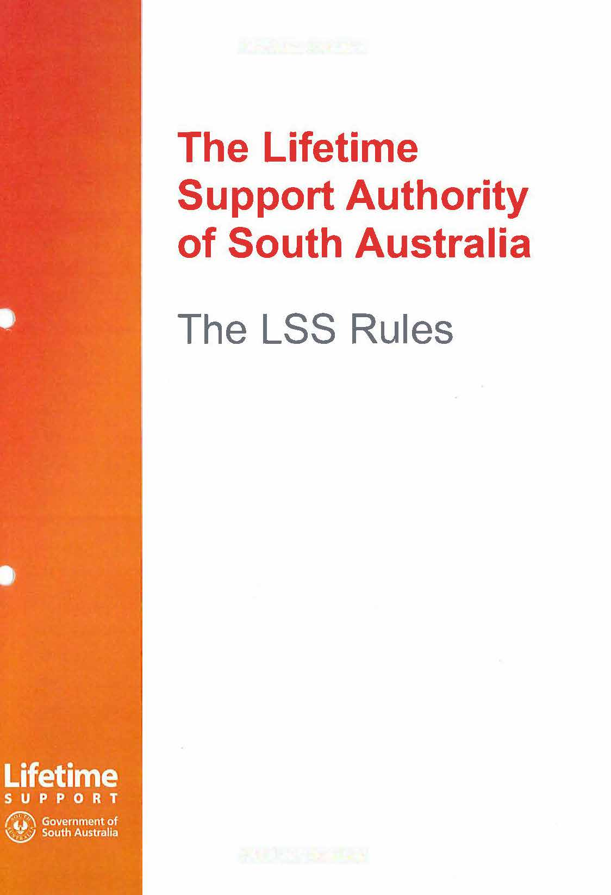

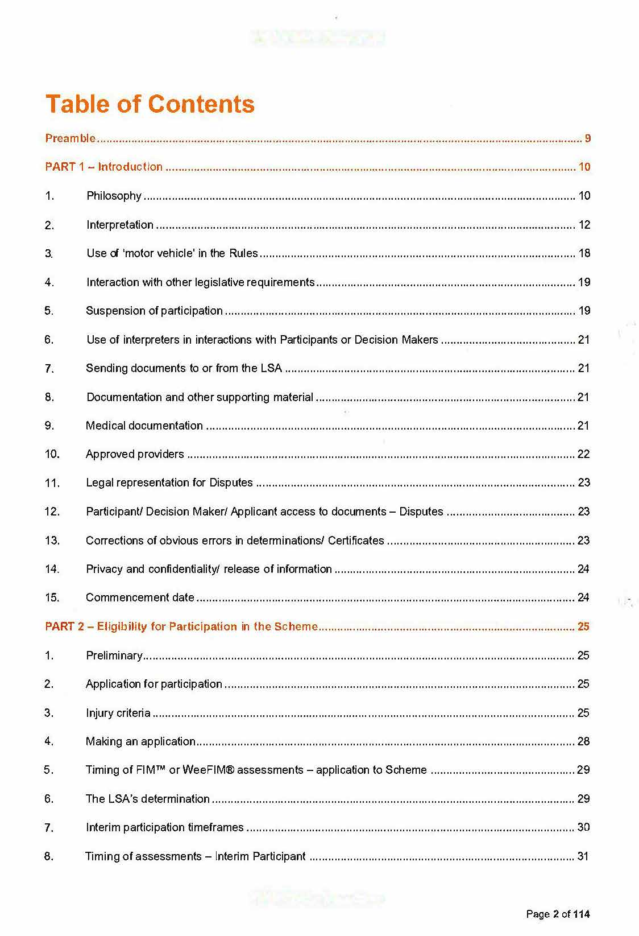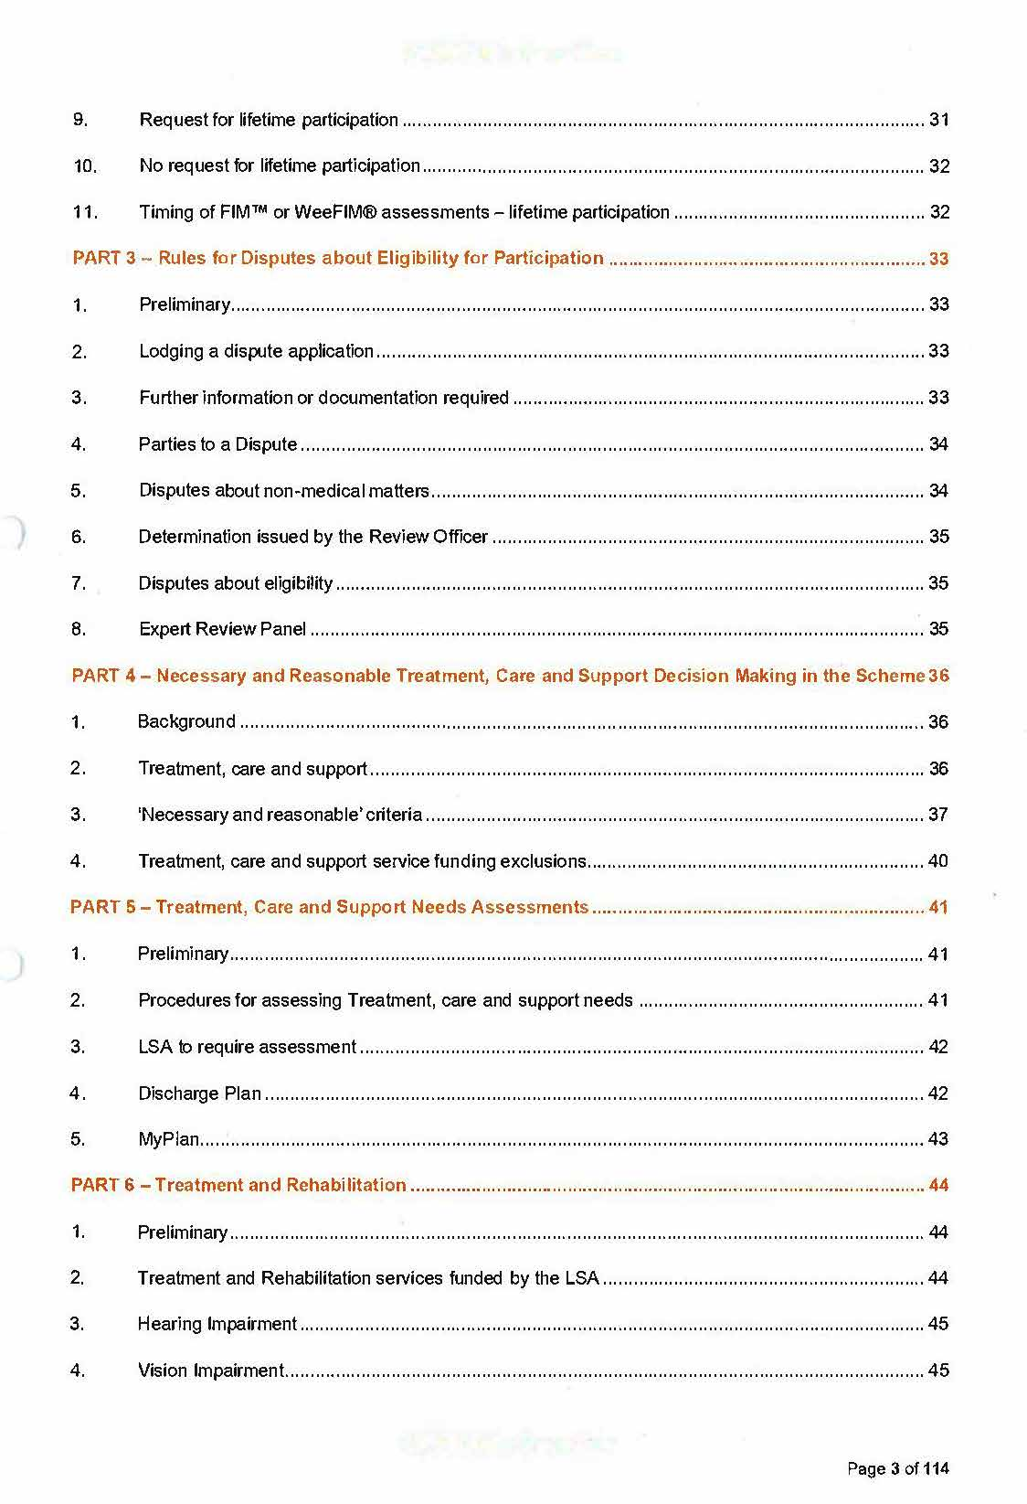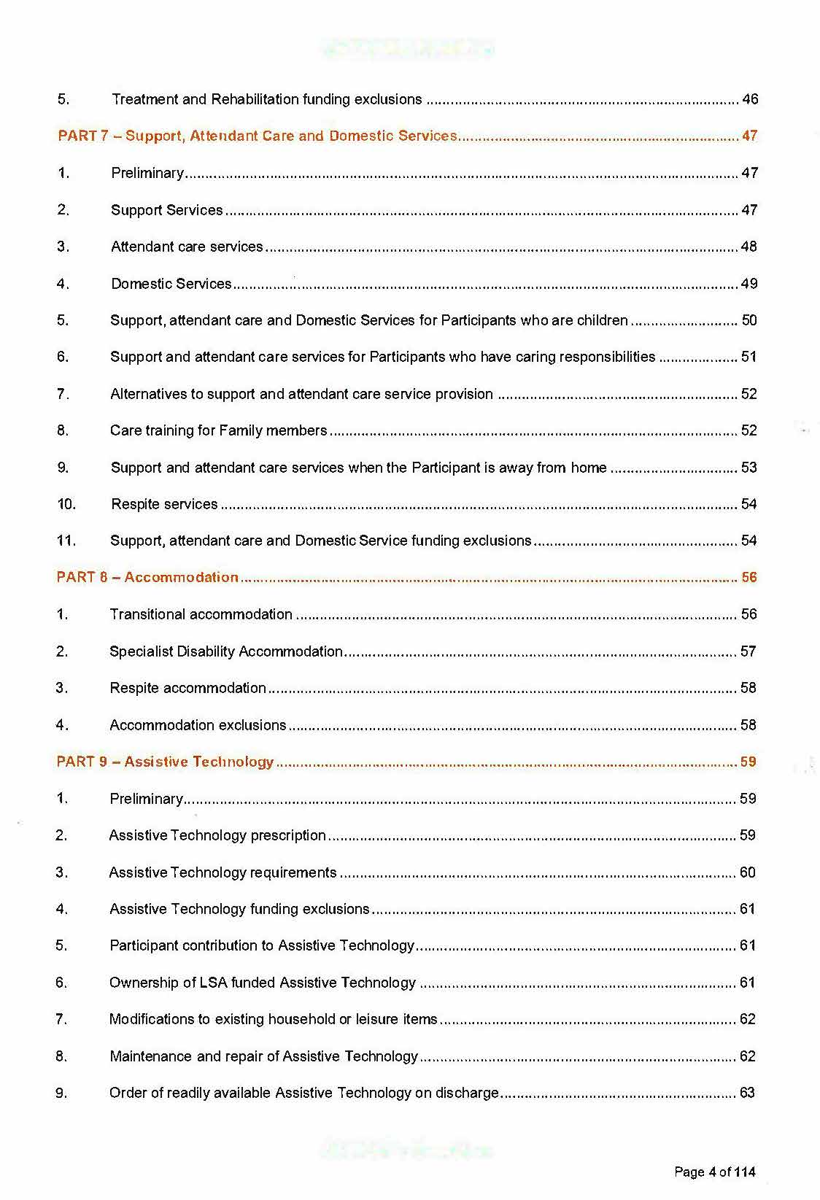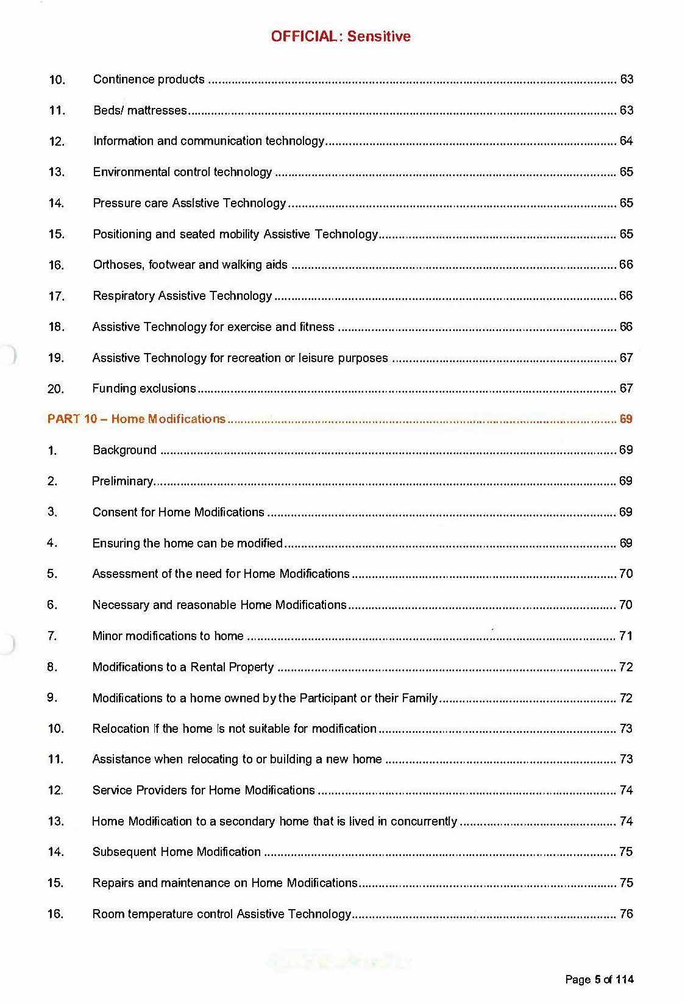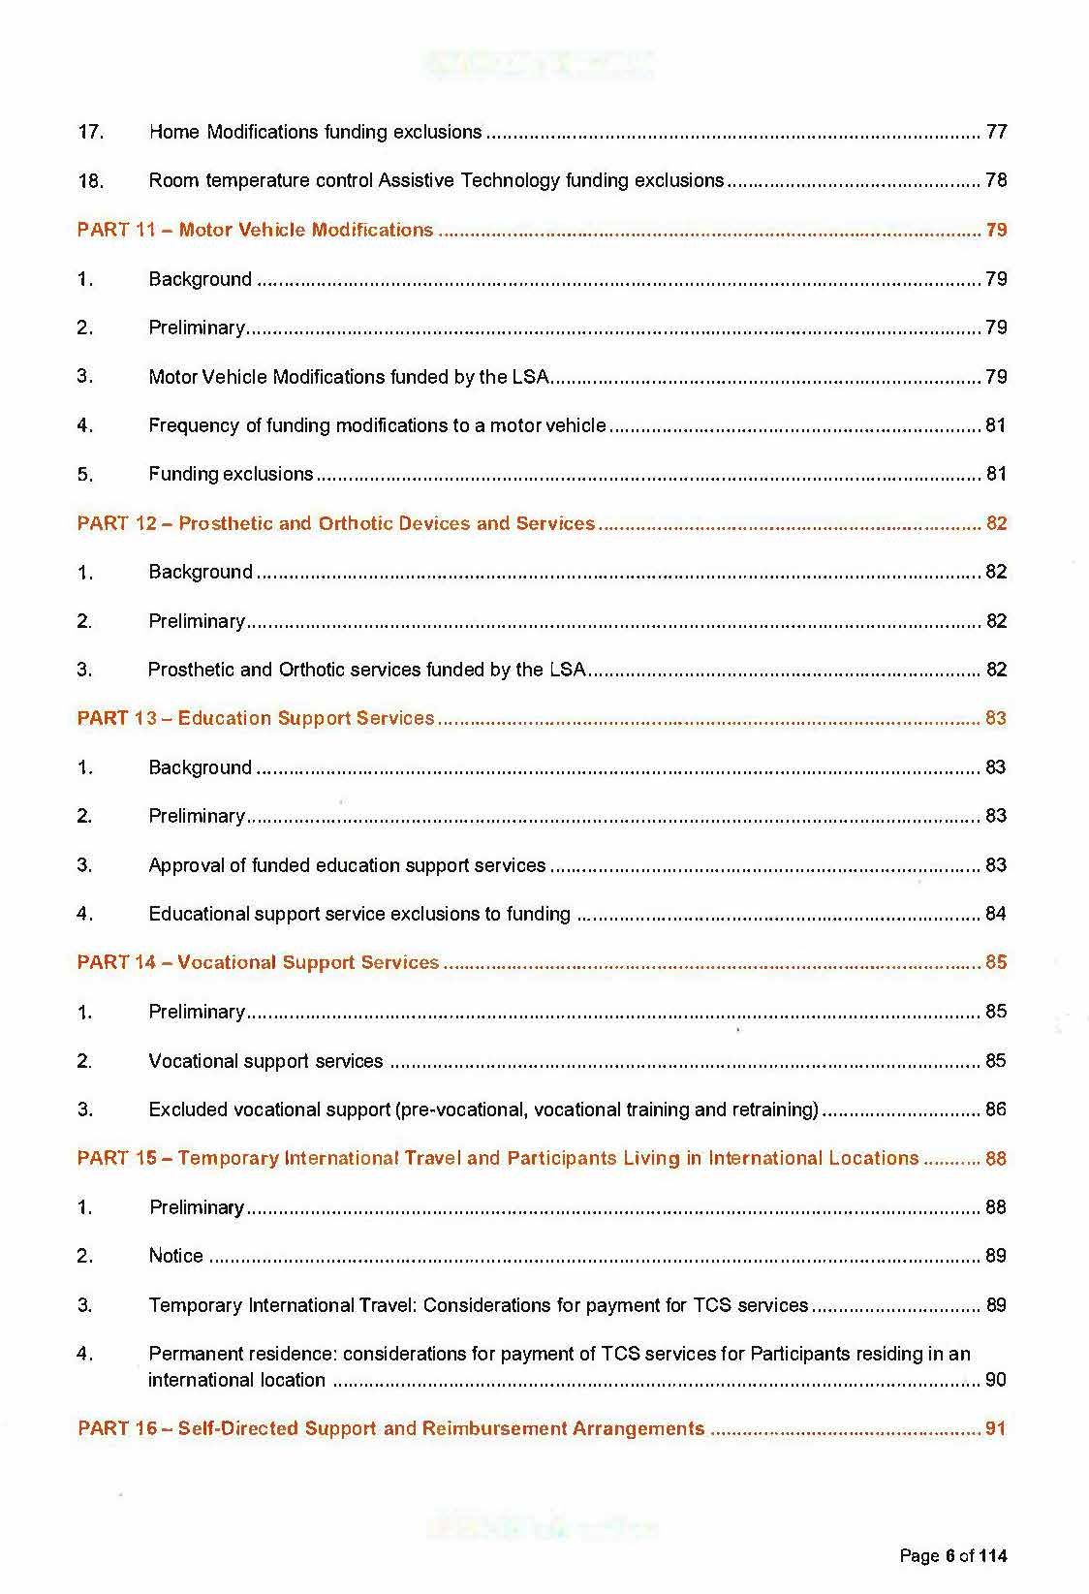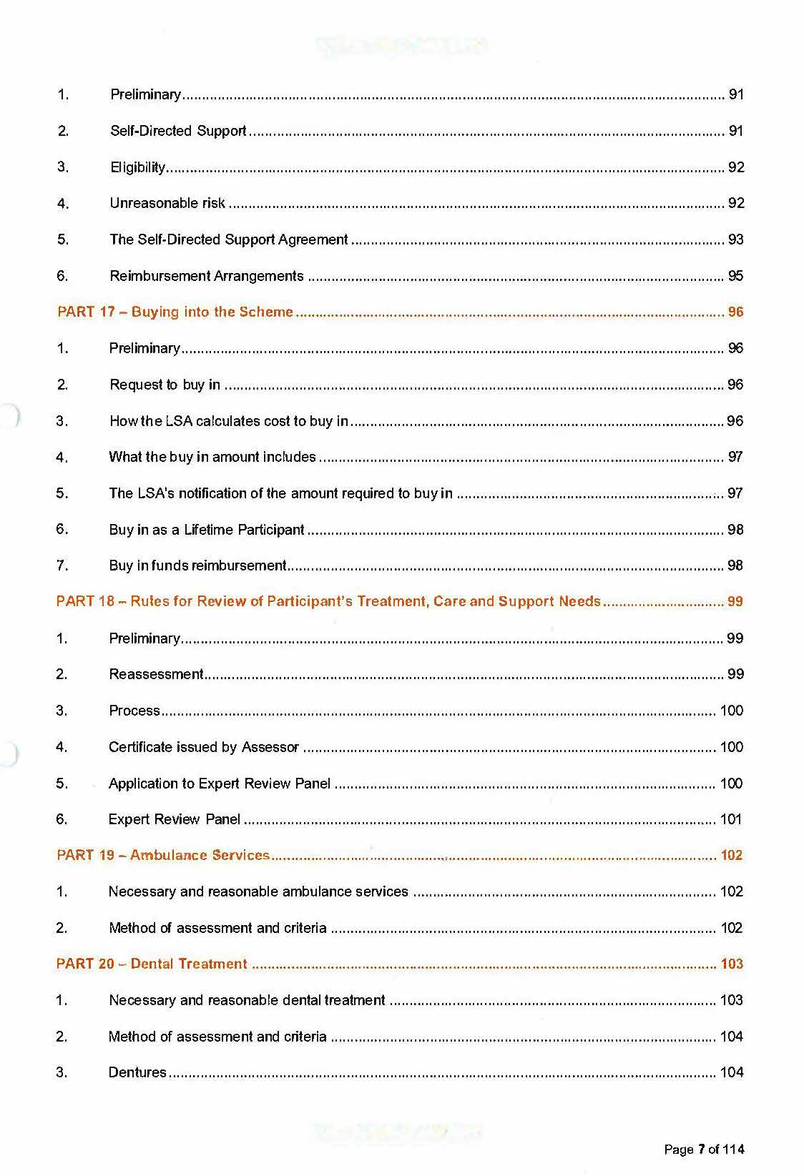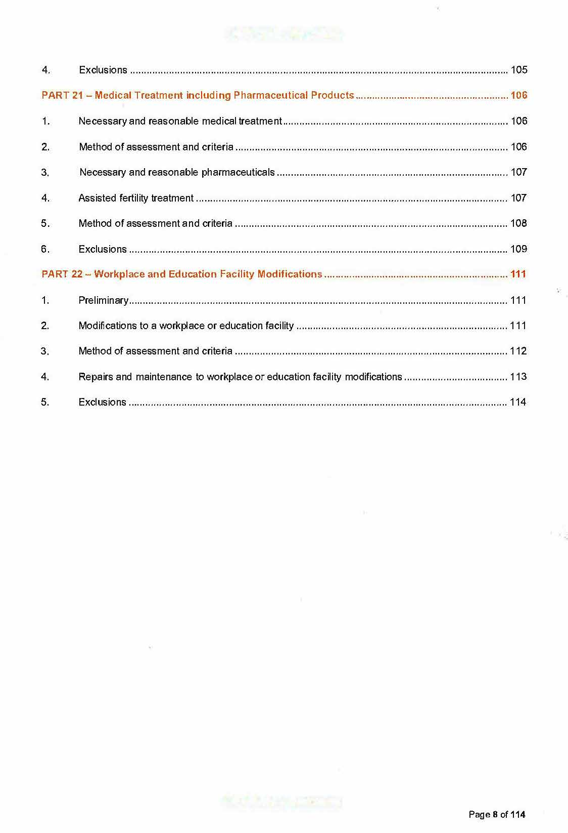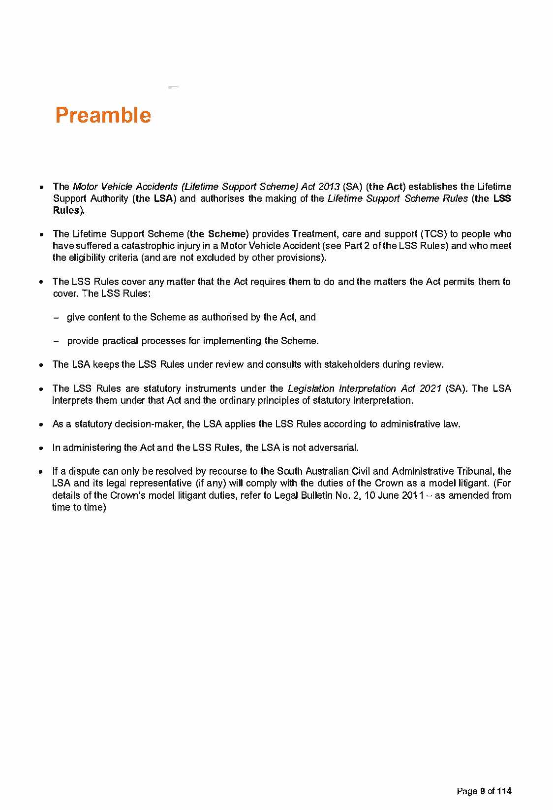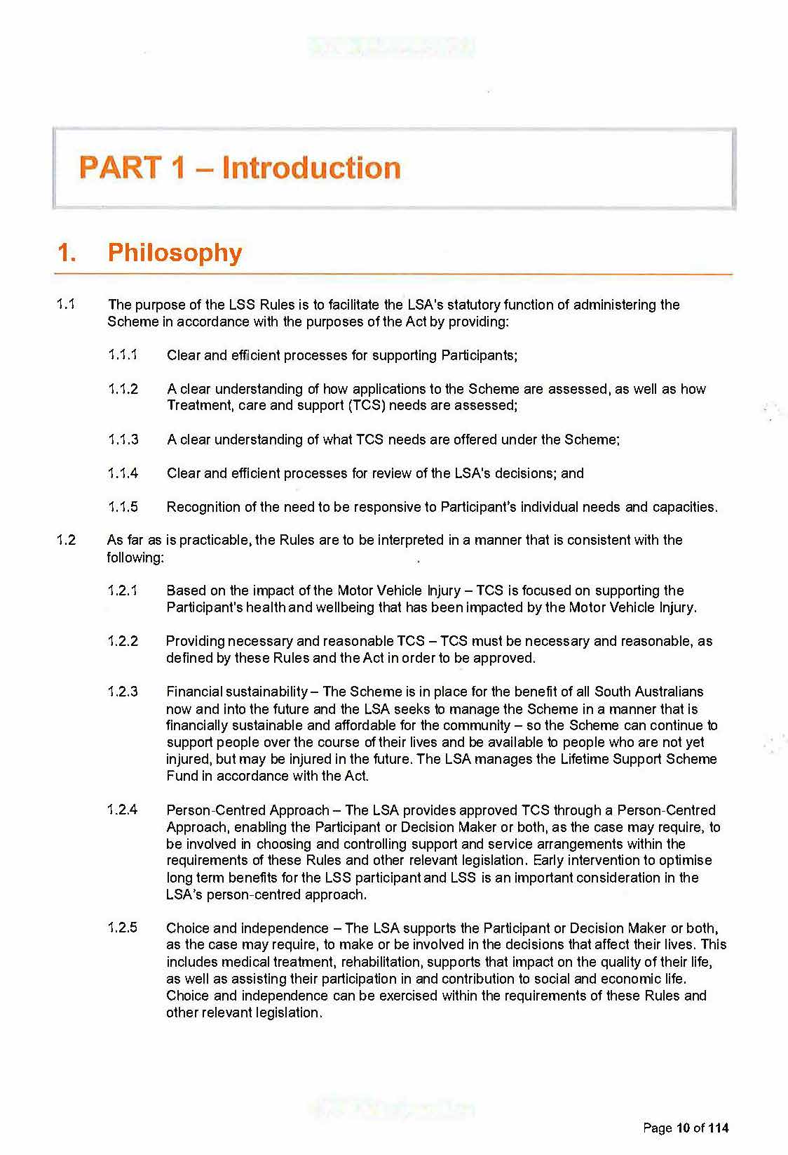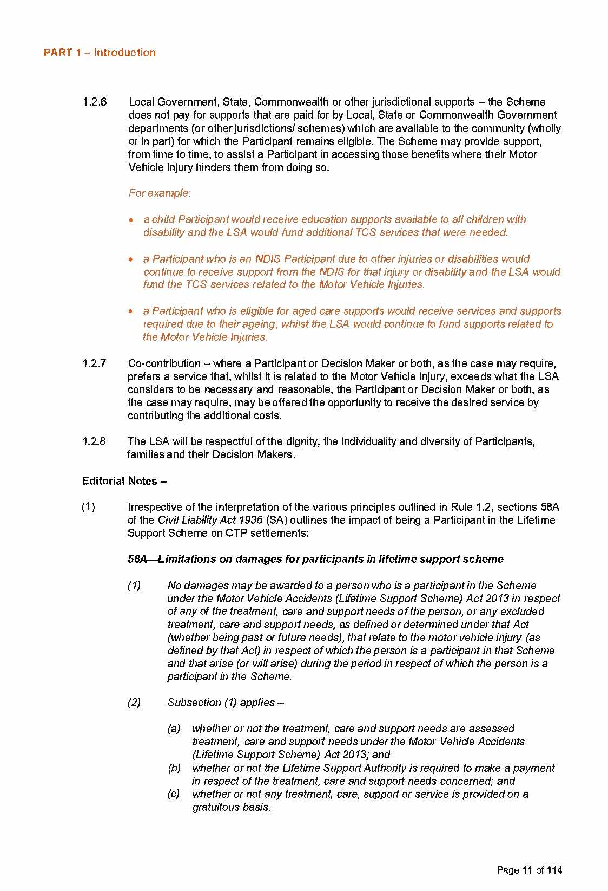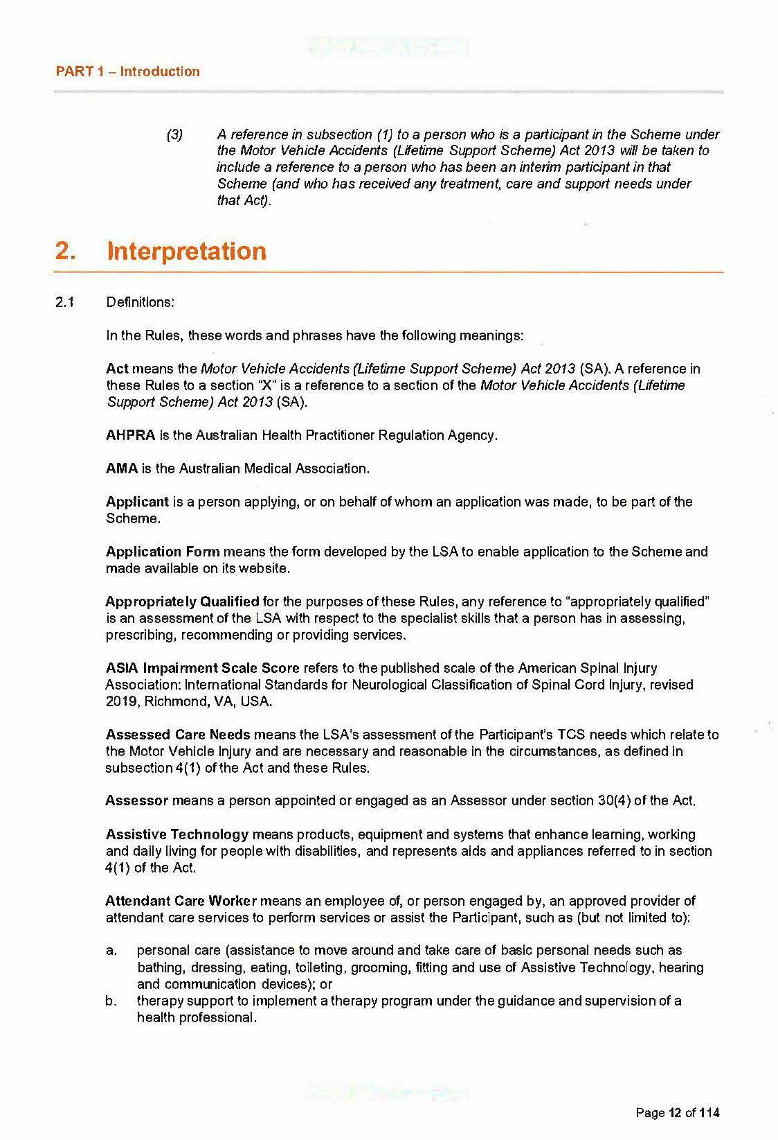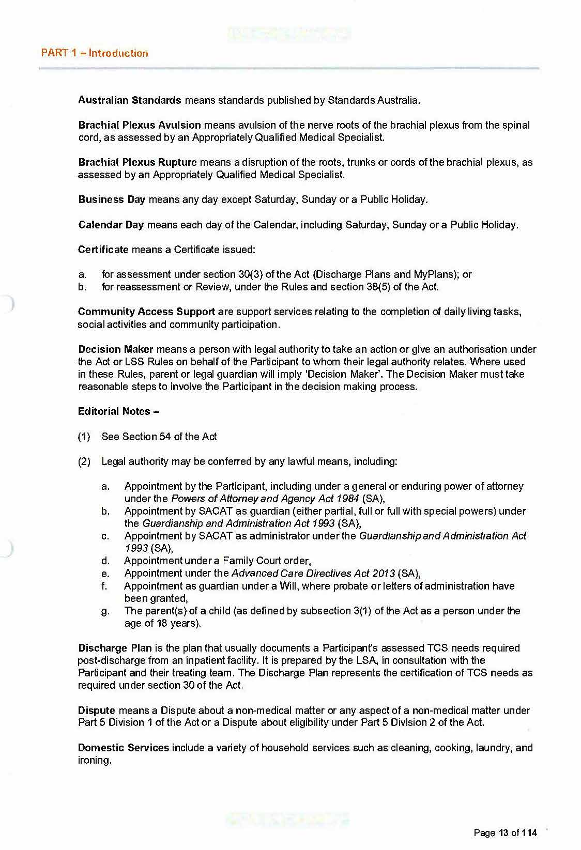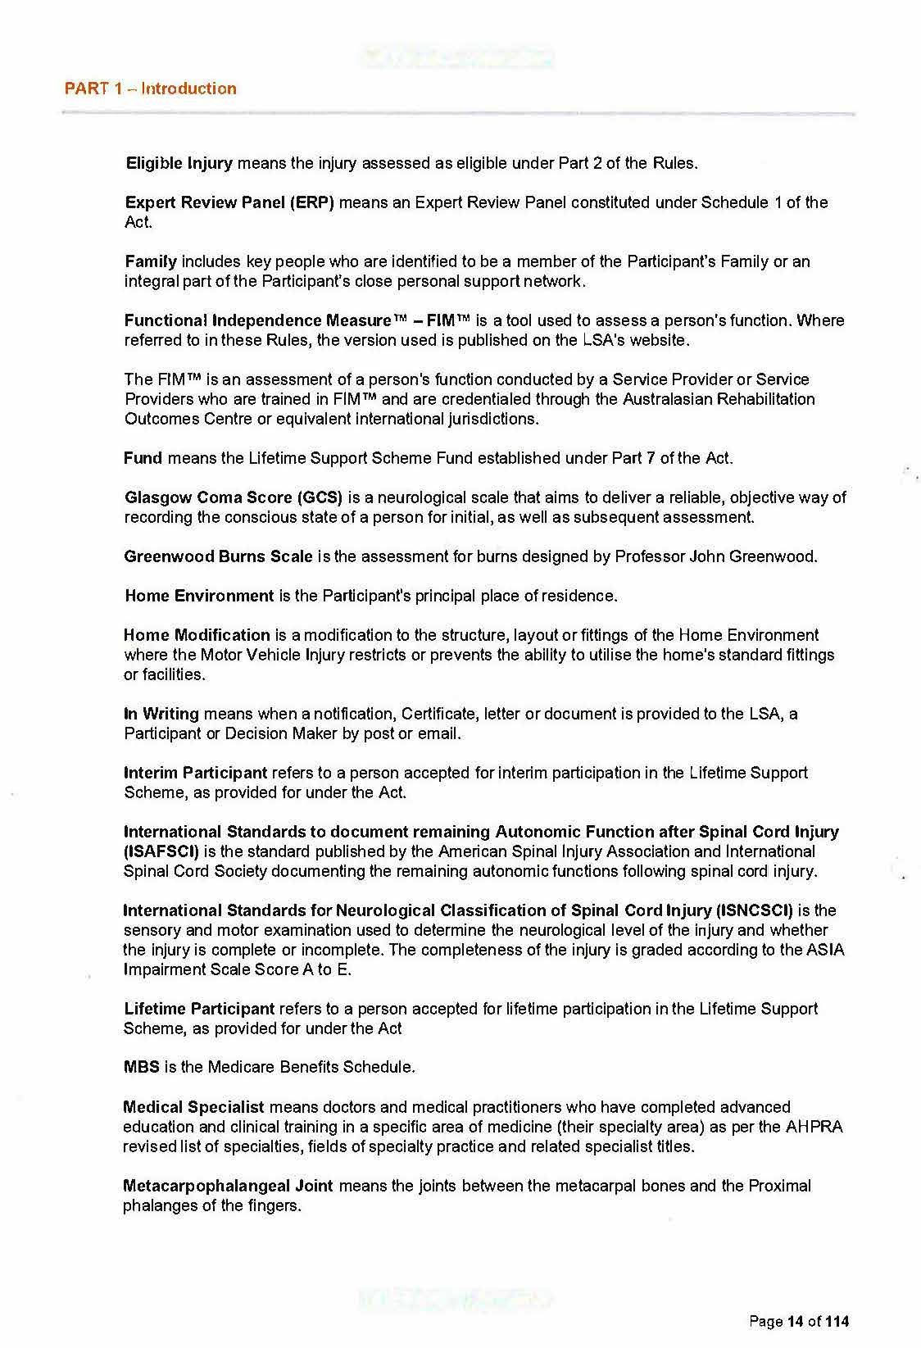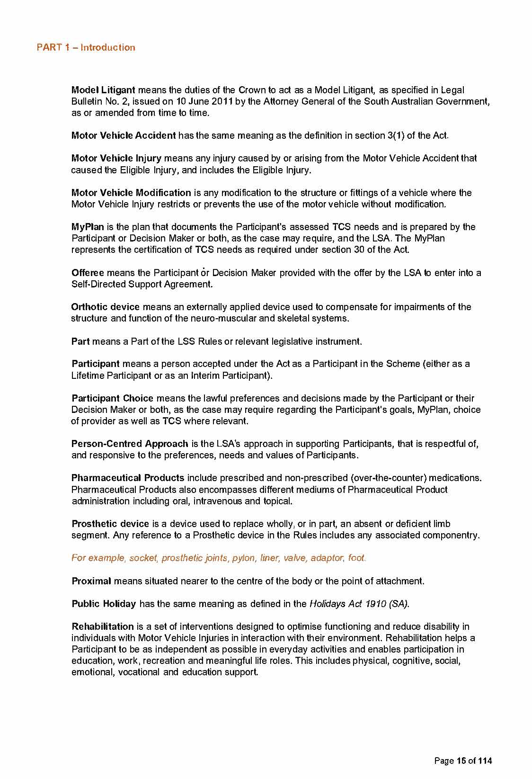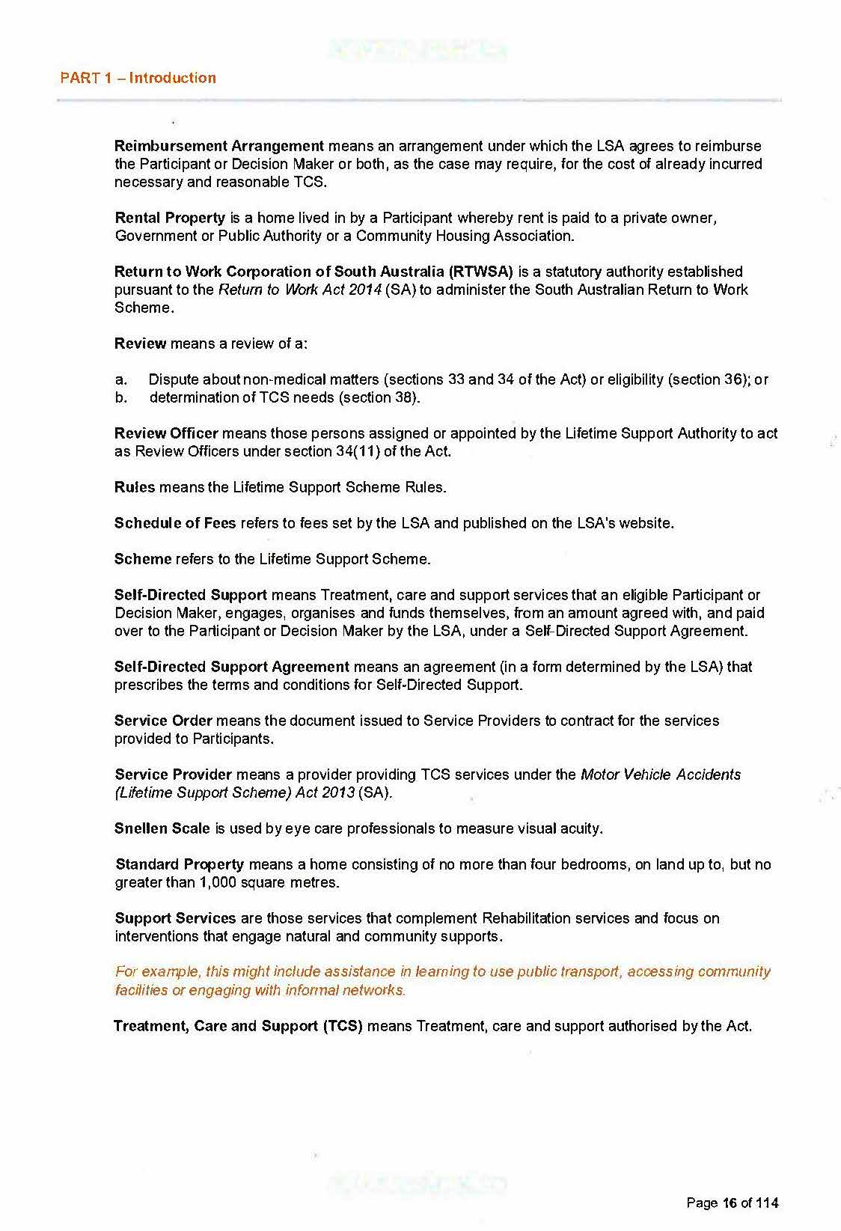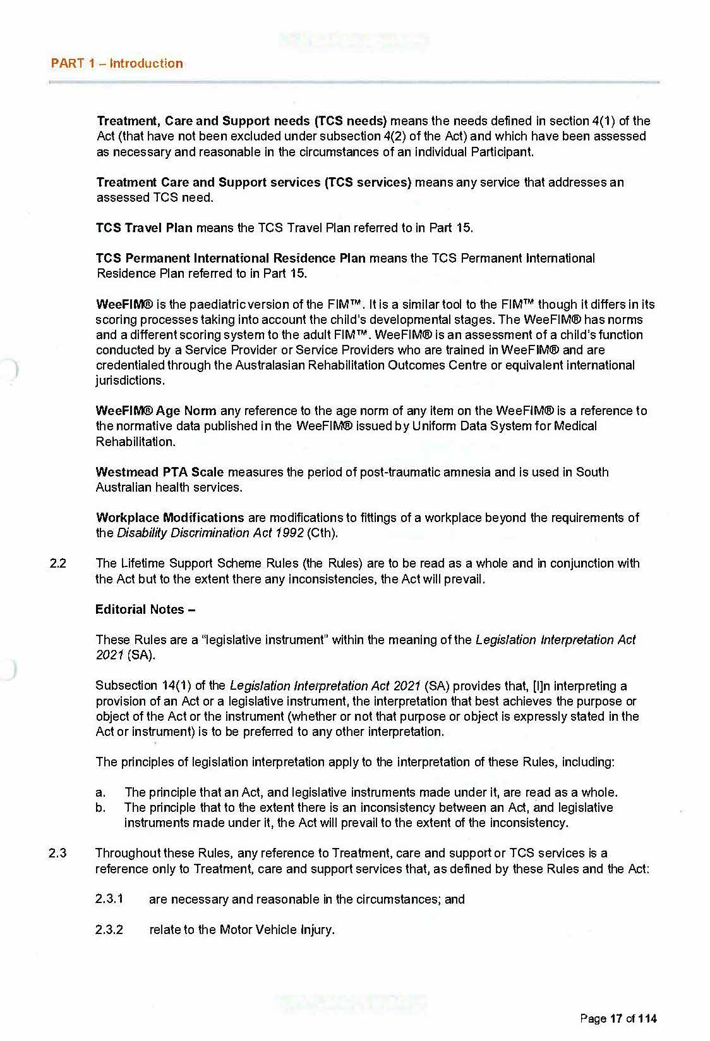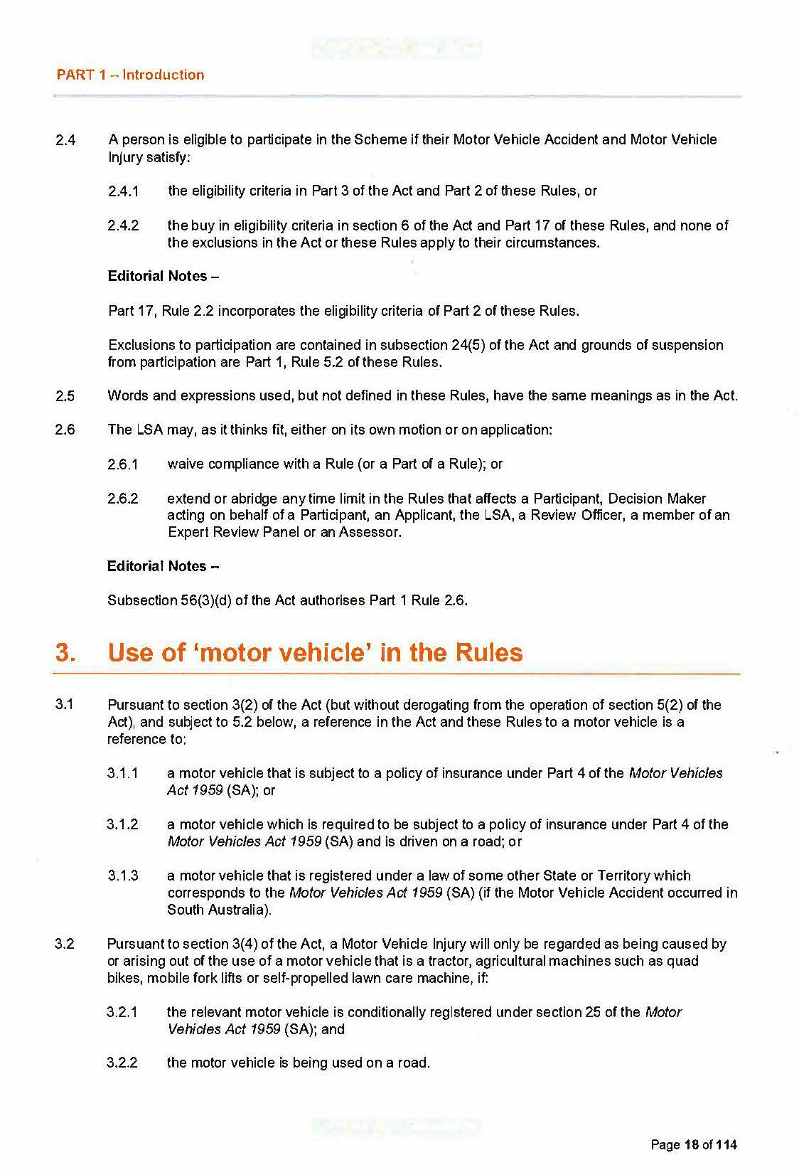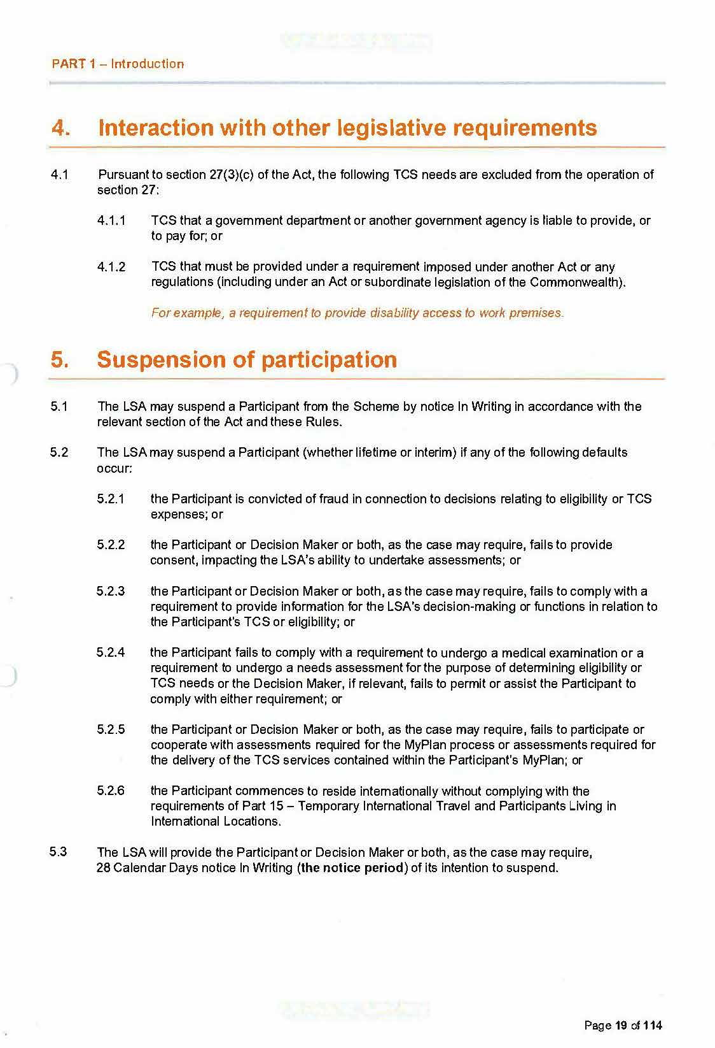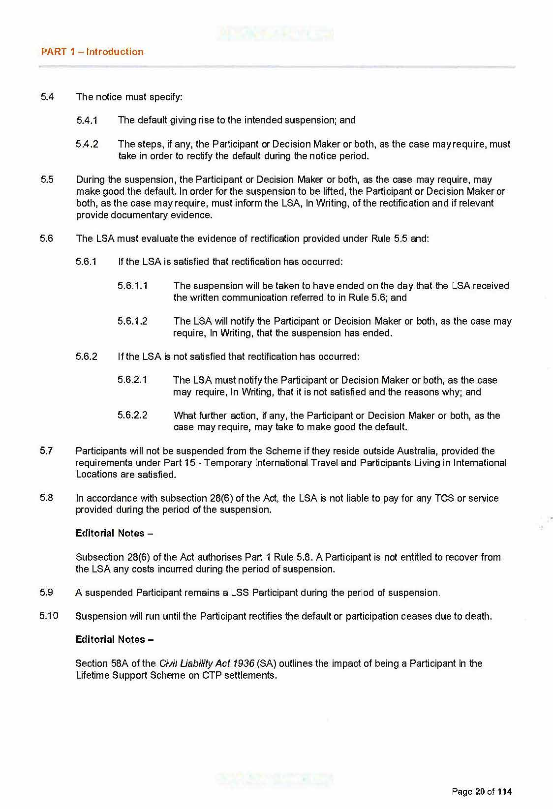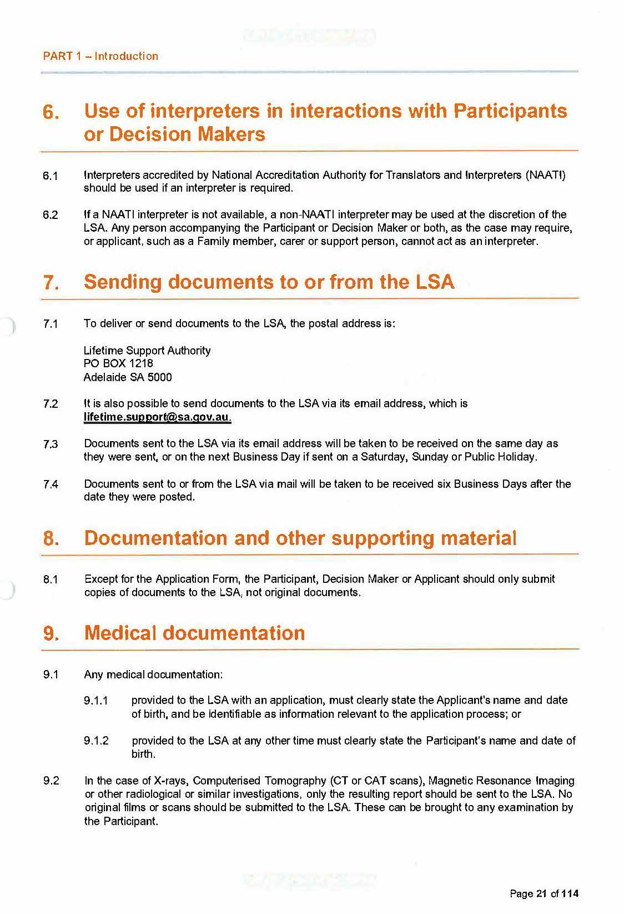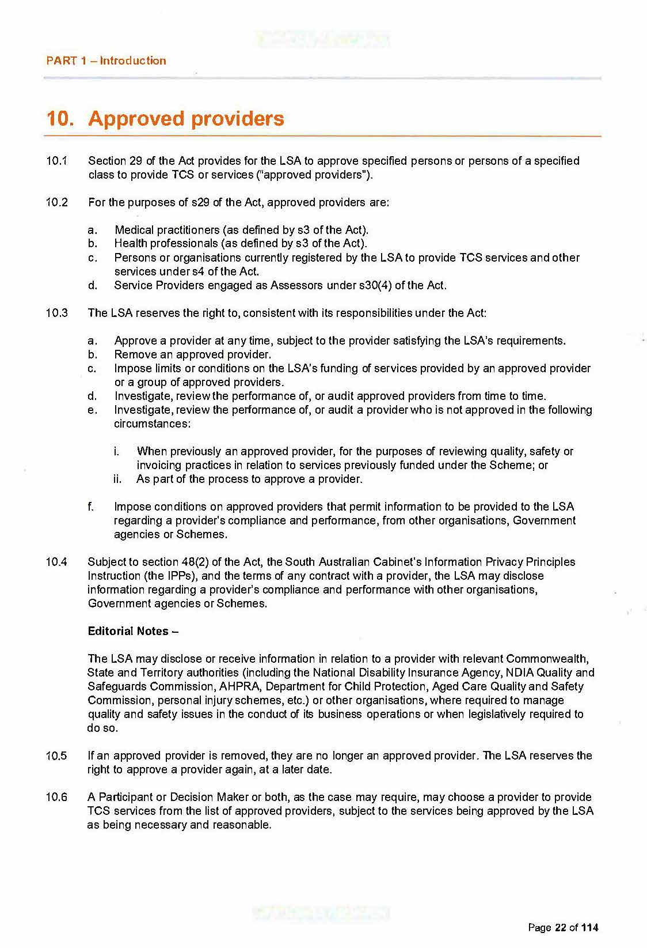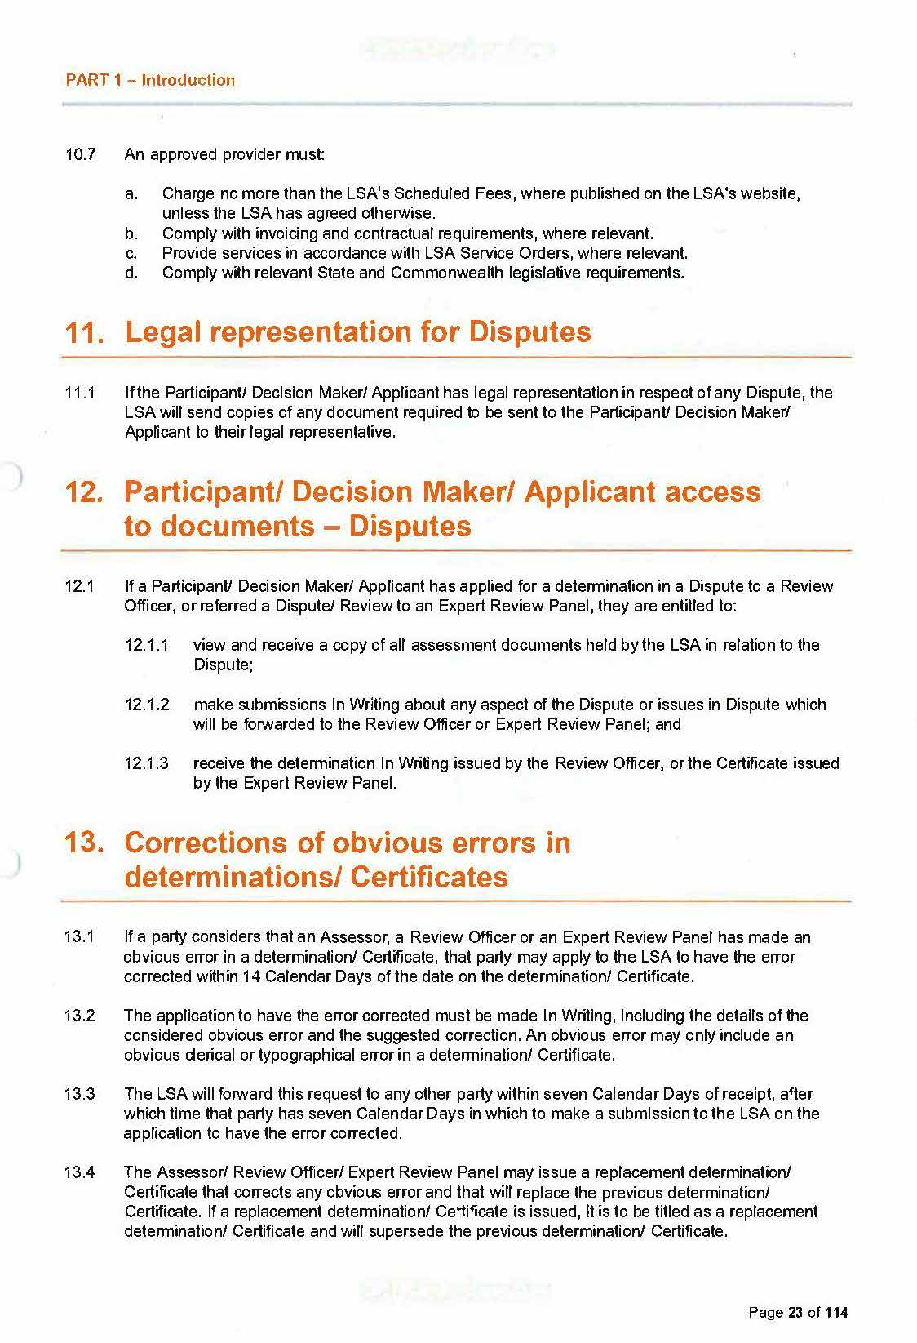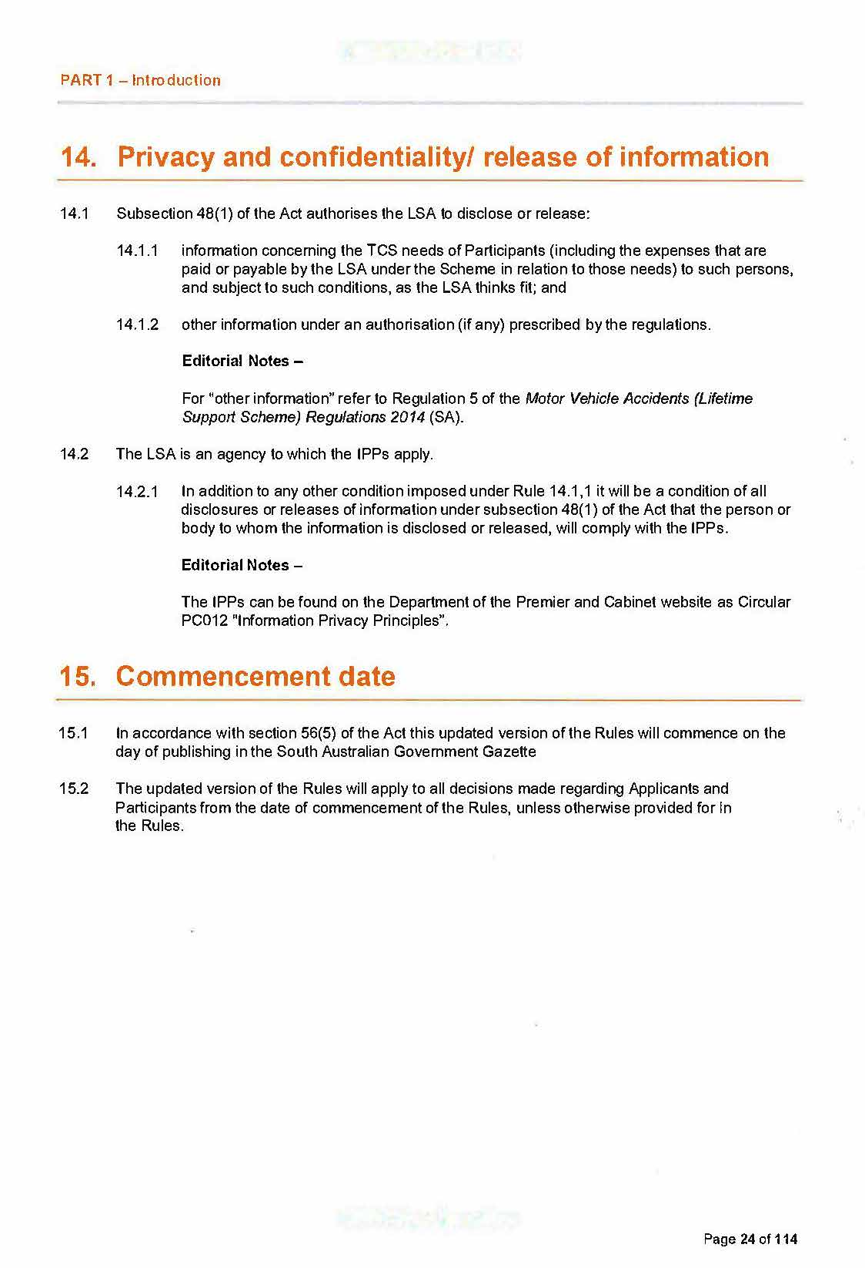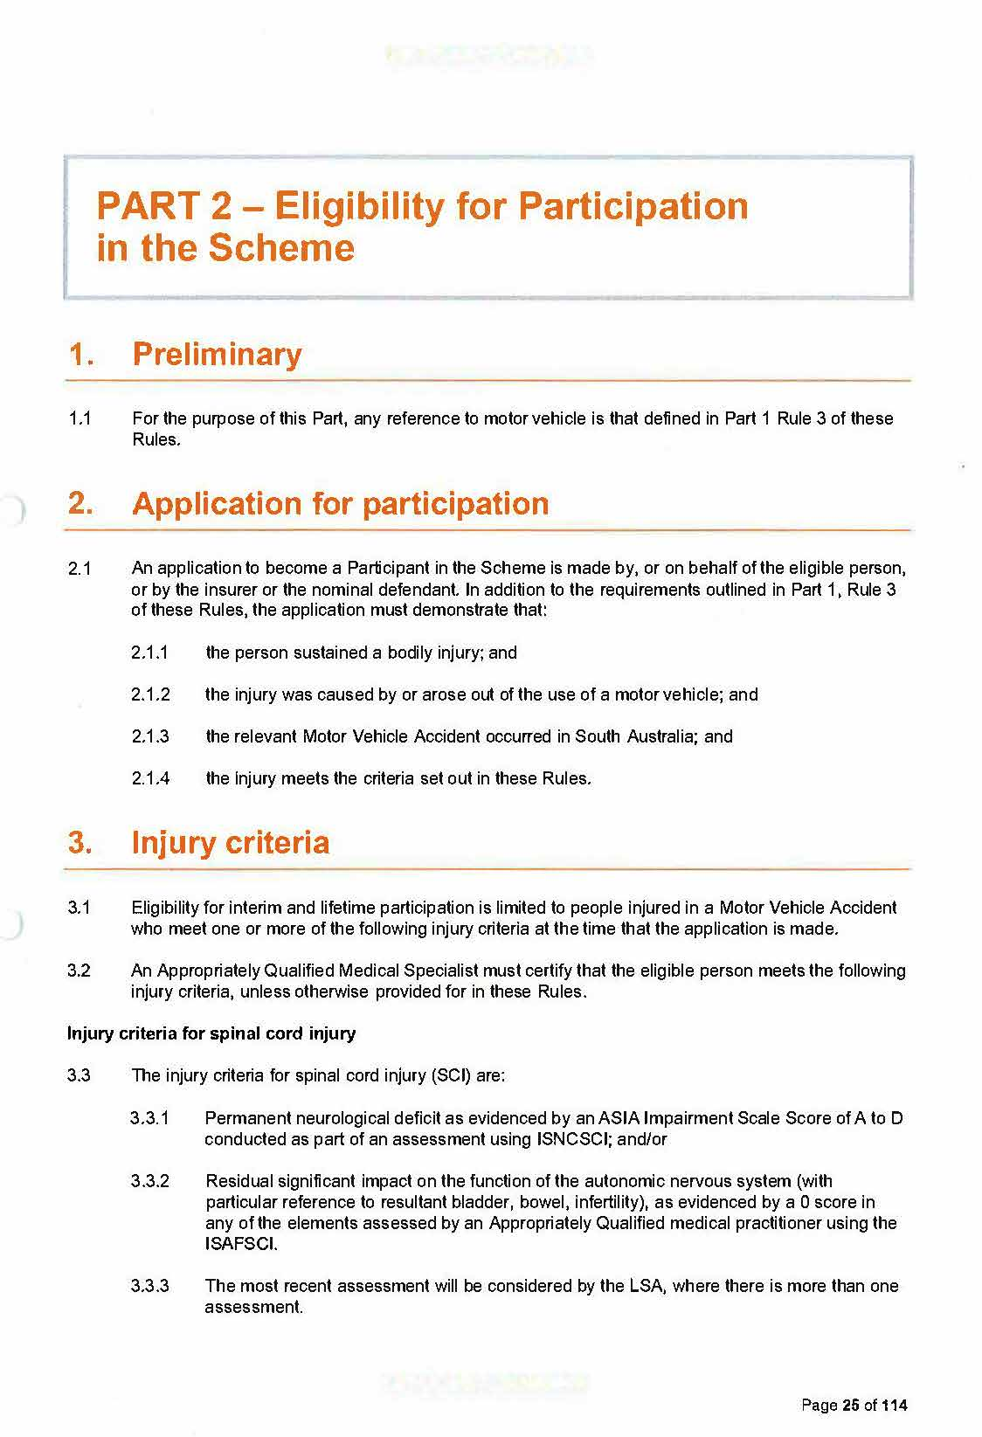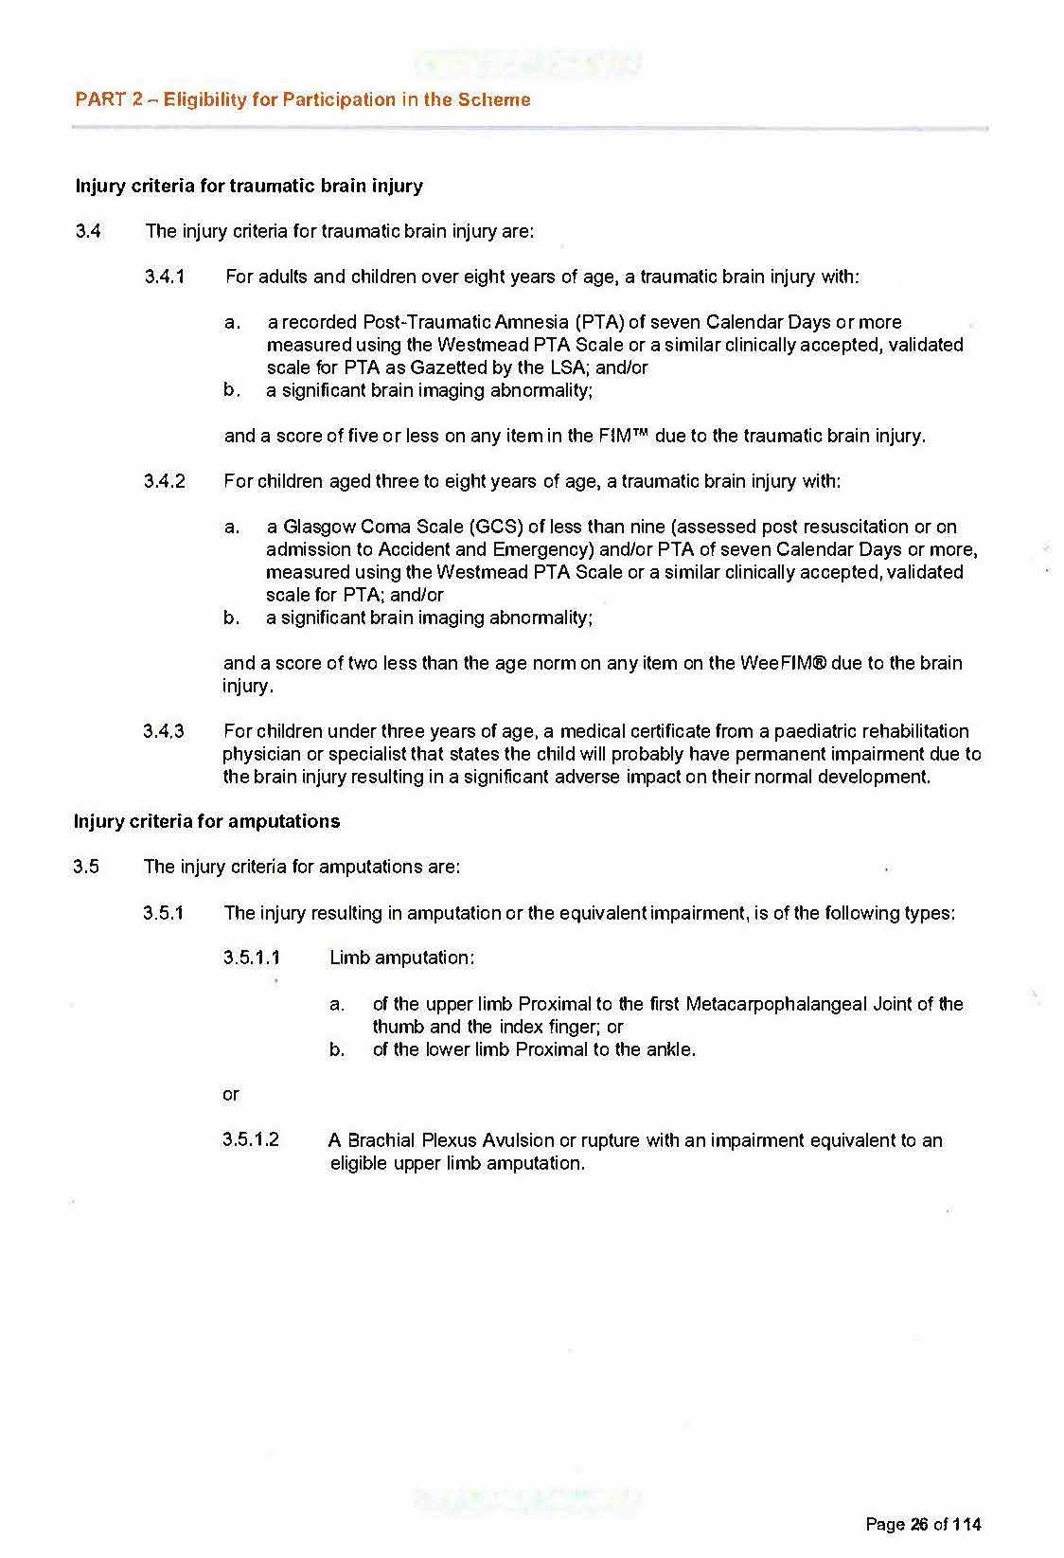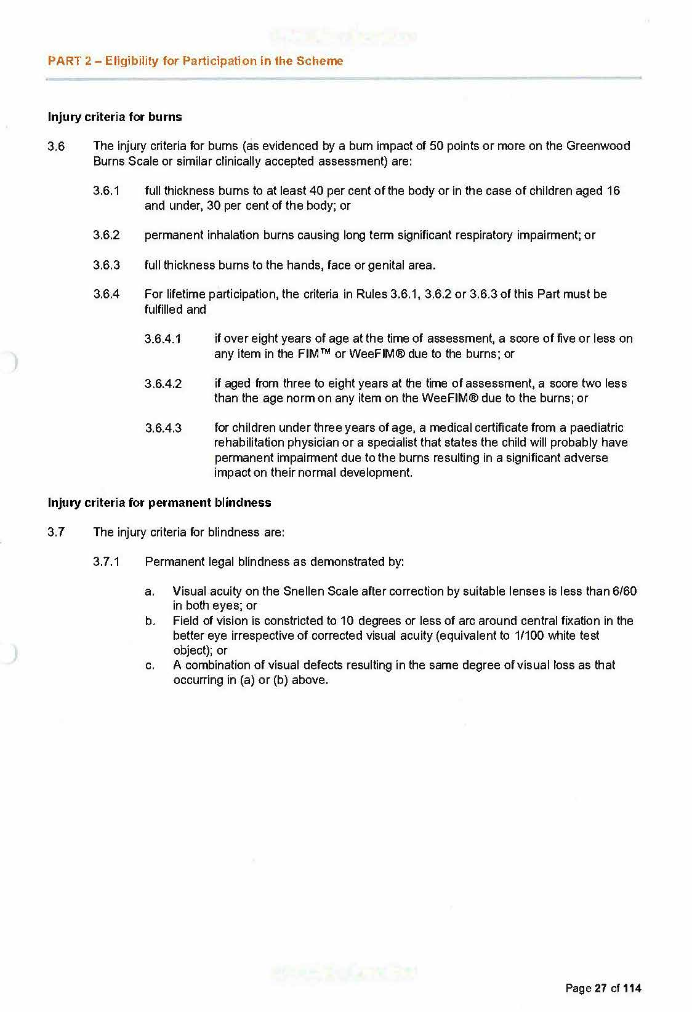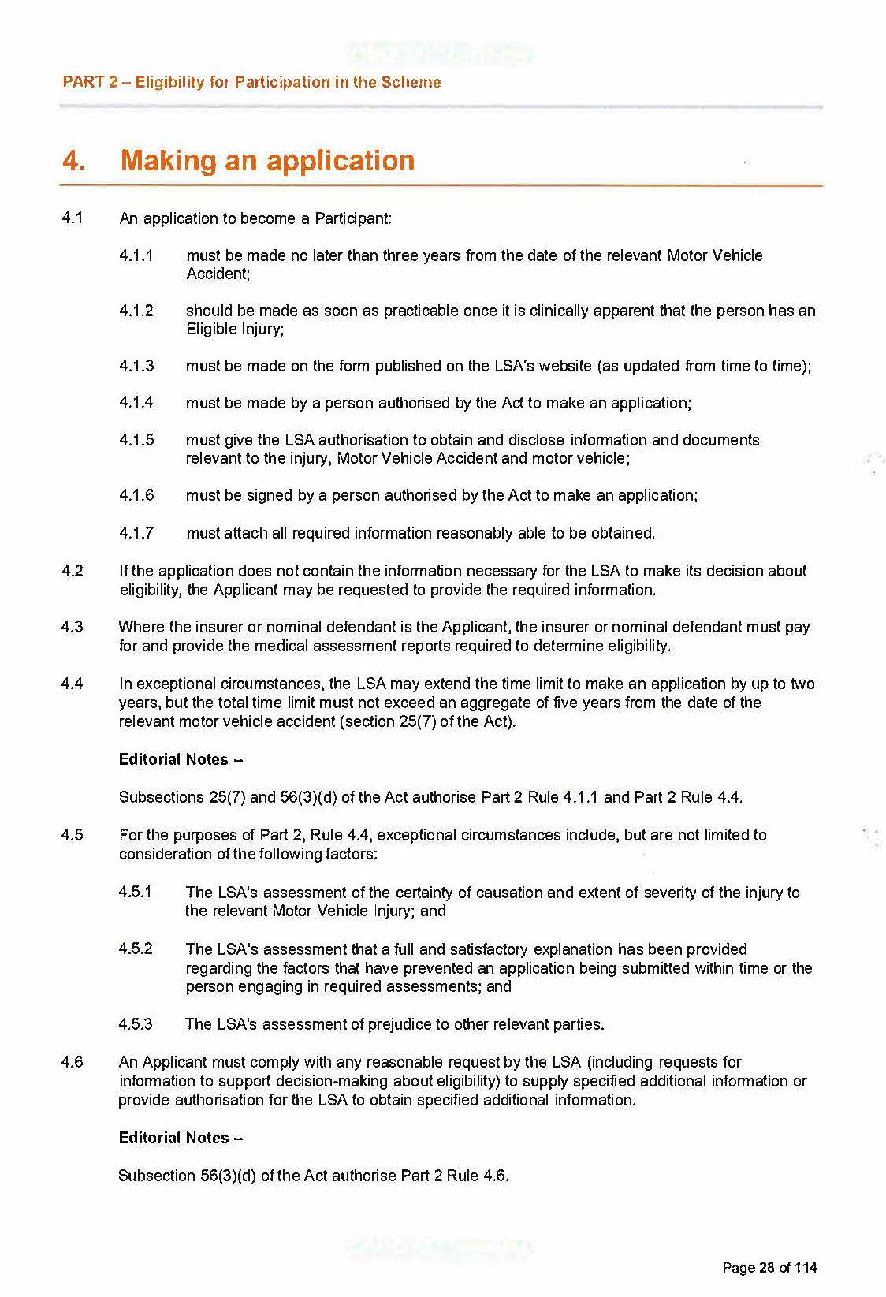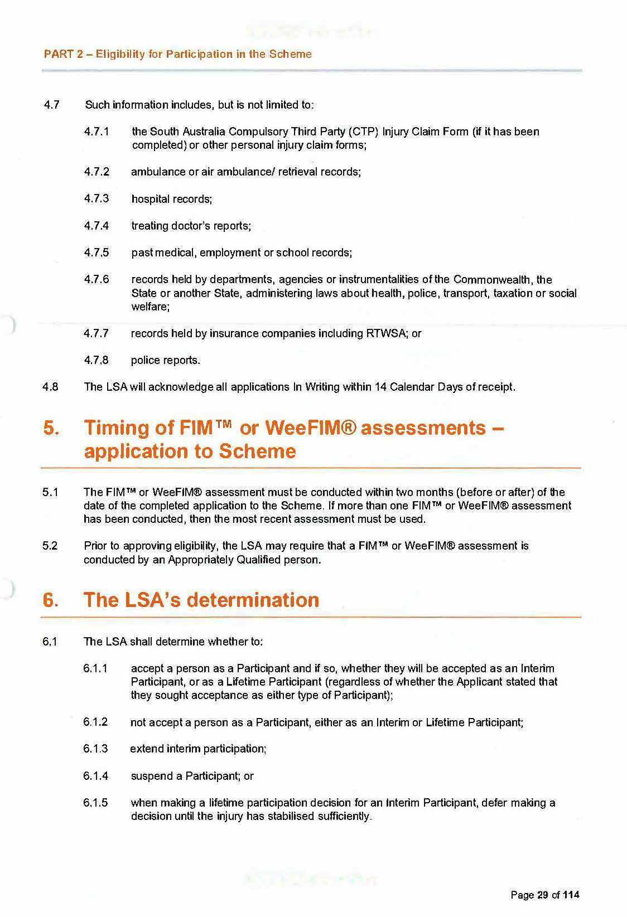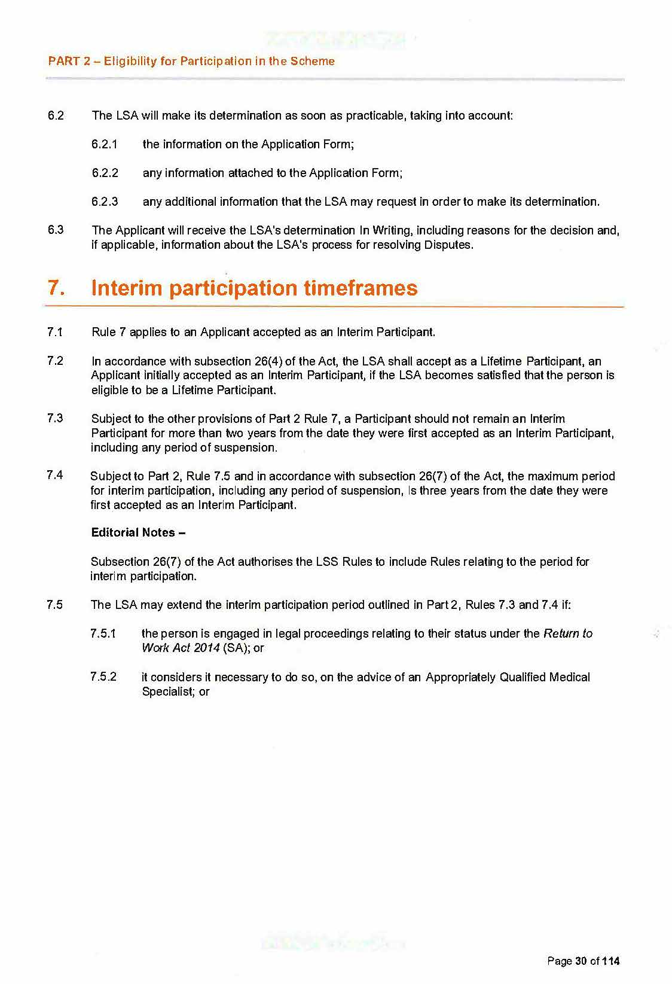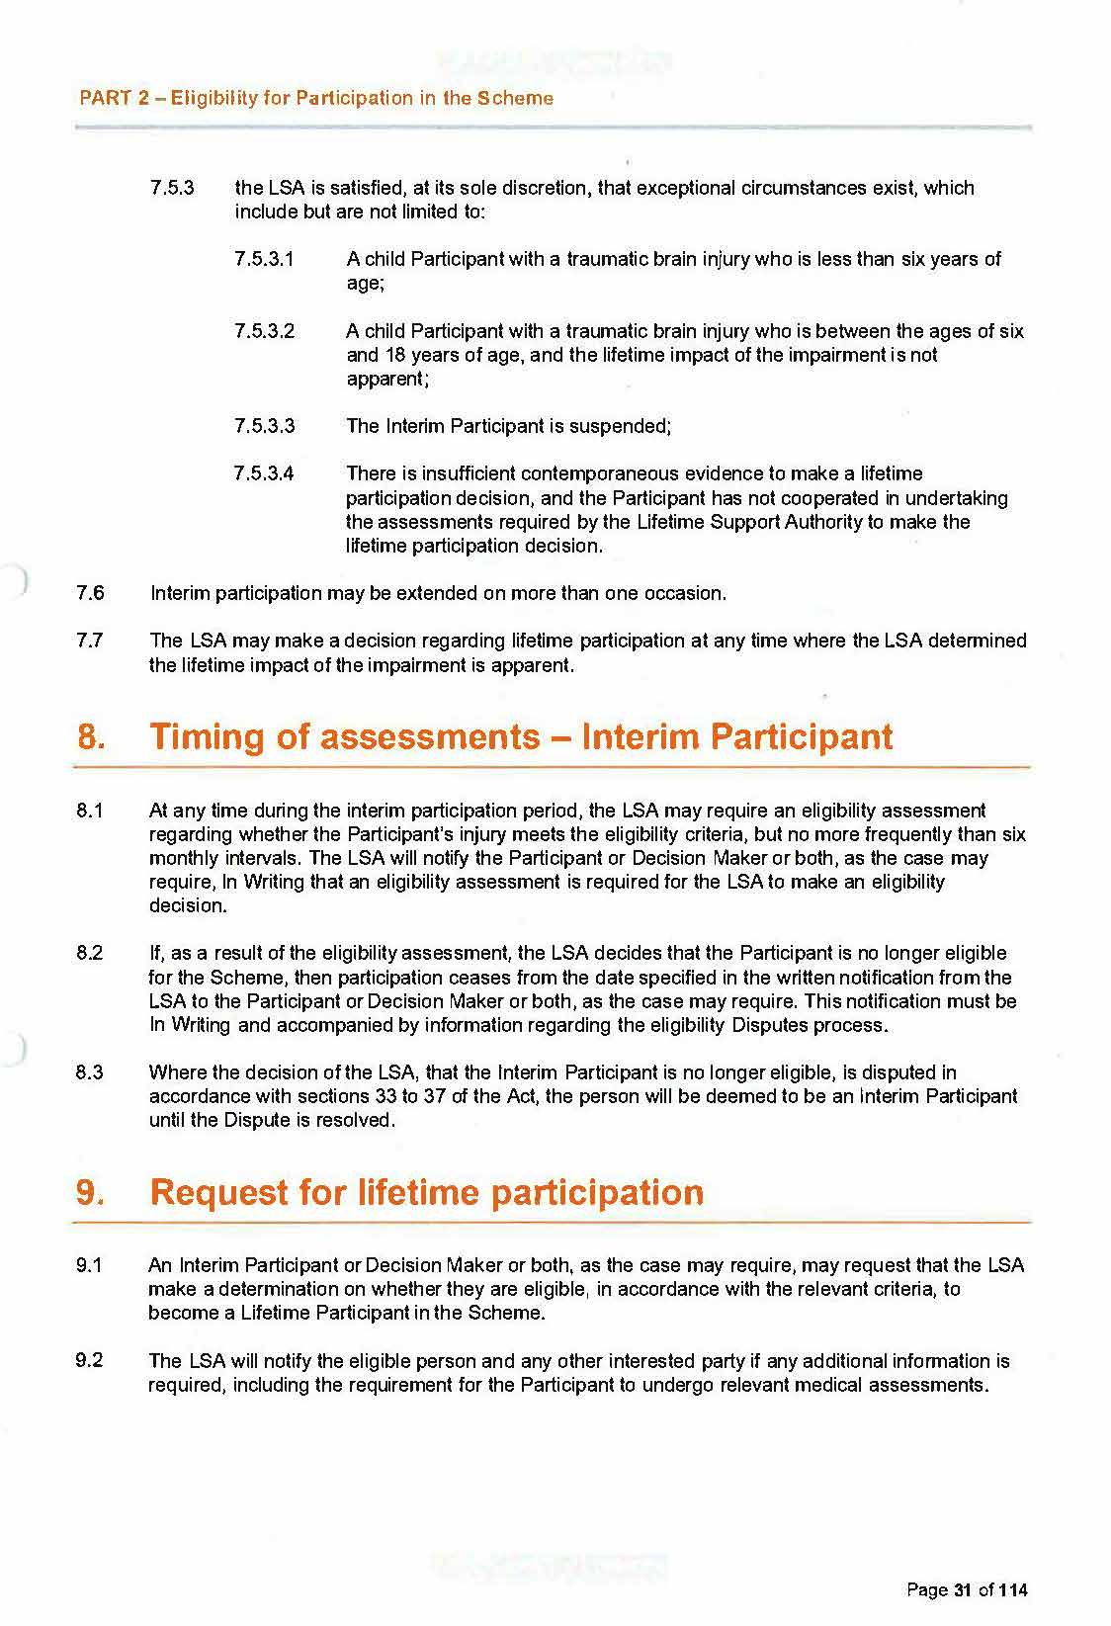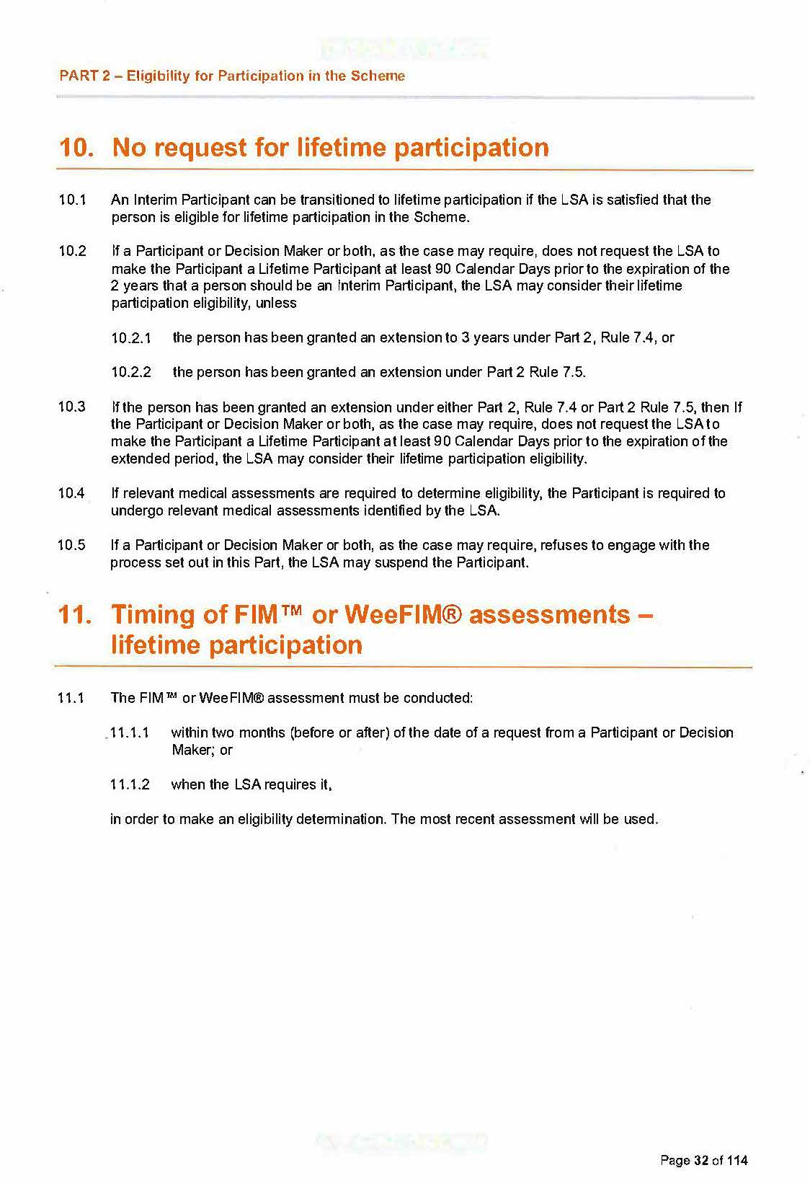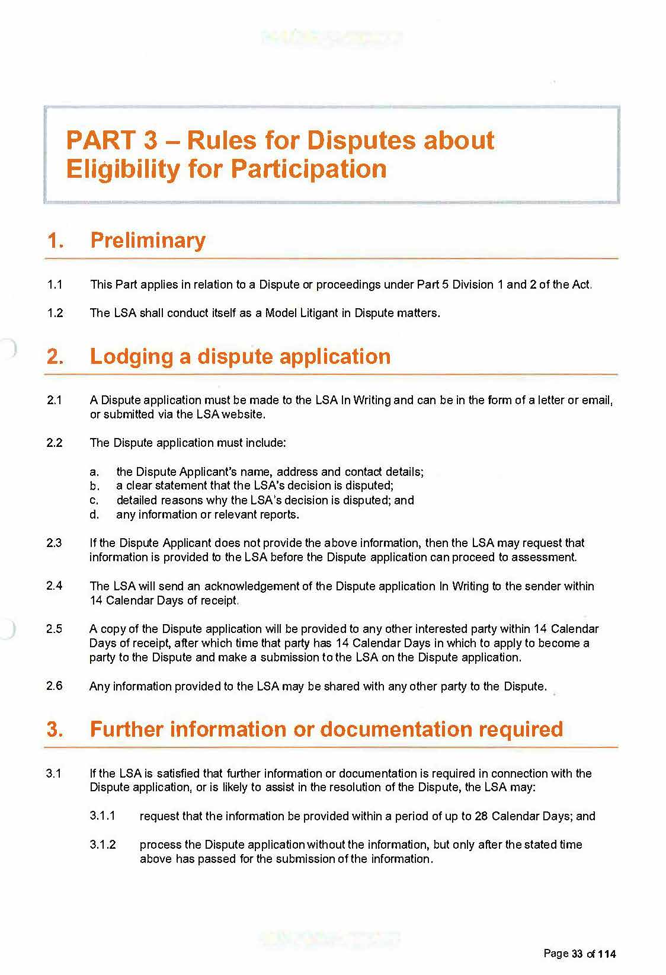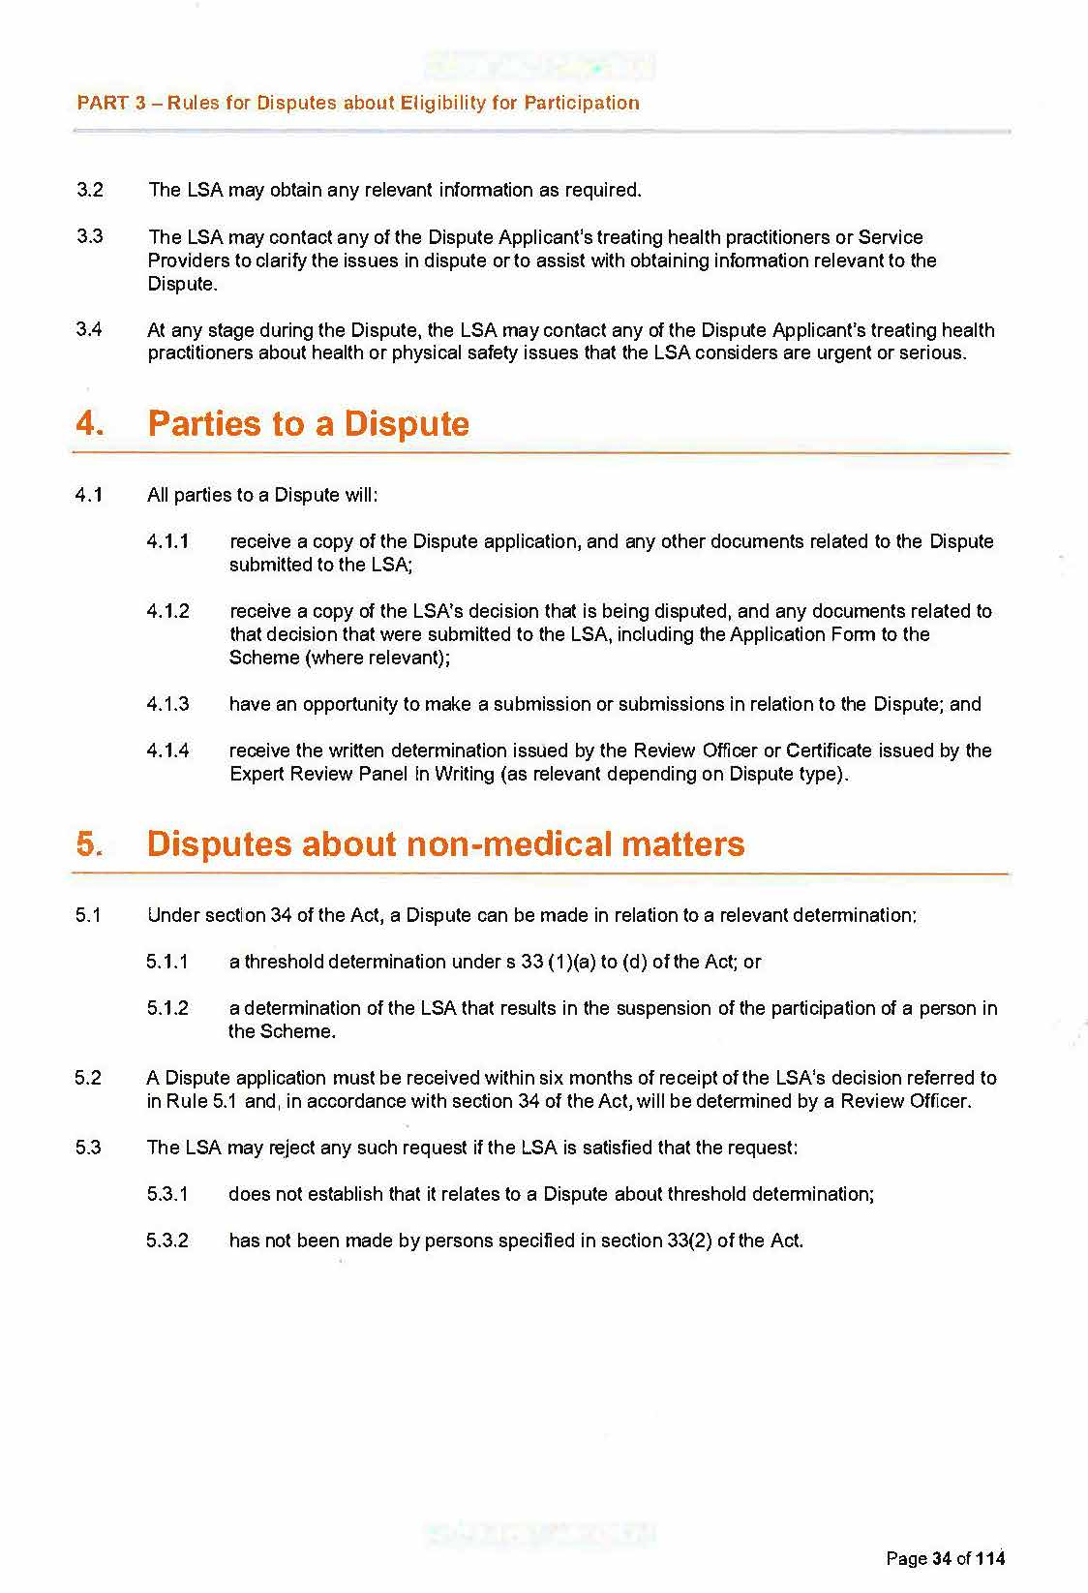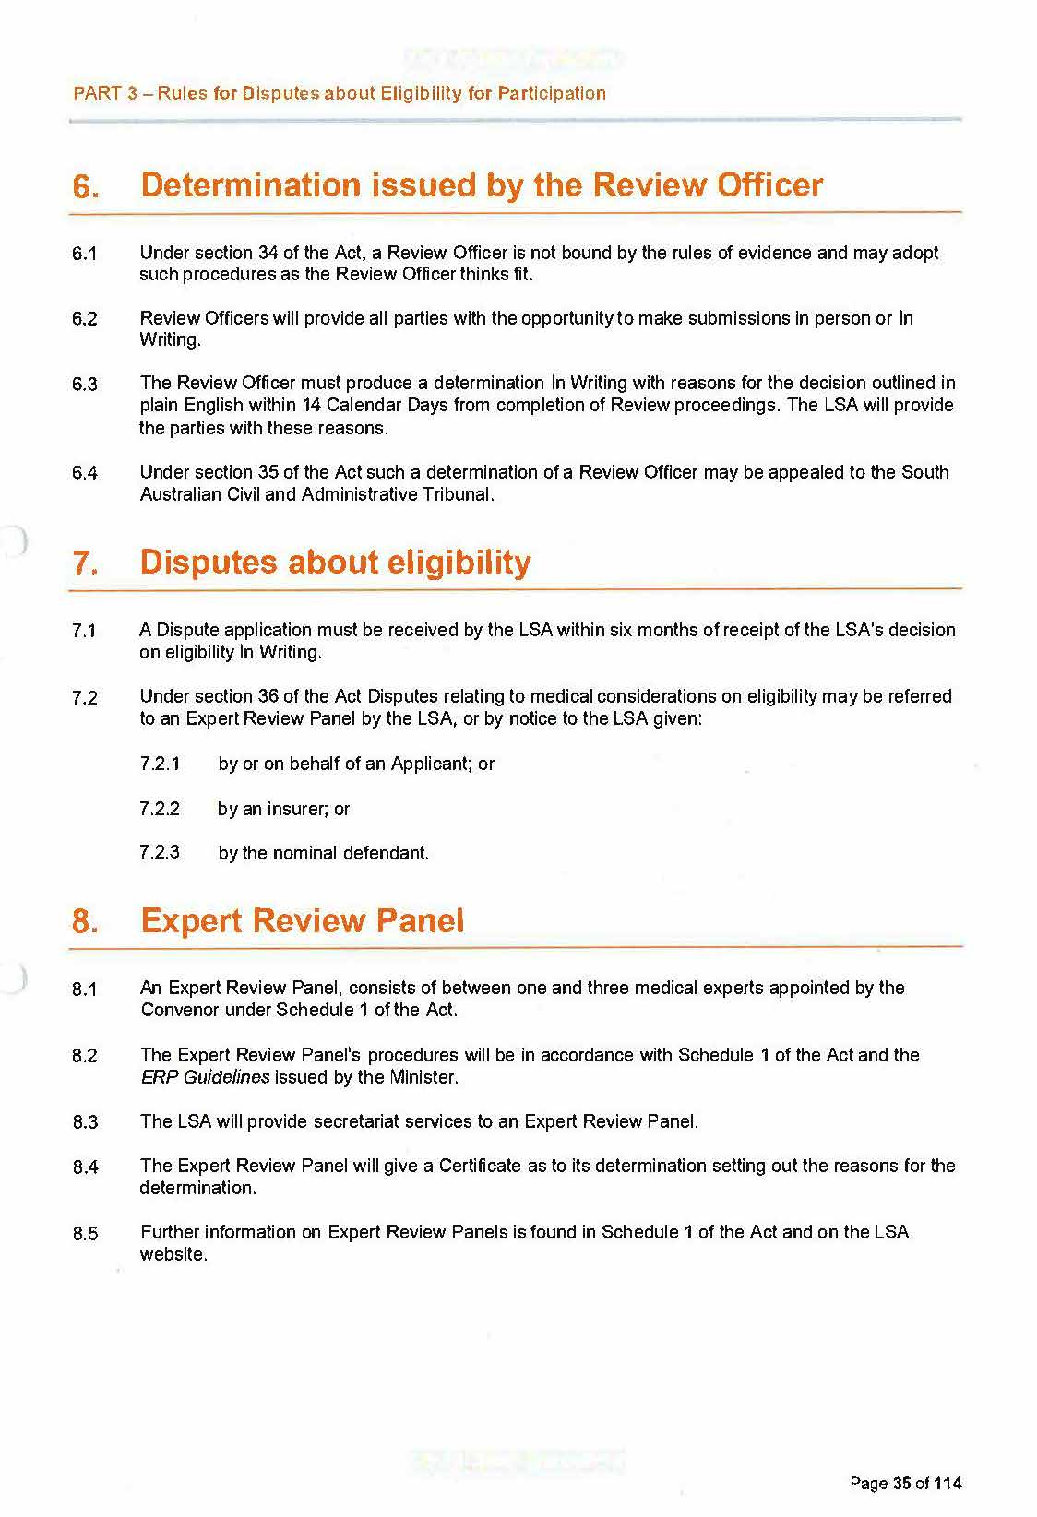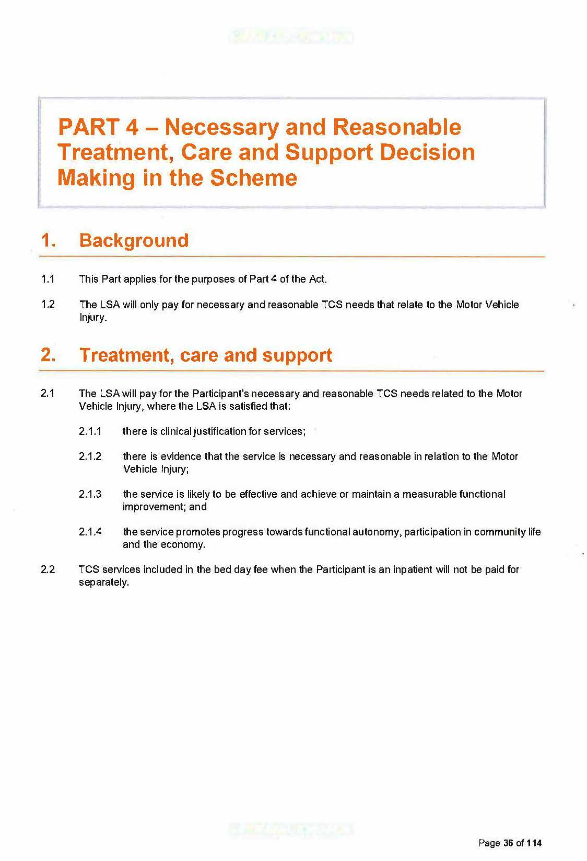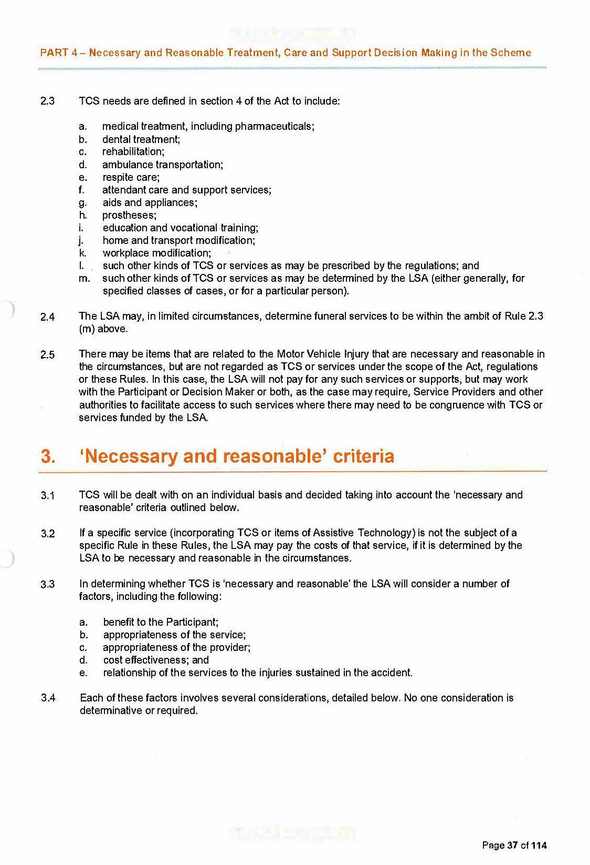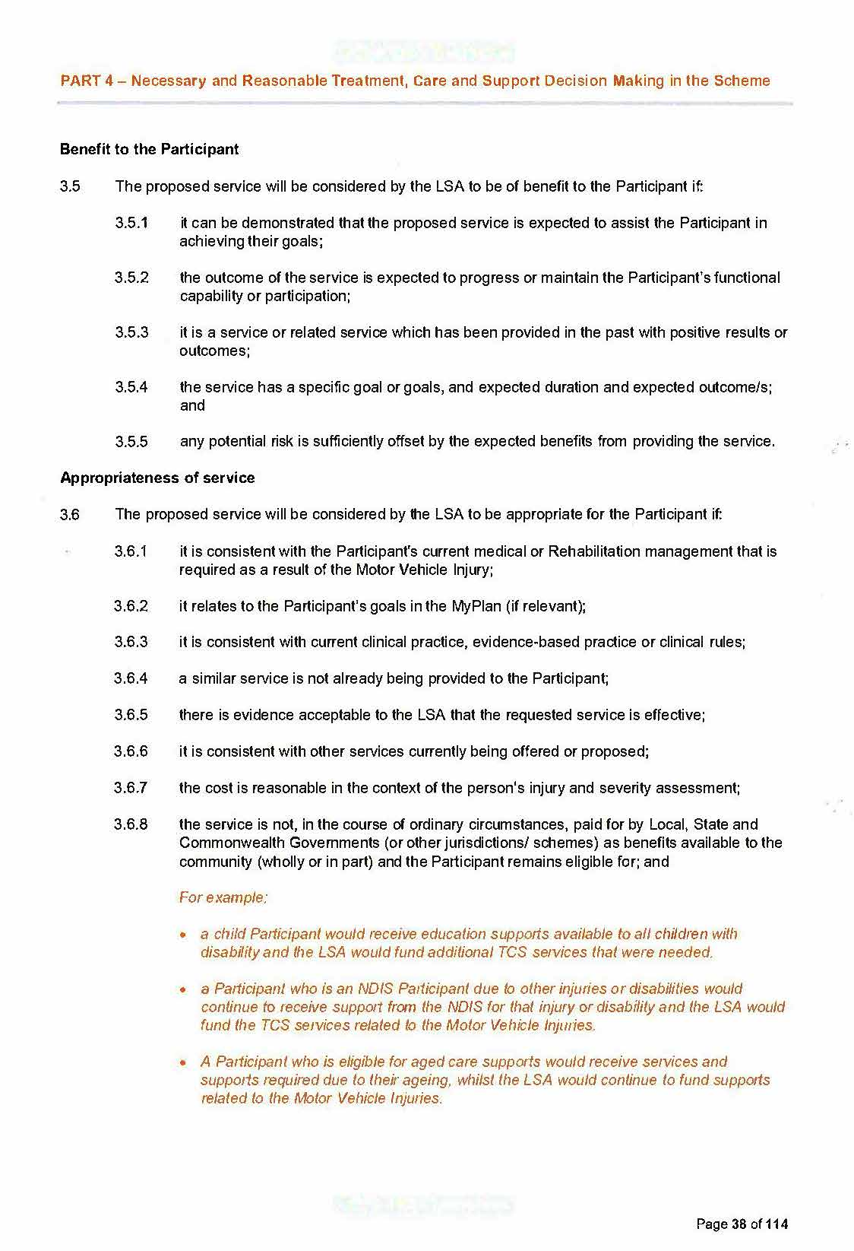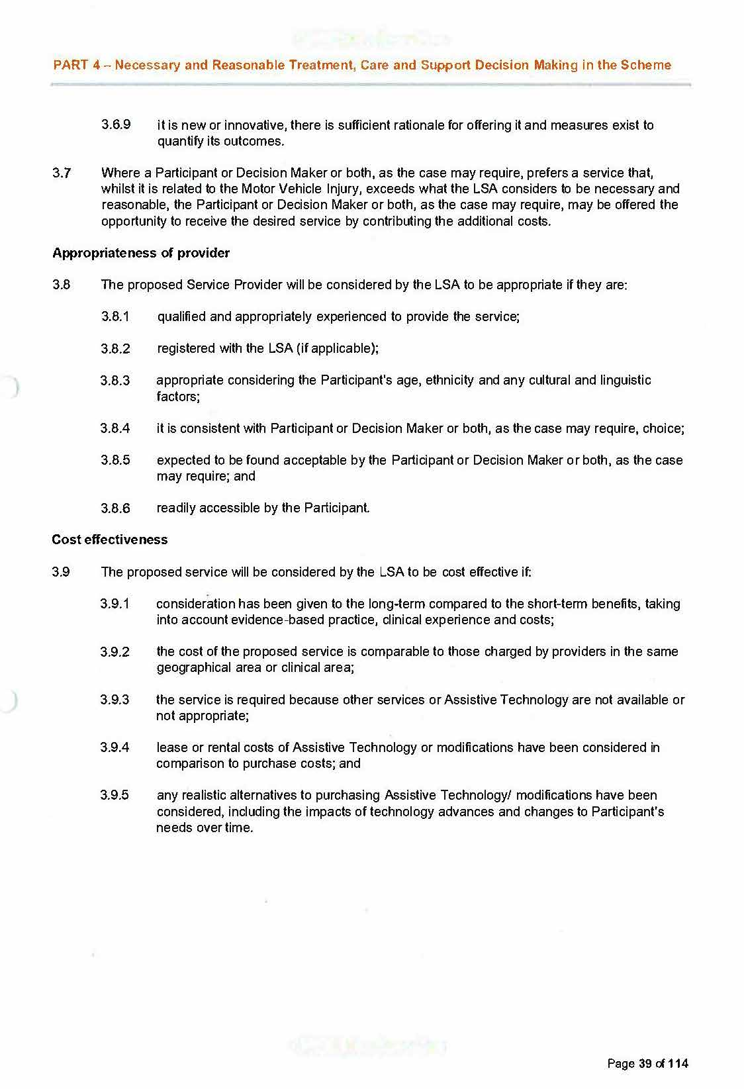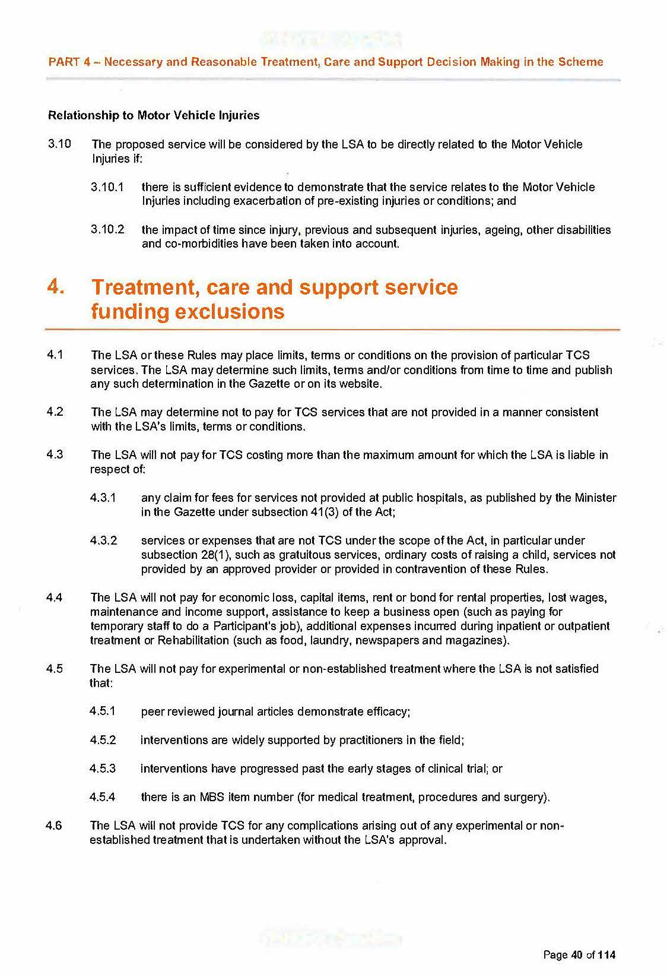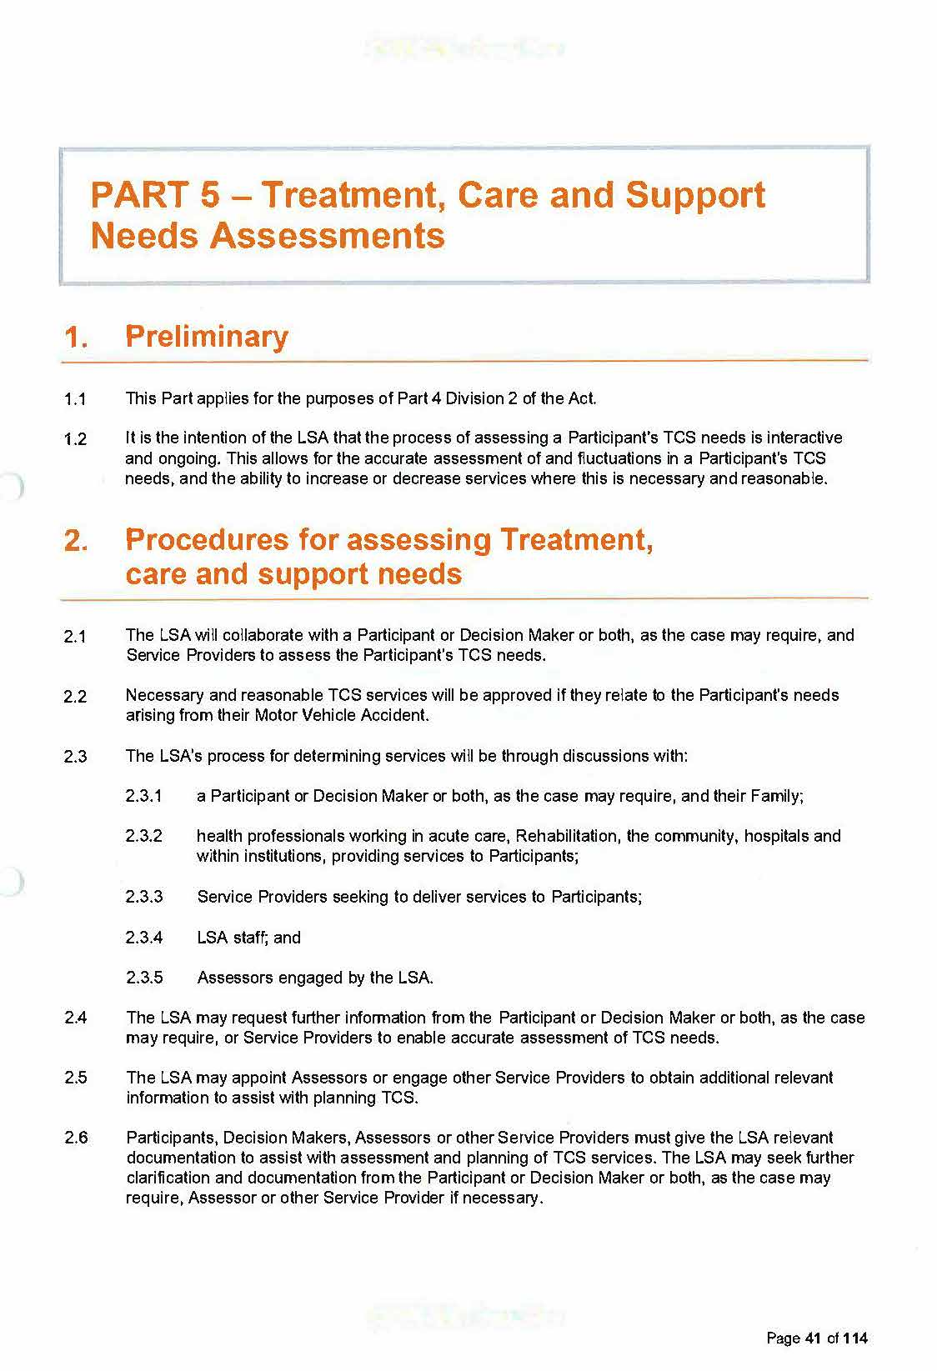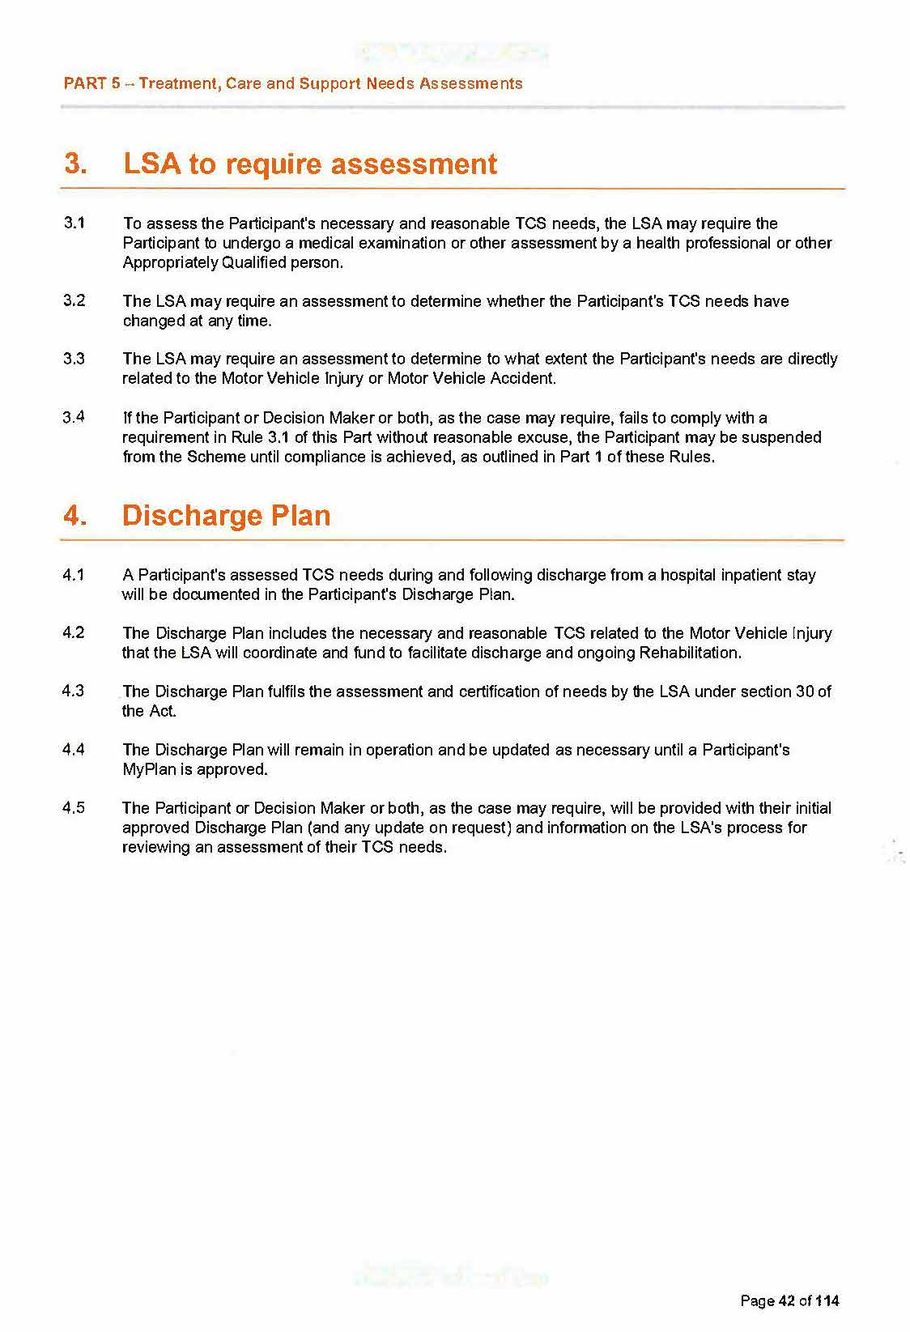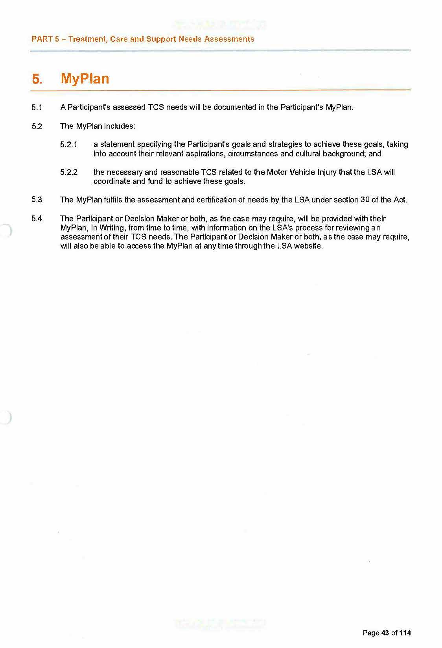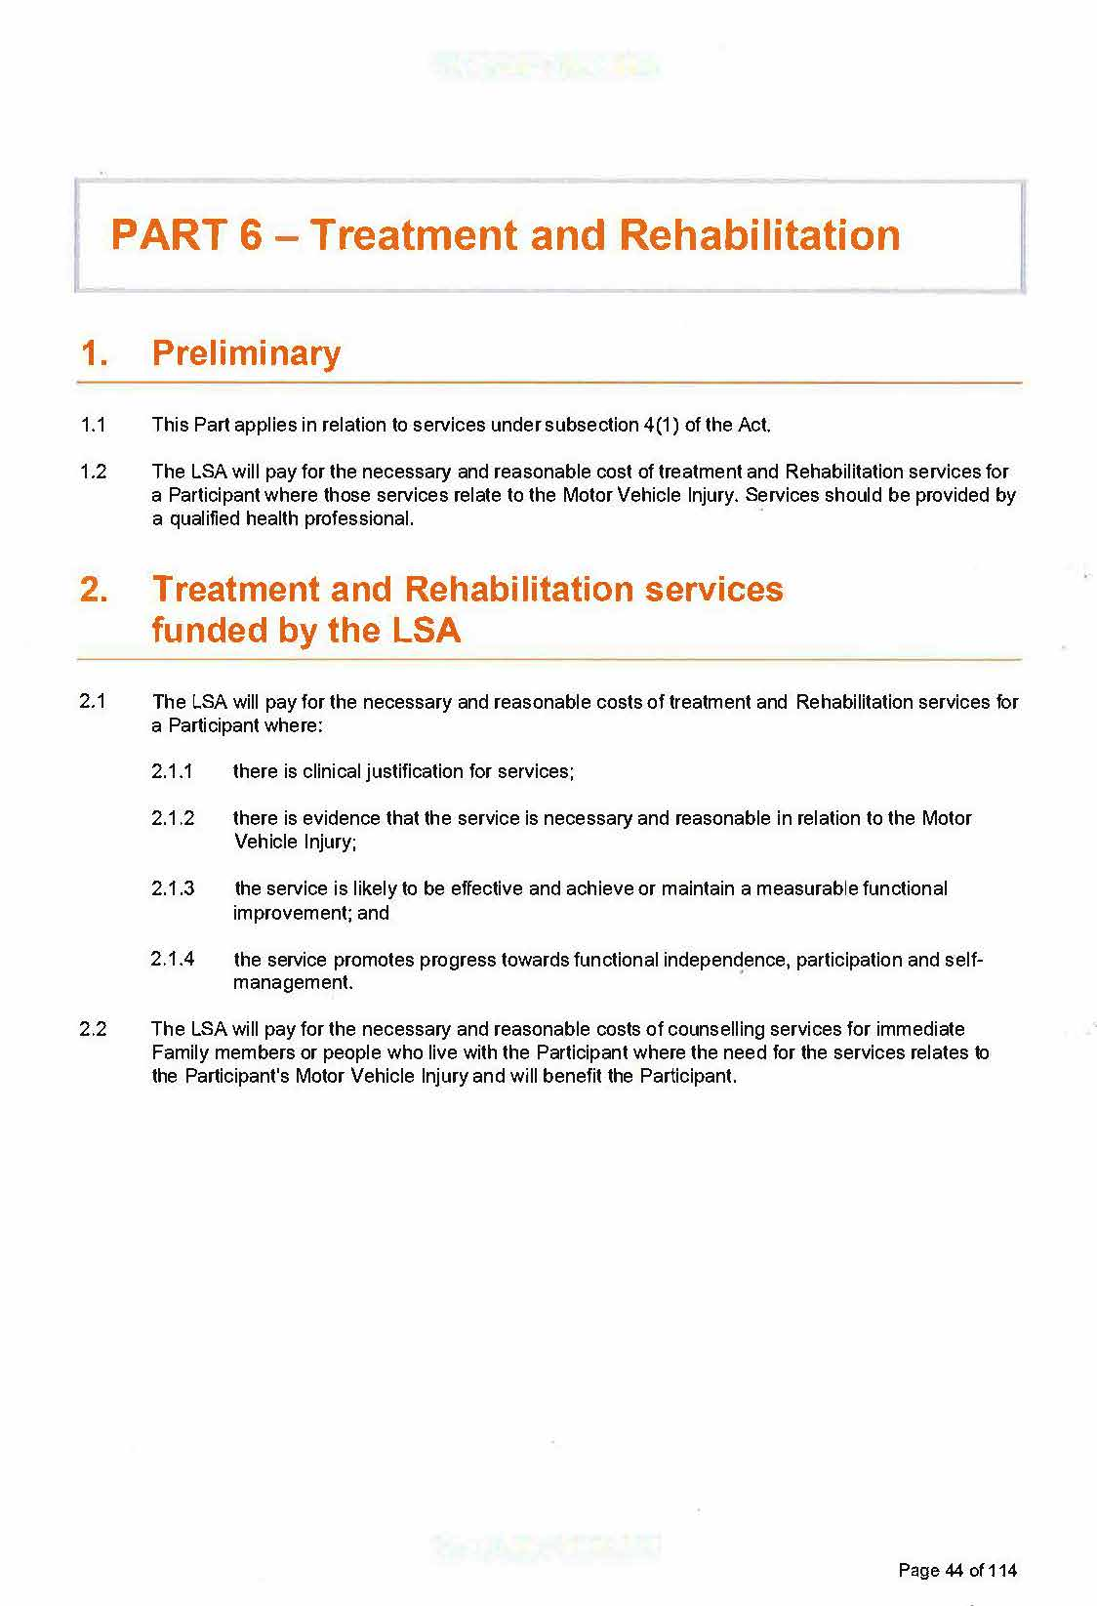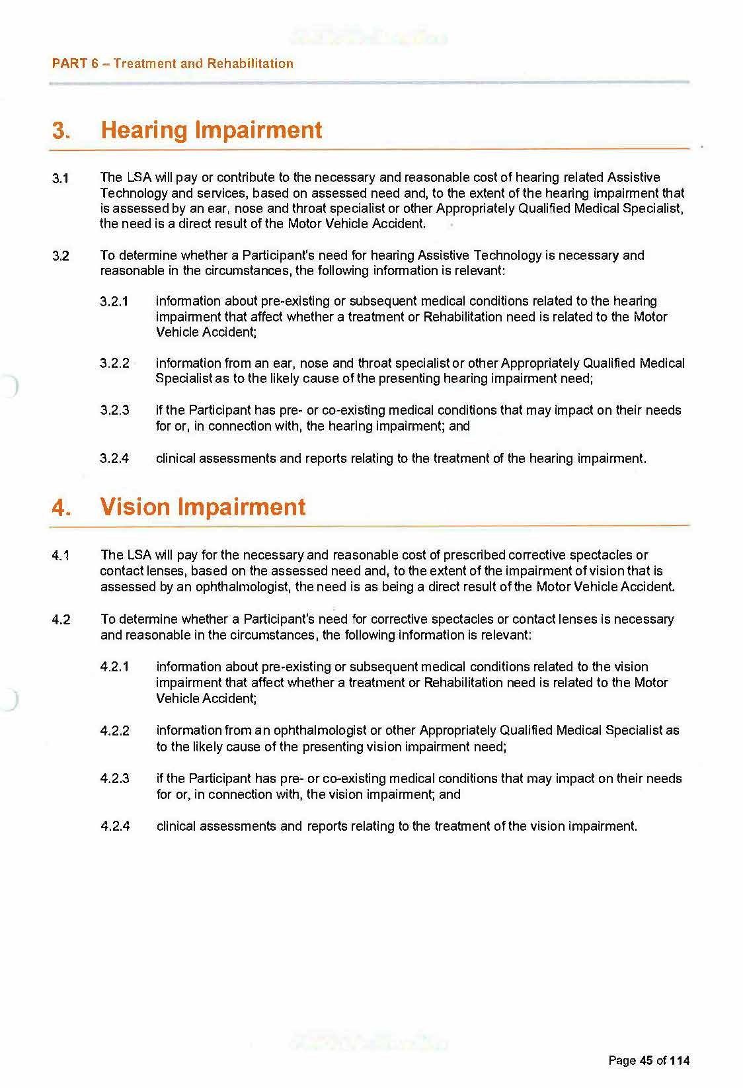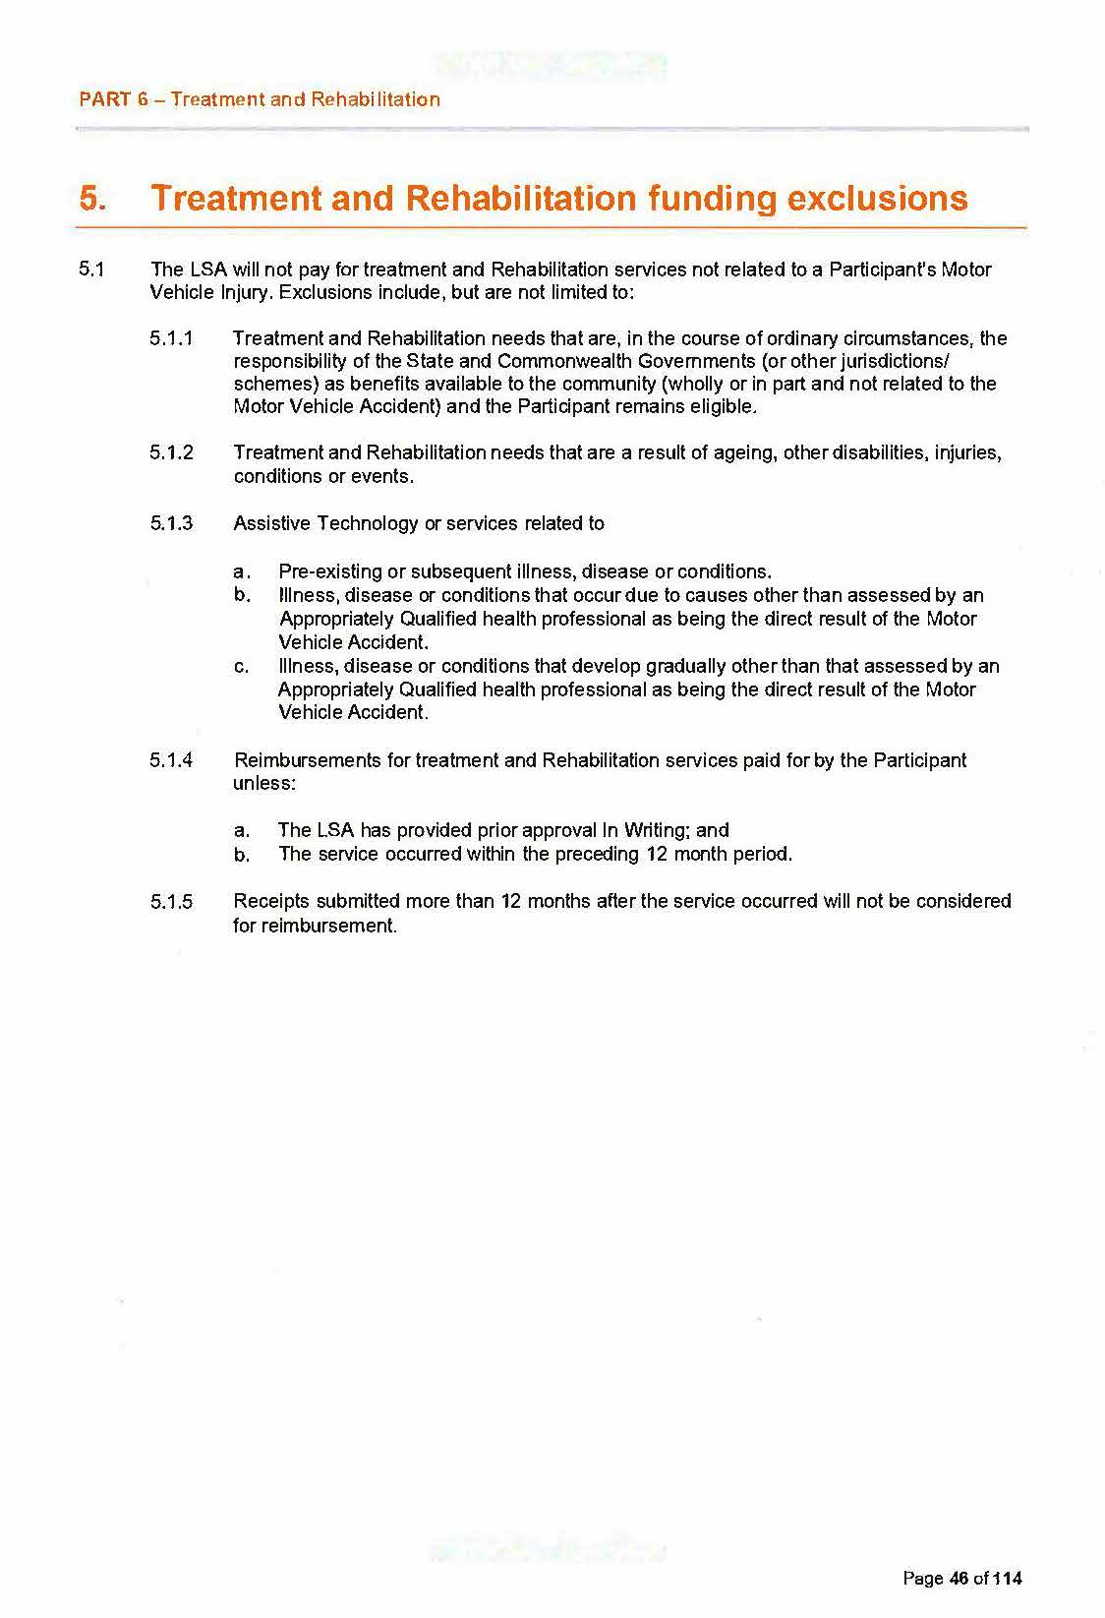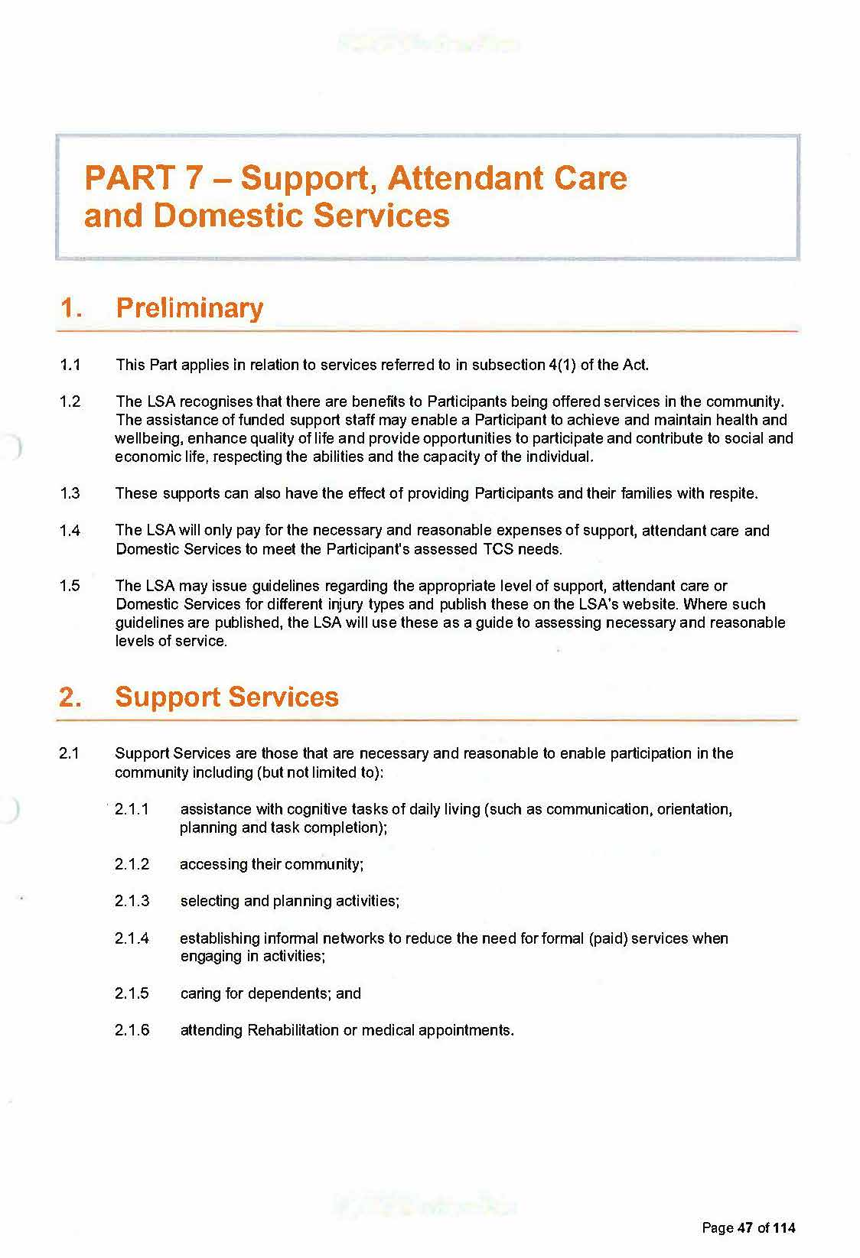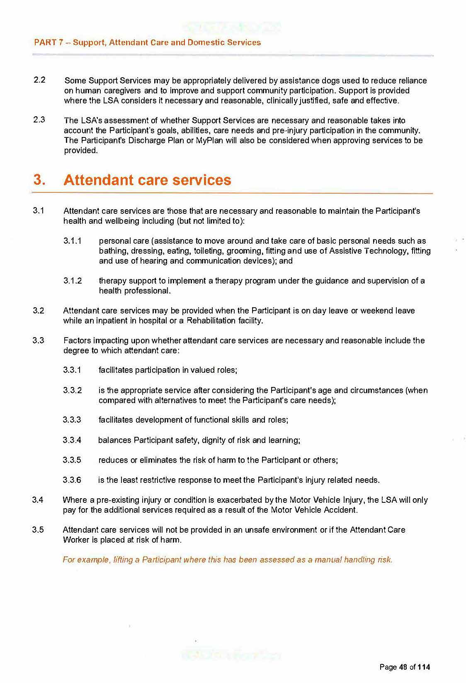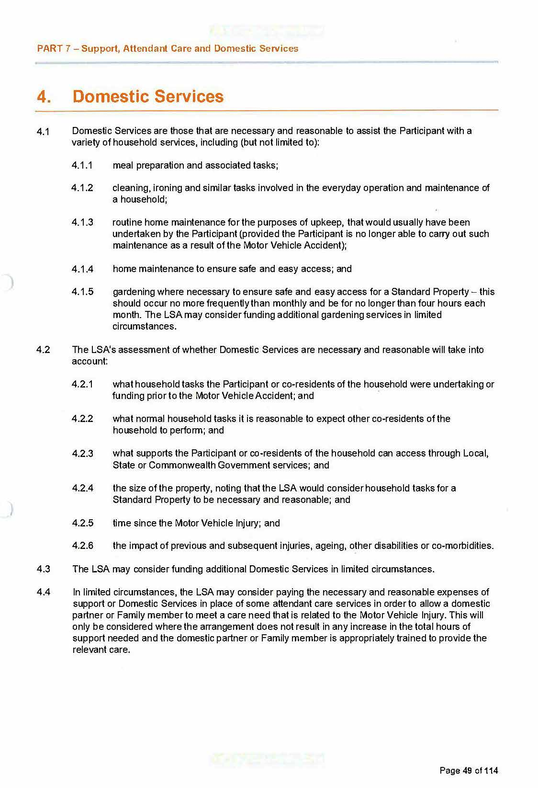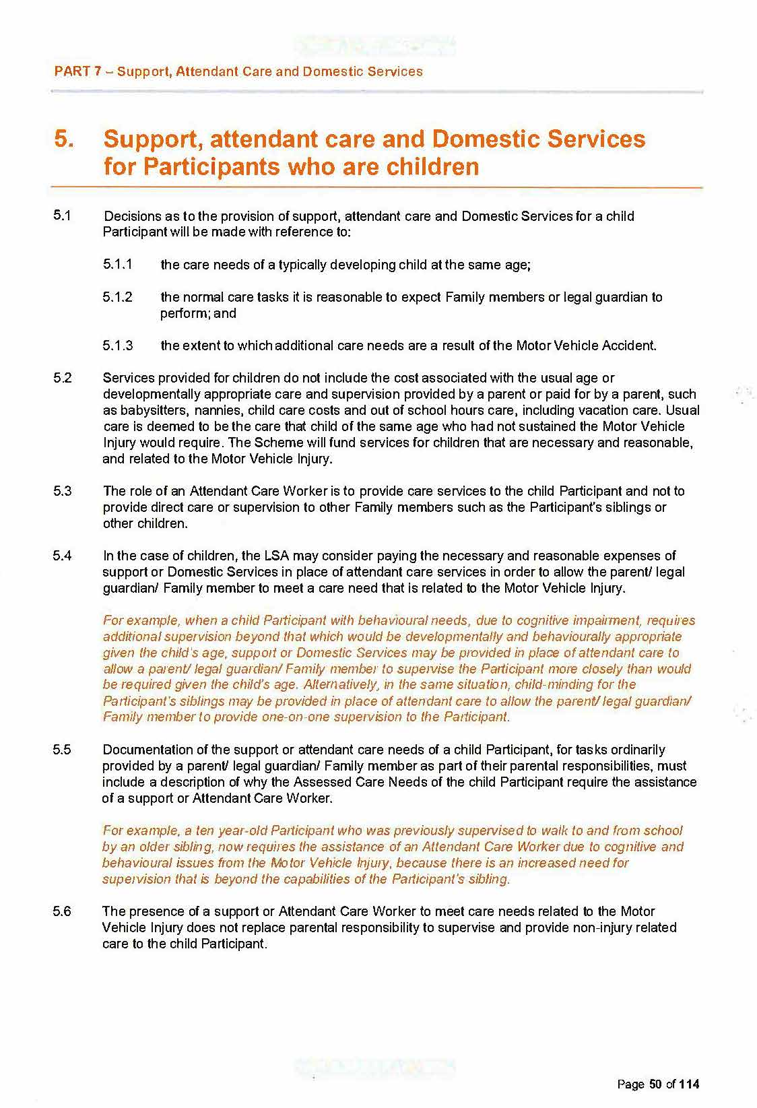

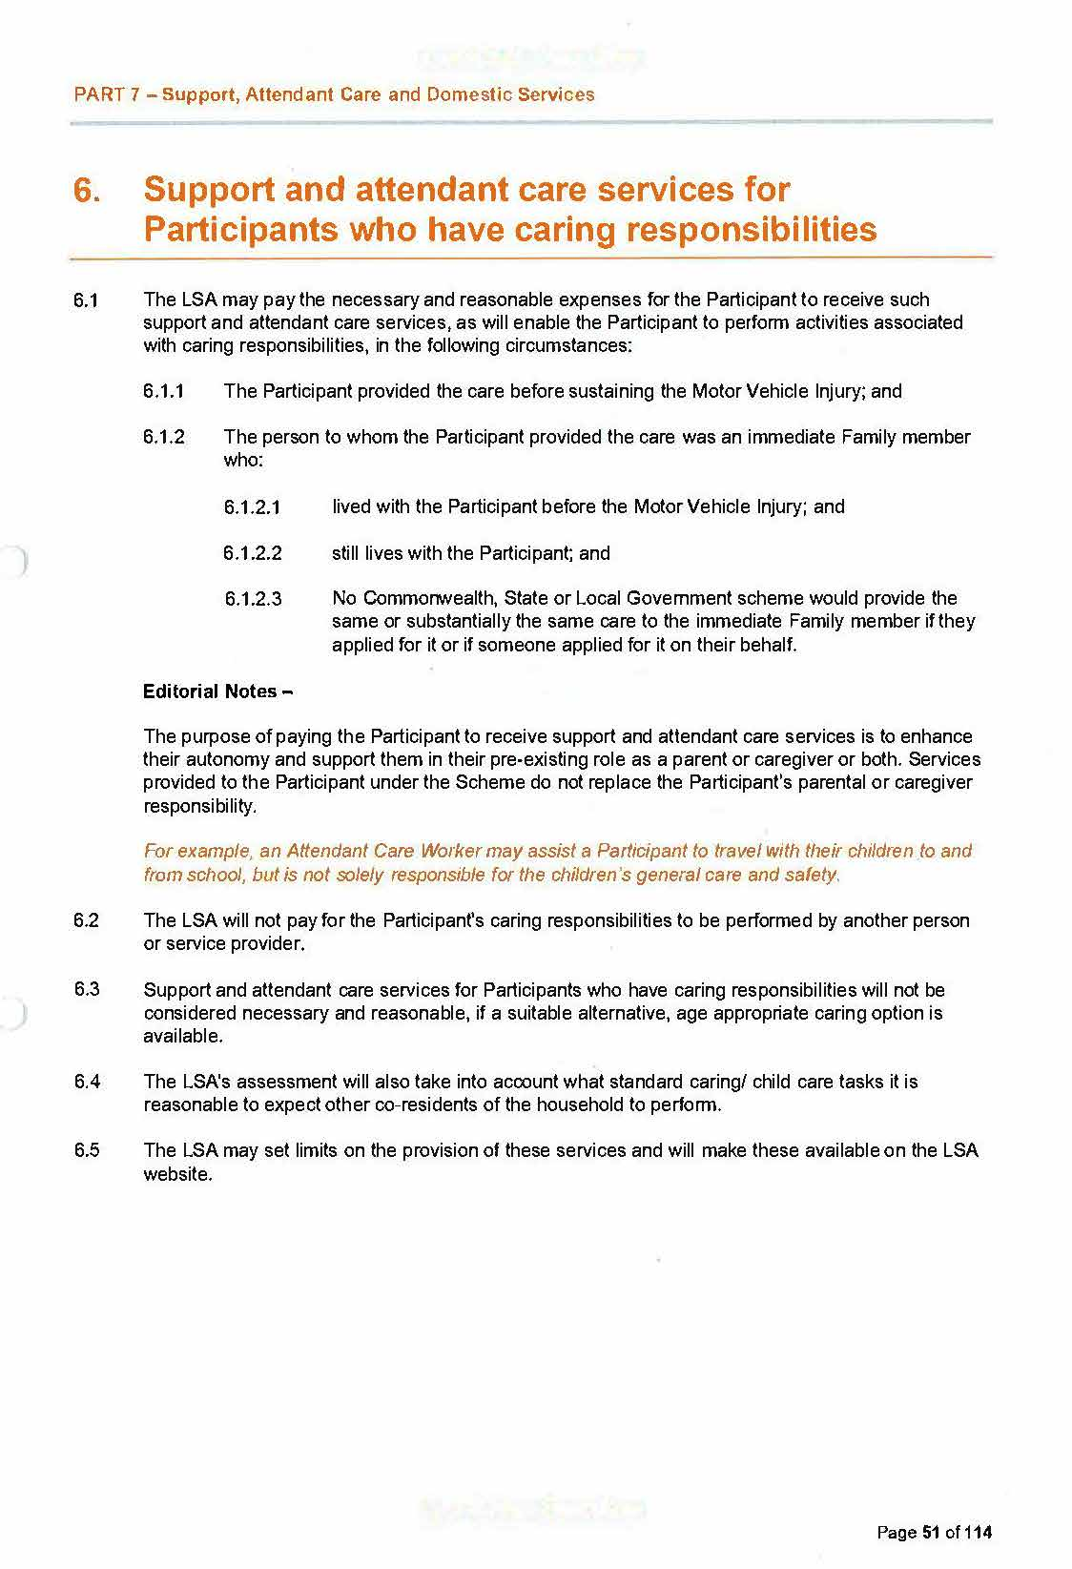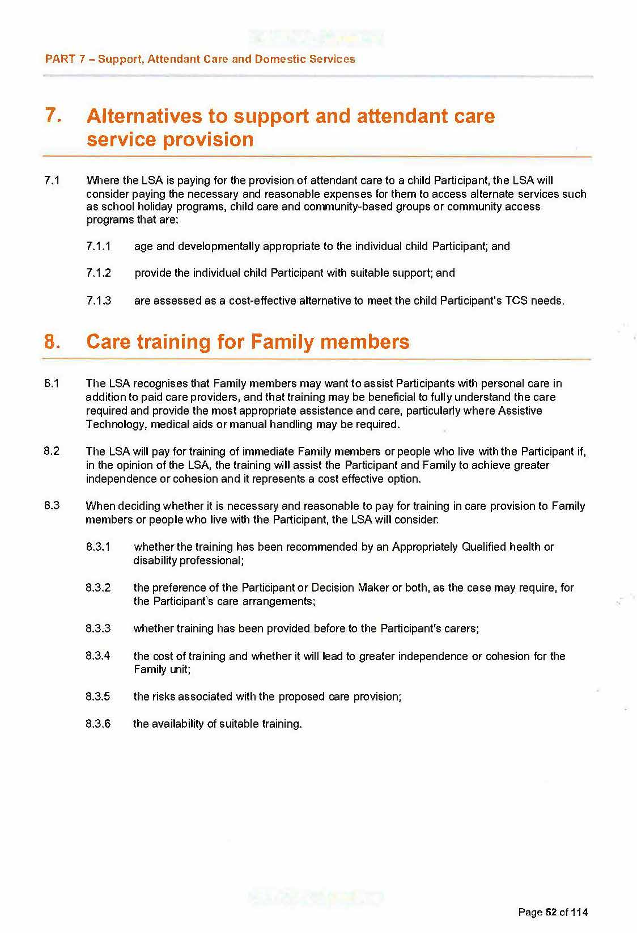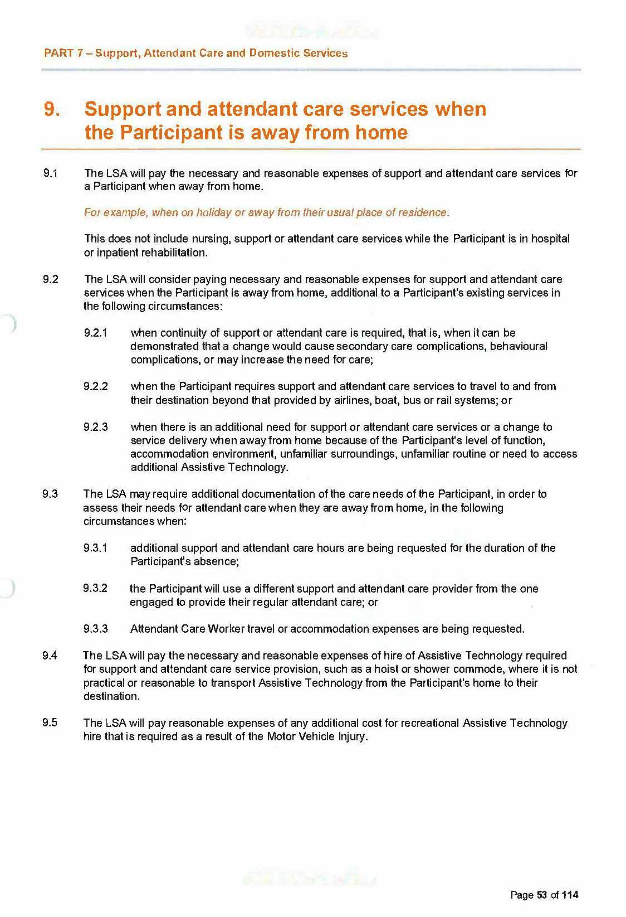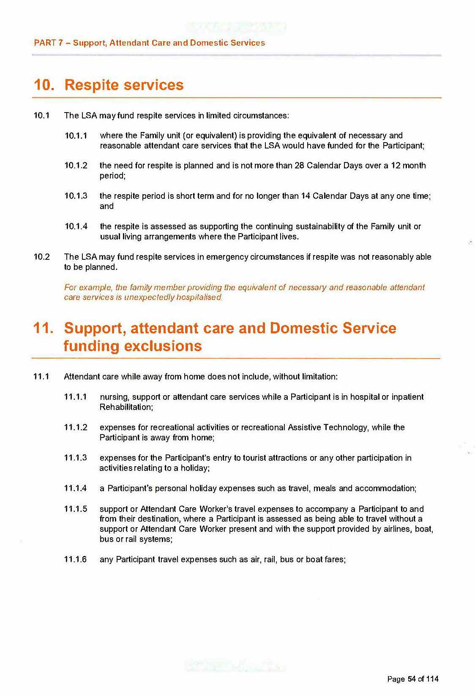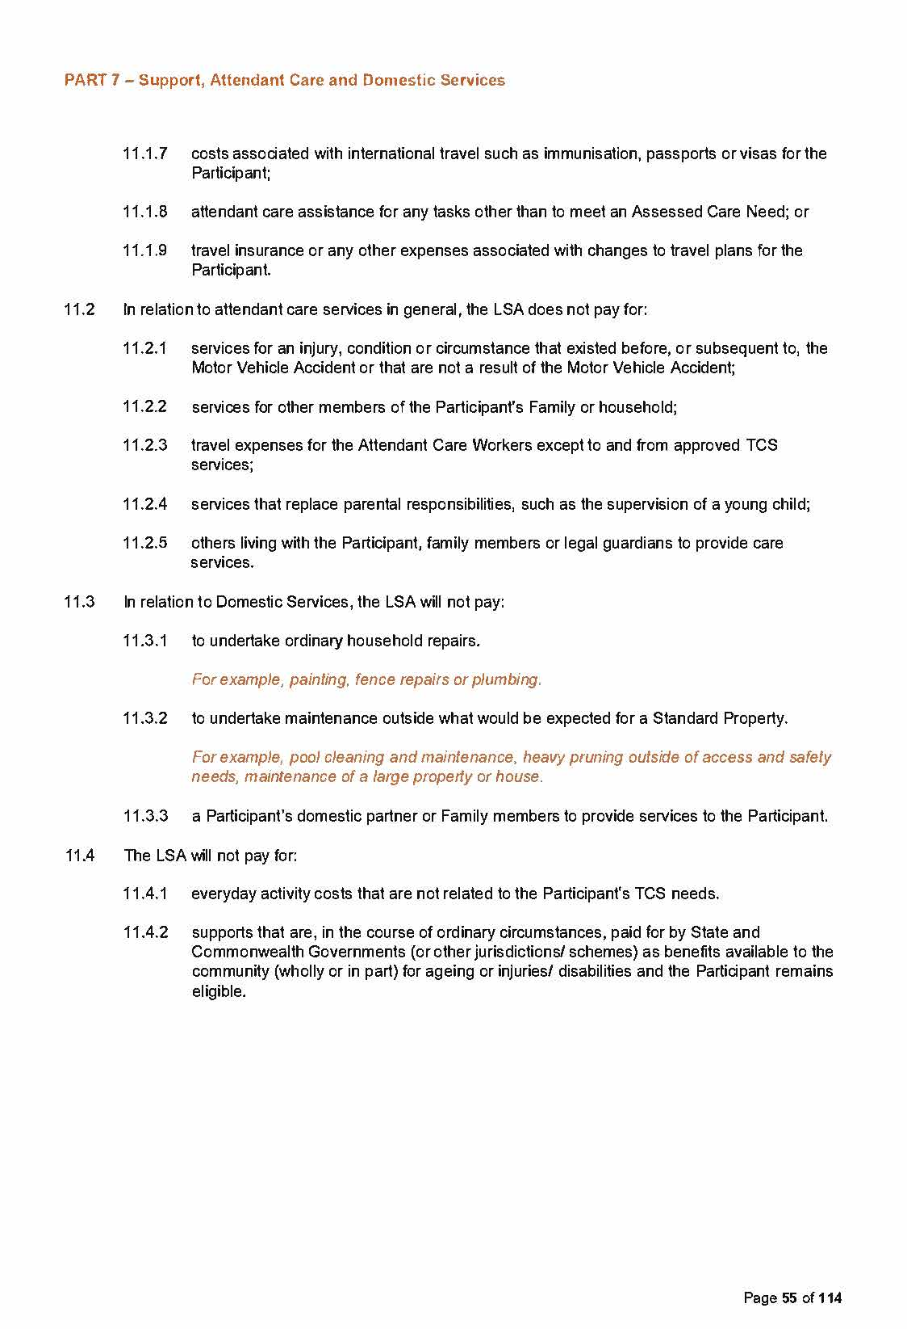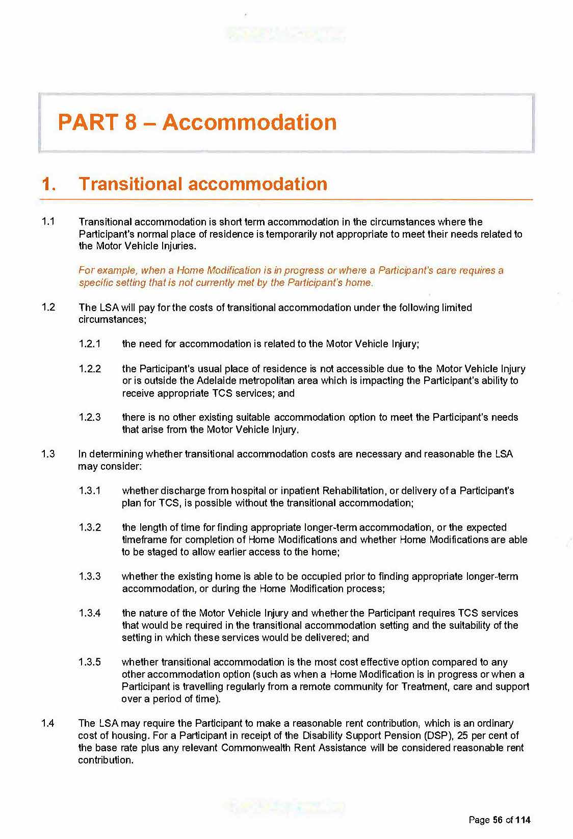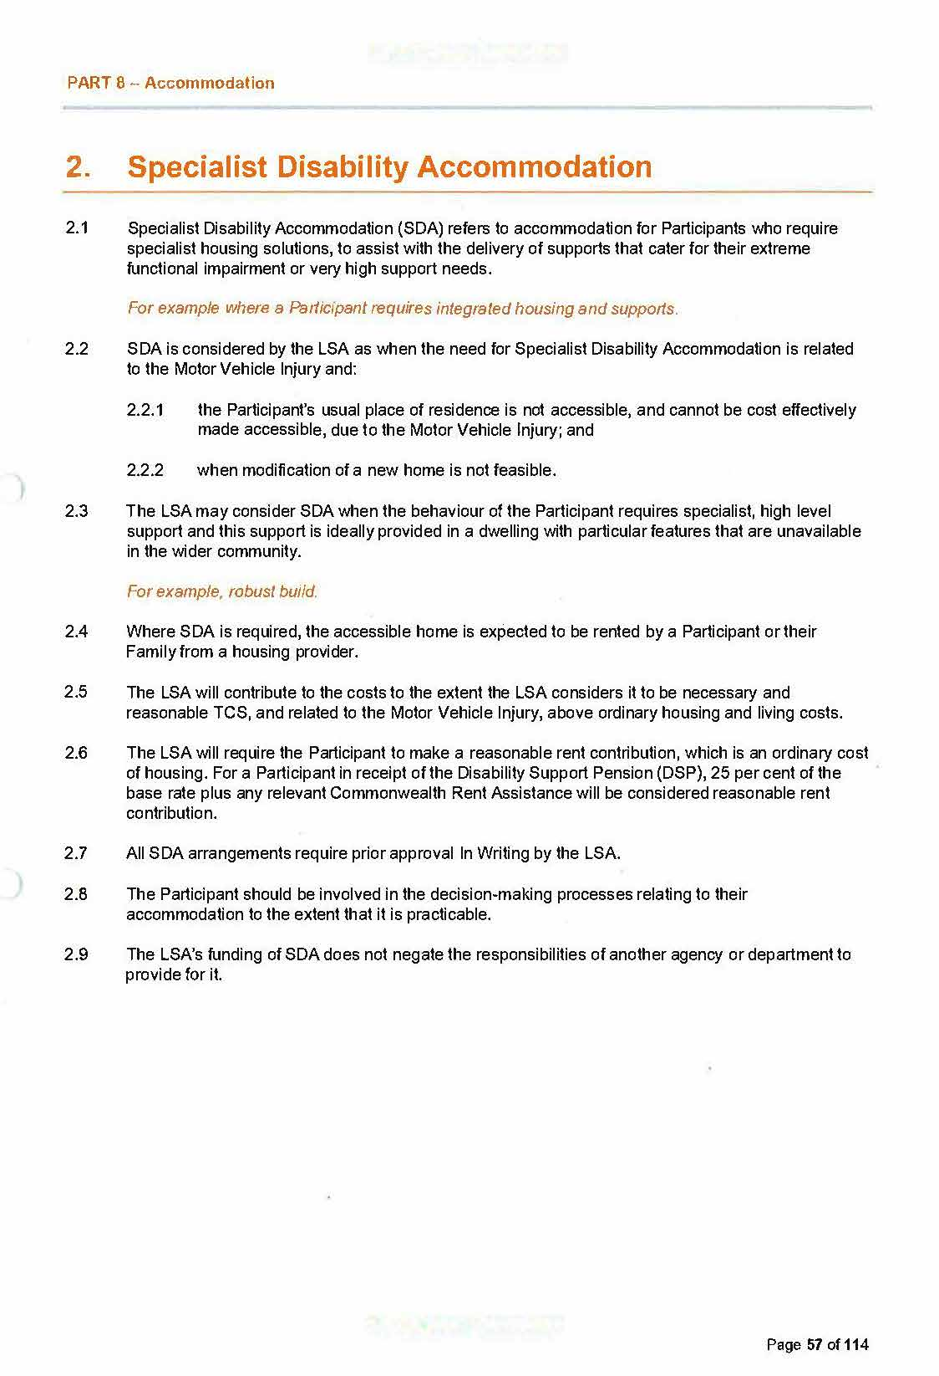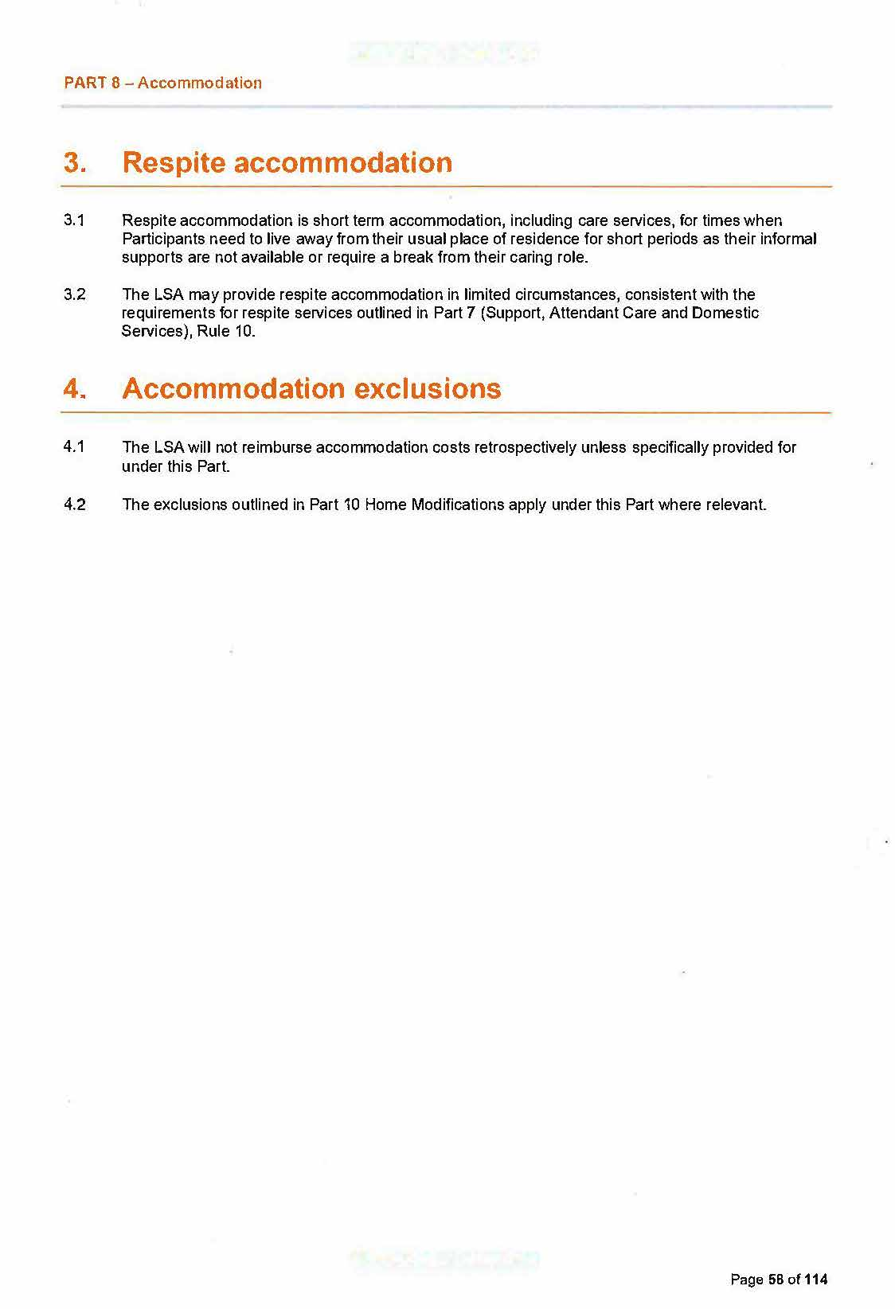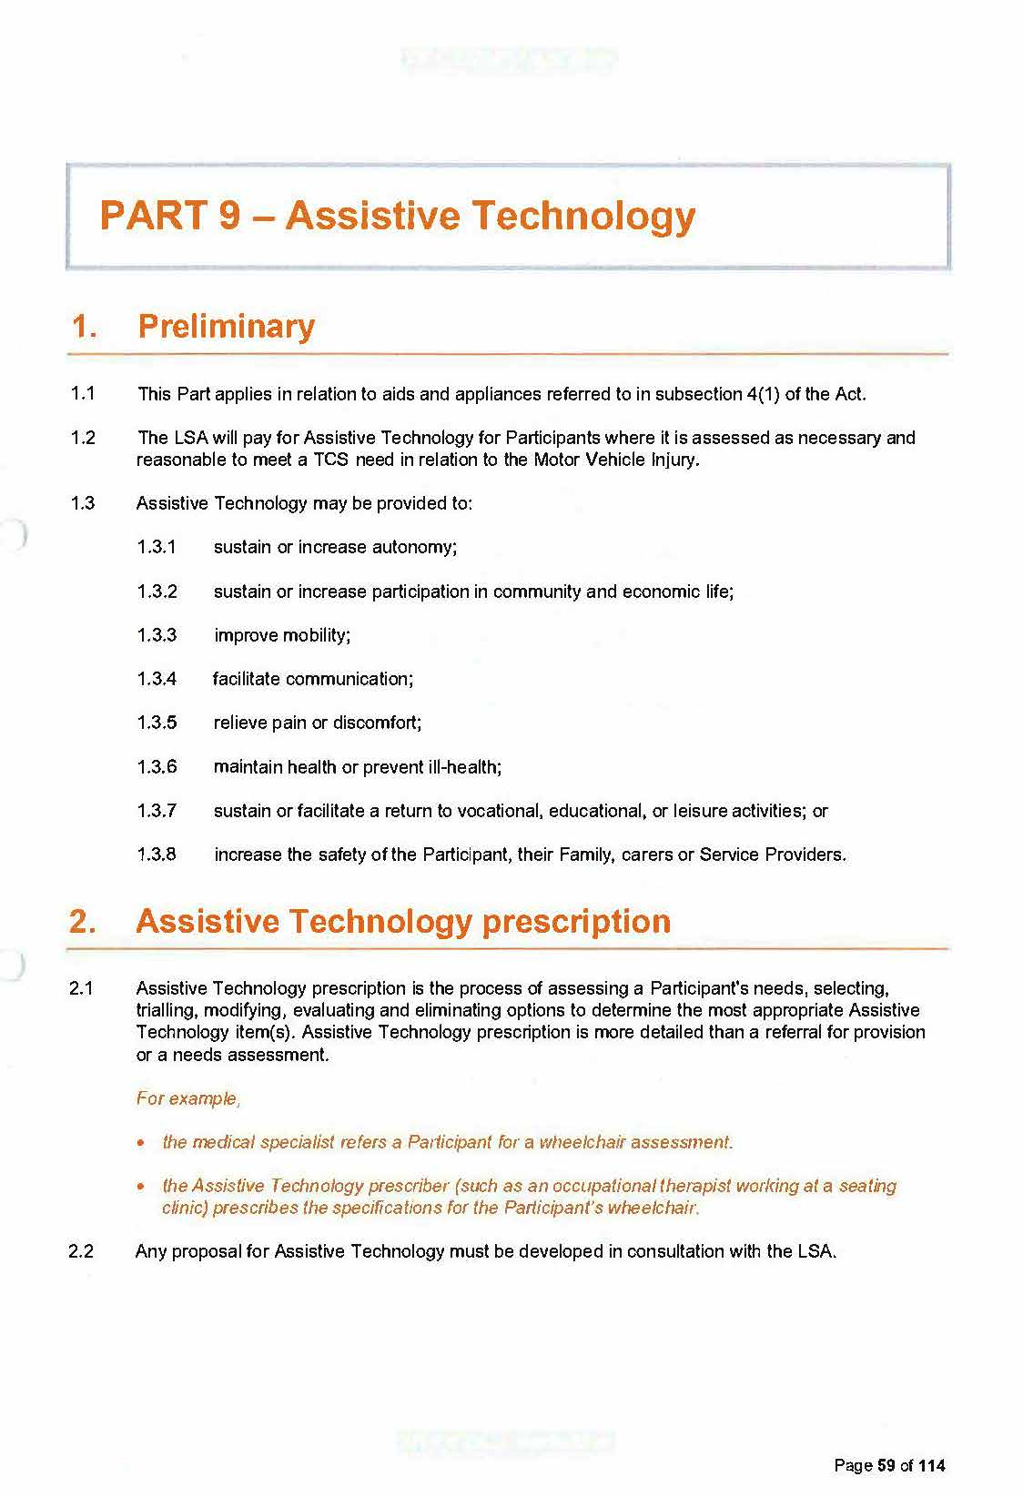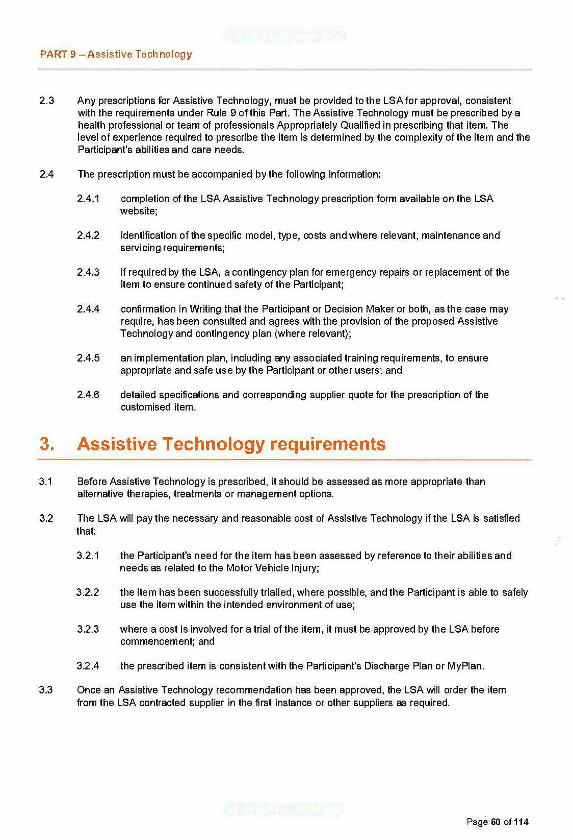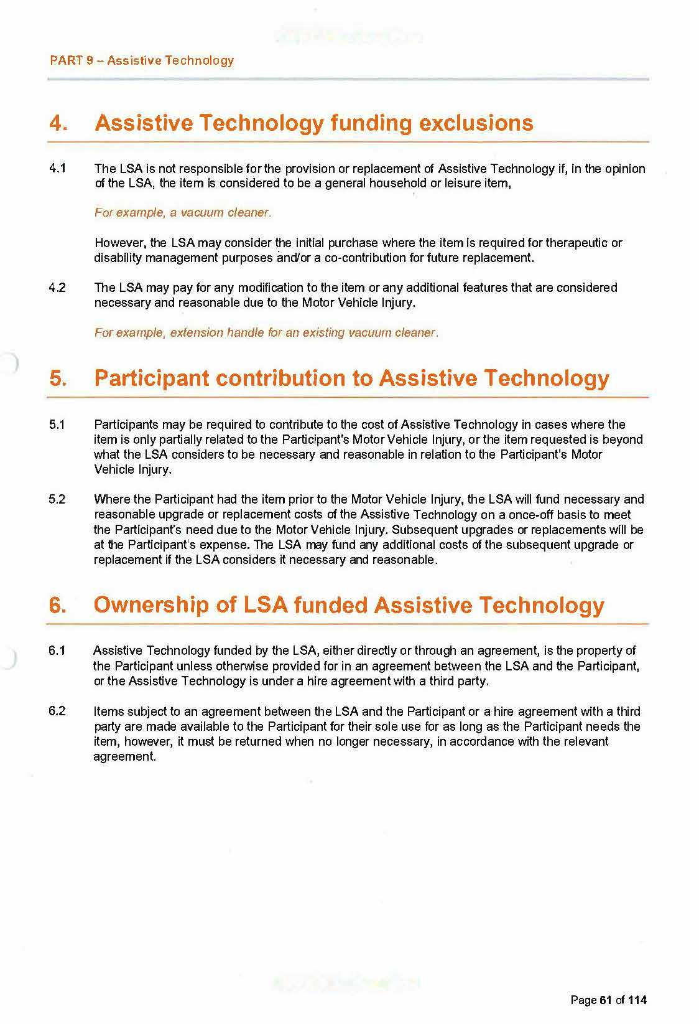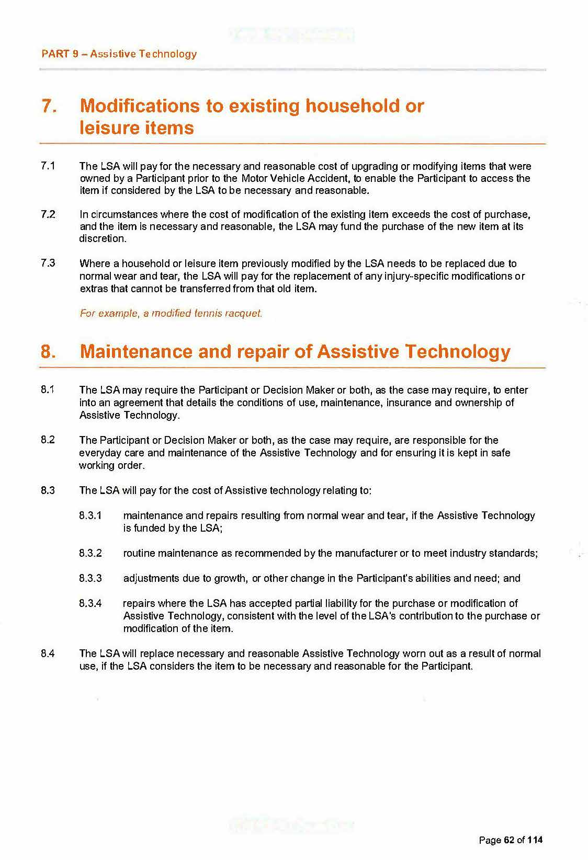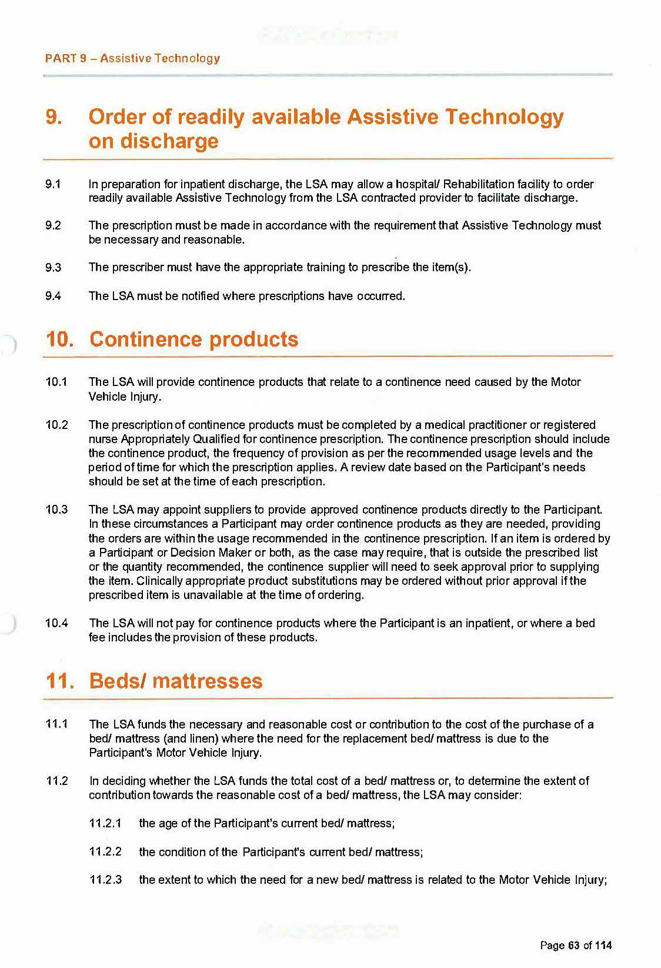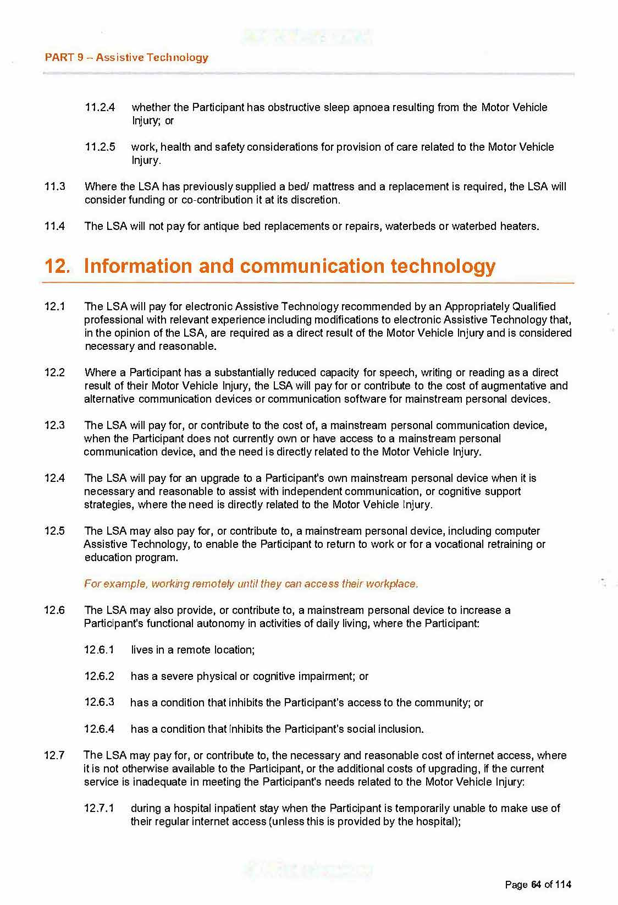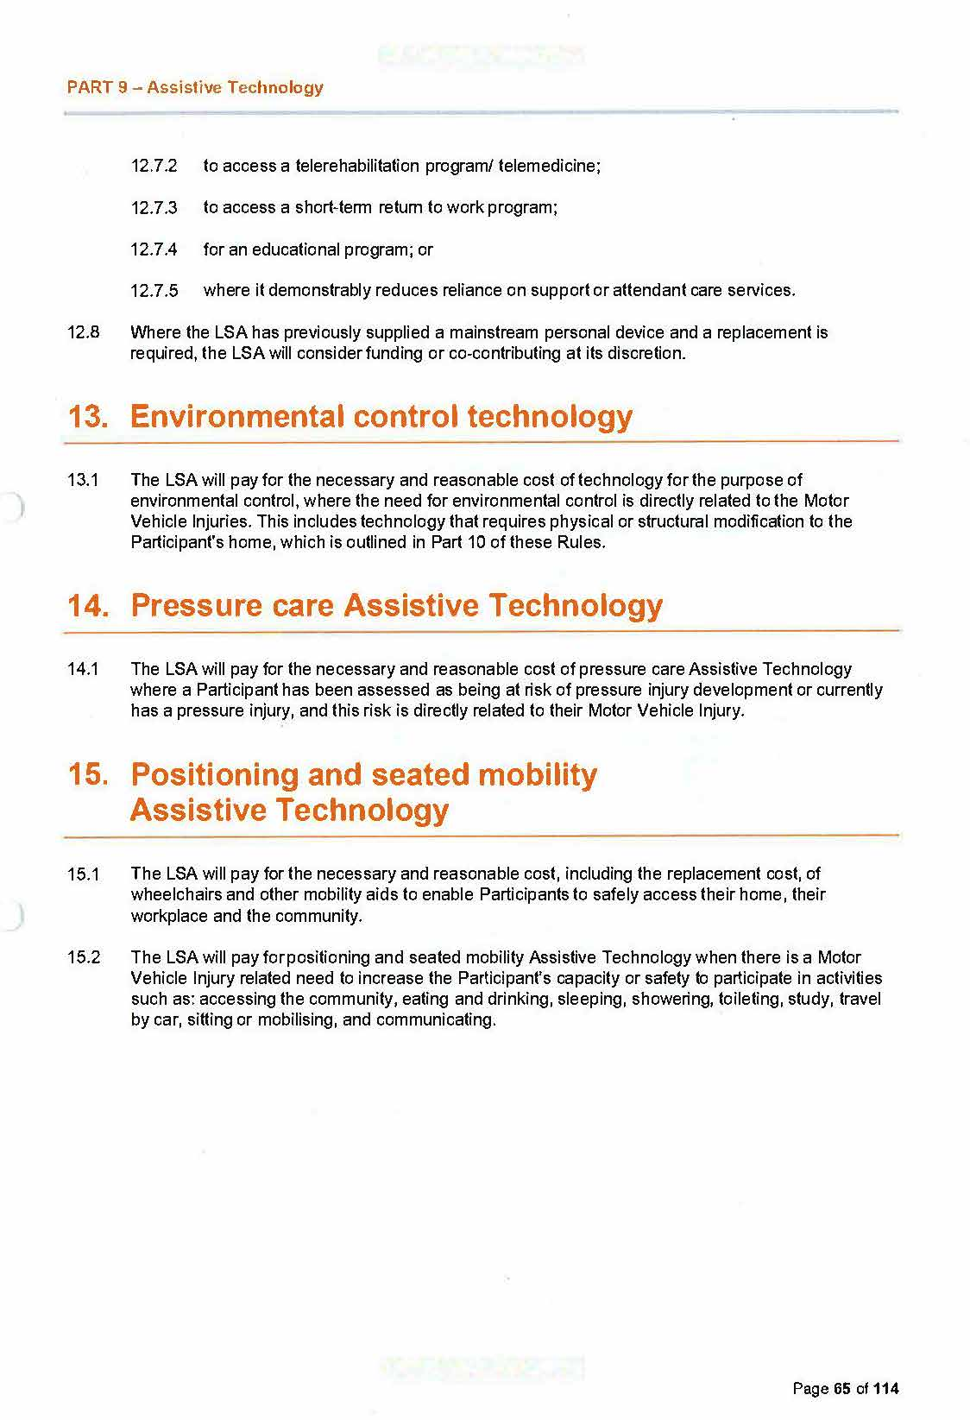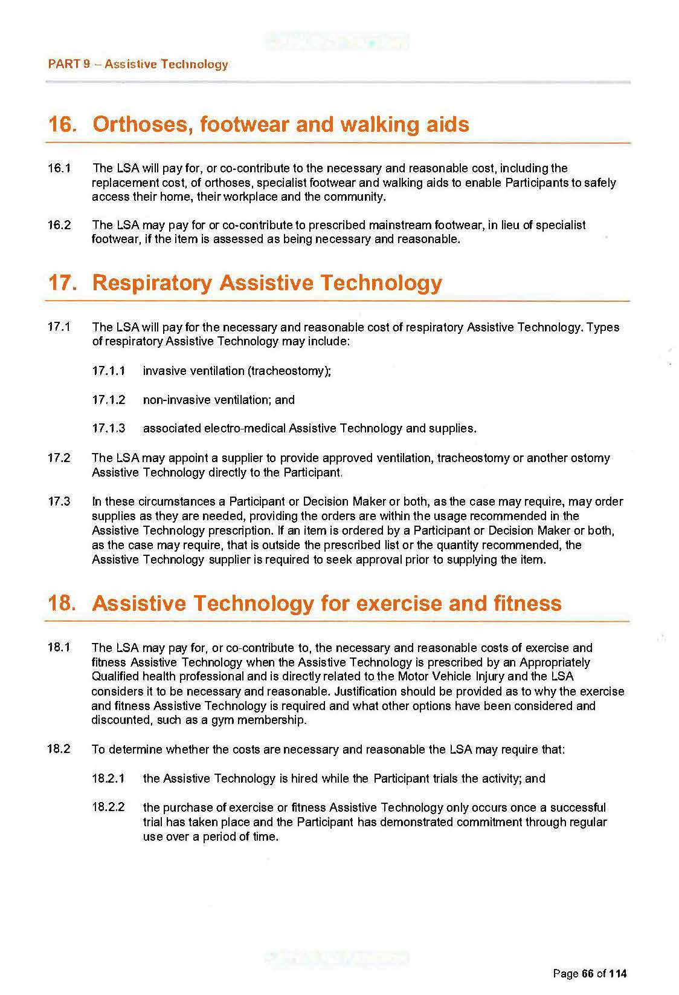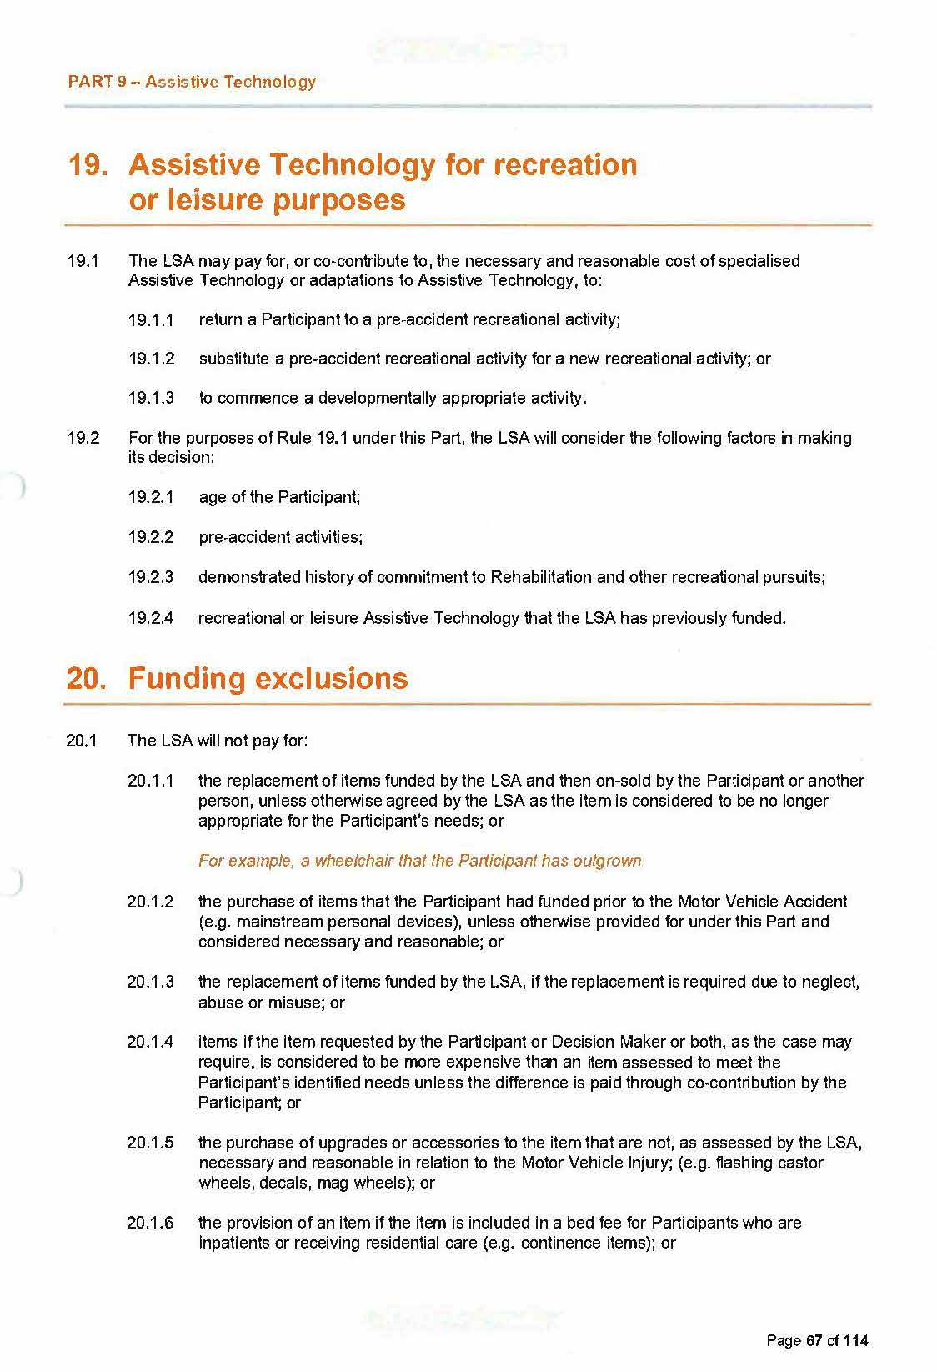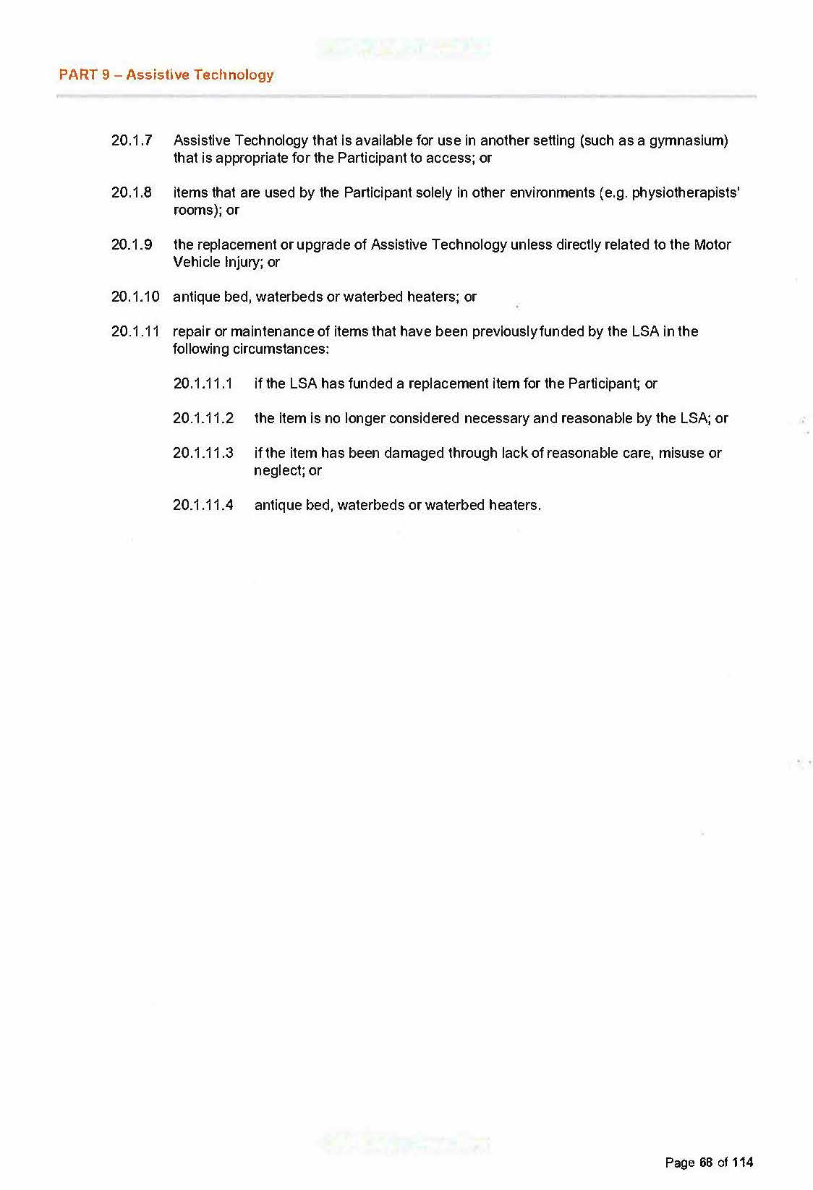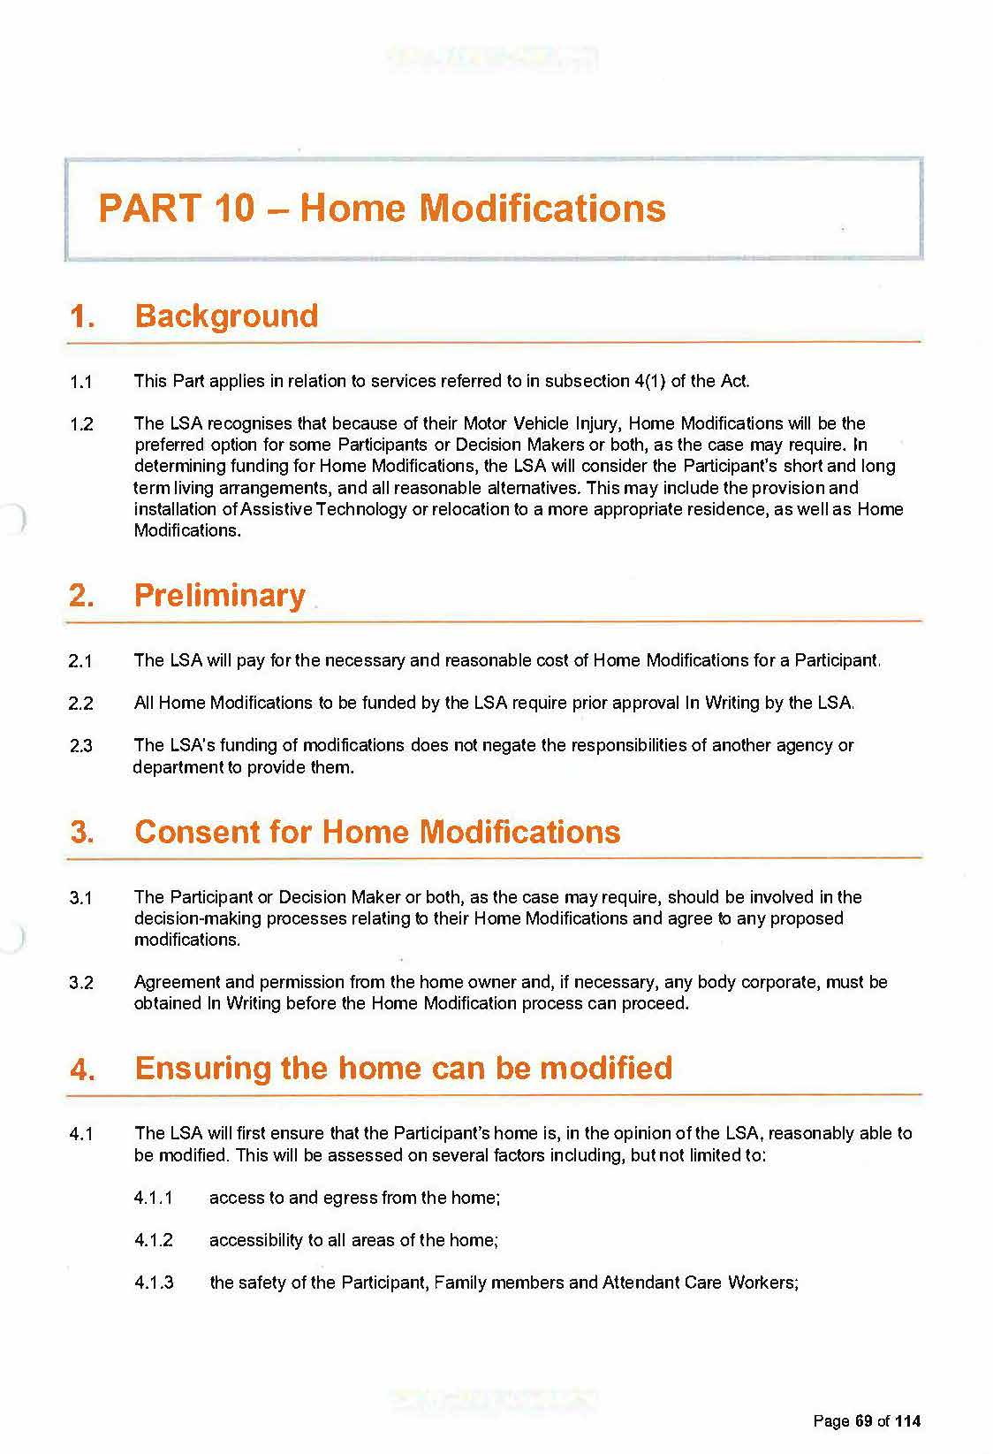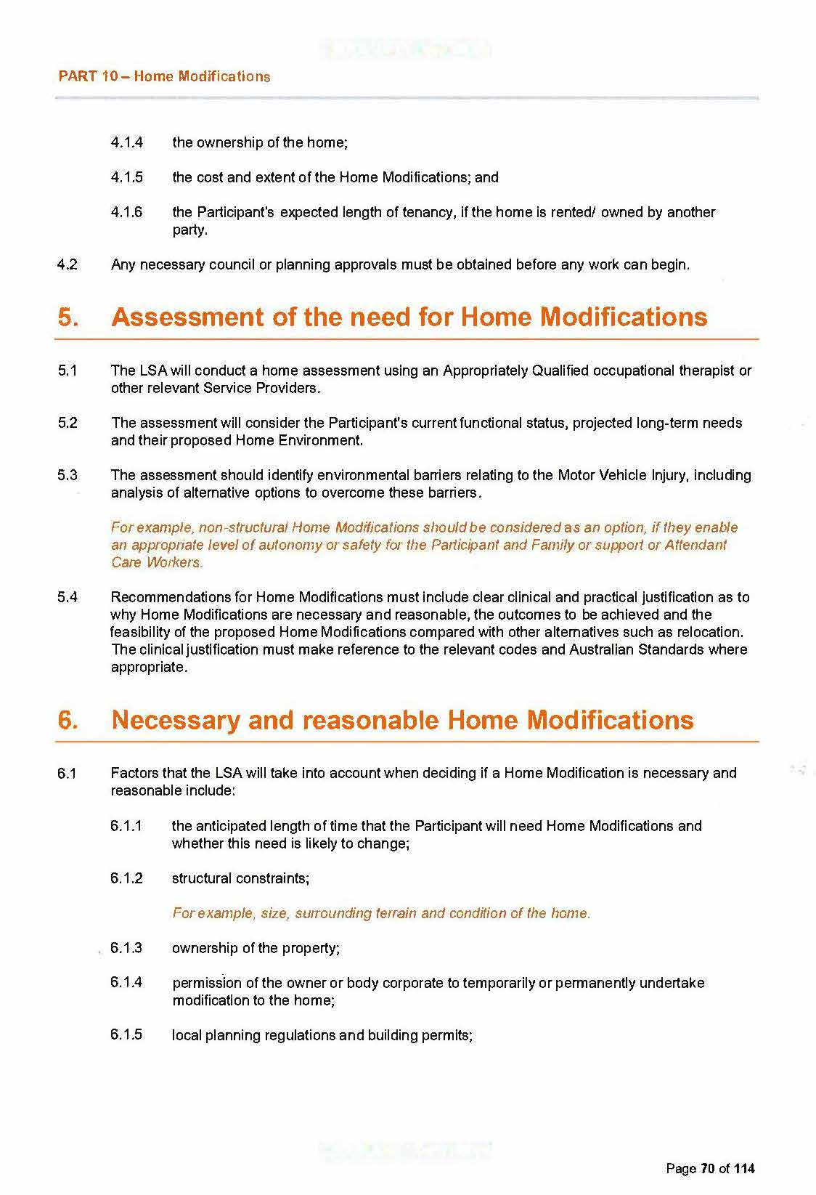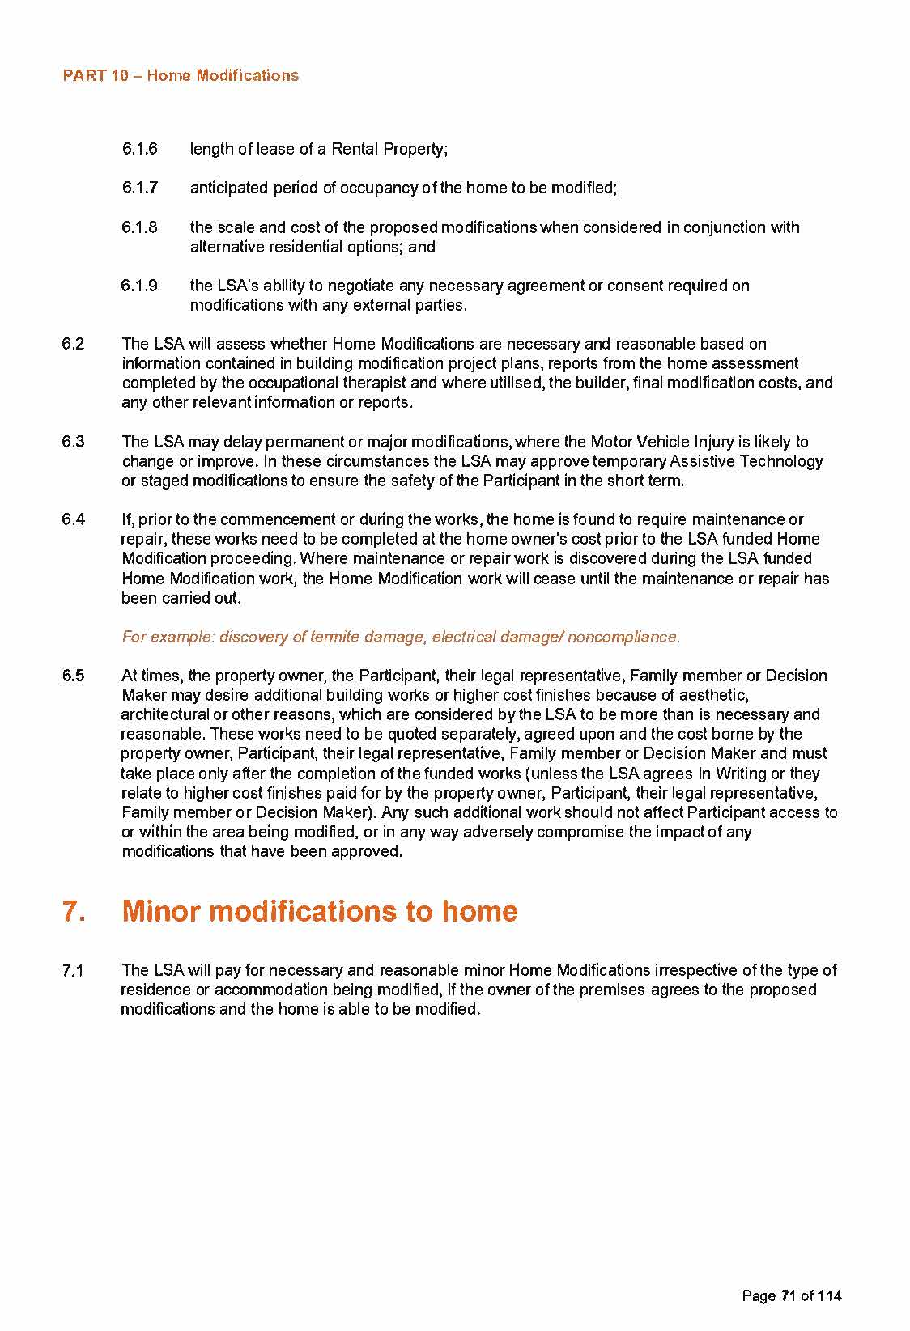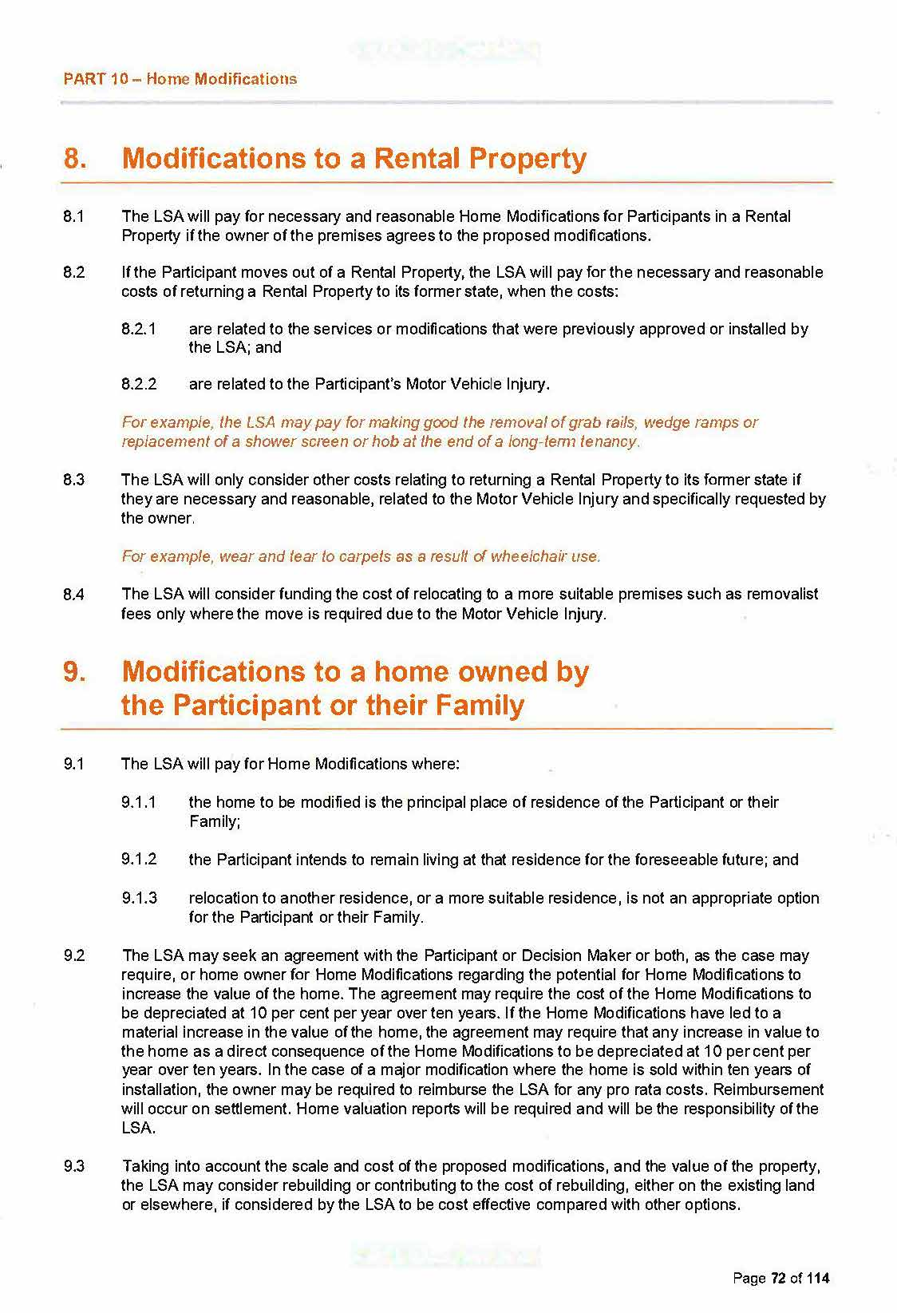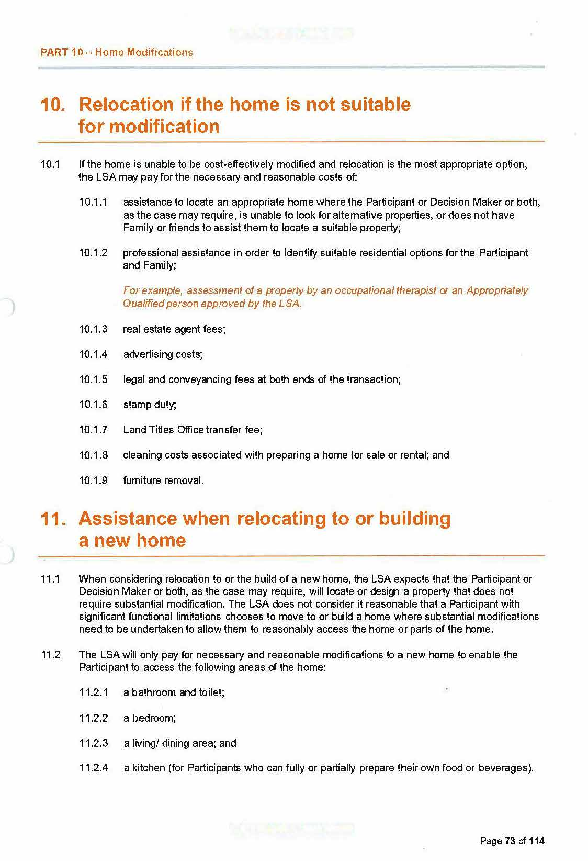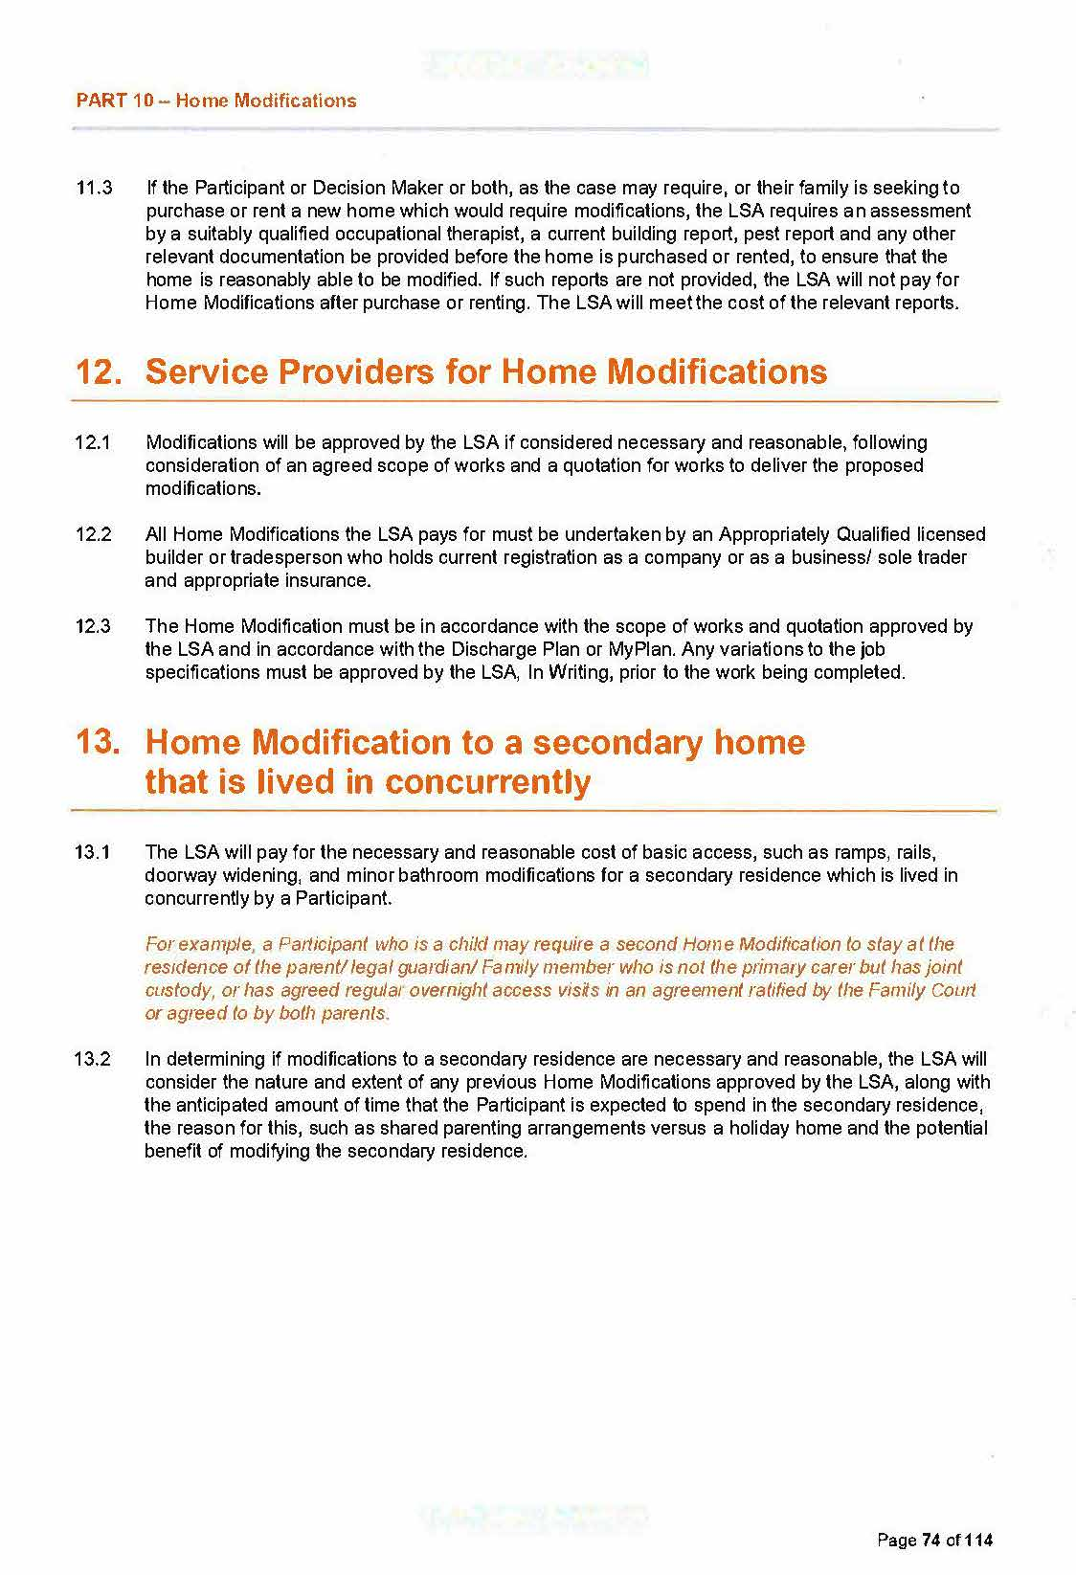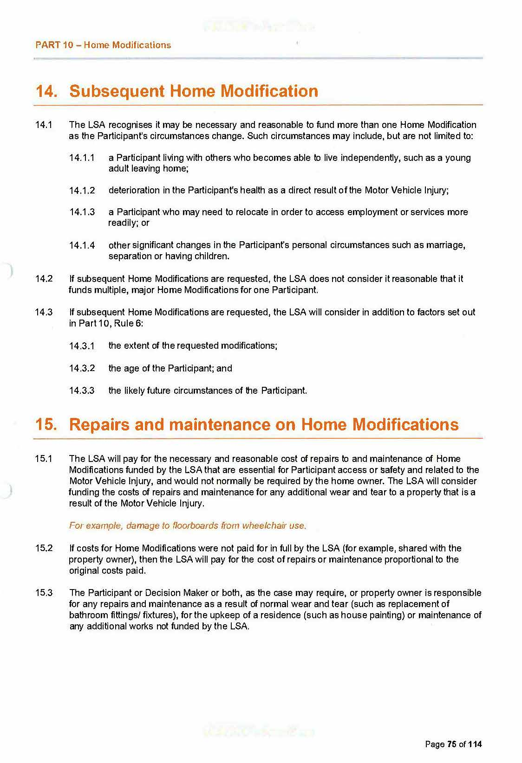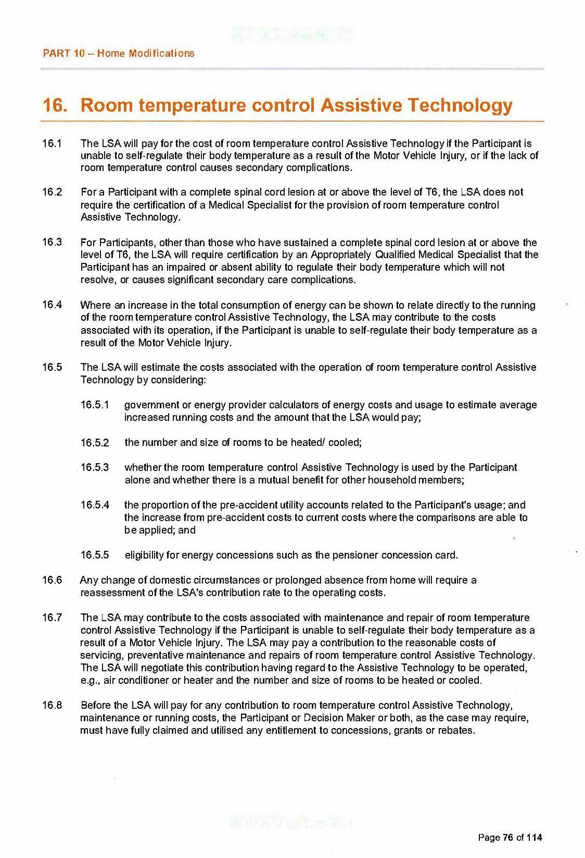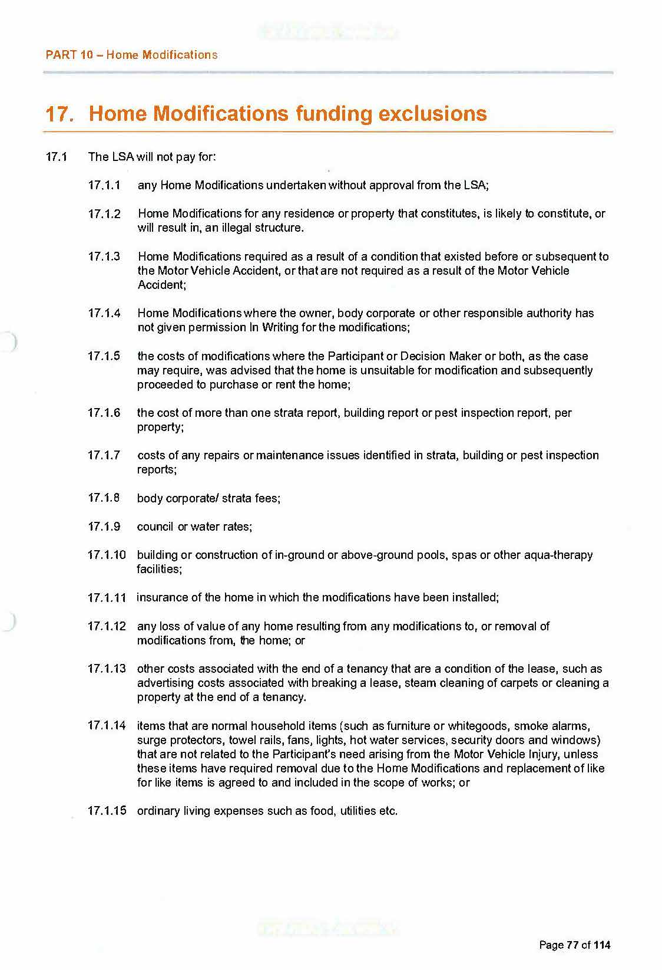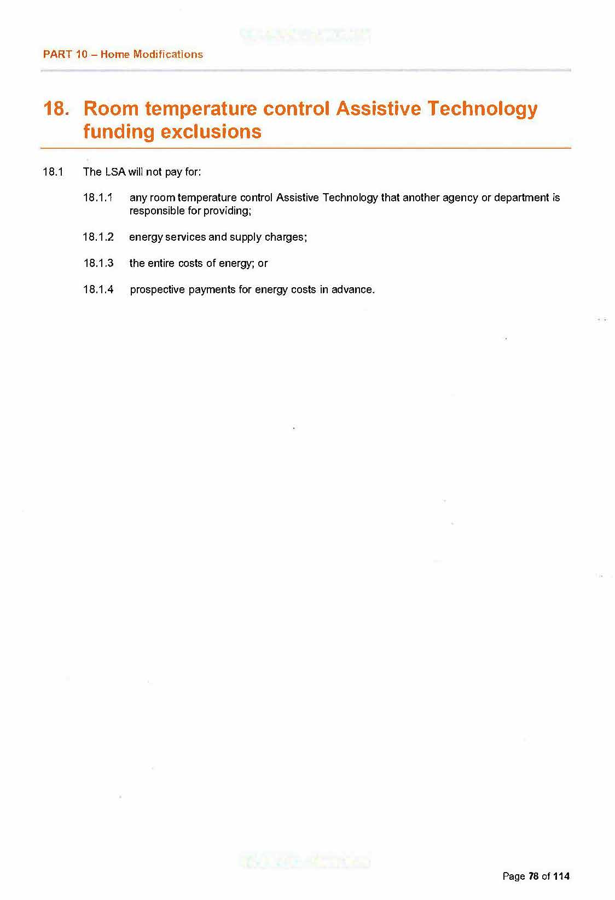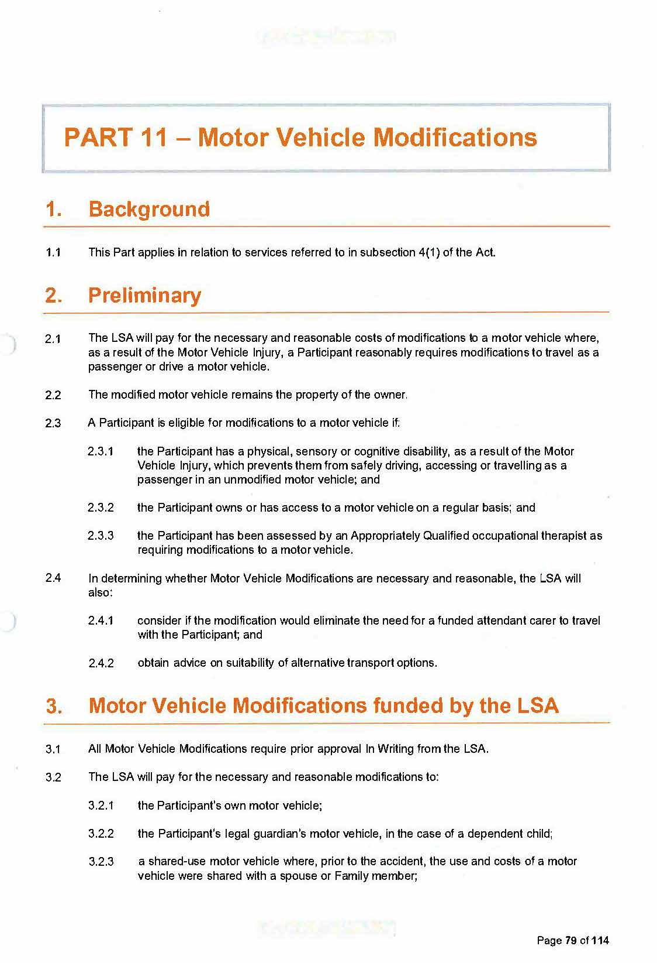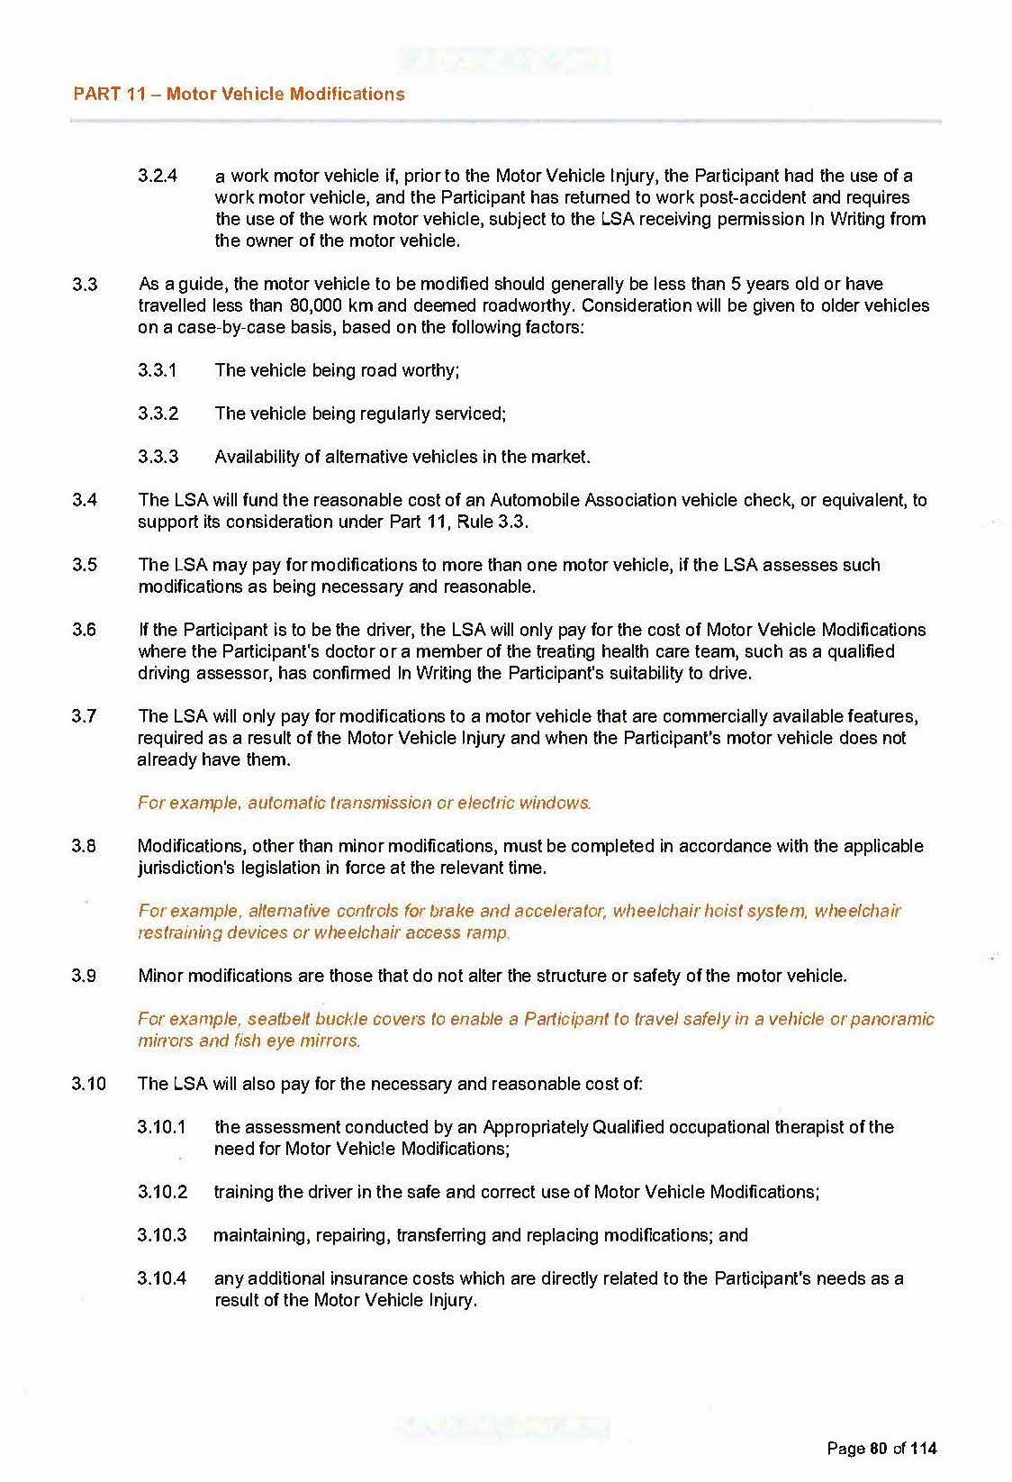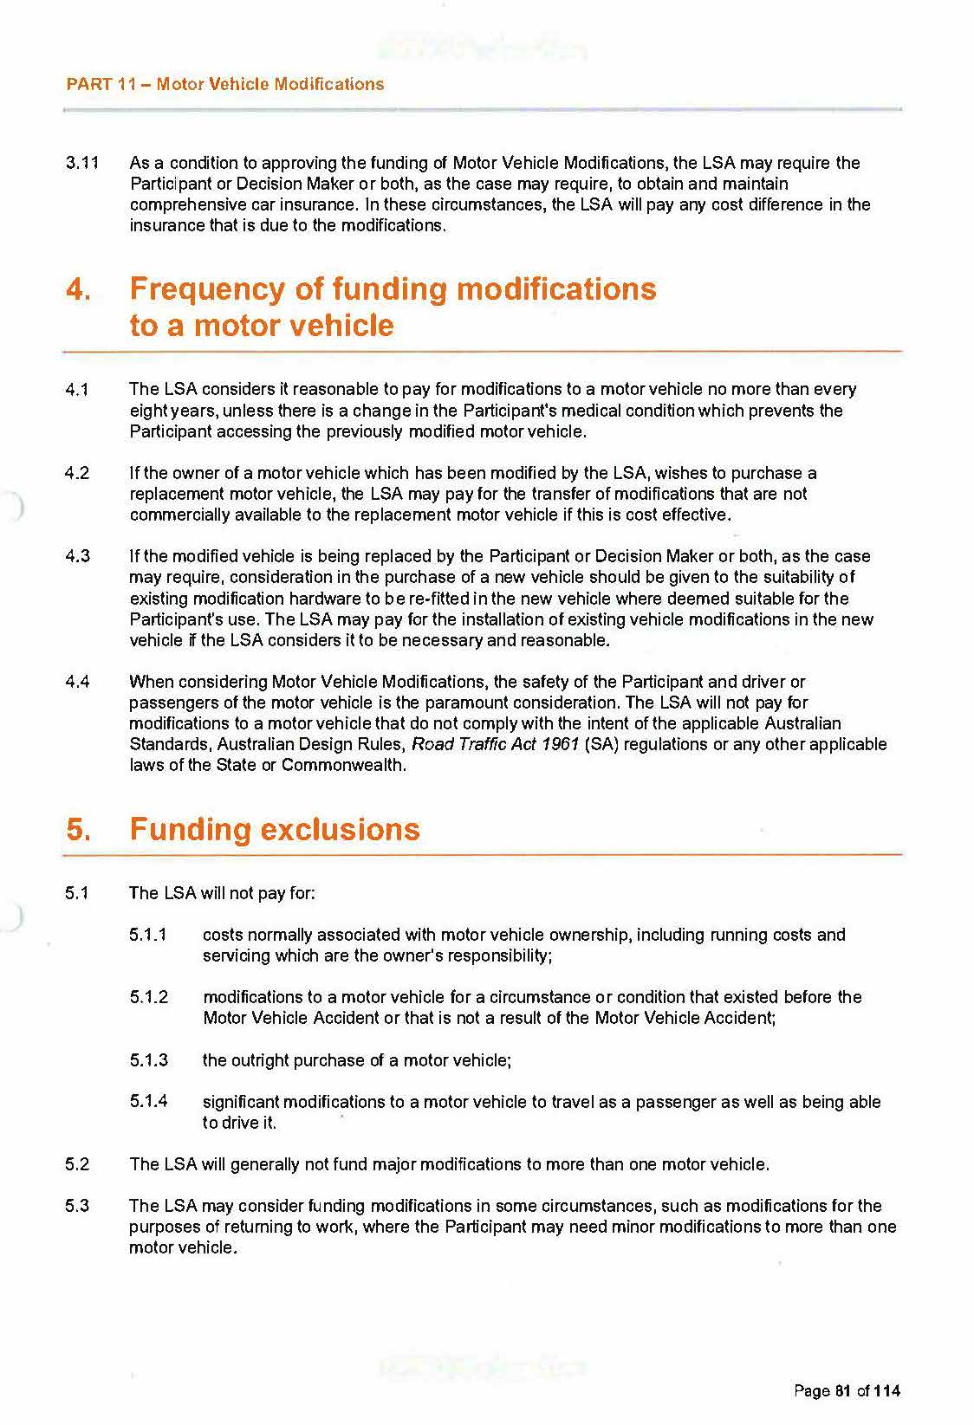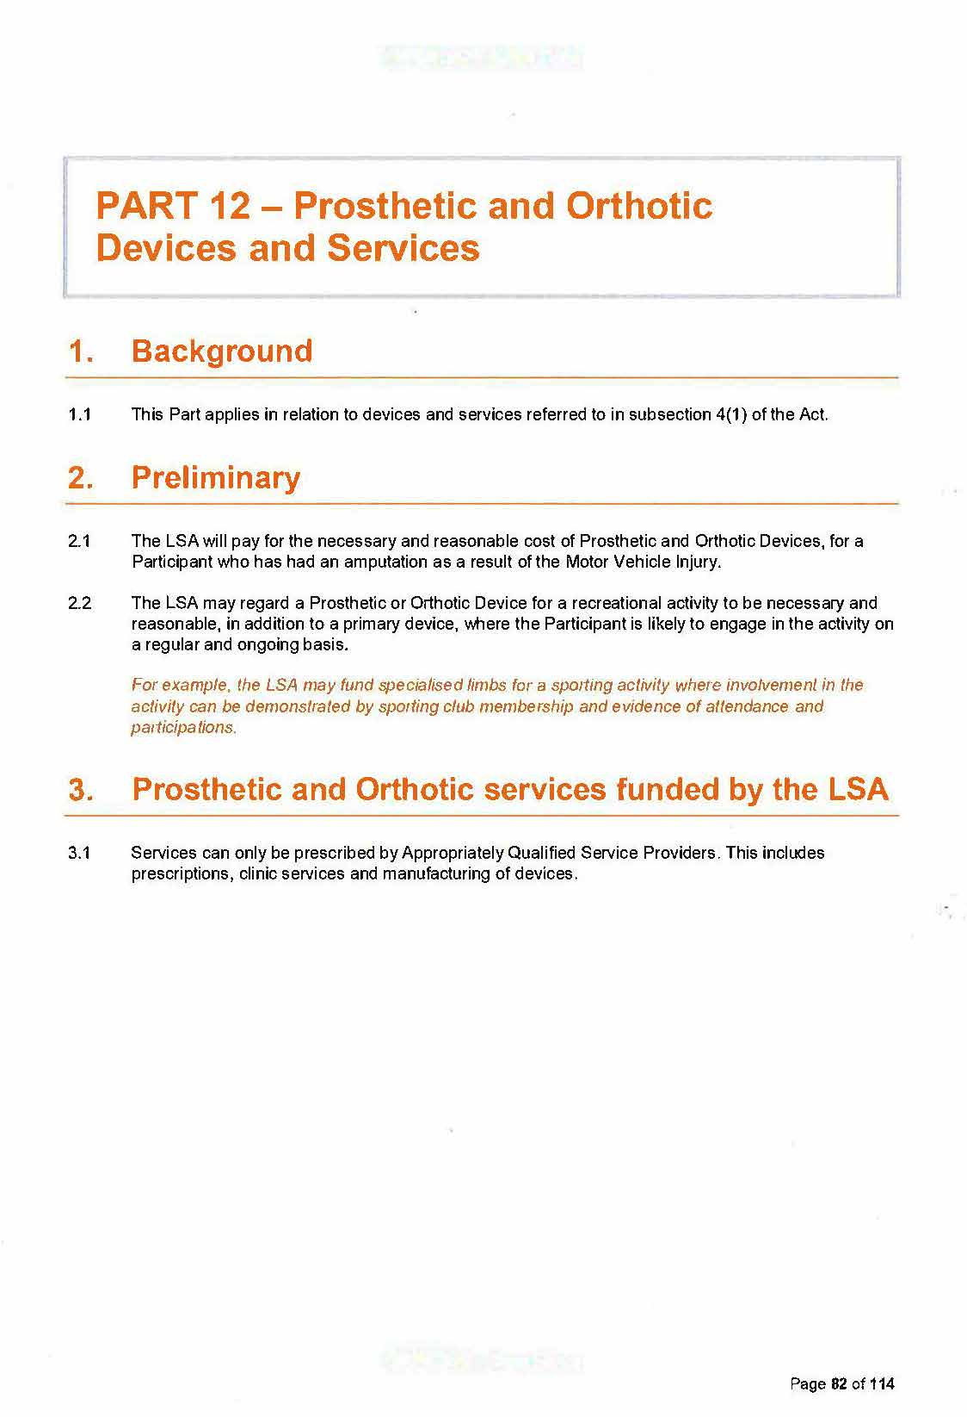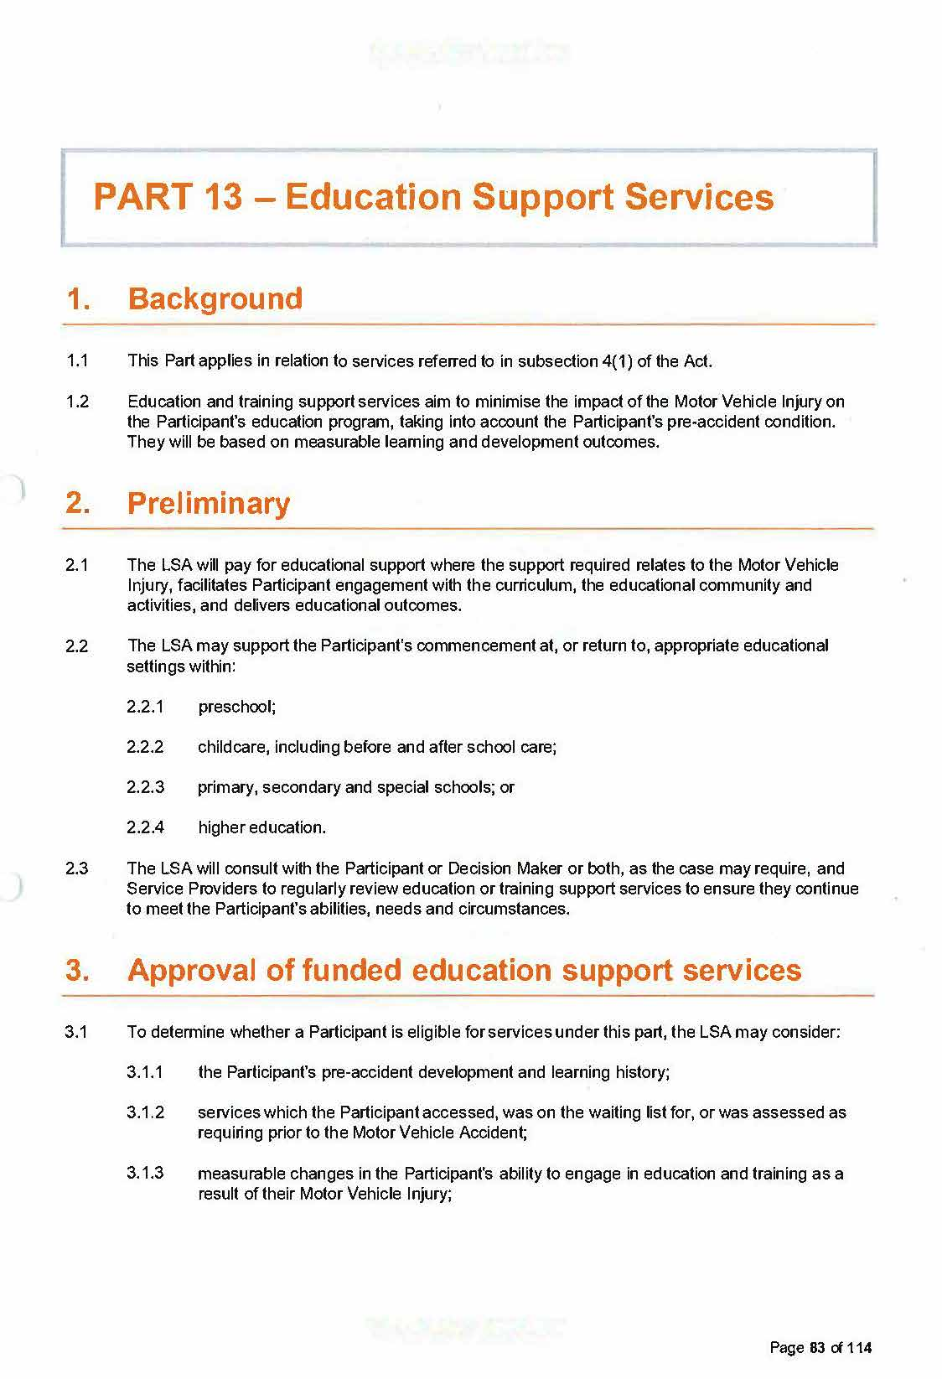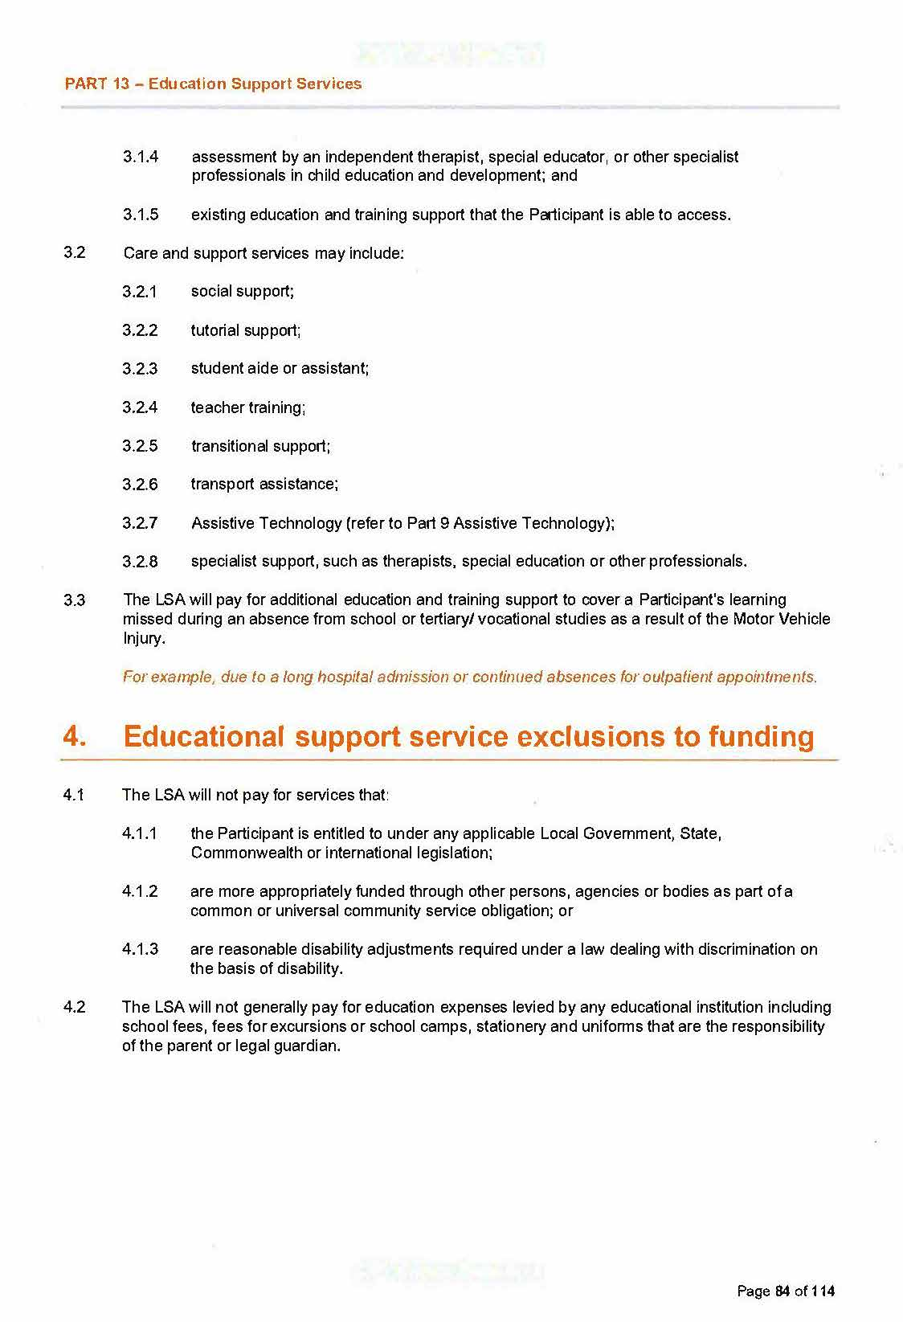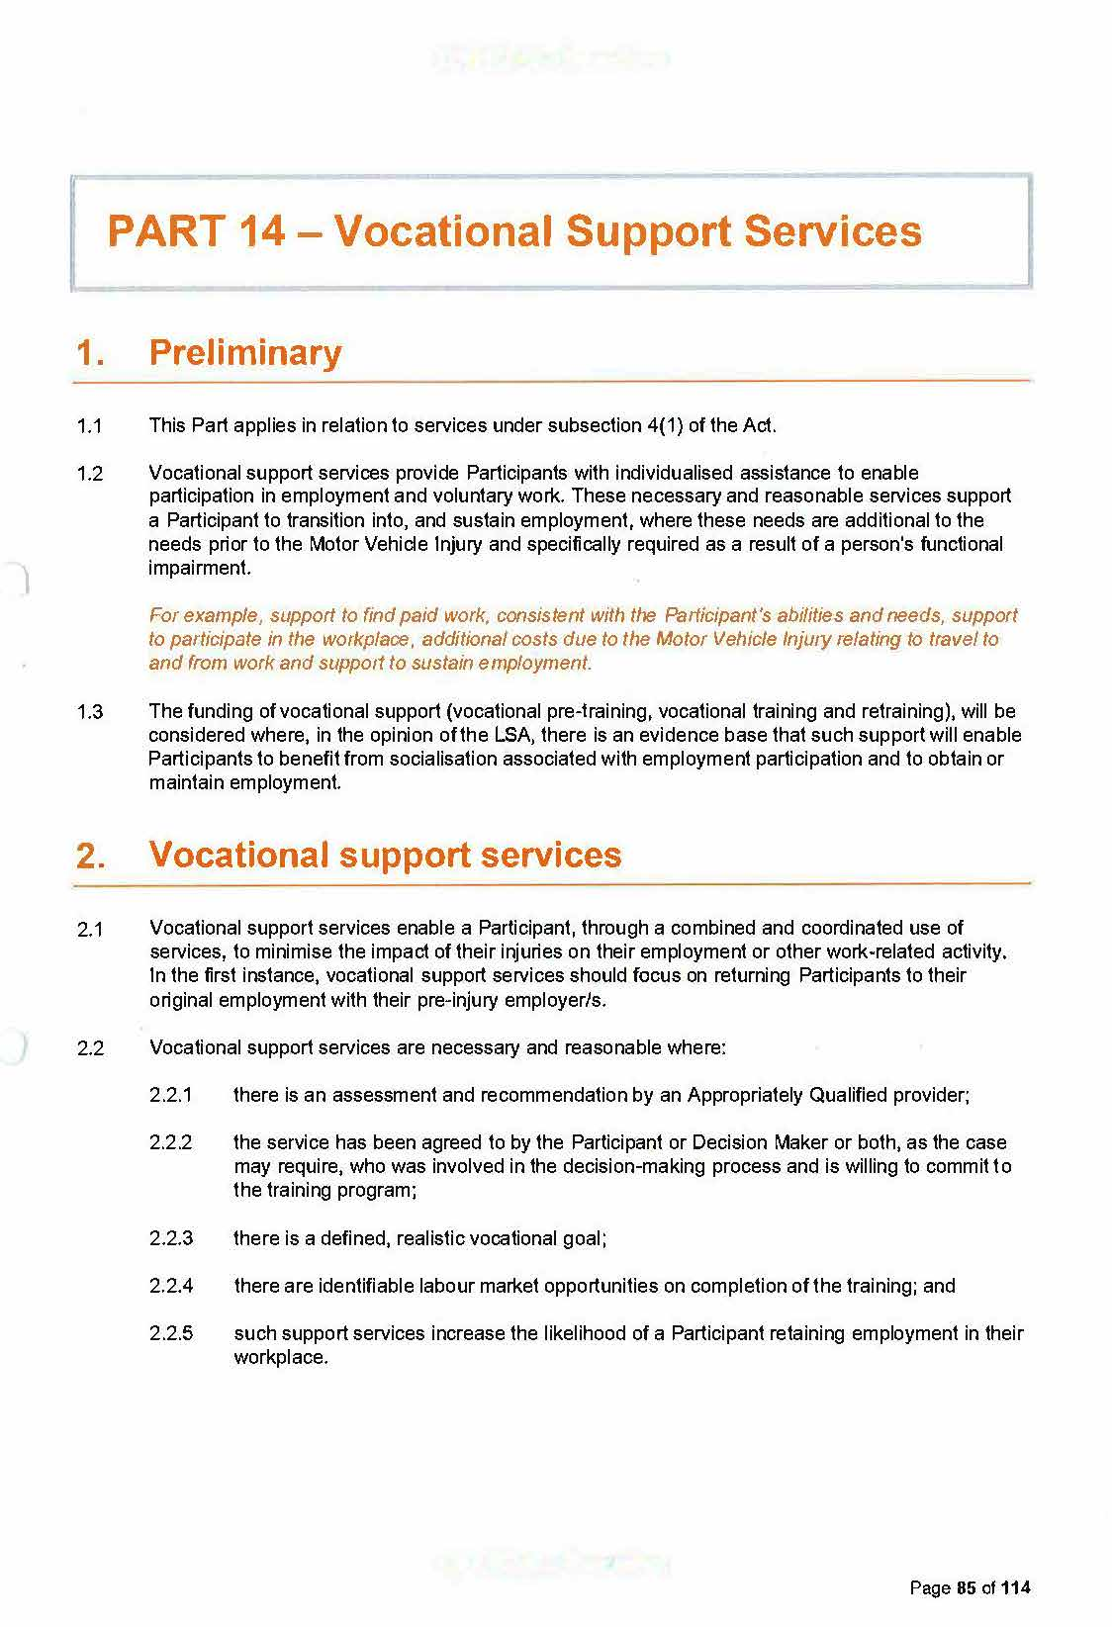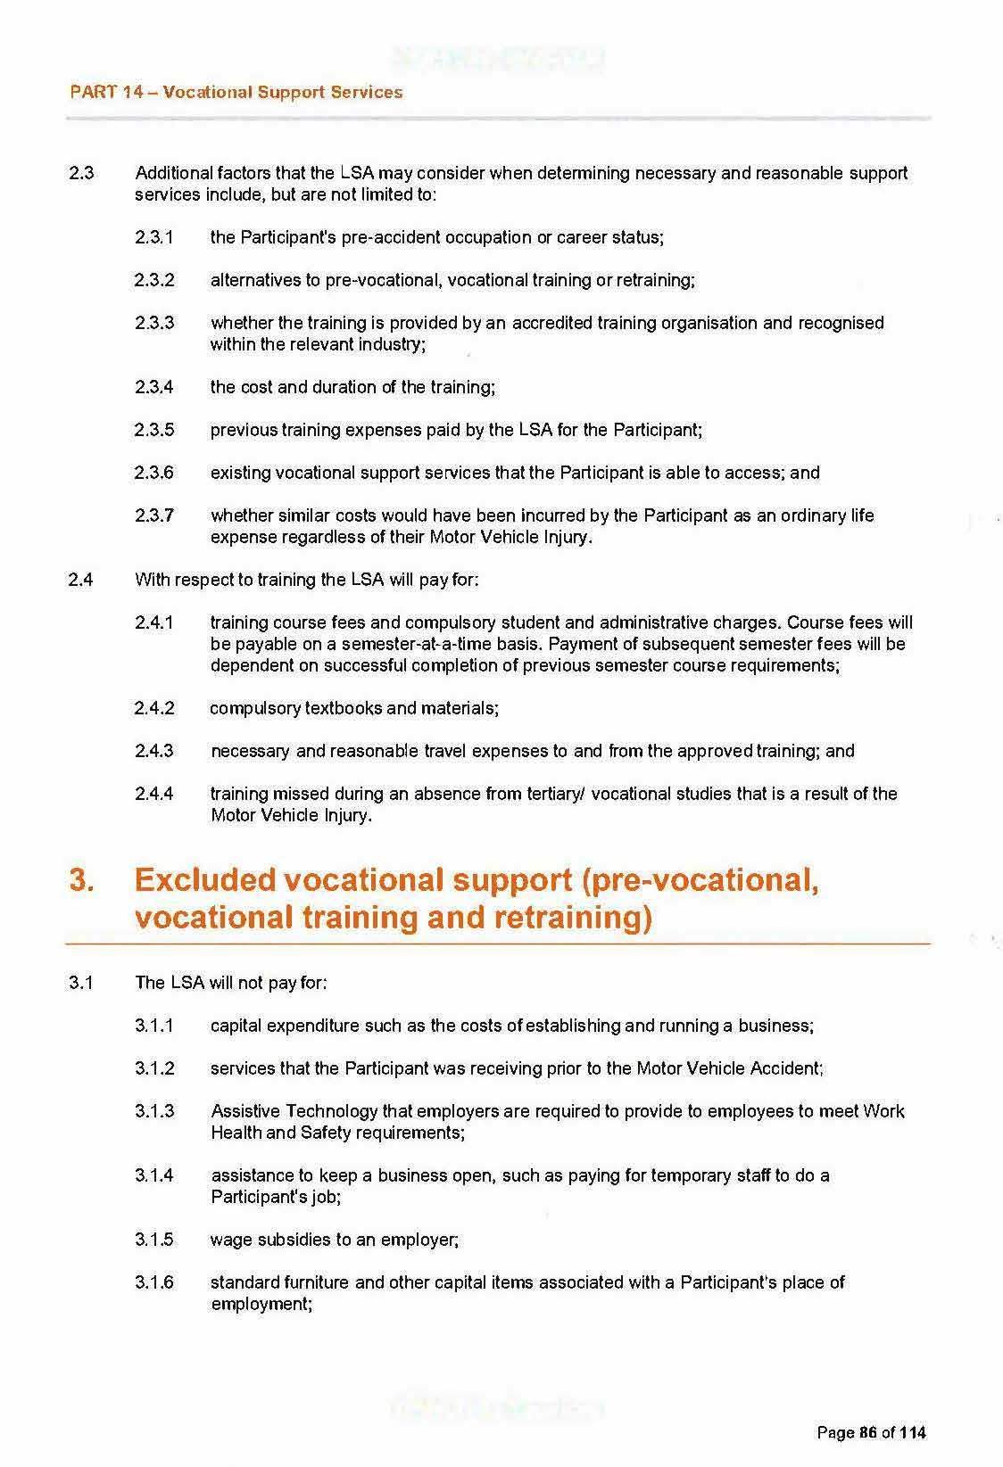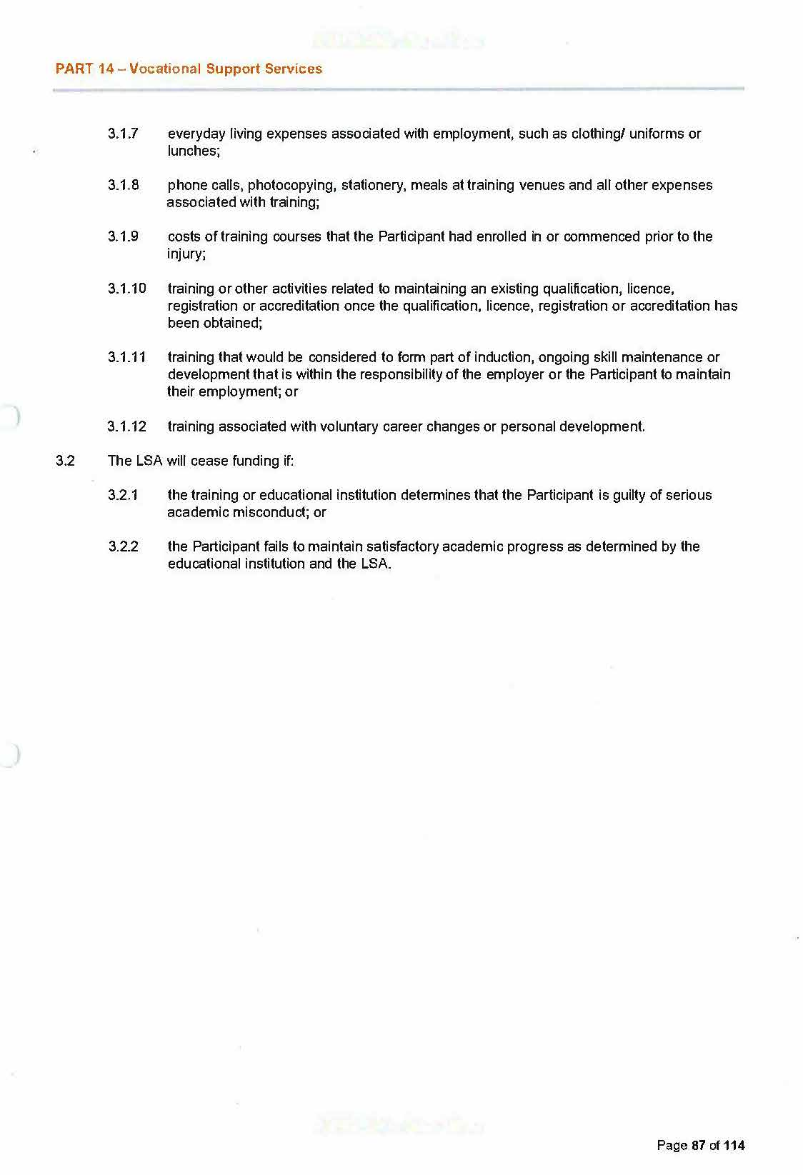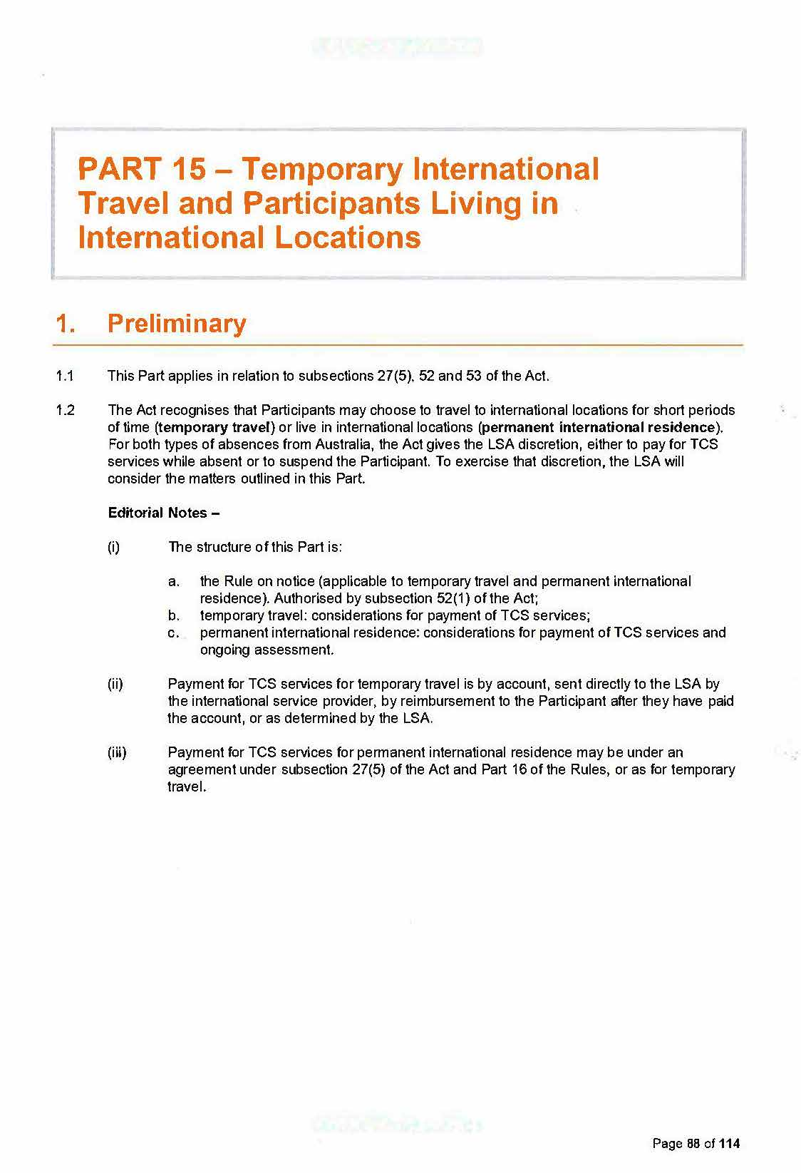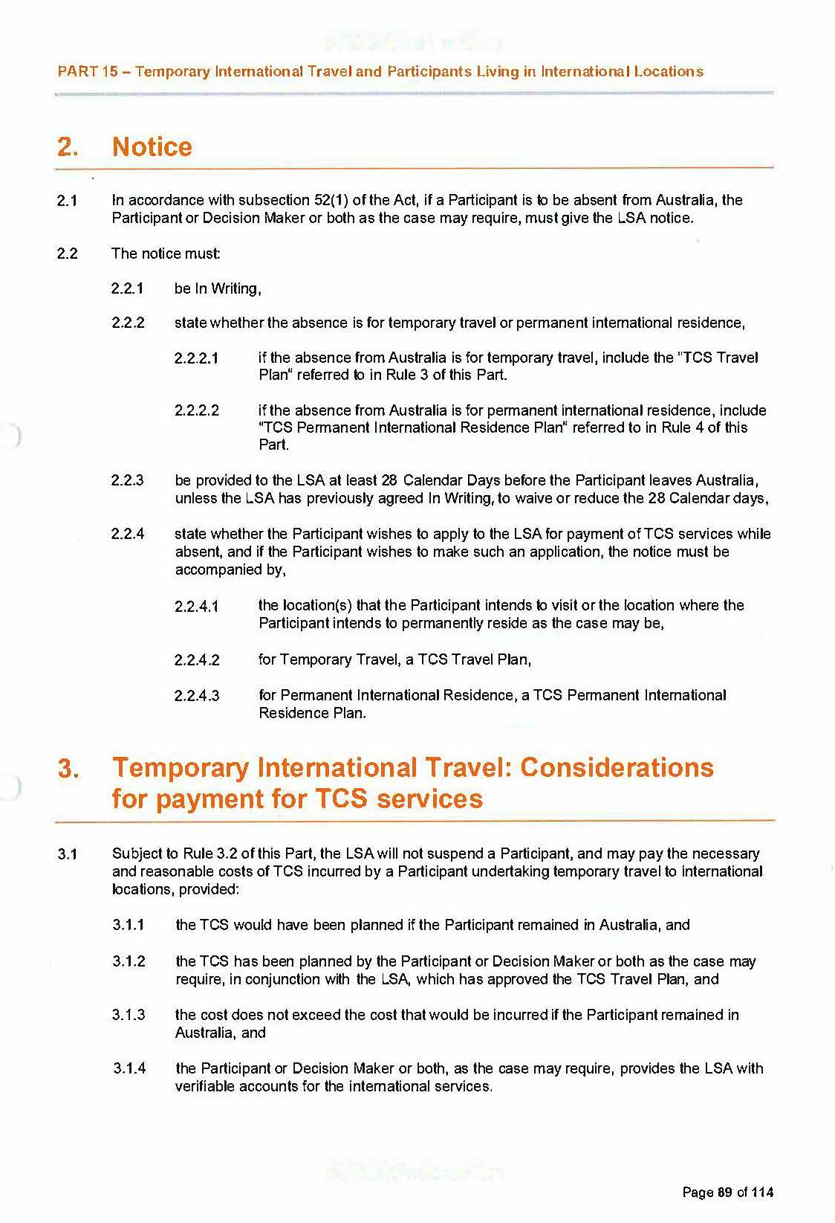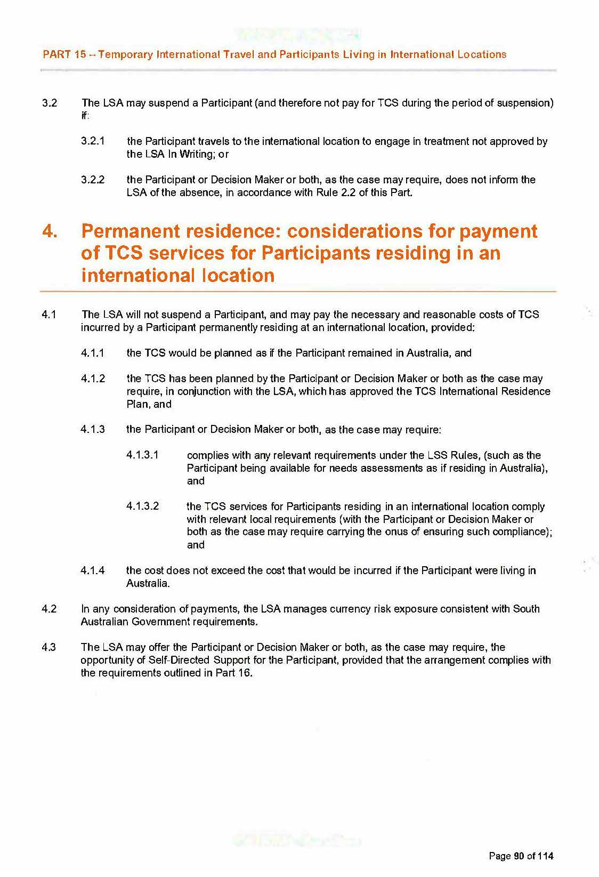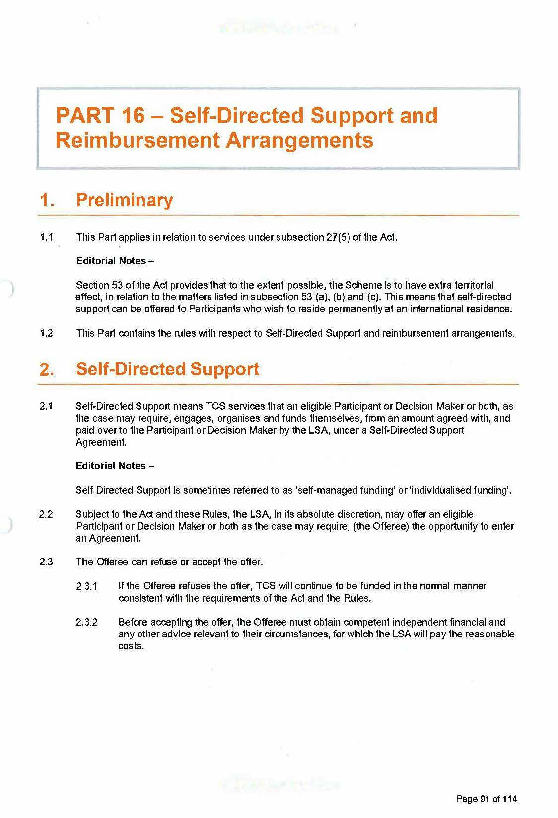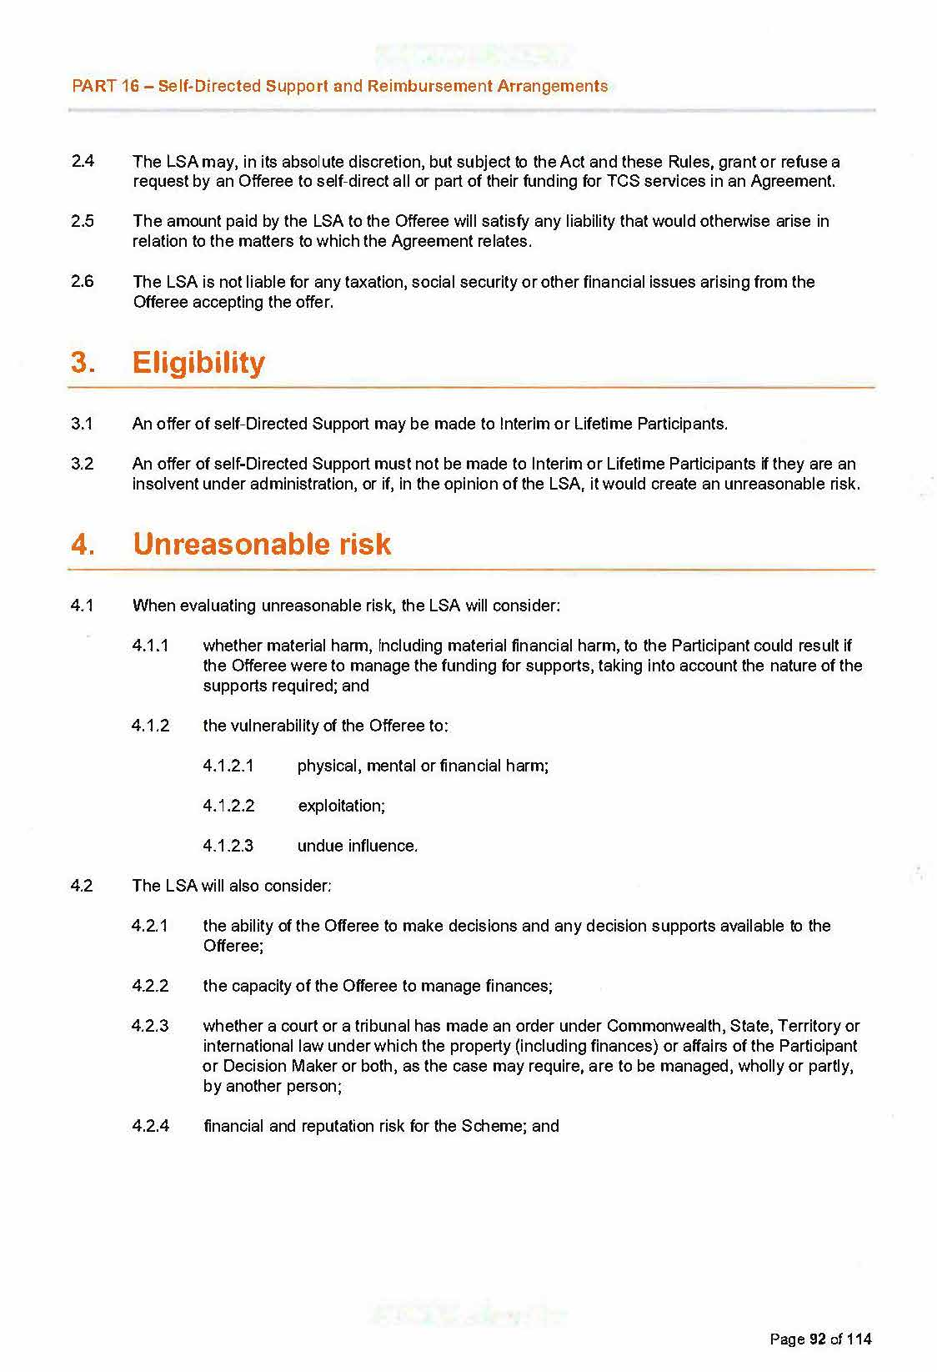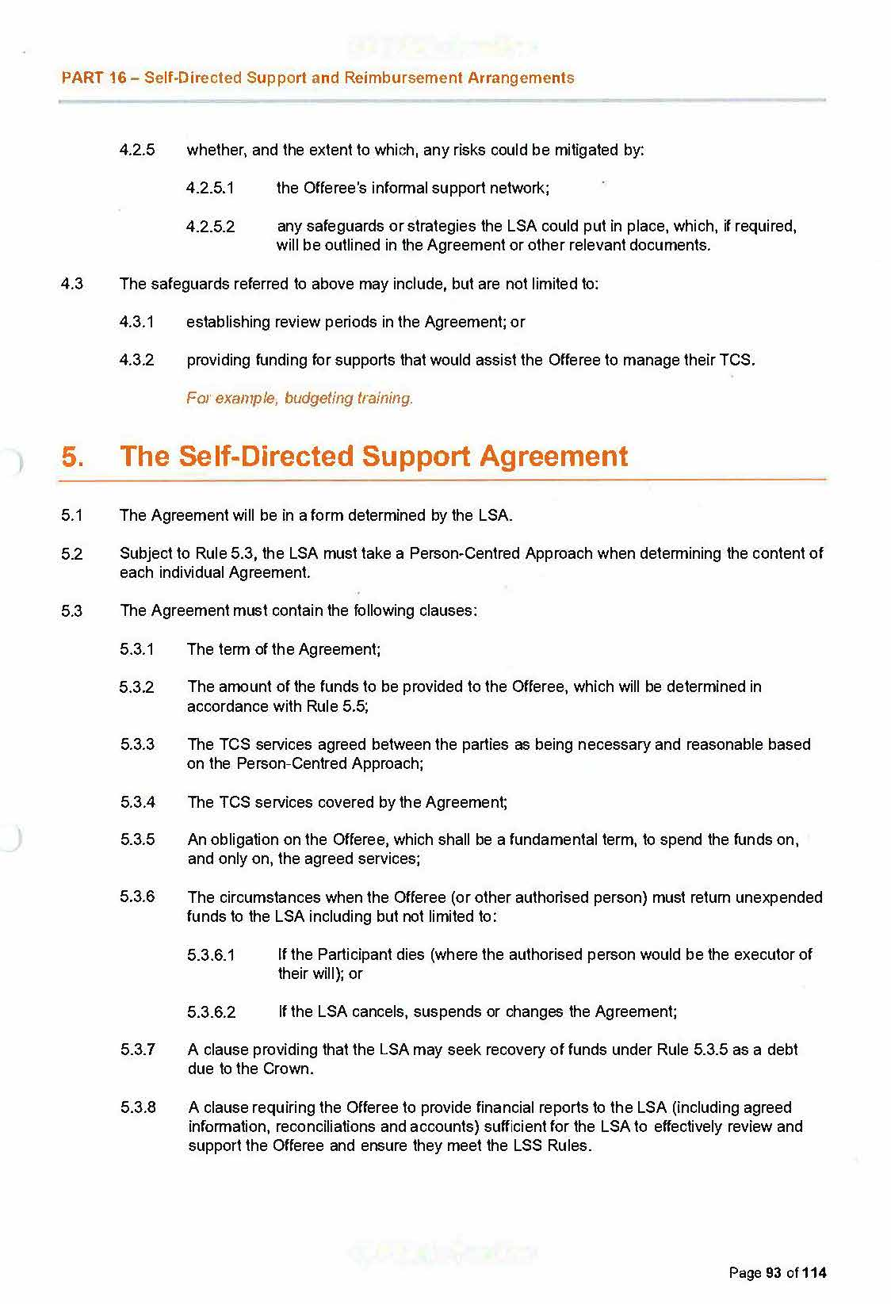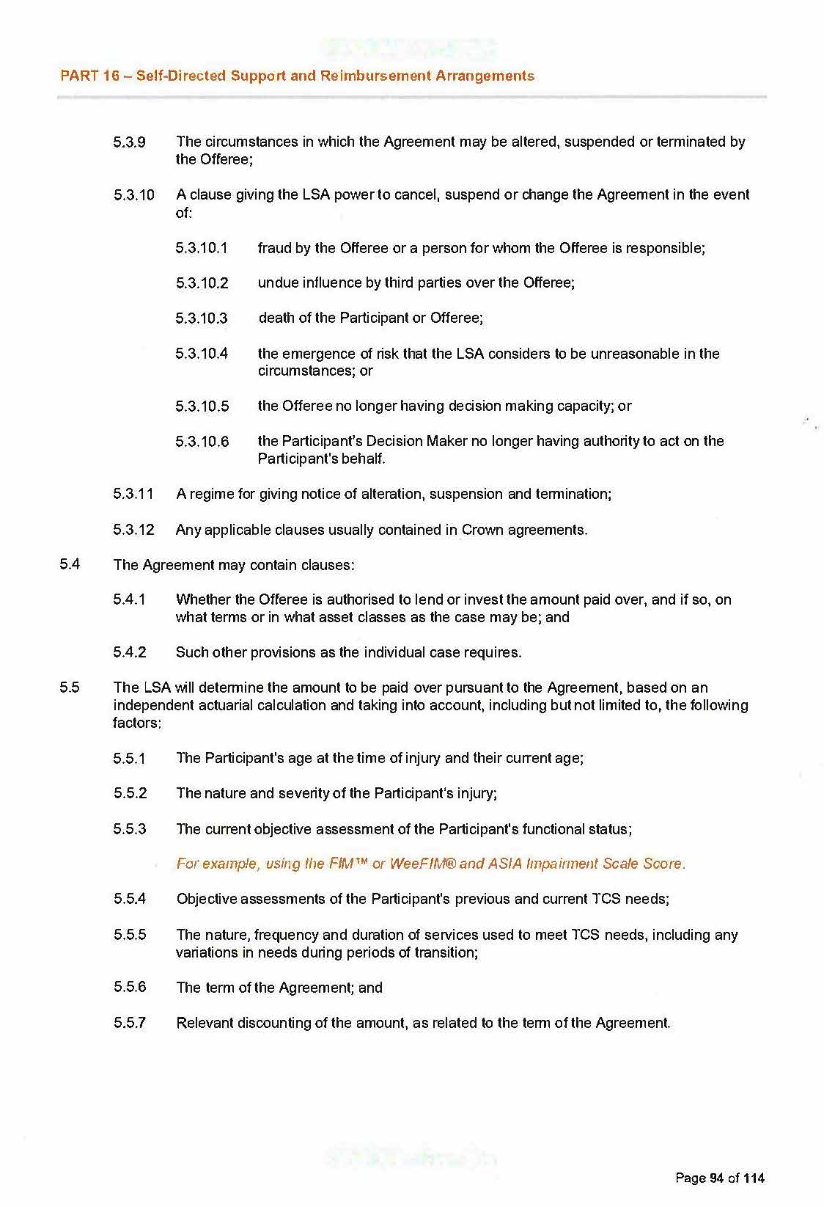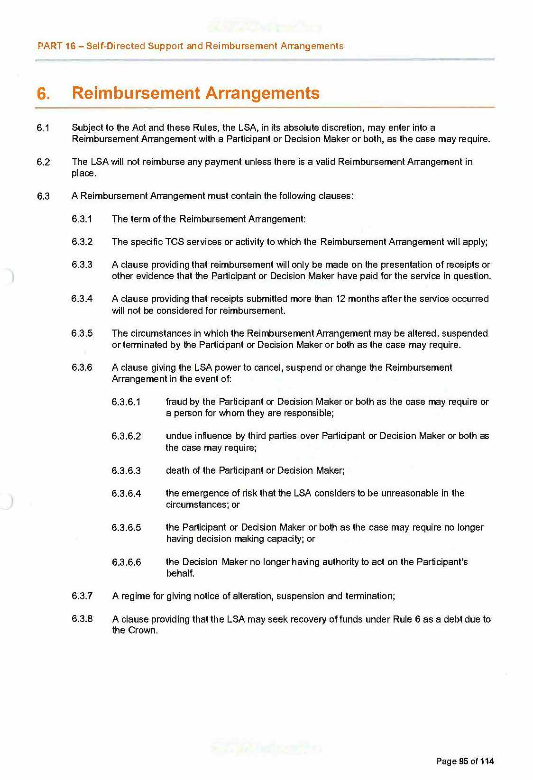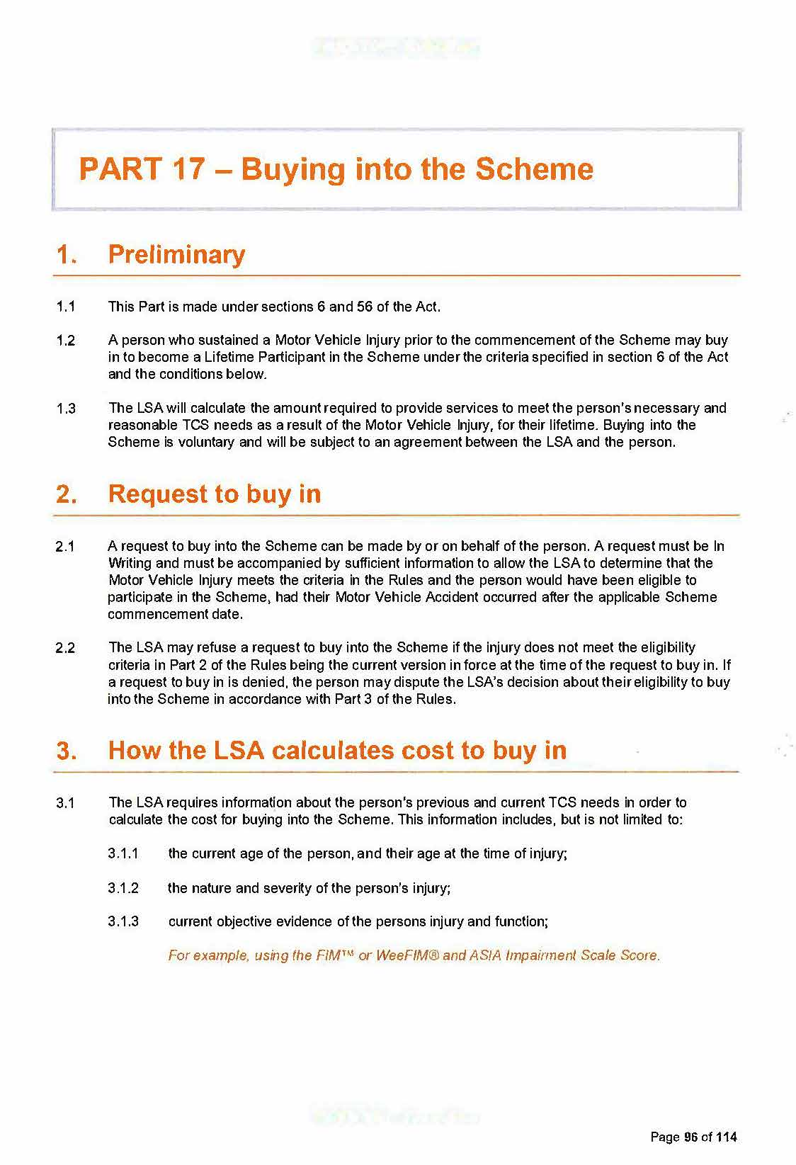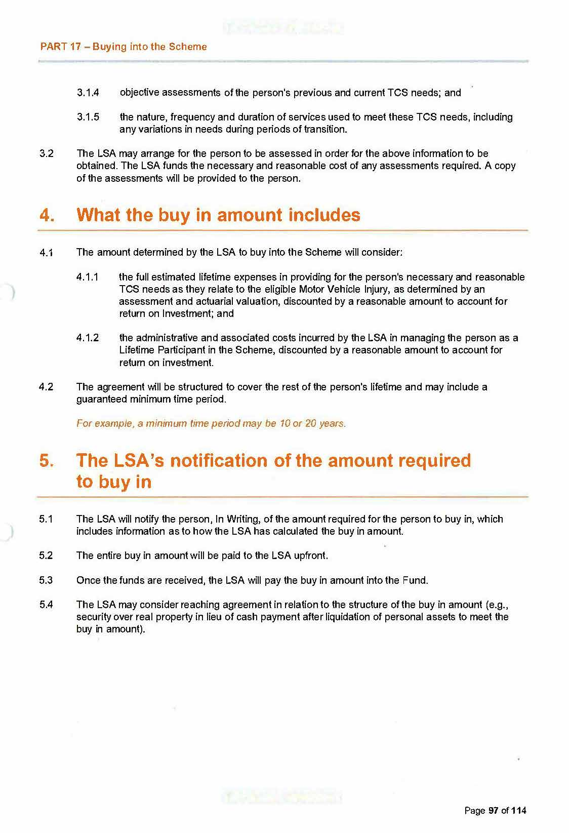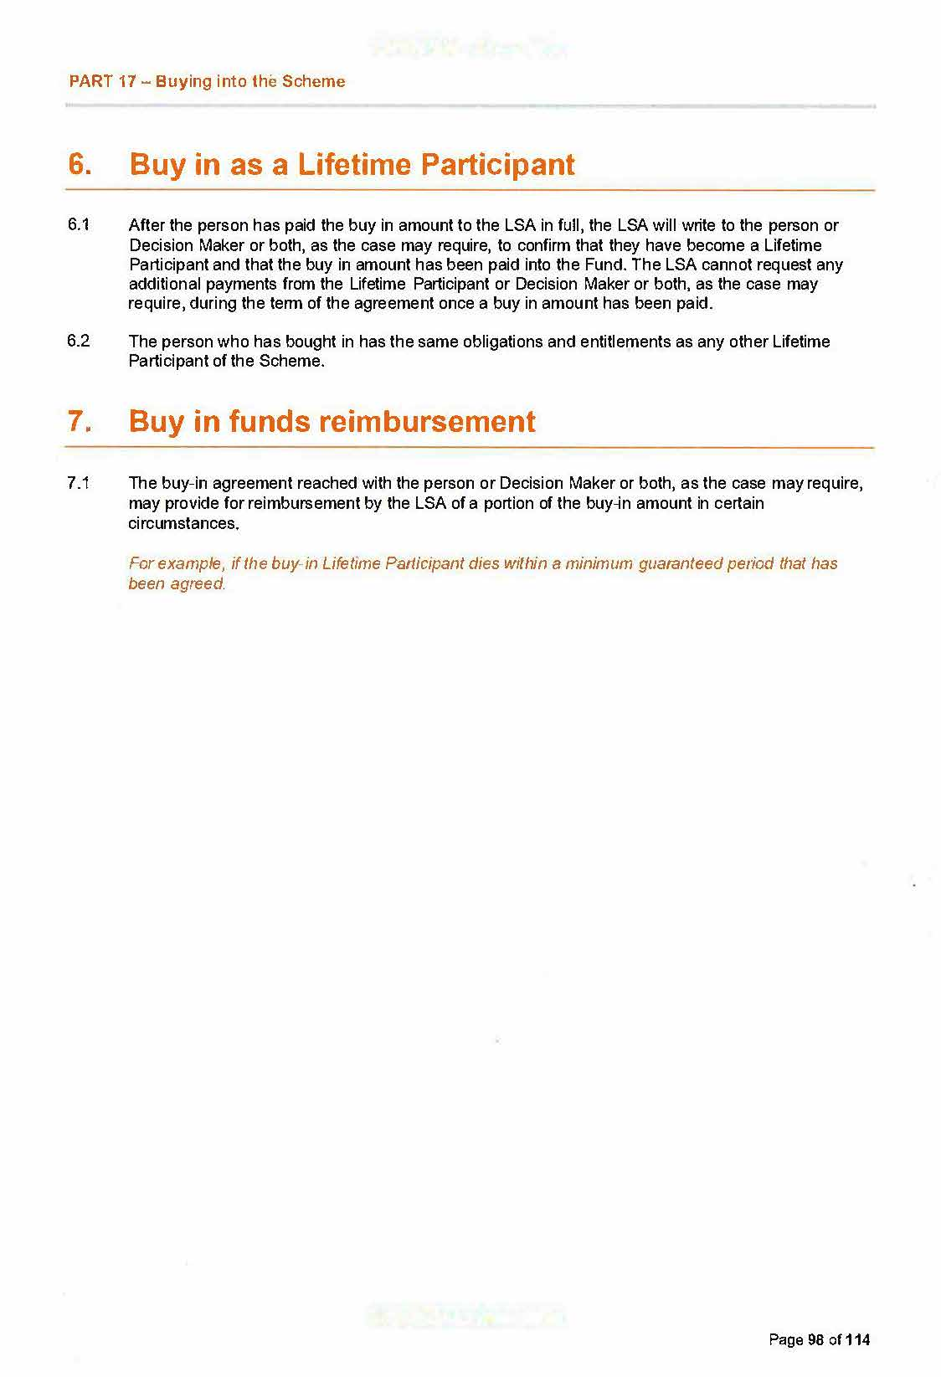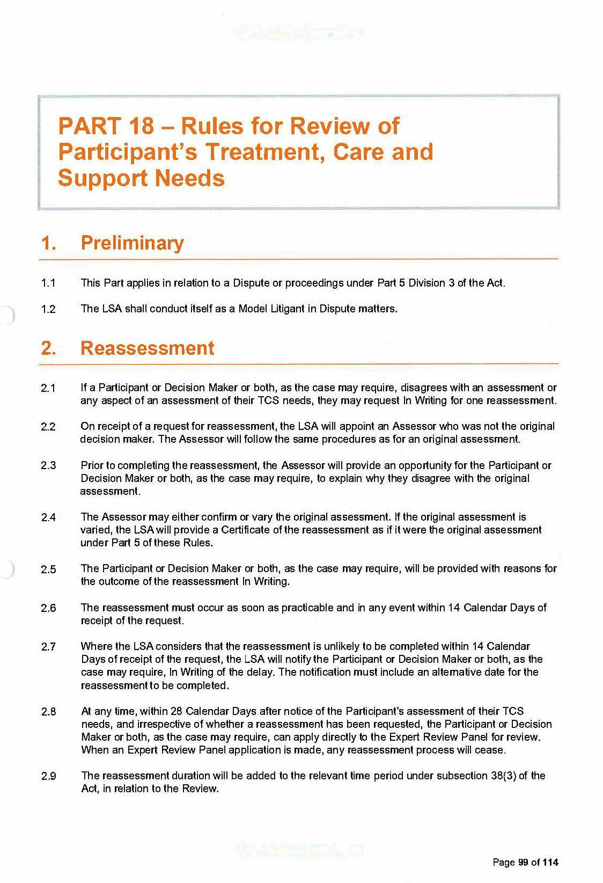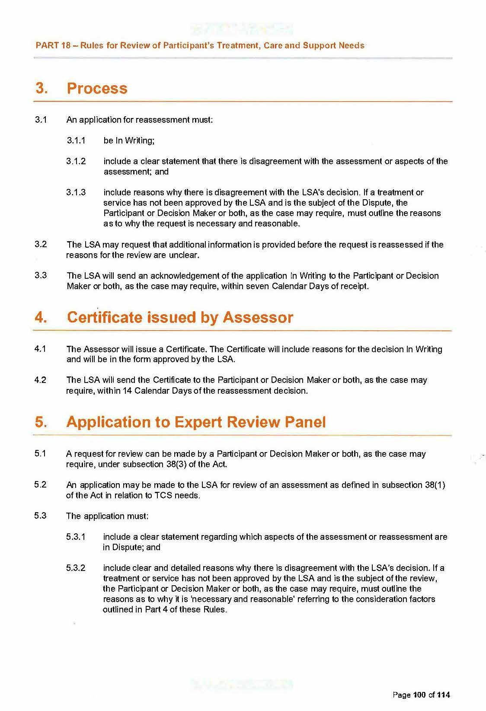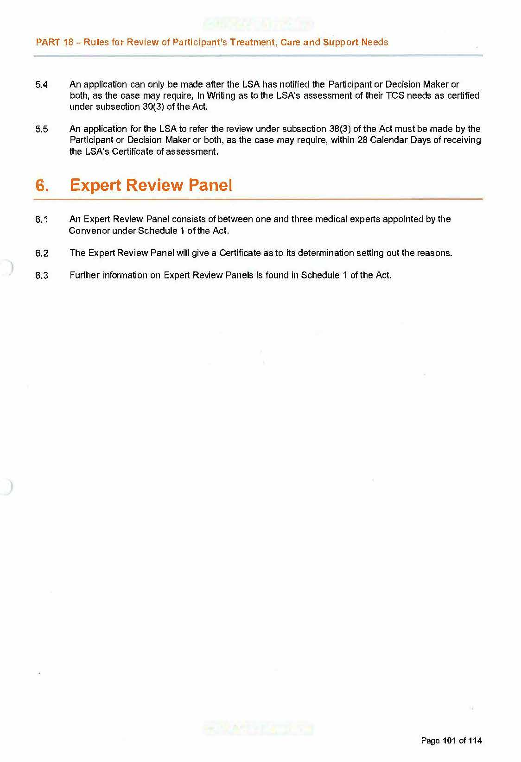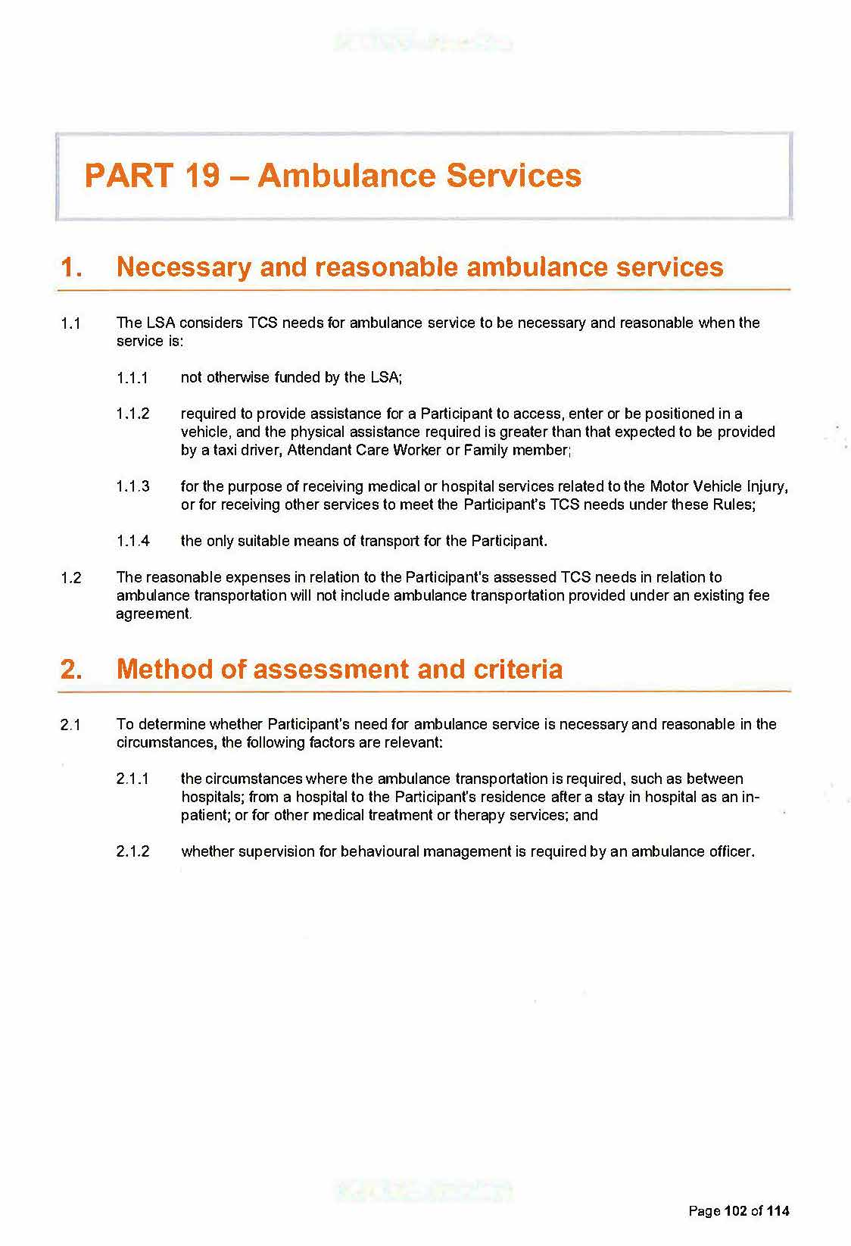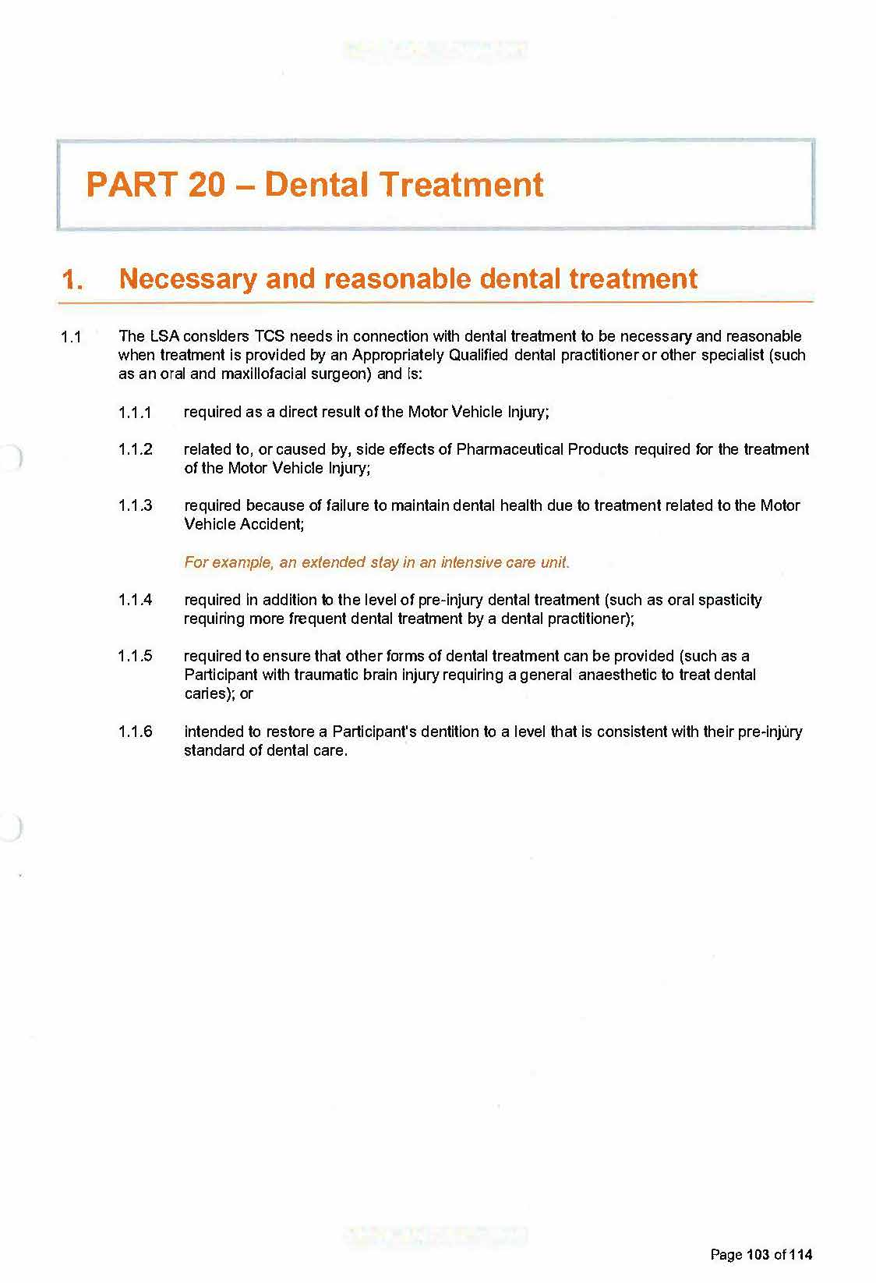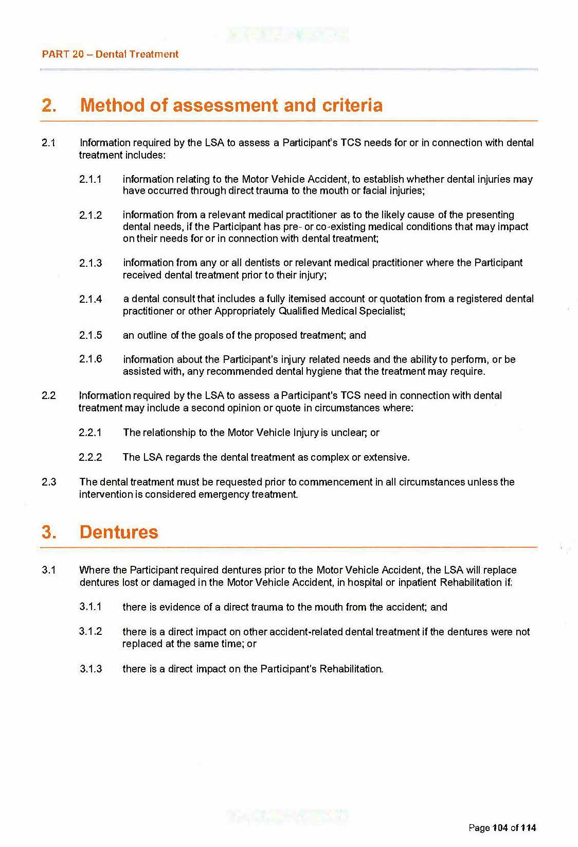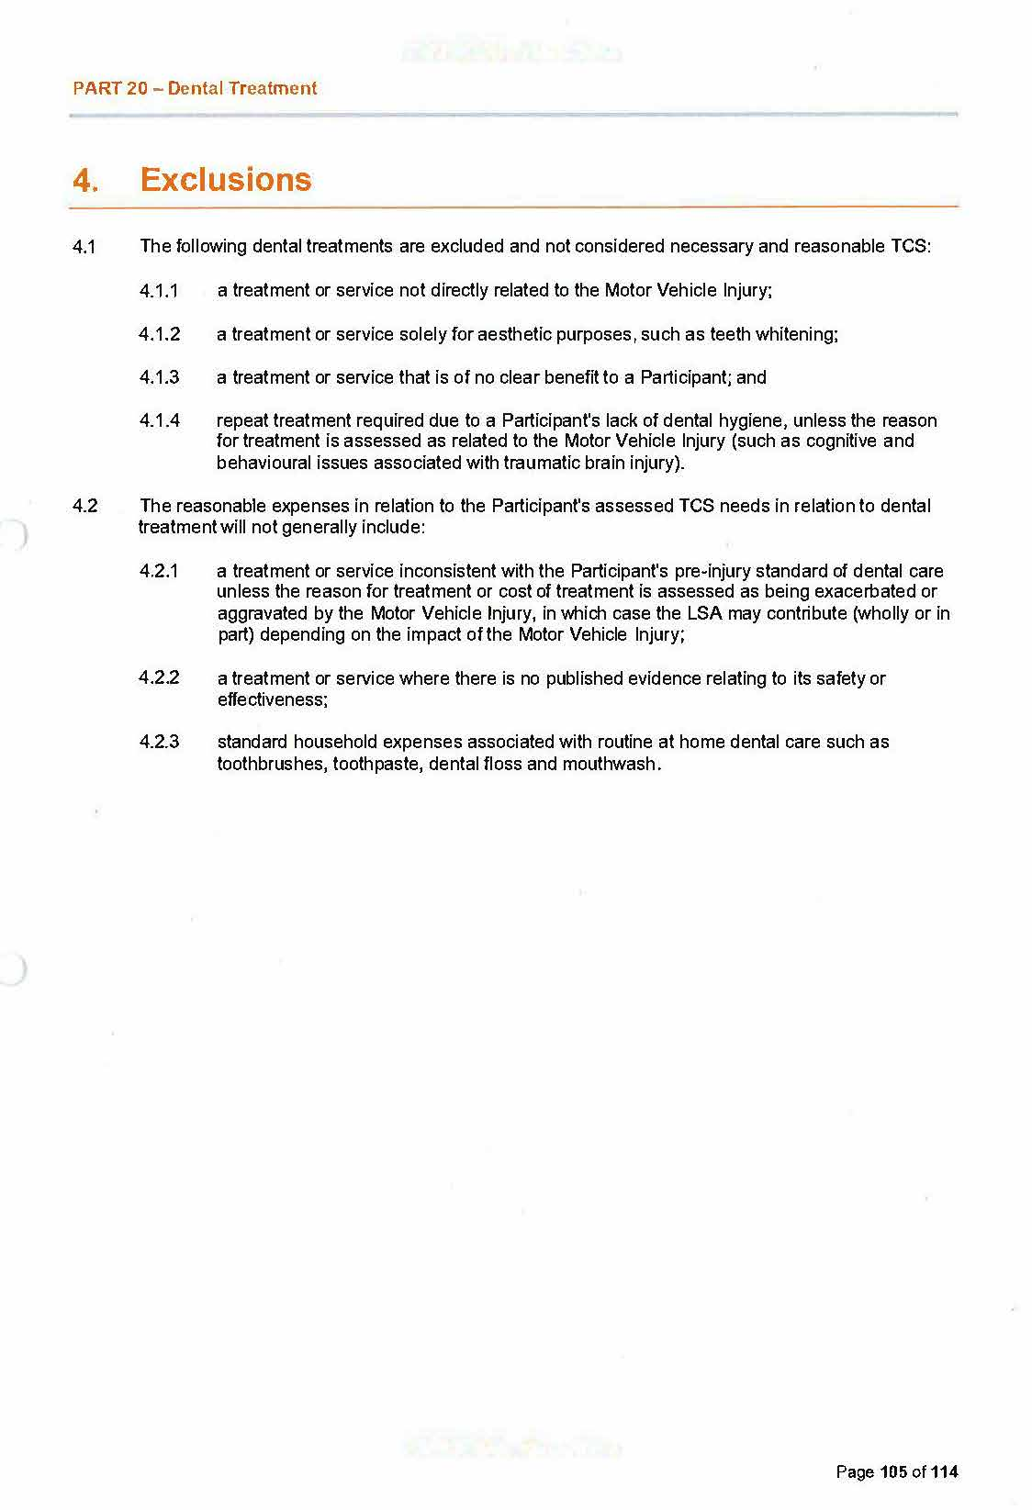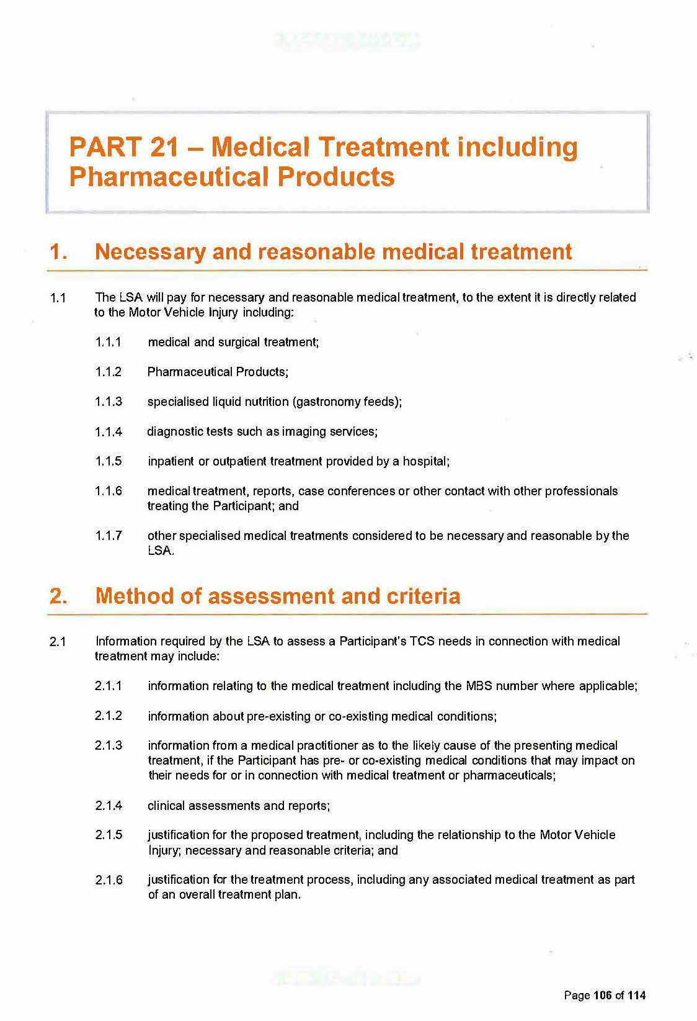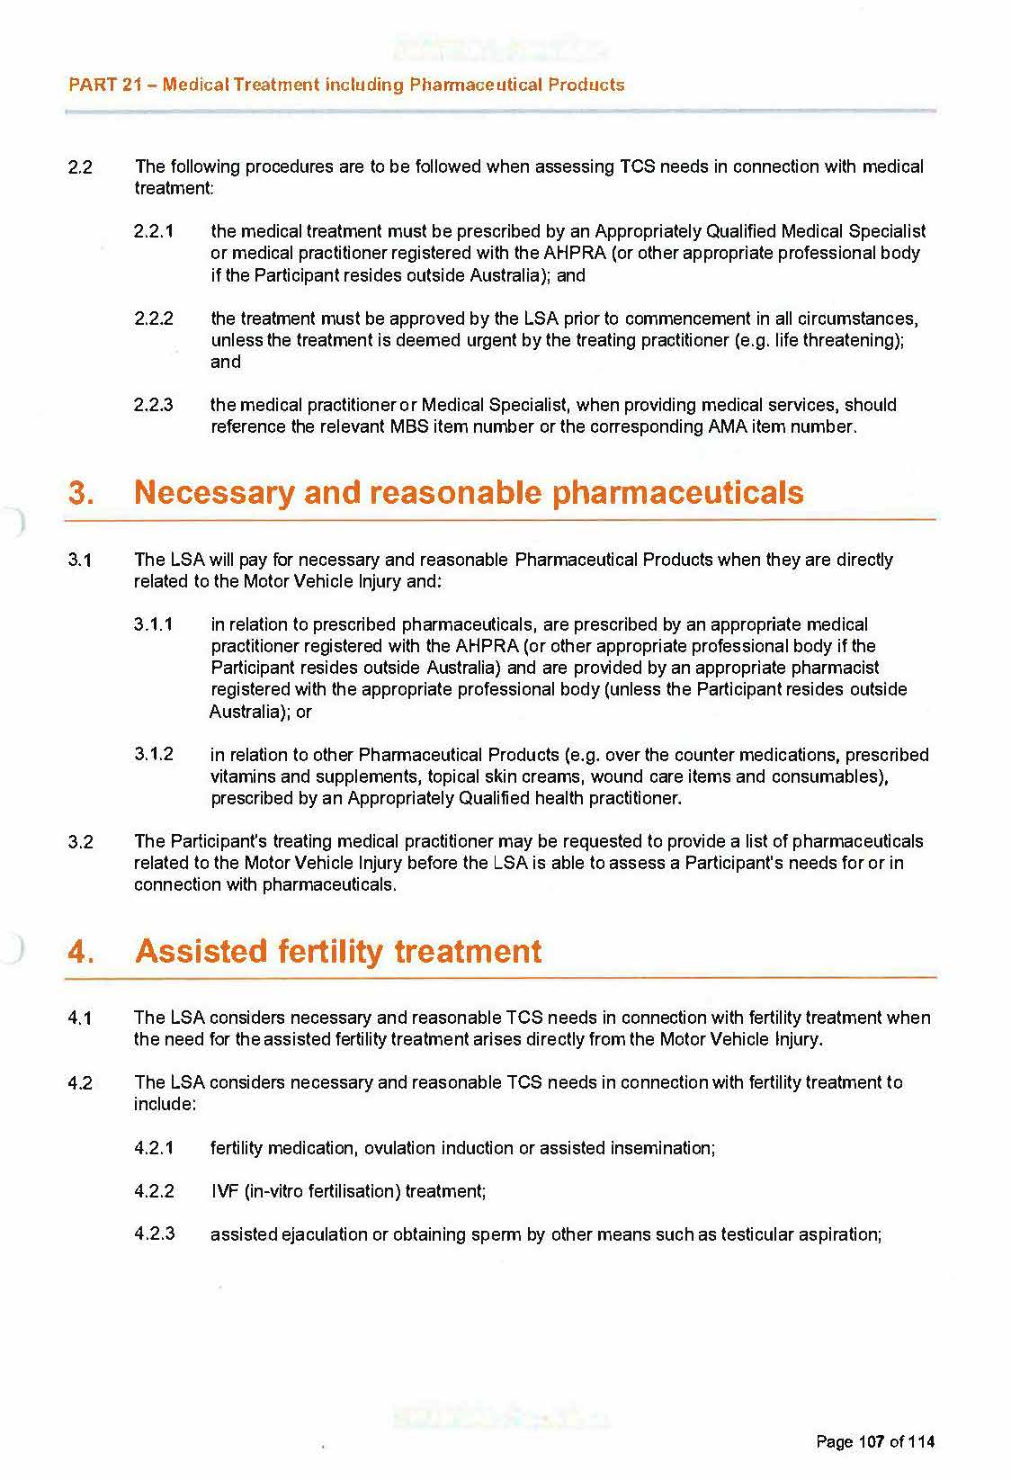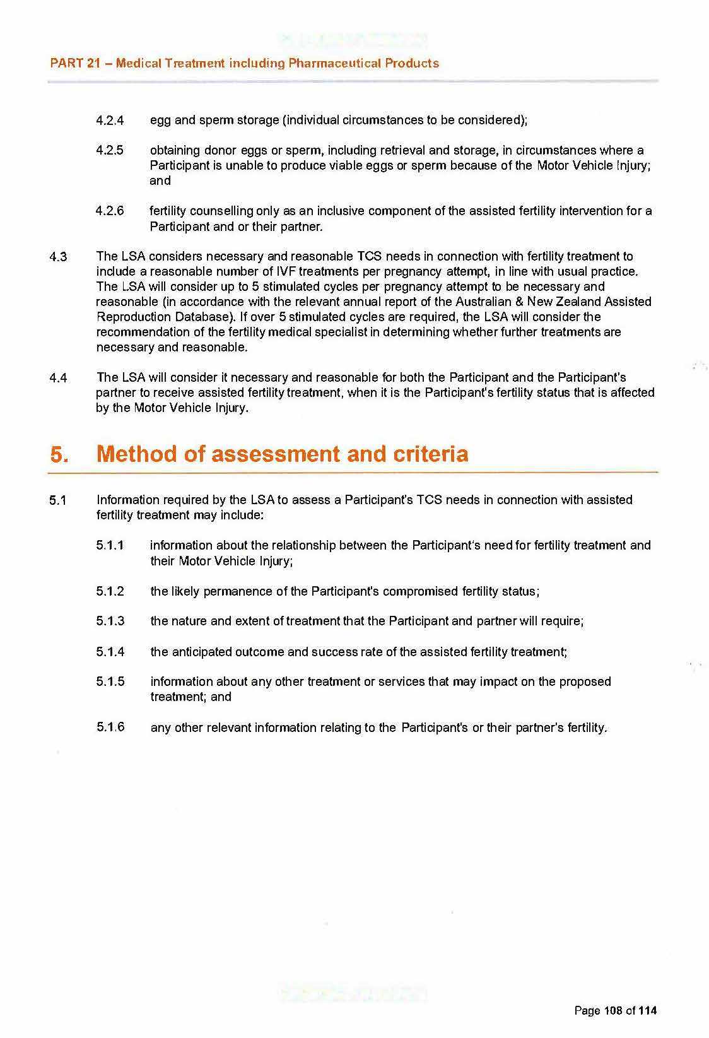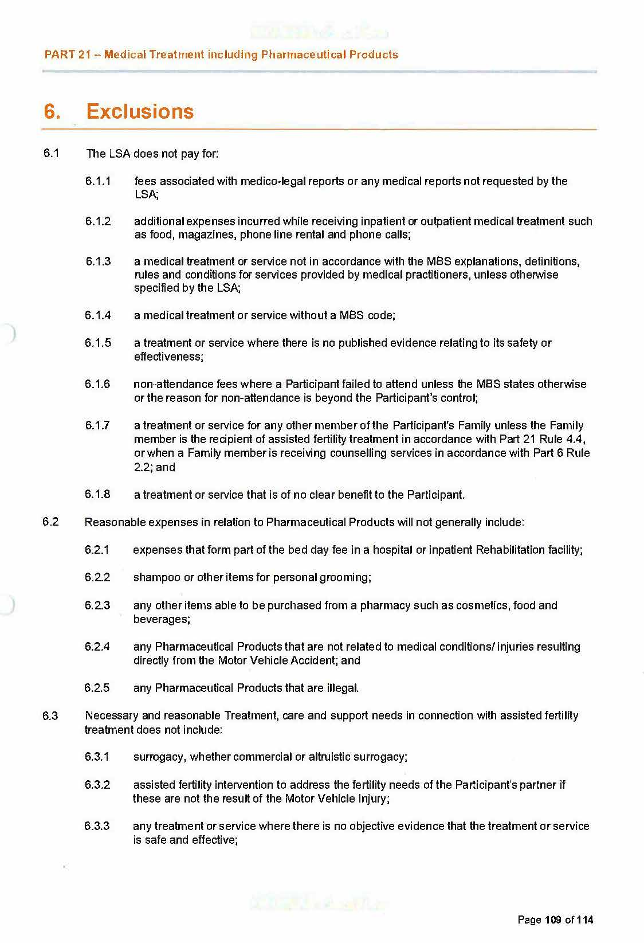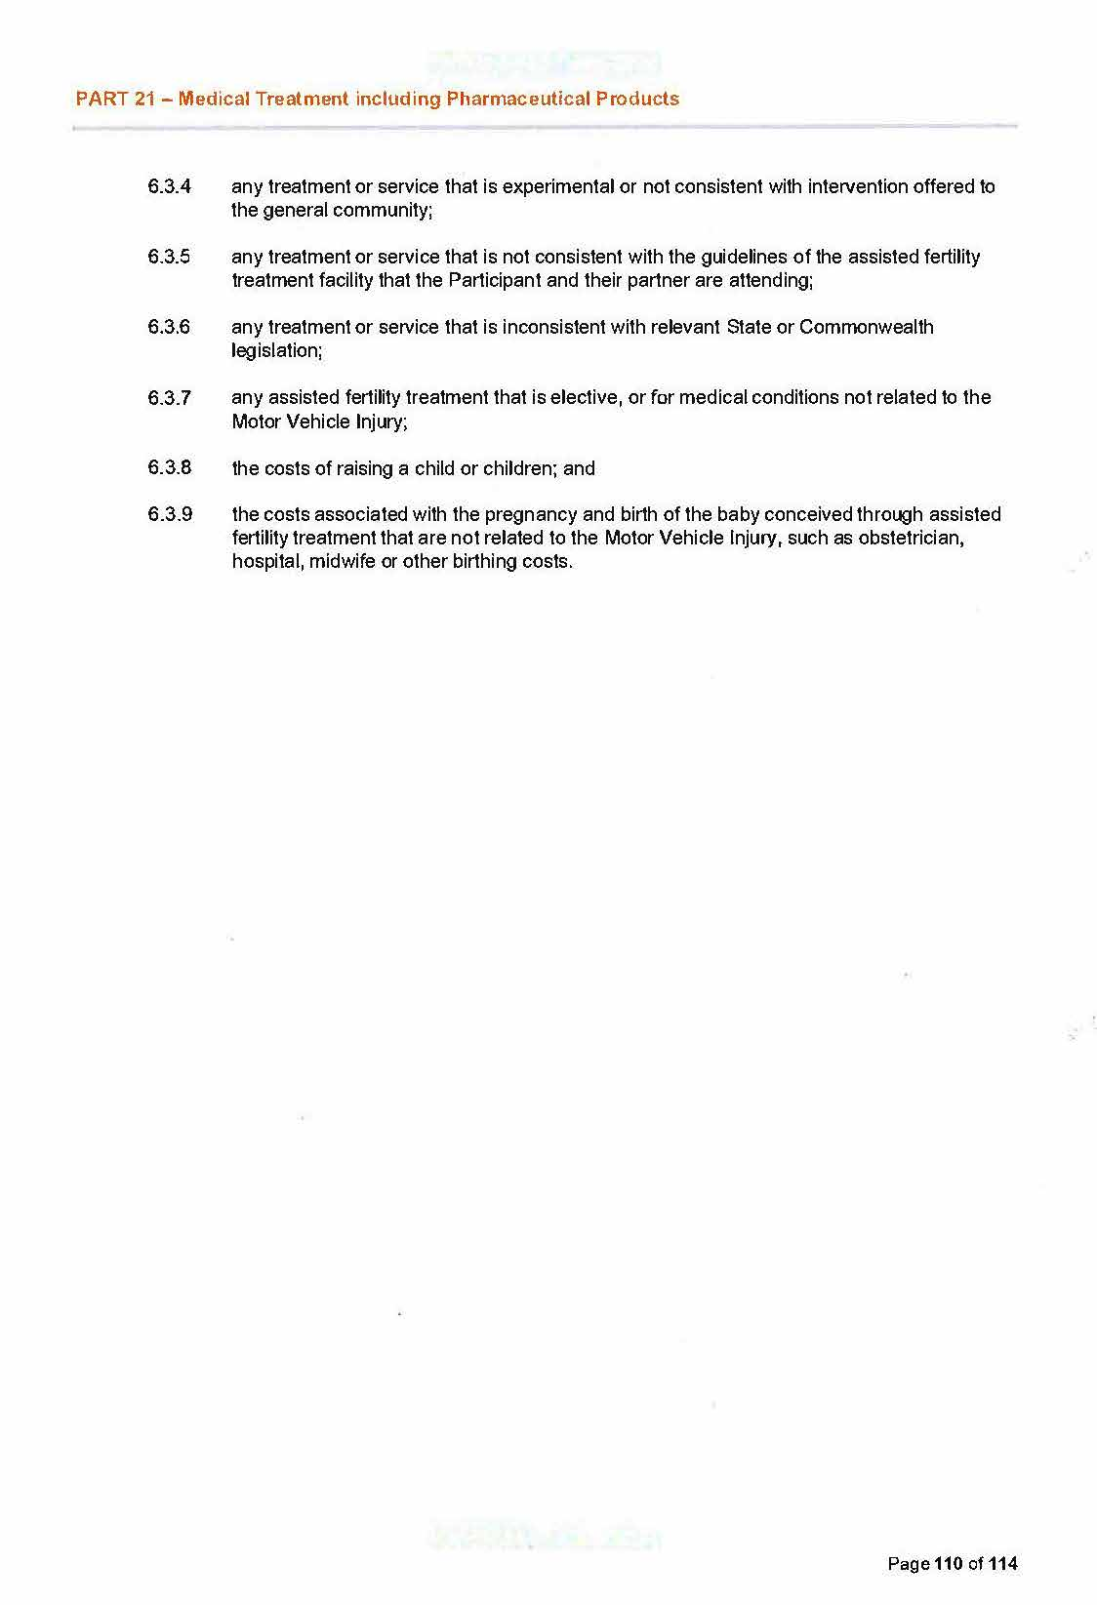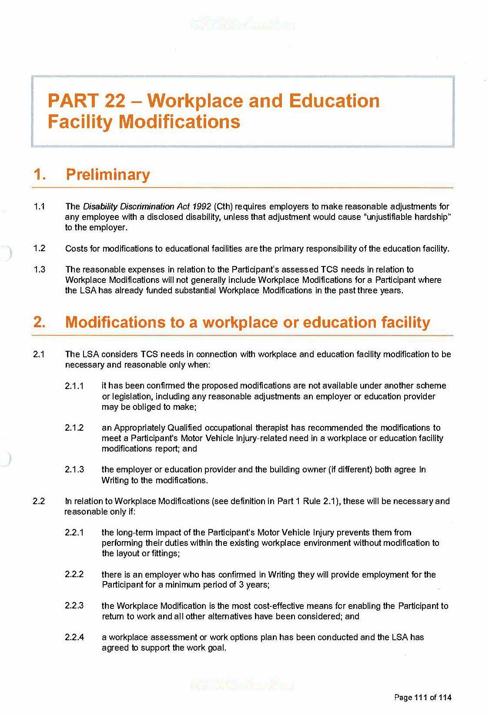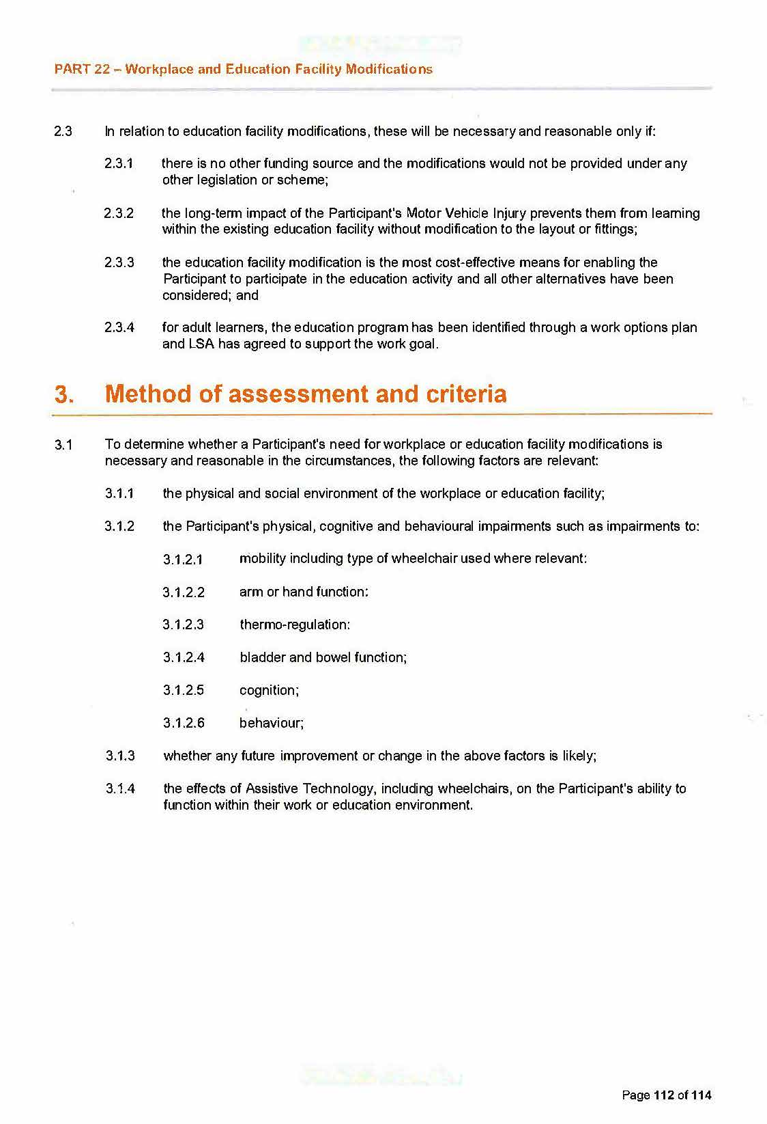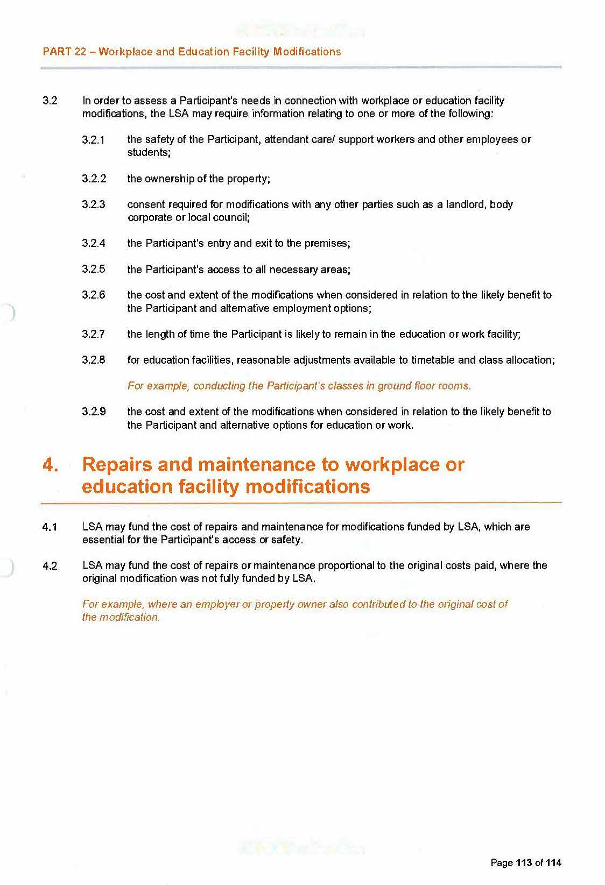

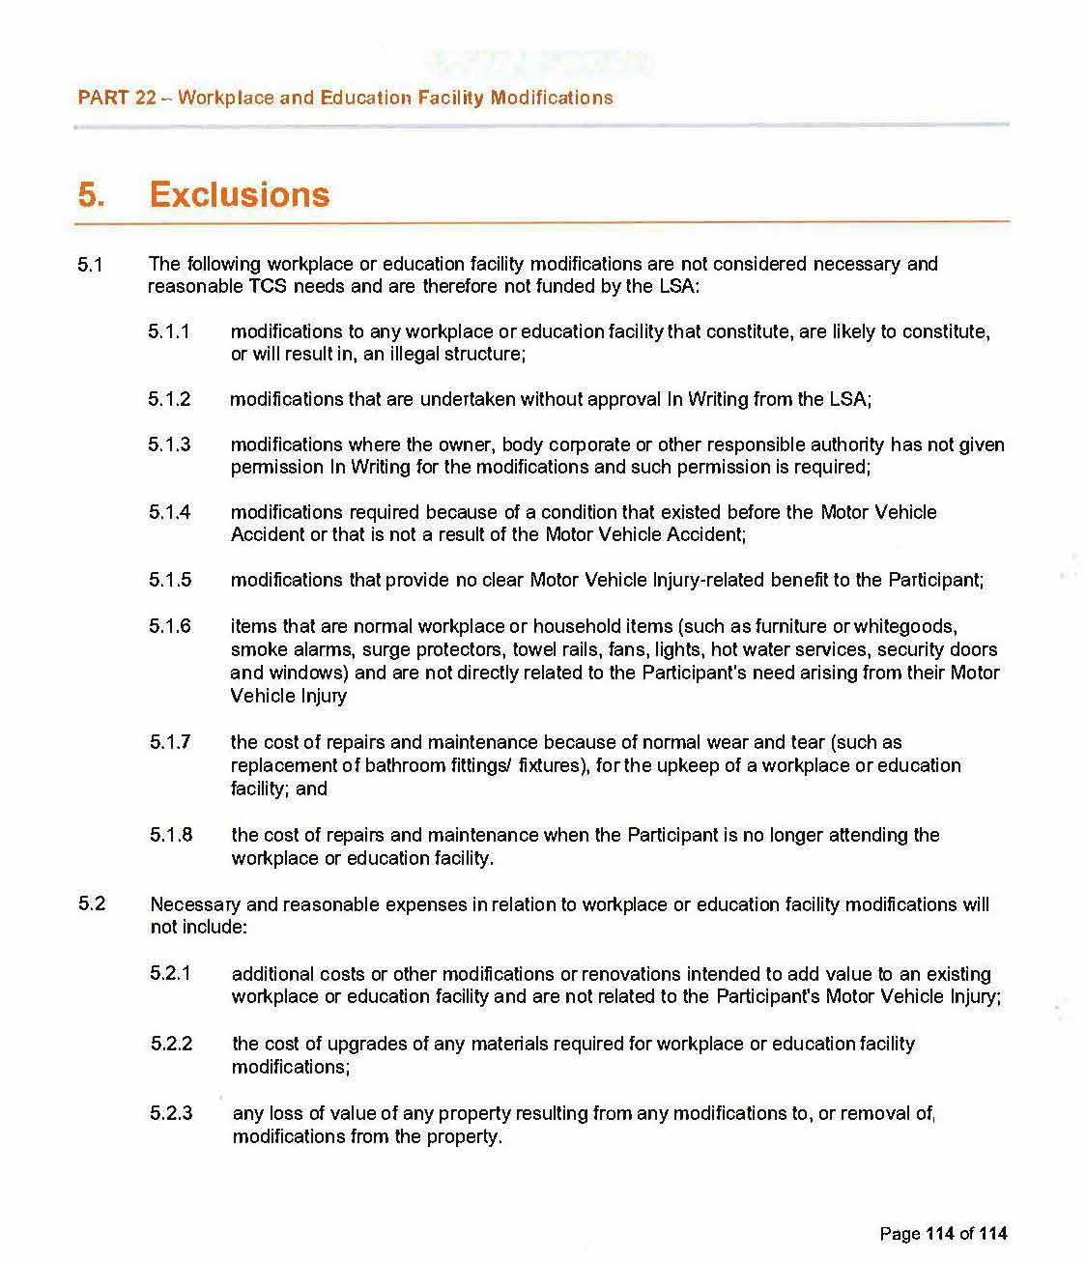

All instruments appearing in this gazette are to be considered official, and obeyed as such

Printed and published weekly by authority of C. McArdle, Government Printer, South Australia
$8.15 per issue (plus postage), $411.00 per annual subscription—GST inclusive
Online publications: www.governmentgazette.sa.gov.au

