No. 23 p. 765
THE SOUTH AUSTRALIAN
GOVERNMENT GAZETTE
Published by Authority

Adelaide, Thursday, 6 April 2023

Contents

Governor’s Instruments
Appointments 766
State Government Instruments
Building Work Contractors Act 1995 767
Fisheries Management Act 2007 767
Geographical Names Act 1991 770
Health Care Act 2008 771
Housing Improvement Act 2016 771
Justices of the Peace Act 2005 772
Land Acquisition Act 1969 772
Major Events Act 2013 776
Mental Health Act 2009 780
Mining Act 1971 780
Petroleum and Geothermal Energy Act 2000 780
Road Traffic Act 1961 780
Roads (Opening and Closing) Act 1991 781
Public Notices
Aerodrome Fees Act 1998 783
Trustee Act 1936 784

Governor’s Instruments

APPOINTMENTS
Department of the Premier and Cabinet
Adelaide, 6 April 2023
Her Excellency the Governor in Executive Council has been pleased to appoint the undermentioned to the Adelaide Festival Centre Trust, pursuant to the provisions of the Adelaide Festival Centre Trust Act 1971:
Member: from 6 April 2023 until 5 April 2026
Phillip Robert Martin
By command,
Christopher James Picton, MP
For Premier
23ART0009CS

Department of the Premier and Cabinet
Adelaide, 6 April 2023
Her Excellency the Governor in Executive Council has been pleased to appoint the undermentioned to the Art Gallery Board, pursuant to the provisions of the Art Gallery Act 1939:
Member: from 6 April 2023 until 5 April 2026
Sandra Maaike Jayne Verschoor
Presiding Member: from 6 April 2023 until 5 April 2026
Sandra Maaike Jayne Verschoor
By command,
Christopher James Picton, MP
For Premier
23ART0007CS

Department of the Premier and Cabinet
Adelaide, 6 April 2023
Her Excellency the Governor in Executive Council has approved the remuneration of Justice Brian Ross Martin AO KC, Auxiliary Judge of the Supreme Court, to be equivalent to that of a Puisne Judge of the Supreme Court, in accordance with the remuneration and conditions of service for persons holding appointments as judicial auxiliaries - pursuant to the Judicial Administration (Auxiliary Appointments and Powers) Act 1988.
By command,
Christopher James Picton, MP
For Premier
AGO0053-23CS

Department of the Premier and Cabinet
Adelaide, 6 April 2023
Her Excellency the Governor in Executive Council has confirmed and signed the Deed of Agreement, to vary the terms of the Joint Scheme between the Minister for Education, Training and Skills, Minister for Recreation, Sport and Racing and the City of Charles Sturt in relation to the St Clair Recreation Ground, Woodville - pursuant to section 7 of the Recreation Grounds (Joint Schemes) Act 1947.
By command,
Christopher James Picton, MP
For Premier
ME23-013

State Government Instruments

Building Work Contractors Act 1995
Exemption
TAKE notice that, pursuant to section 45 of the Building Work Contractors Act 1995, I, Zoe Thomas as a delegate for the Minister for Consumer and Business Affairs, do hereby exempt the licensee named in Schedule 1 from the application of Division 3 of Part 5 of the above Act in relation to domestic building work described in Schedule 2 and subject to the conditions specified in Schedule 3.
Schedule 1
MATTHEW BLACKET- BLD 282094
Schedule 2
Addition of a swimming pool at Allotment 419 in Deposited Plan 6148 being a portion of the land described in Certificate of Title Volume 5650 Folio 677, more commonly known as 2 Lowry Street, Fulham SA 5024.
Schedule 3
1. This exemption is limited to domestic building work personally performed by the licensee in relation to the building work described in Schedule 2.
2. This exemption does not apply to any domestic building work the licensee contracts to another building work contractor, for which that contractor is required by law to hold building indemnity insurance.
3. That the licensee does not transfer his interest in the land prior to five years from the date of completion of the building work the subject of this exemption, without the prior authorisation of Consumer and Business Services (CBS). Before giving such authorisation, CBS may require the licensee to take any reasonable steps to protect the future purchaser(s) of the property, including but not limited to:
• Providing evidence that an adequate policy of building indemnity insurance is in force to cover the balance of the five-year period from the date of completion of the building work the subject of this exemption;
• Providing evidence of an independent expert inspection of the building work the subject of this exemption;
• Making an independent expert report available to prospective purchasers of the property;
• Giving prospective purchasers of the property notice of the absence of a policy of building indemnity insurance.
Dated: 2 April 2023
Zoe Thomas
Assistant Director, Licensing
Delegate for the Minister for Consumer and Business Affairs

Fisheries Management Act 2007
Section 115
Ministerial Exemption: ME9903248
TAKE NOTICE that pursuant to section 115 of the Fisheries Management Act 2007, Mr Keith Maguire of the South Australian Museum, North Terrace, Adelaide, South Australia, (the “exemption holder”), or a person acting as his agent, is exempt from sections 70, 71(1)(b) and 71(2) of the Fisheries Management Act 2007; and regulations 5, 6(1)(a) and 10; and clauses 39(a), 42, 74, 96, 97, 113 and 116 of Schedule 6 and Schedule 7 of the Fisheries Management (General) Regulations 2017, but only insofar as the exemption holder will not be guilty of an offence when conducting research activities that include the taking of voucher specimens of specified marine and freshwater fish and invertebrates for the purposes of maintaining museum collections (“exempted activity”) in the waters described in Schedule 1, using the gear specified in Schedule 2, subject to the conditions specified in Schedule 3, from 31 March 2023 until 30 March 2024, unless varied or revoked earlier.
Schedule 1
South Australian State waters, including intertidal “rocky” reefs and the waters of the Adelaide Dolphin Sanctuary but excluding Sanctuary and Restricted Access zones of any marine park unless authorised under the Marine Parks Act 2007 and aquatic reserves unless otherwise authorised under the Fisheries Management Act 2007.
Schedule 2
Description of equipment that may be used to undertake the proposed activity:
- 6 bait traps – up to 60x30x30 cm
- Hook and line – 1 line/person
- 1 Plankton net – 0.8 m length, 300 mm diameter, 250 μm mesh
- 1 Cast net – up to 3 m diameter
- 1 Seine net – 16 m, 5 mm mesh
- 1 Dredge – 0.5 m (wide), 0.3 m (high) 0.8 m (long), 10 mm mesh
- Hand-held Aquarium or dab net – 2 per person
- Prawn trawling net – operated by commercial Prawn Fishery Licence Holder.
Schedule 3
- The exemption holder will be deemed responsible for the conduct of all persons conducting the exempted activities under this notice. Any person conducting activities under this exemption must be provided with a copy of this notice, which they must have signed as an indication that they have read and understand the conditions under it.
- The exemption holder or their agent/s may only collect voucher specimens of the following species:
  - Teleosts – all life stages
  - Lampreys – all life stages
  - Hagfishes – all life stages
  - Sharks (other than protected species) – all life stages
  - Rays – all life stages
  - Chimaeras – all life stages
  - Marine invertebrates
- All native fish other than those listed and retained consistent with condition 2 must be either returned to the water on completion of scientific evaluation or lodged with the South Australian Museum. All non-native fish must be destroyed and disposed of appropriately.
- A maximum of ten marine macro invertebrate and 100 micro invertebrate specimens per species may be collected and kept pursuant to this exemption from each sampling location.
- A maximum of five teleost, lamprey, hagfish, shark, ray or chimaera specimens per species may be collected and kept pursuant to this exemption from each sampling location, except for species listed in clause 63, 64 and 65 of Schedule 6 of the Fisheries Management (General) Regulations 2017 where the daily bag and boat limits shall apply.
- The specimens collected by the exemption holder or his agent/s are to be used for scientific purposes only and must not be sold.
- The nominated agents of the exemption holder are the following staff of the South Australian Museum:
  - Dr Andrea Crowther
  - Dr Rachael King
  - Ms Shirley Sorokin
  - Mr Ralph Foster
  - Dr Terry Bertozzi
  - Dr Matthew Shaw
  - Mr David Muirhead
  - Mr Dan Monceaux
  - Mr Steve Doyle
- The exemption holder or nominated agent may be assisted by 2 other employees or authorised volunteers of the SA Museum when undertaking the exempted activity but only whilst in the presence of the exemption holder or nominated agent and while working under their direction.
- Before conducting the exempted activity, the exemption holder must contact the Department of Primary Industries and Regions (PIRSA) FISHWATCH on 1800 065 522 and answer a series of questions about the exempted activity. You will need to have a copy of your exemption with you at the time of making the call, and be able to provide information about the area and time of the exempted activity, the vehicles and/or boats involved, the number of agents undertaking the exempted activity and other related issues.
- The exemption holder must provide a report in writing detailing the outcomes of the research and the collection of organisms pursuant to this notice to the Executive Director, Fisheries and Aquaculture (GPO Box 1625, ADELAIDE SA 5001) within 14 days of the expiry of this notice giving the following details:
  - the date and time of collection;
  - the description of all species collected, protected species must be clearly identified; and
  - the number of each species collected or
If no collection has occurred pursuant to this exemption, you are required to clarify this in the report.

- While engaging in the exempted activity, the exemption holder must be in possession of a copy of this notice. Such notice must be produced to a Fisheries Officer if requested.
- The exemption holder must not contravene or fail to comply with the Fisheries Management Act 2007 or any regulations made under that Act, except where specifically exempted by this notice.
This notice does not purport to override the provisions or operation of any other Act including, but not limited to, the Marine Parks Act 2007, Adelaide Dolphin Sanctuary Act 2005 and the Agricultural and Veterinary Products (Control of Use) Act 2002. The exemption holder and his agents must comply with any relevant regulations, permits, requirements and directions from the Department for Environment and Water when undertaking activities within a marine park – In particular the prohibition on use of trawl nets in Habitat Protection Zones under regulation 7(3)(e) Marine Parks (Zoning) Regulations 2012.
Dated: 30 March 2023
Prof Gavin Begg
Executive Director, Fisheries and Aquaculture
Delegate of the Minister for Primary Industries and Regional Development

Fisheries Management Act 2007
Section 115
Ministerial Exemption: ME9903251
TAKE NOTICE that pursuant to section 115 of the Fisheries Management Act 2007, Richard Walsh, Floodplain Ecologist, Department for Environment and Water, 28 Vaughan Tce, BERRI SA 5343 (the ‘exemption holder’) and his nominated agent, are exempt from section 70 of the Fisheries Management Act 2007 and Regulation 5, clauses 42 and 74 of Schedule 6, of the Fisheries Management (General) Regulations 2017 but only insofar as the exemption holder or his nominated agent may engage in activities supporting turtle surveys within the waters described in schedule 1, using the gear specified in schedule 2 (the 'exempted activity'), subject to the conditions set out in schedule 3, from 6 April 2023 until 30 June 2023, unless varied or revoked earlier.
Schedule 1
- The waters of Chowilla, Katarapko and Pike Floodplains within the South Australian Riverlands.
Schedule 2
- 20 x rectangular crab traps with dimensions of 850 x 550 x 230 mm, modified with an additional vertical funnel to allow turtles to surface and breathe. Also referred to as cathedral traps.
Schedule 3
- The exemption holder will be deemed responsible for the conduct of all agents undertaking the exempted activities under this notice. Any person conducting activities under this exemption must be provided with a copy of this notice, which they must have signed as an indication that they have read and understand the conditions under it.
- Modified cathedral traps must be fitted with an additional vertical funnel and be removed from the water and cleared every 12 hours.
- Any traps left unattended must be clearly marked with the exemption holder’s name and Ministerial exemption number on a tag if set close to shore or on a 2L buoy if set away from shore.
- All native fish taken pursuant to the exempted activity must be returned to the water in the locations where they were captured.
- All non-native species of fish caught during the exempted activity must be destroyed and disposed of appropriately.
- The following is the nominated agent of the exemption holder:
- Dr Deborah Bower - School of Environmental and Rural Science, University of New England.
- The exemption holder must notify the Department of Primary Industries and Regions (PIRSA) Fishwatch on 1800 065 522 at least 2 hours prior to conducting the exempted activity and answer a series of questions about the exempted activity. The exemption holder will need to have a copy of the exemption notice at the time of making the call and be able to provide information about the area and time of the exempted activity, the vehicles and boats involved, the number of any persons assisting with undertaking the exempted activity and other related questions.
- The exemption holder must provide a written report detailing the outcomes of the collection of organisms pursuant to this notice to PIRSA, Fisheries and Aquaculture, (PIRSA.Ministerialexemptionsandpermits@sa.gov.au) upon completion, giving the following details:
- the date, soak time and location of collection;
- the number of nets or traps used on each date;
- the description of all species surveyed; and
- the number of each species surveyed.
- While engaging in the exempted activity, the exemption holder must be in possession of a copy of this notice. Such notice must be produced to a Fisheries Officer if requested.
- The exemption holder must not contravene or fail to comply with the Fisheries Management Act 2007 or any regulations made under that Act, except where specifically exempted by this notice.
This notice does not purport to override the provisions or operation of any other Act including but not limited to the River Murray Act 2003.
Dated: 5 April 2023
Prof Gavin Begg
Executive Director, Fisheries and Aquaculture
Delegate of the Minister for Primary Industries and Regional Development

Fisheries Management Act 2007
Section 115
Ministerial Exemption: ME9903255
TAKE NOTICE that pursuant to section 115 of the Fisheries Management Act 2007, I Professor Gavin Begg, Executive Director Fisheries and Aquaculture, delegate of the Minister for Primary Industries and Regional Development, hereby exempt Dr Michael Steer, Research Director of Aquatic and Livestock Sciences of the South Australian Research and Development Institute (SARDI) (hereinafter referred to as the “exemption holder”) and scientists and technical staff employed by the Department of Primary Industries and Regions and substantively engaged by SARDI (“agents”) as defined in this notice, are exempt from sections 70, 72(2)(c), 79 and Clauses 63 (1) and (2), of Schedule 6 of the Fisheries Management (General) Regulations 2017 but only insofar as the activities are within the waters specified in Schedule 1 and consistent with activities specified in Schedule 2 (the ‘exempted activity) for the purposes of a Snapper Restocking Program, subject to the conditions specified in Schedule 3, from 1 April 2023 until 30 November 2023, unless varied or revoked.
Schedule 1
In the state waters of Gulf St Vincent of the following index points (GDA94):
- -34.53024444 138.0631667 (Ardrossan Barge)
- Excluding Sanctuary and Restricted Access Zones of any marine park unless otherwise authorised under the Marine Park Act 2007.
Schedule 2
The capture and possession of:
- 40 live adult Snapper (Chrysophrys auratus)
Schedule 3
- The exemption holder will be deemed responsible for the conduct of all persons conducting the exempted activities under this notice. Any person conducting activities under this exemption must be provided with a copy of this notice, which they must have signed as an indication that they have read and understand the conditions under it.
- The exemption holder may undertake the exempted activity in the specified waters notwithstanding the snapper closure declaration made under Section 79 of the Fisheries Management Act 2007, dated 20 January 2023, and published in the South Australian Government Gazette on 25 January 2023 being the first notice published on page 90.
- Any species collected by the exemption holder are for broodstock purposes only and must not be sold. Any specimens not required must be returned to the water immediately.
- Vessels, vehicles and equipment used to undertake the exempted activities under this exemption must be clearly identifiable as belonging to SARDI. Where possible when undertaking the exempted activities, all persons should be clearly identifiable as SARDI staff or affiliates.
- Any species other than Snapper taken incidentally while undertaking the exempted activity must be returned immediately to the water as close as possible to the location where they were captured.
- In conducting the exempted activity, the following boat may be used:
  - MRV Ngerin 24.9m SARDI ID 418994
- Snapper collected pursuant to this notice must not be released into state waters if they have been kept apart from their natural habitat.
- Any equipment used to collect and hold fish during the exempted activity must be decontaminated prior to and after undertaking the exempted activities.
- The exemption holder and agents, whilst engaged in activities pursuant to this exemption, must carry an identification card issued by SARDI.
- At least 1 hour before conducting activities under this exemption, the exemption holder or nominated agent must contact the Department of Primary Industries and Regions (PIRSA) Fishwatch on 1800 065 522 and answer a series of questions about the exempted activity. The exemption holder will need to have a copy of this notice in their possession at the time of making the call and be able to provide information about the area and time of the exempted activity, the vehicles and/or boats involved, the number of permit holders undertaking the exempted activity and other related questions.
- The exemption holder must provide a report in writing detailing the activities carried out pursuant to this notice to the Executive Director, Fisheries and Aquaculture (GPO Box 1625, ADELAIDE SA 5001) 10 days after each research trip is completed with the following details:
  - The date and location of the activity;
  - The gear used;
  - The number and description of all species collected;
  - Any inaction with protected species and marine mammals; and
  - Any other information or anything deemed relevant or of interest that is able to be volunteered.
- While engaging in the exempted activity, the exemption holder or nominated agents must be in possession of a copy of this exemption. Such exemption must be produced to a PIRSA Fisheries Officer, if requested.
- The exemption holders must not contravene or fail to comply with the Fisheries Management Act 2007, or any regulations made under the Act, except where specifically exempted by this notice.
This notice does not purport to override the provisions or operation of any other Act including, but not limited to, the Marine Parks Act 2007 and the National Parks and Wildlife Act 1972. The exemption holder and his agents must comply with any relevant regulations permits, requirements and directions from the Department for Environment and Water when undertaking activities within a marine or national park.
Dated: 31 March 2023
Prof Gavin Begg
Executive Director, Fisheries and Aquaculture
Delegate of the Minister for Primary Industries and Regional Development

GEOGRAPHICAL NAMES ACT 1991
Notice to Alter the Boundary and Assign a Name to a Place
Notice is hereby given that, pursuant to Section 11B(1)(b) of the Geographical Names Act 1991, I, the Honourable Nick Champion MP, Minister for Planning, Minister of the Crown to whom the administration of the Geographical Names Act 1991 is committed, do hereby:
- Alter the suburb boundary to exclude from the suburb of HACKHAM that area marked (A) shown highlighted in red, as shown on the location map.
- Assign the name ONKAPARINGA HEIGHTS to that area marked (A).
This notice is to take effect immediately upon its publication in the Government Gazette.
This naming proposal can be viewed at:
• the Office of the Surveyor-General, 83 Pirie Street, Adelaide
• www.sa.gov.au/placenameproposals
Dated: 27 March 2023
Hon Nick Champion MP
Minister For Planning
DTI 2022/16795/01

Map
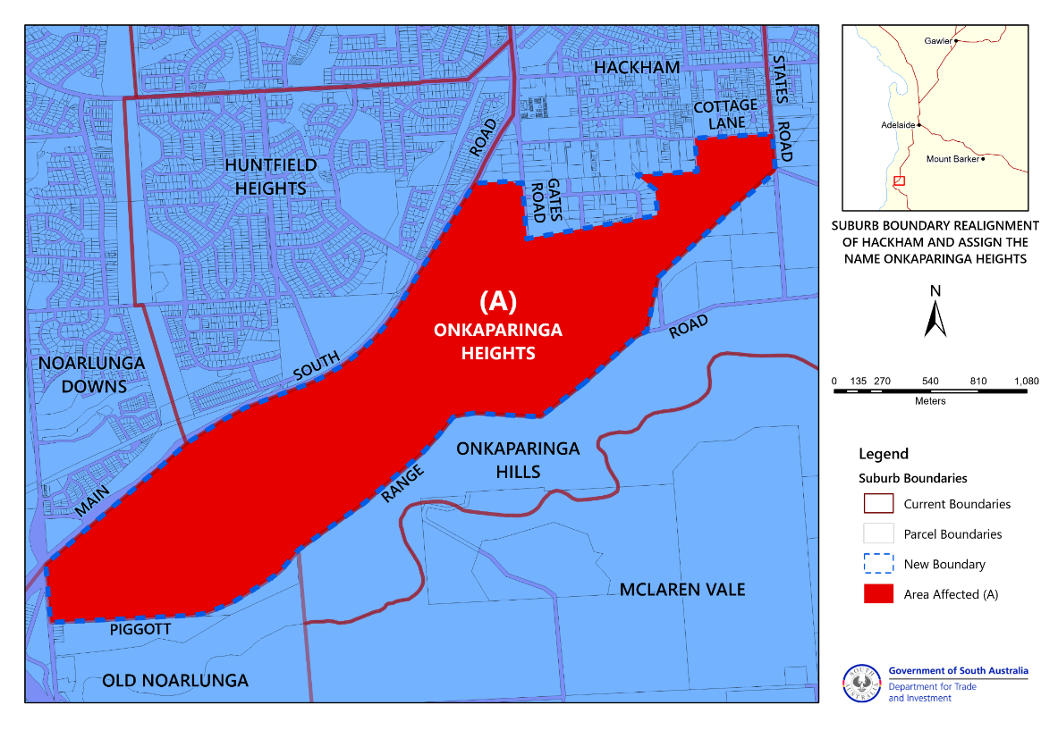

HEALTH CARE ACT 2008
Declaration of Authorised Quality Improvement Activity and Authorised Person under Section 64
Notice by the Minister
TAKE notice that I, Christopher James Picton, Minister for Health and Wellbeing, pursuant to sections 64 (1) (a) (i) and (b) (i) do hereby:
DECLARE the Activities described in the Schedule to this declaration (the Activities) to be authorised quality improvement activities to which Part 7 of the Act applies, and
DECLARE the Person or group of Persons (including a group formed as a committee) described in the Schedule to this declaration (the Persons) to be an authorised entity for the purposes of carrying out the authorised quality improvement activities to which Part 7 of the Act applies,
being satisfied that:
    - the performance of the activities within the ambit of the declaration and the functions or activities of the person or group of persons within the ambit of the declaration, would be facilitated by the making of the declaration; and
    - that the making of the declaration is in the public interest.
Dated: 4 April 2023
Christopher James Picton
Minister for Health and Wellbeing

Schedule
Declaration of Authorised Quality Improvement Activity and Authorised Person under Section 64
ACTIVITY | PERSON OR GROUP OF PERSONS
Review and analysis of causes of Maternal and Perinatal Mortality and Serious Morbidity | South Australian Maternal and Perinatal Mortality Committee
Review and analysis of causes of Maternal Mortality and serious Morbidity | South Australian Maternal Mortality Subcommittee
Review and analysis of causes of Perinatal Mortality and Serious Morbidity | South Australian Perinatal Mortality Subcommittee

Housing Improvement Act 2016
Rent Control Revocations
Whereas the Minister for Human Services Delegate is satisfied that each of the houses described hereunder has ceased to be unsafe or unsuitable for human habitation for the purposes of the Housing Improvement Act 2016, notice is hereby given that, in exercise of the powers conferred by the said Act, the Minister for Human Services Delegate does hereby revoke the said Rent Control in respect of each property.
Address of Premises | Allotment Section | Certificate of Title  Volume/Folio
48 Stirling RD, PORT AUGUSTA SA 5700 | Allotment 270 Filed Plan 185972 Hundred of Davenport | CT5810/91
Dated: 6 April 2023
Craig Thompson
Housing Regulator and Registrar
Housing Safety Authority, SAHA
(Delegate of Minister for Human Services)

Housing Improvement Act 2016
Rent Control Variations
The Minister for Human Services Delegate in the exercise of the powers conferred by the Housing Improvement Act 2016, does hereby vary the rent control notice in respect of each house described in the following table. Variation in the maximum rental per week which shall be payable subject to Section 55 of the Residential Tenancies Act 1995. The varied amount shown in the said table shall come into force on the date of this publication in the Gazette.
Address of Premises | Allotment  Section | Certificate of Title  Volume/Folio | Reason for variation | Maximum Rental per week payable
340 Nelshaby Road, Napperby SA 5540 | Allotment 589 Filed Plan 188721 Hundred of Napperby | CT5407/498 |  | $115.00
Dated: 6 April 2023
Craig Thompson
Housing Regulator and Registrar
Housing Safety Authority, SAHA
(Delegate of Minister for Human Services)

Justices of the Peace Act 2005
Section 4
Notice of Appointment of Justices of the Peace for South Australia
by the Commissioner for Consumer Affairs
I, Dini Soulio, Commissioner for Consumer Affairs, delegate of the Attorney-General, pursuant to Section 4 of the Justices of the Peace Act 2005, do hereby appoint the people listed as Justices of the Peace for South Australia as set out below:
For a period of ten years for a term commencing on 11 April 2023 and expiring on 10 April 2033:
Frank YOUNG
Debra Paula SWAN
Hagen Heinz STEHR
Harinder Pal SINGH
Balbir SINGH
Christopher Cleland SCHACHT
Ross Victor SANDS
Giovanni RAGNELLI
Francis Richard PEPPER
Sophia MATIASZ
Alexander Muir MATHIESON
Rosemary MATHEWS
Patricia Anne MARSHALL
Donald Jack HOPGOOD
Ingrid FLOWER
Tina FELEPPA
Julie Anne DUNCAN
Robert Edwin COX
Christine Janet CHAMBERLAIN
Dated: 30 March 2023
Dini Soulio
Commissioner for Consumer Affairs
Delegate of the Attorney-General

Land Acquisition Act 1969
Section 16
Form 5—Notice of Acquisition
1. Notice of acquisition
The Commissioner of Highways (the Authority), of 83 Pirie Street, Adelaide SA 5000, acquires the following interests in the following land:
Comprising an unencumbered estate in fee simple in that piece of land being the whole of Allotment 33 in Filed Plan 6860 comprised in Certificate of Title Volume 5883 Folio 868.
This notice is given under section 16 of the Land Acquisition Act 1969.
2. Compensation
A person who has or had an interest consisting of native title or an alienable interest in the land that is divested or diminished by the acquisition or the enjoyment of which is adversely affected by the acquisition who does not receive an offer of compensation from the Authority may apply to the Authority for compensation.
2A. Payment of professional costs relating to acquisition (section 26B)
If you are the owner in fee simple of the land to which this notice relates, you may be entitled to a payment of up to $10 000 from the Authority for use towards the payment of professional costs in relation to the acquisition of the land.
Professional costs include legal costs, valuation costs and any other costs prescribed by the Land Acquisition Regulations 2019.
3. Inquiries
Inquiries should be directed to: Petrula Pettas
GPO Box 1533
Adelaide SA 5001
Telephone: (08) 7133 2457
Dated: 4 April 2023
The Common Seal of the COMMISSIONER OF HIGHWAYS was hereto affixed by authority of the Commissioner in the presence of:
Rocco Caruso
Manager, Property Acquisition (Authorised Officer)
Department for Infrastructure and Transport
DIT 2021/13357/01

Land Acquisition Act 1969
Section 16
Form 5—Notice of Acquisition
1. Notice of acquisition
The Commissioner of Highways (the Authority), of 83 Pirie Street, Adelaide SA 5000, acquires the following interests in the following land:
Comprising an unencumbered estate in fee simple in that piece of land being the whole of Allotment 56 in Deposited Plan 1324 comprised in Certificate of Title Volume 5815 Folio 491.
This notice is given under section 16 of the Land Acquisition Act 1969.
2. Compensation
A person who has or had an interest consisting of native title or an alienable interest in the land that is divested or diminished by the acquisition or the enjoyment of which is adversely affected by the acquisition who does not receive an offer of compensation from the Authority may apply to the Authority for compensation.
2A. Payment of professional costs relating to acquisition (section 26B)
If you are the owner in fee simple of the land to which this notice relates, you may be entitled to a payment of up to $10 000 from the Authority for use towards the payment of professional costs in relation to the acquisition of the land.
Professional costs include legal costs, valuation costs and any other costs prescribed by the Land Acquisition Regulations 2019.
3. Inquiries
Inquiries should be directed to: Petrula Pettas
GPO Box 1533
Adelaide SA 5001
Telephone: (08) 7133 2457
Dated: 4 April 2023
The Common Seal of the COMMISSIONER OF HIGHWAYS was hereto affixed by authority of the Commissioner in the presence of:
Rocco Caruso
Manager, Property Acquisition (Authorised Officer)
Department for Infrastructure and Transport
DIT 2021/13572/01

Land Acquisition Act 1969
Section 16
Form 5—Notice of Acquisition
1. Notice of acquisition
The Commissioner of Highways (the Authority), of 83 Pirie Street, Adelaide SA 5000, acquires the following interests in the following land:
Comprising an unencumbered estate in fee simple in that piece of land being the whole of Allotment 6 in Filed Plan 6848 comprised in Certificate of Title Volume 5108 Folio 520.
This notice is given under section 16 of the Land Acquisition Act 1969.
2. Compensation
A person who has or had an interest consisting of native title or an alienable interest in the land that is divested or diminished by the acquisition or the enjoyment of which is adversely affected by the acquisition who does not receive an offer of compensation from the Authority may apply to the Authority for compensation.
2A. Payment of professional costs relating to acquisition (section 26B)
If you are the owner in fee simple of the land to which this notice relates, you may be entitled to a payment of up to $10 000 from the Authority for use towards the payment of professional costs in relation to the acquisition of the land.
Professional costs include legal costs, valuation costs and any other costs prescribed by the Land Acquisition Regulations 2019.
3. Inquiries
Inquiries should be directed to: Rob Gardner
GPO Box 1533
Adelaide SA 5001
Telephone: (08) 7133 2415
Dated: 4 April 2023
The Common Seal of the COMMISSIONER OF HIGHWAYS was hereto affixed by authority of the Commissioner in the presence of:
Rocco Caruso
Manager, Property Acquisition (Authorised Officer)
Department for Infrastructure and Transport
DIT 2022/02733/01

Land Acquisition Act 1969
Section 16
Form 5—Notice of Acquisition
1. Notice of acquisition
The Commissioner of Highways (the Authority), of 83 Pirie Street, Adelaide SA 5000, acquires the following interests in the following land:
First: Portion of the land comprised in Certificate of Title Volume 6259 Folio 643 (being that portion of the free and unrestricted right(s) of way and easements(s) over the land marked “AA” on Deposited Plan 127376 (RTC11892443) appurtenant to Allotment 51 in the said Deposited Plan 127376 that are contained within and form portion of the land identified as Allotment 405 in D129370); and
Secondly: Portion of the land comprised in Certificate of Title Volume 6259 Folio 645 (being that portion of the free and unrestricted right(s) of way and easement(s) over the land marked “AA” on Deposited Plan 127376 (RTC11892443) appurtenant to Allotment 53 in the said Deposited Plan 127376 that are contained within and form portion of the land identified as Allotment 405 in D129370); and
Thirdly: Portion of the land comprised in Certificate of Title Volume 6259 Folio 646 (being that portion of the free and unrestricted right(s) of way and easement(s) over the land marked “AA” on Deposited Plan 127376 (RTC11892443) appurtenant to Allotment 54 in the said Deposited Plan 127376 that are contained within and form portion of the land identified as Allotment 405 in D129370);
To the intent that the acquired portions of the right(s) of way and easement(s) will merge and be extinguished in the fee simple in the land identified as Allotment 405 in D129370.
This notice is given under section 16 of the Land Acquisition Act 1969.
2. Compensation
A person who has or had an interest consisting of native title or an alienable interest in the land that is divested or diminished by the acquisition or the enjoyment of which is adversely affected by the acquisition who does not receive an offer of compensation from the Authority may apply to the Authority for compensation.
2A. Payment of professional costs relating to acquisition (section 26B)
If you are the owner in fee simple of the land to which this notice relates, you may be entitled to a payment of up to $10 000 from the Authority for use towards the payment of professional costs in relation to the acquisition of the land.
Professional costs include legal costs, valuation costs and any other costs prescribed by the Land Acquisition Regulations 2019.
3. Inquiries
Inquiries should be directed to: William Ridgway
GPO Box 1533
Adelaide SA 5001
Telephone: (08) 7133 2465
Dated: 4 April 2023
The Common Seal of the COMMISSIONER OF HIGHWAYS was hereto affixed by authority of the Commissioner in the presence of:
Rocco Caruso
Manager, Property Acquisition (Authorised Officer)
Department for Infrastructure and Transport
DIT 2020/11312/01

Land Acquisition Act 1969
Section 16
Form 5—Notice of Acquisition
1. Notice of acquisition
The Minister for Infrastructure and Transport (the Authority), of 83 Pirie Street, Adelaide SA 5000, acquires the following interests in the following land:
Comprising the entirety of the right, title, estate or interest of Port Bonython Fuels Pty Ltd, pursuant to an Option Agreement between the Minister for Infrastructure (now the Minister for Infrastructure and Transport) and Port Bonython Fuels Pty Ltd dated 21 December 2009, whether as the proprietor of an option to purchase, as licensee and/or otherwise in that piece of land being the whole of Allotment 128 in Deposited Plan 94465 comprised in Certificate of Title Volume 6144 Folio 399 and the appurtenant free and unrestricted right(s) of way over the land marked ‘L’ on DP 94465 (TG 12178979).
This notice is given under section 16 of the Land Acquisition Act 1969.
2. Compensation
A person who has or had an interest consisting of native title or an alienable interest in the land that is divested or diminished by the acquisition or the enjoyment of which is adversely affected by the acquisition who does not receive an offer of compensation from the Authority may apply to the Authority for compensation.
2A. Payment of professional costs relating to acquisition (section 26B)
If you are the owner in fee simple of the land to which this notice relates, you may be entitled to a payment of up to $10 000 from the Authority for use towards the payment of professional costs in relation to the acquisition of the land.
Professional costs include legal costs, valuation costs and any other costs prescribed by the Land Acquisition Regulations 2019.
3. Inquiries
Inquiries should be directed to: Daniel Tuk
GPO Box 1533
Adelaide SA 5001
Telephone: (08) 7133 2479
Dated: 30 March 2023
Hon. Stephen Mullighan MP
Treasurer
As delegate for the Minister for Infrastructure and Transport
DIT 2022/07406/01

Land Acquisition Act 1969
Section 16
Form 5—Notice of Acquisition
1. Notice of acquisition
The Commissioner of Highways (the Authority), of 83 Pirie Street, Adelaide SA 5000, acquires the following interests in the following land:
Firstly, comprising an unencumbered estate in fee simple in that piece of land being portion of Allotment comprising Pieces 4 and 5 in Filed Plan 139706 comprised in Certificate of Title Volume 5259 Folio 972, and being the whole of the land identified as Allotments 28 and 29 in D131810 lodged in the Lands Titles Office.
Secondly, comprising an unencumbered estate in fee simple in that piece of land being portion of Section 386 in Hundred of Goyder in the area named Nantawarra comprised in Certificate of Title Volume 5259 Folio 976, and being the whole of the land identified as Allotment 27 in D131810 lodged in the Lands Titles Office.
This notice is given under section 16 of the Land Acquisition Act 1969.
2. Compensation
A person who has or had an interest consisting of native title or an alienable interest in the land that is divested or diminished by the acquisition or the enjoyment of which is adversely affected by the acquisition who does not receive an offer of compensation from the Authority may apply to the Authority for compensation.
2A. Payment of professional costs relating to acquisition (section 26B)
If you are the owner in fee simple of the land to which this notice relates, you may be entitled to a payment of up to $10 000 from the Authority for use towards the payment of professional costs in relation to the acquisition of the land.
Professional costs include legal costs, valuation costs and any other costs prescribed by the Land Acquisition Regulations 2019.
3. Inquiries
Inquiries should be directed to: Chris Southam
GPO Box 1533
Adelaide SA 5001
Telephone: (08) 7133 2472
Dated: 5 April 2023
The Common Seal of the COMMISSIONER OF HIGHWAYS was hereto affixed by authority of the Commissioner in the presence of:
Rocco Caruso
Manager, Property Acquisition (Authorised Officer)
Department for Infrastructure and Transport
DIT 2022/06869/01

Land Acquisition Act 1969
Section 16
Form 5—Notice of Acquisition
1. Notice of acquisition
The Commissioner of Highways (the Authority), of 83 Pirie Street, Adelaide SA 5000, acquires the following interests in the following land:
Comprising an unencumbered estate in fee simple in that piece of land being portion of Allotment 105 in Deposited Plan 44128 comprised in Certificate of Title Volume 5319 Folio 623, and being the whole of the land identified as Allotment 37 in D131818 lodged in the Lands Titles Office.
This notice is given under section 16 of the Land Acquisition Act 1969.
2. Compensation
A person who has or had an interest consisting of native title or an alienable interest in the land that is divested or diminished by the acquisition or the enjoyment of which is adversely affected by the acquisition who does not receive an offer of compensation from the Authority may apply to the Authority for compensation.
2A. Payment of professional costs relating to acquisition (section 26B)
If you are the owner in fee simple of the land to which this notice relates, you may be entitled to a payment of up to $10 000 from the Authority for use towards the payment of professional costs in relation to the acquisition of the land.
Professional costs include legal costs, valuation costs and any other costs prescribed by the Land Acquisition Regulations 2019.
3. Inquiries
Inquiries should be directed to: Chris Southam
GPO Box 1533
Adelaide SA 5001
Telephone: (08) 7133 2472
Dated: 5 April 2023
The Common Seal of the COMMISSIONER OF HIGHWAYS was hereto affixed by authority of the Commissioner in the presence of:
Rocco Caruso
Manager, Property Acquisition (Authorised Officer)
Department for Infrastructure and Transport
DIT 2022/07173/01

Land Acquisition Act 1969
Section 16
Form 5—Notice of Acquisition
1. Notice of acquisition
The Commissioner of Highways (the Authority), of 83 Pirie Street, Adelaide SA 5000, acquires the following interests in the following land:
First: Comprising an unencumbered estate in fee simple in that piece of land being portion of Allotment 4 in Filed Plan 101607 comprised in Certificate of Title Volume 5110 Folio 914, and being the whole of the land identified as Allotment 32 in D131816 lodged in the Lands Titles Office
Secondly: Comprising an unencumbered estate in fee simple in that piece of land being portion of Allotments 5 in Filed Plan 101607 comprised in Certificate of Title Volume 5111 Folio 98, and being the whole of the land identified as Allotment 33 in D131816 lodged in the Lands Titles Office.
This notice is given under section 16 of the Land Acquisition Act 1969.

2. Compensation
A person who has or had an interest consisting of native title or an alienable interest in the land that is divested or diminished by the acquisition or the enjoyment of which is adversely affected by the acquisition who does not receive an offer of compensation from the Authority may apply to the Authority for compensation.
2A. Payment of professional costs relating to acquisition (section 26B)
If you are the owner in fee simple of the land to which this notice relates, you may be entitled to a payment of up to $10 000 from the Authority for use towards the payment of professional costs in relation to the acquisition of the land.
Professional costs include legal costs, valuation costs and any other costs prescribed by the Land Acquisition Regulations 2019.
3. Inquiries
Inquiries should be directed to: Chris Southam
GPO Box 1533
Adelaide SA 5001
Telephone: (08) 7133 2472
Dated: 5 April 2023
The Common Seal of the COMMISSIONER OF HIGHWAYS was hereto affixed by authority of the Commissioner in the presence of:
Rocco Caruso
Manager, Property Acquisition (Authorised Officer)
Department for Infrastructure and Transport
DIT 2022/06870/01

Major Events Act 2013
Section 6B
Declaration of a Major Event
PURSUANT to section 6B of the Major Events Act 2013, I, Hon Zoe Bettison MP, Minister for Tourism declare the 2023 AFL Gather Round – A Festival of Footy to be held from 13 to 16 April 2023 inclusive to be a major event.
By virtue of the provisions of the Major Events Act 2013 (the Act), I do hereby:
- Declare the 2023 AFL Gather Round – A Festival of Footy to be a major event for the purposes of the Act.
- Specify the major event period for the event to be 13 to 16 April 2023 inclusive from 7.00 am on 13 April to midnight on 16 April.
- Declare the major event venues to be:
- Adelaide Oval, Elder Park and Pinky Flat – 13 to 16 April 2023 inclusive shown as the “Event Site” in the map and declare that an area bounded by the northern boundary of North Terrace, King William Road, Kermode Street, Palmer Place (South of Kermode Street), Montefiore Hill and Montefiore Road is a controlled area for the event, shown as “Declared Controlled Area” in the map;
- Norwood Oval – 14 to 16 April 2023 inclusive shown as the “Event Site” in the map and declare that any public place or part of a public place that is within 250 metres from the boundary of the event site is a controlled area for the event, shown as “Declared Controlled Area” in the map;
- Summit Sport and Recreation Park - 15 April 2023 inclusive shown as the “Event Site” in the map and any public place or part of a public place that is within 250 metres from the boundary of the event site is a controlled area for the event, shown as “Declared Controlled Area” in the map.
- Designate the Australian Football League Ltd (ABN 97 489 912 318) to be the event organisers for the event.
- Declare that the following provisions of Part 3 of the Act apply to the event, the major event venue for the event and the controlled area for the event:
  - section 8.
  - section 10.
  - section 11.
  - section 12.
  - section 13.
  - section 14.
- Being satisfied that the title 2023 AFL Gather Round – A Festival of Footy and the logo as it appears below are sufficiently connected with the identity and conduct of the major event, and that the event has commercial arrangements that are likely to be adversely affected by unauthorised use of the title and logo, I hereby declare, pursuant to section 14(1) of the Act, that 2023 AFL Gather Round – A Festival of Footy is an official title and the logo as it appears below is an official logo in respect of the event.
Dated: 3 April 2023
Hon Zoe Bettison MP
Minister for Tourism

Map of Controlled Area in City of Adelaide for 2023 AFL Gather Round—A Festival of Footy
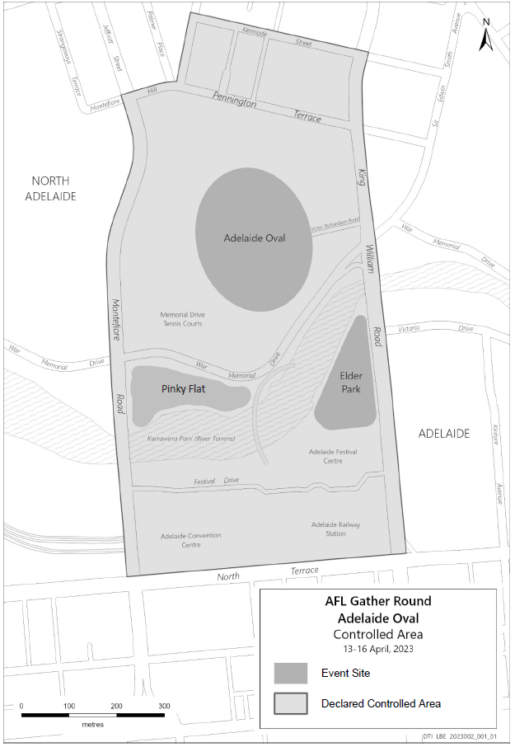

Map of Controlled Area in the City of Norwood Payneham and St Peters for 2023 AFL Gather Round – A Festival of Footy
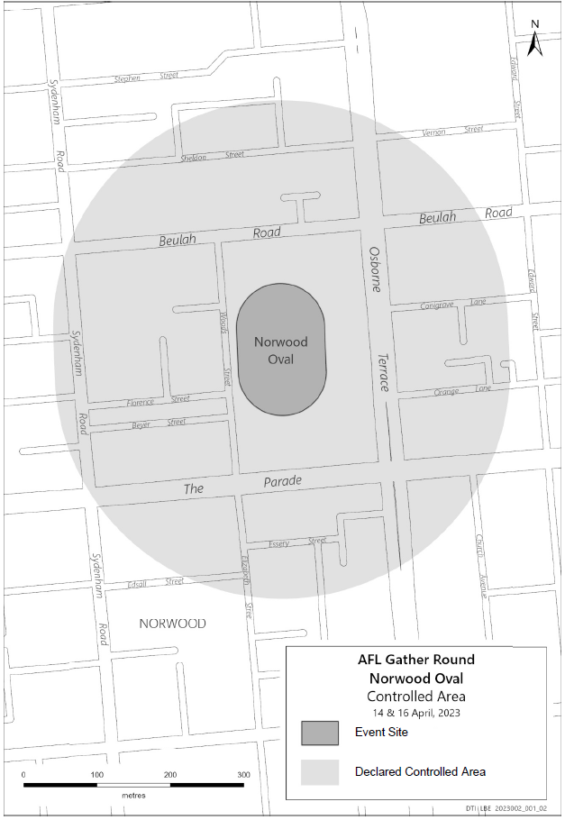

Map of Controlled Area in the Mount Barker District Council for the 2023 AFL Gather Round – A Festival of Footy
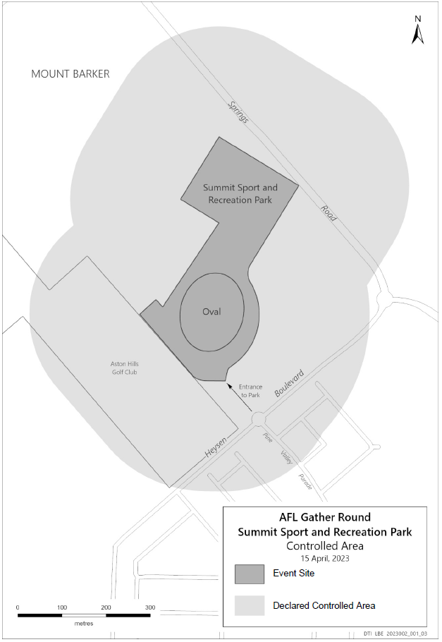

Event Site
Declared Controlled Area

Mental Health Act 2009
Authorised Community Mental Health Facility
Notice is hereby given in accordance with Section 97A of the Mental Health Act 2009, that the Chief Psychiatrist has determined the following place will be an Authorised Community Mental Health Facility from 6 April 2023:
Northgate House (Beachside and Woodland wards), 78-96 Dumfries Avenue, Northgate SA 5085.
Dated: 6 April 2023
Dr John Brayley
Chief Psychiatrist

Mining Act 1971
Section 56H
Application for a Mining Lease
Notice is hereby given in accordance with Section 56H of the Mining Act 1971, that an application for a Mining Lease over the undermentioned mineral claim has been received:
Applicant: A & G Willson Earthmovers (SA) Pty Ltd (ACN 641 331 857)
Claim Number: 4540
Location: CT 5505/836, Wisanger Area, approximately 11km West of Kingscote.
Area: 46.34 hectares approximately
Purpose: Extractive Minerals (Basalt)
Reference: 2021/000218
To arrange an inspection of the proposal at the Department for Energy and Mining, please call the Department on 08 8463 3103.
An electronic copy of the proposal can be found on the Department for Energy and Mining website: https://www.energymining.sa.gov.au/industry/minerals-and-mining/mining/community-engagement-opportunities.
Written submissions in relation to this application are invited to be received at the Department for Energy and Mining, Mining Regulation, Attn: Business Support Officer, GPO Box 320 ADELAIDE SA 5001 or dem.miningregrehab@sa.gov.au by no later than 4 May 2023.
The delegate of the Minister for Energy and Mining is required to have regard to these submissions in determining whether to grant or refuse the application and, if granted, the terms and conditions on which it should be granted.
When you make a written submission, that submission becomes a public record. Your submission will be provided to the applicant and may be made available for public inspection.
Dated: 6 April 2023
C. Andrews
Acting Mining Registrar as delegate for the Minister for Energy and Mining
Department for Energy and Mining

Petroleum and Geothermal Energy Act 2000
Statement of Environmental Objectives
PURSUANT to section 104(1) of the Petroleum and Geothermal Energy Act 2000 (the Act) I, Nick Panagopoulos, A/Executive Director Energy Resources Division, Department for Energy and Mining do hereby publish the following document as having been approved as a statement of environmental objectives under the Act.
Documents:
- Geothermal Resources, Exploration Drillhole Logging, Monitoring, Maintenance, Rehabilitation and Decommissioning Statement of Environmental Objectives, February 2023
This document is available for public inspection on the Environmental Register section of the following webpage - (https://www.petroleum.sa.gov.au/regulation/environmental-register) or at the Public Office determined pursuant to section 107 (1) of the Act to be at:
Energy Resources Division
Customer Services
Level 4
11 Waymouth Street
Adelaide SA 5000
Dated: 4 April 2023
Nick Panagopoulos
A/Executive Director
Energy Resources Division
Department for Energy and Mining
Delegate of the Minister for Energy and Mining

Road Traffic Act 1961
Authorisation to Operate Breath Analysing Instruments
I, GRANT STEVENS, Commissioner of Police, do hereby notify that on and from 27 March 2023, the following persons were authorised by the Commissioner of Police to operate breath analysing instruments as defined in and for the purposes of the:
• Road Traffic Act 1961;
• Harbors and Navigation Act 1993;
• Security and Investigation Industry Act 1995; and
• Rail Safety National Law (South Australia) Act 2012.

PD Number | Officer Name
12464 | BANKS, Jordan Michael
12227 | BRYAN, Samuel Elliott
11133 | BUTLER, Kane Richard
76549 | CUTTING, Leah Margaret
10079 | DANESH, Jalil
74132 | DAWSON, Nicholas David
12376 | LONG, Eric Ge
76673 | PEARCE, Jessica Ann
12249 | RICCIO, Cory Josh
76728 | RYDER, Chantelle Marie
76681 | SAMPSON, Alison Leigh
77193 | TURNER, Levi Benjamin
Dated: 6 April 2023
Grant Stevens
Commissioner of Police
Reference: 2023-0004

Road Traffic Act 1961
Authorisation to Operate Breath Analysing Instruments
I, GRANT STEVENS, Commissioner of Police, do hereby notify that on and from 27 March 2023, the following persons were authorised by the Commissioner of Police to operate breath analysing instruments as defined in and for the purposes of the:
• Road Traffic Act 1961;
• Harbors and Navigation Act 1993;
• Security and Investigation Industry Act 1995; and
• Rail Safety National Law (South Australia) Act 2012.
PD Number | Officer Name
14618 | WINTER, Adam James
Dated: 6 April 2023
Grant Stevens
Commissioner of Police
Reference: 2014-0265

Roads (Opening and Closing) Act 1991
Section 24
NOTICE OF CONFIRMATION OF ROAD
PROCESS ORDER
Road Closure—Boundary Road, Solomontown and Coonamia
By Road Process Order made on 15 February 2023, the Port Pirie Regional Council ordered that:
- Portions of Allotment 440 in Filed Plan 188572 and Allotment 439 in Filed Plan 188571, Solomontown, Hundred of Pirie, more particularly delineated and numbered ‘1’ and ‘2’ (respectively) in Preliminary Plan 22/0004 be opened as road.
- Portion of Boundary Road, Solomontown and Coonamia, situated adjoining Allotment 439 in Filed Plan 188571, Hundred of Pirie, more particularly delineated and lettered ‘A’ in Preliminary Plan 22/0004 be closed.
- Transfer the whole of the land subject to closure to Viterra Operations Pty Ltd (ACN: 007 556 256) in accordance with the Agreement for Exchange dated 5 August 2022 entered into between the Port Pirie Regional Council and Viterra Operations Pty Ltd (ACN: 007 556 256).
On 30 March 2023 that order was confirmed by the Minister for Planning, conditionally upon the deposit by the Registrar-General of Deposited Plan 130715 being the authority for the new boundaries.
Pursuant to Section 24 of the Roads (Opening and Closing) Act 1991, NOTICE of the Order referred to above and its confirmation is hereby given.
Dated: 6 April 2023
B. J. Slape
Surveyor-General
2022/02692/01

Roads (Opening and Closing) Act 1991
Section 24
NOTICE OF CONFIRMATION OF ROAD
PROCESS ORDER
Road Closure—Caloote Shack Road, Caloote
By Road Process Order made on 25 October 2022, the Mid Murray Council ordered that:
- Portion of Caloote Shack Road, Caloote, situated adjoining Allotment 49 in Deposited Plan 52017, Hundred of Finniss, more particularly delineated and lettered ‘A’ in Preliminary Plan 22/0022 be closed.
- Transfer the whole of the land subject to closure to Barry John Kappler and Michelle Ann Kappler in accordance with the Agreement for Transfer dated 2 October 2022 entered into between the Mid Murray Council and Barry John Kappler and Michelle Ann Kappler.
On 30 March 2023 that order was confirmed by the Minister for Planning conditionally upon the deposit by the Registrar-General of Deposited Plan 131623 being the authority for the new boundaries.
Pursuant to section 24(5) of the Roads (Opening and Closing) Act 1991, NOTICE of the Order referred to above and its confirmation is hereby given.
Dated: 6 April 2023
B. J. Slape
Surveyor-General
2022/05109/01

Public Notices

Aerodrome Fees Act 1998
Adelaide Airport Ltd (AAL)
Schedule of Aeronautical Fees, Effective 1 July 2023
The prices shown in this Schedule are inclusive of GST.
This Schedule of Aeronautical Fees (Schedule) is published pursuant to and in accordance with both the Aerodrome Fees Act 1998 (SA) and the ‘Adelaide Airport Terms of Use’ (as amended from time to time) (Terms of Use) (which document is available on the Adelaide Airport website). This Schedule sets out the fees payable for an Aircraft’s use of Adelaide Airport in the absence of any other agreement to which AAL has agreed in writing.
Arrival Fees and Departure Fees—Per Passenger Basis
SERVICE | Landing Fee  (A) | Terminal Fee  (B) | Terminal Expansion Fee (C) | Government Mandated Fee  (D) | Total  (A + B + C + D)
INTERNATIONAL PASSENGER TRANSPORT SERVICES
Arrival Fee (other than Transit or Transfer) | $16.31 | $4.64 | $14.22 | $0.00 | $35.17
Departure Fee (other than Transit or Transfer) | $16.31 | $4.64 | $14.22 | $10.43 | $45.60
Arrival Fee (Transit) | $8.16 | $2.32 | $7.11 | $0.00 | $17.59
Departure Fee (Transit) | $8.16 | $2.32 | $7.11 | $8.42 | $26.01
Arrival Fee (Transfer) | $16.31 | $4.64 | $14.22 | $0.00 | $35.17
Departure Fee (Transfer) | $16.31 | $4.64 | $14.22 | $10.43 | $45.60
DOMESTIC PASSENGER TRANSPORT SERVICES
Arrival Fee (other than Transit) | $8.67 | $4.64 |  | $0.00 | $13.31
Departure Fee (other than Transit) | $8.67 | $4.64 |  | $5.48 | $18.79
Arrival Fee (Transit) | $8.67 | $4.64 |  | $0.00 | $13.31
Departure Fee (Transit) | $8.67 | $4.64 |  | $5.48 | $18.79
REGIONAL RPT SERVICES
Arrival Fee | $5.08 | $0.46 |  | $0.00 | $5.54
Departure Fee | $5.08 | $0.46 |  | $5.48 | $11.02
Arrival Fees—MTOW Basis
SERVICE | Fee per 1,000kg MTOW | Minimum Fee
ARRIVAL FEE FOR DIVERSIONS
Arrival Fee—International Passenger Transport Services | $14.09 | $0.00
Arrival Fee—Domestic Passenger Transport Services | $10.46 | $0.00
Arrival Fee—Freight Diversions | $9.55 | $0.00
GENERAL AVIATION
Arrival Fee—Freighter | $9.55 | $0.00
Arrival Fee—Fixed wing Aircraft (excluding RPT Operations) | $9.55 | $55.87
Arrival Fee—Rotary wing Aircraft and unpowered aircraft | $4.79 | $27.91
Parking Fees (for Aircraft) (see note iv)
SERVICE | Fee
Code A (< 2 hours) | $0.00
Code A, per day (>2 hours) | $20.83
Code B or C (< 2 Hours) | $0.00
Code B or C, per day (> 2 Hours) | $141.92
Code D or E (<2 Hours) | $283.83
Code D or E, per day (> 2 Hours) | $567.66
Code F or greater (< 2 hours) | $476.82
Code F or greater, per day (>2 hours) | $953.67
Notes
- Unless the context otherwise requires or a capitalised term is otherwise defined, capitalised terms in this document have the meaning given to them in the Terms of Use.
- Infants and Positioning Crew are excluded from all Arrival Fees and Departure Fees if calculated on a per Passenger basis.
- All amounts are quoted inclusive of GST and in AUD. Calculations of GST exclusive amounts must be made to four decimal places.
- Aircraft Codes for Parking Fees are as defined in Table 4.01 (4) of the Part 139 (Aerodromes) Manual of Standards 2019 as published at legislation.gov.au.
Adelaide Airport Limited
ABN 78 075 176 653
1 James Schofield Drive, Adelaide Airport SA 5950
www.adelaideairport.com.au

Trustee Act 1936
Public Trustee
Estates of Deceased Persons
In the matter of the estates of the undermentioned deceased persons:
BESENYEI Barnabas late of 66 Nelson Road Valley View of no occupation who died 19 October 2022
COLLINS Joseph Robert late of 5 Baker Avenue Port Vincent Retired Telecom Estimator who died 7 May 2022
De CAUX Olive May late of 15 Halliday Street Risdon Park of no occupation who died 18 December 2022
GERLEC Stanley Raymond late of 11 Clarke Street Elizabeth Vale of no occupation who died 6 August 2022
KREFFL Iris late of 2 Kandahar Crescent Colonel Light Gardens Retired Registered Nurse who died 30 December 2022
McNICOL Ian Victor late of 18 Church Street Penola of no occupation who died 29 December 2022
MOLLER Christopher Brian late of 9 Brenchley Grove Kingswood Retired Educator who died 18 June 2022
PETHERBRIDGE Paul late of 47 King Street Alberton Retired Fitter & Turner who died 4 November 2022
Notice is hereby given pursuant to the Trustee Act 1936, the Inheritance (Family Provision) Act 1972 and the Family Relationships Act 1975 that all creditors, beneficiaries, and other persons having claims against the said estates are required to send, in writing, to the office of Public Trustee at GPO Box 1338, Adelaide 5001, full particulars and proof of such claims, on or before the 5 May 2023 otherwise they will be excluded from the distribution of the said estate; and notice is also hereby given that all persons indebted to the said estates are required to pay the amount of their debts to the Public Trustee or proceedings will be taken for the recovery thereof; and all persons having any property belonging to the said estates are forthwith to deliver same to the Public Trustee.
Dated: 6 April 2023
N. S. Rantanen
Public Trustee

Notice Submission

The South Australian Government Gazette is published each Thursday afternoon.
Notices must be emailed by 4 p.m. Tuesday, the week of publication.
Submissions are formatted per the gazette style and a proof will be supplied prior to publication, along with a quote if applicable. Please allow one day for processing notices.
Alterations to the proof must be returned by 4 p.m. Wednesday.

Gazette notices must be submitted as Word files, in the following format:
• Title—the governing legislation
• Subtitle—a summary of the notice content
• Body—structured text, which can include numbered lists, tables, and images
• Date—day, month, and year of authorisation
• Signature block—name, role, and department/organisation authorising the notice

Please provide the following information in your email:
• Date of intended publication
• Contact details of the person responsible for the notice content
• Name and organisation to be charged for the publication—Local Council and Public notices only
• Purchase order, if required—Local Council and Public notices only

Email: governmentgazettesa@sa.gov.au
Phone: (08) 7109 7760
Website: www.governmentgazette.sa.gov.au

All instruments appearing in this gazette are to be considered official, and obeyed as such

Printed and published weekly by authority of M. Dowling, Government Printer, South Australia
$8.15 per issue (plus postage), $411.00 per annual subscription—GST inclusive
Online publications: www.governmentgazette.sa.gov.au

