SUPPLEMENTARY GAZETTE
THE SOUTH AUSTRALIAN
GOVERNMENT GAZETTE
Published by Authority

Adelaide, Thursday, 10 August 2023

Contents

Governor’s Instruments

Regulations—

Harbors and Navigation Regulations 2023—
No. 84 of 2023 2682

Governor’s Instruments

Regulations
South Australia

Harbors and Navigation Regulations 2023
under the Harbors and Navigation Act 1993

Contents
Part 1—Preliminary
1 Short title
2 Commencement
3 Interpretation
4 Incorporation of codes and standards
Part 2—Administration
5 Approvals
6 Exclusion of property from vesting in Minister
Part 3—Exemptions and exclusions from certain provisions of Act
7 Pilotage of Royal Australian Navy vessels
8 Licences for aquatic activities—River Murray, Adelaide Dolphin Sanctuary and marine parks
Part 4—Vessels
9 Determination of length of vessels
Part 5—Restricted areas and restrictions on use of certain waters
10 Restricted areas
11 Special rule in relation to sailing on Port Adelaide River
12 Special rule in relation to swimming etc near Glenelg breakwaters
13 Certain vessels not to be operated in unprotected waters
Part 6—Activities in relation to wharves other than in harbors
Division 1—Preliminary
14 Interpretation
Division 2—General activities
15 Obstructions on wharves
16 Obstruction of landing places
17 Unauthorised activity on wharf
Division 3—Vehicles and pedestrians
18 Application of Division
19 Traffic signs
20 Traffic and other directions
21 Parking signs and markings
22 Removal of vehicles
23 Signs
24 Permits
25 Evidence
Part 7—Harbors and ports
Division 1—Preliminary
26 Interpretation
27 Definition of harbor boundaries
28 Constitution of ports
Division 2—General activities
29 Obstructions on wharves
30 Obstruction of landing places
31 Unauthorised activity on wharf
32 Use of rail trolley
33 Removal of stevedoring gear after use
34 Directions relating to dangerous or objectionable cargo
35 Damage etc caused by cargo
36 Discharge of liquid on wharves
37 Abandoned cargo
38 Unauthorised entry to wharf or contiguous land
39 Watch officers in harbors
40 Tugs
41 Fuel in vehicles etc
42 Operation of motors in cargo spaces
43 Mooring lines in harbors
44 Use of vessel engines in harbors
45 Mooring and unmooring of vessels in certain harbors
46 Swimming in harbors
Division 3—Vehicles and pedestrians
47 Application of Division
48 Traffic signs
49 Traffic and other directions
50 Parking signs and markings
51 Removal of vehicles
52 Signs
53 Permits
54 Evidence
Division 4—Records
55 Notice of entry
56 Certain papers to be produced
57 Notice of leaving
58 Cargo manifests
59 Production of documents relating to cargo
Division 5—Pilotage
60 Licensing of pilots—qualifications
61 Duration of pilot's licence
62 Pilotage exemption certificates
63 Duration and renewal of pilotage exemption certificates
64 Application for pilot's licence or pilotage exemption certificate
65 Replacement licences and certificates
66 Obligations of pilot or master
67 Records to be kept by holder of pilotage exemption certificate
68 Compulsory pilotage
Part 8—Certificates of competency etc
Division 1—Applications under this Part
69 Application for boat operator's licence etc
70 Exemptions from section 47 of Act
71 Requirements for applicants for boat operator's licence
72 Endorsement of boat operator's licence
73 Special permits
74 Issue of temporary boat operator's licence
75 Obligations of holder of boat operator's licence or special permit
76 Replacement boat operator's licence or special permit
Division 2—Recognition of experience and qualifications etc
77 Equivalent experience and qualifications etc
78 Recognition of other qualification as equivalent of certificate of competency
Part 9—Registration, hull identification numbers and Australian Builders Plates
Division 1—Preliminary
79 Interpretation
Division 2—Registration
Subdivision 1—Registration of vessels
80 Application for registration
81 Grant of registration
82 Certificate of registration
83 Marking of vessel
84 Transfer of registration
85 Refund of registration fees
86 Replacement certificates of registration
87 Notification of change of name or address
Subdivision 2—Temporary registration
88 Temporary registration
Subdivision 3—Cancellation of registration etc
89 Cancellation of registration or temporary registration
90 Return of certificate of registration
Subdivision 4—Exemptions from requirement that vessel be registered
91 Application for exemption
92 Exemptions from requirement to be registered and marked
Subdivision 5—Trade plates
93 Trade plates
94 Return of trade plates, certificates of issue of trade plates or trade plate labels
95 Replacement trade plates, certificates of issue of trade plates or trade plate labels
Subdivision 6—Hull identification numbers (HIN)
96 Interpretation
97 Fixing HIN plates to vessels
98 Unauthorised removal of a HIN plate
99 Appointment of boat code agents
100 Boat code examiners
101 Adding letters and numbers to HIN
102 Forming a HIN into the fabric of a vessel
103 Interim boat code certificate
104 Boat code certificate
105 Register of HINs and vessels
Subdivision 7—Australian Builders Plate
106 Interpretation
107 Vessels to which Part 9 Division 4 of Act applies
108 Australian Builders Plate
109 Certain vessels declared to be constructed before commencement of section 64B of the Act
110 Modification of ABP Standard
Part 10—Safety
Division 1—Equipment and marking requirements
111 Equipment and marking requirements
112 Emergency position indicating radio beacons (EPIRBs)
Division 2—General rules of navigation
113 Navigation at sea
114 Navigation in inland waters
115 Navigation in rivers and channels
Division 3—Speed restrictions
116 Speed restrictions
Division 4—Lifejackets and miscellaneous provisions
117 Lifejackets to be worn on certain vessels
118 Personal watercraft must display approved notice
119 Personal watercraft only to be used during certain hours
120 Means of escape
121 Excess persons on vessel
Division 5—Water skiing and similar activities
122 Obligations of person towed by vessel
123 Obligation of person being towed
124 Obligation of operator of vessel towing a person
125 Obligation of operator of vessel around water skiers etc
126 Operating another vessel too close to person being towed
Division 6—Diving signals
127 Signals when divers working
Division 7—Fishing nets and set lines
128 Interpretation
129 Mesh nets and set lines
130 Drop nets, drum nets, hoop nets and shrimp traps
131 Positioning of fishing apparatus
132 Offence of using fishing apparatus contrary to this Division
Division 8—Rules for certain bridges
133 Birkenhead Bridge
134 Port River Expressway Bridges
135 Exemptions
136 Hindmarsh Island Bridge
137 Jervois Bridge
138 Kingston Bridge
139 Paringa Bridge
Division 9—Miscellaneous
140 Vessels excluded from vicinity of oil rigs
141 Vessels excluded from vicinity of vessels engaged in transfer of petroleum
142 Vessels excluded from vicinity of transhipment points in Spencer Gulf
143 Nuisance
144 Use of spotlights
145 Emissions and discharges
146 Work involving flame or flash
147 Misuse of signals
148 Smoking and use of combustion equipment in vicinity of hold
149 Anchors not to be used in certain areas
150 General defence
Part 11—Accidents
151 Minor accidents involving vessels need not be reported
152 Particulars required in accident report
Part 12—Boat havens
153 Interpretation
154 Moorings not to be laid without approval
155 Permit to moor vessel in boat haven
156 Cancellation of permits
157 Orders
158 Removal of vessel and disposal of vessel if unclaimed
Part 13—Facilities Fund
159 Facilities levy
160 Boating facility advisory committee
Part 14—Miscellaneous
161 Discharging ballast water prohibited in specified waters
162 Directions relating to ballast water
163 Court of Marine Enquiry assessors
164 False statements
165 Signs
166 Waiver, remission and reduction of fees and payment in instalments
Schedule 1—Smooth and partially smooth waters
Part 1—Smooth waters
Part 2—Partially smooth waters
Schedule 2—Operational areas for restricted vessels
Schedule 3—Definition of harbor boundaries
Schedule 4—Ports
Schedule 5—Restricted areas
Part 1—Identification of restricted areas
1 Identification of restricted areas
Part 2—Identification of controls
2 Identification of controls
Part 3—Controls applying in particular areas
3 Controls applying in particular areas
4 Non-application of controls to certain vessels in Angas Inlet
5 Non-application of controls to certain vessels in Glenelg Area 3 and West Beach Area 2
6 Non-application of controls to certain vessels at Henley Beach
7 Non-application of controls to certain vessels in Lake Bonney (South East)
8 Non-application of controls to certain vessels in Murray Bridge Area 2
9 Non-application of controls to certain vessels at Port Bonython, Port Stanvac and Whyalla
10 Non-application of controls to certain vessels in Thistle Island Areas 1 and 2
11 Non-application of controls to certain vessels in Yankalilla Bay
12 Expiry of certain provisions relating to Yankalilla Bay
Schedule 6—Structural equipment and marking requirements for vessels
1 Hatches and exterior doors
2 No open exhausts
3 Compliance plate—maximum load
4 Life saving appliances, fire appliances and miscellaneous equipment
5 Exemptions from requirement for appliances and equipment
6 Minimum standard of equipment
7 Placement of equipment
8 Buoyancy requirements for certain vessels
Schedule 7—Speed restrictions in certain waters
1 7 knot limit—all vessels
2 4 knot limit—all vessels
3 4 knot limit—personal watercraft
Schedule 8—Vessels without compliance plate—maximum number of persons
1 Maximum number of persons that may be carried on vessel that does not have compliance plate
Schedule 9—Boat havens
Schedule 10—Notice requirements
Schedule 11—Fees and levies
1 Interpretation
2 Fees and levies payable to CE
3 Dishonoured cheque or debit card or credit card transactions
4 Facilities levy
5 Fees
Schedule 12—Expiation fees
1 Expiation of alleged offences
2 Expiation fees
Schedule 13—Repeal of Harbors and Navigation Regulations 2009
1 Repeal of Harbors and Navigation Regulations 2009

Part 1—Preliminary
1—Short title
These regulations may be cited as the Harbors and Navigation Regulations 2023.
2—Commencement
These regulations come into operation on 1 September 2023.
3—Interpretation
(1) In these regulations—
Act means the Harbors and Navigation Act 1993;
certificate of registration, in relation to a vessel, means—
(a) a certificate of registration issued in respect of the vessel under regulation 82; or
(b) in the case of a vessel registered in another jurisdiction—a corresponding certificate or other document issued in respect of the vessel by the marine authority of that jurisdiction,
(and a reference to a certificate of registration will be taken to include, if the context permits, a reference to a replacement certificate of registration issued under these regulations);
channel, in relation to a harbor, means an area within the harbor regularly used as a course for vessels entering, leaving or moving within the harbor;
coast station means a shore-based facility—
(a) approved by the Minister for the purposes of communications by radio with vessels and maintaining a radio watch; or
(b) approved by the Minister by notice in the Gazette for the purposes of this definition;
Code means the Uniform Shipping Laws Code endorsed by the Australian Transport Council, as in force from time to time;
container means a crate, box, tank, flat or cylinder that is designed and constructed—
(a) for continuous use as an adjunct to cargo handling and transportation; and
(b) to facilitate the transportation of goods from the place at which they are packed to the place at which they are to be unpacked without the need for the goods to be unloaded from or reloaded into the crate, box, tank, flat or cylinder; and
(c) to facilitate transportation by means of more than 1 mode of transport; and
(d) with devices so as to enable it to be readily handled between 1 mode of transport and another; and
(e) to carry a load the volume of which is at least 1 cubic metre;
EPIRB means an emergency position indicating radio beacon;
fishing apparatus means an implement, apparatus, device or substance for taking or facilitating the taking of an aquatic resource (within the meaning of the Fisheries Management Act 2007);
gross tonnage means—
(a) in relation to a commercial vessel that is registered by a marine authority of the Commonwealth or a State or a Territory of the Commonwealth—the gross tonnage specified in the vessel's certificate of registration; or
(b) in relation to a commercial vessel that is not so registered—the amount of measured tonnage calculated in accordance with the International Convention on Tonnage Measurements of Ships 1969 as set out in the Navigation Act 2012 of the Commonwealth;
identification mark, in relation to a vessel that is registered under these regulations, means the identification mark assigned to the vessel under regulation 83;
Note—
A HIN on a HIN plate affixed to a vessel in accordance with Part 9 Division 2 Subdivision 6 is not an identification mark within the meaning of this definition.
inland waters means navigable waterways or bodies of water in the State excluding any waters within the ebb and flow of the tide;
ISO means an International Standard, published by the International Organization for Standardization, as in force from time to time;
kiteboard means a vessel (being a surfboard or similar item) propelled by a kite tethered to the vessel or the operator of the vessel;
lifejacket level 50 means a lifejacket that complies with any of the following requirements:
(a) AS 4758.1:2022: Lifejackets—General requirements in relation to a lifejacket classified as providing level 50 buoyancy;
(b) AS 4758.1:2015: Lifejackets—General requirements in relation to a lifejacket classified as providing level 50 buoyancy;
(c) AS 4758.1—2008: Personal flotation devices—General requirements in relation to a lifejacket classified as providing level 50 buoyancy;
(d) until 31 December 2024—Lifejacket Type—2 AS 1499—1996, as in force on 1 January 2008;
(e) European Standard EN393-1993 Lifejackets-50N, as in force from time to time;
(f) ISO 12402-5, as in force from time to time;
(g) any other standard or specification approved by the CE by notice in the Gazette for the purposes of this paragraph;
lifejacket level 50S means a lifejacket that complies with any of the following requirements:
(a) AS 4758.1:2022: Lifejackets—General requirements in relation to a lifejacket classified as providing level 50 special purpose (50S) buoyancy;
(b) AS 4758.1:2015: Lifejackets—General requirements in relation to a lifejacket classified as providing level 50 special purpose (50S) buoyancy;
(c) AS 4758.1—2008: Personal flotation devices—General requirements in relation to a lifejacket classified as providing level 50 special purpose (50S) buoyancy;
(d) until 31 December 2024—Lifejacket Type—3 AS 2260—1996, as in force on 1 January 2008;
(e) any other standard or specification approved by the CE by notice in the Gazette for the purposes of this paragraph;
lifejacket level 100 or above means—
(a) a lifejacket that complies with any of the following requirements:
(i) AS 4758.1:2022: Lifejackets—General requirements in relation to a lifejacket classified as providing level 100 or level 150 buoyancy (or more);
(ii) AS 4758.1:2015: Lifejackets—General requirements in relation to a lifejacket classified as providing level 100 or level 150 buoyancy (or more);
(iii) AS 4758.1—2008: Personal flotation devices—General requirements in relation to a lifejacket classified as providing level 100 or level 150 buoyancy (or more);
(iv) until 31 December 2024—Lifejackets—Type 1 AS 1512—1996, as in force on 1 January 2008;
(v) appendix R of section 10 of the Code;
(vi) European Standard EN399-1993 Lifejackets-275N, as in force from time to time;
(vii) European Standard EN396-1993 Lifejackets-150N, as in force from time to time;
(viii) European Standard EN395-1993 Lifejackets-100N, as in force from time to time;
(ix) ISO 12402-2, as in force from time to time;
(x) ISO 12402-3, as in force from time to time;
(xi) ISO 12402-4, as in force from time to time;
(xii) in the case of a lifejacket intended for use—
(A) by adults—Canadian General Standards Board CAN/CGSB-65.11-M88, as in force from time to time;
(B) by children—Canadian General Standards Board CAN/CGSB-65.15-M88, as in force from time to time;
(xiii) Underwriters Laboratories Standards UL1180 Fully inflatable lifejackets, as in force from time to time;
(xiv) New Zealand Standard NZ5823:2001 Type 401, as in force from time to time;
(xv) any other standard or specification approved by the CE by notice in the Gazette for the purposes of this paragraph; or
(b) a lifejacket that complies with the requirements of Australian Maritime Safety Authority Marine Orders Part 25 related to the type of lifejackets required to be carried on Australian registered ships;
long blast means a blast of a whistle approximately 5 seconds in duration;
marine authority means a marine authority of the Commonwealth, a State or a Territory of the Commonwealth or a foreign country recognised by the CE as having authority to issue certificates of competency, certificates of survey or other similar documents;
MF/HF radiotelephony equipment means radiotelephony equipment that operates at medium or high frequency;
moor means to make fast to the shore, a buoy, a jetty or a wharf or to anchor;
motorised canoe or kayak means a canoe or kayak fitted with an electric motor—
(i) manufactured with a capacity of no more than 150 newtons; and
(ii) fitted and maintained to the manufacturer's specifications; and
(iii) containing a power source with a marine grade closed cell 12 volt battery;
National Standard for Commercial Vessels or NSCV means the National Standard for Commercial Vessels endorsed by the Australian Transport Council, as in force from time to time (and includes any standard as in force from time to time referred to in the NSCV);
navigation pass, in relation to a bridge, means the marked channel under the bridge through which vessels are intended to navigate when passing under the bridge;
owner of cargo or goods includes the consignor and consignee of the cargo or goods;
paddle board includes a stand up paddle board;
to park a vehicle includes to leave the vehicle standing;
partially smooth water—the waters specified in Schedule 1 Part 2 are partially smooth waters;
personal watercraft means a device that—
(a) is propelled by a motor; and
(b) has a fully enclosed hull; and
(c) is designed not to retain water if capsized; and
(d) is designed to be operated by a person who sits astride, stands, or kneels on the device,
and includes the device commonly referred to as a jet ski;
planing attitude, in relation to a vessel, means the attitude of the vessel when buoyancy has ceased to be its sole support and a proportion of its weight is supported by the dynamic lift resulting from the speed of the vessel through the water;
Port River Expressway Bridges means—
(a) the road bridge (including any fendering that forms part of the navigation pass of the bridge); and
(b) the rail bridge (including any fendering that forms part of the navigation pass of the bridge),
constructed as part of the authorised project (within the meaning of the Highways Act 1926) known as the Port River Expressway Project (and a reference to a Port River Expressway Bridge will be taken to be a reference to the road bridge or the rail bridge (as the case requires));
potential speed, in relation to a vessel, means the maximum speed of which the vessel is capable—
(a) when moving through the water under its own power without assistance or hindrance from tide, current or wind; and
(b) when carrying no load apart from an operator and the equipment usually carried on the vessel;
Prevention of Collisions Convention has the same meaning as in the Navigation Act 2012 of the Commonwealth;
protected waters means inland waters other than Lakes Alexandrina and Albert;
qualifying entry voyage, in relation to an application for a pilotage exemption certificate, means a voyage into the harbor (or section of the harbor) in respect of which the application is made to a wharf, mooring or anchorage—
(a) that has been undertaken with a licensed pilot (or a master with a current pilotage exemption certificate for that harbor or section of harbor) on board the vessel; and
(b) that has, in the opinion of the CE (formed after consultation with the relevant port operator), been satisfactorily completed; and
(c) that has been undertaken not more than 1 year before the date on which the application is made;
qualifying exit voyage, in relation to an application for a pilotage exemption certificate, means a voyage out of the harbor (or section of the harbor) in respect of which the application is made from a wharf, mooring or anchorage—
(a) that has been undertaken with a licensed pilot (or a master with a current pilotage exemption certificate for that harbor or section of harbor) on board the vessel; and
(b) that has, in the opinion of the CE (formed after consultation with the relevant port operator), been satisfactorily completed; and
(c) that has been undertaken not more than 1 year before the date on which the application is made;
registered owner of a vessel means a person recorded in the register of vessels as the owner of the vessel;
Editorial Note—
The fact that a person is recorded as the registered owner of a vessel does not, in itself, confer proprietary rights on the person in respect of the vessel.
relevant port operator, in relation to a harbor, means the port operator (if any) operating a port comprising or including the whole or some of the land and waters constituting the harbor;
restricted area means an area of water identified in Schedule 5 Part 1;
repealed regulations means the Harbors and Navigation Regulations 2009;
semi-protected waters means waters inshore of a line 2 nautical miles seaward of the Low Water Mark of a coast or of the banks of Lakes Alexandrina and Albert;
short blast means a blast of a whistle approximately 1 second in duration;
smooth water—the waters specified in Schedule 1 Part 1 are smooth waters;
surveyor means a surveyor accredited or otherwise recognised under the Marine Safety (Domestic Commercial Vessel) National Law;
underway, in relation to a vessel, means that the vessel is not moored or aground;
unprotected waters means waters offshore of a line 2 nautical miles seaward of the Low Water Mark of a coast or of the banks of Lakes Alexandrina and Albert;
V distress sheet means a sheet of material—
(a) that is not less than 1.8 m by 1.2 m in size; and
(b) that is fluorescent orange-red in colour; and
(c) on which is displayed the letter V in black, the V being not less than 0.8 m in height and the strokes forming the V being not less than 130 mm in breadth;
VHF FM radiotelephony equipment means radiotelephony equipment that operates at very high frequency using frequency modulation;
whistle means any sound signalling device capable of producing the sound signals required by these regulations.
(2) For the purposes of these regulations, a reference in the Code or the NSCV to the Authority will be taken to be a reference to the CE.
(3) For the purposes of these regulations, a reference to a vessel of a particular class is a reference to a vessel of that class as defined in Part B of the NSCV.
(4) For the purposes of these regulations, unless the contrary intention appears, a reference to a harbor includes a reference to a port.
(5) For the purposes of these regulations, vessels will be regarded as in sight of one another only when 1 can be observed visually from the other.
(6) For the purposes of these regulations, a reference to a particular Australian Standard will, unless the contrary intention appears, be taken to be a reference to that standard as in force from time to time.
(7) For the purposes of these regulations, a requirement to wear a lifejacket will be taken to include a requirement that the device be of an appropriate size and properly adjusted for the person who is wearing, or will be wearing the lifejacket.
(8) For the purposes of these regulations, a reference to a lifejacket will, in relation to a lifejacket worn or required to be worn by a child—
(a) less than 12 years of age; or
(b) weighing less than 40 kg,
be taken not to include a reference to a lifejacket that is designed to be inflated manually.
(9) For the purposes of these regulations, a requirement that a person wear, or that a vessel be equipped with, a lifejacket will, in the case of a lifejacket that is designed to inflate automatically on immersion, or to be inflated by the use of a gas cylinder that forms part of the lifejacket, and that has been so inflated, be taken to include a requirement that—
(a) the lifejacket has been serviced in accordance with the manufacturer's instructions; and
(b) has not been inflated since being so serviced.
(10) For the purposes of these regulations, a requirement that a vessel be equipped, for each person on the vessel, with a lifejacket will be taken to include a requirement that the device be of an appropriate size for the wearer and properly adjusted.
(11) For the purposes of the definitions of semi-protected waters and unprotected waters, a reference to a coast will be taken to be a reference to—
(a) the coast of the mainland; and
(b) the coast of Kangaroo Island.
(12) For the purposes of paragraph (b) of the definition of crew in section 4(1) of the Act, an observer (as contemplated by regulation 122(5)) in a vessel towing a person is declared to be a member of the vessel's crew.
4—Incorporation of codes and standards
(1) A copy of a code or standard referred to or incorporated in these regulations must be kept available for inspection by members of the public, without charge and during normal office hours, at the head office in Adelaide of the department.
(2) If an expression used in a provision of a code or standard referred to or incorporated in these regulations is not defined in the Act or in these regulations, the expression has, for the purposes of these regulations, the meaning (if any) assigned by the code or standard.
(3) If a provision of a code or standard is referred to or incorporated in these regulations, any other code or standard that is incorporated into, or referred to in, that provision is also incorporated in these regulations to the extent necessary to give effect to that provision.
Part 2—Administration
5—Approvals
(1) An application for an approval of the CE or a port operator under these regulations must be made in a manner and form determined by the CE or port operator (as the case requires).
(2) An applicant under this regulation must provide to the CE or port operator such information and records as the CE or port operator reasonably requires.
(3) An approval given by the CE or a port operator for the purposes of these regulations—
(a) must be in writing or, if given orally, must be confirmed in writing as soon as practicable; and
(b) may be subject to such conditions as are specified by the CE or port operator (including a condition fixing a fee to be paid to the CE or port operator); and
(c) may be varied or revoked by the CE or port operator (as the case requires) at any time.
(4) If the CE or a port operator gives approval subject to a condition, the person to whom approval is given must not contravene the condition.
Maximum penalty: $5 000.
(5) In any legal proceedings, a certificate apparently signed by the CE or a port operator certifying an approval or lack of approval under these regulations is, in the absence of proof to the contrary, proof of the matter certified.
6—Exclusion of property from vesting in Minister
For the purposes of section 15(3)(c) of the Act, the following real property is excluded from the ambit of that section:
(a) all subjacent land underlying, and land adjacent to—
(i) the River Murray upstream of the sea mouth; and
(ii) all lakes, lagoons and channels connected with the River Murray;
(b) all subjacent land underlying, and land adjacent to—
(i) the Onkaparinga River upstream of the seaward boundary of the area of the City of Onkaparinga; and
(ii) all lakes, lagoons and channels connected with the Onkaparinga River;
(c) all subjacent land underlying, and land adjacent to—
(i) the Patawalonga Creek upstream of the seaward boundary of the area of the City of Holdfast Bay; and
(ii) all lakes, lagoons and channels connected with the Patawalonga Creek;
(d) all subjacent land underlying, and land adjacent to, the Glenelg River in the Hundred of Caroline, County of Grey;
(e) all subjacent land underlying, and land adjacent to, any other inland waters except Lake Butler;
(f) the land adjacent to the seashore situated above the High Water Mark in the Hundreds of Copley, Gillen, Jenkins and Cultana from the south-eastern corner of the Government Town of Port Augusta West to the southern boundary of the Hundred of Cultana.
Part 3—Exemptions and exclusions from certain provisions of Act
7—Pilotage of Royal Australian Navy vessels
Section 35 of the Act does not apply in relation to vessels belonging to the Royal Australian Navy.
8—Licences for aquatic activities—River Murray, Adelaide Dolphin Sanctuary and marine parks
Pursuant to section 26(2c) of the Act, the following categories of licence are excluded from the operation of section 26(2a) of the Act:
(a) a licence for an event that will not involve a motorised vessel (including any support vessel or vessels);
(b) a licence for an event where only the support vessel or vessels will be motorised and the number of such motorised support vessels will not exceed 2;
(c) a licence for an event where not more than 2 motorised vessels involved in the event will be operated at any particular time, and the number of motorised support vessels (if any) will not exceed 2;
(d) a licence for an event where not more than 5 motorised vessels involved in the event will be operated at any particular time on waters that form part of the River Murray in circumstances where it is proposed that, when the vessels are on the River Murray, they will be spread over at least 2 km of the river, and the number of motorised support vessels (if any) will not exceed 2.
Part 4—Vessels
9—Determination of length of vessels
(1) Pursuant to section 4(3) of the Act, the length of a vessel is to be determined as follows:
(a) in the case of a commercial vessel—in accordance with Part B of the NSCV;
(b) in the case of a vessel constructed of pontoons (not being a commercial vessel)—the length of the vessel is the distance along the deck between the foremost transverse deck beam and the aftermost transverse deck beam;
(c) in any other case—the length of the vessel is the distance from the foremost part of the hull to the aftermost part of the hull taken at the upper side of the uppermost weather tight deck or, in the case of an open vessel, at the height of the gunwale.
(2) In this regulation—
aftermost part of the hull means the trailing edge of the shell plating, planking or other structural material or, in the case of stem bars or posts, the intersection of the outside of the shell plating or planking with the stern bar or post but excluding, in all cases, any member added to the exterior of the hull (for example a fender, sponson or rubbing strip);
foremost part of the hull means the leading edge of the shell plating, planking or other structural material or, in the case of bar stems or stem posts, the intersection of the outside of the shell plating or planking with the stem bar or post but excluding, in all cases, any member added to the exterior of the hull (for example a fender, sponson or rubbing strip).
Part 5—Restricted areas and restrictions on use of certain waters
10—Restricted areas
(1) A person who, without the approval of the CE, contravenes, in a restricted area, a control applying in the area under Schedule 5 is guilty of an offence.
Maximum penalty: $1 250.
(2) It is a defence to a charge of an offence against subregulation (1) if the defendant proves that they were taking part in—
(a) a rescue operation or otherwise acting in an emergency; or
(b) a surf lifesaving activity conducted by a surf lifesaving club.
(3) If a vessel is involved in the commission of an offence against subregulation (1), the owner of the vessel is also guilty of an offence.
Maximum penalty: $1 250.
(4) It is a defence to a charge of an offence against subregulation (3) if the owner proves that the vessel was operated in the manner constituting the offence without the owner's consent.
(5) If an offence against subregulation (1) is constituted of a person being towed by a vessel, the operator of the vessel is also guilty of an offence.
Maximum penalty: $1 250.
(6) This regulation does not apply in relation to an authorised person operating a vessel if—
(a) the authorised person is acting in the course of official duties; and
(b) in the circumstances, the authorised person is taking reasonable care.
11—Special rule in relation to sailing on Port Adelaide River
(1) A person must not, without the approval of the CE, operate a vessel under sail power alone in the waters of the Port Adelaide River—
(a) west of the Birkenhead Bridge; or
(b) in No 1 Dock.
Maximum penalty: $1 250.
(2) It is a defence to a charge of an offence against subregulation (1) for the defendant to prove that the defendant was taking part in a rescue operation or otherwise acting in an emergency.
(3) Without limiting regulation 5, an application for approval under subregulation (1) may be made by an applicant on the applicant's own behalf or on behalf of a group of persons and, if an approval is granted to a group of persons, each member of the group is bound by the conditions (if any) to which the approval is subject.
(4) In this regulation—
No 1 Dock means the waters of the Port Adelaide River east of a line being the prolongation generally south of the western boundary of Piece 118 of Deposited Plan 79638.
Editorial Note—
The following map is provided for convenience of reference only.
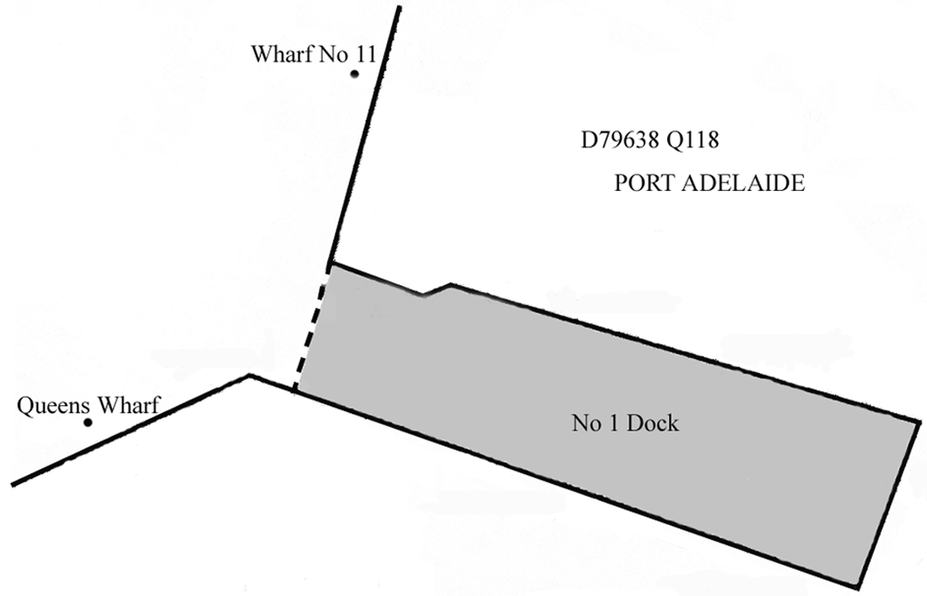
12—Special rule in relation to swimming etc near Glenelg breakwaters
(1) A person must not, without lawful excuse, swim, bathe or dive (including scuba dive) in the waters of Gulf St. Vincent that are within 40 m of any part of—
(a) the northern breakwater or southern breakwater associated with the mouth of the Patawalonga Creek at Glenelg; or
(b) the breakwater located approximately 165 m south-west of the southern breakwater associated with the mouth of the Patawalonga Creek at Glenelg.
Maximum penalty: $1 250.
(2) It is a defence to a charge of an offence against subregulation (1) for the defendant to prove that—
(a) the defendant was taking part in a rescue operation or otherwise acting in an emergency; or
(b) the defendant was taking part in a surf lifesaving activity conducted by a surf lifesaving club.
13—Certain vessels not to be operated in unprotected waters
(1) A person must not, without the approval of the CE, operate a personal watercraft in unprotected waters.
Maximum penalty: $1 250.
(2) It is a defence to a charge of an offence under subregulation (1) for the defendant to prove that the defendant was taking part in a rescue operation or otherwise acting in an emergency.
(3) Without limiting regulation 5, an application for approval under subregulation (1) may be made by an applicant on the applicant's own behalf or on behalf of a group of persons and, if an approval is granted to a group of persons, each member of the group is bound by the conditions (if any) to which the approval is subject.
Part 6—Activities in relation to wharves other than in harbors
Division 1—Preliminary
14—Interpretation
In this Part—
wharf means a wharf under the care, control and management of the Minister that is not within a harbor.
Division 2—General activities
15—Obstructions on wharves
(1) A person must not, without the approval of the CE, place anything on a wharf in a position that is likely to—
(a) obstruct the approaches or any entrance to, or exit from, the wharf; or
(b) obstruct the movement of cargo on, onto or from the wharf; or
(c) impede the free passage of any vehicle or pedestrian on the wharf.
Maximum penalty: $1 250.
(2) If an item is placed on a wharf in contravention of subregulation (1), an authorised person may—
(a) direct—
(i) the owner of the item; or
(ii) the owner or operator of a vessel from which the item has been unloaded or on which the item is to be loaded,
to remove the item from the wharf or to move it to another position on the wharf within a specified time; or
(b) if unable in the circumstances of the particular case to give a direction under paragraph (a) or if a direction is given under that paragraph but the person fails to comply with the direction—remove the item from the wharf or move it to another position on the wharf.
(3) The cost of taking action under subregulation (2)(b) may be recovered as a debt from the owner of the item by the CE.
16—Obstruction of landing places
(1) A person must not, without the approval of the CE, moor a vessel at or near a landing place for longer than—
(a) if the CE has erected a sign regulating mooring at or near the landing place—the period specified by the sign; or
(b) if a direction is given by the CE or an authorised person—the period specified in the direction; or
(c) in any other case—a total of 4 hours in any day.
Maximum penalty: $1 250.
(2) It is a defence to a charge of an offence against subregulation (1) for the defendant to prove that—
(a) the vessel was unable to be safely moved within the time allowed by subregulation (1) because of a mechanical or equipment failure or because of prevailing weather conditions; and
(b) the vessel was moved as soon as it was reasonably practicable to do so.
(3) In this regulation—
landing place means a ramp, public steps, platform or other landing place which is part of or adjacent to a wharf or jetty and gives access from the wharf or jetty to vessels.
17—Unauthorised activity on wharf
A person must not, without the approval of the CE—
(a) undertake any work on a wharf that is not related to the loading or unloading of cargo; or
(b) sort, pack or repair cargo on a wharf; or
(c) place or leave on a wharf anything other than cargo; or
(d) carry on retail trade on a wharf; or
(e) erect or post any notice or advertisement on a wharf; or
(f) damage, remove or interfere with any notice or advertisement on a wharf; or
(g) fish (for any aquatic organism by any means) in contravention of a notice erected on a wharf by the CE or in contravention of a direction of an authorised person; or
(h) light or maintain a fire on a wharf; or
(i) damage or misuse any equipment provided on a wharf for lifesaving or firefighting purposes; or
(j) smoke in or on a structure on a wharf; or
(k) litter a wharf; or
(l) damage a wharf in any manner.
Maximum penalty: $1 250.
Division 3—Vehicles and pedestrians
18—Application of Division
This Division applies in relation to the following places:
(a) all adjacent land vested in the Minister that is not within a harbor;
(b) all wharves, docks, jetties or other structures vested in the Minister that are not within a harbor.
19—Traffic signs
(1) The CE may erect signs on a place to which this Division applies giving directions for any 1 or more of the following purposes:
(a) regulating the route to be followed by vehicles;
(b) prohibiting or regulating the entry, exit or turning of vehicles (including vehicles over a certain mass);
(c) requiring vehicles to be stopped;
(d) requiring certain vehicles to give way to other vehicles;
(e) prohibiting or regulating the parking of vehicles;
(f) imposing speed limits for vehicles;
(g) otherwise regulating vehicular traffic;
(h) prohibiting or regulating pedestrian traffic.
(2) A direction under this regulation may be of general or limited application according to the class of vehicles, drivers or pedestrians to which it applies, the area in which it applies, the circumstances of its application, or any other specified factor.
(3) The CE may issue a permit exempting the holder from directions specified in the permit.
(4) A person who contravenes the directions displayed on a sign erected under this regulation is guilty of an offence unless the person holds a valid permit issued by the CE exempting the person from the directions and the person complied with the terms of the permit.
Maximum penalty: $1 250.
20—Traffic and other directions
(1) An authorised person may, orally or by hand signals, give to any person (whether a driver of a vehicle, a rider of an animal or a pedestrian) on or approaching a place to which this Division applies reasonable directions for the orderly functioning of the place and activities conducted at the place.
(2) An authorised person who suspects on reasonable grounds that a vehicle that exceeds a mass limit imposed in respect of an area is in, or is about to enter, that area may direct the person in charge of the vehicle—
(a) to submit the vehicle immediately for weighing by portable apparatus; or
(b) to take the vehicle by the shortest practicable route to a specified weighbridge.
21—Parking signs and markings
(1) The CE may delineate, by signs or pavement markings or a combination of signs and markings, an area on a place to which this Division applies as an area in which vehicles or vehicles displaying a permit issued by the CE may be parked.
(2) A person must not, without the approval of the CE, park a vehicle on a place to which this Division applies unless—
(a) the vehicle is within an area delineated under this regulation as an area in which vehicles may be parked; or
(b) the vehicle is being loaded or unloaded.
Maximum penalty: $1 250.
(3) A person must not park a vehicle in an area delineated under this regulation as an area in which vehicles displaying a permit issued by the CE may be parked unless a valid permit is displayed in the vehicle and the vehicle is parked in accordance with the terms of that permit.
Maximum penalty: $1 250.
22—Removal of vehicles
(1) If a vehicle is parked in contravention of this Division and an authorised person believes on reasonable grounds that the vehicle is obstructing the proper use of a place to which this Division applies, or that it constitutes a risk to the safety of persons or property, the authorised person may cause the vehicle to be removed to a convenient place (but this does not empower the authorised person to break into the vehicle).
(2) The cost of removing the vehicle may be recovered by the CE as a debt from the owner of the vehicle or the person who parked the vehicle in contravention of this Division.
23—Signs
(1) A sign erected on or in the vicinity of a place to which this Division applies that appears to have been erected for the purposes of this Division will, in the absence of proof to the contrary, be taken to have been erected in accordance with this Division.
(2) A sign erected by the CE, the Minister or the department on or in the vicinity of a place to which this Division applies before the commencement of the repealed regulations will be regarded as having been erected in accordance with this Division.
(3) In determining the meaning of a direction displayed on a sign under this Division, regard must be given to the characteristics of the surrounding physical environment, including any pavement markings.
(4) In a direction displayed on a sign erected under this Division—
maximum axle load, in relation to a vehicle, means the weight of the vehicle (including its load and the weight of the axle and wheels) borne by any axle of the vehicle;
maximum wheel load, in relation to a vehicle, means the weight of the vehicle (including its load) borne by any wheel of the vehicle;
permit means a permit issued by the CE under this Division.
24—Permits
(1) The CE may issue permits for the purposes of this Division subject to such conditions as the CE thinks fit (including a condition fixing a fee to be paid to the CE).
(2) The CE may cancel a permit issued under this Division by written notice to the holder of the permit.
(3) For the purposes of this Division, a permit is displayed in a vehicle only if the permit is displayed on the inside of the windscreen on the side opposite to the driver's position (or, if the vehicle does not have a windscreen, in some other prominent position) so that the permit is easily legible to a person standing beside the vehicle.
(4) An authorised person may require a person apparently acting in a manner for which a permit is required under this Division to produce the permit for inspection immediately or at a specified place and within a specified period.
25—Evidence
In any proceedings for an offence against this Division, an allegation in a complaint—
(a) that a sign or marking was erected or made in accordance with this Division; or
(b) that a specified person was the driver of a specified vehicle at the time of an alleged offence; or
(c) that a specified vehicle was driven or parked in a specified manner or place at a specified time; or
(d) that a specified person held or did not hold a permit under this Division; or
(e) that a specified permit issued under this Division was subject to specified conditions,
will, in the absence of proof to the contrary, be proof of the matters so alleged.
Part 7—Harbors and ports
Division 1—Preliminary
26—Interpretation
In this Part (except Division 3 and Division 4)—
adjacent land means adjacent land under the care, control and management of the Minister or a port operator;
contiguous land means land contiguous to a wharf and under the care, control and management of the Minister or a port operator;
harbor means a harbor, or that part of a harbor, under the care, control and management of the Minister or a port operator;
wharf means a wharf under the care, control and management of the Minister or a port operator that is within a harbor.
27—Definition of harbor boundaries
For the purposes of Schedule 1 of the Act, Schedule 3 defines the boundaries of the harbors referred to in clause 1(1) of that Schedule.
28—Constitution of ports
For the purposes of the definition of port in section 4(1) of the Act, each area of land and water described in Schedule 4 is constituted as a port.
Division 2—General activities
29—Obstructions on wharves
(1) A person must not, without the approval of the CE or the relevant port operator, place anything on a wharf in a position that is likely to—
(a) obstruct the approaches or any entrance to, or exit from, the wharf; or
(b) obstruct the movement of cargo on, onto or from the wharf; or
(c) impede the free passage of any vehicle or pedestrian on the wharf.
Maximum penalty: $1 250.
(2) If an item is placed on a wharf in contravention of subregulation (1), a port management officer may—
(a) direct—
(i) the owner of the item; or
(ii) the owner or operator of a vessel from which the item has been unloaded or on which the item is to be loaded,
to remove the item from the wharf or to move it to another position on the wharf within a specified time; or
(b) if unable in the circumstances of the particular case to give a direction under paragraph (a) or if a direction is given under that paragraph but the person fails to comply with the direction—remove the item from the wharf or move it to another position on the wharf.
(3) The cost of taking action under subregulation (2)(b) may be recovered as a debt from the owner of the item by—
(a) if the port management officer was an officer or employee of the relevant port operator (other than the Minister)—the port operator; or
(b) in any other case—the CE.
30—Obstruction of landing places
(1) A person must not, without the approval of the CE or the relevant port operator, moor a vessel at or near a landing place for longer than—
(a) if the CE or relevant port operator has erected a sign regulating mooring at or near the landing place—the period specified by the sign; or
(b) if a direction is given by the CE, the relevant port operator or a port management officer—the period specified in the direction; or
(c) in any other case—a total of 4 hours in any day.
Maximum penalty: $1 250.
(2) It is a defence to a charge of an offence against subregulation (1) for the defendant to prove that—
(a) the vessel was unable to be safely moved within the time allowed by subregulation (1) because of a mechanical or equipment failure or because of prevailing weather conditions; and
(b) the vessel was moved as soon as it was reasonably practicable to do so.
(3) In this regulation—
landing place means a ramp, public steps, platform or other landing place which is part of or adjacent to a wharf or jetty and gives access from the wharf or jetty to vessels.
31—Unauthorised activity on wharf
A person must not, without the approval of the CE or the relevant port operator—
(a) undertake any work on a wharf that is not related to the loading or unloading of cargo; or
(b) sort, pack or repair cargo on a wharf; or
(c) place or leave on a wharf anything other than cargo; or
(d) carry on retail trade on a wharf; or
(e) erect or post any notice or advertisement on a wharf; or
(f) damage, remove or interfere with any notice or advertisement on a wharf; or
(g) fish (for any aquatic organism by any means) in contravention of a notice erected on a wharf by the CE or the relevant port operator or in contravention of a direction of a port management officer; or
(h) light or maintain a fire on a wharf; or
(i) damage or misuse any equipment provided on a wharf for lifesaving or firefighting purposes; or
(j) smoke in or on a structure on a wharf; or
(k) litter a wharf; or
(l) damage a wharf in any manner.
Maximum penalty: $1 250.
32—Use of rail trolley
(1) A person must not, without the approval of the CE or the relevant port operator, use a trolley except for a purpose connected with the loading or unloading of a vessel or the maintenance of a vessel.
Maximum penalty: $1 250.
(2) A person must not propel a trolley at a dangerous speed or in a dangerous manner.
Maximum penalty: $1 250.
(3) A person who is propelling a trolley must give other persons effective warning of the approach of the trolley.
Maximum penalty: $1 250.
(4) A port management officer may give a person directions in relation to the use of trolleys.
(5) In this regulation—
trolley means a truck or trolley supplied by the Minister or a port operator for use on rails laid on a wharf or contiguous land.
33—Removal of stevedoring gear after use
The operator of a vessel that is being loaded or unloaded on a wharf must ensure that all moveable equipment used in the loading or unloading is removed and stored appropriately on completion of the loading or unloading.
Maximum penalty: $1 250.
34—Directions relating to dangerous or objectionable cargo
If a port management officer suspects on reasonable grounds that particular cargo on a vessel may present, if unloaded on to a wharf, a risk of injury to persons or damage to property, or a nuisance, the port management officer may give directions to the operator or owner of the vessel or the owner of the cargo—
(a) prohibiting the unloading of the cargo on to the wharf; or
(b) prohibiting the storage of the cargo on the wharf; or
(c) regulating the manner in which the cargo is to be unloaded or stored on the wharf.
35—Damage etc caused by cargo
(1) If cargo on a wharf or contiguous land—
(a) causes death or injury to a person; or
(b) causes damage to the wharf or anything on the wharf or contiguous land; or
(c) creates a nuisance or causes offence; or
(d) hinders work on the wharf or contiguous land,
(whether by spillage, leakage or otherwise) the owner of the cargo must—
(e) report the matter to—
(i) if the wharf or contiguous land is within a port—the relevant port operator; or
(ii) in any other case—the CE; and
(f) remove the cargo from the wharf or contiguous land, clean up any spillage and repair any damage to the wharf.
Maximum penalty: $1 250.
(2) If a person fails to take the action required by subregulation (1)(f), a port management officer may take that action.
(3) The cost of taking action under subregulation (2) may be recovered as a debt from the person in default by—
(a) if the port management officer was an officer or employee of a port operator (other than the Minister)—the port operator; or
(b) in any other case—the CE.
36—Discharge of liquid on wharves
The operator of a vessel moored at a wharf must cause a covering to be placed over each outlet on the vessel that is at or above the level of the deck of the wharf so as to prevent any liquid being discharged from the vessel on to the wharf.
Maximum penalty: $1 250.
37—Abandoned cargo
The CE or relevant port operator may take possession of cargo remaining on a wharf or contiguous land for more than 6 months and may deal with the cargo under the Unclaimed Goods Act 1987.
38—Unauthorised entry to wharf or contiguous land
A person must not, without the approval of the CE or the relevant port operator, enter or remain in an area of a wharf or contiguous land to which the Minister or relevant port operator has restricted access by the erection of signs, barriers or by other means.
Maximum penalty: $1 250.
39—Watch officers in harbors
(1) A vessel that is 35 m or more in length and is moored in a harbor must, unless the CE or relevant port operator approves otherwise, have at least 1 person on board for the purposes of communication with the CE, the port operator or a port management officer.
(2) If subregulation (1) is contravened, the master or operator of the vessel is guilty of an offence.
Maximum penalty: $1 250.
40—Tugs
(1) The operator of a tug that is attending a vessel being navigated under the control or at the direction of a licensed pilot must comply with the directions of the pilot.
Maximum penalty: $5 000.
(2) The operator of a tug that is attending a vessel the master of which holds a current pilotage exemption certificate must comply with the directions of that master.
Maximum penalty: $5 000.
41—Fuel in vehicles etc
(1) Cargo consisting of a vehicle, vessel or machine that uses petroleum, or other liquid fuel with a flashpoint below 60°C, must not be carried on a vessel unless each fuel tank of the vehicle, vessel or machine contains less than 50% of its capacity of fuel and is effectively sealed.
(2) Cargo consisting of a vehicle, vessel or machine that uses petroleum, or other liquid fuel with a flashpoint below 60°C, must not be stored on a wharf or adjacent land unless each fuel tank of the vehicle, vessel or machine contains less than 5 litres of fuel and is effectively sealed.
(3) If a vehicle, vessel or machine is carried or stored in contravention of this regulation, the consignor of the vehicle, vessel or machine is guilty of an offence.
Maximum penalty: $1 250.
(4) However, subregulation (3) does not apply to the carriage of a vehicle, vessel or machine on an open deck of—
(a) a ferry; or
(b) a punt that crosses a river or fairway by means of ropes or cables.
(5) A person must not transfer petroleum or other liquid fuel into or out of the tank of a vehicle, vessel or machine—
(a) on a wharf constructed of timber; or
(b) inside a structure on adjacent land under the care, control and management of the Minister or a port operator; or
(c) within 15 m of any such structure; or
(d) within 15 m of any cargo; or
(e) on a vessel or within 15 m of any vessel.
Maximum penalty: $1 250.
(6) Subregulation (5) does not apply to the transfer of petroleum or other liquid fuel into the tank of a vehicle, vessel or machine—
(a) in accordance with any sign erected by the CE or a port operator; or
(b) in accordance with any guidelines published by the CE or the relevant port operator for the purposes of this subregulation.
42—Operation of motors in cargo spaces
A person responsible for the loading or unloading of cargo on a vessel is guilty of an offence if, during the loading or unloading—
(a) an internal combustion engine or electric motor is operated in a cargo space in the vessel in contravention of Appendix 8, Marine Order Part 32—Cargo Handling Equipment under the Navigation Act 2012 of the Commonwealth; or
(b) an internal combustion engine of a mechanical stowing appliance or other vehicle used is fuelled in a cargo space in the vessel in contravention of that Appendix.
Maximum penalty: $2 500.
43—Mooring lines in harbors
(1) The operator of a vessel moored by lines to a wharf or other structure in a harbor must ensure that—
(a) the vessel is safely moored at all times; and
(b) the mooring lines are in good condition and properly adjusted.
Maximum penalty: $1 250.
(2) A person must not, without lawful authority, interfere with a line attached to any vessel, buoy, anchor, mooring, wharf or other structure or device in a harbor.
Maximum penalty: $1 250.
(3) The CE or the relevant port operator may authorise a person to interfere with a line in a manner that would otherwise constitute a contravention of subregulation (2).
44—Use of vessel engines in harbors
(1) The engine of a vessel that is more than 35 m in length and is moored at a wharf in a harbor must not, without the approval of the CE or the relevant port operator—
(a) be interfered with in such a manner that immobilises the vessel to the extent that the vessel cannot be made ready to be underway within 2 hours; or
(b) be operated so as to turn a propeller or propellers.
(2) If the engine of a vessel is interfered with or operated in contravention of subregulation (1), the operator of the vessel is guilty of an offence.
Maximum penalty: $1 250.
45—Mooring and unmooring of vessels in certain harbors
(1) A person must not, unless authorised for the purpose by the CE or the relevant port operator, make fast or let go mooring lines of a vessel moored or to be moored to a wharf in a harbor.
Maximum penalty: $1 250.
(2) This regulation does not apply in relation to the following vessels:
(a) a tug, barge or lighter ordinarily used within a harbor to which this regulation applies;
(b) a vessel with a gross tonnage of less than 1 000 tonnes—
(i) ordinarily employed in trading or going between ports or places in the State; or
(ii) ordinarily used as a pleasure yacht in South Australian waters;
(c) a vessel belonging to the Royal Australian Navy.
(3) Nothing in these regulations prevents a fee being charged for services provided by a person authorised by the CE or the relevant port operator under this regulation.
46—Swimming in harbors
A person must not, without the approval of the CE or the relevant port operator, swim or dive in any harbor—
(a) within 200 m of a vessel that is 15 m or more in length and is arriving or departing from a wharf, mooring or anchorage or is navigating in a channel; or
(b) within 45 m of a vessel that is 15 m or more in length and is moored at a wharf; or
(c) from any portion of a wharf not specifically set aside for entrance of a person into the water.
Maximum penalty: $750.
Division 3—Vehicles and pedestrians
47—Application of Division
This Division applies in relation to the following places:
(a) all adjacent land vested in the Minister that is within a harbor;
(b) all wharves, docks, jetties or other structures vested in the Minister or a port operator that are within a harbor.
48—Traffic signs
(1) The CE or relevant port operator may erect signs on a place to which this Division applies giving directions for any 1 or more of the following purposes:
(a) regulating the route to be followed by vehicles;
(b) prohibiting or regulating the entry, exit or turning of vehicles (including vehicles over a certain mass);
(c) requiring vehicles to be stopped;
(d) requiring certain vehicles to give way to other vehicles;
(e) prohibiting or regulating the parking of vehicles;
(f) imposing speed limits for vehicles;
(g) otherwise regulating vehicular traffic;
(h) prohibiting or regulating pedestrian traffic.
(2) A direction under this regulation may be of general or limited application according to the class of vehicles, drivers or pedestrians to which it applies, the area in which it applies, the circumstances of its application, or any other specified factor.
(3) The CE or the relevant port operator may issue a permit exempting the holder from directions specified in the permit.
(4) A person who contravenes the directions displayed on a sign erected under this regulation is guilty of an offence unless the person holds a valid permit issued by the CE or the relevant port operator exempting the person from the directions and the person complied with the terms of the permit.
Maximum penalty: $1 250.
49—Traffic and other directions
(1) A port management officer may, orally or by hand signals, give to any person (whether a driver of a vehicle, a rider of an animal or a pedestrian) on or approaching a place to which this Division applies reasonable directions for the orderly functioning of the place and activities conducted at the place.
(2) A port management officer who suspects on reasonable grounds that a vehicle that exceeds a mass limit imposed in respect of an area is in, or is about to enter, that area may direct the person in charge of the vehicle—
(a) to submit the vehicle immediately for weighing by portable apparatus; or
(b) to take the vehicle by the shortest practicable route to a specified weighbridge.
50—Parking signs and markings
(1) The CE or relevant port operator may delineate, by signs or pavement markings or a combination of signs and markings, an area on a place to which this Division applies as an area in which vehicles or vehicles displaying a permit issued by the CE or port operator may be parked.
(2) A person must not, without the approval of the CE or the relevant port operator, park a vehicle on a place to which this Division applies unless—
(a) the vehicle is within an area delineated under this regulation as an area in which vehicles may be parked; or
(b) the vehicle is being loaded or unloaded.
Maximum penalty: $1 250.
(3) A person must not park a vehicle in an area delineated under this regulation as an area in which vehicles displaying a permit issued by the CE or the relevant port operator may be parked unless a valid permit is displayed in the vehicle and the vehicle is parked in accordance with the terms of that permit.
Maximum penalty: $1 250.
51—Removal of vehicles
(1) If a vehicle is parked in contravention of this Division and a port management officer believes on reasonable grounds that the vehicle is obstructing the proper use of a place to which this Division applies, or that it constitutes a risk to the safety of persons or property, the port management officer may cause the vehicle to be removed to a convenient place (but this does not empower the port management officer to break into the vehicle).
(2) The cost of removing the vehicle may be recovered as a debt from the owner of the vehicle or the person who parked the vehicle in contravention of this Division by—
(a) if the port management officer was an officer or employee of a port operator (other than the Minister)—the port operator; or
(b) in any other case—the CE.
52—Signs
(1) A sign erected on or in the vicinity of a place to which this Division applies that appears to have been erected for the purposes of this Division will, in the absence of proof to the contrary, be taken to have been erected in accordance with this Division.
(2) A sign erected by the CE, the Minister, the department or a port operator on or in the vicinity of a place to which this Division applies before the commencement of the repealed regulations will be regarded as having been erected in accordance with this Division.
(3) In determining the meaning of a direction displayed on a sign under this Division, regard must be given to the characteristics of the surrounding physical environment, including any pavement markings.
(4) In a direction displayed on a sign erected under this Division—
maximum axle load, in relation to a vehicle, means the weight of the vehicle (including its load and the weight of the axle and wheels) borne by any axle of the vehicle;
maximum wheel load, in relation to a vehicle, means the weight of the vehicle (including its load) borne by any wheel of the vehicle;
permit means a permit issued by the CE or a port operator under this Division.
53—Permits
(1) The CE or relevant port operator may issue permits for the purposes of this Division subject to such conditions as the CE or port operator thinks fit (including a condition fixing a fee to be paid to the CE or port operator).
(2) The CE or relevant port operator may cancel a permit issued under this Division by written notice to the holder of the permit.
(3) For the purposes of this Division, a permit is displayed in a vehicle only if the permit is displayed on the inside of the windscreen on the side opposite to the driver's position (or, if the vehicle does not have a windscreen, in some other prominent position) so that the permit is easily legible to a person standing beside the vehicle.
(4) A port management officer may require a person apparently acting in a manner for which a permit is required under this Division to produce the permit for inspection immediately or at a specified place and within a specified period.
54—Evidence
In any proceedings for an offence against this Division, an allegation in a complaint—
(a) that a sign or marking was erected or made in accordance with this Division; or
(b) that a specified person was the driver of a specified vehicle at the time of an alleged offence; or
(c) that a specified vehicle was driven or parked in a specified manner or place at a specified time; or
(d) that a specified person held or did not hold a permit under this Division; or
(e) that a specified permit issued under this Division was subject to specified conditions,
will, in the absence of proof to the contrary, be proof of the matters so alleged.
Division 4—Records
55—Notice of entry
(1) The owner or operator of a commercial vessel must, as soon as practicable after arrival of the vessel at a port, deliver a notice of entry to the relevant port operator.
Maximum penalty: $1 250.
(2) A notice of entry—
(a) must be made in a manner and form determined by the relevant port operator; and
(b) must be signed by the operator of the vessel.
56—Certain papers to be produced
(1) The operator of a commercial vessel must, at the request of a port management officer, produce the prescribed papers in respect of the vessel to the relevant port operator.
Maximum penalty: $1 250.
(2) Subregulation (1) does not apply in relation to a vessel that trades only within the jurisdiction if the prescribed papers in respect of the vessel have been produced to the relevant port operator in the previous 6 months.
(3) In this regulation—
prescribed papers means—
(a) in the case of an Australian registered vessel—the certificate of survey issued in respect of the vessel; or
(b) the certificate of registration issued in respect of the vessel; or
(c) in the case of a foreign registered vessel—a document issued in respect of the vessel corresponding to a certificate of survey.
57—Notice of leaving
A person must not, without the approval of the relevant port operator, remove a commercial vessel of more than 35 m in length from a wharf, mooring or anchorage in a port.
Maximum penalty: $1 250.
58—Cargo manifests
(1) A manifest relating to cargo unloaded from a commercial vessel in a port must be given to the relevant port operator within 3 days after arrival of the vessel.
(2) A manifest relating to cargo loaded on to a commercial vessel in a port must be given to the relevant port operator within 7 days after departure of the vessel.
(3) A manifest—
(a) must be made in a manner and form determined by the relevant port operator; and
(b) if it is in writing, must be in English and must be legible; and
(c) must include, at least, the following information (given, if the relevant port operator so requires, by reference to codes or descriptions specified by the port operator):
(i) the name of the vessel and the number assigned to the vessel by the International Maritime Organization;
(ii) a description of the voyage being undertaken by the vessel;
(iii) a description of the cargo (including the mass and volume of the cargo) sufficient for the purposes of calculating the charges payable to the port operator in respect of the cargo;
(iv) if the cargo includes a container—
(A) the number, type and dimensions of the container; and
(B) details of the kinds of goods carried in the container; and
(C) the gross weight of the goods carried in the container;
(v) in the case of a container or other cargo unloaded from the vessel in the port—
(A) the port of loading of the container or other cargo; and
(B) the country of origin of the packed container or other cargo; and
(C) if the country of destination of the packed container or other cargo is Australia—the State or Territory of destination; and
(D) if the container or other cargo has been restored on the vessel in the port (with the vessel continuing on the same voyage)—a statement to that effect; and
(E) if the container or other cargo has been or will be transhipped (ie reloaded on a vessel undertaking a different voyage) in the port—a statement to that effect;
(vi) in the case of a container or other cargo loaded onto the vessel in the port (other than a container or cargo that has been unloaded from that vessel and restowed, with the vessel continuing on the same voyage)—
(A) if the container or other cargo has been transhipped (ie unloaded from a vessel undertaking a different voyage and reloaded onto the vessel) in the port—a statement to that effect; and
(B) if the country of origin of the packed container or other cargo is Australia—the State or Territory of origin; and
(C) the port at which it is intended that the container or other cargo will be unloaded; and
(D) the country of destination of the packed container or other cargo; and
(d) must be certified as correct by the operator or owner of the vessel.
(4) Any alteration or correction of a manifest must be notified to the relevant port operator as soon as possible.
(5) If an alteration or correction of a manifest is notified to the relevant port operator when it is not practicable by reason of the movement of the cargo for the alteration or correction to be verified by inspection of the cargo, the alteration need not be taken into account for the purposes of calculating the charges payable to the port operator in respect of the cargo.
(6) If a manifest is not received by the relevant port operator in accordance with this regulation, the charges payable to the port operator in respect of the cargo may be calculated on an estimate by the port operator of the size and nature of the cargo plus 10%.
(7) If a manifest (or an alteration or correction of a manifest) is not given to the relevant port operator in accordance with this regulation, the operator and the owner of the vessel are each guilty of an offence (but it is a defence to a charge of an offence against this regulation if the defendant proves that the defendant could not, by the exercise of reasonable diligence, have prevented the commission of the offence).
Maximum penalty: $1 250.
(8) A person who views a manifest in the course of official duties connected with the administration of the Act must not divulge the contents of that manifest to any person except in the course of those duties.
Maximum penalty: $1 250.
59—Production of documents relating to cargo
(1) The operator or owner of a commercial vessel must, at the request of a port management officer—
(a) produce for inspection and copying all records and documents (including cartnotes, shipping notes and weigh notes) relating to the cargo of that vessel; and
(b) provide the reference number for the bill of lading relating to that cargo.
Maximum penalty: $1 250.
(2) A person who views a record or document in the course of official duties connected with the administration of the Act must not divulge the contents of that record or document to any person except in the course of those duties.
Maximum penalty: $1 250.
Division 5—Pilotage
60—Licensing of pilots—qualifications
(1) For the purposes of section 33 of the Act, a person is qualified to be licensed as a pilot if—
(a) the person holds—
(i) a certificate of competency under the Marine Safety (Domestic Commercial Vessel) National Law of a kind specified by the CE for the purposes of this paragraph that is in force; or
(ii) a seafarer's certificate under the Navigation Act 2012 of the Commonwealth; or
(iii) a qualification under the law of some other place recognised under the Marine Safety (Domestic Commercial Vessel) National Law or the Navigation Act 2012 of the Commonwealth as equivalent to such a certificate of competency or seafarer's certificate; and
(b) the person has such experience or knowledge in relation to the operation of vessels in the harbor in respect of which the application is made as may be required by the CE, after consultation with the relevant port operator, for the purposes of this paragraph; and
(c) the person's eyesight complies with the following requirements:
(i) in the case of a person who does not use corrective lenses—the person must be able to read without the aid of corrective lenses all letters on the fifth line of a letter card based on the Snellen principle;
(ii) in the case of a person who uses corrective lenses—
(A) the person must be able to read with the aid of corrective lenses all letters on the sixth line of the letter card based on the Snellen principle and read without the aid of corrective lenses all letters on the fourth line of the card; and
(B) the sight in the person's better eye must not be worse than 6/6 on the basis of the Snellen principle;
(iii) the person must not suffer from a progressive eye disorder;
(iv) the person must be able to easily distinguish variously coloured lanterns; and
(d) the person does not suffer any mental or physical impairment that may, in the opinion of the CE (formed after consultation with the relevant port operator), affect their ability to perform the duties of a pilot.
(2) For the purposes of determining whether a person—
(a) has the required knowledge in relation to the operation of vessels in the harbor in respect of which an application for a licence is made; or
(b) can easily distinguish variously coloured lanterns,
the CE may require the person to satisfactorily pass an examination set by the CE.
(3) A pass in an examination remains valid for the purposes of this regulation for a period of 12 months from the date of the examination, unless the CE determines otherwise.
(4) If a person fails an examination, the CE may determine that no further attempt may be made by that person for a specified period.
61—Duration of pilot's licence
A pilot's licence remains in force until—
(a) the licensee ceases to be qualified, in accordance with regulation 60, to hold a pilot's licence; or
(b) the licensee dies; or
(c) the licence is surrendered or cancelled,
whichever occurs first.
62—Pilotage exemption certificates
(1) Pilotage exemption certificates will be of the following categories:
(a) category 1—for vessels up to 65 m in length;
(b) category 2—for vessels up to 155 m in length;
(c) category 3—for vessels up to 185 m in length.
(2) Subject to this regulation, the CE may issue a pilotage exemption certificate to the operator of a vessel in respect of a particular harbor or harbors if—
(a) the operator holds a certificate of competency for a vessel of the length appropriate to the category of certificate applied for; and
(b) the operator has undertaken a qualifying voyage or voyages as follows:
(i) in the case of an applicant for a category 1 certificate who does not hold a current pilotage exemption certificate of any category—the operator has undertaken, as operator of a vessel over 35 m in length—
(A) 2 qualifying entry voyages during daylight hours; and
(B) 2 qualifying exit voyages during daylight hours;
(ii) in the case of an applicant for a category 2 or 3 certificate who does not hold a current pilotage exemption certificate of any category—either—
(A) the operator has undertaken, as operator of a vessel of not less than the length appropriate to the category—
• 3 qualifying entry voyages during daylight hours; and
• 3 qualifying exit voyages during daylight hours; and
• 1 further qualifying entry voyage either during daylight hours or during the hours of darkness; and
• 1 further qualifying exit voyage either during daylight hours or during the hours of darkness; or
(B) the operator has undertaken, as operator of a vessel of not less than the length appropriate to the category—
• 2 qualifying entry voyages during daylight hours; and
• 2 qualifying exit voyages during daylight hours,
and, as first mate (actively on duty on the bridge of the vessel) of such a vessel—
• 3 qualifying entry voyages during daylight hours; and
• 3 qualifying exit voyages during daylight hours;
(iii) in the case of an operator who holds a current pilotage exemption certificate of another category—the operator has undertaken, as operator of a vessel of at least the length appropriate to the new category sought—
(A) 2 qualifying entry voyages during daylight hours; and
(B) 2 qualifying exit voyages during daylight hours;
(iv) in the case of an operator who applies for an endorsement for night navigation—
(A) if the application is for a category 1 certificate—the operator has undertaken—
• 1 further qualifying entry voyage of the kind required for the certificate but during the hours of darkness; and
• 1 further qualifying exit voyage of the kind required for the certificate but during the hours of darkness;
(B) if the application is for a category 2 or 3 certificate—the operator has undertaken—
• 3 further qualifying entry voyages of the kind required for the certificate but during the hours of darkness; and
• 3 further qualifying exit voyages of the kind required for the certificate but during the hours of darkness; and
(c) the operator would (apart from the certificate of competency and experience requirements) be eligible to be licensed as a pilot.
(3) The CE may only issue a pilotage exemption certificate in respect of a harbor for which there is a port operator after consultation with the port operator.
(4) Without limiting subregulation (2) and subject to this regulation, the CE may issue a pilotage exemption certificate (a special pilotage exemption certificate) to the operator of a vessel in respect of a particular vessel over 185 m in length and in respect of a particular harbor if—
(a) the operator holds a certificate of competency appropriate to the vessel; and
(b) the operator has undertaken a qualifying voyage or voyages as follows:
(i) the operator has undertaken—
(A) as operator of a vessel of not less than the length of the relevant vessel—
• 3 qualifying entry voyages during daylight hours; and
• 3 qualifying exit voyages during daylight hours; and
• 1 further qualifying entry voyage either during daylight hours or during the hours of darkness; and
• 1 further qualifying exit voyage either during daylight hours or during the hours of darkness; or
(B) as operator of a vessel of not less than the length of the relevant vessel—
• 2 qualifying entry voyages during daylight hours; and
• 2 qualifying exit voyages during daylight hours,
and, as first mate (actively on duty on the bridge of the vessel) of such a vessel—
• 3 qualifying entry voyages during daylight hours; and
• 3 qualifying exit voyages during daylight hours;
(ii) in the case of an operator who holds a current pilotage exemption certificate of category 1, 2 or 3—the operator has undertaken, as operator of a vessel of at least the length of the relevant vessel—
(A) 2 qualifying entry voyages during daylight hours; and
(B) 2 qualifying exit voyages during daylight hours;
(iii) in the case of an operator who applies for an endorsement for night navigation—the operator has undertaken—
(A) 3 further qualifying entry voyages of the kind required for the certificate but during the hours of darkness; and
(B) 3 further qualifying exit voyages of the kind required for the certificate but during the hours of darkness; and
(c) the operator would (apart from the certificate of competency and experience requirements) be eligible to be licensed as a pilot.
(5) The CE may only issue a special pilotage exemption certificate in respect of a harbor for which there is a port operator on the recommendation of the port operator.
(6) If the CE is satisfied that it is impracticable for an applicant for a category 1, 2 or 3 pilotage exemption certificate or special pilotage exemption certificate to complete a required qualifying entry or exit voyage, the CE may exempt the person from that requirement subject to the condition that the person complete a further specified qualifying entry or exit voyage.
(7) The CE may specify in a category 3 pilotage exemption certificate or special pilotage exemption certificate that the certificate is limited to vessels of a lesser length if the CE considers that appropriate in relation to the harbor or section of harbor to which the application for the certificate relates.
(8) A category 1, 2 or 3 pilotage exemption certificate or special pilotage exemption certificate operates only in respect of navigation during daylight hours unless it is endorsed for night navigation.
(9) A category 1, 2 or 3 pilotage exemption certificate or special pilotage exemption certificate ceases to be in force if the holder does not navigate a vessel pursuant to the certificate (during daylight hours or the hours of darkness) for a period of not less than—
(a) in the case of a category 1 certificate—12 months; or
(b) in the case of a category 2 or 3 certificate—6 months; or
(c) in the case of a special pilotage exemption certificate—6 months.
(10) An endorsement for night navigation on a pilotage exemption certificate ceases to be in force if the holder does not navigate a vessel pursuant to the certificate during the hours of darkness for a period of not less than—
(a) in the case of a category 1 certificate—12 months; or
(b) in the case of a category 2 or 3 certificate—6 months; or
(c) in the case of a special pilotage exemption certificate—6 months,
(but, to avoid doubt, nothing in this subregulation prevents the holder of the certificate from navigating vessels pursuant to the certificate during daylight hours).
63—Duration and renewal of pilotage exemption certificates
(1) Subject to the Act and these regulations, a pilotage exemption certificate remains in force for 2 years and may be renewed, in accordance with any procedure determined by the CE, for successive periods of 2 years.
(2) The CE must, on application made in accordance with these regulations, renew a pilotage exemption certificate if satisfied—
(a) that the applicant complies with any eyesight and medical standards required for the issue of a pilot's licence; and
(b) that the applicant has navigated a vessel pursuant to the certificate at least as often as is required for the certificate to remain in force.
(3) Despite subregulation (2), the CE may renew a pilotage exemption certificate that has ceased to be in force pursuant to regulation 62(9), or that has expired, if—
(a) less than 2 years has elapsed since the certificate ceased to be in force or expired; and
(b) subject to this regulation, the CE is satisfied that the applicant has undertaken the following qualifying voyages in the period since the certificate ceased to be in force or expired:
(i) if the application relates to a category 1 certificate—the applicant has undertaken, as operator of a vessel over 35 m in length—
(A) 1 qualifying entry voyage during daylight hours; and
(B) 1 qualifying exit voyage during daylight hours; and
(C) if the application includes an application for an endorsement for night navigation—1 further qualifying entry voyage during the hours of darkness, and 1 further qualifying exit voyage during the hours of darkness;
(ii) if the application relates to a category 2 or 3 certificate—the applicant has undertaken, as operator of a vessel of not less than the length appropriate to the category of certificate—
(A) if the period since the applicant last navigated a vessel pursuant to the certificate is less than 12 months—
• 1 qualifying entry voyage during daylight hours; and
• 1 qualifying exit voyage during daylight hours; and
• if the application includes an application for an endorsement for night navigation—1 further qualifying entry voyage during the hours of darkness, and 1 further qualifying exit voyage during the hours of darkness; or
(B) if the period since the applicant last navigated a vessel pursuant to the certificate is 12 months or more but less than 24 months—
• 2 qualifying entry voyages during daylight hours; and
• 2 qualifying exit voyages during daylight hours; and
• if the application includes an application for an endorsement for night navigation—2 further qualifying entry voyages during the hours of darkness and 2 further qualifying exit voyages during the hours of darkness; or
(C) if the period since the applicant last navigated a vessel pursuant to the certificate is 24 months or more—
• 3 qualifying entry voyages during daylight hours; and
• 3 qualifying exit voyages during daylight hours; and
• if the application includes an application for an endorsement for night navigation—3 further qualifying entry voyages during the hours of darkness, and 3 further qualifying exit voyages during the hours of darkness; and
(c) the CE is satisfied that the applicant has visited the harbor, or the section of the harbor, in respect of which the application is made and satisfactorily updated their knowledge of the harbor and traffic in the harbor.
(4) If the CE is satisfied that it is impracticable for an applicant for renewal of a pilotage exemption certificate to complete a required qualifying entry or exit voyage, the CE may exempt the person from that requirement subject to the condition that the person complete a further specified qualifying entry or exit voyage.
64—Application for pilot's licence or pilotage exemption certificate
(1) An application for a pilot's licence, pilotage exemption certificate or renewal of a pilotage exemption certificate—
(a) must be made to the CE in a manner and form determined by the CE; and
(b) must specify the harbor or the section of the harbor in respect of which the licence or certificate is sought; and
(c) in the case of an application for a pilotage exemption certificate or renewal of a pilotage exemption certificate—must specify whether or not the applicant requires endorsement for night navigation; and
(d) must be accompanied by the fee (if any) fixed by Schedule 11.
(2) An applicant for a pilot's licence or pilotage exemption certificate must provide to the satisfaction of the CE—
(a) a reference from a suitable person as to the character of the applicant; and
(b) proof that the applicant meets the required eyesight standards, consisting of a report of a medical practitioner or an optometrist of the results of an optical examination of the applicant conducted within the previous 6 months; and
(c) proof that the applicant meets the required medical standards, consisting of a report of a medical practitioner of the results of a medical examination of the applicant conducted within the previous 6 months; and
(d) any other information or records that the CE reasonably requires for the purpose of determining the application.
(3) An applicant for renewal of a pilotage exemption certificate must provide to the satisfaction of the CE—
(a) proof that the applicant meets the required eyesight standards, consisting of a report of a medical practitioner or an optometrist of the results of an optical examination of the applicant conducted within the previous 6 months; and
(b) proof that the applicant meets the required medical standards, consisting of a report of a medical practitioner of the results of a medical examination of the applicant conducted within the previous 6 months; and
(c) a statement setting out and certifying—
(i) the date on which the person last navigated a vessel pursuant to the certificate and giving details of the voyage concerned; and
(ii) that the person has navigated a vessel pursuant to the certificate at least as often as is required for the certificate to remain in force; and
(d) any other information or records that the CE reasonably requires for the purpose of determining the application.
65—Replacement licences and certificates
(1) A replacement pilot's licence or pilotage exemption certificate must not be issued unless the original (or previous duplicate) licence or certificate is returned to the CE or the CE is satisfied that the licence or certificate has been lost, stolen or destroyed.
(2) A replacement pilotage exemption certificate will only be issued on payment of the fee (if any) fixed by Schedule 11.
66—Obligations of pilot or master
A person who holds a pilot's licence or pilotage exemption certificate must—
(a) on receiving the licence or certificate, sign it; and
(b) notify the CE as soon as practicable of—
(i) any change of their name or address; or
(ii) any physical or mental impairment that may affect their ability to navigate a vessel.
Maximum penalty: $5 000.
67—Records to be kept by holder of pilotage exemption certificate
A person who holds a pilotage exemption certificate must keep a record of each occasion on which they navigate a vessel pursuant to the certificate (including the dates of the voyages concerned and the name of the vessel navigated).
Maximum penalty: $750.
68—Compulsory pilotage
Section 35 of the Act applies in the following harbors:
(a) Port Adelaide;
Editorial Note—
The pilot station is 2 nautical miles south-west of the channel entrance beacon latitude 34°48.23′ South, longitude 138°20.81′ East.
(b) Port Augusta;
Editorial Note—
The pilot station is 2 nautical miles west of the northern light beacon on Eastern Shoal latitude 33°04.55′ South, longitude 137°45.5′ East.
(c) Port Bonython;
Editorial Note—
The pilot station is 1.1 nautical miles south-south-west of the Port Bonython entrance beacon latitude 33°10.00′ South, longitude 137°39.20′ East.
(d) Port Giles;
Editorial Note—
The pilot station is 2.5 nautical miles east of the seaward end of Port Giles Jetty latitude 35°01.4′ South, longitude 137°49.1′ East.
(e) Port Lincoln;
Editorial Note—
The pilot station is 1.5 nautical miles east-south-east of Boston Point Light latitude 34°39.6′ South, longitude 135°57.85′ East.
(f) Port Pirie;
Editorial Note—
The pilot station is 2 nautical miles west of the northern light beacon on Eastern Shoal latitude 33°04.55′ South, longitude 137°45.5′ East.
(g) Thevenard;
Editorial Note—
The pilot station is 1 nautical mile south-west of the entrance beacon latitude 32°12.6′ South, longitude 133°33.7′ East.
(h) Wallaroo;
Editorial Note—
The pilot station is 1.5 nautical miles west of the channel entrance beacon latitude 33°54.5′ South, longitude 137°31.6′ East.
(i) Whyalla.
Editorial Note—
The pilot station is 1.5 nautical miles south-east of the entrance beacon latitude 33°03.8′ South, longitude 137°38.8′ East.
Part 8—Certificates of competency etc
Division 1—Applications under this Part
69—Application for boat operator's licence etc
(1) This regulation applies to the following applications:
(a) an application for a boat operator's licence;
(b) an application for a special permit;
(c) an application for recognition of experience or qualifications;
(d) an application for an exemption from the requirement to hold a boat operator's licence;
(e) an application for an exemption from the obligation to sit an examination for a boat operator's licence.
(2) An application to which this regulation applies—
(a) must be made to the CE in a manner and form determined by the CE; and
(b) must be accompanied by—
(i) documentary proof, to the satisfaction of the CE, of the identity of the applicant; and
(ii) such other information and records as the CE may reasonably require; and
(iii) the fee (if any) fixed by Schedule 11.
70—Exemptions from section 47 of Act
For the purposes of section 47(3) of the Act, the following persons are exempt from the requirement to hold a boat operator's licence:
(a) a person who holds a temporary boat operator's licence issued under this Division;
(b) a person who is at least 12 years of age and who is operating a vessel (other than a personal watercraft) at a speed of 10 knots or less under the direct supervision of a person who holds a boat operator's licence or a temporary boat operator's licence;
(c) a person who—
(i) is usually resident in another State or a Territory of the Commonwealth; and
(ii) either—
(A) holds a licence, permit or other document issued under the law of another State or a Territory of the Commonwealth authorising the person to operate a vessel of a kind to which Part 7 of the Act would apply if the vessel were in this State; or
(B) is entitled, under a law of another State or a Territory of the Commonwealth recognised by the CE for the purposes of this paragraph, to operate a vessel of a kind to which Part 7 of the Act would apply if the vessel were in this State,
during a period of 90 days after the day on which the person first operates a vessel in the jurisdiction while visiting this State;
(d) a person who is of or above 16 years of age and who is operating a motorised canoe or kayak in protected or semi-protected waters.
71—Requirements for applicants for boat operator's licence
(1) For the purposes of section 48(2) of the Act, an applicant for a boat operator's licence must satisfy the following requirements:
(a) the applicant must be at least 16 years of age;
(b) the sight in the applicant's better eye must not be worse than 6/18 on the basis of the Snellen principle;
(c) the applicant must not suffer any mental or physical impairment that may affect their ability to operate or undertake duties on a vessel pursuant to a boat operator's licence;
(d) the applicant must satisfactorily pass any practical, written or oral examination set by the CE for the purposes of this subregulation.
(2) An applicant will be taken to meet the required eyesight and medical standards if the applicant meets the standards required for obtaining a motor vehicle driver's licence.
(3) A pass in an examination remains valid for the purposes of the issue of a boat operator's licence for a period of 6 months from the date of the examination (unless the CE determines otherwise).
(4) If a person fails an examination, the CE may determine that no further attempt may be made by that person until after a specified interval of time.
(5) Despite subregulation (1), the CE may issue a boat operator's licence to a person who fails to meet an eyesight or other medical standard required under that subregulation if the CE is satisfied that the person can satisfactorily perform the duties required of the holder of a licence.
72—Endorsement of boat operator's licence
(1) The CE may, at any time by written notice, endorse a boat operator's licence with a condition based on an eyesight or medical standard required by these regulations, subject to which the holder may perform the duties normally authorised by the licence.
(2) The CE may, for the purposes of the endorsement of a boat operator's licence under subregulation (1), require an applicant for a licence or the holder of a licence to meet such standards as the CE thinks fit.
(3) The holder of a boat operator's licence must, in operating a vessel, comply with an endorsement on their licence.
Maximum penalty: $750.
(4) For the purposes of this regulation, a reference to a boat operator's licence includes a reference to a qualification under the law of some other place declared under these regulations to be equivalent to a boat operator's licence.
73—Special permits
(1) For the purposes of section 47(3), (3a) and (4) of the Act, the CE may issue a special permit to operate a vessel to a person who is not more than 15 years of age.
Editorial note—
A special permit is not a boat operator's licence.
(2) An applicant for a special permit must satisfactorily pass any practical, written or oral examination set by the CE for the purpose.
(3) A special permit authorises the holder—
(a) to operate a vessel that is less than 4 m in length and has a potential speed of 10 knots or less without supervision; and
(b) to operate any other vessel (other than a personal watercraft) under the direct supervision of a person who holds a boat operator's licence or a temporary boat operator's licence.
(4) A special permit may be issued subject to such conditions as the CE thinks fit.
(5) The holder of a special permit who contravenes a condition of the permit is guilty of an offence.
Maximum penalty: $750.
74—Issue of temporary boat operator's licence
(1) The CE may issue a temporary boat operator's licence to an applicant for a boat operator's licence, pending full determination of the application, if satisfied that—
(a) the application for a boat operator's licence has been properly made in accordance with this Part; and
(b) the applicant satisfies the requirements specified in regulation 71(1); and
(c) the applicant is a fit and proper person to hold a boat operator's licence.
(2) A temporary boat operator's licence may be issued subject to such conditions as the CE thinks fit.
(3) A holder of a temporary boat operator's licence must not contravene a condition of the licence.
Maximum penalty: $750.
(4) A temporary boat operator's licence remains in force—
(a) for a period of 1 month; or
(b) until the relevant application for a boat operator's licence is determined,
whichever period is shorter.
75—Obligations of holder of boat operator's licence or special permit
(1) A person who holds a boat operator's licence or special permit must sign the licence on receiving it.
Maximum penalty: $750.
(2) A person who holds a boat operator's licence or special permit must notify the CE within 14 days of—
(a) any change in their name or address; or
(b) any physical or mental impairment that may affect their capacity to operate a vessel.
Maximum penalty: $750.
76—Replacement boat operator's licence or special permit
(1) A replacement boat operator's licence or special permit must not be issued unless the original (or previous replacement) licence or permit is returned to the CE or the CE is satisfied that the licence or permit has been lost, stolen or destroyed.
(2) A replacement boat operator's licence or special permit will only be issued on payment of the fee (if any) fixed by Schedule 11.
Division 2—Recognition of experience and qualifications etc
77—Equivalent experience and qualifications etc
(1) If the CE is satisfied that a person who applies to be examined for the issue of a boat operator's licence has experience, training or educational qualifications that substantially comply with the requirements of these regulations as to experience and the passing of examinations, the CE may, to the extent that they think fit, accept that experience or training or those educational qualifications as a substitute for compliance with those requirements.
(2) The acceptance of experience, training or educational qualifications by the CE under subregulation (1) may be subject to such conditions or additional requirements as the CE thinks fit.
78—Recognition of other qualification as equivalent of certificate of competency
(1) The CE may, by written notice, declare a qualification under the law of some other place to be equivalent to a boat operator's licence.
(2) A declaration under subregulation (1) may be conditional or unconditional.
(3) The CE may, for the purposes of a declaration under subregulation (1), require the holder of the qualification to meet such requirements as to—
(a) age; and
(b) eyesight and other medical standards; and
(c) experience; and
(d) the satisfactory completion of courses or passing of examinations,
as the CE thinks fit.
Part 9—Registration, hull identification numbers and Australian Builders Plates
Division 1—Preliminary
79—Interpretation
In this Part—
registration includes renewal of registration.
Division 2—Registration
Subdivision 1—Registration of vessels
80—Application for registration
(1) An application for registration of a vessel—
(a) must be made to the CE in a manner and form determined by the CE; and
(b) must correctly state—
(i) the full name of the owner of the vessel; and
(ii) if the owner of the vessel is an individual, the address at which the owner is ordinarily resident; and
(iii) if the owner of the vessel is a body corporate, the address of the principal place of business in this State of the body corporate; and
(c) must be accompanied by—
(i) such other information and records as the CE may reasonably require; and
(ii) the fee (if any) fixed by Schedule 11.
(2) An applicant under this regulation must provide the CE with such further information and records as the CE may reasonably require to determine the application.
81—Grant of registration
(1) Subject to this regulation, if a person applies for registration of a vessel in accordance with these regulations, the CE must grant the application unless satisfied that the vessel—
(a) is not structurally sound or does not conform with the requirements of these regulations; or
(b) does not have the equipment required by these regulations or that the equipment is not in working order; or
(c) is unsafe; or
(d) has been stolen or unlawfully obtained.
(2) The CE may renew the registration of a vessel despite the registration having expired.
(3) The CE may only register a vessel in the name of—
(a) an individual who is of or above 16 years of age; or
(b) a body corporate.
(4) The CE must not—
(a) grant the initial application to register a vessel under this Subdivision; or
(b) grant an application to transfer the registration of a vessel under regulation 84; or
(c) renew the registration of a vessel in a different name to the name in which the vessel is registered,
unless the CE is satisfied—
(d) that HIN plates have been fixed to the hull of the vessel (or, in the case of a multihulled vessel, to 1 of the hulls of the vessel) in accordance with Subdivision 6; or
(e) that—
(i) letters and numbers identifying the vessel in a form approved by the CE have been fixed in accordance with a law of another State or Territory of the Commonwealth or of another country that corresponds with Subdivision 6; and
(ii) those letters and numbers have been recorded against the vessel by the appropriate authority pursuant to that law.
(5) Subregulation (4) does not apply if—
(a) more than 1 person is registered as the owner of a vessel; and
(b) an application is made to—
(i) transfer the registration to 1 or more of those registered owners under regulation 84; or
(ii) renew the registration in the name of 1 or more of those registered owners (being a different name or names to those in which the vessel is currently registered).
(6) The CE may refuse to register a vessel pending investigations (which may include inspection of the vessel) to verify any information disclosed in the application or any evidence provided by the applicant in response to a requirement of the CE.
(7) If, on investigation under this regulation, the CE finds that any information disclosed in the application or any evidence provided by the applicant in response to a requirement of the CE is incorrect, the CE may refuse to register the vessel.
(8) The CE may register a vessel under this Subdivision—
(a) in the case of a personal watercraft—for a period of 6 or 12 months (at the option of the applicant); or
(b) in the case of a vessel not more than 7 m in length—for a period of 6 or 12 months (at the option of the applicant); or
(c) in the case of a vessel more than 7 m in length—for a period of 12 months.
(9) Subject to these regulations, the registration of a vessel under this Subdivision remains in force until the last day of the period for which it was registered (and the registration may be renewed in accordance with any procedure determined by the CE).
Editorial note—
The fees for renewal of registration are set out in Schedule 11.
(10) The CE may fix a common expiry date in respect of the registration of a number of vessels owned by the same person and may fix registration periods of such length, and adjust registration fees, as may be necessary for that purpose.
82—Certificate of registration
The CE must, on registering a vessel under this Subdivision, issue a certificate of registration to the applicant for registration.
83—Marking of vessel
(1) The CE must, on registering a vessel under this Subdivision, assign an identification mark to the vessel (if a mark has not already been assigned).
(2) The CE may, at any time on the CE's own initiative or on application by the registered owner of a vessel, assign a new identification mark in substitution for a mark previously assigned and, on doing so, must issue a new certificate of registration.
(3) An application for assignment of a new identification mark—
(a) must be made to the CE in a manner and form determined by the CE; and
(b) must be accompanied by—
(i) such other information and records as the CE may reasonably require; and
(ii) the fee (if any) fixed by Schedule 11.
(4) A vessel registered under this Subdivision must, as soon as practicable and in any event within 14 days of registration, have its identification mark painted or otherwise displayed as high as practicable on the outside of each bow, or in such other positions as are approved by the CE, as follows:
(a) the identification mark must be in a colour that contrasts with the surface on which it is painted or displayed;
(b) in the case of numbers included in the identification mark—the numbers must be in figures;
(c) all characters in the identification mark must be at least—
(i) if the vessel is less than 3 m in length—100 mm in height; or
(ii) if the vessel is 3 m or more in length—
(A) in the case of a personal watercraft—100 mm in height; or
(B) in any other case, subject to any determination of the CE to the contrary—150 mm in height;
(d) the identification mark must be clearly legible at a distance of not less than 50 m in clear weather conditions while the vessel is underway.
(5) If the identification mark of a vessel is substituted, the new mark must be displayed on the vessel in accordance with this regulation—
(a) if the reason for the substitution is a proposed transfer of ownership of the vessel—as soon as practicable but in any event before ownership of the vessel is transferred; or
(b) in any other case—as soon as practicable.
(6) A vessel must not be marked with—
(a) the identification mark of another vessel; or
(b) a mark that could be mistaken for an identification mark of another vessel.
(7) If a vessel is marked in contravention of subregulation (6), the owner of the vessel is guilty of an offence.
Maximum penalty: $750.
(8) If a vessel that is marked in contravention of subregulation (6) is operated in the jurisdiction, the operator of the vessel is guilty of an offence.
Maximum penalty: $750.
84—Transfer of registration
(1) If ownership of a registered vessel is transferred, the new owner must, within 14 days of the transfer, or within such longer period as the CE may allow, give written notice to the CE of the change in the registered owner's name or address.
Maximum penalty: $750.
(2) A person may apply for the registration of a vessel that is unexpired to be transferred to the new owner of a vessel.
(3) An application for transfer of registration—
(a) must be made to the CE in a manner and form determined by the CE; and
(b) subject to subregulation (4), must be accompanied by—
(i) such other information and records as the CE may reasonably require; and
(ii) the fee (if any) fixed by Schedule 11.
(4) Without limiting the power of the CE to waive or reduce fees under these regulations, the CE must, if they are satisfied that an application for transfer of registration of a vessel has been lodged only for the purpose of transferring registration of the vessel into the name of 1 or more of the vessel's joint owners following the death of a joint owner of the vessel, waive the fee fixed by Schedule 11 in respect of the application.
(5) Subject to this Division, if a person applies for transfer of registration of a vessel in accordance with this regulation, the CE must grant the application.
Note—
However, the CE must not grant the application unless HIN plates are fixed to the vessel in accordance with Subdivision 6—see regulation 81(4).
85—Refund of registration fees
If registration of a vessel under this Subdivision is refused, the registration fee paid on application for registration will be refunded to the applicant less any amount accountable to a period of temporary registration (rounded to the nearest dollar).
86—Replacement certificates of registration
(1) The CE must not issue a replacement certificate of registration in respect of a vessel unless—
(a) the original (or previous replacement) certificate for the vessel has been returned to the CE; or
(b) the CE is satisfied that the certificate has been lost, stolen or destroyed.
(2) A replacement certificate of registration will only be issued on payment of the fee (if any) fixed by Schedule 11.
87—Notification of change of name or address
The registered owner of a vessel must give written notice to the CE within 14 days of any change in the registered owner's name or address.
Maximum penalty: $750.
Subdivision 2—Temporary registration
88—Temporary registration
(1) The CE may, pending determination of an application for registration under Subdivision 1, grant temporary registration of a vessel.
(2) Temporary registration of a vessel under this regulation—
(a) remains in force—
(i) until the application for registration is determined; or
(ii) for a period, not exceeding 21 days, specified in the certificate of temporary registration,
whichever period is shorter; and
(b) may be granted on such conditions as the CE thinks fit.
(3) The CE must, on registering a vessel under this regulation, issue to the applicant for registration a certificate of temporary registration.
(4) If a vessel that is registered under this regulation is operated in the jurisdiction contrary to any condition of such registration, the owner of the vessel, and the operator of the vessel, are each guilty of an offence (but it is a defence to a charge of such an offence brought against the owner for the owner to prove that the vessel was operated without the owner's consent).
Maximum penalty: $750.
Subdivision 3—Cancellation of registration etc
89—Cancellation of registration or temporary registration
(1) The CE may, by written notice, cancel the registration, or temporary registration, of a vessel under these regulations—
(a) if satisfied—
(i) that the registration or temporary registration was obtained improperly; or
(ii) that the vessel was, at the time that it was registered or temporarily registered, stolen or unlawfully obtained; or
(iii) that the vessel has been destroyed or is no longer operational; or
(iv) that the vessel is no longer of a class that must be registered under these regulations; or
(b) on application by the registered owner of the vessel made in a manner and form determined by the CE.
(2) The CE must not, under subregulation (1)(b), cancel the registration of a vessel in relation to which a registration certificate has been issued unless the certificate has been returned to the CE or the CE is satisfied that the certificate has been lost, stolen or destroyed.
(3) If registration of a vessel is cancelled under subregulation (1)(b), the proportion of the registration fee corresponding to the unexpired period of registration less the cancellation fee (if any) fixed by Schedule 11 (rounded to the nearest dollar) will be refunded to the applicant.
Note—
A levy payable under Part 13 is not refundable on cancellation of registration under this regulation.
90—Return of certificate of registration
(1) The CE may, by written notice, require the registered owner of a vessel to return the certificate of registration of the vessel by a specified date—
(a) if the registration of the vessel is cancelled; or
(b) if the CE wishes to issue a replacement certificate (including a replacement issued for the purposes of substituting the identification mark of the vessel).
(2) A person who fails to comply with a requirement of the CE under this regulation is guilty of an offence.
Maximum penalty: $750.
Subdivision 4—Exemptions from requirement that vessel be registered
91—Application for exemption
(1) For the purposes of section 55(3) of the Act, the following provisions apply in relation to an application for an exemption from the requirements of that section:
(a) the applicant must be—
(i) an individual who is of or above 16 years of age; or
(ii) a body corporate;
(b) the application must be made to the CE in a manner and form determined by the CE;
(c) the application must correctly state—
(i) the full name of the owner of the vessel; and
(ii) —
(A) if the owner of the vessel is an individual—the address at which the owner is ordinarily resident and, in the case of an application for an exemption in a business name, the address of the principal place of business at which the owner carries on business in that business name; or
(B) if the owner of the vessel is a body corporate—the address of the principal place of business in this State of the body corporate;
(d) the application must be accompanied by—
(i) such other information and records as the CE may reasonably require; and
(ii) the fee (if any) fixed by Schedule 11.
(2) An applicant under this regulation must provide the CE with such further information and records as the CE may reasonably require to determine the application.
92—Exemptions from requirement to be registered and marked
(1) A vessel is not required to be registered and marked in accordance with these regulations if—
(a) —
(i) the vessel is registered under the law of another State or a Territory of the Commonwealth and is marked in accordance with that law; and
(ii) not more than 90 days have passed since the day on which the vessel was first operated after being brought into the jurisdiction; or
(b) —
(i) the vessel is owned by a person to whom the CE has issued trade plates; and
(ii) all conditions on which the trade plates have been issued by the CE have been, and are being, complied with; and
(iii) a pair of trade plates and a trade plate label issued by the CE are affixed to the vessel in accordance with Subdivision 5; or
(c) the vessel is a motorised canoe or kayak being operated in protected or semi-protected waters.
(2) If the owner or operator of a vessel that is exempt under subregulation (1)(a) from the requirement to be registered is requested by an authorised person to produce satisfactory evidence of registration of the vessel under the law of another State or a Territory of the Commonwealth, the owner or operator must produce that evidence either—
(a) immediately to the person who made the request; or
(b) within 48 hours after the making of the request, at a police station or office of the department conveniently located for the owner or operator, specified by the authorised person at the time of making the request.
Maximum penalty: $750.
(3) In any legal proceedings, a document apparently signed by the Commissioner of Police and certifying that evidence has not been produced as required by this regulation is, in the absence of proof to the contrary, proof of the matter so certified.
Subdivision 5—Trade plates
93—Trade plates
(1) A person is exempt from the operation of section 55 of the Act in respect of a vessel that is not registered and marked in accordance with these regulations if the person—
(a) has been issued trade plates under this regulation; and
(b) the trade plates are in force; and
(c) the person operates the vessel in accordance with any condition imposed in relation to the trade plates under this regulation.
(2) The CE may, on the application of a person, issue trade plates to the person if satisfied that the person is engaged in a business in which trade plates are reasonably required for 1 or more of the following purposes:
(a) demonstration of a vessel to a prospective purchaser;
(b) testing of a vessel prior to delivery of the vessel to a purchaser of the vessel;
(c) testing of a vessel in the course of repairs or servicing or the making of alterations or additions to the vessel;
(d) demonstration of a vessel while the vessel is on display at a boating show or other similar event.
(3) An application for trade plates—
(a) must be made to the CE in a manner and form determined by the CE; and
(b) must be accompanied by—
(i) such other information and records as the CE may reasonably require; and
(ii) the fee (if any) fixed by Schedule 11.
(4) An applicant under this regulation must provide the CE with such further information and records as the CE may reasonably require to determine the application.
(5) Trade plates may be issued subject to such conditions as the CE thinks fit and specifies in the certificate of issue of trade plates.
(6) The CE may, by written notice to the holder of trade plates, vary or revoke a condition of the trade plates.
(7) A person who holds trade plates must not contravene a condition of the trade plates.
Maximum penalty: $2 500.
(8) The CE may, by written notice to the holder of trade plates, cancel the trade plates for breach of a condition.
(9) Subject to this regulation, trade plates remain in force for a period of 12 months (and may be renewed, in accordance with any procedures determined by the CE for further periods of 12 months).
(10) The CE must, on issuing trade plates to an applicant, also issue to the applicant—
(a) a certificate of issue of trade plates; and
(b) a trade plate label.
(11) Trade plates and a trade plate label must be affixed to a vessel as follows:
(a) 1 plate must be securely fixed to the forepart of each side of the vessel;
(b) the trade plate label must be affixed on to the trade plate that is on the starboard side of the vessel, aligned with that edge of the trade plate that is closest to the stern of the vessel;
(c) the plates must be fixed to the vessel in such a manner that every figure and letter on the plate is clearly visible and legible up to a distance of at least 50 m in clear weather conditions while the vessel is underway.
(12) The holder of trade plates may surrender them to the CE at any time.
(13) If the holder of trade plates ceases to carry on the business in relation to which the plates were issued, the person must, within 7 days of ceasing to carry on that business—
(a) surrender the plates to the CE; and
(b) if the business is purchased or acquired by another person—notify the CE in writing of the name and address of that other person and the date of the sale or acquisition.
Maximum penalty: $2 500.
(14) If the holder of trade plates surrenders the trade plates to the CE under this regulation, the CE must refund to the person the proportion of the fee paid for issue of the plates corresponding to the unexpired period of their remaining in force, less the fee (if any) fixed by Schedule 11 for surrender of the plates (the total refundable amount being rounded to the nearest dollar).
94—Return of trade plates, certificates of issue of trade plates or trade plate labels
(1) The CE may, by written notice, require the holder of trade plates to return the trade plates, a certificate of issue of trade plates or a trade plate label by a specified date—
(a) if the relevant trade plates are cancelled or otherwise cease to be in force; or
(b) if the CE wishes to issue replacement trade plates, certificate of issue of trade plates or trade plate label.
(2) A person who fails to comply with a requirement of the CE under this regulation is guilty of an offence.
Maximum penalty: $750.
95—Replacement trade plates, certificates of issue of trade plates or trade plate labels
(1) The CE must not issue replacement trade plates, certificates of issue of trade plates or trade plate labels unless—
(a) the original (or previous replacement) trade plates, certificate or label has been returned to the CE; or
(b) the CE is satisfied that the trade plates, certificate or label have been lost, stolen or destroyed.
(2) Replacement trade plates, certificates of issue of trade plates or trade plate labels will only be issued on payment of the fee (if any) fixed by Schedule 11.
Subdivision 6—Hull identification numbers (HIN)
96—Interpretation
(1) In this Subdivision—
boat code agent means a person whose appointment as a boat code agent under this Subdivision is in force;
boat code examiner means a person whose approval as a boat code examiner under this Subdivision is in force;
business day means every day except—
(a) Saturday, Sunday or a public holiday; or
(b) a day which falls between 25 December in 1 year and 1 January in the following year;
HIN means a series of letters and numbers that identify the vessel to which they are attached or on which they are inscribed and that—
(a) indicate that the vessel is registered in Australia; and
(b) identify the authority that issued the HIN; and
(c) identify the boat code agent who fixed the HIN plate to the vessel; and
(d) identify the year in which the HIN plate was fixed;
HIN plate means a plate issued by the CE on which part of a HIN is inscribed at the time of issue.
(2) For the purposes of this Subdivision—
(a) a reference to fixing a HIN plate to a vessel includes a reference to the forming of the letters and numbers comprising a HIN into the fabric of the hull of a vessel in the course of manufacturing it; and
(b) a reference to a HIN plate includes (if the context permits) a reference to a HIN that is not inscribed on a plate but is, or is to be, formed into the fabric of the hull of a vessel.
97—Fixing HIN plates to vessels
(1) Only—
(a) a boat code agent; or
(b) a boat code examiner acting on behalf of the boat code agent by whom they are employed,
may fix a HIN plate to a vessel.
(2) A person who is not a boat code agent, or a boat code examiner acting on behalf of the boat code agent by whom they are employed, who fixes a HIN plate to a vessel is guilty of an offence.
Maximum penalty: $2 500.
(3) A person, whether a boat code agent or a boat code examiner or not, who fixes anything to a vessel that appears to be a HIN plate, but is not a HIN plate, is guilty of an offence.
Maximum penalty: $2 500.
(4) Two HIN plates must be fixed to the hull of each vessel (or, in the case of a multihulled vessel, to 1 of the hulls of the vessel).
(5) One plate must be fixed by the boat code agent—
(a) in the case of a vessel that has a transom—on the outside of the starboard side of the transom so that—
(i) the top edge of the plate is not more than 50 mm below the top edge of the transom; and
(ii) the plate is clearly visible;
(b) in the case of a vessel that does not have a transom—on the outside of the starboard side of the vessel's hull as close as reasonably practicable to the stern of the vessel so that—
(i) the top edge of the plate is not more than 50 mm below the top of the gunwale; and
(ii) the plate is clearly visible.
(6) The other HIN plate must be fixed by the boat code agent—
(a) in a position on the inside of the vessel's hull that is not likely to be found without searching; and
(b) to a part of the hull—
(i) that is not likely to be damaged in the normal course of using the vessel; and
(ii) that can not be easily removed.
(7) HIN plates must be fixed to the hull of a vessel—
(a) in a manner that prevents removal of the plate without causing visible damage to the vessel; and
(b) in accordance with written directions (if any) of the CE that are in force for the time being.
(8) Before fixing a HIN plate to the hull of a vessel the boat code agent must add the letters and numbers to complete the HIN on the plate in accordance with the directions of the CE under regulation 101.
(9) A HIN plate must not be fixed to a commercial vessel or a vessel without an engine (however a HIN plate may be fixed to a vessel in the course of manufacturing it if it is designed to be fitted with an engine).
(10) A boat code agent must not fix HIN plates to a vessel that is not registered, or temporarily registered, under these regulations.
(11) Subregulation (10) does not apply in the following circumstances:
(a) a boat code agent who carries on the business of dealing in new or used vessels may fix HIN plates to a vessel supplied to them in the course of carrying on that business despite the fact that the vessel is not registered or temporarily registered;
(b) a boat code agent, whether they carry on the business of dealing in new or used vessels or not, may, at the request of a person who does carry on that business, fix HIN plates to a vessel supplied to the dealer in the course of carrying on that business despite the fact that the vessel is not registered or temporarily registered;
(c) a boat code agent who manufactures vessels may—
(i) fix HIN plates to a vessel; or
(ii) form the letters and numbers comprising a HIN into the fabric of the hull of a vessel,
in the course of manufacturing it;
(d) if a vessel—
(i) was previously registered under this Act but is not registered now; and
(ii) is still owned by the same person who was last registered as its owner under this Act,
a boat code agent may, with the approval of the CE, fix HIN plates to the vessel as though it were registered, or temporarily registered.
(12) A boat code agent must not form the letters and numbers comprising a HIN into the fabric of the hull of a vessel after it has been manufactured.
Maximum penalty: $2 500.
(13) A boat code agent must return to the CE HIN plates issued to them by the CE as soon as is reasonably practicable after it becomes certain, or likely, that the boat code agent will not use them for fixing to a vessel.
Maximum penalty: $2 500.
(14) As soon as is reasonably practicable after a boat code agent has formed the letters and numbers comprising a HIN appearing on a HIN plate issued to the agent by the CE into the fabric of the hull of a vessel, the agent must inform the CE in writing of the HIN concerned.
Maximum penalty: $2 500.
98—Unauthorised removal of a HIN plate
A person who removes a HIN plate, or interferes with a HIN plate, without being authorised in writing by the CE to do so is guilty of an offence.
Maximum penalty: $2 500.
99—Appointment of boat code agents
(1) A person may apply to the CE to be appointed as a boat code agent.
(2) An application must—
(a) be made in a manner and a form determined by the CE; and
(b) be accompanied by—
(i) such information as the CE may reasonably require; and
(ii) the fee (if any) fixed by Schedule 11.
(3) An applicant under this regulation must provide the CE with such further information and records as the CE may reasonably require to determine the application.
(4) The CE may only grant an application under this regulation if—
(a) in the case of an applicant who is an individual—the applicant is of or over 18 years of age and is, in the opinion of the CE, a fit and proper person to hold a licence; or
(b) in the case of an applicant who is a body corporate—each director of the applicant is, in the opinion of the CE, a fit and proper person to hold a licence.
(5) The appointment of a boat code agent—
(a) is subject to such conditions as the CE thinks fit and specifies when the application is granted; and
(b) is for such term as is specified by the CE; and
(c) may be revoked by the CE at any time by 7 days written notice served on the agent.
(6) A boat code agent must carry out their functions as a boat code agent in accordance with any directions given to the agent in writing from time to time by the CE.
100—Boat code examiners
(1) If a boat code agent does not fix HIN plates personally to a vessel, they can only fix HIN plates to a vessel through the agency of another person if that person is an employee of the agent and is approved by the CE as a boat code examiner.
(2) An application for approval as a boat code examiner must—
(a) be made in a manner and a form determined by the CE; and
(b) be accompanied by—
(i) such information as the CE may reasonably require; and
(ii) the fee (if any) fixed by Schedule 11.
(3) An applicant under this regulation must provide the CE with such further information and records as the CE may reasonably require to determine the application.
(4) The CE may grant an application under this regulation if, in the CE's opinion, the applicant is a suitable person to be a boat code examiner.
(5) The approval of a boat code examiner—
(a) is subject to such conditions as the CE thinks fit and specifies when the application is granted; and
(b) is for such term as is specified by the CE; and
(c) may be revoked by the CE at any time by 7 days written notice served on the examiner and the boat code agent.
101—Adding letters and numbers to HIN
Without limiting regulation 99(6), the CE may give directions to a boat code agent specifying—
(a) the letters and numbers and the dimensions of the letters and numbers that must be added by the agent to a HIN plate issued to the agent by the CE to identify—
(i) the agent; and
(ii) the year in which the HIN plate is fixed; and
(b) the manner in which those letters and numbers are to be added to the HIN plate.
102—Forming a HIN into the fabric of a vessel
Without limiting regulation 99(6), the CE may give directions to a boat code agent who manufactures vessels and who wishes to form the letters and numbers comprising a HIN into the fabric of the hull of a vessel, specifying—
(a) the dimensions of the letters and numbers; and
(b) the manner in which they are to be formed into the fabric of the hull of the vessel.
103—Interim boat code certificate
(1) Within 5 business days after fixing HIN plates to a vessel, the boat code agent must—
(a) complete an interim boat code certificate in relation to those plates; and
(b) give the certificate to the CE.
(2) An interim boat code certificate must be in a form approved by the CE and must include the following information:
(a) the HIN to which the certificate relates including the letters and numbers added by the agent;
(b) a short description of the vessel to which the HIN plates have been fixed including—
(i) the name of the person who manufactured the vessel; and
(ii) the class to which it belongs; and
(iii) its length; and
(iv) the material of which it is primarily constructed; and
(v) the vessel's primary method of propulsion; and
(vi) if the vessel is registered or temporarily registered—the registration number;
(c) the position in the vessel in which the HIN plate that is hidden has been fixed;
(d) any other information required by the CE.
104—Boat code certificate
(1) After receiving an interim boat code certificate from a boat code agent the CE must issue a boat code certificate to the owner of the vessel.
(2) The boat code certificate must include the information included in the interim boat code certificate, and may include any other information the CE thinks fit.
105—Register of HINs and vessels
(1) The CE must maintain a register of HINs and the vessels to which HIN plates are fixed.
(2) The register must record the following information:
(a) all HIN plates issued by the CE and the date on which each plate was issued and the name of the boat code agent to whom each plate was issued;
(b) a short description of the vessel to which each HIN plate has been fixed including—
(i) the name of the person who manufactured the vessel; and
(ii) the class to which it belongs; and
(iii) its length; and
(iv) the material of which it is primarily constructed; and
(v) the vessel's primary method of propulsion; and
(vi) if the vessel is registered, or temporarily registered—the registration number;
(c) the individual plates (identified by the HIN on them) which have been fixed to each vessel;
(d) the position in each vessel in which the HIN plate that is hidden has been fixed;
(e) the name and address of the person in whose name the vessel is for the time being registered or temporarily registered.
(3) The CE may maintain the register as a separate register or may combine it with the register of vessels.
Subdivision 7—Australian Builders Plate
106—Interpretation
In this Subdivision—
ABP Standard means the National Standard for the Australian Builders Plate for Recreational Boats endorsed by the Australian Transport Council and published by the Australian Recreational Boating Safety Committee as modified by this Division, as in force from time to time (and includes any standard as in force from time to time referred to in the ABP Standard);
aquatic toy means an object designed primarily for play in or on the water, but does not include a personal watercraft or other power-driven vessel;
National Marine Manufacturers Association Inc. means the not for profit organisation of that name established in the United States of America;
NMMA Certification Handbook means the book of that name published by the National Marine Manufacturers Association Inc. as in force from time to time.
107—Vessels to which Part 9 Division 4 of Act applies
For the purposes of section 64B of the Act, vessels other than the following are declared to be a class of vessels in respect of which an Australian Builders Plate is required:
(a) sailing vessels (whether or not the vessel has an auxiliary means of propulsion);
(b) personal watercraft designed to carry not more than 2 persons;
(c) personal watercraft bearing a clearly visible plate or marking displaying the following information:
(i) the total weight (in kilograms) of persons and equipment that may be carried by the personal watercraft;
(ii) the maximum number of persons that may be carried by the personal watercraft,
as recommended by the builder;
(d) inflatable boats to which ISO 6185 applies bearing—
(i) a plate attached in accordance with European Directive 2013/53/EU as in force from time to time; or
(ii) a plate attached in accordance with the requirements set out in the NMMA Certification Handbook that certifies that the inflatable boat complies with the relevant requirements of that handbook;
(e) surf rowboats;
(f) rowing shells designed solely for racing in organised events or a purpose associated with such racing;
(g) canoes, kayaks, surf skis and similar vessels designed to be powered by a paddle;
(h) sailboards, kiteboards and similar vessels;
(i) hydrofoils or hovercraft;
(j) amphibious vehicles;
(k) submersibles;
(l) pedal-powered vessels;
(m) aquatic toys;
(n) water skis.
108—Australian Builders Plate
For the purposes of section 64B of the Act, an Australian Builders Plate must be affixed to a vessel in accordance with, and must contain the information required by and determined in accordance with, the ABP Standard.
109—Certain vessels declared to be constructed before commencement of section 64B of the Act
For the purposes of section 64B(2)(a) of the Act, the following vessels are declared to be vessels constructed before the commencement of that section:
(a) in the case of a keel vessel—a vessel the keel of which was laid before the commencement of that section;
(b) in any other case—a vessel that, before the commencement of that section—
(i) was identifiable as a vessel of a particular class before the commencement of that section; and
(ii) had not less than 50 tonnes or 1% of the estimated total mass of the completed vessel (whichever is the lesser) constructed.
110—Modification of ABP Standard
For the purposes of these regulations the ABP Standard is modified such that a reference to "boat" in the ABP Standard will be taken to be a reference to a vessel.
Part 10—Safety
Division 1—Equipment and marking requirements
111—Equipment and marking requirements
For the purposes of section 65(1) of the Act, a vessel is required to have the equipment and markings set out in Schedule 6 in relation to vessels of the relevant class.
112—Emergency position indicating radio beacons (EPIRBs)
(1) For the purposes of section 65A(1) of the Act, the following classes of vessels are specified:
(a) canoes, kayaks, rowboats or other similar small human-powered recreational vessels being operated in unprotected waters;
(b) all other vessels being operated in prescribed unprotected waters.
(2) However, a canoe, kayak, rowboat or other similar small human-powered recreational vessel being operated in unprotected waters is exempt from the requirement to carry an EPIRB if—
(a) the vessel is in the company of—
(i) at least 2 similar vessels; or
(ii) a support vessel; and
(b) at least 1 of the other vessels referred to in paragraph (a) is equipped with an EPIRB; and
(c) the vessel remains within 50 m of the vessel so equipped at all times.
(3) For the purposes of section 65A(1) of the Act, the following requirements relating to emergency position indicating radio beacons are specified:
(a) the beacon must be capable of transmitting on a frequency of 406 megahertz;
(b) the beacon must comply with AS/NZS 4280.1:2022: 406 MHz satellite distress beacons - Marine emergency position-indicating radio beacons (EPIRBs);
(c) the beacon must be currently registered with the Australian Maritime Safety Authority;
Editorial note—
The procedures for obtaining and renewing registration of EPIRBs as required by this regulation are set out by the Australian Maritime Safety Authority.
(d) the beacon must be suitably located and secured on the relevant vessel having regard to the need for access to the beacon and the need to protect the beacon from accidental damage or loss;
(e) the beacon must be maintained in good working order.
(4) In this regulation—
coast means—
(a) the coast of the mainland; and
(b) the coast of Kangaroo Island;
prescribed unprotected waters means—
(a) those unprotected waters more than 5 nautical miles seaward of the Low Water Mark of the coast in the waters of Spencer Gulf or Gulf St. Vincent; or
(b) those unprotected waters more than 3 nautical miles seaward of the Low Water Mark of the coast in the waters of any other area except Lakes Alexandrina and Albert;
waters of Spencer Gulf or Gulf St. Vincent means—
(a) for Spencer Gulf—the waters in that gulf north of a line drawn from Cape Catastrophe on Eyre Peninsula to Waterhouse Point on Thistle Island and then to Corny Point on Yorke Peninsula (see following map);
(b) for Gulf St. Vincent—the waters in that gulf north of a line drawn from Troubridge Point on Yorke Peninsula to Rapid Head on Fleurieu Peninsula (see following map).
Editorial Note—
The following map is provided for convenience of reference only.
Waters of Spencer Gulf and Gulf St. Vincent
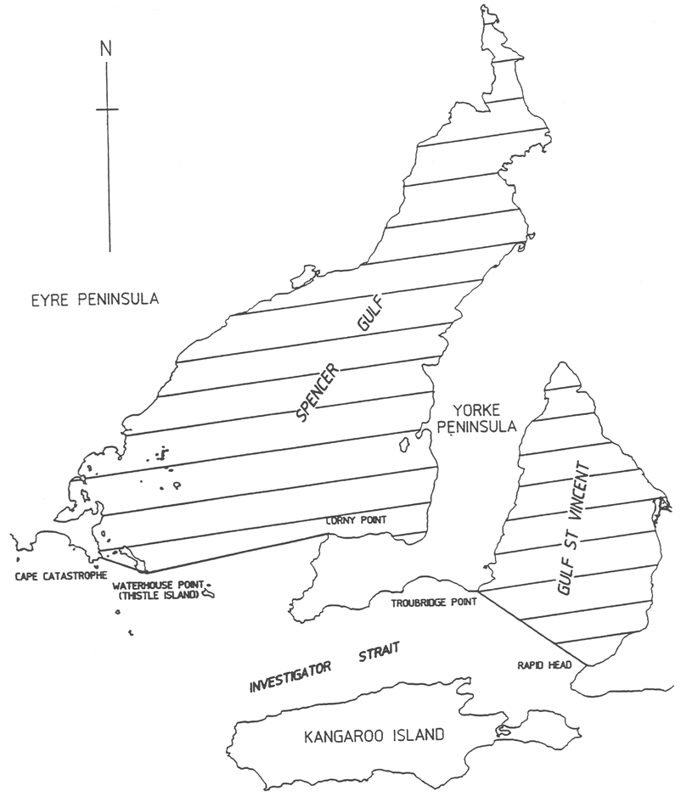
Division 2—General rules of navigation
113—Navigation at sea
(1) The Prevention of Collisions Convention is incorporated in these regulations and applies to all vessels in any part of the jurisdiction except inland waters.
(2) If a vessel is operated in the jurisdiction contrary to the Prevention of Collisions Convention, the owner and operator of the vessel are each guilty of an offence.
Maximum penalty: $5 000.
(3) If—
(a) a vessel fitted with navigation lights is operated in any part of the jurisdiction (other than inland waters); and
(b) the navigation lights are not fitted and exhibited in accordance with the Prevention of Collisions Convention,
the owner and operator of the vessel are each guilty of an offence.
Maximum penalty: $5 000.
(4) Subregulation (3) does not apply in relation to a vessel being operated by an authorised person if—
(a) the authorised person is acting in the course of official duties; and
(b) in the circumstances, the authorised person is taking reasonable care.
(5) It is a defence to a charge of an offence against this regulation brought against the owner for the owner to prove that the vessel was operated without the owner's consent.
114—Navigation in inland waters
(1) Section 17 of the Code (River Murray Traffic Regulations) is incorporated in these regulations and applies to all vessels in inland waters.
(2) If a vessel is operated in the jurisdiction contrary to section 17 of the Code (River Murray Traffic Regulations), the owner and operator of the vessel are each guilty of an offence.
Maximum penalty: $5 000.
(3) If—
(a) a vessel fitted with navigation lights is operated in inland waters; and
(b) the navigation lights are not fitted and exhibited in accordance with section 17 of the Code (River Murray Traffic Regulations),
the owner and operator of the vessel are each guilty of an offence.
Maximum penalty: $5 000.
(4) Subregulation (3) does not apply in relation to a vessel being operated by an authorised person if—
(a) the authorised person is acting in the course of official duties; and
(b) in the circumstances, the authorised person is taking reasonable care.
(5) It is a defence to a charge of an offence against this regulation brought against the owner for the owner to prove that the vessel was operated without the owner's consent.
115—Navigation in rivers and channels
(1) The operator of a vessel proceeding along the course of a river or channel must keep the vessel as near to the outer limit of the river or channel which lies on its starboard side as is safe and practicable.
Maximum penalty: $5 000.
(2) The operator of a vessel which can safely navigate outside a channel must not allow the vessel to hamper the safe passage of a vessel which can safely navigate only inside the channel.
Maximum penalty: $5 000.
(3) The operator of a vessel engaged in fishing must not allow the vessel to impede the passage of any other vessel navigating within a channel.
Maximum penalty: $5 000.
(4) The operator of a vessel must not, except in an emergency, anchor the vessel in a channel.
Maximum penalty: $5 000.
(5) If a vessel is anchored in a channel in an emergency, the operator of the vessel must, as soon as practicable, move the vessel to the side of the channel.
Maximum penalty: $5 000.
(6) The operator of a vessel navigating in a channel must only overtake another vessel if this can be done safely.
Maximum penalty: $5 000.
(7) A person must not, except with the approval of the CE, cause or permit a cable, chain, hawser or rope to be placed across a channel.
Maximum penalty: $5 000.
Division 3—Speed restrictions
116—Speed restrictions
(1) A person who operates a vessel at a speed in excess of 4 knots—
(a) in or through a mooring area or boat haven; or
(b) within 30 m of a jetty, wharf or other place at which a vessel is being removed from the water or placed into the water; or
(c) within 30 m of any vessel that may be adversely affected by the wash of the vessel; or
(d) within 50 m of—
(i) a person in the water; or
(ii) a vessel or buoy on which is displayed a flag indicating that there is a diver below (International Code Flag A); or
(iii) a person in or on a canoe, kayak, surf ski, surfboard, sailboard, kiteboard or similar small unpowered recreational vessel; or
(e) within 100 m of a ferry crossing,
is guilty of an offence.
Maximum penalty: $1 250.
(2) Despite subregulation (1)(a), but subject to any other provision of the Act, a person may operate a vessel within the marked channel in the Port MacDonnell Boat Haven at a speed not exceeding 7 knots.
(3) A person who operates a vessel within the waters specified in Schedule 7 at a speed in excess of that applicable to those waters in accordance with that Schedule is guilty of an offence.
Maximum penalty: $1 250.
(4) It is a defence to a charge of an offence under this regulation for the defendant to prove that the defendant was taking part in a rescue operation or otherwise acting in an emergency, or taking part in a surf lifesaving activity conducted by a surf lifesaving club.
(5) This regulation does not apply in relation to an authorised person operating a vessel if—
(a) the authorised person is acting in the course of official duties; and
(b) in the circumstances, the authorised person is taking reasonable care.
(6) In this regulation—
boat haven has the same meaning as in Part 12.
Division 4—Lifejackets and miscellaneous provisions
117—Lifejackets to be worn on certain vessels
(1) Each occupant of—
(a) a vessel (other than a vessel with an engine, a surfboard, surf ski or rowing shell) that can only carry the operator and no other person; or
(b) a vessel that is not more than 4.8 m in length fitted with an engine; or
(c) a paddle board or surf ski that is being operated 400 m or more from the shore; or
(d) a surfboard, surf ski or similar vessel that is being operated in inland waters; or
(e) a sailboard or kiteboard; or
(f) a canoe or kayak (including a motorised canoe or kayak), rowboat or other similar small human-powered vessel; or
(g) a monohulled sailing dinghy or a similar small multihulled sailing vessel (being a dinghy or vessel that is not more than 6 m in length); or
(h) a personal watercraft; or
(i) a dragon boat,
must, at all times while the vessel is underway or at anchor, wear—
(j) in the case of a vessel being operated in unprotected waters—
(i) if the vessel is a canoe or kayak (including a motorised canoe or kayak), rowboat or other similar small human-powered vessel—a lifejacket level 100 or above or lifejacket level 50; or
(ii) in any other case—a lifejacket level 100 or above; or
(k) in the case of a vessel (other than a personal watercraft or rowboat) that is being operated in semi-protected waters—a lifejacket level 100 or above, lifejacket level 50 or lifejacket level 50S; or
(l) in the case of a sailboard or kiteboard—
(i) being operated more than 400 m from the shore—a lifejacket level 100 or above; or
(ii) being operated not more than 400 m from the shore—a lifejacket level 100 or above, lifejacket level 50 or lifejacket level 50S; or
(m) in the case of a personal watercraft—a lifejacket level 50 or lifejacket level 50S; or
(n) in the case of a paddle board or surf ski being operated more than 400 m from the shore—a lifejacket level 100 or above, lifejacket level 50 or lifejacket level 50S; or
(o) in the case of a dragon boat—
(i) that is being operated in unprotected waters—a lifejacket level 100 or above or lifejacket level 50; or
(ii) in any other case—a lifejacket level 50 or lifejacket level 50S; or
(p) in any other case (other than a rowboat)—a lifejacket level 100 or above, lifejacket level 50 or lifejacket level 50S.
Maximum penalty: $1 250.
Editorial note—
A lifejacket must be of an appropriate size and properly adjusted for the person who is wearing or will be wearing the jacket—see regulation 3(7) and (8).
A lifejacket that is designed to inflate and that has been so inflated must be serviced in accordance with the manufacturer's instructions before being used again—see regulation 3(9).
(2) In circumstances of heightened risk, each occupant in the open area of a vessel of not less than 4.8 m but not more than 12 m in length must, at all times while the vessel is underway or at anchor, wear—
(a) in the case of a vessel that is being operated in unprotected waters—a lifejacket level 100 or above; or
(b) in any other case—a lifejacket level 50 or lifejacket level 50S.
Maximum penalty: $1 250.
(3) If subregulation (1) or (2) is contravened by an occupant of a vessel other than the operator, the operator of the vessel is guilty of an offence.
Maximum penalty: $1 250.
(4) If each occupant of or under 12 years of age—
(a) of a vessel that is not more than 4.8 m in length fitted with an engine; or
(b) in the open area of a vessel of not less than 4.8 m but not more than 12 m in length,
is not, at all times while the vessel is underway or at anchor, wearing—
(c) in the case of a vessel that is being operated in protected waters—a lifejacket level 50 or lifejacket level 50S; or
(d) in any other case—a lifejacket level 100 or above,
the operator of the vessel is guilty of an offence.
Maximum penalty: $1 250.
(5) Subregulations (1) and (4) do not apply if the occupant of the vessel is being towed (in which case the requirements under regulation 122 apply).
(6) The operator of a vessel of not less than 4.8 m but not more than 12 m in length, may, if it is reasonable to do so in the circumstances, direct an occupant who is in an open area of the vessel while the vessel is underway or at anchor to wear a lifejacket level 100 or above, lifejacket level 50 or lifejacket level 50S, and if an occupant fails to comply with the direction, the occupant is guilty of an offence.
Maximum penalty: $1 250.
(7) For the purposes of subregulation (2), a vessel will be taken to be in circumstances of heightened risk if—
(a) the vessel carries the operator and no other person; or
(b) the vessel carries only the operator and a child or children of or under 12 years of age; or
(c) the vessel is being operated between the hours of sunset and sunrise; or
(d) the vessel is crossing a bar; or
(e) the vessel is disabled so as to be incapable of making its way through water; or
(f) the vessel is operating in conditions of restricted visibility; or
(g) the vessel is operating in an area in relation to which a weather warning of any of the following kinds has been issued by the Bureau of Meteorology:
(i) gale warning;
(ii) storm force warning;
(iii) hurricane force wind warning;
(iv) severe thunderstorm warning;
(v) severe weather warning.
118—Personal watercraft must display approved notice
(1) A personal watercraft must not be operated in the jurisdiction unless a notice specifying obligations of operators of personal watercraft (in a form and containing the information approved by the CE) is affixed to the vessel so as to be clearly visible and legible, in daylight, from the steering position of the vessel.
(2) If a personal watercraft is operated in contravention of subregulation (1)—
(a) the registered owner; and
(b) if the operator is a person who is required to hold a boat operator's licence—the operator,
of the vessel are each guilty of an offence.
Maximum penalty: $1 250.
119—Personal watercraft only to be used during certain hours
(1) Subject to this regulation, a person must not operate a personal watercraft—
(a) after sunset or 8 pm (whichever is the earlier) on any day; or
(b) before 9 am on a Sunday or before 8 am on any other day.
Maximum penalty: $1 250.
(2) A person may operate a personal watercraft on the River Murray for the purpose of towing another person at any time between sunrise and sunset on any day.
(3) It is a defence to a charge of an offence under this regulation for the defendant to prove that the defendant was taking part in a rescue operation or otherwise acting in an emergency, or taking part in a surf lifesaving activity conducted by a surf lifesaving club.
120—Means of escape
The operator of a vessel must ensure that all hatches and doors on the vessel are kept unlocked and are clear of obstruction at all times while the vessel is underway.
Maximum penalty: $1 250.
121—Excess persons on vessel
(1) The operator of a vessel must ensure that the number of persons carried on the vessel does not exceed such number as can be carried safely in all the circumstances, and in any case must not exceed the maximum number—
(a) in the case of a vessel fitted by the manufacturer with a compliance plate stating the maximum number of persons that may be safely carried as determined in accordance with AS 1799.1—stated on that plate; or
(b) if no such compliance plate is fitted but the vessel is fitted with an Australian Builders Plate—stated on the Australian Builders Plate; or
(c) if neither a compliance plate nor an Australian Builders Plate is fitted to the vessel—specified in Schedule 8 in relation to a vessel of the relevant class.
Maximum penalty: $1 250.
(2) The operator of a vessel must not cause or permit a load to be carried on the vessel while it is underway or moored greater than can safely be carried in all the circumstances.
Maximum penalty: $1 250.
Division 5—Water skiing and similar activities
122—Obligations of person towed by vessel
(1) No more than 1 prescribed device may be towed by a vessel at any one time.
(2) No more than 3 persons may be towed by a vessel (whether on a prescribed device or not) at any one time.
(3) A person who is being towed by a vessel must wear a lifejacket level 50 or lifejacket level 50S.
(4) A person must not be towed by a vessel between sunset and sunrise.
(5) A person must not be towed by a vessel unless another person (the observer) on the vessel is continuously observing the person being towed and giving such directions to the operator of the vessel as may be necessary to prevent injury or risk of injury to the person being towed or to other persons.
(6) The observer must not be the operator of the vessel.
(7) Either—
(a) both the operator of the vessel and the observer must be not less than 16 years of age; or
(b) the observer must hold a special permit issued under regulation 73 and the operator of the vessel must be not less than 18 years of age.
(8) The CE may, subject to such conditions as the CE thinks fit, exempt a person from any of the requirements of this regulation.
(9) If this regulation is contravened, the operator of the vessel, each person being towed by the vessel (whether or not on a device), and the observer (if any) are each guilty of an offence.
Maximum penalty: $1 250.
(10) In this regulation—
prescribed device means a device (whether inflatable or otherwise)—
(a) that is designed, constructed or adapted to be towed behind a vessel while carrying a person or persons; and
(b) the direction of which is not capable of being effectively controlled by a person being so towed.
Example—
Examples of a prescribed device include an inner tube or a device commonly known as a donut.
Examples of items that are not prescribed devices include water skis, kneeboards and wakeboards.
123—Obligation of person being towed
If a person being towed by a vessel falls into the water, the person must, if practicable, hold an arm, ski or other device vertically in the air to signal their presence.
Maximum penalty: $750.
124—Obligation of operator of vessel towing a person
(1) The operator of a vessel that is towing a person must, in any area being used by more than 1 vessel for the purpose of commencing or finishing towing of a person—
(a) on leaving such an area—
(i) keep the vessel to the starboard side of the waterway; and
(ii) keep the vessel clear of any vessel returning to the area; and
(b) on returning to such an area—
(i) access the area from the starboard side of the waterway; and
(ii) clear the area as soon as is reasonably practicable after finishing towing the person.
Maximum penalty: $5 000.
(2) The operator of a vessel that has finished towing a person must, before returning to any area being used by more than 1 vessel for the purpose of commencing or finishing towing of a person, ensure that all apparatus used in connection with towing the person is back on board the vessel and is not trailing in the water or outside the vessel.
Maximum penalty: $5 000.
(3) This regulation is in addition to, and does not derogate from, any other requirement the operator must comply with under the Act or these regulations in relation to the operation of the vessel.
125—Obligation of operator of vessel around water skiers etc
(1) The operator of a vessel (being a vessel that is not towing a person) must, on leaving or returning to an area being used by more than 1 vessel for the purpose of commencing or finishing towing of a person, keep the vessel clear of any vessel towing a person in the area.
Maximum penalty: $5 000.
(2) This regulation is in addition to, and does not derogate from, any other requirement the operator must comply with under the Act or these regulations in relation to the operation of the vessel.
126—Operating another vessel too close to person being towed
(1) A person who operates a vessel within 100 m directly behind a person who is being towed by another vessel is guilty of an offence.
Maximum penalty: $5 000.
(2) This regulation is in addition to, and does not derogate from, any other requirement the operator must comply with under the Act or these regulations in relation to the operation of the vessel.
Division 6—Diving signals
127—Signals when divers working
(1) The operator of a vessel that is over 10 m in length must, at all times while a diver is operating from the vessel, display in a conspicuous position on the vessel the International Code Flag A.
Maximum penalty: $1 250.
(2) The operator of a vessel that is 10 m or less in length must, at all times while a diver is operating from the vessel, display in a conspicuous position on the vessel a rigid replica of International Code Flag A, at least 750 mm by 600 mm in size.
Maximum penalty: $1 250.
(3) A diver who is operating in a harbor independently of a vessel must ensure that a rigid replica of International Code Flag A, at least 300 mm by 200 mm in size, is displayed, at all times, from a buoy or float which is moored within 30 m of the diver or is attached to a line and towed by the diver.
Maximum penalty: $1 250.
(4) A diver must not operate in a harbor, independently of a vessel, in a marked channel used by vessels.
Maximum penalty: $1 250.
(5) The operator of a vessel navigating in the vicinity of a vessel, float or buoy displaying an International Code Flag A or a replica of that flag, or a light or shape required by Rule 27 of the Prevention of Collisions Convention, must navigate so as to avoid injury to the diver or interference with the vessel, float or buoy.
Maximum penalty: $1 250.
(6) If this regulation requires an International Code Flag A or a replica to be displayed, the person who is required to display the flag or replica must ensure that it is illuminated during the hours of darkness.
Maximum penalty: $1 250.
Division 7—Fishing nets and set lines
128—Interpretation
In this Division—
drop net, drum net, hoop net, mesh net, set line and shrimp trap have the same meanings as in the Fisheries Management Act 2007.
129—Mesh nets and set lines
(1) The following provisions apply in relation to a mesh net or set line that is being used in the waters of Lake Alexandrina, Lake Albert, the Coorong, or in any contiguous waterway downstream of Wellington:
(a) 1 extremity must be marked by 2 black buoys;
(b) the other extremity must be marked by a yellow buoy;
(c) if the mesh net or set line exceeds 50 m in length—it must be marked by red buoys placed at intervals not exceeding 50 m.
(2) The following provisions apply in relation to a mesh net or set line that is being used in the River Murray upstream of Wellington or in any contiguous waterway where the mesh net or set line is placed at a depth beneath the water of less than 1.7 m:
(a) the extremity that is closest to the shore must be marked by a yellow buoy;
(b) the extremity that is furthest from the shore must be marked by a white buoy;
(c) if the mesh net or set line exceeds 50 m in length—it must be marked by red buoys placed at intervals not exceeding 50 m.
(3) The following provisions apply in relation to a mesh net or set line that is being used in the River Murray upstream of Wellington or in any contiguous waterway where the mesh net or set line is placed at a depth beneath the water of not less than 1.7 m:
(a) the extremity that is closest to the shore must be marked by a yellow buoy;
(b) a white buoy must be placed at a distance of at least 3 m from the yellow buoy, indicating the direction in which the net or set line is placed.
(4) For the purposes of this regulation, a buoy—
(a) must be approximately spherical in shape; and
(b) must be of a volume of not less than 4 litres; and
(c) must be made of plastic, polystyrene foam, rubber or other material approved by the CE.
130—Drop nets, drum nets, hoop nets and shrimp traps
A drop net, drum net, hoop net or shrimp trap that is set away from the shore in inland waters must be marked by a buoy that is—
(a) white; and
(b) approximately spherical in shape; and
(c) of a volume of not less than 2 litres; and
(d) made of plastic, polystyrene foam, rubber or other material approved by the CE.
131—Positioning of fishing apparatus
(1) In inland waters (other than the main stream of the River Murray upstream of Wellington) fishing apparatus must not be placed in a manner that prevents navigation of vessels in those waters or, if there is in those waters a recognised navigable channel, in that channel.
(2) In the River Murray upstream of Wellington, fishing apparatus must not extend on the surface for more than half the width of the river.
132—Offence of using fishing apparatus contrary to this Division
A person using fishing apparatus in inland waters must ensure that this Division is complied with in relation to the apparatus.
Maximum penalty: $1 250.
Division 8—Rules for certain bridges
133—Birkenhead Bridge
(1) The operator of a vessel approaching the Birkenhead Bridge during its operating times and requiring the bridge to be opened must contact the person operating the bridge in accordance with any procedure determined by the CE for the purposes of this subregulation—
(a) by mobile phone on a telephone number determined by the CE for the purposes of this subregulation; or
(b) by VHF radio on a frequency determined by the CE for the purposes of this subregulation.
(2) The operator of a vessel who does not intend to navigate under the bridge after requesting the opening of the bridge in accordance with subregulation (1) must immediately notify the person operating the bridge of that fact—
(a) by mobile phone on a telephone number determined by the CE for the purposes of this subregulation; or
(b) by VHF radio on a frequency determined by the CE for the purposes of this subregulation.
Maximum penalty: $5 000.
(3) The operator of a vessel must not allow the vessel to approach within 100 m of the bridge with the intention of passing through the bridge until the bridge is fully opened.
Maximum penalty: $5 000.
(4) Subject to any direction of the operator of the bridge to the contrary, the operator of a vessel must ensure that the vessel, when being navigated under the bridge, is only operated within the navigation pass.
Maximum penalty: $5 000.
(5) The operator of a vessel must not cause or allow the vessel to approach the bridge or attempt to negotiate the navigation pass unless the vessel can be maintained under safe control throughout the manouevre.
Maximum penalty: $5 000.
(6) If 2 vessels are approaching the bridge from opposite directions simultaneously, the operator of the vessel proceeding upstream must give the vessel proceeding downstream priority of passage through the navigation pass unless it is safe for both vessels to pass through the navigation pass simultaneously.
Maximum penalty: $5 000.
(7) In this regulation—
operating times, in relation to the Birkenhead Bridge, means the operating times determined by the CE for the purposes of this regulation.
134—Port River Expressway Bridges
(1) The operator of a vessel approaching a Port River Expressway Bridge during its operating times and requiring the bridge to be opened must contact the person operating the bridge in accordance with the procedure determined by the CE for the purposes of this subregulation—
(a) by mobile phone on a telephone number determined by the CE for the purposes of this subregulation; or
(b) by VHF radio on a frequency determined by the CE for the purposes of this subregulation.
(2) Without limiting subregulation (1), the procedure determined by the CE for the purposes of that subregulation may include a requirement that the operator of a vessel provide the person operating the bridge with the following information:
(a) the registration number or other identification number of the vessel;
(b) the name of the vessel;
(c) a description of the vessel;
(d) the location of the vessel;
(e) a mobile phone number, or a VHF radio frequency, on which the operator can be contacted.
(3) The CE may, by notice in the Gazette, exempt the operator of a vessel, or class of vessels, referred to in subregulation (1) from complying with the requirements of that subregulation in the circumstances set out in the notice.
(4) The operator of a vessel who does not intend to navigate under a Port River Expressway Bridge after requesting the opening of the bridge in accordance with subregulation (1) must immediately notify the person operating the bridge of that fact—
(a) by mobile phone on a telephone number determined by the CE for the purposes of this subregulation; or
(b) by VHF radio on a frequency determined by the CE for the purposes of this subregulation.
Maximum penalty: $5 000.
(5) The operator of a vessel approaching or navigating under a Port River Expressway Bridge during its operating times and requiring the bridge to be opened must, if the vessel is fitted with a VHF radio, cause a radio watch to be maintained on the frequency determined by the CE for the purposes of this subregulation while the vessel is within 100 m of the bridge.
Maximum penalty: $5 000.
(6) The operator of a vessel navigating under a Port River Expressway Bridge, or approaching a Port River Expressway Bridge, must comply with the following provisions:
(a) the operator must comply with any vessel traffic control signals operating at the time on, or in relation to, the bridge;
(b) the operator must comply with any directions of the person operating the bridge;
(c) the operator must not allow the vessel to approach within 100 m of the bridge with the intention of navigating under the bridge while the bridge is in the process of opening or closing;
(d) without limiting paragraph (a) or (b), if the vessel does not require the bridge to be opened to navigate under the bridge, the operator must give way to any vessel approaching a Port River Expressway Bridge or passing through the navigation pass of a Port River Expressway Bridge that does require the bridge to be so opened;
(e) if no vessel traffic control signals are operating at the time on, or in relation to, the bridge and the vessel is approaching the bridge proceeding upstream, the operator must give any vessel proceeding downstream priority of passage through the navigation pass (and the operator must wait until the vessel proceeding downstream is clear of the bridge before proceeding under the bridge) unless it is safe for both vessels to pass through the navigation pass simultaneously;
(f) subject to any direction of the person operating the bridge to the contrary, the operator must ensure that the vessel, when being navigated under the bridge—
(i) in the case of a sailing vessel, operated under sail power alone, that does not require the bridge to be opened to navigate under the bridge—is not operated within the navigation pass; or
(ii) in any other case—is only operated within the navigation pass;
(g) subject to any direction of the person operating the bridge to the contrary, the operator must not reverse direction while passing through the navigation pass;
(h) the operator must not approach the bridge or attempt to navigate under the bridge unless the vessel can be maintained under safe control throughout the manouevre;
(i) the operator must not remain in—
(i) the navigation pass; or
(ii) the area within 100 m of the bridge,
unless intending to navigate under the bridge (and, having navigated under the bridge, must not remain in the area within 100 m on the opposite side of the bridge);
(j) the operator must not allow the vessel to approach within 100 m of the bridge or attempt to navigate under the bridge with the vessel's sail or sails (if any) wholly or partly raised or unfurled;
(k) in the case of a vessel with a beam of more than 10 m, or a displacement of more than 200 tonnes—the operator must not allow the vessel to approach within 100 m of the bridge or attempt to pass through the navigation pass without the approval of the CE;
(l) in the case of a sailing vessel, operated under sail power alone, that does not require the bridge to be opened to navigate under the bridge—the operator must not stop the vessel within 10 m of the bridge.
Maximum penalty: $5 000.
(7) Subject to this regulation, a person who contravenes a provision of subregulation (6) is guilty of an offence.
(8) Paragraphs (a), (i) and (j) of subregulation (6) do not apply to the operator of a sailing vessel, operated under sail power alone, that does not require the bridge to be opened to navigate under the bridge.
(9) Subregulation (6)(i)(ii) does not apply to the operator of a vessel entering or leaving a lawfully constructed temporary berthing facility located within 100 m of a Port River Expressway Bridge.
(10) It is a defence to a charge of an offence under subregulation (6) for the defendant to prove that the defendant was taking part in a rescue operation or otherwise acting in an emergency.
(11) If a vessel appears from evidence obtained through the operation of a camera installed by the CE on, or in the immediate vicinity of, the Port River Expressway Bridges to have been involved in the commission of an offence against subregulation (6), the owner of the vessel is guilty of an offence against this subregulation unless it is proved—
(a) that although the vessel appears to have been involved in the commission of the offence, no such offence was in fact committed; or
(b) that the owner, or, if the owner is a body corporate, an officer of the body corporate acting with the authority of the body corporate, has furnished to the CE a statutory declaration stating the name and address of some person other than the owner who was the operator of the vessel at the time; or
(c) that—
(i) if the owner is a body corporate—the vessel was not being operated at the time by any officer or employee of the body corporate acting in the ordinary course of their duties as such; and
(ii) the owner does not know and could not by the exercise of reasonable diligence have ascertained the identity of the person who was operating the vessel at the time; and
(iii) the owner, or, if the owner is a body corporate, an officer of the body corporate acting with the authority of the body corporate, has furnished to the CE a statutory declaration stating the reasons why the identity of the operator is not known to the owner and the inquiries (if any) made by the owner to identify the operator.
Maximum penalty: $5 000.
(12) If there are 2 or more owners of the same vessel—
(a) a prosecution for an offence against subregulation (11) may be brought against 1 of the owners or against some or all of the owners jointly as co-defendants; and
(b) if the case for the prosecution is proved and a defence is not established under subregulation (11)(a), the defendant or each of the defendants who does not establish a defence under subregulation (11)(b) or (c) is liable to be found guilty of an offence against subregulation (11).
(13) If an offence against subregulation (6) or (11) is alleged, and the allegation is based (wholly or in part) on evidence obtained through the operation of a camera installed by the CE on, or in the immediate vicinity of, the Port River Expressway Bridges, an expiation notice, an expiation reminder notice or summons in respect of the offence must be accompanied by a notice containing the information set out in Schedule 10.
(14) If—
(a) an expiation notice for an offence against subregulation (6) is given to a person named as the alleged operator in a statutory declaration under this regulation; or
(b) proceedings for an offence against subregulation (6) are commenced against a person named as the alleged operator in such a statutory declaration,
the notice or summons, as the case may be, must be accompanied by a notice setting out particulars of the statutory declaration that named the person as the alleged operator.
(15) The particulars of the statutory declaration provided to the person named as the alleged operator must not include the address of the person who provided the statutory declaration.
(16) If a person is found guilty of, or expiates, an offence against subregulation (6), neither that person nor any other person is liable to be found guilty of, or to expiate, an offence against subregulation (11) in relation to the same incident.
(17) If a person is found guilty of, or expiates, an offence against subregulation (11), neither that person nor any other person is liable to be found guilty of, or to expiate, an offence against subregulation (6) in relation to the same incident.
(18) A person who, without proper authority or reasonable excuse, interferes with a camera installed on, or in the immediate vicinity of, the Port River Expressway Bridges by the CE, or a vessel traffic control signal, or the proper functioning of such devices, is guilty of an offence.
Maximum penalty: $5 000.
(19) In proceedings for an offence against this regulation—
(a) a data storage device produced by the prosecution will be admitted in evidence if the images recorded on the device were recorded by a camera installed by the CE on, or in the immediate vicinity of, the Port River Expressway Bridges, and a denotation as to date, time and location that appears as part of such a device, or on such images, is, in the absence of proof to the contrary, proof of the date, time and location at which the images on the device were recorded by the camera;
(b) a certificate produced by the prosecution and apparently signed by the CE or a delegate of the CE certifying that a specified camera used at a specified location during a specified period was a camera installed by the CE is, in the absence of proof to the contrary, proof of that fact;
(c) a certificate produced by the prosecution and apparently signed by the CE or a delegate of the CE that a specified camera was designed and set to operate according to a specified system during that period is, in the absence of proof to the contrary, proof that the camera was designed and set to operate according to that system during that period and did, in fact, so operate;
(d) a certificate produced by the prosecution and apparently signed by the CE or a delegate of the CE certifying that a specified vessel traffic control signal—
(i) was designed and set to operate automatically according to a specified system during a particular period; or
(ii) was designed and set to be operated manually according to a specified system during a particular period,
is, in the absence of proof to the contrary, proof that the vessel traffic control signal was designed and set to operate automatically or manually (as the case requires) according to the system and did, in fact, so operate;
(e) a certificate produced by the prosecution and apparently signed by the CE or a delegate of the CE certifying that a specified person was the person operating a Port River Expressway Bridge at a specified time and on a specified date is, in the absence of proof to the contrary, proof of the matters so certified;
(f) a certificate produced by the prosecution and apparently signed by the CE or a delegate of the CE certifying that a specified vessel traffic control signal was operated manually in a specified manner at a specified time and on a specified date by the person operating a Port River Expressway Bridge is, in the absence of proof to the contrary, proof of the matters so certified.
(20) For the purposes of this regulation, the operator of a vessel complies with a vessel traffic control signal if the operator complies with the following provisions:
(a) the operator of a vessel that is more than 100 m from a Port River Expressway Bridge must not approach to within 100 m of the bridge if a vessel traffic control signal is showing an illuminated solid or flashing red light to vessels travelling in the same direction as the vessel;
(b) the operator of a vessel that is within 100 m of a Port River Expressway Bridge must navigate through the navigation pass of the bridge if a vessel traffic control signal is showing an illuminated solid green light to vessels travelling in the same direction as the vessel;
(c) subject to a direction of the person operating the bridge to the contrary, the operator of a vessel that is within 100 m of a Port River Expressway Bridge but outside of the navigation pass of that bridge—
(i) must not enter the navigation pass of the bridge; and
(ii) must immediately reverse direction and exit the area within 100 m of the bridge,
if a vessel traffic control signal is showing an illuminated solid red light to vessels travelling in the same direction of the vessel (whether or not the vessel traffic control signal was showing an illuminated solid green light to vessels travelling in the same direction as the vessel at the time the vessel approached to within 100 m of the bridge);
(d) subject to a direction of the person operating the bridge to the contrary, the operator of a vessel that is within 100 m of a Port River Expressway Bridge but outside of the navigation pass of that bridge must either—
(i) pass through the navigation pass; or
(ii) immediately reverse direction and exit the area within 100 m of the bridge,
if a vessel traffic control signal is showing an illuminated flashing red light to vessels travelling in the same direction of the vessel (whether or not the vessel traffic control signal was showing an illuminated solid green light to vessels travelling in the same direction as the vessel at the time the vessel approached to within 100 m of the bridge);
(e) in the case of a vessel traffic control signal consisting of a sign (whether electronic or otherwise) displaying directions in writing to vessels approaching a Port River Expressway Bridge—the operator of a vessel within 100 m of a Port River Expressway Bridge must comply with any direction displayed on the vessel traffic control signal.
(21) Subregulation (20)(b), (c) and (d) do not apply to the operator of a vessel moored at a lawfully constructed temporary berthing facility located within 100 m of the bridge.
(22) In this regulation—
operating times, in relation to a Port River Expressway Bridge, means the operating times determined by the CE for the purposes of this regulation;
owner of a vessel means—
(a) a person who is the sole owner, a joint owner or a part owner of the vessel; or
(b) a person who has possession or use of the vessel under a credit, hire-purchase, lease or other agreement, except an agreement requiring the vessel to be registered in the name of someone else,
and includes a registered owner of the vessel;
registered owner, in relation to a vessel, means the person to whom a certificate of registration for the vessel has been issued;
vessel traffic control signal means a visual or audible device, or a combination of visual and audible devices, (whether electronic or otherwise) installed on, or in the immediate vicinity of, a Port River Expressway Bridge regulating 1 or more of the following:
(a) entry of vessels to the area lying within 100 m of a Port River Expressway Bridge;
(b) navigation of vessels (including direction of travel) within the area lying within 100 m of a Port River Expressway Bridge;
(c) entry to and exit from the navigation pass of a Port River Expressway Bridge;
(d) any other matter related to the prevention of damage to a Port River Expressway Bridge.
135—Exemptions
(1) The CE may, on such conditions as the CE thinks fit, exempt the owner or operator of a vessel from the obligation to comply with a requirement of regulation 134.
(2) The CE may, by written notice to the holder of an exemption, revoke the exemption or impose further conditions if there are, in the CE's opinion, proper reasons for doing so.
136—Hindmarsh Island Bridge
(1) This regulation applies to a vessel that is more than 10 m in length and the operator of which intends to navigate under Hindmarsh Island Bridge.
(2) The operator of a vessel must ensure that the vessel, when being navigated under the bridge, is only operated within the navigation pass.
Maximum penalty: $5 000.
(3) The operator of a vessel must proceed with caution in the navigation pass and maintain a mid-channel course through the navigation pass.
Maximum penalty: $5 000.
(4) The operator of a vessel must ensure that the vessel does not come into contact with a support pier of the bridge.
Maximum penalty: $5 000.
(5) The operator of a vessel must not cause or allow the vessel to approach the bridge or attempt to negotiate the navigation pass unless the vessel can be maintained under safe control throughout the manouevre.
Maximum penalty: $5 000.
(6) If 2 vessels are approaching the bridge simultaneously, the operator of the vessel proceeding upstream must give the vessel proceeding downstream priority of passage through the navigation pass.
Maximum penalty: $5 000.
(7) The operator of a vessel proceeding upstream that has had to wait for a vessel proceeding downstream to pass under the bridge must wait until the vessel proceeding downstream is clear of the bridge before proceeding under the bridge.
Maximum penalty: $5 000.
137—Jervois Bridge
(1) The operator of a vessel must ensure that the vessel, when being navigated under the Jervois Bridge, is only operated within the navigation pass.
Maximum penalty: $5 000.
(2) The operator of a vessel must not approach the bridge or attempt to navigate under the bridge unless the vessel can be maintained under safe control throughout the manouevre.
Maximum penalty: $5 000.
(3) If 2 vessels are approaching the bridge from opposite directions simultaneously, the operator of the vessel proceeding upstream must give the vessel proceeding downstream priority of passage through the navigation pass.
Maximum penalty: $5 000.
(4) The operator of a vessel proceeding upstream that has had to wait for a vessel proceeding downstream to navigate under the bridge must wait until the vessel proceeding downstream is clear of the bridge before proceeding under the bridge.
Maximum penalty: $5 000.
138—Kingston Bridge
(1) This regulation applies to a vessel that is more than 10 m in length and the operator of which intends to navigate under Kingston Bridge.
(2) The operator of a vessel must ensure that the vessel, when being navigated under the Kingston Bridge, is only operated within the navigation pass.
Maximum penalty: $5 000.
(3) The operator of a vessel must proceed with caution in the navigation pass and maintain a mid-channel course through the navigation pass.
Maximum penalty: $5 000.
(4) The operator of a vessel must ensure that the vessel does not come into contact with a support pier of the bridge.
Maximum penalty: $5 000.
(5) The operator of a vessel must not cause or allow the vessel to approach the bridge or attempt to negotiate the navigation pass unless the vessel can be maintained under safe control throughout the manouevre.
Maximum penalty: $5 000.
(6) The operator of a vessel must sound 1 long blast when the vessel is within 0.5 nautical miles of the bridge.
Maximum penalty: $5 000.
(7) The operator of a vessel approaching the bridge must, if a long blast is heard apparently from an approaching vessel, respond with 1 long blast.
Maximum penalty: $5 000.
(8) The operator of a vessel must not cause or allow the vessel to pass another vessel within 0.25 nautical miles of the bridge.
Maximum penalty: $5 000.
(9) If 2 vessels are approaching the bridge simultaneously, the operator of the vessel proceeding upstream must give the vessel proceeding downstream priority of passage through the navigation pass.
Maximum penalty: $5 000.
(10) The operator of a vessel proceeding upstream that has had to wait for a vessel proceeding downstream to pass under the bridge must wait until the vessel is clear of the bridge and then again sound 1 long blast before proceeding under the bridge.
Maximum penalty: $5 000.
139—Paringa Bridge
(1) The operator of a vessel approaching the Paringa Bridge during its operating times and requiring the bridge to be opened must contact the person operating the bridge (in accordance with any procedure determined by the CE for the purposes of this subregulation) by mobile phone on a telephone number determined by the CE for the purposes of this subregulation.
(2) The operator of a vessel who does not intend to navigate under the bridge after requesting the opening of the bridge in accordance with subregulation (1) must immediately notify the person operating the bridge of that fact by mobile phone on a telephone number determined by the CE for the purposes of this subregulation.
Maximum penalty: $5 000.
(3) The person operating the bridge will indicate their intention to open the bridge by activating a rotating red light installed on, or in the immediate vicinity of, the bridge.
(4) The operator of a vessel must not allow the vessel to approach within 100 m of the bridge with the intention of passing through the bridge until—
(a) the bridge is fully opened; and
(b) a green light installed on, or in the immediate vicinity of, the bridge is illuminated to vessels travelling in the same direction as the vessel.
Maximum penalty: $5 000.
(5) Subject to any direction of the operator of the bridge to the contrary, the operator of a vessel must ensure that the vessel, when being navigated under the bridge (whether or not the bridge is open), is only operated within the navigation pass.
Maximum penalty: $5 000.
(6) The operator of a vessel must not cause or allow the vessel to approach the bridge or attempt to negotiate the navigation pass unless the vessel can be maintained under safe control throughout the manouevre.
Maximum penalty: $5 000.
(7) The operator of a vessel that does not require the bridge to be opened to navigate under the bridge must give way to any vessel approaching the bridge or passing under the bridge that does require the bridge to be so opened.
Maximum penalty: $5 000.
(8) If 2 vessels are approaching the bridge from opposite directions simultaneously, the operator of the vessel proceeding upstream must give the vessel proceeding downstream priority of passage through the navigation pass unless it is safe for both vessels to pass through the navigation pass simultaneously.
Maximum penalty: $5 000.
(9) In this regulation—
operating times, in relation to the Paringa Bridge, means the operating times determined by the CE for the purposes of this regulation.
Division 9—Miscellaneous
140—Vessels excluded from vicinity of oil rigs
(1) Vessels are prohibited from entering or remaining in waters within 500 m of a vessel or structure engaged in petroleum exploration consisting of—
(a) drilling, or operations associated with drilling, subjacent land; or
(b) tests carried out subsequently for the purposes of discovering petroleum or ascertaining the quality and quantity of petroleum discovered (including tests involving the recovery of petroleum).
(2) The distance referred to in subregulation (1) is to be measured from each point of the outer edge of the vessel or structure or any anchor, buoy or other equipment deployed from the vessel or structure.
(3) If a vessel enters or remains in waters in contravention of this regulation, the owner and operator of the vessel are each guilty of an offence (but it is a defence to a charge of such an offence brought against the owner for the owner to prove that the vessel was operated in the manner constituting the offence without the owner's consent).
Maximum penalty: $5 000.
(4) This regulation does not apply to vessels used in connection with the operations of the vessel or structure engaged in petroleum exploration.
(5) In this regulation—
petroleum has the same meaning as in the Petroleum and Geothermal Energy Act 2000.
141—Vessels excluded from vicinity of vessels engaged in transfer of petroleum
(1) Vessels are prohibited from entering or remaining in waters within 1 nautical mile of a vessel to which petroleum is being transferred from another vessel or from which petroleum is being transferred to another vessel.
(2) The distance referred to in subregulation (1) is to be measured from each point of the outer edge of a vessel engaged in the transfer of petroleum or any anchor, buoy or other equipment deployed from such a vessel.
(3) If a vessel enters or remains in waters in contravention of this regulation, the owner and operator of the vessel are each guilty of an offence (but it is a defence to a charge of such an offence brought against the owner for the owner to prove that the vessel was operated in the manner constituting the offence without the owner's consent).
Maximum penalty: $5 000.
(4) This regulation does not apply to vessels used in connection with the operations of a vessel engaged in the transfer of petroleum to or from another vessel.
(5) In this regulation—
petroleum has the same meaning as in the Petroleum and Geothermal Energy Act 2000.
142—Vessels excluded from vicinity of transhipment points in Spencer Gulf
(1) Vessels are prohibited from entering or remaining in waters within 0.5 nautical miles of a vessel (the loading vessel) while the loading vessel is, or is about to be, engaged in transhipping at TP1, TP2, TP3 or TP4.
(2) The distance referred to in subregulation (1) is to be measured from each point of the outer edge of the loading vessel or any anchor, buoy or other equipment deployed from the loading vessel.
(3) If a vessel enters or remains in waters in contravention of subregulation (1), the owner and operator of the vessel are each guilty of an offence (but it is a defence to a charge of such an offence brought against the owner for the owner to prove that the vessel was operated in the manner constituting the offence without the owner's consent).
Maximum penalty: $5 000.
(4) This regulation does not apply to vessels used in connection with transhipping at TP1, TP2, TP3 or TP4.
(5) In this regulation—
TP1 means a transhipment point in Spencer Gulf at, or in the vicinity of, latitude 33°06′12″ South, longitude 137°38′30″ East;
TP2 means a transhipment point in Spencer Gulf at, or in the vicinity of, latitude 33°09′12″ South, longitude 137°38′21″ East;
TP3 means a transhipment point in Spencer Gulf at, or in the vicinity of, latitude 33°10′12″ South, longitude 137°37′12″ East;
TP4 means a transhipment point in Spencer Gulf at, or in the vicinity of, latitude 33°07′36″ South, longitude 137°39′00″ East;
transhipping means unloading a container or other cargo from a vessel and reloading the container or other cargo onto another vessel.
143—Nuisance
A person who operates a vessel in the vicinity of any person in or near the water or on a vessel in a manner that is likely to cause nuisance or annoyance to the other person is guilty of an offence.
Maximum penalty: $2 500.
144—Use of spotlights
(1) A person must not, without reasonable excuse, direct a beam of light from a vessel on to another vessel.
Maximum penalty: $1 250.
(2) If subregulation (1) is contravened, the operator of the vessel from which the light is directed is also guilty of an offence (but it is a defence if the operator proves that they could not, by the exercise of reasonable diligence, have prevented the commission of the offence).
Maximum penalty: $1 250.
145—Emissions and discharges
(1) If a vessel emits smoke or vapour to the extent that it causes danger to any other person, the owner and operator of the vessel are each guilty of an offence.
Maximum penalty: $1 250.
(2) If any offensive material is discharged from a vessel directly or indirectly into waters in the jurisdiction or on adjacent land under the care, control and management of the Minister, the owner and operator of the vessel are each guilty of an offence.
Maximum penalty: $5 000.
(3) It is a defence to a charge brought against the owner of a vessel of an offence against this regulation committed while the vessel was being operated in the jurisdiction for the owner to prove that the vessel was operated without the owner's consent.
(4) In this regulation—
offensive material includes oil, tar, spirit, other inflammable material, refuse, wire, rope, plastic, the carcass of any animal, sludge from ballast tanks and any matter that may cause pollution, a nuisance or offence.
146—Work involving flame or flash
(1) A person must not do any work on a vessel by means of a device that produces a flame or flash exposed to the air unless—
(a) the work has been authorised in writing by the owner of the vessel or the owner's agent; and
(b) the work is carried out in a safe and professional manner; and
(c) no vessel is being refuelled within 10 m of the vessel.
Maximum penalty: $750.
(2) If subregulation (1) is contravened, the operator of the vessel on which the work was done is also guilty of an offence (but it is a defence for the operator to prove that they could not, by the exercise of reasonable diligence, have prevented the commission of the offence).
Maximum penalty: $750.
147—Misuse of signals
(1) A person who uses, displays or activates, or causes another to use, display or activate, a signal required under these regulations in circumstances not contemplated by these regulations is guilty of an offence.
Maximum penalty: $750.
(2) A person who responds to a signal used or displayed in contravention of subregulation (1) may recover the costs of that response, as a debt, from the person who contravened the subregulation.
(3) In this regulation—
signal includes a flare, an EPIRB or a similar device.
148—Smoking and use of combustion equipment in vicinity of hold
A person must not, within 6 m of any open hatch of a commercial vessel—
(a) smoke, strike a match or use a cigarette lighter; or
(b) use any other device that produces a flame or a flash exposed to the air without the approval of—
(i) if the vessel is within a port—the relevant port operator; or
(ii) in any other case—the CE.
Maximum penalty: $5 000.
149—Anchors not to be used in certain areas
The operator of a vessel must not cause or allow the vessel to be anchored or an anchor to be used in any of the following areas:
(a) the area comprising the full width of the Port Adelaide River which lies within 70 m of a line from a point on the western bank of the river distance 490 m and bearing 314° from No 11 front inward leading beacon to a point on the eastern bank of the river distance 215 m and bearing 22° from No 11 front inward leading beacon;
(b) the area comprising the full width of the Port Adelaide River which lies within 60 m of a line from a point on the western bank of the river distance 410 m and bearing 273° from No 12 rear inward leading beacon to a point on the eastern bank of the river distance 210 m and bearing 204° from No 12 rear inward leading beacon;
(c) the area comprising the area of the Port Adelaide River situated within a radius of 70 m from the control towers of the Birkenhead Bridge;
(d) the area comprising the area of the Port Adelaide River situated within 100 m from a Port River Expressway Bridge;
(e) the area of Spencer Gulf within 1.5 nautical miles either side of a line joining a point latitude 33°39.6′ South and longitude 137°12.8′ East (adjacent to Shoalwater Point) and a point latitude 33°52.4′ South and longitude 137°36.4′ East (adjacent to Point Riley);
(f) the area of Backstairs Passage within 1.5 nautical miles either side of a line joining a point latitude 35°38.0′ South and longitude 138°6.9′ East (Fishery Bay, Kangaroo Island) and a point latitude 35°44.3′ South and longitude 138°1.4′ East (Cuttlefish Bay, Kangaroo Island).
Maximum penalty: $2 500.
150—General defence
It is a defence to a charge of an offence against this Part if it is proved that the contravention or noncompliance with the Part was justified in the circumstances in order to avoid immediate danger having regard to all the dangers of navigation and collision and to any special circumstances, including the limitations of the vessels involved.
Part 11—Accidents
151—Minor accidents involving vessels need not be reported
For the purposes of section 75(1) of the Act, minor injury or damage of the following kinds is excluded from the ambit of that section:
(a) an injury that does not require medical attention;
(b) property damage that does not exceed $1 000.
152—Particulars required in accident report
For the purposes of section 75(2) of the Act, the following particulars are required:
(a) particulars of the vessels involved;
(b) the name and address of the owner and the operator of the vessel involved;
(c) the time and place of the accident;
(d) the circumstances of the accident;
(e) the name and address (if known) of each person killed or injured in the accident;
(f) the name and address (if known) of each witness to the accident.
Part 12—Boat havens
153—Interpretation
In this Part—
boat haven means an area of water specified in Schedule 9;
owner of a mooring means—
(a) if a permit to moor a vessel on the mooring is in force—the holder of a permit; or
(b) in any other case—the person who laid the mooring down or caused the mooring to be laid down;
permit means a permit to moor a vessel in a boat haven issued under this Part.
154—Moorings not to be laid without approval
(1) A person must not lay down a mooring, or cause a mooring to be laid down, in a boat haven except in accordance with the approval of the CE.
Maximum penalty: $1 250.
(2) The owner of a mooring in a boat haven must, at the request of the CE, relocate or remove the mooring as required by the CE.
Maximum penalty: $1 250.
(3) If the owner of a mooring in a boat haven fails to comply with a request under subregulation (2), the CE may remove the mooring from the boat haven and recover the costs of doing so, as a debt, from the owner of the mooring.
155—Permit to moor vessel in boat haven
(1) The CE, on an application being made in accordance with this regulation—
(a) if the applicant is the person who laid down the mooring or caused the mooring to be laid down—must issue a permit to moor a specified vessel on the mooring unless the CE is of the opinion that the vessel is unseaworthy; or
(b) in any other case—may issue a permit to moor a specified vessel at a specified mooring site in a boat haven.
(2) The CE may refuse to issue a permit under subregulation (1)(b)—
(a) if the CE is of the opinion that—
(i) there is no suitable mooring site available; or
(ii) all mooring sites are required for fishing vessels or for vessels used in connection with fishing vessels; or
(iii) the vessel is not seaworthy; or
(b) for any other reason the CE thinks fit.
(3) A person must not moor a vessel, or cause or permit a vessel to be moored, in a boat haven except in accordance with a permit issued under this regulation.
Maximum penalty: $1 250.
(4) An application for a permit—
(a) must be made to the CE in a manner and form determined by the CE; and
(b) must be accompanied by—
(i) proof, in a manner and form determined by the CE, that the vessel to which the application relates is seaworthy; and
(ii) such other information and records as the CE may reasonably require; and
(iii) the application fee (if any) fixed by Schedule 11.
(5) An applicant under this regulation must provide the CE with such further information and records as the CE may reasonably require to determine the application.
(6) A permit—
(a) must specify the vessel to which it relates and the mooring site to which it relates; and
(b) remains in force for the period specified in the permit (and may be renewed in accordance with any procedure determined by the CE); and
(c) is not transferable.
(7) It is a condition of a permit issued under this regulation that a vessel moored at a mooring pursuant to the permit be maintained in a seaworthy condition.
(8) A permit issued under subregulation (1)(b) may be subject to such further conditions as the CE specifies in the permit.
(9) The CE may, by written notice, vary or revoke a condition of a permit issued under subregulation (1)(b).
(10) The holder of a permit issued under this regulation must not contravene a condition of the permit.
Maximum penalty: $1 250.
(11) In determining which mooring site in a boat haven to allocate to an applicant for a permit, the CE must give special consideration to the convenience of applicants and permit holders who moor or will moor a fishing vessel, or a vessel used in connection with a fishing vessel, in the boat haven.
(12) A person who holds a permit—
(a) must produce it at the request of an authorised person; and
(b) must notify the CE as soon as practicable of any of the following:
(i) a change of name or address of the owner of the vessel to which the permit relates;
(ii) the transfer of ownership of the vessel and the name and address of the new owner;
(iii) any intention to no longer moor the vessel at the mooring site;
(iv) the loss, theft, destruction or defacement of the permit.
Maximum penalty: $1 250.
156—Cancellation of permits
(1) If the holder of a permit has contravened this Part, the CE may, by written notice to the permit holder, cancel the permit.
(2) The CE may, on the application of the holder of a permit, cancel the permit.
(3) If a permit is cancelled on the application of the holder of the permit, the proportion of the fee for the permit corresponding to the unexpired period of the permit will be refunded to the applicant.
(4) If a permit is cancelled, the permit holder must cause the vessel to which the permit relates to be removed from the boat haven.
Maximum penalty: $1 250.
157—Orders
(1) If the CE is of the opinion that a vessel moored in a boat haven is in such a state of disrepair that it is in danger of sinking or causing environmental harm (within the meaning of the Environment Protection Act 1993), the CE may issue an order requiring that the registered owner of the vessel—
(a) take action to repair the vessel; or
(b) remove the vessel from the waters of the jurisdiction.
(2) If a vessel moored in a boat haven—
(a) is, in the opinion of the CE, obstructing navigation in the boat haven; or
(b) is not the subject of a current permit,
the CE may issue an order requiring that the registered owner of the vessel remove the vessel from the boat haven.
(3) An order issued under this regulation—
(a) must be in the form of a written notice served on the registered owner of the vessel; and
(b) must specify the vessel that is the subject of the order; and
(c) must specify a period within which the registered owner of the vessel must comply with the order.
(4) A vessel that has been ordered to be removed from the waters of the jurisdiction under subregulation (1) must not be returned to the water until it is in a seaworthy condition.
(5) The CE may, by written notice served on the registered owner of a vessel to whom an order has been issued, vary or revoke the order.
(6) A registered owner of a vessel to whom an order is issued must not fail to comply with the order.
Maximum penalty: $5 000.
158—Removal of vessel and disposal of vessel if unclaimed
(1) If the registered owner of a vessel fails to comply with an order under regulation 157, the CE may remove the vessel from the waters of the jurisdiction and recover the costs of doing so, as a debt, from the registered owner of the vessel.
(2) The CE must notify the registered owner of the vessel of its removal and of the place to which the vessel was removed—
(a) by written notice—
(i) served on the registered owner personally; or
(ii) sent by registered post to the registered owner's last known residential address,
immediately after the removal of the vessel; or
(b) by public notice published in a newspaper circulating generally in the State within 14 days after the removal of the vessel.
(3) If the registered owner of the vessel does not, within 1 month after service or publication of the notice relating to the removal of the vessel—
(a) take possession of the vessel; and
(b) pay all expenses in connection with the removal, custody and maintenance of the vessel and of serving, posting or publishing the notice,
the CE may, subject to subregulation (4), offer the vessel for sale by public auction.
(4) If—
(a) the vessel is offered for sale by public auction but is not sold at the auction; or
(b) the CE reasonably believes that the proceeds of the sale of the vessel would be unlikely to exceed the costs incurred in selling the vessel,
the CE may dispose of the vessel in such manner as the CE thinks fit.
(5) The CE must apply any proceeds of sale of the vessel as follows:
(a) firstly, in payment of the costs of and incidental to the sale;
(b) secondly, in payment of the costs of and incidental to the removal, custody and maintenance of the vessel and of the notice served, posted or published under this regulation;
(c) thirdly, in payment of the balance to the registered owner of the vessel.
(6) If after reasonable inquiry following sale of the vessel the registered owner of the vessel cannot be found, the balance of the proceeds of the sale will be paid to the Treasurer to be credited to the Consolidated Account.
Part 13—Facilities Fund
159—Facilities levy
(1) For the purposes of section 90AA(1) of the Act, the following vessels, and vessels of the following classes, are exempt from the operation of section 90AA of the Act:
(a) a ferry or punt that crosses a river or fairway by means of ropes or cables;
(b) vessels without an engine;
(c) a ferry operated by the Cooper Creek ferry service (being the ferry operated during flooding of Cooper Creek where it crosses the Birdsville Track);
(d) a heritage vessel;
(e) commercial vessels owned by SASES;
(f) commercial vessels owned by a volunteer marine search and rescue organisation;
(g) if the facilities levy is payable on the registration of a vessel and the registration fee is, or was within the 12 months prior to 1 July 2018, waived in relation to a particular vessel—that vessel.
(2) Without limiting subregulation (1), for the purposes of section 90AA(1) of the Act, domestic commercial vessels are, on or after 1 July 2018, exempt from the operation of section 90AA of the Act.
(3) For the purposes of section 90AA(5) of the Act, the amount of the facilities levy payable by the owner of a vessel is the amount fixed by Schedule 11 in relation to a vessel of the relevant kind.
(4) In this regulation—
heritage vessel means a vessel that is—
(a) in the opinion of the CE, of historical significance; and
(b) owned and operated by a not-for-profit organisation that is an institutional member of the Australian Maritime Museums Council; and
(c) listed on the Australian Register of Historic Vessels.
160—Boating facility advisory committee
(1) There is to be a committee to advise the Minister on any variation of the amounts of the facilities levies, and the application of the Facilities Fund, under section 90A of the Act.
(2) The committee is to consist of a maximum of 8 members appointed by the Minister of whom—
(a) 1 must be a person nominated by the Boating Industry Association of South Australia Incorporated; and
(b) 1 must be a person nominated by the South Australian Recreational Boating Council Incorporated; and
(c) 1 must be a person nominated by the South Australian Recreational Fishing Advisory Council Incorporated; and
(d) 1 must be a person nominated by the Local Government Association of South Australia; and
(e) 2 must be persons who, in the opinion of the Minister, have experience in the operation of commercial vessels (with at least 1 having experience in the commercial fishing industry).
(3) At least 1 member of the committee must be a woman and 1 a man.
(4) The Minister may appoint a person to be a deputy of a member of the committee and the deputy may act as a member of the committee in the absence or during a temporary vacancy in the office of that member.
(5) If a person is appointed as a member of the committee on the nomination of a body, a person appointed as the person's deputy must also be appointed on the nomination of that body.
(6) If a body fails to nominate a person within 6 weeks of a request in writing to do so from the Minister, the Minister may appoint such person as the Minister thinks fit and that person will be taken to have been duly appointed as a member or deputy member (as the case may require) of the committee.
(7) A member of the committee will be appointed for a term not exceeding 2 years and, at the expiration of a term of appointment, will be eligible for reappointment.
(8) A member of the committee is entitled to such fees and allowances as may be determined by the Minister.
(9) The Minister may remove a member of the committee from office on any ground that the Minister considers sufficient.
(10) The office of a member of the committee becomes vacant if the member—
(a) dies; or
(b) completes a term of office and is not reappointed; or
(c) resigns by written notice to the Minister; or
(d) is removed from office by the Minister under subregulation (9).
(11) An act of the committee is not invalid by reason only of a vacancy in its membership or a defect in the appointment of a member.
(12) The Minister will appoint 1 member of the committee to be the presiding member of the committee and may appoint 1 member to be the deputy presiding member.
(13) The presiding member of the committee or, in the presiding member's absence, the deputy presiding member (if a deputy presiding member has been appointed), will preside at any meetings of the committee.
(14) Subject to these regulations and any directions of the Minister, the committee may conduct its business in such manner as it thinks fit.
Part 14—Miscellaneous
161—Discharging ballast water prohibited in specified waters
(1) The Minister may, by notice in the Gazette, prohibit the discharge, without the approval of—
(a) in the case of the discharge of ballast water within a port—a port management officer; or
(b) in any other case—an authorised person,
of ballast water, or ballast water of a specified class, from any vessel in the whole or a specified part of the jurisdiction.
(2) If ballast water is discharged from a vessel in contravention of subregulation (1), the operator of the vessel is guilty of an offence.
Maximum penalty: $5 000.
162—Directions relating to ballast water
(1) Without limiting regulation 161, an authorised person or port management officer may give the operator of a vessel in the jurisdiction directions relating to any ballast water carried on the vessel.
(2) Without limiting subregulation (1), a direction may—
(a) prohibit the discharge of ballast water in specified waters; or
(b) require ballast water to be discharged in specified waters or in a specified manner (including that it be treated in a specified manner prior to discharge); or
(c) require ballast water to be exchanged in specified waters; or
(d) make any requirement in relation to the loading of ballast water.
(3) An operator of a vessel who, without reasonable excuse, fails to comply with a direction under subregulation (1) is guilty of an offence.
Maximum penalty: $5 000.
163—Court of Marine Enquiry assessors
For the purposes of section 77(4) of the Act, the Court of Marine Enquiry must choose 2 assessors from the panel of expert assessors established by the Minister to sit with the Court in relation to a matter before it as follows:
(a) the assessors must have knowledge or experience relevant to the kind of matter before the Court;
(b) the assessors must not have a personal interest or a direct or indirect pecuniary interest in the matter before the Court.
164—False statements
A person must not, in providing any information required under these regulations, make a statement that is false or misleading in a material particular.
Maximum penalty: $2 500.
165—Signs
(1) A sign erected on or in the vicinity of a place that appears to have been erected for the purposes of these regulations will, in the absence of proof to the contrary, be taken to have been erected in accordance with these regulations.
(2) A sign erected by the CE, the Minister, the department or a port operator on or in the vicinity of a place before the commencement of the repealed regulations will be regarded as having been erected in accordance with these regulations.
(3) In determining the meaning of a direction displayed on a sign under these regulations, regard must be given to the characteristics of the surrounding physical environment.
(4) In proceedings for an offence against these regulations, an allegation in a complaint that—
(a) a specified sign was erected by the CE or a port operator; or
(b) a specified sign erected by the CE or a port operator contained a specified direction or specified information,
will be accepted, in the absence of proof to the contrary, as proof of the matter so alleged.
166—Waiver, remission and reduction of fees and payment in instalments
(1) The CE may waive, remit or reduce a fee payable by a person under these regulations if the CE considers the circumstances of the particular case justify the waiver, remission or reduction.
(2) The CE may allow a person to pay a fee in instalments.
Editorial Note—
This regulation does not apply in relation to a levy payable under Part 13.
Schedule 1—Smooth and partially smooth waters
Part 1—Smooth waters

Area | Smooth water limits
Eyre Peninsula | Baird Bay, Lake Newland, Round Lake, Lake Hamilton, Lake Greenly and Sleaford Mere.
Port Lincoln | Boston Bay and Port Lincoln south of a line joining Hayden Point to Cape Donnington and west of a line joining Maria Point to Point Boston.
Cowell | Franklin Harbor north of a line joining Germein Point to Victoria Point.
Port Augusta | North of a line joining Curlew Point to latitude 32°32.52′ South and longitude 137°46.8′ East.
Port Pirie | Port Pirie Harbor and approaches south of a line joining Mangrove Point to Mount Ferguson.
Port Adelaide | Port Adelaide river north of a line drawn 270° from Outer Harbor Signal Station and Barker Inlet not north of a line drawn 050° True ↔ 230° True through Point Grey Light Beacon.
River Murray | The River Murray north of Wellington, Lake Bonney, the Goolwa channel and the Coorong.
Lakes in the South East of South Australia | Lake Leake, Lake Bonney, Lake George, Lake St. Claire, Lake Eliza, Lake Robe, Lake Fellmongery, Lake Batte and Valley Lake.
Lakes and rivers in the North of South Australia | Coopers Creek, Lake Eyre, Lakes Frome, Lake Gairdner and Lake Torrens.
Other inland areas | All other inland waters except waters designated by this Schedule as partially smooth.
Part 2—Partially smooth waters

Area | Partially smooth water limits
Thevenard | Tourville Bay, Murat Bay, D'Ecres Bay and Smoky Bay bounded by a line drawn from the southern extremity of Peter Point to the Yatala Channel Fairway Beacon then to the north-west extremity of St. Peter Island then from the north-eastern extremity of St. Peter Island to Cape Missiessy.
Streaky Bay | Streaky Bay south of a line drawn from the northern extremity of Cape Bauer through the South Channel Beacon to the shore at Perlubie.
Venus Bay | Venus Bay east of a line drawn northerly from the north-eastern extremity of South Head to the shore line east of Point Weyland.
Coffin Bay | Coffin Bay south of a line drawn from Sir Isaac Point easterly to Mount Dutton.
Port Lincoln | Louth Bay and adjacent waters which lie west of a line from Point Bolingbroke to Cape Donnington.
Tumby Bay | Adjacent to Tumby Bay west of a line drawn from the southern extremity of Massena Bay to the eastern extremity of Tumby Island then 020° True to the shore.
Port Neill | Dutton Bay west of a line drawn from Cape Burr 020° True to the shore.
Arno Bay | Arno Bay west of a line drawn from Cape Driver 040° True to the shore.
Port Gibbon | North of a line drawn from Point Gibbon to the Knob.
Port Augusta | The approaches to Port Augusta north of a line drawn from Lowly Point Light House to Ward Spit Beacon.
Port Pirie | Germein Bay east of a line drawn from Ward Spit Beacon to Point Jarrold.
Port Broughton | The approaches to Port Broughton including Tickera Bay east of a line drawn from Point Jarrold to the Mundoora Channel (Point Broughton) Entrance Beacon then to Point Riley.
Wallaroo | Wallaroo Bay east of a line drawn from Point Riley to Warburto Point.
Moonta Bay and Point Hughes | Tipara Bay east of a line drawn from Warburto Point to Cape Elizabeth.
Port Victoria | The approaches to Port Victoria bounded by a line drawn from Reef Point to Goose Island then to Cliff Point on Wardang Island then to Gawler Point.
Port Turton | South of a line drawn from Corny Point Light House to Port Minlacowie Jetty.
From Edithburgh coastwise to Port Noarlunga including Adelaide and Environs | Gulf of St. Vincent which lies towards the shore from a line commencing at Troubridge Point then to Troubridge Shoal Light House then through Middle Spit Beacon at Port Vincent to join a line drawn eastwards from the silo at Ardrossan which joins a line drawn northerly from Long Spit Beacon then from Long Spit Beacon to Port Adelaide Fairway Beacon then to Onkaparinga Point.
Kangaroo Island | The waters of Nepean Bay but not seaward of a line from Marsden Point to latitude 35°43.1′ South and longitude 137°58′ East.
 | The waters of Emu Bay but not seaward of a line from Cape D'estrainge to latitude 35°34′ South and longitude 130°34.3′ East.
River Murray | The lower reaches of the River Murray south of Wellington including Lake Alexandrina and Lake Albert.
Schedule 2—Operational areas for restricted vessels
West Coast Eyre Peninsula Area
All that area of the coastal waters of the west coast of the Eyre Peninsula lying eastwards of a line from James Point to the south-western extremity of Goat Island, then to the most southerly point of Franklin Island, then to a position 3 nautical miles south-west of Brown Point, then to a position 3 nautical miles south-west of Westall Point, then to a position 3 nautical miles south-west of Cape Blanche, then to a position 3 nautical miles south-west of Cape Labatt, then following the coast in a general south-easterly direction at a distance of 3 nautical miles from the shore to a position 3 nautical miles south of Cape Catastrophe.
Spencer Gulf and Gulf St. Vincent Area
All that area lying to the north and west of a line from a position 3 nautical miles south of Cape Catastrophe then to Waterhouse Point on the south-easternmost point of Thistle Island then to the light on Dangerous Reef then to the easternmost point of Spilsby Island then to Winceby Island light; and the waters of Spencer Gulf north of a line from Winceby Island light to a position 3 nautical miles west of Wardang Island; and the coastal waters east and north of a line from a position 3 nautical miles west of Wardang Island to a position 3 nautical miles west of Corny Point then following the coast line at a distance of 3 nautical miles from the shore of southern Yorke Peninsula terminating at Marion Reef light; and the waters of Gulf St. Vincent north of a line from Marion Reef light to a position 3 nautical miles west of Port Stanvac West Cardinal Beacon, and east of a line from 3 nautical miles west of Port Stanvac West Cardinal Beacon following the coast at a distance of 3 nautical miles from the shore to a position 3 nautical miles north of Rapid Head.
Kangaroo Island and Backstairs Passage Area
All that area of Investigator Strait and Backstairs Passage lying east and south of a line from Cape Borda light to a point 3 nautical miles to the north, then to a point 3 nautical miles to the north of Cape Cassini, then to a point 3 nautical miles north-east of Marsden Point light, then to a point 3 nautical miles north of Rapid Head; and north of a line from Cape Willoughby light to the southernmost islet of the Pages Group then to the Murray Mouth.
South East Area
All that area lying to the east of a line commencing at a point on the coast 25 nautical miles north of Kingston projecting seaward for 3 nautical miles, then southward following the coastline at a distance of 3 nautical miles from the shore terminating at the border of South Australia with Victoria.
The following map is provided for convenience of reference only.
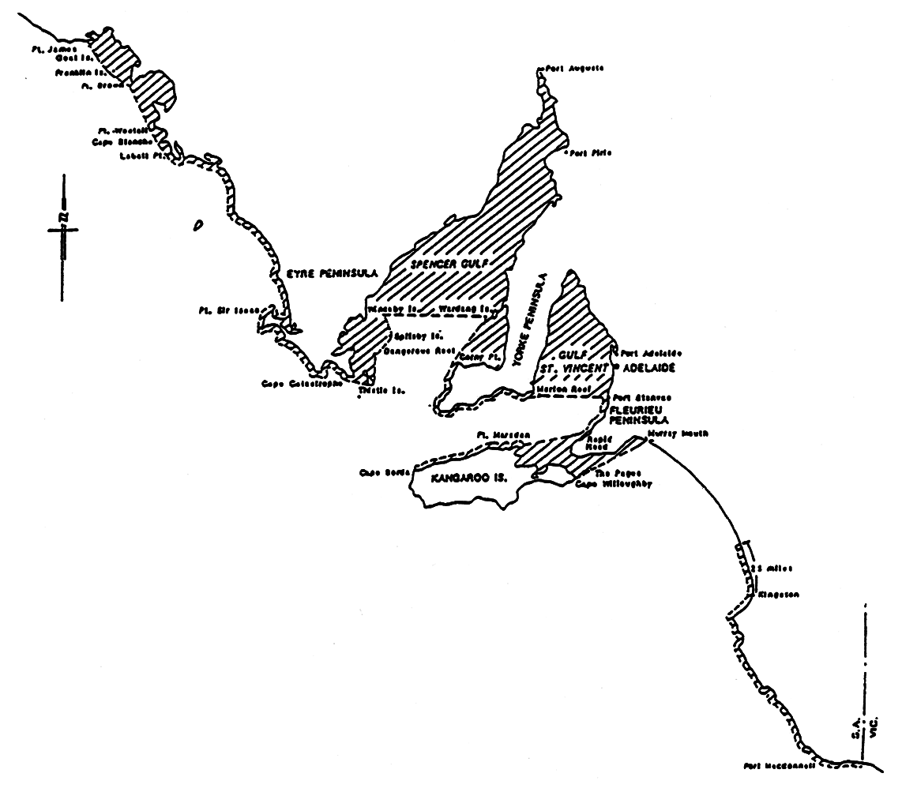
Schedule 3—Definition of harbor boundaries
Editorial note—
Unless the contrary intention appears, the maps in this Schedule are provided for convenience of reference only.
American River
The subjacent land underlying, and the adjacent land extending from, the waters, rivers, creeks, and inlets to the High Water Mark of American River and Eastern Cove bounded as follows:
on the north by a line running north-west from the American River Entrance Beacon to intersect with the High Water Mark on the western side of Eastern Cove then generally south-west along the High Water Mark to its intersection with a straight line drawn from the south-west corner of Allotment 500 in Deposited Plan No 68304 to the most northerly point of Section 178, Hundred of Dudley; then south-easterly along the line to its intersection with the High Water Mark; then generally easterly and northerly along the High Water Mark on the eastern side of American River to Strawbridge Point, then easterly along the High Water Mark to its intersection with a line running south-west from the Entrance Beacon, then along this line to the point of commencement.
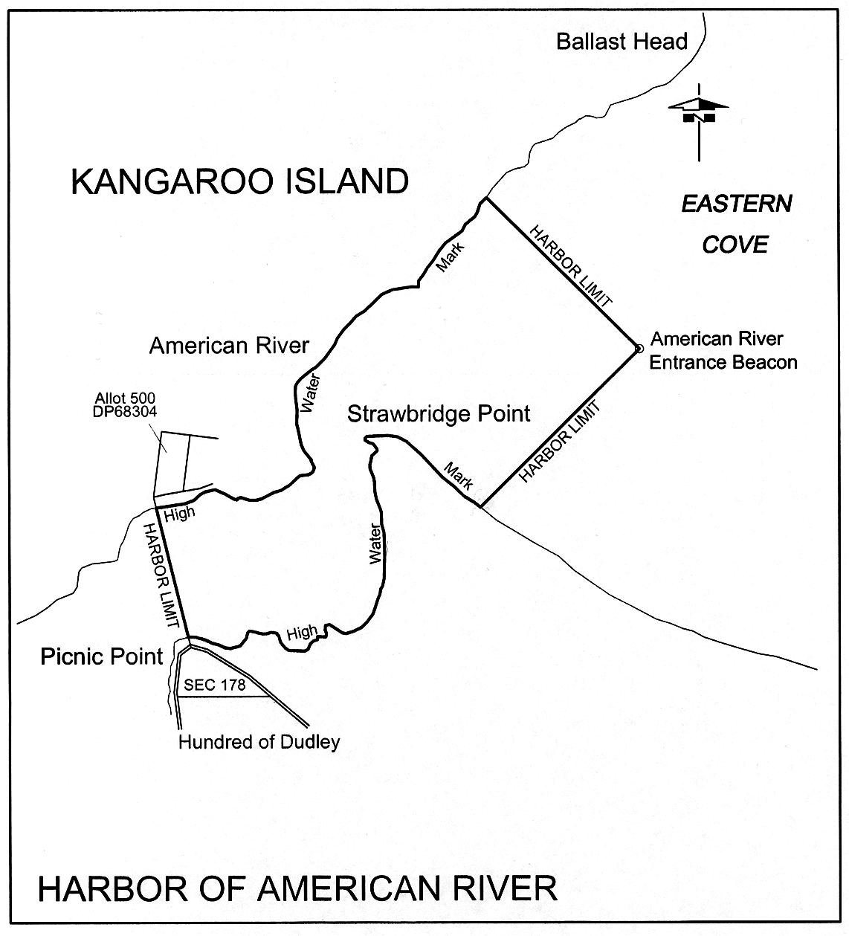
Ardrossan
The subjacent land underlying, and adjacent land extending from, the waters, rivers, creeks and inlets to the High Water Mark of that portion of the western coast of Gulf St. Vincent bounded as follows:
commencing at a point on a line bearing 106°25′ True and distance 1 nautical mile from the intersection of the centre line of the Ardrossan town jetty and the High Water Mark; then by a line bearing 196°25′ True to its intersection with the Ausbulk Jetty line of leads bearing 333°30′ True; then by a line bearing 286°25′ True to its intersection with the High Water Mark; then generally north-north-easterly along the High Water Mark to a point distant 1 nautical mile north-north-easterly and radial from the intersection of the High Water Mark and centre line of the Ardrossan town jetty; then by a 1 nautical mile radial line to the point of commencement.
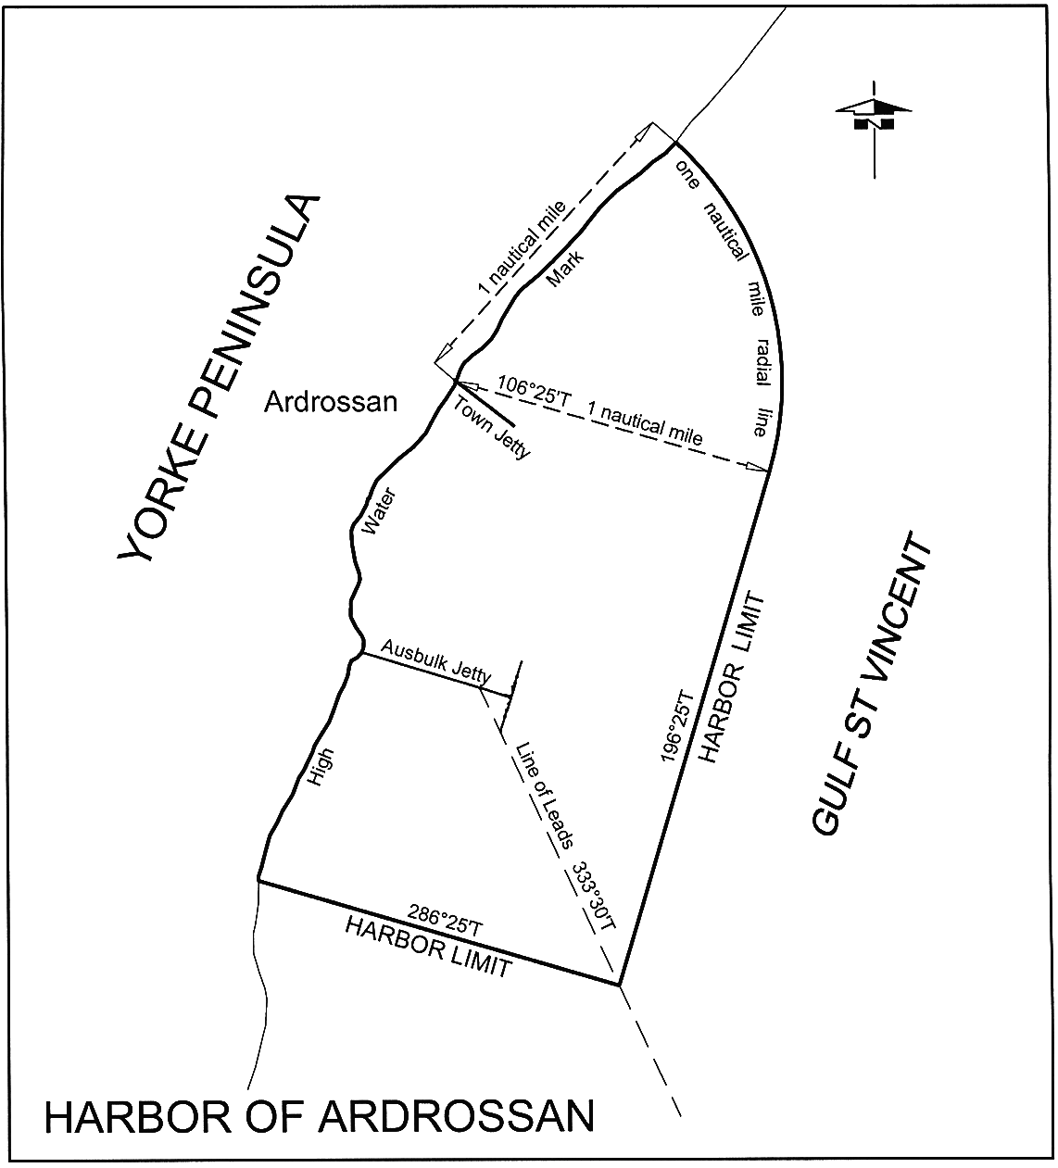
Beachport and Southend
The subjacent land underlying, and the adjacent land extending from, the waters, rivers, creeks and inlets to the High Water Mark on the coast within 3 nautical miles from any point on a straight line between Cape Martin and Cape Buffon.
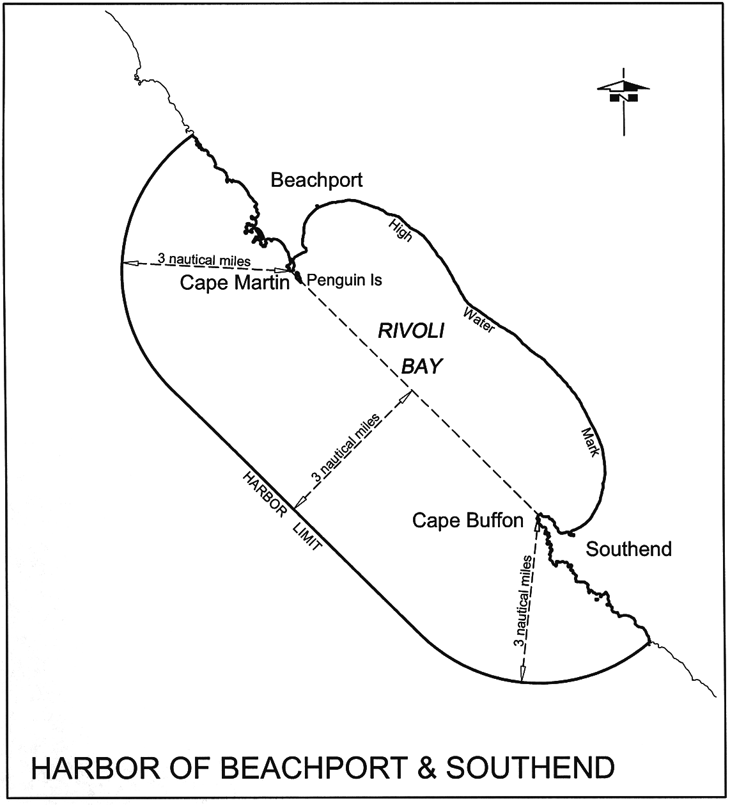
Cape Jaffa
The subjacent land underlying, and the adjacent land extending from, the waters, rivers, creeks and inlets to the High Water Mark within 100 m seaward of any part of the Cape Jaffa Jetty.
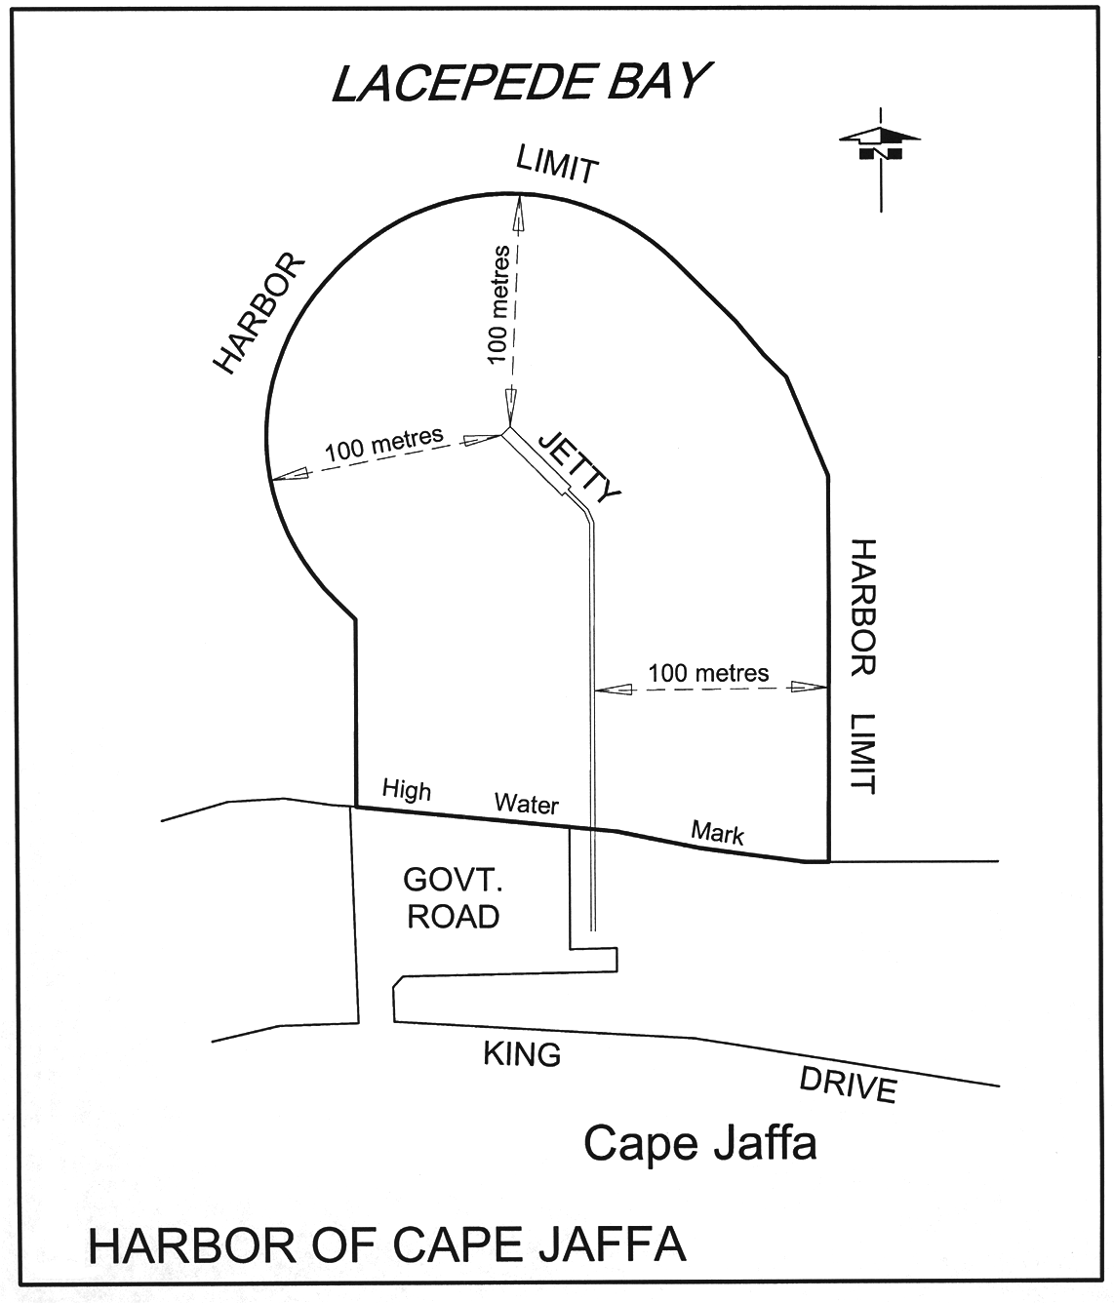
Cape Jervis
The following areas:
(a) the subjacent land underlying, and the adjacent land extending from, the waters, rivers, creeks and inlets to the High Water Mark within a distance of 200 m from the western tip of the south-eastern breakwater at Cape Jervis;
(b) allotments 2, 3 and 4 of Deposited Plan No 40711.
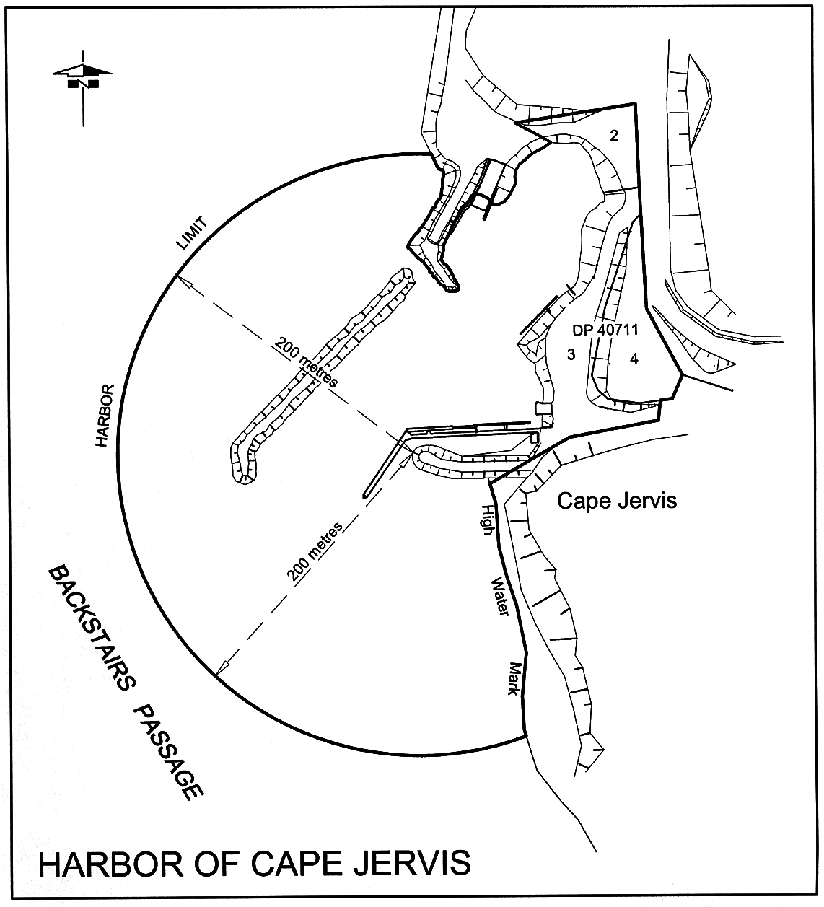
Coffin Bay
The subjacent land underlying, and the adjacent land extending from, the waters, rivers, creeks and inlets to the High Water Mark of Coffin Bay, Port Douglas, Mount Dutton Bay and Kellidie Bay, contained within a line drawn from Point Sir Isaac to a hill known as "Frenchman Lookout" in the Hundred of Warrow.
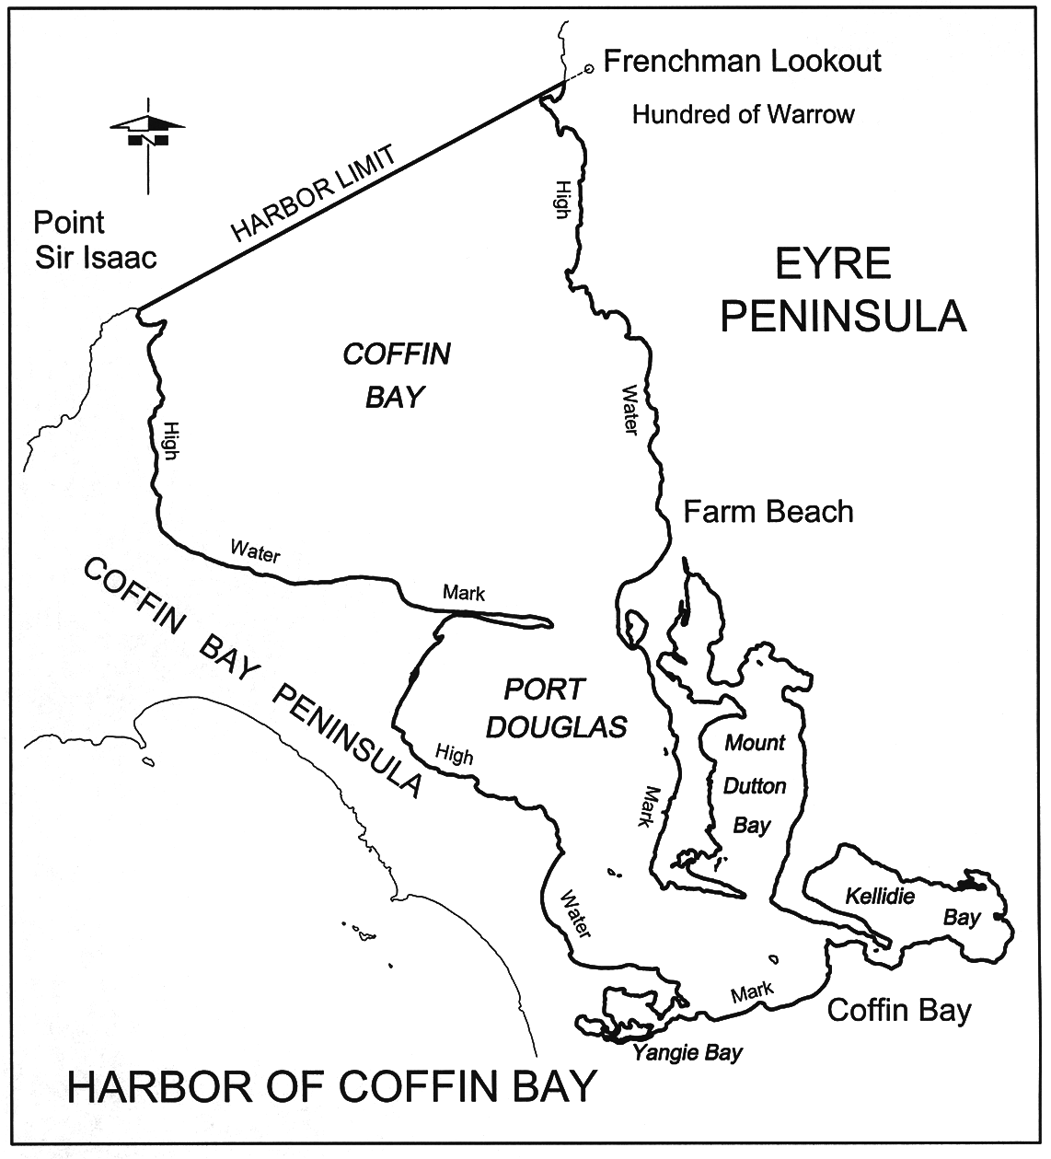
Cowell (Franklin Harbor)
The subjacent land underlying, and the adjacent land extending from, the waters, rivers, creeks and inlets to the High Water Mark of Franklin Harbor and within a straight line from Germein Point to Victoria Point, and 100 m to seaward of any point on that line.
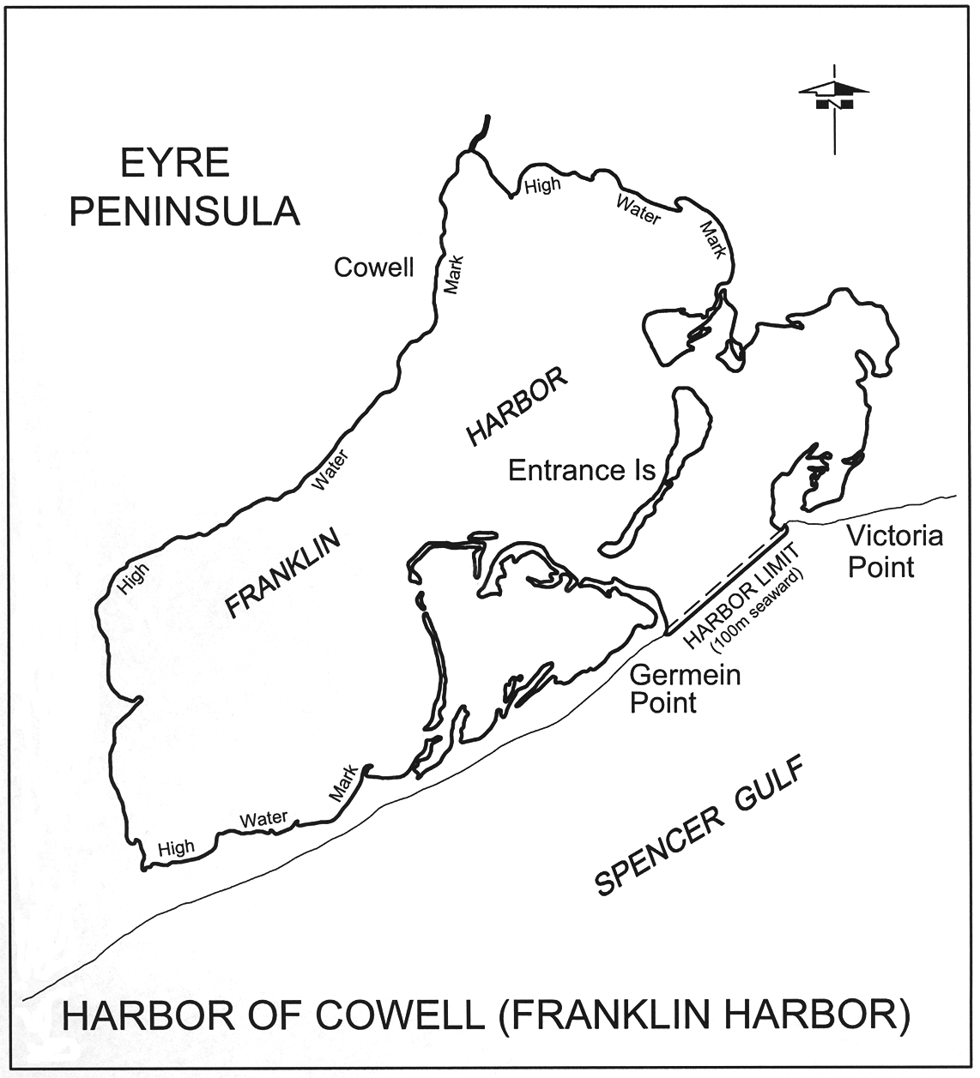
Kingscote
The following areas:
(a) the subjacent land underlying, and the adjacent land extending from, waters, rivers, creeks and inlets to the High Water Mark in Nepean Bay, Kangaroo Island and west of a straight line from Point Marsden to Point Morrison;
(b) the following parcels of land:
• Sections 351, 348, 349, 392, 395, 399 and Blocks 1 and 2 in the Hundred of Menzies
• Allotment 2 in Deposited Plan No 39677
• Closed Road A in Road Plan 4046.
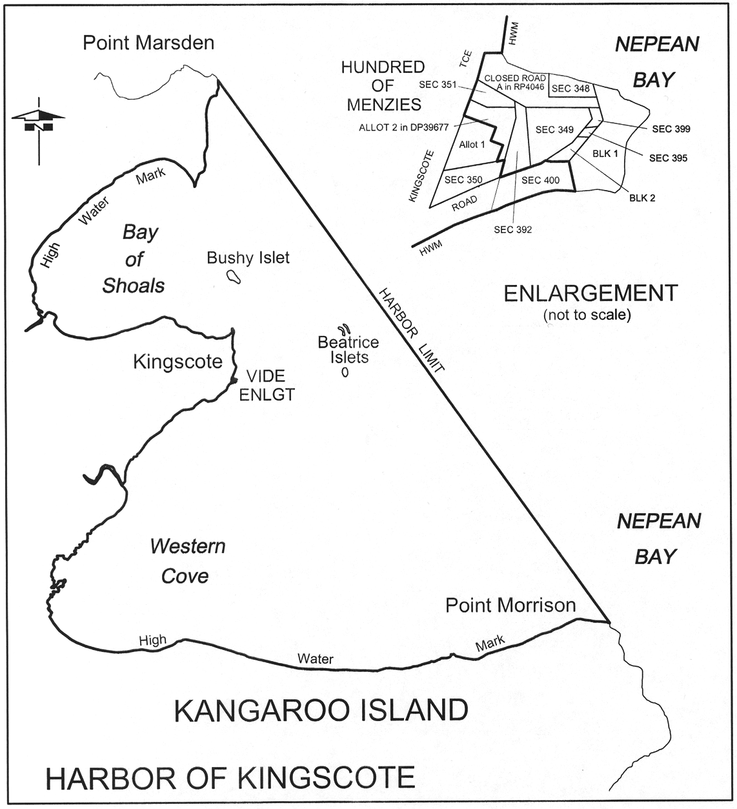
Kingston (SE)
The subjacent land underlying, and the adjacent land extending from, the waters, rivers, creeks and inlets to the High Water Mark within 100 m seaward of any part of the Kingston Jetty.
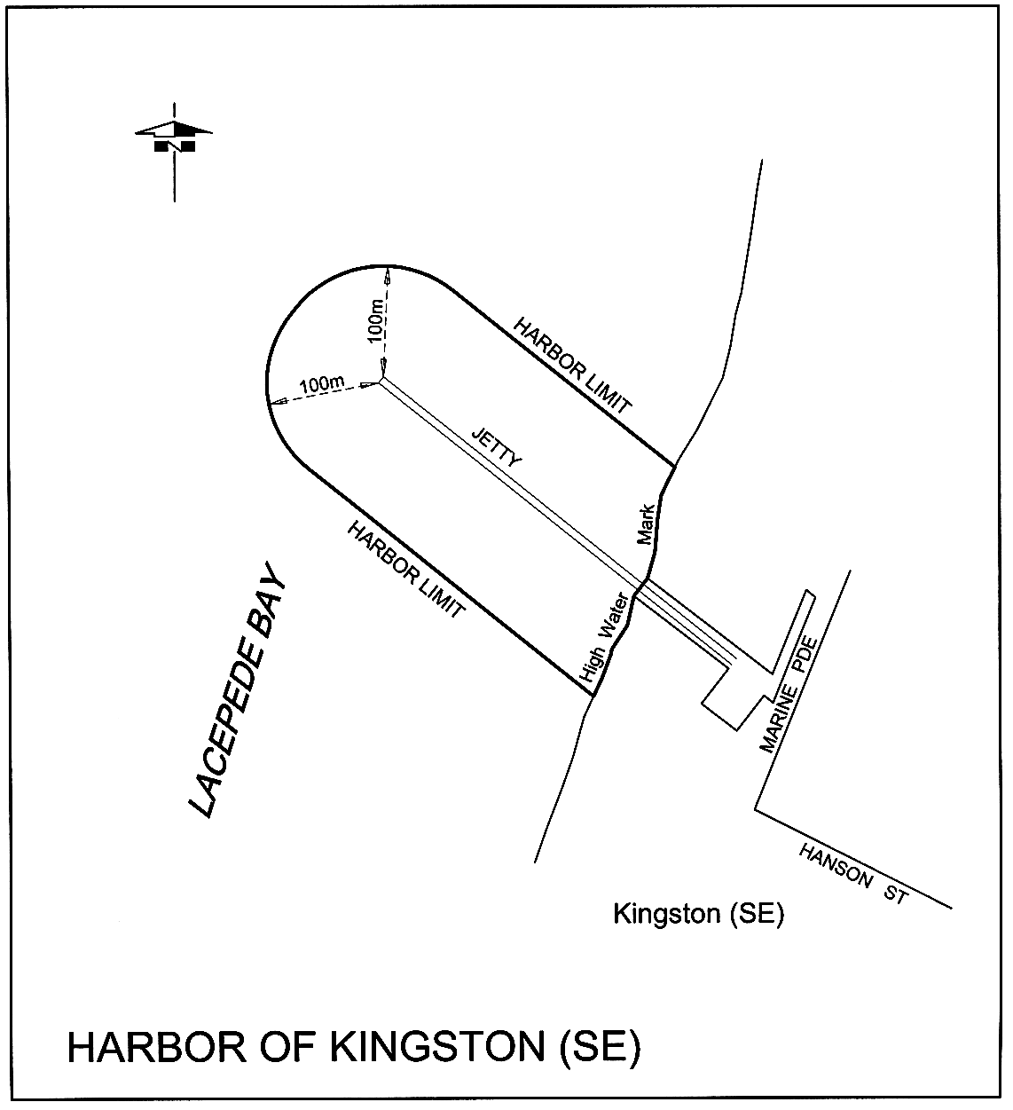
Klein Point
The subjacent land underlying, and the adjacent land extending from, the waters, rivers, creeks and inlets to the High Water Mark within 1 nautical mile seaward of any part of the Klein Point Jetty.
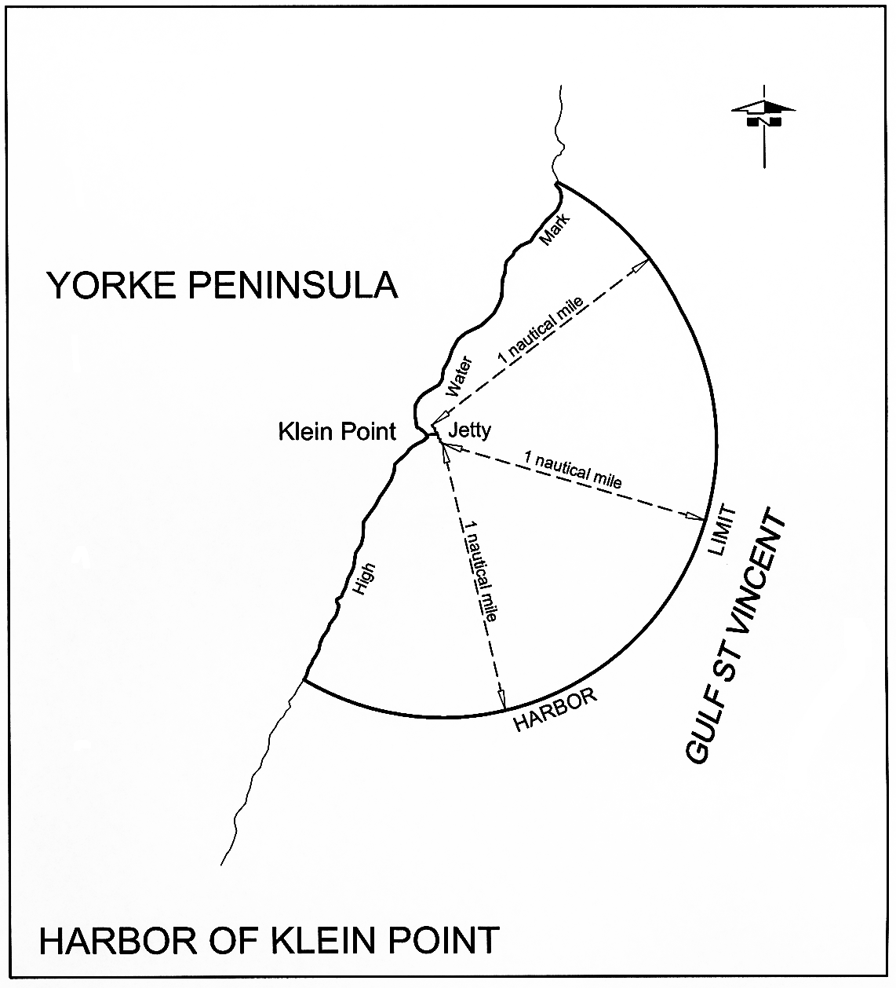
Penneshaw
The subjacent land underlying, and the adjacent land extending from, the waters, rivers, creeks and inlets to the High Water Mark on the northern coast of Dudley Peninsula, Kangaroo Island, and within a straight line from Hog Point to Ironstone Hill, and 1 nautical mile to seaward from any point on that line.
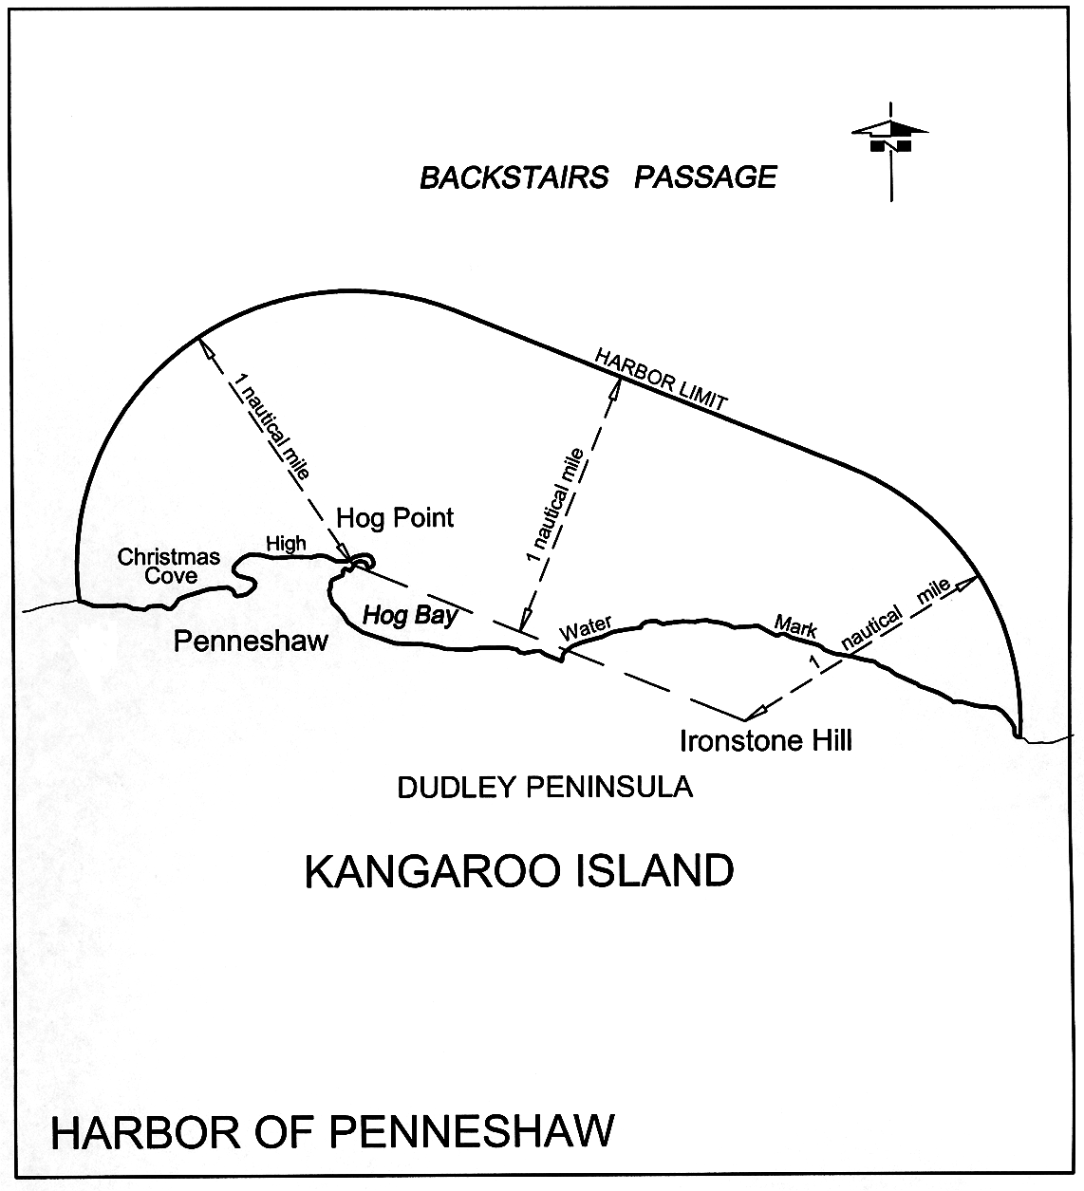
Point Turton
The subjacent land underlying, and the adjacent land extending from, the waters, rivers, creeks and inlets to the High Water Mark on the southern shore of Hardwicke Bay, bounded as follows:
commencing at Point Souttar; then true east to the High Water Mark on the sea coast; then south-westerly and north-westerly following the High Water Mark to the point of commencement.
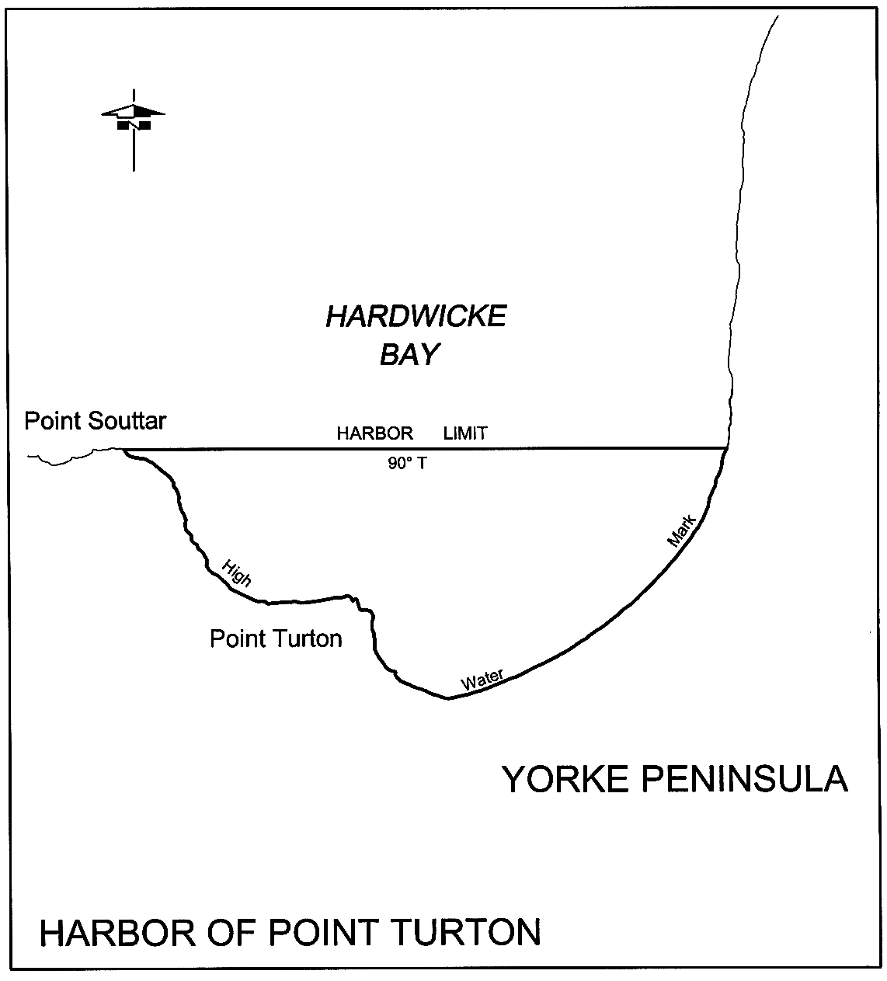
Port Adelaide

(a) The following areas:
(i) the subjacent land underlying, and the adjacent land extending from, the waters, rivers, creeks and inlets to the High Water Mark bounded as follows:
(A) on the north by a line extending due west for 5 nautical miles from a point on the Low Water Mark being the north-western corner of the Hundred of Port Adelaide (approximate latitude 34°40.42′ South);
(B) on the south by a line extending due west for 5 nautical miles from a point on the Low Water Mark being the south-western corner of the Hundred of Port Adelaide (approximate latitude 34°51.30′ South);
(C) on the west by a line extending north-north-westerly and connecting the western extremities of the southern and northern boundaries;
but excluding—
(D) the area bounded on the south by a line being the production west of the southern side of Section 1048, Hundred of Port Adelaide, and on the north by a line running east and west 1 nautical mile north of the Largs Bay Jetty, except for—
• a strip of land 10 m wide on each side of the centre line of the Semaphore Jetty and extending easterly from the Low Water Mark to the eastern end of the approach to that jetty; and
• a strip of land 10 m wide on each side of the centre line of the Largs Bay Jetty and extending easterly from the Low Water Mark to the eastern end of the approach to that jetty;
(E) the area bounded on the south by a line running east and west 1 nautical mile north of the Largs Bay Jetty and on the north-west by a line extending south-westerly from the northern most corner of Section 389, Hundred of Port Adelaide, and at right angles to the north-eastern boundary of Section 389;
(F) the area bounded as follows: commencing at a point on the northern boundary of the Hundred of Port Adelaide, being its intersection with the western edge of the mangroves along the eastern shore of Gulf St. Vincent, then southerly and generally south-easterly along portion of that western edge to intersect the production south-westerly of the north-western boundary of the road north-west of Section B, Hundred of Port Adelaide, then north-easterly along that production and portion of boundary to the High Water Mark, then generally north-westerly along that the High Water Mark to that northern Hundred boundary, then generally westerly along portion of the latter boundary to the point of commencement;
(G) that portion of the subjacent land underlying, and the adjacent land extending from, Old Port Reach (including Port Adelaide Canal), Port Adelaide River, Out of Hundreds (Adelaide) to the High Water Mark bounded as follows:
• on the north by a straight line between the bend on the eastern boundary of Section 661, Hundred of Port Adelaide, at corner 162°12′ and the bend on the western boundary of Section 7640, Hundred of Port Adelaide at corner 173°45′;
• on the south by the southern boundary of the Hundred of Port Adelaide;
(H) on and after the prescribed day, the following parcels of land:
• Allotment 708 of Deposited Plan No 123204
• Allotment 807 of Deposited Plan No 128471;
(ii) the whole of the land comprised in Certificates of Title Register Book—
• Volume 1962 Folio 149
• Volume 1974 Folio 153
• Volume 1974 Folio 154
• Volume 2436 Folio 64
• Volume 2772 Folio 12
• Volume 3009 Folio 131
• Volume 4383 Folio 154
• Volume 5086 Folio 57
• Volume 5123 Folio 453
• Volume 5128 Folio 416
• Volume 5143 Folio 963
• Volume 5179 Folio 216
• Volume 5179 Folio 219
• Volume 5179 Folio 223
• Volume 5191 Folio 911
• Volume 5202 Folio 446
• Volume 5202 Folio 448
• Volume 5202 Folio 451
• Volume 5202 Folio 452
• Volume 5211 Folio 177;
(iii) the following parcels of land:
• Allotments 1, 2, 7, 9, 10 and 12 of Deposited Plan No 40901
• Allotments 52, 55, 57 and 58 of Deposited Plan No 41580
• Allotments 1, 2, 4, 5 and 6 of Deposited Plan No 41006
• Allotments 1, 3, 4 and 7 of Deposited Plan No 41578
• Allotments 101 and 102 of Deposited Plan No 39922
• Allotment 2 of Deposited Plan No 31181
• Allotments 54 and 55 of Deposited Plan No 41577.
(b) In this clause—
prescribed day means the day specified by the Minister by notice in the Gazette as the prescribed day.
Port Augusta
The subjacent land underlying, and the adjacent land extending from, the waters, rivers, creeks and inlets to the High Water Mark of all that portion of Spencer Gulf, north of a line drawn across the Gulf from Point Patterson to Commissariat Point, and including all navigable waters to the extreme northern extent of the Gulf.
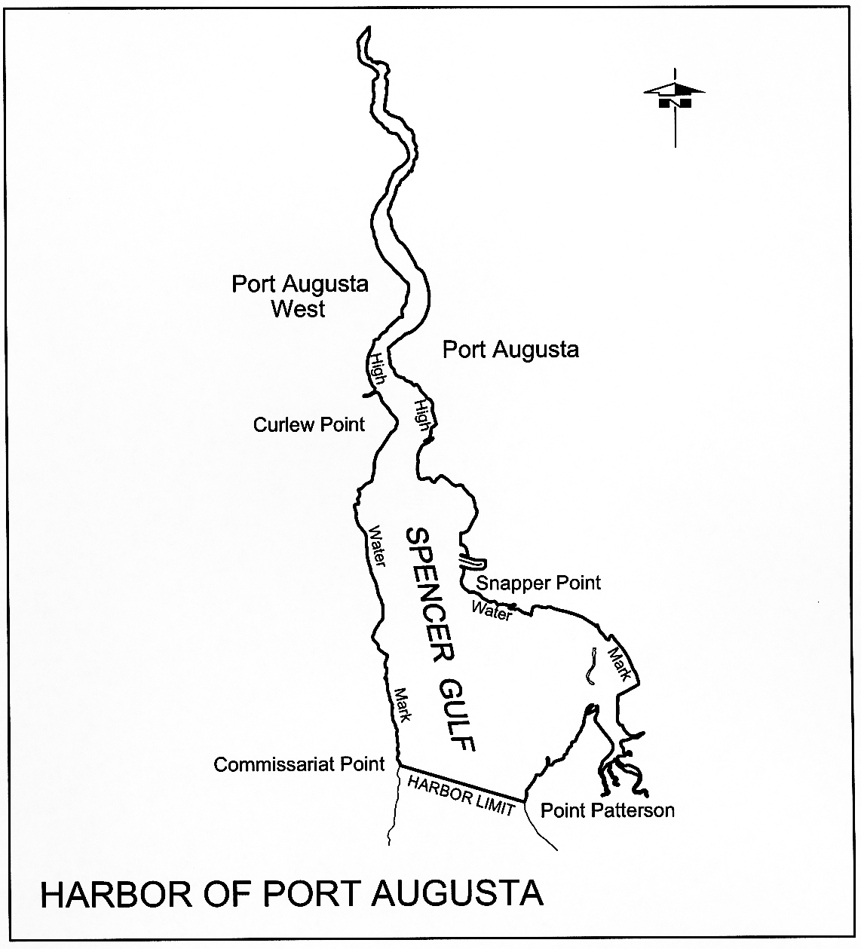
Port Bonython
The subjacent land underlying, and the adjacent land extending from, the waters, rivers, creeks and inlets to the High Water Mark of that portion of the western coast of Spencer Gulf bounded as follows:
commencing at the eastern extremity of the harbor of Whyalla, latitude 33°03.75′ South, longitude 137°40.5′ East, then along the north-east boundary of that harbor bearing 319° True to the High Water Mark, then generally easterly along the High Water Mark to its intersection with a straight line bearing 143.5° True from Lowly Point Light, then along the latter line for a distance of approximately 3.4 nautical miles to the north boundary of the harbor of Port Pirie, then along the latter line bearing 251° True for a distance of approximately 2.5 nautical miles to the west extremity of that harbor, then along the south-west boundary of that harbor bearing 126° True for a distance of approximately 1.6 nautical miles to its intersection with a straight line bearing 97° True from the point of commencement, then along the latter line to the point of commencement.
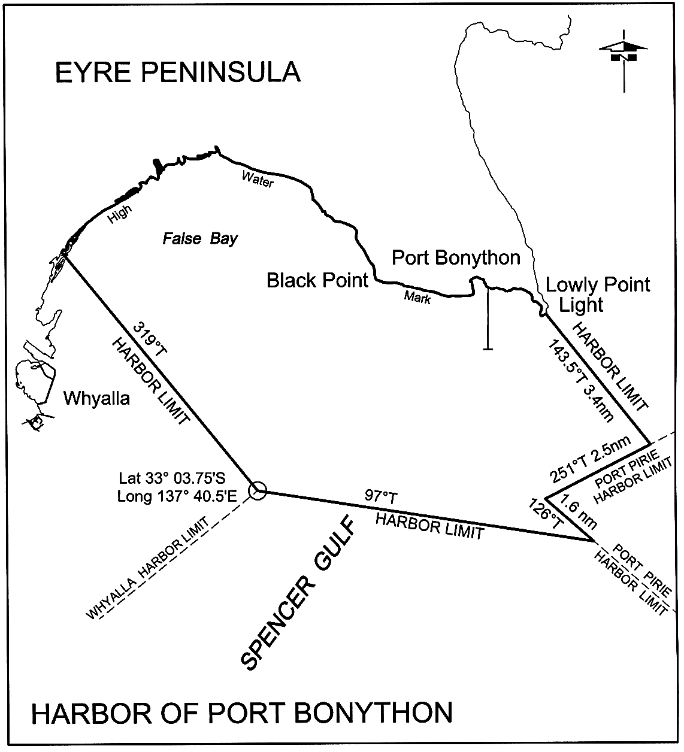
Port Broughton
The subjacent land underlying, and the adjacent land extending from, the waters, rivers, creeks and inlets to the High Water Mark on the eastern coast of Spencer Gulf, and within a straight line drawn from Woods Point to Webling Point, and over 3 nautical miles to seaward measured from any point on the line.
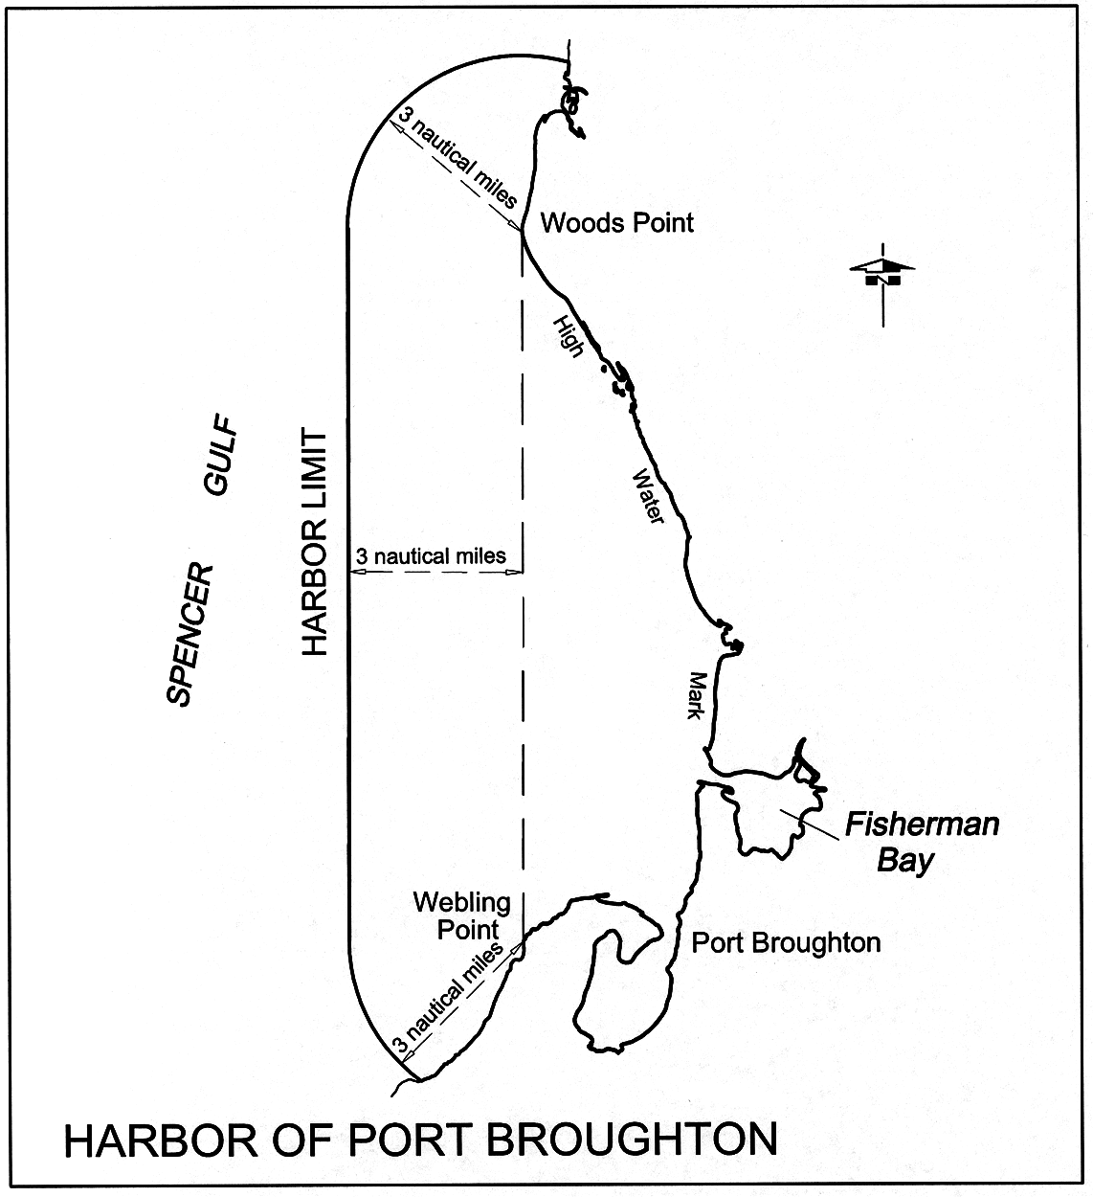
Port Giles
The subjacent land underlying, and the adjacent land extending from, the waters, rivers, creeks and inlets to the High Water Mark of that portion of the western coast of Gulf St. Vincent bounded as follows:
commencing at a point on the High Water Mark 1 nautical mile due north of the intersection of the centre line of the Port Giles Jetty with the High Water Mark; then by a line bearing due east from the High Water Mark for 7 nautical miles; then on a line bearing due south for 2 nautical miles; then on a line bearing due west to the High Water Mark; then generally northerly along the High Water Mark to the point of commencement.
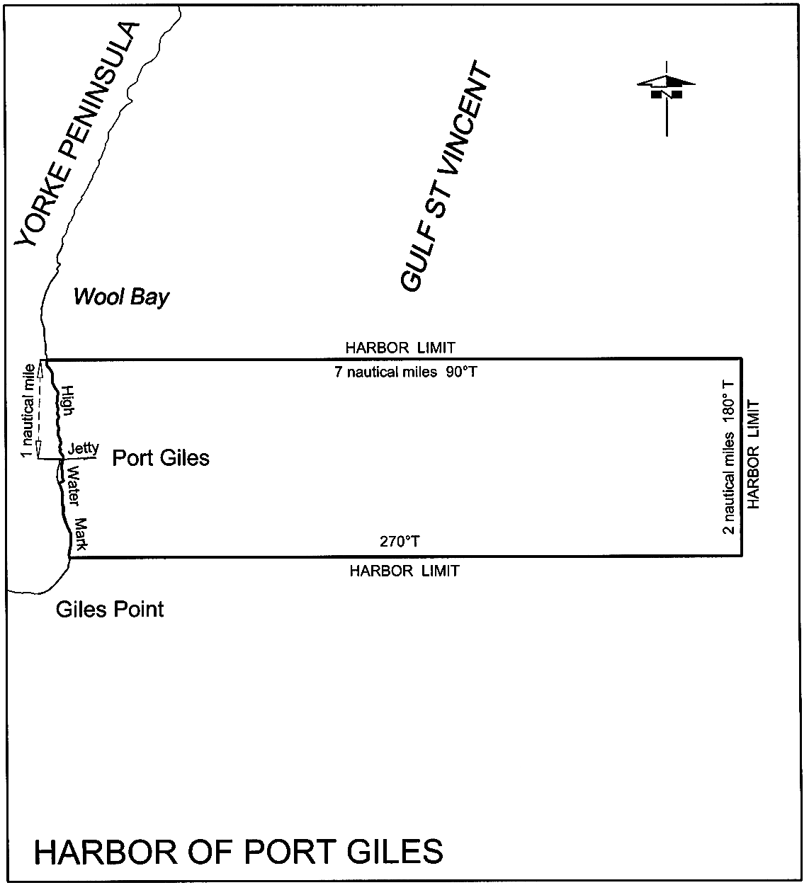
Port Lincoln
The following areas:
(a) the subjacent land underlying, and the adjacent land extending from, the waters, rivers, creeks and inlets to the High Water Mark of Port Lincoln, as embraced within a straight line drawn between Cape Donnington and Point Boston, and within 3 nautical miles to seaward, measured from any point on the line;
(b) the following parcels of land:
• Allotments 63, 64, 65 and 66 in Deposited Plan No 57911
• Allotment 60 in Deposited Plan No 53037
• Block 2, Hundred of Lincoln.
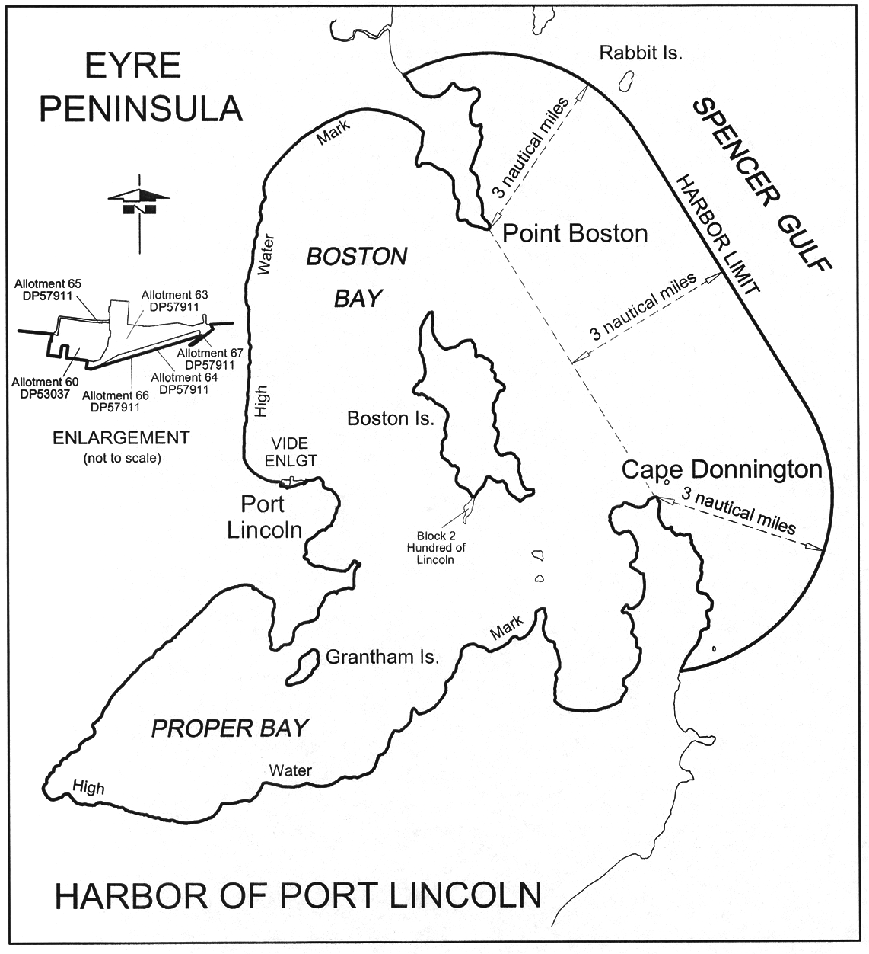
Port MacDonnell
The subjacent land underlying, and the adjacent land extending from, the waters, rivers, creeks and inlets to the High Water Mark of that portion of MacDonnell Bay bounded as follows:
commencing at the intersection of the High Water Mark and a line 100 m westerly and parallel to the centre line of the breakwater, then generally south and east along the line to a point south-west of the eastern tip of the breakwater, then north-easterly along a line towards the south-east corner of Allotment 21 of Deposited Plan No 60070 to its intersection with the High Water Mark, then generally westerly along the High Water Mark to the point of commencement.
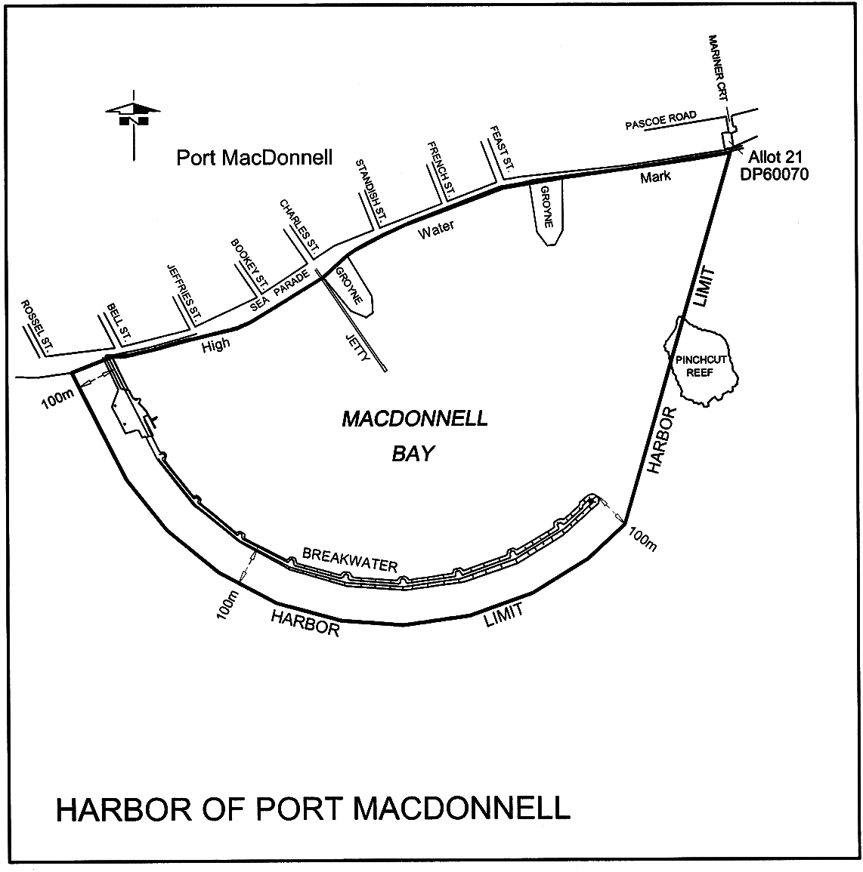
Port Pirie
The following areas:
(a) the subjacent land underlying, and the adjacent land extending from, the waters, rivers, creeks and inlets to the High Water Mark in Germein Bay, Spencer Gulf, commencing at a point on a line bearing 282° True and distant 13 nautical miles from Mount Ferguson (latitude 33°06.34′ South, longitude 138°01.78′ East) situated in Section 1, Hundreds of Telowie and Pirie, then by a line bearing 126° True to the High Water Mark on the shore, generally easterly, generally southerly and generally northerly following that High Water Mark to a point being its intersection with a line bearing 71° True from the point of commencement, then west-south-westerly along the latter line to the point of commencement;
(b) the following parcels of land:
• Allotments 409 of Deposited Plan No 57081
• Pieces 96 and 97 in Filed Plan 203787
• Sections 698, 699, 944, 947, 948 and 958, Hundred of Pirie.
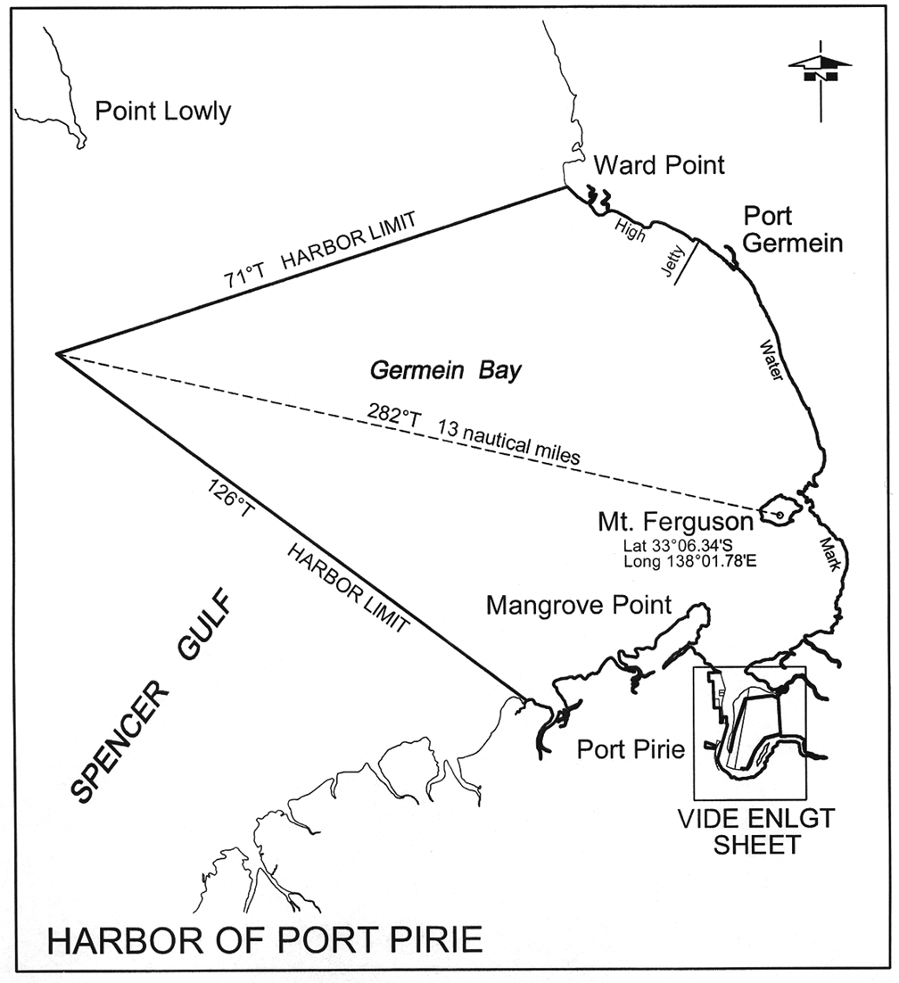
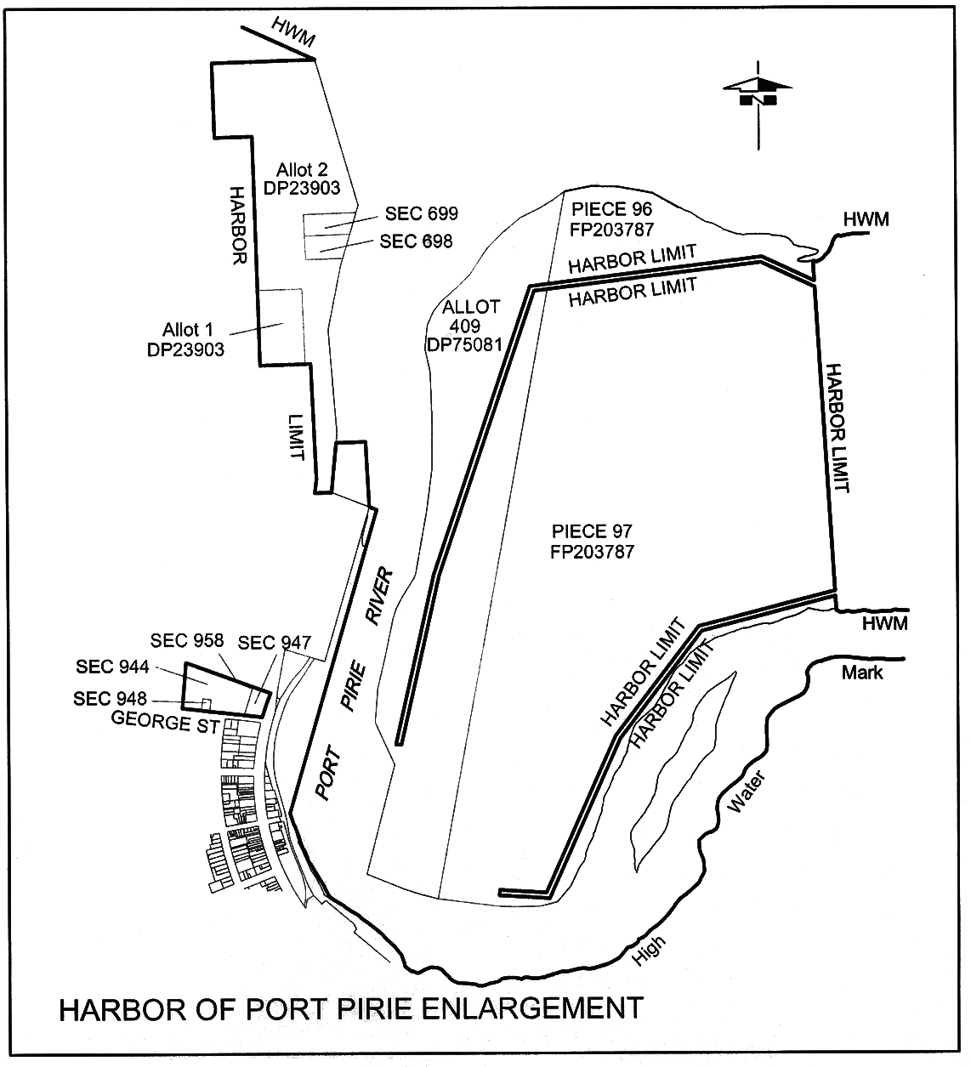
Port Stanvac
The subjacent land underlying, and the adjacent land extending from, the waters, rivers, creeks and inlets to the High Water Mark on the eastern side of Gulf St. Vincent bounded as follows:
(a) on the north-east by a line bearing 315° for 3 nautical miles from the High Water Mark at approximately latitude 35°05.50′ South, longitude 138°29.25′ East;
(b) on the south by a line bearing 270° True for 3 nautical miles from the High Water Mark at approximately latitude 35°07.50′ South, longitude 138°28.25′ East;
(c) on the north-west by a straight line connecting the extremities of those boundaries.
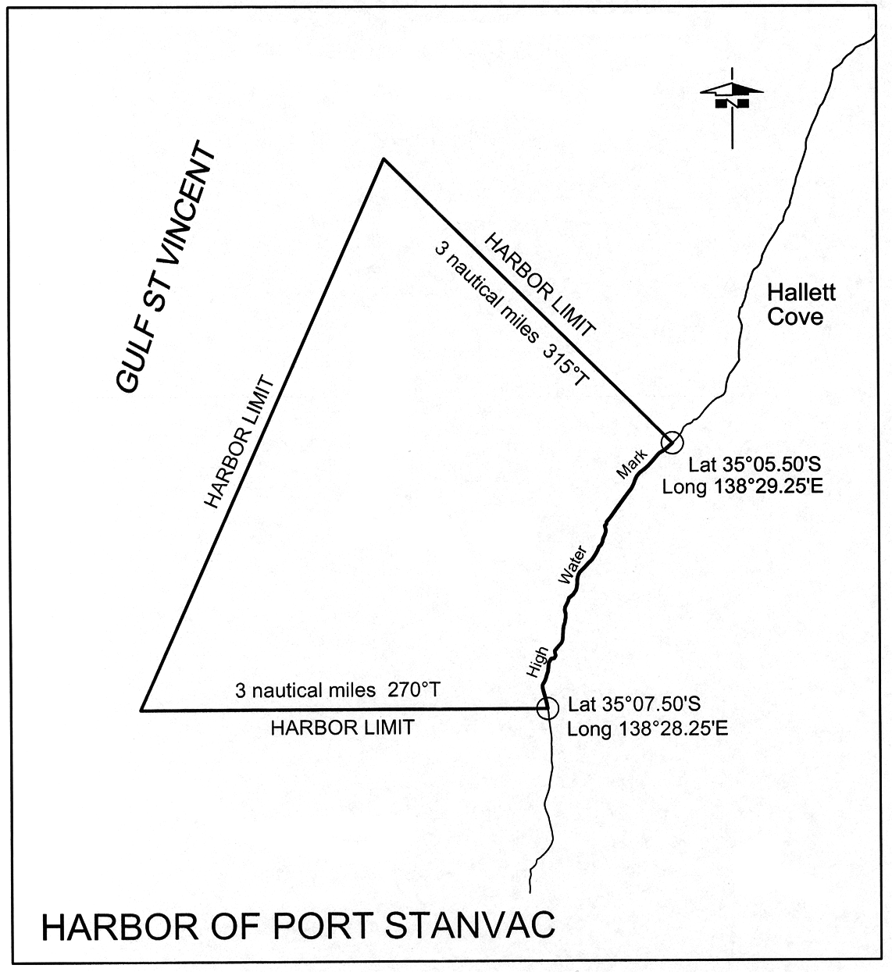
Port Wakefield
The subjacent land underlying, and the adjacent land extending from, the waters, rivers, creeks and inlets to the High Water Mark of that portion of Gulf St. Vincent situated to the north of a line drawn from Sandy Point on the eastern shore to Mangrove Point on the western shore, but excluding an area commencing at a point being the intersection of the production easterly of the northern boundary of Wandilta Terrace, Town of Clinton, Hundred of Clinton, with the eastern edge of the mangroves along the western shore of Gulf St. Vincent, then westerly along that production and portion of boundary to the High Water Mark, then generally northerly along the High Water Mark to its intersection with the production south-easterly of the north-eastern boundary of Section 568 in the Hundred of Clinton, then generally southerly following that edge of the mangroves to the point of commencement.
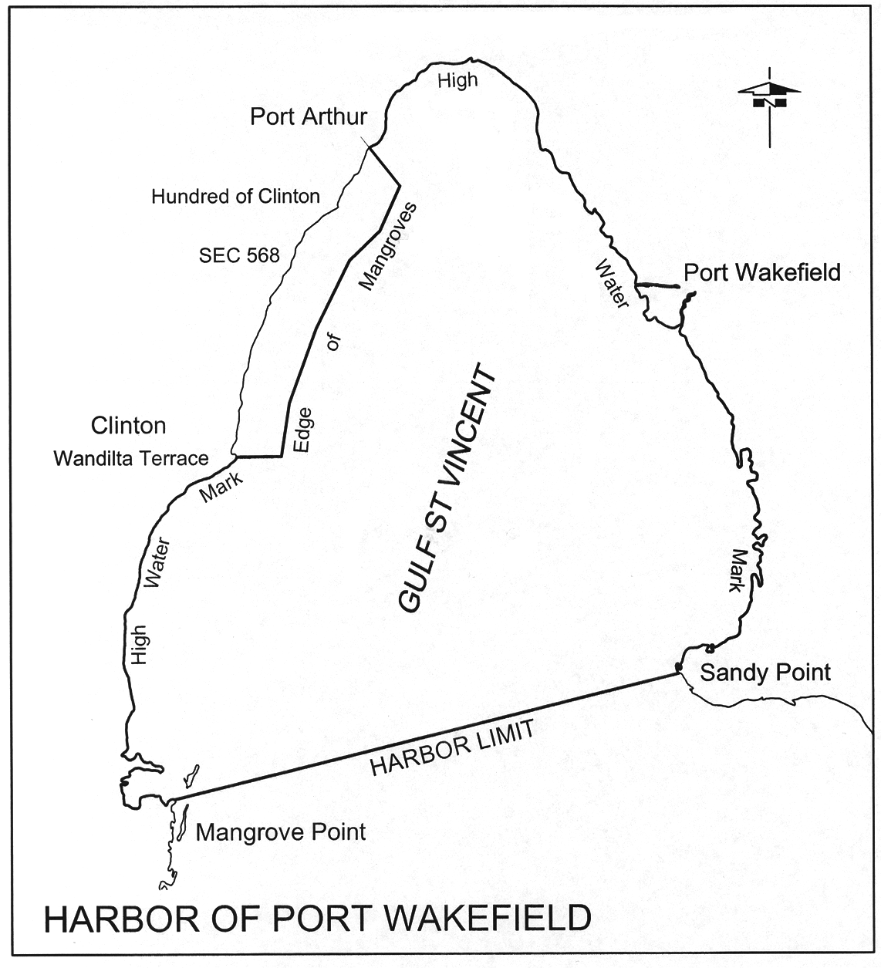
Rapid Bay
The subjacent land underlying, and the adjacent land extending from, the waters, rivers, creeks and inlets to the High Water Mark within 0.5 nautical miles seaward of any part of the Rapid Bay Jetty.
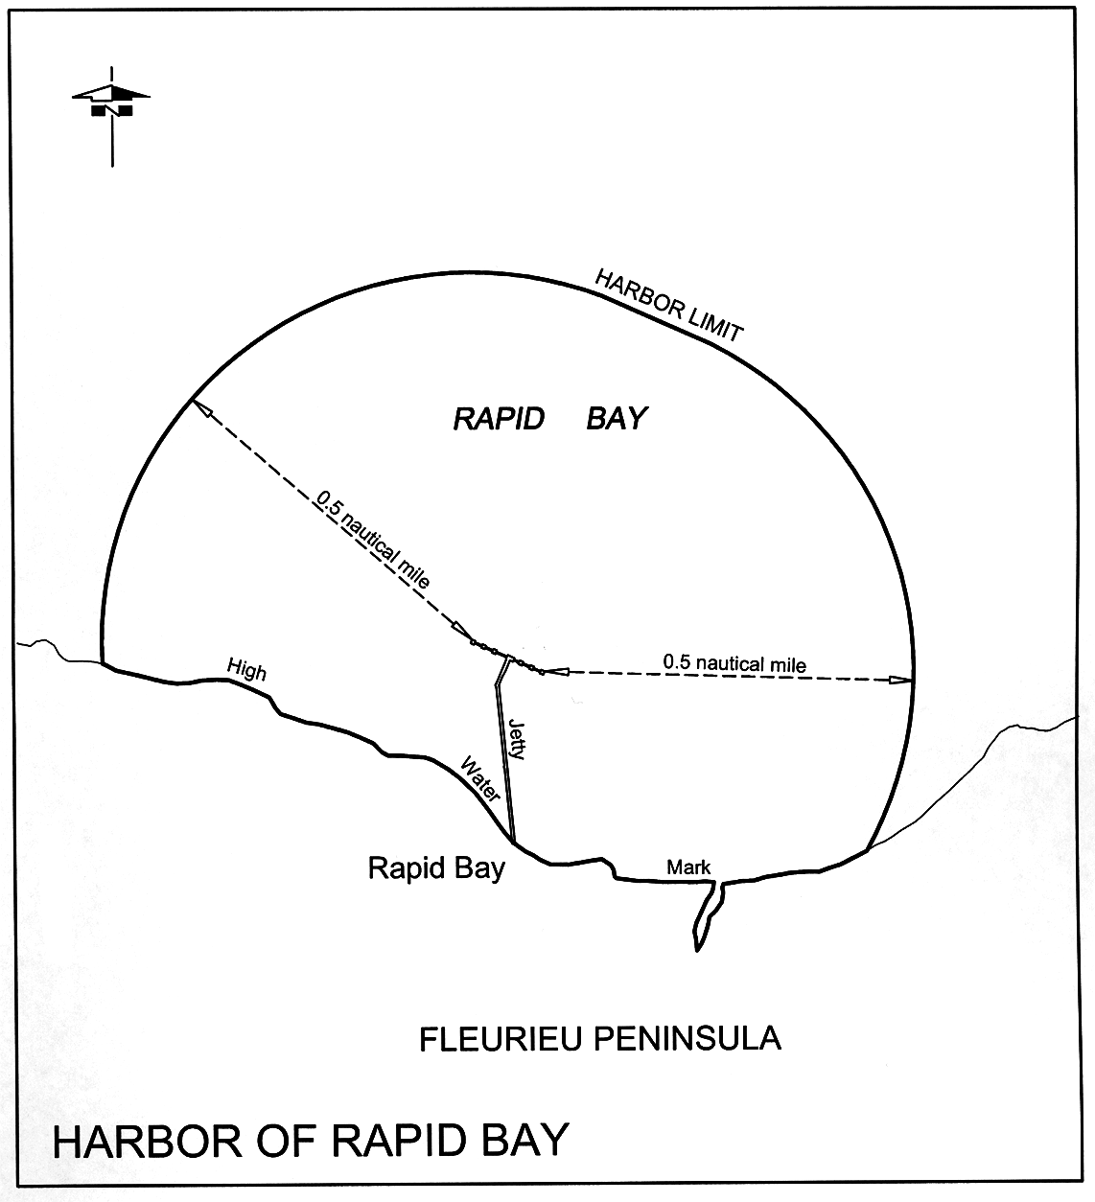
Robe
The subjacent land underlying, and the adjacent land extending from, the waters, rivers, creeks and inlets to the High Water Mark of Guichen Bay, Lake Butler, including the entrance channel, as embraced within straight lines drawn from Cape Dombey to the outward point of Godfrey Island, and from there to Cape Thomas, and over 3 nautical miles to seaward, measured from any point on these lines.
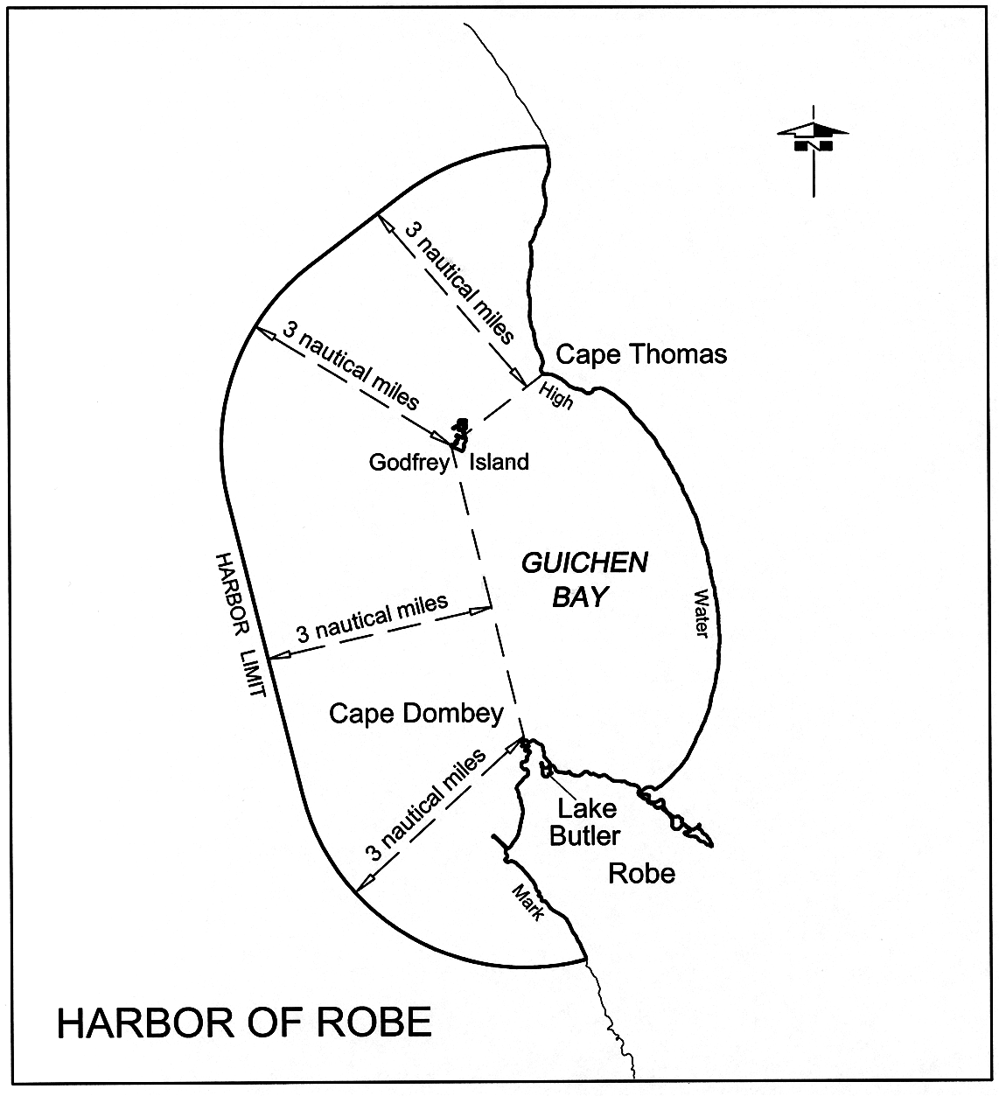
Streaky Bay
The subjacent land underlying, and the adjacent land extending from, the waters, rivers, creeks and inlets to the High Water Mark to the north and east of a line joining Point Brown to Point Westall.
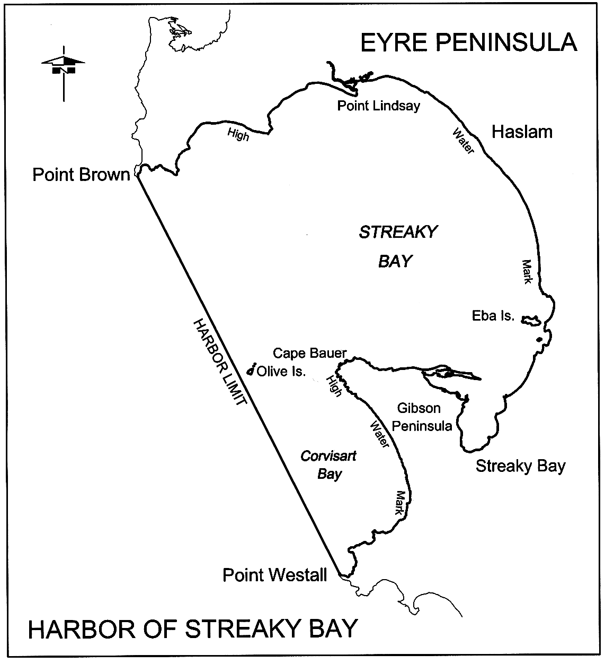
Thevenard
The following areas:
(a) the subjacent land underlying the waters, rivers, creeks and inlets to the Low Water Mark of portions of Denial Bay, Murat Bay, Bosanquet Bay, and D'Ecres Bay bounded as follows:
commencing at the Low Water Mark, Cape Beaufort, Hundred of Moule, then true south for 2 nautical miles, then 150° True for 3.2 nautical miles, then 71° True on a straight line to the Low Water Mark at Wittelbee Point, Hundred of Bonython, then along the Low Water Mark in a westerly, northerly, westerly, and southerly direction to the point of commencement, and including—
• that portion of the foreshore 30.48 m wide being 15.24 m on each side of the centre line of the Denial Bay Jetty, situated opposite Main Street, Denial Bay, Hundred of Moule, extending from the High Water Mark to the Low Water Mark; and
• that portion of the foreshore 30.48 m wide being 15.24 m on each side of the centre line of the Murat Bay Jetty, situated opposite McKenzie Street, Ceduna, Hundred of Bonython, extending from the High Water Mark to the Low Water Mark;
(b) the whole of the land comprised in—
• Allotments 7 and 8 in Deposited Plan No 57833
• Allotment 6 in Deposited Plan No 52794
• Closed Road B in Road Plan 5058.
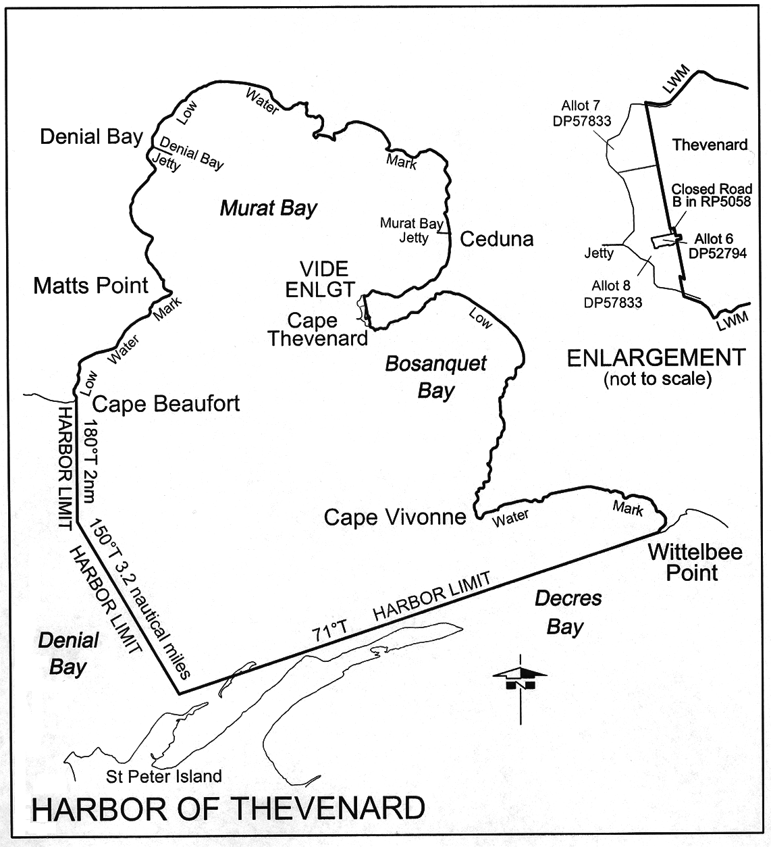
Venus Bay
The subjacent land underlying, and the adjacent land extending from, the waters, rivers, creeks and inlets to the High Water Mark of Venus Bay, including the islands of the bay and the subjacent land underlying, and the adjacent land extending from, waters to the north of a straight line between Point Weyland and South Head.
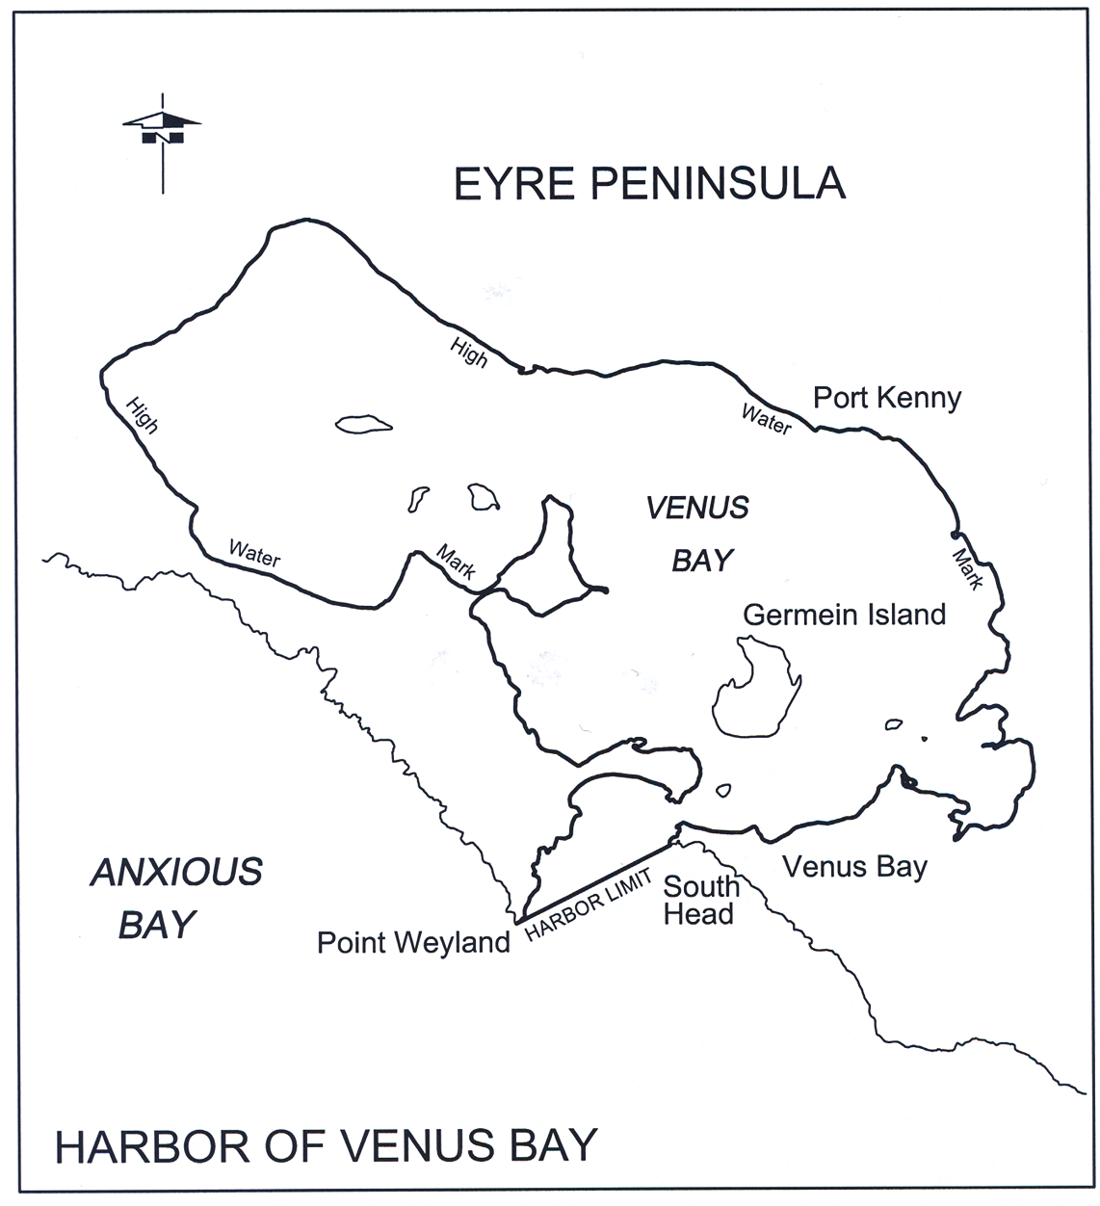
Victor Harbor
The subjacent land underlying, and the adjacent land extending from, the waters, rivers, creeks and inlets to the High Water Mark bounded as follows:
commencing at the intersection of the High Water Mark and a line running 141° True from Rosetta Head, Hundred of Waitpinga; then south-westerly along that line for 0.5 nautical miles; then along a line 51° True to the High Water Mark about 1.5 nautical miles eastward from Middleton, Hundred of Goolwa; then westerly and south-westerly along the High Water Mark to the point of commencement.
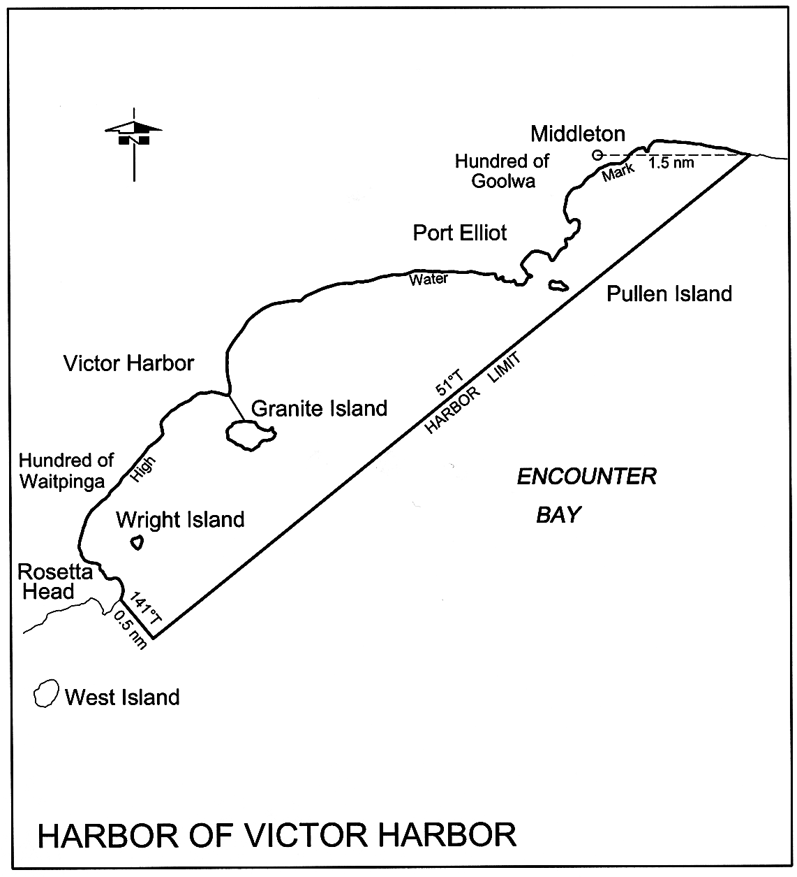
Vivonne Bay
The subjacent land underlying, and the adjacent land extending from, the waters, rivers creeks and inlets to the High Water Mark to the north of a line joining Point Ellen to Mount Bloomfield.
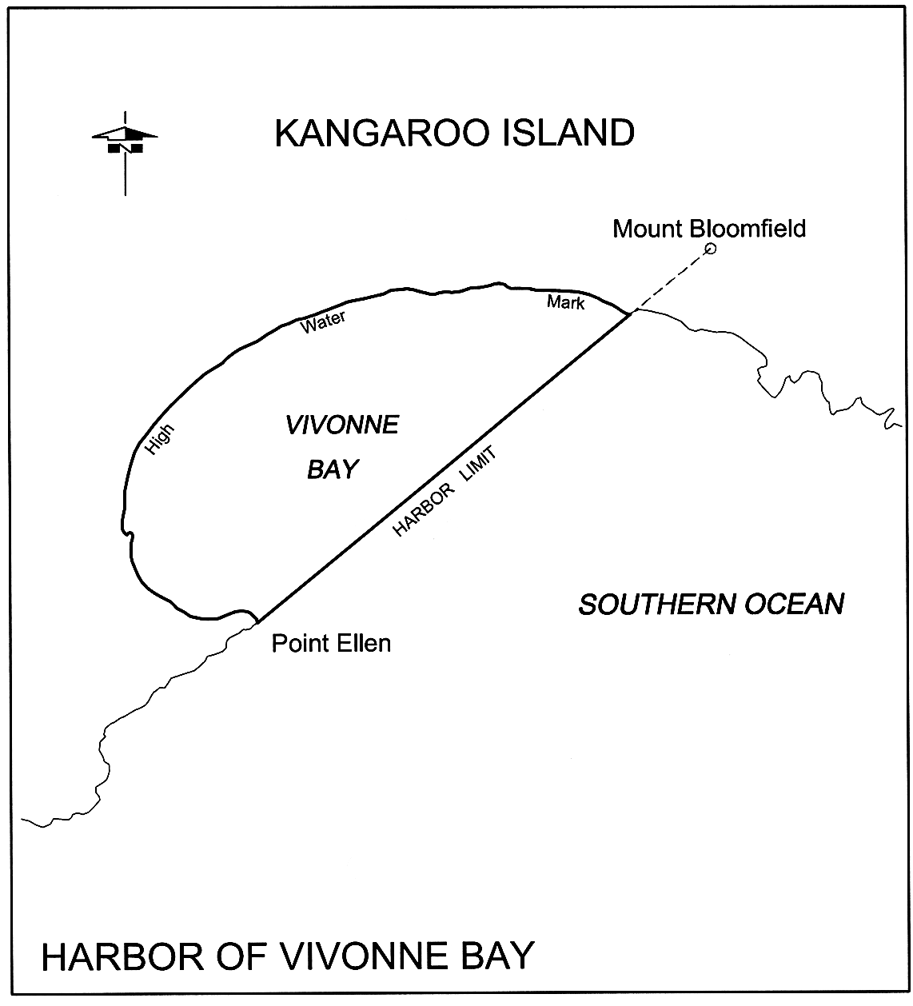
Wallaroo
The following areas:
(a) the subjacent land underlying, and the adjacent land extending from, the waters, rivers, creeks and inlets to the High Water Mark of that part of Wallaroo Bay bounded as follows:
(i) on the north by a line extending due west for 3 nautical miles from a point on the High Water Mark at the south-west extremity on Point Riley;
(ii) on the south by a line extending due west for 3 nautical miles from a point on the High Water Mark at the northern extremity of Point Hughes;
(iii) on the west by a line joining the seaward extremities of those north and south boundaries;
(iv) on the east commencing at a point where the southern boundary intersects with the High Water Mark and continuing in a general north-easterly direction along the High Water Mark to the northerly most corner of Piece 915 in Deposited Plan No 36451 then generally northerly along the Low Water Mark to Point Riley where it intersects with the northerly boundary,
but excluding Allotments 1001 and 1003 in Deposited Plan No 56470;
(b) the whole of the land comprised in Certificate of Title Register Book—
• Allotments 101, 104, 105 and 106 in Deposited Plan No 57809
• Allotment 2 in Deposited Plan No 65551.
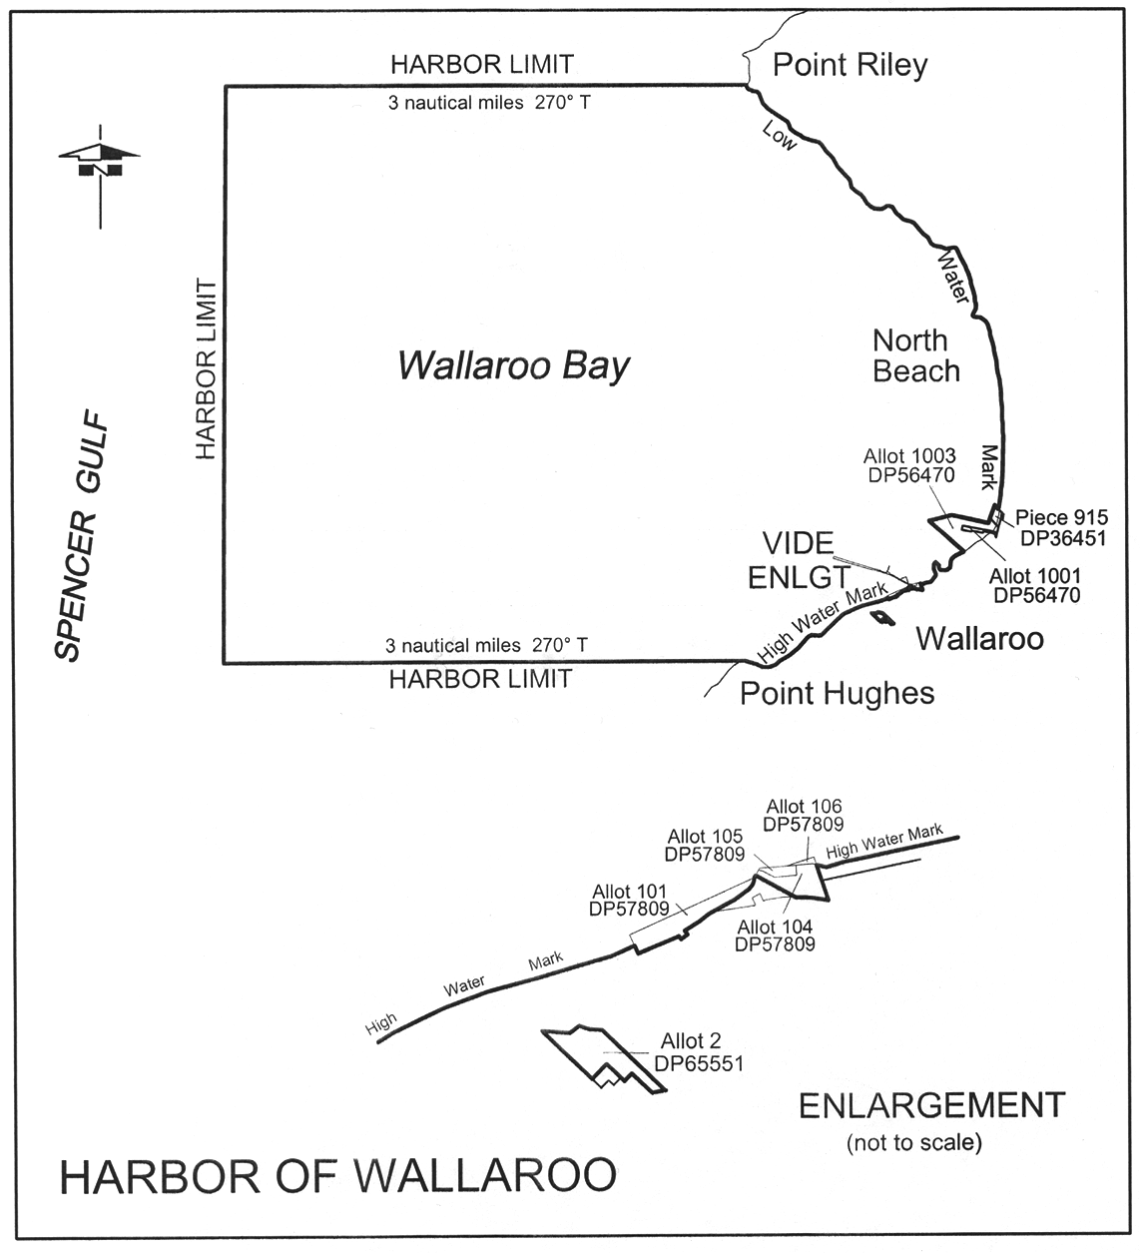
Whyalla
The subjacent land underlying, and the adjacent land extending from, the waters, rivers, creeks and inlets to the High Water Mark of that portion of the western coast of Spencer Gulf bounded as follows:
commencing at point latitude 33°03.75′ South, longitude 137°40.50′ East, then by a straight line to latitude 33°06.25′ South, longitude 137°37.00′ East, then on a line bearing 319° True to the High Water Mark, then generally north-easterly following the High Water Mark to its intersection with a line bearing 319° True from the point of commencement, then from the latter line to the point of commencement but excluding that portion comprising land reclaimed as follows:
• that portion of Allotment 6 in Deposited Plan No 26386, Hundred of Randell, situated between the Old Medium High Water Mark and the Toe of Bank of Reclaimed Area delineated on that Plan;
• that portion shown on Deposited Plan No 26386 as situated between the southern boundary of Allotment 7 and the Medium High Water Mark;
• Allotment 3 in Deposited Plan No 26088, Hundred of Randell and Out of Hundreds (Whyalla).
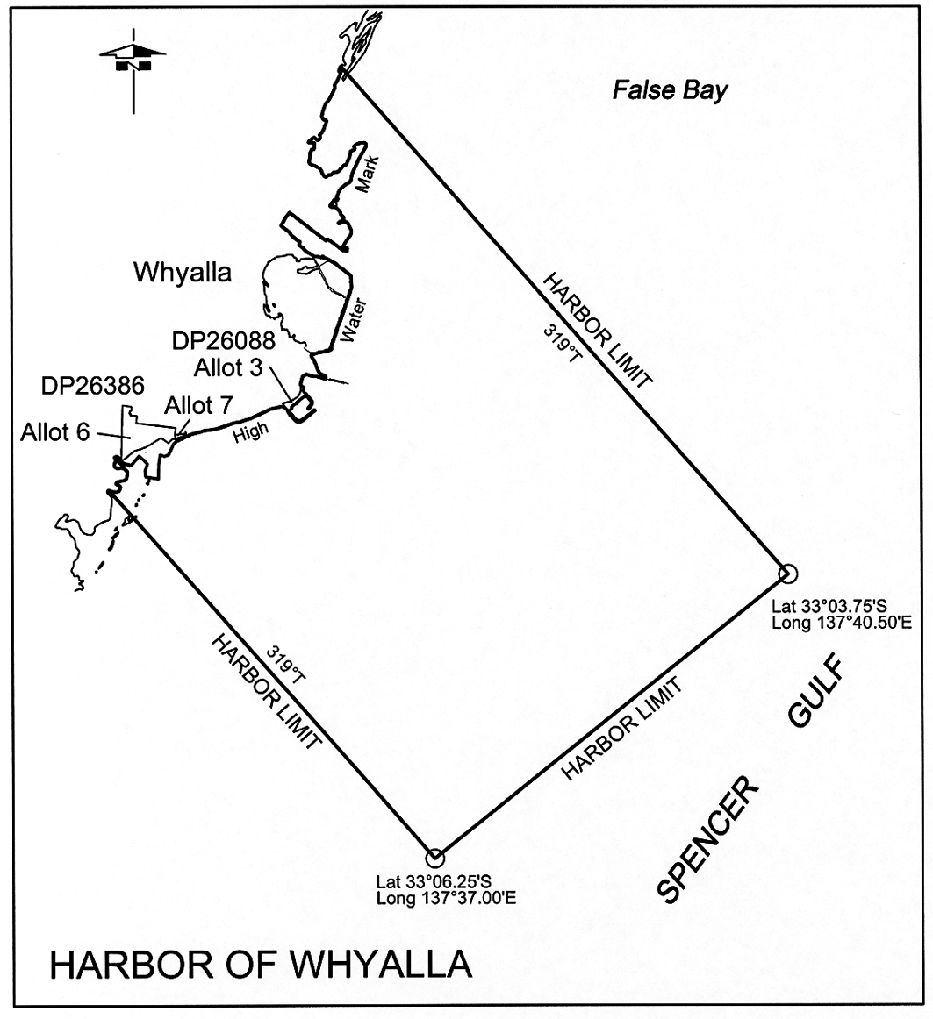
Schedule 4—Ports
Editorial note—
Unless the contrary intention appears, the maps in this Schedule are provided for convenience of reference only.
Ardrossan
The subjacent land underlying, and adjacent land extending from, the waters, rivers, creeks and inlets to the High Water Mark of that portion of the western coast of Gulf St. Vincent bounded as follows:
commencing at a point on the High Water Mark distant 0.5 nautical miles north-north-easterly of the centre line of the Ausbulk Jetty; then by a line bearing 106°25′ True to its intersection with eastern boundary of the harbor of Ardrossan; then by the boundary of the harbor of Ardrossan generally south-south-westerly, west-north-westerly, north-north-easterly (along the High Water Mark) to the point of commencement.
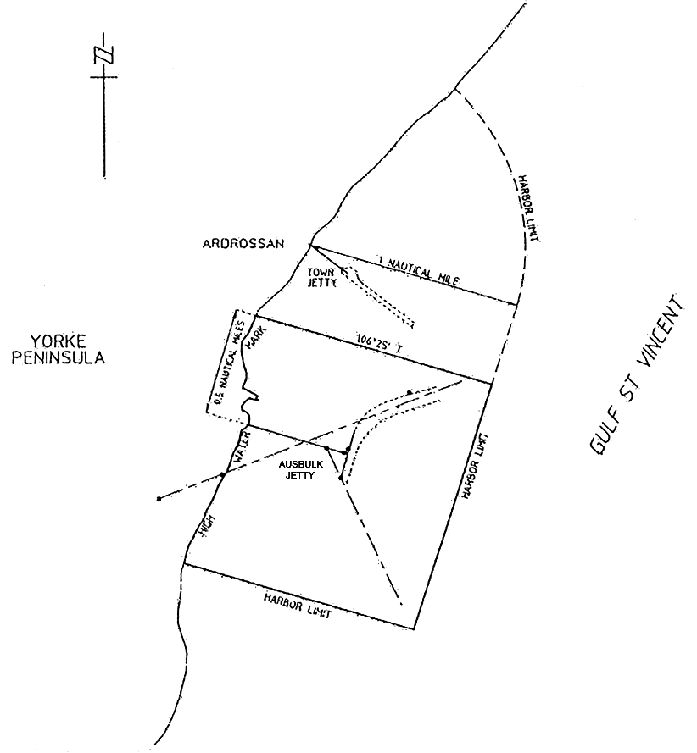
Klein Point
The subjacent land underlying, and adjacent land extending from, the waters, rivers, creeks and inlets to the High Water Mark of that portion of the western coast of Gulf St. Vincent within 1 nautical mile seaward of the intersection of the High Water Mark and the Klein Point Jetty.
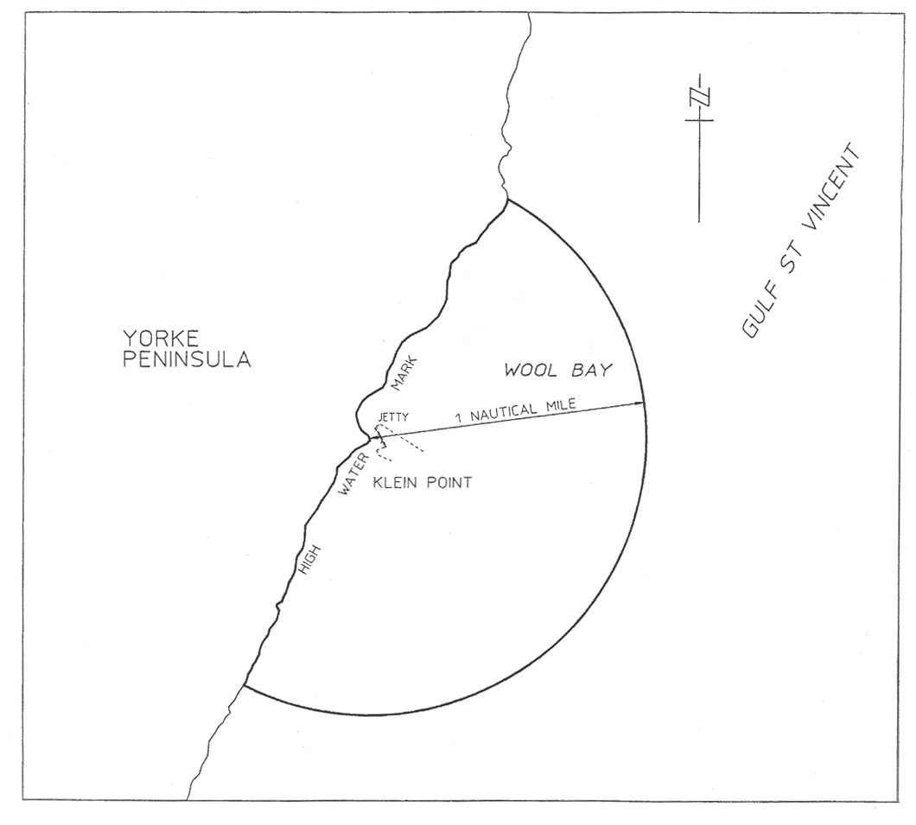
Port Adelaide

(1) In this clause—
prescribed day means the day specified by the Minister by notice in the Gazette as the prescribed day.
(2) Before the prescribed day, the subjacent land underlying, and adjacent land extending from, the waters, rivers, creeks and inlets to the High Water Mark bounded as follows:
• commencing at Point Grey then due west along a line to its intersection with the western boundary of the harbor of Port Adelaide;
• then generally south-south-easterly along the harbor boundary for 3 nautical miles;
• then along a line due east to its intersection with the south-westerly production of the Number 4 Leading Lights;
• then generally north-easterly along the production to its intersection with the High Water Mark on the southern face of the southern breakwater;
• then generally north-easterly along the High Water Mark to its intersection with the south-western boundary of Section 694 Hundred of Port Adelaide;
• then generally north-westerly along that boundary of Section 694 Hundred of Port Adelaide across the southern breakwater to its intersection with the High Water Mark on the northern face of the southern breakwater;
• then generally north-easterly along the High Water Mark to the northern extremity of Number 4 berth;
• then generally south-easterly along the High Water Mark to its intersection with the production southerly of the High Water Mark of the western face of the breakwater at the Royal South Australian Yacht Squadron (RSAYS);
• then generally north-easterly along the production across the RSAYS Basin;
• then generally north-westerly and north-easterly along the High Water Mark to Pelican Point;
• then generally south-easterly and southerly along the High Water Mark to its intersection with a line across the Port Adelaide River perpendicular to the western face of Number 18 berth and intersecting the western face of Number 18 berth and its southerly production at the southern extremity of the western face of Number 18 berth;
• then generally easterly along that perpendicular line across the Port Adelaide River to its intersection with the High Water Mark;
• then generally northerly and easterly along the High Water Mark, including Number 3 dock, to its intersection with the Wave Screen in North Arm;
• then generally northerly along the western face of the Wave Screen and its production to intersect with the High Water Mark on Torrens Island;
• then generally northerly along the High Water Mark to the point of commencement at Point Grey;
• and including Portion of Section 694 Hundred of Port Adelaide being the area described as easement E on FPX 43068,
but excluding—
• Allotment 5 FP 102960
• Allotment 707 FP 50323
• that Portion of Allotment 33 Deposited Plan No 75708 which comprises the Marina Adelaide basin and the entrance to that basin and is bounded by a straight line across the opening to the entrance that is an extension of the High Water Mark on the western bank of the river.
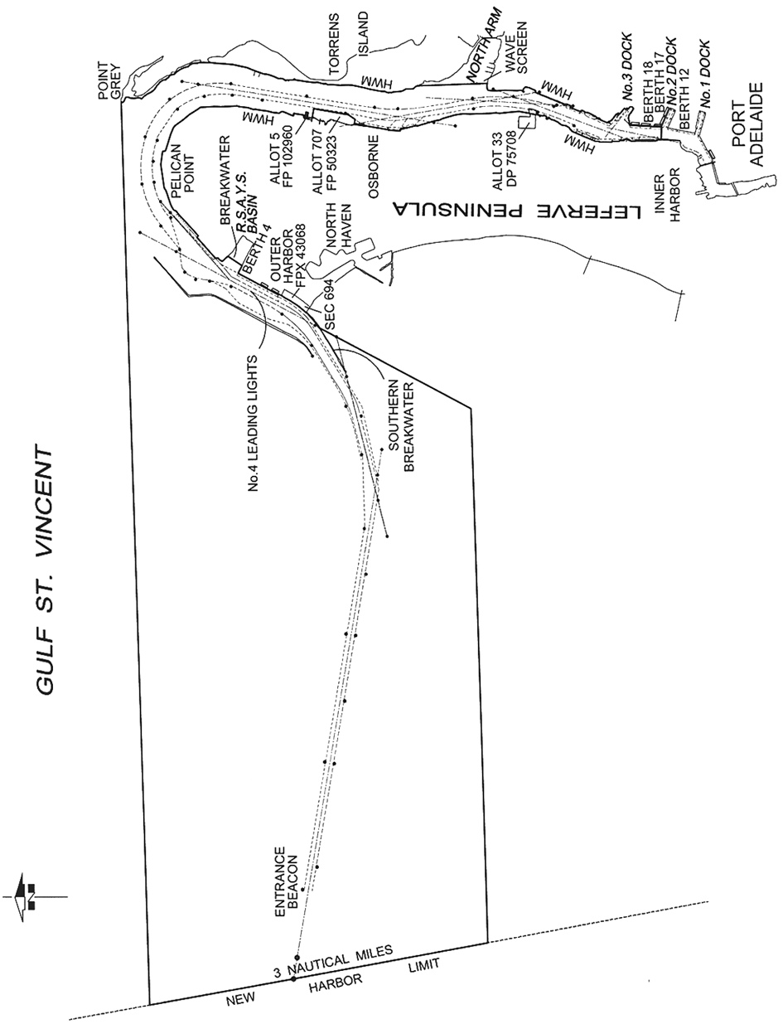
(3) On and after the prescribed day, the subjacent land underlying, and adjacent land extending from, the waters, rivers, creeks and inlets to the High Water Mark bounded as follows:
• commencing at Point Grey then due west along a line to its intersection with the western boundary of the harbor of Port Adelaide;
• then generally south-south-easterly along the harbor boundary for 3 nautical miles;
• then along a line due east to its intersection with the south-westerly production of the Number 4 Leading Lights;
• then generally north-easterly along the production to its intersection with the High Water Mark on the southern face of the southern breakwater;
• then generally north-easterly along the High Water Mark to its intersection with the south-western boundary of Section 694 Hundred of Port Adelaide;
• then generally north-westerly along that boundary of Section 694 Hundred of Port Adelaide to its intersection with the south-eastern boundary of easement E on FPX 43068;
• then generally north-easterly along that boundary of easement E on FPX 43068 to its intersection with the north-western boundary of Section 694 Hundred of Port Adelaide;
• then generally north-westerly along that boundary of Section 694 Hundred of Port Adelaide across the southern breakwater to its intersection with the High Water Mark on the northern face of the southern breakwater;
• then generally north-easterly along the High Water Mark to the northern extremity of Number 4 berth;
• then generally south-easterly along the High Water Mark to its intersection with the production southerly of the High Water Mark on the western face of the breakwater at the Royal South Australian Yacht Squadron (RSAYS);
• then generally north-easterly along the production across the RSAYS Basin;
• then generally north-westerly and north-easterly along the High Water Mark to Pelican Point;
• then generally south-easterly and southerly along the High Water Mark to its intersection with the northern boundary of Allotment 807 in DP 128471;
• then generally easterly and southerly along the northern and eastern boundaries of Allotment 807 in DP 128471;
• then generally southerly along the eastern boundaries of Allotment 708 in DP 123204 and Allotment 707 in DP 76775 and westerly along the southern boundary of Allotment 707 in DP 76775 to its intersection with the High Water Mark;
• then generally southerly along the High Water Mark to the south-eastern corner of Allotment 29 in DP 75708;
• then generally southerly along a straight line connecting that corner of Allotment 29 in DP 75708 to the north-eastern corner of Allotment 70 in DP 114457;
• then generally south-westerly and southerly along the High Water Mark to its intersection with a line across the Port Adelaide River perpendicular to the western boundary of Allotment 4 in DP 73873 (face of Number 18 berth) and connecting the western side of the Port Adelaide River with the south-western corner of Allotment 4 in DP 73873;
• then generally easterly along that perpendicular line across the Port Adelaide River to its intersection with the High Water Mark;
• then generally northerly and north-easterly along the High Water Mark, including Number 3 dock, to its intersection with the Wave Screen in North Arm;
• then generally northerly along the western face of the Wave Screen and its northerly production to intersect with the High Water Mark on Torrens Island;
• then generally northerly along the High Water Mark to the point of commencement at Point Grey.
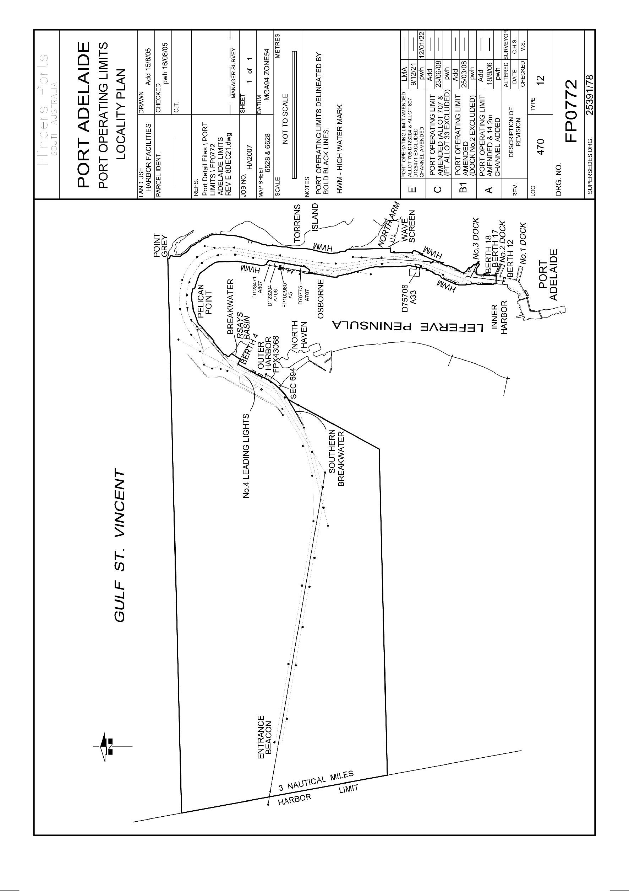
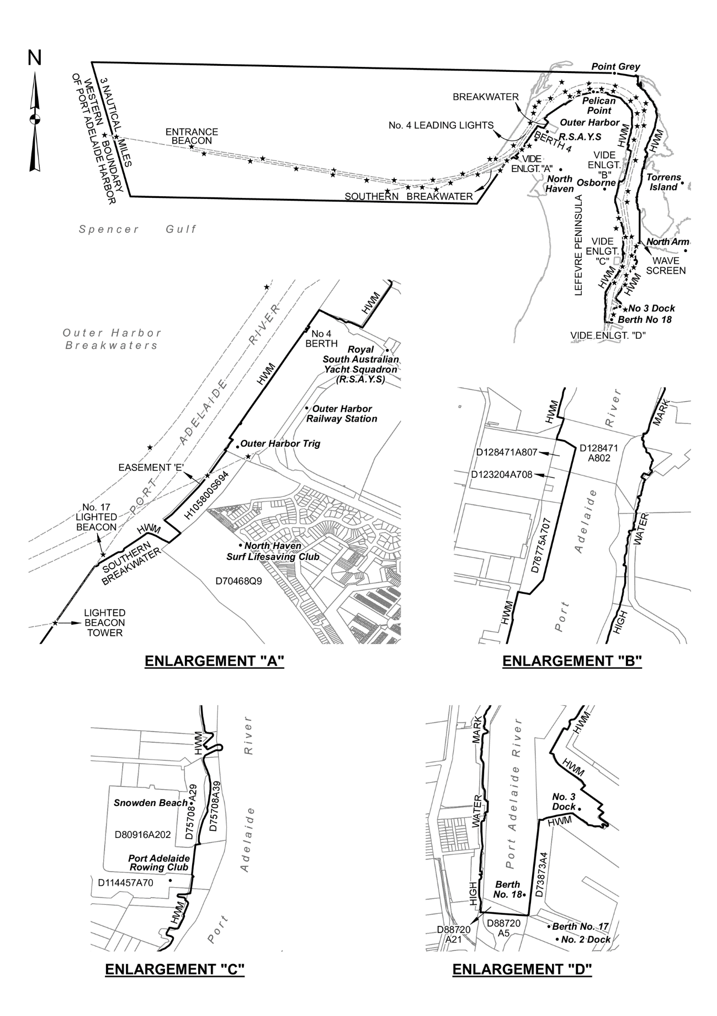
Port Giles
The subjacent land underlying, and adjacent land extending from, the waters, rivers, creeks and inlets to the High Water Mark of that portion of the western coast of Gulf St. Vincent bounded as follows:
commencing at a point on the High Water Mark 1 nautical mile due south of the intersection of the centre line of the Port Giles Jetty with the High Water Mark; then by a line bearing due east from the High Water Mark for 3 nautical miles; then by a line bearing due north for 2 nautical miles; then by a line bearing due west to the High Water Mark; then generally southerly along the High Water Mark to the point of commencement.
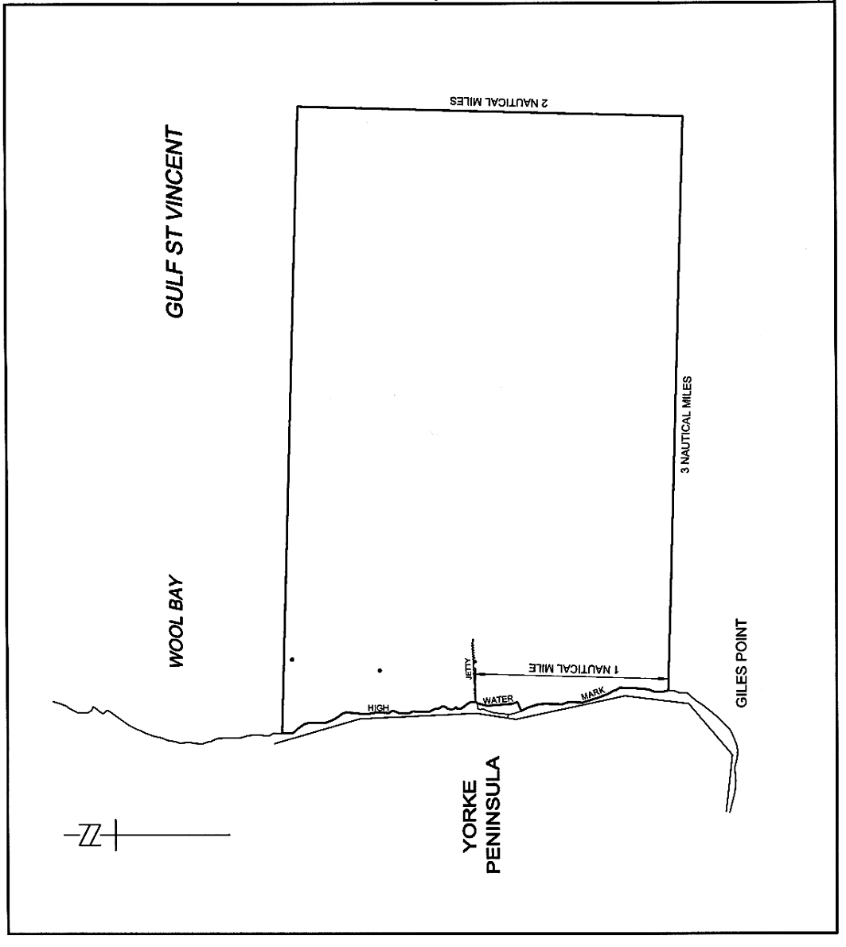
Port Lincoln
The subjacent land underlying, and adjacent land extending from, the waters, rivers, creeks and inlets to the High Water Mark of Port Lincoln bounded as follows:
commencing at the intersection with the High Water Mark of a line running due north from the north-east corner of King and Porter Streets; then due north along that line to its intersection with a line 250 m from and parallel to the port side of the maintained channel; then generally north-easterly by a line 250 m from and parallel to the port side of the maintained channel to a point adjacent the entrance beacon; then continuing generally north-easterly along the production of that line to its intersection with the Low Water Mark; then along the Low Water Mark to Point Boston; then due east along a line to its intersection with the eastern boundary of the harbor of Port Lincoln; then generally south-easterly along the harbor boundary for 1.2 nautical miles; then due west along a line for 4.8 nautical miles; then along a line bearing 231°39′ True for 1.4 nautical miles; then due south along a line for 2.6 nautical miles; then generally south-easterly along a line to the High Water Mark at Fanny Point; then along a line bearing 68° True or thereabouts to its intersection with the High Water Mark on Boston Island; then along the High Water Mark on Boston Island to Hayden Point; then by a line bearing 63°45′ True to its intersection with the eastern boundary of the harbor of Port Lincoln; then generally south-easterly along the harbor boundary for 0.7 nautical miles; then generally south-westerly by a line to the High Water Mark on the northern tip of Grantham Island; then due north along a line to its intersection with the High Water Mark adjacent Section 187 Hundred of Lincoln; then generally north-easterly and northerly along the High Water Mark to Billy Lights Point; then by a line generally north-westerly to its intersection with the High Water Mark and the western corner of Allotment 1012, Town of Port Lincoln; then generally northerly and westerly along the High Water Mark to the point of commencement.
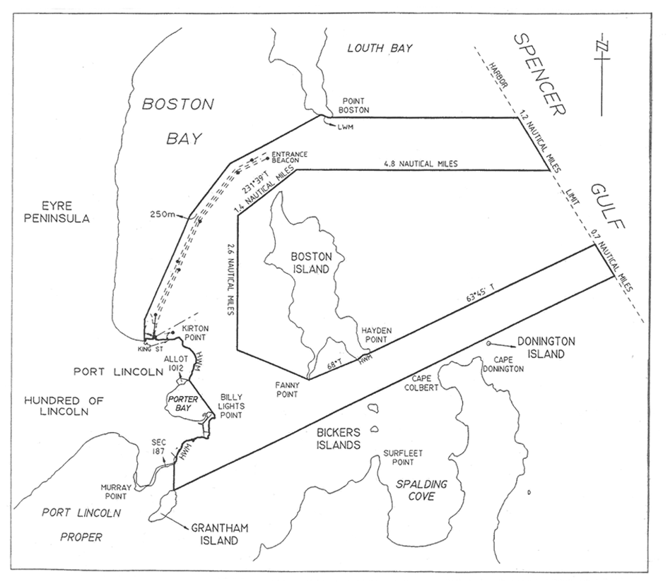
Port Pirie
The subjacent land underlying, and adjacent land extending from, the waters, rivers, creeks and inlets to the High Water Mark in Germein Bay, Spencer Gulf, bounded as follows:
commencing at a point on a line bearing 282° True and distance 13 nautical miles from Mount Ferguson (latitude 33°06.34′ South, longitude 138°01.78′ East); then generally north-easterly along the north-western harbor boundary to the High Water Mark; then generally south-easterly along a line to the Port Germein jetty light; then generally south-westerly along a line joining No 2 port beacon to the intersection point of a line 250 m from and parallel to the port side of the maintained channel; then generally southerly and south-easterly by a line 250 m from and parallel to the port side of the maintained channel to its intersection with the High Water Mark; then generally southerly along the High Water Mark to a point being the prolongation of the southern extremity of No 1 berth Port Pirie across the Port Pirie River; then generally south-westerly across the Port Pirie River along that prolongation to the southern extremity of No 1 berth Port Pirie; then generally north-westerly and northerly along the High Water Mark to the northern extremity of No 10 berth; then generally westerly along the No 10 berth to its intersection with the High Water Mark; then generally northerly along the High Water Mark to the intersection of a line 250 m from and parallel to the starboard side of the maintained channel; then generally north and north-westerly by a line 250 m from and parallel to the starboard side of the maintained channel to a point south-west of the No 17 starboard beacon; then by a line bearing 299°35′ True for 1.5 nautical miles; then by a line bearing 345°16′ True to the intersection point of a line bearing 264°30′ True from No 1 starboard beacon; then by a line bearing 264°30′ True to the intersection with the south-western limit of the harbor of Port Pirie; then generally north-westerly along the south-western limit of the harbor of Port Pirie to the point of commencement.
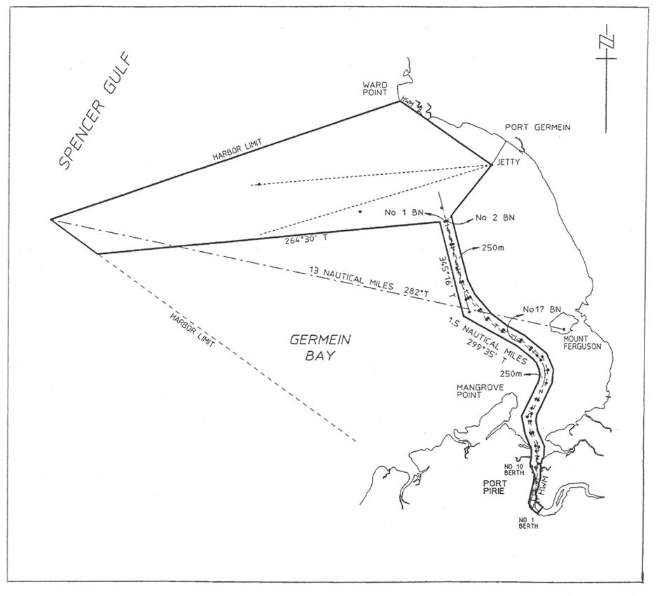
Thevenard
The subjacent land underlying, and adjacent land extending from, the waters, rivers, creeks and inlets to the High Water Mark of Denial Bay, Murat Bay and Bosanquet Bay bounded as follows:
commencing at a point at the intersection of the High Water Mark and the production south-westerly of the north-western boundary of Section 212 Hundred of Bonython; then generally southerly along the High Water Mark to the south-western corner of Section 275 Hundred of Bonython; then generally west-south-westerly along a line joining No 25 starboard beacon to the intersection point of a line 250 m from and parallel to the starboard side of the maintained channel; then by that line bearing 166°34′ True for 2 nautical miles; then by a line bearing 264°30′ True for 2.4 nautical miles; then by a line bearing 220° True to its intersection with the south-western boundary of the harbor of Thevenard; then generally north-westerly along the harbor boundary to a point 2 nautical miles due south of Cape Beaufort; then by a line bearing 57° True to the intersection with a line bearing 46° True from the Entrance beacon (white sector light); then generally easterly by a line joining No 20 port beacon to the intersection point of a line 250 m from and parallel to the port side of the maintained channel; then by a series of lines 250 m from and parallel to the port side of the maintained channel to the intersection point with a line bearing 316° True from Cape Vivonne (white sector light); then by that line bearing 316° True for 1.9 nautical miles; then by a line bearing true north to the intersection point on a line joining Denial Bay Jetty and Ceduna Jetty; then along that line generally east-south-easterly to the intersection point of a line joining Low Point and the point of commencement; then generally southerly along that line to the point of commencement.
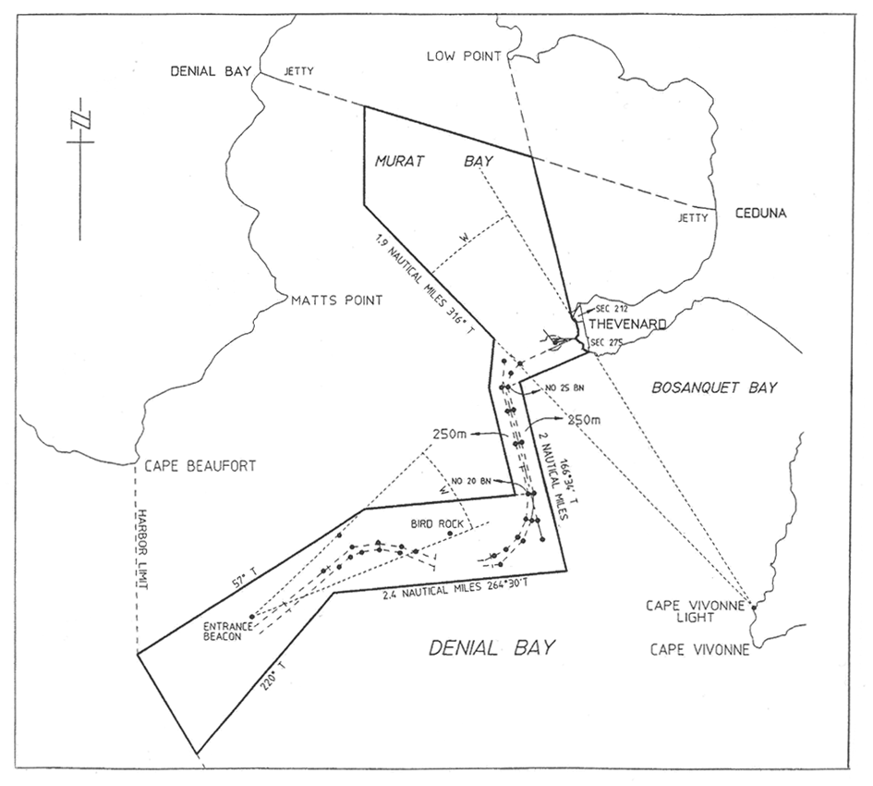
Wallaroo
The subjacent land underlying, and adjacent land extending from, the waters, rivers, creeks and inlets to the High Water Mark of that part of Wallaroo Bay bounded as follows:
commencing at a point on the High Water Mark intersected by a line 150 m north-east and parallel to the northern face of the shipping pier; then generally north-westerly along a line joining the High Water Mark at the south-west extremity of Point Riley to the intersection with a line being the production generally easterly of a line 250 m from and parallel to the port side of the maintained channel; then generally westerly along that line to its intersection with western boundary of the harbor of Wallaroo; then generally southerly along the harbor boundary for 0.6 nautical miles; then generally east-south-easterly along a line joining the front lead to the intersection with the High Water Mark; then generally north-easterly along the High Water Mark to the point of commencement.
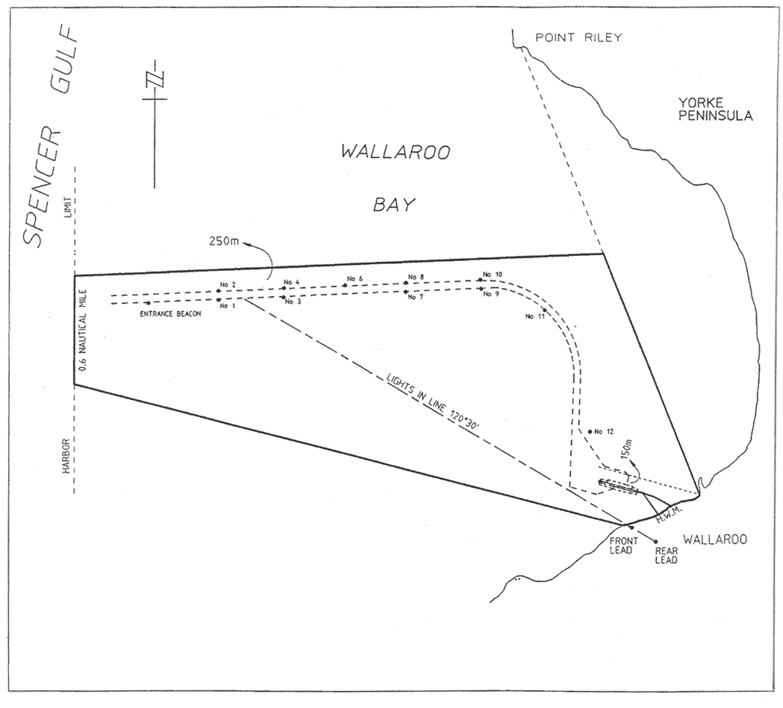
Schedule 5—Restricted areas
Part 1—Identification of restricted areas
1—Identification of restricted areas
Editorial note—
Unless the contrary intention appears, the maps in this Schedule are provided for convenience of reference only.
Angas Inlet
The portion of Angas Inlet that is bounded as follows:
commencing at a point where Median High Water Mark on Torrens Island intersects the line of buoys, then south-east along the line of buoys to a point where median high water on Garden Island intersects the line of buoys, then south-west along Median High Water Mark to the Causeway, then north-west along Median High Water Mark to Torrens Island, then north-east along the Median High Water Mark to the point of commencement.
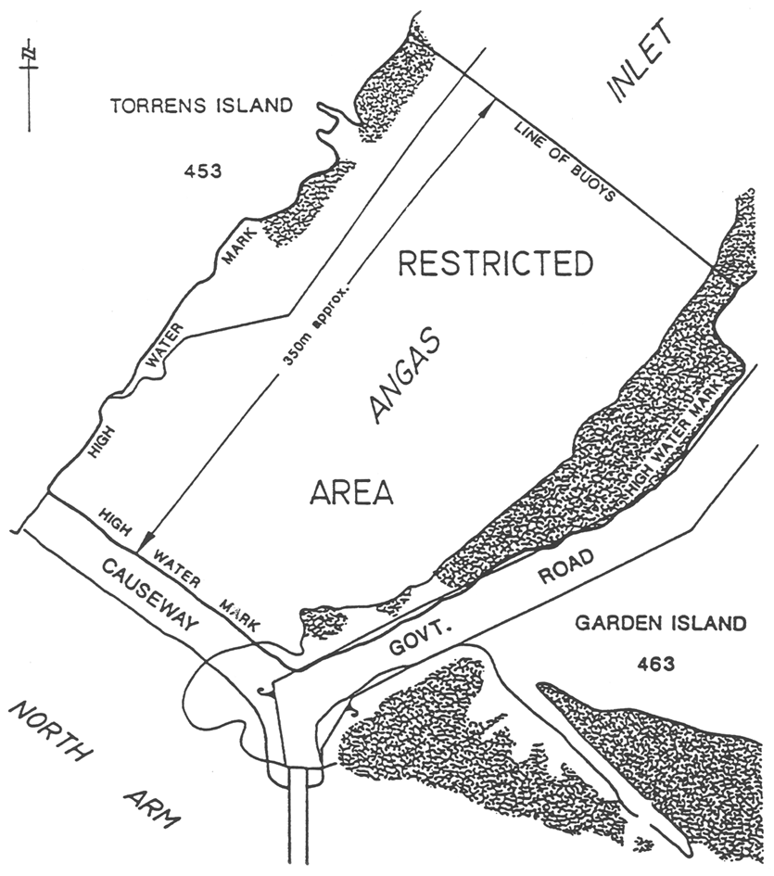
Ardrossan
Area 1: the area of the sea at Ardrossan extending for 30 m north and south of the Ausbulk Jetty centre line and its production westerly, 30 m east and west of the Ausbulk Jetty crosshead centre line, and 30 m from the intersections of that centre line with the north and south ends of the Ausbulk Jetty crosshead.
Area 2: the area of the sea at Ardrossan bounded as follows:
• on the east by a straight line commencing at the intersection of the south-west side of the town jetty and the High Water Mark and drawn in a south-easterly direction toward the north-east corner of the Ausbulk Jetty crosshead: to a point where it intersects with a straight line 30 m west of and parallel to the Ausbulk Jetty crosshead centre line and its production northerly;
• on the south by a straight line 30 m north and parallel to the Ausbulk Jetty centre line and its production westerly;
• on the west and north-west by the High Water Mark.
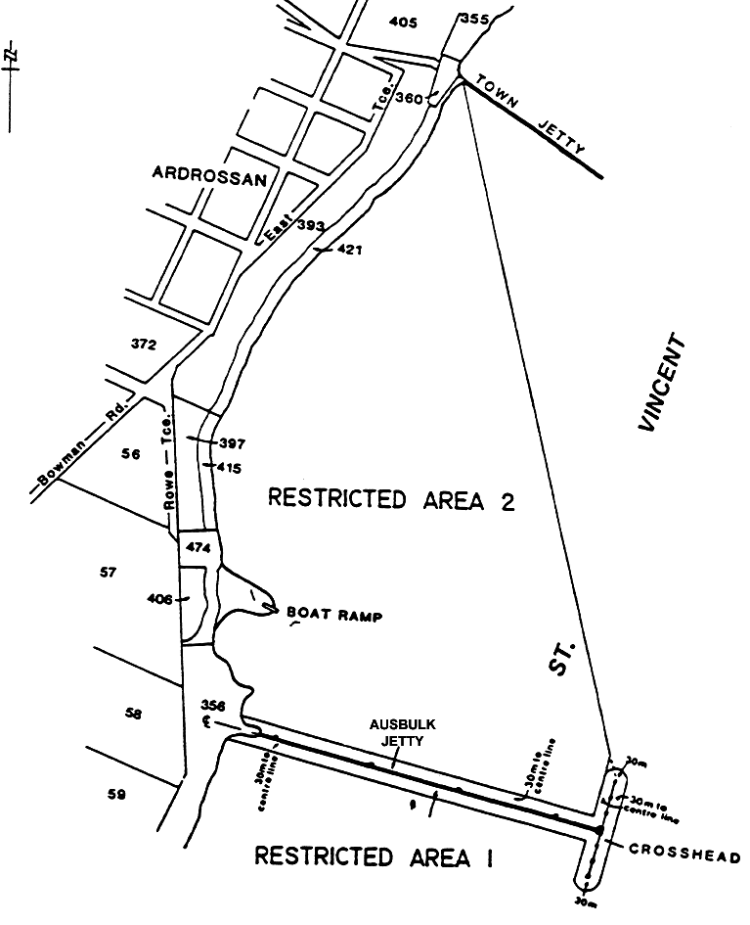
Balgowan
Area 1: the portion of the sea at Balgowan bounded as follows:
• on the north-west by a straight line joining Point Warrenne with a point being the intersection of the High Water Mark and the prolongation seaward of the northern boundary of Section 286, Hundred of Kilkerran;
• on the south and east by the High Water Mark.
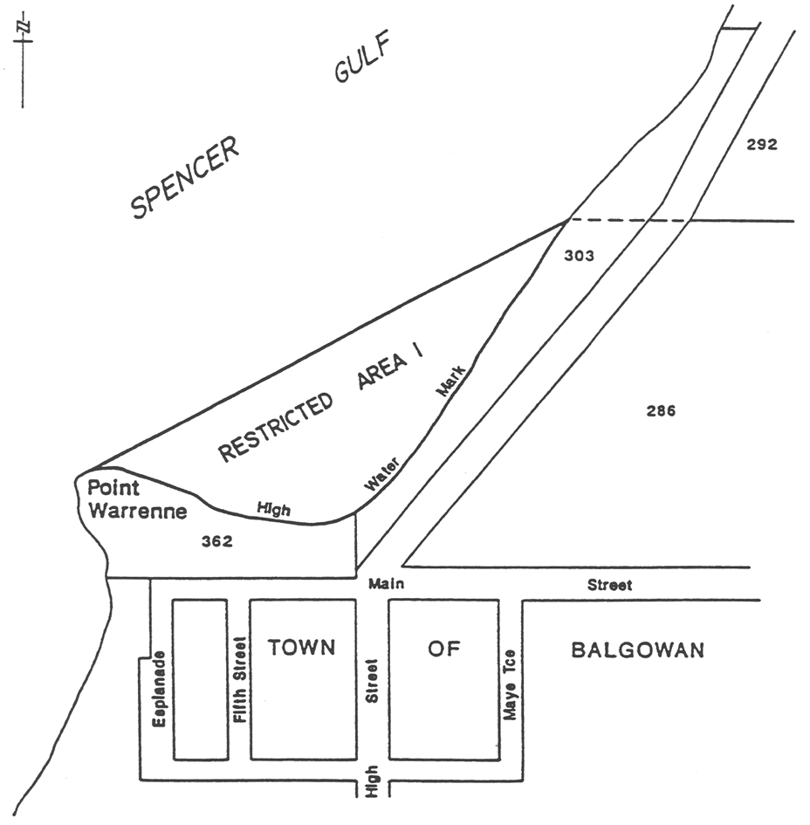
Area 2: the portion of the sea at Balgowan bounded as follows:
• on the west by a straight line joining Point Warrenne with a point being 100 m west of the High Water Mark on the prolongation seaward of the southern boundary of Welfare Road, Township of Balgowan, Hundred of Kilkerran;
• on the south by a straight line commencing at the High Water Mark and extending seaward for 100 m along the prolongation of the southern boundary of Welfare Road, Township of Balgowan, Hundred of Kilkerran;
• on the east by the High Water Mark.
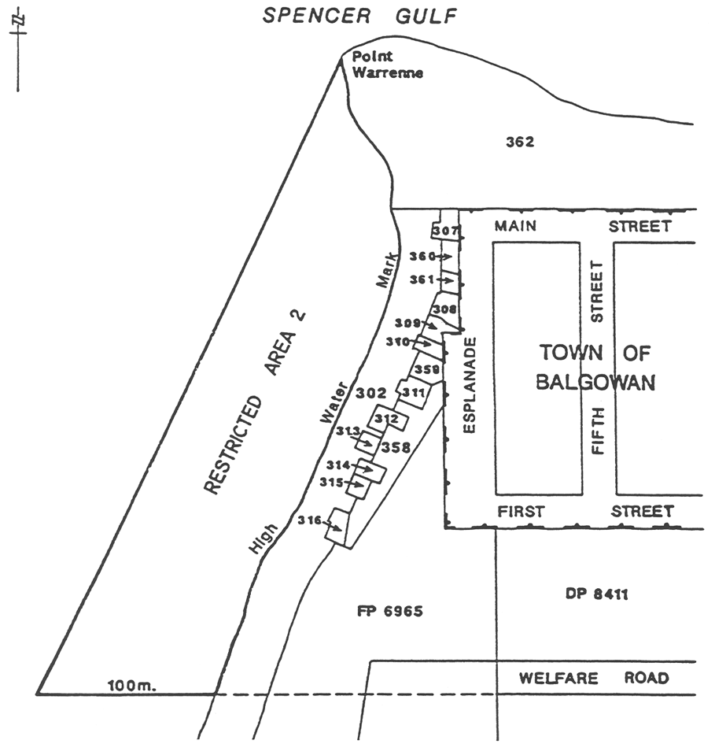
Black Point
The portion of the sea at Black Point bounded as follows:
• on the north-west by a straight line commencing 50 m north-west of the boat ramp and extending seaward (north-easterly) for 100 m from the High Water Mark;
• on the south-east by a straight line parallel to the north-east boundary and extending 100 m seaward from the High Water Mark at Black Point;
• on the north-east by a straight line 100 m from, and parallel to, the High Water Mark, and joining the seaward extremities of the north-west and south-east boundaries;
• on the south-west by the High Water Mark.
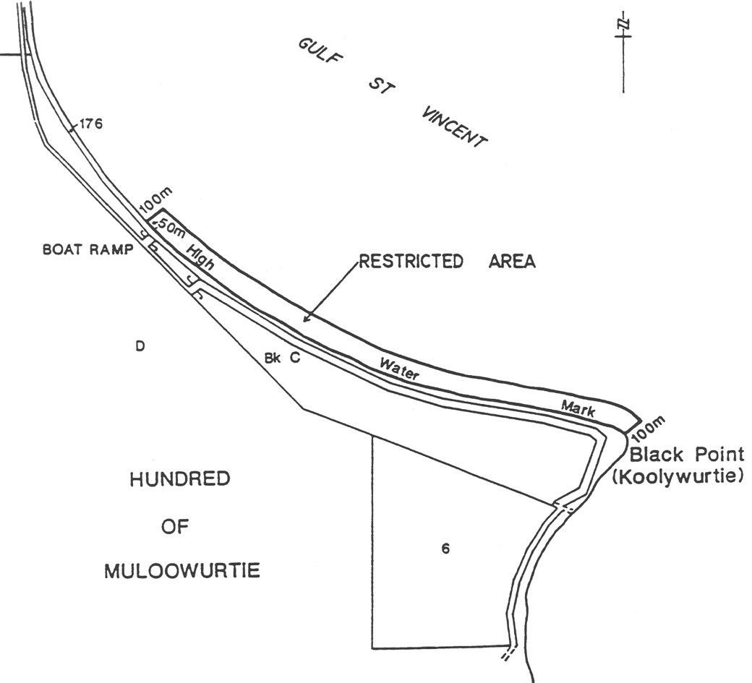
Blackfellows' Caves
Area 1: the portion of the sea at Blackfellows' Caves bounded as follows:
• on the south-east by the north-west boundary of section 621, Hundred of Kongorong;
• on the north-east by a straight line being the prolongation north-westerly of the north-east edge of the boat ramp for a distance of 10 m seawards from the aforesaid south-east boundary;
• on the south-west by a straight line extending south-easterly from the south extremity of the centre line of the reef to intersect the aforesaid south-east boundary at right angles;
• on the north-west by a straight line joining the north-west extremities of the aforesaid south-west and north-east boundaries.
Area 2: the portion of the sea at Blackfellows' Caves bounded as follows:
• on the south-west, west and north-west by the centre line of the reef;
• on the north-east by the High Water Mark;
• on the south-east by the north-west and north-east boundaries of Area 1 and the north-west boundary of Section 621, Hundred of Kongorong.
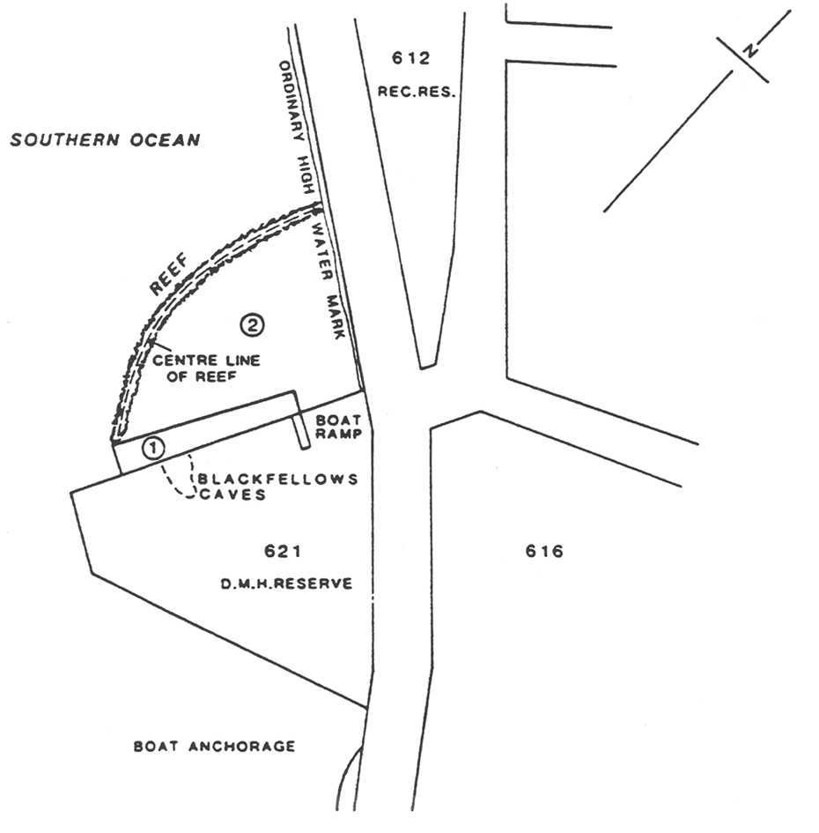
Blanchetown
Area 1: The portion of the River Murray at Blanchetown delineated in bold on the plan below:
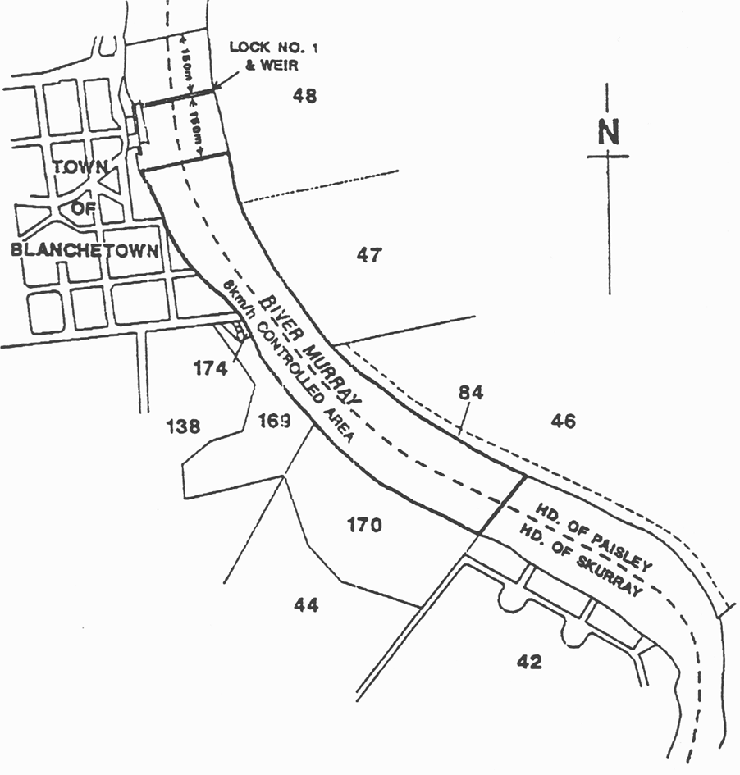
Area 2: the portion of the River Murray at Blanchetown bounded as follows:
• on the north by the northern alignment of the Sturt Highway road bridge;
• on the south by the northern alignment of Lock No 1;
• on the east and west by the river edge.
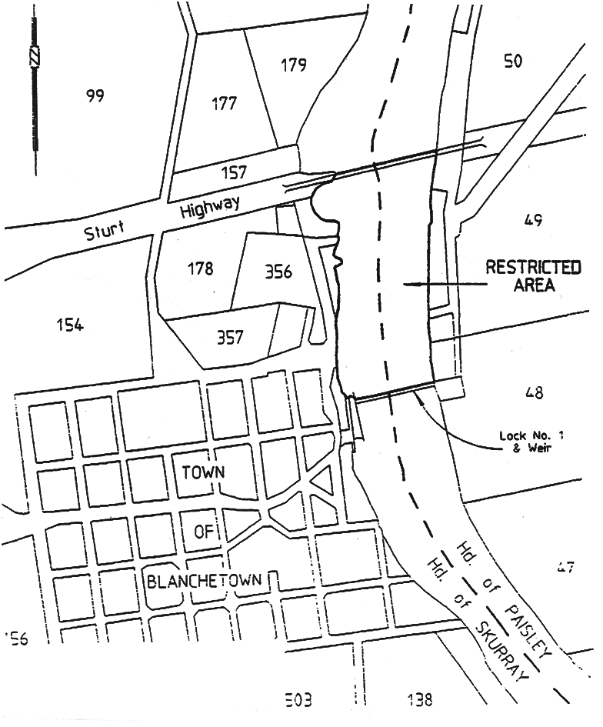
Brighton
Area 1: the portion of the waters of Gulf St. Vincent bounded as follows:
• on the north by a straight line being the north boundary of the City of Brighton adjoining the sea coast and its production seaward;
• on the south by a straight line being the production seaward of the north alignment of Whyte Street;
• on the east by the High Water Mark;
• on the west by a line approximately 100 m seaward of and parallel to the Low Water Mark.
Area 2: the portion of the waters of Gulf St. Vincent bounded as follows:
• on the north by a straight line being the production seaward of the south alignment of Harrow Road;
• on the south by a straight line extending seaward of the High Water Mark and being 200 m north of and parallel to the north alignment of Gladstone Road;
• on the east by the High Water Mark;
• on the west by a line approximately 100 m seaward of and parallel to the Low Water Mark.
Area 3: the portion of the waters of Gulf St. Vincent bounded as follows:
• on the north by a straight line being the production seaward of the south alignment of Downing Street;
• on the south by a straight line being the production seaward of the south alignment of Cambridge Terrace;
• on the east by the High Water Mark;
• on the west by a line approximately 100 m seaward of and parallel to the Low Water Mark.
Area 4: the portion of the waters of Gulf St. Vincent bounded as follows:
• on the north by a straight line being the production seaward of the north alignment of Oleander Street;
• on the south by a straight line extending seaward of the High Water Mark and being 200 m north of the centre of the boat ramp at Maitland Terrace and parallel to the north alignment of Maitland Terrace;
• on the east by the High Water Mark;
• on the west by a line approximately 100 m seaward of and parallel to the Low Water Mark.
Area 5: the portion of the waters of Gulf St. Vincent bounded as follows:
• on the north by a straight line extending seaward form the south extremity of the Seacliff Surf Life Saving Club building;
• on the south by a straight line, being the south boundary of the City of Brighton adjoining the sea coast, and its production seaward;
• on the east by the High Water Mark;
• on the west by a line approximately 100 m seaward of and parallel to the Low Water Mark.
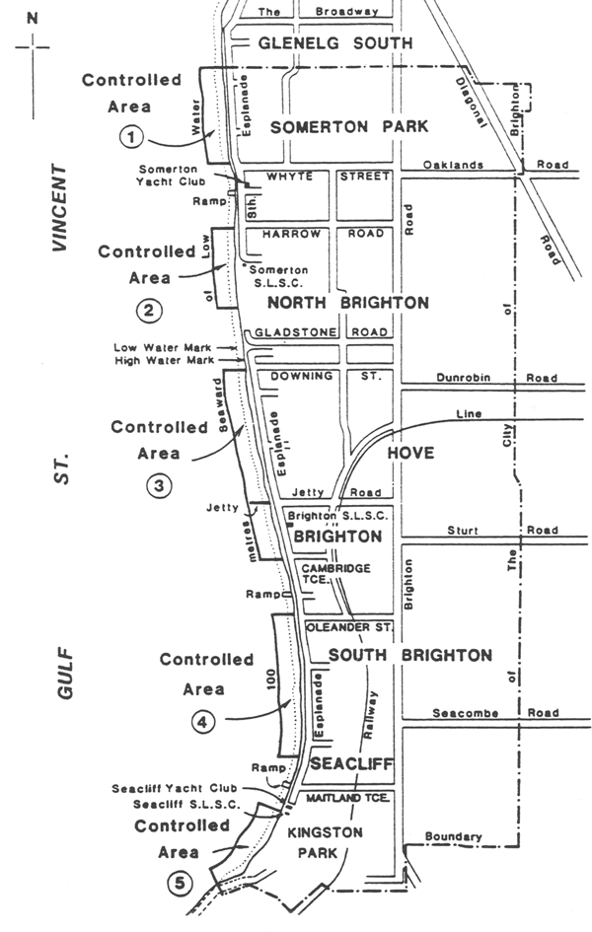
Bucks Bay
The portion of the sea at Bucks Bay bounded as follows:
• on the north-west by a straight line joining the south-east corner of the toilet block adjacent to the southern access road to the beach and the north-west extremity of the promontory forming the southern limit of the bay, the line being further defined by 2 yellow marker posts, the first post on the northern side of the junction of the access road with the beach, the second post being on the north-west extremity of the promontory;
• on the south and east by the High Water Mark.
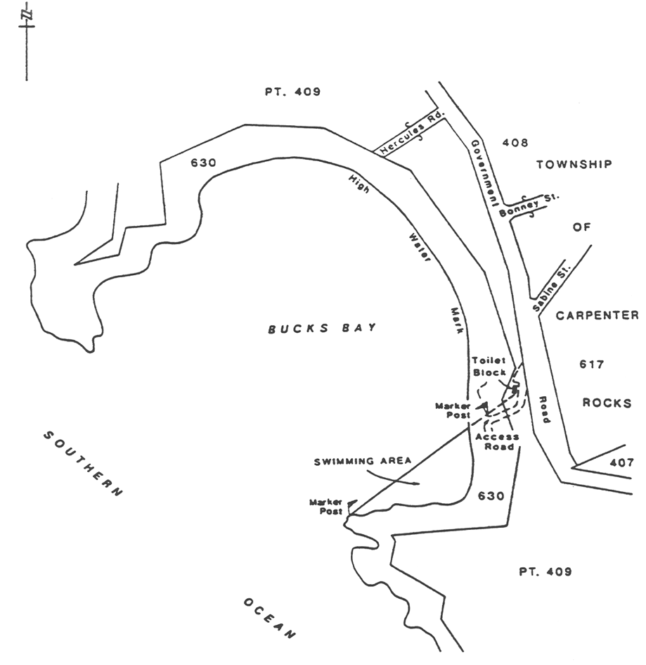
Caloote Landing
Area 1: the portion of the River Murray near Caloote Landing bounded as follows:
• on the west by the river edge;
• on the north, east and south by lines of spherical marker buoys being flame orange in colour, the south boundary being a distance of 15 m north of the boat ramp.
Area 2: the portion of the River Murray near Caloote Landing bounded as follows:
• on the south by a straight line being the prolongation easterly of the most southerly boundary of Section 799, Hundred of Finniss for a distance of 30 m easterly from the river edge;
• on the east by a straight line at right angles to the aforesaid south boundary commencing at its east extremity and extending to intersect the river edge;
• on the west by the river edge.
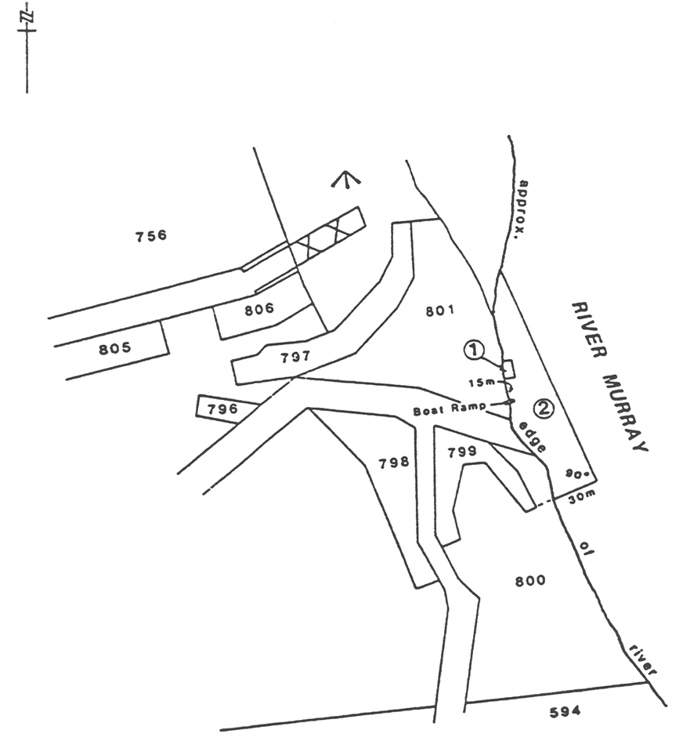
Christies Beach
The portion of the waters of Gulf St. Vincent bounded as follows:
(a) on the north by a line parallel to and 430 m north of the prolongation in a straight line of the northern boundary of Margaret Street, Christies Beach;
(b) on the south by a line parallel to and 230 m north of the prolongation in a straight line of the northern boundary of Margaret Street, Christies Beach;
(c) on the west by a line parallel to and 650 m west of the High Water Mark;
(d) on the east by the High Water Mark.
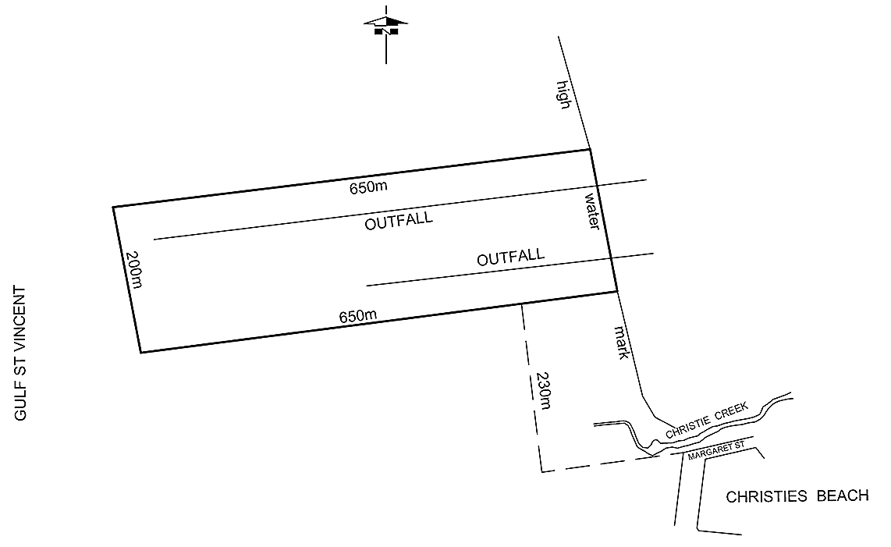
Clayton Bay
The portion of the lower River Murray at Clayton bounded as follows:
• on the north by a straight line, marked by flame orange spherical buoys, being the prolongation westerly of the north boundary of Lot 94 in Deposited Plan No 9225 Section 447, Hundred of Alexandrina for a distance of 30 m westerly from the edge of the water;
• on the south by a straight line, marked by flame orange spherical buoys, being the prolongation westerly of the north boundary of Lot 97 in Deposited Plan No 9225 Section 447, Hundred of Alexandrina for a distance of 30 m westerly from the edge of the water;
• on the south-west by a straight line joining the west extremities of the aforesaid north and south boundaries;
• on the north-east by the edge of the water.
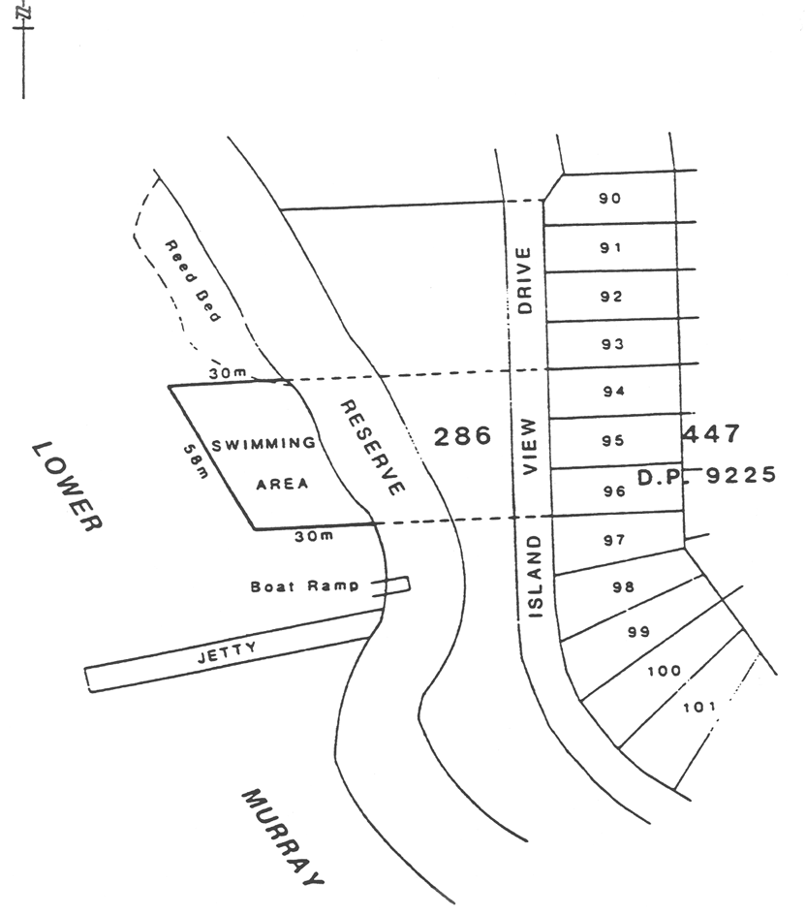
Currency Creek
All the waters of Currency Creek bounded as follows:
• on the west by the causeway on the Goolwa to Strathalbyn Road;
• on the south-east by a line joining the south-west corner of Section 330, Hundred of Goolwa to the south-east corner of Section 2338, Hundred of Nangkita.
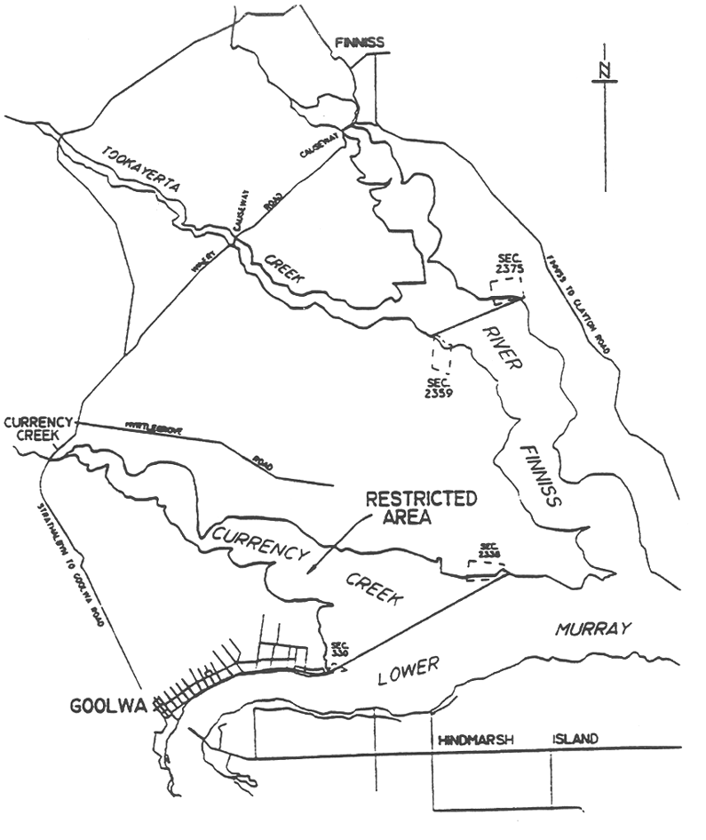
East Wellington
The portion of the East Wellington Recreation Lake delineated in bold on the plan below:
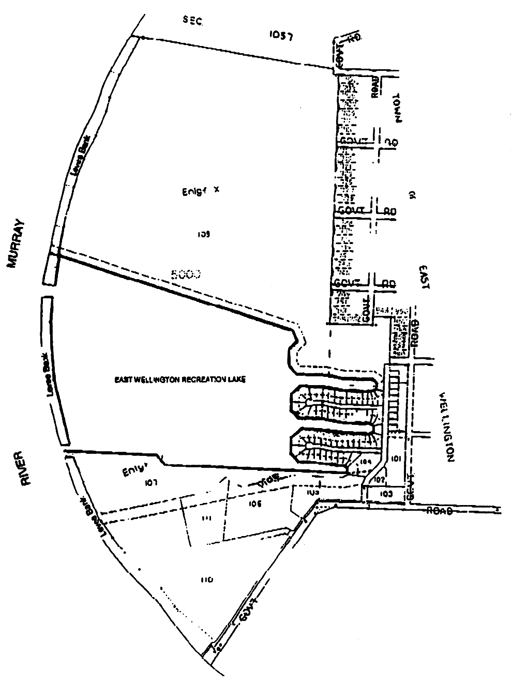
Fisherman Bay
The portion of the waters of Fisherman Bay delineated in bold on the plan below:
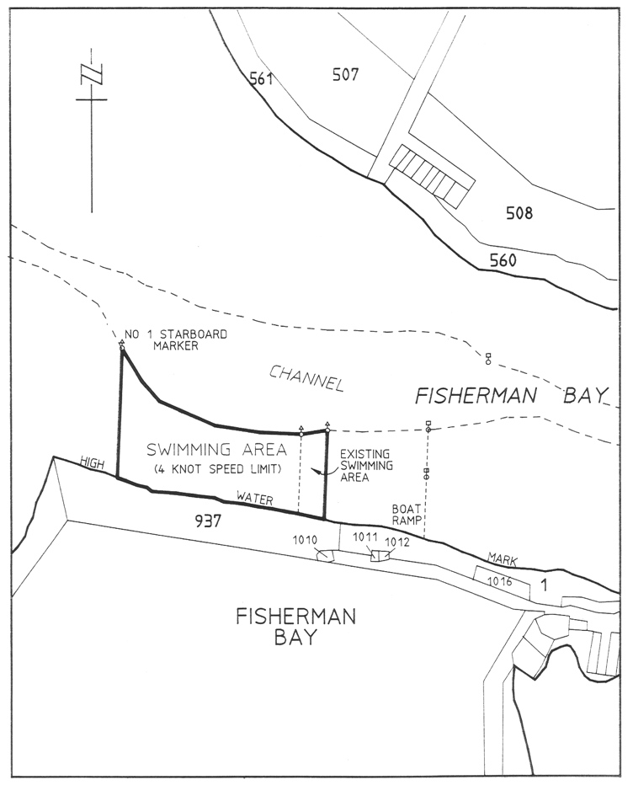
Fleurieu Reef
The portion of the waters of Gulf St. Vincent off the coast of Wirrina Cove bounded by a circle of radius 0.5 of a nautical mile centred on a point at latitude 35° 28.9′ South, longitude 138° 09.5′ East.
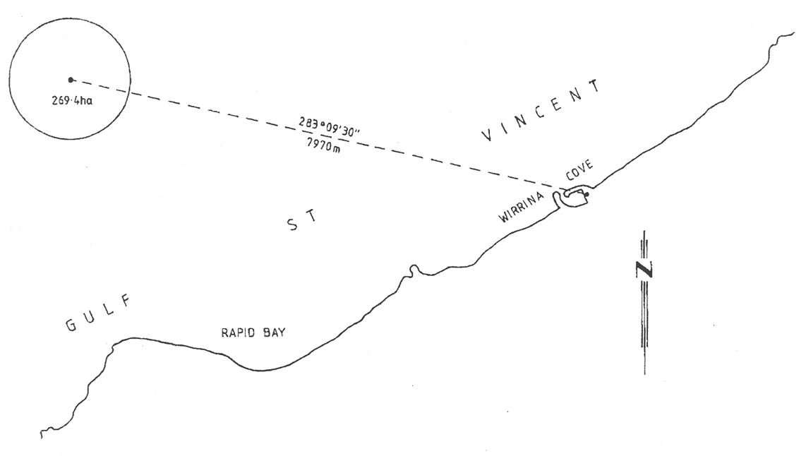
Forbys Island
The portion of the River Murray (near Loxton) between Forbys Island and the south-west edge of the river, marked by flame orange spherical buoys.
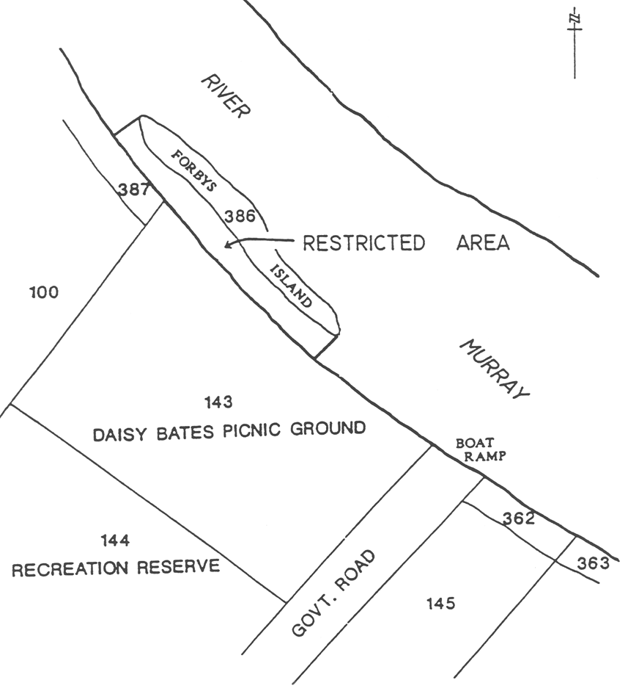
Glenelg
Area 1: the portion of the waters of Gulf St. Vincent at Glenelg bounded as follows:
• commencing at a point being the production seaward of the northern alignment of Anderson Avenue, Glenelg North, for a distance of 200 m from the Low Water Mark;
• then generally southerly along a line 200 m from and parallel to the Low Water Mark to the intersection of a line between the St. Andrews Cross navigational marker at latitude 34°58′01.08″ South, longitude 138°30′28.92″ East and the West Cardinal navigational marker at latitude 34°58′01.08″ South, longitude 138°30′11.28″ East;
• then generally easterly along that line to the St. Andrews Cross navigational marker;
• then generally southerly to the Port hand navigational marker at latitude 34°58′28.11″ South, longitude 138°30′33.94″ East;
• then generally easterly to the intersection of the Low Water Mark on the northern breakwater;
• then generally northerly along the Low Water Mark to the production of the northern alignment of Anderson Avenue;
• then generally westerly to the point of commencement.
Area 2: the portion of the waters of Gulf St. Vincent at Glenelg bounded as follows:
• commencing at a point being the production seaward of the northern alignment of Yarrum Grove, Glenelg South, for a distance of 200 m from the Low Water Mark;
• then generally northerly along a line 200 m from and parallel to the Low Water Mark to the Port hand navigational marker at latitude 34°58′22.07″ South, longitude 138°30′28.30″ East;
• then generally south-easterly to the Port hand navigational marker at latitude 34°58′28.11″ South, longitude 138°30′33.94″ East;
• then generally easterly to the intersection of the Low Water Mark on the northern breakwater;
• then generally easterly, southerly and north-westerly along the Low Water Mark around the Holdfast Shores Marina and the southern breakwater;
• then generally southerly along the Low Water Mark to the production of the northern alignment of Yarrum Grove;
• then generally westerly to the point of commencement.
Area 3: the portion of the waters of Gulf St. Vincent at Glenelg bounded as follows:
• commencing on the north approximately 150 m from the High Water Mark of the coast to the St. Andrews Cross navigational marker at latitude 34°58′01.08″ South , longitude 138°30′28.92″ East and extending seaward in a westerly direction for approximately 450 m to the West Cardinal navigational marker at latitude 34°58′01.08″ South, longitude 138°30′11.28″ East;
• on the west by a straight line drawn in a generally southerly direction from latitude 34°58′01.08″ South, longitude 138°30′11.28″ East, to the West Cardinal navigational marker at latitude 34°58′13.14″ South, longitude 138°30′16.92″ East, then south-easterly to the Port hand navigational marker at latitude 34°58′22.07″ South, longitude 138°30′28.30″ East;
• then continuing from latitude 34°58′22.07″ South, longitude 138°30′28.30″ East in a south-easterly direction to the Port hand navigational marker at latitude 34°58′28.11″ South, longitude 138°30′33.94″ East;
• on the east by a straight line drawn in a generally northerly direction and approximately parallel to the shore from latitude 34°58′28.11″ South, longitude 138°30′33.94″ East to the point of commencement at the St. Andrews Cross navigational marker at latitude 34°58′01.08″ South, longitude 138°30′28.92″ East.
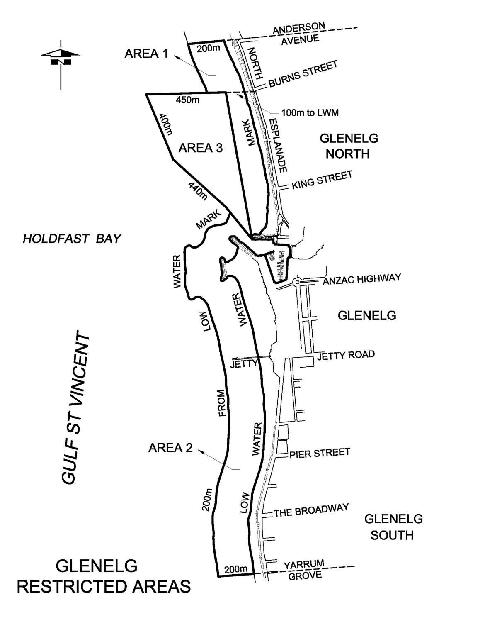
Glenelg River
All the waters of the Glenelg River within the State.
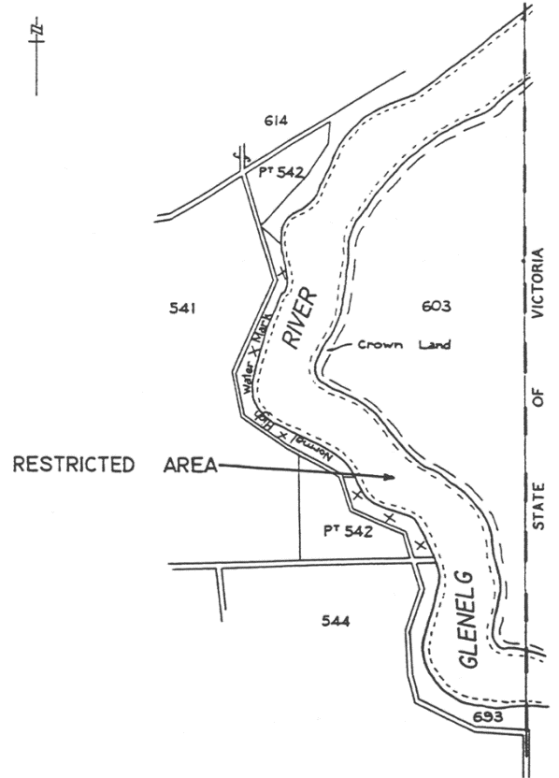
Goolwa
Area 1: the portion of the River Murray at Goolwa bounded as follows:
• on the west by a straight line being the prolongation northerly of the western boundary of Section 476, Hundred of Nangkita, Hindmarsh Island;
• on the north-west by a line 30 m from, and parallel to the edge of the water;
• on the north-east by a straight line being the prolongation north-westerly of the north-eastern boundary of FP11193;
• on the south by the edge of the water on the north side of Hindmarsh Island.
Area 2: the portion of the River Murray at Goolwa bounded as follows:
• on the east by the prolongation southerly of the eastern boundary of New Orleans Street;
• on the south by a line 60 m from and parallel to the edge of the water;
• on the west by a straight line 100 m upstream from and parallel to the Hindmarsh Island Bridge;
• on the north by the edge of the water.
Area 3: the portion of the River Murray at Goolwa bounded as follows:
• on the south-west by a straight line 100 m downstream from the south-east corner of the Goolwa wharf and at right angles to the production of the face of the wharf;
• on the north-west by the edge of the water;
• on the north by a straight line 50 m downstream from the south east corner of the Goolwa wharf and at right angles to the edge of the water;
• on the south east by a line 30 m from and parallel to the edge of the water.
Area 4: those portions of the River Murray and the Coorong in the vicinity of the Murray Mouth bounded as follows:
• on the east and west by lines bearing 025° True and 300 m distant from the centre (for the time being) of the Murray Mouth;
• on the north by the edge of the water on the southern side of Hindmarsh Island;
• on the south-west by the edge of the water on the River Murray side of Sir Richard Peninsula;
• on the south-east by the edge of the water on the Coorong side of Younghusband Peninsula;
• on the south by a straight line across the Murray Mouth joining the westerly extremity of Younghusband Peninsula to the easterly extremity of Sir Richard Peninsula.
Area 5: the portion of the Mundoo Channel to the edge of the water bounded as follows:
• on the north-east by a straight line 150 m downstream and parallel to the south-west side of the Mundoo Barrage;
• on the south by a straight line bearing 315° True from the AGA light on Mundoo Island.
Area 6: those portions of the River Murray and the Coorong in the vicinity of the Murray Mouth bounded as follows:
• on the north by the edge of the water on the southern side of Hindmarsh Island;
• on the west by a line bearing 030° True from No 1 beacon;
• on the east by a line bearing 315° True from the AGA light on Mundoo Island;
• on the south by a line 30 m from and parallel to the edge of the water.
Area 7: the portion of the River Murray at Goolwa bounded as follows:
• on the east by a straight line extending 300 m northwards from a point 20 m from the southern waters edge, parallel to and 600 m upstream from the Goolwa Barrage;
• on the west by a straight line extending 300 m northwards from a point 20 m from the southern waters edge, parallel to and 750 m upstream from the Goolwa Barrage;
• on the north by a straight line joining the northern extremities of the eastern and western boundaries;
• on the south by a line parallel to and 20 m from the edge of the water.
Area 8: the portion of the River Murray at Goolwa bounded as follows:
• on the south by a straight line from a point on the edge of the water at Goolwa 100 m downstream from the southern end of the Goolwa wharf to a point on the western side of Hindmarsh Island, 70 m south of the northern corner of the Hindmarsh Island end of the causeway;
• on the east by the edge of the water on the western side of Hindmarsh Island;
• on the north by a line from a point on the edge of the water at Goolwa 100 m upstream from the northern face of the Hindmarsh Island Bridge, then parallel to the northern face of the Bridge to the point at which that line intersects a line perpendicular to the Bridge extending from the tip of the causeway in a generally north-easterly direction, then along the latter line to the tip of the causeway, then along the northern face of the causeway;
• on the west by the face of the Goolwa wharf and the edge of the water.
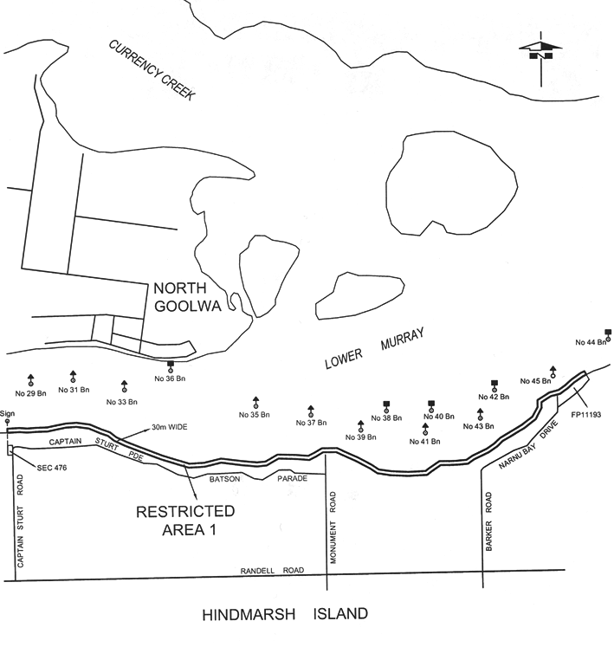
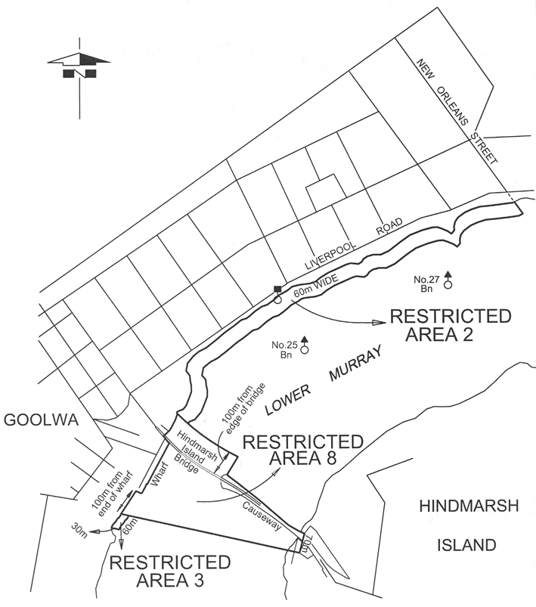
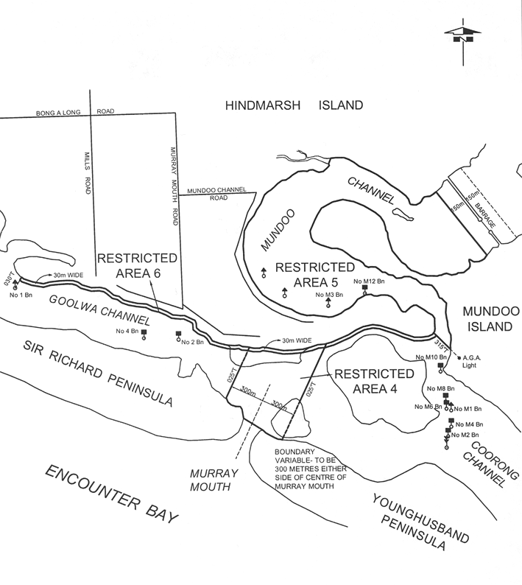
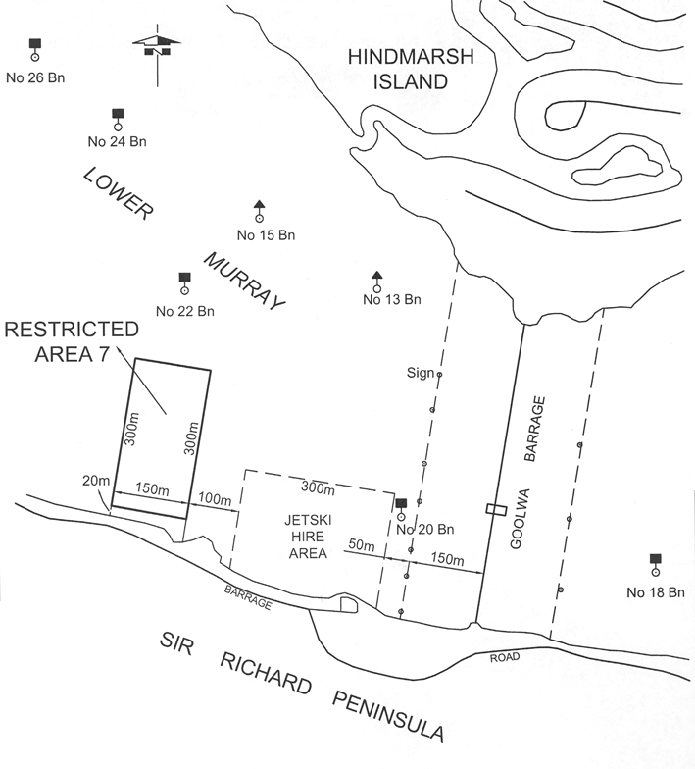
Henley Beach
The portion of the waters of Gulf St. Vincent at Henley Beach bounded as follows:
• on the north by a straight line being the production seaward of the north alignment of Grange Road;
• on the south by a straight line being the production seaward of the north alignment of the River Torrens outfall;
• on the east by the High Water Mark;
• on the west by a line 200 m from, and parallel to, the Low Water Mark.
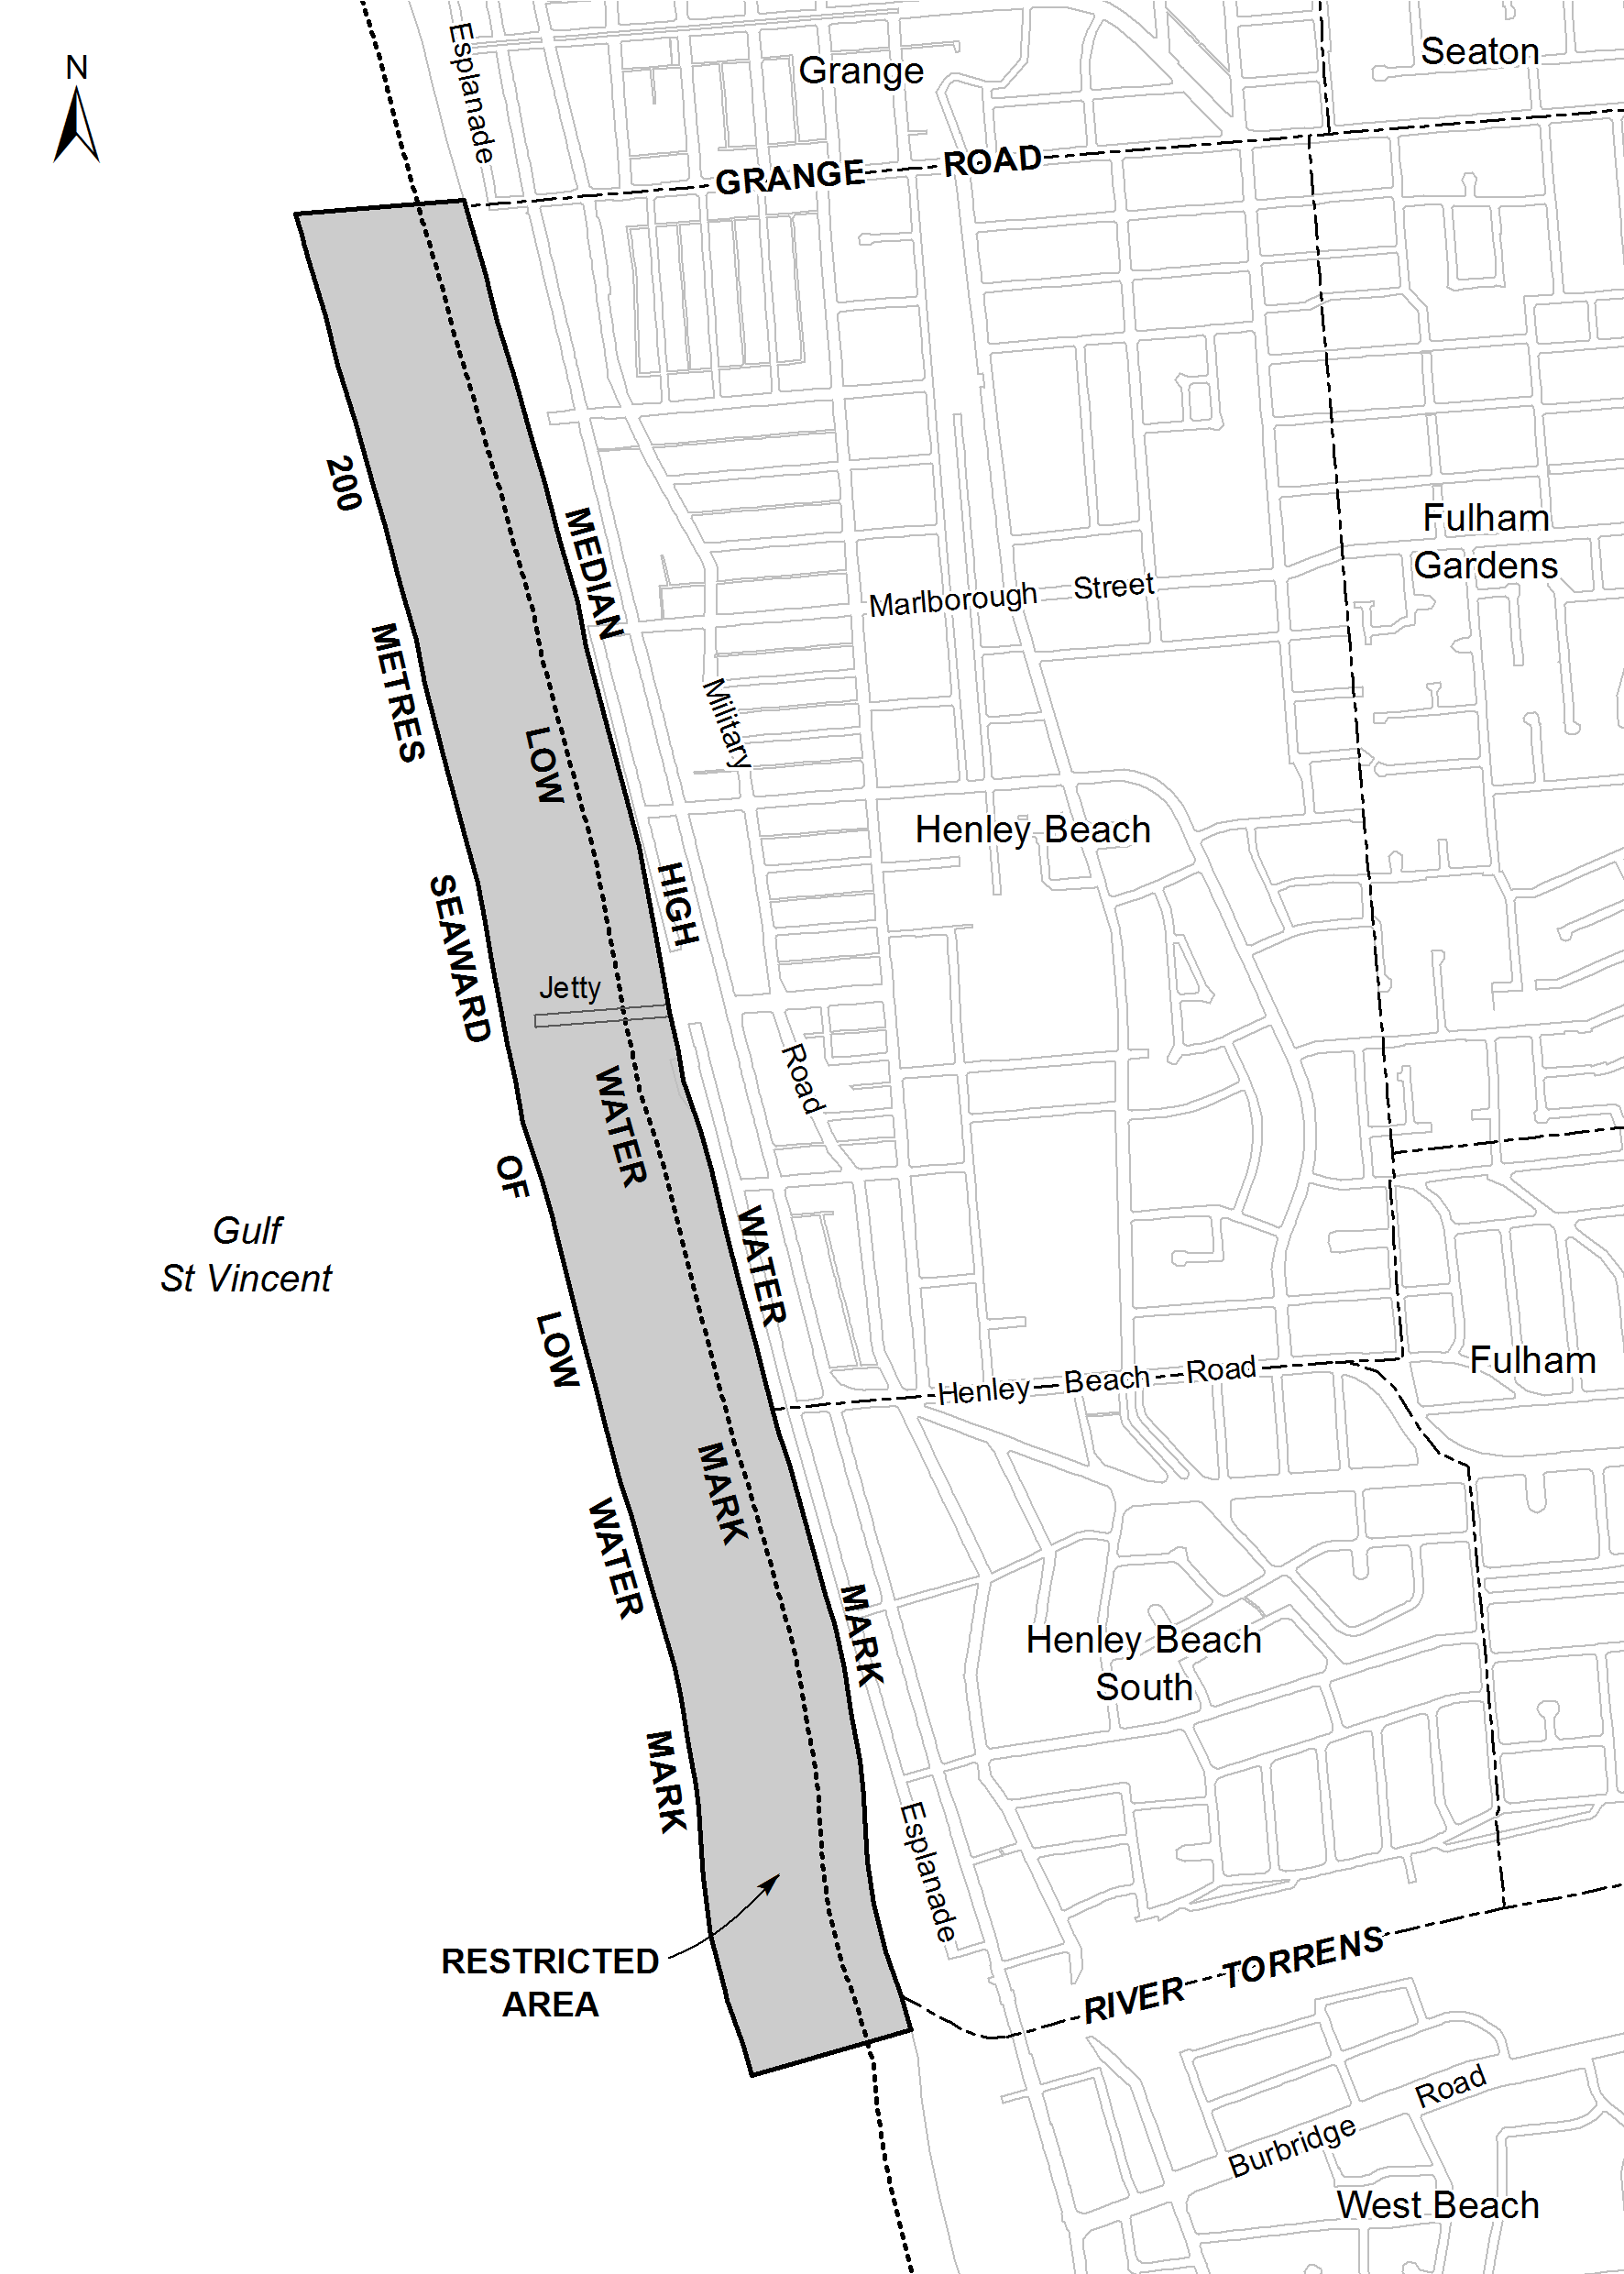
Hog Bay
The portion of the sea at Hog Bay on Kangaroo Island bounded as follows:
• on the north by a straight line being the prolongation of the south boundary of Middle Terrace for a distance of 150 m seawards from the High Water Mark;
• on the east by a straight line parallel to the west boundary of Cheopis Street and commencing at a point 200 m westerly along the High Water Mark from the prolongation of the west boundary at Cheopis Street, and extending 150 m seaward from the High Water Mark;
• on the north-east by a straight line joining the seaward extremities of the north and east boundaries;
• on the south-west by the High Water Mark.
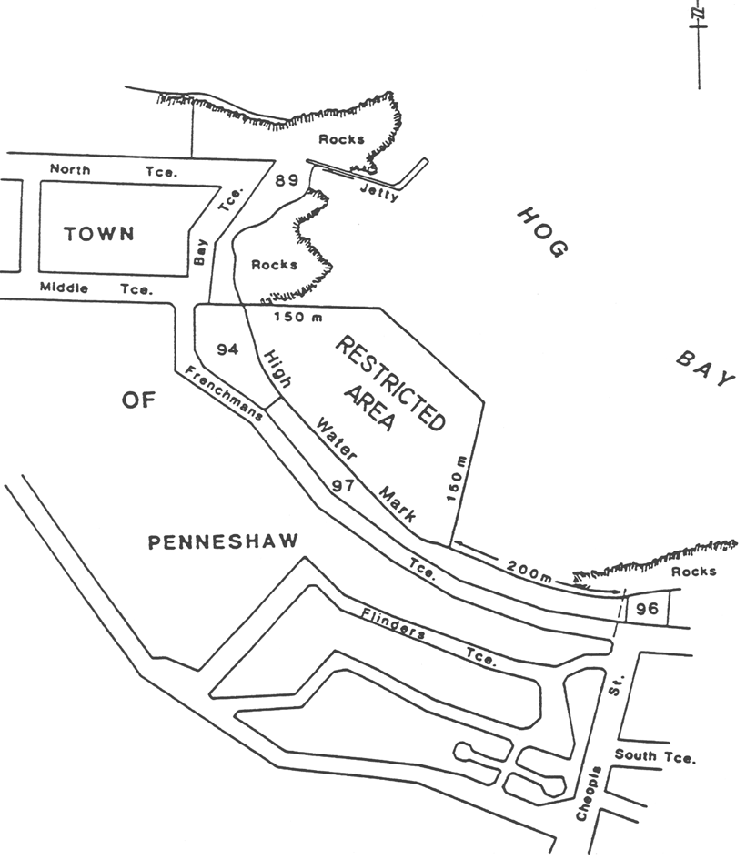
Kellidie Bay
The portion of the sea at Kellidie Bay bounded as follows:
commencing at a point being the southern corner of section 2147 North Out of Hundreds, then north-west along the High Water Mark to its intersection with the north-eastern corner of section 278 Hundred of Lake Wangary, then north along a straight line to its intersection with the High Water Mark at section 631 Hundred of Lake Wangary, then south-west along the High Water Mark to its intersection with the south-western corner of Section 2146 North Out of Hundreds, then south-east along the south-western boundary of Section 2146 North Out of Hundreds to its southern corner, then east along its southern boundary to its south-eastern corner and then north along its eastern boundary to its north-eastern corner, then south-east along a straight line to its intersection with the High Water Mark at a point being the prolongation of the north boundary of Seaview Road, then south along the High Water Mark to its intersection with the eastern corner of section 2147 North Out of Hundreds, then north-west along the north-eastern boundary to its northern corner, then south-west along the north-western boundary to its western corner, then south-east along its south-eastern boundary to the point of commencement, but excluding Goat Island (Section 913 Hundred of Lake Wangary).
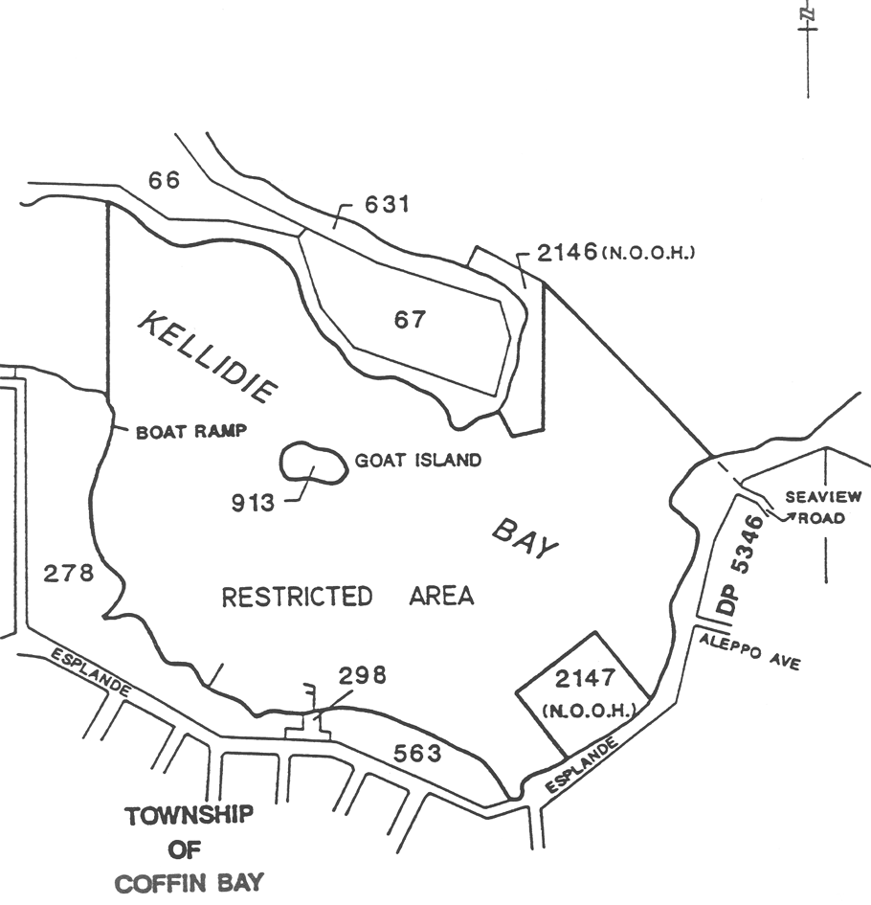
Lake Bonney (Barmera)
Area 1: the portion of Lake Bonney marked out by flame orange spherical buoys and yellow marker posts.
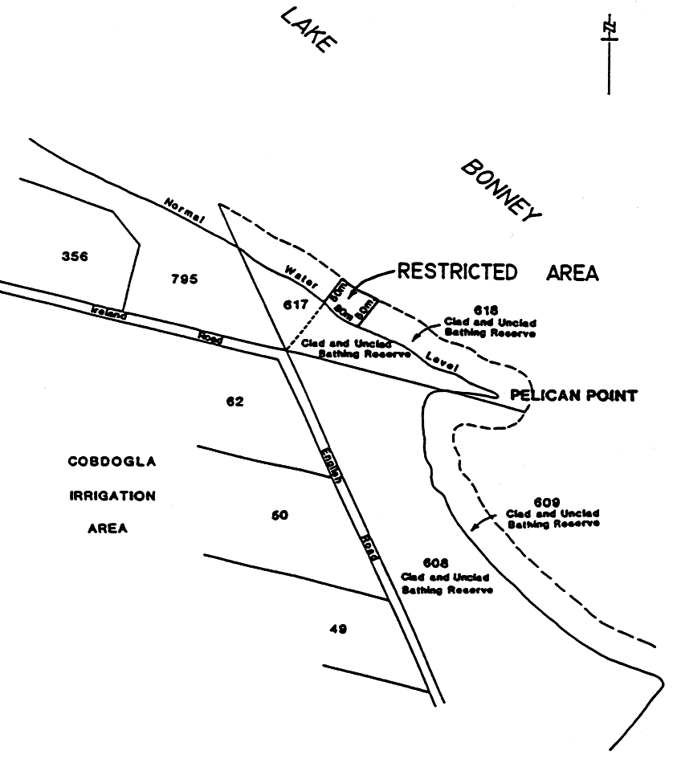
Area 2: the portion of Lake Bonney bounded as follows:
• on the north by a line 100 m from, and parallel to, the edge of the water;
• on the east by the prolongation north-westerly of the north-eastern boundary of Whitmore Avenue;
• on the south by the edge of the water;
• on the west by a straight line from the eastern end of the concrete wharf (approximately 20 m west of the prolongation northerly of the western boundary of James Terrace) and at right angles to the edge of the water.
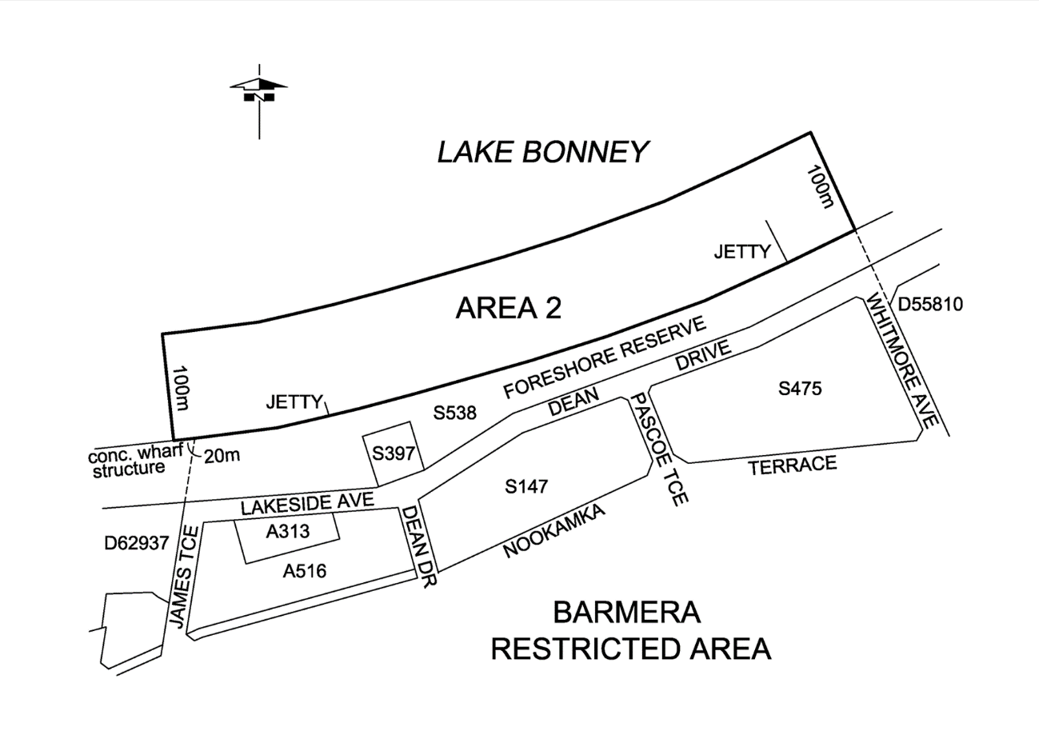
Lake Bonney (South East)
All the waters of Lake Bonney.
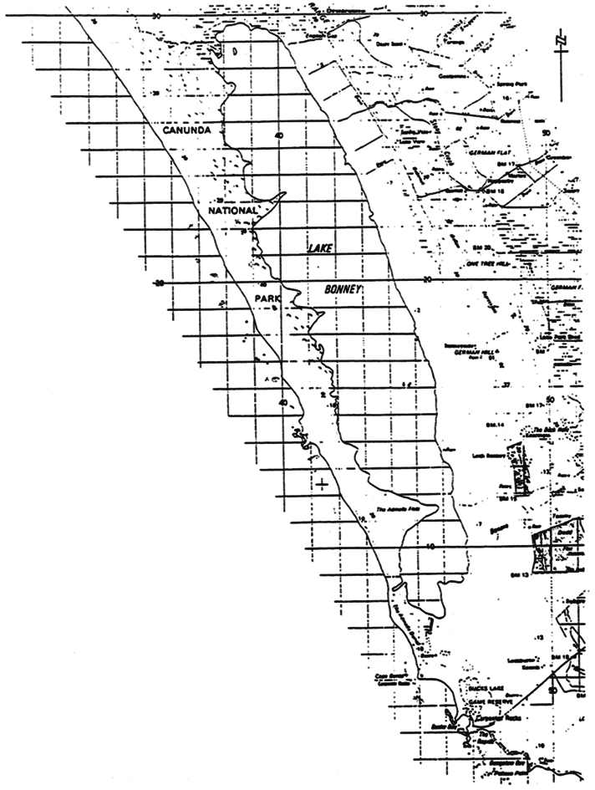
Lake Fellmongery
Area 1: the portion of Lake Fellmongery at Robe bounded as follows:
• on the south-east by a straight line joining the southerly extremity of the most easterly boundary of Section 512, Hundred of Waterhouse, to the intersection of the north alignment of Tobruk Avenue and the west alignment of Lakeside Avenue, the line being marked by a yellow marker post at each of its 2 intersections with the edge of the water, and by a line of marker buoys on the lake;
• on the west and north-west by the edge of the water.
Area 2: the portion of Lake Fellmongery at Robe bounded as follows:
• on the east by a straight line joining the north-east corner of Section 540, Hundred of Waterhouse, to the south-east corner of allotment 1 in Lands Titles Office Deposited Plan No 5689, the line being marked by a yellow marker post at each of its 2 intersections with the edge of the water, and by a line of marker buoys on the lake;
• on the south-west and north-west by the edge of the water.
Area 3: the portion of Lake Fellmongery not included in Areas 1 and 2.
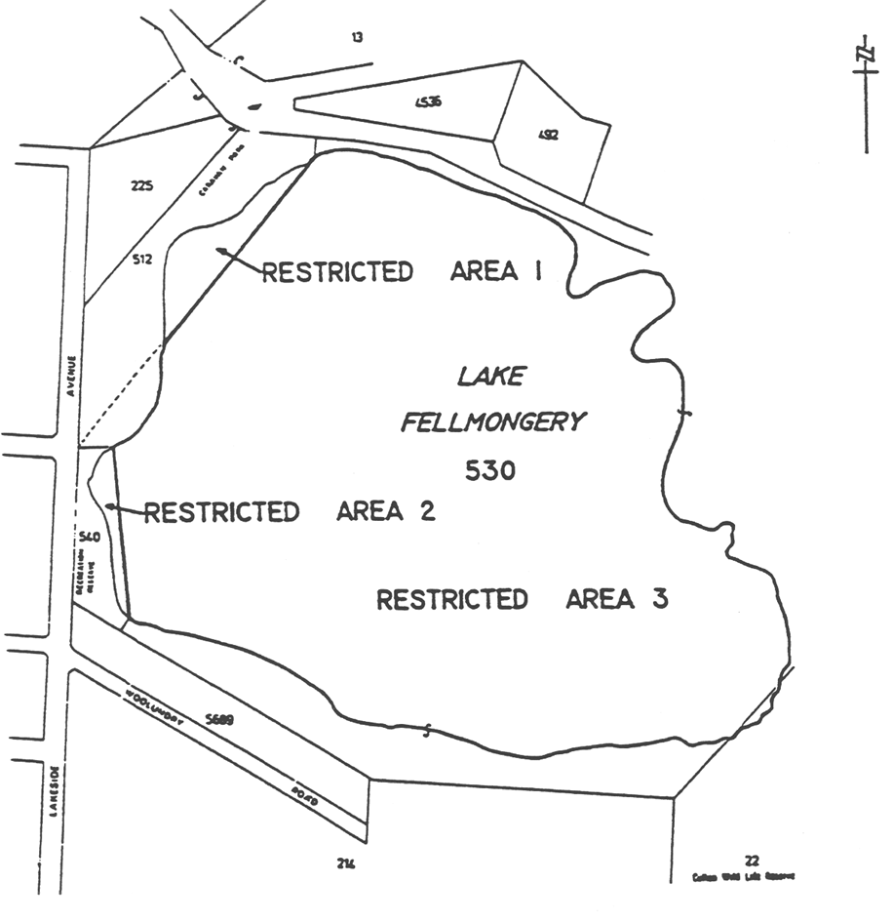
Lake Leake
The area of Lake Leake bounded as follows:
• on the north by a straight line commencing at a point, being the intersection of the east boundary of Section 525 Hundred of Hindmarsh and the north-westerly production of the north-east boundary of Section 372 Hundred of Hindmarsh, and extending westerly at right angles to the water's edge for a distance of 30 m;
• on the east by a line extending southerly along the east boundary of Section 525 Hundred of Hindmarsh from the north boundary for a distance of 100 m;
• on the south by a straight line commencing at the south extremity of the east boundary and extending westerly at right angles to the water's edge for a distance of 30 m;
• on the west by a straight line joining the west extremities of the north and south boundaries.
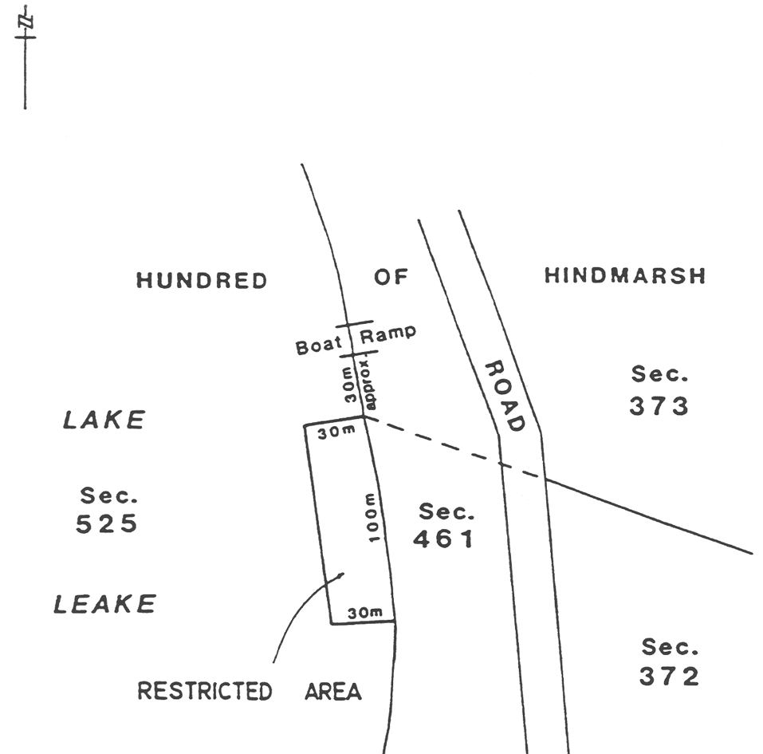
Mannum
Area 1: the portion of the River Murray at Mannum bounded as follows:
• on the south-west, by a straight line from the edge of the water for a distance of 16 m in a south-easterly direction parallel to and at a perpendicular distance of 52 m north-east of the prolongation of the south-western boundary of Section 906, Hundred of Finniss;
• on the north-east, by a straight line from the edge of the water for a distance of 12 m in a south-easterly direction parallel to and at a perpendicular distance of 77 m north-east of the prolongation of the south-western boundary of Section 906, Hundred of Finniss;
• on the south-east, by a straight line joining the southern extremities of the south-western and north-eastern boundaries;
• on the north-west, by the edge of the water.
Area 2: the portion of the River Murray at Mannum bounded as follows:
• on the south-west, by a straight line in a south-easterly direction from the prescribed base line parallel to and at a perpendicular distance of 85 m south-west of the prolongation of the south-western boundary of Allotment 10 in Filed Plan 21817, Hundred of Finniss for a distance of 7 m perpendicular to the prescribed base line;
• on the north-east, by a straight line in a south-easterly direction from the prescribed base line parallel to and at a perpendicular distance of 45 m south-west of the prolongation of the south-western boundary of Allotment 10 in Filed Plan 21817, Hundred of Finniss for a distance of 7 m perpendicular to the prescribed base line;
• on the south-east, by a straight line joining the southern extremities of the south-western and north-eastern boundaries;
• on the north-west, by the edge of the water.
Area 3: the portion of the waters of the River Murray at Mannum delineated in bold on the plan below as Area 3.
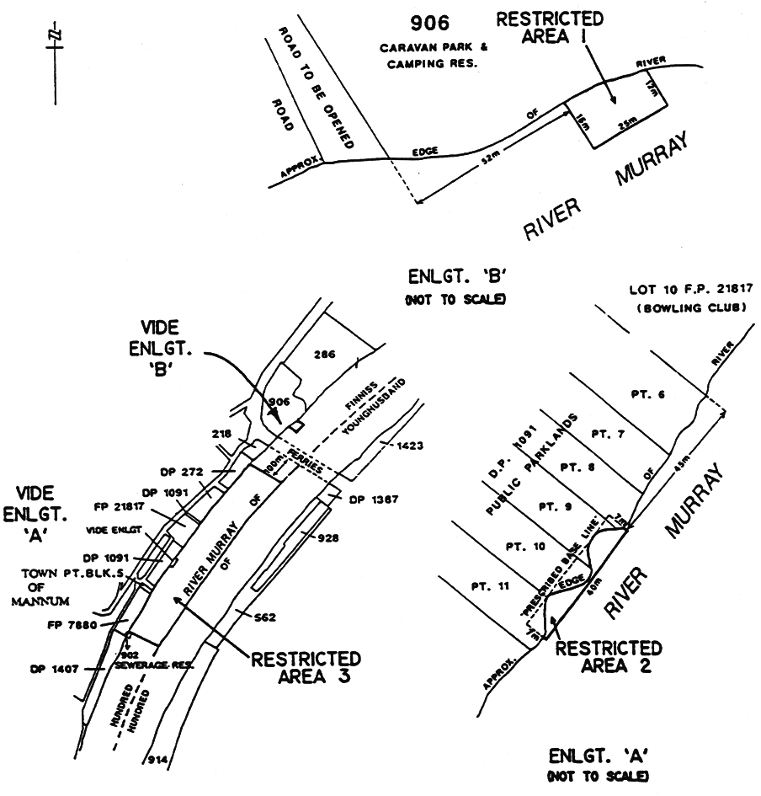
Meningie
Area 1: the portion of Lake Albert at Meningie bounded as follows:
• on the south, by a straight line being the prolongation of the north boundary of Allotment 75 in Development Plan 16240, Hundred of Bonney commencing from the water's edge and extending in a westerly direction for a distance of 75 m;
• on the west, by a straight line perpendicular to the south boundary commencing at its western extremity and extending in a north-easterly direction for a distance of 100 m;
• on the north-east, by the southern side of the Meningie boat ramp commencing at the water's edge and extending in a north-westerly direction for a distance of 18 m;
• on the north-west, by a straight line joining the northern extremity of the west boundary with the western extremity of the north-east boundary;
• on the east, by the water's edge.
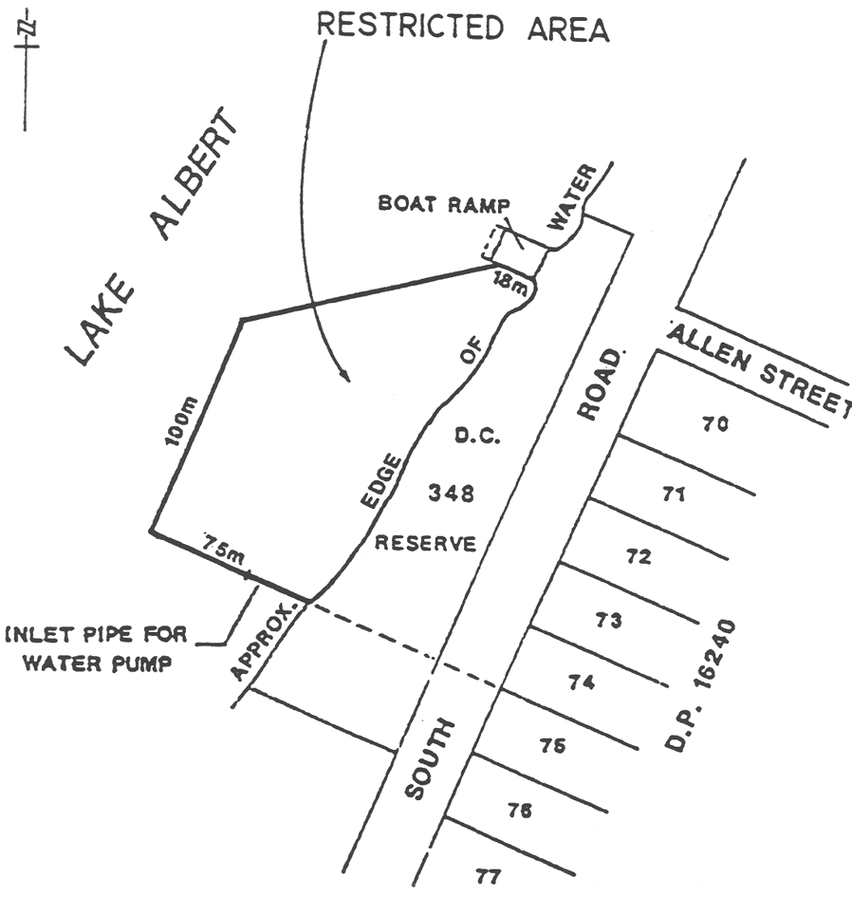
Area 2: the portion of Lake Albert at Meningie bounded as follows:
• on the west, by a straight line being the prolongation of the western boundary of section 374 Hundred of Bonney commencing from the water's edge and extending in a northerly direction for a distance of 50 m;
• on the east, by a straight line being the prolongation of the western boundary of section 378 Hundred of Bonney commencing from the water's edge and extending in a northerly direction for a distance of 50 m;
• on the north, by a straight line joining the northern extremity of the western boundary with the northern extremity of the eastern boundary;
• on the south, by the water's edge.
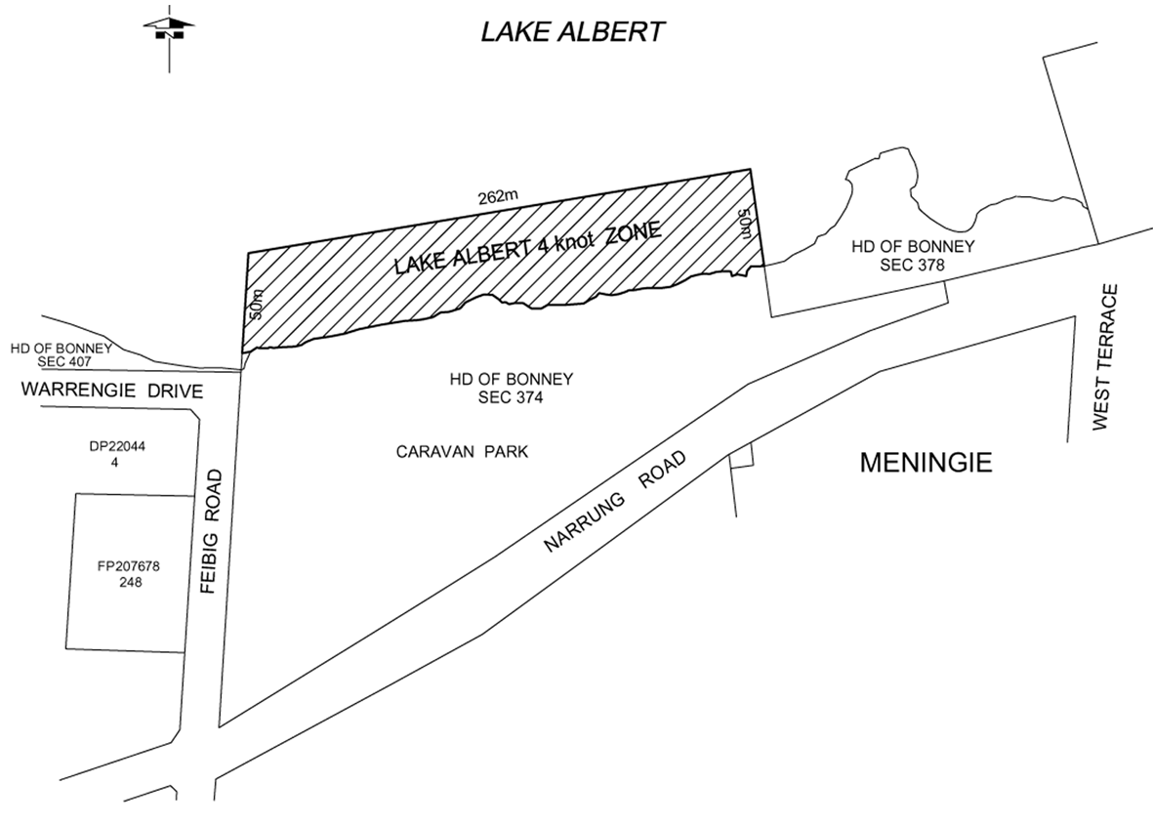
Milang
The portion of Lake Alexandrina at Milang bounded as follows:
• on the north-east by a straight line parallel to and 50 m from a straight line joining piles A and B;
• on the north-west by a straight line commencing at pile A then heading north-east to intersect the north-eastern boundary at right angles;
• on the south-east by a straight line commencing at pile B then heading north-east to intersect the north-eastern boundary at right angles;
• on the south-west by the north-eastern face of the jetty between piles A and B.
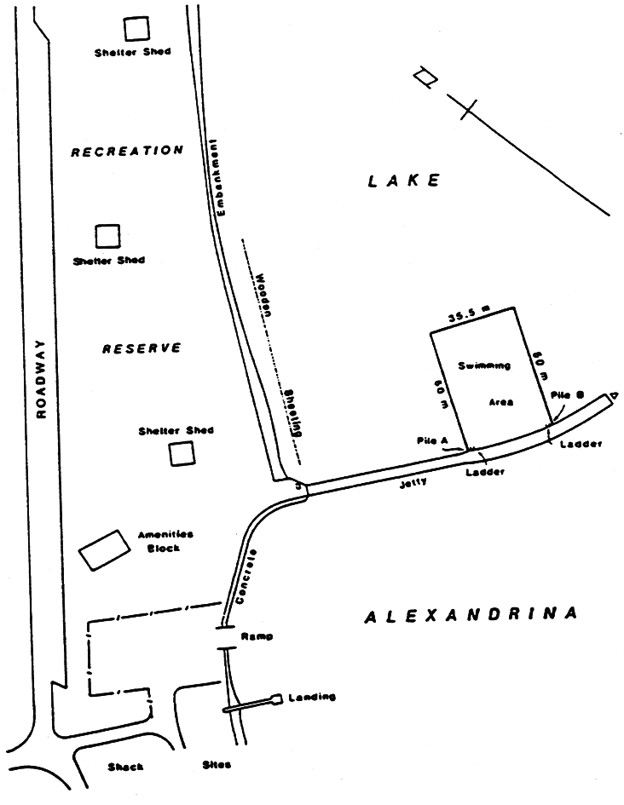
Moana
The portion of the sea at Moana bounded as follows:
• on the north by a straight line west of and parallel to the north side of Third Avenue, that line passing through the south extremity of the pedestrian ramp to the beach and extending for 255 m west of the east alignment of the Esplanade;
• on the south by a straight line west of and parallel to the south side of the west end of Nashwauk Crescent, that line passing through the north extremity of the vehicle ramp to the beach and extending for 270 m west of the east alignment of the Esplanade;
• on the west by a straight line joining the west extremities of the north and south boundaries;
• on the east by the High Water Mark.
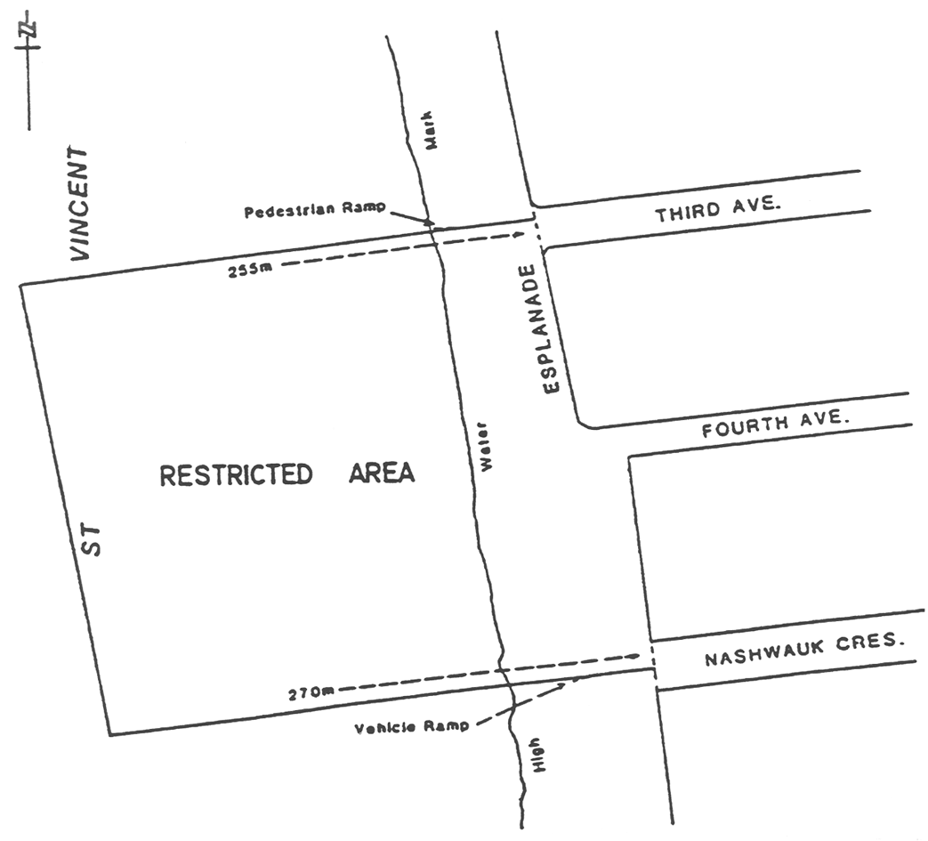
Morgan and Cadell
Area 1: the portion of the River Murray at Morgan bounded as follows:
• on the north by a straight line extending easterly from the yellow marker post situated on the west bank of the River Murray at the north-east corner of Section 451, Hundred of Eba, for 5 m beyond and at right angles to the edge of the water;
• on the south by a straight line extending easterly from the yellow marker post situated on the west bank of the River Murray at the south-east corner of Section 451, Hundred of Eba, for 5 m beyond and at right angles to the edge of the water;
• on the east by a straight line joining the easterly extremities of the north and south boundaries;
• on the west by the edge of the water between those 2 yellow marker posts.
Area 2: the portion of the River Murray at Cadell bounded as follows:
• on the south-east by the edge of the water between the 2 yellow marker posts situated on the south-east bank of the River Murray, the upstream post being approximately 160 m west of the north-west corner of Cadell Valley Road immediately south of the Cadell ferry crossing, and the downstream post being approximately 90 m south-west of the upstream post;
• on the north-east by a straight line extending north-westerly from the upstream yellow marker post of the 2 posts previously defined, for 5 m beyond and at right angles to the edge of the water;
• on the south-west by a straight line extending north-westerly from the downstream yellow marker post of the 2 posts previously defined, for 5 m beyond and at right angles to the edge of the water;
• on the north-west by a straight line joining the north-westerly extremities of the north-east and south-west boundaries.
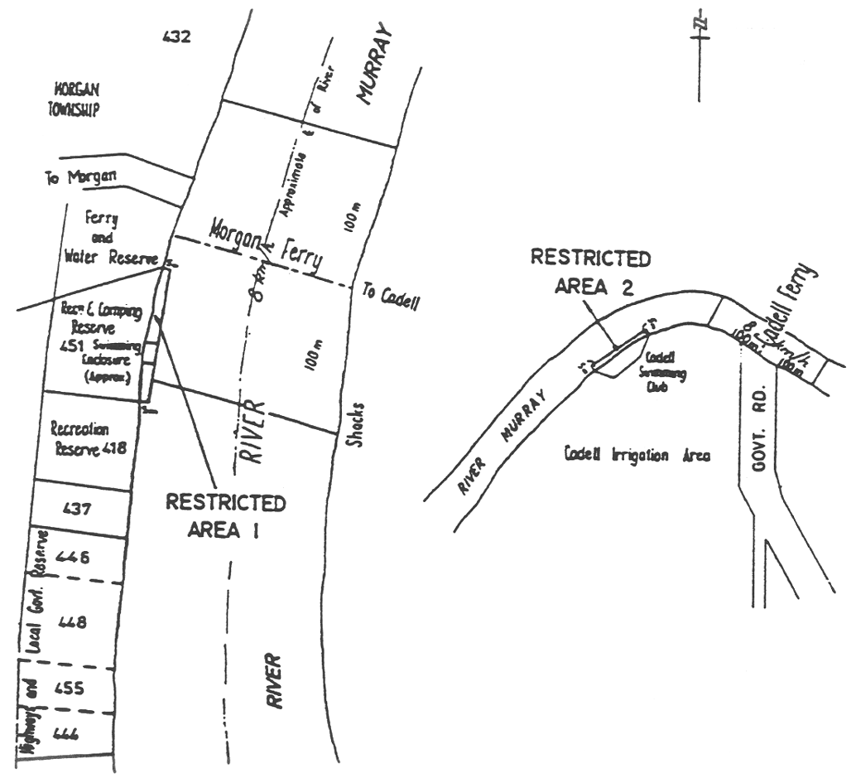
Murray Bridge
Area 1: the portion of the River Murray at Murray Bridge bounded as follows:
• on the north-east by the centre line of the river;
• on the south-east by a straight line extending south-west from the middle ground buoy to the south-west from the middle ground buoy to the south-west bank of the river;
• on the north-west by a line extending from the red mark C on the upstream side of the road traffic bridge, south-west along the line of the north-west (upstream) side of the road traffic bridge to the south-west bank of the river, and on the south-west by the south-west bank of the river, except for an accessway between the south-west bank of the river and the centre line of the river extending north-west for a distance of 100 m from a line being the north-west boundary of allotment 30 in Lands Titles Registration Office Plan No 1443.
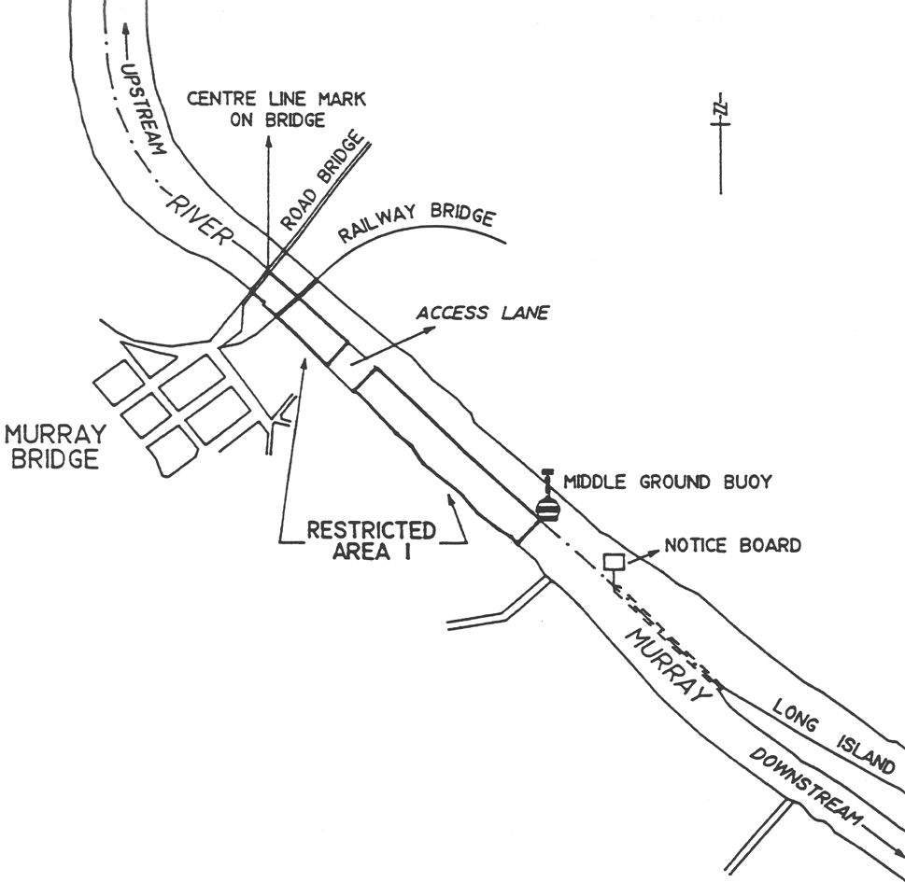
Area 2: the portion of the River Murray at Murray Bridge on the north-east side of Long Island bounded as follows:
• on the north-east by the north-east bank of the river;
• on the south-east by a straight line from the south-east (downstream) extremity of Long Island north-east to the north-east bank of the river;
• on the north-west by a straight line from the notice board north-east to the north-east bank of the river;
• on the south-west by a straight line from the notice board to the north-west (upstream) end of Long Island, then generally south-east along the north-east side of Long Island to its south-east (downstream) extremity.
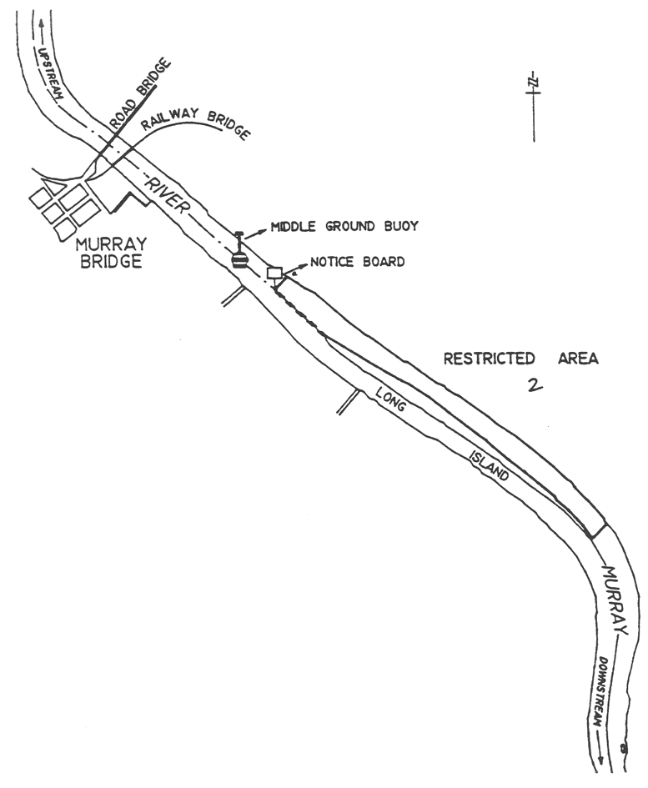
Murray Bridge (bathing)
Area 1: the portion of the River Murray at Murray Bridge (Wellington Reserve) bounded as follows:
• on the south by a line being the prolongation of the southern boundary of Lot 613, Town of Wellington, easterly for a distance of 5 m from the waters edge;
• on the north by a line running easterly from the waters edge for a distance of 5 m and at a distance of 20 m in a northerly direction from the southern boundary of Lot 613, Town of Wellington;
• on the east by a line joining the eastern extremities of the north and south boundaries and parallel to the waters edge;
• on the west by the waters edge.
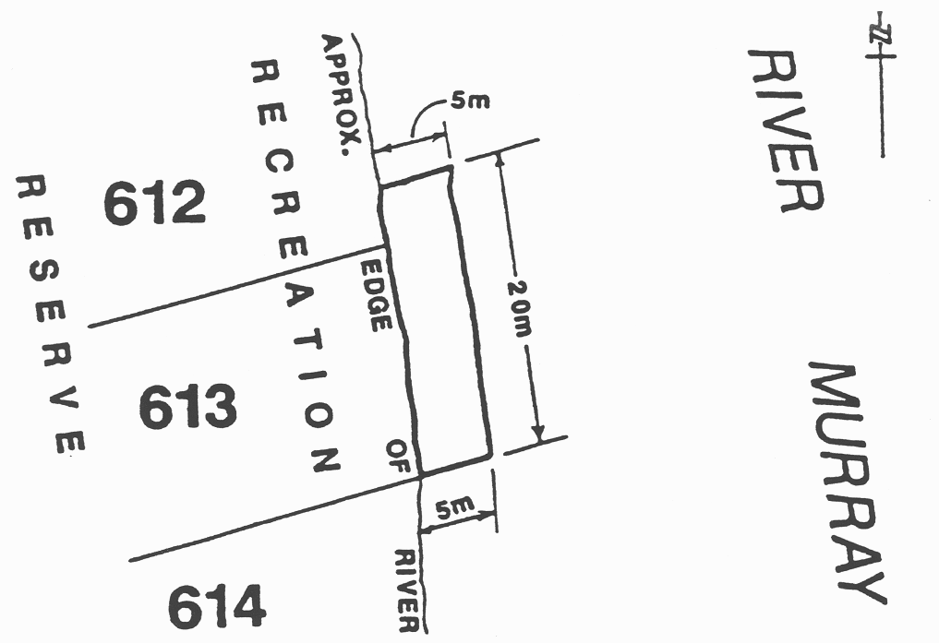
Area 2: the portion of the River Murray at Murray Bridge (Bells Landing—Monteith) bounded as follows:
• on the north-east by a line being the prolongation of a boundary of Section 695 on line with the south-western end of Kellett Street, Hundred of Burdett, westerly for a distance of 5 m from the waters edge;
• on the south-west by a straight line running north-westerly from the waters edge for a distance of 5 m parallel to and at a distance of 30 m from the north-east boundary;
• on the north-west by a line joining the western extremities of the north-east and south-west boundaries and parallel to the waters edge;
• on the south east by the waters edge.
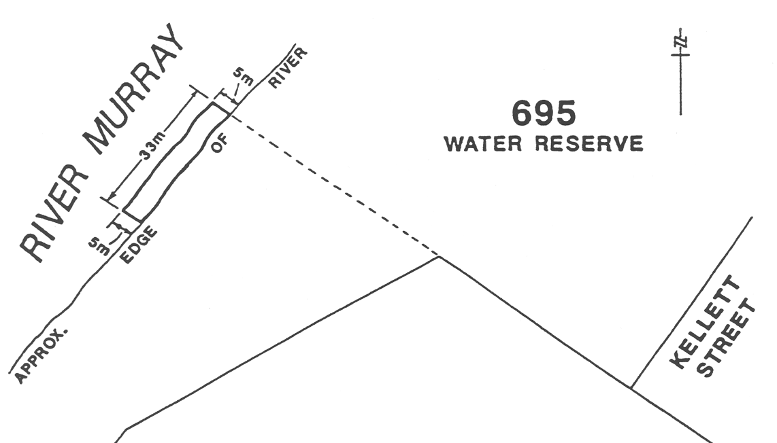
Area 3: the portion of the River Murray at Murray Bridge (Swanport Reserve) bounded as follows:
• on the south-east by a straight line running north-easterly from the waters edge for a distance of 6 m at a distance of 44 m in a north-westerly direction along the waters edge from the north-eastern corner of Section 1065, Hundred of Mobilong;
• on the north-west by a straight line running north-easterly from the waters edge for a distance of 6 m parallel to and at a distance of 92 m in a north-westerly direction along the waters edge from the north-eastern boundary of Section 1065, Hundred of Mobilong;
• on the north-east by a line joining the eastern extremities of the south-east and north-west boundaries and parallel to the waters edge;
• on the south-west by the waters edge.
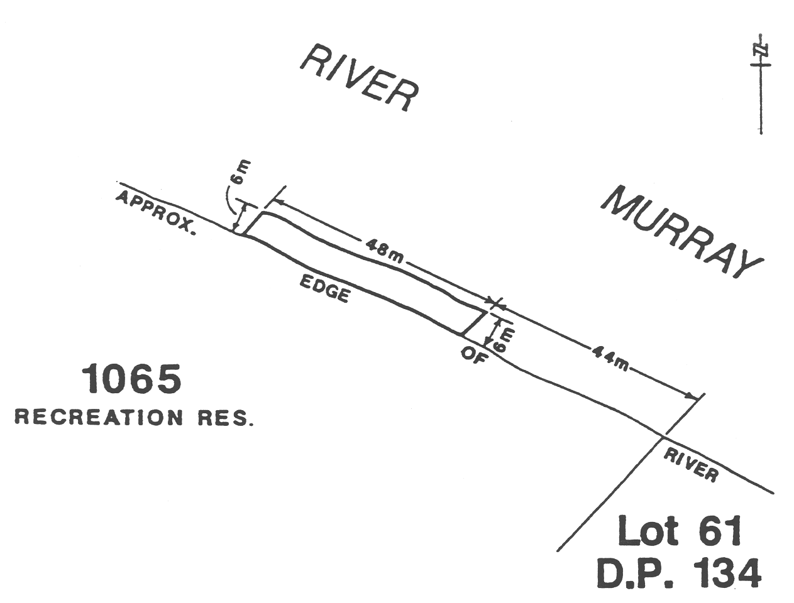
Area 4: the portion of the River Murray at Murray Bridge (Long Island Reserve) bounded as follows:
• on the north-west by a line being the prolongation of the north-western boundary of Lot 12, Deposited Plan No 20027, north-easterly for a distance of 5 m from the waters edge;
• on the south-east by a straight line running north-easterly from the waters edge for a distance of 5 m at a distance of 26 m in a south-easterly direction from the north-western corner of Lot 12, Deposited Plan No 20027;
• on the north-east by a line joining the north-eastern extremities of the north-west and south-east boundaries and parallel to the waters edge;
• on the south-east by the waters edge.
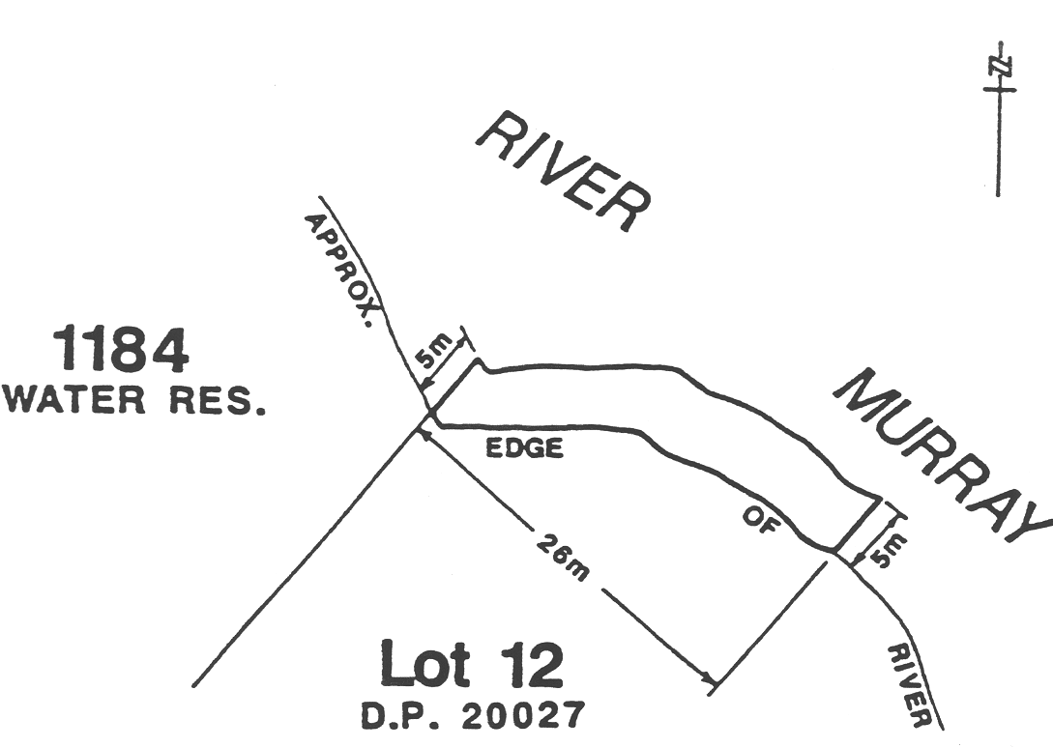
Area 5: the portion of the River Murray at Murray Bridge (Sturt Reserve) bounded as follows:
• on the north-west by a line being the prolongation of the north-western boundary of Lot 32, Deposited Plan No 1443, north-easterly for a distance of 5 m from the waters edge;
• on the south-east by a straight line running north-easterly from the waters edge for a distance of 5 m at a distance of 55 m in a south-easterly direction along the waters edge from the northern corner of Lot 32, Deposited Plan No 1443;
• on the north-east by a line joining the north-eastern extremities of the north-west and south-east boundaries and parallel to the waters edge;
• on the south-east by the waters edge.
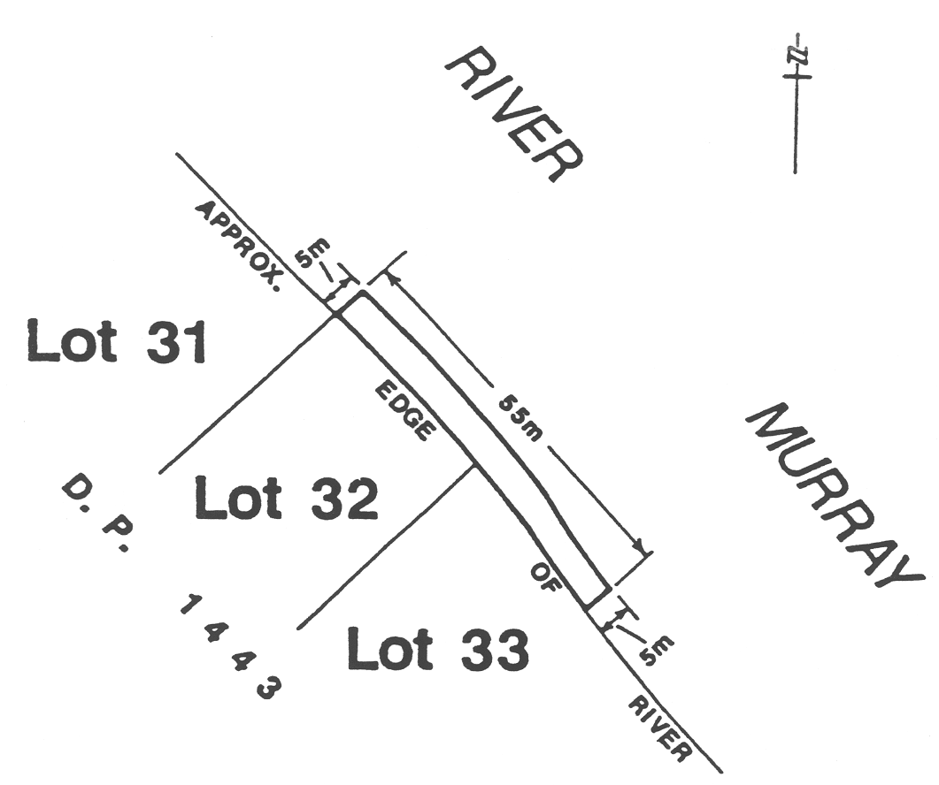
Area 6: the portion of the River Murray at Murray Bridge (Thiele Reserve) bounded as follows:
• on the north-east by a line being the prolongation of the south-western boundary of Section 575, Hundred of Burdett, north-westerly for a distance of 7 m from the waters edge;
• on the south-west by a straight line running north-westerly from the waters edge for a distance of 11 m on the prolongation of a line joining the south-eastern corner of Lincoln Street with the south-western wall of the stone building on the south-eastern corner of the intersection of Siesta Drive and Thiele Road, Hundred of Burdett;
• on the north-west by a line joining the north-western extremities of the north-east and south-west boundaries (being part of a straight line joining the north-western extremity of the north-eastern boundary with the north-eastern tip of the Timber Wharf in Section 458, Hundred of Burdett);
• on the south-east by the waters edge.
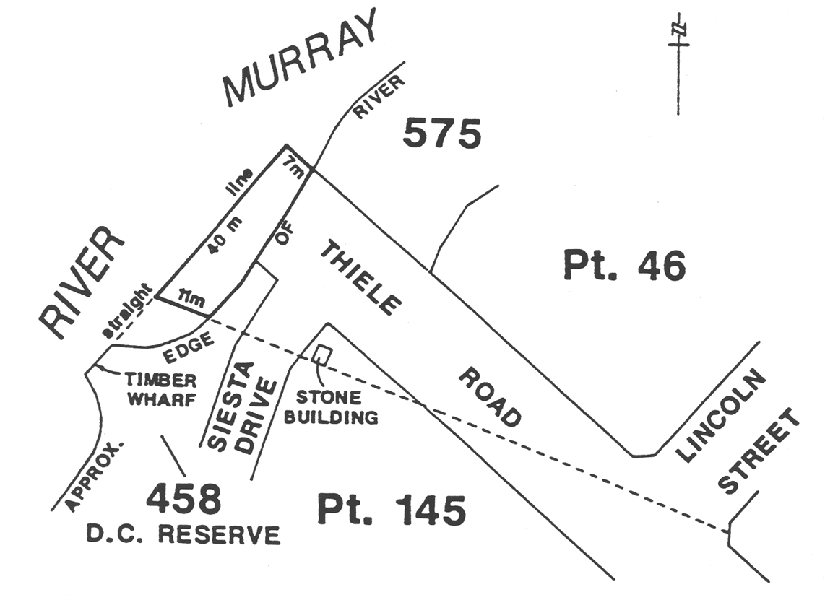
Area 7: the portion of the River Murray at Murray Bridge (Woodlane Reserve) bounded as follows:
• on the south-east by a line being the prolongation of the south-eastern boundary of Section 988, Hundred of Mobilong, north-easterly for a distance of 11 m from the waters edge;
• on the north-west by the south-eastern face of the Timber Jetty approximately 20 m north-west along the waters edge from the south-eastern boundary of Section 988, Hundred of Mobilong;
• on the north-east by a line joining the north-eastern extremities of the north-west and south-east boundaries and parallel to the waters edge;
• on the south-east by the waters edge.
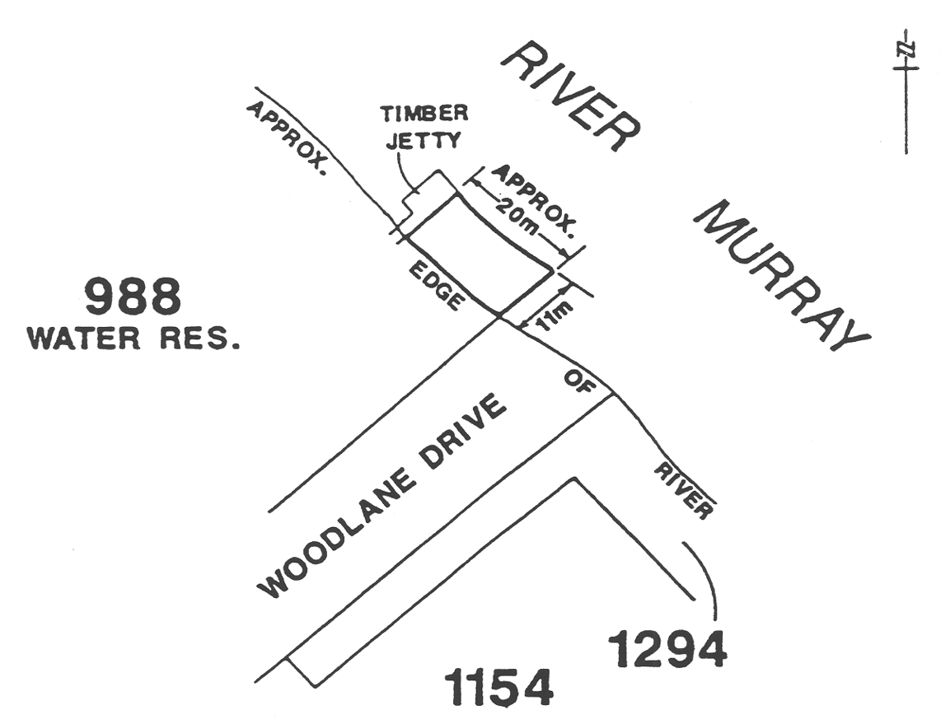
Nildottie
The creek flowing between the River Murray and the Lagoon through sections 275, 666 and 276N, Hundred of Ridley, delineated in bold on the plan below:
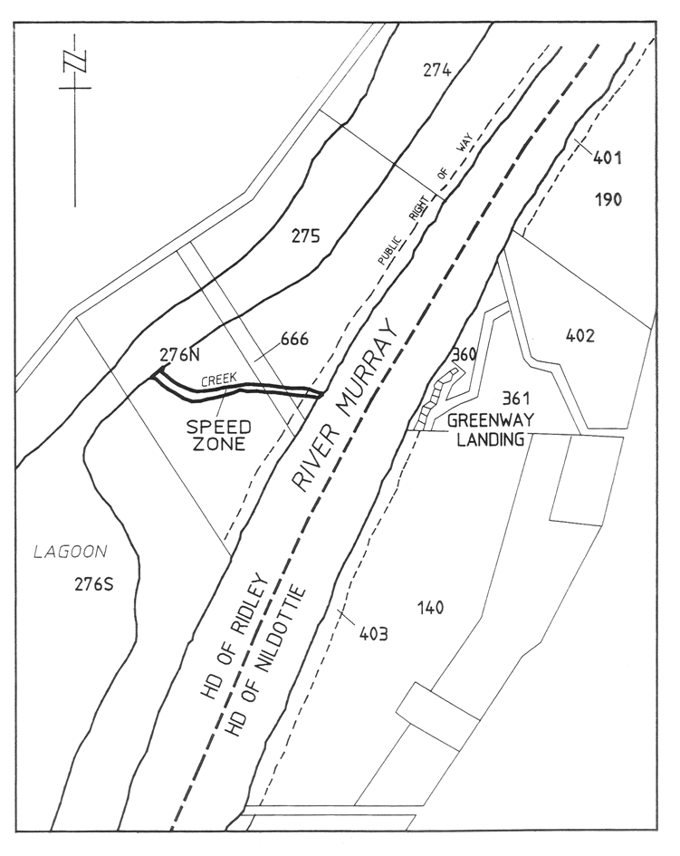
North Haven Marina
The portion of the waters of the North Haven marina bounded by and to the east of a line commencing at the seaward end of the inner breakwater and extending in a north-westerly direction to intersect perpendicularly with the northern breakwater.
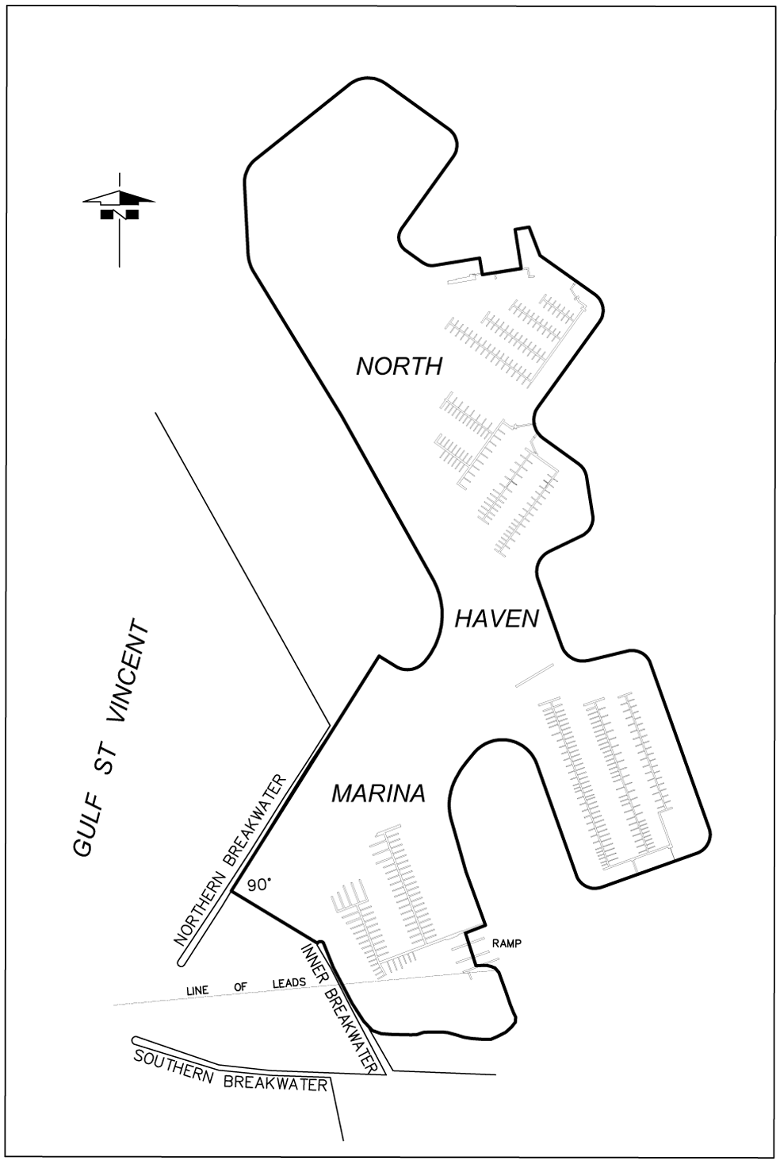
North Shields
The portion of the waters of the sea at North Shields delineated in bold on the plan below:
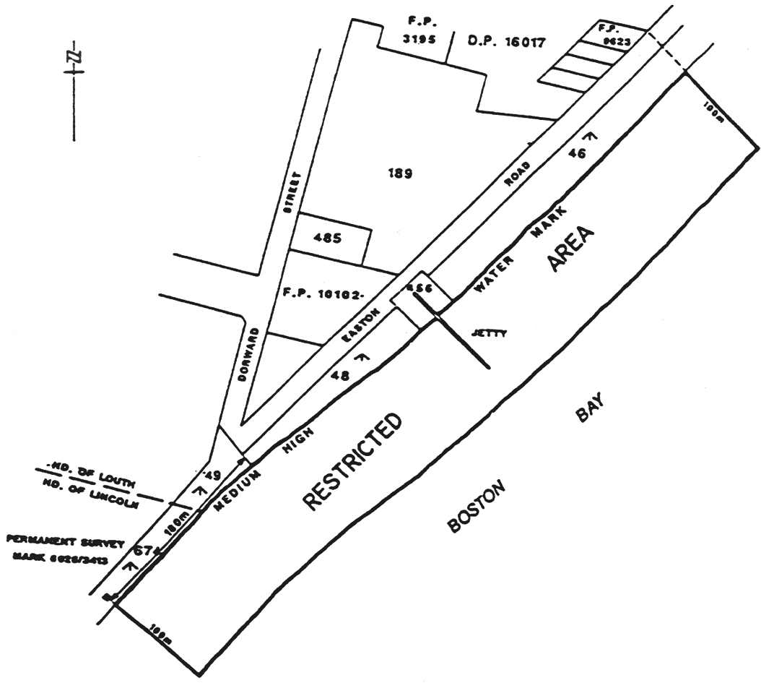
O'Sullivan Beach
The area of the sea at O'Sullivan Beach bounded as follows:
commencing at a point being the intersection with the High Water Mark of a line 10 m north of and parallel to the High Water Mark on the north side of the inner breakwater, then west along that line to its intersection with the circumference of a circle of 75 m radius centred on the light at the seaward end of the outer breakwater, then anti-clockwise around that circumference to its intersection with a line 10 m south-west of and parallel to the High Water Mark on the south-west side of the outer breakwater, then south-east along that line to its intersection with the High Water Mark, then along the High Water Mark to the point of commencement.
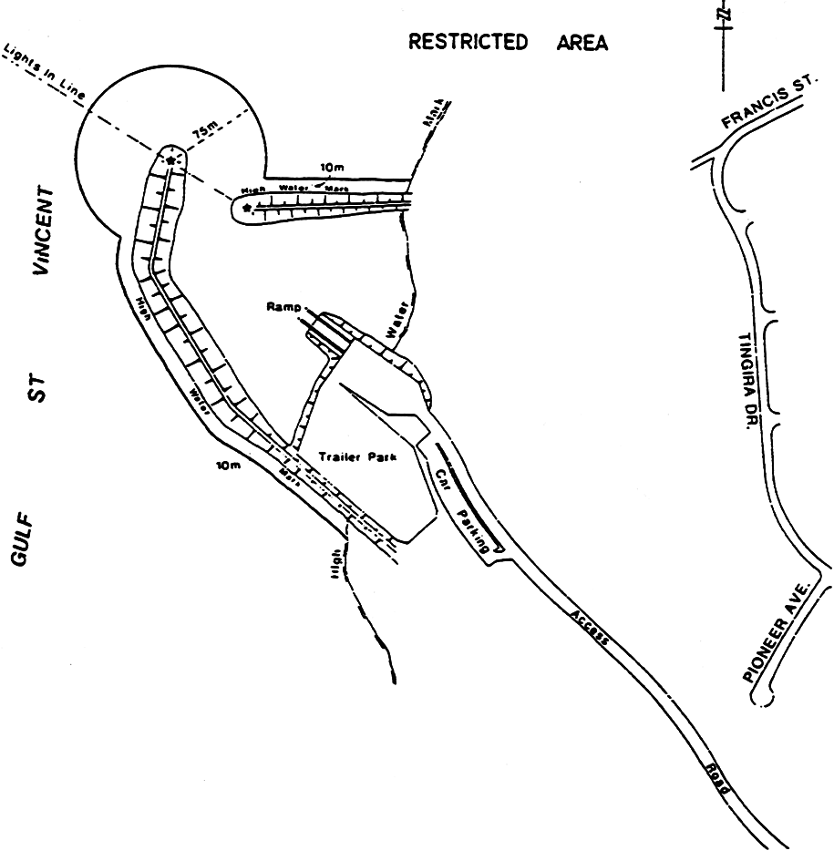
Point Turton
Area 1: the portion of the sea at Hardwicke Bay in Spencer Gulf near Point Turton bounded as follows:
• on the west by a straight line being the prolongation northerly of the west boundary of Section 383, Hundred of Para Wurlie commencing at a point at which that line intersects the High Water Mark (marked by a marker post) and extending 150 m seaward;
• on the east by a straight line parallel to and 200 m to the east of the west boundary of Area 1 described above commencing at a point at which that line intersects the High Water Mark (marked by a marker post) and extending 150 m seaward;
• on the north by a straight line joining the northernmost extremities of the east and west boundaries;
• on the south by the High Water Mark.
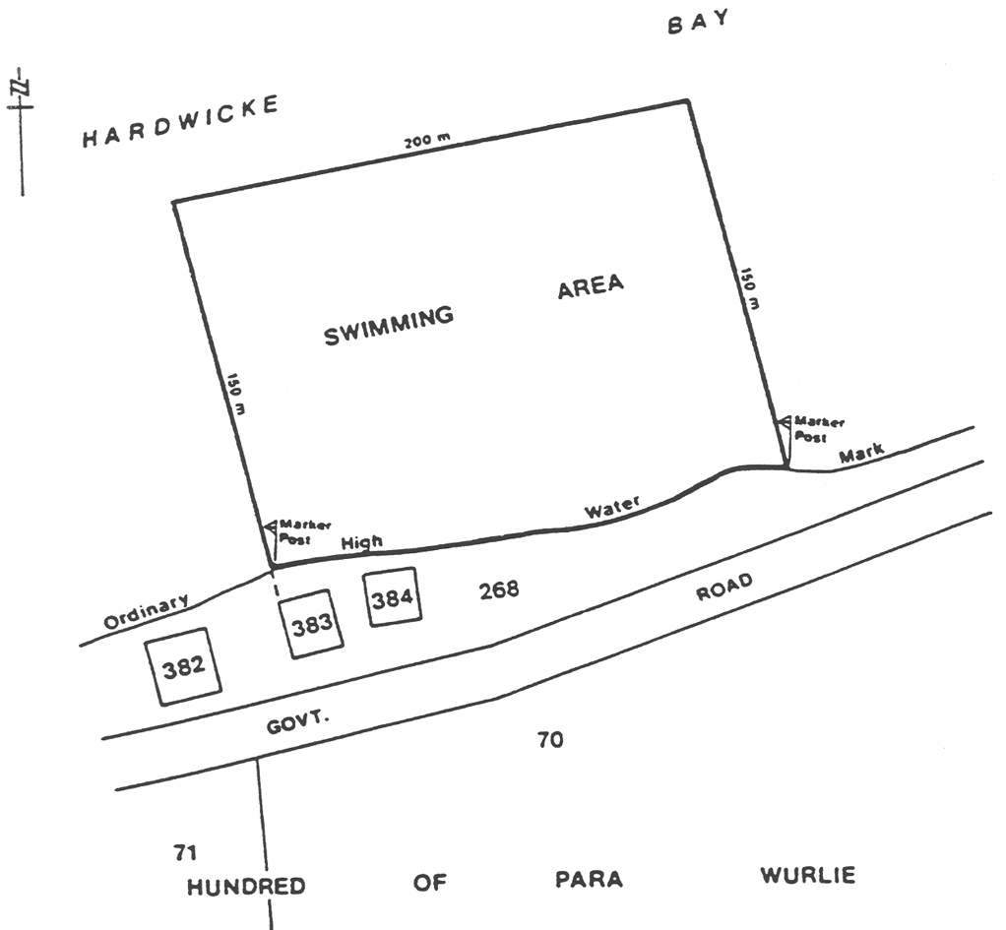
Area 2: the portion of the waters of Hardwicke Bay in Spencer Gulf near Point Turton described as "Area 2" on the plan below:
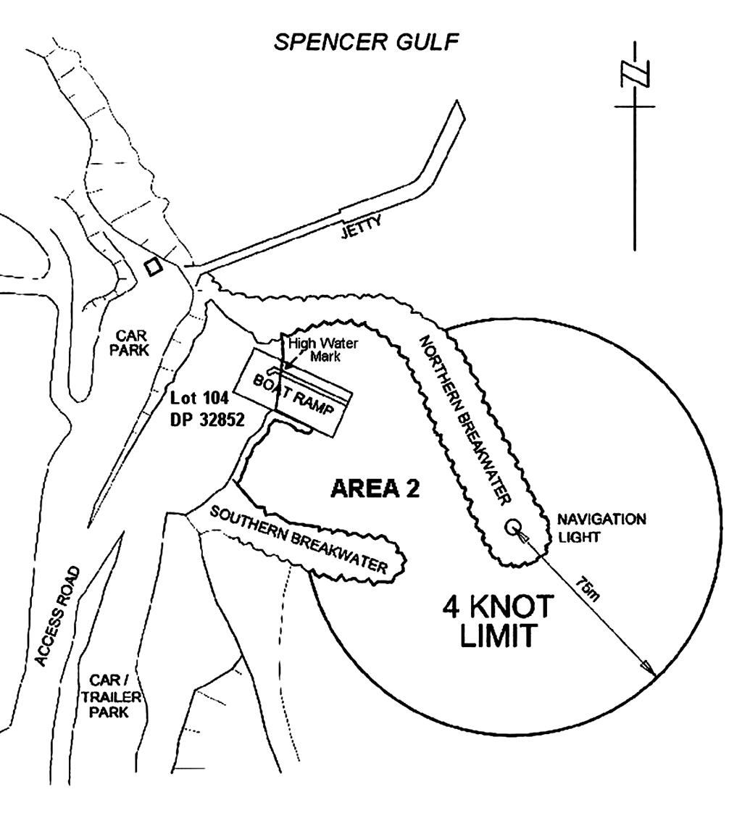
Port Adelaide
The portion of the waters of Port Adelaide and adjacent waters bounded as follows:
• on the north-east by a straight line commencing at a point at latitude 34°46′35.81" South, longitude 138°21′33.51" East and extending to a point at latitude 34°47′25.61" South, longitude 138°26′38.28" East;
• on the east by a straight line commencing at a point at latitude 34°47′25.61" South, longitude 138°26′38.28" East and extending to a point at latitude 34°47′34.62" South, longitude 138°26′38.27" East;
• on the south by a straight line commencing at a point at latitude 34°47′34.62" South, longitude 138°26′38.27" East and extending to a point at latitude 34°47′46.01" South, longitude 138°22′18.12" East;
• on the south-west by a straight line commencing at a point at latitude 34°47′46.01" South, longitude 138°22′18.12" East and extending to a point at latitude 34°48′44.07" South, longitude 138°20′12.23" East;
• on the west by a straight line commencing at a point at latitude 34°48′44.07" South, longitude 138°20′12.23" East and extending to a point at latitude 34°46′35.71" South, longitude 138°20′12.48" East;
• on the north by a straight line commencing at a point at latitude 34°46′35.71" South, longitude 138°20′12.48" East and extending to a point at latitude 34°46′35.81" South, longitude 138°21′33.51" East.
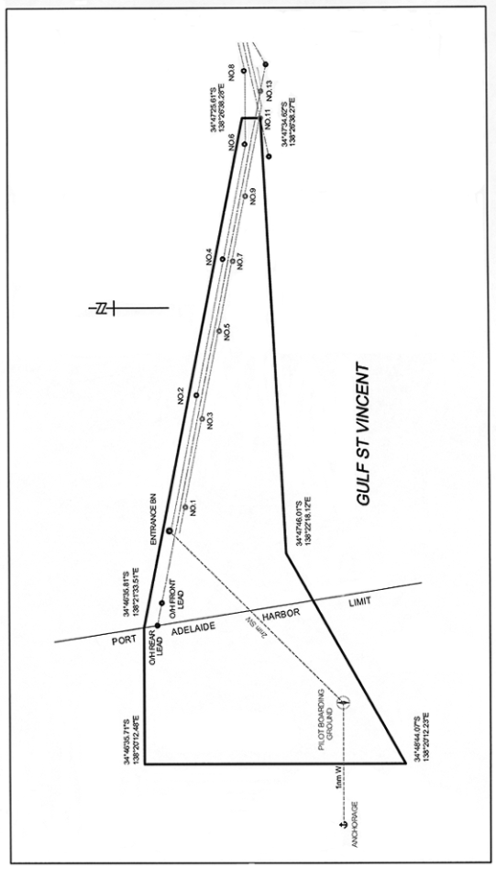
Port Bonython
Zone 1: waters within 400 m of Port Bonython Jetty.
Zone 2: waters within 1 170 m of Port Bonython Jetty.
Zone 3: waters within 2 nautical miles of the berth operations signals at the seaward end of Port Bonython Jetty.
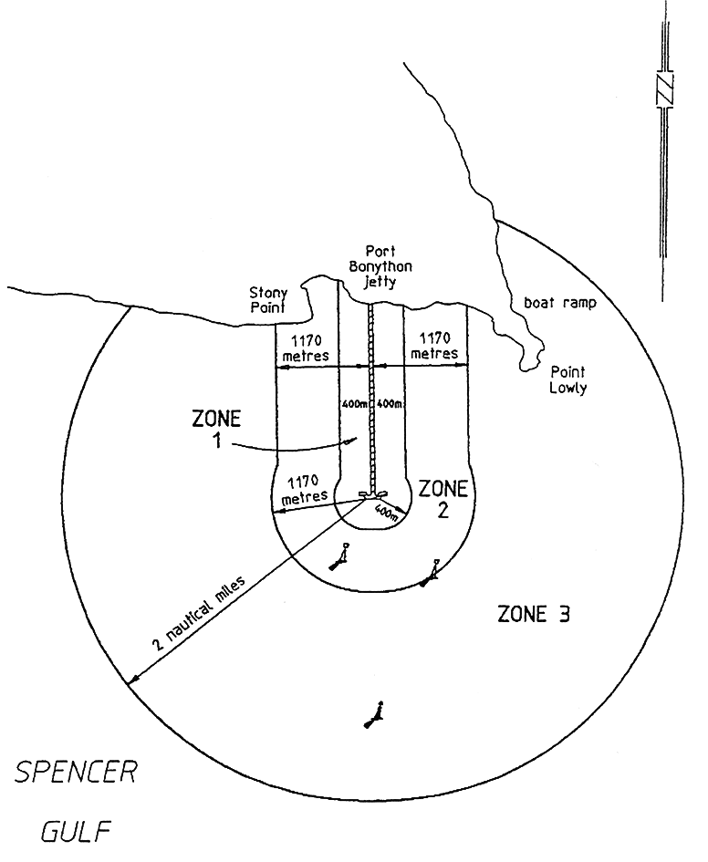
Port Elliot
All the waters of Horseshoe Bay north-west of a line joining the eastern extremity of the breakwater at Freeman Nob with Commodore Point.
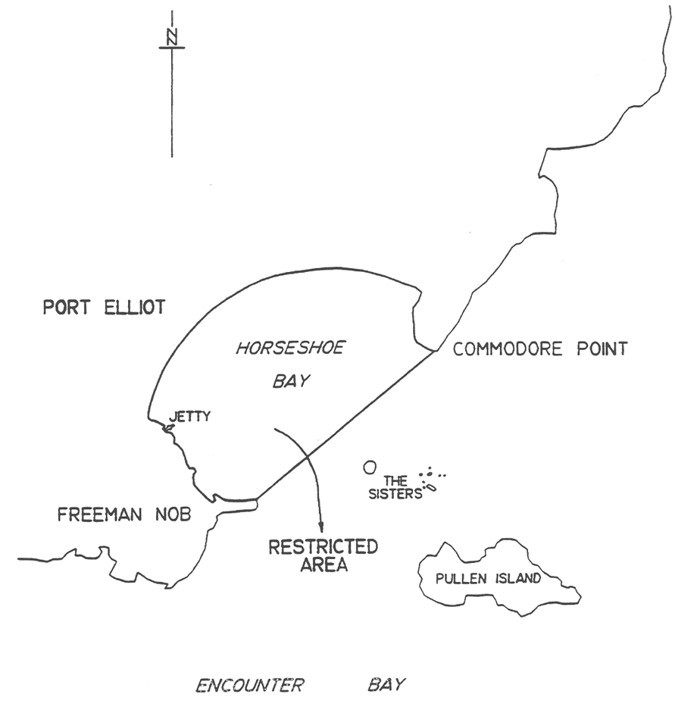
Porter Bay
The portion of the waters at Porter Bay to the west of an imaginary straight line commencing from the seaward boundary of Adelphi Terrace where an obtuse bend occurs, then to the outer entrance beacon of Lincoln Cove Marina and prolongated until it meets the southern foreshore of Porter Bay.
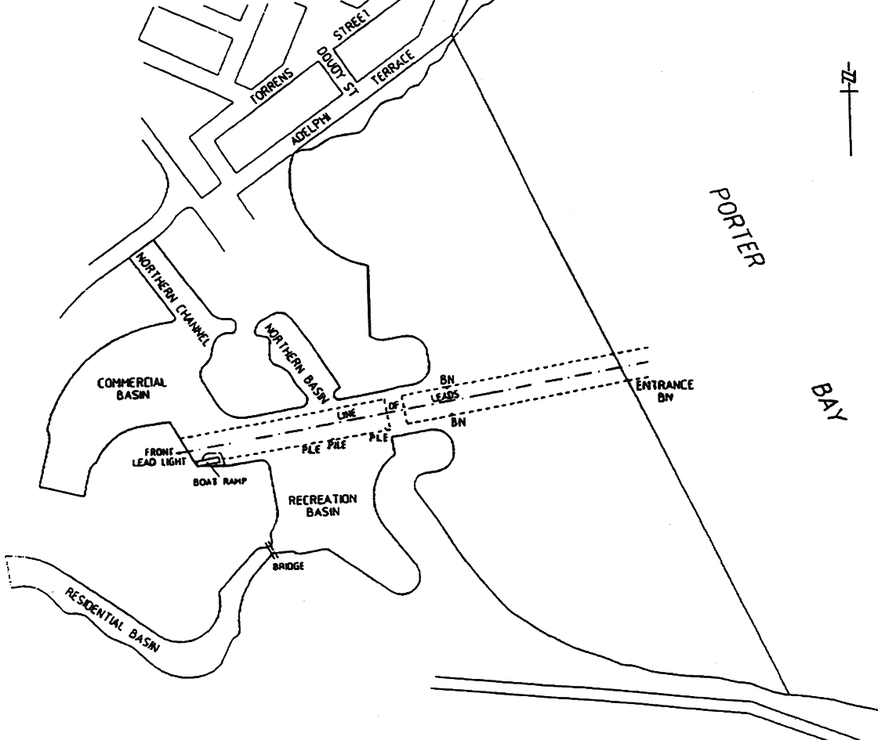
Port Hughes
The portion of the waters of the sea at Port Hughes within the Moonta Bay boat ramp basin, landward of the northern and southern breakwater (shown as a shaded area on the plan below).
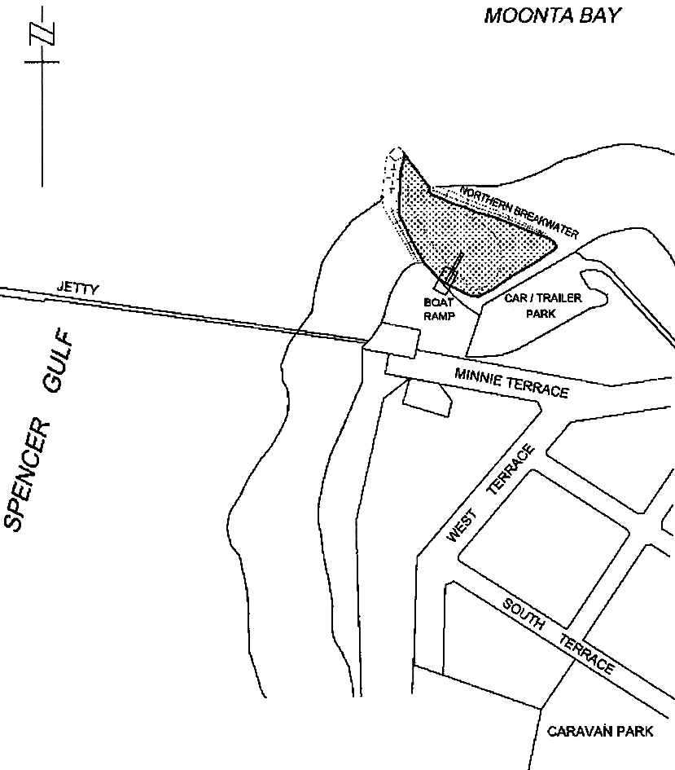
Port Neill
The portion of the sea at Port Neill bounded as follows:
• on the north-west by a straight line being the prolongation seawards of the north-west boundary of Gill Street and Coneybeer Terrace for a distance of 350 m from the High Water Mark;
• on the south-west and south-east by the High Water Mark;
• on the north-east by a straight line joining the seaward extremities of the north-western boundary and the south-east the High Water Mark.
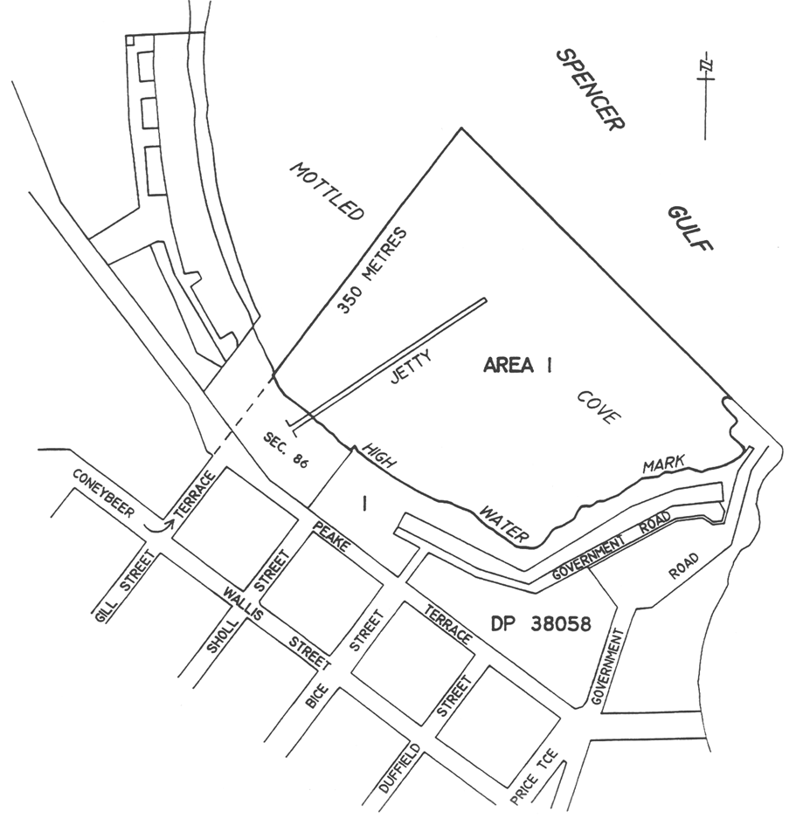
Port Stanvac
Area 1: the portion of western Gulf St. Vincent bounded as follows:
• on the north-east by a straight line 400 m north-east of the north extremity of the Product Berth structure and parallel to the Approach Jetty;
• on the south-east by a straight line 400 m south-west of the south-west side of the Approach Jetty at Port Stanvac and parallel to the jetty;
• on the north-west by a straight line at right angles to the north-east and south-west boundaries and distant 400 m seaward (along the production of the Approach Jetty) from the outermost extremity of the jetty;
• on the east by the High Water Mark.
Area 2: the portion of the waters of western Gulf St. Vincent at Port Stanvac within a 500 m radius of the Single Buoy Mooring Facility in approximate position latitude 35°05.9′ South, longitude 138°26.3′ East.
Area 3: the portion of the waters of western Gulf St. Vincent at Port Stanvac marked by six lit buoys with St. Andrews Cross top marks and within the area bounded—
• on the north-east by a straight line commencing at a point marked by a lit buoy at latitude 35˚05′15.83″ South, longitude 138˚28′08.08″ East and extending south-east to a point marked by a lit buoy at latitude 35˚05′32.43″ South, longitude 138˚28′35.23″ East; and
• on the south-east by a straight line commencing at a point marked by a lit buoy at latitude 35˚05′32.43″ South, longitude 138˚28′35.23″ East and extending south-west to a point marked by a lit buoy at latitude 35˚05′48.05″ South, longitude 138˚28′21.11″ East; and
• on the south-west by a straight line commencing at a point marked by a lit buoy at latitude 35˚05′48.05″ South, longitude 138˚28′21.11″ East and extending north-west to a point marked by a lit buoy at latitude 35˚05′31.45″ South, longitude 138˚27′53.95″ East; and
• on the north-west by a straight line commencing at a point marked by a lit buoy at latitude 35˚05′31.45″ South, longitude 138˚27′53.95″ East and extending north-east to a point marked by a lit buoy at latitude 35˚05′15.83″ South, longitude 138˚28′08.08″ East.
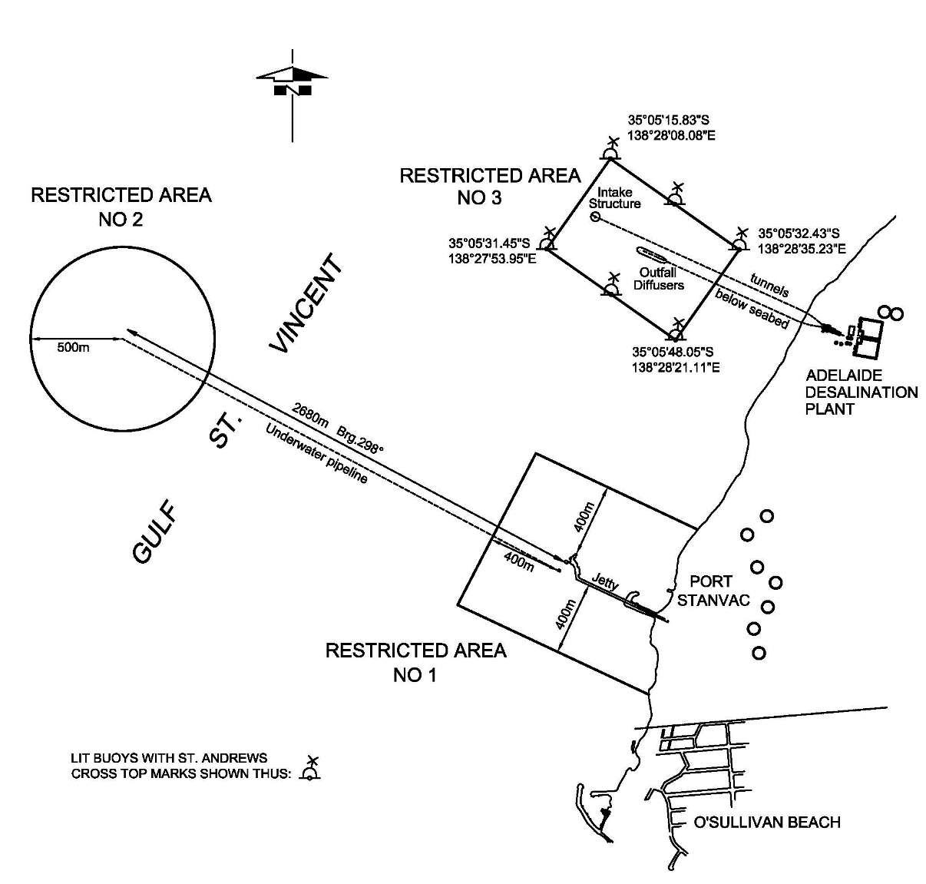
Port Vincent
Area 1: the portion of the waters of Gulf St. Vincent at Port Vincent bounded as follows:
• on the north-east by a straight line joining Surveyor Point with a point being the intersection of the edge of the water and the prolongation seaward of the south-eastern boundary of Way Street;
• on the south-west by the edge of the water, the face of the wharf and the north-western, north-eastern and south-eastern boundaries of Area 2.
Area 2: the portion of the waters of Gulf St. Vincent at Port Vincent bounded as follows:
• on the north-west by a straight line being the prolongation seaward of the south-eastern boundary of Main Street;
• on the north-east by a line 60 m seaward of, and parallel to, the sea wall;
• on the south-east by a straight line being the prolongation seaward of the north-western boundary of Curramulka Road;
• on the south-west by the edge of the water.
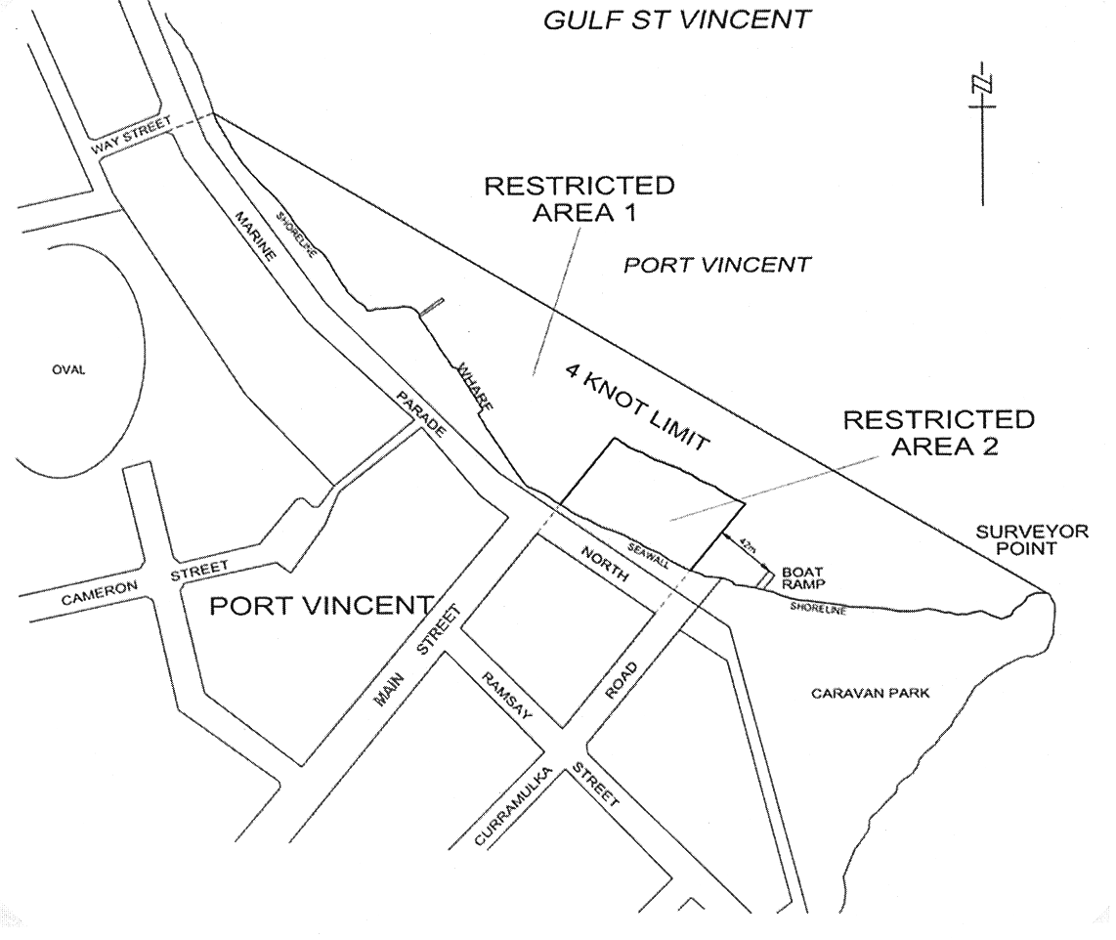
Robe
The portion of the sea at Robe bounded as follows:
• on the west by a straight line being the production seaward of the western boundary of Bagot Street;
• on the east by a straight line extending seaward in a northerly direction from Robe Point;
• on the south by the High Water Mark;
• on the north by a line approximately 200 m seaward of, and parallel to, the High Water Mark.
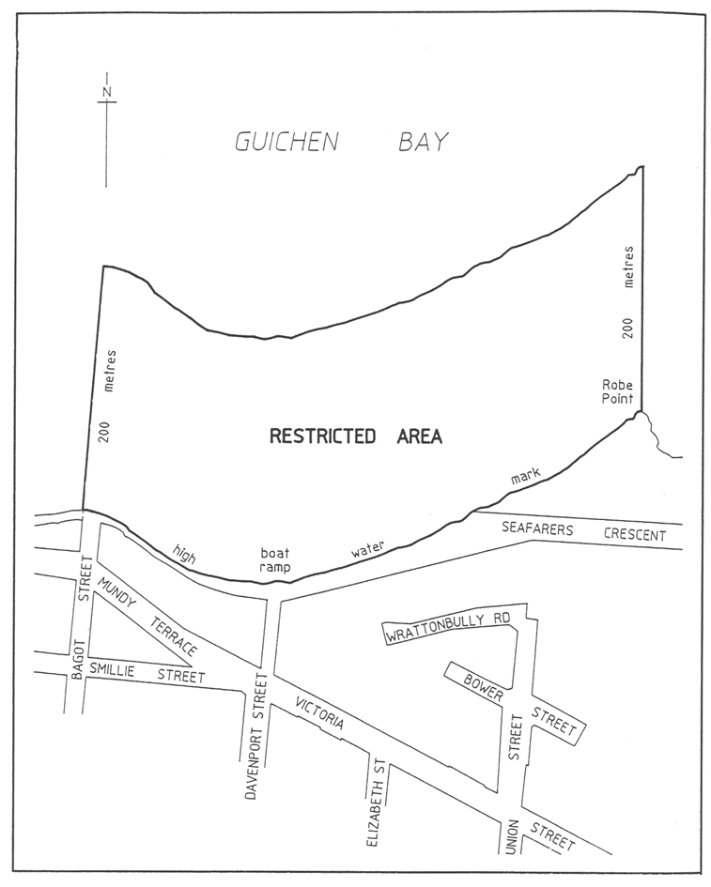
Stansbury
Area 1: the portion of the waters of the sea at Stansbury delineated on the plan below as Area 1;
Area 2: the portion of the waters of the sea at Stansbury delineated on the plan below as Area 2.
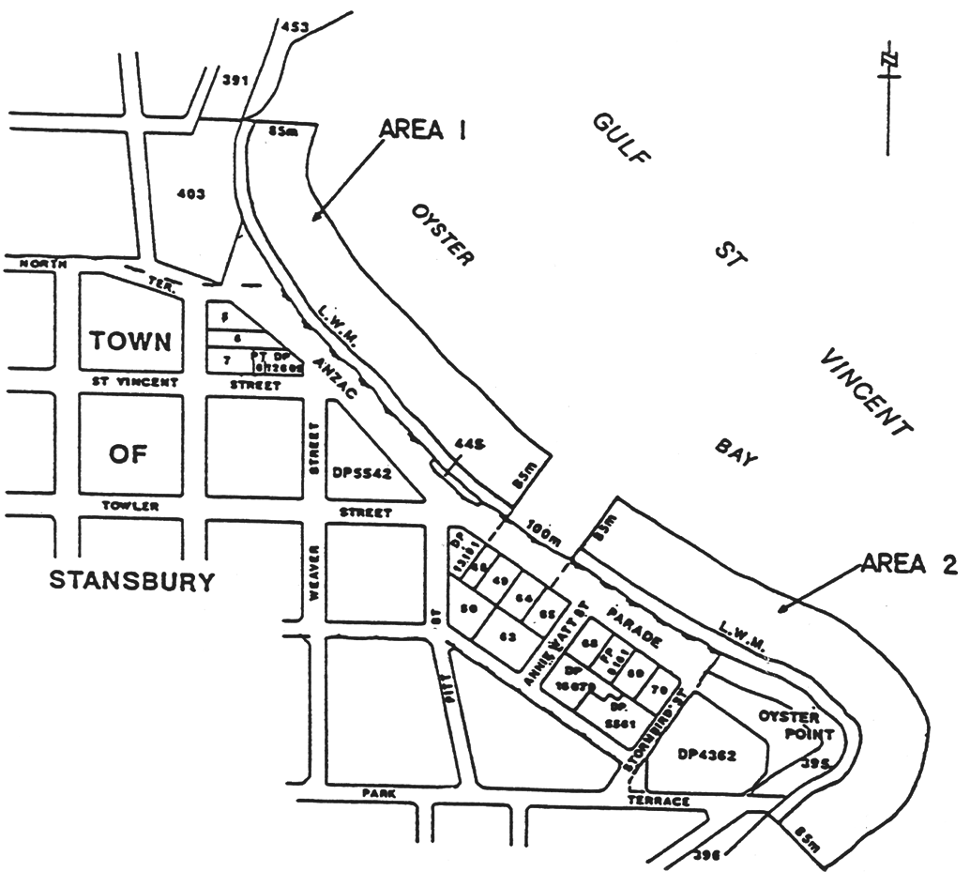
St. Kilda
The waters within the St. Kilda Marina and the channel out to the St. Kilda entrance beacon located at latitude 34°44'59.72" South, longitude 138°31'10.51" East and the starboard lateral beacon located at latitude 34°45'0.47" South, longitude 138°31'11.51" East.
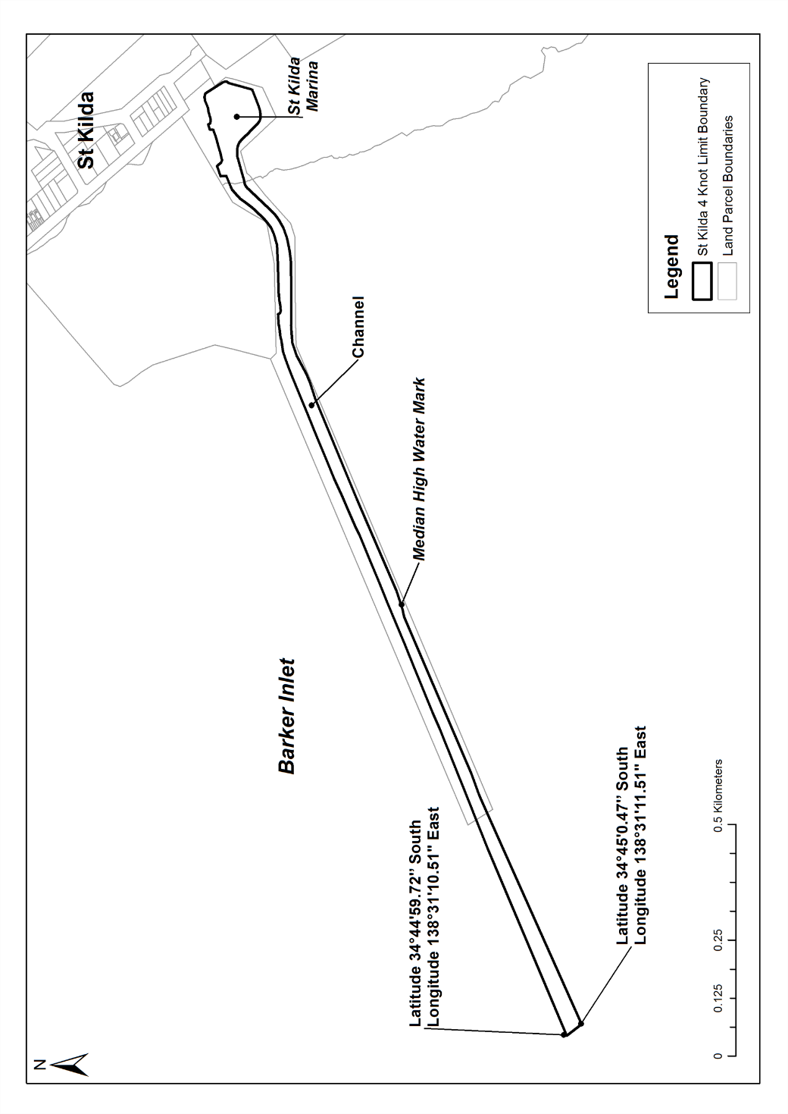
Swanport
The portion of the River Murray at Swanport bounded as follows:
• on the north-west, by a straight line extending 65 m in a north-easterly direction from a point at the water's edge 20 m upstream of the point at which the north-western boundary of Swanport Village Road (or the prolongation of that boundary) meets the water's edge and parallel to that boundary;
• on the south-east, by a straight line extending 85 m in a north-easterly direction from a point at the water's edge 80 m downstream of the point at which the south-eastern boundary of Lot 79 of Deposited Plan No 134 (or the prolongation of that boundary) meets the water's edge and parallel to that boundary;
• on the north-east, by a straight line joining the northern extremity of the north-western boundary with the northern extremity of the south-eastern boundary;
• on the south-west, by the water's edge.
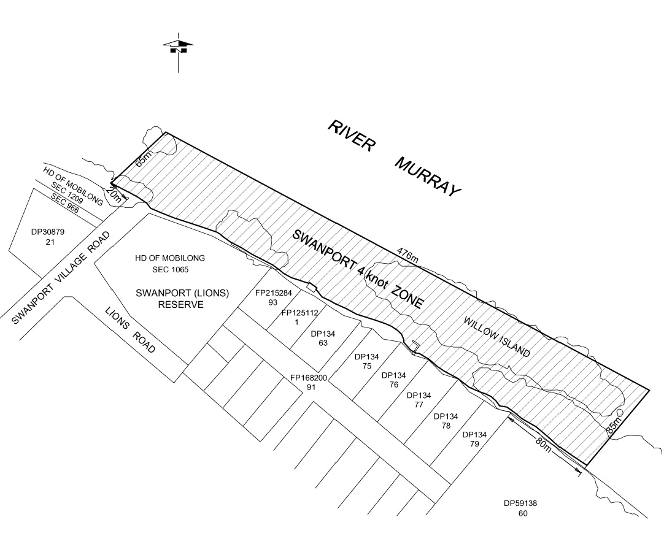
Swan Reach
The portion of the River Murray at Swan Reach bounded as follows:
• on the north-east by a straight line, marked by yellow spherical buoys, being the prolongation north-westerly of the north-east boundary of Section 352, Hundred of Nildottie, extending 10 m north-westerly from the river edge;
• on the south-west by a straight line, 20 m from and parallel to the north-eastern boundary, extending 10 m north-westerly from the river edge;
• on the north-west by a straight line, marked by yellow spherical buoys, joining the north-west extremities of the south-west and north-east boundaries;
• on the south-east by the river edge.
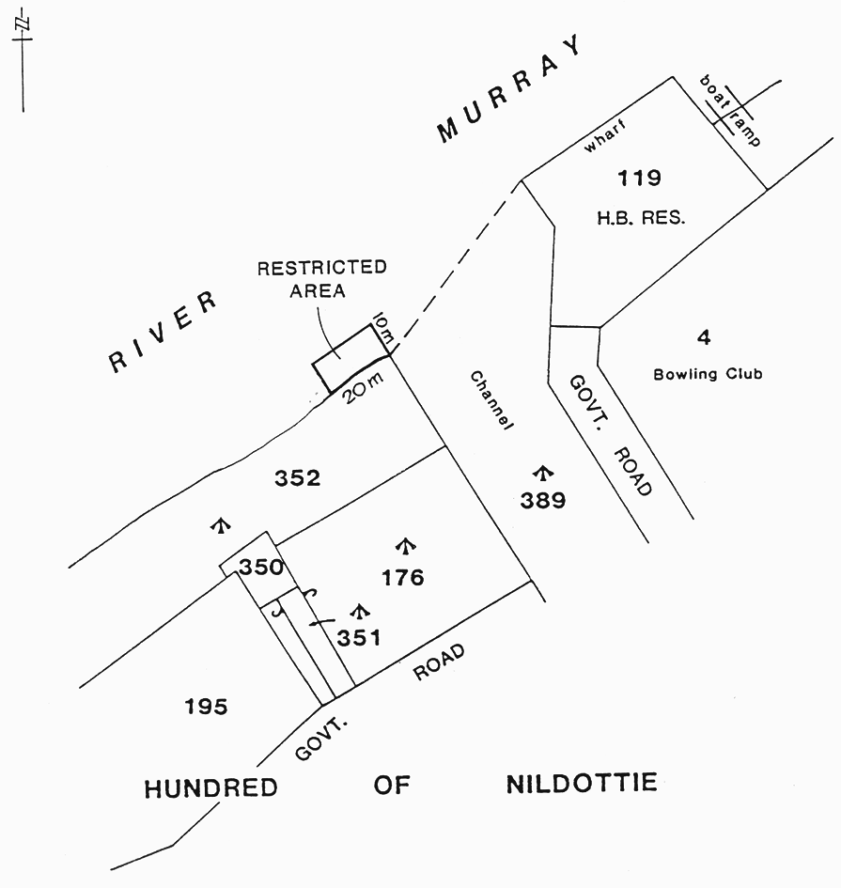
Thevenard
The portion of the sea at Bosanquet Bay delineated in bold on the plan below:
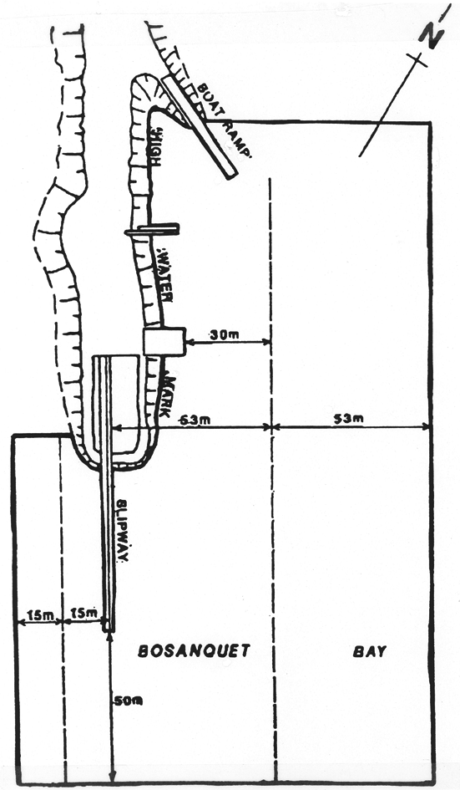
Thistle Island
Area 1: the portion of the waters of Spencer Gulf bounded by a circle of radius 1 nautical mile centred on a point at latitude 34°55.9′ South, longitude 136°14.05′ East.
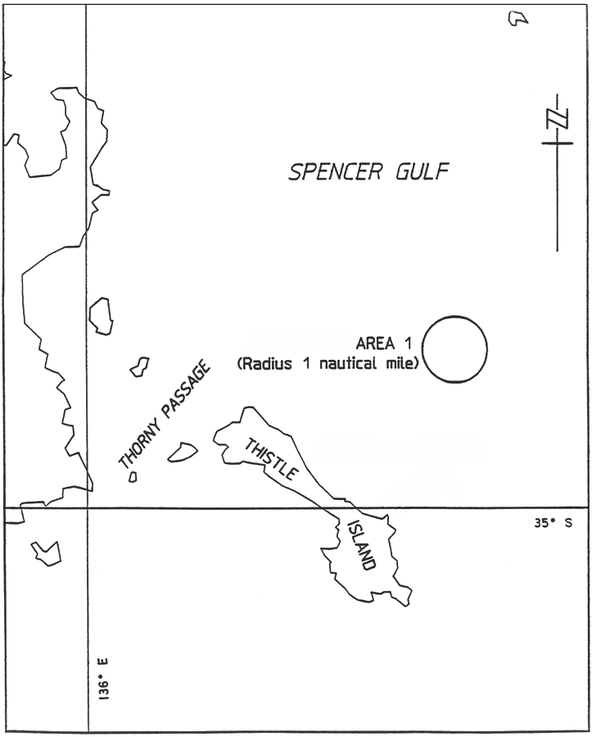
Area 2: the portion of the waters of Spencer Gulf bounded as follows:
commencing at the High Water Mark near Horny Point at a point at latitude 35°00′13.860″ South, longitude 136°11′23.744″ East, then east-north-east in a straight line to a point at latitude 35°00′00.000″ South, longitude 136°12′42.495″ East, being the intersection of that line with the western circumference of a circle of radius 2 nautical miles centred on a point at latitude 35°00′02.280″ South, longitude 136°15′08.778″ East, then clockwise from that intersection around the circumference to a point on the western circumference of the circle at latitude 35°01′02.251″ South, longitude 136°13′01.891″ East, then west in a straight line to the High Water Mark at latitude 35°01′02.251″ South, longitude 136°11′36.068″ East, then north along the High Water Mark to the point of commencement (all positions being in the WGS84 datum).
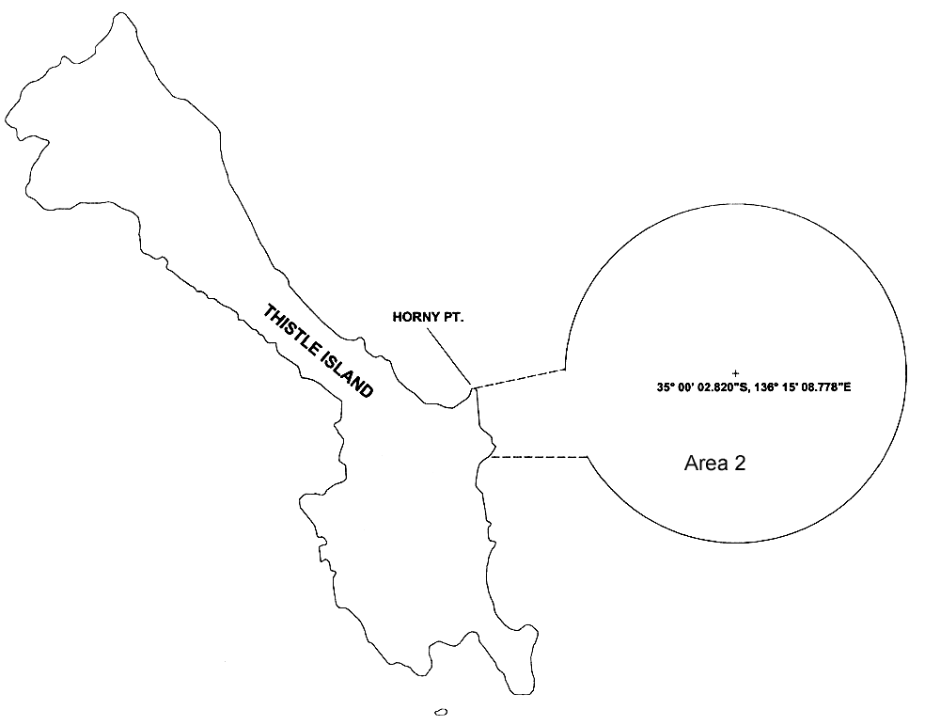
Tumby Bay
Area 1: the portion of the sea at Tumby Bay bounded as follows:
• on the north by a straight line being the prolongation seawards of the south boundary of Elanora Avenue for a distance of 100 m from the High Water Mark;
• on the east by a straight line joining the seaward extremity of the north boundary and the north-east corner of the old jetty;
• on the north-east by a straight line joining the north-east corner of the old jetty and the north-east corner of the new jetty;
• on the east by the seaward end of the new jetty;
• on the south by the south side of the new jetty;
• on the west by the High Water Mark.
Area 2: the area of the sea at Tumby Bay bounded as follows:
• on the south-west by a line parallel to and 100 m seaward from the High Water Mark;
• on the east by a straight line commencing at a point 50 m west of the east extremity of Section 354, Hundred of Hutchison, and extending due north for 450 m from the south-west boundary;
• on the north by a straight line commencing at a point 2 km generally north-westerly along the south-west boundary from the east boundary, and extending due east for 450 m from the south-west boundary;
• on the north-east by a straight line joining the seaward extremities of the south-west and east boundaries.
Area 3: the area of the sea at Tumby Bay bounded as follows:
• on the south by a straight line extending due east from a point 1.2 km along the High Water Mark and generally north-west from the east extremity of Section 354, Hundred of Hutchison;
• on the west by a straight line extending due north from a point 100 m along the High Water Mark and generally north-west from the west extremity of the south boundary;
• on the north-east by the south-west boundary of Area 2.
Area 4: the area of the sea at Tumby Bay bounded as follows:
• on the west and south by the High Water Mark;
• on the north by a straight line being the prolongation seawards of the northern boundary of Goode Avenue for a distance of 350 m from the High Water Mark;
• on the east by a straight line being the prolongation seawards of the eastern boundary of Harvey Drive in a northerly direction joining the seaward extremity of the north boundary.
Area 5: the area of the sea at Tumby Bay bounded as follows:
commencing at the northern most starboard hand channel marker of the marked navigation channel leading to the Tumby Bay Marina, then generally easterly across the marked navigation channel to the northern most port hand channel marker of the marked navigation channel, then generally south-easterly along the eastern edge of the marked navigation channel to its intersection with the breakwater, then generally south-easterly along the western edge of the breakwater to the point at which there is a bend in the breakwater, then generally south-westerly along the eastern edge of marked navigation channel to its intersection with the north-eastern corner of Allotment 75 in Deposited Plan No 55096, then generally southerly, westerly and easterly around the boundary of that Allotment (including Allotment 66 in Deposited Plan No 55096) to its intersection with the north-eastern corner of Allotment 548 in Deposited Plan No 15461, then generally north-easterly and northerly along the western edge of the marked navigation channel to the point of commencement.
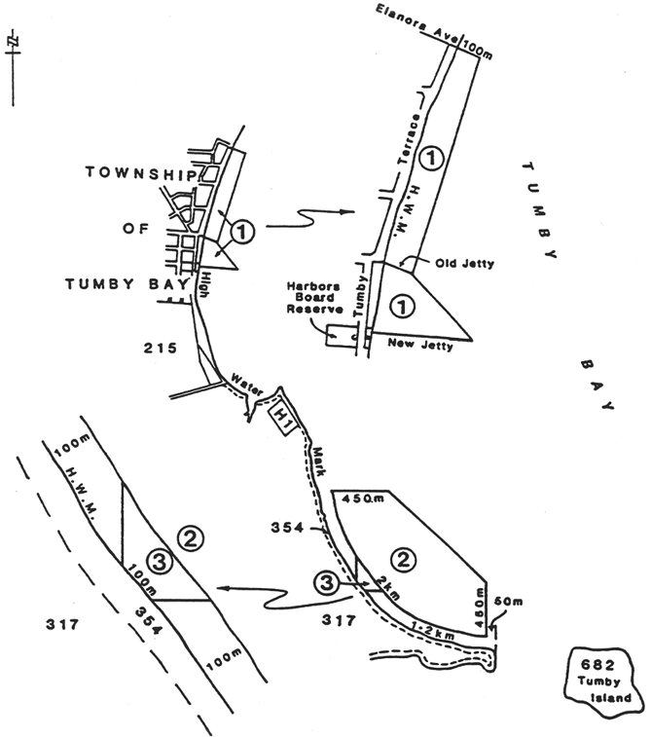
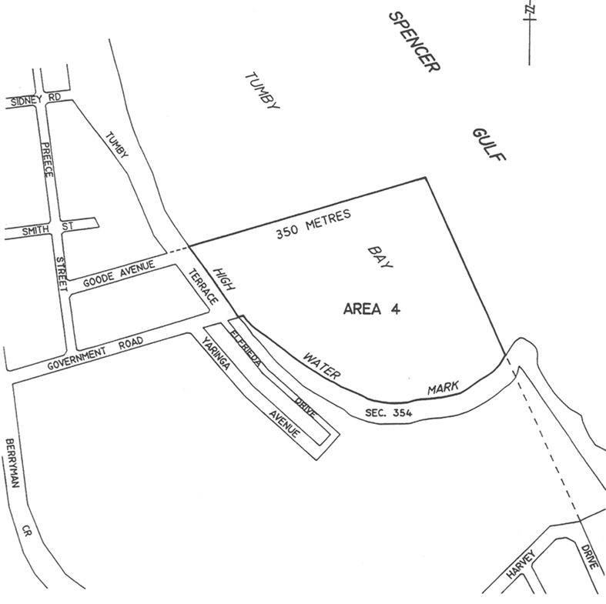
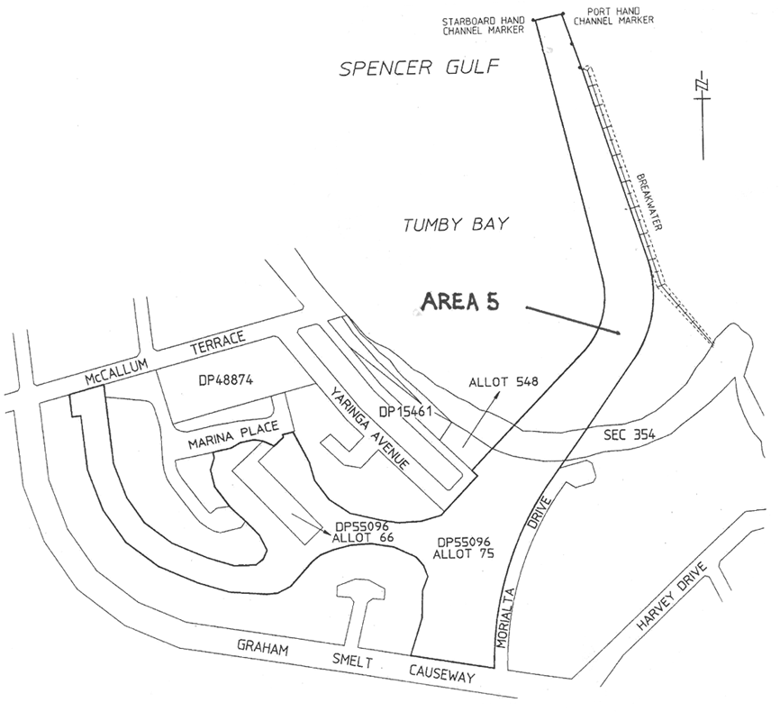
Valley Lake
Area 1: the portion of Valley Lake bounded on the south-east by a straight line extending south-west from the white marker post situated approximately midway along the north shore of Valley Lake to the white marker post situated on the west shore of Valley Lake.
Area 2: the portion of Valley Lake bounded on the west by a straight line from the white marker post situated near the east end of the north shore of Valley Lake to the white marker post on the east shore of Valley Lake.
Area 3: the portion of Valley Lake not included in Area 1 or 2 bounded on the south-west by a straight line extending south-east from the yellow marker post situated on the north shore of Valley Lake to the yellow marker post situated on the shore at the approximate north-east corner of Valley Lake.
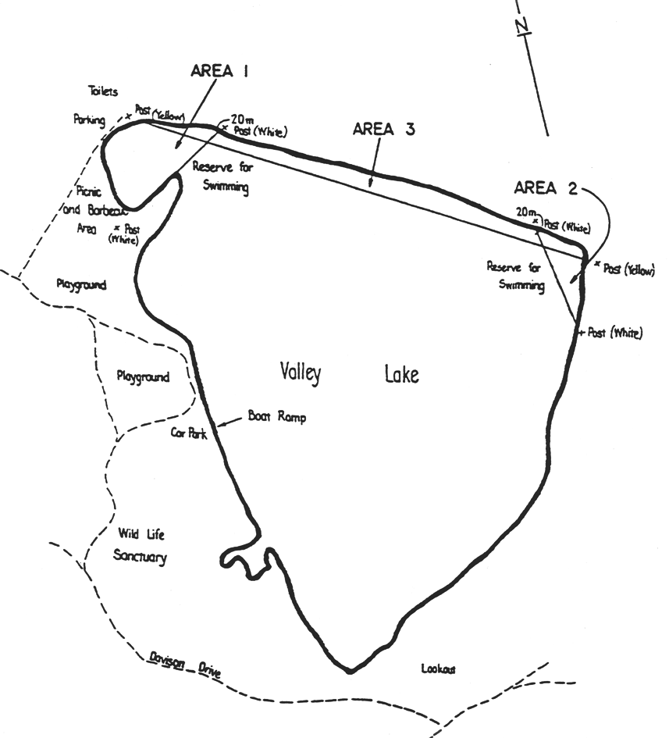
Victor Harbor
The portion of the sea at Victor Harbor bounded as follows:
• on the west by a line joining the most southerly point of King Head to the most southerly point of West Island;
• on the south by a line commencing at the most southerly point of West Island and then proceeding generally eastward towards the Murray mouth to a point where the line intersects at right angles with the prolongation, generally south and to seaward, of the easterly boundary of the area of the City of Victor Harbor;
• on the east by the prolongation, generally south and to seaward, of the easterly boundary of the area of the City of Victor Harbor (ie the eastern side of Ocean Road, Port Elliot);
• on the north by the High Water Mark of the coastline between the easterly boundary of the area of the City of Victor Harbor (ie the eastern side of Ocean Road, Port Elliot) and the most southerly point of King Head.
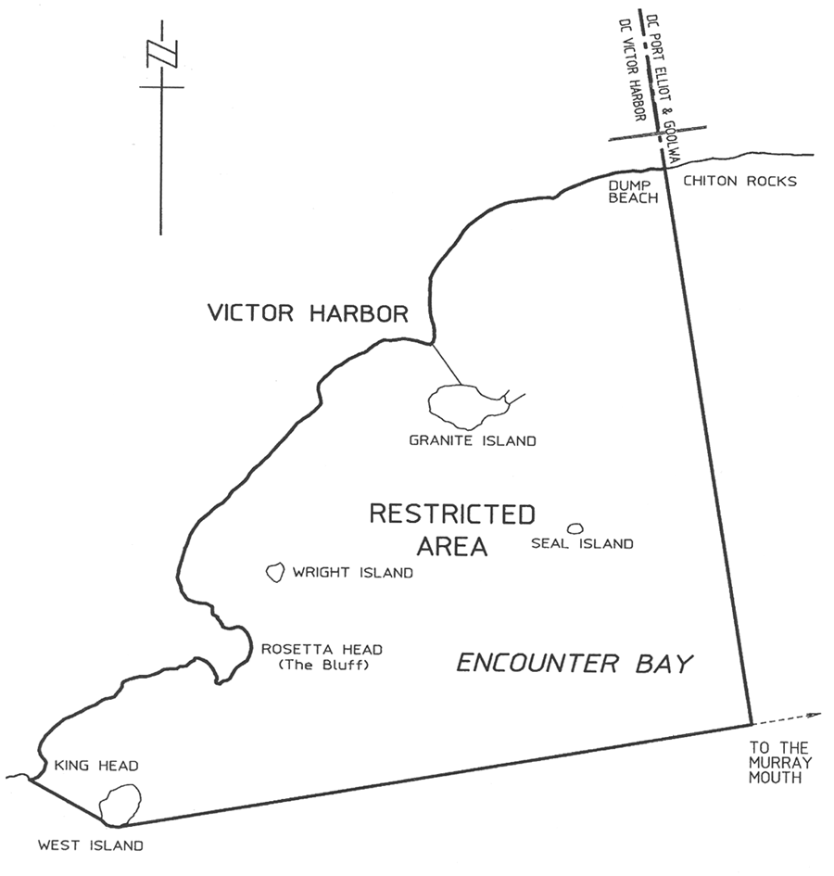
Wallaroo Bay
Area 1: the portion of the waters of the sea at Wallaroo described as "Area 1" on the plan below.
Area 2: the portion of the waters of the sea at Wallaroo described as "Area 2" on the plan below.
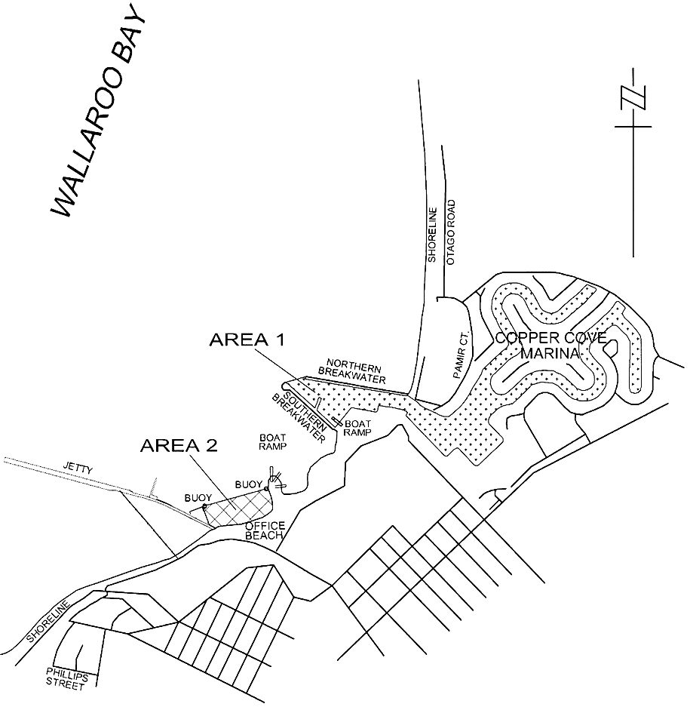
West Beach
Area 1: the portion of the waters of Gulf St. Vincent at West Beach bounded as follows:
commencing at a point being the intersection of the production of the southern boundary of Barcoo Road and the Low Water Mark, then seaward for a distance of 295 m along that prolongation, then northerly for a distance of 380 m, then generally south-easterly on a bearing of 114°02′ to its intersection with the Low Water Mark, then generally westerly, southerly and easterly along the Low Water Mark around the breakwaters and the boat ramp to the point of commencement.
Area 2: the portion of the waters of Gulf St. Vincent at West Beach bounded as follows:
• commencing on the north approximately 140 m from the High Water Mark of the coast to the St. Andrews Cross navigational marker at latitude 34°57′01.08″ South, longitude 138°30′04.76″ East and extending seaward in a westerly direction for approximately 500 m to the St. Andrews Cross navigational marker at latitude 34°57′05.44″ South, longitude 138°29′46.13″ East;
• on the west by a straight line drawn in a generally southerly direction from latitude 34°57′05.44″ South, longitude 138°29′46.13″ East to the St. Andrews Cross navigational marker at latitude 34°57′13.24″ South, longitude 138°29′48.93″ East;
• on the south by a straight line drawn in a generally easterly direction from latitude 34°57′13.24″ South, longitude 138°29′48.93″ East to the St. Andrews Cross navigational marker at latitude 34°57′08.84″ South, longitude 138°30′07.81″ East;
• on the east from latitude 34°57′08.84″ South, longitude 138°30′07.81″ East and parallel to the High Water Mark to the point of commencement at the St. Andrews Cross navigational marker at latitude 34°57′01.08″ South, longitude 138°30′04.76″ East.
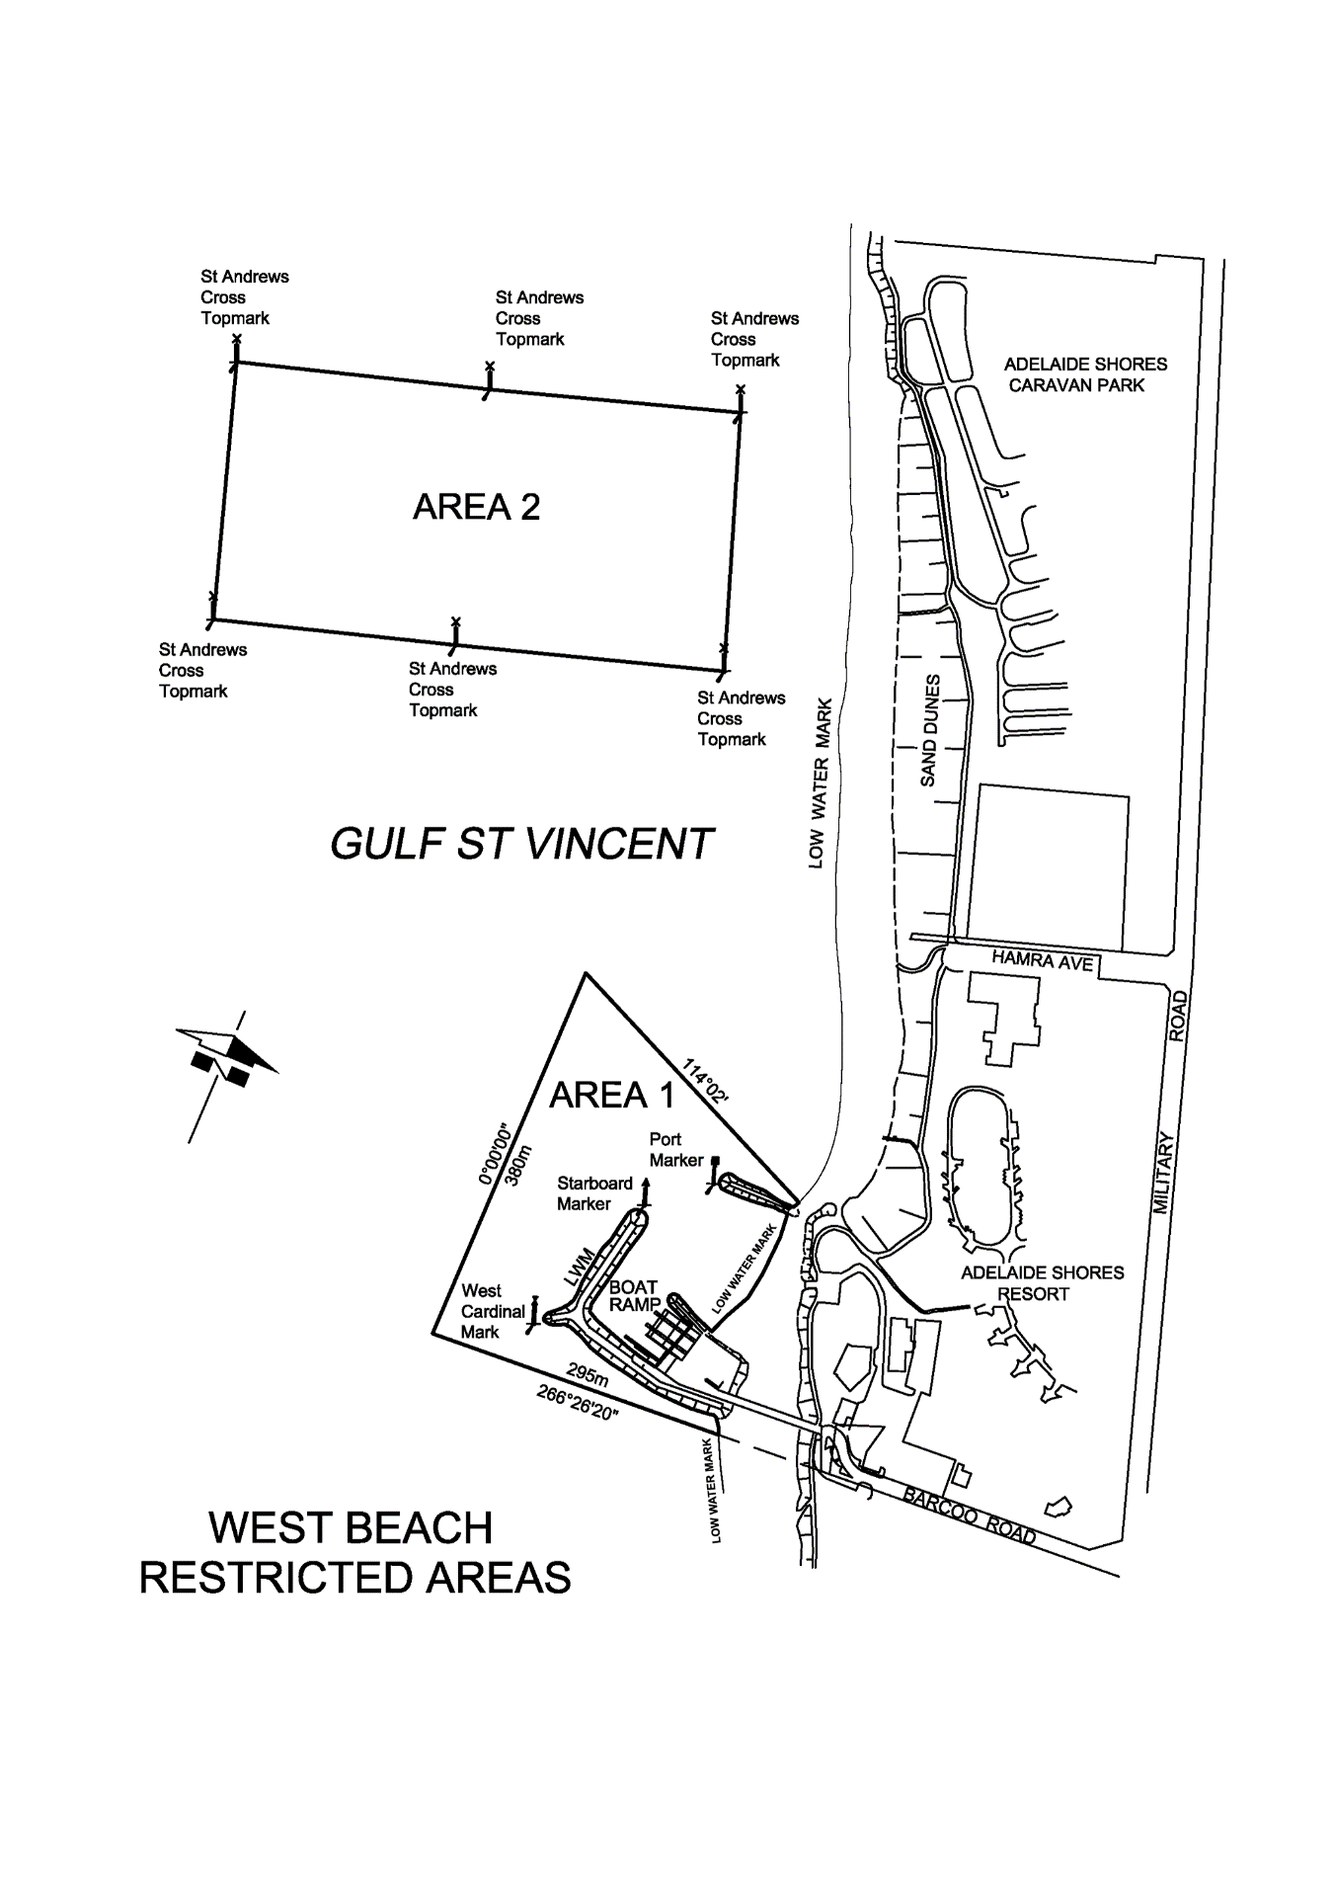
Whyalla
Area 1: the portion of Spencer Gulf at Whyalla bounded as follows:
• on the south-west by a line being the prolongation of the western side of Agett Street, Town of Whyalla, seawards from the High Water Mark for a distance of 100 m;
• on the north-east commencing at the south-eastern corner of Section 108, Hundred of Randell, then south-westerly along the High Water Mark for 100 m;
• on the south-east by a line joining the south-eastern extremities of the south-west and north-east boundaries and parallel to the High Water Mark;
• on the north-west by the High Water Mark.
Area 2: the portion of Spencer Gulf at Whyalla bounded as follows, but excluding the area defined as Area 2A:
commencing at the most westerly point on the north-eastern tip of the southern breakwater (being portion of Lot 3 in Deposited Plan No 26088); then west-north-westerly along a line of bearing 290°14′10″ for a distance of 74.17 m to intersect with the High Water Mark on the northern breakwater; then following the High Water Mark along the inside of the boat haven to the point of commencement.
Area 2A: the portion of Spencer Gulf at Whyalla bounded as follows:
commencing at a point on the northern face of the southern breakwater (being portion of Lot 3 in Deposited Plan No 26088), being a point that is 246 m (measured along the northern face of the southern breakwater) from the most westerly point on the north-eastern tip of the southern breakwater; then generally north-westerly for a distance of 77 m; then south-westerly for a distance of 87 m to the northern face of the southern breakwater, being the area bounded by yellow buoys.
Area 3: the portion of Spencer Gulf at Whyalla bounded as follows:
commencing at the intersection of the High Water Mark and the south-western side of the jetty adjacent to Section 420, Hundred of Randell; then south-easterly along the southern side of the jetty for 100 m; then generally south-westerly along a line parallel to and 100 m seawards of the High Water Mark to its intersection with the northern breakwater (part of Lot 3, Deposited Plan No 26088); then generally north-westerly and northerly along the High Water Mark to the point of commencement.
Area 4: the portion of False Bay at Whyalla described as "Area 4" on the plan below.
Area 5: the portion of False Bay at Whyalla described as "Area 5" on the plan below.
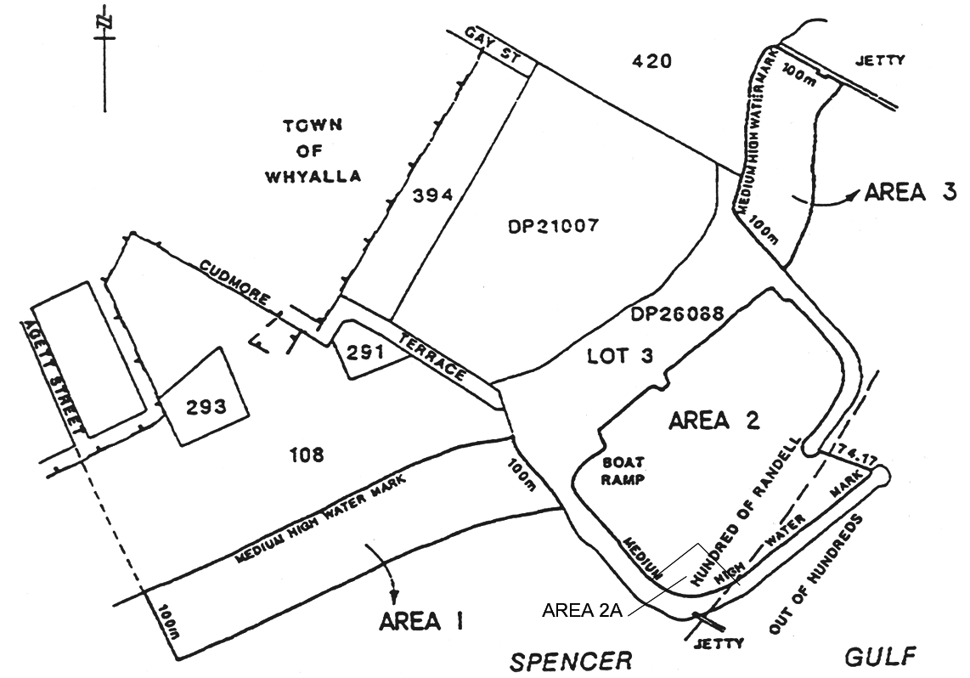
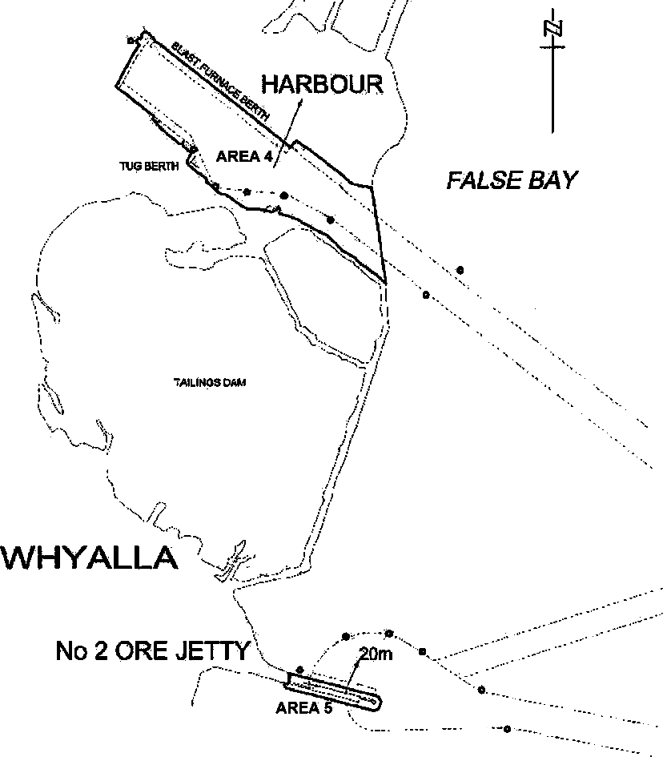
Yankalilla Bay
The portion of the waters of Yankalilla Bay at Carrickalinga bounded as follows:
• on the north by a straight line drawn in a generally easterly direction from latitude 35°25.154′ South, longitude 138°18.279′ East and extending approximately 200 m to latitude 35°25.174′ South, longitude 138°18.417′ East;
• on the east by a straight line drawn in a generally southerly direction from latitude 35°25.174′ South, longitude 138°18.417′ East and extending approximately 200 m to latitude 35°25.319′ South, longitude 138°18.389′ East;
• on the south by a straight line drawn in a generally west-north-westerly direction from latitude 35°25.319′ South, longitude 138°18.389′ East and extending approximately 200 m to latitude 35°25.286′ South, longitude 138°18.262′ East;
• on the west by a straight line drawn in a generally northerly direction from latitude 35°25.286′ South, longitude 138°18.262′ East and extending approximately 200 m to latitude 35°25.154′ South, longitude 138°18.279′ East.
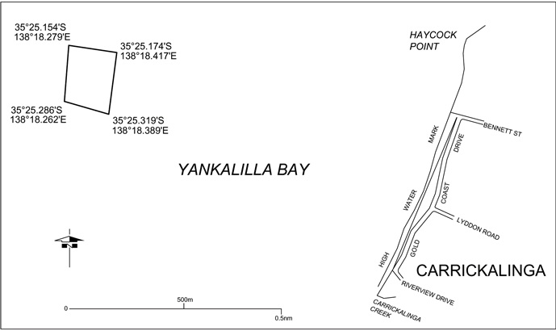
Yatco Lagoon
The whole of Yatco Lagoon being the body of water to the south of a straight line commencing at the point at which the prolongation easterly of the northern boundary of Gogel Road meets the waters edge and extending south-easterly to the northernmost point of the headland immediately to the south of Moorook Island.
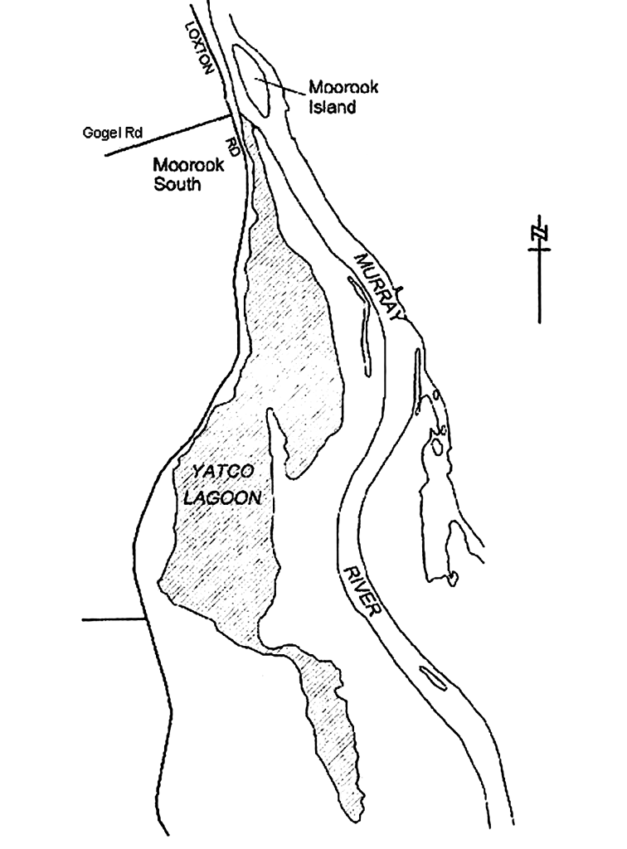
Part 2—Identification of controls
2—Identification of controls
In this Schedule, a reference to a control of a particular number is a reference to the regulation, restriction or prohibition of the relevant number listed below:
1. a person must not take a vessel into the specified waters or cause or permit a vessel to enter or remain in the specified waters;
2. a person must not operate a vessel fitted with an engine in the specified waters at a speed in excess of 4 knots or in a planing attitude;
3. a person must not operate a vessel in the specified waters at a speed in excess of 4 knots or in a planing attitude;
4. a person must not ski, aquaplane or be towed in any other manner by a vessel in the specified waters;
5. a person must not ski, aquaplane or be towed in any other manner by a vessel in specified waters at a speed in excess of 4 knots;
6. a person must not swim, bathe or dive (including scuba dive) in the specified waters;
7. a person must not swim, bathe or dive (including scuba dive) in the specified waters except for purposes connected with water skiing, aquaplaning or like activity;
8. a person must not swim or bathe in the specified waters except for purposes connected with scuba diving or snorkelling;
9. a person must not operate a vessel fitted with an engine in the specified waters;
10. a person must not operate a vessel fitted with an engine in the specified waters during the period between 1 October and 1 April (inclusive) in any year;
11. a person must not operate a vessel in the specified waters except for the purposes of water skiing, aquaplaning or like activity;
12. a person must not leave any fishing apparatus unattended in the specified waters;
13. a person must not moor a vessel, fish or trawl in the specified waters;
14. a person must not moor a vessel in the specified waters except at a permanent mooring facility established in the waters;
15. a person must not remove or interfere with a wreck or any part of a wreck in the specified waters;
16. a person must not—
(i) operate a vessel other than a personal watercraft; or
(ii) swim, bathe or dive (including scuba dive) except for purposes connected with operating a personal watercraft,
in the specified waters;
17. a person must not operate a personal watercraft in the specified waters during the period between 1 May and 30 September (inclusive) in any year;
18. a person must not operate a vessel fitted with an engine in the specified waters at any time between sunrise and sunset on any day during the period between 1 December and 31 March (inclusive) in any year.
Part 3—Controls applying in particular areas
3—Controls applying in particular areas
The controls applying in particular restricted areas are as follows:

Restricted area(s) | Controls applying in the area(s) | Additional controls applying in the area(s)  Editorial Note—  It is also an offence to contravene these controls—see regulation 10.
Angas Inlet | Controls 1 and 4  Editorial Note—  see clause 4 below.
Ardrossan Area 1 | Controls 1 and 4
Ardrossan Area 2 | Control 2
Balgowan Areas 1 and 2 | Controls 3 and 5
Black Point | Controls 3 and 5
Blackfellow's Caves Area 1 | Controls 3 and 5
Blackfellow's Caves Area 2 | Controls 1 and 4
Blanchetown | Controls 3 and 5
Blanchetown Area 2 | Controls 2 and 5
Brighton Areas 1 to 4 | Control 9
Brighton Area 5 | Control 9
Bucks Bay | Controls 1 and 4
Caloote Landing Area 1 | Controls 1 and 4
Caloote Landing Area 2 | Controls 3 and 5
Christies Beach | Control 13
Clayton Bay | Controls 1 and 4
Currency Creek | Control 2
East Wellington | Controls 2 and 5
Fisherman Bay | Controls 2 and 5
Fleurieu Reef | Controls 3, 4, 8, 14 and 15
Forbys Island | Controls 1 and 4
Glenelg Area 1 | Controls 3 and 5
Glenelg Area 2 | Controls 3 and 5
Glenelg Area 3 | Controls 1, 4 and 9
Glenelg River | Controls 3 and 5
Goolwa Areas 1, 3 and 5 | Controls 3 and 5
Goolwa Areas 2, 4 and 6 | Controls 2 and 5
Goolwa Area 7 | Control 16
Goolwa Area 8 | Controls 2 and 4
Henley Beach | Control 18
Hog Bay | Controls 1 and 4
Kellidie Bay | Controls 3 and 5
Lake Bonney (Barmera Area 1) | Controls 1 and 4
Lake Bonney (Barmera Area 2) | Controls 2 and 5
Lake Bonney (South East) | Controls 1, 4 and 6
Lake Fellmongery Area 1 | Control 9 | A person must not operate a vessel that is not fitted with an engine at a speed in excess of 4 knots or in a planing attitude.
Lake Fellmongery Area 2 | Controls 1 and 4
Lake Fellmongery Area 3 | Controls 7 and 11 | A person must not—  (a) operate a vessel at a speed in excess of 35 knots; or  (b) operate a vessel or engage in water skiing, aquaplaning or like activity before 8 am or after sunset or 8 pm (whichever is the earlier) on any day; or  (c) operate a vessel or engage in water skiing, aquaplaning or like activity if there are already 8 vessels within the area.  If there are 8 vessels within the area and others waiting to use the area—  (a) a vessel must not remain in the area for more than 30 minutes at any one time; and  (b) unless otherwise agreed by the operators of all the vessels, vessels must enter the area in the order of their arrival at the area and then rotate turns in the same order.
Lake Leake | Controls 1 and 4
Mannum Areas 1 and 2 | Controls 1 and 4
Mannum Area 3 | Controls 3 and 5
Meningie Area 1 | Controls 1 and 4
Meningie Area 2 | Controls 2 and 5
Milang | Controls 1 and 4
Moana | Controls 4 and 9
Morgan and Cadell Areas 1 and 2 | Controls 1 and 4
Murray Bridge Area 1 | Controls 3 and 5
Murray Bridge Area 2 | Control 9  Editorial Note—  see clause 5 below. | In this area the river is divided into 2 channels and the usual rules of navigation apply in respect of each of those channels.
Murray Bridge (bathing) Areas 1 to 7 | Controls 1 and 4
Nildottie | Controls 2 and 5
North Haven Marina | Control 2
North Shields | Controls 3 and 5
O'Sullivan Beach | Controls 2 and 6
Point Turton Area 1 | Controls 1 and 4
Point Turton Area 2 | Control 2
Port Adelaide | Control 12
Port Bonython Zone 1 | Controls 1 and 4
Port Bonython Zone 2 | Controls 1 and 4, but only while either or both of the following apply:
 | (a) a vessel is moored at the jetty;
 | (a) the berth operations signals at the seaward end of the jetty are signalling a single red light flashing at an approximate rate of 1 flash every 2 seconds.
Port Bonython Zone 3 | Controls 1 and 4, but only while either or both of the following apply:  (a) an audible signal is sounding;  (b) the berth operations signals at the seaward end of the jetty are signalling a single red light flashing at an approximate rate of 2 flashes per second.
Port Elliot | Control 2
Porter Bay | Controls 2 and 5
Port Hughes | Control 6
Port Neill | Controls 2 and 5
Port Stanvac Areas 1 and 2 | Controls 1 and 4
Port Stanvac Area 3 | Controls 1, 4 and 6
Port Vincent Area 1 | Controls 3 and 5
Port Vincent Area 2 | Control 10
Robe | Controls 3 and 5
Stansbury Areas 1 and 2 | Controls 3 and 5
St. Kilda | Controls 2 and 6
Swanport | Controls 2 and 5
Swan Reach | Controls 1 and 4
Thevenard | Control 6
Thistle Island Areas 1 and 2 | Control 13  Editorial Note—  see clause 7 below.
Tumby Bay Areas 1 and 4 | Controls 2 and 5
Tumby Bay Areas 2 and 3 | Control 7
Tumby Bay Area 5 | Controls 3 and 5
Valley Lake Areas 1, 2 and 3 | Controls 1 and 4
Victor Harbor | Control 17
Wallaroo Bay Area 1 | Controls 2, 4 and 6
Wallaroo Bay Area 2 | Controls 1 and 4
West Beach Area 1 | Controls 4 and 6
West Beach Area 2 | Controls 1, 4 and 9
Whyalla Areas 1 and 3 | Control 9
Whyalla Area 2 | Controls 3 and 5
Whyalla Area 2A | Control 1
Whyalla Areas 4 and 5 | Controls 1 and 4
Yankalilla Bay | Controls 1, 4, 6, 12 and 13
Yatco Lagoon | Control 2
4—Non-application of controls to certain vessels in Angas Inlet
The controls set out in the table in clause 3 in relation to Angas Inlet do not apply in relation to vessels in the specified waters for a purpose connected with the operation or maintenance of Torrens Island Power Station.
5—Non-application of controls to certain vessels in Glenelg Area 3 and West Beach Area 2
The controls set out in the table in clause 3 in relation to Glenelg Area 3 and West Beach Area 2 do not apply in relation to the following vessels in the specified waters:
(a) canoes, kayaks, surf skis, rowboats or other human-powered vessels;
(b) vessels used for channel dredging;
(c) survey vessels used by the Department of Environment and Natural Resources.
6—Non-application of controls to certain vessels at Henley Beach
The control set out in the table in clause 3 in relation to Henley Beach does not apply to a person operating a vessel fitted with an engine that is in the specified waters for the purposes of launching or retrieving a vessel by use of the boat ramp near the Grange Sailing Club for a race or practice involving rowing, sailing or other similar activity.
7—Non-application of controls to certain vessels in Lake Bonney (South East)
The controls set out in the table in clause 3 in relation to Lake Bonney (South East) do not apply in relation to a canoe, kayak, rowboat or other similar human-powered vessel.
8—Non-application of controls to certain vessels in Murray Bridge Area 2
The controls set out in the table in clause 3 in relation to Murray Bridge Area 2 do not apply in relation to a vessel fitted with an engine that is in the area because of its official association with a rowing, sailing or similar race or practice.
9—Non-application of controls to certain vessels at Port Bonython, Port Stanvac and Whyalla
(1) The controls set out in the table in clause 3 in relation to the following restricted areas:
(a) Port Bonython Zone 1, 2 and 3;
(b) Port Stanvac Areas 1 and 2;
(c) Whyalla Areas 4 and 5,
do not apply in relation to vessels of the following classes:
(d) vessels entering or remaining in the specified waters for the purposes of loading or unloading at the port facilities;
(e) vessels entering or remaining in the specified waters for purposes connected with the operation of the port facilities or the harbor.
(2) The controls set out in the table in clause 3 in relation to Port Stanvac Area 3 do not apply in relation to—
(a) a person who is an employee, agent or contractor of AdelaideAqua Pty Limited or the Environment Protection Authority and is carrying out duties or working in that capacity in the specified waters; or
(b) a vessel being used by a person referred to in paragraph (a) in the specified waters.
10—Non-application of controls to certain vessels in Thistle Island Areas 1 and 2
The controls set out in the table in clause 3 in relation to Thistle Island Areas 1 and 2 do not apply in respect of the taking of abalone in Thistle Island Area 2 in accordance with a licence under the Fisheries Management Act 2007.
11—Non-application of controls to certain vessels in Yankalilla Bay
(1) The controls set out in the table in clause 3 in relation to Yankalilla Bay do not apply in relation to a person or vessel in the specified waters—
(a) for a purpose connected with the removal, salvage or maintenance of the prescribed structure; or
(b) performing official duties or functions relating to public health or safety, or the environment, arising out of the presence of the prescribed structure in the specified waters.
(2) In this clause—
prescribed structure means the greenWAVE energy convertor (however described) that is, on or after 18 September 2014, located within the restricted area in Yankalilla Bay.
12—Expiry of certain provisions relating to Yankalilla Bay
(1) The following provisions of this Schedule will expire on the prescribed day:
(a) the entry in clause 1 relating to Yankalilla Bay;
(b) the entry in the table in clause 3 relating to Yankalilla Bay;
(c) clause 11;
(d) this clause.
(2) In this clause—
prescribed day means the day fixed by the Minister by notice in the Gazette as the prescribed day.
Schedule 6—Structural equipment and marking requirements for vessels
1—Hatches and exterior doors
All hatches and doors on a vessel constructed after 1 January 1996 must be able to be opened from both inside and outside.
2—No open exhausts
(1) A vessel with an engine must be equipped with an exhaust that complies with the requirements (if any) set out in this Schedule.
(2) An exhaust fitted in relation to an engine of a vessel must not be, or be capable of producing, an open exhaust from the engine.
3—Compliance plate—maximum load
A vessel constructed after 1 January 1996 must have affixed in a prominent position a compliance plate stating the maximum number of persons that the vessel may carry in accordance with AS 1799.1.
4—Life saving appliances, fire appliances and miscellaneous equipment
(1) Subject to these regulations, a vessel that is less than 8 m in length must be equipped with the following:
(a) while the vessel is operated in protected waters—
(i) 1 lifejacket level 100 or above, lifejacket level 50 or lifejacket level 50S for each person carried on the vessel;
(ii) 1 anchor;
(iii) either—
(A) 1 bailer; or
(B) such number of manual or electric bilge pumps as to be capable of draining each compartment of the vessel (other than airtight void spaces);
(iv) if the vessel has an engine or includes facilities for cooking meals—1 fire extinguisher (stowed so as to be readily accessible in case of fire);
(v) if the vessel is being operated between the hours of sunset and sunrise—1 torch or lantern;
(vi) 1 fire bucket (stowed so as to be readily accessible in case of fire);
(b) while the vessel is operated in semi-protected waters—
(i) 1 lifejacket level 100 or above for each person carried on the vessel;
(ii) either—
(A) 1 bailer; or
(B) such number of manual or electric bilge pumps as to be capable of draining each compartment of the vessel (other than airtight void spaces);
(iii) 1 torch or lantern;
(iv) 1 anchor;
(v) if the vessel has an engine or includes facilities for cooking meals—1 fire extinguisher (stowed so as to be readily accessible in case of fire);
(vi) 2 handheld red flares;
(vii) 2 handheld orange smoke signals;
(viii) 1 fire bucket (stowed so as to be readily accessible in case of fire);
(c) while the vessel is operated in unprotected waters—
(i) 1 lifejacket level 100 or above for each person carried on the vessel;
(ii) 1 two-way marine radio capable of communicating with onshore stations;
(iii) either—
(A) 1 bailer; or
(B) such number of manual or electric bilge pumps as to be capable of draining each compartment of the vessel (other than airtight void spaces);
(iv) 1 torch or lantern;
(v) 1 anchor;
(vi) if the vessel has an engine or includes facilities for cooking meals—1 fire extinguisher (stowed so as to be readily accessible in case of fire);
(vii) 2 handheld red flares;
(viii) 2 handheld orange smoke signals;
(ix) 1 compass (affixed to the vessel adjacent to the steering position in a manner and position that allows the operator of the vessel to determine, with reasonable accuracy, bearings and the vessel's heading from the compass while operating the vessel);
Editorial note—
This requirement is not satisfied by GPS or satellite navigation systems (or similar electronic devices) nor a handheld compass—see clause 6 of this Schedule.
(x) 4 litres of fresh water;
(xi) 1 fire bucket (stowed so as to be readily accessible in case of fire);
(xii) while the vessel is operated more than 5 nautical miles seaward of the Low Water Mark of the coast in the waters of Spencer Gulf or Gulf St. Vincent (as defined in subclause (7)), or more than 3 nautical miles seaward of the Low Water Mark of the coast in the waters of any other area except Lakes Alexandrina and Albert (in addition to any other equipment required under this paragraph)—1 V distress sheet;
(xiii) while the vessel is operated more than 10 nautical miles seaward of the Low Water Mark of the coast (in addition to any other equipment referred to in this paragraph)—
(A) 2 distress rockets with parachutes; and
(B) 1 map or chart of the operational area.
(2) Without limiting subclause (1), a vessel that is less than 6 m in length must also be equipped with—
(a) while the vessel is operated in protected waters—1 pair of paddles or oars; or
(b) while the vessel is operated in semi-protected or unprotected waters—1 pair of paddles or oars or other means of auxiliary propulsion.
(3) Subject to these regulations, a vessel that is 8 m or more in length must be equipped with the following:
(a) while the vessel is operated in protected waters—
(i) 1 lifejacket level 100 or above, lifejacket level 50 or lifejacket level 50S for each person carried on the vessel;
(ii) 1 bailer;
(iii) such number of manual or electric bilge pumps as to be capable of draining each compartment of the vessel (other than airtight void spaces);
(iv) 1 anchor;
(v) if the vessel has an engine or includes facilities for cooking meals—2 fire extinguishers (stowed so as to be readily accessible in case of fire);
(vi) 1 lifebuoy with line;
(vii) if the vessel is being operated between the hours of sunset and sunrise—1 torch or lantern;
(viii) 1 fire bucket (stowed so as to be readily accessible in case of fire);
(b) while the vessel is operated in semi-protected waters—
(i) 1 lifejacket level 100 or above for each person carried on the vessel;
(ii) 2 bailers;
(iii) such number of manual or electric bilge pumps as to be capable of draining each compartment of the vessel (other than airtight void spaces);
(iv) 1 torch or lantern;
(v) 2 anchors (but if the vessel is less than 12 m in length, 1 anchor may be carried as a spare);
(vi) if the vessel has an engine or includes facilities for cooking meals—2 fire extinguishers (stowed so as to be readily accessible in case of fire);
(vii) 1 lifebuoy with line;
(viii) 2 handheld red flares;
(ix) 2 handheld orange smoke signals;
(x) 1 fire bucket (stowed so as to be readily accessible in case of fire);
(c) while the vessel is operated in unprotected waters—
(i) 1 lifejacket level 100 or above for each person carried on the vessel;
(ii) 1 two-way marine radio capable of communication with onshore stations;
(iii) 2 bailers;
(iv) such number of manual or electric bilge pumps as to be capable of draining each compartment of the vessel (other than airtight void spaces) (unless the vessel is constructed of permanently enclosed pontoon hulls);
(v) 1 torch or lantern;
(vi) 2 anchors;
(vii) if the vessel has an engine or includes facilities for cooking meals—2 fire extinguishers (stowed so as to be readily accessible in case of fire);
(viii) 2 handheld red flares;
(ix) 2 handheld orange smoke signals;
(x) 1 compass (affixed to the vessel adjacent to the steering position in a manner and position that allows the operator of the vessel to determine, with reasonable accuracy, bearings and the vessel's heading from the compass while operating the vessel);
Editorial note—
This requirement is not satisfied by GPS or satellite navigation systems (or similar electronic devices) nor a handheld compass—see clause 6 of this Schedule.
(xi) 4 litres of fresh water;
(xii) 1 lifebuoy with line;
(xiii) 1 fire bucket (stowed so as to be readily accessible in case of fire);
(xiv) while the vessel is operated more than 5 nautical miles seaward of the Low Water Mark of the coast in the waters of Spencer Gulf or Gulf St. Vincent (as defined in subclause (7)), or more than 3 nautical miles seaward of the Low Water Mark of the coast in the waters of any other area except Lakes Alexandrina and Albert (in addition to any other equipment required under this paragraph)—1 V distress sheet;
(xv) while the vessel is operated more than 10 nautical miles seaward of the Low Water Mark of the coast (in addition to any other equipment referred to in this paragraph)—
(A) 2 distress rockets with parachutes; and
(B) 1 map or chart of the operational area.
(4) Subject to these regulations, a vessel that is more than 15 m in length must also be equipped with the following:
(a) an additional lifebuoy with line;
(b) a life raft.
(5) Subject to subclause (6), a bailer and a fire bucket are not to be used for a purpose other than bailing water and fire fighting respectively.
(6) A fire bucket carried in accordance with this clause and complying with clause 6—
(a) may be used as a signalling device in an emergency (whether by making smoke in the fire bucket or otherwise); and
(b) will be taken to satisfy a requirement under this clause that a vessel be equipped with a bailer; and
(c) may be used as a bailer,
(but if the vessel is required to be equipped with multiple bailers, the fire bucket will only be taken to satisfy the requirement in relation to 1 of those bailers).
(7) In this clause the waters of Spencer Gulf or Gulf St. Vincent means—
(a) for Spencer Gulf—the waters in that gulf north of a line drawn from Cape Catastrophe on Eyre Peninsula to Waterhouse Point on Thistle Island and then to Corny Point on Yorke Peninsula (see following map);
(b) for Gulf St. Vincent—the waters in that gulf north of a line drawn from Troubridge Point on Yorke Peninsula to Rapid Head on Fleurieu Peninsula (see following map).
Note—
The following map is provided for convenience of reference only.
Waters of Spencer Gulf and Gulf St. Vincent
5—Exemptions from requirement for appliances and equipment
(1) A vessel that is a surfboard, surf ski, rowing shell or water ski is exempt from the requirement to be equipped as set out in clause 6.
(2) Subject to subclause (3), a canoe or kayak (including a motorised canoe or kayak), rowboat or other similar small human-powered recreational vessel may, instead of being equipped as required by clause 4, be equipped with the following:
(a) if the vessel is being operated in protected or semi-protected waters—
(i) 1 lifejacket level 100 or above, lifejacket level 50 or lifejacket level 50S for each person carried on the vessel;
(ii) unless the vessel is constructed of permanently enclosed pontoon hulls, a bailer or other suitable device for removing water;
(iii) if the vessel is operated between the hours of sunset and sunrise—1 torch or lantern;
(b) if the vessel is being operated in unprotected waters—
(i) 1 lifejacket level 100 or above or lifejacket level 50, with whistle attached, for each person carried on the vessel;
(ii) unless the vessel is constructed of permanently enclosed pontoon hulls, a bailer or other suitable device for removing water;
(iii) if the vessel is operated between the hours of sunset and sunrise—1 torch or lantern;
(iv) a spare paddle;
(v) a V distress sheet;
(vi) a tow line, at least 15 m in length, of sufficient strength to allow the vessel to be towed in any conditions;
(vii) 2 handheld red flares;
(viii) 2 handheld orange smoke signals;
(ix) 1 compass;
Editorial note—
This requirement is not satisfied by GPS or satellite navigation systems (or similar electronic devices)—see clause 6 of this Schedule.
(x) 1 map or chart of the operational area;
(xi) 1 litre of fresh water.
(3) A canoe or kayak (including a motorised canoe or kayak), rowboat or other similar small human-powered recreational vessel being operated in unprotected waters is exempt from a requirement to be equipped with any or all of the equipment referred to in subclause (2)(b)(vii), (viii), (ix) or (x), if—
(a) the canoe, kayak, rowboat or other vessel is in the company of—
(i) at least 2 similar vessels; or
(ii) a support vessel; and
(b) at least 1 of the other vessels referred to in paragraph (a) is equipped with all of the equipment referred to in those subparagraphs; and
(c) the canoe, kayak, rowboat or other vessel remains within 50 m of the vessel so equipped at all times.
(4) A monohulled sailing dinghy or a similar small multihulled sailing vessel may, whilst in protected or semi-protected waters, instead of being equipped as required by clause 4, be equipped with the following:
(a) 1 lifejacket level 100 or above, lifejacket level 50 or lifejacket level 50S for each person carried on the vessel;
(b) unless the vessel is constructed of permanently enclosed pontoon hulls, a bailer or other suitable device for removing water;
(c) if the vessel is operated between the hours of sunset and sunrise—1 torch or lantern.
(5) A personal watercraft may, instead of being equipped as required by clause 4, be equipped with 1 lifejacket level 50 or lifejacket level 50S for each person carried on the vessel.
(6) A tender vessel, while it is being used in conjunction with another vessel, may, instead of being equipped as required by clause 4, be equipped with the following:
(a) 1 pair of paddles or oars or other means of auxiliary propulsion;
(b) either—
(i) 1 bailer; or
(ii) such number of manual or electric bilge pumps as to be capable of draining each compartment of the vessel (other than airtight void spaces);
(c) 1 lifejacket level 100 or above for each person carried on the vessel;
(7) A surf rescue boat propelled by paddles or oars may, instead of being equipped as required by clause 4, be equipped with a suitable bailer.
(8) An inflatable surf rescue boat involved in rescue work within 1.5 km of the shoreline or patrol work within 1 km of the shoreline may, instead of being equipped as required by clause 4, be equipped with a pair of paddles or oars or other means of auxiliary propulsion.
(9) A vessel (not being a vessel referred to in a preceding subregulation or a vessel fitted with an engine) that can only carry the operator and no other person may instead of being equipped as required by clause 4 be equipped with a lifejacket level 100 or above, lifejacket level 50 or lifejacket level 50S.
6—Minimum standard of equipment
(1) Subject to this clause, the following standards are the minimum standards that must be satisfied in relation to equipment with which a vessel is required to be equipped under these regulations:
(a) in the case of a torch or lantern—the torch or lantern is waterproof and buoyant;
(b) in the case of a distress signal comprised of a pyrotechnic—the signal complies with AS 2092 and is stamped indelibly by the manufacturer with its date of expiry;
(c) in the case of a fire extinguisher—the fire extinguisher—
(i) complies with the applicable part of AS 1841 in respect of the type of fuel or fuels carried by the vessel; and
(ii) is maintained in accordance with AS 1851; and
(iii) is not less than the minimum approved size;
(d) in the case of an anchor—the anchor—
(i) is of a kind and size appropriate to the vessel (having regard to both the size and the area of operation of the vessel); and
(ii) is attached to a length of chain or rope or both appropriate (in respect of both length and breaking strain) to the waters in which the vessel is being operated;
(e) in the case of a compass—the compass—
(i) is a compass from which it is possible to determine, with reasonable accuracy, bearings and the vessel's heading; and
(ii) is a liquid damped magnetic compass or a gyroscopically controlled compass; and
(iii) is marked with the cardinal points;
(f) in the case of a bilge pump—the bilge pump—
(i) is of a kind, and has a pumping capacity, appropriate to the vessel; and
(ii) is fitted with a strainer on the suction pipe with mesh of a suitable size to prevent choking of the pump;
(g) in the case of a bailer—the bailer—
(i) is suitable for bailing water from the vessel; and
(ii) is attached to a lanyard suitable to prevent loss of the bailer from the boat;
(h) in the case of a fire bucket—the fire bucket—
(i) is of a kind and size suitable for the collection of water; and
(ii) does not distort, collapse or break when filled with water; and
(iii) is attached to a lanyard of a length and breaking strain sufficient to allow the fire bucket to be cast over the side of the boat and retrieved filled with water;
(i) in the case of a marine radio—the marine radio must be of a kind approved by the Australian Communications Authority;
(j) in the case of a pair of paddles or oars or other means of auxiliary propulsion—the paddles, oars or other means of auxiliary propulsion are of a kind and size capable of propelling and manoeuvring the vessel.
(2) For the purposes of these regulations, equipment of a kind referred to in subclause (1) will be taken to satisfy the minimum standards set out in that subclause if the equipment satisfies any relevant requirement under SOLAS in relation to minimum standards for equipment of that kind.
(3) Any equipment with which a vessel is required to be equipped under these regulations that is marked by the manufacturer—
(a) with a date of expiry; or
(b) with a date on or before which the equipment must be serviced, inspected or otherwise maintained in order to be safe or fit for use,
will be taken not to be in good working order if that date has passed, or if the equipment has not been serviced, inspected or otherwise maintained on or before that date (as the case requires).
Editorial note—
See section 65(1)(b) of the Act.
(4) For the purposes of this regulation, the minimum approved size of a fire extinguisher is—
(a) in the case of a vessel carrying not more than 115 litres of flammable liquid—0.9 kg;
(b) in the case of a vessel carrying more than 115 litres but not more than 350 litres of flammable liquid—2.0 kg;
(c) in the case of a vessel carrying more than 350 litres but not more than 695 litres of flammable liquid—4.5 kg;
(d) in the case of a vessel carrying more than 695 litres of flammable liquid—9.0 kg.
(5) In this clause—
SOLAS means the International Convention for the Safety of Life at Sea, 1974, as in force from time to time.
7—Placement of equipment
The equipment required to be carried on a vessel must be suitably located and secured on the vessel having regard to the need for access to the equipment and the need to protect the equipment from accidental damage or loss.
8—Buoyancy requirements for certain vessels
(1) A vessel—
(a) that is constructed on or after 18 September 2014; and
(b) that is less than 6 m in length; and
(c) that is required, in accordance with Part 9 Division 4 of the Act, to have an Australian Builders Plate affixed,
must satisfy the buoyancy performance requirement set out in the relevant standard for vessels of a class to which the vessel belongs.
(2) For the purposes of this clause, a vessel will be taken to be constructed after the commencement of this clause if—
(a) the keel of the vessel (if any) was laid on a day on or after 18 September 2014; or
(b) less than 1% of the estimated total mass of the completed vessel had been constructed before 18 September 2014.
(3) For the purposes of this clause, the question of whether a vessel satisfies a buoyancy performance requirement of a particular standard is to be determined in accordance with that standard.
(4) In this clause—
ABYC means the American Boat and Yacht Council incorporated in New York State in the United States of America;
relevant standard, in relation to a vessel, means a standard from among the following which applies to vessels of a class to which the vessel belongs (and if more than 1 standard is applicable, the relevant standard will be taken to be the standard that requires the highest buoyancy performance):
(a) AS 1799;
(b) ISO 6185;
(c) ISO 8665 and ISO 11592;
(d) ISO 13590;
(e) ABYC Standards and Technical Information Reports for Small Craft;
(f) any other standard approved by the CE for the purposes of this clause.
Schedule 7—Speed restrictions in certain waters
Editorial note—
Unless the contrary intention appears, the maps in this Schedule are provided for convenience of reference only.
1—7 knot limit—all vessels
The speed limit in the following waters is 7 knots:
(a) Kangaroo Island
The area, known as the American River Aquatic Reserve, comprising all the waters of American River upstream of the geodesic commencing at the High Water Mark on the western shore of American River at position latitude 35°47.5′ South, longitude 137°45.5′ East, then in a south-easterly direction to the High Water Mark on the eastern shore of American River, position latitude 35°48′ South, longitude 137°45.8′ East, together with the waters of Pelican Lagoon and all adjoining creeks and inlets of Pelican Lagoon;
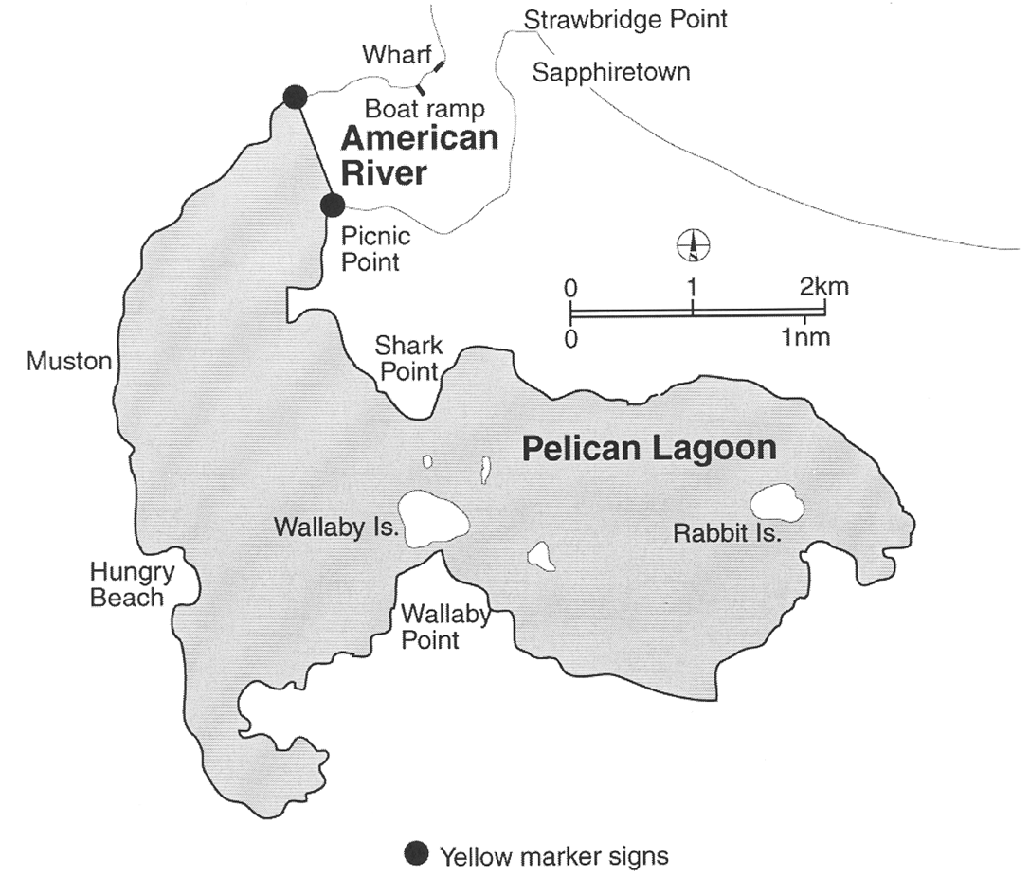
(b) Port Adelaide
The following areas:
(i) the portion of Barker Inlet, Port Adelaide, south-east of a line commencing at the south-eastern end of the southern St. Kilda Channel breakwater, through No 13 Channel Beacon, then south-westerly along a line bearing 225° to its intersection with the High Water Mark on the eastern side of Torrens Island, including all inlets and creeks, but not including the area bounded as follows:
• on the west by a line commencing at No 13 Channel Beacon and ending at No 35 Channel Beacon, through the following points in GDA94 coordinates:

Latitude | Longitude
34° 45′ 5.72″ South | 138° 30′ 58.17″ East
34° 45′ 18.44″ South | 138° 31′ 16.64″ East
34° 45′ 32.62″ South | 138° 31′ 29.30″ East
34° 45′ 43.63″ South | 138° 31′ 37.25″ East
34° 45′ 58.53″ South | 138° 31′ 48.49″ East
34° 46′ 17.27″ South | 138° 31′ 58.49″ East
34° 46′ 32.24″ South | 138° 32′ 10.58″ East
34° 46′ 42.08″ South | 138° 32′ 22.75″ East
34° 46′ 48.85″ South | 138° 32′ 28.46″ East
34° 46′ 59.44″ South | 138° 32′ 36.19″ East
34° 47′ 4.88″ South | 138° 32′ 37.54″ East
34° 47′ 8.71″ South | 138° 32′ 38.17″ East
• on the east by a line commencing at the St. Kilda Starboard Channel marker and ending at No 24 Channel Beacon through the following points in GDA94 coordinates:

Latitude | Longitude
34° 45′ 1.17″ South | 138° 31′ 9.41″ East
34° 45′ 16.16″ South | 138° 31′ 25.47″ East
34° 45′ 35.61″ South | 138° 31′ 36.00″ East
34° 45′ 50.23″ South | 138° 31′ 45.92″ East
34° 46′ 2.50″ South | 138° 31′ 54.50″ East
34° 46′ 14.79″ South | 138° 32′ 3.14″ East
34° 46′ 28.42″ South | 138° 32′ 9.94″ East
34° 46′ 43.1″ South | 138° 32′ 26.44″ East
34° 46′ 51.79″ South | 138° 32′ 32.67″ East
34° 47′ 2.68″ South | 138° 32′ 37.67″ East
34° 47′ 9.44″ South | 138° 32′ 38.76″ East
• on the north by a straight line commencing at No 13 Channel Beacon and ending at the St. Kilda Starboard Channel marker;
• on the south by a straight line commencing at No 35 Channel Beacon and ending at No 24 Channel Beacon; and
(ii) the portion of the North Arm of the Port Adelaide River east of a line bearing 13° from a point at latitude 34°48′44.6″ South, longitude 138°32′23.7″ East in GDA94 coordinates, to the edge of mangroves, including all inlets and creeks; and
(iii) the portion of the North Arm of the Port Adelaide River extending 50 m from the southern edge of mangroves on the southern bank of Garden Island bounded at one end by the eastern end of the Grand Trunkway Bridge and at the other by a line bearing 13° from a point at 34°48′44.6″ South, 138°32′23.7″ East in GDA94 coordinates to the northern edge of mangroves; and
(iv) Angas Inlet, Port Adelaide; and
(v) the portion of the Port Adelaide River which lies between No 12 Channel Beacon and No 22 Channel Beacon; and
(vi) the portion of the Port Adelaide River which lies south of No 35 Channel Beacon;
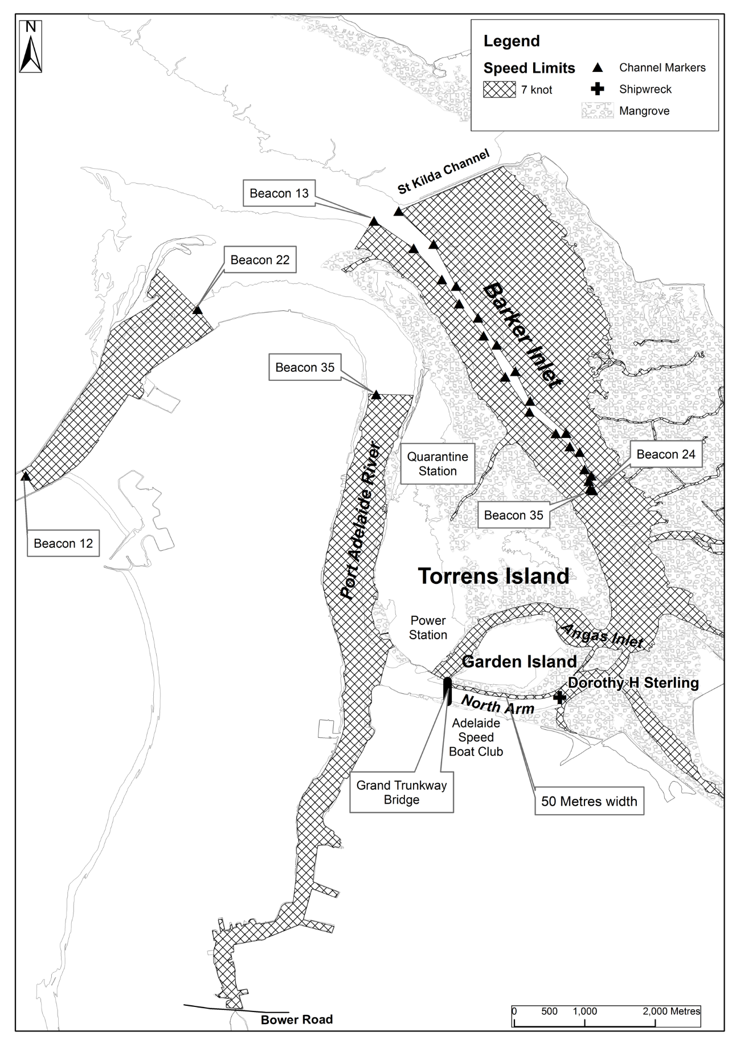
(c) Port Augusta
The area bounded as follows:
commencing at the intersection of the south-eastern end of Great Western Bridge and approaches with the High Water Mark, then south-westerly along the High Water Mark to its intersection with the production shorewards of the north-eastern end of Port Augusta wharf, then seawards along that production and the northern end of Port Augusta wharf to the north-eastern corner of the wharf, then along the face of that wharf and its production south-westerly to its intersection with the High Water Mark on the north-western side of Port Augusta channel, then generally north-east along the High Water Mark to its intersection with the north-western end of the Great Western Bridge and approaches, then south-easterly along the Great Western Bridge to the point of commencement;
(d) Port Lincoln (Boston Bay)
The area bounded as follows:
commencing at the intersection with the High Water Mark of a line running due north from the north-east corner of King and Porter Streets, then due north along that line to its intersection with a line running due east and distant 120 m from the north-west corner of the shipping pier, due east along the latter line to its intersection with a line running due north from the south-eastern extremity of Gawler Terrace, then due south along the latter line to the High Water Mark, then generally westerly along the High Water Mark to the point of commencement;
(e) Port Lincoln (Proper Bay)
The area bounded as follows:
commencing at the intersection with the High Water Mark of a line bearing 155° and distant 120 m from the south-westerly face of the most south-western dolphin at the jetty, then approximately south-easterly along that line to its intersection with a line bearing 65° and 150 m distant from the seaward face of the jetty, then along the latter line to a point opposite the easternmost dolphin at the jetty, then on a line bearing 335° to its intersection with the south-eastern edge of the channel, the channel being 122 m, 61 m either side of the line of leads which bears 245°, then north-easterly along the south-eastern edge of the channel, to a point opposite the outermost beacon, then on a line bearing 335° for 122 m to its intersection with the north-western edge of the channel, then south-westerly on a bearing of 245° along the north-western edge of that channel to a point, being its intersection with a line bearing 155° from the High Water Mark and in line with the easternmost dolphin at the jetty, then north-westerly along that line to the High Water Mark and then generally south-westerly along the High Water Mark to the point of commencement;
(f) Port MacDonnell
The waters of Port MacDonnell in that part of the marked channel that is outside the Port MacDonnell Boat Haven and more than 100 m from the boat ramp.
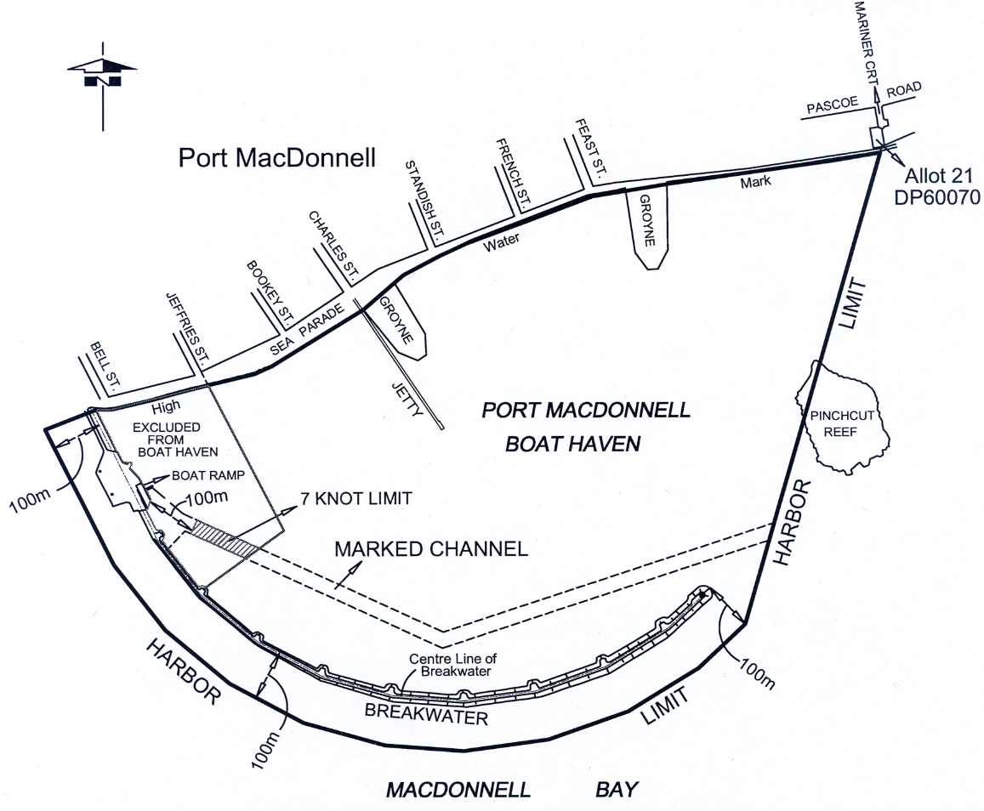
(g) Port Pirie
The portion of the Port Pirie River which lies to the southward of a line drawn east-north-east and west-south-west through No 11 Side Channel Beacon, at such times as a signal in the form of a drum shape with black and yellow vertical stripes or a flashing light of amber colour is displayed from the stobie pole adjacent to the watch officer's office at No 4 berth during the hours of daylight and darkness respectively;
(h) Thevenard
The area bounded as follows:
commencing at a point being the intersection of the High Water Mark and a line 200 m from and parallel to the southern face of the jetty, then approximately south-westerly along that line to its intersection with a line at right angles to it and 200 m distant to seaward at its nearest point to the seaward end of the jetty, then approximately northerly along the latter line to its intersection with a line being the production seawards of the north boundary of HB Block 1, then approximately easterly along that produced line to the High Water Mark, then approximately southerly along the High Water Mark to the point of commencement;
(i) Wallaroo
The area bounded as follows:
commencing at the north-western corner of lot 242, town of Wallaroo, then generally north-westerly to the intersection with a line 150 m from and parallel to the southern face of the shipping pier, then north-westerly along the latter line to a point opposite the seaward end of the shipping pier, then north-westerly a further 120 m on the production north-westerly of the latter line, then north-easterly along a line at right angles to the latter line to its intersection with a line 150 m from and parallel to the northern face of the new shipping pier, then south-easterly along the latter line to its intersection with the High Water Mark, then generally south-westerly along the High Water Mark to its intersection with the northern boundary of lots 261 and 262, then westerly along the latter boundary to the western corner of lot 261, then south-westerly along the north-western boundary of lot 260, then south-easterly along the south-western boundary of lot 260 to the High Water Mark, then generally north-westerly, westerly, south-westerly and westerly along the High Water Mark to its intersection with the south-western boundary of lot 252, then north-westerly along that boundary to the western corner of lot 252, then generally south-westerly along the north-western boundaries of lots 251, 250, Reserve, 248, 247, 246, 245, 244, 243 and 242 to the point of commencement;
(j) Whyalla
The area bounded as follows:
commencing at the intersection of the High Water Mark and the production westerly of the face of the wharf on the north side of the Inner Harbor, then along the face of that wharf to its seaward end, then approximately south-easterly to the entrance beacon, then approximately southerly to a light beacon being the central of 3 beacons marking the northern side of the No 2 Ore Channel, then approximately south-easterly to the light beacon marking the northern side of the seaward end of that channel, then at an angle of 90° bearing approximately south-westerly for 140 m then bearing approximately north-westerly to the light beacon marking the inner end of the southern side of the channel, then approximately south-westerly to a point on the production of the line of dolphins at No 1 Ore Jetty and 120 m distant from the south-westerly face of the most south-westerly dolphin, then approximately north-westerly and parallel to the centre line of the latter jetty, to the High Water Mark, then along the High Water Mark to the point of commencement.
2—4 knot limit—all vessels
The speed limit in the following waters is 4 knots:
(a) Cowell
The portion of the waters of Cowell (Franklin Harbor) bounded by and to the west of a line commencing at the seaward end of the jetty and extending in a south-westerly direction to the seaward end of the southern breakwater;
(b) Kingston
The portion of the waters of Maria Creek seaward of a line 50 m upstream of, and parallel to, the eastern boundary of the boat ramp, that portion of the waters of Lacepede Bay in the channel between the northern groyne and the southern groyne (extending from Maria Creek to a line drawn between the western most end of the northern groyne and the navigation light at the western end of the southern groyne) and that portion of the waters of Lacepede Bay within a 75 m radius of the midpoint of that line;
(c) Lincoln Cove Marina
The portion of the waters within Lincoln Cove Marina bounded by a line commencing at the eastern extremity of the northern breakwater and extending to the starboard land entrance beacon (F1.G), then to the port land entrance beacon (F1.R), and then to the eastern extremity of the southern breakwater;
(d) Mannum Waters Marina
All waters that are from time to time within the Mannum Waters Marina (being the marina comprising a development declared by the Minister under section 46(1) of the Development Act 1993 to be development to which that section applies);
Editorial note—
The marina forms part of the Mannum Waters Marina and residential development—see Gazette 31.03.2005 p719 for the declaration.
(e) Middle Beach
The portion of the waters of Gulf St. Vincent bounded as follows:
• commencing at a point being the intersection of the Medium High Water Mark and the prolongation generally westerly of the northern boundary of Allotment 1790 in Deposited Plan No 55427;
• then generally westerly along that prolongation to the intersection with the edge of mangroves;
• then generally southerly and westerly along the edge of mangroves to a point at 34°36′40.75″ South, 138°24′37.89″ East in WGS84 coordinates;
• then generally south-easterly along a straight line to a point at 34°36′43.03″ South, 138°24′39.39″ East in WGS84 coordinates on the edge of mangroves;
• then generally easterly along the edge of mangroves to the intersection of the prolongation generally southerly of the western edge of the Middle Beach boat ramp;
• then generally northerly along the prolongation of the western edge of the boat ramp and along the western edge of the boat ramp to the intersection with the Medium High Water Mark;
• then generally westerly and northerly along the Medium High Water Mark to the point of commencement.
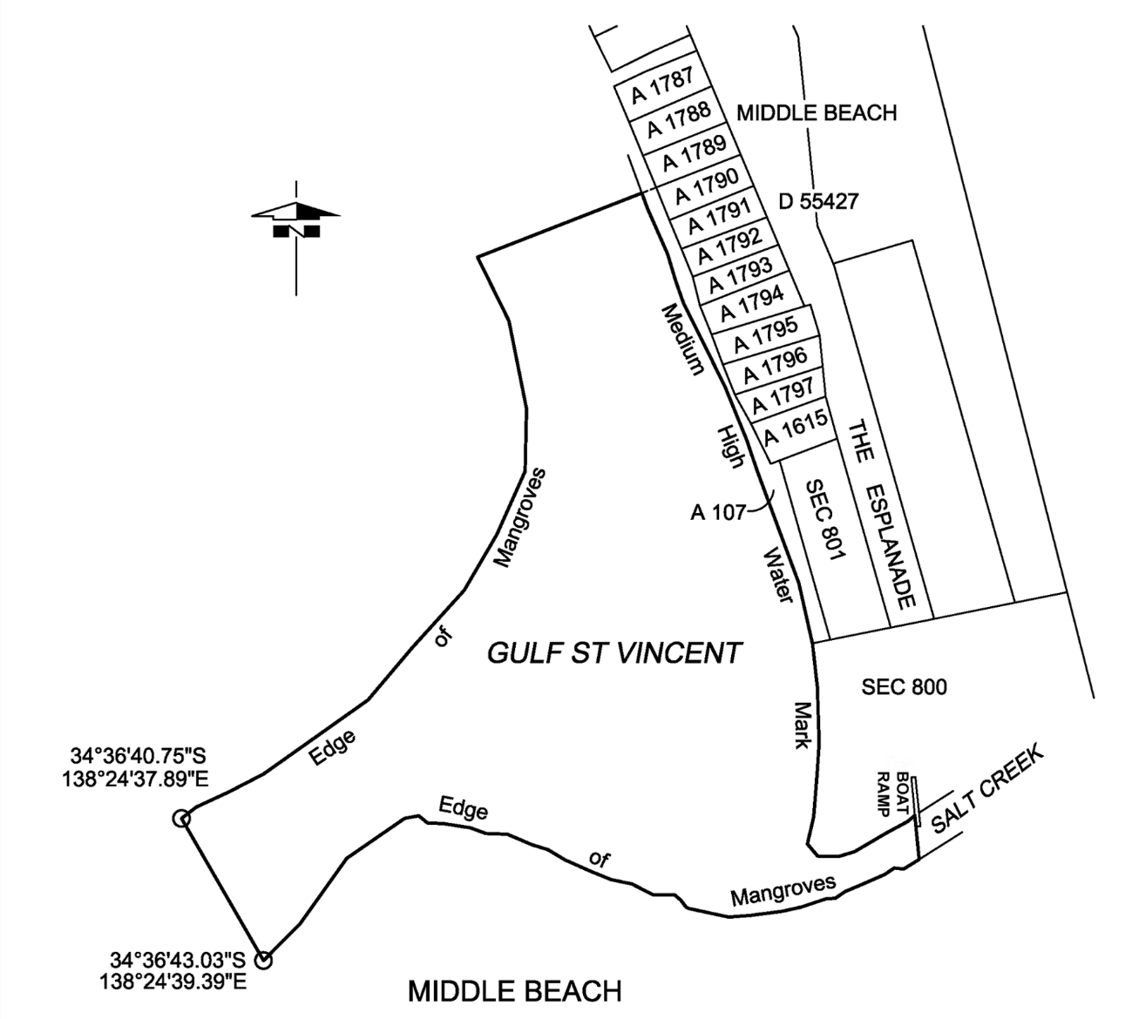
(f) Moonta Bay/Port Hughes
The portion of the waters of Spencer Gulf between the prolongation seaward of the northern boundary of North Terrace, Moonta Bay, and the prolongation seaward of the southern boundary of the Copper Coast District Council (at South Beach) and within 200 m seaward of the shoreline;
(g) Port Adelaide (North Arm)
The portion of the North Arm of the Port Adelaide River bounded by a line extending generally north and south along the western face of the Wave Screen at the western end and the Grand Trunkway Bridge at the eastern end;
(h) Port Adelaide
The area comprising the full width of Port Adelaide River—
(i) lying abreast of any vessel for the time being moored at any wharf or any established mooring place together with the area lying 200 m upstream or downstream of that area; or
(ii) lying abreast of any dredge or marine works in progress between the Fairway Beacon and Jervois Bridge together with the area lying 200 m upstream or downstream of that area; or
(iii) lying 100 m upstream or downstream of the Birkenhead Bridge, a Port River Expressway Bridge or the Jervois Bridge;
(i) Port MacDonnell
The waters of Port MacDonnell bounded as follows:
• on the south-east by a line joining the centre of the second turning bay on the breakwater to the seaward end of the jetty;
• on the south-west by the centre line of the breakwater;
• on the north by the High Water Mark;
• on the north-east by the promulgation seaward of the north-eastern boundary of Jefferies Street,
but not including the waters in that part of the marked channel that is outside the Port MacDonnell Boat Haven and more than 100 m from the boat ramp.
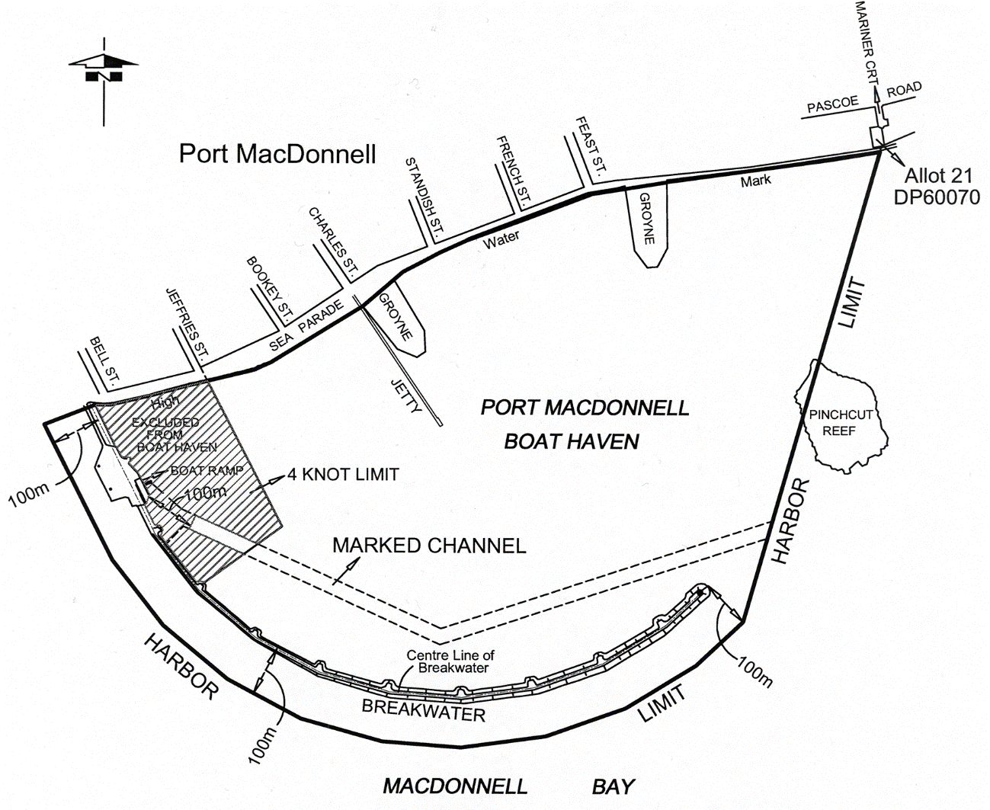
(j) Renmark
The area comprising—
(i) the waters of Ral Ral Creek bounded in the north by a line extending south-east from the south-easternmost corner of the dry dock and in the south by the prolongation in a generally south-easterly direction of the south-western boundary of Lot 602 of Deposited Plan No 24267; and
(ii) the waters to the east of Ral Ral Creek bounded as follows:
(A) in the north by a line extending south-east from the south-easternmost corner of the dry dock referred to in subparagraph (i);
(B) in the south by the prolongation in a generally south-easterly direction of the south-western boundary of Lot 602 of Deposited Plan No 24267;
(C) in the west by Ral Ral Creek;
(D) in the east by a line running parallel to, at a distance of 100 m from, the western bank of Ral Ral Creek; and
(iii) the creeks, tributaries, lakes, lagoons or other bodies of water (collectively known as the Jane Eliza Waterways) connected, whether directly or indirectly, to the waters described in subparagraph (i);
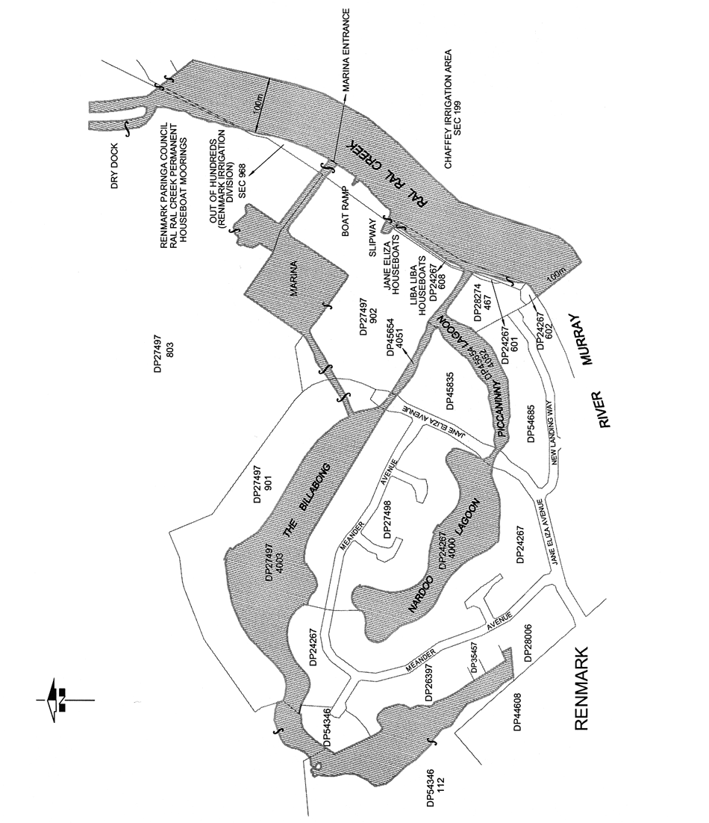
(k) Victor Harbor
The portion of the waters of Encounter Bay commencing at the intersection of the High Water Mark and the base of the north-western edge of the jetty adjacent to the boat ramp at Rosetta Head, then generally easterly along the north-western edge of the jetty, then generally north-easterly and easterly along the starboard hand channel markers of the navigation channel to the solar light navigation aid at the eastern entrance to the navigation channel, then generally westerly and south-westerly along the port hand channel markers of the navigation channel to the southern-most port hand channel marker, then to a point, on the High Water Mark, 40 m south-east of the point of commencement, then generally north-westerly along the High Water Mark to the point of commencement;
(l) Wallaroo Bay
Area 1: the portion of the waters of Wallaroo Bay extending to 200 m seaward from the shoreline, bounded at 1 end by a straight line being the prolongation seaward of the southern boundary of Phillips Street, Wallaroo and at the other by the southern breakwater near Copper Cove Marina;
Area 2: the portion of the waters of Wallaroo Bay extending to 200 m seaward from the shoreline, bounded at 1 end by the northern breakwater near Copper Cove Marina and at the other by a straight line extending westerly from the northern end of Otago Road, North Beach;
Area 3: the portion of the waters of Wallaroo Bay extending to 200 m seaward from the shoreline, bounded at 1 end by a straight line being the prolongation seaward of the southern boundary of Oceanview Drive, North Beach and at the other by a straight line being the prolongation seaward of the northern boundary of North Beach Road, North Beach;
(m) West Beach
The portion of the sea along the metropolitan foreshore within the Adelaide Shores boat ramp facility at West Beach bounded as follows:
• on the south and west by the Adelaide Shores boat ramp and rigging area and the adjoining breakwater;
• on the north by the northern breakwater;
• on the east by the High Water Mark;
• on the north-west by a straight line across the entrance to the Adelaide Shores boat ramp facility joining the northern end of the western breakwater and the western end of the northern breakwater;
(n) Port Broughton
The area bounded as follows:
commencing at the stick beacon without a top-mark situated approximately 655 m north-north-west of the centre of sea-end of the Port Broughton Jetty and between stick beacons No's 34 and 35 which are both surmounted by black triangles (the 3 beacons are on the western side of the Port Broughton channel) then due east to the High Water Mark on the eastern side of Mundoora Arm, then generally southerly along the High Water Mark to its intersection with the production westerly of the southern side of Edmund Street, then west-north-westerly on a line parallel to the jetty to intersect the High Water Mark on the western side of the Mundoora Arm, then generally north-easterly, easterly, south-easterly, north-easterly and north-westerly along the High Water Mark to a point due west of the point of commencement then due east to the point of commencement;
(o) Edithburgh Harbor
The waters within the Edithburgh boating facility bounded by the northern and southern breakwaters and the waters within a 100 m radius of the centrepoint of the eastern end of the southern breakwater.
3—4 knot limit—personal watercraft
The speed limit applicable to personal watercraft in the following waters is 4 knots:
(a) Beachport
The portion of the waters of Rivoli Bay, Beachport, between a straight line extending easterly from the eastern extremity of Section 467, Hundred of Rivoli Bay, and the prolongation, south-easterly, of the western boundary of Section 465, Hundred of Rivoli Bay, and within 100 m seaward of the High Water Mark;
(b) Kangaroo Island
The portion of the waters of Eastern Cove, Kangaroo Island, between a straight line extending northerly from the northern extremity of Strawbridge Point and the prolongation, westerly, of the northern boundary of Section 514, Hundred of Dudley, and within 200 m seaward of the High Water Mark;
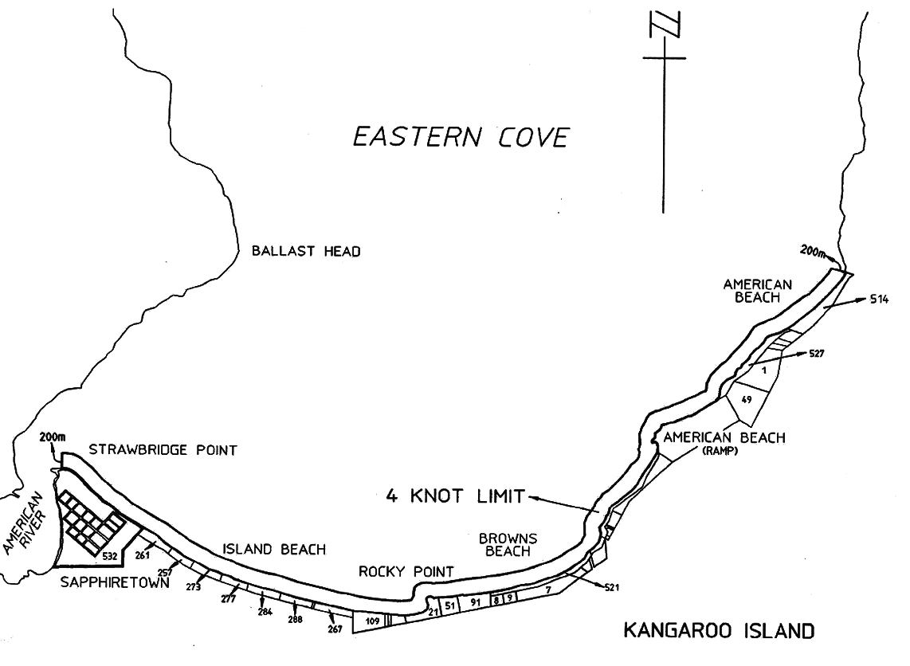
(c) Meningie
The portion of the waters of Lake Albert, Meningie, between the prolongation, northerly, of the far western boundary of Allotment 2 in Filed Plan 149606 and the prolongation, westerly, of the northern boundary of Section 235, Hundred of Bonney, and within 200 m of the shoreline;
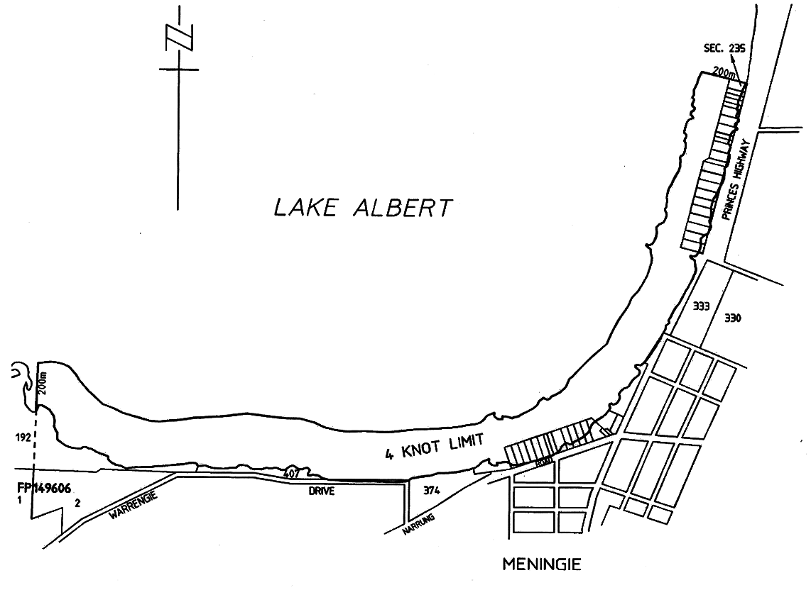
(d) Metropolitan Foreshore
The portion of the sea along the metropolitan foreshore from the landward end of the southern breakwater of the Outer Harbor to the southern end of Sellicks Beach and 200 m seaward of the shoreline;
(e) River Murray
All creeks, tributaries, lakes, lagoons and other bodies of water connected to the River Murray between the border of South Australia and a line joining the upstream sides of the landings used by the ferry at Wellington, except a body of water that has been exempted by the CE by notice in the Gazette;
(f) Southend
The portion of the waters of Rivoli Bay, Southend, between the prolongation, north-easterly, of the northern boundary of Section 372, Hundred of Rivoli Bay, and the prolongation, north-westerly, of the north-east boundary of Section 108, Hundred of Rivoli Bay, and within 100 m seaward of the High Water Mark;
(g) Victor Harbor
The following areas:
(i) the portion of the waters of the sea within 200 m of the centre line of the Granite Island causeway;
(ii) the portion of the waters of the sea within 200 m of the High Water Mark of Granite Island, Seal Island, Wright Island or West Island;
(iii) the portion of the waters of the sea within 200 m of the High Water Mark of the mainland coastline within the area of the City of Victor Harbor, being waters within the area bounded—
(A) on the east by the prolongation, generally south and to seaward, of the easterly boundary of the area of the City of Victor Harbor (ie the eastern side of Ocean Road, Port Elliot); and
(B) on the west by a line joining the most southerly point of King Head to the most southerly point of West Island.
Schedule 8—Vessels without compliance plate—maximum number of persons
1—Maximum number of persons that may be carried on vessel that does not have compliance plate
The maximum number of persons that may be carried on a vessel that does not have a compliance plate fitted by the manufacturer stating the maximum number of persons that may be safely carried as determined in accordance with AS 1799.1 must be determined in accordance with the following tables:

Table 1—Maximum safe capacity (adults) for conventional vessels without flybridges
Length (m) | 3 | 3.5 | 4 | 4.5 | 5 | 5.5 | 6 | 7 | 8 | 9 | 10
Breadth (m)
1 | 2 | 3 | 3
1.5 | 3 | 3 | 4 | 4 | 5 | 5 | 6
2 |  |  | 4 | 5 | 5 | 6 | 6 | 7 | 8 | 10 | 11
2.5 |  |  |  |  | 6 | 7 | 7 | 8 | 9 | 11 | 12
3 |  |  |  |  |  |  | 8 | 9 | 10 | 12 | 13
3.5 |  |  |  |  |  |  |  |  | 11 | 13 | 14
4 |  |  |  |  |  |  |  |  | 12 | 14 | 15
4.5 |  |  |  |  |  |  |  |  |  |  | 16
Example—
A vessel with a length of 5.5 m and a breadth of 2 m has a capacity of 6 adults.

Table 2—Maximum safe capacity (adults) for conventional vessels with flybridges
Length (m) | 4 | 4.5 | 5 | 5.5 | 6 | 7 | 8 | 9 | 10
Breadth (m)
1.5 | 3 | 3 | 4 | 4 | 4
2 | 3 | 4 | 4 | 5 | 5 | 6 | 7 | 8 | 8
2.5 |  |  | 5 | 5 | 6 | 7 | 8 | 9 | 9
3 |  |  |  |  | 6 | 7 | 8 | 9 | 10
3.5 |  |  |  |  |  |  | 9 | 10 | 11
4 |  |  |  |  |  |  |  | 11 | 12
4.5 |  |  |  |  |  |  |  |  | 13
Example—
A flybridge vessel with a length of 8 m and a breadth of 2.5 m has a capacity of 8 adults.
Schedule 9—Boat havens
Note—
Unless the contrary intention appears, the maps in this Schedule are provided for convenience of reference only.
North Arm Boat Haven
The portion of the waters of the North Arm of the Port Adelaide River bounded by a line extending generally north and south along the western face of the Wave Screen at the western end and the Grand Trunkway Bridge at the eastern end.
Port MacDonnell Boat Haven
The waters of Port MacDonnell harbor excluding the waters within the area bounded as follows:
(a) on the south-east by a line joining the centre of the second turning bay on the breakwater to the seaward end of the jetty;
(b) on the south-west by the centre line of the breakwater;
(c) on the north by the High Water Mark;
(d) on the north-east by the production seaward of the north-eastern boundary of Jefferies Street.
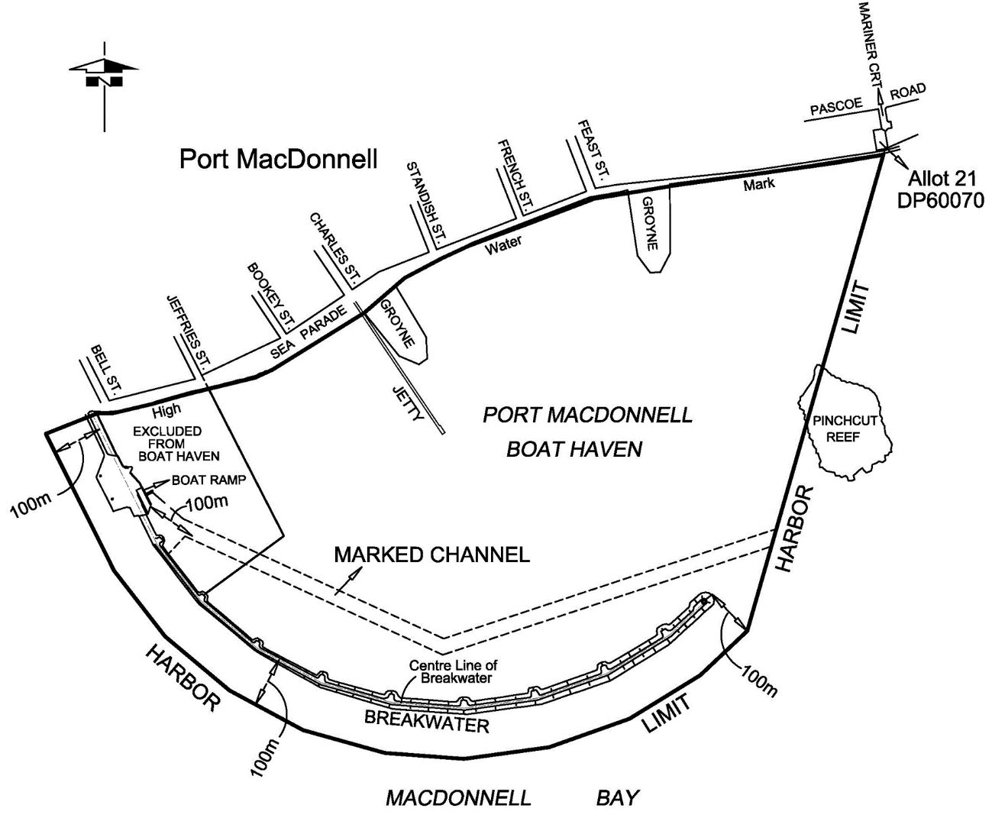
Schedule 10—Notice requirements
A notice required under regulation 134(13) must contain—
(a) a statement that a copy of the evidence obtained through the operation of a camera installed by the CE on, or in the immediate vicinity of, the Port River Expressway Bridges on which the allegation is based may be viewed on application to the CE;
(b) a statement that the CE will, in relation to the question of withdrawal of the expiation notice, reminder notice or complaint, give due consideration to any exculpatory evidence that is verified by statutory declaration and furnished to the CE within the period specified in the notice.
Schedule 11—Fees and levies
1—Interpretation
For the purposes of this Schedule—
(a) when calculating a fee or levy expressed as an amount per metre, part of a metre is to be regarded as a metre; and
(b) when calculating a fee expressed as an amount per hour, part of an hour is to be regarded as an hour.
2—Fees and levies payable to CE
A fee or levy fixed by this Schedule is payable to the CE.
3—Dishonoured cheque or debit card or credit card transactions
If—
(a) an amount payable to the CE under the Act or these regulations, or lawfully collected by the CE on behalf of any other person or body, is purportedly paid by the giving of a cheque or use of a debit card or credit card; and
(b) the cheque is dishonoured on presentation or the amount is not paid to the CE by the body that issued the card or is required to be repaid by the CE,
the CE may, by written notice served personally or by post on the person who is liable to make the payment, require the person to pay to the CE (within a period specified in the notice), the amount payable plus an administration fee of $31.
4—Facilities levy
(1) The amount of a facilities levy set out in this clause is the amount payable if registration of the vessel is for a 12 month period.
(2) If a vessel is registered for a period other than 12 months, a pro rata adjustment is to be made to the amount of the facilities levy set out in this clause by applying the proportion that the number of months in the period of registration bears to 12 months and then rounding the amount up to the nearest dollar.

Levies relating to Part 15
Facilities levy for recreational vessel comprised of personal watercraft | $41.00
Facilities levy for any other vessel, according to its length as follows:
(a) if the vessel is not more than 3.1 m | nil
(b) if the vessel is more than 3.1 m but not more than 3.5 m | $41.00
(c) if the vessel is more than 3.5 m but not more than 5 m | $60.00
(d) if the vessel is more than 5 m but not more than 6 m | $73.00
(e) if the vessel is more than 6 m but not more than 7 m | $89.00
(f) if the vessel is more than 7 m but not more than 8 m | $99.00
(g) if the vessel is more than 8 m but not more than 9 m | $109.00
(h) if the vessel is more than 9 m but not more than 10 m | $122.00
(i) if the vessel is more than 10 m but not more than 11 m | $136.00
(j) if the vessel is more than 11 m but not more than 12 m | $148.00
(k) if the vessel is more than 12 m but not more than 13 m | $160.00
(l) if the vessel is more than 13 m but not more than 14 m | $172.00
(m) if the vessel is more than 14 m but not more than 15 m | $182.00
(n) if the vessel is more than 15 m but not more than 16 m | $196.00
(o) if the vessel is more than 16 m but not more than 17 m | $211.00
(p) if the vessel is more than 17 m but not more than 18 m | $220.00
(q) if the vessel is more than 18 m but not more than 19 m | $232.00
(r) if the vessel is more than 19 m but not more than 20 m | $247.00
(s) if the vessel is more than 20 m | $306.00
5—Fees

Fees relating to Part 7
Application for pilotage exemption certificate | $740.00
Application for renewal of pilotage exemption certificate | $368.00
Issue of replacement pilotage exemption certificate | $69.00
Fees relating to Part 9
Written examination (whether first or subsequent attempt)—
(a) for boat operator's licence | $50.00
(b) for special permit | $22.00
Practical test for special permit | nil
Issue of boat operator's licence—
(a) if applicant has held special permit | $19.00
(b) in any other case | $48.00
Issue of special permit | $19.00
Application for exemption from requirement to hold boat operator's licence | nil
Application for endorsement of boat operator's licence | nil
Application for recognition of qualification under law of some other place as equivalent to boat operator's licence | nil
Issue of replacement boat operator's licence or special permit | $19.00
Fees relating to Part 11
Application for registration of vessel  Note—  Personal watercraft and vessels up to 7 m may be registered for 6 or 12 months but vessels more than 7 m may only be registered for 12 months—see regulation 116(7).  (a) for a personal watercraft— | 6 months/12 months
• initial registration | $202.00/$401.00
• renewal of registration | $184.00/$368.00
• renewal of registration in different name | $206.00/$389.00
(b) for any other vessel—according to its length as follows:
(i) if the vessel is not more than 3.5 m—
• initial registration | $27.00/$53.00
• renewal of registration | $9.00/$19.00
• renewal of registration in different name | $34.00/$44.00
(ii) if the vessel is more than 3.5 m but not more than 6 m—
• initial registration | $49.00/$99.00
• renewal of registration | $35.00/$66.00
• renewal of registration in different name | $54.00/$90.00
(iii) if the vessel is more than 6 m but not more than 7 m—
• initial registration | $109.00/$216.00
• renewal of registration | $93.00/$182.00
• renewal of registration in different name | $113.00/$206.00
(iv) if the vessel is more than 7 m but not more than 10 m—
• initial registration | not applicable/$216.00
• renewal of registration | not applicable/$182.00
• renewal of registration in different name | not applicable/$206.00
(v) if the vessel is more than 10 m but not more than 15 m—
• initial registration | not applicable/$307.00
• renewal of registration | not applicable/$278.00
• renewal of registration in different name | not applicable/$299.00
(vi) if the vessel is more than 15 m but not more than 20 m—
• initial registration | not applicable/$401.00
• renewal of registration | not applicable/$368.00
• renewal of registration in different name | not applicable/$389.00
(vii) if the vessel is more than 20 m—
• initial registration | not applicable/$462.00
• renewal of registration | not applicable/$432.00
• renewal of registration in different name | not applicable/$451.00
Application for exemption from requirement for vessel to be registered | nil
Trade plates—
(a) application for initial issue | $97.00
(b) application for subsequent issue | $66.00
(c) issue of replacement certificate | $19.00
(d) surrender of trade plates | $19.00
Application for assignment of new identification mark | $19.00
Application for transfer of registration of vessel | $19.00
Issue of replacement certificate of registration | $19.00
Application for cancellation of registration | $19.00
Application for appointment as boat code agent | $182.00
Application for further term of appointment as boat code agent | $146.00
Application for approval as boat code examiner | $93.00
Application for further term of approval as boat code examiner | $47.00
Set of 20 HIN plates | $143.00
Pad of 50 interim boat code certificates | $41.00
Duplicate copy of boat code certificate | $19.00
Fees relating to Part 14
Application for permit to moor vessel in boat haven—
(a) North Arm Boat Haven
(i) annual permit—
• fishing vessel 9 m and over in length | $96.00 per metre
• fishing vessel less than 9 m in length | $128.00 per metre
• tender vessel | $96.00 per metre
• the above is subject to the following maximum fees:
• fishing vessel and 2 tender vessels | $623.00
• fishing vessel and 3 tender vessels | $704.00
• other vessels 12 m or more in length | $239.00 per metre
• other vessels less than 12 m in length | $2 877.00
(ii) temporary permit (1 week or part of a week) | $87.00
(b) Port MacDonnell Boat Haven
(i) annual permit | $128.00 per metre
(ii) temporary permit (24 hours) | $6.00
Schedule 12—Expiation fees
1—Expiation of alleged offences
(1) The expiation fees set out in this Schedule are fixed for alleged offences against the regulations specified in this Schedule.
(2) Text set out in italic type under a heading in this Schedule commencing with the words "Description of offence" is a description for convenience purposes only and is not to be taken to define the offence for which a particular amount is fixed as the expiation fee.
2—Expiation fees

Regulation | Description of offence | Fee
Regulation 10(1) | Contravening a control applying in restricted area | $160
Regulation 10(3) | Contravening a control applying in restricted area—offence for owner | $160
Regulation 10(5) | Contravening a control applying in a restricted area by towed vessel—offence for operator | $160
Regulation 11(1) | Operating a vessel under sail power alone in the waters of the Port Adelaide River | $160
Regulation 12(1) | Swimming, bathing or diving in the waters of Gulf St. Vincent within 40 m of Glenelg breakwater | $160
Regulation 13(1) | Operating personal watercraft in unprotected waters | $160
Regulation 15(1) | Obstructing wharf | $160
Regulation 16(1) | Obstructing landing place | $160
Regulation 17 | Undertaking unauthorised activity on wharf | $160
Regulation 19(4) | Contravening direction displayed on traffic sign | $160
Regulation 21(2) | Parking vehicle in area not delineated under regulation | $160
Regulation 21(3) | Parking vehicle in delineated area without displaying permit | $160
Regulation 29(1) | Obstructing wharf in a port | $160
Regulation 30(1) | Obstructing landing place in a port | $160
Regulation 31 | Undertaking unauthorised activity on wharf | $160
Regulation 32(1) | Using trolley other than for purposes connected with loading, unloading or maintenance of vessel | $160
Regulation 32(2) | Propelling trolley at dangerous speed or in dangerous manner | $160
Regulation 32(3) | Failing to give person effective warning of approach of trolley | $160
Regulation 33 | Failing to remove and store moveable equipment after use in loading or unloading on wharf | $160
Regulation 35(1) | Failing to report damage caused by cargo and remove, clean or repair damage | $160
Regulation 36 | Failing to cover outlet on vessel to prevent liquid discharge onto wharf | $160
Regulation 38 | Entering area of wharf or contiguous land with restricted access | $160
Regulation 39(2) | Failing of operator or master of vessel to have watch officer | $160
Regulation 41(3) | Failing of consignor of vehicle, vessel or machine to comply with regulation | $160
Regulation 41(5) | Failing to transfer petroleum or fuel in accordance with regulation | $160
Regulation 42 | Loading or unloading of cargo on a vessel while operating an internal combustion engine other than in accordance with the requirements of regulation | $210
Regulation 43(1) | Failing of operator to ensure vessel is safely moored by lines | $160
Regulation 43(2) | Interfering with mooring lines | $160
Regulation 44(2) | Operating or interfering with vessel in contravention of regulation | $160
Regulation 45(1) | Making fast or letting go of mooring lines | $160
Regulation 46 | Swimming in harbor | $105
Regulation 48(4) | Contravening direction on traffic sign in harbor or port | $160
Regulation 50(2) | Parking a vehicle in area not delineated under regulation | $160
Regulation 50(3) | Parking in a delineated area without displaying permit | $160
Regulation 55(1) | Failing of owner or operator to deliver notice of entry | $160
Regulation 56(1) | Failing of operator of commercial vessel to produce prescribed papers to port operator | $160
Regulation 57 | Removing commercial vessel from port without approval of port operator | $160
Regulation 58(7) | Failing by operator or owner of vessel to give manifest to port operator | $160
Regulation 58(8) | Divulging contents of manifest to person other than in course of duties | $160
Regulation 59(1) | Failing of operator or owner of commercial vessel to produce cargo records and documents on request | $160
Regulation 59(2) | Divulging content of record to person other than in course of duties | $160
Regulation 66 | Failing of holder of pilot licence or pilotage exemption certificate to notify change of details | $315
Regulation 67 | Failing of holder of pilotage exemption certificate to keep records | $105
Regulation 72(3) | Failing of holder of boat operator's licence to comply with licence condition | $105
Regulation 73(5) | Contravening condition of special permit | $105
Regulation 74(3) | Contravening condition of temporary boat operator's licence | $105
Regulation 75(1) | Failing of holder of boat operator's licence to sign licence | $105
Regulation 75(2) | Failing of holder boat operator's licence or special permit to notify CE of change of details | $105
Regulation 83(7) | Marking vessel in contravention of regulation | $105
Regulation 83(8) | Operating vessel marked in contravention of regulation | $105
Regulation 84(1) | Failing to comply with transfer of registration requirements | $105
Regulation 87 | Failing of registered owner of vessel to notify CE of change of name or address | $105
Regulation 88(4) | Operating vessel contrary to condition of registration | $105
Regulation 90(2) | Failing to return certificate of registration | $105
Regulation 92(2) | Failing to produce evidence of registration | $105
Regulation 93(7) | Contravening condition of trade plates | $210
Regulation 93(13) | Failing of holder of trade plates to notify CE of ceasing to carry on business | $210
Regulation 94(2) | Failing to return trade plates | $105
Regulation 97(2) | Fixing HIN plate to a vessel by person other than boat code agent or boat code examiner | $210
Regulation 97(3) | Fixing anything appearing to be, but not being, a HIN plate to vessel | $210
Regulation 97(12) | Forming HIN into hull after manufacture | $210
Regulation 97(13) | Failing to return HIN plates to CE | $210
Regulation 97(14) | Failing of boat code agent to inform CE of HIN formed on hull | $210
Regulation 98 | Unauthorised removal of HIN plate | $210
Regulation 113(2) | Operating vessel in contravention of Prevention of Collisions Convention | $315
Regulation 113(3) | Fitting and exhibiting navigation lights other than in accordance with Prevention of Collisions Convention | $315
Regulation 114(2) | Operating vessel contrary to section 17 of Code (River Murray Traffic Regulations) | $315
Regulation 114(3) | Fitting and exhibiting navigation lights other than in accordance with section 17 of Code (River Murray Traffic Regulation) | $315
Regulation 115(1) | Failing to keep starboard side of vessel near outer limit of river or channel | $315
Regulation 115(2) | Hampering safe passage of vessel inside channel | $315
Regulation 115(3) | Impeding passage of other vessel navigating within channel if vessel is engaged in fishing | $315
Regulation 115(4) | Anchoring vessel in channel other than in emergency | $315
Regulation 115(5) | Failure to move vessel to side of channel if anchored in emergency | $315
Regulation 115(6) | Overtaking vessel in channel unsafely | $315
Regulation 115(7) | Placing cable, chain, hawser or rope across channel | $315
Regulation 116(1) | Operating vessel at speed in excess of 4 knots | $160
Regulation 116(3) | Operating vessel at speed in excess of applicable speed limit | $160
Regulation 117(1) | Failing of occupant of specified vessel to wear specified lifejacket | $160
Regulation 117(2) | Failure of occupant in open area of vessel to wear specified lifejacket in circumstances of heightened risk | $160
Regulation 117(3) | Failing of operator of specified vessel if occupant fails to wear specified lifejacket | $160
Regulation 117(4) | Failing of operator if occupant of vessel of or under 12 years of age is not wearing specified life jacket at all times | $160
Regulation 117(6) | Failing of occupant of vessel to wear specified lifejacket on specified vessel at direction of operator | $160
Regulation 118(2) | Operating personal watercraft in contravention of regulation | $160
Regulation 119(1) | Operating a personal watercraft other than during certain hours | $160
Regulation 120 | Failing of operator to ensure all hatches and doors are unlocked and clear of obstructions | $160
Regulation 121(1) | Failing to ensure not more than maximum number of persons on vessel than can safely be carried | $160
Regulation 121(2) | Causing or permitting load on vessel greater than can be safely carried | $160
Regulation 122(9) | Failing of operator of vessel and person being towed by vessel to comply with towing requirements in regulation | $160
Regulation 123 | Failing of person being towed to signal presence after falling into water | $105
Regulation 124(1) | Failing of operator to manouevre vessel as required while towing a person | $315
Regulation 124(2) | Failing of operator to ensure all apparatus used in towing person is not trailing | $315
Regulation 125(1) | Failing of operator to keep vessel clear of other vessel in area towing a person | $315
Regulation 126(1) | Operating a vessel within 100 m behind a person being towed | $315
Regulation 127(1) | Failing of operator of diver vessel over 10 m in length to display International Code Flag A | $160
Regulation 127(2) | Failing of operator of diver vessel 10 m or less in length to display International Code Flag A | $160
Regulation 127(3) | Failing of diver without vessel to display International Code Flag A on buoy or float | $160
Regulation 127(4) | Diver operating independently in harbor used by vessels | $160
Regulation 127(5) | Failing of operator of vessel to navigate to avoid diver | $160
Regulation 127(6) | Failing to illuminate International Code Flag A during darkness | $160
Regulation 132 | Failing of person using fishing apparatus in inland waters to comply with Part 10 Division 7 | $160
Regulation 133(2) | Failing of operator who requested opening of Birkenhead Bridge to notify that they do not intend to navigate under bridge | $315
Regulation 133(3) | Failing of operator to approach Birkenhead Bridge unless fully open | $315
Regulation 133(4) | Failing to navigate under Birkenhead Bridge within navigation pass | $315
Regulation 133(5) | Failing to safely manoeuver vessel while approaching Birkenhead Bridge and navigational pass | $315
Regulation 133(6) | Failing of operator upstream of Birkenhead Bridge to give navigation pass to vessel proceeding downstream | $315
Regulation 134(4) | Failing of operator who requested opening of Port River Expressway Bridge to notify that they do not intend to navigate under bridge | $315
Regulation 134(5) | Failing of operator to cause a radio watch to be maintained while vessel is within 100 m of Port River Expressway Bridge | $315
Regulation 134(6) | Failing of operator to comply with requirements of regulation | $315
Regulation 134(11) | Failing of vessel to comply with requirements of regulation—offence for owner of vessel | $315
Regulation 134(18) | Interfering with camera installed at Port River Expressway Bridge | $315
Regulation 136(2) | Failing of operator to operate vessel within navigational pass under Hindmarsh Island Bridge | $315
Regulation 136(3) | Failing of operator to proceed with caution in navigational pass under Hindmarsh Island Bridge | $315
Regulation 136(4) | Failing of operator to ensure vessel does not come into contact with support pier of Hindmarsh Island Bridge | $315
Regulation 136(5) | Failing to maintain vessel under safe control in approaching or navigating under Hindmarsh Island Bridge | $315
Regulation 136(6) | Failing of operator of vessel upstream to give priority of passage to vessel downstream if approaching Hindmarsh Island Bridge simultaneously | $315
Regulation 136(7) | Failing of operator of vessel proceeding upstream to wait for vessel proceeding downstream to be clear of Hindmarsh Island Bridge | $315
Regulation 137(1) | Failing of operator to operate within navigational pass under Jervois Bridge | $315
Regulation 137(2) | Failing to maintain vessel under safe control in approaching or navigating under Jervois Bridge | $315
Regulation 137(3) | Failing of operator of vessel upstream to give priority of passage to vessel downstream if approaching Jervois Bridge simultaneously | $315
Regulation 137(4) | Failing of operator of vessel proceeding upstream to wait for vessel proceeding downstream to be clear of Jervois Bridge | $315
Regulation 138(2) | Failing to operate vessel within navigational pass under Kingston Bridge | $315
Regulation 138(3) | Failing to proceed with caution in navigational pass under Kingston Bridge | $315
Regulation 138(4) | Connecting with support pier of Kingston Bridge | $315
Regulation 138(5) | Failing to maintain vessel under safe control in approaching or navigating under Kingston Bridge | $315
Regulation 138(6) | Failing to sound 1 long blast when vessel is within 0.5 nautical miles of Kingston Bridge | $315
Regulation 138(7) | Failing to respond with 1 long blast on hearing a long blast | $315
Regulation 138(8) | Passing another vessel within 0.25 nautical miles of Kingston Bridge | $315
Regulation 138(9) | Failing of operator of vessel upstream to give priority of passage to vessel downstream if approaching Kingston Bridge simultaneously | $315
Regulation 138(10) | Failing of operator of vessel proceeding upstream to wait for vessel proceeding downstream to be clear of Kingston Bridge | $315
Regulation 139(2) | Failing of operator who requested opening of Paringa Bridge to notify that they do not intend to navigate under bridge | $315
Regulation 139(4) | Approaching within 100 m of Paringa Bridge before bridge is fully opened and green light is illuminated | $315
Regulation 139(5) | Failing to operate vessel in navigational pass under Paringa Bridge | $315
Regulation 139(6) | Failing to maintain vessel under safe control in approaching or navigating under Paringa Bridge | $315
Regulation 139(7) | Failing to give way to vessel approaching Paringa Bridge | $315
Regulation 139(8) | Failing of operator of vessel upstream to give priority of passage to vessel downstream if approaching Paringa Bridge simultaneously | $315
Regulation 140(3) | Entering or remaining in waters within 500 m of petroleum exploration | $315
Regulation 141(3) | Entering or remaining in waters within 1 nautical mile of vessel transferring petroleum | $315
Regulation 142(3) | Entering or remaining in waters within 0.5 nautical miles of vessel loading at transhipment point | $315
Regulation 143 | Causing nuisance or annoyance to person in or near water | $210
Regulation 144(1) | Directing beam of light from 1 vessel onto another | $160
Regulation 144(2) | Operating vessel from which beam of light is directed | $160
Regulation 145(1) | Emitting smoke or vapour from vessel causing danger to another person | $160
Regulation 145(2) | Discharging offensive material into waters | $315
Regulation 146(1) | Doing work on a vessel by means of device that produces flame or flash other than in accordance with regulation | $105
Regulation 146(2) | Operating vessel on which work is done in contravention of regulation | $105
Regulation 147(1) | Using, displaying or activating a signal other than in circumstances contemplated by regulations | $105
Regulation 148 | Smoking or use of combustion equipment in vicinity of open hatch of commercial vessel | $315
Regulation 154(1) | Laying down a mooring except in accordance with approval of CE | $160
Regulation 154(2) | Failing to relocate or remove mooring as required by CE | $160
Regulation 155(3) | Mooring vessel in boat haven other than in accordance with permit | $160
Regulation 155(10) | Contravening condition of permit | $160
Regulation 155(12) | Failing of permit holder to produce or notify matters set out in regulation | $160
Regulation 156(4) | Failing to remove vessel from boat haven if permit is cancelled | $160
Regulation 157(6) | Failing of registered owner to comply with order issued under regulation | $315
Regulation 161(2) | Discharging ballast water from vessel in contravention of regulation | $315
Regulation 162(3) | Failing to comply with direction under regulation | $315
Regulation 164 | Making false or misleading statement | $210
Schedule 13—Repeal of Harbors and Navigation Regulations 2009
1—Repeal of Harbors and Navigation Regulations 2009
The Harbors and Navigation Regulations 2009 are repealed.
Editorial note—
As required by section 10AA(2) of the Legislative Instruments Act 1978, the Minister has certified that, in the Minister's opinion, it is necessary or appropriate that these regulations come into operation as set out in these regulations.
Made by the Governor
with the advice and consent of the Executive Council
on 10 August 2023
No 84 of 2023

All instruments appearing in this gazette are to be considered official, and obeyed as such

Printed and published weekly by authority of M. Dowling, Government Printer, South Australia
$8.55 per issue (plus postage), $430.00 per annual subscription—GST inclusive
Online publications: www.governmentgazette.sa.gov.au

