No. 65 p. 3049
THE SOUTH AUSTRALIAN
GOVERNMENT GAZETTE
Published by Authority

Adelaide, Thursday, 24 August 2023

Contents

State Government Instruments
Adelaide Park Lands Act 2005 3050
Agricultural and Veterinary Products (Control of Use) Regulations 2017 3050
Dangerous Substances Act 1979 3051
Fisheries Management (Rock Lobster Fisheries)
Regulations 2017 3051
Fisheries Management Act 2007 3051
Housing Improvement Act 2016 3054
Justices of the Peace Act 2005 3054
Land Acquisition Act 1969 3055
Lotteries Act 2019 3058
Mining Act 1971 3059
Pastoral Land Management and Conservation Act 1989 3060
Petroleum and Geothermal Energy Act 2000 3060
Roads (Opening and Closing) Act 1991 3061
Survey Act 1992 3062
Local Government Instruments
City of Adelaide 3064
City of Port Adelaide Enfield 3064
City of Prospect 3064
Alexandrina Council 3066
Barossa Council, The 3080
Coorong District Council 3081
Lower Eyre Council 3093
Port Pirie Regional Council 3093
Renmark Paringa Council 3094
Municipal Council of Roxby Downs 3094
Wudinna District Council 3096
Public Notices
Sale of Property 3110

State Government Instruments

Adelaide Park Lands Act 2005
Notice of Appointment
I, the Hon Nicholas Champion MP, Minister for Planning, pursuant to Division 2 of Part 2 of the Adelaide Park Lands Act 2005 (the Act) having undertaken the required consultation with the Adelaide City Council, appoint the following person as member of the Board of Management of the Kadaltilla/Adelaide Park Lands Authority:
For the purposes of Sections 6(1)(b) and 10(2) of the Act:
Elinor Walker as Member of the Board and Deputy Presiding Member
Pursuant to Section 7(2) of the Act, I appoint the above person until 31 March 2025.
Dated: 22 August 2023
Hon Nick Champion MP
Minister for Planning

Agricultural and Veterinary Products (Control of Use) Regulations 2017
Notice by the Minister
Approval of Classes of Persons to use Certain Agricultural and Veterinary Products
I, Clare Scriven, Minister for Primary Industries and Regional Development, pursuant to Regulation 34(1) of the Agricultural and Veterinary Products (Control of Use) Regulations 2017, prohibit the use of certain agricultural and veterinary products except by persons of a class specified in this notice.
Restricted Agricultural and Veterinary Products
Agricultural or Veterinary Product | Class of Persons Authorised to Use Product
1. An agricultural chemical product containing alphachloralose. | A person authorised to conduct Domestic and Commercial Pest Control under the Controlled Substances Act 1984.  An authorised officer under the Landscape South Australia Act 2019, who has been trained in the use of that product.
2. An agricultural chemical product containing  4-aminopropiophenone (PAPP). | An authorised officer under the Landscape South Australia Act 2019, who has been trained in the use of that product.  A person who is authorised to handle that product pursuant to a licence issued under Section 22 of the Controlled Substances Act 1984, or in accordance with Regulation 25(2) of the Controlled Substances (Poisons) Regulations 2011.
3. An agricultural chemical product containing  4-aminopyridine. | A person authorised to conduct Domestic and Commercial Pest Control under the Controlled Substances Act 1984.  An authorised officer under the Landscape South Australia Act 2019, who has been trained in the use of that product.
4. An agricultural chemical product that is a pre-construction termiticide product containing bifenthrin or chlorpyrifos. | A person authorised to conduct Domestic and Commercial Pest Control where timber pests are not excluded under the Controlled Substances Act 1984.
5. An agricultural chemical product containing copper chrome arsenate (CCA) (i.e. formulations containing as active constituents all three of copper, chromium and arsenic in various chemical forms) used to treat timber. | A person who holds a valid statement of attainment issued by a training organisation registered by the Australian Skills Quality Authority certifying successful completion of the following unit of competence: FWPSAW3242 (Treat Timber).
6. An agricultural chemical product containing fenthion used for bird control. | A person authorised to conduct Domestic and Commercial Pest Control under the Controlled Substances Act 1984.
7. An agricultural chemical product containing pindone if—  (a) the product is a concentrate; and  (b) the instructions on the approved label for containers of the product require the product to be mixed with carriers before it is ready for use as a bait. | An authorised officer under the Landscape South Australia Act 2019, who has been trained in the use of that product.
8. An agricultural chemical product containing sodium monofluoroacetate (1080) if—  (a) the product is a concentrate; and  (b) the instructions on the approved label for containers of the product require the product to be mixed with carriers before it is ready for use as a bait; or  (c) the product is a ready to use bait; or  (d) the product is a capsule for use with a Canid Pest Ejector; or  (e) the product is a cartridge for use with the Felixer. | An authorised officer under the Landscape South Australia Act 2019, who has been trained in the use of that product.  A person who is authorised to handle that product pursuant to a licence issued under Section 22 of the Controlled Substances Act 1984, or in accordance with Regulation 25(3) of the Controlled Substances (Poisons) Regulations 2011.
9. An agricultural product or a veterinary product to which Section 15 of the Controlled Substances Act 1984 applies. | A person who holds a valid statement of attainment issued by a training organisation registered by the Australian Skills Quality Authority for the units of competence AHCCHM307 (Prepare and Apply Chemicals to Control Pest, Weeds and Diseases) and AHCCHM304 (Transport and Store Chemicals).
Dated: 17 August 2023
Clare Scriven
Minister for Primary Industries and Regional Development

Dangerous Substances Act 1979
Authorised Officers
I, Glenn Stephen Farrell, Executive Director, SafeWork SA, in my capacity as the Competent Authority, hereby appoint the following persons as an Authorised Officer for the purposes of the Dangerous Substances Act 1979 pursuant to Section 7(1) of the Act:
• Ahad Aslam CHAGANI
• Clare Margaret JANES
Dated: 24 August 2023
Glenn Farrell
Executive Director
Competent Authority
Safework SA

Fisheries Management (Rock Lobster Fisheries) Regulations 2017
Regulation 12 and 29
Variation of Restrictions on Fishing Activities during the Closed Season in the Southern Zone
For the purposes of Regulations 12(3) and 12(4) and 29(1) relating to restrictions on fishing activities during the closed season in the Southern Zone, I, Professor Gavin Begg, as delegate of the Minister for Primary Industries and Regional Development, make the following determinations:
(1) The holder of a licence in respect of the Southern Zone Rock Lobster Fishery may take rock lobster in the waters of the Southern Zone during the period commencing at 0600 hours on 1 September 2023 and ending at 0600 hours on 1 October 2023.
(2) The holder of a licence in respect of the Southern Zone Rock Lobster Fishery may set a rock lobster pot in waters of the Southern Zone during the period commencing at 0600 hours on 1 September 2023 and ending at 0600 hours on 1 October 2023.
(3) The holder of a licence in respect of the Southern Zone Rock Lobster Fishery may sell live rock lobster during the period commencing at 0600 hours on 1 September 2023 and ending at 0600 hours on 1 October 2023.
Dated: 17 August 2023
Professor Gavin Begg
Executive Director, Fisheries and Aquaculture
Department of Primary Industries and Regions

Fisheries Management Act 2007
Section 115
Ministerial Exemption ME99003261
Take notice that pursuant to Section 115 of the Fisheries Management Act 2007, the holders of Marine Scalefish Fishery licences listed in Schedule 1 (the ‘exemption holders’), or their registered masters, are exempt from the provisions of Section 70 of the Fisheries Management Act 2007, and Regulation 5(b) and Schedule 7 of the Fisheries Management (General) Regulations 2017 but only insofar as the exemption holder may use a purse seine net for the purposes of taking Western Australian Salmon for trade or business in the waters described in Schedule 2 (the “exempted activity”), subject to the conditions set out in Schedule 3, from 19 August 2023 until 18 August 2024, unless this notice is varied or revoked earlier.
Schedule 1
Licence Holder | Licence Number
Port Lincoln Salmon Pty Ltd | M210
Schedule 2
1. The waters of or near Coffin Bay contained within and bounded by a line commencing at Mean High Water Springs closest to 34°25′44.84″ South, 135°12′22.73″ East (Point Sir Isaac), then easterly to the location on Mean High Water Springs closest to 34°25′06.25″ South, 135°21′31.65″ East (Frenchman Bluff), then beginning southerly following the line of Mean High Water Springs to the location on Mean High Water Springs closest to 34°31′19.92″ South, 135°22′38.52″ East, then westerly to the location on Mean High Water Springs closest to 34°31′19.92″ South, 135°21′12.12″ East (Point Longnose), then beginning northerly following the line of Mean High Water Springs to the point of commencement (GDA94).
Schedule 3
1. This exemption is valid only in respect of fishing activities undertaken on boats that are registered and endorsed on the exemption holder’s Marine Scalefish Fishery licence M210.
2. The exempted activity may only be undertaken using a registered purse seine net that is endorsed on the exemption holder’s Marine Scalefish Fishery licence and is being used pursuant to that licence and the conditions of that licence.
3. The exempted activity must not be undertaken in waters less than ten (10) metres in depth.
4. Whilst engaged in the exempted activity the exemption holder or the registered master must not use any other registered device endorsed on their Marine Scalefish Fishery licence.
5. Any aquatic resources other than Western Australian Salmon captured during the exempted activity must be returned to the water immediately.
6. The exemption holder or registered master must notify the Department of Primary Industries and Regions (Fishwatch) on 1800 065 522 prior to conducting the exempted activity and provide the following information:
• The place and time of departure;
• The place and time of landing; and
• Exemption number.
7. While engaged in the exempted activity the exemption holder or the registered master must have in their possession a copy of this notice and produce that notice to a Fisheries Officer upon request.
This notice does not purport to override the provisions or operation of any other Act including, but not limited to, the Marine Parks Act 2007. The exemption holder and his agents must comply with any relevant regulations, permits, requirements and directions from the Department for Environment and Water when undertaking activities within a marine park.
Dated: 18 August 2023
Professor Gavin Begg
Executive Director
Fisheries and Aquaculture
Delegate of the Minister for Primary Industries and Regional Development

Fisheries Management Act 2007
Section 115
Ministerial Exemption ME99003262
Take notice that pursuant to Section 115 of the Fisheries Management Act 2007, the holders of Marine Scalefish Fishery licences listed in Schedule 1 (the ‘exemption holders’), or their registered masters, are exempt from the provisions of Section 70 of the Fisheries Management Act 2007, and Regulation 5(b) and Schedule 7 of the Fisheries Management (General) Regulations 2017 but only insofar as the exemption holder may use a purse seine net for the purposes of taking Western Australian Salmon for trade or business in the waters described in Schedule 2 (the “exempted activity”), subject to the conditions set out in Schedule 3, from 19 August 2023 until 18 August 2024, unless this notice is varied or revoked earlier.
Schedule 1
Licence Holder | Licence Number
Port Lincoln Salmon Pty Ltd | M210
Schedule 2
1. Waters adjacent to Port Lincoln west of the geodesic from the location on Mean High Water Springs closest to 34°32′30.60″ South, 136°05′19.80″ East (Point Bolingbroke) to the location on Mean High Water Springs closest to latitude 34°43′43.80″ South, longitude 135°59′37.80″ East (Cape Donnington), excluding those waters contained within and bounded by a line commencing at Mean High Water Springs at the shore end of the North Shields jetty, then south-easterly to Maria Point on Boston Island, then beginning southerly following the line of Mean High Water Springs to the light at Point Fanny, then west-south-westerly to the most northerly point of Billy Lights Point, then beginning south-westerly following the line of Mean High Water Springs to the point of commencement (GDA94).
Schedule 3
1. This exemption is valid only in respect of fishing activities undertaken on boats that are registered and endorsed on the exemption holder’s Marine Scalefish Fishery licence M210.
2. The exempted activity may only be undertaken using a registered purse seine net that is endorsed on the exemption holder’s Marine Scalefish Fishery licence and is being used pursuant to that licence and the conditions of that licence.
3. The exempted activity must not be undertaken in waters less than ten (10) metres in depth.
4. Whilst engaged in the exempted activity the exemption holder or the registered master must not use any other registered device endorsed on their Marine Scalefish Fishery licence.
5. Any aquatic resources other than Western Australian Salmon captured during the exempted activity must be returned to the water immediately.
6. The exemption holder ore registered master must notify the Department of Primary Industries and Regions (Fishwatch) on 1800 065 522 prior to conducting the exempted activity and provide the following information:
• The place and time of departure;
• The place and time of landing; and
• Exemption number.
7. While engaged in the exempted activity the exemption holder or the registered master must have in their possession a copy of this notice and produce that notice to a Fisheries Officer upon request.
This notice does not purport to override the provisions or operation of any other Act including, but not limited to, the Marine Parks Act 2007. The exemption holder and his agents must comply with any relevant regulations, permits, requirements and directions from the Department for Environment and Water when undertaking activities within a marine park.
Dated: 18 August 2023
Prof Gavin Begg
Executive Director
Fisheries and Aquaculture
Delegate of the Minister for Primary Industries and Regional Development

Fisheries Management Act 2007
Section 115
Ministerial Exemption ME9903263
Take notice that pursuant to Section 115 of the Fisheries Management Act 2007, Port Lincoln Salmon Pty Ltd of PO Box 1635, Port Lincoln SA 5606, holder of Marine Scalefish Fishery licence number M210, (the ‘exemption holder’), or the registered master is exempt from Section 70 of the Fisheries Management Act 2007 and Regulation 5(b)(i) and Part 1 of Schedule 7 of the Fisheries Management (General) Regulations 2017 but only insofar as the exemption holder may use a purse seine net registered on licence M210 to take Western Australian Salmon for trade or business in the waters described in Schedule 1 (the ‘exempted activity’), subject to the conditions set out in Schedule 2, from 19 August 2023 until 18 August 2024, unless varied or revoked earlier.

Schedule 1
The waters of Spencer Gulf near Wedge Island as described in Schedule 7 of the Fisheries Management (General) Regulations 2017 bounded as follows:
Commencing at the high water mark at the most northern point of Wedge Island latitude 35°07′.956″S and longitude 136°27′.041″E, then in a north easterly direction to the most western point of North Islet, latitude 35°07′.029″S and longitude 136°27′.814″E, then following the line of the high water mark along the southern coastline to the most eastern point of North Islet, latitude 35°07′.251″S and longitude 136°28′.740″E, then south easterly direction to the high water mark of the most north easterly point of Wedge Island latitude 35°09′.705″S and longitude 136°29′.663″E, then following the line of high water along the northern coastline to the point of commencement (GDA94).
Schedule 2
1. The exemption holder will be deemed responsible for the conduct of all persons conducting the exempted activities under this notice. Any person conducting activities under this exemption must be provided with a copy of this notice, which they must have signed as an indication that they have read and understand the conditions under it.
2. The exemption holder or registered master may only undertake the activity pursuant to this exemption when fishing from a boat that is registered on Marine Scalefish Fishery licence M210.
3. The exemption holder or registered master may fish pursuant to this exemption for a maximum of twenty (20) days during the term of this notice.
4. The exempted activity may only be undertaken using a purse seine net, registered on Marine Scalefish Fishery licence M210 and with dimensions of not more than 900 metre length and 13 metre depth and mesh size not less than 50 millimetres.
5. Any aquatic resources other than Western Australian Salmon captured during the exempted activity must be returned to the water immediately.
6. The exempted activity may not occur during the following times:
(a) the period commencing at 0100 hours on the Thursday preceding Easter Sunday in 2022 and ending at midnight on the following Monday;
(b) the period commencing at 0100 hours on a Thursday and ending at midnight on the following Sunday if the Friday in that period is a public holiday;
(c) the period commencing at 0100 hours on a Friday to midnight on the following Monday if that Monday is a public holiday.
7. The exemption holder or registered master of M210 must notify the Department of Primary Industries and Regions (PIRSA) Fishwatch on 1800 065 522 prior to conducting the exempted activity and answer a series of questions about the exempted activity. The exemption holder will need to have a copy of the exemption at the time of making the call and be able to provide information about the area and time of the exempted activity, and the boats involved in undertaking the exempted activity and other related questions.
8. Whilst engaged in the exempted activity the exemption holder or the registered master of M210 must be in possession of a copy of this notice and this notice must be produced to a Fisheries Officer if requested.
9. The exemption holder or registered master must not contravene or fail to comply with the Fisheries Management Act 2007 or any regulations made under that Act, except where specifically exempted by this notice.
This notice does not purport to override the provisions or operation of any other Act including, but not limited to, the Marine Parks Act 2007 and the Defence Act 1903 (Cwlth). The exemption holder and his/her agents must comply with any relevant prohibitions, restrictions, regulations, permits, requirements and directions from the Department for Environment and Water when undertaking activities within a marine park.
Dated: 18 August 2023
Professor Gavin Begg
Executive Director
Fisheries and Aquaculture
Delegate of the Minister for Primary Industries and Regional Development

Fisheries Management Act 2007
Section 115
Exemption Number ME9903274
Take notice that pursuant to Section 115 of the Fisheries Management Act 2007, Dr Russell Bradford, Senior Experimental Scientist, of CSIRO Oceans and Atmosphere, Castray Esplanade, Hobart Tasmania 7000 (the ‘exemption holder’) and his nominated agents, are exempt from Section 70 of the Fisheries Management Act 2007 and Regulation 5(a), Clause 63 of Schedule 6 of the Fisheries Management (General) Regulations 2017 but only insofar as the exemption holder or his agents may undertake the activity specified in Schedule 1, at the location specified in Schedule 2, subject to the conditions set out in Schedule 3 from 1 January 2024 until 30 May 2024 inclusive, unless varied or revoked earlier.
Schedule 1
Collection of Southern Bluefin Tuna (Thunnus maccoyii) as part of the CSIRO research project titled “Gene tagging Southern Bluefin Tuna”.
Schedule 2
All coastal waters adjacent to South Australia between the lines of longitude 131°47′24″E to 140°01′12″E (GDA2020) excluding sanctuary zones and restricted access zones of marine parks (unless otherwise authorised under the Marine Parks Act 2007), the Adelaide Dolphin Sanctuary and aquatic reserves.
Schedule 3
1. The exemption holder will be deemed responsible for the conduct of all persons conducting the exempted activities under this notice. Any person conducting activities under this exemption must be provided with a copy of this notice, which they must have signed as an indication that they have read and understand the conditions under it.
2. No more than a total of 100 Southern Bluefin Tuna specimens may be retained during the term of this notice.
3. All Southern Bluefin Tuna captured and not retained pursuant to condition 2 must be immediately returned to the water upon completion of tagging.

4. The exempted activity may only be undertaken aboard the vessel FV Yasmin (Vessel ID 11128). The vessel must be clearly marked with visible signage indicating the vessel is undertaking research activities.
5. For the purposes of this notice, the following persons are the nominated agents of the exemption holder:
• Jason Hartog, CSIRO GPO Box 1538, Hobart Tas 7001
• Emma Westlake, CSIRO Environment, IOMRC UWA Campus, 35 Stirling HWY, Crawley WA 6009
• Naomi Clear, CSIRO GPO Box 1538, Hobart Tas 7001
6. While engaging in the exempted activity, the exemption holder and his nominated agents must be in possession of a copy of this notice. Such notice must be produced to a Fisheries Officer immediately upon request.
7. The exemption holder must not contravene or fail to comply with the Fisheries Management Act 2007 or any regulations made under that Act, except where specifically exempted by this notice.
8. The exemption holder must not conduct any other fishing activity including recreational fishing whilst undertaking the exempted activity.
9. The exemption holder must provide a report in writing detailing the outcomes of the tagging and collection of samples of Southern Bluefin Tuna, including the location of tagging and sample collection undertaken, pursuant to this notice to the Department of Primary Industries and Regions (PIRSA) Fisheries and Aquaculture, via email to zaynam.middleton@sa.gov.au within 14 days of expiry of this exemption.
10. Before undertaking the exempted activity, the exemption holder or a nominated agent must contact PIRSA Fishwatch on 1800 065 522 and answer a series of questions about the exempted activity. The exemption holder or agent will need to have a copy of the exemption at the time of making the call and be able to provide information about the area and time of the exempted activity, the vehicles and/or boats involved, the number of persons undertaking the exempted activity and other related questions.
This notice does not purport to override the provisions or operation of any other Act including, but not limited to, the Marine Parks Act 2007. The exemption holder and his agents must comply with any relevant regulations, permits, requirements and directions from the Department for Environment and Water when undertaking activities within a marine park.
Dated: 15 August 2023
Professor Gavin Begg
Executive Director
Fisheries and Aquaculture
Department of Primary Industries and Regions
Delegate of the Minister for Primary Industries and Regional Development

Housing Improvement Act 2016
Rent Control Revocations
Whereas the Minister for Human Services Delegate is satisfied that each of the houses described hereunder has ceased to be unsafe or unsuitable for human habitation for the purposes of the Housing Improvement Act 2016, notice is hereby given that, in exercise of the powers conferred by the said Act, the Minister for Human Services Delegate does hereby revoke the said Rent Control in respect of each property.
Address of Premises | Allotment Section | Certificate of Title  Volume/Folio
10 Albion Street, Ridgehaven SA 5097 | Allotment 170 Deposited Plan 6091 Hundred of Yatala | CT5574/418
4 Dublin Avenue, Salisbury Downs SA 5108 | Allotment 54 Deposited Plan 6136 Hundred of Yatala | CT5655/882
15 Robert Avenue, Broadview SA 5083 | Allotment 52 Deposited Plan 3260 Hundred of Yatala | CT5738/546
419 Mersey Road, Taperoo SA 5017 | Allotment 18 Deposited Plan 4488 Hundred of Port Adelaide | CT5155/627
Dated: 24 August 2023
Craig Thompson
Housing Regulator and Registrar
Housing Safety Authority
Delegate of the Minister for Human Services

Justices of the Peace Act 2005
Section 4
Notice of Appointment of Justices of the Peace for South Australia
by the Commissioner for Consumer Affairs
I, Dini Soulio, Commissioner for Consumer Affairs, delegate of the Attorney-General, pursuant to Section 4 of the Justices of the Peace Act 2005, do hereby appoint the people listed as Justices of the Peace for South Australia as set out below.
For a period of ten years for a term commencing on 29 August 2023 and expiring on 28 August 2033:
Joy WOODHOUSE
Vitalia Magdalena VEGA
Santi Ram UPADHAYA DHAKAL
Theresa Mary SWIGGS
Gregory Warren SMITH
Geoffrey Robert ROWETT
Paul Lesley POWELL
Anne Balfour POEL
Keiran Thomas MCPHEE
Julianne MARTINELLA
Gregory Patrick MARSHALL
Martin Bryan Charles KENNISON
Kate Lynne HOOK

Ian Michael Edward HAYLOCK
Sally Ann HARRY
Kerry James HAMMILL
Amy Elizabeth GRANTHAM
Elizabeth Margaret GILES
Joanne EDWARDS
Francesca Jane DUNN
Kim Phuong DINH
Mandy Joy COOTE
Michael David CONNELL
David Stanley CARVER
Denise Caroline BROWN
Heidi BOYD
Kay BEHSMANN
Simon Bruce BARLOW
Dated: 21 August 2023
Dini Soulio
Commissioner for Consumer Affairs
Delegate of the Attorney-General

Land Acquisition Act 1969
Section 16
Form 5—Notice of Acquisition
1. Notice of acquisition
The Commissioner of Highways (the Authority), of 83 Pirie Street, Adelaide SA 5000, acquires the following interests in the following land:
Comprising an unencumbered estate in fee simple in that piece of land being portion of Allotment 110 in Deposited Plan 47444 comprised in Certificate of Title Volume 6145 Folio 40 and being the whole of the land identified as Allotment 2090 in D132694 lodged in the Lands Titles Office and expressly excluding the easement(s) over the land marked ‘B’ (RTC 8265617).
This notice is given under Section 16 of the Land Acquisition Act 1969.
2. Compensation
A person who has or had an interest consisting of native title or an alienable interest in the land that is divested or diminished by the acquisition or the enjoyment of which is adversely affected by the acquisition who does not receive an offer of compensation from the Authority may apply to the Authority for compensation.
2A. Payment of professional costs relating to acquisition (Section 26B)
If you are the owner in fee simple of the land to which this notice relates, you may be entitled to a payment of up to $10,000 from the Authority for use towards the payment of professional costs in relation to the acquisition of the land.
Professional costs include legal costs, valuation costs and any other costs prescribed by the Land Acquisition Regulations 2019.
3. Inquiries
Inquiries should be directed to:
Daniel Tuk
GPO Box 1533
Adelaide SA 5001
Telephone: (08) 7133 2479
Dated: 22 August 2023
The Common Seal of the COMMISSIONER OF HIGHWAYS was hereto affixed by authority of the Commissioner in the presence of:
Rocco Caruso
Manager, Property Acquisition
(Authorised Officer)
Department for Infrastructure and Transport
2021/12978/01

Land Acquisition Act 1969
Section 16
Form 5—Notice of Acquisition
1. Notice of acquisition
The Commissioner of Highways (the Authority), of 83 Pirie Street, Adelaide SA 5000, acquires the following interests in the following land:
Comprising the entirety of the right, estate or interest of Donna Kenmore, whether as lessee, as sub-lessee or as licensee or otherwise in that piece of land, being the whole of Unit 2 in Strata Plan 14090 comprised in Certificate of Title Volume 5422 Folio 30.
This notice is given under Section 16 of the Land Acquisition Act 1969.
2. Compensation
A person who has or had an interest consisting of native title or an alienable interest in the land that is divested or diminished by the acquisition or the enjoyment of which is adversely affected by the acquisition who does not receive an offer of compensation from the Authority may apply to the Authority for compensation.

2A. Payment of professional costs relating to acquisition (Section 26B)
If you are the owner in fee simple of the land to which this notice relates, you may be entitled to a payment of up to $10,000 from the Authority for use towards the payment of professional costs in relation to the acquisition of the land.
Professional costs include legal costs, valuation costs and any other costs prescribed by the Land Acquisition Regulations 2019.
3. Inquiries
Inquiries should be directed to:
Petrula Pettas
GPO Box 1533
Adelaide SA 5001
Telephone: (08) 7133 2457
Dated: 22 August 2023
The Common Seal of the COMMISSIONER OF HIGHWAYS was hereto affixed by authority of the Commissioner in the presence of:
Rocco Caruso
Manager, Property Acquisition
(Authorised Officer)
Department for Infrastructure and Transport
2021/14701/01

Land Acquisition Act 1969
Section 16
Form 5—Notice of Acquisition
1. Notice of acquisition
The Commissioner of Highways (the Authority), of 83 Pirie Street, Adelaide SA 5000, acquires the following interests in the following land:
Comprising an unencumbered estate in fee simple in that piece of land being portion of Allotment 10 in Filed Plan 35195 comprised in Certificate of Title Volume 5245 Folio 341 and being the whole of the land identified as Allotment 301 in D132574 lodged in the Lands Titles Office;
Secondly, comprising an unencumbered estate in fee simple in that piece of land being portion of Allotment 10 in Filed Plan 35195 comprised in Certificate of Title Volume 5245 Folio 341, and being the whole of the land identified as Allotment 302 in D132574 lodged in the Lands Titles Office;
Thirdly, comprising an unencumbered estate in fee simple in that piece of land being portion of Section 1011 in Hundred of Gilbert comprised in Certificate of Title Volume 5516 Folio 900, and being the whole of the land identified as Allotment 304 in D132575 lodged in the Lands Titles Office;
Fourthly, comprising an unencumbered estate in fee simple in that piece of land being portion of Section 294 in Hundred of Gilbert comprised in Certificate of Title Volume 5517 Folio 324, and being the whole of the land identified as Allotment 306 in D132576 lodged in the Lands Titles Office;
Fifthly, comprising an unencumbered estate in fee simple in that piece of land being portion of Allotment 805 in Filed Plan 176125 comprised in Certificate of Title Volume 5600 Folio 270, and being the whole of the land identified as Allotment 310 in D132578 lodged in the Lands Titles Office.
This notice is given under Section 16 of the Land Acquisition Act 1969.
2. Compensation
A person who has or had an interest consisting of native title or an alienable interest in the land that is divested or diminished by the acquisition or the enjoyment of which is adversely affected by the acquisition who does not receive an offer of compensation from the Authority may apply to the Authority for compensation.
2A. Payment of professional costs relating to acquisition (Section 26B)
If you are the owner in fee simple of the land to which this notice relates, you may be entitled to a payment of up to $10,000 from the Authority for use towards the payment of professional costs in relation to the acquisition of the land.
Professional costs include legal costs, valuation costs and any other costs prescribed by the Land Acquisition Regulations 2019.
3. Inquiries
Inquiries should be directed to:
Daniel Tuk
GPO Box 1533
Adelaide SA 5001
Telephone: (08) 7133 2479
Dated this 22 August 2023
The Common Seal of the COMMISSIONER OF HIGHWAYS was hereto affixed by authority of the Commissioner in the presence of:
Rocco Caruso
Manager, Property Acquisition
(Authorised Officer)
Department for Infrastructure and Transport
2022/05144/01

Land Acquisition Act 1969
Section 16
Form 5—Notice of Acquisition
1. Notice of acquisition
The Commissioner of Highways (the Authority), of 83 Pirie Street, Adelaide SA 5000, acquires the following interests in the following land:
Comprising an unencumbered estate in fee simple in that piece of land being portion of Allotment 105 in Deposited Plan No 81806 comprised in Certificate of Title Volume 6053 Folio 585 and being the whole of the land identified as Allotment 308 in D132577 lodged in the Lands Titles Office.
This notice is given under Section 16 of the Land Acquisition Act 1969.
2. Compensation
A person who has or had an interest consisting of native title or an alienable interest in the land that is divested or diminished by the acquisition or the enjoyment of which is adversely affected by the acquisition who does not receive an offer of compensation from the Authority may apply to the Authority for compensation.
2A. Payment of professional costs relating to acquisition (Section 26B)
If you are the owner in fee simple of the land to which this notice relates, you may be entitled to a payment of up to $10,000 from the Authority for use towards the payment of professional costs in relation to the acquisition of the land.
Professional costs include legal costs, valuation costs and any other costs prescribed by the Land Acquisition Regulations 2019.
3. Inquiries
Inquiries should be directed to:
Daniel Tuk
GPO Box 1533
Adelaide SA 5001
Telephone: (80) 7133 2479
Dated: 22 August 2023
The Common Seal of the COMMISSIONER OF HIGHWAYS was hereto affixed by authority of the Commissioner in the presence of:
Rocco Caruso
Manager, Property Acquisition
(Authorised Officer)
Department for Infrastructure and Transport
2022/05146/01

Land Acquisition Act 1969
Section 16
Form 5—Notice of Acquisition
1. Notice of acquisition
The Commissioner of Highways (the Authority), of 83 Pirie Street, Adelaide SA 5000, acquires the following interests in the following land:
Comprising an unencumbered estate in fee simple in that piece of land being portion of Allotment 682 in Filed Plan 209058 comprised in Certificate of Title Volume 5810 Folio 208 and being the whole of the land identified as Allotment 385 in D132328 lodged in the Lands Titles Office.
This notice is given under Section 16 of the Land Acquisition Act 1969.
2. Compensation
A person who has or had an interest consisting of native title or an alienable interest in the land that is divested or diminished by the acquisition or the enjoyment of which is adversely affected by the acquisition who does not receive an offer of compensation from the Authority may apply to the Authority for compensation.
2A. Payment of professional costs relating to acquisition (Section 26B)
If you are the owner in fee simple of the land to which this notice relates, you may be entitled to a payment of up to $10,000 from the Authority for use towards the payment of professional costs in relation to the acquisition of the land.
Professional costs include legal costs, valuation costs and any other costs prescribed by the Land Acquisition Regulations 2019.
3. Inquiries
Inquiries should be directed to:
Daniel Tuk
GPO Box 1533
Adelaide SA 5001
Telephone: (08) 7133 2479
Dated: 22 August 2023
The Common Seal of the COMMISSIONER OF HIGHWAYS was hereto affixed by authority of the Commissioner in the presence of:
Rocco Caruso
Manager, Property Acquisition
(Authorised Officer)
Department for Infrastructure and Transport
2022/09495/01

Land Acquisition Act 1969
Section 16
Form 5—Notice of Acquisition
1. Notice of acquisition
The Commissioner of Highways (the Authority), of 83 Pirie Street, Adelaide SA 5000, acquires the following interests in the following land:
Comprising an unencumbered estate in fee simple in that piece of land being portion of Allotment 7 in Deposited Plan 3254 comprised in Certificate of Title Volume 5801 Folio 197 and being the whole of the land identified as Allotment 370 in D132700 lodged in the Lands Titles Office.
This notice is given under Section 16 of the Land Acquisition Act 1969.
2. Compensation
A person who has or had an interest consisting of native title or an alienable interest in the land that is divested or diminished by the acquisition or the enjoyment of which is adversely affected by the acquisition who does not receive an offer of compensation from the Authority may apply to the Authority for compensation.
2A. Payment of professional costs relating to acquisition (Section 26B)
If you are the owner in fee simple of the land to which this notice relates, you may be entitled to a payment of up to $10,000 from the Authority for use towards the payment of professional costs in relation to the acquisition of the land.
Professional costs include legal costs, valuation costs and any other costs prescribed by the Land Acquisition Regulations 2019.
3. Inquiries
Inquiries should be directed to:
Daniel Tuk
GPO Box 1533
Adelaide SA 5001
Telephone: (08) 7133 2479
Dated: 22 August 2023
The Common Seal of the COMMISSIONER OF HIGHWAYS was hereto affixed by authority of the Commissioner in the presence of:
Rocco Caruso
Manager, Property Acquisition
(Authorised Officer)
Department for Infrastructure and Transport
2022/09651/01

Lotteries Act 2019
South Australia
Lotteries (Fees) Notice 2023
under the Lotteries Act 2019
1—Short title
This notice may be cited as the Lotteries (Fees) Notice 2023.
Note—
This is a fee notice made in accordance with the Legislation (Fees) Act 2019.
2—Commencement
This notice has effect on the day on which it is made.
3—Interpretation
In this notice, unless the contrary intention appears—
Act means the Lotteries Act 2019.
4—Fees
The fees set out in Schedule 1 are prescribed for the purposes of the Act.

Schedule 1—Fees

1 | Application for lottery licence | $10.40
2 | Application for trade promotion lottery licence—standard fee calculated on the basis of the total value of all prizes in the lottery as follows:
 | (a) for a total value of not more than $10 000 | $238.00
 | (b) for a total value of more than $10 000 but not more than $50 000 | $874.00
 | (c) for a total value of more than $50 000 but not more than $100 000 | $1 529.00
 | (d) for a total value of more than $100 000 but not more than $200 000 | $2 622.00
 | (e) for a total value of more than $200 000 | $4 808.00
 | However, if the terms of the lottery provide for allocation of prizes among a number of States or Territories of the Commonwealth, the fee is to be calculated on the basis of the total value of only those prizes that are capable of being awarded to winners in this State.
3 | If an application for a trade promotion lottery licence requests that the licence be granted 5 business days or less from the day on which the application is received by the Minister—fee calculated on the basis of the total value of all prizes in the lottery as follows:
 | (a) for a total value of not more than $10 000 | $477.00
 | (b) for a total value of more than $10 000 but not more than $50 000 | $1 751.00
 | (c) for a total value of more than $50 000 but not more than $100 000 | $3 052.00
 | (d) for a total value of more than $100 000 but not more than $200 000 | $5 242.00
 | (e) for a total value of more than $200 000 | $9 617.00
 | However, if the terms of the lottery provide for allocation of prizes among a number of States or Territories of the Commonwealth, the fee is to be calculated on the basis of the total value of only those prizes that are capable of being awarded to winners in this State.
4 | Application by holder of trade promotion lottery licence to the Minister for variation of terms of lottery to which licence applies | $78.50
5 | Application for grant of supplier's licence | $2 209.00
6 | Application for renewal of supplier's licence | $219.00
Signed by the Minister for Consumer and Business Affairs
On 21 August 2023

Mining Act 1971
Application for a Retention Lease
Notice is hereby given in accordance with Section 56H of the Mining Act 1971, that an application for a Retention Lease over portion of the undermentioned Exploration License has been received:
Applicant: S Uranium Pty Ltd (ACN 116 348 915)
Exploration License: 5926
Location: CL 6171/767, Middleback Range area, approximately 25km southwest of Whyalla.
Area: 237.77 hectares approximately
Purpose: Energy Mineral (Uranium)
Reference: M2023/0103
To arrange an inspection of the proposal at the Department for Energy and Mining, please call the Department on (08) 8463 3103.
An electronic copy of the proposal can be found on the Department for Energy and Mining website:
https://www.energymining.sa.gov.au/industry/minerals-and-mining/mining/community-engagement-opportunities

Written submissions in relation to this application are invited to be received at the Department for Energy and Mining, Mining Regulation, Attn: Business Support Officer, GPO Box 320, Adelaide SA 5001 or dem.miningregrehab@sa.gov.au by no later than 20 September 2023.
The delegate of the Minister for Energy and Mining is required to have regard to these submissions in determining whether to grant or refuse the application and, if granted, the terms and conditions on which it should be granted.
When you make a written submission, that submission becomes a public record. Your submission will be provided to the applicant and may be made available for public inspection.
Dated: 24 August 2023
C Andrews
Acting Mining Registrar
as Delegate for the Minister for Energy and Mining
Department for Energy and Mining

Pastoral Land Management and Conservation Act 1989
Public Access Route Cancellation of Closures August 2023
Intent to Cancel Temporary Closure of Public Access Route Number 13 Halligan Bay
Notice is hereby given of the intent to cancel the temporary closure of the Halligan Bay Public Access Route from William Creek on the Oodnadatta Track to the entrance to Kati Thanda-Lake Eyre, from 16 August 2023, pursuant to Section 45(7) of the Pastoral Land Management and Conservation Act 1989. Notification of the re-opening of the Public Access Route will be provided on the Department for Infrastructure and Transport’s Outback Road Warnings website at www.dpti.sa.gov.au/OutbackRoads/outback_road_warnings/special_notices.
Dated 16 August 2023
Saravan Peacock
Pastoral Board Delegate
A/Manager Pastoral Unit
Department for Environment and Water

Petroleum and Geothermal Energy Act 2000
Grant of Gas Storage Exploration Licences—
GSELs 719, 720, 721, 722, 723 and 724
Notice is hereby given that the undermentioned Gas Storage Exploration Licences have been granted with effect from 15 August 2023, under the provisions of the Petroleum and Geothermal Energy Act 2000, pursuant to delegated powers dated 29 June 2018.
No of Licence | Licensees | Locality | Date of expiry | Reference
GSEL 719 | Southern Green Gas Limited  Corporate Carbon Group Pty Ltd | Eromanga Basin | 14 August 2028 | MER-2021/0577
GSEL 720 |  |  |  | MER-2021/0582
GSEL 721 |  |  |  | MER-2021/0584
GSEL 722 |  |  |  | MER-2021/0585
GSEL 723 |  |  |  | MER-2021/0586
GSEL 724 |  |  |  | MER-2021/0587
Description of Areas
GSEL 719
All that part of the State of South Australia, bounded as follows:
Commencing at a point being the intersection of latitude 27°32′59″S GDA2020 and longitude 136°45′00′E GDA2020, thence east to the western boundary of Munga-Thirri—Simpson Desert National Park, then beginning southerly along the boundary of the said National Park to longitude 137°20′00″E GDA94, south to the southern boundary of Dieri National Native Title Determination (SCD2012/001—registered 2/05/2012), thence generally south-easterly along the boundary of the said Native Title Determination to longitude 137°20′01′E GDA2020, south to latitude 27°55′00′S GDA2020, west to longitude 137°10′00′E GDA2020, south to latitude 28°00′00′S GDA2020, west to longitude 137°05′00′E GDA2020, south to latitude 28°10′00′S GDA2020, west to longitude 137°00′00′E GDA2020, north to latitude 28°00′00′S GDA2020, west to longitude 136°55′00′E GDA2020, north to latitude 27°50′00′S GDA2020, west to longitude 136°50′00′E GDA2020, north to latitude 27°45′00′S GDA2020, west to longitude 136°45′00′E GDA2020, and north to the point of commencement.
AREA: 2,265 square kilometres approximately.
GSEL 720
All that part of the State of South Australia, bounded as follows:
Commencing at a point being the intersection of latitude 28°00′00′S GDA2020 and longitude 137°05′00′E GDA2020, thence east to longitude 137°10′00′E GDA2020, north to latitude 27°55′00′S GDA2020, east to longitude 137°20′01′E GDA2020, north to the southern boundary of Dieri National Native Title Determination (SCD2012/001—registered 2/05/2012), thence generally south-easterly along the boundary of the said Native Title Determination to latitude 28°00′00′S GDA94, east to longitude 137°35′00′E GDA2020, south to latitude 28°05′00′S GDA2020, east to longitude 137°40′00′E GDA2020, south to latitude 28°35′00′S GDA2020, west to longitude 137°35′00′E GDA2020, north to latitude 28°30′00′S GDA2020, west to longitude 137°30′00′E GDA2020, north to latitude 28°25′00′S GDA2020, west to longitude 137°25′00′E GDA2020, north to latitude 28°20′00′S GDA2020, west to longitude 137°20′00′E GDA2020, north to latitude 28°15′00′S GDA2020, west to longitude 137°10′00′E GDA2020, north to latitude 28°10′00′S GDA2020, west to longitude 137°05′00′E GDA2020, and north to the point of commencement.
AREA: 2,465 square kilometres approximately.

GSEL 721
All that part of the State of South Australia, bounded as follows:
Commencing at a point being the intersection of latitude 28°00′00′S GDA94 and longitude 137°35′00′E GDA2020, thence east to longitude 138°00′00′E GDA2020, south to latitude 28°15′00′S GDA2020, east to longitude 138°05′00′E GDA2020, south to latitude 28°35′00′S GDA2020, west to longitude 137°40′00′E GDA2020, north to latitude 28°05′00′S GDA2020, west to longitude 137°35′00′E GDA2020, and north to the point of commencement.
AREA: 2,492 square kilometres approximately.
GSEL 722
All that part of the State of South Australia, bounded as follows:
Commencing at a point being the intersection of latitude 28°00′00′S GDA94 and longitude 138°00′00′E GDA2020, thence east to longitude 138°00′00′E AGD66, north to the northern boundary of Dieri National Native Title Determination (SCD2012/001—registered 2/05/2012), thence beginning south-easterly along the boundary of the said Native Title Determination to longitude 138°20′00′E GDA2020, south to latitude 28°25′00′S GDA2020, east to longitude 138°25′00′E GDA2020, south to latitude 28°35′00′S GDA2020, west to longitude 138°05′00′E GDA2020, north to latitude 28°15′00′S GDA2020, west to longitude 138°00′00′E GDA2020, and north to the point of commencement.
AREA: 2,471 square kilometres approximately.
GSEL 723
All that part of the State of South Australia, bounded as follows:
Commencing at a point being the intersection of latitude 28°25′00′S GDA2020 and longitude 138°25′00′E GDA2020, thence west to longitude 138°20′00′E GDA2020, north to the northern boundary of Dieri National Native Title Determination (SCD2012/001—registered 2/05/2012), thence generally north-easterly along the boundary of the said Native Title Determination to longitude 138°40′00′E GDA2020, south to latitude 28°30′00′S GDA2020, west to longitude 138°30′00′E GDA2020, south to latitude 28°35′00′S GDA2020, west to longitude 138°25′00′E GDA2020, and north to the point of commencement.
AREA: 2,484 square kilometres approximately.
GSEL 724
All that part of the State of South Australia, bounded as follows:
Commencing at a point being the intersection of latitude 28°30′00′S GDA2020 and longitude 138°45′00′E GDA2020, thence west to longitude 138°40′00′E GDA2020, north to the northern boundary of Dieri National Native Title Determination (SCD2012/001—registered 2/05/2012), thence beginning north-easterly along the boundary of the said Native Title Determination to latitude 27°45′00′S AGD66, east to longitude 139°00′00′E GDA2020, south to latitude 28°25′00′S GDA2020, west to longitude 138°45′00′E GDA2020 and south to the point of commencement.
AREA: 2,470 square kilometres approximately.
Dated: 15 August 2023
Nick Panagopoulos
A/Executive Director
Energy Resources Division
Department for Energy and Mining
Delegate of the Minister for Energy and Mining

Roads (Opening and Closing) Act 1991
Section 24
NOTICE OF CONFIRMATION OF
ROAD PROCESS ORDER
Road Closure—Bridge Road, Balaklava
By Road Process Order made on 26 June 2023, the Wakefield Regional Council ordered that:
1. Portion of Bridge Road, Balaklava, situated adjoining Allotment 8 in Deposited Plan 36476, Hundreds of Hall and Dalkey, more particularly delineated and lettered ‘A’ in Preliminary Plan 23/0003 be closed.
2. Issue a Certificate of Title to the Wakefield Regional Council for the whole of the land subject to closure in accordance with the Application for Document of Title dated 20 June 2023.
3. The following easement is to be granted over the whole of the land subject to closure:
Grant to Distribution Lessor Corporation (subject to Lease 8890000) an easement for the transmission of electricity by overhead cable over the land marked ‘A’ in Deposited Plan 132388.
On 17 August 2023 that order was confirmed by the Minister for Planning conditionally upon the deposit by the Registrar-General of Deposited Plan 132388 being the authority for the new boundaries.
Pursuant to Section 24 of the Roads (Opening and Closing) Act 1991, NOTICE of the Order referred to above and its confirmation is hereby given.
Dated: 24 August 2023
B. J. Slape
Surveyor-General
2023/01082/01

Roads (Opening and Closing) Act 1991
Section 24
NOTICE OF CONFIRMATION OF
ROAD PROCESS ORDER
Road Closure—Public Road, Alford
By Road Process Order made on 19 June 2023, the Barunga West Council ordered that:
1. Portions of the Public Roads, Alford, situated adjoining Section 79 and Allotment 2 in Deposited Plan 15778, Hundred of Tickera, more particularly delineated and lettered ‘A’, ‘B’ and ‘C’ in Preliminary Plan 23/0005 be closed.
2. Transfer the whole of the land subject to closure lettered ‘A’ and ‘B’ to Bruce John Philbey and Helen Judith Philbey in accordance with the Agreement for Transfer dated 6 April 2023 entered into between the Barunga West Council and Bruce John Philbey and Helen Judith Philbey.
3. Transfer the whole of the land subject to closure lettered ‘C’ to Alford Downs Pty Ltd (ACN: 008 031 383) in accordance with the Agreement for Transfer dated 6 April 2023 entered into between the Barunga West Council and Alford Downs Pty Ltd (ACN: 008 031 383).
On 17 August 2023 that order was confirmed by the Minister for Planning conditionally upon the deposit by the Registrar-General of Deposited Plan 132549 being the authority for the new boundaries.
Pursuant to Section 24(5) of the Roads (Opening and Closing) Act 1991, NOTICE of the Order referred to above and its confirmation is hereby given.
Dated: 24 August 2023
B. J. Slape
Surveyor-General
2023/01721/01

Survey Act 1992
Licensed and Registered Surveyors in South Australia at 17 August 2023
It is hereby notified for general information that the names of the undermentioned persons are duly registered or licensed under the above Act.
List of Licensed Surveyors
Licensed Surveyor’s Name | Licensed Surveyor’s Address | Date of Licence
Afnan, Ruhi | 19 Dunn Street, Bridgewater SA 5155 | 9.4.1992
Allen, Scott Lewis – Non-Practicing | GPO Box 2471, Adelaide SA 5001 | 8.5.1986
Anderson, Ralph Ian | 26 Evans Street, Renmark SA 5341 | 10.5.1990
Andrew, Robert Lindsay | PO Box 329, Seacliff Park SA 5049 | 23.10.1974
Arnold, Timothy | PO Box 27, Hove SA 5048 | 9.12.2010
Aslanidis, Nicholas Peter | Unit 3/2 Lydia Street, Plympton SA 5038 | 20.9.2012
Bacchus, Scott John | 84 Sawpit Gully Road, Dawesley SA 5252 | 6.8.2003
Baker, Trevor John | PO Box 708, Stirling SA 5152 | 18.5.2017
Barnes, Lyall Bruce | 7 Boronia Court, Paradise SA 5075 | 14.4.1994
Barwick, Craig | PO Box 1000, Kent Town SA 5071 | 15.11.2001
Bennett, Mark Nicholas | 15 Military Road, Tennyson SA 5022 | 18.11.2004
Bested, Antony John | 362 Magill Road, Kensington Park SA 5068 | 1.1.1992
Bevan, Matthew John | 137 Days Road, Regency Park SA 5010 | 21.2.2013
Bleeze, Denis Robert | 130 Range Road South, Houghton SA 5131 | 30.8.1981
Blok, Timothy | 5 Seventh Avenue, Hove SA 5048 | 13.9.1990
Blundell, Marc John Pole | PO Box 1354, Adelaide SA 5001 | 17.7.2003
Brinkley, Peter James | PO Box 1354, Adelaide SA 5001 | 19.8.2010
Brogden, Damian John | 176 Prospect Road, Prospect SA 5082 | 13.7.1989
Burgess, Gregory Stephen | 18A Cameron Road, Mount Barker SA 5251 | 6.7.1995
Burgess, Kevin Trevor | 46 Second Avenue, St Peters SA 5069 | 8.7.1982
Cameron, Michael Leigh | 45 Helen Street, Mount Gambier SA 5290 | 20.4.2006
Carn, Brenton Allen | 16 Chester Street, Henley Beach SA 5022 | 19.9.1996
Castelanelli, Carmelo | 25 Hardys Road, Underdale SA 5032 | 11.3.1993
Cavallo, Rocco | 9 George Street, Hindmarsh SA 5007 | 19.9.1990
Christie, Brenton Andrew | 4 Topaz Court, Hope Valley SA 5090 | 21.7.2005
Ciccarello, Mark Alexander | 2 Joyleen Court, Athelstone SA 5076 | 16.11.2015
Clarke, Matthew James | 69 Heather Road, Heathfield SA 5153 | 19.11.2009
Cooper, Daniel Charles | 226 Leslie Creek Road, Mylor SA 5153 | 20.6.2013
Crowe, Simon John | PO Box 1354, Adelaide SA 5001 | 17.3.2012
D’Aloia, Giuseppe | 9 Cassia Crescent, Kidman Park SA 5025 | 20.6.2002
Deane, Harry James | PO Box 1000, Kent Town SA 5071 | 20.8.2020
Dellatorre, Wade Christopher – Non-Practicing | 9 Belmont Crescent, Mount Barker SA 5251 | 16.5.2002
Eiternick, Paul | 5 Gulfview Road, Blackwood SA 5051 | 17.10.2013
Evans, Jesse Troy | 31 Christie Street, Kadina, SA 5554 | 19.3.2020
Falkenberg, Andrew John | 17 Dame Pattie Circuit, West Lakes SA 5021 | 6.12.1990
Filmer, Scott John | 1 Railway Place, Mount Barker SA 5251 | 16.8.2007
Fudge, Jeffrey Charles | 79 Smith Street, Naracoorte SA 5271 | 11.8.1978
Fritsch, Luke Ian | 14 Sandalwood Crescent, Mount Barker SA 5251 | 1.12.2022
Gathercole, Dylan Luke | 255 Pulteney Street, Adelaide SA 5000 | 16.2.2012
Gehren, Noel Ralfe | 51 Marine Parade, Seacliff SA 5049 | 13.12.2007
Gilbert, Peter Mark | 7 Seaview Avenue, Middleton, SA 5213 | 8.9.1994
Georgiou, Kristan Michael | 2 Elm Grove, Lobethal SA 5241 | 19.6.2016
Gluis, Joel Mark | PO Box 182, Aldinga Beach SA 5173 | 17.3.2011
Grear, Michael Stuart | 24B Willunga Street, Eden Hills SA 5050 | 1.1.1992
Harmer, Michael William | 4 Tay Road, Woodforde SA 5072 | 18.11.2010
Heinrich, Chad Anthony | 17B Whiteleaf Crescent, Glengowrie SA 5044 | 16.8.2018
Henley, John Edward | PO Box 2099, Magill North SA 5072 | 12.10.1989
Hillyard, Tyson Peter | PO Box 1000, Kent Town SA 5071 | 15.11.2012
Holland, Damian John | PO Box 1000, Kent Town SA 5071 | 1.12.2016
Hopkins, Michael Jessop | 3 Glenrowan Avenue, Myrtle Bank SA 5064 | 17.4.1984
Hordacre, Glenn Ian | PO Box 1000, Kent Town SA 5071 | 12.11.1992
Hughes, James Edward | 23 Sydenham Road, Norwood SA 5067 | 20.4.2023
Hynes, Matthew David | 43 Edward Street, Norwood SA 5067 | 20.5.2004
Jeanes, Peter Ian | PO Box 387, Daw Park SA 5041 | 3.2.1982
Jeffrey, Thomas Samuel | 6 Todd Street, Port Adelaide SA 5015 | 18.6.2013
Jericho, David Allan | 48 Lawrence Street, Kadina SA 5554 | 11.3.1993
Kennedy, Ross Alexander | 20 Sizer Street, Lower Mitcham SA 5062 | 14.5.1992
Klau, Timothy David | 7 Bunker Court, Port Hughes SA 5558 | 18.5.2006
Klitscher, Simon Martin | PO Box 226, Brooklyn Park SA 5032 | 15.6.2000
Lambis, Haralambos Michael | PO Box 358, Prospect SA 5082 | 21.4.2005
Lane, Gregory Charles | 4 Light Road, Coromandel Valley SA 5051 | 15.6.2006
Langman, James Stephen | 11 King William Street, Kent Town, SA 5067 | 18.3.2010
Leaker, Martin John | 24 Richardson Avenue, Glenelg North SA 5045 | 11.10.1994
Leith, Grantley David | 30 College Road, Somerton Park SA 5044 | 10.5.1990
Liebelt, Michael John | 6 Graves Street, Kadina SA 5554 | 11.6.1992
Light, Brenton Andrew | 51 Bettess Road, Ward Hill SA 5522 | 21.1.2021
Linsell, John Thomas | 101 Grenfell Street, Adelaide SA 5000 | 20.8.2009
Lock, Craig James | 5 Sturt Street, Glenelg North SA 5043 | 8.3.1984
Lock, Michael Grant | 87 Springbank Road, Clapham SA 5062 | 13.2.1986
Mann, Grant Glenn | 11 Island View Crescent, Victor Harbor SA 5211 | 11.3.1993
Mattsson, Jeffrey Ian | 10 Braeside Avenue, Seacombe Heights SA 5047 | 10.11.1985
Millett, Christopher John | Level 1/124 South Terrace, Adelaide SA 5000 | 1.1.1992
Neale, Graeme Edward | 27 Dover Street, Malvern SA 5061 | 15.5.1980
Nietschke, Michael Dean | 13 Michael Street, Lockleys SA 5032 | 16.10.1997
North, Ashley Linton | 178 Main Road, McLaren Vale SA 5171 | 20.8.2009
Paull, Gregory John | PO Box 1354, Adelaide SA 5001 | 21.3.2013
Pennino, Damiano | PO Box 917, Salisbury SA 5108 | 20.6.2013
Petrilli, Kevin John | 64 Gladstone Road, North Brighton SA 5048 | 19.7.1990
Phillips, Perry Mark | 2/110 Victoria Street, Victor Harbor SA 5211 | 13.12.1984
Pittman, Mark Roger | Level 2/124 South Terrace, Adelaide SA 5000 | 21.8.1997
Pohl, Henry Michael | 23 Sydenham Road, Norwood SA 5067 | 31.3.1983
Pyper, David Edward | 78 Goodwood Road, Wayville SA 5034 | 1.1.1991
Reddy, Max Charles | 15 Mingbool Avenue, Pasadena SA 5042 | 16.6.2022
Rea, Franco | PO Box 1000, Kent Town SA 5071 | 15.6.2000
Retallack, Richard Alan | 25 Narinna Avenue, Cumberland Park SA 5041 | 9.4.1992
Richardson, Brett John | 1 Arrawarra Place, Tanunda SA 5352 | 17.3.2011
Rigon, Dario | 26 Woodcroft Drive, Morphett Vale SA 5162 | 10.3.1998
Ryan, Kane Benjamin | 78 Goodwood Road, Wayville SA 5034 | 18.3.2010
Sayer, Max Alfred Michael | 176 Prospect Road, Prospect SA 5082 | 12.10.1989
Severns, Neil Robert | 26 Premier Circuit, Warana Qld 4575 | 23.2.2023
Seskis, Samuel Thomas | Level 1/24 South Terrace, Adelaide SA 5000 | 16.6.2015
Shepherd, Ben | 18 Leslie Crescent, Crafers SA 5152 | 21.4.2016
Slape, Bradley James | GPO Box 1354, Adelaide SA 5001 | 20.4.2006
Stockley, Nathan James | PO Box 1000, Kent Town SA 5071 | 17.2.2021
Struthers, David Barrie | PO Box 510, North Adelaide SA 5006 | 16.4.2015
Summers, Clayton Myles | 9 St Georges Street, Willunga SA 5172 | 12.6.1986
Thorley, Beau | PO Box 1000, Kent Town SA 5071 | 17.11.2011
Townsend, Steven James | 8 Beaver Court, Port Lincoln SA 5606 | 18.8.2005
Tripodi, Alfredo | 10 Paula Street, Athelstone SA 5076 | 15.3.2007
Turnbull, Shaun William | 176 Prospect Road, Prospect SA 5082 | 15.2.2007
Tucker, Paul | 58 Park Terrace, Edithburgh SA 5583 | 31.5.1973
Turner, George Joseph – Non-Practicing | 52 Gorge Road, Bellevue Heights SA 5050 | 19.5.2011
van Senden, Geoffrey Clifton | 11 Chapel Street, Strathalbyn SA 5255 | 11.10.1990
Waye, Rowan Samuel | 33 Maughan Avenue, Redwood Park SA 5097 | 19.6.2016
Weston, David Arthur Giles | 78 Castle Street, Parkside SA 5063 | 12.3.1992
Whitford, Mark Kenneth | 4 Wycliff Street, Fullarton SA 5063 | 21.11.2013
Wiggins, Adam Michael | 2 Cardinal Street, St Clair SA 5011 | 16.6.2015
Williams, Mark Antony Peter | PO Box 1000, Kent Town SA 5071 | 17.6.2004
Window, Ashley Greg | 9 Dorene Street, St Marys SA 5042 | 13.3.2008
Wood, Adam Browning | 24 Hakea Avenue, Athelstone SA 5076 | 17.8.2006
List of Registered Surveyors
Registered Surveyor’s Name | Registered Surveyor’s Address | Date of Registration
Chemny, Luke Vasyl | PO Box 1000, Kent Town SA 5171 | 19.2.2020
Grose, Michelle Elaine | 113 Mead Street, Peterhead SA 5016 | 19.7.2018
McFarlane, John Alexander | PO Box 1000, Kent Town SA 5171 | 19.7.2007
Pickett, Richard Bruce | 3A Fuller Street, Parkside SA 5063 | 1.1.2000
Walker, Graham | 2/1 North Esplanade, Glenelg SA 5045 | 5.12.2019
Dated: 20 July 2023
S. Medlow Smith
Registrar

Local Government Instruments

City of Adelaide
Adelaide Park Lands Authority
Notice of Appointments
The City of Adelaide, pursuant to Division 2 of Part 2 of the Adelaide Park Lands Act 2005 (the Act) and Council resolution of 25 July 2023, having undertaken the required consultation with the Minister for Planning, appoints the following people as members of the Board of Management of the Adelaide Park Lands Authority:
For the purposes of Section 6(1)(a)(ii) of the Act:
Tim Agius as Member of the Board
Allan Sumner as Deputy Member of the Board
Pursuant to Section 7(2) of the Act, Council appoints the above persons until 31 December 2025.
Dated: 18 August 2023
Clare Mockler
Chief Executive Officer

City of Port Adelaide Enfield
Assignment of Names for New Roads
Notice is hereby given that the City of Port Adelaide Enfield under delegated authority resolved pursuant to Section 219(1) of the Local Government Act 1999 that new roads located in the suburbs of Angle Park and Taperoo and the naming of a previously un-named laneway in Hillcrest be assigned the street names as detailed below:
• New roads be assigned the names Madli Street, McDowell Street, Tarka Street, Kati Street and the extension of Waters Road, Angle Park
• New roads be assigned the names Fort Largs Boulevard, Graduation Parade, Cadet Lane, John McKinna Circuit, Meldrum Lane, Hastings Court and Oceanview Drive, Taperoo
• A previously un-named laneway be assigned the name Bronte Lane, Hillcrest
Plans that delineate the roads that have been assigned street names are available for inspection on Council’s website:
www.cityofpae.sa.gov.au/connect/media-hub/public-notices.
Dated: 21 August 2023
Mark Withers
Chief Executive Officer

City of Prospect
Adoption of Valuation and Declaration of Rates 2023-2024
Notice is hereby given that City of Prospect, at a meeting of Council held on 10 August 2023 for the year ending 30 June 2024 resolved as follows:
Adoption of Valuations
That the Council of the City of Prospect, pursuant to Section 167(2)(a) of the Local Government Act 1999, adopts valuations of capital value made by the Valuer-General in relation to the area of the Council on 1 July 2023 and specifies that the total of the values that are to apply within the area for rating purposes for the year ending 30 June 2024 is $9,756,170,680.
Declaration of Differential General Rates
That the Council of the City of Prospect, pursuant to Sections 152(1)(a), 153(1)(b) and 156(1)(c) of the Local Government Act 1999, hereby declares differential general rates on rateable land within the area, which rates vary by reference to the uses of land designated by Regulation 14 of the Local Government (General) Regulations 2013.
(a) Residential: A rate of 0.227482 cents in the dollar on the capital value of such rateable land.
(b) Commercial—Shop: A rate of 0.568798 cents in the dollar on the capital value of such rateable land.
(c) Commercial—Office: A rate of 0.568798 cents in the dollar on the capital value of such rateable land.
(d) Commercial—Other: A rate of 0.568798 cents in the dollar on the capital value of such rateable land.
(e) Industry—Light: A rate of 0.568798 cents in the dollar on the capital value of such rateable land.
(f) Industry—Other: A rate of 0.568798 cents in the dollar on the capital value of such rateable land.
(g) Primary Production: A rate of 0.568798 cents in the dollar on the capital value of such rateable land.
(h) Vacant Land (Residential Planning Zone): A rate of 0.375346 cents in the dollar on the capital value of such rateable land.
(i) Vacant Land (Non-Residential Planning Zone): A rate of 0.938517 cents in the dollar on the capital value of such rateable land.
(j) Other: A rate of 0.568798 cents in the dollar on the capital value of such rateable land.
Declaration of a Minimum Amount
That the Council of the City of Prospect, pursuant to Section 158(1)(a) of the Local Government Act 1999, hereby fixes, in respect of the year ending 30 June 2024, a minimum amount of $1,438 that shall be payable by way of general rates on rateable land within the Council’s area.
Declaration of a Separate Rate (Prospect Village Heart Marketing Fund)
City of Prospect, pursuant to Sections 154(1) and 154(2)(c) of the Local Government Act 1999, hereby declares separate rate by fixed charge of $150.00 on rateable land within Land Uses of 2, 3, 4, 5, 6 and 9 on Prospect Road, Prospect South Australia bordered at the North by Gladstone Road and Alpha Road and the South by Buller Street and Ballville Street.

Declaration of a Separate Rate (Regional Landscape Levy)
That pursuant to Section 69 of the Landscape South Australia Act 2019 and Section 154 of the Local Government Act 1999, Council declares for the year ending 30 June 2023 a separate rate of 0.007438 cents in the dollar on the capital valuation of all rateable properties within the area of the City of Prospect.
Payment of Rates
Notice is hereby given that pursuant to Section 181 of the Local Government Act 1999, the rates shall be payable in four equal or approximately equal instalments due and payable on 30 September 2023, 15 December 2023, 15 March 2024 and 15 June 2024.
Dated: 24 August 2023
C. White
Chief Executive Officer

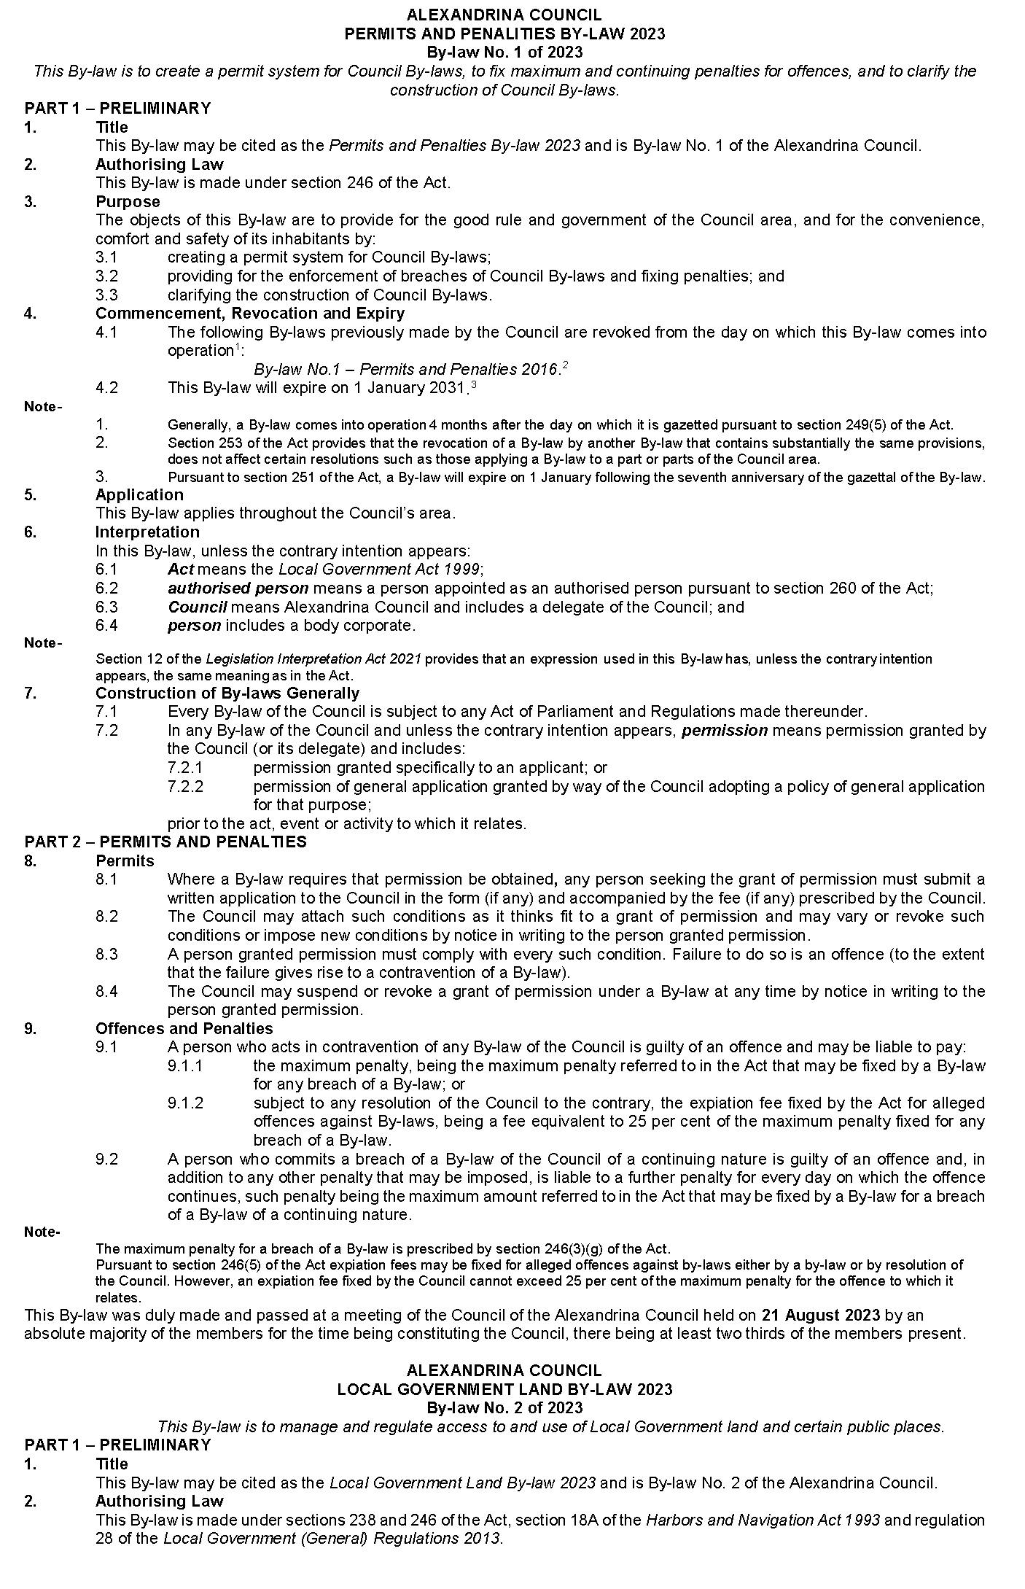
Alexandrina Council
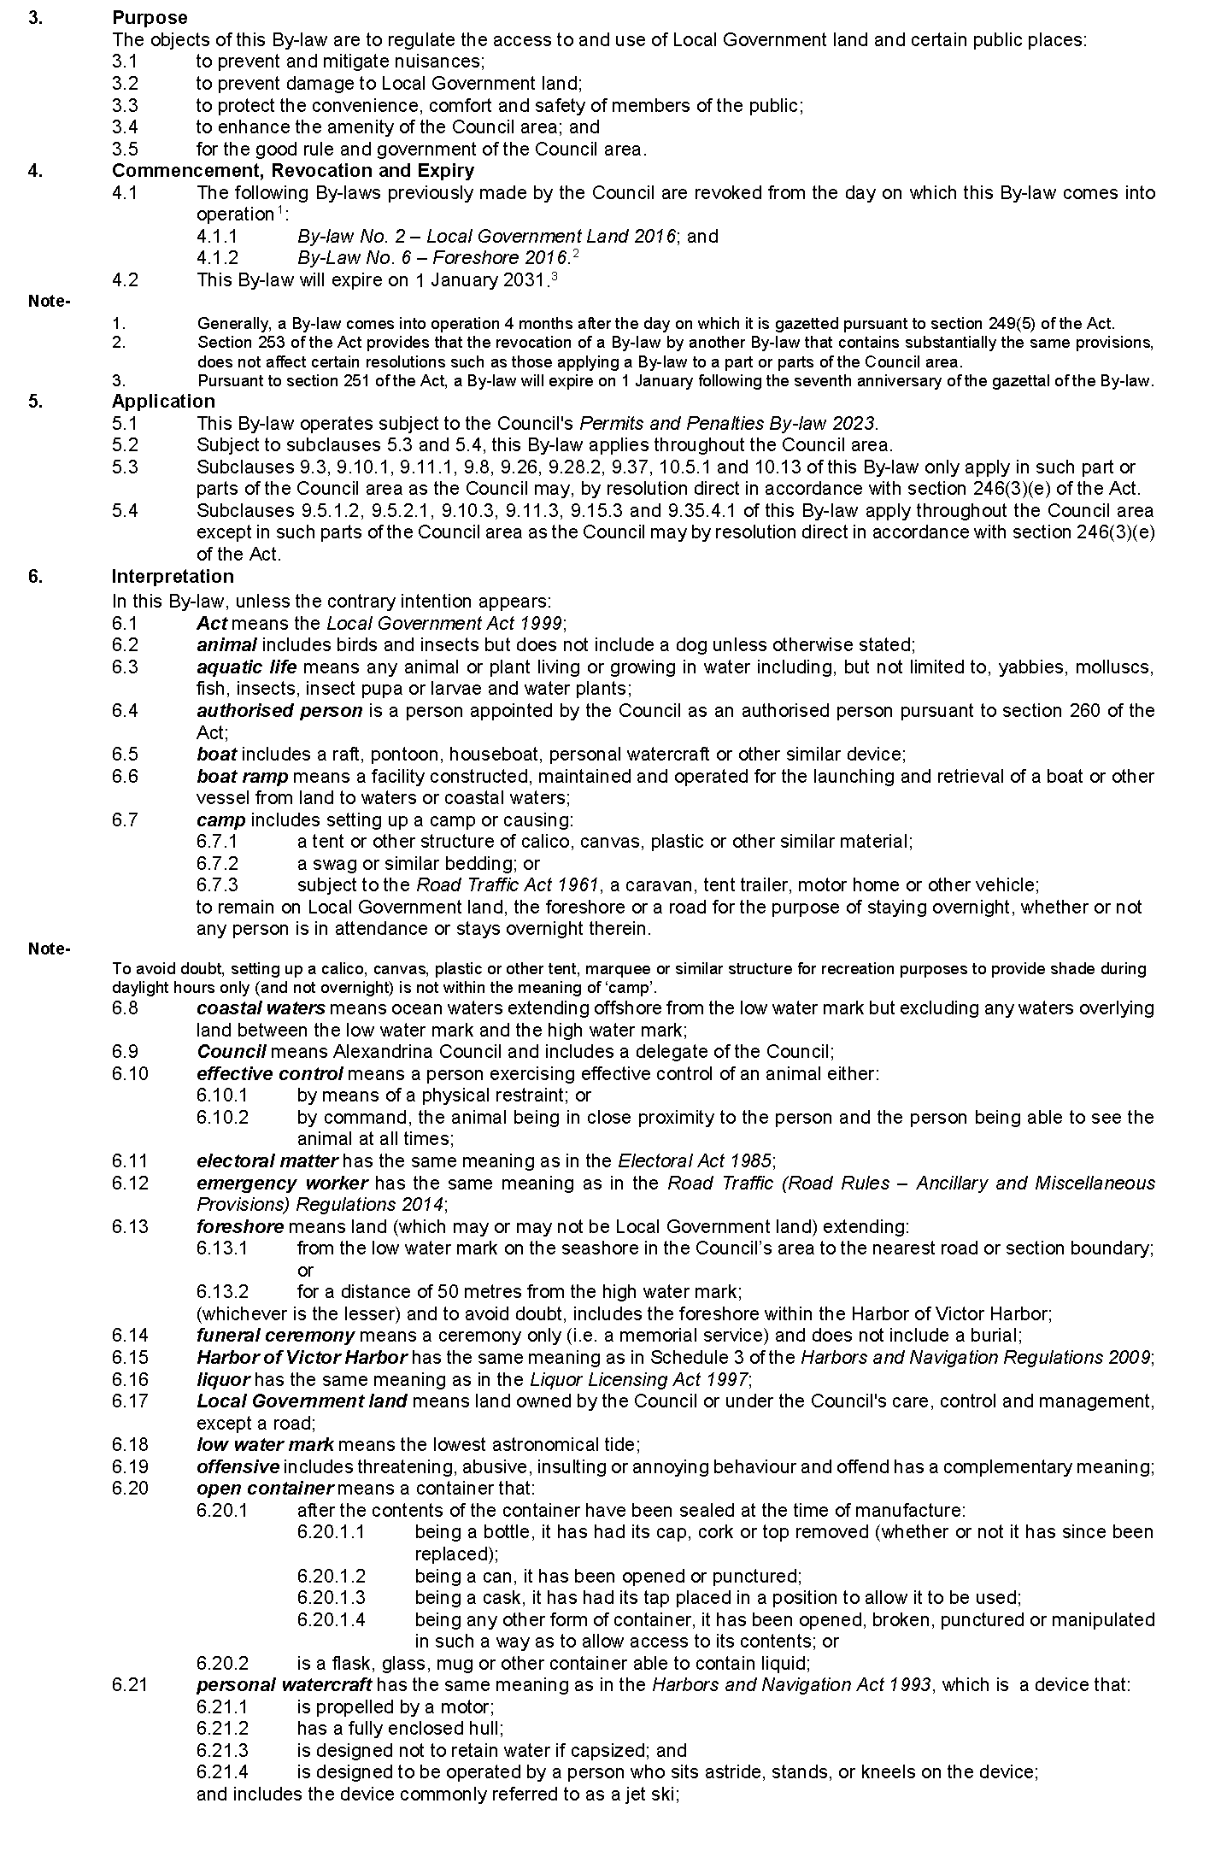
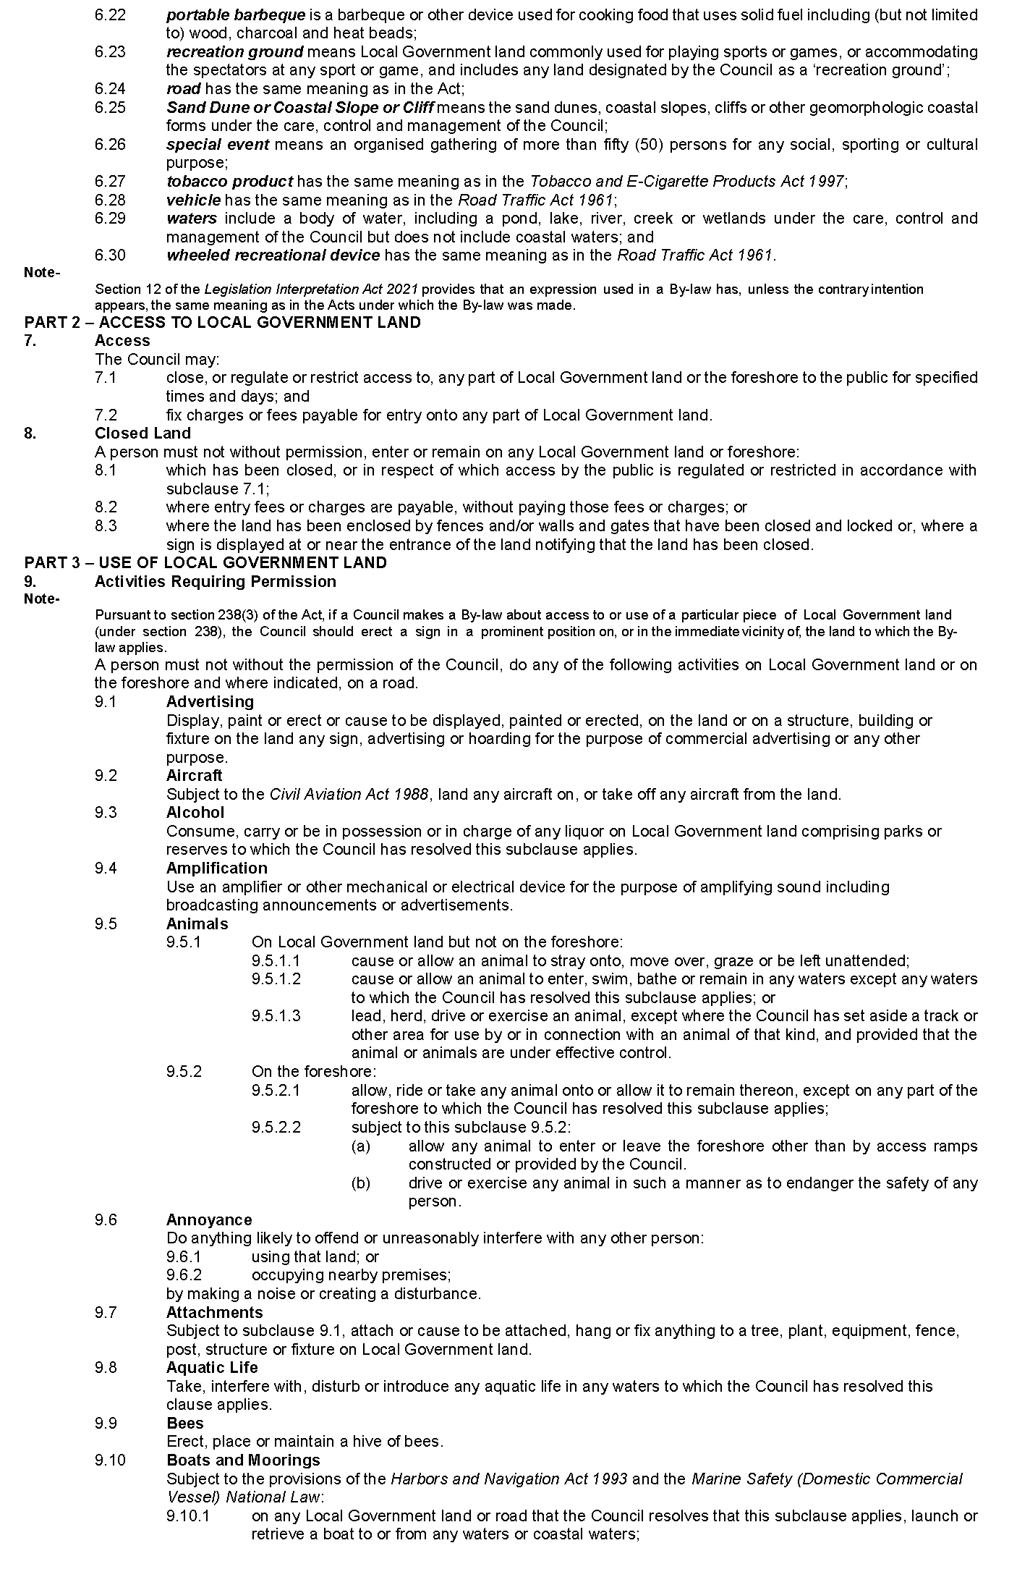
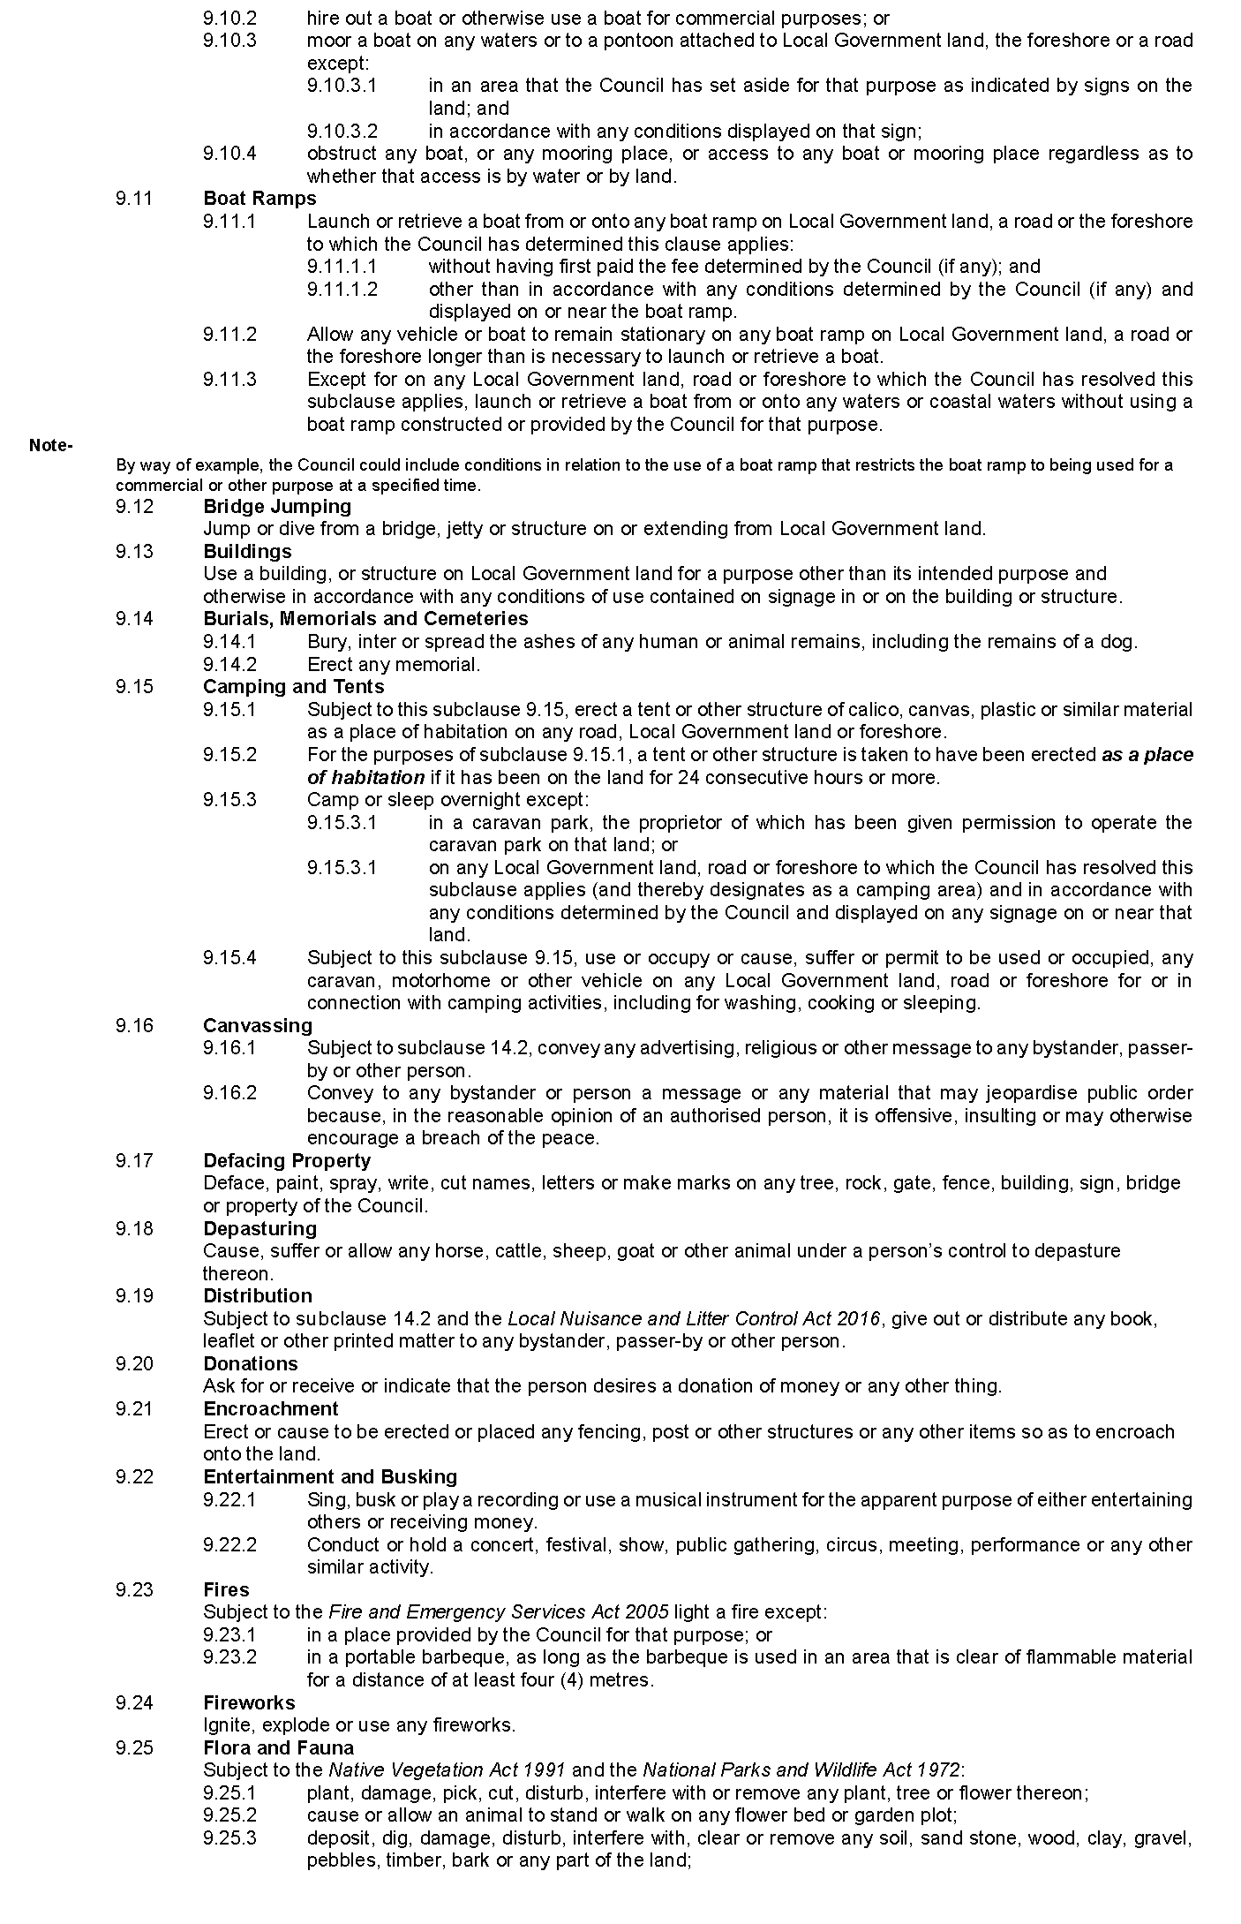
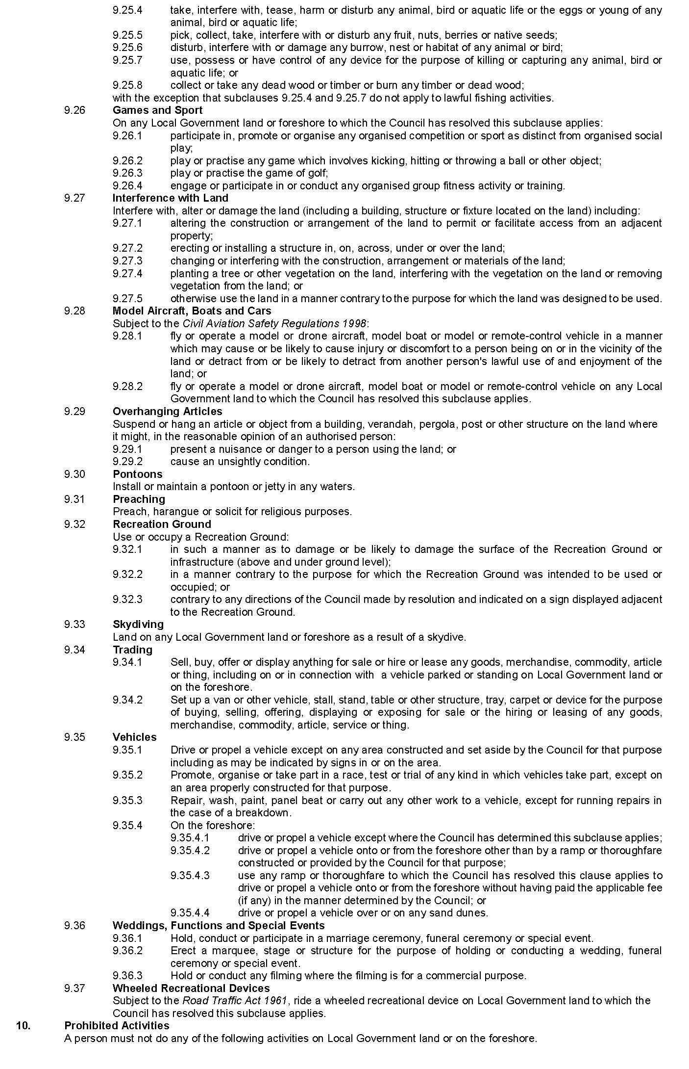
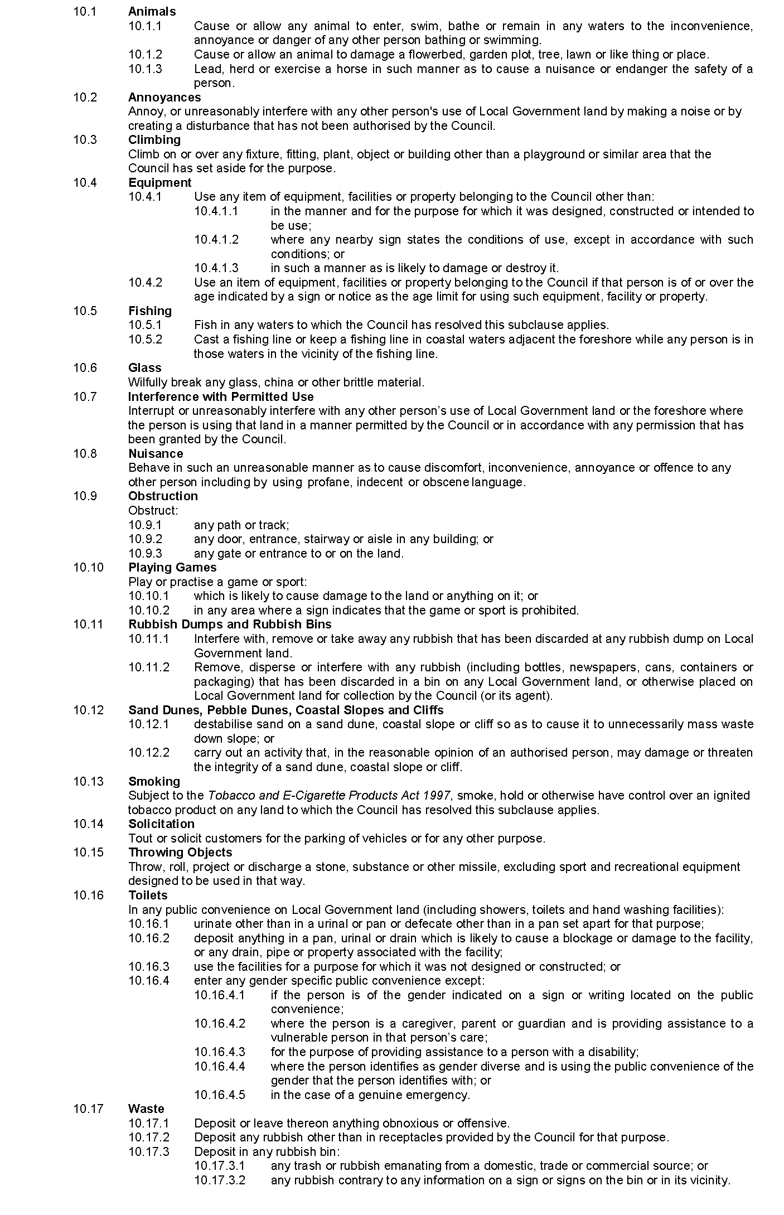
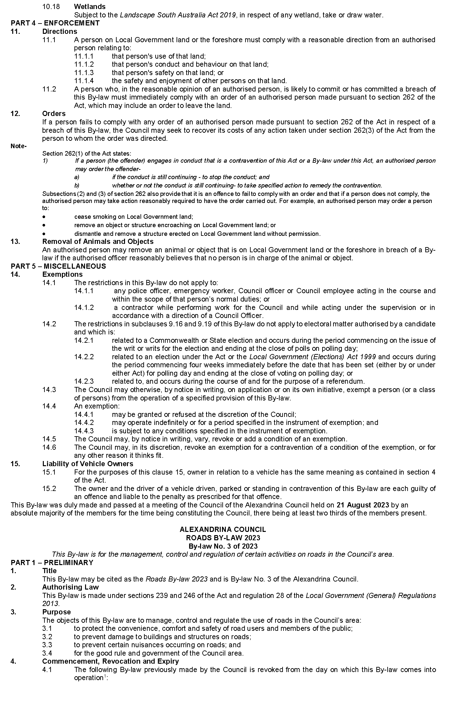
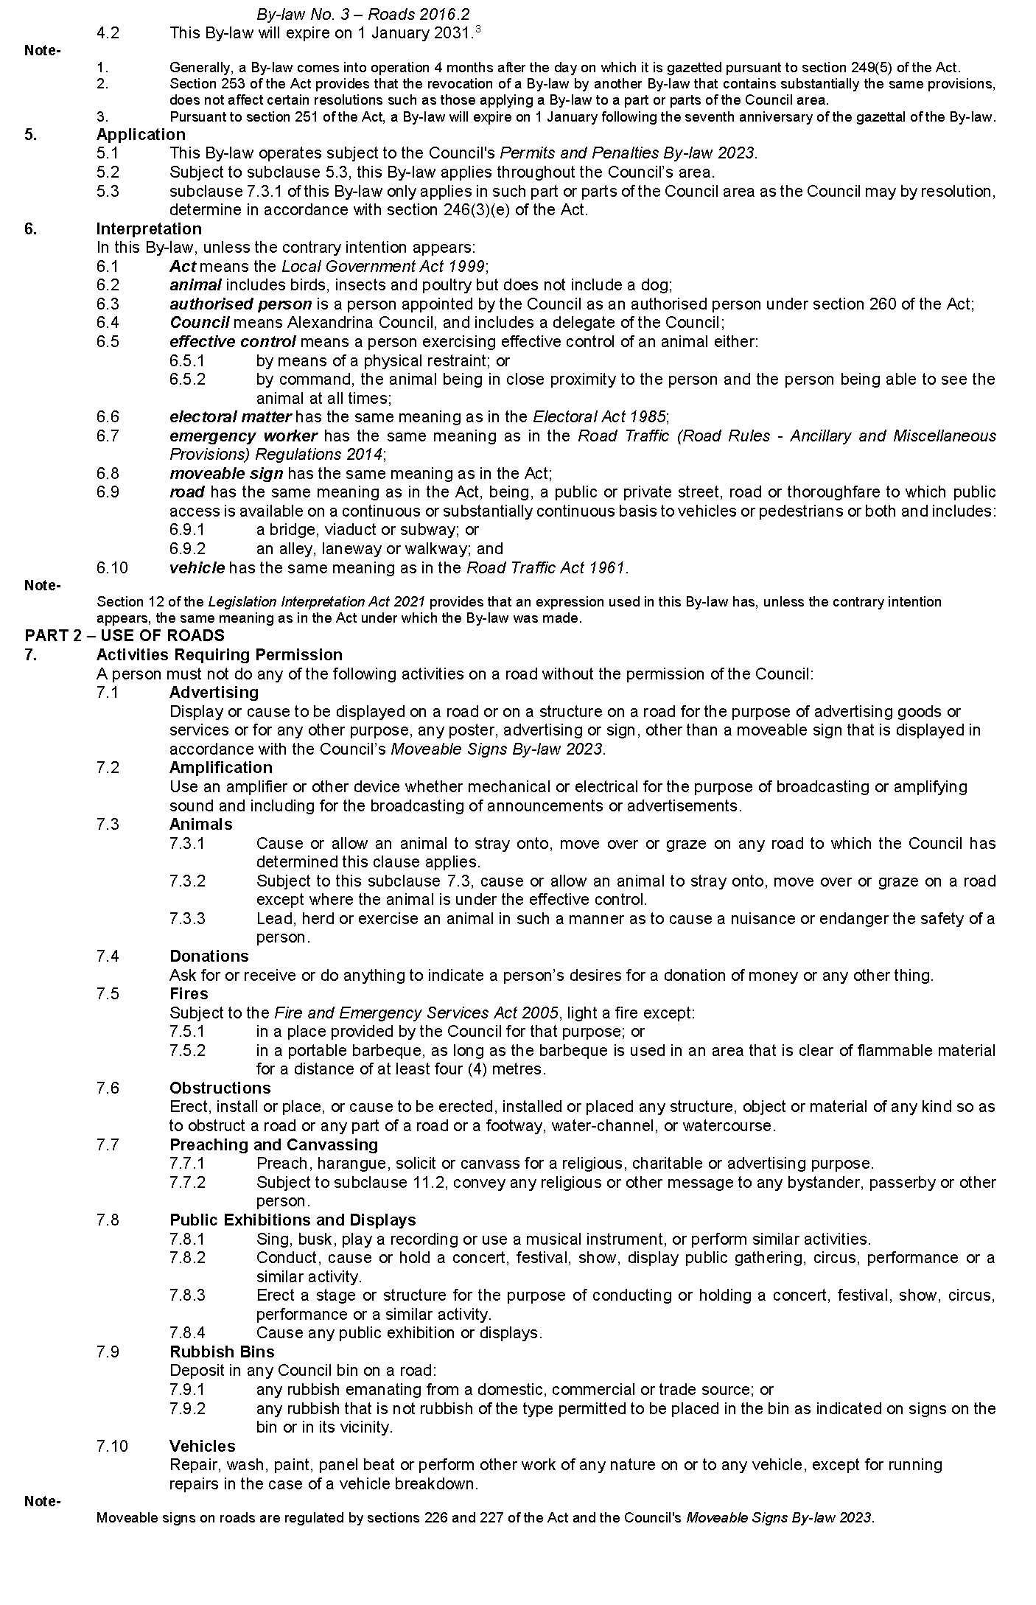
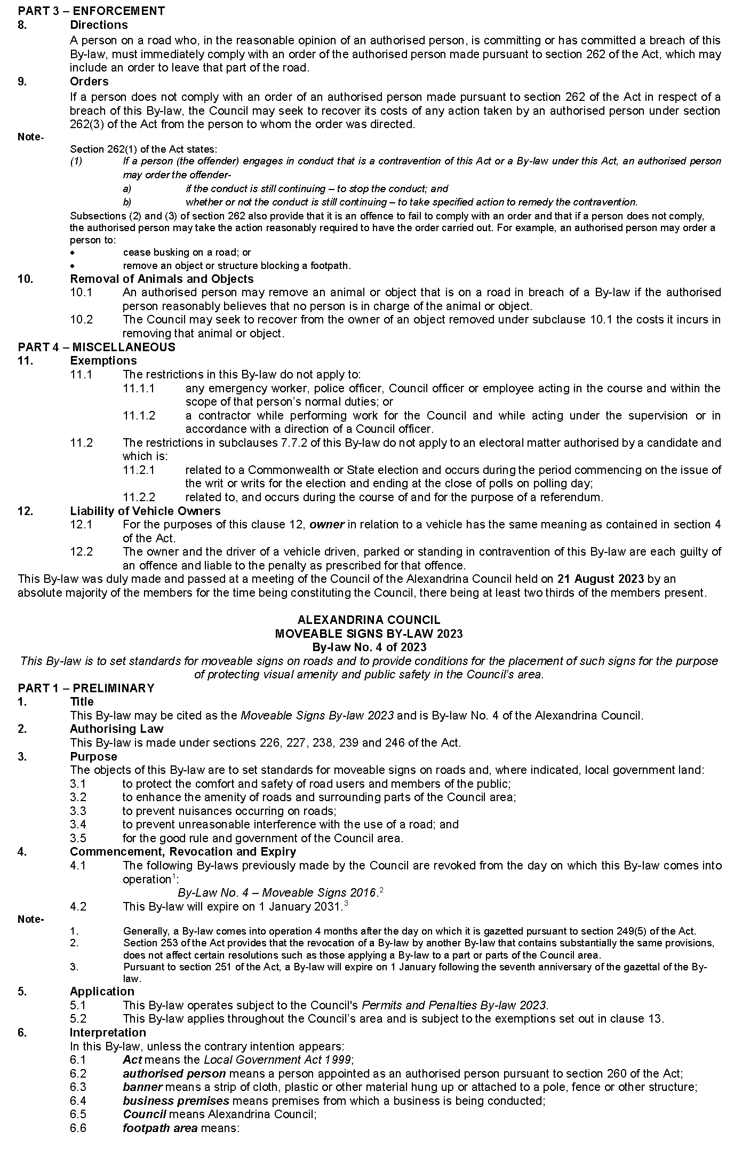
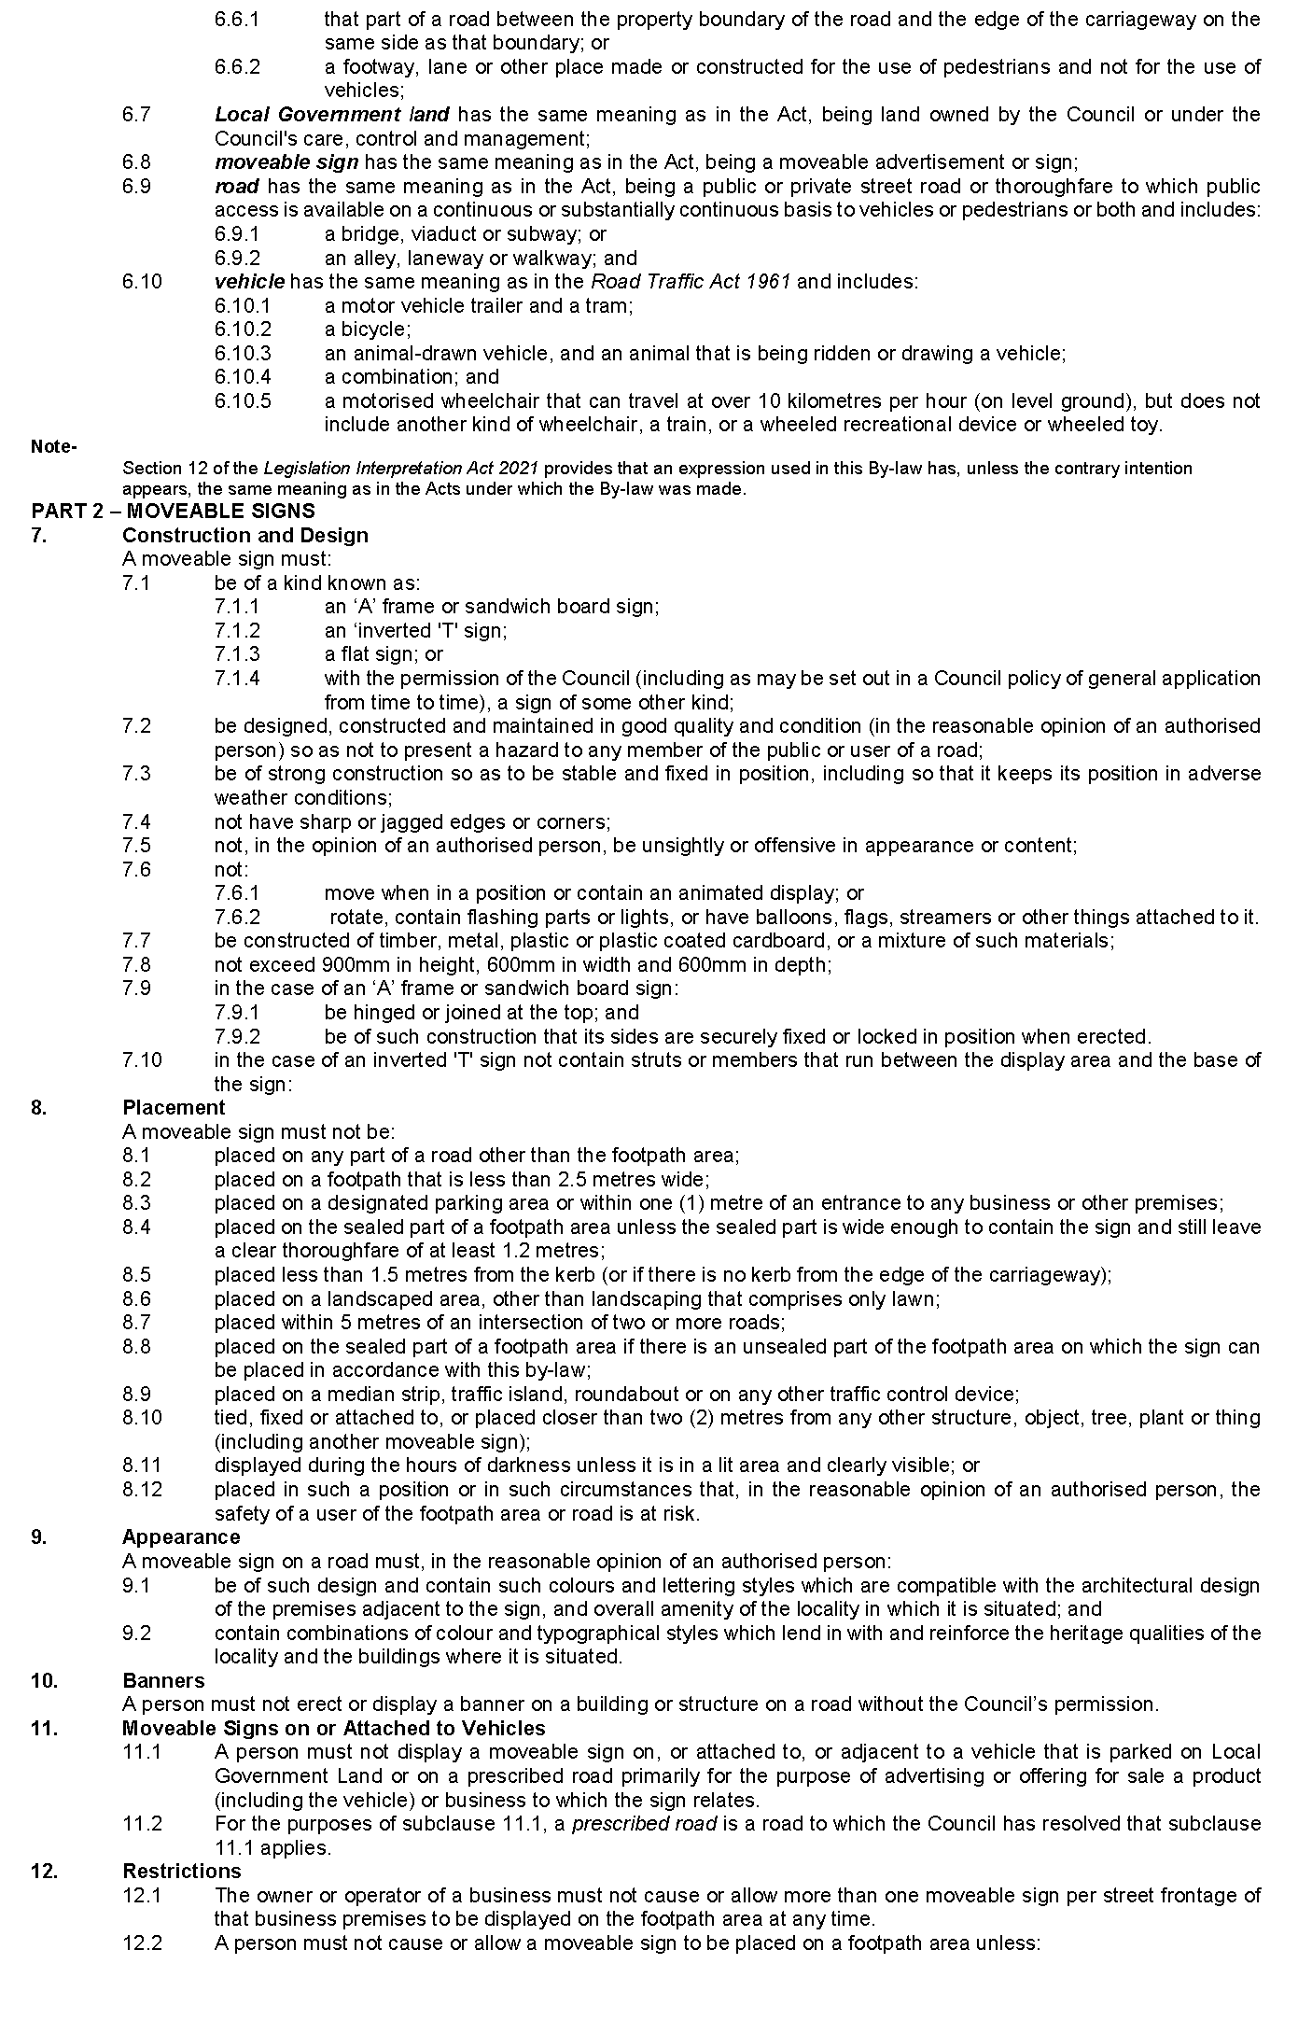
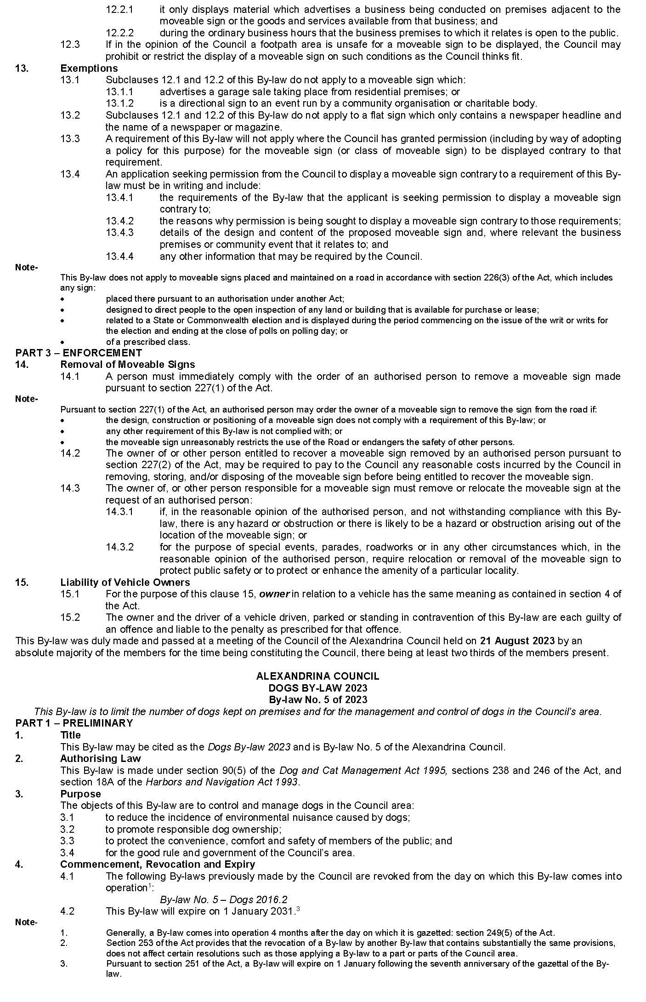
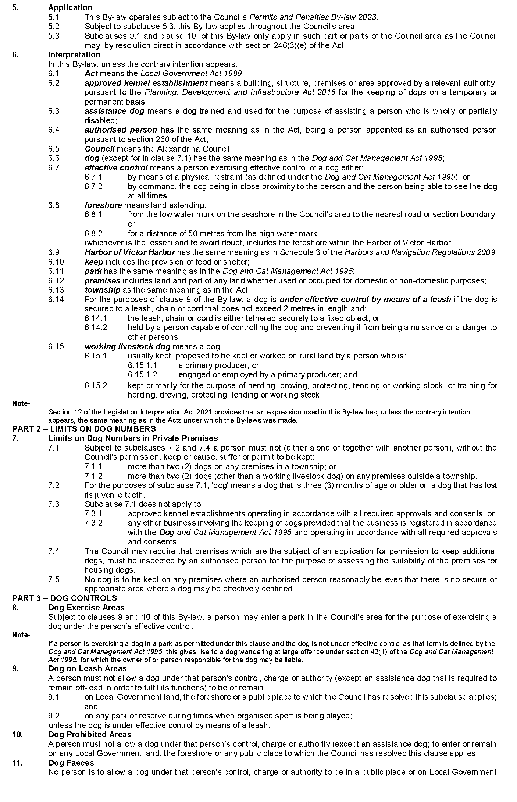
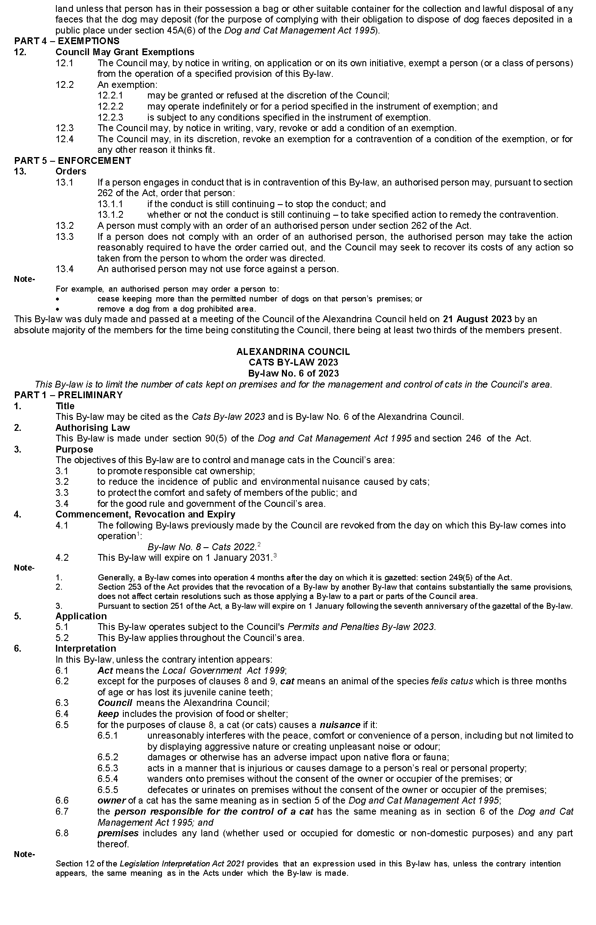
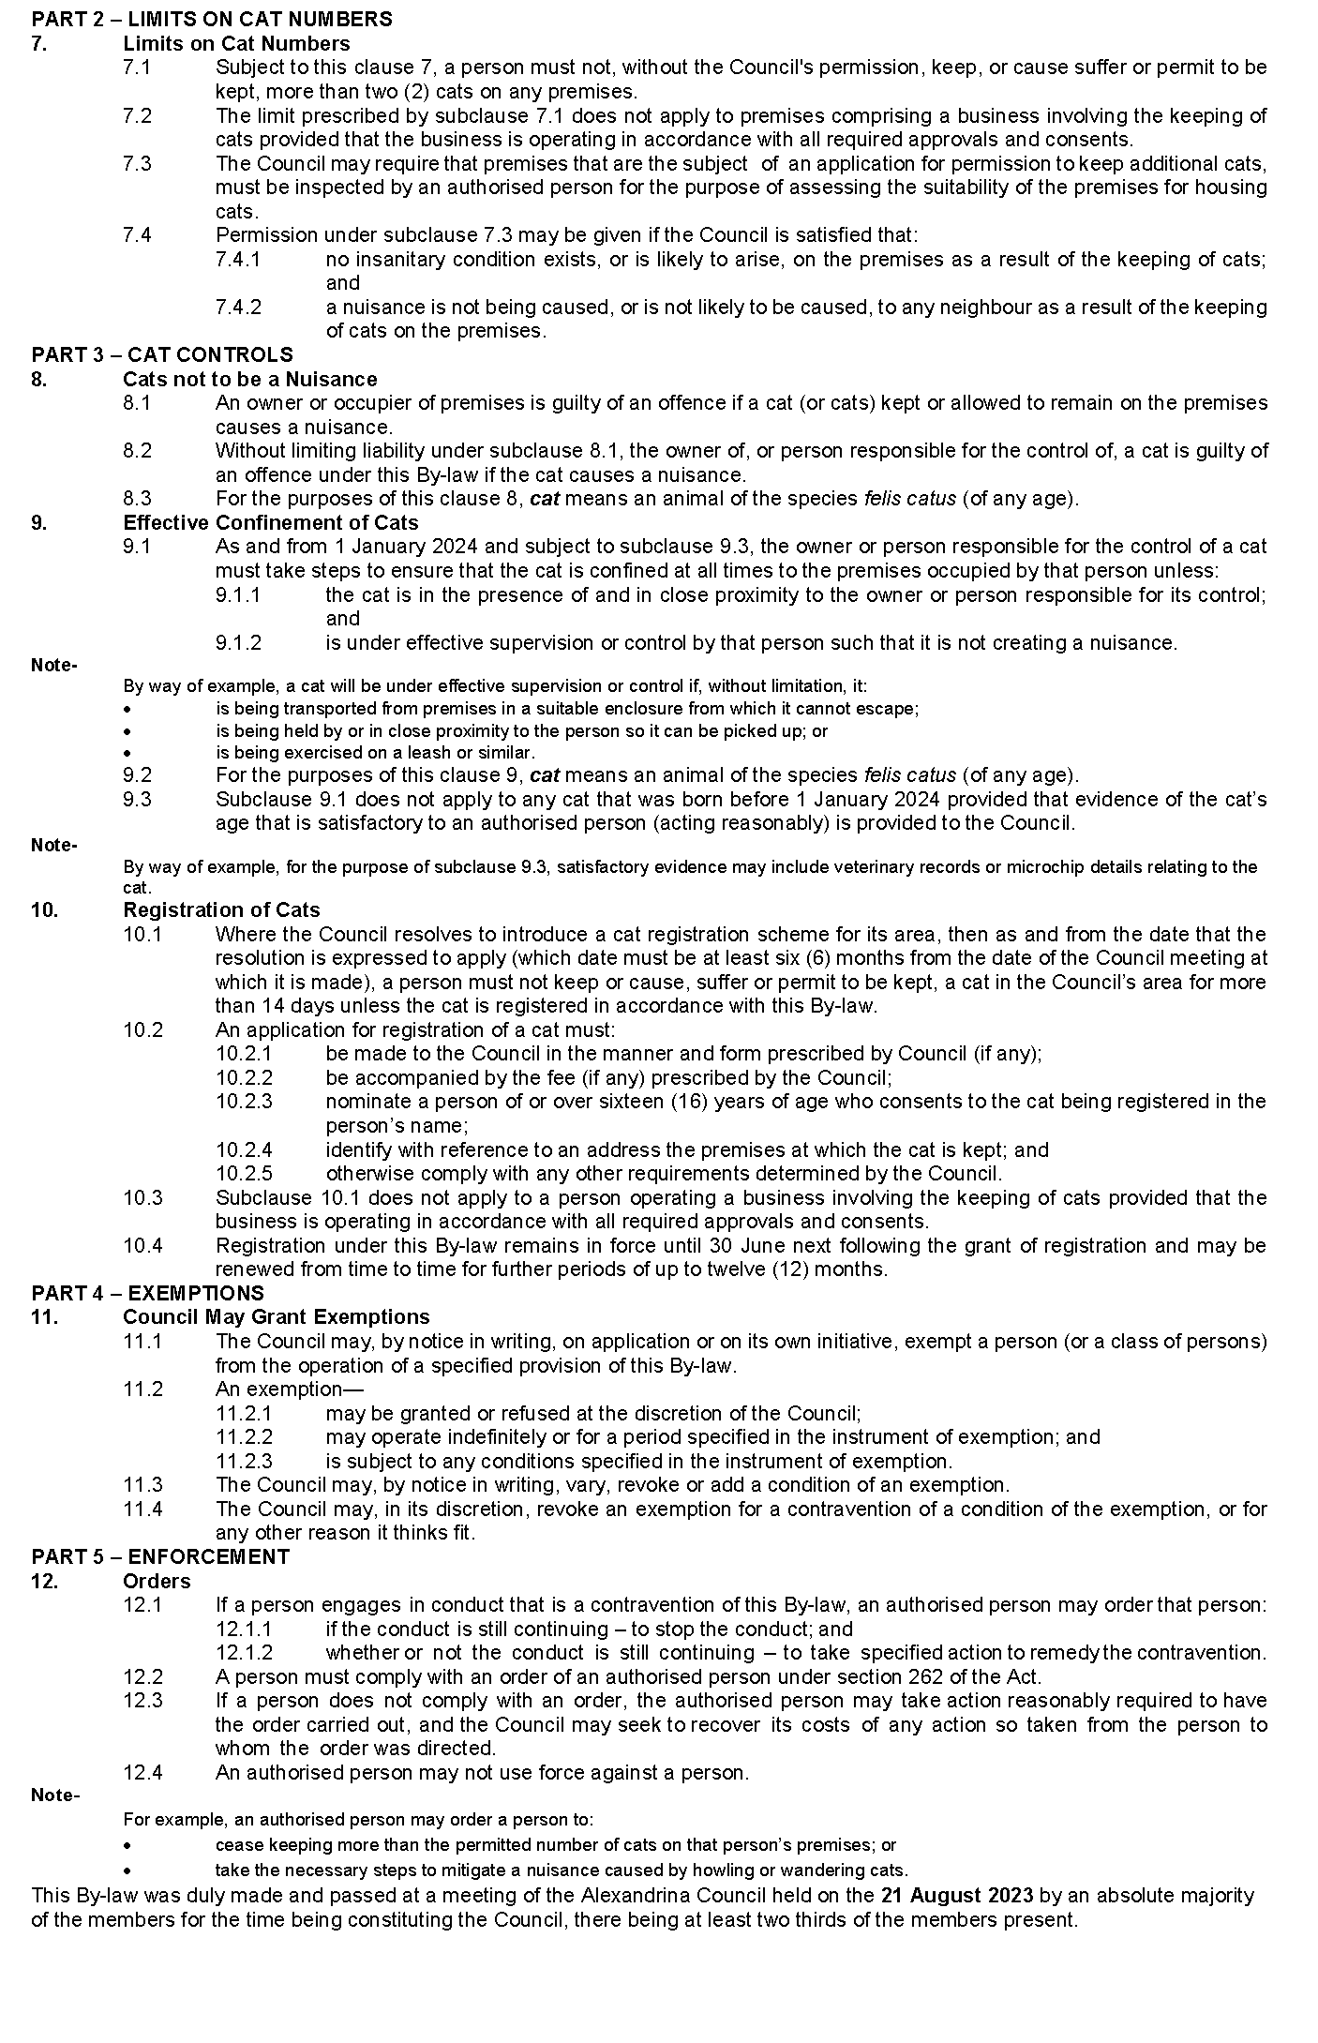

The Barossa Council
Local Government Act 1999
Dog and Cat Management Act 1995
By-law No. 8 of 2023—Dogs (Miscellaneous) Amendment By-Law 2023
To amend the Council’s Dogs By-law 2021 and for related purposes.
Part 1—Preliminary
1. Short title
This by-law may be cited as the Dogs (Miscellaneous) Amendment By-law 2023.
2. Commencement
This by-law will come into operation four months after the day on which it is published in the Gazette in accordance with Section 249(5) of the Local Government Act 1999.
3. Amendment provisions
In this by-law, a provision under a heading referring to the amendment of a specified by-law amends the by-law so specified.
Part 2—Amendment of Dogs By-law 2021
4. Amendment of Paragraph 5
Paragraph 5.4—delete ‘within 5 meters of’ and substitute ‘in’.
5. Amendment of Paragraph 7
5.1 Paragraph 7, wherever occurring—delete ‘his or her’ and substitute ‘their’.
5.2 Paragraph 7.2—delete ‘he or she’ and substitute ‘the person’.
6. Amendment of Paragraph 8
Paragraph 8—delete ‘his or her’ and substitute ‘their’.
The foregoing by-law was duly made and passed at a meeting of The Barossa Council held on the 15th day of August 2023 by an absolute majority of the members for the time being constituting the Council, there being at least two-thirds of the members present.
Dated: 24 August 2023
Joanne Moen
Acting Chief Executive Officer

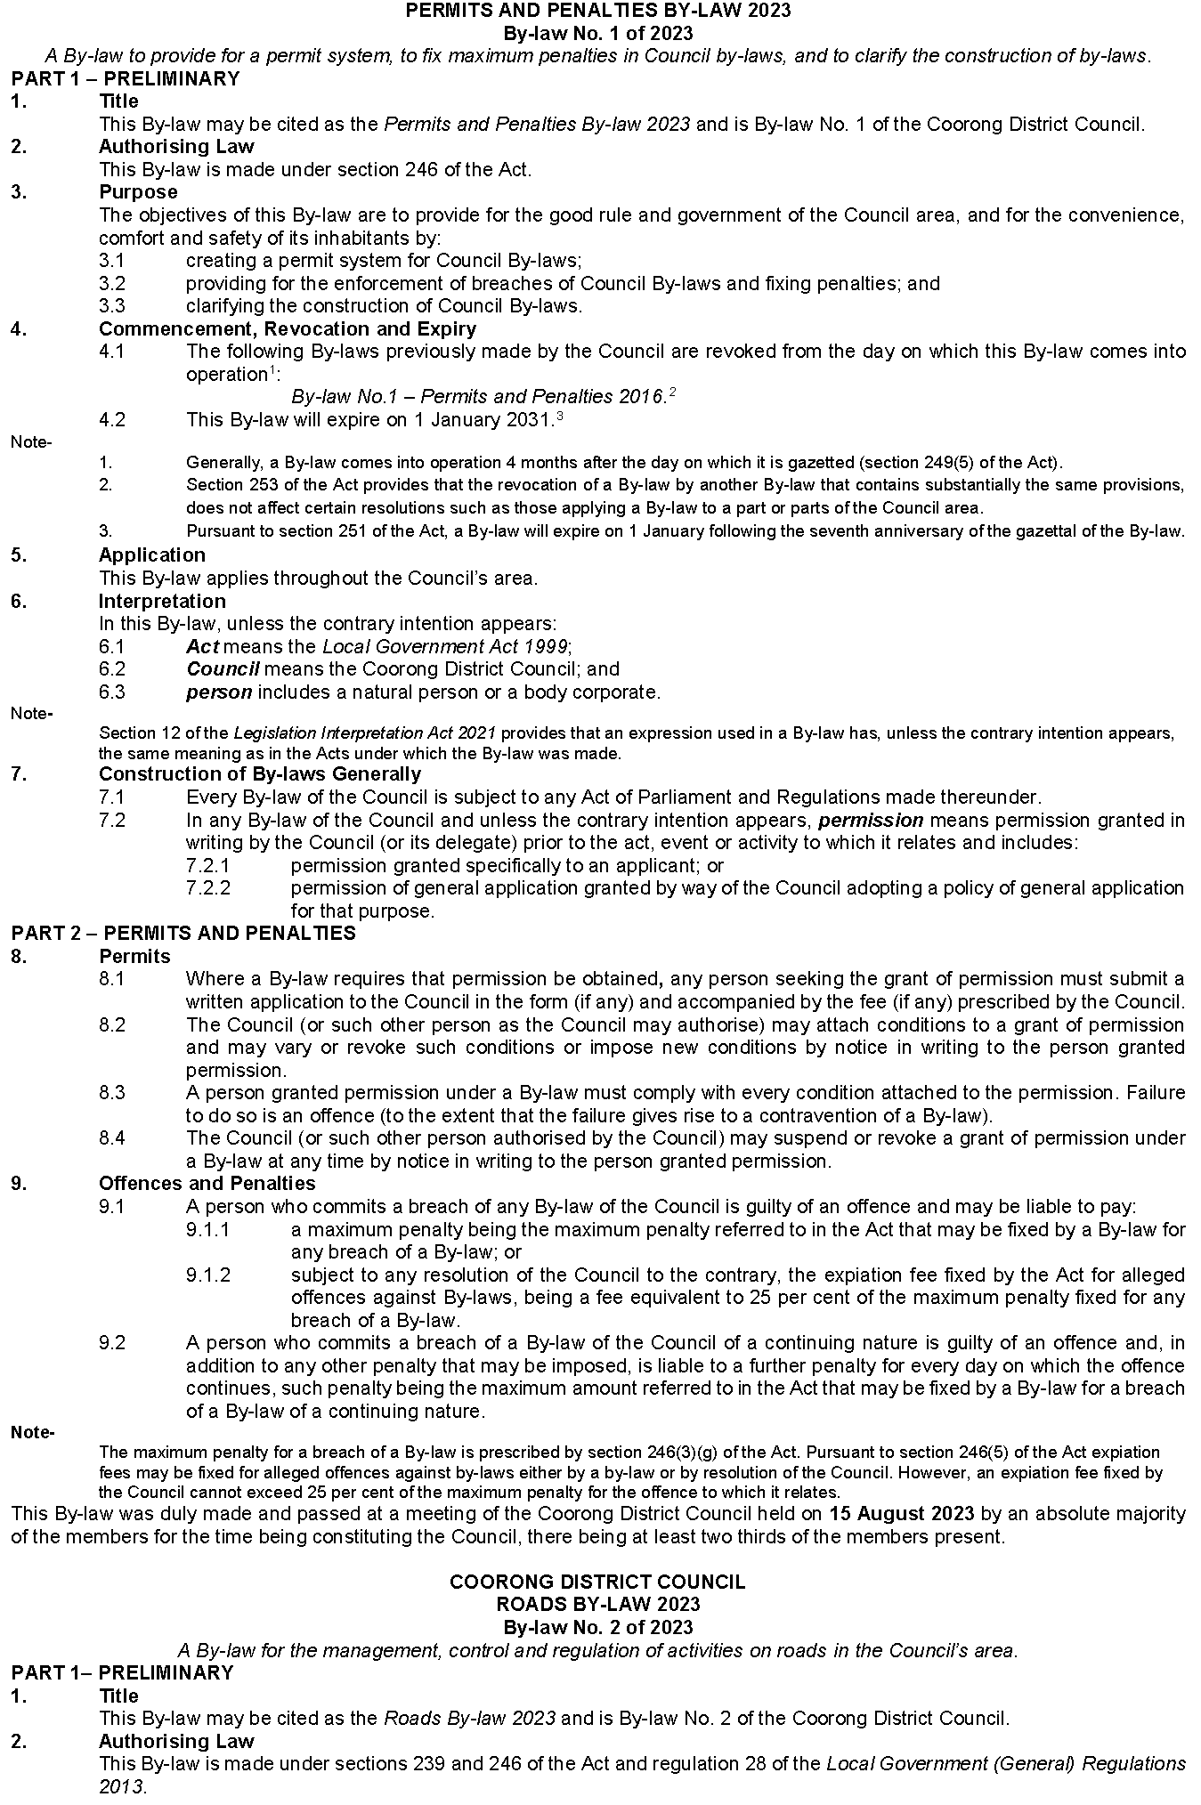
Coorong District Council

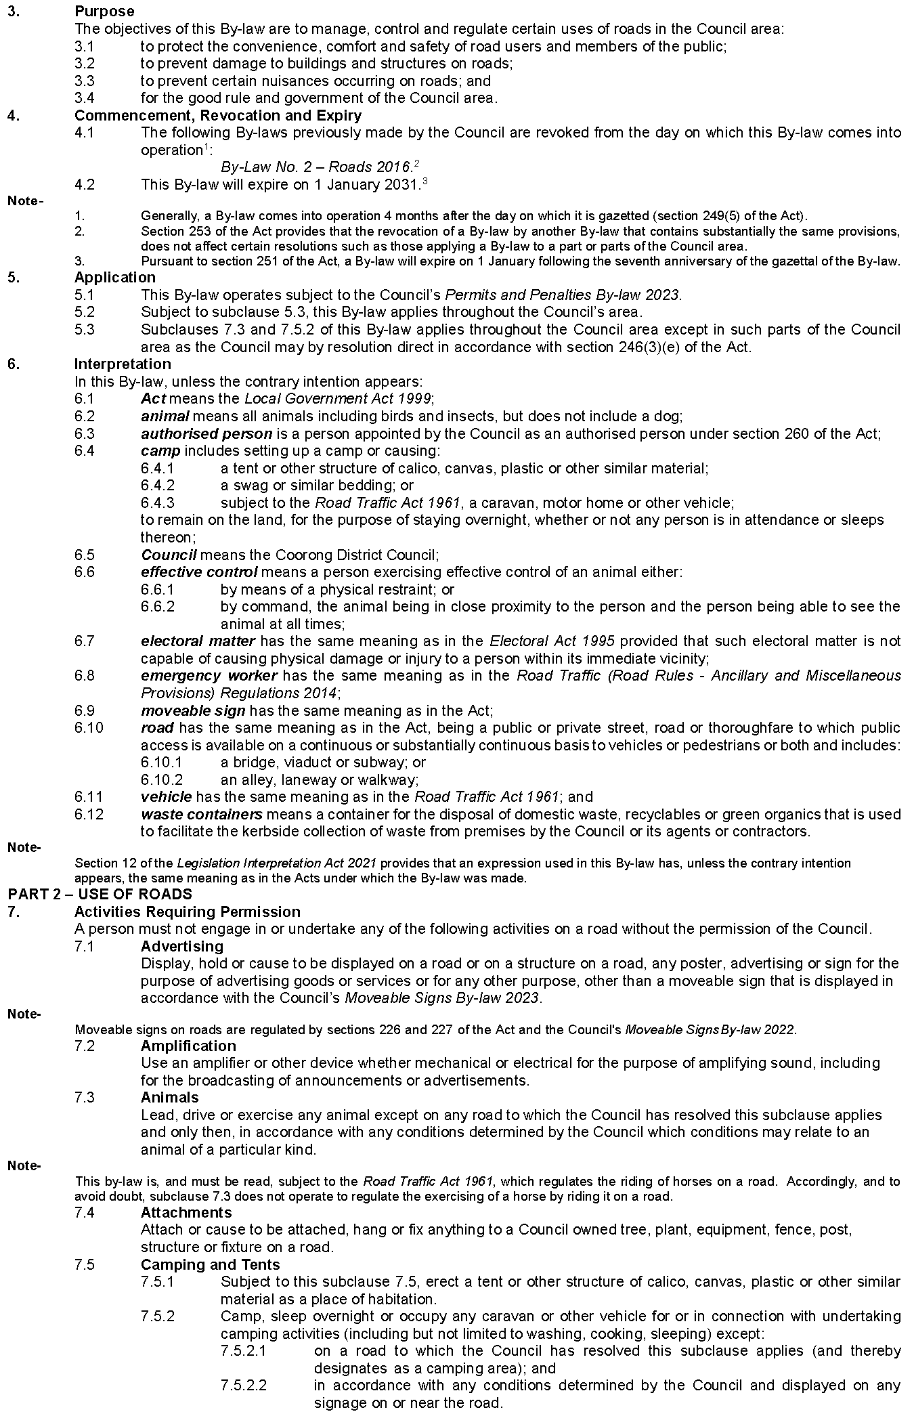
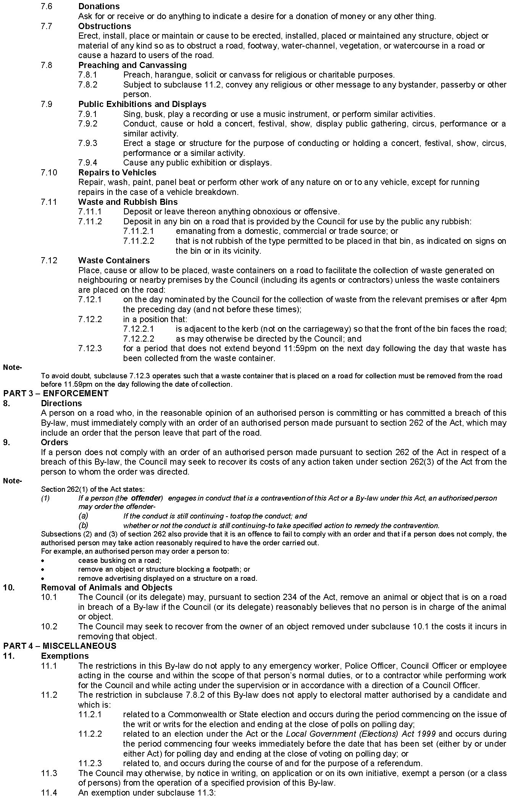
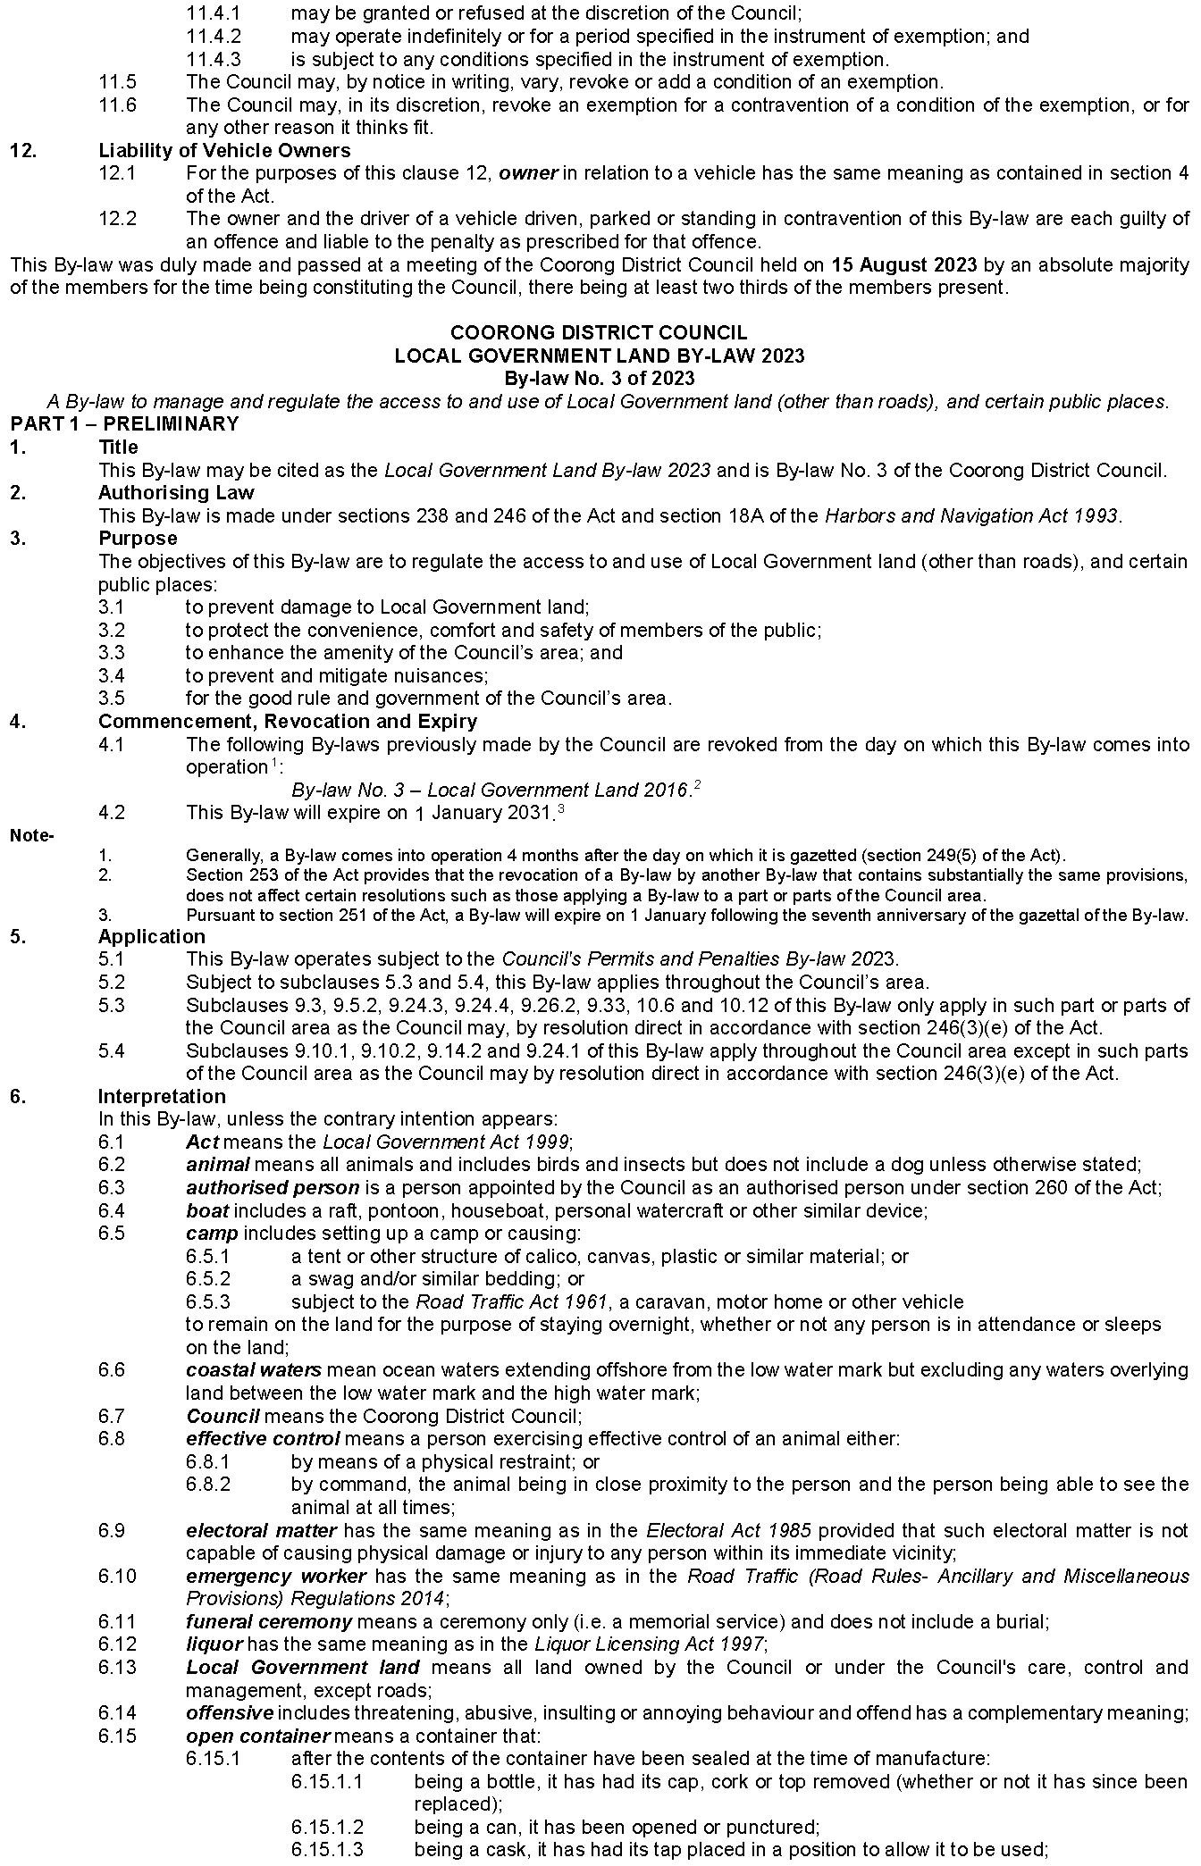
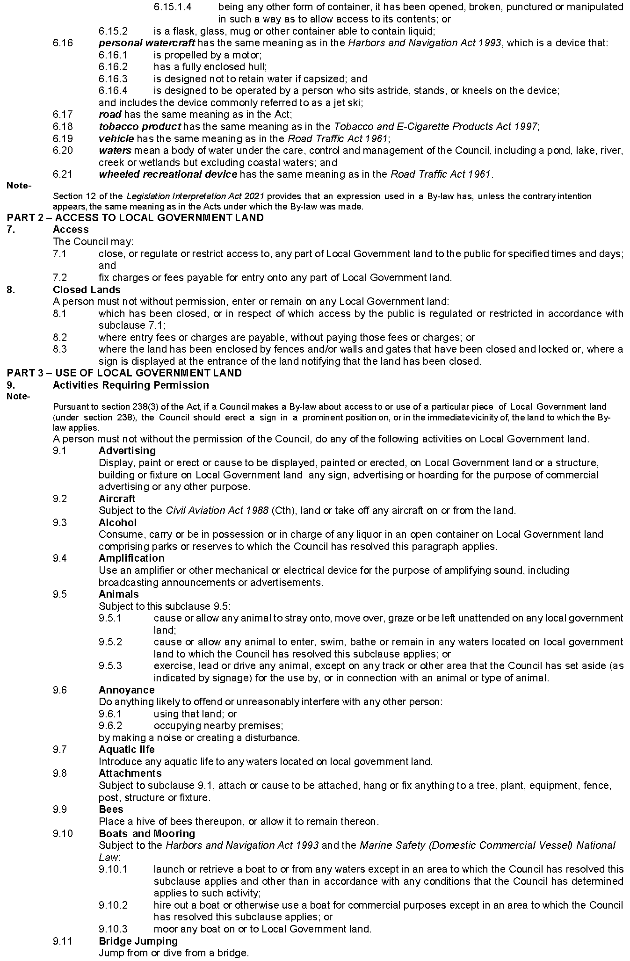
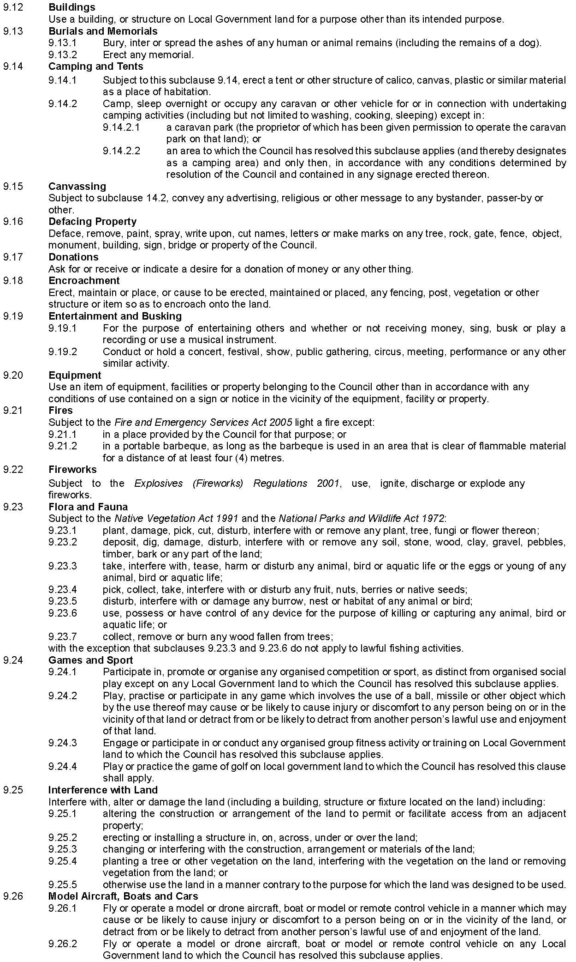
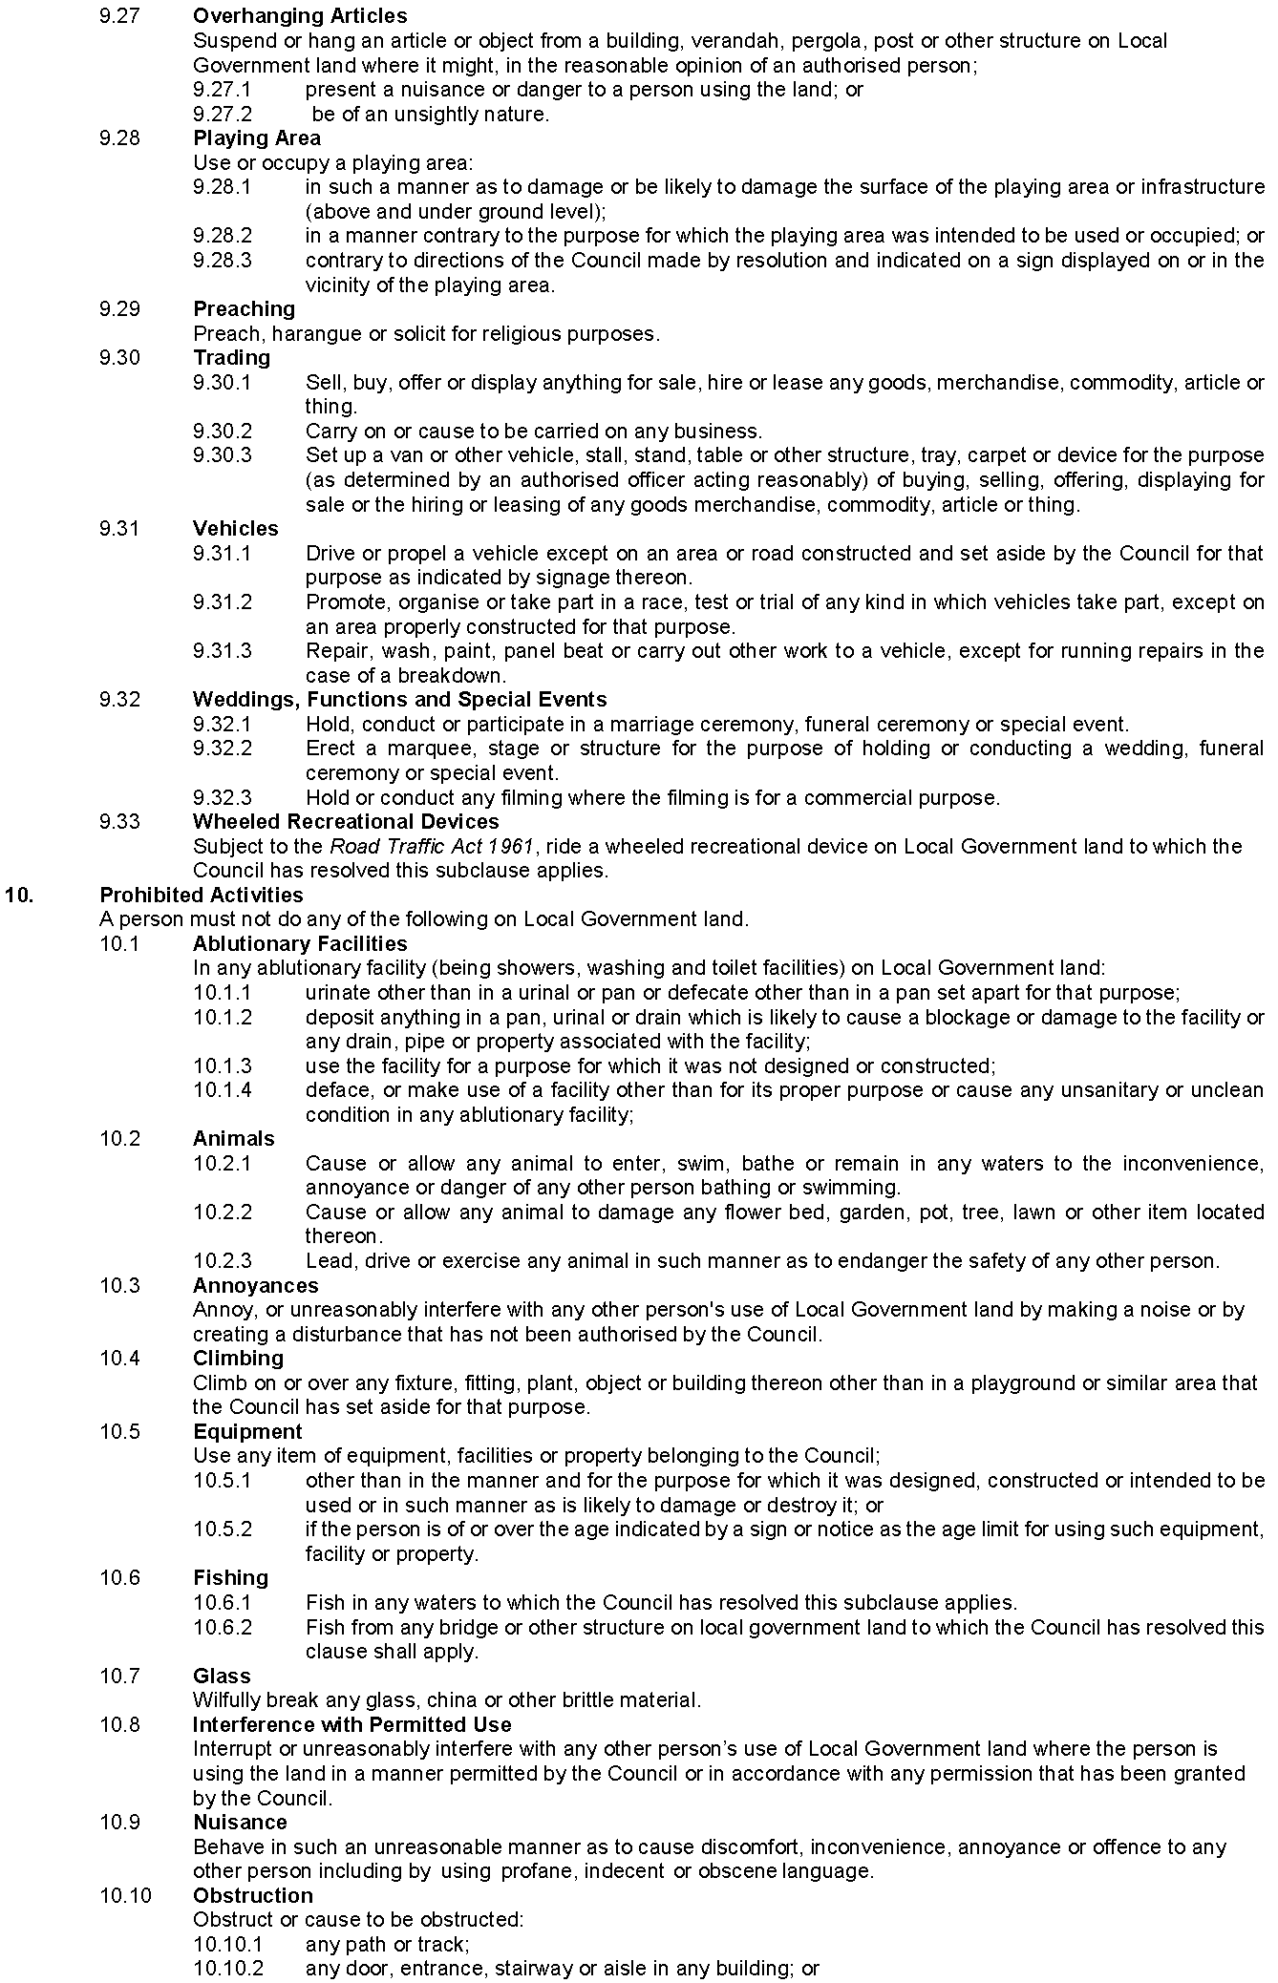
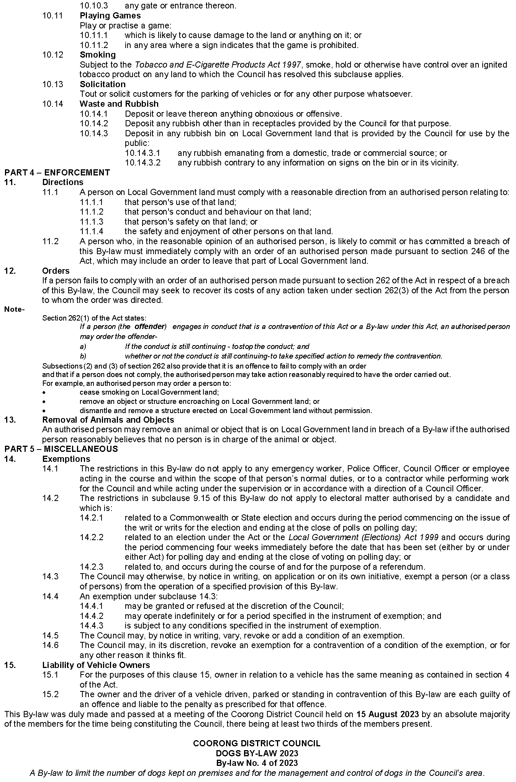
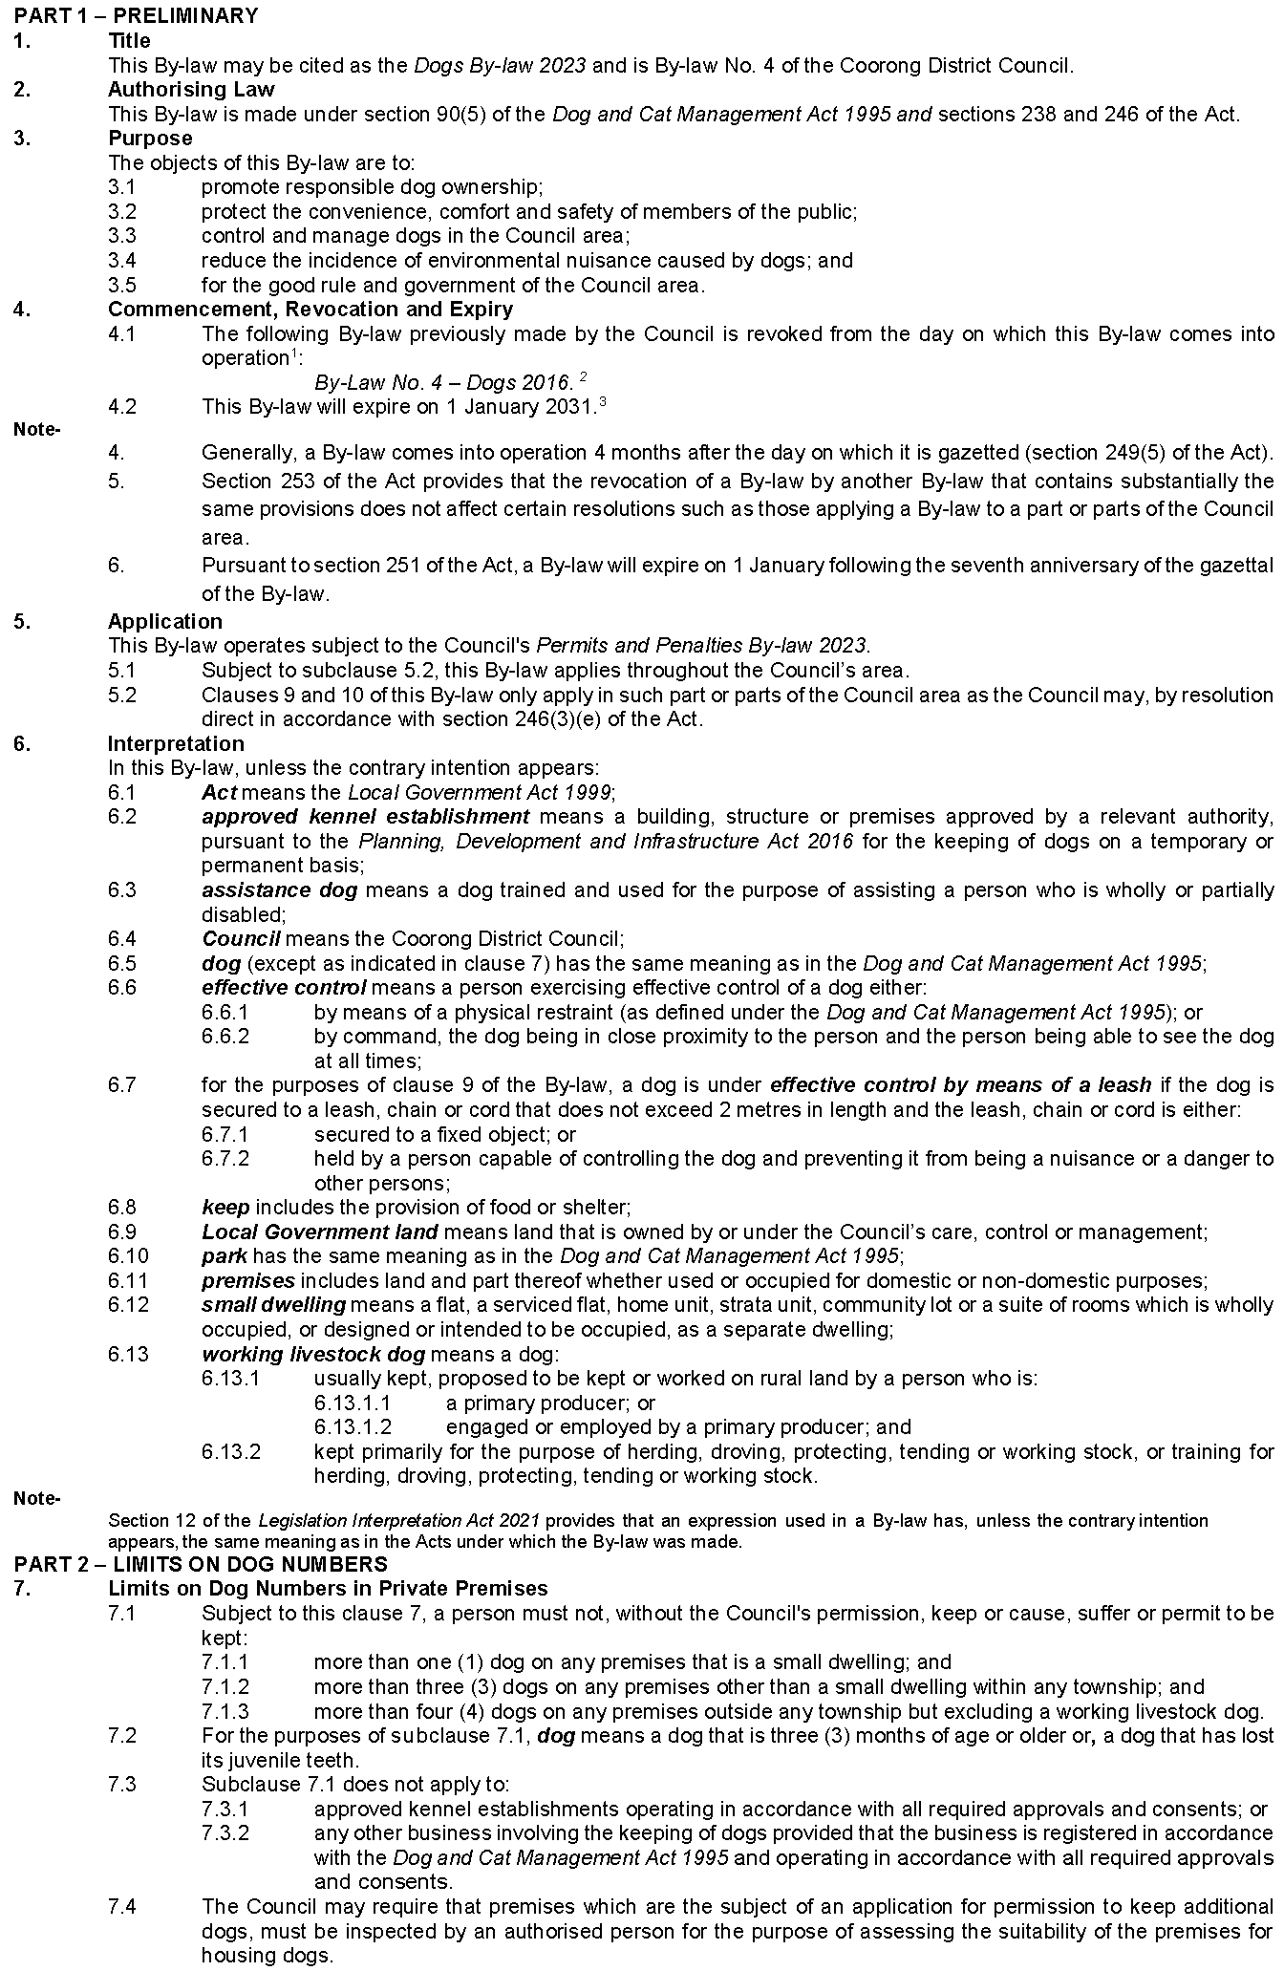
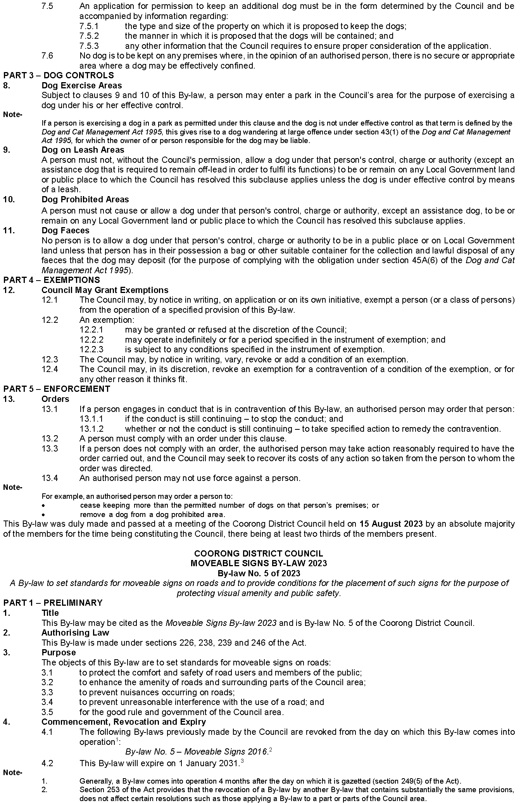
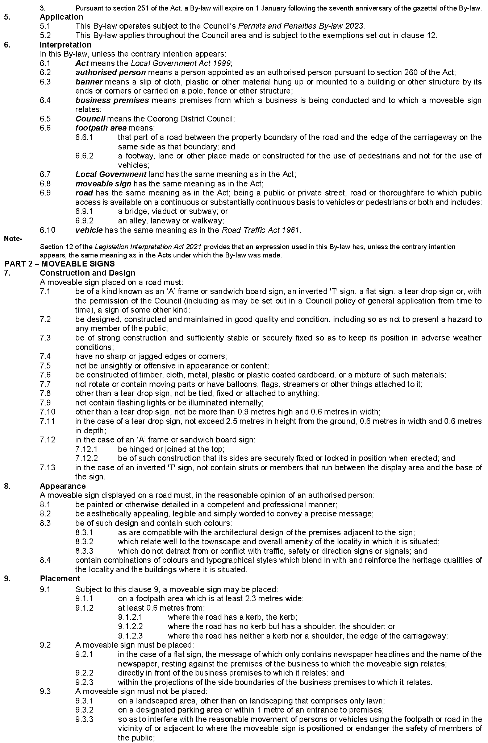
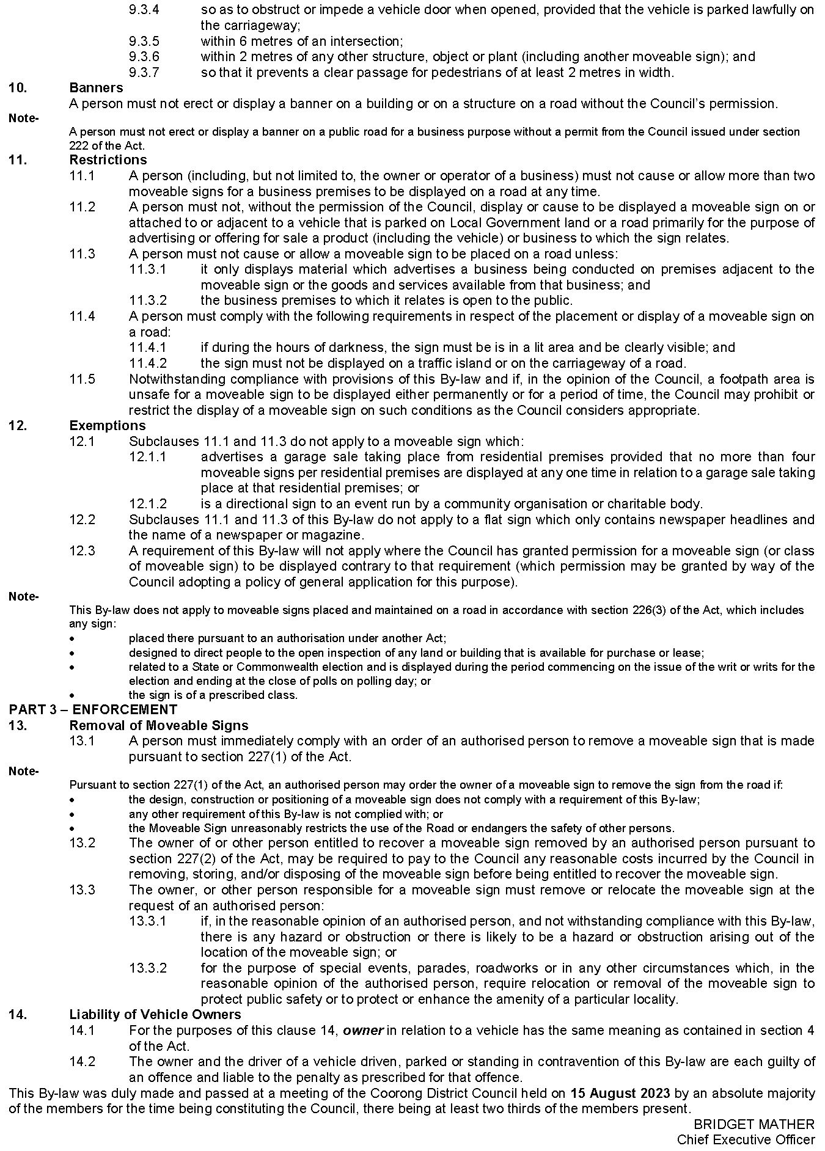

Lower Eyre Council
By-law No. 6 of 2019—Foreshores
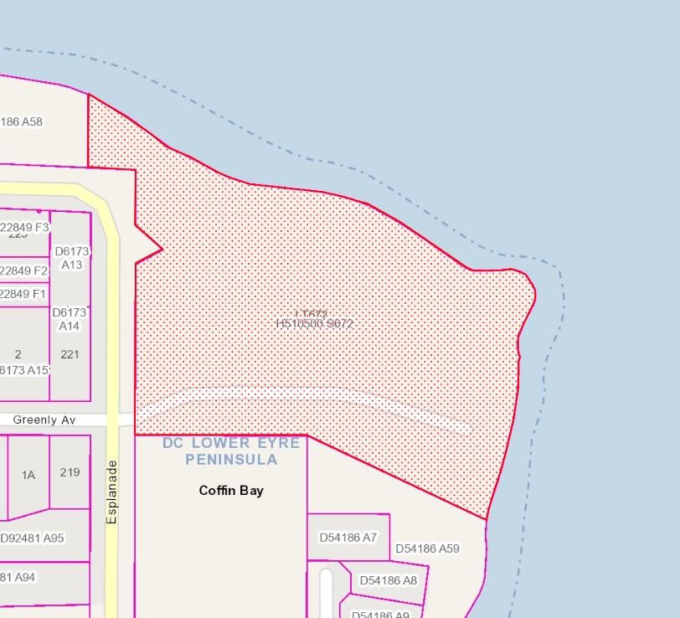
Notice is hereby given that pursuant to Council By-law Number: 6—Foreshores (2019), Clause 7.6.1 hereby applies to the Coffin Bay Boat Ramp (Section 672 in HP 510500, Hundred of Lake Wangary CR6116/786) as identified in the drawing below, effective as and from 4 September 2023:
Dated: 18 August 2023
Delfina Lanzilli
Chief Executive Officer

Port Pirie Regional Council
Roads (Opening and Closing) Act 1991
Road Closings—Public Roads, Nelshaby/Telowie/Napperby
Notice is hereby given, pursuant to Section 10 of the Roads (Opening and Closing) Act 1991 that the Port Pirie Regional Council proposes to make a Road Process Order to close and vest in the Crown the un-made Public Road adjoining Sections 3,322-329, 347, 392 in the Hundred of Napperby, Section 515 in the Hundred of Telowie, allotment 4 in D30142, more particularly delineated and lettered ‘A’ and ‘B’ on Preliminary Plan 23/0020.
The Preliminary Plan and statement of persons affected is available for public inspection at the offices of the Port Pirie Regional Council, 115 Ellen Street, Port Pirie, and the Adelaide Office of the Surveyor-General located at Level 10, 83 Pirie Street Adelaide, during normal office hours. The Preliminary Plan can also be viewed at www.sa.gov.au/roadsactproposals.
Any application for easement or objection must set out the full name, address and details of the submission and must be fully supported by reasons. The application for easement or objection must be made in writing to the Council, PO Box 45, Port Pirie SA 5540, or council@pirie.sa.gov.au WITHIN 28 DAYS OF THIS NOTICE, and a copy must be forwarded to the Surveyor-General at GPO Box 1815, Adelaide SA 5001. Where a submission is made, the applicant must be prepared to support their submission in person upon council giving notification of a meeting at which the matter will be considered.
Dated: 24 August 2023
Peter Ackland
Chief Executive Officer

Renmark Paringa Council
Roads (Opening and Closing) Act 1991
Road Closure—Government Road, Renmark West
Notice is hereby given, pursuant to Section 10 of the Roads (Opening and Closing) Act 1991, that the Renmark Paringa Council proposes to make a Road Process Order to close and sell to the adjoining landowner the whole of the public road adjoining Allotment 426 in F177632 and Allotment 425 in F177631 more particularly delineated and lettered ‘A’ and ‘B’ respectively in Preliminary Plan 23/0016.
The Preliminary Plan and Statement of Persons Affected is available for public inspection at the office of the Renmark Paringa Council, 61 Eighteenth Street, Renmark, and the Adelaide Office of the Surveyor General, during normal office hours. The Preliminary Plan can also be viewed at http://www.sa.gov.au/roadsactproposals.
Any application for easement or objection must set out the full name, address and details of the submission and must be fully supported by reasons. The application for easement or objection must be made in writing to the Renmark Paringa Council, PO Box 730, Renmark SA 5341, WITHIN 28 DAYS OF THIS NOTICE, and a copy must be forwarded to the Surveyor General at GPO Box 1354, Adelaide SA 5001.
Where an objection is made, the Council will give notification of a meeting at which the matter will be considered.
Dated: 24 August 2023
Tony Siviour
Chief Executive Officer

Municipal Council of Roxby Downs
Adoption of Valuations and Declaration of Rates 2023-2024
Notice is hereby given that the Municipal Council of Roxby Downs at its meetings held on 9 August 2023 and 15 August 2023, resolved:
Adoption of Valuations
That pursuant to Section 12(6)(b) of the Roxby Downs (Indenture Ratification) Act 1982 and Section 167(2)(a) of the Local Government Act 1999 the Council adopted for rating purposes the most recent capital valuations available to the Council made by the Valuer-General within Council’s area totalling $561,486,400.00 of which $498,480,158.00 represents rateable land.
Declaration of Differential General Rates
That pursuant to Sections 152(1)(c) and 153(1)(b) of the Local Government Act 1999 a general rate is declared for the year ending 30 June 2024 which consists of two components, one being a fixed charge and the other being a differential rate based on the value of the land the subject to the rate, as more particularly described below:
First Component—Fixed Charge
The Council imposed a fixed charge of $765.00 in respect of each separate piece of rateable land in the Council area for the year ending 30 June 2024.
Second Component—Differential rate based on the value of the land
The Council imposed a differential rate based on the value of the land, varying according to the use of land as follows:
i. Residential—a differential rate of 0.60365 cents in the dollar of the capital value of the land
ii. Commercial Shops—a differential rate of 1.80492 cents in the dollar of the capital value of the land
iii. Commercial Office—a differential rate of 2.26973 cents in the dollar of the capital value of the land
iv. Commercial Other—a differential rate of 2.06449 cents in the dollar of the capital value of the land
v. Industrial Light—a differential rate of 1.41858 cents in the dollar of the capital value of the land
vi. Industrial Other—a differential rate of 0.99602 cents in the dollar of the capital value of the land
vii. Vacant Land—a differential rate of 1.84717 cents in the dollar of the capital value of the land
viii. Other—a differential rate of 1.00810 cents in the dollar of the capital value of the land
Declaration of Service Charge
That pursuant to Section 155 of the Local Government Act 1999 a service charge of $567.50 is imposed upon each separate piece of rateable land to which the Council provides or makes available a service for the collection, treatment, recycling, and disposal of domestic waste (excluding organics), on the basis that the sliding scale provided for in Regulation 13 of the Local Government (General) Regulations 2013 will be applied to reduce the service charge payable, as prescribed.
In accordance with Section 155(3)(b) of the Local Government Act 1999 and Regulation 12(4)(a) of the Local Government (General) Regulations 2013, this service charge will only apply to land of the Residential category.
Declaration of Separate Rates—Regional Landscape Levy
That pursuant to Part 5 of the Landscape South Australia Act 2019 and Section 154 of the Local Government Act 1999, a separate rate based on a fixed charge of $45.35 for Residential/Vacant/Other land use types and $90.69 for Commercial/Industrial land use types is declared on all rateable land in the Council area to raise the amount of $89,928 on behalf of the SA Arid Lands Landscape Board.
Declaration of a Maximum Increase
That Council, pursuant to Section 153(3) and (4) of the Local Government Act 1999, has determined to fix a maximum increase in general rates, for the year ending 30 June 2024 to be charged upon any rateable land which constitutes the principal place of residence of a principal ratepayer at 12% over and above the general rates levied for the 2022/2023 financial year with respect to that land provided that each of the following conditions are met:
i. the property has been the principal place of residence of the principal ratepayer since at least 1 July 2022;
ii. the property has not been subject to a change in land use since 1 July 2022;
iii. the property has not been subject to improvements with a value of more than $20,000 since 1 July 2022; and
iv. an owner of the property makes an application in writing addressed to Municipal Council of Roxby Downs on or before 15 September 2023 claiming the benefit of the maximum increase.

Due Dates for Payment of Rates
In accordance with Section 181 of the Local Government Act 1999, rates declared in respect of the year ending 30 June 2024 shall be due in four (4) equal or approximately equal instalments payable on 15 September 2023, 15 December 2023, 15 March 2024 and 17 June 2024.
Approval under Roxby Downs (Indenture Ratification) Act 1982
The rates resolved herein are operative with the agreement of the Joint Venturers under Clause 29(3)(a) of the Schedule to the Roxby Downs (Indenture Ratification) Act 1982.
Dated: 15 August 2023
R.D. Blight
Chief Executive

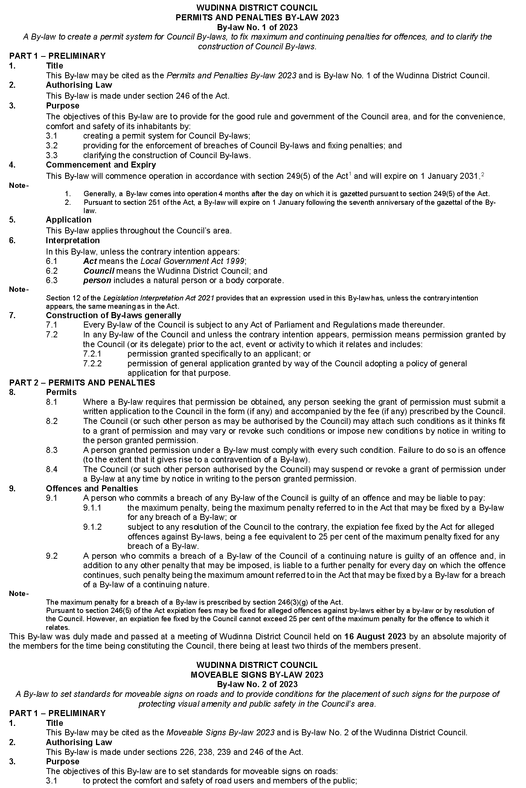
Wudinna District Council
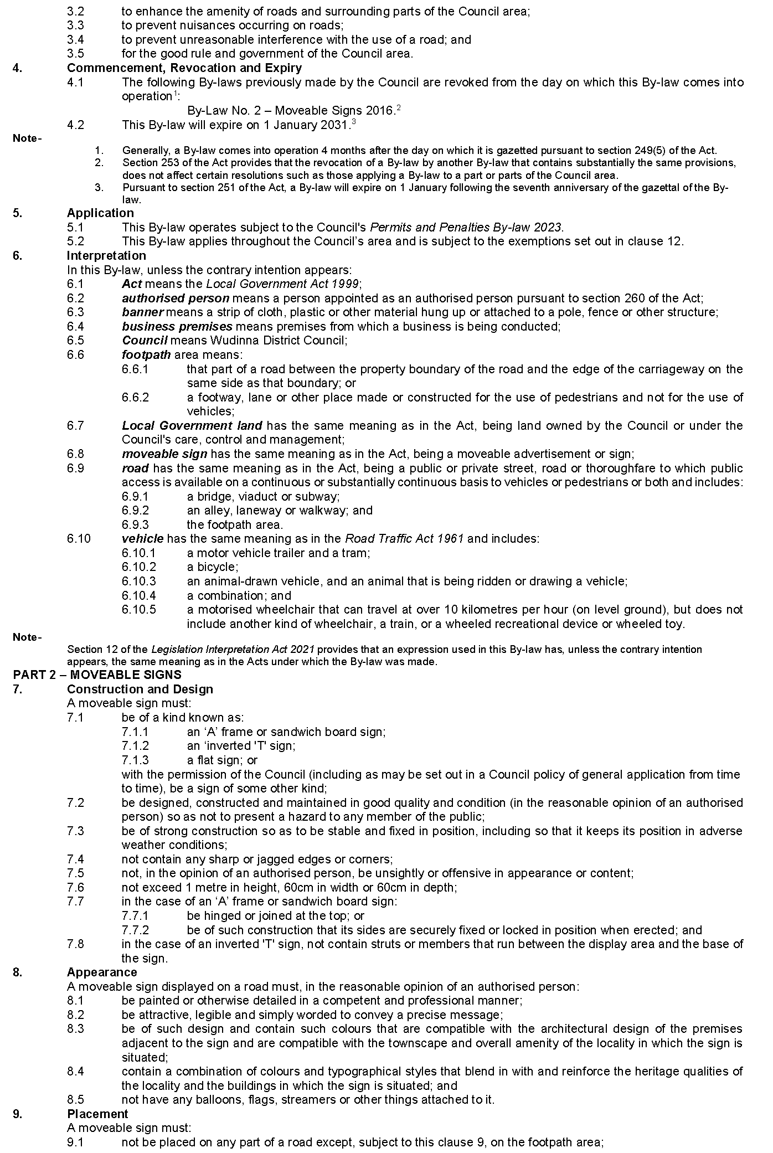
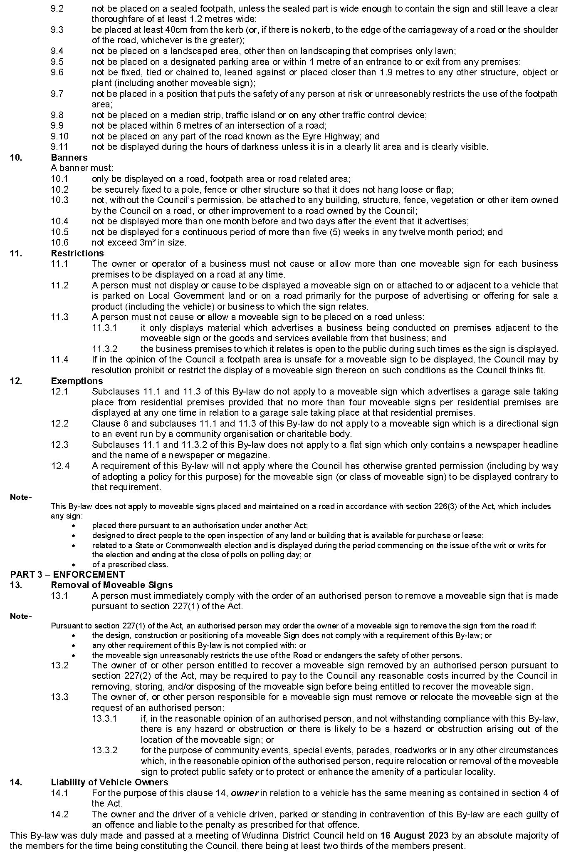
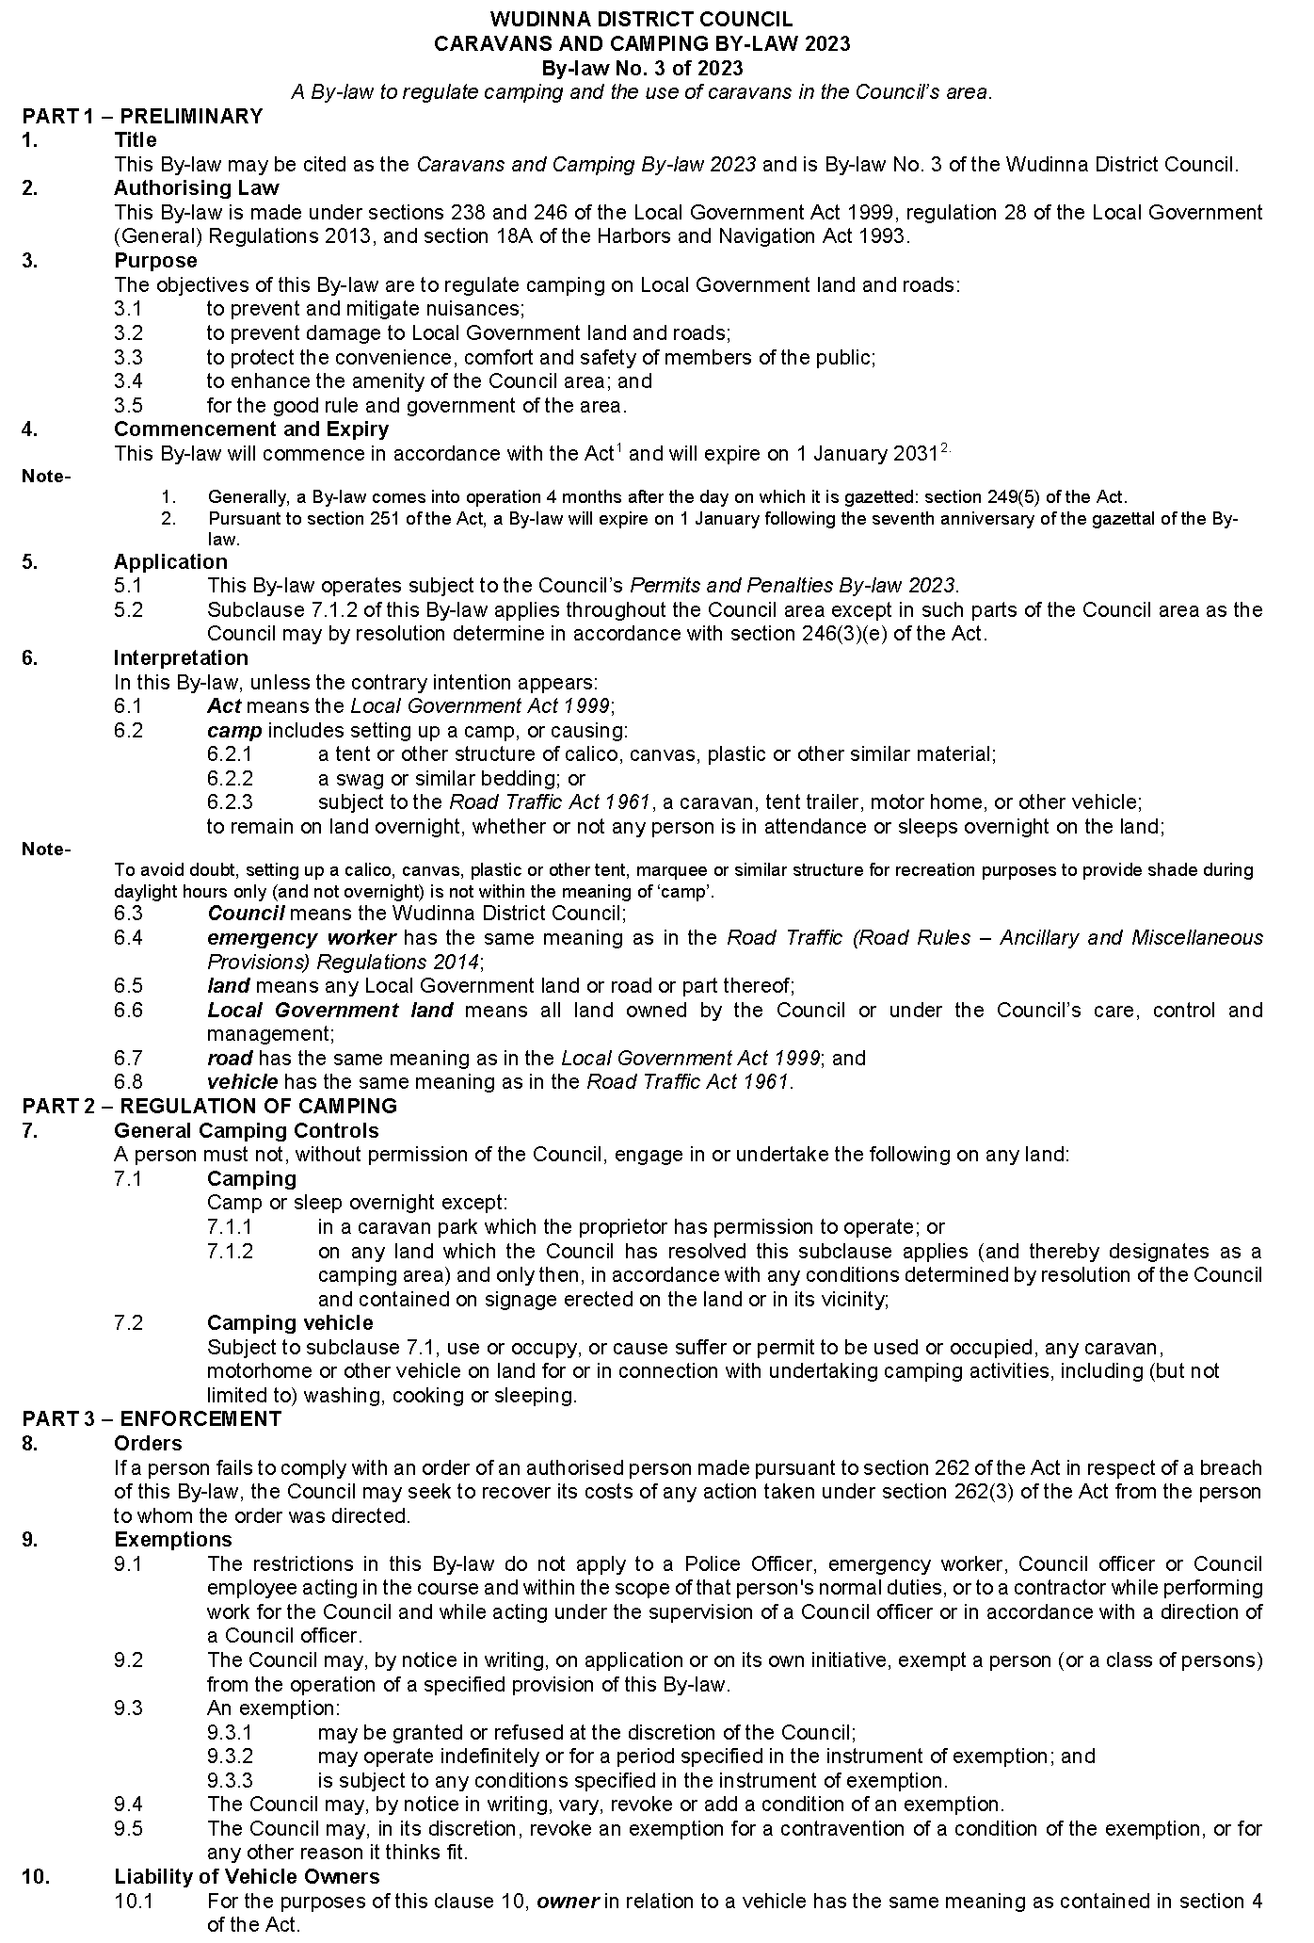
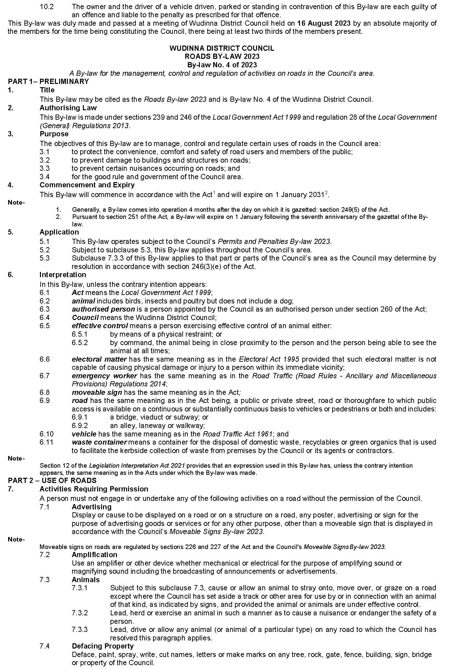
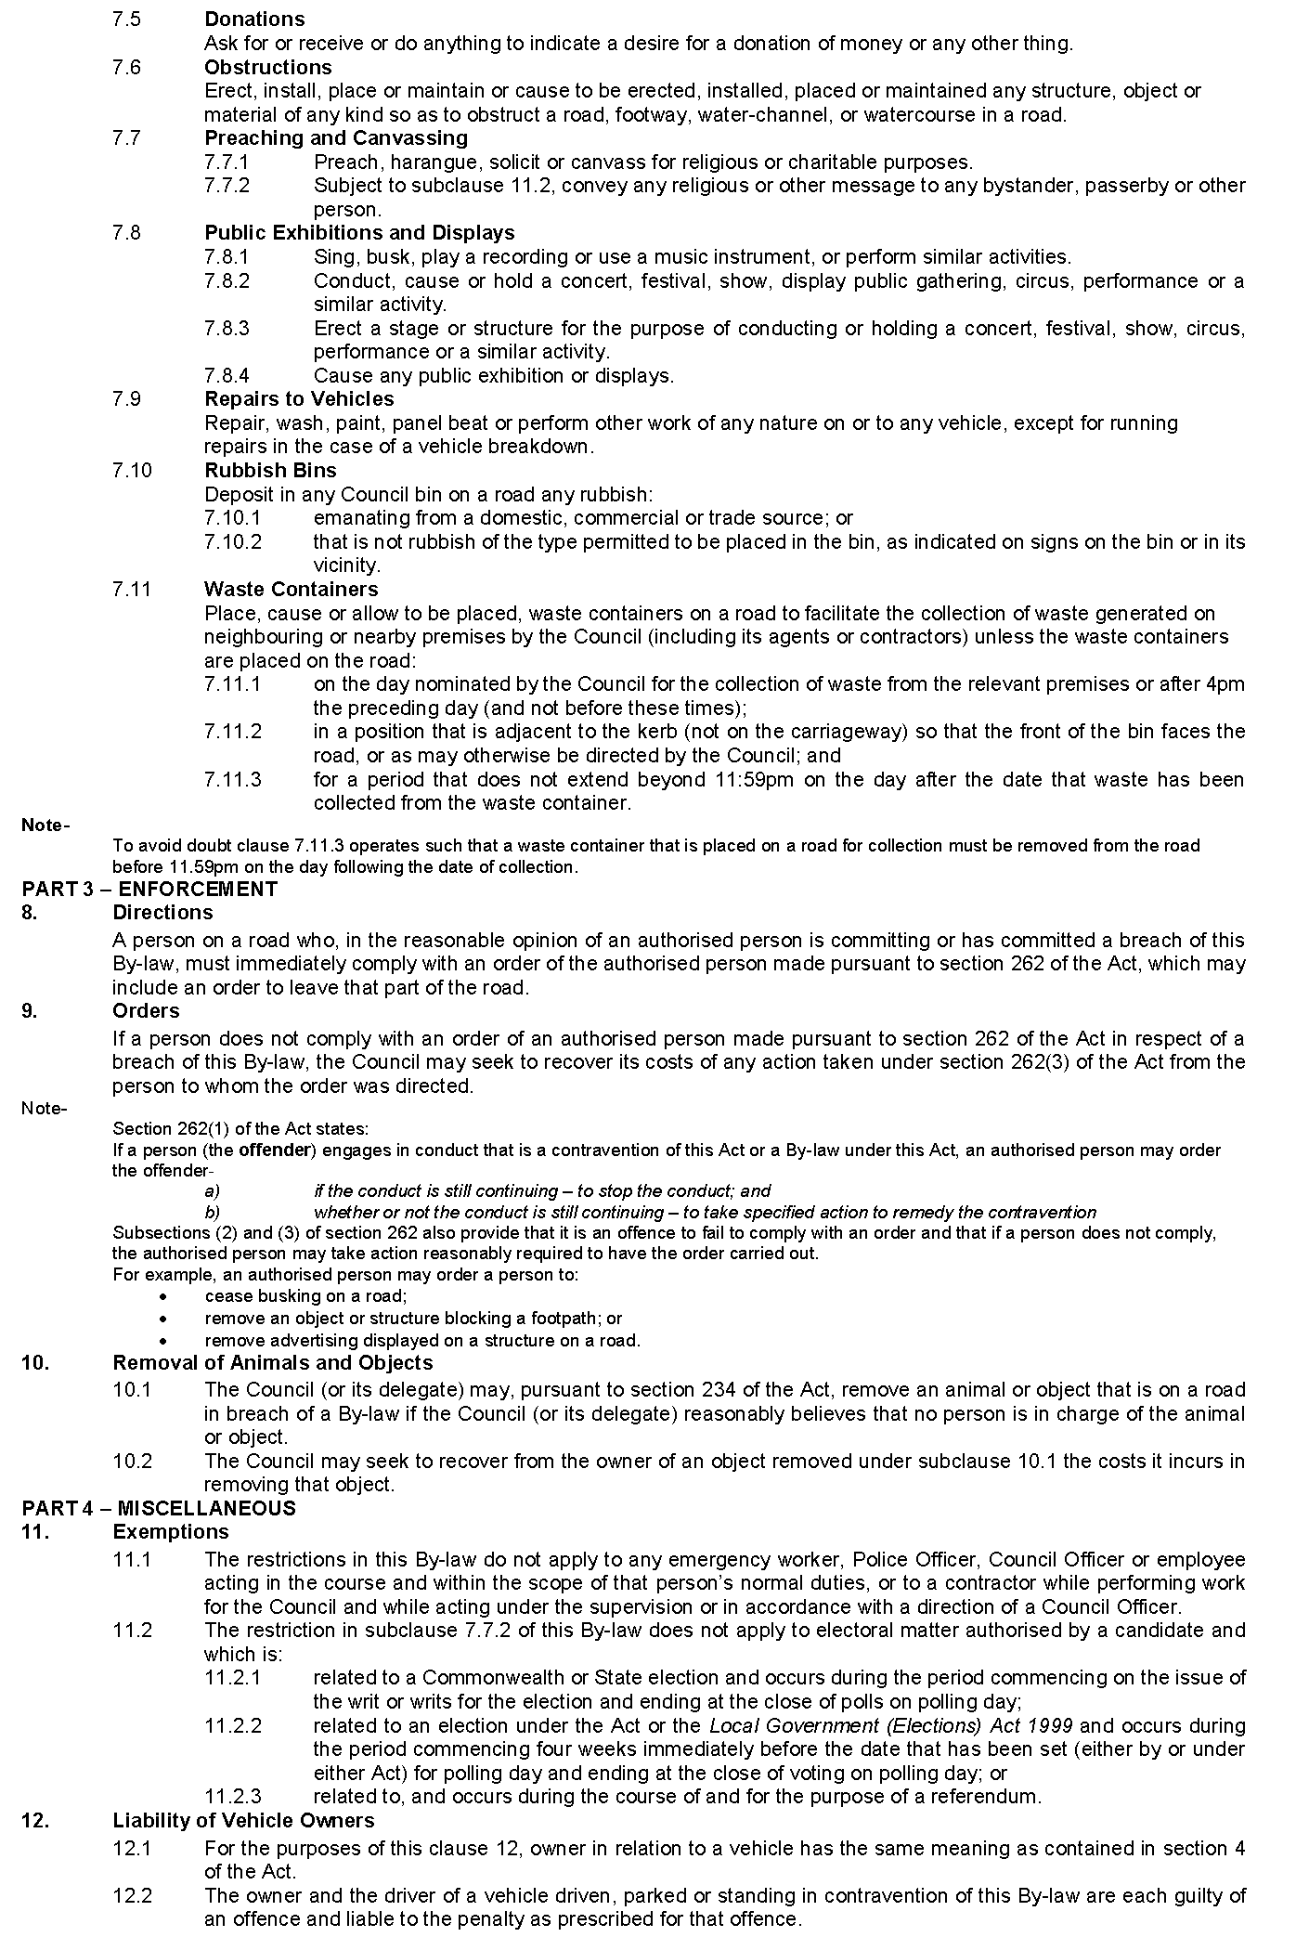
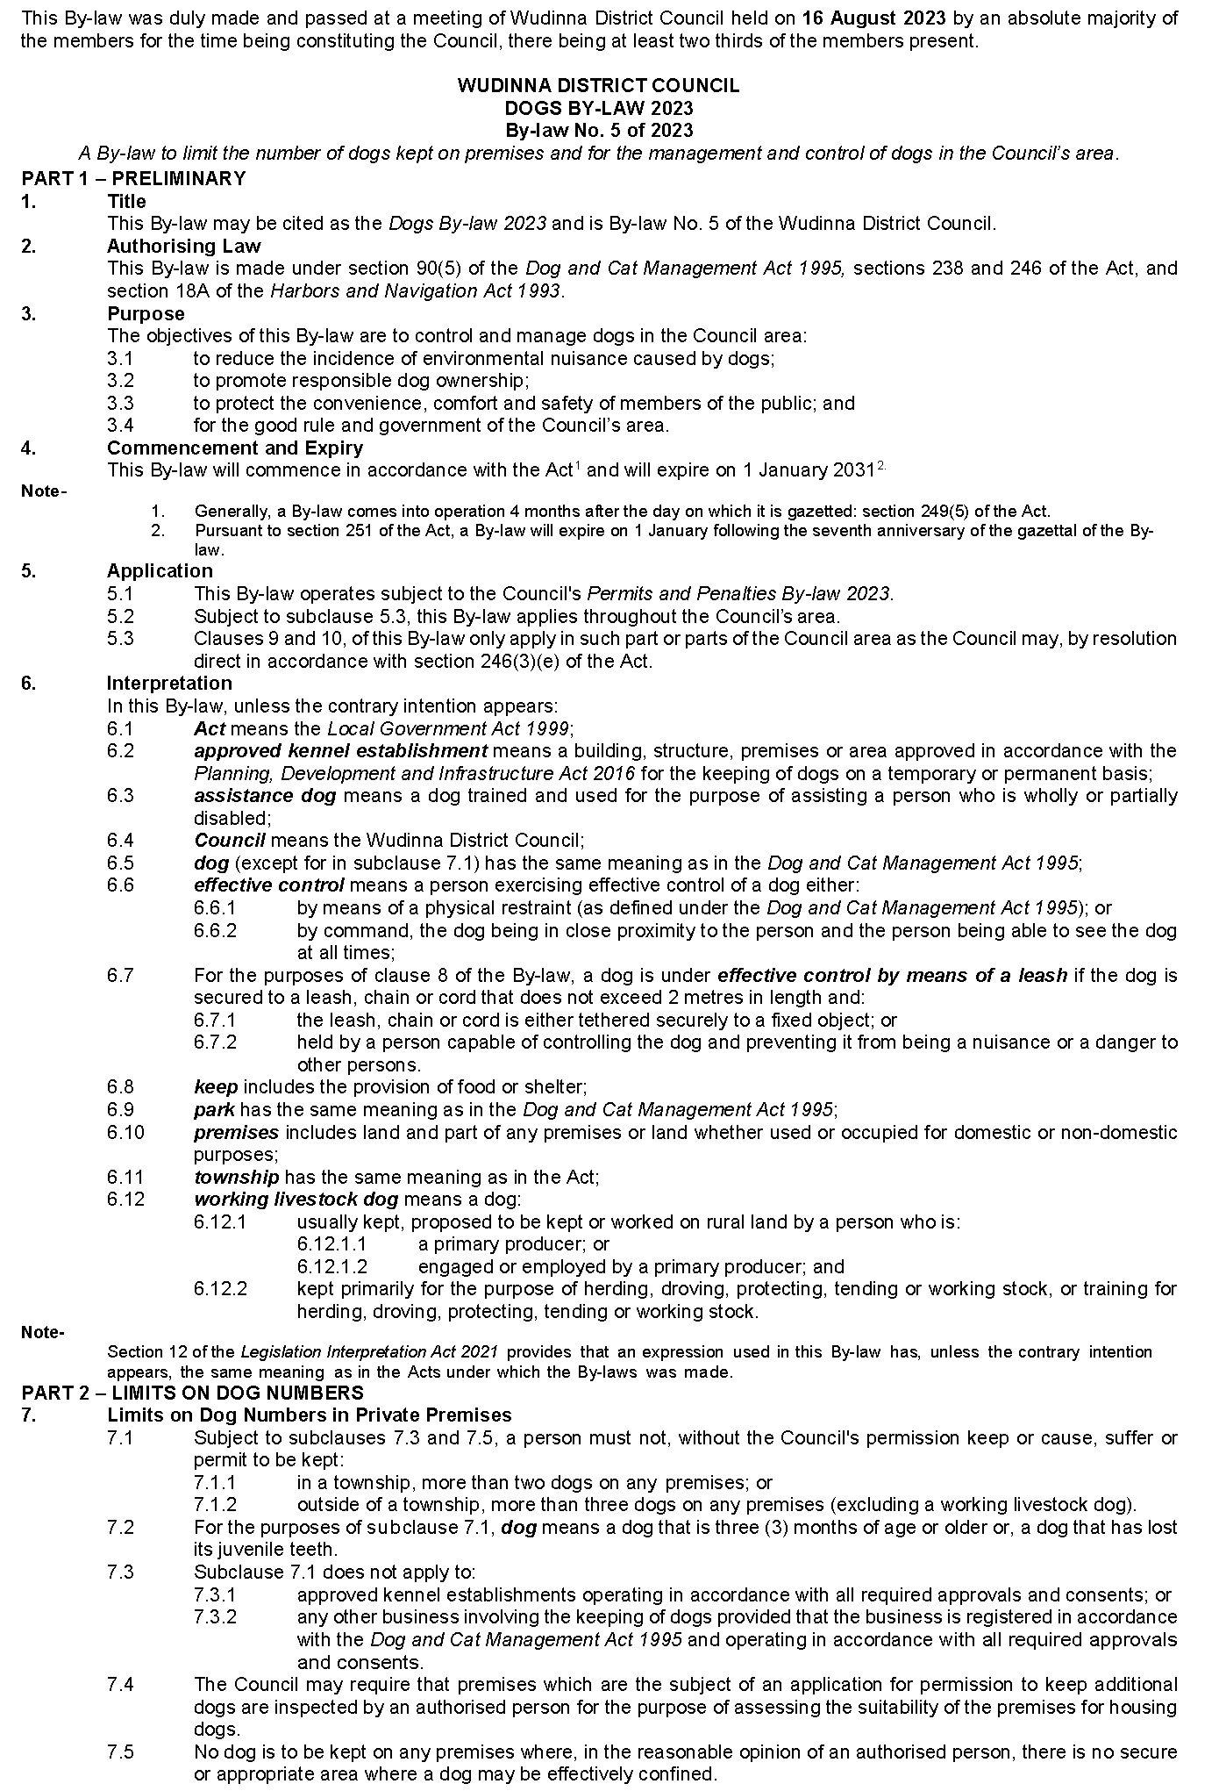
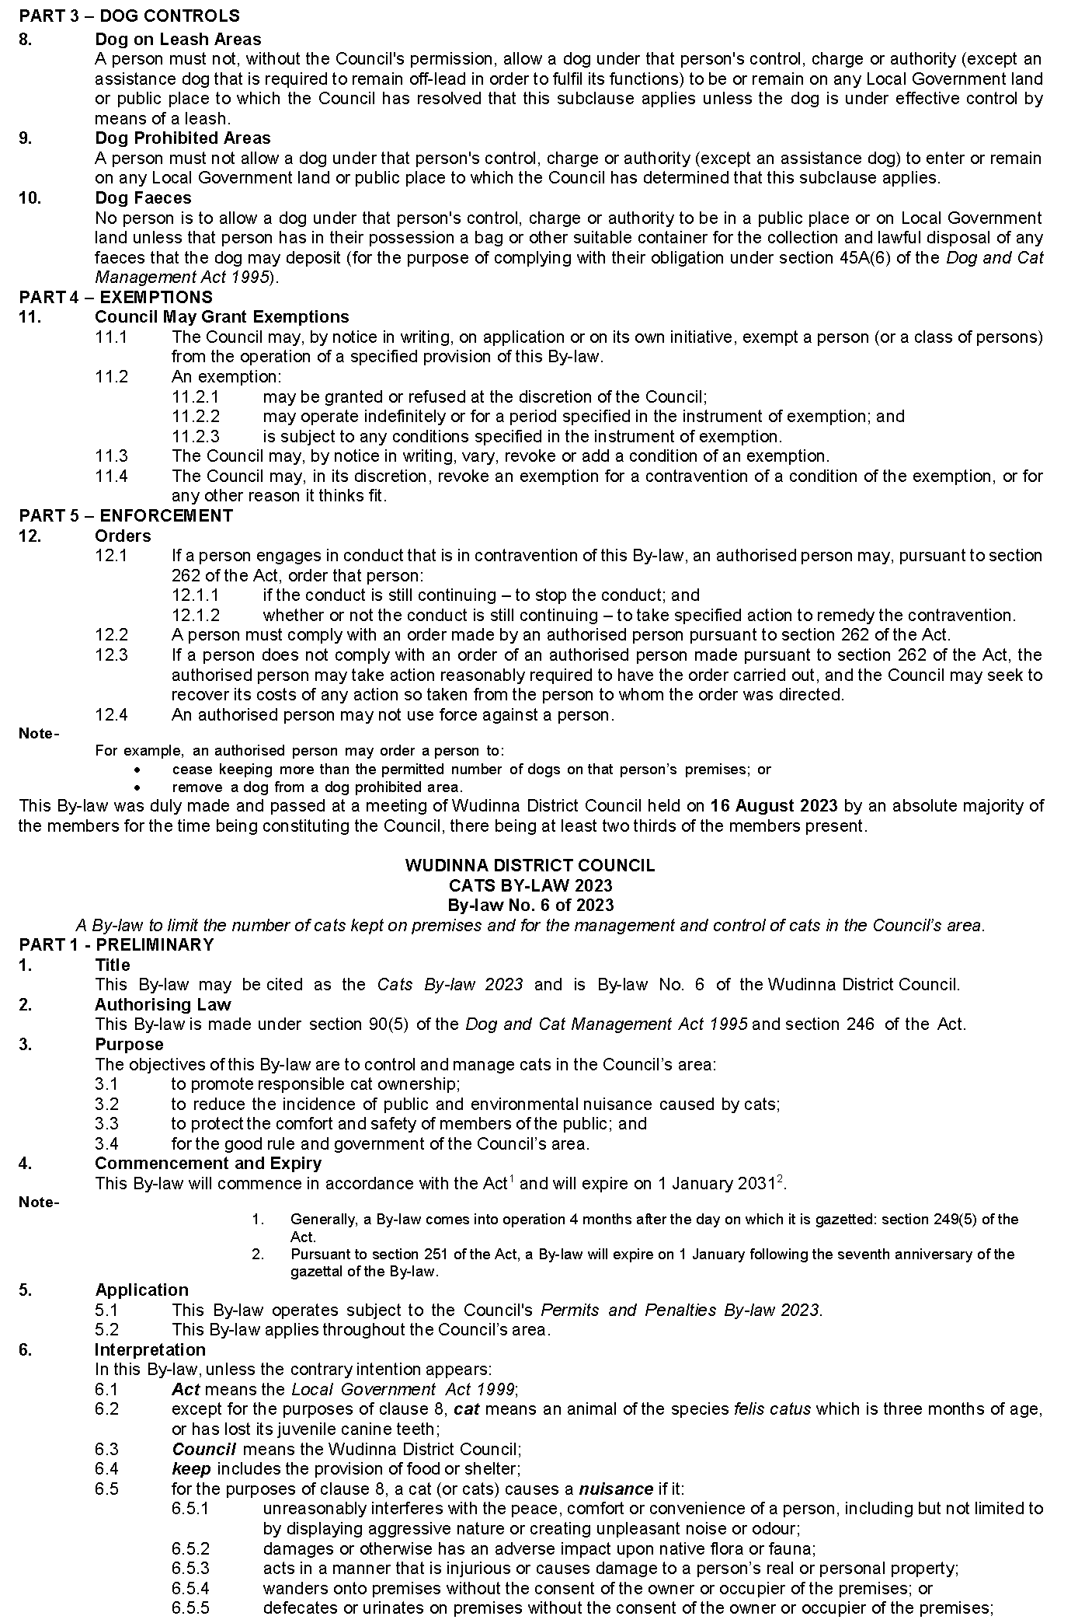
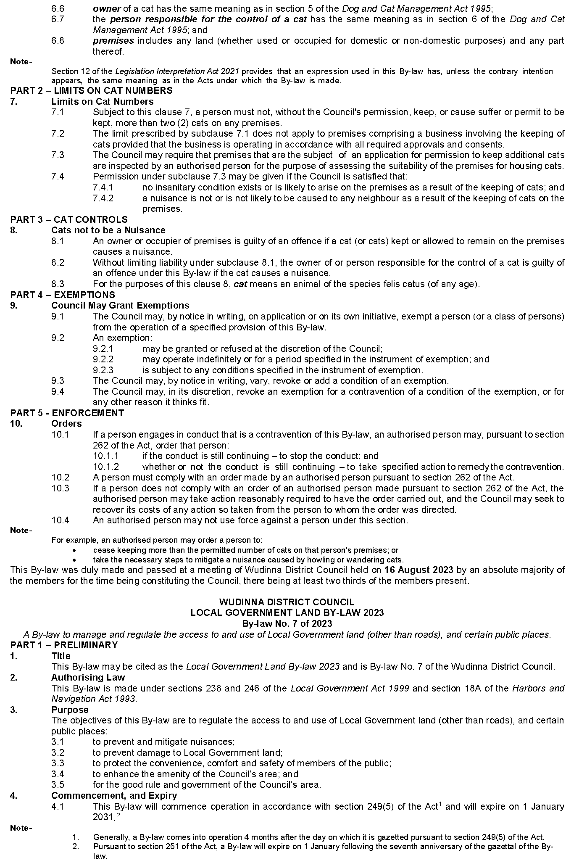
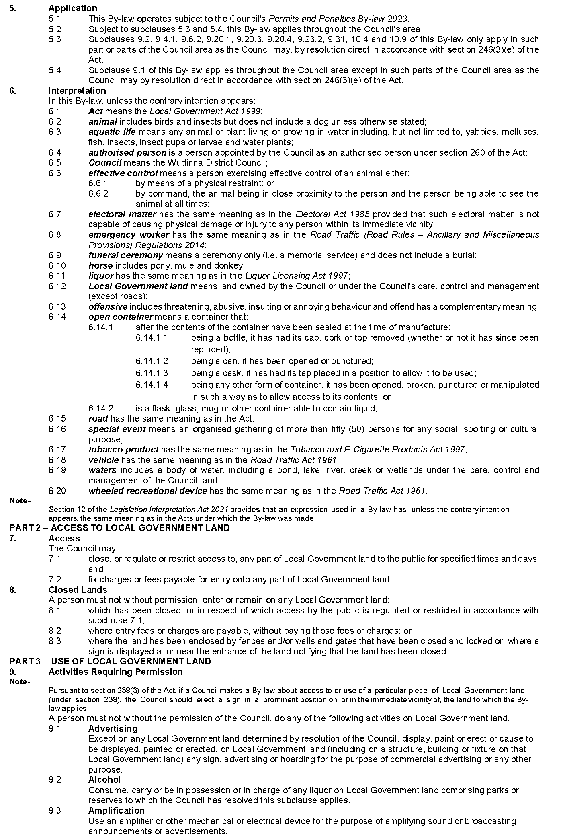
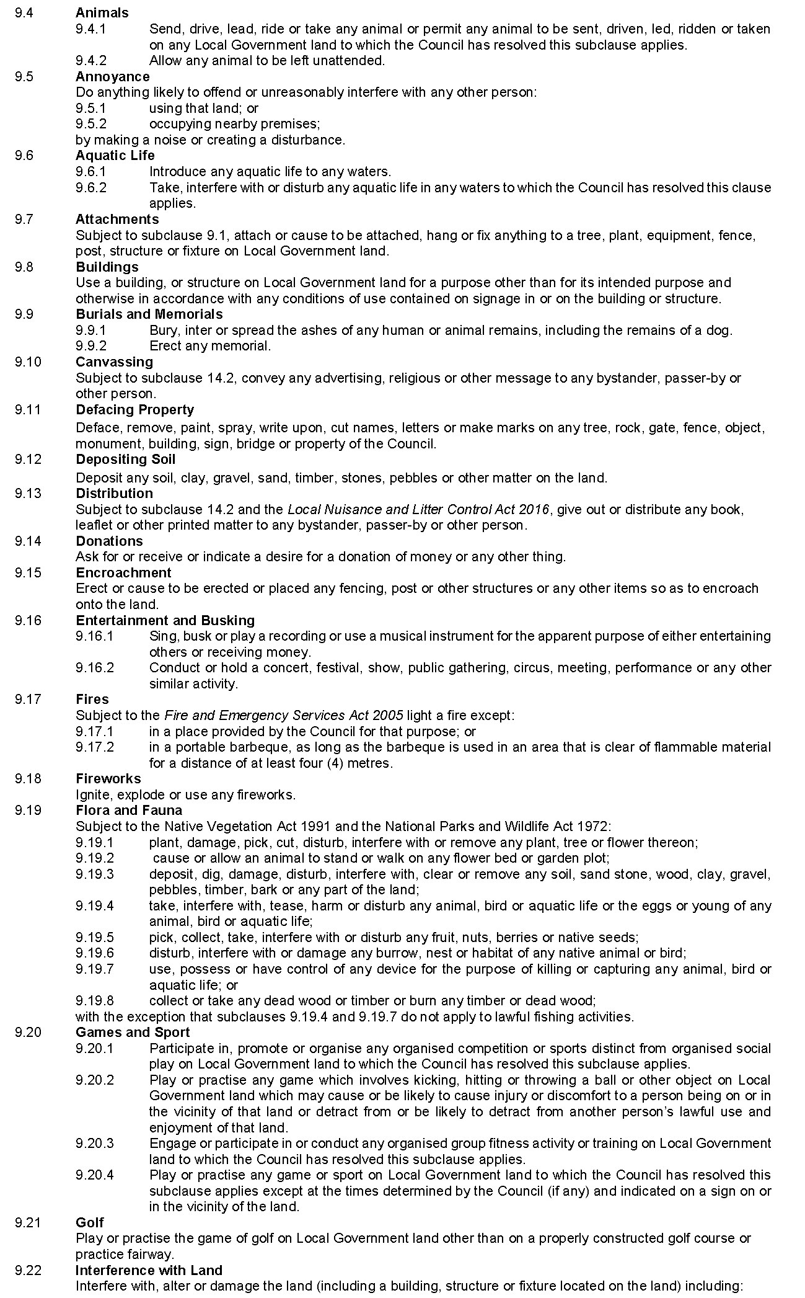
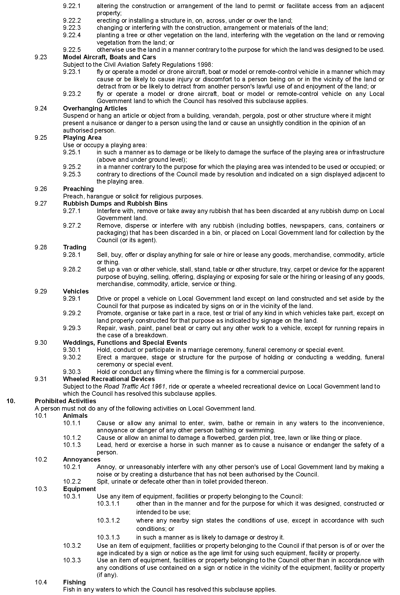
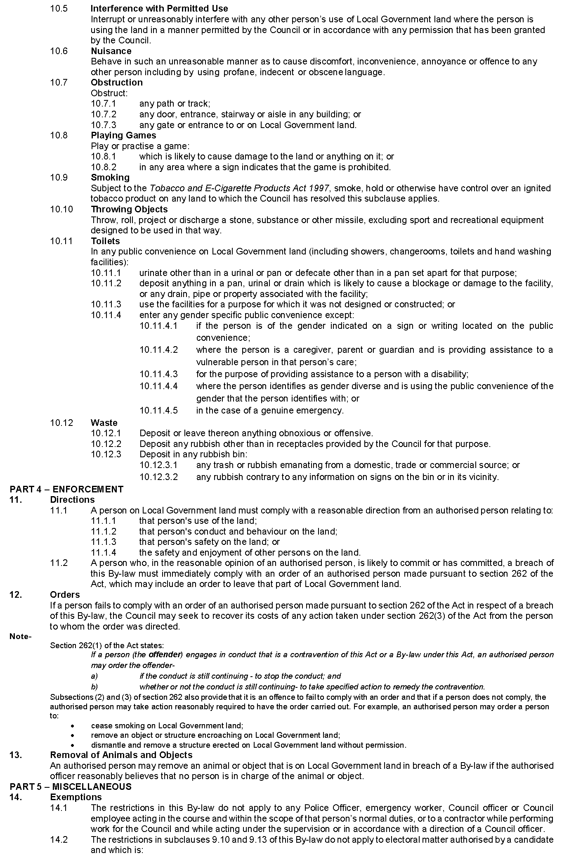
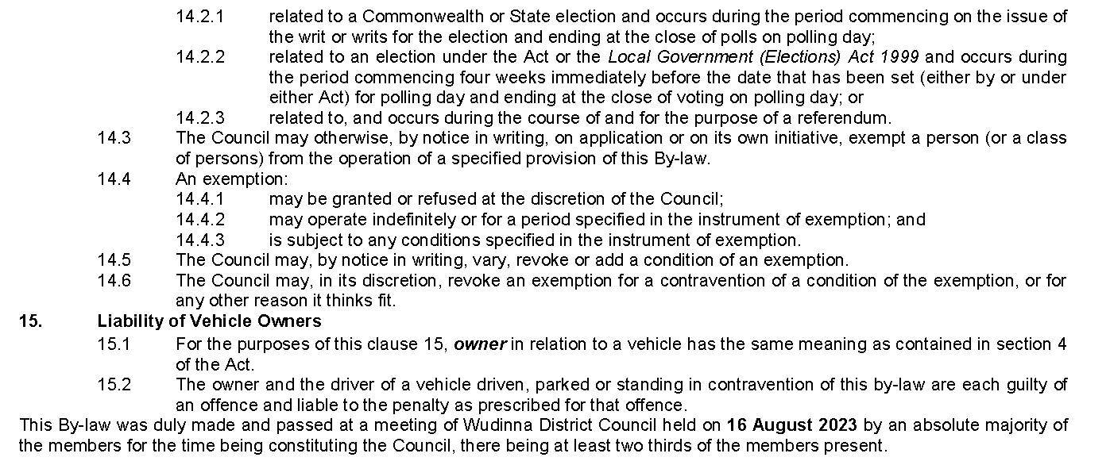

Public Notices

Sale of Property
Warrant of Sale
Auction Date: Thursday, 7 September 2023 at 1:00pm
Location: 2 Mathews Circuit, Woodlane SA 5254
Notice is hereby given that on the above date at the time and place stated, by virtue of the Warrant of Sale issued out of the District Court of South Australia, Action No: CIV 4432 of 2001 directed to the Sheriff of South Australia in an action wherein Safewealth Pty Ltd & Others are the Judgment Creditors and Horacio Bradley Branch is the Judgment Debtor, I, Angela Gransden, Sheriff of the State of South Australia, will by my auctioneers, Ray White Mt Barker, make sale of the estate, right, title or interest whatsoever it may be of the Judgment Debtor, Horacio Bradley Branch the registered proprietor of an estate in fee simple in the following:
That piece of land situated in the area named Woodlane, being 2 Mathews Circuit, Woodlane, Hundred of Mobilong, being the property comprised in Certificate of Title Register Book Volume 5849, Folio 100.
Further particulars from the auctioneers:
Jacob Branch
Ray White Mt Barker
6 Dutton Road
Mt Barker SA 5251
Telephone: (08) 8391 6866
Dated: 24 August 2023
Angela Gransden
Sheriff of the State of South Australia

Notice Submission

The South Australian Government Gazette is published each Thursday afternoon.
Notices must be emailed by 4 p.m. Tuesday, the week of publication.
Submissions are formatted per the gazette style and a proof will be supplied prior to publication, along with a quote if applicable. Please allow one day for processing notices.
Alterations to the proof must be returned by 4 p.m. Wednesday.

Gazette notices must be submitted as Word files, in the following format:
• Title—the governing legislation
• Subtitle—a summary of the notice content
• Body—structured text, which can include numbered lists, tables, and images
• Date—day, month, and year of authorisation
• Signature block—name, role, and department/organisation authorising the notice

Please provide the following information in your email:
• Date of intended publication
• Contact details of the person responsible for the notice content
• Name and organisation to be charged for the publication—Local Council and Public notices only
• Purchase order, if required—Local Council and Public notices only

Email: governmentgazettesa@sa.gov.au
Phone: (08) 7109 7760
Website: www.governmentgazette.sa.gov.au

All instruments appearing in this gazette are to be considered official, and obeyed as such

Printed and published weekly by authority of M. Dowling, Government Printer, South Australia
$8.55 per issue (plus postage), $430.00 per annual subscription—GST inclusive
Online publications: www.governmentgazette.sa.gov.au

