No. 88 p. 4049

**THE SOUTH AUSTRALIAN**

**GOVERNMENT GAZETTE**

**Published by Authority**

Adelaide, Thursday, 7 December 2023

**Contents**

**Governor’s Instruments**

Acts—No. 38-44 of 2023 4050

Appointments 4050

Proclamations—

[Environment Protection (Objects of Act and Board   
Attributes) Amendment Act (Commencement) Proclamation 2023 4052](#_Toc152849923)

Return to Work (Declaration of Crown Agency or Instrumentality not to be Self-Insured Employer) Proclamation 2023 4052

Regulations—

[Tobacco and E‑Cigarette Products (Smoking Bans)   
Amendment Regulations 2023—No. 119 of 2023 4053](#_Toc152849926)

**State Government Instruments**

Housing Improvement Act 2016 4058

Justices of the Peace Act 2005 4058

Land Acquisition Act 1969 4059

Local Government (Elections) Act 1999 4066

National Parks and Wildlife Act 1972 4066

Passenger Transport Act 1994 4067

Passenger Transport Regulations 2009 4068

Pastoral Land Management and Conservation Act 1989 4070

[Planning, Development and Infrastructure (General)   
Regulations 2017 4070](#_Toc152849936)

Planning, Development and Infrastructure Act 2016 4074

Plant Health Act 2009 4076

The Remuneration Tribunal 4081

**Local Government Instruments**

City of Holdfast Bay 4100

City of Victor Harbor 4101

Adelaide Hills Council 4102

District Council of Loxton Waikerie 4102

Mid Murray Council 4102

Naracoorte Lucindale Council 4112

District Council of Tumby Bay 4112

Wudinna District Council 4116

**Public Notices**

National Electricity Law 4117

Sale of Property 4117

Trustee Act 1936 4117

University of Adelaide Act 1971 4118

# Governor’s Instruments

## ACTS

Department of the Premier and Cabinet

Adelaide, 7 December 2023

Her Excellency the Governor directs it to be notified for general information that she has in the name and on behalf of His Majesty The King, this day assented to the undermentioned Bills passed by the Legislative Council and House of Assembly in Parliament assembled, viz.:

No. 38 of 2023—Advance Care Directives (Review) Amendment Bill 2023

An Act to amend the Advance Care Directives Act 2013

No. 39 of 2023—Public Holidays Bill 2023

An Act to provide for public holidays in the State, to make related amendments to various Acts and for other purposes

No. 40 of 2023—Public Sector (Ministerial Travel Reports) Amendment Bill 2023

An Act to amend the Public Sector Act 2009

No. 41 of 2023—Residential Tenancies (Miscellaneous) Amendment Bill 2023

An Act to amend the Residential Tenancies Act 1995 and to make related amendments to the Real Property Act 1886 and the Residential Parks Act 2007

No. 42 of 2023—Statutes Amendment (Budget Measures) Bill 2023

An Act to amend the Emergency Services Funding Act 1998, the First Home and Housing Construction Grants Act 2000, the Land Tax Act 1936 and the Stamp Duties Act 1923

No. 43 of 2023—Work Health and Safety (Industrial Manslaughter) Amendment Bill 2023

An Act to amend the Work Health and Safety Act 2012

No. 44 of 2023—Veterinary Services Bill 2023

An Act to support animal health, safety and welfare and the public interest by providing for the registration of veterinarians and premises at which veterinary services are provided, to regulate the provision of veterinary services for the purposes of maintaining high standards of competence and conduct by veterinarians, to recognise the registration of veterinarians in certain jurisdictions, to make related amendments to various Acts, to repeal the Veterinary Practice Act 2003 and for other purposes

By command,

Peter Bryden Malinauskas

Premier

## APPOINTMENTS

Department of the Premier and Cabinet

Adelaide, 7 December 2023

Her Excellency the Governor in Executive Council has been pleased to appoint the undermentioned to the Adelaide Festival Centre Trust, pursuant to the provisions of the Adelaide Festival Centre Trust Act 1971:

Member: from 7 December 2023 until 6 December 2026

Michael Lewis Abbott

By command,

Peter Bryden Malinauskas

Premier

23ART0027CS

Department of the Premier and Cabinet

Adelaide, 7 December 2023

Her Excellency the Governor in Executive Council has been pleased to appoint the undermentioned to the Veterinary Surgeons Board of South Australia, pursuant to the provisions of the Veterinary Practice Act 2003:

Member: from 1 January 2024 until 31 December 2025

Sonya Marie Beyers

Presiding Member: from 1 January 2024 until 31 December 2025

Sonya Marie Beyers

By command,

Peter Bryden Malinauskas

Premier

MPIRDF2023/000227CS

Department of the Premier and Cabinet

Adelaide, 7 December 2023

Her Excellency the Governor in Executive Council has been pleased to appoint the undermentioned to the SACE Board of South Australia, pursuant to the provisions of the SACE Board of South Australia Act 1983:

Member: from 11 December 2023 until 10 December 2026

Marilyn Sleath

Diarmid Lee

Georgette Elston

Deputy Presiding Member: from 7 December 2023 until 30 June 2024

Pamela Mary Ronan

By command,

Peter Bryden Malinauskas

Premier

ME23/108

Department of the Premier and Cabinet

Adelaide, 7 December 2023

Her Excellency the Governor in Executive Council has been pleased to appoint the undermentioned to the Lifetime Support Authority of South Australia Board, pursuant to the provisions of the Motor Vehicle Accidents (Lifetime Support Scheme) Act 2013:

Member: from 7 December 2023 until 6 December 2026

Andrew John Culley

Timothy Campbell Agar Binks

By command,

Peter Bryden Malinauskas

Premier

HEAC-2023-00065

## Proclamations

South Australia

### Environment Protection (Objects of Act and Board Attributes) Amendment Act (Commencement) Proclamation 2023

**1—Short title**

This proclamation may be cited as the *Environment Protection (Objects of Act and Board Attributes) Amendment Act (Commencement) Proclamation 2023*.

**2—Commencement of Act**

The [*Environment Protection (Objects of Act and Board Attributes) Amendment Act 2023*](http://www.legislation.sa.gov.au/index.aspx?action=legref&type=act&legtitle=Environment%20Protection%20(Objects%20of%20Act%20and%20Board%20Attributes)%20Amendment%20Act%202023) (No 28 of 2023) comes into operation on 1 March 2024.

**Made by the Governor**

with the advice and consent of the Executive Council

on 7 December 2023

South Australia

### Return to Work (Declaration of Crown Agency or Instrumentality not to be Self-Insured Employer) Proclamation 2023

under section 130(2) of the *Return to Work Act 2014*

**1—Short title**

This proclamation may be cited as the *Return to Work (Declaration of Crown Agency or Instrumentality not to be Self-Insured Employer) Proclamation 2023*.

**2—Commencement**

This proclamation comes into operation on the day on which it is made.

**3—Declaration**

The Dairy Authority of South Australia is declared not to be regarded as a self-insured employer.

**Made by the Governor**

with the advice and consent of the Executive Council

on 7 December 2023

## Regulations

South Australia

### Tobacco and E‑Cigarette Products (Smoking Bans) Amendment Regulations 2023

under the *Tobacco and E‑Cigarette Products Act 1997*

**Contents**

Part 1—Preliminary

1 Short title

2 Commencement

Part 2—Amendment of *Tobacco and E‑Cigarette Products Regulations 2019*

3 Amendment of regulation 9—No smoking signs in enclosed public places

4 Insertion of regulations 17 to 24

17 No smoking at or in vicinity of premises at which early childhood services are provided

18 No smoking at or in vicinity of education and children's services facility

19 No smoking at or in vicinity of hospital

20 No smoking at or in vicinity of residential aged care facility

21 No smoking near entrance to enclosed public place, workplace or shared area

22 No smoking at major events venue

23 No smoking at or in vicinity of swimming facility, jetty or certain areas of beach

24 No smoking at underage sporting events

**Part 1—Preliminary**

**1—Short title**

These regulations may be cited as the *Tobacco and E‑Cigarette Products (Smoking Bans) Amendment Regulations 2023*.

**2—Commencement**

(1) Subject to subregulation (2), these regulations come into operation on 1 March 2024.

(2) Regulation 4, insofar as it inserts regulation 20 into the [*Tobacco and E‑Cigarette Products Regulations 2019*](http://www.legislation.sa.gov.au/index.aspx?action=legref&type=subordleg&legtitle=Tobacco%20and%20E%E2%80%91Cigarette%20Products%20Regulations%202019), comes into operation 12 months after the day on which these regulations are made.

**Part 2—Amendment of *Tobacco and E‑Cigarette Products Regulations 2019***

**3—Amendment of regulation 9—No smoking signs in enclosed public places**

Regulation 9(1)(b)—delete "whether of tobacco products or e‑cigarettes" and substitute:

both of tobacco products and e‑cigarettes

**4—Insertion of regulations 17 to 24**

After regulation 16 insert:

**17—No smoking at or in vicinity of premises at which early childhood services are provided**

(1) For the purposes of section 52 of the Act, smoking is banned in all public areas—

(a) within premises at which early childhood services are provided; or

(b) within 10 m of the boundary of premises at which early childhood services are provided,

at all times during which those services are being provided at the premises.

(2) In this regulation—

***early childhood services*** has the same meaning as in section 4 of the [*Education and Early Childhood Services (Registration and Standards) Act 2011*](http://www.legislation.sa.gov.au/index.aspx?action=legref&type=act&legtitle=Education%20and%20Early%20Childhood%20Services%20(Registration%20and%20Standards)%20Act%202011).

**18—No smoking at or in vicinity of education and children's services facility**

(1) For the purposes of section 52 of the Act, smoking is banned in all public areas—

(a) within an education and children's services facility; or

(b) within 10 m of the boundary of an education and children's services facility.

(2) In this regulation—

***education and children's services facility*** means—

(a) premises where services of a kind to which the [*Education and Care Services National Law (South Australia)*](http://www.legislation.sa.gov.au/index.aspx?action=legref&type=act&legtitle=Education%20and%20Care%20Services%20National%20Law%20(South%20Australia)) applies are provided; or

(b) premises occupied by a children's services centre, a Government preschool, a Government school or a non‑Government school all within the meaning of the [*Education and Children's Services Act 2019*](http://www.legislation.sa.gov.au/index.aspx?action=legref&type=act&legtitle=Education%20and%20Childrens%20Services%20Act%202019).

**19—No smoking at or in vicinity of hospital**

(1) For the purposes of section 52 of the Act, smoking is banned in all public areas—

(a) within a hospital; or

(b) within 10 m of the boundary of a hospital.

(2) In this regulation—

***hospital*** means a site at which activities of an incorporated hospital or a private hospital (both within the meaning of the [*Health Care Act 2008*](http://www.legislation.sa.gov.au/index.aspx?action=legref&type=act&legtitle=Health%20Care%20Act%202008)) are undertaken.

**20—No smoking at or in vicinity of residential aged care facility**

(1) For the purposes of section 52 of the Act, smoking is banned in all public areas—

(a) within a residential aged care facility; or

(b) within 10 m of the boundary of a residential aged care facility.

(2) In this regulation—

***residential aged care facility*** means premises at which residential care is provided by an approved provider under the *Aged Care Act 1997* of the Commonwealth.

**21—No smoking near entrance to enclosed public place, workplace or shared area**

(1) Subject to this regulation, for the purposes of section 52 of the Act, smoking is banned in all public areas at or within 10 m of any part of an entry point to an enclosed public place, workplace or shared area at all times during which the enclosed public place, workplace or shared area is open for use by persons who work at or otherwise use the enclosed public place, workplace or shared area.

(2) Subregulation (1) does not apply to an area (not being an enclosed public place, workplace or shared area)—

(a) in respect of which a licence is in force under the [*Liquor Licensing Act 1997*](http://www.legislation.sa.gov.au/index.aspx?action=legref&type=act&legtitle=Liquor%20Licensing%20Act%201997); or

(b) that is at or within 10 m of any part of an entry point for an area referred to in paragraph (a) if the entry point leads directly to such a licensed area and not to an unlicensed area within the same premises; or

(c) that is at or within 10 m of any part of an entry point to a place that—

(i) is used solely for residential purposes; or

(ii) is used partly for residential purposes and partly for other purposes if the entry point is used solely for entry to or exit from that part of the place that is used for residential purposes.

**Examples—**

If an outdoor area that forms part of licensed premises under the [*Liquor Licensing Act 1997*](http://www.legislation.sa.gov.au/index.aspx?action=legref&type=act&legtitle=Liquor%20Licensing%20Act%201997) also lies within 10 m of an entry point to some other enclosed public place, workplace or shared area, the ban in subregulation (1) will not apply to that licensed outdoor area.

If a person is within 10 m of an entry point to residential premises and also within 10 m of an entry point to other premises that are an enclosed public place, workplace or shared area, the ban in subregulation (1) will not apply to the person.

(3) In this regulation—

***entry point*** means an entrance to or exit from a place.

**22—No smoking at major events venue**

For the purposes of section 52 of the Act, smoking is banned in all public areas within a major event venue within the meaning of the [*Major Events Act 2013*](http://www.legislation.sa.gov.au/index.aspx?action=legref&type=act&legtitle=Major%20Events%20Act%202013).

**23—No smoking at or in vicinity of swimming facility, jetty or certain areas of beach**

(1) For the purposes of section 52 of the Act, smoking is banned in all public areas—

(a) at an outdoor swimming facility; or

(b) at, or within 5 m of any part of, a jetty; or

(c) within a sanded area of beach that is—

(i) between red and yellow flags temporarily erected on behalf of Surf Life Saving South Australia Inc. or its affiliated surf life saving clubs marking the boundaries for safe swimming; or

(ii) within a 50 m radius of a red and yellow flag referred to in subparagraph (i).

(2) In this regulation—

***outdoor swimming facility*** means premises where an outdoor swimming pool is available for use.

**24—No smoking at underage sporting events**

(1) For the purposes of section 52 of the Act, smoking is banned in all public areas at or within 10 m of a sporting venue at all times during which—

(a) an organised underage sporting event is being conducted; or

(b) a training or practice session to prepare for participation in an organised underage sporting event is being conducted.

(2) In this regulation—

***organised underage sporting event*** means a sporting event that—

(a) is planned in advance; and

(b) is organised or intended for, or predominantly participated in by, persons under the age of 18 years; and

(c) is conducted according to established rules by a professional or amateur sporting body or by an educational institution; and

(d) may be a one‑off event or part of a series of events;

***sporting event*** means a match, game, tournament or other event that involves the playing of, or participation in, sport;

***sporting venue*** includes any part of a public place at which a sporting event occurs, and includes—

(a) a playing field;

(b) a track;

(c) an arena;

(d) a court or rink;

(e) any permanent or temporarily erected seating at the venue;

(f) any seating, marshalling area, warm‑up area, podium or other part of the venue reserved for the use of participants in the sporting event.

**Editorial note—**

As required by section 10AA(2) of the [*Legislative Instruments Act 1978*](http://www.legislation.sa.gov.au/index.aspx?action=legref&type=act&legtitle=Legislative%20Instruments%20Act%201978), the Minister has certified that, in the Minister's opinion, it is necessary or appropriate that these regulations come into operation as set out in these regulations.

**Made by the Governor**

with the advice and consent of the Executive Council

on 7 December 2023

No 119 of 2023

# 

# State Government Instruments

## Housing Improvement Act 2016

Rent Control

The Minister for Human Services Delegate in the exercise of the powers conferred by the *Housing Improvement Act 2016*, does hereby fix the maximum rental per week which shall be payable subject to Section 55 of the *Residential Tenancies Act 1995*, in respect of each house described in the following table. The amount shown in the said table shall come into force on the date of this publication in the *Gazette*.

| **Address of Premises** | **Allotment Section** | **Certificate of Title Volume/Folio** | **Maximum Rental per week payable** |
| --- | --- | --- | --- |
|  |  |  |  |
| 16 Sherwood Avenue, Bellevue Heights SA 5050 | Allotment 168 Deposited Plan 4773  Hundred of Adelaide | CT 5653/970 | $50.00 |
|  |  |  |  |

Dated: 7 December 2023

Craig Thompson

Housing Regulator and Registrar

Housing Safety Authority, SAHA

Delegate of Minister for Human Services

Housing Improvement Act 2016

Rent Control Revocations

Whereas the Minister for Human Services Delegate is satisfied that each of the houses described hereunder has ceased to be unsafe or unsuitable for human habitation for the purposes of the *Housing Improvement Act 2016*, notice is hereby given that, in exercise of the powers conferred by the said Act, the Minister for Human Services Delegate does hereby revoke the said Rent Control in respect of each property.

|  |  |  |
| --- | --- | --- |
| **Address of Premises** | **Allotment Section** | **Certificate of Title Volume/Folio** |
|  |  |  |
| 137 Baker Road, Lewiston SA 5501  (PKA Lot 2 Baker Road, Virginia) | Allotment comprising Pieces 2 and 3 Filed Plan 40160 in the area named Virginia Hundred of Munno Para | CT5471/159 |
| 14 Chabrel Road, Glossop SA 5344 | Allotments 11 & 12 Deposited Plan 128845 In the area named Glossop Berri Irrigation Area | CT6272/679 CT6272/680 |
| 122 Main South Road, Yankalilla  SA 5203 | Allotment 12 Filed Plan 40181 Hundred of Yankalilla | CT5065/954 |
|  |  |  |

Dated: 7 December 2023

Craig Thompson

Housing Regulator and Registrar

Housing Safety Authority, SAHA

Delegate of Minister for Human Services

## Justices of the Peace Act 2005

Section 4

Notice of Appointment of Justices of the Peace for South Australia   
by the Commissioner for Consumer Affairs

I, Dini Soulio, Commissioner for Consumer Affairs, delegate of the Attorney-General, pursuant to section 4 of the *Justices of the Peace Act 2005*, do hereby appoint the people listed as Justices of the Peace for South Australia as set out below:

For a period of ten years for a term commencing on 16 January 2024 and expiring on 15 January 2034:

Ralf ZURBRUGG

Suzanne Hope URBAN

David Christopher SHANNON

Marco Anthony PUZ

Barry Williamson PHILLIPS

John MAUALAIVAO

Robert Yee Seng LEE

Beverly Olive Mary HILLIER

Adrian Noel HILL

Andrew John Colman EVANS

Julie Ann DOUDLE

Peter Gordon DAVIS

Paul DAVIES

David Terence D'LIMA

Robin Lloyd BURDETT

Geoffrey Warren Stephen BRYANS

Jennifer Kay BOON

Graham Richard AYRES

Andrew Stephen AGIUS

Dated: 1 December 2023

Dini Soulio

Commissioner for Consumer Affairs

Delegate of the Attorney-General

## Land Acquisition Act 1969

Section 16

Form 5—Notice of Acquisition

**1. Notice of acquisition**

The Commissioner of Highways (the Authority), of 83 Pirie Street, Adelaide SA 5000, acquires the following interests in the following land:

Comprising an unencumbered estate in fee simple in that piece of land being portion of Allotment 83 in Filed Plan 144411 comprised in Certificate of Title Volume 5826 Folio 630, and being the whole of the land identified as Allotment 363 in D132689 lodged in the Lands Titles Office.

This notice is given under Section 16 of the *Land Acquisition Act 1969*.

**2. Compensation**

A person who has or had an interest consisting of native title or an alienable interest in the land that is divested or diminished by the acquisition or the enjoyment of which is adversely affected by the acquisition who does not receive an offer of compensation from the Authority may apply to the Authority for compensation.

**2A. Payment of professional costs relating to acquisition (Section 26B)**

If you are the owner in fee simple of the land to which this notice relates, you may be entitled to a payment of up to $10,000 from the Authority for use towards the payment of professional costs in relation to the acquisition of the land.

Professional costs include legal costs, valuation costs and any other costs prescribed by the *Land Acquisition Regulations 2019*.

**3. Inquiries**

Inquiries should be directed to: Daniel Tuk

GPO Box 1533

Adelaide SA 5001

Telephone: 08 7133 2479

Dated: 1 December 2023

The Common Seal of the COMMISSIONER OF HIGHWAYS was hereto affixed by authority of the Commissioner in the presence of:

Rocco Caruso

Manager, Property Acquisition

(Authorised Officer)

Department for Infrastructure and Transport

DIT: 2022/09664/01

Land Acquisition Act 1969

Section 16

Form 5—Notice of Acquisition

**1. Notice of acquisition**

The Commissioner of Highways (the Authority), of 83 Pirie Street, Adelaide SA 5000, acquires the following interests in the following land:

First: Comprising an unencumbered estate in fee simple in that piece of land being portion of Section 430 in Hundred of Willunga, comprised in Certificate of Title Volume 5580 Folio 274, and being the whole of the land identified as Allotment 2210 in D132197 lodged in the Lands Titles Office

Secondly: Comprising an unencumbered estate in fee simple in that piece of land being portion of Allotment 790 in Filed Plan 164613 comprised in Certificate of Title Volume 5756 Folio 120, and being the whole of the land identified as Allotment 2212 in D132197 lodged in the Lands Titles Office

Thirdly: Comprising an unencumbered estate in fee simple in that piece of land being portion of Allotment 782 in Filed Plan 164605 comprised in Certificate of Title Volume 5756 Folio 121, and being the whole of the land identified as Allotment 2214 in D132197 lodged in the Lands Titles Office.

This notice is given under Section 16 of the *Land Acquisition Act 1969*.

**2. Compensation**

A person who has or had an interest consisting of native title or an alienable interest in the land that is divested or diminished by the acquisition or the enjoyment of which is adversely affected by the acquisition who does not receive an offer of compensation from the Authority may apply to the Authority for compensation.

**2A. Payment of professional costs relating to acquisition (Section 26B)**

If you are the owner in fee simple of the land to which this notice relates, you may be entitled to a payment of up to $10,000 from the Authority for use towards the payment of professional costs in relation to the acquisition of the land.

Professional costs include legal costs, valuation costs and any other costs prescribed by the *Land Acquisition Regulations 2019*.

**3. Inquiries**

Inquiries should be directed to: Philip Cheffirs

GPO Box 1533

Adelaide SA 5001

Telephone: 08 7133 2479

Dated: 4 December 2023

The Common Seal of the COMMISSIONER OF HIGHWAYS was hereto affixed by authority of the Commissioner in the presence of:

Rocco Caruso

Manager, Property Acquisition

(Authorised Officer)

Department for Infrastructure and Transport

DIT: 2021/12983/01

Land Acquisition Act 1969

Section 16

Form 5—Notice of Acquisition

**1. Notice of acquisition**

The Commissioner of Highways (the Authority), of 83 Pirie Street, Adelaide SA 5000, acquires the following interests in the following land:

Comprising an unencumbered estate in fee simple in that piece of land being the whole of Allotment 5 in Filed Plan 7056 comprised in Certificate of Title Volume 5797 Folio 429.

This notice is given under Section 16 of the *Land Acquisition Act 1969*.

**2. Compensation**

A person who has or had an interest consisting of native title or an alienable interest in the land that is divested or diminished by the acquisition or the enjoyment of which is adversely affected by the acquisition who does not receive an offer of compensation from the Authority may apply to the Authority for compensation.

**2A. Payment of professional costs relating to acquisition (Section 26B)**

If you are the owner in fee simple of the land to which this notice relates, you may be entitled to a payment of up to $10,000 from the Authority for use towards the payment of professional costs in relation to the acquisition of the land.

Professional costs include legal costs, valuation costs and any other costs prescribed by the *Land Acquisition Regulations 2019*.

**3. Inquiries**

Inquiries should be directed to: Petrula Pettas

GPO Box 1533

Adelaide SA 5001

Telephone: 08 7133 2457

Dated: 5 December 2023

The Common Seal of the COMMISSIONER OF HIGHWAYS was hereto affixed by authority of the Commissioner in the presence of:

Rocco Caruso

Manager, Property Acquisition

(Authorised Officer)

Department for Infrastructure and Transport

DIT: 2022/02774/01

Land Acquisition Act 1969

Section 16

Form 5—Notice of Acquisition

**1. Notice of acquisition**

The Commissioner of Highways (the Authority), of 83 Pirie Street, Adelaide SA 5000, acquires the following interests in the following land:

Comprising an unencumbered estate in fee simple in that piece of land being the whole of Allotment 341 in Filed Plan 19503 comprised in Certificate of Title Volume 5840 Folio 692.

This notice is given under Section 16 of the *Land Acquisition Act 1969*.

**2. Compensation**

A person who has or had an interest consisting of native title or an alienable interest in the land that is divested or diminished by the acquisition or the enjoyment of which is adversely affected by the acquisition who does not receive an offer of compensation from the Authority may apply to the Authority for compensation.

**2A. Payment of professional costs relating to acquisition (Section 26B)**

If you are the owner in fee simple of the land to which this notice relates, you may be entitled to a payment of up to $10,000 from the Authority for use towards the payment of professional costs in relation to the acquisition of the land.

Professional costs include legal costs, valuation costs and any other costs prescribed by the *Land Acquisition Regulations 2019*.

**3. Inquiries**

Inquiries should be directed to: Petrula Pettas

GPO Box 1533

Adelaide SA 5001

Telephone: 08 7133 2457

Dated: 5 December 2023

The Common Seal of the COMMISSIONER OF HIGHWAYS was hereto affixed by authority of the Commissioner in the presence of:

Rocco Caruso

Manager, Property Acquisition

(Authorised Officer)

Department for Infrastructure and Transport

DIT: 2022/02751/01

Land Acquisition Act 1969

Section 16

Form 5—Notice of Acquisition

**1. Notice of acquisition**

The Commissioner of Highways (the Authority), of 83 Pirie Street, Adelaide SA 5000, acquires the following interests in the following land:

Comprising an estate in fee simple in that piece of land being the whole of Allotment 314 in Filed Plan 19503 comprised in Certificate of Title Volume 5919 Folio 727, Subject to easement(s) over the land marked B for drainage purposes (TG 9770530), Subject to free and unrestricted right(s) of way over the land marked B, together with the easement(s) over the land marked D for drainage purposes (TG 9770529), together with free and unrestricted right(s) of way over the land marked A.

This notice is given under Section 16 of the *Land Acquisition Act 1969*.

**2. Compensation**

A person who has or had an interest consisting of native title or an alienable interest in the land that is divested or diminished by the acquisition or the enjoyment of which is adversely affected by the acquisition who does not receive an offer of compensation from the Authority may apply to the Authority for compensation.

**2A. Payment of professional costs relating to acquisition (Section 26B)**

If you are the owner in fee simple of the land to which this notice relates, you may be entitled to a payment of up to $10,000 from the Authority for use towards the payment of professional costs in relation to the acquisition of the land.

Professional costs include legal costs, valuation costs and any other costs prescribed by the *Land Acquisition Regulations 2019*.

**3. Inquiries**

Inquiries should be directed to: Petrula Pettas

GPO Box 1533

Adelaide SA 5001

Telephone: 08 7133 2457

Dated: 5 December 2023

The Common Seal of the COMMISSIONER OF HIGHWAYS was hereto affixed by authority of the Commissioner in the presence of:

Rocco Caruso

Manager, Property Acquisition

(Authorised Officer)

Department for Infrastructure and Transport

DIT: 2022/02741/01

Land Acquisition Act 1969

Section 16

Form 5—Notice of Acquisition

**1. Notice of acquisition**

The Commissioner of Highways (the Authority), of 83 Pirie Street, Adelaide SA 5000, acquires the following interests in the following land:

Comprising an unencumbered estate in fee simple in that piece of land being the whole of Unit 6 in Strata Plan 2339 comprised in Certificate of Title Volume 5040 Folio 222.

This notice is given under Section 16 of the *Land Acquisition Act 1969*.

**2. Compensation**

A person who has or had an interest consisting of native title or an alienable interest in the land that is divested or diminished by the acquisition or the enjoyment of which is adversely affected by the acquisition who does not receive an offer of compensation from the Authority may apply to the Authority for compensation.

**2A. Payment of professional costs relating to acquisition (Section 26B)**

If you are the owner in fee simple of the land to which this notice relates, you may be entitled to a payment of up to $10,000 from the Authority for use towards the payment of professional costs in relation to the acquisition of the land.

Professional costs include legal costs, valuation costs and any other costs prescribed by the *Land Acquisition Regulations 2019*.

**3. Inquiries**

Inquiries should be directed to: Petrula Pettas

GPO Box 1533

Adelaide SA 5001

Telephone: 08 7133 2457

Dated: 5 December 2023

The Common Seal of the COMMISSIONER OF HIGHWAYS was hereto affixed by authority of the Commissioner in the presence of:

Rocco Caruso

Manager, Property Acquisition

(Authorised Officer)

Department for Infrastructure and Transport

DIT: 2022/11124/01

Land Acquisition Act 1969

Section 16

Form 5—Notice of Acquisition

**1. Notice of acquisition**

The Commissioner of Highways (the Authority), of 83 Pirie Street, Adelaide SA 5000, acquires the following interests in the following land:

Comprising an unencumbered estate in fee simple in that piece of land being the whole of Allotment 67 in Filed Plan 19717 comprised in Certificate of Title Volume 5843 Folio 141.

This notice is given under Section 16 of the *Land Acquisition Act 1969*.

**2. Compensation**

A person who has or had an interest consisting of native title or an alienable interest in the land that is divested or diminished by the acquisition or the enjoyment of which is adversely affected by the acquisition who does not receive an offer of compensation from the Authority may apply to the Authority for compensation.

**2A. Payment of professional costs relating to acquisition (Section 26B)**

If you are the owner in fee simple of the land to which this notice relates, you may be entitled to a payment of up to $10,000 from the Authority for use towards the payment of professional costs in relation to the acquisition of the land.

Professional costs include legal costs, valuation costs and any other costs prescribed by the *Land Acquisition Regulations 2019*.

**3. Inquiries**

Inquiries should be directed to: William Ridgway

GPO Box 1533

Adelaide SA 5001

Telephone: 08 7133 2465

Dated: 4 December 2023

The Common Seal of the COMMISSIONER OF HIGHWAYS was hereto affixed by authority of the Commissioner in the presence of:

Rocco Caruso

Manager, Property Acquisition

(Authorised Officer)

Department for Infrastructure and Transport

DIT: 2023/01348/01

Land Acquisition Act 1969

Section 16

Form 5—Notice of Acquisition

**1. Notice of acquisition**

The Commissioner of Highways (the Authority), of 83 Pirie Street, Adelaide SA 5000, acquires the following interests in the following land:

Comprising an estate in fee simple in that piece of land being the whole of Unit 12 in Strata Plan 10194 comprised in Certificate of Title Volume 6004 Folio 664, together with free and unrestricted right (s) of way over the land marked A on SP 13374.

This notice is given under Section 16 of the *Land Acquisition Act 1969*.

**2. Compensation**

A person who has or had an interest consisting of native title or an alienable interest in the land that is divested or diminished by the acquisition or the enjoyment of which is adversely affected by the acquisition who does not receive an offer of compensation from the Authority may apply to the Authority for compensation.

**2A. Payment of professional costs relating to acquisition (Section 26B)**

If you are the owner in fee simple of the land to which this notice relates, you may be entitled to a payment of up to $10,000 from the Authority for use towards the payment of professional costs in relation to the acquisition of the land.

Professional costs include legal costs, valuation costs and any other costs prescribed by the *Land Acquisition Regulations 2019*.

**3. Inquiries**

Inquiries should be directed to: Rob Gardner

GPO Box 1533

Adelaide SA 5001

Telephone: 08 7133 2415

Dated: 6 December 2023

The Common Seal of the COMMISSIONER OF HIGHWAYS was hereto affixed by authority of the Commissioner in the presence of:

Rocco Caruso

Manager, Property Acquisition

(Authorised Officer)

Department for Infrastructure and Transport

DIT: 2023/01367/01

Land Acquisition Act 1969

Section 16

Form 5—Notice of Acquisition

**1. Notice of acquisition**

The Commissioner of Highways (the Authority), of 83 Pirie Street, Adelaide SA 5000, acquires the following interests in the following land:

Comprising an unencumbered estate in fee simple in that piece of land being the whole of Allotment 296 Deposited Plan 3091 comprised in Certificate of Title Volume 5457 Folio 882.

This notice is given under Section 16 of the *Land Acquisition Act 1969*.

**2. Compensation**

A person who has or had an interest consisting of native title or an alienable interest in the land that is divested or diminished by the acquisition or the enjoyment of which is adversely affected by the acquisition who does not receive an offer of compensation from the Authority may apply to the Authority for compensation.

**2A. Payment of professional costs relating to acquisition (Section 26B)**

If you are the owner in fee simple of the land to which this notice relates, you may be entitled to a payment of up to $10,000 from the Authority for use towards the payment of professional costs in relation to the acquisition of the land.

Professional costs include legal costs, valuation costs and any other costs prescribed by the *Land Acquisition Regulations 2019*.

**3. Inquiries**

Inquiries should be directed to: Daniel Tuk

GPO Box 1533

Adelaide SA 5001

Telephone: 08 7133 2479

Dated: 5 December 2023

The Common Seal of the COMMISSIONER OF HIGHWAYS was hereto affixed by authority of the Commissioner in the presence of:

Rocco Caruso

Manager, Property Acquisition

(Authorised Officer)

Department for Infrastructure and Transport

DIT: 2023/05374/01

Land Acquisition Act 1969

Section 16

Form 5—Notice of Acquisition

**1. Notice of acquisition**

The Commissioner of Highways (the Authority), of 83 Pirie Street, Adelaide SA 5000, acquires the following interests in the following land:

Comprising an unencumbered estate in fee simple in that piece of land being the whole of Allotment 75 Filed Plan in 122222 comprised in Certificate of Title Volume 5781 Folio 683.

This notice is given under Section 16 of the *Land Acquisition Act 1969*.

**2. Compensation**

A person who has or had an interest consisting of native title or an alienable interest in the land that is divested or diminished by the acquisition or the enjoyment of which is adversely affected by the acquisition who does not receive an offer of compensation from the Authority may apply to the Authority for compensation.

**2A. Payment of professional costs relating to acquisition (Section 26B)**

If you are the owner in fee simple of the land to which this notice relates, you may be entitled to a payment of up to $10,000 from the Authority for use towards the payment of professional costs in relation to the acquisition of the land.

Professional costs include legal costs, valuation costs and any other costs prescribed by the *Land Acquisition Regulations 2019*.

**3. Inquiries**

Inquiries should be directed to: Daniel Tuk

GPO Box 1533

Adelaide SA 5001

Telephone: 08 7133 2479

Dated: 6 December 2023

The Common Seal of the COMMISSIONER OF HIGHWAYS was hereto affixed by authority of the Commissioner in the presence of:

Rocco Caruso

Manager, Property Acquisition

(Authorised Officer)

Department for Infrastructure and Transport

DIT: 2023/05396/01

Land Acquisition Act 1969

Section 16

Form 5—Notice of Acquisition

**1. Notice of acquisition**

The Commissioner of Highways (the Authority), of 83 Pirie Street, Adelaide SA 5000, acquires the following interests in the following land:

First: Comprising an unencumbered estate in fee simple in that piece of land being the whole of Allotment 80 in Filed Plan 122227 comprised in Certificate of Title Volume 5731 Folio 388.

Secondly: Comprising an estate in fee simple in that piece of land being the whole of Allotment 81 in Filed Plan 122228 comprised in Certificate of Title Volume 5859 Folio 524, subject to party wall right(s) over the land marked A (T 2316826), together with party wall right(s) over the land marked B (T 2316826).

This notice is given under Section 16 of the *Land Acquisition Act 1969*.

**2. Compensation**

A person who has or had an interest consisting of native title or an alienable interest in the land that is divested or diminished by the acquisition or the enjoyment of which is adversely affected by the acquisition who does not receive an offer of compensation from the Authority may apply to the Authority for compensation.

**2A. Payment of professional costs relating to acquisition (Section 26B)**

If you are the owner in fee simple of the land to which this notice relates, you may be entitled to a payment of up to $10,000 from the Authority for use towards the payment of professional costs in relation to the acquisition of the land.

Professional costs include legal costs, valuation costs and any other costs prescribed by the *Land Acquisition Regulations 2019*.

**3. Inquiries**

Inquiries should be directed to: Daniel Tuk

GPO Box 1533

Adelaide SA 5001

Telephone: 08 7133 2479

Dated: 6 December 2023

The Common Seal of the COMMISSIONER OF HIGHWAYS was hereto affixed by authority of the Commissioner in the presence of:

Rocco Caruso

Manager, Property Acquisition

(Authorised Officer)

Department for Infrastructure and Transport

DIT: 2023/05205/01

Land Acquisition Act 1969

Section 16

Form 5—Notice of Acquisition

**1. Notice of acquisition**

The Commissioner of Highways (the Authority), of 83 Pirie Street, Adelaide SA 5000, acquires the following interests in the following land:

First: Comprising an unencumbered estate in fee simple in that piece of land being the whole of Allotment 22 in Deposited Plan 1993 comprised in Certificate of Title Volume 5567 Folio 825.

Secondly: Comprising an unencumbered estate in fee simple in that piece of land being the whole of Allotments 20 and 21 in Deposited Plan 1993 comprised in Certificate of Title Volume 5444 Folio 656.

Thirdly: Comprising an unencumbered estate in fee simple in that piece of land being the whole of Allotment 23 in Deposited Plan 1993 comprised in Certificate of Title Volume 5592 Folio 101.

This notice is given under Section 16 of the *Land Acquisition Act 1969*.

**2. Compensation**

A person who has or had an interest consisting of native title or an alienable interest in the land that is divested or diminished by the acquisition or the enjoyment of which is adversely affected by the acquisition who does not receive an offer of compensation from the Authority may apply to the Authority for compensation.

**2A. Payment of professional costs relating to acquisition (Section 26B)**

If you are the owner in fee simple of the land to which this notice relates, you may be entitled to a payment of up to $10,000 from the Authority for use towards the payment of professional costs in relation to the acquisition of the land.

Professional costs include legal costs, valuation costs and any other costs prescribed by the *Land Acquisition Regulations 2019*.

**3. Inquiries**

Inquiries should be directed to: Daniel Tuk

GPO Box 1533

Adelaide SA 5001

Telephone: 08 7133 2479

Dated: 6 December 2023

The Common Seal of the COMMISSIONER OF HIGHWAYS was hereto affixed by authority of the Commissioner in the presence of:

Rocco Caruso

Manager, Property Acquisition

(Authorised Officer)

Department for Infrastructure and Transport

DIT: 2023/02494/01

Land Acquisition Act 1969

Section 16

Form 5—Notice of Acquisition

**1. Notice of acquisition**

The Commissioner of Highways (the Authority), of 83 Pirie Street, Adelaide SA 5000, acquires the following interests in the following land:

Comprising an unencumbered estate in fee simple in that piece of land being the whole of Allotment 702 in Deposited Plan 83927 comprised in Certificate of Title Volume 6060 Folio 122.

This notice is given under Section 16 of the *Land Acquisition Act 1969*.

**2. Compensation**

A person who has or had an interest consisting of native title or an alienable interest in the land that is divested or diminished by the acquisition or the enjoyment of which is adversely affected by the acquisition who does not receive an offer of compensation from the Authority may apply to the Authority for compensation.

**2A. Payment of professional costs relating to acquisition (Section 26B)**

If you are the owner in fee simple of the land to which this notice relates, you may be entitled to a payment of up to $10,000 from the Authority for use towards the payment of professional costs in relation to the acquisition of the land.

Professional costs include legal costs, valuation costs and any other costs prescribed by the *Land Acquisition Regulations 2019*.

**3. Inquiries**

Inquiries should be directed to: Rob Gardner

GPO Box 1533

Adelaide SA 5001

Telephone: 08 7133 2415

Dated: 4 December 2023

The Common Seal of the COMMISSIONER OF HIGHWAYS was hereto affixed by authority of the Commissioner in the presence of:

Rocco Caruso

Manager, Property Acquisition

(Authorised Officer)

Department for Infrastructure and Transport

DIT: 2022/02752/01

Land Acquisition Act 1969

Section 16

Form 5—Notice of Acquisition

**1. Notice of acquisition**

The Commissioner of Highways (the Authority), of 83 Pirie Street, Adelaide SA 5000, acquires the following interests in the following land:

First: Comprising an estate in fee simple in that piece of land being the whole of Allotment 225 in Filed Plan 12391 comprised in Certificate of Title Volume 5167 Folio 183, subject to free and unrestricted right (s) of way over the land marked A

Secondly: Comprising an estate in fee simple in that piece of land being the whole of Allotment 226 in Filed Plan 12391 comprised in Certificate of Title Volume 5167 Folio 182, together with free and unrestricted right (s) of way over the land marked A.

This notice is given under Section 16 of the *Land Acquisition Act 1969*.

**2. Compensation**

A person who has or had an interest consisting of native title or an alienable interest in the land that is divested or diminished by the acquisition or the enjoyment of which is adversely affected by the acquisition who does not receive an offer of compensation from the Authority may apply to the Authority for compensation.

**2A. Payment of professional costs relating to acquisition (Section 26B)**

If you are the owner in fee simple of the land to which this notice relates, you may be entitled to a payment of up to $10,000 from the Authority for use towards the payment of professional costs in relation to the acquisition of the land.

Professional costs include legal costs, valuation costs and any other costs prescribed by the *Land Acquisition Regulations 2019*.

**3. Inquiries**

Inquiries should be directed to: Rob Gardner

GPO Box 1533

Adelaide SA 5001

Telephone: 08 7133 2415

Dated: 5 December 2023

The Common Seal of the COMMISSIONER OF HIGHWAYS was hereto affixed by authority of the Commissioner in the presence of:

Rocco Caruso

Manager, Property Acquisition

(Authorised Officer)

Department for Infrastructure and Transport

DIT: 2022/08315/01

Land Acquisition Act 1969

Section 16

Form 5—Notice of Acquisition

**1. Notice of acquisition**

The Minister for Infrastructure and Transport (the Authority), of 83 Pirie Street, Adelaide SA 5000, acquires the following interests in the following land:

First: Comprising an unencumbered estate in fee simple in that piece of land being the whole of Allotment 27 in Filed Plan 14384 comprised in Certificate of Title Volume 5594 Folio 222,

Secondly: Comprising an unencumbered estate in fee simple in that piece of land being the whole of Allotment 28 in Filed Plan 14384 comprised in Certificate of Title Volume 5594 Folio 223.

This notice is given under Section 16 of the *Land Acquisition Act 1969*.

**2. Compensation**

A person who has or had an interest consisting of native title or an alienable interest in the land that is divested or diminished by the acquisition or the enjoyment of which is adversely affected by the acquisition who does not receive an offer of compensation from the Authority may apply to the Authority for compensation.

**2A. Payment of professional costs relating to acquisition (Section 26B)**

If you are the owner in fee simple of the land to which this notice relates, you may be entitled to a payment of up to $10,000 from the Authority for use towards the payment of professional costs in relation to the acquisition of the land.

Professional costs include legal costs, valuation costs and any other costs prescribed by the *Land Acquisition Regulations 2019*.

**3. Inquiries**

Inquiries should be directed to: Daniel Tuk

GPO Box 1533

Adelaide SA 5001

Telephone: 08 7133 2479

Dated: 6 December 2023

**SIGNED** for and on behalf of the **MINISTER FOR INFRASTRUCTURE AND** **TRANSPORT** by his duly constituted Attorney Pursuant to Power of Attorney No. 13405184, who has not received a notice of the revocation of that Power of Attorney in the presence of:

Rocco Caruso

Manager, Property Acquisition

(Authorised Officer)

Department for Infrastructure and Transport

DIT: 2022/16780/01

## Local Government (Elections) Act 1999

City of Tea Tree Gully

*Casual Vacancy Filled*

A casual vacancy occurred in the office of Councillor for Drumminor Ward in the City of Tea Tree Gully, effective from 13 November 2023. The vacancy was filled in accordance with section 6A of the *Local Government (Elections) Act 1999*. As multiple candidates were willing and eligible to be elected to the vacancy, a recount of the votes cast at the November 2022 periodic election was conducted on 28 November 2023. At the conclusion, **Lyn Petrie** was declared elected to the vacancy.

Formal Ballot Papers – 2689

New Exhaust Ballot Papers – 131

Informal Ballot Papers – 131

Quota – 1345

|  |  |  |
| --- | --- | --- |
| **Candidates** | **First Preference Votes** | **Elected/Excluded** |
| PETRIE, Lyn | 1373 | Elected |
| ROBERTS, Kylie | 812 |  |
| LEUNG, Cyril | 504 |  |

Mick Sherry

Returning Officer

## National Parks and Wildlife Act 1972

*Parks of Eastern Kangaroo Island Management Plan—Draft*

I, MICHAEL JOSEPH WILLIAMS, Director of National Parks and Wildlife, hereby give notice under the provisions of Section 38 of the *National Parks and Wildlife Act 1972* that the draft Parks of Eastern Kangaroo Island Management Plan has been prepared for Baudin Conservation Park, Busby Islet Conservation Park, Beatrice Islet Conservation Park, Cape Willoughby Conservation Park, Cygnet Estuary Conservation Park, Dudley Conservation Park, Lashmar Conservation Park, Lesueur Conservation Park, Nepean Bay Conservation Park, Pelican Lagoon Conservation Park and Simpson Conservation Park. Copies of the draft plan may be obtained from:

* Department for Environment and Water Customer Service Centre, Ground Floor, 81-95 Waymouth Street, Adelaide SA 5000
* Kingscote National Parks and Wildlife Service Office, 37 Dauncey Street, Kingscote, SA 5223

Or online at:

* <https://yoursay.sa.gov.au/>
* <https://www.parks.sa.gov.au/park-management/management-plans>

Any person may make representations in connection with the draft plan during the period up to and including 5pm Friday 1 March 2024.

Written comments should be forwarded to National Parks and Protected Area Program Unit, Department for Environment and Water, GPO Box 1047 ADELAIDE SA 5001or e-mailed to[DEWProtectedAreaManagement@sa.gov.au](mailto:DEWProtectedAreaManagement@sa.gov.au)

Dated: 7 December 2023

M. J. Williams

Director of National Parks and Wildlife

Delegate of the Minister for Climate, Environment and Water

## PASSENGER TRANSPORT ACT 1994

PASSENGER TRANSPORT REGULATIONS 2009

*Conditions for Drivers of Vehicles under Special Taxi Licences*

**Conditions of Accreditation**

I, Hon Tom Koutsantonis, Minister for Infrastructure and Transport:

1. Pursuant to section 31(1)(b)(i) of the Act hereby make Drivers of Vehicles under Special Taxi Licences subject to the conditions contained in this instrument as below.
2. Pursuant to section 31(3) of the Act hereby vary the conditions of accreditation for persons who are Drivers of Vehicles under Special Taxi Licences to include the below conditions, in addition to those conditions set out in, or otherwise imposed in accordance with, the Act and Regulations.

**Definitions**

1. “**Access Taxi**” means a passenger transport vehicle licenced under section 45 of the Act and regulation 30(1)(c) of the Regulations to carry persons who use wheelchairs, scooters, or other large (ride-on) mobility aids.
2. “**Access Taxi Hours**” means:
   1. 7:30 am to 6:30 pm Monday to Saturday (unless a Public Holiday); and
   2. 9:00 am to 5:00 pm on Sundays and all Public Holidays (as determined under the *Holidays Act 1910* (SA)) subject to the following exceptions:
      1. 5:00 am to 5:00 pm on Anzac Day;
      2. 10:00 am to 6:00 pm on Mother’s Day; and
      3. 9:00 am to 6:00 pm on Christmas Day.
   3. any other period where a Driver of an Access Taxi is directed by the CBS to log onto the Computerised Telecommunications System and provide Access Taxi Services.
3. “**Access Taxi Services**” means the provision of a taxi service to persons who use wheelchairs, scooters, or other large (ride-on) mobility aids.
4. “**CBS**” means the centralised booking service contracted by the Minister and accredited under the Act to co-ordinate and allocate or assign bookings for Access Taxis.
5. “**Computerised Telecommunications System**” means the computerised telecommunications system operated by CBS for the purposes of connecting the Access Taxi and the central control station for the CBS and which is a computerised telecommunications system for the purposes of the Regulations.
6. “**Driver**” means a person who is accredited under section 28 of the Act, who drives an Access Taxi.
7. “**Licence**” means a Special Taxi Licence issued under section 47(5) of the Act and regulation 30(3) of the Regulations.
8. “**Operator**” means a person who is accredited under section 27 of the Act, who operates an Access Taxi that is driven by the Driver.
9. “**Other Taxi Services**” means taxi services which are not Access Taxi Services.
10. “**Out of Zone**” means Taxi Services which commence and conclude outside of Metropolitan Adelaide (Area A).
11. “**Taxi Services**” means Access Taxi Services and Other Taxi Services.
12. **Unless** otherwise specified in these Conditions, a term defined in the Act or Regulations will have the same meaning in these Conditions.

**Conditions of Accreditation**

1. The Driver must be signed-in to the Computerised Telecommunications System at all times while the Driver is driving an Access Taxi.
2. At any time that the Driver is driving an Access Taxi, the Driver must accept and perform any booking for Access Taxi Services allocated or assigned by the CBS regardless of location, trip distance, voucher status or any other factor unless:
   1. the Driver is already providing Access Taxi Services or Other Taxi Services which have been approved by CBS (including any booking pre-approved by CBS), at the time that the allocated or assigned booking is scheduled to take place; or
   2. at the time of the allocation or assignment the Driver is unable (as determined by the CBS in its sole discretion having regard to the current location of the driver, the time since the Driver’s last break, the passenger booking time and traffic flows, with reference to mapping services) to travel to and commence the booking for Access Taxi Services at the time requested by the passenger.

For the avoidance of doubt, nothing in this clause 14 prevents a Driver from undertaking an ad-hoc request for Access Taxi Services which is to be performed immediately and is properly notified and approved in accordance with clause 16;

1. During Access Taxi Hours the Driver of an Access Taxi must only provide Access Taxi Services and must not provide Other Taxi Services unless:
   1. there are no Access Taxi Services allocated or assigned by the CBS to the Driver or otherwise available for the driver to undertake at the time at which Other Taxi Services becomes available;
   2. undertaking the Other Taxi Services would not prevent the Driver from taking on Access Taxi Services which were known or booked prior to the Driver being requested to take on the Other Taxi Services; and
   3. the CBS has provided the Driver with express approval to undertake the Other Taxi Services, which approval may be granted in respect of either a particular Other Taxi Services job or a fixed period of time during Core Access Taxi Hours.
2. Ensure that the Driver promptly notifies and receives approval from the CBS before accepting and performing any request for Access Taxi Services made other than through the CBS, including pre-booked Access Taxi Services or an ad-hoc request for Access Taxi Services which is to be performed immediately.
3. The Driver must not do anything which would cause the Operator or the holder of a Licence for any Access Taxi driven by the Driver to be in breach of their conditions of Accreditation or Licence conditions.
4. The Driver must commence all pre-booked allocated or assigned Access Taxi Services promptly at the booked time.
5. The Driver must not perform Taxi Services which are Out of Zone except when directed or otherwise approved by the CBS.
6. The Driver must ensure that the passenger and any wheelchair, scooter or other large (ride-on) mobility aid used by the passenger are safely secured within the Access Taxi before commencing the journey. If the wheelchair, scooter, or other large (ride-on) mobility aid cannot be secured, the Driver must ensure the passenger is safely secured in a passenger seat within the Access Taxi. If the passenger cannot be safely secured in the Access Taxi, the Driver must immediately notify and comply with any directions of the CBS and must not perform the Access Taxi Services.
7. Prior to providing Access Taxi Services, the Driver must complete an appropriate course of training recognised by the Minister.
8. The Driver must undertake such additional training in relation to the Access Taxi, the operation of the Access Taxi and the delivery of Access Taxi Services as may be required by the Minister from time to time.
9. A certificate of completion of training under clauses 21 and 22 of these conditions of accreditation must be made available to the Minister within 7 days of request.
10. Any action of the Minister under these conditions may be undertaken by the Minister or a person duly authorised by the Minister in that regard.
11. All drivers must comply with the contents of the following documents:
    1. South Australian Transport Subsidy Scheme Conditions of Use determined under Regulation 150A of the Regulations, and
    2. Lifting Fee Determination(s) made under Schedule 3 Clause 1(5) of the Regulations including determinations concerning SATSS members and non-SATSS members.

Inappropriate use of SATSS vouchers, a SATSS Member ID Card or a non-SATSS Access Taxi Card may result in penalties including action being taken with regard to your eligibility to continue to hold accreditation under the *Passenger Transport Act 1994*.

These Conditions:

1. take effect from the day that it is published in the South Australian Government Gazette and will remain in force until varied or revoked by a subsequent notice;and
2. do not derogate from any other requirement imposed pursuant to the Act or the Regulations, including but not limited to any conditions of accreditation imposed pursuant to the Act or the Regulations which continue to apply.

Dated: 30 November 2023

Hon Tom Koutsantonis MP

Minister For Infrastructure and Transport

## Passenger Transport Regulations 2009

Schedule 3

*Lifting Fee Determination – Non-SATSS Access Taxi Card*

1. **Lifting Fee Determination**

I, Tom Koutsantonis, Minister for Infrastructure and Transport further to my powers in the *Passenger Transport Regulations 2009* (‘Regulations’) hereby **DETERMINE** pursuant to Clause 1(5) of Schedule 3 that a lifting fee of $25 plus GST will be paid by the Department for Infrastructure and Transport (the Department) in relation to a taxi service where all the following requirements concerning the journey are satisfied.

* 1. Requirements

The following requirements must be met, being that the journey:

* involves the carriage of a person using a wheelchair, scooter or large (ride-on) mobility aide;
* is taken in a taxi operating under a special licence (i.e. an *Access Taxi*);
* is booked through the contracted Access Taxi Centralised Booking Service;
* is taken by an eligible person holding a non-SATSS Access Taxi card.
  1. Taxi-meter

The taxi has a taxi-meter that:

* is programmed and approved to apply the lifting fee;
* is programmed such that the waiting time calculation does not commence prior to 7 minutes and 31 seconds elapsing or, upon the vehicle travelling 100 metres or more (whichever occurs first), following activation of the meter;
* only applies the lifting fee if the lifting fee function/tariff selection is automated and activated by the contracted Access Taxi Centralised Booking Service, or as otherwise approved;
* does not include the lifting fee as part of the fare component to be paid in full or part by the passenger or display the lifting fee in such a manner as to imply the passenger is liable for any payment of the lifting fee;
* may record the lifting fees on the taxi-meter totals for a shift or other appropriate time period; and
* may display the lifting fee on the face of the taxi-meter, but where it does so, it must indicate a lifting fee applies to the trip and is paid by the Government of South Australia.
  1. Tariffs – Schedule 3, clause 1 of the Regulations
* Tariff 1 and Tariff 2 as set out in clause 1 of Schedule 3 of the Regulations must be used for calculating the legal fare.
* For ease of meter programming and audit purposes, the lifting fee together with the legal fare payable on Tariff 1 and Tariff 2 in clause 1 of Schedule 3 to the Regulations, may be respectively displayed on the taxi-meter and in records as Tariff 5 and Tariff 6. In all other respects, Tariff 5 and Tariff 6 will be taken to be respectively Tariff 1 and Tariff 2 for the purposes of determining and charging the legal fare.
  1. General
* In accordance with regulations 21 and 22 of the Regulations, the holder of an accreditation under Part 4 of the Act must, if required by me, provide information relevant to, or associated with, the payment of the lifting fee.
* Accredited drivers of taxi services providing services to eligible persons must ensure that the journey complies with the requirements set out in paragraph 1.2 above.
* Where a journey is taken and the lifting fee is to be claimed, accredited drivers of taxi services providing services to eligible persons must ensure that the relevant non-SATSS Access Taxi Card is scanned at the start and end of the journey.

1. **Conditions of Use**
   1. Conditions of Use for Eligible Persons
      * An Eligible Person is required to hold a non-SATSS Access Taxi Card issued by the Department.
      * The passenger’s non-SATSS Access Taxi Card must be presented for scanning at the start and end of a journey.
      * The non-SATSS Access Taxi Card can only be used by the person named on the Card who is the person dependent on the use of a wheelchair, scooter or large (ride-on) mobility aide.
   2. Conditions of Use for Drivers and Operators
      * A driver must have the ‘SATSS mobile application’ installed on their mobile device in order to scan a non-SATSS Access Taxi Card.
      * A driver must only accept the physical non-SATSS Access Taxi Card for scanning. Photocopies or other forms of entering the details of an Eligible person’s card will not result in the payment of the lifting fee.
      * Penalties will apply to misuse of the non-SATSS Access Taxi card.
2. **Commencement and Operation**
   1. This determination does not vary or revoke any other determinations made under regulation 150A and/or Schedule 3 clause 1(5) of the Regulations, including, but not limited to, determinations concerning lifting fees and the South Australian Transport Subsidy Scheme (SATSS).
   2. This determination takes effect from the day that it is published in the *South Australian Government Gazette* and will remain in force until varied or revoked by a subsequent notice.
3. **Interpretation**

In this instrument:

* Terms defined in the *Passenger Transport Act 1994* and Passenger Transport Regulations 2009 (the Regulations) have the same meaning unless defined otherwise in this determination.
* ‘Access Taxi’ means a passenger transport vehicle licenced under section 45 of the Act and regulation 30(1)(c) of the Regulations to carry persons who use wheelchairs, scooters, or other large (ride-on) mobility aides.
* ‘Accredited driver’ means a person who is accredited under section 28 of the Act, who drives an Access Taxi.
* ‘Access CBS’ means the centralised booking service contracted by the Minister and accredited under the Act to co-ordinate and allocate or assign bookings for Access Taxis.
* ‘Eligible person’ is a person who:
  + is not currently a member of SATSS,
  + satisfies the Department that they are a person using a wheelchair, scooter or large (ride-on) mobility aide, and
  + holds a non-SATSS Access Taxi card.
* ‘Eligible trip’ is a trip booked through the Access CBS for the transport of an eligible person.
* ‘Non-SATSS Access Taxi Card’ means a non-transferable identification card with a unique barcode issued by the Department to an eligible person (and does not include a SATSS Member ID Card).
* ‘SATSS’ means the South Australian Transport Subsidy Scheme.
* ‘SATSS Member ID Card’ means a non-transferable identification card issued to a SATSS member which contains a photograph of the member and a unique barcode which has been determined by the Minister.

1. **Transitional Arrangements** 
   1. During the transitional period a lifting fee of $25 plus GST will be paid by the Department where all the following requirements concerning the journey are satisfied.
   2. Requirements

The following requirements must be met being that the journey:

* occurs during the transitional period;
* involves the carriage of a person using a wheelchair, scooter or large (ride-on) mobility aide;
* is taken in a taxi operating under a special licence (i.e. an *Access Taxi*);
* is booked through the contracted Access Taxi Centralised Booking Service; and
* is not currently a member of SATSS.
  1. Interpretation
* Terms defined in the *Passenger Transport Act 1994* and Passenger Transport Regulations 2009 (the Regulations) have the same meaning unless defined otherwise in this determination.
* ‘Transitional period’ means between 12:00am, 1 December 2023 and will remain in force until 11:59 pm, 30 June 2024.
  1. Commencement and Operation
* This clause takes effect from 12:00am, 1 December 2023 and will remain in force until 11:59 pm, 30 June 2024.
* Subject to clause 1.1., all other clauses within this determination will apply during the transitional period. This clause does not vary or revoke any other clauses within this determination.
* This clause does not vary or revoke any other determinations made under regulation 150A and/or Schedule 3 clause 1(5) of the Regulations, including, but not limited to, determinations concerning lifting fees and the South Australian Transport Subsidy Scheme (SATSS).

Dated: 30 November 2023

Hon Tom Koutsantonis MP

Minister For Infrastructure and Transport

## Pastoral Land Management and Conservation Act 1989

*Public Access Route Closures 2023-2024 Summer*

*Notice of Intent to Temporarily Close Public Access Route Number 13, named Halligan Point*

Notice is hereby given of the intent to temporarily close the Halligan Point Public Access Route from the Oodnadatta Track to Lake Eyre National Park, for the period 1 December 2023 to and including 16 March 2024, pursuant to section 45 (7) of the *Pastoral Land Management and Conservation Act 1989.*

*Notice of Intent to Temporarily Close Public Access Route Number 15, named K1 Warburton Crossing*

Notice is hereby given of the intent to temporarily close the K1 Warburton Crossing Public Access Route from the Birdsville Track to the Simpson Desert Regional Reserve, for the period 1 December 2023 to and including 16 March 2024, pursuant to section 45 (7) of the *Pastoral Land Management and Conservation Act 1989.*

*Notice of Intent to Temporarily Close Public Access Route Number 16, named Walkers Crossing*

Notice is hereby given of the intent to temporarily close the Walkers Crossing Public Access Route from the Birdsville Track to the Innamincka Regional Reserve, for the period 1 December 2023 to and including 16 March 2024, pursuant to section 45 (7) of the *Pastoral Land Management and Conservation Act 1989.*

Dated: 1 December 2023

Saravan Peacock

Pastoral Board delegate of section 45 (7) of the *Pastoral Land Management and Conservation Act 1989*

Manager Pastoral Unit, Department for Environment and Water

## PLANNING, DEVELOPMENT AND INFRASTRUCTURE (GENERAL) REGULATIONS 2017

Notice of Decision—Regulation 57(1)

*Determination of the form for a notice of a decision under Regulation 57(1)*

*Preamble*

Regulation 57(1) of the *Planning, Development and Infrastructure (General) Regulations 2017* provides that notice of a decision on an application under Part 7 of the *Planning, Development and Infrastructure Act 2016* (other than Subdivision 4 of Division of that Part) must be given in a form determined by the Minister for Planning (being a form published by the Minister in the Gazette).

**Notice**

PURSUANT to Regulation 57(1) of the *Planning, Development and Infrastructure (General) Regulations 2017*, I, Troy Fountain, as the delegate of the Minister administering this regulation under the *Planning, Development and Infrastructure Act 2016*, have determined that the form contained in ‘Attachment A’ comprises the form for a notice of a decision on an application given under Part 7 of the *Planning, Development and Infrastructure Act 2016* (other than Subdivision 4 of Division 2 of that Part).

The form may be adapted into a digital format for use on the SA planning portal.

This notice will come into force on 8 December 2023.

Dated: 5 December 2023

Troy Fountain

Manager, Commission Assessment

delegate of the Minister for Planning

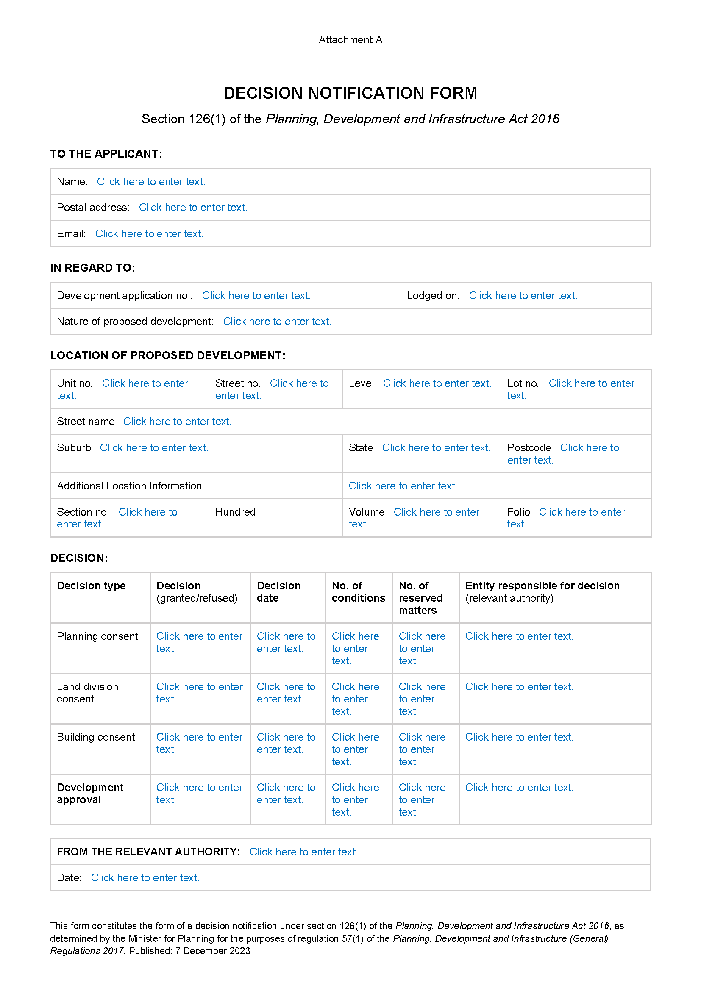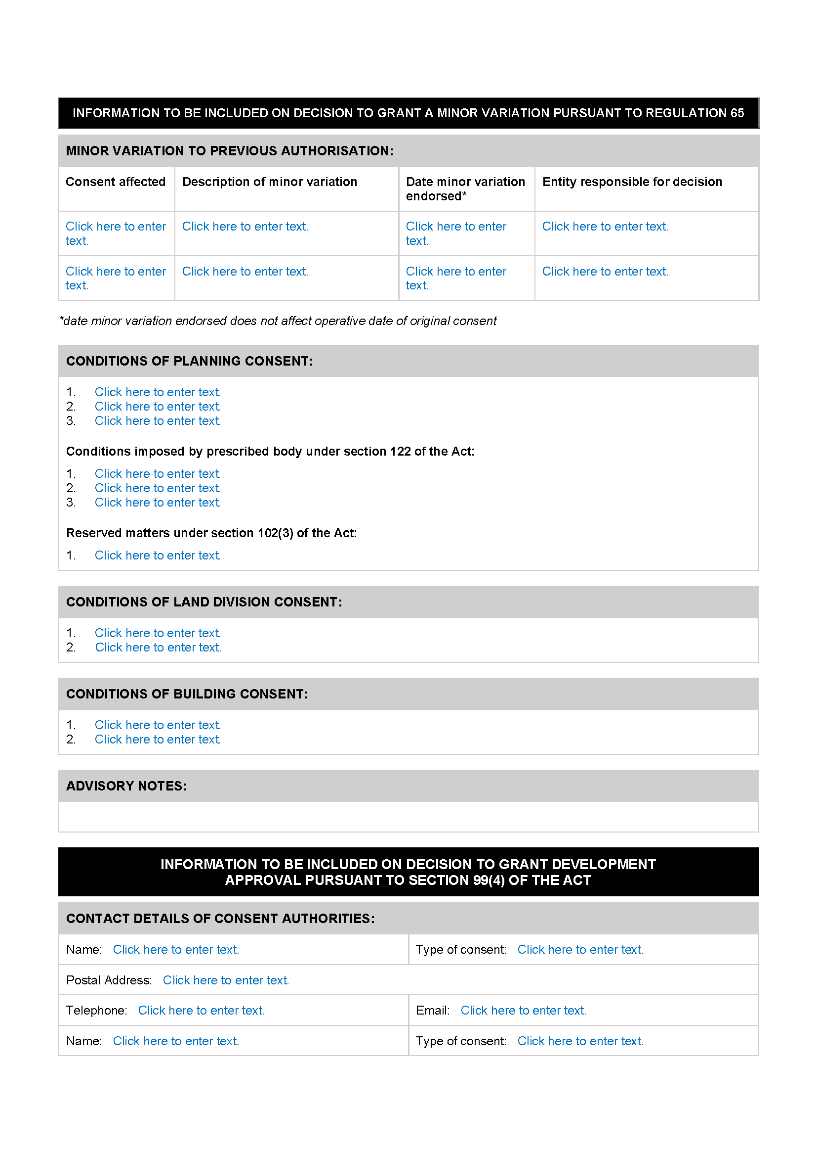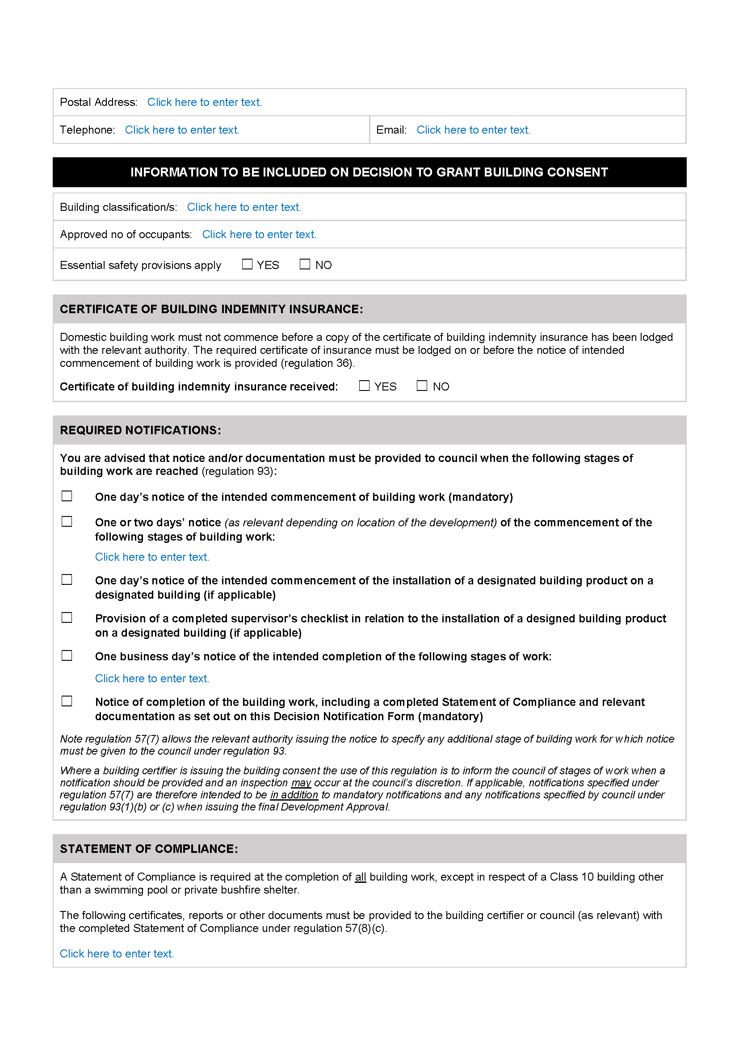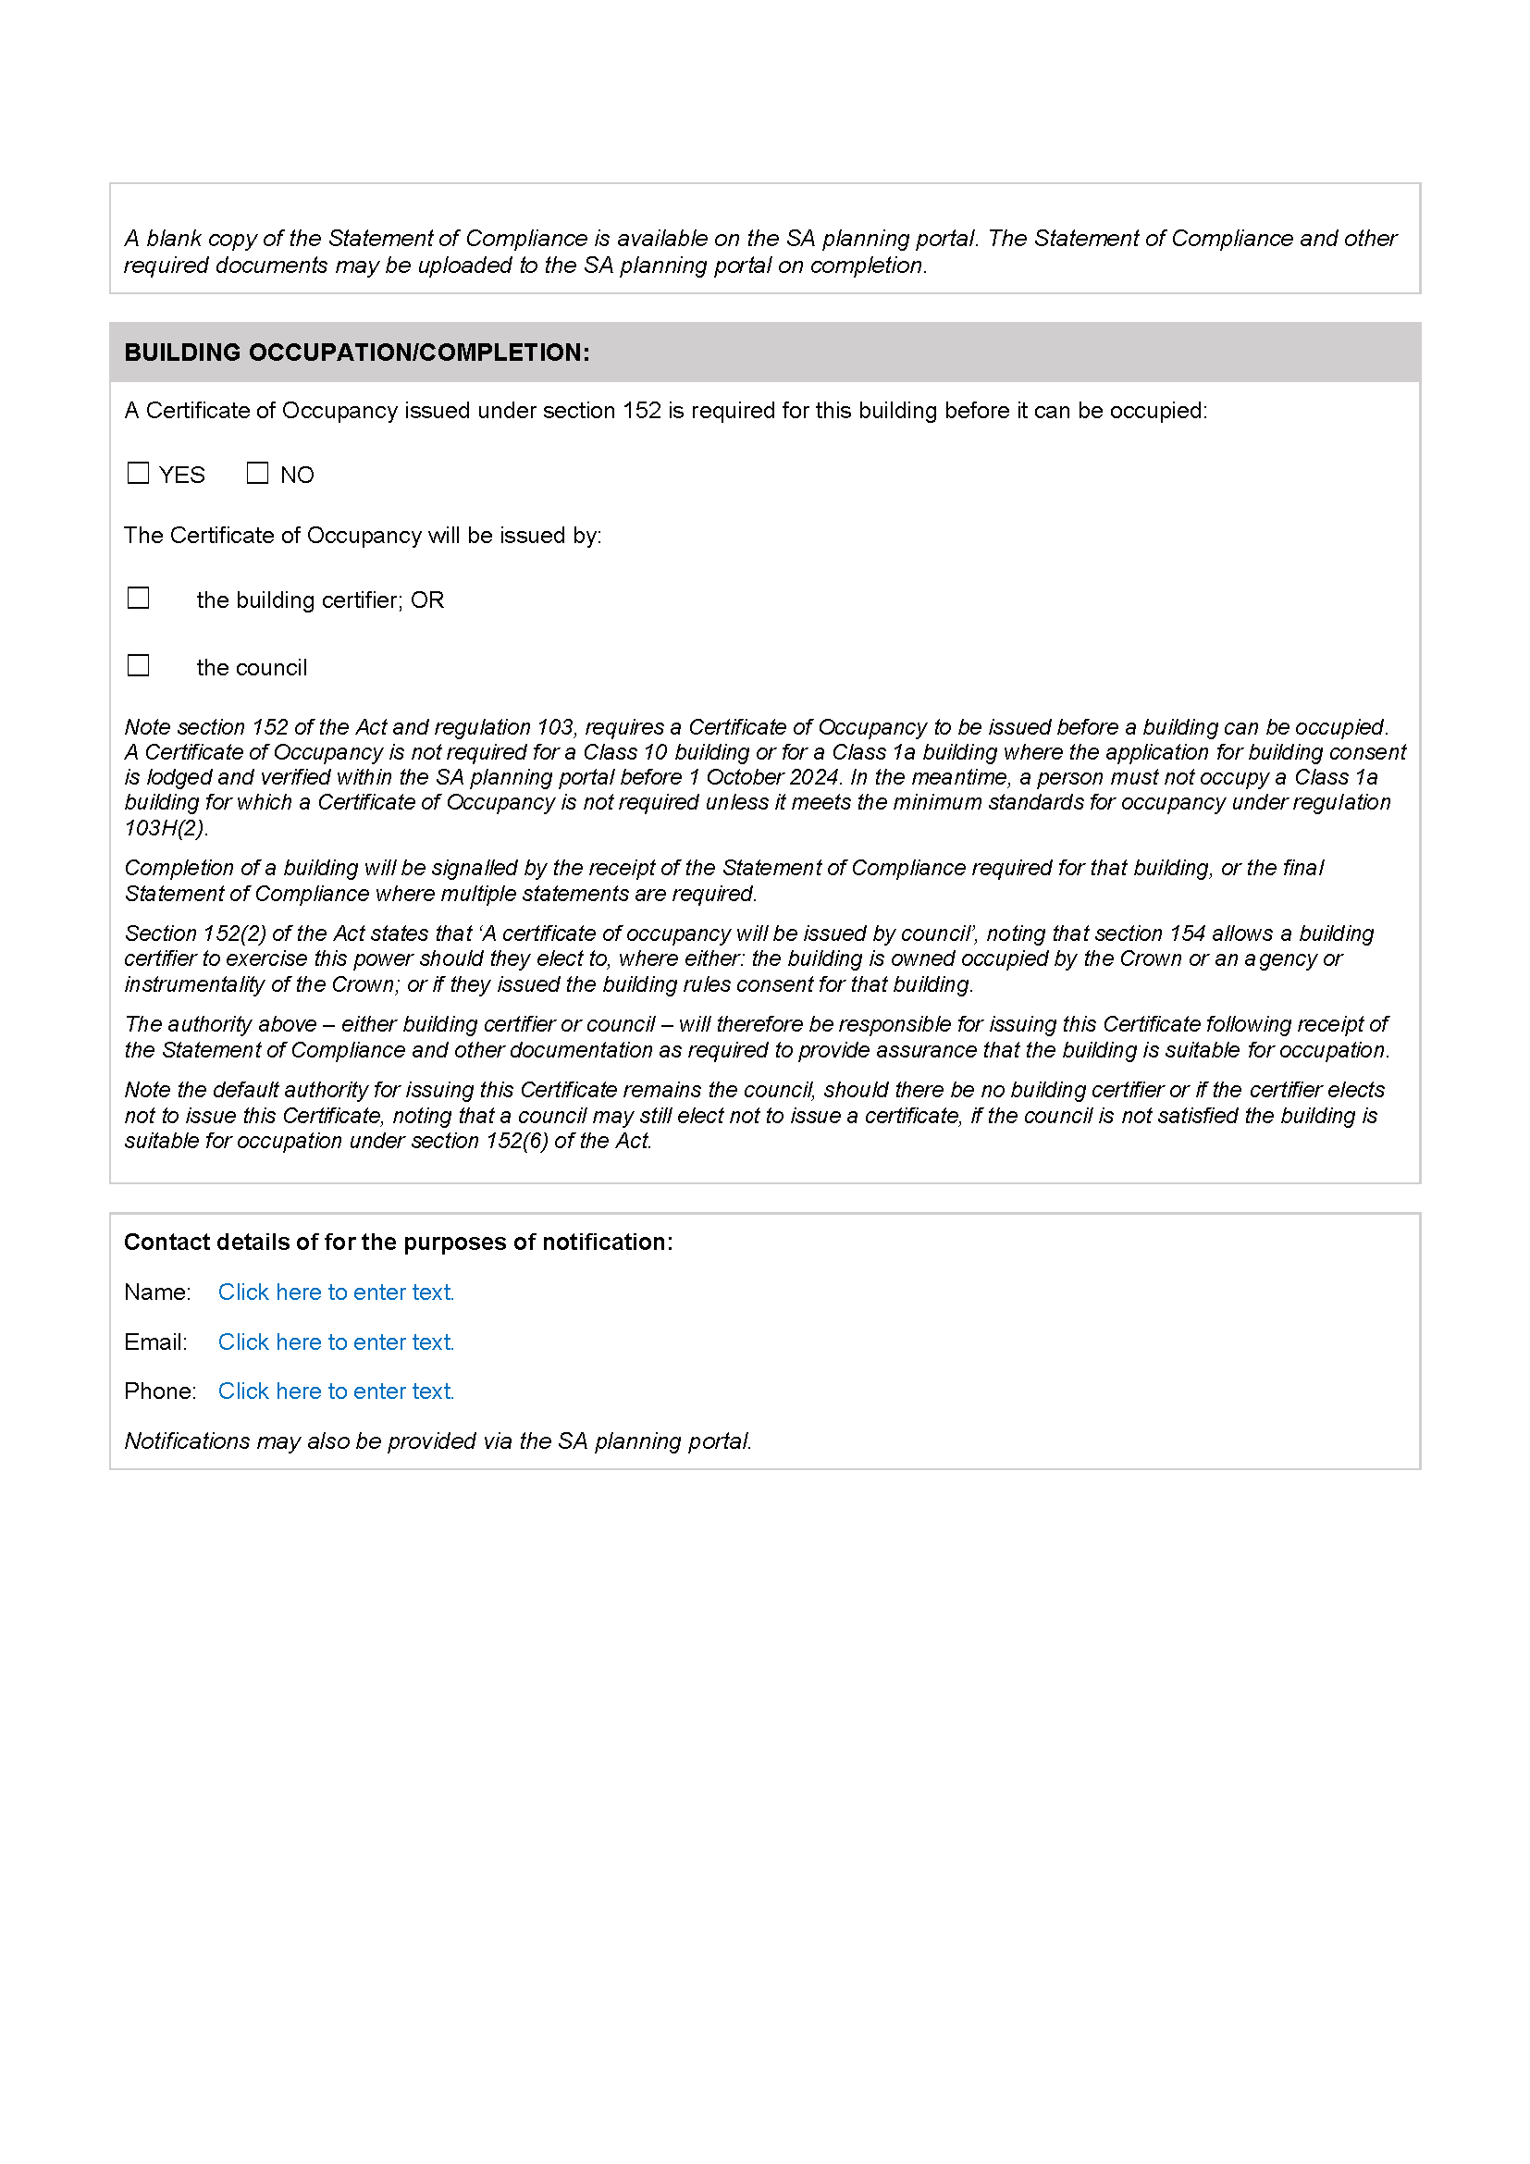

## Planning, Development and Infrastructure Act 2016

Section 76

*Amendment to the Planning and Design Code*

*Preamble*

It is necessary to amend the Planning and Design Code (the Code) in operation at 23 November 2023 (Version 2023.17) in order to make changes of form relating to the Code’s spatial layers and their relationship with land parcels. NOTE: There are no changes to the application of zone, subzone or overlay boundaries and their relationship with affected parcels or the intent of policy application as a result of this amendment.

1. PURSUANT to section 76 of the *Planning, Development and Infrastructure Act 2016* (the Act), I hereby amend the Code in order to make changes of form (without altering the effect of underlying policy), correct errors and make operational amendments as follows:
2. Undertake minor alterations to the geometry of the spatial layers and data in the Code to maintain the current relationship between the parcel boundaries and Code data as a result of the following:
   1. New plans of division deposited in the Land Titles Office between 15 November 2023 and 28 November 2023 affecting the following spatial and data layers in the Code:
      1. Zones and subzones
      2. Technical and Numeric Variations
         * Building Heights (Levels)
         * Building Heights (Metres)
         * Finished Ground and Floor Levels
         * Minimum Frontage
         * Minimum Site Area
         * Minimum Primary Street Setback
         * Minimum Side Boundary Setback
         * Future Local Road Widening Setback
      3. Overlays
         * Affordable Housing
         * Hazards (Bushfire - High Risk)
         * Hazards (Bushfire - Medium Risk)
         * Hazards (Bushfire - General Risk)
         * Hazards (Bushfire - Urban Interface)
         * Hazards (Bushfire - Regional)
         * Hazards (Bushfire - Outback)
         * Heritage Adjacency
         * Local Heritage Place
         * Noise and Air Emissions
         * State Heritage Place
         * Stormwater Management
         * Urban Tree Canopy
3. In Part 13 of the Code – Table of Amendments, update the publication date, Code version number, amendment type and summary of amendments within the ‘Table of Planning and Design Code Amendments’ to reflect the amendments to the Code as described in this Notice.
4. PURSUANT to section 76(5)(a) of the Act, I further specify that the amendments to the Code as described in this Notice will take effect upon the date those amendments are published on the SA planning portal.

Dated: 1 December 2023

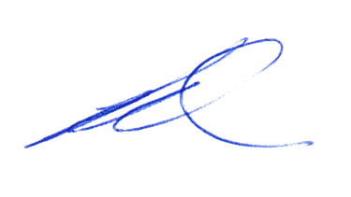Greg Van Gaans

Director, Land and Built Environment,

Department for Trade and Investment

Delegate of the Minister for Planning

Planning, Development and Infrastructure Act 2016

Section 76

*Amendment to the Planning and Design Code*

*Preamble*

It is necessary to amend the Planning and Design Code (the Code) in operation at 23 November 2023 (Version 2023.17) in order to make the following minor or operational amendments:

* to remove irrelevant material relating to:
  + the misapplication of the Historic Area Overlay (PAdE1) to properties at Alberton.
* to correct errors relating to:
* missing performance assessed development policy criteria for ‘detached dwellings’ and ‘ancillary accommodation’ within the Fisherman Bay Subzone of the Rural Settlement Zone.

1. PURSUANT to section 76 of the *Planning, Development and Infrastructure Act 2016* (the Act), I hereby amend the Code in order to make the following minor or operational amendments as follows:
2. In Part 2 – Zones and Sub Zones, amend ‘Table 3 - Applicable Policies for Performance Assessed Development’ of the Rural Settlement Zone by inserting the following Subzone policies for Class of Development ‘detached dwelling’ and ‘ancillary accommodation’:

Fisherman Bay Subzone

[Land Use and Intensity] PO 1.1

[Site Dimensions and Land Division] PO 2.1

[Built Form and Character] PO 3.1

[Flooding] PO 4.1

1. Amend the spatial layer of the Historic Area Overlay PAdE 1 so that it does not apply to the allotments shaded blue in the map in **Attachment A**:
2. In Part 13 – Table of Amendments, update the publication date, Code version number, amendment type and summary of amendments within the ‘Table of Planning and Design Code Amendments’ to reflect the amendments to the Code as described in this Notice.

PURSUANT to section 76(5)(a) of the Act, I further specify that the amendments to the Code as described in this Notice will take effect upon the date those amendments are published on the SA planning portal.

Dated: 1 December 2023

Sally Smith

Executive Director, Planning and Land Use Services

Department for Trade and Investment

Delegate of the Minister for Planning

Attachment

## Plant Health Act 2009

Sections 4 and 8

Declaration of Pests and Quarantine Areas

PURSUANT to Sections 4 and 8 of the *Plant Health Act 2009*, I, Nicholas Secomb, Chief Inspector, delegate of the Minister for Primary Industries and Regional Development, hereby declare the species listed in Part 1 of this notice to be pests for the purposes of the Act and the portions of the State listed in Part 2 of this notice to be quarantine areas for the purposes of the Act.

This notice revokes the previous notice made by the Chief Inspector pursuant to Sections 4(3) and 8(3) on 23 March 2023, published on 30 March 2023, page 754.

Part 1

*Declaration of Pests—Pursuant to Section 4 of the Act*

The following pests specified by common name or scientific name are declared to be pests for the purposes of the Act:

| **Common Name(s)** | **Scientific Name(s)** |
| --- | --- |
| African citrus psyllid | *Trioza erytreae* |
| American serpentine leaf miner | *Liriomyza trifolii* |
| Anthracnose of Brassica crops | *Colletotrichum higginsianum* |
| Asian citrus psyllid | *Diaphorina citri* |
| Asian longicorn beetle | *Anaplophora glabripennis* |
| Asian subterranean termite | *Cryptotermes gestroi* |
| Australian plague locust | *Chortoicetes terminifera* |
| Bacterial wilt of potato | *Ralstonia solanacearum* Race 3 |
| Barley stem gall midge | *Mayetiola hordei* |
| Barley stripe rust | *Puccinia striiformis* f. *sp*. *hordei* |
| Blueberry rust | *Thekopsora minima* |
| Boil smut of maize | *Ustilago maydis* |
| Brown marmorated stink bug | *Halyomorpha halys* |
| Browsing ant | *Lepisiota frauenfeldi* |
| Burning moth | *Hylesia nigricans* |
| *Caracollina lenticula* | *Caracollina lenticula* |
| Ceratocystis wilt | *Ceratocystis manginecans, Ceratocystis* spp. (exotic species) |
| Chestnut blight | *Cryphonectria parasitica* |
| Chickpea leaf miner | *Liriomyza cicerina* |
| Chocolate-band snail | *Eobania vermiculata* |
| Citrus blight | (unknown causal agent) |
| Citrus canker | *Xanthomonas citri* subsp*. citri* |
| Citrus longicorn beetle | *Anaplophora chinensis* |
| Citrus red mite | *Panonychus citri* |
| Citrus tristeza virus – sweet orange stem pitting strain | Citrus tristeza closterovirus – sweet orange stem pitting strain |
| Citrus variegated chlorosis | *Xylella fastidiosa* |
| Columnea latent viroid (CLVd) | Columnea latent viroid |
| Cucumber fruit mottle mosaic virus (CFMMV) | Cucumber fruit mottle mosaic tobamovirus |
| Cucumber green mottle mosaic virus (CGMMV) | Cucumber green mottle mosaic tobamovirus |
| Drywood termite | *Cryptotermes dudleyi* |
| Electric ant | *Wasmannia auropunctata* |
| European House Borer | *Hylotrupes bajulus* |
| Exotic gypsy moth | *Lymantria* spp. (*L.* *dispar* and sub-species, *L*. *monacha*) |
| Fire blight | *Erwinia amylovora* |
| Fruit flies | Pest species of Tephritidae family |
| Fusarium wilt of tomatoes | *Fusarium oxysporum* f.sp. *lycopersicon* Race 3 |
| Giant African snail | *Lissachatina fulica* |
| Giant pine scale | *Marchalina hellenica* |
| Glassy-winged sharpshooter | *Homalodisca vitripennis* |
| Golden apple snail | *Pomacea canaliculata* |
| Grape phylloxera | *Daktulosphaira vitifolliae* |
| Grapevine leaf rust | *Phakopsora euvitis* |
| Grapevine red blotch-associated virus | Grapevine red blotch-associated geminivirus |
| Green snail | *Cantareus apertus* |
| Guava Root Knot Nematode | *Meloidogyne enterolobii* |
| Harlequin lady beetle | *Harmonia axyridis* |
| Hessian fly | *Mayetiola destructor* |
| Huanglongbing disease of citrus | ‘*Candidatus liberibacter*’ spp. |
| Karnal bunt | *Tilletia indica* |
| Khapra beetle | *Trogoderma granarium* |
| Kyuri green mottle mosaic virus (KGMMV) | Kyuri green mottle mosaic tobamovirus |
| Melon necrotic spot virus (MNSV) | Melon necrotic spot carmovirus |
| Melon thrips | *Thrips palmi* |
| Myrtle rust | *Puccinia psidii* (syn. *Uredo rangelii*) |
| Myrtle rust (exotic strains) | *Austropuccinia psidii* (syn. *Puccinia psidii,* *Uredo rangelii*) – exotic strains |
| Parlatoria date scale | *Parlatoria blanchardi* |
| Pepino mosaic virus (PepMV) | Pepino mosaic potexvirus |
| Pepper chat fruit viroid (PCFVd) | Pepper chat fruit viroid |
| Phoney peach disease | *Xylella fastidiosa* |
| Phytophthora blight | *Phytophthora kernoviae* |
| Pierce’s disease of grapevines | *Xylella fastidiosa* |
| Pine wilt nematode | *Bursaphelenchus spp.* including *B. xylophilus* |
| Pitch canker | *Fusarium circinatum* |
| Polyphagous shot hole borer | *Euwallacea fornicatus* |
| Polyphagous shot hole borer-associated fusarium wilt | *Fusarium euwallaceae* |
| Potato blackleg and soft rot | *Dickeya spp. Including D. dianthicola, D. dadantii and D. solani* |
| Potato cyst nematode | *Globodera pallida* |
| Potato cyst nematode | *Globodera rostochiensis* |
| Potato late blight | *Phytophthora infestans* (A2 mating type) |
| Potato spindle tuber viroid (PSTVd) | Potato spindle tuber pospiviroid |
| Pyriform scale | *Protopulvinaria pyriformis* |
| Red imported fire ant | *Solenopsis invicta* |
| Sawyer beetles | *Monochamus spp.* including  *M. alternatus, M. galloprovincialis,*  *M. scutellatus, M. titillator* |
| Serpentine leaf miner | *Liriomyza huidobrensis* |
| Sharka | Plum pox potyvirus |
| Small plague grasshopper | *Austroicetes cruciata* |
| Spotted-winged drosophila (fruit fly) | *Drosophila suzukii* |
| Strawberry latent ringspot virus (SLRSV) | Strawberry latent ringspot virus |
| Stubborn disease of citrus | *Spiroplasma citri* |
| Subterranean termite | *Coptotermes formosanus* |
| Sudden oak death | *Phytophthora ramorum* |
| Tarnished plant bug | *Lygus lineolaris* |
| Teratosphaeria canker | *Teratosphaeria destructans* and*T. zuluensis* |
| Tomato apical stunt viroid (TASVd) | Tomato apical stunt viroid |
| Tomato black ring virus (TBRV) | Tomato black ring nepovirus |
| Tomato brown rugose fruit virus (ToBRFV) | Tomato brown rugose fruit tobamovirus |
| Tomato chlorotic dwarf viroid (TCDVd) | Tomato chlorotic dwarf viroid |
| Tomato leaf miner | *Liriomyza bryoniae* |
| Tomato mottle mosaic virus (ToMMV) | Tomato mottle mosaic tobamovirus |
| Tomato planta macho viroid (TPMVd) | Tomato planta macho viroid |
| Tomato-potato psyllid | *Bactericera cockerelli* |
| Tropical fire ant | *Solenopsis geminata* |
| Vegetable leaf miner | *Liriomyza sativae* |
| Watermelon green mottle mosaic virus (WGMMV) | Watermelon green mottle mosaic tobamovirus |
| West Indian drywood termite | *Cryptotermes brevis* |
| Western plant bug | *Lygus hesperus* |
| Wheat stem rust (exotic strains) | *Puccinia graminis* f. sp. *tritici* (exotic strains) |
| Wheat stem sawfly | *Cephus* spp*.* (*C. cinctus*, *C. pygmeaus*) |
| Yellow crazy ant | *Anoplolepis gracilipes* |
| Zebra chip of potatoes, ‘yellows’ and other diseases of solanaceous and apiaceous plants | *‘Candidatus* Liberibacter solanacearum’ (all Haplotypes) |
| Zucchini green mottle mosaic virus (ZGMMV) | Zucchini green mottle mosaic tobamovirus |

Part 2

*Quarantine Areas—Pursuant to Section 8 of the Act*

* 1. The following portions of the State are declared to be quarantine areas:
     1. the whole of Kangaroo Island with respect to the declared diseases of potatoes, namely bacterial wilt (*Ralstonia solanacearum* Race 3) and potato cyst nematodes (*Globodera rostochinesis* and *Globodera pallida*). This quarantine area is to be known as the ‘Kangaroo Island Protected Production Area’.
     2. with respect to pest fruit flies, for the purposes of control and eradication, a “Controlled Movement Zone” (as defined in Part 3 of this Notice).
     3. with respect to pest fruit flies, for the purpose of excluding fruit flies from the Riverland of South Australia (“Riverland Pest Free Area”), the:
        1. County of Hamley; and
        2. Hundreds of Bookpurnong, Cadell, Gordon, Holder, Katarapko, Loveday, Markaranka, Moorook, Murtho, Parcoola, Paringa, Pooginook, Pyap, Stuart, Waikerie, Eba, Fisher, Forster, Hay, Murkbo, Nildottie, Paisley, Ridley and Skurray.
     4. with respect to Caracollina lenticula, the following are declared to be quarantine areas:
        1. 9 Creswell Road, Largs North, Certificate of Title Volume 5781 Folio 919; and
        2. 10 Creswell Road, Largs North, Certificate of Title Volume 5208 Folio 532; and
        3. 1- 4 / 2 Elder Road, Largs North, Certificates of Title Volume 6129 Folio 124 and Volume 6129 Folio 125.
  2. Measures to be taken in Quarantine Areas
     1. The owner or occupier of any premises within the ‘Kangaroo Island Protected Production Area’ established under Part 2 1.1(1) must take the measures prescribed in the Standard for eradication of the declared diseases of potatoes.
     2. For the purposes of control and eradication of fruit flies, unless permitted within the Standard, host fruit grown in or introduced into a Controlled Movement Zone must not be moved within or removed from the Controlled Movement Zone without approval from the Chief Inspector or delegate; and
     3. the owner or occupier of any premises within a portion of the State declared to be a:
        1. Delimitation Zone (as defined in Part 3 of this Notice) must take the measures prescribed in the Standard for the control and eradication of such flies from a fruit fly outbreak zone; and
        2. Corrective Action Zone (as defined in Part 3 of this Notice) must take the measures prescribed in the Standard for the control and eradication of such flies from a fruit fly outbreak area; and
        3. Export Assurance Zone (as defined in Part 3 of this Notice) must take the measures prescribed in the Standard for the control and eradication of such flies from a fruit fly suspension area.
     4. Measures for the exclusion of fruit flies from the Riverland of South Australia (“Riverland Pest Free Area”):
        1. Introduction of host fruits, as specified under Section 7 of the Act, into the Riverland Pest Free Area is prohibited unless:
           1. in transit through the Riverland Pest Free Area; or
           2. if the host fruit was produced in a State or Territory other than South Australia or interstate Fruit Fly Pest Free Area (FF-PFA): the host fruit complies with the treatments described within Part 2, paragraph 1.2(4)(iii) below and is accompanied with plant health certification; or
           3. if the host fruit was produced in any part of South Australia outside the Riverland Pest Free Area, the host fruit has been certified by an inspector as having been either;

grown in an area free of fruit flies as defined by the Standard; or

treated in compliance with the treatments described in Part 2, paragraph 1.2(4)(iii) below; or

* + - * 1. moved under an accreditation arrangement as approved by the Minister under Part 4 Division 2 of the Act and Regulation 7 of the *Plant Health Regulations 2022*; or
        2. accompanied by an itemised retail purchase docket applicable to that produce and issued by an Approved PFA suitable retail store.
      1. if the host fruit was originally produced in the Riverland Pest Free Area or an interstate Fruit Fly Pest Free Area, but has moved outside that area and is now proposed to be re-introduced, or introduced for the first time as the case may be, into the Riverland Pest Free Area, the produce must be;
         1. maintained under secure conditions throughout the duration that it was outside the Riverland Pest Free Area or interstate Fruit Fly Pest Free Area; and
         2. labelled in accordance with the *Plant Health Regulations 2022* and accompanied with documentation demonstrating the origin and destination of the host fruit; or
         3. moved under an accreditation arrangement as approved by the Minister under Part 4 Division 2 of the Act and Regulation 7 of the *Plant Health Regulations 2022*; or
         4. Treated in compliance with the treatments described in Part 2, paragraph 1.2(4)(iii) below and is accompanied with plant health certification.
      2. The following treatments are prescribed for the purpose of moving produce into the Riverland Pest Free Area:
         1. Treatment in accordance with Condition 9 (Area Freedom for fruit flies / secure transportation) as described in the Standard
         2. Treatment in accordance with Condition 10.1 (Hard green or similar condition for Fruit Fly) as described in the Standard
         3. Treatment in accordance with Condition 11 (Disinfestation by Cold Storage) as described in the Standard
         4. Treatment in accordance with Condition 12 (Disinfestation using Dimethoate – Queensland fruit fly) as described in the Standard
         5. Treatment in accordance with Condition 12E (Winegrapes Secure Transportation – Queensland Fruit Fly / Mediterranean Fruit Fly – Systems Approach – ICA 33) as described in the Standard
         6. Treatment in accordance with Condition 13 (Disinfestation by Methyl Bromide fumigation) as described in the Standard
         7. Treatment in accordance with Condition 14 (Disinfestation by Irradiation) as described in the Standard
         8. Treated or consigned under conditions approved by the Chief Inspector.
    1. The owner or occupier of any premises within the quarantine area with respect to Caracollina lenticula, must take the following measures
       1. all outdoor areas must be treated with the following molluscicide bait treatments in accordance with label specifications:
          1. a metaldehyde-based bait (e.g. Metarex Inov Slug and Snail Bait, Axcela Slug and Snail Bait) at least once during the months of March, April, May, September, October and November; and,
          2. an iron-based bait (e.g. Protect Us Snail and Slug Killer, Eradicate Snail and Slug Bait) at least once during the months of June, July and August of each year.
          3. bait applications must occur at regular intervals over the twelve months (e.g. every 30 days plus (+) or minus (–) 3 days).
       2. all annual vegetative ground cover must be destroyed but retained within the premises.
          1. any item from the quarantine area that may harbour Caracollina lenticula is prohibited from leaving the quarantine area unless it meets the conditions laid out in Part 2, paragraphs 1.2(5)(iii)a) to 1.2(5)(iii)d) below:
          2. the item is inspected by an inspector and the inspector is satisfied that the item is free of Caracollina lenticula; or
          3. a staff member nominated by the affected business who is authorised by an inspector to do the inspections is satisfied that the item is free of Caracollina lenticula, and,
          4. if Caracollina lenticula are found during inspection, or the item cannot be inspected to satisfy that the item is free of Caracollina lenticula, the item must be cleaned or treated in a method approved by the Department of Primary Industries and Regions, South Australia, and,
          5. the item is removed from the quarantine area immediately upon being inspected in accordance with Part 2, paragraph 1.2(5)(iii)a) or b) above; or immediately upon being cleaned or treated in accordance with Part 2, paragraph 1.2(5)(iii)c) above.

Part 3

*Definitions*

In this Notice:

* “the Act” means the *Plant Health Act 2009*.
* “annual vegetation” means plants that grow for only a single year and not purposely grown for amenity reasons.
* “Approved PFA suitable retail store” means a retail store who holds an accreditation arrangement as approved by the Minister under Part 4 Division 2 of the Act and Regulation 7 of the *Plant Health Regulations 2022*, and as having verified systems for the management and traceability of host fruit, and does not receive, display or sell any host fruit that does not meet the requirements of Part 2, paragraph 1.2(4)(iii) of this Notice.
* “Controlled Movement Zone” (also known as the *Fruit Fly Affected Area*) means the entire area within a circle of pre-determined radius surrounding a fruit fly outbreak centre Epicentre in which area freedom status is suspended and movement controls are applied.
  + Unless otherwise determined by the Chief Inspector, the pre-determined radius of the Controlled Movement Zone is 15 kilometres in the case of an outbreak of Queensland fruit fly.
  + Unless otherwise determined by the Chief Inspector, the pre-determined radius of the Controlled Movement Zone is 7.5 kilometres in the case of an outbreak of Mediterranean fruit fly.
* “Corrective Action Zone” (also known as the *fruit fly outbreak area*) means an area within 1.5 kilometres radius of a fruit fly outbreak centre Epicentre, unless otherwise determined by the Chief Inspector.
* “DelimitationZone” (also known as the *fruit fly outbreak zone*) means all of the land within a 200-metre radius around each fruit fly Discovery Point once the outbreak trigger has been met, unless otherwise determined by the Chief Inspector.
* “Discovery Point” means the physical location where:
  + One or more suspect adult flies have been collected during a single inspection of a trap (regardless of whether the detection triggers and outbreak or not); or
  + Host material containing fruit fly larvae was grown.
* “Export Assurance Zone” (also known as the *fruit fly suspension area*) means the area starting at the outer boundary of the Corrective Action Zone to the pre-determined radius surrounding an Epicentre in which area freedom status is suspended and movement controls are applied.
  + The pre-determined radius of the fruit fly Export Assurance Zone is 15 kilometres in the case of an outbreak of Queensland fruit fly, unless otherwise determined by the Chief Inspector.
  + he pre-determined radius of the fruit fly Export Assurance Zone is 7.5 kilometres in the case of an outbreak of Mediterranean fruit fly, unless otherwise determined by the Chief Inspector.
* “Epicentre” (also known as the *fruit fly outbreak centre*) means the means the location related to each single detection or grouping of detections that triggers an outbreak. An Epicentre may be:
  + the Discovery Point where the first larvae or gravid female was detected; or
  + a location between a grouping of male flies that precipitated the outbreak.
* “fruit fly outbreak trigger” means the detection of fruit fly larvae in locally grown fruit, the detection of one gravid female fruit fly, or the detection of a predetermined number of male fruit flies or non-gravid female fruit flies within a 1-kilometre radius within a consecutive fourteen-day period
  + The pre-determined number of male fruit flies or non-gravid female fruit flies is five for Queensland fruit fly
  + The pre-determined number of male fruit flies or non-gravid female fruit flies is three for Mediterranean fruit fly.
* “host fruit” means the host fruits of fruit flies as specified under Section 7 of the Act.
* “inspector” means an inspector appointed pursuant to Section 41 of the Act
* "interstate Fruit Fly Pest Free Area” means an area outside of South Australia certified by the Commonwealth Government department responsible for agriculture as a Fruit Fly Pest Free Area.
* “introduced into”, for the purposes of control and eradication of fruit flies only, excludes host fruit in transit.
* an “item that may harbour Caracollina lenticula” includes any vehicle, machinery or equipment, whether or not it is a plant-related product.
* “the Minister” means the Minister for Primary Industries and Regional Development.
* “molluscicide” means a pesticide that will kill snails and slugs.
* “plant-related product” has the same meaning as in the Act.
* "plant health certification” means assurance certificate or plant health certificate certifying the consignment as treated with the requirements described in Part 2, paragraph 1.2(4)(iii).
* “quarantine area” means the area described in Part 2 of this Notice.
* “retail purchase docket” means a sale provided by an Approved PFA suitable retail store for fruit or fruiting vegetables sold to the public for personal consumption rather than for resale.
* “the Standard” means the document published by the Department of Primary Industries and Regions entitled the “Plant Quarantine Standard South Australia”.
* “transiting” or “in transit” means the movement of securely contained plant product, either directly through South Australia or through another quarantine area for a plant pest, that is accompanied by documentation that can demonstrate both the origin and destination of product, and, whilst in South Australia or another quarantine area, is not subject to off-loading, reloading or storage.
* “securely contained” means transported in a manner that prevents infestation of product with a quarantine pest and/or release of a quarantine pest and, for fruit fly purposes, meets the requirements of Condition 9 of the Standard.

This Notice will remain in force until revoked by subsequent Notice.

Dated: 4 December 2023

Nicholas Secomb

Chief Inspector

Delegate of the Minister for Primary Industries and Regional Development

## The Remuneration Tribunal

Report—No. 9 of 2023

*2023 Review of Accommodation Reimbursement and Allowances for  
Country Members of Parliament*

**Introduction**

1. The Remuneration Tribunal (**Tribunal**) has conducted a review of Determination 18 of 2022, which provides for eligible members of Parliament to claim allowances or reimbursements for accommodation costs from commercial accommodation or a second residence in Metropolitan Adelaide.
2. As explained in this report, the Tribunal has determined to increase the commercial accommodation reimbursement by 1.5%, the second residence accommodation payment by 4.4% and to introduce a new category of non-commercial accommodation. The Tribunal has issued an accompanying determination, which applies from 1 January 2024.

**Background**

1. The country members accommodation determination exists to facilitate journeys of an official nature from a country member's principal place of residence to Adelaide. The determination operates such that country members are not disadvantaged for fully and properly carrying out their official parliamentary, electoral, community or ministerial duties in Adelaide.
2. The Tribunal’s Report 9 of 2020 contains extensive information about the history of the country members accommodation reimbursement/allowance. We do not propose to reproduce that information in this report.
3. In 2020 the Tribunal implemented significant changes by moving the system from an allowance based one to a reimbursement and allowance based arrangement. In particular, it adopted a reimbursement system for commercial accommodation expenses and an allowance based approach for those country members of Parliament who purchase, or rent on a long term basis, a second Adelaide based residence to enable them to undertake their parliamentary, community and electoral duties.
4. In 2021 the Tribunal made some changes to the administrative requirements for the reimbursement and allowance payment arrangements.
5. In 2022 the Tribunal commented that it believed administrative improvements could conceivably be made to the system, particularly in relation to the reporting arrangements. It also noted its intention to put out a draft proposal ahead of the next review:

**The Review Process**

1. On 1 June 2023, in accordance with sections 10(2) and 10(4) of the *Remuneration Act 1990* (SA) (**Act**), the Tribunal wrote to and invited submissions by 29 June 2023 in respect of this review from:
2. the Honourable Premier of South Australia – as the Minister responsible for the Act who may make submissions or introduce evidence on any question relevant to the public interest;
3. members of Parliament;
4. the Treasurer; and
5. the Independent Commissioner Against Corruption (**ICAC**).
6. The Tribunal also advertised its intention to review Determination 18 of 2022 on its website from 1 June 2023. Submissions were also invited by 29 June 2023.
7. Consistent with the comments made in Report 18 of 2022, the Tribunal included a consultation paper that contained some options for consideration by those wishing to make submissions. Those options, in summary, included:
8. Simplifying the current determination
9. Returning to the previous allowance scheme
10. Making no changes to the current determination
11. Implementing a fixed yearly allowance amount
12. The Tribunal advised in the consultation paper that it was of the preliminary view that option 1, simplifying the current determination, increased transparency and accountability through improvements made to the reporting arrangements, whilst also simplifying the current scheme.
13. Attached to the consultation paper was a draft determination reflecting option 1. Details of the other options were discussed in the consultation paper, with other questions posed at the end of the paper for consideration.
14. Submissions were invited on the options put by the Tribunal as well as other alternate approaches that were not contained within the consultation paper. Importantly, submissions were not limited to the options contained within the consultation paper.
15. On 21 June 2023, the ICAC, the Hon Ann Vanstone KC, sent a letter referring to her submission from previous years for a fixed yearly allowance, which she considered would streamline the process. She observed that the processes demanded by the draft determination of option 1 would result in the expenditure of a disproportionate amount of time by the member, his or her staff, parliamentary officers and Shared Services.
16. On 28 June 2023, the Premier’s representative confirmed that no submission would be made.

**Opposition Members Submission**

1. On 29 June 2023, a written submission was received from Opposition Members.
2. Opposition Members submitted firstly, that the determination should include a statement of purpose, rather than codifying criteria and secondly that the Tribunal should adopt the recommendations and observations of the ICAC set out in the Commissioner’s letters dated 14 July 2021 and 29 June 2022 respectively.
3. Opposition Members advised that country members who are Ministers, Shadow Ministers, Members of the Legislative Council or who hold other offices may be required to spend more nights working in Adelaide than at their usual place of residence. Furthermore, that the only office provided for Members of the Legislative Council is located in Parliament House.
4. Historically Parliament incorporated overnight accommodation quarters for country members within the building itself. The provision of accommodation is a core component of country members capacity to serve their constituents. Nowadays, country members set up routines to establish a sustainable home away from home. This may include sharing accommodation with family or colleagues and making other long-term arrangements, for example buying or leasing city accommodation, rather than booking night by night commercial accommodation.
5. Opposition Members adopt the earlier ICAC’s recommendation of 14 July 2021 that the current regime ought to be replaced with an allowance and applied in increments according to relevant responsibilities. Such a model would eliminate uncertainty and would add transparency of remuneration of members of Parliament. Opposition Members share ICAC’s doubts that there is a valid reason to discriminate between members of Parliament who incur accommodation costs at hotels as against those who choose to keep a second residence in Adelaide. Furthermore, a distinction ought to be drawn between transparency on the one hand and privacy on the other hand. There being a clear public interest in ensuring transparency of remuneration but not the particular living arrangements of a member of Parliament, which includes country members.
6. Opposition Members submit that the definition of terms in the determination appear to contemplate a non-exhaustive and wide range of ways and reasons to stay overnight in Adelaide, with the utility of doing so not being clear. In their view, it is problematic to codify certain categories of a country member’s duties, as codification risks circumscribing the role of a country member in a way that is not elsewhere so circumscribed.
7. Opposition Members also sought to make oral submissions and therefore a hearing was held on 19 July 2023. Joshua Teague MP and David Basham MP appeared on behalf of Opposition Members. They reiterated the written submissions.

**Clerk of the House of Assembly**

1. On 25 July 2023, the Tribunal received a submission from the Clerk of the House of Assembly.
2. The Clerk’s submission was limited to the proposed insertion of a clause that requires the Clerk of the House to cause to be tabled the claim forms, not the signed statutory declarations, in each House of Parliament.
3. The Clerk advised that since early in the financial year 2020-21, both Houses of Parliament have published on the SA Parliament website monthly Country Members Accommodation Reimbursement and Allowance consolidated reports. This reporting function was a direct response to a statement made in the House of Assembly by Speaker Tarzia on 22 September 2020, that claims for the Country Members’ Accommodation Allowance and the Leader of the Opposition’s travel be published on the Parliament’s website each month.
4. Furthermore, if claim forms were tabled, they contain details such as the name of the commercial accommodation being used, the address of the member’s usual place of residence and/or second residence. On 21 July 2020, Speaker Tarzia tabled advice from SAPOL regarding the publishing of members addresses. That advice stated that public access to members details such as their address presents a risk to members.

**Consideration**

1. The Tribunal is not persuaded that the fundamental nature of this allowance should be changed to reflect an administratively simple allowance payment. Taking into account the contentious history of this allowance system, the Tribunal remains committed to a system that has a significant level of accountability. Changes to make this as administratively efficient as possible are advantageous but accountability mechanisms continue to be of paramount significance.
2. The Tribunal is of the view that Determination 18 of 2022 could be amended to simplify and clarify the eligibility requirements for claiming a country members accommodation reimbursement or allowance. It has therefore rearranged various parts of the determination, consistent with the draft determination that accompanied the consultation paper. In effect, the overall entitlement to make a claim has not significantly changed.
3. Part A now clearly sets out the options available to a member of Parliament whose principal place of residence is greater than 75kms by road from Parliament House, by the most direct route. In this instance, the member has access to three different options. The first is to claim a commercial accommodation reimbursement, which is short term accommodation in a commercial establishment, which now includes Airbnb or a similar platform. The second option is to receive payment for staying at a second residence in Metropolitan Adelaide and the third is a new category, non-commercial accommodation.
4. Non-commercial accommodation provides a mechanism for members of Parliament to claim a set allowance for staying with family or friends on the basis that it is likely that members incur some costs in doing so. Those costs may include commercial meal costs or simply a contribution to their hosts. The intention is to provide another option to members, on the basis that the amount payable to a member is significantly less than the other two options.
5. The claim limit for Part A claims, regardless of the type of claim made, is currently 135 nights. The Tribunal has determined to continue to apply this limit. It recognises there is a new category of claim, non-commercial accommodation. However, the intention of this new category is to increase the options available for country members, not to increase the number of nights of accommodation available. Evidence that satisfactorily establishes a requirement for increased nights in Adelaide has not been provided to the Tribunal.
6. Part B applies to a member of Parliament whose principal place of residence is less than 75kms by road from Parliament House, by the most direct route, but is outside of Metropolitan Adelaide. A commercial accommodation reimbursement is the only option available to Members who fall within this category. The claim limit of 15 nights, per financial year, continues to apply.
7. Part C is a newly created section of the determination. It takes the evidence requirements listed in various clauses of Determination 18 of 2022 and lists them more easily in one place by categorising them in relation to the claim being made (commercial accommodation reimbursement, second residence payment, non-commercial accommodation allowance). Furthermore, clause 11.1.4 makes it clear that a member of Parliament cannot commercially rent out their principal place of residence or second residence if they wish to make a claim.
8. One element of the determination that the Tribunal has decided to amend is the landmark that is used to determine the distance required in order to be eligible to make a claim. The current landmark is the General Post Office at Adelaide (GPO). The Tribunal is of the view that using Parliament House as a landmark, rather than the GPO, better aligns with the primary purpose of the determination and as such has amended the determination in this regard.
9. The Tribunal also proposed, in the consultation paper and draft determination, a clause stating that the Clerk of the House shall cause a copy of the claim forms to be tabled in each House of Parliament. The Tribunal notes the submission made by the Clerk of the House of Assembly that consolidated details of the claims are already published on Parliament’s website as a result of a statement made in 2020 by Speaker Tarzia. As such, the Tribunal has determined not to include this clause. The Tribunal agrees with the position that the address of members of Parliament need not be publicly disclosed.
10. In relation to the Opposition Members submission, the Tribunal has not been convinced that the determination should merely be a statement of purpose, rather than a codifying criteria and, further, that a fixed yearly allowance should apply as first suggested by the ICAC in 2021. The Tribunal is primarily concerned with having a system that is transparent and ensures public accountability. Whilst it recognises the concerns raised in relation to privacy, it is of the view that the scheme that has been implemented strikes a balance between the need for transparency and privacy.
11. Whilst the Tribunal has not accepted the Opposition Members submission, it has decided to include a purpose at the beginning of the determination to make it clear to those administering it that the purpose is to provide a mechanism for members of Parliament who meet the eligibility criteria to make a claim for expenditure incurred when staying in Metropolitan Adelaide for the primary purpose of performing either parliamentary, electoral, community or ministerial duties.
12. Finally, given the wording of the determination has been simplified, this has allowed the interpretation section to be reduced to only terms that require a definition. For example, some of the terms that have been removed include ‘Overnight Accommodation Costs’, ‘Country Members’, and ‘House of Parliament’.

**Amounts**

1. The Tribunal has reviewed the determination amounts in the context of the following data on cost increases.
2. The Consumer Price Index (All groups Adelaide) shows the following percentage changes from the corresponding quarters of previous years:
   * 1. 8.6% for December 2022
     2. 7.9% for March 2023
     3. 6.9% for June 2023
     4. 5.9% for September 2023
3. The Tribunal has also had regard to the Australian Taxation Office Taxation Determinations TD2022/10 and TD2023/3, which respectively set for taxation purposes reasonable accommodation, meal and incidental expenses for the 2022-23 and 2023-24 income years. The Tribunal has noted there was an overall increase of 1.16% to 1.81% for the daily total (which includes accommodation, meals and incidentals), with the exception of Hobart which had an 11.26% increase to the daily total. The Tribunal has also taken note of interest rate movements.
4. Having regard to these factors, the Tribunal has decided to increase the commercial accommodation reimbursement amount by 1.5%. The Tribunal has also decided to increase the second residence payment by 4.4%. The new category of non-commercial accommodation will be set as $89 The Tribunal will be interested to review the uptake of the non-commercial accommodation allowance at the next review. The increases and new non-commercial accommodation allowance will apply from 1 January 2024

Dated: 5 December 2023

Matthew O’Callaghan

President

Deborah Black

Member

Peter De Cure AM

Member

Determination—No. 9 of 2023

*Accommodation Reimbursement and Allowances for  
Country Members of Parliament*

**Scope of Determination**

1. This Determination applies to Members of Parliament who meet the eligibility criteria for a Part A or Part B accommodation reimbursement or allowance:

**Purpose**

1. The purpose of this Determination is to provide a mechanism for Country Members of Parliament who meet the eligibility criteria to make a claim for expenditure incurred when staying in Metropolitan Adelaide for the primary purpose of performing either parliamentary, electoral, community or ministerial duties.

**Interpretation**

1. In this Determination, unless the contrary appears:

**“Actual Expenditure”** means an amount of money spent by a Member of Parliament.

**“Clerk of the House”** means a person who holds the office of, or is acting in the office of, either the Clerk of the Legislative Council or the Clerk of the House of Assembly.

**“Commercial Accommodation”** means short term (not permanent) accommodation in a commercial establishment such as a hotel, motel, serviced apartment, Airbnb or similar platform and must be a genuine arms-length commercial transaction.

**“Community Duties”** means any activities of the Member of Parliament in connection with their duty to be actively involved in community affairs, including attendance at community events and functions.

**“Electoral Duties”** means any activities of the Member of Parliament that support or serve their constituents. This includes the Member of Parliament’s duty to represent and assist their constituents in dealings with governmental and other public agencies and authorities.

**“Member of Parliament”** means a Member of the Parliament of South Australia, either of the Legislative Council or the House of Assembly.

**“Metropolitan Adelaide”** bears the same meaning as defined in the *Development Act 1993* (SA).

**“Ministerial Duties”** means activities undertaken by a Member of Parliament in relation to their role as a Minister.

**“Non-commercial Accommodation”** means accommodation with family or friends.

**“Parliamentary Duties”** means any activities that relate directly to a Member of Parliament’s role as a Member of Parliament. This includes duties in connection with sittings of Parliament or sittings as a Member on parliamentary committees.

**“Party Political Duties”** means activities of the Member of Parliament in connection with both their political party and their own, or another Member of Parliament’s, membership of the Parliament.

**“Principal Place of Residence”** means the Member of Parliament’s home residence where the Member of Parliament is enrolled to vote on the electoral roll.

**“Second Residence”** means a residence where a Member of Parliament resides other than the Member of Parliament’s principal place of residence. The second residence must be owned by the Member of Parliament and/or the Member of Parliament’s spouse, or the Member of Parliament and/or the Member of Parliament’s spouse must have a rental agreement for the second residence for a period of six months or more.

**“Spouse”** means a person with whom a Member of Parliament is married or is in a registered relationship under the *Relationships Register Act 2016* (SA).

**“Tribunal”** means the Remuneration Tribunal of South Australia established by the *Remuneration Act 1990* (SA).

**Part A - Greater Than 75kms From Parliament House**

**4. Commercial Accommodation Reimbursement**

4.1. A Member of Parliament:

4.1.1. whose principal place of residence is greater than 75kms by road from Parliament House (by the most direct route); and

4.1.2. who has a requirement to stay in Metropolitan Adelaide overnight for the primary purpose of performing either parliamentary, electoral, community or ministerial duties (but not for the primary purpose of party political duties); and

4.1.3. who has incurred actual expenditure for staying overnight in commercial accommodation within Metropolitan Adelaide

is, upon complying with the requirements in Part C, entitled to be reimbursed for the actual amount paid for commercial accommodation up to a maximum amount of $246 per night.

**5. Second Residence Payment**

5.1. A Member of Parliament:

5.1.1. whose principal place of residence is greater than 75kms by road from Parliament House (by the most direct route); and

5.1.2. who has a requirement to stay in Metropolitan Adelaide overnight for the primary purpose of performing either parliamentary, electoral, community or ministerial duties (but not for the primary purpose of party political duties); and

5.1.3. who has incurred actual expenditure for staying overnight at a second residence in Metropolitan Adelaide

is, upon complying with the requirements in Part C, entitled to a payment of $203 per night.

**6. Non-commercial Accommodation Allowance**

6.1. A Member of Parliament:

6.1.1. whose principal place of residence is greater than 75kms by road from Parliament House (by the most direct route); and

6.1.2. who has a requirement to stay in Metropolitan Adelaide overnight for the primary purpose of performing either parliamentary, electoral, community or ministerial duties (but not for the primary purpose of party political duties)

is, upon complying with the requirements in Part C, entitled to an allowance of $89 per night.

**7. Part A Claim Limit**

7.1. A Member of Parliament may claim up to 135 nights, per financial year, for any Part A claims, or combination of Part A claims, made within a financial year.

7.2. If a Member is not a Member of Parliament for a whole financial year, the maximum number of nights per financial year available under Part A shall be reduced on a pro-rata basis, based on the number of days served as a Member of Parliament in the relevant financial year, as a proportion of the total number of days in that financial year. The pro-rata amount shall be rounded to the nearest whole number.

**Part B - Less Than 75km From Parliament House**

**8. Commercial Accommodation Reimbursement**

8.1. A Member of Parliament:

8.1.1. whose principal place of residence is less than 75kms by road from Parliament House (by the most direct route), but is outside of Metropolitan Adelaide; and

8.1.2. who has a requirement to stay in Metropolitan Adelaide overnight for the primary purpose of performing either parliamentary, electoral, community or ministerial duties (but not for the primary purpose of party political duties); and

8.1.3. who has incurred actual expenditure for staying overnight in commercial accommodation within Metropolitan Adelaide

is, upon complying with the requirements in Part C, entitled to be reimbursed for the actual amount paid for commercial accommodation up to a maximum amount of $246 per night.

**9. Part B Claim Limit**

9.1. A Member of Parliament may claim up to 15 nights, per financial year, for Part B claims.

9.2. If a Member is not a Member of Parliament for a whole financial year, the maximum number of nights per financial year available under Part B shall be reduced on a pro-rata basis, based on the number of days served as a Member of Parliament in the relevant financial year, as a proportion of the total number of days in that financial year. The pro-rata amount shall be rounded to the nearest whole number.

**Part C - Evidence Requirements**

**10. Commercial Accommodation Reimbursement**

10.1. To receive a commercial accommodation reimbursement, under Part A or Part B, a Member of Parliament must provide to the Clerk of the House:

10.1.1. a signed statutory declaration stating the suburb, town or nearest town as appropriate of the Member of Parliament’s principal place of residence and confirming it is greater than 75kms from Parliament House (by the most direct route) for Part A or less than 75kms from Parliament House but outside Metropolitan Adelaide (by the most direct route) for Part B; and

10.1.2. a receipt as evidence of the amount of actual expenditure for each night of commercial accommodation; and

10.1.3. a claim form confirming any relevant particulars that the Clerk of the House deems necessary to ensure compliance with this Determination.

**11. Second Residence Payment**

11.1. To receive a second residence payment, under Part A, a Member of Parliament must provide the Clerk of the House with a signed statutory declaration confirming:

11.1.1. a second residence is maintained by the Member of Parliament in Metropolitan Adelaide; and

11.1.2. the suburb, town or nearest town as appropriate of the second residence; and

11.1.3. the suburb, town or nearest town as appropriate of the Member of Parliament’s principal place of residence and confirming it is greater than 75kms from Parliament House (by the most direct route); and

11.1.4. a certificate of title evidencing the Member of Parliament and/or the Member of Parliament’s spouse as the registered owner and confirming their principal place of residence or second residence is not commercially rented out; or

11.1.5. a rental agreement evidencing the Member of Parliament and/or the Member of Parliament’s spouse as the tenant of the second residence.

11.2. A Member of Parliament must provide a claim form confirming any relevant particulars that the Clerk of the House deems necessary to ensure compliance with this Determination.

**12. Non-commercial Accommodation Allowance**

12.1. To receive a non-commercial accommodation allowance, under Part A, a Member of Parliament must provide to the Clerk of the House:

12.1.1. a signed statutory declaration stating the suburb, town or nearest town as appropriate of the Member of Parliament’s principal place of residence and confirming it is greater than 75kms from Parliament House (by the most direct route); and

12.1.2. a claim form confirming any relevant particulars that the Clerk of the House deems necessary to ensure compliance with this Determination.

**13. Change of Circumstances**

13.1. If a Member of Parliament has provided a statutory declaration in relation to their principal place of residence or second residence and their circumstances change, then the Member of Parliament is responsible for notifying the Clerk of the House, by way of signed statutory declaration, of a change of circumstances within 30 days of such change occurring.

13.2. A change of circumstances includes establishing, changing or ceasing to maintain a second residence.

13.3. For the avoidance of doubt, there is no entitlement to a second residence payment or other claim under this Determination from the date eligibility ceases.

**Date of Operation**

14. This Determination operates from 1 January 2024. It supersedes Determination 18 of 2022.

Dated: 5 December 2023

Matthew O’Callaghan

President

Deborah Black

Member

Peter De Cure AM

Member

The Remuneration Tribunal

Report—No. 10 of 2023

*2023 Review of Remuneration of Members of the Judiciary, Presidential Members of the SAET,   
Presidential Members of the SACAT, the State Coroner,   
and Commissioners of the Environment, Resources and Development Court*

**Introduction**

1. The Remuneration Tribunal (**Tribunal**) has conducted a review of Determination 7 of 2022 which sets salaries payable to the members of the judiciary and office holders listed in section 13 of the *Remuneration Act 1990* (SA) (**Act**), and salaries payable to certain other office holders as conferred under section 14 of the Act. That determination also sets a communication allowance and security allowance which is payable to some of the above-mentioned office holders and judicial members.
2. As explained in this report, the Tribunal has decided to increase salaries by 4%. The Tribunal has issued an accompanying determination, which applies from 1 September 2023.

**Background**

1. On 31 August 2023, in accordance with sections 10(2) and 10(4) of the Act, the Tribunal wrote to and invited submissions by 15 September 2023 in respect of this review from:
2. the Honourable Premier of South Australia – as the Minister responsible for the Act who may make submissions or introduce evidence in the public interest
3. the Judicial Remuneration Coordinating Committee (**JRCC**)
4. members of the judiciary and relevant office holders
5. The Tribunal also placed a notice on its website from 31 August 2023 inviting submissions from affected persons by 15 September 2023.
6. The JRCC provided a written submission on 14 September 2023, on behalf of:
7. the Chief Justice, Judges of Appeal, Judges and Masters of the Supreme Court;
8. the Chief Judge, Judges and Masters of the District Court;
9. the Chief Magistrate and the Magistrates of the Magistrates Court;
10. the State Coroner and Deputy Coroner;
11. the Commissioners of the Environment, Resources and Development Court; and
12. the President and Deputy Presidents of the South Australian Employment Tribunal.
13. In summary, the JRCC submitted that:
14. The Tribunal should continue to set judicial salaries in accordance with the national framework.
15. In conformity with that policy the salary of a Puisne Judge of the Supreme Court of South Australia should be increased to $500,140 per annum.
16. The salary of the other judicial members and officers should be increased by no less than the percentage increase applicable to the salary of a Puisne Judge of the Supreme Court.
17. The increase should operate from 1 September 2023.
18. On 25 September 2023, after an extension was granted, the Premier’s representative confirmed that the Premier did not intend to make a submission.
19. No submissions were received in relation to the communication and security allowance.

**Consideration and Conclusion**

1. The Tribunal has considered the current judicial salaries across the Commonwealth and States and Territories, as set out below:

|  |  |  |
| --- | --- | --- |
| **Jurisdiction** | **Supreme Court Judge Salary** | **Operative Date** |
| Commonwealth (Federal Court Judge used) | $500,140 | 1 July 2023 |
| New South Wales* | $497,580 | 1 July 2023 |
| Northern Territory | $500,140 | 1 July 2023 |
| Australian Capital Territory** | $500,140 | 1 July 2023 |
| Victoria** | $500,140 | Date to be fixed |
| Queensland** | $500,140 | 1 July 2023 |
| Tasmania*** | $486,810 | 1 July 2023 |
| Western Australia | $471,247 | 1 March 2023 |
| SA (salary prior to this Determination) | $480,900 | 1 September 2023 |

*Noting that the salaries of office holders in the Judges and Magistrates Group is subject to a statutory wage freeze until 1 July 2025 – see 2023 Annual Determination Judges and Magistrates Group.

**These salaries are directly linked by legislation to the salary of a Federal Court Judge, under section 37U of the *Supreme Court Act 1933* (ACT), section 5 of the *Judicial Entitlements Act 2015* (Vic) and section 5 of the *Judicial Remuneration Act 2007* (Qld). The effective date of the increase for Victoria is yet to be fixed in accordance with the Victorian Act.

***This salary is set by a statutory formula under section 7 of the *Supreme Court Act 1887* (Tas), being 90% of the average of the salaries of the Chief Justices of South Australia and Western Australia

1. The Tribunal has had regard to the principles, guidelines, conditions, practices and procedures adopted by the South Australian Employment Tribunal under Part 4 of the *Fair Work Act 2009* (SA), as required by section 101 of that Act.
2. The Tribunal has also taken the following economic data into account:
3. The Consumer Price Index (All groups Adelaide) shows the following percentage changes from the corresponding quarters of previous years:
4. 8.6% for December 2022
5. 7.9% for March 2023
6. 6.9% for June 2023
7. 5.9% for September 2023
8. The Australian Bureau of Statistics Wage Price Index (Public Sector in South Australia) shows the following percentage changes from the corresponding quarters of previous years:
9. 2.7% September 2022
10. 2.9% December 2022
11. 2.3% March 2023
12. 2.6% June 2023
13. 1.8% September 2023
14. As at August 2023 the Reserve Bank of Australia forecast of the Consumer Price Index was as follows:
15. 4 ¼ % for December 2023
16. 3 ½ % for June 2024
17. 3 ¼ % for December 2024
18. 3% for June 2025
19. 2 ¾ % for December 2025
20. The Tribunal continues to adopt a cautionary approach to inflationary movements.
21. As is evident in previous reports of the Tribunal, there has been a long-standing practice of aligning judicial remuneration in South Australia with the national framework, whilst preserving the discretion to adopt an independent position. This means that while the Tribunal has, since 2012, determined increases with the effect of aligning the salary of a puisne Judge of the Supreme Court to that of a Judge of the Federal Court, this should not be interpreted as a commitment to automatically link the salaries of these positions in the future.
22. Determining salaries within the national framework still requires the Tribunal to appropriately consider and have regard to all the differing factors in the different jurisdictions and, where appropriate, the value of the work of a particular judicial office. For the avoidance of doubt, when considering the national framework, the Tribunal only has regard to the salary of a Federal Court Judge. It does not consider the additional allowances provided to Judicial Officers within that framework.
23. Accordingly, the Tribunal has decided that it is appropriate to increase the salary of a Puisne Judge of the Supreme Court to $500,140, which reflects the salary of a Judge of the Federal Court and also the median salary of Supreme Court Judges in all states and territories other than South Australia. This is a 4% increase. The Tribunal has decided to increase the other salaries within the scope of this review by the same rate.

**Operative date**

1. The JRCC sought that the operative date of any increase awarded by the Tribunal be fixed as 1 September 2023. The JRCC noted that this is consistent with the approach taken by the Tribunal last year.
2. The Tribunal considers it appropriate to continue the long-standing practice of aligning judicial remuneration in South Australia with the national framework, whilst preserving the discretion to adopt an independent position. While this alignment continues the Tribunal also considers it appropriate to adopt a consistent date of 1 September for the annual review of judicial remuneration. Accordingly, we have determined this determination will take effect from 1 September 2023.

**Communication Allowance**

1. A communication allowance of $1,254 per annum is paid to eligible office holders in respect of their expenditure on mobile and landline telephones, and internet usage, connected with their duties.
2. This rate was set in 2013 and has not been increased since. Last year the Tribunal noted in its report that it would be aided by information on cost increases over recent years and information about typical annual costs incurred by office holders in relation to telephone and internet usage.
3. No information was provided and as such the Tribunal has determined that the Communication Allowance will continue to be $1,254 per annum.
4. The Tribunal continues to be open to receiving information, from office holders to whom the Determination applies, about the adequacy of the Communication Allowance.

**Security Allowance**

1. Similar to the Communication Allowance, the Tribunal noted in its report last year that it would be aided by information on what the allowance is being spent on and whether the rate of the allowance is sufficient for its designated purpose – noting that it was never the intention for this allowance to cover all possible costs of this nature.
2. The Tribunal did not receive any submission in relation to the Security Allowance and therefore has determined that the amount of $1,025 per annum will continue to apply.
3. As was the case last year, the Tribunal would be aided by receiving information from office holders about the adequacy of the Security Allowance. The Tribunal reiterates that it is open to receiving applications for an increase to the Security Allowance at anytime of the year. Office holders should not wait until the next review and indeed if there are sufficient reasons that warrant an increase to the allowance, these should be brought to the Tribunal’s attention.

Dated: 5 December 2023

Matthew O’Callaghan

President

Deborah Black

Member

Peter De Cure AM

Member

Determination—No. 10 of 2023

*Remuneration of Members of the Judiciary, Presidential Members of the SAET,   
Presidential Members of the SACAT, the State Coroner,   
and Commissioners of the Environment, Resources and Development Court*

**Scope of Determination**

1. This Determination sets out the remuneration payable to the holders of public offices listed in section 13 of the *Remuneration Act 1990* (SA)(**Act**), and the remuneration payable to certain specified statutory office holders where such jurisdiction is conferred under section 14 of the Act:

**Salary**

1. **Members of the Judiciary**
   1. Annual salaries for the following members of the judiciary will be:

|  |  |
| --- | --- |
|  | per annum  operative 1 September 2023 |
| Chief Justice of the Supreme Court…………………………………………………………… | ……………$560,110 |
| President of the Court of Appeal……………………………………………………………… | ……………$524,260 |
| Puisne Judges of the Court of Appeal………………………………………………………… | ……………$515,140 |
| Puisne Judges of the Supreme Court………………………………………………………….. | ……………$500,140 |
| Masters of the Supreme Court………………………………………………………………… | ……………$441,660 |
| Chief Judge of the District Court……………………………………………………………… | ……………$500,140 |
| Other District Court Judges…………………………………………………………………… | ……………$441,660 |
| Masters of the District Court………………………………………………………………….. | ……………$390,060 |
| Chief Magistrate……………………………………………………………………………... | ……………$423,380 |
| Supervising Magistrates………………………………………………………………………. | ……………$384,880 |
| Assistant Supervising Magistrate of the Adelaide Magistrates Court………………………... | ……………$377,180 |
| Magistrates……………………………………………………………………………………. | ……………$358,800 |
|  |  |
| Magistrate appointed Warden under the *Mining Act 1971* as amended and performing the duties of Senior Warden paid the salary shown for as long as that person continues to perform such duties. | ……………$378,070 |
| A judicial officer who is appointed to the office of the Chief Magistrate whose primary office is a Judge of the District Court is entitled to the salary of a District Court Judge, as prescribed by section 6A of the *Magistrates Act 1983* and section 6 of the *Judicial Administration (Auxiliary Appointments and Powers) Act 1988*. |  |

* 1. Where a person is appointed as Acting Chief Justice of the Supreme Court or as Acting Chief Judge of the District Court and such appointment extends for a continuous period of more than one week, the person appointed shall be paid a salary equal to the salary specified herein for the Chief Justice or the Chief Judge, as appropriate, for the whole of the period the appointment is in effect.
  2. Annual allowances for the following members of the judiciary will be as follows, and shall be payable in addition to any entitlement to salary under this Determination.

|  |  |
| --- | --- |
|  | per annum operative 1 September 2023 |
| Senior Judge, Environment Resources and Development Court, appointed as such, paid the allowance shown for as long as that person continues to perform such duties and is designated as ‘Senior’. | $12,390 |
| Judge of the Youth Court for as long as that person continues to perform such duties | $12,390 |
|  |  |
| Magistrate appointed to the position of Supervising Regional Manager by the Chief Magistrate with the concurrence of the Attorney-General, to perform special duties as specified by the Chief Magistrate, and associated with the role of Supervising Regional Manager, for as long as that person continues in that position and performs the duties of that position. | $35,220 |
| Magistrate directed by the Chief Magistrate with the concurrence of the Attorney-General to perform special administrative duties in a region (Regional Manager) or in a residential country area (Country Resident Magistrate) paid the allowance shown for as long as that person continues to perform such duties. | $26,100 |
| Magistrate appointed to the position of Manager Family Violence List by the Chief Magistrate with the concurrence of the Attorney-General, to perform special duties, relating to family violence state-wide, for as long as that person continues in that position and performs the duties of the position. | $26,100 |
| Magistrate directed by the Chief Magistrate with the concurrence of the Attorney-General to perform special administrative duties at a particular court (Magistrate-in-Charge) paid the allowance shown for as long as that person continues to perform such duties. | $10,180 |
| Magistrate appointed as a Deputy State Coroner on a full-time ongoing basis paid the allowance shown for as long as that person continues to perform such duties. | $9,870 |

1. **Statutory Office Holders**
   1. Annual salaries for the following statutory office holders will be:

|  |  |  |  |
| --- | --- | --- | --- |
|  | | Per annum  operative  1 September 2023 | |
| The State Coroner | | $406,460 |
| Additional salary component for a Judge of the District Court who holds the appointment, and performs the functions of, the President of the South Australian Employment Tribunal. | | An amount equal to 10 per cent of the salary of a judge of the District Court |
| Additional salary payable to Magistrate appointed as a Deputy President of the South Australian Employment Tribunal under section 13(1)(b) of the *South Australian Employment Tribunal Act 2014* | | $37,410 |
| Additional salary payable to a puisne judge of the Supreme Court appointed as President of the South Australian Civil and Administrative Tribunal, on account of holding the office of President of the South Australian Civil and Administrative Tribunal. | | An amount equal to 10 per cent of the salary of a puisne judge of the Supreme Court |
| Commissioners of the Environment, Resources and Development Court. | | $333,950 |
| 1. **Deputy President of the SACAT**    1. Annual salaries for the following office holders will be**:** | | | Per annum  operative  1 September 2023 |
| Deputy President of the South Australian Civil and Administrative Tribunal appointed under section 14(1)(b) of the *South Australian Civil and Administrative Tribunal Act 2013*. Should such an appointment be made on a part-time basis, the salary shall be payable on a pro-rata basis. | | $358,800 | |

**Communication Allowance**

1. A communication allowance of $1,254 per annum for expenditures for the purpose of mobile telephone, landline telephone and internet usage incurred in relation to the conduct of a judicial officer’s duties shall be payable to the following office holders:

The Chief Justice, Judges and Masters of the Supreme Court;

The President and Judges of the Court of Appeal;

The Chief Judge, Judges and Masters of the District Court;

The Judges and Magistrates of the South Australian Employment Tribunal;

The Chief Magistrate and the Magistrates of the Magistrates Court;

The State Coroner and the Deputy Coroner;

The Commissioners of the Environment, Resources and Development Court and Commission;

The President and Deputy Presidents of the South Australian Employment Tribunal; and  
The President and Deputy President of the South Australian Civil and Administrative Tribunal.

1. The allowance is payable fortnightly and at a fortnightly rate of the annual amount payable at clause 5 of this Determination.
2. Should an office holder at clause 5 be appointed on a part-time basis, the communication allowance shall be payable on a pro-rata basis.

**Judicial Security Allowance**

1. A security allowance of $1,025 per annum for expenditures for the purpose of personal security at the judicial officer’s residence shall be payable to the following office holders:

The Chief Justice, Judges and Masters of the Supreme Court;

The President and Judges of the Court of Appeal;

The Chief Judge, Judges and Masters of the District Court;

The Judges and Magistrates of the South Australian Employment Tribunal;

The Chief Magistrate and the Magistrates of the Magistrates Court;

The State Coroner and the Deputy Coroner;

The Commissioners of the Environment, Resources and Development Court and Commission;

The President and Deputy Presidents of the South Australian Employment Tribunal; and

The President and Deputy President of the South Australian Civil and Administrative Tribunal.

1. The allowance is payable fortnightly and at a fortnightly rate of the annual amount payable at clause 8 of this Determination.
2. Part-time office holders are entitled to the full amount of the judicial security allowance, with effect from 1 September 2023.

**Date of Operation**

1. This Determination operates (backdated) from 1 September 2023. It supersedes Determination 7 of 2022.

Dated: 5 December 2023

Matthew O’Callaghan

President

Deborah Black

Member

Peter De Cure AM

Member

The Remuneration Tribunal

Report—No. 11 of 2023

*2023 Review of Salary Sacrifice Arrangements for*

*Judges, Court Officers and Statutory Officers*

**Introduction**

1. The Remuneration Tribunal (**Tribunal**) has conducted a review of Determination 10 of 2022 which provides for salary sacrifice arrangements for Judges, Court Officers and Statutory Officers covered by the determination.
2. As explained in this report, the Tribunal has determined that Determination 10 of 2022 will continue to apply, with parties being at liberty to make an application requesting amendments at any time prior to the next review in 2024.

**The Review Process**

1. On 31 August 2023, in accordance with sections 10(2) and 10(4) of the *Remuneration Act 1990* (SA) (**Act**), the Tribunal wrote to and invited submissions by 15 September 2023 in respect of this review from:
2. the Honourable Premier of South Australia – as the Minister responsible for the Act who may make submissions or introduce evidence in the public interest
3. the Judicial Remuneration Coordinating Committee (**JRCC**)
4. members of the judiciary and relevant office holders covered by Determination 10 of 2022
5. The Tribunal also placed a notice on its website from 31 August 2023 inviting submissions from affected persons by 15 September 2023.
6. On 5 September 2023, the Electoral Commissioner confirmed that he would not be making a submission on this occasion.
7. On 6 September 2023, the Deputy Auditor-General confirmed that the Auditor-General would not be making a submission in relation to this review.
8. The JRCC provided a written submission on 14 September 2023, on behalf of:
9. the Chief Justice, Judges and Masters of the Supreme Court;
10. the Chief Judge, Judges and Masters of the District Court;
11. the Judges and Magistrates of the South Australian Employment Tribunal;
12. the Chief Magistrate and the Magistrates of the Magistrates Court;
13. the State Coroner and Deputy Coroner;
14. the Commissioners of the Environment, Resources and Development Court; and
15. the President and Deputy Presidents of the South Australian Employment Tribunal.
16. The JRCC submitted that the Tribunal should review the determination of the salary sacrifice arrangements in the usual way and otherwise make a determination that reflects the terms of Determination 10 of 2022.
17. On 25 September 2023, after an extension was granted, the Premier’s representative confirmed that it had liaised with the Office of the Commissioner for Public Sector Employment and that no submission is being made at this point in time.

**Consideration and Conclusion**

1. Last year, the Tribunal stated the following at paragraph 12 of Report 10 of 2022:

“The Tribunal is aware that a procurement process is currently underway to establish a new across government Panel Agreement for salary sacrifice, as the existing Agreement is due to expire on 30 June 2023. The Tribunal has been informed that when the current Panel Agreement expires, office holders and public sector employees who wish to make pre-tax voluntary superannuation contributions to their chosen superannuation fund will need to do this via payroll. It will not be possible to make such contributions through a Panel Member. The Tribunal understands that these changes will not diminish any ability to salary sacrifice to superannuation, but instead would change the process for doing so.”

1. The Tribunal has not received any submissions requesting changes be made to the current arrangement contained in Determination 10 of 2022.
2. Affected parties, the Premier, the Office of Commissioner for Public Sector Employment or any other agency who oversees or administers the current arrangement contained within Determination 10 of 2022 may apply to the Tribunal at any time to seek that the determination be amended. The Tribunal would like to highlight that parties do not need to wait until the next review to request that changes be made and, indeed, the Tribunal should be notified if changes are made to salary sacrifice arrangements within the public sector that require a review of Determination 10 of 2022. The Tribunal is prepared to make changes to the administrative arrangements contained within the Determination at any time necessary.
3. Given the Tribunal has not been requested to make any changes to the current arrangement, it has determined that Determination 10 of 2022 will continue in operation:

Dated: 5 December 2023

Matthew O’Callaghan

President

Deborah Black

Member

Peter De Cure AM

Member

The Remuneration Tribunal

Report—No. 12 of 2023

*2023 Review of Berri Country Magistrate Housing Allowance*

**Introduction**

1. The Remuneration Tribunal (**Tribunal**) has conducted a review of Determination 1 of 2021 which sets a housing allowance for the Berri Country Magistrate.
2. As explained in this report, the Tribunal has decided to revoke Determination 1 of 2021.

**The Review Process**

1. On 31 August 2023, in accordance with sections 10(2) and 10(4) of the *Remuneration Act 1990* (SA) (**Act**), the Tribunal wrote to and invited submissions by 15 September 2023 in respect of this review from:
2. the Honourable Premier of South Australia – as the Minister responsible for the Act who may make submissions or introduce evidence in the public interest
3. the Judicial Remuneration Coordinating Committee (**JRCC**)
4. the Magistrates Association of South Australia (**MASA**)
5. members of the judiciary and relevant office holders
6. The Tribunal also placed a notice on its website from 31 August 2023 seeking submissions from affected persons by 15 September 2023.
7. In addition, on 4 September 2023 the Tribunal wrote to the President of MASA to draw their attention to paragraphs 10-12 in Report 11 of 2022, which provided as follows:

“10. The Tribunal has been advised that Magistrate Deland has since retired, and the CAA has advised the current Berri Country Resident Magistrate is making use of the traditional arrangements for Resident Magistrates which involves the CAA providing accommodation at the country court locations. The Tribunal notes that Resident Magistrates at Mount Gambier and Port Augusta are also provided with CAA funded accommodation, and no determination of the Tribunal allows them to receive an allowance similar to that set by Determination 1 of 2021.

11. In these circumstances, the Tribunal is of the view that Determination 1 of 2021 should be revoked, bearing in mind that it would be open to a future Resident Magistrate to apply to the Tribunal to make a new determination on similar terms as Determination 1 of 2021.

12. The Tribunal however has decided to defer making a final decision on this topic under next year’s review, in order to afford Magistrates the opportunity to comment on the necessity for the determination to continue.”

1. The President of MASA noted the Tribunal’s correspondence on the same day.
2. On 14 September 2023, the JRCC provided a written submission advising that no determination need be made and that the circumstances that justified the grant of an allowance previously no longer exist.
3. On 25 September 2023, after an extension was granted, the Premier’s representative confirmed that the Premier did not intend to make a submission.

**Consideration and Conclusion**

1. The Tribunal notes that Determination 1 of 2021 was made following application by the then Berri Country Resident Magistrate. It appears to the Tribunal that the circumstances and reasons for granting the allowance in Determination 1 of 2021 no longer exist and, as such, the current determination of the Tribunal is redundant.
2. The Tribunal has accordingly determined to revoke Determination 1 of 2021, noting that ad hoc applications may be made to the Tribunal at any time seeking an allowance and that the Tribunal will consider the grounds for such application if and when made:

Dated: 5 December 2023

Matthew O’Callaghan

President

Deborah Black

Member

Peter De Cure AM

Member

Determination—No. 12 of 2023

*Berri Country Magistrate Housing Allowance*

**Revocation**

1. Determination 1 of 2021 dated 3 February 2021 is hereby revoked.

**Date of Operation**

1. This Determination operates from 5 December 2023.

Dated: 5 December 2023

Matthew O’Callaghan

President

Deborah Black

Member

Peter De Cure AM

Member

The Remuneration Tribunal

Report—No. 13 of 2023

*2023 Review of Accommodation and Meal Allowances –*

*Judges, Court Officers and Statutory Officers*

**Introduction**

1. The Remuneration Tribunal (**Tribunal**) has conducted a review of Determination 8 of 2022 which sets accommodation and meal allowances payable to the members of the judiciary and office holders listed in section 13 of the *Remuneration Act 1990* (SA) (**Act**), and certain other office holders as conferred under section 14 of the Act.
2. As explained in this report, the Tribunal has decided to increase the rate of the allowances by 1.5%. The Tribunal has issued an accompanying determination. The increased allowances apply from 1 January 2024.

**The Review Process**

1. On 31 August 2023, in accordance with sections 10(2) and 10(4) of the Act, the Tribunal wrote to and invited submissions by 15 September 2023 in respect of this review from:
2. the Honourable Premier of South Australia – as the Minister responsible for the Act who may make submissions or introduce evidence in the public interest
3. the Judicial Remuneration Coordinating Committee (**JRCC**)
4. members of the judiciary and relevant office holders
5. On 5 September 2023, the Electoral Commissioner confirmed that he would not be making a submission on this occasion.
6. On 6 September 2023, the Deputy Auditor-General confirmed that the Auditor-General would not be making a submission in relation to this review.
7. The JRCC provided a written submission on 14 September 2023, on behalf of:
8. the Chief Justice, Judges and Masters of the Supreme Court;
9. the Chief Judge, Judges and Masters of the District Court;
10. the Judges and Magistrates of the South Australian Employment Tribunal;
11. the Chief Magistrate and the Magistrates of the Magistrates Court;
12. the State Coroner and Deputy Coroner;
13. the Commissioners of the Environment, Resources and Development Court; and
14. the President and Deputy Presidents of the South Australian Employment Tribunal.
15. The JRCC submitted that the Tribunal should review the amount of the accommodation and meal allowance in the usual way.
16. On 25 September 2023, after an extension was granted, the Premier’s representative confirmed that the Premier did not intend to make a submission.
17. No other submissions were received.

**Consideration and Conclusion**

1. The determination under review sets allowances to cover the costs of commercial accommodation and meals associated with official travel by members of the judiciary and other relevant office holders.
2. In considering this matter, the Tribunal has had regard to the following economic data relevant to the costs of commercial accommodation and meals:
3. The Consumer Price Index (All groups Adelaide) shows the following percentage changes from the corresponding quarters of previous years:
4. 8.6% for December 2022
5. 7.9% for March 2023
6. 6.9% for June 2023
7. 5.9% for September 2023
8. As at August 2023 the Reserve Bank of Australia forecast of the Consumer Price Index was as follows:
9. 4 ¼ % for December 2023
10. 3 ½ % for June 2024
11. 3 ¼ % for December 2024
12. 3% for June 2025
13. 2 ¾ % for December 2025
14. The Australian Taxation Office Taxation Determinations TD2022/10 and TD2023/3, which respectively set for taxation purposes reasonable accommodation, meal and incidental expenses for the 2022-23 and 2023-24 income years. The Tribunal has noted the following percentage changes between those respective Taxation Determinations, for the highest earners:
15. 0% increase to accommodation costs for Brisbane, Canberra, Darwin, Hobart, Melbourne, Perth, Sydney and most country centres
16. 0.96% increase to accommodation costs for Adelaide
17. 19.90% increase to accommodation costs for Tasmania
18. 1.83% increase to breakfast costs
19. 1.76% increase to lunch costs
20. 1.78% increase to dinner costs
21. 7.87% increase to incidentals
22. overall 1.16% to 1.81% increase for daily total (which includes accommodation, meals and incidentals), with the exception of Hobart which had an 11.26% increase to the daily total
23. The Tribunal continues to adopt a cautionary approach to inflationary movements.
24. Having regard to these factors, the Tribunal has decided that these allowances should be increased by 1.5%, with effect from 1 January 2024.

Dated: 5 December 2023

Matthew O’Callaghan

President

Deborah Black

Member

Peter De Cure AM

Member

Determination—No. 13 of 2023

*Accommodation and Meal Allowances –*

*Judges, Court Officers and Statutory Officers*

**Scope of Determination**

1. This Determination applies to Judges, Court Officers, and Statutory Officers.

**Date of Operation**

1. In this Determination, unless the contrary appears:

**“Commercial Accommodation”** means short term (not permanent) accommodation in a commercial establishment such as a hotel, motel or serviced apartment and must be a genuine arms-length commercial transaction. Commercial Accommodation does not include AirBnB or other “sharing economy” type accommodation.

**“Court Officer”** means a Commissioner of the Environment, Resources and Development Court.

**“Incurs Actual Expenditure”** means an amount of money spent by a Judge, Court Officer or Statutory Officer.

**“Judge”** means any of the following members of the judiciary:

the Chief Justice of the Supreme Court;

the President of the Court of Appeal;

the Judges of the Court of Appeal;

the Puisne Judges of the Supreme Court;

the Masters of the Supreme Court;

the Chief Judge of the District Court;

the Judges of the Environment, Resources and Development Court;

the Masters of the District Court;

the Other District Court Judges;

the Judges of the South Australian Employment Tribunal;

the Chief Magistrate;

the Magistrates;

the Magistrates of the South Australian Employment Tribunal;

the State Coroner; and

the Deputy State Coroner.

**“Meals”** means food or drink purchased by a Judge, Court Officer or Statutory Officer in connection with an allowance payable under this Determination.

**“Metropolitan Adelaide”** bears the same meaning as defined in the *Development Act 1993*.

**“Official Duties”** means activities undertaken by a Judge, Court Officer or Statutory Officer in relation to their duties as either a Judge, Court Officer or Statutory Officer.

**“Statutory Officer”** means any of the following statutory office holders:

the Auditor General;

the Electoral Commissioner;

the Deputy Electoral Commissioner;

the Health and Community Services Complaints Commissioner;

the Deputy President of the South Australian Civil and Administrative Tribunal.

**“Sydney”** means locations which are less then 10km by road from the Sydney General Post Office (by the most direct route), or less then 5km by road from Sydney’s principal airport (by the most direct route).

**Accommodation And Meal Allowances**

1. A Judge, Court Officer or Statutory Officer who incurs actual expenditure for both commercial accommodation and meals when travelling for the purpose of performing their official duties and which necessitates absence from home overnight shall be entitled to be paid a per day accommodation and meal allowance, as follows
   1. Within Metropolitan Adelaide:
      1. An allowance at the rate of $355.00 per day for the purpose of meeting expenditure in relation to commercial accommodation and meals.
   2. Outside Metropolitan Adelaide, but within South Australia:
      1. An allowance at the rate of $326.00 per day for the purpose of meeting expenditure in relation to commercial accommodation and meals.
   3. Outside South Australia, but within Australia (other than Sydney):
      1. An allowance at the rate of $497.00 per day for the purpose of meeting expenditure in relation to commercial accommodation and meals.
   4. Sydney:
      1. An allowance at the rate of $566.00 per day for the purpose of meeting expenditure in relation to commercial accommodation and meals.
   5. Office holders who travel interstate and return on the same day may be reimbursed for lunch only on the basis of actual expenditure up to $26.19. Reimbursement is not to be made for lunch during single day absences within South Australia.
   6. When an additional period of less than 24 hours absence occurs without overnight accommodation consecutive with and immediately following a period of absence in paragraph 3.1, 3.2, 3.3, or 3.4, then a further payment calculated at the rate of one half of the allowance shall be paid with respect to the excess hours.

**Date of Operation**

1. This Determination operates from 1 January 2024. It supersedes Determination 8 of 2022.

Dated: 5 December 2023

Matthew O’Callaghan

President

Deborah Black

Member

Peter De Cure AM

Member

The Remuneration Tribunal

Report—No. 14 of 2023

*2023 Review of Conveyance Allowances –*

*Judges, Court Officers and Statutory Officers*

**Introduction**

1. The Remuneration Tribunal (**Tribunal**) has conducted a review of Determination 9 of 2022 which sets conveyance allowances and related entitlements for members of the judiciary and office holders listed in section 13 of the *Remuneration Act 1990* (SA) (**Act**), and certain other office holders as conferred under section 14 of the Act.
2. As explained in this report, the Tribunal has decided to increase the allowances by 2.5%. The Tribunal has issued an accompanying determination, which applies from 1 January 2024.

**The Review Process**

1. On 31 August 2023, in accordance with sections 10(2) and 10(4) of the Act, the Tribunal wrote to and invited submissions by 15 September 2023 in respect of this review from:
2. the Honourable Premier of South Australia – as the Minister responsible for the Act who may make submissions or introduce evidence in the public interest
3. the Judicial Remuneration Coordinating Committee (**JRCC**)
4. members of the judiciary and relevant office holders
5. The Tribunal also placed a notice on its website from 31 August 2023 inviting submissions from affected persons by 15 September 2023.
6. On 5 September 2023, the Electoral Commissioner confirmed that he would not be making a submission on this occasion.
7. On 6 September 2023, the Deputy Auditor-General confirmed that the Auditor-General would not be making a submission in relation to this review.
8. The JRCC provided a written submission on 14 September 2023, on behalf of:
9. the Chief Justice, Judges and Masters of the Supreme Court;
10. the Chief Judge, Judges and Masters of the District Court;
11. the Judges and Magistrates of the South Australian Employment Tribunal;
12. the Chief Magistrate and the Magistrates of the Magistrates Court;
13. the State Coroner and Deputy Coroner;
14. the Commissioners of the Environment, Resources and Development Court; and
15. the President and Deputy Presidents of the South Australian Employment Tribunal.
16. The JRCC submitted that the Tribunal should review the amount of the conveyance allowance in the usual way and otherwise make a determination that reflects the terms of Determination 9 of 2022.
17. On 25 September 2023, after an extension was granted, the Premier’s representative confirmed that the Premier did not intend to make a submission.
18. The South Australian Government Financing Authority also considered the determination and suggested some updates, which the Tribunal has adopted.
19. No other submissions were received.

**Consideration and Conclusion**

1. The determination under review sets conveyance allowances which are payable on a fortnightly basis, based on an annual amount of $18,418, $17,379, or $16,063 (depending on the office holder).
2. The determination also sets related entitlements, including the ability for Judges and other office holders to elect to have a motor vehicle allocated to them from the Judicial Vehicle Schedule compiled by the South Australian Government Financing Authority. Where such an election is made, the relevant office holder is charged an annual rate set by the South Australian Government Financing Authority from time to time. The conveyance allowance is then accordingly reduced, and if it is not adequate to cover the cost of the allocated vehicle the office holder will be charged the excess amount over the allowance.
3. The three allowance amounts remained the same from 2016-2022. Last year the Tribunal determined to increase the allowances by 5%, having regard to the previous fluctuations in prices set by the South Australian Government Financing Authority, price changes at the time, and the range of vehicles available without excess charges depending on the level of the allowance.
4. The Tribunal has considered the same factors this year and as a result has determined to increase the allowances by 2.5%.

Dated: 5 December 2023

Matthew O’Callaghan

President

Deborah Black

Member

Peter De Cure AM

Member

Determination—No. 14 of 2023

*Conveyance Allowances –*

*Judges, Court Officers and Statutory Officers*

**Determination**

1. **Interpretation**
   1. In this Determination, unless the contrary appears:

**“Court Officer”** means a Commissioner of the Environment, Resources and Development Court.

**“Executives”** means persons appointed to an executive position under the *Public Sector Act 2009* (SA);

**“Judges”** means any of the following members of the judiciary:

the Chief Justice of the Supreme Court;

the President of the Court of Appeal;

the Judges of the Court of Appeal;

the Puisne Judges of the Supreme Court;

the President of the South Australian Employment Tribunal;

the Deputy Presidents of the South Australian Employment Tribunal;

the Judges of the Environment, Resources and Development Court;

the Judges of the South Australian Employment Tribunal;

the Chief Judge of the District Court;

the other District Court Judges;

the Chief Magistrate (as a Judge of the District Court);

the Magistrates of the South Australian Employment Tribunal;

the other Magistrates;

the Masters of the Supreme Court;

the Masters of the District Court;

the State Coroner; and

the Deputy State Coroner.

**“Registrar”** means the "Registrar” within the meaning of the *South Australian Employment Tribunal Act 2014* (SA).

**“Relevant authority”** means:

(a) the State Courts Administrator in relation to Judges and Court Officers;

(b) the Registrar in relation to the presidential members of the South Australian Employment Tribunal; and

(c) the Manager Fleet, South Australian Government Financing Authority in relation to other Statutory Officers.

**“Retirement”** bears the same meaning as in the *Judges’ Pensions Act 1971,* the *Superannuation Act 1988* and the *Southern State Superannuation Act 2009*.

**“Resignation”** bears the same meaning as in the *Judges’ Pensions Act 1971,* the *Superannuation Act 1988*, and the *Southern State Superannuation Act 2009.*

**“Statutory** **Officers**” means any of the following statutory office holders:

the Auditor-General;

the Electoral Commissioner;

the Deputy Electoral Commissioner; and

the Health and Community Services Complaints Commissioner.

* 1. For the purposes of this Determination, “**salary**” bears the same meaning as in the *Judges’ Pensions Act 1971,* *Southern State Superannuation Act 2009,* and in the *Superannuation Act 1988,* to the intent and effect that any amount paid by way of conveyance allowance is not “salary”, and that any abatement or reduction of salary in accordance with this Determination will not affect the determination of entitlements or obligations pursuant to those Acts.

1. **Conveyance Allowances**
   1. **Amount of Allowances**

Subject to the conditions set out in this Determination, Judges, Court Officers and Statutory Officers are entitled to receive a conveyance allowance payable fortnightly at an annual rate as follows:

2.1.1 For:

the Chief Justice of the Supreme Court;

the President of the Court of Appeal;

the Judges of the Court of Appeal;

Judges of the Supreme Court;  
the Chief Judge of the District Court;  
the President of the South Australian Employment Tribunal; and  
the Auditor-General;

an amount of $18,478.

2.1.2 For:

Judges of the District Court;

the Chief Magistrate;

Judges of the South Australian Employment Tribunal;  
Judges of the Environment, Resources and Development Court;  
Masters of the Supreme Court;

the Electoral Commissioner; and  
the Health and Community Services Complaints Commissioner;

an amount of $17,813.

2.1.3 For:

Magistrates;  
Masters of the District Court;  
the State Coroner;  
the Deputy State Coroner;  
Magistrates of the South Australian Employment Tribunal;

Deputy President of the South Australian Civil and Administrative Tribunal, appointed under section 14(1)(b) of the SACAT Act 2013.  
Commissioners of the Environment, Resources and Development Court; and  
the Deputy Electoral Commissioner;

an amount of $16,465.

* 1. **Part Time Appointees**

Where a person to whom this Determination applies is appointed on a part time basis, that person is entitled to receive a conveyance allowance at a pro rata amount of the relevant allowance in clause 2.1, based on the number of ordinary hours worked as a proportion of the full time equivalent.

* 1. **Temporary Appointees**

Where a person who is not provided with a vehicle in their substantive position is appointed on a temporary basis to act as a Judge, Court Officer or Statutory Officer, that person is entitled after the expiration of the first calendar month of service to receive a conveyance allowance in accordance with clause 2.1.

* 1. **Use of Taxis and Private Vehicles**

2.4.1. **Judges and Court Officers**

A Judge or Court Officer is not entitled to use a government fleet vehicle allocated to the Courts Administration Authority, or to engage taxis or hire car at the expense of the State Courts Administrator, or to seek the payment of any additional allowance for the use of a private vehicle, whether for official or unofficial purposes unless:

1. it has been certified by the State Courts Administrator that it was inefficient or not cost effective for the Judge or Court Officer to use the vehicle available for their official and private use; or
2. it has been certified by the State Courts Administrator that the vehicle available for the Judge or Court Officer’s official and private use cannot travel safely to a designated location; or
3. such use or engagement is consistent with a general direction given by the Chief Judicial Officer of the relevant Court, or in the case of Court Officers, the presiding officer of the relevant Tribunal, as to the circumstances where the vehicle available for official and private use, need not be used by reason of efficiency and cost effectiveness.

For the presidential members of the South Australian Employment Tribunal, the Registrar is the relevant approval authority.

An example of circumstances where such certification or general directions may be given is for journeys to and from the airport, where it may be more efficient or cost effective to use a taxi.

2.4.2. **Statutory Officers**

A Statutory Officer must not engage a taxi or hire car, and is not entitled to the payment of any additional allowance for the use of a private vehicle, whether for official or unofficial purposes, unless it is inefficient or not cost effective to use the vehicle available for the Statutory Officer’s official and private use.

2.4.3. **Amount of Reimbursement**

Where any person subject to this Determination is seeking payment of an additional allowance to cover the use of a private motor vehicle for official purposes, reimbursement of the cost will be made, calculated at the rate per kilometre at a rate equating to that pursuant to the *SA Public Sector Salaried Employees Interim Award.*

1. **Vehicles Available Through The South Australian Government Financing Authority For Official And Private Use**
   1. **Selection of Vehicle**

Persons who are subject to this Determination are entitled, in accordance with the conditions specified herein, to elect to have allocated to them a motor vehicle of any model and type from the Judicial Vehicle Schedule compiled by the South Australian Government Financing Authority, as varied from time to time. Notice of the selected motor vehicle should be made in writing as follows:

* by Judges and Court Officers to the State Courts Administrator;
* by members of the South Australian Employment Tribunal to the Registrar, including members who are Statutory Officers; and
* by other Statutory Officers to the Manager Fleet, South Australian Government Financing Authority.

The annual charge payable for each vehicle, determined by the South Australian Government Financing Authority is set out in the Judicial Vehicle Schedule compiled by the South Australian Government Financing Authority.

* 1. **Temporary Appointees**

Persons appointed on a temporary basis to act as a Judge, Court Officer or Statutory Officer are not entitled to make an election under clause 3.1.

* 1. **Charges for Use of Vehicles**

The annual amount payable by a Judge, Court Officer or Statutory Officer for the use of a selected vehicle is the amount set out in the South Australian Government Financing Authority Judicial Vehicle Schedule adjacent to the description of the type of vehicle.

Where a person to whom this Determination applies is appointed on a part time basis, and elects pursuant to clause 3.1 to have a motor vehicle, the charge payable by that person pursuant to clause 3.4 shall be an amount determined by the South Australian Government Financing Authority, which may be greater than the standard charge to a full time officer to appropriately reflect the proportionately greater private use of such a motor vehicle.

* 1. **Payment of Vehicle Charges**

If a Judge, Court Officer or Statutory Officer makes an election under clause 3.1 and a vehicle is supplied in accordance with that election, then the salary and allowances otherwise payable to the Judge, Court Officer or Statutory Officer must be abated and reduced so as to offset the charges for the use of the vehicle for the period during which the Judge, Court Officer or Statutory Officer has the use of the vehicle.

* 1. **New Models or Types**
     1. If a new type of vehicle, or a new model of a type specified in the Schedules becomes available for selection in terms of 3.1 after the date of election but before the placement of a binding order, the Judge, Court Officer, or Statutory Officer is entitled to withdraw the original election and elect to take the new model or type of vehicle.
     2. The annual charge payable for a new model or new type of vehicle is that amount determined by the South Australian Government Financing Authority as the annual charge for private use of the vehicle. The annual charge takes into account the following:

**.** purchase price and depreciation;

**.** fuel, maintenance, insurance roadside assistance, registration costs and interest rates; (operating costs are calculated on the basis of an average of 70% private usage and 30% business usage);

**.** Goods and Services Tax (GST);

**.** Fringe Benefits Tax (FBT) based on an attributed business rate of 20,000 kilometres per year; and

**.** the vehicle being retained for 3 years or 60,000 kilometres travelled, whichever first occurs.

* + 1. If a model or type of vehicle selected by a Judge, Court Officer or Statutory Officer becomes unavailable before the placement of a binding order, the Judge, Court Officer or Statutory Officer must be advised accordingly and allowed to make a further election under clause 3.1.
    2. If a model becomes unavailable after the date of placement of a binding order and a later or better model vehicle is supplied, any Judge, Court Officer or Statutory Officer who has selected the unavailable vehicle is liable only to pay the annual charge for the vehicle as selected, and not the charge payable for the vehicle as supplied.
  1. **Accessories**

The Judge, Court Officer or Statutory Officer may choose to have manufacturer approved accessories fitted to the vehicle. The full cost of the accessories and the expense of having them fitted (including any tax incurred) is payable by the Judge, Court Officer or Statutory Officer. When the vehicle is due for return the Judge, Court Officer or Statutory Officer may have personally-installed accessories removed from the vehicle, providing the Judge, Court Officer or Statutory Officer meets the full cost of restoring the vehicle to the same condition as if the accessories had not been fitted. No compensation will be paid if options are left on the vehicle unless agreed by the relevant authority.

Standard options such as mud flaps, floor mats, cargo barriers (where fitted) may not be removed from the vehicle. Tow bars must not be reinstalled on another vehicle.

The non-fitment of standard features requires that the Judge, Court Officer or Statutory Officer undertakes a comprehensive risk assessment prior to requesting approval from the relevant authority under clause 3.1.

The fitment of non-standard vehicle options fitted requires that the Judge, Court Officer or Statutory Officer seeks documented advice or engineering certificates (as required) to support the decision and to cover any additional costs incurred for registering or re-registering the vehicle in relation to the new specifications. The Judge, Court Officer or Statutory Officer is required to undertake a comprehensive risk assessment prior to requesting approval to fit non-standard vehicle options from the relevant authority under clause 3.1.

* 1. **Retention of Vehicle**

Having made an election and receiving the vehicle, the Judge, Court Officer or Statutory Officer must keep the vehicle for a period equivalent to the period determined from time to time by the South Australian Government Financing Authority as the period for the replacement of vehicles provided.

At the conclusion of that period the Judge, Court Officer or Statutory Officer will be entitled to make a new election, or, if they do not make an election, to be paid the allowance.

* 1. **Conditions of Use**

The vehicle will be fully maintained, serviced and insured by the relevant authority under clause 3.1.

The vehicle will be made available at or near the place of duty of the Judge, Court Officer, or Statutory Officer and the vehicle will be available for private and official use, subject to the following:

* + 1. The Judge, Court Officer, or Statutory Officer must make the vehicle available for official use (including for official use by the Judge, Court Officer, or Statutory Officer) at all times whilst the vehicle is parked at or near the usual place of work of the Judge, Court Officer, or Statutory Officer, and the Judge, Court Officer or Statutory Officer, does not require the vehicle for private use.
    2. The Judge, Court Officer, or Statutory Officer will be authorised by the relevant authority to refuel the vehicle provided the vehicle is fuelled or recharged in accordance with any requirements specified by the South Australian Government Financing Authority, which may include requirements that the vehicle be fuelled using a particular brand of motor fuel and that it be only fuelled in South Australia. (If fuelled otherwise than in accordance with those requirements, it will be at the cost of the Judge, Court Officer, or Statutory Officer).
    3. The Judge, Court Officer, or Statutory Officer must make the vehicle available as required by the relevant authority for the purposes of the maintenance and repair of the vehicle and must deliver the vehicle to such place as the relevant authority may specify for that purpose.
    4. The relevant authority will ensure that Judges, Court Officers and Statutory Officers are insured (which may be pursuant to Government “self-insurance”) in respect of compulsory third party liability, third party property damage and any property damage to the vehicle and will hold the Judge, Court Officer, or Statutory Officer harmless in respect of any such property damage.
    5. The Judge, Court Officer, or Statutory Officer is responsible for making their own arrangements for insurance in respect of personal items within the vehicle and any towed items (e.g. trailers and caravans). The Judge, Court Officer, or Statutory Officer must comply with any requirements of the insurance policy of which the member is aware or should have been made aware of.
    6. The Judge, Court Officer or Statutory Officer will be responsible for any driving or parking fines for offences incurred.
    7. The vehicle is available to the Judge, Court Officer or Statutory Officer while on leave. Where the Judge, Court Officer or Statutory Officer is absent from duty for a period greater than 7 days then the Judge, Court Officer, or Statutory Officer will be responsible for fuelling the vehicle until returning to duty.
    8. Vehicles may be driven interstate during periods of leave and there is no limit to privately travelled kilometres. Fuel and recharging charges for private interstate trips are entirely the personal responsibility of the Judge, Court Officer, or Statutory Officer.
  1. **Special Conditions of Use**

Notwithstanding anything else in this Determination:

* + 1. where any damage is the result of a wilful or deliberate act of any person, the relevant authority may take such action as they think is fit to recover the cost of such damage;
    2. the insurance and discharges are not applicable if the driver is under the influence of drugs and/or alcohol;
    3. the insurance and discharges are not applicable if the insurance has been brought to the attention of the Judge, Court Officer or Statutory Officer and is avoided by an action of the driver of the vehicle; and
    4. where the insurance policy contains an excess clause, then the Judge, Court Officer or Statutory Officer will be liable to repay the relevant authority the amount of that excess (or any part thereof) in the event that it becomes payable by reason of the driver of the vehicle being blameworthy for any of the damage giving rise to a claim on the policy when the vehicle is being used other than for official use.
  1. **Care of Vehicle**

The Judge, Court Officer or Statutory Officer is responsible for ensuring that reasonable care is taken of the vehicle. Off street parking at the home of the person concerned is to be used if available and reasonable steps are to be taken to ensure its security. Where any damage to a vehicle supplied to a:

* + 1. Judge or Court Officer is, in the opinion of the Courts Administration Council, the consequence of a serious breach of the obligations imposed by this clause, the Judge, or Court Officer must, on demand, pay the Courts Administration Authority the proper cost of rectification of such damage;
    2. Statutory Officer is, in the opinion of the Manager Fleet, South Australian Government Financing Authority, the consequence of a serious breach of the obligations imposed by this clause, the Statutory Officer concerned must, on demand, pay to the South Australian Government Financing Authority the proper cost of rectification of such damage; and
    3. Presidential member of the South Australian Employment Tribunal is, in the opinion of the Registrar, the consequence of a serious breach of the obligations imposed by this clause, the Member concerned must, on demand, pay to the Tribunal the proper cost of rectification of such damage.
  1. **Additional Drivers**

The vehicle may be driven by any other Government employee who requires the vehicle for official use.

Judges, Court Officers, and Statutory Officers, must nominate to the relevant authority the names of any persons to use the vehicle at times when it is not required to be available for official use and, subject to the control and direction of the Judge, Court Officer or Statutory Officer, such persons will be authorised to use the vehicle upon such nomination.

Approval is required from the relevant authority for the vehicle to be driven by holders of any form of provisional licence or learner’s permit. Approval is also required if any other category of person not otherwise mentioned, is to drive the vehicle.

* 1. **Right to Purchase**

At any time during the 12 months immediately preceding the date of his or her retirement or resignation, a Judge, Court Officer, or Statutory Officer may, by notice in writing to the relevant authority, elect to purchase the vehicle then allocated to him or her as at the date of his or her retirement or resignation or at the end of the lease period. After such notification has been given, the relevant authority must take such steps as are necessary to ensure that it can sell the vehicle to the member.

* 1. **No Changeover**

A Judge, Court Officer or Statutory Officer who makes an election under clause 3.12 shall not be permitted or required to hand a vehicle in for normally scheduled changeover where that changeover would occur between the date of election and the date of retirement/resignation/end of lease period.

* 1. **Conditions of Purchase**

The conditions in relation to a purchase made following an election under clause 3.12 shall be:

3.14.1 The price will be the fair market value, as determined by the South Australian Government Financing Authority, for such a vehicle sold without any statutory warranty.

3.14.2 The price will be agreed between the Manager Fleet, South Australian Government Financing Authority, and the Judge, Court Officer or Statutory Officer, with due regard being had to prices generally recovered for such vehicles at the South Australian Government Financing Authority public motor vehicle auctions.

3.14.3 Failing such agreement, the price will be determined by an independent valuer agreed by the parties. Where the prospective retiree/resignee is a:

3.14.3.1. Judge or Court Officer, any fee payable to such a valuer shall be borne in equal shares by the prospective retiree/resignee and the State Courts Administrator;

3.14.3.2. Statutory Officer, any fee payable to such a valuer shall be borne in equal shares with half payable by the respective retiree/resignee and the other half being payable from funds appropriated to pay expenses associated with the statutory office held by the retiree/resignee; and

3.14.3.3. Presidential member of the South Australian Employment Tribunal, any fee payable to such a valuer shall be borne in equal shares by the prospective retiree/resignee and the Registrar.

3.14.4 The purchase of the vehicle will be directly from SAFA’s agent for Vehicle Disposal Management (VDM) services.

3.14.5 The price shall be payable to SAFA’s VDM agent in full on, or prior to, the date of retirement/resignation of the Judge, Court Officer or Statutory Officer.

3.14.6 Vehicles are sold without motor vehicle registration, or registration plates. It is the responsibility of the purchaser to make their own arrangements for the registration of the vehicle, and to affix new registration plates to the vehicle.

3.14.7 From the sale date, all liabilities such as registration, insurance, fuel management and ongoing servicing requirements will become the responsibility of the new owner.

1. **Date Of Operation**
   1. This Determination operates from 1 January 2024. It supersedes Determination 9 of 2022.
   2. If a Judge, Court Officer or Statutory Officer currently has the use of a vehicle pursuant to a previous Determination of the Remuneration Tribunal, the conveyance allowance and annual charge payable under the previous Determination will continue to apply. Clause 2 of this Determination will have no effect until that Judge, Court Officer or Statutory Officer takes delivery of a vehicle pursuant to this Determination, or elects not to receive a vehicle.

Dated: 5 December 2023

Matthew O’Callaghan

President

Deborah Black

Member

Peter De Cure AM

Member

# Local Government Instruments

## City of Holdfast Bay

South Australia

**Liquor Licensing (Dry Areas) Notice 2023**

under section 131 of the *Liquor Licensing Act 1997*

**1—Short title**

This notice may be cited as the *Liquor Licensing (Dry Areas) Notice 2023*

**2—Commencement**

This notice comes into operation on 31 December 2023.

**3—Interpretation**

(1) In this notice—

***principal notice*** means the *Liquor Licensing (Dry Areas) Notice 2023* published in the Gazette on 7.12.2023, as in force from time to time.

(2) Clause 3 of the principal notice applies to this notice as if it were the principal notice.

**4—Consumption etc of liquor prohibited in dry areas**

(1) Pursuant to section 131 of the Act, the consumption and possession of liquor in the area described in the Schedule is prohibited in accordance with the provisions of the Schedule.

(2) The prohibition has effect during the periods specified in the Schedule.

(3) The prohibition does not extend to private land in the area described in the Schedule.

(4) Unless the contrary intention appears, the prohibition of the possession of liquor in the area does not extend to—

(a) a person who is genuinely passing through the area if—

(i) the liquor is in the original container in which it was purchased from licensed premises; and

(ii) the container has not been opened; or

(b) a person who has possession of the liquor in the course of carrying on a business or in the course of his or her employment by another person in the course of carrying on a business; or

(c) a person who is permanently or temporarily residing at premises within the area or on the boundary of the area and who enters the area solely for the purpose of passing through it to enter those premises or who enters the area from those premises for the purpose of leaving the area.

**Schedule 1—Glenelg Area 2**

**1—Extent of prohibition**

The consumption of liquor is prohibited. The possession of liquor is prohibited, and the prohibition extends to possession in each of the circumstances referred to in clause 4(4). This also includes the total prohibition of alcohol in sealed and/or unsealed containers on community land.

**2—Period of prohibition**

From 6pm on Sunday, 31 December 2023 to 6am on Monday, 1 January 2024.

**3—Description of area**

The area in Glenelg bounded as follows: commencing at the point at which the eastern boundary of Colley Terrace intersects the northern boundary of Augusta Street, then generally easterly along the northern boundary of Augusta Street (including around the western, northern and eastern boundaries of Torrens Square) to its intersection with the eastern boundary of Brighton Road, then southerly along that boundary of Brighton Road to the northern boundary of Dunbar Terrace, then easterly along that boundary of Dunbar Terrace to the point at which it meets the western boundary of First Avenue, then in a straight line by the shortest route (across Dunbar Terrace and Maxwell Terrace) to the point at which the southern boundary of Maxwell Terrace meets the eastern boundary of Fortrose Street, then westerly along that boundary of Maxwell Terrace to the eastern boundary of Brighton Road, then southerly along that boundary of Brighton Road to its intersection with the prolongation in a straight line of the southern boundary of High Street, then generally westerly along that prolongation and boundary of High Street to the point at which the prolongation in a straight line of that southern boundary of High Street intersects the western boundary of Moseley Street, then northerly along that boundary of Moseley Street to the southern boundary of College Street, then westerly along that boundary of College Street and the prolongation in a straight line of that boundary to the western boundary of St John's Row, then northerly along that boundary of St John's Row to the southern boundary of South Esplanade Lane (the northern boundary of Lot 101 FP 6859), then westerly along that boundary of South Esplanade Lane to the eastern boundary of the South Esplanade, then south-westerly along that boundary of the South Esplanade to the northern boundary of Kent Street, then westerly along that boundary of Kent Street and the prolongation in a straight line of that boundary to the low water mark of Gulf St Vincent, then generally northerly along the low water mark (including the low water mark around the outer boundary of any breakwater or groyne) to the entrance to the Patawalonga River, then generally south easterly, easterly, northerly, easterly and northerly along the southern and eastern bank of the River to the point at which the eastern bank of the River intersects the prolongation in a straight line of the southern boundary of St Anne's Terrace, then easterly along that prolongation to the western boundary of Adelphi Terrace, then southerly along that western boundary of Adelphi Terrace and the prolongation in a straight line of that boundary to the southern boundary of Anzac Highway, then westerly along that boundary of Anzac Highway to the eastern boundary of Colley Terrace, then southerly along that boundary of Colley Terrace to the point of commencement. The area includes the Glenelg Jetty and any other jetty, wharf, mooring, dock or other structure (apart from the Patawalonga Weir) projecting into the Gulf or River from the area described above, as well as any area beneath such a structure.



Roberto Bria

Chief Executive Officer

## City of Victor Harbor

Local Government Act 1999

Naming of Road

The City of Victor Harbor hereby gives NOTICE pursuant to section 219(4) of the *Local Government Act 1999*, and in accordance with the Council’s Resolution OC4082023 of 27 November 2023, that the unnamed road, as part of Seascape Land Division off Waitpinga Road, be named Seascape Rise.

A copy of this notice and further information can be obtained from the Council’s offices at 1 Bay Road, Victor Harbor SA 5211, during ordinary business hours or on the Council’s website at [www.victor.sa.gov.au](http://www.victor.sa.gov.au).

Victoria MacKirdy

Chief Executive Officer

City of Victor Harbor

Local Government Act 1999

Renaming of Reserve

The City of Victor Harbor hereby gives NOTICE pursuant to section 219(4) of the *Local Government Act 1999*, and in accordance with the Council’s Resolution OC4062023 of 27 November 2023, that Kent Reserve be renamed to Muwerang/Kent Reserve.

A copy of this notice and further information can be obtained from the Council’s offices at 1 Bay Road, Victor Harbor SA 5211, during ordinary business hours or on the Council’s website at [www.victor.sa.gov.au](http://www.victor.sa.gov.au).

Victoria MacKirdy

Chief Executive Officer

## Adelaide Hills Council

Road (Opening and Closing) Act 1991

*Re-advertised—Pedare Park Road, Hundred of Onkaparinga*

NOTICE is hereby given, pursuant to Section 10 of the *Roads (Opening and Closing) Act 1991*, that the Adelaide Hills Council hereby gives notice of its intent to implement a Road Process Order to:

1. Open as road portion of Allotment 5 in Filed Plan 156740 shown delineated as “1” on Preliminary Plan PP22/0043.
2. Close and transfer portion of Public Road (Pedare Park Road), and merge with Allotment 10 in F156745 in the name of Katherine Emma Pettigrew shown delineated as “A” on Preliminary Plan PP22/0043.

A copy of the plan and a statement of persons affected are available for viewing on Council’s website www.ahc.sa.gov.au and at the Adelaide office of the Surveyor- General during normal office hours.

The Preliminary Plan can also be viewed at www.sa.gov.au/roadsactproposals

Any application for easement or objection must set out the full name, address and details of the submission and must be fully supported by reasons. The application for easement or objection must be made in writing to the Council at 63 Mount Barker Road, Stirling SA 5152 WITHIN 35 DAYS OF THIS NOTICE (an extension of the statutory 28 day consultation period) and a copy must be forwarded to the Surveyor-General at GPO Box 1815, Adelaide 5001. Where a submission is made, the Council will give notification of a meeting at which the matter will be considered.

Dated: 7 December 2023

Greg Georgopoulos

Chief Executive Officer

## District Council of Loxton Waikerie

Notice of Application of Local Government Land By-law

Pursuant to Section 246(4a) of the *Local Government Act 1999* (the Act), notice is hereby given that at its meeting on 19 July 2023 and in exercise of its power under Section 246(3)(e) of the Act, the Council resolved, for the purposes of Clause 9.15.2(b) of the Local Government Land By-law No. 2 (which permits camping on designated Local Government land in accordance with conditions determined by the Council) that:

1. the portions of the Local Government land comprising the land contained in Certificates of Title Volume 5751 Folio 346 and Volume 5776 Folio 880 and Volume 5755 Folio 646 and Volume 1065 Folio 153 that are outlined in blue on the map marked as ‘Appendix 17.1.1.1’ to the Council Report, are a designated camping area where camping is permitted; and

2. the conditions with which a person camping in the designated camping areas described in paragraph 2.1, 2.2 and 2.3 must comply are:

2.1. a person is prohibited to camp in the area for more than seven (7) consecutive days within any twenty one (21) day period without Council permission;

2.2. camping sites may not be reserved, including by way of personal items (ie. tents, chairs, signage etc.) being left in the area for the intended purpose of camping there at a later time; and

2.3. camping sites must be left in a clean and sanitary condition at all times that is free from rubbish.

and

1. sets a fee for overnight camping and per use for the shower facility where the camp ground is not used, as provided in the Council Fees and Charges register.

The map referred to above that is marked ‘Appendix 17.1.1.1’ is available for inspection on the Council’s website at [www.loxtonwaikerie.sa.gov.au](http://www.loxtonwaikerie.sa.gov.au) and at the Council’s offices at 35 Bookpurnong Terrace, Loxton and Strangman Road, Waikerie during business hours.

Dated: 30 November 2023

David Beaton

Chief Executive Officer

## Mid Murray Council

South Australia

**Liquor Licensing (Dry Areas) Notice 2023**

*Under Section 131(1ab) of the Liquor Licensing Act 1997*

**1 – Short title**

This notice may be cited as the Liquor Licensing (Dry Areas) Notice 2023.

**2 – Commencement**

This notice comes into operation on 31 December 2023.

**3 – Interpretation**

1. In this notice-

***principal notice*** means the Liquor Licensing (Dry Areas) Notice 2017 published in the Gazette on 17.10.17, as in force from time to time.

1. Clause 3 of the principal notice applies to this notice as if it were the principal notice.

**4 – Consumption etc of liquor prohibited in dry areas**

1. Pursuant to section 131 of the Act, the consumption and possession of liquor in the area described in the Schedule is prohibited in accordance with the provisions of the Schedule.
2. The prohibition has effect during the periods specified in the Schedule.
3. The prohibition does not extend to private land in the area described in the Schedule.
4. Unless the contrary intention appears, the prohibition of the possession of liquor in the area does not extend to –
5. a person who is genuinely passing through the area if –
6. the liquor is in the original container in which it was purchased from licensed premises; and
7. the contained has not been opened; or
8. a person who has possession of the liquor in the course of carrying on a business or in the course of his or her employment by another person in the course of carrying on a business; or
9. a person who is permanently or temporarily residing at premises within the area or on the boundary of the area and who enters the area solely for the purpose of passing through it to enter those premises or who enters the area from those premises for the purpose of leaving the area
10. The Schedule is in addition to Schedule – Mannum Area 2, Mannum Area 3, Mannum Area 4 and Mannum Area 5 in the principal notice.

**Schedule – Cadell Area 1**

**1 – Extent of prohibition**

The consumption of liquor is prohibited and the possession of liquor is prohibited.

**2 – Period of prohibition**

From 4:00pm on 31 December 2023 to 9:00am on 1 January 2024.

**3 – Description of area**

The area adjacent to and to the north of the town of Cadell, being the whole of the land comprised in Piece 14 DP75804 (approximately the area bounded on the north-west and north-east by the River Murray, on the east by the Cadell Valley Road and on the south by the portion of Kings Riverside Drive that runs generally east-west and the access road from that portion of Kings Riverside Drive to a boat ramp on the eastern bank of the River Murray).

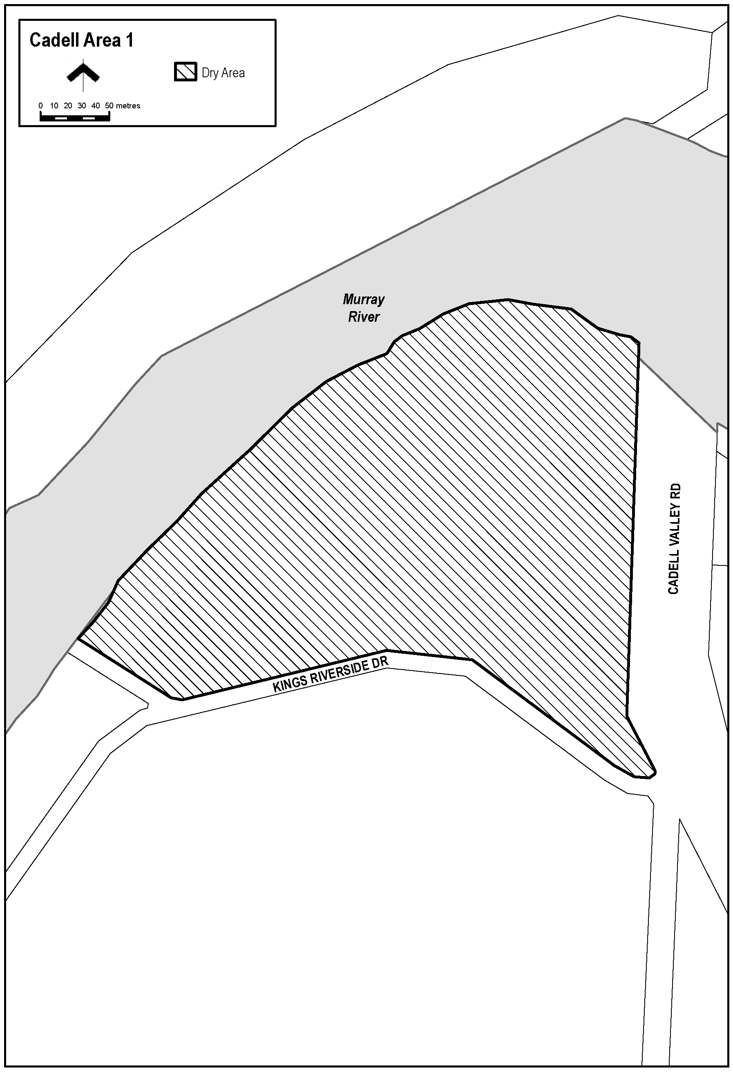

**Schedule – Morgan Area 1**

**1 – Extent of prohibition**

The consumption of liquor is prohibited and the possession of liquor is prohibited.

**2 – Period of prohibition**

From 4:00pm on 31 December 2023 to 9:00am on 1 January 2024.

**3 – Description of area**

The area in Morgan bounded as follows: commencing at the point at which the prolongation in a straight line of the southern boundary of Section 432, Hundred of Eba intersects the waterline on the north-western side of the River Murray, then generally north-westerly, westerly and north-westerly along that prolongation and boundary of Section 432 so the south-eastern boundary of Railway Terrace, then generally north-easterly along that south-eastern boundary of Railway Terrace to the point at which it meets the northern corner of Section 484, Hundred of Eba, then generally north-easterly along the north-western boundary of Section 433, Hundred of Eba to the northernmost boundary of Section 429, Hundred of Eba, then north-easterly along that boundary of Section 429 and the prolongation in a straight line of that boundary to the waterline on the north-western side of the River Murray, then generally south-westerly along the waterline of the River to the point of commencement, but excluding Section 483, 484 and 485, Hundred of Eba.

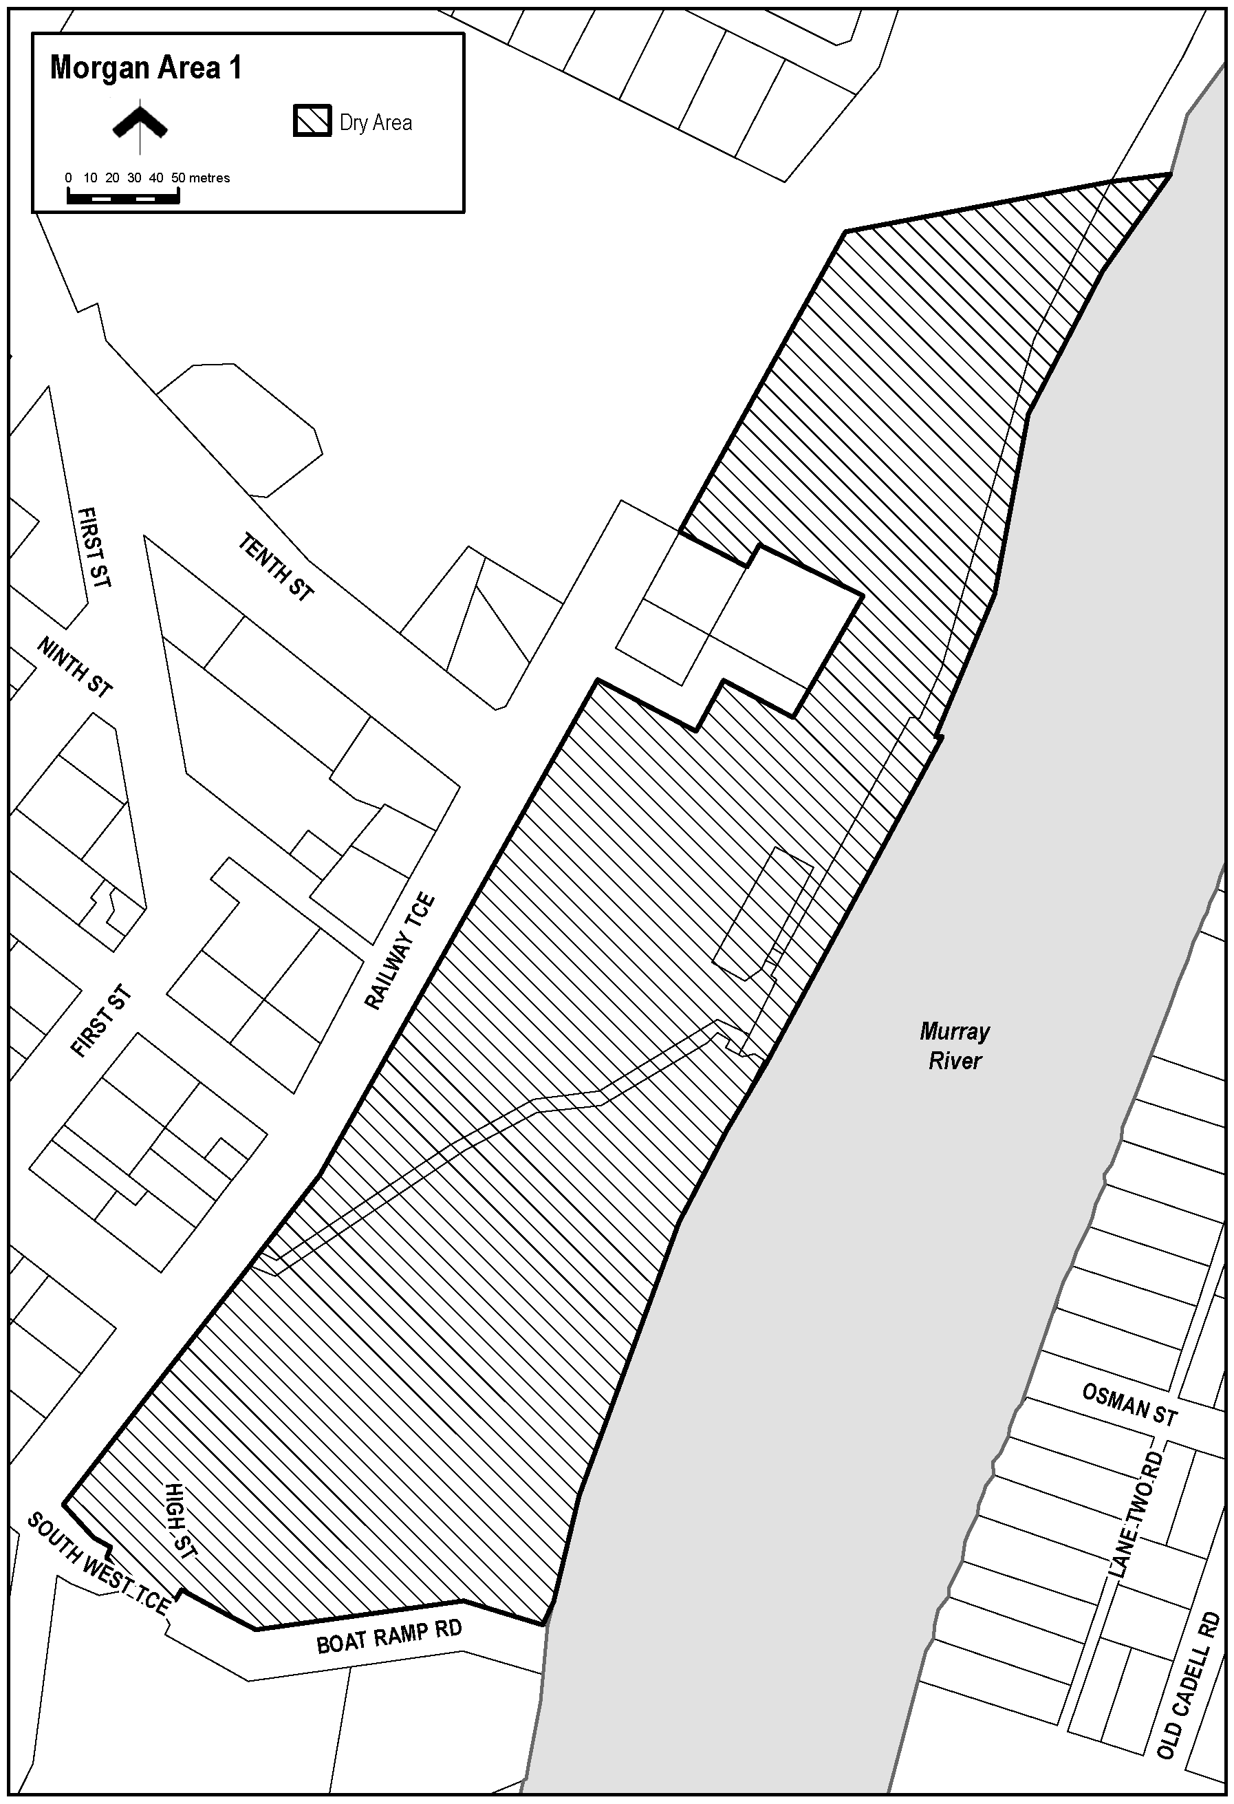

**Schedule – Mannum Area 2**

**1 – Extent of prohibition**

The consumption of liquor is prohibited and the possession of liquor is prohibited.

**2 – Period of prohibition**

From 6:00pm to 11:00pm on 31 December 2023.

**3 – Description of area**

Anna Street between Randell Street and William Street.

The stairway (generally known as “the Golden Stairs”) between Anna Street and Randell Street, adjacent to Shearer’s Carpark.

Randell Street (and Purnong Road) between William Street and River Road.

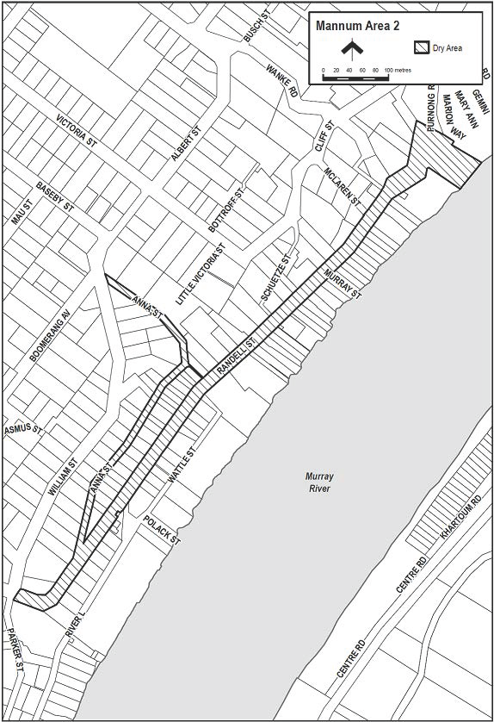

**Schedule – Mannum Area 3**

**1 – Extent of prohibition**

The consumption of liquor is prohibited and the possession of liquor is prohibited.

**2 – Period of prohibition**

From 6:00pm to 11:00pm on 31 December 2023.

**3 – Description of area**

The car park in Mannum (generally known as Shearer’s Carpark) situated between Randell Street and Anna Street, being Lots 33 and 34 DP1091, Hundred of Finniss and Lot 435 FP208811, Hundred of Finniss.

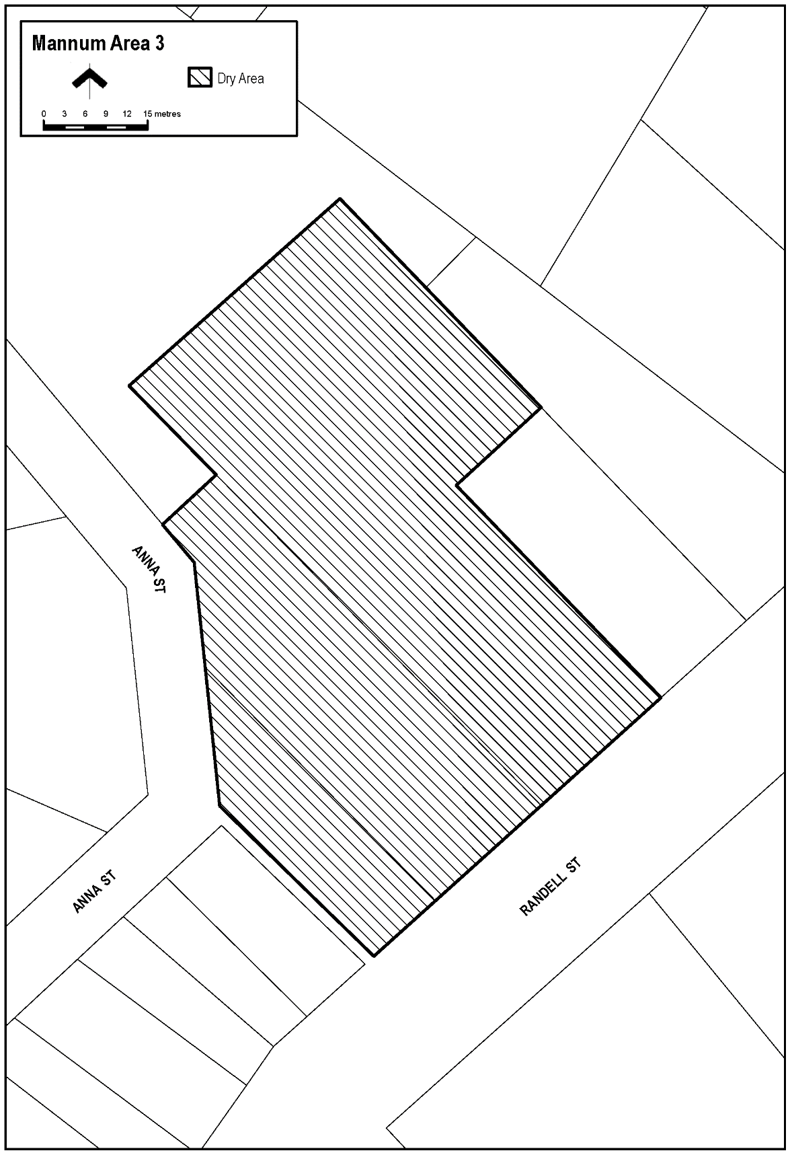

**Schedule – Mannum Area 4**

**1 – Extent of prohibition**

The consumption of liquor is prohibited and the possession of liquor is prohibited.

**2 – Period of prohibition**

From 6:00pm to 11:00pm on 31 December 2023.

**3 – Description of area**

The area in Mannum known as Mary Ann Reserve (together with abutting land and structures), being the area bounded on the north-east by the south-west boundary of Lot 10 FP21817 (Bowling Green), on the north-west by River Lane, on the south-west by the north-eastern boundary of Certificate of Title Volume 5799 Folio 318 (24 River Lane) and on the south-east by the River Murray, together with the whole of any wharf, jetty, boat ramp or other structure projecting from that area into the River.

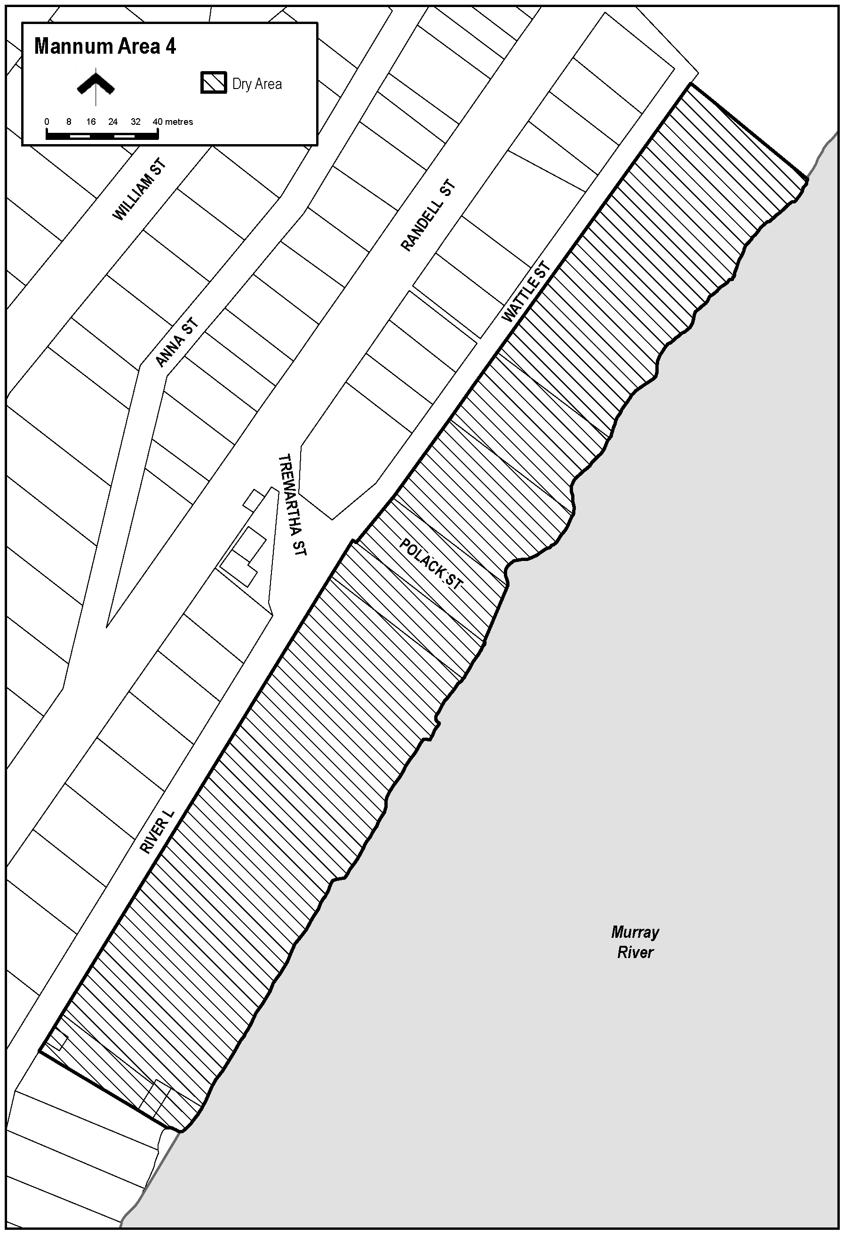

**Schedule – Mannum Area 5**

**1 – Extent of prohibition**

The consumption of liquor is prohibited and the possession of liquor is prohibited.

**2 – Period of prohibition**

From 6:00pm to 11:00pm on 31 December 2023.

**3 – Description of area**

The area in Mannum known as Arnold Park, situated between Randell Street and the River Murray adjacent to the south-western boundary of River Road, being Lot 93 FP213066, Hundred of Finniss.

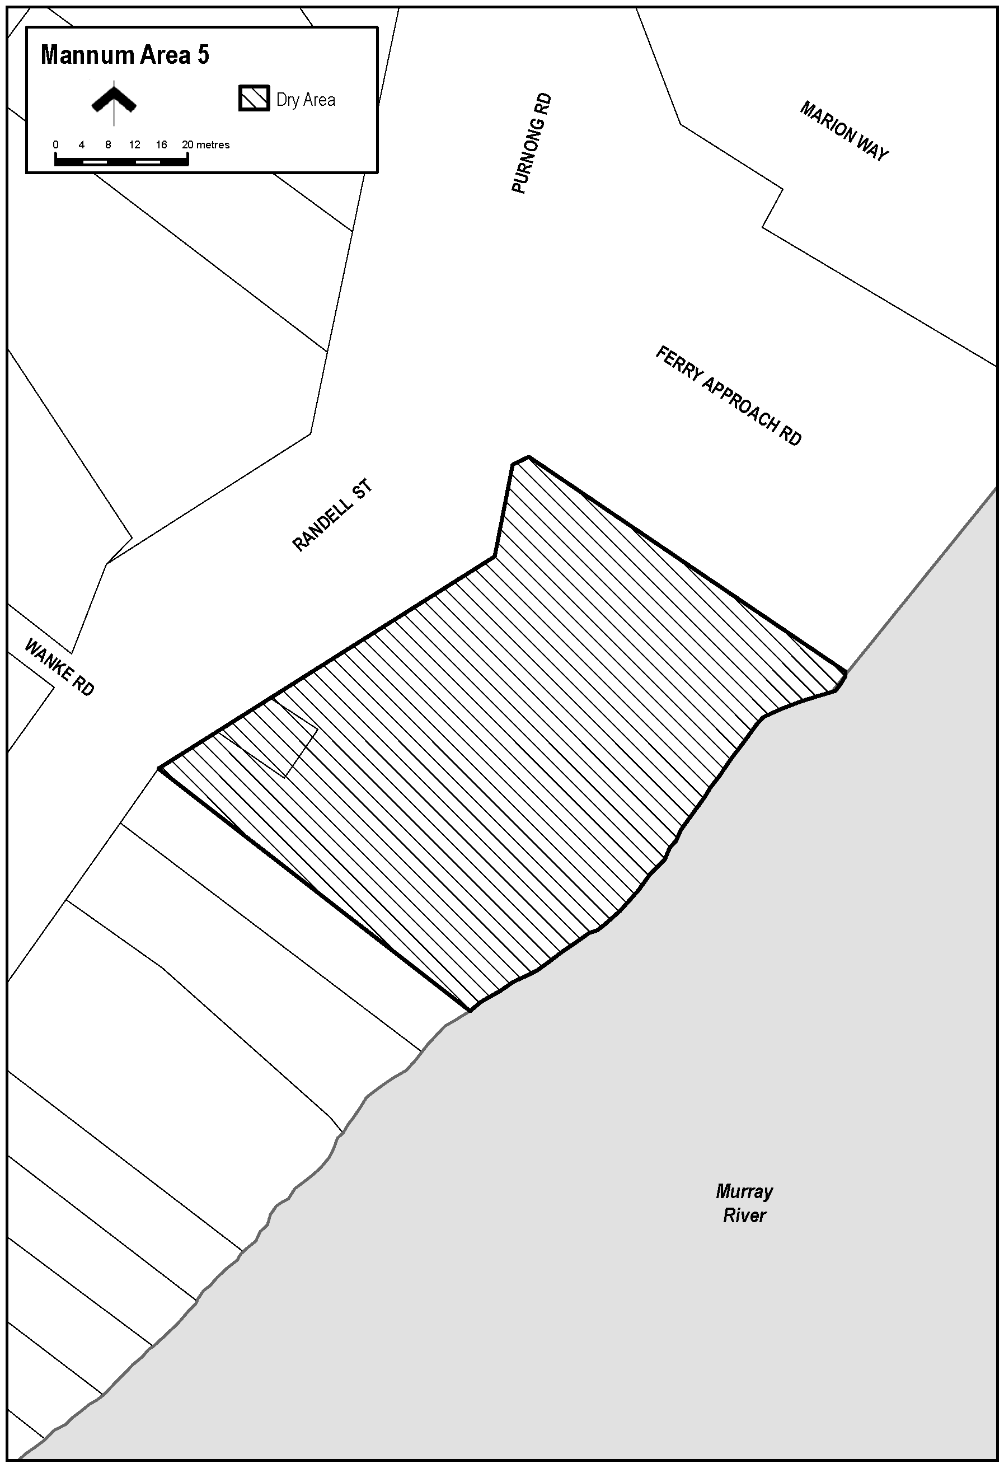

**Schedule – Mannum Area 6**

**1 – Extent of prohibition**

The consumption of liquor is prohibited and the possession of liquor is prohibited.

**2 – Period of prohibition**

From 6:00pm on 31 December 2023 to 8:00am on 1 January 2024.

**3 – Description of area**

The area adjacent Mannum, generally known as Bolto Reserve, bounded on the south-east by the north-western boundary of Section 909, Hundred of Younghusband, on the south-west by the north-eastern boundary of Section 914, Hundred of Younghusband, on the north-west by the River Murray and on the north-east by the south-western boundary of Lot 94 DP49431 and the prolongation in a straight line north-westerly and south-easterly of that boundary.

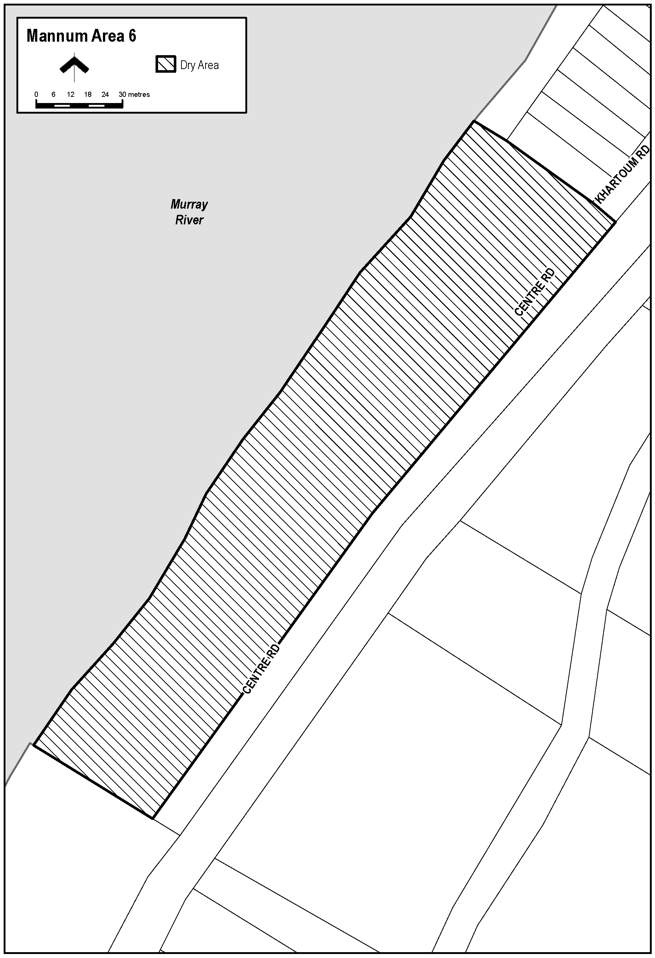

**Schedule – Mannum Area 7**

**1 – Extent of prohibition**

The consumption of liquor is prohibited and the possession of liquor is prohibited.

**2 – Period of prohibition**

From 6:00pm on 31 December 2023 to 8:00am on 1 January 2024.

**3 – Description of area**

The area adjacent Mannum, generally known as Haythorpe Reserve, bounded on the south-east by the north-western boundary of the carriageway of Hunter Road, on the south-west by the south-western boundary of Section 727, Hundred of Younghusband and the prolongation in a straight line south-easterly and north-westerly of that boundary, on the north-west by the River Murray and on the north-east by the south-western boundary of Section 397, Hundred of Younghusband and the prolongation in a straight line north-westerly and south-easterly of that boundary.

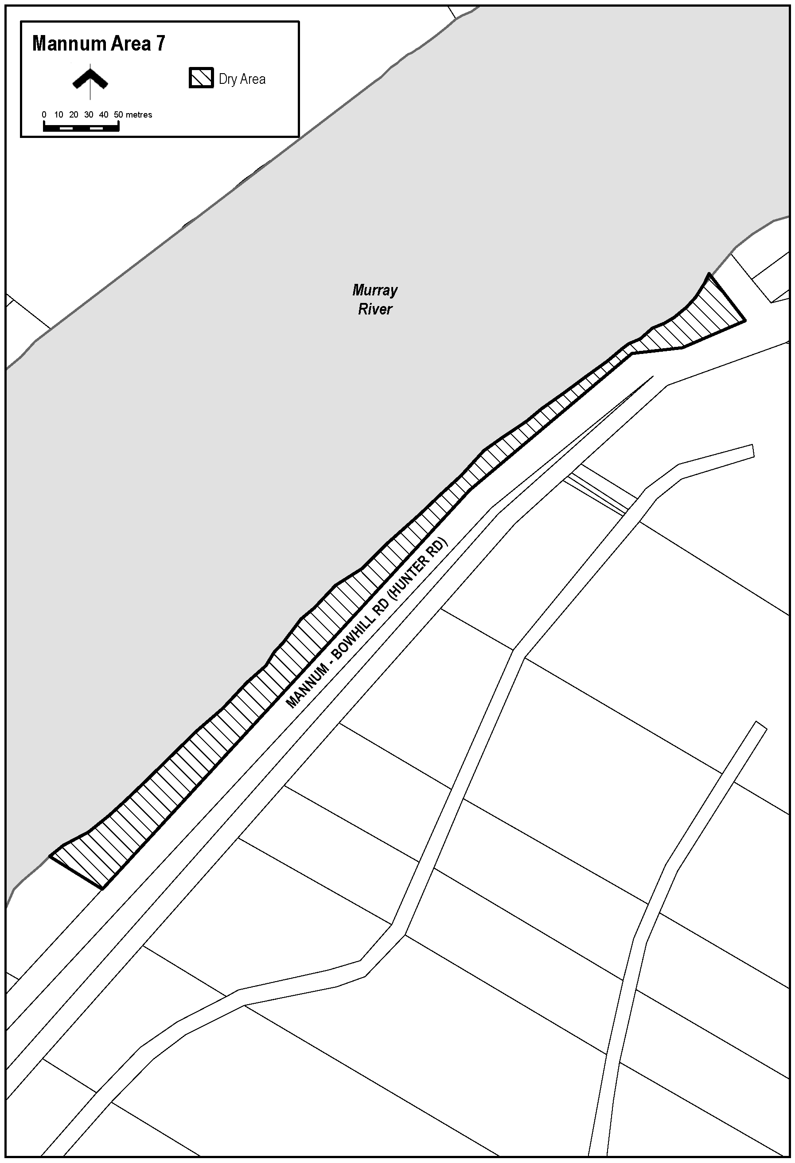

Ben Scales

Chief Executive Officer

## Naracoorte Lucindale Council

Roads (Opening And Closing) Act 1991

Road Closure—Naracoorte

NOTICE is hereby given, pursuant to Section 10 of the *Roads (Opening and Closing) Act 1991*, that the Naracoorte Lucindale Council proposes to make a Road Process Order to:

To close and merge with Allotment 10 in F105719 portion of Ormerod Street adjoining Allotment 10 in F105719, more particularly delineated and lettered ‘A’ on Preliminary Plan No. 23/0009.

AND

To close and merge with Allotment 100 in D80983 portion of Ormerod Street adjoining Allotment 100 in D80983, more particularly delineated and lettered ‘B’ on Preliminary Plan No. 23/0009.

AND

To close and merge with Allotment 101 in D80983 portion of Ormerod Street adjoining Allotment 101 in D80983, more particularly delineated and lettered ‘C’ on Preliminary Plan No. 23/0009.

The Preliminary Plan and Statement of Persons Affected is available for public inspection at the offices of the Naracoorte Lucindale Council at DeGaris Place, Naracoorte and the Adelaide Office of the Surveyor-General during normal office hours. The Preliminary Plan can also be viewed at [www.sa.gov.au/roadsactproposals](http://www.sa.gov.au/roadsactproposals).

Any application for easement or objection must set out the full name, address and details of the submission and must be fully supported by reasons. The application for easement or objection must be made in writing to the Naracoorte Lucindale Council at P.O. Box 555, Naracoorte, SA 5271 WITHIN 28 DAYS OF THIS NOTICE and a copy must be forwarded to the Surveyor-General at GPO Box 1815, Adelaide SA 5001. Where a submission is made, the Council will give notification of a meeting at which the matter will be considered.

Dated: 14March 2023

T. Smart

Chief Executive Officer

## District Council of Tumby Bay

South Australia

**Liquor Licensing (Dry Areas) Notice 2023**

under section 131(1ab) of the *Liquor Licensing Act 1997*

**1—Short title**

This notice may be cited as the *Liquor Licensing (Dry Areas) Notice 2023*.

**2—Commencement**

This notice comes into operation on 31 December 2023.

**3—Interpretation**

(1) In this notice—

***principal notice*** means the [*Liquor Licensing (Dry Areas) Notice 2015*](http://www.legislation.sa.gov.au/index.aspx?action=legref&type=subordleg&legtitle=Liquor%20Licensing%20(Dry%20Areas)%20Notice%202015) published in the Gazette on 5 January 2015, as in force from time to time.

(2) Clause 3 of the principal notice applies to this notice as if it were the principal notice.

**4—Consumption etc of liquor prohibited in dry areas**

(1) Pursuant to section 131 of the Act, the consumption and possession of liquor in the area described in the Schedule is prohibited in accordance with the provisions of the Schedule.

(2) The prohibition has effect during the periods specified in the Schedule.

(3) The prohibition does not extend to private land in the area described in the Schedule.

(4) Unless the contrary intention appears, the prohibition of the possession of liquor in the area does not extend to—

(a) a person who is genuinely passing through the place if—

(i) the liquor is in the original container in which it was purchased from licensed premises; and

(ii) the container has not been opened; or

(b) a person who has possession of the liquor in the course of carrying on a business or in the course of their employment by another person in the course of carrying on a business; or

(c) a person who is permanently or temporarily residing at premises near the public place and who enters the public place solely for the purpose of passing through it to enter those premises or who enters the public place from those premises for the purpose of leaving the place; or

(d) a person who possesses or consumes the liquor for sacramental or other similar religious purposes.

**Schedule—Port Neill Area 1**

|  |  |
| --- | --- |
| **1—Extent of prohibition** | |
|  | The consumption of liquor is prohibited and the possession of liquor is prohibited. |
| **2—Period of prohibition** | |
|  | From 10.30pm on 31 December 2023 to 8am on 1 January 2024. |
| **3—Description of area** | |
|  | Port Neill Area 1  The area in and adjacent to Port Neill bounded as follows: commencing at the point at which the prolongation in a straight line of the south-western boundary of Section 194 Hundred of Dixson intersects the low water mark on the western side of Spencer Gulf, then north-westerly along that prolongation and boundary of Section 194 to the western  boundary of the Section, then in a straight line by the shortest route to the point at which the eastern boundary of Section 195 Hundred of Dixson meets the south-western  boundary of that Section, then north-westerly along the south-western boundary of Section 195 to the north-western boundary of the Section (the south-eastern boundary of Kinnaird Street), then in a straight line by the shortest route to the eastern corner of Lot 55 of DP 80902, then south-westerly along the south-eastern boundary of Lot 55 to the eastern boundary of North Coast Road, then northerly, north-westerly and northerly  along that boundary of North Coast Road to the point at which it meets the northern boundary of Coneybeer Terrace, then in a straight line by the shortest route across North Coast Road to the western boundary of North Coast Road, then due west in a straight line for 200 metres, then due north in a straight line to the northern boundary of Section 54 Hundred of Dixson (the southern boundary of the Port Neill Access Road), then easterly along that boundary of Section 54 and the prolongation in a straight line of that boundary to the eastern boundary of North Coast Road, then northerly along that boundary of North Coast Road to the point at which it meets the northern boundary of Section 120 Hundred of Dixson, then south-easterly, north-easterly and southerly along the northern and eastern boundaries of Section 120 to the point at which the eastern boundary of the Section is intersected by the prolongation in a straight line of the northern boundary of Section 136 Hundred of Dixson, then easterly along that prolongation and boundary of Section 136, and the prolongation in a straight line of that boundary, to the low water mark on the western side of Spencer Gulf, then generally south-easterly, easterly, southwesterly, easterly, southerly and south-westerly along the low water mark to the point of commencement. The area includes any jetty, wharf, boat ramp, breakwater or other structure projecting below low water mark from within the area described above, as well as any area beneath such a structure. |

**Schedule—Tumby Bay Area 1**

|  |  |
| --- | --- |
| **1—Extent of prohibition** | |
|  | The consumption of liquor is prohibited and the possession of liquor is prohibited. |
| **2—Period of prohibition** | |
|  | From 10.30pm on 31 December 2023 to 8am on 1 January 2024. |
| **3—Description of area** | |
|  | Tumby Bay Area 1  The area in and adjacent to Tumby Bay bounded as follows: commencing at the point at which the prolongation in a straight line of the northern boundary of Section 353 Hundred of Hutchison intersects the low water mark of Tumby Bay, then generally southerly, easterly, south-easterly, southerly and westerly along the low water mark to the point at which it is intersected by the prolongation in a straight line of the northern boundary of Section 355 Hundred of Hutchison, then westerly along that prolongation and northern boundary of Section 355 and the southern boundary of Piece 501 DP 85629 to the point at which the southern boundary of Piece 501 meets the eastern boundary of Thuruna Road, then generally northerly, north-easterly and northerly along that eastern boundary of Thuruna Road to the point at which it intersects the northern boundary of Dutton Terrace, then westerly and northerly along that boundary of Dutton Terrace to the point at which it meets the southern boundary of Bratten Way, then in a straight line by the shortest route (across Bratten Way) to the southern boundary of Lot 65 DP 59150, then generally north-westerly, north-easterly and south-easterly along the south-western, north-western and north-eastern boundaries of Lot 65 to the point at which the north-eastern boundary of Lot 65 is intersected by the prolongation in a straight line of the western boundary of Lot 101 DP 78505, then northerly along that prolongation and boundary of Lot 101 to the northern boundary of the Lot, then easterly along the northern boundaries of Lot 101, Section 817 Hundred of Hutchison and Section 353 Hundred of Hutchison and the prolongation in a straight line of the northern boundary of Section 353 to the point of commencement. The area includes the whole of any wharf, jetty, boat ramp, breakwater or other structure extending below low water mark from within the area described above, as well as any area beneath such a structure. |

Dated: 4 December 2023

Rebecca Hayes

Chief Executive Officer

## Wudinna District Council

Road Traffic Act 1961—Section 33

*Notice of Road Closure*

**NOTICE** is hereby given that acting under the authorisation of the Wudinna District Council, I hereby make the following order, for and on behalf of the said Council:

That Council in exercise of power pursuant to *Section 33 of the* *Road Traffic Act 1961* and clause G of the *Instrument of General Approval of the Minister dated 22 August 2013*:

1. Declare that the event described below (“Event”) that is to take place on the roads described below (“Roads”) is an event to which *Section 33 of the Road Traffic Act 1961* applies;
2. Make an order directing that the Roads on which the Event is to be held is specified below be closed to traffic for the period specified below:

Roads: The portion of Ballantyne Street, from Atkins Street to Adams Terrace and De Latour Street from the rear of Foodland Supermarket to the rear of Wudinna Memorial Hall.

Period of Closure: From 5.00pm to 11.00pm on Friday 8 December 2023

Event: Wudinna and Districts Business and Tourism Association Christmas Twilight Market

1. Make an order directing that persons taking part in the event be exempted in relation to the Roads, from the duty to observe Australian Road Rules specified and attached to the exemption: Rule 230 – Crossing of a Road – General for the duration of the temporary closure of the Roads.

Andrew Buckham

Acting Chief Executive Officer

# Public Notices

## National Electricity Law

Notice of Final Rule

Notice of Extensions

Notice of Draft Determination

The Australian Energy Market Commission (AEMC) gives notice under the National Electricity Law as follows:

Under ss 102 and 103, the making of the *National Electricity Amendment (Amendment of the Market Price Cap, Cumulative Price Threshold and Administered Price Cap) Rule 2023* *No. 6* (Ref. ERC0353) and related final determination. Provisions commence as follows: **Schedule 1 - 1 July 2025, Schedule 2 - 1 July 2026, Schedule 3 - 1 July 2027.**

Under s 107, the time for making the draft determination on the *Enhancing reserve information* (Ref. ERC0295) proposal has been extended to **21 December 2023.**

Under s 107, the time for making the draft determination on the *Enhancing investment certainty in the R1 process* (Ref. ERC0363) proposal has been extended to **7 March 2024.**

Under s 99, the making of a draft determination and related draft rule on the *Improving the workability of the feedback loop* proposal(Ref. ERC0369). Submissions must be received by **25 January 2024**.

Submissions can be made via the [AEMC’s website](https://www.aemc.gov.au/contact-us/lodge-submission). Before making a submission, please review the AEMC’s [privacy statement](https://www.aemc.gov.au/terms-use/terms-use-0) on its website, and consider the AEMC’s[Tips for making a submission](https://www.aemc.gov.au/our-work/changing-energy-rules-unique-process/making-rule-change-request/submission-tips). The AEMC publishes all submissions on its website, subject to confidentiality.

Documents referred to above are available on the AEMC’s website and are available for inspection at the AEMC’s office.

Australian Energy Market Commission

Level 15, 60 Castlereagh St

Sydney NSW 2000

Telephone: (02) 8296 7800

[www.aemc.gov.au](http://www.aemc.gov.au)

Dated: 7 December 2023

## Sale of Property

*Warrant of Sale*

Auction Date: Tuesday, 19 December 2023 at 1.00pm

Location: 109 Barton Terrace West, North Adelaide, South Australia

Notice is hereby given that on the above date at the time and place stated, by virtue of the Warrant of Sale issued out of the Magistrates Court of South Australia, Action No. 4240 of 2023 directed to the Sheriff of South Australia in an action wherein Ru Rua Management Association Incorporated are the Applicants and Helen Marmanidis is the Respondent, I Steve Duncan, A/Sheriff of the State of South Australia, will by my auctioneers, Harris Real Estate, make sale of the estate, right, title or interest whatsoever it may be of the Respondent, Helen Marmanidis the registered proprietor of an estate in fee simple in the following:

That piece of land situated in the area named North Adelaide, being 109 Barton Terrace West, North Adelaide, Hundred of Yatala, being the property comprised in Certificate of Title Register Book Volume 5363 Folio 138.

Further particulars from the auctioneers:

Craig Costello

Harris Real Estate

5-9 Rundle Street,

Kent Town SA 5067

Telephone 0448 212 066

Dated: 7 December 2023

Steve Duncan

A/Sheriff of the State of South Australia

## Trustee Act 1936

Public Trustee

*Estates of Deceased Persons*

In the matter of the estates of the undermentioned deceased persons:

HANSEN Gerhard Christian late of 16 Dimboola Court Craigmore Retired Supervisor who died 31 August 2023

HEADLAND Brian Cobrey late of 49 Second Avenue Klemzig Retired Administration Manager who died 21 July 2023

MAYNARD Beverly Kaye late of 1 East Parkway Lightsview of no occupation who died 7 January 2022

MILLER Mary Murray late of 18 Trafford Street Angle Park Retired Pay Clerk who died 3 March 2023

MORGAN Gerald George late of 262 Cross Road Kings Park Retired Sales Representative who died 24 June 2023

PHILLIPPS Marlene Dawn late of 4 Windsor Avenue Pennington Retired Customer Service who died 26 July 2023

SCHENSCHER Malcolm Keith late of 49 Buxton Street North Adelaide Retired Public Servant who died 16 March 2023

Notice is hereby given pursuant to the *Trustee Act 1936*, the *Inheritance (Family Provision) Act 1972* and the *Family Relationships Act 1975* that all creditors, beneficiaries, and other persons having claims against the said estates are required to send, in writing, to the office of Public Trustee at GPO Box 1338, Adelaide SA 5001, full particulars and proof of such claims, on or before 4 January 2024 otherwise they will be excluded from the distribution of the said estate; and notice is also hereby given that all persons indebted to the said estates are required to pay the amount of their debts to the Public Trustee or proceedings will be taken for the recovery thereof; and all persons having any property belonging to the said estates are forthwith to deliver same to the Public Trustee.

Dated: 7 December 2023

N. S. Rantanen

Public Trustee

## University of Adelaide Act 1971

Authority of Council for Authorisations under the By-Laws of the University of Adelaide

1. **Background**

The University is responsible for the management, preservation and protection of its campuses at North Terrace, Roseworthy and Waite. The campuses include the land and grounds on which the campuses are built.

Section 23 of *The University of Adelaide Act 1971 (SA) (the Act)* provides the power to Council to make by-laws for a range of purposes.

Under By-Law 1.1 an “authorised person” means “*a person or class of persons authorised in writing by the Council for the purposes of these by-laws or a part of these by-laws*”.

The Council has previously issued authorisations under the By-Laws of the University of Adelaide which it now seeks to update and replace.

1. **Authority**

With the approval of Council:

1. All previous authorisations made under the By-Laws of the University of Adelaide are revoked.
2. The following authorisations are made and replace all previous authorisations made under the By-Laws of the University of Adelaide:
3. Campus Managers and Security Officers shall be authorised persons for the purposes of By‑Laws 4.8, 4.11, 7.2, 8.2, 10.2, 11.2, 11.3, 13.1 and 13.2.
4. Parking Officers shall be authorised persons for the purposes of By-Laws 4.8 and 4.11.
5. The following persons shall be authorised persons for the purposes of By-Law 4.11:
6. Chief Operating Officer
7. Executive Director, Infrastructure
8. Facilities Manager, Roseworthy
9. Facilities Manager, Waite
10. Facilities Co-ordinator, Roseworthy
11. Site Supervisor, Waite
12. Manager, Security Services
13. Security Supervisor
14. The following persons shall be authorised persons for the purpose of expedited enforcement of the University of Adelaide’s By-Laws under the *Expiation of Offences Act 1996 (SA)*  and the *Fines Enforcement and Debt Recovery Act 2017 (SA)* and specifically authorised to exercise the powers and functions under sections 5(1), 6(3)(b)(ii), 8A(2), 8A(3), 11(1), 11A(1), 12, 16(1), 16(5), and 18 of the *Expiation of Offences Act 1996 (SA)*, and section 22(1) of the *Fines Enforcement and Debt Recovery Act 2017 (SA)* for alleged offences against the University of Adelaide’s By-Laws:
15. Chief Operating Officer
16. Executive Director, Infrastructure
17. Campus Manager
18. Facilities Manager, Roseworthy
19. Facilities Manager, Waite
20. Facilities Co-ordinator, Roseworthy
21. Site Supervisor, Waite
22. Manager, Security Services
23. Security Supervisor
24. Security Officers
25. Parking Officers
26. A general permission is granted under By-Law 10.1 to the Chancellor, members of Council, members of Council Committees and staff to bring, keep and consume alcoholic liquor upon University of Adelaide grounds, provided it is in accord with University of Adelaide policy and Workplace Health and Safety obligations and provided that the by-laws are otherwise observed.
27. A general permission is granted under By-Law 10.1 to tenants of the University of Adelaide to bring, keep and consume alcoholic liquor upon the grounds which are the subject of the lease or similar agreement, subject to the terms of any such lease and provided that the by-laws are otherwise observed.
28. Pursuant to By-Law 4.7, a 30-day time limit is established for bike parking at all areas designated for bicycle parking on University of Adelaide grounds in accordance with the Traffic Management Plan.
29. A general permission is granted under By-Law 4.4 to the Chancellor, members of Council, members of Council Committees, staff, students and visitors to the University of Adelaide to park or leave a vehicle in a designated space on University of Adelaide grounds, provided it is in obeyance with parking signage, rules and conditions (including control devices) and provided that the by-laws are otherwise observed.

Definitions

For the purpose of this authorisation:

Campus Managers shall be the staff member holding the following positions:

For the North Terrace Campus, the position of Director, Capital Projects & Facilities Management

For the Roseworthy and Waite Campuses, the position of Campus Estate Manager, Roseworthy & Waite

or successor positions responsible for the same or similar functions as the positions identified above.

**Security Officers** shall be staff members, contractors, or employees or sub-contractors of contractors, of the University of Adelaide, who are engaged in roles as Security Officers.

**Parking Officers** shall be employees or sub-contractors of such contractor as is contracted by the University of Adelaide to manage parking on its campus or campuses.

1. **Revocation**

Any Authorities under the By-Laws of the University of Adelaide in force immediately before the commencement of this Authority are hereby revoked.

1. **Commencement**

This Authority comes into full force and effect on the date it is signed by the Chancellor.

Approved by Council.

Dated: 4 December 2023

Signed by the Chancellor.

Dated: 4 December 2023

Andrew Lee

Director, Governance Services

Office of the Chancellor and Council Secretariat

The University of Adelaide

**Notice Submission**

The South Australian Government Gazette is published each Thursday afternoon.

Notices must be emailed by 4 p.m. Tuesday, the week of publication.

Submissions are formatted per the gazette style and a proof will be supplied prior to publication, along with a quote if applicable. Please allow one day for processing notices.

Alterations to the proof must be returned by 4 p.m. Wednesday.

**Gazette notices must be submitted as Word files, in the following format:**

• Title—the governing legislation

• Subtitle—a summary of the notice content

• Body—structured text, which can include numbered lists, tables, and images

• Date—day, month, and year of authorisation

• Signature block—name, role, and department/organisation authorising the notice

**Please provide the following information in your email:**

• Date of intended publication

• Contact details of the person responsible for the notice content

• Name and organisation to be charged for the publication—Local Council and Public notices only

• Purchase order, if required—Local Council and Public notices only

Email: [governmentgazettesa@sa.gov.au](mailto:governmentgazettesa@sa.gov.au)

Phone: (08) 7133 3552

Website: [www.governmentgazette.sa.gov.au](http://www.governmentgazette.sa.gov.au)

**All instruments appearing in this gazette are to be considered official, and obeyed as such**

Printed and published weekly by authority of M. Dowling, Government Printer, South Australia

$8.55 per issue (plus postage), $430.00 per annual subscription—GST inclusive

Online publications: [www.governmentgazette.sa.gov.au](http://www.governmentgazette.sa.gov.au)