No. 90 p. 4129
THE SOUTH AUSTRALIAN
GOVERNMENT GAZETTE
Published by Authority

Adelaide, Thursday, 14 December 2023

Contents

Governor’s Instruments
Appointments 4130
Proclamations—
Adelaide University Act (Commencement)
Proclamation 2023 4133
Petroleum and Geothermal Energy (Energy Resources) Amendment Act (Commencement) Proclamation 2023 4134
Administrative Arrangements (Administration of
Adelaide University Act) Proclamation 2023 4135
Administrative Arrangements (Administration of
Automated External Defibrillators (Public Access)
Act) Proclamation 2023 4135
Regulations—
Child Safety (Prohibited Persons) (Exemption)
Amendment Regulations 2023—No. 120 of 2023 4136
State Government Instruments
Associations Incorporation Act 1985 4139
Building Work Contractors Act 1995 4139
Dangerous Substances Act 1979 4139
Environment Protection Act 1993 4140
Fisheries Management (Prawn Fisheries) Regulations 2017 4143
Fisheries Management Act 2007 4145
Housing Improvement Act 2016 4146
Liquor Licensing Act 1997 4147
Livestock Act 1997 4152
Major Events Act 2013 4152
National Parks and Wildlife Act 1972 4158
Petroleum and Geothermal Energy Act 2000 4158
Radiation Protection and Control Act 2021 4159
Roads (Opening and Closing) Act 1991 4161
South Australian Housing Trust Act 1995 4161
Local Government Instruments
City of Adelaide 4163
City of Salisbury 4163
City of Tea Tree Gully 4164
City of Victor Harbor 4164
City of Mitcham 4169
District Council of Lower Eyre Peninsula 4169
District Council of Mount Remarkable 4173
Public Notices
National Electricity Law 4175
Sale of Property 4175
Trustee Act 1936 4175

Governor’s Instruments

APPOINTMENTS
Department of the Premier and Cabinet
Adelaide, 14 December 2023
Her Excellency the Governor in Executive Council has been pleased to appoint the undermentioned to the Board of the Southern Select Super Corporation, pursuant to the provisions of the Public Corporations (Southern Select Super Corporation) Regulations 2012 under the Public Corporations Act 1993:
Member: from 14 December 2023 until 13 December 2026
Rosina Hislop
By command,
Anastasios Koutsantonis MP
For Premier
T&F23-048CS

Department of the Premier and Cabinet
Adelaide, 14 December 2023
Her Excellency the Governor in Executive Council has been pleased to appoint the undermentioned to the South Australian Superannuation Board, pursuant to the provisions of the Superannuation Act 1988:
Member: from 14 December 2023 until 13 December 2026
Rosina Hislop
By command,
Anastasios Koutsantonis MP
For Premier
T&F23-049CS

Department of the Premier and Cabinet
Adelaide, 14 December 2023
Her Excellency the Governor in Executive Council has been pleased to appoint the undermentioned to the Adelaide Cemeteries Authority Board, pursuant to the provisions of the Adelaide Cemeteries Authority Act 2001:
Director: from 14 January 2024 until 13 January 2026
Patricia Christie
Camilla Jane Pettica
Deborah Ann Black
Alexander Ian Wilkinson
By command,
Anastasios Koutsantonis MP
For Premier
23MPCS02485

Department of the Premier and Cabinet
Adelaide, 14 December 2023
Her Excellency the Governor in Executive Council has been pleased to appoint the undermentioned to the Construction Industry Long Service Leave Board, pursuant to the provisions of the Construction Industry Long Service Leave Act 1987:
Member: from 14 December 2023 until 28 September 2027
Kim Eloise Eldridge
Presiding Officer: from 14 December 2023 until 28 September 2027
Kim Eloise Eldridge
By command,
Anastasios Koutsantonis MP
For Premier
AGO0226-23CS

Department of the Premier and Cabinet
Adelaide, 14 December 2023
Her Excellency the Governor in Executive Council has been pleased to appoint the Honourable Joseph Karl Szakacs MP, as Acting Minister for Climate, Environment and Water, Acting Minister for Industry, Innovation and Science and Acting Minister for Defence and Space Industries from 6 January 2024 until 26 January 2024 inclusive, during the absence of the Honourable Dr Susan Elizabeth Close MP.
By command,
Anastasios Koutsantonis MP
For Premier
DPC23/067CS

Department of the Premier and Cabinet
Adelaide, 14 December 2023
Her Excellency the Governor in Executive Council has been pleased to appoint the Honourable Kyam Joseph Maher MLC, as Acting Deputy Premier from 6 January 2024 until 26 January 2024 inclusive, during the absence of the Honourable Dr Susan Elizabeth Close MP.
By command,
Anastasios Koutsantonis MP
For Premier
DPC23/067CS

Department of the Premier and Cabinet
Adelaide, 14 December 2023
Her Excellency the Governor in Executive Council has been pleased to appoint the Honourable Kyam Joseph Maher MLC, as Acting Treasurer from 22 December 2023 until 14 January 2024 inclusive, during the absence of the Honourable Stephen Campbell Mullighan MP.
By command,
Anastasios Koutsantonis MP
For Premier
DPC23/067CS

Department of the Premier and Cabinet
Adelaide, 14 December 2023
Her Excellency the Governor in Executive Council has been pleased to appoint the Honourable Clare Michele Scriven MLC, as Acting Minister for Tourism and Acting Minister for Multicultural Affairs from 18 December 2023 until 7 January 2024 inclusive, during the absence of the Honourable Zoe Lee Bettison MP.
By command,
Anastasios Koutsantonis MP
For Premier
DPC23/067CS

Department of the Premier and Cabinet
Adelaide, 14 December 2023
Her Excellency the Governor in Executive Council has been pleased to appoint the Honourable Stephen Campbell Mullighan MP, as Acting Minister for Health and Wellbeing from 15 January 2024 until 2 February 2024 inclusive, during the absence of the Honourable Christopher James Picton MP.
By command,
Anastasios Koutsantonis MP
For Premier
DPC23/067CS

Department of the Premier and Cabinet
Adelaide, 14 December 2023
Her Excellency the Governor in Executive Council has been pleased to appoint the Honourable Natalie Fleur Cook MP, as Acting Minister for Child Protection and Acting Minister for Women and the Prevention of Domestic and Family Violence from 24 January 2024 until 29 January 2024 inclusive, during the absence of the Honourable Katrine Anne Hildyard MP.
By command,
Anastasios Koutsantonis MP
For Premier
DPC23/067CS

Department of the Premier and Cabinet
Adelaide, 14 December 2023
Her Excellency the Governor in Executive Council has been pleased to appoint the Honourable Andrea Michaels MP, as Acting Minister for Recreation, Sport and Racing from 24 January 2024 until 29 January 2024 inclusive, during the absence of the Honourable Katrine Anne Hildyard MP.
By command,
Anastasios Koutsantonis MP
For Premier
DPC23/067CS

Department of the Premier and Cabinet
Adelaide, 14 December 2023
Her Excellency the Governor in Executive Council has been pleased to appoint the Honourable Zoe Lee Bettison MP, as Acting Minister for Primary Industries and Regional Development and Acting Minister for Forest Industries from 8 January 2024 until 21 January 2024 inclusive, during the absence of the Honourable Clare Michele Scriven MLC.
By command,
Anastasios Koutsantonis MP
For Premier
DPC23/067CS

Department of the Premier and Cabinet
Adelaide, 14 December 2023
Her Excellency the Governor in Executive Council has been pleased to appoint the Honourable Joseph Karl Szakacs MP, as Acting Minister for Education, Training and Skills from 16 December 2023 until 24 December 2023 inclusive, during the absence of the Honourable Blair Ingram Boyer MP.
By command,
Anastasios Koutsantonis MP
For Premier
DPC23/067CS

Department of the Premier and Cabinet
Adelaide, 14 December 2023
Her Excellency the Governor in Executive Council has been pleased to appoint the Honourable Dr Susan Elizabeth Close MP, as Acting Minister for Local Government, Acting Minister for Regional Roads and Acting Minister for Veterans Affairs from 18 December 2023 until 24 December 2023 inclusive, during the absence of the Honourable Geoffrey Graham Brock MP.
By command,
Anastasios Koutsantonis MP
For Premier
DPC23/067CS

Department of the Premier and Cabinet
Adelaide, 14 December 2023
Her Excellency the Governor in Executive Council has been pleased to appoint the Honourable Blair Ingram Boyer MP, as Acting Minister for Local Government, Acting Minister for Regional Roads and Acting Minister for Veterans Affairs from 25 December 2023 until 14 January 2024 inclusive, during the absence of the Honourable Geoffrey Graham Brock MP.
By command,
Anastasios Koutsantonis MP
For Premier
DPC23/067CS

Department of the Premier and Cabinet
Adelaide, 14 December 2023
Her Excellency the Governor in Executive Council has been pleased to appoint Marlene Natasha Haese, Justice of the Peace, as a Special Justice for South Australia from 22 January 2024 until 4 November 2028 - pursuant to the Justices of the Peace Act 2005.
By command,
Anastasios Koutsantonis MP
For Premier
AGO0204-23CS

Department of the Premier and Cabinet
Adelaide, 14 December 2023
Her Excellency the Governor in Executive Council has been pleased to appoint Dr Andrew James Blok, a Forensic Scientist at Forensic Science SA, as an Analyst for the purposes of the Controlled Substances Act 1984, effective from 14 December 2023 - pursuant to section 51 of the Controlled Substances Act 1984.
By command,
Anastasios Koutsantonis MP
For Premier
AGO0233-23CS

Department of the Premier and Cabinet
Adelaide, 14 December 2023
Her Excellency the Governor in Executive Council has been pleased to appoint Donny Walford and Mark Dennis Young as Members of the Remuneration Tribunal for a term commencing on 1 January 2024 and expiring on 31 December 2026 - pursuant to the provisions of the Remuneration Act 1990.
By command,
Anastasios Koutsantonis MP
For Premier
DPC23/069CS

Proclamations
South Australia

Adelaide University Act (Commencement) Proclamation 2023
1—Short title
This proclamation may be cited as the Adelaide University Act (Commencement) Proclamation 2023.
2—Commencement of Act and suspension of certain provisions
(1) Subject to this clause, the Adelaide University Act 2023 (No 32 of 2023) comes into operation on 14 December 2023.
(2) The following provisions of the Act come into operation on 8 March 2024:
(a) sections 5 to 11 (inclusive);
(b) sections 14 to 40 (inclusive);
(c) sections 43 to 54 (inclusive);
(d) Schedule 1 clause 1;
(e) Schedule 1 clause 4(2);
(f) Schedule 1 clauses 8 to 28 (inclusive);
(g) Schedule 1 clauses 30 to 39 (inclusive).
(3) Sections 41 and 42 of the Act come into operation on 1 July 2024.
(4) The operation of the following provisions of the Act is suspended until a day or time or days or times to be fixed by subsequent proclamation or proclamations:
(a) section 55;
(b) Schedule 1 clauses 2 and 3;
(c) Schedule 1 clause 4(1);
(d) Schedule 1 clauses 5 and 6;
(e) Schedule 1 clause 29.
Made by the Governor
with the advice and consent of the Executive Council
on 14 December 2023

South Australia

Petroleum and Geothermal Energy (Energy Resources) Amendment Act (Commencement) Proclamation 2023
1—Short title
This proclamation may be cited as the Petroleum and Geothermal Energy (Energy Resources) Amendment Act (Commencement) Proclamation 2023.
2—Commencement of Act and suspension of certain provisions
(1) Subject to this clause, the Petroleum and Geothermal Energy (Energy Resources) Amendment Act 2023 (No 34 of 2023) comes into operation on 14 December 2023.
(2) The operation of the following provisions of the Act is suspended until a day or time or days or times to be fixed by subsequent proclamation or proclamations:
(a) sections 3 and 4;
(b) sections 6 to 41 (inclusive);
(c) sections 43 to 71 (inclusive);
(d) Schedule 1.
Made by the Governor
with the advice and consent of the Executive Council
on 14 December 2023

South Australia

Administrative Arrangements (Administration of Adelaide University Act) Proclamation 2023
under section 5 of the Administrative Arrangements Act 1994
1—Short title
This proclamation may be cited as the Administrative Arrangements (Administration of Adelaide University Act) Proclamation 2023.
2—Commencement
This proclamation comes into operation on the day on which it is made.
3—Administration of Act committed to Minister for Industry, Innovation and Science
The administration of the Adelaide University Act 2023 is committed to the Minister for Industry, Innovation and Science.
Made by the Governor
with the advice and consent of the Executive Council
on 14 December 2023

South Australia

Administrative Arrangements (Administration of Automated External Defibrillators (Public Access) Act) Proclamation 2023
under section 5 of the Administrative Arrangements Act 1994
1—Short title
This proclamation may be cited as the Administrative Arrangements (Administration of Automated External Defibrillators (Public Access) Act) Proclamation 2023.
2—Commencement
This proclamation comes into operation on the day on which it is made.
3—Administration of Act committed to Minister for Health and Wellbeing
The administration of the Automated External Defibrillators (Public Access) Act 2022 is committed to the Minister for Health and Wellbeing.
Made by the Governor
with the advice and consent of the Executive Council
on 14 December 2023

Regulations
South Australia

Child Safety (Prohibited Persons) (Exemption) Amendment Regulations 2023
under the Child Safety (Prohibited Persons) Act 2016

Contents
Part 1—Preliminary
1 Short title
2 Commencement
Part 2—Variation of Child Safety (Prohibited Persons) Regulations 2019
3 Amendment of regulation 13—Prescribed functions and powers
4 Substitution of regulation 27
27 Temporary exemptions

Part 1—Preliminary
1—Short title
These regulations may be cited as the Child Safety (Prohibited Persons) (Exemption) Amendment Regulations 2023.
2—Commencement
These regulations come into operation on 30 June 2024.
Part 2—Variation of Child Safety (Prohibited Persons) Regulations 2019
3—Amendment of regulation 13—Prescribed functions and powers
Regulation 13(a)—delete paragraph (a)
4—Substitution of regulation 27
Regulation 27—delete the regulation and substitute:
27—Temporary exemptions
(1) This regulation applies to—
(a) a person—
(i) who has applied for a working with children check in accordance with the Act (whether before or after the commencement of this regulation); and
(ii) in respect of whom a working with children check was previously conducted within the 5 years immediately preceding the making of the application; and
(iii) whose application had not been completed by the central assessment unit before the fifth anniversary of the conduct of the previous working with children check; or
(b) any other person determined by the Registrar by instrument in writing to be a person to whom this section applies,
(however this regulation does not apply to a person who is, or has ever been, a prohibited person).
(2) This regulation ceases to apply to a person—
(a) in the case of a person referred to in subregulation (1)(a)—on the completion of a working with children check in respect of the person (including, to avoid doubt, a working with children check referred to in section 28 or 30); and
(b) in the case of a person referred to in subregulation (1)(b)—
(i) on the completion of a working with children check in respect of the person; or
(ii) if the written instrument specifies a date on which this regulation ceases to apply to the person—on that date; or
(iii) if the person contravenes a condition of the exemption; or
(iv) if the written instrument specifies an event on the occurrence of which this regulation ceases to apply to the person—on the occurrence of that event,
whichever occurs first; and
(c) in any case—if the person becomes a prohibited person.
(3) A person to whom this regulation applies is exempt from the operation of section 16 of the Act.
(4) An exemption under this regulation relating to a person referred to in subregulation (1)(b) is subject to such conditions as may be specified by the Registrar in the written instrument.
(5) The employer of a person to whom this regulation applies is exempt from the operation of the following provisions of the Act to the extent that the provision relates to that person:
(a) section 17(1)(b)(i);
(b) section 18(1);
(c) section 18(2)(a).
(6) An exemption under subregulation (5) ceases to have effect in relation to a person to whom this regulation applies if this regulation ceases to apply to the person.
(7) The central assessment unit is exempt from the operation of sections 41(1)(b) and 42(1)(b) of the Act in respect of a person to whom this regulation applies (however, nothing in this subregulation prevents the central assessment from nevertheless complying with those requirements).
(8) For the purposes of this regulation, a person will be taken to have made an application for a working with children on the day on which a receipt is issued to the person in accordance with section 27(4)(a) of the Act.
Made by the Governor
with the advice and consent of the Executive Council
on 14 December 2023
No 120 of 2023

State Government Instruments

Associations Incorporation Act 1985
Order Pursuant to Section 42(2)
Dissolution of Association
WHEREAS the CORPORATE AFFAIRS COMMISSION (the Commission) pursuant to section 42(1) of the Associations Incorporation Act 1985 (the Act) is of the opinion that the undertaking or operations of DEFENCE SPECIAL NEEDS SUPPORT GROUP INCORPORATED (the Association) being an incorporated association under the Act are being carried on, or would more appropriately be carried on by a Company Limited by Guarantee incorporated under the Corporations Act 2001 (Cth) AND WHEREAS the Commission was on 24 July 2023 requested by the Association to transfer its undertaking to DEFENCE SPECIAL NEEDS SUPPORT GROUP LIMITED (Australian Company Number 673 335 941 ), the Commission pursuant to section 42(2) of the Act DOES HEREBY ORDER that on 14 DECEMBER 2023 the Association will be dissolved, the property of the Association becomes the property of DEFENCE SPECIAL NEEDS SUPPORT GROUP LIMITED and the rights and liabilities of the Association become the rights and liabilities of DEFENCE SPECIAL NEEDS SUPPORT GROUP LIMITED.
Given under the seal of the Commission at Adelaide this 12th day of December 2023.
Lisa Berry
A delegate of the Corporate Affairs Commission

Building Work Contractors Act 1995
Exemption
TAKE notice that, pursuant to section 45 of the Building Work Contractors Act 1995, I, Rita McPhail as a delegate for the Minister for Consumer and Business Affairs, do hereby exempt the licensee named in Schedule 1 from the application of Division 3 of Part 5 of the above Act in relation to domestic building work described in Schedule 2 and subject to the conditions specified in Schedule 3.
Schedule 1
DARIOUSH HASHEMI-SAKHTSARI (BLD 266742)
Schedule 2
Construction of decking and verandahs at Allotment 90 Deposited Plan 3336 being a portion of the land described in Certificate of Title Volume 5517 Folio 545, more commonly known as 12 Woodfield Avenue, Warradale SA 5046.
Schedule 3
1. This exemption is limited to domestic building work personally performed by the licensee in relation to the building work described in Schedule 2.
2. This exemption does not apply to any domestic building work the licensee contracts to another building work contractor, for which that contractor is required by law to hold building indemnity insurance.
3. That the licensee does not transfer his interest in the land prior to five years from the date of completion of the building work the subject of this exemption, without the prior authorisation of Consumer and Business Services (CBS). Before giving such authorisation, CBS may require the licensee to take any reasonable steps to protect the future purchaser(s) of the property, including but not limited to:
- Providing evidence that an adequate policy of building indemnity insurance is in force to cover the balance of the five-year period from the date of completion of the building work the subject of this exemption;
- Providing evidence of an independent expert inspection of the building work the subject of this exemption;
- Making an independent expert report available to prospective purchasers of the property;
- Giving prospective purchasers of the property notice of the absence of a policy of building indemnity insurance.
Dated: 12 December 2023
Rita McPhail
Director Customer Service and Transformation
Delegate for the Minister for Consumer and Business Affairs

Dangerous Substances Act 1979
Authorised Officers
I, Glenn Stephen Farrell, Executive Director, SafeWork SA, in my capacity as the Competent Authority, hereby appoint the following persons as an Authorised Officer for the purposes of the Dangerous Substances Act 1979 pursuant to section 7(1) of the Act:
Christopher Ryan AMEZDROZ
Michael Anthony BANKS
Nicholas James BOYD
Stuart Stanley BRUGGEMANN
Stanley CHAPWANYA
Keyo Anthony GELSTON
Sophia HENTOSZ
Phillip John JONAS
Joseph George KARAM
Guy Edward LANE
Thomas Alistair OVERALL
Michael Stewart PATERSON
Anne Beatrice PENROSE
Timothy James POULTON
Stuart John POWIS
Mitchell Leigh PUYENBROEK
Lachlan Barry REEKS
Jason Troy ROSE
Catherine Ann SINTON
Heidi TURBILL
Joshua Anthony WIGZELL
Dylan Jade WILLIAMS
Dated: 14 December 2023
Glenn Farrell
Executive Director
Competent Authority
SafeWork SA

Environment Protection Act 1993
Prohibition on Taking Water affected by Site Contamination
I, REBECCA ANNE HUGHES, Manager Site Contamination and Delegate of the Environment Protection Authority (‘the Authority’), being satisfied that site contamination exists that affects or threatens groundwater and that action is necessary pursuant to section 103S of the Environment Protection Act 1993 to prevent actual or potential harm to human health or safety hereby prohibit the taking of groundwater from the Quaternary sediments (as defined below) within the area specified in the map to this notice, other than for environmental assessment or environmental monitoring purposes or as approved in writing by the Authority.
This Notice relates to groundwater in:
  - The Quaternary sediments (comprising the Saint Kilda Formation and Pooraka Formation), being the body of groundwater 0 to approximately 13 metres below ground surface within the specified area (see map).
The site contamination affecting the groundwater is in the form of per - and polyfluoroalkyl substances (PFAS) and metals which represent actual or potential harm to human health or safety. This prohibition becomes official upon the gazettal of this notice.
Dated: 14 December 2023
R. Hughes
Manager Site Contamination
Environment Protection Authority

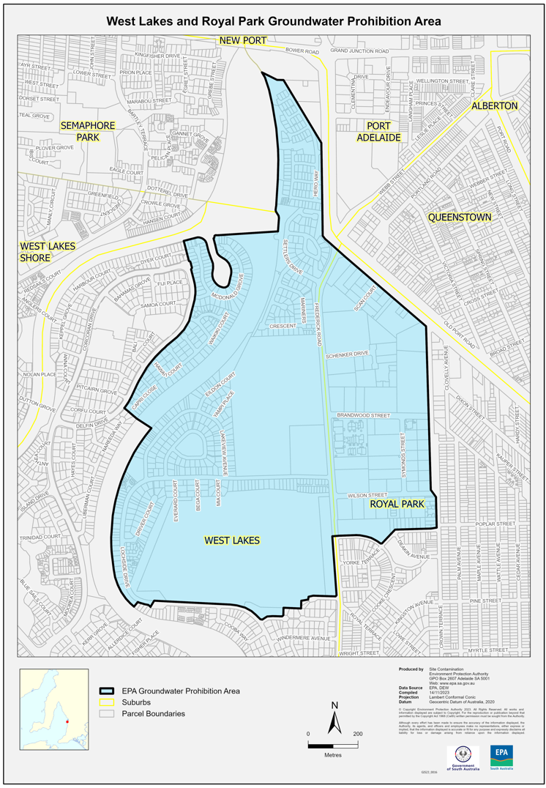

Environment Protection Act 1993
Section 69
Approval of Additional Collection Depots
I, Nicholas Stewart, Delegate of the Environment Protection Authority (‘the Authority’), pursuant to Section 69 of the Environment Protection Act 1993 (SA) (‘the Act’) hereby:
1. Approval of Additional Collection Depots:
1.1 Approval of additional collection depots:
Approve the collection depot identified by reference to the following matters, to receive all containers belonging to a class of containers which is, at or subsequent to, the date of this Notice, approved as Category B Containers:
(a) the name of the collection depot described in Column 1 of Schedule 1 of this Notice;
(b) the name of the company identified in Column 2 of Schedule 1 of this Notice;
(c) the name of the proprietor of the depot identified in Column 3 of Schedule 1 of this Notice; and
(d) the location of the depot described in Columns 4-7 of Schedule 1 of this Notice.
and
1.2 Conditions of approval:
Impose the following conditions on the approval:
1. If the Approval Holder’s name or postal address (or both) changes, then the Approval Holder must inform the Authority in writing, within 28 days of the change occurring.
2. If the collection depot is sold to another party, the Approval Holder must inform the Authority in writing, within 28 days of settlement.
3. The Approval Holder who wishes to cease operation of the depot shall notify the Authority in writing no less than 14 days from the date of closing.
4. The Approval Holder, or a person acting on his or her behalf, must not pay a refund on, or seek reimbursement for, containers that the Approval Holder, or the person acting on his or her behalf, knows were not purchased in South Australia.
5. The Approval Holder must ensure that prominent signage is displayed, detailing the offence and the penalties under Section 69 the Act, for presenting interstate containers for refund.
Dated: 14 December 2023
Nicholas Stewart
Team Leader, Container Deposit Scheme and Product Stewardship
Delegate of the Environment Protection Authority

Schedule 1
Column 1 | Column 2 | Column 3 | Column 4 | Column 5 | Column 6 | Column 7
Depot Name | Company  Name | Proprietors | Depot Location  Street | Depot Location  Suburb | Certificate of  Title/Volume | Collection  Area
Eudunda Depot | David Button | David Button | 1 Bruce Road | EUDUNDA | n/a | Regional

Environment Protection Act 1993
Section 69
Variation to Existing Approval of Collection Depot
I, Nicholas Stewart, Delegate of the Environment Protection Authority (‘the Authority’), pursuant to Section 69 of the Environment Protection Act 1993 (SA) (‘the Act’) hereby:
1. Variation to Existing Approval of Collection Depot:
Vary the approval of the collection depot listed at Schedule 1 of this notice, that was granted under the Act prior to the date of this Notice and impose the conditions of this approval to be as follows:
1.1 Approval of Collection Depot:
The collection depot identified by reference to the following matters is approved:
(a) the name of the collection depot described in Column 1 of Schedule 1 of this Notice;
(b) the name of the company identified in Column 2 of Schedule 1 of this notice;
(c) the name of the proprietor of the depot identified in Column 3 of Schedule 1 of this Notice;
(d) the location of the depot described in Columns 4-7 of Schedule 1 of this Notice.
The collection depot listed at Schedule 1 of this Notice is approved in relation to all classes of containers, which were approved under the Act, at or subsequent to the date of this Notice, as Category B Containers.
1.2 Conditions of Approval:
Impose the following conditions on the approval:
1. If the Approval Holder’s name or postal address (or both) changes, then the Approval Holder must inform the Authority in writing, within 28 days of the change occurring.
2. If the collection depot is sold to another party, the Approval Holder must inform the Authority in writing, within 28 days of settlement.
3. The Approval Holder who wishes to cease operation of the depot shall notify the Authority in writing no less than 14 days from the date of closing.
4. The Approval Holder, or a person acting on his or her behalf, must not pay a refund on, or seek reimbursement for, containers that the Approval Holder, or the person acting on his or her behalf, knows were not purchased in South Australia.
5. The Approval Holder must ensure that prominent signage is displayed, detailing the offence and the penalties under Section 69 the Act, for presenting interstate containers for refund.
Dated: 14 December 2023
Nicholas Stewart
Team Leader, Container Deposit Scheme and Product Stewardship
Delegate of the Environment Protection Authority

Schedule 1
Column 1 | Column 2 | Column 3 | Column 4 | Column 5 | Column 6 | Column 7
Depot Name | Company Name | Proprietors | Depot Location  Street | Depot Location  Suburb | Certificate of Title/Volume | Collection Area
Havachat Bottle Can & Scrap depot | Three Tin Cans Pty Ltd | Ashley Marshall; Donna Paech; Jason Vines | Lot 31, Addison Street | KINGSCOTE | 5398/609 | Regional
Arno Bay Receival Centre | EE Recycling Pty Ltd | Terence Traeger | Lot 52, Alexandria Avenue | ARNO BAY | 52/051145 | Regional
Cleve Receival Centre | EE Recycling Pty Ltd | Terence Traeger | 433 Depot Street | CLEVE | CT-5327-971 | Regional
Port Neill Receival Centre | EE Recycling Pty Ltd | Terence Traeger | 19 Wallis Street | PORT NEILL | 5370/927 | Regional
Lock Recycling Centre | Celesce Koch | Celesce Koch | 19-21 Birdseye Highway | LOCK | Vol 5553 Folio 115 & Folio 1 | Regional

Fisheries Management (Prawn Fisheries) Regulations 2017
Revocation
TAKE NOTE that the notice pursuant to regulation 10 of the Fisheries Management (Prawn Fisheries) Regulations 2017 that the notice dated 6 November 2023 in relation to variation to prohibited fishing activities in the Spencer Gulf Prawn Fishery, is HEREBY revoked.
Dated: 10 December 2023
Ashley Lukin
Coordinator at Sea, Spencer Gulf & West Coast Prawn Association Inc.
Delegate of the Minister for Primary Industries and Regional Development

Fisheries Management (Prawn Fisheries) Regulations 2017
Variation to the Spencer Gulf Prawn Fishery
TAKE NOTE that pursuant to regulation 10 of the Fisheries Management (Prawn Fisheries) Regulations 2017, the notice dated 22 September 2023 on page 3296 of the South Australian Government Gazette on 28 September 2023 prohibiting fishing activities in the Spencer Gulf Prawn Fishery, is hereby varied such that it will not be unlawful for a person fishing pursuant to a Spencer Gulf Prawn Fishery licence to use prawn trawl nets in the areas specified in Schedule 1, during the period specified in Schedule 2, and under the conditions specified in Schedule 3.
Schedule 1
The waters of the Spencer Gulf Prawn Fishery:
- Except the Northern Closure area, which is defined as the area north of the following index points:
 | 33 | ° | 14.30 | S |  | 137 | ° | 46.56 | E
 | 33 | ° | 12.50 | S |  | 137 | ° | 45.10 | E
 | 33 | ° | 12.50 | S |  | 137 | ° | 40.00 | E
 | 33 | ° | 14.80 | S |  | 137 | ° | 38.80 | E
 | 33 | ° | 14.80 | S |  | 137 | ° | 33.50 | E
 | 33 | ° | 27.50 | S |  | 137 | ° | 29.00 | E
 | 33 | ° | 27.50 | S |  | 137 | ° | 19.00 | E
- Except the Wallaroo Closure area, which is defined as the waters contained within the following index points;
1. | 33 | ° | 22.20 | S |  | 137 | ° | 47.60 | E
2. | 33 | ° | 27.20 | S |  | 137 | ° | 42.70 | E
3. | 33 | ° | 27.20 | S |  | 137 | ° | 35.80 | E
4. | 33 | ° | 46.00 | S |  | 137 | ° | 29.40 | E
5. | 33 | ° | 50.00 | S |  | 137 | ° | 38.60 | E
- Except the Southern area, which is defined as the waters contained within the following index points:
 | 33 | ° | 41.00 | S |  | 137 | ° | 06.00 | E
 | 33 | ° | 55.00 | S |  | 137 | ° | 16.00 | E
 | 34 | ° | 16.00 | S |  | 136 | ° | 59.00 | E
 | 34 | ° | 16.00 | S |  | 136 | ° | 55.00 | E
 | 34 | ° | 29.00 | S |  | 136 | ° | 48.50 | E
 | 34 | ° | 29.00 | S |  | 136 | ° | 45.00 | E
 | 34 | ° | 33.00 | S |  | 136 | ° | 41.50 | E
 | 34 | ° | 33.00 | S |  | 136 | ° | 40.00 | E
 | 34 | ° | 07.50 | S |  | 136 | ° | 45.50 | E
 | 33 | ° | 59.25 | S |  | 136 | ° | 57.50 | E
 | 33 | ° | 57.20 | S |  | 136 | ° | 56.00 | E
 | 33 | ° | 56.00 | S |  | 136 | ° | 58.00 | E
 | 33 | ° | 53.30 | S |  | 136 | ° | 56.00 | E
 | 33 | ° | 52.00 | S |  | 136 | ° | 58.50 | E
 | 33 | ° | 47.00 | S |  | 136 | ° | 54.20 | E
- Except the Wardang Closure area, which is defined as the waters contained within the following index points:
 | 34 | ° | 10.00 | S |  | 137 | ° | 28.00 | E
 | 34 | ° | 21.00 | S |  | 137 | ° | 12.00 | E
 | 34 | ° | 45.00 | S |  | 137 | ° | 15.00 | E
 | 34 | ° | 48.53 | S |  | 137 | ° | 09.45 | E
 | 34 | ° | 48.53 | S |  | 137 | ° | 06.00 | E
 | 34 | ° | 50.75 | S |  | 137 | ° | 06.00 | E
 | 34 | ° | 54.00 | S |  | 137 | ° | 01.00 | E
- Except the Corny closure area, which is defined as the waters within and bounded by the following closure index points:
 | 34 | ° | 27.00 | S |  | 136 | ° | 53.00 | E
 | 34 | ° | 27.00 | S |  | 137 | ° | 02.00 | E
 | 34 | ° | 35.00 | S |  | 136 | ° | 56.00 | E
 | 34 | ° | 48.60 | S |  | 136 | ° | 52.00 | E
 | 34 | ° | 54.00 | S |  | 136 | ° | 52.00 | E
 | 34 | ° | 54.00 | S |  | 136 | ° | 48.50 | E
 | 34 | ° | 49.50 | S |  | 136 | ° | 48.50 | E
 | 34 | ° | 49.50 | S |  | 136 | ° | 40.50 | E
 | 34 | ° | 39.50 | S |  | 136 | ° | 40.50 | E
 | Then back to point 1
- Except the Jurassic Park closure area, which is defined as the waters contained within the following closure index points:
 | 33 | ° | 54.90 | S |  | 137 | ° | 17.60 | E
 | 33 | ° | 54.40 | S |  | 137 | ° | 19.40 | E
 | 33 | ° | 54.70 | S |  | 137 | ° | 19.60 | E
 | 33 | ° | 55.20 | S |  | 137 | ° | 17.80 | E
 | Then back to point 1
- Except the Illusions closure area, which is defined as the waters contained within the following closure index points:
1. | 33 | ° | 28.8 | S |  | 137 | ° | 32.2 | E
2. | 33 | ° | 28.3 | S |  | 137 | ° | 33.2 | E
3. | 33 | ° | 28.85 | S |  | 137 | ° | 33.5 | E
4. | 33 | ° | 29.4 | S |  | 137 | ° | 32.5 | E
Then back to 1
- Except the Estelle Star closure area, which is defined as the waters contained within the following closure index points:
 |  | 33 | ° | 58.8 |  | S | 136 | ° | 49.8 | E
 |  | 33 | ° | 58.2 |  | S | 136 | ° | 51 | E
 |  | 33 | ° | 59.1 |  | S | 136 | ° | 51.7 | E
 |  | 33 | ° | 59.8 |  | S | 136 | ° | 50.4 | E
 | Then back to point 1
Schedule 2
Commencing at sunset on 9 December 2023 and ending at sunrise on the 21 December 2023.
Schedule 3
- The coordinates in Schedule 1 are defined as degrees decimal minutes and are based on the World Geodetic System 1984 (WGS 84).
- No fishing activity may be undertaken between the prescribed times of sunrise and sunset for Adelaide (as published in the South Australian Government Gazette pursuant to the requirements of the Proof of Sunrise and Sunset Act 1923) during the period specified in Schedule 2.
- Based on the best information available from the fleet, fishing must cease in the Stones/Musgrave and Yarraville area if the fleet average catch falls below 400kg/vessel/night; or the Channel and South if the fleet average catch falls below 300kg/vessel/night for two consecutive nights; or the Mid/North Gulf if the average prawn bucket count exceeds 260 prawns per 7kg; or in an area in the Southern Gulf if the average prawn bucket count exceeds 260 prawns/7kg or in the whole area when a total catch of 211 tonnes has been landed.
- No fishing activity may occur without the authorisation of Coordinator at Sea, Ashley Lukin, or other nominated Coordinator at Sea appointed by the Spencer Gulf and West Coast Prawn Association.
- The authorisation of the Coordinator at Sea must be in writing, signed and record the day, date and permitted fishing area within the waters of Schedule 1 in the form of a notice sent to the fishing fleet or vary an earlier authorisation issued by the Coordinator at Sea.
- The Coordinator at Sea must cause a copy of any authorisation for fishing activity or variation of same, made under this notice to be emailed to the Prawn Fisheries Manager immediately after it is made.
- The Spencer Gulf and West Coast Prawn Association must keep records of all authorisations issued pursuant to this notice.
Dated: 10 December 2023
Ashley Lukin
Coordinator at Sea, Spencer Gulf & West Coast Prawn Association Inc.
Delegate of the Minister for Primary Industries and Regional Development

FISHERIES MANAGEMENT ACT 2007
Section 115
Ministerial Exemption ME9903266
TAKE NOTICE that pursuant to section 115 of the Fisheries Management Act 2007 (the Act), Dr Scotte Wedderburn of the School of Biological Sciences, University of Adelaide SA 5005 (the ‘exemption holder’) or his nominated agents, are exempt from Sections 70 of the Fisheries Management Act 2007, Schedule 6, Regulation 5, clauses 40 and 74 of the Fisheries Management (General) Regulations 2017 but only insofar as he may use the fishing gear specified in Schedule 1, in the waters specified in Schedule 2, subject to the conditions specified in Schedule 3, from 1 January 2024 until 31 March 2024, unless varied or revoked earlier.
Schedule 1
- Up to 12 fyke nets that comply with the following dimensions:
- 6 m long, 1 m height hoops, 28 mm 20 ply nylon mesh. Single-winged with a front “D” hoop and 4 other hoops, 2 funnels, fitted with three floats and two bait bags.
Schedule 2
- In wetland habitats associated with the River Murray Proper, Lake Albert and Lake Alexandrina, South Australia.
Schedule 3
- The exemption holder will be deemed responsible for the conduct of all persons conducting the exempted activities under this notice. Any person conducting activities under this exemption must be provided with a copy of this notice, which they must have signed as an indication that they have read and understand the conditions under it.
- The nominated agents of the exemption holder are the following members of the Ngarrindjeri Aboriginal Corporation:
- Tyreen Gollan
- Gerald Rigney
- Trevor Sumner
- Tina Kartinyeri
- Any native fish that may be caught incidentally during the exempted activity must be immediately returned to the water in the location where they were caught.
- Any noxious fish captured during the exempted activity must be humanely destroyed and disposed of.
- A maximum of three (3) fyke nets may be set at any one site on any day after 3 pm but must all be retrieved and cleared the following morning.
- Fyke nets must be deployed with a minimum of two floats >10 cm diameter in the cod end (final chamber) to permit surface access of >3 cm for air-breathing by-catch.
- Any equipment used to collect and hold noxious fish or turtles during the exempted activity must be decontaminated prior to and after undertaking the research activities.
- At least 1 hour before conducting activities under this exemption, the exemption holder or nominated agent must contact the Department of Primary Industries and Regions (PIRSA) Fishwatch on 1800 065 522 and answer a series of questions about the exempted activity. The exemption holder will need to have a copy of this notice in their possession at the time of making the call and be able to provide information about the area and time of the exempted activity, the vehicles and/or boats involved, the number of persons assisting with undertaking the exempted activity and other related questions.
- The exemption holder must provide a report in writing detailing the activities carried out pursuant to this notice to the Executive Director, Fisheries and Aquaculture (GPO Box 1625, ADELAIDE SA 5001) within 30 days of the expiry of this exemption that includes the following details:
  - the date and location of sampling;
  - the gear used;
  - the number and description of all species collected;
  - any interactions with protected species and marine mammals; and
  - other information regarding size, breeding or anything deemed relevant or of interest that is able to be volunteered.
- While engaging in the exempted activity, the exemption holder must be in possession of a copy of this exemption. Such exemption must be produced to a PIRSA Fisheries Officer if requested.
- The exemption holder must not contravene or fail to comply with the Fisheries Management Act 2007 or any regulations made under that Act, except where specifically exempted by this notice.
- This notice does not purport to override the provisions or operation of any other Act including, but not limited to, the River Murray Act 2003. The exemption holder must comply with any relevant regulations, permits, requirements and directions from the Department for Environment and Water when undertaking activities within a specially protected area..
Dated: 5 December 2023
Prof. Gavin Begg
Executive Director
Fisheries and Aquaculture
Delegate of the Minister for Primary Industries and Regional Development

FISHERIES MANAGEMENT ACT 2007
Section 115
Ministerial Exemption ME9903296
TAKE NOTICE that, pursuant to section 115 of the Fisheries Management Act 2007, I Professor Gavin Begg, Executive Director Fisheries and Aquaculture, delegate of the Minister for Primary Industries and Regional Development, hereby exempt the classes of persons specified in Schedule 1 from section 71 of the Fisheries Management Act 2007 insofar as they may take, destroy, injure, damage or otherwise harm White Sharks also known as Great White or White Pointer Sharks (Carcharodon carcharias) in an emergency (the exempted activity), in State waters, subject to the conditions specified in Schedule 2, from 12 December 2023 until 11 December 2024, unless otherwise varied or revoked.
Schedule 1
- A Fisheries Officer appointed under the Fisheries Management Act 2007; or
- A Police Officer appointed under the Police Act 1998.
Schedule 2
- Subject to the conditions of this notice, the exempted activity must not be carried out without the written authorisation and direction of one of the following officers of the Department of Primary Industries and Regions:
- Director Operations, Fisheries and Aquaculture
- Regional Manager, Fisheries and Aquaculture
- General Manager, Operations Support, Fisheries and Aquaculture.
- Authorisation to carry out the exempt activity may only be granted in such circumstances where there is prolonged danger or continued threat to human life consistent with the PIRSA Fisheries and Aquaculture Shark Sightings and Incident Response Plan.
- Authorisation may be verbal if the urgency of the situation requires an immediate response. In these circumstances written confirmation of the authorisation and direction must be given within 48 hours.
- No authorisation is required if:
- The threat to human life from shark attack is considered to be so imminent that seeking authorisation is not reasonably practicable; or
- All reasonable attempts to contact the persons listed in condition 1 have been unsuccessful and immediate action is required in circumstances consistent with condition 2.
Dated: 11 December 2023
Prof. Gavin Begg
Executive Director
Fisheries and Aquaculture
Delegate of the Minister for Primary Industries and Regional Development

Housing Improvement Act 2016
Rent Control
The Minister for Human Services Delegate in the exercise of the powers conferred by the Housing Improvement Act 2016, does hereby fix the maximum rental per week which shall be payable subject to Section 55 of the Residential Tenancies Act 1995, in respect of each house described in the following table. The amount shown in the said table shall come into force on the date of this publication in the Gazette.
Address of Premises | Allotment Section | Certificate of Title Volume/Folio | Maximum Rental per week payable
12 Grandview Drive, Tea Tree Gully SA 5091 | Allotment 166 D6533 Hundred of Yatala | CT 5257/782 | $275.00
Dated: 14 December 2023
Craig Thompson
Housing Regulator and Registrar
Housing Safety Authority, SAHA
Delegate of Minister for Human Services

Housing Improvement Act 2016
Rent Control Revocations
Whereas the Minister for Human Services Delegate is satisfied that each of the houses described hereunder has ceased to be unsafe or unsuitable for human habitation for the purposes of the Housing Improvement Act 2016, notice is hereby given that, in exercise of the powers conferred by the said Act, the Minister for Human Services Delegate does hereby revoke the said Rent Control in respect of each property.
Address of Premises | Allotment Section | Certificate of Title Volume/Folio
27 Trevena Road, Tailem Bend SA 5260 | Allotment 3 Filed Plan 107836 Hundred of Seymour | CT5188/513, CT6107/848
21 Wolfe Street, Jamestown SA 5491 | Allotment 101 Deposited Plan 83571 Hundred of Belalie | CT5667/415, CT6057/500
Dated: 14 December 2023
Craig Thompson
Housing Regulator and Registrar
Housing Safety Authority, SAHA
Delegate of Minister for Human Services

Liquor Licensing Act 1997
South Australia
Liquor Licensing (Dry Areas) Notice 2023 (No.2)
under section 131(1) of the Liquor Licensing Act 1997
1—Short title
This notice may be cited as the Liquor Licensing (Dry Areas) Notice 2023 (No.2).
2—Commencement
This notice comes into operation on 22 December 2023.
3—Interpretation
(1) In this notice—
principal notice means the Liquor Licensing (Dry Areas) Notice 2015 published in the Gazette on 5.1.15, as in force from time to time.
(2) Clause 3 of the principal notice applies to this notice as if it were the principal notice.
4—Consumption etc of liquor prohibited in dry areas
(1) Pursuant to section 131 of the Act, the consumption and possession of liquor in the area described in the Schedule is prohibited in accordance with the provisions of the Schedule.
(2) The prohibition has effect during the periods specified in the Schedule.
(3) The prohibition does not extend to private land in the area described in the Schedule.
(4) Unless the contrary intention appears, the prohibition of the possession of liquor in the area does not extend to—
(a) a person who is genuinely passing through the place if—
(i) the liquor is in the original container in which it was purchased from licensed premises; and
(ii) the container has not been opened; or
(b) a person who has possession of the liquor in the course of carrying on a business or in the course of their employment by another person in the course of carrying on a business; or
(c) a person who is permanently or temporarily residing at premises near the public place and who enters the public place solely for the purpose of passing through it to enter those premises or who enters the public place from those premises for the purpose of leaving the place; or
(d) a person who possesses or consumes the liquor for sacramental or other similar religious purposes.

Schedule 1—Adelaide Park Lands Area 1
1—Extent of prohibition
The consumption of liquor is prohibited and the possession of liquor is prohibited.
2—Period of prohibition
From 8 pm on each day to 11 am on the following day, until 11 am on 22 June 2025.
3—Description of area
The area in and adjacent to Adelaide and North Adelaide, generally known as the Adelaide Park Lands, together with other land, bounded as follows: commencing at the point at which the western boundary of Fullarton Road, Adelaide, meets the northern boundary of Greenhill Road, Adelaide, then westerly along that northern boundary of Greenhill Road to where this intersects with the western side of Unley Road, Adelaide, then in a northerly direction along the western side of Unley Road to where this intersects with the southern side of South Terrace, Adelaide, then in a westerly direction along the southern boundary of South Terrace to where this intersects with the eastern boundary of Sir Lewis Cohen Avenue, Adelaide, then in a southerly direction along the eastern boundary of Sir Lewis Cohen Avenue to where this intersects the northern boundary of Greenhill Road, then westerly along that northern boundary of Greenhill Road and the prolongation in a straight line of that boundary to the point at which it intersects the western boundary of Lot 8 DP 83004, then generally northerly along that western boundary of Lot 8 and the western boundaries of Lot 50 FP 219636 and Lot 24 DP 90434 to the north-western corner of Lot 24 DP 90434, then in a straight line by the shortest route to the south-western corner of Lot 74 DP 56872, then generally northerly along the eastern boundary of James Congdon Drive, Adelaide, to the south-western boundary of Port Road, Adelaide, then in a straight line by the shortest route across Port Road to the north-eastern boundary of Port Road, then generally northerly along that boundary of Port Road to the point at which the eastern boundary of Port Road meets the south-eastern boundary of Park Terrace, North Adelaide, then generally north-easterly along that south-eastern boundary of Park Terrace, easterly along the southern boundary of Fitzroy Terrace, North Adelaide, and south-easterly along the south-western boundary of Robe Terrace, North Adelaide, to the point at which the south-western boundary of Robe Terrace meets the south-western boundary of Mann Road, North Adelaide, then in a straight line by the shortest route to the point at which the south-western boundary of Park Road, North Adelaide, meets the eastern boundary of Northcote Terrace, North Adelaide, then generally south-easterly and southerly along that boundary of Park Road, southerly along the western boundary of Hackney Road, Adelaide, and southerly and south-easterly along the south-western boundary of Dequetteville Terrace, Adelaide, and the prolongation in a straight line of that boundary to the point at which the prolongation in a straight line of the south-western boundary of Dequetteville Terrace meets the western boundary of Fullarton Road, Adelaide, then southerly along the western boundary of Fullarton Road to the point of commencement, but excluding any part of that area that is within—
(a) the area defined in Schedule—Adelaide Area 1 as the area to which the prohibition in that Schedule applies; or
(b) an area defined in Schedule—Adelaide Area 1 as an area excluded from the area to which the prohibition in that Schedule applies; or
(c) the area defined in Schedule—North Adelaide Area 1 as the area to which the prohibition in that Schedule applies.

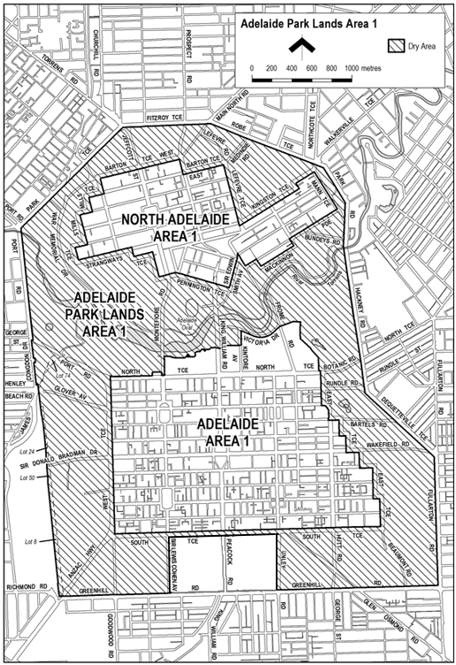
Made by the Minister for Consumer and Business Affairs
On 12 December 2023

Liquor Licensing Act 1997
South Australia
Liquor Licensing (Dry Areas) Notice 2023 (No. 3)
under section 131(1) of the Liquor Licensing Act 1997
1—Short title
This notice may be cited as the Liquor Licensing (Dry Areas) Notice 2023 (No. 3).
2—Commencement
This notice comes into operation on 22 December 2023.
3—Interpretation
(1) In this notice—
principal notice means the Liquor Licensing (Dry Areas) Notice 2015 published in the Gazette on 5.1.15, as in force from time to time.
(2) Clause 3 of the principal notice applies to this notice as if it were the principal notice.
4—Consumption etc of liquor prohibited in dry areas
(1) Pursuant to section 131 of the Act, the consumption and possession of liquor in the area described in the Schedule is prohibited in accordance with the provisions of the Schedule.
(2) The prohibition has effect during the periods specified in the Schedule.
(3) The prohibition does not extend to private land in the area described in the Schedule.
(4) Unless the contrary intention appears, the prohibition of the possession of liquor in the area does not extend to—
(a) a person who is genuinely passing through the place if—
(i) the liquor is in the original container in which it was purchased from licensed premises; and
(ii) the container has not been opened; or
(b) a person who has possession of the liquor in the course of carrying on a business or in the course of their employment by another person in the course of carrying on a business; or
(c) a person who is permanently or temporarily residing at premises near the public place and who enters the public place solely for the purpose of passing through it to enter those premises or who enters the public place from those premises for the purpose of leaving the place; or
(d) a person who possesses or consumes the liquor for sacramental or other similar religious purposes.

Schedule 1—Adelaide Park Lands Area 2
1—Extent of prohibition
The consumption of liquor is prohibited and the possession of liquor is prohibited.
2—Period of prohibition
Continuous until 12:00am on the 22 June 2025.
3—Description of area
The area generally known as Blue Gum / Kurangga (Park 20) and Veale Gardens / Walya Yarta (Park 21) contained in the southern part of the Adelaide Park Lands, bounded as follows: commencing at the point at which the northern part of Greenhill Road, Adelaide, meets the western boundary of Unley Road, Adelaide, then westerly along the northern boundary of Greenhill Road until where it intersects the eastern boundary of Sir Lewis Cohen Avenue, Adelaide, then in a northerly direction along the eastern boundary of Sir Lewis Cohen Avenue until where it intersects the southern border of South Terrace, Adelaide, then in an easterly direction along the southern boundary of South Terrace until where it intersects the western border of Unley Road and then in a southerly direction along the western boundary of Unley Road to where this meets the point of commencement.

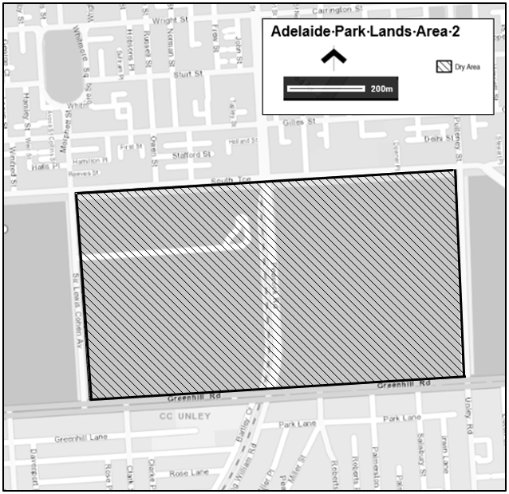

Made by the Minister for Consumer and Business Affairs
On 12 December 2023

Livestock Act 1997
Section 63(3)
Revocation of appointment of Chief Inspector of Stock
Pursuant to Section 63(3) of the Livestock Act 1997, I, Clare Scriven, Minister for Primary Industries and Regional Development, revoke the appointment of Dr Mary Carr as Chief Inspector of Stock made on 6 February 2019 and published on 14 February 2019 on page 467 with effect from 21 December 2023.
Dated: 11 December 2023
Clare Scriven
Minister for Primary Industries and Regional Development

Major Events Act 2013
Section 6B
Declaration of a Major Event
PURSUANT to section 6B of the Major Events Act 2013, I, Hon. Zoe Bettison MP, Minister for Tourism South Australia declare the 2024 Commbank Women’s ODI Series, Australia V South Africa to be held on Saturday 3 February 2024 to be declared a major event.
By virtue of the provisions of the Major Events Act 2013, I do hereby:
- Declare the 2024 Commbank Women’s ODI Series, Australia V South Africa to be a major event.
- Specify the period for the event, for which the declaration of the major event is in force to be Saturday 3 February 2024.
- Declare the major event venue to be Adelaide Oval/Tarntanya Wama (Park 26).
- Specify an area bounded by the northern boundary of Festival Drive including the northern entry to Adelaide Railway Station, King William Road, Kermode Street, Palmer Place (south of Kermode Street), Montefiore Hill and Montefiore Road as a controlled area in relation to the event;
- Designate Cricket Australia (ABN 53 006 089 130) to be the event organisers for the event.
- Declare that the following provisions of Part 3 of the Act apply to the event, the major event venue for the event and the controlled area for the event:
  - Section 8.
  - Section 10.
  - Section 11.
  - Section 12.
  - Section 13.
  - Section 14.
- Being satisfied that the title “Commbank Women’s ODI Series, Australia V South Africa” and the logo as it appears below are sufficiently connected with the identity and conduct of the major event, and that the event has commercial arrangements that are likely to be adversely affected by unauthorised use of the title and logo, I hereby declare, pursuant to section 14(1) of the Act, that “Commbank Women’s ODI Series, Australia V South Africa” is an official title and the logo as it appears below is an official logo in respect of the event.
Dated: 12 December 2023
Hon Zoe Bettison MP
Minister for Tourism

Map of Controlled Area for the Commbank Women’s ODI Series, Australia V South Africa
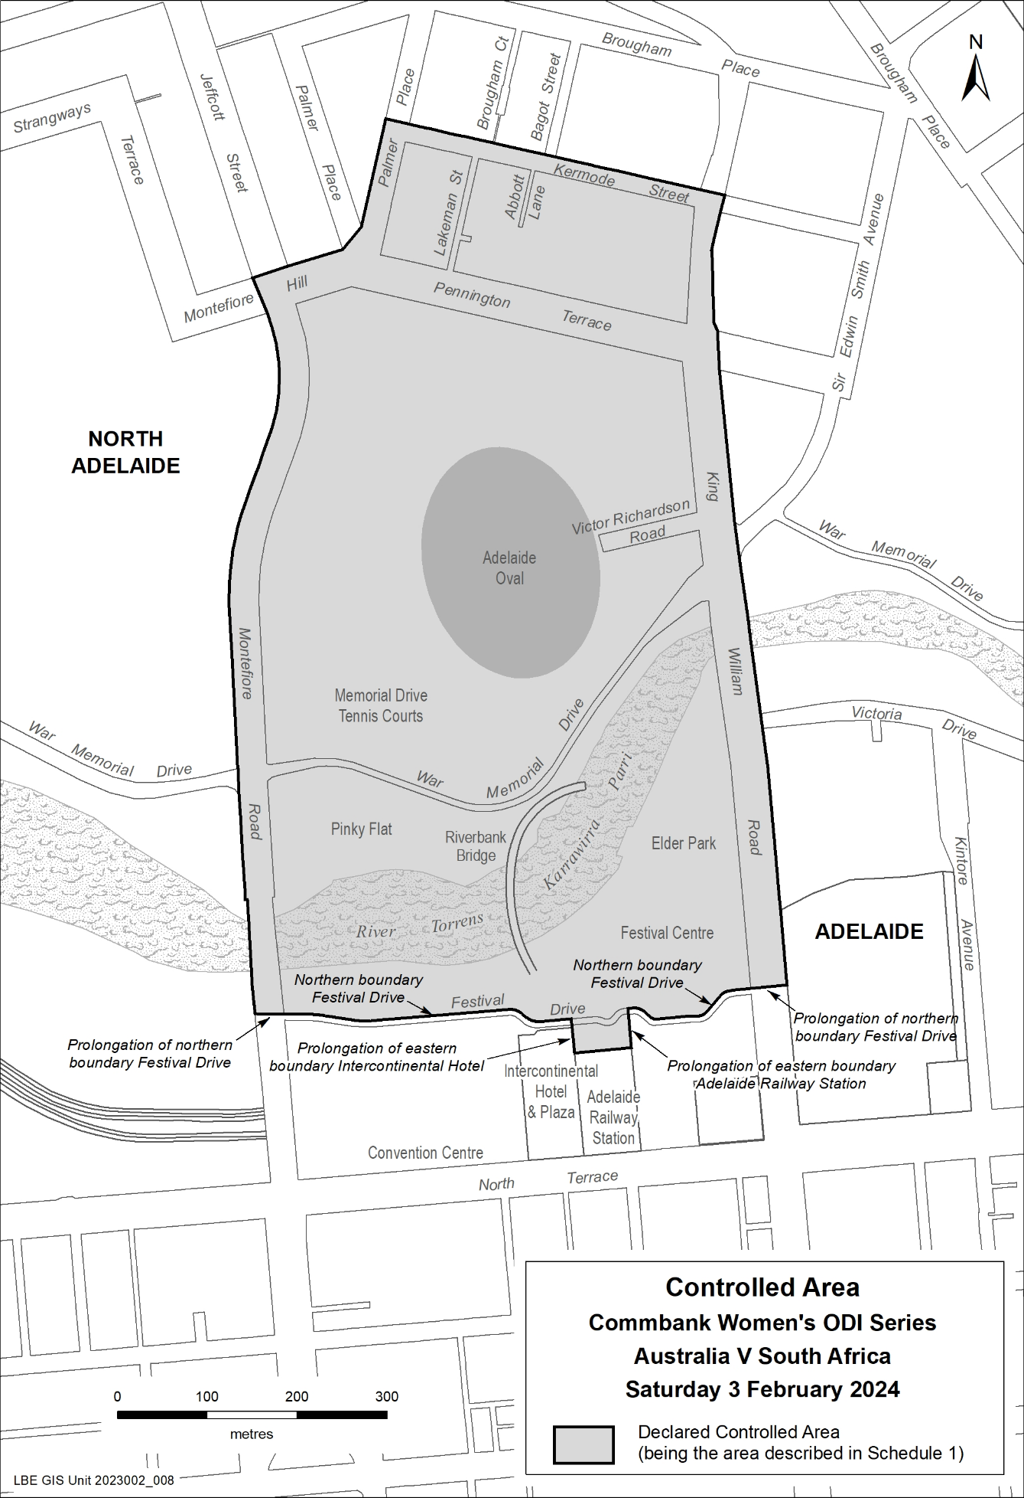

Major Events Act 2013
Section 6B
Declaration of a Major Event
PURSUANT PURSUANT to section 6B of the Major Events Act 2013, I, Hon. Zoe Bettison MP, Minister for Tourism South Australia declare the 2024 Dettol Men’s T20 Series, Australia V West Indies to be held on Sunday 11 February 2024 to be declared a major event.
By virtue of the provisions of the Major Events Act 2013, I do hereby:
- Declare the 2024 Dettol Men’s T20 Series, Australia V West Indies to be a major event.
- Specify the period for the event, for which the declaration of the major event is in force to be Sunday 11 February 2024, from 7:00am to midnight.
- Declare the major event venue to be Adelaide Oval/Tarntanya Wama (Park 26).
- Specify an area bounded by the northern boundary of Festival Drive, including the northern entry to Adelaide Railway Station, King William Road, Kermode Street, Palmer Place (south of Kermode Street), Montefiore Hill and Montefiore Road as a controlled area in relation to the event;
- Designate Cricket Australia (ABN 53 006 089 130) to be the event organisers for the event.
- Declare the following provisions of Part 3 of the Act apply to the event, the major event venue for the event and the controlled area for the event:
- Section 8.
- Section 10.
- Section 11.
- Section 12.
- Section 13.
- Section 14.
- Being satisfied the title “Dettol Men’s T20 Series, Australia V West Indies” and the logo as it appears below are sufficiently connected with the identity and conduct of the major event, and the event has commercial arrangements that are likely to be adversely affected by unauthorised use of the title and logo, I hereby declare, pursuant to section 14(1) of the Act, that “Dettol Men’s T20 Series, Australia V West Indies” is an official title and the logo as it appears below is an official logo in respect of the event.
Dated: 12 December 2023
Hon Zoe Bettison MP
Minister for Tourism

Map of Controlled Area for the Dettol Men’s T20 Series, Australia V West Indies
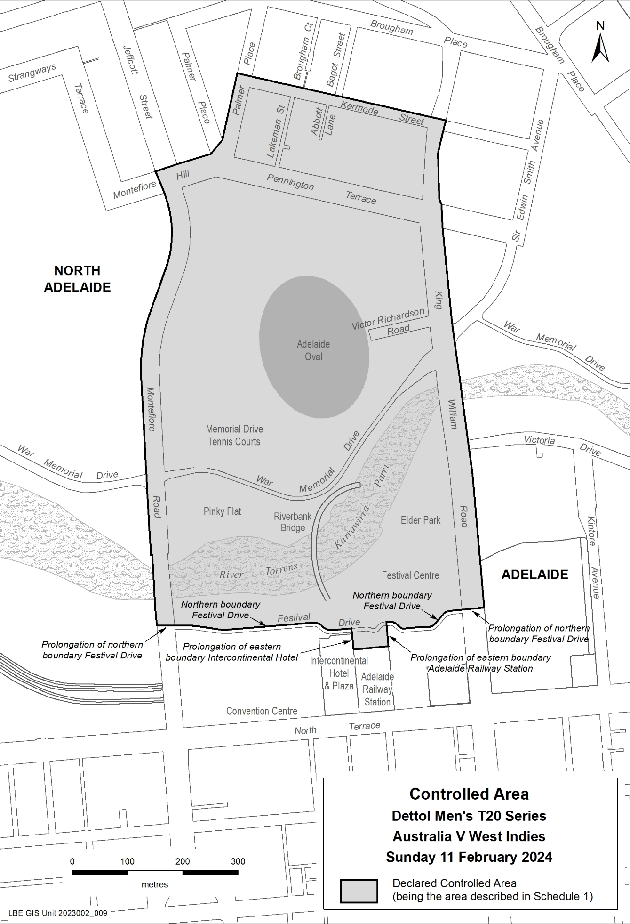

Major Events Act 2013
Section 6B
Declaration of a Major Event
PURSUANT to section 6B of the Major Events Act 2013, I, Hon. Zoe Bettison MP, Minister for Tourism South Australia declare the 2024 NRMA Insurance Men’s Test Series, Australia V West Indies to be held from Wednesday 17 January to Saturday 21 January 2024 to be declared a major event.
By virtue of the provisions of the Major Events Act 2013, I do hereby:
- Declare the 2024 NRMA Insurance Men’s Test Series, Australia V West Indies to be a major event.
- Specify the period for the event, for which the declaration of the major event is in force to be from Wednesday 17 January to Saturday 21 January 2024.
- Declare the major event venue to be Adelaide Oval/Tarntanya Wama (Park 26).
- Specify an area bounded by the northern boundary of Festival Drive, including the northern entry to Adelaide Railway Station, King William Road, Kermode Street, Palmer Place (south of Kermode Street), Montefiore Hill and Montefiore Road as a controlled area in relation to the event;
- Designate Cricket Australia (ABN 53 006 089 130) to be the event organisers for the event.
- Declare the following provisions of Part 3 of the Act apply to the event, the major event venue for the event and the controlled area for the event:
- Section 8.
- Section 10.
- Section 11.
- Section 12.
- Section 13.
- Section 14.
- Being satisfied that the title “NRMA Insurance Men’s Test Series, Australia V West Indies” and the logo as it appears below are sufficiently connected with the identity and conduct of the major event, and the event has commercial arrangements that are likely to be adversely affected by unauthorised use of the title and logo, I hereby declare, pursuant to section 14(1) of the Act, that “NRMA Insurance Men’s Test Series, Australia V West Indies” is an official title and the logo as it appears below is an official logo in respect of the event.
Dated: 12 December 2023
Hon Zoe Bettison MP
Minister for Tourism

Map of Controlled Area for the NRMA Insurance Men’s Test Series, Australia V West Indies
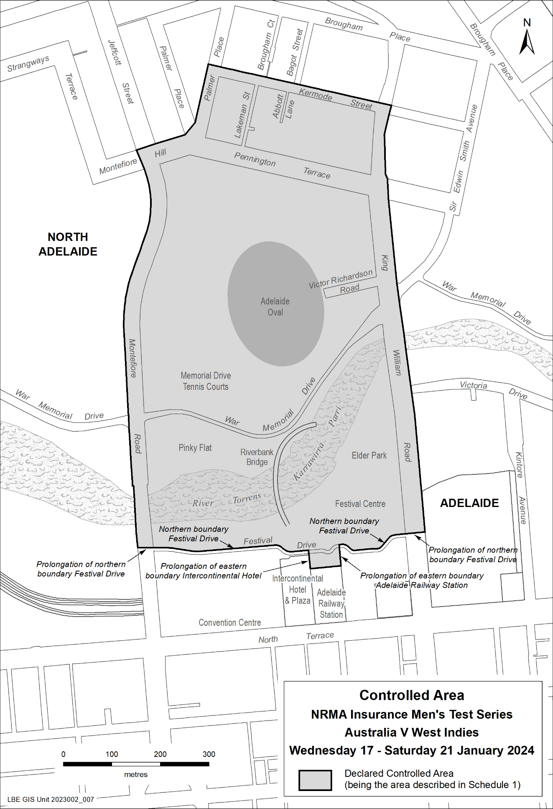

National Parks and Wildlife Act 1972
Parks of Western and Central Kangaroo Island Draft Management Plan Amendment 2023
I, MICHAEL JOSEPH WILLIAMS, Director of National Parks and Wildlife, hereby give notice under the provisions of Section 38 of the National Parks and Wildlife Act 1972 that the Parks of Western and Central Kangaroo Island Draft Management Plan Amendment 2023 has been prepared for Flinders Chase National Park. Copies of the draft plan amendments may be obtained from:
- Kingscote National Parks and Wildlife Office, 37 Dauncey Street, Kingscote
Or online at:
- https://yoursay.sa.gov.au/
- https://www.parks.sa.gov.au/park-management/management-plans
Any person may make representations in connection with the draft plan during the period up to and including 5pm Monday 11 March 2024.
Written comments should be forwarded to National Parks and Protected Area Program Unit, Department for Environment and Water, GPO Box 1047 ADELAIDE SA 5001 or e-mailed to DEWProtectedAreaManagement@sa.gov.au
Dated: 29 November 2023
M. J. Williams
Director of National Parks and Wildlife
Delegate of the Minister for Climate, Environment and Water

Petroleum and Geothermal Energy Act 2000
Application for Grant of Associated Activities Licence—AAL 313
Pursuant to section 65(6) of the Petroleum and Geothermal Energy Act 2000 and delegation dated 27 November 2023, notice is hereby given that an application for the grant of an associated activities licence over the area described below has been received from:
Santos QNT Pty Ltd
Red Sky Energy (NT) Pty Ltd
The application will be determined on or after 12 January 2024.
Description of Application Area
All that part of the State of South Australia, bounded as follows:
All coordinates MGA2020, Zone 54
473939.517781 6970014.458505
473940.776459 6969299.363544
473610.440366 6969020.120745
473218.533471 6968772.392470
473125.542874 6968613.934808
472515.777473 6968095.635634
472442.089798 6967848.607231
472293.934587 6967704.800422
471994.122710 6967096.484987
471517.950474 6966641.793057
470946.226304 6966250.162939
470444.777719 6965753.208156
469879.201386 6965479.703176
469623.091054 6964849.394591
469678.302290 6964818.944385
469711.329179 6964849.230669
469756.738557 6964829.684774
469992.891374 6965385.052889
470530.928996 6965644.772475
471023.913133 6966133.260925
471585.122434 6966484.775230
472105.745066 6966977.535696
472769.202575 6968120.463785
473258.306720 6968528.767219
473340.646336 6968708.300372
473745.312955 6968941.279949
474149.711175 6969309.299867
474383.042694 6970003.178150
474450.437834 6970322.687510
474306.476633 6970322.828332
474306.921678 6970014.789975
473939.517781 6970014.458505
AREA: 1.23 square kilometres approximately
Dated: 12 December 2023
Benjamin Zammit
Executive Director
Regulation and Compliance Division
Department for Energy and Mining
Delegate of the Minister for Energy and Mining

Radiation Protection and Control Act 2021
Section 76
Notice RPC202312-01
PURSUANT to section 76 of the Radiation Protection and Control Act 2021 (the Act), I, Daniel Bellifemine, Manager, Mining and Radiation, Environment Protection Authority, Delegate of the Minister for Climate, Environment and Water, exempt the owner of an Iroquois (Huey) Helicopter, the Port Pirie Sub-Branch of the Returned and Services League of Australia (RSL) from the requirement to hold a Radiation Management Licence, Possession of a Radiation Source under Section 22 of the Act, subject to the following conditions:
- This exemption only applies in relation to radioactive thorium contained within the Iroquois (Huey) Helicopter’s engine structure.
- The Iroquois (Huey) Helicopter must not be subjected to repair work that involves grinding, filing, or drilling of any part of the engine casing which contains radioactive thorium.
- The Iroquois (Huey) Helicopter must not be disposed of without prior approval required for disposal of radioactive material by the Regulations under the Radiation Protection and Control Act 2021.
- The Port Pirie Sub-Branch of the RSL must notify the EPA in writing within 14 days of disposal of the Iroquois (Huey) Helicopter.
Dated: 28 November 2023
D. Bellifemine
Delegate of the Minister for Climate, Environment and Water

Radiation Protection and Control Act 2021
Section 76
Notice RPC202312-02
PURSUANT to section 76 of the Radiation Protection and Control Act 2021 (the Act), I, Daniel Bellifemine, Manager, Mining and Radiation, Environment Protection Authority, Delegate of the Minister for Climate, Environment and Water, exempt persons who dispose of domestic ionisation chamber smoke alarms into domestic waste from the requirements of Regulation 65 of Radiation Protection and Control Regulations 2022, subject to the following conditions:
- A person must not dispose of a smoke alarm that contains more than 40 kilobecquerels of americium-241.
- A person must not dispose of more than two domestic smoke alarms into domestic waste during any period of seven days.
- The exemption shall take effect commencing on the date of publication of this Notice in the Government Gazette.
Dated: 28 November 2023
D. Bellifemine
Delegate of the Minister for Climate, Environment and Water

Radiation Protection and Control Act 2021
Section 76
Notice RPC202312-03
PURSUANT to section 76 of the Radiation Protection and Control Act 2021 (the Act), I, Daniel Bellifemine, Manager, Mining and Radiation, Environment Protection Authority, Delegate of the Minister for Climate, Environment and Water, exempt persons dealing with a security enhanced radioactive source from the requirement in the Code of Practice for the Security of Radioactive Sources to have a Source Security Plan or Source Transport Security Plan endorsed by an accredited assessor:
This exemption does not absolve a person from any requirement in the Code of Practice for the Security of Radioactive Sources to have or comply with the Source Security Plan or Source Transport Security Plan.
This exemption shall take effect commencing on the date of publication of this Notice in the Government Gazette.
Dated: 28 November 2023
D. Bellifemine
Delegate of the Minister for Climate, Environment and Water

Radiation Protection and Control Act 2021
Section 76
Notice RPC202312-04
PURSUANT to section 76 of the Radiation Protection and Control Act 2021 (the Act), I, Daniel Bellifemine, Manager, Mining and Radiation, Environment Protection Authority, Delegate of the Minister for Climate, Environment and Water, exempt persons dealing with a security enhanced radioactive source from the requirement in the Code of Practice for the Security of Radioactive Sources 2019, section E2.1 to have a security assessment in respect of a person, issued by ASIO, and criminal history checks by the Australian Federal Police.
This exemption does not absolve the person from the requirement in the Code of Practice for the Security of Radioactive Sources to have criminal history checks by all State and Territory police services, in the form of a National Police Certificate.
This exemption shall take effect commencing on the date of publication of this Notice in the Government Gazette.
Dated: 28 November 2023
D. Bellifemine
Delegate of the Minister for Climate, Environment and Water

Radiation Protection and Control Act 2021
Regulation 89
Notice RPC202312-05
PURSUANT to Part 5, Division 3 of the Radiation Protection and Control Regulations 2022, I, Daniel Bellifemine, Manager, Mining and Radiation, Environment Protection Authority, Delegate of the Minister for Climate, Environment and Water, approve the following kinds of personal monitoring devices issued by the organisations listed in Column 1 of the Schedule below for detecting and measuring external exposure to the type of ionising radiations listed in Column 2, subject to the following conditions:
- all measurements must remain traceable to Australian standards, or international standards in the absence of an Australian standard;
- relevant NATA or equivalent accreditation of the measurement system must be maintained;
- the organisation must supply free of charge to the EPA, measurements of radiation workers’ exposures;
- the approved personal monitoring devices are also to be used in accordance with any instructions given by the respective organisations or the EPA; and
- Radiation Safety Institute of Canada must ensure continuation of the licence held by RSIC in relation to the PAD system, issued by the Canadian Nuclear Safety Commission.
The Schedule
Column 1 |  | Column 2
TLD Monitor | ARPANSA* | beta, gamma, X-ray
Special TLD Monitor | ARPANSA | beta, gamma, X-ray
Neutron Monitor | ARPANSA | beta, gamma, X-ray, neutron
Extremity Monitor | ARPANSA | beta, gamma, X-ray
PADC/BeO OSL | ARPANSA | Photon, fast neutron
BeO OSL | ARPANSA | gamma, X-ray
RDC Type 82 TLD-XBGN dosimeter | GMS* | beta, gamma, X-ray, neutron
RDC Type 83 TLD-XBGN/TE dosimeter | GMS | beta, gamma, X-ray, neutron
RDC Type 05 TLD-XBG ring dosimeter | GMS | beta, gamma, X-ray
Pa Badge | Landauer* | beta, gamma, X-ray
Ja Badge | Landauer | beta, gamma, X-ray, neutron
Ta Badge | Landauer | beta, gamma, X-ray, thermal
U Badge (Ring) . | Landauer | beta, gamma, X-ray
Personal Alpha Dosimeter | RSIC* | radon progeny and long-lived radioactive dust
Instadose® 2 | SGS* | beta, gamma, X-ray
InstadoseTM | SGS | gamma, X-ray
Instadose +TM | SGS | gamma, X-ray
Genesis Ultra TLD | SGS | beta, gamma, neutron
Genesis Ultra TLD with CR39 | SGS | beta, gamma, neutron
Film + Orange holder | SGS | gamma, X-ray
Film + Yellow holder | SGS | gamma, X-ray
Film + Blue holder | SGS | gamma, X-ray
TLD + Ring holder | SGS | gamma, X-ray
TLD + PB5 holder | SGS | gamma, X-ray
TLD + PB10 holder | SGS | gamma, X-ray
Mirion DMC 3000 | SGS | gamma, X-ray
Mirion SOR/R | SGS | gamma, X-ray
Mirion SOR/T | SGS | gamma, X-ray

(*ARPANSA—Australian Radiation Protection and Nuclear Safety Agency);
(*GMS—Global Medical Solutions Pty Ltd);
(*Landauer—Landauer Australasia Pty Lyd);
(*RSIC—Radiation Safety Institute of Canada);
(*SGS—SGS Australia Pty Ltd).
This notice of approval shall take effect commencing on the date of publication of this notice in the Government Gazette.
Dated: 28 November 2023
D. Bellifemine
Delegate of the Minister for Climate, Environment and Water

Radiation Protection and Control Act 2021
Section 76
Notice RPC202312-06
PURSUANT to section 76 of the Radiation Protection and Control Act 2021 (the Act), I, Daniel Bellifemine, Manager, Mining and Radiation, Environment Protection Authority, Delegate of the Minister for Climate, Environment and Water, exempt the following class of persons, from the requirement to hold a licence for the use or handling of radioactive material under section 23 of the Radiation Protection and Control Act 2021:
- Urologists to the extent that they may use or handle radioactive iodine-125, while assisting radiation oncologists in a brachytherapy procedure involving implantation of the prostate with iodine-125 seeds, subject to the following conditions:
  - The urologist must be deemed competent by the employer in the principles and practices of radiation protection in relation to the use or handling of the radioactive iodine-125 seeds; and
  - The urologist must only use or handle the radioactive iodine-125 seeds under the direct supervision of a licensed radiation oncologist, and with the assistance of a licensed medical physicist.
This notice of approval shall take effect commencing on the date of publication of this notice in the Government Gazette.
Dated: 28 November 2023
D. Bellifemine
Delegate of the Minister for Climate, Environment and Water

Roads (Opening and Closing) Act 1991
Section 24
NOTICE OF CONFIRMATION OF ROAD
PROCESS ORDER
Road Closure—Paynter Street, Glen Osmond
By Road Process Order made on 21 August 2023, the City of Burnside ordered that:
- Portion of Paynter Street, Glen Osmond, situated adjoining the eastern boundary of Allotment 2 in Deposited Plan 133202, Hundred of Adelaide, more particularly delineated and lettered ‘B’ in Preliminary Plan 22/0042 be closed.
- Transfer the whole of the land subject to closure to Pietro Lauro Martire and Aisha Leah Akbar in accordance with the Agreement for Transfer dated 21 August 2023 entered into between the City of Burnside and Pietro Lauro Martire and Aisha Leah Akbar.
On 12 December 2023 that order was confirmed by the Minister for Planning conditionally upon the deposit by the Registrar-General of Deposited Plan 133202 being the authority for the new boundaries.
Pursuant to Section 24 of the Roads (Opening and Closing) Act 1991, NOTICE of the order referred to above and its confirmation is hereby given.
Dated: 14 December 2023
B. J. Slape
Surveyor-General
2022/12161/01

SOUTH AUSTRALIAN HOUSING TRUST ACT 1995
Transfer of assets of the South Australian Housing Trust
PURSUANT to the provisions of Section 23 (1) (b) (ii) of the South Australian Housing Trust Act 1995, Nat Cook, Minister for Human Services, with the concurrence of Stephen Mullighan, Treasurer, gives notice of the transfer of properties listed in Schedule 1 from the South Australian Housing Trust to the Urban Renewal Authority on 14 December 2023.
Schedule 1
Address | Certificate of Title |  | Certificate of Title Description
 | Volume | Folio | Plan | Parcel
Lot 3 Glenburnie St, Seaton | 5428 | 45 | D26040 | A3
70 Glenburnie St, Seaton | 5798 | 48 | D4581 | A307
72 Glenburnie St, Seaton | 5798 | 48 | D4581 | A306
74 Glenburnie St, Seaton | 5798 | 48 | D4581 | A305
76 Glenburnie St, Seaton | 5798 | 48 | D4581 | A304
78 Glenburnie St, Seaton | 5798 | 48 | D4581 | A303
80 Glenburnie St, Seaton | 5798 | 47 | D4581 | A302
82 Glenburnie St, Seaton | 5798 | 47 | D4581 | A301
84 Glenburnie St, Seaton | 5798 | 47 | D4581 | A300
86 Glenburnie St, Seaton | 5798 | 47 | D4581 | A299
88 Glenburnie St, Seaton | 5798 | 47 | D4581 | A298
90 Glenburnie St, Seaton | 5798 | 46 | D4581 | A297
92 Glenburnie St, Seaton | 5798 | 46 | D4581 | A296
Lot 2 Lark Ave, Seaton | 5428 | 46 | D26040 | A2
Lot 1 Lark Ave, Seaton | 5428 | 47 | D26040 | A1
69 Matthews Ave, Seaton | 5688 | 613 | D4581 | A289
71 Matthews Ave, Seaton | 5688 | 613 | D4581 | A288
73 Matthews Ave, Seaton | 5792 | 87 | F41233 | A12
75 Matthews Ave, Seaton | 5792 | 86 | F41233 | A11
77 Matthews Ave, Seaton | 5688 | 613 | D4581 | A285
79 Matthews Ave, Seaton | 5688 | 613 | D4581 | A284
81 Matthews Ave, Seaton | 5688 | 613 | D4581 | A283
83 Matthews Ave, Seaton | 5688 | 613 | D4581 | A282
85 Matthews Ave, Seaton | 5688 | 611 | F40804 | A10
87 Matthews Ave, Seaton | 5688 | 610 | F40804 | A9
89 Matthews Ave, Seaton | 5688 | 613 | D4581 | A279
91 Matthews Ave, Seaton | 5688 | 613 | D4581 | A278
93 Matthews Ave, Seaton | 5688 | 613 | D4581 | A277
95 Matthews Ave, Seaton | 5688 | 613 | D4581 | A276
97 Matthews Ave, Seaton | 5633 | 1 | D4581 | A273
143 Frederick Rd, Seaton | 5633 | 1 | D4581 | A274
145 Frederick Rd, Seaton | 5633 | 1 | D4581 | A275
147 Frederick Rd, Seaton | 5798 | 46 | D4581 | A293
149 Frederick Rd, Seaton | 5798 | 46 | D4581 | A294
151 Frederick Rd, Seaton | 5798 | 46 | D4581 | A295

Dated: 12 December 2023
Hon Nat Cook MP
Minister For Human Services
Dated: 11 December 2023
Hon Stephen Mullighan
Treasurer

SOUTH AUSTRALIAN HOUSING TRUST ACT 1995
Transfer of rights and liabilities contained in specified contracts of the
South Australian Housing Trust
PURSUANT to the provisions of Section 23 (1) (b) (ii) of the South Australian Housing Trust Act 1995 Nat Cook, Minister for Human Services, with the concurrence of Stephen Mullighan, Treasurer, gives notice of the transfer of the present and future rights and liabilities contained in the contracts listed in Schedule 1 (entered into by the South Australian Housing Trust with the counterparties listed in Schedule 1 incorporating any amendments to those contracts from time to time, which contracts are individually and collectively called ‘Transferred Contracts’), from the South Australian Housing Trust to the Urban Renewal Authority, as at and from 14 December 2023.
PURSUANT to the provisions of Section 23 (2) of the South Australian Housing Trust Act 1995, Nat Cook, Minister for Human Services, with the concurrence of Stephen Mullighan, Treasurer, gives notice that the transfer of the present and future rights and liabilities contained in the Transferred Contracts acts as an assignment of the rights and liabilities of the South Australian Housing Trust in the Transferred Contracts, in that the Urban Renewal Authority, as and from 14 December 2023 takes the benefit of the rights and agrees to perform the obligations and assume the liabilities of the South Australian Housing Trust (as the named party in the Transferred Contracts) under the Transferred Contracts.
Schedule 1—Transferred Contracts
PARTIES TO CONTRACT |  | DESCRIPTION
Camco (SA) Pty Ltd | South Australian Housing Trust | Civil and Landscape construction works at the Seaton Demonstration Project (Seaton Stage 1 Urban Renewal Project Area)  Contract date: 11 August 2022
Greenhill Engineers Pty Ltd | South Australian Housing Trust | The supply of Engineering and Landscape Architecture Services Seaton Demonstration Project (Seaton Stage 1)  Contract date: 14 July 2021
Nation Creative Pty Ltd | South Australian Housing Trust | Advertising, Design, Marketing and Communication Services for the Seaton Demonstration Project  Contract date: 10 October 2022

Dated: 12 December 2023
Hon Nat Cook MP
Minister For Human Services
Dated: 11 December 2023
Hon Stephen Mullighan
Treasurer

Local Government Instruments

City of Adelaide
Local Government Act 1999—Section 220
Alteration of Numbering System for Roads
Notice is hereby given that, at its meeting of 14 June 2022, the Corporation of the City of Adelaide amended its Street Numbering Policy to provide for the numbering of premises on the northern side of North Terrace.
A copy of Council’s Street Numbering Policy, as amended, can be accessed online at www.cityofadelaide.com.au.
C. Mockler
Chief Executive Officer

City of Adelaide
Local Government Act 1999—Section 122
And
City of Adelaide Act 1998: Section 30
Draft Transportation & Urban Elements Asset Management Plans for public consultation
The City of Adelaide is consulting on its Draft Transportation & Urban Elements Asset Management Plans.
Pursuant to the provisions of section 122 of the Local Government Act 1999, and section 30 of the City of Adelaide Act 1998, the City of Adelaide is required to conduct public consultation on its Asset Management Plans before they can be formally adopted.
A copy of each draft Asset Management Plan will be available for inspection at the Council’s principal office (25 Pirie Street, Adelaide SA 5000), and at its libraries and community centres.
For further information on the consultation process or to provide feedback you can visit yoursay.cityofadelaide.com.au at any time, or Council’s principal office, its libraries and community centres during ordinary office hours.
Consultation is open from Friday, 15 December 2023.
All submissions on the Draft Transportation and Urban Elements Asset Management Plans must be received by 5:00 pm, Friday, 9 February 2024.
Clare Mockler
Chief Executive Officer

City Of Salisbury
Local Government Act 1999
Revocation of Community Land Classification
Pursuant to Section 194 of the Local Government Act 1999(2) (b), The City of Salisbury proposes to revoke the Community Land classification from a portion of Community Land.
The City of Salisbury is the registered owner of the land described as Cedarwood Avenue Reserve, Allotment 410 in Deposited Plan 67910, described in Certificate of Title Volume 6109 Folio 846. As a request from the adjoining owner it is proposed that this reserve measuring 10 m2 be revoked of its Community Land Classification for the purpose of amalgamating into the adjoining allotments and allowing access between theses parcels.
A copy of the plans detailing the proposals and location are available for public inspection at Council’s Community Hub at 34 Church Street, Salisbury.
Any objection to the proposal must set out the full name and address of the person making the objection and must be fully supported by reasons.
Any submissions must be made in writing prior to Wednesday, 31 January 2024 to the Council at PO Box 8 Salisbury SA 5108.
Where submissions are made Council will give notification of a meeting to deal with the matter.
Enquiries to be directed to Tim Starr on (08) 8406 8577 or by email to tstarr@salisbury.sa.gov.au
Dated: 14 December 2023
John Harry
Chief Executive Officer

City Of Salisbury
Local Government Act 1999
Revocation of Community Land Classification
Pursuant to Section 194 of the Local Government Act 1999(2) (b), The City of Salisbury proposes to revoke the Community Land classification from a portion of Community Land.
The City of Salisbury is the registered owner of the land described as West Avenue Buffer Reserve, Allotment 51 in Deposited Plan 81170, described in Certificate of Title Volume 6050 Folio 965. As a request from the adjoining owners it is proposed that this reserve measuring 172 m2 be revoked of its Community Land Classification for the purpose of amalgamating into the adjoining allotment and allowing access from West Avenue.
A copy of the plans detailing the proposals and location are available for public inspection at Council’s Community Hub at 34 Church Street, Salisbury.
Any objection to the proposal must set out the full name and address of the person making the objection and must be fully supported by reasons.
Any submissions must be made in writing prior to Wednesday, 31 January 2024 to the Council at PO Box 8 Salisbury SA 5108.
Where submissions are made Council will give notification of a meeting to deal with the matter.
Enquiries to be directed to Tim Starr on (08) 8406 8577 or by email to tstarr@salisbury.sa.gov.au
Dated: 14 December 2023
John Harry
Chief Executive Officer

City of Tea Tree Gully
Local Government Act 1999
Adoption of Community Land Management Plans—Various Locations
Amendment—Modbury Heights Community Land Management Plan
Notice is hereby provided pursuant to Section 197(3) of the Local Government Act 1999, that at its ordinary meeting held on 28 November 2023, Council resolved to adopt community land management plans for the following sites within the City of Tea Tree Gully, revoking previous community land management plans:
- Banksia Sports Park
- Burragah Recreation Area
- Golden Grove Golden Fields
- Greenwith Reserve
- Greenwith Sports Park
- Hargrave Reserve
- Harpers Field
- Hope Valley Sports Area
- Illyarrie Reserve
- Ladywood Reserve
- Little Para Reserve
- Lyons Reserve
- Modbury Sports Area
- Richardson Oval
- Tea Tree Gully Sports Area
- Tilley Recreation Park
- Turramurra Recreation Centre
- Wynn Vale Recreation Area
And pursuant to Section 198(4) of the Local Government Act 1999, at its ordinary meeting of 28 November 2023, Council resolved to amend the Modbury Heights Community Land Management Plan by removing reference to Hargrave Reserve.
The community land management plans may be viewed by visiting Council’s website.
Dated: 14 December 2023
Ryan McMahon
Chief Executive Officer

City of Victor Harbor
South Australia
Liquor Licensing (Dry Areas) Notice 2023
under section 131(1AB) of the Liquor Licensing Act 1997
- Short title
This notice may be cited as the Liquor Licensing (Dry Areas) Notice 2023
- Commencement
This notice comes into operation on 31 December 2023.
- Interpretation
- In this notice—
principal notice means the Liquor Licensing (Dry Areas) Notice 2015 published in the Gazette on 5.1.15, as in force from time to time.
(2) Clause 3 of the principal notice applies to this notice as if it were the principal notice.
- Consumption etc of liquor prohibited in dry areas
(1) Pursuant to section 131 of the Act, the consumption and possession of liquor in the area described in the Schedule is prohibited in accordance with the provisions of the Schedule.
(2) The prohibition has effect during the periods specified in the Schedule.
(3) The prohibition does not extend to private land in the area described in the Schedule.
(4) Unless the contrary intention appears, the prohibition of the possession of liquor in the
area does not extend to —
- a person who is genuinely passing through the area if —
- the liquor is in the original container in which it was purchased from licensed premises; and
- the container has not been opened; or
- a person who has possession of the liquor in the course of carrying on a business or in the course of his or her employment by another person in the course of carrying on a business; or
- a person who is permanently or temporarily residing at premises within the area or on the boundary of the area and who enters the area solely for the purpose of passing through it to enter those premises or who enters the area from those premises for the purpose of leaving the area.

Schedule – Victor Harbor Area 1 and 2
1 – Extent of prohibition
The consumption of liquor is prohibited and the possession of liquor is prohibited.
2 – Period of prohibition
From 3pm on 31 December 2023 to 9am 1 January 2024.
3 – Description of area
Victor Harbor Area 1
The area in and adjacent to Victor Harbor bounded as follows: commencing at the point at which the north-western boundary of Hindmarsh Road intersects the southern bank of the Hindmarsh River, then generally north-easterly along that bank of the Hindmarsh River to the low water mark of Encounter Bay, then generally south-westerly along the low water mark to the point at which it meets the northern boundary of the area defined in Schedule—Victor Harbor Area 3 (the prolongation in a straight line of the northernmost boundary of the bitumenised car parking area immediately to the north of the skating arena of the Victor Harbor Skate and Youth Park), then generally north- westerly, south-westerly and south-easterly around the northern, western and southern boundaries of that area back to the low water mark of Encounter Bay, then generally southerly along the low water mark to the eastern side of both causeways linking Granite Island to the mainland, then in a straight line by the shortest route to the low water mark on the western side of both causeways, then generally westerly, south-westerly, southerly and south-westerly along the low water mark to the point at which it is intersected by the prolongation in a straight line of the south-western boundary of Harbour View Terrace, then north-westerly along that prolongation and boundary of Harbour View Terrace to the point at which it is intersected by the prolongation in a straight line of the north- western boundary of Kent Drive, then generally north-easterly, northerly and north- westerly along that prolongation and boundary of Kent Drive to the point at which it is intersected by the prolongation in a straight line of the south-eastern boundary of a foot bridge across the Inman River (being the foot bridge closest to the mouth of the river), then north-easterly along the line of that south-eastern boundary of the foot bridge across the river to the south-western boundary of the Victor Harbor Beachfront Holiday Park, then generally south-easterly and north-easterly along the boundary of the park to the south-western boundary of Inman Street, then north-westerly along that boundary of Inman Street and the prolongation in a straight line of that boundary to the north-western boundary of Victoria Street, then north-easterly along that boundary of Victoria Street to the south-western boundary of George Main Road, then north-westerly along that boundary of George Main Road to the northern bank of the Inman River, then westerly along that bank of the river to the point at which it is intersected by the prolongation in a straight line of the western boundary of Lot 57 of FP 20694, then north-westerly along that prolongation to the kerb line on the south-eastern side of Bay Road, then generally north-easterly along that kerb line to the kerb line on the south-western side of George Main Road, then in a straight line by the shortest route across George Main Road to the north-eastern boundary of that road, then south-easterly along that boundary of George Main Road to the north-western boundary of Victoria Street, then north-easterly along that boundary of Victoria Street to the south-western boundary of Oval Road, then generally north-westerly along that boundary of Oval Road to the point at which it is intersected by the prolongation in a straight line of the north-western boundary of Leworthy Street, then generally north-easterly along that prolongation and boundary of Leworthy Street, and the prolongation in a straight line of that boundary, to the north- eastern boundary of Crozier Road, then south-easterly along that boundary of Crozier Road to the north-western boundary of Acraman Street, then north-easterly along the north-western boundaries of Acraman Street and Carlyle Street to the point at which the north-western boundary of Carlyle Street intersects the north-eastern boundary of Cornhill Road, then south-easterly along that north-eastern boundary of Cornhill Road to the north-western boundary of Hindmarsh Road, then north-easterly along that boundary of Hindmarsh Road to the north-eastern boundary of Peace Avenue, then north-westerly along that boundary of Peace Avenue to the south-eastern boundary of Broadway Terrace, then north-easterly along that boundary of Broadway Terrace to the south- western boundary of Renown Avenue, then south-easterly along that boundary of Renown Avenue to the north-western boundary of Hindmarsh Road, then generally north-easterly along that boundary of Hindmarsh Road to the point of commencement. The area includes the whole of any wharf, jetty, boat ramp, breakwater or other structure that extends below low water mark from within the area (as well as any area beneath such a structure), but does not include that part of the causeways to Granite Island that lies within the area to which the prohibition in Schedule—Victor Harbor Area 2 applies.
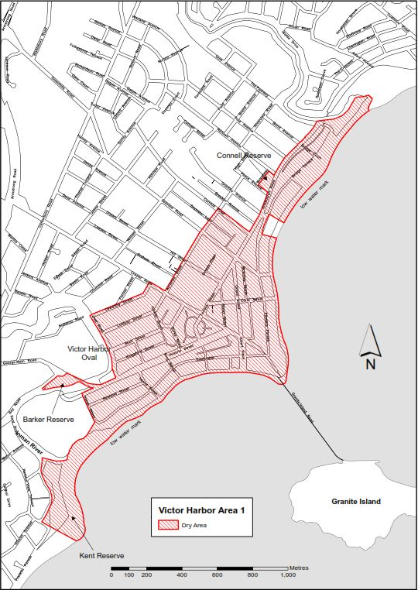

Victor Harbor Area 2
The whole of Granite Island to low water mark, together with the whole of both old and new causeways linking the mainland and Granite Island (apart from the part of the causeways above the low water mark on the mainland as well as any area beneath the causeways. In addition to the causeways, the area also includes the whole of any wharf, jetty, boat ramp, breakwater or other structure extending below low water mark from Granite Island, as well as any area beneath such a structure.
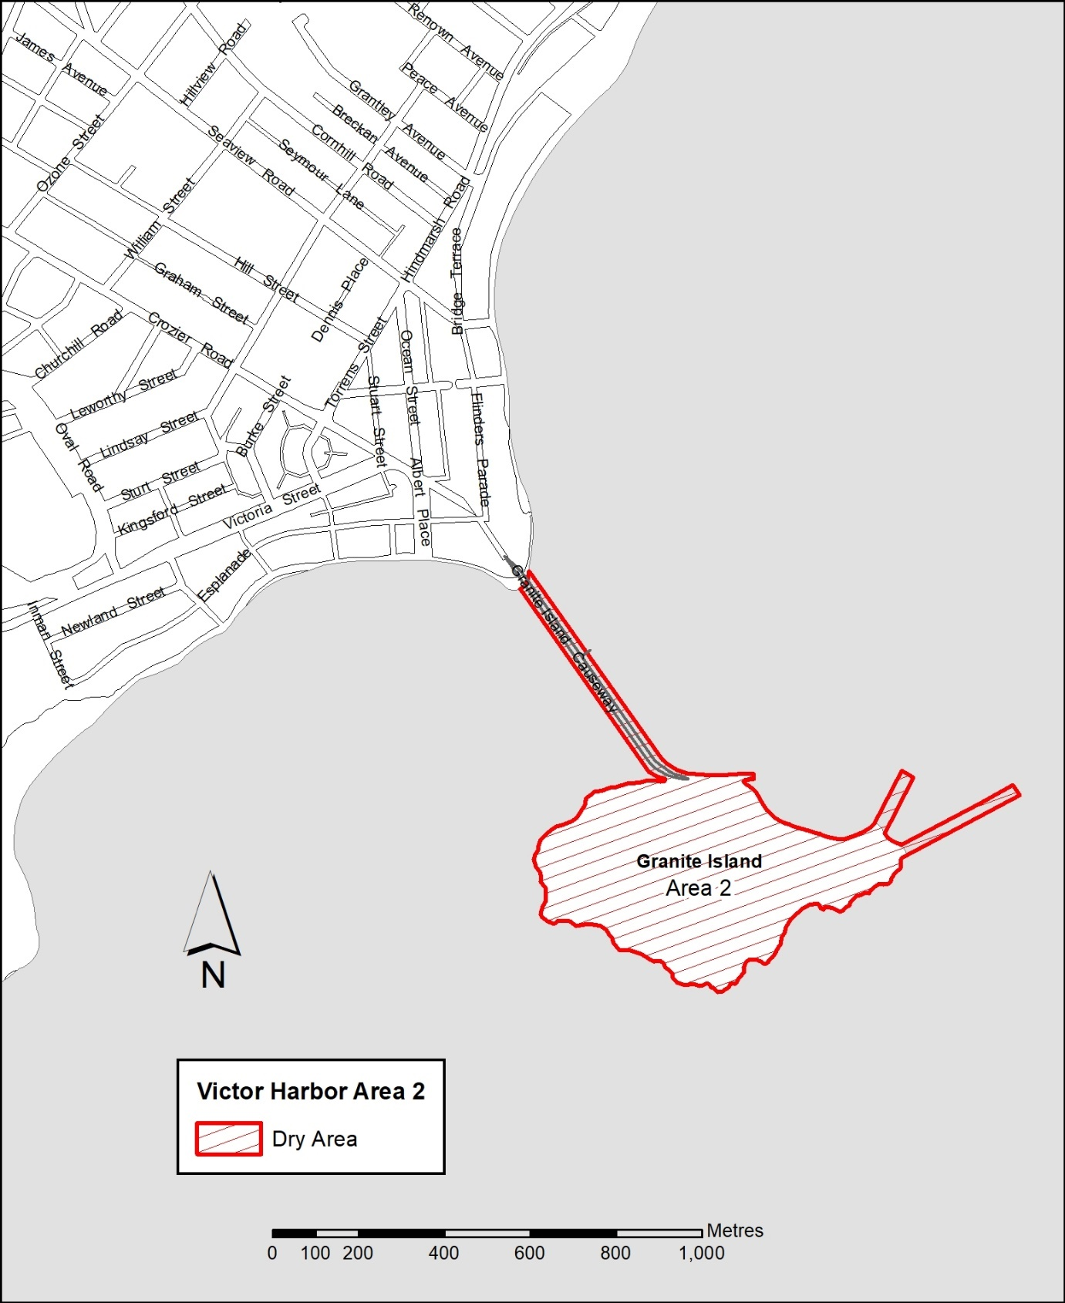

Schedule – Hayborough 2
1 – Extent of prohibition
The consumption of liquor is prohibited and the possession of liquor is prohibited.
2 – Period of prohibition
From 3pm on 31 December 2023 to 9am 1 January 2024.
3 – Description of area
Hayborough - Area 2
The area in and adjacent to Hayborough (being the area generally known as the Investigator car park, together with other land) bounded on the north by the southwesterly Prolongation in a straight line of the southern boundary of Lot 401DP 3207, on the east by the south-easterly prolongation in a straight line of the western boundary of that Lot, on the south by the low water mark of Encounter Bay and on the west by the eastern boundaries of Lots 1 and 2 DP 91118 and the south-easterly prolongation in a straight line of the eastern boundary of Lot 2 DP 91118.
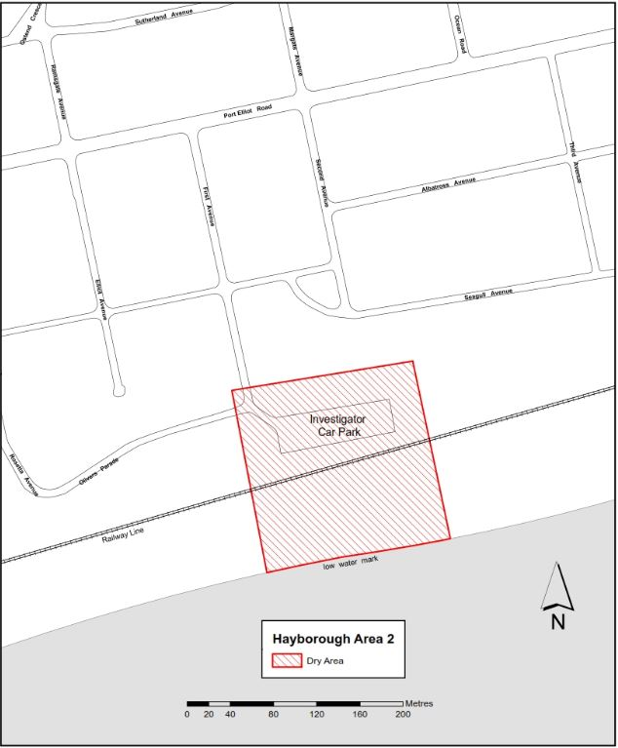
Victoria MacKirdy
Chief Executive Officer

City Of Mitcham
Local Government Act 1999
Adoption of amendments to Community Land Management Plans
NOTICE is hereby given pursuant to section 198(2) of the Local Government Act 1999 that on 29 November 2023 the City of Mitcham adopted amendments to the Community Land Management Plans for;
- Category One Reserves
- Category Two Reserves
- Category Three Reserves
- Category Four Reserves
The amended Community Land Management Plan can be viewed at www.mitchamcouncil.sa.gov.au.
Dated: 7 December 2023
Matthew Pears
Chief Executive Officer

District Council of Lower Eyre Peninsula
South Australia
Liquor Licensing (Dry Areas) Notice 2023
Under Section 131(1a) of the Liquor Licensing Act 1997
1—Short title
This notice may be cited as the Liquor Licensing (Dry Areas) Notice 2023.
2—Commencement
This notice comes into operation on 31 December 2023.
3—Interpretation
(1) In this notice—
principal notice means the Liquor Licensing (Dry Areas) Notice 2015 published in the Gazette on 5.1.15, as in force from time to time.
(2) Clause 3 of the principal notice applies to this notice as if it were the principal notice.
4—Consumption etc of liquor prohibited in dry areas
(1) Pursuant to section 131 of the Act, the consumption and possession of liquor in the area described in the Schedule is prohibited in accordance with the provisions of the Schedule.
(2) The prohibition has effect during the periods specified in the Schedule.
(3) The prohibition does not extend to private land in the area described in the Schedule.
(4) Unless the contrary intention appears, the prohibition of the possession of liquor in the area does not extend to—
(a) a person who is genuinely passing through the area if—
(i) the liquor is in the original container in which it was purchased from licensed premises; and
(ii) the container has not been opened; or
(b) a person who has possession of the liquor in the course of carrying on a business or in the course of his or her employment by another person in the course of carrying on a business; or
(c) a person who is permanently or temporarily residing at premises within the area or on the boundary of the area and who enters the area solely for the purpose of passing through it to enter those premises or who enters the area from those premises for the purpose of leaving the area.
Schedule—Coffin Bay Area 1
1—Extent of prohibition
The consumption of liquor is prohibited and the possession of liquor is prohibited.
2—Period of prohibition
From 9pm on 31 December 2023 to 8am on 1 January 2024.
3—Description of area
The public area in and adjacent to the town of Coffin Bay bounded as follows:
Commencing at the point at which the prolongation in a straight line of the northern boundary of Section 665 Hd of Lake Wangary intersects the low water mark of Coffin Bay, then generally northerly, easterly, southerly, south-easterly and north-easterly along the low water mark to the point at which it is intersected by the prolongation in a straight line of the western boundary of Section 131 Hd of Lake Wangary, then southerly along that prolongation and boundary of Section 131 to the northern boundary of Lot 57 DP 54186, then generally south-westerly and south-easterly along the northern and south-western boundaries of Lot 57 to the point at which the south-western boundary is intersected by the prolongation in a straight line of the north-western boundary of Section 273 Hd of Lake Wangary, then south-westerly along that prolongation and boundary of Section 273 to the point at which it meets the eastern boundary of Section 295 Hd of Lake Wangary, then south-westerly, north-westerly, north-easterly and north-westerly along the north-eastern and northern boundaries of Section 295 to the western boundary of the Section, then southerly along the western boundaries of Section 295, Lots 212 and 211 of DP 71703, Lot 101 of DP 56785 and Lot 6 DP 25759 to the northern boundary of Section 665 Hd of Lake Wangary, then generally westerly, north-westerly, northerly and westerly along the northern boundary of that Section to the point at which it meets the eastern boundary of Section 667 Hd of Lake Wangary, then westerly along the northern boundary of Section 667, the northern boundary of Section 665 Hd of Lake Wangary and the prolongation in a straight line of the northern boundary of Section 665 to the point of commencement. The area includes the whole of any jetty, boat ramp or other structure that projects below the low water mark from within the area described above (as well as any area beneath such a structure).
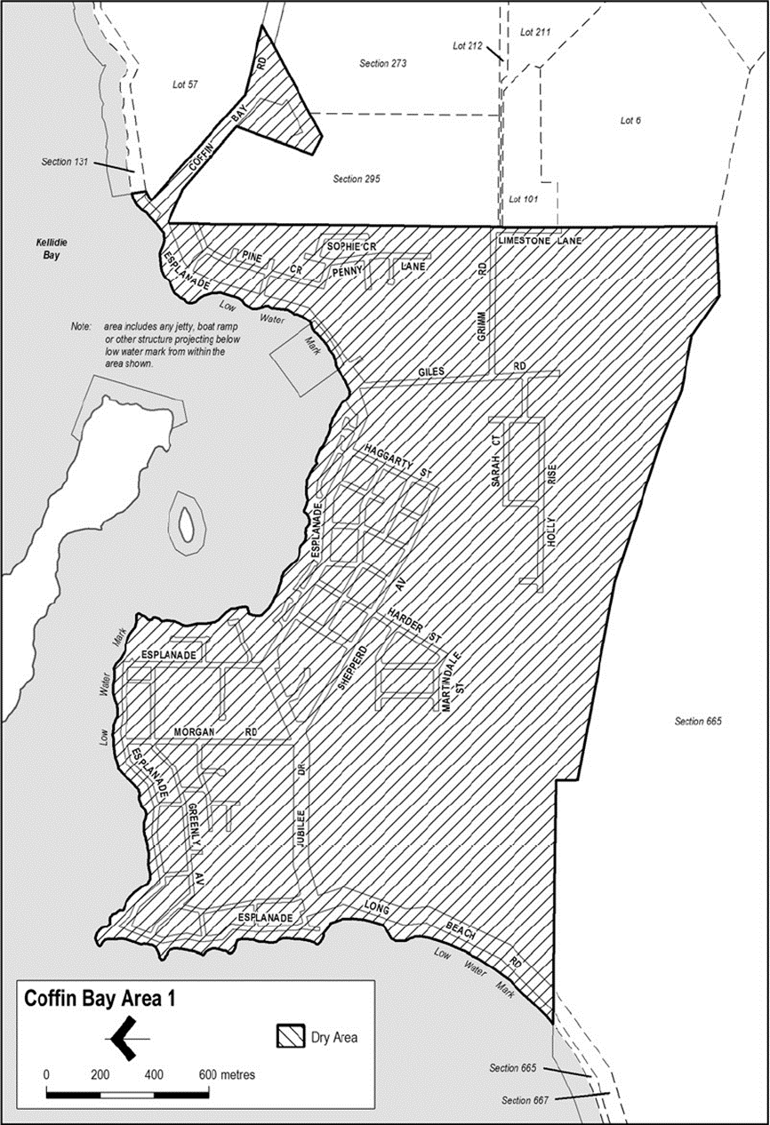
Made by the District Council of Lower Eyre Peninsula
Dated: 20 September 2023
Delfina Lanzilli
Chief Executive Officer

District Council of Lower Eyre Peninsula
South Australia
Liquor Licensing (Dry Areas) Notice 2023
Under Section 131(1a) of the Liquor Licensing Act 1997
1—Short title
This notice may be cited as the Liquor Licensing (Dry Areas) Notice 2023.
2—Commencement
This notice comes into operation on 31 December 2023.
3—Interpretation
(1) In this notice—
principal notice means the Liquor Licensing (Dry Areas) Notice 2015 published in the Gazette on 5.1.15, as in force from time to time.
(2) Clause 3 of the principal notice applies to this notice as if it were the principal notice.
4—Consumption etc of liquor prohibited in dry areas
(1) Pursuant to section 131 of the Act, the consumption and possession of liquor in the area described in the Schedule is prohibited in accordance with the provisions of the Schedule.
(2) The prohibition has effect during the periods specified in the Schedule.
(3) The prohibition does not extend to private land in the area described in the Schedule.
(4) Unless the contrary intention appears, the prohibition of the possession of liquor in the area does not extend to—
(a) a person who is genuinely passing through the area if—
(i) the liquor is in the original container in which it was purchased from licensed premises; and
(ii) the container has not been opened; or
(b) a person who has possession of the liquor in the course of carrying on a business or in the course of his or her employment by another person in the course of carrying on a business; or
(c) a person who is permanently or temporarily residing at premises within the area or on the boundary of the area and who enters the area solely for the purpose of passing through it to enter those premises or who enters the area from those premises for the purpose of leaving the area.
Schedule—Cummins Area 1
1—Extent of prohibition
The consumption of liquor is prohibited and the possession of liquor is prohibited.
2—Period of prohibition
From 9pm on 31 December 2023 to 8am on 1 January 2024.
3—Description of area
The public area in Cummins bounded as follows:
All in the Hundred of Cummins and within an area as defined as commencing at northwest corner of Allotment 99 in FP 180131 and extending northwards in line with the western boundary of this allotment to a point on the northern boundary of Warrow Road, then heading eastwards and following the boundary of Allotment 550 in DP 66791 until the north corner of Allotment 22 in DP 79231, then heading eastwards across Bratten Way to follow the southern boundary, then the eastern boundary of Allotment 71 in DP 94689 to a point in line with the northern boundary of Section 80, then heading eastwards across the Tod Highway to follow northern and then eastern boundary of Section 80, then heading roughly southeast to the nearest corner of Section 30, then heading eastwards along the northern boundary of Section 30 until reaching a point in line with the northeast corner of Allotment 601 in DP 87427, then heading southwest and following the boundary of Allotment 600 in DP 87427 until the southern corner of Allotment 24 in DP 50626, then heading to a point on the southern boundary of Tumby Bay Road in line with the southeast boundary of Allotment 24 in DP 50626, then heading northwest nd following the southern boundary of Bratten Way up to the northwest corner of Allotment 149 in FP 180181 and then following, in a southerly direction the western boundary of Allotments 10, 11 and 12 in DP 95966 and Allotment 52 in DP 53199 until the southwest corner of Allotment 802 in FP 209177, then heading westwards along and in line with the southern boundary of Allotment 802 in FP 209177 until the western boundary of the Tod Highway, then heading north and following the boundary of Allotment 111 in DP 67442 until, and then following the eastern boundary of Allotment 11 in DP 85166 until the commencement point being the northwest corner of Allotment 99 in FP 180131.
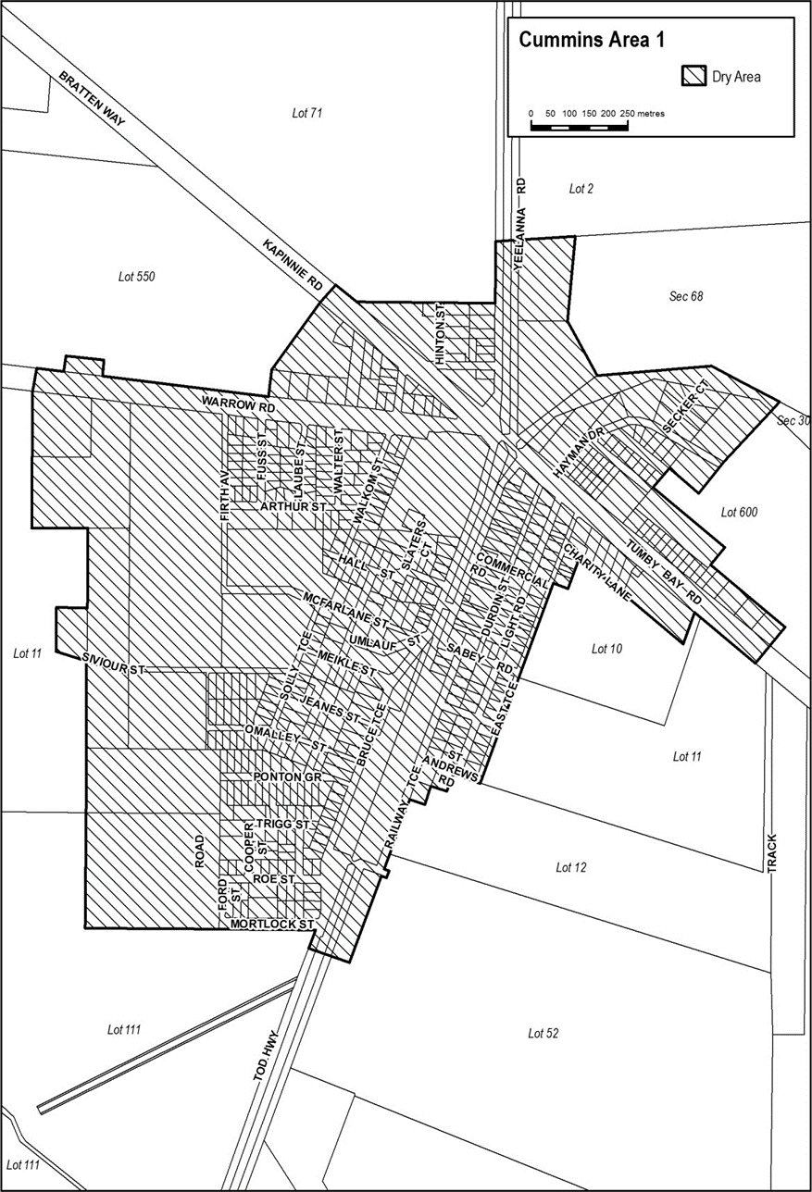
Made by the District Council of Lower Eyre Peninsula
Dated: 20 September 2023
Delfina Lanzilli
Chief Executive Officer

DISTRICT COUNCIL OF MOUNT REMARKABLE
Short Term Dry Area-Wilmington
Notice is hereby given that the District Council of Mount Remarkable pursuant to 131(1a) of the Liquor Licensing Act 1997 that Council declares Short Term Dry Areas commencing from 12 noon on Saturday 27 January 2024 to 12 noon on Sunday 28 January 2024.
- Pursuant to section 131 of the Act, the consumption and possession of liquor in the area described in the Schedule is prohibited in accordance with the provisions of the Schedule.
- The prohibition has effect during the periods specified in the Schedule.
- The prohibition does not extend to private land in the area described in the Schedule.
- Unless the contrary intention appears, the prohibition of the possession of liquor in the area does not extend to-
- A person who is genuinely passing through the areas if-
- The liquor is in the original container in which it was purchased from licensed premises; and
- The container has not been opened; or
- A person who has possession of the liquor in the course of carrying on a business or in the course of his or her employment by another person in the course of carrying on a business; or
- A person who is permanently or temporarily residing at premises within the area or on the boundary of the area and who enters the area solely for the purpose of passing through it to enter those premises or who enters the area from those premises for the purpose of leaving the area.
Description of area: The area in and adjacent to Wilmington bounded as follows: commencing at the intersection of the south-western boundary of Maria Terrace and the south-eastern boundary of Cudmore Terrace (at the south-eastern corner of Section 536 Hundred of Willochra), then travelling generally north-westerly along the western boundary of Maria Terrace until it intersects the southern boundary of Section 3 Hundred of Willochra, then north-easterly along that boundary until it intersects the south-western boundary of Oval Road, then generally north-westerly along that western boundary of Oval Road to the point at which the prolongation in a straight line of Oval Road intersects the northern boundary of Horrocks Pass Road, then easterly along that northern boundary of Horrocks Pass Road to the point at which the northern boundary of Horrocks Pass Road meets the south-western boundary of Gunyah Road, then north-westerly along the western boundary of Gunyah Road to the point at which it is intersected by the prolongation in a straight line of the north-western boundary of Beautiful Valley Road, then north-easterly along the northern boundary of Beautiful Valley Road to the south-western boundary of Section 716 Hundred of Willochra, then south-easterly along the prolongation in a straight line of that boundary of Section 716 to the south-eastern boundary of Horrocks Highway, then south-westerly along that boundary of Horrocks Highway to the point at which it intersects the north-eastern boundary of Alexis Road, then south-easterly along the eastern boundary of Alexis Road to the point at which it is intersected by the prolongation in a straight line of the south-eastern boundary of Gogler Road, then travelling south-westerly along the southern boundary and thence north-westerly along the western boundary of Gogler Road to a point where it intersects with the south-eastern boundary of Parkville Avenue, then in a south westerly direction along the southern boundary of Parkville Avenue to a point where the prolongation in a straight line of that boundary meets the intersection of the south-western boundary of Wilds Way and western boundary of Horrocks Highway, then north-westerly along the western boundary of Horrocks Highway until it intersects with the southern boundary of Cudmore Terrace, then south westerly along that boundary to the point of commencement.
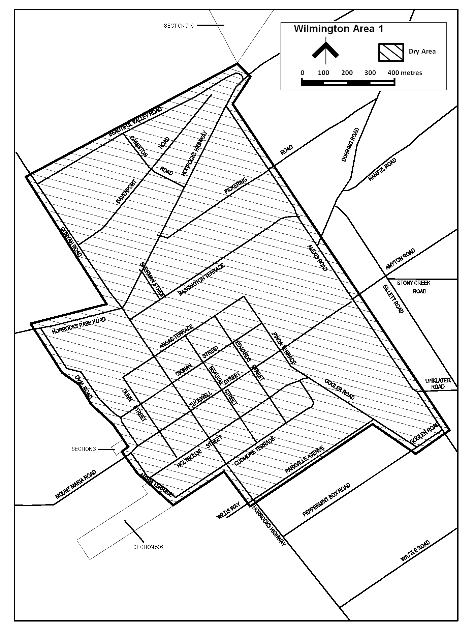
Sam Johnson
Chief Executive Officer

Public Notices

National Electricity Law
Notice of Draft Determinations
The Australian Energy Market Commission (AEMC) gives notice under the National Electricity Law as follows:
Under s 99, the making of a draft determination and related draft rule on the Accommodating financeability in the regulatory framework proposal (Ref. ERC0348). Written requests for a pre-determination hearing must be received by 21 December 2023. Submissions must be received by 8 February 2024.
Under s 99, the making of a draft determination and related draft rule on the Sharing concessional finance benefits with consumers proposal (Ref. ERC0349). Written requests for a pre-determination hearing must be received by 21 December 2023. Submissions must be received by 8 February 2024.
Submissions can be made via the AEMC’s website. Before making a submission, please review the AEMC’s privacy statement on its website, and consider the AEMC’s Tips for making a submission. The AEMC publishes all submissions on its website, subject to confidentiality.
Written requests should be sent to submissions@aemc.gov.au and cite the reference in the title. Before sending a request, please review the AEMC’s privacy statement on its website.
Australian Energy Market Commission
Level 15, 60 Castlereagh St
Sydney NSW 2000
Telephone: (02) 8296 7800
www.aemc.gov.au
Dated: 14 December 2023

Sale of Property
Warrant of Sale
Auction Date: Thursday, 21 December 2023 at 11.30am
Location: Unit 3, 16 Collins Street, Enfield, South Australia
Notice is hereby given that on the above date at the time and place stated, by virtue of the Warrant of Sale issued out of the Magistrates Court of South Australia, Action No. 1039 of 2022 directed to the Sheriff of South Australia in an action wherein Strata Plan 2513 Inc are the Applicants and Wayne Graham Hewitt and Burlene Joanelle Simon are the Respondents, I Steve Duncan, A/Sheriff of the State of South Australia, will by my auctioneers, Griffin Real Estate, make sale of the estate, right, title or interest whatsoever it may be of the Respondent, Wayne Graham Hewitt and Burlene Joanelle Simon the registered proprietors of an estate in fee simple in the following:
That piece of land situated in the area named Enfield, being Unit 3, 16 Collins Street, Enfield, Hundred of Yatala, being the property comprised in Certificate of Title Register Book Volume 5050 Folio 444.
Further particulars from the auctioneers:
Mark Griffin
Griffin Real Estate
22 Greenhill Road
WAYVILLE SA 5034
Telephone 0413 214 858
Dated: 14 December 2023
Steve Duncan
A/Sheriff of the State of South Australia

Trustee Act 1936
Public Trustee
Estates of Deceased Persons
In the matter of the estates of the undermentioned deceased persons:
BIENIARZ Cecylia late of 22 Kylie Crescent Ingle Farm Retired waitress who died 4 April 2023
FULLER Veronica Beverly late of 19-31 Shackleton Avenue Ingle Farm Retired cleaner who died 13 June 2023
HASKARD James Roe late of 52 Dunrobin Road Hove Retired Chief Property Officer who died 25 September 2023
MCKENZIE Douglas late of 44 Dawkins Place Adelaide of no occupation who died 24 July 2023
MCKEOWN Margaret late of 175 Main South Road Yankalilla Retired Cleaner who died 10 August 2023
OWENS Cynthia Juliet late of 16 Modler Road Morphett Vale Retired Family Practice Physician who died 15 May 2022
POLGLASE Patricia Joan late of 2 Jean Street Oaklands Park Retired Carer who died 13 September 2023
SPOONER Madelyne Jean late of 18-24 Trafford Street Angle Park Retired Taxation Department Consultant who died 1 August 2023
TILBROOK Margaret Dawn late of 40 Skyline Drive Flagstaff Hill Retired Sewing Machinist who died 7 May 2023
Notice is hereby given pursuant to the Trustee Act 1936, the Inheritance (Family Provision) Act 1972 and the Family Relationships Act 1975 that all creditors, beneficiaries, and other persons having claims against the said estates are required to send, in writing, to the office of Public Trustee at GPO Box 1338, Adelaide SA 5001, full particulars and proof of such claims, on or before 12 January 2024 otherwise they will be excluded from the distribution of the said estate; and notice is also hereby given that all persons indebted to the said estates are required to pay the amount of their debts to the Public Trustee or proceedings will be taken for the recovery thereof; and all persons having any property belonging to the said estates are forthwith to deliver same to the Public Trustee.
Dated: 14 December 2023
N. S. Rantanen
Public Trustee

Notice Submission

The South Australian Government Gazette is published each Thursday afternoon.
Notices must be emailed by 4 p.m. Tuesday, the week of publication.
Submissions are formatted per the gazette style and a proof will be supplied prior to publication, along with a quote if applicable. Please allow one day for processing notices.
Alterations to the proof must be returned by 4 p.m. Wednesday.

Gazette notices must be submitted as Word files, in the following format:
• Title—the governing legislation
• Subtitle—a summary of the notice content
• Body—structured text, which can include numbered lists, tables, and images
• Date—day, month, and year of authorisation
• Signature block—name, role, and department/organisation authorising the notice

Please provide the following information in your email:
• Date of intended publication
• Contact details of the person responsible for the notice content
• Name and organisation to be charged for the publication—Local Council and Public notices only
• Purchase order, if required—Local Council and Public notices only

Email: governmentgazettesa@sa.gov.au
Phone: (08) 7133 3552
Website: www.governmentgazette.sa.gov.au

All instruments appearing in this gazette are to be considered official, and obeyed as such

Printed and published weekly by authority of M. Dowling, Government Printer, South Australia
$8.55 per issue (plus postage), $430.00 per annual subscription—GST inclusive
Online publications: www.governmentgazette.sa.gov.au

