No. 91 p. 4177
THE SOUTH AUSTRALIAN
GOVERNMENT GAZETTE
Published by Authority

Adelaide, Thursday, 21 December 2023

Contents

State Government Instruments
Associations Incorporation Act 1985 4178
Controlled Substances Act 1984 4178
Correctional Services Act 1982 4178
Department for Infrastructure and Transport 4178
Environment Protection Act 1993 4179
Fisheries Management Act 2007 4181
Housing Improvement Act 2016 4182
Landscape South Australia Act 2019 4182
Major Events Act 2013 4184
Petroleum and Geothermal Energy Act 2000 4198
Planning, Development and Infrastructure Act 2016 4200
Primary Industry Funding Schemes Act 1998 4201
Return to Work Act 2014 4203
Safe Drinking Water Act 2011 4203
Local Government Instruments
City of Victor Harbor 4205
Alexandrina Council 4206
District Council of Franklin Harbour 4206
Mount Barker District Council 4207
Public Notices
National Electricity Law 4208

State Government Instruments

Associations Incorporation Act 1985
Section 43A
Deregistration of Associations
NOTICE is hereby given that the Corporate Affairs Commission approves the applications for deregistration received from the associations named below pursuant to section 43A of the Associations Incorporation Act 1985 (SA). Deregistration takes effect on the date of publication of this notice.
THE ABBEYFIELD SOCIETY (MARION) INCORPORATED [A19308]
BALAKLAVA SENIOR CITIZENS CLUB INCORPORATED [A4384]
KIWANIS CLUB OF TEA TREE GULLY INCORPORATED [A7184]
CORNERSTONE FOUNDATION (AUSTRALIA) INCORPORATED [A36314]
LIMESTONE COAST OPERA INCORPORATED [A42853]
NORTHFIELD CHRISTIAN SPIRITUALIST MISSION INCORPORATED [A4923]
ONKAPARINGA SENIOR CITIZENS CLUB INCORPORATED [A5087]
MCGUINNESS AND MCDERMOTT FOUNDATION SURVIVORSHIP SERVICES INCORPORATED [A40127]
LITTLE HEROES FOUNDATION CHILD FAMILY CARE INCORPORATED [A4135]
Given under the seal of the Commission at Adelaide this 15th day of December 2023.
Lisa Berry
Team Leader, Lotteries & Associations
A delegate of the Corporate Affairs Commission

Controlled Substances Act 1984
Approval and Publication of the Vaccine Administration Code
I, ROBYN LAWRENCE, Chief Executive of the Department for Health and Wellbeing, approved for publication the Vaccine Administration Code (December 2023), on the SA Health website.
The Code is available at: www.sahealth.sa.gov.au/immunisationprovider.
Dated: 14 December 2023
Dr Robyn Lawrence
Chief Executive
Department for Health and Wellbeing

Correctional Services Act 1982
Section 81E
Notice of an Award of Damages to a Prisoner
In accordance with section 81E of the Correctional Services Act 1982, notice is given that an award of damages has been made to Alan Kingsley KENT in a claim against the State. Award monies have been paid into the Prisoner Compensation Quarantine Fund, where it will be held until legal proceedings are finally determined, initially 12 months.
Victims in relation to the criminal acts of Alan Kingsley KENT are invited to seek further information from the Chief Executive, Department for Correctional Services, South Australia. To do so, please contact the Chief Executive by writing to GPO Box 1747, Adelaide SA 5001.
Dated: 21 December 2023
Christian Thompson
Manager, Strategic Communications
Department for Correctional Services

Department for Infrastructure and Transport
Service SA
Appointment of Government Printer
I designate Ms Tasca Anne Foresto, employed by the Government of South Australia, to be the Government Printer, effective 23 December 2023. This role is in addition to the duties of Acting Director, Service SA and no further remuneration is payable and no other benefit will be available to Ms Foresto in respect of the appointment or performance of the functions of Government Printer.
The appointment will continue until Ms Foresto ceases to be employed by the State Government, unless revoked earlier.
I revoke Ms Dowling as the Government Printer, effective 23 December 2023.
Dated: 13 December 2023
Jon Whelan
Chief Executive, Department for Infrastructure and Transport

Environment Protection Act 1993
Intent to draft Industrial Chemicals Environment Protection Policy
Pursuant to Section 28(3)(b) of the Environment Protection Act 1993, the Environment Protection Authority intends to prepare a draft industrial chemicals environment protection policy.
The purpose of the policy will be to implement the Commonwealth Industrial Chemicals Environmental Management Standard (IChEMS) in South Australia including, but not limited to, giving effect to the IChEMS Register, established by the Industrial Chemicals Environmental Management (Register) Act 2021 (Cwth).
Further notices providing information regarding the draft policy and the details of public consultation sessions will be published at a later date.
Dated: 15 December 2023
Jon Gorvett
Chief Executive
Environment Protection Authority

Environment Protection Act 1993
Prohibition on Taking Water affected by Site Contamination
I, REBECCA ANNE HUGHES, Manager Site Contamination and Delegate of the Environment Protection Authority (‘the Authority’), being satisfied that site contamination exists that affects or threatens groundwater and that action is necessary pursuant to section 103S of the Environment Protection Act 1993 to prevent actual or potential harm to human health or safety hereby prohibit the taking of groundwater from the 1st, 2nd and 3rd Quaternary aquifers (as defined below) within the area specified in the map to this notice, other than for environmental assessment or environmental monitoring purposes or as approved in writing by the Authority.
This Notice relates to groundwater in:
- The watertable (Q1) aquifer, the underlying Q2 and Q3 aquifers, and any deeper water bearing zones within the Quaternary sediments, being the body of groundwater 0 to approximately 49 metres below ground surface within the specified area (see map)
The site contamination affecting the groundwater is in the form of chlorinated hydrocarbons which represent actual or potential harm to human health or safety. This prohibition becomes official upon the gazettal of this notice.
Dated: 21 December 2023
R. Hughes
Manager Site Contamination
Environment Protection Authority

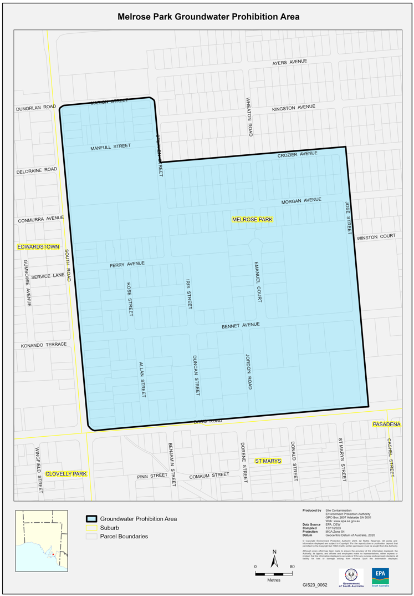

FISHERIES MANAGEMENT ACT 2007
Section 115
Ministerial Exemption ME9903279
TAKE notice that pursuant to section 115 of the Fisheries Management Act 2007 (the Act), the holders of the Northern Zone Rock Lobster Fishery licences listed in Schedule 1 (the ‘exemption holder’) or their registered masters are exempt from section 70 of the Act and regulation 5(a), clause 18 of Schedule 6 of the Fisheries Management (General) Regulations 2017, but only insofar as the exemption holders are permitted to operate the rock lobster pots of a design described in Schedule 2 (the “exempted activity’), within the area described in Schedule 3, subject to conditions specified in Schedule 4, from 3 November 2023 until 2 November 2024, unless varied or revoked earlier.
Schedule 1
Licence holders or registered masters of the following Northern Zone Rock Lobster Fishery licences:
Licence Holder | Licence number | Vessel
WJ Fountain Pty Ltd | N002 | Diamantina III
Southern Sea Eagles Pty Ltd | N007 | Celtic Chief
Barwick, Jennifer | N014 | Wave Action
Rebecca Cray Pty Ltd. | N036 | Rebecca
Klinkem Pty Ltd. | N101 | Shooting Star
Southern Sea Eagles Pty Ltd. | N079 | Kelynsu
Southern Sea Eagles Pty Ltd. | N084 | Diamantina III
Famazos Fishing Operations Pty Ltd. | N056 | Intrepid
Schedule 2
Waters of the Northern Zone Rock Lobster Fishery, excluding the waters of any aquatic reserve or of any Sanctuary Zone or Restricted Access Zone of any Marine Park (unless otherwise authorised under the Marine Parks Act 2007).
Schedule 3
‘Western Australian Batten rock lobster pots’ that have the following attributes:
- A rectangular cuboid shape with a maximum dimension <122 cm; and
- A single cove mouth at the top; and
- A securely fitted Sea Lion Exclusion Device being either:
- A metal rod that is securely fastened to the centroid of the base of the pot and extends perpendicular to a height not less than level with the base of the neck of the pot; or
- A rigid metal frame rectangular or square in shape with two opposite sides opening to not more than 135 mm securely attached to the pot neck; or
- A rigid metal frame circular in shape opening to not more than 150 mm in diameter securely attached to the pot neck; and
- Two escape gaps (escape gap dimensions – 280 mm L x 57 mm H) and
- A total weight of >40 kg.
Schedule 4
- The exemption holders will be deemed responsible for the conduct of all persons conducting the ‘exempted activity’ under their licence. Any person conducting the ‘exempted activity’ under this exemption must be provided with a copy of this notice.
- The exempted activity may only occur on the specified vessels that are registered on the specified licences listed in Schedule 1 of this notice.
- The number of batten rock lobster pots used as part of the ‘exempted activity’ on vessels listed in column 3 of Table 1 must not exceed the number of rock lobster pots listed as registered devices on the corresponding rock lobster licences listed in column 2.
- Whilst engaged in the exempted activity, the exemption holders must have in their possession a copy of this notice and produce that notice to a PIRSA Fisheries Officer upon request.
- The exemption holders must not contravene or fail to comply with the Fisheries Management Act 2007, or any other regulations made under that Act, except where specifically exempted by this notice.
This notice does not purport to override the provisions or operation of any other Act including, but not limited to, the Marine Parks Act 2007. The exemption holders and their agents must comply with any relevant regulations, permits, requirements and directions from the Department for Environment and Water when undertaking activities within a marine park.
Dated: 2 November 2023
Prof. Gavin Begg
Executive Director
Fisheries and Aquaculture
Delegate of the Minister for Primary Industries and Regional Development

FISHERIES MANAGEMENT ACT 2007
Section 115
Ministerial Exemption ME9903280
TAKE notice that pursuant to section 115 of the Fisheries Management Act 2007 (the Act), the holder of a Northern Zone Rock Lobster Fishery licence (the ‘exemption holder’) or their registered master is exempt from Section 70 of the Fisheries Management Act 2007, and Regulation 5 and clause 18(1)(a) of Schedule 6 of the Fisheries Management (General) Regulations 2017, but only insofar as the exemption holders are permitted to operate rock lobster pots set in waters less than 100 metres depth specified in Schedule 1, without a pot spike, being a metal rod fastened to the base of the pot, subject to conditions specified in Schedule 2, from 3 November 2023 until 2 November 2024, unless varied or revoked earlier.
Schedule 1
Waters of the Northern Zone Rock Lobster Fishery, excluding aquatic reserves and Sanctuary Zones or Restricted Area Zones of any Marine Park (unless otherwise authorised under the Marine Parks Act 2007).
Schedule 2
- The rock lobster pots used pursuant to this exemption must have a cove mouth opening (inner or outer) that consists of either:
  - A rigid frame rectangular or square in shape with two opposite sides opening to not more than 135 mm securely attached to the pot neck; or
  - A rigid frame circular in shape opening to not more than 150 mm in diameter securely attached to the pot neck.
- Prior to using any rock lobster pot fitted as described in condition 1, the exemption holder must provide to the Department of Primary Industries and Regions (PIRSA), in writing at GPO Box 1625, Adelaide 5001, the following information:
  - A description of the frame attached to the cove mouth of all pots to be used; and
  - How the frame is attached to the cove mouth of all pots to be used; and
  - The total number of pots fitted with the rectangular or circular frame on the cove mouth that are to be used by that licence holder.
- The exemption holder must complete a South Australian Managed Fisheries Wildlife Interaction Form following any interaction between the exempted rock lobster pots and threatened, endangered or protected species (TEPS).
- Completed South Australian Managed Fisheries Wildlife Interaction Forms must be submitted to SARDI within 28 days of any interaction.
- Whilst engaged in the exempted activity, the exemption holder must have in their possession a copy of this notice and produce that notice to a PIRSA Fisheries Officer upon request.
- The exemption holder must not contravene or fail to comply with the Fisheries Management Act 2007, or any other regulations made under that Act, except where specifically exempted by this notice).
This notice does not purport to override the provisions or operation of any other Act including, but not limited to, the Marine Parks Act 2007. The exemption holder must comply with any relevant regulations, permits, requirements and directions from the Department for Environment and Water when undertaking activities within a marine park.
Dated: 2 November 2023
Prof. Gavin Begg
Executive Director
Fisheries and Aquaculture
Delegate of the Minister for Primary Industries and Regional Development

Housing Improvement Act 2016
Rent Control Revocations
Whereas the Minister for Human Services Delegate is satisfied that each of the houses described hereunder has ceased to be unsafe or unsuitable for human habitation for the purposes of the Housing Improvement Act 2016, notice is hereby given that, in exercise of the powers conferred by the said Act, the Minister for Human Services Delegate does hereby revoke the said Rent Control in respect of each property.
Address of Premises | Allotment Section | Certificate of Title Volume/Folio
59 Milner Street, Prospect SA 5082 | Allotment 37 Deposited Plan 696 Hundred of Yatala | CT5758/214
462 South Road, Marleston SA 5033 | Allotment 337 Filed Plan 19503 Hundred of Adelaide | CT5854/264
128 Hill Street West, Peterborough  SA 5422 | Allotment 434 Deposited Plan 3873 Hundred of Yongala | CT5204/695
46 Tisbury Street, Elizabeth North  SA 5113 | Allotment 298 Deposited Plan 43946 Hundred of Munno Para | CT6158/713
48 Hookings Terrace, Woodville Gardens  SA 5012 | Allotment 386 Deposited Plan 3369 Hundred Yatala | CT5573/246
Dated: 21 December 2023
Craig Thompson
Housing Regulator and Registrar
Housing Safety Authority, SAHA
Delegate of Minister for Human Services

LANDSCAPE SOUTH AUSTRALIA ACT 2019
Declaration of Penalty in Relation to the Unauthorised or Unlawful Taking of Water
PURSUANT to Section 88 of the Landscape South Australia Act 2019 (the Act), I, Dan Jordan, delegate of the Minister for Climate, Environment and Water to whom the Act is committed, hereby declare that the following penalties are payable in relation to the unauthorised or unlawful taking of water during the consumption period that corresponds to the accounting period 1 July 2023 to 30 June 2024 inclusive:
- Where a person who is the holder of a water allocation (other than a water allocation pursuant to an authorisation under Section 105 of the Act) takes water from a prescribed water resource listed in column one of the table in Schedule 1 to this notice, which is in excess of the amount available under the allocation, the penalty declared pursuant to Section 88(1)(a) is the corresponding rate in column two of the table in Schedule 1 per kilolitre of water taken in excess of the amount available under the allocation, as determined or assessed to have been taken in accordance with Section 79 of the Act.
- Where a person who is the holder of a water allocation pursuant to an authorisation under Section 105 of the Act takes water from a prescribed water resource listed in column one of the table in Schedule 2 to this notice, which is in excess of the amount available under the allocation, the penalty declared pursuant to Section 88(1)(a) is the corresponding rate in column two of the table in Schedule 2 per kilolitre of water taken in excess of the amount available under the allocation, as determined or assessed to have been taken in accordance with Section 79 of the Act.
- Where a person takes water from a prescribed water resource in column one of the table in Schedule 1 to this notice and is not authorised under section 105 or as part of a water allocation to take that water, and so acts in contravention of the Act, the penalty declared under Section 88(1)(e) is the corresponding rate in column three of the table in Schedule 1 per kilolitre of water taken, as determined or assessed to have been taken in accordance with Section 79 of the Act.
- Where a person takes water from a prescribed water resource described in column one of the table in Schedule 1 to this notice in contravention of a notice under Section 109 of the Act, the penalty declared under Section 88(1)(f) is the corresponding rate in column three of the table in Schedule 1 per kilolitre of water taken in excess of the amount authorised for take, as determined or assessed to have been taken in accordance with Section 79 of the Act.
- Where a person may be subject to more than one penalty under Section 88 in respect of the same conduct, the penalty that is the greater shall be imposed.
In this notice:
‘the Northern Adelaide Plains Prescribed Wells Area’ means the area declared to be the Northern Adelaide Plains Proclaimed Region by proclamation under Section 41 of the Water Resources Act 1976 (see Government Gazette 13 May 1976 page 2459), and as further declared by regulation under Section 125 of the Natural Resources Management Act 2004 (see Government Gazette 22 July 2004, p. 2600);
‘the Central Adelaide Prescribed Wells Area’ means the area which includes the wells declared by regulation under section 125 of the Natural Resources Management Act 2004 (Natural Resources Management (Central Adelaide – Prescribed Wells Area) Regulations 2007) (see Government Gazette 7 June 2007, pp.2573-2574);
‘the Dry Creek Prescribed Wells Area’ means the area declared to be the Dry Creek Proclaimed Wells Area by proclamation under Section 33(2) of the Water Resources Act 1990 (see Government Gazette 11 July 1996 p. 76, and as further varied by Government Gazette 28 November 1996, p. 1747)’;
‘the Angas-Bremer Prescribed Wells Area’ means the area declared to be the Angas-Bremer Proclaimed Region by proclamation under Section 41 of the Water Resources Act 1976 (see Government Gazette 23 October 1980 p. 1192);
‘the Peake, Roby and Sherlock Prescribed Wells Area’ means the area declared by regulation under Section 125 of the Natural Resources Management Act 2004 (Natural Resources Management (Peake, Roby and Sherlock Prescribed Wells Area) Regulations 2005) (see Government Gazette 27 October 2005 p. 3836);
‘the Marne Saunders Prescribed Water Resources Area’ means the area declared by regulation under Section 125 of the Natural Resources Management Act 2004 (see Government Gazette 20 March 2003, p. 1111);
‘the Clare Valley Prescribed Water Resources Area’ means the area declared by regulation to be the Clare Valley Prescribed Wells Area and Watercourses under section 8 of the Water Resources Act 1997 (see Government Gazette 25 July 1996 p.171) and the area declared by regulation to be the Clare Valley Prescribed Surface Water Area under Section 8 of the Water Resources Act 1997 (see Government Gazette 28 October 1999 p.2127);
‘the Mallee Prescribed Wells Area’ means the area declared to be the Mallee Prescribed Wells Area by proclamation under Section 41 of the Water Resources Act 1976 (See Government Gazette 28 July 1983, page 205 and varied on 9 January 1986, page 19) and as further declared by regulation under Section 125 of the Natural Resources Management Act 2004 (see Government Gazette 27 October 2005, p. 3833);
‘the Southern Basins Prescribed Wells Area’ means the area declared to be the Southern Basins Proclaimed Region by proclamation under Section 41 of the Water Resources Act 1976 (see Government Gazette 12 March 1987 p. 596);
‘the Musgrave Prescribed Wells Area’ means the area declared to be the Musgrave Proclaimed Region by proclamation under Section 41 of the Water Resources Act 1976 (see Government Gazette 12 March 1987 p. 596);
‘the Far North Prescribed Wells Area’ means the area declared to be the Far North Prescribed Wells Area by regulation under Section 8 of the Water Resources Act 1997 (see Government Gazette 27 March 2003 p. 1250);
‘the Barossa Prescribed Water Resources Area’ means the area declared by regulation under Section 8 of the Water Resources Act 1997 (see Government Gazette 19 May 2005, p. 1295);
‘the McLaren Vale Prescribed Wells Area’ means the area gazetted on 7 January 1999 page 13, under the provisions of the Water Resources Act 1997;
‘the Western Mount Lofty Ranges Prescribed Water Resources Area’ means that area which includes:
the watercourses declared by regulation under section 125 of the Natural Resources Management Act 2004 (Natural Resources Management (Western Mount Lofty Ranges -- Prescribed Watercourses) Regulations 2005) (see Government Gazette 20 October 2005, pp. 3791-3792); and
the wells declared by regulation under section 125 of the Natural Resources Management Act 2004 (Natural Resources Management (Western Mont Lofty Ranges – Prescribed Wells Area) Regulations 2005) (see Government Gazette 20 October 2005, pp.3793-3794); and
the surface water area declared by regulation under section 125 of the Natural Resources Management Act 2004 (Natural Resources Management (Western Mount Lofty Ranges - Surface Water Prescribed Area) Regulation 2005) (see Government Gazette 20 October 2005, pp. 3795-3796);
‘the Eastern Mount Lofty Ranges Prescribed Resources Area’ means that area which includes:
the watercourses and surface water area declared by regulation under section 125 of the Natural Resources Management Act 2004 (Natural Resources Management (Eastern Mount Lofty Ranges - Prescribed Watercourses and Surface Water Prescribed Area) Regulations 2005) (see Government Gazette 8 September 2005, pp.3292-3293); and
the wells declared by regulation under section 125 of the Natural Resources Management Act 2004 (Natural Resources Management (Eastern Mount Lofty Ranges – Prescribed Wells Area) Regulations 2005) (see Government Gazette 8 September 2005, pp.3294-3295).
‘the Morambro Creek Prescribed Watercourse and Prescribed Surface Water Area’ means that area which includes:
the watercourse declared by regulation under section 8 of the Water Resources Act 1997 (Water Resources (Morambro Creek) Regulations 2001) (see Government Gazette 12 April 2001, p.1605); and
the surface water prescribed area declared by regulation under section 8 of the Water Resources Act 1997 (Water Resources (Surface Water Prescribed Area – Morambro Catchment) Regulations 2001).
‘the Lower Limestone Coast Prescribed Wells Area’ means the area declared by regulation under section 8 of Water Resource Act 1997 (see Government Gazette 02 December 2004, p. 4462-4464);
‘the Padthaway Prescribed Wells Area’ means the area declared by proclamation under section 25 of the Water Resources Act 1976 (see Government Gazette 13 May 1976, p. 2459);
‘the Tatiara Prescribed Wells Area’ means the area declared to be the Tatiara Prescribed Area by proclamation under Section 41 of the Water Resources Act 1976 (See Government Gazette 12 July 1984, p. 134) and further revoked and varied (see Government Gazette 30 January 1986, p. 206);
‘the Tintinara-Coonalpyn Prescribed Wells Area’ means the area prescribed under Section 8 of the Water Resource Act 1997 (Water Resources (Tintinara Coonalpyn Prescribed Wells Area) Regulations 2000) (see Government Gazette 02 November 2000, p.2933).
Schedule 1
Penalties for unauthorised or unlawful take from a prescribed water resource 2023 - 2024:
Column 1 | Column 2 | Column 3
Angas Bremer Prescribed Wells Area | $0.69/kL | $0.92/kL
Barossa Prescribed Water Resources Area | $2.25/kL | $3.00/kL
Clare Valley Prescribed Water Resources Area | $0.69/kL | $0.92/kL
Dry Creek Prescribed Wells Area | $0.69/kL | $0.92/kL
Eastern Mt Lofty Ranges Prescribed Water Resources Area | $1.20/kL | $1.60/kL
Far North Prescribed Wells Area | $0.69/kL | $0.92/kL
Lower Limestone Coast Prescribed Wells Area | $1.20/kL | $1.60/kL
Mallee Prescribed Wells Area | $1.46/kL | $1.94/kL
Marne Saunders Prescribed Water Resources Area | $0.69/kL | $0.92/kL
McLaren Vale Prescribed Wells Area | $3.90/kL | $5.20/kL
Morambro Creek Prescribed Watercourse and Prescribed Surface Water Area | $0.69/kL | $0.92/kL
Musgrave Prescribed Wells Area | $0.69/kL | $0.92/kL
Northern Adelaide Plains Prescribed Wells Area | $4.85/kL | $6.46/kL
Padthaway Prescribed Wells Area | $0.69/kL | $0.92/kL
Peake, Roby and Sherlock Prescribed Wells Area | $0.69/kL | $0.92/kL
Southern Basins Prescribed Wells Area | $0.69/kL | $0.92/kL
Tatiara Prescribed Wells Area | $0.90/kL | $1.20/kL
Tintinara Coonalpyn Prescribed Wells Area | $0.69/kL | $0.92/kL
Western Mt Lofty Ranges Prescribed Water Resources Area | $1.50/kL | $2.00/kL
Unit of measure kL is the abbreviation of kilolitre
Schedule 2
Penalties for unauthorised take from a prescribed water resource, taken in association with an authorisation pursuant to section 105 of the Act
Column 1 | Column 2
Central Adelaide Prescribed Wells Area | $0.69/kL
Western Mount Lofty Ranges Prescribed Water Resources Area | $1.50/kL
Unit of measure kL is the abbreviation of kilolitre
Dated: 19 December 2023
Dan Jordan
A/Executive Director, Water and River Murray
Department for Environment and Water
Delegate of the Minister for Climate, Environment and Water

Major Events Act 2013
Section 6B
Declaration of a Major Event
PURSUANT to section 6B of the Major Events Act 2013, I, Hon. Zoe Bettison MP, Minister for Tourism declare the 2024 Santos Tour Down Under to be held from 12-21 January 2024 to be declared a major event.
By virtue of the provisions of the Major Events Act 2013, I do hereby:
- Specify the period for the event, being 12 January 2024 to 21 January 2024.
- Declare the 2024 Santos Tour Down Under and its associated events officially organised by the event organiser to be a major event:
o The Santos Tour Down Under comprises:
o Down Under Classic Men’s
o Down Under Criterium Women’s
o Three days of women’s competition racing, namely:
o Ziptrak Women’s Stage One
o Women’s Stage Two
o Women’s Stage Three
o Six days of men’s competition racing, namely:
o Ziptrak Men’s Stage 1
o efex Men’s Stage 2
o Men’s Stage 3
o Hahn Men’s Stage 4
o Think! Road Safety Men’s Stage 5
o Schwalbe Men’s Stage 6
o The associated events officially organised by the event organiser, namely:
o City of Adelaide Tour Village
o Criterium Racing at Pakapakanthi
o Family Day Ride
o Team Presentation
o Detours
o Breakaway Zone
o Oakley Carpark Climb
- Declare the major event venues to be the women’s race routes, men’s race routes, Down Under Classic race route, Tour Village, Victoria Park, Carpark Climb and any public place or part of a public place that is within 250 metres from the boundary of the race route or Tour Village.
- Designate the South Australian Tourism Commission (ABN 80 485 623 691) to be the event organiser for the event;
- Declare that the following provisions of Part 3 of the Act apply to the event, the major event venue for the event and the controlled area for the event:
  - Section 8.
  - Section 10.
  - Section 11.
  - Section 12.
  - Section 13.
  - Section 14.
- Being satisfied that the title “Santos Tour Down Under” and the logo as it appears below are sufficiently connected with the identity and conduct of the major event, and that the event has commercial arrangements that are likely to be adversely affected by unauthorised use of the title and logo, I hereby declare, pursuant to section 14(1) of the Act, that “Santos Tour Down Under” is an official title and the logo as it appears below is an official logo in respect of the event.
Dated: 15 December 2023
Hon Zoe Bettison MP
Minister for Tourism

Maps of Controlled Areas for the Santos Tour Down Under
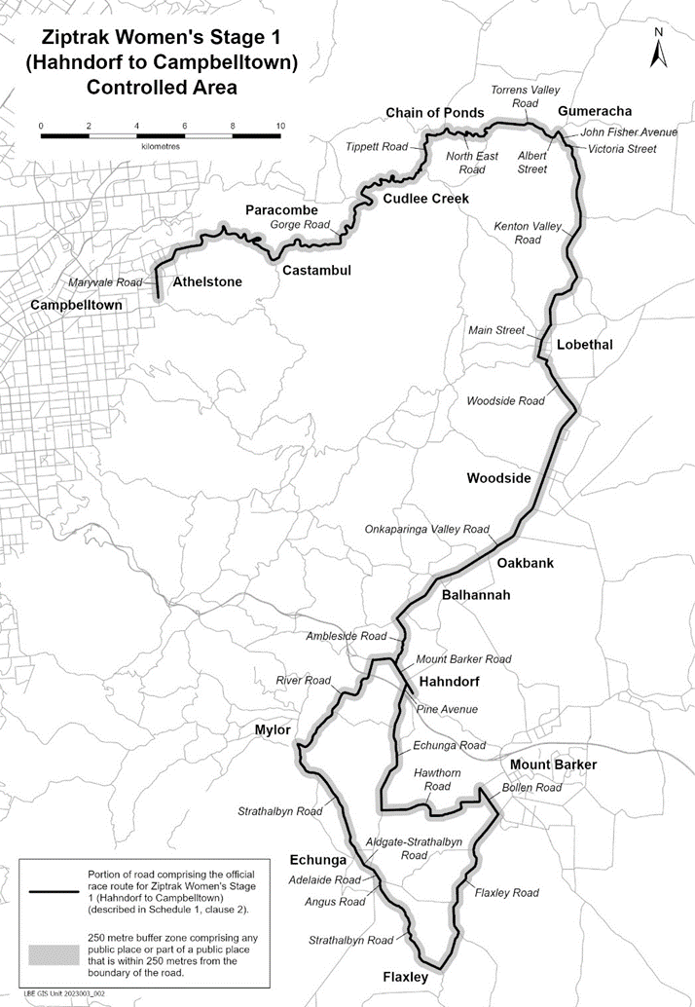
Description of official race route for Ziptrak Women’s Stage 1 (Hahndorf to Campbelltown)
The official race route for Ziptrak Women’s Stage 1 (Hahndorf to Campbelltown) comprises –
- the portion of road commencing at the intersection of Windsor Avenue and Mount Barker Road in Hahndorf, then north-westerly and westerly along Mount Barker Road to its intersection with River Road, then generally south-westerly, generally westerly and generally south-westerly and north-westerly along River Road to its intersection with Strathalbyn Road, then generally southerly and generally south-easterly along Strathalbyn Road until it becomes Aldgate-Strathalbyn Road in Echunga, then generally south-easterly along Aldgate-Strathalbyn Road to its intersection with Adelaide Road, then south-easterly along Adelaide Road to its intersection with Angas Road, then generally southerly along Angus Road until it becomes Strathalbyn Road in Echunga, then generally south-easterly along Strathalbyn Road to its intersection with Flaxley Road, then generally north-easterly, generally northerly and generally north-easterly, north-westerly and generally north-easterly along Flaxley Road to its intersection with Bollen Road, then north-westerly along Bollen Road to its intersection with Hawthorn Road, then generally southerly, generally westerly, generally northerly and generally westerly along Hawthorn Road to its intersection with Echunga Road, then northerly, generally north-easterly and generally northerly along Echunga Road until it becomes Pine Avenue in Hahndorf, then north-easterly along Pine Avenue to its intersection with Mount Barker Road in Hahndorf; and
- the portion of road commencing at the intersection of Mount Barker Road and Ambleside Road in Hahndorf, then generally north-easterly, generally northerly and north-westerly along Ambleside Road to its intersection with Onkaparinga Valley Road, then generally north-easterly along Onkaparinga Valley Road to its intersection with Woodside Road, then generally north-westerly, north-easterly and north-westerly along Woodside Road to its intersection with Main Street in Lobethal, then generally north-easterly along Main Street to its intersection with Kenton Valley Road, then northerly, generally north-easterly, generally north-westerly, north-easterly and generally northerly along Kenton Valley Road until it becomes Victoria Street in Gumeracha, then generally north-westerly and generally westerly along Victoria Street to its intersection with John Fisher Avenue, then generally north-westerly along John Fisher Avenue to its intersection with Albert Street, then generally south-westerly and generally westerly along Albert Street until it becomes Torrens Valley Road in Gumeracha, then generally north-westerly, generally westerly and generally south-westerly, south-easterly along Torrens Valley Road to its intersection with North East Road, then generally westerly, generally south-westerly along North East Road to its intersection with Tippett Road, then generally westerly, generally southerly and generally south-westerly along Tippett Road to its intersection with Gorge Road, then generally south-westerly, south-easterly, generally south-westerly, generally westerly, generally south-westerly, generally north-westerly, generally westerly and generally south-westerly along Gorge Road to its intersection with Maryvale Road, then generally southerly along Maryvale Road to its intersection with Crestwood Drive in Athelstone (Campbelltown City Council).

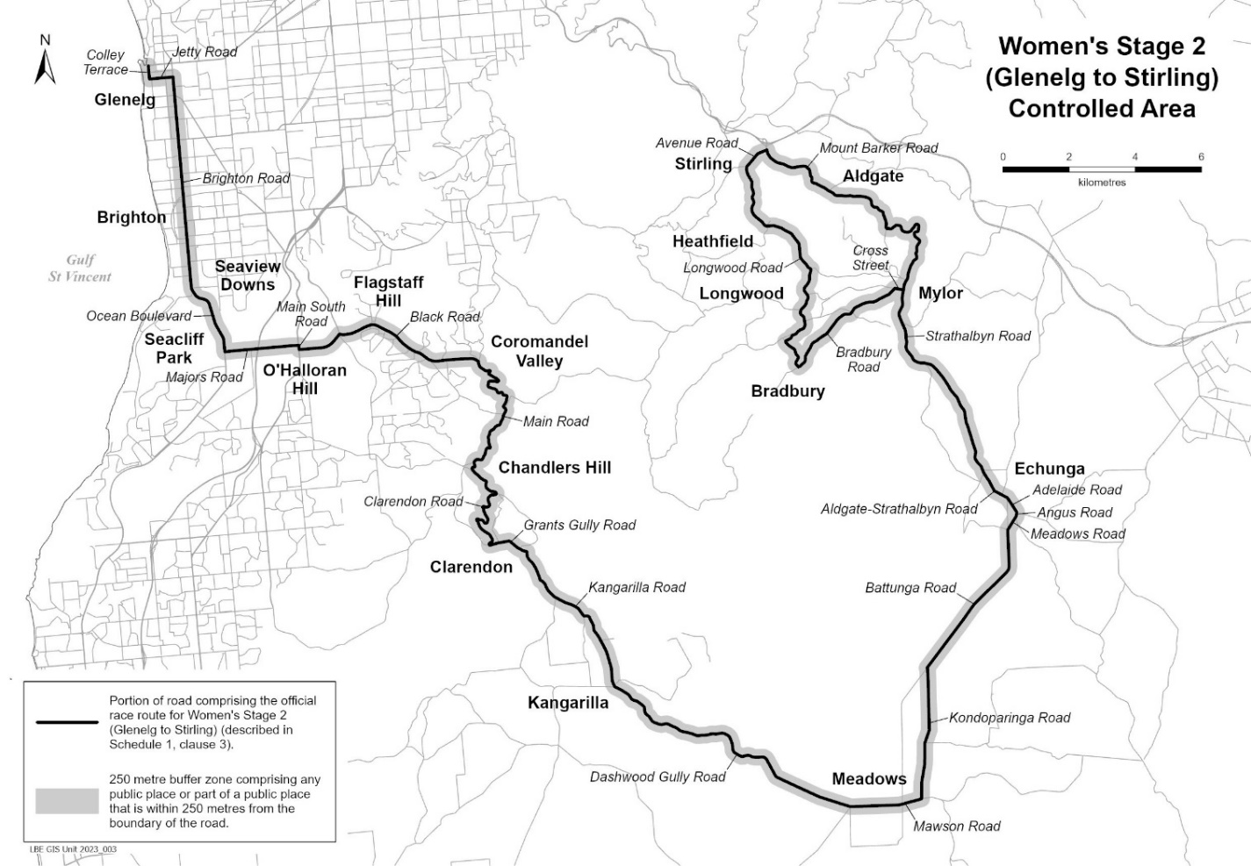
Description of official race route for Women’s Stage 2 (Glenelg to Stirling)
The official race route for Women’s Stage 2 (Glenelg to Stirling) comprises the portion of road commencing at the intersection of Anzac Highway and Colley Terrace in Glenelg, then southerly along Colley Terrace to its intersection with Jetty Road, then easterly along Jetty Road to its intersection with Brighton Road, then southerly along Brighton Road until it becomes Ocean Boulevard in Seacliff Park, then generally south-easterly and southerly along Ocean Boulevard to its intersection with Majors Road, then easterly along Majors Road to its intersection with Main South Road, then southerly along Main South Road to its intersection with Black Road, then easterly, generally north-easterly, generally south-easterly and generally easterly along Black Road to its intersection with Main Road in Coromandel Valley, then generally south-easterly, generally south-westerly and south-easterly along Main Road to its intersection with Clarendon Road, then generally south-easterly, generally south-westerly and generally south-easterly along Clarendon Road to its intersection with Grants Gully Road, then generally easterly, generally south-easterly and southerly along Grants Gully Road until it becomes Kangarilla Road in Clarendon, then generally south-easterly along Kangarilla Road to its intersection with Dashwood Gully Road, then generally south-easterly and generally easterly along Dashwood Gully Road until it becomes Mawson Road in Meadows, then generally easterly along Mawson Road to its intersection with Kondoparinga Road, then generally northerly along Kondoparinga Road to its intersection with Battunga Road, then generally north-easterly and northerly along Battunga Road to its intersection with Meadows Road, then north-easterly along Meadows Road to its intersection with Angus Road, then northerly along Angus Road to its intersection with Adelaide Road, then north-westerly along Adelaide Road to its intersection with Adelaide-Strathalbyn Road, then generally north-westerly along Aldgate-Strathalbyn Road until it becomes Strathalbyn Road in Echunga, then generally north-westerly, generally northerly and generally north-westerly along Strathalbyn Road to its intersection with Mount Barker Road, then generally north-westerly, generally northerly, generally westerly and generally north-westerly along Mount Barker Road to its intersection with Avenue Road, then generally south-westerly along Avenue Road to its intersection with Longwood Road, then generally southerly, generally south-easterly, generally south-westerly and generally south-easterly along Longwood Road to its intersection with Bradbury Road, then generally north-easterly along Bradbury Road to its intersection with Cross Street, then easterly along Cross Street to its intersection with Strathalbyn Road in Mylor

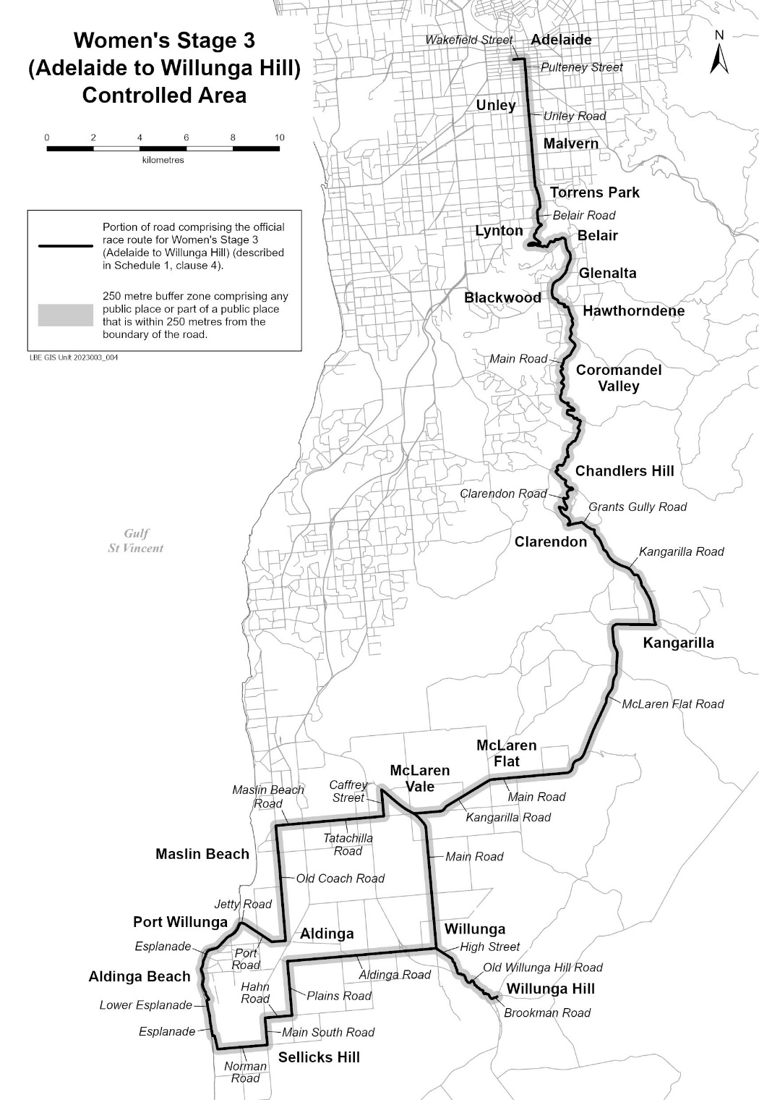
Description of official race route for Women’s Stage 3 (Adelaide to Willunga Hill)
The official race route for Women’s Stage 3 (Adelaide to Willunga Hill) comprises –
          - the portion of road commencing at the intersection of Victoria Square with Wakefield Street in Adelaide, then easterly along Wakefield Street to its intersection with Pulteney Street, then southerly along Pulteney Street to its intersection with Unley Road, then southerly along Unley Road to its intersection with Belair Road, then generally southerly, generally south-easterly, generally south-westerly, south-easterly, generally westerly, generally easterly and generally north-easterly along Belair Road to its intersection with Main Road in Belair, then generally southerly, generally south-easterly, generally south-westerly and south-easterly along Main Road to its intersection with Clarendon Road, then generally south-easterly, generally south-westerly and generally south-easterly along Clarendon Road to its intersection with Grants Gully Road, then generally easterly, generally south-easterly and southerly along Grants Gully Road until it becomes Kangarilla Road in Clarendon, then generally south-easterly along Kangarilla Road to its intersection with McLaren Flat Road, then westerly, generally southerly, generally south-westerly and westerly along McLaren Flat Road to its intersection with Main Road in McLaren Flat, then westerly along Main Road to its intersection with Kangarilla Road, then generally south-westerly and westerly along Kangarilla Road to its intersection with Main Road in McLaren Vale, then generally south-easterly and southerly along Main Road to its intersection with Aldinga Road, then westerly along Aldinga Road to its intersection with Plains Road, then southerly along Plains Road to its intersection with Hahn Road, then westerly along Hahn Road to its intersection with Main South Road, then southerly along Main South Road to its intersection with Norman Road, then westerly along Norman Road to its intersection with Esplanade in Aldinga Beach, then northerly, westerly and northerly along Esplanade to its intersection with Lower Esplanade, then generally northerly and easterly along Lower Esplanade to its intersection with Esplanade, then generally north-westerly and generally north-easterly along Esplanade to its intersection with Jetty Road, then generally easterly along Jetty Road to its intersection with Port Road, then generally south-easterly and easterly along Port Road to its intersection with Old Coach Road, then northerly along Old Coach Road to its intersection with Maslin Beach Road, then easterly along Maslin Beach Road to its intersection with Tatachilla Road, then easterly along Tatachilla Road to its intersection with Caffrey Street, then northerly along Caffrey Street to its intersection with Main Road in McLaren Vale, then generally south-easterly along Main Road to its intersection with Kangarilla Road in McLaren Vale; and
          - the portion of road commencing at the intersection of Main Road and High Street in Willunga, then south-easterly along High Street to its intersection with Old Willunga Hill Road, then generally south-easterly along Old Willunga Hill Road to its intersection with Brookman Road, then north-easterly along Brookman Road to its intersection with Range Road in Willunga Hill.

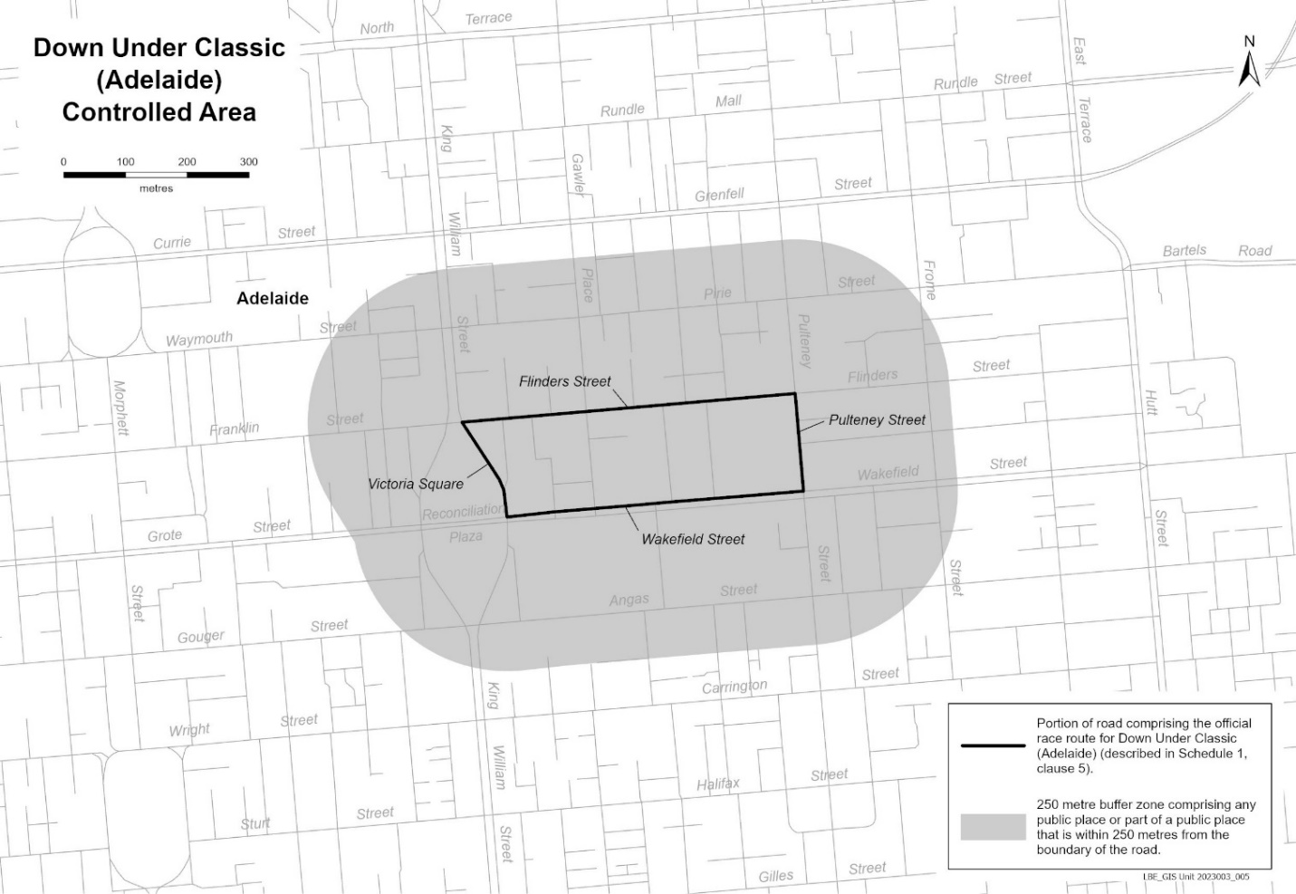
Description of official race route for Down Under Classic (Adelaide)
The official race route for the Down Under Classic (Adelaide) comprises the portion of road commencing in Adelaide at the intersection of Flinders Street and the portion of road (running generally north-west to south-east) known as Victoria Square, then generally south-easterly and southerly along the portion of road known as Victoria Square to its intersection with Wakefield Street, then easterly along Wakefield Street to its intersection with Pulteney Street, then northerly along Pulteney Street to its intersection with Flinders Street, then westerly along Flinders Street to the point of commencement.
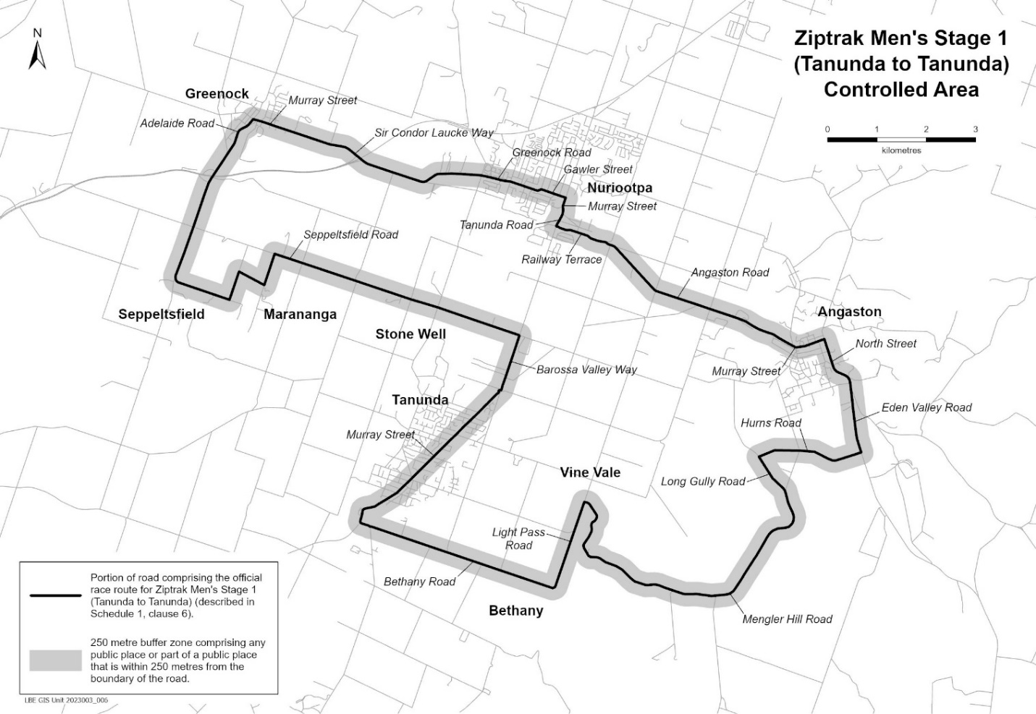
Description of official race route for Ziptrak Men’s Stage 1 (Tanunda to Tanunda)
The official race route for Men’s Stage 1 (Tanunda to Tanunda) comprises the portion of road commencing at the intersection of Elizabeth Street and Murray Street in Tanunda, then north-easterly along Murray Street to its intersection with Barossa Valley Way, then north-easterly along Barossa Valley Way to its intersection with Seppeltsfield Road, then north-westerly, south-westerly, north-westerly, south-westerly, north-westerly and generally north-easterly along Seppeltsfield Road until it becomes Adelaide Road in Greenock, then north-easterly along Adelaide Road to its intersection with Murray Street in Greenock, then south-easterly along Murray Street to its intersection with Sir Condor Laucke Way, then generally south-easterly, generally north-easterly and generally easterly along Sir Condor Laucke Way to its intersection with Greenock Road in Nuriootpa, then generally easterly and generally south-easterly along Greenock Road to its intersection with Gawler Street in Nuriootpa, then south-easterly along Gawler Street to its intersection with Murray Street in Nuriootpa, then generally south-westerly along Murray Street to its intersection with Tanunda Road, then generally south-westerly along Tanunda Road to its intersection with Railway Terrace, then generally south-easterly along Railway Terrace to its intersection with Angaston Road, then generally south-easterly along Angaston Road until it becomes Murray Street in Angaston, then generally south-easterly and generally north-easterly along Murray Street to its intersection with North Street, then generally south-easterly along North Street to its intersection with Eden Valley Road, then generally south-easterly along Eden Valley Road to its intersection with Hurns Road, then generally south-westerly, generally north-westerly and generally south-westerly along Hurns Road to its intersection with Long Gully Road, then generally south-easterly along Long Gully Road to its intersection with Mengler Hill Road, then generally south-easterly, generally south-westerly, generally north-westerly and generally northerly along Mengler Hill Road to its intersection with Light Pass Road, then south-westerly along Light Pass Road to its intersection with Bethany Road, then north-westerly along Bethany Road to its intersection with Murray Street in Tanunda, then north-westerly, northerly and generally north-easterly along Murray Street to the point of commencement.
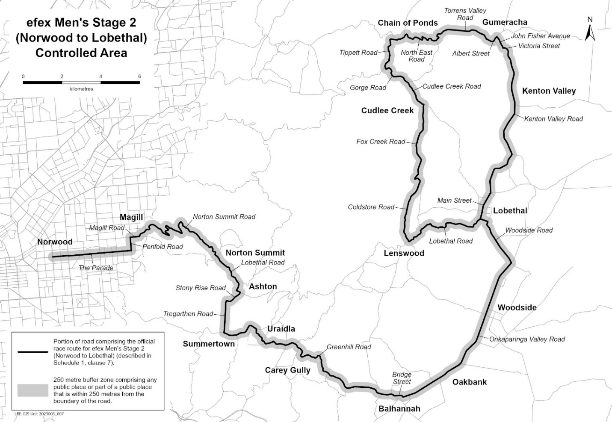
Description of official race route for efex Men’s Stage 2 (Norwood to Lobethal)
The official race route for Men’s Stage 2 (Norwood to Lobethal) comprises the portion of road commencing at the intersection of Osmond Terrace and The Parade in Norwood, then easterly along The Parade to its intersection with Penfold Road, then northerly along Penfold Road to its intersection with Magill Road, then easterly along Magill Road to its intersection with Norton Summit Road, then generally north-easterly, generally south easterly, generally northerly, generally south easterly, generally northerly and generally south-easterly along Norton Summit Road to its intersection with Lobethal Road, then generally south-easterly, generally south-westerly and generally south-easterly along Lobethal Road to its intersection with Stony Rise Road, then generally south-westerly and generally westerly along Stony Rise Road to its intersection with Tregarthen Road, then generally southerly along Tregarthen Road to its intersection with Greenhill Road, then generally easterly, generally north-easterly, generally south-easterly, generally southerly and generally easterly along Greenhill Road to its intersection with Bridge Street in Balhannah, then easterly and south-easterly along Bridge Street to its intersection with Onkaparinga Valley Road in Balhannah, then generally north-easterly along Onkaparinga Valley Road to its intersection with Woodside Road, then generally north-westerly along Woodside Road to its intersection with Main Street in Lobethal, then generally north-easterly along Main Street to its intersection with Kenton Valley Road, then northerly, generally north-easterly, generally north-westerly, north-easterly and generally northerly along Kenton Valley Road until it becomes Victoria Street in Gumeracha, then generally north-westerly and generally westerly along Victoria Street to its intersection with John Fisher Avenue, then generally north-westerly along John Fisher Avenue to its intersection with Albert Street, then generally south-westerly and generally westerly along Albert Street until it becomes Torrens Valley Road in Gumeracha, then generally north-westerly, generally westerly and generally south-westerly along Torrens Valley Road to its intersection with North East Road, then generally westerly along North East Road to its intersection with Tippett Road, then generally westerly and generally southerly along Tippett Road to its intersection with Gorge Road, then generally south-easterly along Gorge Road to its intersection with Cudlee Creek Road, then generally south-easterly along Cudlee Creek Road to its intersection with Fox Creek Road, then generally southerly along Fox Creek Road to its intersection with Coldstore Road, then generally south-westerly and generally south-easterly along Coldstore Road to its intersection with Lobethal Road in Lenswood, then generally north-easterly, generally easterly and generally north-easterly along Lobethal Road to its intersection with Main Street in Lobethal.
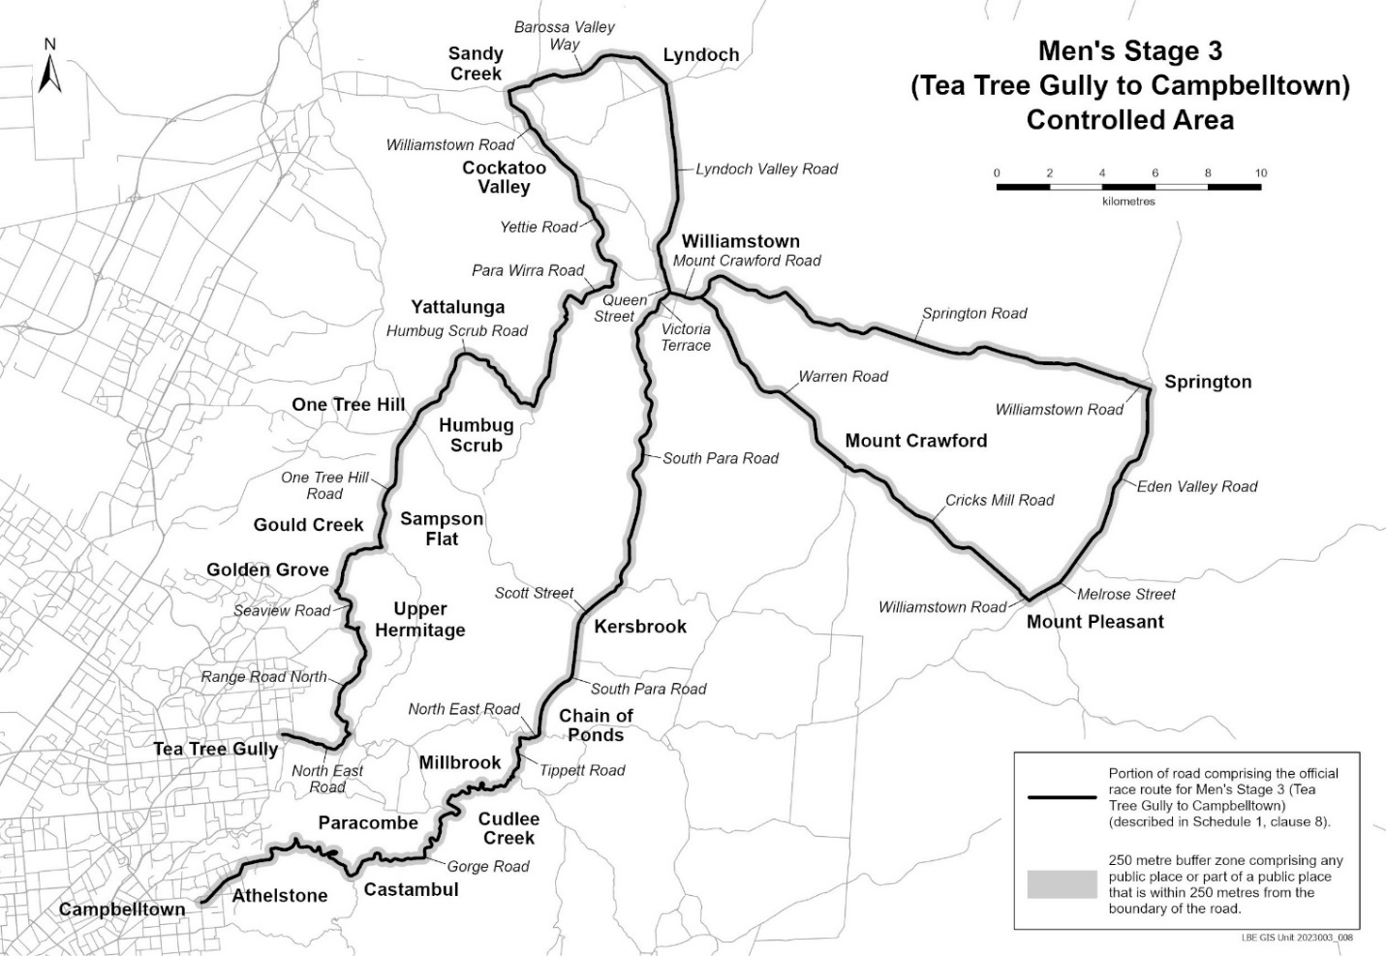
Description of official race route for Men’s Stage 3 (Tea Tree Gully to Campbelltown)
The official race route for Men’s Stage 3 (Tea Tree Gully to Campbelltown) comprises –
    - the portion of road commencing at the intersection of Memorial Drive and North East Road in Tea Tree Gully, then generally south-easterly and generally north-easterly along North East Road to its intersection with Range Road North, then generally north-westerly, generally north-easterly and generally north-westerly along Range Road North to its intersection with Seaview Road, then generally northerly, generally north-easterly and generally north-westerly along Seaview Road to its intersection with One Tree Hill Road, then generally north-easterly, generally easterly and generally north-easterly along One Tree Hill Road to its intersection with Humbug Scrub Road, then generally north-easterly, generally south-easterly and generally north-easterly along Humbug Scrub Road to its intersection with Para Wirra Road, then generally south-easterly, generally north-easterly and generally northerly along Para Wirra Road to its intersection with Yettie Road, then generally north-westerly, generally north-easterly and generally north-westerly along Yettie Road to its intersection with Williamstown Road, then generally north-westerly and northerly along Williamstown Road to its intersection with Barossa Valley Way, then generally north-easterly, generally easterly and generally south-easterly along Barossa Valley Way to its intersection with Lyndoch Valley Road, then generally southerly, generally south-westerly and generally south-easterly along Lyndoch Valley Road to its intersection with Queen Street, then south-easterly along Queen Street to its intersection with Mount Crawford Road, then generally easterly along Mount Crawford Road to its intersection with Springton Road, then generally north-easterly and generally south-easterly along Springton Road to its intersection with Williamstown Road in Springton, then south-easterly along Williamstown Road to its intersection with Eden Valley Road, then generally southerly and generally south-westerly along Eden Vally Road to its intersection with Melrose Street, then generally south-westerly along Melrose Street to its intersection with Williamstown Road in Mount Pleasant, then north-westerly along Williamstown Road until it becomes Cricks Mill Road in Mount Pleasant, then generally north-westerly along Cricks Mill Road to its intersection with Warren Road, then generally north-westerly along Warren Road to its intersection with Mount Crawford Road; and
    - the portion of road commencing at the intersection of Mount Crawford Road with Victoria Terrace in Williamstown, then generally south-westerly along Victoria Terrace to its intersection with South Para Road, then generally south-westerly and generally southerly along South Para Road until it becomes Scott Street in Kersbrook, then generally south-westerly along Scott Street until it becomes South Para Road in Kersbrook, then southerly and generally south-westerly along South Para Road to its intersection with North East Road, then generally south-westerly to its intersection with Tippett Road, then generally westerly and generally southerly along Tippett Road to its intersection with Gorge Road, then generally south-westerly, south-easterly, generally south-westerly, generally westerly, generally south-westerly, generally north-westerly, generally westerly and generally south-westerly along Gorge Road to its intersection with Stradbroke Road in Athelstone (Campbelltown City Council).

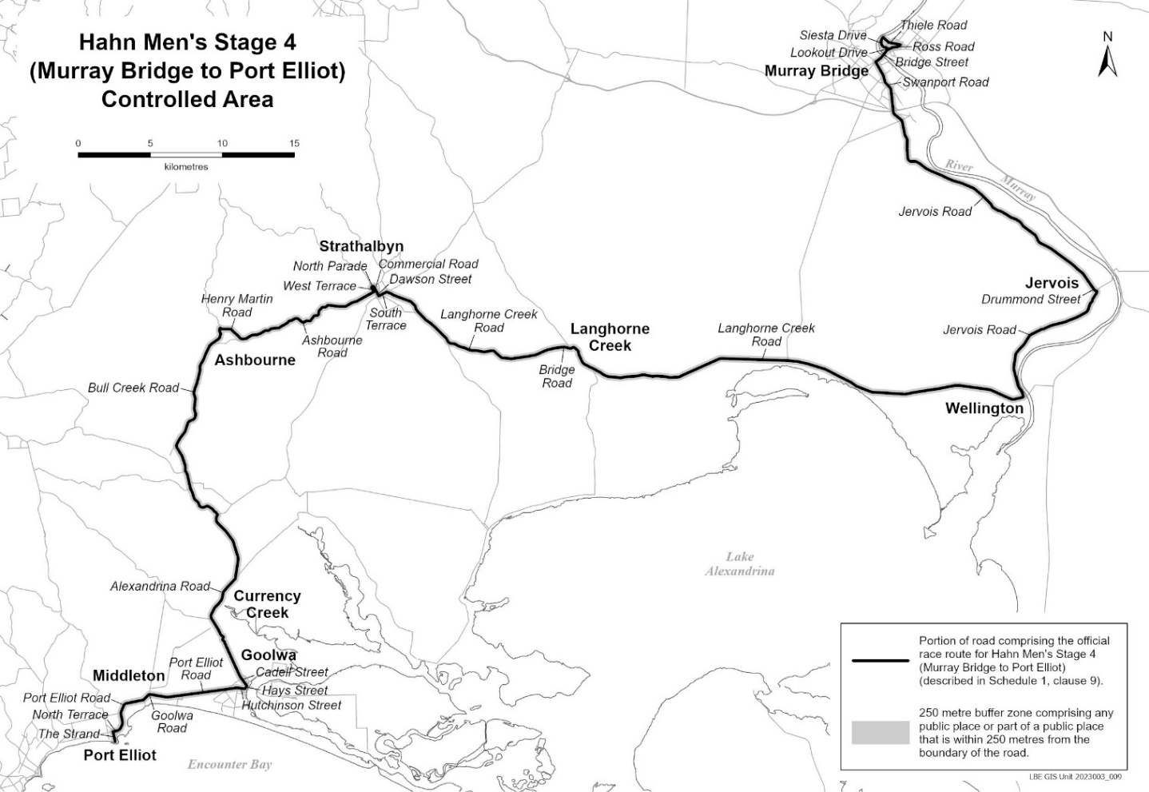
Description of official race route for Hahn Men’s Stage 4 (Murray Bridge to Port Elliot)
The official race route for Hahn Men’s Stage 4 (Murray Bridge to Port Elliot) comprises the portion of road commencing at the intersection of Lookout Drive and Bridge Street in Murray Bridge East, then generally easterly along Bridge Street to its intersection with Ross Road, then generally north-easterly along Ross Road to its intersection with Thiele Road, then generally north-westerly along Thiele Road to its intersection with Siesta Drive, then generally southerly and generally south-easterly along Siesta Drive to its intersection with Lookout Drive, then southeasterly and southerly along Lookout Drive to its intersection with Bridge Street, then generally south-westerly along Bridge Street to its intersection with Swanport Road, then generally south-easterly along Swanport Road to its intersection with Jervois Road, then generally southerly and generally south-easterly along Jervois Road to its intersection with Drummond Street, then generally south-easterly along Drummond Street to its intersection with Jervois Road, then generally southerly, generally south-westerly and generally south-easterly along Jervois Road to its intersection with Langhorne Creek Road in wellington, then generally westerly and generally north-westerly along Langhorne Creek Road to its intersection with Bridge Road, then north-westerly and westerly along Bridge Road to its intersection with Langhorne Creek Road, then generally westerly and generally north-westerly along Langhorne Creek Road to its intersection with South Terrace, then south-westerly along South Terrace to its intersection with Dawson Street, then north-westerly along Dawson Street to its intersection with Commercial Road, then north-westerly along Commercial Road to its intersection with North Parade, then south-westerly along North Parade to its intersection with West Terrace, then south-easterly along South Terrace to its intersection with Ashbourne Road, then generally south-westerly, generally westerly and generally south-westerly along Ashbourne Road to its intersection with Henry Martin Road, then generally north-westerly and westerly along Henry Martin Road to its intersection with Bull Creek Road, then generally southerly, generally south-westerly and generally south-easterly along Bull Creek Road to its intersection with Alexandrina Road, then generally southerly, generally south-easterly, generally south-westerly and generally south-easterly along Alexandrina Road until it becomes Cadell Street in Goolwa, then generally south-easterly along Cadell Street to its intersection with Hay Street, then south-easterly and south-westerly along Hay Street to its intersection with Hutchinson Street, then westerly along Hutchinson Street to its intersection with Port Elliot Road, then generally south-westerly along Port Elliot Road to its intersection with Goolwa Road, then westerly and south-westerly along Goolwa Road to its intersection with Port Elliot Road, then generally south-westerly, generally southerly and generally south-westerly along Port Elliot Road to its intersection with North Terrace, then generally south-westerly along North Terrace to its intersection with The Strand, then southerly along The Strand to its intersection with Freeman Lookout in Port Elliot.

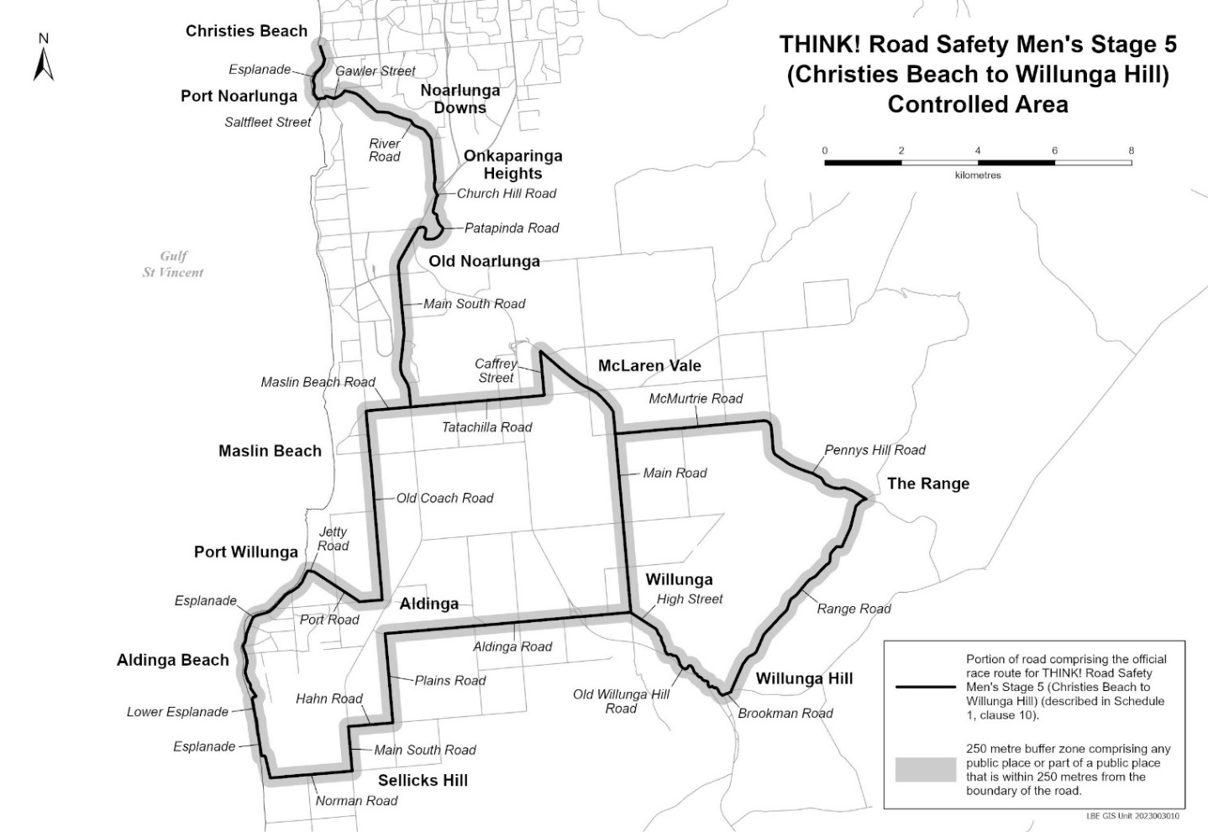
Description of official race route for THINK! Road Safety Men’s Stage 5 (Christies Beach to Willunga Hill)
The official race route for THINK! Road Safety Men’s Stage 5 (Christies Beach to Willunga Hill) comprises –
- the portion of road commencing at the intersection of Sydney Crescent and Esplanade in Christies Beach, then generally south-easterly, generally south-westerly and generally southerly along Esplanade to its intersection with Saltfleet Street, then easterly along Saltfleet Street to its intersection with Gawler Street, then generally north-easterly, generally south-easterly and generally north-easterly along Gawler Street to its intersection with River Road, then generally south-easterly and generally southerly along River Road until it becomes Church Hill Road in Onkaparinga Heights, then south-easterly along Church Hill Road to its intersection with Patapinda Road, then generally southerly, south-westerly, westerly, northerly and generally westerly along Patapinda Road to its intersection with Main South Road, then south-westerly and generally southerly along Main South Road to its intersection with Tatachilla Road, then easterly along Tatachilla Road to its intersection with Caffrey Street, then northerly along Caffrey Street to its intersection with Main Road in McLaren Vale, then generally south-easterly and southerly along Main Road to its intersection with Aldinga Road, then westerly along Aldinga Road to its intersection with Plains Road, then southerly along Plains Road to its intersection with Hahn Road, then westerly along Hahn Road to its intersection with Main South Road, then southerly along Main South Road to its intersection with Norman Road, then westerly along Norman Road to its intersection with Esplanade in Aldinga Beach, then northerly, westerly and northerly along Esplanade to its intersection with Lower Esplanade, then generally northerly and easterly along Lower Esplanade to its intersection with Esplanade, then generally north-westerly and generally north-easterly along Esplanade to its intersection with Jetty Road, then generally easterly along Jetty Road to its intersection with Port Road, then generally south-easterly and easterly along Port Road to its intersection with Old Coach Road, then northerly along Old Coach Road to its intersection with Maslin Beach Road, then easterly along Maslin Beach Road to its intersection with Main South Road in Maslin Beach; and
- the portion of road commencing at the intersection of Main Road and High Street in Willunga, then south-easterly along High Street to its intersection with Old Willunga Hill Road, then generally south-easterly along Old Willunga Hill Road to its intersection with Brookman Road, then north-easterly along Brookman Road to its intersection with Range Road, then generally north-easterly along Range Road to its intersection with Pennys Hill Road, then generally north-westerly, northerly and westerly along Pennys Hill Road until it becomes McMurtrie Road in McLaren Vale, then westerly along McMurtrie Road to its intersection with Main Road in McLaren Vale.

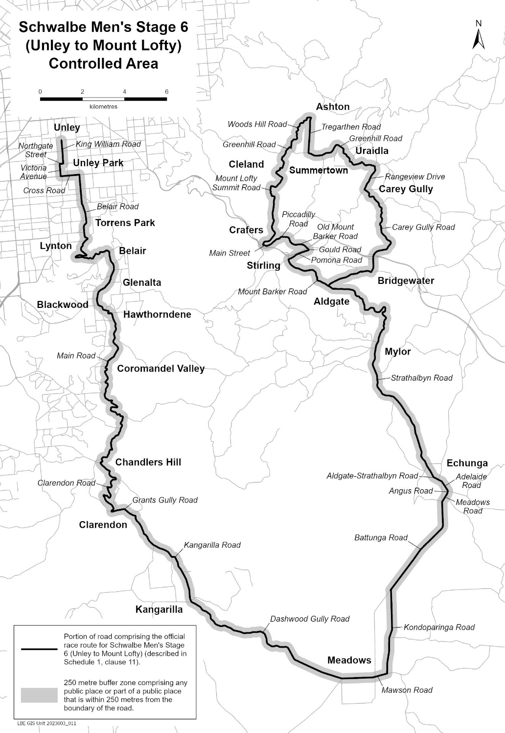
Description of official race route for Schwalbe Men’s Stage 6 (Unley to Mount Lofty)
The official race route for Schwalbe Men’s Stage 6 (Unley to Mount Lofty) comprises the portion of road commencing at the intersection of Arthur Street and King William Road in Unley, then southerly along King William Road to its intersection with Northgate Street, then westerly along Northgate Street to its intersection with Victoria Avenue, then southerly along Victoria Avenue to its intersection with Cross Road, then easterly along Cross Road to its intersection with Belair Road, then generally southerly, generally south-easterly, generally south-westerly, south-easterly, generally westerly, generally easterly and generally north-easterly along Belair Road to its intersection with Main Road in Belair, then generally southerly, generally south-easterly, generally south-westerly and south-easterly along Main Road to its intersection with Clarendon Road, then generally south-easterly, generally south-westerly and generally south-easterly along Clarendon Road to its intersection with Grants Gully Road, then generally easterly, generally south-easterly and southerly along Grants Gully Road until it becomes Kangarilla Road in Clarendon, then generally south-easterly along Kangarilla Road to its intersection with Dashwood Gully Road, then generally south-easterly and generally easterly along Dashwood Gully Road until it becomes Mawson Road in Meadows, then generally easterly along Mawson Road to its intersection with Kondoparinga Road, then generally northerly along Kondoparinga Road to its intersection with Battunga Road, then generally north-easterly and northerly along Battunga Road to its intersection with Meadows Road, then north-easterly along Meadows Road to its intersection with Angus Road, then northerly along Angus Road to its intersection with Adelaide Road, then north-westerly along Adelaide Road to its intersection with Aldgate-Strathalbyn Road, then generally north-westerly along Aldgate-Strathalbyn Road until it becomes Strathalbyn Road in Echunga, then generally north-westerly, generally northerly and generally north-westerly along Strathalbyn Road to its intersection with Mount Barker Road in Aldgate, then generally north-westerly, generally northerly, generally westerly and generally north-westerly along Mount Barker Road to its intersection with Pomona Road, then generally north-easterly along Pomona Road to its intersection with Gould Road, then north-easterly along Gould Road to its intersection with Old Mount Barker Road, then generally north-westerly, generally westerly and generally north-westerly along Old Mount Barker Road to its intersection with Piccadilly Road, then generally westerly and generally south-westerly along Piccadilly Road to its intersection with Main Street in Crafers, then north-westerly along Main Street to its intersection with Mount Lofty Summit Road, then generally north-easterly, generally northerly, generally north-westerly and generally north-easterly along Mount Lofty Summit Road to its intersection with Greenhill Road, then generally north-easterly and generally south-easterly along Greenhill Road to its intersection with Woods Hill Road, then generally northerly and generally north-easterly along Woods Hill Road to its intersection with Tregarthen Road, then generally southerly along Tregarthen Road to its intersection with Greenhill Road, then generally easterly, generally north-easterly, generally south-easterly, and generally easterly along Greenhill Road to its intersection with Rangeview Drive, then southerly and generally south-westerly along Rangeview Drive to its intersection with Carey Gully Road, then generally south-easterly, generally southerly, generally south-easterly and generally south-westerly along Carey Gully Road to its intersection with Mount Barker Road, then generally westerly and generally south-westerly along Mount Barker Road to its intersection with Strathalbyn Road in Aldgate.

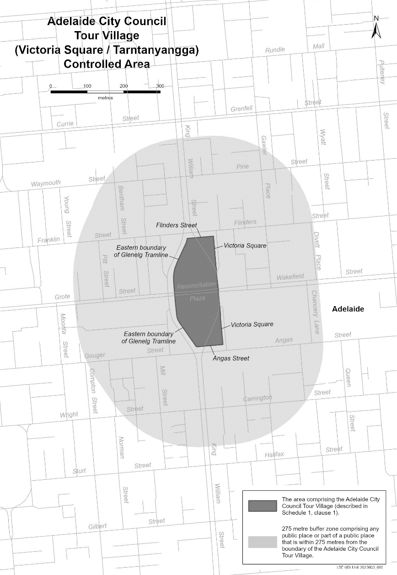
Description of Adelaide City Council Tour Village
The Adelaide City Council Tour Village comprises the area in Victoria Square / Tarntanyangga in Adelaide bounded as follows: commencing at the point at which the eastern boundary of the Glenelg Tramline intersects the southern boundary of Franklin Street, then easterly along the southern boundary of Franklin Street to its intersection with the western boundary of the portion of road (running generally north to south) known as Victoria Square, then southerly along that boundary to its south-eastern-most point, then southerly in a straight line across Wakefield Street to the north-eastern-most point on the western boundary of the portion of road (running generally north to south) known as Victoria Square, then southerly along that boundary to its intersection with the northern boundary of Angas Street, then westerly along the northern boundary of Angas Street to its intersection with the eastern boundary of the Glenelg Tramline, then generally north-westerly and northerly along the eastern boundary of the Glenelg Tramline to its intersection with the southern boundary of Reconciliation Plaza, then northerly in a straight line across Reconciliation Plaza to the intersection of the northern boundary of Reconciliation Plaza with the eastern boundary of the Glenelg Tramline, then northerly and generally north-easterly along the eastern boundary of the Glenelg Tramline to the point of commencement.

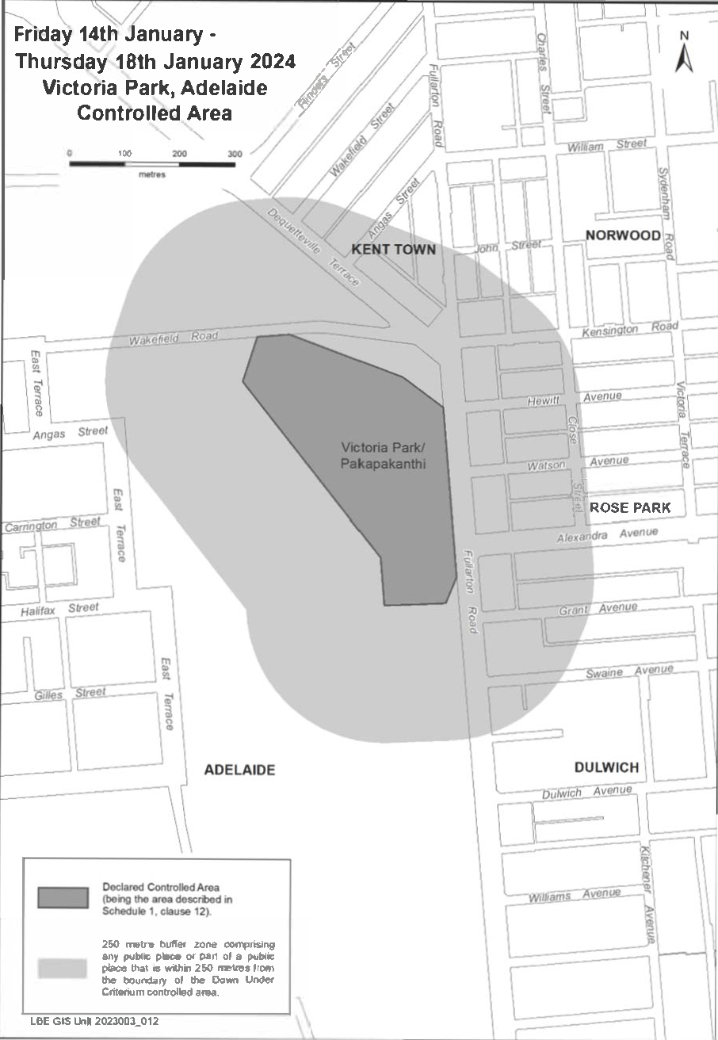
Description of Victoria Park including Down Under Criterium, Adelaide
Victoria Park event space is bordered on the east by Fullarton Road, on the north by Wakefield Road, on the south by the pedestrian path directly running between Grant Avenue, Rose Park and Halifax Street Adelaide and on the west by the diagonal section of the Adelaide Parklands Circuit running in a south-easterly direction from Senna Chicane to the pedestrian path running between Grant Ave and Halifax Street.

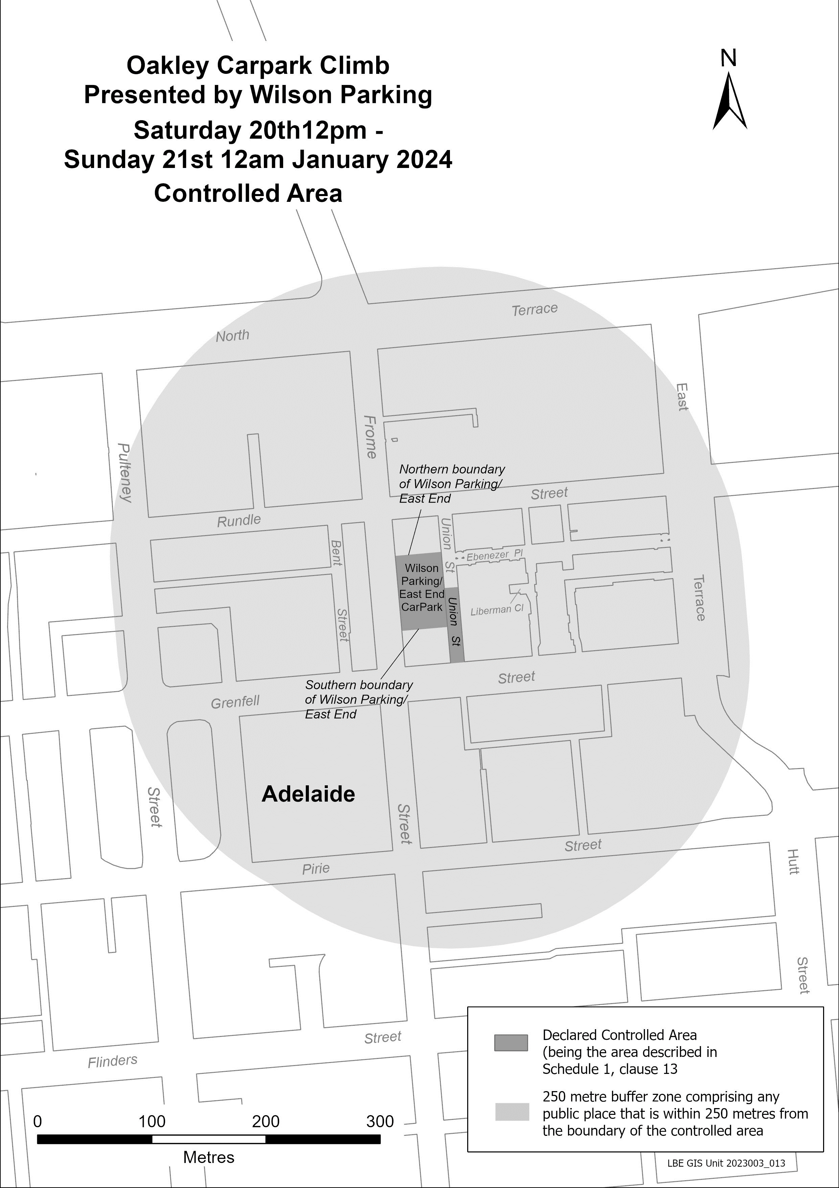
Description of Oakley Carpark Climb, Adelaide
The Oakley Carpark Climb, Adelaide, commences at an intersection of the western boundary of Union Street and Grenfell Street, then generally northerly along the eastern boundary of Union Street till its intersection with the Southern boundary of the Wilson Parking, then generally westerly along the southern boundary of the Wilson Carpark until its intersection with Frome Street, then generally northernly along the eastern boundary of Frome Street until its intersection with the northern boundary of the Wilson Parking, then generally easternly along the Northern boundary of Wilson Parking until its intersection with Union Street, then generally southernly along the eastern boundary of Union Street, until its intersection with the westerly production of the northern boundary of Liberman Close, then generally easterly, following the westerly production of Liberman Close across Union Street to the eastern boundary of Union Street, then generally southernly until its intersection with Grenfell Street, then generally westerly along Grenfell Street until its intersection with Union Street, point of commencement.

Petroleum and Geothermal Energy Act 2000
Application for Grant of Associated Activities Licence—AAL 314
Pursuant to section 65(6) of the Petroleum and Geothermal Energy Act 2000 and delegation dated 27 November 2023, notice is hereby given that an application for the grant of an associated activities licence over the area described below has been received from:
Santos QNT Pty Ltd
Drillsearch (513) Pty Limited
The application will be determined on or after 19 January 2024.
Description of Application Area
All coordinates GDA2020, Zone 54
398121.170777 6885549.778390
398101.305068 6885596.052878
398205.652692 6885633.848382
398307.413462 6885755.079902
398136.009682 6885898.878120
397968.750032 6886056.505282
397849.593302 6886175.584233
397807.859352 6886229.175823
397792.381382 6886259.213343
397779.199302 6886296.104113
397771.583012 6886332.796193
397769.292804 6886359.963160
397820.073296 6886360.397910
397821.156922 6886339.358813
397827.210072 6886310.068593
397837.778542 6886280.219703
397856.382492 6886245.920533
397885.478602 6886210.410003
398004.086482 6886091.879512
398168.122292 6885937.203392
398298.493852 6885827.847442
398377.730101 6885761.127460
398235.359187 6885591.559444
398121.170777 6885549.778390
AREA: 0.06 square kilometres approximately
Dated: 19 December 2023
Benjamin Zammit
Executive Director
Regulation and Compliance
Department for Energy and Mining
Delegate of the Minister for Energy and Mining

Petroleum and Geothermal Energy Act 2000
Designation of Competitive Tender Regions
I, Hon TOM KOUTSANTONIS, Minister for Energy and Mining, pursuant to section 16 of the Petroleum and Geothermal Energy Act 2000 (the Act), hereby revoke the Designation of Competitive Tender Regions as published in the Government Gazette dated 10 November 2022, page 6609 and in substitution designate the following regions to be Competitive Tender Regions:
COMPETITIVE TENDER REGION, COOPER BASIN FOR ALL REGULATED
RESOURCES UNDER THE PETROLEUM AND GEOTHERMAL ENERGY ACT 2000
Description of Area
All that part of the State of South Australia, bounded as follows:-
Commencing at a point being the intersection of latitude 29°30'00"S AGD66 and longitude 139°00'00"E AGD66, thence north to the northern border of the State of South Australia, thence easterly along the border of the said State to the eastern border of the State of South Australia, thence southerly along the border of the said State to latitude 29°30'00" AGD66, and west to the point of commencement.
AREA: 76,402 square kilometres approximately
COMPETITIVE TENDER REGION, OTWAY BASIN FOR ALL REGULATED
RESOURCES UNDER THE PETROLEUM AND GEOTHERMAL ENERGY ACT 2000
Description of Area
All that part of the State of South Australia, bounded as follows:-
Commencing at a point being the intersection of latitude 36°51'00"S GDA94, and longitude 140°25'00"E GDA94, thence east to the eastern border of the State of South Australia, thence southerly along the border of the said State to the Territorial Sea Baseline at low water mark, Southern Ocean, thence generally northwesterly along the said baseline to latitude 37°00'00"S GDA94, east to longitude 139°50'00"E GDA94, north to latitude 36°54'00"S GDA94, east to longitude 140°00'00"E GDA94, south to latitude 36°55'00"S GDA94, east to longitude 140°25'00"E GDA94, and north to point of commencement.
AREA: 10,480 square kilometres approximately.
COMPETITIVE TENDER REGION, ARROWIE BASIN FOR ALL REGULATED
RESOURCES UNDER THE PETROLEUM AND GEOTHERMAL ENERGY ACT 2000
Description of Area
All that part of the State of South Australia, bounded as follows:-
Commencing at a point being the intersection of longitude 138°45'00"E GDA2020 and latitude 30°00'00"S GDA2020, thence east to the eastern border of the State of South Australia, then south along the border of the said State to latitude 31°45'00"S GDA2020, west to longitude 138°45'00"E GDA2020 and north to point of commencement.
AREA: 41,753 square kilometres approximately
COMPETITIVE TENDER REGION, ARCKARINGA BASIN FOR ALL REGULATED
RESOURCES UNDER THE PETROLEUM AND GEOTHERMAL ENERGY ACT 2000
Description of Area
All that part of the State of South Australia, bounded as follows:-
Commencing at a point being the intersection of longitude 133°30'00"E GDA2020
and latitude 27°00'00"S GDA2020, thence east to longitude 135°45'00"E GDA2020, south to latitude 27°30'00"S GDA2020, east to longitude 136°15'00"E GDA2020, south to latitude 29°00'00"S GDA2020, east to longitude 136°45'00"E GDA2020, south to latitude 30°45'00"S GDA2020, west to longitude 134°15'00"E GDA2020, north to latitude 30°15'00"S GDA2020, west to longitude 131°30'00"E GDA2020, north to latitude 29°00'00"S GDA2020, east to longitude 132°15'00"E GDA2020, north to latitude 28°15'00"S GDA2020, east to longitude 133°00'00"E GDA2020, north to latitude 27°45'00"S GDA2020, east to longitude 133°30'00"E GDA2020 and north to point of commencement.
AREA: 154,046 square kilometres approximately
COMPETITIVE TENDER REGION, POLDA BASIN FOR ALL REGULATED
RESOURCES UNDER THE PETROLEUM AND GEOTHERMAL ENERGY ACT 2000
Description of Area
All that part of the State of South Australia, bounded as follows:-
Commencing at a point being the intersection of the Territorial Sea Baseline at low water mark, Southern Ocean and latitude 33°15'00"S GDA2020, thence east to longitude 136°1B'0O"E GDA2020, south to latitude 33°48'00"S GDA2020, west to the Territorial Sea Baseline at low water mark, Southern Ocean, then generally north-westerly along the said baseline to the point of commencement.
AREA: 8,115 square kilometres approximately
This designation of competitive tender regions shall remain in effect up to and including 31 December 2024 unless revoked earlier.
Dated: 18 December 2023
Hon Tom Koutsantonis MP
Minister for Energy and Mining

Petroleum and Geothermal Energy Act 2000
Grant of Preliminary Survey Licence—PSL 41
Pursuant to section 92(1) of the Petroleum and Geothermal Energy Act 2000, notice is hereby given that the undermentioned Preliminary Survey Licence has been granted under the provisions of the Petroleum and Geothermal Energy Act 2000, pursuant to delegated powers dated 27 November 2023.
No of Licence | Licensees | Locality | Area in km2 | Reference
PSL 41 | South East Australia Gas Pty Ltd | Pelican Point | 3.26 | MER-2023/0218
Description of Area
All that part of the State of South Australia, bounded as follows:
271686.35mE 6150226.58mN
271903.77mE 6150150.70mN
272001.80mE 6150016.60mN
272330.51mE 6149514.15mN
272421.95mE 6148708.88mN
272394.92mE 6148417.39mN
272010.86mE 6148481.66mN
271926.80mE 6148041.62mN
271298.21mE 6148125.51mN
271250.55mE 6148199.77mN
271155.27mE 6148298.21mN
270574.19mE 6148639.28mN
270555.28mE 6149879.82mN
270938.88mE 6150224.16mN
271319.55mE 6150335.24mN
271686.35mE 6150226.58mN
All coordinates GDA2020
AREA: 3.26 square kilometres approximately
Dated: 15 December 2023
Benjamin Zammit
Executive Director
Regulation and Compliance Division
Department for Energy and Mining
Delegate of the Minister for Energy and Mining

Planning, Development and Infrastructure Act 2016
Section 76
Amendment to the Planning and Design Code
Preamble
It is necessary to amend the Planning and Design Code (the Code) in operation at 7 December 2023 (Version 2023.18) in order to make changes of form relating to the Code’s spatial layers and their relationship with land parcels. NOTE: There are no changes to the application of zone, subzone or overlay boundaries and their relationship with affected parcels or the intent of policy application as a result of this amendment.
- PURSUANT to section 76 of the Planning, Development and Infrastructure Act 2016 (the Act), I hereby amend the Code in order to make changes of form (without altering the effect of underlying policy), correct errors and make operational amendments as follows:
- Undertake minor alterations to the geometry of the spatial layers and data in the Code to maintain the current relationship between the parcel boundaries and Code data as a result of the following:
  - New plans of division deposited in the Land Titles Office between 29 November 2023 and 12 December 2023 affecting the following spatial and data layers in the Code:
    - Zones and subzones
    - Technical and Numeric Variations
      - Building Heights (Levels)
      - Building Heights (Metres)
      - Concept Plan
      - Finished Ground and Floor Levels
      - Interface Height
      - Minimum Frontage
      - Minimum Site Area
      - Minimum Primary Street Setback
      - Minimum Side Boundary Setback
      - Future Local Road Widening Setback
    - Overlays
      - Affordable Housing
      - Coastal Areas
      - Coastal Flooding
      - Defence Aviation Area
      - Dwelling Excision
      - Future Road Widening
      - Hazards (Bushfire - High Risk)
      - Hazards (Bushfire - Medium Risk)
      - Hazards (Bushfire - General Risk)
      - Hazards (Bushfire - Urban Interface)
      - Hazards (Bushfire - Regional)
      - Hazards (Bushfire - Outback)
      - Heritage Adjacency
      - Limited Dwelling
      - Limited Land Division
      - Local Heritage Place
      - Noise and Air Emissions
      - State Heritage Place
      - Stormwater Management
      - Urban Tree Canopy
- In Part 13 of the Code – Table of Amendments, update the publication date, Code version number, amendment type and summary of amendments within the ‘Table of Planning and Design Code Amendments’ to reflect the amendments to the Code as described in this Notice.
- PURSUANT to section 76(5)(a) of the Act, I further specify that the amendments to the Code as described in this Notice will take effect upon the date those amendments are published on the SA planning portal.
Dated: 14 December 2023
Greg Van Gaans
Director, Land and Built Environment,
Department for Trade and Investment
Delegate of the Minister for Planning

Primary Industry Funding Schemes Act 1998
Ministerial Notices
Adelaide Hills Wine Industry Fund
Pursuant to regulation 5(1a) of the Primary Industry Funding Schemes (Adelaide Hills Wine Industry Fund) Regulations 2017, under the Primary Industry Funding Schemes Act 1998, the following contributions are payable to the Minister for payment into the Adelaide Hills Wine Industry Fund for Adelaide Hills grapes delivered to an Adelaide Hills grapes winemaker:
- For the purposes of regulation 5(1a)(a)(i), in the case of grapes grown by a person other than an Adelaide Hills grapes winemaker, the grower of the grapes must contribute the amount fixed, as follows:
- $7.80 for each tonne of grapes delivered during the prescribed period commencing on 1 June 2024;
- $7.95 for each tonne of grapes delivered during the prescribed period commencing on 1 June 2025.
- $8.10 for each tonne of grapes delivered during a prescribed period commencing on or after 1 June 2026.
- For the purposes of regulation 5(1a)(a)(ii), in the case of grapes grown by a person other than an Adelaide Hills grapes winemaker, the winemaker must contribute the amount fixed, as follows:
- $7.80 for each tonne of grapes delivered during the prescribed period commencing on 1 June 2024;
- $7.95 for each tonne of grapes delivered during the prescribed period commencing on 1 June 2025.
- $8.10 for each tonne of grapes delivered during a prescribed period commencing on or after 1 June 2026.
- For the purposes of regulation 5(1a)(b), in the case of grapes grown by an Adelaide Hills grapes winemaker, the winemaker must contribute the amount fixed, as follows:
- $15.60 for each tonne of grapes delivered during the prescribed period commencing on 1 June 2024;
- $15.90 for each tonne of grapes delivered during the prescribed period commencing on 1 June 2025.
- $16.20 for each tonne of grapes delivered during a prescribed period commencing on or after 1 June 2026.
Barossa Wine Industry Fund
Pursuant to regulation 5 of the Primary Industry Funding Schemes (Barossa Wine Industry Fund) Regulations 2021, under the Primary Industry Funding Schemes Act 1998, the following contributions are payable to the Minister for payment into the Barossa Wine Industry Fund for Barossa grapes delivered to a Barossa winemaker:
- For the purposes of regulation 5(1)(a)(i) in the case of a Barossa winemaker who has a cellar door, winemaking facility or vineyard in the Barossa, the Barossa winemaker must contribute whichever of the following is the greater amount:
- the amount fixed at $213 as the minimum contribution for a prescribed period commencing on or after 1 June 2023;
- the amount fixed at $11.70 for each tonne of grapes delivered to the winemaker during a prescribed period commencing on or after 1 June 2023.
- For the purposes of regulation 5(1)(a)(ii), in the case of a Barossa winemaker who does not have a cellar door, winemaking facility or vineyard in the Barossa, the Barossa winemaker must contribute, whichever of the following is the greater amount:
- for the purposes of regulation 5(1)(a)(ii)(A) - the amount fixed at $213 as the minimum contribution for a prescribed period commencing on or after 1 June 2023;
- for the purposes of regulation 5(1)(a)(ii)(B) - the amount fixed at $11.70 for each tonne of grapes delivered to the winemaker during a prescribed period commencing on or after 1 June 2023.
- For the purposes of regulation 5(1)(b), in the case of a grower of grapes who delivers the Barossa grapes to the Barossa winemaker, the grower of grapes must contribute the amount fixed at $11.70 for each tonne of grapes delivered during a prescribed period commencing on or after 1 June 2023.
For the purposes of regulation 5(2), the maximum amount that is to be payable by the grower of grapes or a winemaker, under regulation 5, for a prescribed period commencing on or after 1 June 2023, is fixed at $55,281.
Clare Valley Wine Industry Fund
Pursuant to regulation 5(1) of the Primary Industry Funding Schemes (Clare Valley Wine Industry Fund) Regulations 2021, under the Primary Industry Funding Schemes Act 1998, the following contributions are payable to the Minister for payment into the Clare Valley Wine Industry Fund for Clare Valley grapes delivered to a Clare Valley winemaker:
- For the purposes of regulation 5(1)(a), in the case of a Clare Valley winemaker who has a vineyard, winemaking facility or cellar door in the Clare Valley, the winemaker must contribute whichever of the following is the greater amount:
  - For the purposes of regulation 5(1)(a)(i):
    - if the winemaker does not have a cellar door located in the Clare Valley the amount fixed at $500 as the minimum contribution for a prescribed period commencing on or after 1 June 2023; or
    - if the winemaker has a cellar door located in the Clare Valley the amount fixed at $1,000 as the minimum contribution for the prescribed period commencing on or after 1 June 2023.
  - For the purposes of regulation 5(1)(a)(ii) - an amount being the sum of:
      - For the purposes of regulation 5(1)(a)(ii)(A) - the amount fixed at $9.00 for each tonne of grapes grown by the winemaker delivered during a prescribed period commencing on or after 1 June 2023; and
      - For the purposes of regulation 5(1)(a)(ii)(B) - the amount fixed at $9.00 for each tonne of grapes grown by a person other than the winemaker delivered during a prescribed period commencing on or after 1 June 2023.
- For the purposes of regulation 5(1)(b), in the case of a Clare Valley Winemaker who does not have a vineyard, winemaking facility or cellar door in the Clare Valley, the winemaker must contribute the amount fixed at $9.00 for each tonne of grapes grown by a person other than the winemaker delivered during a prescribed period commencing on or after 1 June 2023.
- For the purposes of regulations 5(1)(c), if the grapes are grown by a person other than the winemaker, the grower of the grapes must contribute the amount fixed at $9.00 for each tonne of grapes delivered during a prescribed period commencing on or after 1 June 2023.
For the purposes of regulation 5(2), the maximum amount that is to be payable by the grower of grapes or a winemaker, under regulation 5, for a prescribed period commencing on or after 1 June 2023, is fixed at $20,000.
Langhorne Creek Wine Industry Fund
Pursuant to regulation 5(1a) of the Primary Industry Funding Schemes (Langhorne Creek Wine Industry Fund) Regulations 2016, under the Primary Industry Funding Schemes Act 1998, the following contributions are payable to the Minister for payment into the Langhorne Creek Wine Industry Fund for Langhorne Creek grapes processed by a Langhorne Creek grapes winemaker:
- For the purposes of regulation 5(1a)(a)(i), in the case of grapes grown by a person other than the winemaker, the grower of the grapes must contribute the amount fixed at $6.15 for each tonne of grapes processed during a prescribed period ending on or after 31 May 2024.
- For the purposes of regulation 5(1a)(a)(ii), in the case of grapes grown by a person other than the winemaker, the winemaker must contribute the amount fixed at $4.31 for each tonne of grapes processed during a prescribed period ending on or after 31 May 2024.
- For the purposes of regulation 5(1a)(b), in the case of grapes grown by the winemaker, the winemaker must contribute the amount fixed at $10.46 for each tonne of grapes processed during a prescribed period ending on or after 31 May 2024.
For the purposes of the definition of prescribed maximum contribution in regulation 5(10)(b), the maximum contribution for a prescribed period ending on or after 31 May 2024, is fixed at $30,000.
Mclaren Vale Wine Industry Fund
Pursuant to regulation 5(2a) of the Primary Industry Funding Schemes (McLaren Vale Wine Industry Fund) Regulations 2017, under the Primary Industry Funding Schemes Act 1998, the following contributions are payable to the Minister for payment into the McLaren Vale Wine Industry Fund for McLaren Vale grapes delivered to a McLaren Vale grapes winemaker:
- For the purposes of regulation 5(2a)(a)(i), in the case of grapes grown by a person other than the winemaker, the grower of the grapes must contribute the amount fixed, as follows:
  - $9.66 for each tonne of grapes delivered during the prescribed periods ending on 31 May 2024 and on 31 May 2025;
  - $10.14 for each tonne of grapes delivered during a prescribed period ending on or after 31 May 2026.
- For the purposes of regulation 5(2a)(a)(ii), in the case of grapes grown by a person other than the winemaker, the winemaker must contribute the amount fixed, as follows:
  - $12.81 for each tonne of grapes delivered during the prescribed periods ending on 31 May 2024 and on 31 May 2025;
  - $13.45 for each tonne of grapes delivered during a prescribed period ending on or after 31 May 2026.
- For the purposes of regulation 5(2a)(b), in the case of grapes grown by the winemaker, the winemaker must contribute the amount fixed, as follows:
  - $12.81 for each tonne of grapes delivered during the prescribed periods ending on 31 May 2024 and on 31 May 2025;
  - $13.45 for each tonne of grapes delivered during a prescribed period ending on or after 31 May 2026.
For the purposes of the definition of prescribed maximum contribution in regulation 5(11)(f), the maximum contribution for the prescribed periods ending on 31 May 2024 and on 31 May 2025 is fixed at $36,466.50, and for a prescribed period ending on or after 31 May 2026 is fixed at $38,289.80.

Riverland Wine Industry Fund
Pursuant to regulation 5(1b) of the Primary Industry Funding Schemes (Riverland Wine Industry Fund) Regulations 2016, under the Primary Industry Funding Schemes Act 1998, the following contributions are payable to the Minister for payment into the Riverland Wine Industry Fund for Riverland grapes delivered to a Riverland grapes winemaker:
- For the purposes of regulation 5(1b)(a)(i), in the case of grapes grown by a person other than the winemaker, the grower of the grapes must contribute the amount fixed at of 0.5% of the amount payable to the grower by the winemaker for each tonne of grapes delivered during a prescribed period commencing on or after 1 June 2023.
- For the purposes of regulation 5(1b)(a)(ii), in the case of grapes grown by a person other than the winemaker, the winemaker must contribute as an industry development contribution, the amount fixed at 50 cents for each tonne of grapes delivered during a prescribed period commencing on or after 1 June 2023.
- For the purposes of regulation 5(1b)(b)(i), in the case of grapes grown by the winemaker, the winemaker must contribute as a winemaker contribution, the amount fixed at $1.00 for each tonne of grapes delivered during a prescribed period commencing on or after 1 June 2023.
- For the purposes of regulation 5(1b)(b)(ii), in the case of grapes grown by the winemaker, the winemaker must contribute as an industry development contribution, the amount fixed at 50 cents for each tonne of grapes delivered during a prescribed period commencing on or after 1 June 2023.
Dated: 18 December 2023
Hon Clare Scriven MLC
Minister for Primary Industries and Regional Development

Return to Work Act 2014
Notice of Travel Allowance
Preamble
Section 33(8) of the Return to Work Act 2014 (the Act) states that:
If a worker travels in a private vehicle to or from any place for the purpose of receiving medical services, hospitalisation or approved recovery/return to work services, and the travel is reasonably necessary in the circumstances of the case, the worker is entitled to a travel allowance at rates fixed by a scale published by the Minister under this section.
Notice
I DECLARE that the rate for travel allowance in 2024 is hereby fixed for the purposes of section 33(8) of the Act at 0.546 cents per kilometre, and this notice supersedes all previous notices of the travel allowance rate published under section 33(8) of the Act.
This Notice is effective for travel on or after 1 January 2024.
Dated 14 December 2023
Hon Kyam Maher MLC
Minister for Industrial Relations and Public Sector

Safe Drinking Water Act 2011
Notice of Exemption by the Minister for Health and Wellbeing
Take notice that pursuant to section 4(2) of the Safe Drinking Water Act 2011, I, Chris Picton, Minister for Health and Wellbeing, do hereby exempt from the provisions of the Safe Drinking Water Act 2011 drinking water providers who only supply drinking water:
- to one premises; and
- which has been:
        - directly supplied by another registered drinking water provider; and
        - treated additionally with chlorine as a disinfectant
Dated: 18 December 2023
Chris Picton
Minister for Health and Wellbeing

Safe Drinking Water Act 2011
South Australia
Safe Drinking Water (Fees) Notice 2023
under the Safe Drinking Water Act 2011
1—Short title
This notice may be cited as the Safe Drinking Water (Fees) Notice 2023.
Note—
This is a fee notice made in accordance with the Legislation (Fees) Act 2019.
2—Commencement
This notice has effect on 1 January 2024.
3—Interpretation
In this notice—
Act means the Safe Drinking Water Act 2011;
Department auditor or inspector means an approved auditor or approved inspector who is an employee of the Department assisting the Minister in the administration of the Act;
Follow up audit or inspection means any subsequent audit or inspection of a drinking water provider conducted during the same prescribed period;
prescribed period means the period determined by the Chief Executive under s 20 of the Act; and
Level 3 drinking water provider means a drinking water provider who aligns with one of the following specified classes:
- Water carters
- Small rainwater supplies
- Small bore water supplies
- Regulated care premises
- Education - childcare and preschool
- Education – primary and secondary schools
- Regulated food premises
- Primary producers (excluding dairy)
- Accommodation and food premises
- Wineries and restaurants; or
- On-supply from other drinking water provider where materially altered by treatment or extended storage
Level 2 drinking water provider means a drinking water provider who aligns with one of the following specified classes:
- Desalinated water supplies
- Bore water with reverse osmosis treatment; or
- Providers with multiple source waters – rainwater and bore water
Level 1 drinking water provider means a drinking water provider who aligns with one of the following specified classes:
- Drinking water providers greater than 2,000 population; or
- Surface water supplies – River Murray or Dam
4—Fees
(1) The fees set out in Schedule 1 are prescribed for the purposes of the Act.
(2) However, no fee is payable under this fee notice if –
- the drinking water provider is a registered entity within the meaning of the Australian Charities and Not-for-profits Commission Act 2012 of the Commonwealth; or
- the drinking water provider has paid a fee for another regulatory audit or inspection conducted at the same location and time, by the same person, and under an Act committed to the Minister for Health and Wellbeing.
Schedule 1—Fees
- Audit or inspection for the purpose of Part 4 of the Act conducted by a department auditor or inspector of a -
- Level 3 drinking water provider $209
- Level 2 drinking water provider $418
- Level 1 drinking water provider $627
Note: where a drinking water provider aligns with multiple levels, the higher level applies. Example: a winery using a surface water supply – River Murray or Dam
- Follow-up audit or inspection for the purpose of Part 4 of the Act conducted by a department auditor or inspector $209
Dated: 18 December 2023
Chris Picton
Minister for Health and Wellbeing

Local Government Instruments

CITY OF VICTOR HARBOR
Local Government Act 1999
Naming of Road
The City of Victor Harbor hereby gives NOTICE pursuant to section 219(1) of the Local Government Act 1999, and in accordance with the Council’s Resolution OC4632023 of 11 December 2023, that the unnamed road, as part of the SA Ambulance Station development, be named Tuck Court.
A copy of this notice and further information can be obtained from the Council’s offices at 1 Bay Road, Victor Harbor SA 5211, during ordinary business hours or on the Council’s website at www.victor.sa.gov.au.
Victoria MacKirdy
Chief Executive Officer

CITY OF VICTOR HARBOR
Local Government Act 1999
Resolved By-laws 2023
Notice is hereby given that the City of Victor Harbor resolves that:
By-law 3 - Roads
Pursuant to the power contained in Section 246(3)(e) of the Local Government Act 1999, resolve that no locations have been identified for the application of Clause 4.9 of By-law 3 – Roads, the Council has resolved that no location be identified for the purpose of Clauses 4.9.
By-law 4 – Local Government Land
Pursuant to the power contained in Section 246(3)(e) of the Local Government Act 1999, and Clause 11 - Application of By-law 4 – Local Government Land, the Council resolved:
- clause 4.6.1.3, shall apply to all waters on local government land; and
- clause 4.8, shall apply to all waters on local government land (fishing is permitted); and
- clause 4.10.2, shall apply to all waters on local government land (for a motorised craft only); and
- clause 4.10.3, shall apply to all waters on local government land (for non-motorised craft only); and
- clause 4.10.4, shall apply to all waters on local government land; and
- clause 4.20, shall apply to the waters of Encounter Lakes and Franklin Island Lake, subject to the following conditions:
- not within 25 metres of the inlet or outlet structure of Encounter Lakes; and
- not within 10 metres of the bridge over the Franklin Island Lake; and
- not within 10 metres of Encounter Lakes pump station (35 Bartel Boulevard, Encounter Bay); and
- clause 4.25.2, shall apply to all local government land; and
- clause 5.8.1, shall apply to any building or part of any building on local government land; and
- clause 5.9, shall apply to all waters on local government land (except for dive and scuba dive).
Pursuant to the power contained in Section 246(3)(e) of the Local Government Act 1999, and Clause 11 – Application of By-law 4 – Local Government Land, the Council resolved that no locations have been identified for the application of Clauses 4.10.1, 4.22, 4.26, 4.28.2, 4.28.3, 4.37, 5.5.1 (except in the area of Encounter Lakes and Franklin Island Lake where catch and release fishing is allowed) and 5.8.2.
Pursuant to the power contained in Section 246(3)(e) of the Local Government Act 1999, and Clause 11 – Application of By-law 4 – Local Government Land, the Council resolved that:
- Clause 4.24.2 – no location has been identified; and
- Clause 4.35 – shall apply to all Local Government land (subject to the Road Traffic Act 1961).
By-law 5 – Dogs
Pursuant to the power contained in Section 246(3)(e) of the Local Government Act 1999, and Clause 8 – Application of By-law 5 – Dogs, the Council resolved that no location has been identified for a dog free area at Clause 4.1.
Pursuant to the power contained in Section 246(3)(e) of the Local Government Act 1999, and Clause 8 – Application of Clause of By-law 5 – Dogs, the Council resolved the following areas are ‘Dog on-leash areas’ 24/7 for the purposes of Clause 5.1:
- Soldiers Memorial Reserve
- Soldiers Memorial Garden
- Warland Reserve
- Along the foreshore areas adjacent to Encounter Lakes and Franklin Island Lakes:
- John Simmons Park– Corner of Central Drive and Clifton Way
- CM Thorpe Park – Corner Mathew Flinders Drive and Bartel Boulevard
- John Crompton Reserve – Corner Tabernacle and Nicholas Baudin Drive
- Petrel Cove.
Pursuant to the power contained in Section 246(3)(e) of the Local Government Act 1999, and Clause 8 – Application of By-law – Dogs, the Council resolved the following as new ‘Dog on-leash areas’ 24/7 for the purposes of Clause 5.1:
- Hindmarsh River Estuary Sand Dunes
- Inman River Estuary Sand Dunes
- Wright Island.
Pursuant to the power contained in Section 246(3)(e) of the Local Government Act 1999, and Clause 8 – Application of By-law – Dogs, the Council resolved that the foreshore area between the Bluff and Chiton Rocks will have the following Dog leashing requirements (excluding Hindmarsh River, Inman River Estuaries and Wright Island) for the purposes of Clause 5.1:
- Daylight Savings (October to March)
- Dogs must be on-leash between 10am and 6pm during daylight savings; and
- Dogs may be off-leash (must be under effective control) between 6pm and 10am during daylight saving (October to March)
- Non-Daylight Savings (April to September)
- Dogs may be off-leash (must be under effective control) during non-daylight saving.
Pursuant to the power contained in Section 246(3)(e) of the Local Government Act 1999, and Clause 8 – Application of By-law 5 – Dogs, the Council resolved that the Victor Harbor Dog Park located at the corner of George Main Road and Oval Park Road, Victor Harbor is a Dog Exercise Area for the purposes of Clause 6.1.
By-law 7 - Foreshore
Pursuant to Section 246 (3)(e) of the Local Government Act 1999, and Clause 10 – Application of By-law 7 – Foreshore, the Council resolved no locations have been identified for the purpose of Clauses 5.1 and 5.8.
That Council delegates to the Chief Executive Officer (or delegate) under Part 2 and 3 of By-law 1 – Permits and Penalties:
- to grant permission to a person who seeks permission to undertake an activity under Council by-laws that is otherwise prohibited under a Council by-law, and that the authorisation is recorded in Council’s Delegations Register; and
- to vary or revoke such conditions or impose new conditions by notice in writing to the person granted permission, or to suspend or revoke a grant of permission at any time by notice in writing to the person granted permission.
That Council authorises the application of the by-laws, as resolved and pursuant to the power contained in Section 246(3)(e) of the Local Government Act 1999, to take effect from 12 December 2023.
Victoria MacKirdy
Chief Executive Officer

Alexandrina Council
Local Government Act 1999
Notice of Application of Local Government Land 2023 By-law
Pursuant to Section 246(4a) of the Local Government Act 1999, notice is hereby given that at its meeting on 18 December 2023 and in exercise of its powers under Section 246(3)(e) of the Act, the Council resolved,
- for the purposes of clause 9.15.3.1 of the Local Government Land By-law 2023, the signed area at Frank Potts Reserve Creek is designed as an area where camping is permitted for a maximum period of 72 hours.
A map showing the designated area is available on Council’s website at www.alexandrina.sa.gov.au
- for the purposes of clause 9.10.3.1 of the Local Government Land By-law 2023, that the following areas are designated for mooring purposes:
  - ‘Goolwa Area’ Goolwa Township side of the river – the river frontage from an imaginary line continued from Daniel Avenue Goolwa North to an imaginary line continued from Kestrel Court Goolwa South,
  - Hindmarsh Island side of the river – the river frontage from the Goolwa Barrage to an imaginary line from the end of Narnu Drive Hindmarsh Island to the river,
  - ‘Milang Area’ – the river frontage from an imaginary line continued from Story Street Milang in the North to an imaginary line continued from Amaroo Avenue Miland in the South, but subject to the compliance with the condition specified in the paragraph 3, and
  - ‘Clayton Bay Area’ – the river frontage from an imaginary line drawn from the end of Finniss Street Clayton Bay to the river in the west along the riverfront to an imaginary line continued in an easterly direction from the end of Lowther Street and the river frontage from the southern boundary of the caravan park to the North Eastern end of the most eastern carpark on Island View Drive, but subject to the condition specified in paragraph 3.
- for the purpose of clause 9.10.3.2 of the Local Government Land By-law 2023, the following condition must be complied with to moor a boat in the Goolwa Area, Milang Area or Clayton Bay Area as described above (2):
- the person responsible for or occupying the boat that is being moored must provide evidence of current registration and insurance for the boat to an authorised officer of the Council upon request.
- In the area of Goolwa Beach (highlighted on in the map available on Council’s website) Council resolves:
  - for the purpose of clause 9.5.2.1 of the Local Government Land By-law, it is designated as an area where an animal may be ridden, taken onto or allowed to (remain thereon; and
  - for the purpose of clause 9.35.4.1 of the Local Government Land By-law, it is designated as area where a vehicle may be drive or propelled, but subject to comply with the balance of clause 9.35.4
Council notes that the resolutions previously made on 16 October 2017 by Council in relation to the Dog By-law 2016 to declare dog on-leash and dog prohibited areas will continue in operation under the Dogs By-law 2023 pursuant to Section 253 of the Local Government Act 1999 until any future decision of the Council to vary the same.
All maps referring to designated areas listed above as well as Council’s By-laws 2023 are available for inspection on the Council’s website www.alexandrina.sa.gov.au and at the Council’s offices at 11 Cadell Street, Goolwa during business hours.
Nigel Morris
Chief Executive Officer

District Council of Franklin Harbour
Change of Meeting Date
NOTICE is hereby given that the Ordinary January Council Meeting will now be held on Wednesday, 17 January 2024, commencing at 1.00pm in the Council Chambers of Main Street, Cowell, in lieu of Wednesday, 10 January 2024.
Dated: 14 December 2023
S. A. Gill
Chief Executive Officer

Mount Barker District Council
Roads (Opening and Closing) Act 1991
Road Opening—Portion of Princes Highway Kanmantoo South Australia
Notice is hereby given, pursuant to Section 10 of the Roads (Opening and Closing) Act 1991, that, the Mount Barker District Council proposes to commence a Road Process Order to open a portion of Princes Highway adjoining 36 Princes Highway Kanmantoo South Australia LOT: 42 FP: 161072 on the Preliminary Plan 23/0027, delineated in purple.
A copy of the Preliminary Plan and a statement of persons affected are available for public inspection at the Local Government Centre, 6 Dutton Road Mount Barker, and the office of the Surveyor-General 101 Grenfell Street, Adelaide during normal opening hours and from Councils website www.mountbarker.sa.gov.au
Any application for easement or objection must be made in writing to the Council at PO Box 54 Mount Barker SA 5251 within 28 days of this Notice and a copy must be forwarded to the Surveyor General at GPO Box 1354, Adelaide 5001 setting out full details. Where a submission is made, the Council will give notification of a meeting at which the matter will be considered.
Any enquiries regarding the proposal should be directed to Council on 8391 7200 or email council@mountbarker.sa.gov.au.
Dated: 21 December 2023
Andrew Stewart
Chief Executive Officer

Public Notices

National Electricity Law
Notice of Draft Determination
The Australian Energy Market Commission (AEMC) gives notice under the National Electricity Law as follows:
Under s 99, the making of a draft determination and related draft rule on the Enhancing reserve information proposal (Ref. ERC0295). Written requests for a pre-determination hearing must be received by 11 January 2024. Submissions must be received by 8 February 2024.
Submissions can be made via the AEMC’s website. Before making a submission, please review the AEMC’s privacy statement on its website, and consider the AEMC’s Tips for making a submission. The AEMC publishes all submissions on its website, subject to confidentiality.
Written requests should be sent to submissions@aemc.gov.au and cite the reference in the title. Before sending a request, please review the AEMC’s privacy statement on its website.
Australian Energy Market Commission
Level 15, 60 Castlereagh St
Sydney NSW 2000
Telephone: (02) 8296 7800
www.aemc.gov.au
Dated: 21 December 2023

Notice Submission

The South Australian Government Gazette is published each Thursday afternoon.
Notices must be emailed by 4 p.m. Tuesday, the week of publication.
Submissions are formatted per the gazette style and a proof will be supplied prior to publication, along with a quote if applicable. Please allow one day for processing notices.
Alterations to the proof must be returned by 4 p.m. Wednesday.

Gazette notices must be submitted as Word files, in the following format:
• Title—the governing legislation
• Subtitle—a summary of the notice content
• Body—structured text, which can include numbered lists, tables, and images
• Date—day, month, and year of authorisation
• Signature block—name, role, and department/organisation authorising the notice

Please provide the following information in your email:
• Date of intended publication
• Contact details of the person responsible for the notice content
• Name and organisation to be charged for the publication—Local Council and Public notices only
• Purchase order, if required—Local Council and Public notices only

Email: governmentgazettesa@sa.gov.au
Phone: (08) 7133 3552
Website: www.governmentgazette.sa.gov.au

All instruments appearing in this gazette are to be considered official, and obeyed as such

Printed and published weekly by authority of M. Dowling, Government Printer, South Australia
$8.55 per issue (plus postage), $430.00 per annual subscription—GST inclusive
Online publications: www.governmentgazette.sa.gov.au

