SUPPLEMENTARY GAZETTE
THE SOUTH AUSTRALIAN
GOVERNMENT GAZETTE
Published by Authority

Adelaide, Friday, 22 December 2023

Contents

Rules of Court

Joint Criminal (No 3) Amending Rules 2023 4212

Uniform Civil (No 10) Amending Rules 2023 4282

Uniform Special Statutory (No 2) Amending Rules 2023 4323

State Government Instruments

Livestock Act 1997 4454

Summary Offences Act 1953 4462

Rules of Court
Supreme Court Act 1935
District Court Act 1991
Environment, Resources and Development Court Act 1993
Magistrates Court Act 1991
Youth Court Act 1993
South Australia

Joint Criminal (No 3) Amending Rules 2023
By virtue and in pursuance of the Supreme Court Act 1935, the District Court Act 1991, the Environment, Resources and Development Court Act 1993, the Magistrates Court Act 1991 and the Youth Court Act 1993, and all other enabling powers, we, the Chief Justice of the Supreme Court, the Chief Judge of the District Court, the Senior Judge of the Environment, Resources and Development Court, the Chief Magistrate of the Magistrates Court, and the Judge of the Youth Court make the following Joint Criminal (No 3) Amending Rules 2023.
- These Rules may be cited as the Joint Criminal (No 3) Amending Rules 2023.
- The Joint Criminal Rules 2022 (“the Rules”) are amended as set out below.
- The amendments made by these rules come into effect on the later of—
(a) Monday 1 January 2024; or
(b) the date of their publication in the Gazette.
- A new subrule 24.2(4A) is inserted immediately after subrule 24.2(4) as follows:
“(4A) A law firm is to be regarded as representing a defendant in a proceeding in a Higher Court from the commencement of that proceeding if the defendant was committed by a Lower Court for trial or sentence and the law firm was regarded as representing that defendant or youth in the proceeding in the Lower Court at the time of committal for trial or sentence.”
- A new subrule 24.3(1A) is inserted immediately after subrule 24.3(1) as follows:
“(1A) When a law firm is to be regarded as representing a defendant as a result of the operation of subrule 24.2(4A), the person who was the responsible solicitor at that law firm in the proceeding in the Lower Court at the time of committal for trial or sentence is to be regarded as the responsible solicitor at that law firm in the proceeding in the Higher Court from the commencement of that proceeding in the Higher Court.”
- Rule 38.5 is deleted and substituted as follows:
“38.5—Appearance by audio link or audio visual link
(1) The Court may direct or permit one or more participants (parties, lawyers and witnesses) to appear at a hearing remotely by audio link or by audio visual link.
Note—
Appearance remotely is an exception to the general rule that appearances of parties, lawyers and witnesses is in person and a remote appearance therefore needs to be justified in the circumstances.
Some other rules provide for remote appearances. They include rules 38.3, 77.2, 99.2, 101.1, 102.1(3)(c), 107.2, 129.3, 130.6 and 183.8.
(2) Unless the Court otherwise orders, the costs incurred by the Court in conducting an audio visual hearing at the request of a party must be paid by the requesting party.
Remote appearance by party or lawyer
(3) A request for a party or lawyer to appear by audio link or by audio visual link must be made by—
(a) an interlocutory application in the prescribed form;
Prescribed form—
Form 92D Interlocutory Application for Hearing by Audio or Audiovisual Link
(b) oral application at a prior hearing;
(c) ticking the remote appearance box on a form filed using the Electronic System; or
(d) email sent to the chambers of the judicial officer before whom the hearing is to be conducted.
(4) A request under subrule (3) must identify the reason why the party or lawyer seeks to appear remotely rather than in person.
(5) A request under subrule (3) must be made to the Court in sufficient time before the hearing to allow the Court to decide whether to allow the request and, if so, make appropriate arrangements.
(6) If the Court is unable to contact the party or lawyer at any time within 15 minutes after the time appointed for the hearing at the nominated facility, or by the nominated audio visual link number, the party or lawyer will be regarded as having failed to appear at the hearing for the purposes of these Rules.
Remote appearance by witness
(7) An application for a witness to appear by audio link or by audio visual link must be made by—
(a) an interlocutory application in the prescribed form supported by an affidavit in the prescribed form; or
Prescribed forms—
Form 92D Interlocutory Application for Hearing by Audio or Audiovisual Link
Form 93 Affidavit
(b) oral application at a prior hearing.
(8) An application under subrule (7) must identify the reason why the requesting party seeks that the witness appear remotely rather than in person.
(9) An application under subrule (7) must be made to the Court—
(a) in sufficient time before the hearing to allow the Court to decide whether to allow the application and, if so, make appropriate arrangements; and
(b) in any event at least seven days before the hearing at which the evidence is to be given.”
- A new subrule 38.9(3) is inserted immediately after subrule 38.9(2) as follows:
“(3) Written submissions or a summary of argument must include at the end of the document the name of counsel who settles the document (if applicable) or, if no counsel did so, the name of the solicitor who is responsible for the document (when a law firm is acting for the party).”
- A new subrule 38.9(4) is inserted immediately after the new subrule 38.9 (3) as follows:
“(4) In this rule, “counsel” and “solicitor” include a sworn police prosecutor or prosecuting solicitor referred to in Chapter 2 Part 4 Division 3 of these Rules.”
- A new rule 38.17 is inserted immediately after rule 38.16 as follows:
“38.17— Requirement to produce hard copies
If a party intends to put to a witness or tender in evidence a document at trial or a hearing, the party must provide to the Court two hard copies of that document at or before the time of putting or tender.”
- Rule 41.7(3) is amended by:
(a) deleting the words in paragraph (d) and substituting the words “a delegate of any of these persons”; and
(b) inserting a new paragraph (e) immediately after paragraph (d) as follows:
“(e) any other person or class of persons specified by the Court.”
- A new Division 8—Sentencing material is inserted immediately after Division 7—Sentencing conferences in Part 2 of Chapter 7 as follows:
“Division 8—Sentencing material
148.1A – Sentencing material filed
When material is filed for the purposes of sentencing (including without limitation reports, victim or community impact statements or references), it must be filed by accompanying a sentencing material form in the prescribed form.
Prescribed form—
Form 136 Sentencing material.”
- Subrule 171.1(1) is amended to substitute the words “269ND or 269P” for the words “269ND, 269P or 269UC”
- A Note is inserted immediately after subrule 193.1(1) as follows:
“Note—
Under rule 40.2, unless the Court orders otherwise, an order or judgment takes effect, when the Court pronounces it orally in court, at the end of the hearing when the pronouncement is made or, if the Court pronounces it other than at a hearing, when the Court communicates its terms to the parties. Time to appeal begins to run when the order or judgment takes effect under those rules. Time does not begin to run if the Court merely delivers reasons for judgment but does not yet make orders.”
- A new rule 193.2A is inserted immediately after rule 193.2 as follows:
“193.2A – Information Sheet
(1) The appellant must serve on each other party a draft information sheet in the prescribed form at the same time as filing a notice of appeal under rule 193.2.
Prescribed forms—
Form 182A Information Sheet
(2) The respondent must serve on the appellant any changes or additions it seeks to be added to the information sheet not more than 7 days after the draft information sheet has been served under subrule (1).
(3) The appellant must file and serve on each party a completed information sheet not more than 14 days after the draft information sheet has been served under subrule (1).”
- In the index to Schedule 2, the words “Form 21B—Interlocutory Application for Review of Bail by Telephone” are deleted and substituted by the words “Form 21B—Interlocutory Application for Review of Bail by Audio Link”.
- In Schedule 2, Form 21B—Interlocutory Application for Review of Bail by Telephone is deleted and substituted as follows:
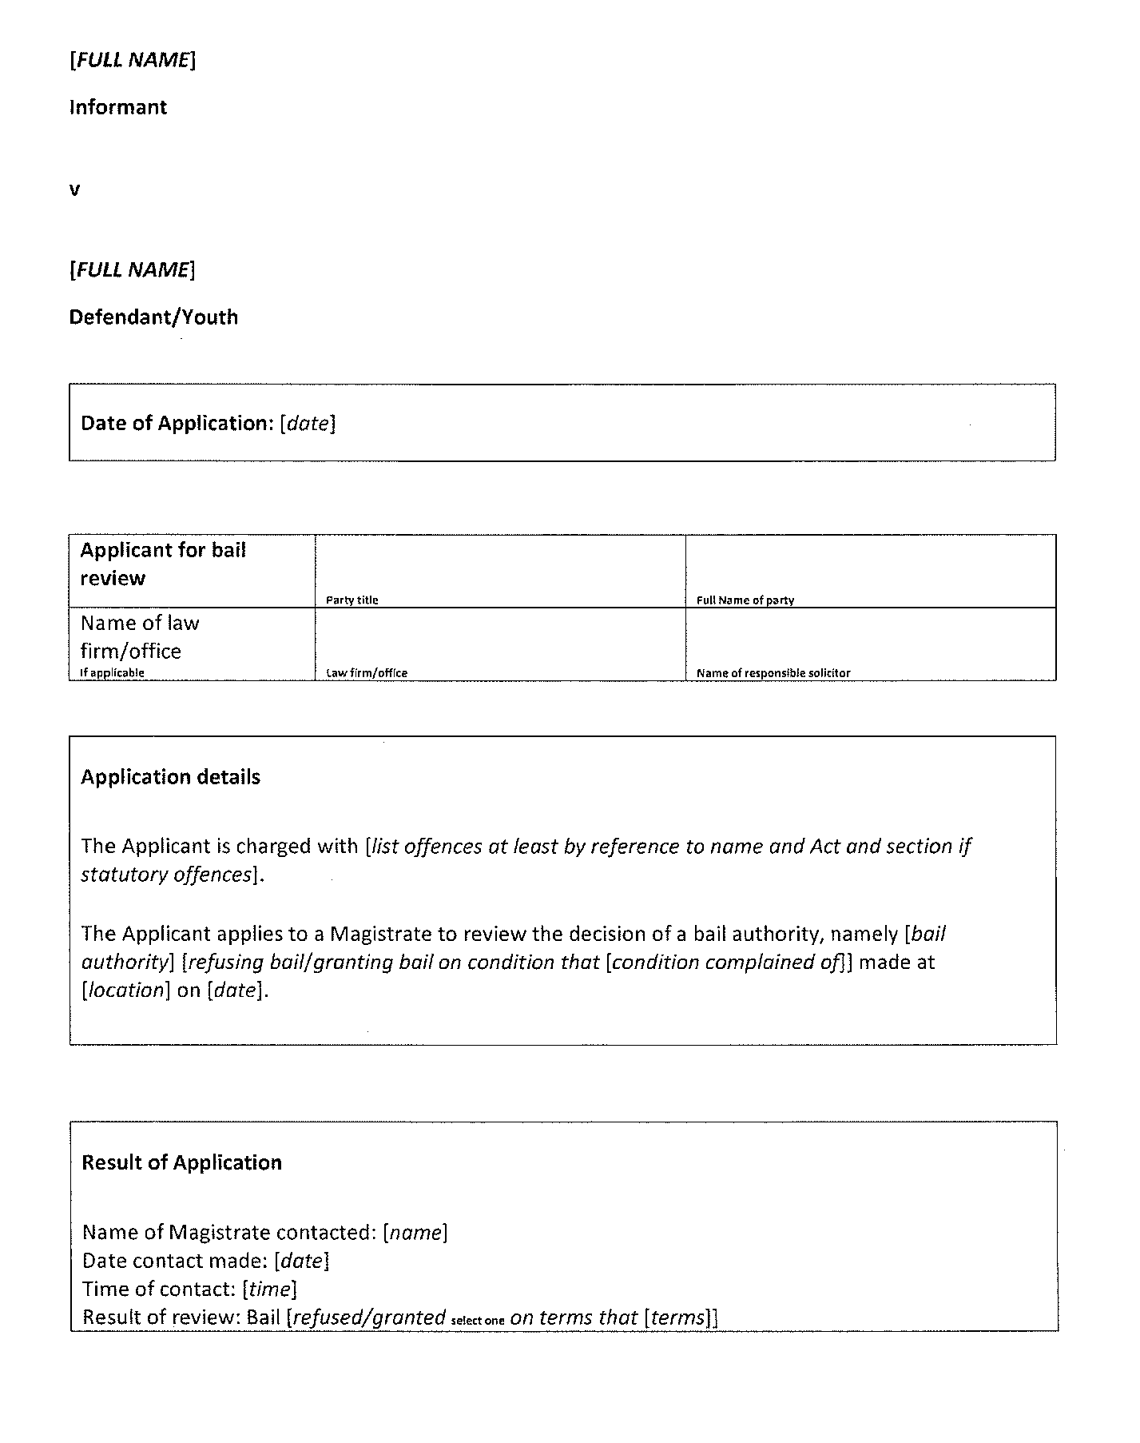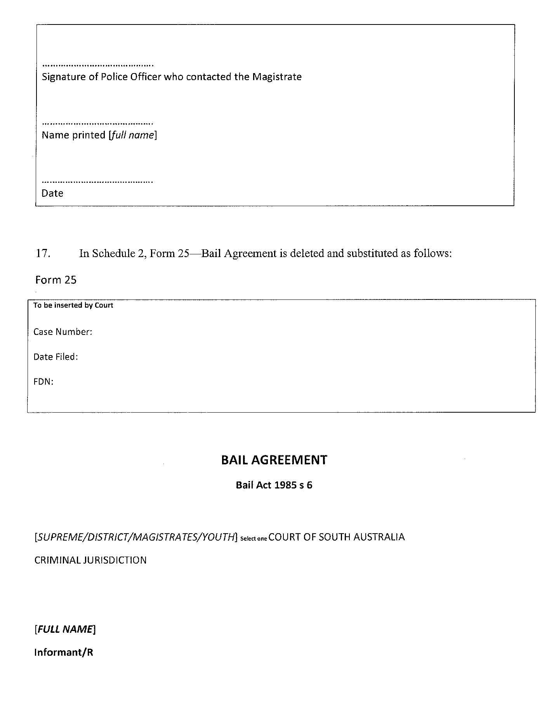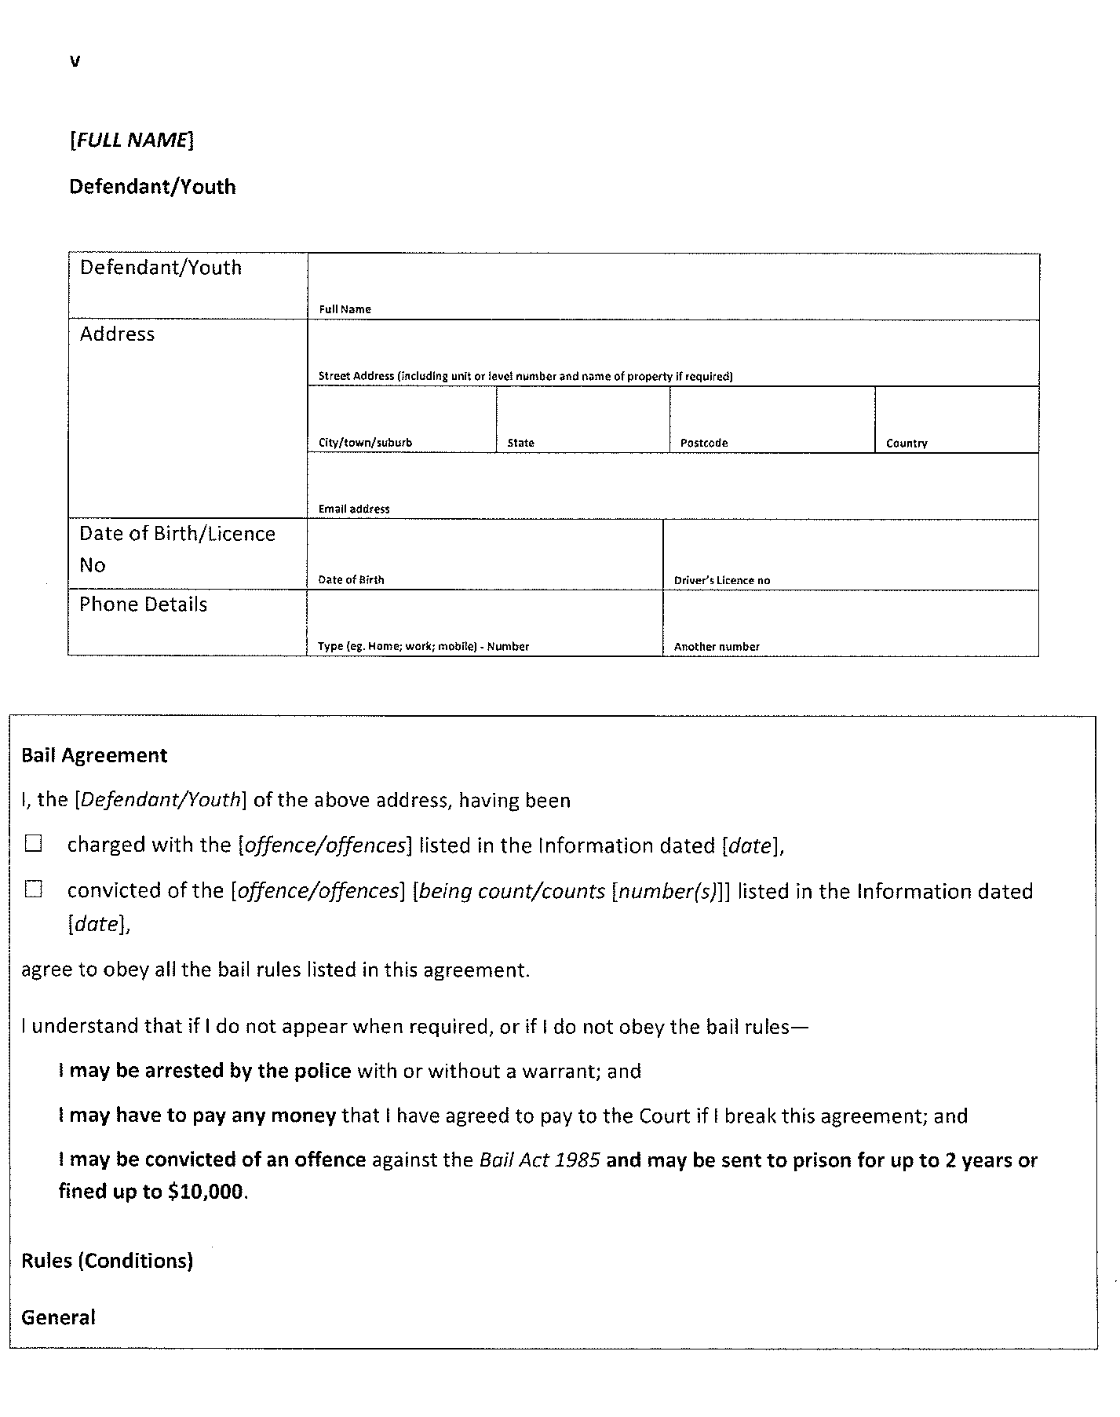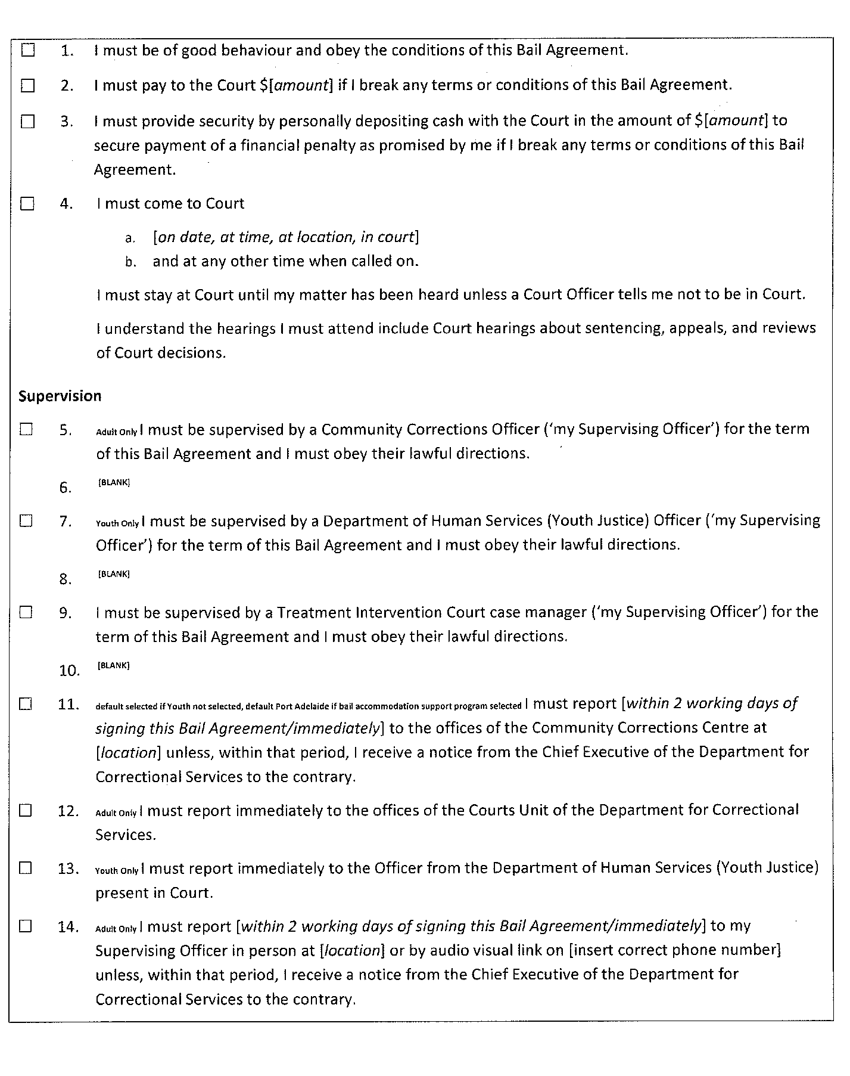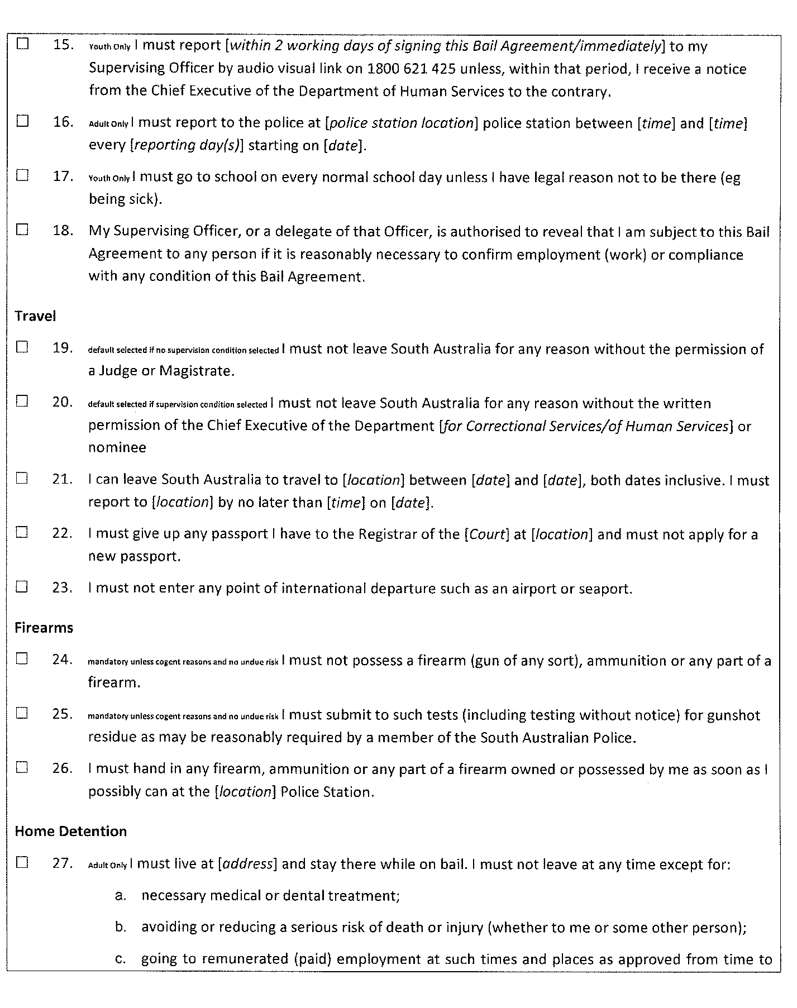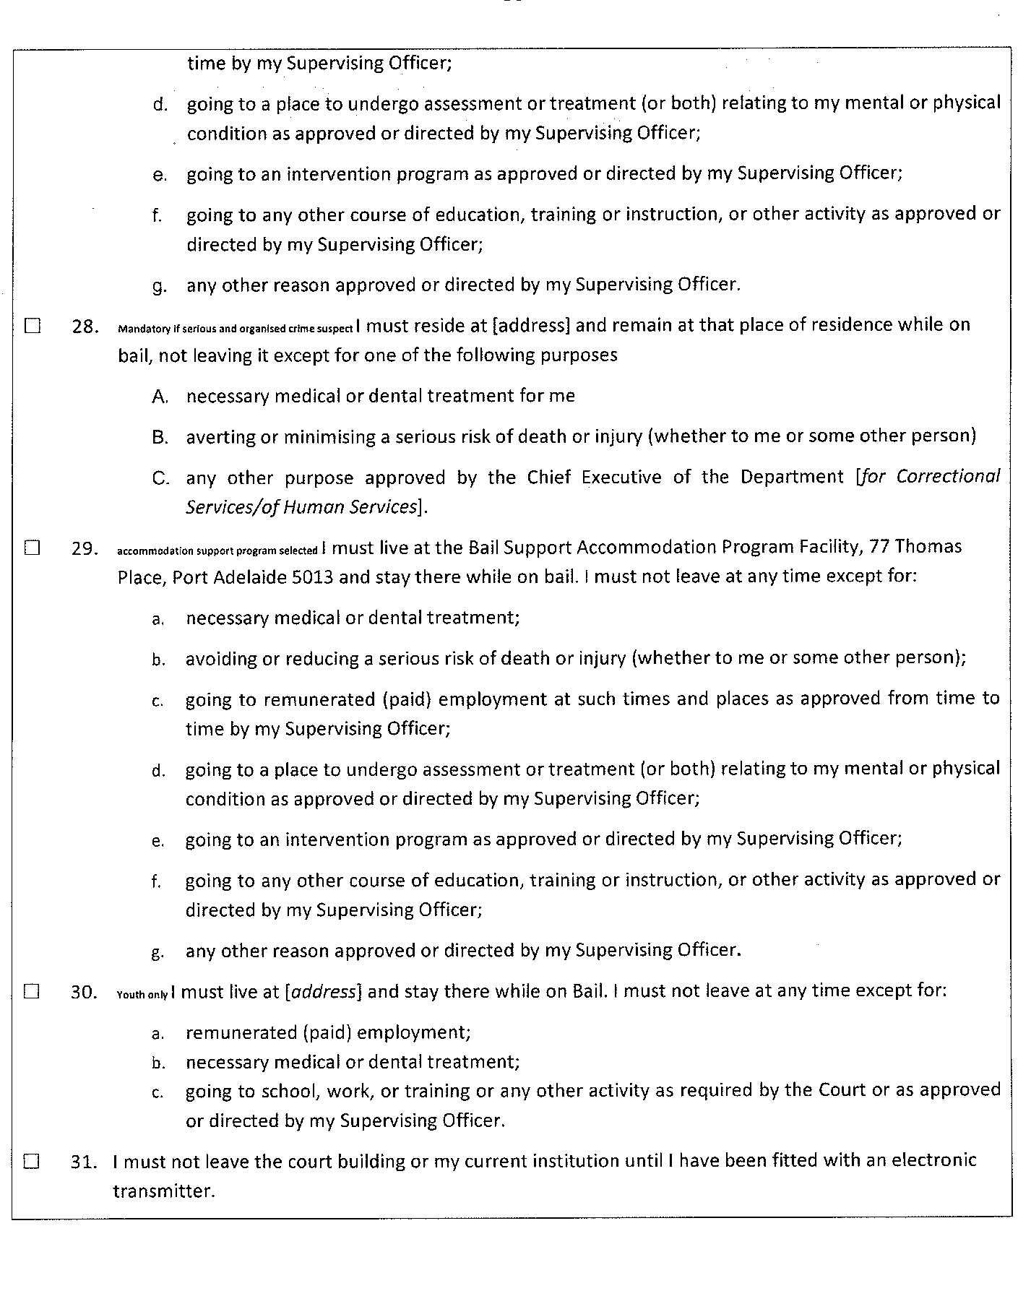

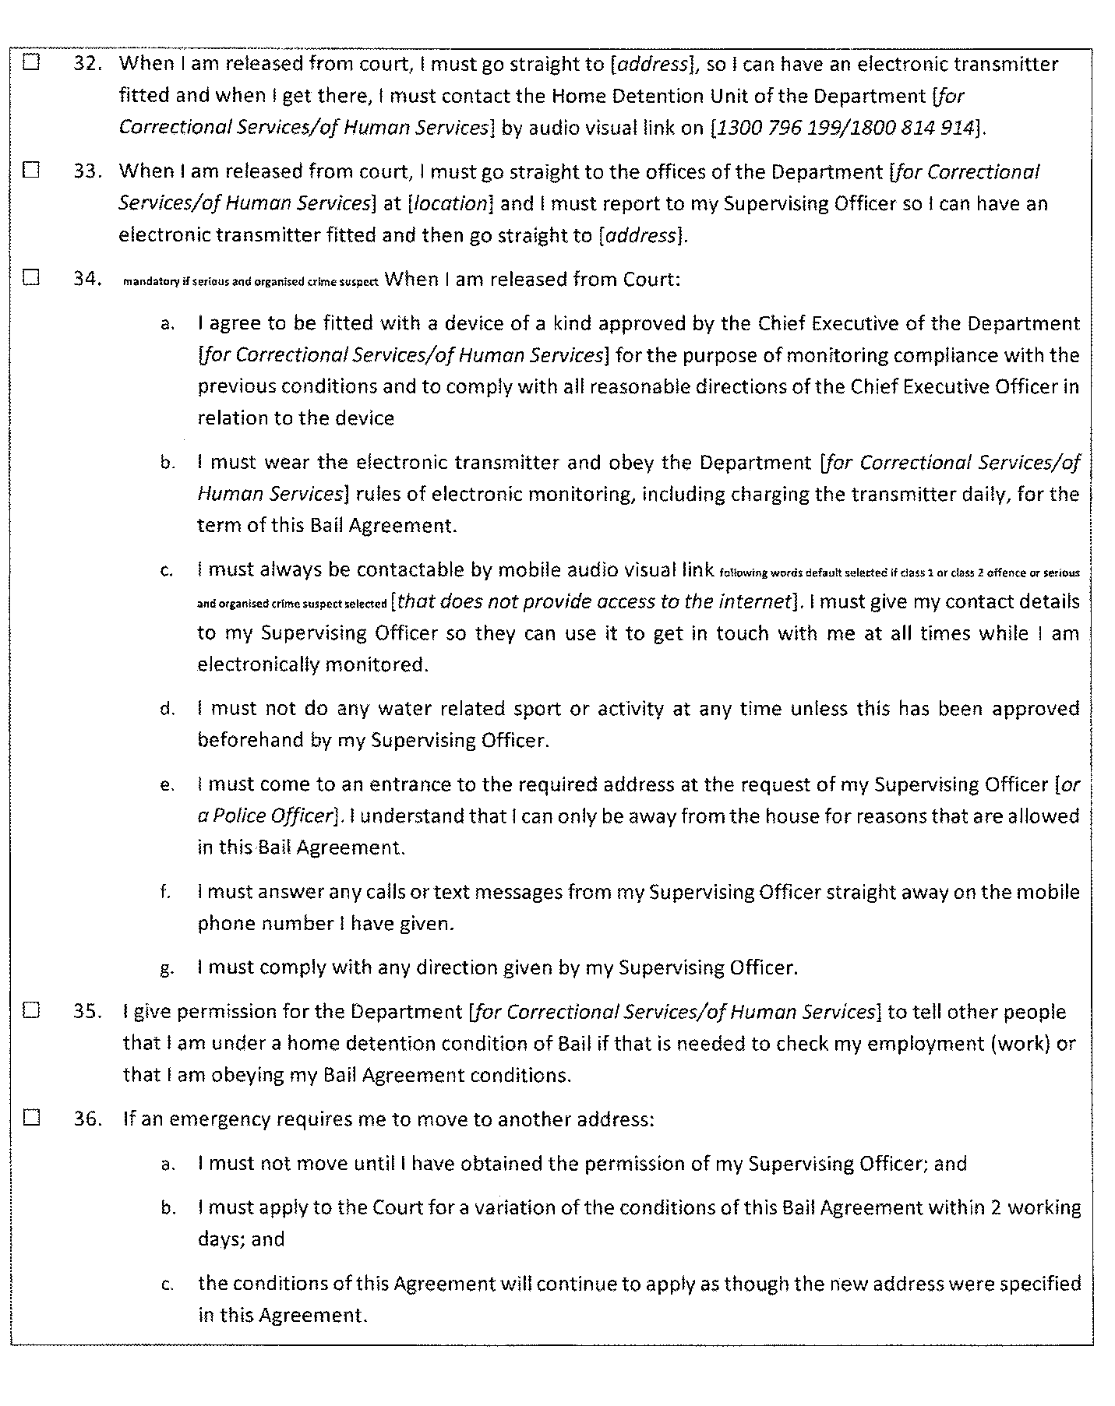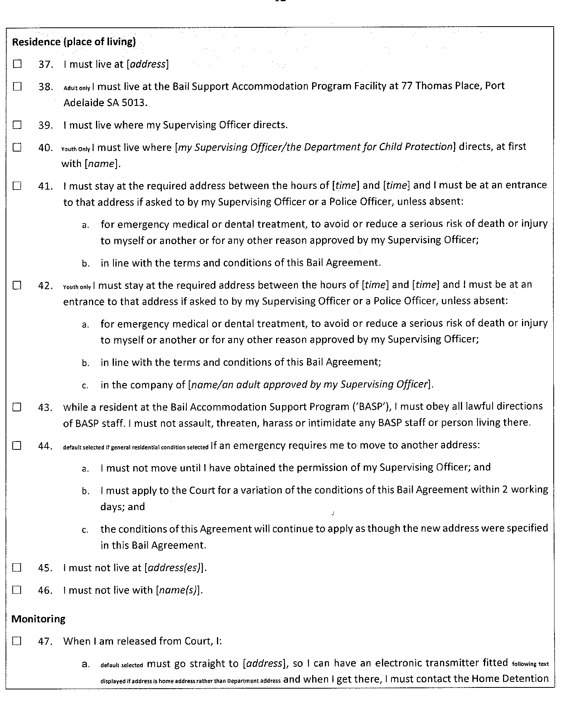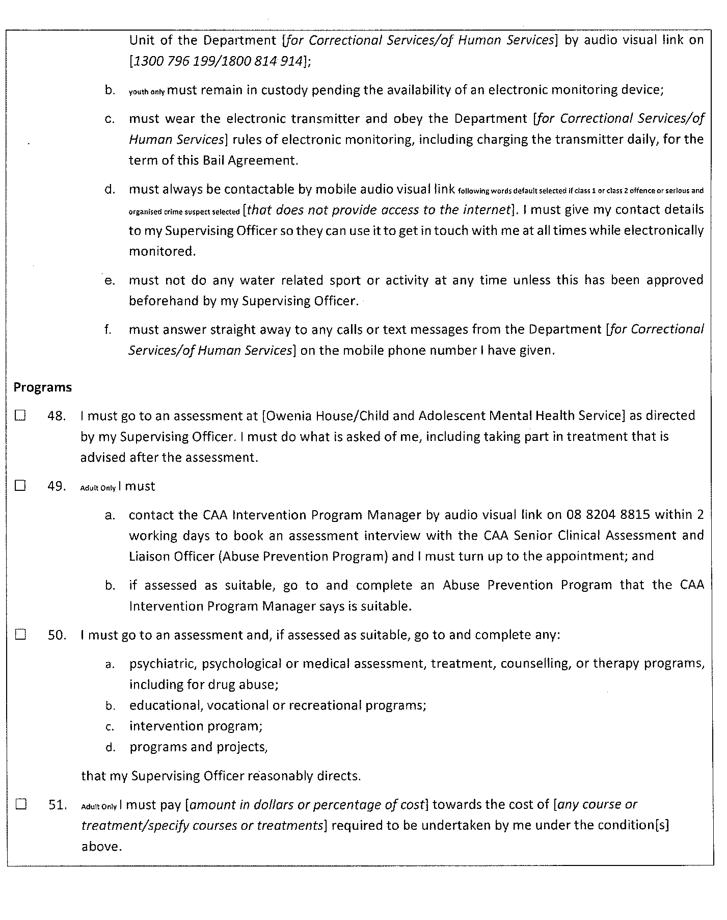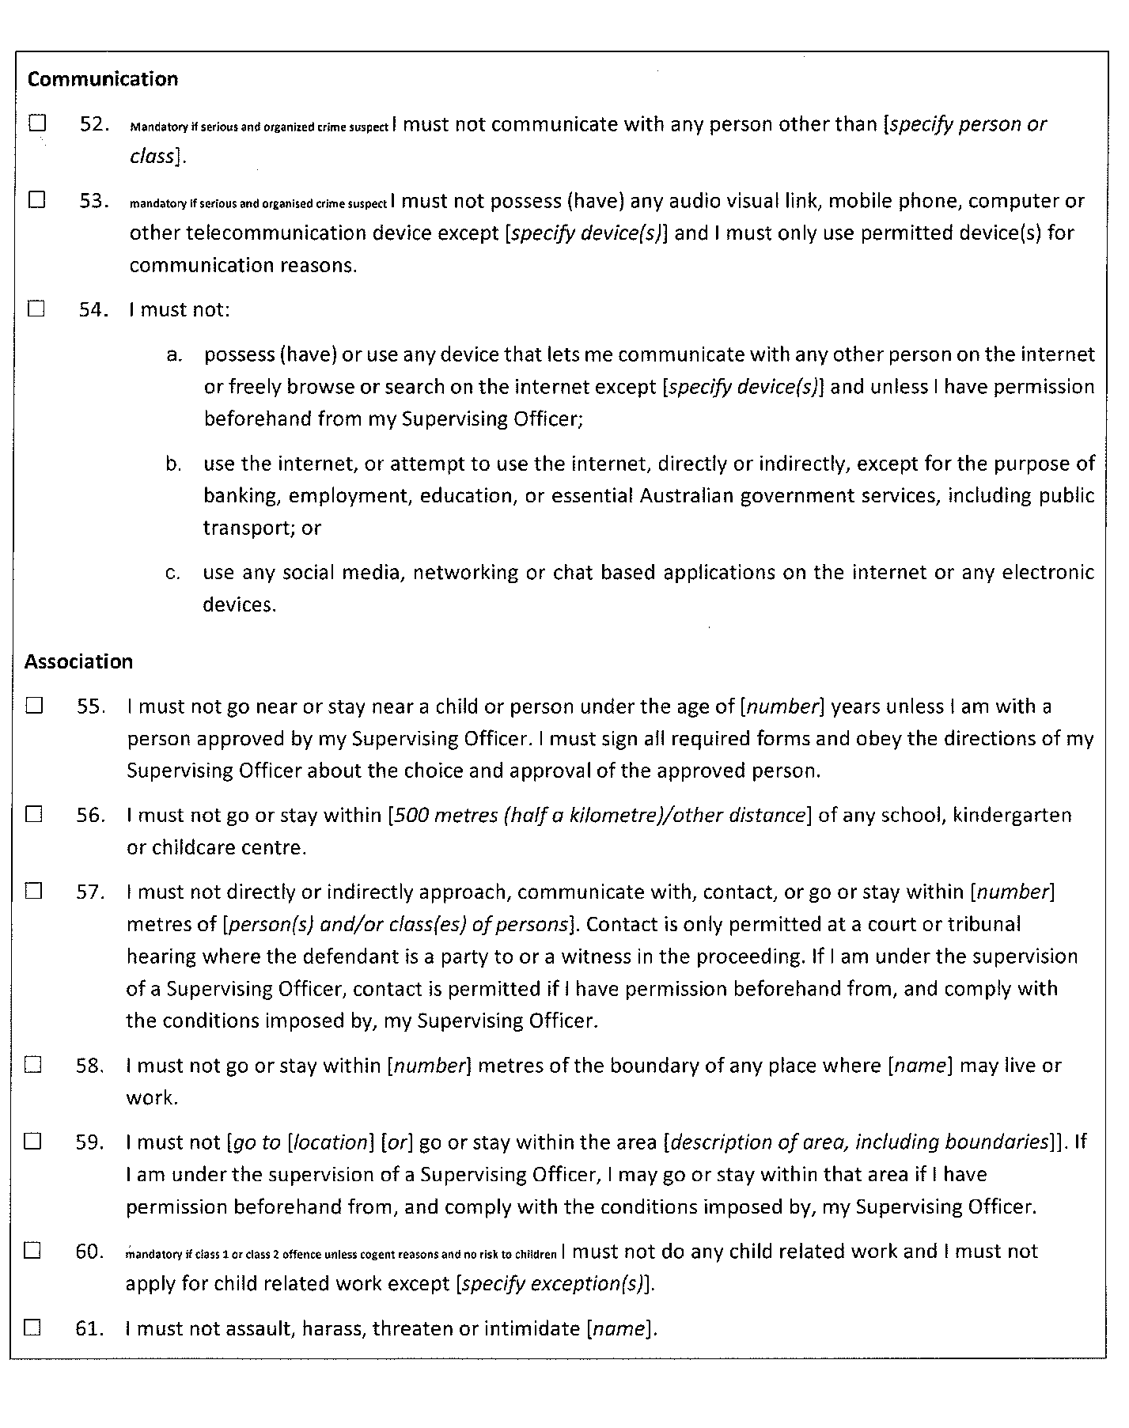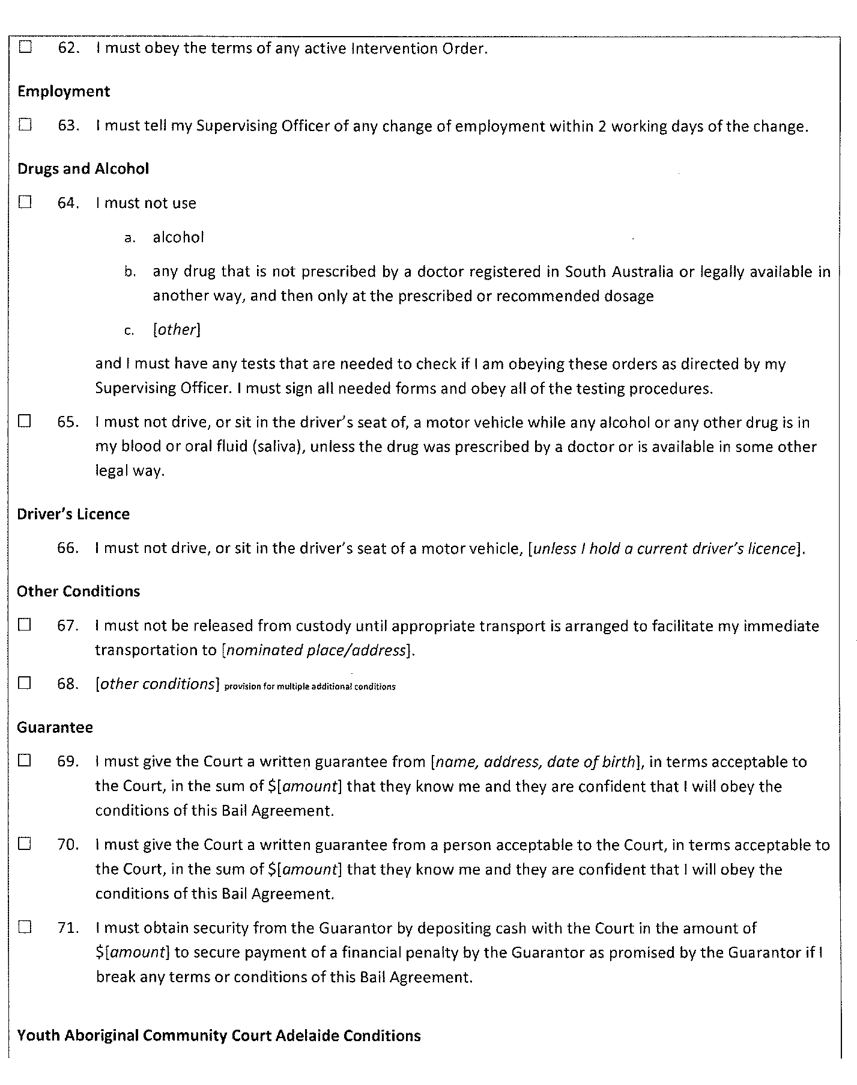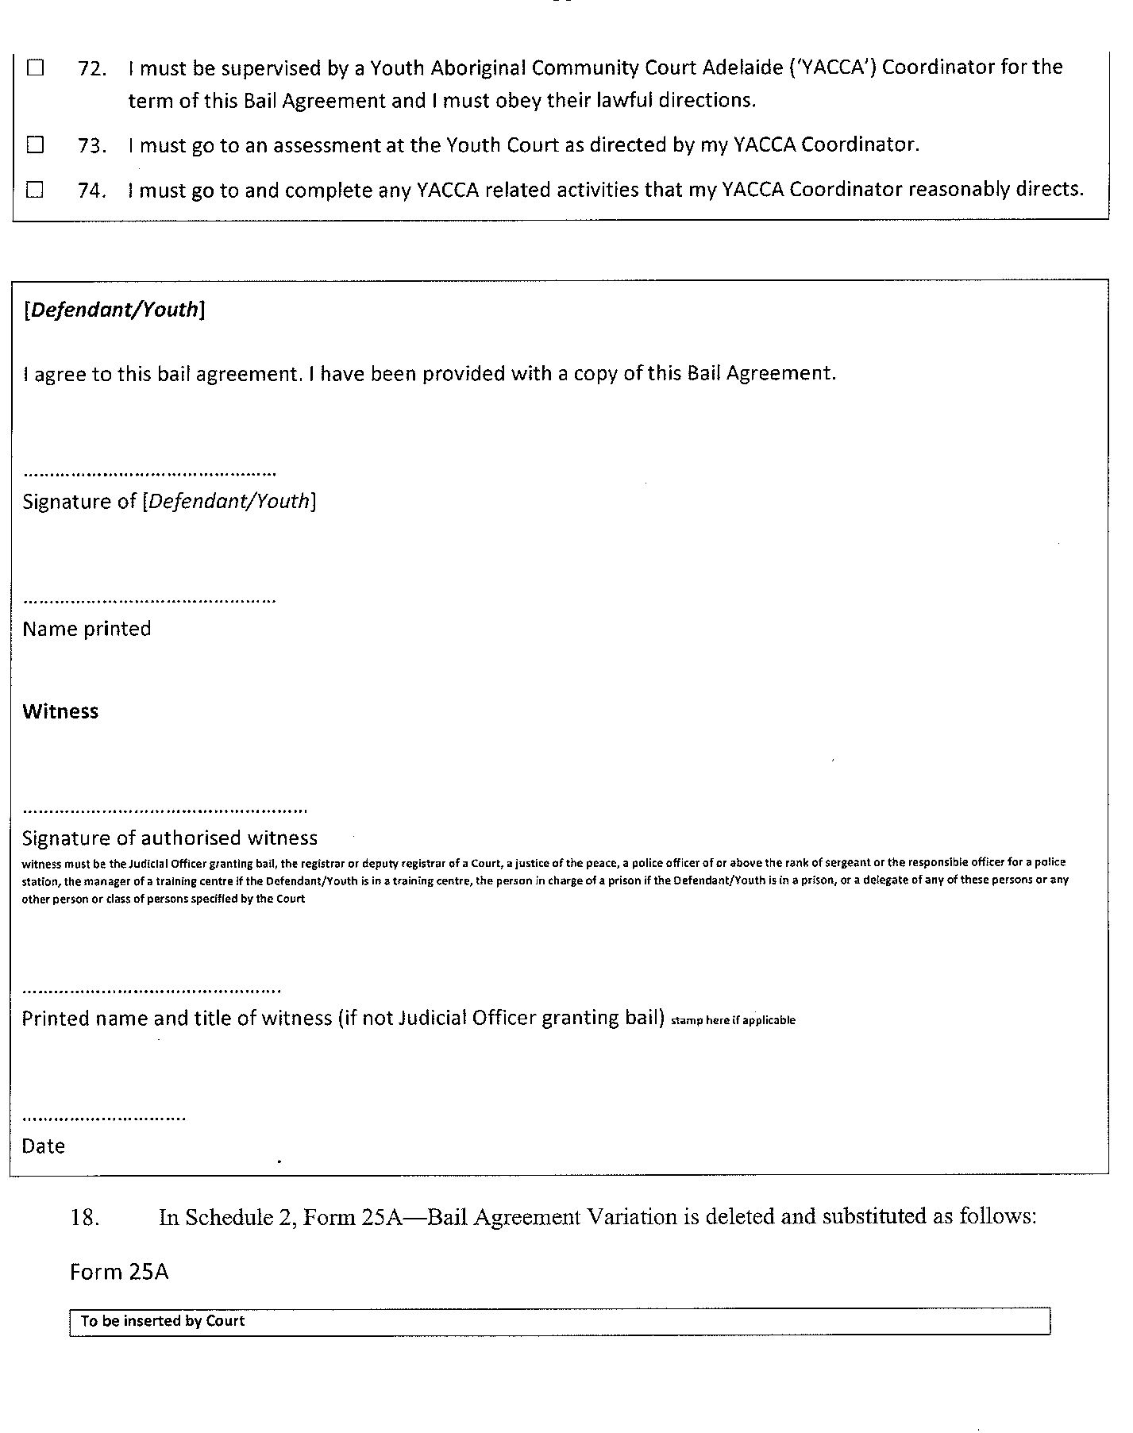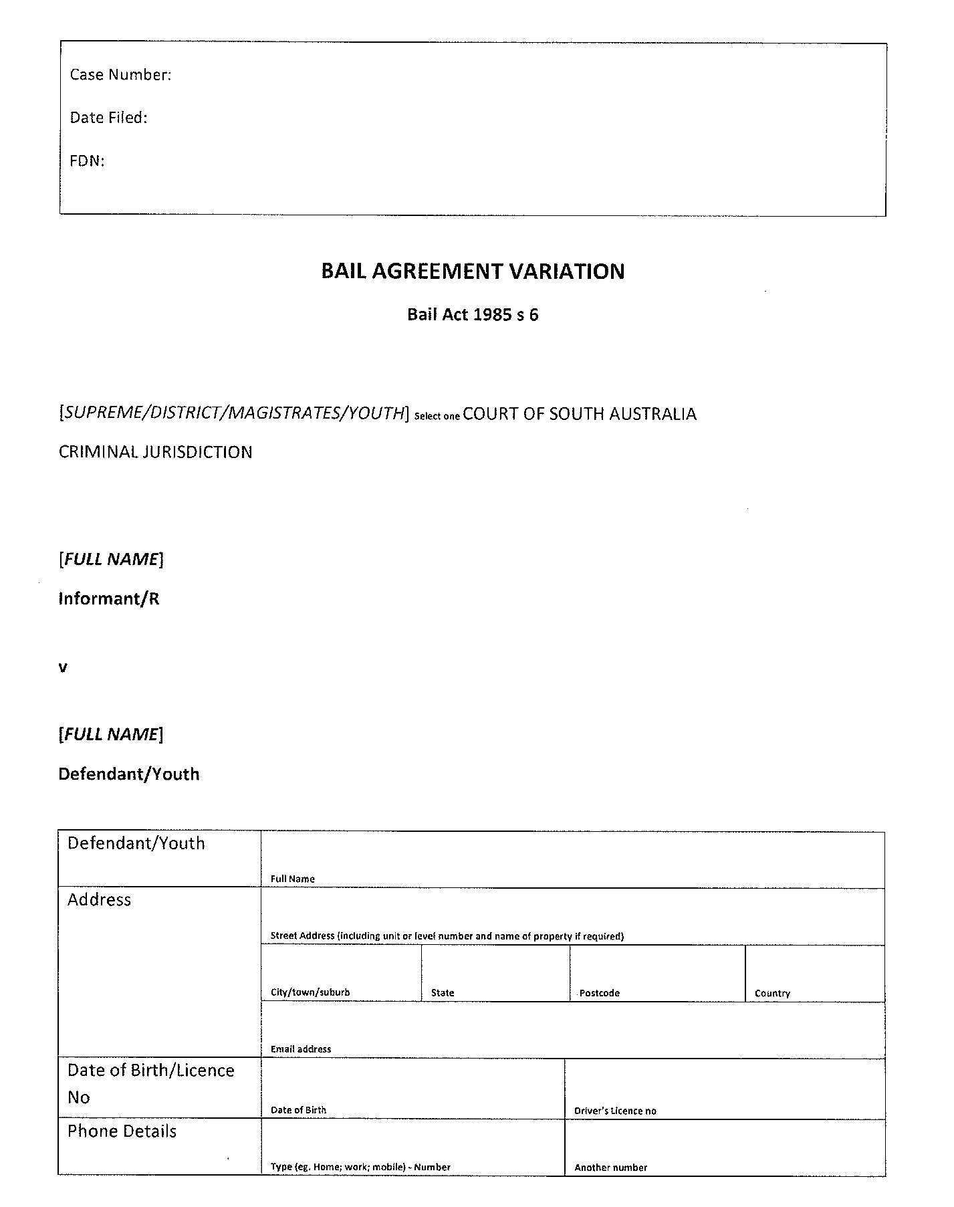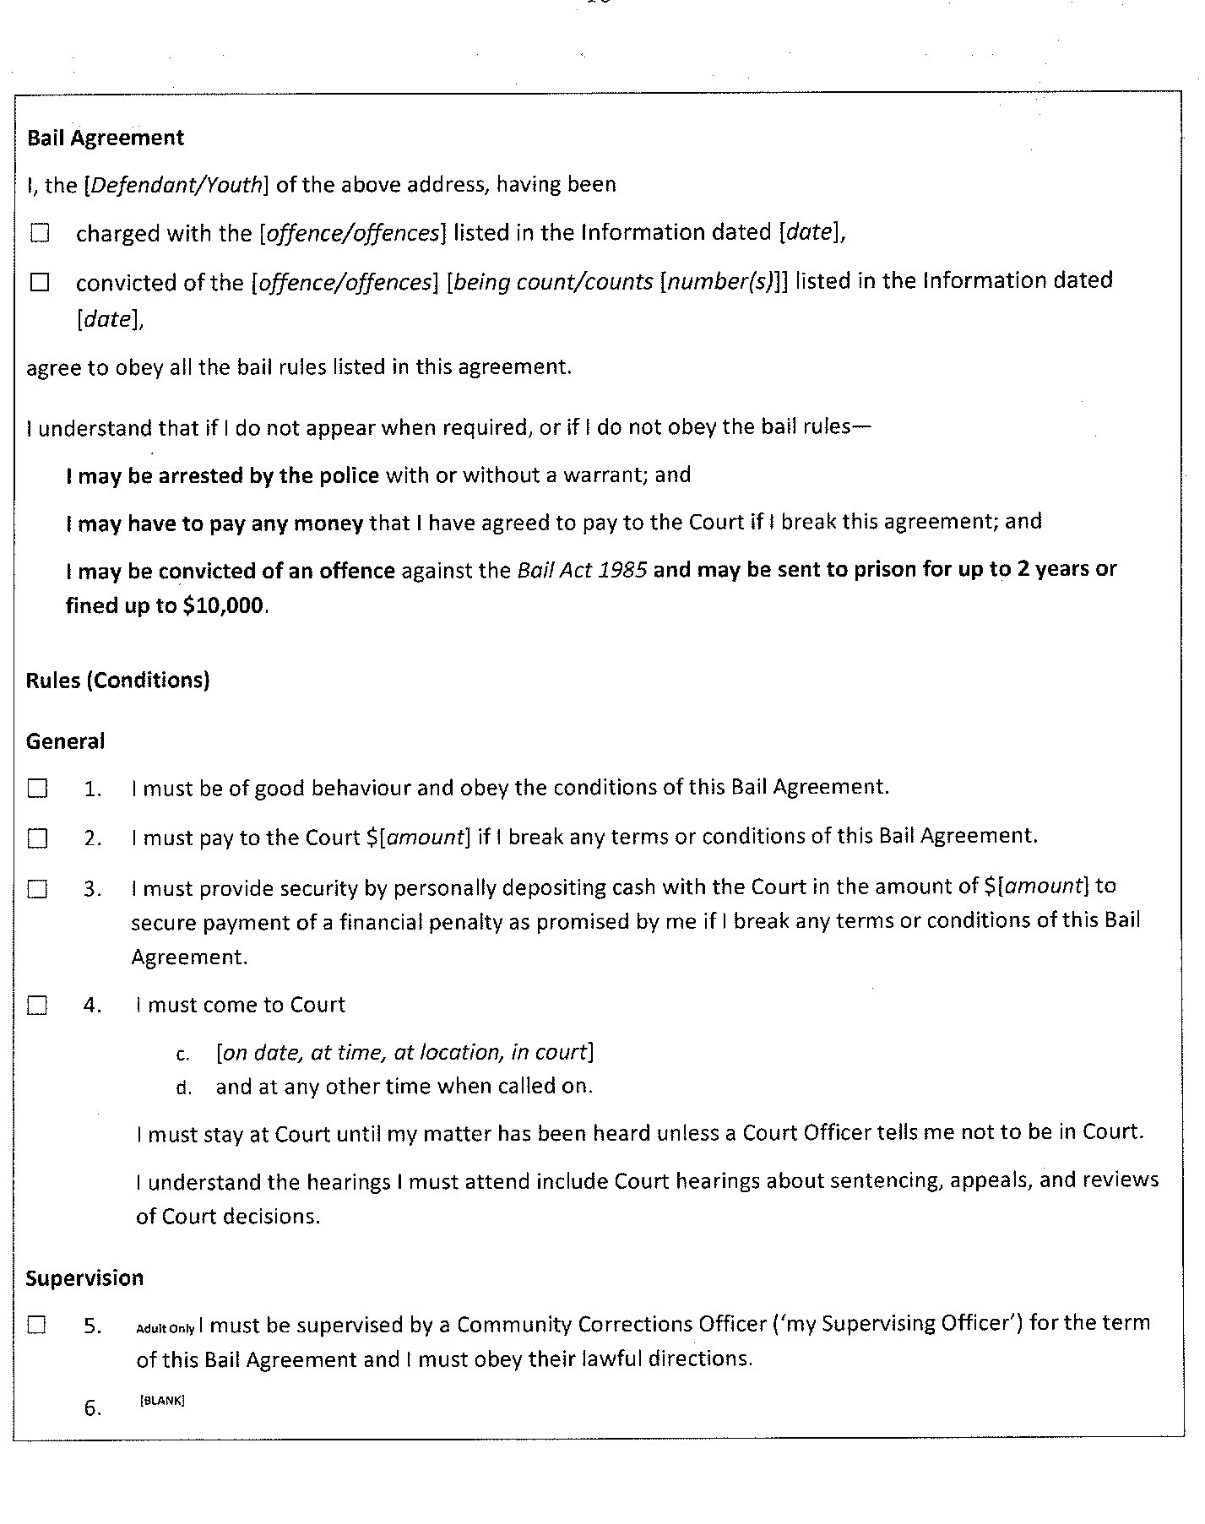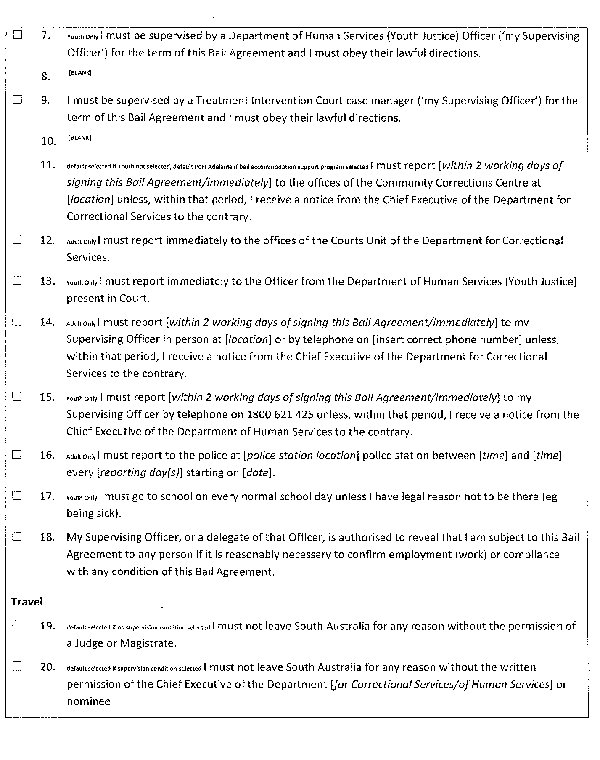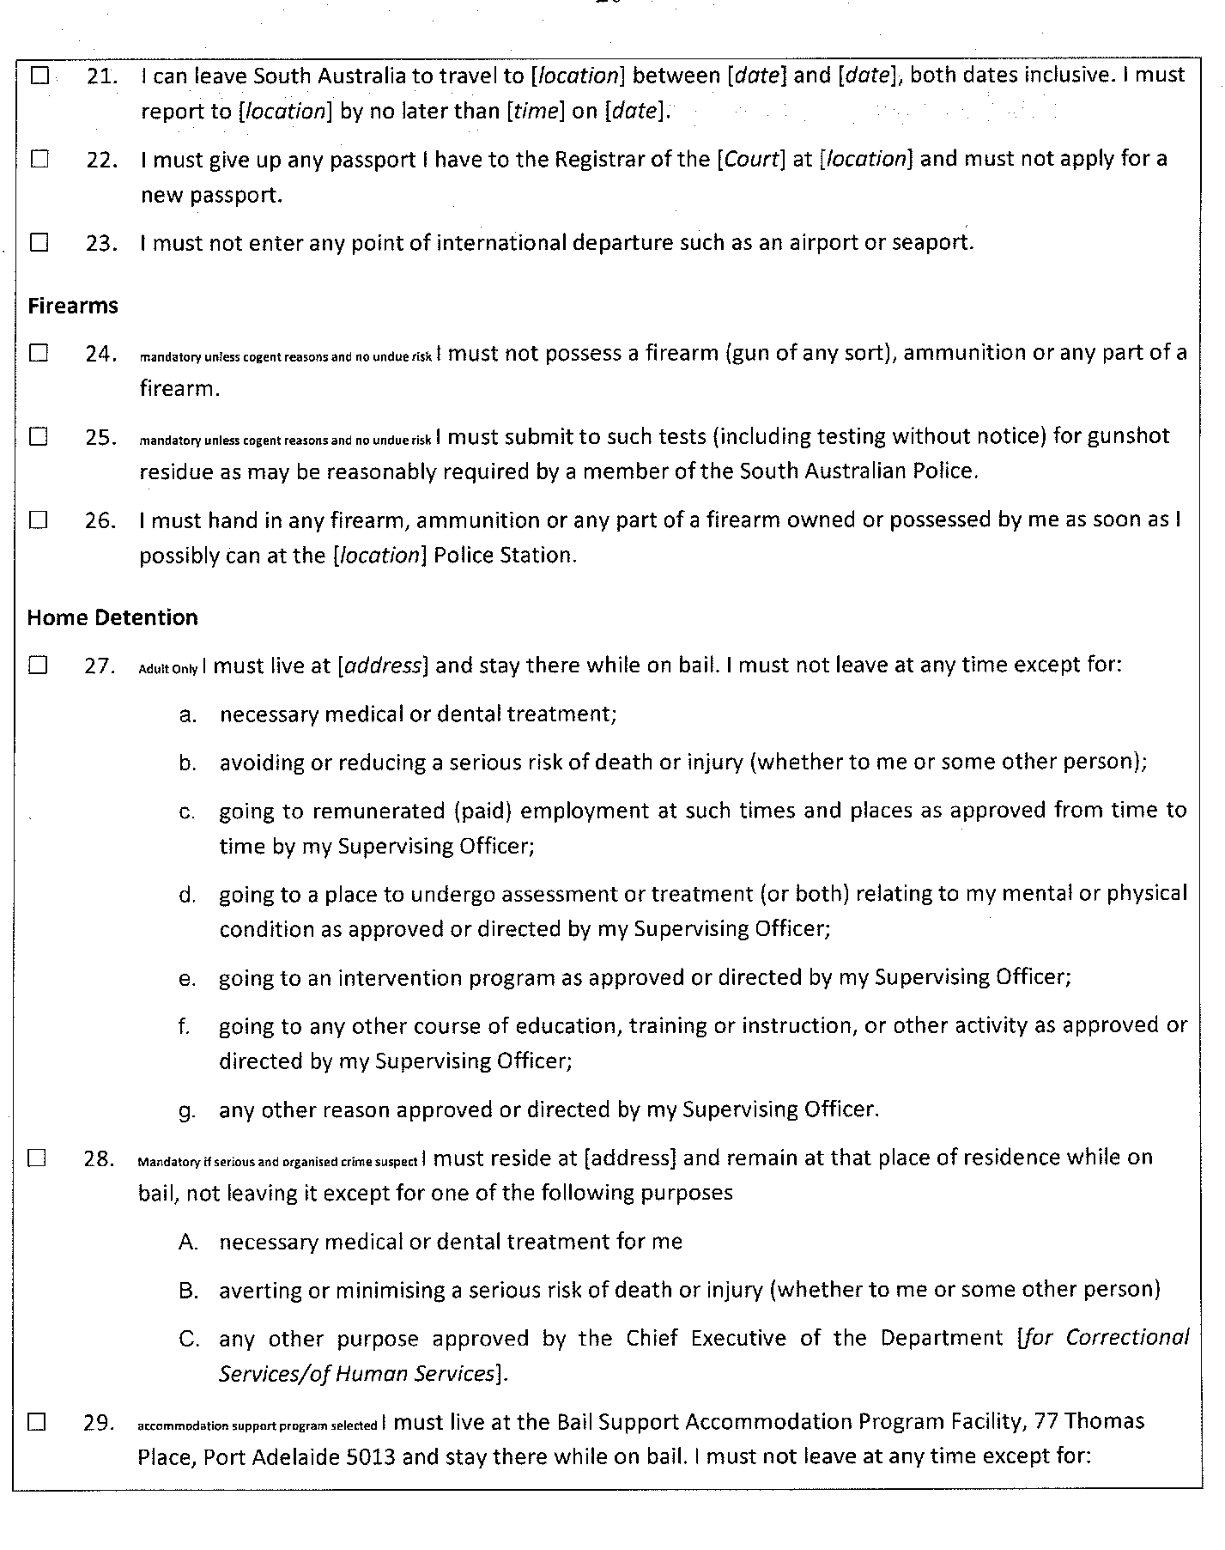

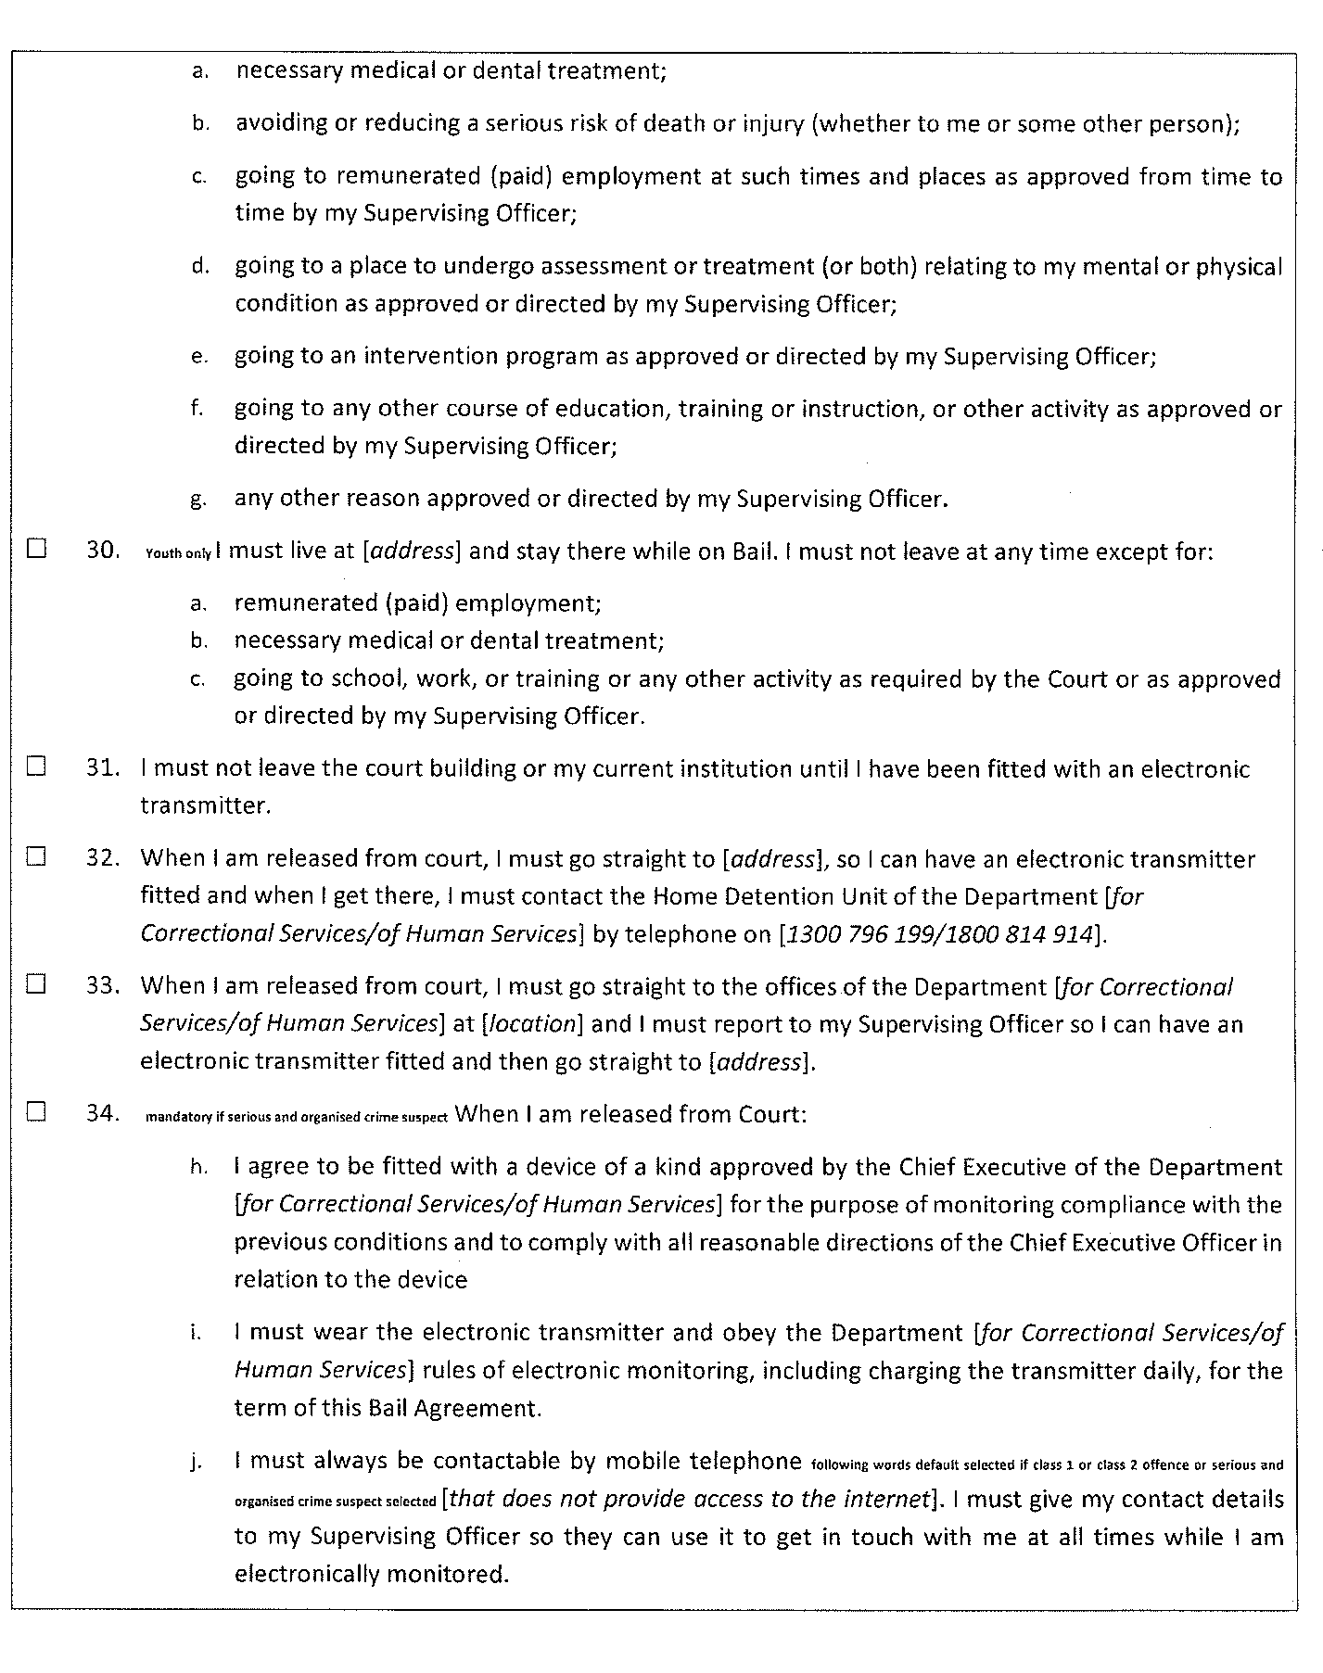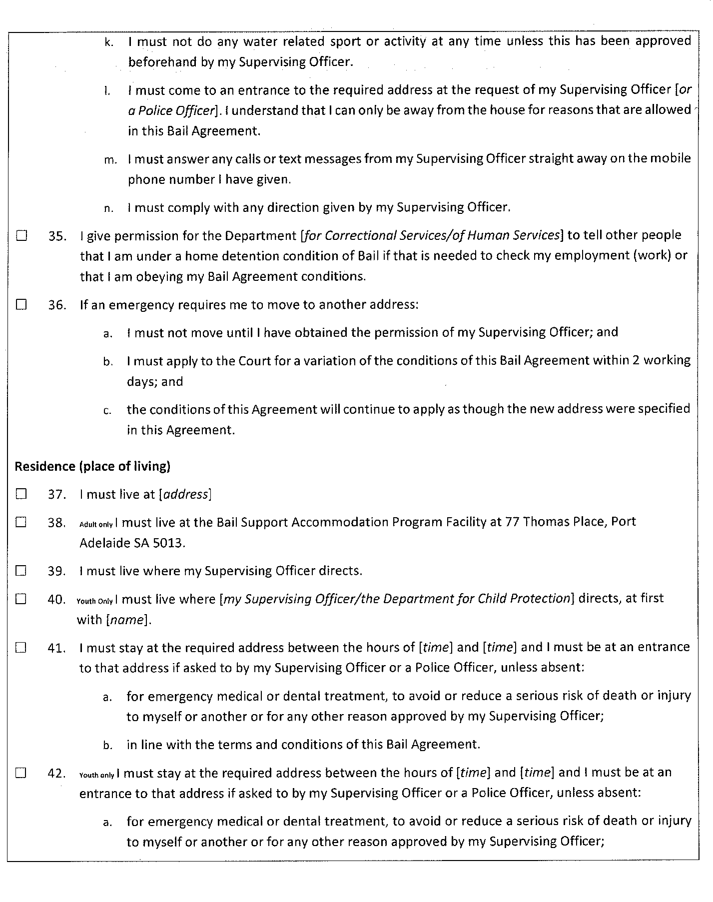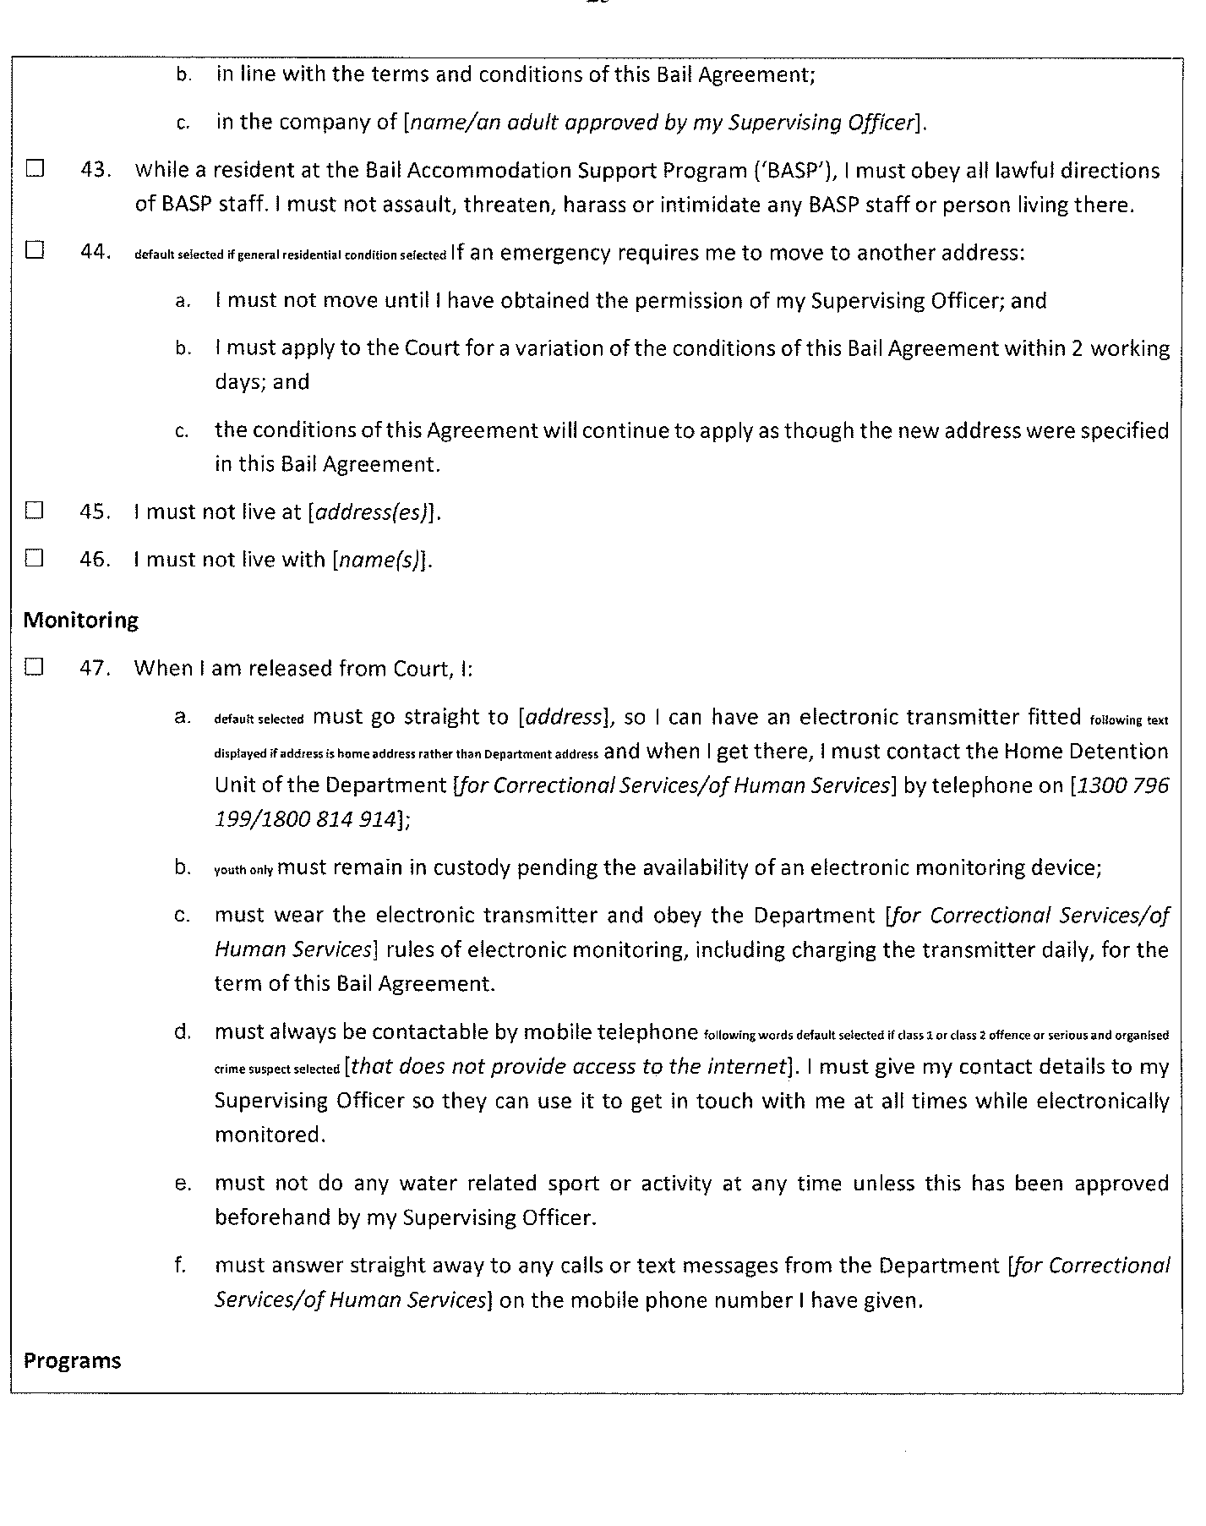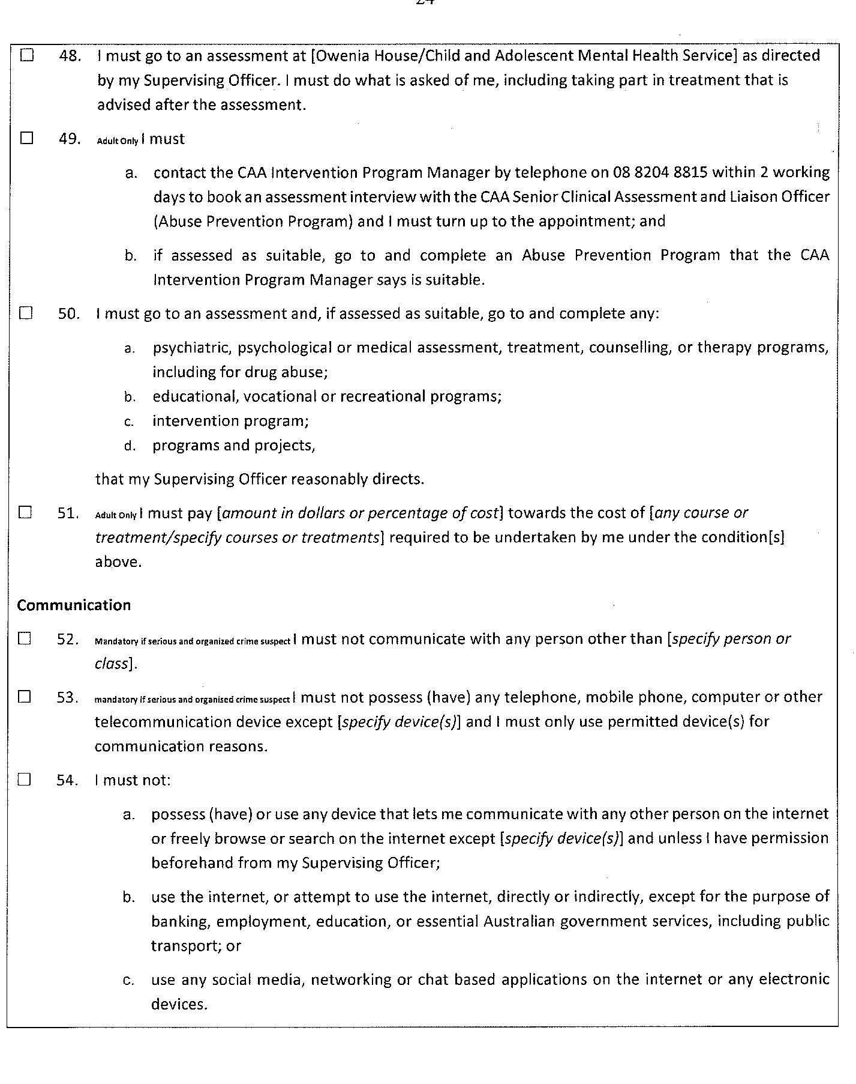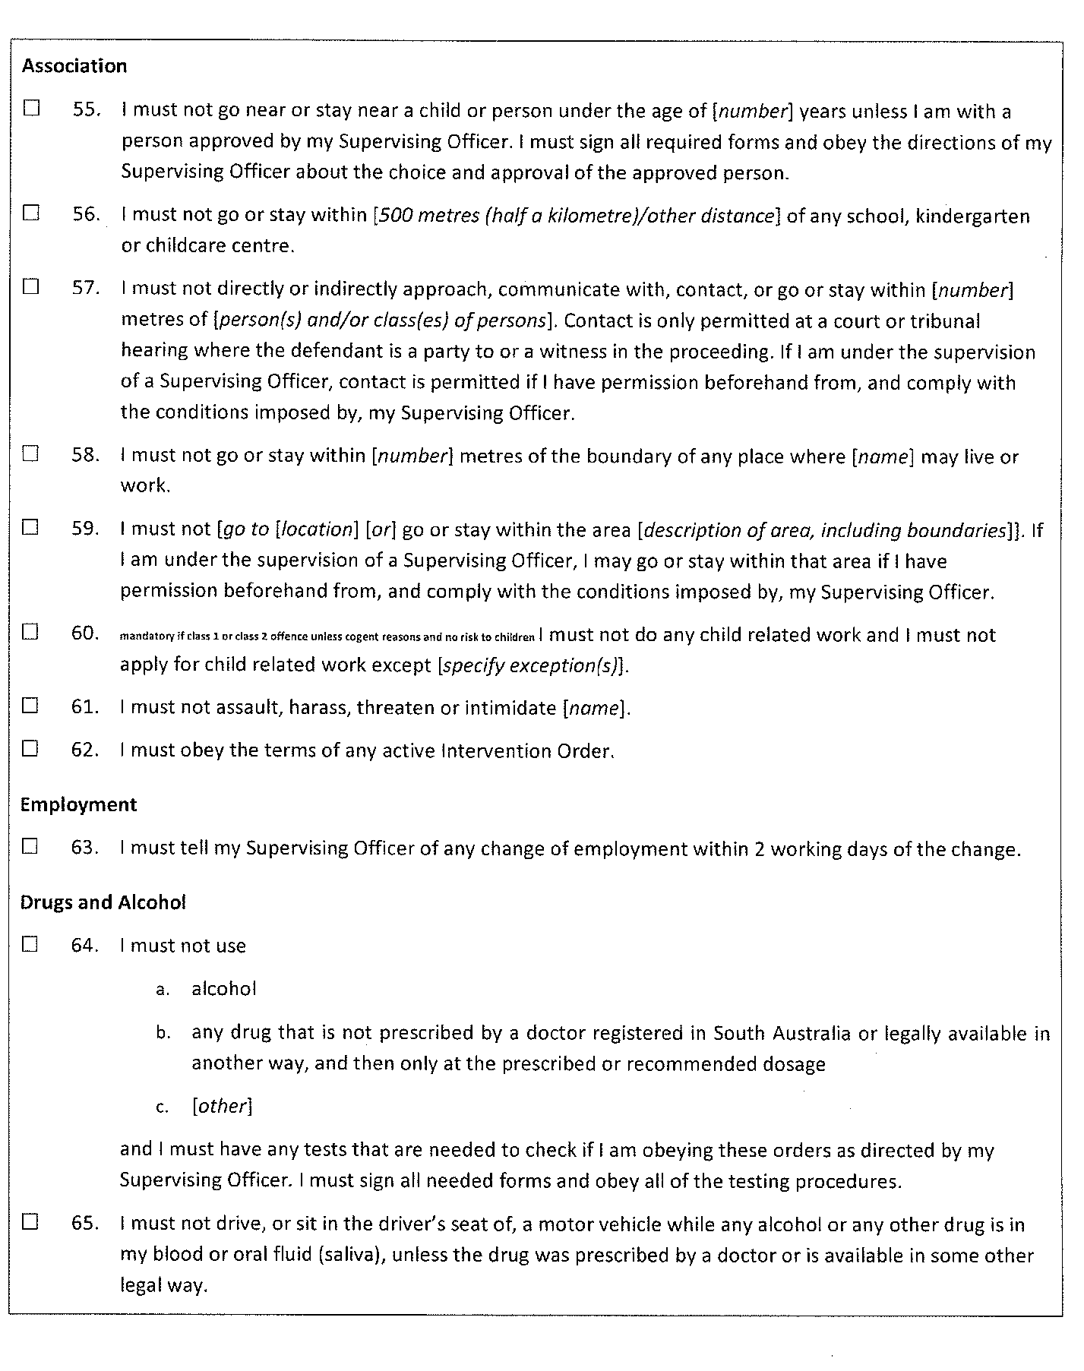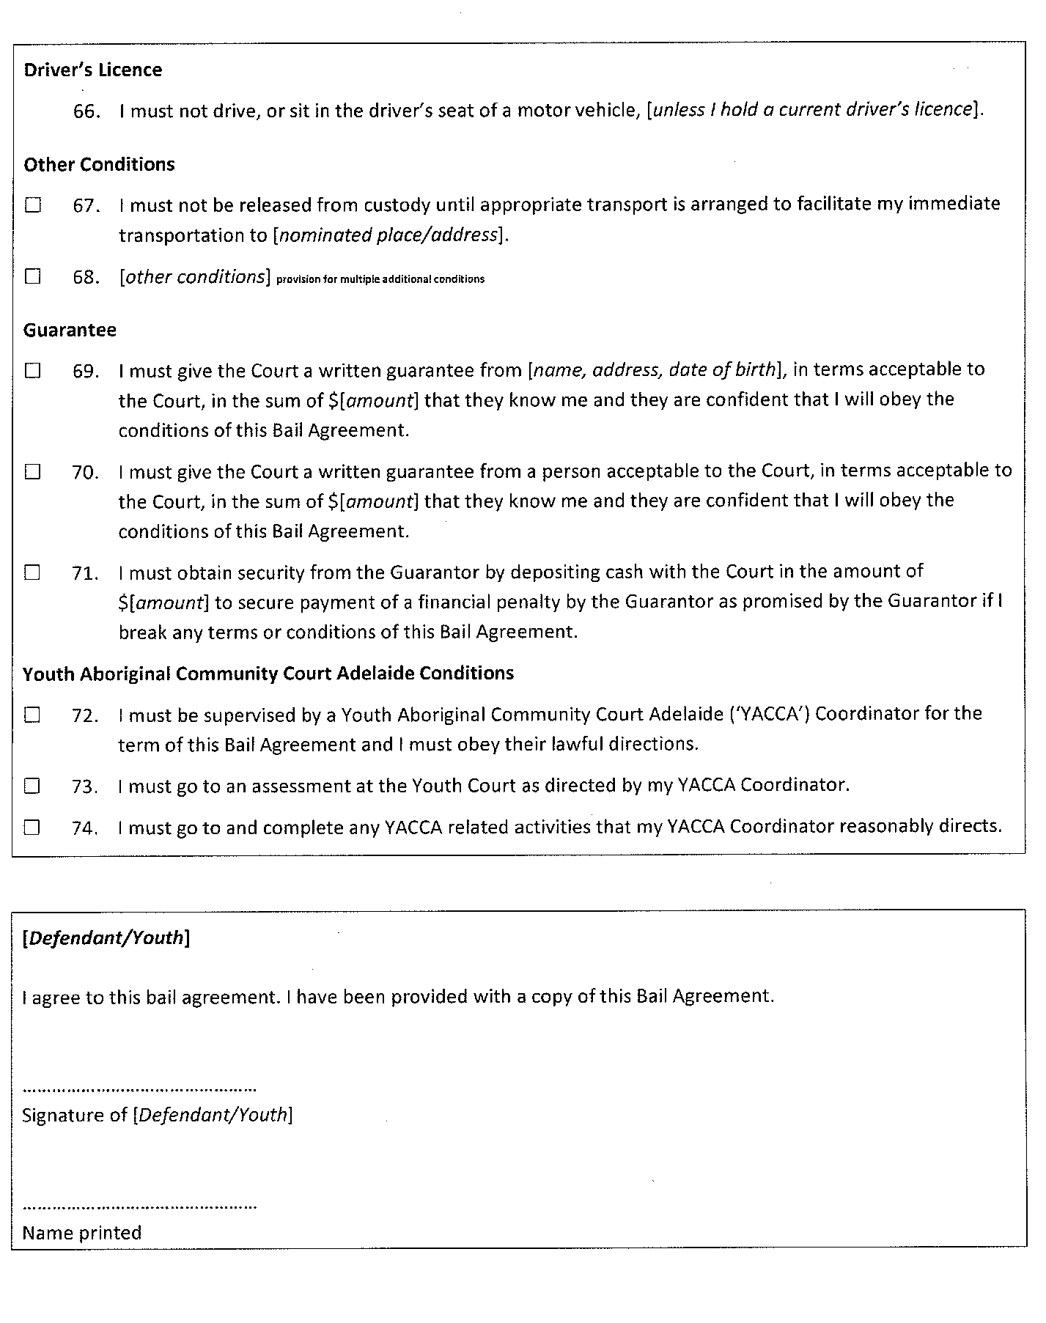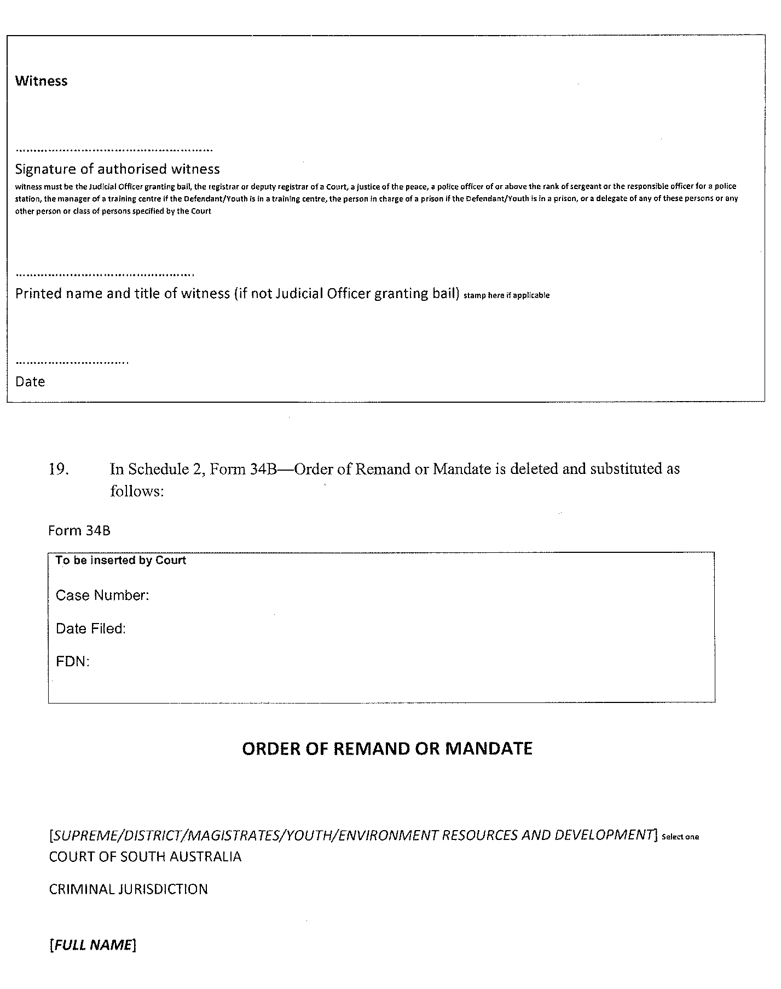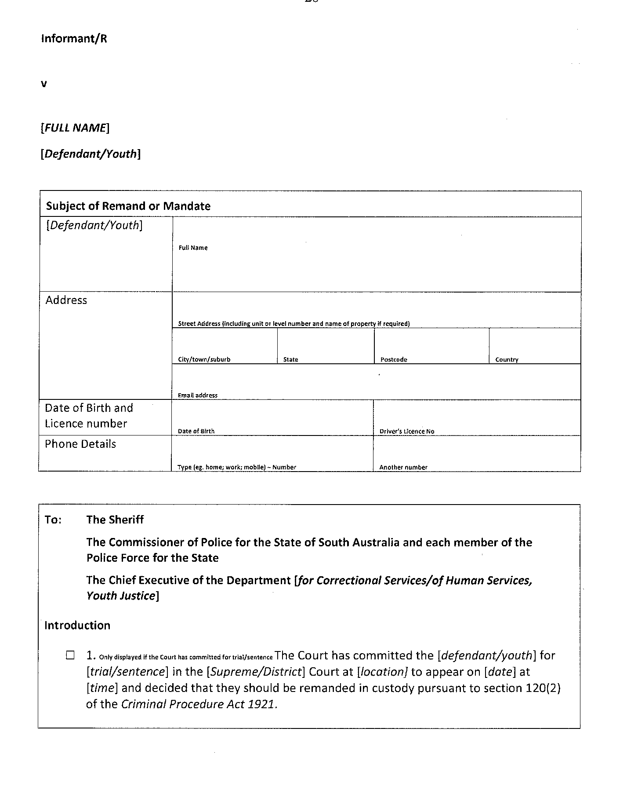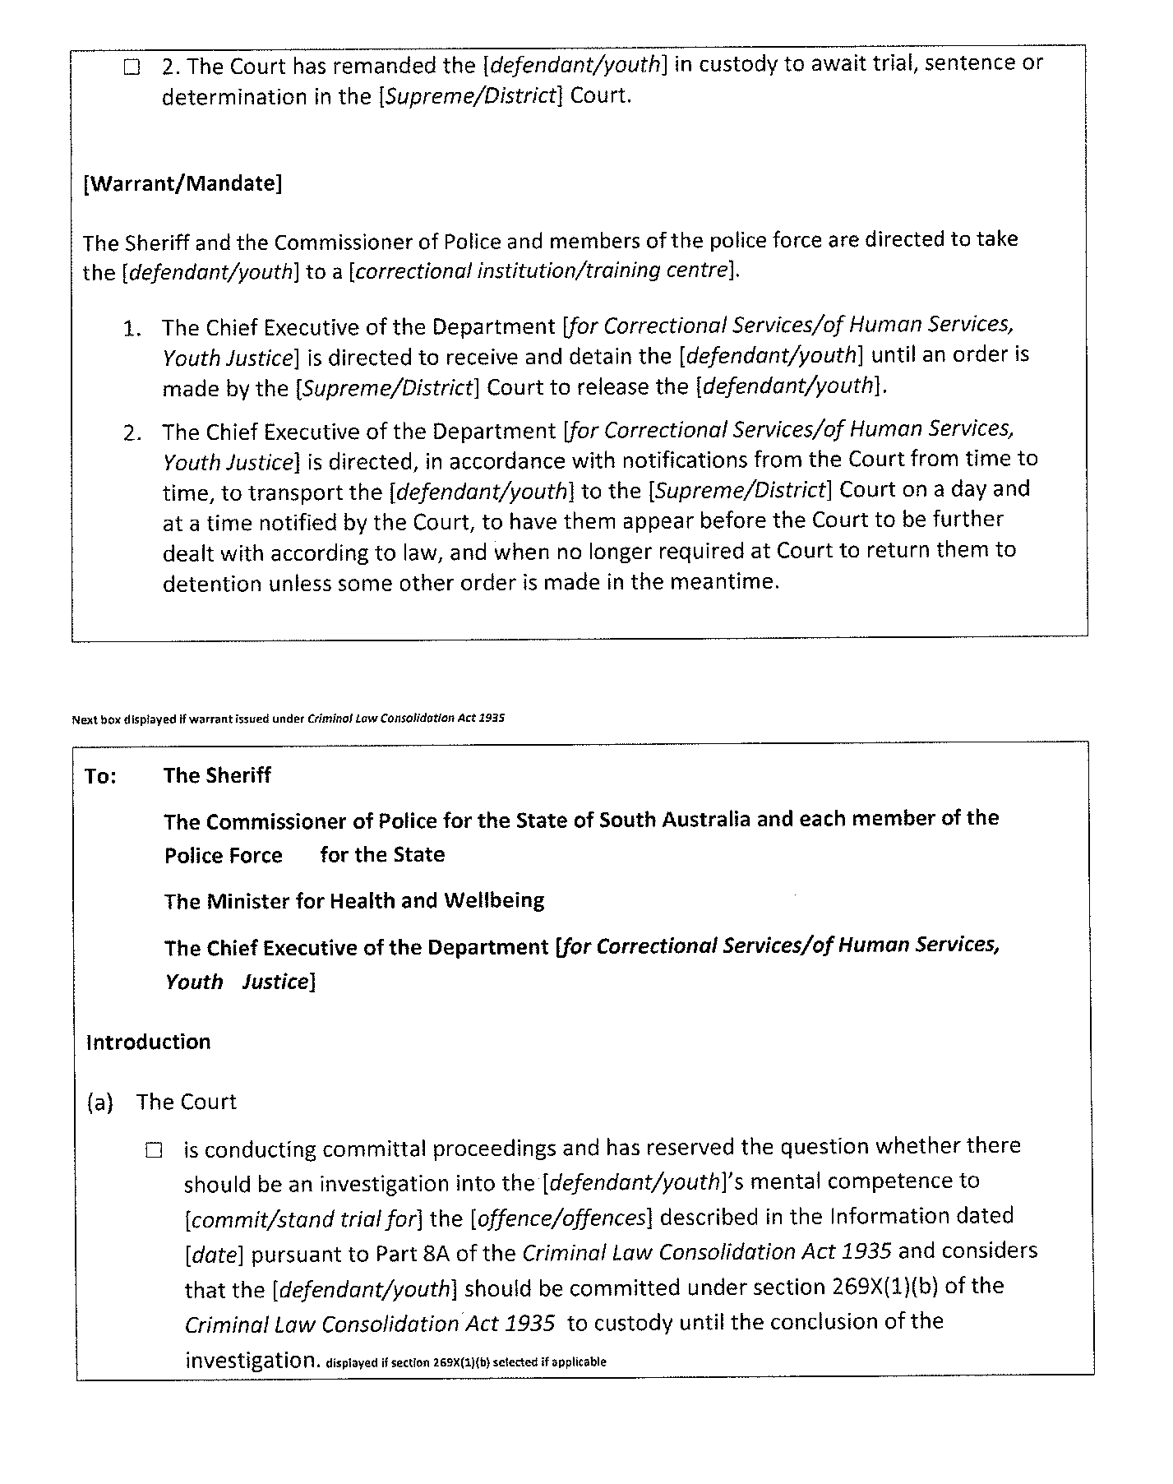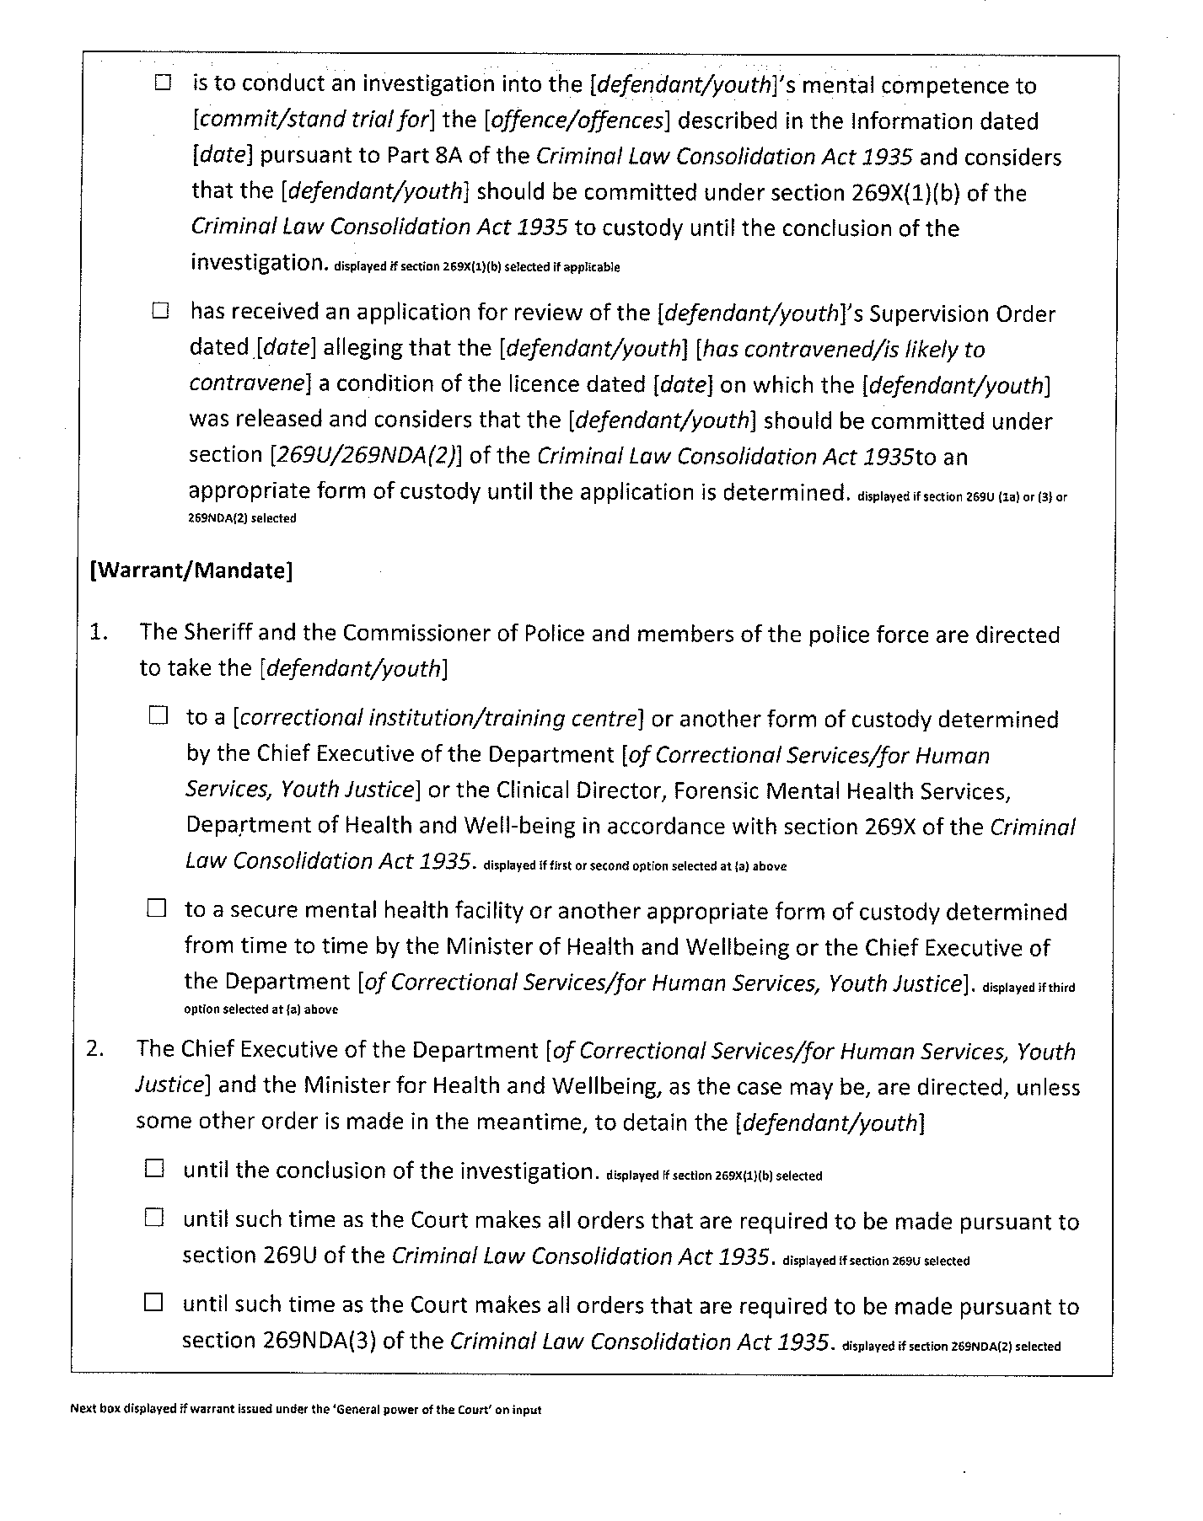
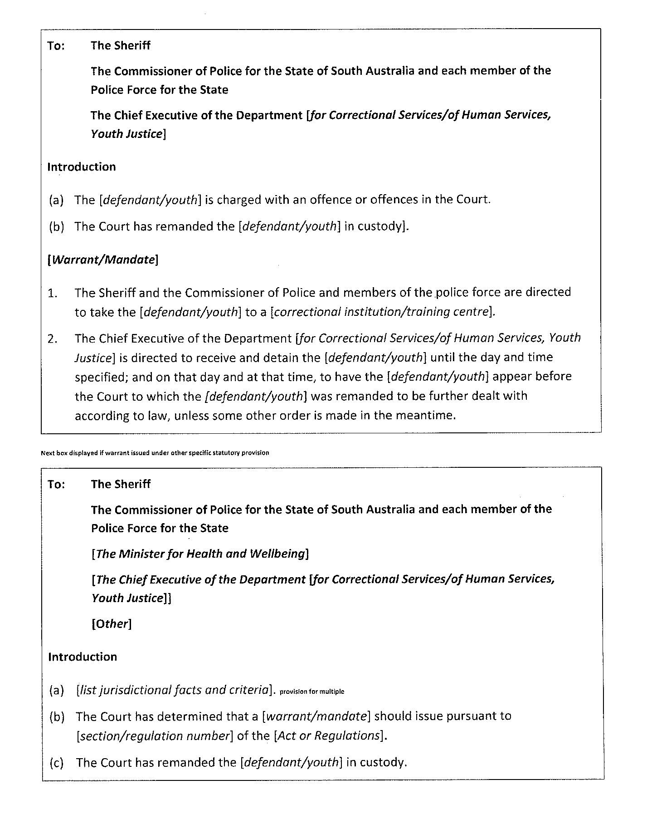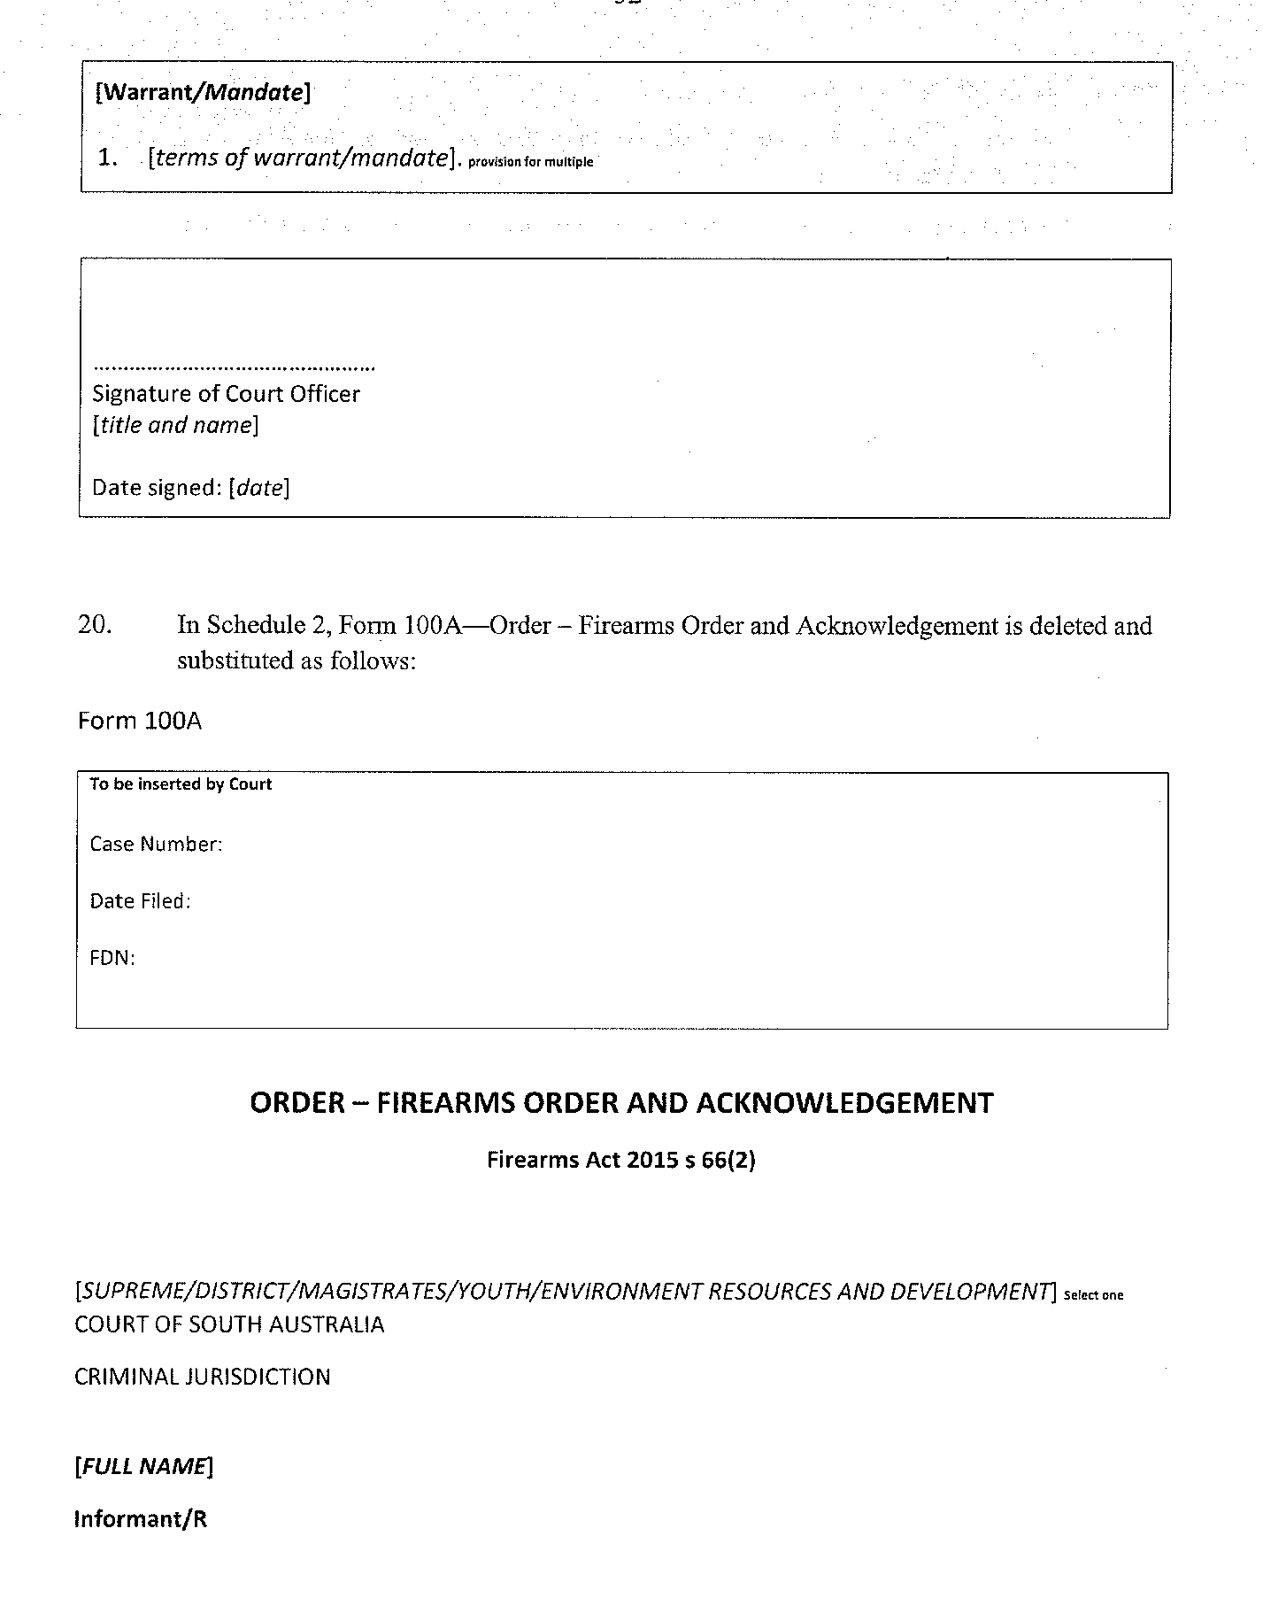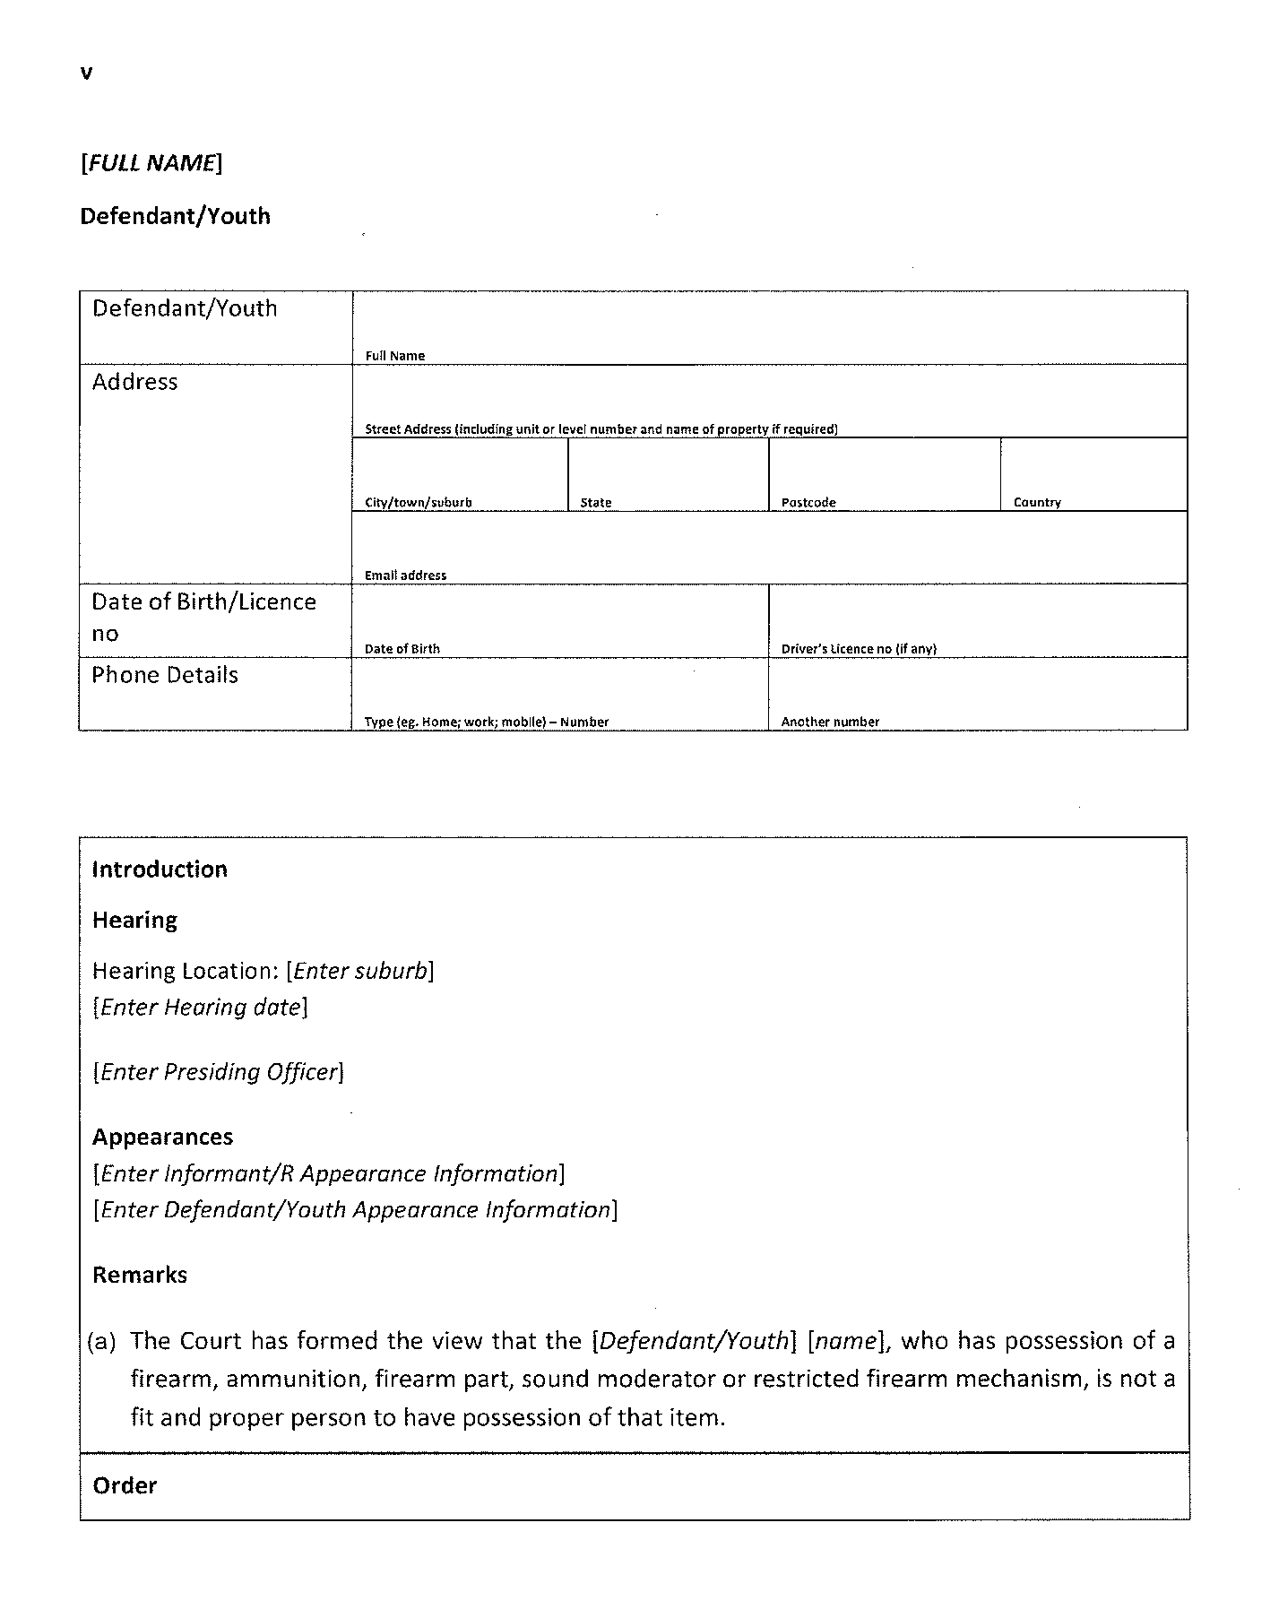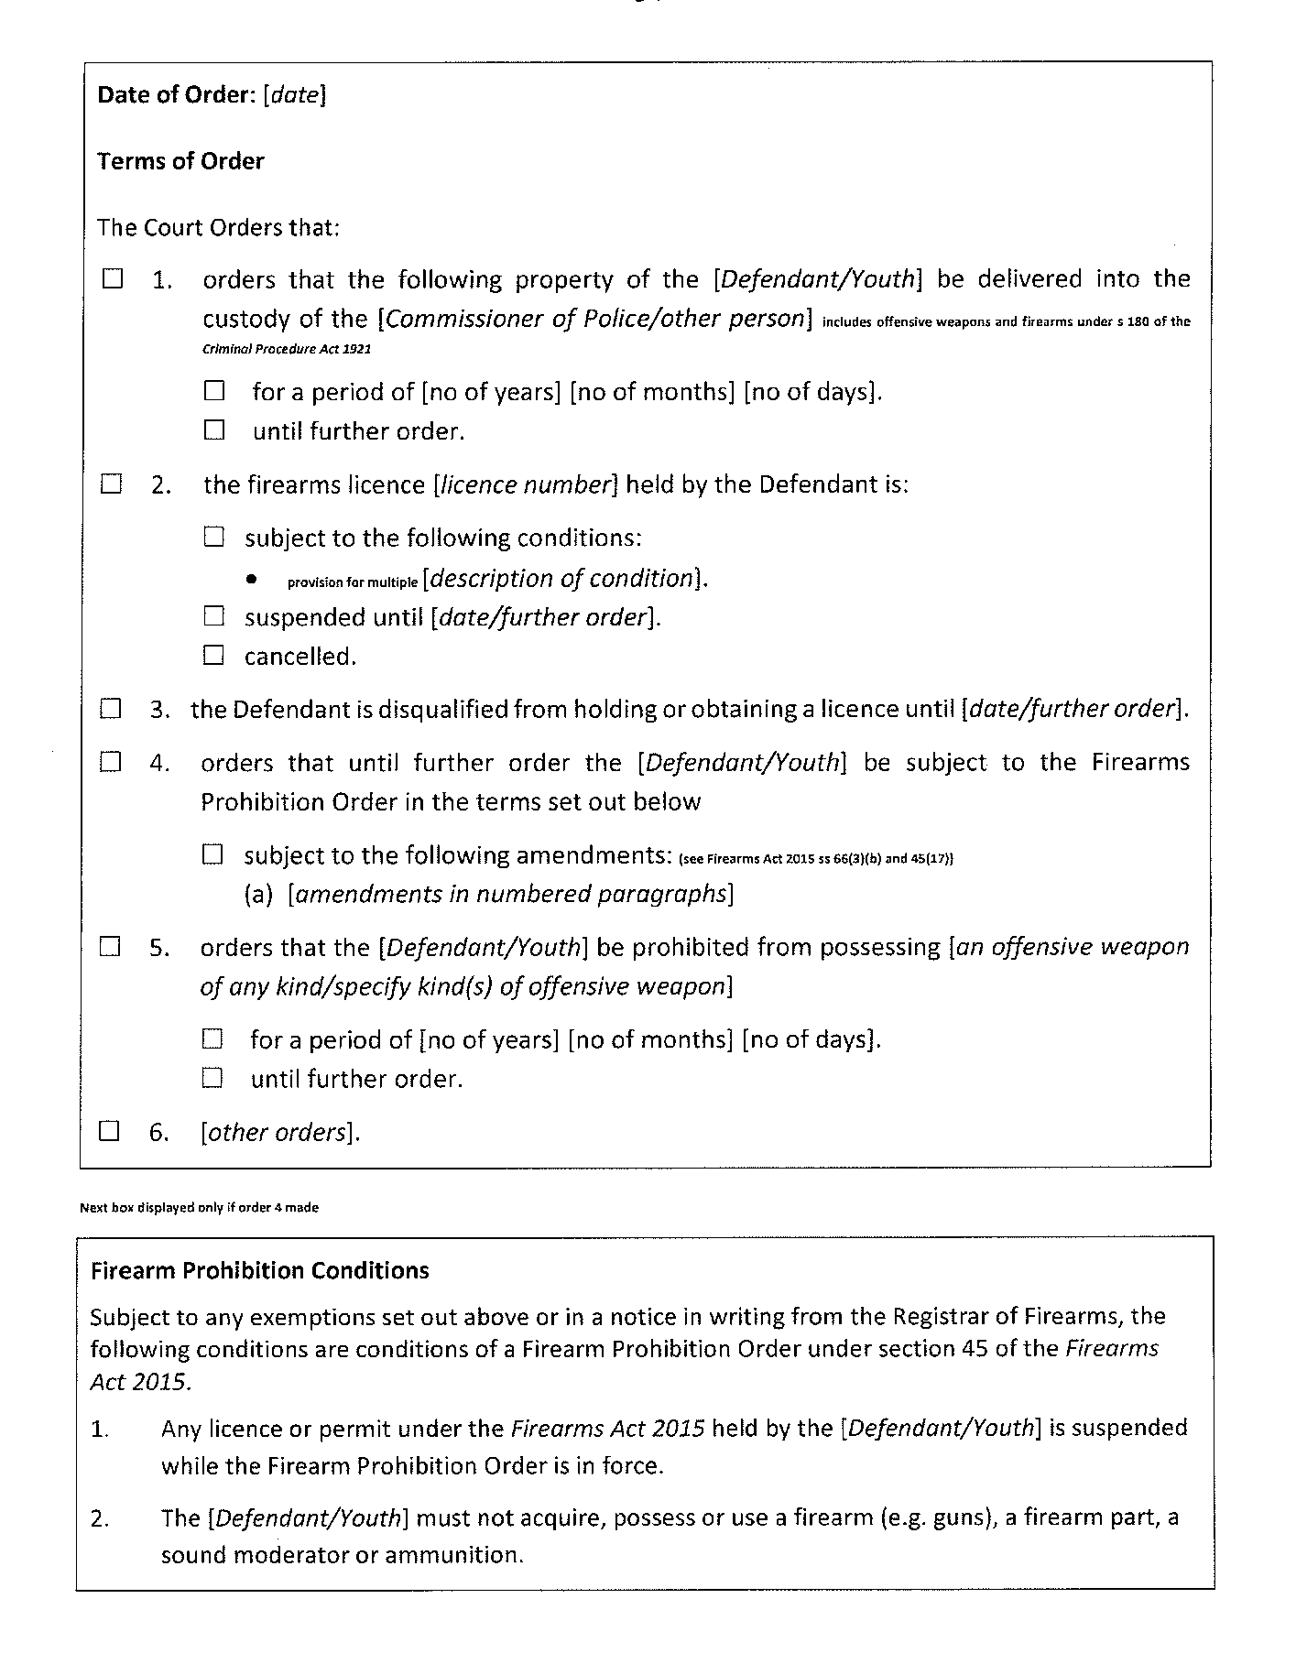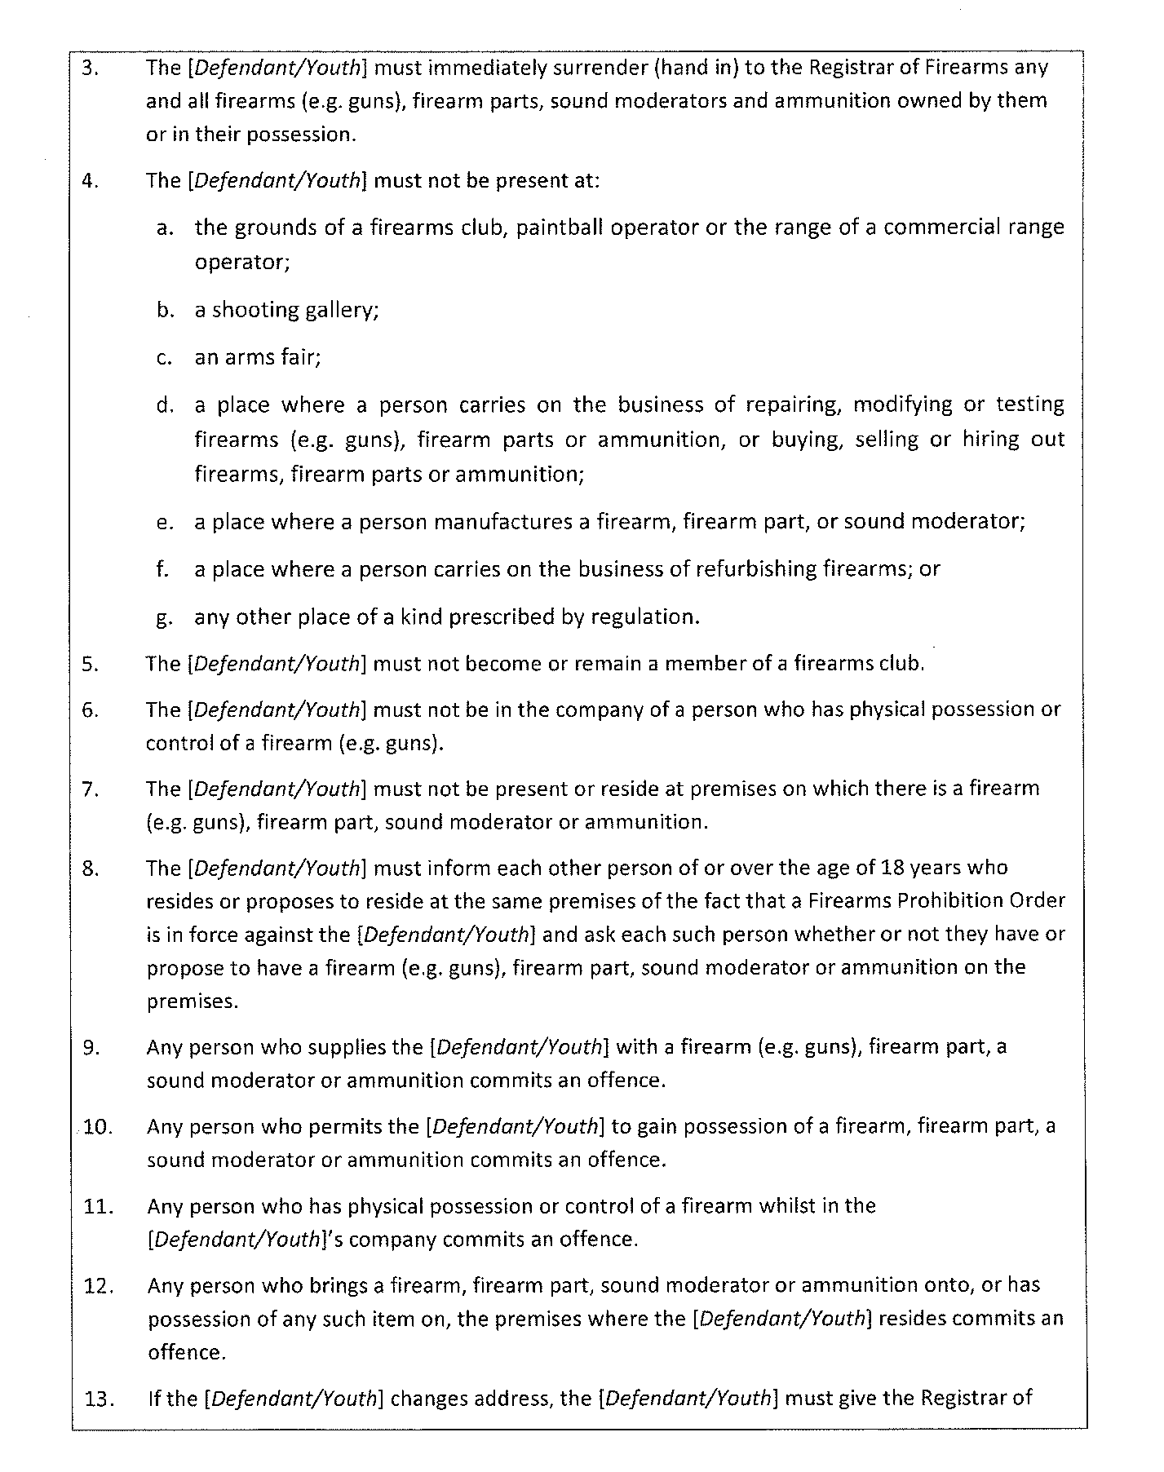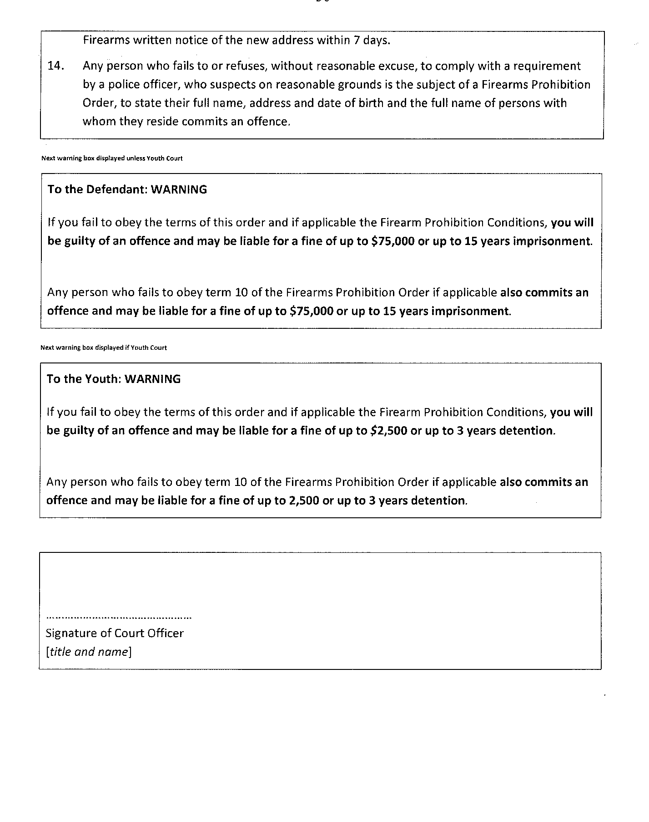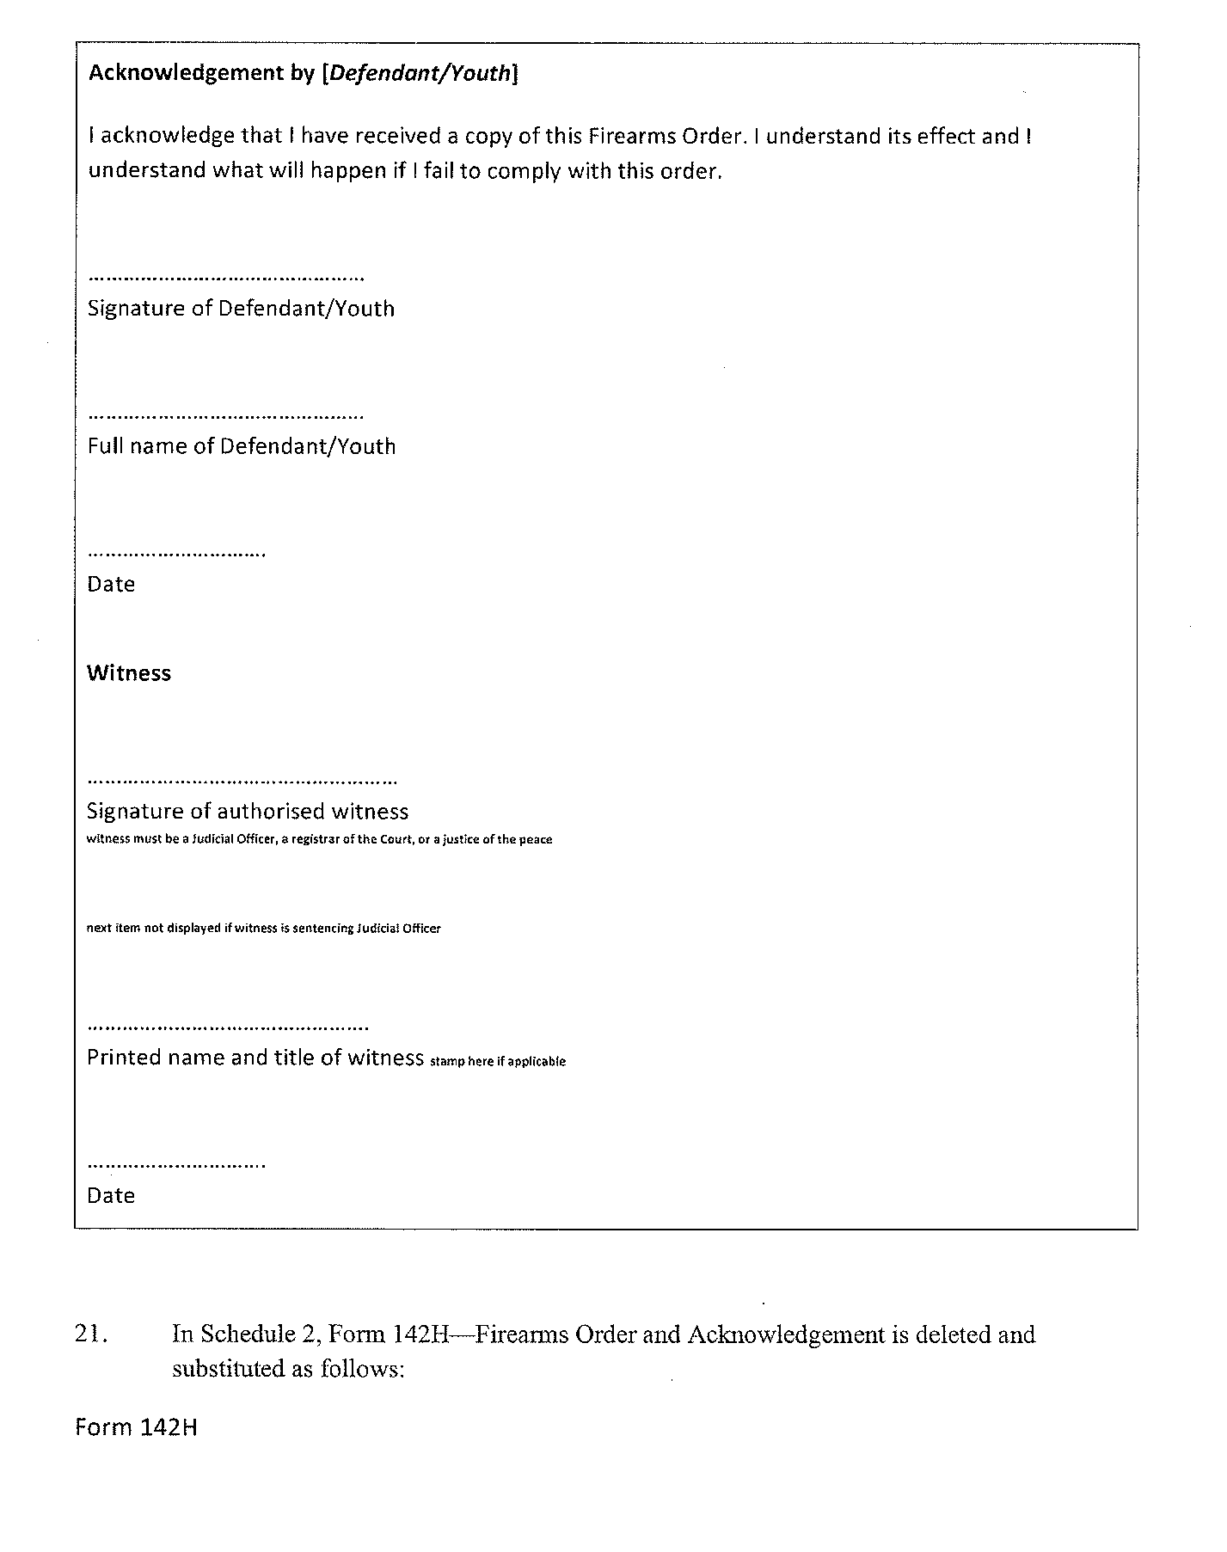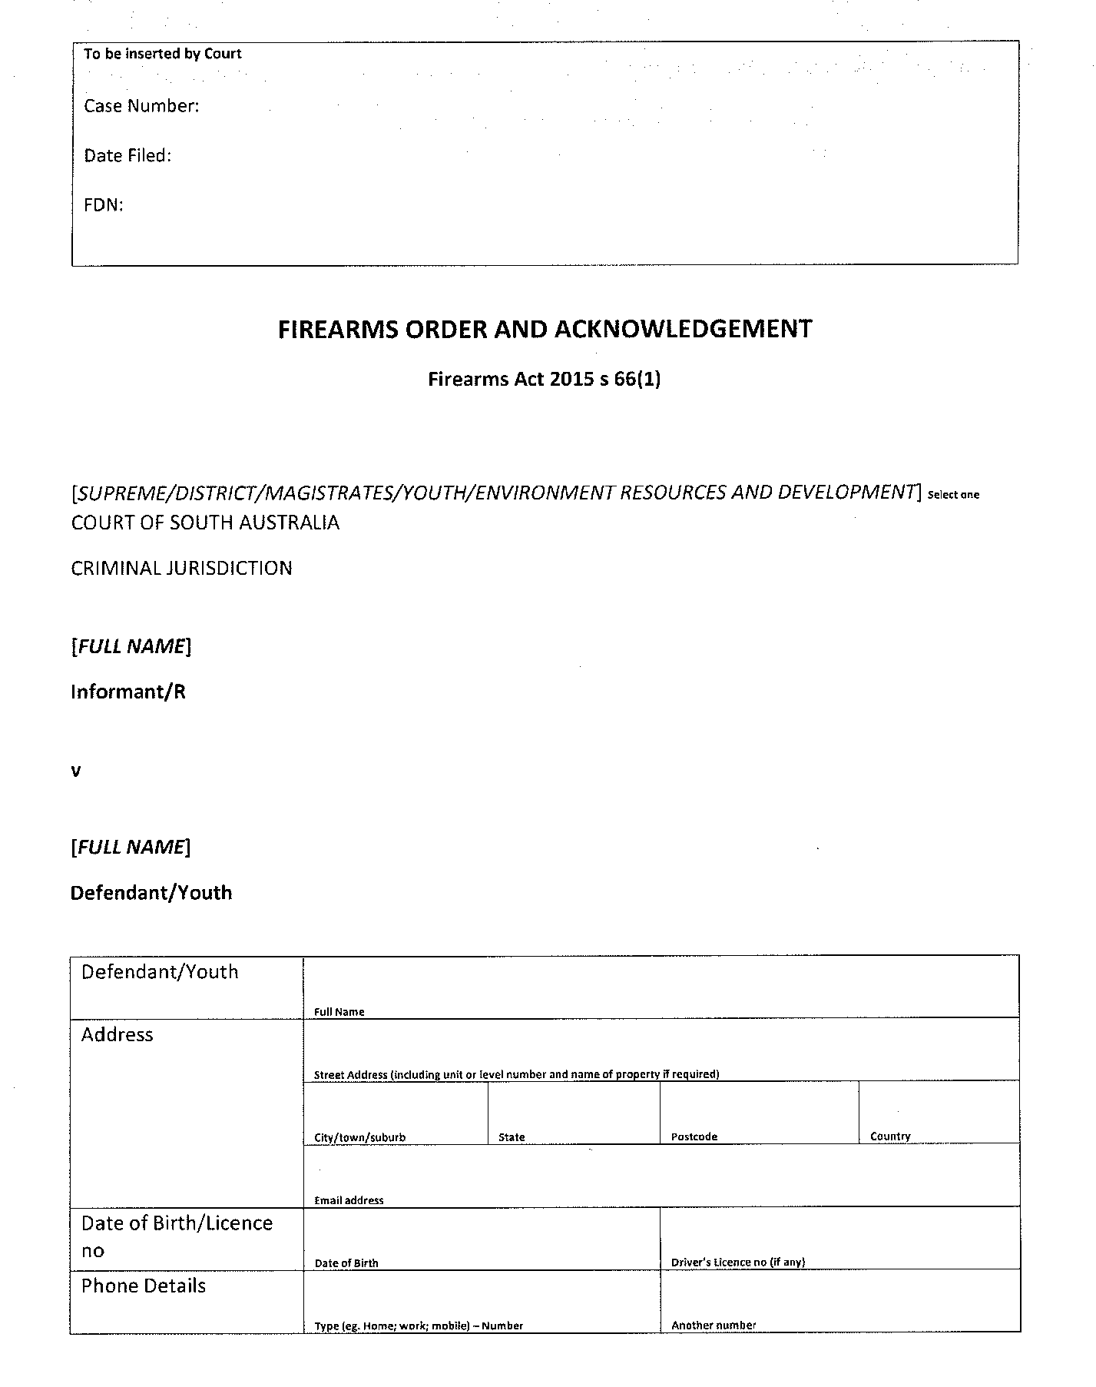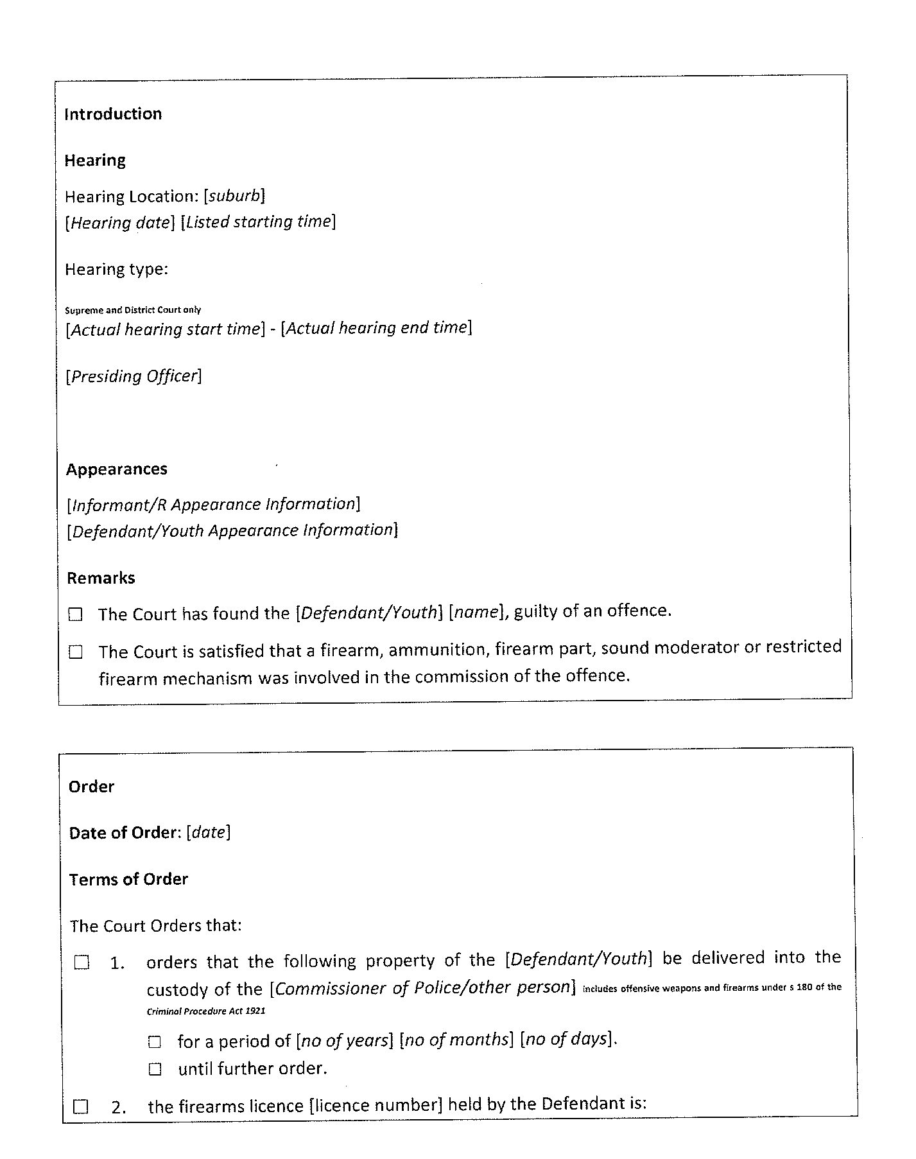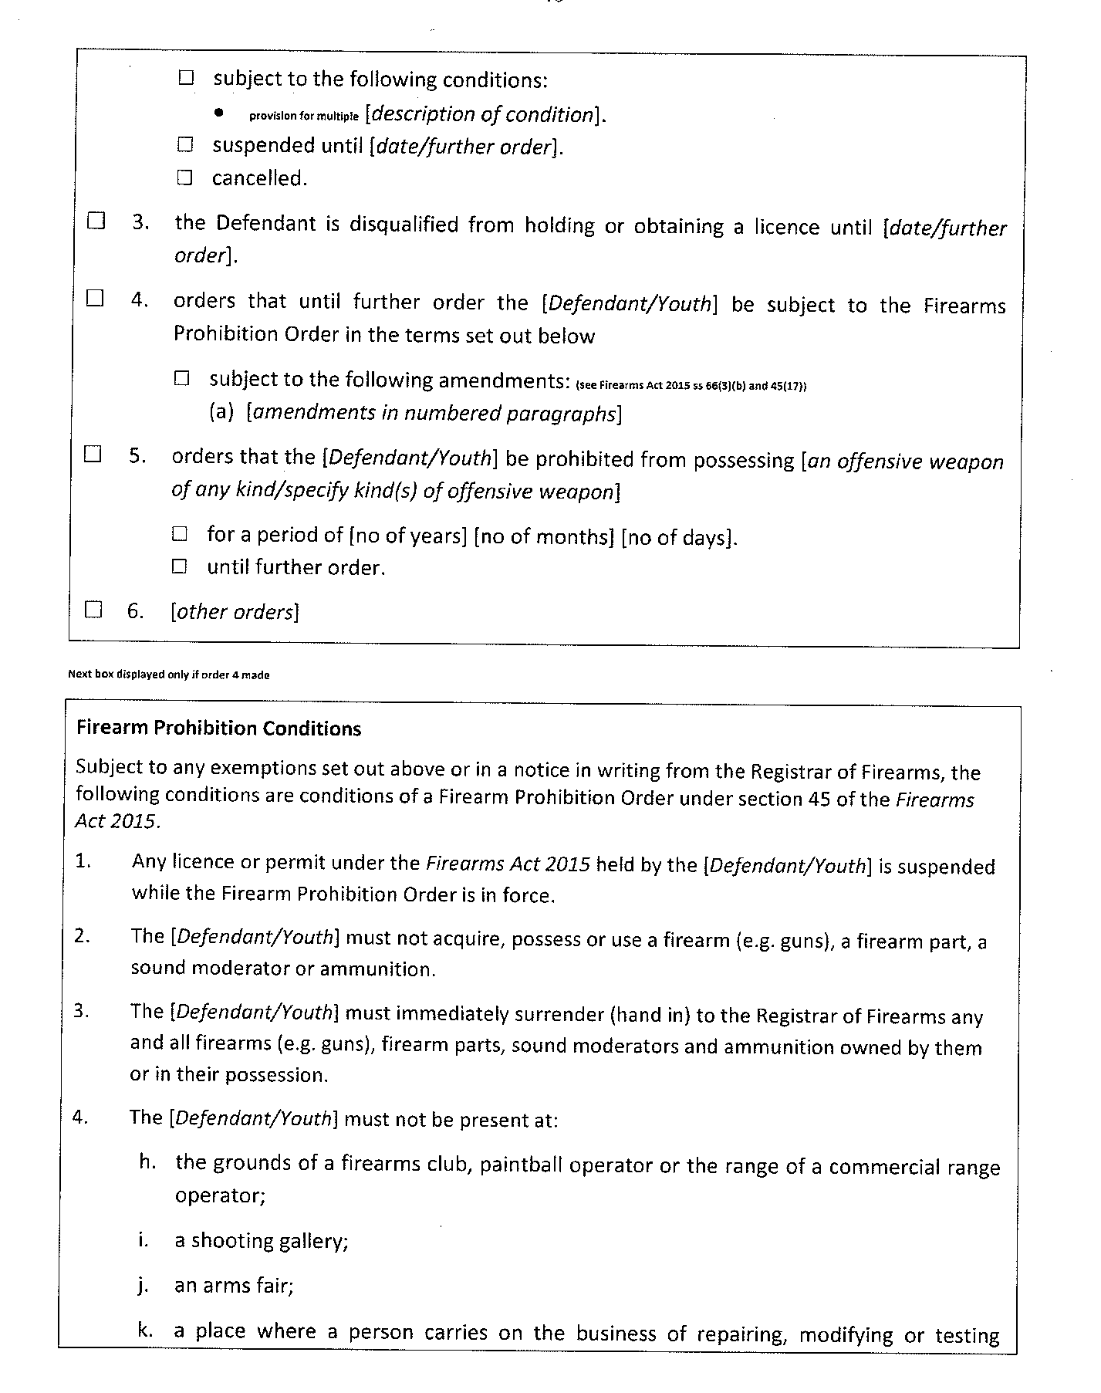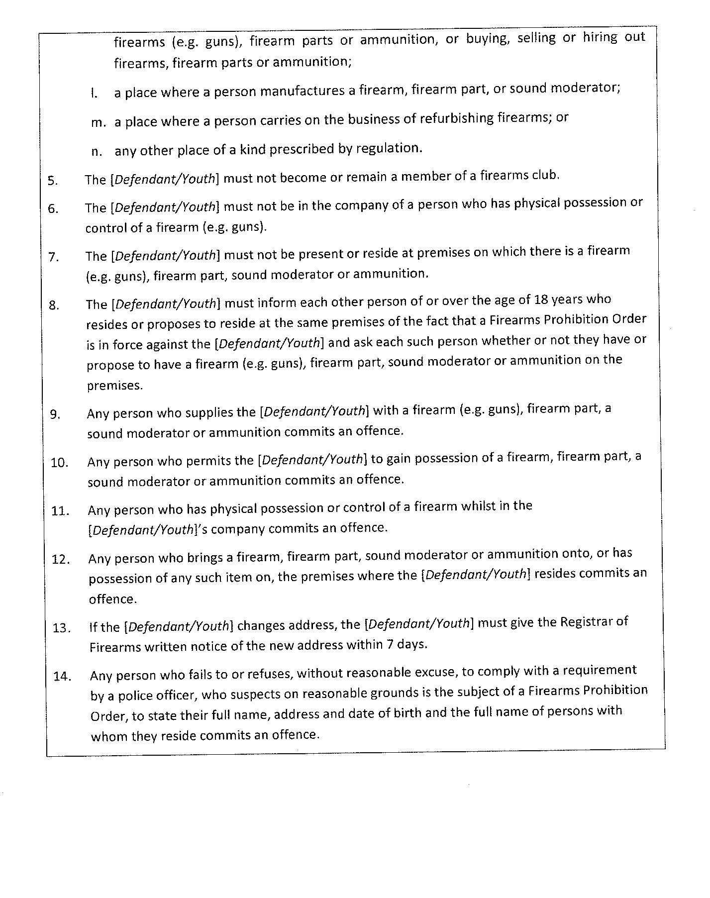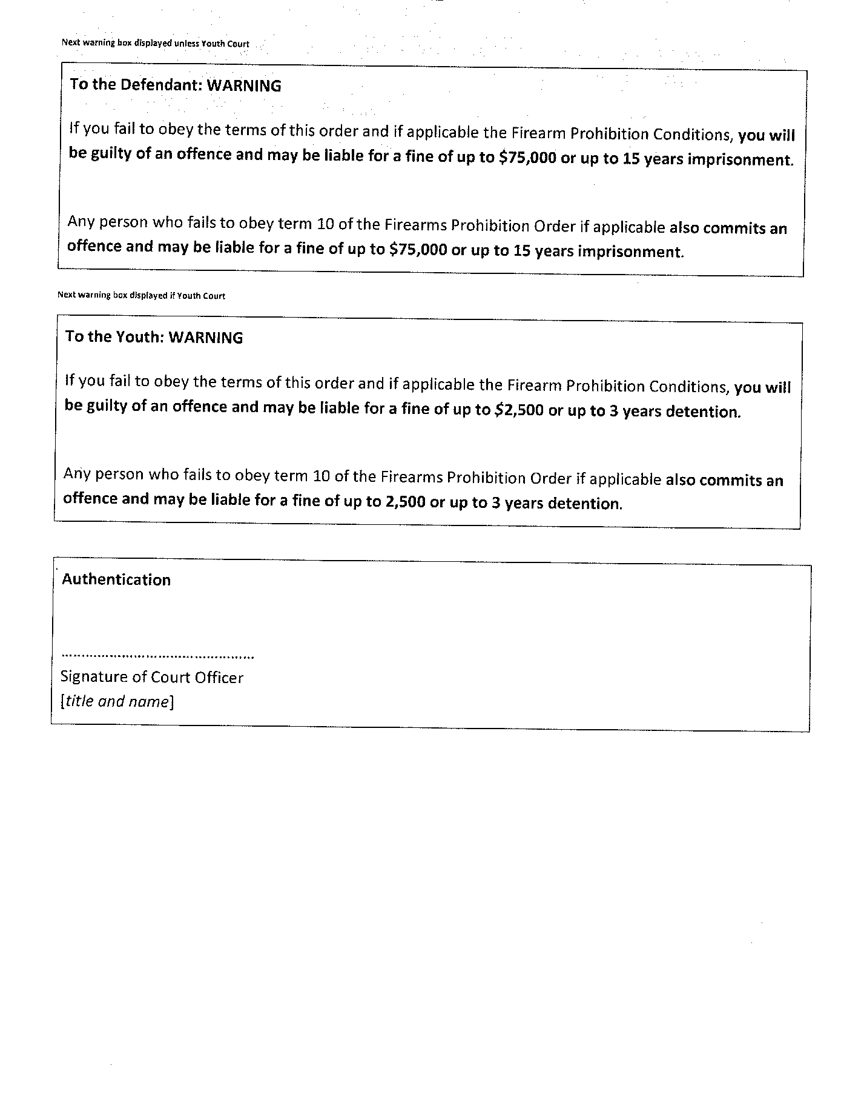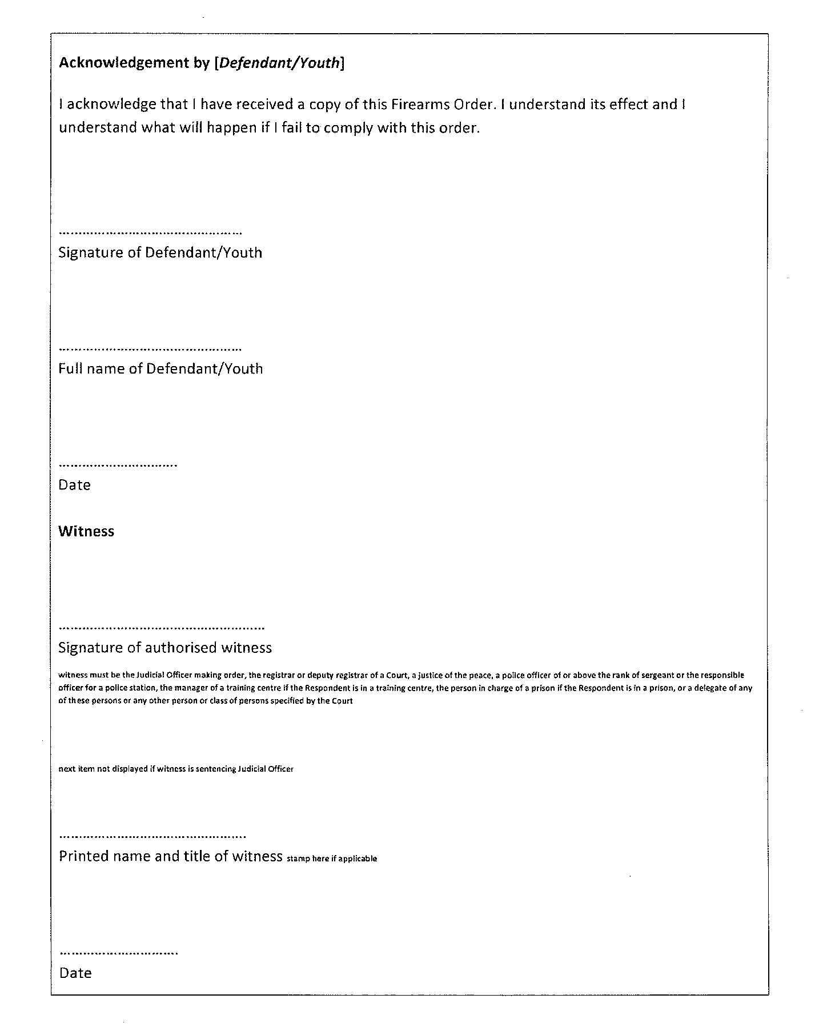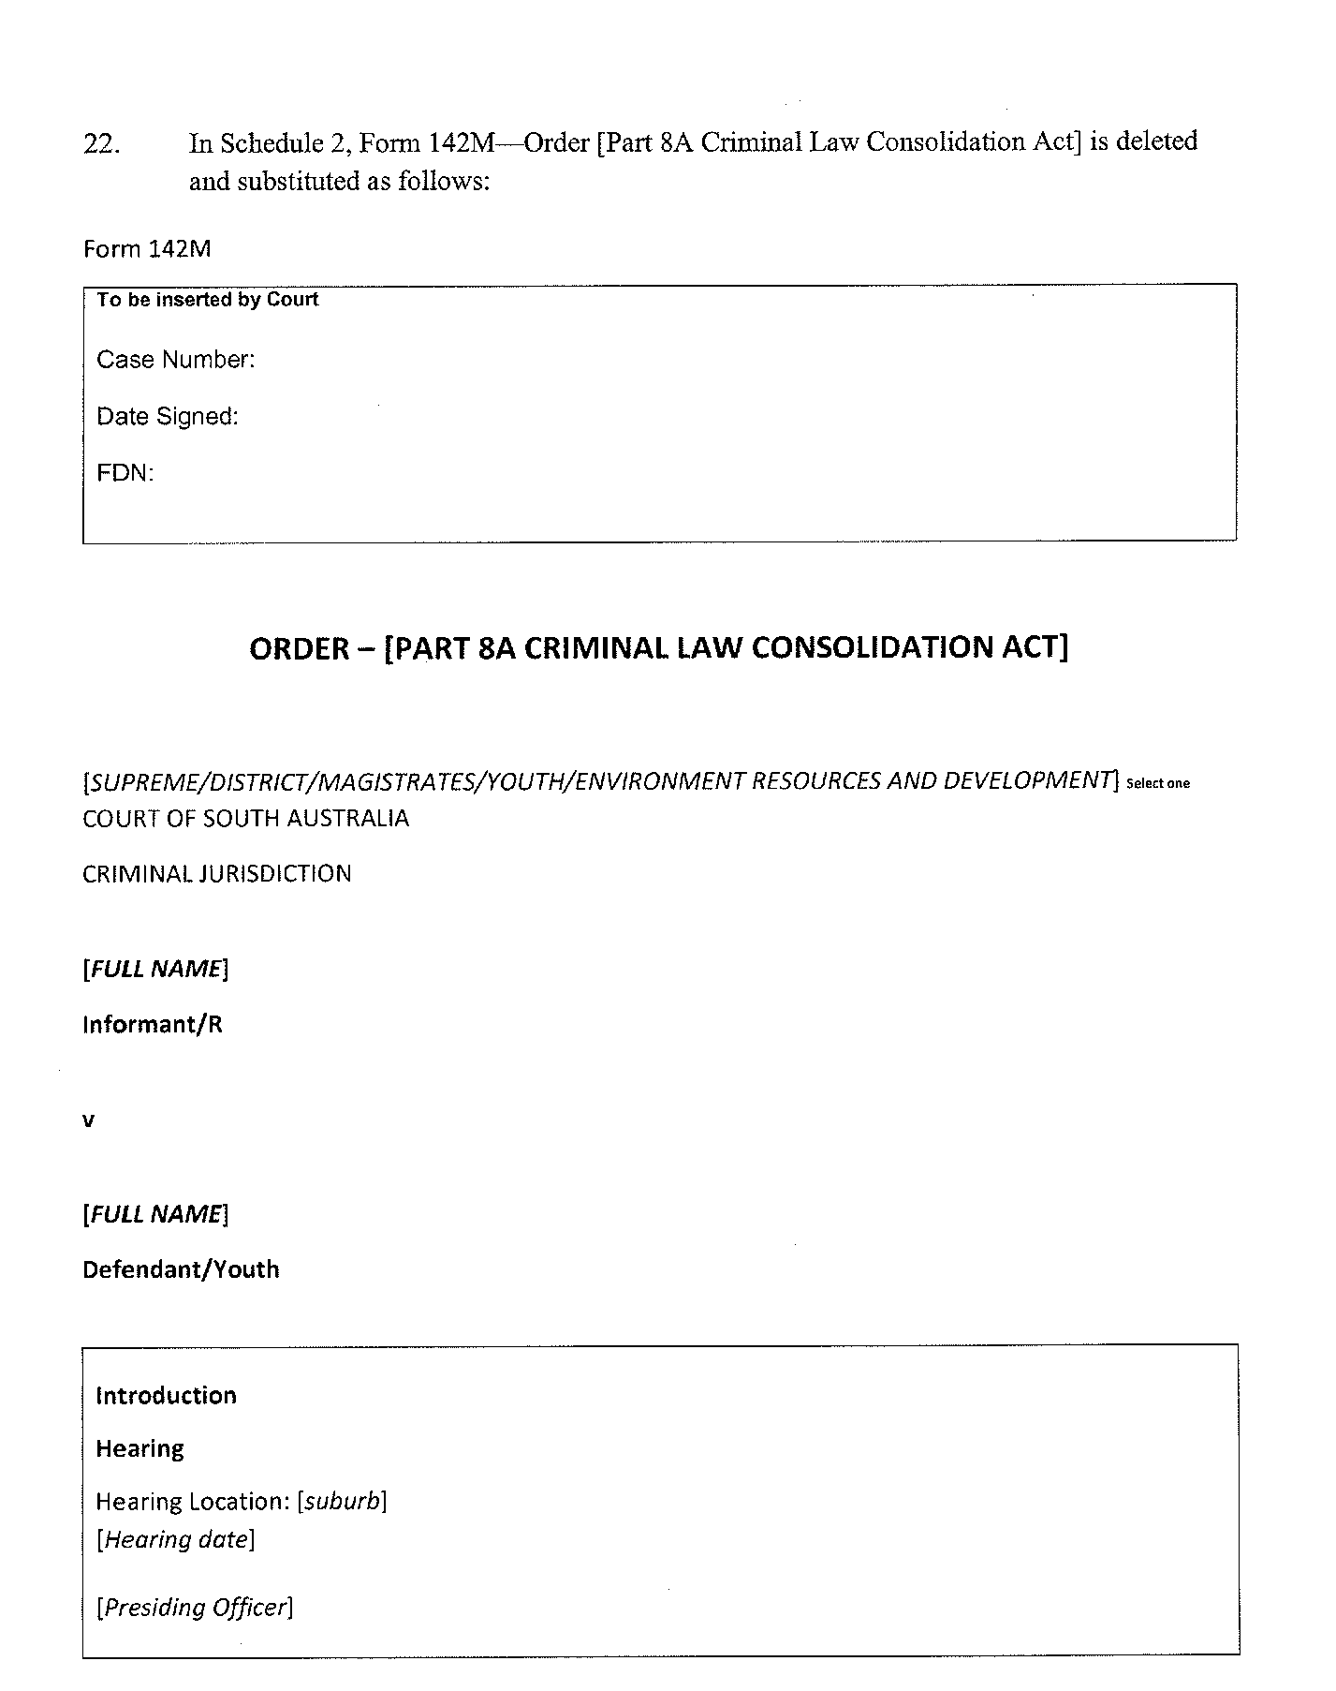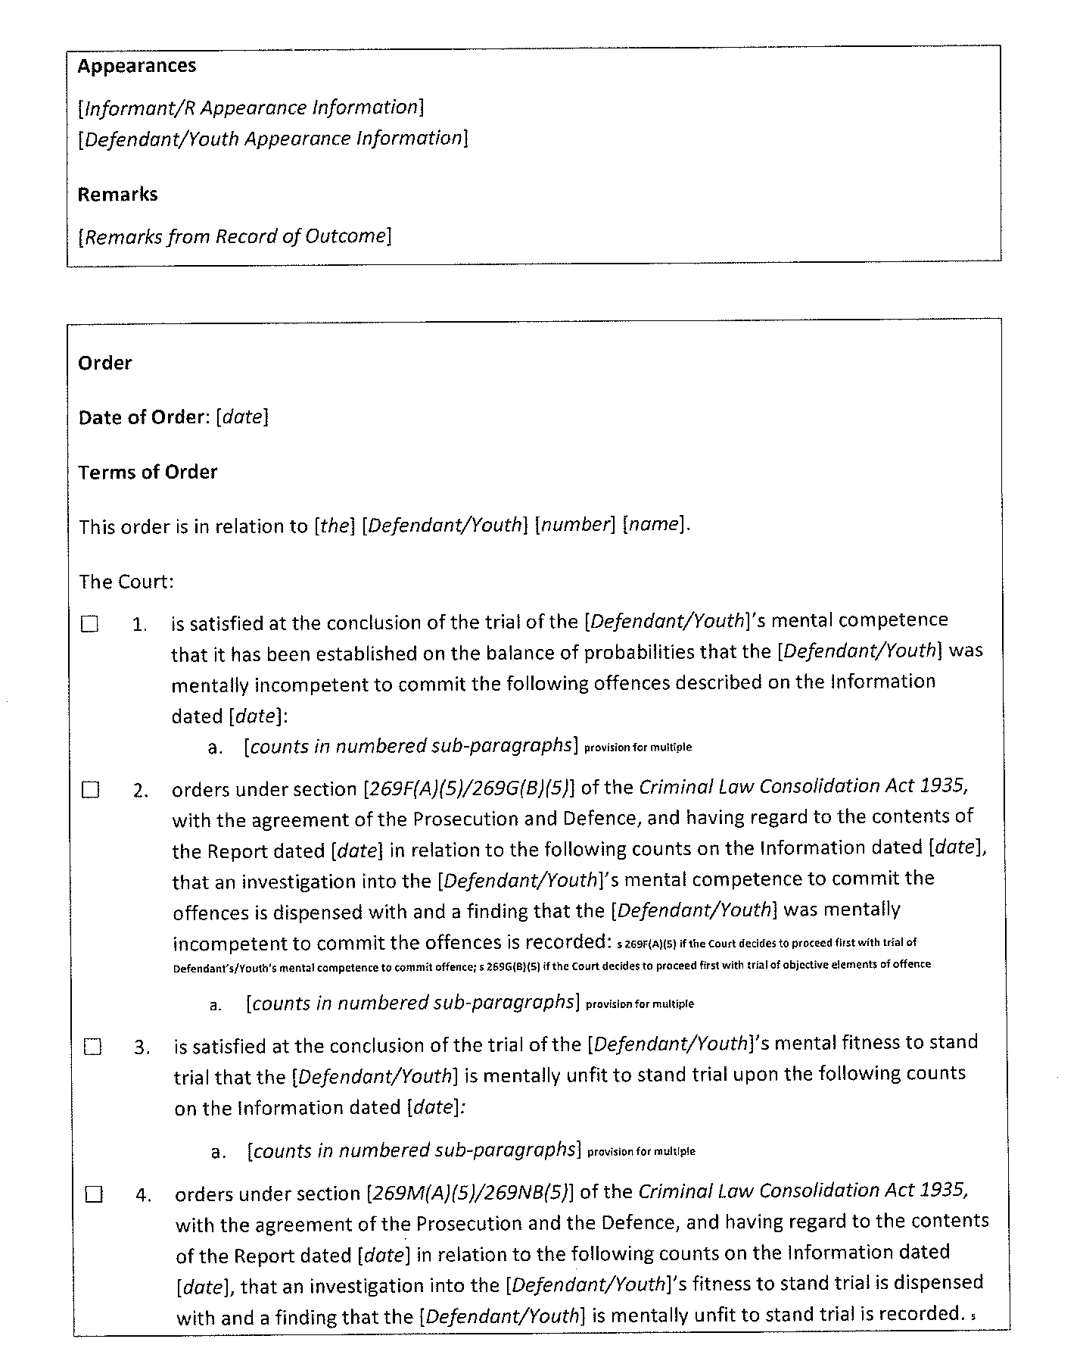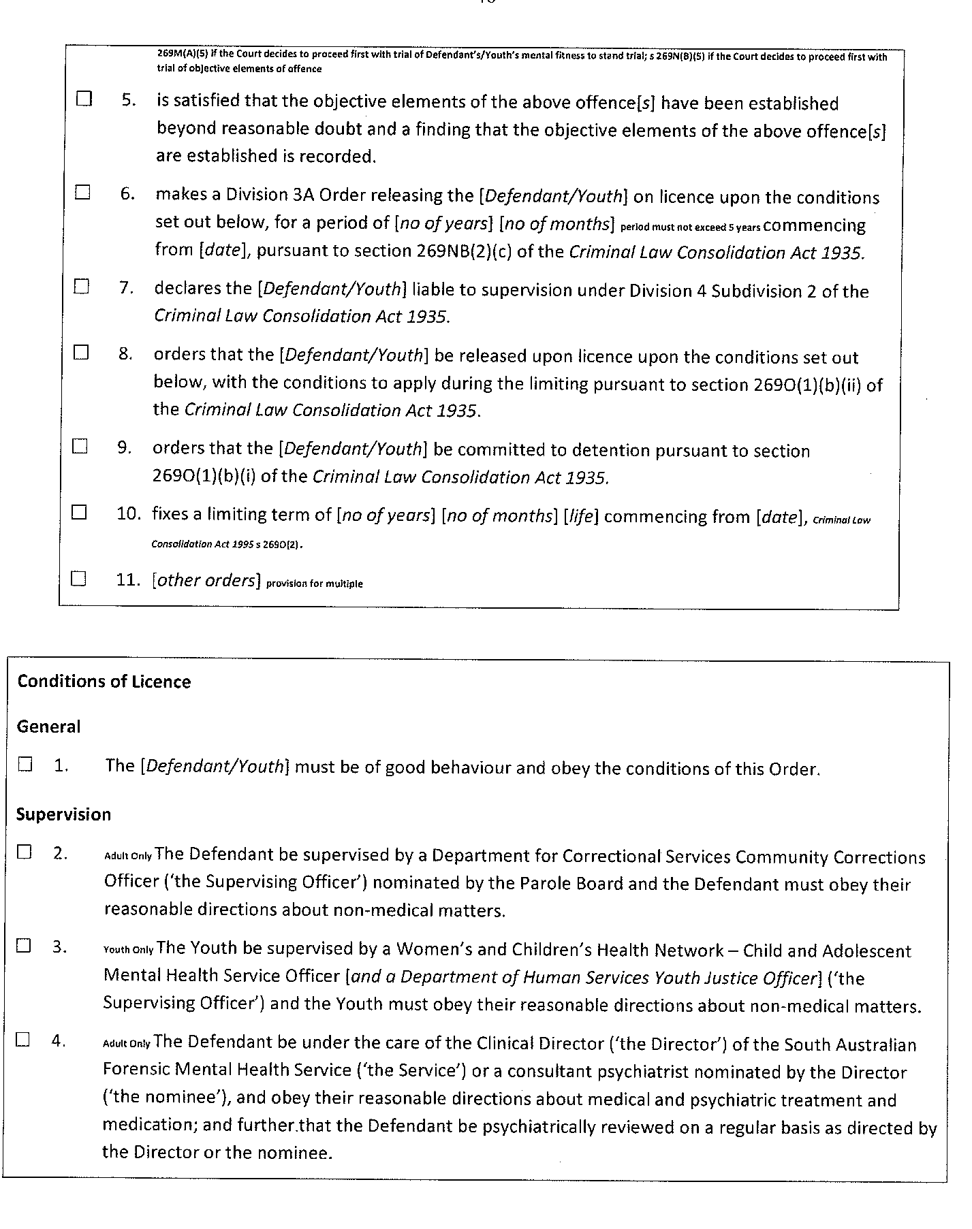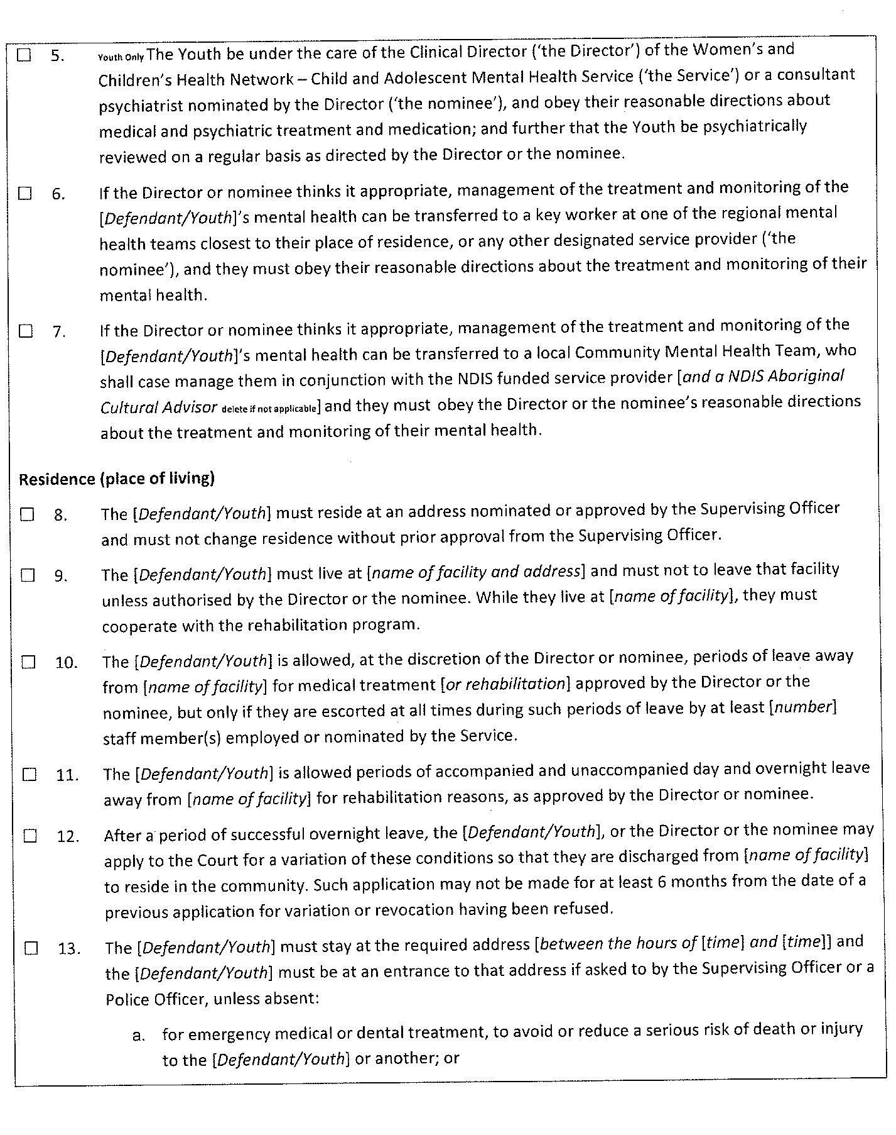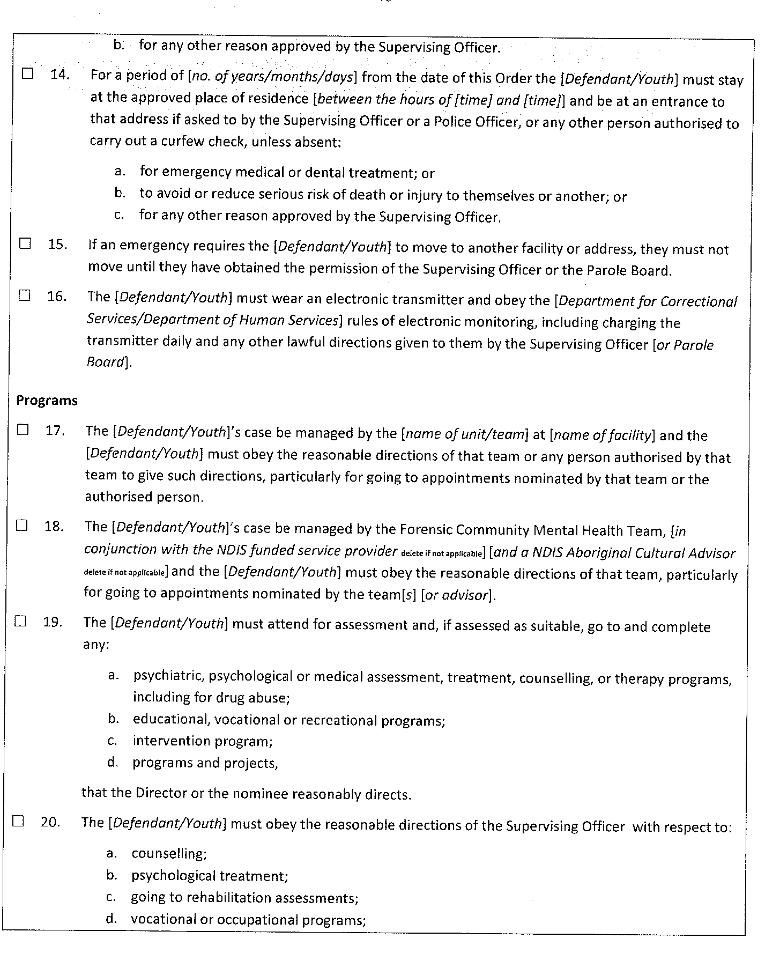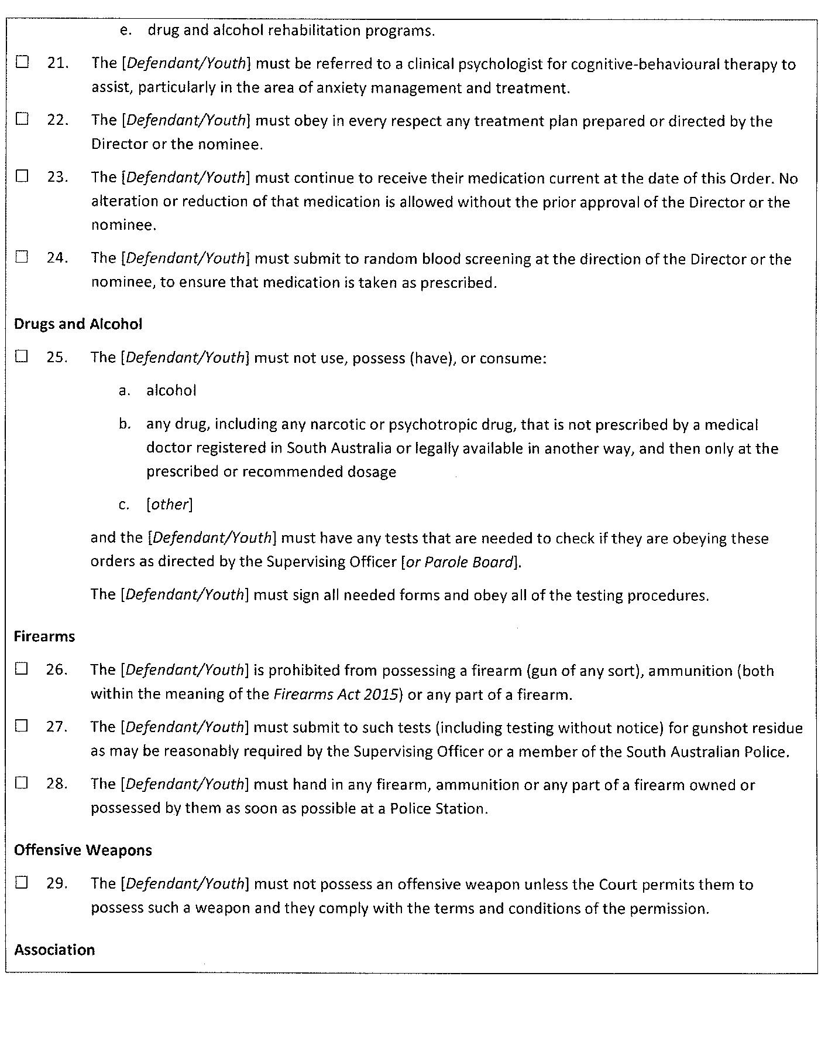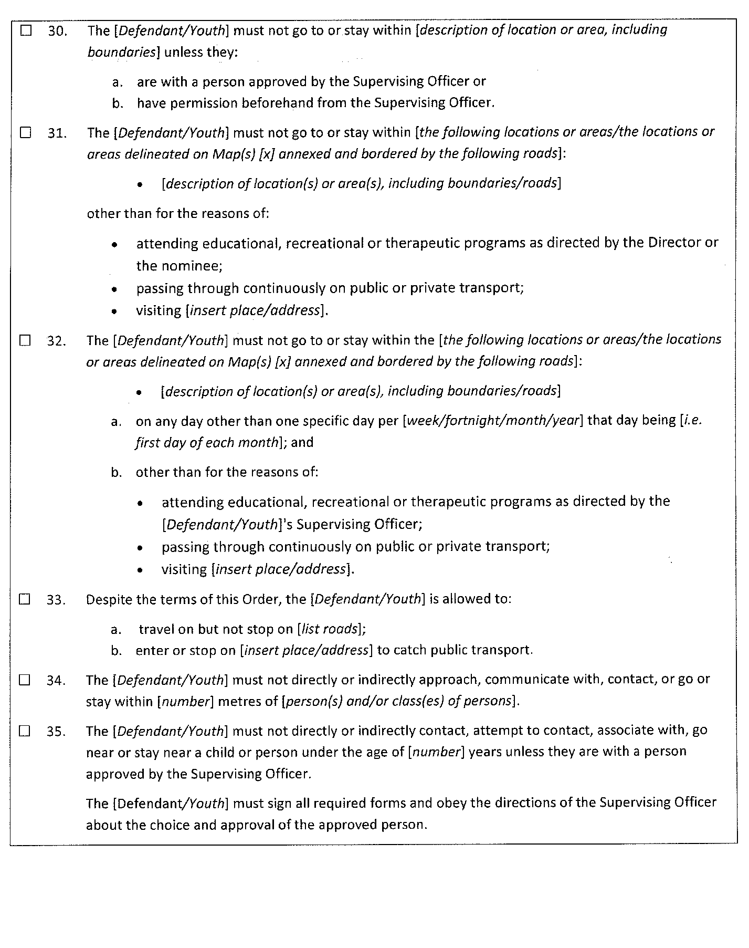
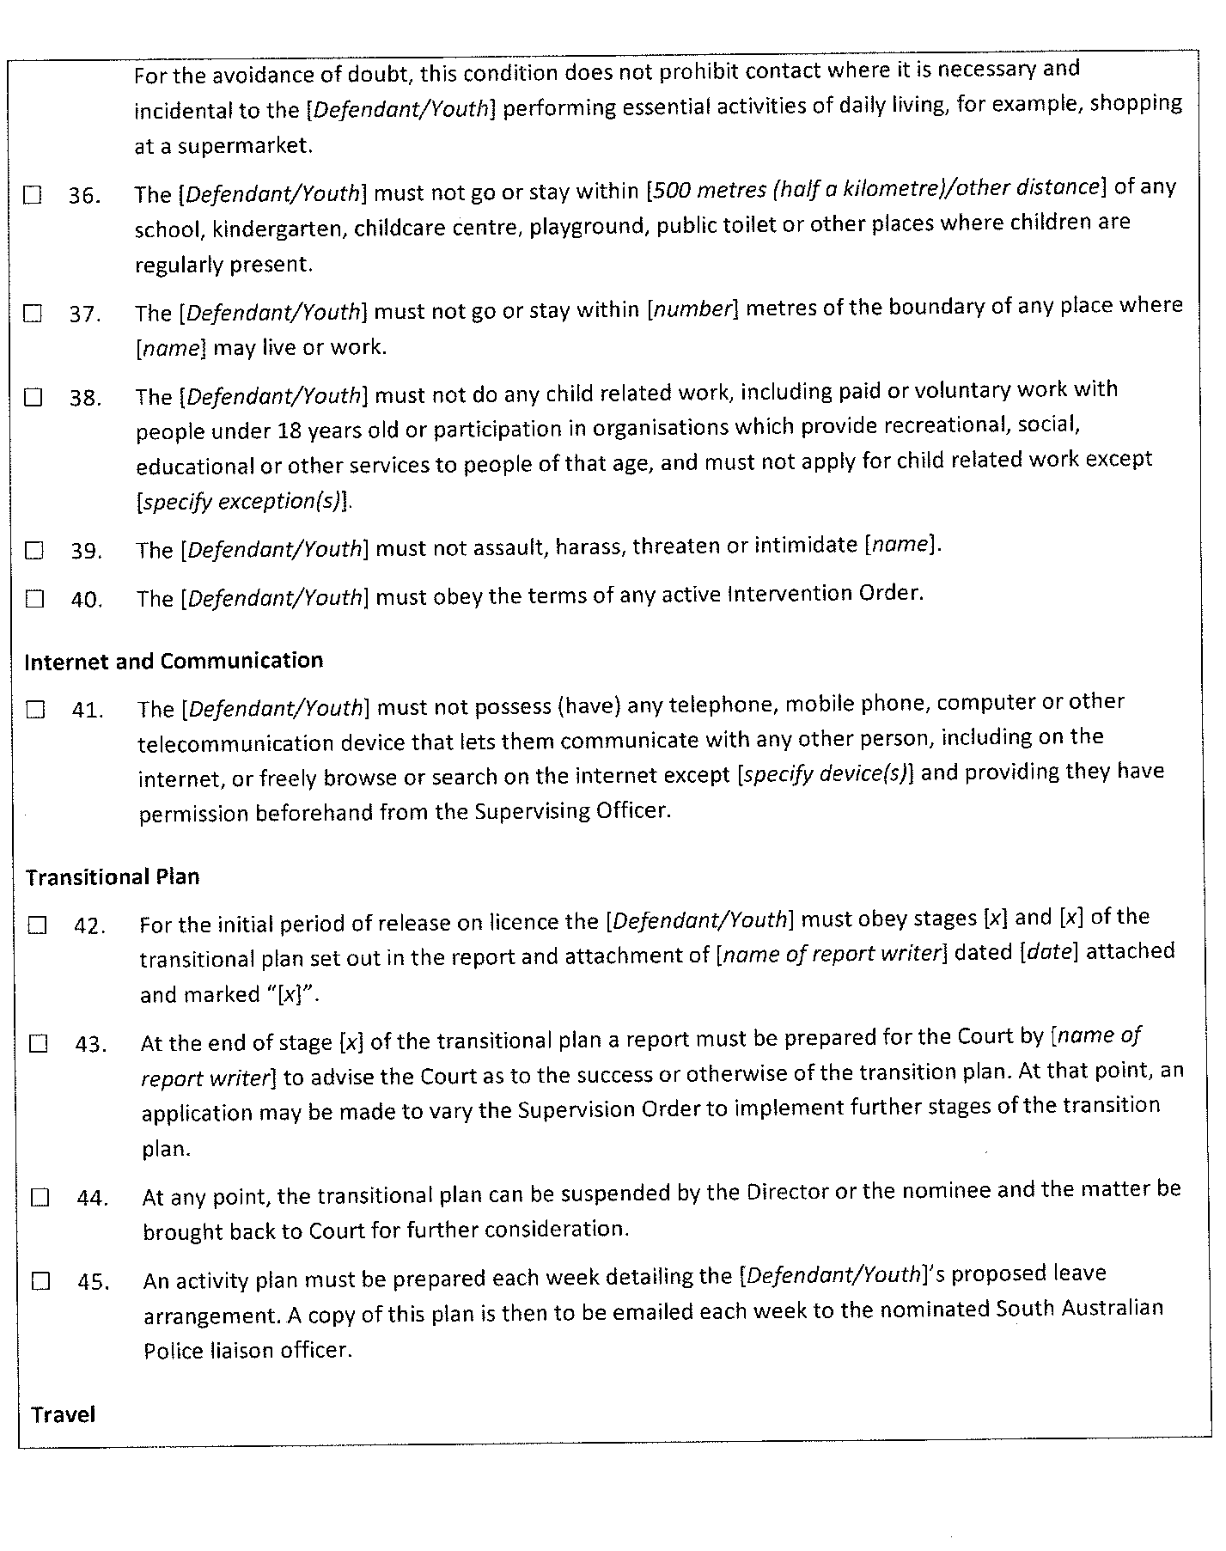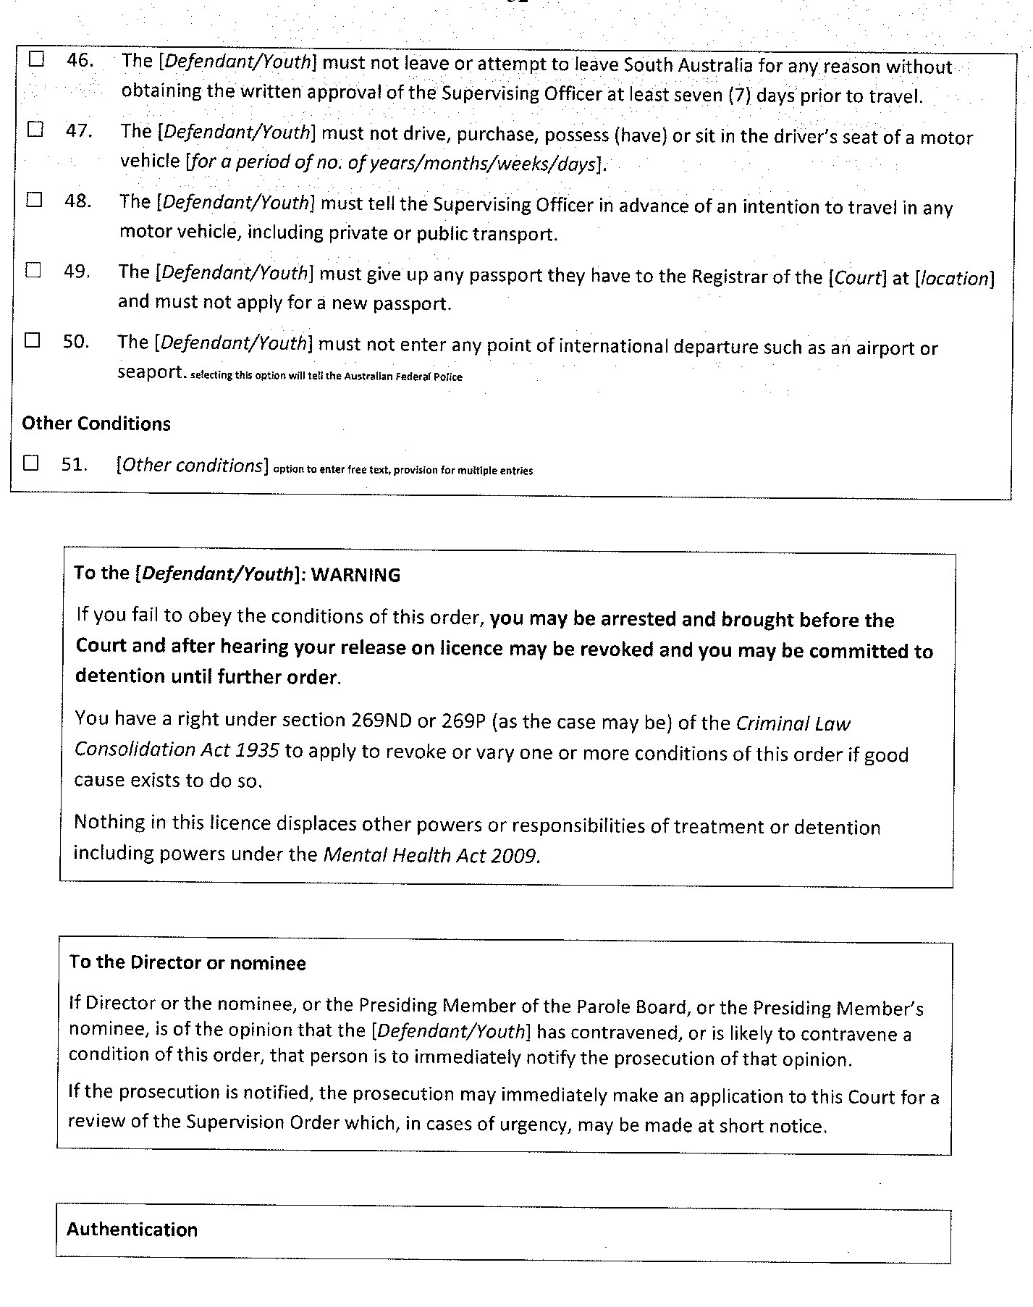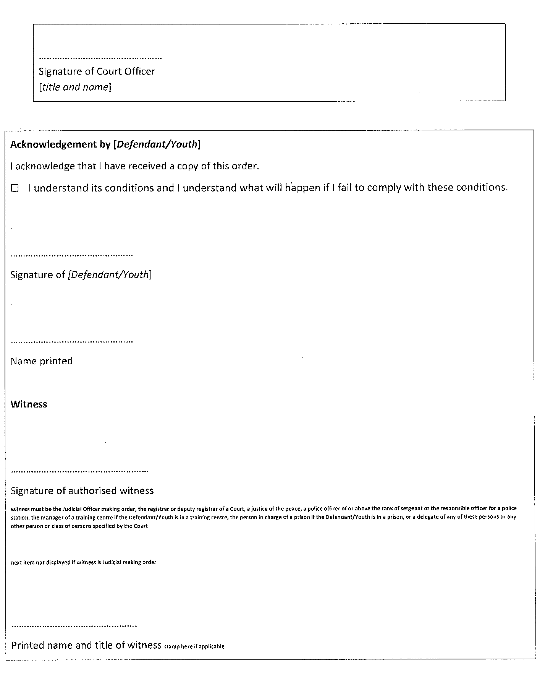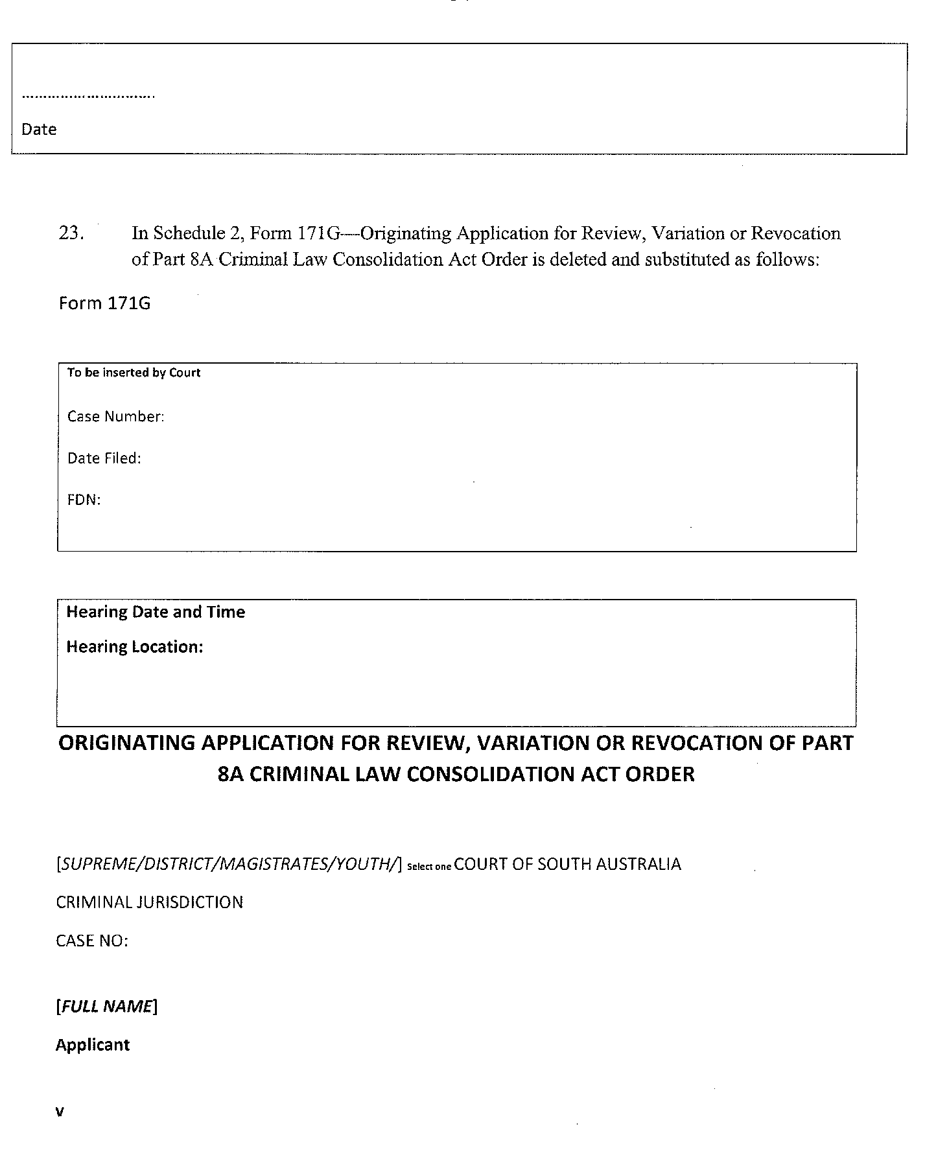
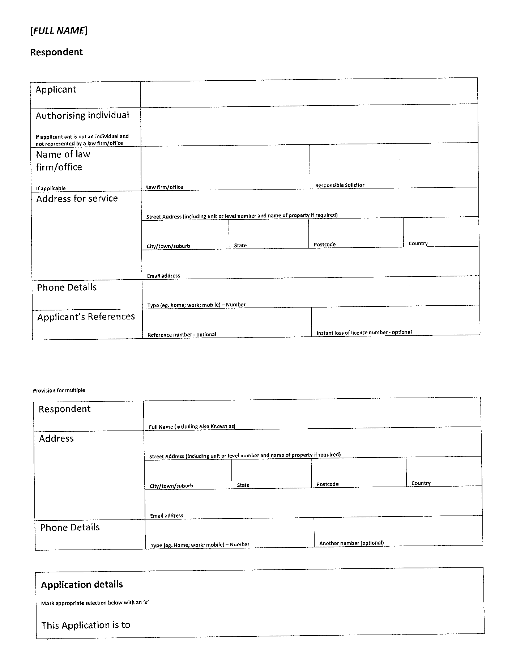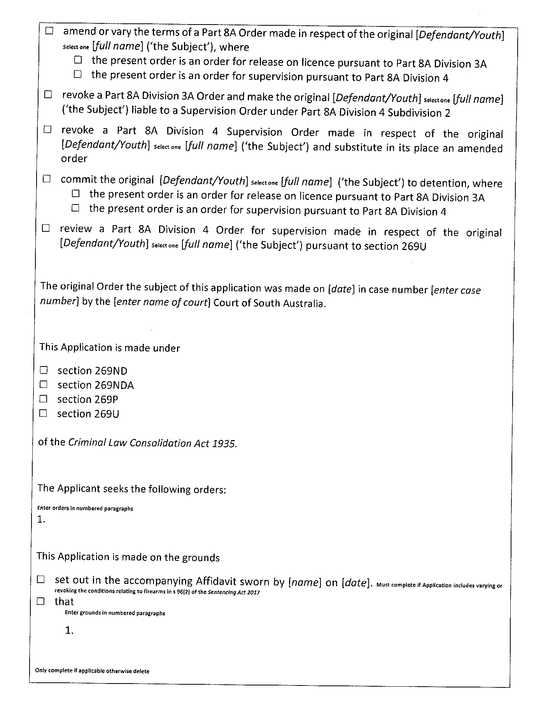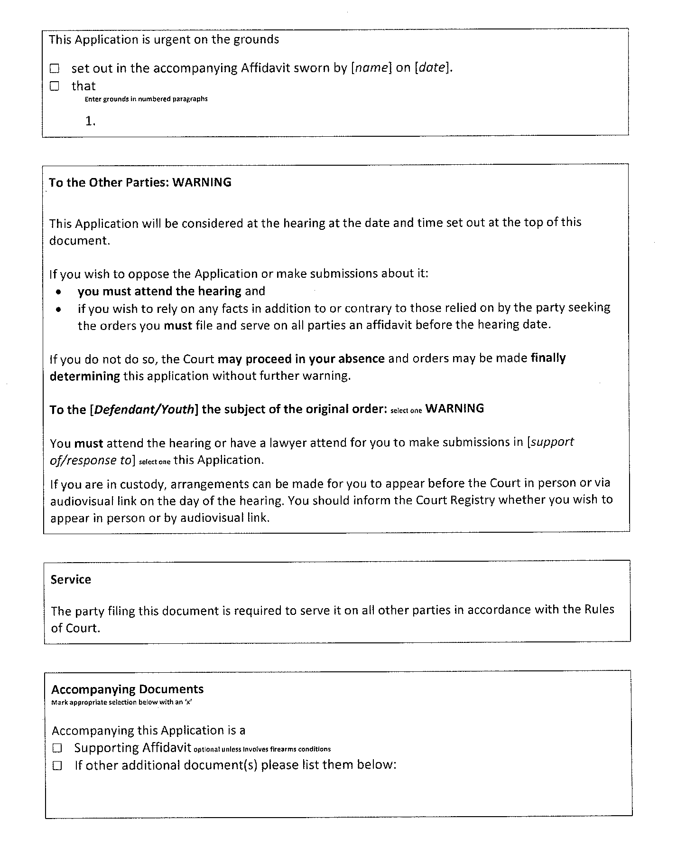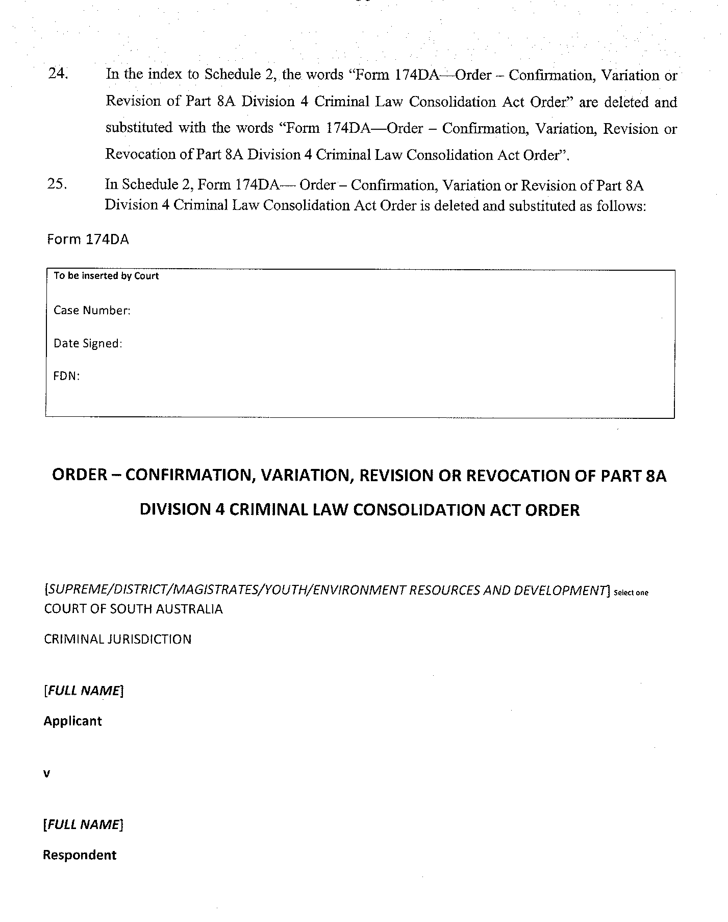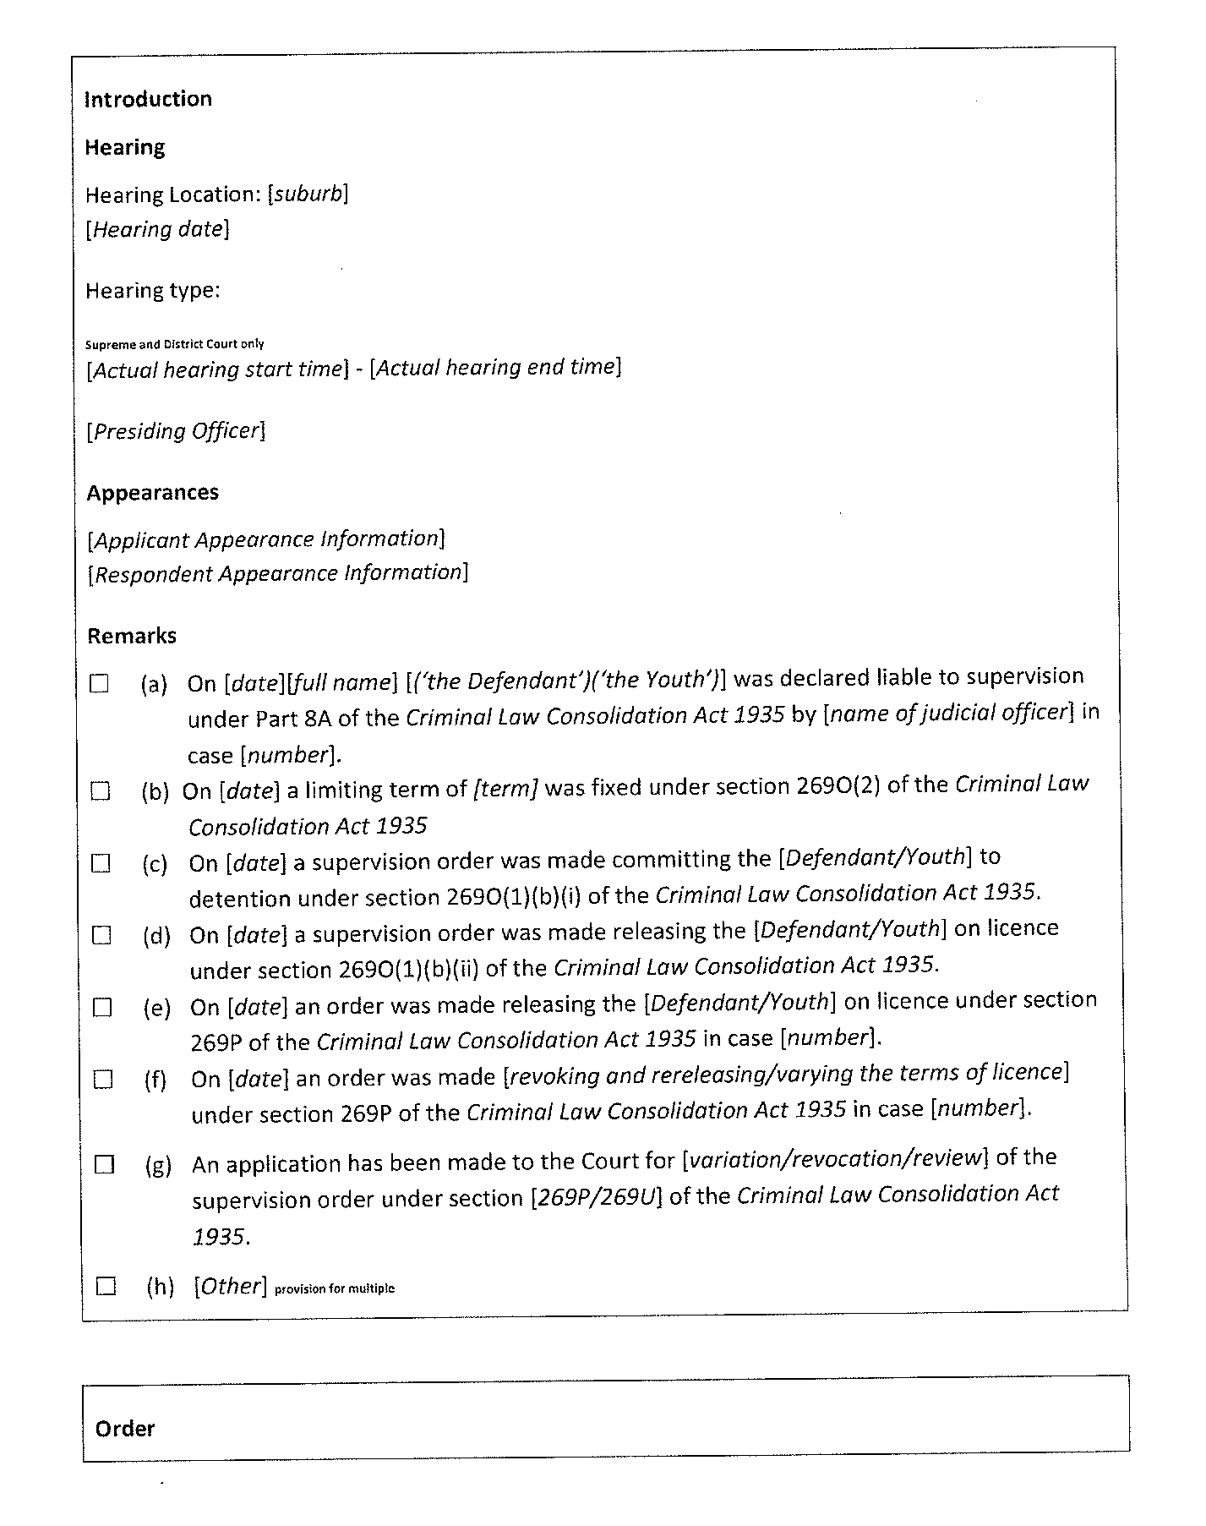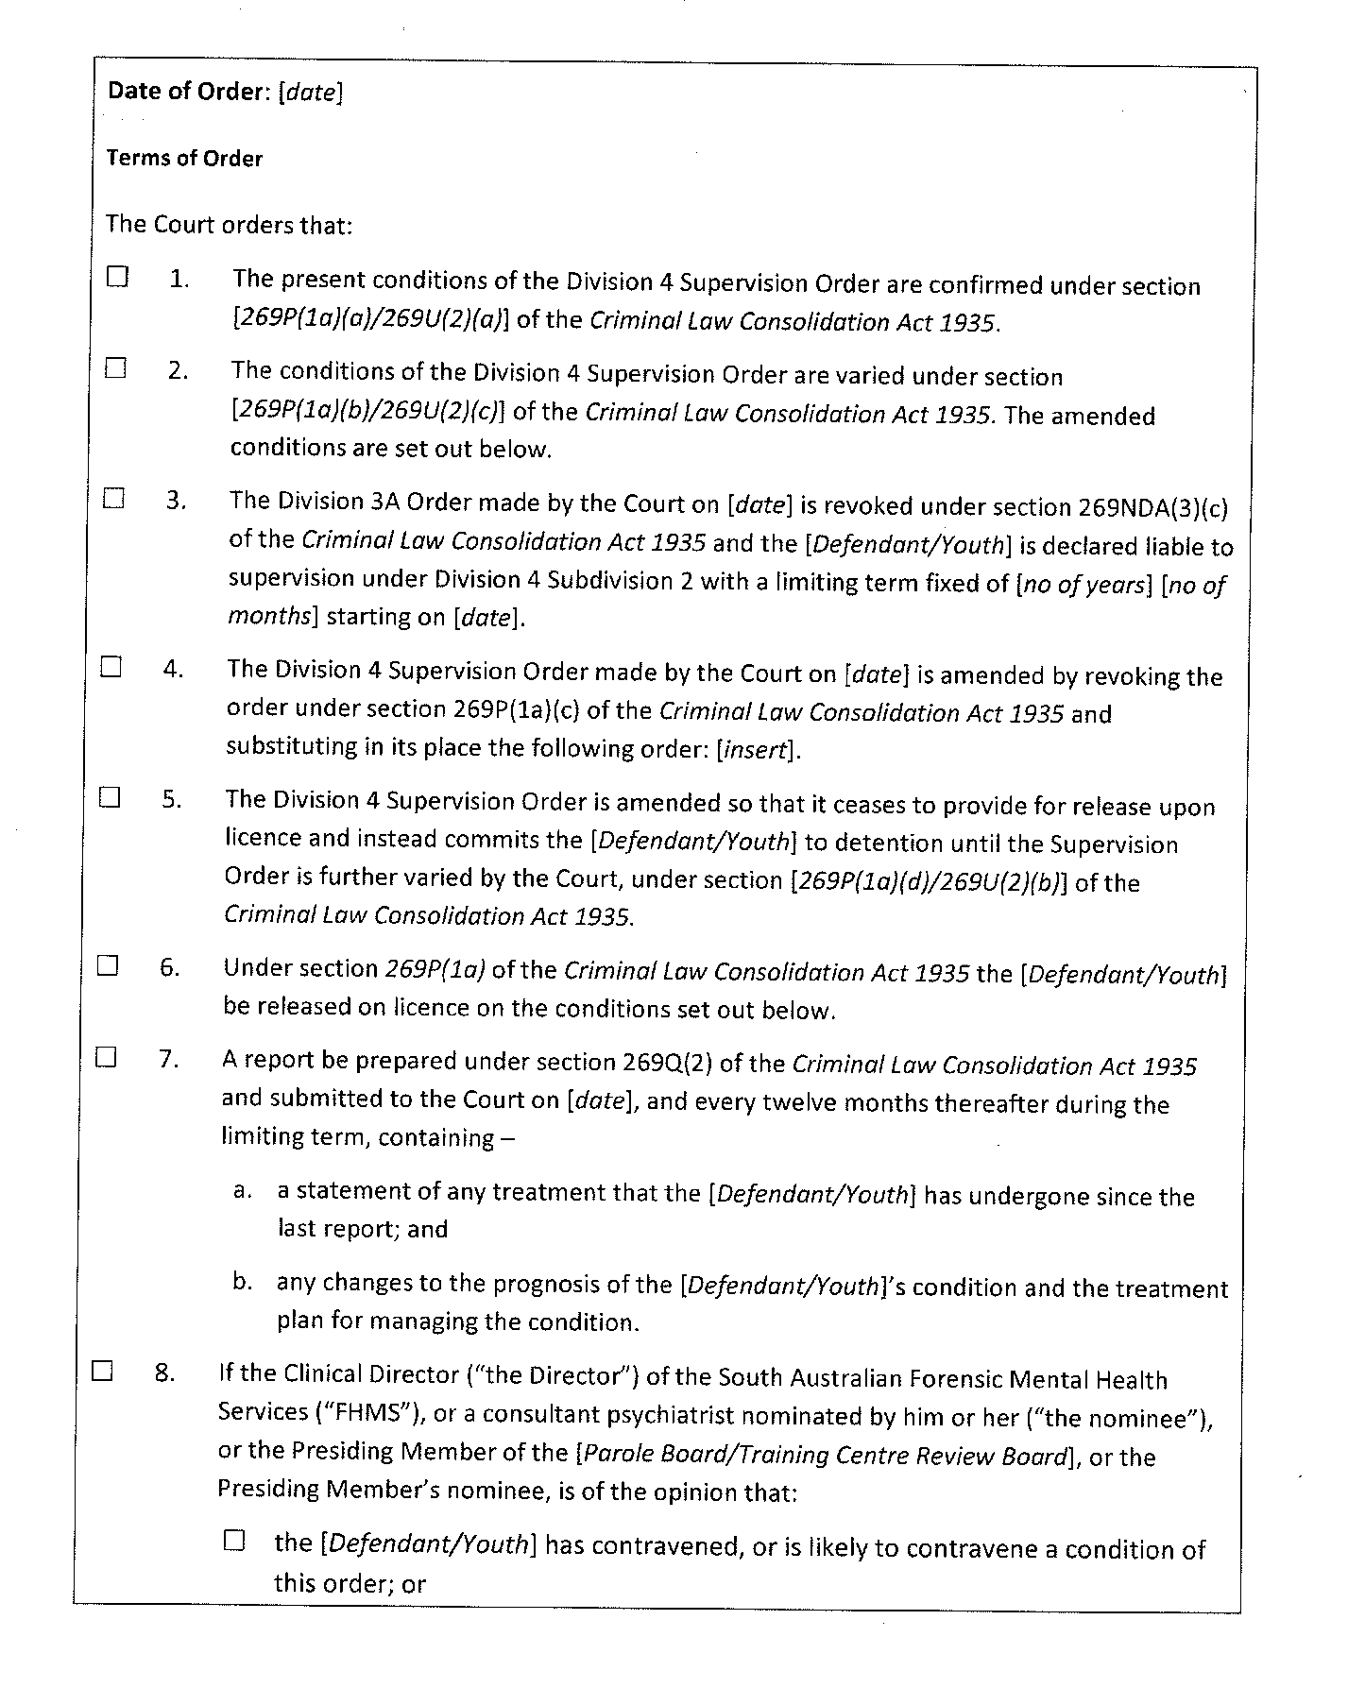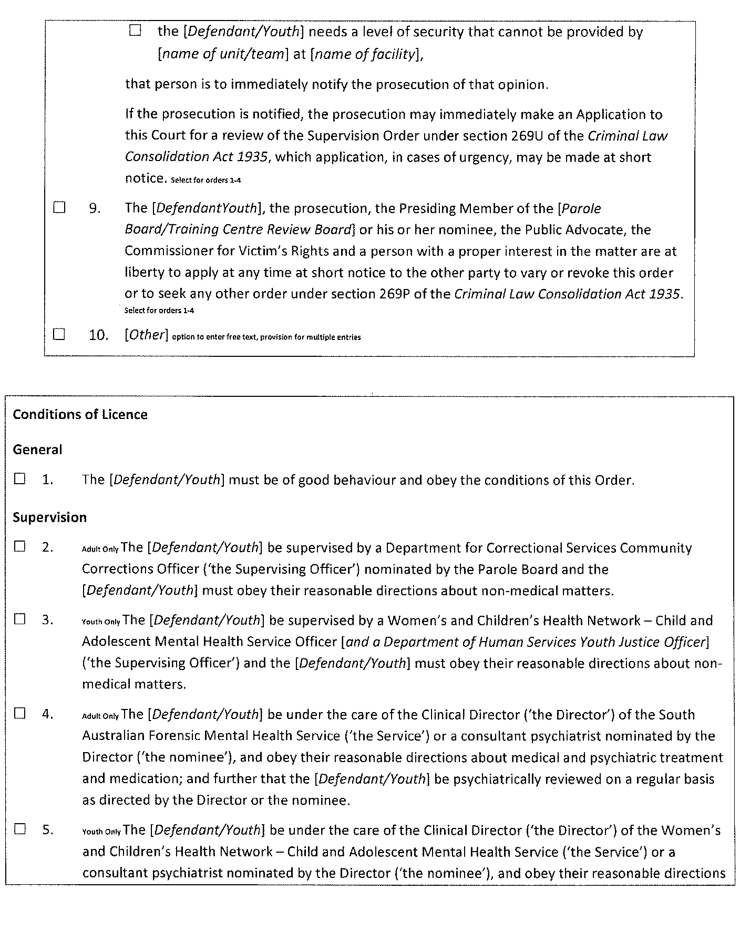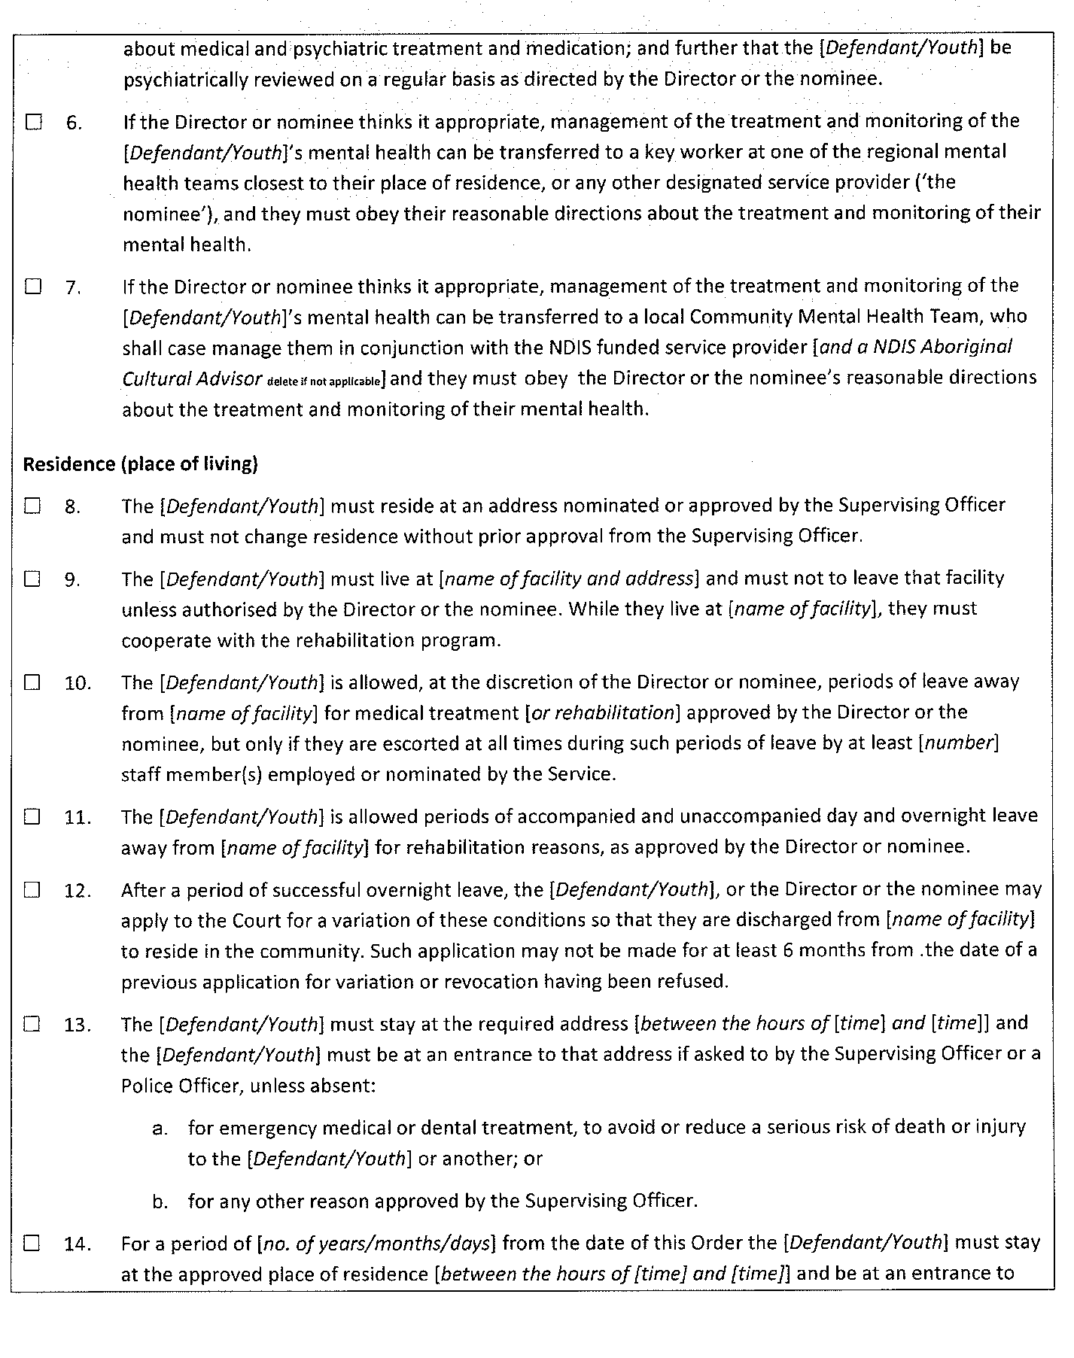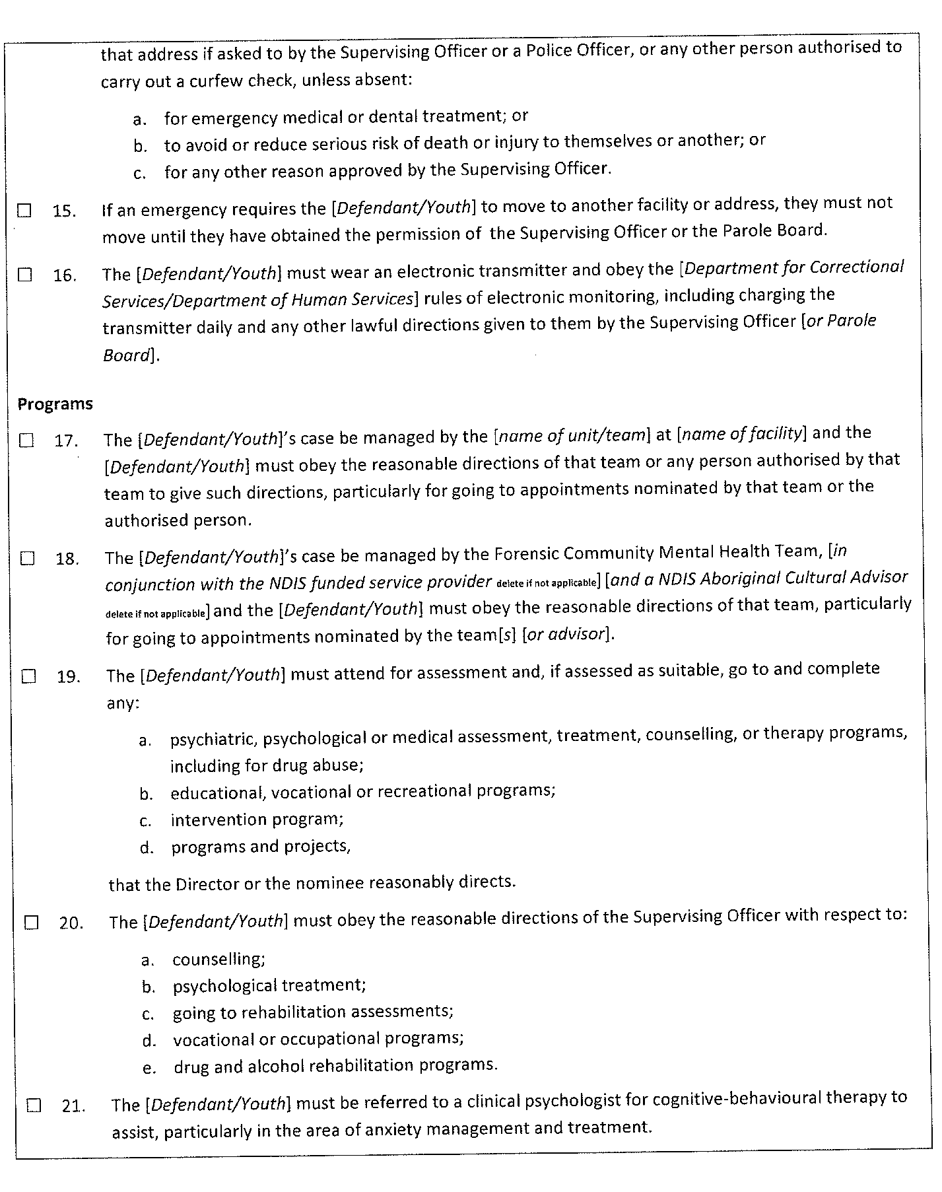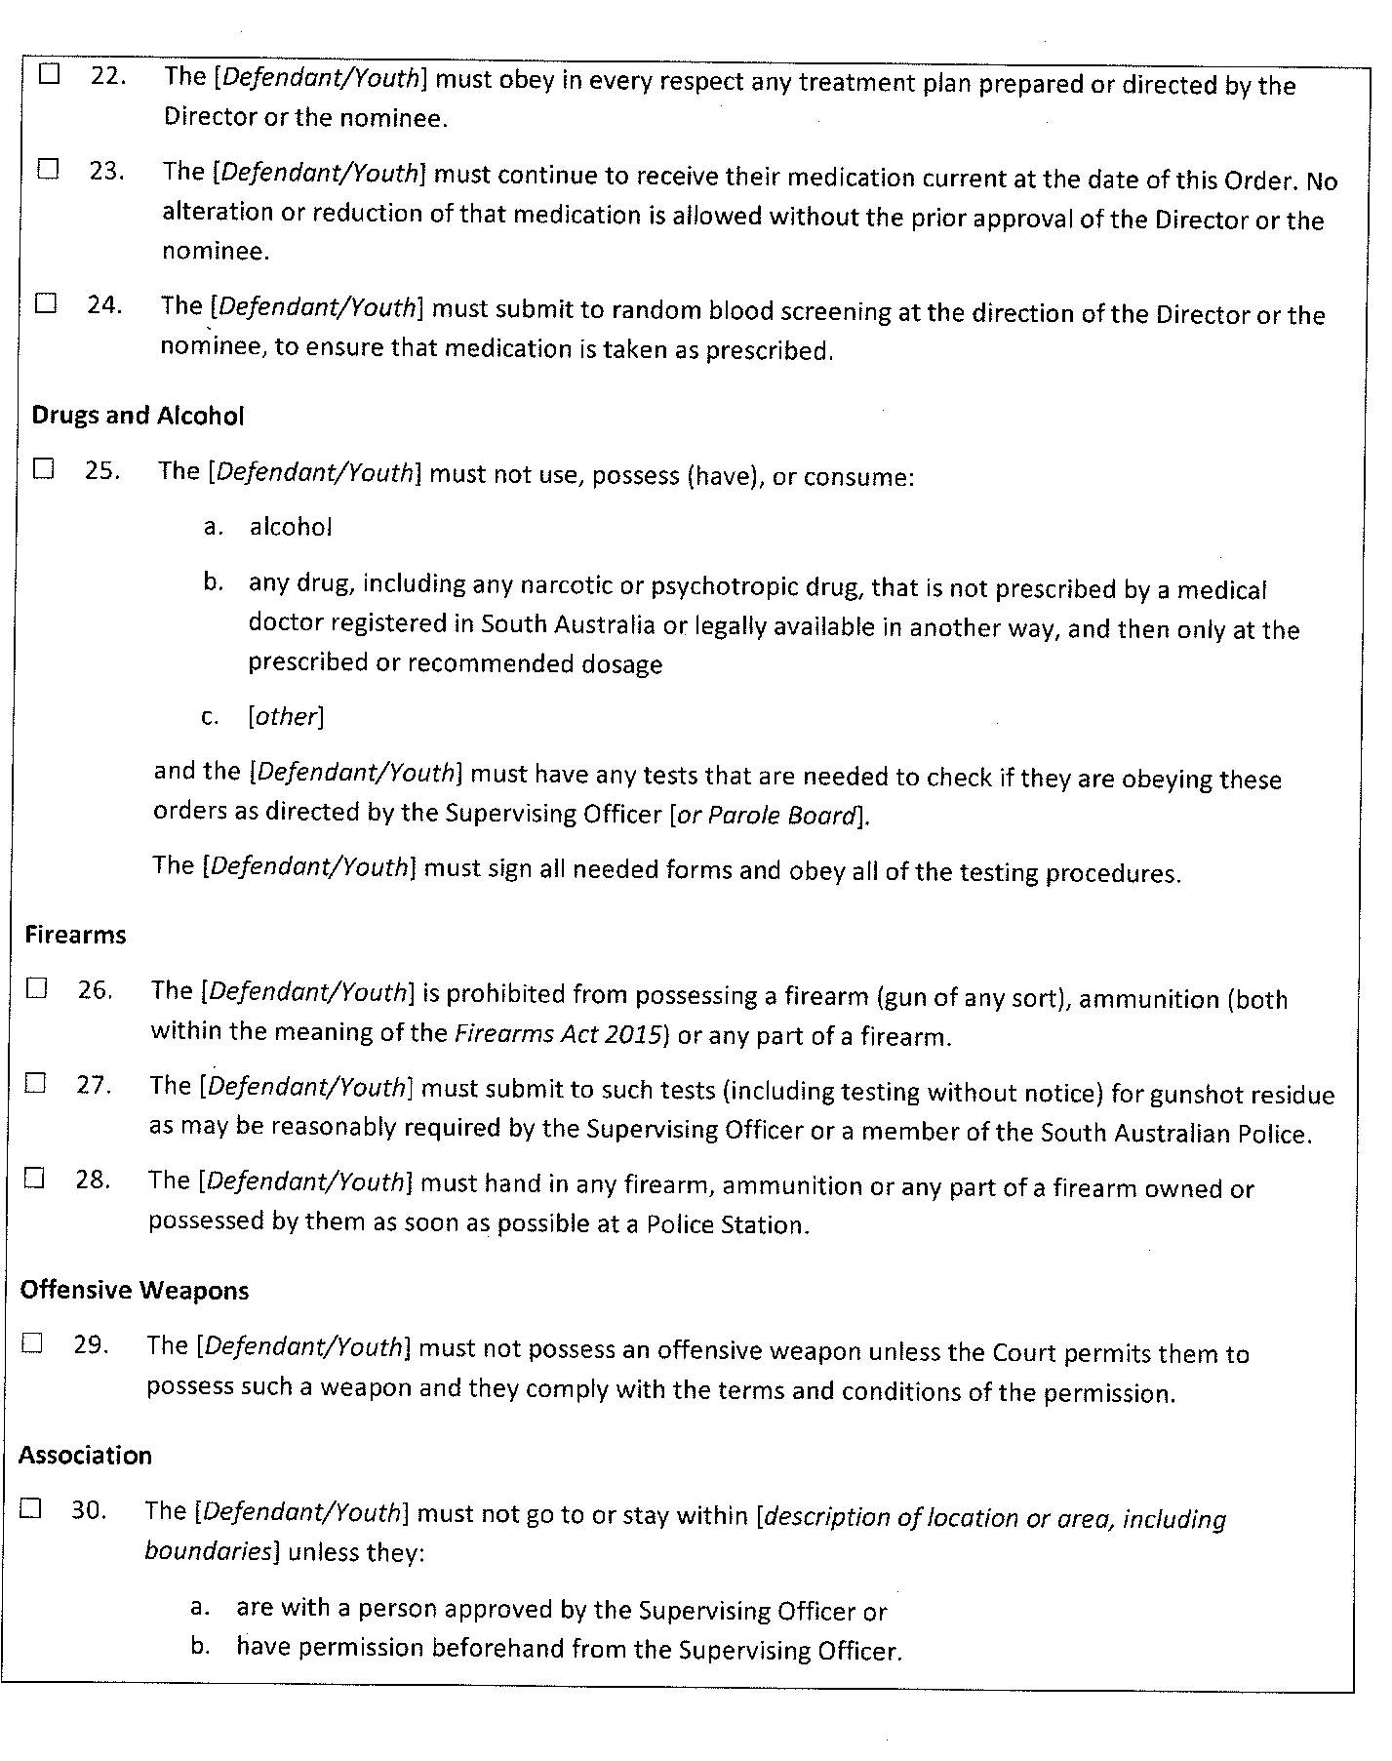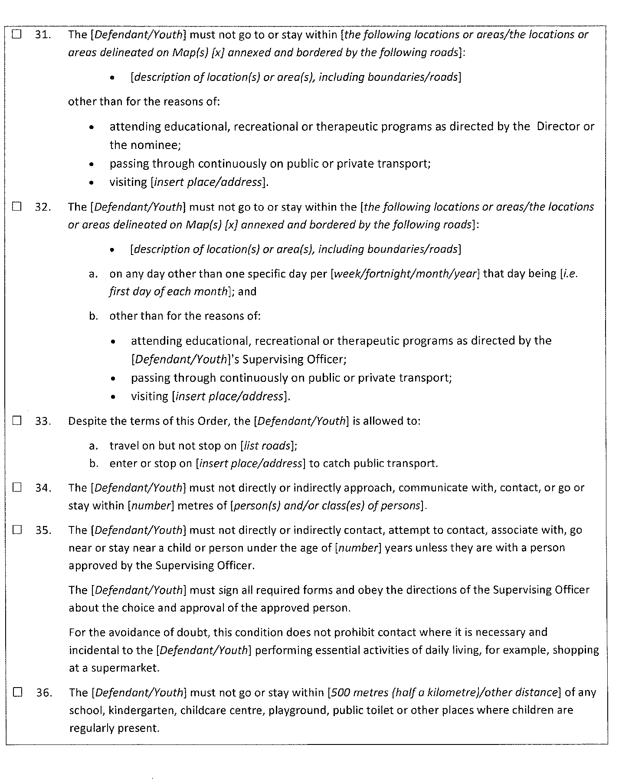
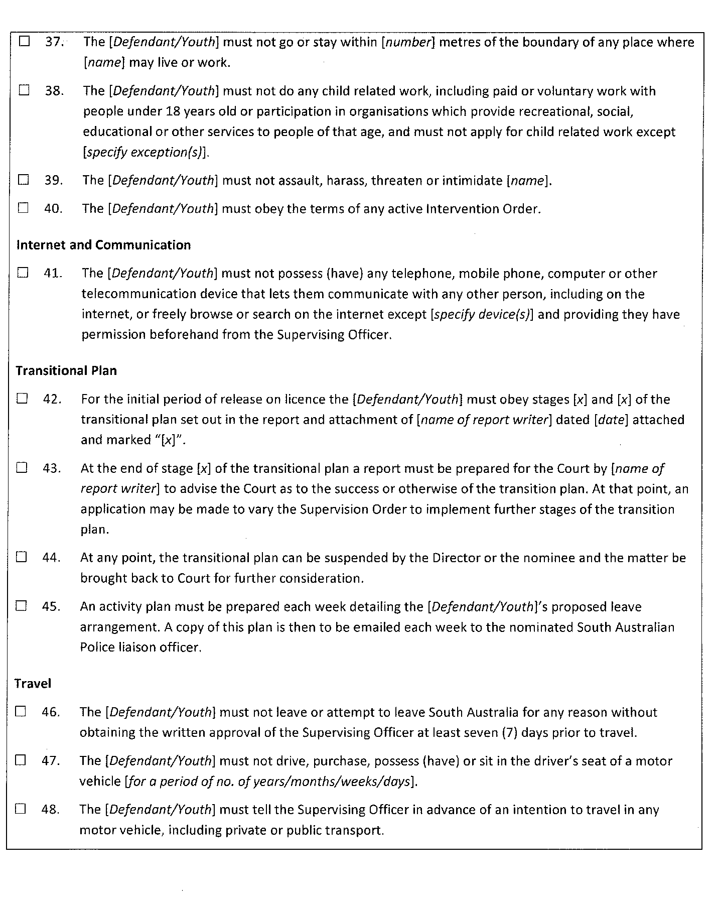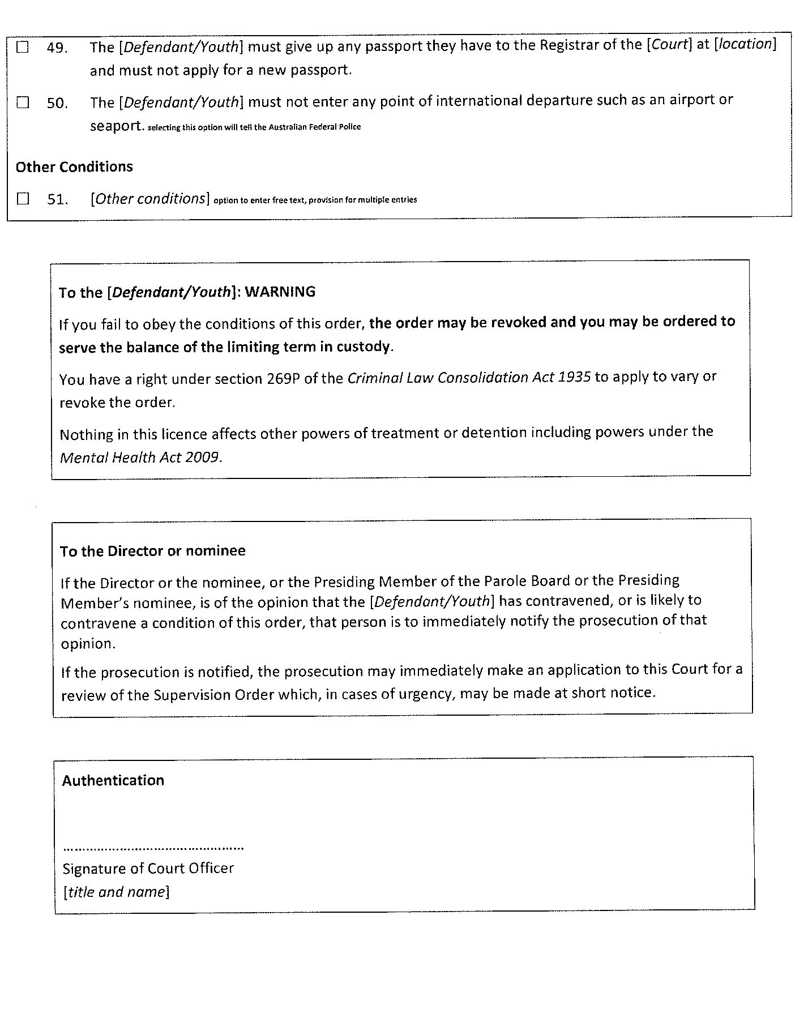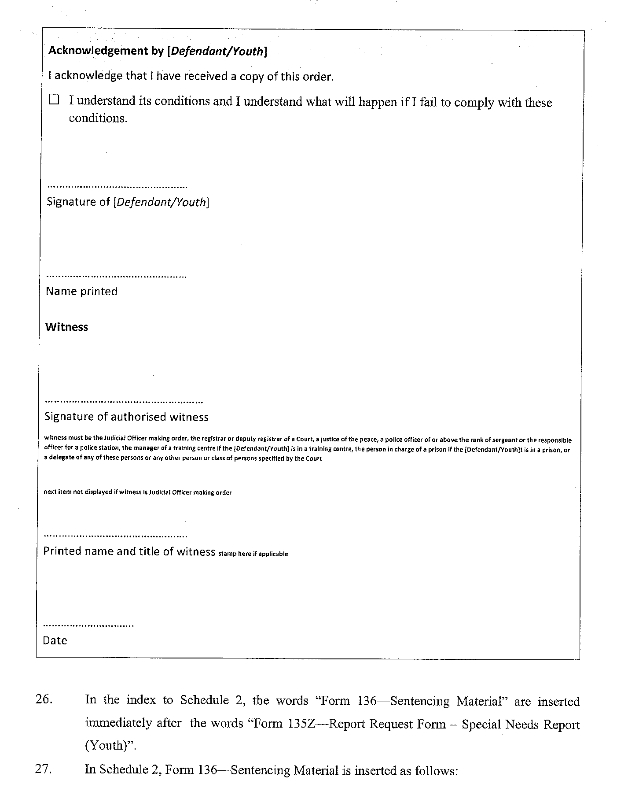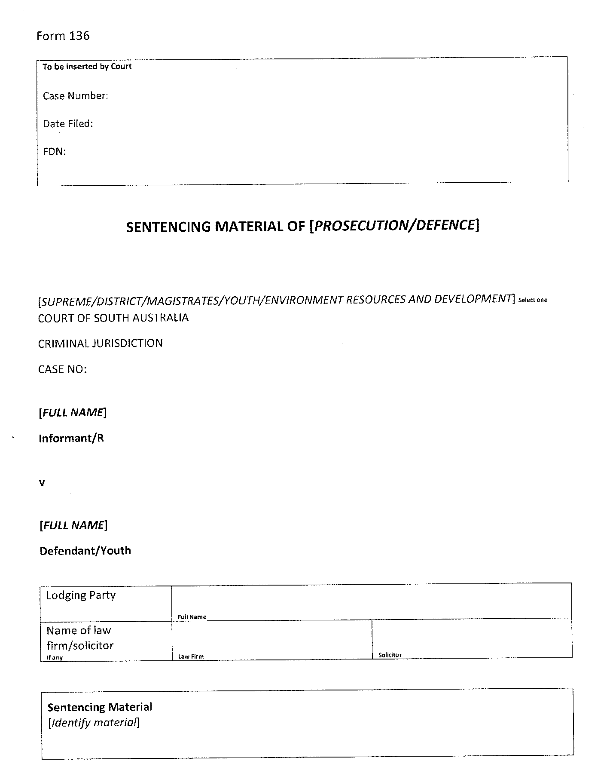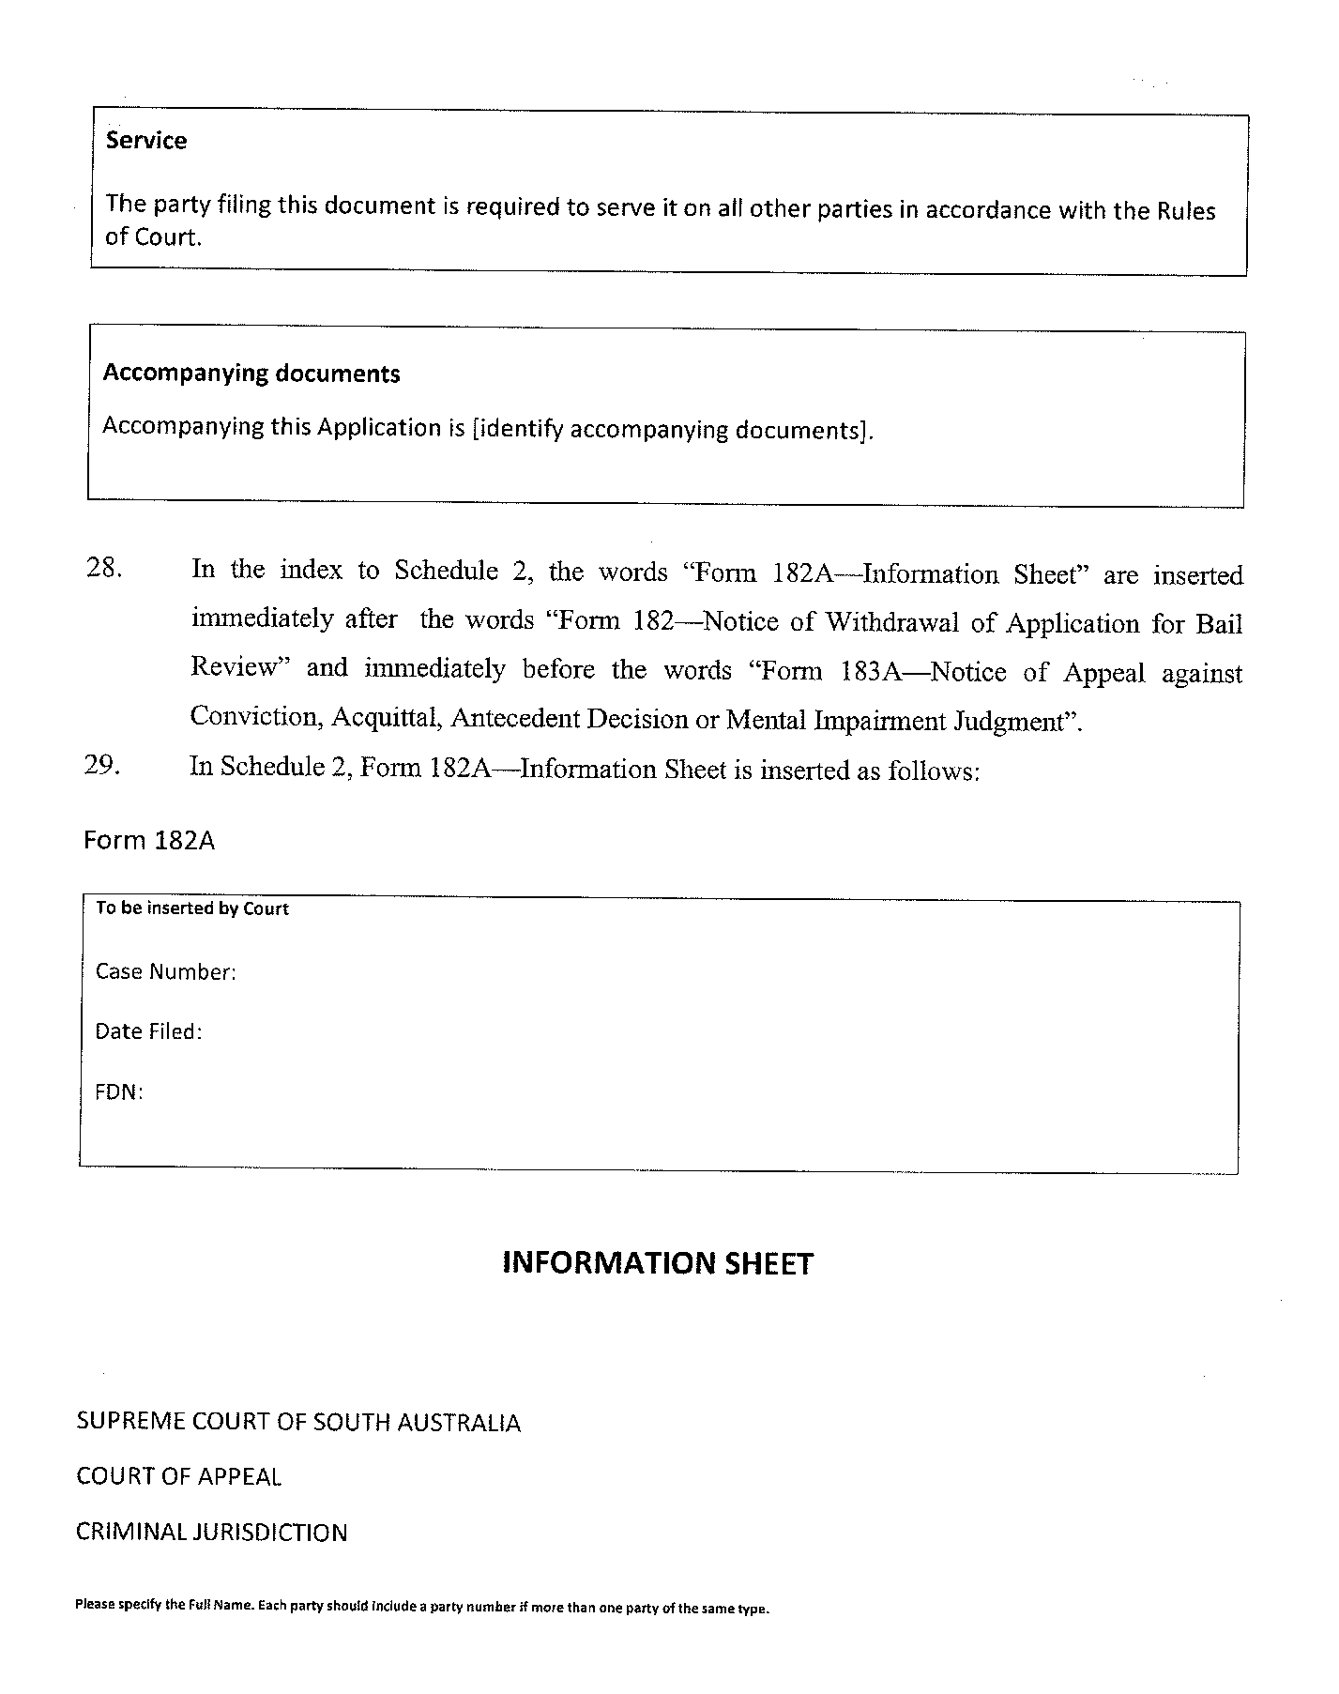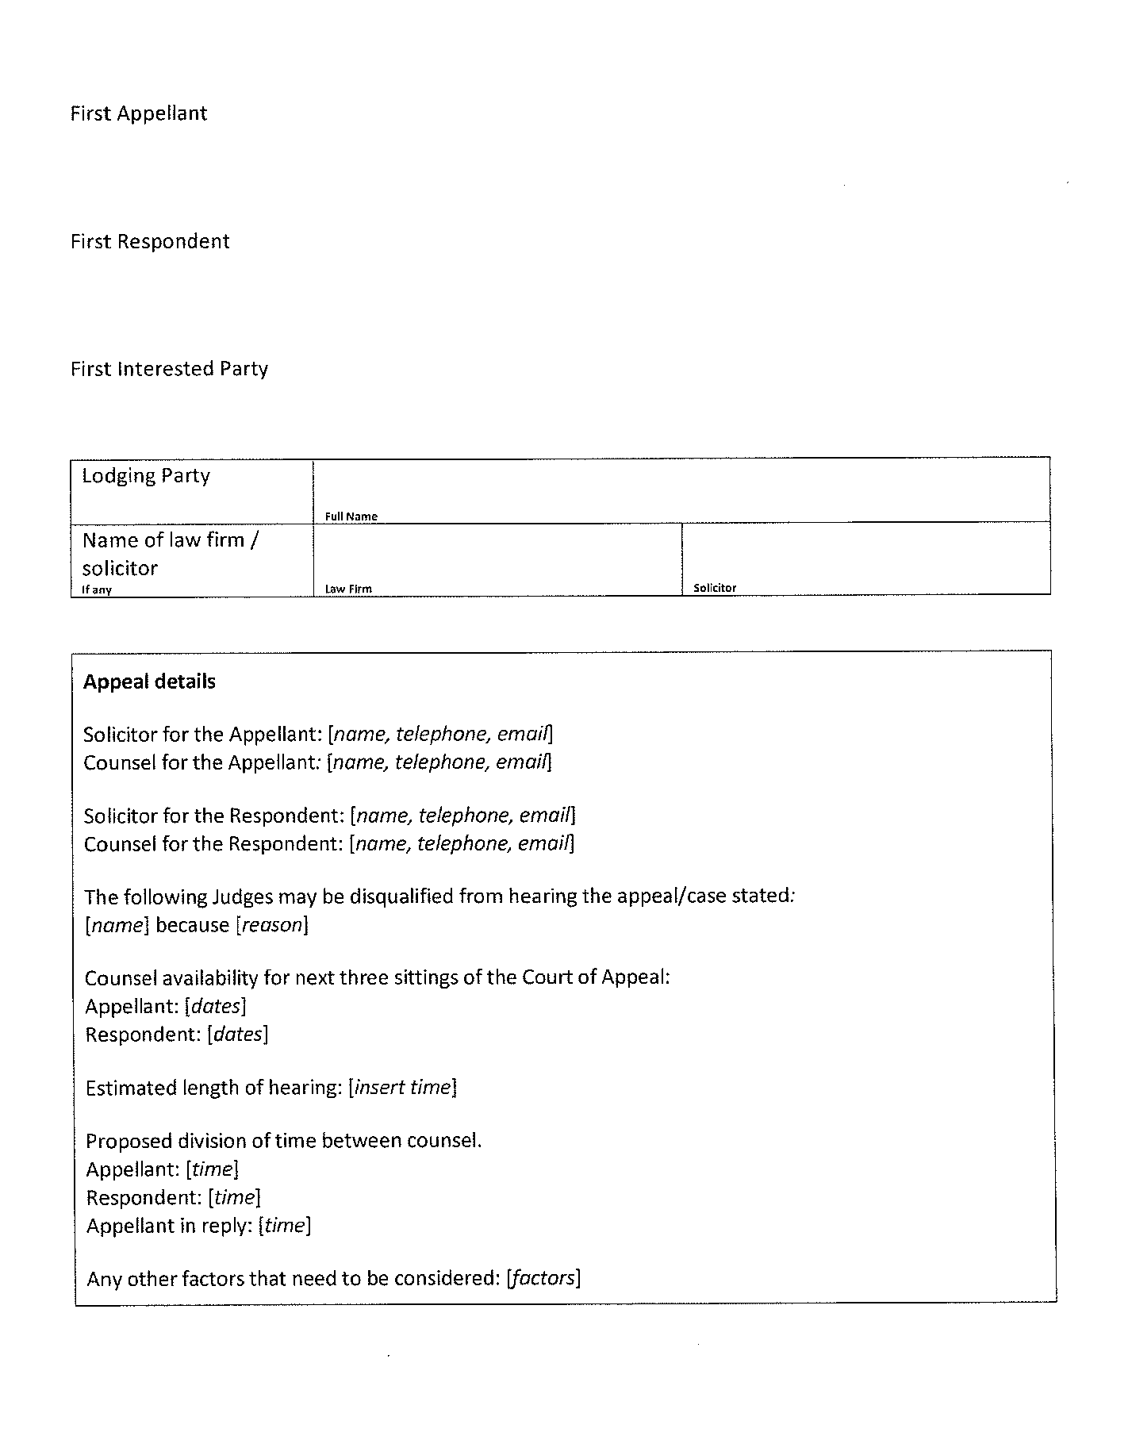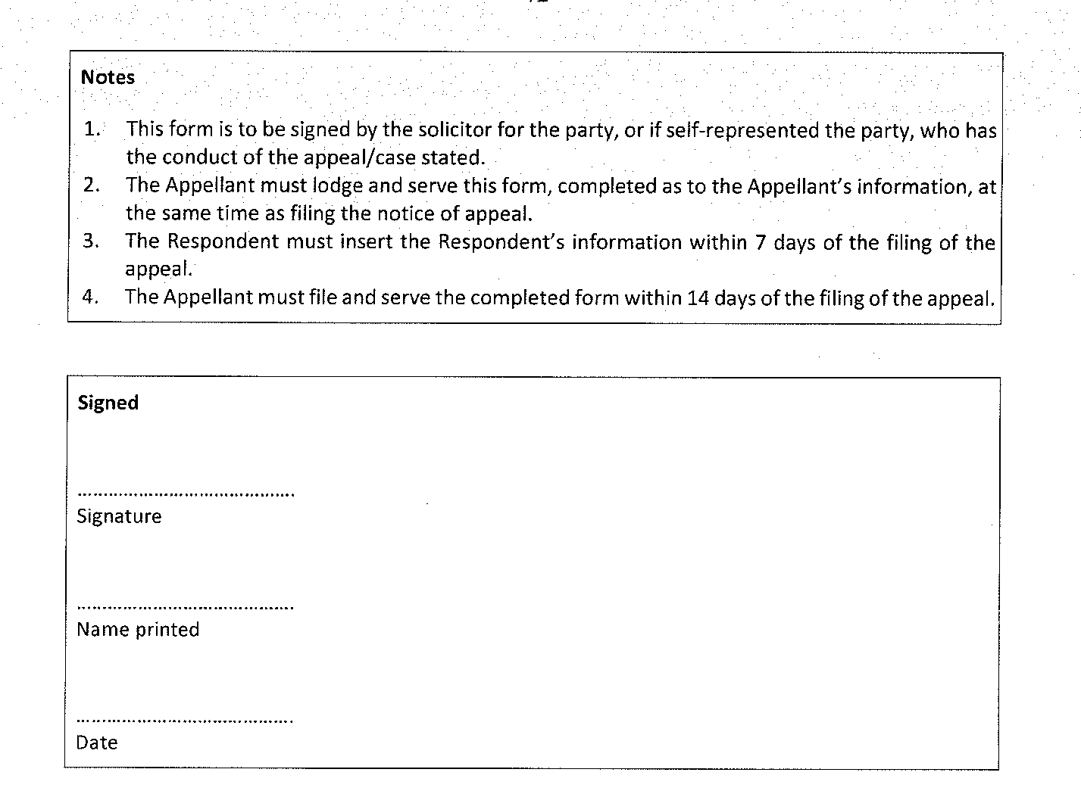

In accordance with the Supreme Court Act 1935, the District Court Act 1991, the Environment, Resources and Development Court Act 1993, the Magistrates Court Act 1991 and the Youth Court Act 1993, and all other enabling powers, the Joint Criminal (No 3) Amending Rules 2023 have been made –
- as rules of the Supreme Court by 3 or more Judges of the Supreme Court; and
- as rules of the District Court by the Chief Judge and 2 or more other Judges of that Court; and
- as rules of the Magistrates Court by the Chief Magistrate and 2 or more other Magistrates; and
- as rules of the Environment, Resources and Development Court by the Senior Judge and 1 other Judge; and
- as rules of the Youth Court by the Judge and the magistrates who are members of the principal judiciary of that Court,
and such rules will apply to and in relation to the Court in accordance with their terms.
Dated this 11th day of December 2023.
Chief Justice Kourakis
Chief Judge Evans
Senior Judge Durrant
Chief Magistrate Hribal
Judge Eldridge

Supreme Court Act 1935
District Court Act 1991
Magistrates Court Act 1991
Youth Court Act 1993
South Australia

Uniform Civil (No 10) Amending Rules 2023
By virtue and in pursuance of the Supreme Court Act 1935, the District Court Act 1991, the Youth Court Act 1993 and the Magistrates Court Act 1991, and all other enabling powers, we, the Chief Justice of the Supreme Court, the Chief Judge of the District Court, the Judge of the Youth Court and the Chief Magistrate of the Magistrates Court, make the following Uniform Civil (No 10) Amending Rules 2023.
- These Rules may be cited as the Uniform Civil (No 10) Amending Rules 2023.
- The Uniform Civil Rules 2020 (“the Rules”) are amended as set out below.
- The amendments made by these rules come into effect on the later of—
(a) Monday 1 January 2024; or
(b) the date of their publication in the Gazette.
- Existing rule 15.9 is renumbered as rule 15.10.
- A new rule 15.9 is inserted immediately after rule 15.8 as follows:
“15.9— Requirement to produce hard copies
If a party intends to put to a witness or tender in evidence a document at trial or a hearing, the party must provide to the Court two hard copies of that document at or before the time of putting or tender.”

- Rule 15.4 is deleted and substituted as follows:
“15.4—Appearance by audio visual link or telephone
(1) The Court may direct or permit one or more participants (parties, lawyers and witnesses) to appear at a hearing remotely by audio visual link or by telephone.
Note—
Appearance remotely is an exception to the general rule that appearances of parties, lawyers and witnesses is in person and a remote appearance therefore needs to be justified in the circumstances.
(2) Unless the Court otherwise orders, the costs incurred by the Court in conducting an audio visual hearing at the request of a party must be paid by the requesting party.
Remote appearance by party or lawyer
(3) A request for a party or lawyer to appear by audio visual link or by telephone must be made by—
(a) an interlocutory application in the prescribed form;
Prescribed form—
Form 77 Interlocutory Application
(b) oral application at a prior hearing;
(c) ticking the remote appearance box on a form filed using the Electronic System; or
(d) email sent to the chambers of the judicial officer before whom the hearing is to be conducted.
(4) A request under subrule (3) must identify the reason why the party or lawyer seeks to appear remotely rather than in person.
(5) A request under subrule (3) must be made to the Court in sufficient time before the hearing to allow the Court to decide whether to allow the request and, if so, make appropriate arrangements.
(6) If the Court is unable to contact the party or lawyer at any time within 15 minutes after the time appointed for the hearing at the nominated facility or by the nominated telephone number, the party or lawyer will be regarded as having failed to appear at the hearing for the purposes of these Rules.
Remote appearance by witness
(7) An application for a witness to appear by audio visual link or by telephone must be made by—
(a) an interlocutory application in the prescribed form supported by an affidavit in the prescribed form; or
Prescribed forms—
Form 77 Interlocutory Application
Form 12 Affidavit
(b) oral application at a prior hearing.
(8) An application under subrule (7) must identify the reason why the requesting party seeks that the witness appear remotely rather than in person.
(9) An application under subrule (7) must be made to the Court—
(a) in sufficient time before the hearing to allow the Court to decide whether to allow the application and, if so, make appropriate arrangements; and
(b) in any event at least seven days before the hearing at which the evidence is to be given.”
- Paragraph 64.5(2)(d) is deleted and substituted as follows:
“(d) no party is entitled to take any step in the proceeding, except if the party is—
- applying to remove the proceeding from the moratorium;
- filing a notice of discontinuance by consent under rule 141.2; or
- making or responding to a formal offer.”
- Existing subrule 101.8(7) is renumbered as subrule (8).
- A new subrule 101.8(7) is inserted immediately after subrule 101.8(6) as follows:
“(7) Written submissions or a summary of argument must include at the end of the document the name of counsel who settles the document (if applicable) or, if no counsel did so, the name of the solicitor who is responsible for the document (when a law firm is acting for the party).”
- A new subrule 132.10(5) is inserted immediately after subrule 132.10(4) as follows:
“(5) For the purposes of this rule, if a formal offer is filed during a moratorium under rule 64.5, the formal offer will be treated as having been filed on the first day after the moratorium ends.”
- A new subrule 132.11(5) is inserted immediately after subrule 132.11(4) as follows:
“(5) For the purposes of this rule, if a formal offer is filed during a moratorium under rule 64.5, the formal offer will be treated as having been filed on the first day after the moratorium ends.”
- A new rule 142.13 is inserted immediately after rule 142.12 as follows:
“142.13—Application to set aside by consent and discontinuance
- This rule applies to a proceeding in which there is no cross claim or third party claim or interested party and a default monetary judgment was entered in favour of the applicant or applicants against the respondent or respondents.
- The parties may execute and a party may file an application and consent to set aside judgment and discontinuance in the prescribed form.
Prescribed form—
Form 126A Application and Consent to Set Aside Judgment and Discontinuance
- If a document under subrule (2) is filed, the Court may set aside the default judgment and the action will be treated as wholly discontinued.”
- Rule 195.7A is deleted and substituted as follows:
“195.7A—Witness fees—Supreme Court and District Court
An amount paid, or to be paid, for attendance by a witness at a hearing is a disbursement properly incurred for a proceeding if—
(1) the attendance is reasonably required; and
(2) the amount is reasonable or is authorised, or approved, by the Court.”
- A Note to subrule 196.1 is inserted immediately after subrule (2) as follows:
“Note—
Under rule 212.2(1)(a) an appeal under this rule lies to a single Judge.”
- Rule 201.1 is amended to insert the words “ADI means an authorised deposit-taking institution;” immediately after the words “In this Chapter, unless the contrary intention appears—”.
- A new rule 203.3A is inserted immediately before rule 203.4 as follows:
“203.3A—Investigation Notice
(1) An investigation notice issued by a judgment creditor under section 3A of the Enforcement Act must be in the prescribed form.
Prescribed form—
Form 140 Investigation Notice
Note—
Section 3A(2) of the Enforcement Act provides that an investigation notice must specify the period (being not less than 28 days) within which its requirements must be complied with.
(2) An investigation notice—
(a) if the judgment debtor had an address for service in the proceeding in which judgment was entered—may be served at that address for service by one of the means set out in rule 44.3; or
(b) otherwise—must be served by original service.
(3) If an investigation notice seeks production for inspection of documents, it must specify a reasonable place, date and time for inspection in default of agreement.
(4) The Court may have regard to the question whether a judgment debtor served an investigation notice or whether the judgment debtor complied with the requirements of an investigation notice governed by this rule on the question of costs in any subsequent enforcement proceeding.
Notes—
Section 3A(1) of the Enforcement Act provides that a judgment debtor may be required by the judgment creditor to do either or both of the following:
- provide answers to specified questions relating to the judgment debtor’s means of satisfying the judgment (material questions);
- produce for inspection by the judgment creditor specified documents relating to material questions.
Section 3A(4) provides that, if a person uses information or a document provided in accordance with an investigation notice for a purpose other than assessing a judgment debtor’s means of satisfying a judgment, that person is guilty of an offence.
Maximum penalty: $ 5,000.”
- Subrule 203.4(3) is amended by inserting after the word “and” the words “subject to subrule (4)”.
- Existing subrule 203.4(4) is renumbered as subrule (5).
- A new subrule 203.4(4) is inserted immediately after subrule (3) as follows:
“(4) Despite subrule (3), a questionnaire may but need not be served if, within the three months preceding the issue of an investigation summons—
- the judgment debtor served on the judgment creditor a fully completed investigation notice containing answers to the same questions that are contained in a questionnaire; or
- a fully completed questionnaire was provided to the Court for the purposes or as part of a previous enforcement process.”
- Subrule 203.5(1) is amended to substitute for the words “investigation summons” the words “investigation notice under rule 203.3A or an investigations summons under rule 203.4”.
- Paragraph 203.11(2)(b) is deleted.
- Subrule 203.12(3) is deleted.
- Subrule 203.12(4) is amended to delete the words “, subject to compliance with section 6(2) of the Enforcement Act if applicable”.
- A new rule 203.13A is inserted immediately after rule 203.13 as follows:
“203.13A— Payment of money subject to attachment
(1) Unless the Court otherwise orders, the garnishee must pay money subject to the attachment directly to the judgment creditor—
(a) by depositing the money into an ADI account nominated by the judgment creditor;
(b) by cheque; or
(c) by another method agreed between the garnishee and the judgment creditor.
(2) The garnishee must use the judgment debtor’s first and last name, and where possible, the case number in which the garnishee order was made as a reference to identify the transaction when paying the money in accordance with subrule (1).
(3) The garnishee must provide a receipt in respect of the payment to the judgment debtor within 7 days of the payment being made.
(4) The judgment creditor must acknowledge receipt of the payment within 7 days by written notice to the garnishee.”
- Rule 206.7 is amended to insert a new subrule (8) immediately after subrule (7) as follows:
“(8) A notice by the Sheriff under section 7 of the Enforcement Act must—
(a) be in the prescribed form;
Prescribed form—
Form 170 Sheriff Notice
(b) if issued to the judgment debtor—be served on the judgment debtor at their address for service in the proceeding in which the warrant was issued (if any) or otherwise by personal service;
(c) if issued to a person other than the judgment debtor—be served on the person by personal service.”
- Paragraph 212.2(1)(a) is amended by inserting after the word “under” the words “Chapter 16 Part 6 or”.
- Subparagraph 212.3(1)(a)(i) is amended by inserting after the word “under” the words “Chapter 16 Part 6 or”.
- The heading of Part 3 in Chapter 18 is amended to insert the words “and District Court” immediately after the words “Part 3— Leave to appeal—Supreme Court”.
- The heading of rule 213.1 is amended to insert the words “: Supreme Court” immediately after the words “213.1—When required”.
- A new rule 213.1A is inserted immediately after rule 213.1 as follows:
“213.1A—When required: District Court
(1) Subject to any statute to the contrary, leave to appeal is required in respect of any appeal to a Judge of the Court against a judgment order or decision of a Master or Judicial Registrar.
(2) If leave to appeal is granted, but it later becomes evident that it ought not to have been granted, the Court may revoke the grant of leave.
Note—
Section 43(3) of the District Court Act 1991 provides that an appeal lies as of right, or by permission, according to the rules of the appellate court.”
- Subrule 213.3(1) is amended to insert the words “of the District Court or Supreme Court” immediately after the words “An application for leave to appeal against an order or judgment of a Master”.
- Rule 213.4 is deleted and substituted as follows:
“213.4—Appeal to single Judge
(1) This rule applies to the determination of leave to appeal to a Judge of the District Court or the Supreme Court.
(2) A Judge may—
(a) order that the application for leave to appeal be determined on the basis of written submissions by the applicant for leave or by the parties and give directions for that purpose;
(b) order that the application for leave to appeal be listed for separate hearing and determination;
(c) order that the application for leave to appeal be heard at the same time as the appeal;
(d) invite a party to produce specific documents or make submissions on a specific matter; or
(e) make any other or further order.”
- The heading for rule 213.5 is amended to include the words “: Supreme Court” immediately after the words “213.5—Determination of leave to appeal to Court of Appeal”.
- A Note is inserted immediately after subrule 214.1(1) as follows:
“Note—
Under rules 103.2 and 182.2, unless the Court orders otherwise, an order or judgment takes effect, when the Court pronounces it orally in court, at the end of the hearing when the pronouncement is made or, if the Court pronounces it other than at a hearing, when the Court communicates its terms to the parties. Time to appeal begins to run when the order or judgment takes effect under those rules. It does not begin to run if the Court merely delivers reasons for judgment but does not yet make orders.”
- Subrule 217.5(2) is deleted and substituted as follows:
“(2) An appeal book must contain a filing page, be paginated, be printed on both sides of the page and contain a table of contents at the front.”
- Existing subrule 217.7(6) is renumbered as subrule (7).
- A new subrule 217.7(6) is inserted as follows:
“(6) Written submissions must include at the end of the document the name of counsel who settles them or, if no counsel did so, the name of the solicitor who is responsible for the document.”
- Subrule 218.4(3) is deleted and substituted as follows:
“(3) A core appeal book must contain a filing page, be paginated, be printed on both sides of the page and contain a table of contents at the front.”
- Existing subrule 218.6(6) is renumbered as subrule (7).
- A new subrule 218.6(6) is inserted as follows:
“(6) Written submissions must at the end of the document include the name of counsel who settles written submissions or, if no counsel did so, the name of the solicitor who is responsible for the document, must appear at the end of the document.”
- Part G: Certifications and acknowledgments contained in subrule 263.4(2) is amended to number the paragraph which commences with the words “The following certifications and acknowledgements:” as paragraph (1); renumber the current paragraph (3) as paragraph (2); and renumber the current paragraph (4) as paragraph (3).
- Subrule 218.9(3) is deleted and substituted as follows:
“(3) The appellant must file 3 physical copies of the exhibit appeal book, printed on both sides of the page, 7 days after the last of the written submissions are filed or due (whichever is earlier).”
- Rule 218.11 is deleted and substituted as follows:
“218.11 – Information Sheet
(1) The appellant must serve on each other party a draft information sheet in the prescribed form at the same time as filing a notice of appeal under rule 214.2.
Prescribed forms—
Form 189 Information Sheet
(2) The respondent must serve on the appellant any changes or additions it seeks to be added to the information sheet not more than 7 days after the draft information sheet has been served under subrule (1).
(3) The appellant must file and serve on each party a completed information sheet not more than 14 days after the draft information sheet has been served under subrule (1).”
- Part D: Supporting Submission contained in subrule 263.4(2) is deleted and substituted as follows:
“Part D: Supporting Submission
A statement of the reasons why the applicant considers that she or he is suitable for appointment to the office of Senior Counsel. Here the applicant should address all the criteria set out in rule 263.2.
In support of the application, an applicant may:
(a) refer to cases falling outside the 18 month period referred to in Part C (1) and should state why the cases referred to in Part C (2) evidence attainment of the standard of Senior Counsel;
(b) provide a confidential report from a community legal centre or the Legal Services Commission demonstrating the pro bono hours worked by the applicant.”
- Part 2 to Schedule 6 is amended as follows:
- Subrule 3(1) is amended to substitute “(5)” for “(6)”.
- Subrule 3(2) is amended to substitute “(5)” for “(6)”.
- Subrule 3(3) is amended to substitute “(5)” for “(6)”.
- Subrule 3(4) is amended to substitute “(5)” for “(6)”.
- Existing subrule 3(5) is renumbered as 3(6) and the words “(1), (2), (3) and (4)” are replaced with “(1), (2), (3), (4) and (5)”.
- A new subrule 3(5) is inserted as follows:
“(5) Subject to subrule (6), the Higher Courts costs scale in respect of work done from on or after 1 January 2024 is set out in the following table.”
Higher Courts costs scale
Item | Description | Amount
Documents
1 | Drawing any document of importance, other than documents mentioned under item 2, 10 or 11 (including original and the lawyer’s file copy). | $64.63 —for each ¼ page.
2 | Drawing proofs, indices, formal lists, extracts from other documents, lists of authorities, or other formal documents (including original and the lawyer’s file copy). | $21.23—for each ¼ page.
3 | Engrossing documents, when copying or scanning is not appropriate (including original and the lawyer’s file copy). | $6.14—for each ¼ page.
4 | Perusing documents (including electronic documents). | a range between $3.08 and $12.02—for each ¼ page.
5 | Examining documents (including electronic documents), when a perusal is not justified. | $0.77—for each ¼ page.
6 | Documents produced by copying or scanning, or receiving emails, faxes or any other electronic transmissions. | $0.45—for each sheet.
Attendances and Communications
7 | Attendances and oral communications, whether personal or by electronic communication, including attendances to swear or take affidavits. | Either:  - for each 6 minute unit by a lawyer involving skill—$44.69;  - for each 6 minute unit by a lawyer not involving skill—$26.81;  - for each 6 minute unit by a non-lawyer employed or engaged by a lawyer—$21.23; or  - for arranging appointments, including all work involved—$30.17 per person.
8 | Attending hearings, including preparation, and when not attending as instructing lawyer for counsel. | Either:  - for an ordinary hearing—$223.47; or  - if protracted (beyond 5 units), for each 6 minute unit of hearing time—$44.69.
9 | Filing or delivery of documents other than personal service, when no other attendance is properly allowable. | $30.17.
Correspondence
10 | Correspondence, including original to send and the lawyer’s file copy, and the ordinary postal or transmission expenses—whether sent by letter, email, SMS or fax. | $30.17—for each ¼ page.
11 | Circular correspondence, including original to send and the lawyer’s file copy, and the ordinary postal or transmission, expenses—after the first. | $15.09—for each letter, including copying for subsequent pages (regardless of the number of pages).
Miscellaneous
12 | Paying disbursements by whatever means and including all work and associated expenses. | $30.17.
13 | Preparation of Pleadings Books, Tender Books, Application Books, Appeal Books and Briefs, including indices, pagination and binding. | $2.24—for each page.
14 | Lump sum on a default judgment. | $3051.58.

- A new Part 6 to Schedule 6 is inserted as follows:
“Part 6—Winding up proceedings (including oppression proceedings where winding up is sought)
6.1—Method of fixing costs
When an order for the winding up of a company is made by the Court, the applicant or a supporting creditor may apply to have the amount of its costs and disbursements fixed—
(a) by the Judge or Master making the winding up order at the time the order is made; or
(b) in the ordinary way under Part 5 of Chapter 16.
6.2—Costs fixed at time of order
Under subrule 6.1(a), the total of the costs and disbursements will be fixed at the following amounts without the need to present any details of the costs or disbursements to the Court when the application was made on or after 18 May 2020—
(a) Applicant’s costs when the applicant is not the company being wound up and that company was trading in South Australia—$5,955 plus the filing fee;
(b) Applicant’s costs when the applicant is not the company being wound up and that company was not trading in South Australia— $6,410 (allowance for advertising) plus the filing fee;
(c) Supporting creditor awarded costs— $1,520 (when one set of costs is awarded to more than one supporting creditor there is to be no increase in this item);
(d) Supporting creditor is substituted as applicant— any amount fixed under paragraph (c) plus $1,820.
6.3—Variation in costs
Where the work done in obtaining a winding up order varies significantly from that generally described in subrule 6.2, the party seeking a costs order may request the Court on the making of the winding up order to allow a lump sum either more or less than those set out in subrule 6.2 to reflect the work actually done in obtaining the order.
6.4—Percentage increase
When any percentage increase is allowed on or after 18 May 2020 in Parts 2 of Schedule 6— that percentage increase is to be added to the lump sum amounts in this Part (not including filing fees) when orders for winding up are made on or after the date on which the increase takes effect.
6.5—Discretion
When a party seeks that costs be fixed under paragraph (a) or (b) of subrule 6.1— the Court retains a discretion to require that the costs be fixed under paragraph (c).
6.6—Application to set aside
When the costs have been fixed under paragraph (a) of subrule 6.1— a liquidator or other interested party may apply to have the order or allocatur set aside on the ground that the costs fixed are excessive and to have the costs fixed under paragraph (b).”
- In Schedule 7, Form 7C—Originating Application – Ex Parte – Appointment as Senior Counsel is deleted and substituted as follows:
Form 7C

To be inserted by Court
Case Number:

Date Filed:

FDN:

Hearing Date and Time:

Hearing Location:

ORIGINATING APPLICATION EX PARTE
SUPREME COURT OF SOUTH AUSTRALIA
CIVIL JURISDICTION
Please specify the Full Name of the Applicant.

First Applicant
Applicant
 | Full Name (including Also Known as, capacity (eg Administrator, Liquidator, Trustee) and Litigation Guardian Name (if applicable))
Address
 | Street Address (including unit or level number and name of property if required)
 | City/town/suburb | State | Postcode | Country
 | Email address
Phone Details
 | Type - Number

Part A: Formal Particulars
Date of birth: [date]
Academic qualifications: [name] [university/institution] [date of conferral]
Date and place of first admission as legal practitioner: [date] [jurisdiction]
Date and admission as legal practitioner in South Australia: [date]
Date of joining independent bar: [date/not applicable]
Year of first application for Senior Counsel: [year/not applicable]
Year of last application for Senior Counsel: [year/not applicable]

Part B: Areas of practice
Narrative description of Applicant’s practice including main areas of practice and the courts or tribunals in which she or he predominantly practices.

Part C: Details of recent cases – Detail multiple if applicable
(1) Substantial cases in last 18 months
Parties: [name]
Citation: [citation/not applicable]
Court: [name]
Judicial officer/arbitrator/mediator: [name]
Instructing solicitor: [name]
Counsel by whom led: [name/not applicable]
Counsel led by Applicant: [name/not applicable]
Opposing counsel: [name]
(2) Selected cases in the last 2 years
Brief precis of cases which evidence attainment of the standard of Senior Counsel (up to 10 cases).
Identification of case: [identification]
Precis: [precis]

Part D: Supporting submission
Reasons why Applicant is suitable for appointment as Senior Counsel addressing all the criteria set out in rule 263.2 including (1) why cases referred to in Part C (2) evidence attainment of the standard of Senior Counsel and (2) a confidential report form a community legal centre or the Legal Services Commission demonstrating the extent pro bono work undertaken by the applicant

Part E: Complaint history
Provide multiple entries where applicable.
- Complaints
Applicable: [yes/no]
Date of complaint: [date]
Name of complainant: [name]
Subject of complaint: [summary of complaint]
Complaint finalised: [yes/no]
Date of finalisation of complaint: [date/not applicable]
Body/person determining complaint: [name/not applicable]
Outcome of complaint: [date/not applicable]
- Offences
Applicable: [yes/no]
Date of conviction/finding of guilt: [date]
Court: [name]
Offence: [name/section]
Offence details: [offence details]
Outcome/penalty: [date/not applicable]
- Professional negligence findings
Applicable: [yes/no]
Date of finding: [date]
Court: [name]
Order: [order]
Type of negligence: [type]
Finding details: [details]
- Notifications to insurer
Applicable: [yes/no]
Date of notification: [date]
Name of claimant/potential claimant: [name]
Subject of claim/potential claim: [summary of claim/potential claim]
- Personal costs orders
Applicable: [yes/no]
Date of order: [date]
Court: [name]
Order: [order]
Ground for order: [ground]
Finding details: [details]
- Insolvency
Applicable: [yes/no]
Date of bankruptcy/personal insolvency agreement: [date]
Type: [bankruptcy/personal insolvency agreement]
Court making order: [name/not applicable]
Circumstances giving rise to insolvency order: [circumstances]
Discharged: [yes/no]
Date of discharge: [date]
Return to creditors: [details]
- Inappropriate Workplace Complaints
Applicable: [yes/no]Date of complaint: [date]
Name of complainant: [name]
Subject of complaint: [summary of complaint]
Complaint finalised: [yes/no]
Date of finalisation of complaint: [date/not applicable]
- Any other relevant matters
Applicable: [yes/no]
Subject matter: [subject]
Details: [details]

Part F: Referees
- Judicial
First referee: [name] [name of court/tribunal/other]
Second referee: [name] [name of court/tribunal/other]
Third referee: [name] [name of court/tribunal/other]
- Instructing Solicitor
Referee: [name] [firm]
- Non-judicial
First referee: [name] [description of role/position]
Second referee: [name] [description of role/position]
- Any additional referees Optional
Referee: [name] [description of role/position]
- Any references Optional
References are attached to this application: [yes/no]

Part G: Certification and acknowledgement
I certify that the information provided in this application is correct to the best of my knowledge and belief and that there are no other matters of which I am aware that may provide a reason why I should not be appointed Senior Counsel.
I acknowledge that the Chief Justice, the Court, the advisory committee and persons the advisory committee may consult may make enquiries of the persons referred to in the application and such other persons as it or they think fit in relation to my application. I authorise such enquiries to be made and acknowledge that it will be done on a confidential basis and that the information received from such enquiries and provided by such third parties is confidential as against me and I cannot require disclosure of it.
I agree to confidential enquiries being made of the Legal Profession Conduct Commissioner or any other regulatory body about any matter or circumstances, either past or anticipated that may adversely affect my fitness or propriety to hold an appointment as Senior Counsel. I agree that the Legal Profession Conduct Commissioner and any such other regulatory body as may be consulted may provide to the advisory committee and the Chief Justice, on a confidential basis, all information necessary to answer such enquiries.
I undertake to notify the Chief Justice in the event that any new matter arises that would be required to be disclosed in this application.

Accompanying Documents
Mark appropriate section below with an ‘x’
Accompanying this Application is a:
[ ] Reference or references (optional)

- In Schedule 7, Form 89—Summary of Argument is deleted and substituted as follows:
Form 89
To be inserted by Court
Case Number:

Date Filed:

FDN:

SUMMARY OF ARGUMENT OF [PARTY TITLE]

[SUPREME/DISTRICT/MAGISTRATES/YOUTH] Delete all but one COURT OF SOUTH AUSTRALIA
[COURT OF APPEAL] If applicable
CIVIL JURISDICTION
[MINOR CIVIL] If applicable
[NAME OF LIST] LIST If applicable
Please specify the Full Name including capacity (eg Administrator, Liquidator, Trustee) and Litigation Guardian Name (if applicable) for each party. Each party should include a party number if more than one party of the same type.

First Applicant/Appellant

First Respondent

First Interested Party
Lodging Party
 | Full Name (including Also Known as, capacity (eg Administrator, Liquidator, Trustee) and Litigation Guardian Name (if applicable))
Name of law firm / solicitor
If any
 | Law Firm | Solicitor

Interlocutory Application: [date and FDN]
Affidavits relied upon: [deponent, date and FDN] Provision for multiple

Summary of Argument
[submissions]
[name(s) of counsel/author]
Accompanying Documents
Mark with an ‘x’ if applicable
Accompanying this summary of argument is:
[ ] [identify additional documents]

- In Schedule 7, Form 90—Written Submissions is deleted and substituted as follows:
Form 90
To be inserted by Court
Case Number:

Date Filed:

FDN:

WRITTEN SUBMISSIONS OF [PARTY TITLE]

[SUPREME/DISTRICT/MAGISTRATES/YOUTH] Delete all but one COURT OF SOUTH AUSTRALIA
[COURT OF APPEAL] If applicable
CIVIL JURISDICTION
[MINOR CIVIL] If applicable
[NAME OF LIST] LIST If applicable
Please specify the Full Name including capacity (eg Administrator, Liquidator, Trustee) and Litigation Guardian Name (if applicable) for each party. Each party should include a party number if more than one party of the same type.

First Applicant/Appellant

First Respondent

First Interested Party
Lodging Party
 | Full Name (including Also Known as, capacity (eg Administrator, Liquidator, Trustee) and Litigation Guardian Name (if applicable))
Name of law firm / solicitor
If any
 | Law Firm | Solicitor

Interlocutory Application: [date and FDN]
Affidavits relied upon: [deponent, date and FDN] Provision for multiple

Written Submissions
[submissions]
[name(s) of counsel/author]
Accompanying Documents
Mark with an ‘x’ if applicable
Accompanying these submissions is:
[ ] [identify additional documents]

- In the index to Schedule 7, the words “Form 126A—Application and Consent to Set Aside Default Judgment and Discontinuance” are inserted immediately after the words “Form 126—Notice of and Consent to Discontinuance” and immediately before the words “Form 127—Draft Judgment”.
- In Schedule 7, a new Form 126A— Application and Consent to Set Aside Default Judgment and Discontinuance is inserted immediately after Form 126—Notice of and Consent to Discontinuance and immediately before Form 127—Draft Judgment as follows:
Form 126A

To be inserted by Court
Case Number:

Date Filed:

FDN:

APPLICATION AND CONSENT TO SET ASIDE DEFAULT JUDGMENT AND DISCONTINUANCE

[SUPREME/DISTRICT/MAGISTRATES] Delete all but one COURT OF SOUTH AUSTRALIA
CIVIL JURISDICTION
[MINOR CIVIL] If applicable
[NAME OF LIST] LIST If applicable

Please specify the Full Name including capacity (eg Administrator, Liquidator, Trustee) and Litigation Guardian Name (if applicable) for each party. Each party should include a party number if more than one party of the same type.

First Applicant

First Respondent

Lodging Party
 | Full Name (including Also Known as, capacity (eg Administrator, Liquidator, Trustee) and Litigation Guardian Name (if applicable))
Name of law firm / solicitor
If any
 | Law Firm | Solicitor

Application and Consent to Set Aside Judgment and Discontinuance of Action
The applicant(s) apply to set aside the judgment in this action dated [date]and consent to the respondent(s) wholly discontinuing the action on the basis that neither party claims costs against the other in respect of the action and any costs already paid are not recoverable by the paying party from the receiving party.
The respondent(s) consent to the setting aside of the judgment sought by the applicant(s) and wholly discontinue the action on the basis that neither party claims costs against the other in respect of the action and any costs already paid are not recoverable by the paying party from the receiving party.

Execution by or on behalf of the applicant(s) To be signed EITHER by solicitor OR by applicant(s)
…………………………………………
Signature of solicitor for applicants
…………………………………………
Name printed
………………………….
Date

…………………………………………
Signature of applicant(s)
…………………………………………
Name(s) printed
………………………….
Date

Execution by or on behalf of the respondent(s) To be signed EITHER by solicitor OR by applicant(s)
…………………………………………
Signature of solicitor for respondent(s)
…………………………………………
Name printed
………………………….
Date

…………………………………………
Signature of respondent(s)
…………………………………………
Name(s) printed
………………………….
Date

- In the index to Schedule 7, the words “Form 140—Investigation Notice” are inserted immediately before the words “Form 141—Application to Enforce Judgement”.
- In Schedule 7, a new Form 140—Investigation Notice is inserted immediately before Form 141—Application to Enforce Judgement as follows:
Form 140

INVESTIGATION NOTICE
Enforcement of Judgments Act 1991 s 3A
[SUPREME/DISTRICT/MAGISTRATES] Delete all but one COURT OF SOUTH AUSTRALIA
CIVIL JURISDICTION
First Applicant

First Respondent
Judgment Creditor
 | Full Name (including Also Known as, capacity (eg Administrator, Liquidator, Trustee) and Litigation Guardian Name (if applicable))
Name of law firm / solicitor
If any
 | Law Firm |  | Solicitor
Address for service
 | Street Address (including unit or level number and name of property if required)
 | City/town/suburb | State | Postcode | Country
 | Email address
Phone Details
 | Type - Number
Duplicate panel if multiple Judgment Creditors

Amount Owing
Case Number:
Date Judgment entered:

Balance owing after payments $
Interest since last process $
Issue fee (for summons) $
Service fee (for summons $
Solicitor’s Fee (including attendance) $
Other $
TOTAL OWING $

To the Judgment Debtor
This is an investigation notice issued under section 3A of the Enforcement of Judgments Act 1991.
Next sentence displayed only if documents required to be produced
You are required to
- answer the questions set out below relating to your means of satisfying the judgment set out below; and
- produce for inspection by the judgment creditor the documents specified below relating to relating to your means of satisfying the judgment.
Next sentence displayed only if documents required to be produced
You are required to answer the questions set out below relating to your means of satisfying the judgment set out below.
You are required by [date], being not less than 28 days after service of this investigation notice on you, to send the completed investigation notice to the judgment creditor by one of the means set out in rule 44.3 of the Uniform Civil Rules 2020 at the judgment creditor’s address for service shown above.
Next sentence displayed only if documents required to be produced
You are required by [date], being not less than 28 days after service of this investigation notice on you, to produce for inspection by the judgment creditor the documents specified below at a place and on a date and at a time agreed between you and the judgment creditor and, to the extent that there is no such agreement between you, produce them for inspection at [place] on [date] at [time].
The purpose of this investigation notice is for the judgment creditor to assess or means of satisfying a judgement debt and either entering into an agreement with you for satisfying the debt or taking steps to enforce payment of the debt.
If you fail to complete and return this investigation notice, the judgment creditor may issue an investigation summons or take other steps to enforce the judgment and seek a special costs order against you because you failed to complete and return this investigation notice.
You should not enter into a payment agreement with the judgment creditor if you believe you do not have the financial means to satisfy the judgment debt.

To the Judgment Creditor
It is an offence to use information or documents provided in accordance with this investigation notice for a purpose other than assessing the judgment debtor’s means of satisfying the judgment.

Judgment details

Court: [name and, if Magistrates Court, registry of court in which judgment entered]

Case number: [case number of case in which judgment entered]

Date of judgment: [date]

Judgment original sum (including interest to date of judgment and costs]: $

Judgment sum under previous enforcement process (if any): $
(if no previous process, show judgment original sum from previous line)

Amount claimed

Judgment sum from last line of previous box: $
Payments since then (if any): $
Interest since then $
Costs recoverable since then $
TOTAL OWING $

[The judgment creditor may vary Part A and/or Part B below by altering, deleting or substituting questions without limitation subject to the questions relating to the judgment debtor’s means of satisfying the judgment]

Part A Your Details
Your details
- Name
 | Full Name (including Also Known as, capacity (eg Administrator, Liquidator, Trustee) and Litigation Guardian Name (if applicable)
- Address
 | Street Address (including unit or level number and name of property if required)
 | City/town/suburb | State |  | Postcode | Country
 | Email address
- Current occupation
- Previous occupations
If different to current
(last 3 years)
- Current work | [ ] Employed  [ ] Self-employed  [ ] Partnership  [ ] Unemployed  [ ] Pensioner  [ ] Domestic  [ ] Other [specify] |  | [ ] Employer name/address:  [ ] Self-employed:  Name of business and address  [ ] Partnership:  Name of business and address  [ ] Other – [specify details]  Any benefits received:  [ ] Centrelink/Veterans Affairs  [ ] Compensation  [ ] Insurance  [ ] Superannuation  [ ] Maintenance  [ ] Other – [specify]  [ ] Nil
6. Do you receive any Centrelink/ Veteran Affairs payments?  If Yes, you must attach your most recent statement showing the amount of payment received. | [ ] Yes  [ ] No |  | If you answered Yes select the type of payments received  [ ] Unemployment  [ ] Sickness  [ ] Age  [ ] Disability  [ ] Sole parent  [ ] Widow  [ ] Veterans  [ ] Family Tax Benefit  [ ] Other – [specify]
7. Previous work  If not currently working (last 3 years) | [ ] Employed  [ ] Self-employed  [ ] Partnership  [ ] Unemployed  [ ] Pensioner  [ ] Domestic  [ ] Other [specify] |  | [ ] Employer name/address:  [ ] Self-employed:  Name of business and address  [ ] Partnership:  Name of business and address  [ ] Other – [specify details]  Any benefits received:  [ ] Centrelink/Veterans Affairs  [ ] Compensation  [ ] Insurance  [ ] Superannuation  [ ] Maintenance  [ ] Other – [specify]  [ ] Nil
8. Do you have a current spouse/ domestic partner? | [ ] Yes: [provide full name]  [ ] No
9. Do you have a former spouse/ de facto/domestic partner to whom you contribute financially? | [ ] Yes: [provide full name]  [ ] No |  | If you answered Yes:  I give financial support of $[amount] per week.
10. Do you have a former spouse/ de facto/domestic partner from whom you receive financial contributions? | [ ] Yes: [provide full name]  [ ] No |  | If you answered Yes:  I receive financial support of $[amount] per week.
11. Do you have children or other dependants or persons on whom you are dependent living in your household? | [ ] Yes: [provide full name(s) and age(s)]  [ ] No |  | If you answered Yes:  11A. Does any such person living in your household receive income (other than pocket money)?  [ ] Yes: [provide full name(s)]  [ ] No
12. Do you have children or other dependants for whom you contribute financially? | [ ] Yes: [provide full name(s)]  [ ] No |  | If you answered Yes:  I give financial support of $[amount] per week.
13. Bank where accounts or main account held:
14. Do you have an interest in a family company or trust? | [ ] Yes: [provide full name and principal activity]  [ ] No
If you answered Yes to Question 8, complete this section.
Your current spouse/domestic partner’s details
15. Name
 | Full name
16. Current occupation
17. Previous occupations
If different to current (last 3 years)
18. Current work | [ ] Employed  [ ] Self-employed  [ ] Partnership  [ ] Unemployed  [ ] Pensioner  [ ] Domestic  [ ] Other [specify] | [ ] Employer name/address:  [ ] Self-employed:  Name of business and address  [ ] Partnership:  Name of business and address  [ ] Other – [specify details]  Any benefits received:  [ ] Centrelink/Veterans Affairs  [ ] Compensation  [ ] Insurance  [ ] Superannuation  [ ] Maintenance  [ ] Other – [specify]  [ ] Nil
19. Previous work  If not currently working (last 3 years) | [ ] Employed  [ ] Self-employed  [ ] Partnership  [ ] Unemployed  [ ] Pensioner  [ ] Domestic  [ ] Other [specify] | [ ] Employer name/address:  [ ] Self-employed:  Name of business and address  [ ] Partnership:  Name of business and address  [ ] Other – [specify details]  Any benefits received:  [ ] Centrelink/Veterans Affairs  [ ] Compensation  [ ] Insurance  [ ] Superannuation  [ ] Maintenance  [ ] Other – [specify]  [ ] Nil
If you answered Yes to Question 11A ‘Does any such person living in your household receive income (other than pocket money)?’ above.
Please duplicate the box below, one for each named person.
Other persons living in your household details
20. Name
 | Full name
21 Current occupation
If any
22. Current work  If any | [ ] Employed  [ ] Self-employed  [ ] Partnership  [ ] Unemployed  [ ] Pensioner  [ ] Domestic  [ ] Other [specify] | [ ] Employer name/address:  [ ] Self-employed:  Name of business and address  [ ] Partnership:  Name of business and address  [ ] Other – [specify details]  Any benefits received:  [ ] Centrelink/Veterans Affairs  [ ] Compensation  [ ] Insurance  [ ] Superannuation  [ ] Maintenance  [ ] Other – [specify]  [ ] Nil

Part B Your Financial Circumstances
Income (before tax) |  | $[amount per week]
 |  | Applicant | Spouse/partner | Company/trust (net income after deductible expenses and tax)
Income | Wage/Salary | $ | $
 | Self employed | $ | $
 | Investments/Dividends | $ | $
 | Income from rental property | $ | $
 | Pension benefit or allowance (eg. Centrelink, Veterans Affairs benefit) | $ | $
 | Child support | $ | $
 | Superannuation/Insurance payments | $ | $
 | Other – [specify] | $ | $
Total income |  | $ | $ | $

Household expenses | $[amount per week]
Expenses | Rent/Board | $
 | Mortgage | $
 | Food | $
 | Household expenses  (eg groceries, cleaning, maintenance) | $
 | Health  (eg Medicine, chemist, health fund) | $
 | Clothing | $
 | Children (eg nappies, formula, sport, childcare) | $
 | Education  (eg fees, books, uniforms etc). | $
 | Energy  (eg electricity, gas, heating etc) | $
 | Phone and internet | $
 | Rates  (eg council and SA Water) | $
 | Insurance  (eg house, contents) | $
 | Vehicle expenses  (eg fuel, registration, maintenance) | $
 | Other transport (eg bus or train fares) | $
 | Car loan | $
 | Credit card | $
 | Other – [specify] | $
Total expenses |  | $

Household assets
Assets | Real estate | $
 | Vehicle | $
 | Savings | $
 | Investments | $
 | Other – [specify] | $
Total assets |  | $

Household liabilities
Liabilities | Judgment debts | $
 | Fines (outstanding with Court) | $
 | Mortgage | $
 | Car loan | $
 | Credit card | $
 | Centrelink | $
 | Other – [specify] | $
Total liabilities |  | $

Other
List specified questions if not listed above. Delete if inapplicable.

Next box displayed only if documents required to be produced
You are required to provide to the judgment creditor for inspection in accordance with rule 73.12 of the Uniform Civil Rules 2020 [place and time] the documents in column A below relating to your means of satisfying the judgment.

A Documents sought | B Documents produced (list and describe)
1 [description of document(s) sought by judgment creditor]
2
3
4

Signature of Judgment Debtor

The information contained in this investigation notice (including relating to documents sought if applicable) is true to the best of my knowledge, information and belief.
…………………………………………
Signature of deponent
…………………………………………
Name printed
…………………………………………
Date

Financial Counselling Services
The Financial Counselling Service is a FREE and CONFIDENTIAL counselling and advisory service for people who are:
- having trouble making ends meet
- in debt or have high bills
- faced with a sudden drop in income
- behind in loan/credit repayments
- unfairly or unjustly treated by traders or creditors
- facing court action because of debts
- considering bankruptcy

You will still have control of your money. Financial Counsellors will provide the skills and knowledge to help you to work out your money problems. However, the decision to follow the advice is yours.
Financial Counsellors can:
- talk to your creditors about your debts
- advocate for you if you have been treated unfairly
- help you plan your finances

Financial Counsellors can give you information and advice on:
- dealing with creditors
- concessions and benefits
- consumer rights
- credit and debt issues
- bankruptcy information

If you would like the services of a Financial Counsellor, call 1800 007 007 and make an appointment with one of the financial counselling service agencies listed on the South Australian Financial Counselling Association’s website: http://www.safca.org.au.

- In Schedule 7, Form 141—Application to Enforce Judgement is deleted and substituted as follows:

Form 141

To be inserted by Court
Case Number:

Date Filed:

FDN:

Hearing Date and Time:

Hearing Location:

Hearing panel above only completed if application for investigation summons or examination summons

APPLICATION TO ENFORCE A JUDGMENT

[SUPREME/DISTRICT/MAGISTRATES] Delete all but one COURT OF SOUTH AUSTRALIA
CIVIL JURISDICTION
Please specify the Full Name including capacity (eg Administrator, Liquidator, Trustee) and Litigation Guardian Name (if applicable) for party. Each party should include a party number if more than one party of the same type.

First Applicant

First Respondent

First Interested Party
Judgment Creditor
 | Full Name (including Also Known as, capacity (eg Administrator, Liquidator, Trustee) and Litigation Guardian Name (if applicable))
Name of law firm / solicitor
If any
 | Law Firm |  | Solicitor
Address for service
 | Street Address (including unit or level number and name of property if required)
 | City/town/suburb | State | Postcode | Country
 | Email address
Phone Details
 | Type - Number
Duplicate panel if multiple Judgment Creditors

Judgment Debtor
 | Full Name (including Also Known as, capacity (eg Administrator, Liquidator, Trustee) and Litigation Guardian Name (if applicable))
Address
 | Street Address (including unit or level number and name of property if required)
 | City/town/suburb | State | Postcode | Country
 | Email address
Phone Details
 | Type - Number
Duplicate panel if multiple Judgment Debtors

Application
Mark appropriate sections below with an ‘x’
The Judgment Creditor applies for the Registrar to [ ] issue [ ] reissue:
[ ] an Investigation Summons against the Judgment Debtor.
[ ] an Examination Summons against the Judgment Debtor.
[ ] an Investigation Summons to Witness namely [name], whose address for service is [address].
[ ] a Warrant of Sale in respect of:
[ ] personal property, namely [property], situated at [address].
[ ] real property, namely Certificate of Title Register Book Volume [number] Folio [number], situated at [address].
[ ] a Warrant of Possession of personal property, namely [property], situated at [address].
[ ] a Warrant of Possession of land, namely [property], situated at [address].
[ ] a Warrant of Apprehension against [name] who resides at [address].
[ ] a Warrant of Commitment against [name] who resides at [address].

Amount owing below only displayed if monetary judgment being enforced
Amount Owing
Date Judgment entered:
Balance owing after payments $
Interest since last process $
Issue fee (for summons/warrant) $
Service fee (for summons/warrant) $
Solicitor’s Fee (including attendance) $
Other $
TOTAL OWING $

Undertaking below only displayed if application for Issue of warrant of sale or warrant of possession
Undertaking
The [Judgment Creditor /Judgment Creditor’s solicitor] by filing this application undertakes to pay the Sheriff’s reasonable costs and expenses associated with the execution of the warrant and sale or attempted sale of and/or recovery of and dealing with the property.

Investigation Notice
[ ] An investigation notice was not served on the Judgment Debtor(s).
[ ] An investigation notice has been served on the Judgment Debtor(s). Date debtor was required to return the
requested Form 140 Investigation Notice [DD/MM/YYYY].

- In Schedule 7, Form 148—Interim Garnishee Order is deleted and substituted as follows:

Form 148
To be inserted by Court
Case Number:

Date Signed:

FDN:

Hearing Date and Time:

Hearing Location:

INTERIM GARNISHEE ORDER

[SUPREME/DISTRICT/MAGISTRATES] Delete all but one COURT OF SOUTH AUSTRALIA
CIVIL JURISDICTION
Please specify the Full Name including capacity (eg Administrator, Liquidator, Trustee) and Litigation Guardian Name (if applicable) for each party. Each party should include a party number if more than one party of the same type.

First Applicant

First Respondent

First Interested Party
Judgment Creditor
 | Full Name (including Also Known as, capacity (eg Administrator, Liquidator, Trustee) and Litigation Guardian Name (if applicable))
Name of law firm / solicitor
If any
 | Law Firm |  | Solicitor
Address for service
 | Street Address (including unit or level number and name of property if required)
 | City/town/suburb | State | Postcode | Country
 | Email address
Phone Details
 | Type - Number
Duplicate panel if multiple Judgment Creditors

Judgment Debtor
 | Full Name (including Also Known as, capacity (eg Administrator, Liquidator, Trustee) and Litigation Guardian Name (if applicable))
Address
 | Street Address (including unit or level number and name of property if required)
 | City/town/suburb | State | Postcode | Country
 | Email address
Phone Details
 | Type - Number
Duplicate panel if multiple Judgment Debtors

Garnishee
 | Full Name (including Also Known as, capacity (eg Administrator, Liquidator, Trustee) and Litigation Guardian Name (if applicable))
Address
 | Street Address (including unit or level number and name of property if required)
 | City/town/suburb | State | Postcode | Country
 | Email address
Phone Details
 | Type - Number

Balance owing after payments | $
Interest since last process | $
Cost of Order | $
Total Owing | $

Introduction
[Presiding Officer]

Application made by:
Appearances
[Applicant Appearance Information]
[Respondent Appearance Information]
[Third Party Appearance Information]
[Interested Party Appearance Information]
Date of Order: [date]
Terms of Order
It is ordered that:
- Subject to any subsequent variation or revocation, any money owing or accruing to the Judgment Debtor from the Garnishee other than in the nature of salary or wages be attached to the Judgment Debt, being the total owing displayed earlier on this Form.
- Subject to any subsequent variation or revocation, any money owing or accruing to the Judgment Debtor from the Garnishee in the nature of salary or wages to the extent of $ [amount] be attached to the Judgment Debt, being the total owing displayed earlier on this Form.
- The costs of obtaining this order (including attendance) be fixed at $ [cost of interim order] and be reserved.
- The proceeding be adjourned to the date and time shown at the beginning of the form to give the Judgment Debtor and the Garnishee an opportunity to be heard whether this order should be confirmed, varied or revoked.
- The garnishee be restrained from dealing with money to which this order relates until the Court determines whether this order should be confirmed, varied or revoked.

To the Garnishee: WARNING
You must not deal with the monies to which this order relates until the hearing referred to above has occurred and the Court has made final orders.
Failure to comply with this order is a contempt of court and you will be liable to imprisonment and/or a fine or other punishment. Any other person who knows of this order and does anything which helps or permits you to breach the terms of this order may be similarly punished.
In you do not comply with this order, you become personally liable for payment to the Judgment Creditor of the amount subject to attachment.

Court use only
…………………………………………
Registrar

- In Schedule 7, Form 149—Final Garnishee Order is deleted and substituted as follows:

Form 149

To be inserted by Court
Case Number:

Date Signed:

FDN:

FINAL GARNISHEE ORDER

[SUPREME/DISTRICT/MAGISTRATES] Delete all but one COURT OF SOUTH AUSTRALIA
CIVIL JURISDICTION
Please specify the Full Name including capacity (eg Administrator, Liquidator, Trustee) and Litigation Guardian Name (if applicable) for party. Each party should include a party number if more than one party of the same type.

First Applicant

First Respondent

First Interested Party
Judgment Creditor
 | Full Name (including Also Known as, capacity (eg Administrator, Liquidator, Trustee) and Litigation Guardian Name (if applicable))
Name of law firm / solicitor
If any
 | Law Firm |  | Solicitor
Address for service
 | Street Address (including unit or level number and name of property if required)
 | City/town/suburb | State | Postcode | Country
 | Email address
Phone Details
 | Type - Number
Duplicate panel if multiple Judgment Creditors

Judgment Debtor
 | Full Name (including Also Known as, capacity (eg Administrator, Liquidator, Trustee) and Litigation Guardian Name (if applicable))
Address
 | Street Address (including unit or level number and name of property if required)
 | City/town/suburb | State | Postcode | Country
 | Email address
Phone Details
 | Type - Number
Duplicate panel if multiple Judgment Debtors

Garnishee
 | Full Name (including Also Known as, capacity (eg Administrator, Liquidator, Trustee) and Litigation Guardian Name (if applicable))
Name of law firm / solicitor
If any
 | Law Firm |  | Solicitor
Address for service
 | Street Address (including unit or level number and name of property if required)
 | City/town/suburb | State | Postcode | Country
 | Email address
Phone Details
 | Type - Number

Total Owing
Total due on Interim Order | $
Cost of Final Order | $
Total Owing | $

Introduction
[Presiding Officer]
Application made by:
Appearances
[Applicant Appearance Information]
[Respondent Appearance Information]
[Third Party Appearance Information]
[Interested Party Appearance Information]
Date of Order: [date]
Terms of Order
It is ordered that:
- Any money owing or accruing to the Judgment Debtor from the Garnishee other than in the nature of salary or wages be attached to the Judgment Debt, being the total owing displayed earlier on this Form.
- Any money owing or accruing to the Judgment Debtor from the Garnishee in the nature of salary or wages to the extent of $[amount] be attached to the Judgment Debt, being the total owing displayed earlier on this Form.
- The costs of obtaining this final order (including attendance) be fixed at $[insert cost of final order], be paid by the Judgment Debtor to the Judgment Creditor and be added to the amount of the Judgment Debt the subject of the attachment.
- The Garnishee is entitled to retain from the money subject to attachment the sum of $[amount] as compensation for the Garnishee's expenses in complying with the order.

To the Garnishee: WARNING
You must not deal with the monies attached to the Judgment Debt other than in accordance with the above orders.
Failure to comply with this order is a contempt of court and you will be liable to imprisonment and/or a fine or other punishment. Any other person who knows of this order and does anything which helps or permits you to breach the terms of this order may be similarly punished.
In you do not comply with this order, you become personally liable for payment to the Judgment Creditor of the amount subject to attachment.

Court use only
…………………………………………
Registrar

- In the index to Schedule 7, the words “Form 170—Sheriff Notice” are inserted immediately after the words “Form 169— Warrant of Possession of Personal Property”.
- In Schedule 7, a new Form 170—Sheriff Notice is inserted immediately after Form 169— Warrant of Possession of Personal Property as follows:
Form 170

To be inserted by Court
Case Number:

Date Filed:

SHERIFF NOTICE

[SUPREME/DISTRICT/MAGISTRATES] Delete all but one COURT OF SOUTH AUSTRALIA
CIVIL JURISDICTION
Please specify the Full Name including capacity (eg Administrator, Liquidator, Trustee) and Litigation Guardian Name (if applicable) for each party. Each party should include a party number if more than one party of the same type.
Served by the Sheriff’s Office
Name of Sheriff’s Officer
 | Full name
Address for service | Street Address (including unit or level number and name of property if required)
 | City/town/suburb | State | Postcode | Country
 | Email address
Phone Details | Type - Number

Next box only displayed if notice is being served on a judgment debtor pursuant to s 7(2a) of the Enforcement of Judgments Act 1991
Judgment Debtor

 | Full Name (including Also Known as, capacity (eg Administrator, Liquidator, Trustee) and Litigation Guardian Name (if applicable))
Name of law firm / solicitor
If any
 | Law Firm |  | Solicitor
Address for service
 | Street Address (including unit or level number and name of property if required)
 | City/town/suburb | State | Postcode | Country
 | Email address
Phone Details
 | Type - Number
Duplicate panel if multiple Judgment Debtors
Next box only displayed if notice is being served on a third party pursuant to s 7(2b) of the Enforcement of Judgments Act 1991
Third Party

 | Full Name (including Also Known as, capacity (eg Administrator, Liquidator, Trustee) and Litigation Guardian Name (if applicable))
Address for service
 | Street Address (including unit or level number and name of property if required)
 | City/town/suburb | State | Postcode | Country
 | Email address
Phone Details
 | Type - Number
Duplicate panel if multiple Third Parties

Notice to Judgment Debtor or Third Party
The sheriff named in this notice is in receipt of real or personal property specified below and is directed to sell the interest of [judgment debtor and/or third party] in that property.
The specified real or personal property includes the following:
[……]
[……]
[……]
For the purpose of determining whether and to what extent the judgment debtor and/or third party has a saleable interest in the real or personal property, you are required to provide to the sheriff the following information (or documents) relating to the interests of third parties in the specified real or personal property:
[……]
[……]
[……]
This notice is made under section 7[(2a)/(2b)] of the Enforcement of Judgments Act 1991.
To the Judgment Debtor or Third Party: WARNING
Failure to comply with the requirements of this Notice is a criminal offence punishable by a maximum penalty of $5,000.

- In the index to Schedule 7, the words “Form 189—Information Sheet – Setting Down Appeal or Case Stated for Hearing” is deleted and substituted by the words ““Form 189—Information Sheet”.
- In Schedule 7, Form 189—Information Sheet is deleted and substituted as follows:
Form 189

To be inserted by Court
Case Number:

Date Filed:

FDN:

INFORMATION SHEET

SUPREME COURT OF SOUTH AUSTRALIA
[COURT OF APPEAL] If applicable
CIVIL JURISDICTION
Please specify the Full Name including capacity (eg Administrator, Liquidator, Trustee) and Litigation Guardian Name (if applicable) for each party. Each party should include a party number if more than one party of the same type.

First Appellant

First Respondent

First Interested Party
Lodging Party
 | Full Name (including Also Known as, capacity (eg Administrator, Liquidator, Trustee) and Litigation Guardian Name (if applicable))
Name of law firm / solicitor
If any
 | Law Firm | Solicitor

Appeal details
Solicitor for the Appellant: [name, telephone, email]
Counsel for the Appellant: [name, telephone, email]
Solicitor for the Respondent: [name, telephone, email]
Counsel for the Respondent: [name, telephone, email]
The following Judges may be disqualified from hearing the appeal/case stated:
[name] because [reason]
Counsel availability for next three sittings of the Court of Appeal:
Appellant: [dates]
Respondent: [dates]
Estimated length of hearing: [insert time]
Proposed division of time between counsel.
Appellant: [time]
Respondent: [time]
Appellant in reply: [time]
Any other factors that need to be considered: [factors]

Notes
- This form is to be signed by the solicitor for the party, or if self-represented the party, who has the conduct of the appeal/case stated.
- The Appellant must lodge and serve this form, completed as to the Appellant’s information, at the same time as filing the notice of appeal.
- The Respondent must insert the Respondent’s information within 7 days of the filing of the appeal.
- The Appellant must file and serve the completed form within 14 days of the filing of the appeal.

Signed
…………………………………….
Signature
…………………………………….
Name printed
…………………………………….
Date

In accordance with the Supreme Court Act 1935, the District Court Act 1991, the Magistrates Court Act 1991 and the Youth Court Act 1993 and all other enabling powers, the Uniform Civil (No 10) Amending Rules 2023 have been made–
- as rules of the Supreme Court by 3 or more Judges of the Supreme Court; and
- as rules of the District Court by the Chief Judge and 2 or more other Judges of that Court; and
- as rules of the Magistrates Court by the Chief Magistrate and 2 or more other Magistrates,
- as rules of the Youth Court by the Judge and the magistrates who are members of the principal judiciary of that Court,
and such rules will apply to and in relation to the Court in accordance with their terms.
Dated this 11th day of December 2023.
Chief Justice Kourakis
Chief Judge Evans
Chief Magistrate Hribal
Judge Eldridge

Supreme Court Act 1935
District Court Act 1991
Magistrates Court Act 1991
Youth Court Act 1993
South Australia

Uniform Special Statutory (No 2) Amending Rules 2023
By virtue and in pursuance of the Supreme Court Act 1935, the District Court Act 1991, the Magistrates Court Act 1991 and the Youth Court Act 1993, and all other enabling powers, we, the Chief Justice of the Supreme Court, the Chief Judge of the District Court, the Chief Magistrate of the Magistrates Court, and the Judge of the Youth Court make the following Uniform Special Statutory (No 2) Amending Rules 2023.
- These Rules may be cited as the Uniform Special Statutory (No 2) Amending Rules 2023.
- The Uniform Special Statutory Rules 2022 (“the Rules”) are amended as set out below.
- The amendments made by these rules come into effect on the later of—
(a) Monday 1 January 2024; or
(b) the date of their publication in the Gazette.
- A new Part 10 to Chapter 4 is inserted as follows:
“Part 10—Other Applications
Division 1—Assistance in relation to Child Exploitation Offence Data
215.1—Application
(1) An application for an order under section 74BR of the Summary Offences Act 1953 requiring a specified person to provide information or assistance in respect of computer data must be—
(a) in the prescribed form; and
(b) supported by an affidavit in the prescribed form.
Prescribed forms—
Form 4G Originating Application Ex Parte
Form 7 Affidavit
Note—
Section 74BR of the Summary Offences Act 1953 empowers a magistrate to make an order requiring a specified person to provide information or assistance that is reasonable or necessary to allow a police officer to access, examine, copy or reproduce computer data

215.2—Order
If an order is made requiring a specified person to provide information or assistance in respect of computer data—
(a) the record of outcome must be in the prescribed form; and
Prescribed form—
Form 91 Record of Outcome
(b) if a formal order is issued, it must be in the prescribed form.
Prescribed form—
Form 92AP Order – Order to Provide Information or Assistance to Access Data”
- In the index to Schedule 1, the words “Form 4G—Originating Application Ex Parte – Application for Order to Provide Information or Assistance to Access Data” are inserted immediately after the words “Form 4F—Originating Application Ex Parte – Witness Protection Act Order” and immediately before the words “Form 5—Originating Application Ex Parte – Warrant”.
- In Schedule 1, Form 4G—Originating Application Ex Parte – Application for Order to Provide Information or Assistance to Access Data is inserted as follows:
Form 4G

To be inserted by Court
Case Number:

Date Filed:

FDN:

ORIGINATING APPLICATION EX PARTE – APPLICATION FOR ORDER TO PROVIDE INFORMATION OR ASSISTANCE TO ACCESS DATA
Summary Offences Act 1953 s 74BR

MAGISTRATES COURT OF SOUTH AUSTRALIA
SPECIAL STATUTORY JURISDICTION
[FULL NAME]
Applicant

Applicant
 | Full Name
Name of responsible officer If applicable | Full Name
Responsible officer details If applicable | Rank/position |  | Number/identifier
Name of law firm/solicitor
If any
 | Law Firm |  | Responsible Solicitor
Address for service
 | Street Address (including unit or level number and name of property if required)
 | City/town/suburb | State | Postcode | Country
 | Email address
Phone Details
 | Type (eg. home; work; mobile) – Number |  | Another number (optional)

Application Details
Matter type: [Enter matter type]
This Application is made under section 74BR of the Summary Offences Act 1953 in connection with a child exploitation offence that is suspected to have been committed, and in relation to which the order is required:
State the nature of the offence.

This Application is for an order requiring that [Specified Person], date of birth (date), provide information or assistance that is reasonable or necessary in relation to a computer or data storage device (‘the Device’),to allow a police officer to:
- (a) [access/examine/specify function] in relation to data held on the Device;
- (b) copy data held on the Device to another computer or data storage device;
- (c) reproduce or convert data held on the Device into documentary form or another form that enables it to be understood.

The Applicant seeks the orders set out in the draft order:
This Application is made on the grounds set out in the accompanying Affidavit sworn by [full name] on [date].

Accompanying Documents
Accompanying this Application is a:
- Supporting Affidavit mandatory
- Draft order mandatory
- If other additional document(s) please list below:

Retention of Documents
The Applicant proposes that the Court retain this Application and the associated documents for [enter period] and then:
- return the documents to the Applicant.
- destroy the documents.

- In the index to Schedule 1, the words “Form 33D—Order – Child Protection Restraining Order (Show Cause)” are inserted immediately after the words “Form 33C—Order – Authorisation to Enter and Inspect Land or Building” and immediately before the words “Form 33E—Order – Child Sex Offenders Registration Act – Control Order (Interim)”.
- In Schedule 1, Form 33D—Order – Child Protection Restraining Order (Show Cause) is deleted and substituted as follows:
Form 33D

To be inserted by Court
Case Number:

Date Filed:

FDN:

Hearing Date and Time:

Hearing Location:

ORDER – CHILD PROTECTION RESTRAINING ORDER (SHOW CAUSE)

MAGISTRATES COURT OF SOUTH AUSTRALIA
SPECIAL STATUTORY JURISDICTION
[FULL NAME]
Applicant
v
[FULL NAME]
Respondent
Person against whom order made (‘the Respondent’)
 | Full name | Date of birth

Introduction
Hearing
Hearing Location: [suburb]
[Hearing date]
[Presiding Officer]
Appearances
[Applicant Appearance Information]
[Respondent Appearance Information]

Remarks
- The Court is satisfied on an interim basis that:
- the Respondent is an adult who is, or has been, residing with [name] (“the Child”) who is under the age of 17 years of whom the Respondent is not a guardian;
- the Respondent and the Child [are/have been] residing at premises other than premises in which a guardian of the Child resides;
- iii. [the Respondent/another person who resides at, or frequents, premises at which the Respondent and the Child reside or have resided]:
- has within the preceding 10 years been convicted of a prescribed offence[s]
- [is/has in the past been] subject to a Restraining Order under section 99AAC of the Criminal Procedure Act 1921.
- iv. as a consequence of the Child’s contact or residence with the Respondent, the Child is at risk of:
- sexual, physical, psychological or emotional abuse or neglect
- engaging in, or being exposed to, conduct that is an offence under Part 5 of the Controlled Substances Act 1984.
- The Court is satisfied that a Restraining Order should be made under section 99AAC(2) of the Criminal Procedure Act 1921.

Order
Date of Order: [date]
Terms of Order
It is ordered that:
Orders in separately numbered paragraphs.
1. The Respondent be restrained on an interim basis until [date/further order of the Court] from [insert restraint].
2. [other orders].

Service of this Order
Service of this order on the Respondent is
- deemed to have been made because the Respondent was present when this order was made (section 99E(3)(c) Criminal Procedure Act 1921).
- required to be made.

To the Respondent: WARNING
The Court has adjourned to the date and time set out at the top of this document the question whether the interim order set out above should not be confirmed.
The Court will hear the Application, or make orders for the hearing of the Application, at the hearing.
If you wish to oppose the Application or make submissions about it:
- you must attend the hearing; and
- if you wish to rely on any facts in addition to or contrary to those relied on by the party seeking the orders you must file and serve on all parties an Affidavit within 14 days after service of this order and summons.
If you do not appear at the hearing or on any day to which this matter is adjourned:
- you may be in contempt of court and liable to imprisonment and/or a fine or other punishment.
- you may be in contempt of court and liable to imprisonment and/or a fine or other punishment.
- the Court may proceed in your absence and orders may be made against you finally determining this proceeding without further warning.

If you disobey this interim order, you will commit an offence and will be liable to a term of imprisonment not exceeding 2 years.

Authentication
…………………………………………
Signature of Court Officer
[title and name]

- In Schedule 1, Form 34B—Order and Summons – Child Protection Restraining Order (Show Cause) is deleted and substituted as follows:
Form 34B

To be inserted by Court
Case Number:

Date Filed:

FDN:

Hearing Date and Time:

Hearing Location:

ORDER AND SUMMONS – CHILD PROTECTION RESTRAINING ORDER (SHOW CAUSE)

MAGISTRATES COURT OF SOUTH AUSTRALIA
SPECIAL STATUTORY JURISDICTION
[FULL NAME]
Applicant
[FULL NAME]
Respondent
Person against whom order made (‘the Respondent’)
 | Full name | Date of birth

Introduction
Hearing
Hearing Location: [suburb]
[Hearing date]
[Presiding Officer]
Appearances
[Applicant Appearance Information]
Remarks
- The Court is satisfied on an interim basis that:
- the Respondent is an adult who is, or has been, residing with [name] (“the Child”) who is under the age of 17 years of whom the Respondent is not a guardian;
- the Respondent and the Child [are/have been] residing at premises other than premises in which a guardian of the Child resides;
- iii. [the Respondent/another person who resides at, or frequents, premises at which the Respondent and the Child reside or have resided]:
- has within the preceding 10 years been convicted of a prescribed offence[s]
- [is/has in the past been] subject to a Restraining Order under section 99AAC of the Criminal Procedure Act 1921.
- iv. as a consequence of the Child’s contact or residence with the Respondent, the Child is at risk of:
- sexual, physical, psychological or emotional abuse or neglect
- engaging in, or being exposed to, conduct that is an offence under Part 5 of the Controlled Substances Act 1984.
- The Court is satisfied that a Restraining Order should be made under section 99AAC(2) of the Criminal Procedure Act 1921.

Order
Date of Order: [date]
Terms of Order
It is ordered that:
Orders in separately numbered paragraphs.
1. The Respondent be restrained on an interim basis until [date/further order of the Court] from [insert restraint].
2. A Summons be issued to the Respondent to appear before the Court at the time and place shown above to show cause why the order should not be confirmed.
3. [other orders].

Service of this Order
Service of this order on the Respondent is
- deemed to have been made because the Respondent was present when this order was made (section 99E(3)(c) Criminal Procedure Act 1921.
- required to be made.

To the Respondent: WARNING
You are summoned to attend before the Court at the date and time set out at the top of this document to show cause why the interim order set out above should not be confirmed.
The Court will hear the Application, or make orders for the hearing of the Application, at the hearing.
If you wish to oppose the Application or make submissions about it:
- you must attend the hearing and
- if you wish to rely on any facts in addition to or contrary to those relied on by the party seeking the orders you must file and serve on all parties an Affidavit within 14 days after service of this order and summons.
If you do not appear at the hearing or on any day to which this matter is adjourned:
- you may be in contempt of court and liable to imprisonment and/or a fine or other punishment.
- you may be in contempt of court and liable to imprisonment and/or a fine or other punishment.
the Court may proceed in your absence and orders may be made against you finally determining this proceeding without further warning.
If you disobey this interim order, you will commit an offence and will be liable to a term of imprisonment not exceeding 2 years.

Authentication
…………………………………………
Signature of Court Officer
[title and name]

- In Schedule 1, Form 65—Bail Agreement – Extradition (Interim) is deleted and substituted as follows:
Form 65

To be inserted by Court
Case Number:

Date Filed:

FDN:

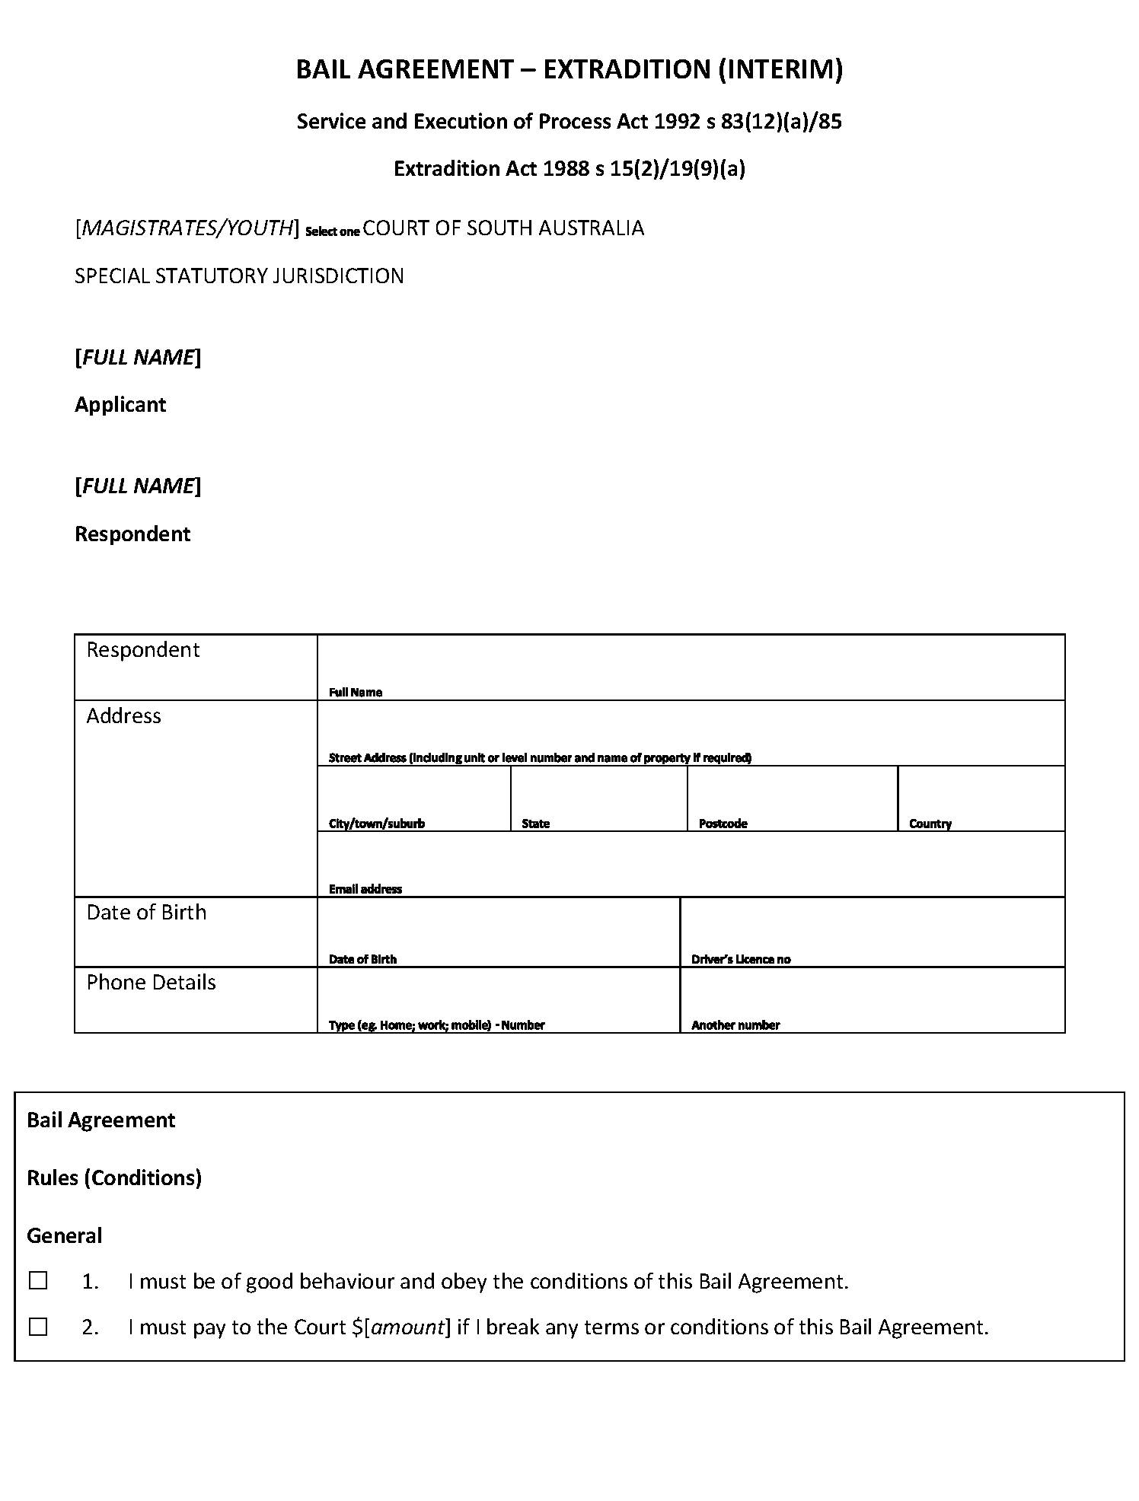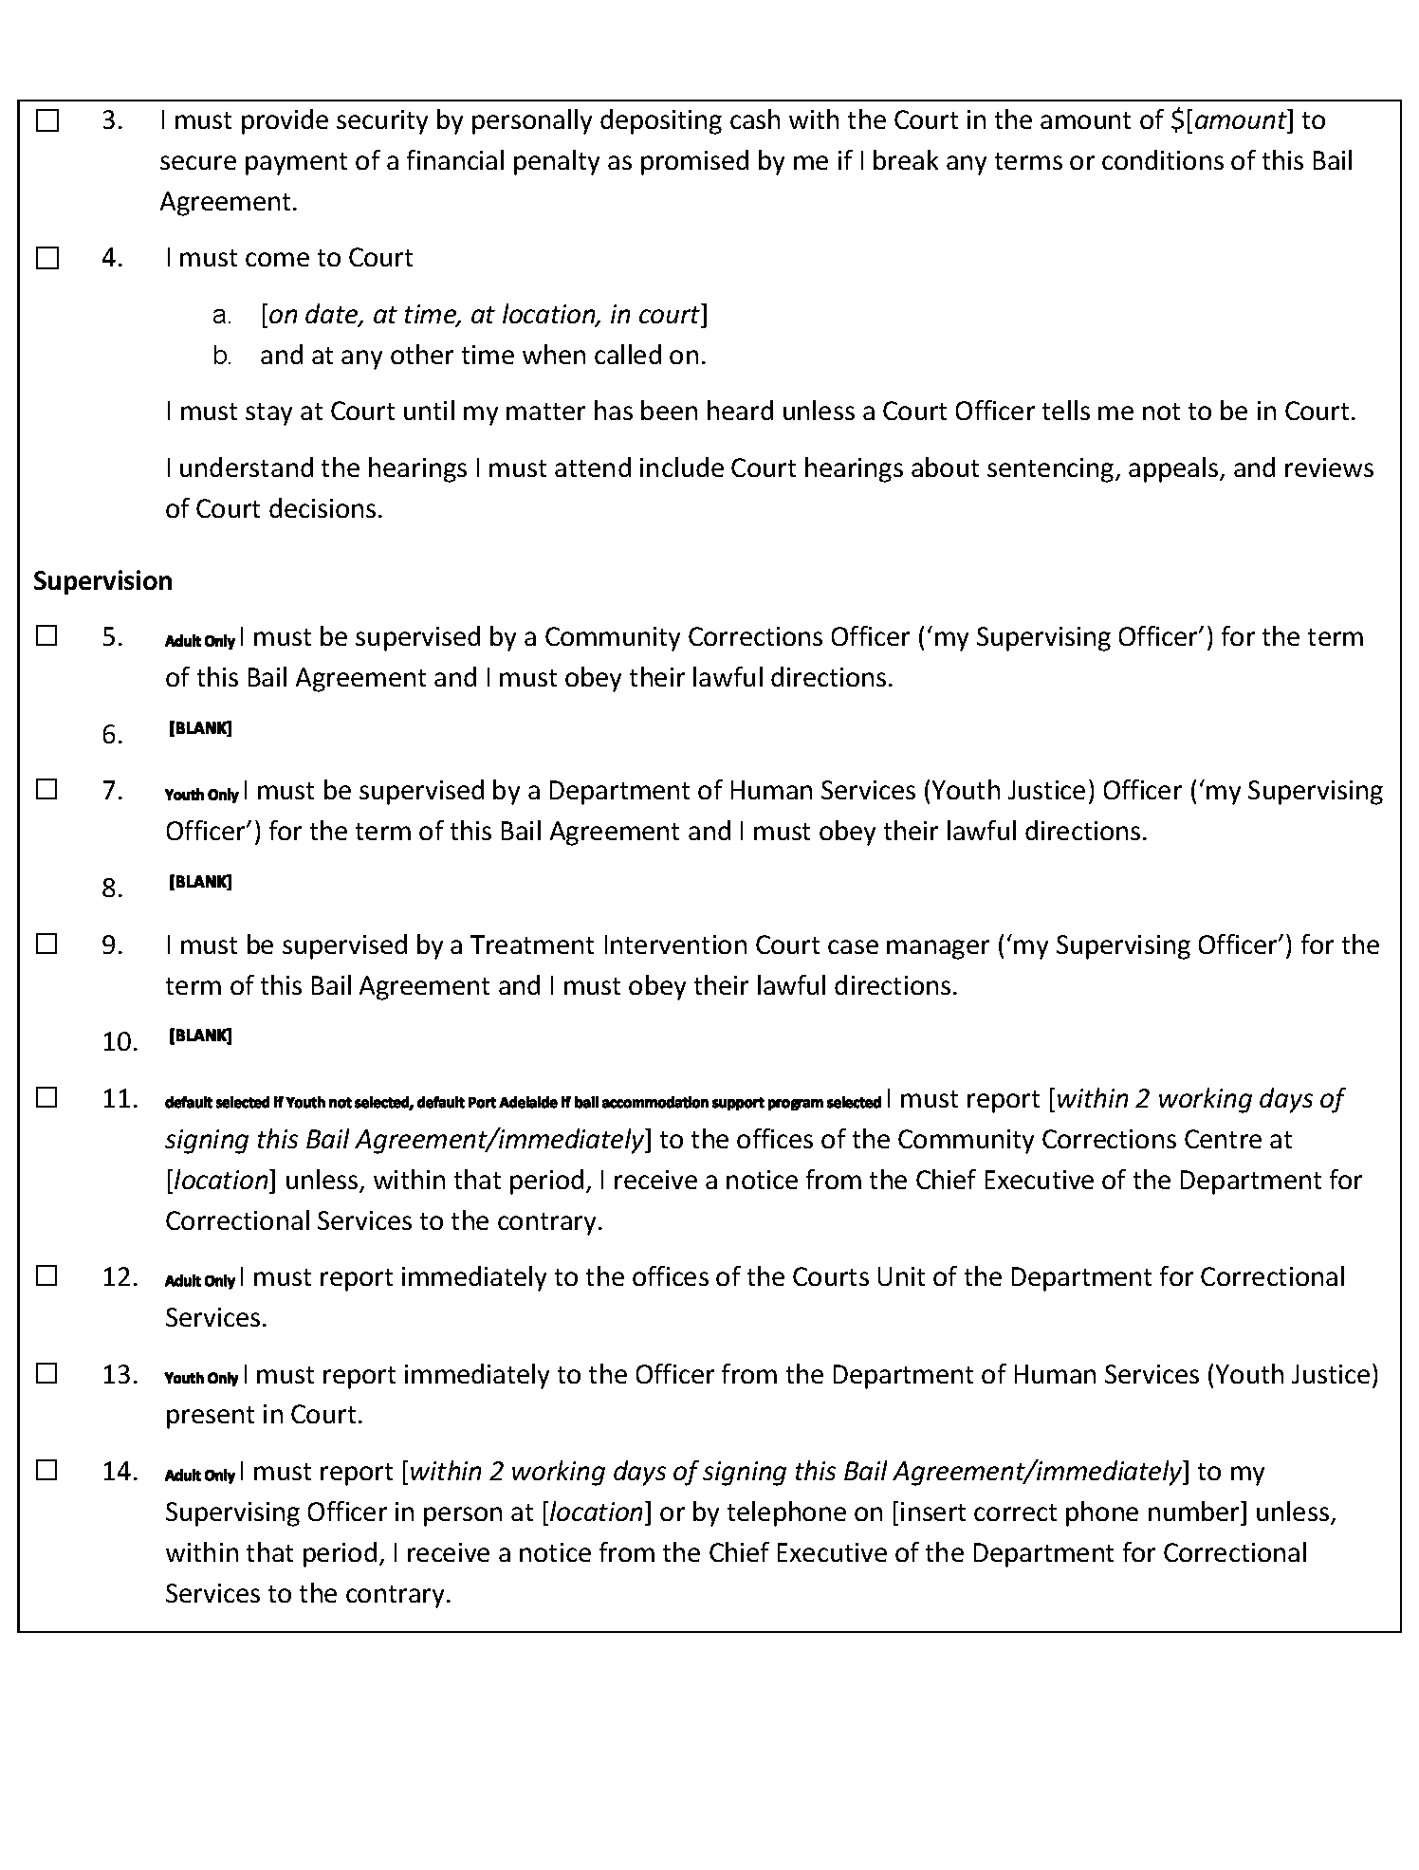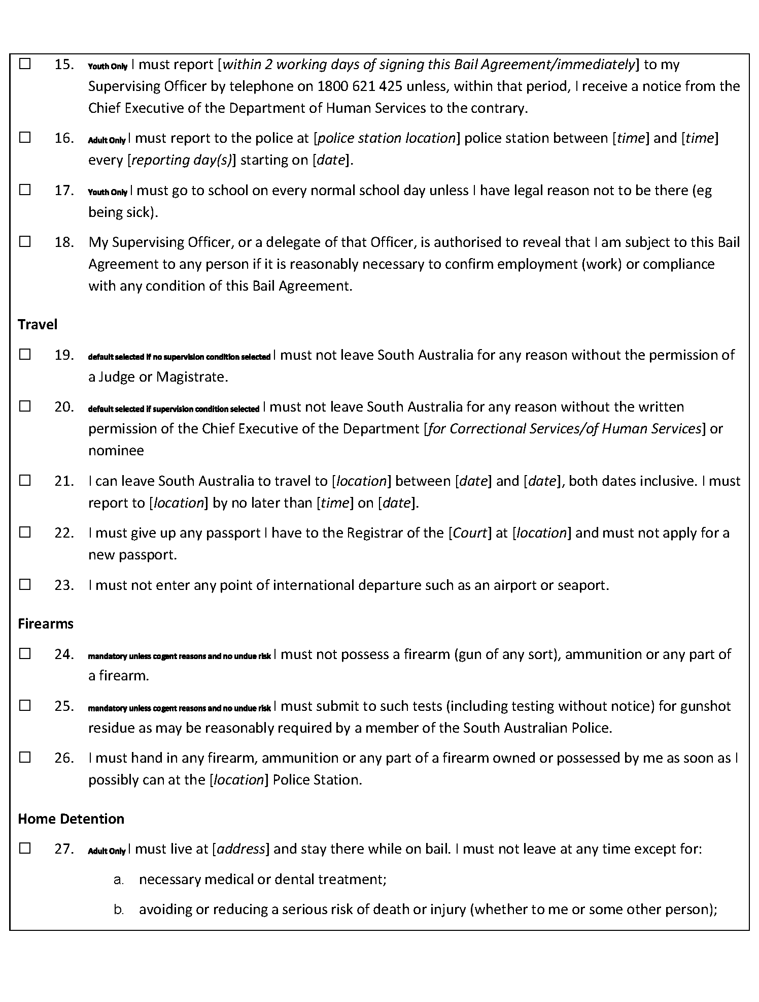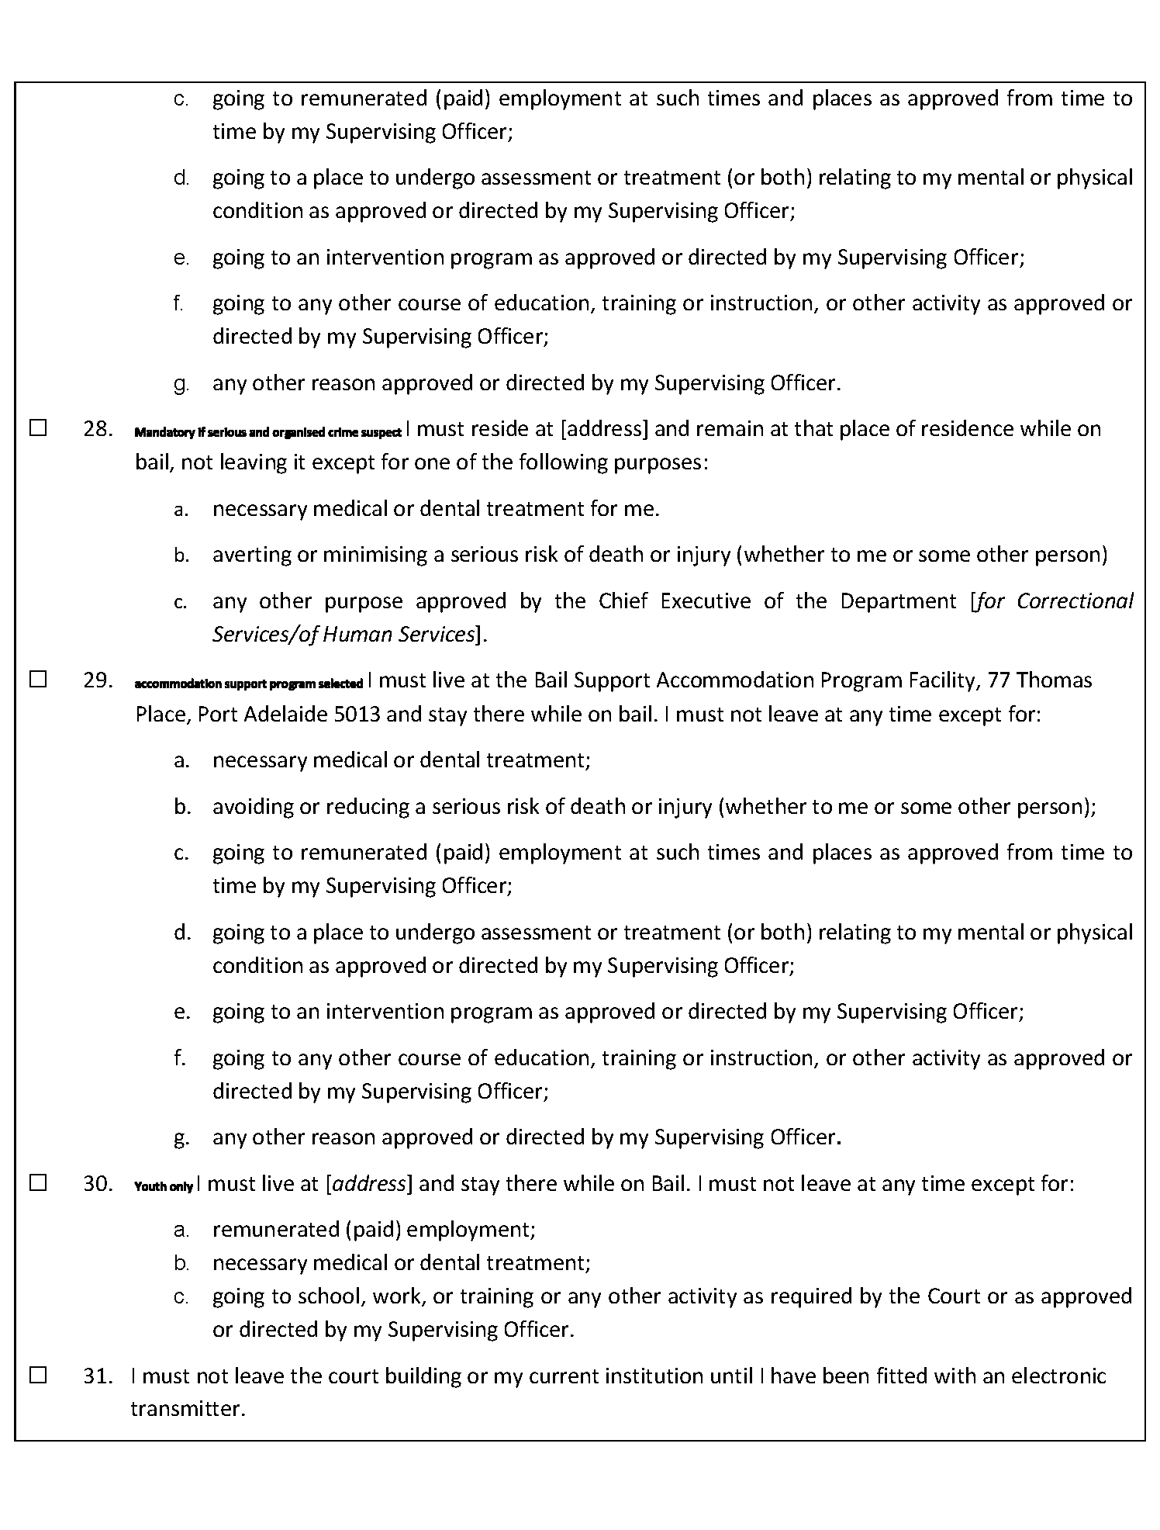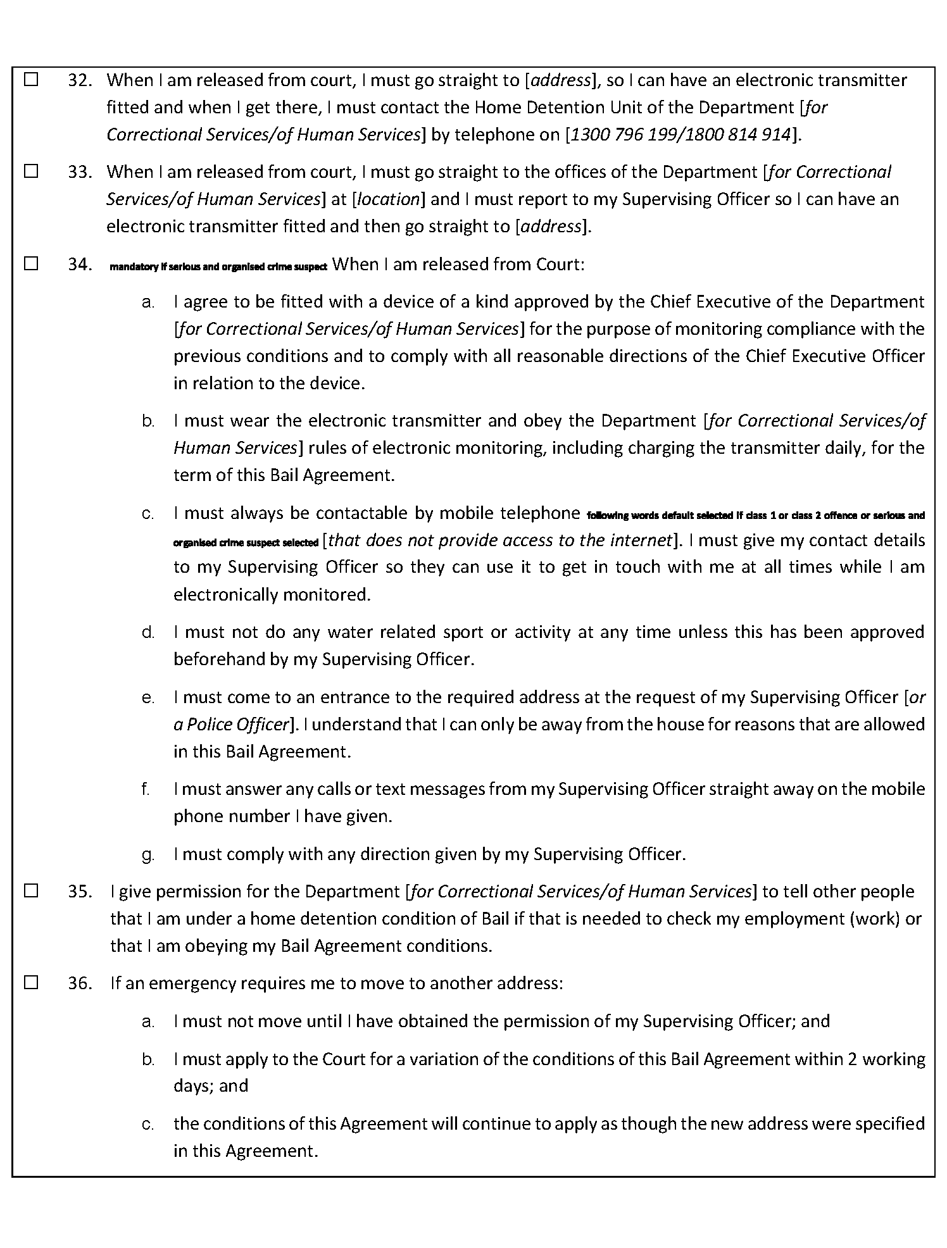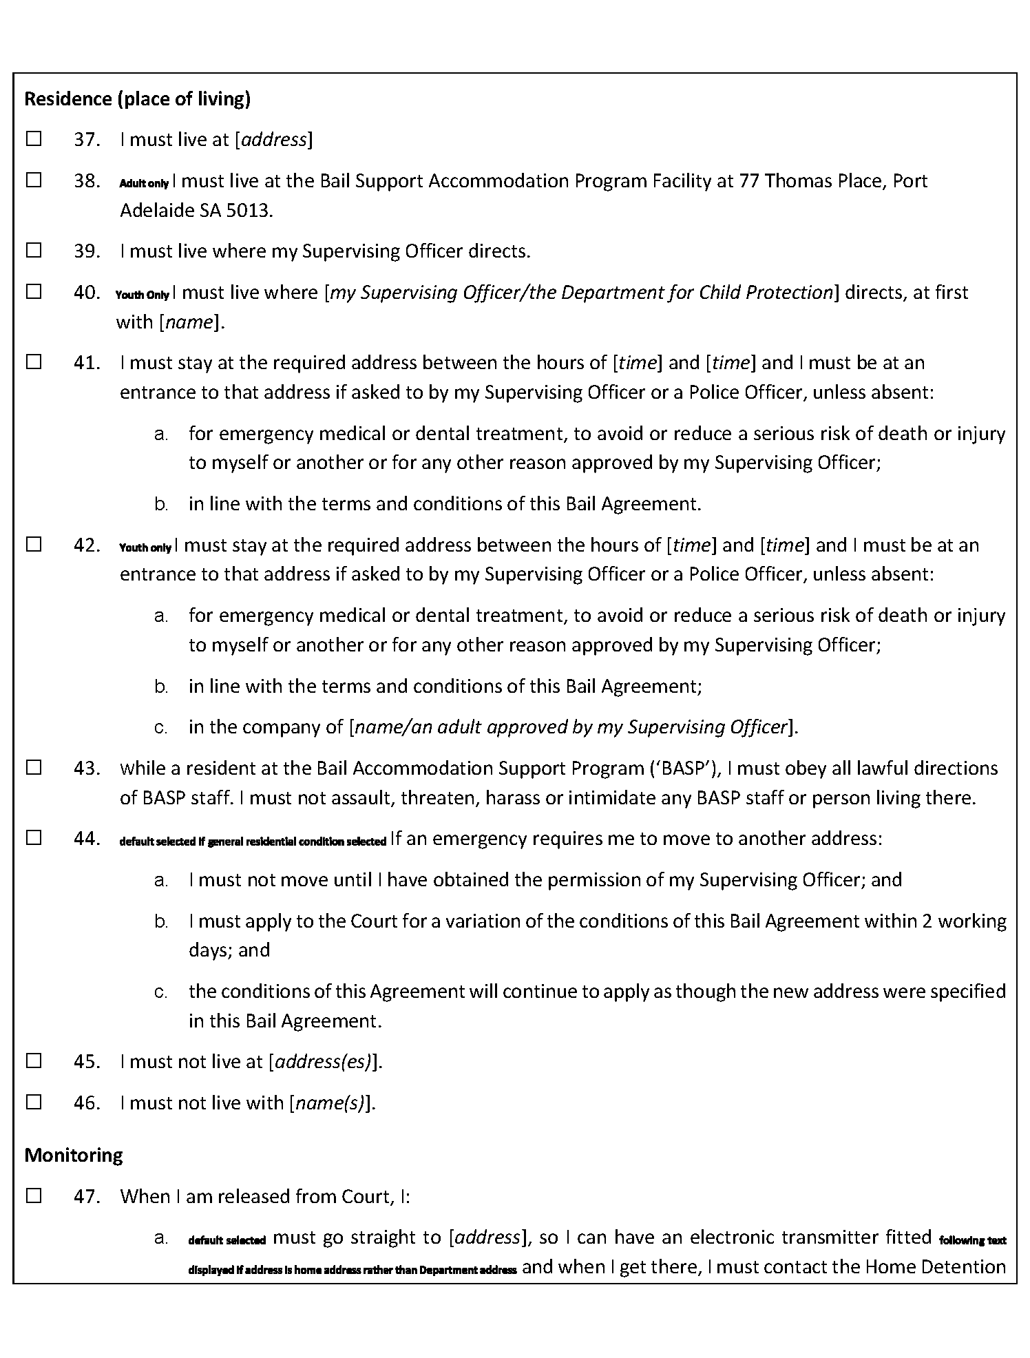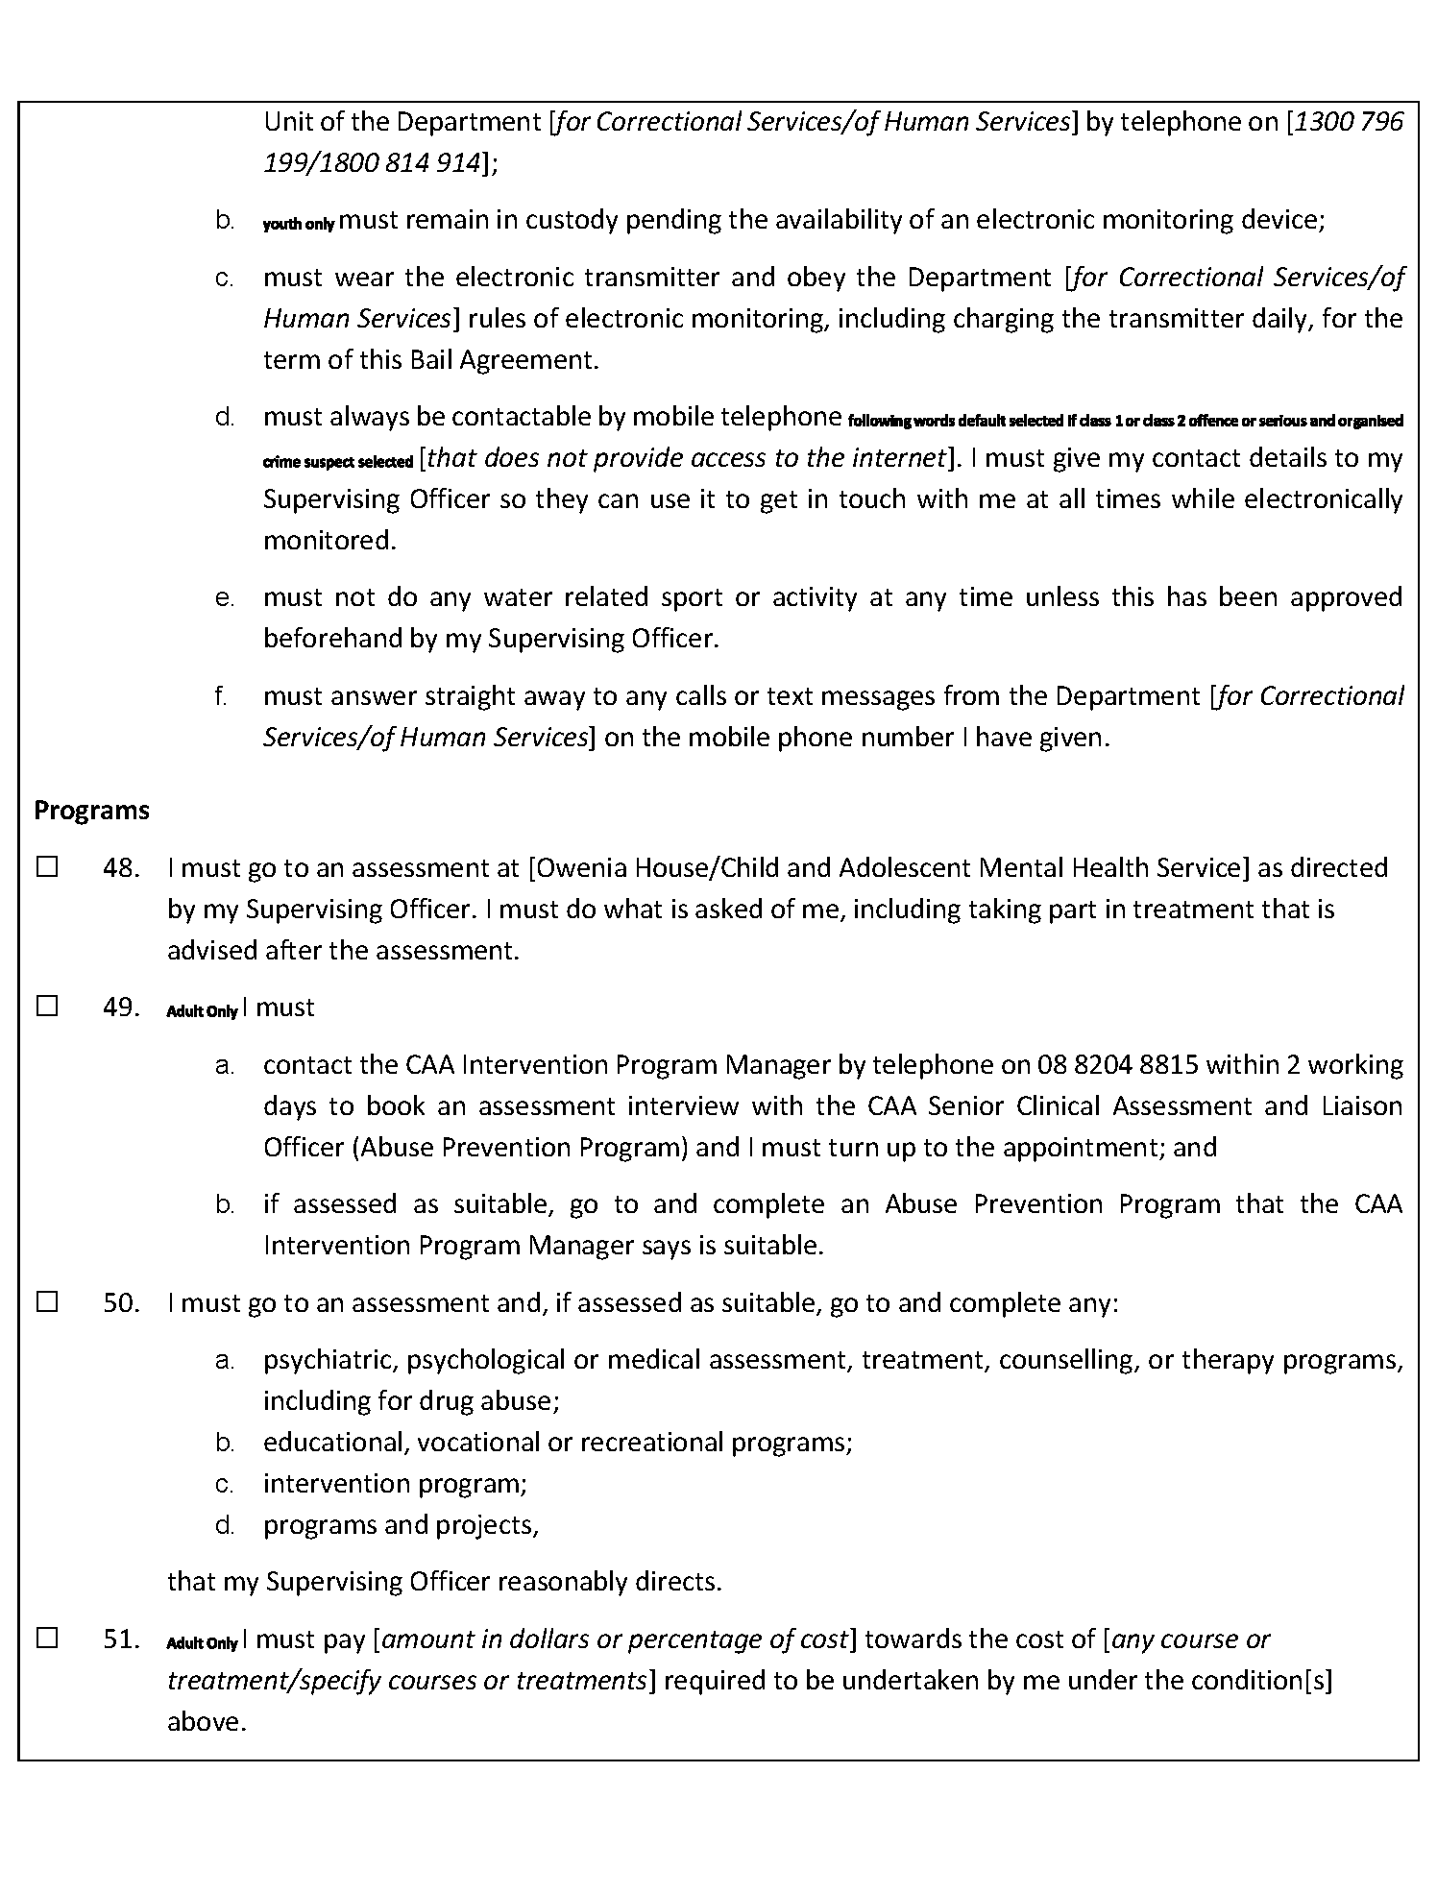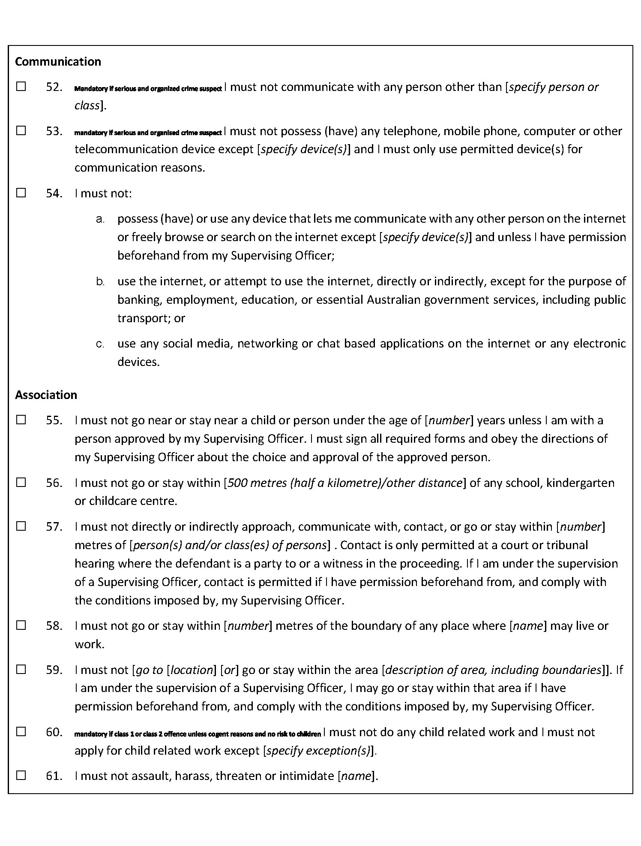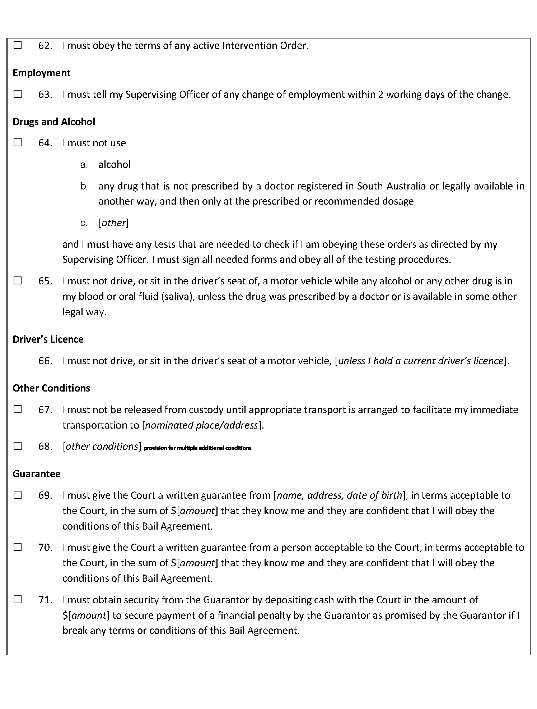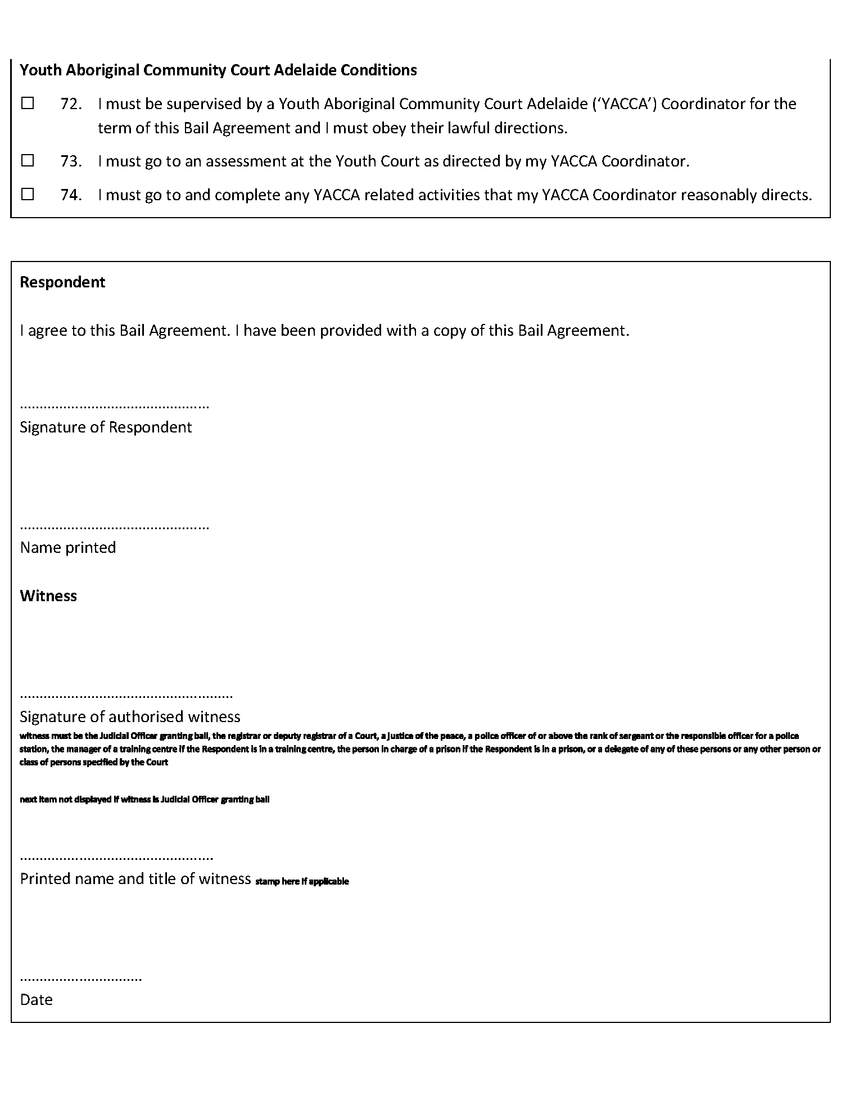

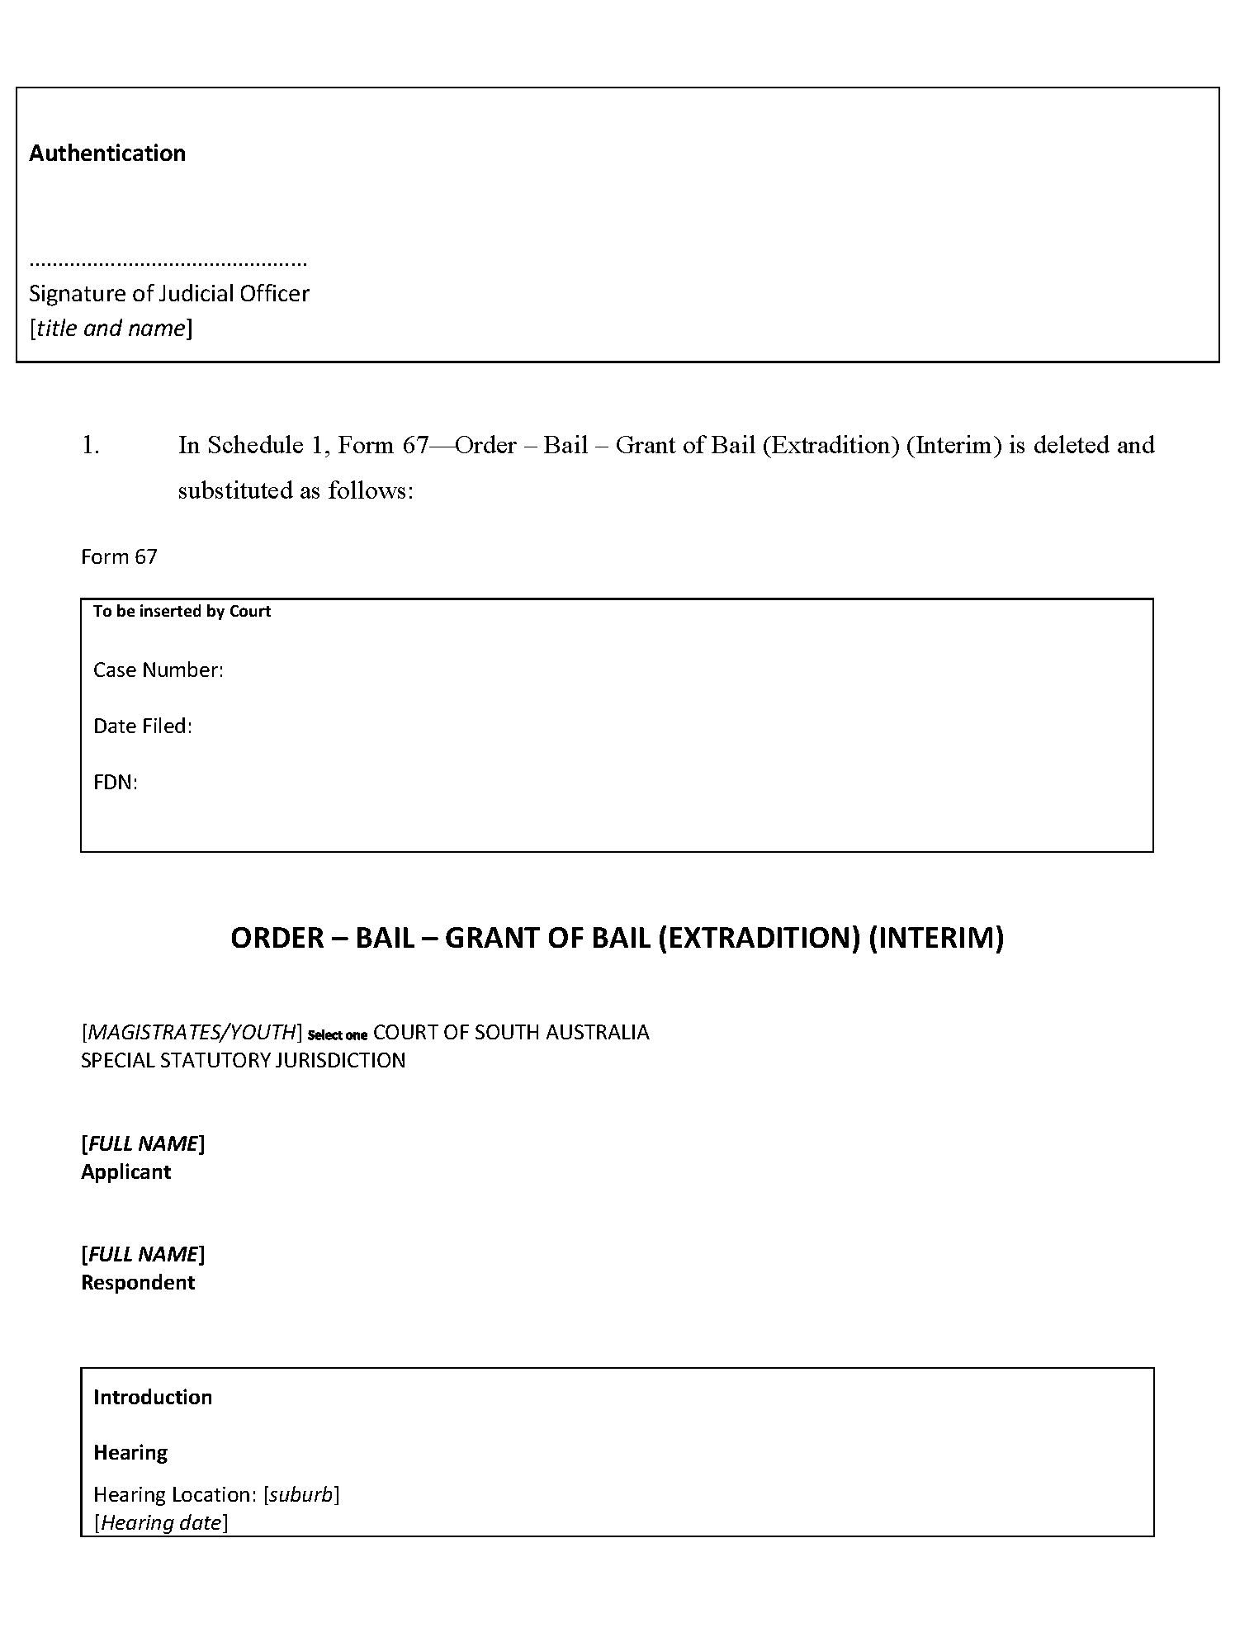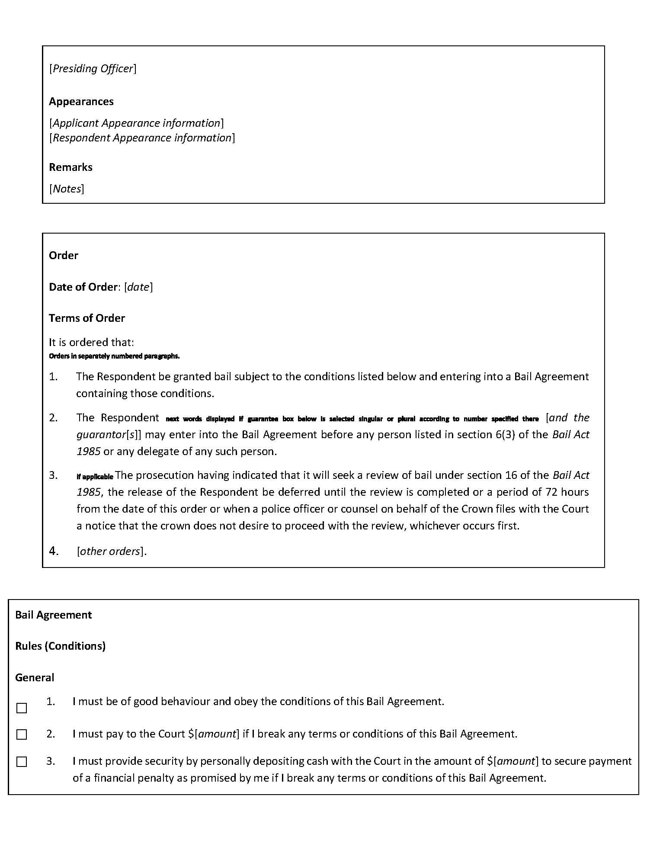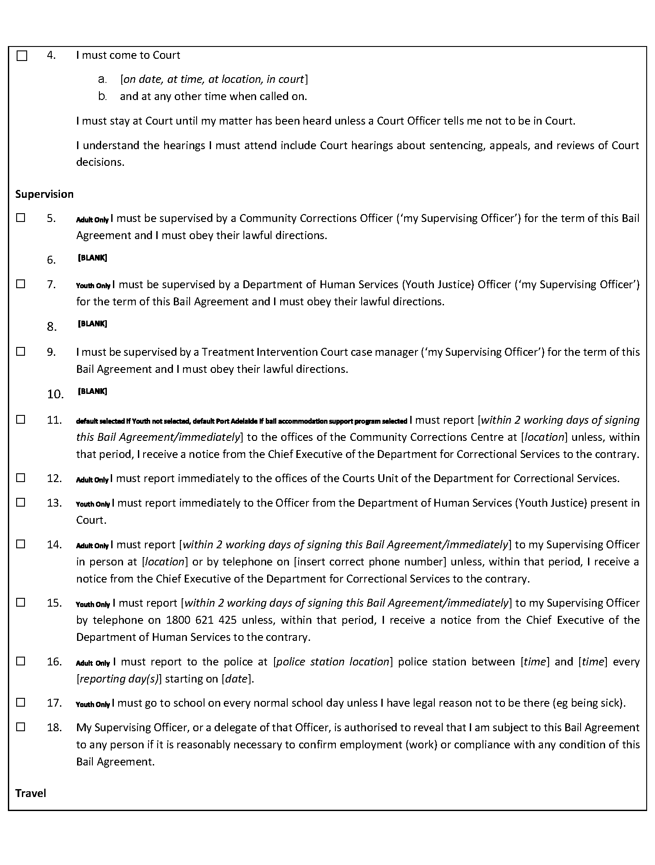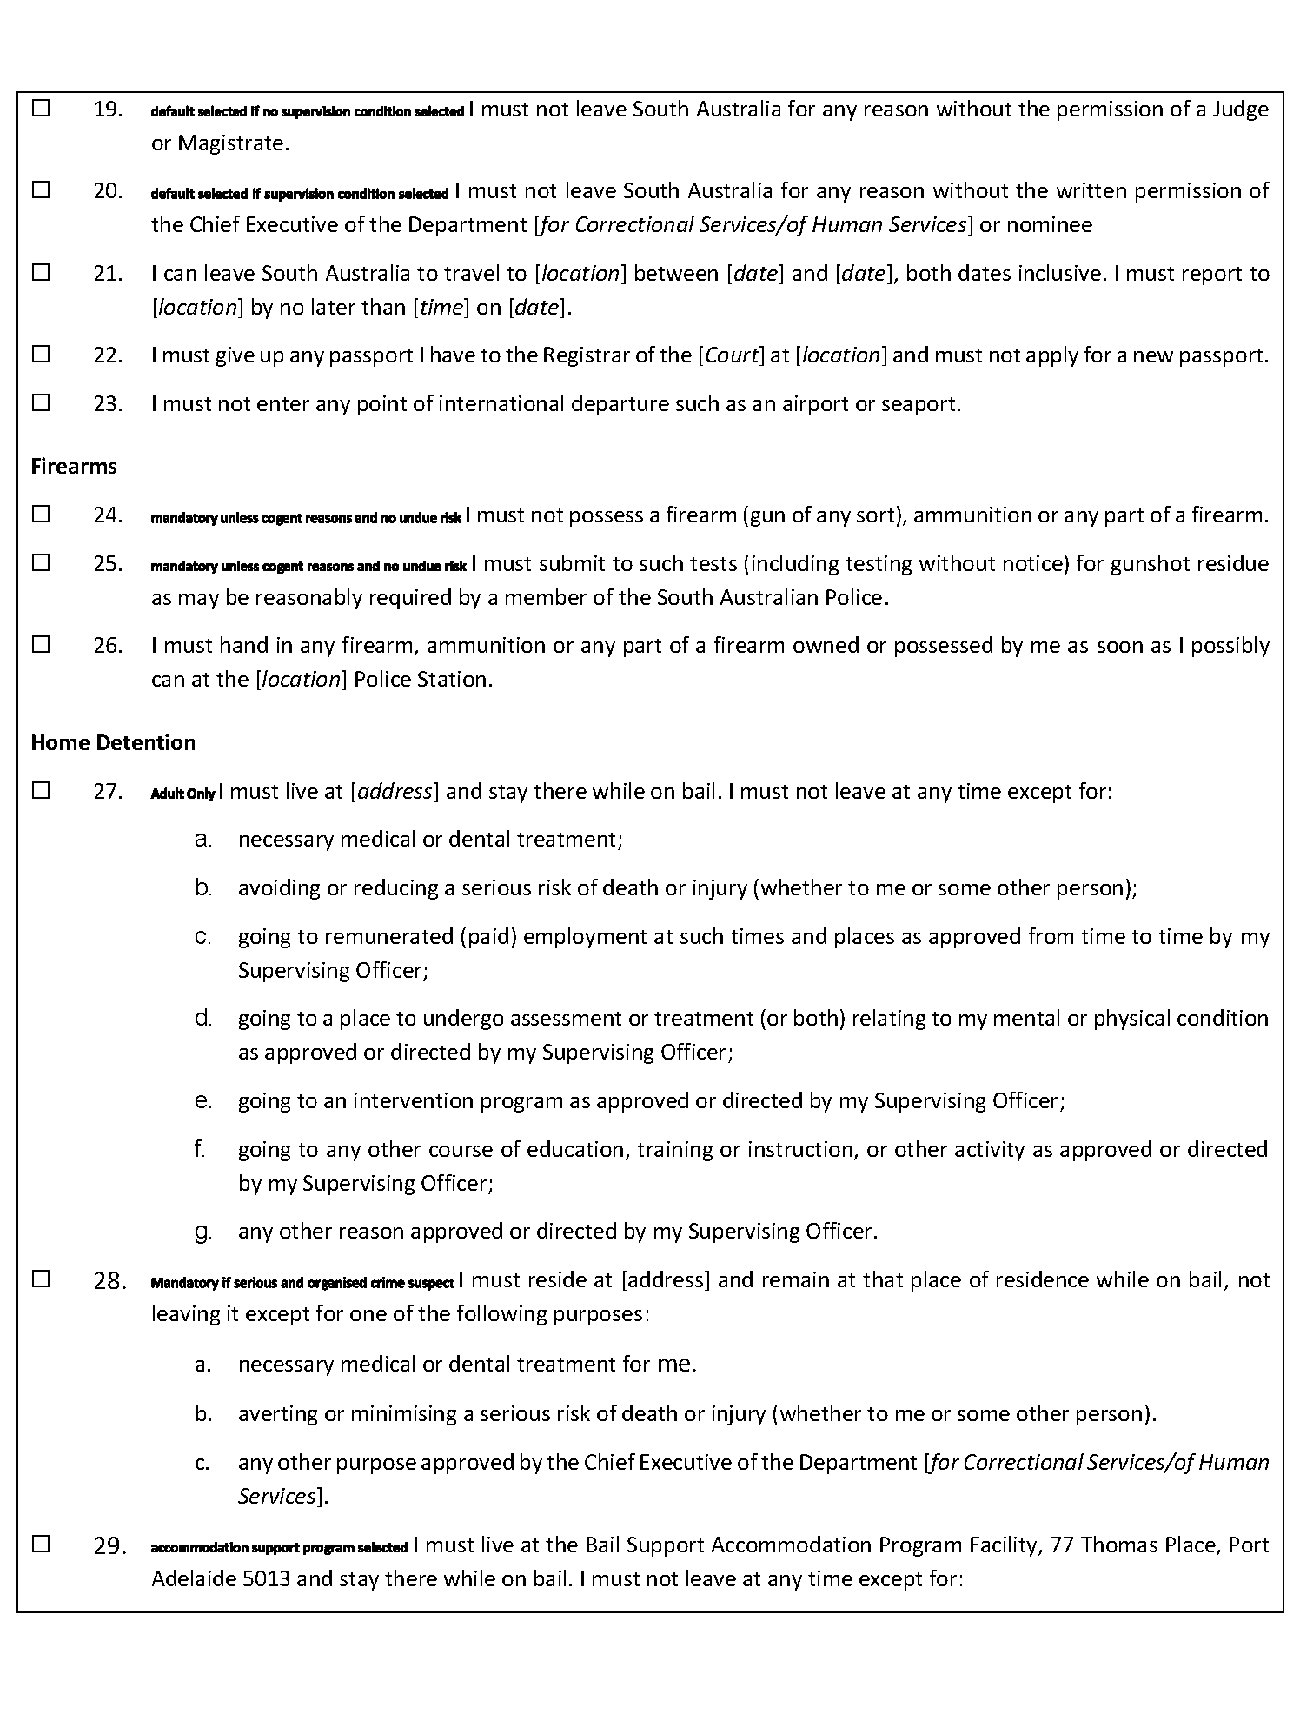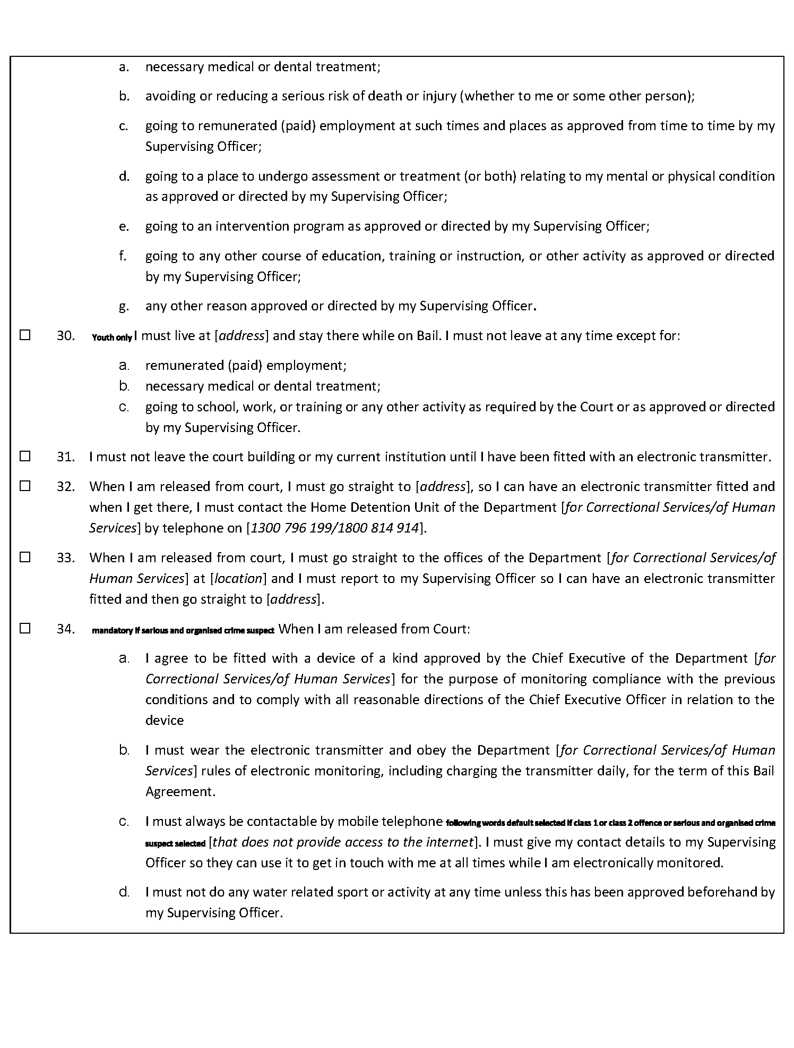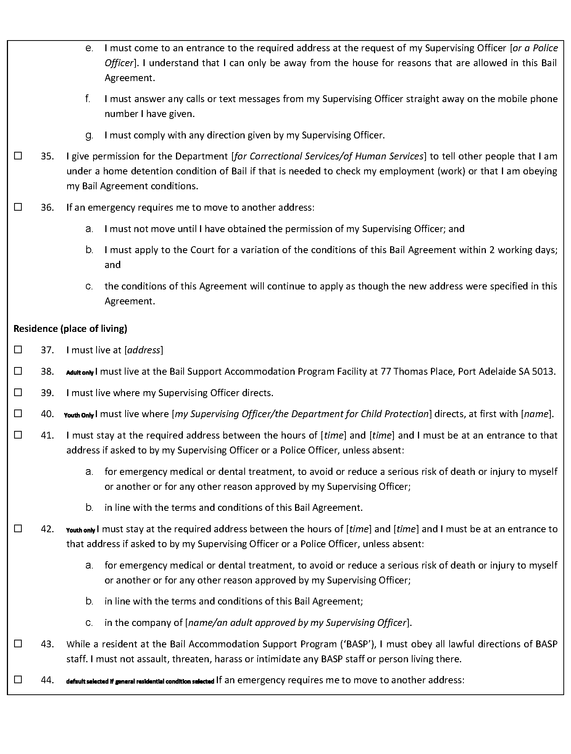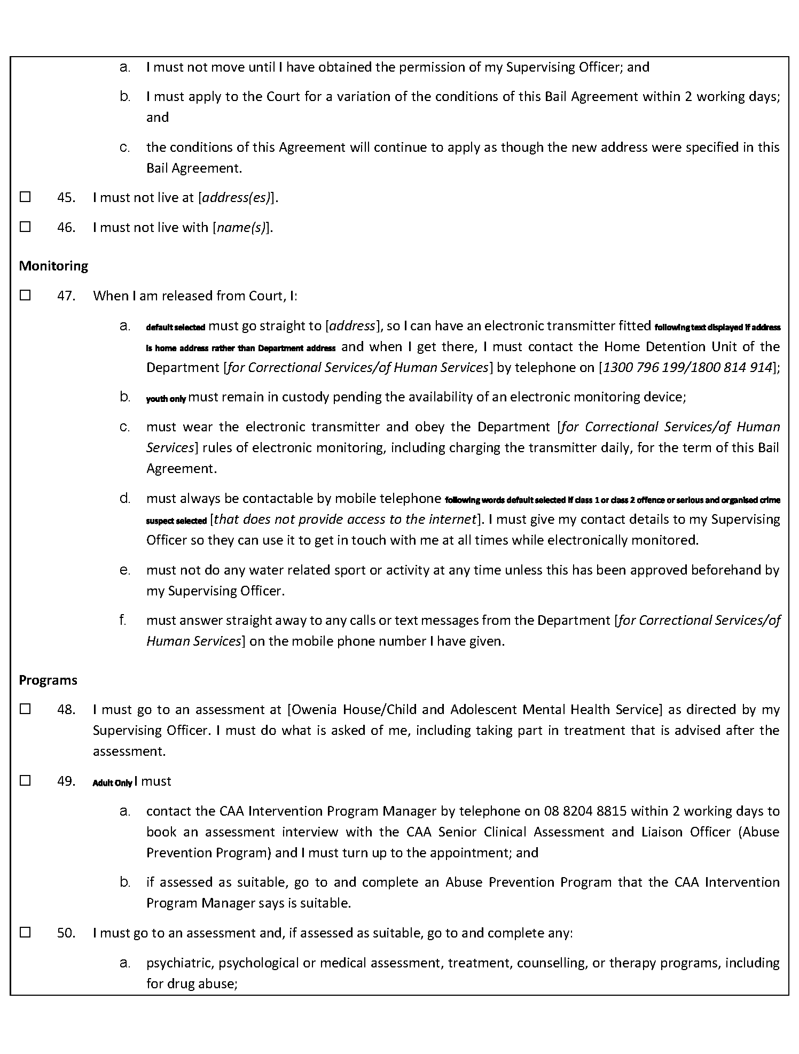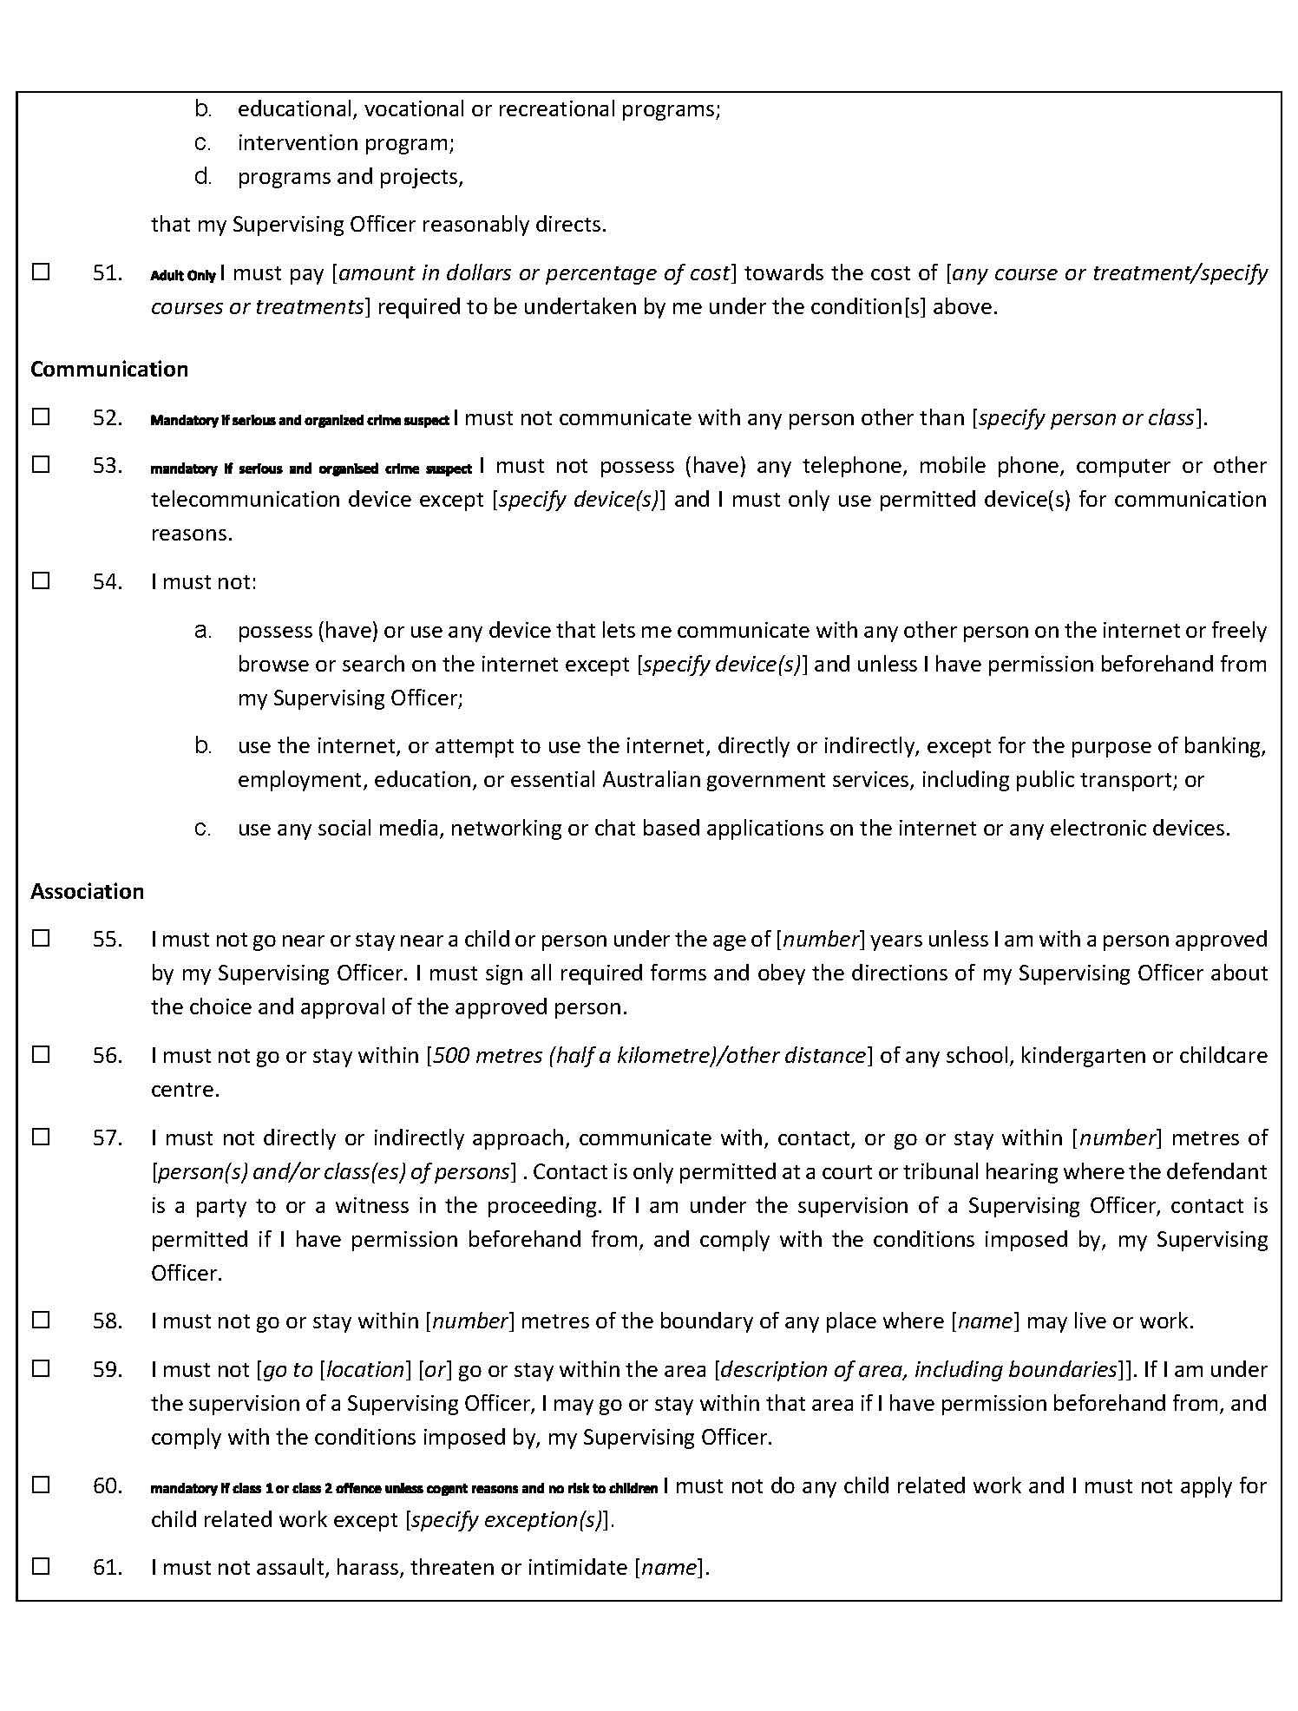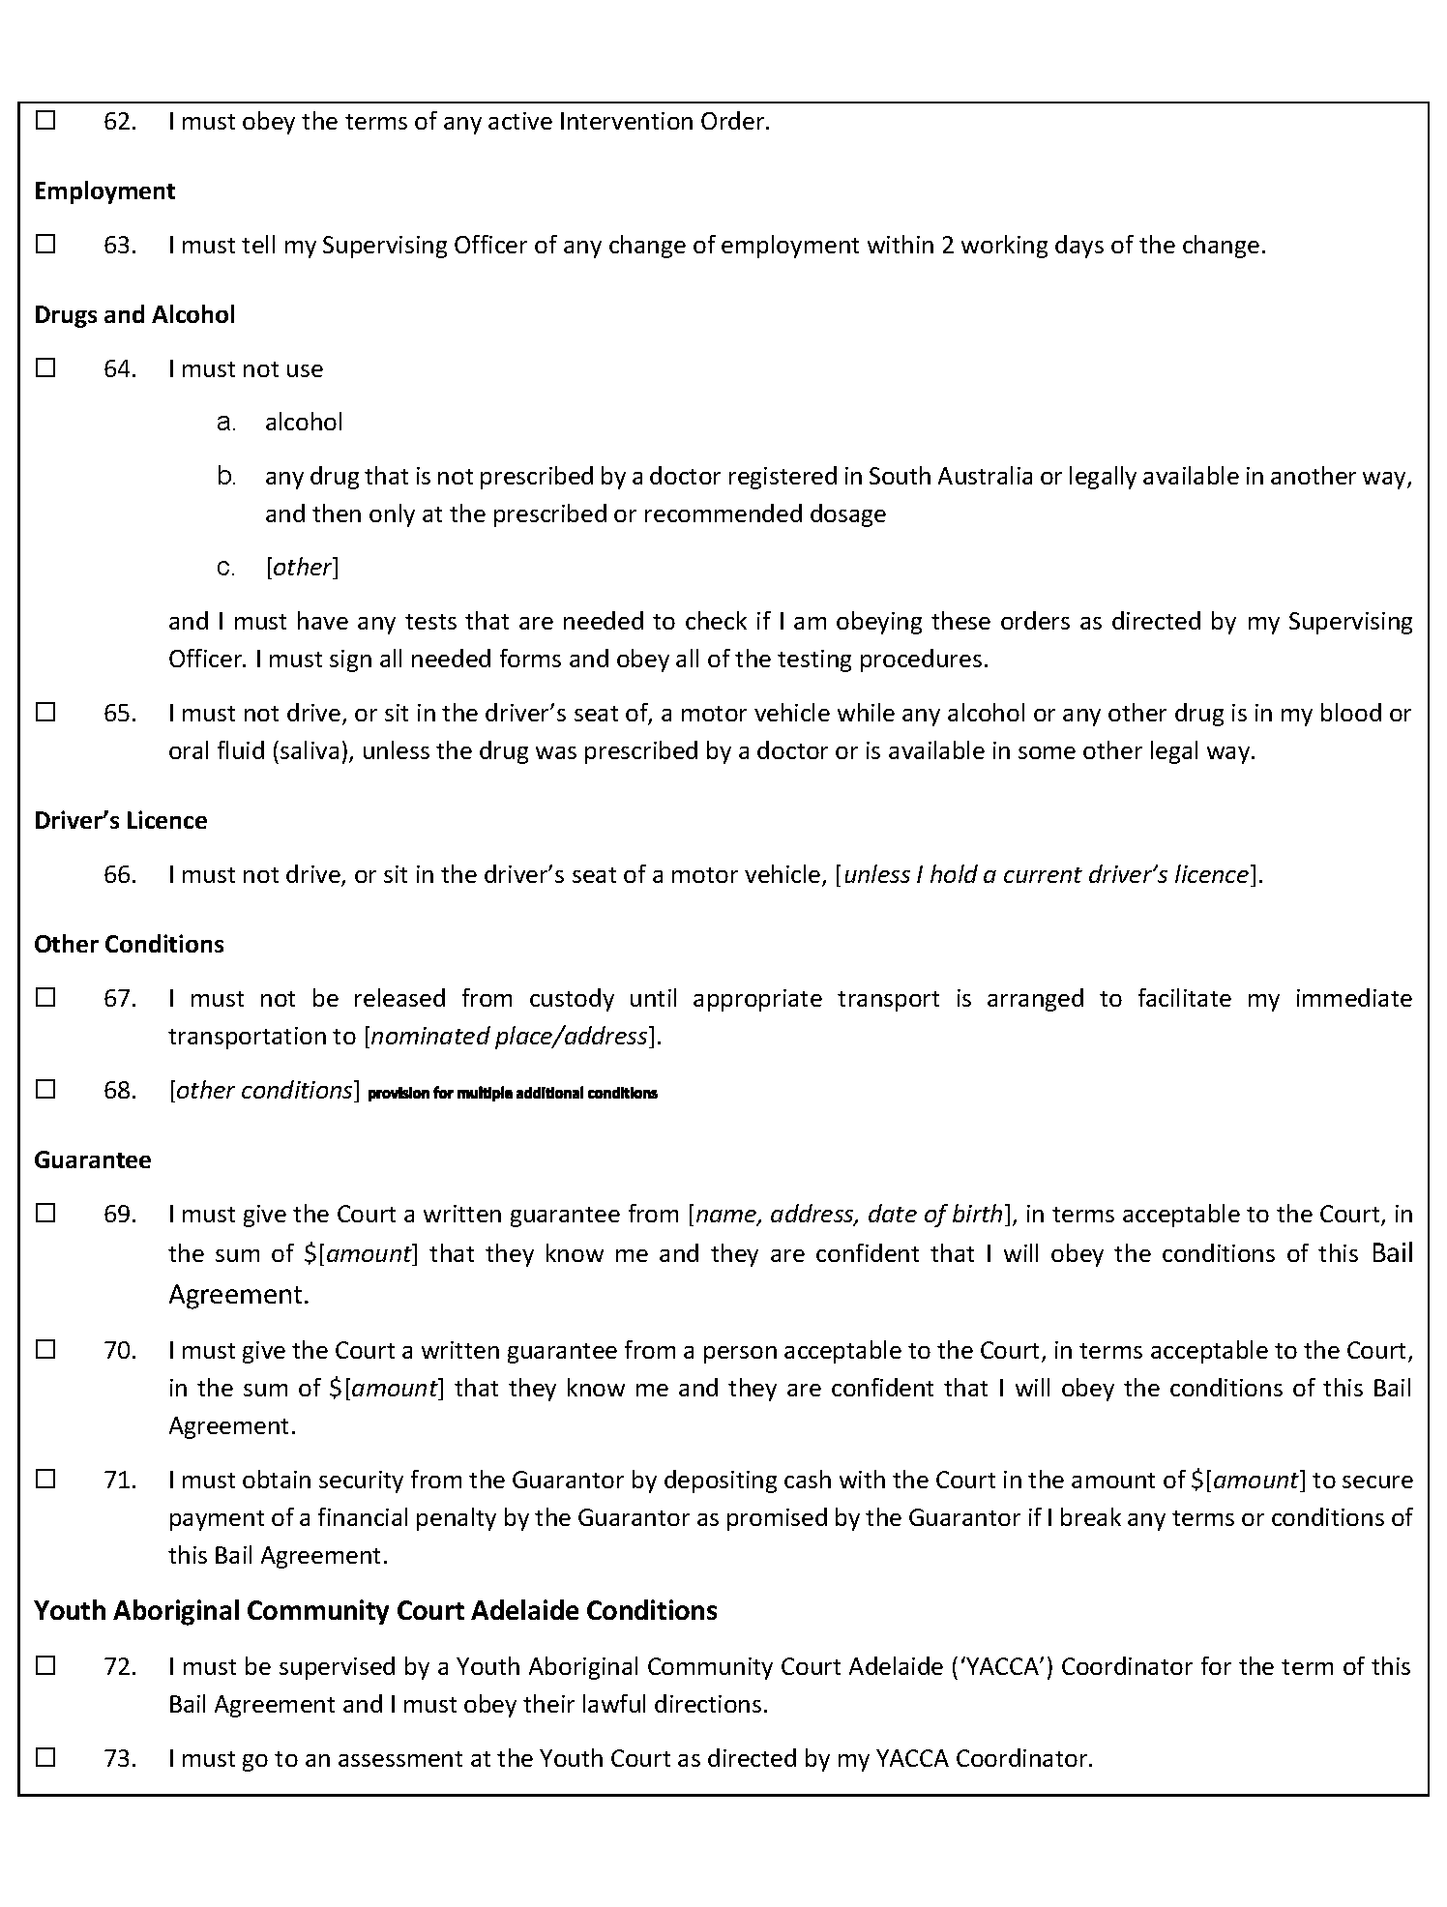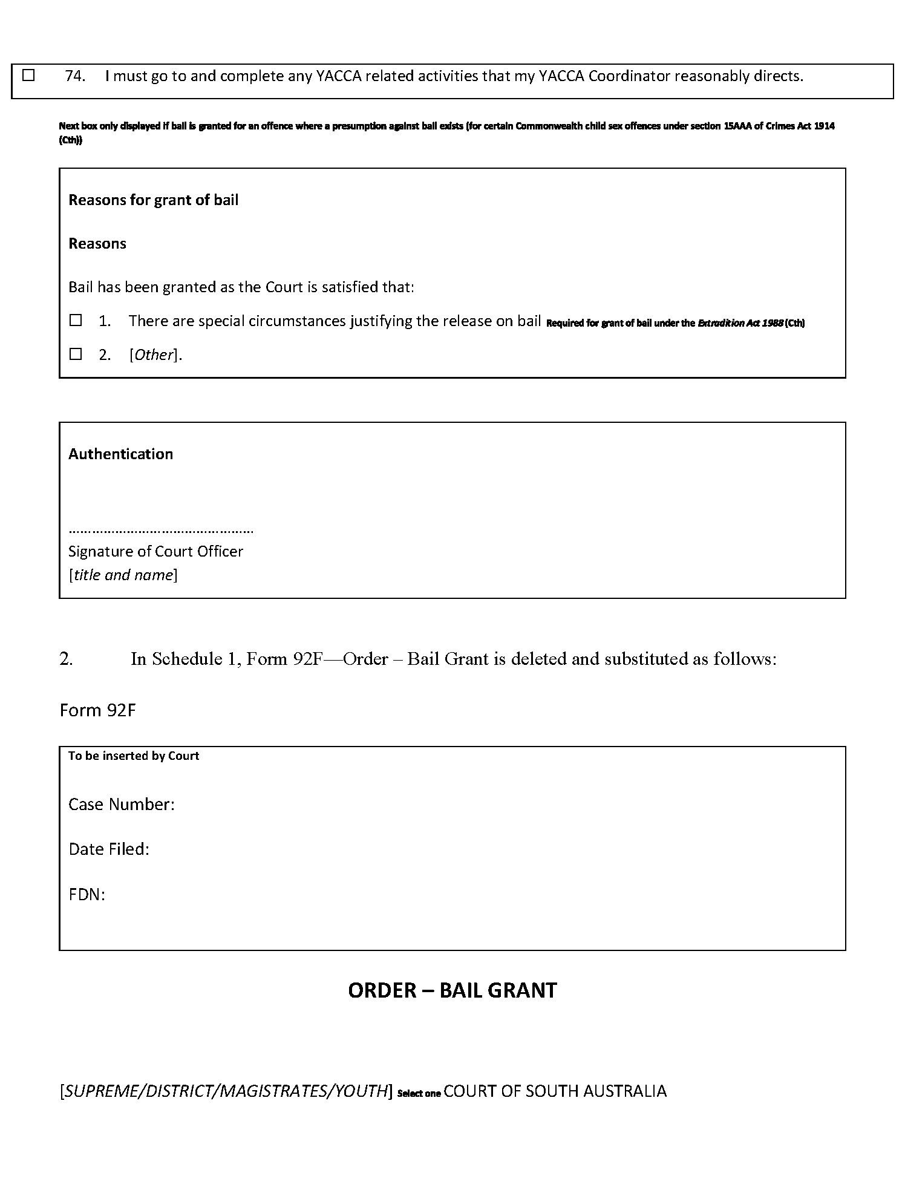
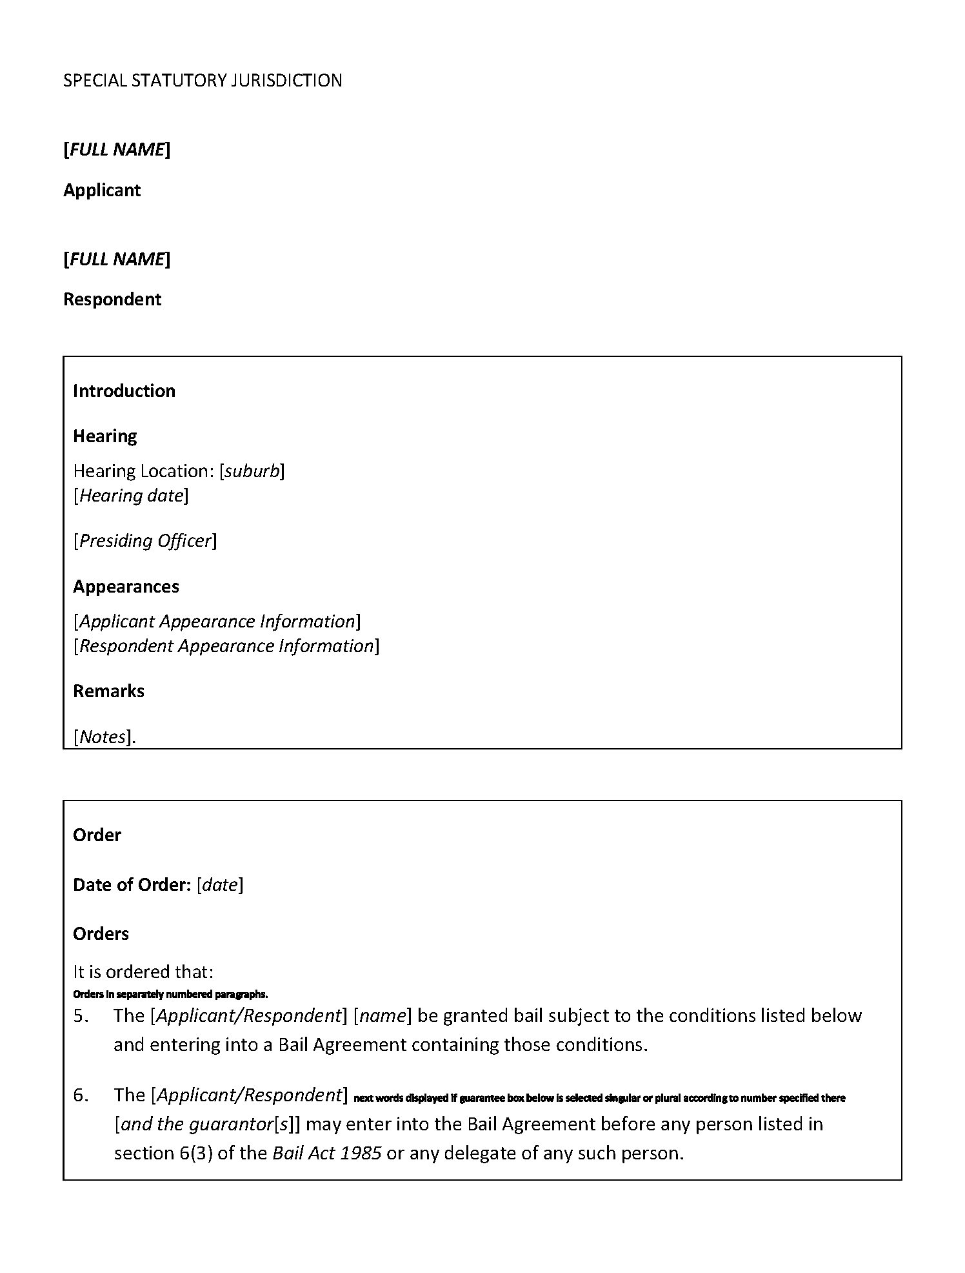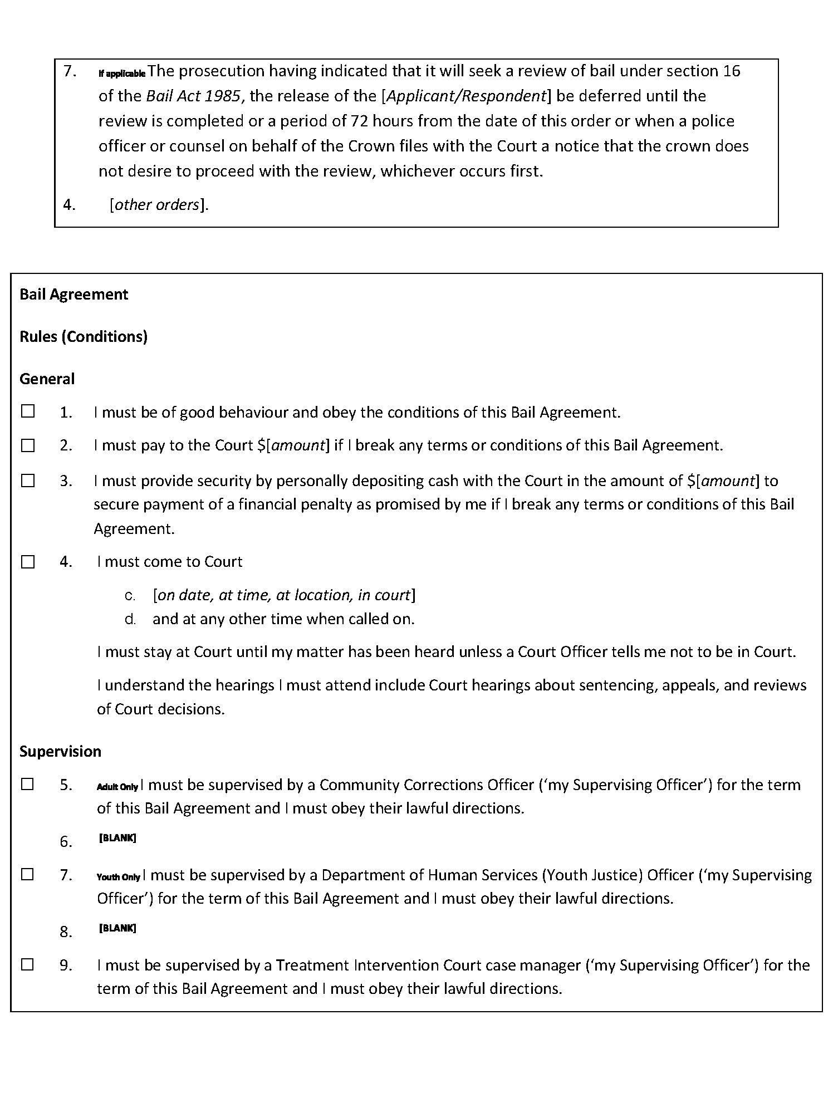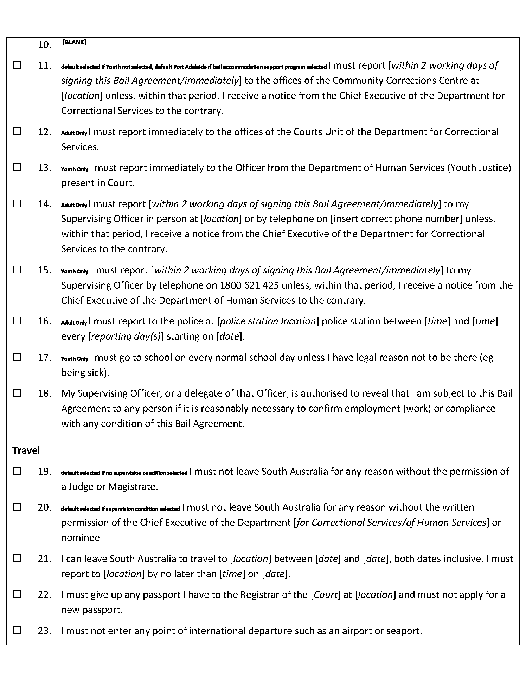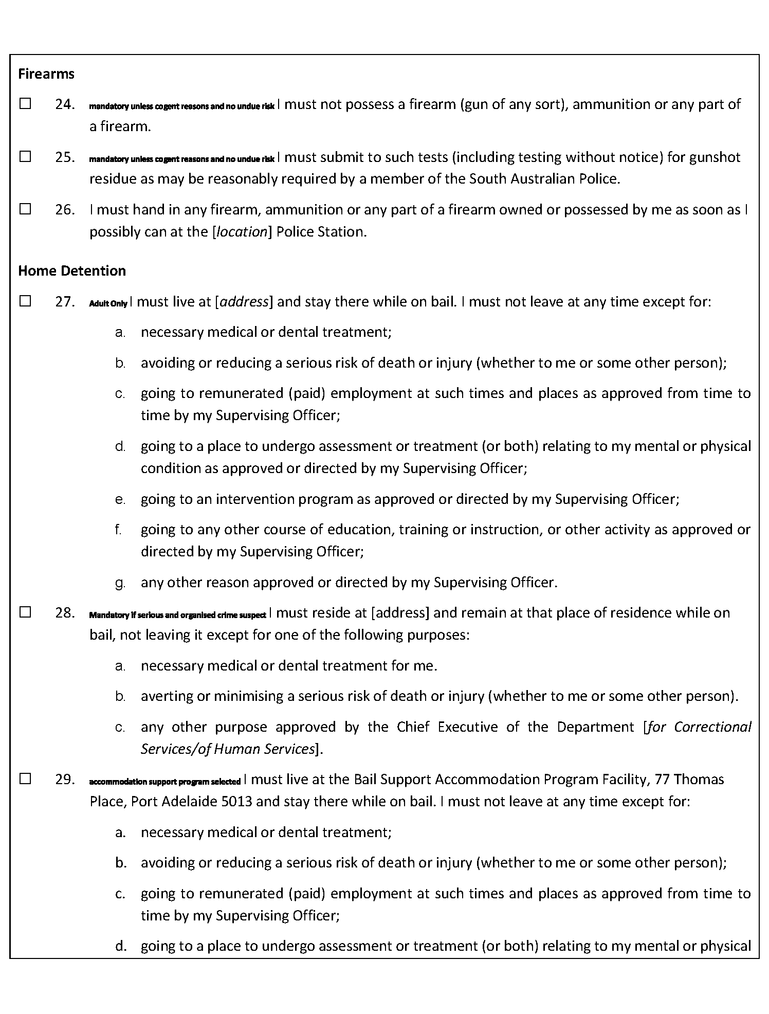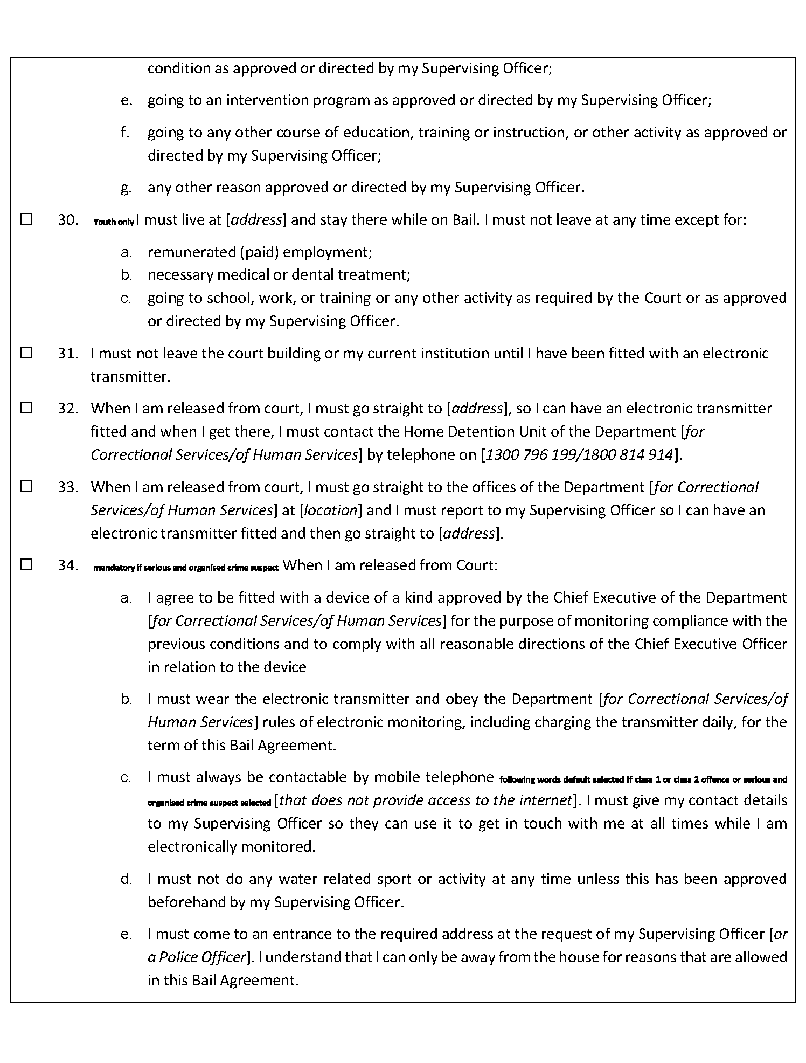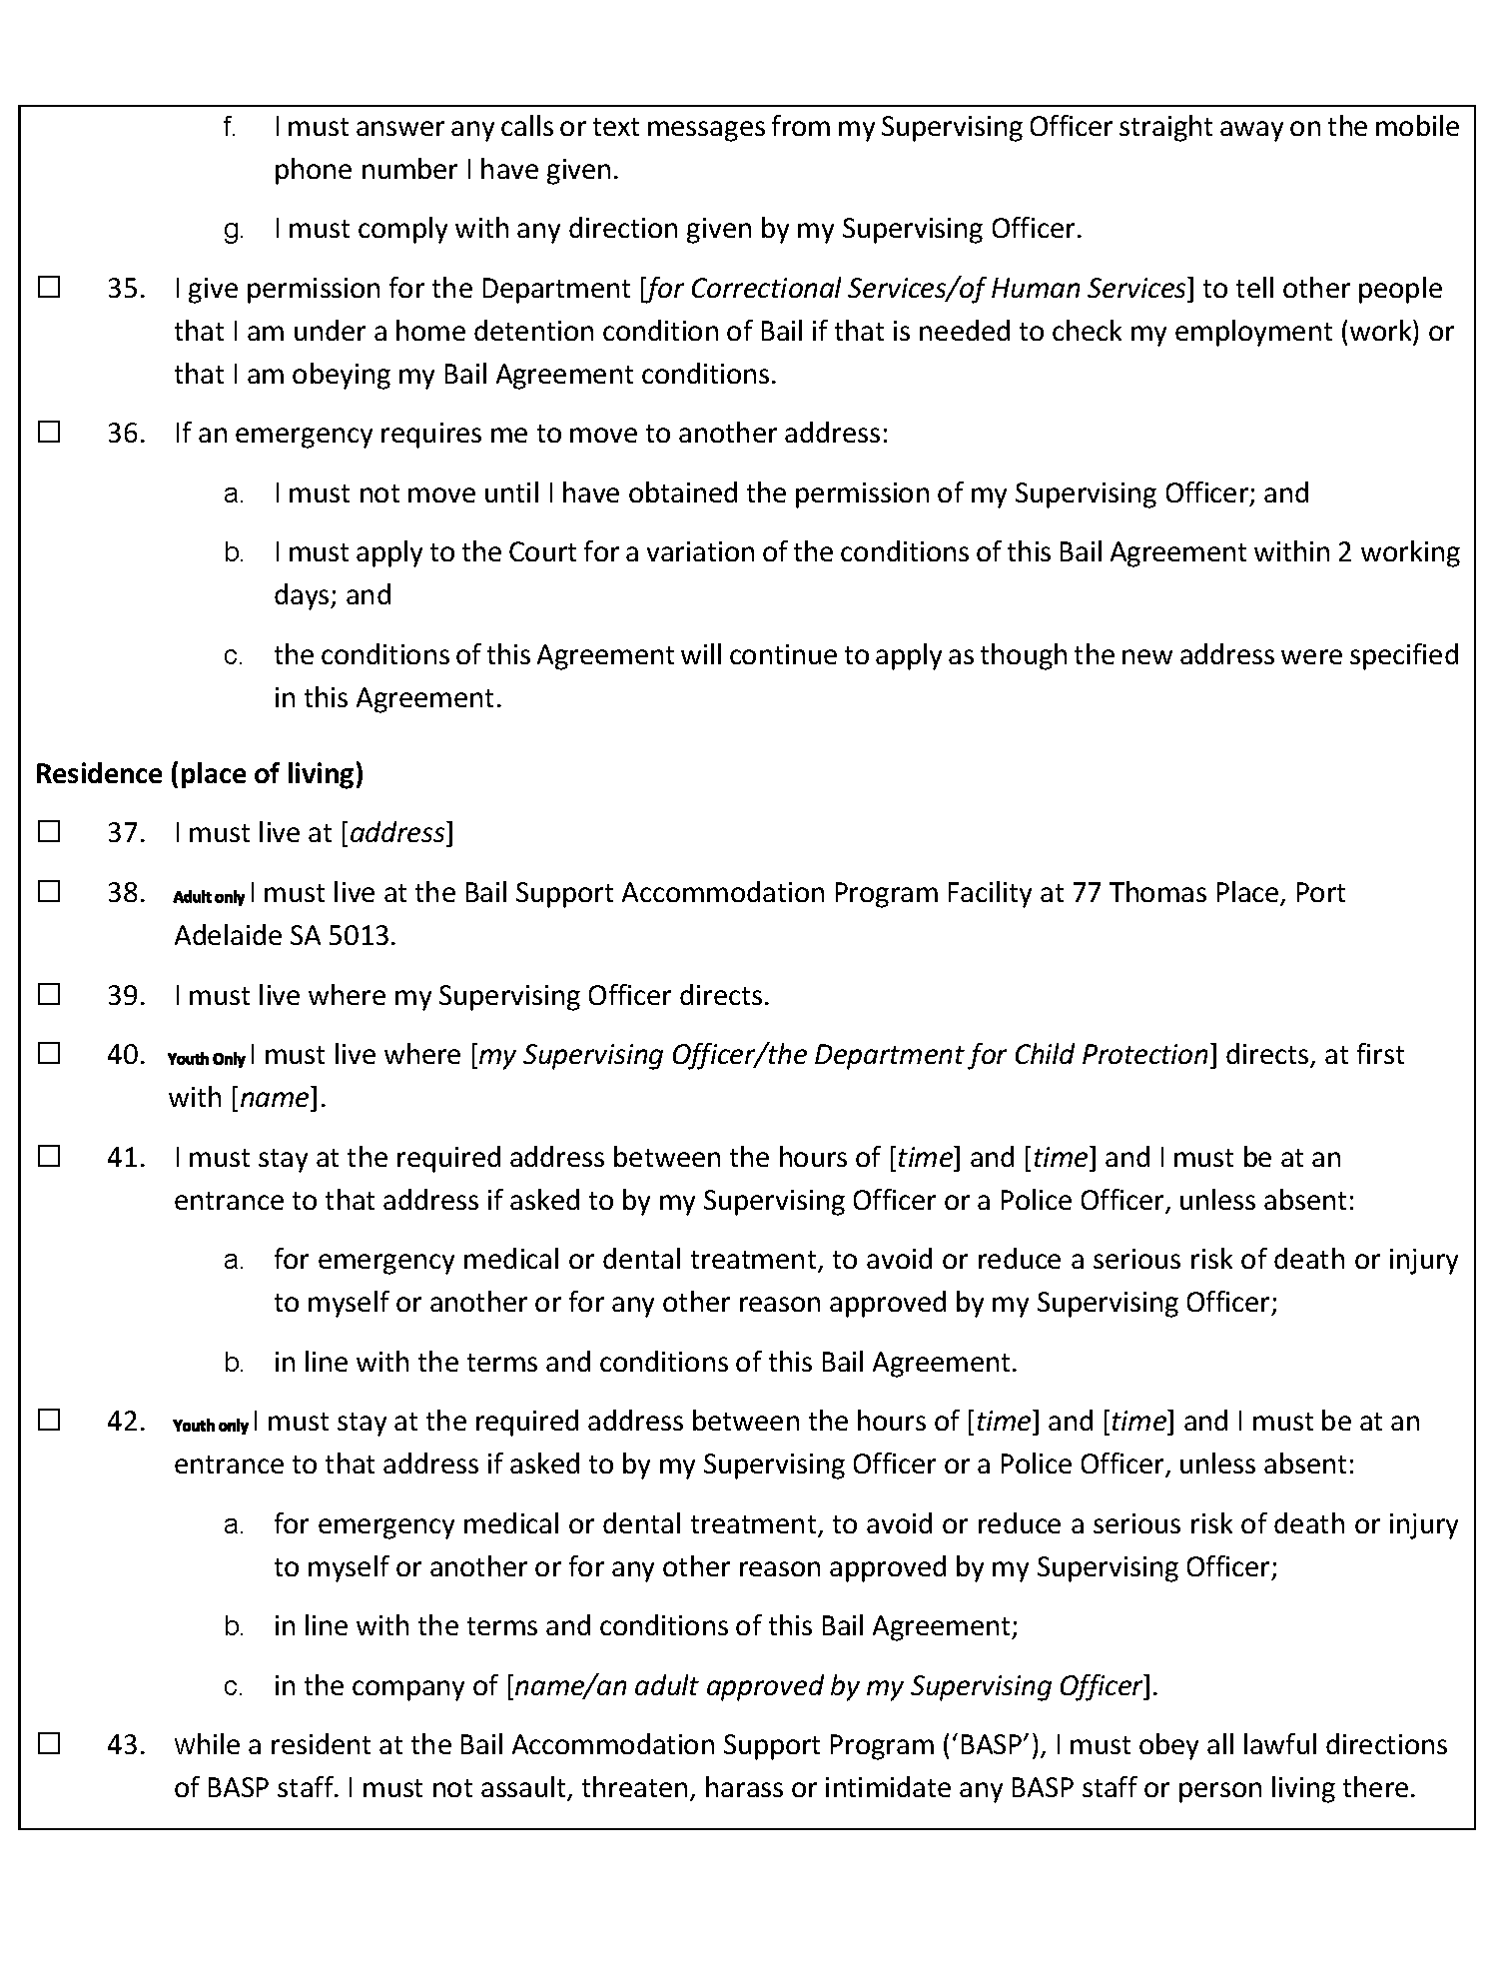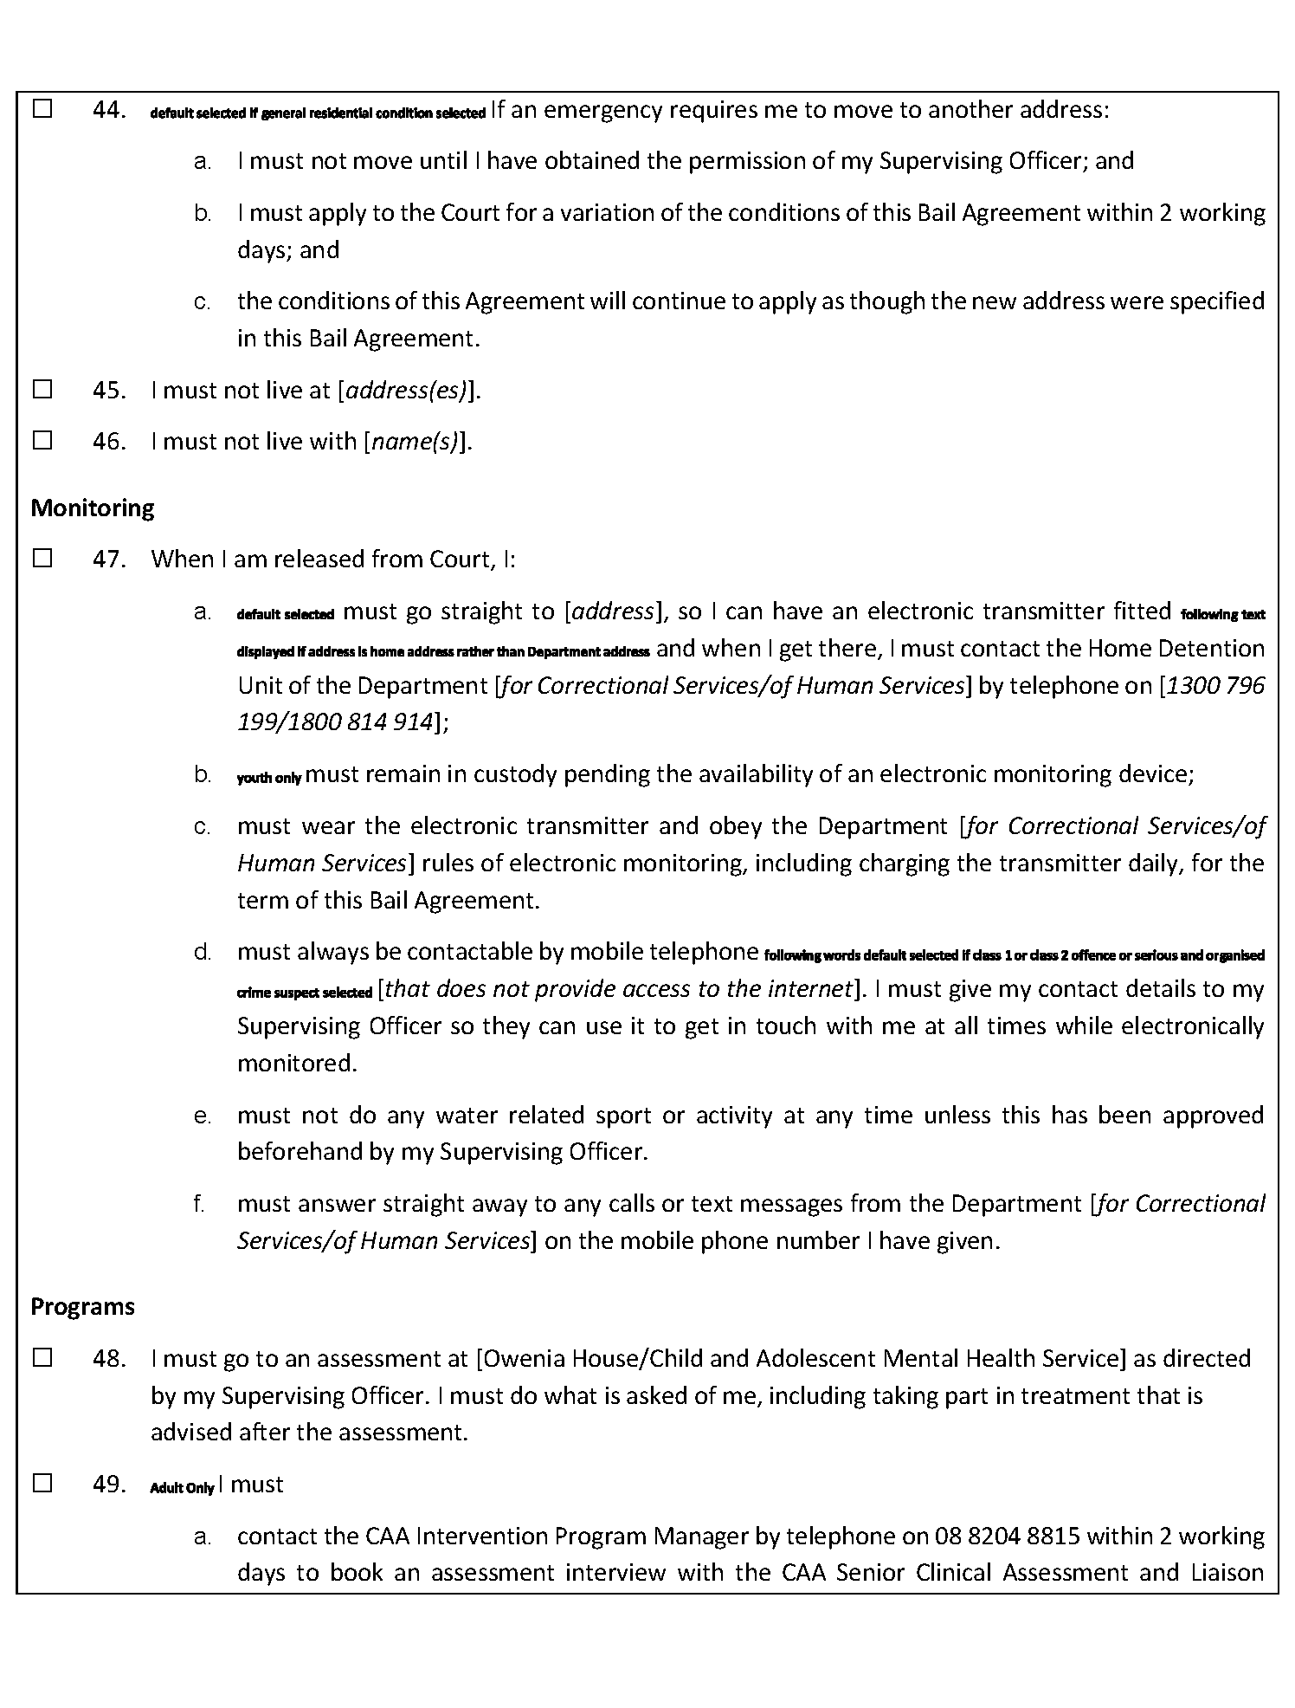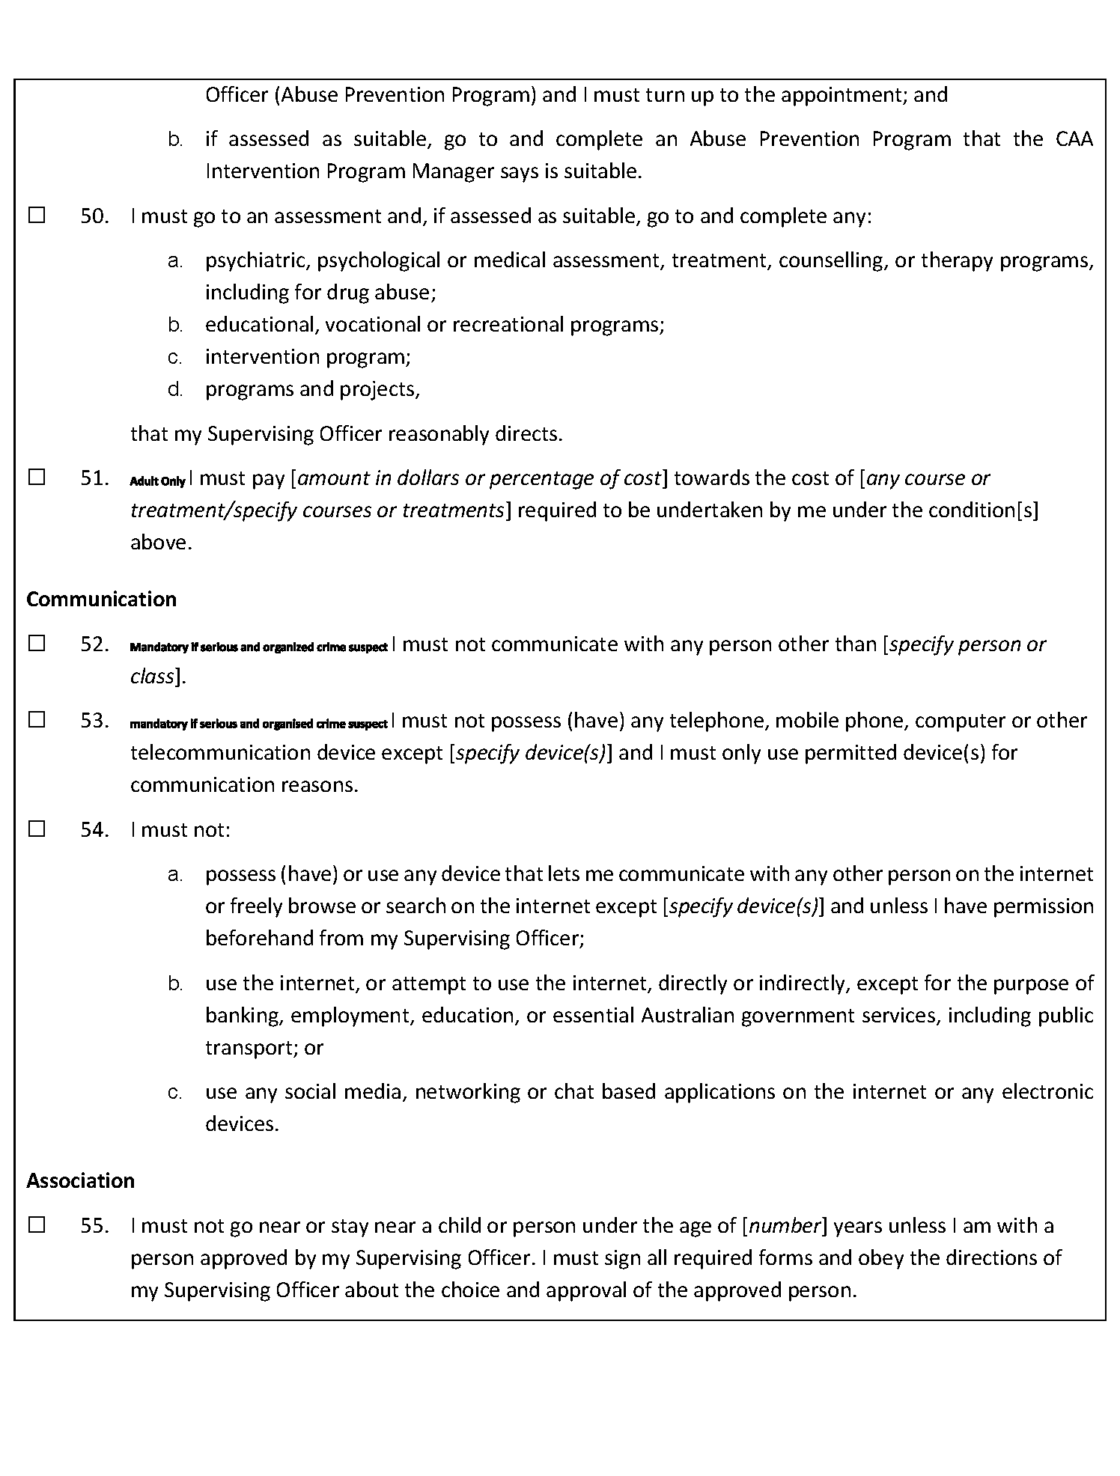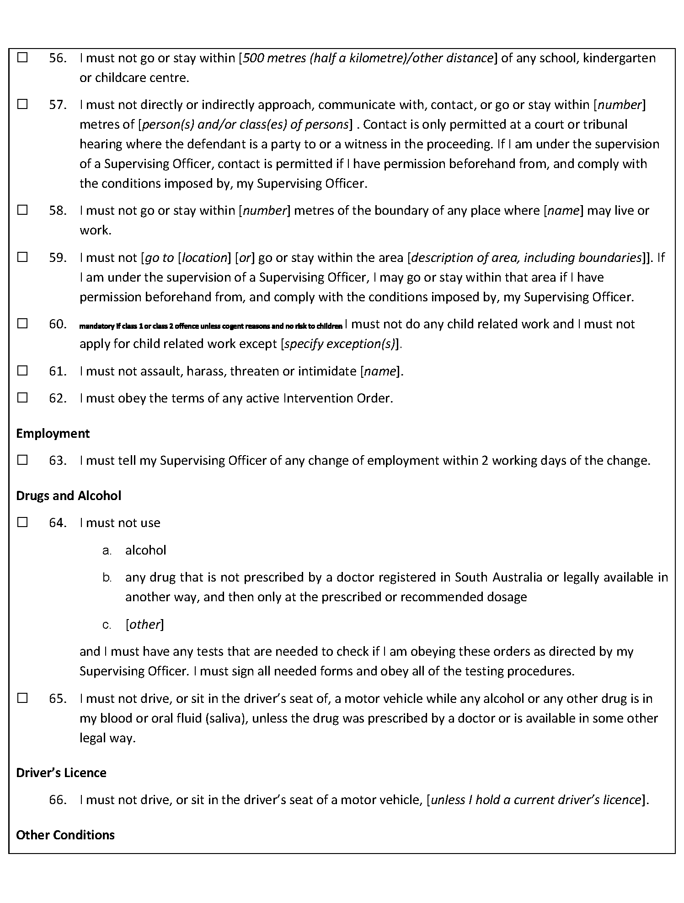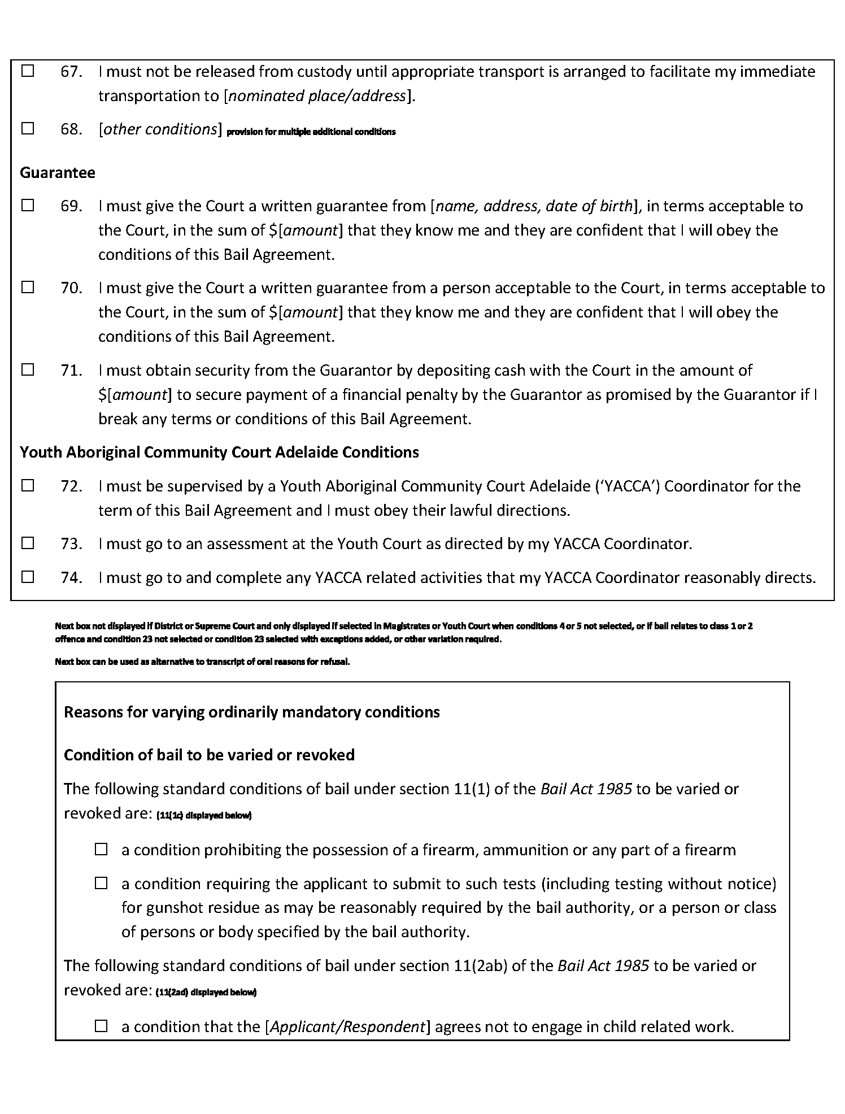
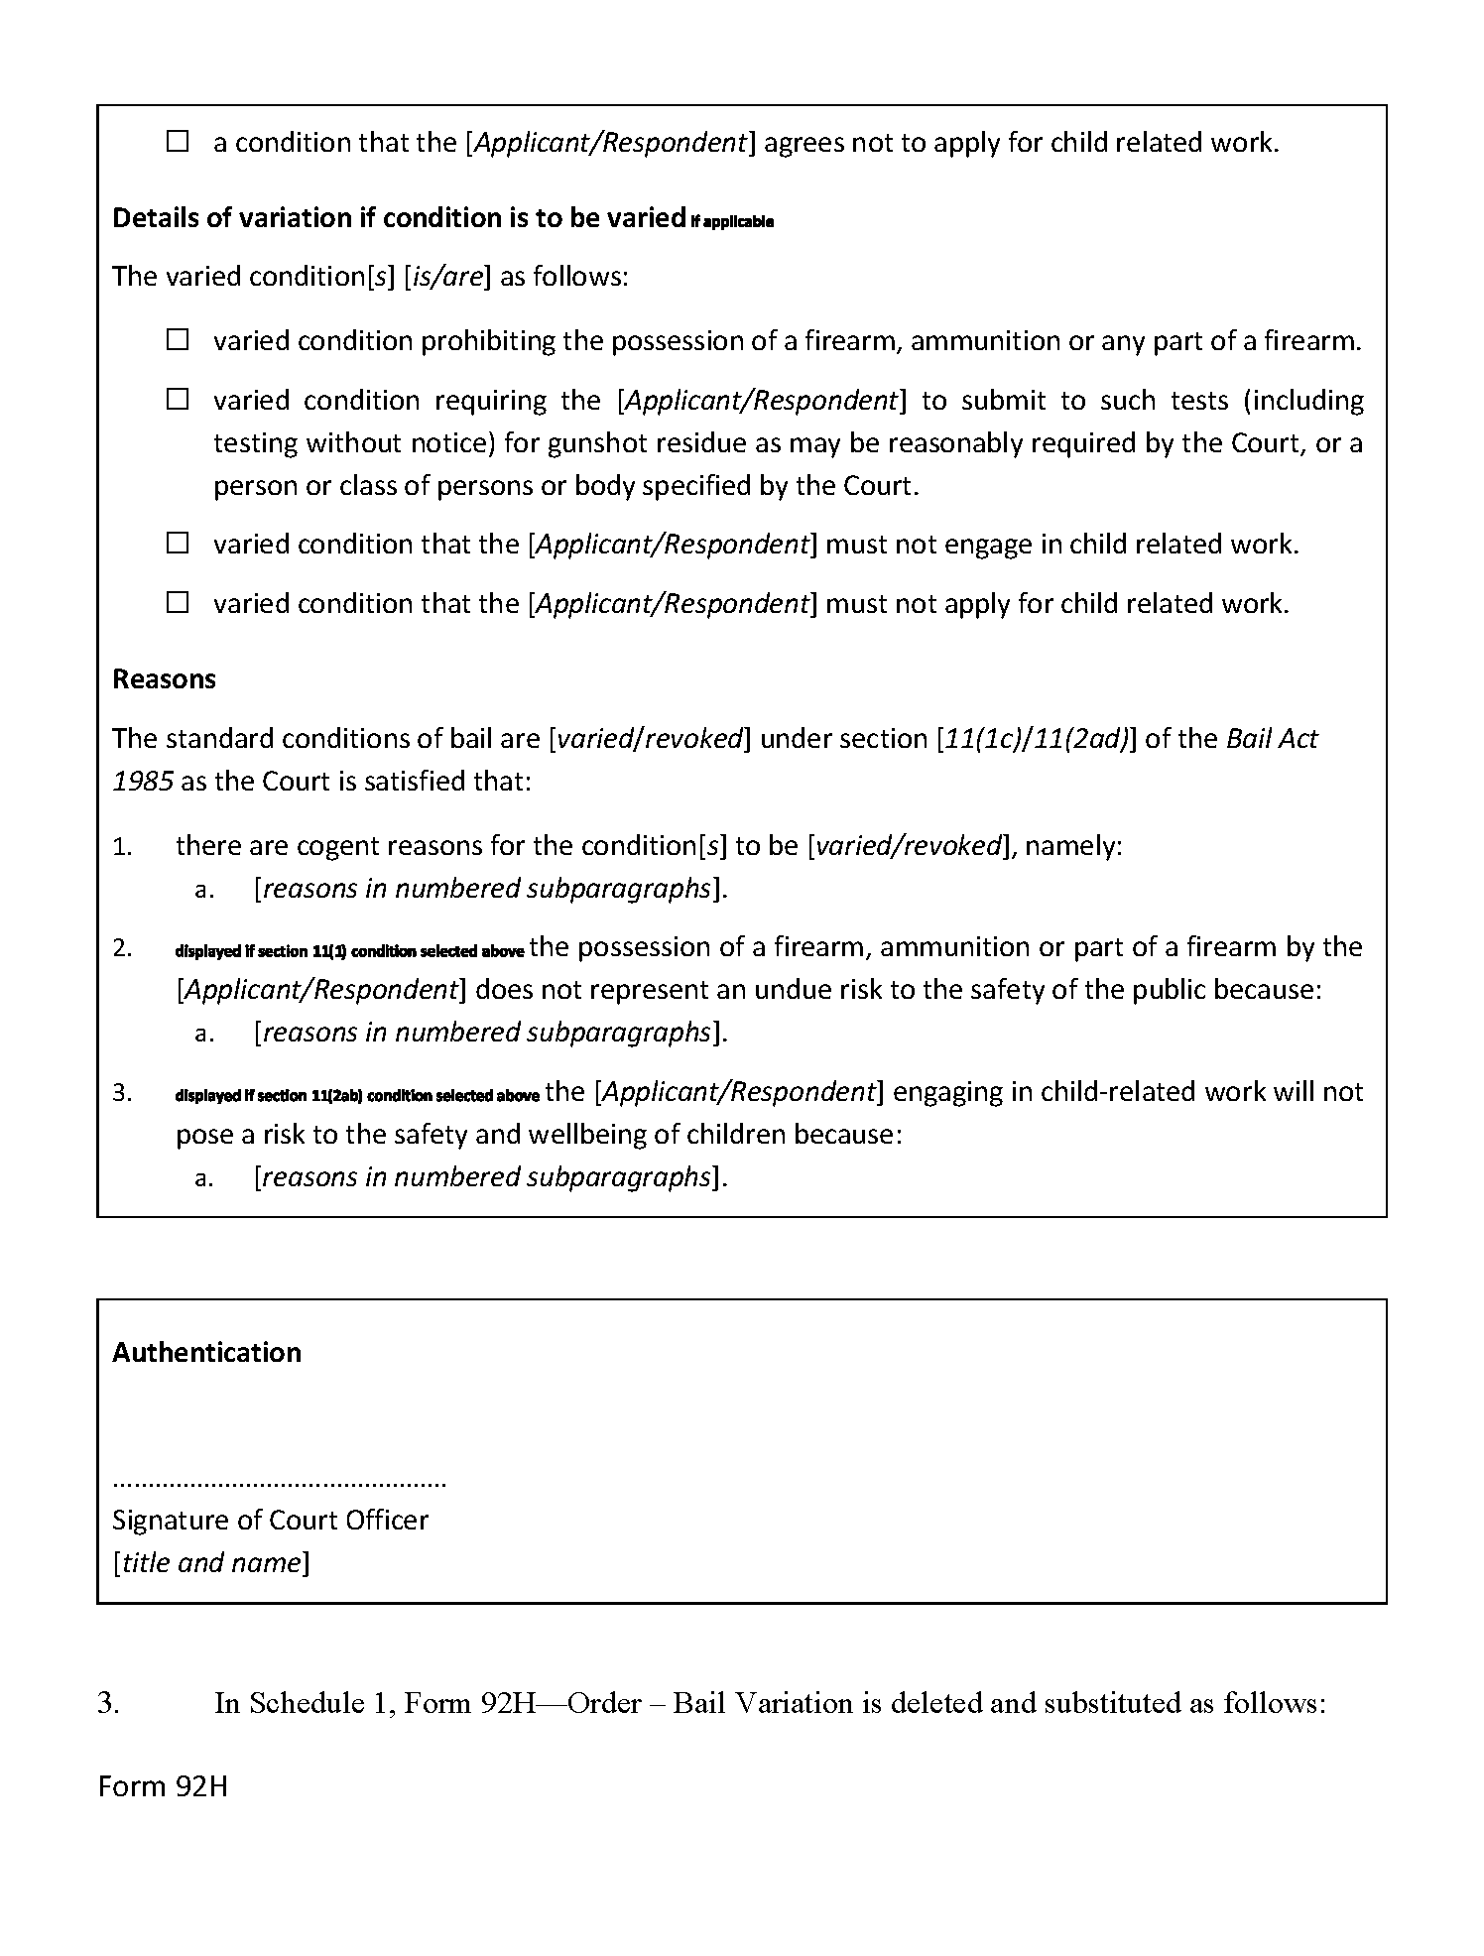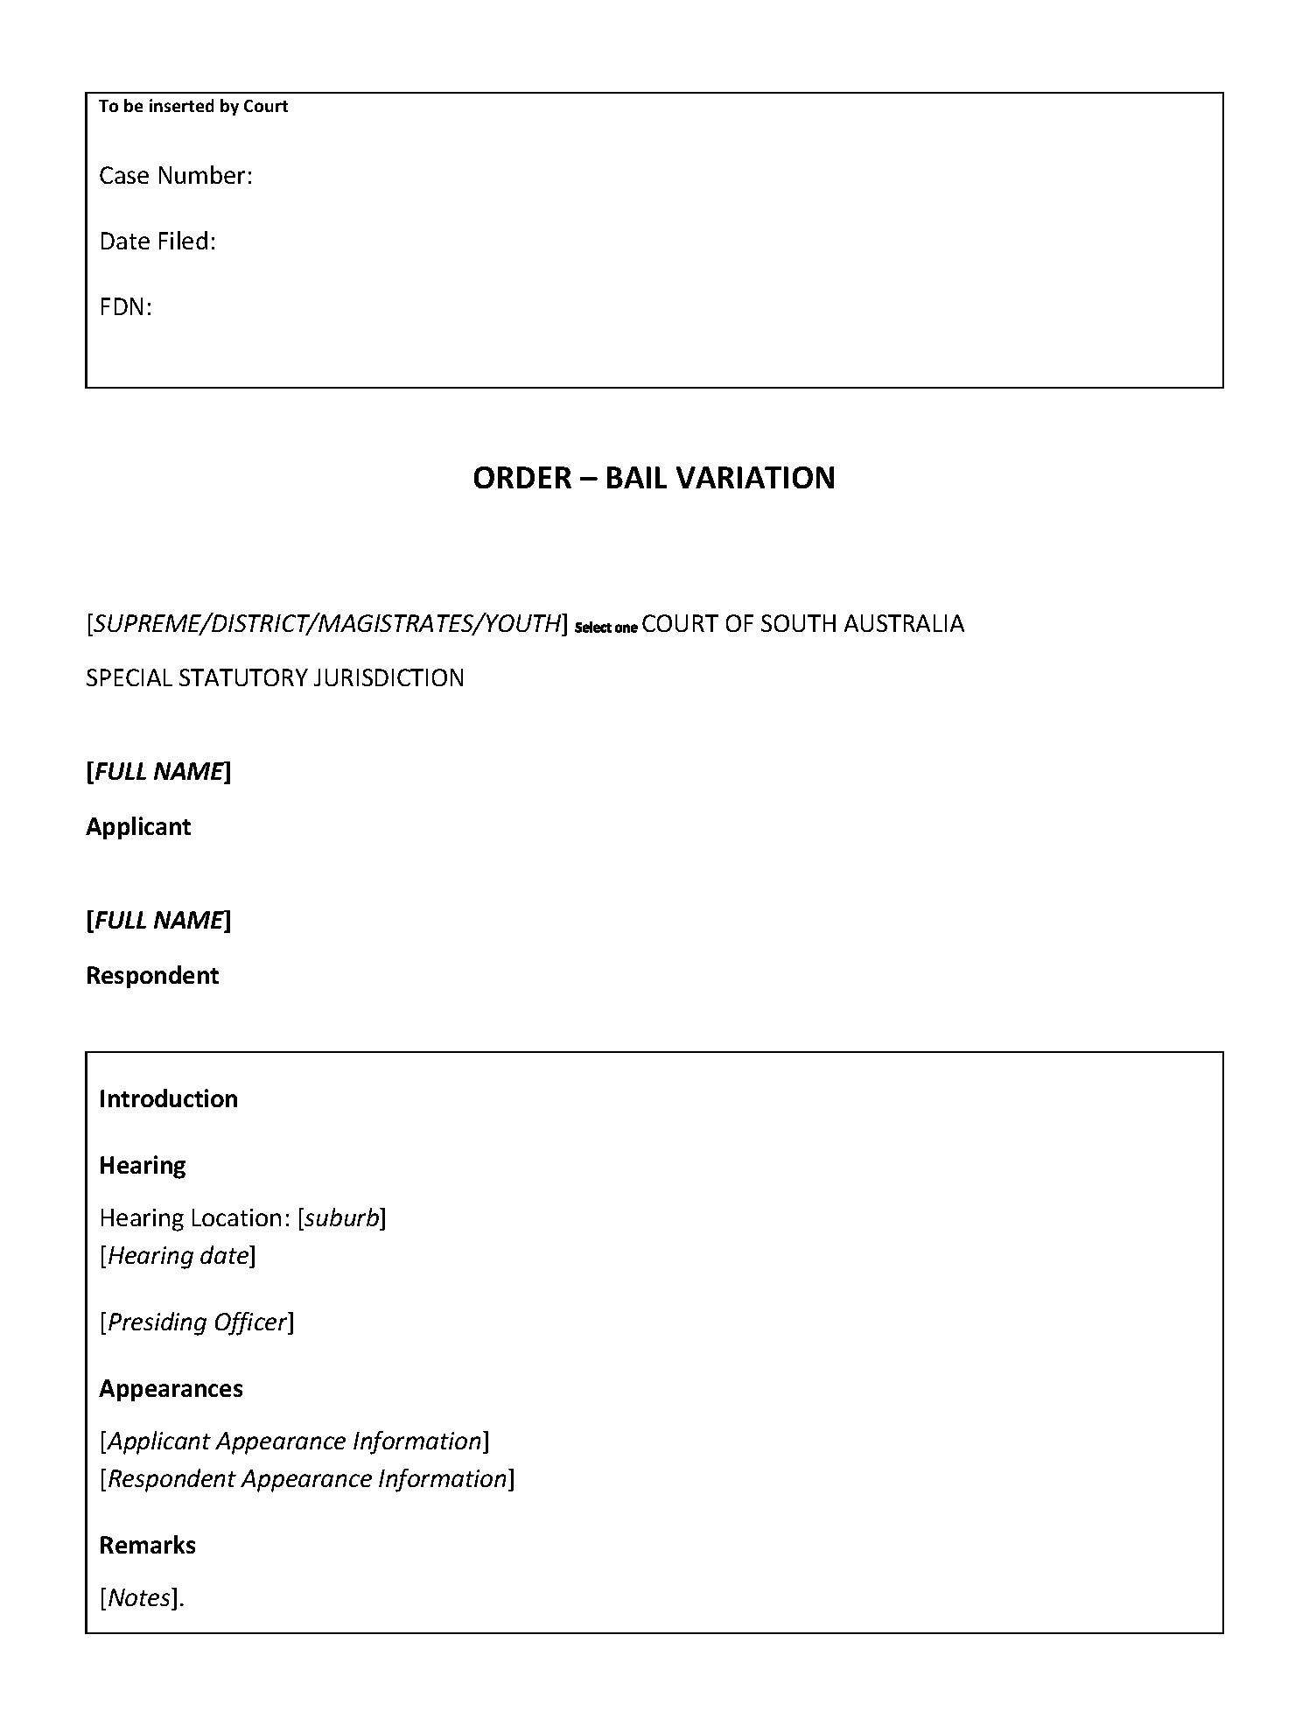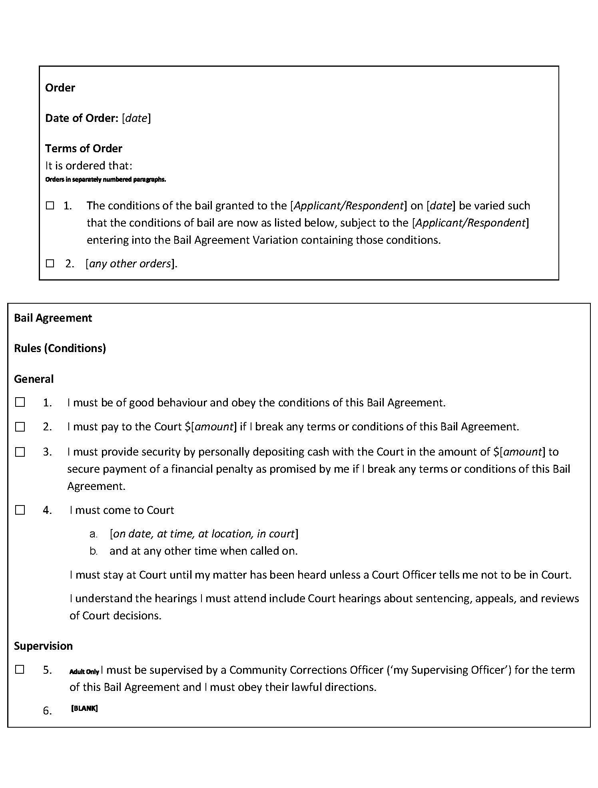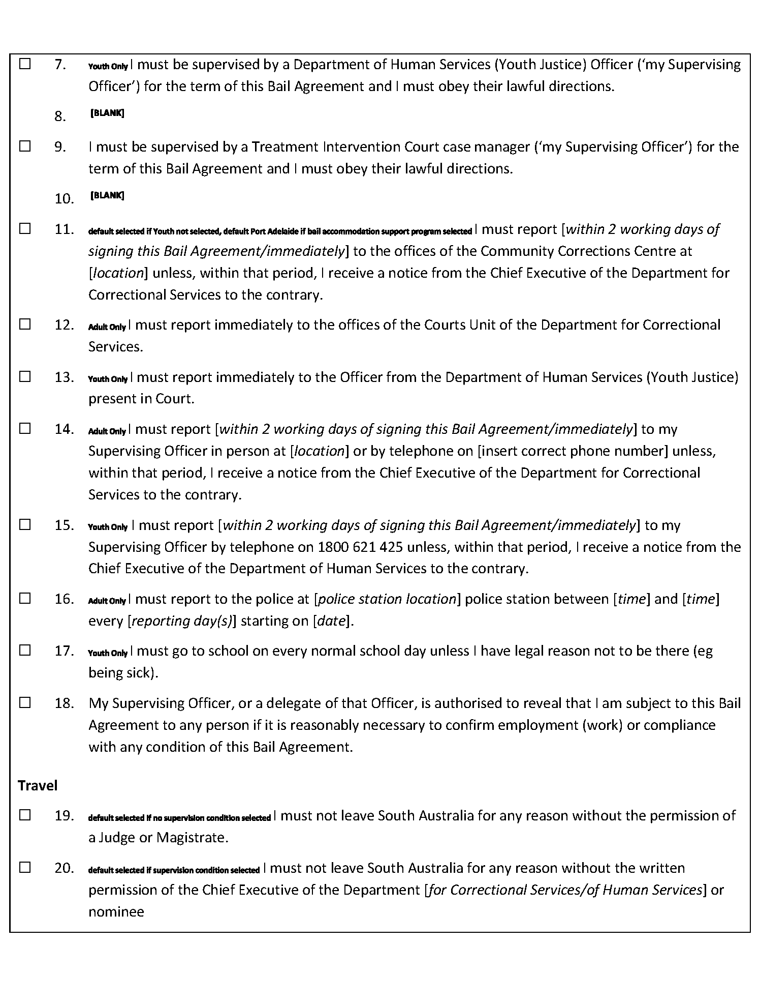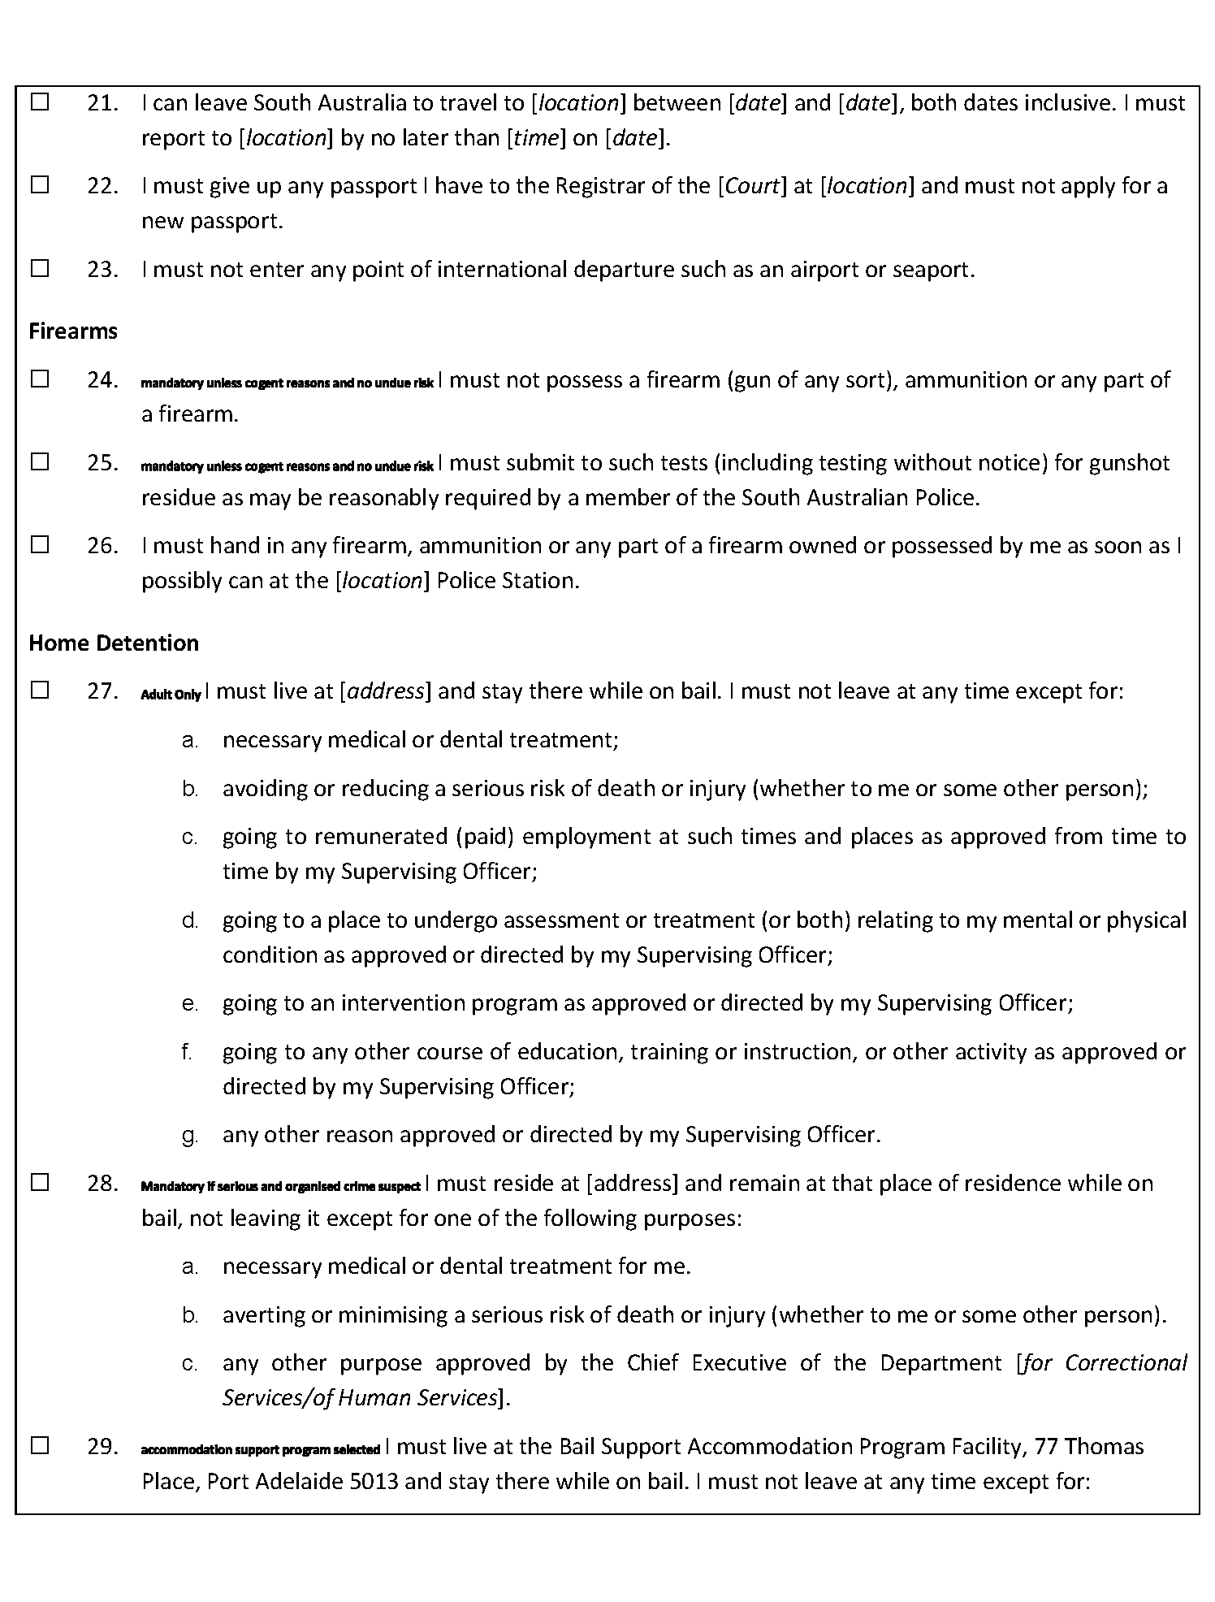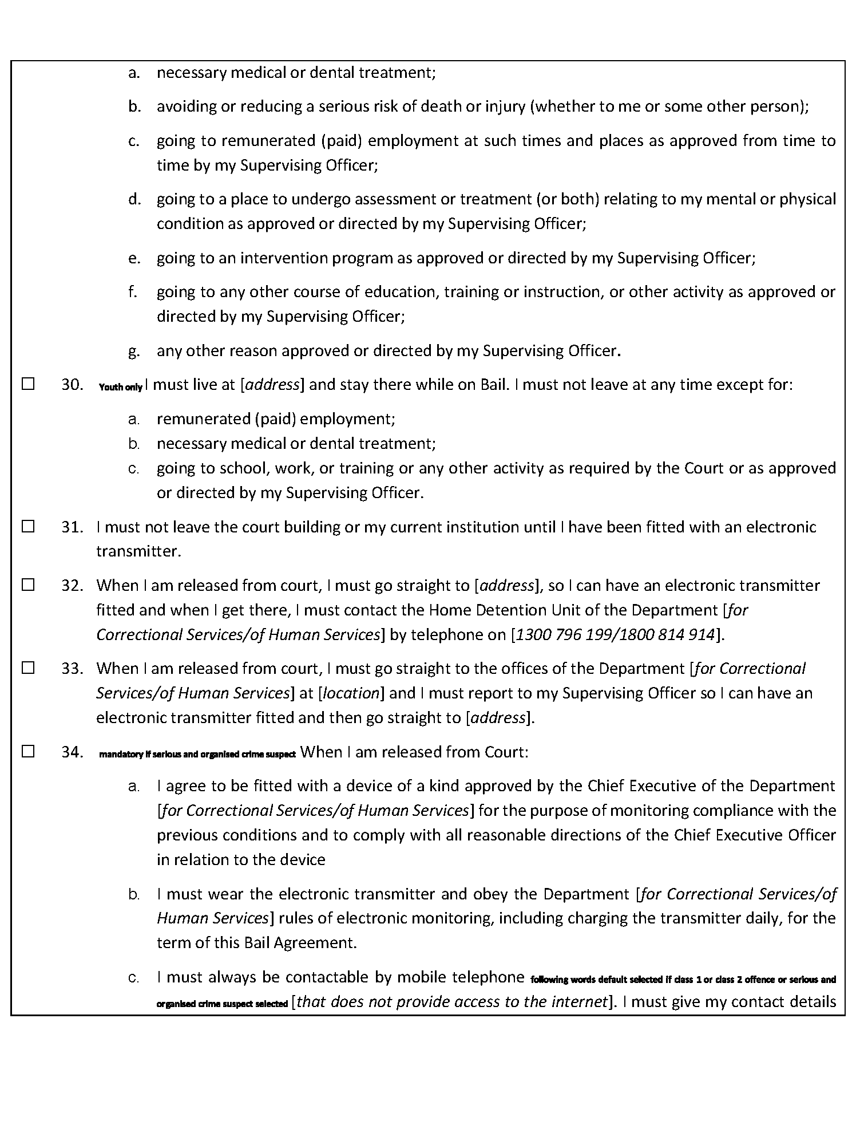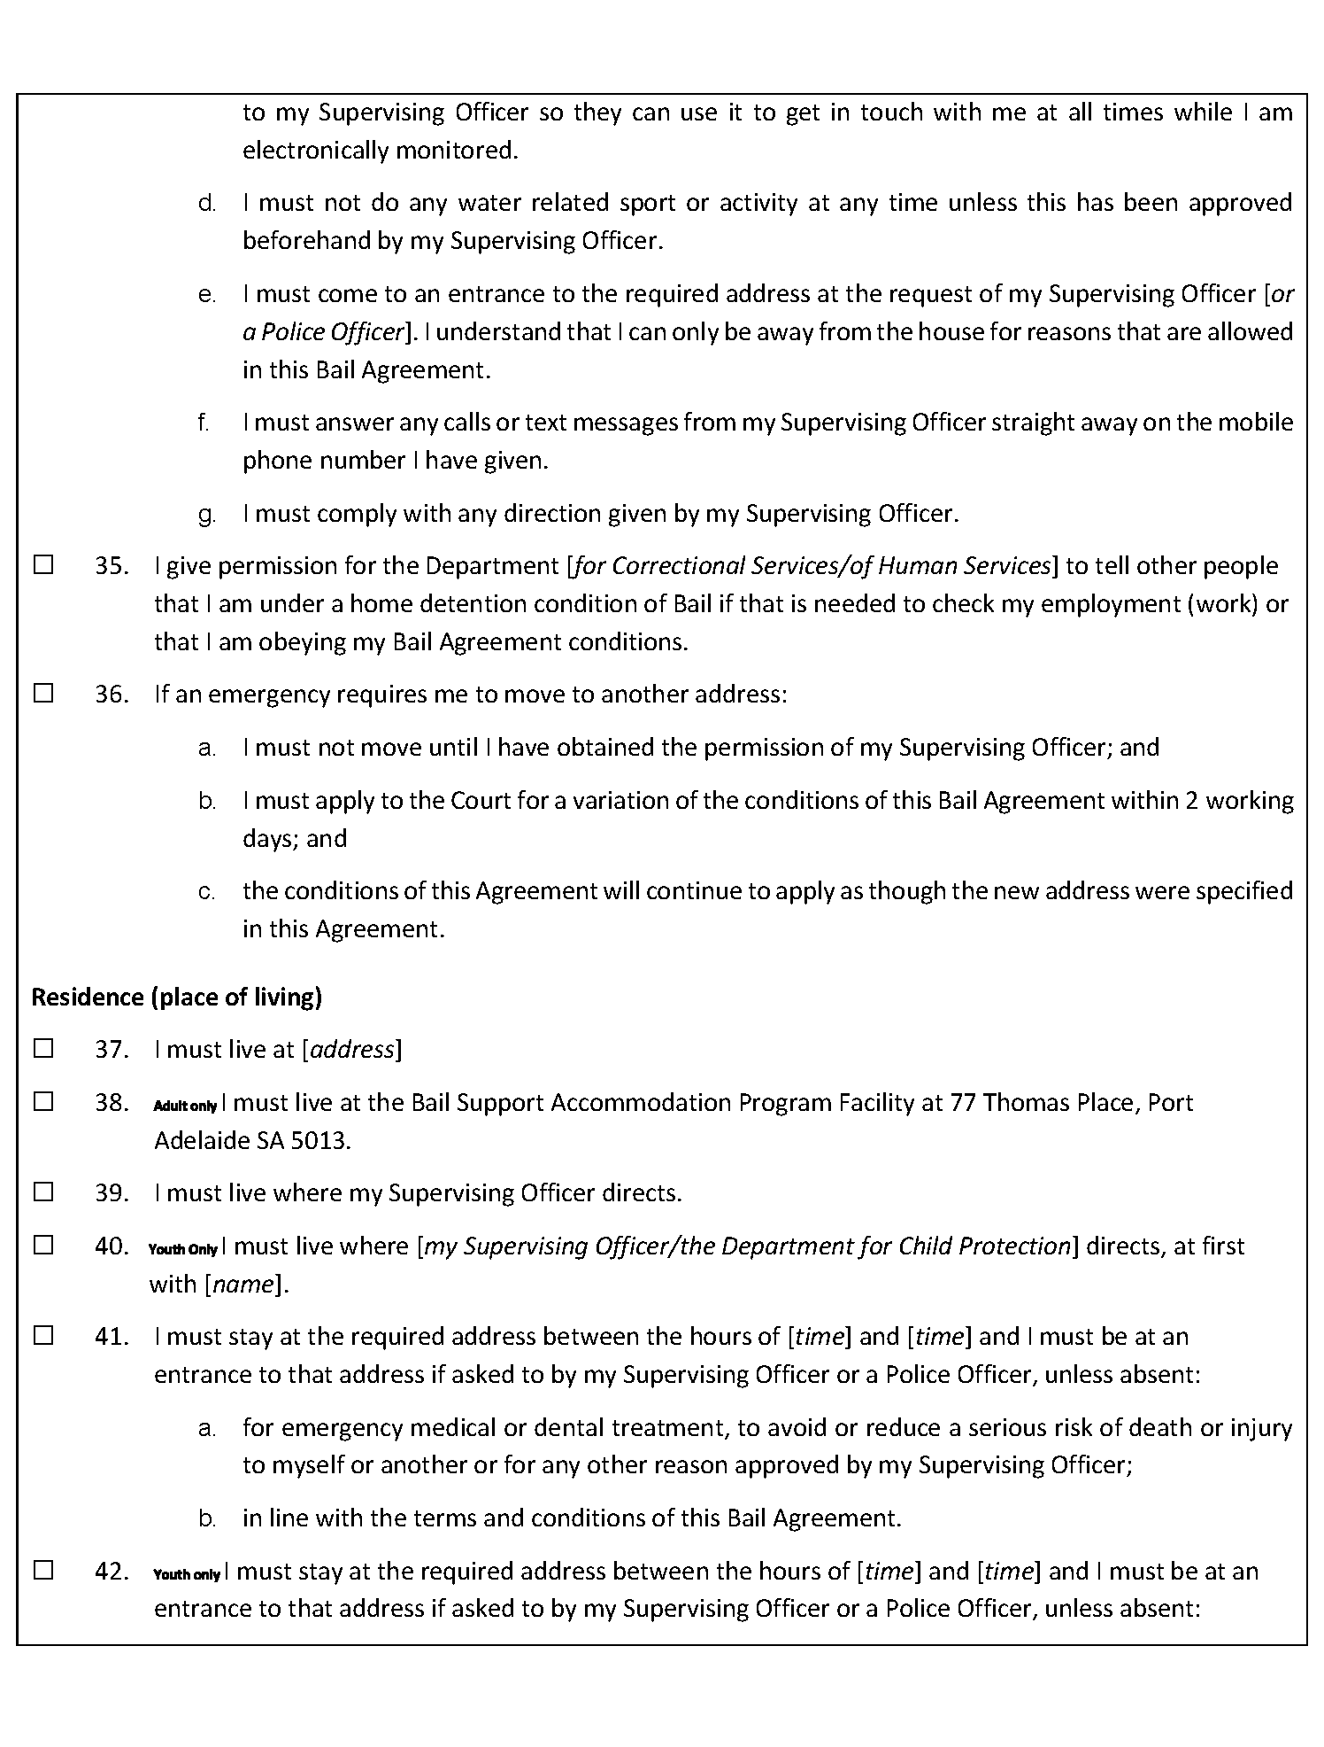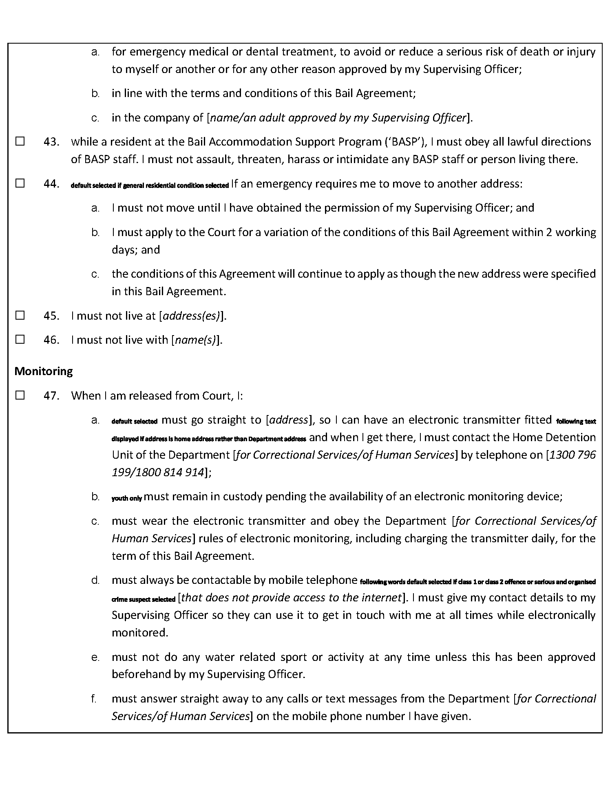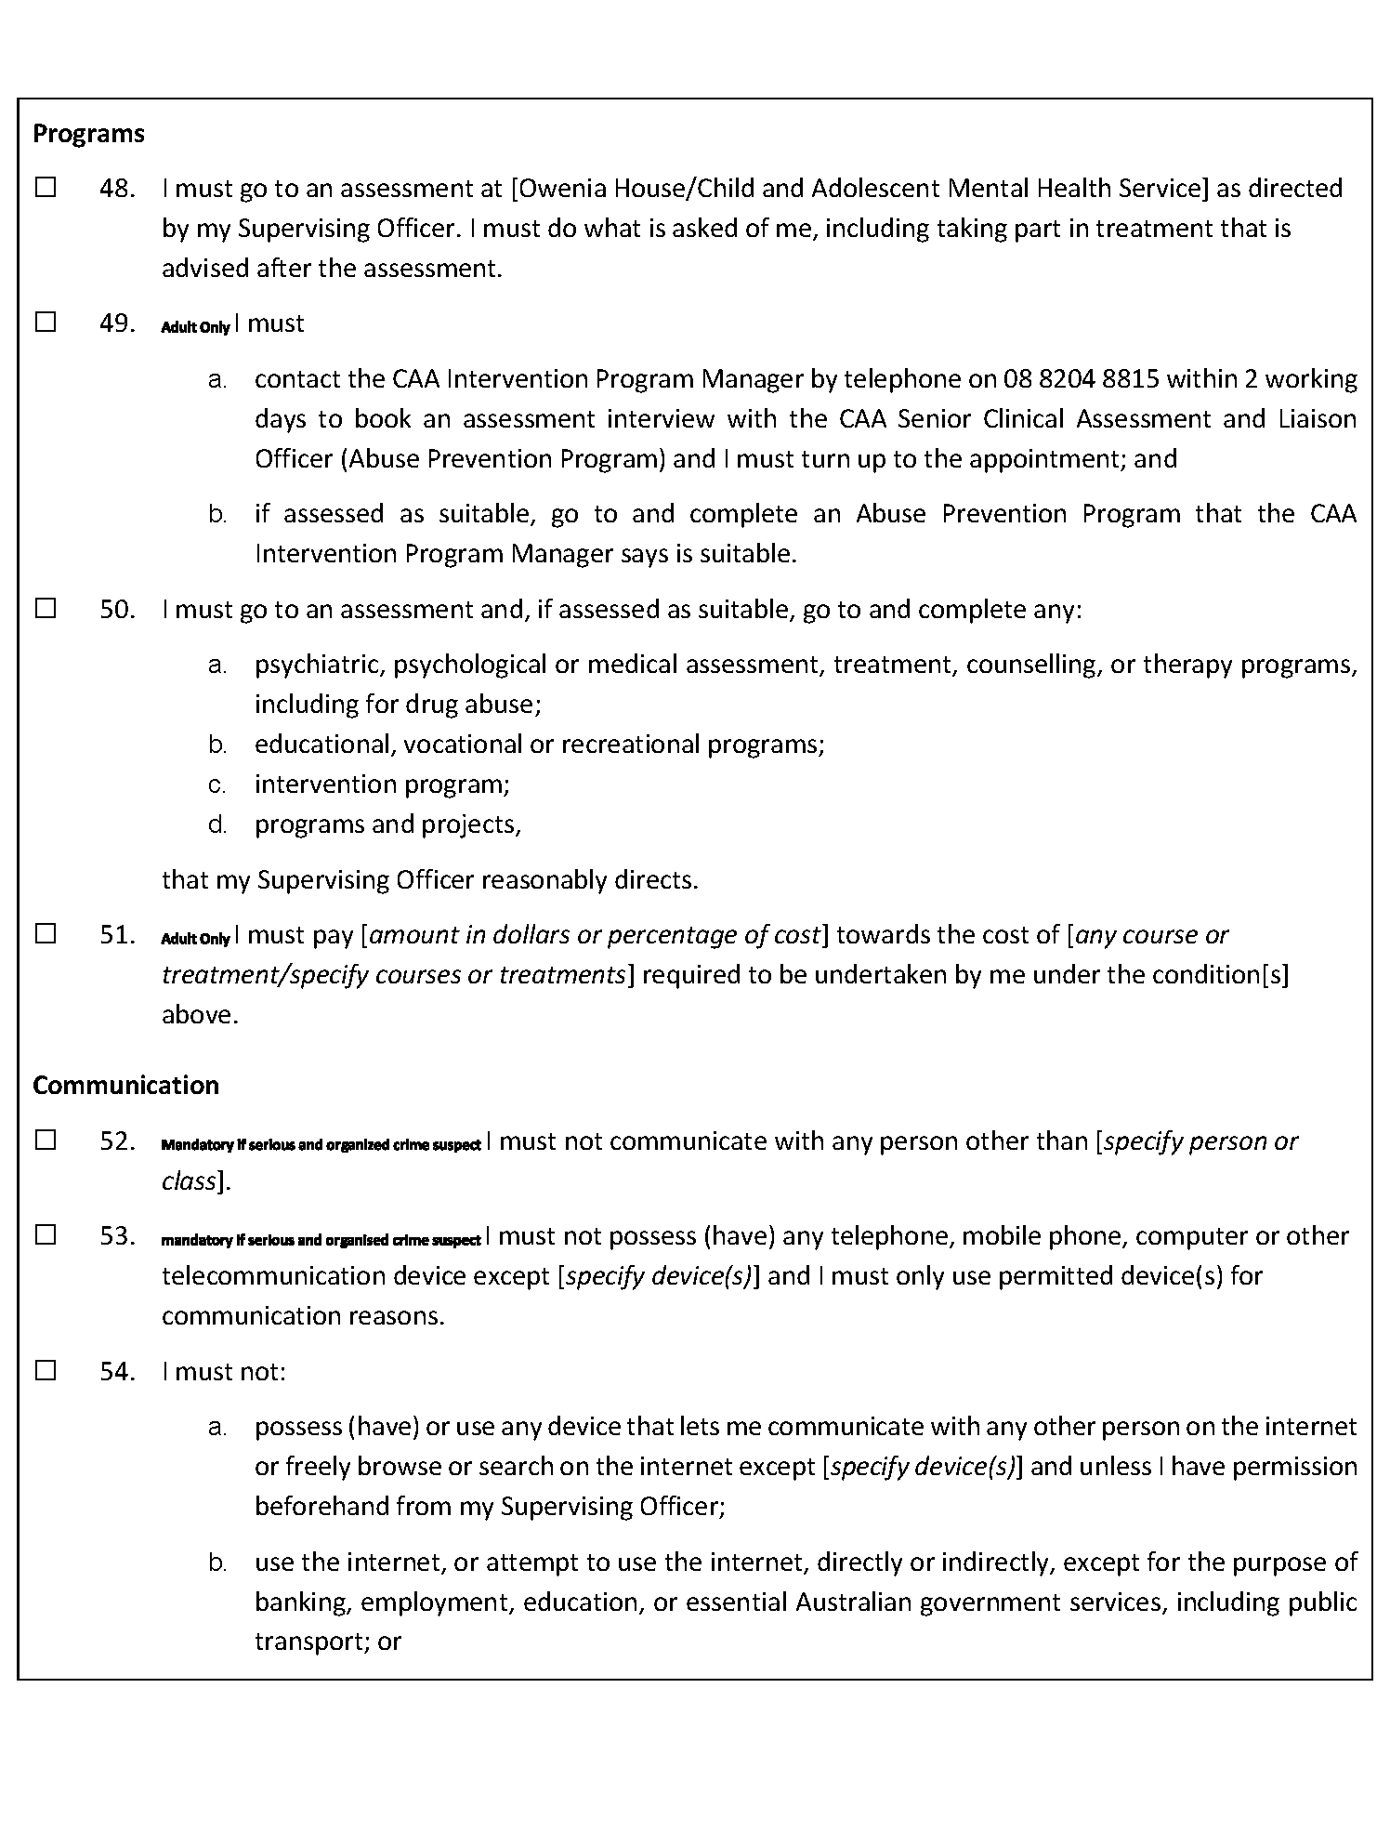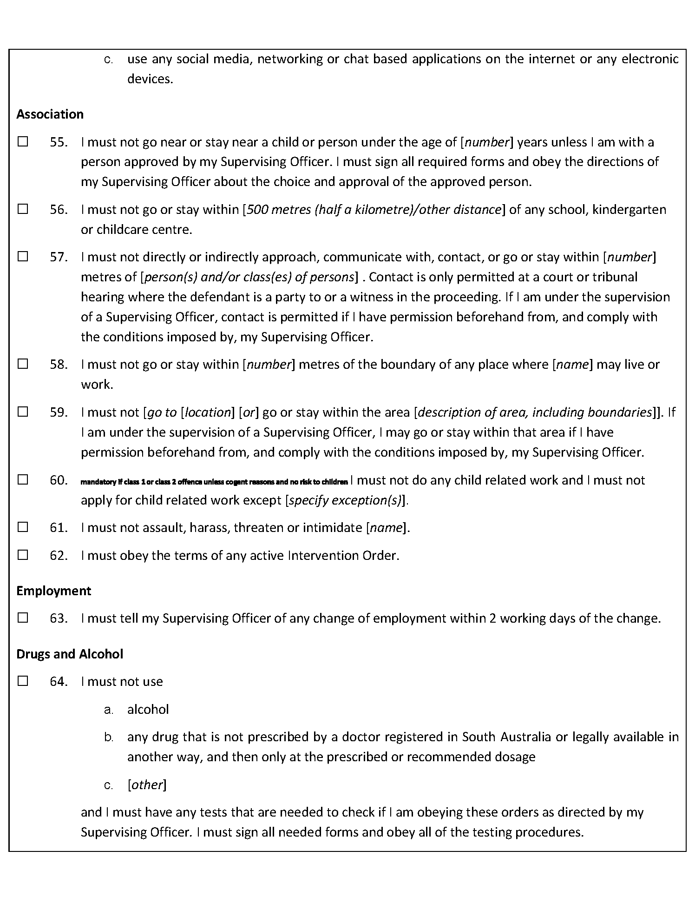
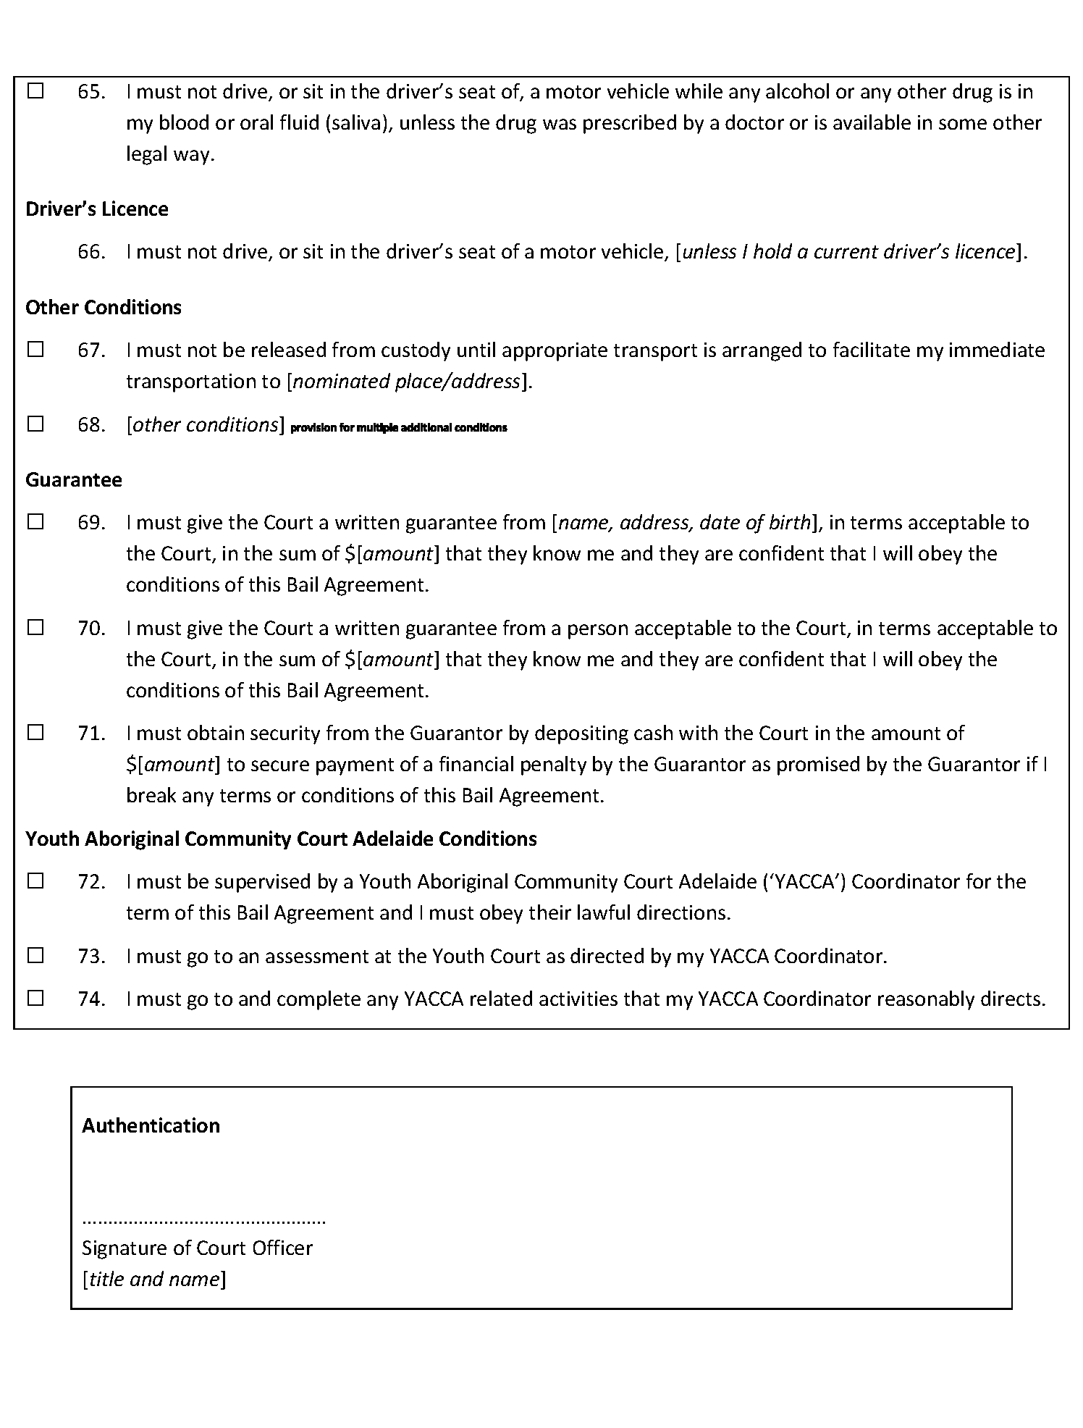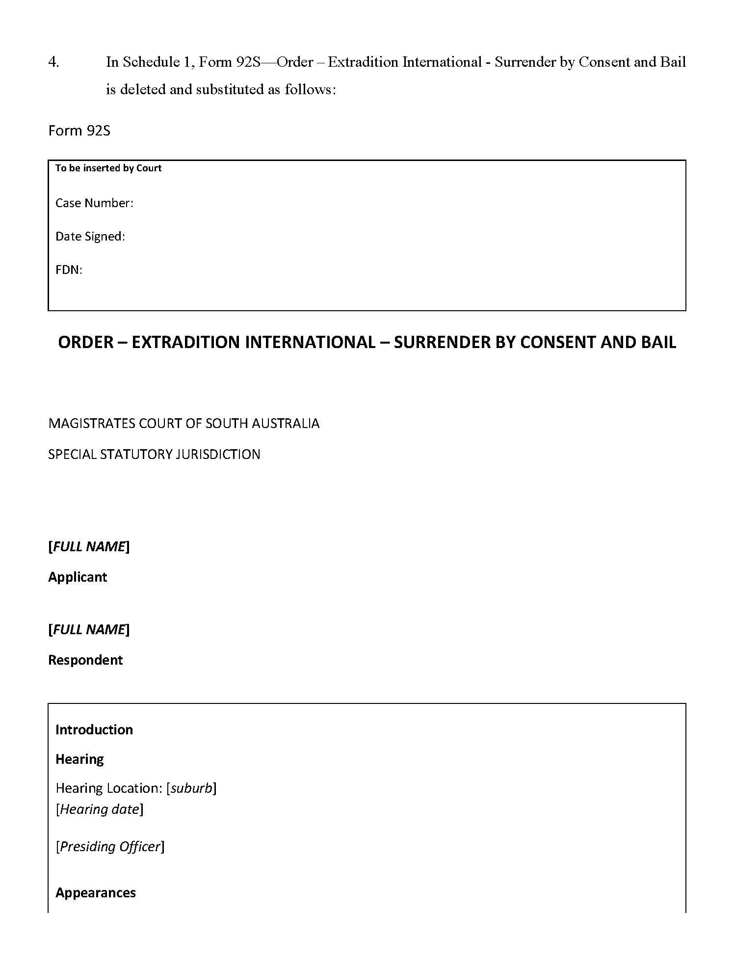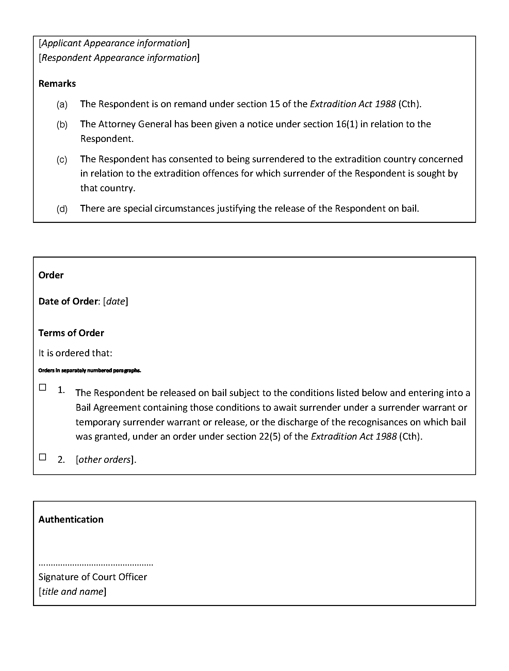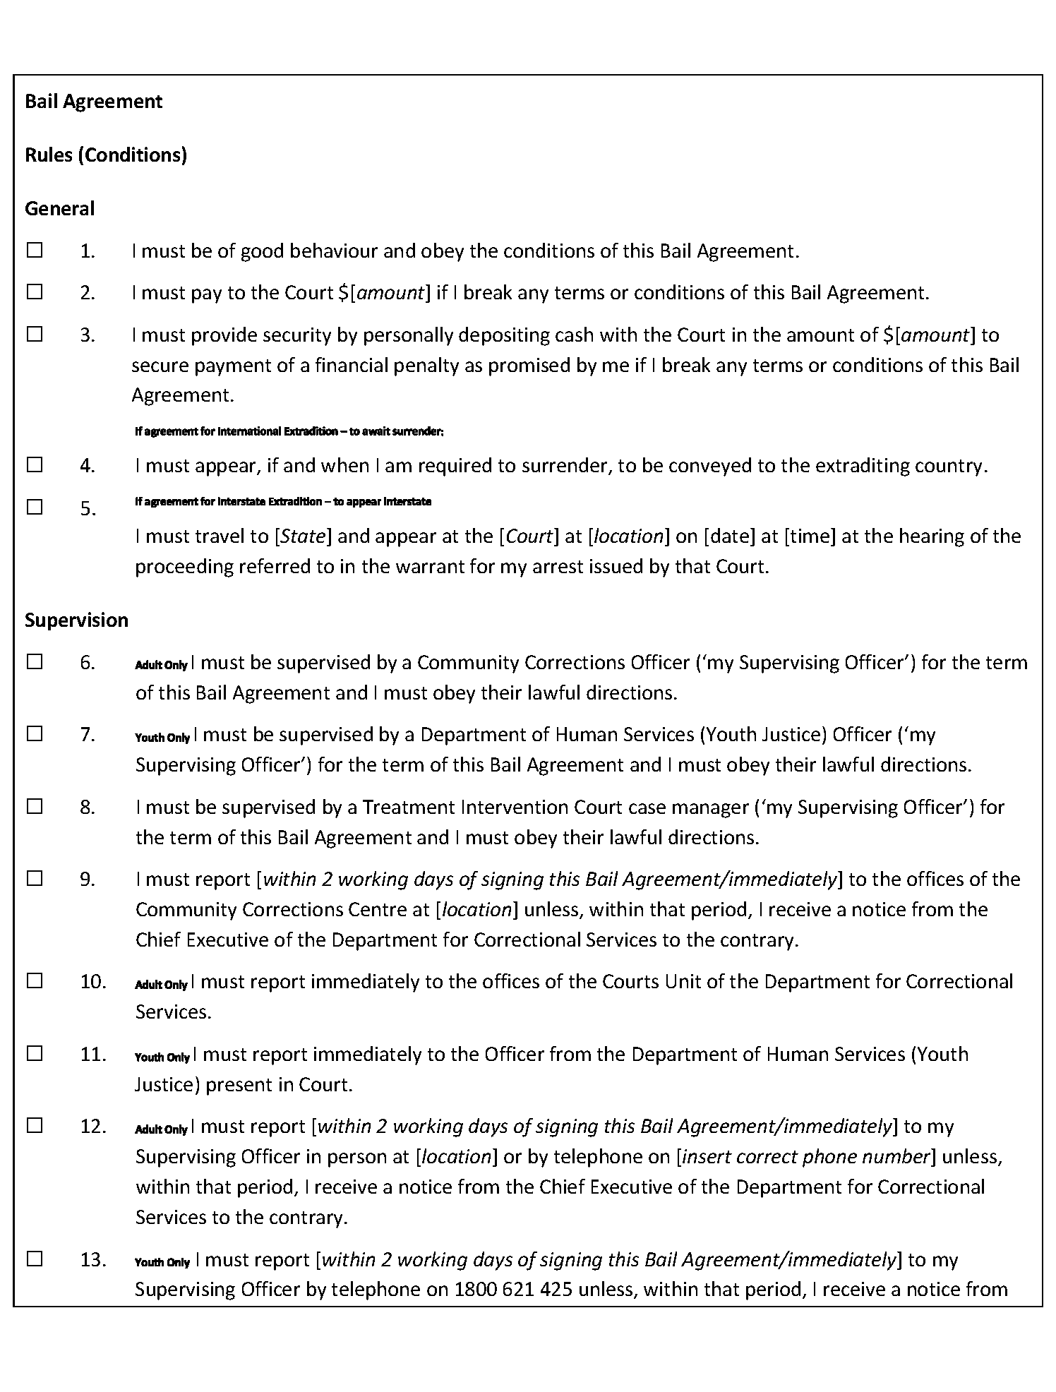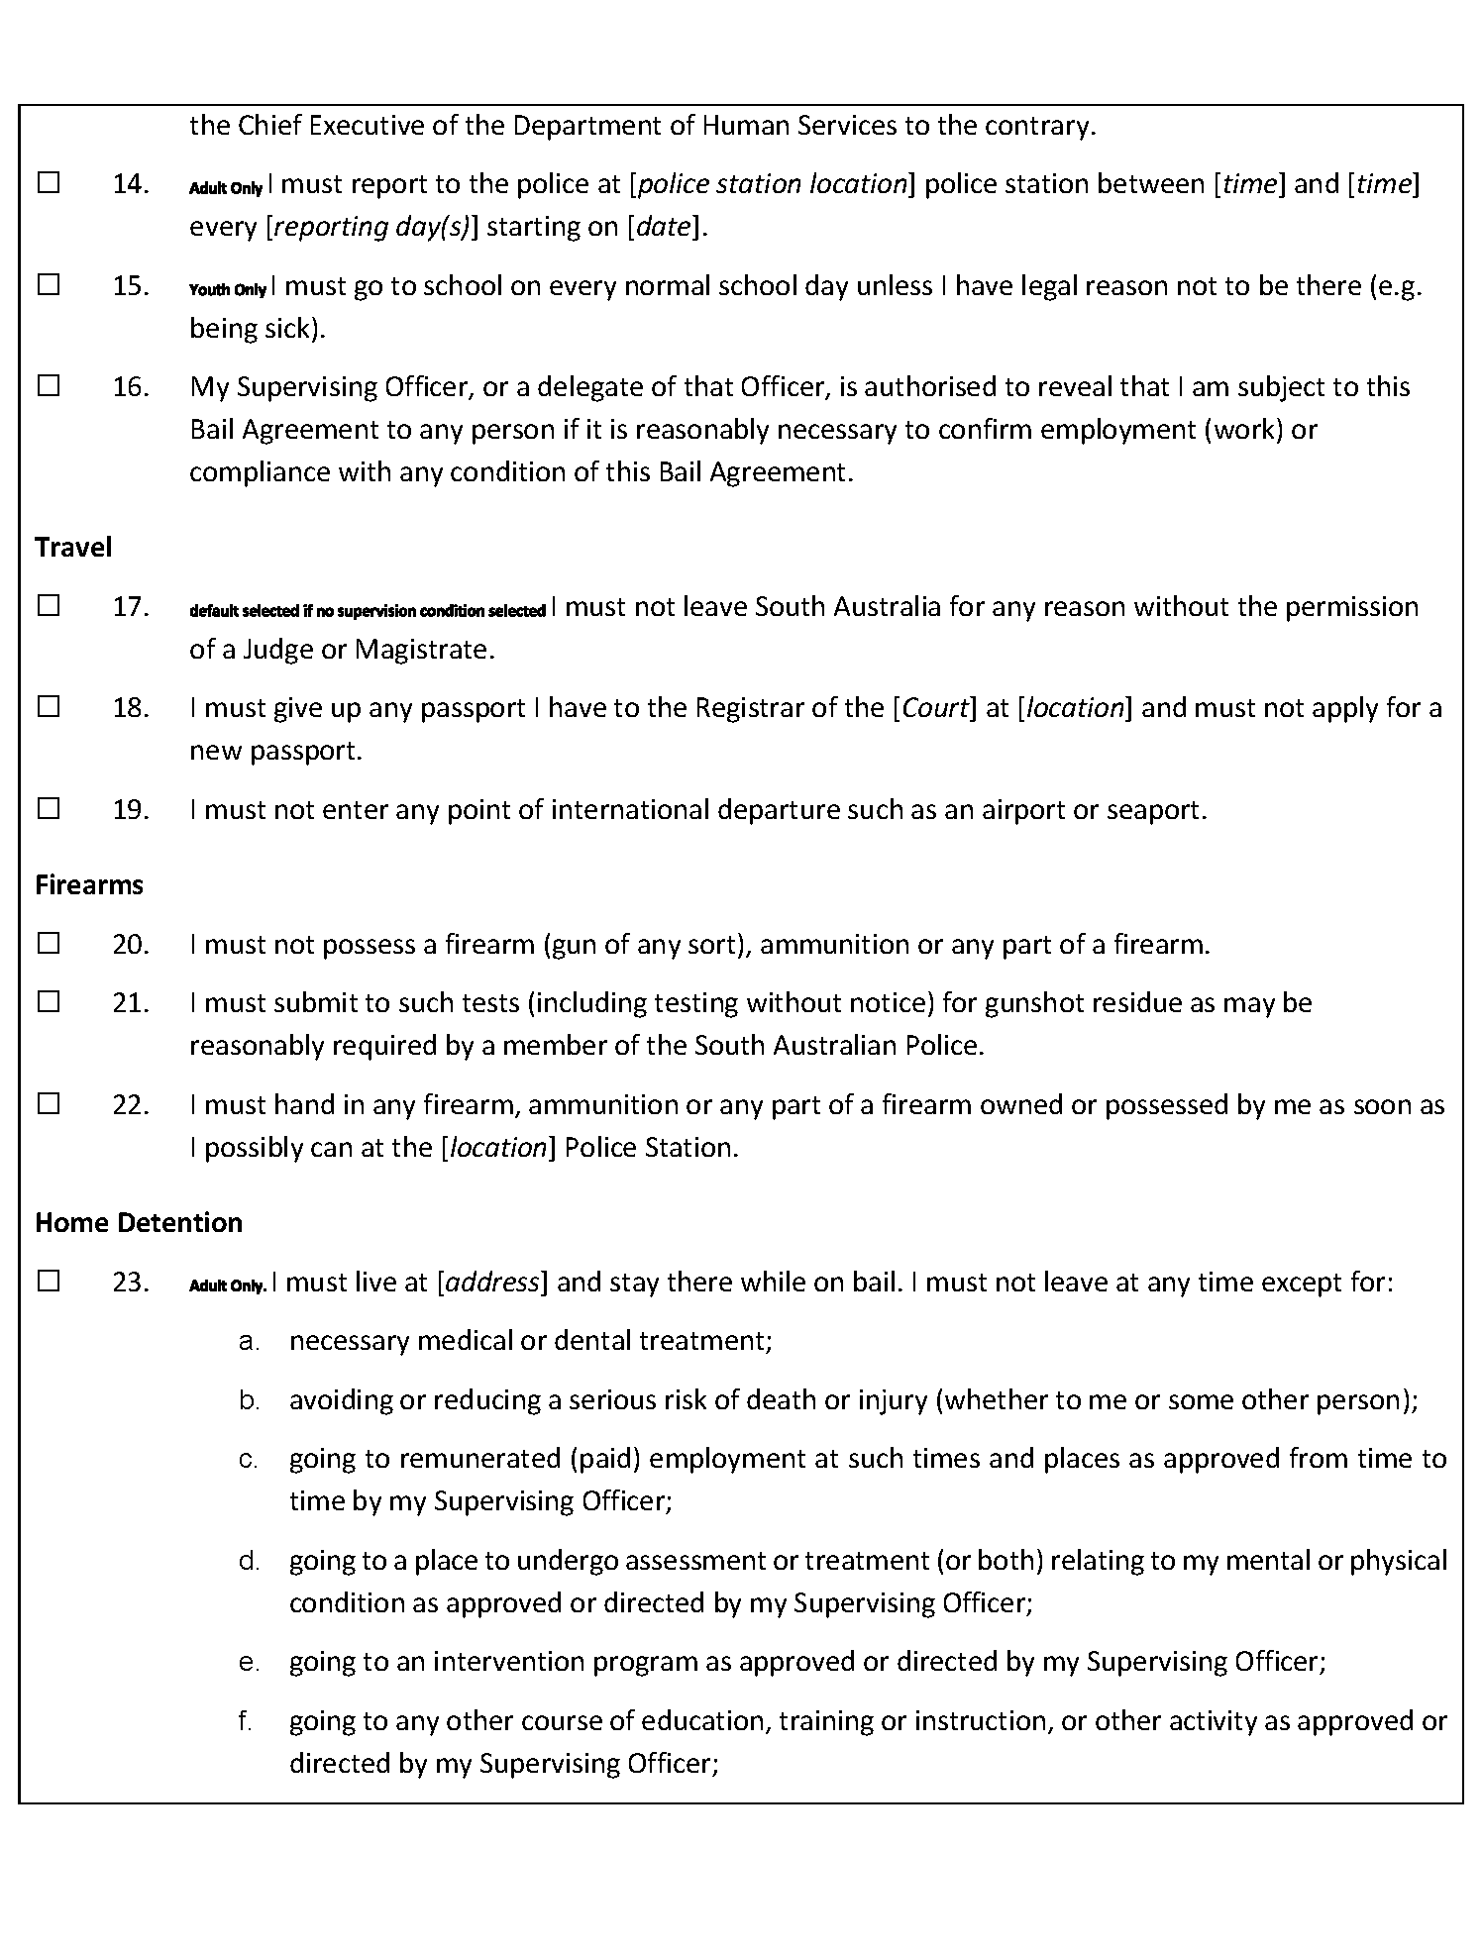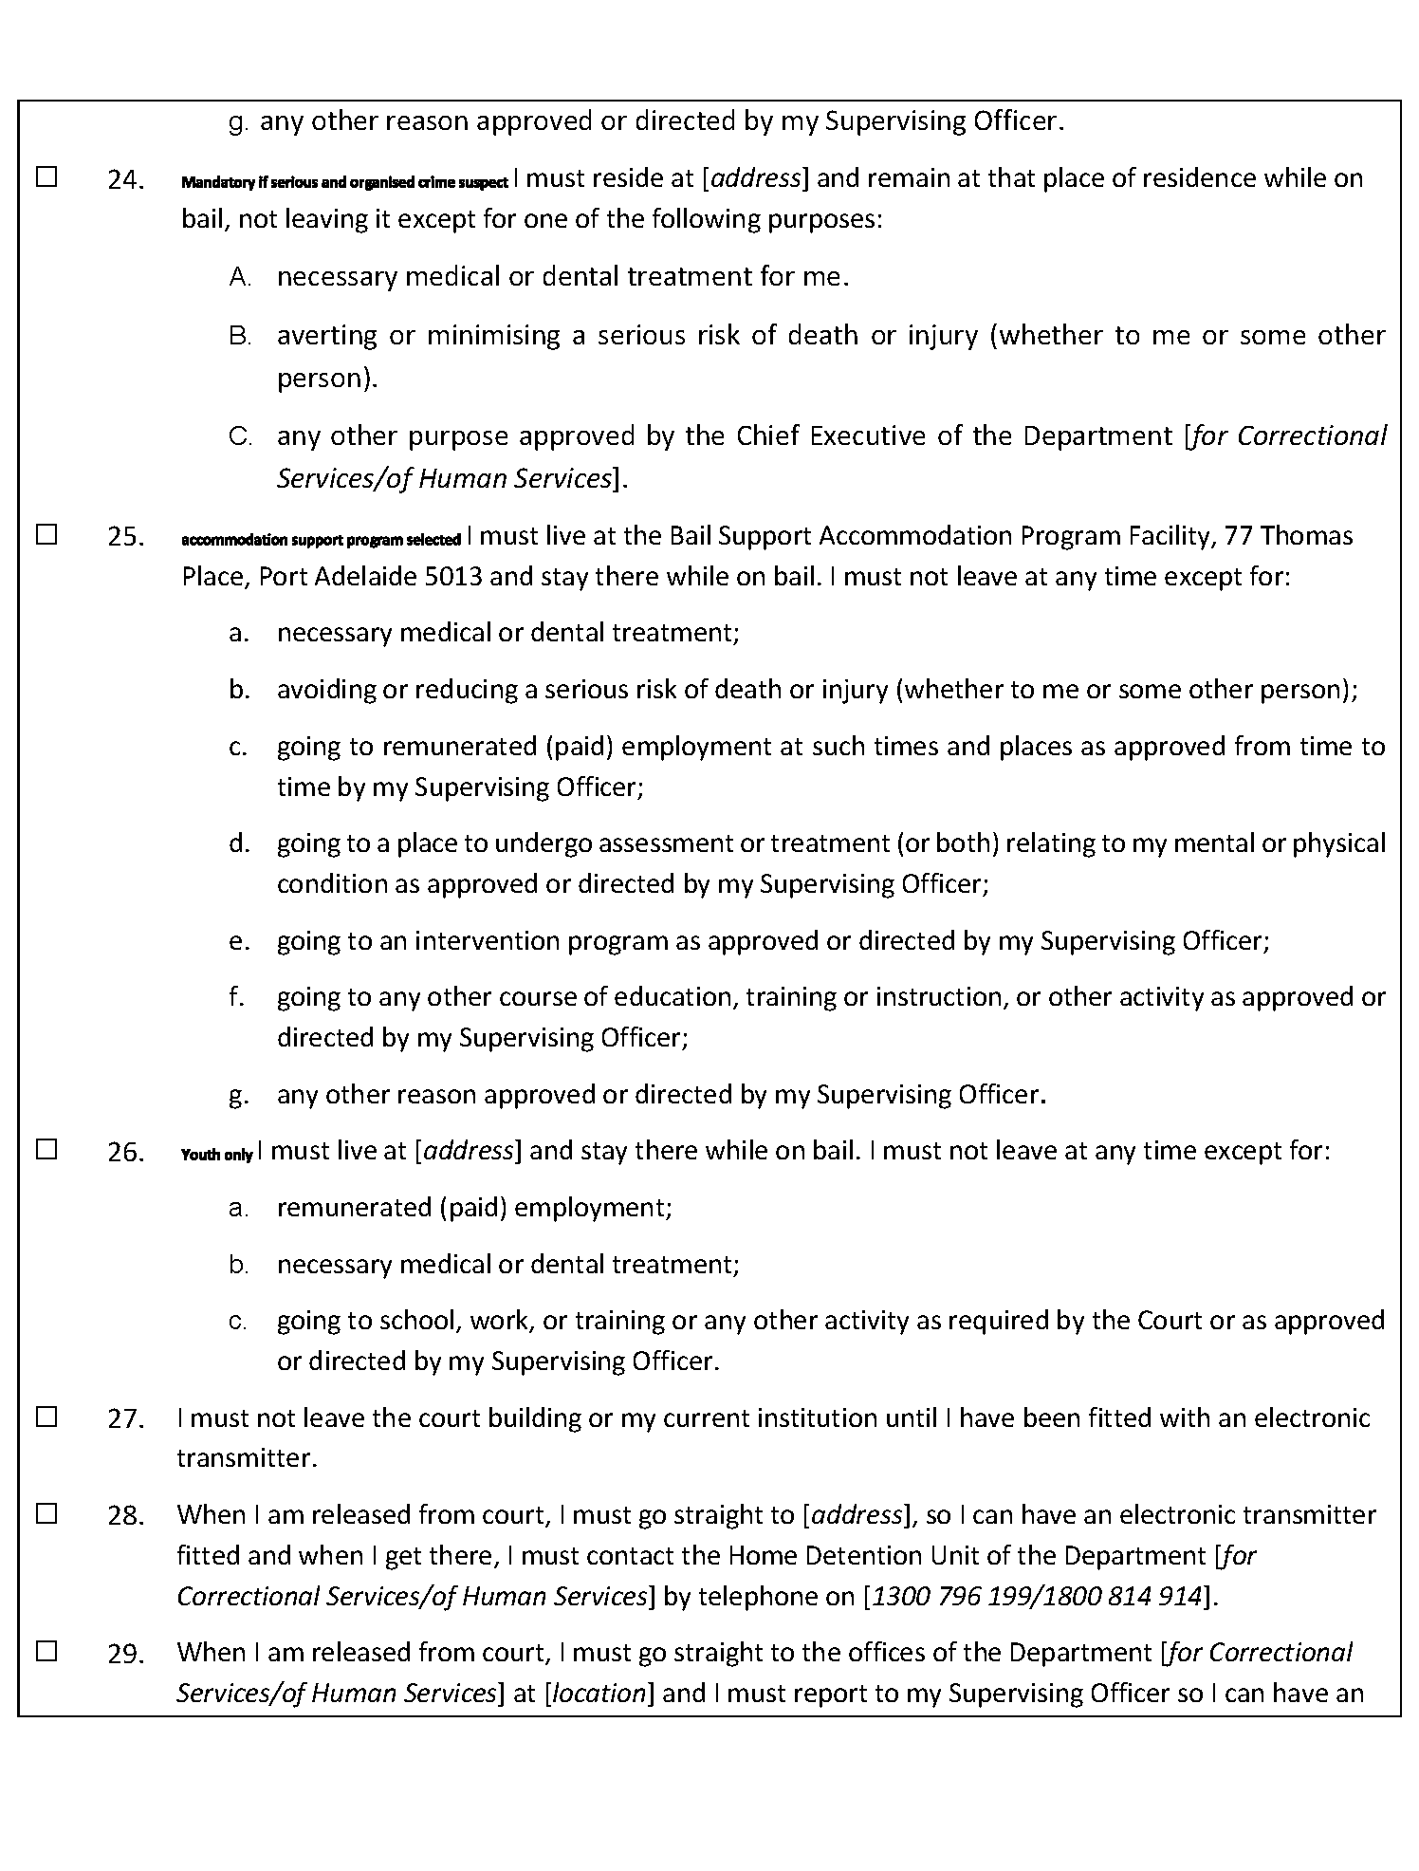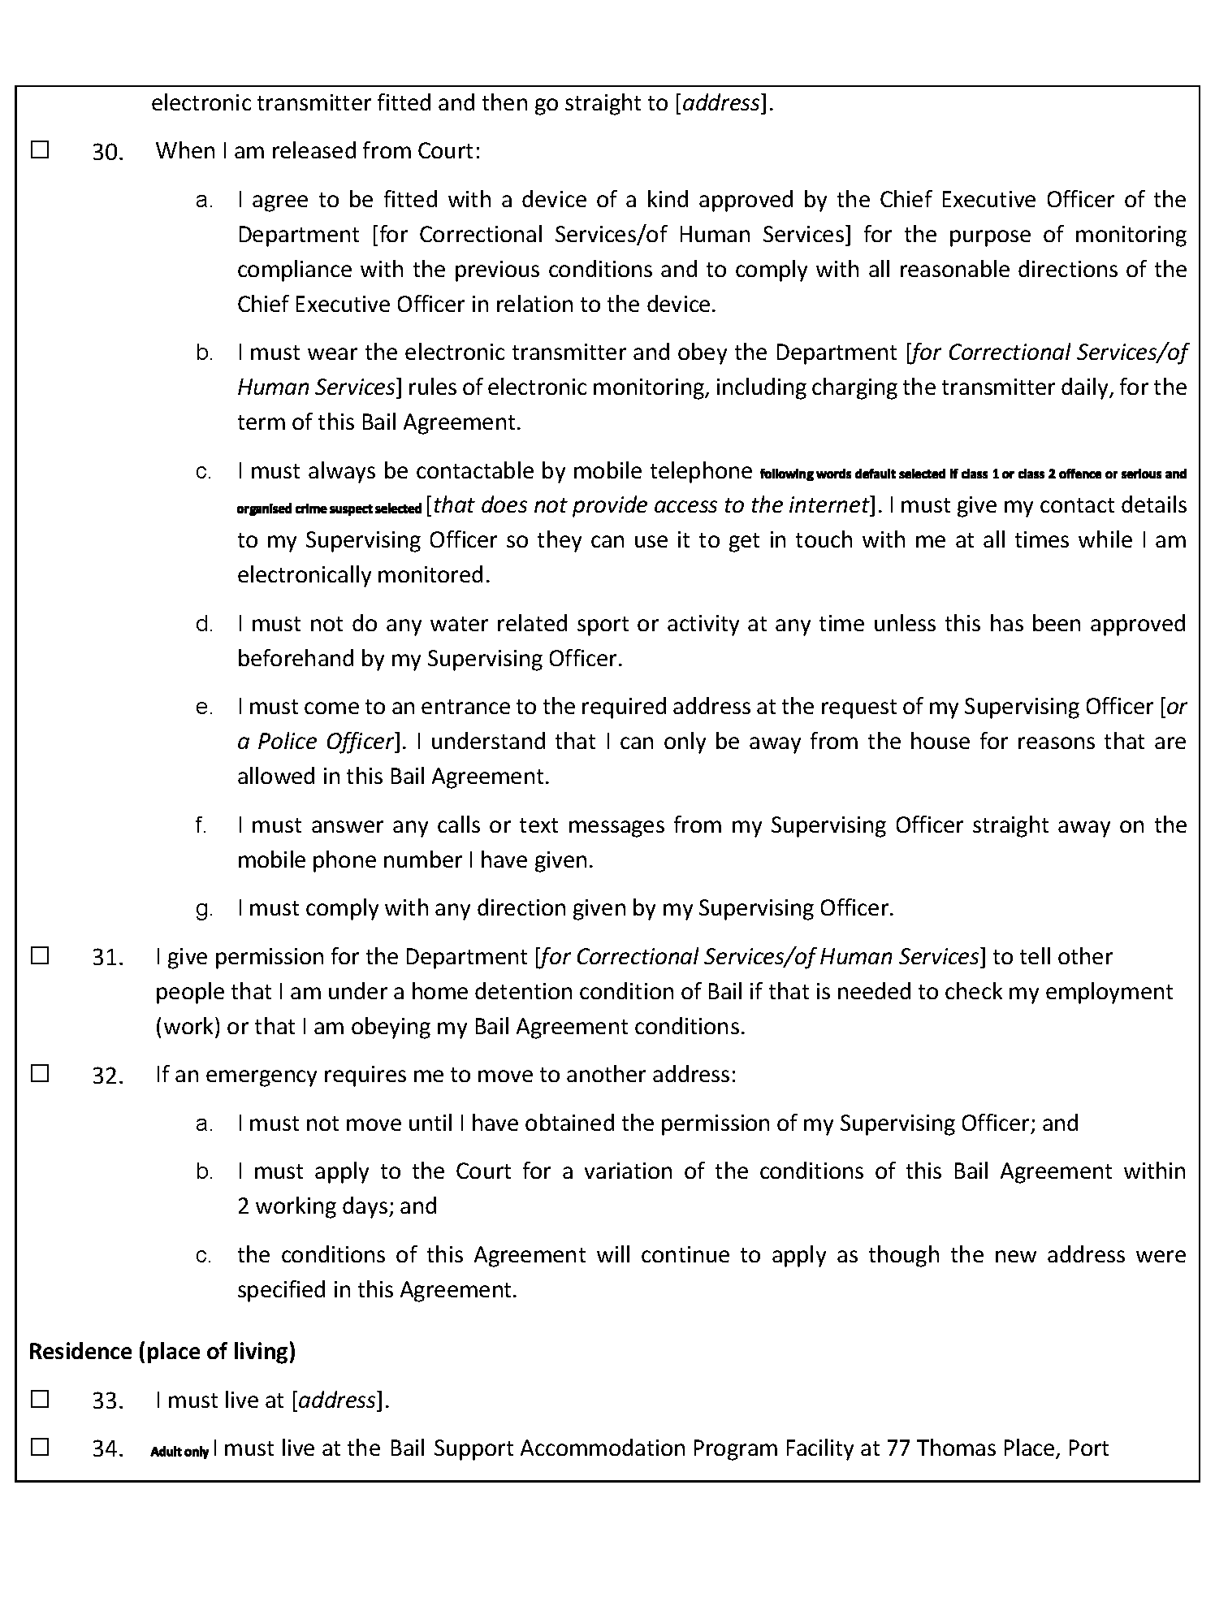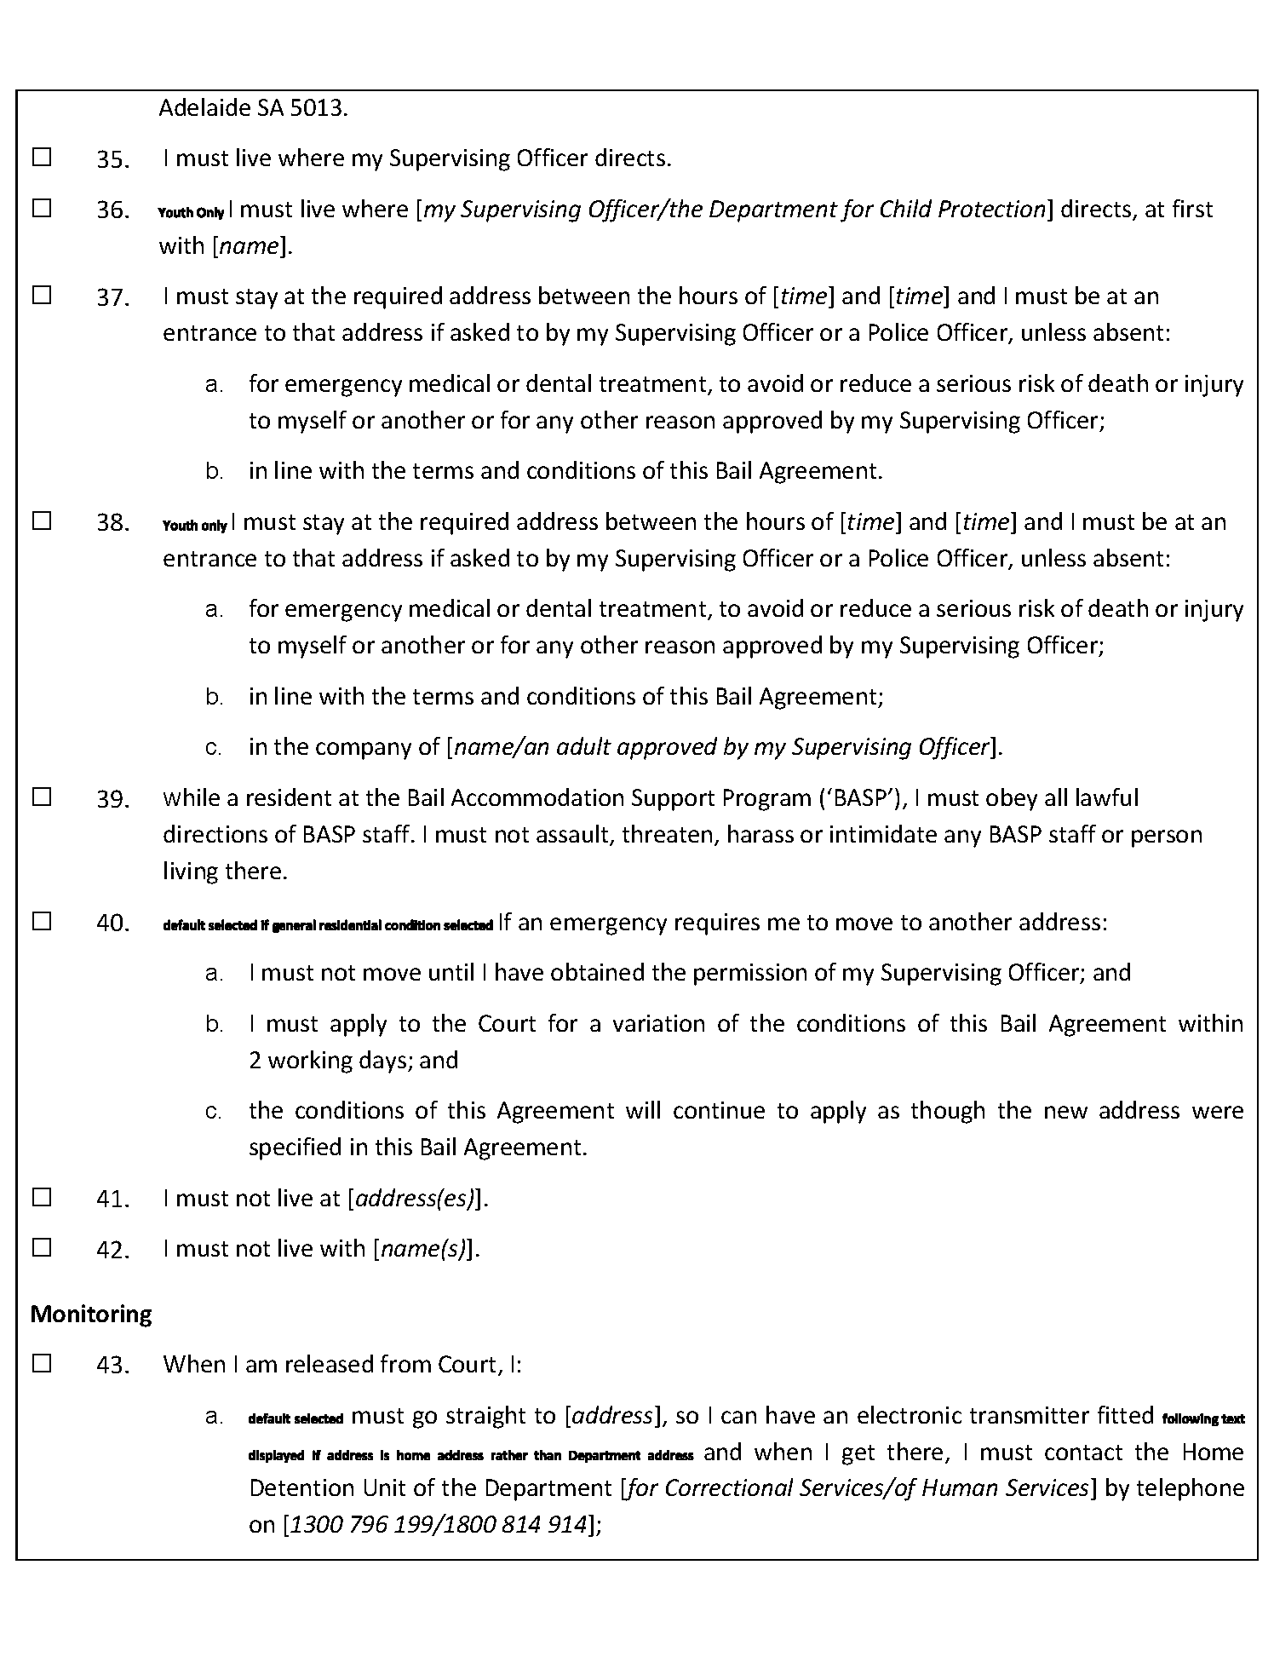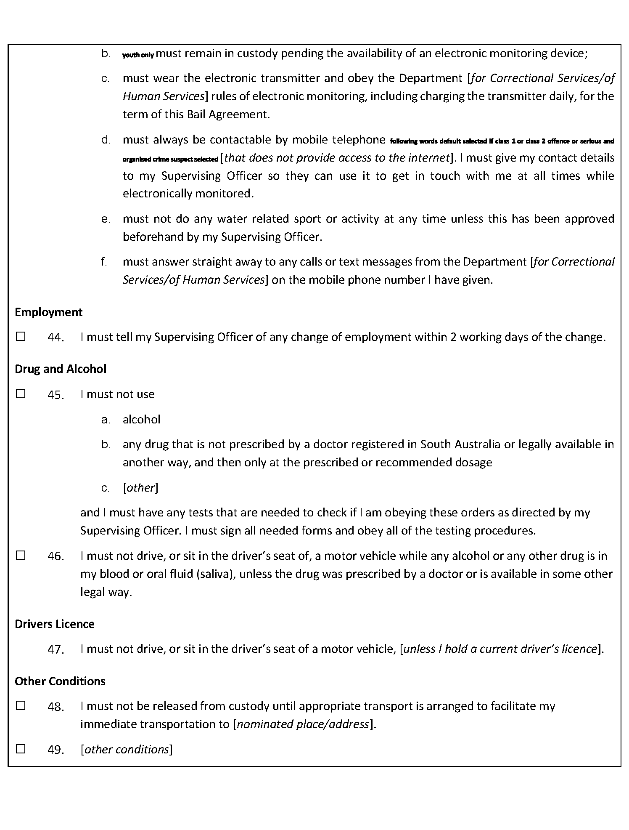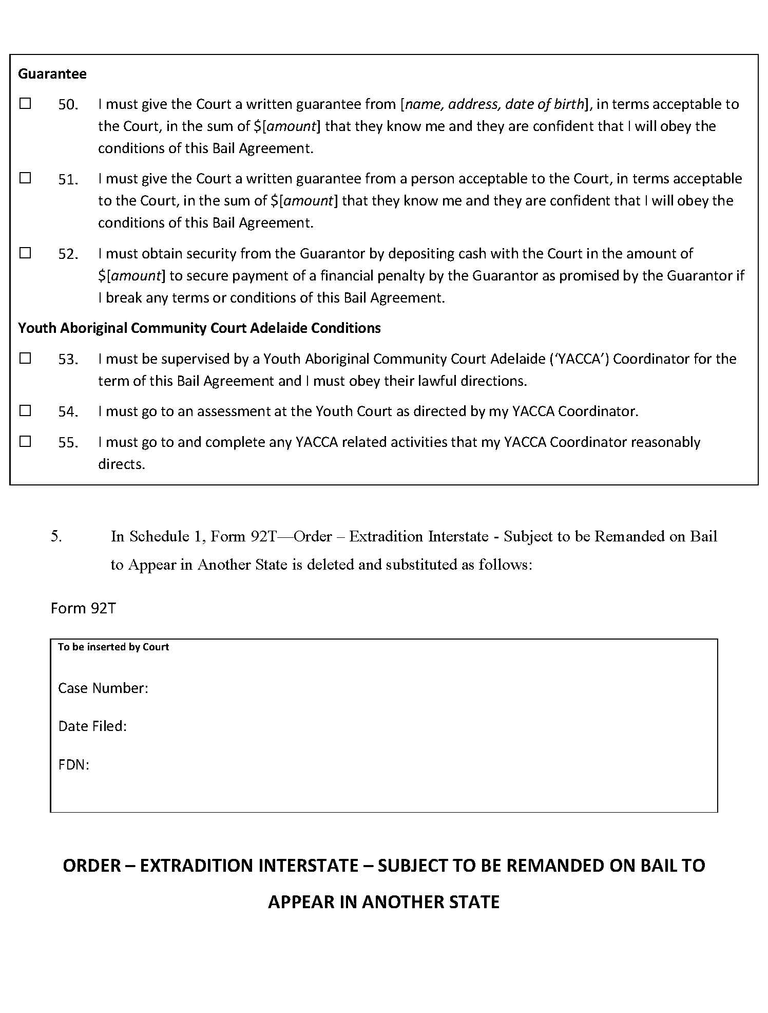

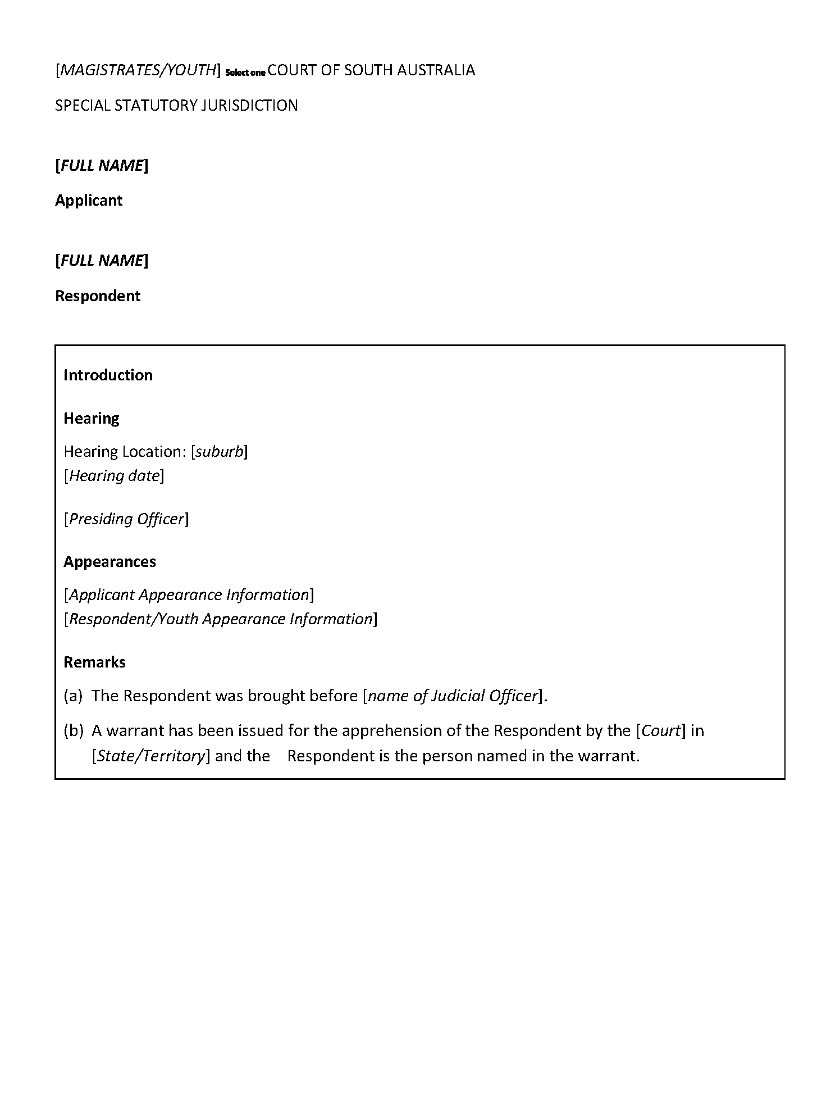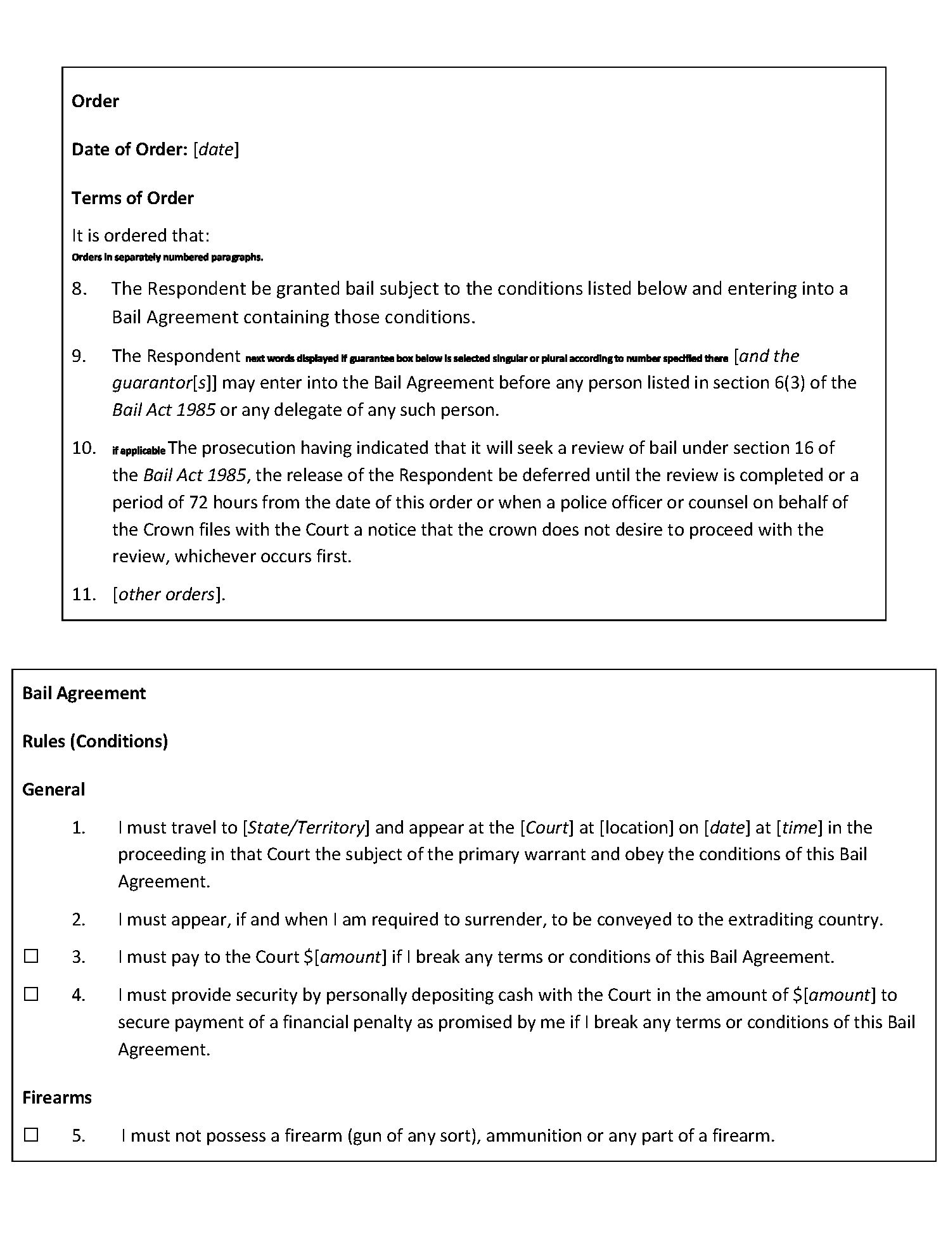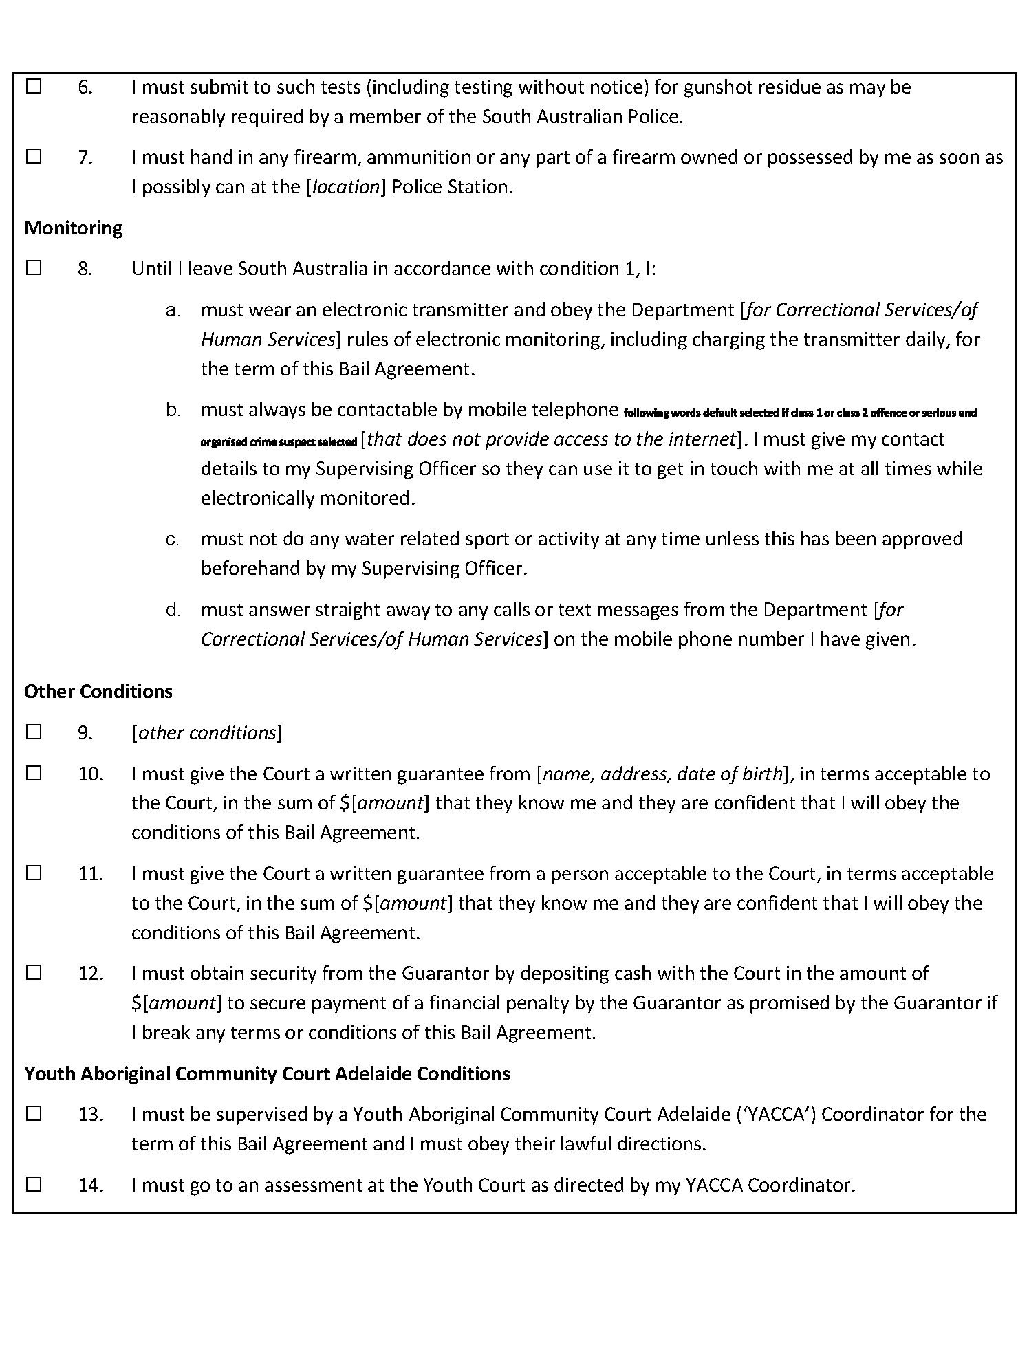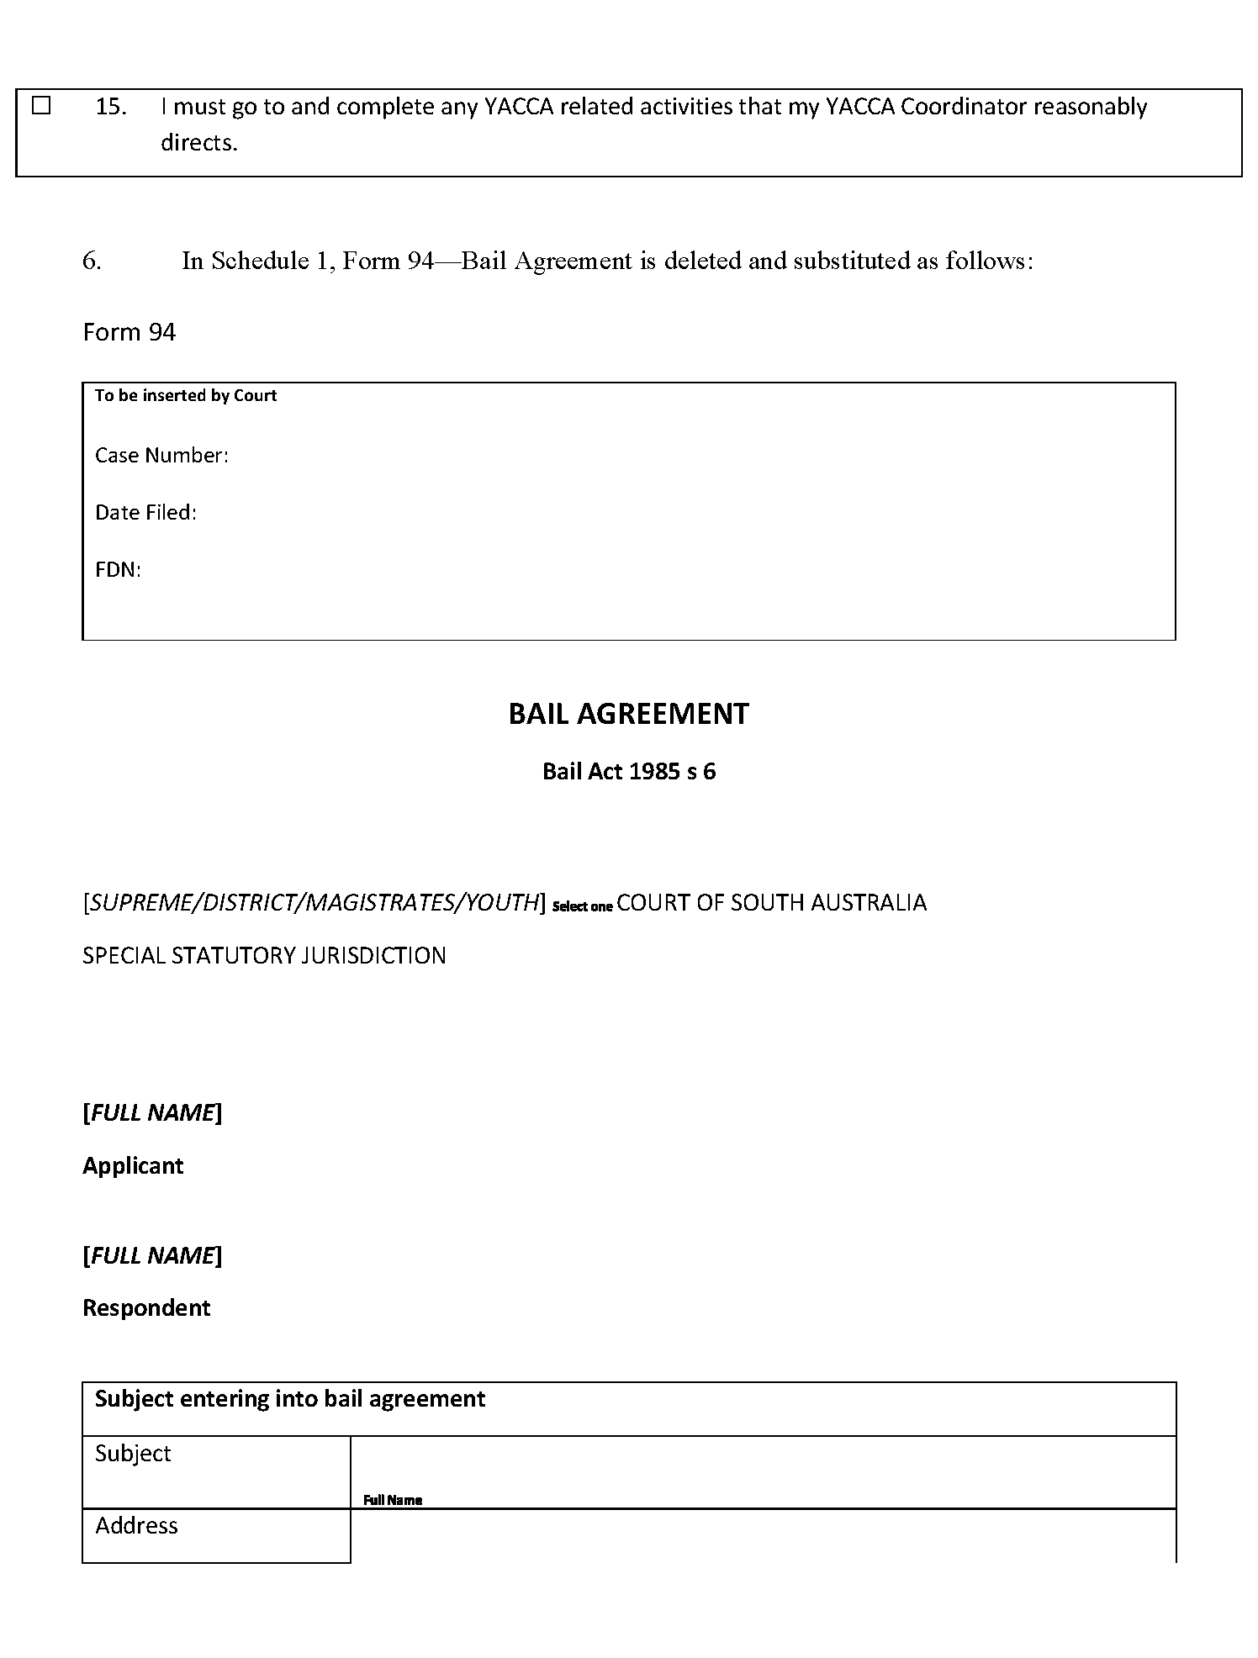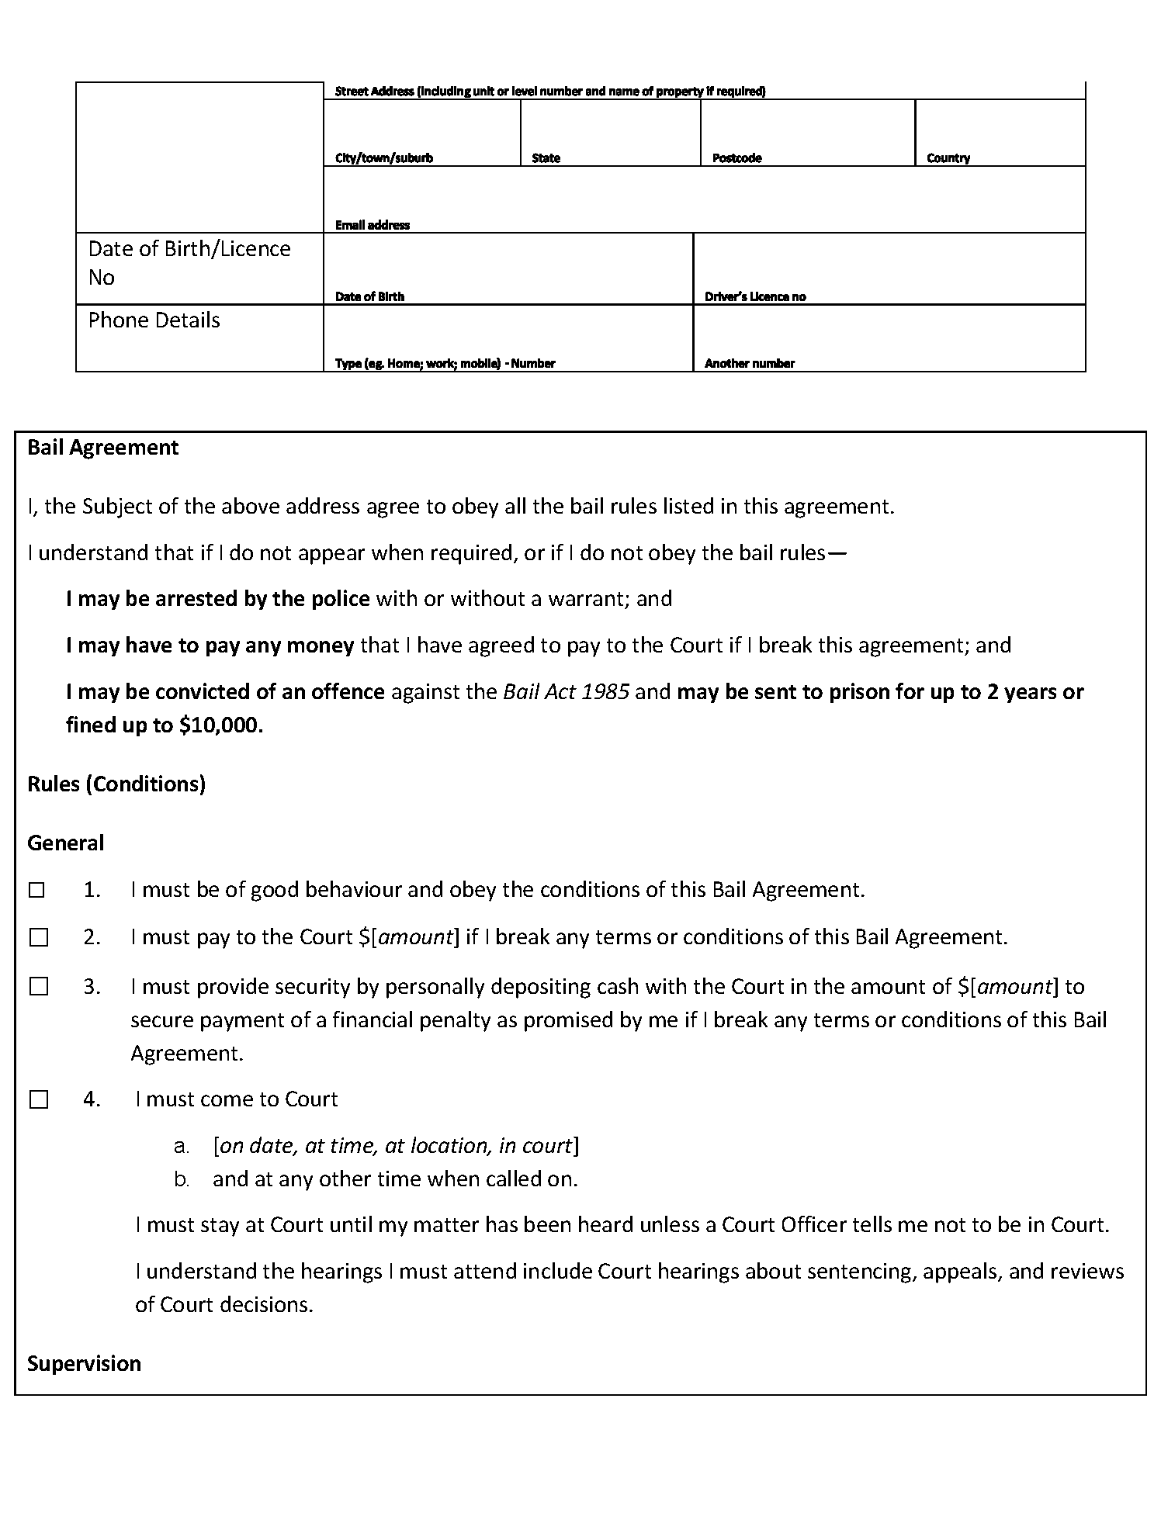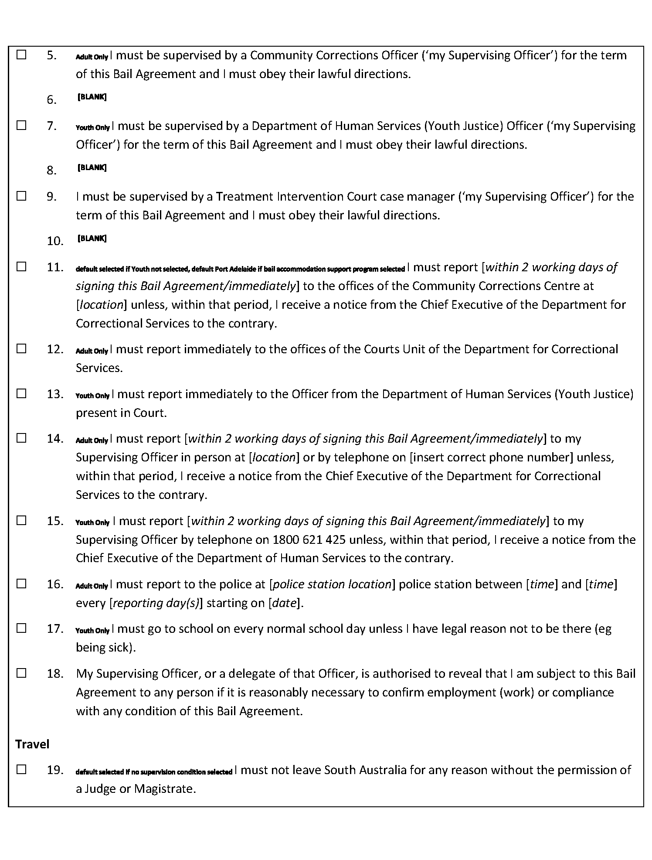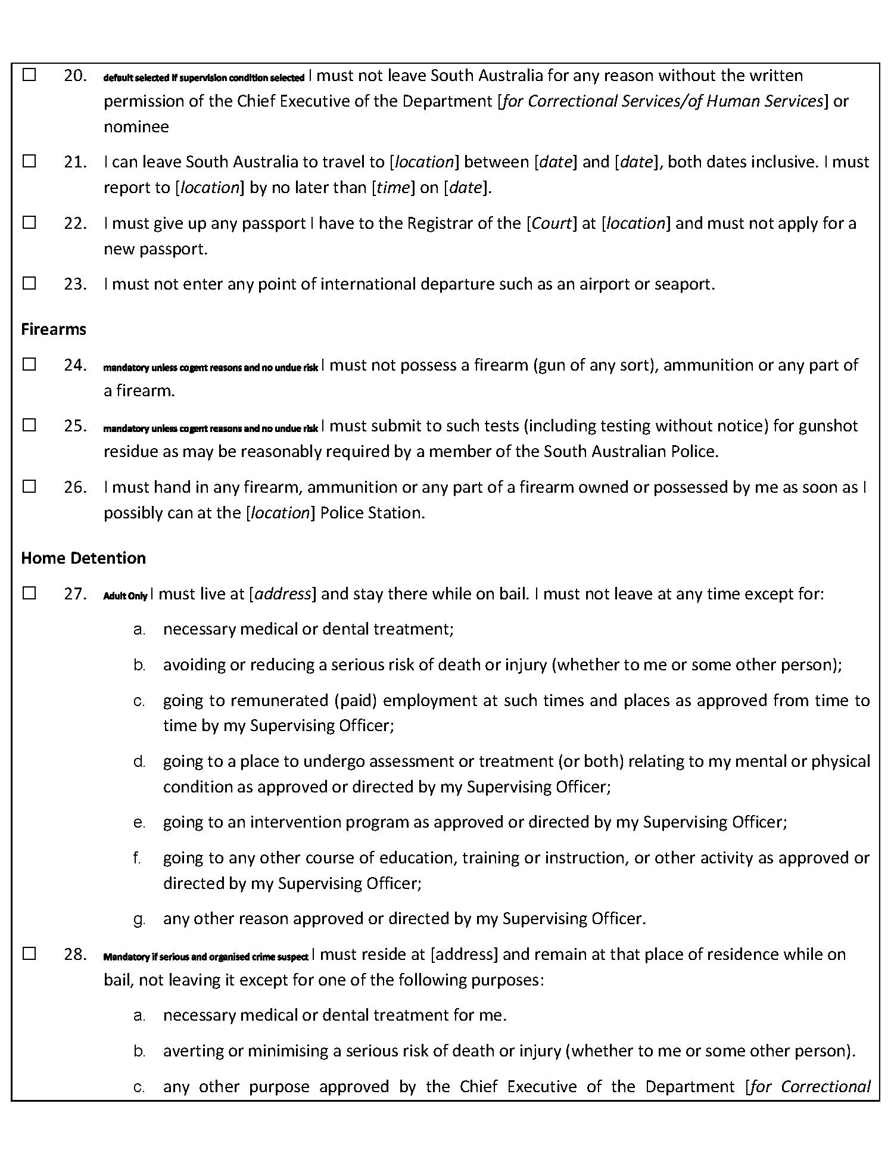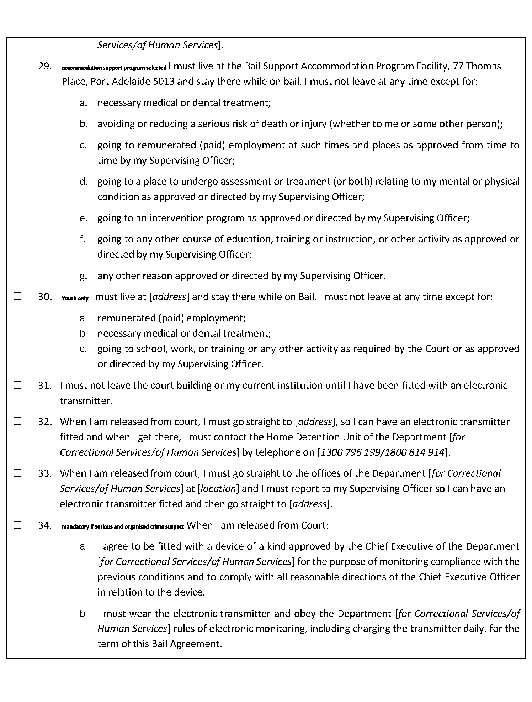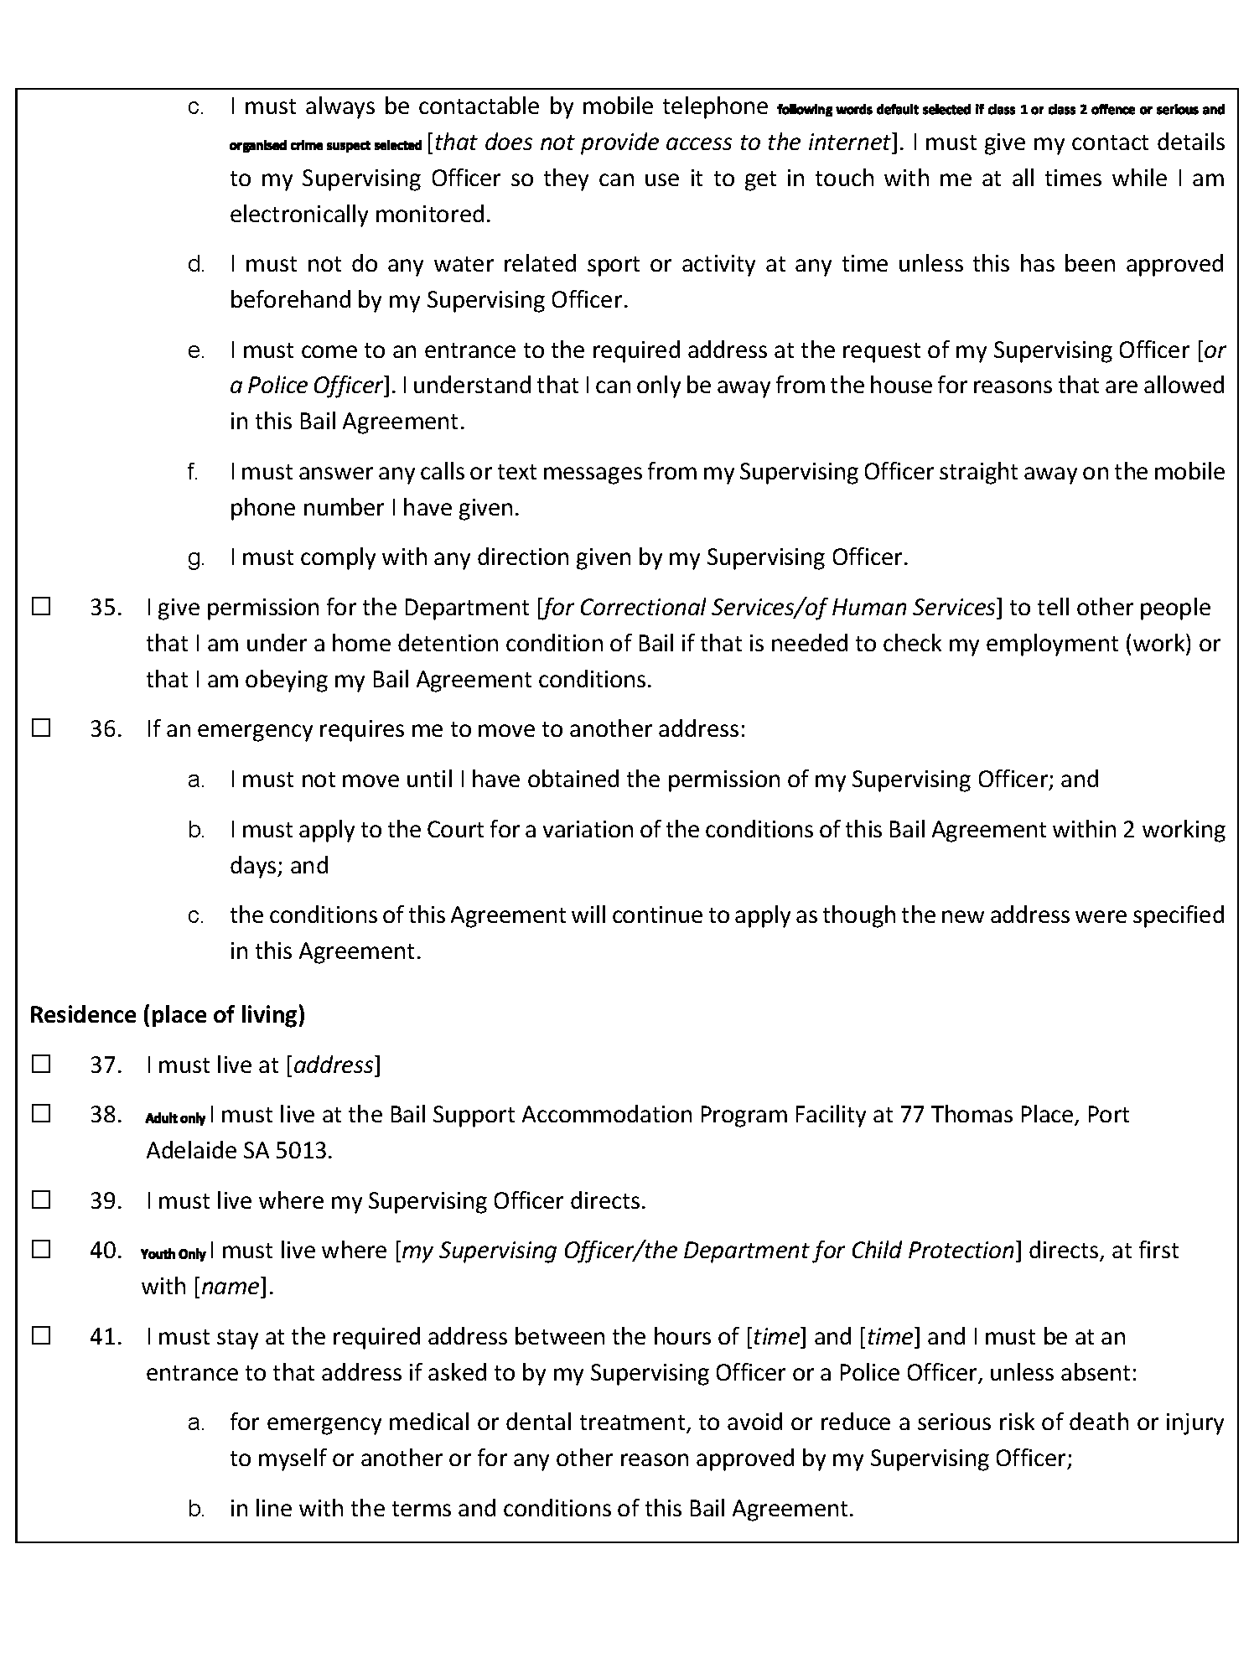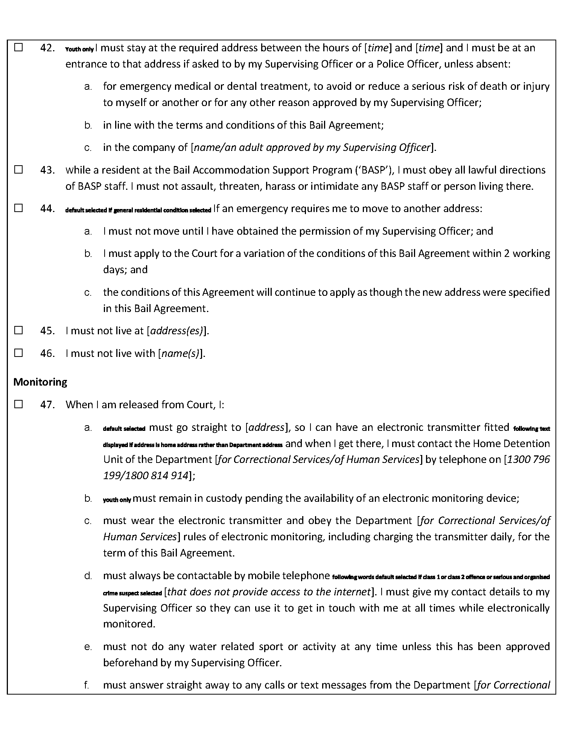
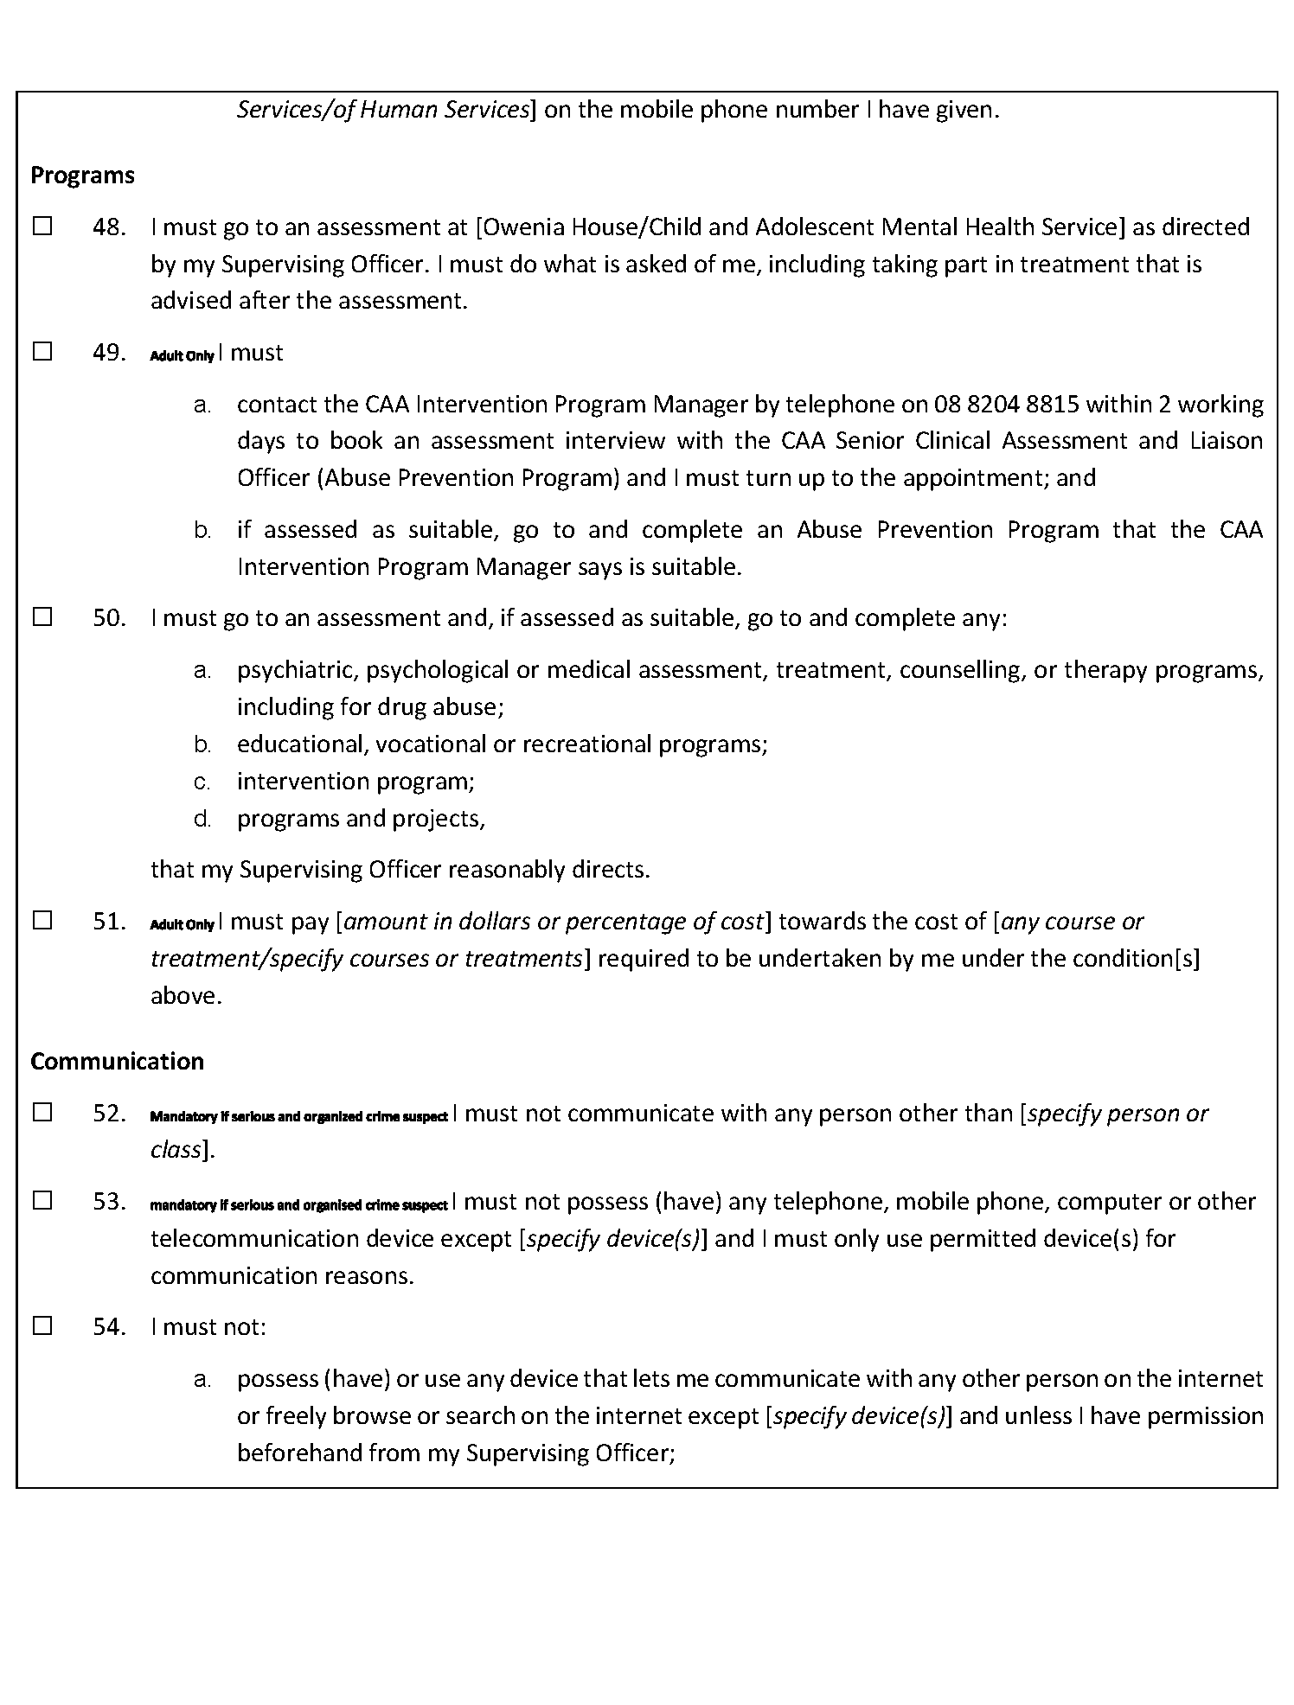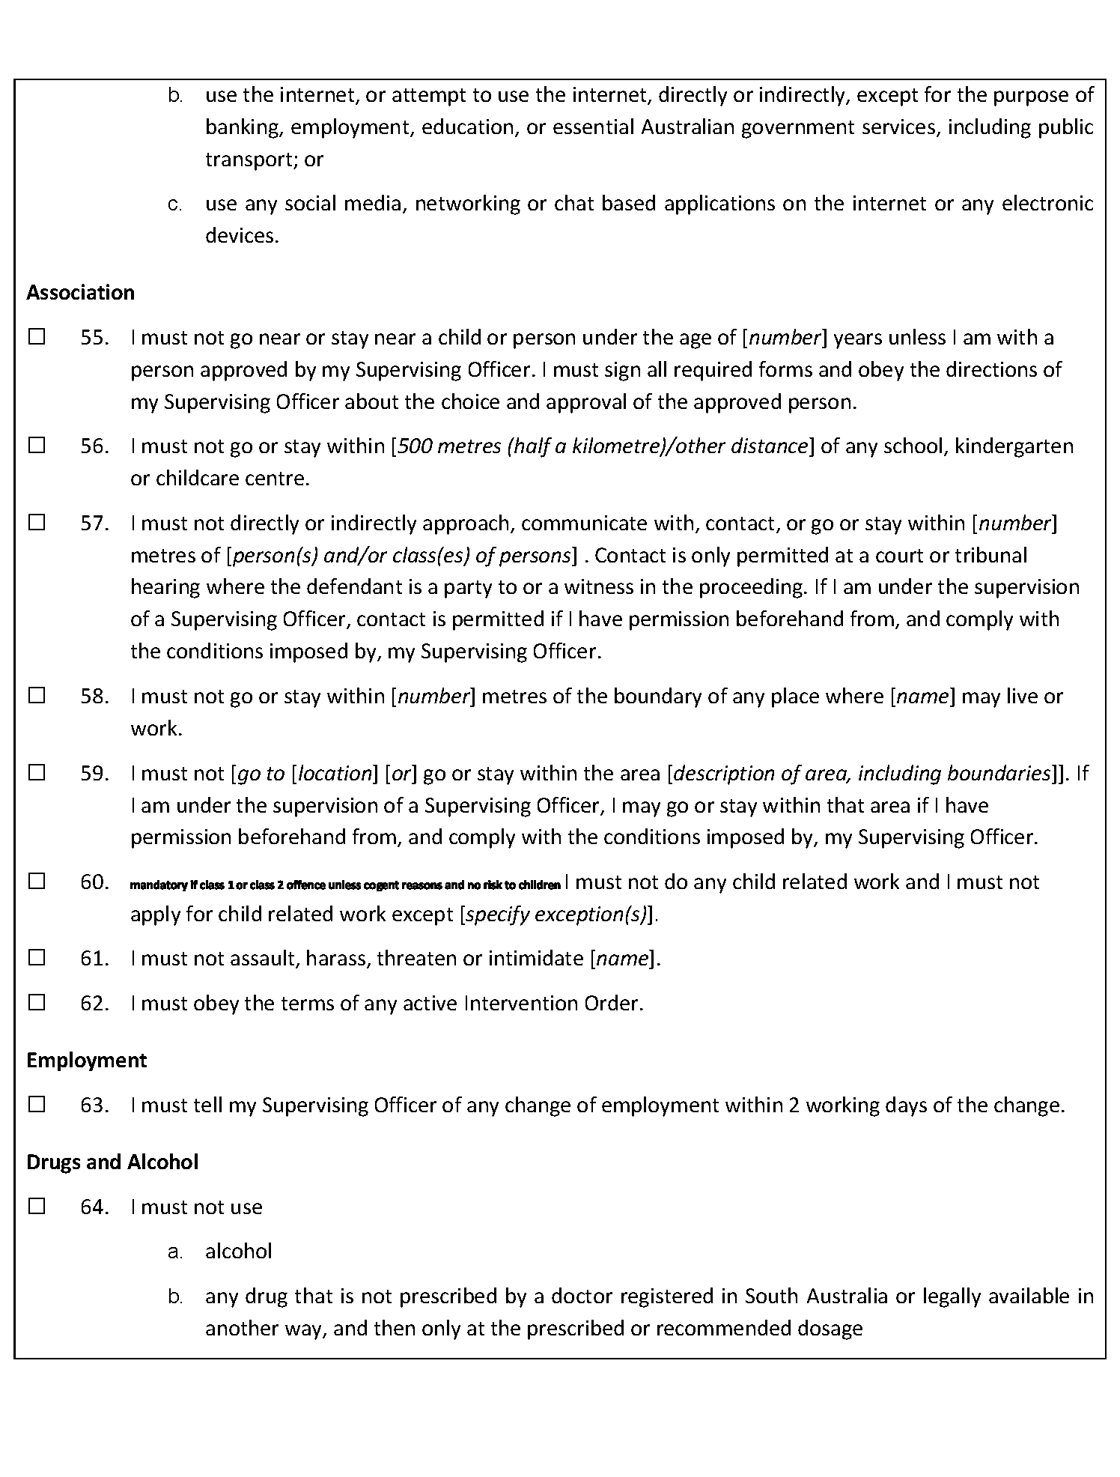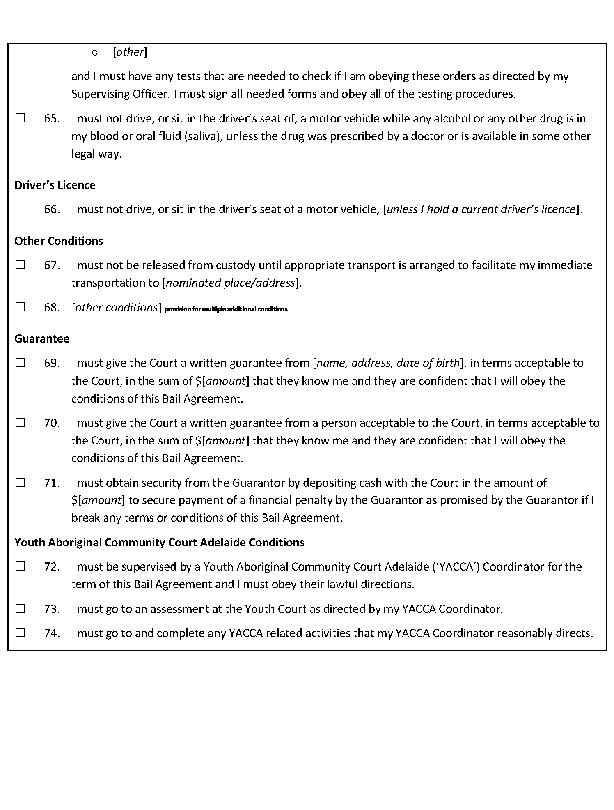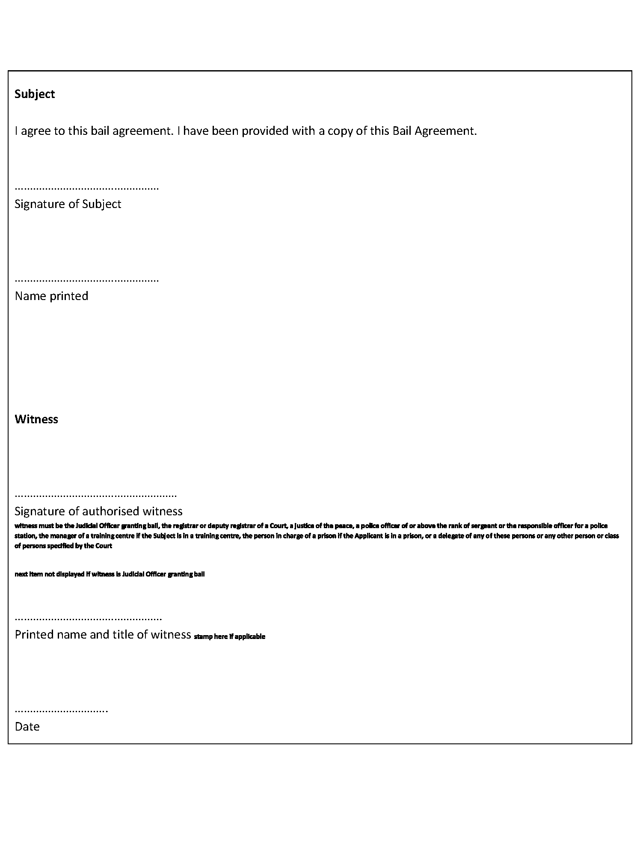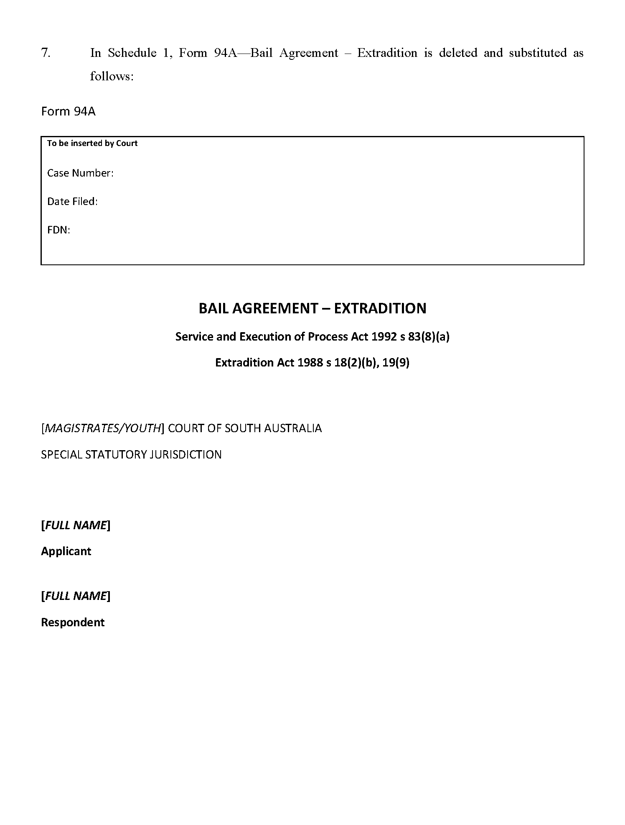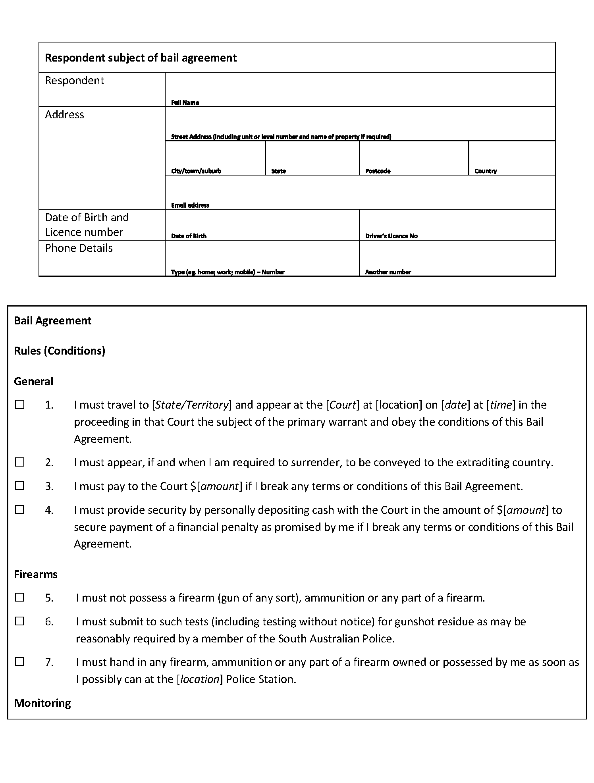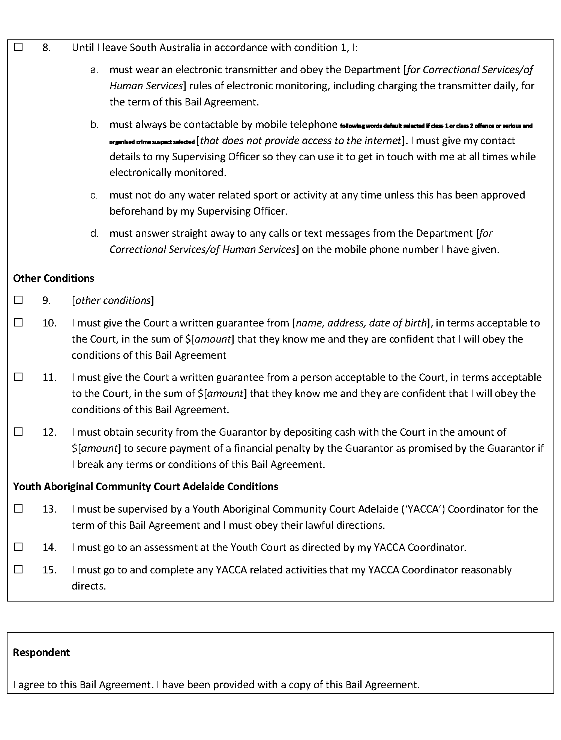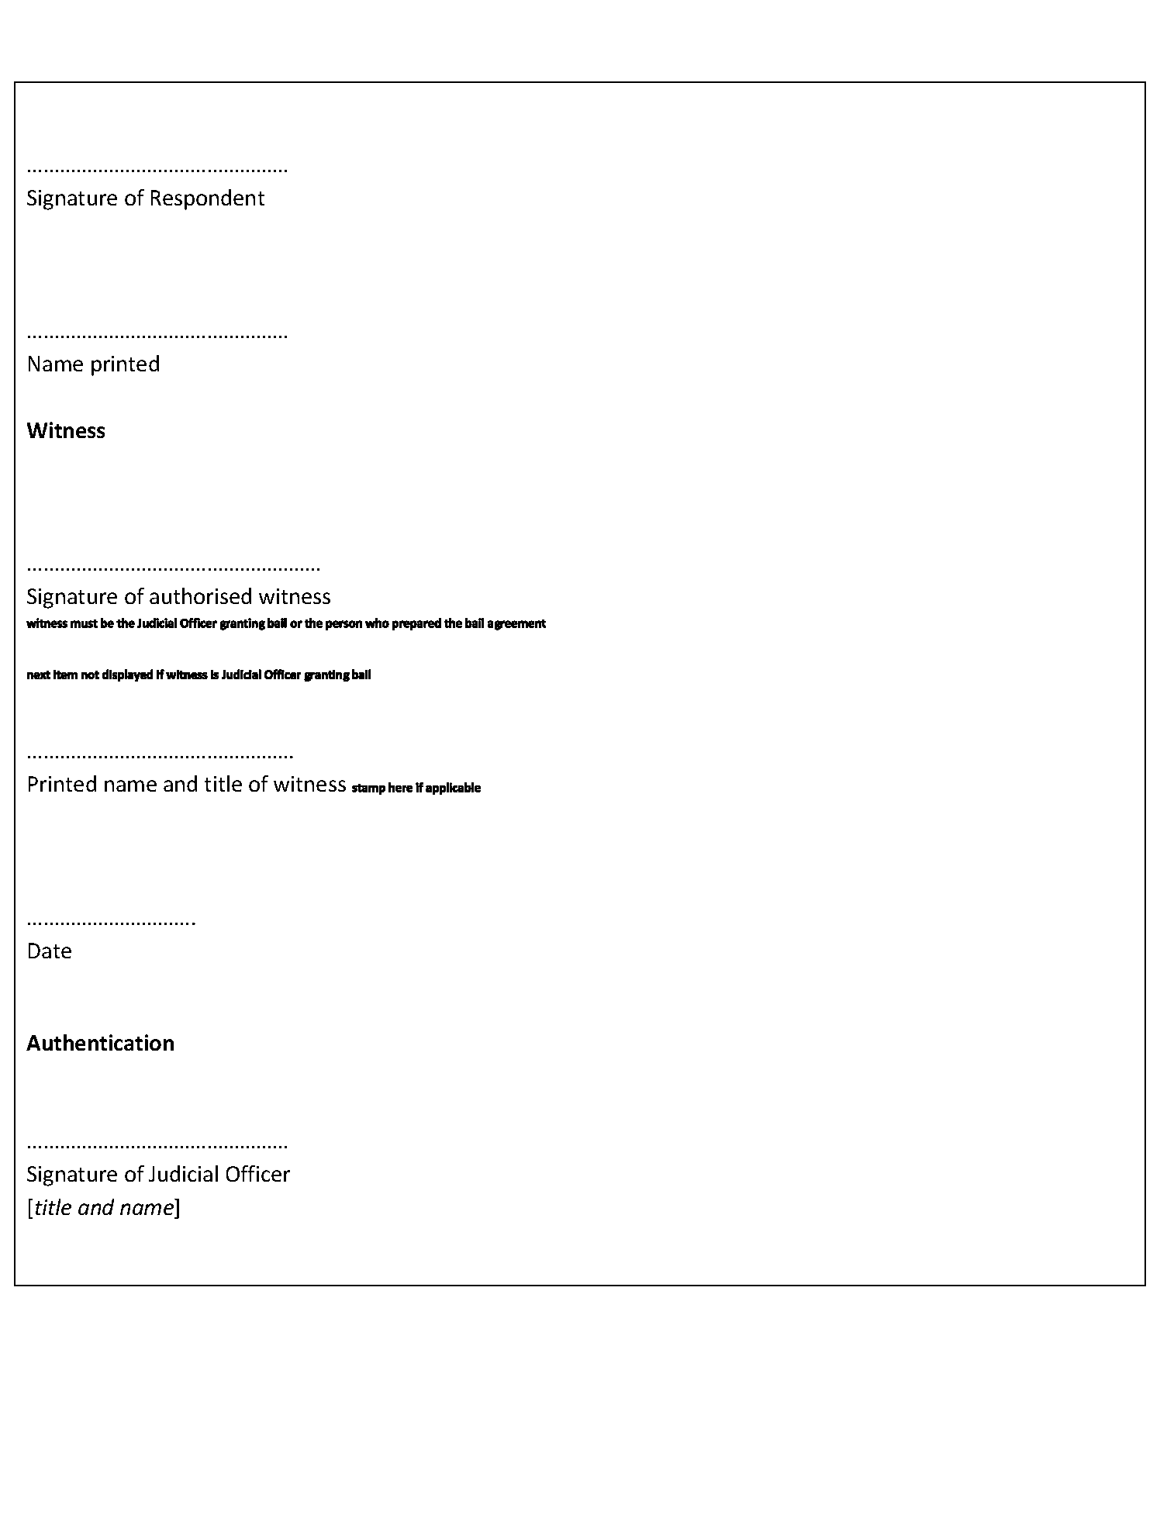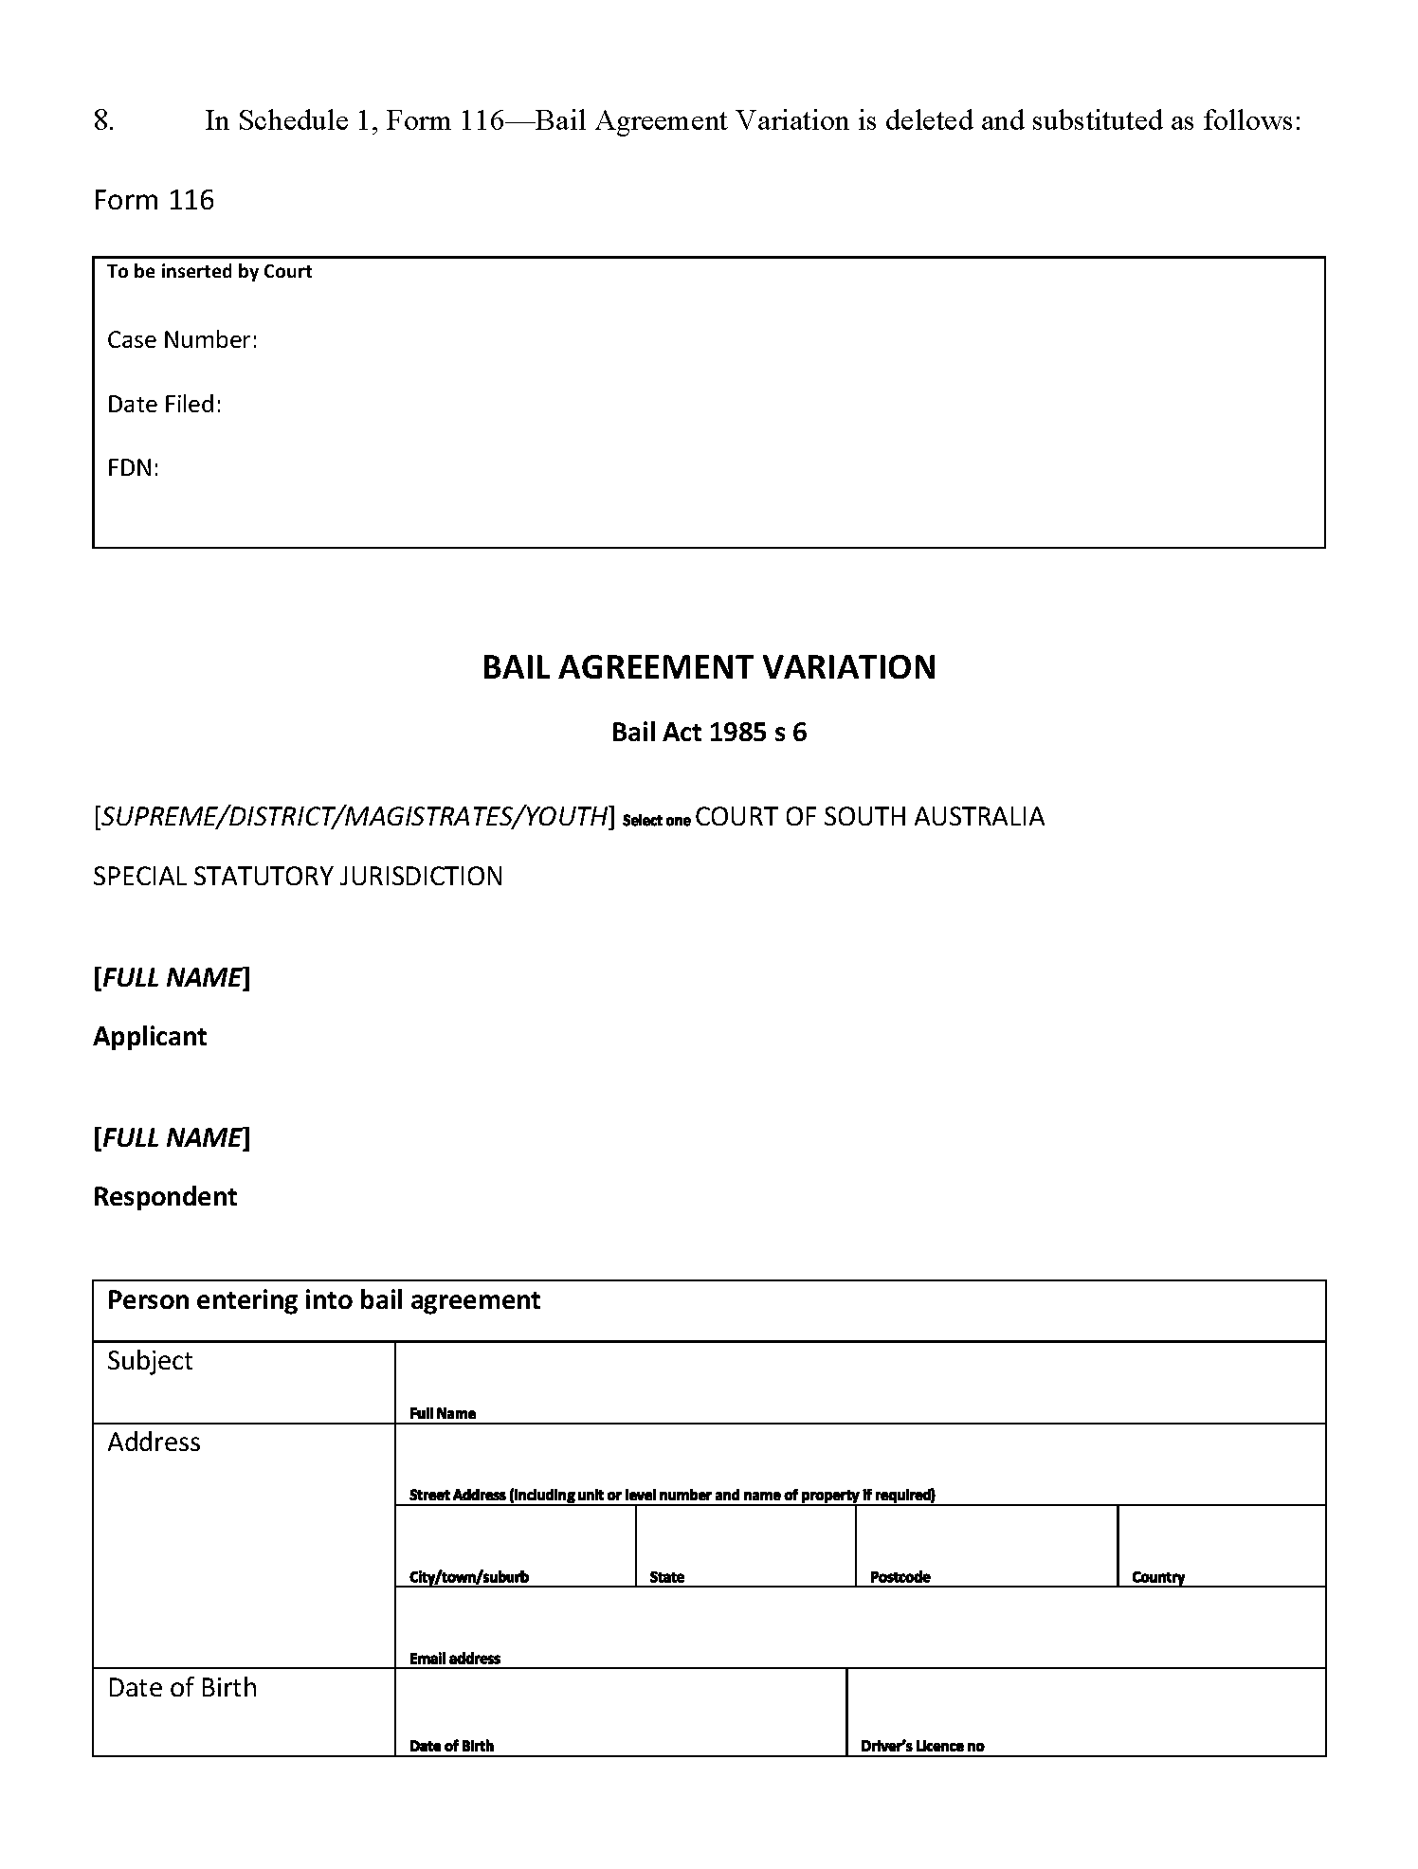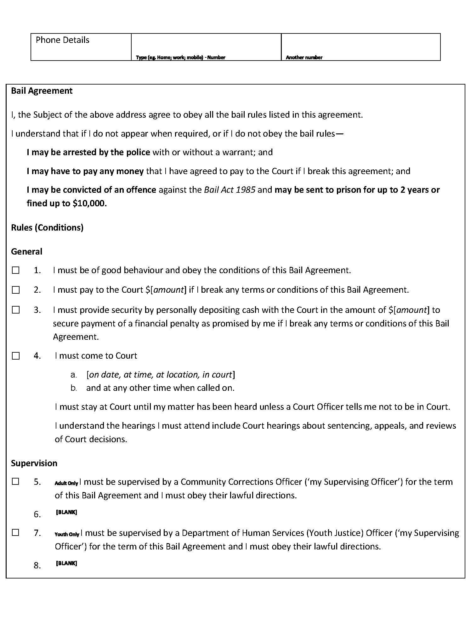
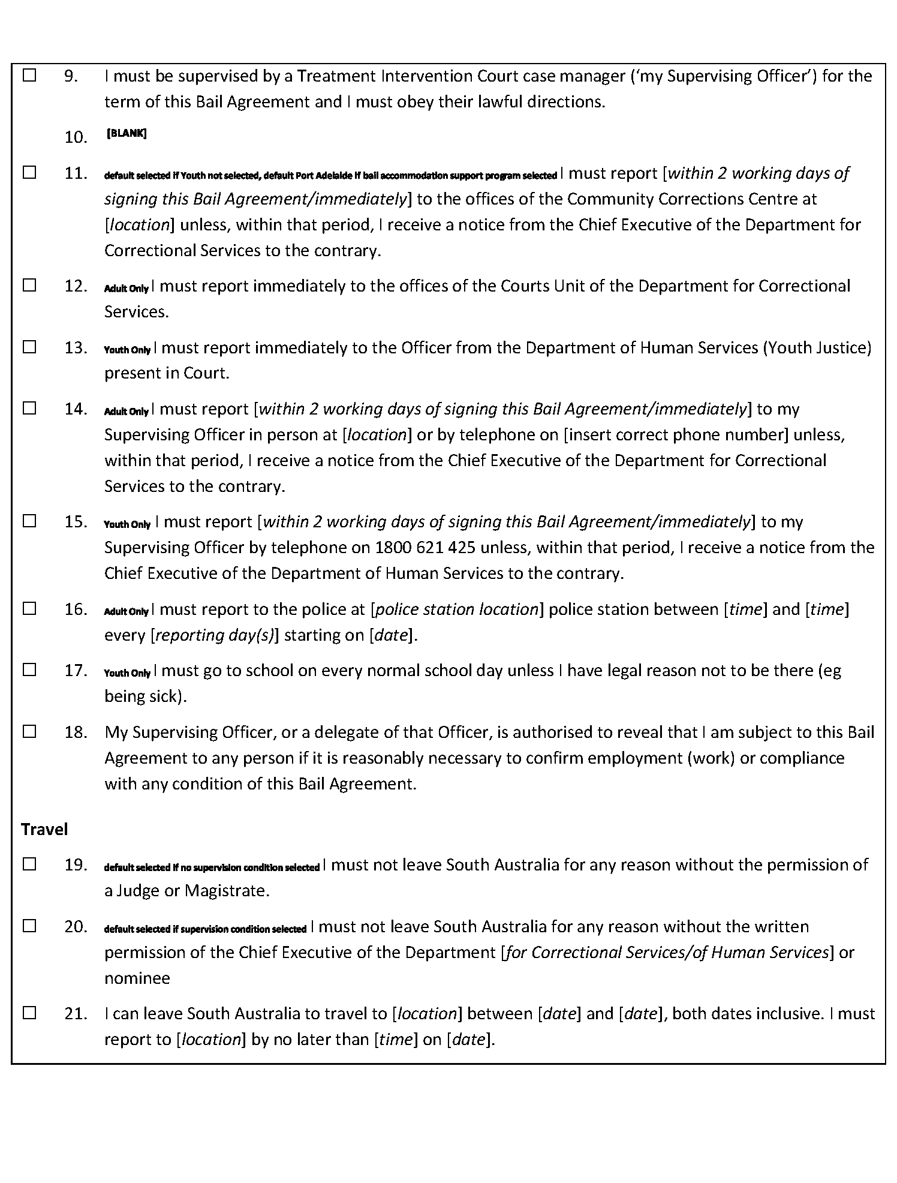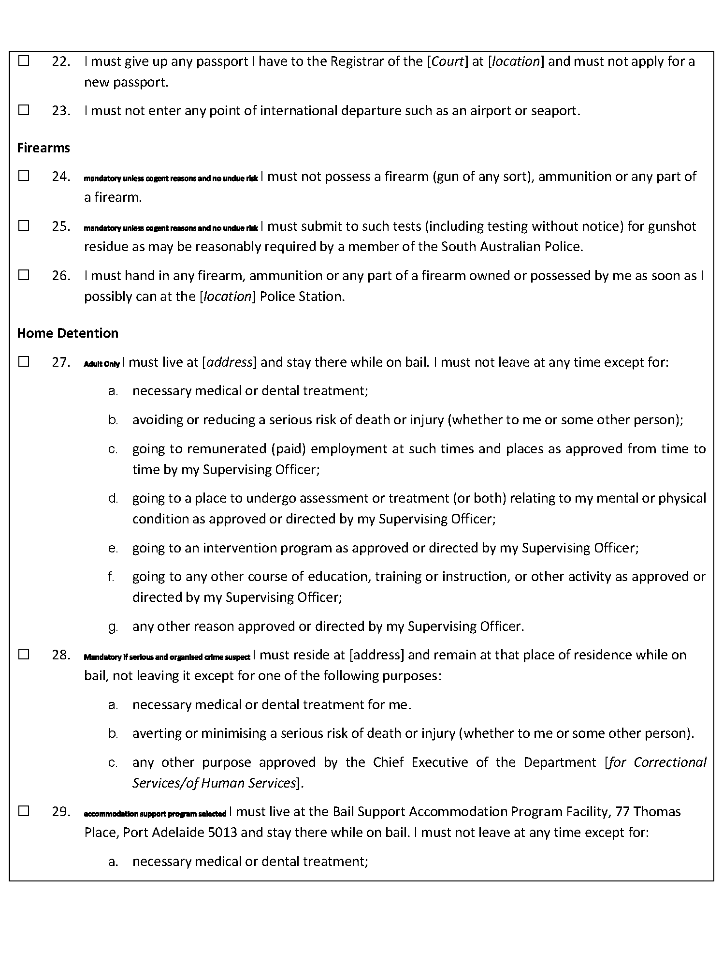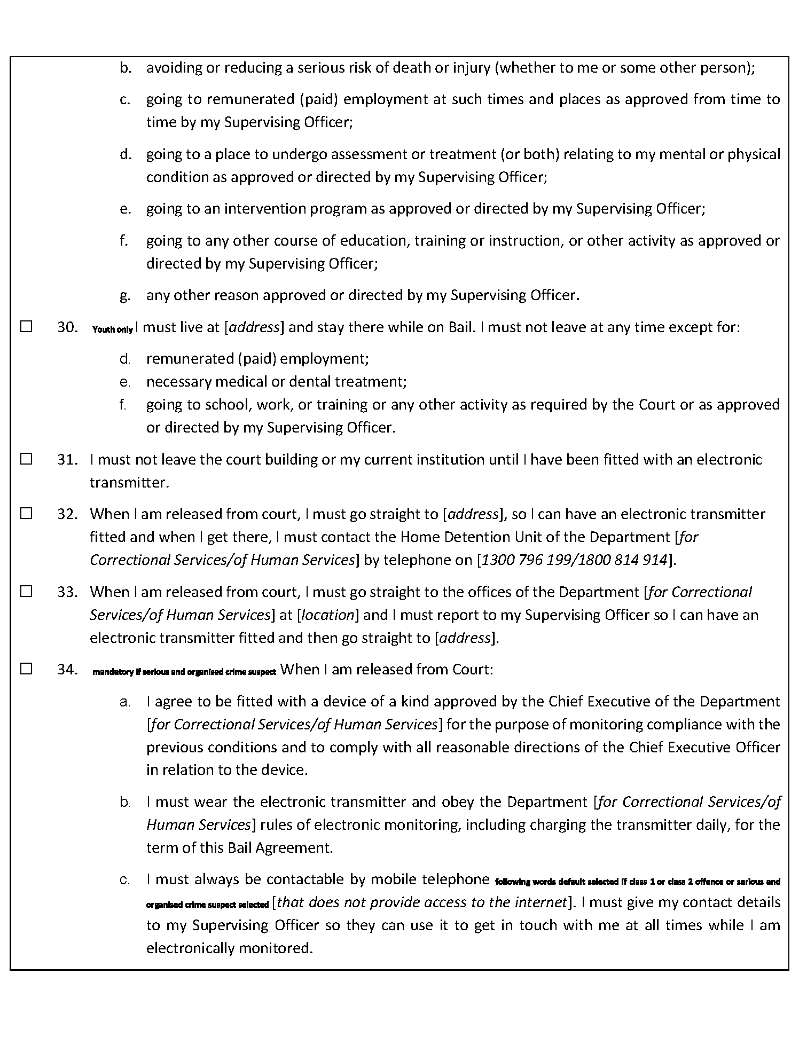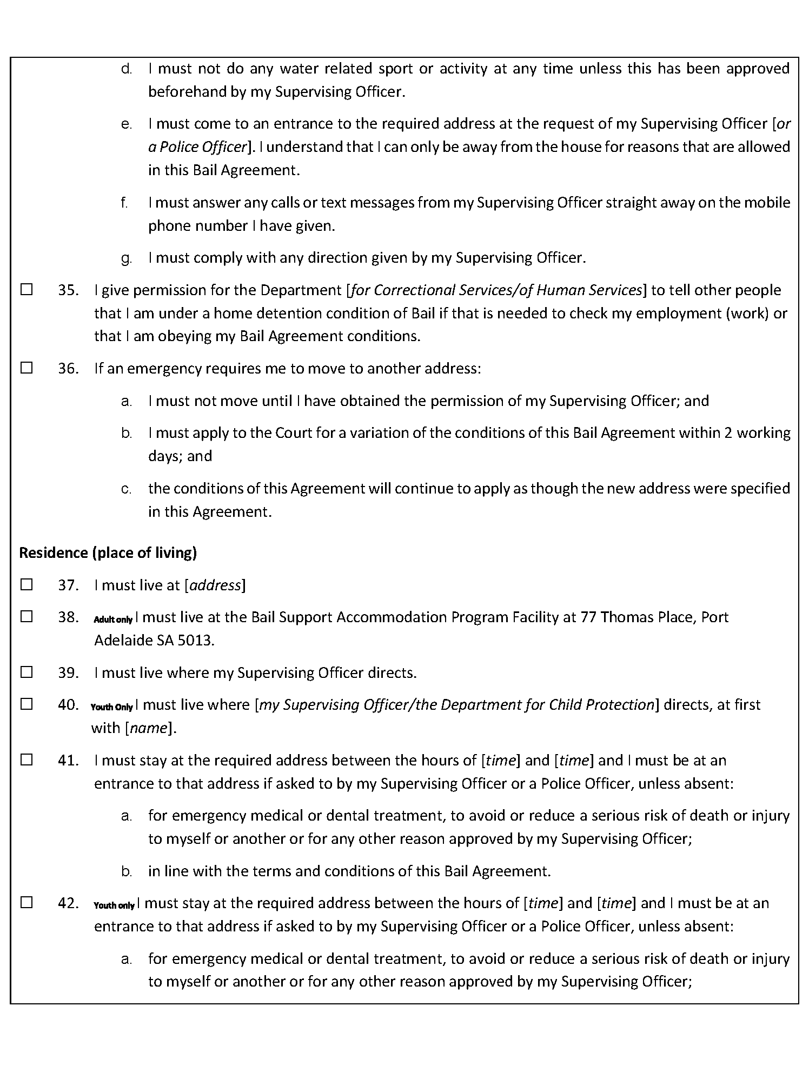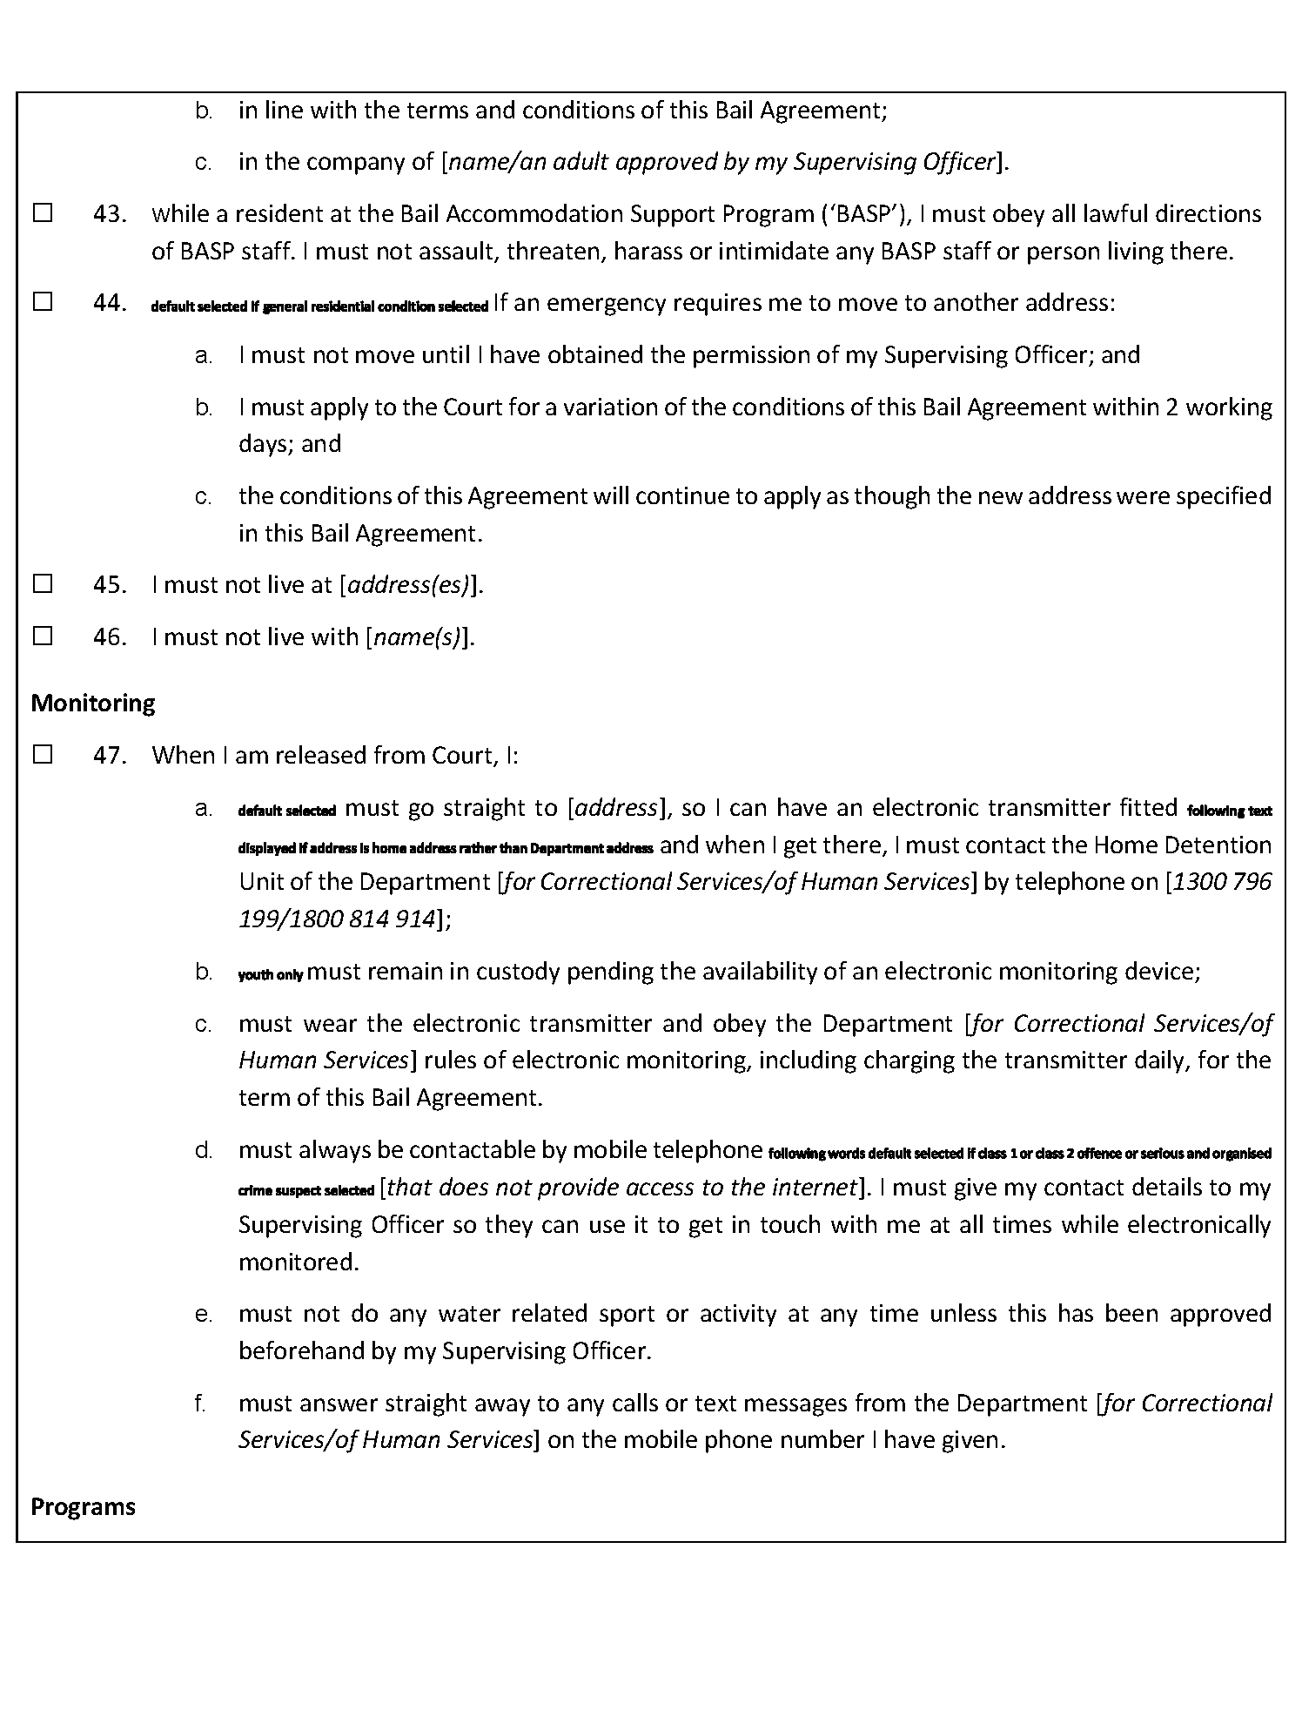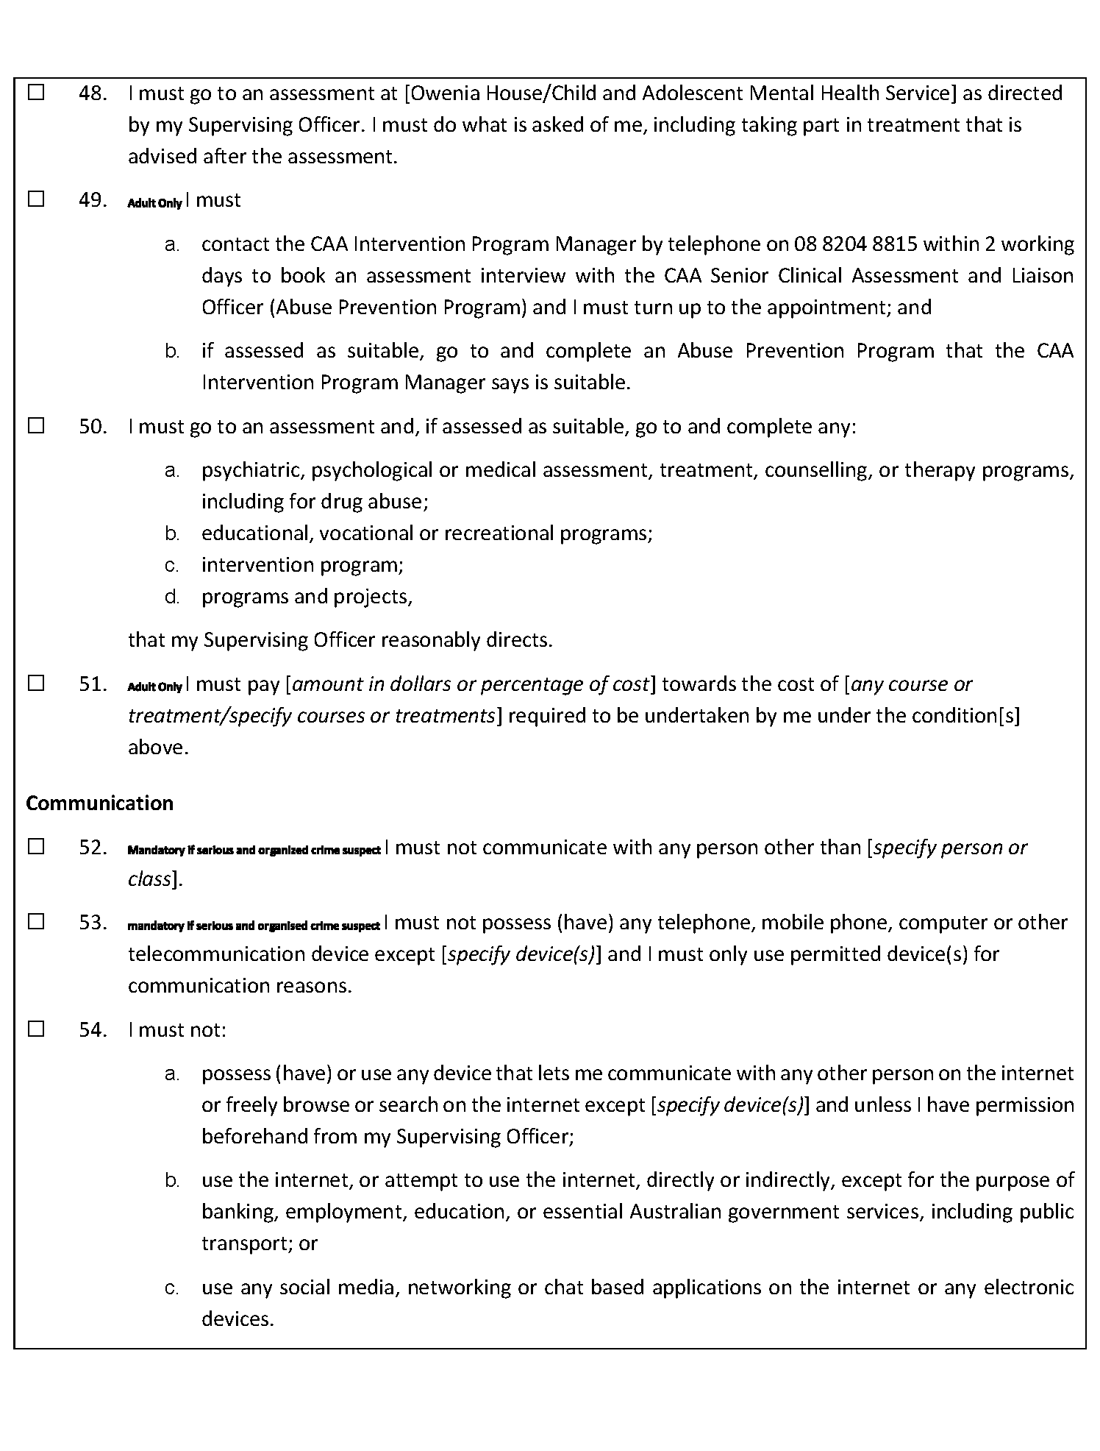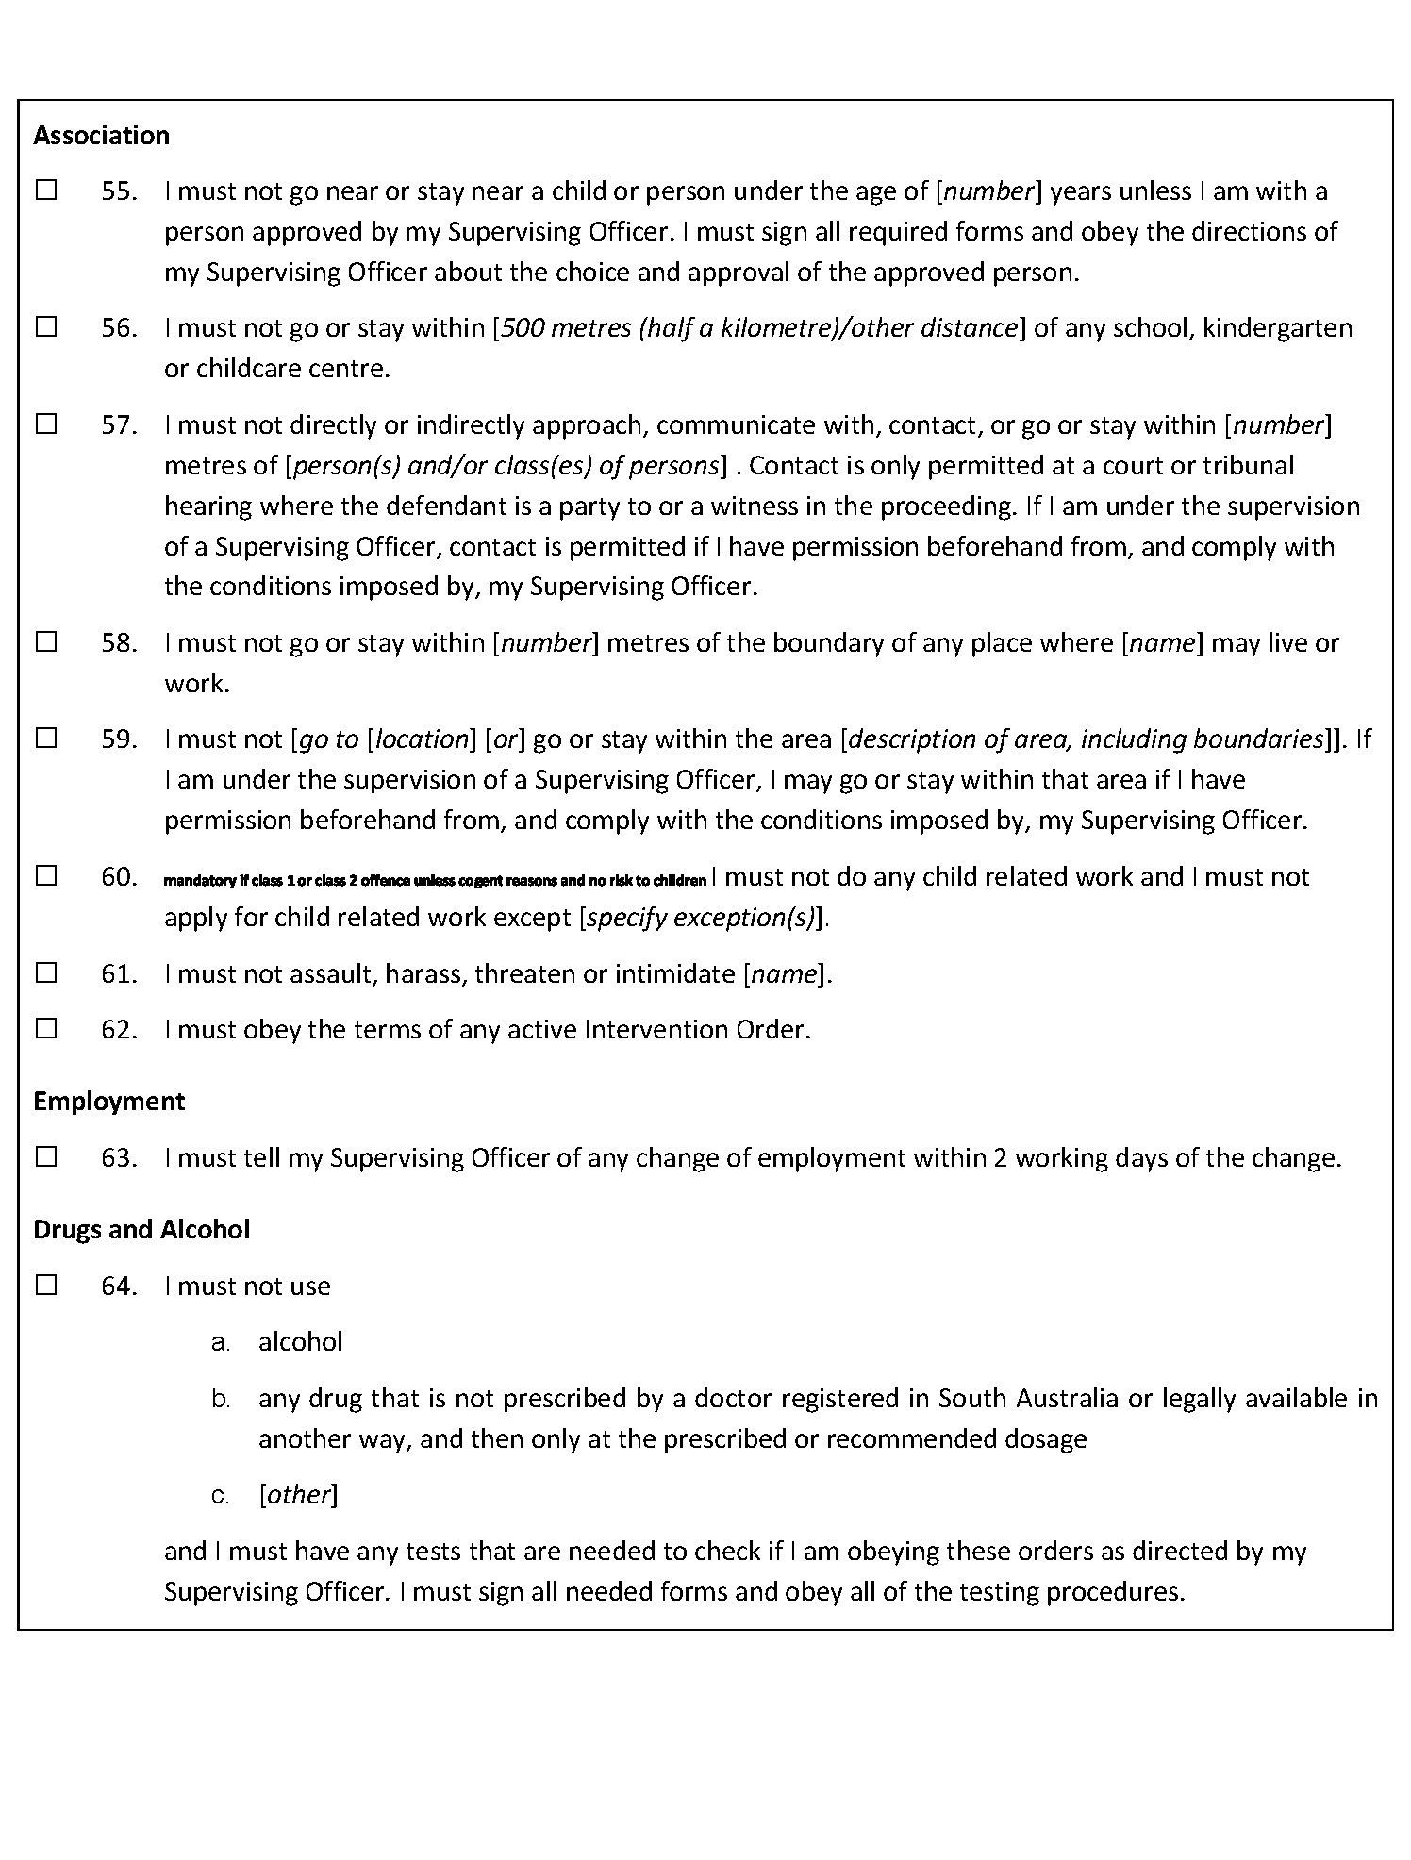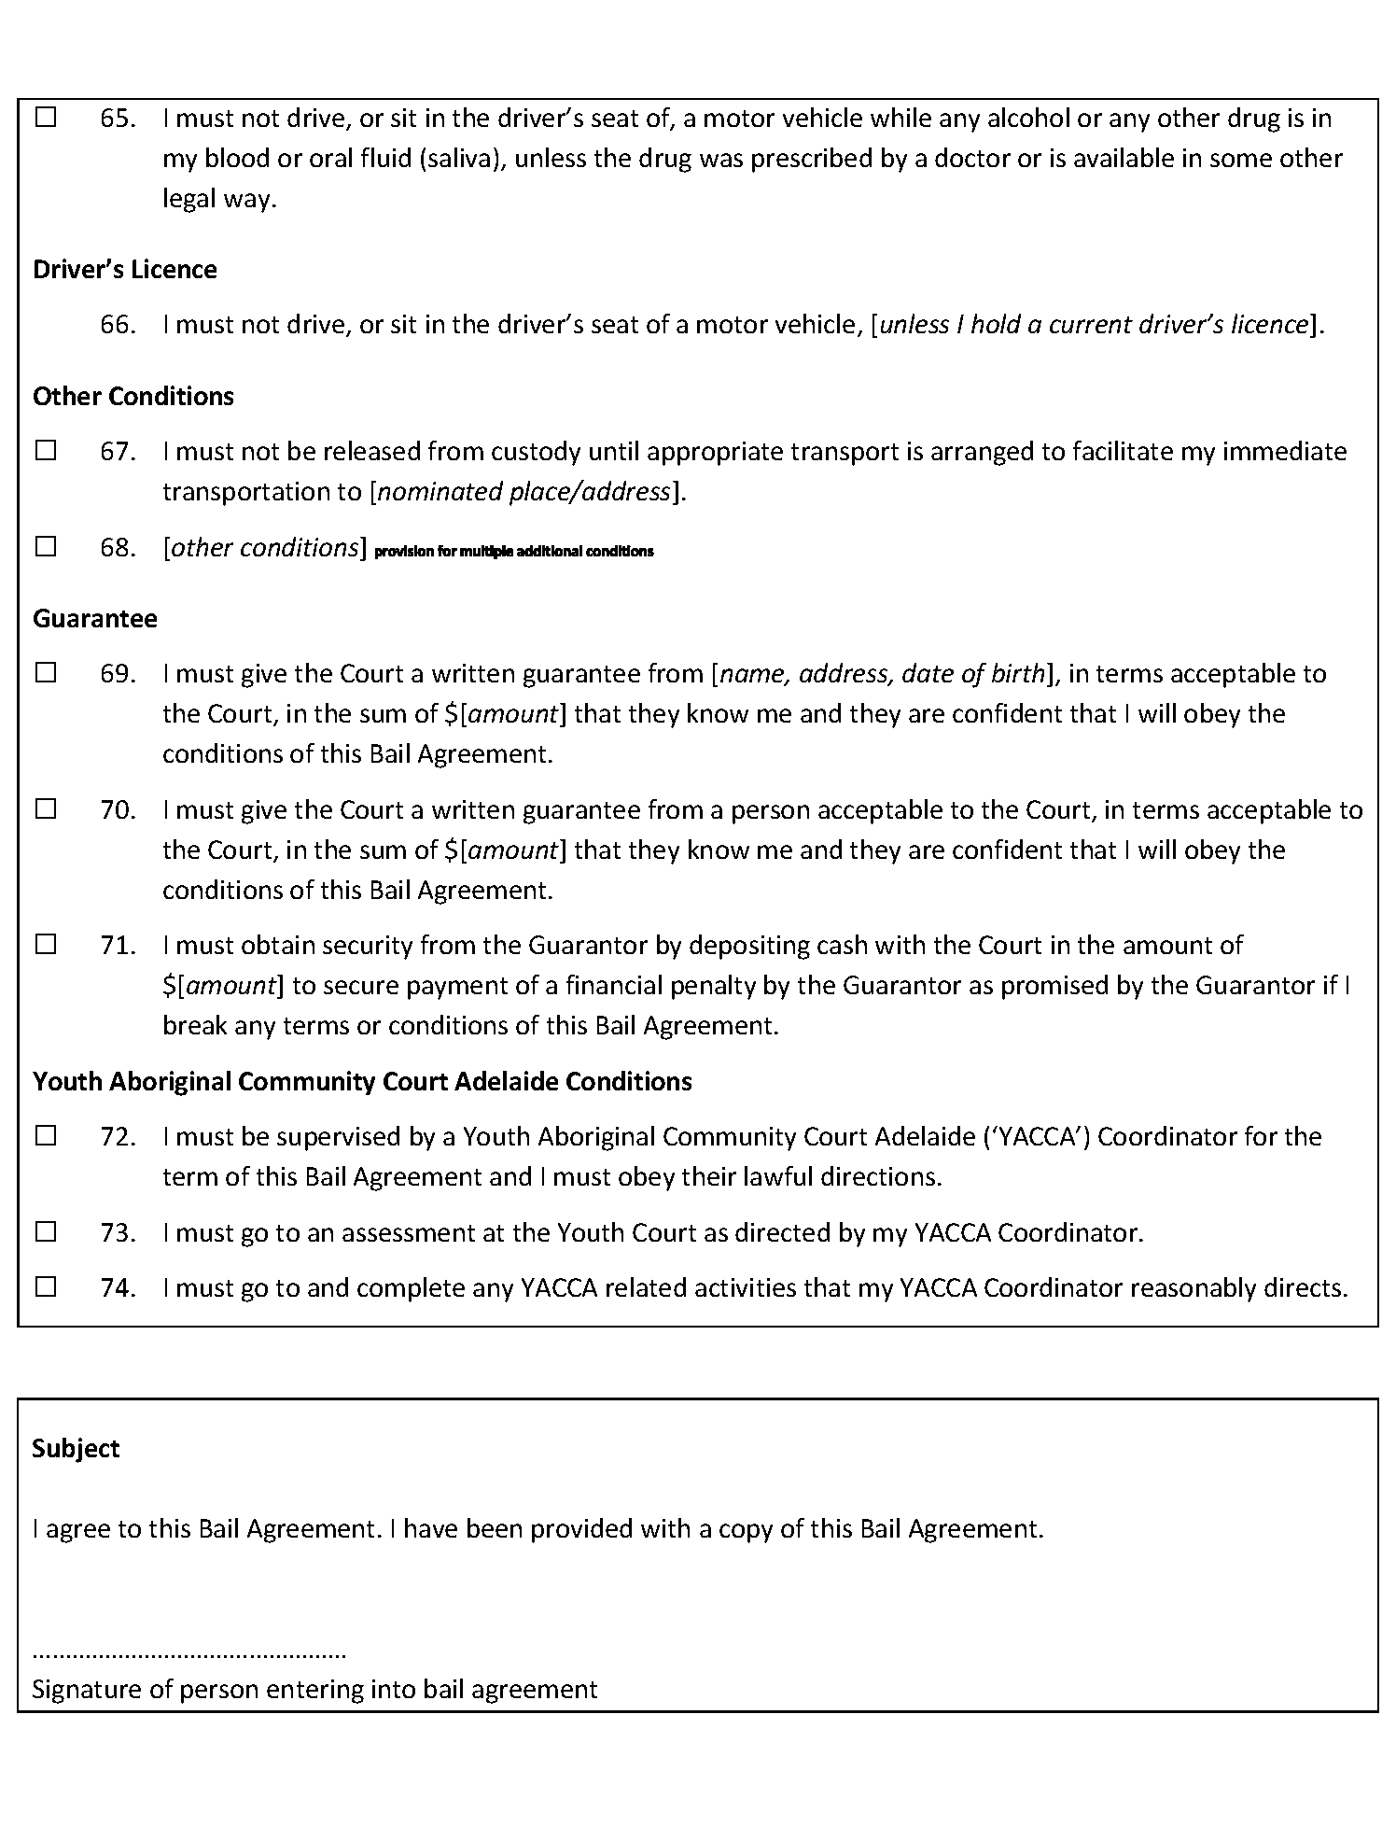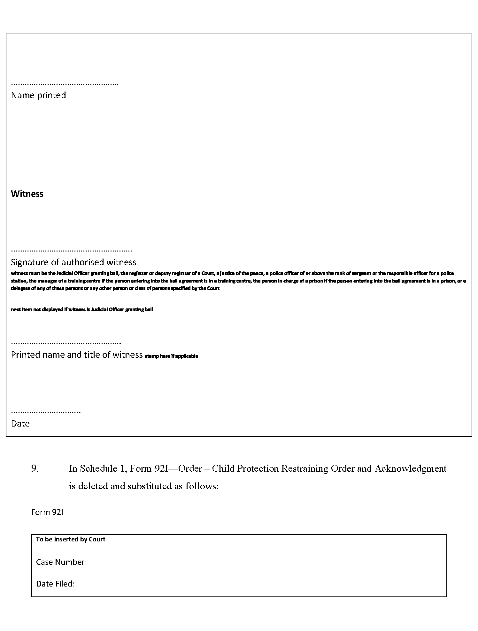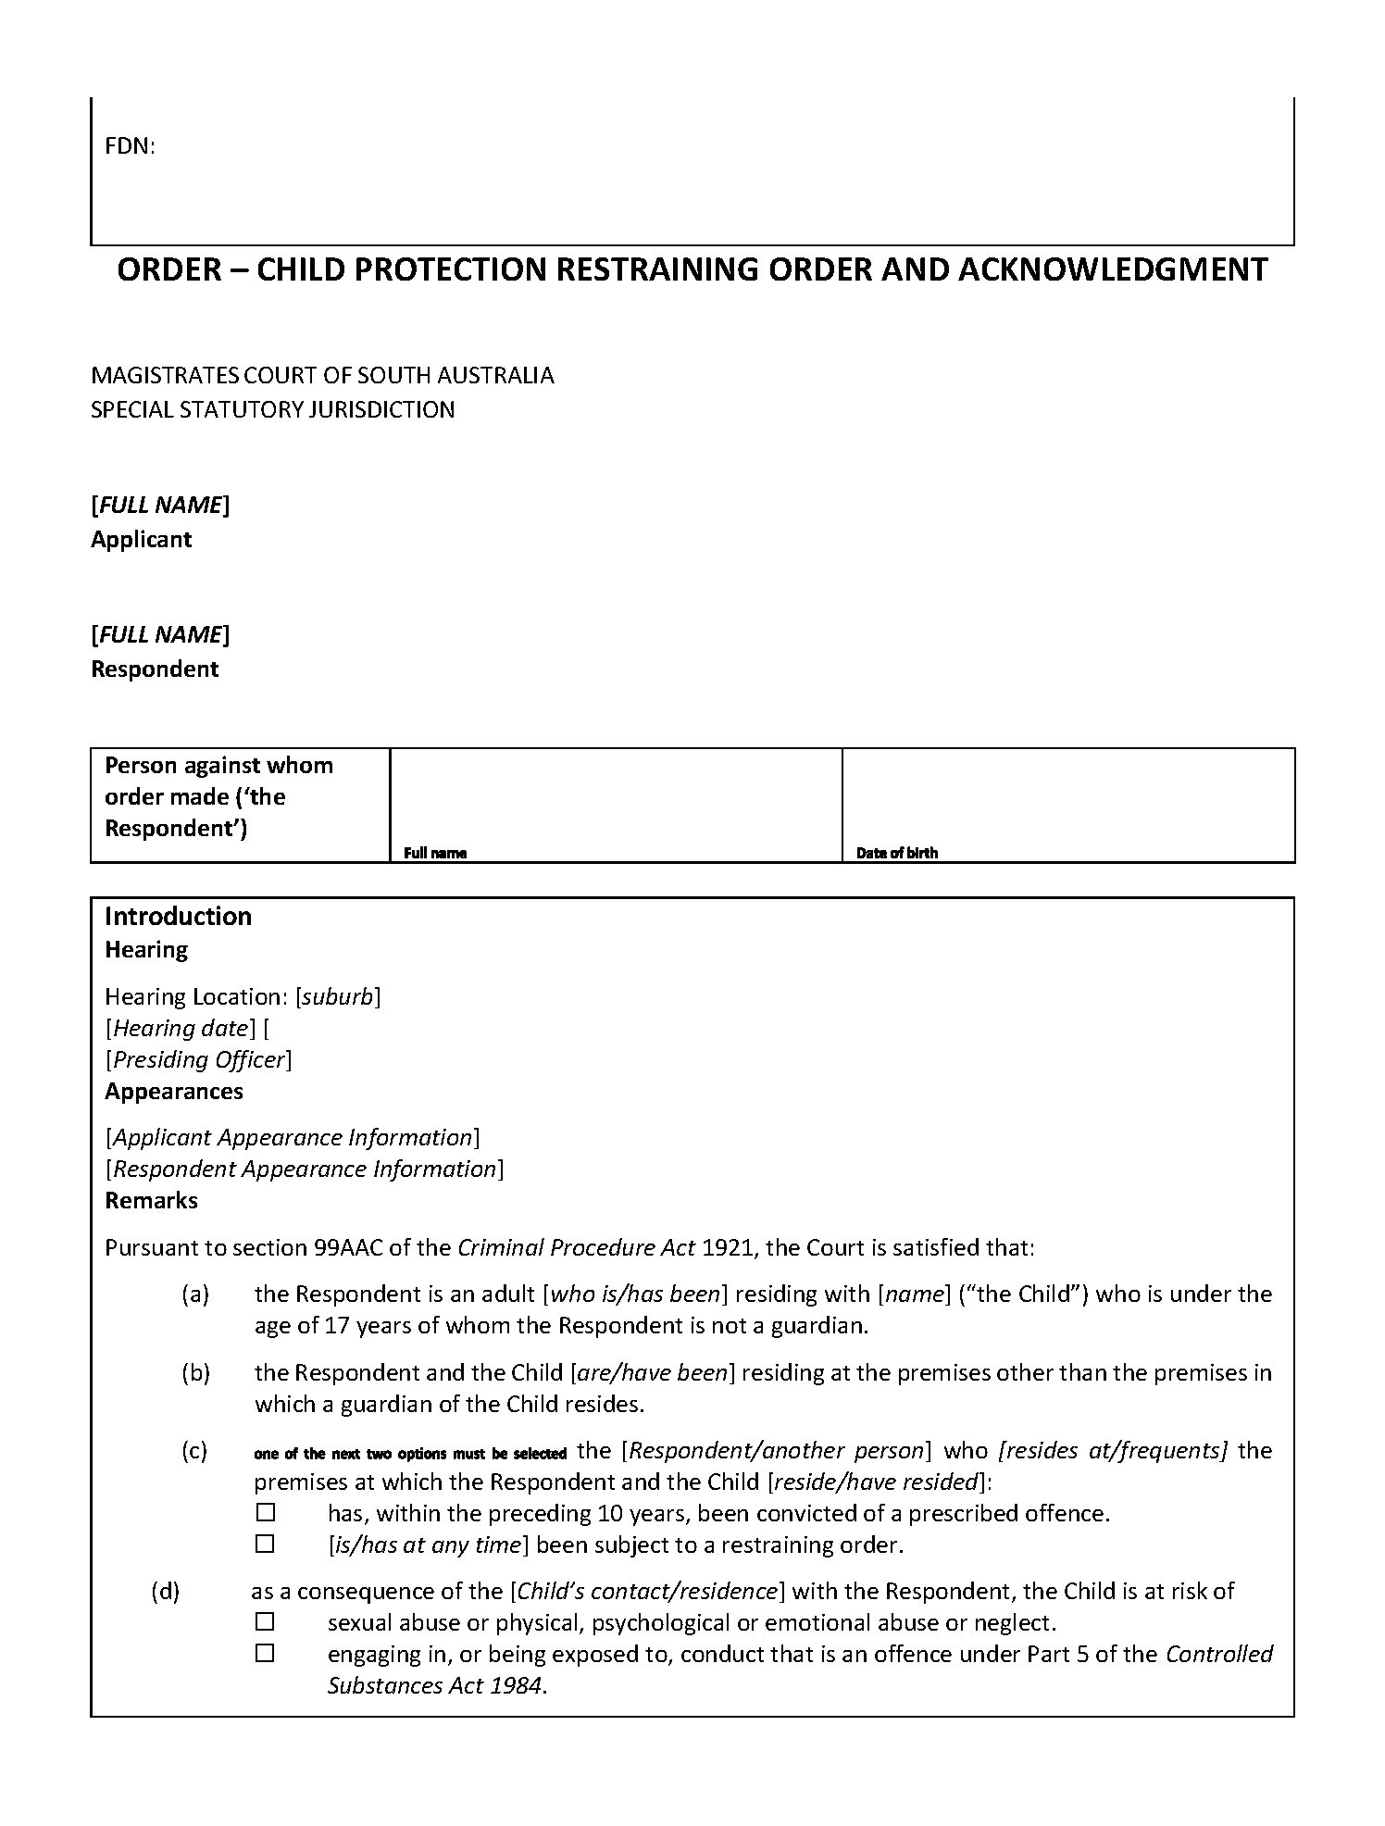

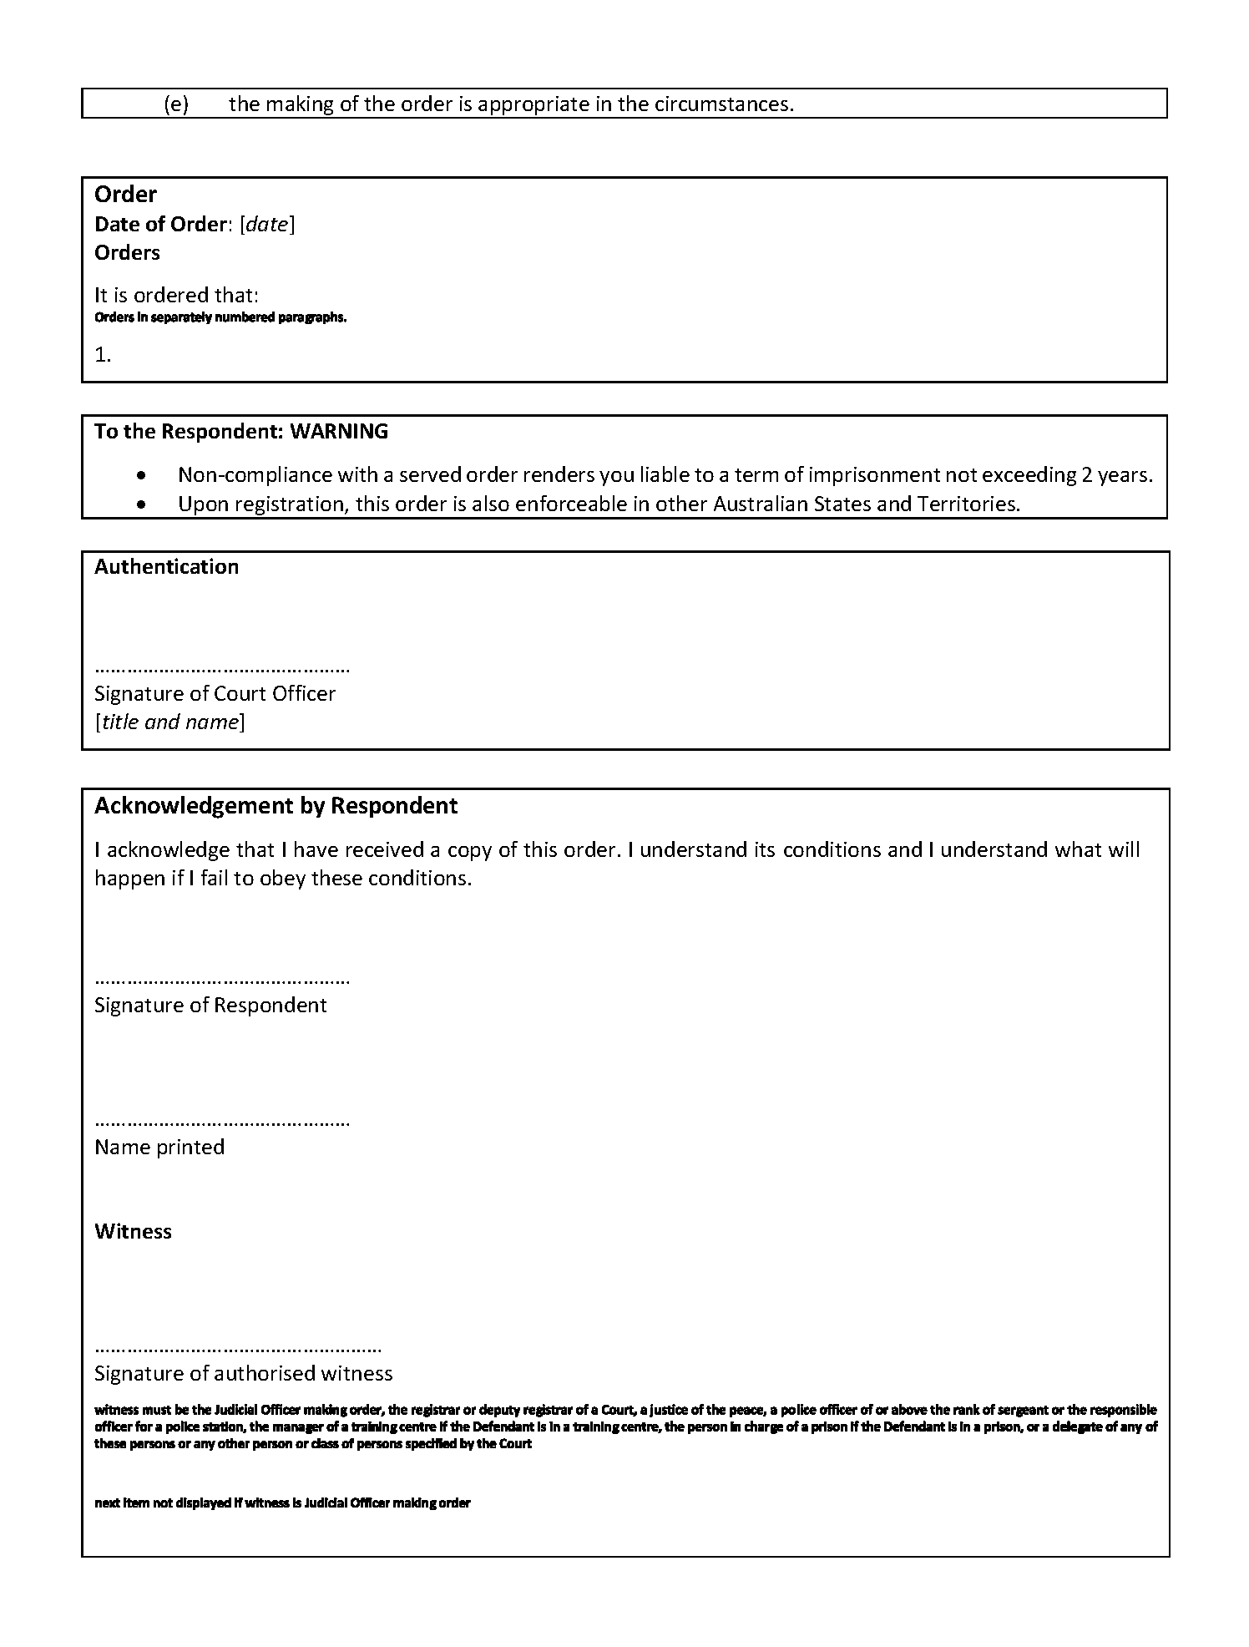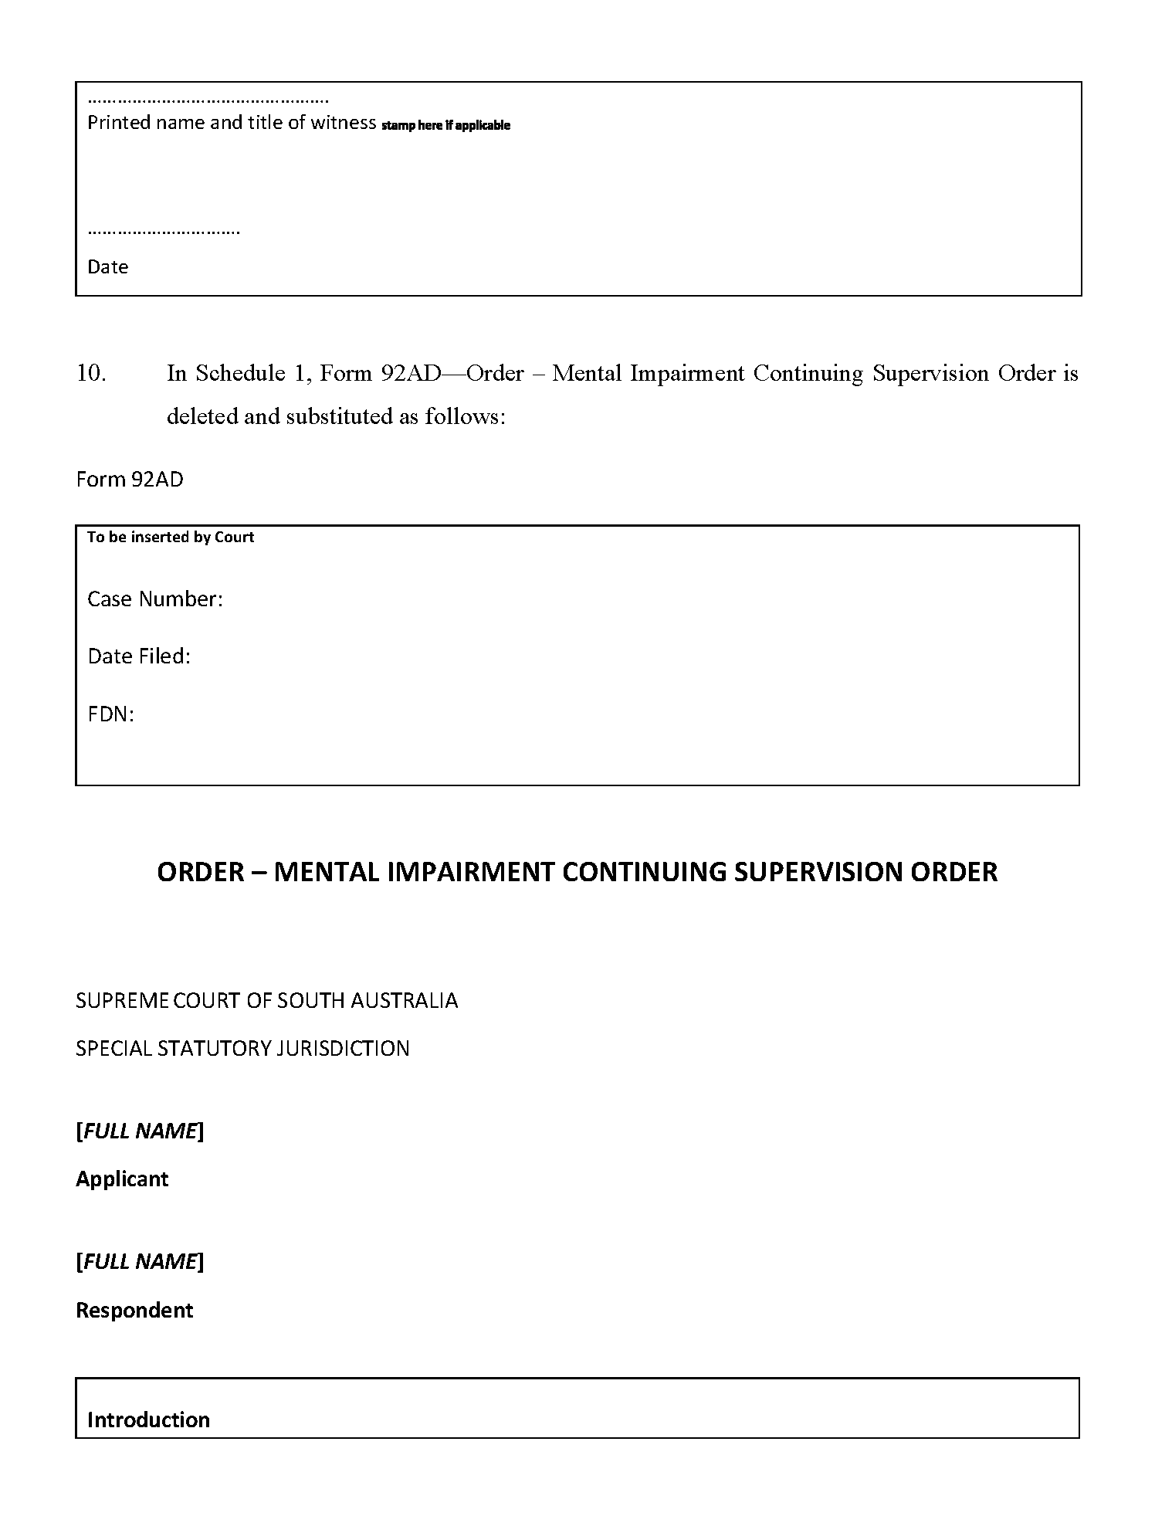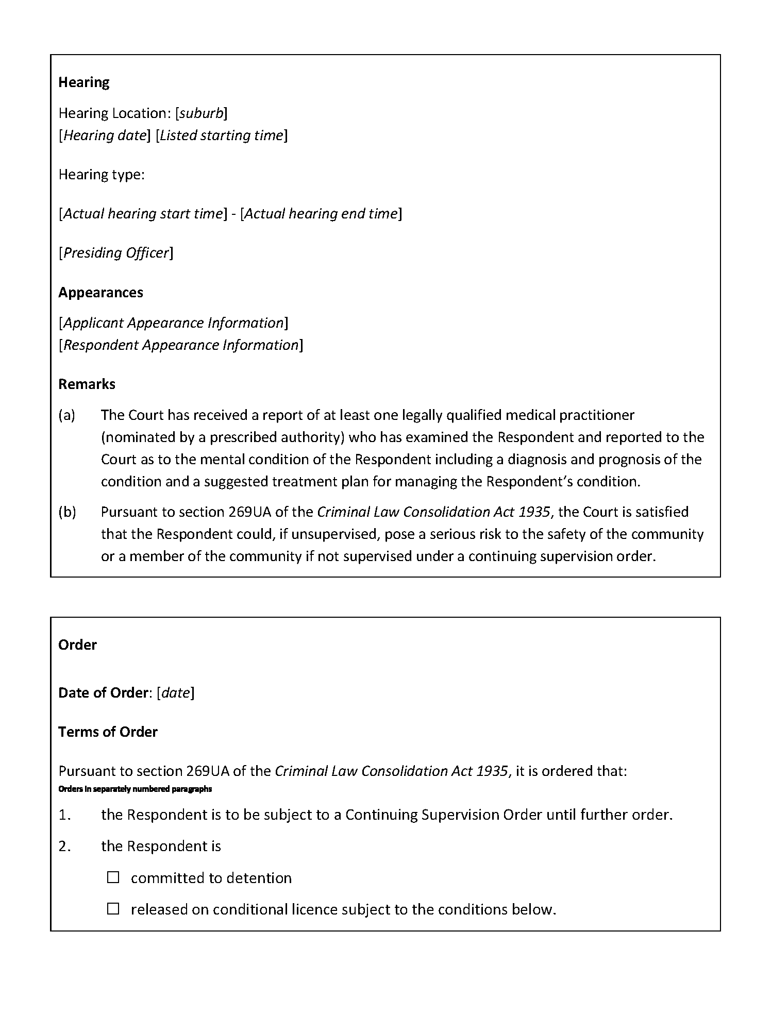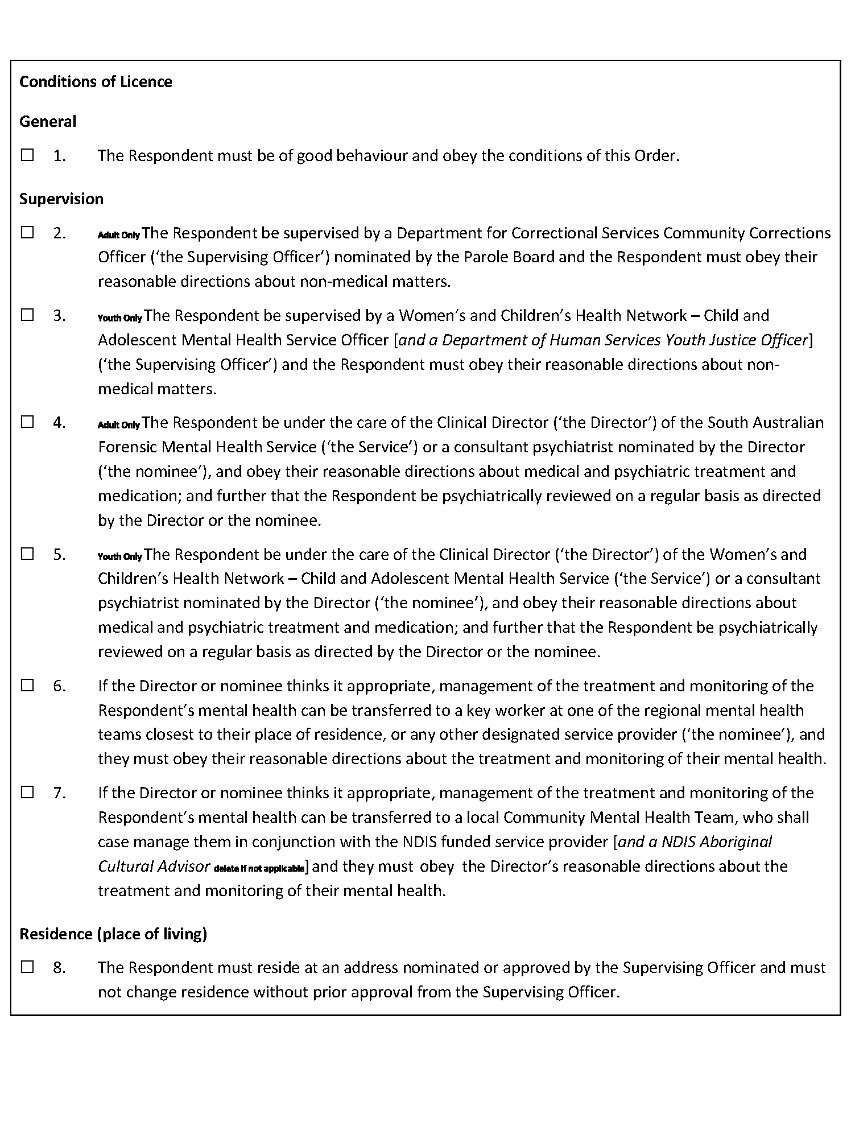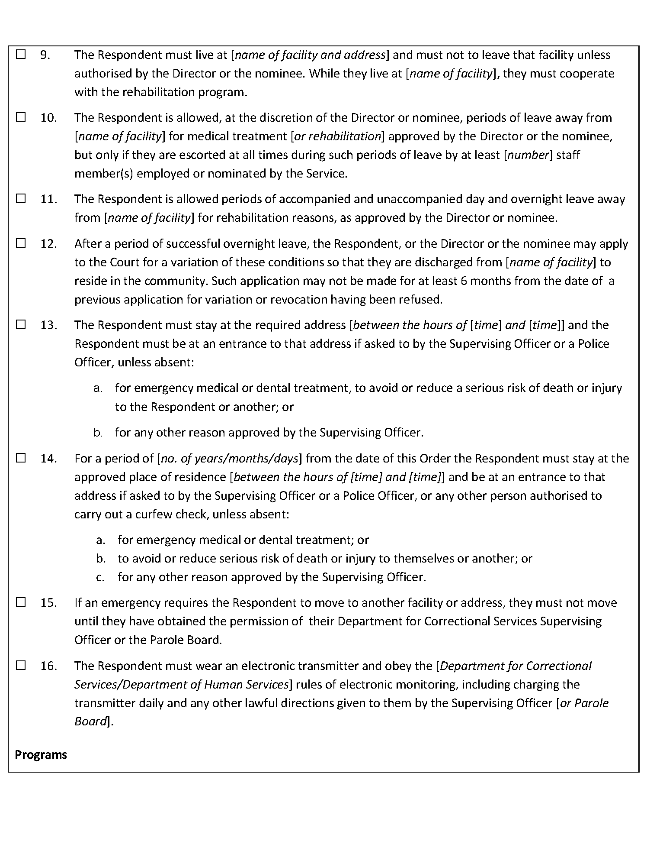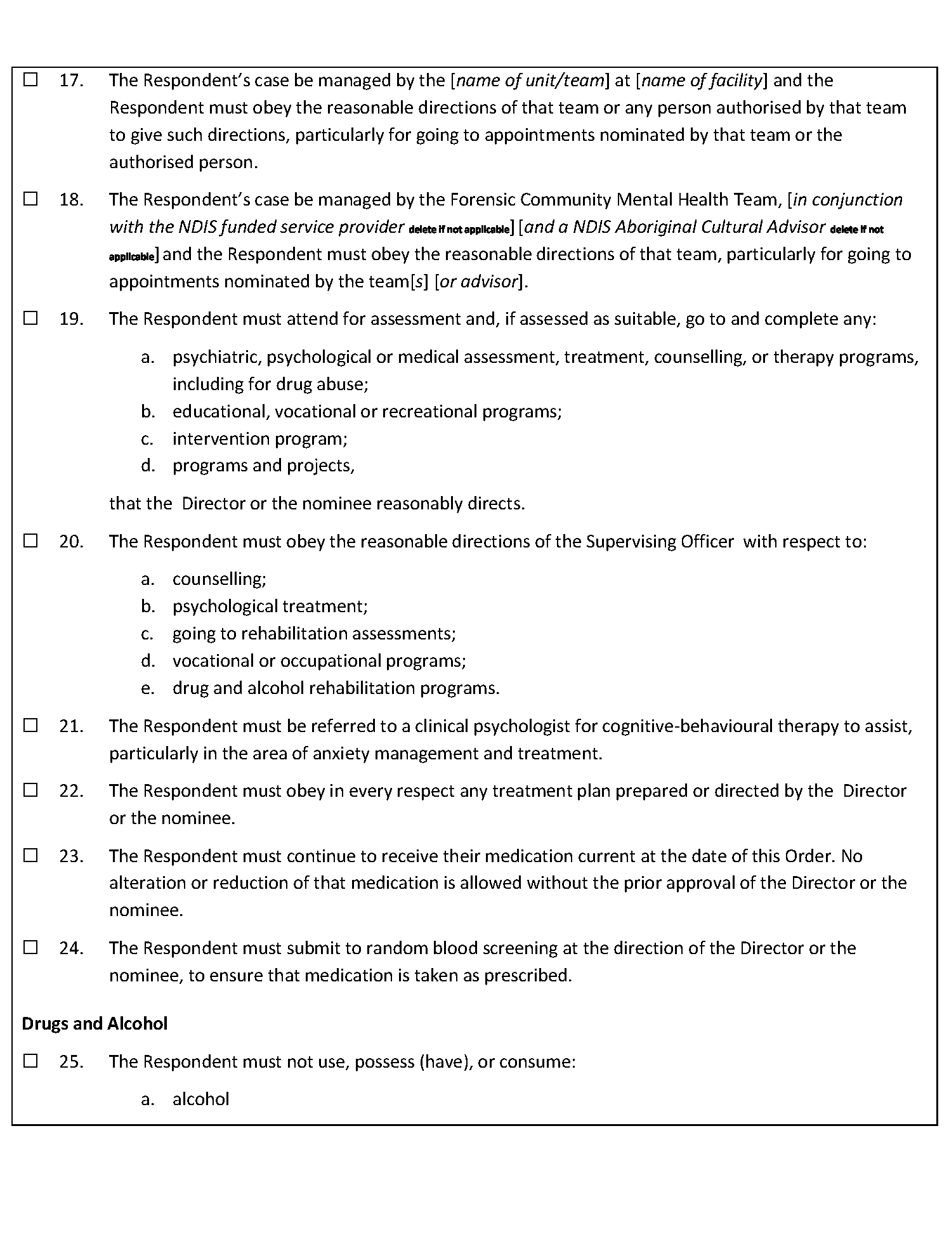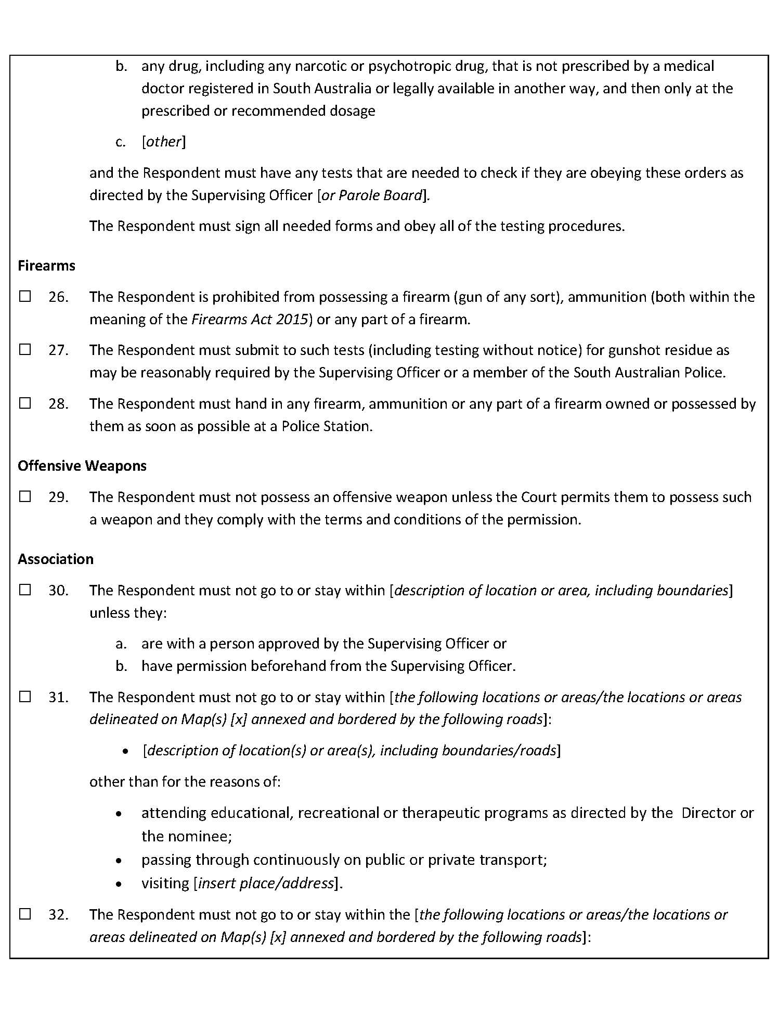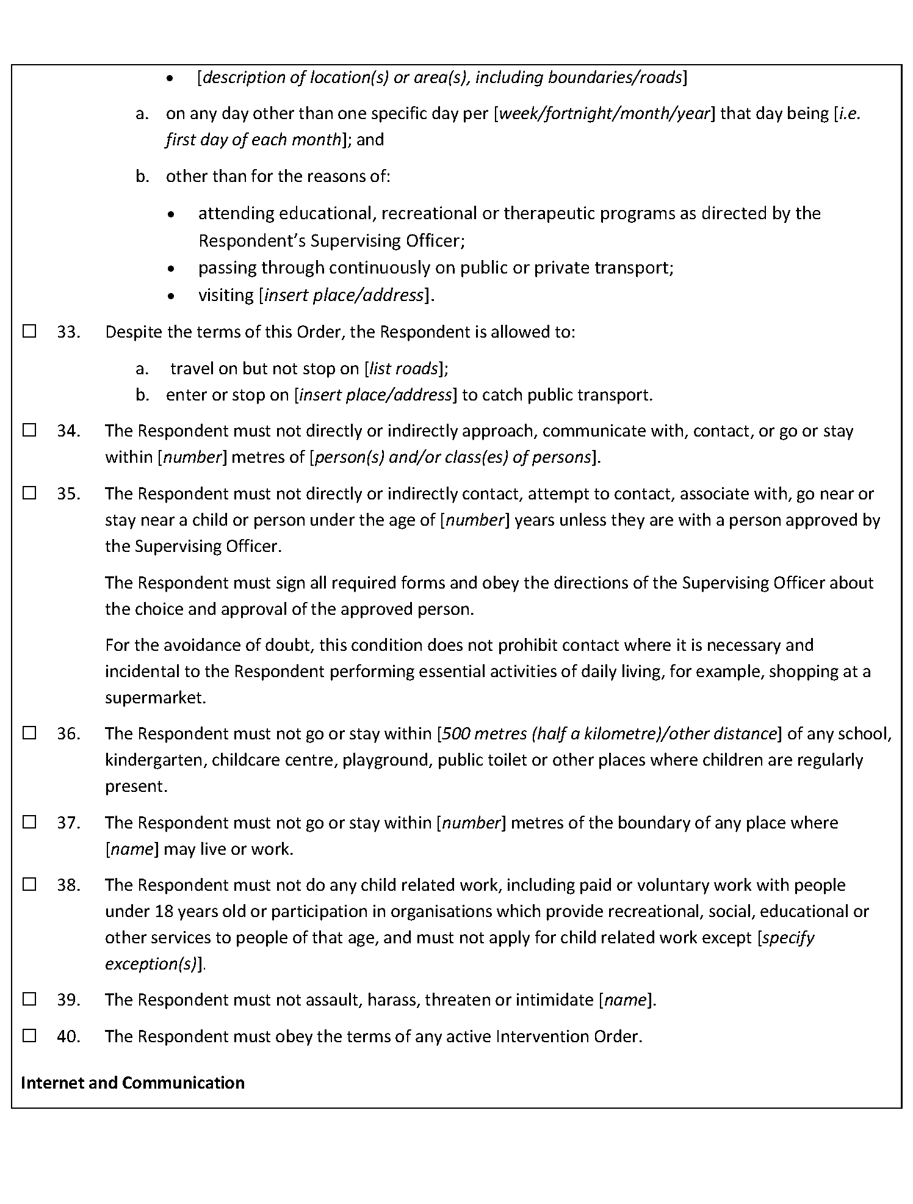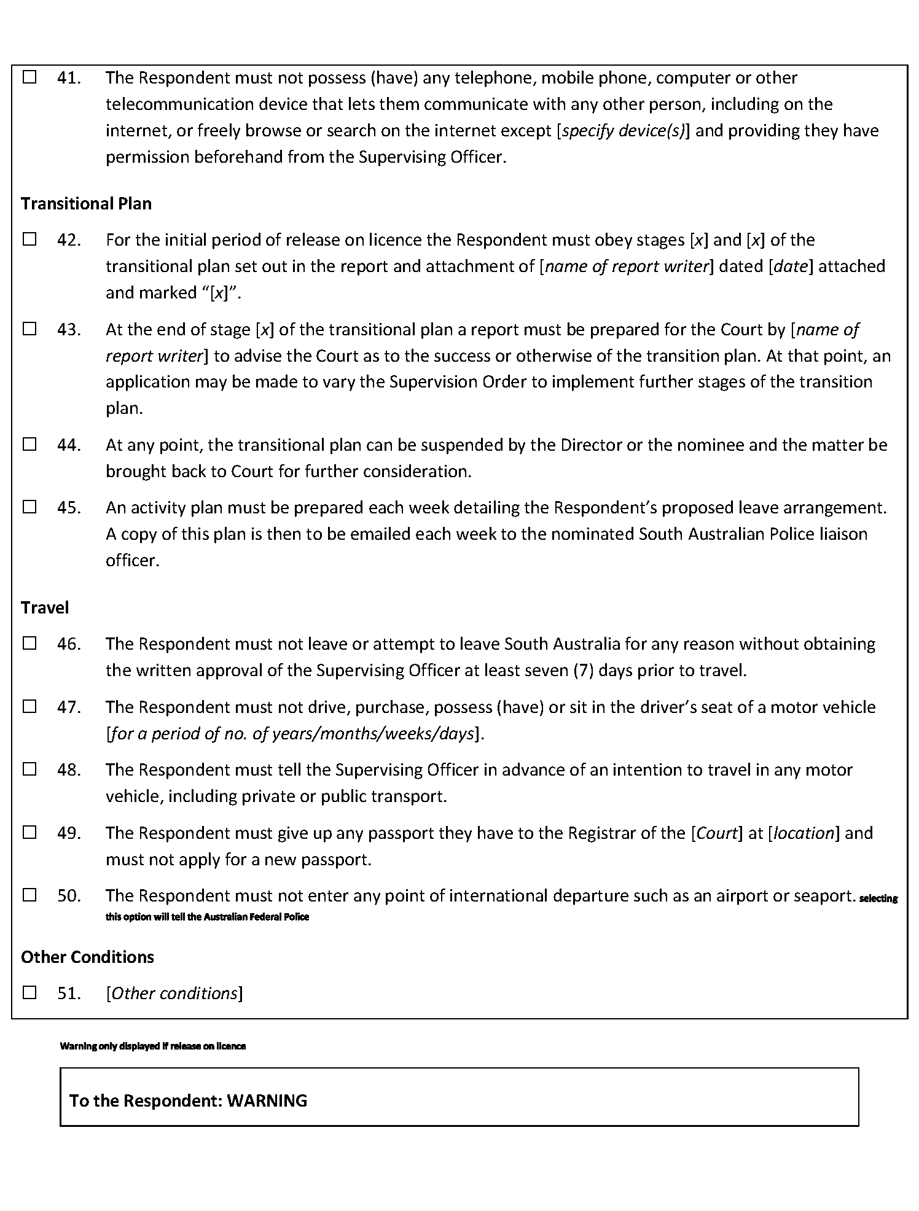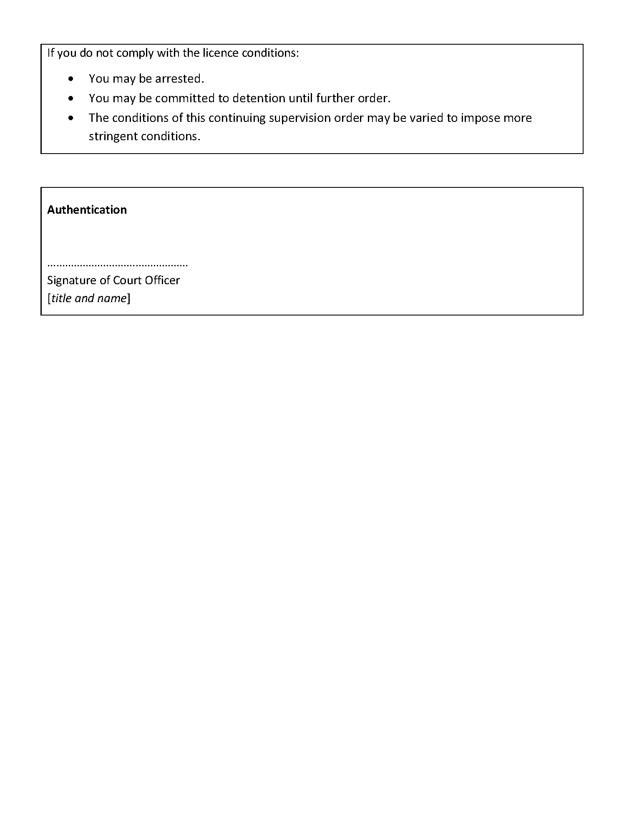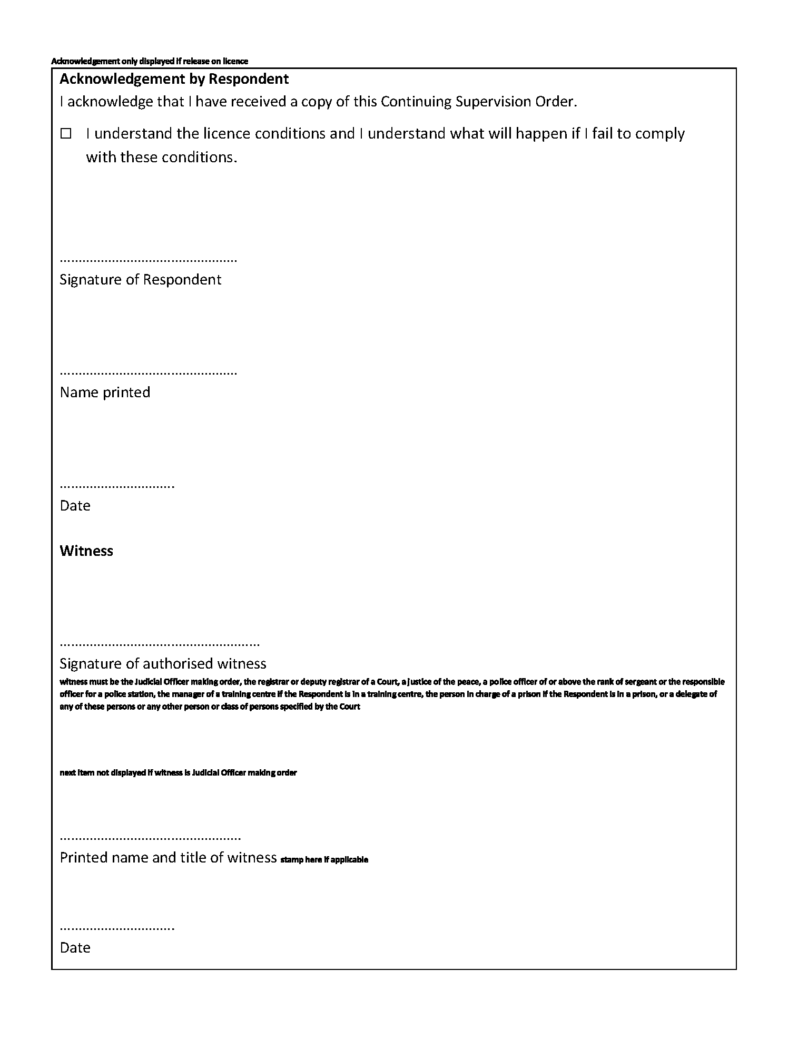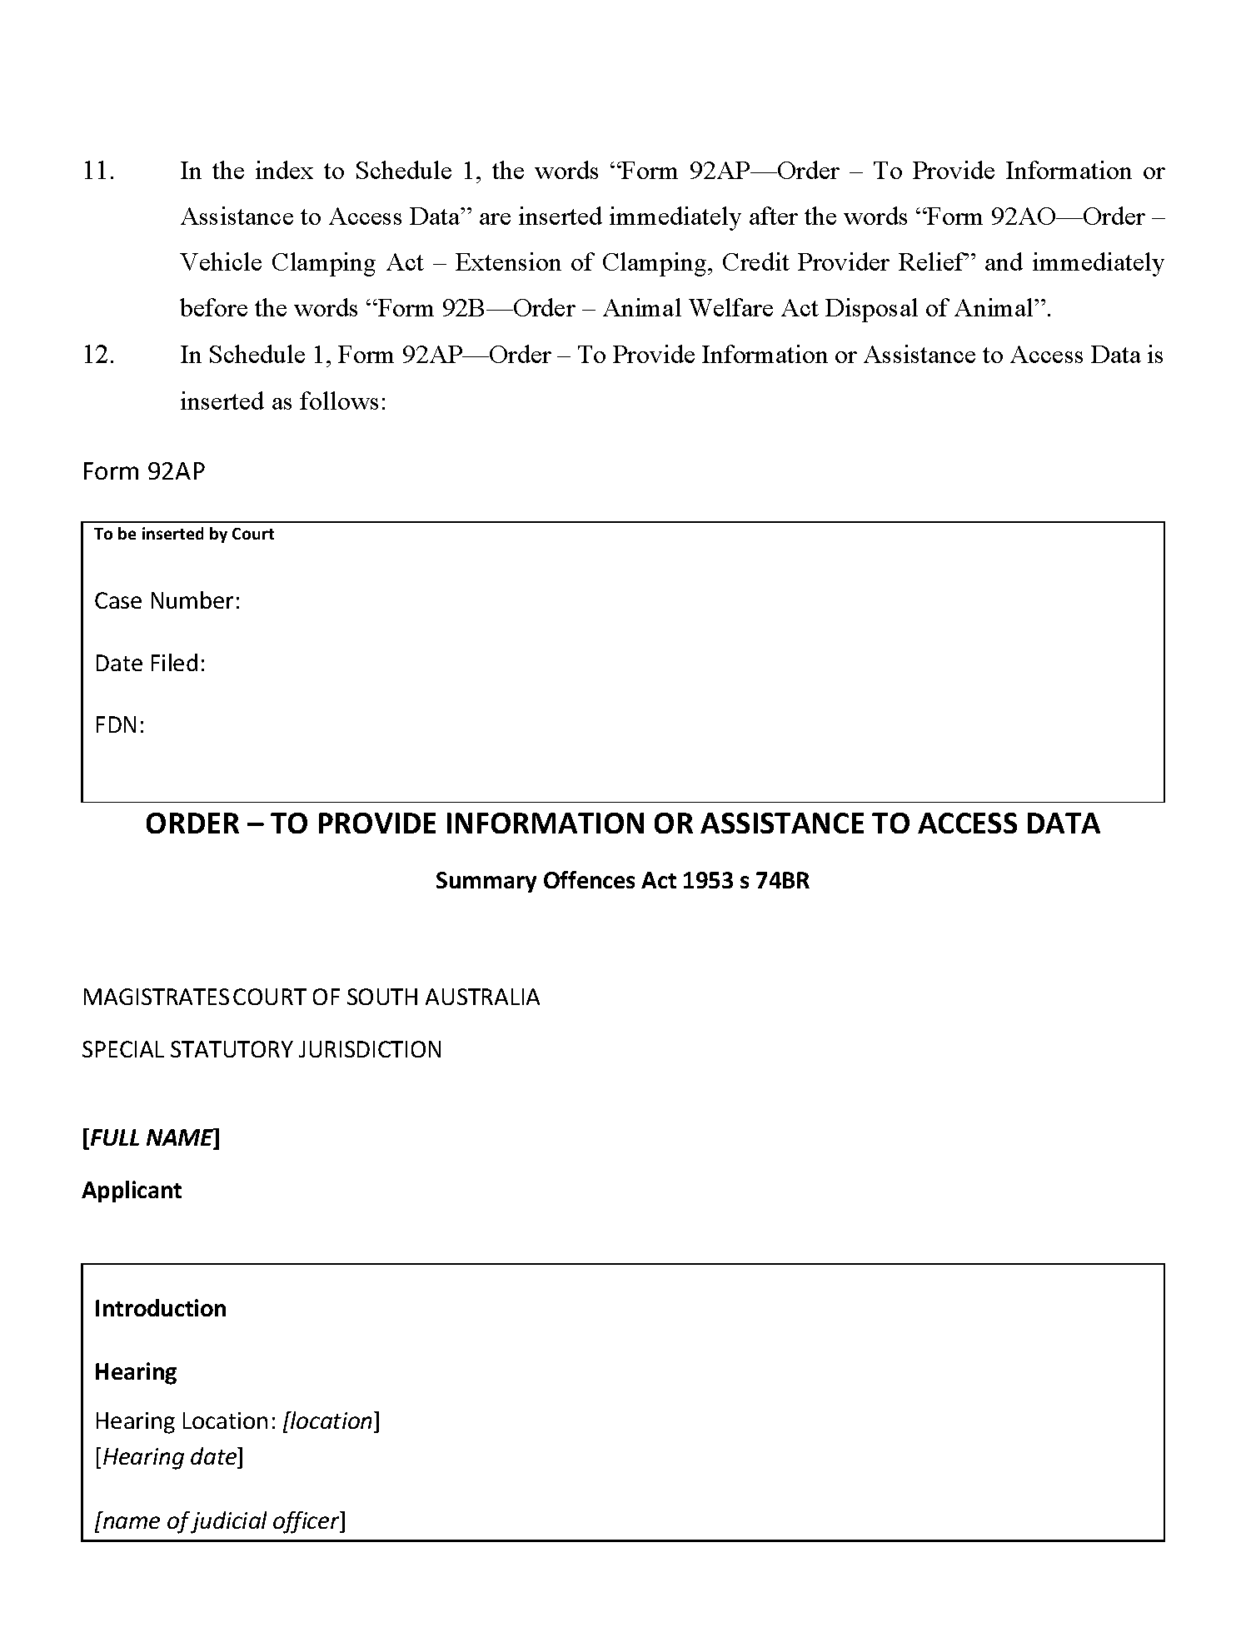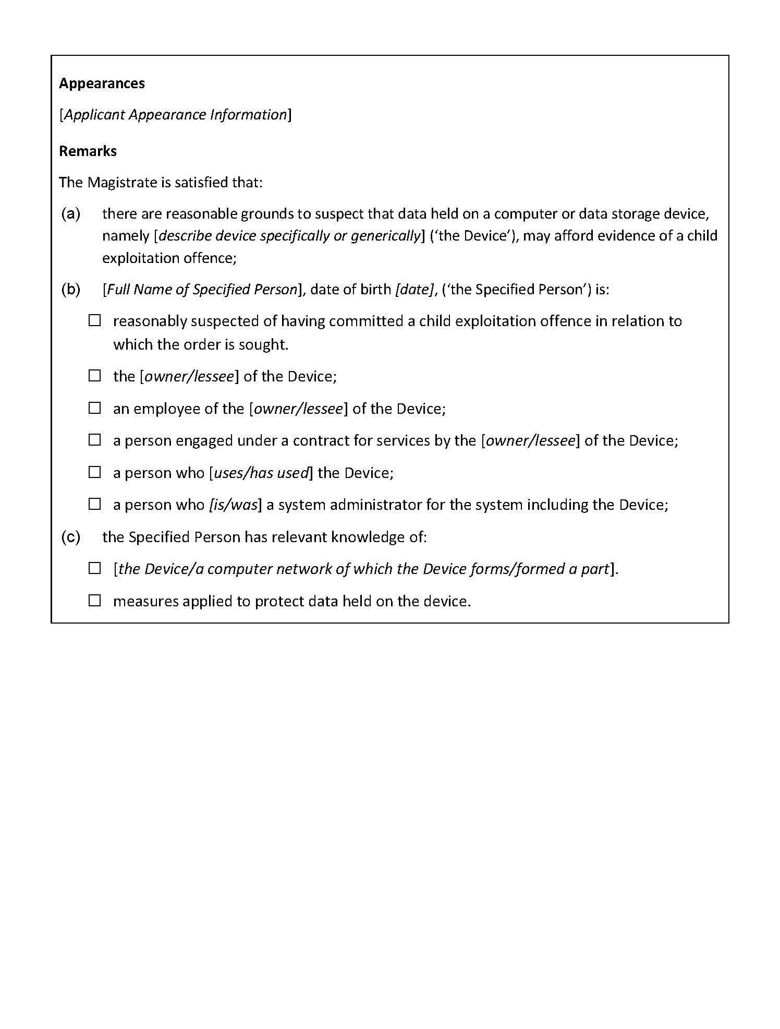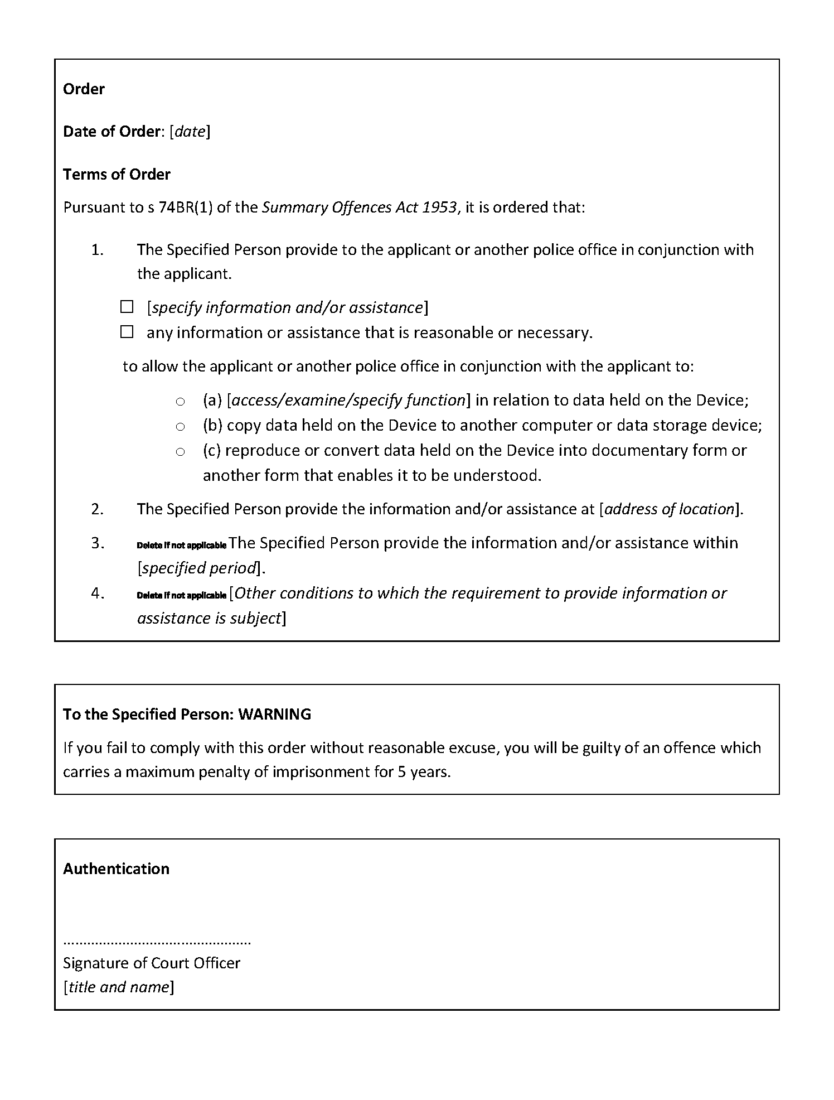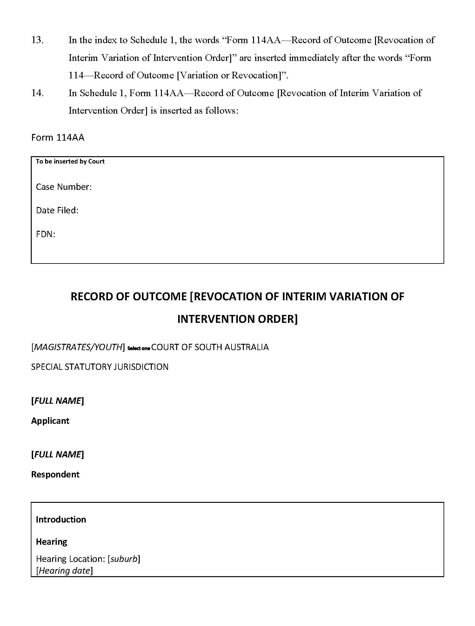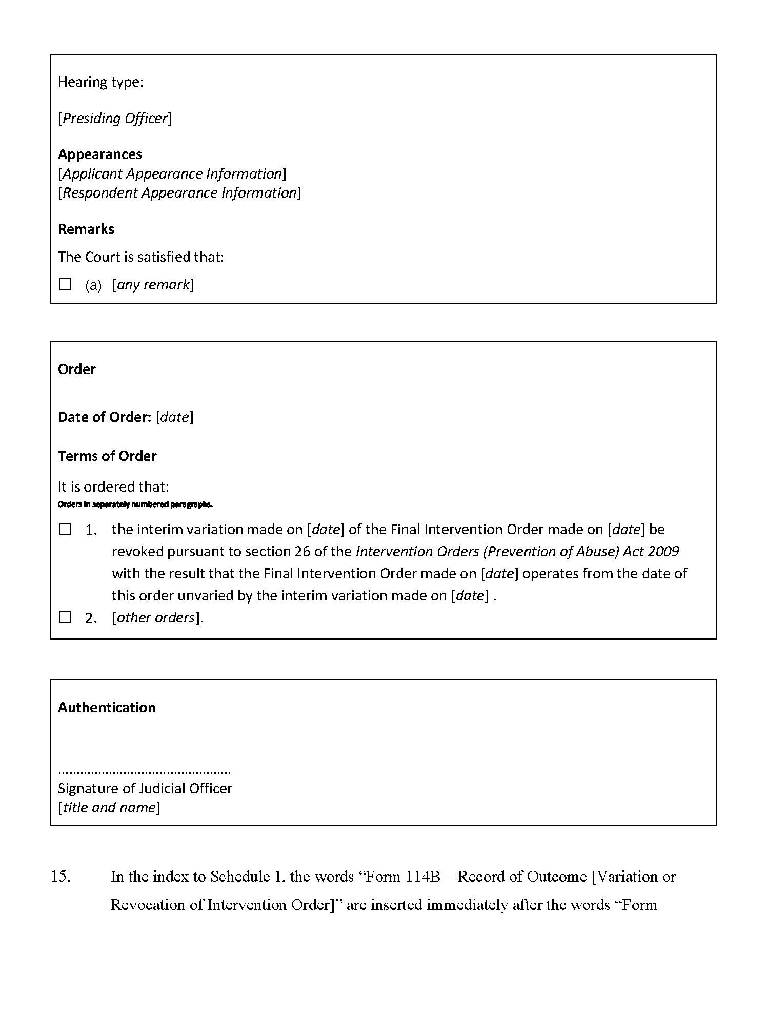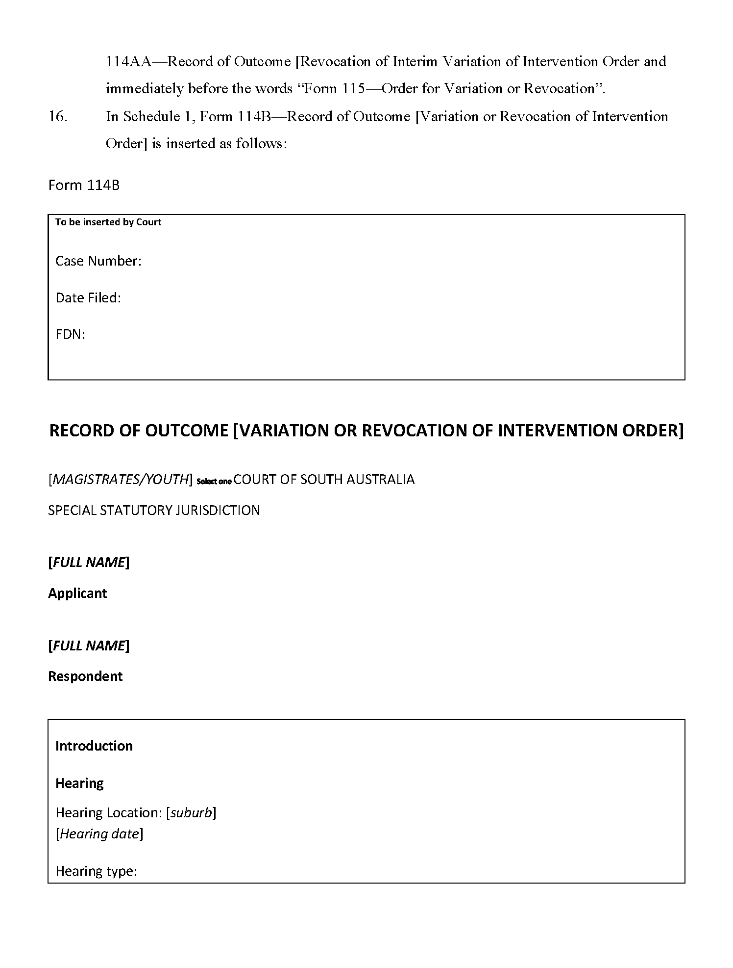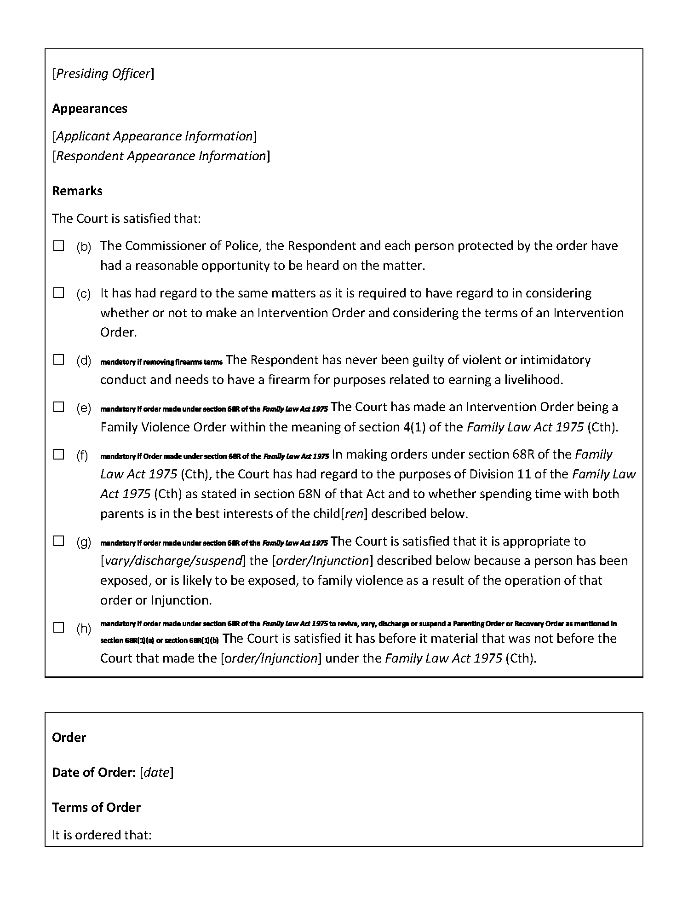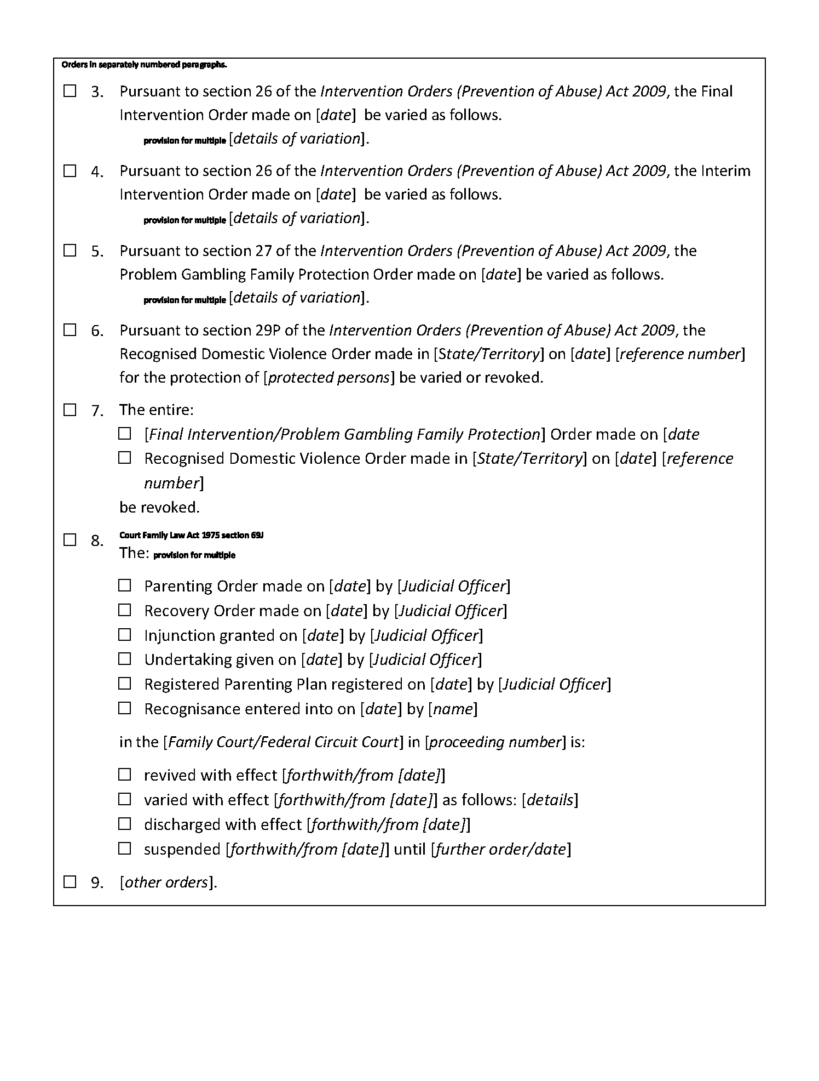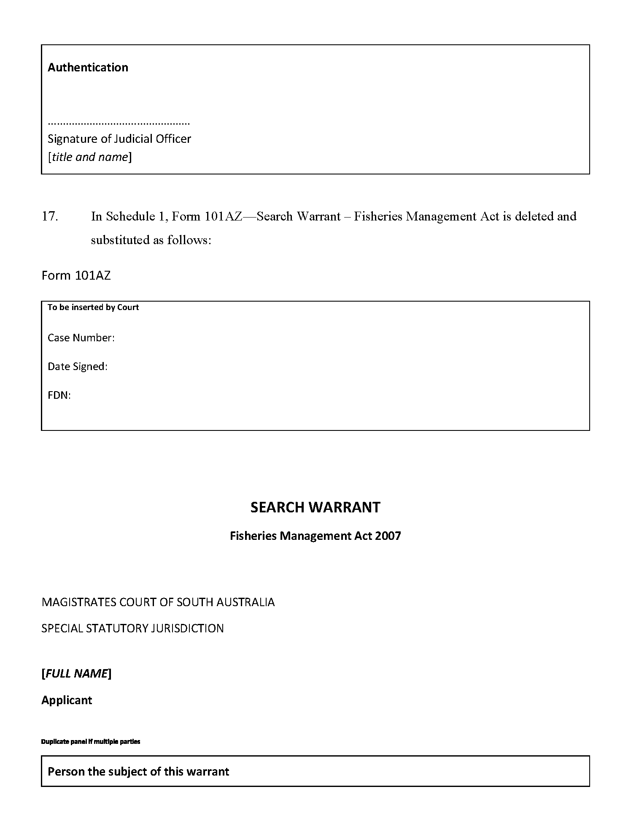
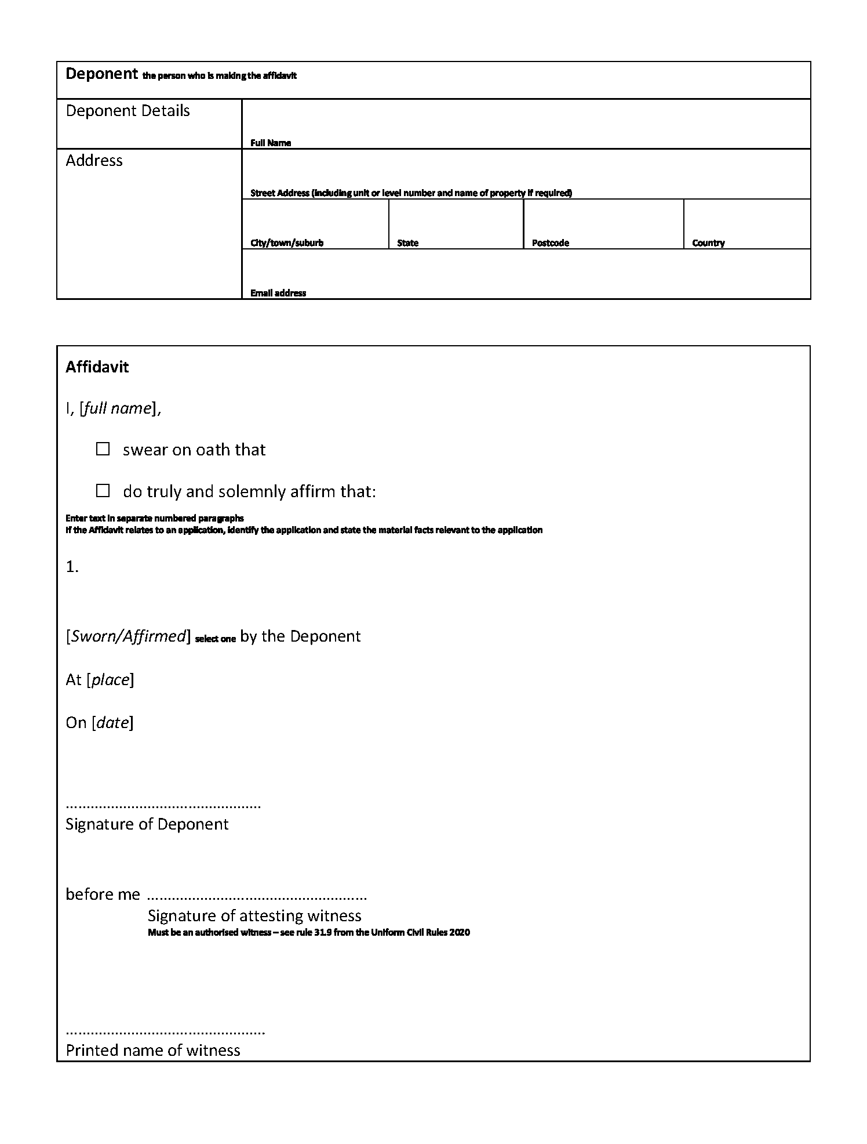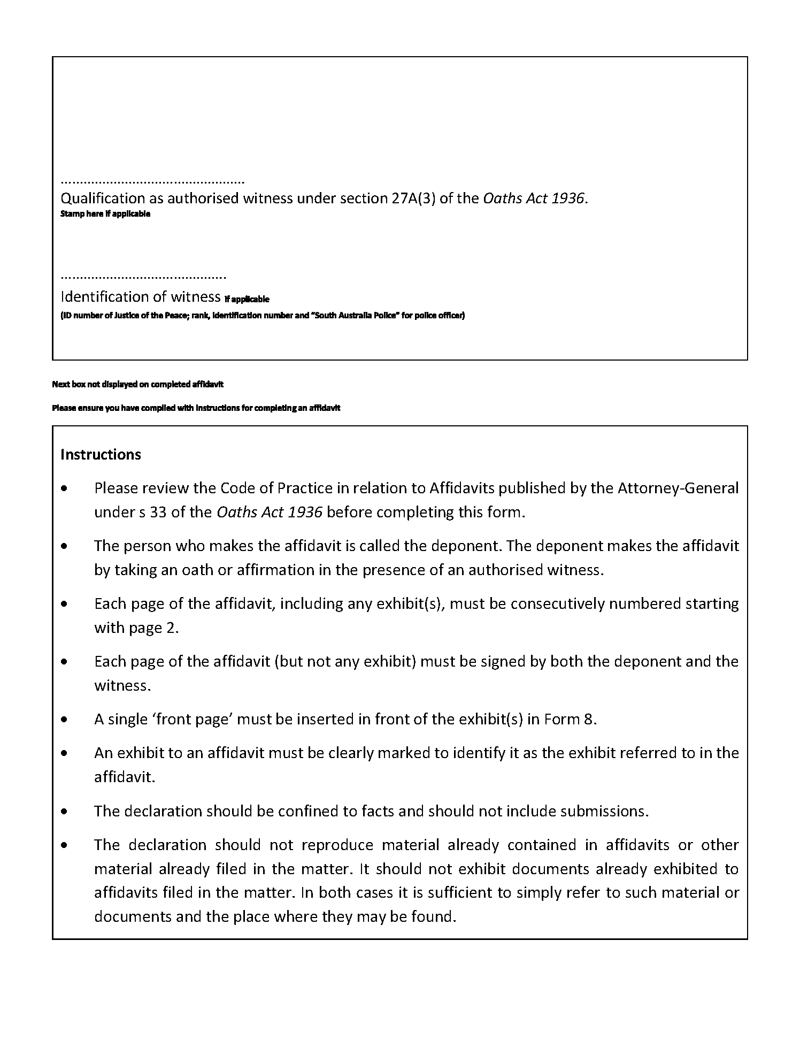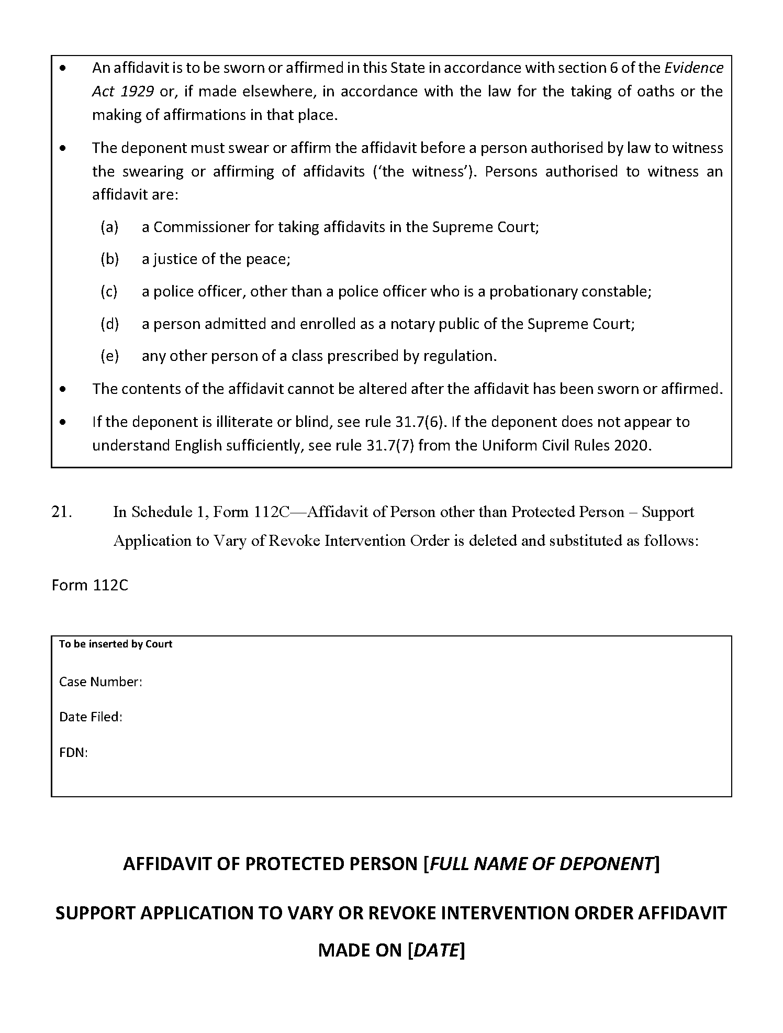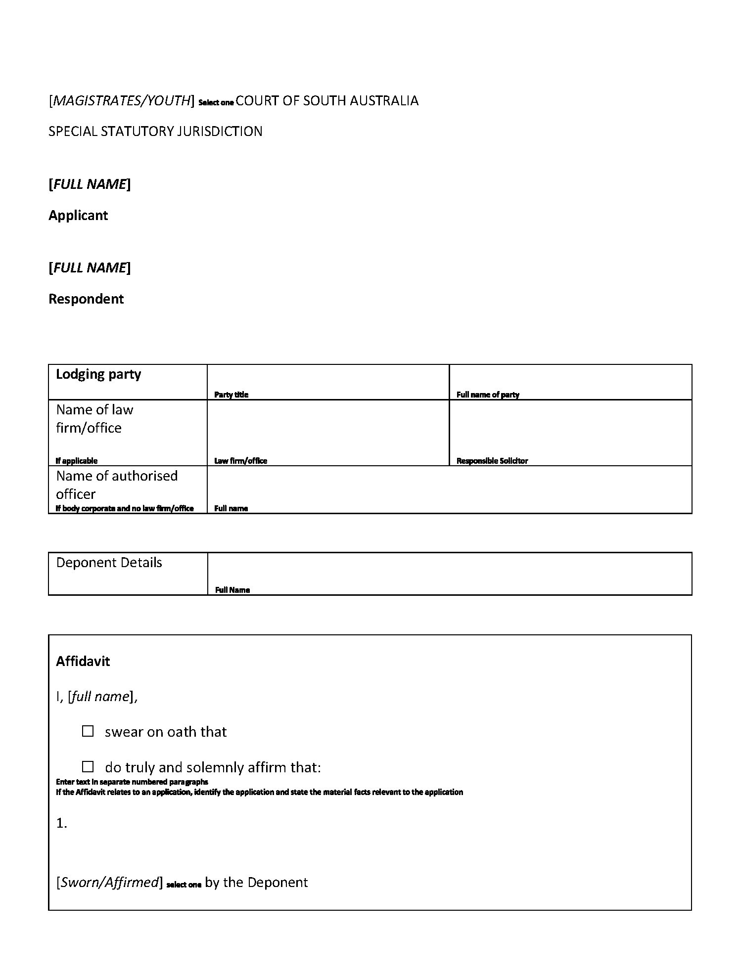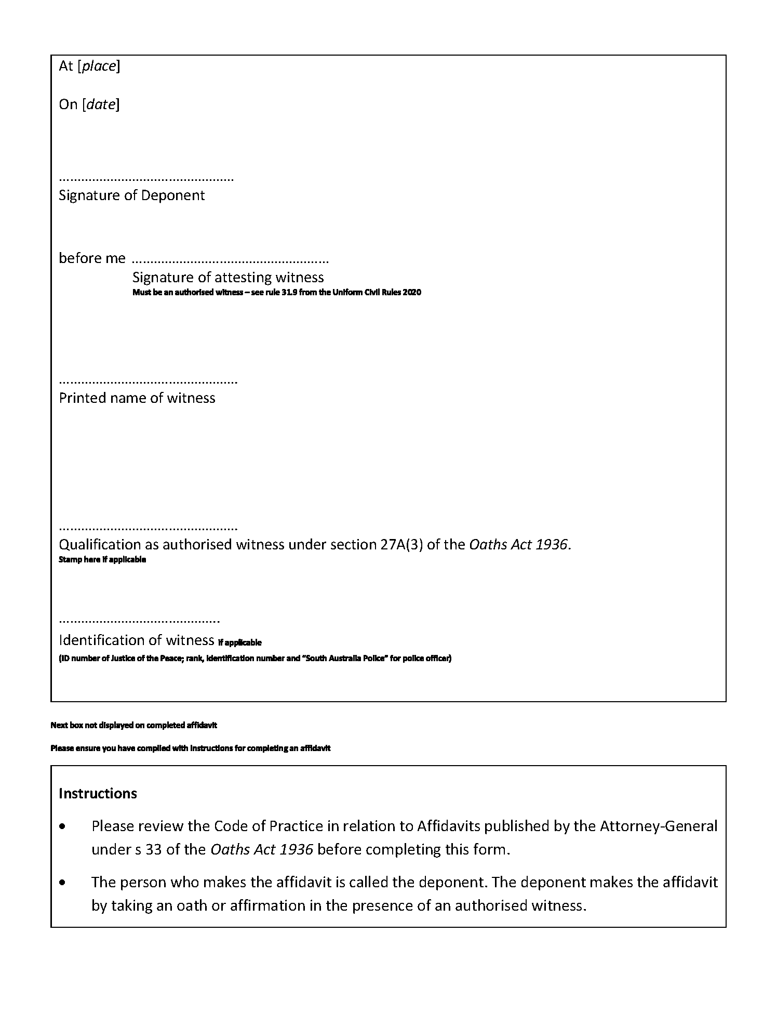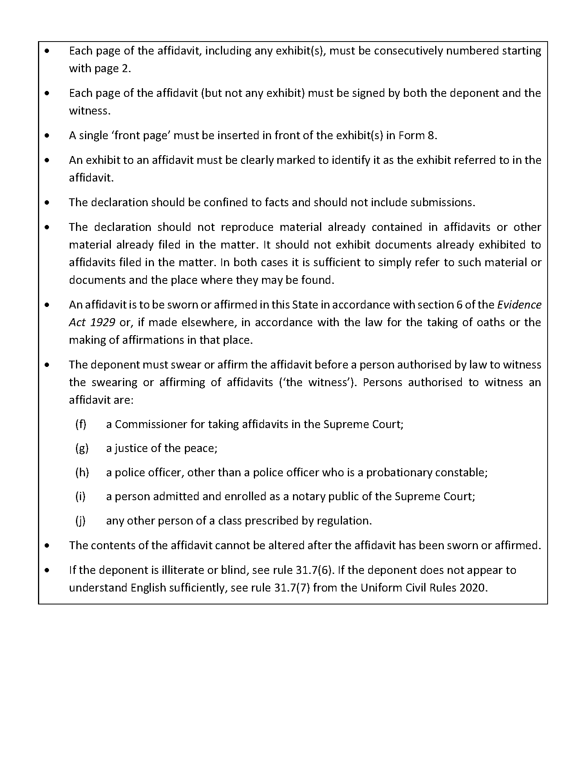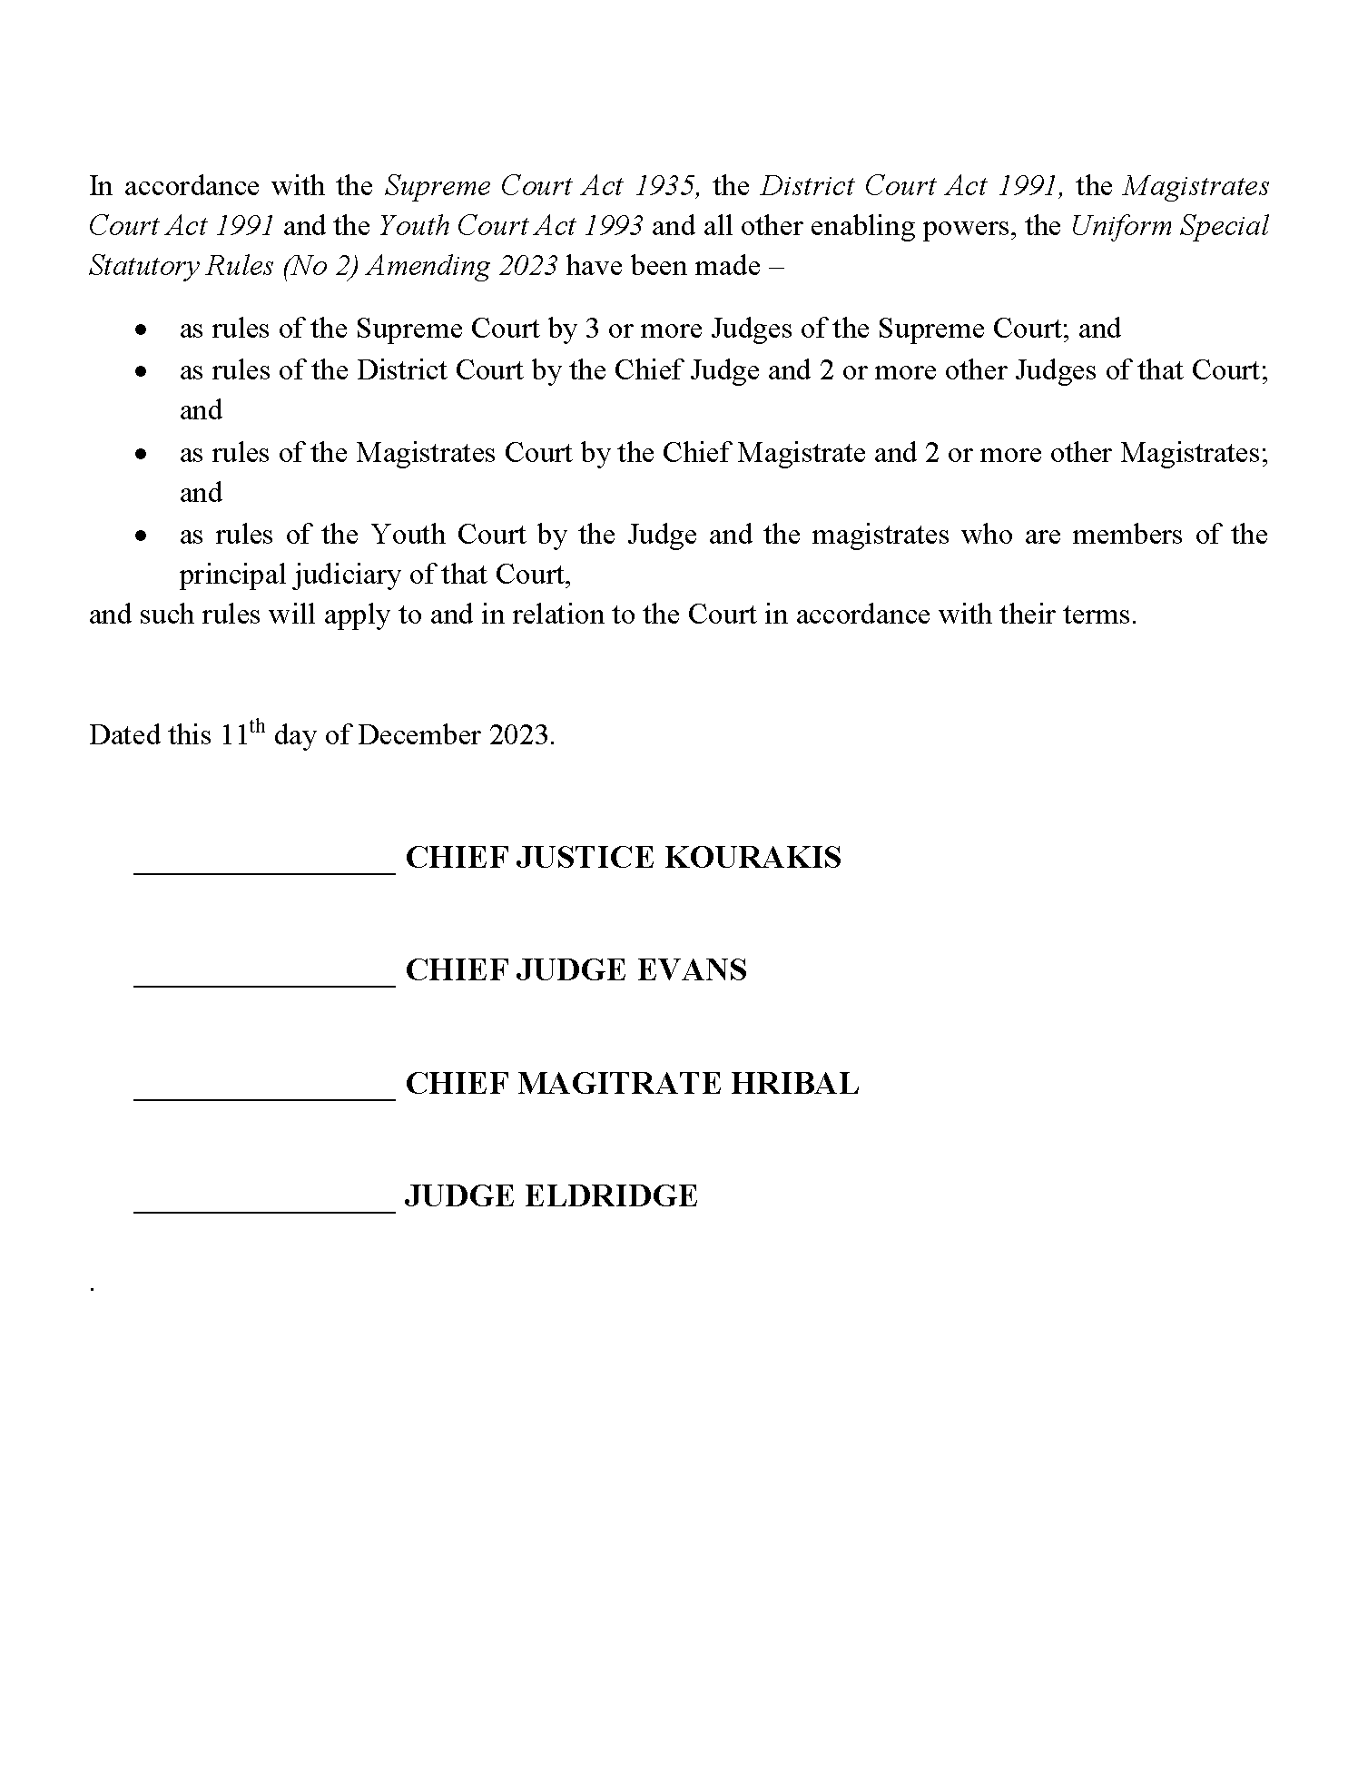
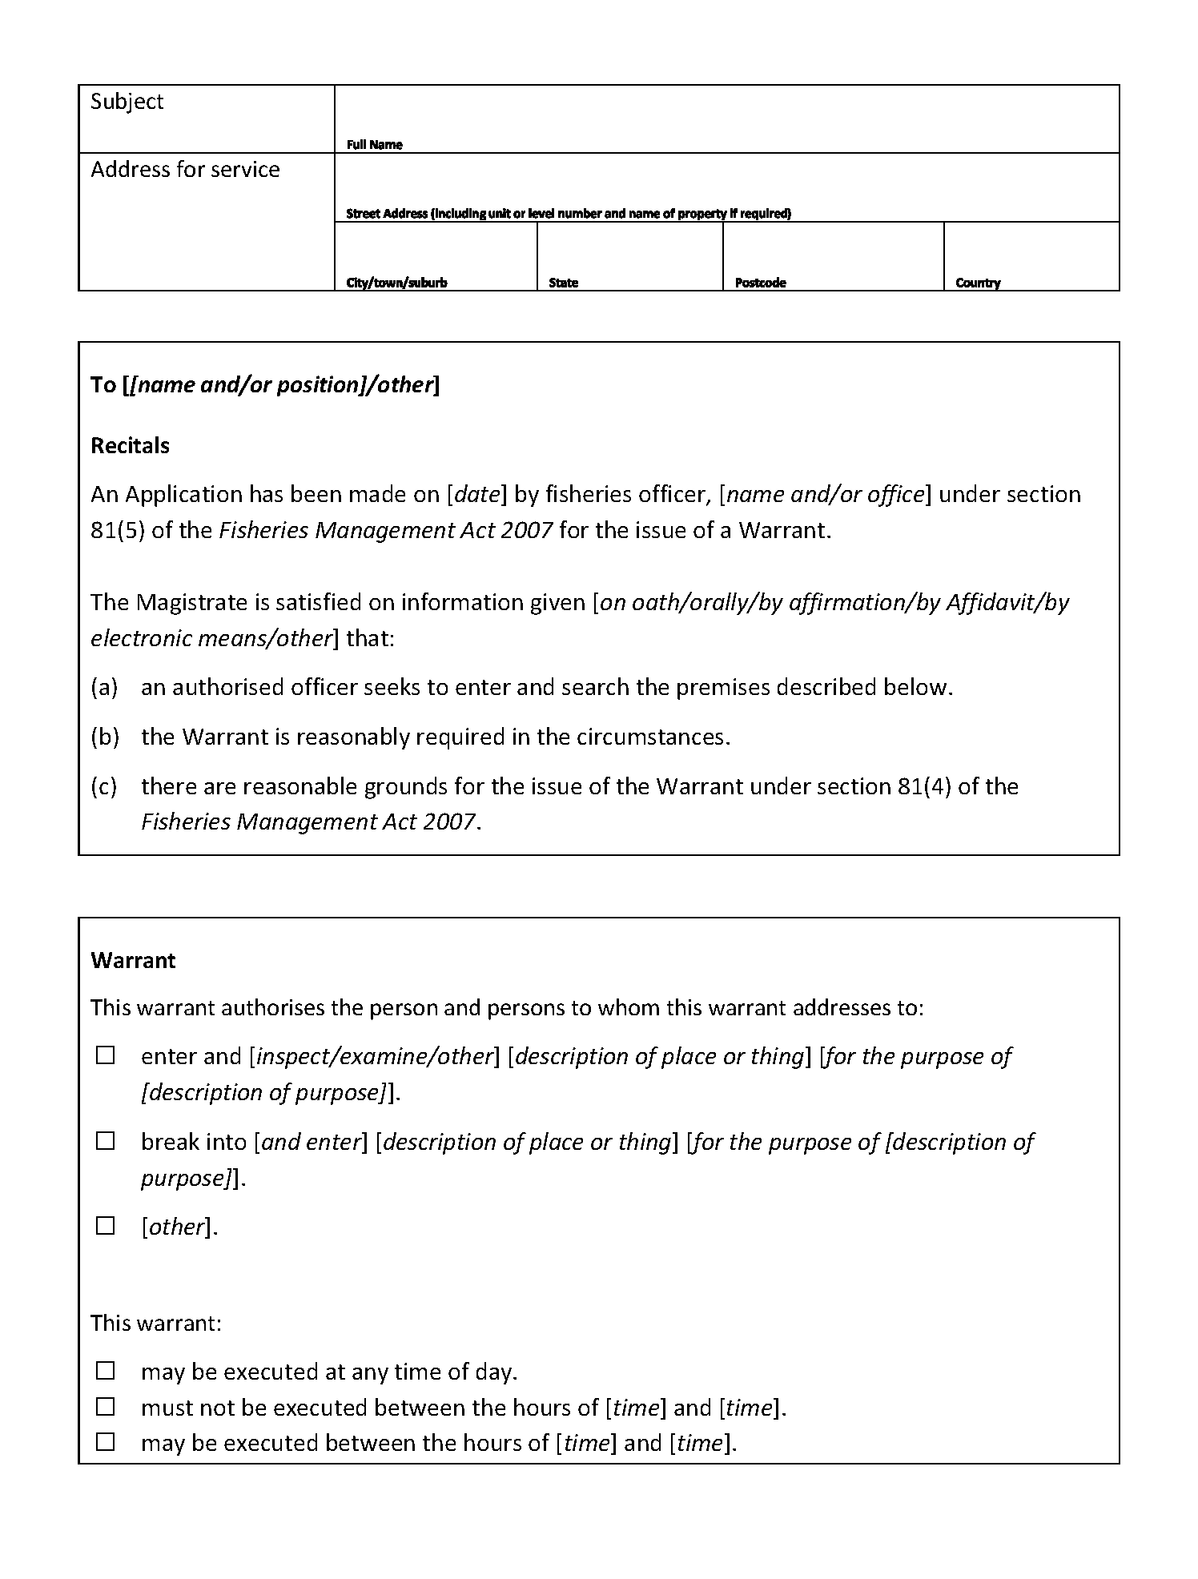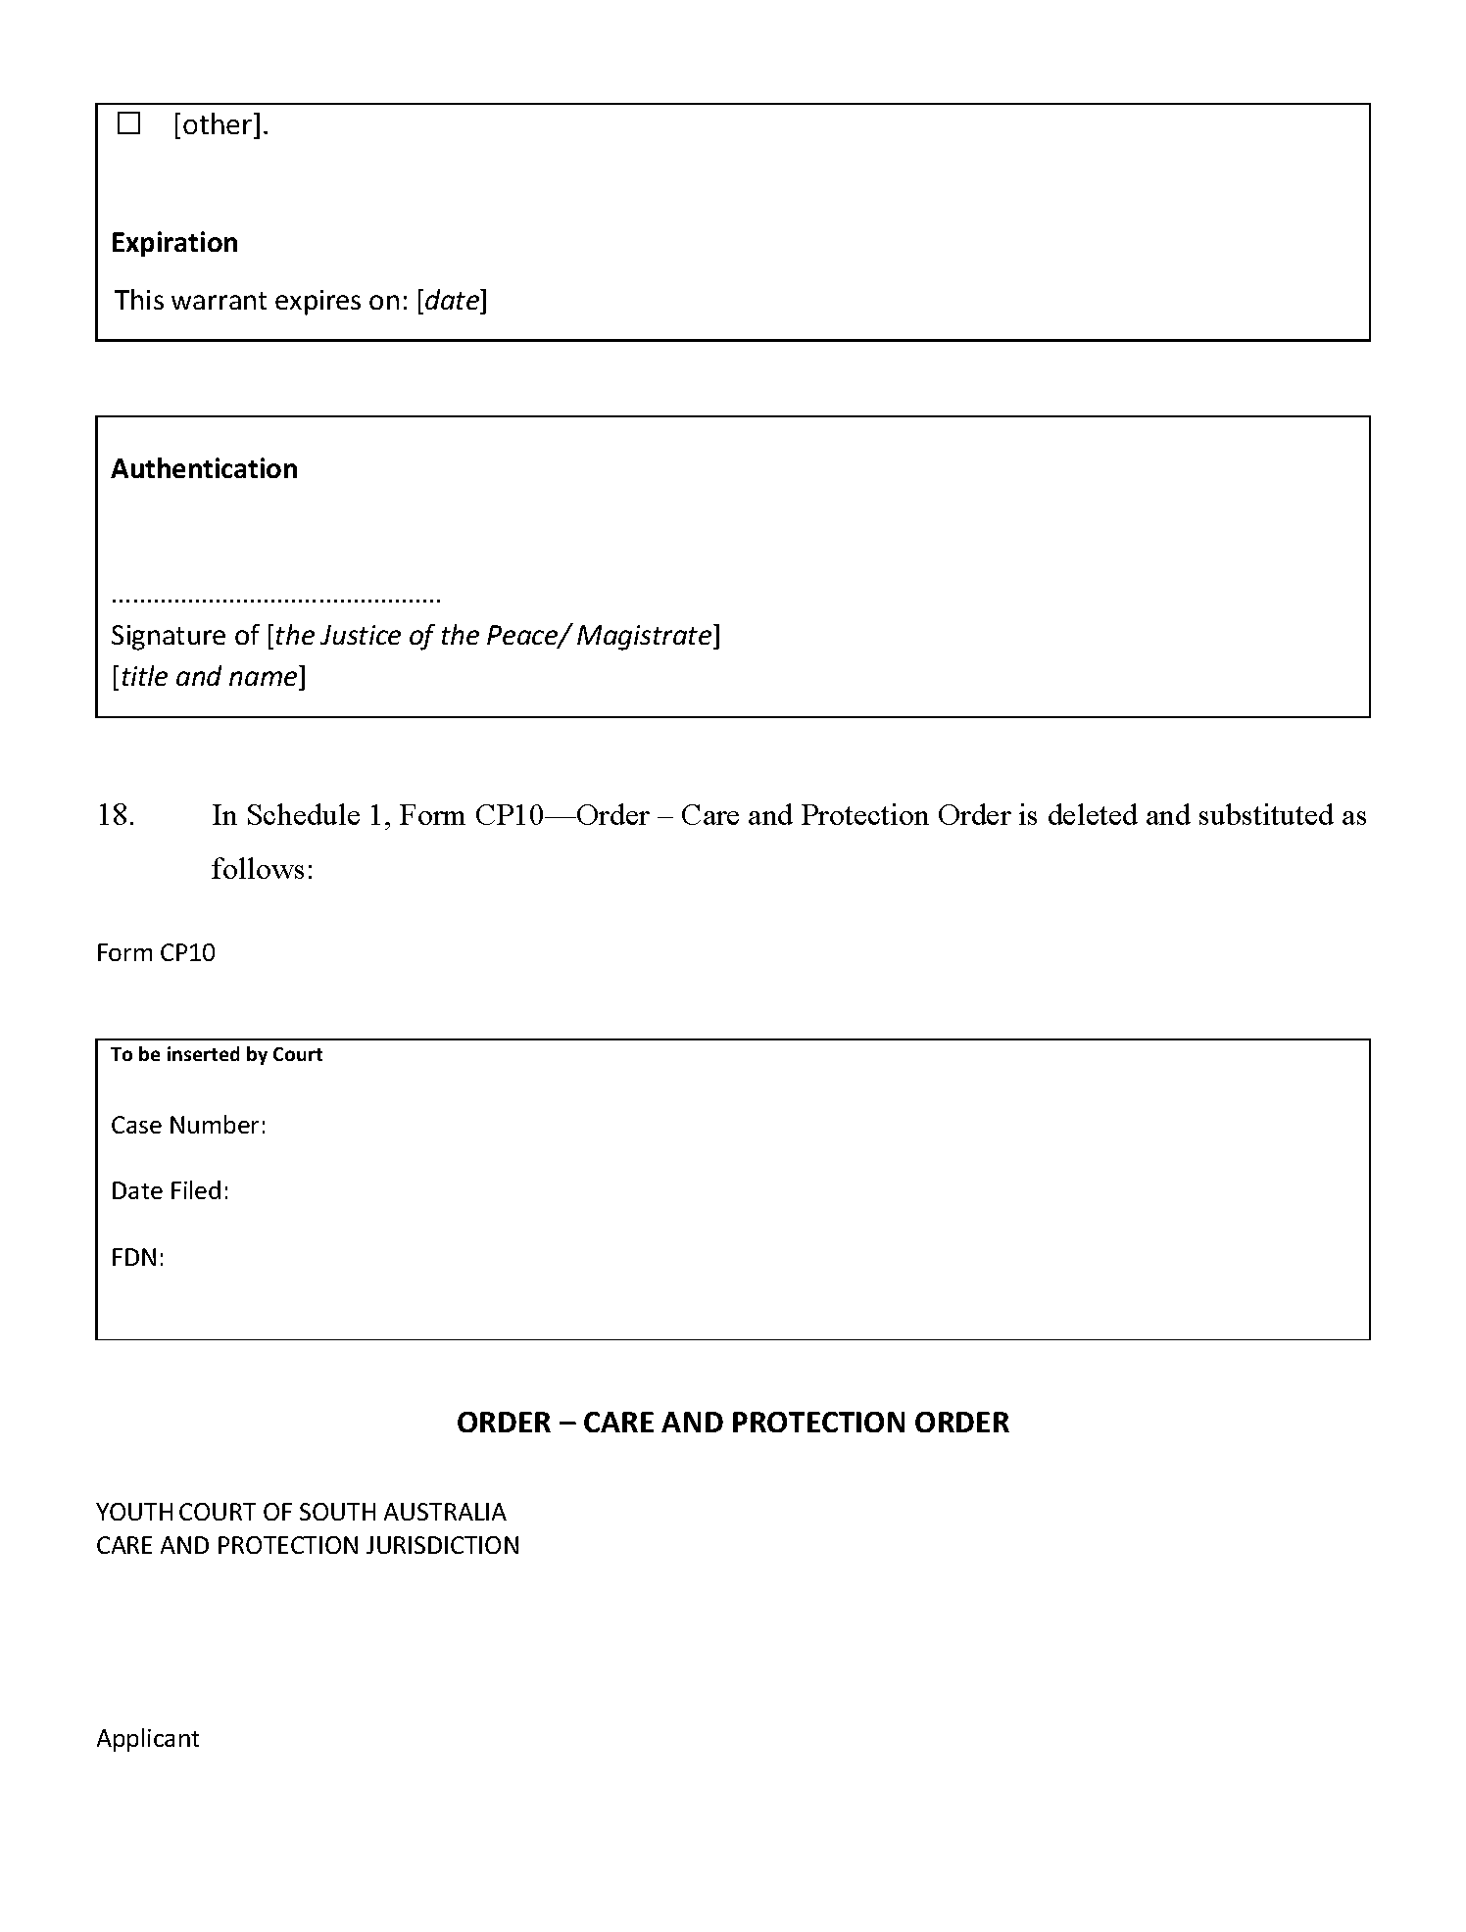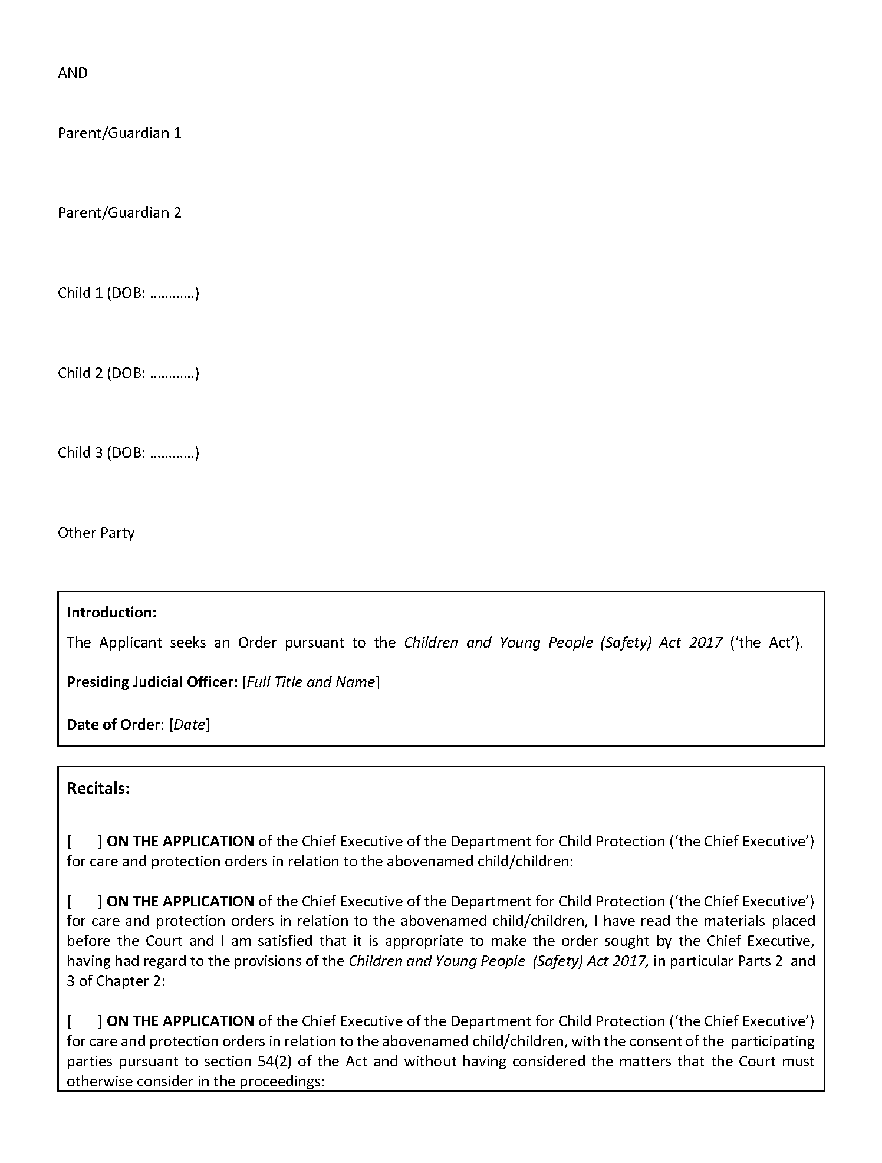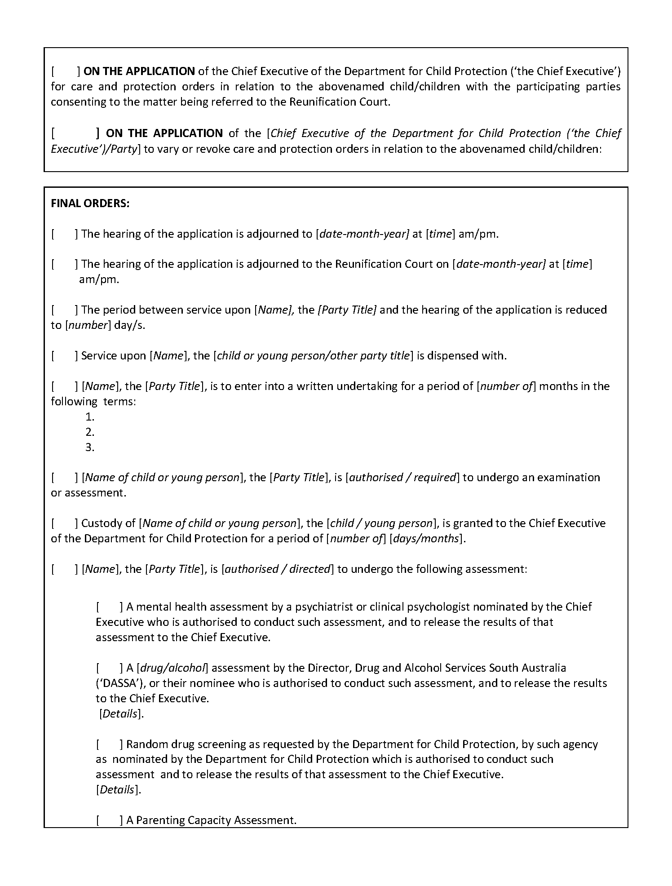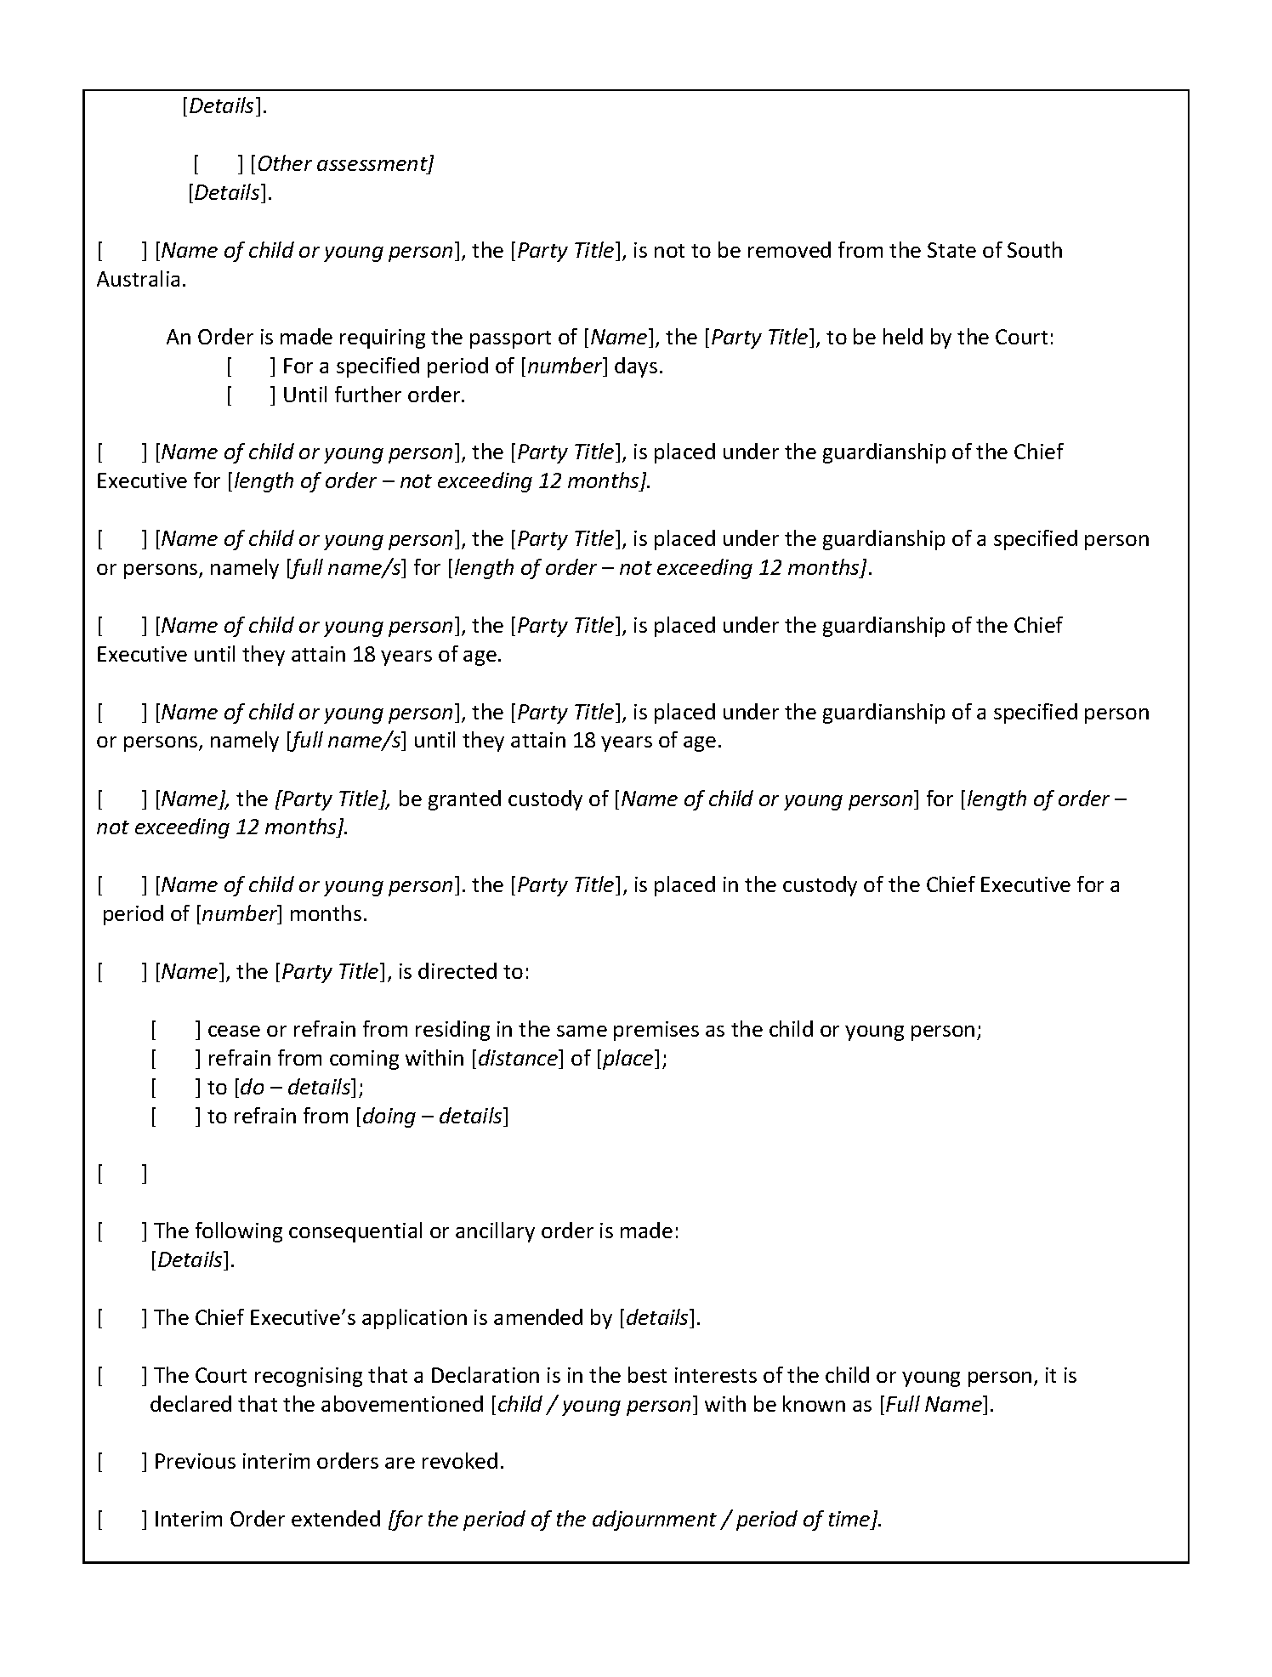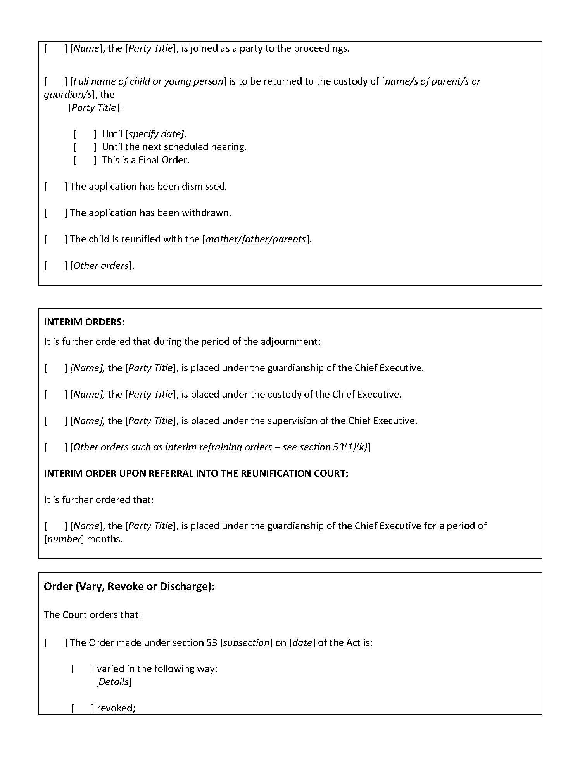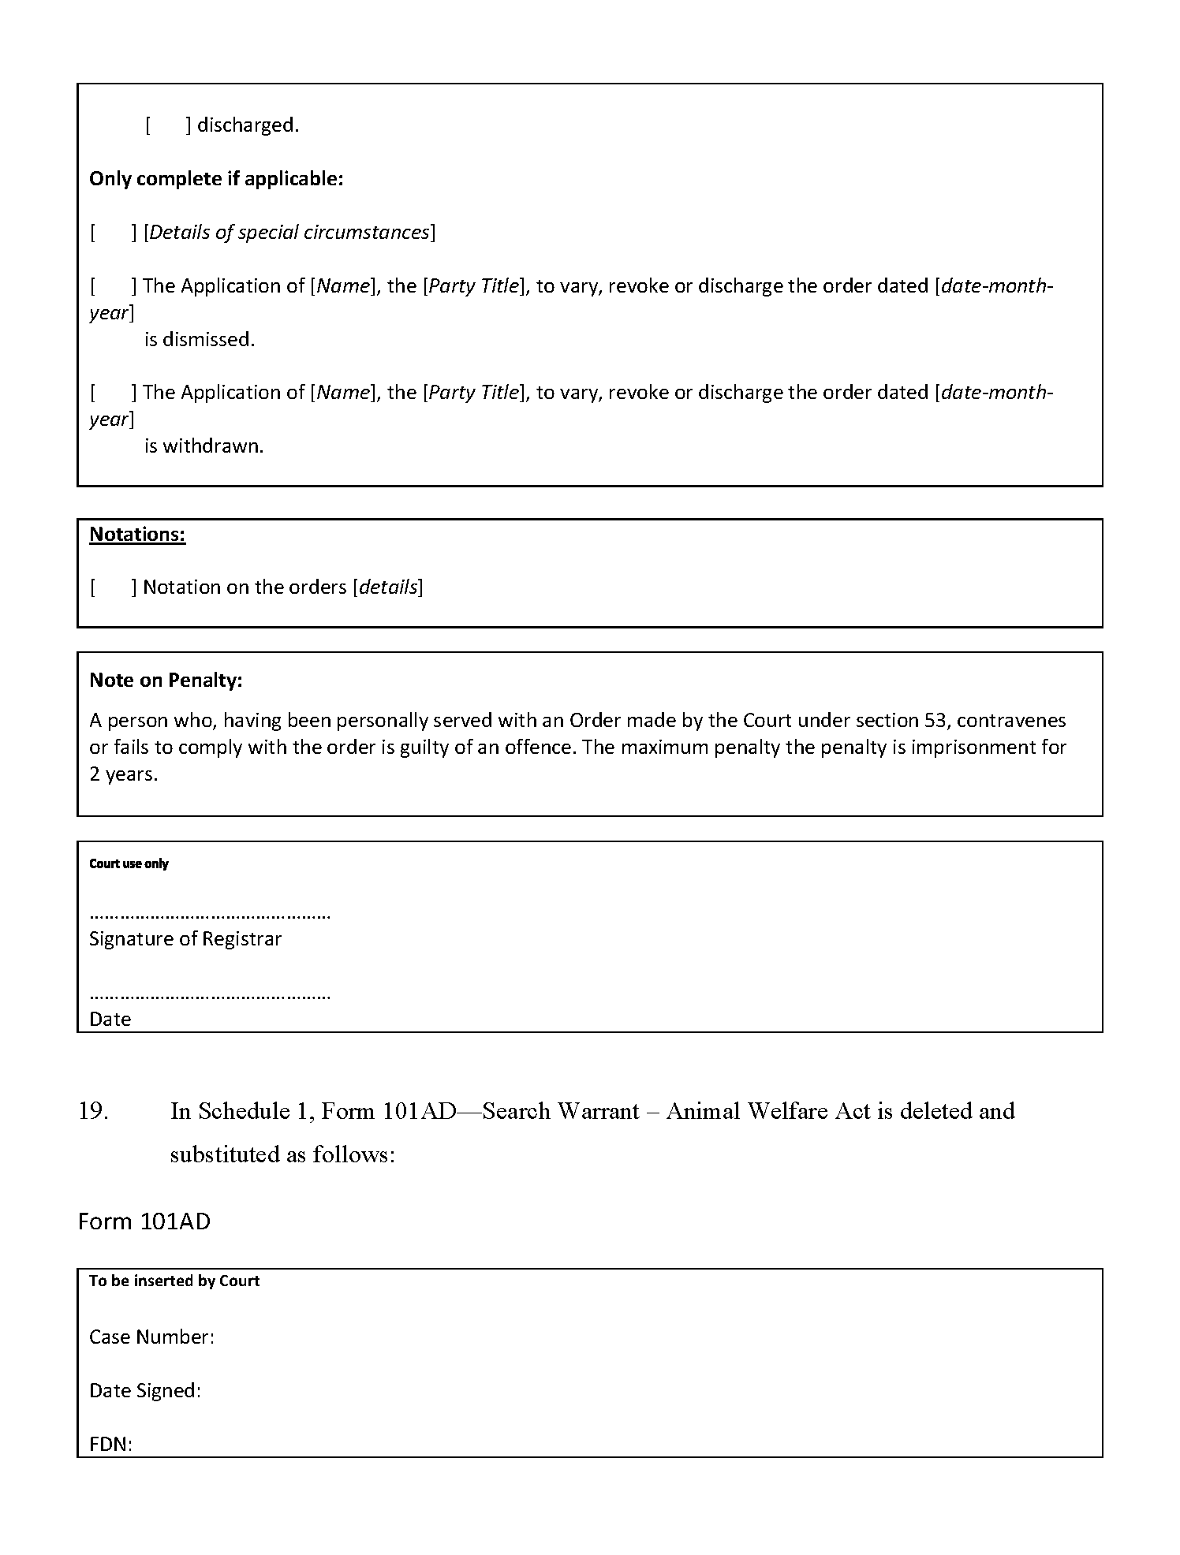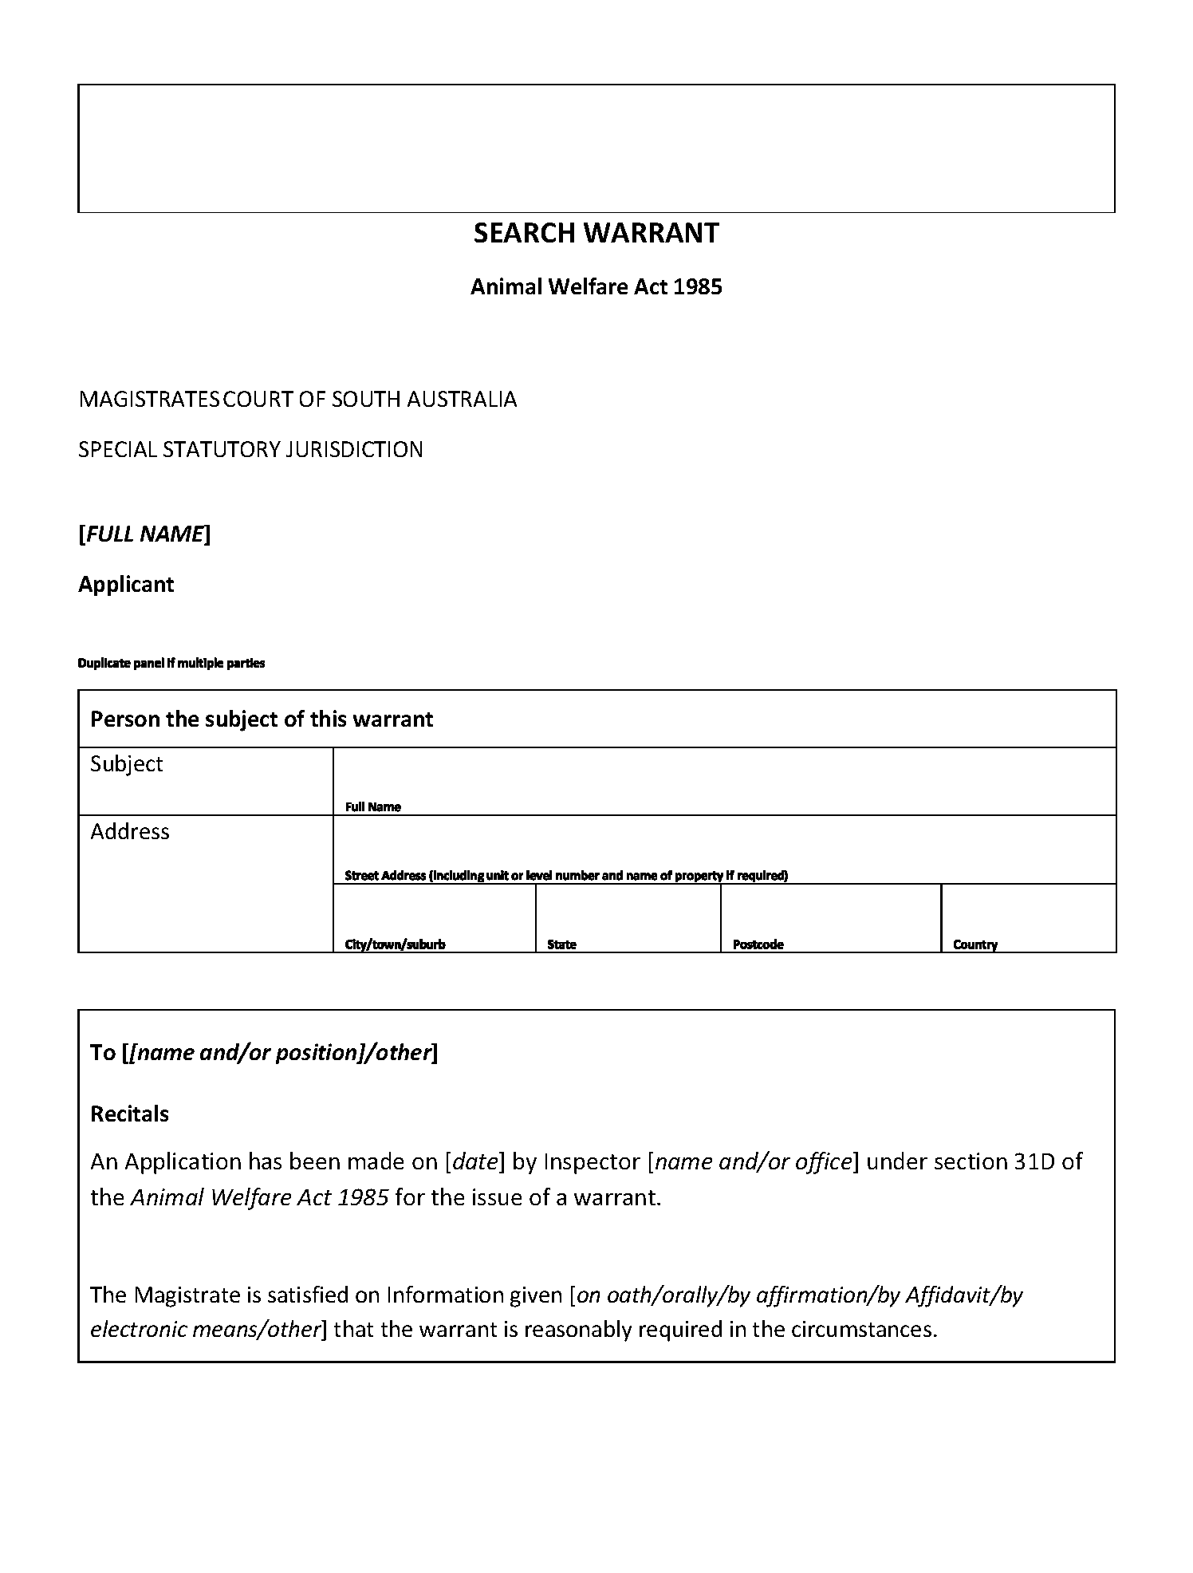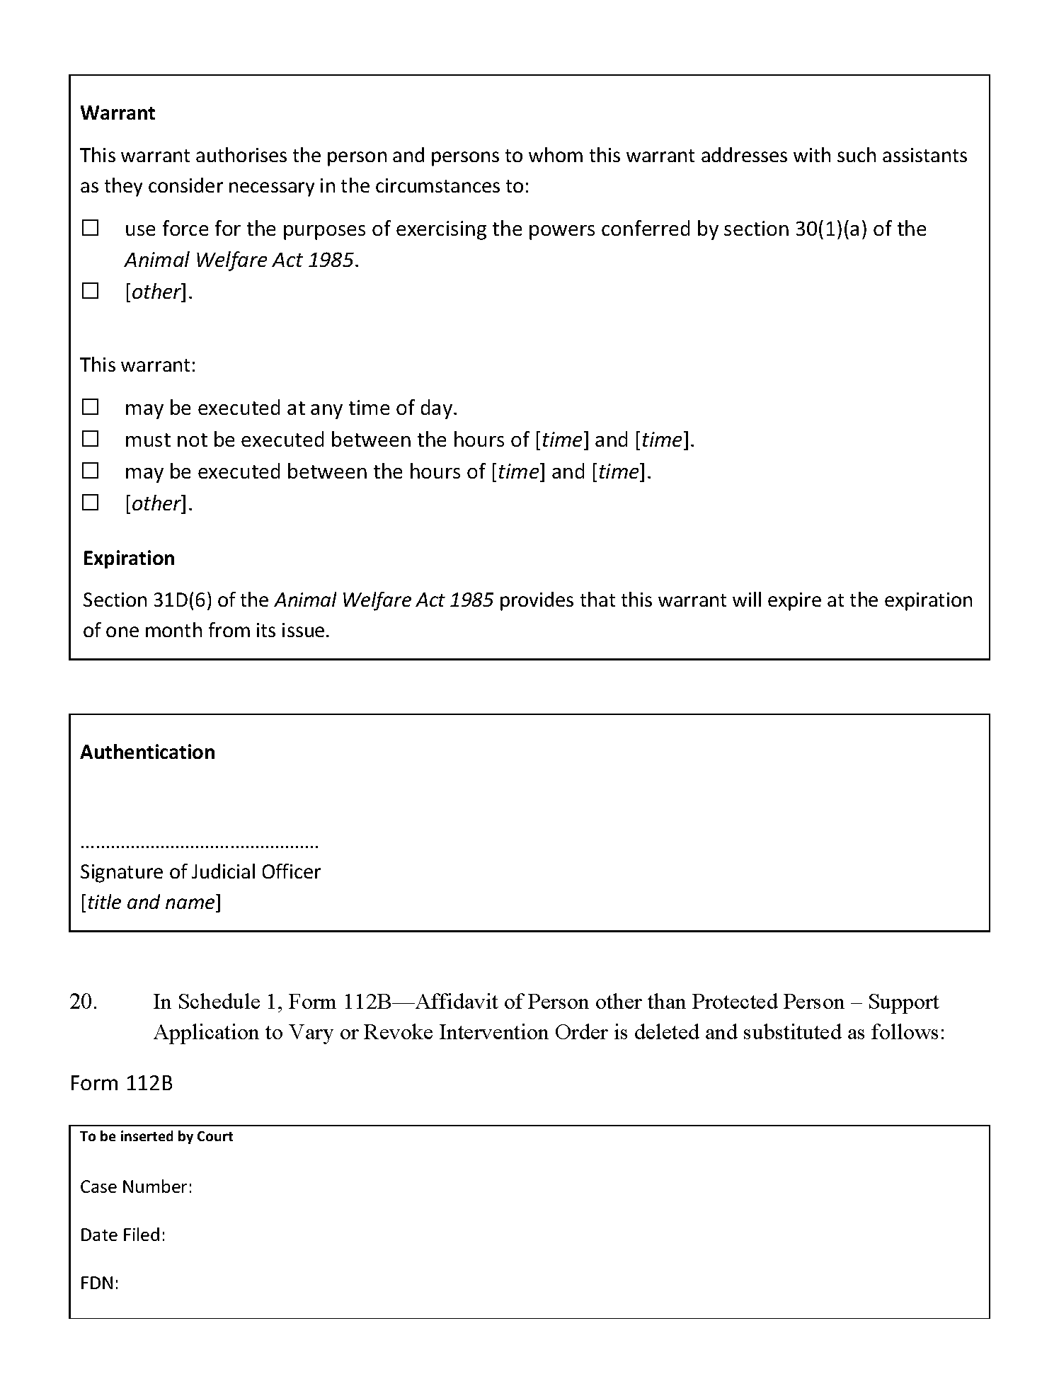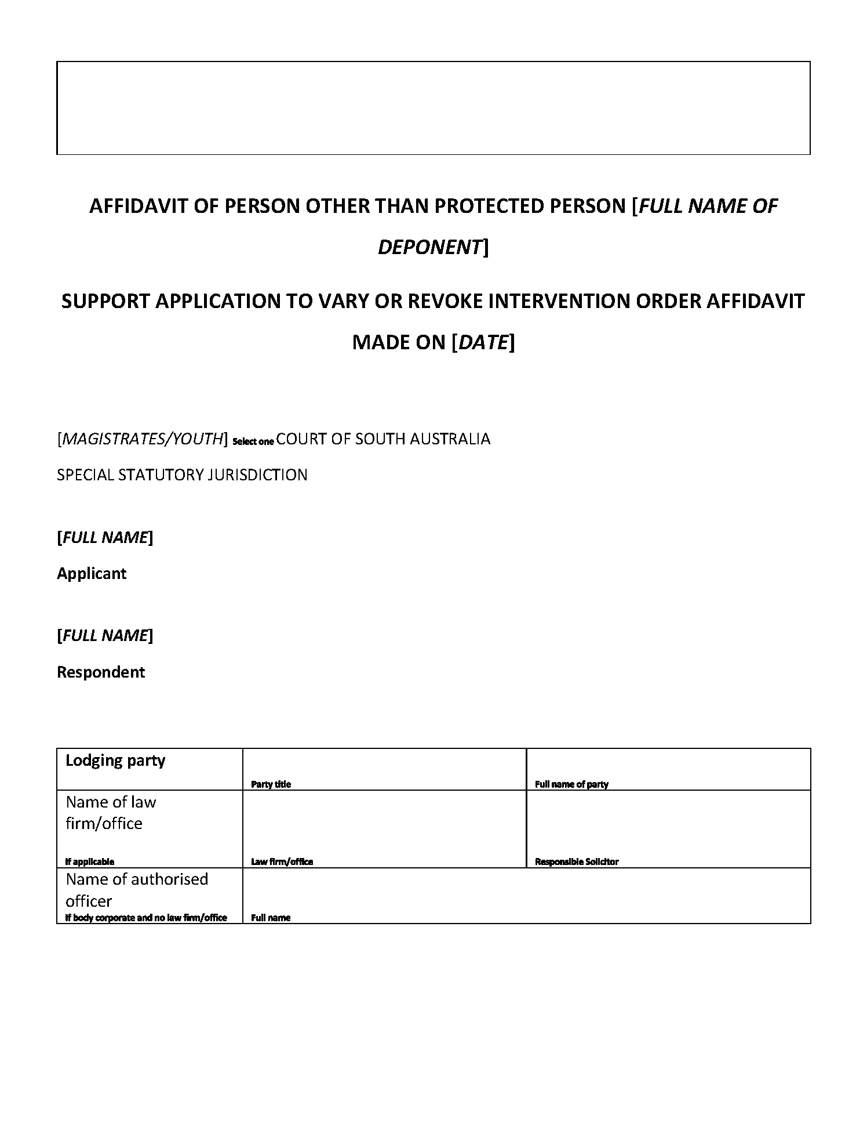

In accordance with the Supreme Court Act 1935, the District Court Act 1991, the Magistrates Court Act 1991 and the Youth Court Act 1993 and all other enabling powers, the Uniform Special Statutory Rules (No 2) Amending 2023 have been made –
- as rules of the Supreme Court by 3 or more Judges of the Supreme Court; and
- as rules of the District Court by the Chief Judge and 2 or more other Judges of that Court; and
- as rules of the Magistrates Court by the Chief Magistrate and 2 or more other Magistrates; and
- as rules of the Youth Court by the Judge and the magistrates who are members of the principal judiciary of that Court,
and such rules will apply to and in relation to the Court in accordance with their terms.
Dated this 11th day of December 2023.
Chief Justice Kourakis
Chief Judge Evans
Chief Magistrate Hribal
Judge Eldridge

State Government Instruments

LIVESTOCK ACT 1997
Section 33
Conditions for Entry of Livestock, Livestock Products and Other Property
into South Australia or a Specified Part of the State
Pursuant to Section 87 of the Livestock Act 1997, I, Elise Katherine Spark, deputy Chief Inspector of Stock, with delegated authority from the Minister for Primary Industries and Regional Development, revoke the notice made pursuant to Section 33 of the Livestock Act 1997 on 19 July 2023, published on 19 July 2023.
Pursuant to Section 33 of the Livestock Act 1997, I prohibit entry into the State, or the part of the State specified in bold in Column 2, of the Schedule hereto, the class of livestock, livestock products and/or other property specified in Column 1 of the Schedule subject to the conditions specified in Column 2 of the Schedule (or, if no conditions specified, then absolutely):
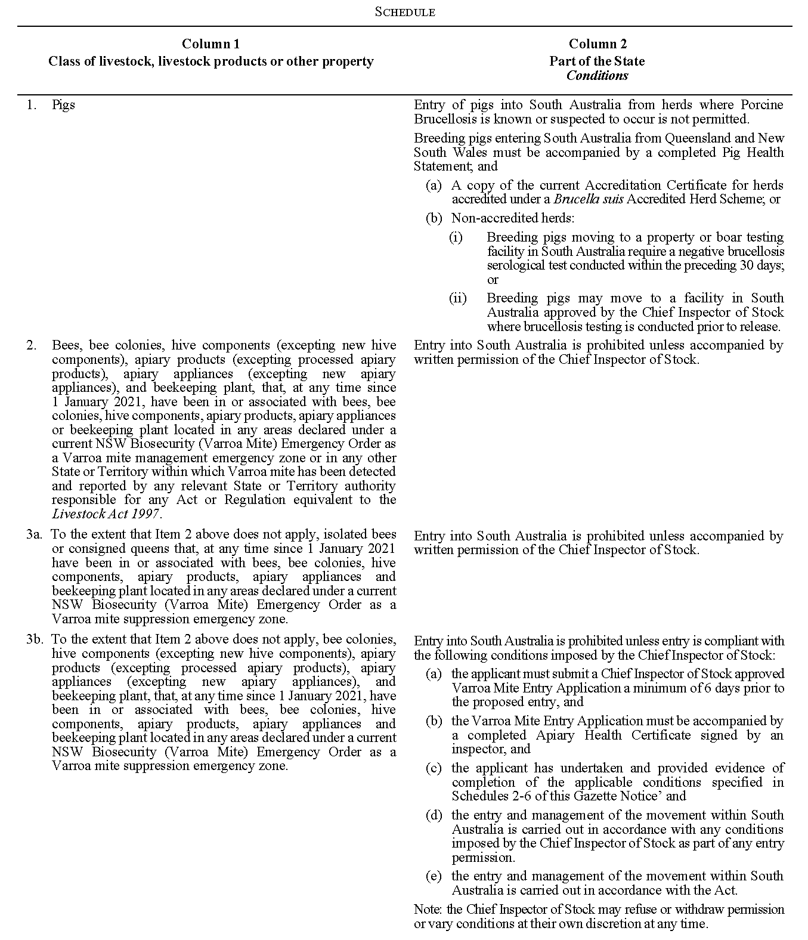
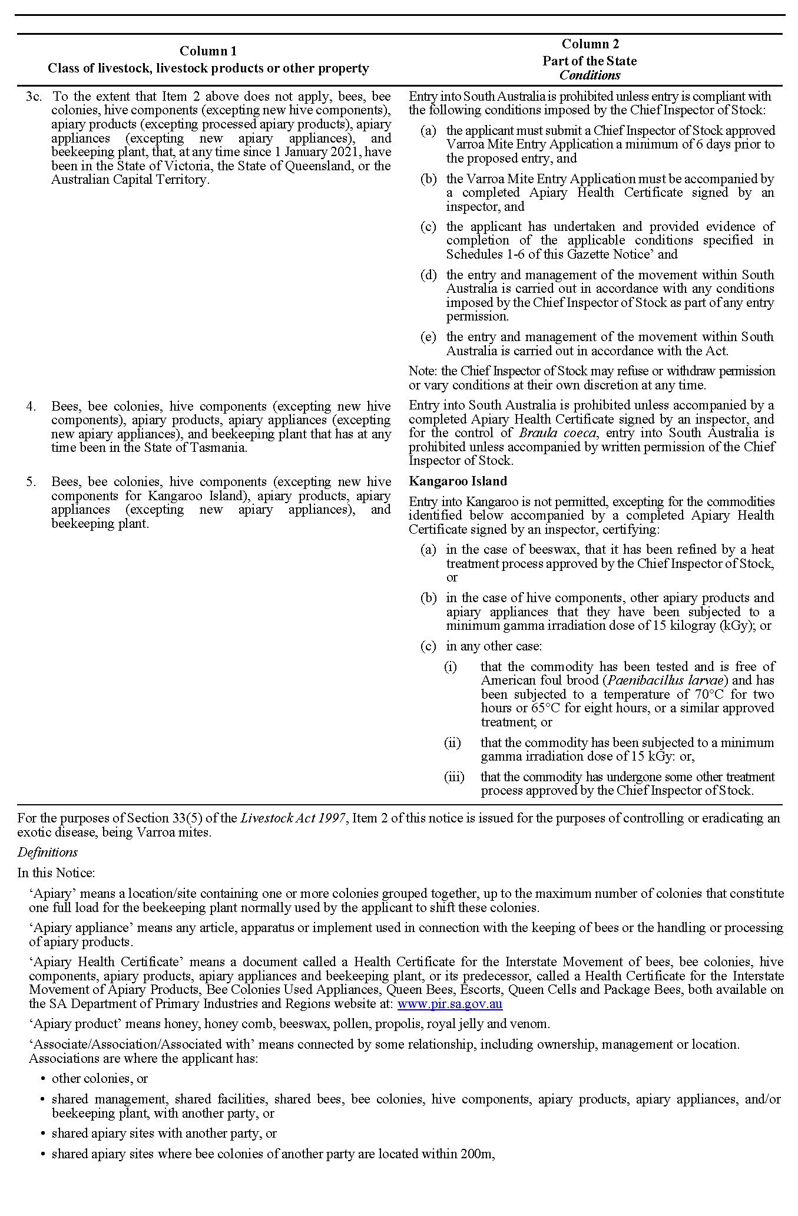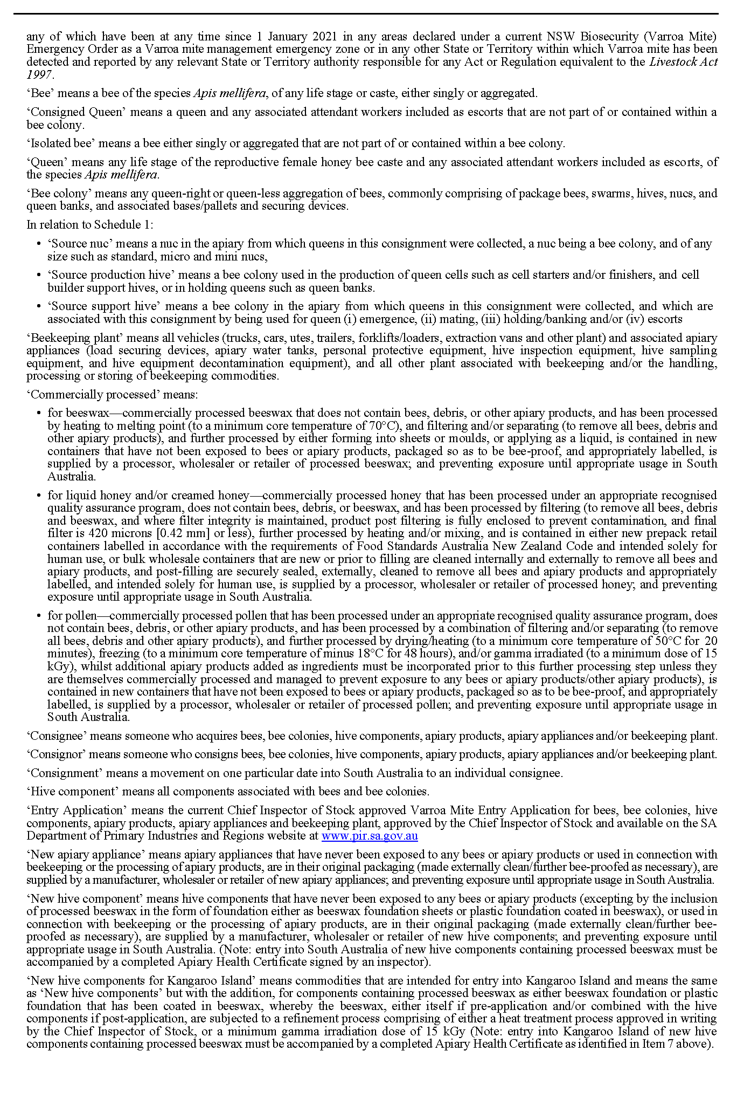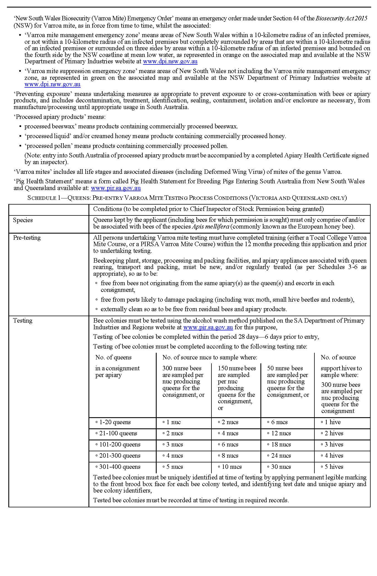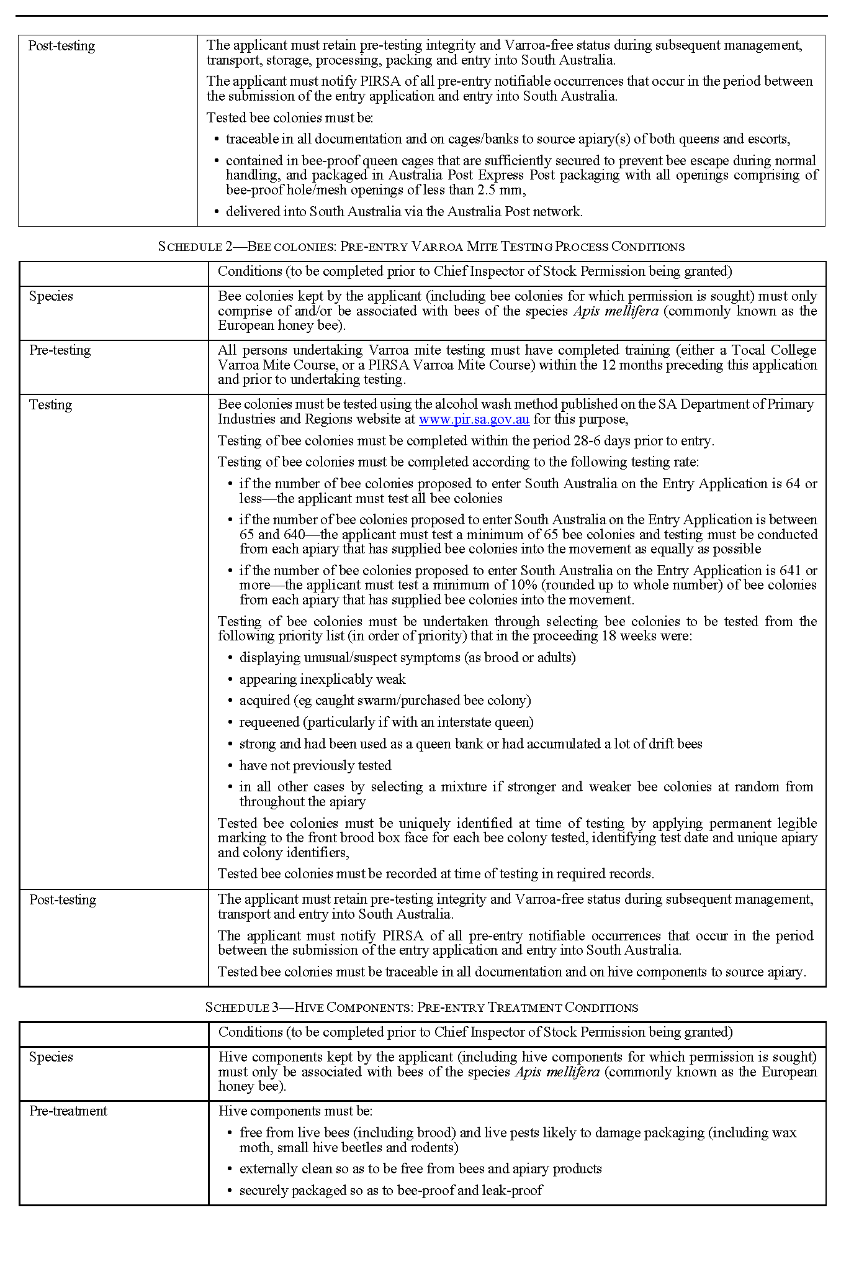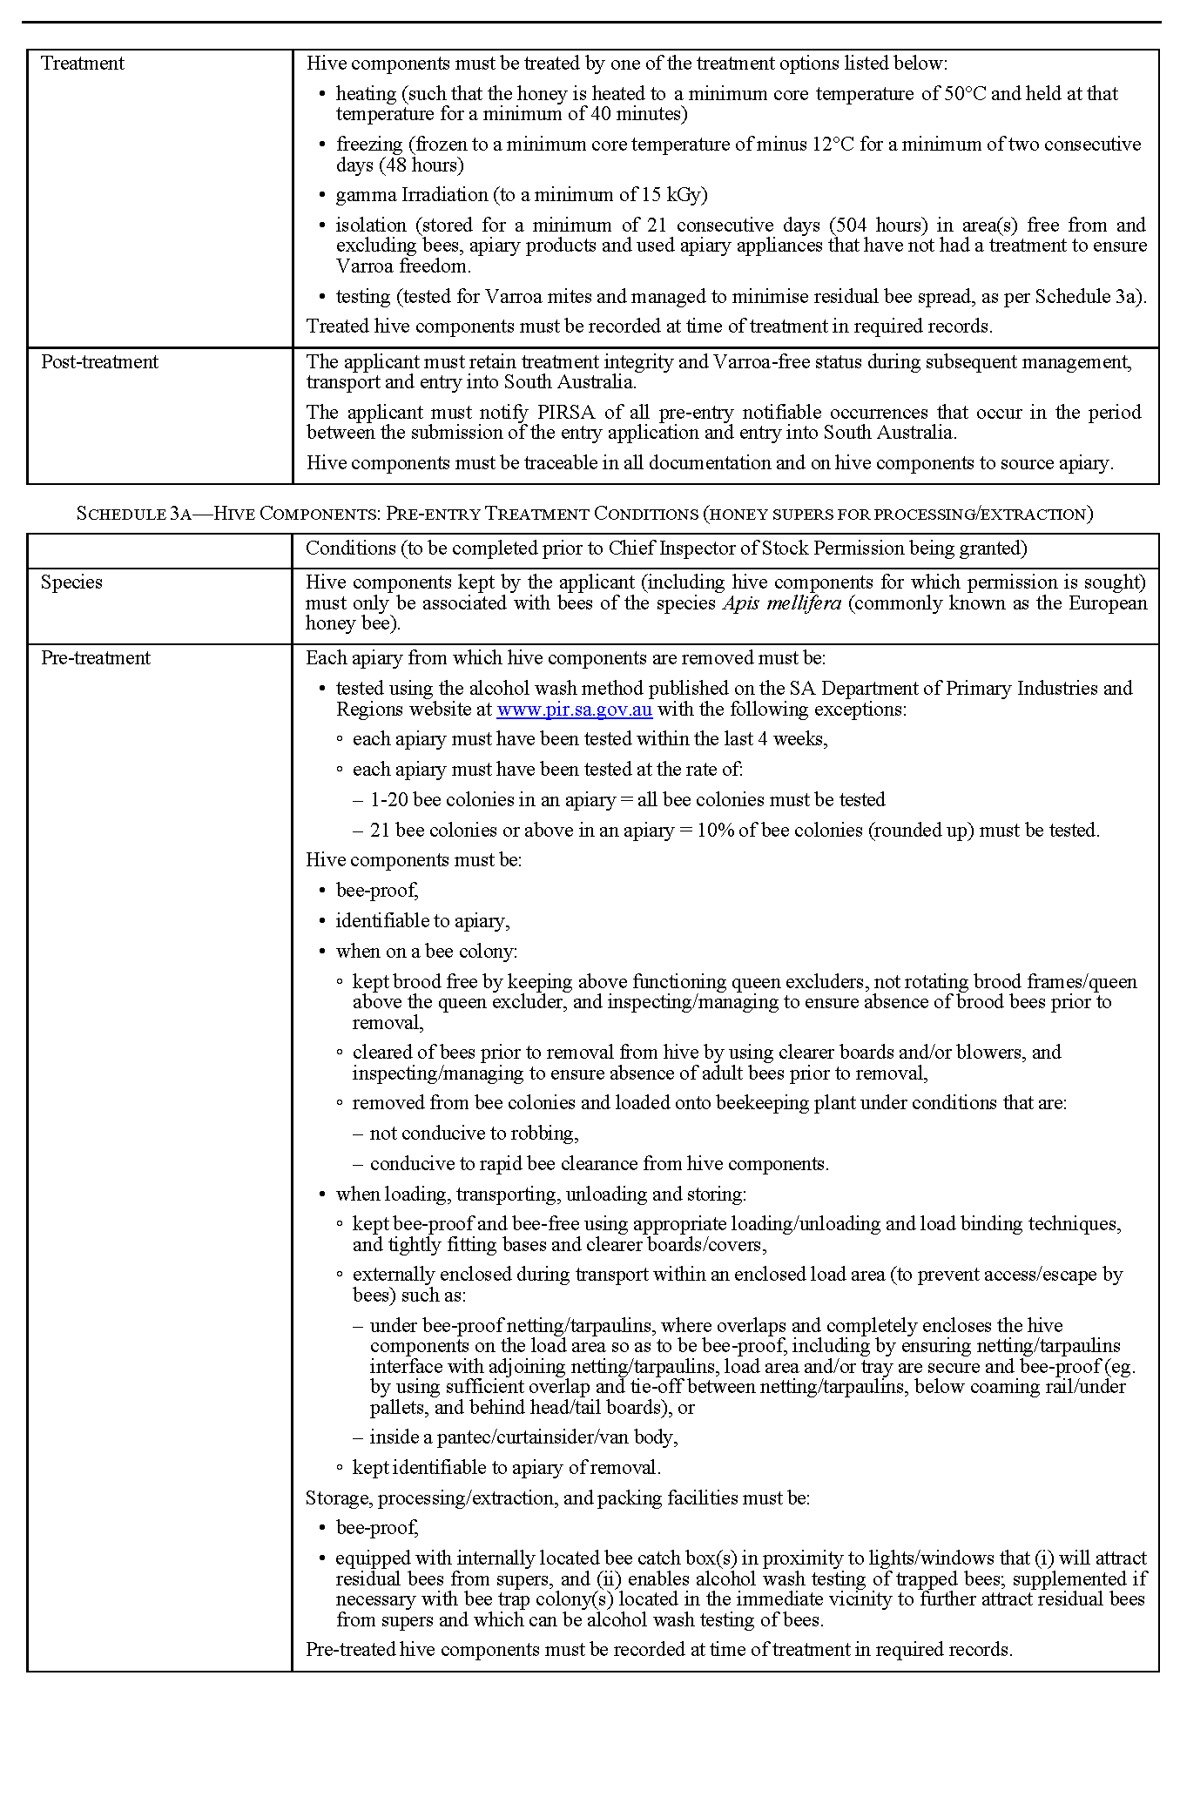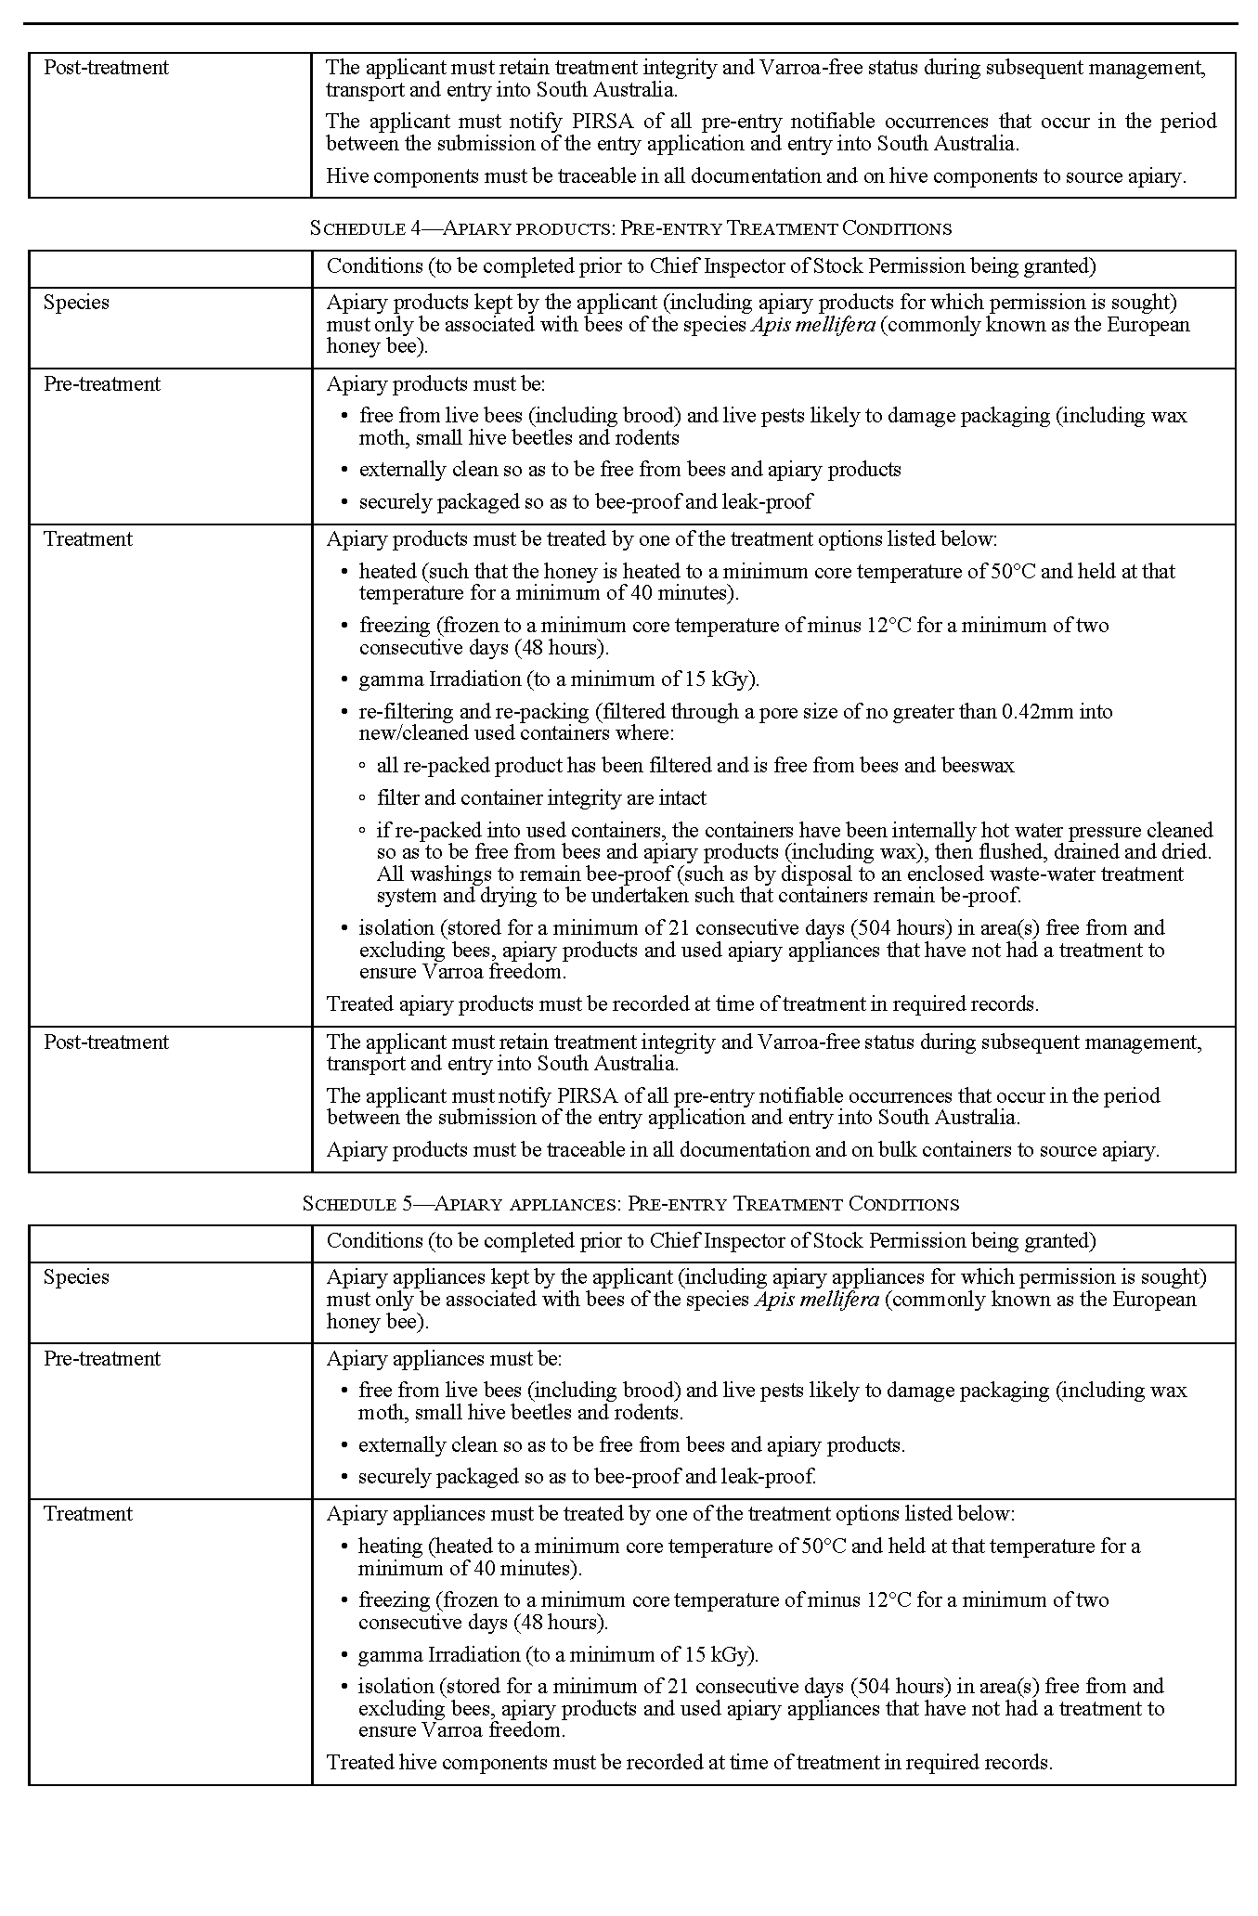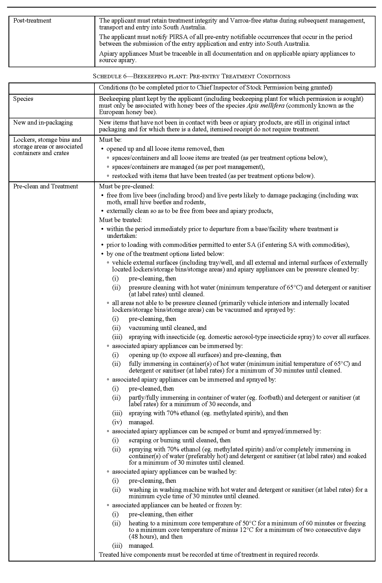
Copies of documents referred to in this notice may also be obtained from the Chief Inspector of Stock at 33 Flemington Street, Glenside SA 5065, or GPO Box 1671, Adelaide SA 5001 or by phone (08) 8207 7900.
Dated: 22 December 2023
Elise Katherine Spark
Deputy Chief Inspector of Stock
Delegate of the Minister for Primary Industries and Regional Development

Summary Offences Act 1953
Notice Of Ministerial Declaration
Declared Public Precincts
I, KYAM JOSEPH MAHER, Attorney-General in the State of South Australia, being the Minister responsible for the administration of Part 14B – Declared Public Precincts of the Summary Offences Act 1953, DO HEREBY DECLARE pursuant to the provisions of section 66N of the said Act that the area, comprised of more than one public place, within the following boundaries:
- Northern boundary of North Terrace to western boundary of Montefiore Road; and
- Western Boundary of Montefiore Road to the Southern Bank of the River Torrens.
- Southern bank of the River Torrens to eastern boundary of King William Road (adjacent to the King William Road Bridge);
- Eastern boundary of King William Road to the northern boundary of Victoria Drive.
- Northern Boundary of Victoria Drive to the Eastern Boundary of Kintore Avenue.
- The Eastern Boundary of Kintore Avenue to the Northern boundary of North Terrace.
- Northern boundary of North Terrace to the Eastern Boundary of Pulteney Street.
- Eastern Boundary of Pulteney Street to the Southern Boundary of Grenfell Street.
- Southern boundary of Grenfell Street and Currie Streets to the Western boundary of West Terrace; and
- Western boundary of West Terrace to northern boundary of North Terrace
will be a declared public precinct for a period of 8 hours from 10.00pm on Sunday 31 December 2023 to 6.00am Monday 1 January 2024.
This variation period combined with the current Declaration made 9 October 2023 combines a total of 20 hours in one 24 hour period. I am satisfied that special circumstances exist in this particular case to allow the extra hours.
References to boundaries identified by streets, roads or terraces for the purpose of this declaration will be taken to mean and include the area up to applicable building or fence lines, or the imagined projection thereof, on the relevant boundary.
I am satisfied that there is, during the period specified in this declaration, a reasonable likelihood of conduct in the area posing a risk to public order and safety.
I am satisfied that the inclusion of each public place in the area is reasonable having regard to that identified risk.
Dated: 22 December 2023
Kyam Joseph Maher
Attorney-General

Map
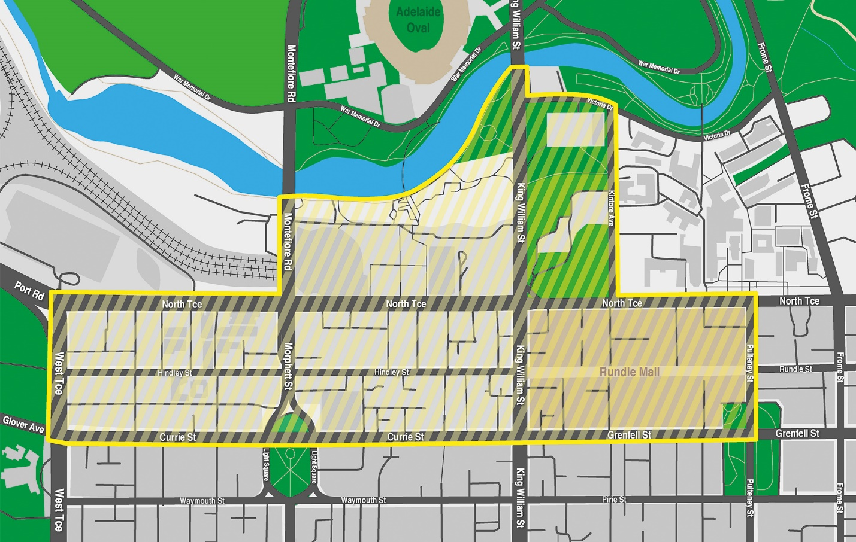

All instruments appearing in this gazette are to be considered official, and obeyed as such

Printed and published weekly by authority of M. Dowling, Government Printer, South Australia
$8.55 per issue (plus postage), $430.00 per annual subscription—GST inclusive
Online publications: www.governmentgazette.sa.gov.au

