No. 12 p. 363
THE SOUTH AUSTRALIAN
GOVERNMENT GAZETTE
Published by Authority

Adelaide, Thursday, 16 February 2023

Contents

State Government Instruments
Boxing and Martial Arts Act 2000 364
Dog Fence Act 1946 364
Education and Children’s Services Regulations 2020 365
Fisheries Management Act 2007 366
Geographical Names Act 1991 367
Justices of the Peace Act 2005 367
Land Acquisition Act 1969 368
Local Government (Elections) Regulations 2010 369
Major Events Act 2013 369
Mining Act 1971 371
New Women’s and Children’s Hospital Act 2022 371
Planning, Development and Infrastructure Act 2016 371
Public Finance and Audit Act 1987 372
Retirement Villages Act 2016 376
Roads (Opening and Closing) Act 1991 376
South Australian Skills Act 2008 376
Summary Offences Act 1953 377
Local Government Instruments
City of Burnside 379
City of Campbelltown 379
City of Port Adelaide Enfield 379
City of Prospect 379
City of Tea Tree Gully 379
City of Whyalla 379
District Council of Ceduna 388
District Council of Franklin Harbour 388
Regional Council of Goyder 398
District Council of Mount Remarkable 398
Renmark Paringa Council 399
District Council of Tumby Bay 399
Wakefield Regional Council 399
Public Notices
Trustee Act 1936 400

State Government Instruments

Boxing and Martial Arts Act 2000
Notice of Exemption
TAKE NOTICE that pursuant to section 17 of the Boxing and Martial Arts Act 2000, I Kylie Taylor, Chief Executive of the Office for Recreation, Sport and Racing, as delegate for the Minister for Recreation, Sport and Racing to whom the administration of the Boxing and Martial Arts Act 2000 is committed, have exempt the contestants of Historical European Martial Arts competition and medieval battle demonstrations from sections 11 and 14 of the Act for the purposes of APEX Sport Fest 2023 to be held on 25 February 2023.
Dated:10 February 2023
KYLIE TAYLOR
Chief Executive, Office for Recreation, Sport and Racing
as delegate for the Minister for Recreation, Sport and Racing

Boxing and Martial Arts Act 2000
Notice of Rules
TAKE NOTICE that pursuant to section 10 of the Boxing and Martial Arts Act 2000, I Kylie Taylor, Chief Executive of the Office for Recreation, Sport and Racing, as delegate for the Minister for Recreation, Sport and Racing to whom the administration of the Boxing and Martial Arts Act 2000 is committed, have approved the rules applicable to the conduct of boxing events to commence operation on this date of publication.
The approved rules are set out below.
Dated: 10 February 2023
Kylie Taylor
Chief Executive, Office for Recreation, Sport and Racing
as delegate for the Minister for Recreation, Sport and Racing

Australian National Boxing Federation – Rules and Regulations – 24 August 2022.

Boxing and Martial Arts Act 2000
Revocation of Rules
TAKE NOTICE that pursuant to section 10 of the Boxing and Martial Arts Act 2000, I Kylie Taylor, Chief Executive of the Office for Recreation, Sport and Racing, as delegate for the Minister for Recreation, Sport and Racing to whom the administration of the Boxing and Martial Arts Act 2000 is committed, have revoked the rules applicable to the conduct of boxing events to cease operation on this date of publication.
The revoked rules are set out below.
Dated: 10 February 2023
Kylie Taylor
Chief Executive, Office for Recreation, Sport and Racing
as delegate for the Minister for Recreation, Sport and Racing

Australian National Boxing Federation Rules and Regulations 15 March 2019.

Dog Fence Act 1946
Section 35C
Local Dog Fence Board Membership
PURSUANT to the provision of Section 35C of the Dog Fence Act 1946, on the recommendation of the Dog Fence Board, I vary the proclamation made under that Act on 2 October 1975 (see Gazette 2 October 1975 p. 1819), as varied-
- by striking out from the list of names under the heading Frome Local Dog Fence Board in the Second Schedule “Michael Goldsworthy”
- by adding to the list of names under the heading Marree Local Dog Fence Board in the Second Schedule “Donald Fels”
Dated: 14 February 2023
Hon Clare Scriven MLC
Minister for Primary Industries and Regional Development

Dog Fence Act 1946
Section 35C
Variation of powers and duties of a local board established by proclamation under section 35A
Pursuant to section 35C of the Dog Fence Act 1946, on the recommendation of the Dog Fence Board, I vary the proclamation made under that Act on 2 October 1975 (see Gazette 20 October 1975 p.1819 - 1822), as varied, by deleting subparagraph 6(1) under the heading General Powers and Duties and substituting -
- (1) A Local Board shall have and shall exercise the following powers and duties in relation to that part of the dog fence within the area of that Local Board:
- the powers and duties of an owner as specified in subsection (1) of Section 22 of the said Act; and
- controlling or destroying feral animals in the vicinity of the dog fence where necessary for the purpose of maintaining the fence or making it dog-proof, namely pest or feral:
- Cat (Felis catus)
- Donkey (Equus asinus)
- Horse (Equus caballus)
- Mule (Equus caballus x E. asinus)
- Camel (Camelus dromedarius)
- Cow (Bos spp.)
- Fox (Vulpes vulpes)
- Rabbit (Oryctolagus cuniculus)
- Goat (Capra hircus)
- Pig (Sus scrofa)
Dated: 14 February 2023
Hon Clare Scriven MLC
Minister for Primary Industries and Regional Development

Education and Children’s Services Regulations 2020
Notice of Policy by the Minister for Education, Training and Skills
PURSUANT to Regulation 12(1) of the Education and Children’s Services Regulations 2020, I, the Minister for Education, Training and Skills publish a policy for the purposes of the enrolment of a child at Roma Mitchell Secondary College on or after 1 May 2023:
SCHOOL ZONE
Roma Mitchell Secondary College
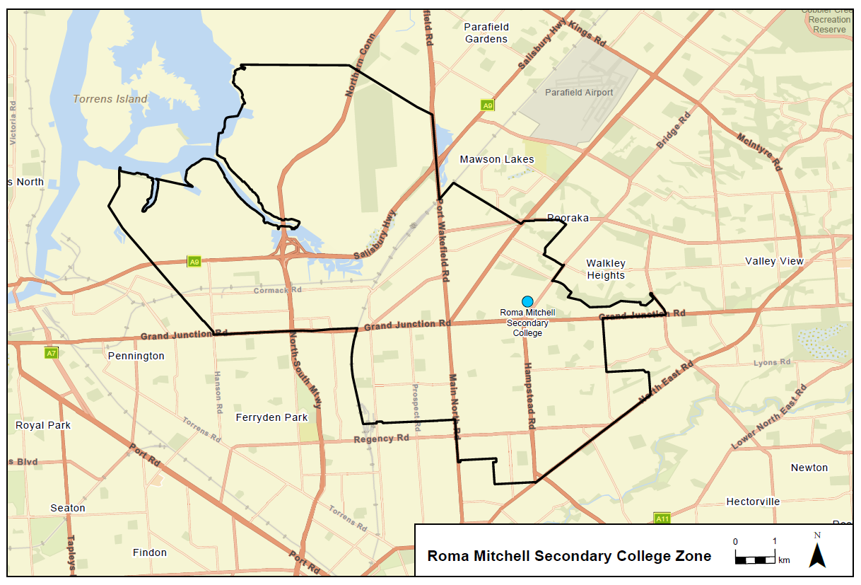
A school zone is a defined area from which the school accepts its core intake of students. The school zone for Roma Mitchell Secondary College is within the area bordered by the black line on the map below. Students residing within this zone are eligible to be enrolled at Roma Mitchell Secondary College and will be given priority enrolment.
An online map of the Roma Mitchell Secondary College zone and a search tool to indicate if a home address is within the school zone is available at www.education.sa.gov.au/findaschool.
Information on enrolment and placement in school is available from www.education.sa.gov.au/enrolment.
Dated: 3 February 2023
Blair Boyer
Minister for Education, Training and Skills

Education and Children’s Services Regulations 2020
Notice of Revocation of Policy by the Minister for Education, Training and Skills
PURSUANT to Regulation 12(3) of the Education and Children’s Services Regulations 2020, I, the Minister for Education, Training and Skills revoke the Norwood International High School Capacity Management Plan, published in the Gazette on 30 June 2022, effective 1 May 2023.
Dated: 3 February 2023
Blair Boyer
Minister for Education, Training and Skills

Education and Children’s Services Regulations 2020
Notice of Revocation of Policy by the Minister for Education, Training and Skills
PURSUANT to Regulation 12(3) of the Education and Children’s Services Regulations 2020, I, the Minister for Education, Training and Skills revoke the Roma Mitchell Secondary College Capacity Management Plan, published in the Gazette on 10 December 2020, effective 1 May 2023.
Dated: 3 February 2023
Blair Boyer
Minister for Education, Training and Skills

FISHERIES MANAGEMENT ACT 2007
Section 115
Exemption No. ME990324
TAKE NOTICE that pursuant to section 115 of the Fisheries Management Act 2007, I Prof Gavin Begg, Executive Director Fisheries and Aquaculture, delegate of the Minister of Primary Industries and Regional Development, hereby declare that holders of a Commonwealth concession issued under the Fisheries Management Act 1991 (Cwth) (the ‘exemption holder’) are exempt from the provisions contained in the declaration made under section 79 of the Fisheries Management Act 2007, dated 20 January 2023, and published in the South Australian Government Gazette on 25 January 2023 being the first notice published on page 90, but only insofar as the exemption holders may possess Snapper (Chrysophrys auratus) on a fishing vessel that may be used under their Commonwealth concession (the 'exempted activity'), subject to the conditions set out in Schedule 1 during the period specified in Schedule 2 unless varied or revoked earlier.
Schedule 1
- All Snapper in the exemption holder’s possession must have been taken lawfully in waters outside the Snapper closure area.
- At least one hour prior to travelling through any part of the Snapper closure area described in this notice, the exemption holder must, if in possession of Snapper, make a prior report to the Department of Primary Industries and Regions (PIRSA) via the Commercial Fishing SA App or Fishwatch on 1800 065 522 and must provide the Department the following information:
- The name of the person making the telephone call or providing the information via the App;
- Contact phone number of the person making the telephone call or providing the information via the App;
- The Commonwealth concession type and number;
- Name of vessel;
- Weight of Snapper on board;
- The time the boat will enter the Snapper closure area; and
- The point of landing.
- At least one hour prior to arrival at the point of landing in South Australia the exemption holder must, if in possession of Snapper, make a prior report to PIRSA via the Commercial Fishing SA App or Fishwatch (1800 065 522) of the time the boat will arrive at the nominated point of landing,
- The exemption holder must not delete or alter track logs recorded on electronic devices (e.g. Chart plotter, Global Positioning System) on board the boat for a period of 7 days after creating the track log if the boat has transited the Snapper closure area.
- While engaging in the exempted activity, the exemption holder must be in possession of a copy of this notice. This notice must be produced to a Fisheries Officer if requested
Schedule 2
From 0001 hours on 9 February 2023 until 2359 hours on 8 February 2024.
For the purpose of this Notice, the Snapper closure area includes:
Gulf St. Vincent and Kangaroo Island Fishing Zone - the waters of Gulf St. Vincent and surrounding waters contained within and bounded by a line commencing at Mean High Water Springs closest to 34°59'59.95" South, 136°58'07.73" East (Gleesons Landing, Yorke Peninsula), then beginning southerly following the line of Mean High Water Springs to the location closest to 35°38′26.13″ South, 138°07'28.73" East (southern Fleurieu Peninsula), then southerly to Mean High Water Springs closest to 35°48'07.14" South, 138°07'28.73" East (Cape St. Albans, Kangaroo Island), then beginning south-westerly following the line of Mean High Water Springs to the location closest to 35°59'59.95" South, 136°41'04.52" East (south-western Kangaroo Island), then westerly to 35°59'59.95" South, 136°00'00.03" East, then northerly to 35°29'59.95" South, 136°00'00.03" East, then easterly to 35°29'59.95" South, 136°40'12.03" East, then northerly to 34°59'59.95" South, 136°40'12.03" East, then easterly to the point of commencement.
West Coast Fishing Zone - the waters adjacent to the west coast of South Australia contained within and bounded by a line commencing at Mean High Water Springs closest to 31°41'16.13" South, 129°00'00.03" East (Western Australian-South Australian border), then beginning southerly following the line of Mean High Water Springs to the location closest to 33°59'59.90" South, 135°15'32.12" East (western Eyre Peninsula), then westerly to 33°59'59.95" South, 134°00'00.03" East, then southerly to 34°59'59.95" South, 134°00'00.03" East, then westerly to 34°59'59.95" South, 132°00'00.03" East, then northerly to 33°59'59.95" South, 132°00'00.03" East, then westerly to 33°59'59.95" South, 131°00'00.03" East, then northerly to 32°59'59.95" South, 131°00'00.03" East, then westerly to 32°59'59.95" South, 129°00'00.03" East, then northerly to the point of commencement.
Spencer Gulf Fishing Zone - the waters of Spencer Gulf and surrounding water contained within and bounded by a line commencing at Mean High Water Springs closest to 33°59'59.90" South, 135°15'32.12" East (western Eyre Peninsula), then beginning southerly following the line of Mean High Water Springs to the location closest to 34°59'59.95" South, 136°58'07.73" East (Gleesons Landing, Yorke Peninsula), then westerly to 34°59'59.95" South, 136°40'12.03" East, then southerly to 35°29'59.95" South, 136°40'12.03" East, then westerly to 35°29'59.95" South, 136°00'00.03" East, then southerly to 36°59'59.95" South, 136°00'00.03" East, then westerly to 36°59'59.95" South, 135°00'00.03" East, then northerly to 35°59'59.95" South, 135°00'00.03" East, then westerly to 35°59'59.95" South, 134°00'00.03" East, then northerly to 33°59'59.95" South, 134°00'00.03" East, then easterly to the point of commencement;
Port Adelaide River estuary - all waters of the Port Adelaide River estuary contained within and bounded by a line commencing at the line of Mean High Water Springs closest to 34°40′12.26″ South, 138°26′35.25″ East (end of Port Gawler Road), then beginning easterly following the line of Mean High Water Springs, including West Lakes, North Arm and tributaries, to the location closest to 34°46′59.03″ South, 138°28′40.48″ East, then north-westerly to the point of commencement, but excluding any land or waters so encompassed that lie landward of the line of Mean High Water Springs.
For the purpose of this notice all lines are geodesics based on the Geocentric Datum of Australia 2020 (GDA2020). GDA2020 has the same meaning as in the National Measurement (Recognized-Value Standard of Measurement of Position) Determination 2017 made under section 8A of the National Measurement Act 1960 of the Commonwealth. All co-ordinates are expressed in terms of GDA2020.
Dated: 8 February 2023
Prof. Gavin Begg
Executive Director
Fisheries and Aquaculture
Delegate of the Minister for Primary Industries and Regional Development

GEOGRAPHICAL NAMES ACT 1991
Notice of Intention to Alter the Boundaries of a Place and Assign a Name to a Place
NOTICE is hereby given that, pursuant to section 11B(2)(d) of the Geographical Names Act 1991, I, the Honourable Nick Champion MP, Minister for Planning, Minister of the Crown to whom the administration of the Geographical Names Act 1991 is committed, seeks public comment on a proposal to:
- Alter the suburb boundary to exclude from the suburb of HACKHAM that area marked (A) shown highlighted in green, as shown on the location map.
- Assign the name ONKAPARINGA HEIGHTS to that area marked (A).
A copy of the location maps for this naming proposal can be viewed at;
- the Office of the Surveyor-General, 83 Pirie Street, Adelaide
- www.sa.gov.au/placenameproposals
Submissions in writing regarding this proposal may be lodged with the Surveyor-General, GPO Box 1815, Adelaide SA 5001, or DTI.PlaceNames@sa.gov.au within one month of the publication of this notice.
Dated: 13 February 2023
Hon Nick Champion MP
Minister For Planning

Justices of the Peace Act 2005
Section 4
Notice of Appointment of Justices of the Peace for South Australia
by the Commissioner for Consumer Affairs
I, Dini Soulio, Commissioner for Consumer Affairs, delegate of the Attorney-General, pursuant to Section 4 of the Justices of the Peace Act 2005, do hereby appoint the people listed as Justices of the Peace for South Australia as set out below:
For a period of ten years for a term commencing on 21 February 2023 and expiring on 20 February 2033:
Walter Dieter WITTMANN
Robert John Keith SHEPHERD
David Peter NELSON
Barrie Malcolm MANSOM
Lawrence Lin Jar LIANG
Rosalie Helen FORTH
Maurice John Lloyd EASTON
John Alexander CROCI
Christopher William CLARK
Nicola CIROCCO
Gordon BURNELL
Bernadette BUHAGIAR
Debra May BRADLEY
Adam John BODZIOCH
Antonio BERLANGIERI
Janet Isabelle BARNETT
Paul Vincent BARBER
Peter Albert BALAZS
Dated: 9 February 2023
Dini Soulio
Commissioner for Consumer Affairs
Delegate of the Attorney-General

Land Acquisition Act 1969
Section 16
Form 5—Notice of Acquisition
1. Notice of acquisition
The Commissioner of Highways (the Authority), of 83 Pirie Street, Adelaide SA 5000, acquires the following interests in the following land:
Comprising an unencumbered estate in fee simple in that piece of land being portion of Allotment 10 Town of Yunta out of Hundreds (Olary) comprised in Certificate of Title Volume 5831 Folio 755 and being the whole of the land identified as Allotment 51 in D131088 lodged in the Lands Titles Office.
This notice is given under section 16 of the Land Acquisition Act 1969.
2. Compensation
A person who has or had an interest consisting of native title or an alienable interest in the land that is divested or diminished by the acquisition or the enjoyment of which is adversely affected by the acquisition who does not receive an offer of compensation from the Authority may apply to the Authority for compensation.
2A. Payment of professional costs relating to acquisition (section 26B)
If you are the owner in fee simple of the land to which this notice relates, you may be entitled to a payment of up to $10 000 from the Authority for use towards the payment of professional costs in relation to the acquisition of the land.
Professional costs include legal costs, valuation costs and any other costs prescribed by the Land Acquisition Regulations 2019.
3. Inquiries
Inquiries should be directed to: Daniel Tuk
GPO Box 1533
Adelaide SA 5001
Telephone: (08) 7133 2479
Dated: 14 February 2023
The Common Seal of the COMMISSIONER OF HIGHWAYS was hereto affixed by authority of the Commissioner in the presence of:
Rocco Caruso
Manager, Property Acquisition (Authorised Officer)
Department for Infrastructure and Transport
DIT 2022/04549/01

Land Acquisition Act 1969
Section 16
Form 5—Notice of Acquisition
1. Notice of acquisition
The Commissioner of Highways (the Authority), of 83 Pirie Street, Adelaide SA 5000, acquires the following interests in the following land:
Comprising an unencumbered estate in fee simple in that piece of land being portion of Allotment 54 Town of Whyte-Yarcowie in the Area Named Whyte-Yarcowie in Hundred of Whyte comprised in Certificate of Title Volume 5485 Folio 492 and being the whole of the land identified as Allotment 11 in D131087 lodged in the Lands Titles Office.
This notice is given under section 16 of the Land Acquisition Act 1969.
2. Compensation
A person who has or had an interest consisting of native title or an alienable interest in the land that is divested or diminished by the acquisition or the enjoyment of which is adversely affected by the acquisition who does not receive an offer of compensation from the Authority may apply to the Authority for compensation.
2A. Payment of professional costs relating to acquisition (section 26B)
If you are the owner in fee simple of the land to which this notice relates, you may be entitled to a payment of up to $10 000 from the Authority for use towards the payment of professional costs in relation to the acquisition of the land.
Professional costs include legal costs, valuation costs and any other costs prescribed by the Land Acquisition Regulations 2019.
3. Inquiries
Inquiries should be directed to: Daniel Tuk
GPO Box 1533
Adelaide SA 5001
Telephone: (08) 7133 2479
Dated: 14 February 2023
The Common Seal of the COMMISSIONER OF HIGHWAYS was hereto affixed by authority of the Commissioner in the presence of:
Rocco Caruso
Manager, Property Acquisition (Authorised Officer)
Department for Infrastructure and Transport
DIT 2022/04548/01

Land Acquisition Act 1969
Section 16
Form 5—Notice of Acquisition
1. Notice of acquisition
The Commissioner of Highways (the Authority), of 83 Pirie Street, Adelaide SA 5000, acquires the following interests in the following land:
Comprising an unencumbered estate in fee simple in that piece of land being the whole of Unit 3 in Strata Plan 6426 comprised in Certificate of Title Volume 5013 Folio 202.
This notice is given under section 16 of the Land Acquisition Act 1969.
2. Compensation
A person who has or had an interest consisting of native title or an alienable interest in the land that is divested or diminished by the acquisition or the enjoyment of which is adversely affected by the acquisition who does not receive an offer of compensation from the Authority may apply to the Authority for compensation.
2A. Payment of professional costs relating to acquisition (section 26B)
If you are the owner in fee simple of the land to which this notice relates, you may be entitled to a payment of up to $10 000 from the Authority for use towards the payment of professional costs in relation to the acquisition of the land.
Professional costs include legal costs, valuation costs and any other costs prescribed by the Land Acquisition Regulations 2019.
3. Inquiries
Inquiries should be directed to: Petrula Pettas
GPO Box 1533
Adelaide SA 5001
Telephone: (08) 7133 2457
Dated: 14 February 2023
The Common Seal of the COMMISSIONER OF HIGHWAYS was hereto affixed by authority of the Commissioner in the presence of:
Rocco Caruso
Manager, Property Acquisition (Authorised Officer)
Department for Infrastructure and Transport
DIT 2022/02992/01

Local Government (Elections) Regulations 2010
under the Local Government (Elections) Act 1999
Regulation 9A(2)—Assisted voting – preliminary
Pursuant to regulation 9A(2) of the Local Government (Elections) Regulations 2010 (LGER), and for the purposes of section 41A(2)(a)(ii) of the Local Government (Elections) Act 1999 (LGEA), I, Mick Sherry, Returning Officer, hereby determine the following days and times at which the telephone assisted voting method is to be made available and the telephone numbers for the telephone assisted voting method for the 2023 supplementary council elections.
To vote by the telephone assisted voting method, prescribed electors (41A(8) LGEA) will call the Electoral Commission’s call centre on:
- 1300 655 232 within South Australia only
- 08 7424 7400 from interstate
- +61 8 7424 7400 from overseas
The telephone assisted voting method will operate as follows:
- Operating period
- Opening Monday 27 February at 10:00 am
- Closing Tuesday 14 March at 12 noon
Daily operating hours
- Monday 27 February 2023 to Friday 3 March 2023 – 10:00 am to 5:00 pm
- Monday 6 March 2023 to Friday 10 March – 10:00 am to 5:00 pm
- Monday 13 March 2023 – closed due to public holiday
- Tuesday 14 March 2023 – 9:00 am to 12 noon
Dated: 18 January 2023
M. Sherry
Returning Officer

Major Events Act 2013
Section 6B
Declaration of a Major Event
PURSUANT to section 6B of the Major Events Act 2013, I, Hon Zoe Bettison MP, Minister for Tourism declare the 2023 Tasting Australia presented by RAA Travel to be held from 28 April to 7 May 2023 inclusive to be a major event.
By virtue of the provisions of the Major Events Act 2013 (the Act), I do hereby:
- Declare the 2023 Tasting Australia presented by RAA Travel to be a major event for the purposes of the Act.
- Specify the major event period for the event to be 28 April to 7 May 2023 inclusive.
- Declare the major event venue to be the northern end of Victoria Square / Tarntanyangga.
- Designate the South Australian Tourism Commission to be the event organiser for the event.
- Declare that the following provisions of Part 3 of the Act apply to the event, the major event venue for the event and the controlled area for the event:
- section 8;
- section 10;
- section 11;
- section 12;
- section 13;
- section14 of the Major Events Act 2013 to the event by specifying the official title as 2023 Tasting Australia presented by RAA Travel and the official logo as it appears below.
- Being satisfied that the title “2023 Tasting Australia” is sufficiently connected with the identity and conduct of the major event, and that the event has commercial arrangements that are likely to be adversely affected by unauthorised use of titles, I hereby declare, pursuant to section 14(1) of the Act, that “2023 Tasting Australia” is an official title in respect of the event.
Dated: 8 February 2023
Hon. Zoe Bettison MP
Minister for Tourism, South Australia

Map of Controlled Area for the 2023 Tasting Australia presented by RAA Travel
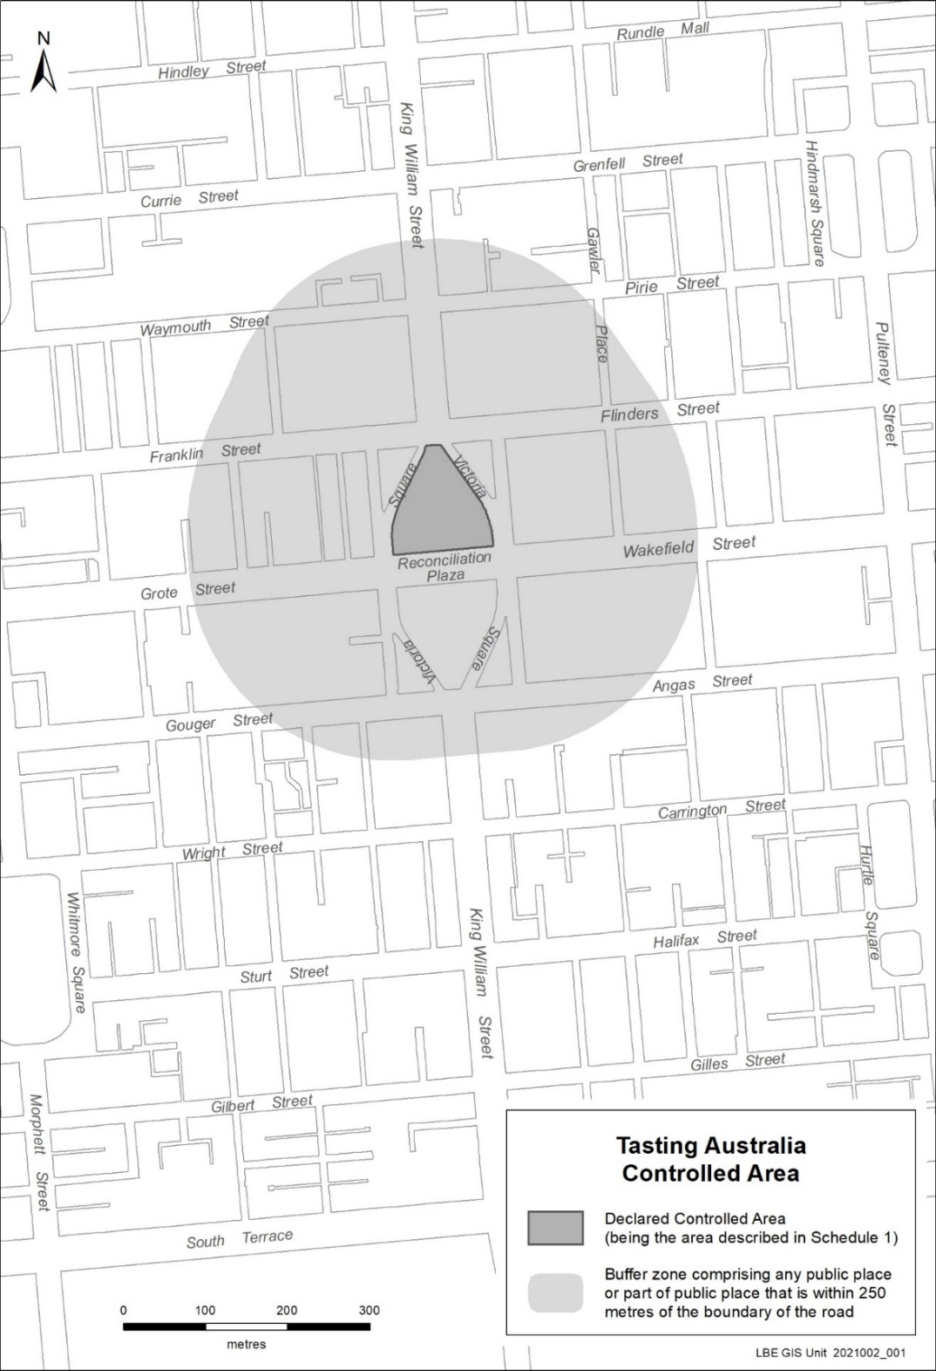

Mining Act 1971
Section 56H
Application for a Mining Lease
Notice is hereby given in accordance with Section 56H of the Mining Act 1971, that an application for a Mining Lease over the undermentioned mineral claim has been received:
Applicant: Southern Contracting Group Pty Ltd (ACN 153 055 602)
Claim Number: 4554
Location: CT 5381/334, Peake area - approximately 50 km east-southeast of Tailem Bend.
Area: 18.14 hectares approximately
Purpose: Industrial Minerals (Limestone)
Reference: 2022/000484
To arrange an inspection of the proposal at the Department for Energy and Mining, please call the Department on 08 8463 3103.
An electronic copy of the proposal can be found on the Department for Energy and Mining website: https://www.energymining.sa.gov.au/industry/minerals-and-mining/mining/community-engagement-opportunities.
Written submissions in relation to this application are invited to be received at the Department for Energy and Mining, Mining Regulation, Attn: Business Support Officer, GPO Box 320 ADELAIDE SA 5001 or dem.miningregrehab@sa.gov.au by no later than 28 February 2023.
The delegate of the Minister for Energy and Mining is required to have regard to these submissions in determining whether to grant or refuse the application and, if granted, the terms and conditions on which it should be granted.
When you make a written submission, that submission becomes a public record. Your submission will be provided to the applicant and may be made available for public inspection.
Dated: 16 February 2023
C. Andrews
Acting Mining Registrar as delegate for the Minister for Energy and Mining
Department for Energy and Mining

New Women’s and Children’s Hospital Act 2022
Notice pursuant to sections 5, 6 and 7
I, CHRIS PICTON, Minister for Health and Wellbeing, give notice:
- Pursuant to sections 5(a), 6(2) and 7(1)(b) of the New Women's and Children's Hospital Act 2022, the Project Site and Support Zones for the New Women's and Children's Hospital are as delineated in GRO Plan G5/2023 deposited in the General Registry Office at Adelaide on 25 January 2023 (GRO Plan); and
- Pursuant to section 6(1) of the New Women's and Children's Hospital Act 2022, an estate in fee simple in the land marked “Project Site” in the GRO Plan is vested in the Minister for Health and Wellbeing.
Dated: 9 February 2023
Hon Chris Picton MP
Minister for Health and Wellbeing

Planning, Development and Infrastructure Act 2016
Section 76
Amendment to the Planning and Design Code
Preamble
It is necessary to amend the Planning and Design Code (the Code) in operation at 2 February 2023 (Version 2023.2) in order to make changes of form relating to the Code’s spatial layers and their relationship with land parcels. NOTE: There are no changes to the application of zone, subzone or overlay boundaries and their relationship with affected parcels or the intent of policy application as a result of this amendment.
- PURSUANT to section 76 of the Planning, Development and Infrastructure Act 2016 (the Act), I hereby amend the Code in order to make changes of form (without altering the effect of underlying policy), correct errors and make operational amendments as follows:
- Undertake minor alterations to the geometry of the spatial layers and data in the Code to maintain the current relationship between the parcel boundaries and Code data as a result of the following:
  - New plans of division deposited in the Land Titles Office between 25 January 2023 and 7 February 2023 affecting the following spatial and data layers in the Code:
    - Zones and subzones
    - Technical and Numeric Variations
      - Building Heights (Levels)
      - Building Heights (Metres)
      - Concept Plan
      - Finished Ground and Floor Levels
      - Interface Height
      - Minimum Frontage
      - Minimum Site Area
      - Minimum Primary Street Setback
      - Minimum Side Boundary Setback
      - Future Local Road Widening Setback
      - Site Coverage

    - Overlays
      - Affordable Housing
      - Character Preservation District
      - Future Road Widening
      - Hazards (Acid Sulfate Soils)
      - Hazards (Bushfire - High Risk)
      - Hazards (Bushfire - Medium Risk)
      - Hazards (Bushfire - General Risk)
      - Hazards (Bushfire - Urban Interface)
      - Hazards (Bushfire - Regional)
      - Hazards (Bushfire - Outback)
      - Heritage Adjacency
      - Historic Area
      - Limited Dwelling
      - Limited Land Division
      - Local Heritage Place
      - Noise and Air Emissions
      - Scenic Quality
      - State Heritage Place
- In Part 13 of the Code – Table of Amendments, update the publication date, Code version number, amendment type and summary of amendments within the ‘Table of Planning and Design Code Amendments’ to reflect the amendments to the Code as described in this Notice.
- PURSUANT to section 76(5)(a) of the Act, I further specify that the amendments to the Code as described in this Notice will take effect upon the date those amendments are published on the SA planning portal.
Dated: 10 February 2023
Greg Van Gaans
Director, Land and Built Environment
Department for Trade and Investment
Delegate of the Minister for Planning

Public Finance and Audit Act 1987
Treasurer’s Quarterly Statement
Summary of the Statement on the Consolidated Account for the Quarters and
3 Months Ended 30 September 2022 and 30 September 2021
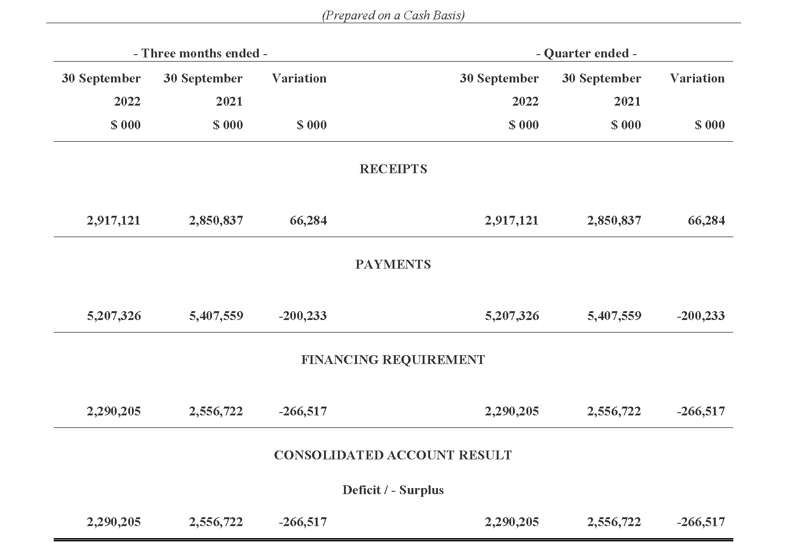

Statement of the Receipts and Borrowings on the Consolidated Account
Quarters and 3 Months Ended 30 September 2022 and 30 September 2021
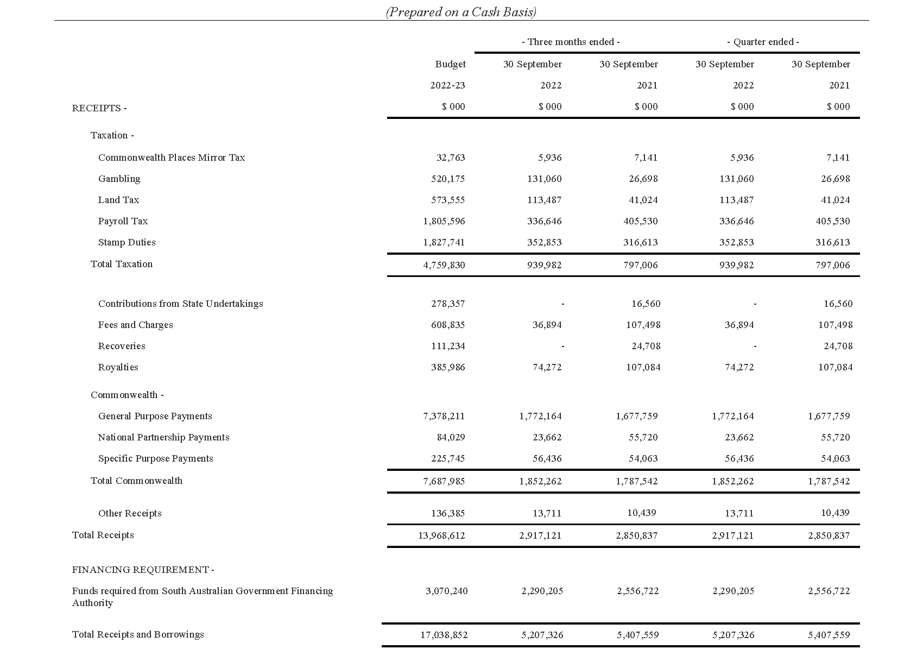

Statement of Payments on the Consolidated Account
Quarters and 3 Months Ended 30 September 2022 and 30 September 2021
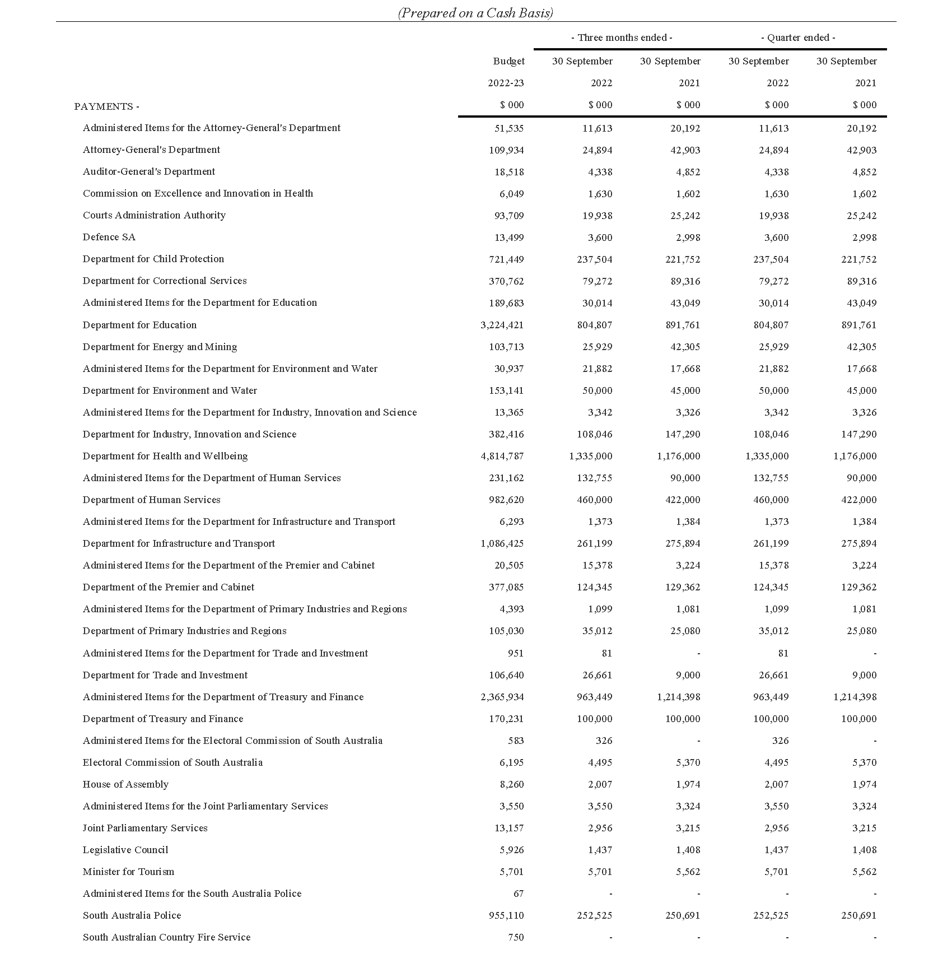

Statement of Payments on the Consolidated Account
Quarters and 3 Months Ended 30 September 2022 and 30 September 2021

Commentary to the Statement of the Amounts Credited to and Issued from the Consolidated Account
for the Quarters Ended 30 September 2022 and 30 September 2021
Receipts
Taxation
Gambling tax receipts in the September quarter 2022 were higher compared to the corresponding prior year period largely reflecting the timing of gaming machine taxation receipts. Excluding the timing of receipts, underlying collections were higher in the September quarter 2022 compared to the September quarter 2021 largely due to strength in receipts from gaming machines in hotels and clubs.
Land tax receipts in the September quarter 2022 were higher than the corresponding prior year period mainly due to the timing of collections associated with government land tax liabilities.
Payroll tax receipts in the September quarter 2022 were lower than the corresponding prior year period primarily reflecting the timing of collections. The timing of payroll tax collections is impacted, among other things, by relief measures introduced in response to COVID-19.
Stamp duty receipts in the September quarter 2022 were higher than the corresponding prior year period largely due to higher conveyance duty receipts on the transfer of properties, reflecting both an increase in the volume of residential property transactions and the average value of properties transferred. In addition, insurance duty receipts were higher compared to the previous period.
Royalties
Royalty receipts for the September quarter 2022 were lower than the corresponding prior year period mainly due to timing differences. The September quarter 2022 only reflects two months of collections compared to three months of collections recorded in the September quarter 2021.
Commonwealth—General Purpose Payments
Growth in general purpose grant receipts in 2022-23 compared to 2021-22 is not indicative of underlying movements in Goods and Services Tax (GST) revenue. This is because monthly grants are paid according to a payment schedule prepared by the Commonwealth Government rather than actual emerging monthly GST collections.
Based on the growth in the national GST pool and population estimates as well as South Australia’s relativity in 2022-23, the Commonwealth Government estimated in its October 2022-23 Budget that South Australia’s GST entitlement grant will increase by 11.4 per cent in 2022-23.
Commonwealth—Specific Purpose Payments
No material variances.
Commonwealth—National Partnership Payments
National Partnership Payments received in the September quarter 2022 were lower than the corresponding prior year period mainly due to lower reimbursements for Commonwealth HomeBuilder grants that are being administered by the state on behalf of the Commonwealth Government, partially offset by the receipt of COVID-19 Business Support Payments relating to grants paid to businesses in 2021-22.
Other receipts
Other Receipts for the September quarter 2022 were higher than the corresponding prior year period due to the collection of proceeds from land sales (Department for Industry Innovation and Science and Department for Infrastructure and Transport), offset by the fluctuations of loan repayments for Treasurer’s Loans.
Payments
Payments were made pursuant to the Appropriation Act 2022 and also in accordance with other Acts for which specific appropriation has been authorised. The timing of the payments is based on agreed agency drawdown schedules and may change from period to period based on specific agency requirements.
All appropriations were paid within approved limits established under the various Acts.
Note
The following points should be considered when reviewing the quarterly statement of Consolidated Account transactions:
• Unlike the State Budget which comprises transactions on an accrual basis, the information reflected in the quarterly statement is limited to cash transactions.
• The Consolidated Account does not capture all the transactions undertaken by the general government sector. In particular, it does not record receipts to, and payments from, Agency deposit and special deposit accounts.
• The timing of receipts and payments can fluctuate within a financial year and between financial years. As a result, apparently large movements between quarters or years may only be due to changes in the timing of receipts and payments and therefore may not have consequences for the underlying budget position.
Dated: 6 February 2023
Hon. Stephen Mullighan MP
Treasurer of South Australia

Retirement Villages Act 2016
Section 5(2)
Exemption from the application of section 57(1)
TAKE NOTICE that I, Chris Picton, Minister for Health and Wellbeing, pursuant to section 5(2) of the Retirement Villages Act 2016 (the Act), hereby exempt the retirement village Boandik Lodge Inc, operated by Boandik Lodge Incorporated, from the requirements of section 57(1) of the Act, subject to the following conditions:
1. this exemption applies only in respect of:
a. the Kentish Court Units (K1 – K8); and
b. Units 1, 2 and 4.
2. the exemption with respect to Units 1, 2 and 4 expires on 31 December 2024
Dated: 9 February 2023
Hon Chris Picton MP
Minister for Health and Wellbeing

Roads (Opening and Closing) Act 1991
Section 24
NOTICE OF CONFIRMATION OF ROAD
PROCESS ORDER
Road Closure—Herbert Road, West Croydon
By Road Process Order made 14 November 2022, the City of Charles Sturt ordered that:
- Portion of Herbert Road, West Croydon, situated adjoining Allotment 16 in Filed Plan 116728, Hundred of Yatala, more particularly delineated and lettered ‘A’ in Preliminary Plan 21/0031 be closed.
- Transfer the whole of the land subject to closure to Alison Louise Bishop and Daniel Thomas Carroll in accordance with the Agreement for Transfer dated 14 November 2022 entered into between the City of Charles Sturt and Alison Louise Bishop and Daniel Thomas Carroll.
On 14 February 2023 that order was confirmed by the Minister for Planning conditionally upon the deposit by the Registrar-General of Deposited Plan 131196 being the authority for the new boundaries.
Pursuant to section 24(5) of the Roads (Opening and Closing) Act 1991, NOTICE of the Order referred to above and its confirmation is hereby given.
Dated: 16 February 2023
B. J. Slape
Surveyor-General
2021/19918/01

South Australian Skills Act 2008
Part 4—Apprenticeships, Traineeships and Training Contracts
PURSUANT to the provision of the South Australian Skills Act 2008, the South Australian Skills Commission (SASC) gives notice that determines the following Trades or Declared Vocations in addition to the Gazette notices of:
- 25 Sep 2008 | - 23 Oct 2008 |  | - 13 Nov 2008 |  | - 04 Dec 2008 |  | - 18 Dec 2008 |  | - 29 Jan 2009
- 12 Feb 2009 | - 05 Mar 2009 |  | - 12 Mar 2009 |  | - 26 Mar 2009 |  | - 30 Apr 2009 |  | - 18 Jun 2009
- 25 Jun 2009 | - 27 Aug 2009 |  | - 17 Sep 2009 |  | - 24 Sep 2009 |  | - 09 Oct 2009 |  | - 22 Oct 2009
- 03 Dec 2009 | - 17 Dec 2009 |  | - 04 Feb 2010 |  | - 11 Feb 2010 |  | - 18 Feb 2010 |  | - 18 Mar 2010
- 08 Apr 2010 | - 06 May 2010 |  | - 20 May 2010 |  | - 03 Jun 2010 |  | - 17 Jun 2010 |  | - 24 Jun 2010
- 08 Jul 2010 | - 09 Sep 2010 |  | - 23 Sep 2010 |  | - 04 Nov 2010 |  | - 25 Nov 2010 |  | - 16 Dec 2010
- 23 Dec 2010 | - 17 Mar 2011 |  | - 07 Apr 2011 |  | - 21 Apr 2011 |  | - 19 May 2011 |  | - 30 Jun 2011
- 21 Jul 2011 | - 08 Sep 2011 |  | - 10 Nov 2011 |  | - 24 Nov 2011 |  | - 01 Dec 2011 |  | - 08 Dec 2011
- 16 Dec 2011 | - 22 Dec 2011 |  | - 05 Jan 2012 |  | - 19 Jan 2012 |  | - 01 Mar 2012 |  | - 29 Mar 2012
- 24 May 2012 | - 31 May 2012 |  | - 07 Jun 2012 |  | - 14 Jun 2012 |  | - 21 Jun 2012 |  | - 28 Jun 2012
- 05 Jul 2012 | - 12 Jul 2012 |  | - 19 Jul 2012 |  | - 02 Aug 2012 |  | - 09 Aug 2012 |  | - 30 Aug 2012
- 13 Sep 2012 | - 04 Oct 2012 |  | - 18 Oct 2012 |  | - 25 Oct 2012 |  | - 08 Nov 2012 |  | - 29 Nov 2012
- 13 Dec 2012 | - 25 Jan 2013 |  | - 06 Feb 2013 |  | - 14 Feb 2013 |  | - 21 Feb 2013 |  | - 28 Feb 2013
- 07 Mar 2013 | - 14 Mar 2013 |  | - 21 Mar 2013 |  | - 28 Mar 2013 |  | - 26 Apr 2013 |  | - 23 May 2013
- 30 May 2013 | - 13 Jun 2013 |  | - 20 Jun 2013 |  | - 11 Jul 2013 |  | - 01 Aug 2013 |  | - 08 Aug 2013
- 15 Aug 2013 | - 29 Aug 2013 |  | - 12 Jun 2014 |  | - 28 Aug 2014 |  | - 04 Sep 2014 |  | - 16 Oct 2014
- 23 Oct 2014 | - 05 Feb 2015 |  | - 26 Mar 2015 |  | - 07 Apr 2015 |  | - 16 Apr 2015 |  | - 27 May 2015
- 18 Jun 2015 | - 03 Dec 2015 |  | - 30 Jun 2016 |  | - 28 Jul 2016 |  | - 08 Sep 2016 |  | - 22 Sep 2016
- 27 Oct 2016 | - 01 Dec 2016 |  | - 15 Dec 2016 |  | - 07 Mar 2017 |  | - 21 Mar 2017 |  | - 23 May 2017
- 13 Jun 2017 | - 18 Jul 2017 |  | - 19 Sep 2017 |  | - 26 Sep 2017 |  | - 17 Oct 2017 |  | - 03 Jan 2018
- 23 Jan 2018 | - 14 Mar 2018 |  | - 14 Jun 2018 |  | - 05 Jul 2018 |  | - 02 Aug 2018 |  | - 09 Aug 2018
- 16 Aug 2018 | - 30 Aug 2018 |  | - 27 Sep 2018 |  | - 04 Oct 2018 |  | - 18 Oct 2018 |  | - 01 Nov 2018
- 15 Nov 2018 | - 22 Nov 2018 |  | - 29 Nov 2018 |  | - 06 Dec 2018 |  | - 20 Dec 2018 |  | - 24 Jan 2019
- 14 Feb 2019 | - 30 May 2019 |  | - 06 Jun 2019 |  | - 13 Jun 2019 |  | - 20 Jun 2019 |  | - 27 Jun 2019
- 11 Jul 2019 | - 08 Aug 2019 |  | - 22 Aug 2019 |  | - 12 Sep 2019 |  | - 19 Sep 2019 |  | - 14 Nov 2019
- 28 Nov 2019 | - 12 Dec 2019 |  | - 19 Dec 2019 |  | - 23 Jan 2020 |  | - 27 Feb 2020 |  | - 21 Apr 2020
- 25 Jun 2020 | - 10 Sep 2020 |  | - 17 Sep 2020 |  | - 08 Oct 2020 |  | - 29 Oct 2020 |  | - 05 Nov 2020
- 10 Dec 2020 | - 17 Dec 2020 |  | - 24 Dec 2020 |  | - 21 Jan 2021 |  | - 11 Feb 2021 |  | - 25 Feb 2021
- 25 Mar 2021 | - 01 Apr 2021 |  | - 08 Apr 2021 |  | - 06 May 2021 |  | - 10 Jun 2021 |  | - 01 Jul 2021
- 12 Aug 2021 | - 16 Sep 2021 |  | - 23 Sep 2021 |  | - 30 Sep 2021 |  | - 14 Oct 2021 |  | - 21 Oct 2021
- 09 Nov 2021 | - 02 Dec 2021 |  | - 23 Dec 2021 |  | - 24 Feb 2022 |  | - 10 Mar 2022 |  | - 24 Mar 2022
- 12 May 2022 | - 16 Jun 2022 |  | - 23 Jun 2022 |  | - 11 Aug 2022 |  | - 25 Aug 2022 |  | - 27 Oct 2022
- 22 Dec 2022 | - 26 Jan 2023 |  | - 16 Feb 2023
Trades or Declared Vocations and Required Qualifications and Training Contract Conditions for the Agriculture, Horticulture and Conservation and Land Management (AHC), Food, Beverage and Pharmaceutical (FBP), Forest and Wood Products (FWP), Laboratory Operations (MSL), Textiles, Clothing and Footwear (MST) Training Package/s
*Trade/ #Declared Vocation/ Other Occupation |  | Qualification Code |  | Qualification Title |  | Nominal Term of Training Contract |  | Probationary Period |  | Supervision Level Rating
Environment Worker # |  | AHC60422 |  | Advanced Diploma of Conservation and Ecosystem Management |  | 48 |  | 90 |  | Medium
Forest Products Operators # |  | FWP30622 |  | Certificate III in Timber Building Products Supply |  | 24 |  | 60 |  | Medium
General Foods Processing # |  | FBP20122 |  | Certificate II in Food Processing |  | 18 |  | 60 |  | Low
Laboratory Technician # |  | MSL30122 |  | Certificate III in Laboratory Skills |  | 24 |  | 60 |  | Medium
Laboratory Technician # |  | MSL40122 |  | Certificate IV in Laboratory Techniques |  | 36 |  | 90 |  | High
Laboratory Technician # |  | MSL50122 |  | Diploma of Laboratory Technology |  | 48 |  | 90 |  | High
Leading Hand - Dry Cleaning # |  | MST30922 |  | Certificate III in Dry Cleaning Operations |  | 36 |  | 90 |  | Low
Technical Officer # |  | MSL60122 |  | Advanced Diploma of Laboratory Management |  | 24 |  | 60 |  | Medium
Dated: 16 February 2023
John Evangelista
Director, Traineeship and Apprenticeship Services

Summary Offences Act 1953
Declared Public Precincts
Notice of Ministerial Declaration
I, KYAM MAHER, Attorney-General in the State of South Australia, being the Minister responsible for the administration of Part 14B – Declared Public Precincts of the Summary Offences Act 1953, DO HEREBY DECLARE pursuant to the provisions of section 66N of the said Act that the area, comprised of more than one public place in the suburb of Adelaide, within the following boundaries:
- eastern boundary of King William Street from southern boundary of Grenfell Street to northern boundary of North Terrace
- northern boundary of North Terrace from eastern boundary of King William Street to northern boundary of Botanic Road
- northern boundary of Botanic Road from northern boundary of North Terrace to eastern boundary of Dequetteville Terrace
- eastern boundary of Dequetteville Terrace from northern boundary of Botanic Road to southern boundary of Bartels Road
- southern boundary of Bartels Road from eastern boundary of Dequetteville Terrace to southern boundary of Pirie Street
- southern boundary of Pirie Street from southern boundary of Bartels Road to western boundary of Pulteney Street
- western boundary of Pulteney Street from southern boundary of Pirie Street to southern boundary of Grenfell Street
- southern boundary of Grenfell Street from western boundary of Pulteney Street to eastern boundary of King William Street
be a declared public precinct for a period of 12 hours from 6:00pm on each night commencing on Friday 17 February 2023 and reoccurring for each described day and time of the week until declared otherwise or until 6:00am on Monday 20 March 2023, whichever occurs sooner.
I am satisfied that there is, during the periods specified in this declaration, a reasonable likelihood of conduct posing a risk to public order and safety in the area specified.
I am satisfied that the inclusion of each public place in the area is reasonable having regard to that identified risk.
Dated: 7 February 2023
Hon Kyam Maher MLC
Attorney-General

Appendix A Map
‘Fringe 2023’ Declared Public Precinct
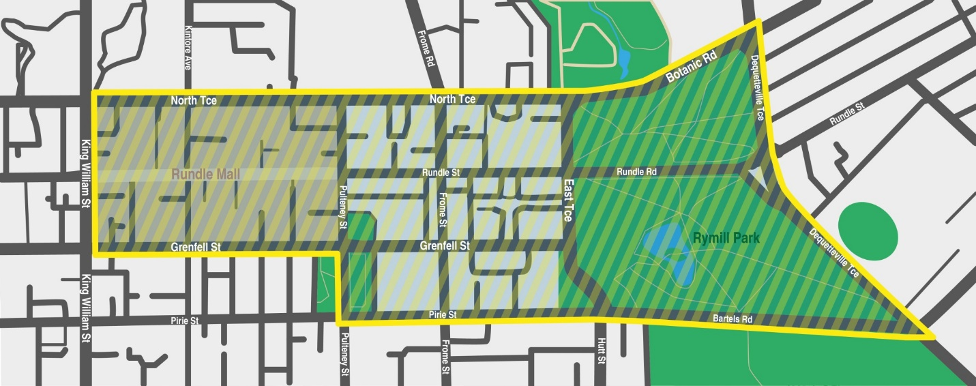

Local Government Instruments

City of Burnside
Local Government Act 1999
Council Member Office Vacancy
Notice is hereby given in accordance with section 54(6) of the Local Government Act 1999, that a vacancy has occurred in the office of Councillor for Eastwood and Glenunga Ward, due to the operation of Section 54(1)(h) of the Local Government Act 1999 and the loss of office of Councillor Edward (Ted) Jennings, to take effect from 20 January 2023.
Dated: 16 February 2023
C. Cowley
Chief Executive Officer

City of Campbelltown
Local Government Act 1999
Casual Vacancy
Notice is given in accordance with section 54(6) of the Local Government Act 1999, that a vacancy has occurred in an office of Councillor for Woodforde Ward, due to the operation of section 54(1)(h) of the Local Government Act 1999 through the loss of office by Councillor Therese Britton-La Salle, with effect from 13 January 2023.
Dated: 16 February 2023
Paul Di Iulio
Chief Executive Officer

CITY OF PORT ADELAIDE ENFIELD
Local Government Act 1999
Loss of Office of Councillors
NOTICE is given in accordance with section 54(6) of the Local Government Act 1999 that a vacancy has occurred in the office of Parks Ward Councillor, Councillor Wasim Saeed and Port Adelaide Ward Councillors, Councillor Joost den Hartog and Councillor Steve Vines, due to the operation of section 54(1)(h) of the Local Government Act 1999, effective 19 January 2023.
Dated: 16 February 2023
A Dickson
Acting Chief Executive Officer

City of Prospect
Local Government Act 1999
Casual Vacancy
Pursuant to Section 54(6) of the Local Government Act 1999 (SA), City of Prospect gives notice that a casual vacancy has occurred in the office of Mayor.
Members of Council are advised of this vacancy at its next meeting being a Special Meeting to be convened at 5:30pm on 14 February 2023 at 128 Prospect Road, Prospect.
Dated: 16 February 2023
Chris White
Chief Executive Officer

City of Tea Tree Gully
Local Government Act 1999
Removal of Councillor from Office
NOTICE is given in accordance with section 54(6) of the Local Government Act 1999 that a vacancy has occurred in the office of Pedare Ward Councillor effective from 20 January 2023. The office of Councillor Tammie Sinclair has become vacant pursuant to section 54(1)(h) due to failure to submit a return under Part 14 of the Local Government (Elections) Act 1999 before the expiration of one month from the end of the period allowed under that Act for the submission of the return.
Dated: 16 February 2023
R. McMahon
Chief Executive Officer

City of Whyalla
Water Industry Act 2012
Standard Terms and Conditions for the Supply of Drinking Water to Fitzgerald Bay
Notice is hereby given, in accordance with Section 36(2) of the Water Industry Act 2012, the Council adopted the ‘Standard Terms and Conditions for the Supply of Drinking Water to Fitzgerald Bay’ at the meeting held on 23 January 2023, in relation to charging for water supplied to the shacks/dwellings/premises at Black Oak Cove, Fitzgerald Bay, South Australia. These standard terms and conditions will come into force on 1 April 2023.
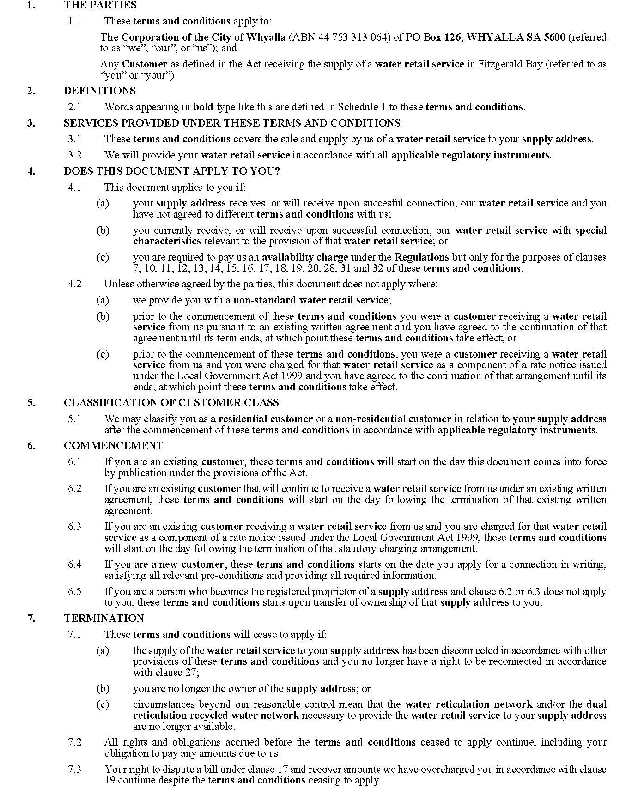

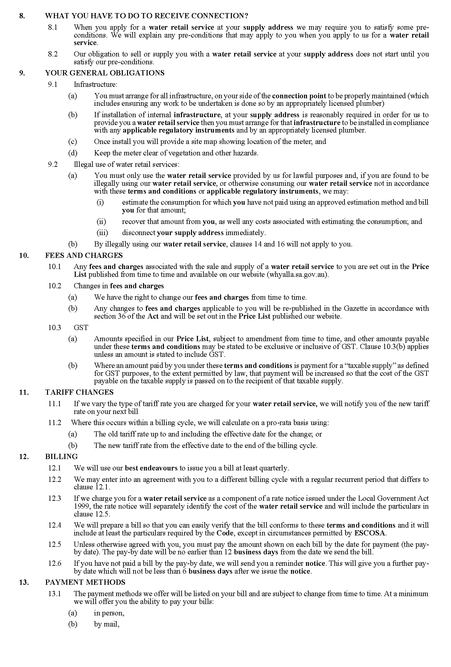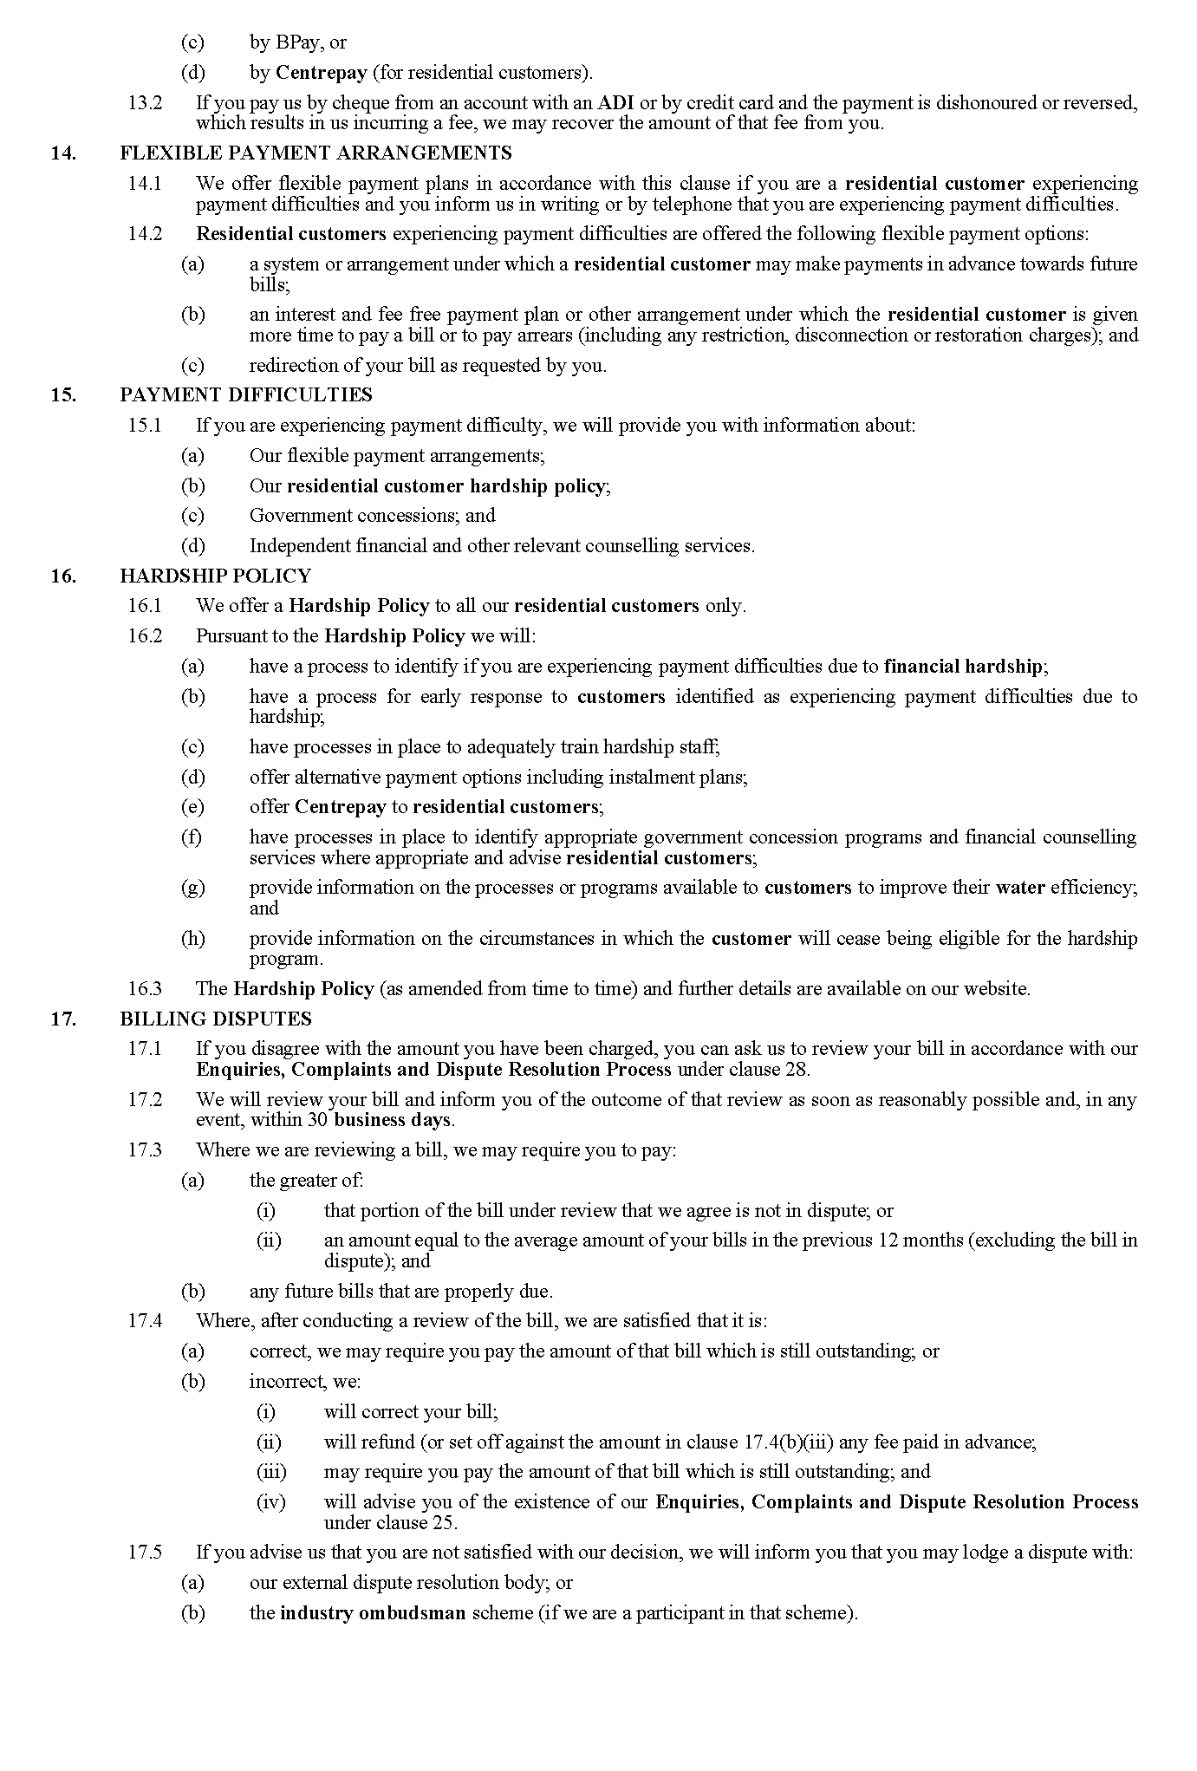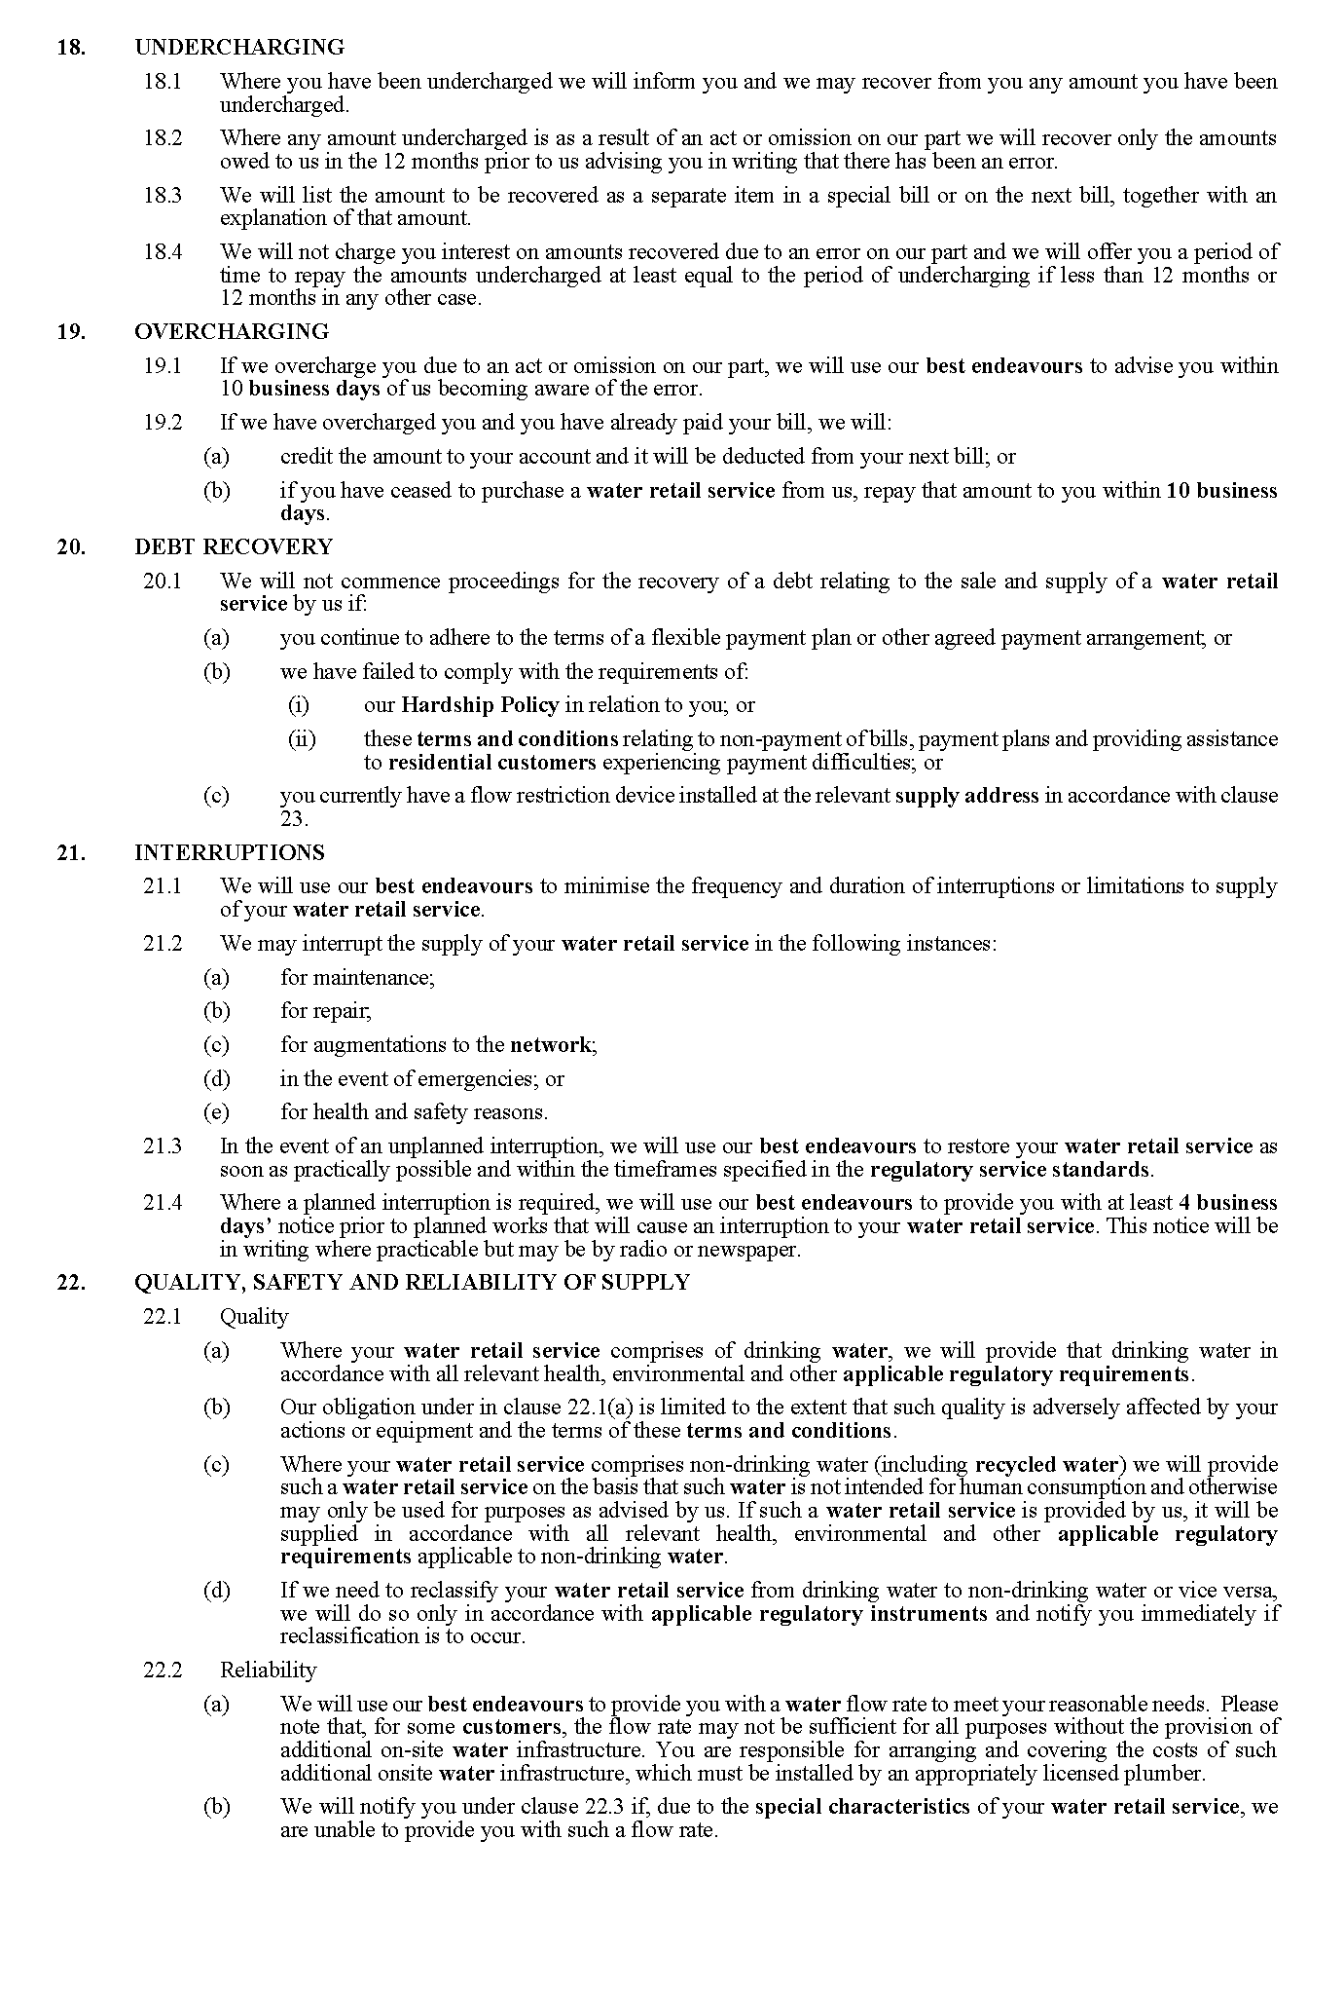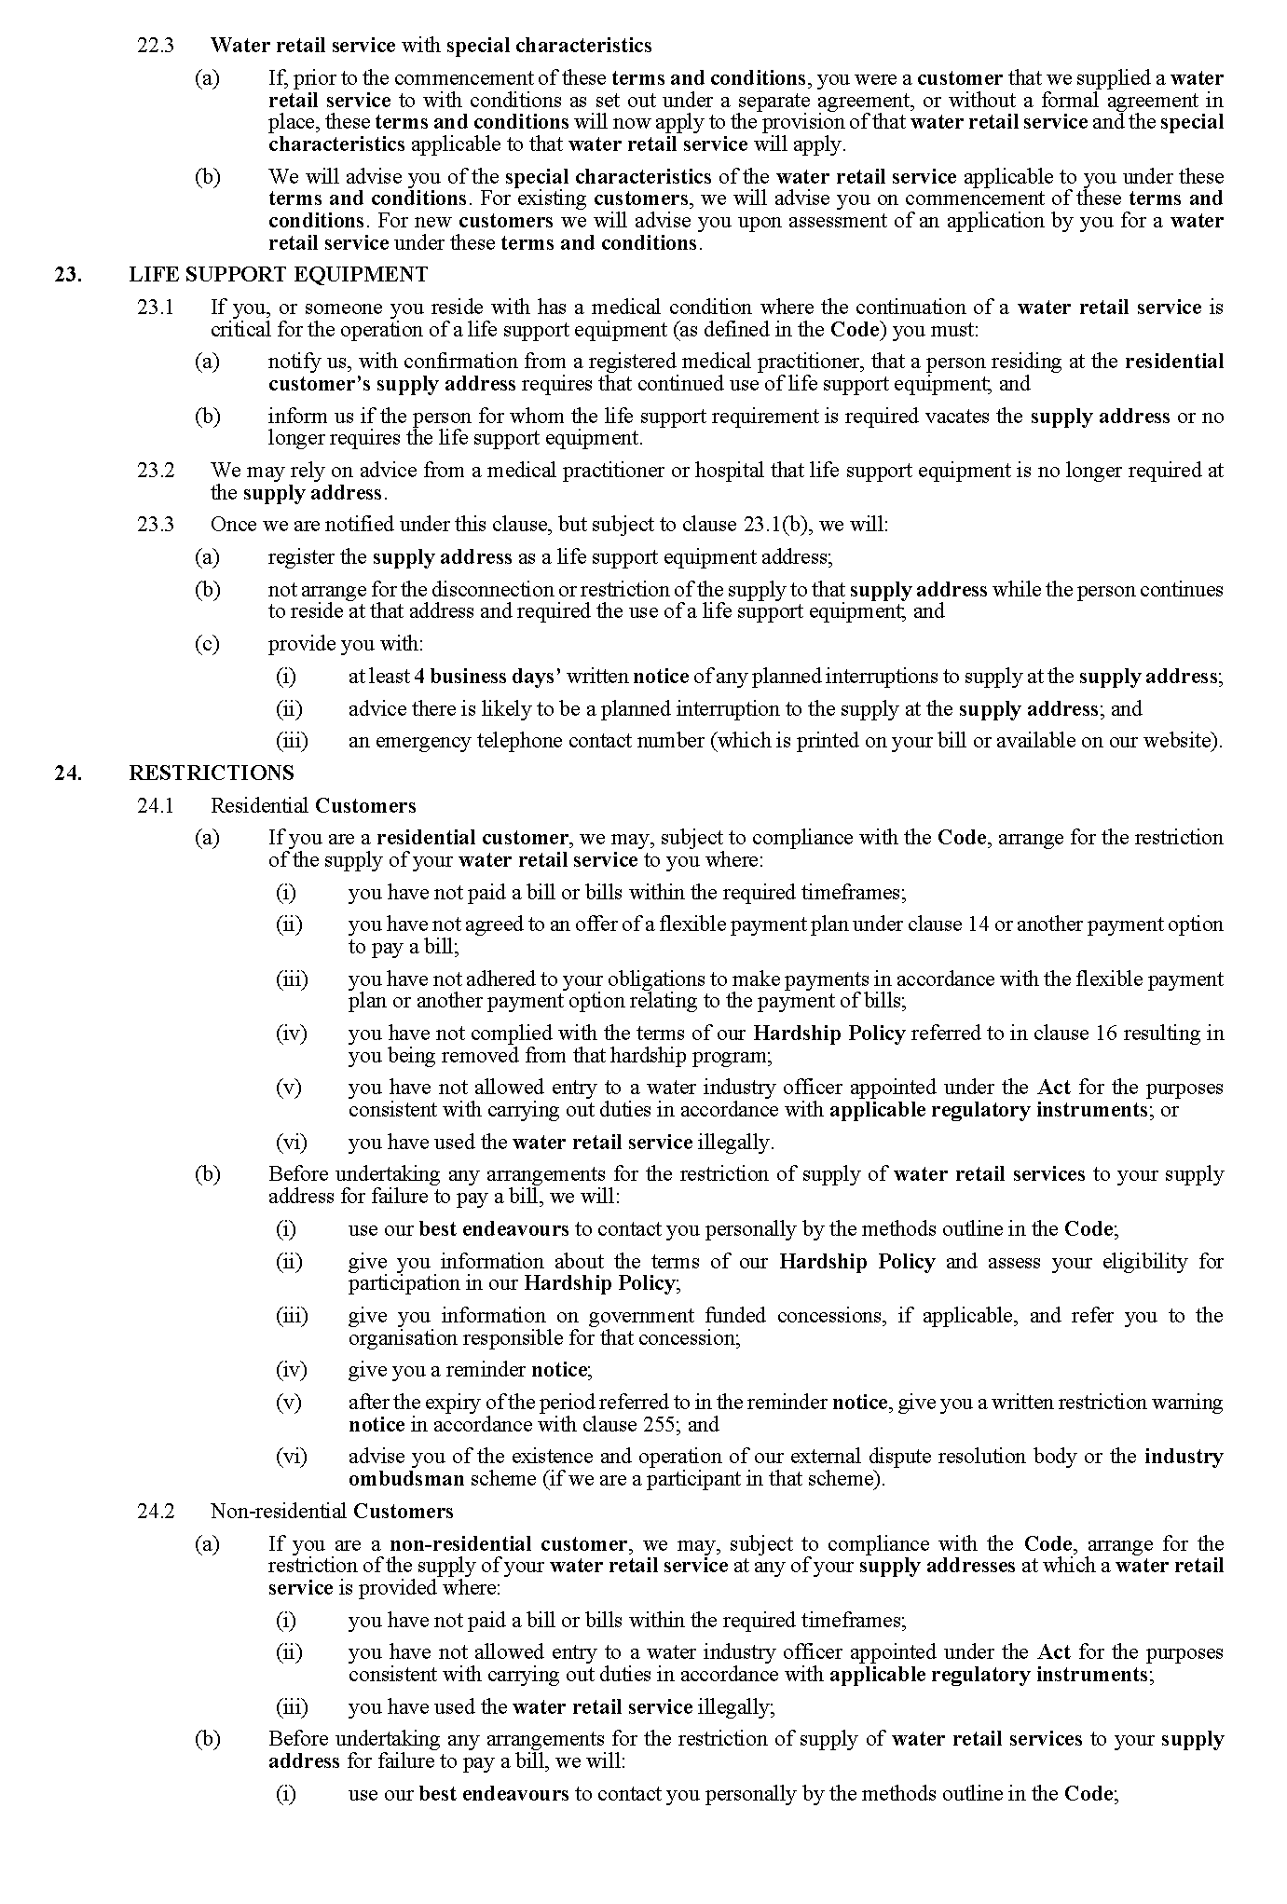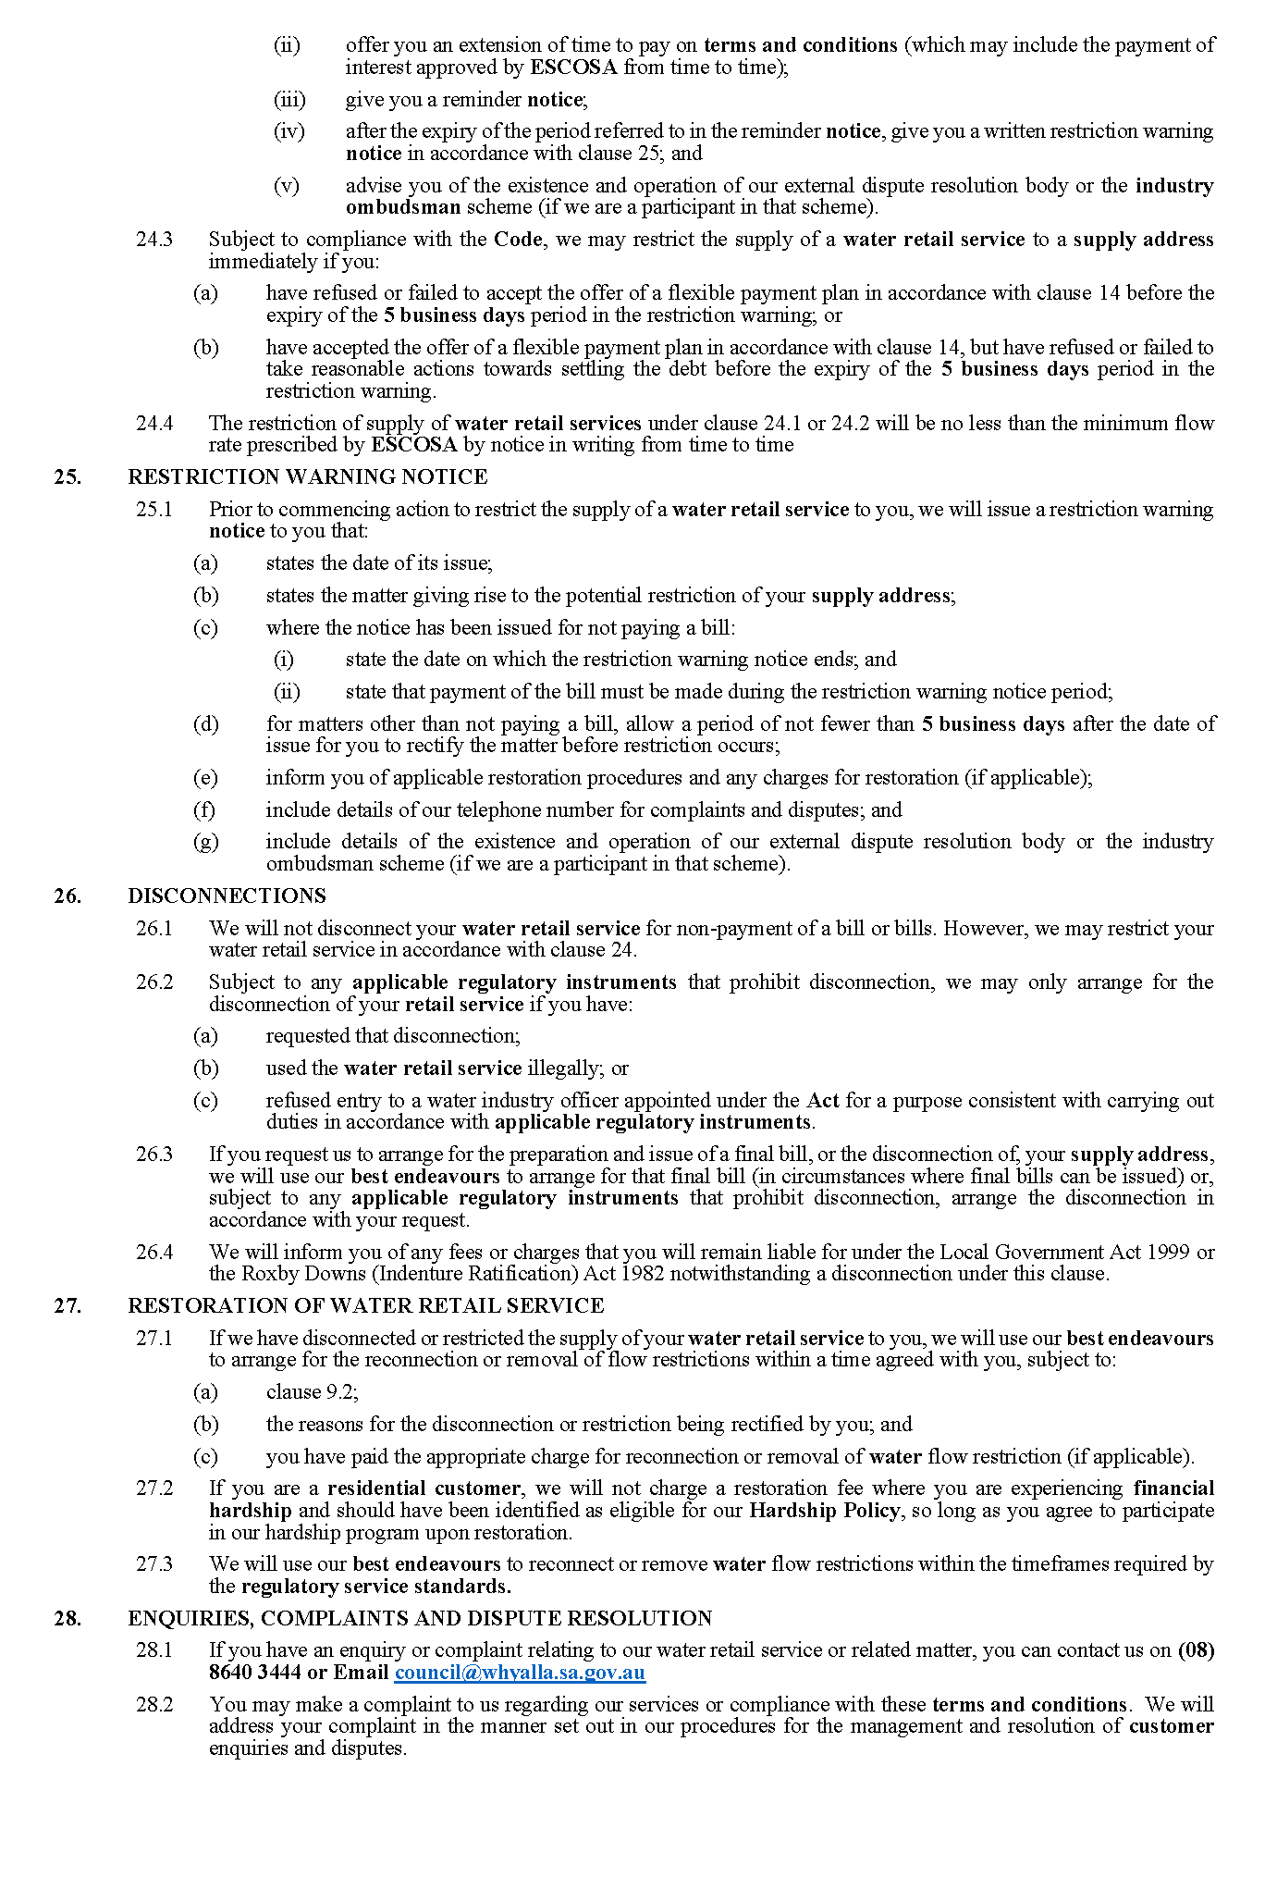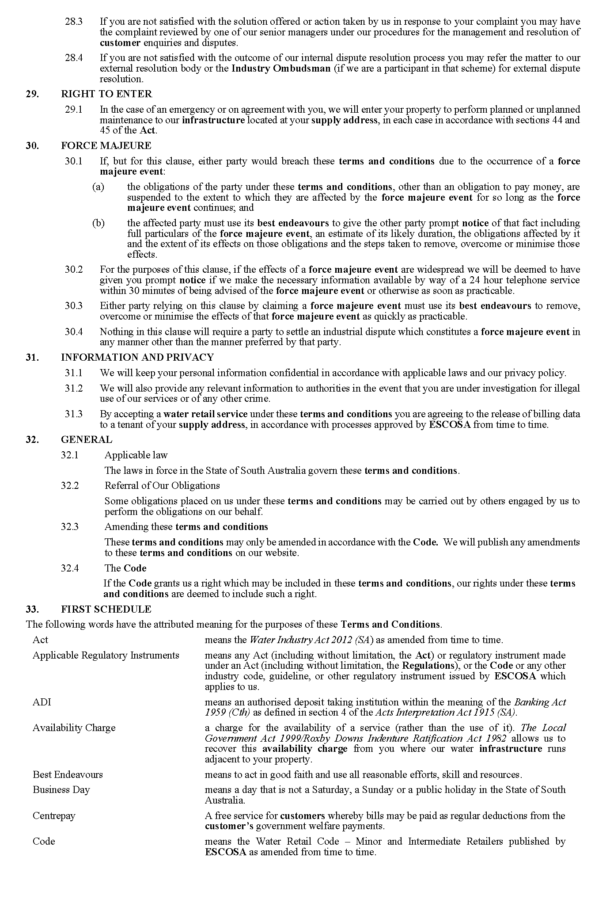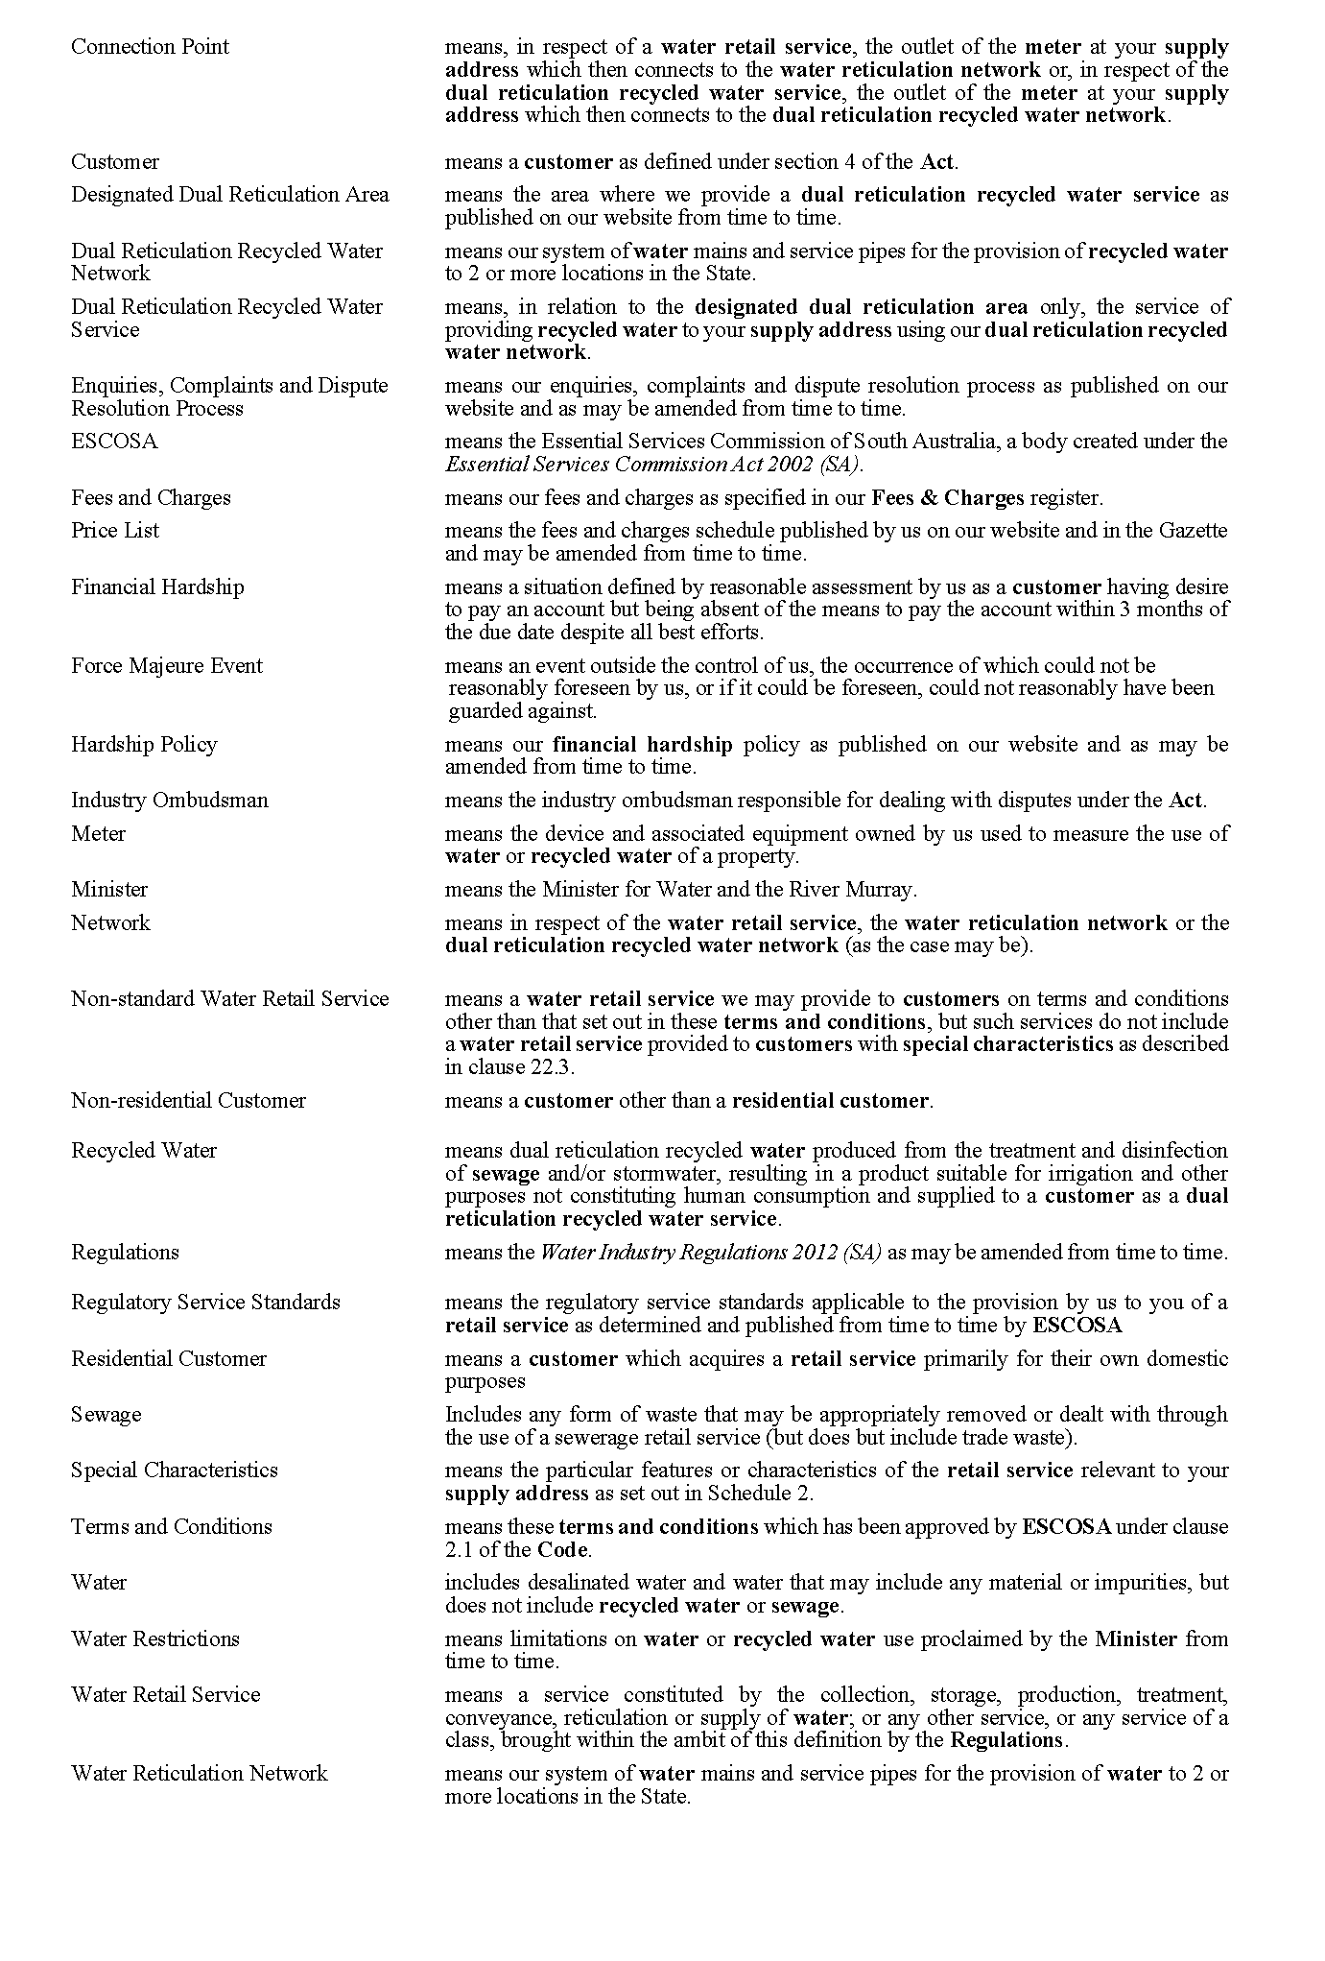
34. SCHEDULE 2 – SPECIAL CHARACTERISTICS
Not applicable
These terms and conditions were duly presented and passed at a meeting of The Whyalla City Council held on 23 January 2023 by an absolute majority of the members of the time being constituting the Council, there being at least two thirds of the members present.
Dated: 23 January 2023
Justin Commons
Chief Executive Officer

District Council of Ceduna
Local Government Act 1999
Notice of Vacancy in the Office of Member of Council
NOTICE is hereby given in accordance with section 54(6) of the Local Government Act 1999 that the office of Area Councillor of the District Council of Ceduna, formerly occupied by Michele Jacobsen, became vacant by operation of section 54(1)(h) of the Local Government Act 1999, on 20 January 2023.
Dated: 16 February 2023
Timothy Coote
Chief Executive Officer

District Council of Franklin Harbour
Local Government Act 1999
By-Law No. 2 of 2023—Local Government Land By-Law 2023
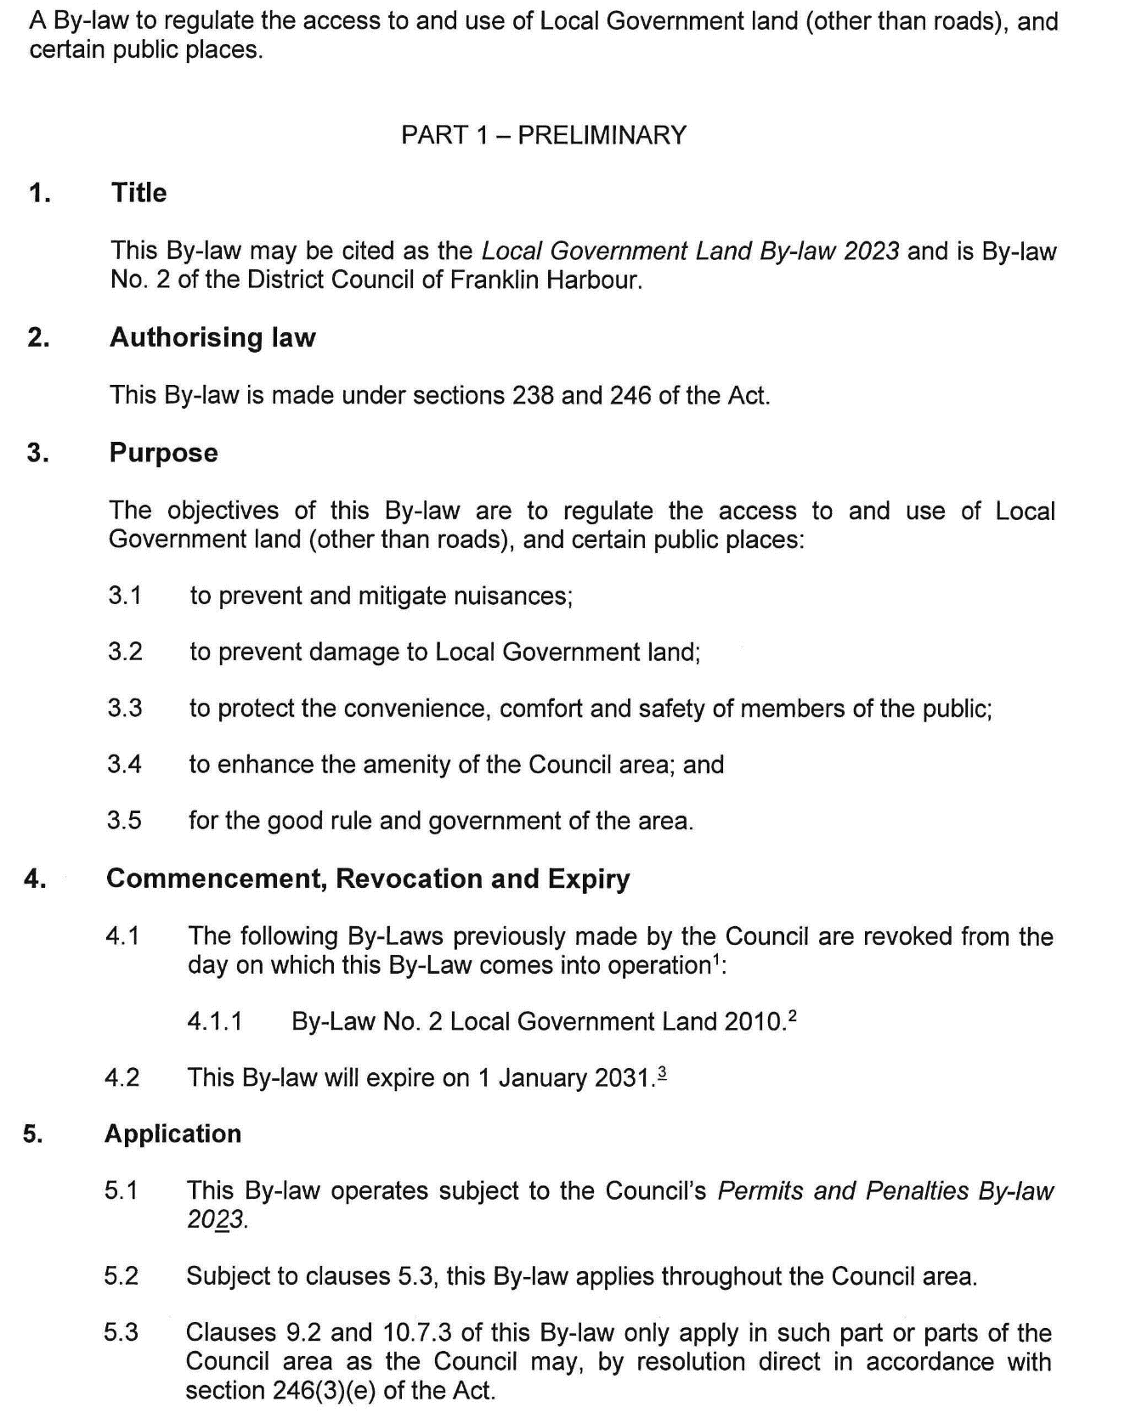
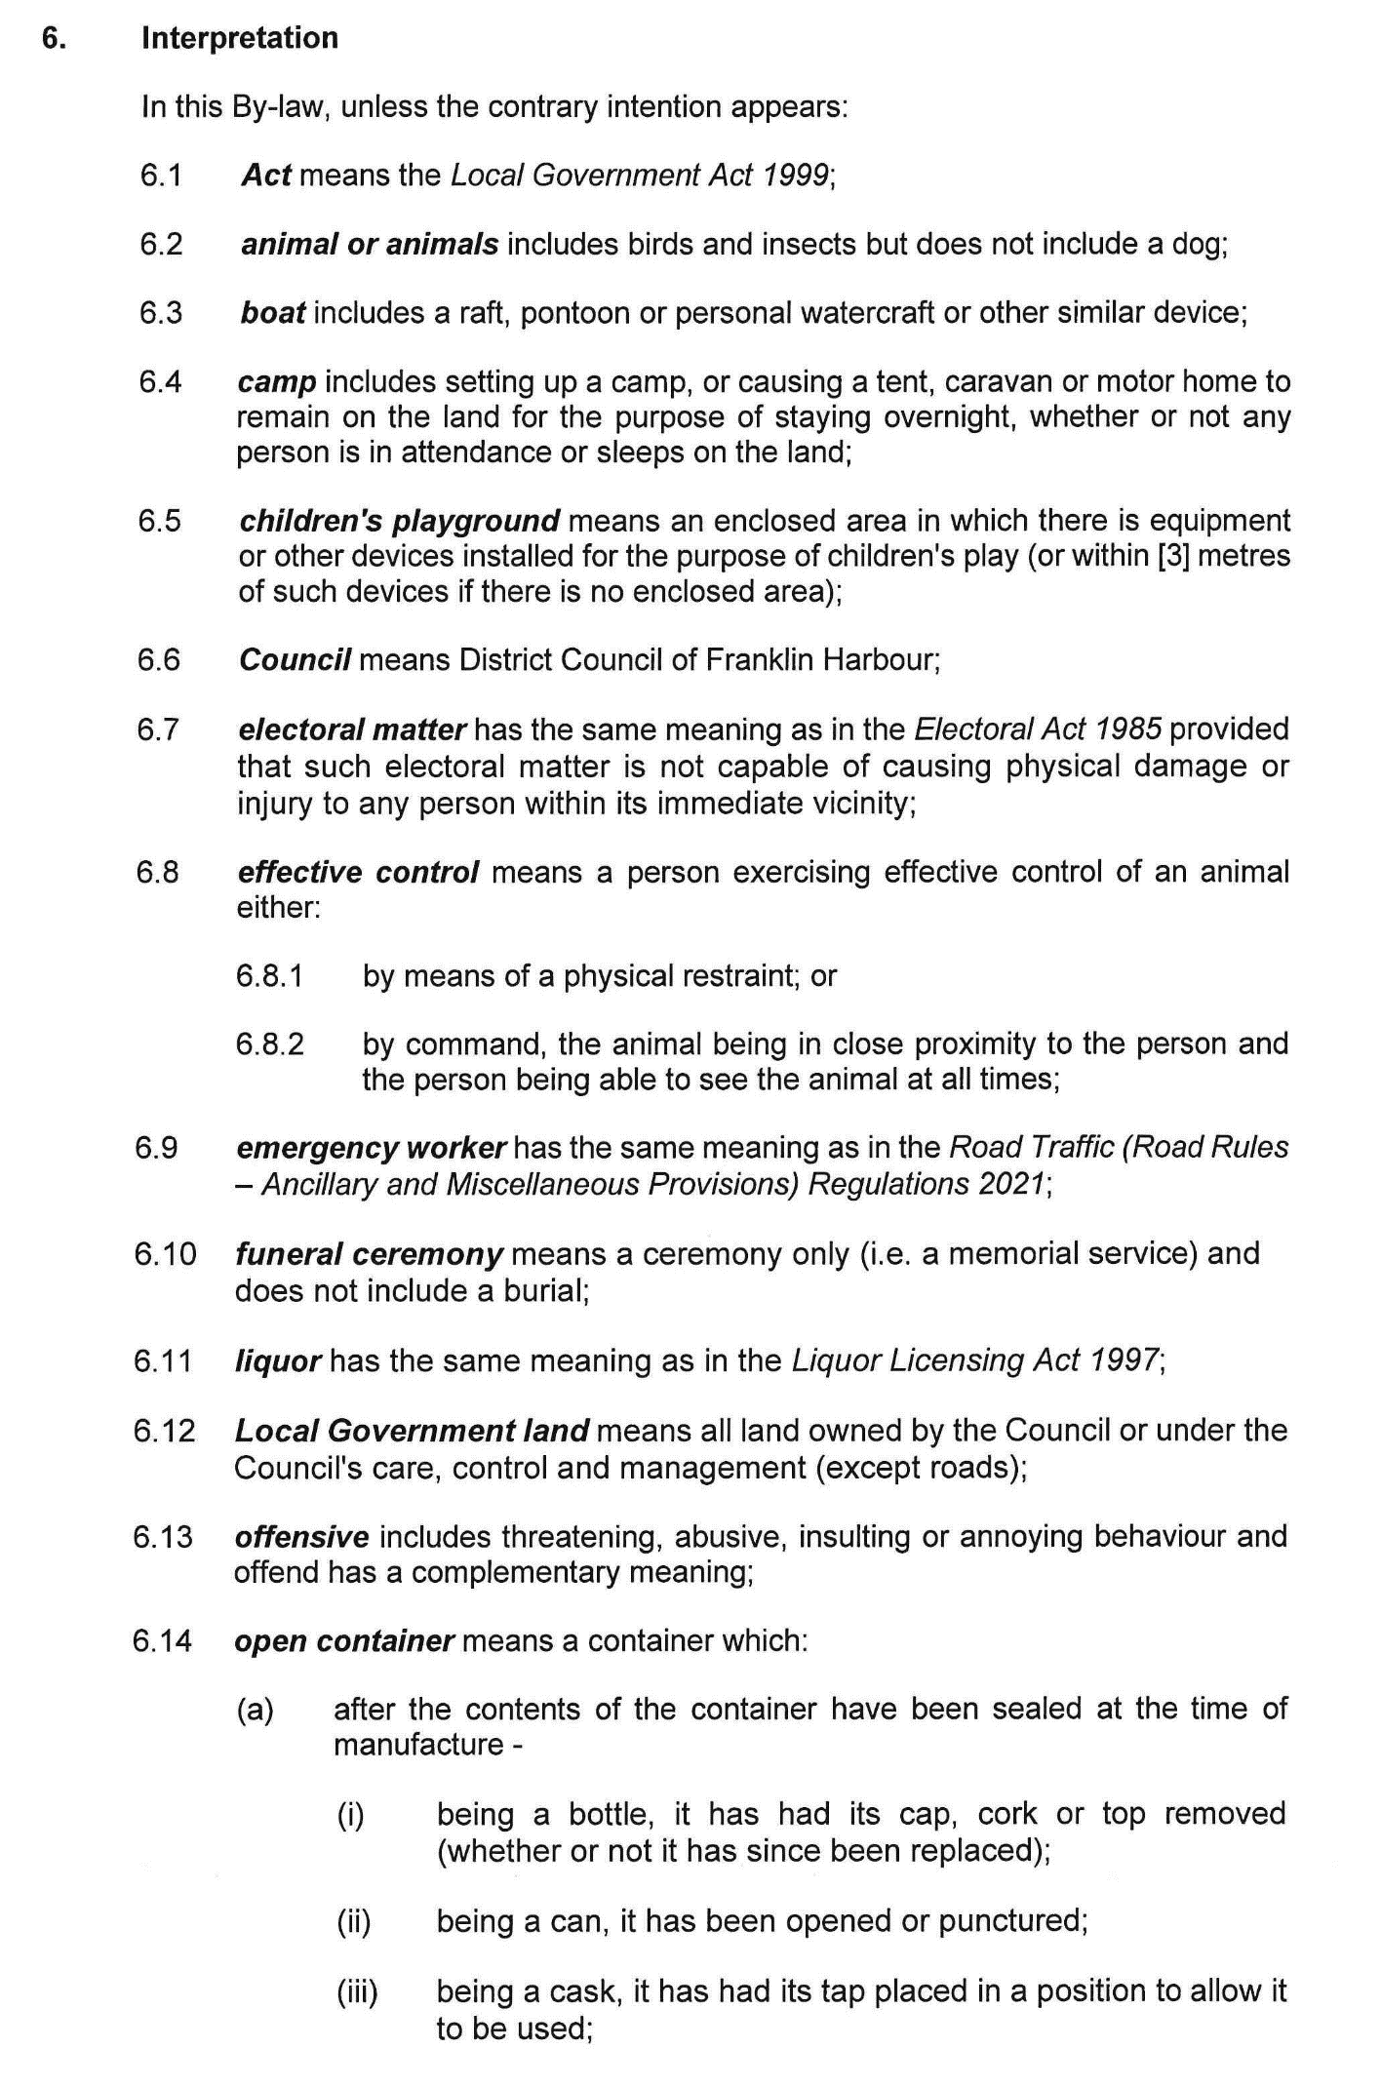
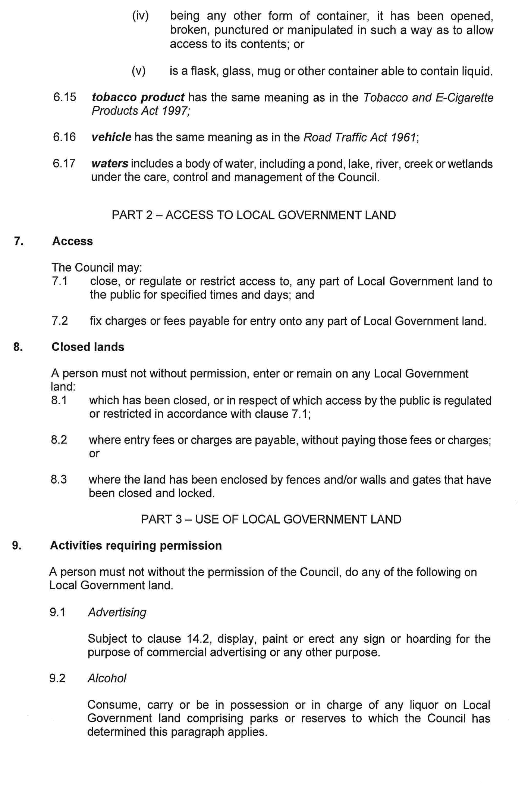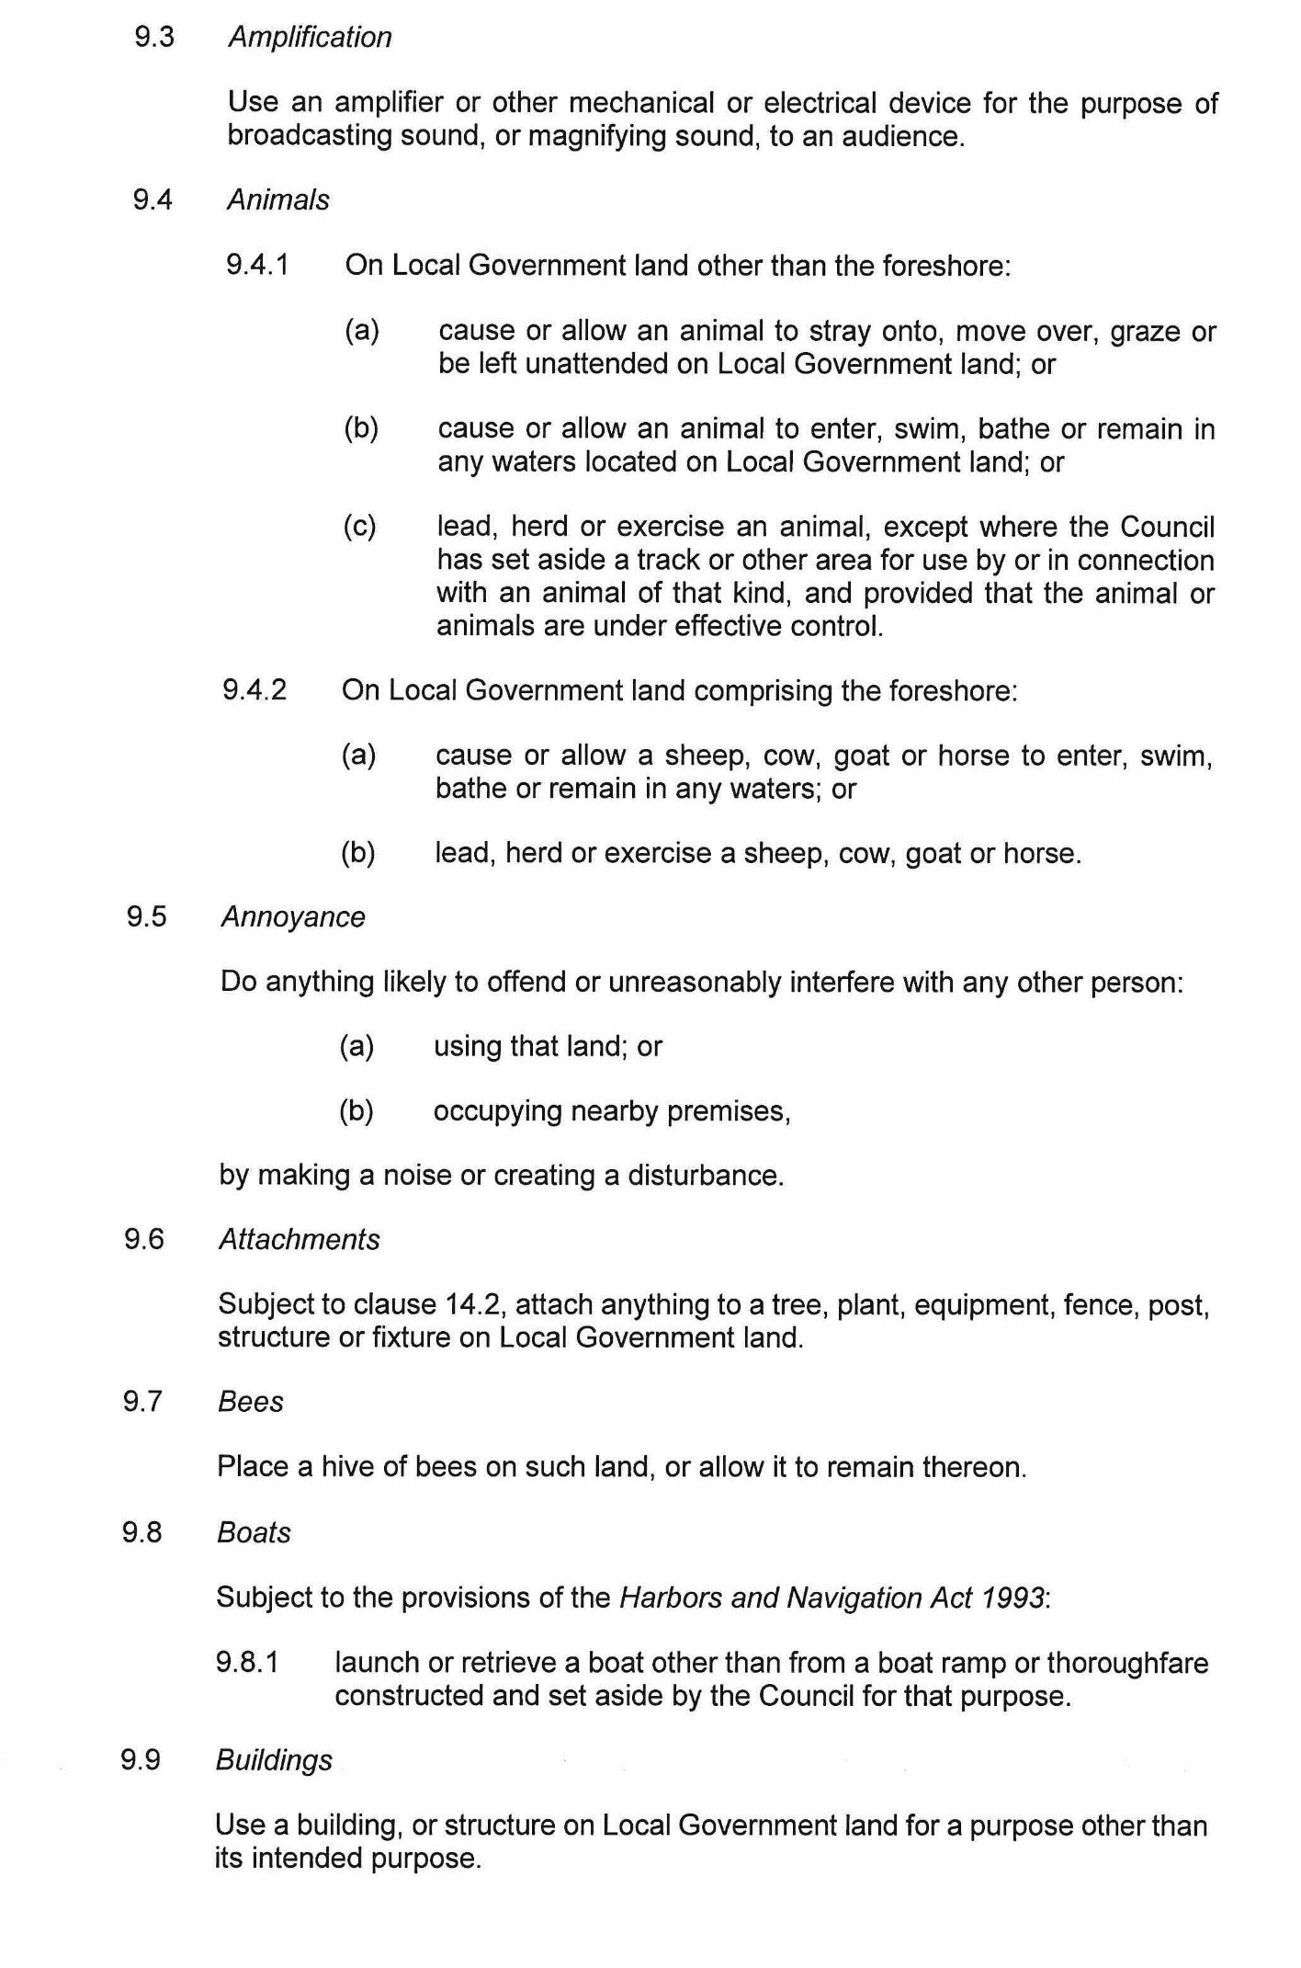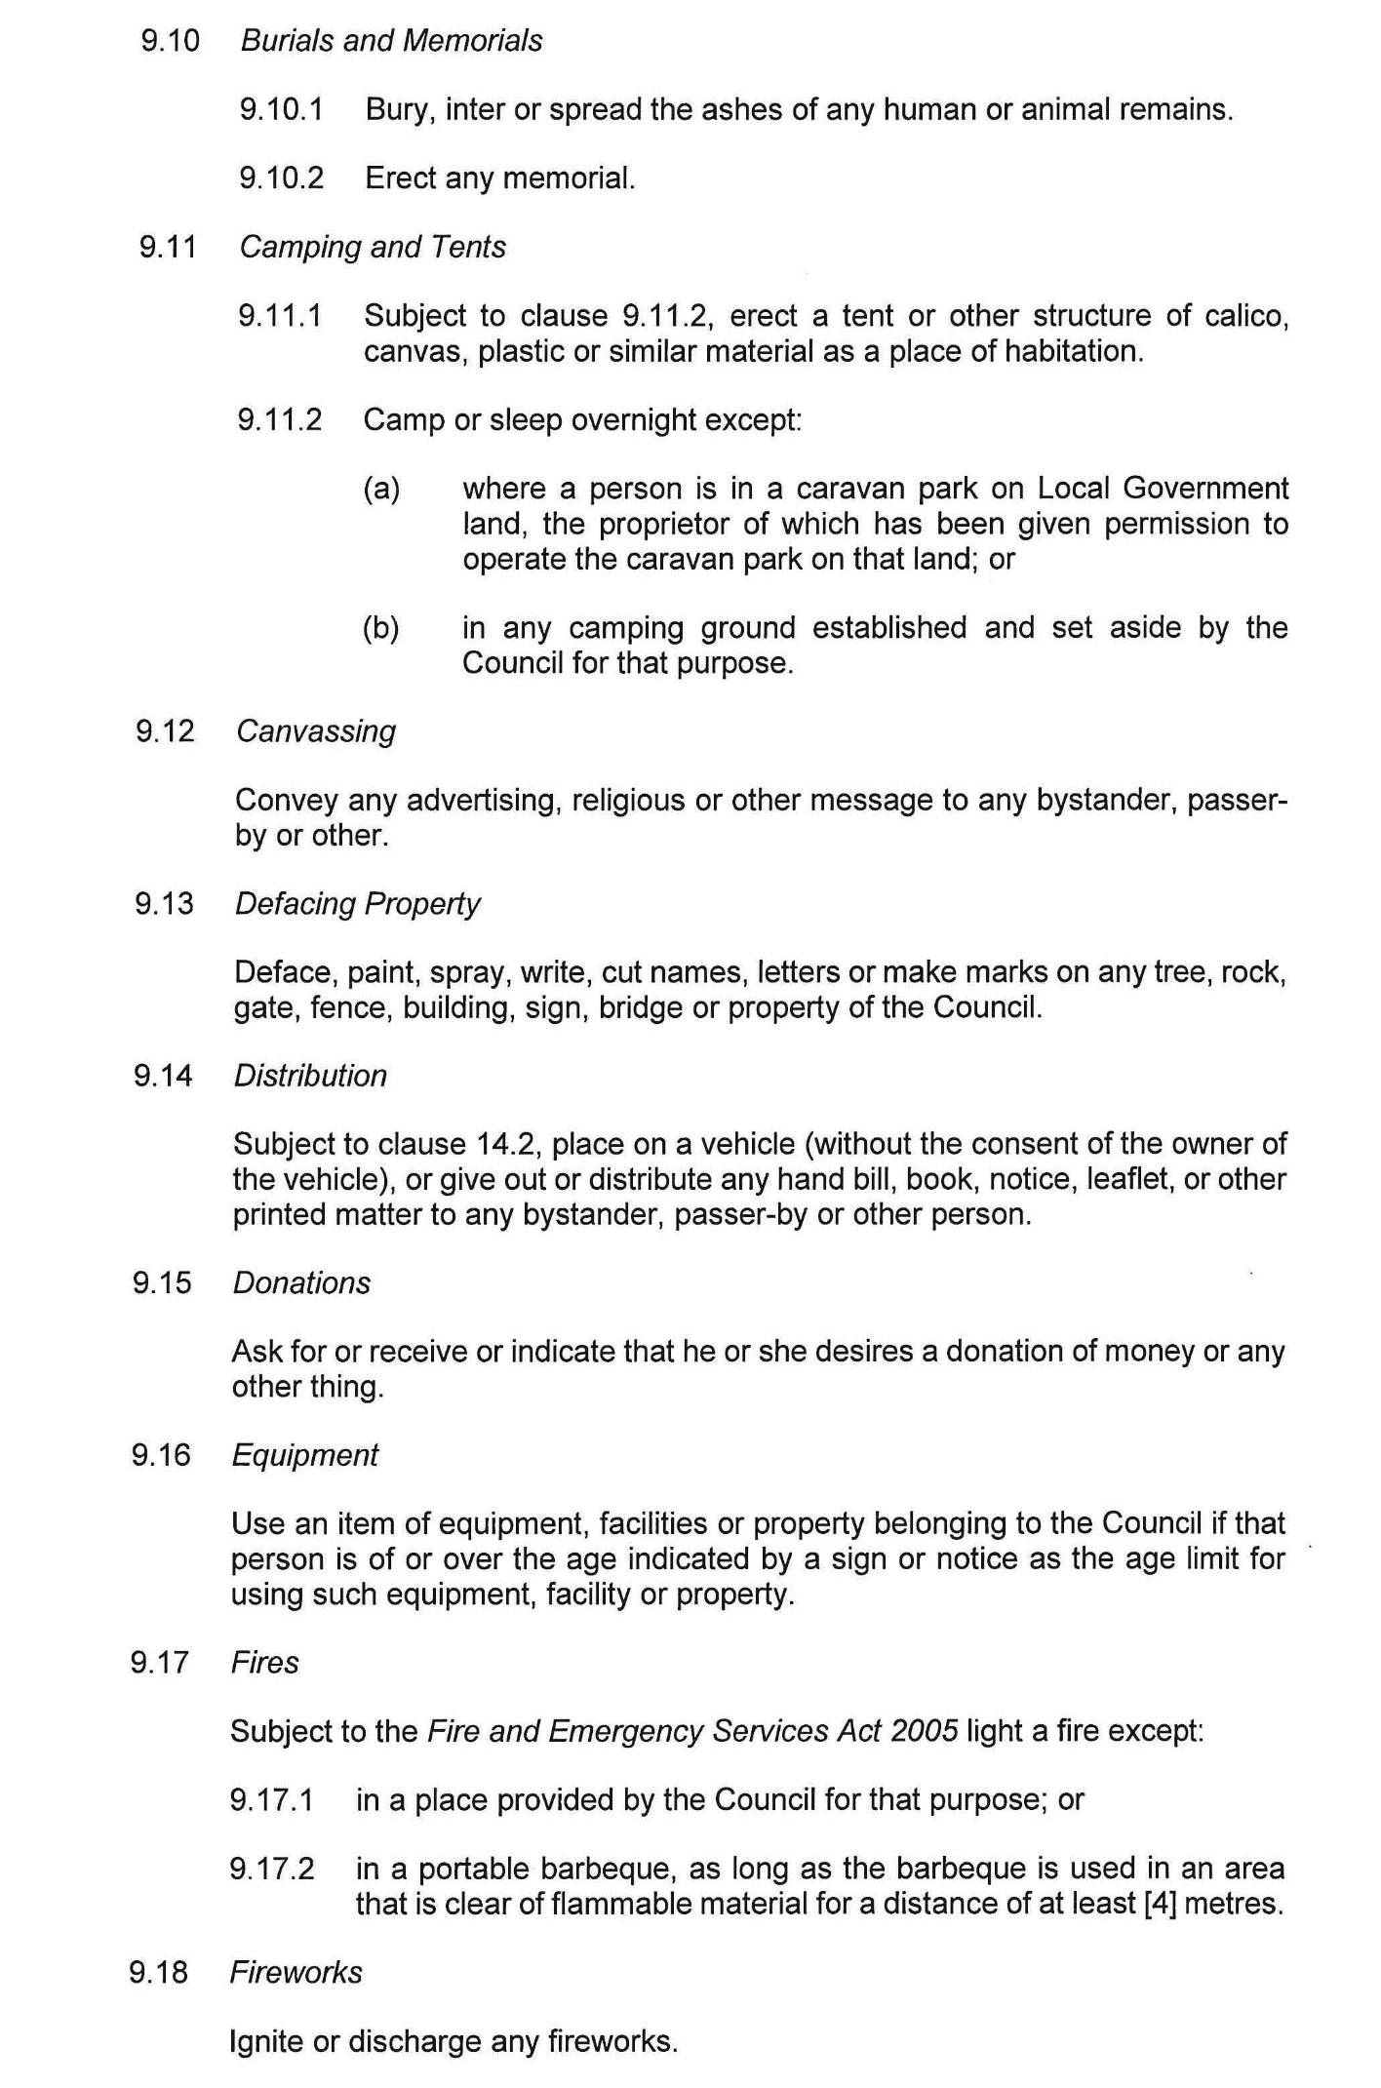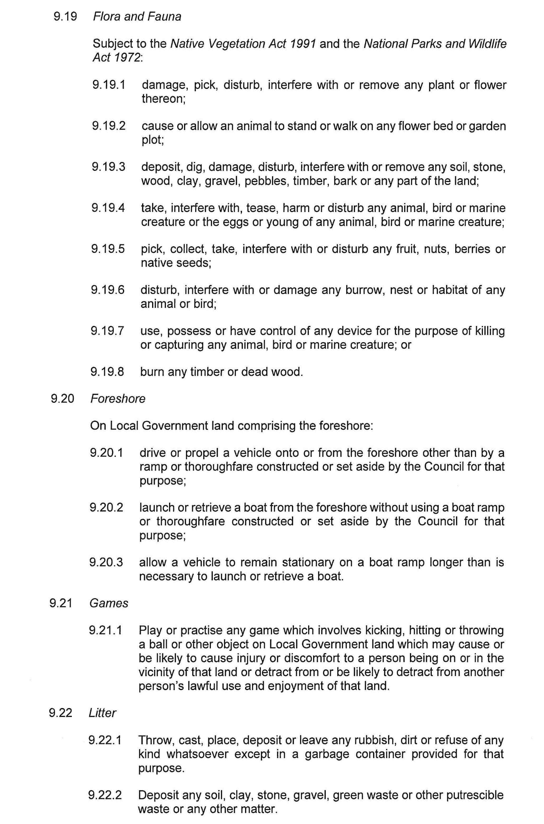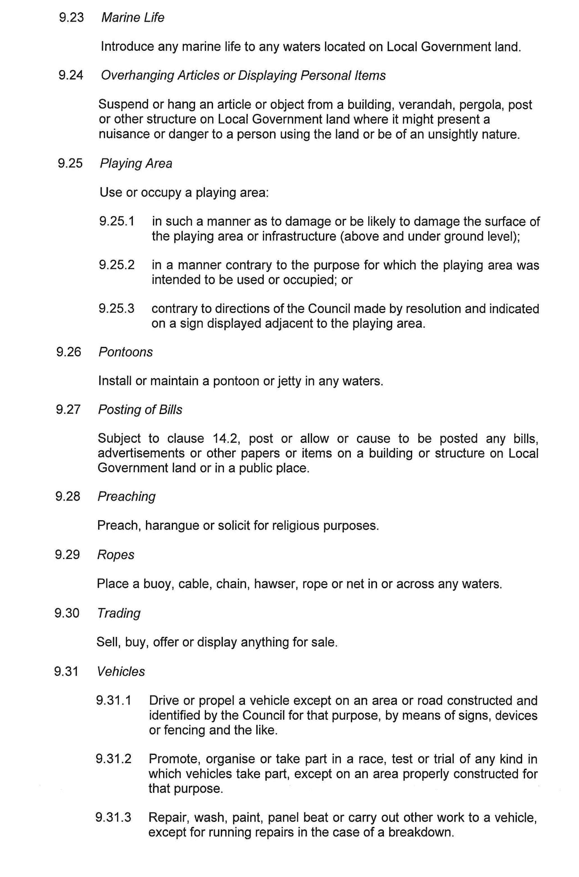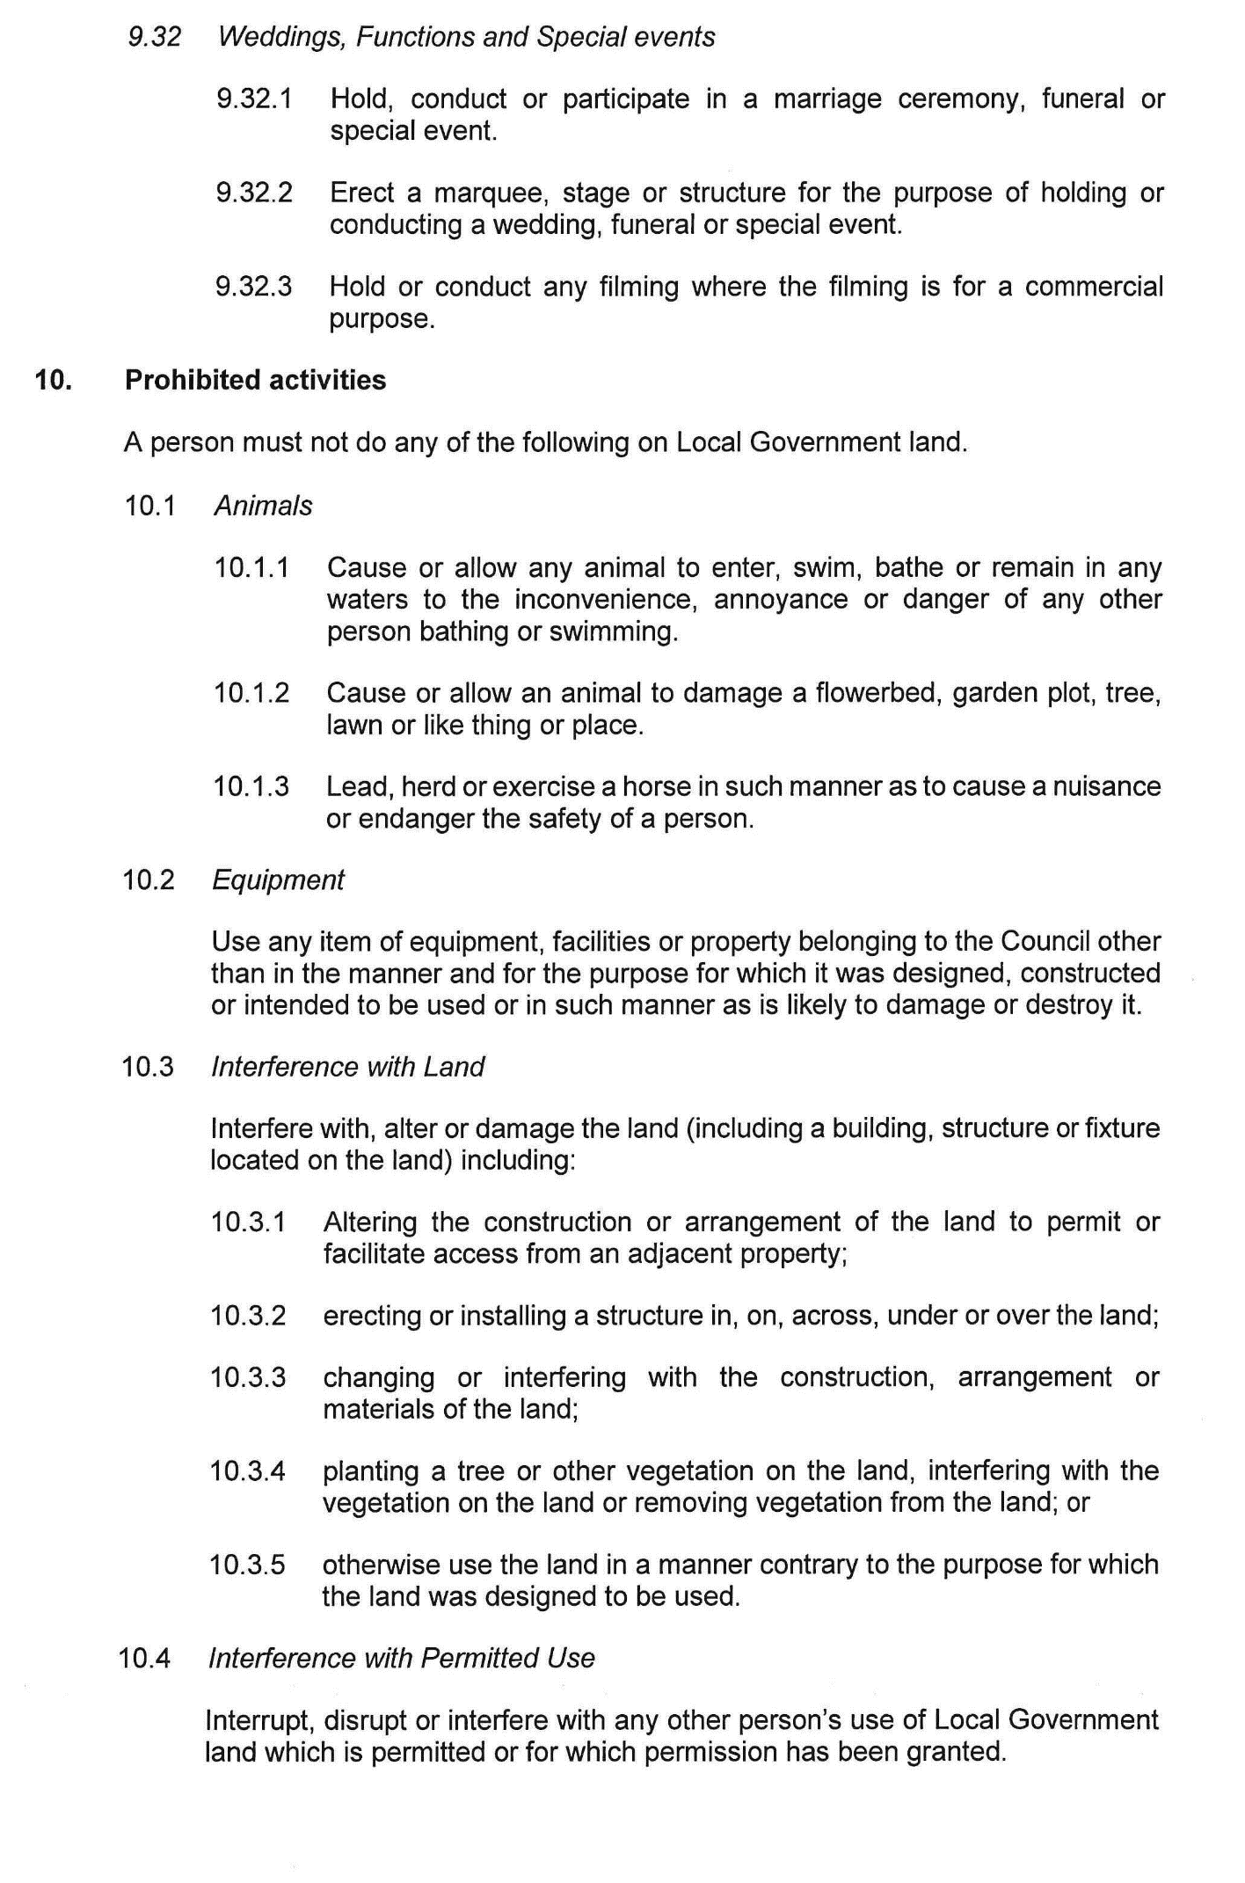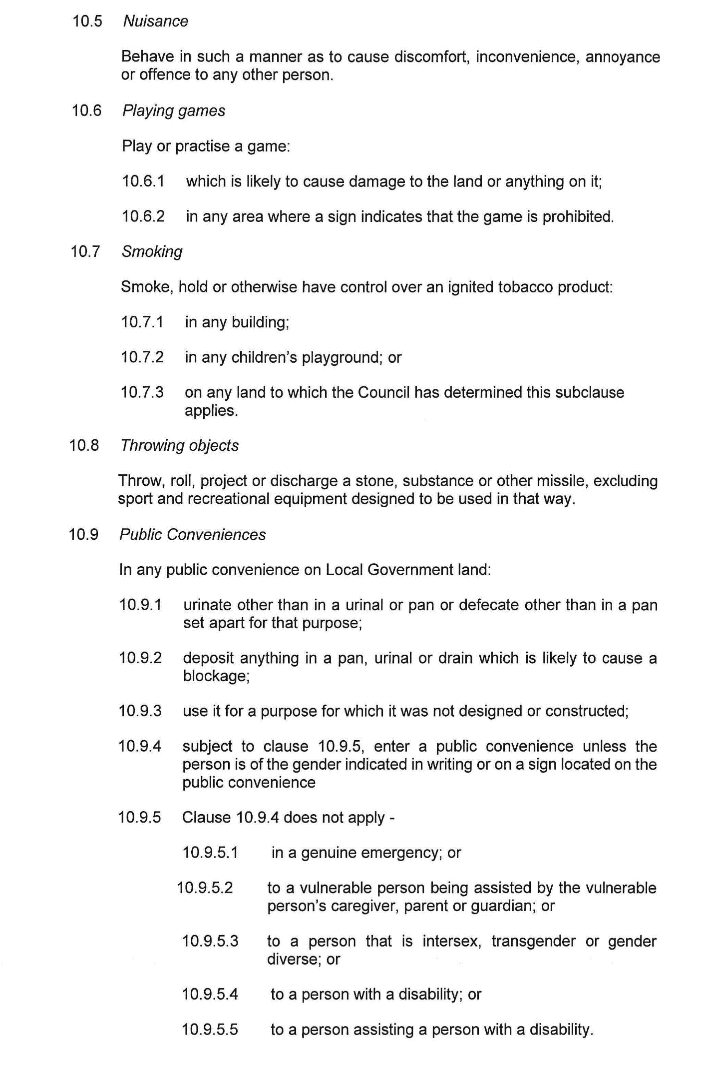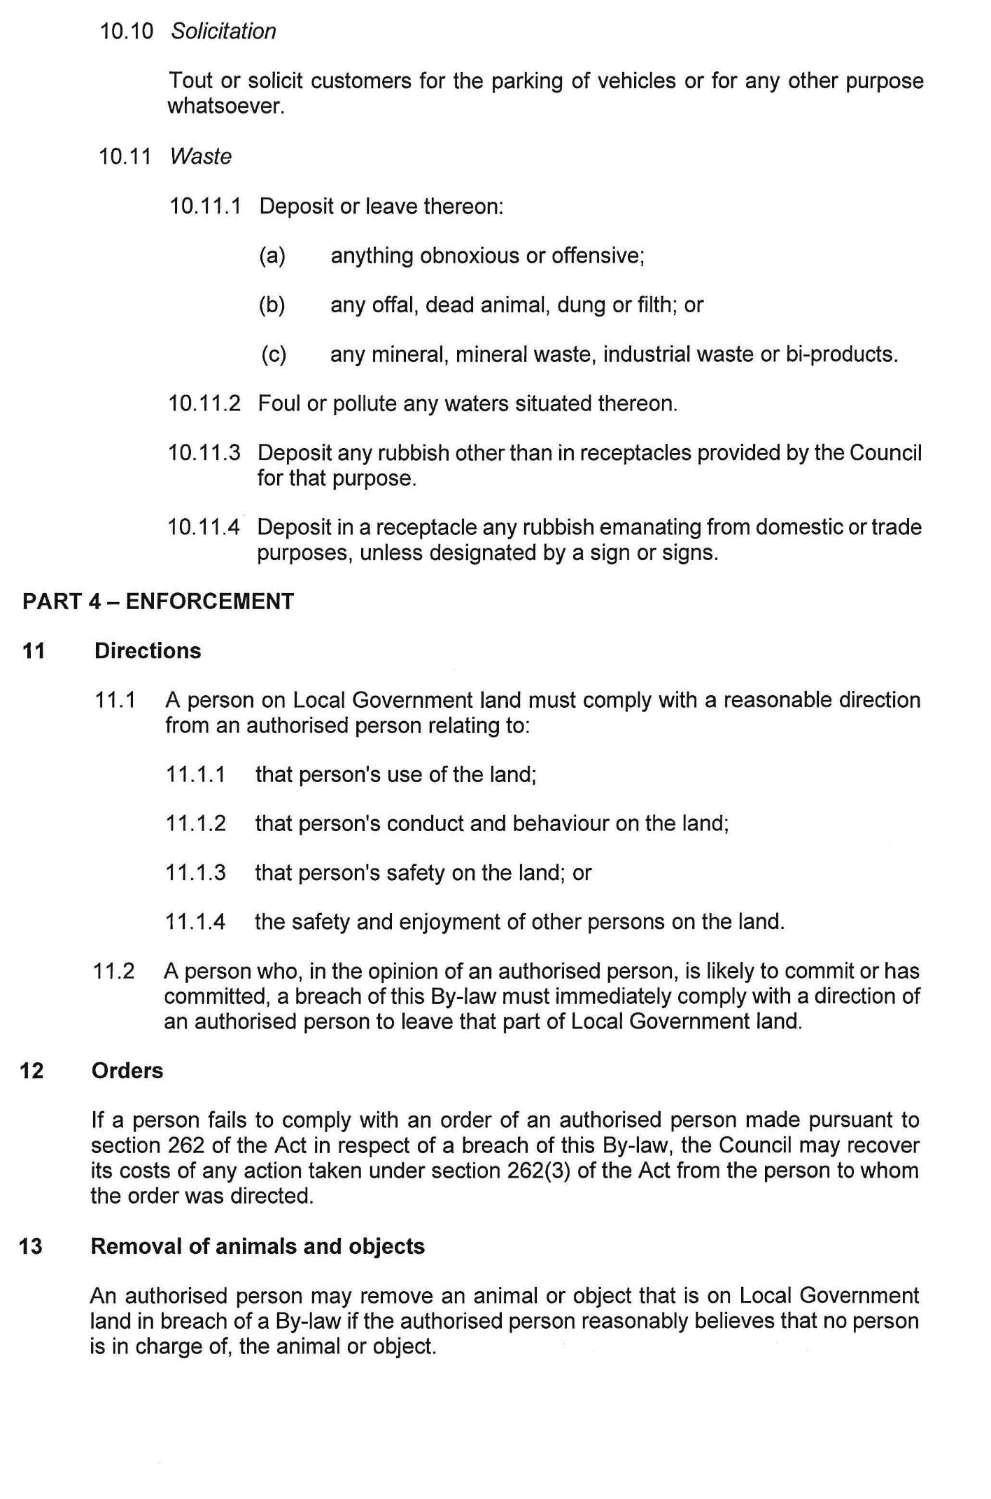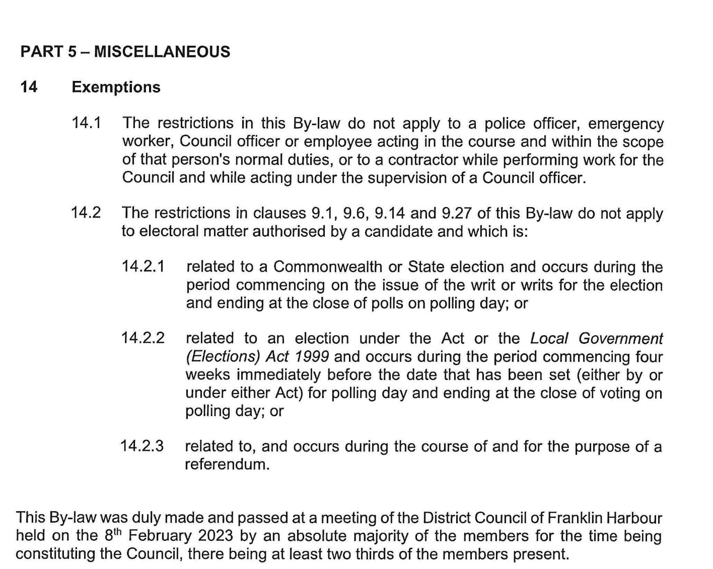

Dated: 10 February 2023
Shane Gill
Chief Executive Officer

REGIONAL COUNCIL OF GOYDER
Local Government Act 1999
Casual Vacancy
Notice is hereby given that Regional Council of Goyder pursuant to Section 54 (1) (h) of the Local Government Act 1999 declares a casual vacancy in the office of Councillor for Eudunda Ward, due to the failure to submit under Part 14 of the Local Government (Elections) Act 1999 before the expiration of one month from the end of the period allowed under that Act for the submission of the return, by Councillor Judith Ann Partington.
Dated: 13 February 2023
David J. Stevenson
Chief Executive Officer

District Council of Mount Remarkable
Local Government Act 1999
Notice of Vacancy in the Office of Member of Council
NOTICE is hereby given in accordance with Section 54(6) of the Local Government Act 1999 that the office of Councillor for the Telowie Ward of the District Council of Mount Remarkable, formerly occupied by Phillip Michael Heaslip, became vacant by operation of section 54(1)(h) of the Local Government Act 1999 on 9 February 2023.
Dated: 16 February 2023
Sam Johnson OAM
Chief Executive Officer

Renmark Paringa Council
Roads (Opening and Closing) Act 1991
Road Closing—Government Road, Renmark West
NOTICE is hereby given, pursuant to Section 10 of the Roads (Opening and Closing) Act 1991 that the Renmark Paringa Council proposes to make a Road Process Order to close and retain a portion of Government Road adjoining Allotment 11on D8435, Renmark West, more particularly delineated and lettered ‘A’ on Preliminary Plan 23/0004.
The Preliminary Plan and statement of persons affected is available for public inspection at the offices of the Renmark Paringa Council, and the Adelaide Office of the Surveyor-General, during normal office hours. The Preliminary Plan can also be viewed at www.sa.gov.au/roadsactproposals.
Any application for easement or objection must set out the full name, address and details of the submission and must be fully supported by reasons. The application for easement or objection must be made in writing to the Renmark Paringa Council, PO Box 730, Renmark SA 5341, WITHIN 28 DAYS OF THIS NOTICE, and a copy must be forwarded to the Surveyor-General at PO Box 1815, Adelaide 5001. Where a submission is made, the Council will give notification of a meeting at which the matter will be considered.
Dated: 9 February 2023
Tony Siviour
Chief Executive Officer

District COUNCIL OF Tumby Bay
Local Government Act 1999
Notice of Vacancies in the Offices of Member of Council
NOTICE is hereby given in accordance with section 54(6) of the Local Government Act 1999 that a vacancy has occurred in the office of Mayor, Mayor Geoffrey Churchett, of The District Council of Tumby Bay, by operation of section 54(1)(h) of the Local Government Act 1999 effective 12 January 2023.
Dated: 16 February 2023
R. Hayes
Chief Executive Officer

Wakefield Regional Council
Roads (Opening and Closing) Act 1991
Road Closing—Bridge Road, Balaklava
Notice is hereby given, pursuant to section 10 of the Roads (Opening and Closing) Act 1991, that the Wakefield Regional Council proposes to make a Road Process Order to close and retain for Council purposes, portion of Bridge Road, Balaklava as delineated and lettered ‘A’ on the Preliminary Plan PP 23/0003.
A copy of the plan and a statement of persons affected are available for public inspection at the Council Office at Scotland Place, Balaklava, and the Adelaide Office of the Surveyor-General during normal office hours. The Preliminary Plan may also be viewed at www.sa.gov.au/roadsactproposals
Any application for easement or objection must set out the full name, address and details of the submission and must be fully supported by reasons.
The application for easement or objection must be made in writing to the Council at Scotland Place, Balaklava within 28 days of this notice and a copy must be forwarded to the Surveyor-General at GPO Box 1815 Adelaide 5001. Where a submission is made, the Council will give notification of a meeting at which the matter will be considered.
Dated: 16 February 2023
Andrew MacDonald
Chief Executive Officer

Public Notices

Trustee Act 1936
Public Trustee
Estates of Deceased Persons
In the matter of the estates of the undermentioned deceased persons:
DUDJONS Inge Martha late of South Terrace Jamestown Retired School Teacher who died 1 June 2022
DUNN Margaret late of 7 Shackleton Avenue Ingle Farm Retired Kitchen Hand who died 22 September 2022
ELDRIDGE Ian late of 11-15 Hollywood Boulevard Salisbury Downs Retired Master Plumber who died 14 September 2022
EWERS Jennifer Joy late of 333 Marion Road North Plympton Retired Book Keeper who died 10 August 2022
GEBLER Walter Wolfgang late of 20 Kleinschmidt Road Lobethal Retired Baker who died 12 May 2022
HODGKISON Dennis Roy late of 2 Leighton Avenue Klemzig Retired Public Servant who died 8 October 2022
KOSKI John Colin late of 2-16 Cardigan Street Angle Park Retired Forestry Officer and Linesman who died 2 September 2022
WEAR Marie Joy late of 53 Austral Terrace Morphettville Of no occupation who died 2 September 2022
Notice is hereby given pursuant to the Trustee Act 1936, the Inheritance (Family Provision) Act 1972 and the Family Relationships Act 1975 that all creditors, beneficiaries, and other persons having claims against the said estates are required to send, in writing, to the office of Public Trustee at GPO Box 1338, Adelaide 5001, full particulars and proof of such claims, on or before the 17 March 2023 otherwise they will be excluded from the distribution of the said estate; and notice is also hereby given that all persons indebted to the said estates are required to pay the amount of their debts to the Public Trustee or proceedings will be taken for the recovery thereof; and all persons having any property belonging to the said estates are forthwith to deliver same to the Public Trustee.
Dated: 16 February 2023
N. S. Rantanen
Public Trustee

Notice Submission

The South Australian Government Gazette is published each Thursday afternoon.
Notices must be emailed by 4 p.m. Tuesday, the week of publication.
Submissions are formatted per the gazette style and a proof will be supplied prior to publication, along with a quote if applicable. Please allow one day for processing notices.
Alterations to the proof must be returned by 4 p.m. Wednesday.

Gazette notices must be submitted as Word files, in the following format:
• Title—the governing legislation
• Subtitle—a summary of the notice content
• Body—structured text, which can include numbered lists, tables, and images
• Date—day, month, and year of authorisation
• Signature block—name, role, and department/organisation authorising the notice

Please provide the following information in your email:
• Date of intended publication
• Contact details of the person responsible for the notice content
• Name and organisation to be charged for the publication—Local Council and Public notices only
• Purchase order, if required—Local Council and Public notices only

Email: governmentgazettesa@sa.gov.au
Phone: (08) 7109 7760
Website: www.governmentgazette.sa.gov.au

All instruments appearing in this gazette are to be considered official, and obeyed as such

Printed and published weekly by authority of M. Dowling, Government Printer, South Australia
$8.15 per issue (plus postage), $411.00 per annual subscription—GST inclusive
Online publications: www.governmentgazette.sa.gov.au

