No. 1 p. 1
THE SOUTH AUSTRALIAN
GOVERNMENT GAZETTE
Published by Authority

Adelaide, Thursday, 5 January 2023

Contents

State Government Instruments

Aquaculture Act 2001 2

Building Work Contractors Act 1995 2

Fair Trading (Motor Vehicle Insurers and Repairers)
Amendment Act 2021 3

Fisheries Management (General) Regulations 2017 24

Fisheries Management Act 2007 25

Justices of the Peace Act 2005 28

Land Agents Act 1994 29

National Electricity (South Australia) Act 1996 29

Petroleum and Geothermal Energy Act 2000 29

Public Finance and Audit Act 1987 30

Local Government Instruments

The Flinders Ranges Council 34

Wattle Range Council 34

State Government Instruments

Aquaculture Act 2001
Grant of Aquaculture Lease
Pursuant to the provisions of Section 22 of the Aquaculture Act 2001, notice is hereby given of the grant of the following lease for the purposes of aquaculture in the waters of Point Pearce, South Australia:
LA00486
Further details are available for the above lease on the Aquaculture Public Register; which can be found at:
http://www.pir.sa.gov.au/aquaculture/aquaculture_public_register
or by contacting Aquaculture Leasing & Licensing on 8207 5332.
Dated: 20 December 2022
Mandee Theil
Aquaculture Environmental Assessment Officer

Aquaculture Act 2001
Grant of Aquaculture Lease
Pursuant to the provisions of Section 22 of the Aquaculture Act 2001, notice is hereby given of the grant of the following lease for the purposes of aquaculture in the Lincoln aquaculture zone, Port Lincoln, South Australia:
LA00516
Further details are available for the above lease on the Aquaculture Public Register; which can be found at:
http://www.pir.sa.gov.au/aquaculture/aquaculture_public_register
or by contacting Aquaculture Leasing & Licensing on 8207 5332.
Dated: 21 December 2022
Georgia Macaulay
Aquaculture Environmental Assessment Officer

Building Work Contractors Act 1995
Exemption
Take notice that, pursuant to Section 45 of the Building Work Contractors Act 1995, I, Zoe Thomas as a delegate for the Minister for Consumer and Business Affairs, do hereby exempt the licensee named in Schedule 1 from the application of Division 3 of Part 5 of the above Act in relation to domestic building work described in Schedule 2 and subject to the conditions specified in Schedule 3.
Schedule 1
DAVID GEORGE HAYDEN BLD 10818
Schedule 2
Additions to an existing single storey residential dwelling at Allotment 62 in Deposited Plan 10092 being a portion of the land described in Certificate of Title Volume 5131 Folio 973, more commonly known as 15 Flotilla Street, Seaford SA 5169.
Schedule 3
1. This exemption is limited to domestic building work personally performed by the licensee in relation to the building work described in Schedule 2.
2. This exemption does not apply to any domestic building work the licensee contracts to another building work contractor, for which that contractor is required by law to hold building indemnity insurance.
3. That the licensee does not transfer his interest in the land prior to five years from the date of completion of the building work the subject of this exemption, without the prior authorisation of Consumer and Business Services (CBS). Before giving such authorisation, CBS may require the licensee to take any reasonable steps to protect the future purchaser(s) of the property, including but not limited to:
• Providing evidence that an adequate policy of building indemnity insurance is in force to cover the balance of the five-year period from the date of completion of the building work the subject of this exemption;
• Providing evidence of an independent expert inspection of the building work the subject of this exemption;
• Making an independent expert report available to prospective purchasers of the property;
• Giving prospective purchasers of the property notice of the absence of a policy of building indemnity insurance.
Dated: 29 December 2022
Zoe Thomas
Assistant Director, Licensing
Delegate for the Minister for Consumer and Business Affairs

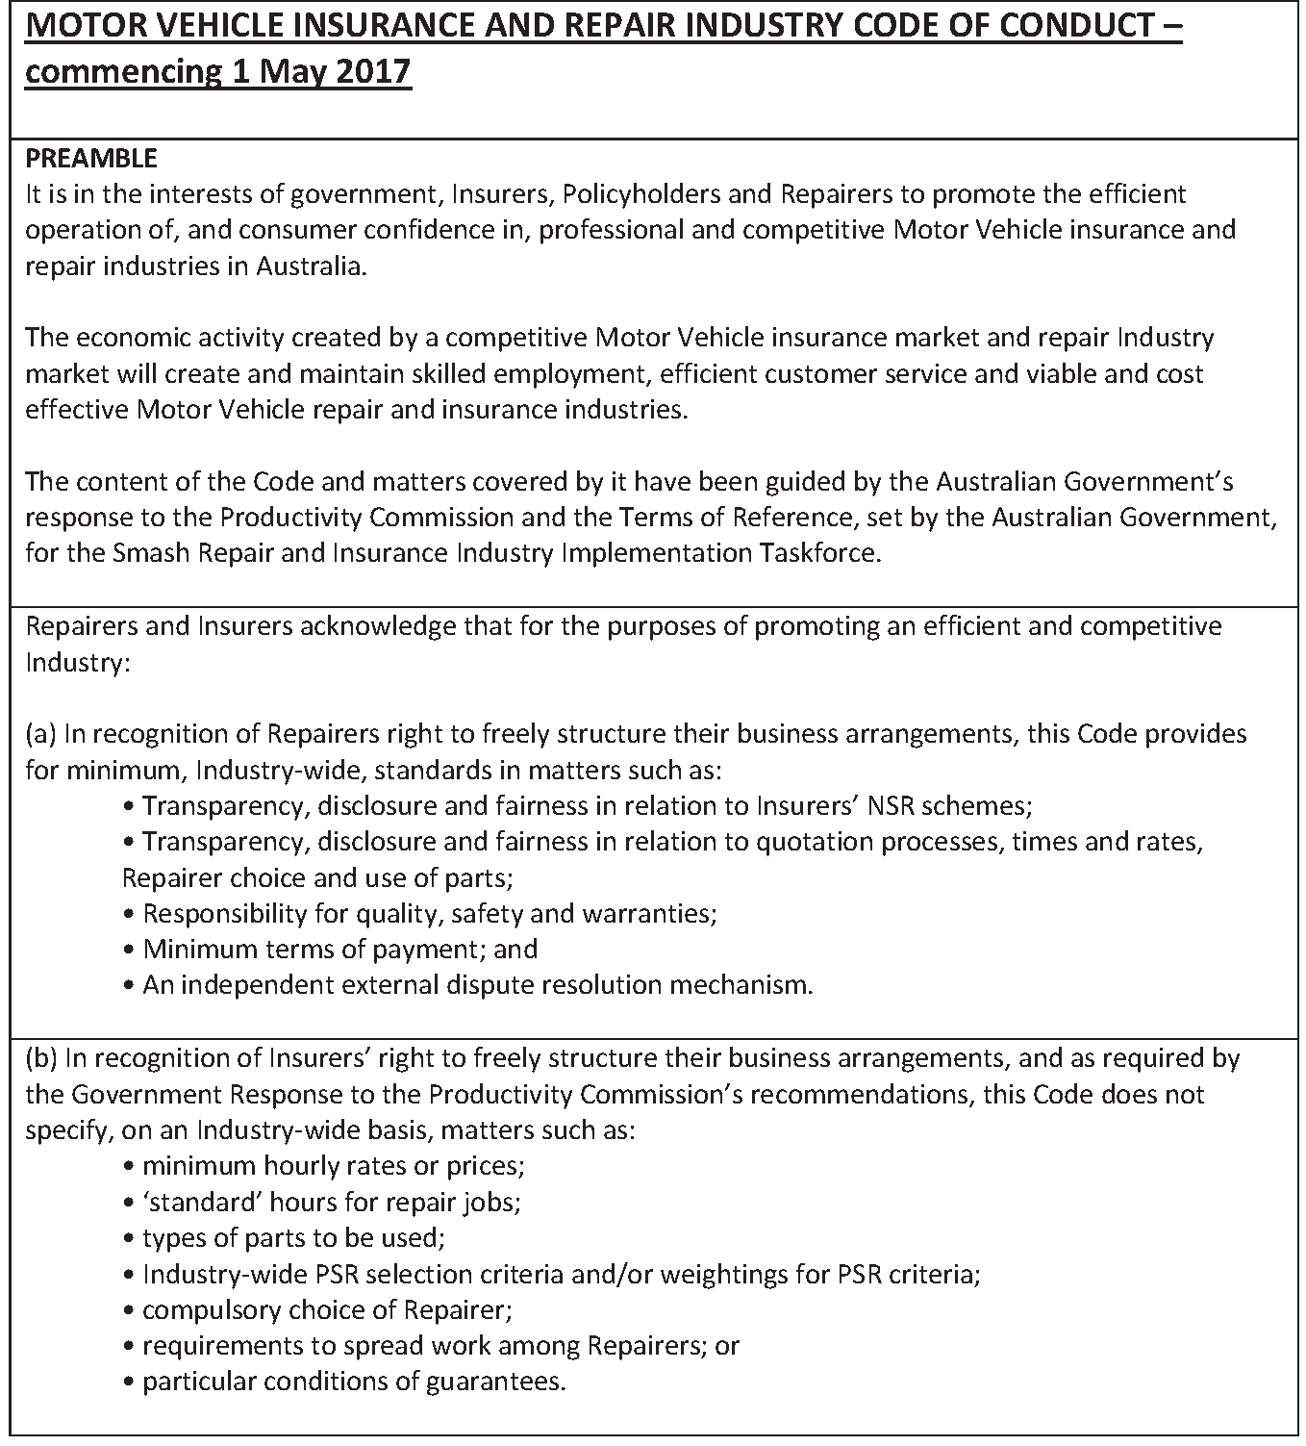
Fair Trading (Motor Vehicle Insurers and Repairers) Amendment Act 2021

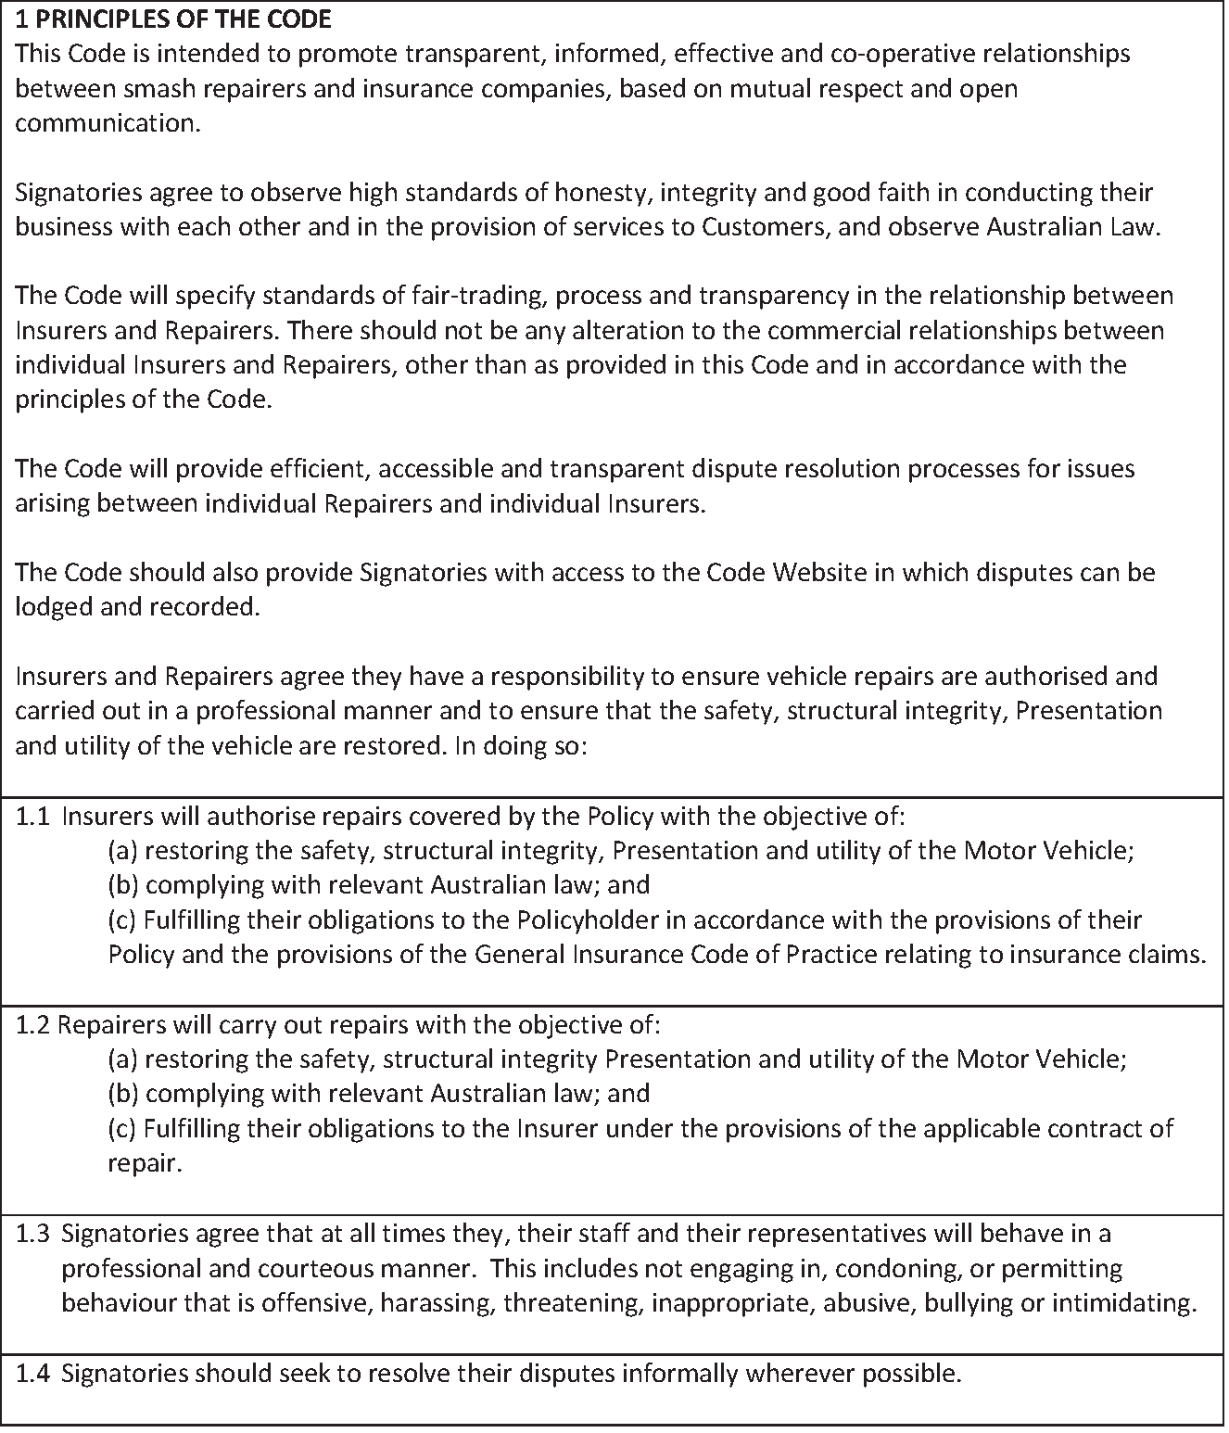
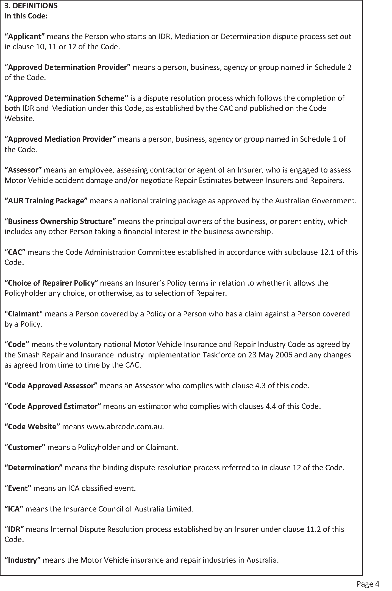
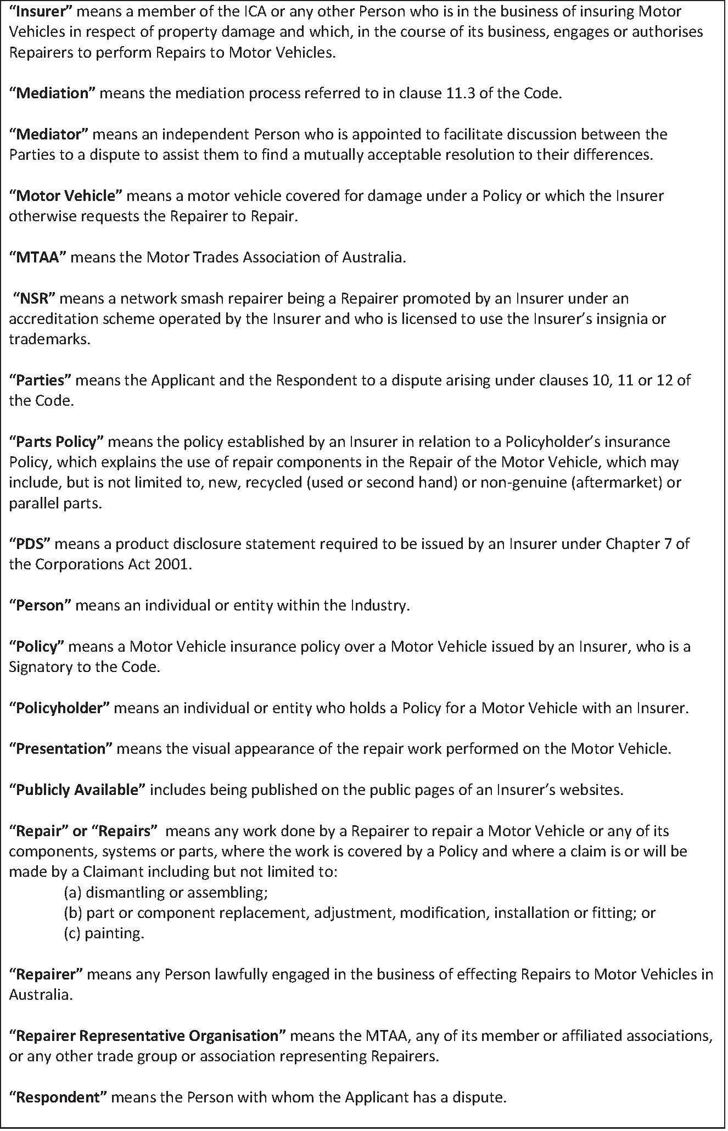
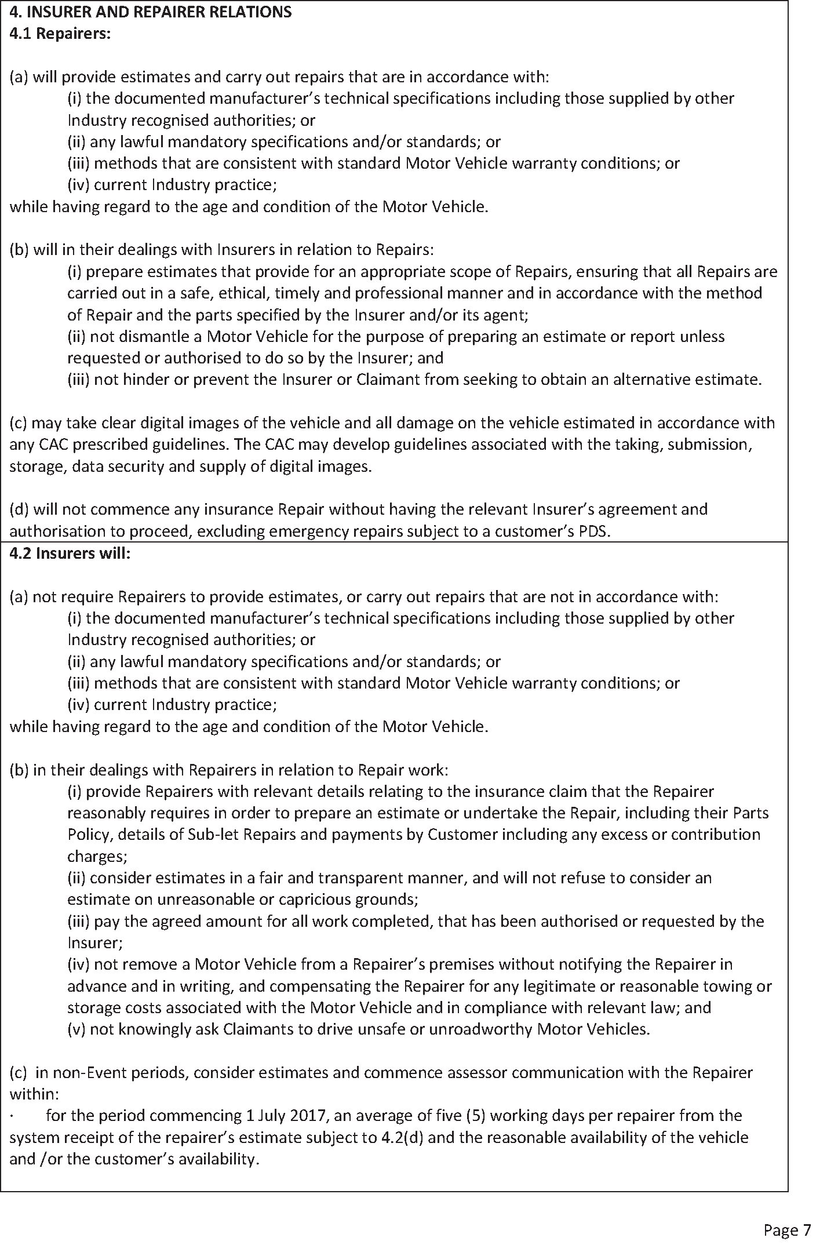
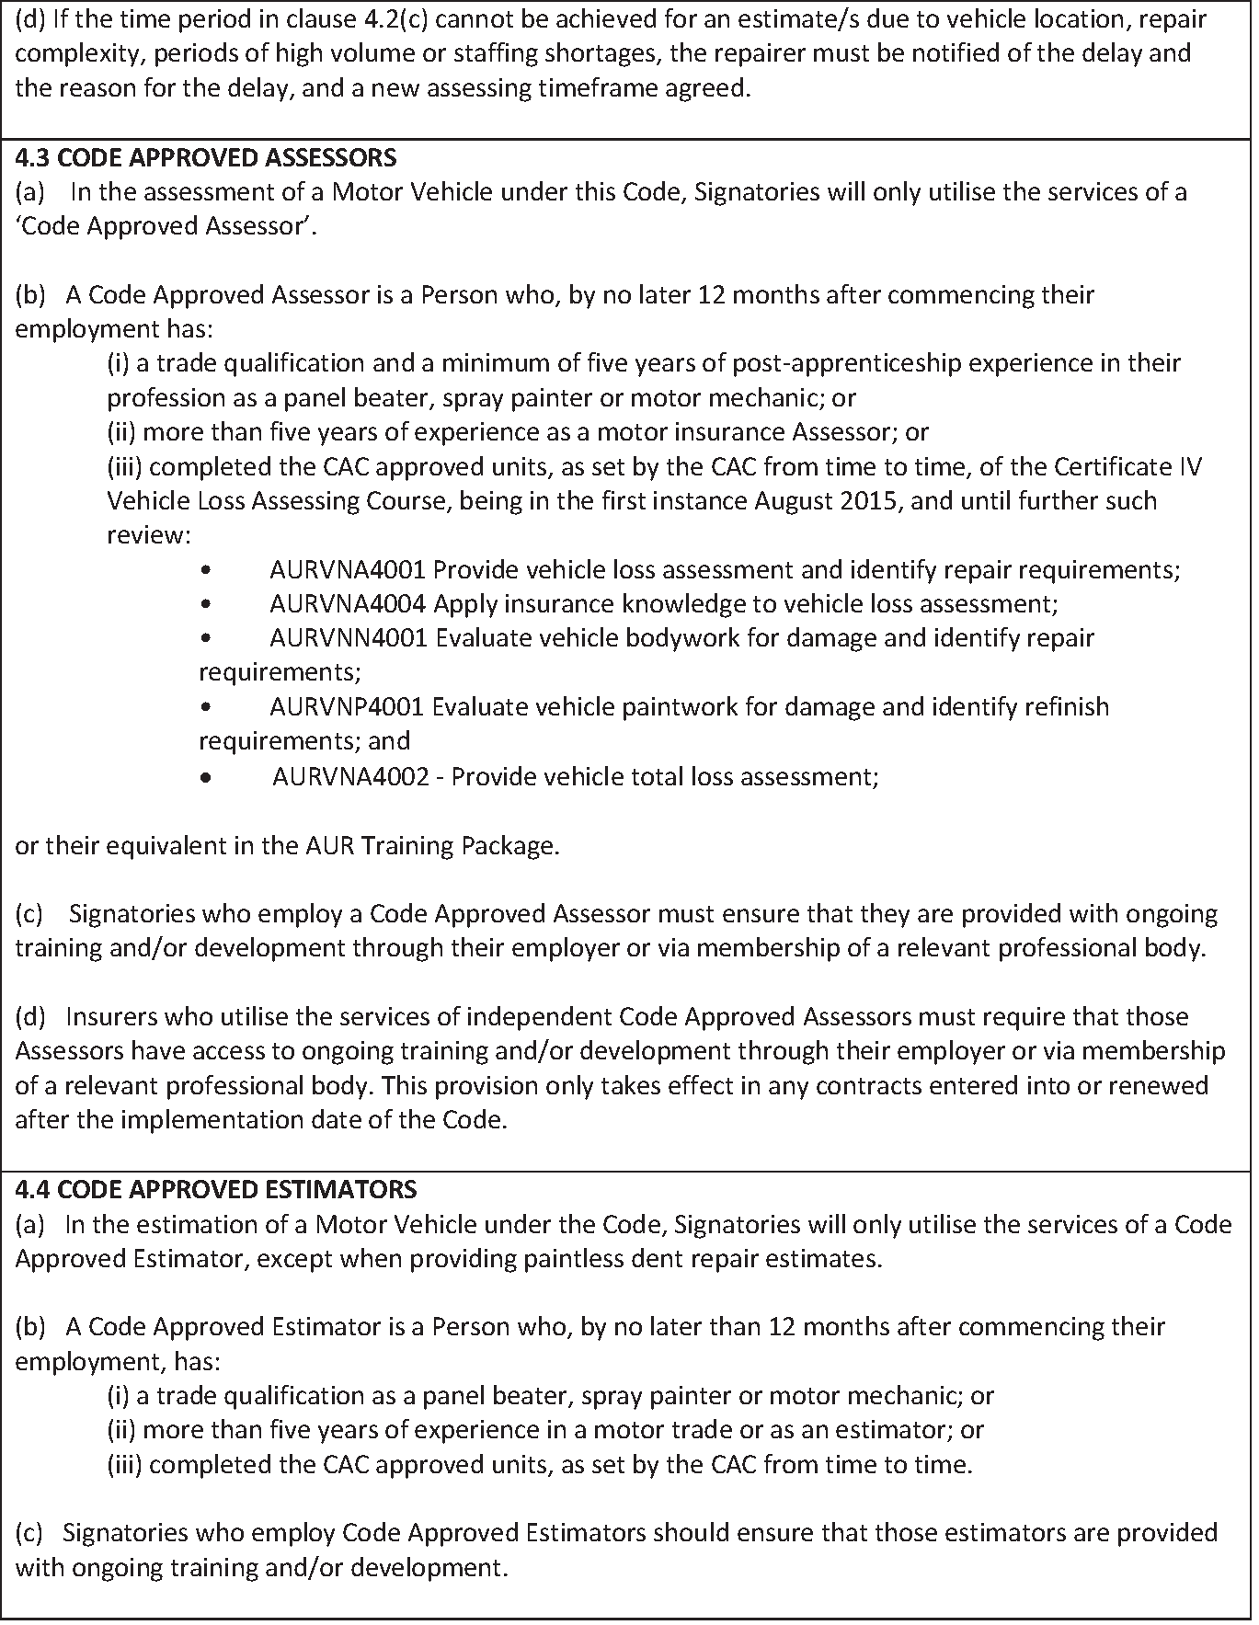
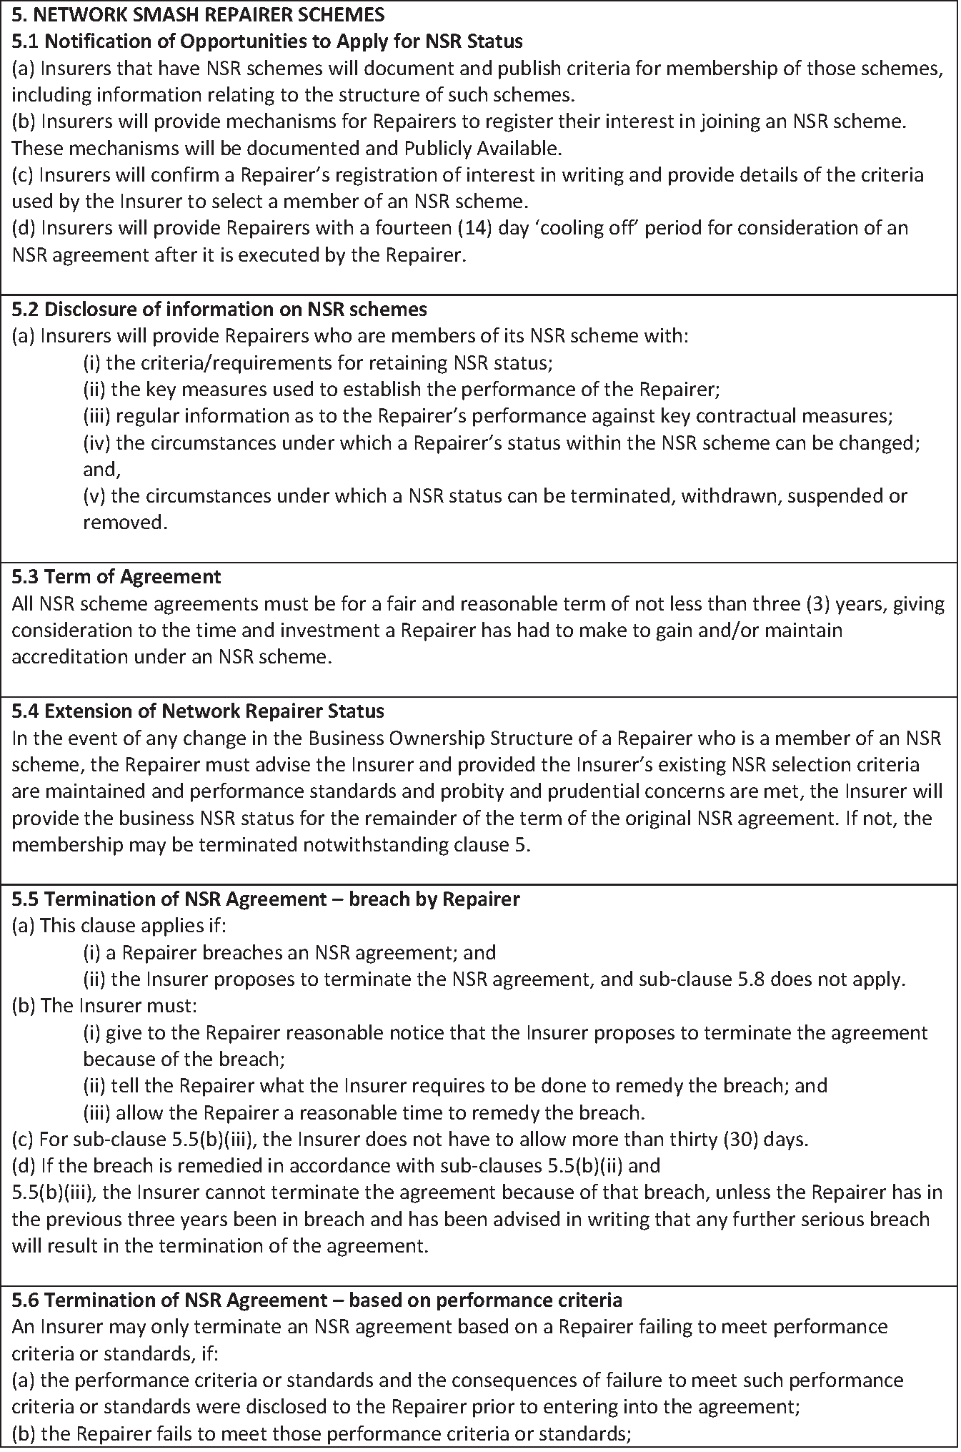
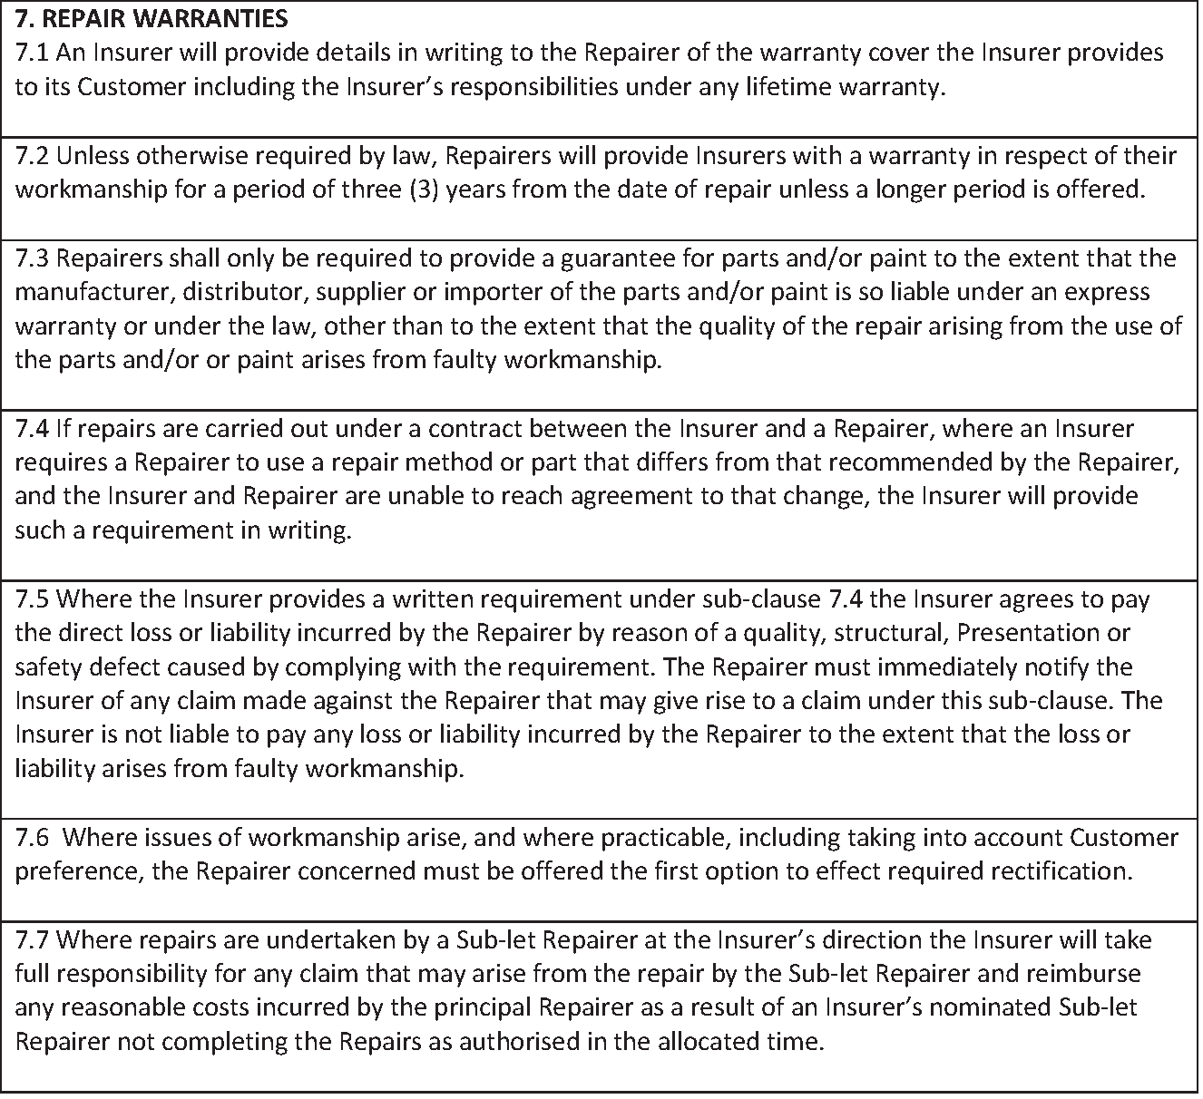

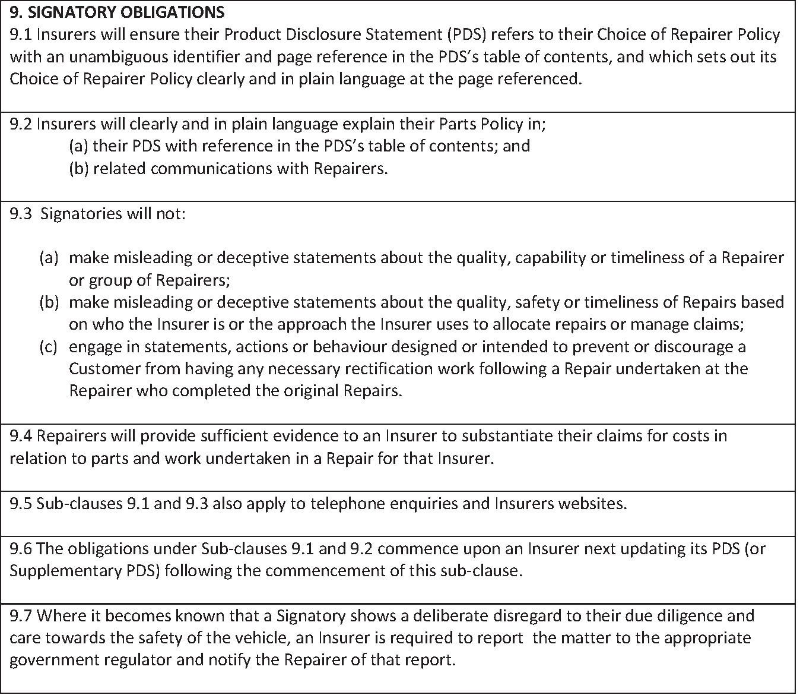
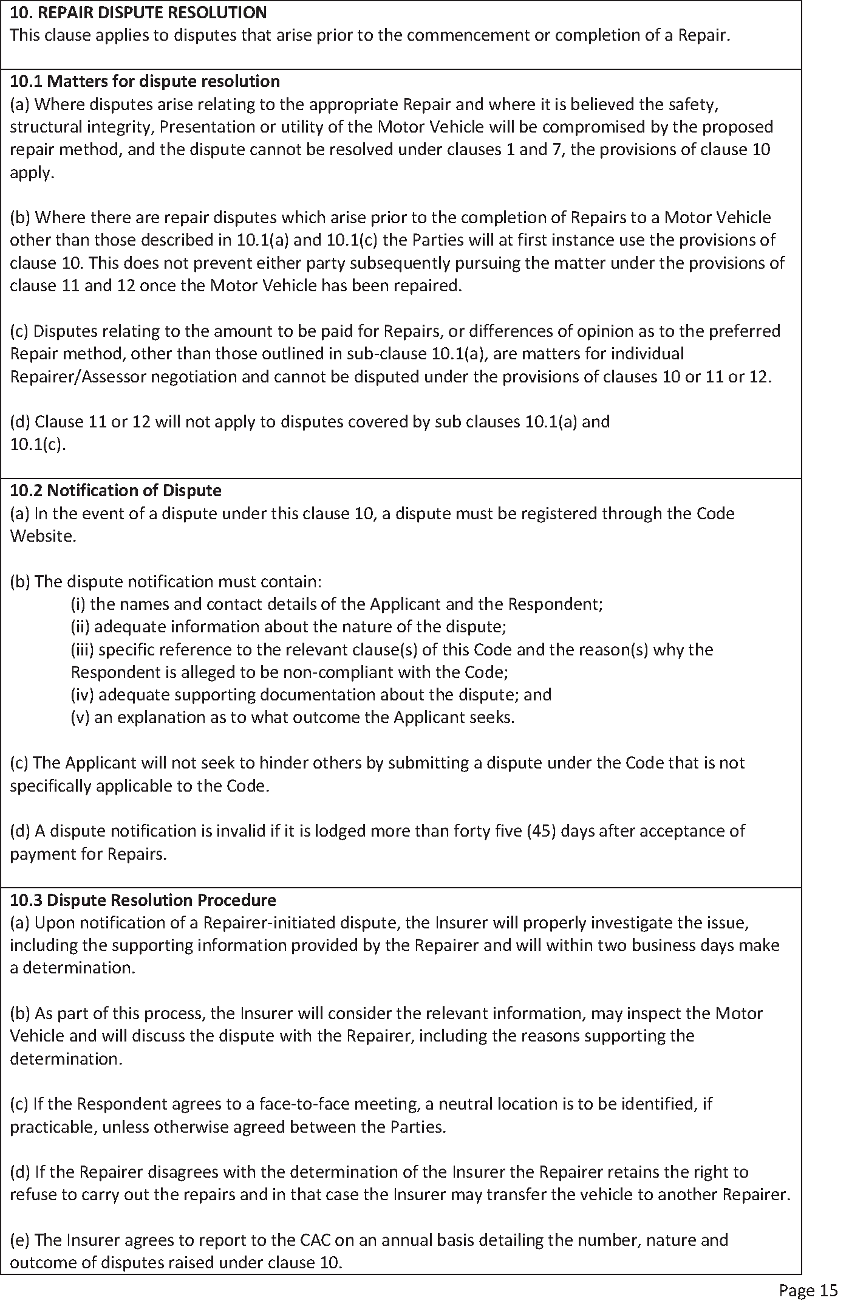
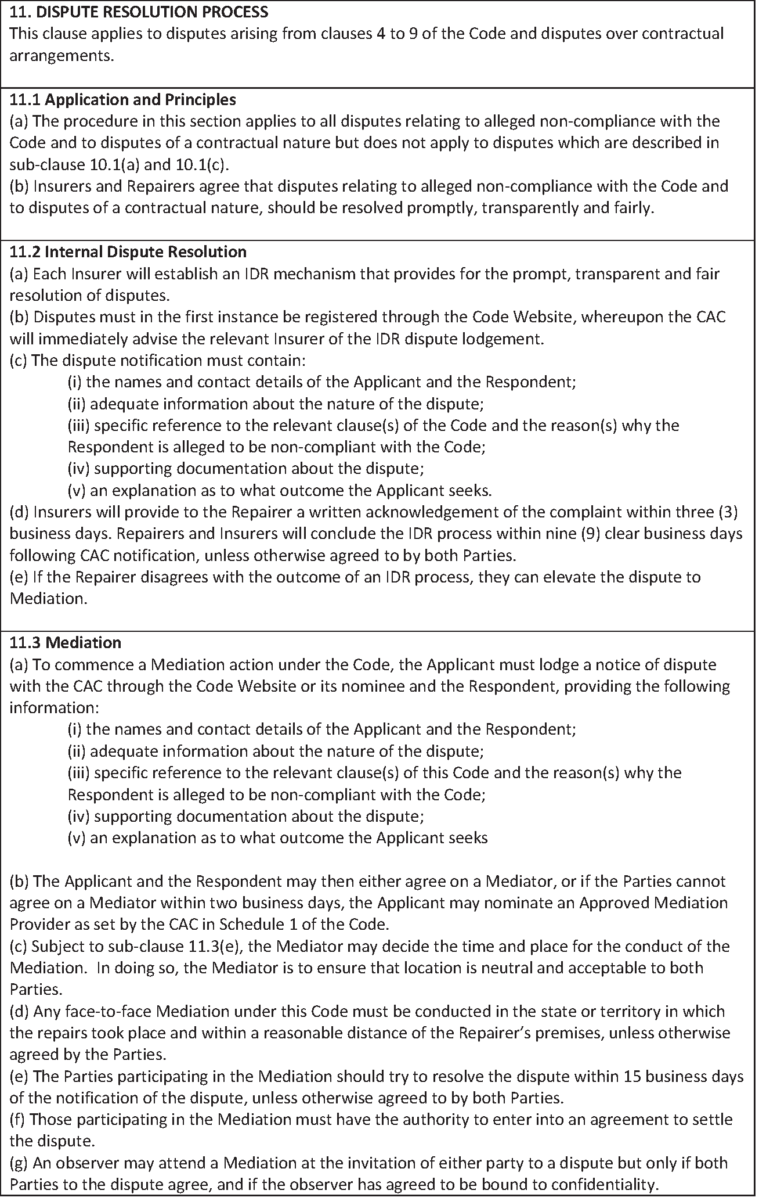

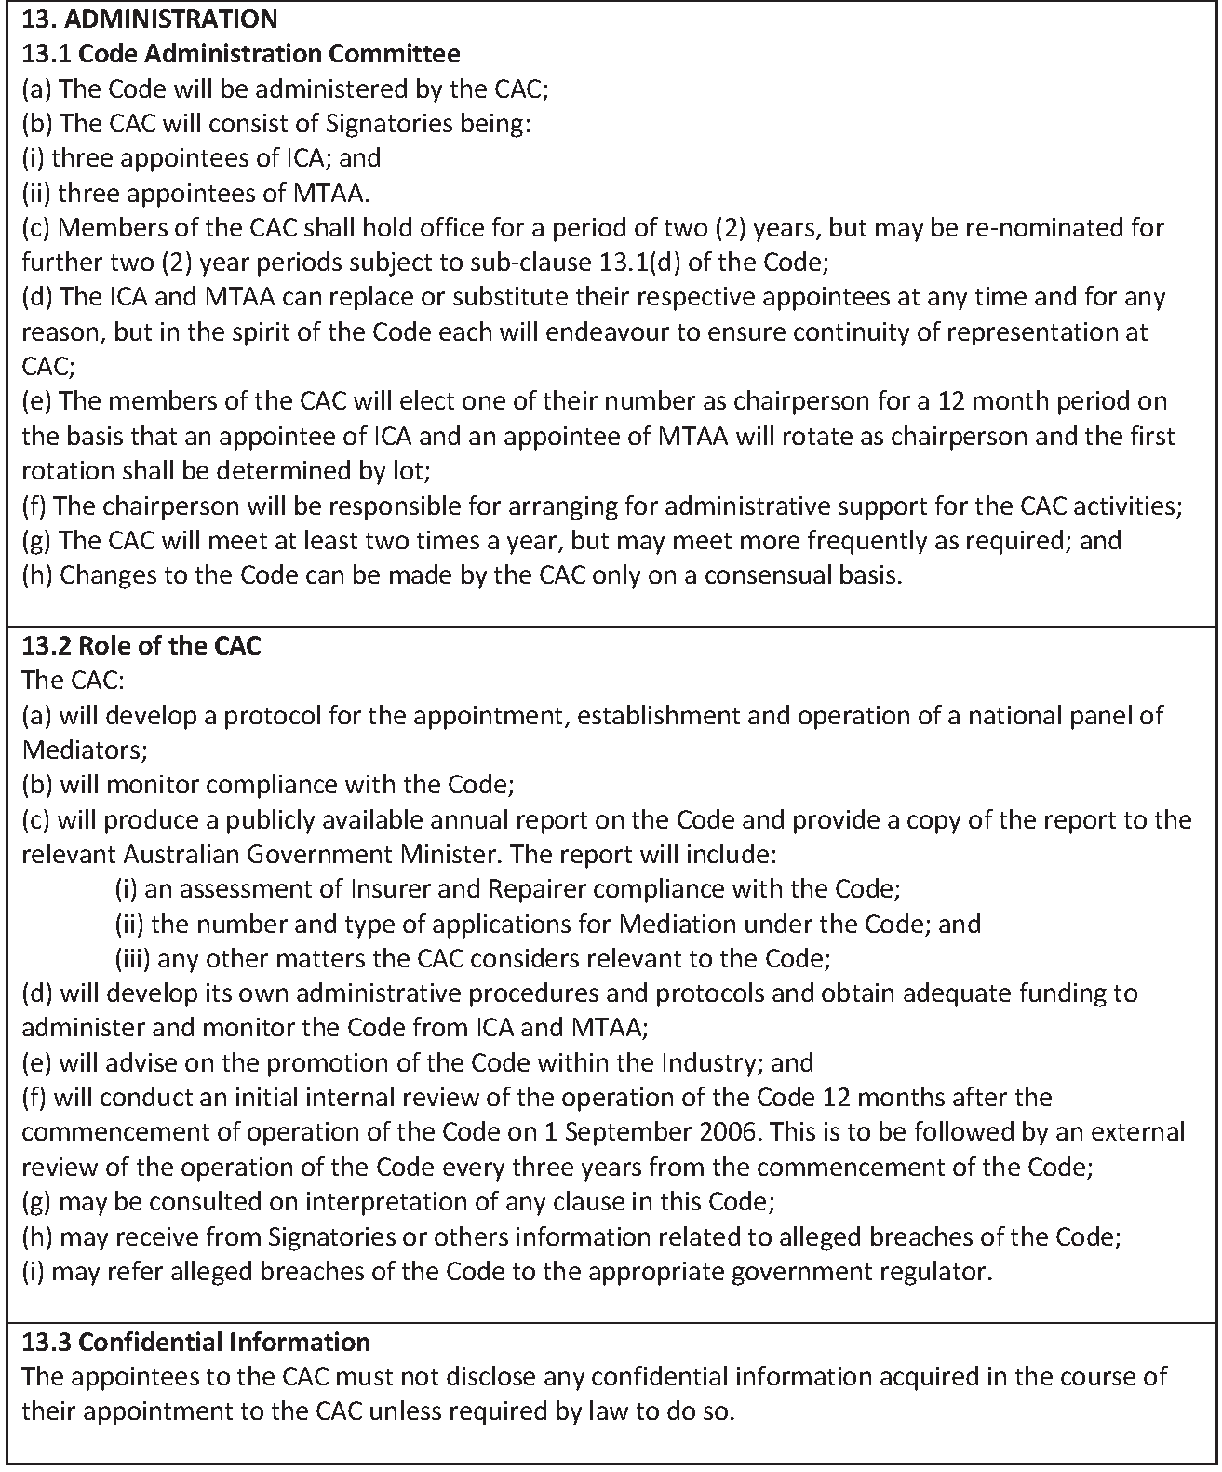
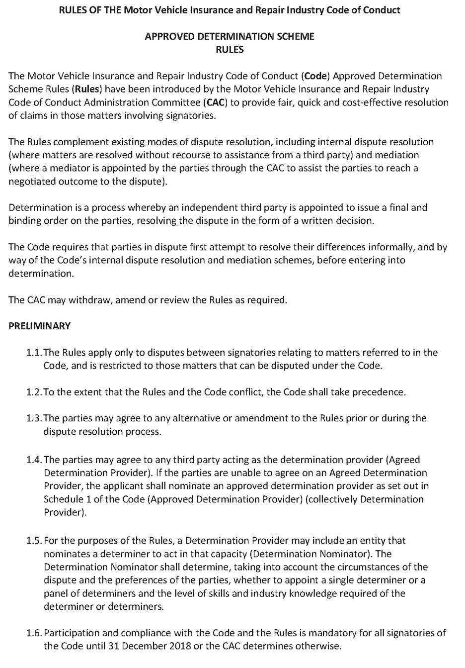
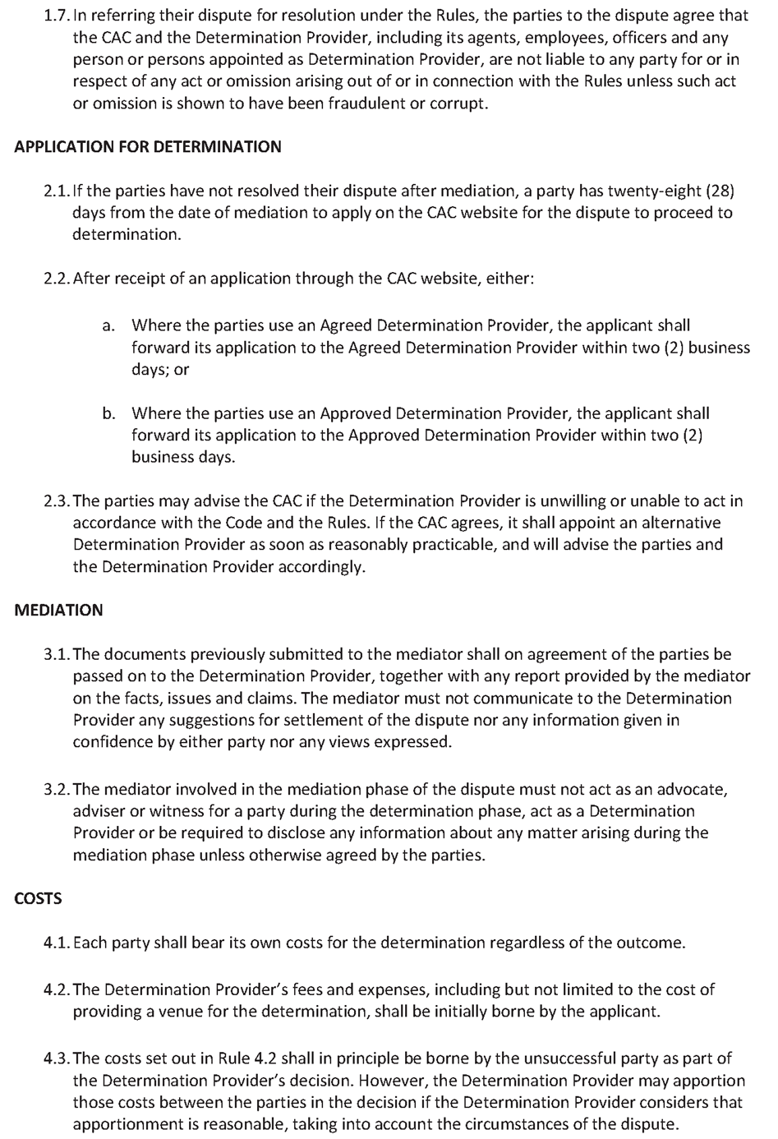
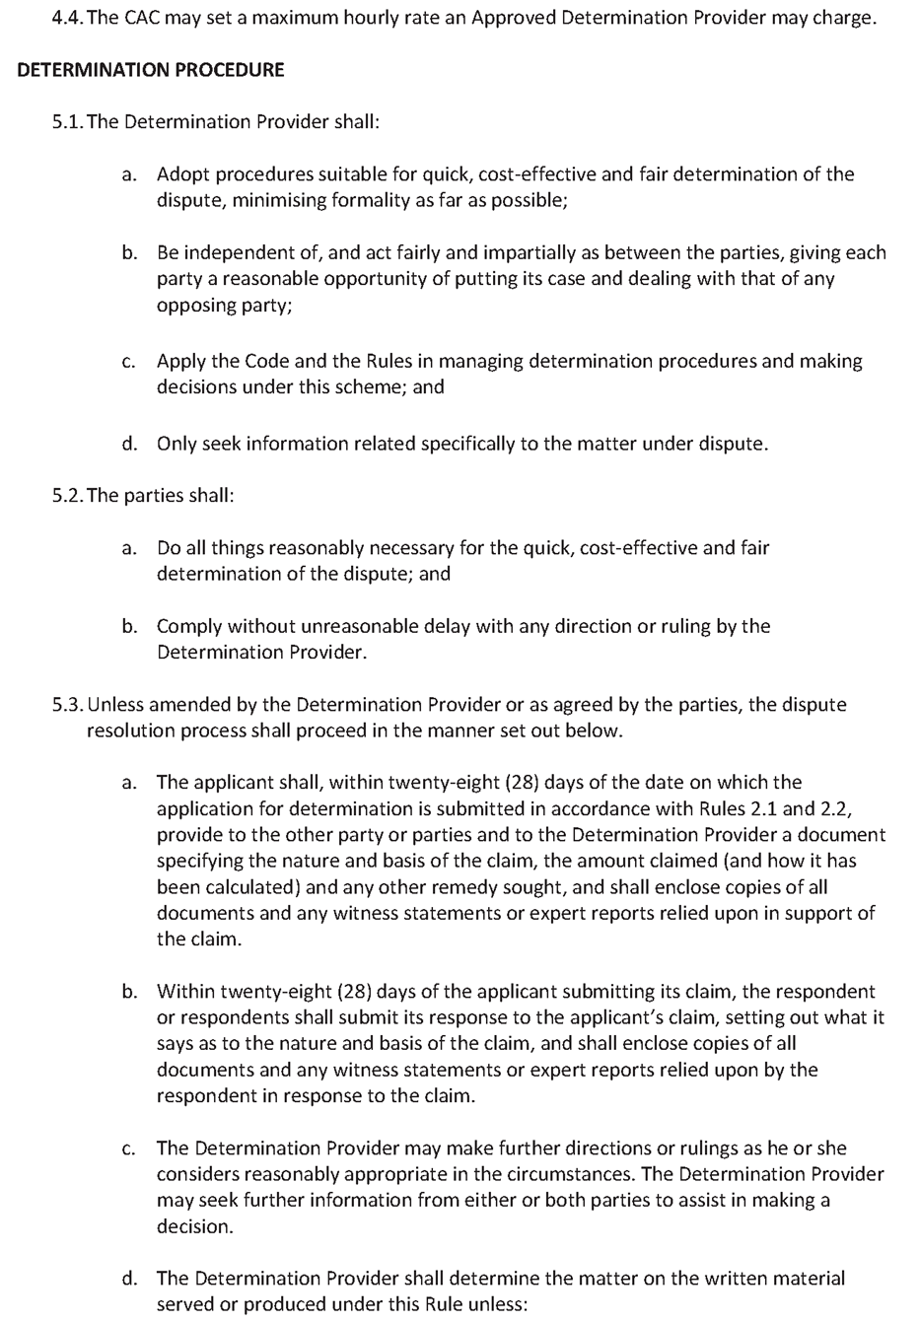
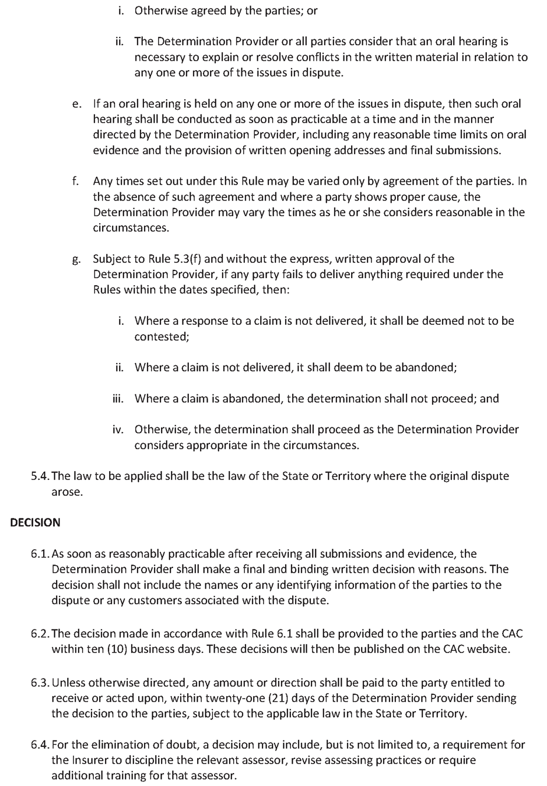
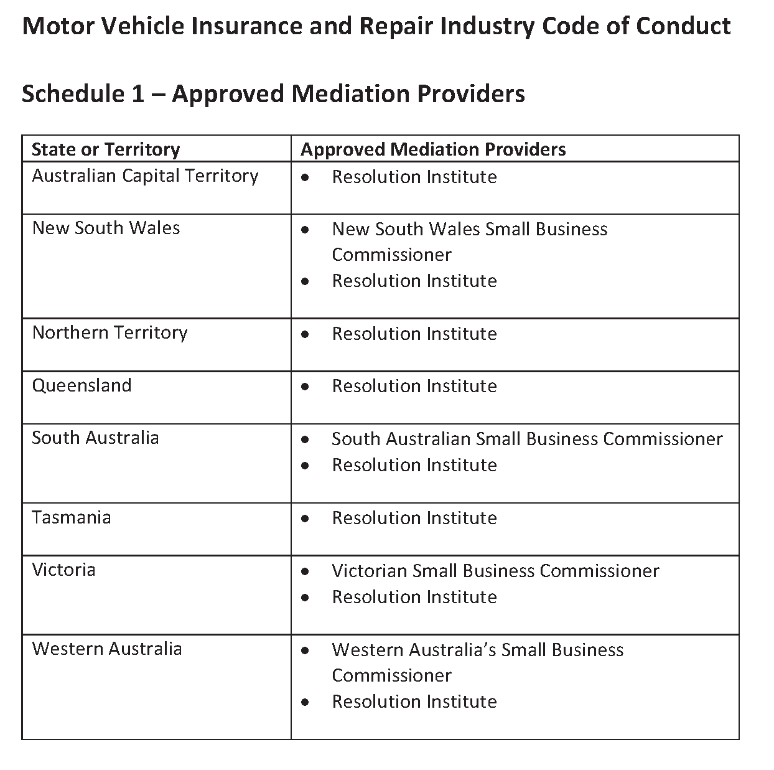
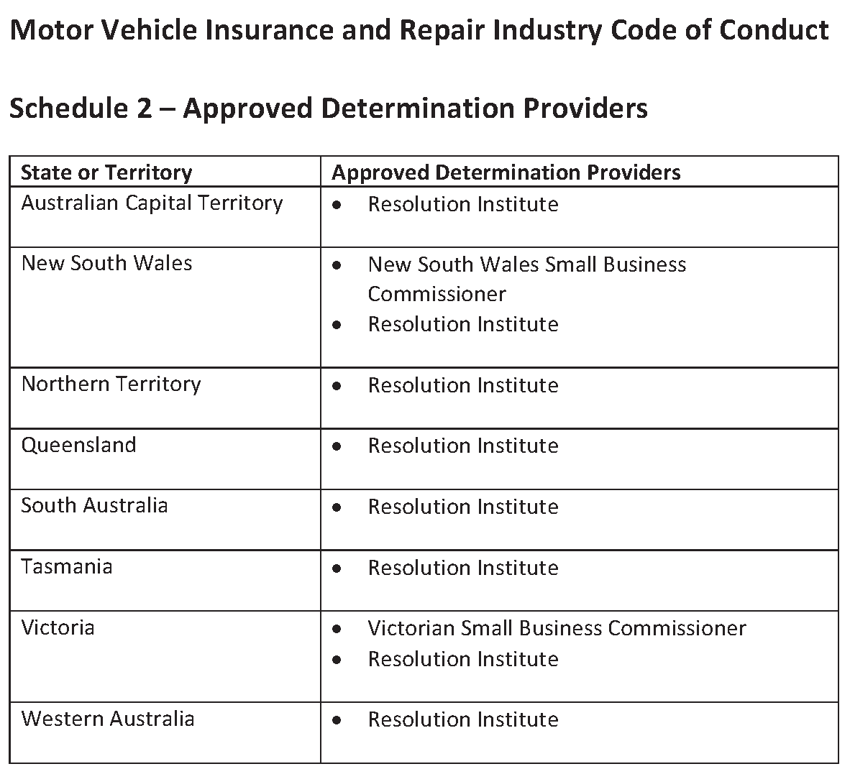
Dated: 5 January 2023
Nerissa Kilvert
South Australian Small Business Commissioner

Fisheries Management (General) Regulations 2017
Regulation 23A(1)
Determination—Taking of Bivalve Filter-Feeding Molluscs in Port Adelaide River Estuary
As the delegate of the Minister for Primary Industries and Regional Development, I, Professor Gavin Begg, Executive Director of Fisheries and Aquaculture make the following determination for the purposes of Regulation 23A(1) of the Fisheries Management (General) Regulations 2017 regarding the taking of bivalve molluscs in the Port Adelaide River Estuary, unless this notice is otherwise varied or revoked:
(1) Dr Ryan Baring, Flinders University and nominated agents (Authorised employees of the Flinders University), and persons acting under supervision of authorised employees of Flinders University who are engaged in research activities under Ministerial exemption ME9903230 may collect bivalve filter-feeding molluscs from within the waters of the Port Adelaide River Estuary excluding the waters of aquatic reserves (unless otherwise authorised under the Fisheries Management Act 2007).
(2) The taking of bivalve filter feeding molluscs with the Port Adelaide River Estuary under this determination may only occur where it is consistent with the arrangements contained in Ministerial exemption ME9903230 during the period 22 December 2022 until 22 December 2023.
(3) All equipment used in collecting specimens must be appropriately decontaminated in accordance with the “AQUAVETPLAN Operational Procedures Manual – Decontamination”.
(4) Following the completion of any laboratory analysis required, all bivalve molluscs collected must be disposed of appropriately in accordance with AQUAVETPLAN Operational Procedures Manual – Disposal.
(5) Bivalve molluscs collected from within the Port Adelaide River Estuary must not be made available for human consumption.
Dated: 21 December 2022
Benn Gramola
A/Executive Director
Fisheries and Aquaculture
Delegate of the Minister for Primary Industries and Regional Development

Fisheries Management (General) Regulations 2017
Regulation 23B
Taking of Murray Cod in Certain Waters—River Murray Flood Event 2022-2023
For the purposes of Regulation 23B of the Fisheries Management (General) Regulations 2017 regarding the taking of Murray Cod in certain waters, I, Benn Gramola, A/Executive Director of Fisheries and Aquaculture, delegate of the Minister for Primary Industries and Regional Development make the following determination:
(1) Nathan Rhodes Executive Director, PIRSA Biosecurity and his nominated agents may take dead and dying Murray Cod (Maccullochella peelii) from the waters of the River Murray proper and Lakes Albert and Alexandrina, consistent with activities under Ministerial exemption ME9903240 and undertaken under the “Operational Response Plan—River Murray flood events: management of fish kills 2002-2023”.
(2) The nominated agents of Mr Rhodes are:
• Garry Warrick, 1979 Kingston Road, Loxton, SA 5333
• Timothy Hoad, PO Box 2178, Murray Bridge, SA 5253
• Nicholas Cuconits, 4 Sherwood Avenue, Valley View, SA 5093
• Zane Skrypek, PO Box 811, Goolwa, SA 5214
• Perry Robinson 2-6 Kent Street, Murray Bridge, SA 5253
• Staff and registered volunteers of the Murrayland and Riverland Landscape Board, 110A Kent Street, Murray Bridge, SA 5253
• Staff and registered volunteers of PIRSA Biosecurity, 33 Flemington Street, Glenside, SA 5065
• Staff and registered volunteers of Department of Environment and Water 81-95 Waymouth Street, Adelaide, SA 5000 and 28 Vaughan Terrace, Berri, SA 5343
(3) Murray cod taken pursuant to this determination must not be sold.
(4) Murray cod taken pursuant to this determination must be transferred as soon as possible to a composting or landfill facility.
(5) If the exemption holder varies the list of nominated agents or requires more agents than what is described in this notice, written advice listing names of the additional agents must be provided to the Department by email on PIRSA.MinisterialExemptionsandPermits@sa.gov.au as soon as is practicable.
(6) The activity under this determination may only occur from 23 December 2022 until 30 June 2023.
Dated: 23 December 2022
Benn Gramola
A/Executive Director for Fisheries and Aquaculture
Delegate of the Minister for Primary Industries and Regional Development

Fisheries Management Act 2007
Section 115
Ministerial Exemption ME9903230
Take notice that pursuant to Section 115 of the Fisheries Management Act 2007, I, Professor Gavin Begg, Executive Director Fisheries and Aquaculture, delegate of the Minister for Primary Industries and Regional Development, hereby exempt Dr Ryan Baring of Flinders University, Sturt Road, Bedford Park (the ‘exemption holder’) and his nominated agents, from Sections 70 and 71(2)of the Fisheries Management Act 2007 and Regulation 5(a) and Clauses 63 (1) and (2), 74 and 113 of Schedule 6 of the Fisheries Management (General) Regulations 2017, but only insofar as the activities are within the waters specified in Schedule 1 and consistent with research activities specified in Schedule 2, using the gear specified in Schedule 3 (the ‘exempted activity’), subject to the conditions specified in Schedule 4, from 22 December 2022 until 22 December 2023, unless varied or revoked.
Schedule 1
• The Port River Estuary, excluding waters of aquatic reserves (unless otherwise authorised under the Fisheries Management Act 2007), specifically:
◦ Razorfish (Pinna bicolor) beds situated in the lower intertidal zone on section bank will be surveyed in the intertidal zone between 34°46′18.2″S 138°28′52.3″E and 34°45′54.4″S 138°29′10.4″E (GDA94).
◦ Sampling of mangroves, oyster aggregation and unstructured control sites is to occur in the lower intertidal zone along the western side of Torrens Island between 34°48′09.0″S 138°30′57.0″E and 34°45′42.8″S 138°30′59.9″E (GDA94).
Schedule 2
Activities that are part of the Flinders University research project entitled ‘Response of fisheries to shellfish reefs in South Australia’.
Schedule 3
Equipment Type | Quantity | Dimensions
Quadrats—benthic invertebrates | 2-3 quadrats for 56 samples | 40cm width x 65cm length x 5cm height
Fyke nets—mobile nekton | 6 nets for 36 samples | 0.4m diameter opening, 4m total length, mesh size 1.2mm² with 2m x 1.2m wings
Hand nets | 1-2 nets for 180 samples | 30cm diameter x 1mm mesh. 5 m hauls
PVC Corer—infauna | 1 corer for 72 samples | 86.6cm² x 20 cm depth PVC corer
Paint Scraper—epibionts | 2-3 scrapers used for 72 samples | generic paint scraper (2cm – 10cm width)

Schedule 4
1. The exemption holder will be deemed responsible for the conduct of all persons conducting exempted activities under this notice. Any person conducting activities under this exemption must be provided with a copy of this notice, which they must have signed as an indication that they have read and understand the conditions under it.
2. Any species collected by the exemption holder are for scientific, education and research purposes only and must not be sold. Any specimens not required must be returned to the water immediately.
3. The nominated agents of the exemption holder are the following staff of Flinders University:
• Brad Martin, Sturt Road, Bedford Park, SA, 5042
• Charlie Huveneers, Sturt Road, Bedford Park, SA, 5042
• Simon Reeves, Sturt Road, Bedford Park, SA, 5042
4. The exemption holder must not collect specimens for aquaculture research purposes pursuant to this notice.
5. Any protected species taken incidentally while undertaking the exempted activity must be returned immediately to the water as close as possible to the location where they were captured.
6. Noxious species captured during the exempted activity must be humanly destroyed and cannot be returned to the water.
7. Organisms collected pursuant to this notice must not be released into state waters if they have been kept apart from their natural habitat.
8. Any equipment used to collect and hold fish during the exempted activity must be decontaminated prior to and after undertaking the research activities in accordance with AQUAVETPLAN Operational Procedures Manual—Decontamination.
9. The exemption holder or nominated agent/s may only retain post-larval (adults/ juveniles) samples of the following species as part of the exempted activity:
• Unknown scorpion fishes, Scorpaenoidei spp  • Unknown gobies, Gobiiformes spp  • Unknown blennies, Blenniiformes spp  • Unknown silversides, Atheriniformes spp  • Estuarine worms, Polychaeta spp  • Mediterranean fan worm, Sabella spallanzanii  • Southern Bobtail, Euprymna tasmanica  • Lesser Blue-ringed Octopus, Hapalochlaena maculosa  • Southern Pygmy Squid, Xipholeptos notoides  • Common Biscuit Star, Tosia australis  • Crested Oystergoby, Cryptocentroides gobioides  • Yellowspotted Sandgoby, Favonigobius punctatus  • Chameleon Goby, Tridentiger trigonocephalus  • Southern Ribbed Top Snail, Austrocochlea constricta  • Striped-mouth Conniwink, Bembicium nanum  • Wavy Top, Diloma concameratum  • estuarine snails, Hypsogastropoda spp  • Elongate Chiton, Ischnochiton elongatus  • Pacific Oyster, Magallana gigas  • Australian Black Nerite, Nerita atramentosa  • Razorfish, Pinna bicolor  • Cockles spp, Tapetinae spp  • Yellowfin Goby, Acanthogobius flavimanus  • Black Bream, Acanthopagrus butcheri  • Shaw’s Cowfish, Aracana aurita  • Ornate Cowfish, Aracana ornata  • Bridled Goby, Arenigobius bifrenatus  • Mulloway, Argyrosomus japonicus  • Australian Herring, Arripis georgiana  • Western Australian Salmon, Arripis truttacea  • Smallmouth Hardyhead, Atherinosoma microstoma  • Krefft’s Frillgoby, Bathygobius krefftii  • Sculptured Goby, Callogobius mucosus  • Australasian Snapper, Chrysophrys auratus  • Moonlighter, Tilodon sexfasciatus  • Weeping Toadfish, Torquigener pleurogramma  • Yellowtail Scad, Trachurus novaezelandiae  • Southern Fiddler Ray, Trygonorrhina dumerilii | • Striped barnacle, Amphibalanus amphitrite  • Amphipods, Amphipoda spp  • Little Shore Crab, Brachynotus spinosus  • European Green Crab, Carcinus maenas  • estuarine crabs, Decapoda spp  • Haswell’s Crab, Helograpsus haswellianus  • Sand Crab, Ovalipes australiensis  • Australian Blue Swimmer Crab, Portunus armatus  • Priess’ Sand Star, Astropecten preissi  • Brittle Stars, Ophiuroidea spp  • Estuary Cobbler, Cnidoglanis macrocephalus  • Southern Longfin Goby, Favonigobius lateralis  • zebrafish, Girella zebra  • South Australian Cobbler, Gymnapistes marmoratus  • Blackthroat Threefin, Helcogramma decurrens  • Western Striped Grunted, Helotes octolineatus  • Southern Garfish, hyporhamphus melanochir  • Western Jumping Blenny, Lepidoblennius marmoratus  • Sea Mullet, Mugil cephalus  • Southern Eagle Ray, Myliobatis tenuicadautus  • Little Weed Whiting, Neoodax balteatus  • Twinbar Goby, Nesogobius greeni  • Oyster Blenny, Omobranchus anolius  • Tasmanian Blenny, Parablennius tasmanianus  • Wavy Grubfish, Parapercis haackei  • Longsnout Boarfish, Pentaceropsis recurvirostris  • Southern bluespotted flathead, Platycephalus speculator  • Congolli, Pseudaphritis urvillii  • Magpie Perch, Pseudogoniistius nigripes  • Greenback Flounder, Rhombosolea tapirina  • Rough Leatherjacket, Scobinichthys granulatus  • Longfinned Worm Eel, Scolecenchelys breviceps  • Sweep, Scorpididae spp  • King George Whiting, Sillaginodes punctatus  • Snook, Sphyraena novaehollandiae  • Pipefish, syngnathidae spp  • Bluespotted Goatfish, Upeneichthys vlamingii  • Australian long-nosed pipefish, Vanacampus poecilolaemus  • Southern Calamari Squid, Sepioteuthis australis

10. At least 1 hour before conducting research under this exemption, the exemption holder or nominated agent must contact the Department of Primary Industries and Regions (PIRSA) Fishwatch on 1800 065 522 and answer a series of questions about the exempted activity. The caller will need to have a copy of this notice in their possession at the time of making the call and be able to provide information about the area and time of the exempted activity, the vehicles and/or boats involved, the number of permit holders undertaking the exempted activity and other related questions.
11. The exemption holder must provide a report in writing detailing the activities carried out pursuant to this notice to the Executive Director, Fisheries and Aquaculture (GPO Box 1625, ADELAIDE SA 5001) 10 days after each research trip is completed with the following details:
• The date and location of sampling;
• The gear used;
• The number and description of all species collected;
• Any interaction with protected species and marine mammals; and
• Any other information or anything deemed relevant or of interest that is able to be volunteered.
12. While engaging in the exempted activity, the exemption holder or nominated agents must be in possession of a copy of this exemption. Such exemption must be produced to a PIRSA Fisheries Officer, if requested.
13. The exemption holders must not contravene or fail to comply with the Fisheries Management Act 2007, or any regulations made under the Act, except where specifically exempted by this notice.
This notice does not purport to override the provisions or operation of any other Act including, but not limited to, the Adelaide Dolphin Sanctuary Act 2005 and the National Parks and Wildlife Act 1972. The exemption holder and his agents must comply with any relevant regulations permits, requirements and directions from the Department for Environment and Water when undertaking activities within a marine or national park.
Dated: 21 December 2022
Benn Gramola
A/Executive Director
Fisheries and Aquaculture
Delegate of the Minister for Primary Industries and Regional Development

Fisheries Management Act 2007
Section 115
Ministerial Exemption ME9903240
Take notice that pursuant to Section 115 of the Fisheries Management Act 2007 (the Act), Nathan Rhodes, Executive Director PIRSA Biosecurity, (the ‘exemption holder’) or his nominated agents, are exempt from Sections 70 and 71 of the Fisheries Management Act 2007, and Regulation 5, Schedule 2, and Clauses 40, 41, 44, 46, 47, 50, 51, 63, 64, 113(1) of Schedule 6 of the Fisheries Management (General) Regulations 2017 but only insofar as they may use the gear specified in Schedule 1 to take dead and dying fish from the waters specified in Schedule 2, subject to the conditions specified in Schedule 3, from 23 December 2022 until 30 June 2023, unless varied or revoked earlier.
Schedule 1
• Landing net/hand/dab net as defined under the Fisheries Management (General) Regulations) 2017; or
• Hauling Net; or
• Rake
Schedule 2
• The River Murray System from the South Australian border with Victoria to the mouth of the Murray River and associated tributaries including the Lakes and Coorong.
Schedule 3
1. The exemption holder will be deemed responsible for the conduct of all nominated agents conducting the exempted activities under this notice. Any agents conducting activities under this exemption must be provided with a copy of this notice, which they must have signed as an indication that they have read and understand the conditions under it.
2. The nominated agents of the exemption holder are the following:
• Garry Warrick, 1979 Kingston Road, Loxton, SA 5333
• Timothy Hoad, PO Box 2178, Murray Bridge, SA 5253
• Nicholas Cuconits, 4 Sherwood Avenue, Valley View, SA 5093
• Zane Skrypek, PO Box 811, Goolwa, SA 5214
• Perry Robinson 2-6 Kent Street, Murray Bridge, SA 5253
• Staff and registered volunteers of the Murrayland and Riverland Landscape Board, 110A Kent Street, Murray Bridge, SA 5253
• Staff and registered volunteers of PIRSA Biosecurity, 33 Flemington Street, Glenside, SA 5065
• Staff and registered volunteers of Department of Environment and Water 81-95 Waymouth Street, Adelaide, SA 5000 and 28 Vaughan Terrace, Berri, SA 5343
3. The exempted activity may only be undertaken consistent with the PIRSA Operational Response Plan—River Murray flood event: management of fish kills 2022-2023.
4. Only dead and dying fish may be collected as part of the exempted activity consistent with the PIRSA Biosecurity Operational Response Plan. Any live noxious species caught must be destroyed humanly.
5. Fish collected under this exemption must not be sold and must be transferred as soon as possible to a composting or landfill facility.

6. All fish collected must be deposited in accordance with specific guidelines outlined in the Australian Aquatic Veterinary Emergency Plan (AQUAVETPLAN).
7. Whilst engaged in the exempted activity nominated agents must not engage in commercial fishing activities. Commercial vessels must be deregistered prior to being used by calling FISHWATCH or via the commercial fishing app.
8. In conducting the exempted activity, the following boats may be used:
• Boats registered under authority R27—4.5m and 6m
• Boats registered under authority L41—4.8m and 5.2m
• Boats registered under authority L21—5.2m and 4.8m (TCB and RV Congoli)
• Boats registered under authority L37—5.2m and 6m (Optimus)
• Boats registered under authority L12—5.5m, 4.3m and 5m
• Landscapes SA—Murraylands and Riverlands—4.9m, NC266S
• Jimbo (tri-hull—Z0017)
• Bulyong (Quintrex—30720)
• Punkah (Rivermate—30722)
• Swift (RIB 4m—RU147S)
• Coorong 2 (30723)
• Innamincka CK218S—4.43m
• Dodder 414528
9. Any equipment used to collect and hold fish during the exempted activity must be decontaminated prior to and after undertaking the exempted activities.
10. If the exemption holder varies the list of nominated agents or requires more agents or boats than what is described in this notice, written advice listing the additional names of agents and describing additional boats must be provided to the Department by email on PIRSA.MinisterialExemptionsandPermits@sa.gov.au as soon as is practicable.
11. While engaging in the exempted activity, the exemption holder or listed agents must be in possession of a copy of this exemption. Such exemption must be produced to a PIRSA Fisheries Officer if requested.
12. The exemption holder must not contravene or fail to comply with the Fisheries Management Act 2007 or any regulations made under that Act, except where specifically exempted by this notice.
13. This notice does not purport to override the provisions or operation of any other Act including, but not limited to, the River Murray Act 2003. The exemption holder and nominated agents must comply with any relevant regulations, permits, requirements and directions from the Department for Environment and Water when undertaking activities within a specially protected area.
Dated: 23 December 2022
Benn Gramola
A/Executive Director
Fisheries and Aquaculture
Delegate of the Minister for Primary Industries and Regional Development

Justices of the Peace Act 2005
Section 4
Notice of Appointment of Justices of the Peace for South Australia
by the Commissioner for Consumer Affairs
I, Dini Soulio, Commissioner for Consumer Affairs, delegate of the Attorney-General, pursuant to Section 4 of the Justices of the Peace Act 2005, do hereby appoint the people listed as Justices of the Peace for South Australia as set out below:
For a period of ten years for a term commencing on 17 January 2023 and expiring on 16 January 2033:
Steven John SMITH
Gurjit SINGH
June Anne ROSE
Anna PRANDALOS
Raquel Dimas PACICCA
Nadia Graziella LOOKER
Dhaval Pravinbhai KHAMAR
Geoffrey William KAY
Leszek JARCO
Christopher Martin HOWIE
Barbara Ethel HOLMES
Bakhshinder Singh HARJAI
Katrina Ann FROMM
John Patrick FLYNN
Gary DUPEROUZEL
Rosemary Anne CLANCY
Dated: 3 January 2023
Dini Soulio
Commissioner for Consumer Affairs
Delegate of the Attorney-General

Justices of the Peace Act 2005
Section 4
Notice of Appointment of Justices of the Peace for South Australia
by the Commissioner for Consumer Affairs
I, Dini Soulio, Commissioner for Consumer Affairs, delegate of the Attorney-General, pursuant to Section 4 of the Justices of the Peace Act 2005, do hereby appoint the people listed as Justices of the Peace for South Australia as set out below. It being a condition of appointment that the Justices of the Peace must take the oaths required of a justice under the Oaths Act 1936 and return the oaths of office form to Justice of the Peace Services within three months after the date of appointment:
For a period of ten years for a term commencing on 23 January 2023 and expiring on 22 January 2033:
Ghanshyamsinh Bharatsinh ZALA
Jodie Louise WEBB
Julie Alice VIRGIN
Suzana UZELAC
Sarah Kate Josephine SMELT
Julia Margaret SKANE
Jason Charles SIZE
Carmine John Vincent SIGNORIELLO
Namrata Umang SHAH
Caitlin Maree MOXON
Joanna Elizabeth MCCUE
John Edward LEWIS
Sven Peter KAHL
Ashim GUPTA
Julie Jane GUNN
Joshua Luke GOLOTTA
Emma GLOVER
Alexandrino AZEVEDO
Dated: 3 January 2023
Dini Soulio
Commissioner for Consumer Affairs
Delegate of the Attorney-General

Land Agents Act 1994
Exemption
Take notice that I, Zoe Thomas, Assistant Director, Licensing, as delegate for the Minister for Consumer and Business Affairs, pursuant to Section 51 of the Land Agents Act 1994, hereby exempt Michael Kennedy from compliance with Section 8A(b)(i) and 8A(b)(ii) of the Land Agents Act 1994, with respect to the offence for which he was convicted on 15 July 2013.
Dated: 29 December 2022
Zoe Thomas
Assistant Director, Licensing
Delegate for the Minister for Consumer and Business Affairs

National Electricity (South Australia) Act 1996
Section 19B
Making of a T-3 Reliability Instrument for South Australia
I, Tom Koutsantonis, Minister for Energy and Mining for the Crown in right of the State of South Australia, as the Minister administering the National Electricity (South Australia) Act 1996 of South Australia, hereby make a T-3 Reliability Instrument under Section 19B of the National Electricity (South Australia) Act 1996.
This T-3 Reliability Instrument applies to the South Australian region of the National Electricity Market for the trading intervals between 3pm and 9pm Eastern Standard Time each working weekday during the period 12 January 2026 to 13 March 2026 inclusive.
Working weekday refers to any day other than a Saturday, Sunday or public holiday in South Australia.
The Australian Energy Market Operator’s one-in-two year peak demand forecast for this period is 3,223 Megawatts.
This T-3 Reliability Instrument takes effect from the date of publication in the Gazette.
Dated 14 December 2022
Hon Tom Koutsantonis MP
Minister for Energy and Mining

Petroleum and Geothermal Energy Act 2000
Suspension of Petroleum Exploration Licences—PELs 126 and 153
Pursuant to Section 90 of the Petroleum and Geothermal Energy Act 2000, notice is hereby given that the abovementioned Petroleum Exploration Licences have been suspended for the period from 18 December 2022 until 17 January 2023 inclusive, pursuant to delegated powers dated 29 June 2018.
The expiry date of PELs 126 and 153 is now determined to be 27 January 2023.
Dated: 19 December 2022
Nick Panagopoulos
A/Executive Director
Energy Resources Division
Department for Energy and Mining
Delegate of the Minister for Energy and Mining

Petroleum and Geothermal Energy Act 2000
Suspension of Petroleum Retention Licences—PRLs 207, 208 and 209
Pursuant to Section 90 of the Petroleum and Geothermal Energy Act 2000, notice is hereby given that the abovementioned Petroleum Retention Licences have been suspended for the period 29 November 2022 to 28 November 2023 inclusive, pursuant to delegated powers dated 29 June 2018.
The expiry date of these licences is now determined to be 6 December 2025.
Dated: 20 December 2022
Nick Panagopoulos
A/Executive Director
Energy Resources Division
Department for Energy and Mining
Delegate of the Minister for Energy and Mining

Public Finance and Audit Act 1987
Treasurer’s Quarterly Statement
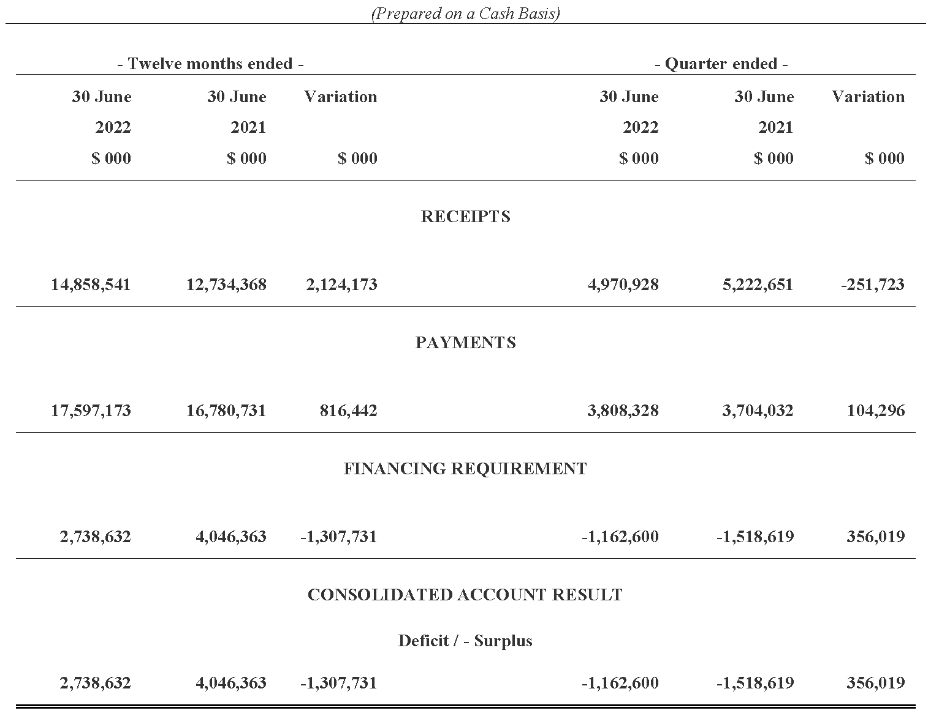
Summary of the Statement on the Consolidated Account for the Quarters and
12 Months Ended 30 June 2022 and 30 June 2021

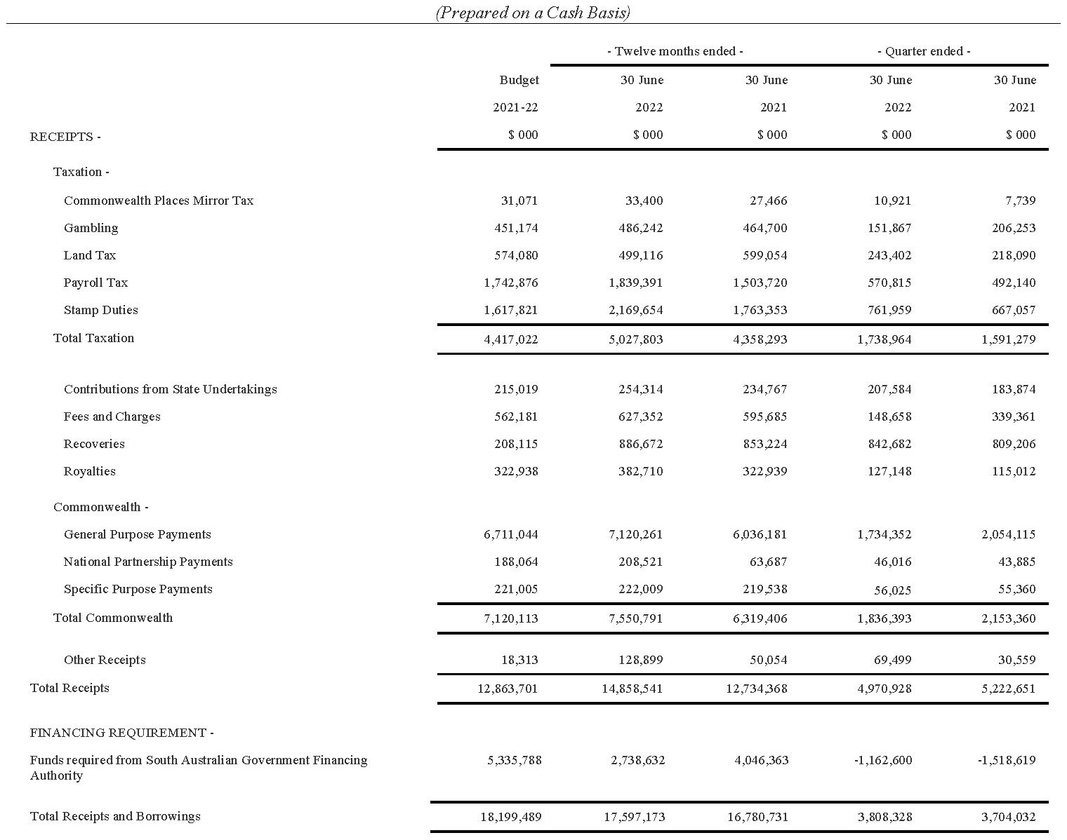
Statement of the Receipts and Borrowings on the Consolidated Account
Quarters and 12 Months Ended 30 June 2022 and 30 June 2021

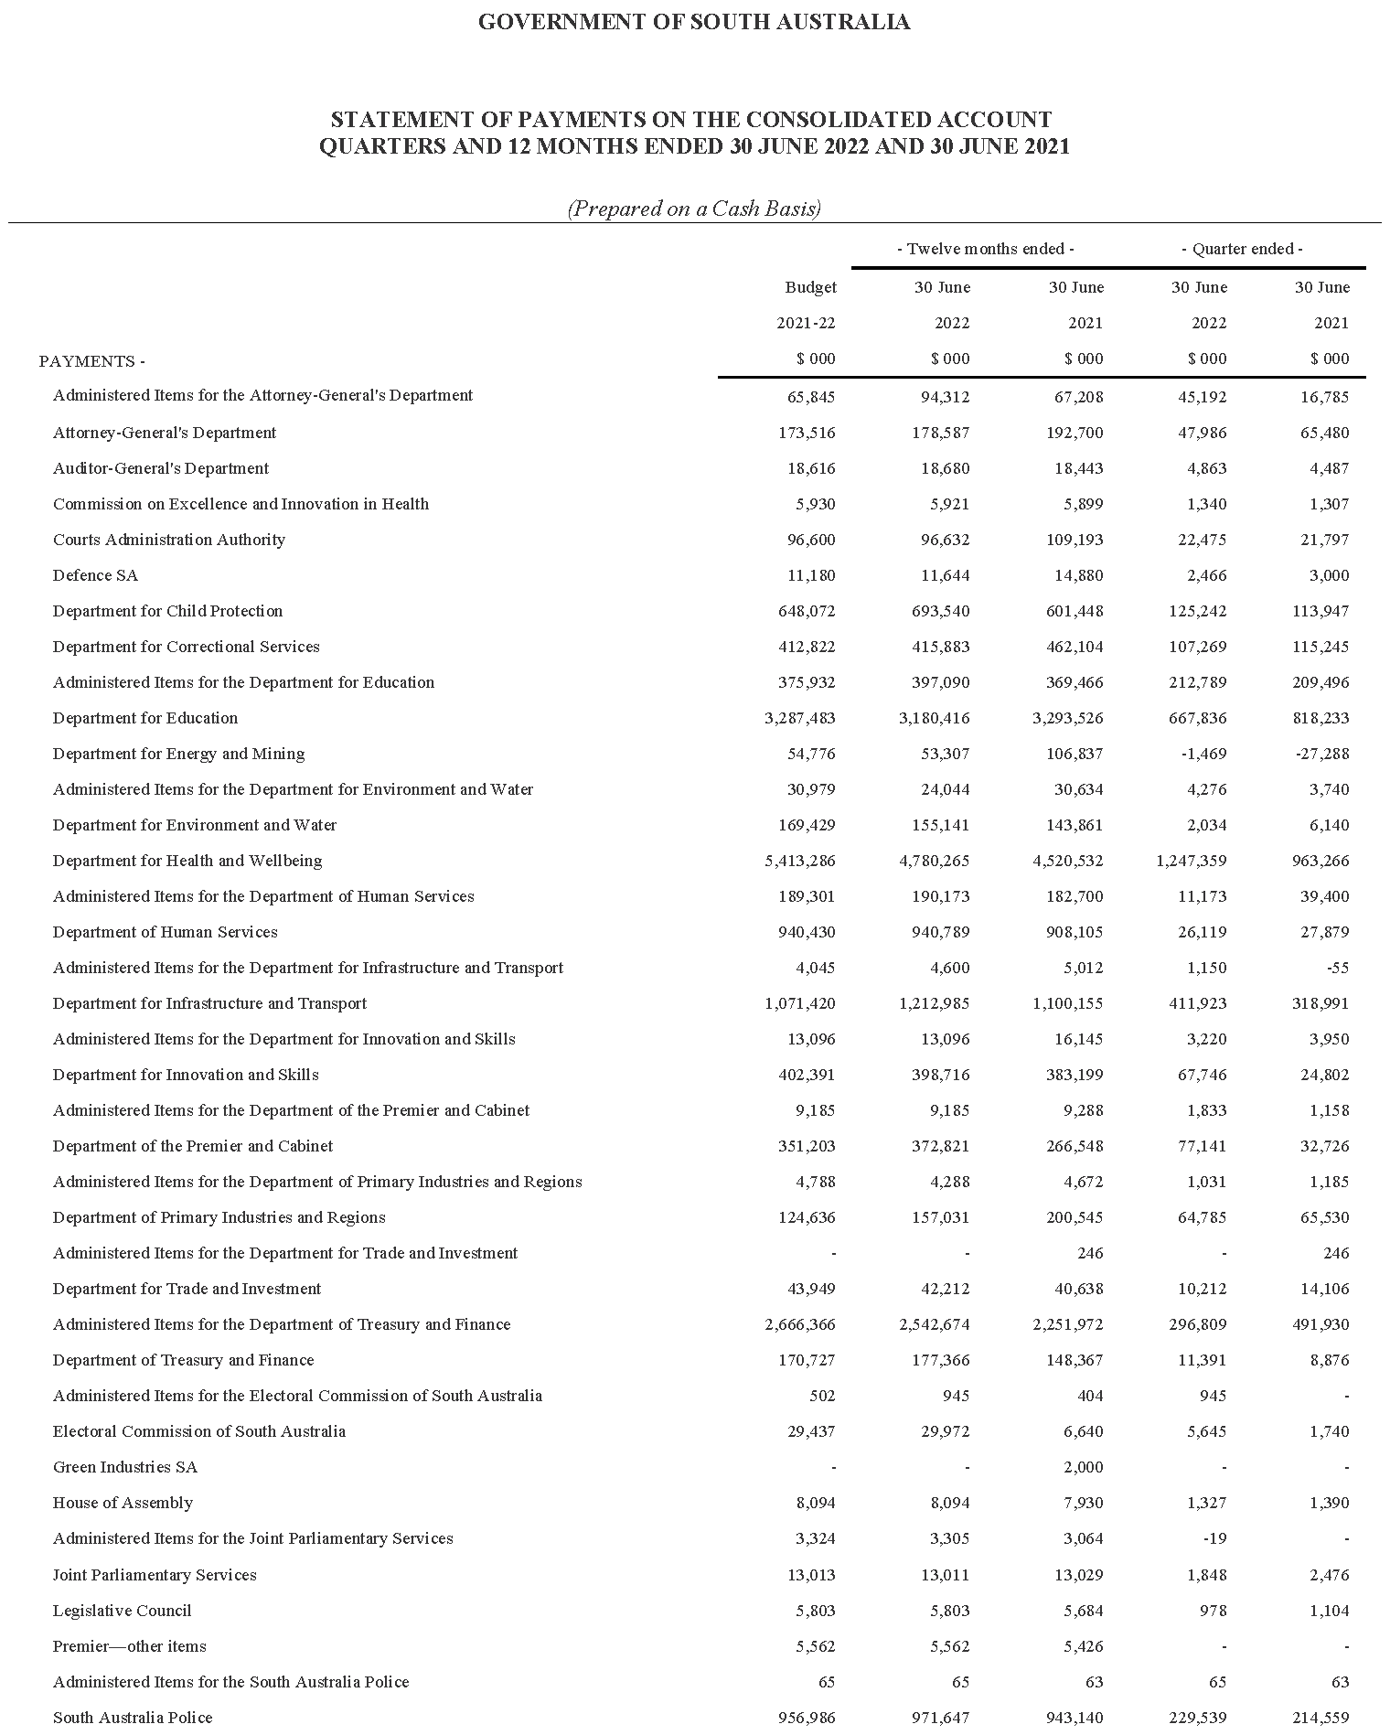
Statement of Payments on the Consolidated Account
Quarters and 12 Months Ended 30 June 2022 and 30 June 2021

Commentary to the Statement of the Amounts Credited to and Issued from the Consolidated Account
for the Quarters Ended 30 June 2022 and 30 June 2021
Receipts
Taxation
Gambling tax receipts in the June quarter 2022 were lower compared to the corresponding prior year period due to the timing of collections, with receipts in the June quarter 2021 including payments relating to previous quarters. Gambling tax receipts for the twelve months ended June 2022 were higher compared to the corresponding prior year period largely reflecting growth in gaming machine taxation receipts.
Land tax receipts in the June quarter 2022 were higher than the corresponding prior year period, while land tax receipts for the twelve months ended June 2022 were lower compared to the corresponding prior year period. These variances largely reflect differences in the timing of collections between years.
Payroll tax receipts in the June quarter 2022 and the twelve months ended June 2022 were higher than the corresponding previous periods. This largely reflects the impacts of COVID-19 payroll tax relief measures in 2020-21, which lowered collections in that year, combined with growth in taxable payrolls in 2021-22.
Stamp duty receipts in the June quarter 2022 and twelve months ended June 2022 were higher than the corresponding prior year periods. This was predominantly due to higher conveyance duty on the transfer of properties, reflecting both an increase in the volume of residential property transactions and the average value of properties transferred. In addition, insurance duty receipts and stamp duty receipts on the transfer of motor vehicles were higher over both periods.
Royalties
Royalty receipts for the June 2022 quarter and twelve months ended June 2022 were higher than the corresponding prior year periods mainly reflecting improvements in commodity prices combined with a lower Australian dollar.
Commonwealth—General Purpose Payments
Growth in general purpose grant receipts in 2021-22 compared to 2020-21 is not indicative of underlying movements in Goods and Services Tax (GST) revenue. This is because monthly grants are paid according to a payment schedule prepared by the Commonwealth Government rather than actual emerging monthly GST collections.
The monthly payment schedules include prior year balancing adjustments to reflect actual GST revenue grants paid to a jurisdiction in the previous financial year compared to the final GST entitlement as determined in the Commonwealth Government’s Final Budget Outcome.
South Australia’s GST receipts were higher for the twelve months ended June 2022 compared to the corresponding prior year period mainly reflecting the impact of prior year balancing adjustments, which had the effect of reducing receipts in 2020-21 and increasing receipts in 2021-22.
Commonwealth—National Partnership Payments
National Partnership Payments received in the June quarter 2022 were broadly in line with the corresponding prior year period. Payments received for the twelve months ended June 2022 were higher than the corresponding previous period mainly due to reimbursements for Commonwealth HomeBuilder grants that are being administered by the state on behalf of the Commonwealth Government.
Other receipts
Other receipts in the June quarter 2022 and twelve months ended June 2022 were higher compared to the corresponding prior year periods. This is largely due to the receipt of surplus cash from TAFE SA pursuant to the Cash Alignment Policy. TAFE SA elected for the repayment to be treated as a return against their equity capital contribution previously provided by SA Government. Receipts from the proceeds of the sale of land, as well as loan repayments, were higher over both periods.
Payments
Payments were made pursuant to the Appropriation Act 2021 and also in accordance with other Acts for which specific appropriation has been authorised. The timing of the payments is based on agreed agency drawdown schedules and may change from period to period based on specific agency requirements.
All appropriations were paid within approved limits established under the various Acts.
Note
The following points should be considered when reviewing the quarterly statement of Consolidated Account transactions:
• Unlike the State Budget which comprises transactions on an accrual basis, the information reflected in the quarterly statement is limited to cash transactions.
• The Consolidated Account does not capture all the transactions undertaken by the general government sector. In particular, it does not record receipts to, and payments from, Agency deposit and special deposit accounts.
• The timing of receipts and payments can fluctuate within a financial year and between financial years. As a result, apparently large movements between quarters or years may only be due to changes in the timing of receipts and payments and therefore may not have consequences for the underlying budget position.
Dated: 17 November 2022
Hon. Stephen Mullighan MP
Treasurer of South Australia

Local Government Instruments

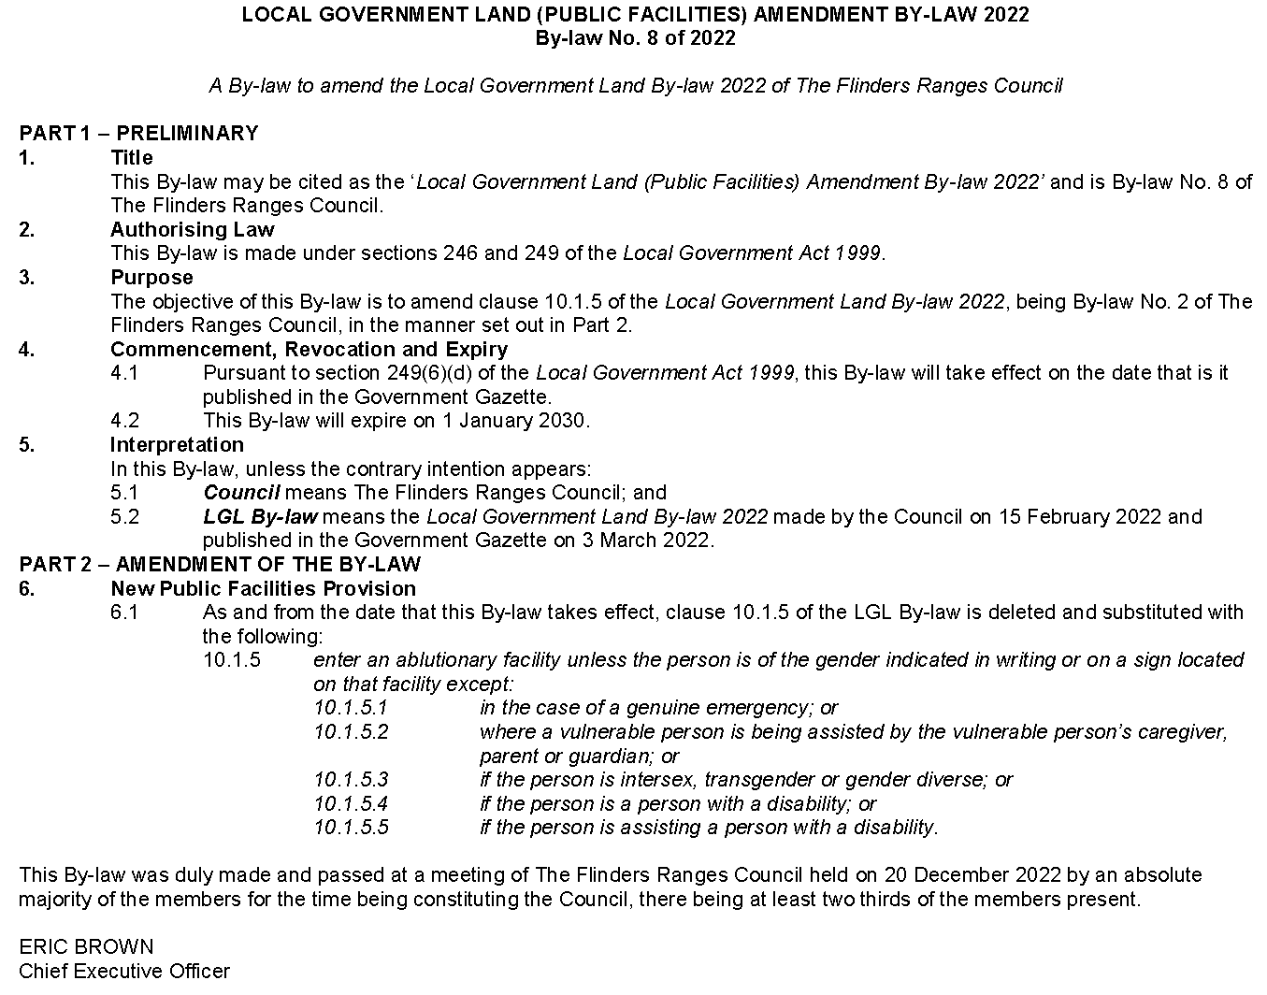
The Flinders Ranges Council

Wattle Range Council
Local Government Act 1999
Exclusion of Land from Classification of Community Land
NOTICE is hereby given that pursuant to Section 193(4) of the Local Government Act 1999, the Council resolved at its meeting held on 13 December 2022, to exclude from classification as community land the whole of the land, Section 989, Fifth Street, Millicent, Hundred of Mount Muirhead which is presently described in Crown Record Volume 5666 Folio 386 and which the Council proposes to acquire a fee simple estate and interest from the Crown.
Dated: 20 December 2022
Ben Gower
Chief Executive Officer

Notice Submission

The South Australian Government Gazette is published each Thursday afternoon.
Notices must be emailed by 4 p.m. Tuesday, the week of publication.
Submissions are formatted per the gazette style and a proof will be supplied prior to publication, along with a quote if applicable. Please allow one day for processing notices.
Alterations to the proof must be returned by 4 p.m. Wednesday.

Gazette notices must be submitted as Word files, in the following format:
• Title—the governing legislation
• Subtitle—a summary of the notice content
• Body—structured text, which can include numbered lists, tables, and images
• Date—day, month, and year of authorisation
• Signature block—name, role, and department/organisation authorising the notice

Please provide the following information in your email:
• Date of intended publication
• Contact details of the person responsible for the notice content
• Name and organisation to be charged for the publication—Local Council and Public notices only
• Purchase order, if required—Local Council and Public notices only

Email: governmentgazettesa@sa.gov.au
Phone: (08) 7109 7760
Website: www.governmentgazette.sa.gov.au

All instruments appearing in this gazette are to be considered official, and obeyed as such

Printed and published weekly by authority of C. McArdle, Government Printer, South Australia
$8.15 per issue (plus postage), $411.00 per annual subscription—GST inclusive
Online publications: www.governmentgazette.sa.gov.au

