SUPPLEMENTARY GAZETTE
THE SOUTH AUSTRALIAN
GOVERNMENT GAZETTE
Published by Authority

Adelaide, Friday, 27 January 2023

Contents

State Government Instruments

Voluntary Assisted Dying Regulations 2022 132

State Government Instruments

Voluntary Assisted Dying Regulations 2022
Regulations 4 to 11, 14, 15, 17 and 19
Determination of Prescribed Forms
I, CHRIS PICTON, Minister for Health and Wellbeing, hereby determine:
- the First Assessment Report Form in Schedule 1 as the prescribed form for the purposes of regulation 8 of the Regulations;
- the Consulting Assessment Report Form in Schedule 2 as the prescribed form for the purposes of regulation 4 of the Voluntary Assisted Dying Regulations 2022 (the Regulations);
- the Written Declaration in Schedule 3 as the prescribed form for the purposes of regulation 11 of the Regulations;
- the Contact Person Appointment Form in Schedule 4 as the prescribed form for the purposes of regulation 5 of the Regulations;
- the Final Review Form in Schedule 5 as the prescribed form for the purposes of regulation 7 of the Regulations;
- the Application for Practitioner Administration Permit in Schedule 6 as the prescribed form for the purposes of regulation 15 of the Regulations;
- the Application for Self Administration Permit in Schedule 7 as the prescribed form for the purposes of regulation 14 of the Regulations;
- the Voluntary Assisted Dying Permit in Schedule 8 as the prescribed form for the purposes of regulation 17 of the Regulations;
- the Labeling Requirements for Voluntary Assisted Dying Substance in Schedule 9 as the prescribed form for the purposes of regulation 19 of the Regulations.
- the Voluntary Assisted Dying Substance Dispensing Form in Schedule 10 as the prescribed form for the purposes of regulation 9 of the Regulations;
- the Coordinating Medical Practitioner Administration Form in Schedule 11 as the prescribed form for the purposes of regulation 6 of the Regulations;
- the Voluntary Assisted Dying Substance Disposal Form in Schedule 12 as the prescribed form for the purposes of regulation 10 of the Regulations;
Dated: 24 January 2023
Hon Chris Picton MP
Minister for Health and Wellbeing

Schedule 1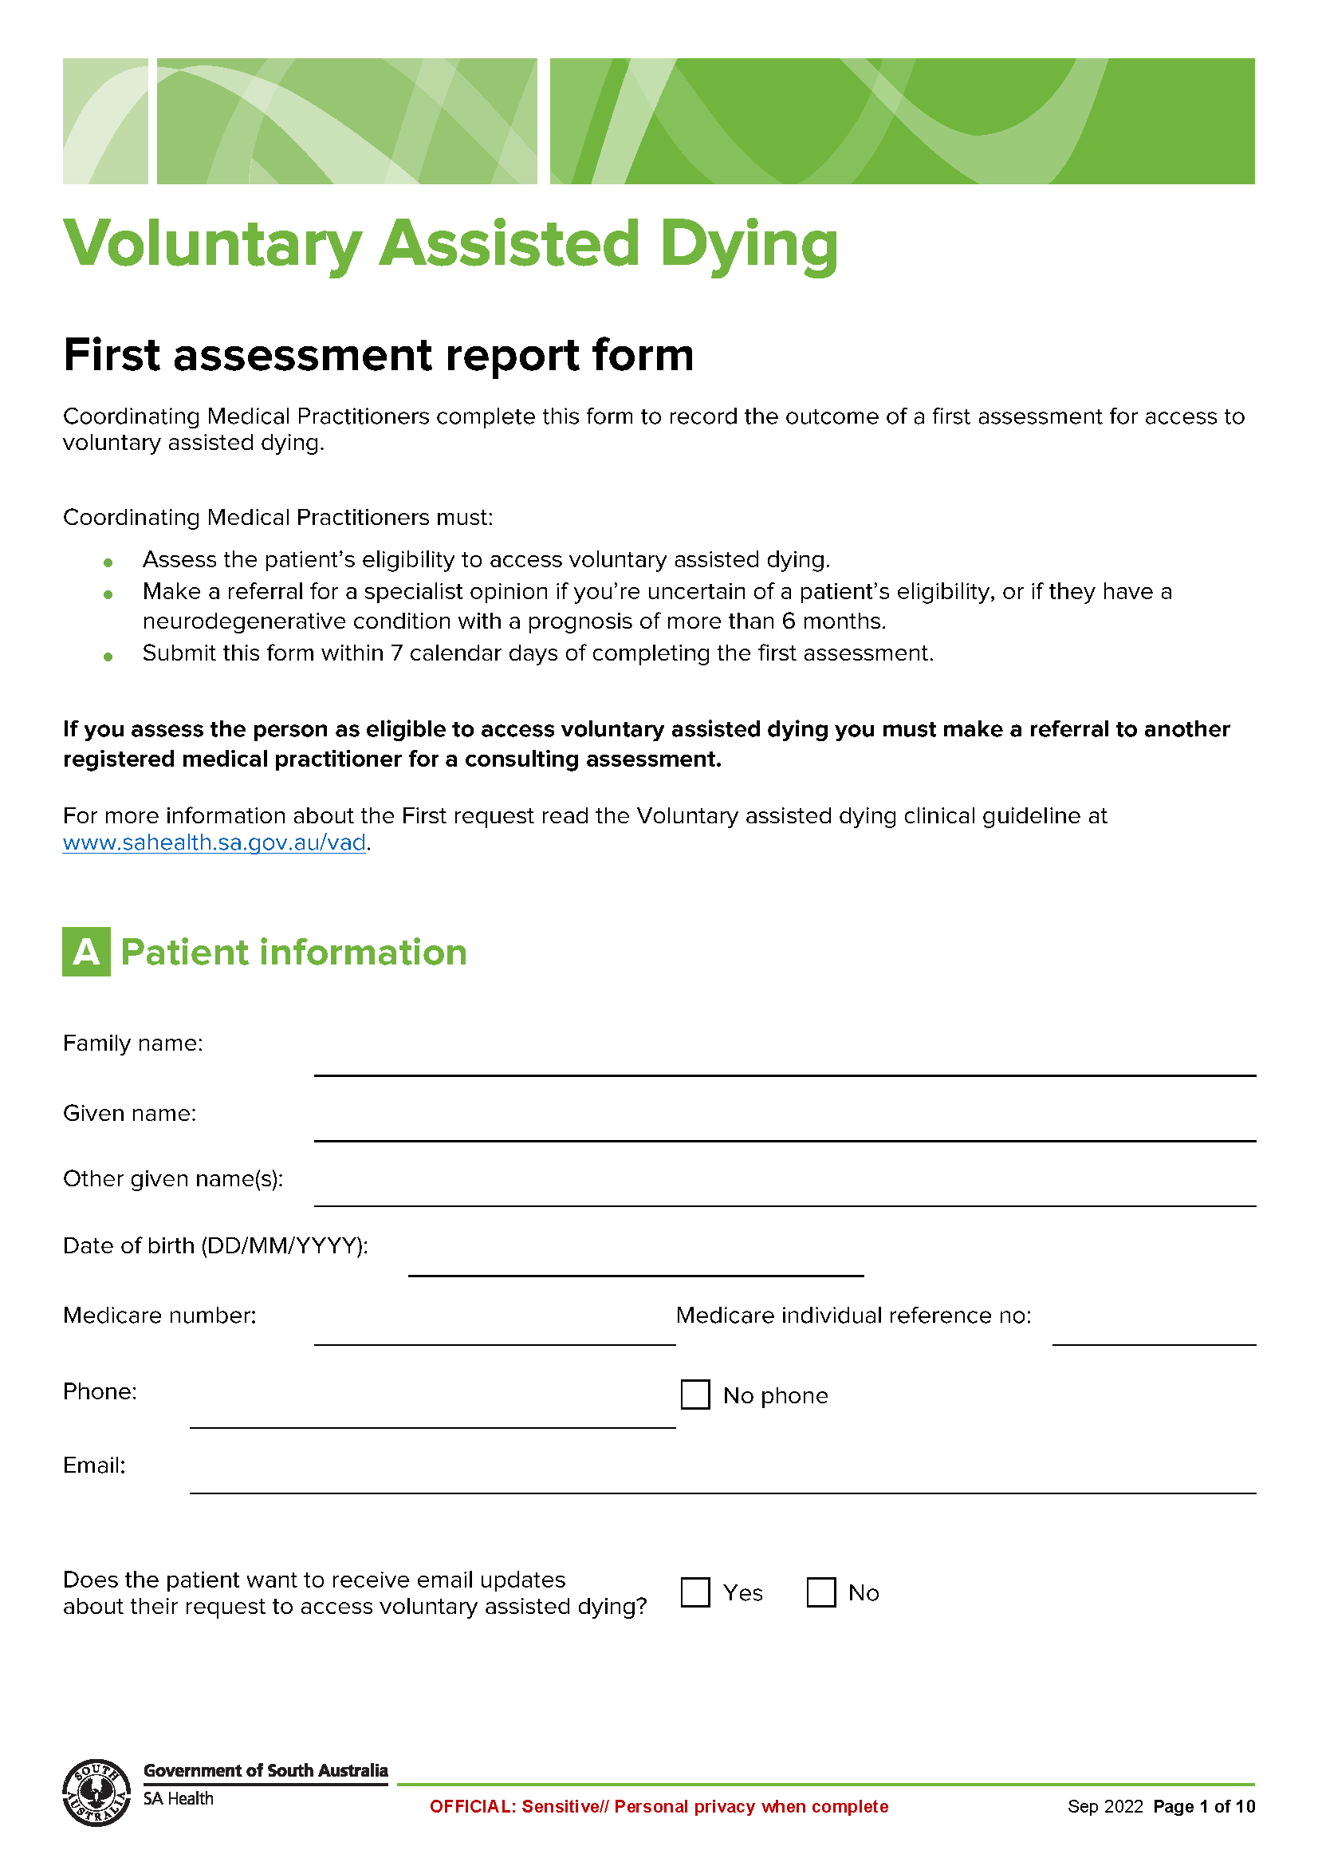
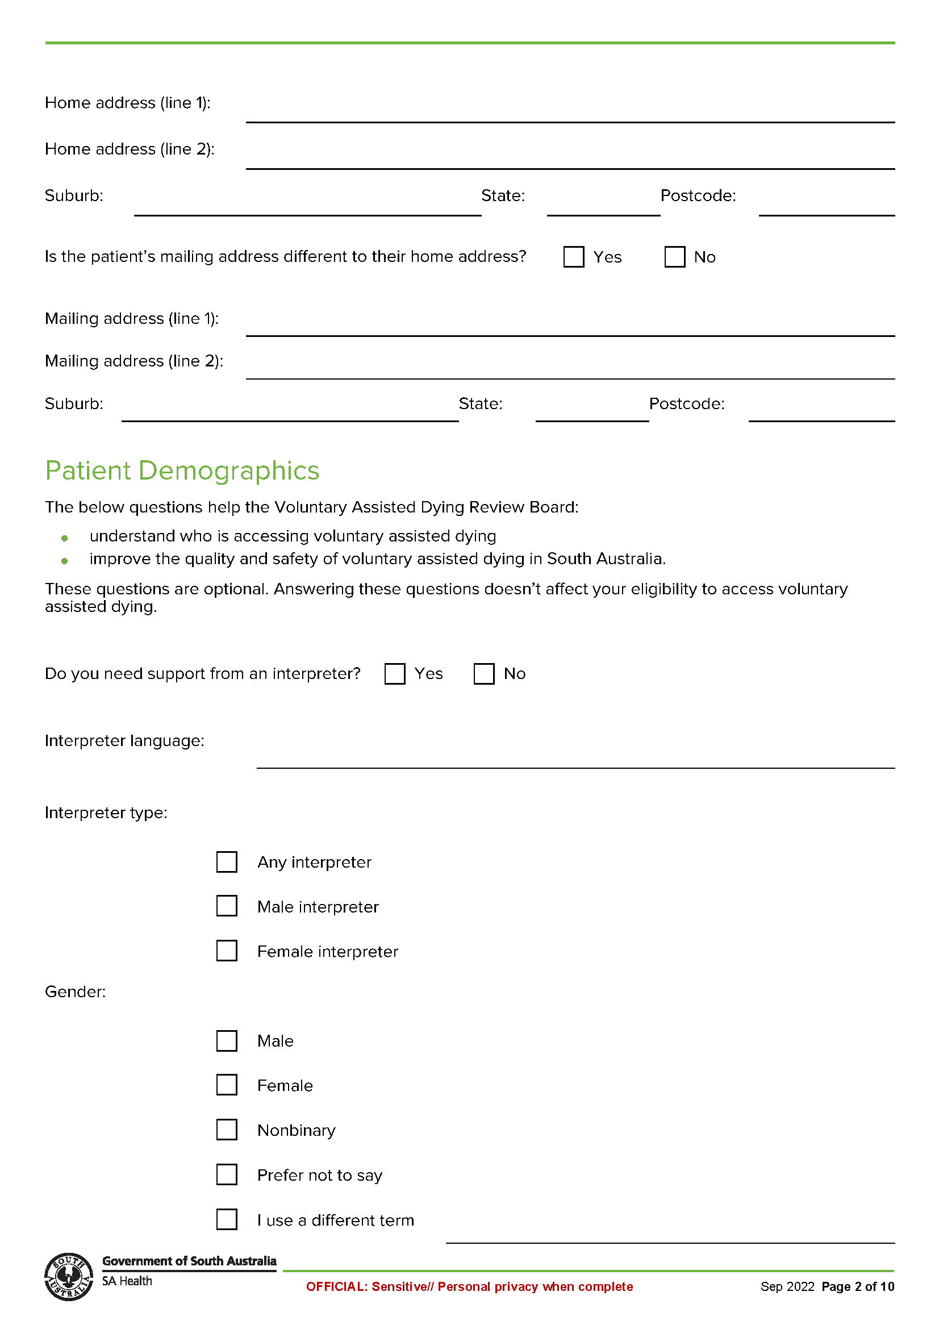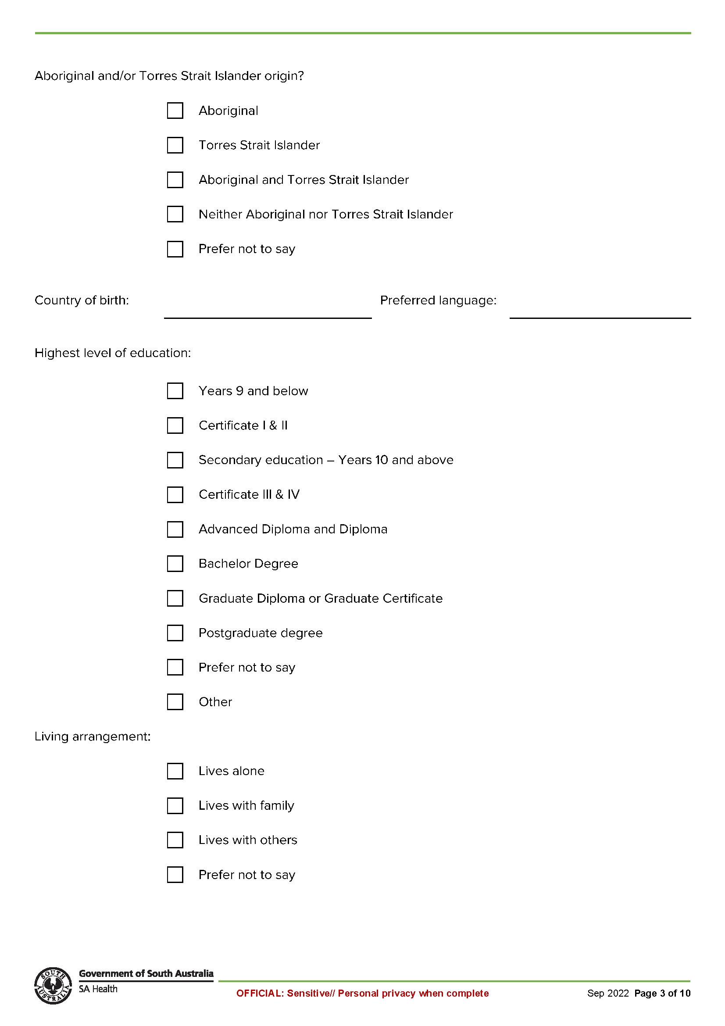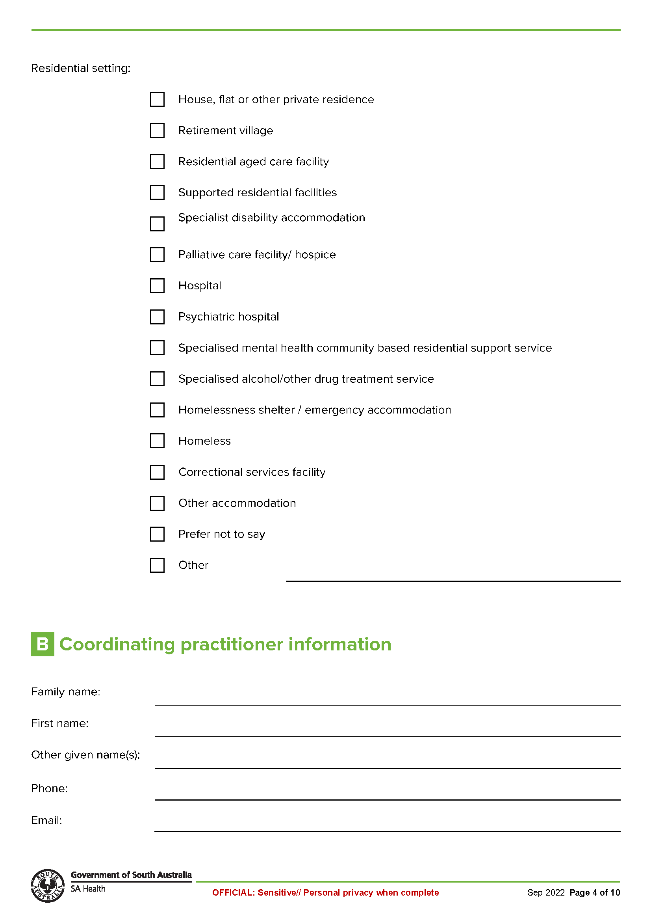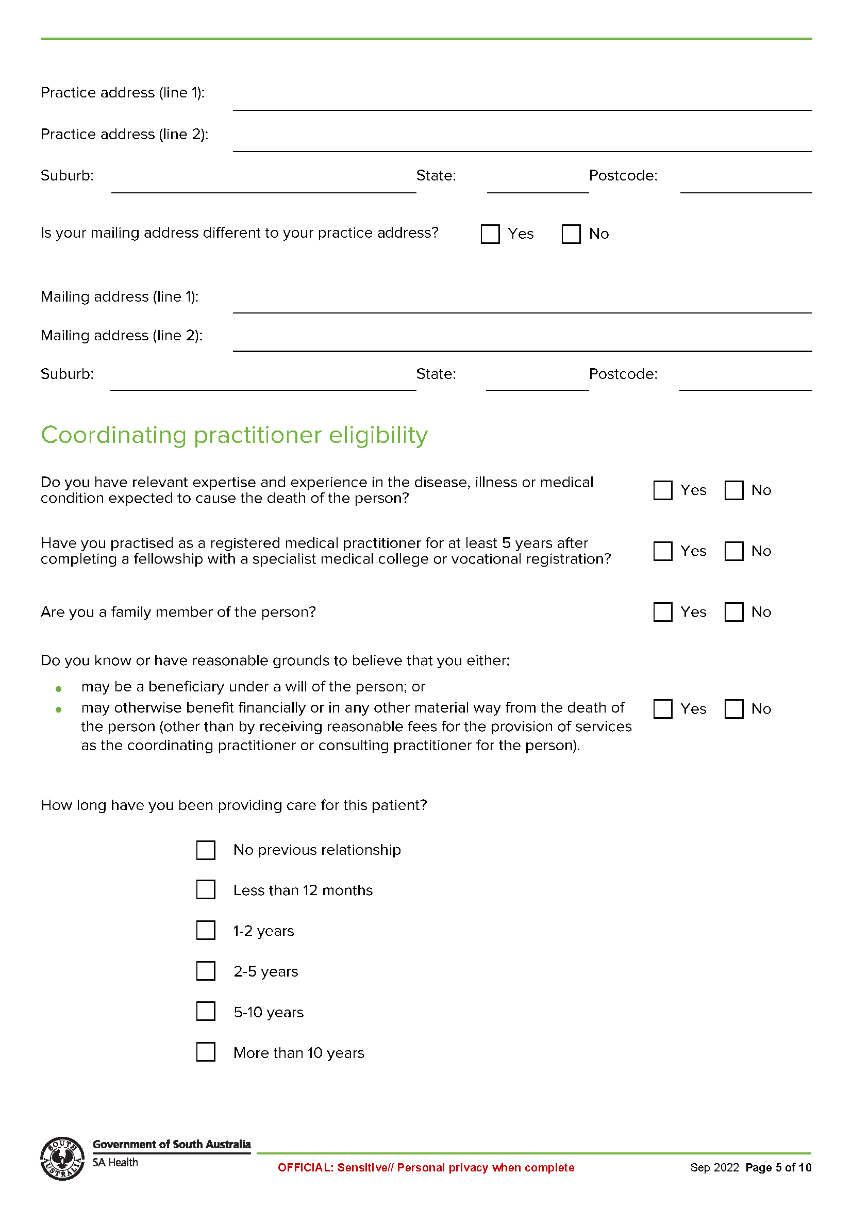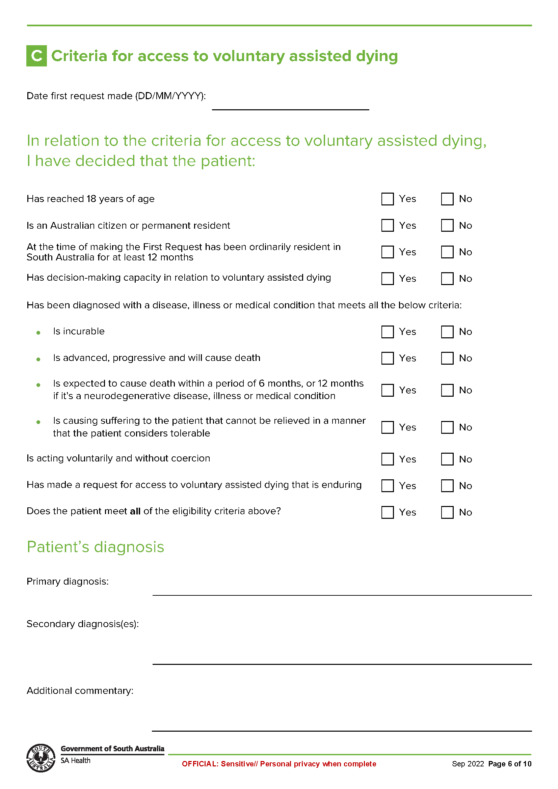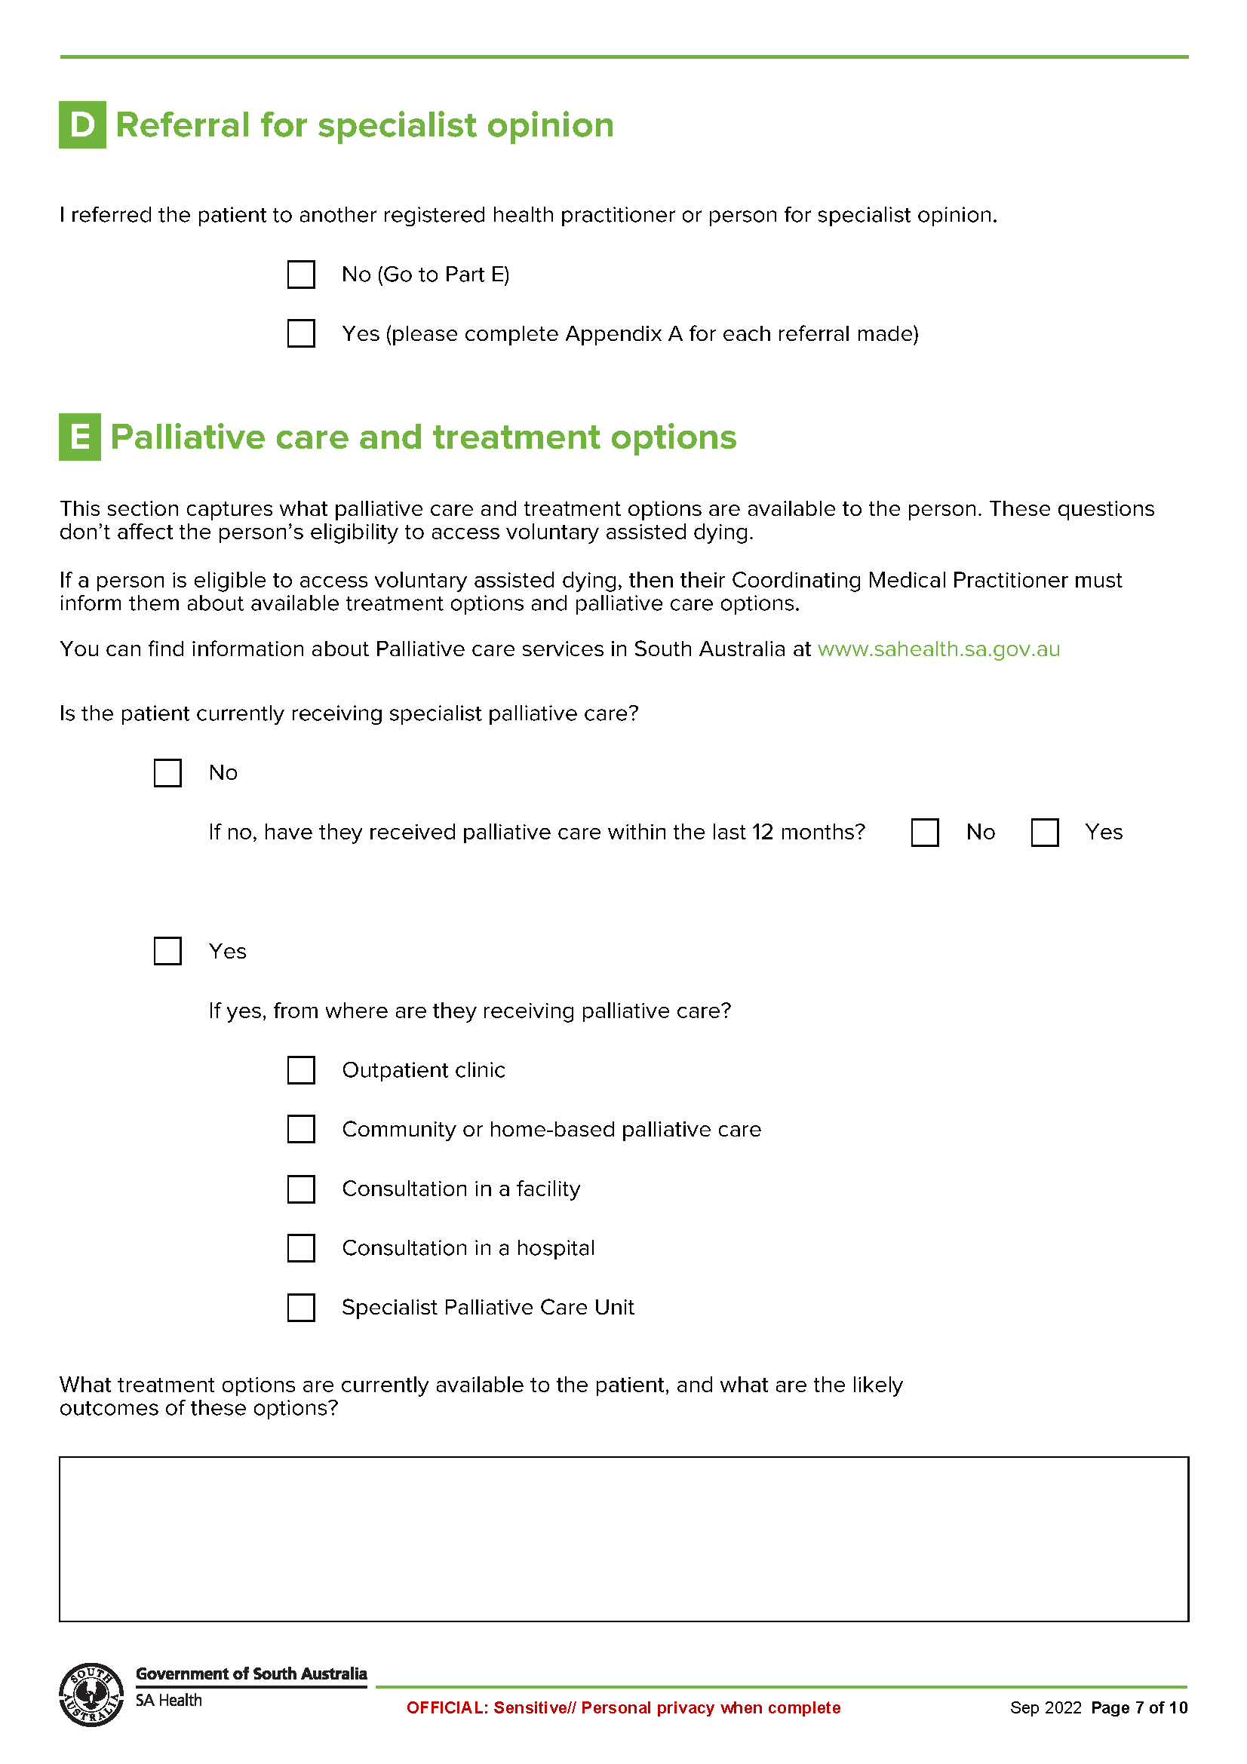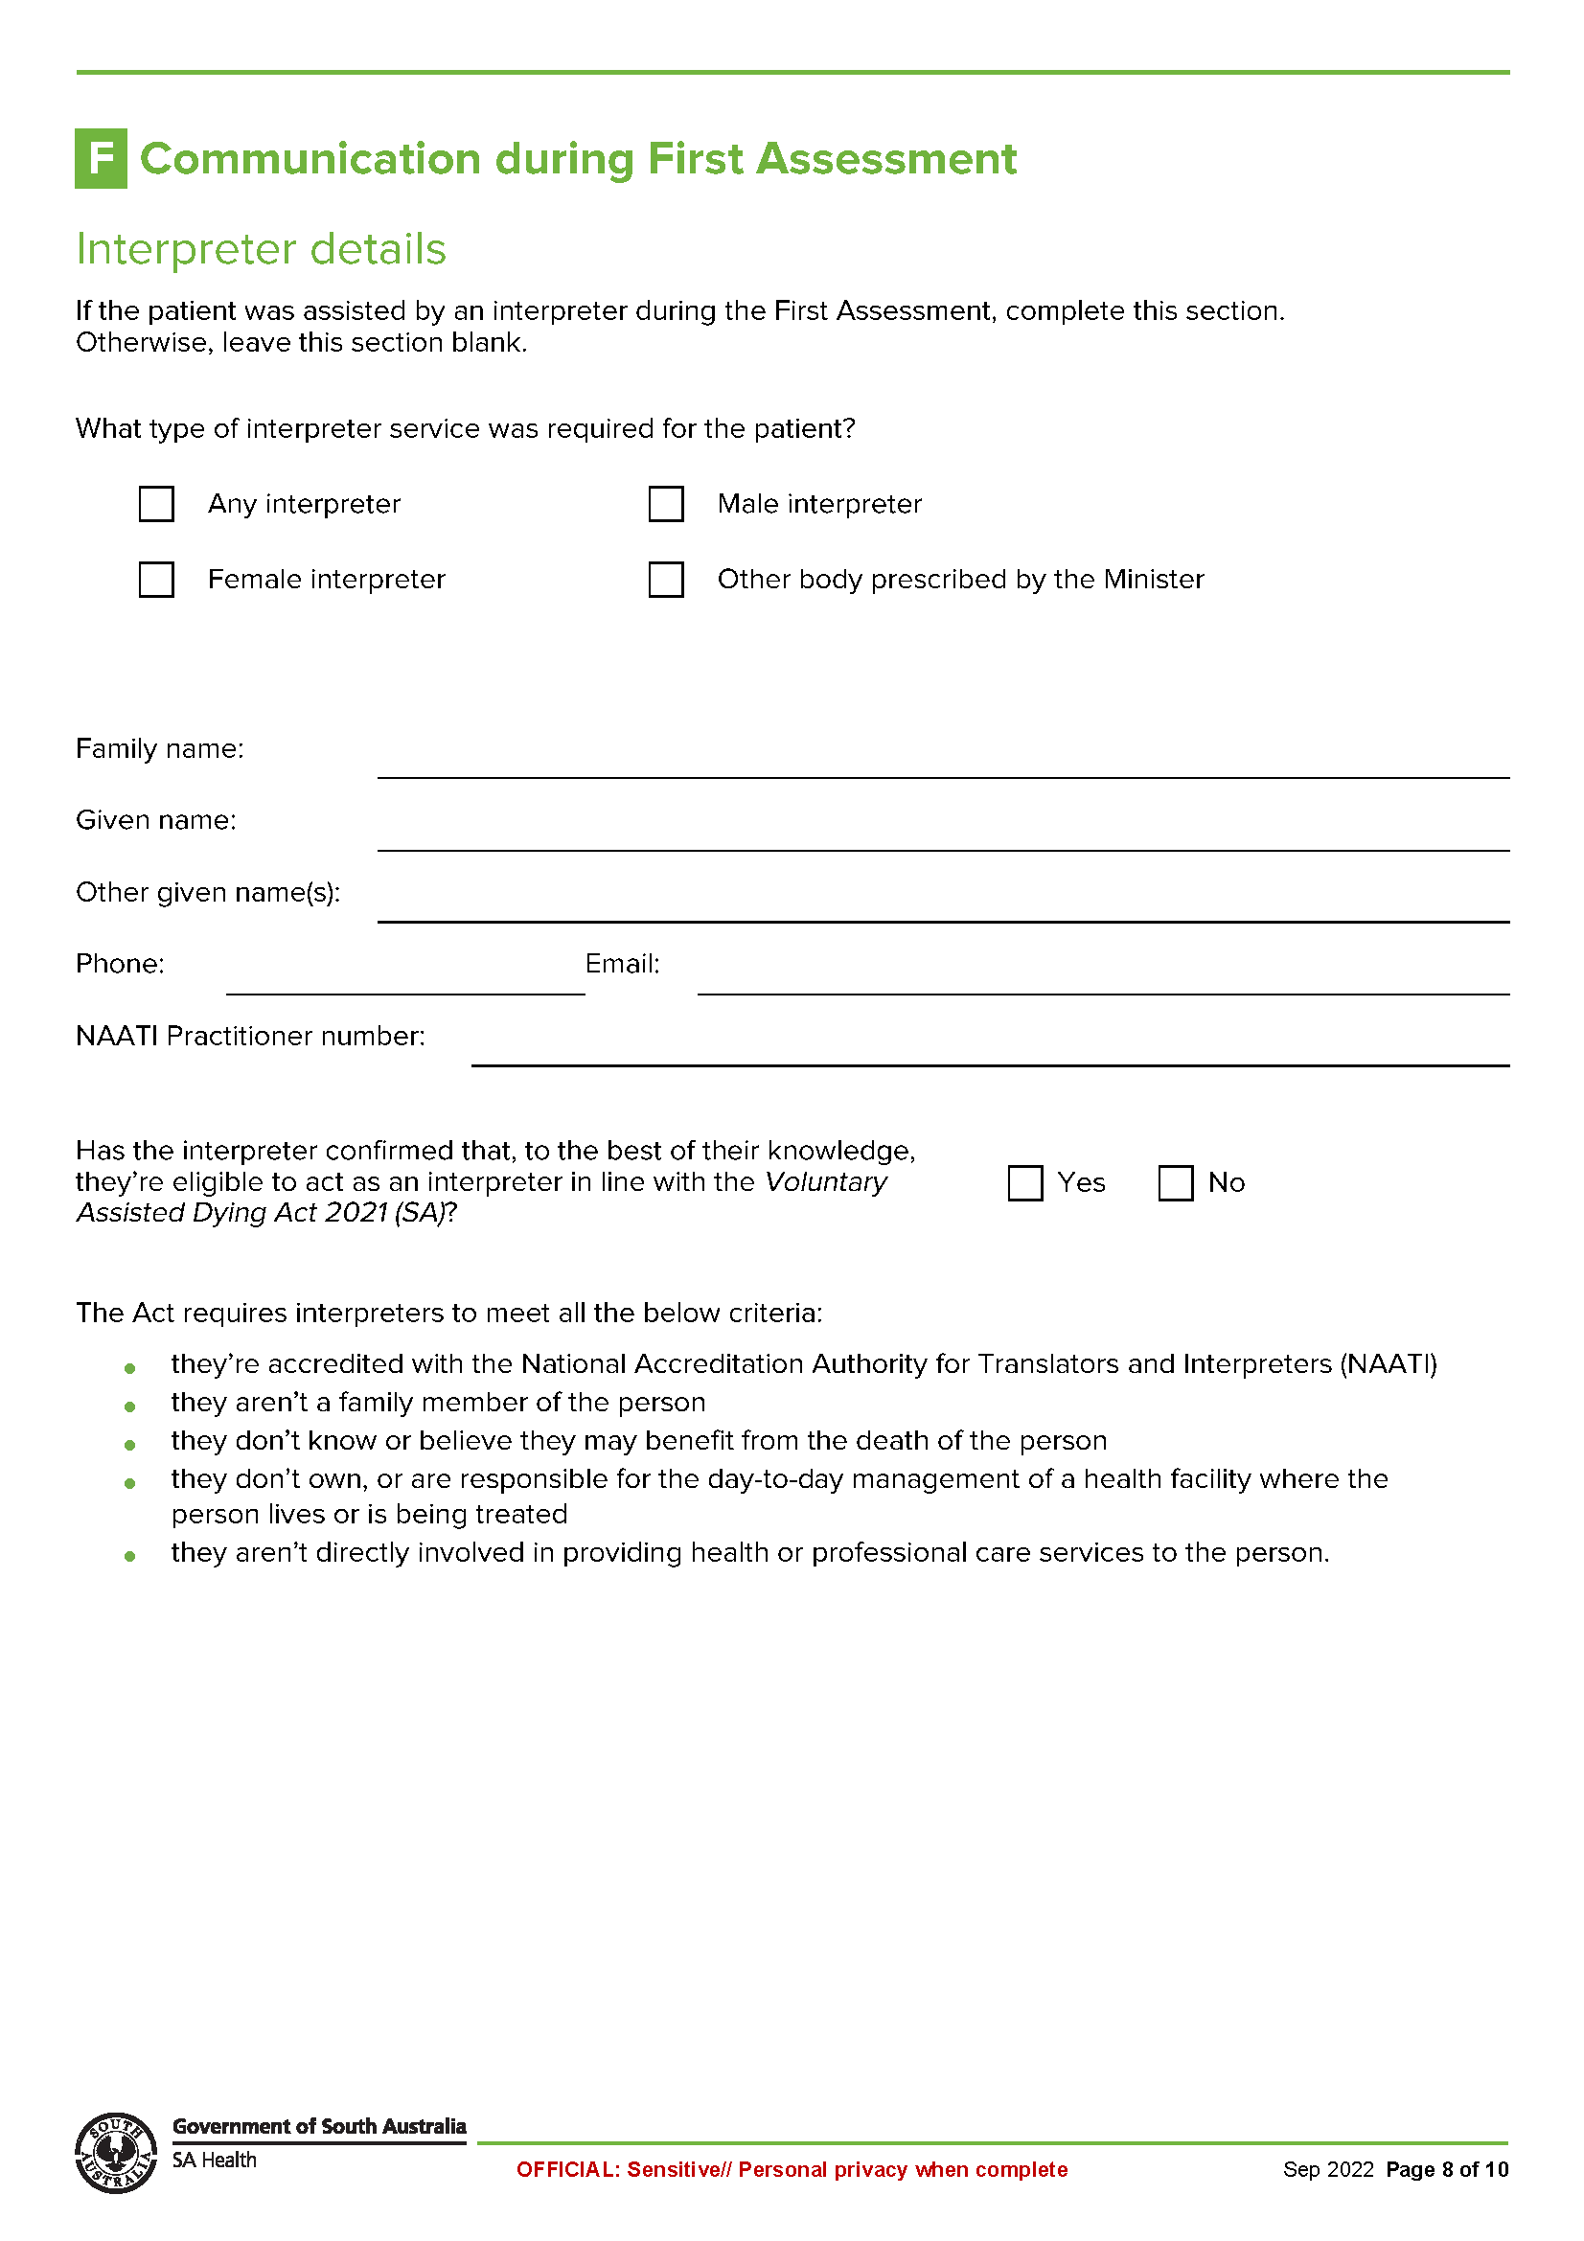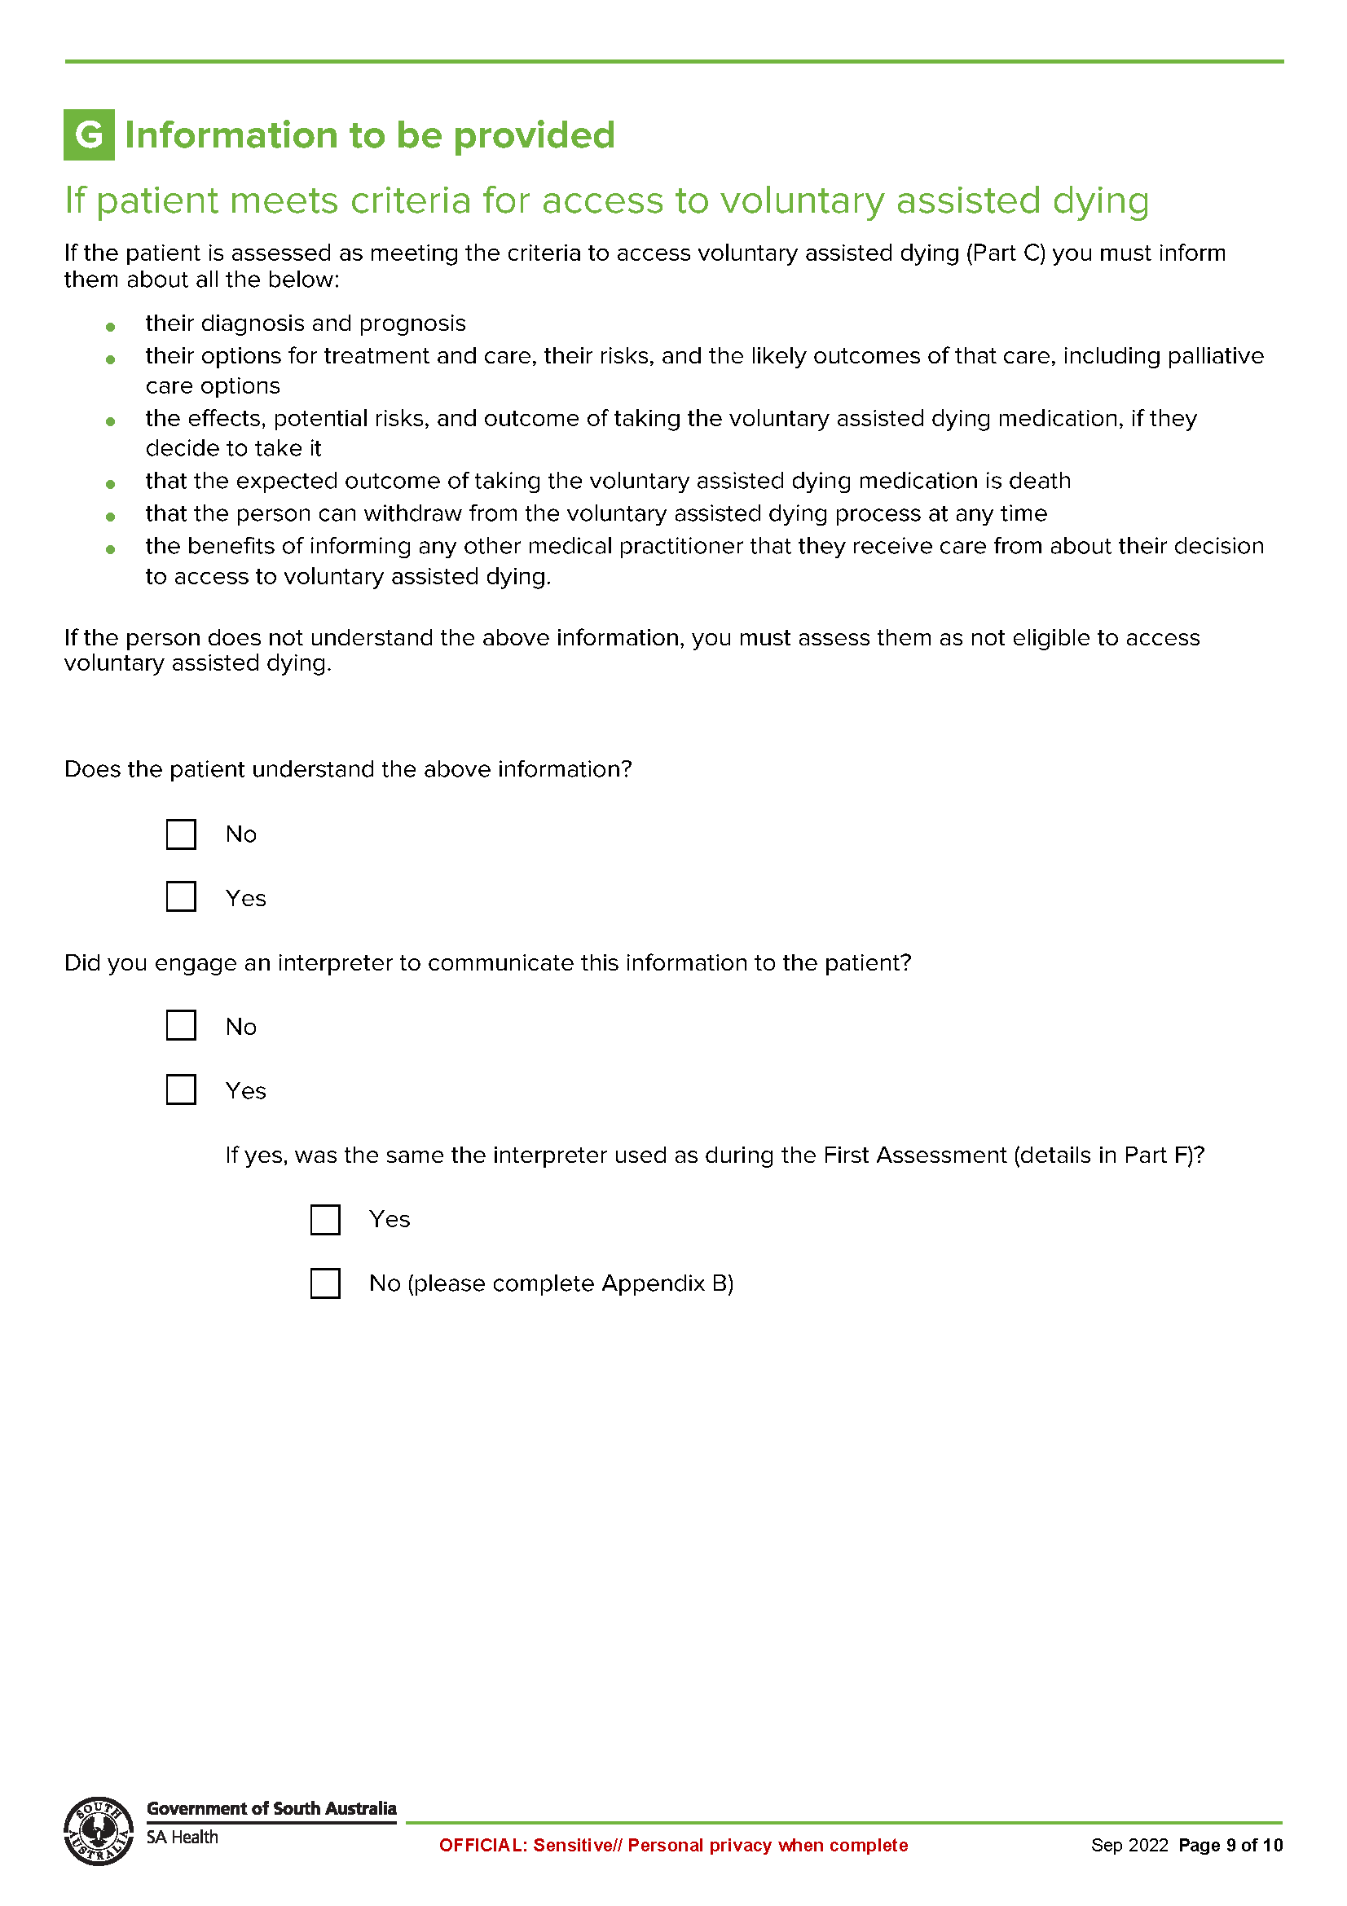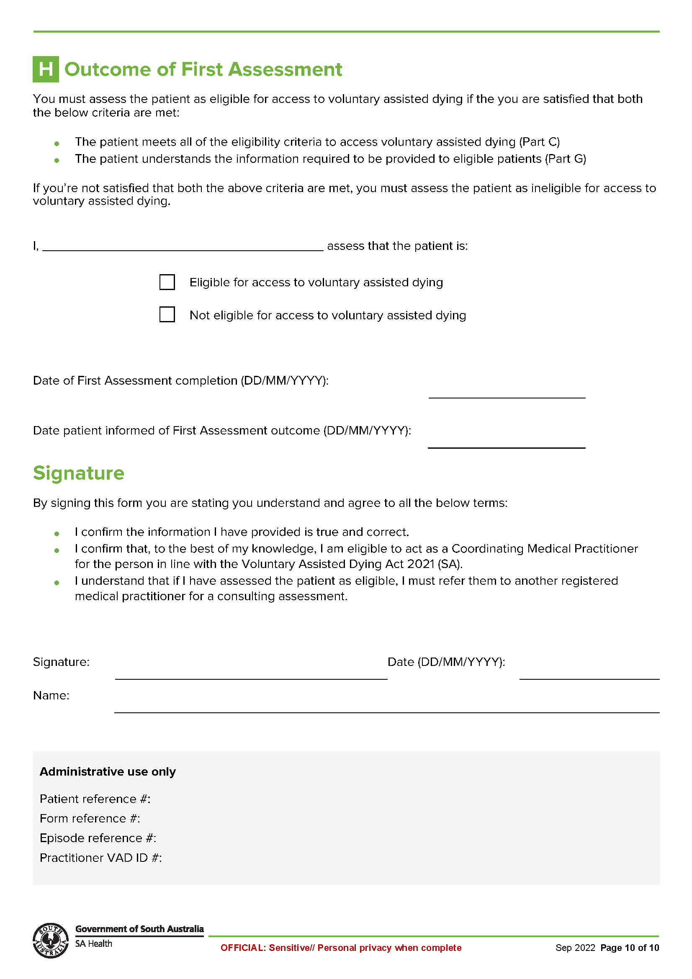

Schedule 2
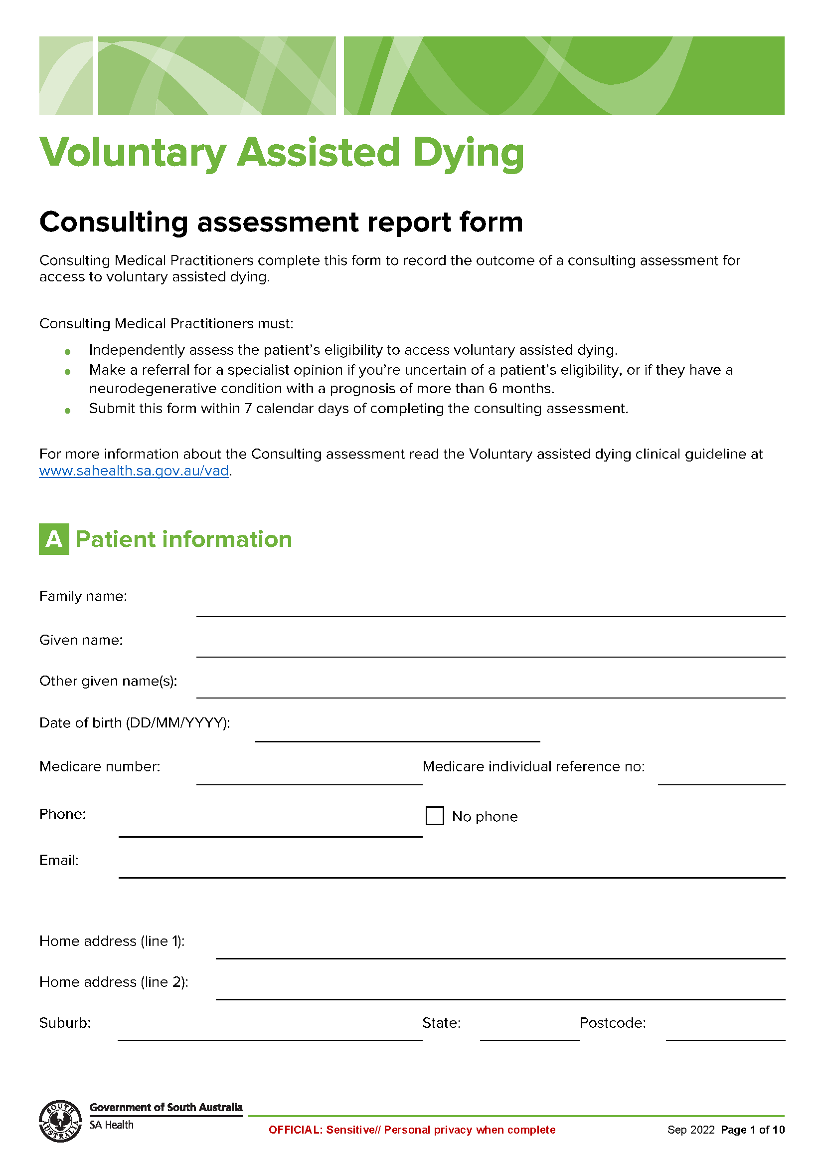
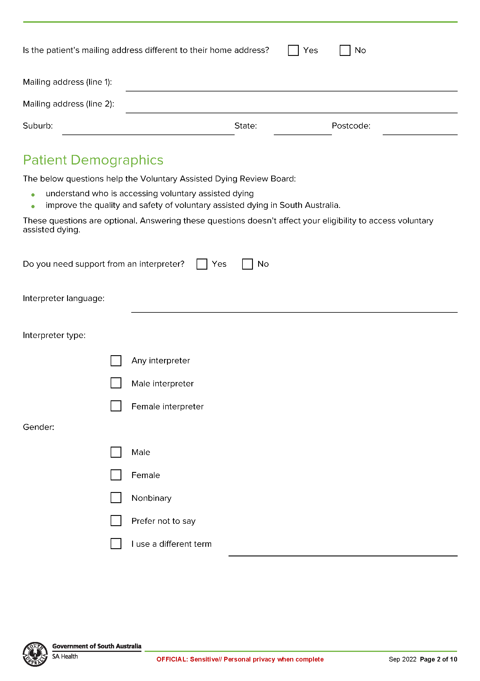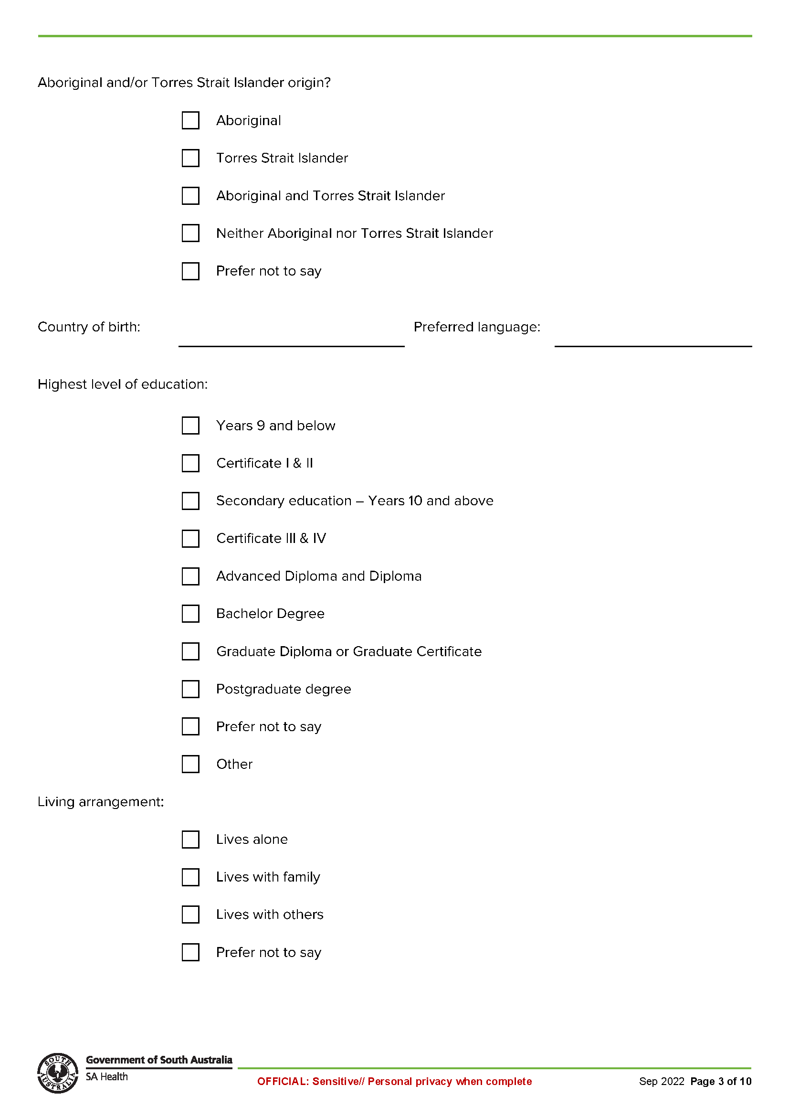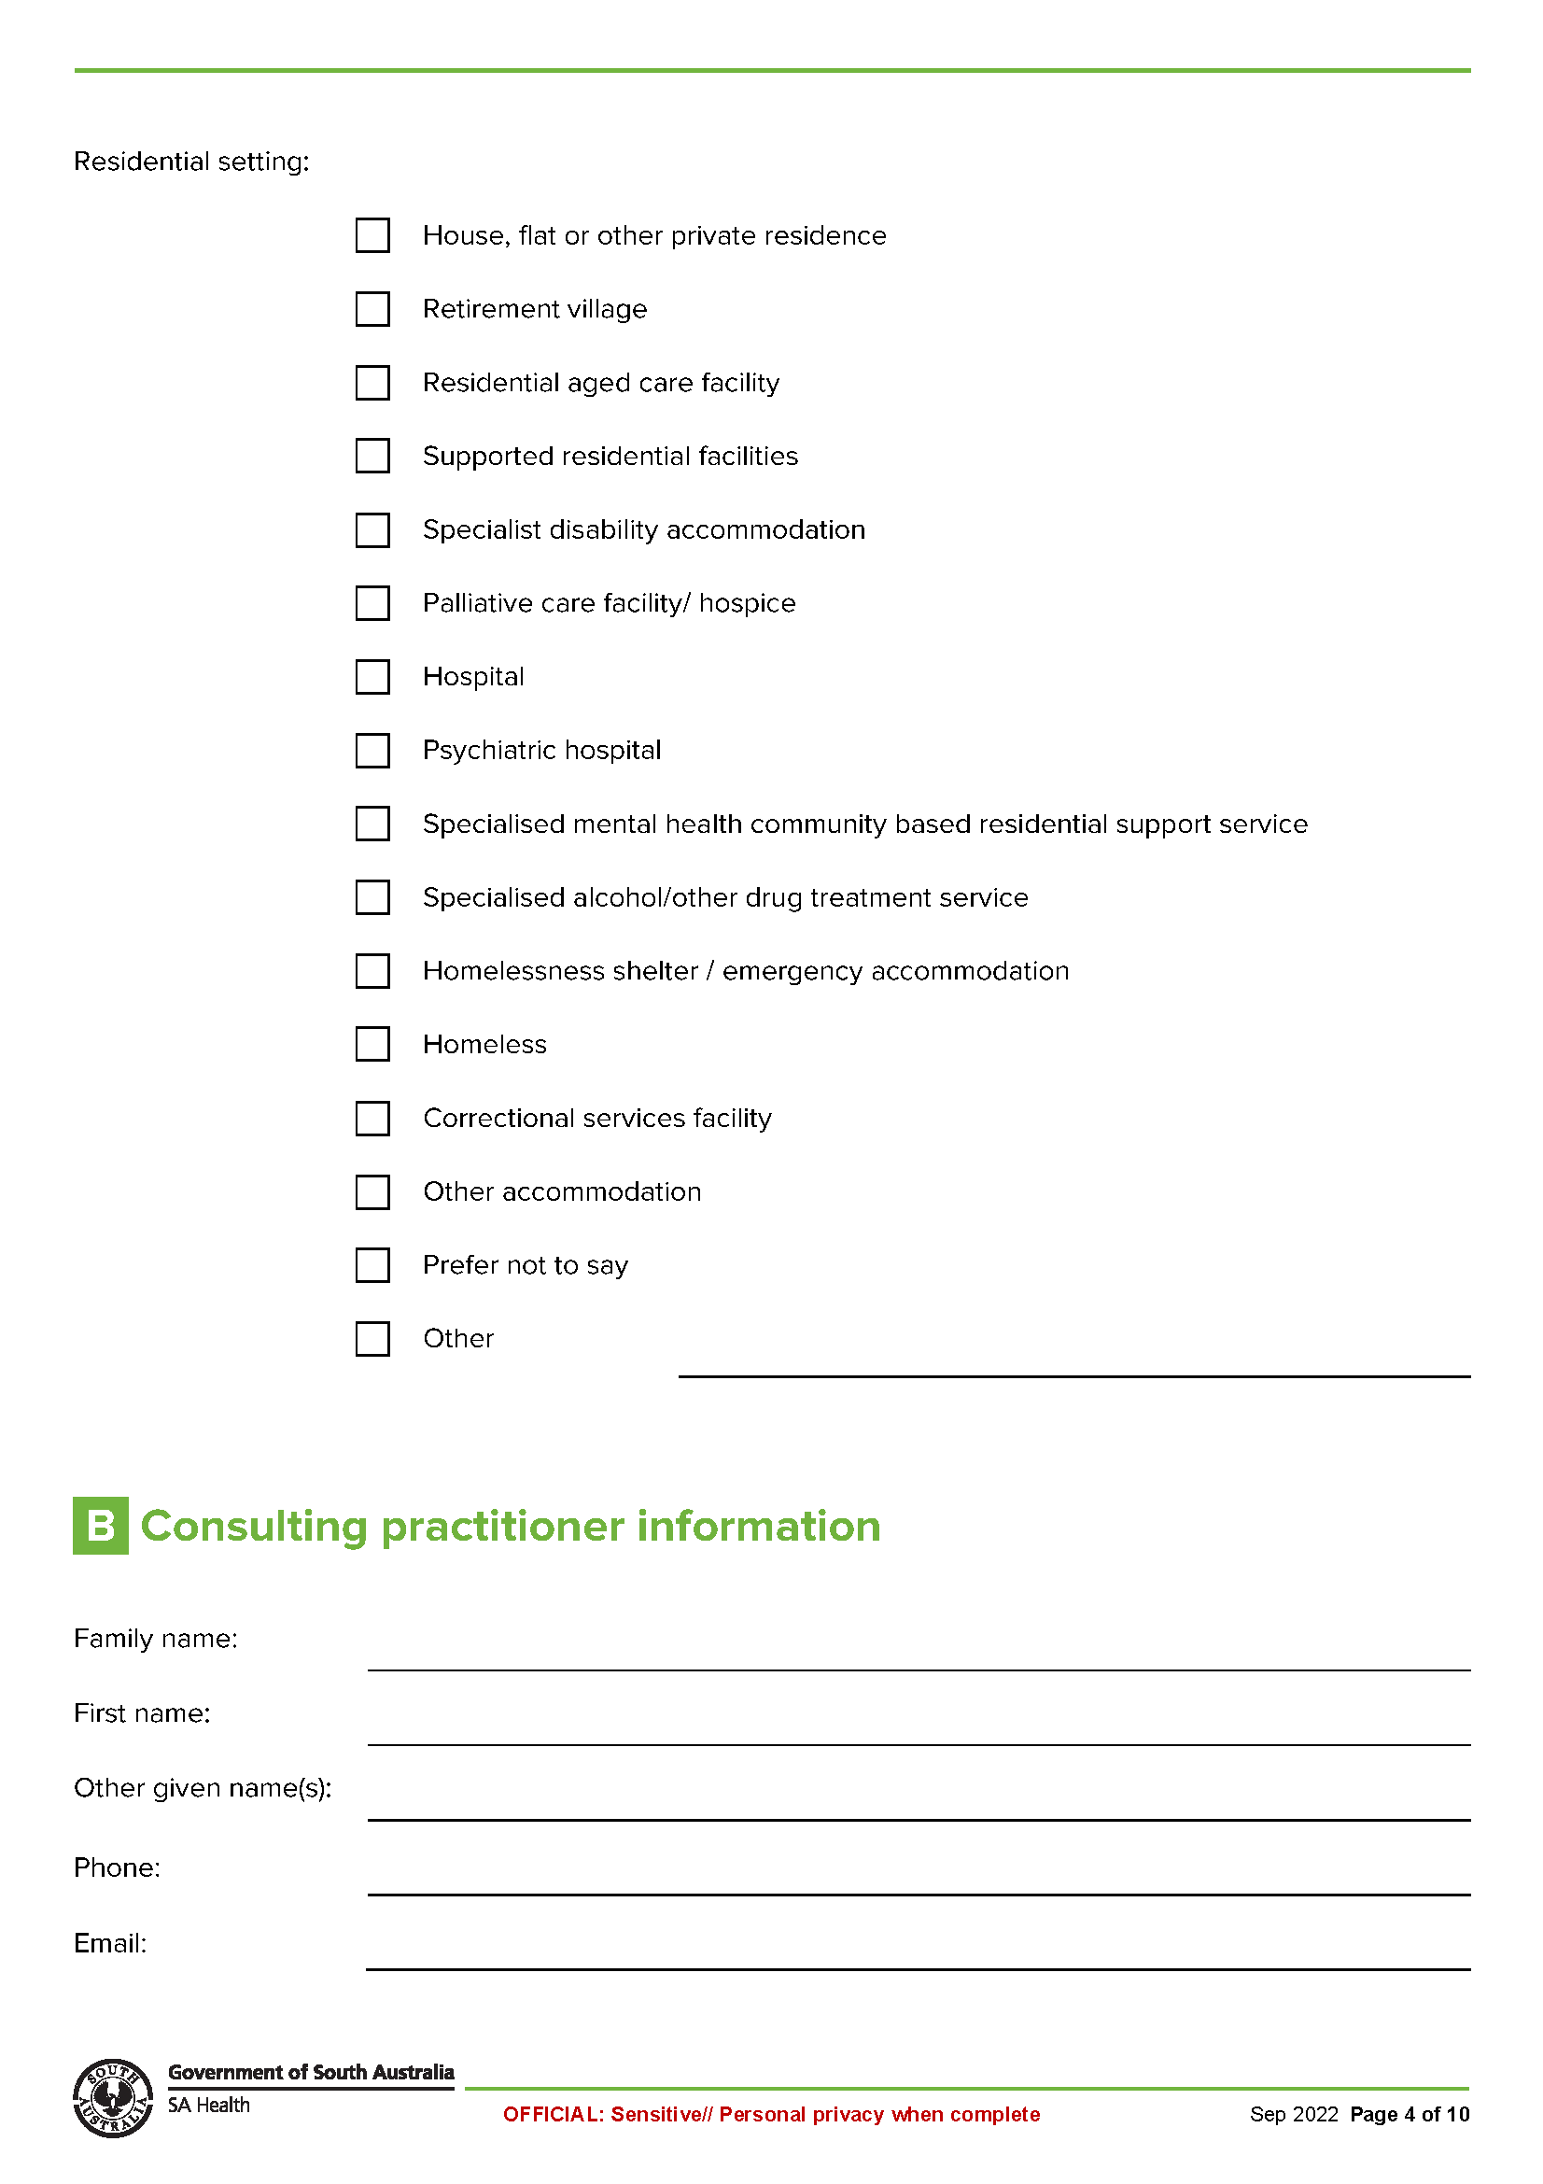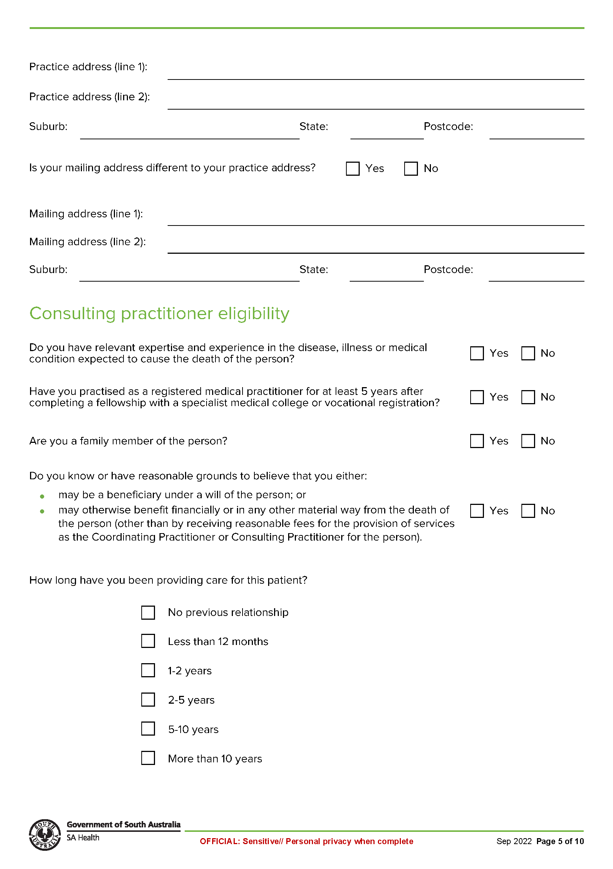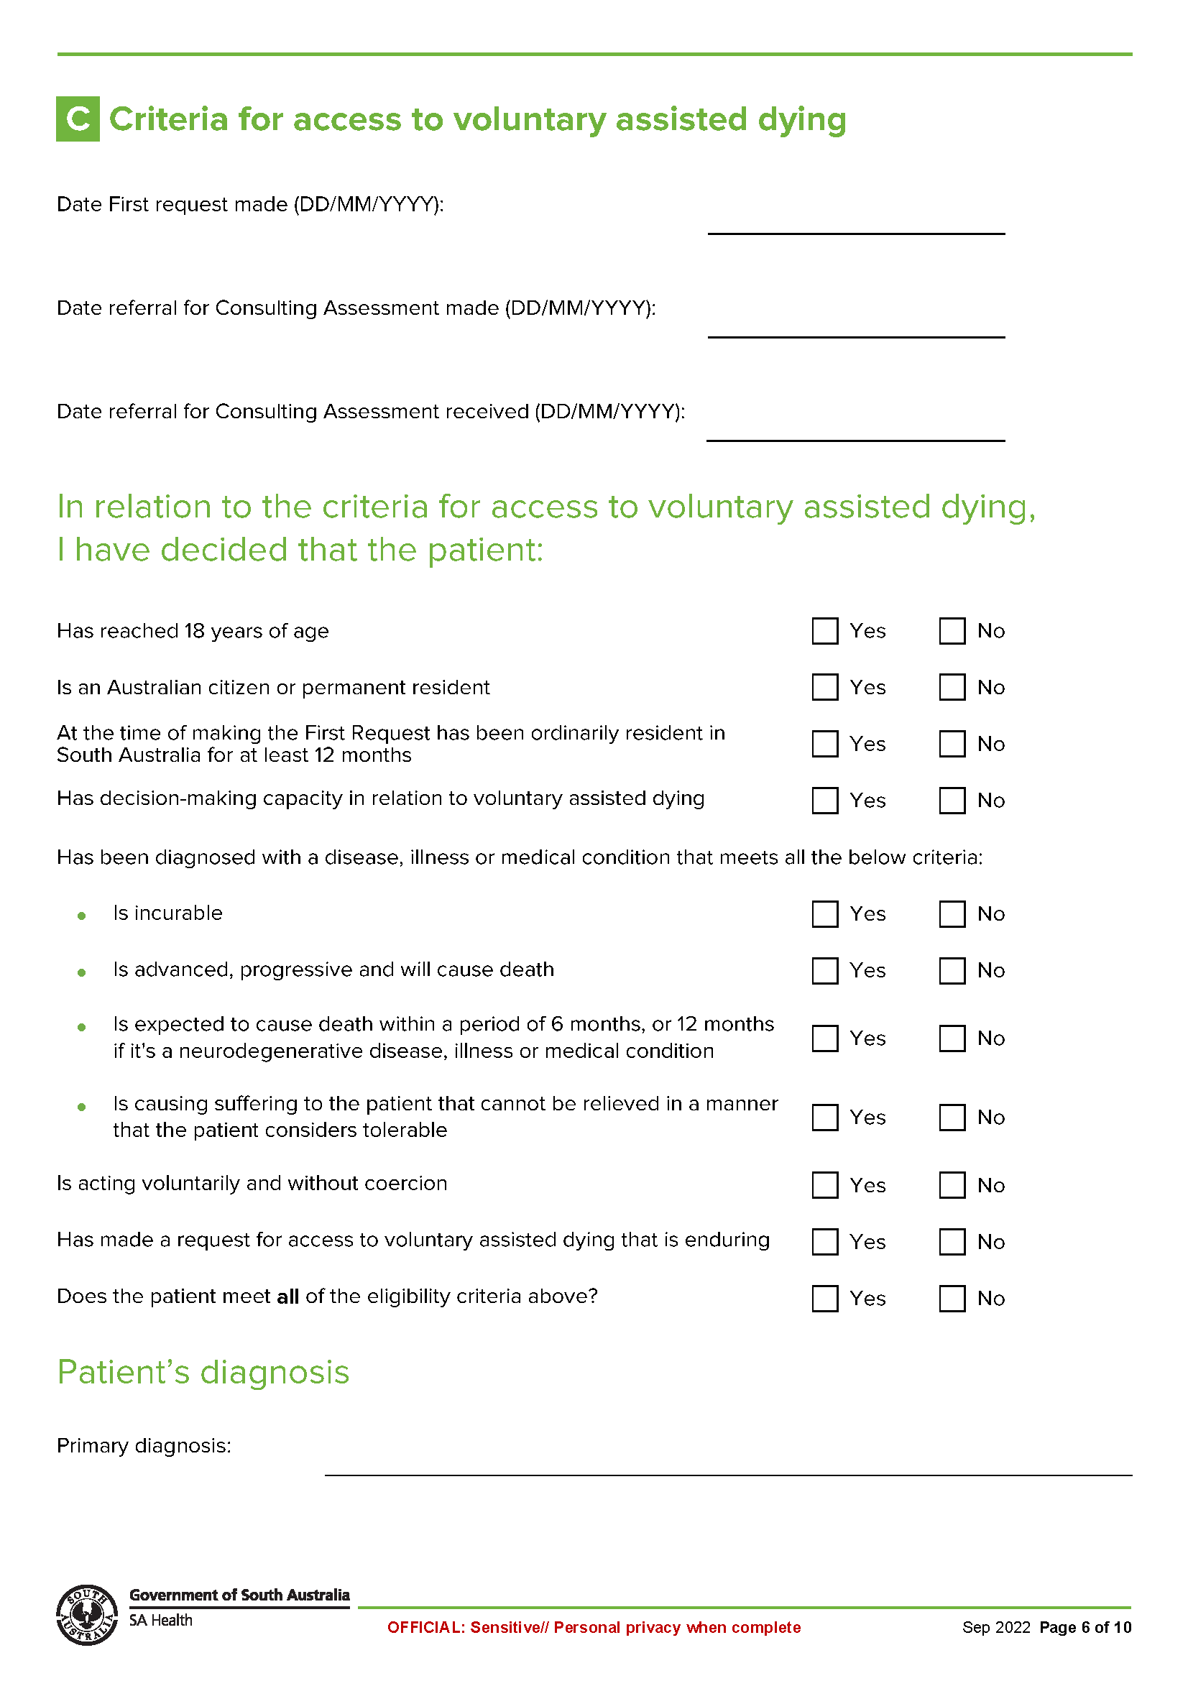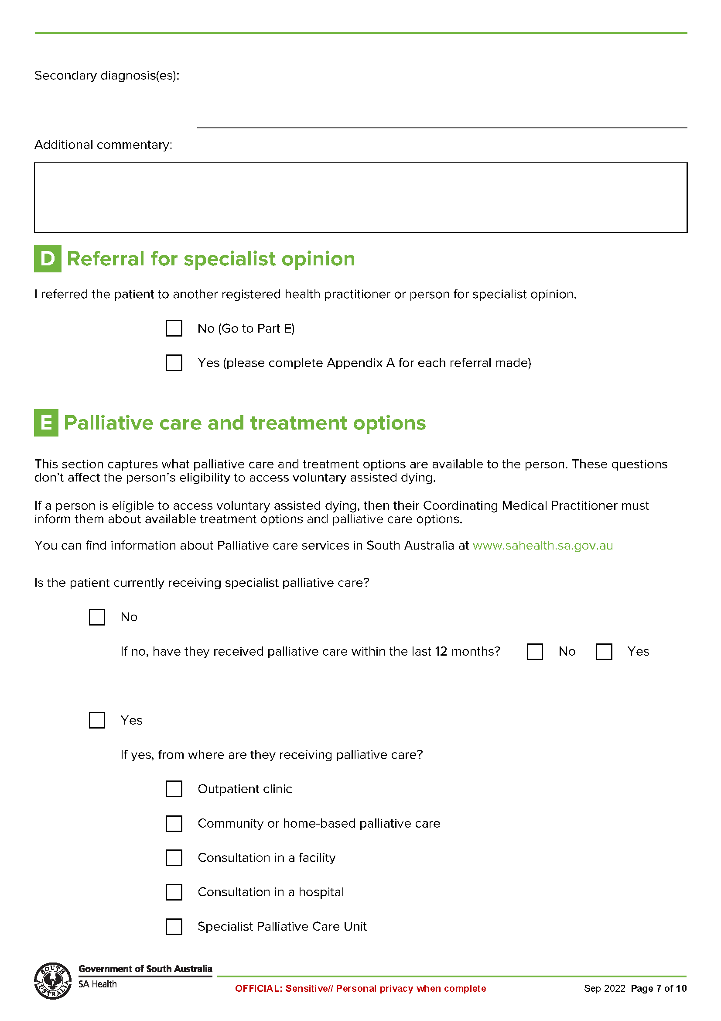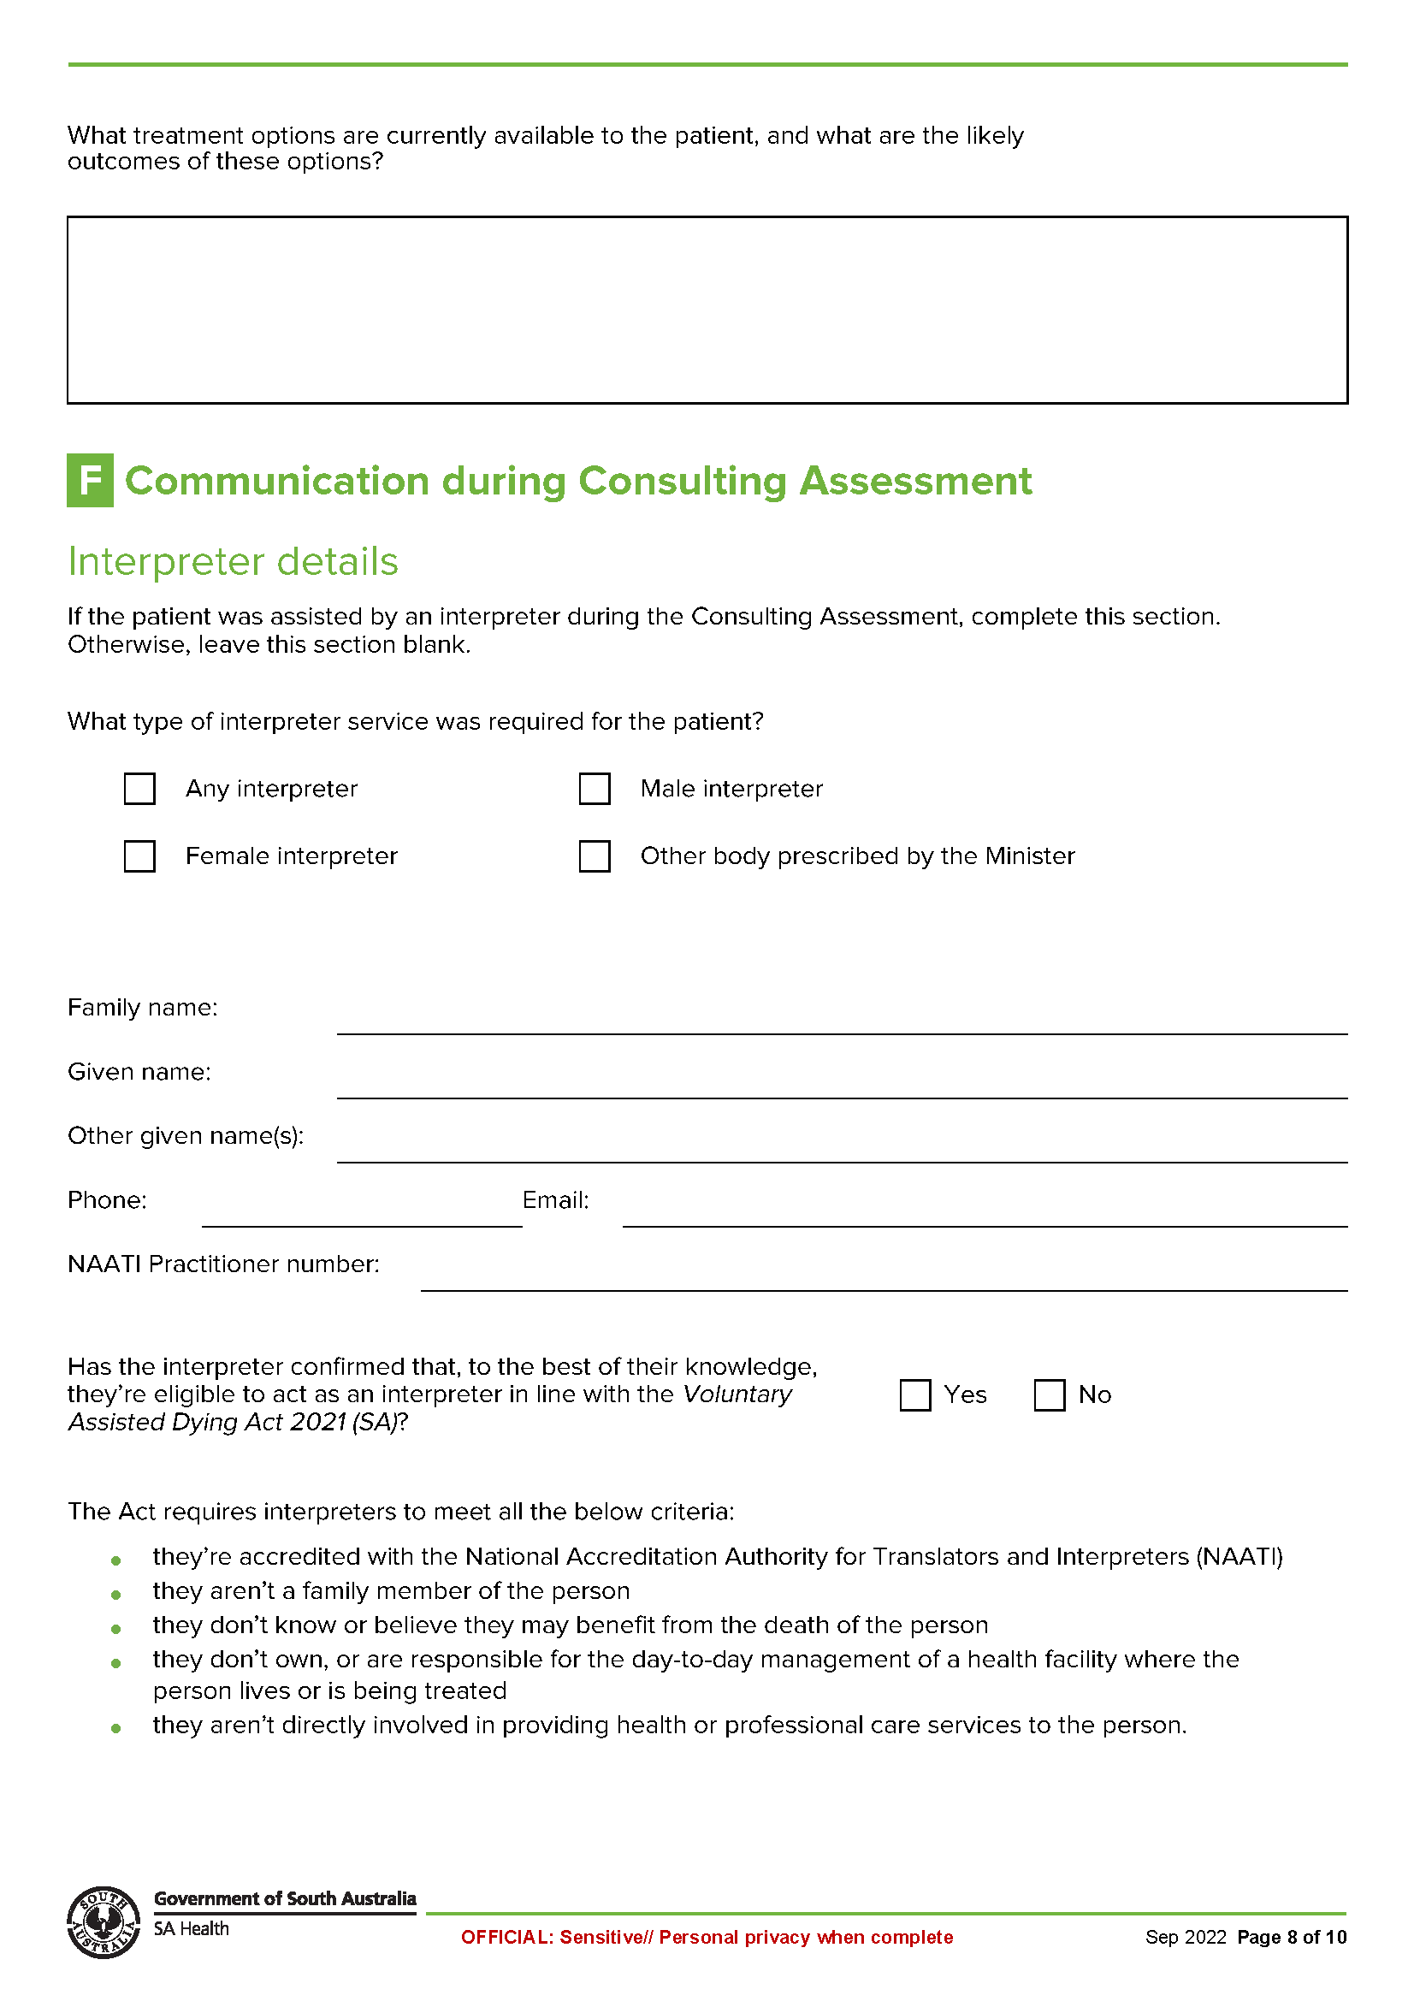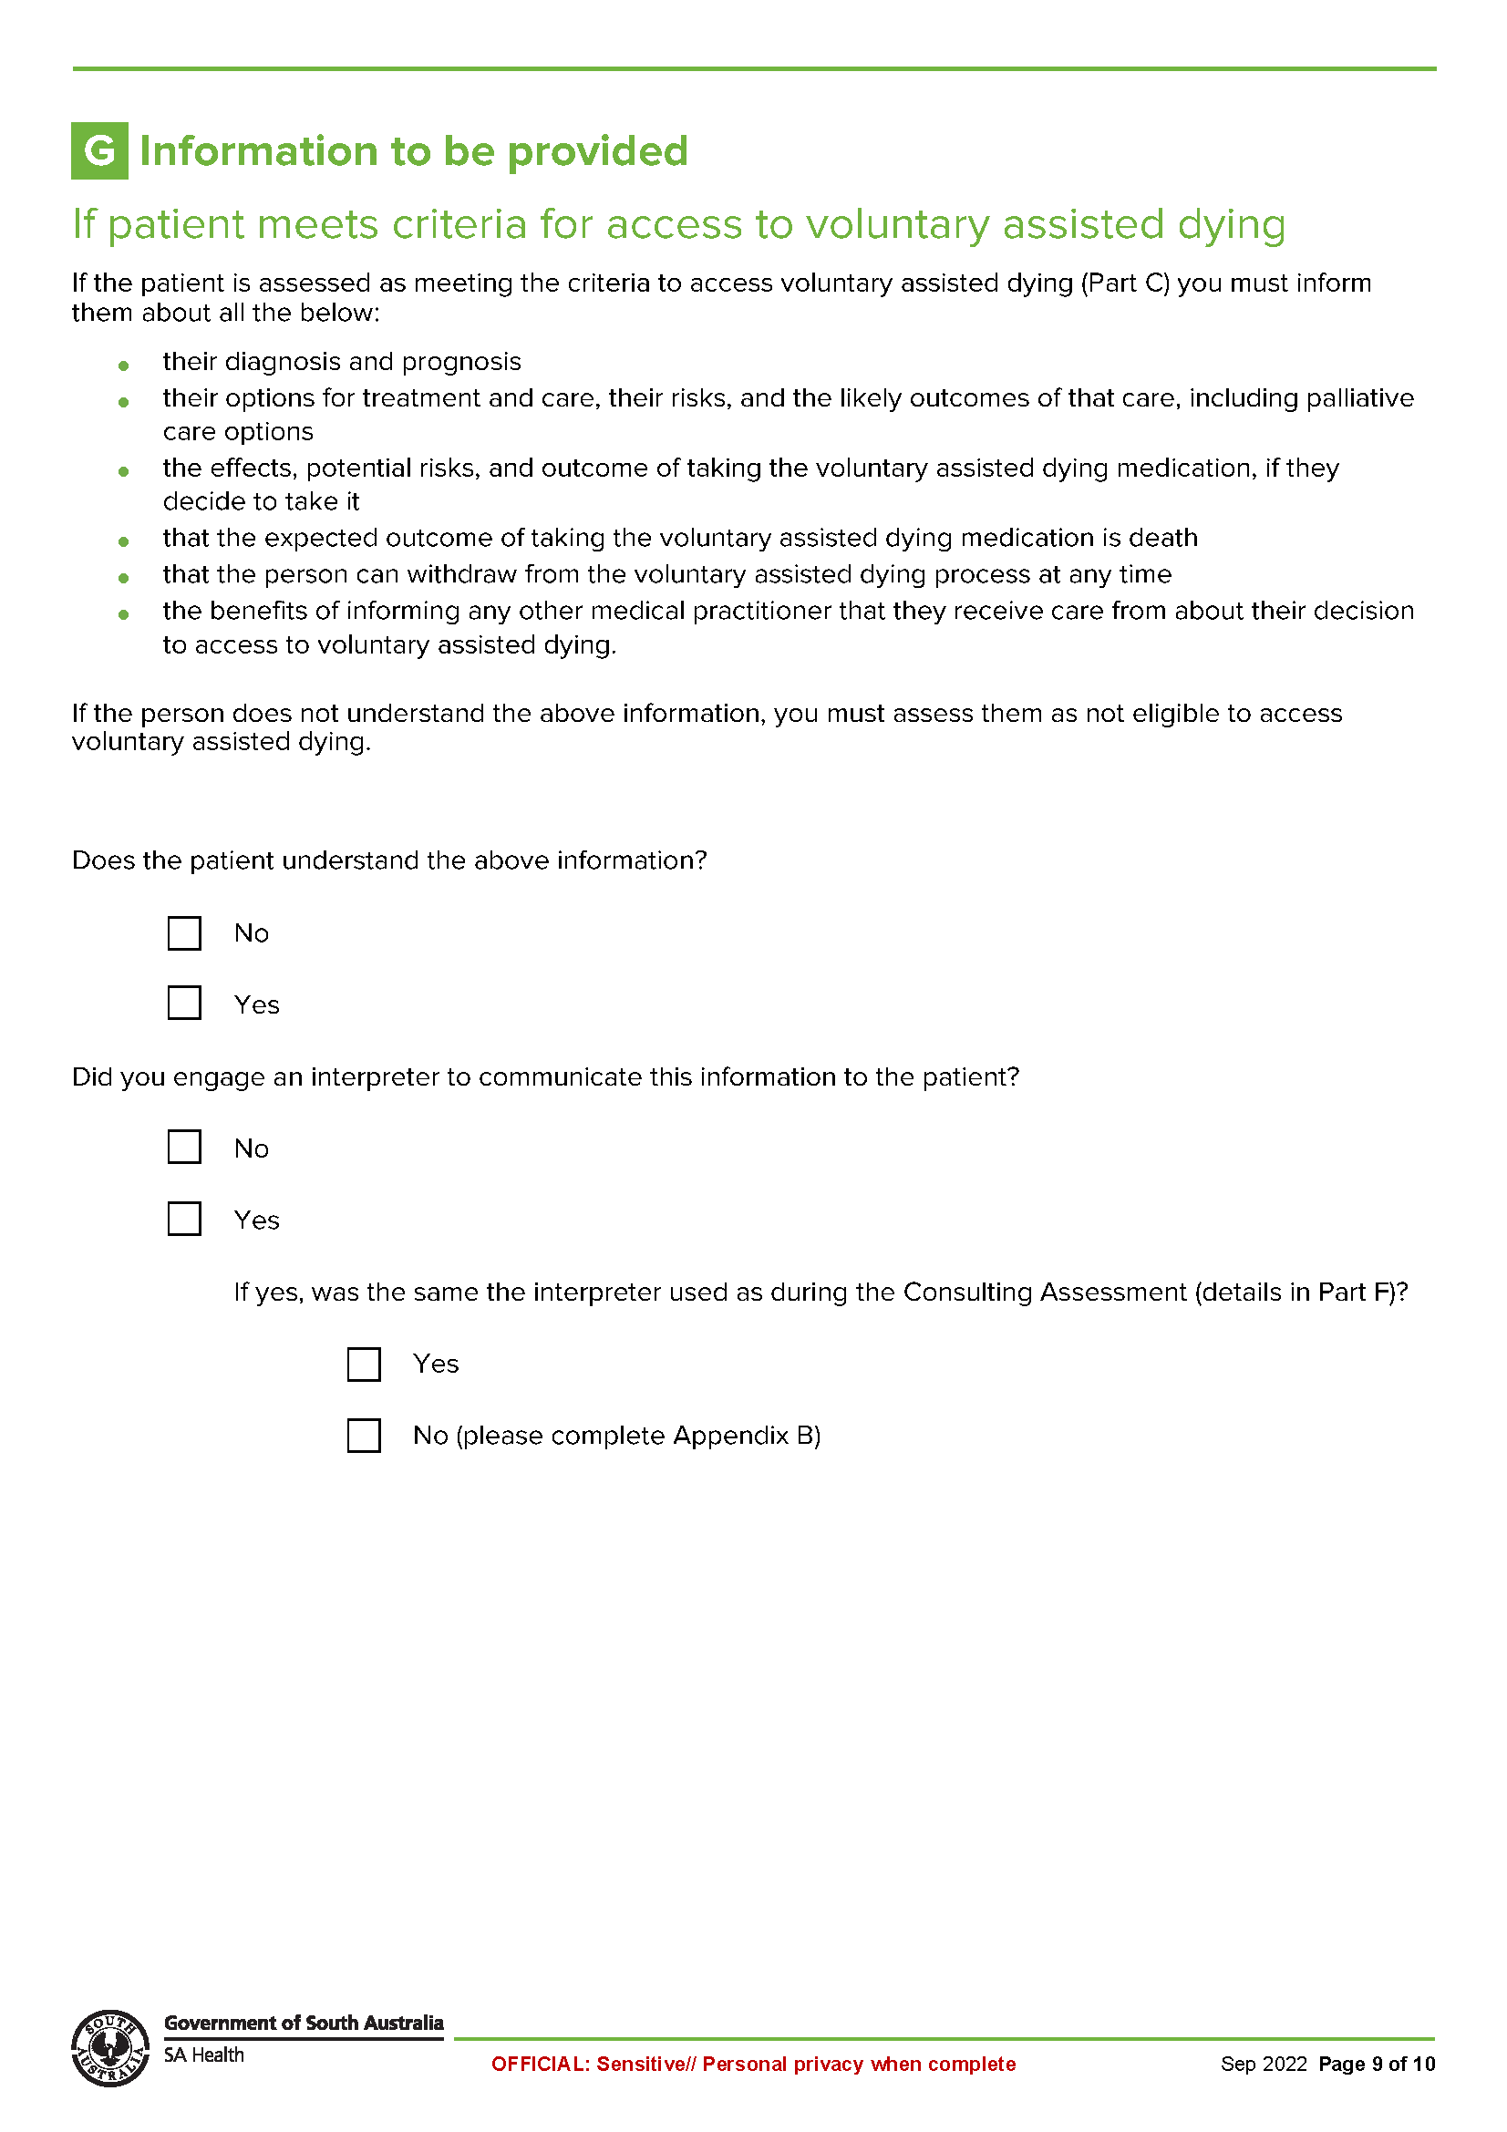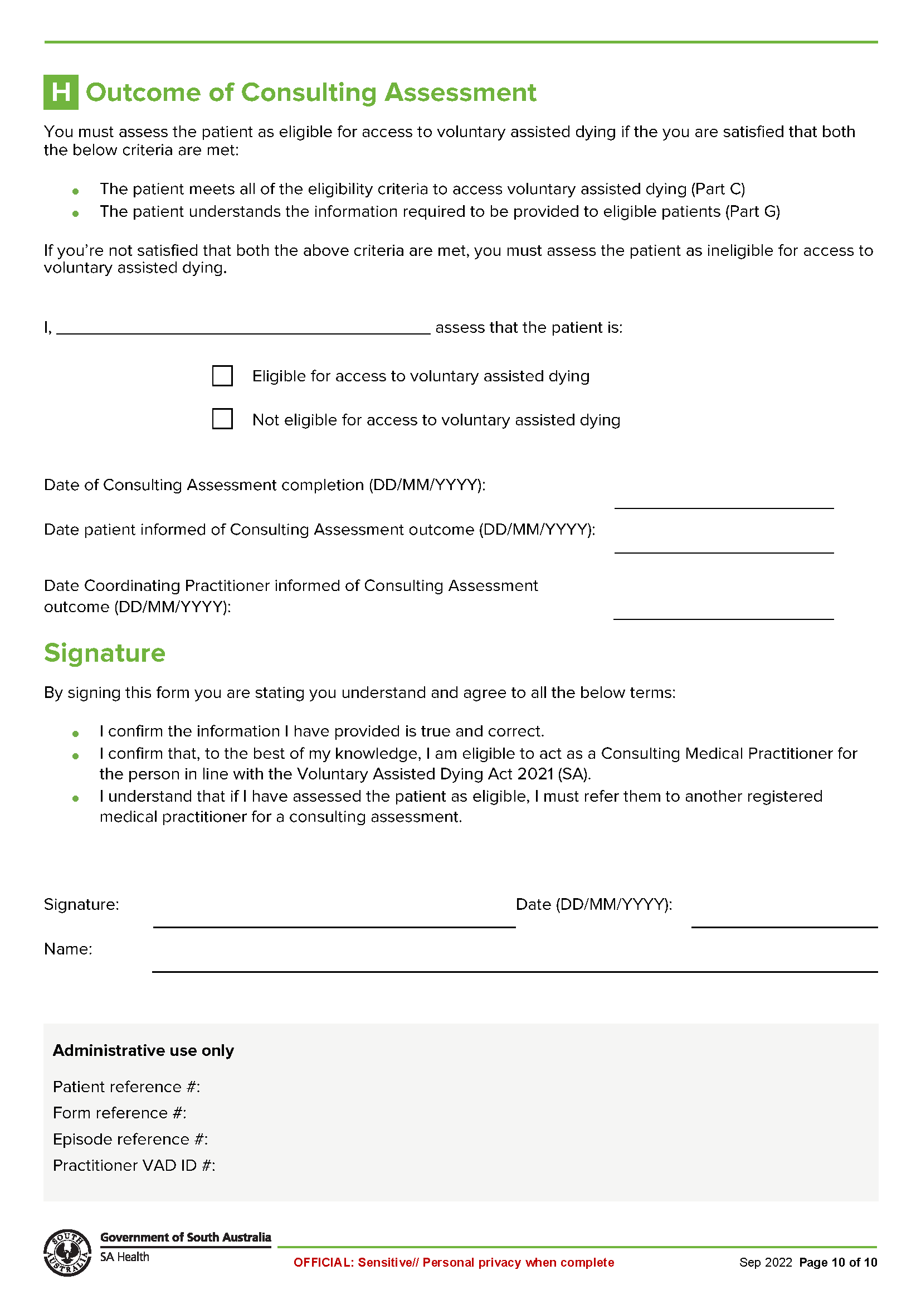

Schedule 3
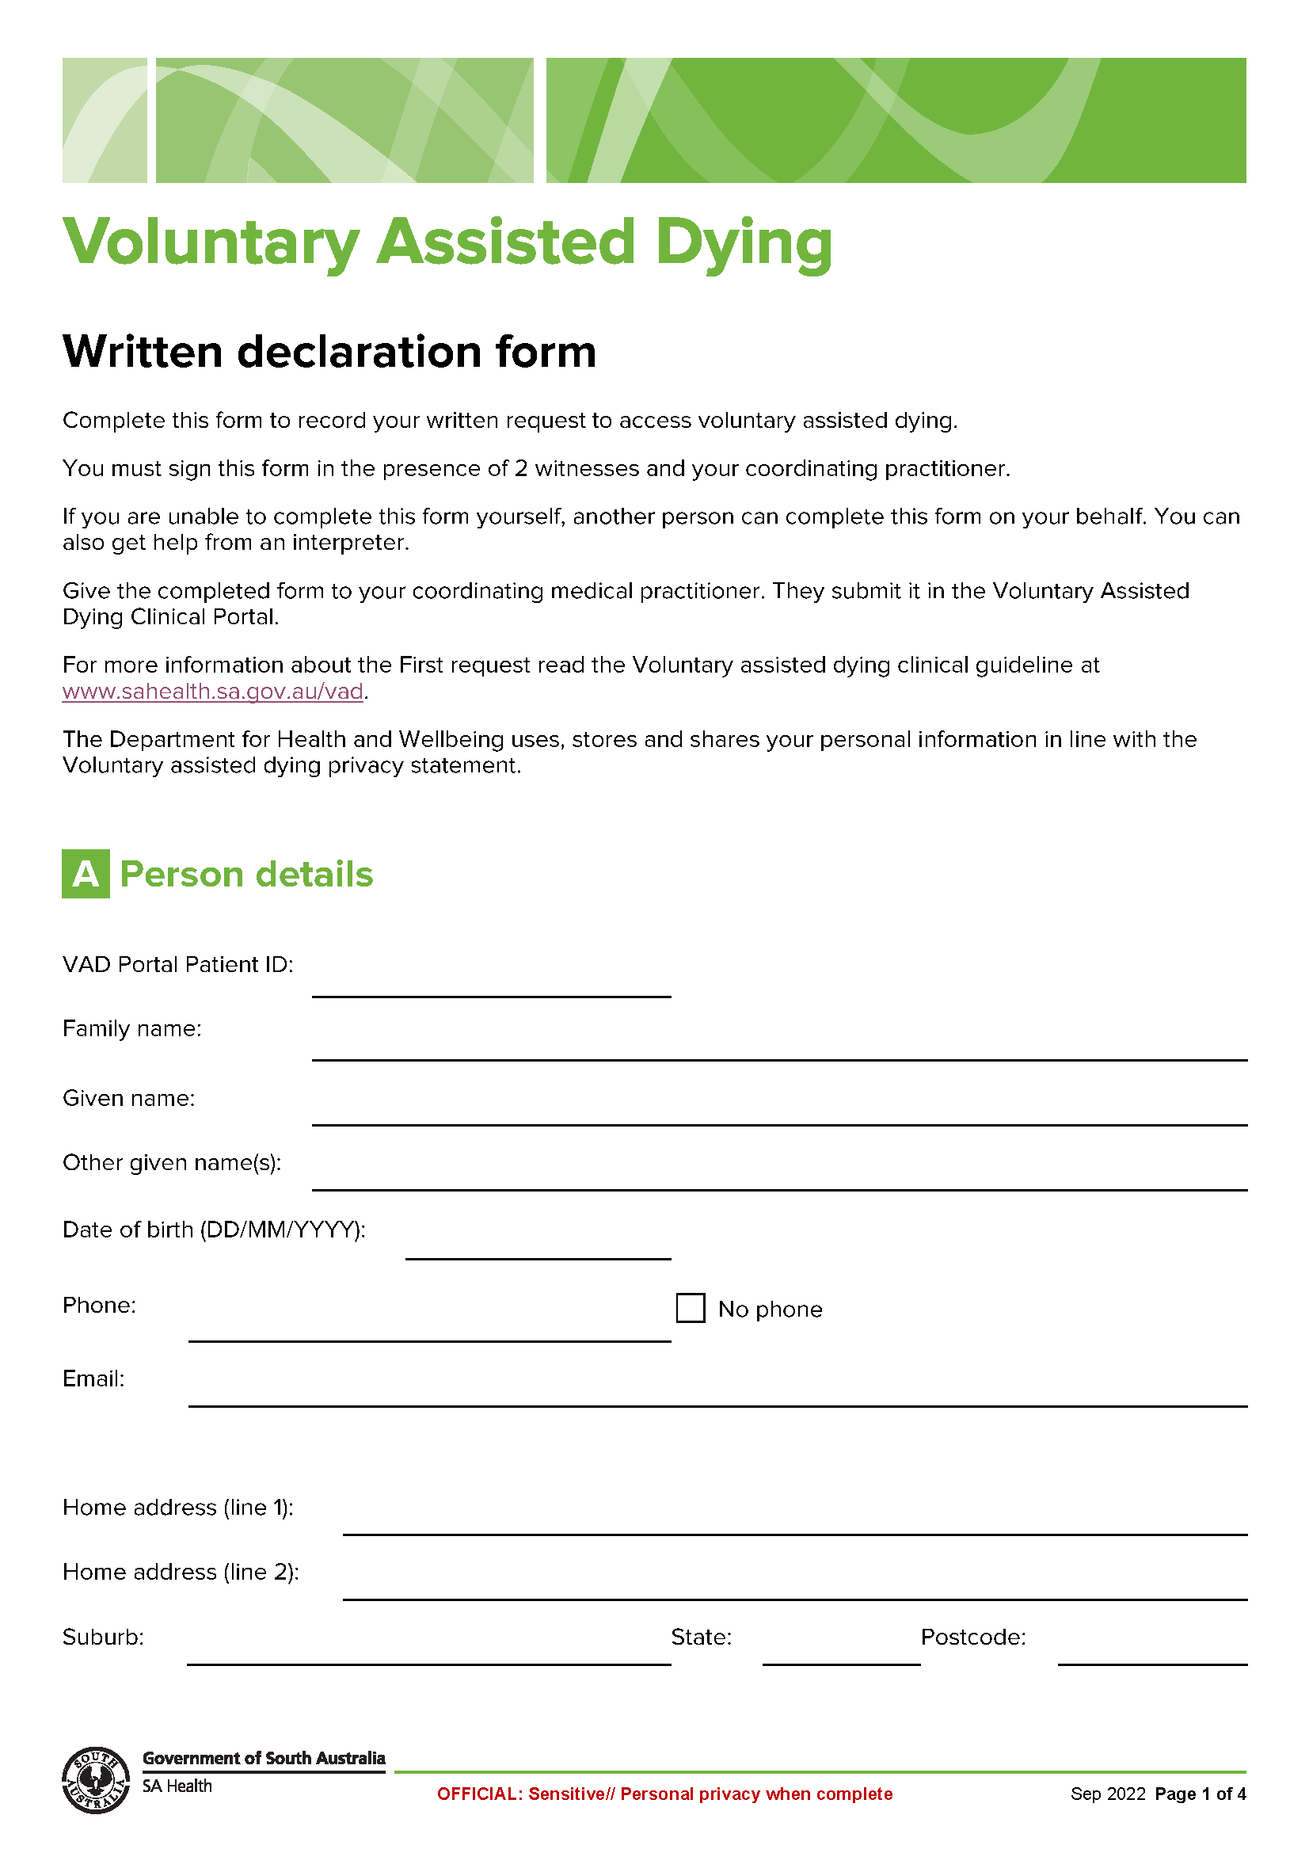
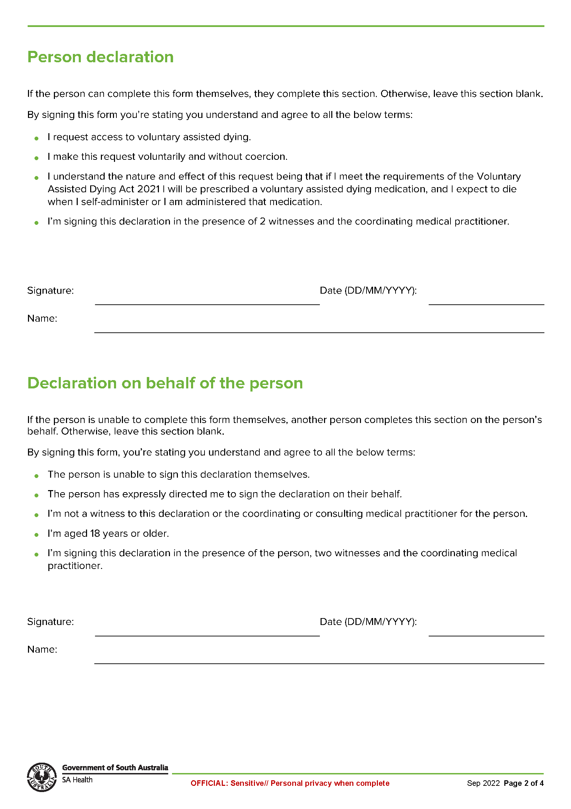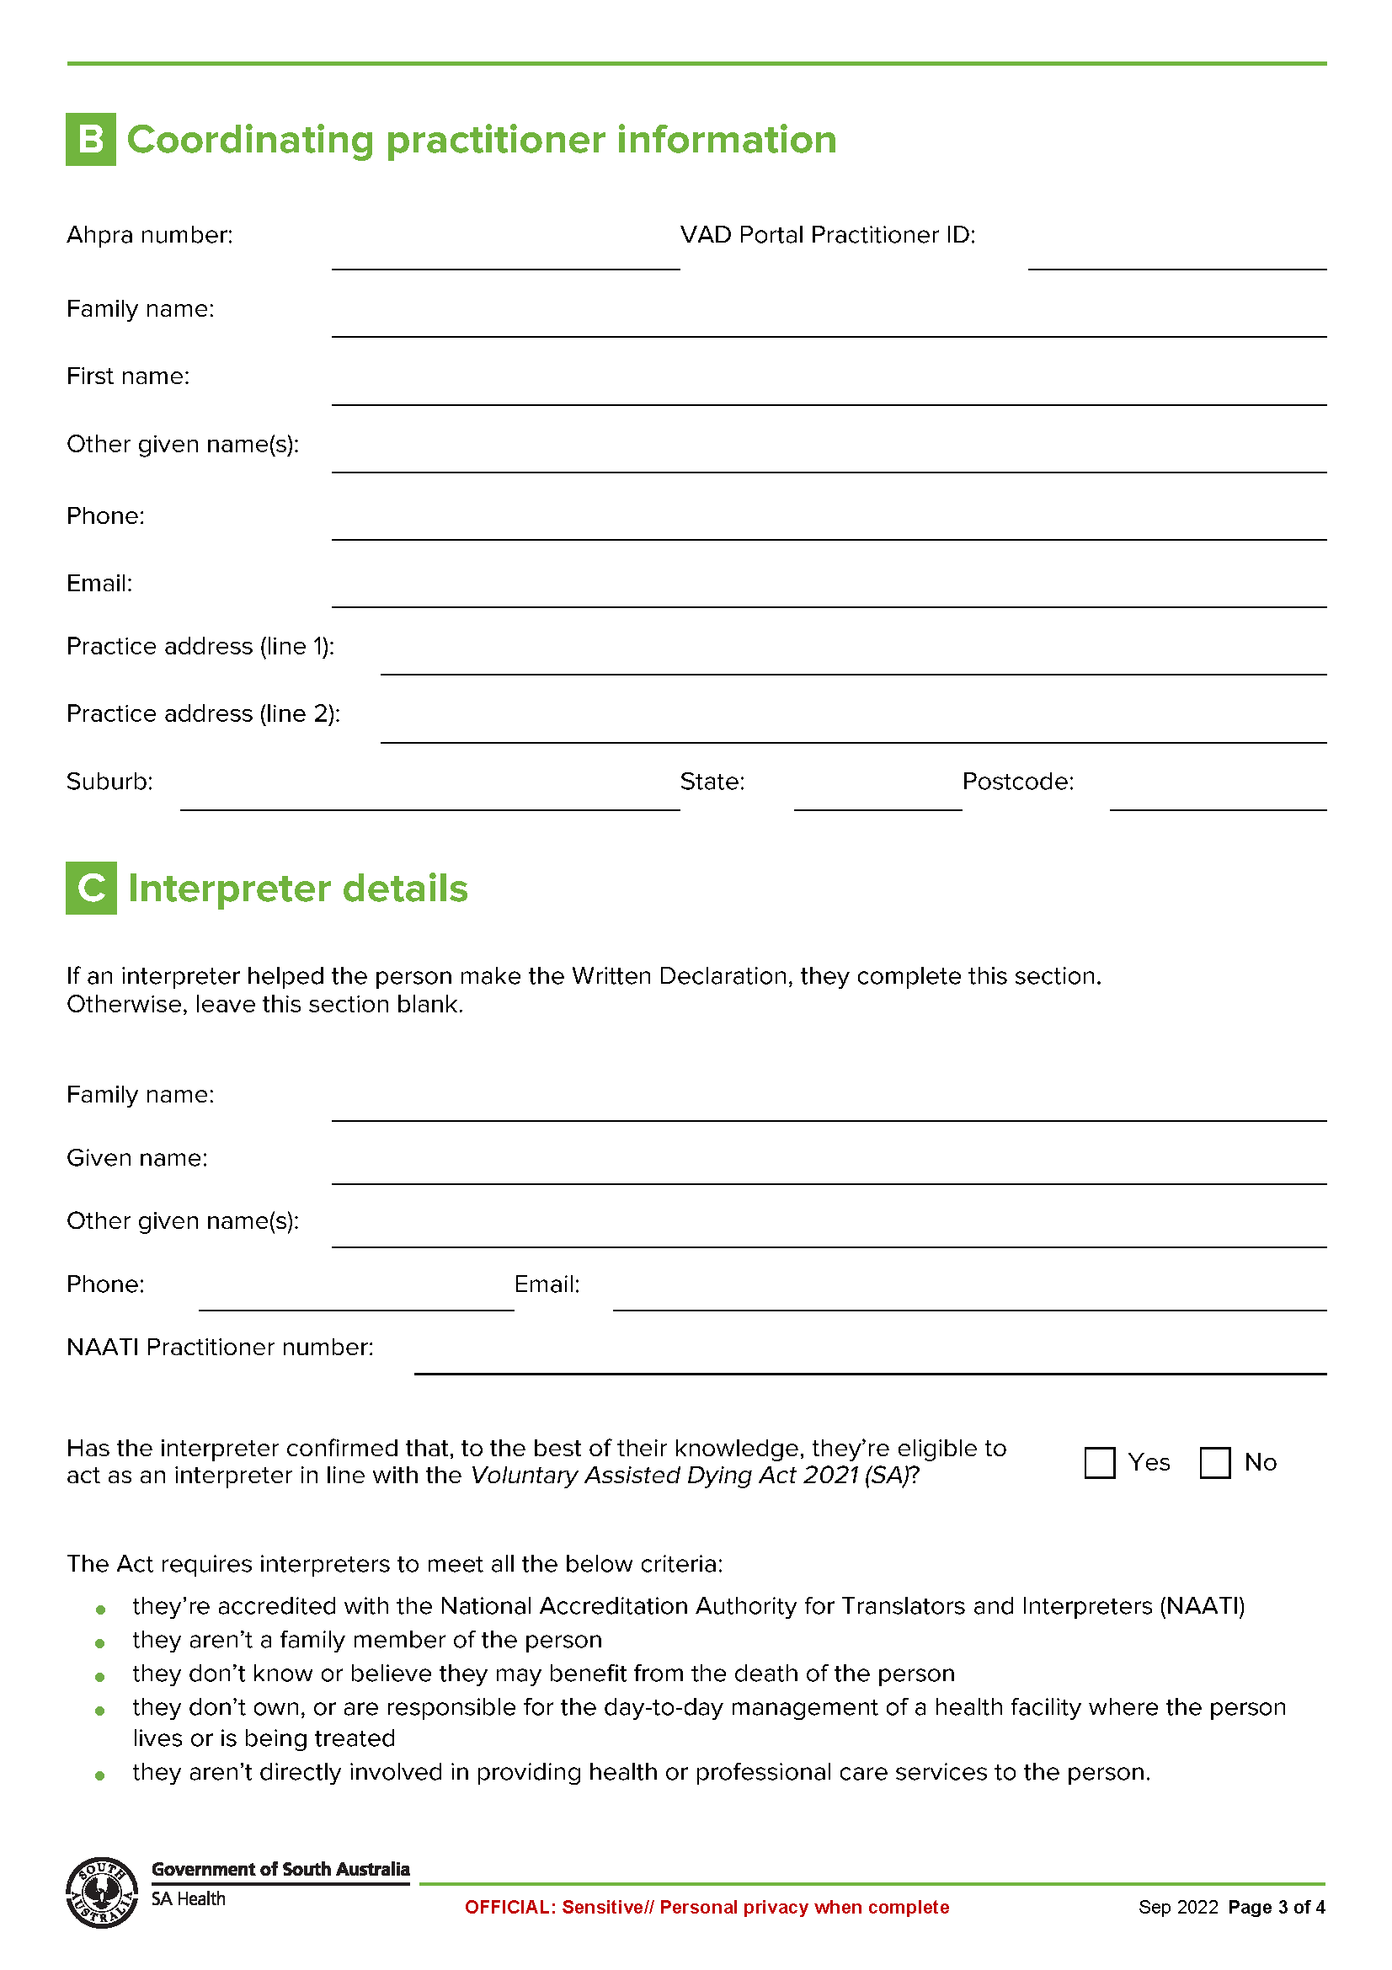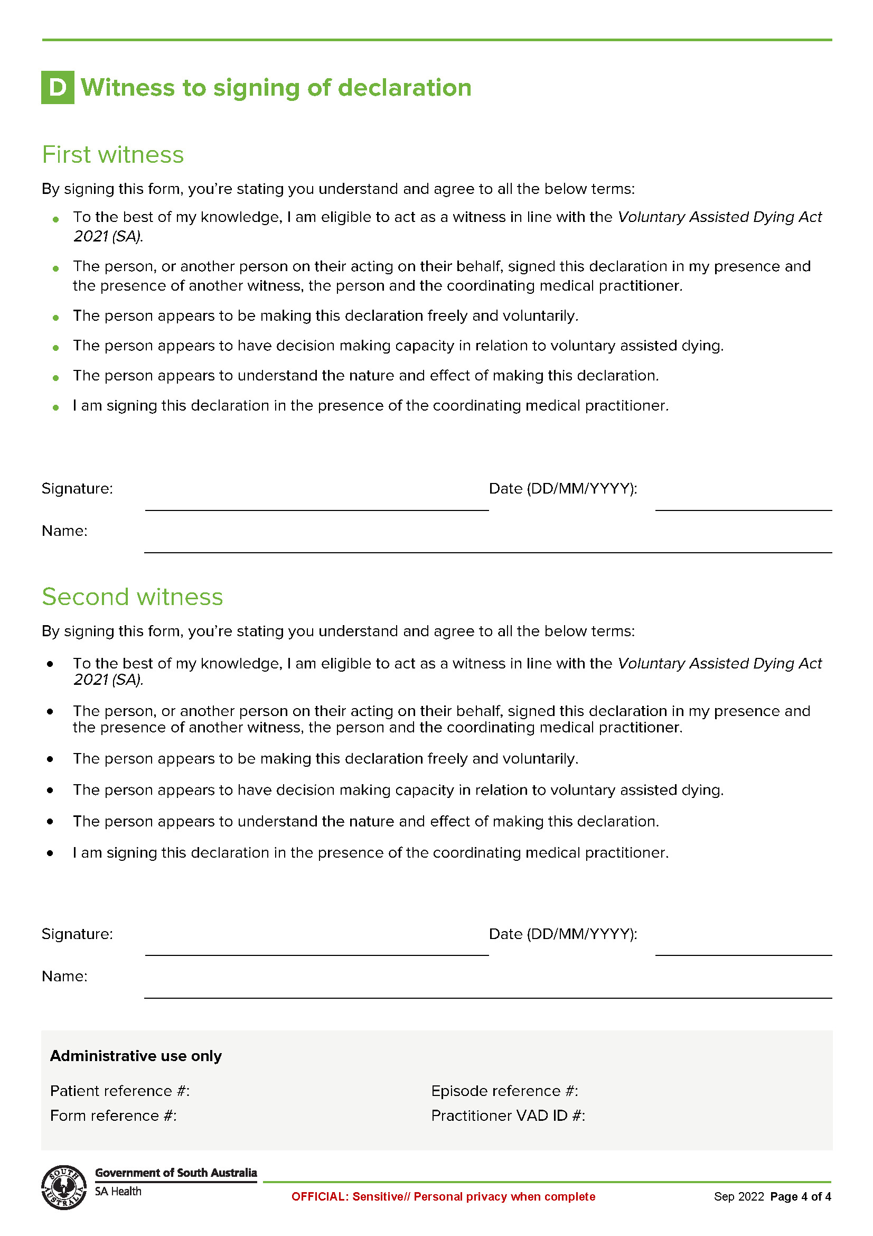

Schedule 4
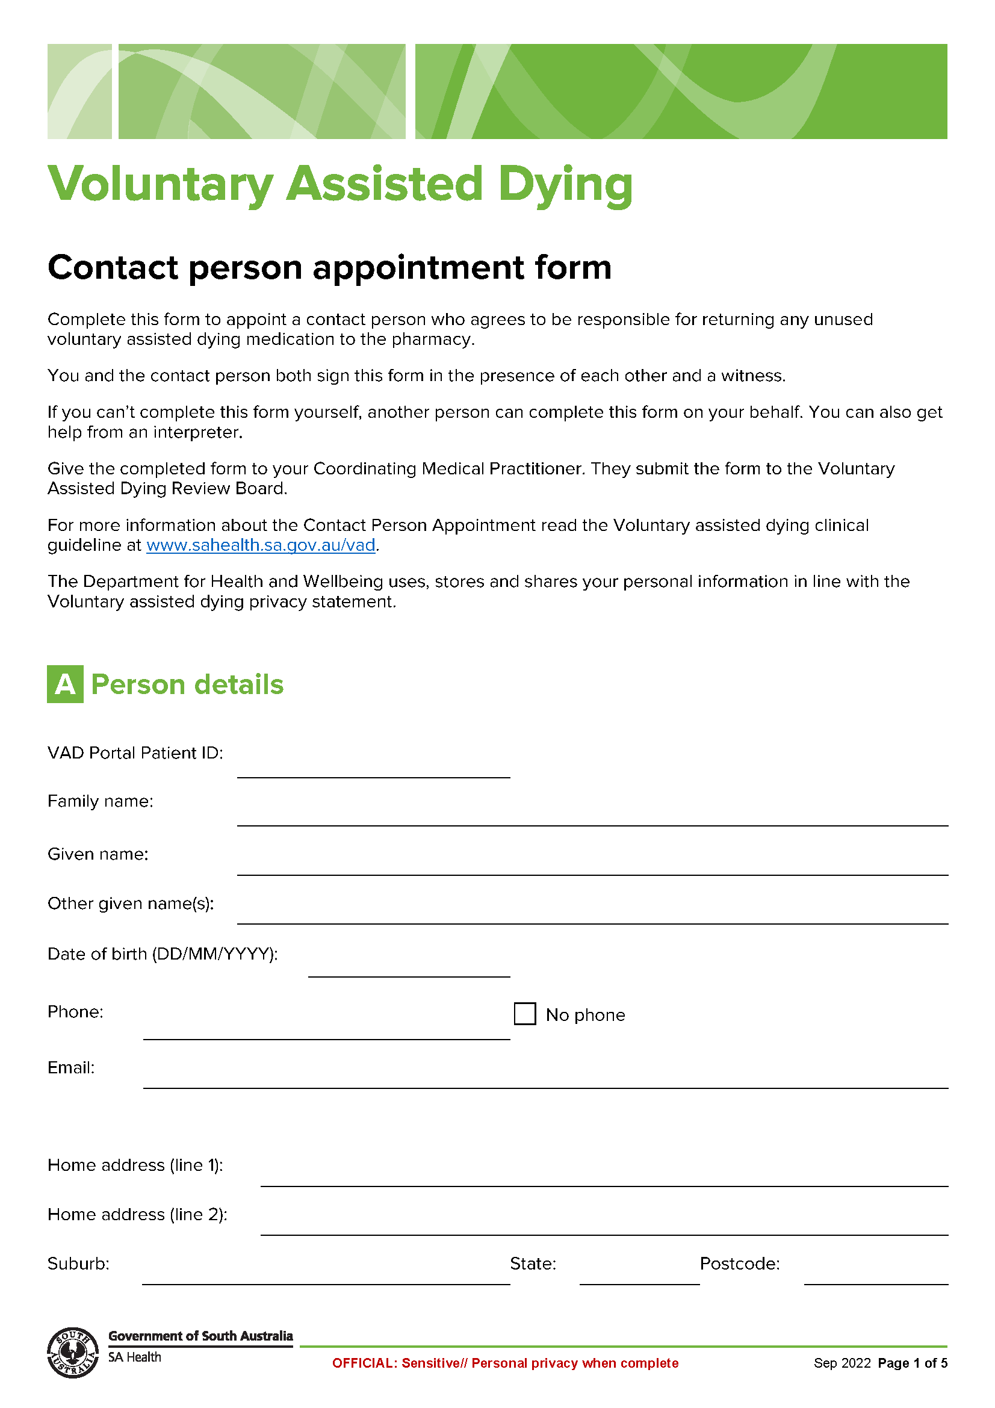
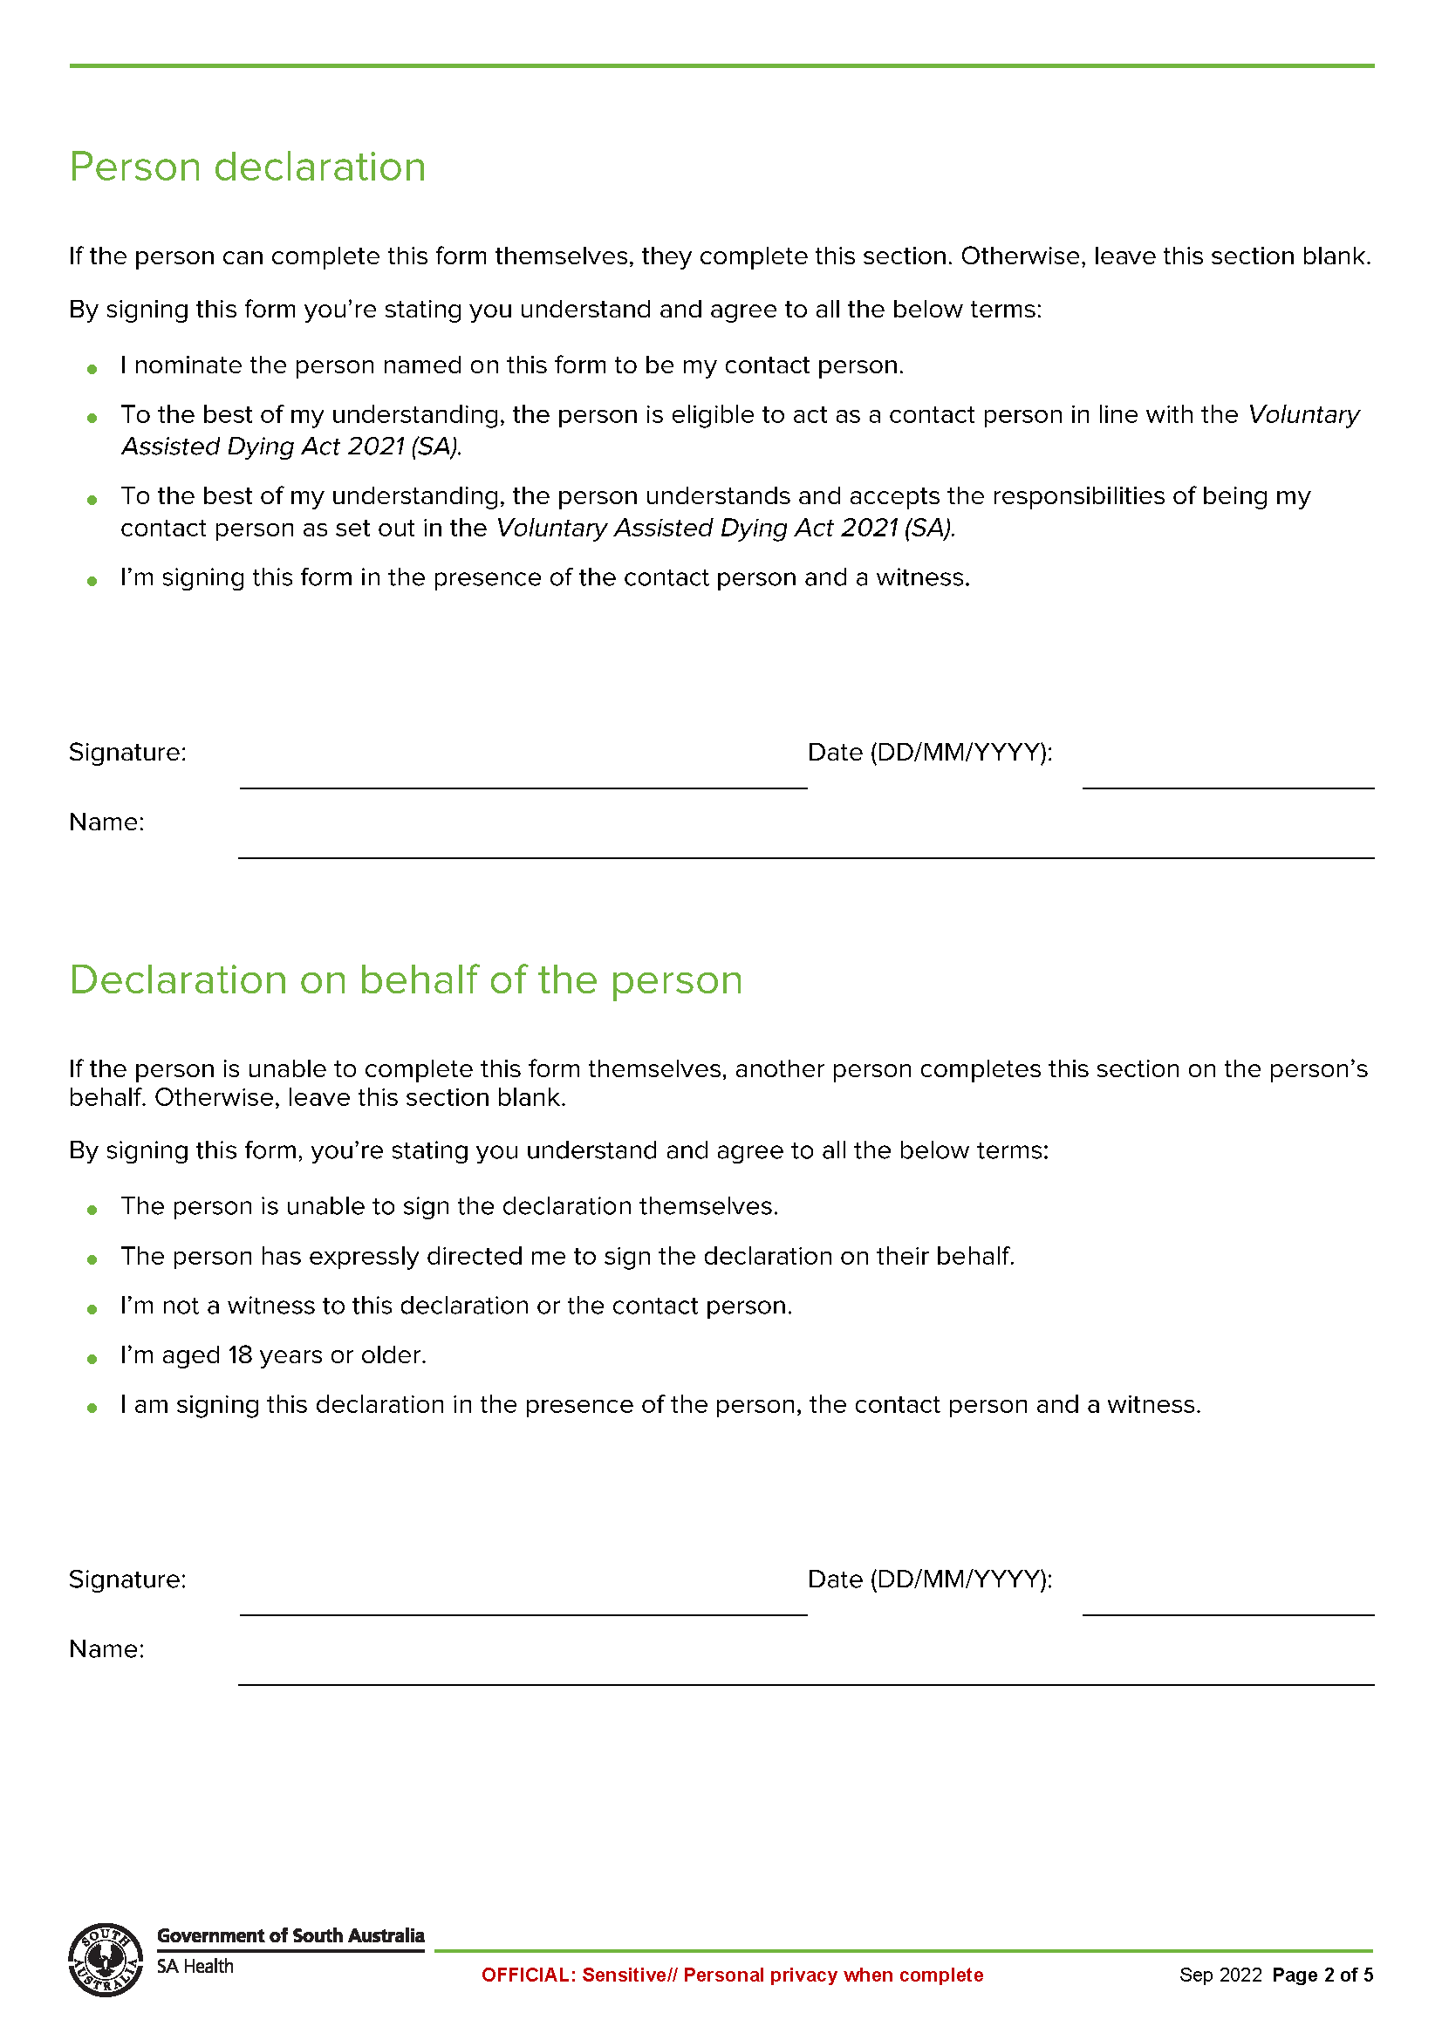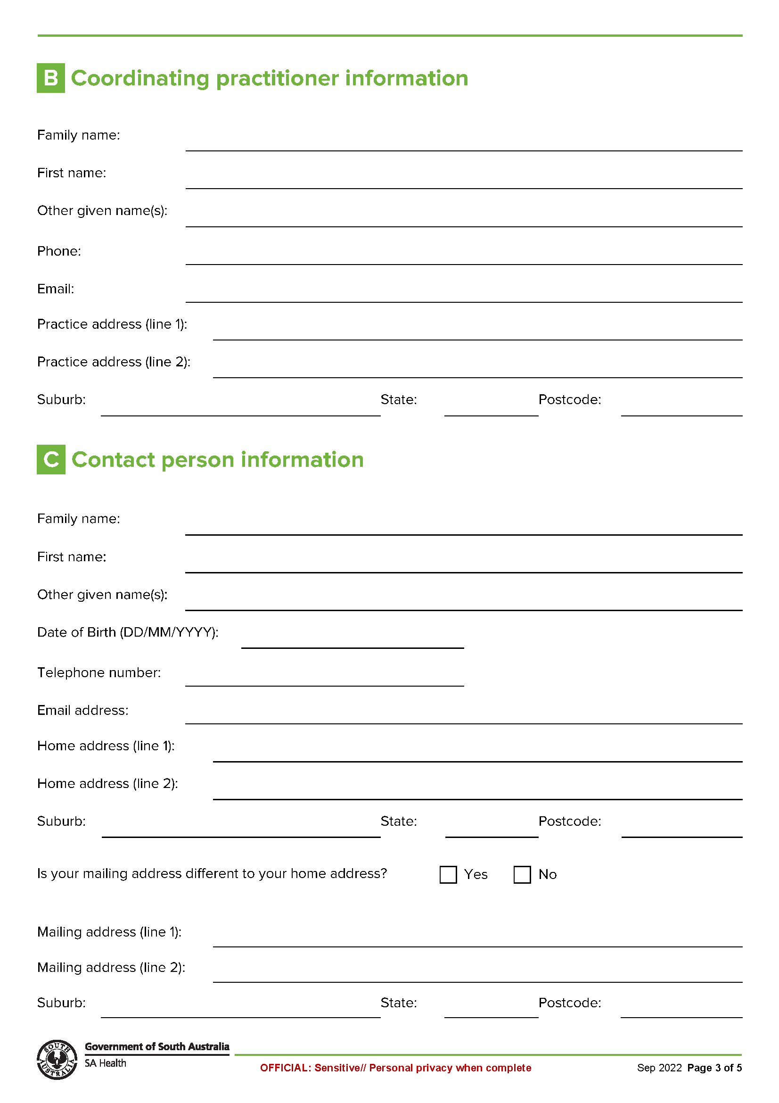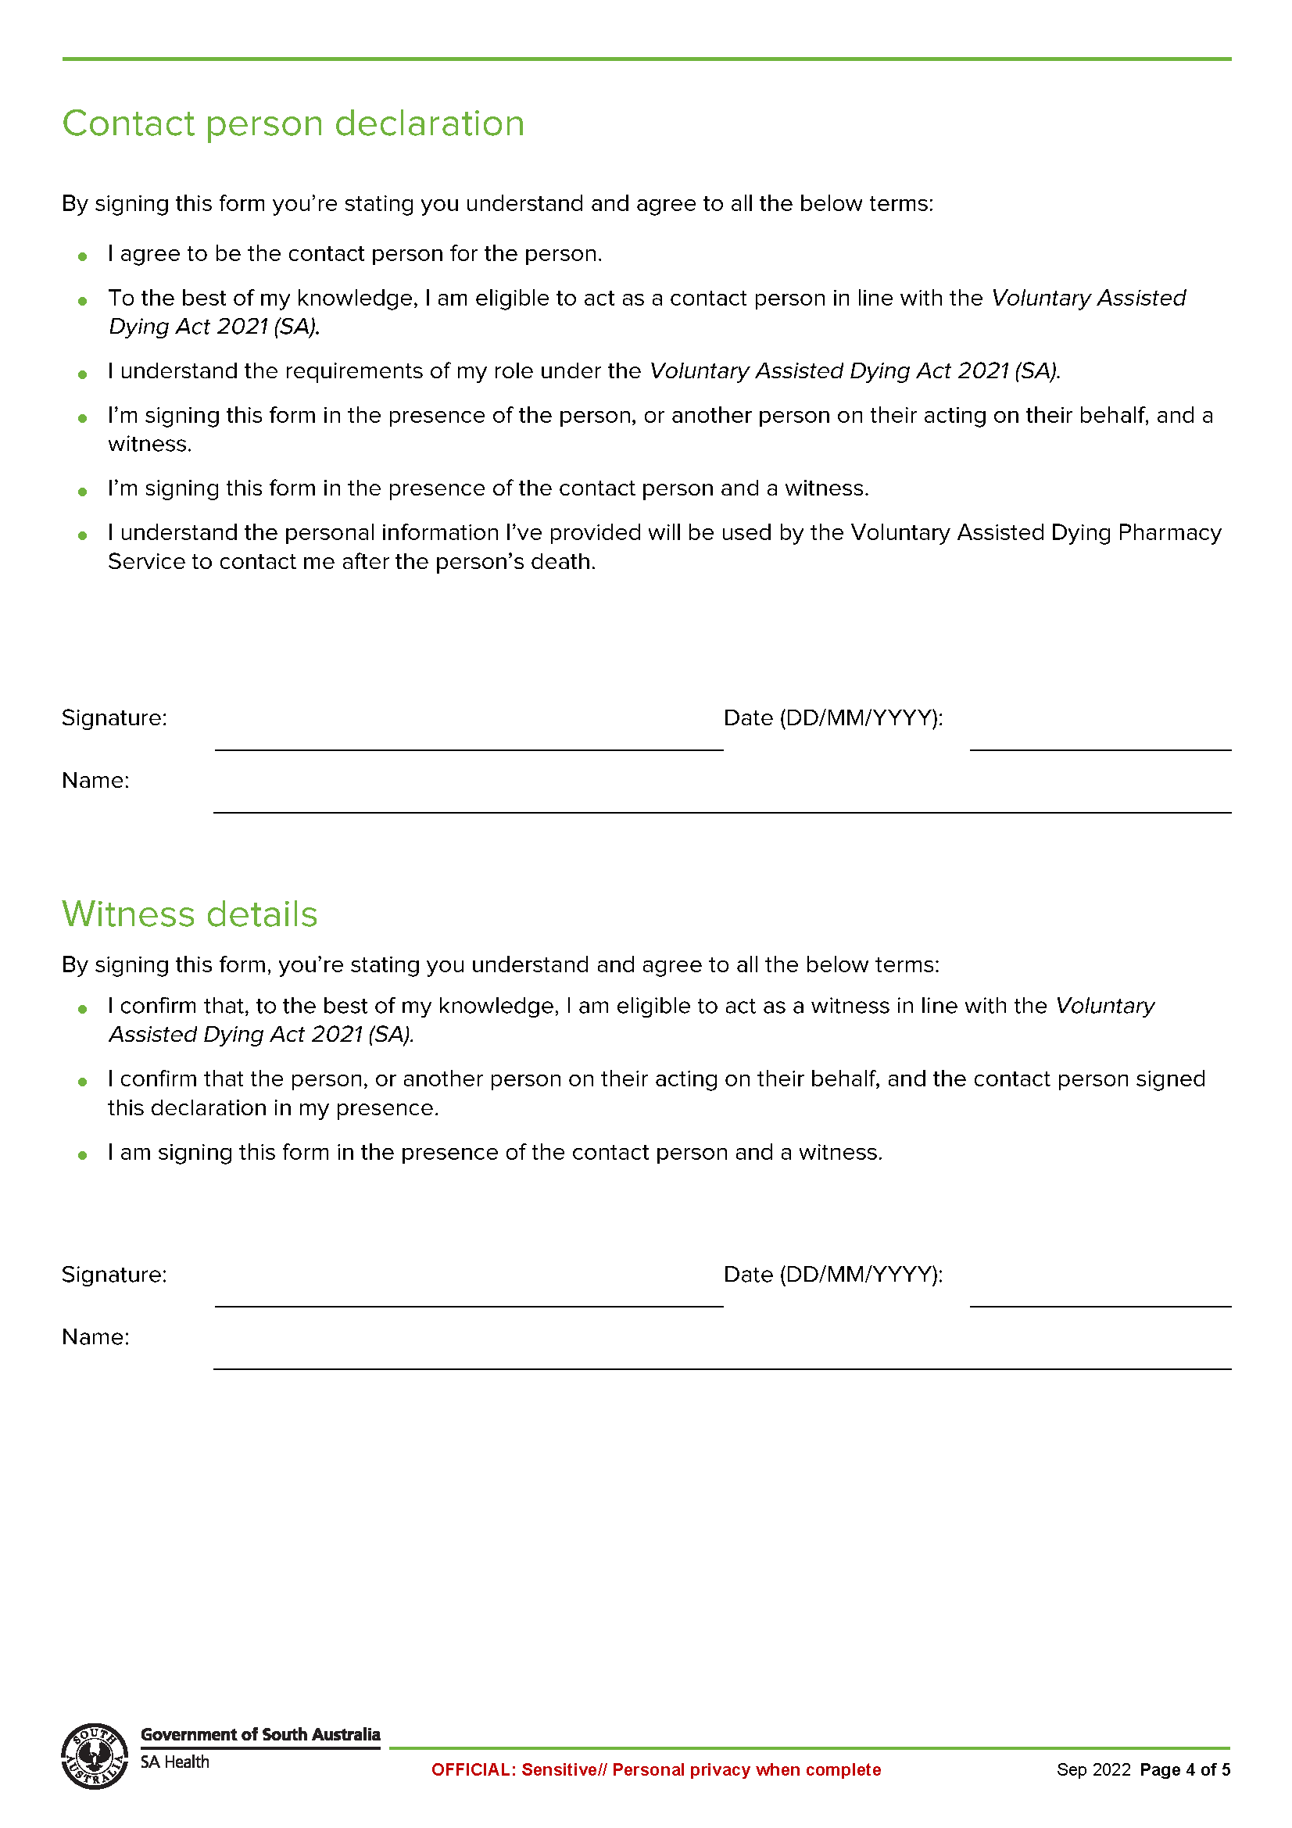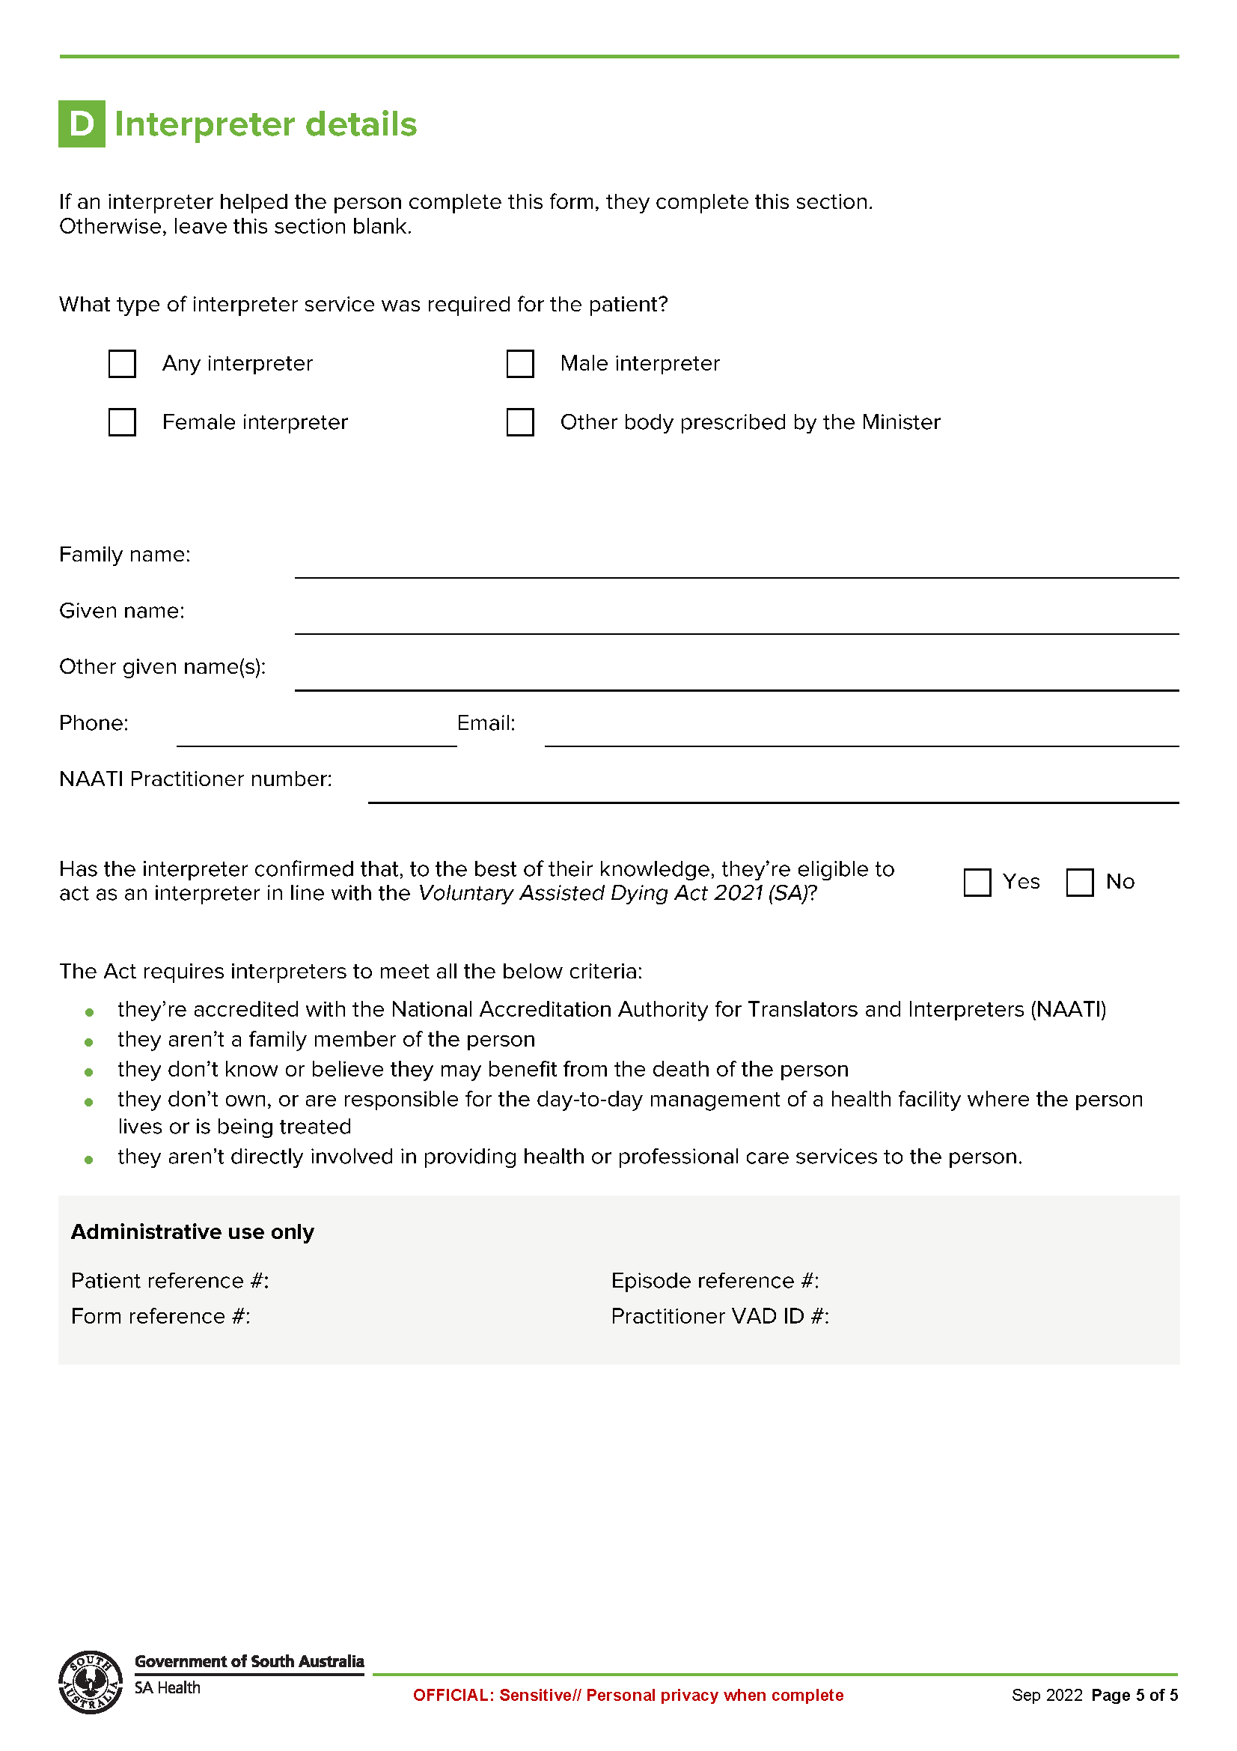

Schedule 5
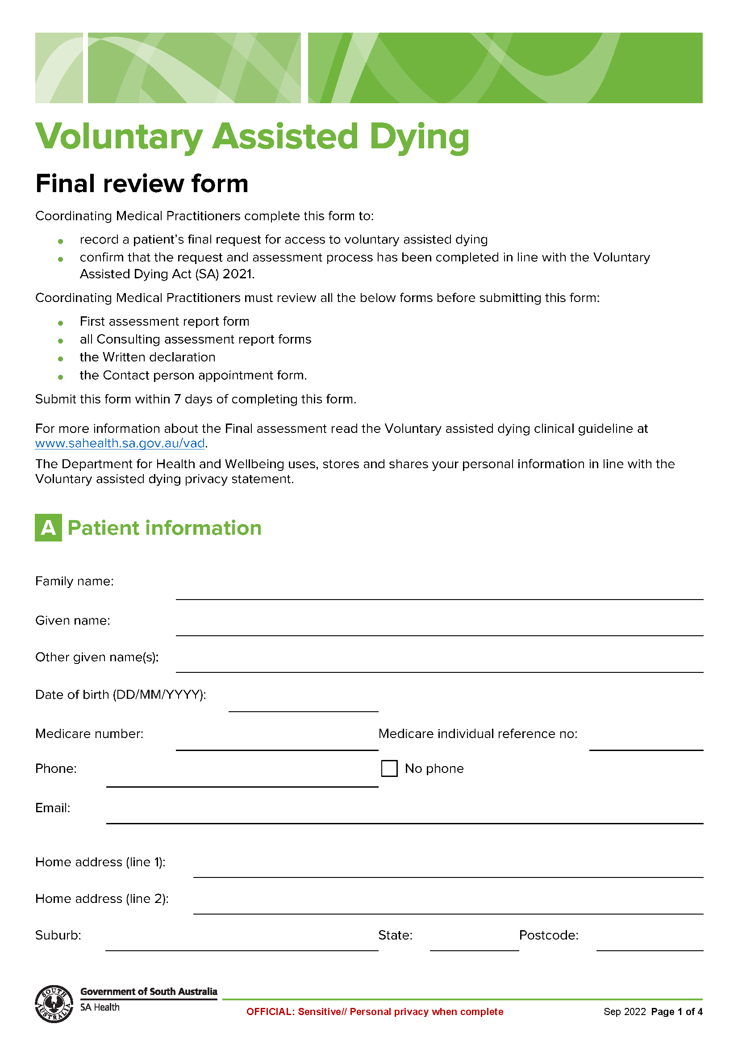
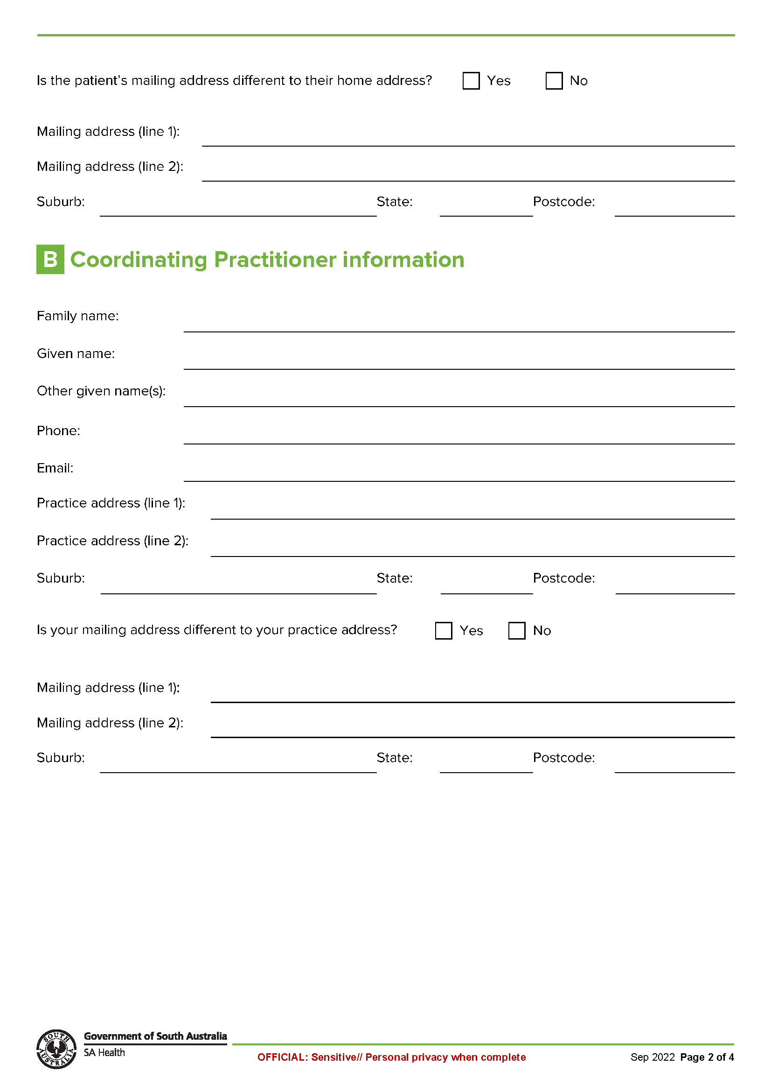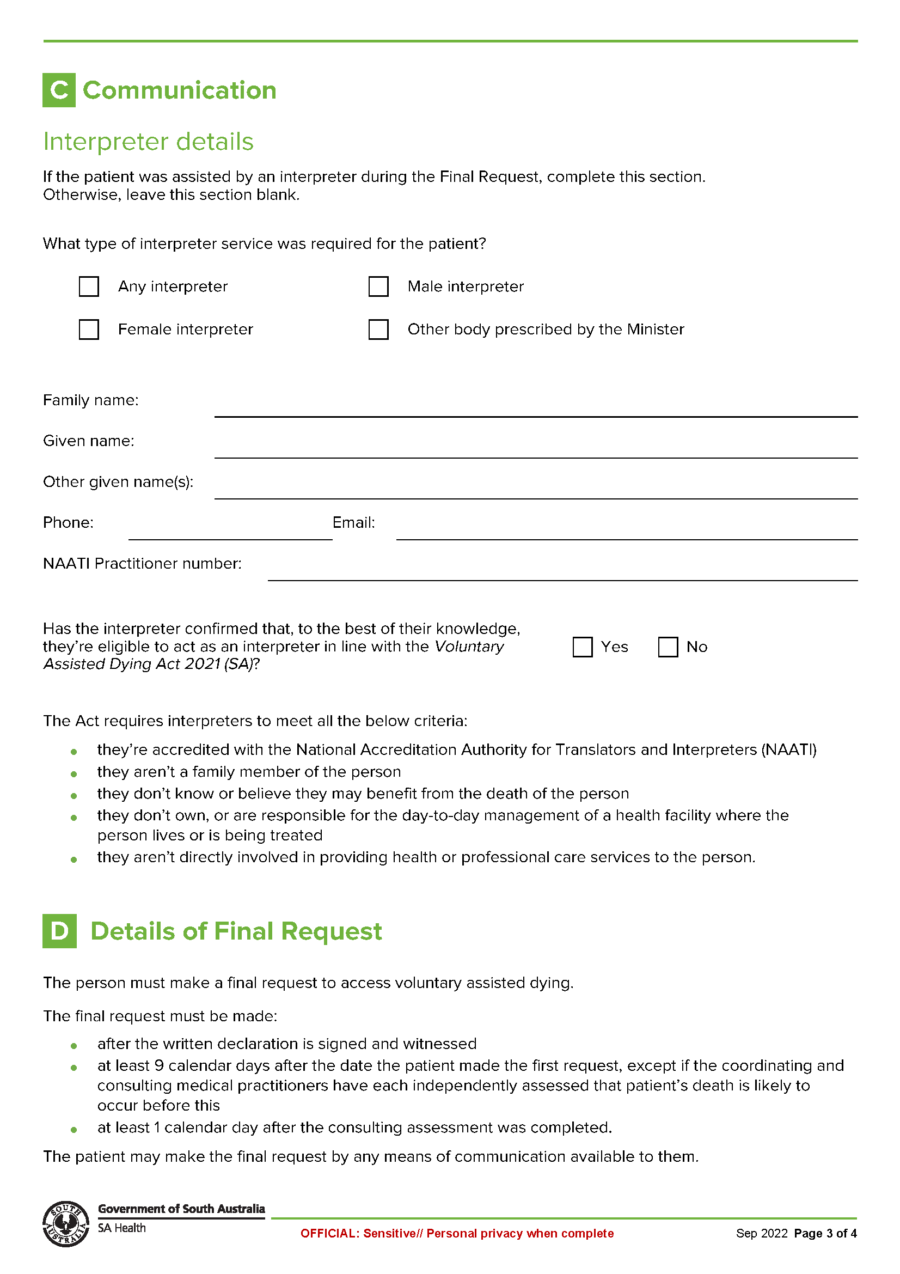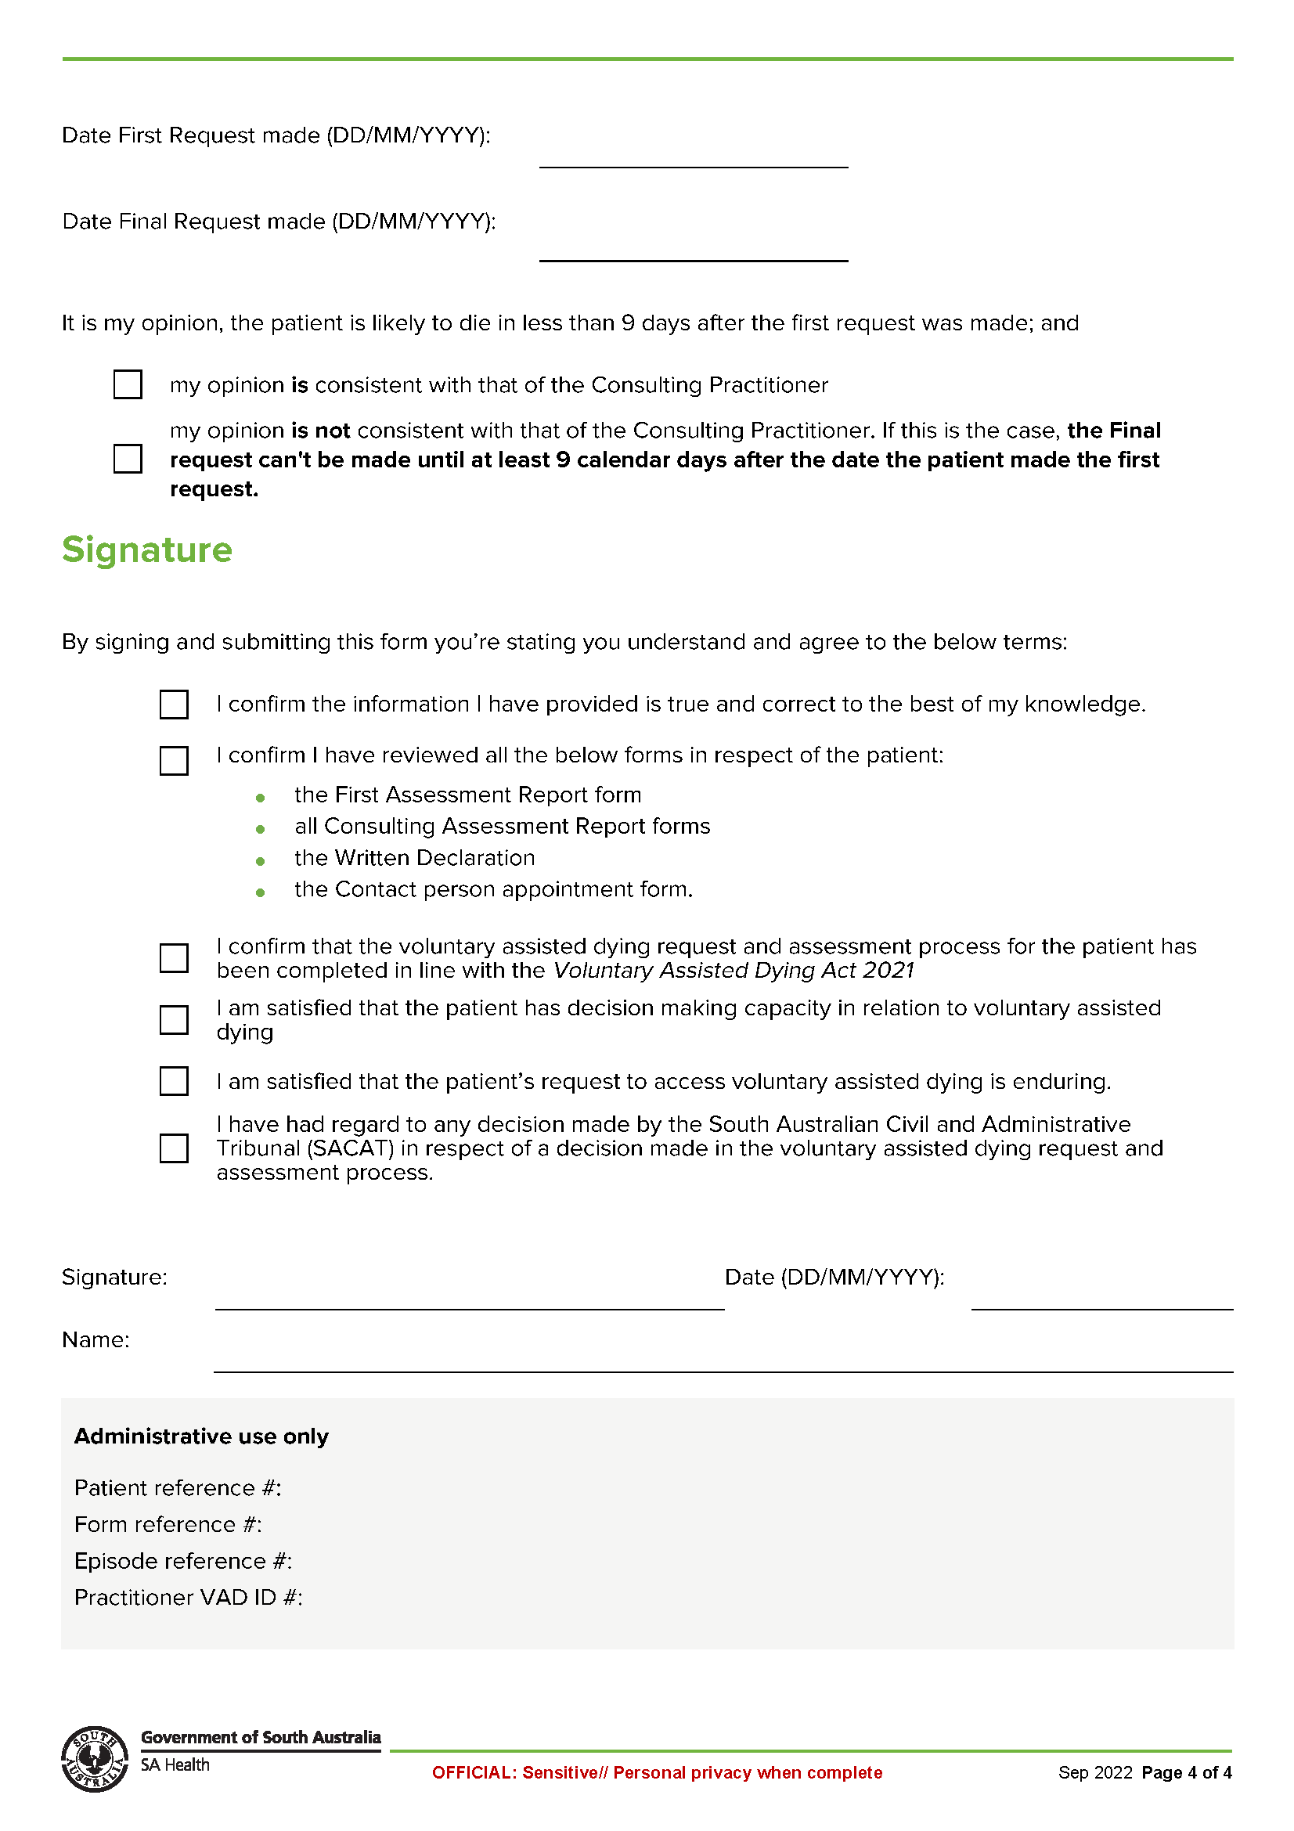

Schedule 6
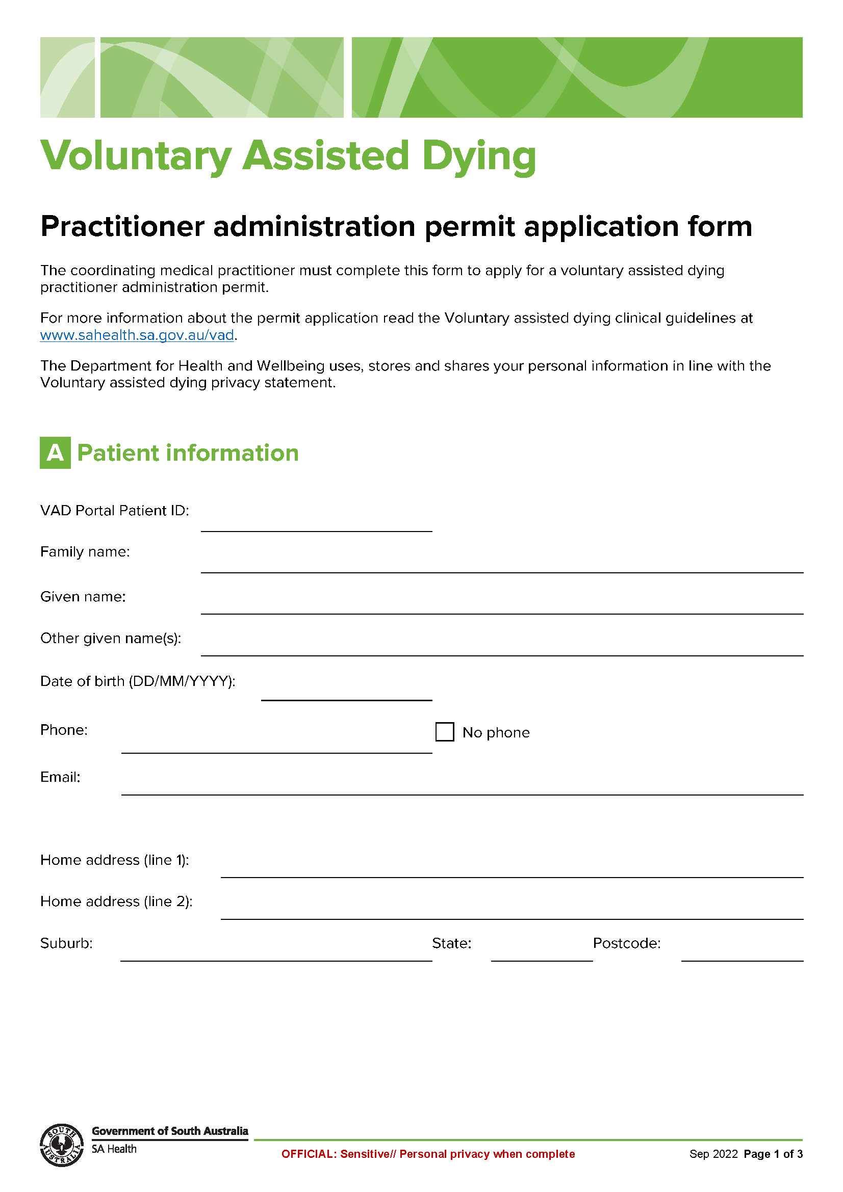
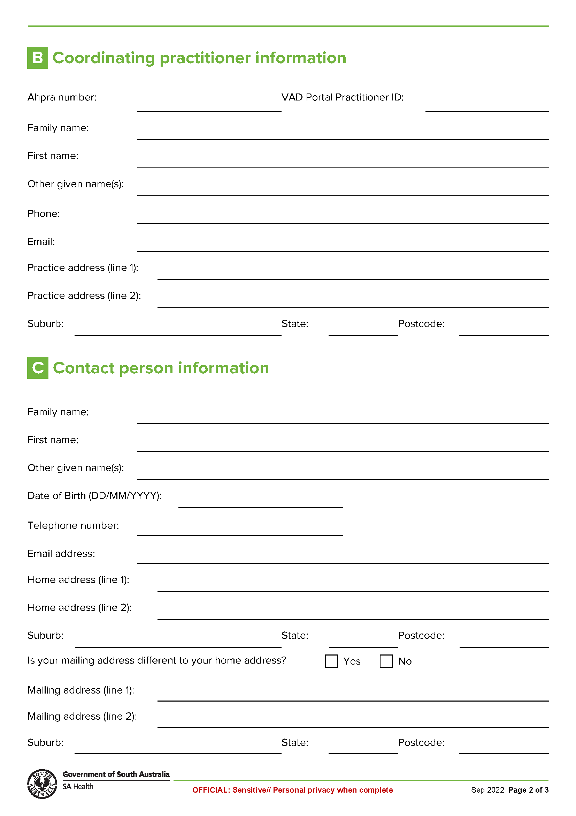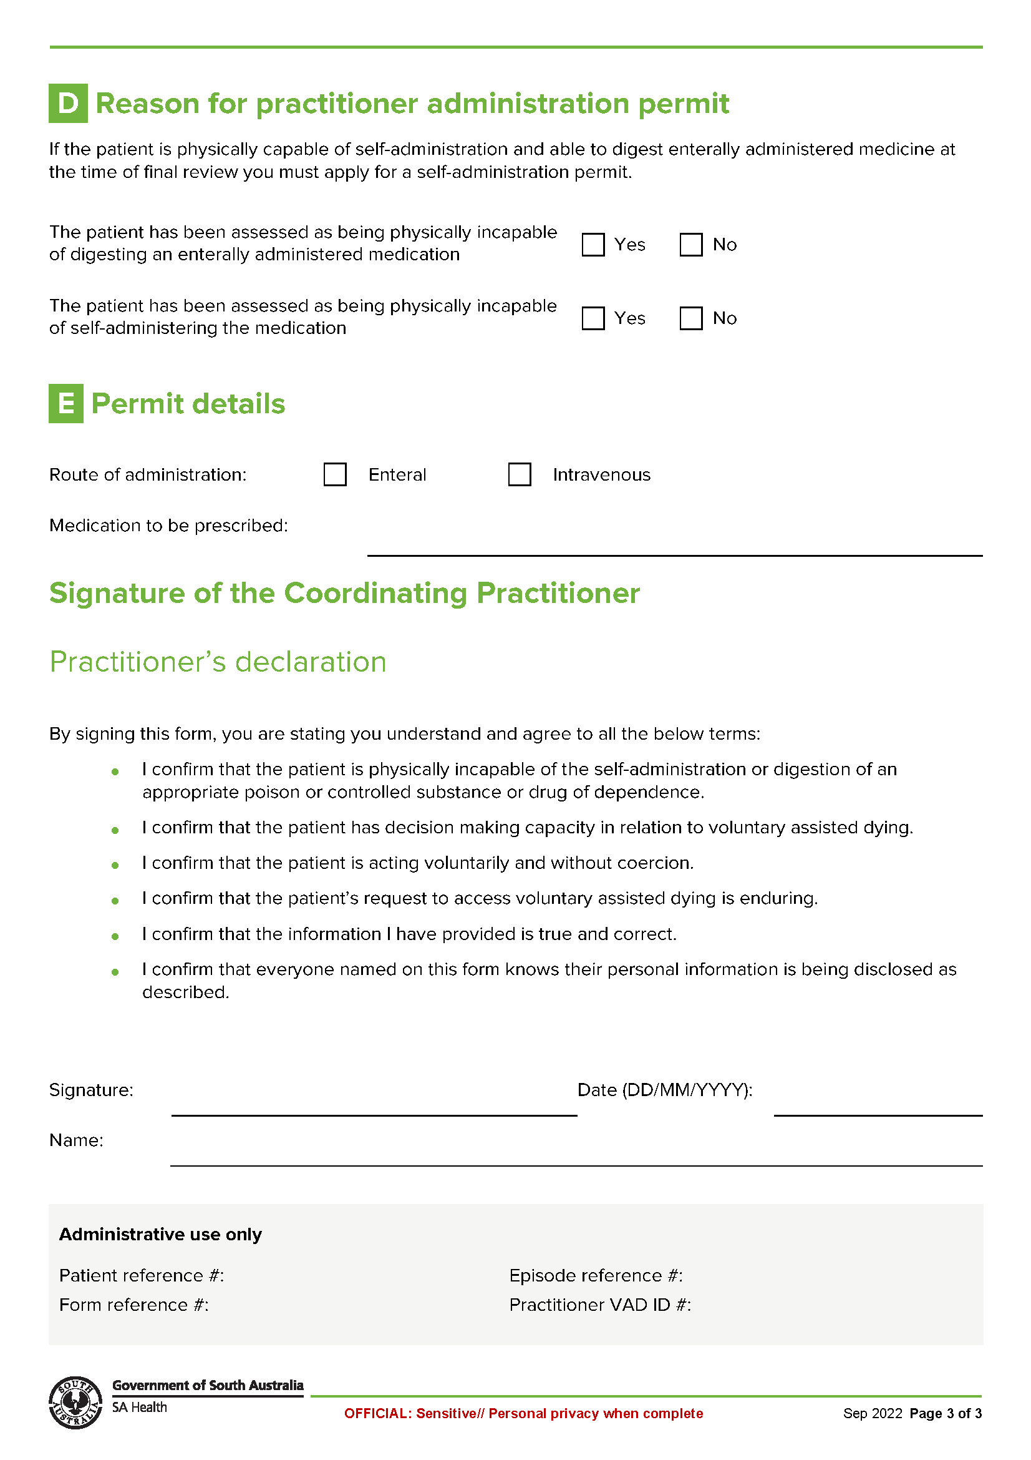

Schedule 7
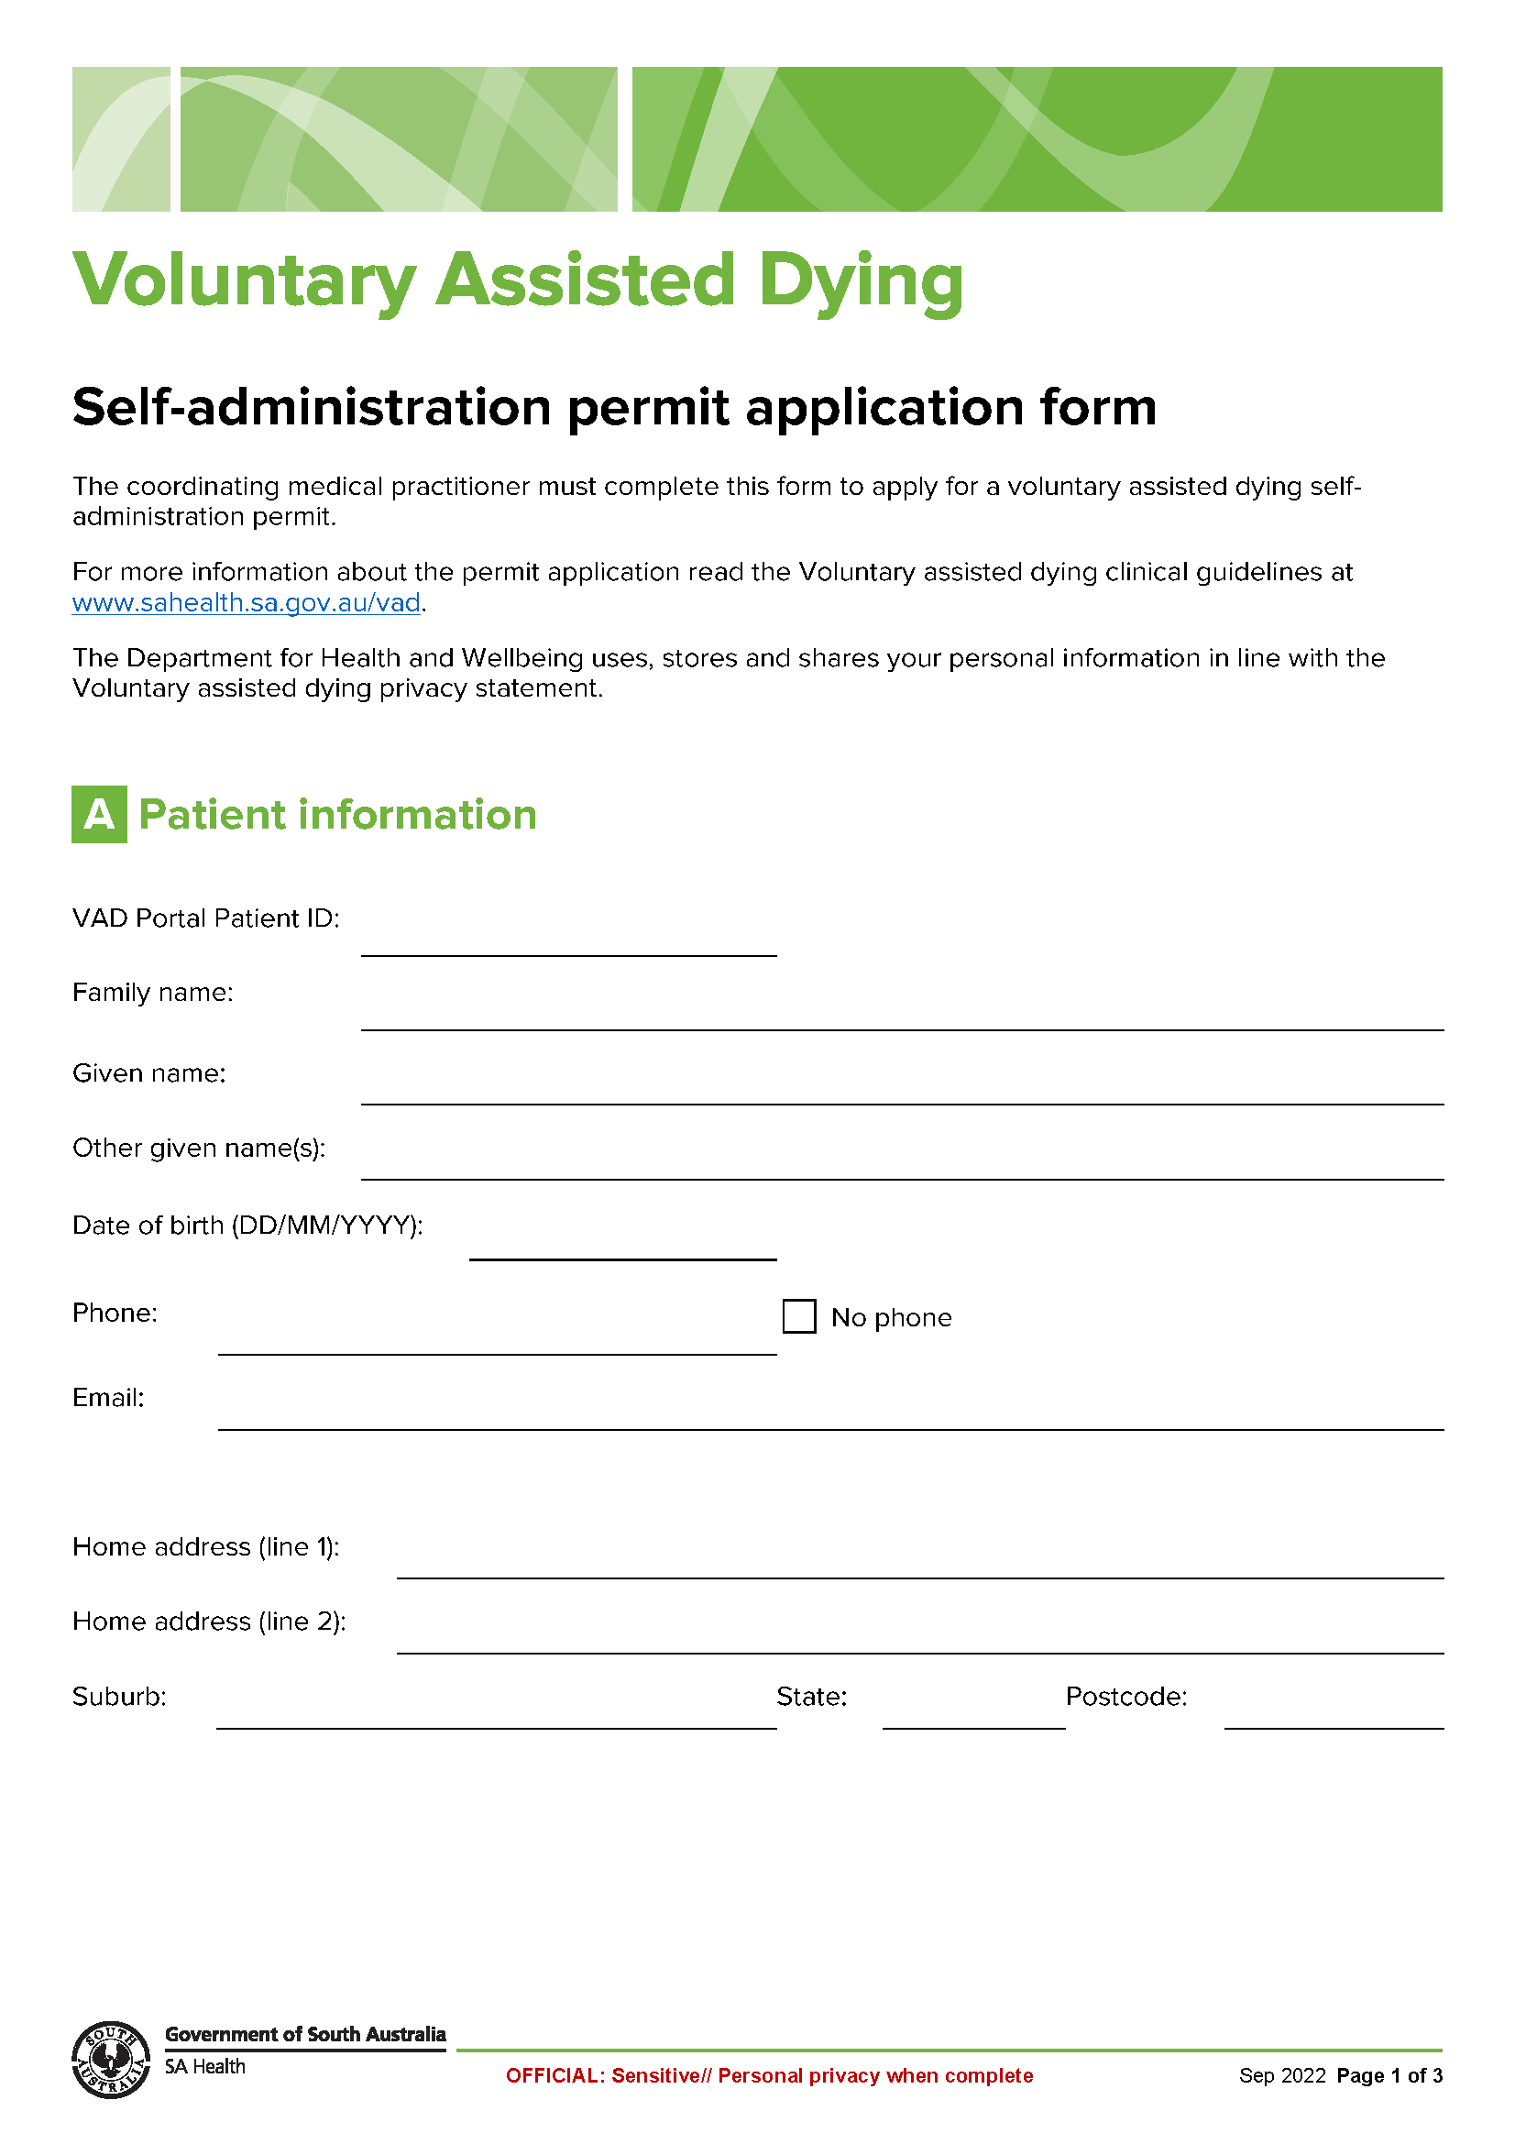
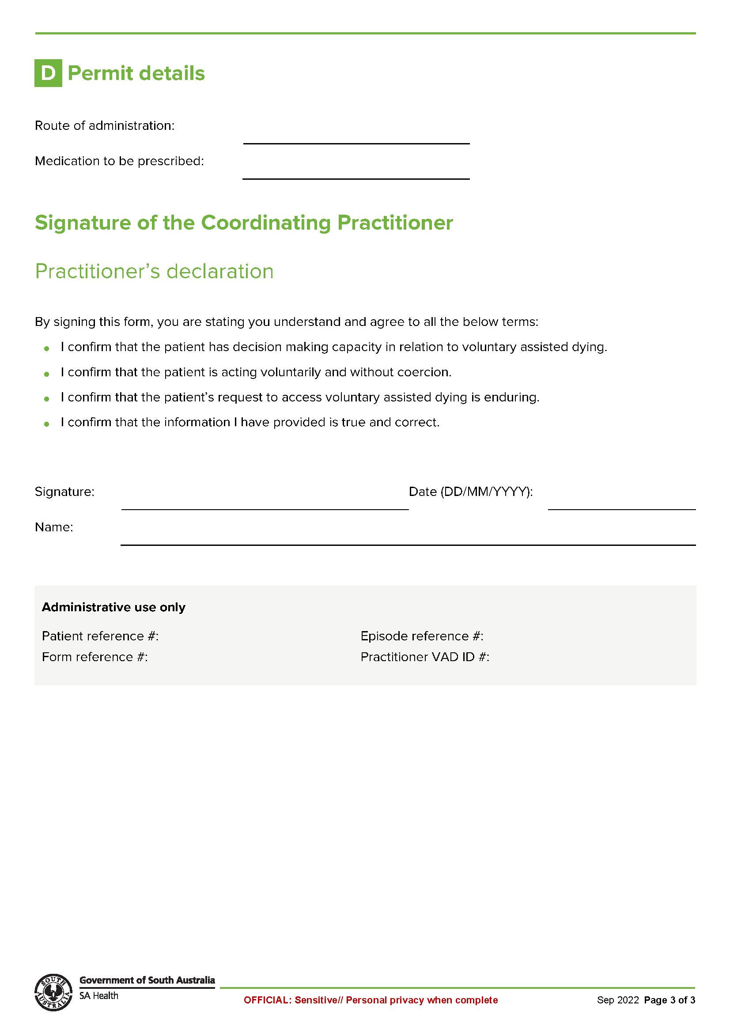

Schedule 8
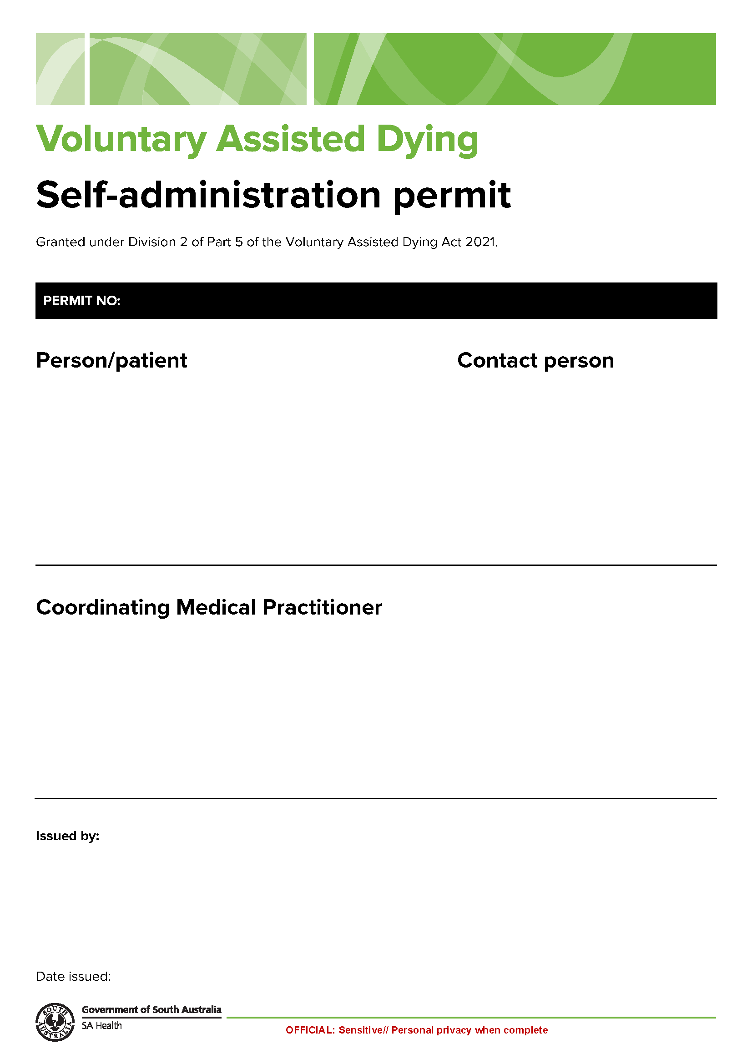
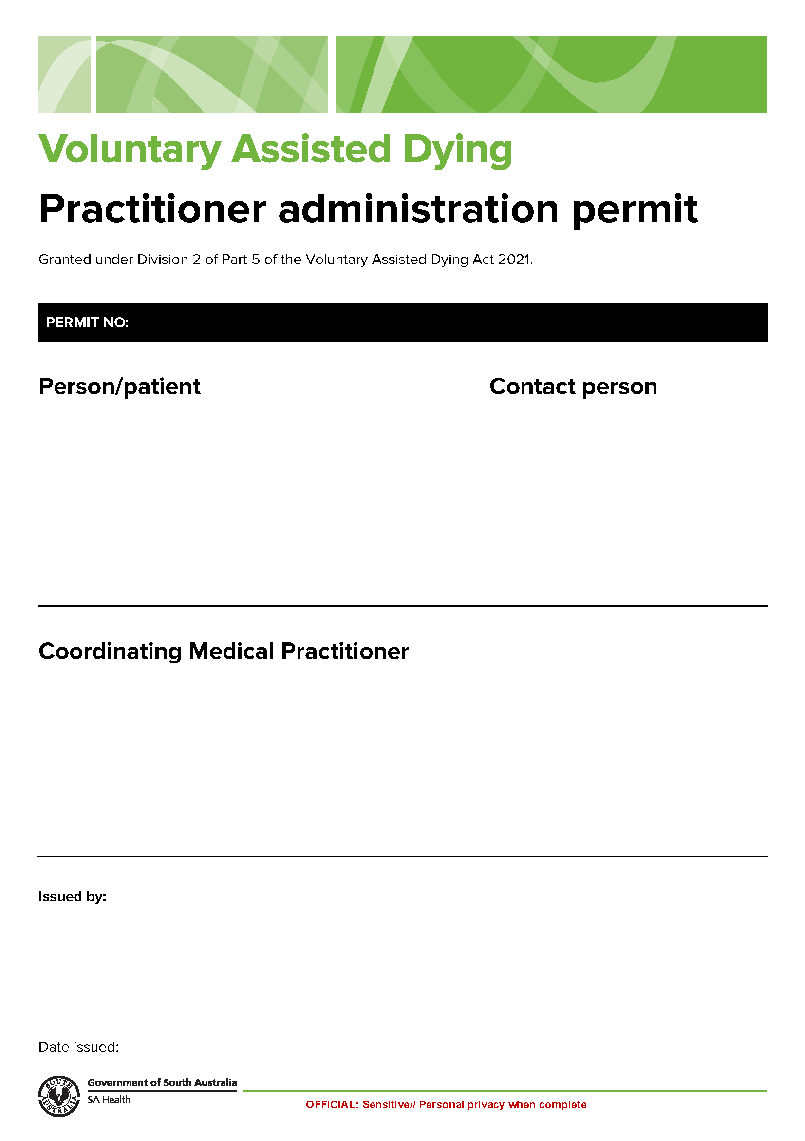

Schedule 9

Schedule 10
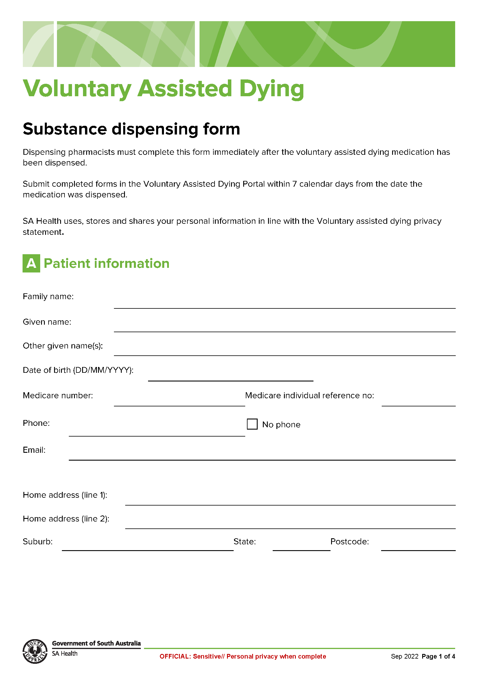
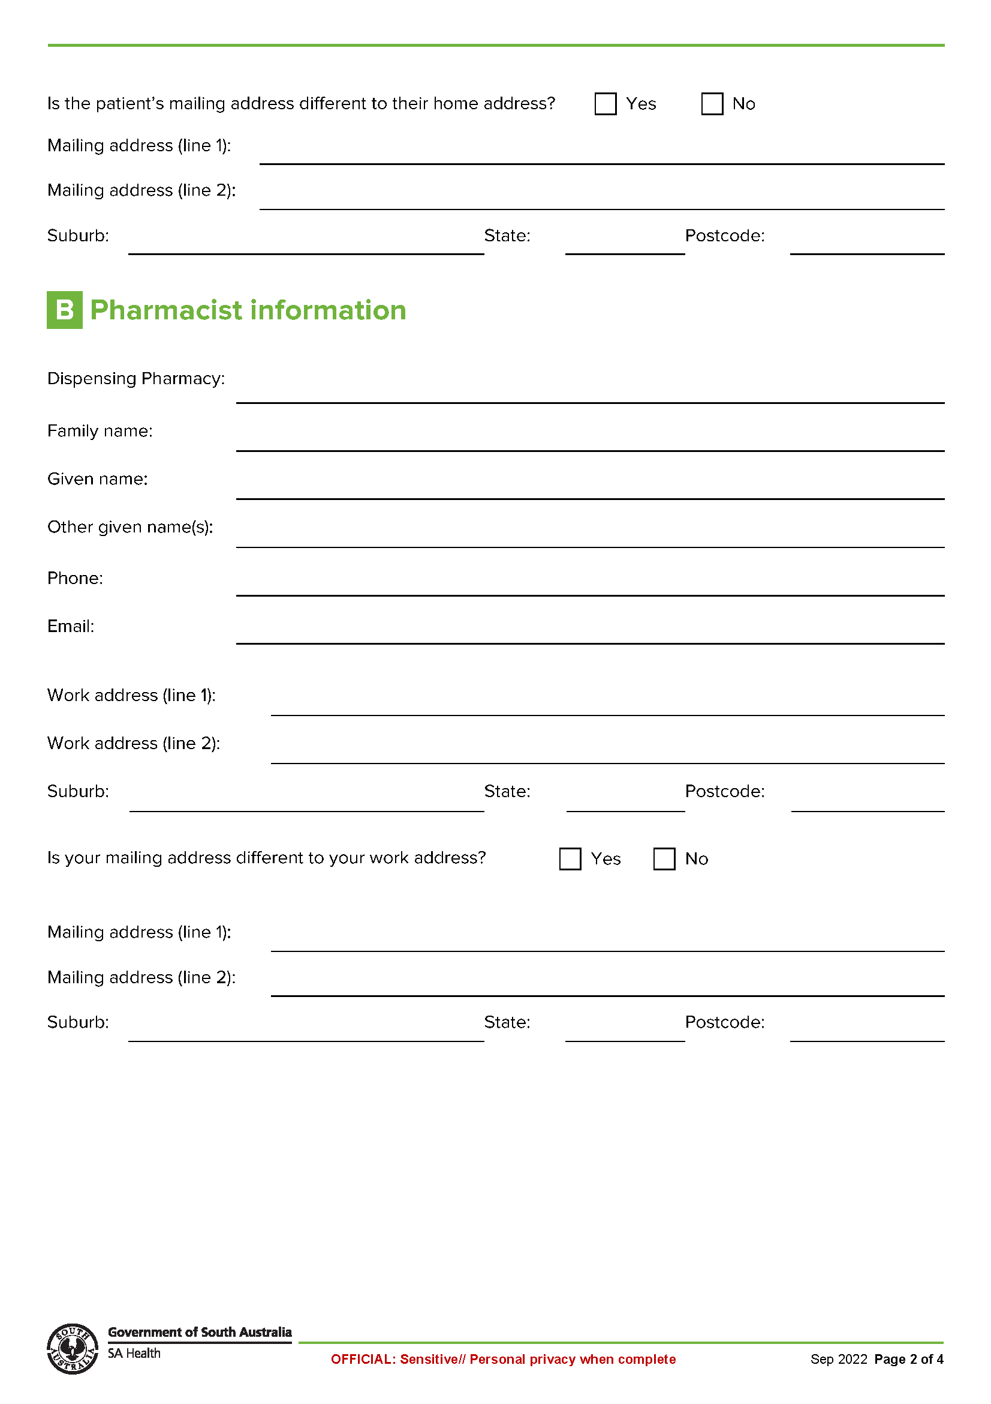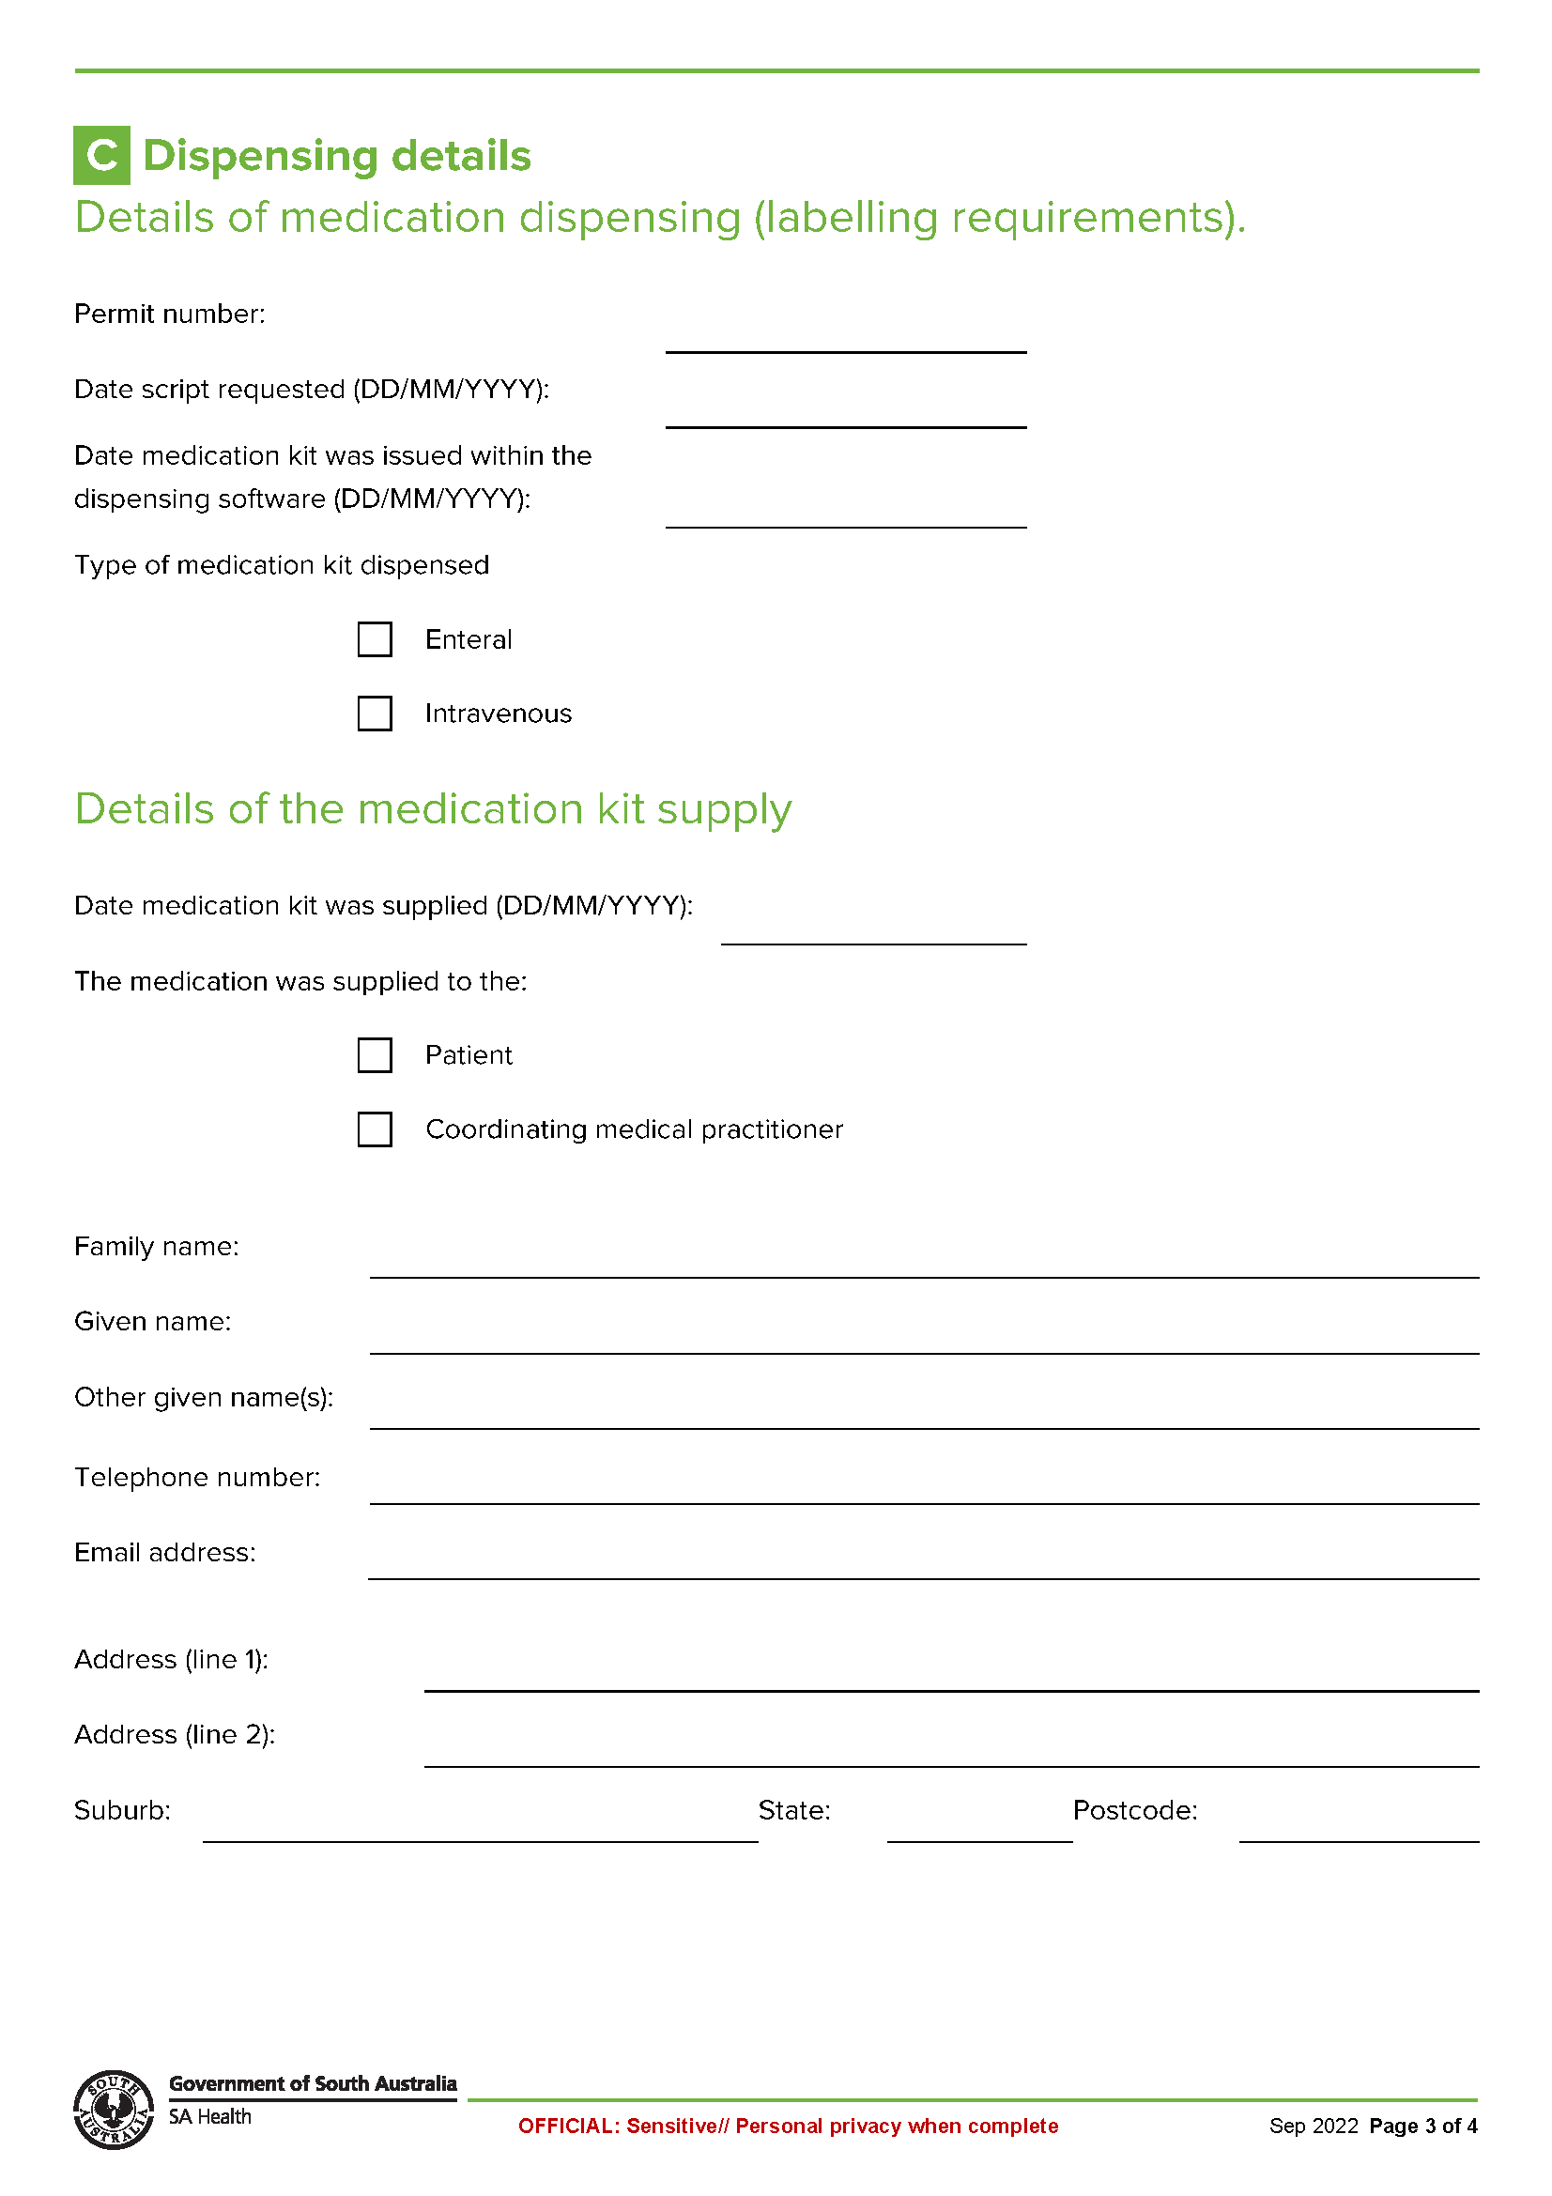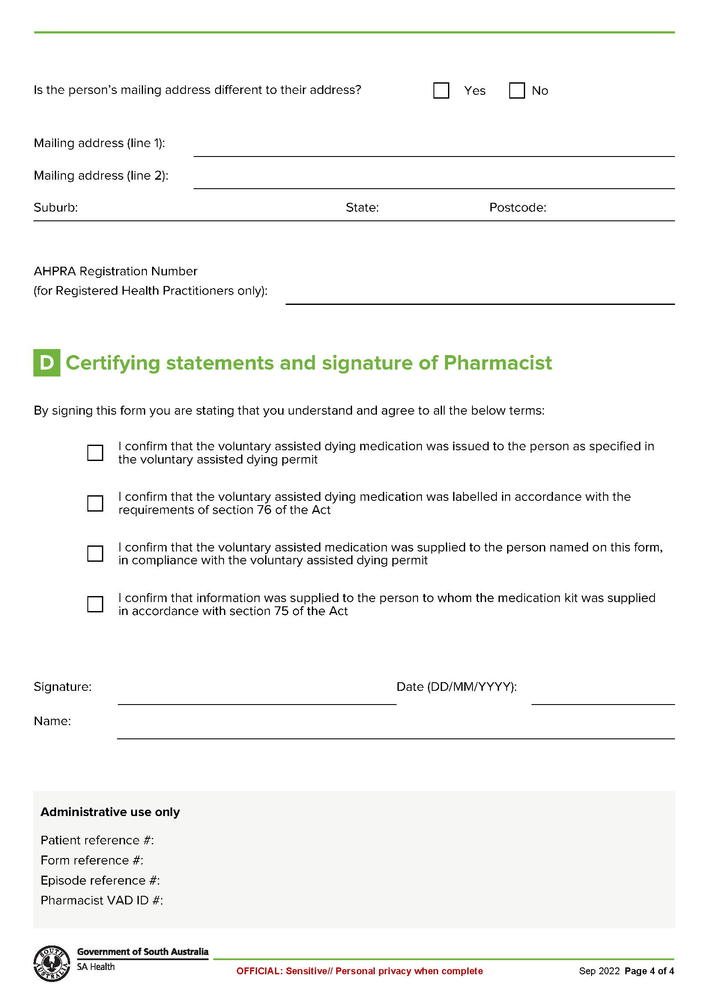

Schedule 11
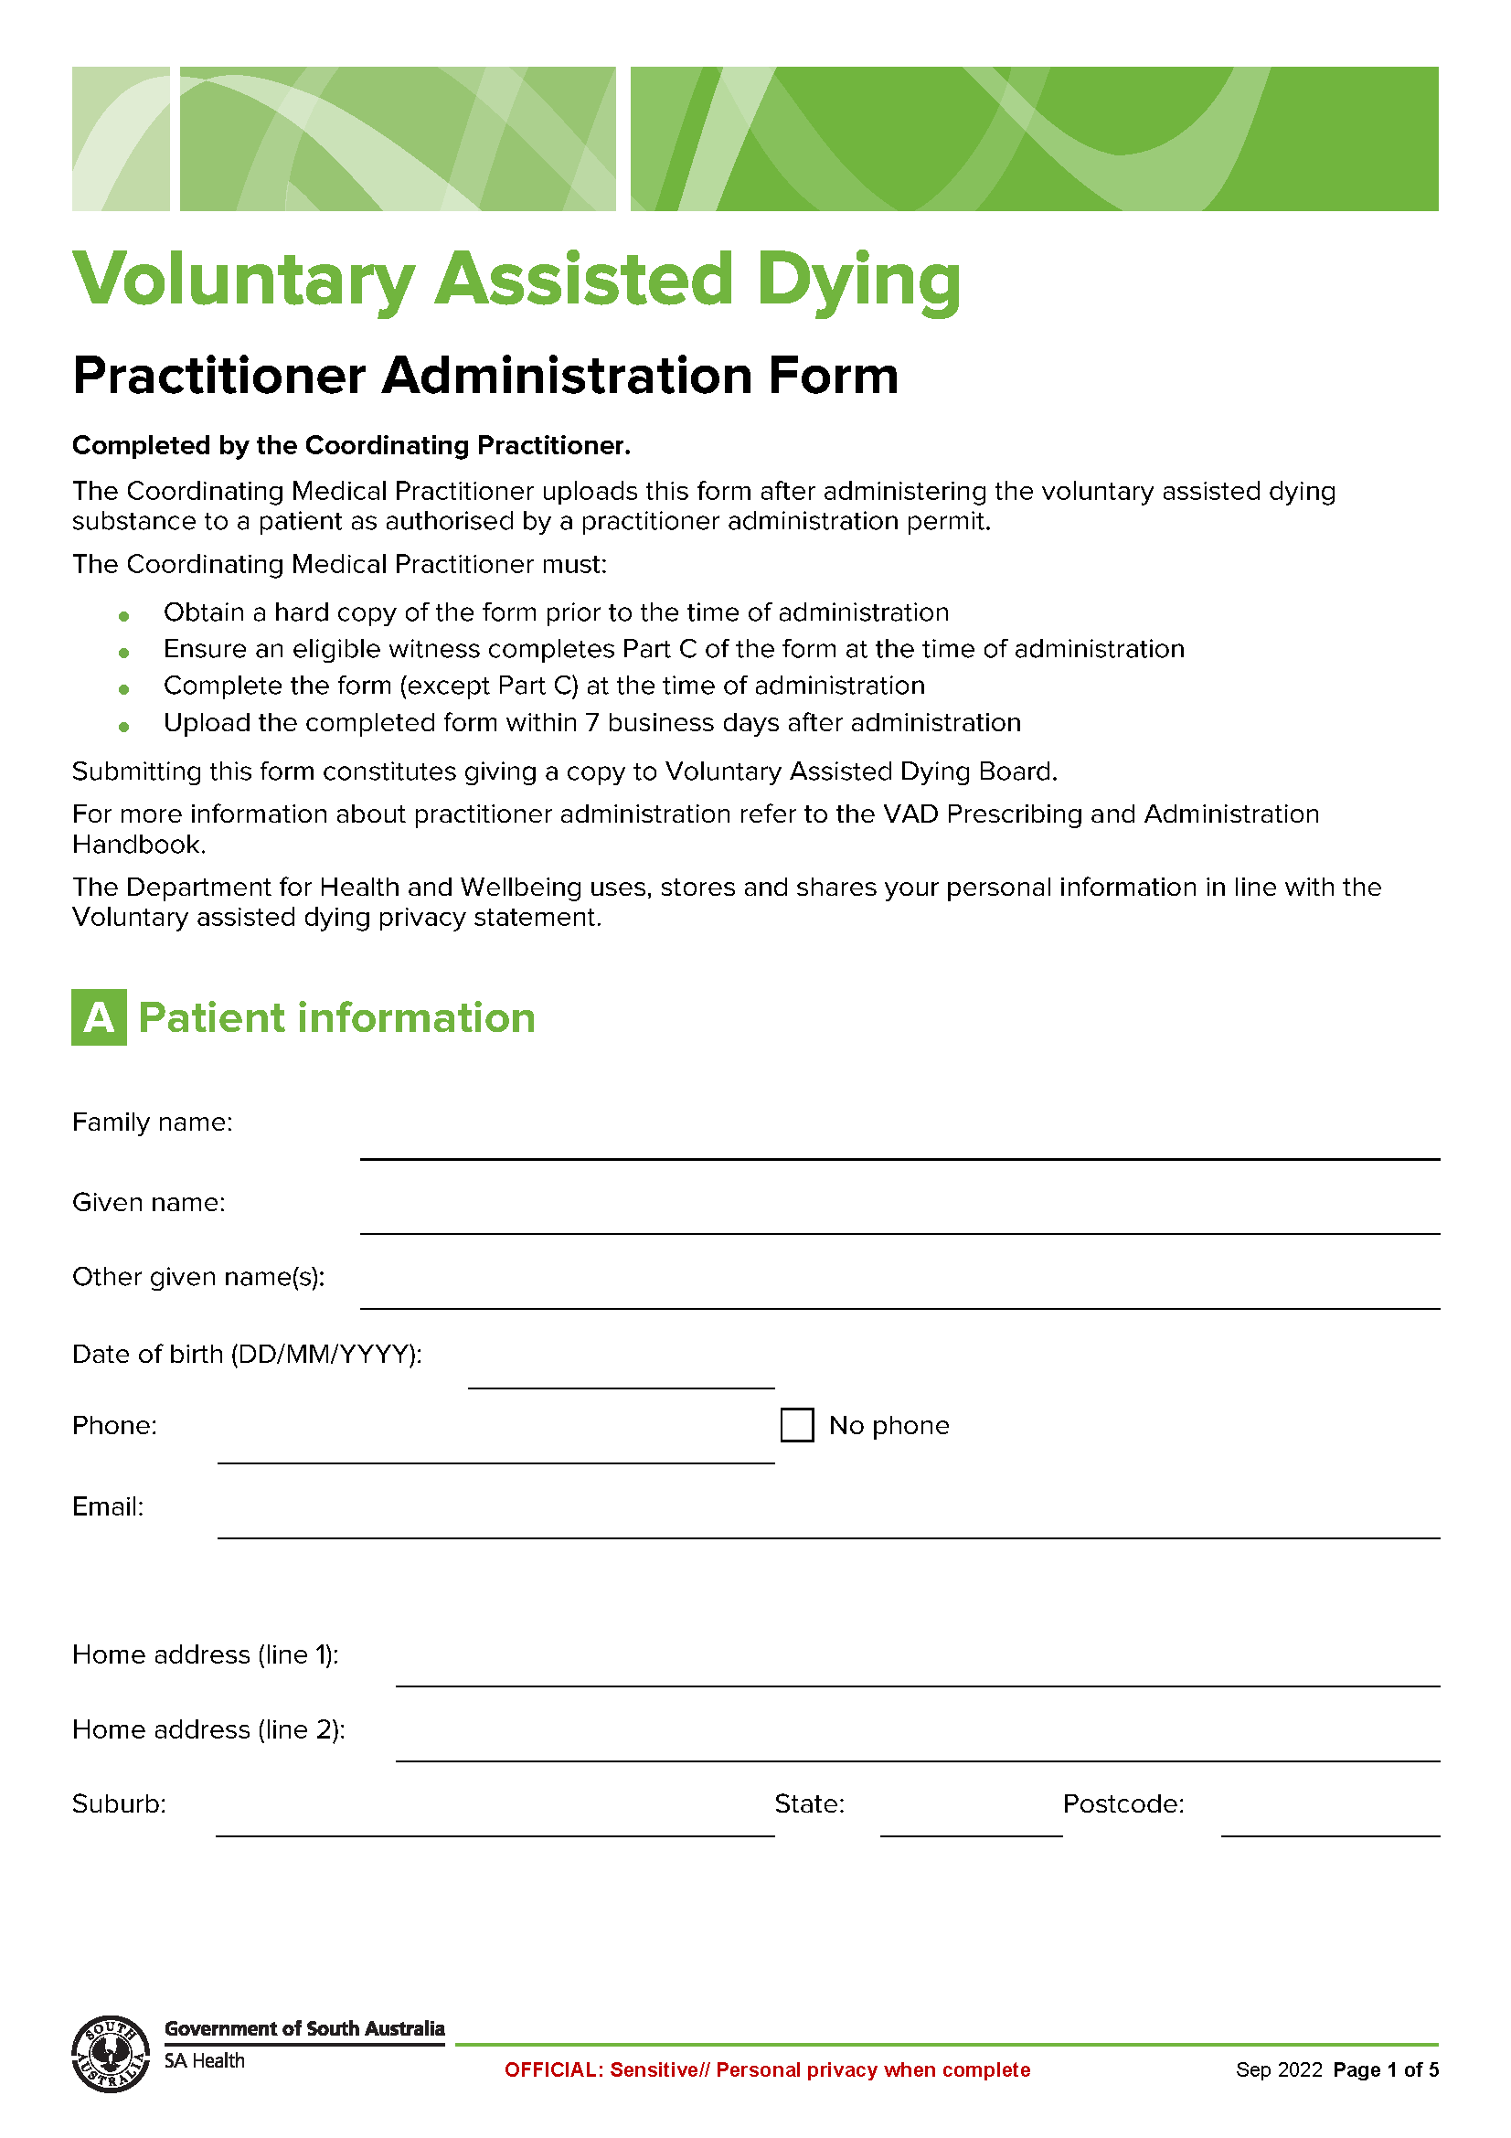

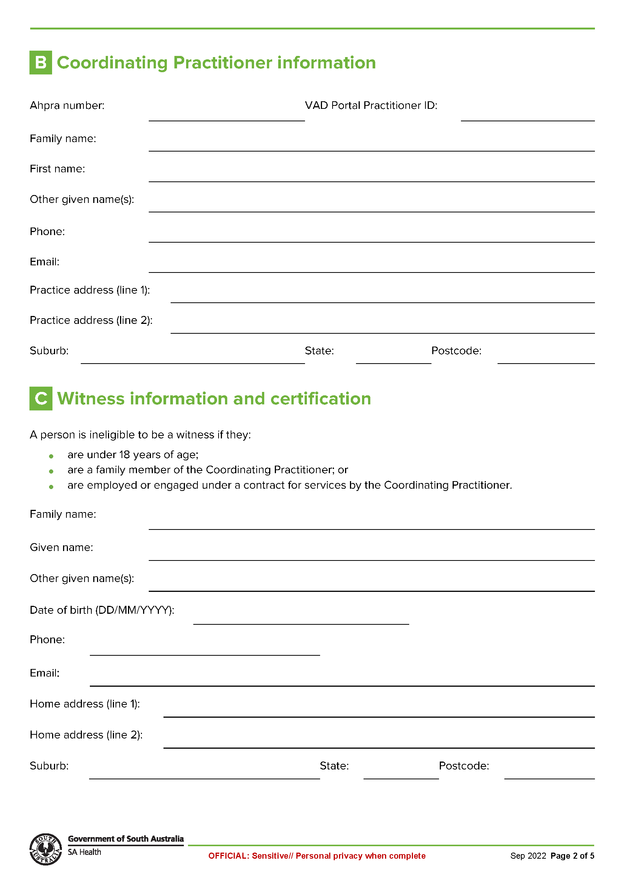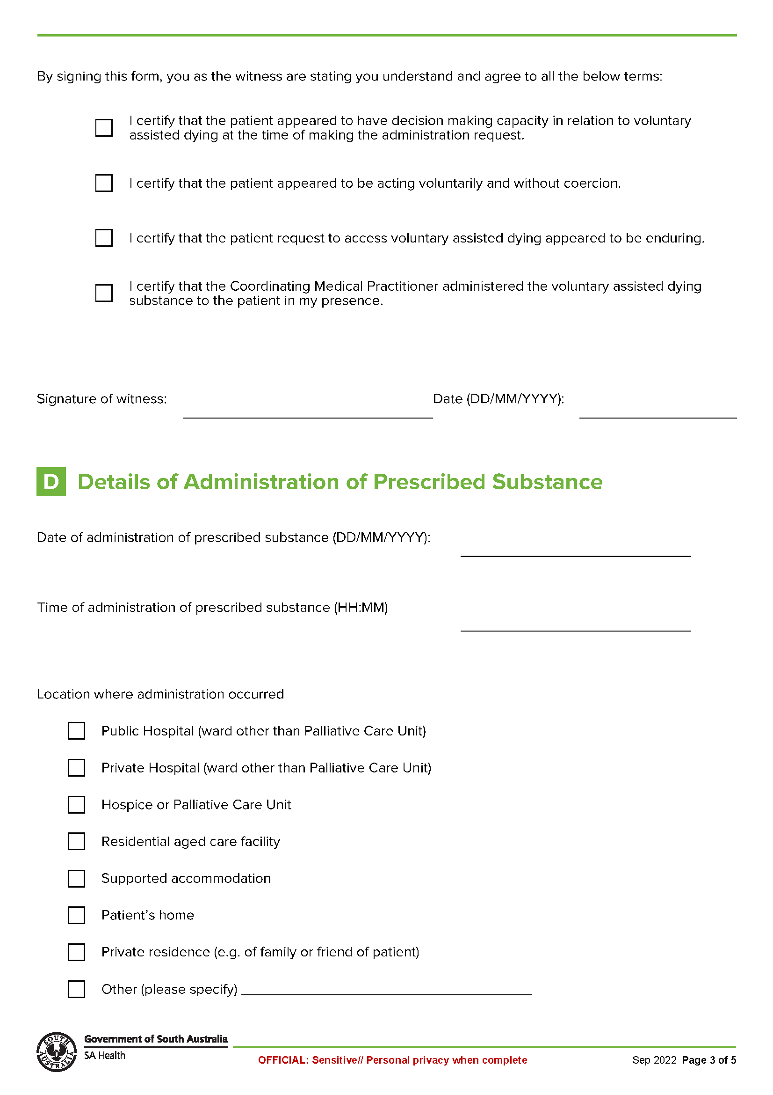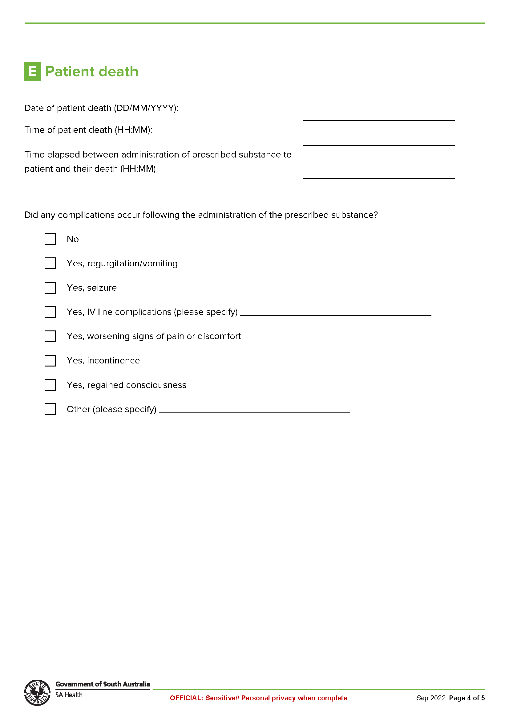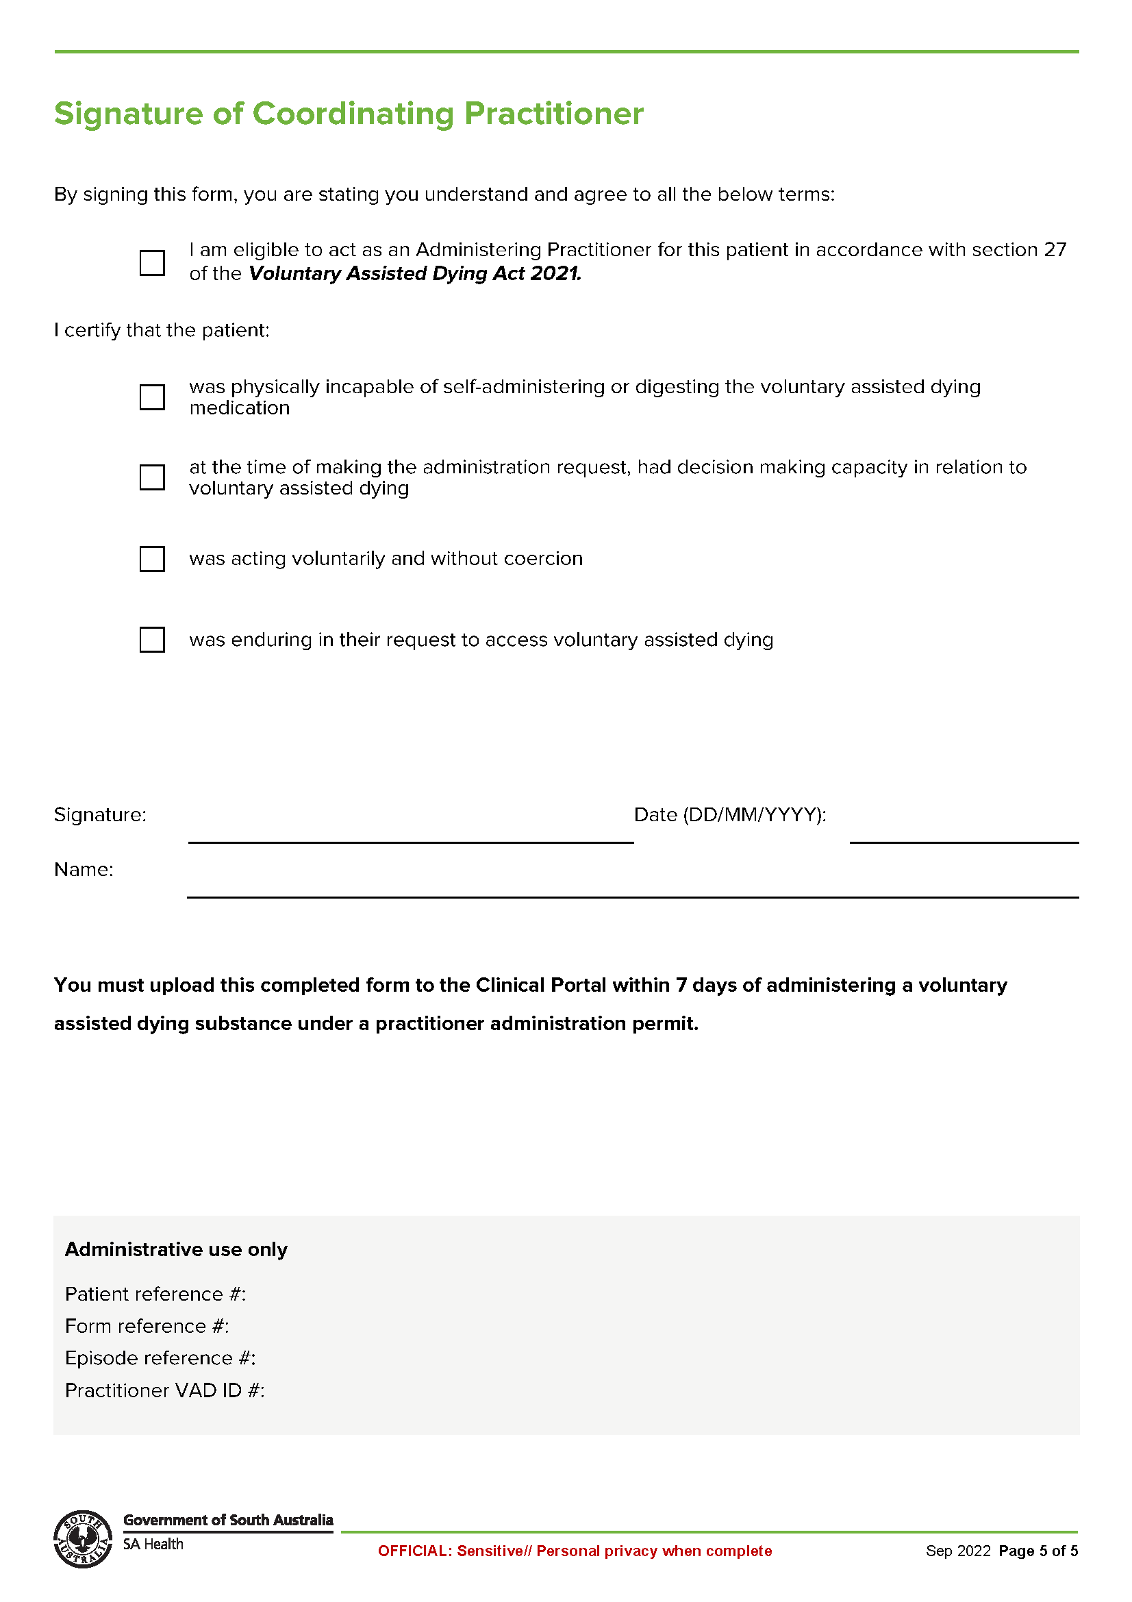
Schedule 12
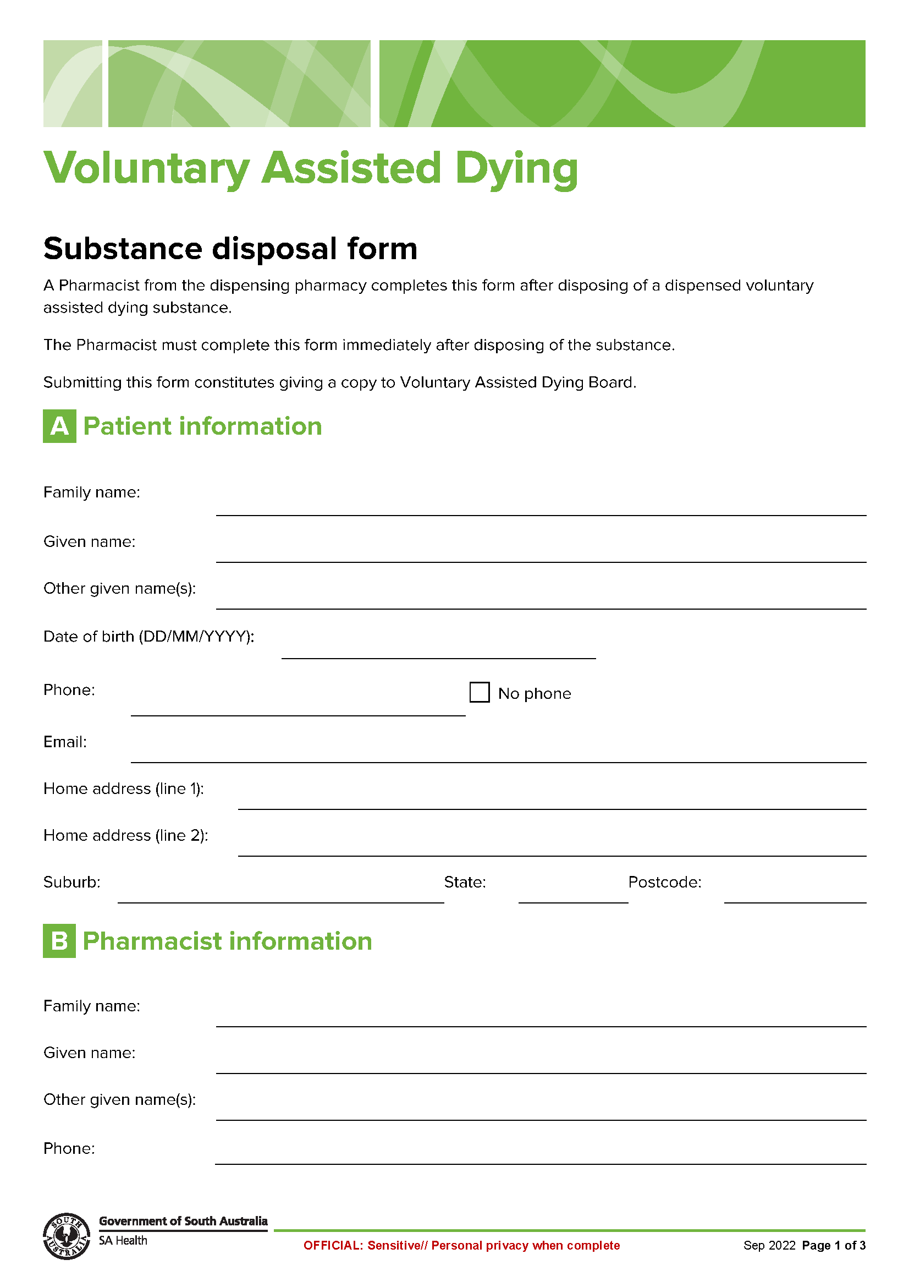
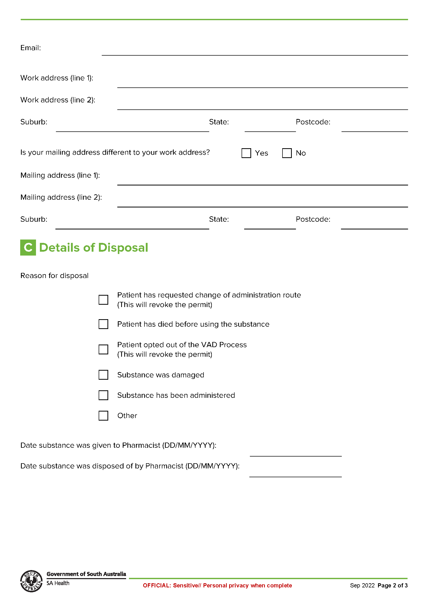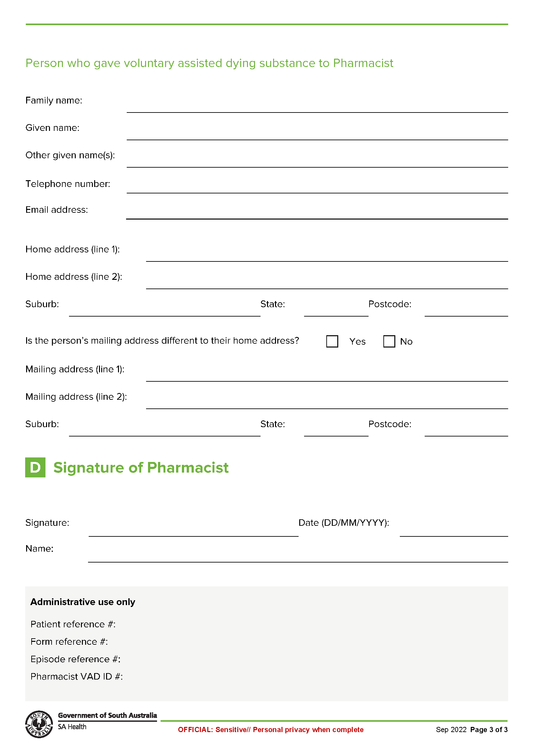

All instruments appearing in this gazette are to be considered official, and obeyed as such

Printed and published weekly by authority of M. Dowling, Government Printer, South Australia
$8.15 per issue (plus postage), $411.00 per annual subscription—GST inclusive
Online publications: www.governmentgazette.sa.gov.au

