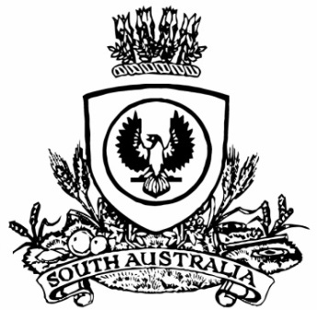
SUPPLEMENTARY GAZETTE
THE SOUTH AUSTRALIAN
GOVERNMENT GAZETTE
Published by Authority

Adelaide, Saturday, 15 July 2023

Governor’s Instrument
Letters Patent Constituting the Office of Governor
Assumption of the Administration of the State by an Administrator
TAKE NOTICE THAT, having been notified of the temporary incapacity of Her Excellency the Governor, I have requested that the Lieutenant-Governor, Dr James Muecke AM, assume the administration of the State as Administrator from 10.31am on Sunday, 16 July 2023, pursuant to the Letters Patent Constituting the Office of Governor made on 14 February 1986, as amended by the Governor of the State of South Australia by Order in Council on 25 October 2001 and 29 June 2023.
Dated: 15 July 2023
Susan Close, MP
Acting Premier

