No. 58 p. 2373
THE SOUTH AUSTRALIAN
GOVERNMENT GAZETTE
Published by Authority

Adelaide, Thursday, 27 July 2023

Contents

Governor’s Instruments
Appointments 2374
Regulations—
Marine Parks Regulations 2023—No. 69 of 2023 2376
Fisheries Management (Prawn Fisheries) (Prescribed
Period) Amendment Regulations 2023—
No. 70 of 2023 2381
Fisheries Management (Rock Lobster Fisheries)
(Miscellaneous) (No 2) Amendment
Regulations 2023—No. 71 of 2023 2383
Fisheries Management (Demerit Points) (Rock Lobster Fisheries) Amendment Regulations 2023—
No. 72 of 2023 2385
Independent Commission Against Corruption
(National Anti-Corruption Commission)
Amendment Regulations 2023—No. 73 of 2023 2386
State Government Instruments
Disability Inclusion Act 2018 2388
Fisheries Management (General) Regulations 2017 2388
Fisheries Management Act 2007 2388
Housing Improvement Act 2016 2389
Justices of the Peace Act 2005 2389
Land Acquisition Act 1969 2390
Local Government (Elections) Act 1999 2392
Mental Health Act 2009 2392
Mining Act 1971 2392
Petroleum and Geothermal Energy Act 2000 2393
Planning, Development and Infrastructure Act 2016 2393
Police Act 1998 2394
Real Property Act 1886 2395
Retail and Commercial Leases Act 1995 2395
Road Traffic Act 1961 2395
The District Court of South Australia—
Port Augusta Circuit Court 2397
Unregulated Fees and Charges 2398
Local Government Instruments
City of Onkaparinga 2400
The Barossa Council 2412
District Council of Cleve 2414
District Council of Coober Pedy 2414
Mid Murray Council 2415
District Council of Mount Remarkable 2416
Wattle Range Council 2417
Wudinna District Council 2418
Yorke Peninsula Council 2419
Public Notices
Trustee Act 1936 2420

Governor’s Instruments

Appointments
Department of the Premier and Cabinet
Adelaide, 27 July 2023
Her Excellency the Governor in Executive Council has been pleased to appoint the undermentioned to the South Australian Forestry Corporation Board, pursuant to the provisions of the South Australian Forestry Corporation Act 2000:
Director: from 1 October 2023 until 30 September 2025
June Ruby Roache
Chair: from 1 October 2023 until 30 September 2025
June Ruby Roache
Director: from 4 August 2023 until 30 September 2024
Grant Anthony Pelton
By command,
Stephen Campbell Mullighan, MP
For Premier
MPIRD F2023.000174

Department of the Premier and Cabinet
Adelaide, 27 July 2023
Her Excellency the Governor in Executive Council has been pleased to appoint the undermentioned to the Urban Renewal Authority Board of Management, pursuant to the provisions of the Urban Renewal Act 1995:
Member: from 31 July 2023 until 30 July 2026
Kimberley Willits
Bronwyn Kaye Gallacher
By command,
Stephen Campbell Mullighan, MP
For Premier
23MUDCS01916

Department of the Premier and Cabinet
Adelaide, 27 July 2023
Her Excellency the Governor in Executive Council has been pleased to appoint the undermentioned to the Adelaide Cemeteries Authority Board, pursuant to the provisions of the Adelaide Cemeteries Authority Act 2001:
Director: from 2 August 2023 until 1 August 2025
Tristan Ashley Just
Luisa Greco
Chair: from 2 August 2023 until 1 August 2025
Tristan Ashley Just
By command,
Stephen Campbell Mullighan, MP
For Premier
23MPCS01857

Department of the Premier and Cabinet
Adelaide, 27 July 2023
Her Excellency the Governor in Executive Council has been pleased to appoint the undermentioned to the South Australian Superannuation Board, pursuant to the provisions of the Superannuation Act 1988:
Member: from 27 July 2023 until 1 December 2025
June Ruby Roache
Presiding Member: from 27 July 2023 until 1 December 2025
June Ruby Roache
By command,
Stephen Campbell Mullighan, MP
For Premier
T&F23/056CS

Department of the Premier and Cabinet
Adelaide, 27 July 2023
Her Excellency the Governor in Executive Council has been pleased to appoint the undermentioned to the Board of the Southern Select Super Corporation, pursuant to the provisions of the Public Corporations (Southern Select Super Corporation) Regulations 2012 under the Public Corporations Act 1993:
Member: from 27 July 2023 until 1 December 2025
June Ruby Roache
Presiding Member: from 27 July 2023 until 1 December 2025
June Ruby Roache
By command,
Stephen Campbell Mullighan, MP
For Premier
T&F23/58CS

Department of the Premier and Cabinet
Adelaide, 27 July 2023
Her Excellency the Governor in Executive Council has been pleased to appoint the Honourable Anastasios Koutsantonis, MP as Acting Minister for Local Government, Acting Minister for Regional Roads and Acting Minister for Veterans Affairs, from 29 July 2023 until 20 August 2023 inclusive, during the absence of the Honourable Geoffrey Graeme Brock, MP.
By command,
Stephen Campbell Mullighan, MP
For Premier
23MINCAB/0010

Department of the Premier and Cabinet
Adelaide, 27 July 2023
Her Excellency the Governor in Executive Council has been pleased to appoint the Honourable Zoe Lee Bettison, MP as Acting Minister for Primary Industries and Regional Development and Acting Minister for Forest Industries from 29 July 2023 until 9 August 2023 inclusive, during the absence of the Honourable Clare Michele Scriven, MLC.
By command,
Stephen Campbell Mullighan, MP
For Premier
MPIRD F2023/000070CS

Department of the Premier and Cabinet
Adelaide, 27 July 2023
Her Excellency the Governor in Executive Council has been pleased to appoint Claire Anne Ryan and Damian James Dawson a full-time Commissioners of the Environment, Resources and Development Court of South Australia, from 28 August 2023 and 4 September 2023 respectively - pursuant to the Environment, Resources and Development Court Act 1993.
By command,
Stephen Campbell Mullighan, MP
For Premier
AGO0125-23CS

Department of the Premier and Cabinet
Adelaide, 27 July 2023
Her Excellency the Governor in Executive Council has been pleased to appoint Jane Elizabeth Abbey, being Senior Counsel in the State of South Australia appointed by the Chief Justice of the Supreme Court of South Australia on 8 September 2022, as His Majesty's Counsel in the State of South Australia, without loss or gain of precedence granted previously upon her appointment as Senior Counsel - pursuant to section 92 of the Legal Practitioners Act 1981.
By command,
Stephen Campbell Mullighan, MP
For Premier
AGO0126-23CS

Regulations
South Australia

Marine Parks Regulations 2023
under the Marine Parks Act 2007

Contents
Part 1—Preliminary
1 Short title
2 Commencement
3 Interpretation
Part 2—General provisions supporting Act
4 Notice of establishment of marine park (section 10(7))
5 Applications for warrants (section 34(6))
6 General duty of care—prescribed circumstances (section 37(3))
7 Action on non-compliance with order etc—prescribed rate of interest (sections 39, 41 and 42)
Part 3—Permits
8 Variation of conditions of permit
9 Transfer of permit
10 Minister may require further information
11 Defects in applications
12 Waiver or refund of permit fees
13 Issue of duplicate permit
14 Expiation of offence
Schedule 1—Repeal and transitional provisions
Part 1—Repeal of Marine Parks Regulations 2008
1 Repeal of regulations
Part 2—Transitional provisions
2 Transitional provisions

Part 1—Preliminary
1—Short title
These regulations may be cited as the Marine Parks Regulations 2023.
2—Commencement
These regulations come into operation on the day on which they are made.
3—Interpretation
In these regulations—
Act means the Marine Parks Act 2007;
fee notice has the same meaning as in the Legislation (Fees) Act 2019.
Part 2—General provisions supporting Act
4—Notice of establishment of marine park (section 10(7))
For the purposes of section 10(7) of the Act, the Minister must give notice of the making of a proclamation to establish a marine park by notice in the Gazette, in a newspaper circulating generally within the State and on a website determined by the Minister.
5—Applications for warrants (section 34(6))
(1) The grounds of an application for a warrant under section 34 of the Act made personally must be verified by affidavit.
(2) If an application for a warrant is made by telephone—
(a) the applicant must inform the magistrate of the applicant's name and identify the position that the applicant holds for the purposes of the Act, and the magistrate, on receiving that information, is entitled to assume, without further inquiry, that the applicant holds that position; and
(b) the applicant must inform the magistrate of the purpose for which the warrant is required and the grounds on which it is sought; and
(c) if it appears to the magistrate from the information given by the applicant that there are proper grounds to issue a warrant, the magistrate must inform the applicant of the facts that justify, in the magistrate's opinion, the issue of the warrant, and must not proceed to issue the warrant unless the applicant undertakes to make an affidavit verifying those facts; and
(d) if the applicant gives such an undertaking, the magistrate may then make out and sign a warrant, noting on the warrant the facts that justify, in the magistrate's opinion, the issue of the warrant; and
(e) the warrant is taken to have been issued, and comes into force, when signed by the magistrate; and
(f) the magistrate must inform the applicant of the terms of the warrant; and
(g) the applicant must, as soon as practicable after the issue of the warrant, forward to the magistrate an affidavit verifying the facts referred to in paragraph (c).
6—General duty of care—prescribed circumstances (section 37(3))
For the purposes of section 37(3) of the Act, any circumstance involving the exercise of a statutory power by a public authority in an emergency situation is prescribed.
7—Action on non-compliance with order etc—prescribed rate of interest (sections 39, 41 and 42)
(1) For the purposes of sections 39(5)(a), 41(5)(a) and 42(8)(a) of the Act, the prescribed rate of interest per annum on an unpaid amount will be the prime bank rate for any financial year for which the amount remains unpaid.
(2) In this regulation—
prime bank rate for a particular financial year means the corporate loan reference rate applied by the Commonwealth Bank of Australia for corporate lending on the first trading day of the Bank in that financial year.
Part 3—Permits
8—Variation of conditions of permit
(1) For the purposes of section 19(8)(c)(ii) of the Act, the Minister may vary a condition of a permit on application made by the holder of the permit.
(2) An application under subregulation (1)—
(a) must be made to the Minister in the manner and form determined by the Minister; and
(b) must be accompanied by the fee prescribed by fee notice.
9—Transfer of permit
For the purposes of section 19(9) of the Act—
(a) a permit is for a prescribed activity if it is for an activity referred to in regulation 8(3)(g) to (k) (inclusive) of the Marine Parks (Zoning) Regulations 2012; and
(b) the prescribed conditions to be complied with in respect of the transfer of such a permit are as follows:
(i) the permit may only be transferred with the consent of the Minister;
(ii) an application for consent to transfer the permit—
(A) must be made to the Minister in the manner and form determined by the Minister; and
(B) must be accompanied by the fee prescribed by fee notice;
(iii) the proposed transferee must, in the opinion of the Minister, be a fit and proper person to hold the permit;
(iv) the transfer must not result in a change in—
(A) conditions of the permit; or
(B) the expiry date of the permit.
10—Minister may require further information
A person who makes an application for a permit, or any application under this Part, must provide the Minister with any information required by the Minister in connection with the determination of the application, verified, if the Minister so requires, by statutory declaration.
11—Defects in applications
(1) The Minister may request a person who makes an application for a permit, or any application under this Part, to remedy a defect or deficiency in an application or accompanying document or information required by or under the Act or these regulations.
(2) The Minister may, in relation to such an application, request the applicant—
(a) to pay the relevant fee prescribed in connection with the application; or
(b) to provide any outstanding information required to be provided under these regulations by the applicant.
(3) If the applicant to whom a request has been made under this regulation fails to comply with the request within 60 days or such longer period as the Minister may allow, the application lapses.
12—Waiver or refund of permit fees
The Minister may waive a fee payable in relation to an application for a permit, or any application under this Part, if satisfied that—
(a) the application is made in connection with—
(i) a statutory authorisation; or
(ii) an authorisation or matter under a law of the Commonwealth; or
(b) it is otherwise appropriate to do so in a particular case.
13—Issue of duplicate permit
The Minister may, on payment of the fee prescribed by fee notice, issue to the holder of a permit a duplicate of the permit.
14—Expiation of offence
Pursuant to section 63(2)(d) of the Act, the expiation fee fixed for an alleged offence against section 20 of the Act is $315.
Schedule 1—Repeal and transitional provisions
Part 1—Repeal of Marine Parks Regulations 2008
1—Repeal of regulations
The Marine Parks Regulations 2008 are repealed.
Part 2—Transitional provisions
2—Transitional provisions
(1) An application for the variation of a condition of a permit under regulation 10 of the repealed regulations made but not determined immediately before the commencement of this clause will be taken to be an application made under regulation 8 of these regulations.
(2) An application for consent to transfer a permit under regulation 11(b) of the repealed regulations made but not determined immediately before the commencement of this clause will be taken to be an application made under regulation 9(b) of these regulations.
(3) In this clause—
repealed regulations means the Marine Parks Regulations 2008.
Editorial note—
As required by section 10AA(2) of the Legislative Instruments Act 1978, the Minister has certified that, in the Minister's opinion, it is necessary or appropriate that these regulations come into operation as set out in these regulations.
Made by the Governor
with the advice and consent of the Executive Council
on 27 July 2023
No 69 of 2023

South Australia

Fisheries Management (Prawn Fisheries) (Prescribed Period) Amendment Regulations 2023
under the Fisheries Management Act 2007

Contents
Part 1—Preliminary
1 Short title
2 Commencement
Part 2—Amendment of Fisheries Management (Prawn Fisheries) Regulations 2017
3 Amendment of regulation 9—Individual fishing nights entitlement scheme—Gulf St. Vincent Prawn Fishery

Part 1—Preliminary
1—Short title
These regulations may be cited as the Fisheries Management (Prawn Fisheries) (Prescribed Period) Amendment Regulations 2023.
2—Commencement
These regulations come into operation on 31 July 2023.
Part 2—Amendment of Fisheries Management (Prawn Fisheries) Regulations 2017
3—Amendment of regulation 9—Individual fishing nights entitlement scheme—Gulf St. Vincent Prawn Fishery
(1) Regulation 9(1), definition of closed season—delete the definition and substitute:
closed season means the period commencing on 1 January in any year and ending on the last day of February in the same year;
(2) Regulation 9(1), definition of fishing season—delete "31 July" and substitute:
31 October
(3) Regulation 9(1), definition of prescribed period 1—delete "24 December" and substitute:
31 December
(4) Regulation 9(1), definition of prescribed period 2—delete the definition and substitute:
prescribed period 2 means—
(a) the period that commenced on 1 March 2023 and ending on 31 October 2023; or
(b) a period commencing on 1 March in any subsequent year and ending on 31 October in the same year;
Editorial note—
As required by section 10AA(2) of the Legislative Instruments Act 1978, the Minister has certified that, in the Minister's opinion, it is necessary or appropriate that these regulations come into operation as set out in these regulations.
Made by the Governor
with the advice and consent of the Executive Council
on 27 July 2023
No 70 of 2023

South Australia

Fisheries Management (Rock Lobster Fisheries) (Miscellaneous) (No 2) Amendment Regulations 2023
under the Fisheries Management Act 2007

Contents
Part 1—Preliminary
1 Short title
2 Commencement
Part 2—Amendment of Fisheries Management (Rock Lobster Fisheries) Regulations 2017
3 Amendment of regulation 12—Restrictions on fishing activities during closed season
4 Amendment of regulation 15—Individual rock lobster catch quota system—Northern Zone
5 Amendment of regulation 16—Individual rock lobster catch quota system—Southern Zone

Part 1—Preliminary
1—Short title
These regulations may be cited as the Fisheries Management (Rock Lobster Fisheries) (Miscellaneous) (No 2) Amendment Regulations 2023.
2—Commencement
(1) Subject to subregulation (2), these regulations come into operation on 31 August 2023.
(2) Regulations 3 and 4 come into operation on 1 November 2023.
Part 2—Amendment of Fisheries Management (Rock Lobster Fisheries) Regulations 2017
3—Amendment of regulation 12—Restrictions on fishing activities during closed season
(1) Regulation 12(1) and (2)—delete subregulations (1) and (2)
(2) Regulation 12(5), definition of closed season, (a)—delete paragraph (a)
4—Amendment of regulation 15—Individual rock lobster catch quota system—Northern Zone
Regulation 15(1), definition of quota period—delete the definition and substitute:
quota period—a quota period for the fishery means—
(a) the period commencing on 1 November 2023 and ending on 31 August 2024; or
(b) the period of 12 months commencing on 1 September 2024 or on 1 September in any subsequent year;
5—Amendment of regulation 16—Individual rock lobster catch quota system—Southern Zone
Regulation 16(1), definition of quota period, (d) and (e)—delete paragraphs (d) and (e) and substitute:
(d) the period that commenced on 1 September 2022 and ends on 31 August 2023; or
(e) the period of 12 months commencing on 1 September 2023 or on 1 September in any subsequent year;
Editorial note—
As required by section 10AA(2) of the Legislative Instruments Act 1978, the Minister has certified that, in the Minister's opinion, it is necessary or appropriate that these regulations come into operation as set out in these regulations.
Made by the Governor
with the advice and consent of the Executive Council
on 27 July 2023
No 71 of 2023

South Australia

Fisheries Management (Demerit Points) (Rock Lobster Fisheries) Amendment Regulations 2023
under the Fisheries Management Act 2007

Contents
Part 1—Preliminary
1 Short title
2 Commencement
Part 2—Amendment of Fisheries Management (Demerit Points) Regulations 2017
3 Amendment of Schedule 1—Demerit point offences and demerit points

Part 1—Preliminary
1—Short title
These regulations may be cited as the Fisheries Management (Demerit Points) (Rock Lobster Fisheries) Amendment Regulations 2023.
2—Commencement
These regulations come into operation on 1 November 2023.
Part 2—Amendment of Fisheries Management (Demerit Points) Regulations 2017
3—Amendment of Schedule 1—Demerit point offences and demerit points
Schedule 1, clause 17, table, entries relating to regulation 12(1) and (2) of the Fisheries Management (Rock Lobster Fisheries) Regulations 2017—delete the entries
Editorial note—
As required by section 10AA(2) of the Legislative Instruments Act 1978, the Minister has certified that, in the Minister's opinion, it is necessary or appropriate that these regulations come into operation as set out in these regulations.
Made by the Governor
with the advice and consent of the Executive Council
on 27 July 2023
No 72 of 2023

South Australia

Independent Commission Against Corruption (National Anti-Corruption Commission) Amendment Regulations 2023
under the Independent Commission Against Corruption Act 2012

Contents
Part 1—Preliminary
1 Short title
2 Commencement
Part 2—Amendment of Independent Commission Against Corruption Regulations 2013
3 Substitution of regulation 3A
3A Declared law enforcement agency

Part 1—Preliminary
1—Short title
These regulations may be cited as the Independent Commission Against Corruption (National Anti-Corruption Commission) Amendment Regulations 2023.
2—Commencement
These regulations come into operation on the day on which they are made.
Part 2—Amendment of Independent Commission Against Corruption Regulations 2013
3—Substitution of regulation 3A
Regulation 3A—delete the regulation and substitute:
3A—Declared law enforcement agency
In accordance with paragraph (m) of the definition of law enforcement agency in section 4(1) of the Act, each of the following is declared to be a law enforcement agency:
(a) the Australian Competition and Consumer Commission established by section 6A of the Competition and Consumer Act 2010 of the Commonwealth;
(b) the National Anti-Corruption Commission established by section 20 of the National Anti-Corruption Commission Act 2022 of the Commonwealth.
Editorial note—
As required by section 10AA(2) of the Legislative Instruments Act 1978, the Minister has certified that, in the Minister's opinion, it is necessary or appropriate that these regulations come into operation as set out in these regulations.
Made by the Governor
with the advice and consent of the Executive Council
on 27 July 2023
No 73 of 2023

State Government Instruments

Disability Inclusion Act 2018
Authorised Program Officer
I, Trinh Mai, Senior Authorising Officer, hereby revoke authorisation for the following person to be an Authorised Program Officer with respect to BET Group Global for the purposes of the Disability Inclusion Act 2018 in accordance with Section 23L(4) of that Act:
• Ivan Taban
Dated: 19 July 2023
Trinh Mai
Senior Authorising Officer
Department of Human Services

Fisheries Management (General) Regulations 2017
Regulation 23B
Catch and Release Activities for Murray Cod in Certain Waters
Revocation
The Determination made for the purposes of regulation 23B dated 16 February 2022 and published in the Government Gazette dated 17 February 2022 being the third notice on page 524 relating to catch and release activities for Murray Cod in Certain Waters is revoked as of the date of gazettal of this notice.
Determination
Catch and Release Activities for Murray Cod in Certain Waters
I Professor Gavin Begg, Delegate of the Minister for Primary Industries and Regional Development, make the following determination for the purpose of regulation 23B of the Fisheries Management (General) Regulations 2017, regarding the taking of Murray Cod in certain waters commencing on the date of gazettal of this notice until otherwise varied or revoked:
1. During the period 1 January and 31 July in any calendar year within the waters of the River Murray proper and Lakes Albert and Alexandrina (excluding the waters of the Coorong) a person may catch and release Murray Cod (Maccullochella peelii) but only so far as no part of the Murray Cod (Maccullochella peelii) is removed from the water other than for the purposes of removing a fishing hook where:
- The gills or fins of the fish are not handled at any stage;
- The weight of the fish is at all times supported; and
- The fish is released immediately after removal of a fishing hook.
Dated: 3 June 2023
Professor Gavin Begg
Executive Director, Fisheries and Aquaculture
As delegate of the Minister for Primary Industries and Regional Development

Fisheries Management Act 2007
Section 115
Exemption Number: ME9903269
Take notice that pursuant to Section 115 of the Fisheries Management Act 2007, the Executive Director, National Parks and Wildlife Service and the Director, Regional Operations, of the Department for Environment and Water (DEW) (the ‘exemption holders’) and their nominated agents are exempt from Sections 71 and 70 of the Fisheries Management Act 2007, and Regulation 5 including Clauses 4, 39(a), 40 and 41 of Schedule 6 and Schedule 7 of the Fisheries Management (General) Regulations 2017 but only insofar as the exemption holders are permitted to use a fish net as described in Schedule 1 in State waters to undertake the marine mammal or turtle rescue and intervention activities subject to the conditions set out in Schedule 2 from 20 July 2023 until 19 July 2024, unless varied or revoked earlier.
Schedule 1
The use of:
• a fish net with dimensions not greater than 150 metres by 3 metres by an unlicensed person; or
• a fish net that is otherwise lawful if used by the holder (or registered master) of a commercial fishing licence that is endorsed with a haul net and is also authorised;
to capture marine mammals and turtles as may be required from time to time as part of the due administration of the National Parks and Wildlife Act 1972 consistent with DEW’s Marine Mammal Intervention Policy (Ref: DEWNR 97/14/0023) or consistent with other DEW animal welfare standards and guidelines.
Schedule 2
1. The exemption holders will be deemed responsible for the conduct of all persons conducting the exempted activities under this notice. Any person conducting activities under this exemption must be provided with a copy of this notice, which they must have signed as an indication that they have read and understand the conditions under it.
2. The exemption holders or their nominated agents must take all reasonable steps to minimise the extent of injury, damage, or harm to all captured aquatic animals when undertaking the activity.
3. The nominated agents of the exemption holders are:
• Wardens appointed under the National Parks and Wildlife Act 1972;
• A licence holder or a registered master of a Marine Scalefish Fishery licence endorsed with a haul net who is authorised to capture aquatic animals under the National Parks and Wildlife Act 1972; or
• Persons who are registered volunteers of DEW.
4. Nominated agents of the exemption holders that are not Wardens appointed under the National Parks and Wildlife Act 1972, must be under the direct supervision of a Warden appointed under the National Parks and Wildlife Act 1972 who is working pursuant to a permit issued for the purpose of administration of that Act.
5. Before undertaking the exempted activity pursuant to this notice, an exemption holder or their nominated agent must contact the Department of Primary Industries and Regions (PIRSA) Fishwatch on 1800 065 522 and answer a series of questions about the exempted activity. The exemption holder or their nominated agent will need to have a copy of the exemption at the time of making the call and be able to provide information about the area and time of the exempted activity, the vehicles and/or boats involved and other related questions.
6. While engaging in the exempted activity, the exemption holders or their nominated agents must be in possession of a copy of this notice. Such notice must be produced to a Fisheries Officer if requested.
7. Except where specifically exempted by this notice, the exemption holders or their nominated agents must not contravene or fail to comply with the Fisheries Management Act 2007 or any regulations made under that Act, and pursuant to Section 23 of the River Murray Act 2003, the permit holder must take all reasonable measures to prevent or minimise any harm to the River Murray.
This notice does not purport to override the provisions or operation of any other Act including but not limited to the Adelaide Dolphin Sanctuary Act 2005, the Marine Parks Act 2007, or the River Murray Act 2003.
Dated: 20 July 2023
Professor Gavin Begg
Executive Director
Fisheries and Aquaculture
Delegate of the Minister for Primary Industries and Regional Development

Housing Improvement Act 2016
Rent Control
The Minister for Human Services Delegate in the exercise of the powers conferred by the Housing Improvement Act 2016, does hereby fix the maximum rental per week which shall be payable subject to Section 55 of the Residential Tenancies Act 1995, in respect of each house described in the following table. The amount shown in the said table shall come into force on the date of this publication in the Gazette.
Address of Premises | Allotment Section | Certificate of Title Volume/Folio | Maximum Rental per week payable
140 Swanport Village Road, Swanport SA 5253 | Allotment 7 Deposited Plan 26467 Hundred of Mobilong | CT 5376/817 | $0.00
Dated: 27 July 2023
Craig Thompson
Housing Regulator and Registrar
Housing Safety Authority, SAHA
Delegate of Minister for Human Services

Housing Improvement Act 2016
Rent Control Revocations
Whereas the Minister for Human Services Delegate is satisfied that each of the houses described hereunder has ceased to be unsafe or unsuitable for human habitation for the purposes of the Housing Improvement Act 2016, notice is hereby given that, in exercise of the powers conferred by the said Act, the Minister for Human Services Delegate does hereby revoke the said Rent Control in respect of each property.
Address of Premises | Allotment Section | Certificate of Title Volume/Folio
14 Barossa Valley Way, Lyndoch SA 5351 | Allotment 99 Deposited Plan 49651 Hundred of Barossa | CT6144/17
Dated: 27 July 2023
Craig Thompson
Housing Regulator and Registrar
Housing Safety Authority, SAHA
Delegate of Minister for Human Services

Justices of the Peace Act 2005
Section 4
Notice of Appointment of Justices of the Peace for South Australia
by the Commissioner for Consumer Affairs
I, Fraser Stroud, Commissioner for Consumer Affairs, delegate of the Attorney-General, pursuant to Section 4 of the Justices of the Peace Act 2005, do hereby appoint the people listed as Justices of the Peace for South Australia as set out below.
For a period of ten years for a term commencing on 1 August 2023 and expiring on 31 July 2033:
Fiona Louise WOOLFITT
Andrew Edwin WILSON
Joanne WALKLEY
Paul Polihronis TSIMOPOULOS
David Allan SWAIN
Tarik SKAKA
Rocco SCHIRRIPA
Kym Althorp SANDERCOCK
Craig Charles NIHILL
Ian Alick NEIGHBOUR
Beverly Kay MICKEL
Dean Lloyd MARSH
Jennifer Anne MACKAY
Heather Julia KEEP
Darryl Francis JONES
Arthur Boucaut JONES
Karen Marie GROGAN
Timothy John GRIEGER
Trevor Kingsley GOWLING
Darryl Wayne FREER
Suzanne DALLA SANTA
Phillip Andrew COLE
Francis Gerard COGHLAN
Robin Stanier BOURNE
Douglas Ian BALNAVES
Jennifer Cindy AMOR
Sheralie Bettene ALEKNA
Dated: 25 July 2023
Dini Soulio
Commissioner for Consumer Affairs
Delegate of the Attorney-General

Land Acquisition Act 1969
Section 16
Form 5—Notice of Acquisition
1. Notice of acquisition
The Commissioner of Highways (the Authority), of 83 Pirie Street, Adelaide SA 5000, acquires the following interests in the following land:
Comprising an unencumbered estate in fee simple in that piece of land being the whole of Allotment 201 in Deposited Plan 34545 comprised in Certificate of Title Volume 5107 Folio 560.
This notice is given under section 16 of the Land Acquisition Act 1969.
2. Compensation
A person who has or had an interest consisting of native title or an alienable interest in the land that is divested or diminished by the acquisition or the enjoyment of which is adversely affected by the acquisition who does not receive an offer of compensation from the Authority may apply to the Authority for compensation.
2A. Payment of professional costs relating to acquisition (section 26B)
If you are the owner in fee simple of the land to which this notice relates, you may be entitled to a payment of up to $10 000 from the Authority for use towards the payment of professional costs in relation to the acquisition of the land.
Professional costs include legal costs, valuation costs and any other costs prescribed by the Land Acquisition Regulations 2019.
3. Inquiries
Inquiries should be directed to: Petrula Pettas
GPO Box 1533
Adelaide SA 5001
Telephone: (08) 7133 2457
Dated: 25 July 2023
The Common Seal of the COMMISSIONER OF HIGHWAYS was hereto affixed by authority of the Commissioner in the presence of:
Rocco Caruso
Manager, Property Acquisition (Authorised Officer)
Department for Infrastructure and Transport
DIT 2022/02737/01

Land Acquisition Act 1969
Section 16
Form 5—Notice of Acquisition
1. Notice of acquisition
The Commissioner of Highways (the Authority), of 83 Pirie Street, Adelaide SA 5000, acquires the following interests in the following land:
First: Comprising an unencumbered estate in fee simple in that piece of land being the whole of Allotment 9 in Deposited Plan 29290 comprised in Certificate of Title Volume 5226 Folio 128.
Secondly: Comprising an unencumbered estate in fee simple in that piece of land being the whole of Allotment 96 in Filed Plan 19717 comprised in Certificate of Title Volume 5232 Folio 937.
This notice is given under section 16 of the Land Acquisition Act 1969.
2. Compensation
A person who has or had an interest consisting of native title or an alienable interest in the land that is divested or diminished by the acquisition or the enjoyment of which is adversely affected by the acquisition who does not receive an offer of compensation from the Authority may apply to the Authority for compensation.
2A. Payment of professional costs relating to acquisition (section 26B)
If you are the owner in fee simple of the land to which this notice relates, you may be entitled to a payment of up to $10 000 from the Authority for use towards the payment of professional costs in relation to the acquisition of the land.
Professional costs include legal costs, valuation costs and any other costs prescribed by the Land Acquisition Regulations 2019.
3. Inquiries
Inquiries should be directed to: Petrula Pettas
GPO Box 1533
Adelaide SA 5001
Telephone: (08) 7133 2457
Dated: 25 July 2023
The Common Seal of the COMMISSIONER OF HIGHWAYS was hereto affixed by authority of the Commissioner in the presence of:
Rocco Caruso
Manager, Property Acquisition (Authorised Officer)
Department for Infrastructure and Transport
DIT 2022/02919/01

Land Acquisition Act 1969
Section 16
Form 5—Notice of Acquisition
1. Notice of acquisition
The Commissioner of Highways (the Authority), of 83 Pirie Street, Adelaide SA 5000, acquires the following interests in the following land:
Comprising an unencumbered estate in fee simple in that piece of land being the whole of Unit 6 in Strata Plan 3965 comprised in Certificate of Title Volume 5045 Folio 925.
This notice is given under section 16 of the Land Acquisition Act 1969.
2. Compensation
A person who has or had an interest consisting of native title or an alienable interest in the land that is divested or diminished by the acquisition or the enjoyment of which is adversely affected by the acquisition who does not receive an offer of compensation from the Authority may apply to the Authority for compensation.
2A. Payment of professional costs relating to acquisition (section 26B)
If you are the owner in fee simple of the land to which this notice relates, you may be entitled to a payment of up to $10 000 from the Authority for use towards the payment of professional costs in relation to the acquisition of the land.
Professional costs include legal costs, valuation costs and any other costs prescribed by the Land Acquisition Regulations 2019.
3. Inquiries
Inquiries should be directed to: Petrula Pettas
GPO Box 1533
Adelaide SA 5001
Telephone: (08) 7133 2457
Dated: 25 July 2023
The Common Seal of the COMMISSIONER OF HIGHWAYS was hereto affixed by authority of the Commissioner in the presence of:
Rocco Caruso
Manager, Property Acquisition (Authorised Officer)
Department for Infrastructure and Transport
DIT 2022/02945/01

Land Acquisition Act 1969
Section 16
Form 5—Notice of Acquisition
1. Notice of acquisition
The Commissioner of Highways (the Authority), of 83 Pirie Street, Adelaide SA 5000, acquires the following interests in the following land:
Comprising an unencumbered estate in fee simple in that piece of land being the whole of Unit 2 in Strata Plan 7019 comprised in Certificate of Title Volume 5006 Folio 318.
This notice is given under section 16 of the Land Acquisition Act 1969.
2. Compensation
A person who has or had an interest consisting of native title or an alienable interest in the land that is divested or diminished by the acquisition or the enjoyment of which is adversely affected by the acquisition who does not receive an offer of compensation from the Authority may apply to the Authority for compensation.
2A. Payment of professional costs relating to acquisition (section 26B)
If you are the owner in fee simple of the land to which this notice relates, you may be entitled to a payment of up to $10 000 from the Authority for use towards the payment of professional costs in relation to the acquisition of the land.
Professional costs include legal costs, valuation costs and any other costs prescribed by the Land Acquisition Regulations 2019.
3. Inquiries
Inquiries should be directed to: Rob Gardner
GPO Box 1533
Adelaide SA 5001
Telephone: (08) 7133 2415

Dated: 26 July 2023
The Common Seal of the COMMISSIONER OF HIGHWAYS was hereto affixed by authority of the Commissioner in the presence of:
Rocco Caruso
Manager, Property Acquisition (Authorised Officer)
Department for Infrastructure and Transport
DIT 2022/10663/01

Local Government (Elections) Act 1999
Area Councillor Elected
District Council of Tumby Bay
A casual vacancy occurred in the office of area councillor in the District Council of Tumby Bay, effective Tuesday 20 June 2023. The vacancy was filled in accordance with section 6A of the Local Government (Elections) Act 1999. As multiple candidates were willing and eligible to be elected to the vacancy, a recount of the votes cast at the March 2023 Supplementary Election was conducted on Wednesday 19 July 2023. At the conclusion, Christian KOTZ was declared elected to the vacancy.
Formal Ballot Papers – 1160
New Exhaust Ballot Papers – 321
Informal Ballot Papers – 9
Quota – 420

Candidates | First Preference Votes | Elected/Excluded
KOTZ, Christian | 434 | Elected
GILES, Geoff | 405
Mick Sherry
Returning Officer

Mental Health Act 2009
Conditions placed on an Approved Treatment Centre
The Chief Psychiatrist pursuant to Section 96 of the Mental Health Act 2009 (‘the Act’), by notice in the Gazette published on 28 March 2019 varied the determination that the Royal Adelaide Hospital, Port Road, Adelaide SA 5000 is an Approved Treatment Centre by attaching the condition that the service may continue to admit voluntary mental health patients and patients subject to Inpatient Treatment Orders providing that: a risk mitigation plan approved by the Chief Psychiatrist is in place to provide for the safety of consumers, visitors and staff in the context of the inconsistent performance of the duress system.
Notice is hereby given that the Chief Psychiatrist pursuant to Section 96 of the Act, revokes the condition placed on 28 March 2019. The revocation of this condition commences on 27 July 2023, the date of publication of this notice.
The Chief Psychiatrist pursuant to Section 96 of the Act, attaches a further condition following the revocation of this previous condition: the service may continue to admit voluntary mental health patients and patients subject to Inpatient Treatment Orders providing that there is quarterly reporting of duress system performance, in a form agreed by the Chief Psychiatrist, for a period of twelve months.
Dated: 27 July 2023
Dr John Brayley
Chief Psychiatrist

Mining Act 1971
Application for a Mining Lease
Notice is hereby given in accordance with Section 56H of the Mining Act 1971, that an application for a Mining Lease over the undermentioned mineral claim has been received:
Applicant: Erimar Quarries Pty Ltd (ACN 652 403 159)
Claim Number: 4541
Location: CT 5933/630, Hartley area, approximately 16km northeast of Strathalbyn.
Area: 108.26 hectares approximately
Purpose: Extractive Minerals (Limestone and Sand)
Reference: 2021/000567
To arrange an inspection of the proposal at the Department for Energy and Mining, please call the Department on (08) 8463 3103.
An electronic copy of the proposal can be found on the Department for Energy and Mining website:
https://www.energymining.sa.gov.au/industry/minerals-and-mining/mining/community-engagement-opportunities
Written submissions in relation to this application are invited to be received at the Department for Energy and Mining, Mining Regulation, Attn: Business Support Officer, GPO Box 320, Adelaide SA 5001 or dem.miningregrehab@sa.gov.au by no later than 24 August 2023.
The delegate of the Minister for Energy and Mining is required to have regard to these submissions in determining whether to grant or refuse the application and, if granted, the terms and conditions on which it should be granted.
When you make a written submission, that submission becomes a public record. Your submission will be provided to the applicant and may be made available for public inspection.
Dated: 27 July 2023
C. Andrews
Acting Mining Registrar as delegate for the Minister for Energy and Mining
Department for Energy and Mining

Petroleum and Geothermal Energy Act 2000
Grant of Gas Storage Exploration Licence—GSEL 766
Pursuant to section 92(1) of the Petroleum and Geothermal Energy Act 2000, notice is hereby given that the undermentioned Gas Storage Exploration Licence has been granted under the provisions of the Petroleum and Geothermal Energy Act 2000, pursuant to delegated powers dated 29 June 2018.
No of Licence | Licensees | Locality | Area in km² | Reference
GSEL 766 | ECOSSAUS Limited | Mid-north | 1,823 | MER-2022/0397
Description of Areas
All that part of the State of South Australia, bounded as follows:-
Area 1
Commencing at a point being the intersection of latitude 32°58′55″S GDA2020 and longitude 138°05′05″E GDA2020,
thence east to longitude 138°29′05″E GDA2020,
south to latitude 33°01′27″S GDA94, west to longitude 138°21′13″E GDA94,
south to latitude 33°03′41″S GDA94, west to longitude 138°18′03″E GDA94,
south to latitude 33°20′15″S GDA94, west to longitude 138°15′00″E GDA94,
south to latitude 33°22′30″S GDA94, west to longitude 138°07′30″E GDA94,
south to latitude 33°22′55″S GDA2020, west to longitude 138°02′05″E GDA2020,
north to latitude 33°15′55″S GDA2020, east to longitude 138°05′05″E GDA2020,
and north to the point of commencement.
But excluding cadastral parcel Hundred of Telowie, Section 439 and Hundred of Napperby, Section 328
Area 2
Commencing at a point being the intersection of latitude 33°09′55″S GDA2020 and longitude 138°36′09″E GDA94,
thence east to longitude 138°38′15″E GDA2020,
south to latitude 33°12′35″S GDA2020, east to longitude 138°40′05″E GDA2020,
south to latitude 33°22′55″S GDA2020, west to longitude 138°23′55″E GDA94,
north to latitude 33°11′51″S GDA94, east to longitude 138°29′05″E GDA2020,
south to latitude 33°11′55″S GDA2020, east to longitude 138°31′05″E GDA2020,
north to latitude 33°11′51″S GDA94, east to longitude 138°36′09″E GDA94
and north to the point of commencement.
Area 3
Commencing at a point being the intersection of latitude 33°12′35″S GDA2020 and longitude 138°43′05″E GDA2020,
thence east to longitude 138°53′05″E GDA2020,
south to latitude 33°15′55″S GDA2020, west to longitude 138°51′05″E GDA2020,
south to latitude 33°18′55″S GDA2020, east to longitude 138°54′05″E GDA2020,
south to latitude 33°22′55″S GDA2020, west to longitude 138°43′05″E GDA2020
and north to the point of commencement.
AREA: 1,823 square kilometres approximately.
Date: 20 July 2023
Nick Panagopoulos
A/Executive Director
Energy Resources Division
Department for Energy and Mining
Delegate of the Minister for Energy and Mining

Planning, Development and Infrastructure Act 2016
Section 108(6)
Notice of Revocation of Major Development Declaration
Preamble
1. By notice pursuant to Section 46(1) of the Development Act 1993, published in the Gazette on 8 February 2007 on page 382, the Minister for Urban Development and Planning declared that Section 46 of the Development Act 1993 applied to development for the purposes of altering or replacing the four principal light towers, and their associated head frames, used for the purpose of illuminating the playing field at the AAMI Stadium at West Lakes (the declaration).
2. By notice published in the Gazette on 11 December 2008 on pages 5446-5447, the Governor granted provisional development authorisation under Section 48 of the Development Act 1993 for a proposed development within the ambit of the declaration (the development authorisation).
3. By notice in writing to the owners of the relevant land dated 28 June 2023, acting pursuant to Section 115(9) of the Planning, Development and Infrastructure Act 2016 (as it applied pursuant to Regulation 11A(1)(a) of the Planning, Development and Infrastructure (Transitional Provisions) Regulations 2017), I cancelled the development authorisation.
Revocation
Pursuant to Section 108(6) of the Planning, Development and Infrastructure Act 2016 (as it applies to the declaration pursuant to Regulation 11A(1)(b) of the Planning, Development and Infrastructure (Transitional Provisions) Regulations 2017), I revoke the declaration.
Dated: 2 July 2023
Hon Nicholas David Champion MP
Minister for Planning

Planning, Development and Infrastructure Act 2016
Section 108(6)
Notice of Revocation of Major Development Declaration
Preamble
1. By notice pursuant to Section 46(1) of the Development Act 1993, published in the Gazette on 23 October 2003 on pages 3854-3855, the Minister for Urban Development and Planning declared that Section 46 of the Development Act 1993 applied to specified development for the purposes of, or ancillary to, establishing or operating, at a site near Ceduna on the West Coast, a commercial marina facility, boat harbour, waterfront residential development, a coastal community centre or a constructed wetland (the declaration).
2. By notice published in the Gazette on 15 December 2005 on pages 4272-4277, the Governor granted provisional development authorisation under Section 48 of the Development Act 1993 for a proposed development within the ambit of the declaration (the development authorisation). The development authorisation was subsequently varied four times, pursuant to Section 48 of the Development Act 1993, by notices published in the Gazette on 13 December 2007 (on pages 4775-4781), 22 October 2009 (on pages 4887-4893), 3 February 2011 (on pages 328-334) and 17 November 2011 (on pages 4536-4541).
3. By notice in writing to the owners of the relevant land dated 28 June 2023, acting pursuant to Section 115(9) of the Planning, Development and Infrastructure Act 2016 (as it applied pursuant to Regulation 11A(1)(a) of the Planning, Development and Infrastructure (Transitional Provisions) Regulations 2017), I cancelled the development authorisation, as varied.
Revocation
Pursuant to Section 108(6) of the Planning, Development and Infrastructure Act 2016 (as it applies to the declaration pursuant to Regulation 11A(1)(b) of the Planning, Development and Infrastructure (Transitional Provisions) Regulations 2017), I revoke the declaration.
Dated: 2 July 2023
Hon Nicholas David Champion MP
Minister for Planning

Police Act 1998
Authorisation to Conduct Oral Fluid Screening
I, GRANT STEVENS, Commissioner of Police, do hereby notify that on and from 24 July 2023, the following persons were authorised by the Commissioner of Police to conduct oral fluid screening as defined in and for the purposes of the:
• Police Act 1998;
• Police Regulations 2014;
PD Number | Officer Name
41465  85728  74365  77547  75088 | DALY, Adrian  DENTON, Stephen  KEPKA, Michael  RICHTER, Aaron  WATKINS, Kate
Dated: 24 July 2023
Grant Stevens
Commissioner of Police
Reference: 21/1005

Police Act 1998
Authorisation to Conduct Urine Screening
I, GRANT STEVENS, Commissioner of Police, do hereby notify that on and from 21 July 2023, the following persons were authorised by the Commissioner of Police to conduct Urine screening as defined in and for the purposes of the:
• Police Act 1998;
• Police Regulations 2014;
PD Number | Officer Name
41465  85728  49700  74365  77547 | DALY, Adrian  DENTON, Stephen  JANKOVIC, Benjamin  KEPKA, Michael  RICHTER, Aaron
Dated: 21 July 2023
Grant Stevens
Commissioner of Police
Reference: 2021/3377

Real Property Act 1886
Caveat to be Lodged
Whereas the Applicant named at the foot hereof has for itself made application to have the land set forth and described before its name at the foot hereof brought under the operation of the Real Property Act 1886:
Notice is hereby given that unless caveat be lodged with the Registrar General by some person having estate or interest in the said land on or before the expiration of the period herein below for each case specified, the said land will be brought under the operation of the said Act as by law directed. Diagrams delineating this land may be inspected at the Land Titles Registration Office, Adelaide and in the offices of the several corporations or district councils in which the lands are situated.
The Schedule
No. of Application | Description of Property | Name | Residence | Date up to and inclusive of which caveat may be lodged
32077 | Allotment 93 FP 219248, Hundred of Yatala, in the area named North Adelaide | Giuseppina Condina as the executor of Rosaria Condina, deceased | 309 Montacute Road, Athelstone SA 5076 | 25 September 2023
Dated: 27 July 2023
B. Pike
Chief Executive Officer, Land Services SA
Acting under delegation of the Registrar-General
Pursuant to Section 17 of the Real Property Act 1886

Retail and Commercial Leases Act 1995
Exemption
PURSUANT to section 77(2) of the Retail and Commercial Leases Act 1995 (SA) I, Nerissa Kilvert, Small Business Commissioner for the State of South Australia,
EXEMPT the Lease Agreement between the City of Salisbury and TreeClimb SA Pty Ltd (ACN 62 612 016 145) from compliance with section 13 of the Act, in relation to a portion of the land comprised in Certificate of Title Volume 5889 Folio 142, known as “Harry Bowie Reserve”, and depicted in Annexure A to Lease Agreement.
Dated: 25 July 2023
Nerissa Kilvert
Small Business Commissioner

Retail and Commercial Leases Act 1995
Exemption
PURSUANT to section 77(2) of the Retail and Commercial Leases Act 1995 (SA) I, Nerissa Kilvert, Small Business Commissioner for the State of South Australia,
EXEMPT the management agreement between the City of Salisbury and GreenSpace Management Pty Ltd (ABN 51 626 072 053) from entirety of the Act, in relation to the management of the Little Para Golf Course, located at 62 Martins Road, Paralowie SA 5108.
Dated: 25 July 2023
Nerissa Kilvert
Small Business Commissioner

Road Traffic Act 1961
Authorisation to Operate Breath Analysing Instruments
I, GRANT STEVENS, Commissioner of Police, do hereby notify that on and from 17 July 2023, the following persons were authorised by the Commissioner of Police to operate breath analysing instruments as defined in and for the purposes of the:
• Road Traffic Act 1961;
• Harbors and Navigation Act 1993;
• Security and Investigation Industry Act 1995; and
• Rail Safety National Law (South Australia) Act 2012.
PD Number | Officer Name
12487 | BALL, Aled Tomos
74347 | CZULOWSKI, Luke Edmund
12230 | FLETCHER, Kristina Lee
76807 | GREAVES, Maddison Kiesha
12782 | LANG, Alexandra Zoe
10438 | ROSE, Scott Alexander
12572 | SMIRNIOS, Zachary
12811 | SPINELLI, Thomas James
77071 | TOWEY, Laura Marie
12379 | WALL, Dylan Douglas
Dated: 27 July 2023
Grant Stevens
Commissioner of Police
Reference: 2023-0060

Road Traffic Act 1961
Authorisation to Operate Breath Analysing Instruments
I, GRANT STEVENS, Commissioner of Police, do hereby notify that on and from 17 July 2023, the following persons were authorised by the Commissioner of Police to operate breath analysing instruments as defined in and for the purposes of the:
• Road Traffic Act 1961;
• Harbors and Navigation Act 1993;
• Security and Investigation Industry Act 1995; and
• Rail Safety National Law (South Australia) Act 2012.
PD Number | Officer Name
10128 | BLACK, Travis James
77170 | BURNETT, Christian Alexander
10915 | EDSON, Jordan William
77163 | GARDINER, Michael George
12068 | HERMANSON, Regan Mark
10080 | LUCKS, Shane Jesse
11070 | LYON, Jake Joseph
12491 | MCKENZIE, Tayler Emma
11122 | PRIDHAM, Sarah Kate
12101 | RAVESTEYN, Eryn Celia
Dated: 27 July 2023
Grant Stevens
Commissioner of Police
Reference: 2023-0061

Road Traffic Act 1961
South Australia
Road Traffic (Electric Personal Transporters) Notice No 4 of 2023
under section 161A of the Road Traffic Act 1961
1 Operation and revocation
This Notice comes into operation on Monday 24 July 2023 and will cease operation on Wednesday 9 August 2023.
2 Interpretation
In this Notice—
Act means the Road Traffic Act 1961;
Council means the Corporation of the City of Charles Sturt;
electric personal transporter has the same meaning as in the Road Traffic (Miscellaneous) Regulations 2014;
Minister means the Minister to whom the administration of the Act is committed;
shared path has the same meaning as in the Australian Road Rules.
3 Approval
In accordance with the power under section 161A of the Act, I hereby APPROVE an electric personal transporter to be driven on or over a road within the Council area.
4 Conditions
An electric personal transporter may only be driven:
- along the shared path known as the River Torrens Linear Park between Port Road and the western end of River Street, Hindmarsh, and along the shared path between Park Terrace and Station Place, Bowden;
- if supplied by an operator permitted by Council, or otherwise authorised or accredited;
- by a driver aged 18 years old or older;
- if the electric personal transporter meets the criteria in paragraphs (a) to (d) of the definition of scooter in rule 244A(1) of the Australian Road Rules;
- if the maximum speed of the electric personal transporter cannot exceed 15km/h;
- if the unladen mass of the electric personal transporter does not exceed 25kg.
5 Revocation
This Notice may be revoked by the Minister or his delegate at any time.
6 Execution
Dated: 21 July 203
Hon Tom Koutsantonis MP
Minister for Infrastructure and Transport

THE DISTRICT COURT OF SOUTH AUSTRALIA
Port Augusta Circuit Court
Sheriff’s Office, Port Augusta 31 July 2023
IN pursuance of a precept from the District Court to me directed, I do hereby give notice that the said Court will sit as a Court of Oyer and Terminer and General Gaol Delivery at the Courthouse at Port Augusta on the day and time undermentioned and all parties bound to prosecute and give evidence and all jurors summoned and all others having business at the said Court are required to attend the sittings thereof and the order of such business will be unless a Judge otherwise orders as follows:
Monday 31 July at 10 a.m. on the first day of the sittings the only business taken will be the arraignment of prisoners in gaol and the passing of sentences on prisoners in gaol committed for sentence; the surrender of prisoners on bail committed for sentence; the surrender of persons in response to ex officio informations or of persons on bail and committed for trial who have signified their intentions to plead guilty and the passing of sentences for all matters listed for disposition by the District Court.
Juries will be summoned for 31 July 2023 and persons will be tried on this and subsequent days of the sittings.
Prisoners in H.M. Gaol and on bail for sentence and for trial at the sittings
of the Port Augusta Courthouse, commencing 31 July 2023.
Baiton, Andrew Martin |  | Aggravated causing harm | On bail
Baptiste, Daniel William |  | Maintaining an unlawful sexual relationship with a child | On bail
Bates, Andrew Lyall |  | Maintaining an unlawful sexual relationship with a child | On bail
Beaumont, Kevin Thomas Cyril |  | Indecent Assault (5); Aggravated indecent assault (3) | On bail
Bishop, Shaun James |  | Prevent person from attending as witness | In gaol
Bishop, Stephen Graham |  | Maintaining an unlawful sexual relationship with a child | On bail
Bromley, Arthur Charles Everett |  | Aggravated cause serious harm | In gaol
Burgoyne, Jason |  | Unlawful sexual intercourse | In gaol
Burgoyne, Jason Byron |  | Dishonestly take property without consent; Commit assault | In gaol
Burgoyne, Kristin Dianne |  | Attempted aggravated theft | On bail
Coe, Tommy Lee |  | Traffic in a controlled drug | In gaol
Collins, Luke James |  | Aggravated cause harm | In goal
Colson, Dennis Edward Lee |  | Aggravated cause serious harm | In gaol
Coulthard, Alexander |  | Aggravated cause serious harm (with intent) other | On bail
Drage, Heath |  | Communicate to make child amenable to sexual activity | In gaol
Dunn, Allan |  | Unlawful sexual intercourse with person under 17 years; produce child exploitation material; unlawful sexual intercourse with person under 17 years | In gaol
Ferguson, Phillip |  | Maintaining an unlawful sexual relationship with a child (2); indecent assault | On bail
Gray, Thomas |  | Aggravated serious criminal trespass in place of residence; aggravated endangering life; Discharge firearm to injure, annoy or frighten person; Assault causing harm; Aggravated possess prescribed firearm without a licence; acquire, own, or possess ammunition without licence or permit | In gaol
Griffiths, Steven |  | Aggravated assault; Rape | In gaol
Ham, Christopher |  | Adult, maintain unlawful sexual relationship with a child | In gaol
Hill, Jacsyn Douglas |  | Maintaining an unlawful sexual relationship with a child; unlawful sexual intercourse; aggravated assault (2); disseminating child exploitation material; aggravated assault | On bail
H, T R |  | Maintaining an unlawful sexual relationship with a child | On bail
Holman, Angus |  | Maintaining an unlawful sexual relationship; aggravated assault | On bail
Kelly, Richard John |  | Serious criminal trespass in place of residence (aggravated); commit theft using force; aggravated assault that causes harm | In gaol
Kumer, Steven Anthony |  | Aggravated indecent assault (2); gross indecency | On bail
Lambourne, Rodney Hoosan, Jacob |  | Rape (2); rape (1) | On bail
Large, Kerry Leigh |  | Aggravated procure child for sexual activity; Procure child for sexual activity (2); knowingly be in possession of child exploitation material | In gaol
Longman, Daniel Robert Wayne |  | Unlawful sexual intercourse with a person under 17 years; rape (2) | On bail
Longman, Daniel Robert Wayne |  | Attempted rape; aggravated indecent assault (2); maintaining an unlawful sexual relationship with a child | On bail
Mason, Blake |  | Trafficking in a controlled drug | In gaol
Matthews-Rudolph, Vincent De Paul Corey |  | Aggravated cause serious harm | On bail
McClelland, Jake William |  | Rape | On bail
McCormick, Cameron Dwayne |  | Engage in sexual intercourse with a person without consent (3); commit assault against own child/spouse; unlawfully on premises; arson of building or motor vehicle | In gaol
McManus, Timothy James |  | Aggravated threaten to kill or endanger life | On bail
McManus, Timothy James |  | Aggravated commit assault; aggravated threaten to kill or endanger life | On bail
Milera, Jarman Phillip Miller, Liam Darcy |  | Aggravated recklessly causing serious harm aggravated recklessly causing serious harm | On bail
Morris, Anthony |  | Supply or administer controlled drug to child (2) | On bail
Mundy, Scott Aaron Cardy, Blake Michael |  | Aggravated assault causing harm; aggravated causing harm with intent to cause harm | In gaol  In gaol
Naylon, Billy |  | Aggravated indecently assault a person | On bail
Olds, Mark David |  | Aggravated assault causing harm; unlawfully choking, suffocating, or strangling another (2) | On bail
Orr, Aaron Ross |  | Damage property not building or motor vehicle; aggravated commit assault; aggravated commit assault against own child/spouse (2); choke, suffocate or strangle a person in a domestic setting | In gaol
Reese, Corey Allan |  | Persistent sexual exploitation of a child | On bail
Richards-Barrett, Blake Adam |  | Aggravated commit assault | On bail
Salmoni, Robert Heath |  | Unlawfully choking, suffocating, or strangling another; aggravated assault | On bail
Salter, Jordan Brian Meldrum, Amy |  | Traffic in a large commercial quantity of controlled drug | In gaol  On bail
Scafidi, John Raymond |  | Arson of building or motor vehicle | In gaol
Silva, Joel Luis |  | Trafficking in a controlled drug | On bail
Simic, Andre |  | Maintaining an unlawful sexual relationship with a child | On bail
Simmons, Francis Louis |  | Maintaining an unlawful sexual relationship with a child | On bail
Smith, Blake |  | Unlawful sexual intercourse with a person under 17 years | On bail
Spargo, Dwaine Kenneth |  | Procure child for sexual activity | On bail
Spargo, Dwaine Kenneth |  | Unlawful sexual intercourse with person under 17 years (2) | On bail
Spargo, Dwayne Kenneth |  | Aggravated indecent assault (2) | On bail
Spargo, Dwayne Kenneth |  | Procure child for sexual activity | On bail
Spirat, Nicholas Richard |  | Communicate to make child amenable to sexual activity; aggravated communicate to make child amenable to sexual activity; possess child exploitation material (3); aggravated possess child exploitation material | On bail
Steele, Nathanial |  | Engage in sexual intercourse with a person without consent (2) | On bail
Wardrop, Kaedyn |  | Application for enforcement of a breached bond | On bail
W, D A |  | Maintaining an unlawful sexual relationship with a child | In gaol
Williams, Ryan John |  | Choke, suffocate or strangle a person in a domestic setting; aggravated commit assault against own child/spouse | In gaol
Willis, Jason Thomas |  | Aggravated recklessly causing serious harm | In gaol
Wright, Graham |  | Aggravated endanger life | On bail
Yakupiti, Gayan Asanka |  | Indecent assault (2) | On bail
Young, Mark Gregory |  | Maintaining an unlawful sexual relationship with a child | On bail
Prisoners on bail must surrender at 10 a.m. of the day appointed for their respective trials. If they do not appear when called upon their recognizances and those of their bail will be estreated and a bench warrant will be issued forthwith.
By order of the Court,
A. Gransden
Sheriff

Unregulated Fees and Charges
South Australian Migration Fees 2023
Notice by the Minister for Industry, Innovation and Science
Fees Payable for Services Provided by the Department for Industry, Innovation and Science
The fees set out in the table below are payable for the assessment by the Department for Industry, Innovation and Science of an application made by a prospective migrant to the State seeking nomination or sponsorship relating to the making of an application for the appropriate visa for the purposes of the Migration Act 1957 (Cth).
Class of migrant | Application to be assessed | Fee | GST Status
Skilled Migrant | Assessment of an application by a skilled migrant to be nominated for a general skilled work visa, skilled nomination visa or any individual skilled visa stream that supersedes the aforementioned streams. | $359 | Applicable to  onshore applicants
Business Migrant  (excluding 188 Entrepreneur stream where supported by a designated service provider) | Assessment of an application by a business migrant to be nominated for a business innovation and investment visa, business talent visa or any business visa stream that supersedes the aforementioned streams. | $1,013 | Applicable to  onshore applicants
Investor Retirement Renewal | Assessment of an application by an applicant to be nominated or sponsored for an Investor Retirement  Renewal visa (Subclass 405). | $598 | Applicable to  onshore applicants
Business Migrant 188 Entrepreneur stream  (where supported by a  designated service provider) | Assessment of an application by a business migrant to be nominated for a 188 Entrepreneur stream visa where supported by designated service provider. | $359 | Applicable to  onshore applicants
408 Temporary Activity Visa for a Government endorsed event | Assessment of an application by an applicant for a 408 Temporary Activity Visa for a Government endorsed event. | $359 | Applicable to  onshore applicants
This notice will come into operation on the date of Gazettal.
Dated: 9 July 2023
Hon Dr Susan Close MP
Minister for Industry, Innovation and Science

Local Government Instruments
CITY OF ONKAPARINGA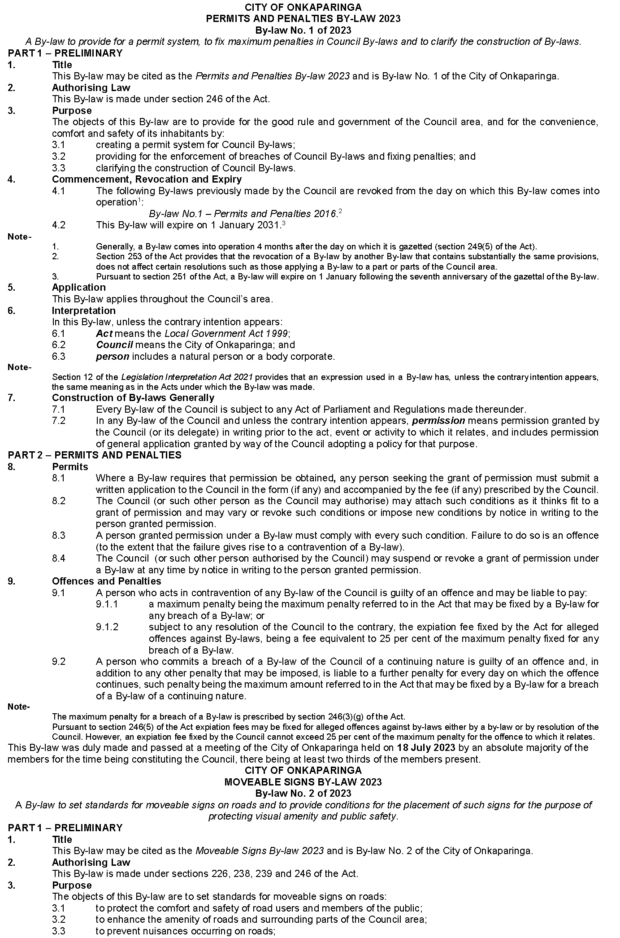
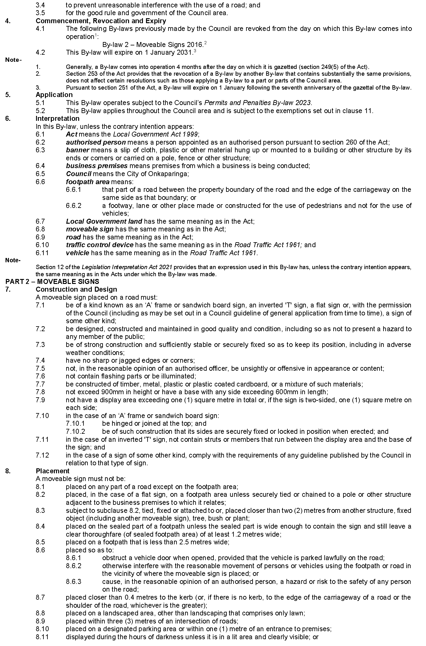
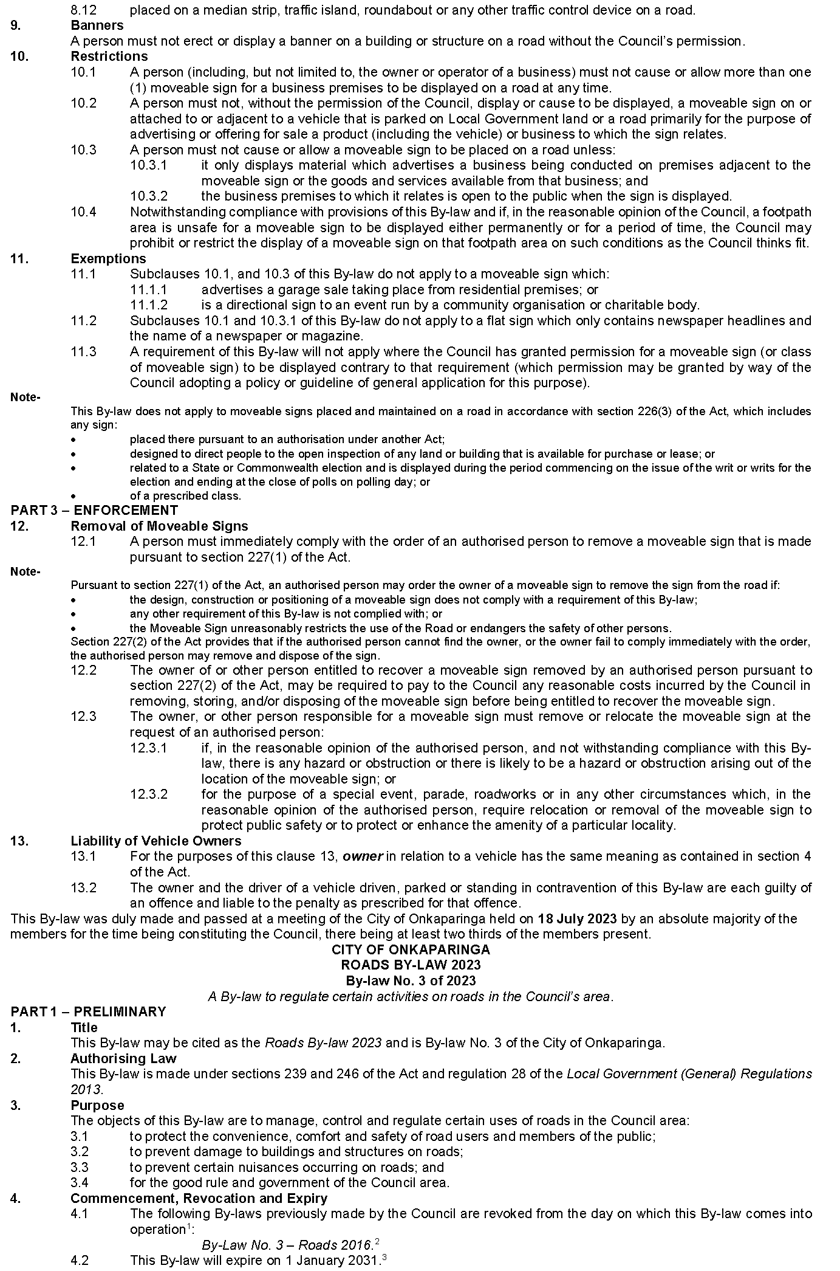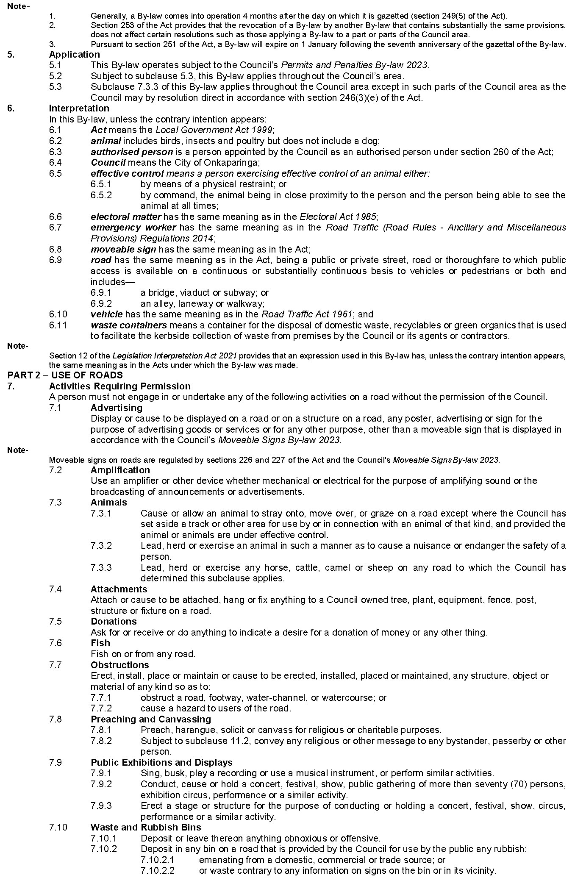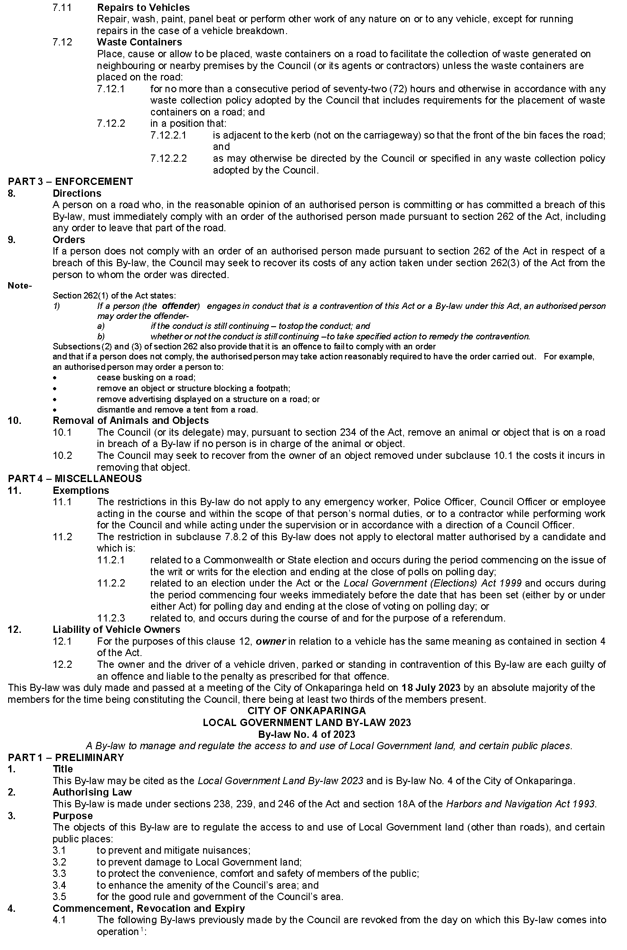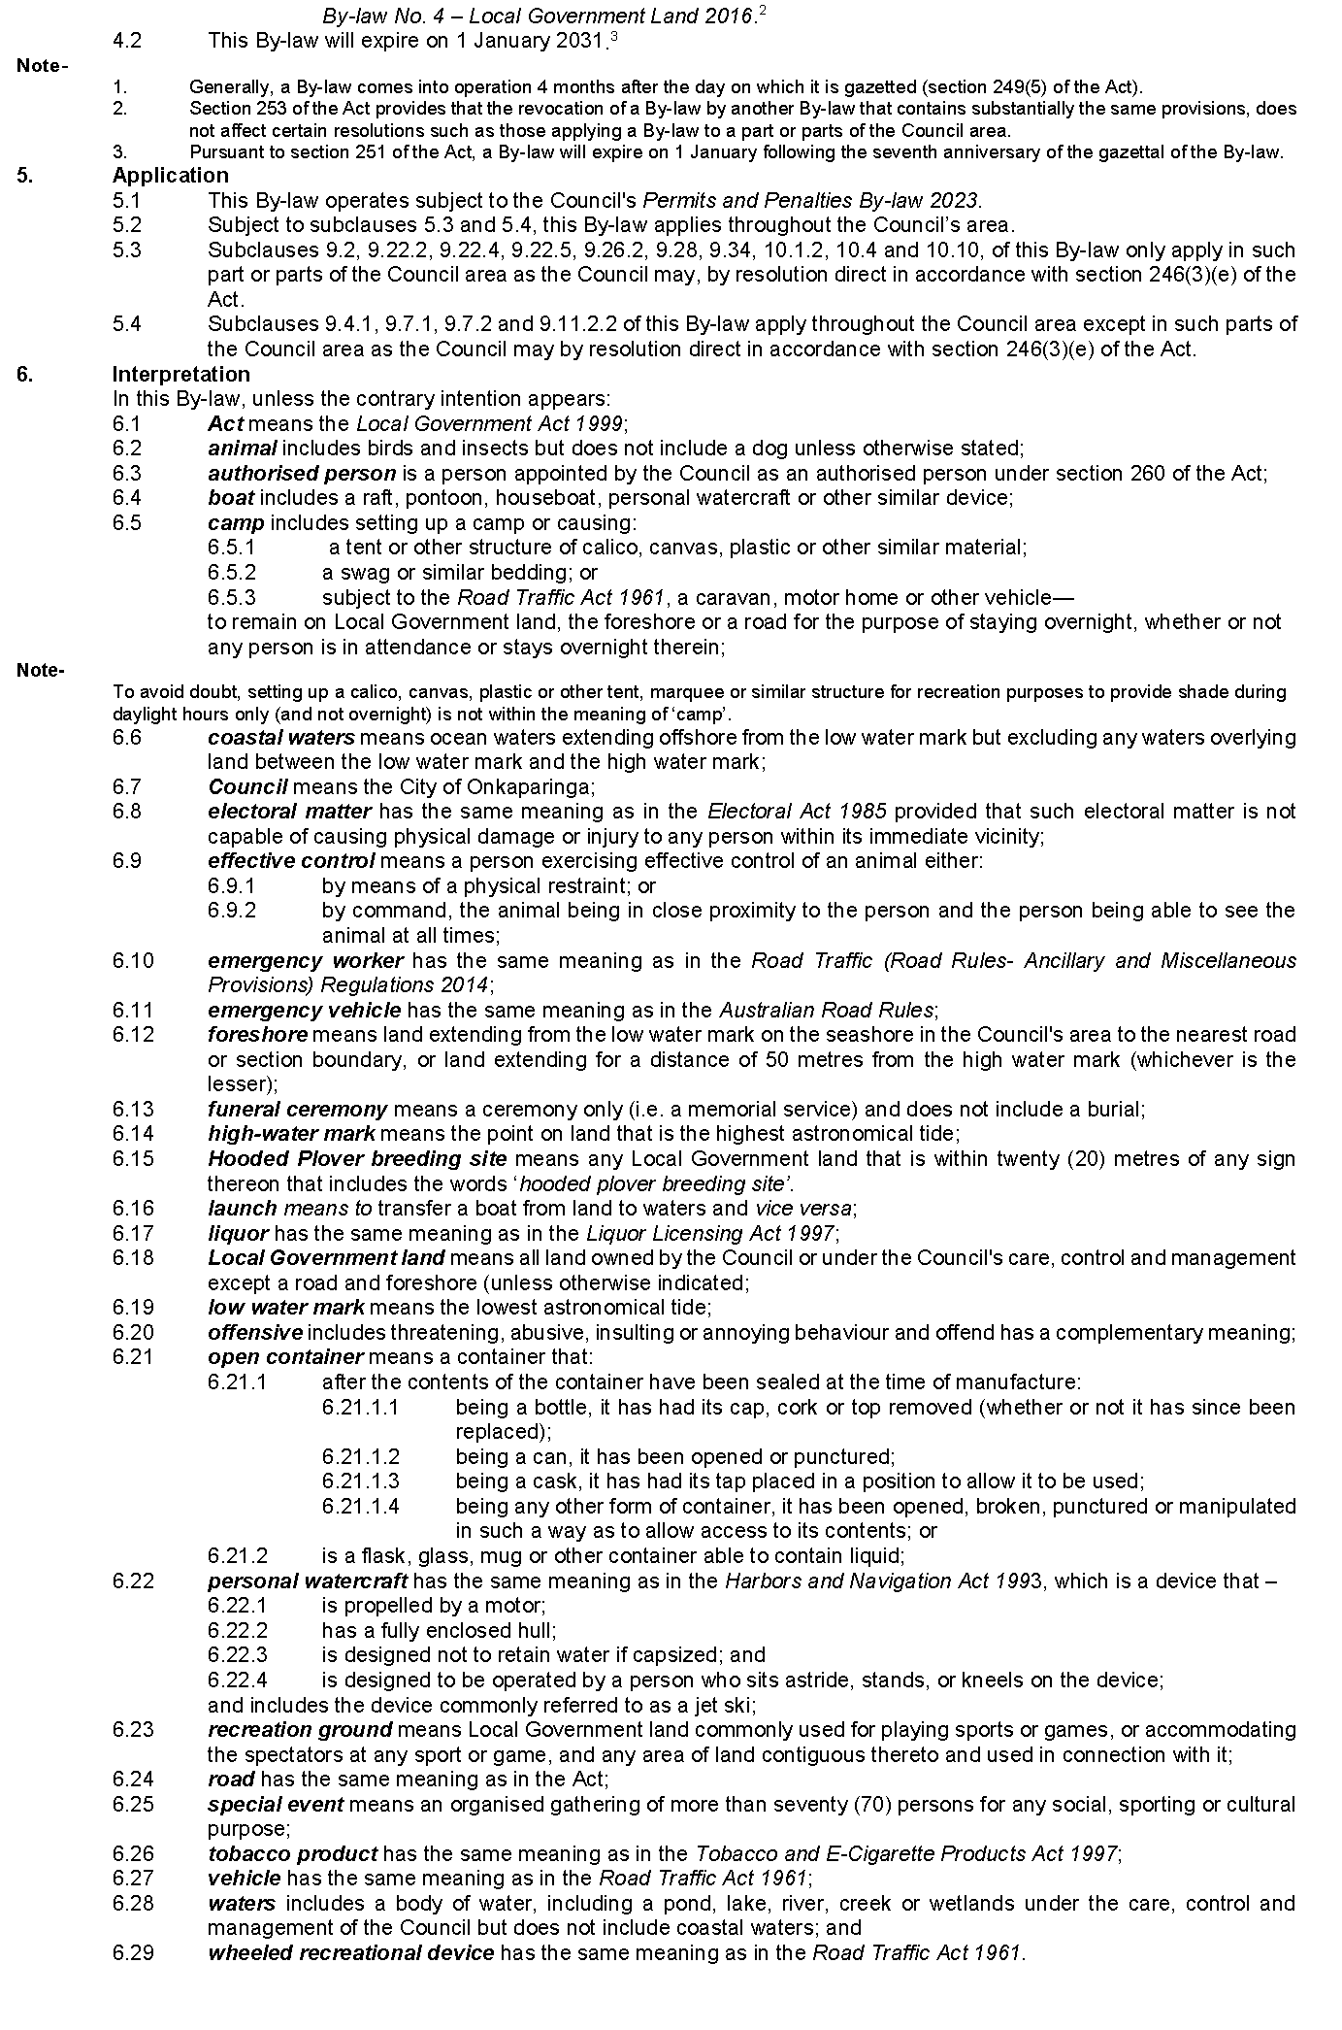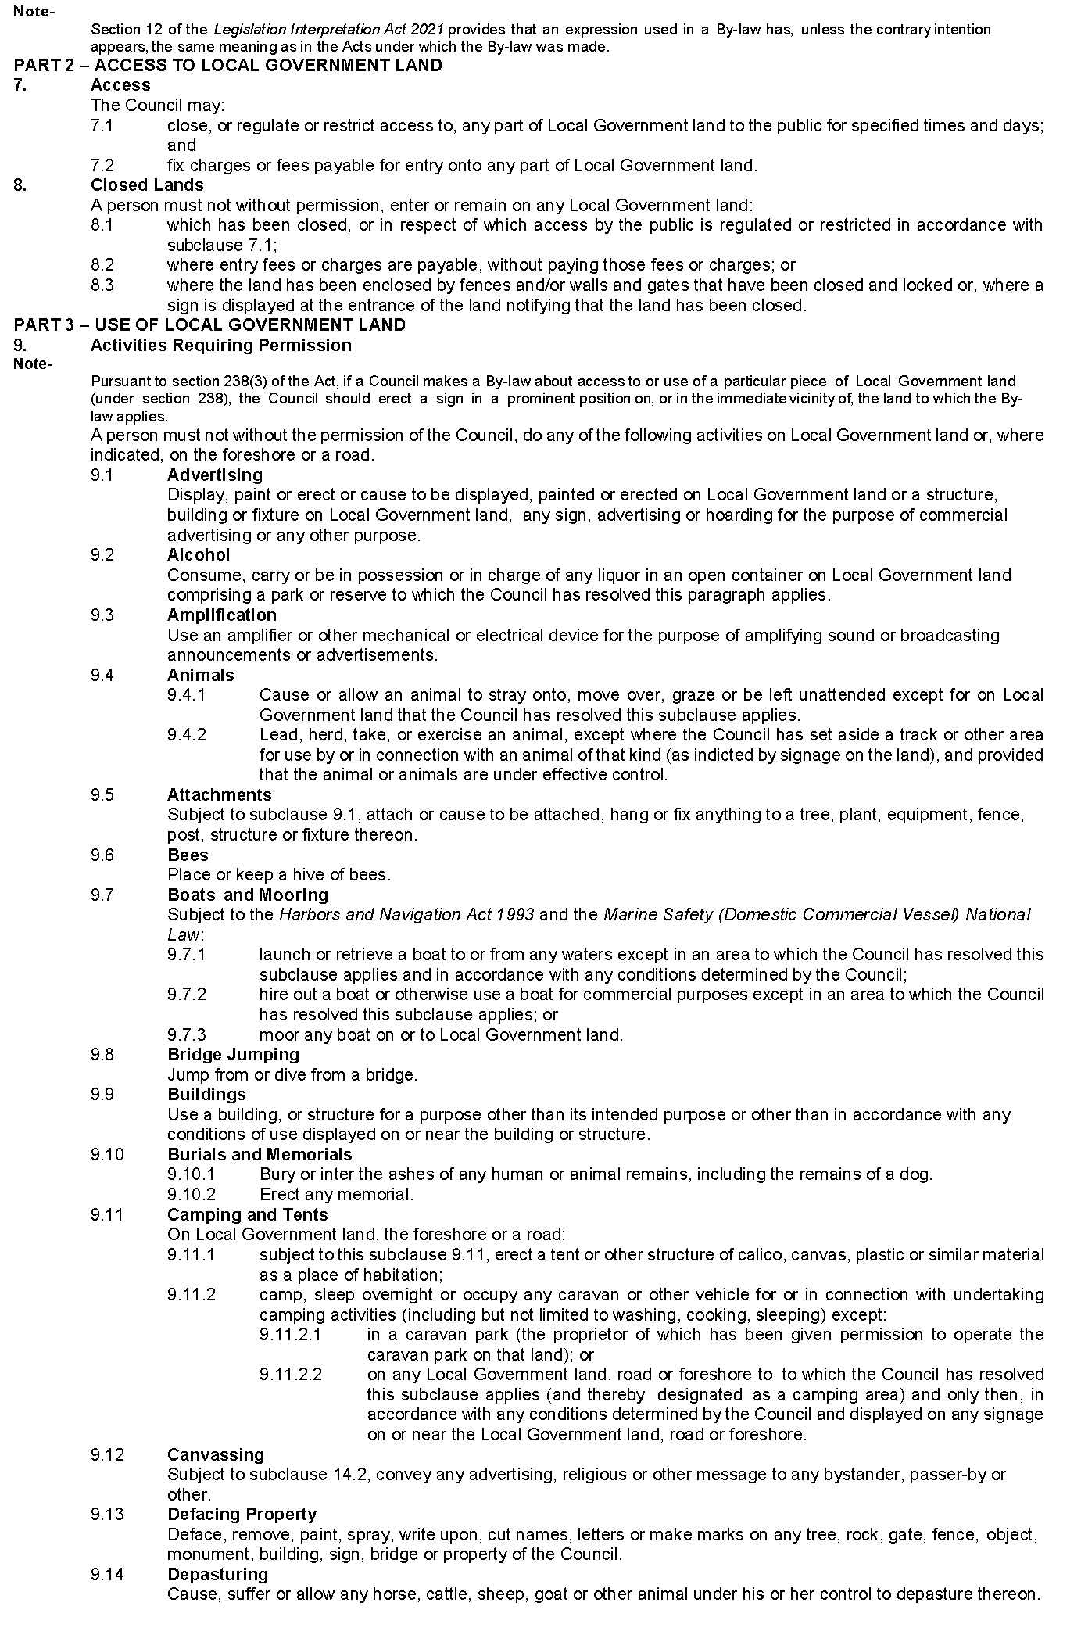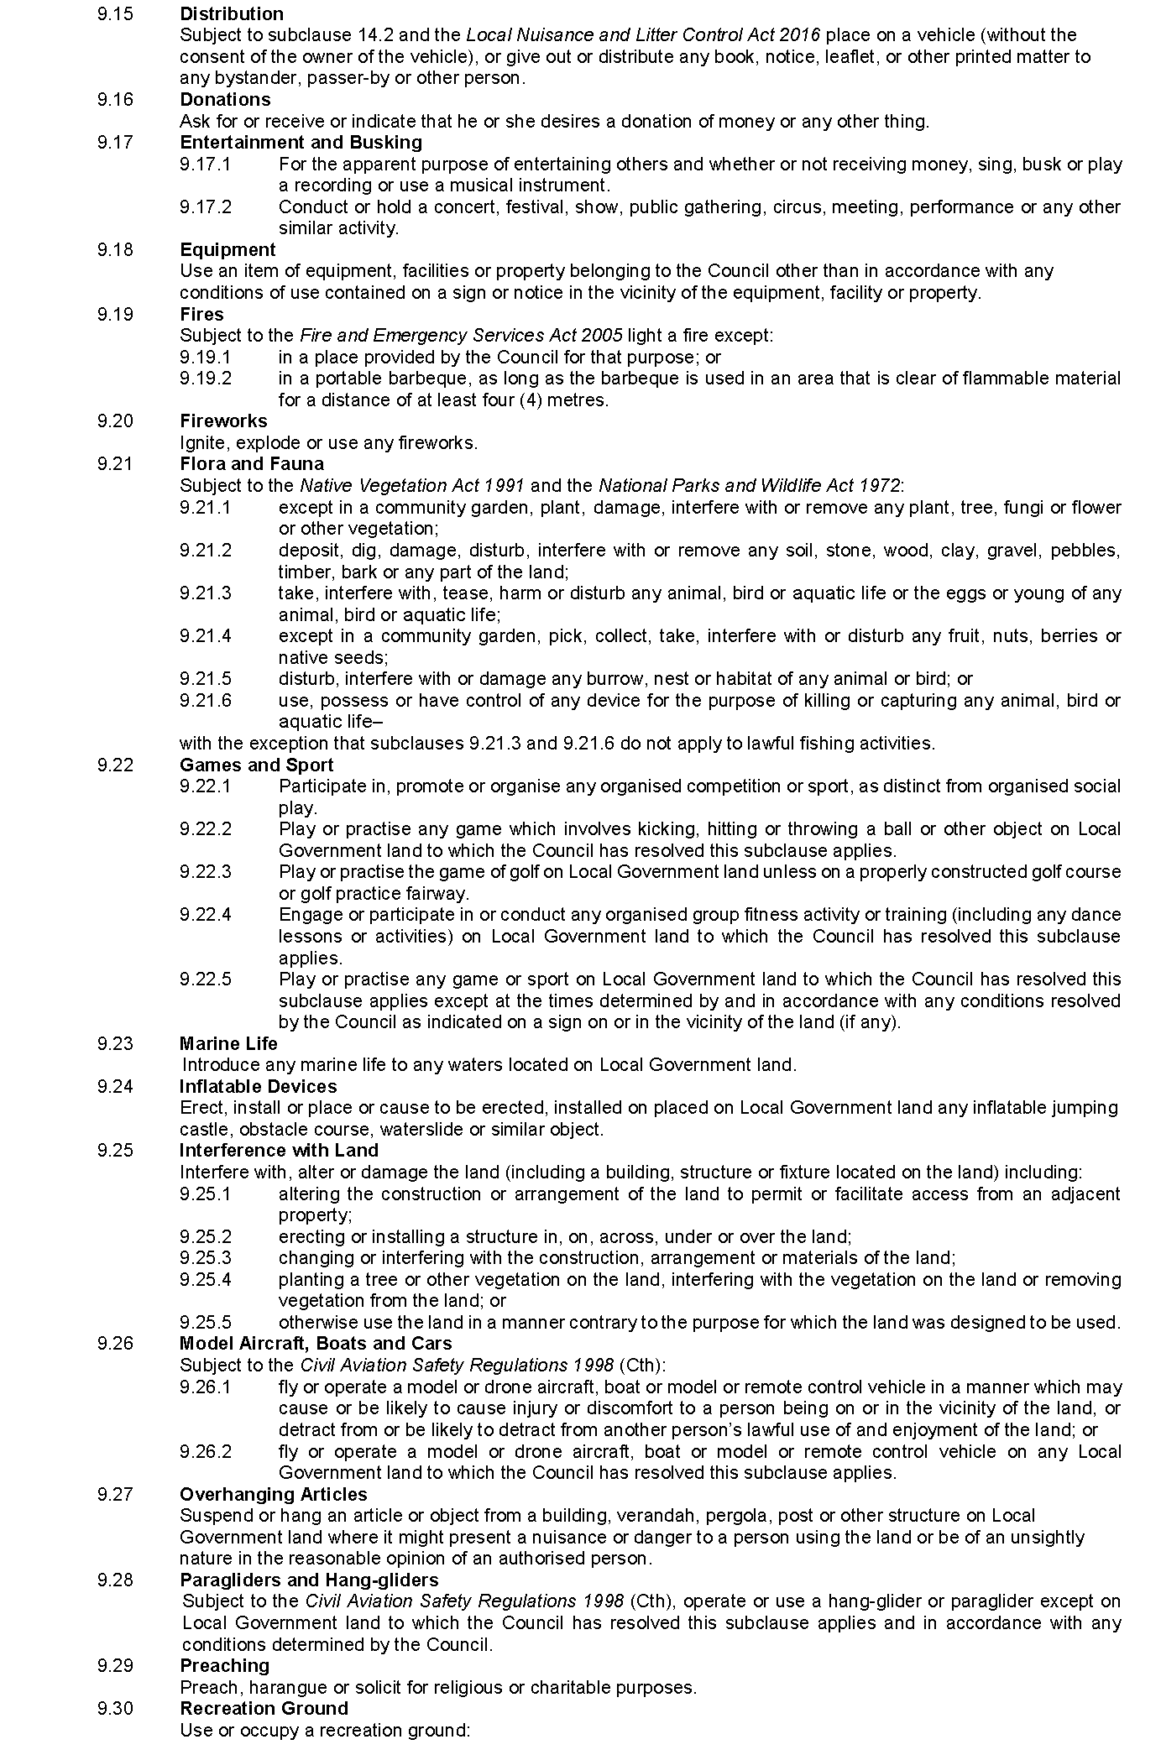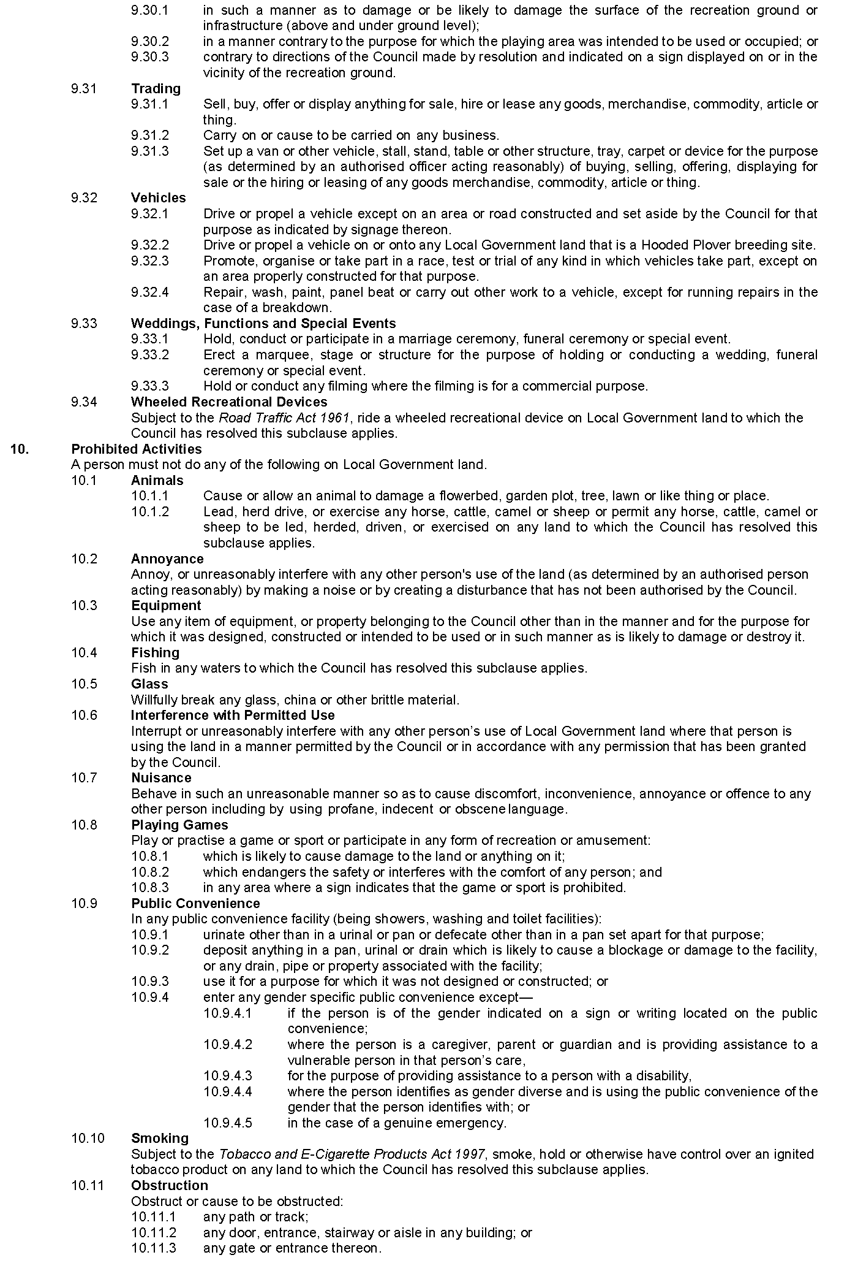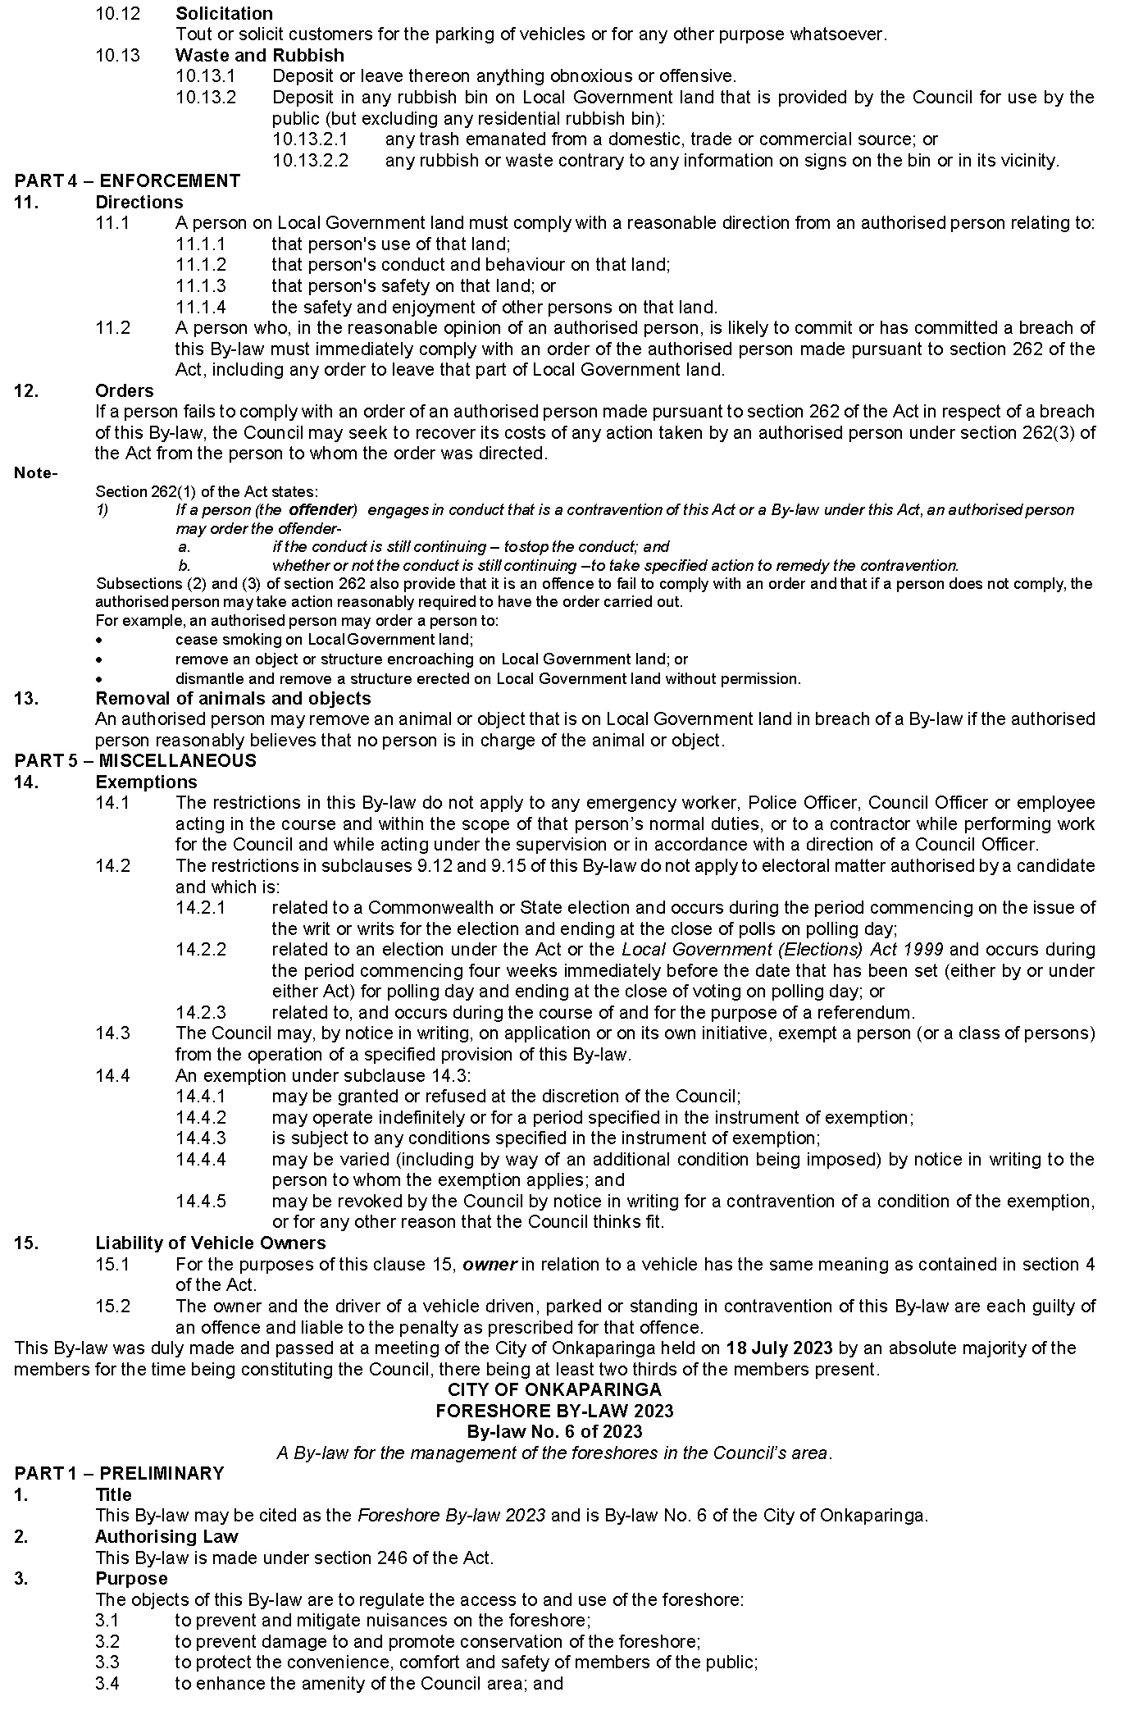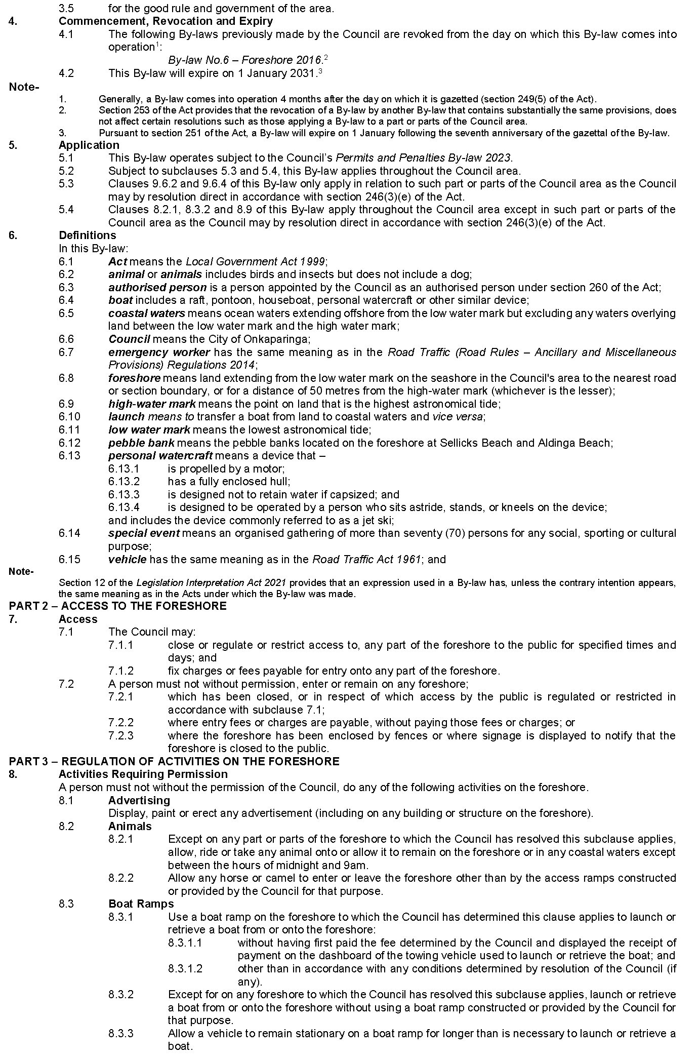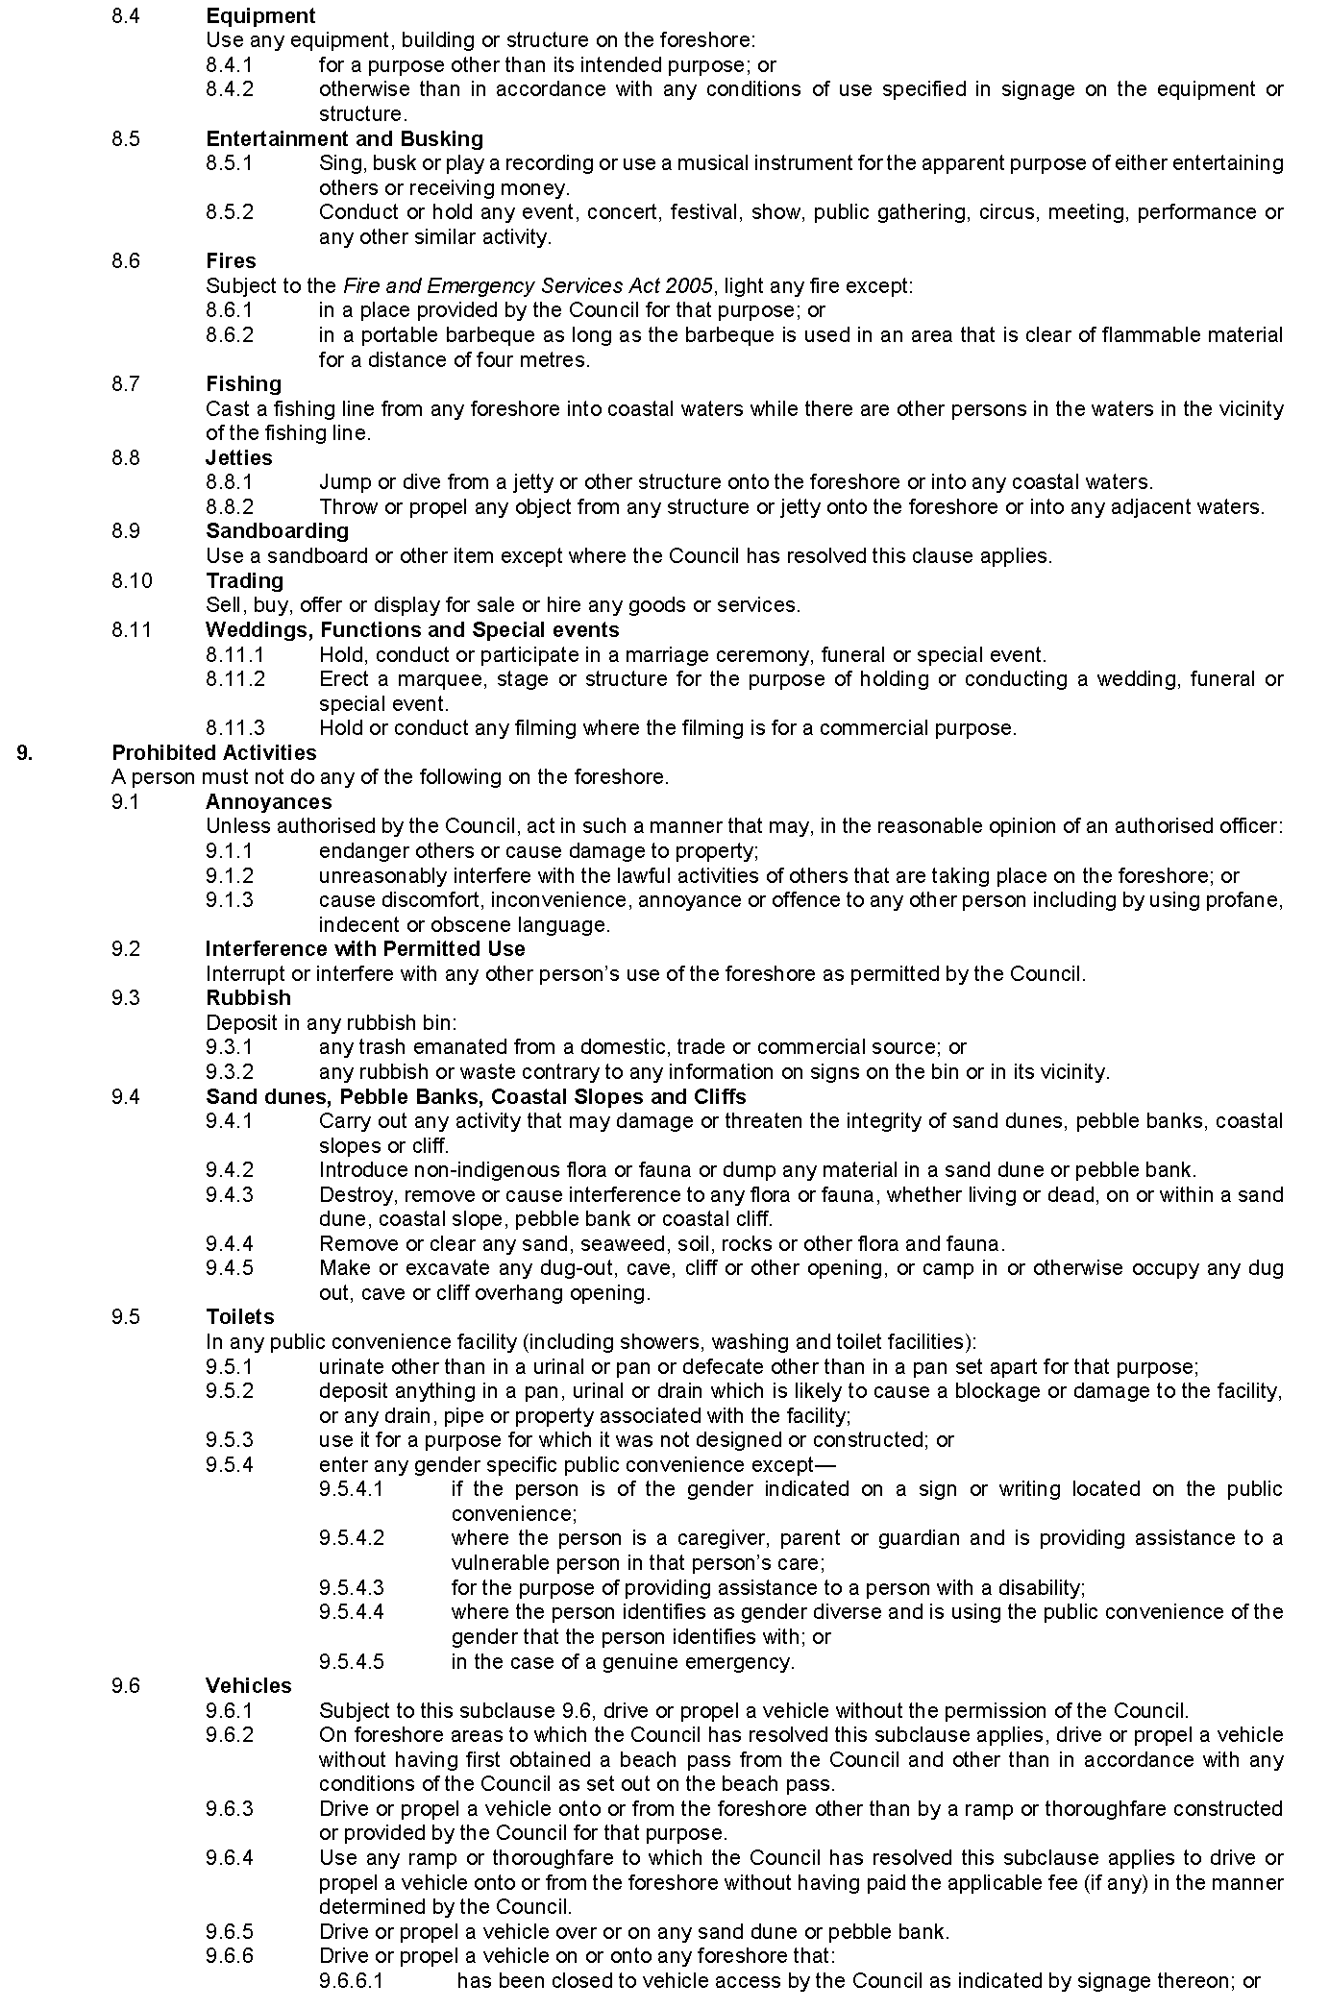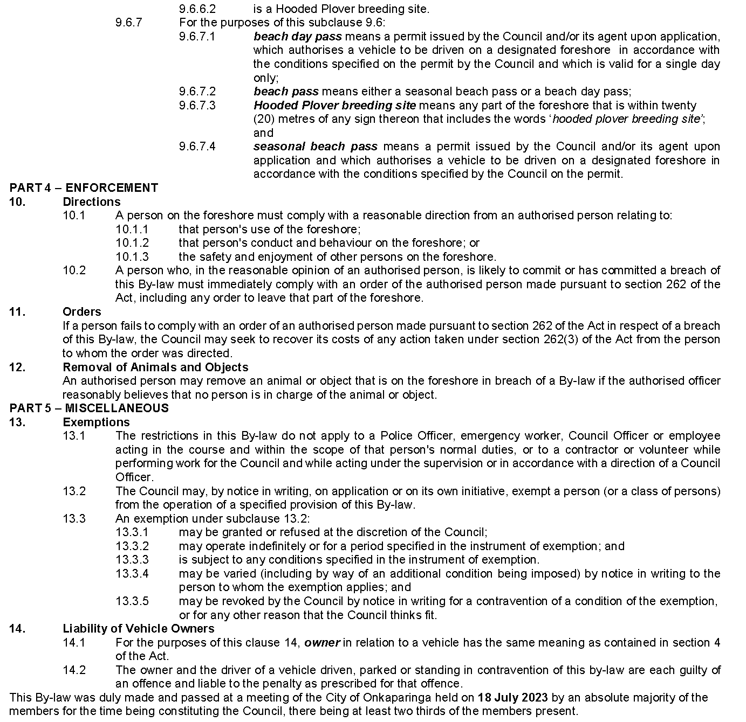

The Barossa Council
Adoption of Valuation and Declaration of Rates and Charges
1. Adoption of Valuations
Council, in accordance with Section 167(2)(a) of the Local Government Act 1999, adopts for rating purposes the Valuer-General’s most recent valuations available to the Council of the Capital Value in relation to the area of the Council, which specifies that the total of the values that are to apply within the area is $7,478,941,400 of which $7,328,819,865 is rateable.
2. Declaration of Differential General Rates
That Council, pursuant to Sections 152(1)(c)(i), 153(1)(b) and 156(1)(a) of the Local Government Act 1999, declares the following differential general rates on rateable land within its area for the year ending 30 June 2024, based upon the capital value of the land which rates vary by reference to land use categories as per Regulation 14 of the Local Government (General) Regulations 2013 as follows:
(1) Category (a)—Residential, a rate of 0.00294 in the dollar;
(2) Category (b)—Commercial—Shop, category (c)—Commercial—Office and category (d)—Commercial—Other, a rate of 0.00454 in the dollar;
(3) Category (e)—Industry—Light, a rate of 0.0045 in the dollar;
(4) Category (f)—Industry—Other, a rate of 0.01433 in the dollar;
(5) Category (g)—Primary Production, a rate of 0.00295 in the dollar;
(6) Category (h)—Vacant Land, a rate of 0.00559 in the dollar;
(7) Category (i)—Other, a rate of 0.005 in the dollar;

3. Fixed Charge
That Council, pursuant to Section 152(1)(c)(ii) of the Local Government Act 1999, impose a fixed charge of $420.00 on each separately valued piece of rateable land within the Council area for the year ending 30 June 2024.
4. Waste Collection Service Charge
That Council, pursuant to Section 155 of the Local Government Act 1999, and in order to provide or make available the service of waste collection in those parts of the Council’s area described in (3) below, impose the following service charges by reference to the nature and/or level of usage of the service, for the year ending 30 June 2024:
(1) Non-recyclable Waste Collection
(a) An annual service charge of $130 for 140L General (Landfill) Waste collection receptacles;
(b) An annual service charge of $169 for 240L General (Landfill) Waste collection receptacles;
except in instances where, subject to written application to and the approval of the Council, residential households with six or more permanent residents or a special medical condition may receive a 240L receptacle at the same service charge for a 140L receptacle.
(2) Recyclable Waste Collection
(a) An annual service charge of $70 for 240L Co-mingled Recycling collection receptacle
(b) An annual service charge of $71 for 240L Green Organic Recycling collection receptacle.
(3) Parts of Council Area
All Service Entitled Properties in the Designated Waste Collection Areas and along the Approved Waste Collection route as identified in the Waste Management Services Policy.
5. Community Wastewater Management Systems (CWMS) Rate and Service Charge
That Council, pursuant to Section 155 of the Local Government Act 1999, declares a service rate and imposes a service charge for the year ending 30 June 2024, in the following areas to which Council makes available a Community Wastewater Management System (CWMS):
(1) Lyndoch, Mount Pleasant, Nuriootpa, Penrice, Stockwell, Tanunda and Williamstown—Residential & Vacant Land Properties
(a) An annual service charge of $386 for occupied residential rateable and non-rateable land;
(b) An annual service charge of $110 on each assessment of vacant rateable and non-rateable land.
(2) Lyndoch, Mount Pleasant, Nuriootpa, Penrice, Stockwell, Tanunda and Williamstown—Non-Residential & Non-Vacant Land Properties
A service rate of 0.001004 in the dollar of the capital value of occupied non-residential rateable land.
(3) Springton—Residential & Vacant Land Properties
(a) An annual service charge of $386 on assessments of occupied residential rateable land and non-rateable land;
(b) An annual service charge of $95 on each assessment of vacant rateable and non-rateable land.
(4) Springton—Non-Residential & Non-Vacant Land Properties
(a) A service rate of 0.001004 in the dollar of the capital value of occupied non-residential rateable land.
6. Regional Landscape Levy
That Council, in exercise of the powers contained in Section 154 of the Local Government Act 1999 and Section 69 of the Landscape South Australia Act 2019, for the year ending 30 June 2024 and in order to reimburse the Council for the amount contributed to the Northern and Yorke Landscape Board, a levy in the nature of a separate rate of 0.0001122 in the dollar of the capital value of land, be declared on all rateable land in the area of that Board.
7. Payment of Rates
(1) Pursuant to Section 181(1) and (2) of the Local Government Act 1999, all rates and charges will be payable in four quarterly instalments due on 12 September 2023, 5 December 2023, 5 March 2024 and 4 June 2024; provided that in cases where the initial account requiring payment of rates is not sent at least 30 days prior to these dates, or an amended account is required to be sent, authority to fix the date by which rates must be paid in respect of those assessments affected is delegated pursuant to Section 44 of the Act, to the Chief Executive Officer;
(2) Pursuant to Section 44 of the Local Government Act 1999, the Chief Executive Officer is delegated the power under Section 181(4)(b) of the Act to enter into agreements with ratepayers relating to the payment of rates in any case where the Chief Executive Officer thinks it necessary or desirable to do so;
8. General Rates Cap—Residential and Primary Production
That Council, pursuant to Section 153(3) and (4) of the Local Government Act 1999, has determined to fix, on application of the property owner, a maximum increase in general rates (excluding fixed charge) levied upon a category (a) land use (Residential) or category (g) land use (Primary Production) property, for the year ending 30 June 2024 which constitutes the principal place of residence of a principal ratepayer at:
(a) 7.5% over and above the general rates levied for the 2022/2023 financial year (for those eligible for a State Government concession on their Council rates including those in receipt of the Cost of Living Concession) or;
(b) 15% over and above the general rates levied for the 2022/2023 financial year (for all other such ratepayers), provided that:
(c) the property has been the principal place of residence of the principal ratepayer since at least 1 July 2022, and;
(d) the property has not been subject to improvements with a value of more than $20,000 since 1 July 2022, and;
(e) excluding land related to the principal place of residence for the purposes of single farm enterprise and/or contiguous land.
Dated: 27 July 2023
Martin McCarthy
Chief Executive Officer

District Council of Cleve
Adoption of Valuations and Declaration of Rates
NOTICE is hereby given that at its meeting held on 25 July 2023, the District Council of Cleve for the financial year ending 30 June 2024:
- adopted for rating purposes, the capital valuations of land within the Council area as made by the Valuer General, being the most recent valuations available to the Council, totalling $1,211,209,580;
- declared a fixed charge of $570 payable in respect of rateable land within the Council area;
- declared differential rates as follows:
All land within the Commercial  (Bulk Handling) zones as defined in  Council’s Development Plan | 1.139245 | rate in the $
All other land within the Council area
according to its land use as follows:
Residential (Category A) | 0.244750 | rate in the $
Commercial (Category B, C & D) | 0.244750 | rate in the $
Industrial (Category E & F) | 0.244750 | rate in the $
Primary Production (Category G) | 0.222615 | rate in the $
Vacant Land (Category H) | 0.244750 | rate in the $
Other (Category I) | 0.244750 | rate in the $
- imposed the following annual service charges, payable in respect to rateable land where a septic tank effluent disposal connection point is provided or made available:
  - within the Township of Cleve – $581 per unit in respect of each piece of rateable land (if a connected allotment) serviced by the Cleve Scheme;
  - within the Township of Cleve - $387 per unit in respect of each piece of rateable land (if an unconnected allotment) serviced by the Cleve Scheme;
imposed the following annual service charges, payable in respect to rateable land where a sewerage system connection point is provided or made available:
  - within the Township of Arno Bay (Arno Bay Foreshore Properties) - $581 per unit in respect of each piece of rateable land (if a connected allotment) serviced by the Arno Bay Scheme;
- imposed an annual service charge of $276 per bin per assessment for the collection and disposal of waste and recyclables in respect of all land within the townships of Cleve, Arno Bay, Rudall and Darke Peak to which it provides or makes available the service;
- imposed an annual service charge, upon properties serviced by a common antenna television retransmission service for the properties serviced by the Whyte St/Cottages CATV system $132 (GST inc); and
- declared a differential separate rate according to land use in order to reimburse the Council the amount contributed to the Eyre Peninsula Landscape Board as follows:
Land Use | Levy rate per Land Use ($)
Residential | 87.43
Other & Vacant Land | 87.43
Commercial | 131.14
Industrial | 131.14
Primary Production | 174.85
David Penfold
Chief Executive Officer

District Council of Coober Pedy
Adoption of Valuations and Declaration of Rates
Notice is hereby given that at its meeting of 26 July 2023 the District Council of Coober Pedy adopted its valuations and declared its rates for the 2023-24 financial year.
Adoption of Valuations
That pursuant to Section 167(2)(a) of the Local Government Act 1999, the Council adopts for rating purposes the capital valuations made by the Valuer-General within the Council’s area totalling $171,644,800 of which $149,689,908 represents rateable land.
Declaration of Differential General Rates
That, having taken into account the general principles of rating contained in Section 150 of the Local Government Act 1999 and the requirements of Section 153(2) of the Local Government Act 1999, Council, pursuant to and in accordance with Sections 152(1)(a) and 153(1)(a) of the Local Government Act 1999 declares:
Land Use 1 Residential 1.2915 cents in the dollar
Land Use 2 Commercial—Shop 1.6144 cents in the dollar
Land Use 3 Commercial—Office 1.6144 cents in the dollar
Land Use 4 Commercial—Other 1.6144 cents in the dollar
Land Use 5 Industry Light 1.6144 cents in the dollar
Land Use 6 Industry—Other 1.6144 cents in the dollar
Land Use 8 Vacant Land 1.2915 cents in the dollar
Land Use 9 Other 1.6144 cents in the dollar
That a fixed charge of $100.00 will apply to each separate piece of rateable land within the Council’s area in accordance with Section 153(2) of the Local Government Act 1999 for the financial year ending 30th June 2024.
That, pursuant to Section 153(3) of the Local Government Act 1999, Council determines it will not fix a maximum increase in the general rates on the principal place of residence of a principal ratepayer.
Adoption of Regional Landscape Levy
That, pursuant to Part 5 of the Landscape South Australia Act 2019 and Section 154 of the Local Government Act 1999, the Council declares a separate rate based on a fixed charge based on land use code on all rateable land in the Council area of:
Land Use 1 Residential $45.35
Land Use 2 Commercial—Shop $90.69
Land Use 3 Commercial—Office $90.69
Land Use 4 Commercial—Other $90.69
Land Use 5 Industry Light $90.69
Land Use 6 Industry—Other $90.69
Land Use 8 Vacant Land $45.35
Land Use 9 Other $45.35
To raise the amount of $76,561 on behalf of the SA Arid Lands Landscape Board for the financial year ending 30th June 2024.
Adoption of Water Annual Service Charge
That pursuant to Section 155 of the Local Government Act 1999, the Council declares an annual service charge for the financial year ending 30 June 2024 on all land within the Council’s area to which the Council provides or makes available the prescribed service of the treatment and provision of water, based on the nature of the service, of $302.75.
Declaration of Annual Wastewater Service Rate
That pursuant to and in accordance with Section 155 of the Local Government Act 1999, the Council declares a service rate for the prescribed service of the collection, treatment and disposal of waste in respect of all rateable land within the Community Wastewater Management Scheme Area and within the area of the Council, as set out in in Attachment 1 to this report as presented with the Agenda, for the financial year ending 30 June 2024 being a rate of 0.6081 cents in the dollar, based on the capital value of the land the subject of the rate.
Payment of Rates
That pursuant to Section 181 of the Local Government Act 1999 rates for the financial year ending 30 June 2024 will fall due in four equal or approximately equal instalments on 12 September 2023, 4 December 2023, 4 March 2024, and 3 June 2024.
A copy of the Annual Business Plan 2023-24 can be viewed at the Council offices, Lot 773, Hutchison Street, Coober Pedy SA 5723, during business hours, or from www.cooberpedy.sa.gov.au.
Dated: 27 July 2023
D. Kelly
Chief Executive Officer

Mid Murray Council
Adoption of Valuation & Declaration of Rates
Notice is hereby given that on 18 July 2023 Mid Murray Council, pursuant to the provisions of the Local Government Act 1999, and for the year ending 30 June 2024 made the following resolutions.
To adopt the most recent valuations of capital value made by the Valuer General for rating purposes totalling the area aggregate $3,484,550,320.00,
of which $3,381,227,073.00 is the valuation of rateable land.
To declare differential general rates on the capital value of all rateable land within the area, varying according to the use of the land, as follows:-
- Residential 0.4578 cents in the dollar
- Commercial – Shop 0.4578 cents in the dollar
- Commercial – Office 0.4578 cents in the dollar
- Commercial – Other 0.4578 cents in the dollar
- Industry – Light 0.4578 cents in the dollar
- Industry – Other 0.4578 cents in the dollar
- Primary Production 0.412 cents in the dollar
- Vacant Land 0.4578 cents in the dollar
- Other 0.4578 cents in the dollar
- Marina Berths 0.4578 cents in the dollar
To fix a minimum amount of $925.00 payable by way of general rates on rateable land within the Council area.
To declare for Regional Landscape Levy, being $624,568, a separate rate of 0.01863 cents in the dollar, based on all rateable land in the Council’s area.
To declare a Separate Rate of 37 cents per square metre for Waterfront properties (includes marina berths) and rebate of 65% for Non-waterfront properties (Net 13 cents per square metre) within the Mannum Waters development. The purpose of the Separate Rate is to meet the costs incurred by Council in financing and purchasing a permanent water entitlement, to assist in meeting Council’s evaporation loss obligations under the Landscape South Australia Act 2019.
To declare annual service charges in respect of all land to which Council provides or makes available the prescribed service of a Community Wastewater Management System in the following areas:
Big Bend area |  |  | $578.00 per unit
Blanchetown area |  |  | $257.00 per unit
Bolto Reserve area |  |  | $450.00 per unit
Bowhill area |  |  | $280.00 per unit
Brenda Park/Morphett Flat areas |  |  | $351.00 per unit
Caloote Landing area |  |  | $366.00 per unit
Caurnamont area |  |  | $347.00 per unit
Cowirra area |  |  | $1,082.00 per unit
Five Mile Shacks and Kia Marina areas |  |  | $1,426.00 per unit
Greenways Landing area |  |  | $855.00 per unit
Idyll Acres area |  |  | $468.00 per unit
Julanker/Younghusband Holdings areas |  |  | $720.00 per unit
Kroehn's Landing area |  |  | $1,167.00 per unit
Marks Landing area |  |  | $295.00 per unit
North Punyelroo area |  |  | $214.00 per unit
North West Bend/Beaumonts areas |  |  | $168.00 per unit
Old Teal Flat area |  |  | $340.00 per unit
Pelican Point area |  |  | $283.00 per unit
Pellaring Flat area |  |  | $451.00 per unit
Rob Loxton Road area |  |  | $172.00 per unit
Scotts Creek area |  |  | $348.00 per unit
Scrubby Flat area |  |  | $464.00 per unit
Seven Mile Shacks area |  |  | $623.00 per unit
South Punyelroo area |  |  | $310.00 per unit
Swan Reach area |  |  | $429.00 per unit
Teal Flat area |  |  | $296.00 per unit
The Rocks area |  |  | $949.00 per unit
Truro area |  |  | $662.00 per unit
Truro area – Aerobic Wastewater Treatment (50%) |  |  | $331.00 per unit
Truro area – private pumping chamber |  |  | $632.00 per unit
Walker Flat area |  |  | $172.00 per unit
To declare an annual service charge in respect of all land to which Council provides the prescribed service of television transmission known as the Bowhill Multi Access Television Transmission Service of $146.00.
To declare an annual service charge in respect of each property to which Council provides the prescribed service of the treatment or provision of water known as the Bowhill Reticulated Water Supply System:-
Consumption of up to 120 kilolitres of water $256.00
All water consumed in excess of 120 kilolitres 40 cents per kilolitre
To declare an annual service charge for the Township Waste Collection (General Waste and Recyclables) Service of $305.00, based upon the nature of the service, in respect of each residential property within a township to which it makes available.
To declare an annual service charge for the Rural (non-township) General Waste Collection Service of $216.00, based upon the nature of the service, in respect of land outside of a township which has a residential or primary production land use and upon which there is a residential dwelling and to which it makes available, noting that where the Service is not provided at the access point to the land, the annual service charge will be adjusted as required by Regulation 13 of the Local Government (General) Regulations 2013.
BF Scales
Chief Executive Officer

District Council of Mount Remarkable
Adoption of Valuations and Declaration of Rates 2023-2024
Notice is hereby given that the District Council of Mount Remarkable at an Ordinary Meeting held on 18 July 2023 for the financial year ending 30 June 2024 adopted its Annual Business Plan and Budget and:
Adoption of Valuations
Adopted, for rating purposes, the Valuer-General’s most recent valuations of capital values applicable to land within the area of Council, which totals $1,304,208,660.
Declaration of General Rates
Declared a general rate comprising two components, one based on the value of the land the subject of the rate of 0.1987 cents in the dollar and the other being a fixed charge of $500.00 upon each rateable assessment.
Separate Rate
Regional Landscape Levy
Declared a separate rate of 0.0197 cents in the dollar on all rateable land located within the area of the Council to reimburse the Council for the amount payable to the Northern and Yorke Landscape Board.
Annual Service Charges
1. Imposed an annual service charge for the collection, treatment and disposal of wastewater in respect of all assessments within the townships of Wilmington, Melrose, Booleroo Centre and Wirrabara to which Council makes available a Community Wastewater Management Scheme as follows:
Wilmington: $570.00 per unit on each assessment of land, and;
Melrose: $570.00 per unit on each assessment of land, and;
Booleroo Centre: $570.00 per unit on each assessment of land, and;
Wirrabara: $570.00 per unit on each assessment of land.
2. Imposed an annual service charge of $395.00 for the weekly collection and disposal of waste in a mobile garbage bin and the fortnightly collection and disposal of recyclables and green waste in a mobile garbage bin on:
(a) all occupied land in the defined townships of Appila, Booleroo Centre, Hammond, Melrose, Murray Town, Port Germein, Weeroona Island, Willowie, Wilmington and Wirrabara for which the service is provided or made available; and
(b) each section of land outside of the townships abutting the defined collection route on which a habitable dwelling exists for which the service is provided or made available, provided that the sliding scale set out in Regulation 13 of the Local Government (General) Regulations 2013 will apply to reduce the service charge as prescribed.
3. Imposed an annual service (and supply) charge based on the nature of the service and the level of usage of the service of:
(a) $300.00 for the nature of the service on each assessment of rateable and non-rateable land within the township of Weeroona Island to which Council provides or makes available the ‘Weeroona Island Water Supply’; and
(b) Including a level of usage charge of $3.00 per kilolitre for each kilolitre of water supplied to each assessment of rateable and non-rateable land to which Council provides or makes available the ‘Weeroona Island Water Supply’.
Dated: 27 July 2023
S. Johnson
Chief Executive Officer

Wattle Range Council
Adoption of Valuations and Declaration of Rates
Notice is hereby given that the Wattle Range Council at a meeting held on 13 July 2023 and in relation to the financial year ending 30 June 2024, adopted the 2023-2024 Annual Business Plan and Budget and resolved to:
1. Valuations
Pursuant to Section 167(2)(a) of the Local Government Act 1999, adopted the valuations that are to apply in its area for rating purposes for the 2023/24 financial year, being the capital valuations of the Valuer-General, totalling $8,118,634,520.
2. Differential Rates
Pursuant to Sections 152(1)(c)(i), 153(1)(b) and 156(1)(a) of the Local Government Act 1999, declares the following differential general rates on rateable land within its area for the year ending 30 June 2024, based upon the capital value of the land which rates vary by reference to land use categories as per Regulation 14 of the Local Government (General) Regulations 2013 as follows:
(a) Residential—a differential rate of 0.3398 cents in the dollar
(b) Commercial Shop—a differential rate of 0.3398 cents in the dollar
(c) Commercial Office—a differential rate of 0.3398 cents in the dollar
(d) Commercial Other—a differential rate of 0.3398 cents in the dollar
(e) Industry Light—a differential rate of 0.3398 cents in the dollar
(f) Industry Other—a differential rate of 0.3398 cents in the dollar
(g) Primary Production—a differential rate of 0.1858 cents in the dollar
(h) Vacant Land—a differential rate of 0.5102 cents in the dollar
(i) Other—a differential rate of 0.5102 cents in the dollar
3. Minimum Rate
Pursuant to Section 158(1)(a) of the Local Government Act 1999 declared that the minimum amount payable by way of general rates on rateable land in the Council area is $650.00.
4. Service Charges
Pursuant to Section 155 of the Local Government Act 1999 imposed the following annual service charges;
(i) Waste Collection Service
based on the level of usage of the service, on all land to which the Council provides or makes available the prescribed services of the collection, treatment or disposal of waste via Council’s waste management services in respect of each set of bins, or part thereof, provided on the basis that the sliding scale provided for in Regulation 13 of the Local Government (General) Regulations 2013 will be applied to reduce the service charge payable, as prescribed.
(a) three bin normal waste, recycling and green organics collection and disposal service of $352.00; and
(b) two bin normal waste and recycling collection and disposal service of $275.00
(ii) Community Wastewater Management Systems
based on the nature of the service and varying according to the CWMS Property Units Code in accordance with Regulation 12 of the Local Government (General) Regulations 2013 on all land in the Townships of Penola, Southend, Kalangadoo and Beachport to which it provides or makes available the Community Wastewater Management Systems being prescribed services for the collection, treatment and disposal of waste.
(a) Penola, Southend and Kalangadoo—Occupied Unit $720.00
(b) Penola, Southend and Kalangadoo—Vacant Unit $538.00
(c) Beachport Occupied Unit $817.00
(d) Beachport Vacant Unit $613.00
5. Separate Rates
Pursuant to Section 69 of the Landscape South Australia Act 2019 and Section 154 of the Local Government Act 1999, in order to reimburse the Council for amounts contributed to the Limestone Coast Landscape Board declared a separate rate based on a fixed charge varying on the basis of land use categories in respect of rateable land in the Council’s area.
(i) $90.30 per assessment on rateable land categories (a), (h) and (i) (Residential, Vacant and Other);
(ii) $135.25 per assessment on rateable land categories (b), (c) and (d) (Commercial Shop, Commercial Office, Commercial Other);
(iii) $211.70 per assessment on rateable land categories (e) and (f) (Industry Light and Industry Other);
(iv) $389.30 per assessment on rateable land category (g) (Primary Production).
6. Payment of Rates
Pursuant to Section 181 of the Local Government Act 1999, rates for the year ending 30 June 2024 will fall due in four equal or approximately equal instalments on 13 September 2023, 6 December 2023, 6 March 2024 and 5 June 2024.
Dated: 27 July 2023
Ben Gower
Chief Executive Officer

Wudinna District Council
Adoption of Valuation and Declaration of Rates 2023-24
Notice is hereby given that the Wudinna District Council at a meeting held on 18 July 2023 resolved for the 2023-24 financial year as follows:
Adoption of Valuation
Adopted for rating purposes the capital valuations made by the Valuer-General totalling $654,566,220 for rateable and non-rateable land in the Council area.
Declaration of Rates
Declared differential general rates on rateable land within its area by reference to locality as follows:
(a) The whole of the township of Wudinna, a rate of 0.6024 cents in the dollar.
(b) The whole of the township of Minnipa, a rate of 0.6024 cents in the dollar.
(c) The whole of the township of Kyancutta, a rate of 0.6024 cents in the dollar.
(d) The whole of the township of Warramboo, a rate of 0.6024 cents in the dollar.
(e) The whole of the township of Yaninee, a rate of 0.6024 cents in the dollar.
(f) The whole of the town of Pygery, a rate of 0.6024 cents in the dollar.
(g) In respect of all land within the area of the Council not otherwise included as above, a differential general rate of 0.3201 cents in the dollar.
Minimum Rate
Declared a minimum amount payable by way of rates of $545.00 in respect to all rateable land within the area of Council.
Annual Service Charges
(a) Imposed an annual service charge where a septic effluent disposal connection is provided within the Township of Wudinna of $325 per unit for all occupied properties and $290 for all unoccupied properties.
(b) Imposed an annual service charge to properties that have an occupiable dwelling, outbuilding or other class of structure to which the Council provides or makes available the prescribed service of the collection, treatment and disposal of waste via Council’s waste collection service of $262 per mobile garbage bin.
Separate Rate
Declared a separate rate of $180 based on a proportional basis of expenditure incurred in maintaining the area of the cottage home units within portion Section 175, Hundred of Pygery—Wudinna Homes for the Aged identified as being assessments:
9270269037 | 9270269067 | 9070269097 | 9270269127 | 9270269157 | 9270269187
9270269047 | 9270269077 | 9070269107 | 9270269137 | 9270269167
9270269057 | 9270269087 | 9270269117 | 9270269147 | 9270269177
Regional Landscape Levy
Declared differential separate rates varying on the basis of land use on all rateable land in the area of the Council in order to reimburse the Council for amounts contributed to the Eyre Peninsula Natural Resource Management Board.
(a) A land use of Primary Production, a Separate Rate of $174.85 per assessment;
(b) A land use of:
(i) Commercial
(ii) Industrial
A separate rate of $131.14 per assessment;
(c) A land use of:
(i) Residential
(ii) Vacant Land
(iii) Other
A separate rate of $87.43 per assessment.
Dated: 27 July 2023
Kristy Davis
Chief Executive Officer

Wudinna District Council
Change of Meeting Date
Notice is hereby given that the Wudinna District Council resolved at its meeting held on 18 July 2023, to change the scheduled August 2023 Council Meeting from Tuesday, 15 August 2023 commencing at 1pm to Wednesday, 16 August 2023 commencing at 1pm.
Dated: 21 July 2023
Kristy Davis
Chief Executive Officer

Yorke Peninsula Council
Adoption of Valuations and Declaration of Rates 2023/2024
NOTICE is given that at the meeting of the Yorke Peninsula Council held on 12 July 2023, the Council resolved for the financial year ending 30 June 2024, as follows:
Adopted the most recent valuations of the Valuer-General available to the Council of the capital value of land within the Council’s area for rating purposes for the financial year ending 30 June 2024, totalling $10,661,958,760 comprising $167,820,755 in respect of non-rateable land and $10,494,138,005 in respect of rateable land.
Declared differential general rates on rateable land within the Council area as follows:
- on rateable land of category (g) use (primary production) in the area of the Council, a rate of 0.120004 cents in the dollar; and
- on all other rateable land within the area of the Council, a rate of 0.263238cents in the dollar; and
- to impose a fixed charge component of the general rate of $410.
Imposed on each assessment of rateable and non-rateable land in the following areas to which land the Council provides or makes available a Community Wastewater Management System, as follows:
- Maitland, Tiddy Widdy Beach, Ardrossan, Balgowan, Black Point, Edithburgh, Point Turton, Port Vincent, Port Victoria, Stansbury, Sultana Point, Yorketown, Bluff Beach, Chinaman Wells, Foul Bay, Port Julia, Hardwicke Bay & Rogues Point areas:
Occupied Land: $635.00 per unit
Vacant Land: $471.00 per allotment
Imposed on each assessment of rateable and non-rateable land in the following area to which land the Council provides or makes available a water supply service:
Balgowan, Black Point and Hardwicke Bay areas: $230.00
Imposed an annual service charge for the year ending 30 June 2024 upon both rateable and non-rateable land to which it provides or makes available the prescribed service of waste collection (the Waste Collection and Recycling Service) which is imposed as follows:
- $226 for a two (2) bin service; and
- $265 for a three (3) bin service.
Declared a separate rate of 0.010994 cents in the dollar on all rateable land in the area of the Council to raise the amount of $1,154,428 with $1,150,628 payable to the Northern and Yorke Landscape Board.
Dated: 12 July 2023
B. Thompson
Acting Chief Executive Officer

Public Notices

Trustee Act 1936
Public Trustee
Estates of Deceased Persons
In the matter of the estates of the undermentioned deceased persons:
ADAMS Peter Andrew late of 59 Porter Street Salisbury Retired Bookkeeper who died 16 October 2022
BORMANN Dallas late of 100 Seaford Road Seaford Retired Cook and Secretary who died 14 April 2023
BOWES Ilga late of 181 Days Road Regency Park of no occupation who died 5 November 2022
BULL Doreen Eva late of 6 Pridham Boulevard Aldinga Beach Retired Clerk who died 28 December 2022
DANIEL Edward James late of 6 Robin Terrace Hope Valley Retired Draftsman who died 3 April 2023
GIANNOPOULOS Despina late of 83-93 Regency Road Croydon Park Retired Cleaner who died 12 June 2022
SOLTYSIAK George Francis late of 176 Railway Terrace Peterborough of no occupation who died 14 December 2019
TANKARD Christine Ann late of 30 Shillabeer Road Elizabeth Park Retired Store Manager who died 20 August 2022
THOMPSON Margaret Jean late of 100 Seaford Road Seaford Retired Dressmaker who died 12 August 2022
YON Valerie Elaine late of 367-379 Waterloo Corner Road Burton of no occupation who died 8 January 2023
Notice is hereby given pursuant to the Trustee Act 1936, the Inheritance (Family Provision) Act 1972 and the Family Relationships Act 1975 that all creditors, beneficiaries, and other persons having claims against the said estates are required to send, in writing, to the office of Public Trustee at GPO Box 1338, Adelaide SA 5001, full particulars and proof of such claims, on or before the 25 August 2023 otherwise they will be excluded from the distribution of the said estate; and notice is also hereby given that all persons indebted to the said estates are required to pay the amount of their debts to the Public Trustee or proceedings will be taken for the recovery thereof; and all persons having any property belonging to the said estates are forthwith to deliver same to the Public Trustee.
Dated: 27 July 2023
N. S. Rantanen
Public Trustee

Notice Submission

The South Australian Government Gazette is published each Thursday afternoon.
Notices must be emailed by 4 p.m. Tuesday, the week of publication.
Submissions are formatted per the gazette style and a proof will be supplied prior to publication, along with a quote if applicable. Please allow one day for processing notices.
Alterations to the proof must be returned by 4 p.m. Wednesday.

Gazette notices must be submitted as Word files, in the following format:
• Title—the governing legislation
• Subtitle—a summary of the notice content
• Body—structured text, which can include numbered lists, tables, and images
• Date—day, month, and year of authorisation
• Signature block—name, role, and department/organisation authorising the notice

Please provide the following information in your email:
• Date of intended publication
• Contact details of the person responsible for the notice content
• Name and organisation to be charged for the publication—Local Council and Public notices only
• Purchase order, if required—Local Council and Public notices only

Email: governmentgazettesa@sa.gov.au
Phone: (08) 7109 7760
Website: www.governmentgazette.sa.gov.au

All instruments appearing in this gazette are to be considered official, and obeyed as such

Printed and published weekly by authority of M. Dowling, Government Printer, South Australia
$8.55 per issue (plus postage), $430.00 per annual subscription—GST inclusive
Online publications: www.governmentgazette.sa.gov.au

