SUPPLEMENTARY GAZETTE
THE SOUTH AUSTRALIAN
GOVERNMENT GAZETTE
Published by Authority

Adelaide, Thursday, 1 June 2023

Contents

State Government Instruments

Planning, Development and Infrastructure Act 2016 1442

State Government Instruments

Planning, Development and Infrastructure Act 2016
Section 76
Amendment to the Planning and Design Code
Preamble
It is necessary to amend the Planning and Design Code (the Code) in operation at 27 April 2023 (Version 2023.6) in order to make changes of form relating to the Code’s spatial layers and their relationship with land parcels. NOTE: There are no changes to the application of zone, subzone or overlay boundaries and their relationship with affected parcels or the intent of policy application as a result of this amendment.
- PURSUANT to section 76 of the Planning, Development and Infrastructure Act 2016 (the Act), I hereby amend the Code in order to make changes of form (without altering the effect of underlying policy), correct errors and make operational amendments as follows:
- Undertake minor alterations to the geometry of the spatial layers and data in the Code to maintain the current relationship between the parcel boundaries and Code data as a result of the following:
  - New plans of division deposited in the Land Titles Office between 19 April 2023 and 23 May 2023 affecting the following spatial and data layers in the Code:
    - Zones and subzones
    - Technical and Numeric Variations
      - Building Heights (Levels)
      - Building Heights (Metres)
      - Concept Plan
      - Finished Ground and Floor Levels
      - Gradient Minimum Frontage
      - Gradient Minimum Site Area
      - Interface Height
      - Minimum Dwelling Allotment Size
      - Minimum Frontage
      - Minimum Site Area
      - Minimum Primary Street Setback
      - Minimum Side Boundary Setback
      - Future Local Road Widening Setback
      - Site Coverage
    - Overlays
      - Affordable Housing
      - Character Area
      - Coastal Areas
      - Defence Aviation Area
      - Dwelling Excision
      - Environment and Food Production Area
      - Future Local Road Widening
      - Future Road Widening
      - Gateway
      - Hazards (Bushfire - High Risk)
      - Hazards (Bushfire - Medium Risk)
      - Hazards (Bushfire - General Risk)
      - Hazards (Bushfire - Urban Interface)
      - Hazards (Bushfire - Regional)
      - Hazards (Bushfire - Outback)
      - Heritage Adjacency
      - Historic Area
      - Historic Shipwrecks
      - Limited Dwelling
      - Limited Land Division
      - Local Heritage Place
      - Noise and Air Emissions
      - Significant Landscape Protection
      - State Heritage Place
      - Stormwater Management
      - Urban Tree Canopy
  - Improved spatial data for existing land parcels in the following locations (as described in Column A) that affect data layers in the Code (as shown in Column B):

Location (Column A) | Layers (Column B)
S4096 UCP – Woodforde  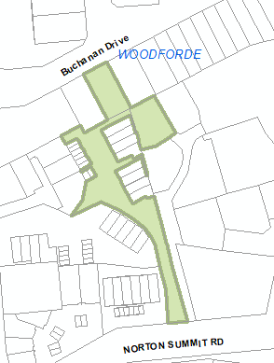 | Zones  Technical and Numeric Variations  - Building Heights (Levels)  - Building Heights (Metres)  - Minimum Frontage  - Minimum Site Area  Overlays  - Urban Transport Routes
Hampden  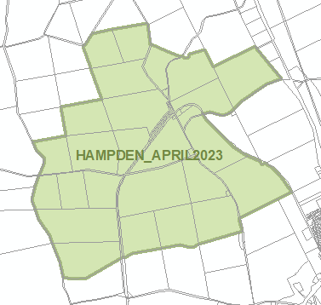 | Technical and Numeric Variations  - Minimum Site Area  Overlays  - Key Outback and Rural Routes

Location (Column A) | Layers (Column B)
HD Ridley D53979 – Caurnamont  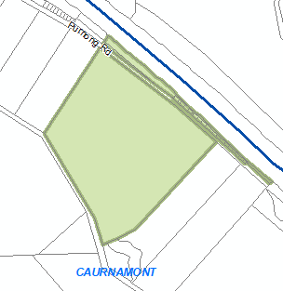 | Zones  Technical and Numeric Variations  - Building Heights (Metres)

- In Part 13 of the Code – Table of Amendments, update the publication date, Code version number, amendment type and summary of amendments within the ‘Table of Planning and Design Code Amendments’ to reflect the amendments to the Code as described in this Notice.
- PURSUANT to section 76(5)(a) of the Act, I further specify that the amendments to the Code as described in this Notice will take effect upon the date those amendments are published on the SA planning portal.
Dated: 30 May 2023
Greg Van Gaans
Director, Land and Built Environment
Department for Trade and Investment
Delegate of the Minister for Planning

All instruments appearing in this gazette are to be considered official, and obeyed as such

Printed and published weekly by authority of M. Dowling, Government Printer, South Australia
$8.15 per issue (plus postage), $411.00 per annual subscription—GST inclusive
Online publications: www.governmentgazette.sa.gov.au

