No. 43 p. 1815
THE SOUTH AUSTRALIAN
GOVERNMENT GAZETTE
Published by Authority

Adelaide, Thursday, 22 June 2023

Contents

State Government Instruments
Development Act 1993 1816
Fisheries Management (Prawn Fisheries) Regulations 2017 1817
Fisheries Management Act 2007 1819
Health Care Act 2008 1821
Housing Improvement Act 2016 1824
Juries (Remuneration for Jury Service) Regulations 2017 1824
Justices of the Peace Act 2005 1824
Land Acquisition Act 1969 1825
Landscape South Australia Act 2019 1833
Motor Vehicle Accidents (Lifetime Support Scheme)
Act 2013 1839
Petroleum and Geothermal Energy Act 2000 1840
Primary Industry Funding Schemes Act 1998 1841
South Australian Civil and Administrative Tribunal 1841
South Australian Skills Act 2008 1842
Survey Act 1992 1860
The Remuneration Tribunal 1860
Local Government Instruments
City of Mount Gambier 1869
City of Port Adelaide Enfield 1869
City of Salisbury 1870
City of Victor Harbor 1870
District Council of Orroroo Carrieton 1870
Public Notices
National Energy Retail Law 1871
National Gas Law 1871
Trustee Act 1936 1871

State Government Instruments

Development Act 1993
Section 46 (4)
Whalers Way Orbital Launch Complex
Preamble
On 29 August 2019 by notice in the Gazette at page 3132 the Minister for Planning made a declaration under section 46(1) of the Development Act 1993 in relation to the staged establishment and operation of an orbital space launch facility at Allotment 101 at Whalers Way, Sleaford.
On 22 April 2021 by notice in the Gazette at page 1223 the Minister for Planning and Local Government varied the declaration under section 46(4) of the Development Act 1993 to exclude from Schedule 1 “development for the purposes of establishing and carrying out three test rocket launches up until 31 December 2021”.
On 20 January 2022 by notice in the Gazette at page 98 the Minister for Planning and Local Government varied the declaration under section 46(4) of the Development Act 1993 to exclude from Schedule 1 “development for the purposes of establishing and carrying out three test rocket launches up until 31 December 2022.”
Notice
PURSUANT to Section 46(4) of the Development Act 1993, I vary the Declaration as follows:
- Replace in Schedule 1:
“But Excluding:
- Development for the purposes of establishing and carrying out three test rocket launches up until 31 December 2022.”
With
“But Excluding:
- Development for the purposes of establishing and carrying out two test rocket launches from 22 June 2023 up until 14 November 2023.”
The varied Declaration is set out in full in the Schedule.
Dated: 14 June 2023
Hon Nick Champion MP
Minister for Planning

Schedule—Varied Declaration
Preamble
Subsection (1) of Section 46 of the Development Act 1993, allows the Minister for Planning to apply that section to a specified kind of development or project if the Minister is of the opinion that a declaration under that section is appropriate or necessary for the proper assessment of development or a project of major environmental, social or economic importance.
Notice
PURSUANT to Section 46 (1) (a) of the Development Act 1993, being of the opinion that a declaration under Section 46 of the Act is appropriate for the proper assessment of a development of major environmental, and social and economic importance, I declare that Section 46 of the Act applies to any development of a kind specified in Schedule 1, in that part of the State specified in Schedule 2:
Schedule 1
Specified Kinds of Development
Development directly associated with the staged establishment and operation of an orbital space launch facility at Whalers Way, Sleaford (land as described in Schedule 2), being 25 kilometres south-west of Port Lincoln on Eyre Peninsula, including any or all of the following elements:
(a) all activities and works associated with the construction and operation of an orbital space launch facility, and associated infrastructure, in that part of the State specified in Schedule 2, including:
(i) launch pads;
(ii) assembly facilities (both temporary and permanent);
(iii) secure block houses, blast walls and firing bunkers;
(iv) lightening rods and anemometer towers;
(v) propellant (liquid, hybrid and solid) storage;
(vi) diesel power generators and solar arrays;
(vii) bunding for blast wave deflection;
(viii) office, laboratory and research related facilities;
(ix) visitor viewing facilities; and
(x) road transport access;
(b) any change in the use of land associated with any development within the ambit of paragraphs (a);
(c) the undertaking of works for the purposes of, or otherwise related to; roads, parking, stormwater, water supply, fuel storage, power supply, telecommunications, fire suppression, perimeter fencing and effluent treatment in connection with the development;
(d) any associated excavation and filling of land;
(e) the division of land by lease associated with the development; and
(f) any related or ancillary development associated with the development within the ambit of preceding paragraphs.
But Excluding:
- Development for the purposes of establishing and carrying out two test rocket launches from 22 June 2023 up until 14 November 2023.
Schedule 2
Location of Development
The following part of the State is specified for the purposes of Schedule 1:
- Allotment 101 in Deposited Plan 71437, Hundred of Sleaford, Certificate of Title Volume 5993, Folio 374.
Dated: 14 June 2023
Hon Nick Champion MP
Minister for Planning

Fisheries Management (Prawn Fisheries) Regulations 2017
June 2023 Survey in the West Coast Prawn Fishery
TAKE notice that pursuant to regulation 10 of the Fisheries Management (Prawn Fisheries) Regulations 2017, the notice dated 18 November 2022 on page 6707 of the South Australian Government Gazette of 24 November 2022, prohibiting fishing activities in the West Coast Prawn Fishery is HEREBY varied such that it will not apply to the holders of a West Coast Prawn Fishery licence issued pursuant to the Fisheries Management (Prawn Fisheries) Regulations 2017 listed in Schedule 1 or their register master insofar as they may use prawn trawl nets in accordance with the conditions of their fishery licence for the purpose of undertaking a prawn survey during the period specified in Schedule 2, subject to the conditions contained in Schedule 3 unless this notice is varied or revoked.
Schedule 1
Licence Number | Licence Holder / Master | Boat Name | Trawl Survey Area
D03 | Limnos Fishing/ Terry Paleologoudias | Limnos | Venus Bay
Schedule 2
Commencing at sunset on 20 June 2023 and ending at sunrise on 22 June 2023.
Schedule 3
- The licence holder listed in Schedule 1 or their registered master must operate within the trawl survey area nominated in the table in Schedule 1.
- For the purposes of this notice the trawl survey areas cannot include any waters of a habitat protection zone or a sanctuary zone of a marine park established under the Marine Parks Act 2007.
- The registered master must keep a ‘skippers log’ to record catch information during the survey.
- All fish, other than King Prawns, Southern Calamari, Gould’s Squid, Scallops, Octopus and Balmain Bugs taken during the exempted activity for survey purposes, are to be returned to the water immediately after capture.
- The licence holders listed in Schedule 1 or their registered master must comply with all regulations and conditions that apply to fishing activities undertaken pursuant to their licence, in addition to the conditions imposed by this exemption.
- While engaged in fishing activities or unloading the survey catch, the licence holder listed in Schedule 1 or their register master must have a copy of this notice on board the boat or near his person. This notice must be produced to a Fisheries Officer if requested.
- The licence holders listed in Schedule 1 or their registered master must not contravene or fail to comply with the Fisheries Management Act 2007, or any other regulations made under that Act except where specifically exempted by this notice.
This notice does not purport to override the provisions or operation of any other Act including, but not limited to, the Marine Parks Act 2007. The notice holder and his agents must comply with any relevant regulations, permits, requirements and directions from the Department for Environment and Water when undertaking activities within a marine park.
Dated: 19 June 2023
Jordan Lear
Prawn Fishery Manager
Delegate of the Minister for Primary Industries and Regional Development

Fisheries Management (Prawn Fisheries) Regulations 2017
Variation to Fishing Activities in the Spencer Gulf Prawn Fishery
TAKE NOTE that pursuant to regulation 10 of the Fisheries Management (Prawn Fisheries) Regulations 2017, the notice dated 20 September 2022 on page 6144 of the South Australian Government Gazette on 23 September 2022 prohibiting fishing activities in the Spencer Gulf Prawn Fishery, is hereby varied such that it will not be unlawful for a person fishing pursuant to a Spencer Gulf Prawn Fishery licence to use prawn trawl nets in the areas specified in Schedule 1, during the period specified in Schedule 2, and under the conditions specified in Schedule 3.
Schedule 1
The waters of the Spencer Gulf Prawn Fishery:
- i. Except the Northern Closure area, which is defined as the area north of the following index points:
 | 33 | ° | 29.50 | S |  | 137 | ° | 16.00 | E
 | 33 | ° | 29.50 | S |  | 137 | ° | 28.40 | E
 | 33 | ° | 31.50 | S |  | 137 | ° | 28.40 | E
 | 33 | ° | 31.50 | S |  | 137 | ° | 30.30 | E
 | 33 | ° | 23.30 | S |  | 137 | ° | 30.80 | E
 | 33 | ° | 23.30 | S |  | 137 | ° | 32.60 | E
 | 33 | ° | 29.00 | S |  | 137 | ° | 32.60 | E
 | 33 | ° | 29.00 | S |  | 137 | ° | 34.00 | E
 | 33 | ° | 37.00 | S |  | 137 | ° | 33.00 | E
 | 33 | ° | 46.00 | S |  | 137 | ° | 44.00 | E

ii. Excluding the Stones area, as defined by the area within the following index points:
 | 33 | ° | 12.00 | S |  | 137 | ° | 51.00 | E
 | 33 | ° | 12.00 | S |  | 137 | ° | 43.00 | E
 | 33 | ° | 17.50 | S |  | 137 | ° | 35.50 | E
 | 33 | ° | 26.50 | S |  | 137 | ° | 35.50 | E
 | 33 | ° | 26.50 | S |  | 137 | ° | 37.30 | E
 | 33 | ° | 32.70 | S |  | 137 | ° | 37.30 | E
 | 33 | ° | 18.70 | S |  | 137 | ° | 51.30 | E
- Except the Southern Closure area, which is defined as the waters contained within the following closure index points:
1. | 33 | ° | 41.50 | S |  | 137 | ° | 08.90 | E
2. | 33 | ° | 51.00 | S |  | 137 | ° | 18.00 | E
3. | 33 | ° | 54.80 | S |  | 137 | ° | 09.10 | E
4. | 34 | ° | 03.00 | S |  | 137 | ° | 09.00 | E
5. | 34 | ° | 14.00 | S |  | 136 | ° | 58.30 | E
6. | 34 | ° | 14.00 | S |  | 136 | ° | 55.60 | E
7. | 34 | ° | 24.00 | S |  | 136 | ° | 49.00 | E
8. | 34 | ° | 31.40 | S |  | 136 | ° | 49.00 | E
9. | 34 | ° | 31.40 | S |  | 136 | ° | 42.80 | E
10. | 34 | ° | 34.40 | S |  | 136 | ° | 39.40 | E
11. | 34 | ° | 20.20 | S |  | 136 | ° | 39.40 | E
12. | 34 | ° | 02.20 | S |  | 136 | ° | 51.30 | E
13. | 34 | ° | 01.00 | S |  | 136 | ° | 50.40 | E
14. | 33 | ° | 59.50 | S |  | 136 | ° | 53.30 | E
15. | 34 | ° | 00.70 | S |  | 136 | ° | 54.60 | E
16. | 33 | ° | 59.10 | S |  | 136 | ° | 57.60 | E
17. | 33 | ° | 55.50 | S |  | 136 | ° | 53.80 | E
18. | 34 | ° | 00.40 | S |  | 136 | ° | 44.40 | E
19. | 34 | ° | 02.40 | S |  | 136 | ° | 46.50 | E
20. | 34 | ° | 03.70 | S |  | 136 | ° | 44.00 | E
21. | 33 | ° | 55.40 | S |  | 136 | ° | 33.80 | E
- Except the Wardang Closure area, which is defined as the waters contained within the following index points:
1. | 34 | ° | 10.00 | S |  | 137 | ° | 28.00 | E
2. | 34 | ° | 21.00 | S |  | 137 | ° | 12.00 | E
3. | 34 | ° | 45.00 | S |  | 137 | ° | 15.00 | E
4. | 34 | ° | 48.53 | S |  | 137 | ° | 09.45 | E
5. | 34 | ° | 48.53 | S |  | 137 | ° | 06.00 | E
6. | 34 | ° | 50.75 | S |  | 137 | ° | 06.00 | E
7. | 34 | ° | 54.00 | S |  | 137 | ° | 01.00 | E
- Except the Corny closure area, which is defined as the waters within and bounded by the following closure index points:
1. | 34 | ° | 27.00 | S |  | 136 | ° | 53.00 | E
2. | 34 | ° | 27.00 | S |  | 137 | ° | 02.00 | E
3. | 34 | ° | 35.00 | S |  | 136 | ° | 56.00 | E
4. | 34 | ° | 48.60 | S |  | 136 | ° | 52.00 | E
5. | 34 | ° | 54.00 | S |  | 136 | ° | 52.00 | E
6. | 34 | ° | 54.00 | S |  | 136 | ° | 48.50 | E
7. | 34 | ° | 49.50 | S |  | 136 | ° | 48.50 | E
8. | 34 | ° | 49.50 | S |  | 136 | ° | 40.50 | E
9. | 34 | ° | 39.50 | S |  | 136 | ° | 40.50 | E
Then back to point 1
- Except the Illusions closure area, which is defined as the waters contained within the following closure index points:
1. | 33 | ° | 28.80 | S |  | 137 | ° | 32.2 | E
2. | 33 | ° | 28.30 | S |  | 137 | ° | 33.2 | E
3. | 33 | ° | 28.85 | S |  | 137 | ° | 33.5 | E
4. | 33 | ° | 29.40 | S |  | 137 | ° | 32.5 | E
Then back to point 1
- Except the Jurassic Park closure area, which is defined as the waters contained within the following closure index points:
 | 33 | ° | 54.90 | S |  | 137 | ° | 17.60 | E
 | 33 | ° | 54.40 | S |  | 137 | ° | 19.40 | E
 | 33 | ° | 54.70 | S |  | 137 | ° | 19.60 | E
 | 33 | ° | 55.20 | S |  | 137 | ° | 17.80 | E
Then back to point 1
- Except the Estelle Star closure area, which is defined as the waters contained within the following closure index points:
 | 33 |  | ° | 58.8 | S |  | 136 | ° | 49.8 | E
 | 33 |  | ° | 58.2 | S |  | 136 | ° | 51 | E
 | 33 |  | ° | 59.1 | S |  | 136 | ° | 51.7 | E
 | 33 |  | ° | 59.8 | S |  | 136 | ° | 50.4 | E
Then back to point 1
Schedule 2
Commencing at sunset on 16 June 2023 and ending at sunrise on 28 June 2023.
Schedule 3
- The coordinates in Schedule 1 are defined as degrees decimal minutes and are based on the World Geodetic System 1984 (WGS 84).
- No fishing activity may be undertaken between the prescribed times of sunrise and sunset for Adelaide (as published in the South Australian Government Gazette pursuant to the requirements of the Proof of Sunrise and Sunset Act 1923) during the period specified in Schedule 2.
- Fishing must cease:
- In the fishing area known as the ‘Stones’ area (as identified by the coordinates in this gazette) if the average catch per vessel, per night (based on the best information available to the committee at sea) drops below 700kg or 3 nights (which ever comes first); and
- in the fishing area known as the ‘Mid/North Gulf’ area (as described on page 40 of the Management Plan for the South Australian Commercial Spencer Gulf Prawn Fishery October 2020) if the average catch per vessel, per night (based on the best information available to the committee at sea) drops below 500kg; and
- in the fishing area known as the ‘Southern Gulf’ area (as described on page 40 of the Management Plan for the South Australian Commercial Spencer Gulf Prawn Fishery October 2020) if the average catch per vessel over two consecutive nights (based on the best information available to the committee at sea) falls below 350kg.
- Based on the best information available from the fleet, fishing must cease in an area in the Mid/North Gulf if the average prawn bucket count exceeds 260 prawns per 7kg; or in an area in the Southern Gulf if the average prawn bucket count exceeds 260 prawns/7kg.
- No fishing activity may occur without the authorisation of Coordinator at Sea, Ashley Lukin, or other nominated Coordinator at Sea appointed by the Spencer Gulf and West Coast Prawn Fishermen’s Association.
- The authorisation of the Coordinator at Sea must be in writing, signed and record the day, date, and permitted fishing area within the waters of Schedule 1 in the form of a notice sent to the fishing fleet or vary an earlier authorisation issued by the Coordinator at Sea.
- The Coordinator at Sea must cause a copy of any authorisation for fishing activity or variation of same, made under this notice to be emailed to the Prawn Fisheries Manager immediately after it is made.
- The Spencer Gulf and West Coast Prawn Fishermen’s Association must keep records of all authorisations issued pursuant to this notice.
Dated: 15 June 2023
Ashley Lukin
Coordinator at Sea, Spencer Gulf & West Coast Prawn Fishermen’s Association Inc.
Delegate of the Minister for Primary Industries and Regional Development

Fisheries Management Act 2007
Section 115
Ministerial Exemption ME9903260
Exemption for SARDI Employees and Specified Affiliates
TAKE NOTICE that pursuant to section 115 of the Fisheries Management Act 2007, Dr Michael Steer, Research Director of Aquatic and Livestock Sciences of the South Australian Research and Development Institute (SARDI) (hereinafter referred to as the “exemption holder”) and scientists and technical staff employed by the Department of Primary Industries and Regions and substantively engaged by SARDI (“agents”) and Specified Affiliates of SARDI as defined in this notice, are exempt from Sections 52, 70, 71, 72(2)(c), 73, 74(1)(b), and 79(9) of the Fisheries Management Act 2007, while undertaking the research activities directly required to support the administration of the Fisheries Management Act 2007 listed in Schedule 2 (the “exempted activity”), subject to the conditions specified in Schedule 1, from 1 July 2023 until 30 June 2024 unless varied or revoked earlier.
Schedule 1
- All activities undertaken under this notice must only be for the purposes of the research activities listed in Schedule 2 and directly related to the administration of the Fisheries Management Act 2007.
- Research activities undertaken pursuant to this notice may be undertaken within all waters of the State excluding:
- Sanctuary and restricted access zones of marine parks (unless otherwise authorised under the Marine Parks Act 2007)
- Aquatic reserves (unless otherwise authorised under the Fisheries Management Act 2007).
- The exemption holder or agents may take any species of fish using any type of device reasonably required to undertake the research activities identified in Schedule 2, other than explosives, from the waters of the State as described in clause 2 of this notice.
- Vessels, vehicles and research equipment used to undertake research activities under this exemption must be clearly identifiable as belonging to SARDI. Where possible when undertaking the exempted activities, all persons should be clearly identifiable as SARDI staff or affiliates.
- The exemption holder must not contravene or fail to comply with any provision of the Fisheries Management Act 2007 or any regulations made under that Act, except where specifically exempted by this notice.
- The exemption holder will be deemed responsible for the conduct of all persons conducting the research activities under this notice. Any person conducting research activities under this exemption must have been provided with a copy of this notice and have signed it to confirm that they have read, understood it, and agreed to act in accordance with the conditions under it.
- The exemption holder and agents, whilst engaged in research activities pursuant to this exemption, must carry an identification card issued by SARDI.
- In this exemption Specified Affiliates of SARDI means commercial fishing licence holders, independent contractors, research students, volunteers, and other affiliates provided the following additional conditions are met:
  - At least 1 clear business day (the “consideration period”) prior to undertaking the exempted activity the exemption holder (or his delegate) notifies the Fisheries Regional Manager in writing of the names of the affiliates that will be undertaking the exempted activity together with any other identifying information about the affiliates that may be specifically required from time to time by email to PIRSA.FisheriesOperationalManagement@sa.gov.au ; and
  - No objection is taken to the affiliates nominated by SARDI during the consideration period (with any such objection being communicated to the exemption holder).
- At least 1 hour before conducting the exempted activity, the exemption holder or agent must contact PIRSA FISHWATCH on 1800 065 522 and answer a series of questions about the exempted activity. The exemption holder or agent will need to have a copy of this notice in their possession at the time of making the call and be able to provide information about who will be involved in the exempted activity, including area and time of the exempted activity, the vehicles and/or boats involved, and other related issues.
- Before commencing any exempted activity under this notice within the Adelaide Dolphin Sanctuary, the exemption holder or his agents must provide notification of intended dates and times of the activity to:
- Jon Emmett, Regional Coordinator Marine Parks: jon.emmett@sa.gov.au
- Any person engaging in the exempted activity under this notice, must be in possession of a copy of this exemption. The copy must be produced to a PIRSA Fisheries Officer if requested.
- The exemption holder must cause records to be kept of the names of all affiliates used under the exemptions for each project and when they were engaged in research activities pursuant to this notice.
Schedule 2
Research Projects - Service Level Agreements
- South Australian Central Zone Abalone Fishery
- South Australian Southern Zone Abalone Fishery
- South Australian Western Zone Abalone Fishery
- South Australian Blue Crab Fishery
- Lakes and Coorong Finfish Fishery
- Lakes and Coorong Pipi Fishery
- Marine Scalefish Fishery (inc. Snapper stock assessments)
- South Australian Rock Lobster Fishery (Northern Zone and Southern Zone)
- Sardine Fishery
- Gulf St Vincent Prawn Fishery
- Spencer Gulf Prawn Fishery
- West Coast Prawn Fishery
- South Australian Vongole Fishery (Mud cockle - Coffin Bay)
- South Australian Vongole Fishery (Mud cockle – West Coast)
Research Projects - Fisheries Research and Development Corporation (FRDC)
- FRDC 2019 – 044 – Snapper post release survival project
- FRDC 2019 – 046 – Snapper recruitment index project
- FRDC 2022 – 041 – Vongole translocation assessment project
Research Projects – Other
- Marine pest identification and testing
- Marine pest surveys – analysis of plankton
- Disease, parasite and treatment investigations
- New invasive species, parasite and disease investigations
- Gulf St Vincent Seagrass rehabilitation
- Monitoring, Evaluation and Research Project (2019 – 2024) for the Lower River Murray
- The Living Murray Coorong – monitoring, evaluation and research project
- Assessment and movement study of fish – Salt Creek and Morella fishway
- Murray Darling Basin fish survey – Lower River Murray
- Fish survey – Lake George and Southeast Region
- Fish Condition and Intervention Monitoring – Chowilla, Pike and Katarapko
- Barrage fishway monitoring – Murray Barrages, Lakes and Coorong
- Monitoring influence of Plume River Murray on marine productivity
- Assessing distribution and recruitment of common carp post flood – River Murray
- Assessing Coorong food web and fish assemblages post flood
- Blue Carbon Ecosystem Restoration Project – Upper Gulf St Vincent
- Research of stocked reservoir recreational fisheries to inform future reservoir stocking programs – SA Water
- Torrens Lake Carp Control project – reducing car densities
- Lake Eyre Basin Rivers – Fish Monitoring and Assessment
- Fish Monitoring and Assessment – Mount Lofty Ranges, Fleurieu Peninsula, Kangaroo Island and Northern York Peninsula
- Assessment of chemical contaminants in estuarine fish
- Northern Water supply project – plankton survey in Spencer Gulf
- Impact Plankton Survey – DNA sequencing of crustaceans
- Snapper restocking – Spencer Gulf and Gulf St Vincent
This notice does not purport to override the provisions or operation of any other Act including but not limited to the Adelaide Dolphin Sanctuary Act 2005, Marine Parks Act 2007 or the River Murray Act 2003.
Dated: 13 June 2023
Prof. Gavin Begg
Executive Director
Fisheries and Aquaculture
Delegate of the Minister for Primary Industries and Regional Development

Fisheries Management Act 2007
Section 78(2)
Pursuant to subsection 78(1) (b) and (d) of the Fisheries Management Act 2007, this permit is issued to allow the holder of the permit to collect, be in possession and/or control of the noxious species specified below, subject to the conditions of this permit.
Permit Number:  Permit holder:  Specified species: | MP0211  Dr Michael Steer  South Australian Research and Development Institute AQUATIC SCIENCES (SARDI)  2 Hamra Avenue  WEST BEACH SA 5024  All fish and aquatic plant species as declared by the Minister for Primary Industries and Regional Development from time to time by notice in the South Australia Government Gazette to be a noxious species for the purposes of the Fisheries Management Act 2007.
Conditions
- This permit is valid from the date of signature unless varied or revoked.
- Noxious species held pursuant to this permit must have been taken and held consistent with an exemption or another permit or otherwise lawfully by the permit holder or his agents being the scientists and technical staff employed by the Department of Primary Industries and Regions and substantively engaged by SARDI.
- Noxious species may be collected as part of a PIRSA biosecurity emergency response as necessary to support the operations of the First Response Team.
- The permit holder must ensure that any equipment used to collect and hold noxious species must be decontaminated prior to and after undertaking the research activities.
- The permit holder must ensure that all noxious and invasive species collected under this permit are disposed of appropriately and are not returned to any waters of the State.
- An Affiliate of SARDI may be in possession of a noxious organism under this notice for the purposes of transporting those organisms from the area of collection to SARDI. In this clause an Affiliate of SARDI means commercial fishing licence holders, independent contractors, research students, volunteers, and other affiliates provided the affiliates are at all times in the presence of, and under the direct supervision, of the permit holder or a person acting as his agent while undertaking the permitted activity.
- Before conducting the permitted activity, the permit holder or a person acting as his agent must contact PIRSA Fishwatch on 1800 065 522 and answer a series of questions about the permitted activity. The permit holder or a person acting as his agent will need to have a copy of this permit at the time of making the call and be able to provide information about the area and time of the permitted activity and the boat involved.
- While engaging in the permitted activity, the permit holder or his agent must be in possession of a copy of this permit and evidence of manner of engagement with SARDI. It must be produced to a PIRSA Fisheries Officer if requested.
- A full and complete inventory of all samples of protected species held by the SARDI Aquatic Science must be provided to the Executive Director, Fisheries and Aquaculture, (GPO Box 1625, Adelaide SA 5001) by 15 July of each year this permit is in place. The inventory must include the following information:
- A description of samples of all noxious species held
- The number of samples of each noxious species held
- The location where the samples are held
- The permit holder must not contravene or fail to comply with the Fisheries Management Act 2007 or any regulations made under that Act, except where specifically permitted by this notice.
This permit does not purport to override the provisions or operation of any other Act including, but not limited to, the River Murray Act 2003. The exemption holder must comply with any relevant regulations, permits, requirements and directions from the Department for Environment and Water when undertaking activities within a specially protected area.
Dated: 13 June 2023
Prof. Gavin Begg
Executive Director
Fisheries and Aquaculture
Delegate of the Minister for Primary Industries and Regional Development

Health Care Act 2008
Fees and Charges
I, CHRIS PICTON, Minister for Health and Wellbeing, hereby give notice pursuant to section 44 of the Health Care Act 2008, of the fees in the list attached to apply to a Medicare patient who is not a compensable patient.
These fees will operate from 1 July 2023 until I make a further Notice under section 44 of the Act.
Dated: 7 June 2023
Chris Picton MP
Minister for Health and Wellbeing

1—Interpretation
(1) unless the contrary intention appears –
admitted patient means a patient of a public hospital site who has undergone the formal admission process of the public hospital site;
Australian Government Department of Health Schedule of Fees and Charges for Residential and Home Care is a schedule issued by the Australian Government Department of Health which contains the maximum daily fees for residential care and for home care (in an accredited aged care facility), in addition to income thresholds and caps on income tested care fees;
Commonwealth benefit, in relation to a patient, means the aggregate of the following amounts:
- the maximum amount (expressed on a daily basis) payable as an age pension under the Social Security Act 1991 of the Commonwealth to a person who is not a member of a couple within the meaning of that Act, excluding the amount of any pharmaceutical allowance payable under that Act; and
(b) —
(i) if the patient receives rent assistance under that Act—the amount (expressed on a daily basis) received; or
(ii) if the patient is not entitled to an age pension or disability support pension under that Act—the maximum amount (expressed on a daily basis) payable as rent assistance under that Act;
hospital in the home service, in relation to a public hospital site, means treatment or care provided by the public hospital site to a patient at a location outside of the public hospital site’s premises (being treatment or care provided as a direct substitute for treatment or care that would normally be provided as an inpatient service on the public hospital site’s premises);
Hospital Nursing Home Service patient means a patient who is transitioning accommodation from accredited aged care residential facilities to a public hospital facility for reasons other than for specific clinically required hospital treatment or a patient who is admitted to an SA Health hospital site having been assessed and determined as in need of aged care residential services consistent with those typically provided by an accredited aged care facility. These patients are not long-stay patients and should be charged from their first day in the facility;
incorporated hospital means a hospital incorporated under the Health Care Act 2008;
long stay patient means a patient who has been an admitted patient in a public hospital site for a continuous period exceeding 35 days in any hospital, which includes total days where a patient returns for admitted hospital treatment not later than seven days after receiving hospital treatment at that hospital or another hospital.
Medicare patient means a patient who is an eligible person for the purpose of receiving medical benefits under the Health Insurance Act 1973 of the Commonwealth;
overnight stay patient means an admitted patient of a public hospital site who remains an admitted patient of the public hospital site until a day subsequent to the day of his or her admission;
patient means a person to whom a public hospital site provides medical or diagnostic services or other treatment or care and includes a person to whom a public hospital site provides outreach services;
private, in relation to a patient, connotes that the patient receives medical or diagnostic services from a medical practitioner selected by the patient;
public, in relation to a patient, connotes that the patient receives medical or diagnostic services from a medical practitioner selected by the public hospital site;
public hospital site means a hospital facility which is operated by and is part of an incorporated hospital and which can have buildings and facilities at more than one location in the State;
same day patient means an admitted patient of a public hospital site who, on the same day, is both admitted to and leaves the care of the public hospital site (whether on formal discharge by the public hospital site or voluntary discharge by the patient);
single room, in relation to the accommodation of a patient, means the accommodation of the patient in a room in which he or she is the only patient.
(2) a patient will be regarded as being acutely ill during a particular period if a medical practitioner has certified that the patient will require extensive medical treatment and supervision during that period.
(3) A certificate referred to in subsection (2) remains in force for the period specified in the certificate (not exceeding 30 days) or, if no period is specified, for a period of 30 days.
2—Fees for services provided to Medicare patients
(1) The fee to be charged by a public hospital site for a service of a kind set out in the Schedule provided to a Medicare patient who is not a compensable patient is as set out in the Schedule.
(2) A person who is—
(a) a resident of a State or Territory of the Commonwealth other than South Australia; or
(b) a member of the armed forces of the Commonwealth; or
(c) entitled to a benefit under the Veterans' Entitlements Act 1986 of the Commonwealth,
may, with the approval of the Minister, be released from liability to pay the fees contained in the schedule.
(3) A public hospital site may discount payment of, or remit, the whole or any part of a fee payable to it.
Schedule—Fees for services provided to Medicare patients by incorporated hospitals and public hospital sites
Fee (per day)
- For the accommodation, maintenance, care and treatment at a no fee
public hospital site of a public overnight stay patient

- For the accommodation, maintenance and care at a public
hospital site of a private overnight stay patient—
- where the patient requests and subsequently receives single $725.00
room accommodation (maximum fee/day)
(b) in any other case $421.00

- For the accommodation, maintenance, care and treatment at a no fee
public hospital site of a public patient who is a same day patient

- For the accommodation, maintenance and care at a public hospital
site of a private patient who is a same day patient—
- for gastro-intestinal endoscopy or other minor surgical and $305.00
non-surgical procedures that do not normally require an
anaesthetic (Band 1)
- for procedures (other than Band 1 procedures) carried out $350.00
under local anaesthetic with no sedation given where the
actual time in the theatre is less than one hour (Band 2)
- for procedures (other than Band 1 procedures) carried out $384.00
under general or regional anaesthesia or intravenous sedation
where the actual time in the theatre is less than one hour (Band 3)
- for any procedures carried out under general or regional $421.00
anaesthesia or intravenous sedation where the actual time
in the theatre is one hour or more (Band 4)

- For the accommodation, maintenance, care and treatment at a no fee
public hospital site of a public long stay patient who is acutely ill

- For the accommodation, maintenance, care and treatment at a 87.5 per cent
public hospital site of a public long stay patient who is not acutely of the
ill, excluding category 8 Commonwealth
benefit

- For the accommodation, maintenance, care and treatment at a $141.00
public hospital site of a private long stay patient who is not plus 87.5
acutely ill per cent of the
Commonwealth
Benefit

- For Hospital Nursing Home Service patients. These patients equivalent to the
are not long-stay patients and should be charged from their ‘Australian
first day at the public hospital site. Government
Department of Health
Schedule of Fees and
Charges for Residential
And Home Care’

- For hospital in the home services provided by a public $191.00
hospital site to a private patient (maximum fee/day)

- Pharmaceutical Reform arrangements
Under the agreement between the South Australian and the
Australian Government the following fees apply for
pharmaceuticals provided to admitted patients on discharge:
- For the supply of Pharmaceutical Benefit Scheme items
(per item)
the community co-payment rate for pharmaceuticals as set under the Commonwealth National Health Act 1953 each year on 1 January.
- For the supply of non-Pharmaceutical Benefit Scheme items
(per item)
an amount that is the cost to the public hospital (using a full cost recovery principle) for supply of that item

Housing Improvement Act 2016
Rent Control
The Minister for Human Services Delegate in the exercise of the powers conferred by the Housing Improvement Act 2016, does hereby fix the maximum rental per week which shall be payable subject to Section 55 of the Residential Tenancies Act 1995, in respect of each house described in the following table. The amount shown in the said table shall come into force on the date of this publication in the Gazette.
Address of Premises | Allotment  Section | Certificate of Title  Volume Folio | Maximum Rental  per week payable
31 Hughes Avenue, Henley Beach SA 5022 | Allotment 98 Deposited Plan 5192 Hundred of Yatala | CT 5675/49 | $318.75
Dated: 22 June 2023
Craig Thompson
Housing Regulator and Registrar
Housing Safety Authority, SAHA
Delegate of Minister for Human Services

Housing Improvement Act 2016
Rent Control Revocations
Whereas the Minister for Human Services Delegate is satisfied that each of the houses described hereunder has ceased to be unsafe or unsuitable for human habitation for the purposes of the Housing Improvement Act 2016, notice is hereby given that, in exercise of the powers conferred by the said Act, the Minister for Human Services Delegate does hereby revoke the said Rent Control in respect of each property.
Address of Premises | Allotment  Section | Certificate of Title  Volume Folio
50 Rawnsley Road, LOVEDAY SA 5345 | Section 379 Hundred Plan 740700 Hundred of Loveday | CT5973/308
Dated: 22 June 2023
Craig Thompson
Housing Regulator and Registrar
Housing Safety Authority, SAHA
Delegate of Minister for Human Services

Juries (Remuneration for Jury Service) Regulations 2017
Declaration of Long Trial
PURSUANT to Regulation 4(2) of the Juries (Remuneration for Jury Service) Regulations 2017 and on the advice of the relevant court, I, Kyam Maher, Attorney-General, do hereby declare the criminal trial of R v Husain Alzuain and Others (SCCRM-21-100197), to be a long trial for the purposes of these Regulations.
Dated: 14 June 2023
Hon. Kyam Maher MLC
Attorney-General

Justices of the Peace Act 2005
Section 4
Notice of Appointment of Justices of the Peace for South Australia
by the Commissioner for Consumer Affairs
I, Fraser Stroud, Commissioner for Consumer Affairs, delegate of the Attorney-General, pursuant to section 4 of the Justices of the Peace Act 2005, do hereby appoint the people listed as Justices of the Peace for South Australia as set out below:
For a period of ten years for a term commencing on 20 June 2023 and expiring on 19 June 2033:
Wonho CHONG
Rosemary Anne CHAMBERLAIN
For a period of ten years for a term commencing on 27 June 2023 and expiring on 26 June 2033:
Trevor Douglas URLWIN
Paul TASKER
Sebine SMITH
Patricia SMITH
Christopher Kenneth SIMPSON
Christopher George SHORT
Louise Anne SEAMAN
Sylvia POHLNER
Dennis Wayne O'DONNELL
Robert Leslie NEILSON
Graham Walter KENNETT
Denise Anne JACKSON-COOK
Jason HONDOW
Linden Mark GIBSON
David John FERME

Laszlo FALKAI
Denis EVANOFF
James Thomas DAVIS
Michael COX
Dated: 20 June 2023
Fraser Stroud
Commissioner for Consumer Affairs
Delegate of the Attorney-General

Land Acquisition Act 1969
Section 16
Form 5—Notice of Acquisition
1. Notice of acquisition
The Commissioner of Highways (the Authority), of 83 Pirie Street, Adelaide SA 5000, acquires the following interests in the following land:
Comprising an unencumbered estate in fee simple in that piece of land being the portion of Allotment 791 in Filed Plan 164614 comprised in Certificate of Title Volume 5762 Folio 512, and being the whole of the land identified as Allotment 2220 in D132198 lodged in the Lands Titles Office.
This notice is given under section 16 of the Land Acquisition Act 1969.
2. Compensation
A person who has or had an interest consisting of native title or an alienable interest in the land that is divested or diminished by the acquisition or the enjoyment of which is adversely affected by the acquisition who does not receive an offer of compensation from the Authority may apply to the Authority for compensation.
2A. Payment of professional costs relating to acquisition (section 26B)
If you are the owner in fee simple of the land to which this notice relates, you may be entitled to a payment of up to $10 000 from the Authority for use towards the payment of professional costs in relation to the acquisition of the land.
Professional costs include legal costs, valuation costs and any other costs prescribed by the Land Acquisition Regulations 2019.
3. Inquiries
Inquiries should be directed to: Philip Cheffirs
GPO Box 1533
Adelaide SA 5001
Telephone: (08) 7133 2395
Dated: 19 June 2023
The Common Seal of the COMMISSIONER OF HIGHWAYS was hereto affixed by authority of the Commissioner in the presence of:
Rocco Caruso
Manager, Property Acquisition (Authorised Officer)
Department for Infrastructure and Transport
DIT 2021/12982/01

Land Acquisition Act 1969
Section 16
Form 5—Notice of Acquisition
1. Notice of acquisition
The Commissioner of Highways (the Authority), of 83 Pirie Street, Adelaide SA 5000, acquires the following interests in the following land:
Comprising an unencumbered estate in fee simple in that piece of land being portion of Allotment 784 in Filed Plan 164607 comprised in Certificate of Title Volume 5738 Folio 184, and being the whole of the land identified as Allotment 2260 in D132302 lodged in the Lands Titles Office.
This notice is given under section 16 of the Land Acquisition Act 1969.
2. Compensation
A person who has or had an interest consisting of native title or an alienable interest in the land that is divested or diminished by the acquisition or the enjoyment of which is adversely affected by the acquisition who does not receive an offer of compensation from the Authority may apply to the Authority for compensation.
2A. Payment of professional costs relating to acquisition (section 26B)
If you are the owner in fee simple of the land to which this notice relates, you may be entitled to a payment of up to $10 000 from the Authority for use towards the payment of professional costs in relation to the acquisition of the land.
Professional costs include legal costs, valuation costs and any other costs prescribed by the Land Acquisition Regulations 2019.
3. Inquiries
Inquiries should be directed to: Philip Cheffirs
GPO Box 1533
Adelaide SA 5001
Telephone: (08) 7133 2395

Dated: 19 June 2023
The Common Seal of the COMMISSIONER OF HIGHWAYS was hereto affixed by authority of the Commissioner in the presence of:
Rocco Caruso
Manager, Property Acquisition (Authorised Officer)
Department for Infrastructure and Transport
DIT 2022/15473/01

Land Acquisition Act 1969
Section 16
Form 5—Notice of Acquisition
1. Notice of acquisition
The Commissioner of Highways (the Authority), of 83 Pirie Street, Adelaide SA 5000, acquires the following interests in the following land:
Comprising an unencumbered estate in fee simple in that piece of land being portion of Allotment 61 in Deposited Plan 69282 comprised in Certificate of Title Volume 6018 Folio 939, and being the whole of the land identified as Allotment 2540 in D132291 lodged in the Lands Titles Office, expressly excluding the free and unrestricted rights(s) of way over the land marked ‘B’.
This notice is given under section 16 of the Land Acquisition Act 1969.
2. Compensation
A person who has or had an interest consisting of native title or an alienable interest in the land that is divested or diminished by the acquisition or the enjoyment of which is adversely affected by the acquisition who does not receive an offer of compensation from the Authority may apply to the Authority for compensation.
2A. Payment of professional costs relating to acquisition (section 26B)
If you are the owner in fee simple of the land to which this notice relates, you may be entitled to a payment of up to $10 000 from the Authority for use towards the payment of professional costs in relation to the acquisition of the land.
Professional costs include legal costs, valuation costs and any other costs prescribed by the Land Acquisition Regulations 2019.
3. Inquiries
Inquiries should be directed to: Daniel Tuk
GPO Box 1533
Adelaide SA 5001
Telephone: (08) 7133 2479
Dated: 20 June 2023
The Common Seal of the COMMISSIONER OF HIGHWAYS was hereto affixed by authority of the Commissioner in the presence of:
Rocco Caruso
Manager, Property Acquisition (Authorised Officer)
Department for Infrastructure and Transport
DIT 2022/15481/01

Land Acquisition Act 1969
Section 16
Form 5—Notice of Acquisition
1. Notice of acquisition
The Commissioner of Highways (the Authority), of 83 Pirie Street, Adelaide SA 5000, acquires the following interests in the following land:
First: Comprising an unencumbered estate in fee simple in that piece of land being the whole of Allotment 12 in Deposited Plan 14388 comprised in Certificate of Title Volume 5539 Folio 318
Secondly: Comprising an unencumbered estate in fee simple in that piece of land being the whole of Allotment 13 in Deposited Plan 14388 comprised in Certificate of Title Volume 5539 Folio 316,
Thirdly: Comprising an estate in fee simple in that piece of land being the whole of Allotment 18 in Deposited Plan 14525 comprised in Certificate of Title Volume 5543 Folio 587, subject only to service easement(s) over the land marked ‘A’ on DP 14525 for Drainage purposes to the Council for the area (223LG RPA)
Fourthly: Comprising an unencumbered estate in fee simple in that piece of land being portion of Allotment 101 in Deposited Plan 47144 comprised in Certificate of Title Volume 5411 Folio 700, and being the whole of the land identified as Allotment 2040 in D132030 lodged in the Lands Titles Office.
This notice is given under section 16 of the Land Acquisition Act 1969.
2. Compensation
A person who has or had an interest consisting of native title or an alienable interest in the land that is divested or diminished by the acquisition or the enjoyment of which is adversely affected by the acquisition who does not receive an offer of compensation from the Authority may apply to the Authority for compensation.
2A. Payment of professional costs relating to acquisition (section 26B)
If you are the owner in fee simple of the land to which this notice relates, you may be entitled to a payment of up to $10 000 from the Authority for use towards the payment of professional costs in relation to the acquisition of the land.
Professional costs include legal costs, valuation costs and any other costs prescribed by the Land Acquisition Regulations 2019.

3. Inquiries
Inquiries should be directed to: Philip Cheffirs
GPO Box 1533
Adelaide SA 5001
Telephone: (08) 7133 2395
Dated: 19 June 2023
The Common Seal of the COMMISSIONER OF HIGHWAYS was hereto affixed by authority of the Commissioner in the presence of:
Rocco Caruso
Manager, Property Acquisition (Authorised Officer)
Department for Infrastructure and Transport
DIT 2022/03764/01, 2022/03765/01 and 2022/15461/01

Land Acquisition Act 1969
Section 16
Form 5—Notice of Acquisition
1. Notice of acquisition
The Commissioner of Highways (the Authority), of 83 Pirie Street, Adelaide SA 5000, acquires the following interests in the following land:
Comprising an estate in fee simple in that piece of land being the whole of Unit 4 in Strata Plan 3623 comprised in Certificate of Title Volume 6058 Folio 272, subject to easement(s) with limitations over the land marked A on SP 3623 to the Commissioner of Highways (RTC 11310279).
This notice is given under section 16 of the Land Acquisition Act 1969.
2. Compensation
A person who has or had an interest consisting of native title or an alienable interest in the land that is divested or diminished by the acquisition or the enjoyment of which is adversely affected by the acquisition who does not receive an offer of compensation from the Authority may apply to the Authority for compensation.
2A. Payment of professional costs relating to acquisition (section 26B)
If you are the owner in fee simple of the land to which this notice relates, you may be entitled to a payment of up to $10 000 from the Authority for use towards the payment of professional costs in relation to the acquisition of the land.
Professional costs include legal costs, valuation costs and any other costs prescribed by the Land Acquisition Regulations 2019.
3. Inquiries
Inquiries should be directed to: Petrula Pettas
GPO Box 1533
Adelaide SA 5001
Telephone: (08) 7133 2475
Dated: 20 June 2023
The Common Seal of the COMMISSIONER OF HIGHWAYS was hereto affixed by authority of the Commissioner in the presence of:
Rocco Caruso
Manager, Property Acquisition (Authorised Officer)
Department for Infrastructure and Transport
DIT 2021/13412/01

Land Acquisition Act 1969
Section 16
Form 5—Notice of Acquisition
1. Notice of acquisition
The Commissioner of Highways (the Authority), of 83 Pirie Street, Adelaide SA 5000, acquires the following interests in the following land:
Comprising an unencumbered estate in fee simple in that piece of land being the whole of Allotment 103 in Filed Plan 14058 comprised in Certificate of Title Volume 6145 Folio 799.
This notice is given under section 16 of the Land Acquisition Act 1969.
2. Compensation
A person who has or had an interest consisting of native title or an alienable interest in the land that is divested or diminished by the acquisition or the enjoyment of which is adversely affected by the acquisition who does not receive an offer of compensation from the Authority may apply to the Authority for compensation.
2A. Payment of professional costs relating to acquisition (section 26B)
If you are the owner in fee simple of the land to which this notice relates, you may be entitled to a payment of up to $10 000 from the Authority for use towards the payment of professional costs in relation to the acquisition of the land.
Professional costs include legal costs, valuation costs and any other costs prescribed by the Land Acquisition Regulations 2019.
3. Inquiries
Inquiries should be directed to: Petrula Pettas
GPO Box 1533
Adelaide SA 5001
Telephone: (08) 7133 2475

Dated: 20 June 2023
The Common Seal of the COMMISSIONER OF HIGHWAYS was hereto affixed by authority of the Commissioner in the presence of:
Rocco Caruso
Manager, Property Acquisition (Authorised Officer)
Department for Infrastructure and Transport
DIT 2022/02713/01

Land Acquisition Act 1969
Section 16
Form 5—Notice of Acquisition
1. Notice of acquisition
The Commissioner of Highways (the Authority), of 83 Pirie Street, Adelaide SA 5000, acquires the following interests in the following land:
First: Comprising an unencumbered estate in fee simple in that piece of land being the whole of Allotment 314 in Filed Plan 211100 comprised in Certificate of Title Volume 5742 Folio 401
Secondly: Comprising an unencumbered estate in fee simple in that piece of land being the whole of Allotment 718 in Filed Plan 211504 comprised in Certificate of Title Volume 5825 Folio 664
Thirdly: Comprising an unencumbered estate in fee simple in that piece of land being the whole of Allotment 2 in Deposited Plan 130093 comprised in Certificate of Title Volume 6274 Folio 25.
This notice is given under section 16 of the Land Acquisition Act 1969.
2. Compensation
A person who has or had an interest consisting of native title or an alienable interest in the land that is divested or diminished by the acquisition or the enjoyment of which is adversely affected by the acquisition who does not receive an offer of compensation from the Authority may apply to the Authority for compensation.
2A. Payment of professional costs relating to acquisition (section 26B)
If you are the owner in fee simple of the land to which this notice relates, you may be entitled to a payment of up to $10 000 from the Authority for use towards the payment of professional costs in relation to the acquisition of the land.
Professional costs include legal costs, valuation costs and any other costs prescribed by the Land Acquisition Regulations 2019.
3. Inquiries
Inquiries should be directed to: Petrula Pettas
GPO Box 1533
Adelaide SA 5001
Telephone: (08) 7133 2475
Dated: 20 June 2023
The Common Seal of the COMMISSIONER OF HIGHWAYS was hereto affixed by authority of the Commissioner in the presence of:
Rocco Caruso
Manager, Property Acquisition (Authorised Officer)
Department for Infrastructure and Transport
DIT 2022/17863/01

Land Acquisition Act 1969
Section 16
Form 5—Notice of Acquisition
1. Notice of acquisition
The Commissioner of Highways (the Authority), of 83 Pirie Street, Adelaide SA 5000, acquires the following interests in the following land:
Comprising an unencumbered estate in fee simple in that piece of land being the whole of Unit 2 in Strata Plan 3623 comprised in Certificate of Title Volume 5032 Folio 672.
This notice is given under section 16 of the Land Acquisition Act 1969.
2. Compensation
A person who has or had an interest consisting of native title or an alienable interest in the land that is divested or diminished by the acquisition or the enjoyment of which is adversely affected by the acquisition who does not receive an offer of compensation from the Authority may apply to the Authority for compensation.
2A. Payment of professional costs relating to acquisition (section 26B)
If you are the owner in fee simple of the land to which this notice relates, you may be entitled to a payment of up to $10 000 from the Authority for use towards the payment of professional costs in relation to the acquisition of the land.
Professional costs include legal costs, valuation costs and any other costs prescribed by the Land Acquisition Regulations 2019.
3. Inquiries
Inquiries should be directed to: Petrula Pettas
GPO Box 1533
Adelaide SA 5001
Telephone: (08) 7133 2475

Dated: 20 June 2023
The Common Seal of the COMMISSIONER OF HIGHWAYS was hereto affixed by authority of the Commissioner in the presence of:
Rocco Caruso
Manager, Property Acquisition (Authorised Officer)
Department for Infrastructure and Transport
DIT 2021/13407/01

Land Acquisition Act 1969
Section 16
Form 5—Notice of Acquisition
1. Notice of acquisition
The Commissioner of Highways (the Authority), of 83 Pirie Street, Adelaide SA 5000, acquires the following interests in the following land:
First: Comprising an unencumbered estate in fee simple in that piece of land being portion of Section 44 in Hundred of Jellicoe, comprised in Certificate of Title Volume 6146 Folio 613 and being the whole of the land identified as Allotment 425 in D132211 lodged in the Lands Titles Office,
Secondly: Comprising an unencumbered estate in fee simple in that piece of land being portion of Allotment 21 Deposited Plan 92926 comprised in Certificate of Title Volume 6146 Folio 613 and being the whole of the land identified as Allotment 430 in D132211 lodged in the Lands Titles Office,
Thirdly: Comprising an unencumbered estate in fee simple in that piece of land being portion of Section 46 in Hundred of Jellicoe, comprised in Certificate of Title Volume 6146 Folio 613 and being the whole of the land identified as Allotment 431 in D132211 lodged in the Lands Titles Office,
Fourthly: Comprising an unencumbered estate in fee simple in that piece of land being portion of Section 47 in Hundred of Jellicoe, comprised in Certificate of Title Volume 6146 Folio 613 and being the whole of the land identified as Allotment 436 in D132211 lodged in the Lands Titles Office,
Fifthly: Comprising an unencumbered estate in fee simple in that piece of land being portion of Section 128 in Hundred of Jellicoe, comprised in Certificate of Title Volume 6146 Folio 613 and being the whole of the land identified as Allotment 437 in D132211 lodged in the Lands Titles Office.
This notice is given under section 16 of the Land Acquisition Act 1969.
2. Compensation
A person who has or had an interest consisting of native title or an alienable interest in the land that is divested or diminished by the acquisition or the enjoyment of which is adversely affected by the acquisition who does not receive an offer of compensation from the Authority may apply to the Authority for compensation.
2A. Payment of professional costs relating to acquisition (section 26B)
If you are the owner in fee simple of the land to which this notice relates, you may be entitled to a payment of up to $10 000 from the Authority for use towards the payment of professional costs in relation to the acquisition of the land.
Professional costs include legal costs, valuation costs and any other costs prescribed by the Land Acquisition Regulations 2019.
3. Inquiries
Inquiries should be directed to: Philip Cheffirs
GPO Box 1533
Adelaide SA 5001
Telephone: (08) 7133 2395
Dated: 20 June 2023
The Common Seal of the COMMISSIONER OF HIGHWAYS was hereto affixed by authority of the Commissioner in the presence of:
Rocco Caruso
Manager, Property Acquisition (Authorised Officer)
Department for Infrastructure and Transport
DIT 2022/09508/01

Land Acquisition Act 1969
Section 16
Form 5—Notice of Acquisition
1. Notice of acquisition
The Commissioner of Highways (the Authority), of 83 Pirie Street, Adelaide SA 5000, acquires the following interests in the following land:
First: Comprising an unencumbered estate in fee simple in that piece of land being portion of Allotment 689 in Filed Plan 209065 comprised in Certificate of Title Volume 5816 Folio 835 and being the whole of the land identified as Allotment 399 in D132208 lodged in the Lands Titles Office,
Secondly: Comprising an unencumbered estate in fee simple in that piece of land being portion of Allotment comprising Pieces 100, 101 and 102 in Filed Plan 200231 comprised in Certificate of Title Volume 5363 Folio 541 and being the whole of the land identified as Allotment 407 in D132210 lodged in the Lands Titles Office,
Thirdly: Comprising an estate in fee simple in that piece of land being portion of the Allotment comprising Pieces 100, 101 and 102 in Filed Plan 200231 comprised in Certificate of Title Volume 5363 Folio 541 and being the whole of the land identified as Allotment 408 in D132210 lodged in the Lands Titles Office and subject only to existing easement(s) over the land marked ‘A’ to the ETSA Corporation (T 4887918).
This notice is given under section 16 of the Land Acquisition Act 1969.
2. Compensation
A person who has or had an interest consisting of native title or an alienable interest in the land that is divested or diminished by the acquisition or the enjoyment of which is adversely affected by the acquisition who does not receive an offer of compensation from the Authority may apply to the Authority for compensation.
2A. Payment of professional costs relating to acquisition (section 26B)
If you are the owner in fee simple of the land to which this notice relates, you may be entitled to a payment of up to $10 000 from the Authority for use towards the payment of professional costs in relation to the acquisition of the land.
Professional costs include legal costs, valuation costs and any other costs prescribed by the Land Acquisition Regulations 2019.
3. Inquiries
Inquiries should be directed to: Philip Cheffirs
GPO Box 1533
Adelaide SA 5001
Telephone: (08) 7133 2395
Dated: 20 June 2023
The Common Seal of the COMMISSIONER OF HIGHWAYS was hereto affixed by authority of the Commissioner in the presence of:
Rocco Caruso
Manager, Property Acquisition (Authorised Officer)
Department for Infrastructure and Transport
DIT 2022/09501/01 and 2022/09503/01

Land Acquisition Act 1969
Section 16
Form 5—Notice of Acquisition
1. Notice of acquisition
The Commissioner of Highways (the Authority), of 83 Pirie Street, Adelaide SA 5000, acquires the following interests in the following land:
First: Comprising an unencumbered estate in fee simple in that piece of land being portion of Allotment 105 in Deposited Plan 65817 comprised in Certificate of Title Volume 5950 Folio 563, and being the whole of the land identified as Allotment 394 in D132059 lodged in the Lands Titles Office.
Secondly: Comprising an unencumbered estate in fee simple in that piece of land being portion of Allotment 106 in Deposited Plan 65817 comprised in Certificate of Title Volume 5950 Folio 564 and being the whole of the land identified as Allotment 396 in D132059 lodged in the Lands Titles Office.
This notice is given under section 16 of the Land Acquisition Act 1969.
2. Compensation
A person who has or had an interest consisting of native title or an alienable interest in the land that is divested or diminished by the acquisition or the enjoyment of which is adversely affected by the acquisition who does not receive an offer of compensation from the Authority may apply to the Authority for compensation.
2A. Payment of professional costs relating to acquisition (section 26B)
If you are the owner in fee simple of the land to which this notice relates, you may be entitled to a payment of up to $10 000 from the Authority for use towards the payment of professional costs in relation to the acquisition of the land.
Professional costs include legal costs, valuation costs and any other costs prescribed by the Land Acquisition Regulations 2019.
3. Inquiries
Inquiries should be directed to: Philip Cheffirs
GPO Box 1533
Adelaide SA 5001
Telephone: (08) 7133 2395
Dated: 21 June 2023
The Common Seal of the COMMISSIONER OF HIGHWAYS was hereto affixed by authority of the Commissioner in the presence of:
Rocco Caruso
Manager, Property Acquisition (Authorised Officer)
Department for Infrastructure and Transport
DIT 2022/09500/01 and 2022/09499/01

Land Acquisition Act 1969
Section 16
Form 5—Notice of Acquisition
1. Notice of acquisition
The Commissioner of Highways (the Authority), of 83 Pirie Street, Adelaide SA 5000, acquires the following interests in the following land:
Firstly, comprising an unencumbered estate in fee simple in that piece of land being portion of Section 256 in Hundred of Jellicoe, comprised in Certificate of Title Volume 5578 Folio 42, and being the whole of the land identified as Allotment 388 in D132058 lodged in the Lands Titles Office,
Secondly, comprising an unencumbered estate in fee simple in that piece of land being portion of Allotment 1 in Deposited Plan 48415 comprised in Certificate of Title Volume 5652 Folio 492, and being the whole of the land identified as Allotment 393 in D132058 lodged in the Lands Titles Office.
This notice is given under section 16 of the Land Acquisition Act 1969.
2. Compensation
A person who has or had an interest consisting of native title or an alienable interest in the land that is divested or diminished by the acquisition or the enjoyment of which is adversely affected by the acquisition who does not receive an offer of compensation from the Authority may apply to the Authority for compensation.
2A. Payment of professional costs relating to acquisition (section 26B)
If you are the owner in fee simple of the land to which this notice relates, you may be entitled to a payment of up to $10 000 from the Authority for use towards the payment of professional costs in relation to the acquisition of the land.
Professional costs include legal costs, valuation costs and any other costs prescribed by the Land Acquisition Regulations 2019.
3. Inquiries
Inquiries should be directed to: Philip Cheffirs
GPO Box 1533
Adelaide SA 5001
Telephone: (08) 7133 2395
Dated: 20 June 2023
The Common Seal of the COMMISSIONER OF HIGHWAYS was hereto affixed by authority of the Commissioner in the presence of:
Rocco Caruso
Manager, Property Acquisition (Authorised Officer)
Department for Infrastructure and Transport
DIT 2022/09497/01 and 2022/09498/01

Land Acquisition Act 1969
Section 16
Form 5—Notice of Acquisition
1. Notice of acquisition
The Commissioner of Highways (the Authority), of 83 Pirie Street, Adelaide SA 5000, acquires the following interests in the following land:
Comprising an unencumbered estate in fee simple in that piece of land being portion of Allotment 91 in Filed Plan 207850 comprised in Certificate of Title Volume 5461 Folio 362, and being the whole of the land identified as Allotment 383 in D132057 lodged in the Lands Titles Office.
This notice is given under section 16 of the Land Acquisition Act 1969.
2. Compensation
A person who has or had an interest consisting of native title or an alienable interest in the land that is divested or diminished by the acquisition or the enjoyment of which is adversely affected by the acquisition who does not receive an offer of compensation from the Authority may apply to the Authority for compensation.
2A. Payment of professional costs relating to acquisition (section 26B)
If you are the owner in fee simple of the land to which this notice relates, you may be entitled to a payment of up to $10 000 from the Authority for use towards the payment of professional costs in relation to the acquisition of the land.
Professional costs include legal costs, valuation costs and any other costs prescribed by the Land Acquisition Regulations 2019.
3. Inquiries
Inquiries should be directed to: Philip Cheffirs
GPO Box 1533
Adelaide SA 5001
Telephone: (08) 7133 2395
Dated: 20 June 2023
The Common Seal of the COMMISSIONER OF HIGHWAYS was hereto affixed by authority of the Commissioner in the presence of:
Rocco Caruso
Manager, Property Acquisition (Authorised Officer)
Department for Infrastructure and Transport
DIT 2022/09496/01

Land Acquisition Act 1969
Section 16
Form 5—Notice of Acquisition
1. Notice of acquisition
The Minister for Health and Wellbeing (the Authority), of 11 Hindmarsh Square, Adelaide SA 5000, acquires the following interests in the following land:
Comprising an estate in fee simple in that piece of land being portion of Allotment 904 in Deposited Plan No 115188 comprised in Certificate of Title Volume 6277 Folio 852, and being the whole of the land identified as Allotment ‘506’ in the plan D130461 lodged in the Lands Titles Office, and subject only to the following: subject to encumbrance 8638584, subject to easement(s) over the land marked PP, QA and TA on F254642 (TG 12947972), subject to easement(s) over the land marked R on F254642 (RTC 12684279), subject to easement(s) over the land marked W on F254642 (RTC 12684279), subject to easement(s) over the land marked XX on F254642 (TG 12947974), subject to easement(s) over the land marked ZG and ZZ on F254642 (TG 12947976), subject to free and unrestricted right(s) of way over the land marked QQ on F254642 (RTC 12684279), subject to free and unrestricted right(s) of way over the land marked TT on D115188 (TG 13080750), subject to right(s) of way over the land marked PP, QA and TA on F254642 (TG 12947970), subject to right(s) of way over the land marked PP, QA, and TA on F254642 (TG 12947971), subject to right(s) of way over the land marked PP, QA, and TA on F254642 (TG 12947972), subject to right(s) of way with limitations over the land marked XX on F254642 (TG 12947974), subject to right(s) of way with limitations over the land marked ZG and ZZ on F254642 (TG 12947976), subject to right(s) of way on foot over the land marked EE and FF on F254642 (TG 13096691), subject to service easement(s) over the land marked H on F254642 for sewerage purposes to South Australian Water Corporation (223LG RPA), together with right(s) of way over the land marked M on F254642 (RTC 12684279), together with right(s) of way over the land marked N on F254642 (RTC 12684279), together with right(s) of way with limitations over the land marked YY on F254642 (TG 12947975), together with right(s) of way and easement(s) over the land marked X on F254642 (RTC 12684279) and expressly excludes the right(s) of way and easement(s) over the land marked Y on D130123 (RTC 12684279).
This notice is given under section 16 of the Land Acquisition Act 1969.
2. Compensation
A person who has or had an interest consisting of native title or an alienable interest in the land that is divested or diminished by the acquisition or the enjoyment of which is adversely affected by the acquisition who does not receive an offer of compensation from the Authority may apply to the Authority for compensation.
2A. Payment of professional costs relating to acquisition (section 26B)
If you are the owner in fee simple of the land to which this notice relates, you may be entitled to a payment of up to $10 000 from the Authority for use towards the payment of professional costs in relation to the acquisition of the land.
Professional costs include legal costs, valuation costs and any other costs prescribed by the Land Acquisition Regulations 2019.
3. Inquiries
Inquiries should be directed to: Daniel Tuk
GPO Box 1533
Adelaide SA 5001
Telephone: (08) 7133 2479
Dated: 19 June 2023
The Common Seal of the MINISTER FOR HEALTH AND WELLBEING was hereto affixed by authority of the Minister in the presence of:
Tyson Weber
Witness
DIT 2022/17663/01

Land Acquisition Act 1969
Section 16
Form 5—Notice of Acquisition
1. Notice of acquisition
The Commissioner of Highways (the Authority), of 83 Pirie Street, Adelaide SA 5000, acquires the following interests in the following land:
Comprising an estate in fee simple in that piece of land being the whole of the land identified as Allotment 507 in the plan D130461 lodged in the Lands Titles Office, being:
First, portion of Allotment 904 in Deposited Plan No 115188 comprised in Certificate of Title Volume 6277 Folio 852, subject to encumbrance 8638584, subject to free and unrestricted Right(s) of Way over the land marked “TT” on Deposited Plan 115188 (TG 13080750) appurtenant to the land comprised in Certificate of Title Volume 6222 Folio 204, subject to the Service Easement(s) over the land marked “F” on F254642 for drainage purposes to the Council of the area (223LG RPA), subject to Service Easements(s) over the land marked “H” on F254642 for sewerage purposes to South Australian Water Corporation (223LG RPA) and expressly excluding Right(s) of Way over the land marked “M” and “N” on F254642 (RTC 12684279) and expressly excluding Right(s) of Way and Easement(s) over the land marked “X” on F254642 (RTC 12684279) and expressly excluding Right(s) of Way and Easement(s) over the land marked “Y” on D130123 (RTC 12684279) and expressly excluding Right(s) of Way with limitations over the land marked “YY” on F254642 (TG 12947975)
Secondly, portion of the land comprised in Certificate of Title Volume 6277 Folio 850 (being that portion of the Easement(s) over the land marked “W” on F254642 and that portion of the Right(s) of Way over the land marked “QA” and “TA” on F254642 appurtenant to Allotment 902 in Deposited Plan 115188 that is contained within, and forms portion of, the said Allotment “507” in D130461) subject to encumbrance 8638584, to the intent that that portion of the Easement(s) and that portion of the Right(s) of Way will merge and be extinguished in the fee simple in the said Allotment “507”
Thirdly, portion of the land comprised in Certificate of Title Volume 6277 Folio 849 (being that portion of the Right(s) of Way over the land marked “QA” and “TA” on F254282 appurtenant to Allotment 901 in Deposited Plan 115188 that is contained within, and forms portion of, the said Allotment “507” in D130461) subject to encumbrance 8638584, to the intent that that portion of the Right(s) of Way will merge and be extinguished in the fee simple in the said Allotment “507”
Fourthly, portion of the land comprised in Certificate of Title Volume 6280 Folio 430 (being that portion of the Easement(s) over the land marked “R” on F256053 and that portion of the Easement(s) over the land marked “QA” and “TA” and that portion of the Right(s) of Way over the land marked “QA” and “TA” on F256053 appurtenant to Allotment 903 in Deposited Plan 115188 that is contained within, and forms portion of, the said Allotment “507” in D130461) subject to encumbrance 8638584, to the intent that that portion of the Easement(s) and that portion of the Right(s) of Way will merge and be extinguished in the fee simple in the said Allotment “507”
Fifthly, portion of the land comprised in Certificate of Title Volume 6280 Folio 430 (being that portion of the Easement(s) over the land marked “XX” and that portion of the Rights of Way with limitations over the land marked “XX” on F256053 appurtenant to Allotment 903 in Deposited Plan 115188 that is contained within, and forms portion of, the said Allotment “507” in D130461) subject to encumbrance 8638584, to the intent that that portion of the Easement(s) and portion of Right(s) of Way with limitations will merge and be extinguished in the fee simple in the said Allotment “507”
Sixthly, portion of the land comprised in Certificate of Title Volume 6277 Folio 843 (being that portion of the free and unrestricted Right(s) of Way over the land marked “QQ” on Deposited Plan 130123 appurtenant to Allotment 503 in that Plan that is contained within, and forms portion of, the said Allotment “507” in D130461), to the intent that that portion of the free and unrestricted Right(s) of Way will merge and be extinguished in the fee simple in the said Allotment “507”.
This notice is given under section 16 of the Land Acquisition Act 1969.
2. Compensation
A person who has or had an interest consisting of native title or an alienable interest in the land that is divested or diminished by the acquisition or the enjoyment of which is adversely affected by the acquisition who does not receive an offer of compensation from the Authority may apply to the Authority for compensation.
2A. Payment of professional costs relating to acquisition (section 26B)
If you are the owner in fee simple of the land to which this notice relates, you may be entitled to a payment of up to $10 000 from the Authority for use towards the payment of professional costs in relation to the acquisition of the land.
Professional costs include legal costs, valuation costs and any other costs prescribed by the Land Acquisition Regulations 2019.
3. Inquiries
Inquiries should be directed to: Philip Cheffirs
GPO Box 1533
Adelaide SA 5001
Telephone: (08) 7133 2395
Dated: 20 June 2023
The Common Seal of the COMMISSIONER OF HIGHWAYS was hereto affixed by authority of the Commissioner in the presence of:
Rocco Caruso
Manager, Property Acquisition (Authorised Officer)
Department for Infrastructure and Transport
DIT 2020/20102/01

Land Acquisition Act 1969
Section 16
Form 5—Notice of Acquisition
1. Notice of acquisition
The Commissioner of Highways (the Authority), of 83 Pirie Street, Adelaide SA 5000, acquires the following interests in the following land:
Comprising an unencumbered estate in fee simple in that piece of land being portion of Allotment 353 in Deposited Plan 46709 comprised in Certificate of Title Volume 5432 Folio 743, and being the whole of the land identified as Allotment 2370 in D132289 lodged in the Lands Titles Office and expressly excluding the free and unrestricted right(s) of way over the land marked “A”.
This notice is given under section 16 of the Land Acquisition Act 1969.
2. Compensation
A person who has or had an interest consisting of native title or an alienable interest in the land that is divested or diminished by the acquisition or the enjoyment of which is adversely affected by the acquisition who does not receive an offer of compensation from the Authority may apply to the Authority for compensation.
2A. Payment of professional costs relating to acquisition (section 26B)
If you are the owner in fee simple of the land to which this notice relates, you may be entitled to a payment of up to $10 000 from the Authority for use towards the payment of professional costs in relation to the acquisition of the land.
Professional costs include legal costs, valuation costs and any other costs prescribed by the Land Acquisition Regulations 2019.
3. Inquiries
Inquiries should be directed to: Philip Cheffirs
GPO Box 1533
Adelaide SA 5001
Telephone: (08) 7133 2395
Dated: 21 June 2023
The Common Seal of the COMMISSIONER OF HIGHWAYS was hereto affixed by authority of the Commissioner in the presence of:
Rocco Caruso
Manager, Property Acquisition (Authorised Officer)
Department for Infrastructure and Transport
DIT 2021/12977/01

Landscape South Australia Act 2019
Notice of Authorisation to Take Water from the Central Adelaide Prescribed Wells Area
Ref. 416453
PURSUANT to section 105 of the Landscape South Australia Act 2019 (the Act), I, SUSAN CLOSE, Minister for Climate, Environment and Water (the Minister) to whom the Act is committed, hereby authorise the taking of water from the Central Adelaide Prescribed Wells Area prescribed under the Natural Resources Management (Central Adelaide—Prescribed Wells Area) Regulations 2007 in the area specified in Schedule A, for the purpose set out in Schedule B and subject to the conditions specified in Schedule C.
Schedule A
Location
Torrens Road and South Road Underpass (Main South Road, underlying Torrens Road Bridge adjacent to Certificate of Title 5863/693, Allotment 51, Plan F110330).
Schedule B
Purpose
Dewatering for the purpose of protection of subsurface infrastructure associated with the Torrens Road and South Road Underpass.
Schedule C
Conditions
- A maximum of 31,500 kilolitres of water may be taken per financial year from the Quaternary aquifer and may only be taken from the date of this notice until 30 June 2026.
- Water may be taken from the Quaternary aquifer when the pumping system is automatically activated due to the groundwater level intercepting the subsurface stormwater drains beneath the Torrens Road and South Road intersection, or when there is a risk to the associated subsurface infrastructure.
- The water user must submit an annual report detailing instances of groundwater dewatering activities (including timing and monthly logged water take estimates).
- The annual report must be submitted to the Minister or the Minister’s agent, not more than 30 days after cessation of each financial year. The report is to be emailed to dewwaterlicensing@sa.gov.au and dewgroundwater@sa.gov.au.
- The water user must notify the Minister’s agent immediately if the data shows more than the authorised maximum volume is draining from the aquifer at any time within the approval period, by email to dewwaterlicensing@sa.gov.au and dewgroundwater@sa.gov.au.
For the purposes of this authorisation:
‘Water user’ means a person who takes water pursuant to this notice.
Words used in this authorisation that are defined in the Act shall have the meanings as set out in the Act.
This authorisation will commence on the date below and will remain in effect until 30 June 2026 unless earlier varied or revoked.
Dated: 19 June 2023
Hon Susan Close MP
Minister for Climate, Environment and Water

Landscape South Australia Act 2019
Notice of Establishment of Water Levy for the Angas Bremer Prescribed Wells Area
Pursuant to section 76 of the Landscape South Australia Act 2019, I, Susan Close, Minister for Climate, Environment and Water, hereby declare the following levy payable by persons authorised by a water licence to take water from prescribed wells within the Angas Bremer Prescribed Wells Area:
- A levy of 0.758 cents per kilolitre of water allocated as endorsed on the water licence; or
- A levy of $200,
whichever is the greater.
The levy does not apply where the water is taken for domestic purposes or for the watering of stock not subject to intensive farming.
This notice has effect in relation to the financial year commencing on 1 July 2023.
Dated: 15 June 2023
Hon Susan Close MP
Minister for Climate, Environment and Water

Landscape South Australia Act 2019
Notice of Establishment of Water Levies for the Barossa Prescribed Water Resources Area
Pursuant to section 76 of the Landscape South Australia Act 2019, I, Susan Close, Minister for Climate, Environment and Water, hereby declare the following levies, payable by persons authorised by a water licence, to take or hold water from the prescribed surface water resources, wells and watercourses within the Barossa Prescribed Water Resources Area:
- A levy of 0.705 cents per kilolitre of water allocated as endorsed on the water licence.
The levy does not apply where the water is taken for domestic purposes or for the watering of stock not subject to intensive farming.
This notice has effect in relation to the financial year commencing on 1 July 2023.
Dated: 15 June 2023
Hon Susan Close MP
Minister for Climate, Environment and Water

Landscape South Australia Act 2019
Notice of Establishment of Water Levies for the Central Adelaide Prescribed Wells Area
Pursuant to section 76 of the Landscape South Australia Act 2019, I, Susan Close, Minister for Climate, Environment and Water, hereby declare the following levies, payable by persons authorised by a water licence to take water from prescribed wells within the Central Adelaide Prescribed Wells Area:
- A levy of 0.705 cents per kilolitre of water allocated as endorsed on the water licence.
The levy does not apply where:
- the water is taken for domestic purposes or for the watering of stock not subject to intensive farming; or
- the water is taken from the Managed Aquifer Recharge Consumptive Pool.
This notice has effect in relation to the financial year commencing on 1 July 2023.
Dated: 16 June 2023
Hon Susan Close MP
Minister for Climate, Environment and Water

Landscape South Australia Act 2019
Notice of Establishment of Water Levy for the Clare Valley Prescribed Water Resources Area
Pursuant to section 76 of the Landscape South Australia Act 2019, I, Susan Close, Minister for Climate, Environment and Water, hereby declare the following water levies payable by persons authorised by a water licence to take or hold water from prescribed wells or watercourses in the Clare Valley Prescribed Water Resources Area or to take or hold surface water in the Clare Valley Prescribed Water Resources Area:
- A levy of $114.35 as a fixed amount per water licence; and
- A levy of 4.080 cents per kilolitre of water allocated as endorsed on the water licence
The levy does not apply where the water is taken for domestic purposes or for the watering of stock not subject to intensive farming.
This notice has effect in relation to the financial year commencing on 1 July 2023.
Dated: 15 June 2023
Hon Susan Close MP
Minister for Climate, Environment and Water

Landscape South Australia Act 2019
Notice of Establishment of Water Levies for the Dry Creek Prescribed Wells Area
Pursuant to section 76 of the Landscape South Australia Act 2019, I, Susan Close, Minister for Climate, Environment and Water, hereby declare the following levies, payable by persons authorised by a water licence to take water from prescribed wells within the Dry Creek Prescribed Wells Area:
- A levy of 0.705 cents per kilolitre of water allocated as endorsed on the water licence.
The levy does not apply where:
- the water is taken for domestic purposes or for the watering of stock not subject to intensive farming; or
- the water is taken from the Managed Aquifer Recharge Consumptive Pool.
This notice has effect in relation to the financial year commencing on 1 July 2023.
Dated: 16 June 2023
Hon Susan Close MP
Minister for Climate, Environment and Water

Landscape South Australia Act 2019
Notice of Establishment of Water Levy for the Eastern Mount Lofty Ranges Prescribed Water Resources Area
Pursuant to section 76 of the Landscape South Australia Act 2019, I, Susan Close, Minister for Climate, Environment and Water, hereby declare a levy payable by persons authorised by a water licence to take water from the Eastern Mount Lofty Ranges Prescribed Water Resources Area:
- Subject to paragraphs (2) and (3), a levy per kilolitre of water of:
- 0.758 cents per kilolitre where the water allocation endorsed on the licence is specified as an annual volume in kilolitres; or
- A levy of $200,
whichever is the greater (except for a water allocation endorsed on the licence as a Taking Lower Angas Bremer Allocation (LABA) (Flood) in which case paragraph (2) below applies).
- A levy per kilolitre for a water allocation endorsed on the licence of 0.181 cents per kilolitre of water allocated as Taking LABA (Flood).
- No levy will be applied where:
  - the water allocation is endorsed on the licence as Taking LABA (Flood Delivery);
  - water is taken for domestic purposes; or
  - water is taken for the watering of stock not subject to intensive farming.
For the purpose of this Notice:
“Taking LABA (Flood)” means an allocation granted to take water sourced from a watercourse in surface water management zones 426AR026 and/or 426BR062, or that flows from these zones, and to be taken by means of a pump or flood gate for the purpose of flood irrigation.
“Taking LABA (Flood Delivery)” means an allocation granted to take water sourced from a watercourse in surface water management zones 426AR026 and/or 426BR062, or that flows from these zones, and to be taken by means of a pump or flood gate as a delivery supplement for the purpose of flood irrigation.
“Eastern Mount Lofty Ranges Prescribed Water Resources Area” means the watercourses and wells prescribed by the Natural Resources Management (Eastern Mount Lofty Ranges—Prescribed Watercourses and Surface Water Prescribed Area) Regulations 2005 and the wells prescribed by the Natural Resources Management (Eastern Mount Lofty Ranges—Prescribed Wells Area) Regulations 2005.
This notice has effect in relation to the financial year commencing on 1 July 2023.
Dated: 15 June 2023
Hon Susan Close MP
Minister for Climate, Environment and Water

Landscape South Australia Act 2019
Notice of Establishment of Water Levies for the Far North Prescribed Wells Area
Pursuant to section 76 of the Landscape South Australia Act 2019, I, Susan Close, Minister for Climate, Environment and Water, hereby declare the following water levies, payable by persons holding a water allocation, obtained from a water access entitlement on a water licence or an authorisation issued under section 105 of the Landscape South Australia Act 2019 from the prescribed wells within the Far North Prescribed Wells Area:
- A levy of 4.92 cents per kilolitre of water allocation obtained from a water access entitlement or authorised from the All Purpose Consumptive pool for the purpose of providing a public water supply;
- A levy of 7.64 cents per kilolitre of water allocation obtained from a water access entitlement or authorised from the All Purpose Consumptive pool to the mining, energy, gas and petroleum sector;
- A levy of 4.92 cents per kilolitre of water allocation obtained from a water access entitlement or authorised from the All Purpose Consumptive pool for the operation of tourist parks and associated irrigation activities;
- A levy of 4.24 cents per kilolitre for water allocation obtained from a water access entitlement or authorised from the All Purpose Consumptive pool for the co-production of water during gas and oil extraction.
The amount of levy payable is based on the water allocation obtained on account of the water access entitlement under the water licence, or the volume of water authorised to be taken under an authorisation issued pursuant to section 105 of the Landscape South Australia Act 2019.
The levy does not apply where:
- the water allocation is obtained on account of a water access entitlement from the Stock and Domestic Consumptive Pool; or
- the water allocation is obtained on account of a water access entitlement from the Cultural Water Consumptive Pool; or
- the water allocation is obtained on account of a water access entitlement from the All Purpose Consumptive Pool for bore-fed wetlands or recreational use; or
- the water is authorised under section 105 of the Landscape South Australia Act 2019 and the authorisation is listed on page 40 of the Water Allocation Plan for the Far North Prescribed Wells Area adopted on 28 February 2021
This notice has effect in relation to the financial year commencing on 1 July 2023.
Dated: 15 June 2023
Hon Susan Close MP
Minister for Climate, Environment and Water

Landscape South Australia Act 2019
Notice of Establishment of Water Levies in the Lower Limestone Coast, Padthaway,
Tintinara Coonalpyn and Tatiara Prescribed Wells Areas
Pursuant to section 76 of the Landscape South Australia Act 2019 (the Act), I, Susan Close, Minister for Climate, Environment and Water, hereby declare the following water levies payable by persons authorised by a water licence to take water or under section 105 of the Act from the prescribed wells in the Lower Limestone Coast, Padthaway, Tintinara Coonalpyn and Tatiara Prescribed Wells Areas:
    - A levy of $226.45 as a fixed charge per water licence; and
    - A levy per kilolitre of water allocated as endorsed on the water licence, or authorised under section 105 of the Act, of:
  - 1.832 cents per kilolitre of water allocated in the Lower Limestone Coast, Padthaway and Tatiara Prescribed Wells Areas where water is allocated for the supply of water by means of reticulated systems by the South Australian Water Corporation established pursuant to the South Australian Water Corporation Act 1994 or where a water allocation on a water licence is specified as a public water supply;
  - 0.289 cents per kilolitre of water allocated or authorised in the Lower Limestone Coast, Padthaway, Tatiara and Tintinara Coonalpyn Prescribed Wells Areas where the water allocation on a water licence is specified as a water taking allocation (excluding delivery supplements) or where the water allocation is authorised under section 105 of the Act;
  - 0.382 cents per kilolitre of water allocated in the Lower Limestone Coast, Padthaway, Tatiara and Tintinara Coonalpyn Prescribed Wells Areas where the water allocation on a water licence is specified as an industrial, aquaculture, industrial-dairy, intensive animal keeping, environmental, Pulp and Paper mill operations and recreational allocation;
  - 0.289 cents per kilolitre of water allocated in the Lower Limestone Coast, Padthaway, Tatiara and Tintinara Coonalpyn Prescribed Wells Areas, where the water allocation on a water licence is specified as a water (holding) allocation;
  - 0.029 cents per kilolitre of water allocated in the Lower Limestone Coast, Padthaway, Tatiara and Tintinara Coonalpyn Prescribed Wells Areas, where the water allocation from the unconfined aquifer is specified as a delivery supplement allocation;
  - 0.289 cents per kilolitre of water allocated in the Lower Limestone Coast, Padthaway, Tatiara and Tintinara Coonalpyn Prescribed Wells Areas, where the water allocation from the confined aquifer on a water licence is specified as a delivery supplement allocation;
  - 0.289 cents per kilolitre of water allocated in the Lower Limestone Coast, Padthaway, Tatiara and Tintinara Coonalpyn Prescribed Wells Areas, where the water allocation on a water licence is specified as a specialised production requirement allocation (excluding Specialised production requirement-frost allocations in the Lower Limestone Coast);
  - 0.096 cents per kilolitre of water allocated in the Lower Limestone Coast Prescribed Wells Areas, where the water allocation is specified as a specialised production requirement frost allocation;
  - 0.289 cents per kilolitre of water allocated in the Lower Limestone Coast Prescribed Wells Areas, where the water allocation on a licence is specified as a forest water allocation.
The levies do not apply where the water is taken for domestic purposes or for the watering of stock not subject to intensive farming.
This notice has effect in relation to the financial year commencing on 1 July 2023.
Dated: 15 June 2023
Hon Susan Close MP
Minister for Climate, Environment and Water

Landscape South Australia Act 2019
Notice of Establishment of Water Levies for the Mallee Prescribed Wells Area
Pursuant to section 76 of the Landscape South Australia Act 2019, I, Susan Close, Minister for Climate, Environment and Water hereby declare the following levies payable by persons authorised by a water licence to take water from the prescribed wells in the Mallee Prescribed Wells Area:
- A levy per kilolitre of water allocated as endorsed on the water licence of:
  - 2.354 cents per kilolitre of water allocated for the purpose of providing a reticulated water supply; or
  - 0.758 cents per kilolitre of water allocated where the water allocation on the licence is not for the purpose of providing a reticulated water supply; or
- A levy of $200,
whichever is the greater.
The levy does not apply where the water is taken for domestic purposes or for the watering of stock not subject to intensive farming.
This notice has effect in relation to the financial year commencing on 1 July 2023.
Dated: 15 June 2023
Hon Susan Close MP
Minister for Climate, Environment and Water

Landscape South Australia Act 2019
Notice of Establishment of Water Levy for the Marne Saunders Prescribed Water Resources Area
Pursuant to section 76 of the Landscape South Australia Act 2019, I, Susan Close, Minister for Climate, Environment and Water, hereby declare a levy payable by persons authorised by a water licence to take or hold water from prescribed wells or watercourses in the Marne Saunders Prescribed Water Resources Area or to take or hold surface water in the Marne Saunders Prescribed Water Resources Area:
- A levy of 0.758 cents per kilolitre of water allocated as endorsed on the water licence; or:
- A levy of $200,
whichever is the greater.
The levy does not apply where the water is taken for domestic purposes or for the watering of stock not subject to intensive farming.
This notice has effect in relation to the financial year commencing on 1 July 2023.
Dated: 15 June 2023
Hon Susan Close MP
Minister for Climate, Environment and Water

Landscape South Australia Act 2019
Notice of Establishment of Water Levies for the McLaren Vale Prescribed Wells Area
Pursuant to section 76 of the Landscape South Australia Act 2019, I, Susan Close, Minister for Climate, Environment and Water, hereby declare the following levies, payable by persons authorised by a water licence, to take or hold water from the prescribed wells within the McLaren Vale Prescribed Wells Area:
- A levy of 0.705 cents per kilolitre of water allocated as endorsed on the water licence.
The levy does not apply where the water is taken for domestic purposes or for the watering of stock not subject to intensive farming.
This notice has effect in relation to the financial year commencing on 1 July 2023.
Dated: 15 June 2023
Hon Susan Close MP
Minister for Climate, Environment and Water

Landscape South Australia Act 2019
Notice of Establishment of Water Levy for the Morambro Creek and Nyroca Channel Prescribed Water Resources
Pursuant to section 76 of the Landscape South Australia Act 2019, I, Susan Close, Minister for Climate, Environment and Water, hereby declare the following levies payable by persons authorised by a water licence to take or hold water from the Morambro Creek and Nyroca Channel Prescribed Watercourses including Cockatoo Lake and the Prescribed Surface Water Area:
- A levy as endorsed on the water licence of:
  - $25.21 per percentage share; and
- A levy of $226.45 as a fixed charge per water licence.
The levy does not apply where the water is taken for domestic purposes or for the watering of stock not subject to intensive farming.
This notice has effect in relation to the financial year commencing on 1 July 2023.
Dated: 15 June 2023
Hon Susan Close MP
Minister for Climate, Environment and Water

Landscape South Australia Act 2019
Notice of Establishment of Water Levies for the Musgrave and Southern Basins Prescribed Wells Areas
Pursuant to section 76 of the Landscape South Australia Act 2019, I, Susan Close, Minister for Climate, Environment and Water, hereby declare the following levies payable by persons authorised by a water licence within the Musgrave and Southern Basins Prescribed Wells Areas:
- A levy of 5.31 cents per unit share of all consumptive pool entitlements with the water class public water supply.
- A levy of 2.94 cents per unit share of all consumptive pool entitlements with the water class taking.
- A levy of 5.31 cents per unit share of all consumptive pool entitlements with the water class mining;
The levy does not apply where the water is taken for domestic purposes or for the watering of stock not subject to intensive farming
This notice has effect in relation to the financial year commencing on 1 July 2023.
Dated: 15 June 2023
Hon Susan Close MP
Minister for Climate, Environment and Water

Landscape South Australia Act 2019
Notice of Establishment of Water Levies for the Northern Adelaide Plains Prescribed Wells Area
Pursuant to section 76 of the Landscape South Australia Act 2019, I, Susan Close, Minister for Climate, Environment and Water, hereby declare the following levies, payable by persons authorised by a water licence to take water from prescribed wells within the Northern Adelaide Plains Prescribed Wells Area:
- A levy of 0.705 cents per kilolitre of water allocated as endorsed on the water licence.
The levy does not apply where the water is taken for domestic purposes or for the watering of stock not subject to intensive farming.
This notice has effect in relation to the financial year commencing on 1 July 2023.
Dated: 15 June 2023
Hon Susan Close MP
Minister for Climate, Environment and Water

Landscape South Australia Act 2019
Notice of Establishment of Water Levy for the Peake, Roby and Sherlock Prescribed Wells Area
Pursuant to section 76 of the Landscape South Australia Act 2019, I, Susan Close, Minister for Climate, Environment and Water, hereby declare a levy payable by persons authorised by a water licence to take water from the Peake, Roby and Sherlock Prescribed Wells Area:
- A levy of 0.758 cents per kilolitre of water allocated as endorsed on the water licence; or:
- A levy of $200,
whichever is the greater.
The levy does not apply where the water is taken for domestic purposes or for the watering of stock not subject to intensive farming.
This notice has effect in relation to the financial year commencing on 1 July 2023.
Dated: 15 June 2023
Hon Susan Close MP
Minister for Climate, Environment and Water

Landscape South Australia Act 2019
Notice of Establishment of Water Levy for the River Murray Prescribed Watercourse
Pursuant to section 76 of the Landscape South Australia Act 2019, I, Susan Close, Minister for Climate, Environment and Water, hereby declare the following levies payable by persons authorised by a water licence within the River Murray Prescribed Watercourse:
- A levy per unit share held by the water licensee as endorsed on the water licence of:
  - 2.354 cents per unit share of All Purpose consumptive pool (Class 2) and Metropolitan Adelaide consumptive pool (Class 6);
  - 0.758 cents per unit share of All Purpose consumptive pool (Class 3 and Class 5);
  - 0.720 cents per unit share of All Purpose consumptive pool (Class 3 -Qualco Sunlands); or
- A levy of $200,
whichever is the greater.
The levy does not apply where the water is taken for domestic purposes or for the watering of stock not subject to intensive farming.
This notice has effect in relation to the financial year commencing on 1 July 2023.
Dated: 15 June 2023
Hon Susan Close MP
Minister for Climate, Environment and Water

Landscape South Australia Act 2019
Notice of Establishment of Water Levy for Water Authorised
pursuant to Section 105 of the Landscape South Australia Act 2019
Pursuant to section 76 of the Landscape South Australia Act 2019 I, Susan Close, Minister for Climate, Environment and Water, hereby declare a levy payable by persons authorised by an authorisation issued under section 105 of the Landscape South Australia Act 2019 from the prescribed water resources of the Western Mount Lofty Ranges Prescribed Water Resources Area, the Barossa Prescribed Water Resources Area, the McLaren Vale Prescribed Wells Area and the Northern Adelaide Plains Prescribed Wells Area:
- A levy of 0.705 cents per kilolitre of water authorised or allocated.
The levy does not apply where the water is taken:
- for domestic purposes; or
- for the watering of stock that are not subject to intensive farming; or
- in conjunction with a released ‘dilution flow’ for environmental/water quality purposes (as specified in the conditions of the authorisation); or
- for a purpose that is authorised across an entire prescribed water resource or water resource(s)
Note: in relation to (iv) above, this includes where a particular purpose is authorised under section 105 of the Landscape South Australia Act 2019 generally either across all prescribed water resources of the State (State-wide authorisations) or across a particular water resource of the State. Such authorisations are not limited to taking water from a specified water source(s) or site(s) that is tied to a specified location(s). An example of a state-wide authorised purpose is road making.
This notice has effect in relation to the financial year commencing on 1 July 2023.
Dated: 15 June 2023
Hon Susan Close MP
Minister for Climate, Environment and Water

Landscape South Australia Act 2019
Notice of Establishment of Water Levy for the Western Mount Lofty Ranges Prescribed Water Resources Area
Pursuant to section 76 of the Landscape South Australia Act 2019, I, Susan Close, Minister for Climate, Environment and Water, hereby declare a levy payable by persons authorised by a water licence to take or hold water from prescribed wells or watercourses in the Western Mount Lofty Ranges Prescribed Water Resources Area or to take or hold surface water in the Western Mount Lofty Ranges Prescribed Water Resources Area:
- A levy of 0.705 cents per kilolitre of water allocated as endorsed on the water licence.
The levy does not apply where the water is taken for domestic purposes or for the watering of stock not subject to intensive farming or by SA Water for the purpose of providing a public water supply.
This notice has effect in relation to the financial year commencing on 1 July 2023.
Dated: 15 June 2023
Hon Susan Close MP
Minister for Climate, Environment and Water

Landscape South Australia Act 2019
Notice of Establishment of Water Levy for the Western Mount Lofty Ranges Prescribed Water Resources Area
Pursuant to section 76 of the Landscape South Australia Act 2019, I, Susan Close, Minister for Climate, Environment and Water, hereby declare the following water levy, payable by SA Water Corporation which is authorised by a water licence to take surface water in the Western Mount Lofty Ranges Prescribed Water Resources Area for the purpose of providing a public water supply:
- A fixed charge of $1,409,273.
This notice has effect in relation to the financial year commencing on 1 July 2023.
Dated: 15 June 2023
Hon Susan Close MP
Minister for Climate, Environment and Water

Motor Vehicle Accidents (Lifetime Support Scheme) Act 2013
Notice of 2023-2024 Lifetime Support Scheme (LSS) attendant care rates
The following rates have been set as the maximum the Lifetime Support Authority of South Australia is liable for in respect to attendant care services from 1 July 2023:
2023-24 LSS attendant care rates
Monday-Friday 6am-8pm (per hour) | $60.61
Monday-Friday 8pm-12am (per hour) | $67.03
Monday-Friday 12am-6am (Active) (per hour) | $68.32
Saturday (per hour) | $86.31
Sunday (per hour) | $112.01
Public Holiday (per hour) | $137.71
Inactive Sleepover (per hour) | $32.61
Dated: 21 June 2023
Hon Stephen Mullighan MP
Treasurer

Petroleum and Geothermal Energy Act 2000
Application for Grant of Petroleum Production Licence—PPL 278
Pursuant to section 65(6) of the Petroleum and Geothermal Energy Act 2000 (the Act) and delegation dated 29 June 2018, notice is hereby given that an application for the grant of a petroleum production licence over the area described below, which falls within the area of petroleum retention licence PRL 201 has been received from:
Santos QNT Pty Ltd
Drillsearch (513) Pty Limited
The application will be determined on or after 21 July 2023.
Description of Application Area
All that part of the State of South Australia, bounded as follows:
Commencing at a point being the intersection of latitude 27°45′45″S GDA2020 and longitude 140°02′52″E AGD66, thence east to longitude 140°03′25″E GDA2020,
south to latitude 27°45′50″S GDA2020, east to longitude 140°03′45″E GDA2020,
south to latitude 27°46′00″S GDA2020, east to longitude 140°03′55″E GDA2020,
south to latitude 27°46′15″S GDA2020, east to longitude 140°04′00″E GDA2020,
south to latitude 27°46′50″S GDA2020, east to longitude 140°04′05″E GDA2020,
south to latitude 27°47′00″S GDA2020, east to longitude 140°04′15″E GDA2020,
south to latitude 27°47′20″S AGD66, west to longitude 140°03′40″E AGD66,
south to latitude 27°47′50″S AGD66, west to longitude 140°03′30″E AGD66,
south to latitude 27°48′00″S GDA94, west to longitude 140°02′50″E AGD66,
north to latitude 27°48′00″S AGD66, east to longitude 140°03′10″E AGD66,
north to latitude 27°47′50″S AGD66, east to longitude 140°03′20″E AGD66,
north to latitude 27°47′25″S GDA2020, east to longitude 140°03′35″E GDA2020,
north to latitude 27°46′30″S GDA2020, west to longitude 140°03′20″E GDA2020,
south to latitude 27°46′40″S GDA2020, west to longitude 140°03′14″E GDA2020,
south to latitude 27°47′10″S AGD66, west to longitude 140°02′05″E GDA2020,
north to latitude 27°47′00″S GDA94, east to longitude 140°02′05″E GDA94,
north to latitude 27°46′55″S GDA94, east to longitude 140°02′10″E GDA94
north to latitude 27°46′50″S GDA94, east to longitude 140°02′25″E GDA94
north to latitude 27°46′20″S GDA94, west to longitude 140°02′25″E GDA2020
north to latitude 27°46′00″S AGD66, east to longitude 140°02′52″E AGD66 and north to the point of commencement.
AREA: 6.64 square kilometres approximately
Dated: 16 June 2023
Nick Panagopoulos
A/Executive Director
Energy Resources Division
Department for Energy and Mining
Delegate of the Minister for Energy and Mining

Petroleum and Geothermal Energy Act 2000
Surrender of Petroleum Exploration Licence—PEL 515
Notice is hereby given that I have accepted the surrender of the abovementioned exploration licence under the provisions of the Petroleum and Geothermal Energy Act 2000, pursuant to delegated powers dated 29 June 2018 –
No. of Licence | Licensee | Locality | Effective Date  of Surrender | Reference
PEL 515 | Strike Energy Limited | Cooper Basin | 10 May 2023 | F2010/000024
Dated: 16 June 2023
Nick Panagopoulos
A/Executive Director
Energy Resources Division
Department for Energy and Mining
Delegate of the Minister for Energy and Mining

Petroleum and Geothermal Energy Act 2000
Section 25(5)(b)
Variation of Petroleum Exploration Licence—PEL 515
Notice is hereby given that under the provisions of the Petroleum and Geothermal Energy Act 2000, pursuant to delegated powers dated 29 June 2018, the conditions of the abovementioned Petroleum Exploration Licence has been varied as follows:
Condition 1 of the licence is omitted and the following substituted:
“ During the term of the licence, the Licensee shall carry out or cause to be carried out, exploratory operations on the area comprised in the licence in accordance with such work programs as are approved by the Minister from time to time. Years one to three exploratory operations are guaranteed. These exploratory operations shall include but not necessarily be limited to:

Year of Term of Licence | Minimum Work Requirements
One | - 150 km seismic reprocessing
Two | - Geological and geophysical studies
Three | - Geological and geophysical studies
Four | - Geological and geophysical studies
Five | - Drill 2 wells
”
The revised work program requirements as a result of this variation would not have altered the outcome of the original competitive tender process.
Dated: 16 June 2023
Nick Panagopoulos
A/Executive Director
Energy Resources Division
Department for Energy and Mining
Delegate of the Minister for Energy and Mining

Primary Industry Funding Schemes Act 1998
Grain Industry Fund
NOTICE is hereby given in accordance with Regulation 5(1)(a)(ii) of the Primary Industry Funding Schemes (Grain Industry Fund) 2012, that following a review of the contributions for the Grain Industry Fund, the amount payable to the Minister be decreased to $0.20 per tonne of grain produced and sold by a grain grower on or after 1 July 2023.
Dated: 14 June 2023
Hon Clare Scriven MLC
Minister for Primary Industries and Regional Development

South Australian Civil and Administrative Tribunal
SACAT Reference Number: 2023/SA000956
Notice of Renewal of Exemption before Tribunal Member Alexander Lazarevich
I HEREBY certify that on 4 May 2023, the South Australian Civil and Administrative Tribunal, on application of LOCKHEED MARTIN AUSTRALIA PTY LTD and LOCKHEED MARTIN GLOBAL INC and Sikorsky Aircraft Australia Ltd, made the following orders for renewal of an exemption under section 92 of the Equal Opportunity Act 1984 (“the Act”):
1. The Applicants are granted an exemption from the requirements of the following sections of the Act, in relation to the conduct specified in order 2:
a. section 52 - discrimination against applicants and employees;
b. section 53 - discrimination against agents and independent contractors;
c. section 54 - discrimination against contract workers; and
d. section 103 - discriminatory advertisements.
2. The Applicants are permitted to engage in the following forms of conduct in pursuance of the exemption granted by order 1:
a. ask present and future employees and contractors to disclose their full names;
b. ask present and future employees and contractors to declare their exact citizenship (including any dual citizenship) and their country of birth;
c. require present and future employees and contractors to produce a photocopy of their passport(s);
d. require present and future employees and contractors (including contractors’ staff) involved in programs which use ITAR (where “ITAR” refers to the US International Traffic in Arms Regulation 22 CFR § 120 to 130 (2003)) Controlled Material, to notify the Applicants of any change to their citizenship status, to the best of their knowledge and belief;
e. restrict access, by means of transfer if necessary, to controlled technology to particular members of the Applicants’ workforce, based on their citizenship or country of birth;
f. restrict access to areas of its facilities connected with the performance of work on ITAR/EAR programs, based on citizenship or country of birth;
g. reject applications from prospective employees and contractors for positions related to programs which use ITAR Controlled Material, based on the prospective employee or contractor’s (including a contractor’s staff): (i) citizenship, as declared; (ii) country of birth; (iii) nationality; or substantive contacts, where such contacts objectively create an unacceptable risk of diversion of ITAR controlled material or technology; but not on the basis of the prospective employee’s (or contractor’s or contractors’ staff) descent or ethnic or ethnoreligious origin;
h. advertise controlled positions with the Applicants as being subject to the matters set out in the proposed exemption;
i. record and maintain a register of those employees and contractors (including contractors’ staff) that are permitted to access ITAR Controlled Material or work on controlled programs due to citizenship, or country of birth status. Access to the register to be limited to only those employees, contractors (including contractors’ staff), contract workers and agents of the Applicants with a need to know;
j. ask present and future employees and contractors (including contractors’ staff) to execute a nondisclosure agreement in accordance with the licence or TAA (Technical Assistance Agreement) required by the Department of State, in the event they are authorised to have access to ITAR Controlled Material;
k. ask present and future employees and contractors (including contractors’ staff) to disclose their substantive contacts with individuals from restricted or prohibited countries listed in the ITAR;
l. restrict access, by means of transfer if necessary, to controlled technology to particular members of the Applicants’ workforce, based on their substantive contacts, where such contacts objectively create an unacceptable risk of diversion of ITAR Controlled Material or technology;
m. record and maintain a register of those employees and contractors (including contractors’ staff) that are permitted to access ITAR Controlled Material or work on controlled programs due to substantive contacts. Access to the register to be limited to only those employees, contractors (including contractors’ staff), contract workers and agents of the Applicants with a need to know;
n. disclose information about the citizenship of its workforce (including employees, contractors and contractors’ staff) to the US State Department, the Australian Department of Defence or any other organisation or government department for which or on whose behalf the Applicants undertake work that is subject to ITAR/EAR obligations;
o. terminate the employment or engagement of members of the Applicants’ workforce on the basis that:
i. due to their citizenship (including a change to their citizenship), the Applicants may not permit them to participate in the provision of the ITAR/EAR services; and
ii. it is not reasonable in all the circumstances to redeploy or transfer them to another role within the Applicants’ business, or within a business operated by one of the Applicants’ associated entities;
p. advertise positions as being open only to citizens of particular nations who can obtain the necessary clearances for access to perform work on ITAR/EAR programs;
q. impose a condition on any offer of employment or engagement in roles which will require access to ITAR controlled material that the person must, pursuant to ITAR controls, be authorised to access the material whether pursuant to an individual clearance obtained from the US Government or otherwise.
3. The above exemption is to remain in force for a period of 3 years commencing on 4 May 2023.
4. The Applicants must, on the 12 month anniversary of these Orders, and every 12 months thereafter for the duration of this exemption, report to the Equal Opportunity Commissioner on their compliance with the Orders and changes (if any) in their procedures to reflect any amendments to the International Traffic in Arms Regulations (ITAR) 22 CFR § 120 (2003) (USA), and as to how their employees and contractors are affected. That report must include:
- The training and education provided to new and existing employees on these Orders and their implementation;
- The steps taken by the Applicants to implement these Orders;
- How the Applicants monitor compliance with these Orders;
- The number of persons affected by these Orders and the nature of those effects;
- The steps taken by the Applicants to address any adverse effects on existing employees as a result of these Orders;
- The steps taken by the Applicants to minimise the impact of these Orders on current and future employees.
Dated: 9 June 2023
Anne Lindsay
Principal Registrar
South Australian Civil and Administrative Tribunal

South Australian Skills Act 2008
Changes to the National Training Contract April 2022
The Australian Government Department of Employment and Workforce Relations (DEWR) administers the National Training Contract (NTC) form, which is used in every jurisdiction except WA.
A small number of changes were made to the NTC form in April 2022:
- Clarification that a Training Contract can only be audited by the relevant State/Territory government department, instead of any department;
- Adding an additional option of ‘Unspecified’ for gender. This nomenclature is consistent with the Australian Government Guidelines on the Recognition of Sex and Gender when referring to any person who does not exclusively identify as either female or male.
- Seeking further clarification on the nature of employment of an apprentice or trainee who was employed by the same employer prior to entering the Training Contract.
- Wording changes on several questions to provider greater clarity.
The South Australian Skills Commission has approved the changes of the revised NTC as per 45(3) of the Act.
Dated: 22 June 2023
Sara Longbottom
A/South Australian Skills Commissioner
Office of the South Australian Skills Commission

Attachment 3
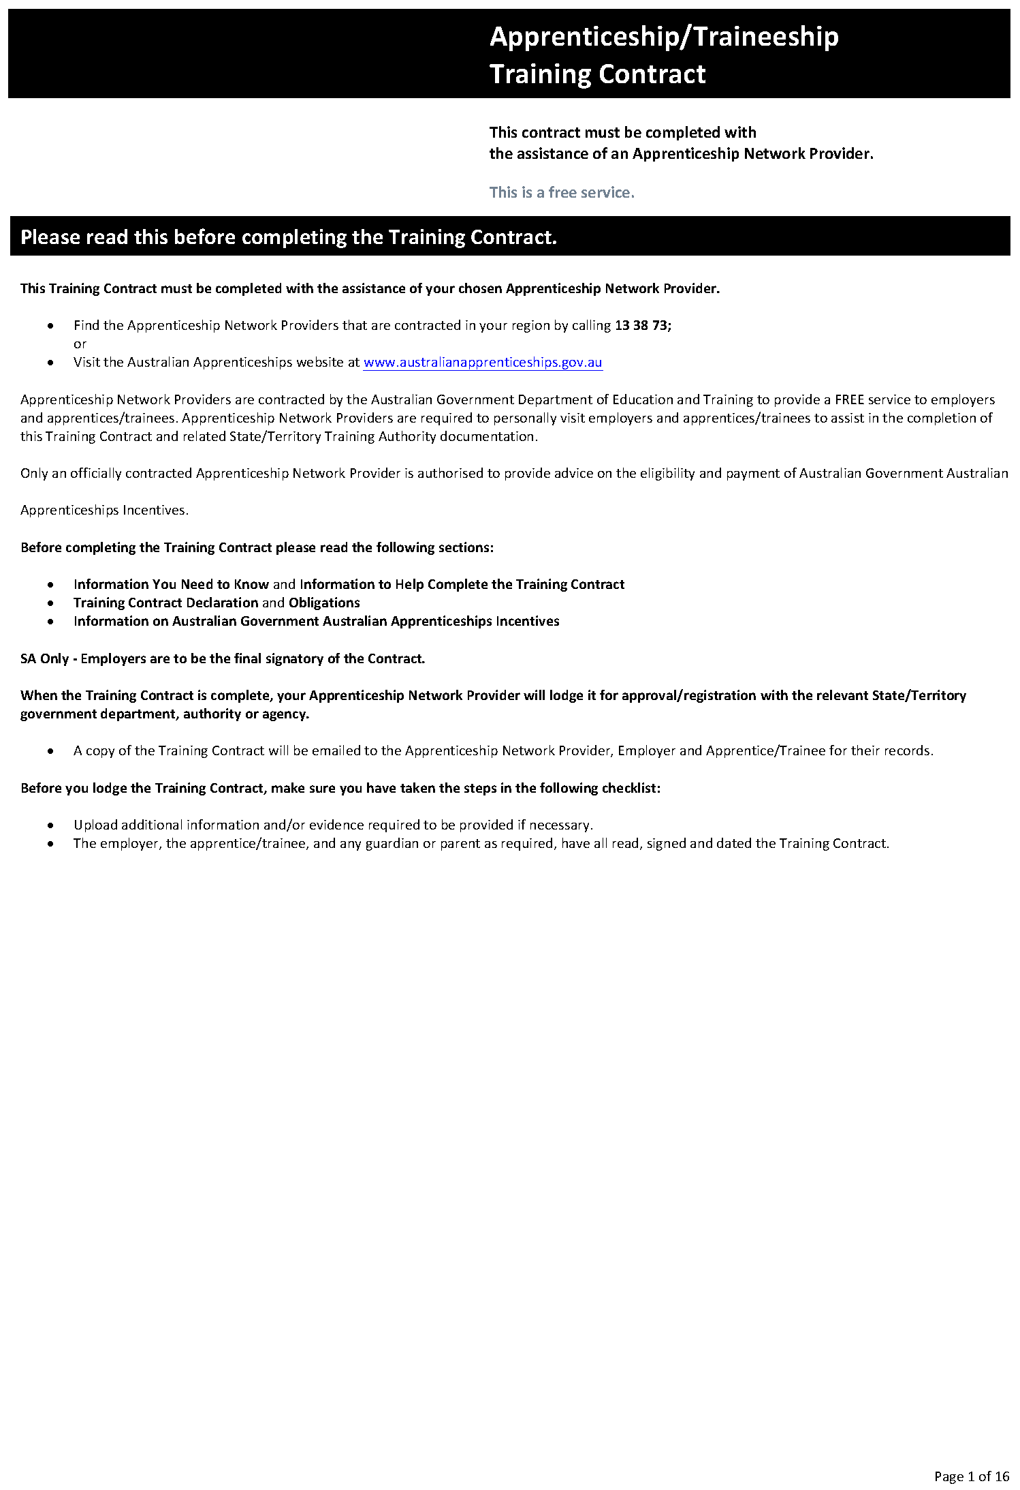
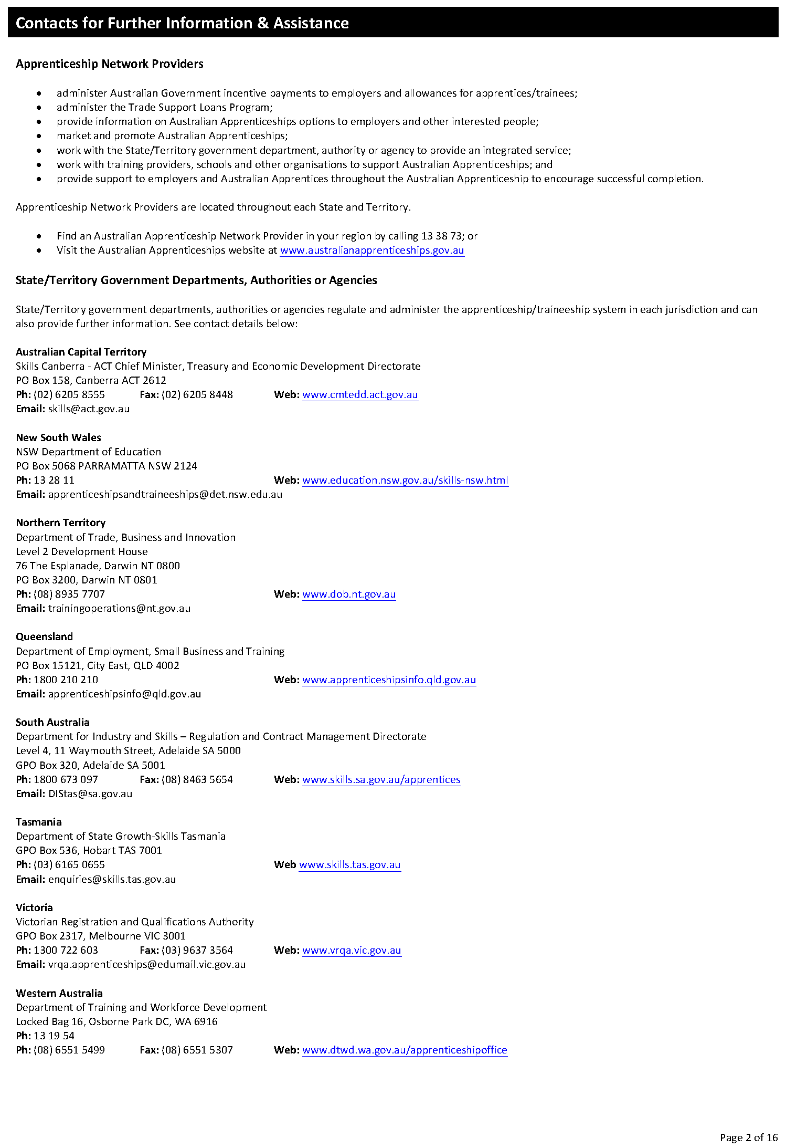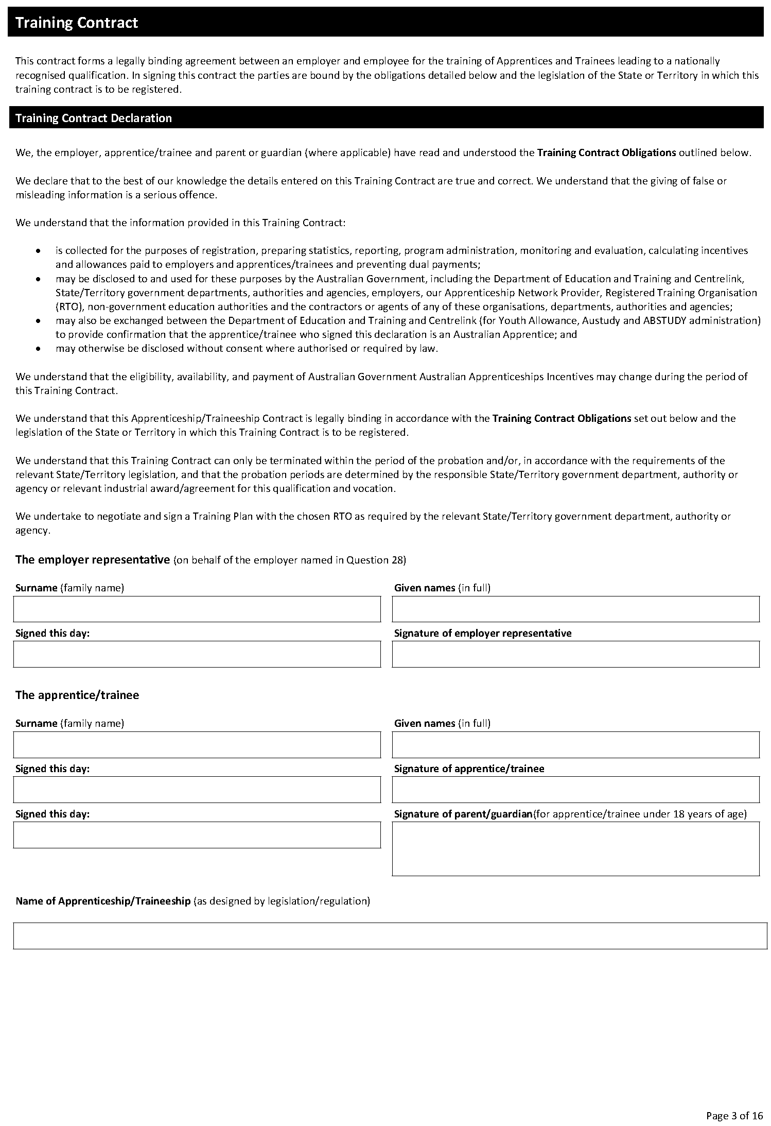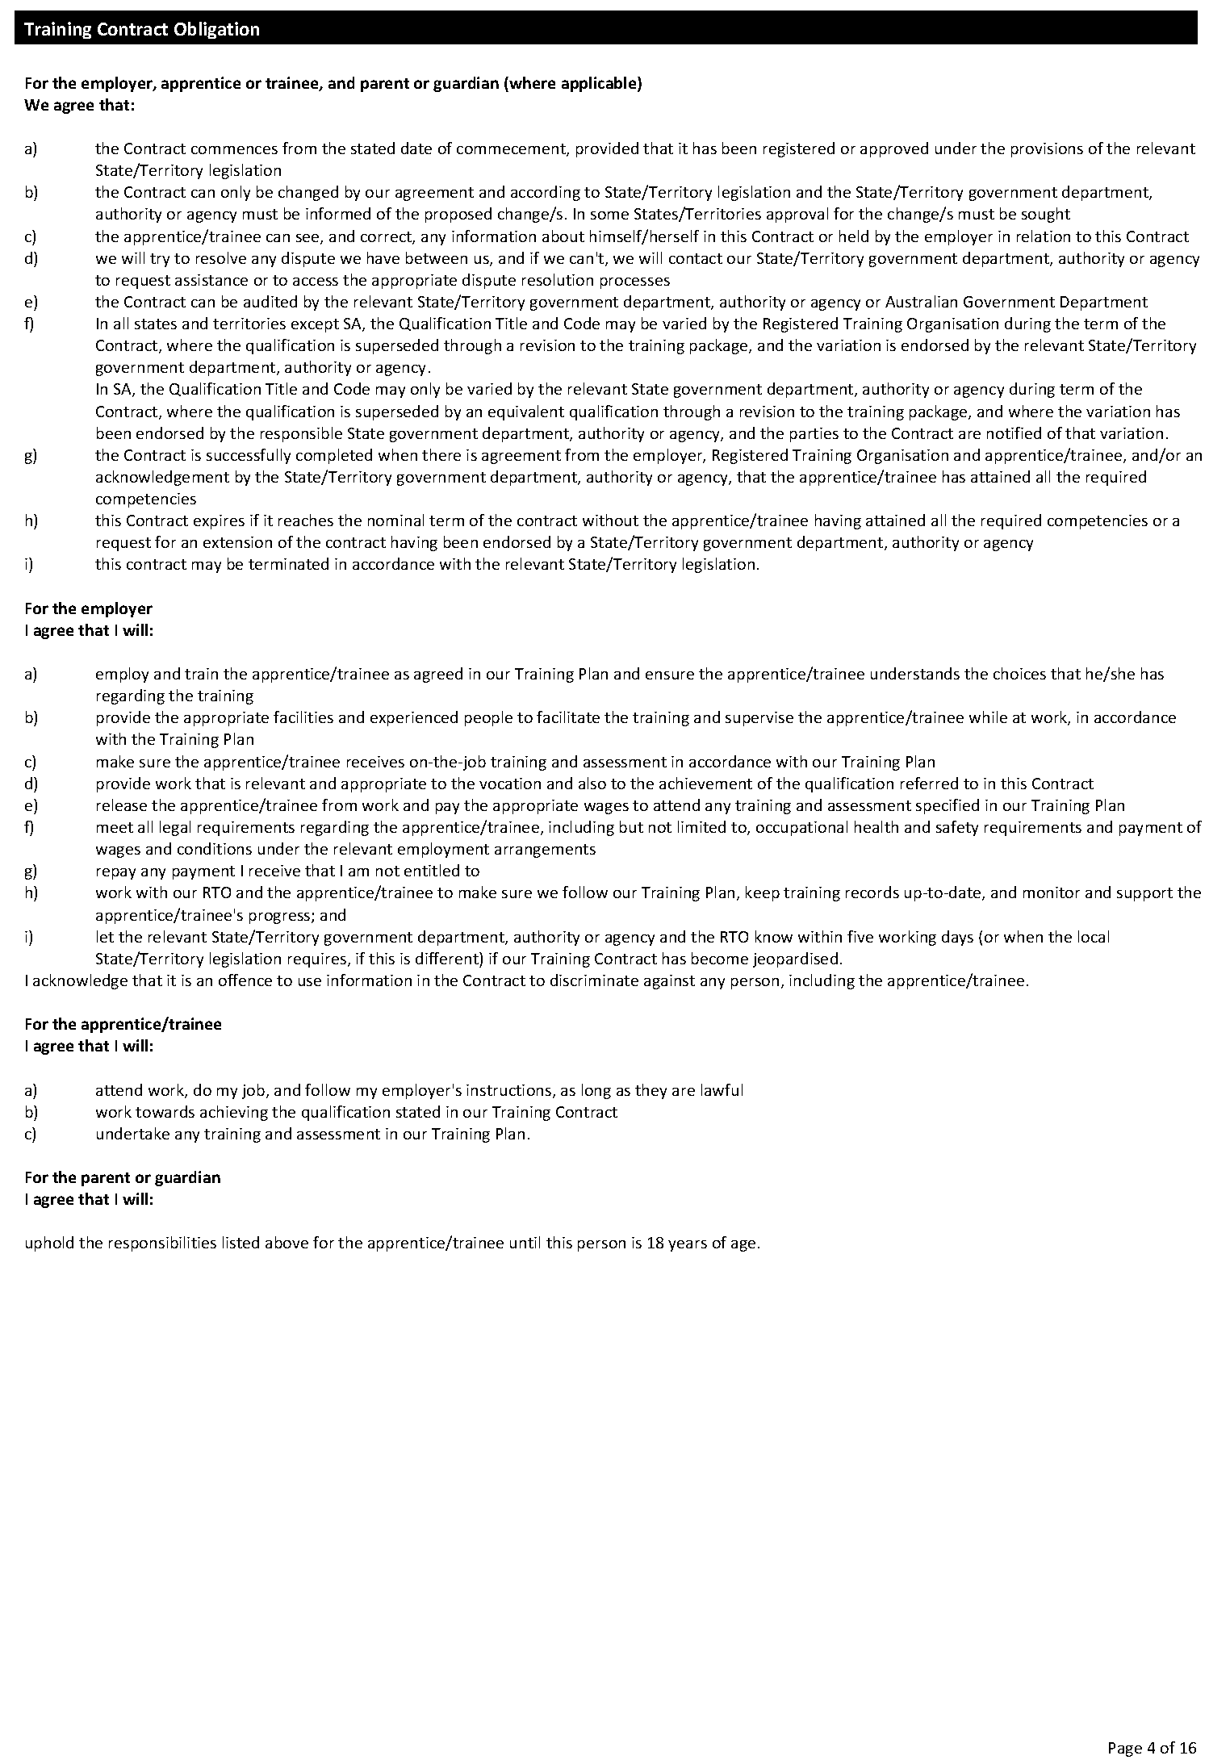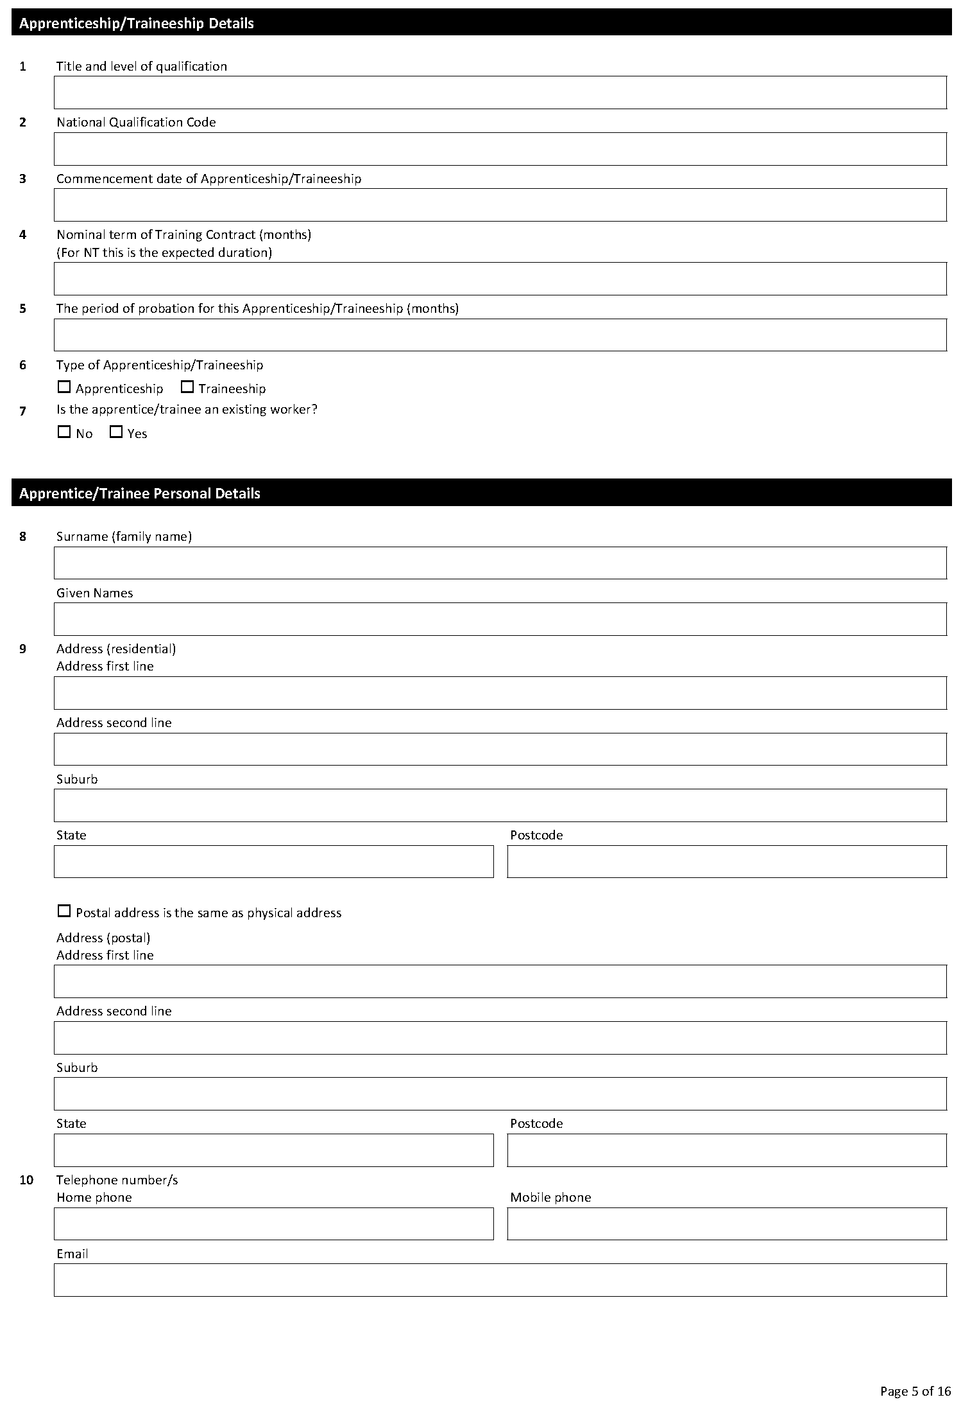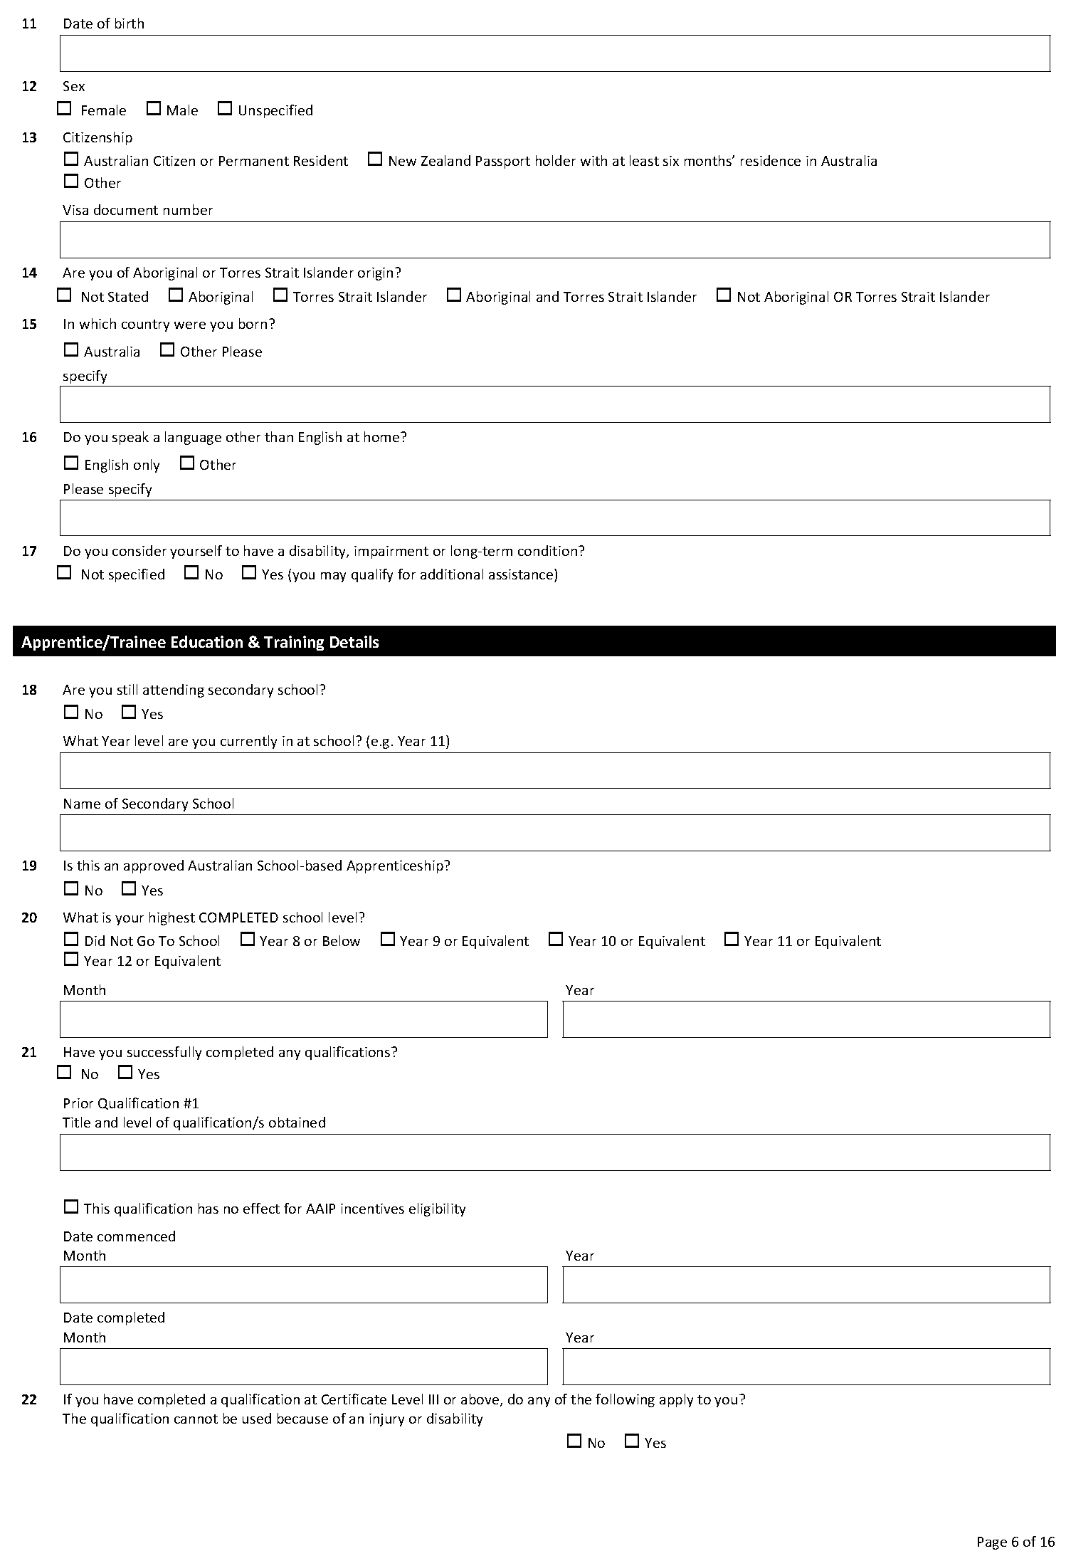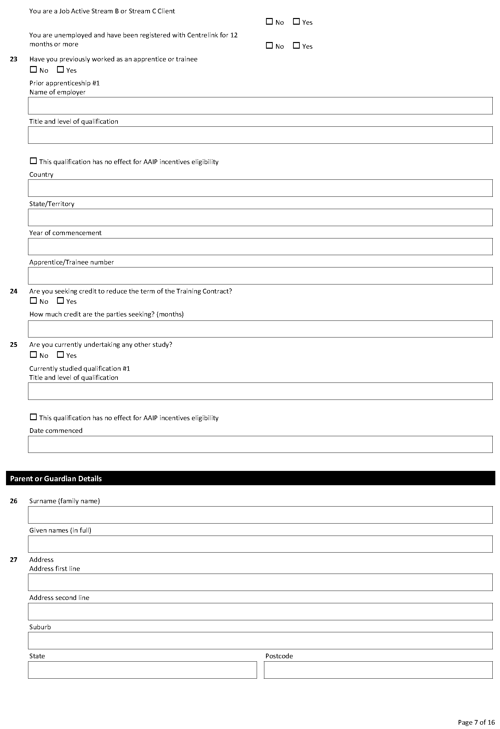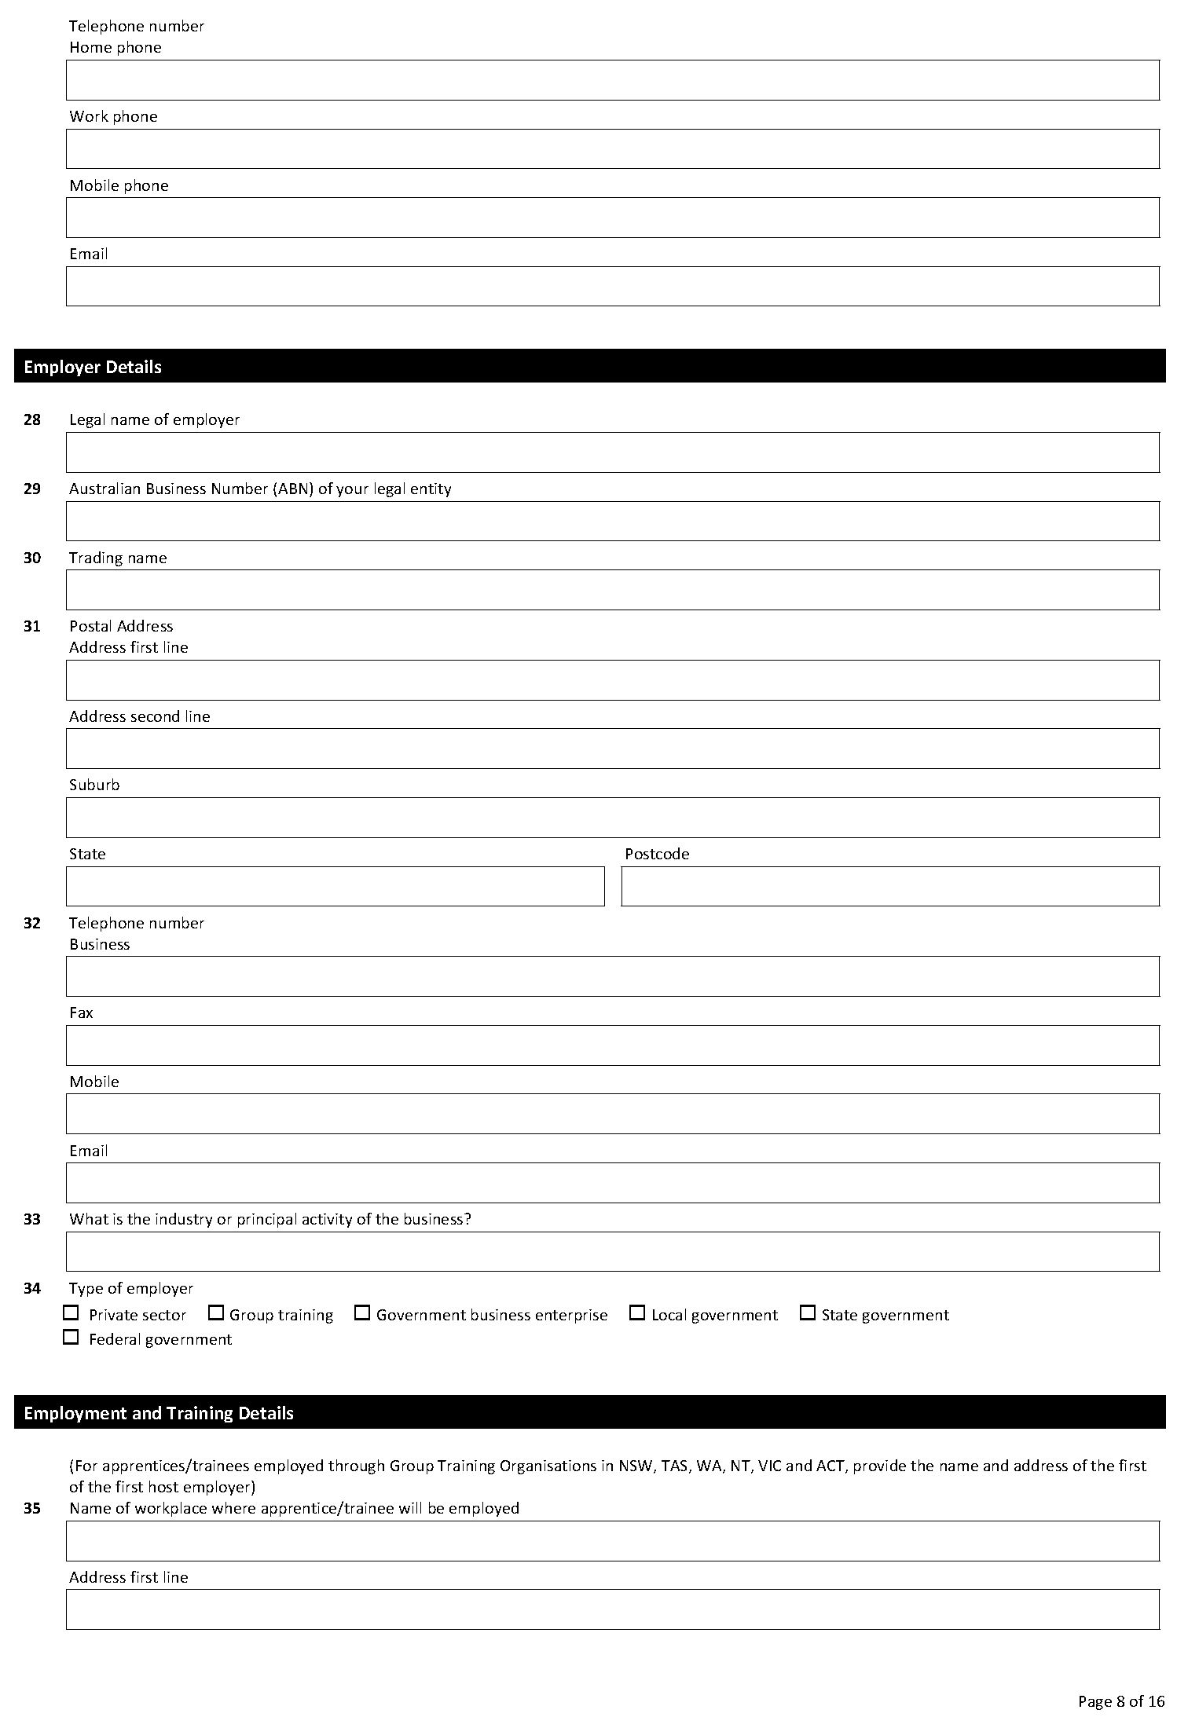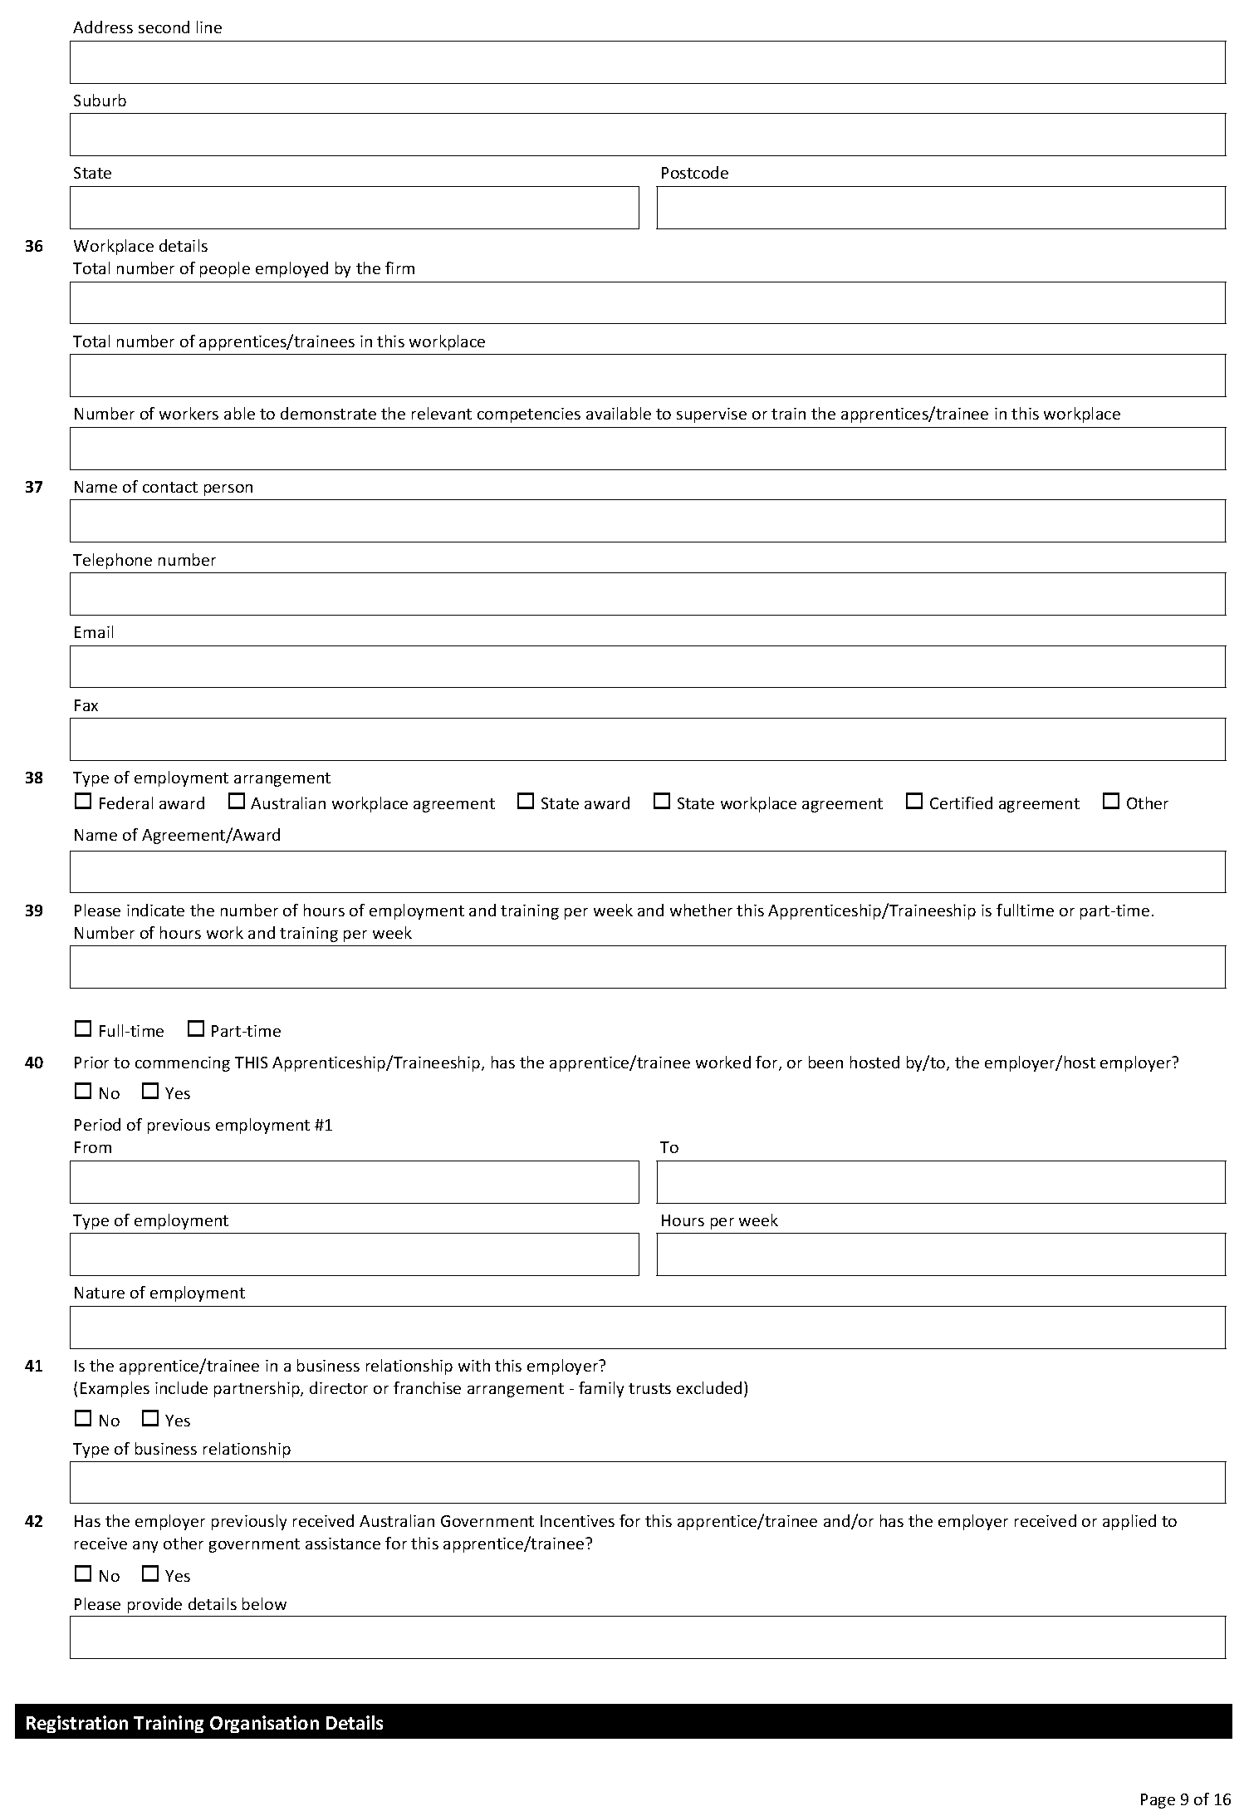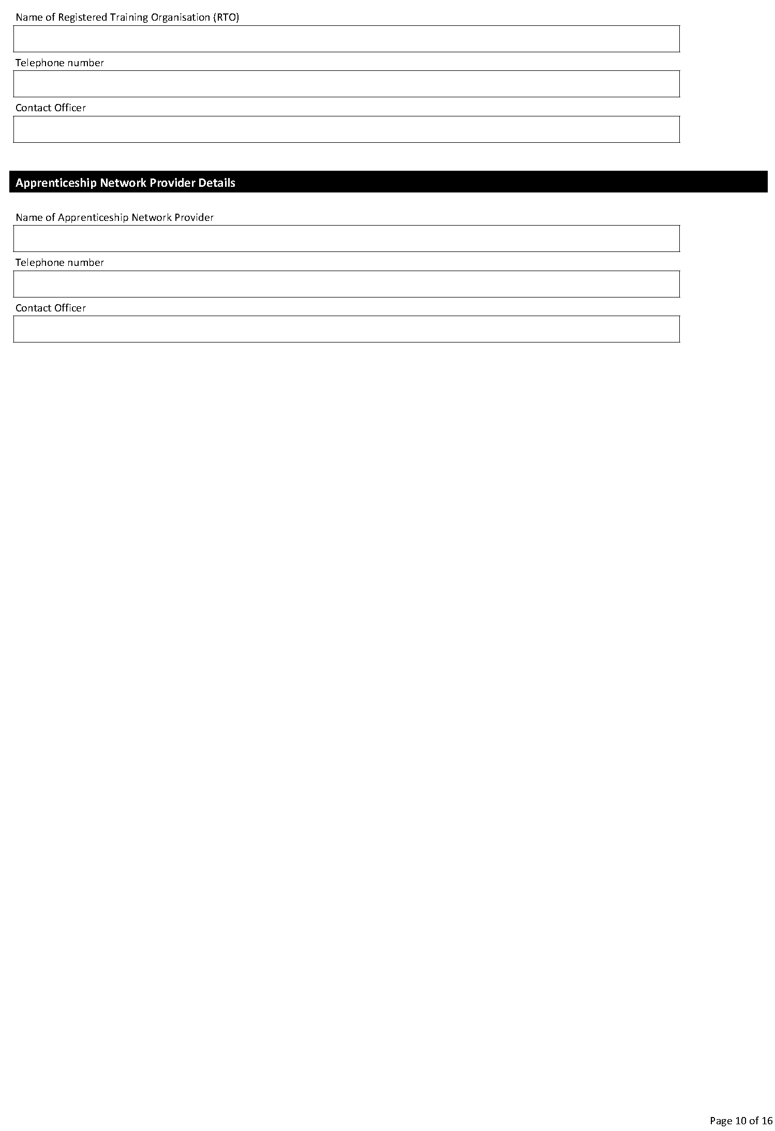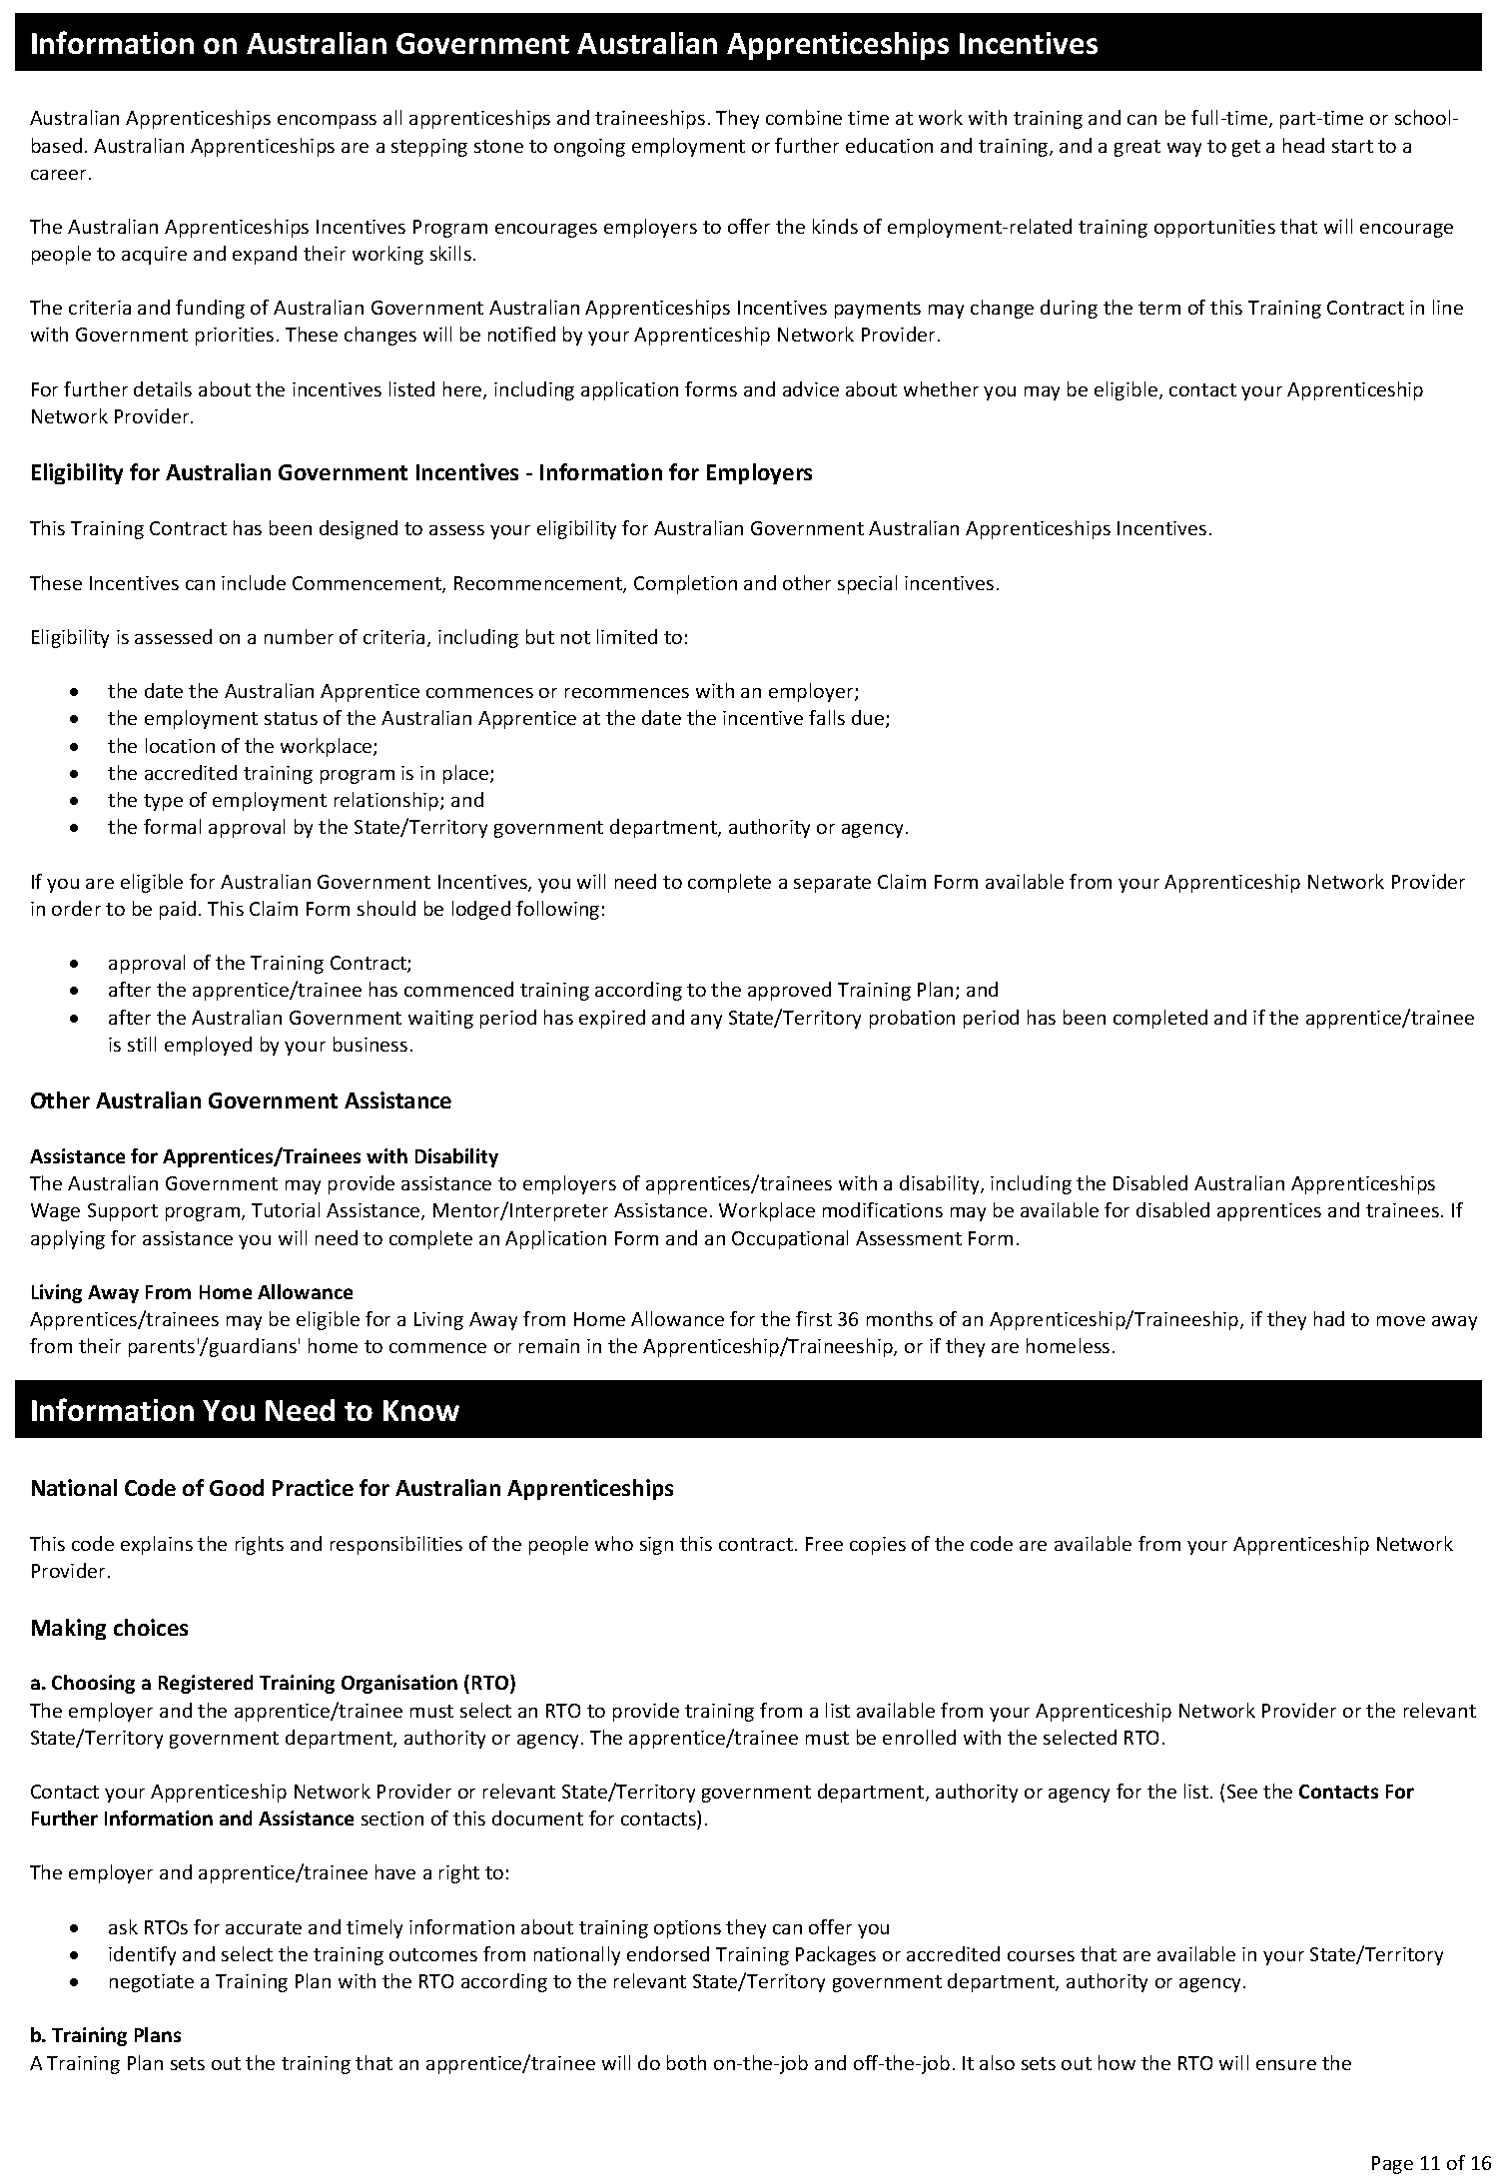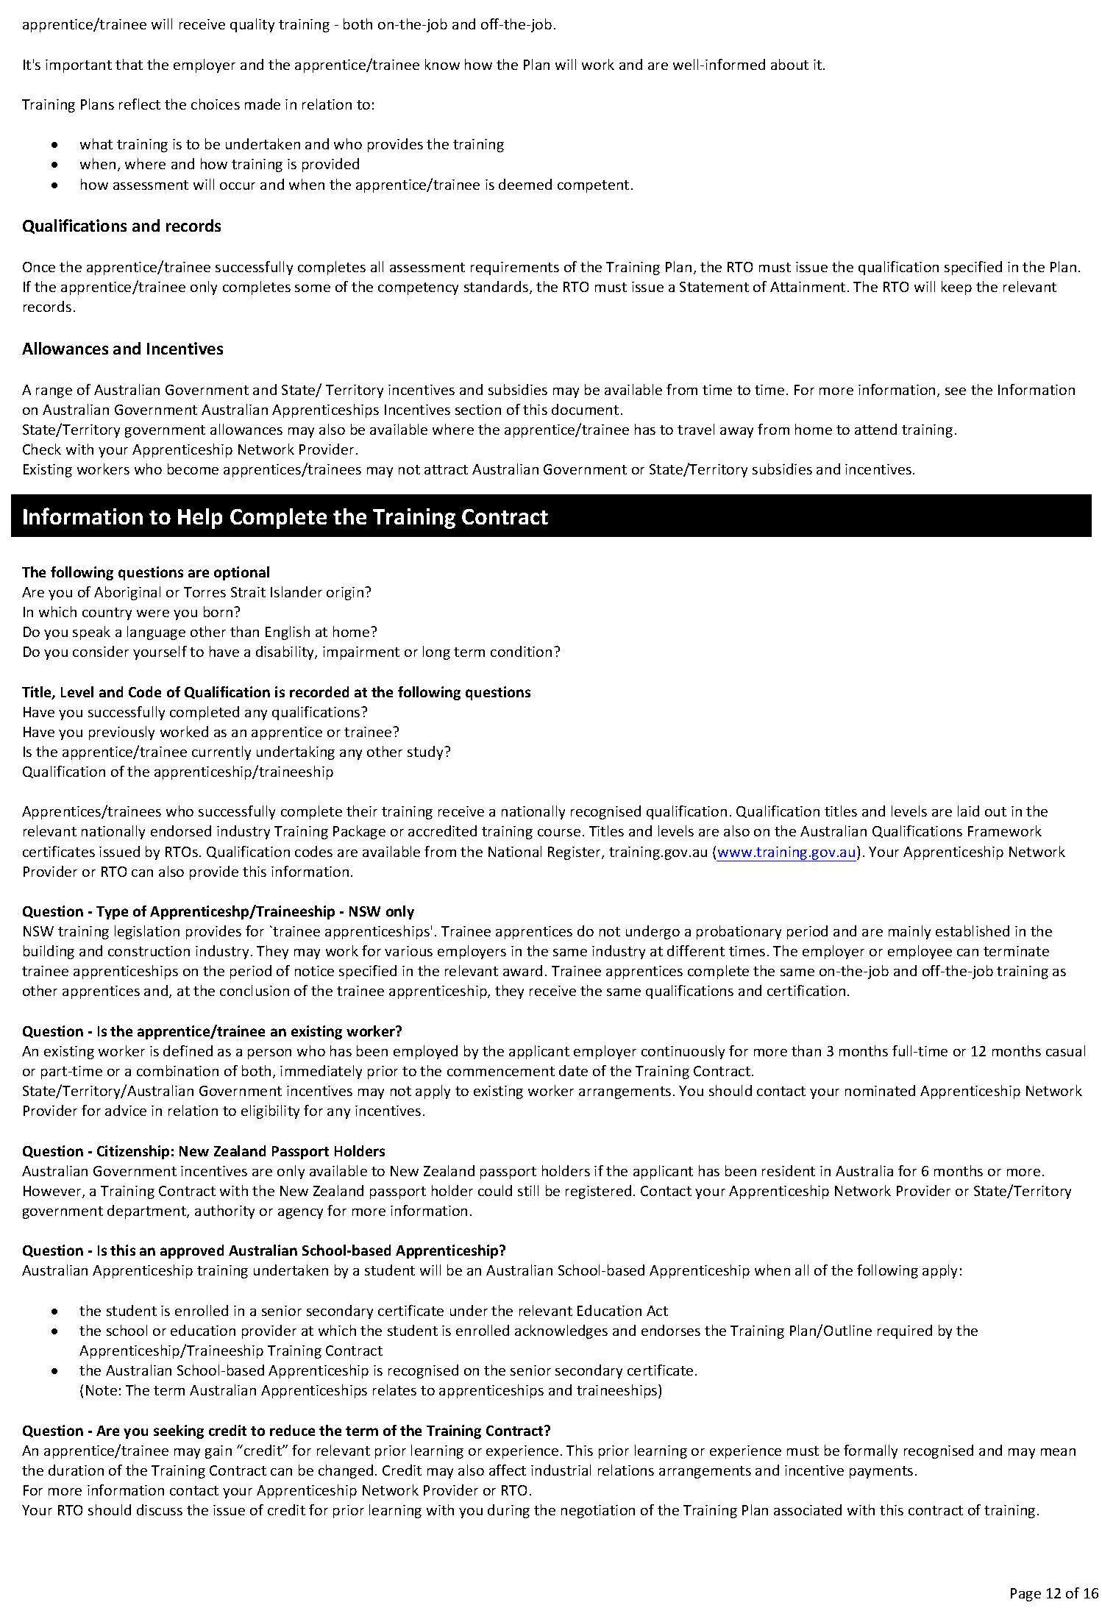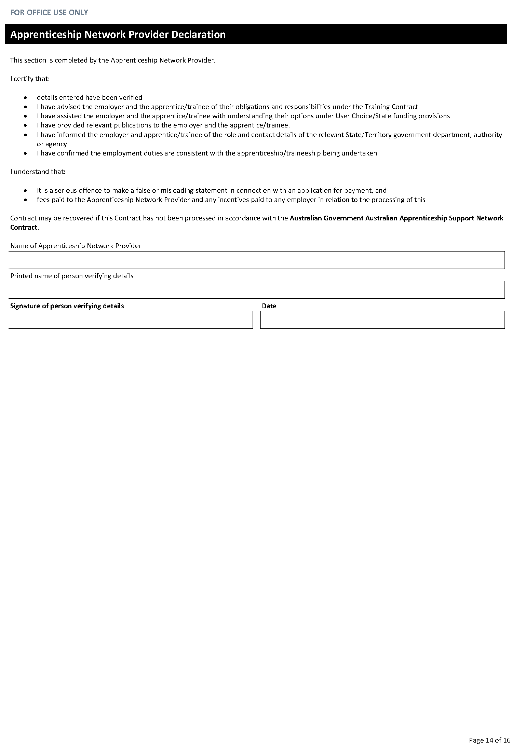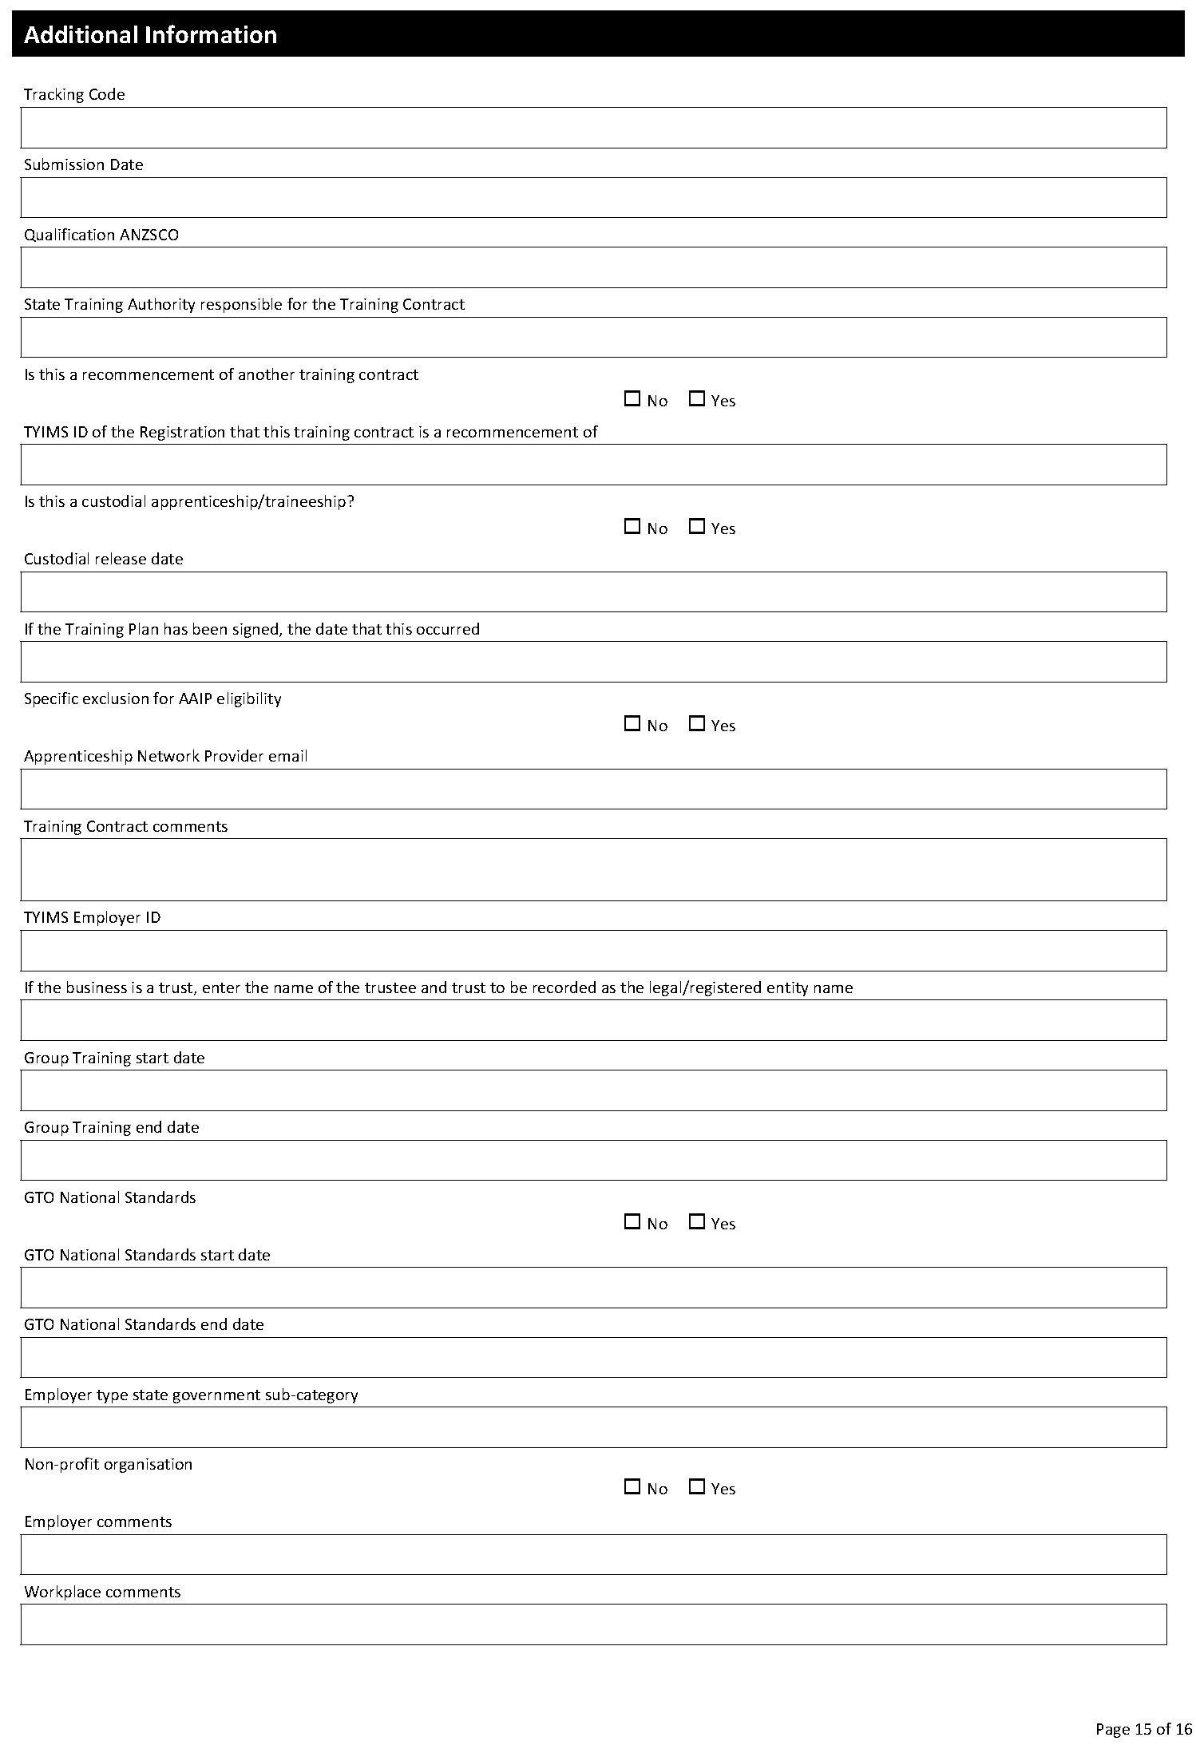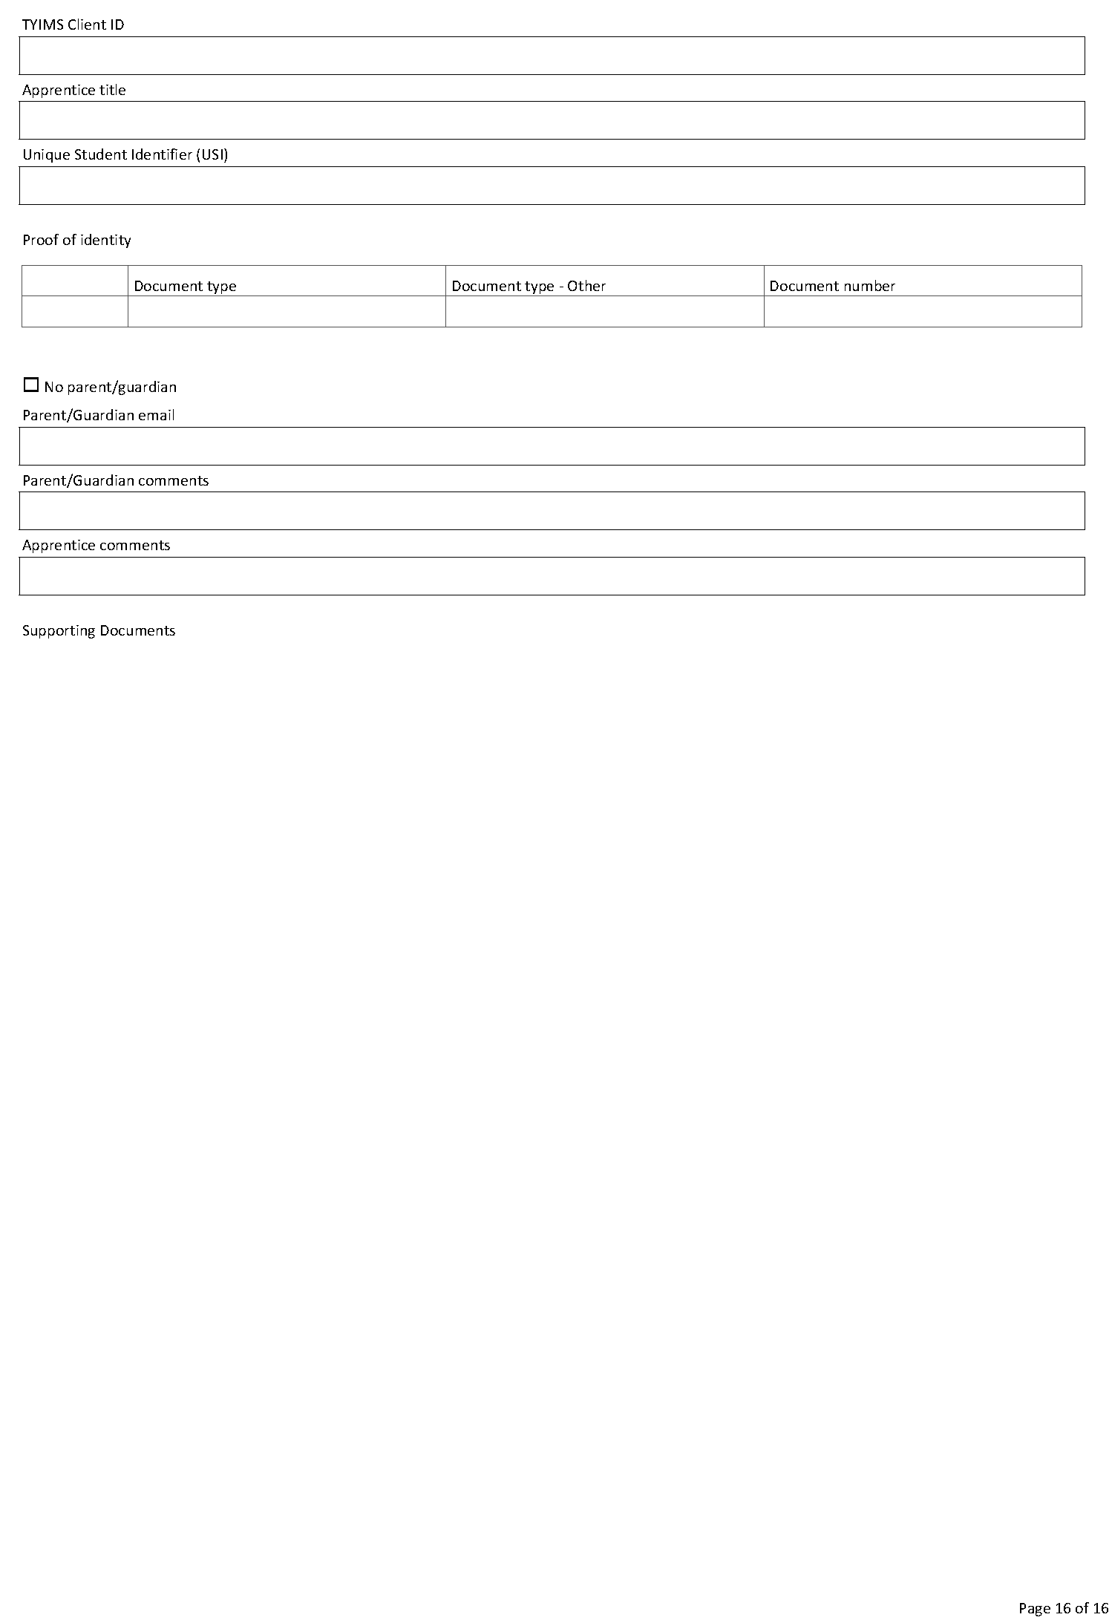

South Australian Skills Act 2008
South Australia
South Australian Skills (Fees) Notice 2023
under the South Australian Skills Act 2008
1—Short title
This notice may be cited as the South Australian Skills (Fees) Notice 2023.
Note—
This is a fee notice made in accordance with the Legislation (Fees) Act 2019.
2—Commencement
This notice has effect on 1 July 2023.
3—Interpretation
In this notice, unless the contrary intention appears—
Act means the South Australian Skills Act 2008.
4—Fees
The fees set out in Schedule 1 are prescribed for the purposes of the Act.
Schedule 1—Fees

1 | Fee payable to Commission on application under section 70A of the Act (section 70A(2)(c) of Act)—
 | (a) for a first or initial assessment | $534.00
 | (b) for a competency assessment or examination | $1 069.00
 | (c) for a second or subsequent assessment | $214.00
2 | Transfer fee payable to previous employer (section 54O(2) of the Act)—
 | (a) payable by a proposed employer who is a small business within the meaning of section 54O(6)(a) of the Act—
 | (i) for a transfer occurring in the first year of the training contract | $1 710.00
 | (ii) for a transfer occurring in the second year of the training contract | $3 421.00
 | (iii) for a transfer occurring in the third year of the training contract | $5 131.00
 | (iv) for a transfer occurring in the fourth year of the training contract | $6 841.00
 | (b) payable by a proposed employer who is a large business within the meaning of section 54O(6)(b) of the Act
 | (i) for a transfer occurring in the first year of the training contract | $2 138.00
 | (ii) for a transfer occurring in the second year of the training contract | $4 276.00
 | (iii) for a transfer occurring in the third year of the training contract | $6 414.00
 | (iv) for a transfer occurring in the fourth year of the training contract | $8 552.00
Made by the Minister for Education, Training and Skills
On 9 June 2023

Survey Act 1992
Fees and Levies Received by the Institution of Surveyors, Australia, South Australia Division Inc.
It is hereby notified that the below fees and charges to be levied by the Institution of Surveyors, Australia, South Australia Division Inc. for the 2023-24 financial year have been approved by Hon Nick Champion MP, Minister for Planning.
Inspection of Register $14.25
First Registration or Licence and Renewal of Registration or Licence $203.45
Late Renewal Charge and Issue of Duplicate Certificate of Registration or Licence $94.75
Plan Levy on lodgement of survey plans $141.60
Dated: 15 June 2023
S. Medlow-Smith
Registrar
Institution of Surveyors, Australia, South Australia Division Inc.

The Remuneration Tribunal
Report—No. 4 of 2023
2023 Inaugural Review of Minimum and Maximum Remuneration for Local Government Chief Executive Officers
Summary
- On 20 September 2021, section 60 of the Statutes Amendment (Local Government Review) Act 2021 (SA) came into operation. This inserted section 99A into the Local Government Act 1999 (SA) conferring jurisdiction on the Tribunal to determine the minimum and maximum remuneration that may be paid or provided to chief executive officers of councils constituted under the Local Government Act 1999 (SA).
- The Tribunal collected data in relation to the current total remuneration package of chief executive officers by way of two surveys. This occurred over an extended period of time due to the lack of response and inconsistencies of the first survey and the inaccuracies and incomplete information provided through the second survey, which required further consultation with councils.
- For this inaugural review, the Tribunal has determined to group 67 councils into eight bands. While these bands have some generally common characteristics, the Tribunal recognises differences and potential anomalies in terms of council characteristics within and between some of these bands. Each band is based on the data provided by councils in relation to the total remuneration package of their chief executive officer. The Tribunal has then applied assumptions in relation to the value of the provision of a motor vehicle and any additional leave entitlements beyond that of usual administrative staff. This has resulted in a figure described as an “adjusted total remuneration package” for each chief executive officer who is covered by this review.
- For the future, the Tribunal proposes to progress toward a review of the minimum and maximum remuneration of chief executive officers on a four yearly basis that is commensurate with the timeframe for local government member allowances. However, because this is the first review of this nature and it is based on data that is conflicting and inconsistent, it is acknowledged that councils may need to refer specific instances to the Tribunal for consideration. The Tribunal proposes to review the minimum and maximum remuneration amounts in July 2024 to take account of any feedback from councils and chief executive officers and annual wage and cost of living movements. The Tribunal expects any council who, as part of any future review, identifies significant differences in the remuneration package to provide sufficient detail and reasons as to why this is the case.
Introduction
- Section 14 of the Remuneration Act 1990 (SA) (Act) provides that the Remuneration Tribunal (Tribunal) has jurisdiction to determine the remuneration, or a specified part of the remuneration, payable in respect of certain offices, if such jurisdiction is conferred upon the Tribunal by any other Act or by the Governor by proclamation.
- On 20 September 2021, section 60 of the Statutes Amendment (Local Government Review) Act 2021 (SA) (Amending Act) came into operation. This inserted section 99A into the Local Government Act 1999 (SA) (LG Act) to confer jurisdiction upon the Tribunal to determine the minimum and maximum remuneration that may be paid or provided to chief executive officers (CEOs) of councils constituted under the LG Act.
- This review marks the first occasion on which the Tribunal has considered remuneration for local government CEOs.
Legislative Provisions
- Section 99A of the LG Act states:
“99A—Remuneration of chief executive officer
(1) Subject to this section, the remuneration of the chief executive officer of a council will be determined by the council.
(2) The Remuneration Tribunal will determine (from time to time) the minimum and maximum remuneration that may be paid or provided to chief executive officers of councils.
(3) In making a determination under subsection (2), the Remuneration Tribunal must have regard to any matter prescribed by the regulations.
(4) A determination under subsection (2)—
(a) may differ based on any factor including, for example, the geographical location of a council or group of councils (such that different minimum and maximum remuneration may be paid or provided to chief executive officers from different councils); and
(b) may provide for minimum and maximum remuneration that may be paid or provided to chief executive officers to be indexed in accordance with the determination.
(5) The regulations—
(a) may make further provision in relation to a determination of the Remuneration Tribunal for the purposes of this section; and
(b) may modify the application of section 10 of the Remuneration Act 1990 in relation to a determination under this section.
(6) Sections 17 and 19 of the Remuneration Act 1990 do not apply in relation to a determination under this section.
(7) A reference in the Remuneration Act 1990 to determining remuneration payable in respect of an office will, for the purposes of this section, be taken to include a reference to determining the minimum and maximum remuneration payable in respect of the office.
(8) Despite any other Act or law, the reasonable costs of the Remuneration Tribunal in making a determination under this section are to be paid by the LGA under an arrangement determined by the Minister from time to time after consultation with the LGA and the President of the Tribunal.
(9) The LGA may recover the reasonable costs incurred by the Remuneration Tribunal in making a determination under this section as a debt from the councils to which the determination relates.
(10) A council must ensure that the remuneration of its chief executive officer is within the relevant minimum and maximum remuneration determined by the Remuneration Tribunal for the purposes of this section.”
- The Tribunal has noted that some limited guidance about the intention of the above legislative provision can be drawn from the second reading speech in the following terms:
“The bill also proposes that the South Australian Remuneration Tribunal should set salaries for council chief executive officers to provide assurances to communities that CEOs are paid appropriately for the work that they do.”¹

¹ South Australia, Parliamentary Debates, House of Assembly, 17 June 2020 (Stephan Knoll).
- The Tribunal has considered the function of CEOs as these are expressed in the LG Act:
“99—Role of chief executive officer
(1) The functions of the chief executive officer include—
(a) to ensure that the policies and lawful decisions of the council are implemented in a timely and efficient manner;
(b) to undertake responsibility for the day-to-day operations and affairs of the council;
(c) to provide advice and reports to the council on the exercise and performance of its powers and functions under this or any other Act;
(d) to co-ordinate proposals for consideration by the council for developing objectives, policies and programs for the area;
(e) to provide information to the council to assist the council to assess performance against its strategic management plans;
(f) to ensure that timely and accurate information about council policies and programs is regularly provided to the council's community, and to ensure that appropriate and prompt responses are given to specific requests for information made to the council;
(g) to ensure that the assets and resources of the council are properly managed and maintained;
(h) to ensure that records required under this or another Act are properly kept and maintained;
(i) to give effect to the principles of human resource management prescribed by this Act and to apply proper management practices;
(j) to exercise, perform or discharge other powers, functions or duties conferred on the chief executive officer by or under this or other Acts, and to perform other functions lawfully directed by the council.
(2) The chief executive officer must consult with the council (to a reasonable degree) when determining, or changing to a significant degree—
(a) the organisational structure for the staff of the council; or
(b) the processes, terms or conditions that are to apply to the appointment of senior executive officers; or
(c) the appraisal scheme that is to apply to senior executive officers.”
- The Act provides a definition of remuneration, as follows:
“3—Interpretation
In this Act—
remuneration includes—
(a) salary; and
(b) allowances; and
(c) expenses; and
(d) fees; and
(e) any other benefit of a pecuniary nature;
the Tribunal means the Remuneration Tribunal established under Part 2.”
- The Tribunal has also noted the transitional provisions at section 147(5) of the Amending Act as follows:
“The remuneration of a chief executive officer holding office on the commencement of section 99A of the principal Act (as inserted by this Act) is not affected during the term of that office by a determination under section 99A.”
Procedural History
- Section 10(2) of the Act provides that prior to making a determination affecting the remuneration of a particular person, or persons of a particular class, the Tribunal must allow that person, or the persons of that class, a reasonable opportunity to make submissions orally or in writing to the Tribunal.
- Section 10(4) of the Act provides that the Minister responsible for the Act may intervene, personally or by counsel or other representative, in proceedings before the Tribunal for the purpose of introducing evidence, or making submissions, on any question relevant to the public interest.
- On 13 December 2021, the Tribunal met with the Local Government Association of South Australia (LGA) to discuss the Tribunal’s proposed process and guidelines for submissions.
- On 20 December 2021, the Tribunal wrote to the Premier of South Australia, as the Minister responsible for the Act, the Minister for Local Government, as the Minister responsible for the LG Act, the LGA and local government CEOs, inviting submissions.
- Additionally, on 20 December 2021, a public notification of the review and a guideline for the making of submissions was published on the Tribunal’s website.
- The guidelines advised the Tribunal would consider the following factors in making its determination:
  - The role of local government CEOs generally, including the diversity and complexity of the functions and duties performed by CEOs.
  - Any factors that demonstrate effective service delivery and responsible expenditure of public resources, including, but not limited to, any observations on the significance of this consideration.
  - The impact of council elected member code of conduct issues on the role of local government CEOs.
  - The impact of any mergers or amalgamations of local government councils on the role of the CEO.
  - Any regional issues, for example, housing entitlements or remote locality entitlements in regional local government areas.
  - The geographical size (area) of the council.
  - The revenue ($) of the council.
  - Number of electors (persons) of the council.
  - The impact of council staff numbers (FTE) on the role of the CEO and the extent to which CEOs of smaller councils undertake a diversity of roles.
  - The methodology by which any determination of minimum and maximum CEO remuneration bands should be indexed (CPI for example), and the frequency of further reviews of the remuneration bands by the Tribunal (4 yearly cycle as per elected members, for example).
  - Any other relevant information for the Tribunal’s consideration.
- These guidelines took into account the provisions of section 99A of the LG Act which states:
“(3) In making a determination under subsection (2), the Remuneration Tribunal must have regard to any matter prescribed by the regulations.
(4) A determination under subsection (2)—
(a) may differ based on any factor including, for example, the geographical location of a council or group of councils (such that different minimum and maximum remuneration may be paid or provided to chief executive officers from different councils); and
(b) may provide for minimum and maximum remuneration that may be paid or provided to chief executive officers to be indexed in accordance with the determination.”
- The closing date for written submissions was 11 March 2022.
- On 10 January 2022, the LGA wrote to the Tribunal offering its support with this review and proposing to conduct a survey of CEOs remuneration. The Tribunal provided examples of the elements of remuneration that could be collected through a survey.
- On 23 February 2022, the LGA provided an update to the Tribunal that it had received 30 responses from a total of 68 CEOs. The LGA advised it was uncertain as to whether the data from 30 councils constituted a fair and representative sample of CEOs remuneration. The Tribunal was of the view that a broader sample of information was required, noting there was real potential for a decision of the Tribunal to profoundly affect CEOs whose remuneration information had not been provided.
- The Tribunal also noted that some CEOs may be reticent to provide information relating to their remuneration to the LGA and, on this basis, the Tribunal wrote to CEOs on 17 March 2022 requesting a spreadsheet be completed and returned directly to the Tribunal by 1 April 2022.
- The Tribunal is sensitive to the potential confidentiality issues in relation to the information provided and as a result will not be disclosing individual names or information within this report or the accompanying determination.
- As part of this process, the Tribunal received a further 12 surveys.
- The Tribunal conducted a hearing on 2 May 2022 for councils and individuals seeking to make oral submissions to the Tribunal.
- The Tribunal received eight submissions from the following councils and individuals
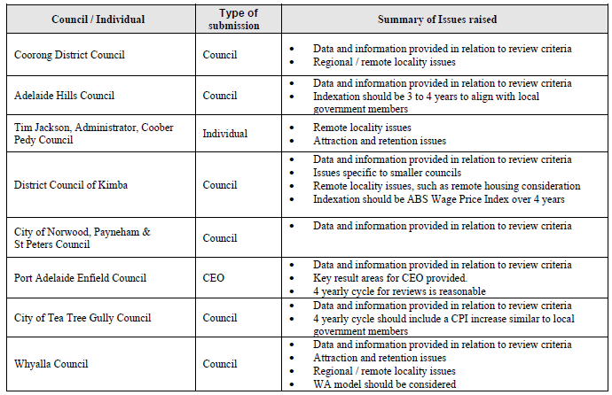
- This represents a small proportion of the councils and CEOs that were given the opportunity to make submissions.
- While the submissions generally provided information about the characteristics of these councils against the guidelines provided by the Tribunal, the information provided did not assist the Tribunal to determine a coherent and sustainable approach to establishing minimum and maximum levels of remuneration.
- The Tribunal noted information provided by the City of Port Adelaide Enfield’s CEO. This information provided a useful summary of the role of the CEO, covering oversight of the diverse assets and effective service delivery to a demographically diverse community together with engagement with the local and broader communities, and the development of that council area. This submission incorporated consideration of unique geographic, demographic, social, historical characteristics of that council.
- The Tribunal also noted the City of Norwood, Payneham and St Peters advice that CEO experience, performance reviews and annual remuneration reviews are pertinent issues when councils are considering CEO remuneration.
- Additionally, the Tribunal noted submissions made by primarily regional councils that they expected their CEOs to be more operationally focussed because of fewer middle management levels within the organisation.
- The regional council submissions also noted greater distance and travel commitments and challenges associated with staffing. Some councils argued strongly in favour of attraction and retention payments. The Tribunal particularly noted difficulties experienced by the Coober Pedy Council in attracting and retaining CEOs.
- The Tribunal noted that councils have unique requirements of their CEOs and require flexibility to negotiate remuneration arrangements to best meet these needs. For example, some councils may require a strategic leader to lead a complex organisation, while a small council may prefer a leader with exceptional technical expertise.
- The Tribunal was unable to identify any objective or standard approach to setting remuneration levels between councils.
- On 15 September 2022, the Tribunal provided an update to the LGA that it had obtained information from all councils and had spent some time assessing the data. The Tribunal’s capacity to reach accurate conclusions about the remuneration arrangements was severely limited by quite disparate approaches to different components of remuneration recorded by councils and their CEOs. This was exemplified in differing approaches to recording superannuation arrangements, including defined benefit superannuation arrangements and to motor vehicle costings which varied substantially. The Tribunal suggested it might engage an external professional consultancy to assist in this process.
- The LGA provided a response on 11 October 2022 in which it expressed concern about the costs of an external consultancy. The LGA suggested the Tribunal contact CEOs with questions of clarification designed to fill in any gaps in the data already available, rather than undertaking the survey process anew, advising this would reduce the costs associated with the review.
- On 29 November 2022, the Tribunal advised the LGA that the remuneration data it had was problematic in that the information provided by councils reflected very different approaches to calculating current significant elements of total remuneration and hence would result in a flawed and inconsistent assessment of maximum and minimum remuneration levels. The Tribunal also advised of its intention to conduct a further survey of CEO salary levels, requiring councils to provide costing instructions consistent with normal salary and accounting practices. Consistent with the request of the LGA, and to reduce the cost imposts on councils, the Tribunal agreed to conduct the further survey ‘in house’ using its own resources.
- Prior to distributing the updated survey to all CEOs, the Tribunal tested the revised survey approach on a small number of CEOs to identify any issues that councils may have with it. The LGA nominated four CEOs for this purpose.
- Following the conclusion of this trial process, the revised survey was sent to all CEOs on 16 December 2022. CEOs were requested to complete the survey by 25 January 2023.
- All survey responses were ultimately received by 7 March 2023 but inaccuracies and incomplete information required further consultation with councils to clarify the information provided. In a small number of instances, particularly relating to vehicle costing approaches, the Tribunal has had to make an estimate of total costs, including Fringe Benefits Tax implications.
Consideration
- The Tribunal’s jurisdiction in relation to local government CEOs is confined to making determinations, from time to time, in relation to the minimum and maximum levels of remuneration only.
- The Tribunal notes that individual councils can determine, within those minimum and maximum remuneration levels, the specific amount of remuneration to be paid to their CEO, as well as the various components of the remuneration package, such as superannuation, motor vehicles, allowances or other non-monetary benefits, provided that these total remuneration arrangements fall within the minimum and maximum amounts set by the Tribunal.
- In determining what constitutes remuneration, the Tribunal has taken into account the following components:
- Monetary remuneration
- Superannuation, including the statutory minimum employer contributions, any salary sacrifice component and any additional payments made by a council
- Annual leave loading
- Additional leave entitlements
- Bonuses and performance incentives - in cash or otherwise
- The private benefit value of any motor vehicle and/or equipment (excluding mobile telephones and portable computing equipment provided to the CEO by the council)
- School or childcare fees, including school uniforms
- Newspaper/magazine/online subscriptions
- Personal travel or any other benefit taken in lieu of salary by the CEO (and immediate family at the discretion of the council)
- Health insurance
- Any and all allowances
- Any other form of payment - cash or otherwise
- Any Fringe Benefits Tax paid by council in respect of any of the above
- The Tribunal concluded that mobile telephones and portable computing equipment provided to CEOs, fundamentally for work purposes, but which may be used for reasonable personal use, should not be regarded as remuneration for these purposes. The Tribunal considers that these items are inherent requirements for a CEO function and, in any event, any additional reasonable use represents a minimal additional cost such that separating personal and business use involves unreasonable administrative costs.
- The Tribunal has not included professional development costs that directly relate to the performance of CEO duties and membership of professional associations related to the performance of CEO functions in its assessment of remuneration.
- The Tribunal has not included one-off payments that relate directly and solely to relocation expenses in its consideration of remuneration.
- Motor Vehicles
- The December 2022 survey required councils to include the annual amount of the personal benefit value of the provision of a motor vehicle for private use or cash in lieu of a motor vehicle. The personal benefit value was to be determined by multiplying the percentage of personal use of the vehicle, by the annual cost to the council for that vehicle, including all annual costs of maintenance, fuel, taxes, registration, running costs, as well as an annual depreciation. Depreciation was to be calculated using the rate of 12.5% (prime cost method) or 25% (diminishing value method).
- There were significant variations in motor vehicle arrangements amongst councils, reflecting different costing approaches, obvious differences in motor vehicles, the extent to which motor vehicle use was for business purposes and Fringe Benefits Tax recognition.
- The Tribunal has concluded that a sustainable basis for some of these estimates has not been established and urges councils to review their costing methodologies. The Tribunal suggests the application of a consistent approach to motor vehicle costing arrangements for the future based on actual annual cost of provision of any motor vehicle provided by the council, less an assessed component for business use. The methodology outlined above is proposed as an appropriate approach for the future.
- To assist the Tribunal in setting minimum and maximum levels of remuneration, for the purpose of this review, it has built an assumption into the data obtained for motor vehicles. Where the value of the motor vehicle and Fringe Benefits Tax was below $20,000, the Tribunal added the difference to the total package of remuneration (i.e. if the council provided a value of $15,000 for the motor vehicle and Fringe Benefits Tax, then the Tribunal has added $5,000 to the total package of remuneration). Where a Council has not provided Fringe Benefits Tax information, the Tribunal has estimated that value and incorporated that estimate into its assessment of total remuneration. For clarity, this does not propose an actual increase in the remuneration payable to those CEOs, but rather, ensures a more consistent and realistic approach to the valuation of vehicles.
- To the extent that councils negotiate new contractual arrangements, it is appropriate that motor vehicle costs that relate to all private use are separately recognised as remuneration components.
- Additional leave per year
- Councils were requested to provide any additional leave entitlements that CEOs receive beyond the standard four week entitlement and to confirm if that additional leave was “purchased” through a salary deduction or whether it was simply an added employment benefit.
- The total remuneration package of CEOs for the purpose of assessing minimum and maximum remuneration was then adjusted to take into account the monetary value of any additional leave entitlements.
- Superannuation
- The Tribunal noted that some CEOs are members of defined benefit funds but access to these superannuation arrangements is not available to more recent appointees. The Tribunal has also recognised that some CEOs contribute extra payments to these defined benefit funds. The difficulties associated with comparing defined benefit funds with accumulation funds are significant. For the purposes of this assessment, the Tribunal has universally recognised the minimum Superannuation Guarantee legislative provisions, and any explicit amounts paid by councils in excess of these national minimum standards irrespective of whether a defined benefit scheme is in operation.

- Allowances
- As discussed above, the Tribunal has considered any and all allowances to form part of remuneration. This includes any housing allowance, remote allowance, attraction or retention allowance, utilities allowance or reimbursement or direct payment, grooming or clothing allowance and any entertainment related allowances or entitlements.
- The Tribunal recognises that the characteristics of some councils means they may place more significance on some allowances. For example, an additional remuneration element in the form of an allowance may need to be agreed between a council and its CEO to recognise either distance or remoteness issues.
- The Tribunal has adopted the position that the Coober Pedy Council should be recognised as facing particular recruitment challenges given the combination of its remoteness and unique characteristics.
- Whilst the current minimum and maximum amounts set for each remuneration level take into account all allowances, the Tribunal urges councils to notify it of any substantial issues or adjustments that may need to be made or taken into account in the next review.
- Fringe Benefits Taxes
- The minimum and maximum remuneration amounts have been set on the basis that councils will recognise any applicable Fringe Benefits Tax in the total remuneration costing for CEOs.
- The Municipal Council of Roxby Downs
- The Tribunal has noted the unique position of the Municipal Council of Roxby Downs. This reflects the indenture agreement applicable to that area and the unique funding arrangements that apply. Accordingly, the Tribunal has not included this council in this review.
Remuneration Levels
- Other Jurisdictions
- In the conduct of this review, the Tribunal considered available information relating to local government CEO remuneration in other Australian jurisdictions.
- The April 2023 determination of the Western Australian Salaries and Allowances Tribunal reviewed remuneration bands for local government CEOs and allowances for certain elected members. In that determination, a four-band structure was adopted with total reward package bands ranging from $136,023 to $404,488 per annum. In addition, maximum separate isolation allowance amounts for nominated councils were identified, taking into account the remoteness, cost of living, social disadvantage, the impact of a dominant industry, attraction and retention issues and community expectations. The quantum of these maximum payments depended on the assessed circumstances of the local council concerned. The determination provided for a discretionary housing allowance where there was a lack of suitable housing, or recruitment issues. The determination considered the private benefit value of motor vehicles provided to CEOs for reporting purposes.
- Information relative to other States and Territories is not uniformly published, thereby limiting the usefulness of any comparative analysis, and there is no regulatory arrangement equivalent to the Western Australia Salaries and Allowances Tribunal.
- The Tribunal has historically applied a six-level grouping system for the consideration of allowances applicable to members of councils. In its 2022 Report, the Tribunal expressed reservations about the usefulness of this arrangement and has indicated that it proposes to invite submissions about a review of that arrangement in 2026.² Notwithstanding these observations, the Tribunal has considered the extent to which the current groupings could provide a basis for the determination of minimum and maximum remuneration levels. There are significant impediments to such an approach. Firstly, the characteristics of councils within the established groups that may be particularly relevant to CEOs vary substantially within and between the groups such that use of the groups for this purpose appears illogical. Secondly, the Tribunal considers that exclusive reliance on factors such as overall staff numbers does not equate to a measure of CEO skill requirements.

² South Australian Remuneration Tribunal, Report of the Remuneration Tribunal: 2022 Allowances for Members of Local Government Councils, Report 2 of 2022, p.9 [https://www.remtribunal.sa.gov.au/documents/2022/20220705-Report-2-of-2022-Members-of-Local-Government.pdf]
- The Tribunal has taken into account national salary surveys of the local government sector. Because of the substantial range between low and high remuneration levels, and uncertainties about just how employment benefits are assessed, this information is of limited value in setting minimum and maximum levels in South Australia, consistent with the legislative requirements. It has, however, confirmed that the CEO remuneration levels are generally consistent with the indicative survey data.
- Minimum and maximum remuneration levels in South Australia
- The Tribunal’s preference is to progress toward establishing minimum and maximum remuneration levels founded on an assessment of skill and competence levels. Such an approach would allow the flexibility to set remuneration consistent with the challenges confronting a given council. However, the limited information available to the Tribunal, combined with the very small number of submissions, simply does not support such an approach at this time. Councils are encouraged to make submissions about such an approach in the future.
- The Tribunal is not in a position to determine the minimum and maximum remuneration levels based on factors such as the geographical size of the council, revenue of the council and other factors as listed in paragraph 18 above. It considers these factors to be sensible criterion to guide any future determinations of the Tribunal, however, under the current legislation such an approach requires the cooperation of councils.
- For this inaugural review, the Tribunal has determined to group councils into eight bands. While these bands have some generally common characteristics, the Tribunal recognises differences and potential anomalies in terms of council characteristics within and between some of these bands. Each band is based on the data provided by councils in relation to the total remuneration package of their CEO. The Tribunal has then applied assumptions in relation to the value of the provision of a motor vehicle and any additional leave entitlements beyond that of usual administrative staff. This has resulted in a figure described as an “adjusted total remuneration package” for each CEO who is covered by this review.
- With the exception of the band consisting of the City of West Torrens, City of Charles Sturt and City of Port Adelaide Enfield, the bandwidths range from $17,680 to $32,240. This group of three councils has a much smaller bandwidth be it that total remuneration amounts are significantly higher than most other metropolitan councils. The Tribunal was cognisant of the fact that remuneration discrepancies between councils meant that clearly definable criterion such as that listed in paragraph 18 could not be used to define bands without resulting in very large band remuneration diversity inconsistent with the function of the legislation.
- The Tribunal has determined that the Adelaide City Council should be separated from councils generally for the purpose of considering CEO remuneration. This recognises that separate legislation covers that council. As no submission was received from the Adelaide City Council in relation to this review, the Tribunal’s consideration is entirely based on the current total remuneration for the Adelaide City Council CEO.
- The Tribunal has differentiated between the City of West Torrens, City of Charles Sturt and City of Port Adelaide Enfield and other significant metropolitan councils. This distinction is entirely based on current remuneration arrangements which differ substantially from other significant metropolitan councils and large provincial centres.
- A further group of metropolitan, near metropolitan councils and larger regional councils have been grouped together. The Tribunal has placed the Corporation of the Town of Walkerville in this group but notes that the characteristics of that Corporation are fundamentally different from all other metropolitan councils. Finally, the Tribunal has established two groupings of regional councils, largely distinguished by population characteristics.
- While the approach the Tribunal has taken in this review restricts the extent to which exceptional circumstances of a particular council can be properly recognised and provides limited explanation of the basis for existing remuneration levels to the community, this reflects the disparate current remuneration levels and lack of information about how these were arrived at. A more accurate assessment of remuneration bands based on council characteristics and performance measures is not possible on the information made available to the Tribunal. The Tribunal suggests that it may be appropriate for discussions with the LGA in advance of the next review to identify minimum and maximum remuneration levels based on agreed council criteria, with the potential for separate recognition of attraction incentives and defined performance measures.
- The Tribunal considers that wage price movements should be recognised within the framework of minimum and maximum remuneration levels, particularly given the time period that has lapsed between the commencement of the inaugural review and the operative date of the Determination.
- The Tribunal has considered the wage movements and current rate of inflation and has factored these into the minimum and maximum amounts of remuneration but notes that the increase applied is substantially less than CPI.
- Any decision in relation to an annual increase for CEO remuneration within the bands set by the Tribunal remains a matter for each council in accordance with section 99A(1) of the LG Act.
- Furthermore, in accordance with section 147(5) of the Statutes Amendment (Local Government Review) Act 2021 (SA), if the current remuneration level for a CEO is below the minimum band level set by the Tribunal, this may be increased to within the band limits at the discretion of the council. Conversely, if the remuneration level for a CEO is above the band level maximum, the Tribunal would expect no further increase in remuneration during the term of that appointment unless the remuneration level was to fall below the maximum remuneration level following any annual adjustments established by the Tribunal.
Frequency of Reviews
- The Tribunal proposes to progress toward a review of the minimum and maximum remuneration of CEOs on a four yearly basis that is commensurate with the timeframe for local government member allowances. However, because this is the first review of this nature and it is based on data that is conflicting and inconsistent, it is acknowledged that councils may need to refer specific instances to the Tribunal for consideration. The Tribunal will review the minimum and maximum remuneration levels in July 2024 to take account of any feedback from councils or CEOs and wage and cost of living adjustments. The Tribunal expects any council who, as part of any future review, identifies significant differences in the remuneration package to provide sufficient detail and reasons as to why this is the case.
Operative Date
- The accompanying Determination will come into operation on and from 1 July 2023.
Dated: 16 June 2023
Matthew O’Callaghan
President
Deborah Black
Member
Peter De Cure AM
Member

The Remuneration Tribunal
Determination —No. 4 of 2023
Minimum and Maximum Chief Executive Officer Remuneration
Scope of Determination
- This Determination applies to Chief Executive Officers of Local Government Councils to whom section 99A of the Local Government Act 1999 (SA) applies.
- For the reasons provided in the accompanying report, The Municipal Council of Roxby Downs is not covered by this Determination.
Minimum and Maximum Remuneration
- In accordance with section 99A of the Local Government Act 1999 (SA) (LG Act) the Remuneration Tribunal hereby determines the following rates of minimum and maximum remuneration for Chief Executive Officers of Local Government Councils in South Australia:
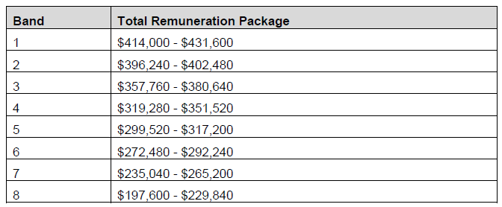
- Remuneration figures are expressed on a total remuneration package basis.
- A list of council groupings is included at attachment 1.
- Any decision in relation to an annual increase for CEO remuneration within the bands set by the Tribunal remains a matter for each council in accordance with section 99A(1) of the LG Act
Date of Operation
- This Determination shall have operative effect on and from 1 July 2023.
Dated: 16 June 2023
Matthew O’Callaghan
President
Deborah Black
Member
Peter De Cure AM
Member

Attachment 1
Council | Band
Adelaide Hills Council | 5
Adelaide Plains Council | 6
Alexandrina Council | 5
Barunga West Council | 7
Berri Barmera Council | 7
Campbelltown City Council | 3
City of Adelaide | 1
City of Burnside | 4
City of Charles Sturt | 2
City of Holdfast Bay | 4
City of Marion | 4
City of Mitcham | 3
City of Mount Gambier | 5
City of Norwood Payneham & St Peters | 4
City of Onkaparinga | 3
City of Playford | 4
City of Port Adelaide Enfield | 2
City of Port Lincoln | 7
City of Prospect | 5
City of Salisbury | 3
City of Tea Tree Gully | 4
City of Unley | 3
City of Victor Harbor | 6
City of West Torrens | 2
City of Whyalla | 4
Clare & Gilbert Valleys Council | 7
Coorong District Council | 7
Copper Coast Council | 6
Corporation of the Town of Walkerville | 5
District Council of Ceduna | 6
District Council of Cleve | 7
District Council of Coober Pedy | 8
District Council of Elliston | 8
District Council of Franklin Harbour | 7
District Council of Grant | 7
District Council of Karoonda East Murray | 8
District Council of Kimba | 8
District Council of Lower Eyre Peninsula | 7
District Council of Loxton Waikerie | 7
District Council of Mount Remarkable | 7
District Council of Orroroo Carrieton | 8
District Council of Peterborough | 8
District Council of Robe | 8
District Council of Streaky Bay | 8
District Council of Tumby Bay | 7
District Council of Yankalilla | 7
Kangaroo Island Council | 7
Kingston District Council | 8
Light Regional Council | 5
Mid Murray Council | 6
Mount Barker District Council | 3
Naracoorte Lucindale Council | 7
Northern Areas Council | 7
Port Augusta City Council | 6
Port Pirie Regional Council | 6
Regional Council of Goyder | 6
Renmark Paringa Council | 6
Southern Mallee District Council | 7
Tatiara District Council | 7
The Barossa Council | 4
The Flinders Ranges Council | 8
The Rural City of Murray Bridge | 5
Town of Gawler | 4
Wakefield Regional Council | 7
Wattle Range Council | 7
Wudinna District Council | 8
Yorke Peninsula Council | 4

Local Government Instruments

City of Mount Gambier
Local Government Act 1999
Exclusion of Land from Community Land Classification
NOTICE is hereby given that pursuant to Section 193(4) of the Local Government Act 1999, the Council resolved at its meeting held on 16 November 2021, that the whole of the land comprised in Certificates of Title Volume 5962 Folio 699, Volume 6264 Folio 151, Volume 5848 Folio 60 and Volume 6089 Folio 38, Rail Corridor Land, be excluded from classification as Community Land.
Dated: 22 June 2023
Sarah Philpott
Chief Executive Officer

City of Port Adelaide Enfield
Local Government Land Amendment By-Law 2023
By-law No. 9 of 2023
A By-law to amend the Local Government Land By-Law of the City of Port Adelaide Enfield
to address matters raised by the Legislative Review Committee
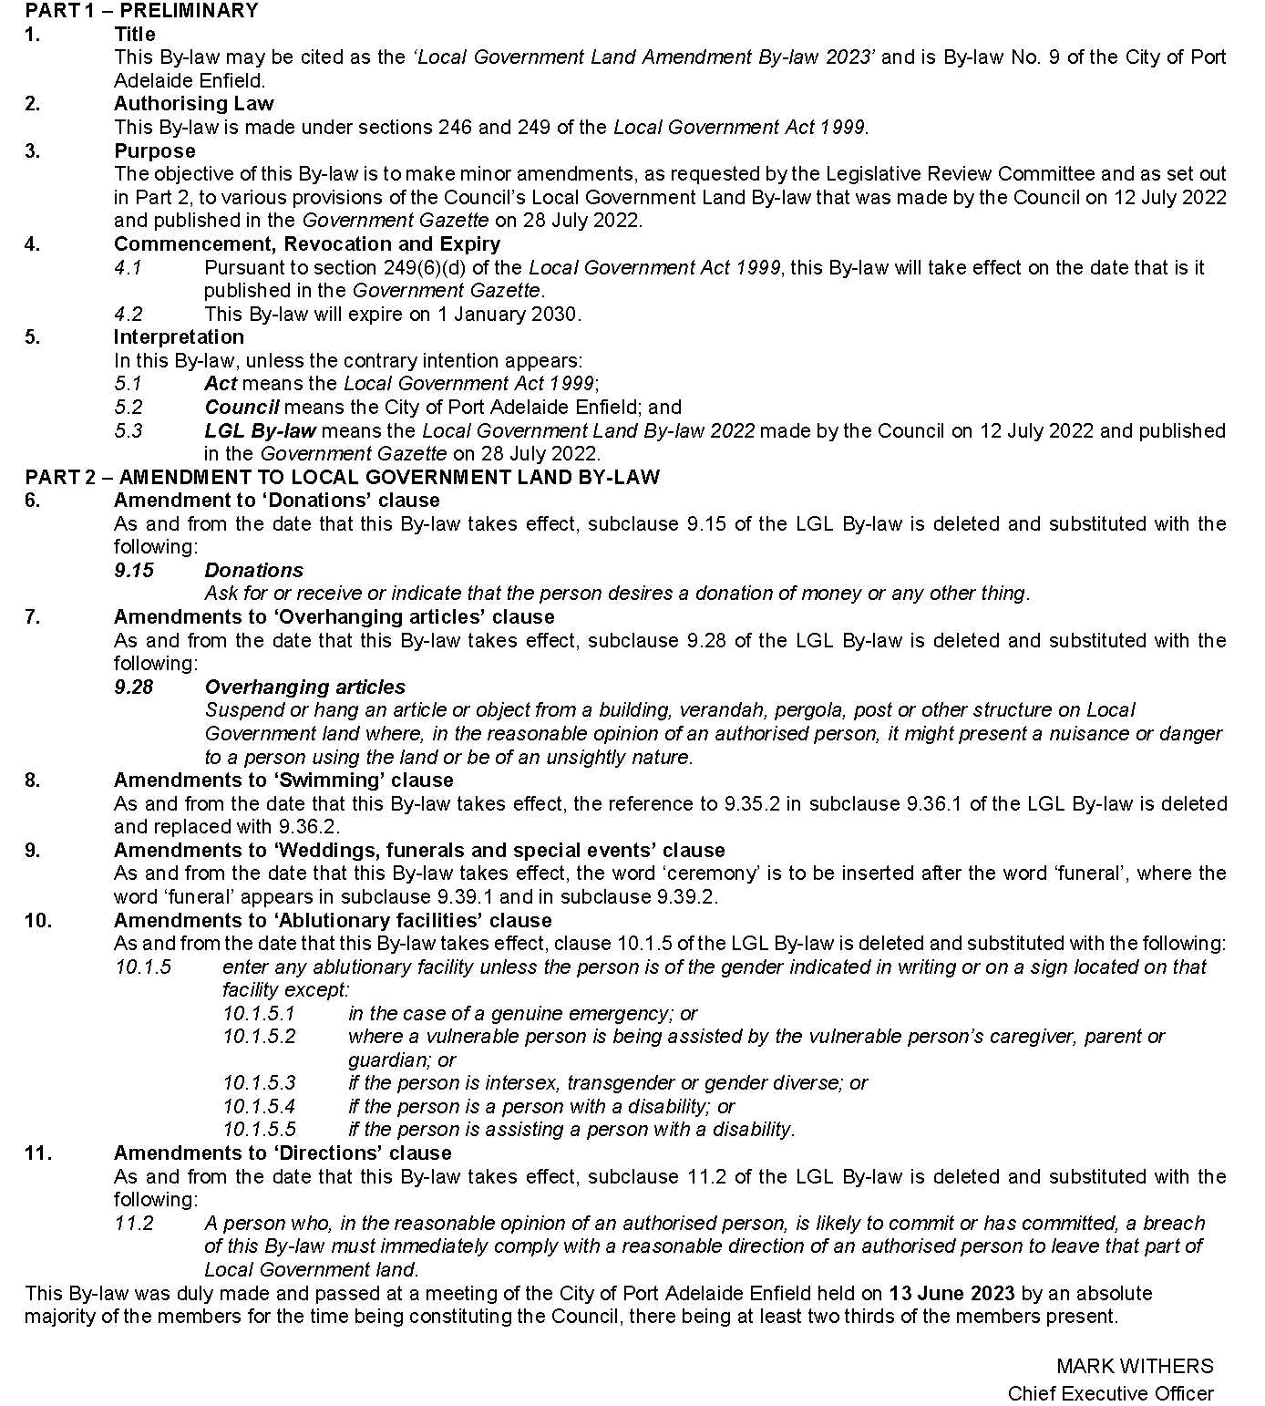

City of Port Adelaide Enfield
Re-Naming of a Portion of Road
NOTICE is hereby given that the Council of the City of Port Adelaide Enfield under delegated authority resolved pursuant to Section 219(1) of the Local Government Act 1999 that a road located in the suburb of Blair Athol be assigned new street names effective 20 June 2023 as detailed below:
- The eastern portion of Anson Street, Blair Athol to be re-named Anson Street East, Blair Athol
- The western portion of Anson Street, Blair Athol to be re-named Anson Street West, Blair Athol
A copy of the plan that delineates the road that is the subject to the assignment of the new street names is available for inspection on the Council’s website www.cityofpae.sa.gov.au/connect/media-hub/public-notices
Dated: 20 June 2023
Mark Withers
Chief Executive Officer

City of Salisbury
Removal of Councillor from Office
Notice is given in accordance with section 54(6) of the Local Government Act 1999 (the Act) that, pursuant to section 54(1)(d) of the Act, a vacancy has occurred in the office of Central Ward and North Ward effective from 13 June 2023, due to Councillor Severina Burner and Councillor Grace Bawden being removed from office by Council, on the grounds that they have been absent, without leave of the Council, from three consecutive ordinary meetings of the Council.
Dated: 22 June 2023
John Harry
Chief Executive Officer

City of Victor Harbor
Local Government Act 1999
Notice of Naming of Road
The City of Victor Harbor hereby gives NOTICE pursuant to section 219(1) of the Local Government Act 1999, and in accordance with the approval of the Chief Executive Officer on 8 June 2023, that the unnamed road, as part of Lot 31 Crozier Road land development (453/D006/20) be named Whaleboat Court.
A copy of this notice and further information can be obtained from the Council’s offices at 1 Bay Road, Victor Harbor SA 5211, during ordinary business hours or on the Council’s website at www.victor.sa.gov.au
Dated: 22 June 2023
Victoria MacKirdy
Chief Executive Officer

District Council of Orroroo Carrieton
Adoption of Valuations and Declaration of Rates 2023-2024
Notice is given that the Council at a Special meeting held on 2 June 2023, in respect of the financial year ending 30 June 2024, resolved as follows:
Adoption of Valuations
Adopted, for rating purposes, the most recent valuations of the Valuer-General available to Council of the Capital Value of land within the Council’s area totalling $387,381,980, of which $378,779,719 is the total Capital Value of rateable land.
General Rates
Declared the following rates for the year ending 30 June 2024, be declared on rateable land within its area, based on the capital value of the land.
(a) 0.2290 cents in the dollar for Primary Production land located within the Council area
(b) 0.3555 cents in the dollar for all other forms of land use located within the Council area
Fixed Charge
Declared a fixed charge of $358.00 on all rateable land within the Council area.
Annual Service Charges
Waste Management Collection
Imposed an annual services charge for waste management collection of $450.00 to be applied to all properties to which the service is provided or is made available, with a charge of $140.00 for each additional bin.
Community Waste Water Scheme
Imposed an annual service charge based on the level of usage of the service of $1,600 per property unit in respect of all land to which the Council provides the Community Wastewater Management scheme.
Separate Rate—Regional Landscape Levy
Declared a separate rate of 0.01141 cents in the dollar on all rateable land within the Council area to recover the amount payable to the Regional Landscapes Board.
Dated: 22 June 2023
Paul Simpson
Chief Executive Officer

Public Notices

National Energy Retail Law
Notice for Initiation of Request
The Australian Energy Market Commission (AEMC) gives notice under the National Energy Retail Law as follows:
Under s 251, the Australian Energy Regulator (AER) has requested the Electricity Consumption Benchmarks (Ref. RRC0049) proposal. The proposal seeks to remove the AER’s obligation to develop Electricity Consumption Benchmarks. The AEMC intends to expedite the proposal under s 252 as it considers the proposed Rule is non-controversial, subject to requests not to do so. Written requests not to expedite the proposal must be received by 6 July 2023. Submissions must be received by 20 July 2023.
Submissions can be made via the AEMC’s website. Before making a submission, please review the AEMC’s privacy statement on its website, and consider the AEMC’s Tips for making a submission. The AEMC publishes all submissions on its website, subject to confidentiality.
Australian Energy Market Commission
Level 15, 60 Castlereagh St
Sydney NSW 2000
Telephone: (02) 8296 7800
www.aemc.gov.au
Dated: 22 June 2023

National Gas Law
Notice to Initiate Request
The Australian Energy Market Commission (AEMC) gives notice under the National Gas Law as follows:
Under s 303, The Honourable Chris Bowen MP, Minister for Climate Change and Energy on behalf of the Energy Ministers Sub-Group has requested the Gas compensation and dispute resolution frameworks (Ref. GRC0067) proposal. The proposal seeks to amend the compensation frameworks for gas directions and make any consequential changes to the dispute resolution frameworks. Submissions must be received by 20 July 2023.
Submissions can be made via the AEMC’s website. Before making a submission, please review the AEMC’s privacy statement on its website, and consider the AEMC’s Tips for making a submission. The AEMC publishes all submissions on its website, subject to confidentiality.
Australian Energy Market Commission
Level 15, 60 Castlereagh St
Sydney NSW 2000
Telephone: (02) 8296 7800
www.aemc.gov.au
Dated: 22 June 2023

Trustee Act 1936
Public Trustee
Estates of Deceased Persons
In the matter of the estates of the undermentioned deceased persons:
BECHARA Daad late of 29 Ways Road Hampstead Gardens Retired Hospitality Manager who died 6 February 2018
BLAGOJEVIC Slobodan late of 3 Grant Avenue Gilles Plains Of no occupation who died 28 October 2022
DE SALES CRAWFORD Margaret late of 366 Kensington Road Leabrook Of no occupation who died 11 November 2022
GRINDLEY Yvonne Marie late of 15 Parker Street Ferryden Park Of no occupation who died 16 June 2022
HUTCHINS Margaret Ann late of 42 Vincent Street South Plympton Of no occupation who died 30 May 2022
MCKENZIE Kenneth Ross late of 18 West Terrace Quorn Retired Stockman who died 8 February 2023
MOLLER Pauline Ann late of 7 Kelly Avenue Seaton Retired Registered Nurse who died 25 February 2023
WELLS Elizabeth Anne late of 1 Warooka Drive Smithfield Retired Comptometrist who died 6 January 2023
WILLIAMS Peter James late of 1 Wilton Street Davoren Park Of no occupation who died 17 June 2022
Notice is hereby given pursuant to the Trustee Act 1936, the Inheritance (Family Provision) Act 1972 and the Family Relationships Act 1975 that all creditors, beneficiaries, and other persons having claims against the said estates are required to send, in writing, to the office of Public Trustee at GPO Box 1338, Adelaide, 5001, full particulars and proof of such claims, on or before the 21 July 2023 otherwise they will be excluded from the distribution of the said estate; and notice is also hereby given that all persons indebted to the said estates are required to pay the amount of their debts to the Public Trustee or proceedings will be taken for the recovery thereof; and all persons having any property belonging to the said estates are forthwith to deliver same to the Public Trustee.
Dated: 22 June 2023
N. S. Rantanen
Public Trustee

Notice Submission

The South Australian Government Gazette is published each Thursday afternoon.
Notices must be emailed by 4 p.m. Tuesday, the week of publication.
Submissions are formatted per the gazette style and a proof will be supplied prior to publication, along with a quote if applicable. Please allow one day for processing notices.
Alterations to the proof must be returned by 4 p.m. Wednesday.

Gazette notices must be submitted as Word files, in the following format:
• Title—the governing legislation
• Subtitle—a summary of the notice content
• Body—structured text, which can include numbered lists, tables, and images
• Date—day, month, and year of authorisation
• Signature block—name, role, and department/organisation authorising the notice

Please provide the following information in your email:
• Date of intended publication
• Contact details of the person responsible for the notice content
• Name and organisation to be charged for the publication—Local Council and Public notices only
• Purchase order, if required—Local Council and Public notices only

Email: governmentgazettesa@sa.gov.au
Phone: (08) 7109 7760
Website: www.governmentgazette.sa.gov.au

All instruments appearing in this gazette are to be considered official, and obeyed as such

Printed and published weekly by authority of M. Dowling, Government Printer, South Australia
$8.15 per issue (plus postage), $411.00 per annual subscription—GST inclusive
Online publications: www.governmentgazette.sa.gov.au

