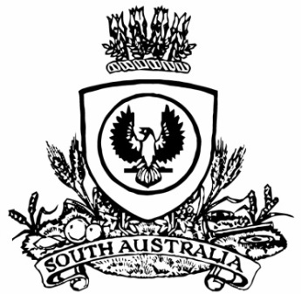
SUPPLEMENTARY GAZETTE
THE SOUTH AUSTRALIAN
GOVERNMENT GAZETTE
Published by Authority

Adelaide, Friday, 30 June 2023

Contents

State Government Instruments

Summary Offences Act 1953 2128

State Government Instruments

Summary Offences Act 1953
Declared Public Precincts
Notice of Ministerial Declaration
I, KYAM JOSEPH MAHER, Attorney-General in the State of South Australia, being the Minister responsible for the administration of Part 14B – Declared Public Precincts of the Summary Offences Act 1953, DO HEREBY DECLARE pursuant to the provisions of Section 66N of the said Act that the area, comprised of more than one public place, within the following boundaries:
• Northern boundary of North Terrace to western boundary of West Terrace; and
• Western boundary of West Terrace to southern boundary of Currie Street; and
• Southern boundary of Currie Street to eastern boundary of King William Street; and
• Eastern boundary of King William Street to northern boundary of North Terrace
will be a declared public precinct for a period of 12 hours from 6.00pm on each Friday and for a period of 12 hours from 6.00pm on each Saturday commencing on Friday 30 June 2023, local time and reoccurring for each described day and time of the week until declared otherwise or until 6.00am on Sunday 30 June 2024, whichever occurs sooner.
I am satisfied that there is, during the period specified in this declaration, a reasonable likelihood of conduct posing a risk to public order and safety in the area specified.
I am satisfied that the inclusion of each public place in the area is reasonable having regard to that identified risk.
Made at Adelaide on this 29th Day of June 2023.
Kyam Maher
Attorney-General
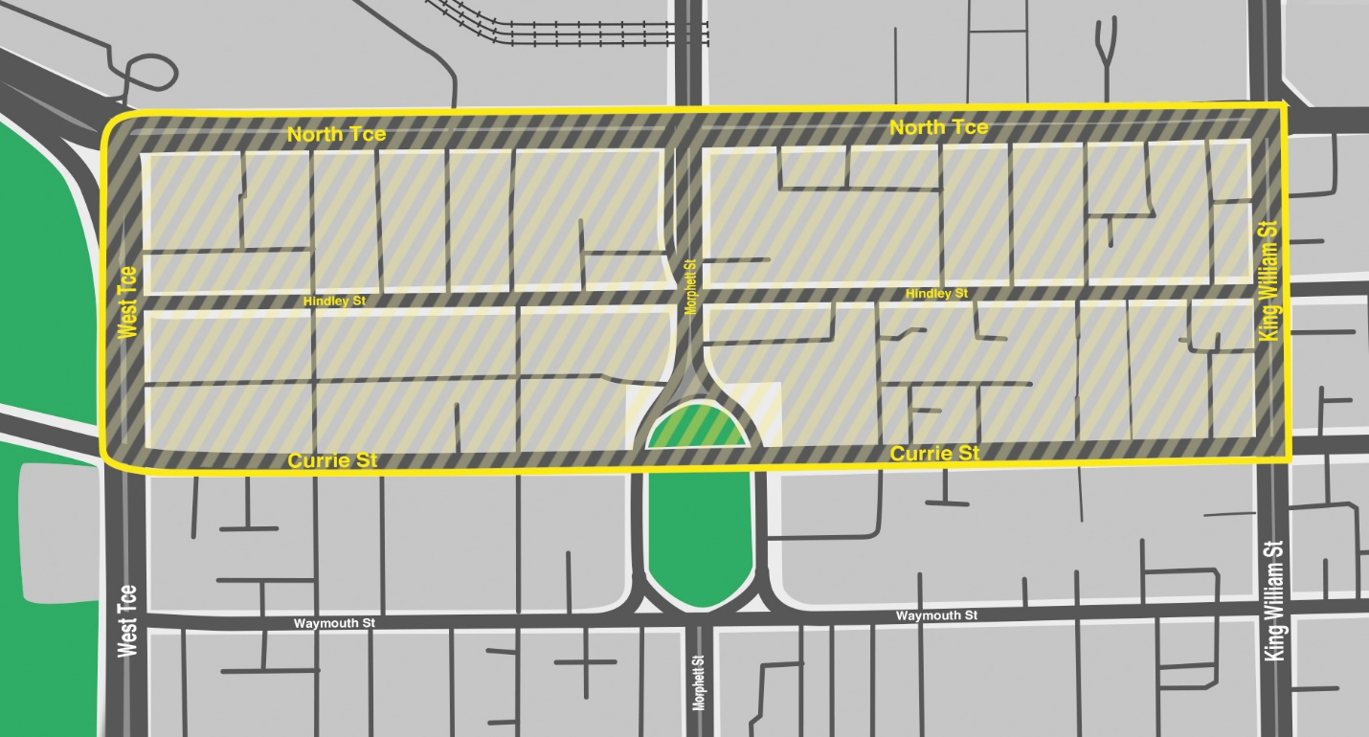

All instruments appearing in this gazette are to be considered official, and obeyed as such

Printed and published weekly by authority of M. Dowling, Government Printer, South Australia
$8.15 per issue (plus postage), $411.00 per annual subscription—GST inclusive
Online publications: www.governmentgazette.sa.gov.au

