No. 18 p. 529
THE SOUTH AUSTRALIAN
GOVERNMENT GAZETTE
Published by Authority

Adelaide, Thursday, 16 March 2023

Contents

State Government Instruments
Education and Children’s Services Regulations 2020 530
Environment Protection Act 1993 531
Firearms Regulations 2017 533
Fisheries Management (General) Regulations 2017 533
Fisheries Management (Prawn Fisheries) Regulations 2017 534
Fisheries Management Act 2007 535
Geographical Names Act 1991 536
Housing Improvement Act 2016 536
Justices of the Peace Act 2005 537
Land Acquisition Act 1969 538
Major Events Act 2013 540
Motor Vehicles Act 1959 543
National Gas (South Australia) Law 545
Petroleum and Geothermal Energy Act 2000 545
Planning, Development and Infrastructure Act 2016 545
South Australian Skills Act 2008 548
Local Government Instruments
City of Norwood Payneham & St Peters 551
Public Notices
Highbury Landfill Authority 552
Trustee Act 1936 552

State Government Instruments

Education and Children’s Services Regulations 2020
Notice of Revocation of Policy by the Minister for Education, Training and Skills
PURSUANT to Regulation 12(3) of the Education and Children’s Services Regulations 2020, I, the Minister for Education, Training and Skills revoke the East Marden Primary School Capacity Management Plan, published in the Gazette on 29 July 2021, effective 1 May 2023.
Dated: 14 February 2023
Blair Boyer
Minister for Education, Training and Skills

Education and Children’s Services Regulations 2020
Notice of Policy by the Minister for Education, Training and Skills
PURSUANT to Regulation 12(1) of the Education and Children’s Services Regulations 2020, I, the Minister for Education, Training and Skills publish a policy for the purposes of the enrolment of a child at East Marden Primary School on or after 1 May 2023:
SCHOOL ZONE
East Marden Primary School
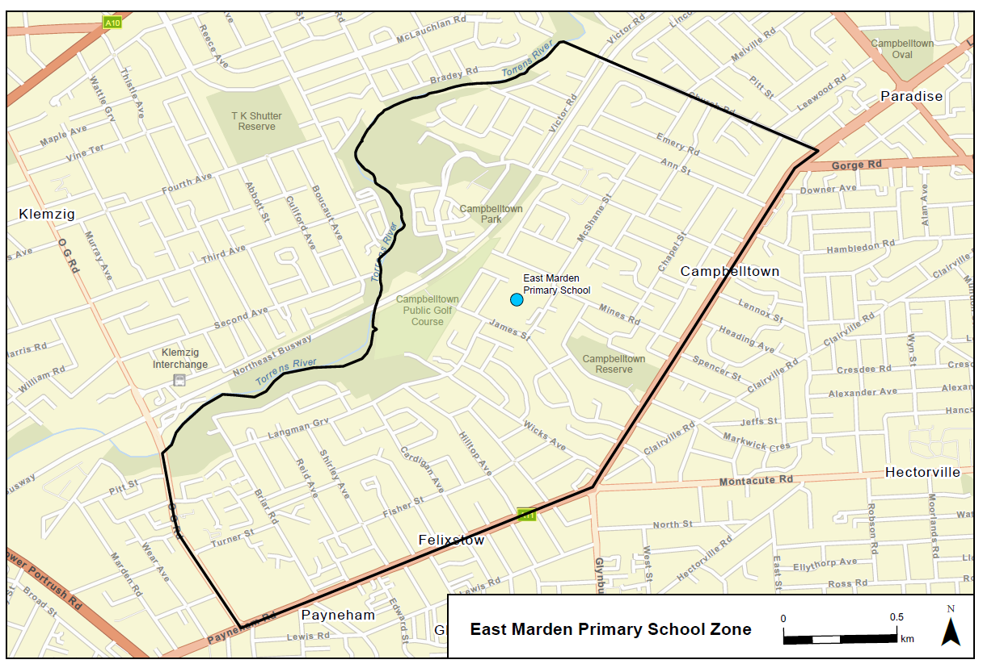
A school zone is a defined area from which the school accepts its core intake of students. The school zone for East Marden Primary School is within the area bordered by the black line on the map below. Students residing within this zone are eligible to be enrolled at East Marden Primary School and will be given priority enrolment.
An online map of the East Marden Primary School zone and a search tool to indicate if a home address is within the school zone is available at www.education.sa.gov.au/findaschool.
Information on enrolment and placement in school is available from www.education.sa.gov.au/enrolment.
Dated: 14 February 2023
Blair Boyer
Minister for Education, Training and Skills

Environment Protection Act 1993
Prohibition on Taking Water affected by Site Contamination
I, REBECCA ANNE HUGHES, Manager Site Contamination and Delegate of the Environment Protection Authority (‘the Authority’), being satisfied that site contamination exists that affects or threatens groundwater and that action is necessary pursuant to section 103S of the Environment Protection Act 1993 to prevent actual or potential harm to human health or safety hereby prohibit the taking of groundwater from the 1st, 2nd and 3rd Quaternary aquifers (as defined below) within the area specified in the map to this notice, other than for environmental assessment or environmental monitoring purposes or as approved in writing by the Authority.
This Notice relates to groundwater in:
  - The Pooraka Formation aquifer and the underlying first and second Hindmarsh Clay aquifers, being the body of groundwater 0 to approximately 45 metres below ground surface within the specified area (see map)
The site contamination affecting the groundwater is in the form of chlorinated hydrocarbons which represent actual or potential harm to human health or safety. This prohibition becomes official upon the gazettal of this notice.
Dated: 16 March 2023
R. Hughes
Manager Site Contamination
Environment Protection Authority

Map
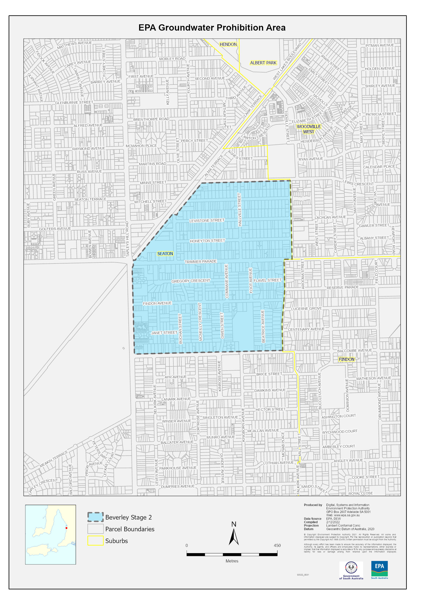

Firearms Regulations 2017
Recognised Firearms Club
I DECLARE Port Augusta Gun Club Inc to now be known as Port Augusta Clay Target Club Inc and to be a recognised Firearms Club, pursuant to Regulation 69 (1) of the Firearms Regulations 2017.
First Schedule
Gazette Reference:
Port Augusta Gun Club Inc, dated 5 November 1981, page 1436
Second Schedule
Port Augusta Clay Target Club Inc
Dated: 9 March 2023
A/Inspector Dan Cahill
Delegate of the Registrar of Firearms

Fisheries Management (General) Regulations 2017
March 2023 Survey in the West Coast Prawn Fishery
TAKE notice that pursuant to regulation 10 of the Fisheries Management (Prawn Fisheries) Regulations 2017, the notice dated 18 November 2022 on page 6707 of the South Australian Government Gazette of 24 November 2022, prohibiting fishing activities in the West Coast Prawn Fishery is HEREBY varied such that it will not apply to the holders of a West Coast Prawn Fishery licence issued pursuant to the Fisheries Management (Prawn Fisheries) Regulations 2017 listed in Schedule 1 or their register master insofar as they may use prawn trawl nets in accordance with the conditions of their fishery licence for the purpose of undertaking a prawn survey during the period specified in Schedule 2, subject to the conditions contained in Schedule 3 unless this notice is varied or revoked.
Schedule 1
Licence Number | Licence Holder / Master | Boat Name | Trawl Survey Area
D02 | Kontias Developments /Danny Reid | Lincoln Lady | Venus Bay
Schedule 2
Commencing at sunset on 19 March 2023 and ending at sunrise on 21 March 2023.
Schedule 3
- The licence holder listed in Schedule 1 or their registered master must operate within the trawl survey area nominated in the table in Schedule 1.
- For the purposes of this notice the trawl survey areas cannot include any waters of a habitat protection zone or a sanctuary zone of a marine park established under the Marine Parks Act 2007.
- The registered master must keep a ‘skippers log’ to record catch information during the survey.
- All fish, other than King Prawns, Southern Calamari, Gould’s Squid, Scallops, Octopus and Balmain Bugs taken during the exempted activity for survey purposes, are to be returned to the water immediately after capture.
- The licence holders listed in Schedule 1 or their registered master must comply with all regulations and conditions that apply to fishing activities undertaken pursuant to their licence, in addition to the conditions imposed by this exemption.
- While engaged in fishing activities or unloading the survey catch, the licence holder listed in Schedule 1 or their register master must have a copy of this notice on board the boat or near his person. This notice must be produced to a Fisheries Officer if requested.
- The licence holders listed in Schedule 1 or their registered master must not contravene or fail to comply with the Fisheries Management Act 2007, or any other regulations made under that Act except where specifically exempted by this notice.
This notice does not purport to override the provisions or operation of any other Act including, but not limited to, the Marine Parks Act 2007. The notice holder and his agents must comply with any relevant regulations, permits, requirements and directions from the Department for Environment and Water when undertaking activities within a marine park.
Dated: 14 March 2023
Jordan Lear
Prawn Fishery Manager
Delegate of the Minister for Primary Industries and Regional Development

Fisheries Management (General) Regulations 2017
Regulation 23A(1)
Determination—Taking of Bivalve Filter-feeding Molluscs in Port Adelaide River Estuary
As the delegate of the Minister for Primary Industries and Regional Development, I Professor Gavin Begg, Executive Director of Fisheries and Aquaculture make the following determination for the purposes of regulation 23A(1) of the Fisheries Management (General) Regulations 2017 in regard to the taking of bivalve molluscs in the Port Adelaide River Estuary, unless this notice is otherwise varied or revoked.
- Dr Warwick Noble, Environment Protection Authority and nominated agents (Authorised employees of the Environment Protection Authority), and persons acting under supervision of authorised employees of the Environment Protection Authority who are engaged in the activities under Ministerial permit MP0201 may take bivalve filter-feeding mollusc samples that have been placed within the waters of the Port Adelaide River Estuary excluding the waters of aquatic reserves (unless otherwise authorised under the Fisheries Management Act 2007) for the purposes of monitoring and testing.
- The taking of bivalve filter feeding mollusc samples that have been placed within the Port Adelaide River Estuary under this determination may only occur where it is consistent with the arrangements contained in Ministerial permit MP0201 during the period 12 March 2023 until 1 July 2023.
- All equipment used in collecting specimens must be appropriately decontaminated in accordance with the “AQUAVETPLAN Operational Procedures Manual – Decontamination”.
- Following the completion of any laboratory analysis required, all bivalve molluscs collected must be disposed of appropriately in accordance with AQUAVETPLAN Operational Procedures Manual – Disposal.
- Bivalve molluscs collected from within the Port Adelaide River Estuary must not be made available for human consumption.
Dated: 11 March 2023
Prof. Gavin Begg
Executive Director
Fisheries and Aquaculture
Delegate of the Minister for Primary Industries and Regional Development

Fisheries Management (General) Regulations 2017
Regulation 23E(1)
Determination—Taking of Mussels (Mytilus spp) in Germein Bay (Zone 1)
As the delegate of the Minister for Primary Industries and Regional Development, I Professor Gavin Begg, Executive Director of Fisheries and Aquaculture make the following determination for the purposes of regulation 23E (1) of the Fisheries Management (General) Regulations 2017 regarding the taking of Mussels in Germein Bay (Zone 1), unless this notice is otherwise varied or revoked.
- Dr Warwick Noble, Environment Protection Authority and nominated agents (Authorised employees of the Environment Protection Authority), and persons acting under supervision of authorised employees of the Environment Protection Authority who are engaged in the activities under Ministerial permit MP0201 may take Mussel samples (Mytilus spp) that have been placed within the waters of Germein Bay (Zone 1) for the purposes of monitoring and testing.
- The taking of Mussel samples (Mytilus spp) that have been placed within Germein Bay under this determination may only occur where it is consistent with the arrangements contained in Ministerial permit MP0201 during the period 12 March 2023 until 1 July 2023.
- Mussel samples (Mytilus spp) collected from within Germein Bay must not be made available for human consumption.
Dated: 11 March 2023
Prof. Gavin Begg
Executive Director
Fisheries and Aquaculture
Delegate of the Minister for Primary Industries and Regional Development

Fisheries Management (Prawn Fisheries) Regulations 2017
Temporary prohibition on fishing activities in the Gulf St Vincent Prawn Fishery
TAKE notice that pursuant to regulation 10 of the Fisheries Management (Prawn Fisheries) Regulations 2017, the activities of the class specified in Schedule 1 are prohibited in the waters of the Gulf St Vincent Prawn Fishery during the period specified in Schedule 2 except for the licences listed in Schedule 3 undertaking the activities described in Schedule 4 unless this notice is varied or revoked.
Schedule 1
The act of taking or an act preparatory to or involved in the taking of King Prawns (Melicertus latisulcatus).
Schedule 2
Between sunset on 18 March 2023 and sunrise on 22 March 2023.
Schedule 3
Licence Number | Licence Holder | Boat Name
V02 | WJ Fountain P/L | Angela Kaye
V03 | Josephine K Fisheries P/L | Josephine K
V04 | Ledo P/L | Frank Cori
V06 | Todreel P/L | Anna Pearl
V14 | WJ Fountain P/L | Zadar
Schedule 4
- For the purposes of this schedule the trawl survey areas cannot include any waters of a habitat protection zone or a sanctuary zone of a marine park established under the Marine Parks Act 2007 or depths less than 10 metres.
- The licence holders listed in Schedule 3 or their registered master must comply with all regulations and conditions that apply to fishing activities undertaken pursuant to their Gulf St Vincent Prawn Fishery licence, in addition to the conditions imposed by this notice.
- All fishing activity pursuant to this fishing notice must be conducted in the area of Fishery Independent Survey stations identified on page 16 of the “Gulf St Vincent Prawn Penaeus (Melicertus) latisulcatus Fishery 2019/20” (McLeay and Hooper 2020).
- Fishing activity pursuant to this fishing notice must not exceed more than one survey shot at each of the Fishery Independent Survey stations.
- While engaged in fishing activities or unloading the survey catch, the licence holders listed in Schedule 3 or their registered master must have a copy of this notice on board the boat or near his person. This notice must be produced to a Fisheries Officer if requested.
- No fishing activity may be undertaken between the prescribed times of sunrise and sunset for Adelaide (as published in the South Australian Government Gazette).
- The licence holders listed in Schedule 3 or their register master must not contravene or fail to comply with the Fisheries Management Act 2007, or any other regulations made under that Act except where specifically exempted by this notice.
- This notice does not purport to override the provisions or operation of any other Act including, but not limited to, the Marine Parks Act 2007. The notice holder and his agents must comply with any relevant regulations, permits, requirements and directions from the Department for Environment and Water when undertaking activities within a marine park.
- A report (including the raw survey data) is to be provided to SARDI by the Saint Vincent Gulf Prawn Boat Owner’s Association detailing the outcomes of the survey as soon as practicable on the survey completion.
Dated: 9 March 2023
Hamish Telfer
Fisheries Manager
Delegate of the Minister for Primary Industries and Regional Development

FISHERIES MANAGEMENT ACT 2007
Section 115
Exemption No. ME9903226
TAKE NOTICE that pursuant to section 115 of the Fisheries Management Act 2007, Dr Michael Steer, Research Director of Aquatic and Livestock Sciences of the South Australian Research and Development Institute (SARDI) (hereinafter referred to as the “exemption holder”) and scientists and technical staff employed by the Department of Primary Industries and Regions and substantively engaged by SARDI (“agents”) and Specified Affiliates of SARDI as defined in this notice, are exempt from Sections 52, 70, 71, 72(2)(c), 73, 74(1)(b), and 79(9) of the Fisheries Management Act 2007, while undertaking the research activities directly required to support the administration of the Fisheries Management Act 2007 listed in Schedule 2 (the “exempted activity”), subject to the conditions specified in Schedule 1, from 10 March 2023 until 30 June 2023 unless varied or revoked earlier.
Schedule 1
- All activities undertaken under this notice must only be for the purposes of the research activities listed in Schedule 2 and directly related to the administration of the Fisheries Management Act 2007.
- Research activities undertaken pursuant to this notice may be undertaken within all waters of the State excluding:
- Sanctuary and restricted access zones of marine parks (unless otherwise authorised under the Marine Parks Act 2007)
- Aquatic reserves (unless otherwise authorised under the Fisheries Management Act 2007).
- The exemption holder or agents may take any species of fish using any type of device reasonably required to undertake the research activities identified in Schedule 2, other than explosives, from the waters of the State as described in clause 2 of this notice.
- Vessels, vehicles and research equipment used to undertake research activities under this exemption must be clearly identifiable as belonging to SARDI. Where possible when undertaking the exempted activities, all persons should be clearly identifiable as SARDI staff or affiliates.
- The exemption holder must not contravene or fail to comply with any provision of the Fisheries Management Act 2007 or any regulations made under that Act, except where specifically exempted by this notice.
- The exemption holder will be deemed responsible for the conduct of all persons conducting the research activities under this notice. Any person conducting research activities under this exemption must have been provided with a copy of this notice and have signed it to confirm that they have read, understood it, and agreed to act in accordance with the conditions under it.
- The exemption holder and agents, whilst engaged in research activities pursuant to this exemption, must carry an identification card issued by SARDI.
- In this exemption Specified Affiliates of SARDI means commercial fishing licence holders, independent contractors, research students, volunteers, and other affiliates provided the following additional conditions are met:
  - At least 1 clear business day (the “consideration period”) prior to undertaking the exempted activity the exemption holder (or his delegate) notifies the Fisheries Regional Manager in writing of the names of the affiliates that will be undertaking the exempted activity together with any other identifying information about the affiliates that may be specifically required from time to time by email to PIRSA.FisheriesOperationalManagement@sa.gov.au ; and
  - No objection is taken to the affiliates nominated by SARDI during the consideration period (with any such objection being communicated to the exemption holder).
- At least 1 hour before conducting the exempted activity, the exemption holder or agent must contact PIRSA FISHWATCH on 1800 065 522 and answer a series of questions about the exempted activity. The exemption holder or agent will need to have a copy of this notice in their possession at the time of making the call and be able to provide information about who will be involved in the exempted activity, including area and time of the exempted activity, the vehicles and/or boats involved, and other related issues.
- Before commencing any exempted activity under this notice within the Adelaide Dolphin Sanctuary, the exemption holder or his agents must provide notification of intended dates and times of the activity to:
- Jon Emmett, Regional Coordinator Marine Parks: jon.emmett@sa.gov.au
- Any person engaging in the exempted activity under this notice, must be in possession of a copy of this exemption. The copy must be produced to a PIRSA Fisheries Officer if requested.
- The exemption holder must cause records to be kept of the names of all affiliates used under the exemptions for each project and when they were engaged in research activities pursuant to this notice.
Schedule 2
Research Projects - Service Level Agreements
- South Australian Central Zone Abalone Fishery
- South Australian Southern Zone Abalone Fishery
- South Australian Western Zone Abalone Fishery
- South Australian Blue Crab Fishery
- Lakes and Coorong Finfish Fishery
- Lakes and Coorong Pipi Fishery
- Marine Scalefish Fishery (inc. Snapper stock assessments)
- South Australian Rock Lobster Fishery (Northern Zone and Southern Zone)
- Sardine Fishery
- Gulf St Vincent Prawn Fishery
- Spencer Gulf Prawn Fishery
- West Coast Prawn Fishery
- South Australian Vongole Fishery (Mud cockle - Coffin Bay)
- South Australian Vongole Fishery (Mud cockle – West Coast)
Research Projects - Fisheries Research and Development Corporation (FRDC)
- FRDC 2020 – 004 - Abalone Perkinsus project (Western Zone)
- FRDC 2019 – 044 – Snapper post release survival project
- FRDC 2019 – 046 – Snapper recruitment index project
Research Projects – Other
- Marine pest identification and testing
- Marine pest surveys
- Disease, parasite and treatment investigations
- New invasive species, parasite and disease investigations
- Gulf St Vincent Seagrass rehabilitation
- Monitoring, Evaluation and Research Project (2019 – 2024) for the Lower River Murray
- The Living Murray Coorong - monitoring, evaluation and research project
- Assessment and congolli movement study - Salt Creek and Morella fishway
- Murray Darling Basin fish survey - Lower River Murray
- Lake George - Fish survey
- Fish Condition and Intervention Monitoring - Chowilla
- Fish Condition Monitoring - Pike and Katarapko and adjacent River Murray
- Barrage fishway monitoring - Murray Barrages, Lakes and Coorong
- Monitoring influence of Plume River Murray on marine productivity
- Assessing distribution and recruitment of common carp post flood – River Murray
- Fish community monitoring of fish stocks and to inform future reservoir stocking programs SA Water
- Torrens Lake Carp Control project
- Lake Eyre Basin Rivers - Fish Monitoring and Assessment
- Mount Lofty Ranges - Fish Monitoring and Assessment
This notice does not purport to override the provisions or operation of any other Act including but not limited to the Adelaide Dolphin Sanctuary Act 2005, Marine Parks Act 2007 or the River Murray Act 2003.
Dated: 9 March 2023
Prof. Gavin Begg
Executive Director
Fisheries and Aquaculture
Delegate of the Minister for Primary Industries and Regional Development

Geographical Names Act 1991
Notice to Assign a Name to a Place
NOTICE is hereby given that, pursuant to section 11B(1)(a) of the Geographical Names Act 1991, I, the Honourable Nick Champion MP, Minister for Planning, Minister of the Crown to whom the administration of the Geographical Names Act 1991 is committed, DO HEREBY;
- Assign the following indigenous dual names to places of public interest within the City of Mount Gambier:
UMPHERSTON SINKHOLE / BALUMBUL
CAVE GARDEN / THUGI
LEG OF MUTTON LAKE / YATTON LOO
BLUE LAKE / WARWAR
BROWNE LAKE / KROWERATWARI
VALLEY LAKE / KETLA MALPI
This notice is to take effect immediately upon its publication in the Government Gazette.
This naming proposal can be viewed at;
- the Office of the Surveyor-General, 83 Pirie Street, Adelaide
- www.sa.gov.au/placenameproposals
Dated: 10 March 2023
Hon Nick Champion MP
Minister For Planning
DTI 2022/05953/01

Housing Improvement Act 2016
Rent Control
The Minister for Human Services Delegate in the exercise of the powers conferred by the Housing Improvement Act 2016, does hereby fix the maximum rental per week which shall be payable subject to Section 55 of the Residential Tenancies Act 1995, in respect of each house described in the following table. The amount shown in the said table shall come into force on the date of this publication in the Gazette.

Address of Premises | Allotment  Section | Certificate of Title  Volume Folio | Maximum Rental  per week payable
3 Mill Street, Burra SA 5417 | Allotment 91 Filed Plan 206218 Hundred of Kooringa | CT 5408/67 | $0.00
7 Fowlers Road, Salisbury North SA 5108 | Allotment 10 Filed Plan 33592 Hundred Munno Para | CT 5133/815 | $195.00
12 Amber Avenue, Clearview SA 5085 | Allotment 33 Deposited Plan 4648 Hundred of Yatala | CT 5682/37 | $0.00
Dated: 16 March 2023
Craig Thompson
Housing Regulator and Registrar
Housing Safety Authority, SAHA
Delegate of Minister for Human Services

Housing Improvement Act 2016
Rent Control Revocations
Whereas the Minister for Human Services Delegate is satisfied that each of the houses described hereunder has ceased to be unsafe or unsuitable for human habitation for the purposes of the Housing Improvement Act 2016, notice is hereby given that, in exercise of the powers conferred by the said Act, the Minister for Human Services Delegate does hereby revoke the said Rent Control in respect of each property.
Address of Premises | Allotment Section | Certificate of Title  Volume/Folio
19 Casterley Road, Elizabeth North  SA 5113 | Allotment 15 Deposited Plan 60552 Hundred of Munno Para | CT 5883/73
Dated: 16 March 2023
Craig Thompson
Housing Regulator and Registrar
Housing Safety Authority, SAHA
(Delegate of Minister for Human Services)

Justices of the Peace Act 2005
Section 4
Notice of Appointment of Justices of the Peace for South Australia
by the Commissioner for Consumer Affairs
I, Dini Soulio, Commissioner for Consumer Affairs, delegate of the Attorney-General, pursuant to Section 4 of the Justices of the Peace Act 2005, do hereby appoint the people listed as Justices of the Peace for South Australia as set out below:
For a period of ten years for a term commencing on 21 March 2023 and expiring on 20 March 2033:
Barry Raymond SOWERBY
Graham John SOUTHERN
David Lloyd SNELLING
Pauline Elizabeth SIMCOCK
James Nigel SCHROETER
Sharon Louise REINKE
Andrew Guy PEAKE
Shane Michael O'DEA
Kevin Ernest NICHOLLS
Diane Lesley MCKINNA
Nicholas Vivian KINGSLEY
Belinda KERYN
Jay Gordon HOSKING
Gail Bernadette HARDING
Leigh Kenneth HALL
Veronica Margaret FAGGOTTER
Brenton Ashley Owen EDEN
Glenys Ruth DREYER
Warren John Ord DICKIE
David Leon CLARNETTE
Shane Robert BERNHARDT
Roy Alfred BARKER
Peter James ALI
Dated: 14 March 2023
Dini Soulio
Commissioner for Consumer Affairs
Delegate of the Attorney-General

Land Acquisition Act 1969
Section 16
Form 5—Notice of Acquisition
1. Notice of acquisition
The Commissioner of Highways (the Authority), of 83 Pirie Street, Adelaide SA 5000, acquires the following interests in the following land:
Comprising an unencumbered estate in fee simple in that piece of land being portion of Allotment 884 in Filed Plan 180916 comprised in Certificate of Title Volume 5550 Folio 666, and being the whole of the land identified as Allotment 51 in D131612 lodged in the Lands Titles Office.
This notice is given under section 16 of the Land Acquisition Act 1969.
2. Compensation
A person who has or had an interest consisting of native title or an alienable interest in the land that is divested or diminished by the acquisition or the enjoyment of which is adversely affected by the acquisition who does not receive an offer of compensation from the Authority may apply to the Authority for compensation.
2A. Payment of professional costs relating to acquisition (section 26B)
If you are the owner in fee simple of the land to which this notice relates, you may be entitled to a payment of up to $10 000 from the Authority for use towards the payment of professional costs in relation to the acquisition of the land.
Professional costs include legal costs, valuation costs and any other costs prescribed by the Land Acquisition Regulations 2019.
3. Inquiries
Inquiries should be directed to: Daniel Tuk
GPO Box 1533
Adelaide SA 5001
Telephone: (08) 7133 2479
Dated: 15 March 2023
The Common Seal of the COMMISSIONER OF HIGHWAYS was hereto affixed by authority of the Commissioner in the presence of:
Rocco Caruso
Manager, Property Acquisition (Authorised Officer)
Department for Infrastructure and Transport
DIT 2022/09932/01

Land Acquisition Act 1969
Section 16
Form 5—Notice of Acquisition
1. Notice of acquisition
The Commissioner of Highways (the Authority), of 83 Pirie Street, Adelaide SA 5000, acquires the following interests in the following land:
Comprising an unencumbered estate in fee simple in that piece of land being portion of Piece 102 in Deposited Plan No 88424 comprised in Certificate of Title Volume 6089 Folio 346 and being the whole of the land identified as Allotment 52 in D129502 lodged in the Lands Titles Office
Secondly, comprising an unencumbered estate in fee simple in that piece of land being portion of Allotment 101 in Deposited Plan No 88424 comprised in Certificate of Title Volume 6089 Folio 345 and being whole of the land identified as Allotment 53 in D129502 lodged in the Lands Titles Office.
This notice is given under section 16 of the Land Acquisition Act 1969.
2. Compensation
A person who has or had an interest consisting of native title or an alienable interest in the land that is divested or diminished by the acquisition or the enjoyment of which is adversely affected by the acquisition who does not receive an offer of compensation from the Authority may apply to the Authority for compensation.
2A. Payment of professional costs relating to acquisition (section 26B)
If you are the owner in fee simple of the land to which this notice relates, you may be entitled to a payment of up to $10 000 from the Authority for use towards the payment of professional costs in relation to the acquisition of the land.
Professional costs include legal costs, valuation costs and any other costs prescribed by the Land Acquisition Regulations 2019.
3. Inquiries
Inquiries should be directed to: Daniel Tuk
GPO Box 1533
Adelaide SA 5001
Telephone: (08) 7133 2479
Dated: 9 March 2023
The Common Seal of the COMMISSIONER OF HIGHWAYS was hereto affixed by authority of the Commissioner in the presence of:
Rocco Caruso
Manager, Property Acquisition (Authorised Officer)
Department for Infrastructure and Transport
DIT 2021/18352/01

Land Acquisition Act 1969
Section 16
Form 5—Notice of Acquisition
1. Notice of acquisition
The Minister for Infrastructure and Transport (the Authority), of 83 Pirie Street, Adelaide SA 5000, acquires the following interests in the following land:
Comprising an unencumbered estate in fee simple in that piece of land being portion of Allotment 133 in Filed Plan 251114 comprised in Certificate of Title Volume 6234 Folio 70, and being the whole of the land identified as Allotment 203 in D131307 lodged in the Lands Titles Office.
This notice is given under section 16 of the Land Acquisition Act 1969.
2. Compensation
A person who has or had an interest consisting of native title or an alienable interest in the land that is divested or diminished by the acquisition or the enjoyment of which is adversely affected by the acquisition who does not receive an offer of compensation from the Authority may apply to the Authority for compensation.
2A. Payment of professional costs relating to acquisition (section 26B)
If you are the owner in fee simple of the land to which this notice relates, you may be entitled to a payment of up to $10 000 from the Authority for use towards the payment of professional costs in relation to the acquisition of the land.
Professional costs include legal costs, valuation costs and any other costs prescribed by the Land Acquisition Regulations 2019.
3. Inquiries
Inquiries should be directed to: Daniel Tuk
GPO Box 1533
Adelaide SA 5001
Telephone: (08) 7133 2479
Dated: 9 March 2023
SIGNED for and on behalf of the MINISTER FOR INFRASTRUCTURE AND TRANSPORT by his duly constituted Attorney Pursuant to Power of Attorney No. 13405184, who has not received a notice of the revocation of that Power of Attorney in the presence of:
Rocco Caruso
Manager, Property Acquisition (Authorised Officer)
Department for Infrastructure and Transport
DIT 2021/13368/01

Land Acquisition Act 1969
Section 16
Form 5—Notice of Acquisition
1. Notice of acquisition
The Minister for Infrastructure and Transport (the Authority), of 83 Pirie Street, Adelaide SA 5000, acquires the following interests in the following land:
Comprising an unencumbered estate in fee simple in that piece of land being portion of Allotment 302 in Deposited Plan 86124 comprised in Certificate of Title Volume 6090 Folio 80, and being the whole of the land identified as Allotment 500 in D130988 lodged in the Lands Titles Office, expressly excluding easement(s) over the land marked ‘C’ for the transmission of electricity by underground cable (RTC 9131631) and expressly excluding free and unrestricted rights(s) of way over the land marked ‘G’.
This notice is given under section 16 of the Land Acquisition Act 1969.
2. Compensation
A person who has or had an interest consisting of native title or an alienable interest in the land that is divested or diminished by the acquisition or the enjoyment of which is adversely affected by the acquisition who does not receive an offer of compensation from the Authority may apply to the Authority for compensation.
2A. Payment of professional costs relating to acquisition (section 26B)
If you are the owner in fee simple of the land to which this notice relates, you may be entitled to a payment of up to $10 000 from the Authority for use towards the payment of professional costs in relation to the acquisition of the land.
Professional costs include legal costs, valuation costs and any other costs prescribed by the Land Acquisition Regulations 2019.
3. Inquiries
Inquiries should be directed to: Daniel Tuk
GPO Box 1533
Adelaide SA 5001
Telephone: (08) 7133 2479
Dated: 15 March 2023
SIGNED for and on behalf of the MINISTER FOR INFRASTRUCTURE AND TRANSPORT by his duly constituted Attorney Pursuant to Power of Attorney No. 13405184, who has not received a notice of the revocation of that Power of Attorney in the presence of:
Rocco Caruso
Manager, Property Acquisition (Authorised Officer)
Department for Infrastructure and Transport
DIT 2021/17882/01

Major Events Act 2013
Section 6B
Declaration of a Major Event
In Government Gazette No 10, published on 9 February 2023, the notice under the Major Events Act 2013 on page 23 was incorrect. It should be replaced as follows:
PURSUANT to section 6B of the Major Events Act 2013, I, Hon Zoe Bettison MP, Minister for Tourism declare the 2023 Adelaide Motorsport Festival to be held from 24 to 26 March 2023 to be declared a major event.
By virtue of the provisions of the Major Events Act 2013, I do hereby:
- Declaring the 2023 Adelaide Motorsport Festival to be a major event.
- Specify the period for which the declaration of the major event is in force 24-26 March 2023 inclusive from 5am on 24 March 2023 to 11.59pm on 26 March 2023.
- Declare the major event venues to be:
- King Rodney Park/Ityamai-itpina (Park 15) and Victoria Park/Pakapakanthi (Park 16) and any public place or part of a public place that is within 200 metres of the boundary of these parks from 24-26 March 2023 inclusive from 5am on 24 March 2023 to 11.59pm on 26 March 2023
- East Terrace between Rundle Street and Grenfell Street and any public place or part of a public place that is within 200 metres of the boundary of this section of East Terrace from 4pm to 9.30pm on 24 March 2023
- Designate Massive Events Corp to be the event organiser for the event.
- Apply section 8 of the Major Events Act to the event.
- Apply section 10 of the Major Events Act to the event.
- Apply section 11 of the Major Events Act to the event.
- Apply section 12 of the Major Events Act to the event.
- Apply section 13 of the Major Events Act to the event.
- Apply section 14 of the Major Events Act to the event by specifying the official title as 2023 Adelaide Motorsport Festival and the official logo as it appears below.
Dated: 9 March 2023
Hon. Zoe Bettison MP
Minister for Tourism, South Australia

Map of Controlled Area for the Adelaide Motorsport Festival Street Party
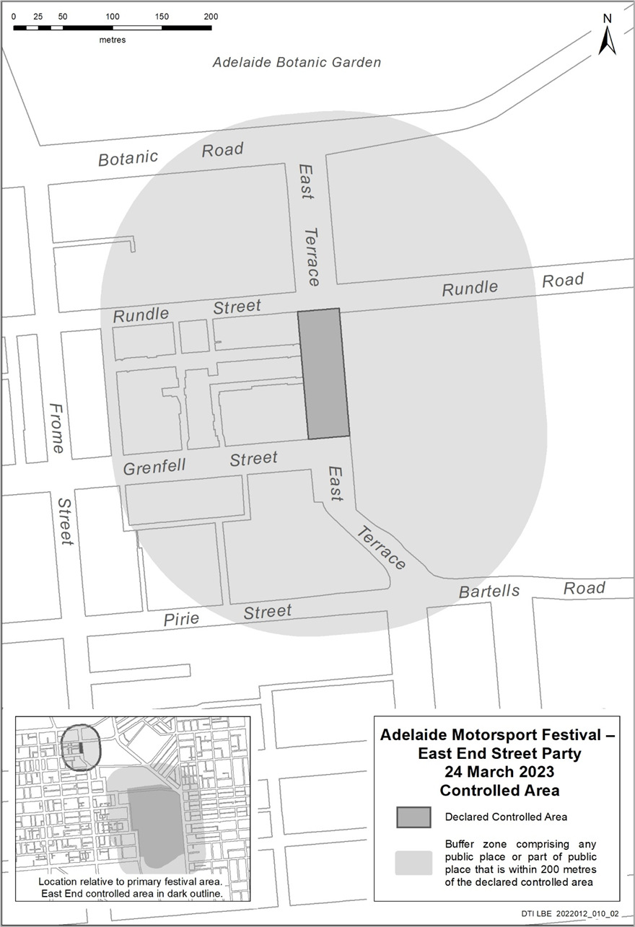
Map of Controlled Area for the Adelaide Motorsport Festival
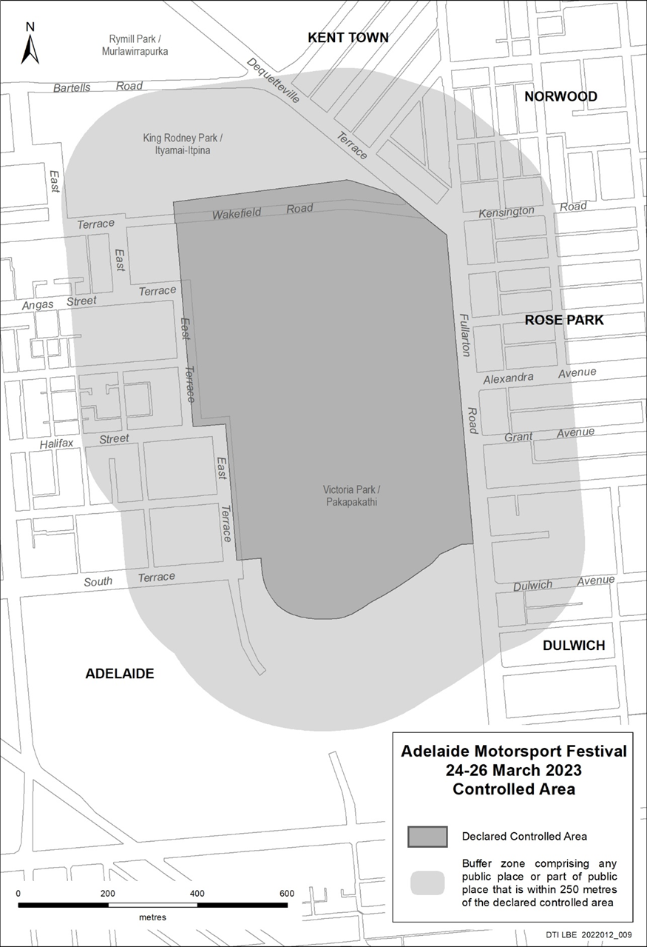

Motor Vehicles Act 1959
South Australia
Motor Vehicles (Conditional Registration—Recognition of Motor Vehicle Clubs) Notice 2023 – Mil-lel Steam and Machinery Association Incorporated
under the Motor Vehicles Act 1959
1—Short title
This notice may be cited as the Motor Vehicles (Conditional Registration—Recognition of Motor Vehicle Clubs) Notice 2023 – Mil-lel Steam and Machinery Association Inc.
2—Commencement
This notice takes effect from the date it is published in the Gazette.
3—Interpretation
In this notice—
Act means the Motor Vehicles Act 1959;

Code of Practice means the ‘Code of Practice for Club Registration - a 90 day conditional registration scheme for historic, left hand drive and street rod vehicles’ published by the Department for Infrastructure and Transport;

Conditional Registration Scheme or Scheme means the scheme for conditional registration of historic, prescribed left hand drive and street rod motor vehicles under section 25 of the Act and regulations 15 and 16 of the Motor Vehicles Regulations 2010;

Department means the Department for Infrastructure and Transport;

Federation means the Federation of Historic Motoring Clubs SA Incorporated;

MR334 form means an ‘Approval for Registration of Vehicle on the Club Registration Scheme (MR334)’;

Prescribed log book means a log book in a form approved by the Registrar;

Registrar means the Registrar of Motor Vehicles;

Regulations means the Motor Vehicles Regulations 2010.
4—Recognition of motor vehicles clubs
The motor vehicle clubs specified in Schedule 1 are, subject to the conditions set out in clause 5, recognised for the purposes of regulation 16 of the Regulations.
5—Conditions of recognition
A motor vehicle club specified in Schedule 1 must comply with the following conditions:
  - the club must maintain a constitution approved by the Registrar;
(b) the club must nominate and have members authorised by the Registrar (authorised persons). The club’s authorised person(s) are responsible for approving applicants and motor vehicles for registration under the Scheme. This includes confirming that Scheme applicants are financial members of a club; any other details as required by the Registrar on the MR334 form; and to inspect members’ vehicles when requested to do so by the Registrar;
(c) the club must issue a prescribed log book to club members for each of their vehicles to record vehicle use;
(d) the club must cancel a member’s prescribed log book when a member resigns, must ensure that a statutory declaration is provided when a member’s log book is lost or destroyed, must keep details of members’ prescribed log book return sheets and forward copies of the same to the Registrar or Federation annually as required;
(e) the club must create and maintain records detailing all its financial members, its authorised persons, all vehicles for which an MR334 form has been issued, all statutory declarations received and prescribed log books issued and returned to the club;
(f) the club must keep records for a period of 5 years from the date of the document and these records must include all duplicate MR334 forms, all records of motor vehicle inspections undertaken in accordance with paragraph (b), all statutory declarations provided by members for the purposes of paragraphs (d), all prescribed log books issued by reference to their serial number, the member’s name and the vehicle for which it was issued, and to make all such records available for inspection or provide copies of the records at the request of the Registrar for audit purposes;
(g) the club must ensure, as far as practicable, that all members comply with the Code of Practice;
(h) the club, as far as practicable, must report to the Registrar or the Federation details of members and motor vehicles not complying with the conditions and criteria set out in the Code of Practice for the Scheme;
(i) the club must provide to the Registrar, within 2 months after the end of the club’s financial year, an annual report detailing members from that financial year with vehicles registered under the Scheme who are no longer financial members of the club;
(j) the club must notify the Registrar, in writing, within 14 days of resolution to cease operation as a club and must provide the club records specified in paragraph (f) to the Registrar within 14 days of its dissolution.
Note—
Under regulation 16(3)(c) of the Motor Vehicles Regulations 2010, the Registrar may, by notice in the Gazette, withdraw the recognition of a motor vehicle club if satisfied that the club has contravened or failed to comply with a condition applying to its recognition by the Registrar, or if there is other good cause to withdraw the recognition.
Schedule 1—Recognised motor vehicle clubs
Historic, left-hand drive and street rod motor vehicle clubs
Mil-lel Steam and Machinery Association Incorporated
Made By Stuart Gilbert Deputy Registrar of Motor Vehicles
On 10 March 2023

National Gas (South Australia) Law
Section 294FB
Notice of Making of National Gas Amendment (Gas Pipelines) Rule 2023
I, Tom Koutsantonis, Minister for Energy and Mining for the Crown in right of the State of South Australia, as the Minister administering the National Gas (South Australia) Act 2008 of South Australia, hereby make the National Gas Amendment (Gas Pipelines) Rule 2023 under Section 294FB of the National Gas (South Australia) Law on the unanimous recommendation of the Ministers of the participating jurisdictions sitting as the Ministerial Council on Energy for the purposes of that section.
This Rule has been signed by me for the purposes of identification as the National Gas Amendment (Gas Pipelines) Rule 2023 and commence operation on 16 March 2023.
Dated: 10 March 2023
Hon Tom Koutsantonis MP
Minister for Energy and Mining

Petroleum and Geothermal Energy Act 2000
Suspension of Petroleum Retention Licences—PRLs 231, 232, 233 and 237
Pursuant to section 90 of the Petroleum and Geothermal Energy Act 2000, notice is hereby given that the abovementioned Petroleum Retention Licences have been suspended for the period from 10 January 2023 to 9 January 2024 inclusive, pursuant to delegated powers dated 29 June 2018.
- PRLs 231, 232, 233 and 237 will now expire on 17 January 2026
Dated: 9 March 2023
NICK PANAGOPOULOS
A/Executive Director
Energy Resources Division
Department for Energy and Mining
Delegate of the Minister for Energy and Mining

Planning, Development and Infrastructure Act 2016
Section 76
Amendment to the Planning and Design Code
Preamble
It is necessary to amend the Planning and Design Code (the Code) in operation at 16 February 2023 (Version 2023.3) in order to make the following minor or operational amendments:
- to correct the Minimum Site Area TNV in the Established Neighbourhood Zone at St Morris.
- to remove irrelevant material (the Local Heritage Place Overlay) from new allotments (containing no items of Local Heritage status) that have been created following the subdivision of Local Heritage properties in Norwood.
- to correct a typographical error in the Roadside Service Centre Subzone of the Employment Zone.
- to apply a change of form to the Heritage Adjacency Overlay to emphasise that only State Heritage Places need to be referred.
- to correct the misapplication of the State Heritage Place Overlay over properties at Torrens Island and Adelaide.
- PURSUANT to section 76 of the Planning, Development and Infrastructure Act 2016 (the Act), I hereby amend the Code in order to make the following minor or operational amendments as follows:
- Amend the spatial layer of the Minimum Site Area Technical and Numeric Variation (TNV) at St Morris by replacing the value for detached dwelling and semi-detached dwelling from 450 sqm to 400 sqm in the area bounded by the blue line in the map contained in Attachment A.
- Amend the spatial layer of the Minimum Site Area Technical and Numeric Variation (TNV) at St Morris by replacing the value for detached dwelling and semi-detached dwelling from 400 sqm to 450 sqm in the area bounded by the blue line in the map contained in Attachment B.
- Amend the spatial layer of the Local Heritage Place Overlay so that it is not applied over Lot 22, Prosser Avenue, Norwood (CT6270/564) and update the spatial layer of the Heritage Adjacency Overlay to reflect this change.
- Amend the spatial layer of the Local Heritage Place Overlay so that it is not applied over 319 Portrush Road, Norwood (Lot 300 CT 6142/946) and update the spatial layer of the Heritage Adjacency Overlay to reflect this change.
- In Part 2 of the Code, in the Roadside Service Centre Subzone of the Employment Zone, amend DTS/DPF 1.1(i) by replacing the text ‘gross leasable area’ with the text ‘gross leasable floor area’.
- In Part 3 of the Code, amend the Procedural Matters (PM) – Referrals Table of the Heritage Adjacency Overlay by applying ‘bold’ formatting to the text ‘State Heritage Place’ in the column titled Class of Development / Activity.
- Amend the spatial layer of the State Heritage Place Overlay at Adelaide so that it does not apply to allotments within the area bounded by the red line in the map contained in Attachment C and make corresponding spatial adjustment to the Heritage Adjacency Overlay to reflect this change.
- Amend the spatial layer of the State Heritage Place Overlay so that it is not applied over the following allotments:
  - Lot 112 Grand Trunkway, Torrens Island (CT5907/399)
  - Lot 115 Grand Trunkway, Torrens Island (CT6211/938)
- In Part 13 of the Code – Table of Amendments, update the publication date, Code version number, amendment type and summary of amendments within the ‘Table of Planning and Design Code Amendments’ to reflect the amendments to the Code as described in this Notice.
- PURSUANT to section 76(5)(a) of the Act, I further specify that the amendments to the Code as described in this Notice will take effect upon the date those amendments are published on the SA planning portal.
Dated: 10 March 2023
Sally Smith
Executive Director, Planning and Land Use Services
Department for Trade and Investment
Delegate of the Minister for Planning

Attachment A
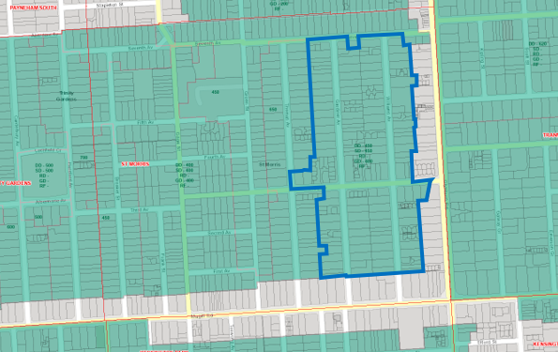
Attachment B
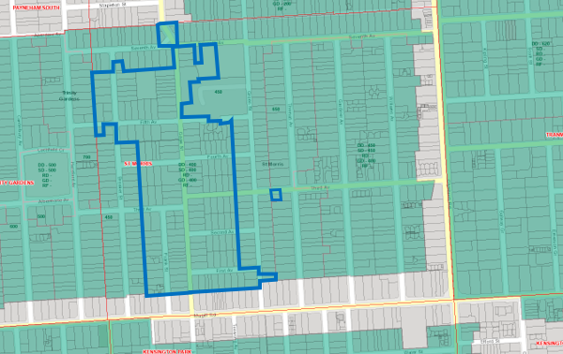

Attachment C
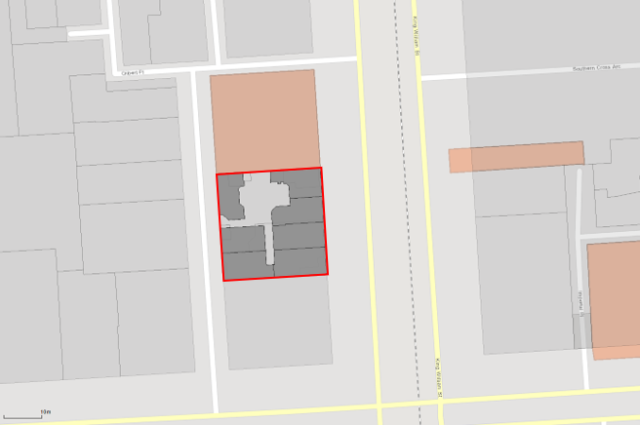

Planning, Development and Infrastructure Act 2016
Section 76
Amendment to the Planning and Design Code
Preamble
It is necessary to amend the Planning and Design Code (the Code) in operation at 16 February 2023 (Version 2023.3) in order to make changes of form relating to the Code’s spatial layers and their relationship with land parcels. NOTE: There are no changes to the application of zone, subzone or overlay boundaries and their relationship with affected parcels or the intent of policy application as a result of this amendment.
- PURSUANT to section 76 of the Planning, Development and Infrastructure Act 2016 (the Act), I hereby amend the Code in order to make changes of form (without altering the effect of underlying policy), correct errors and make operational amendments as follows:
- Undertake minor alterations to the geometry of the spatial layers and data in the Code to maintain the current relationship between the parcel boundaries and Code data as a result of the following:
  - New plans of division deposited in the Land Titles Office between 22 February 2023 and 7 March 2023 affecting the following spatial and data layers in the Code:
    - Zones and subzones
    - Technical and Numeric Variations
      - Building Heights (Levels)
      - Building Heights (Metres)
      - Finished Ground and Floor Levels
      - Minimum Dwelling Allotment Size
      - Minimum Frontage
      - Minimum Site Area
      - Minimum Primary Street Setback
      - Minimum Side Boundary Setback
      - Future Local Road Widening Setback
    - Overlays
      - Affordable Housing
      - Character Area
      - Coastal Areas
      - Future Road Widening
      - Hazards (Bushfire - High Risk)
      - Hazards (Bushfire - Medium Risk)
      - Hazards (Bushfire - General Risk)
      - Hazards (Bushfire - Urban Interface)
      - Hazards (Bushfire - Regional)
      - Hazards (Bushfire - Outback)
      - Heritage Adjacency
      - Historic Area
      - Local Heritage Place
      - Noise and Air Emissions
      - State Heritage Place
      - Stormwater Management
      - Urban Tree Canopy
  - Improved spatial data for existing land parcels in the following locations (as described in Column A) that affect data layers in the Code (as shown in Column B):
Location (Column A) | Layers (Column B)
Cadnia - Warraweena  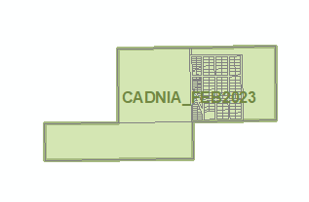 | Overlays  - Heritage Adjacency  - Key Outback and Rural Routes  - State Heritage Place
- In Part 13 of the Code – Table of Amendments, update the publication date, Code version number, amendment type and summary of amendments within the ‘Table of Planning and Design Code Amendments’ to reflect the amendments to the Code as described in this Notice.
- PURSUANT to section 76(5)(a) of the Act, I further specify that the amendments to the Code as described in this Notice will take effect upon the date those amendments are published on the SA planning portal.
Dated: 10 March 2023
Greg Van Gaans
Director, Land and Built Environment
Department for Trade and Investment
Delegate of the Minister for Planning

South Australian Skills Act 2008
Part 4—Apprenticeships, Traineeships and Training Contracts
PURSUANT to the provision of the South Australian Skills Act 2008, the South Australian Skills Commission (SASC) gives notice that determines the following Trades or Declared Vocations in addition to the Gazette notices of:
- 25 Sep 2008 | - 23 Oct 2008 | - 13 Nov 2008 | - 04 Dec 2008 | - 18 Dec 2008 | - 29 Jan 2009
- 12 Feb 2009 | - 05 Mar 2009 | - 12 Mar 2009 | - 26 Mar 2009 | - 30 Apr 2009 | - 18 Jun 2009
- 25 Jun 2009 | - 27 Aug 2009 | - 17 Sep 2009 | - 24 Sep 2009 | - 09 Oct 2009 | - 22 Oct 2009
- 03 Dec 2009 | - 17 Dec 2009 | - 04 Feb 2010 | - 11 Feb 2010 | - 18 Feb 2010 | - 18 Mar 2010
- 08 Apr 2010 | - 06 May 2010 | - 20 May 2010 | - 03 Jun 2010 | - 17 Jun 2010 | - 24 Jun 2010
- 08 Jul 2010 | - 09 Sep 2010 | - 23 Sep 2010 | - 04 Nov 2010 | - 25 Nov 2010 | - 16 Dec 2010
- 23 Dec 2010 | - 17 Mar 2011 | - 07 Apr 2011 | - 21 Apr 2011 | - 19 May 2011 | - 30 Jun 2011
- 21 Jul 2011 | - 08 Sep 2011 | - 10 Nov 2011 | - 24 Nov 2011 | - 01 Dec 2011 | - 08 Dec 2011
- 16 Dec 2011 | - 22 Dec 2011 | - 05 Jan 2012 | - 19 Jan 2012 | - 01 Mar 2012 | - 29 Mar 2012
- 24 May 2012 | - 31 May 2012 | - 07 Jun 2012 | - 14 Jun 2012 | - 21 Jun 2012 | - 28 Jun 2012
- 05 Jul 2012 | - 12 Jul 2012 | - 19 Jul 2012 | - 02 Aug 2012 | - 09 Aug 2012 | - 30 Aug 2012
- 13 Sep 2012 | - 04 Oct 2012 | - 18 Oct 2012 | - 25 Oct 2012 | - 08 Nov 2012 | - 29 Nov 2012
- 13 Dec 2012 | - 25 Jan 2013 | - 06 Feb 2013 | - 14 Feb 2013 | - 21 Feb 2013 | - 28 Feb 2013
- 07 Mar 2013 | - 14 Mar 2013 | - 21 Mar 2013 | - 28 Mar 2013 | - 26 Apr 2013 | - 23 May 2013
- 30 May 2013 | - 13 Jun 2013 | - 20 Jun 2013 | - 11 Jul 2013 | - 01 Aug 2013 | - 08 Aug 2013
- 15 Aug 2013 | - 29 Aug 2013 | - 12 Jun 2014 | - 28 Aug 2014 | - 04 Sep 2014 | - 16 Oct 2014
- 23 Oct 2014 | - 05 Feb 2015 | - 26 Mar 2015 | - 07 Apr 2015 | - 16 Apr 2015 | - 27 May 2015
- 18 Jun 2015 | - 03 Dec 2015 | - 30 Jun 2016 | - 28 Jul 2016 | - 08 Sep 2016 | - 22 Sep 2016
- 27 Oct 2016 | - 01 Dec 2016 | - 15 Dec 2016 | - 07 Mar 2017 | - 21 Mar 2017 | - 23 May 2017
- 13 Jun 2017 | - 18 Jul 2017 | - 19 Sep 2017 | - 26 Sep 2017 | - 17 Oct 2017 | - 03 Jan 2018
- 23 Jan 2018 | - 14 Mar 2018 | - 14 Jun 2018 | - 05 Jul 2018 | - 02 Aug 2018 | - 09 Aug 2018
- 16 Aug 2018 | - 30 Aug 2018 | - 27 Sep 2018 | - 04 Oct 2018 | - 18 Oct 2018 | - 01 Nov 2018
- 15 Nov 2018 | - 22 Nov 2018 | - 29 Nov 2018 | - 06 Dec 2018 | - 20 Dec 2018 | - 24 Jan 2019
- 14 Feb 2019 | - 30 May 2019 | - 06 Jun 2019 | - 13 Jun 2019 | - 20 Jun 2019 | - 27 Jun 2019
- 11 Jul 2019 | - 08 Aug 2019 | - 22 Aug 2019 | - 12 Sep 2019 | - 19 Sep 2019 | - 14 Nov 2019
- 28 Nov 2019 | - 12 Dec 2019 | - 19 Dec 2019 | - 23 Jan 2020 | - 27 Feb 2020 | - 21 Apr 2020
- 25 Jun 2020 | - 10 Sep 2020 | - 17 Sep 2020 | - 08 Oct 2020 | - 29 Oct 2020 | - 05 Nov 2020
- 10 Dec 2020 | - 17 Dec 2020 | - 24 Dec 2020 | - 21 Jan 2021 | - 11 Feb 2021 | - 25 Feb 2021
- 25 Mar 2021 | - 01 Apr 2021 | - 08 Apr 2021 | - 06 May 2021 | - 10 Jun 2021 | - 01 Jul 2021
- 12 Aug 2021 | - 16 Sep 2021 | - 23 Sep 2021 | - 30 Sep 2021 | - 14 Oct 2021 | - 21 Oct 2021
- 09 Nov 2021 | - 02 Dec 2021 | - 23 Dec 2021 | - 24 Feb 2022 | - 10 Mar 2022 | - 24 Mar 2022
- 12 May 2022 | - 16 Jun 2022 | - 23 Jun 2022 | - 11 Aug 2022 | - 25 Aug 2022 | - 27 Oct 2022
- 22 Dec 2022 | - 26 Jan 2023 | - 16 Feb 2023 | - 16 Mar 2023

Trades or Declared Vocations and required qualifications and training contract conditions for the Agriculture, Horticulture and Conservation and Land Management (AHC), Australian Meat Processing (AMP), Community Services (CHC), Electrotechnology (UEE), Forest and Wood Products (FWP), Furnishing (MSF), Health (HLT), Manufacturing (MSM), Manufacturing and Engineering (MEM), Sport, Fitness and Recreation (SIS), Sustainability (MSS), Textiles, Clothing and Footwear (MST) training package/s

*Trade/ #Declared Vocation/ Other Occupation | Qualification Title | Nominal Term of Training Contract | Probationary Period | Supervision Level Rating
Aboriginal and/or Torres Strait Islander Health Care Practitioner # | Certificate IV in Aboriginal and/or Torres Strait Islander Primary Health Care Practice | 24 | 60 | High
Aboriginal And/Or Torres Strait Islander Health Worker # | Certificate II in Aboriginal and/or Torres Strait Islander Primary Health Care | 12 | 60 | Low
Aboriginal And/Or Torres Strait Islander Health Worker # | Certificate III in Aboriginal and/or Torres Strait Islander Primary Health Care | 12 | 60 | Medium
Aboriginal And/Or Torres Strait Islander Health Worker # | Certificate IV in Aboriginal and/or Torres Strait Islander Primary Health Care | 24 | 60 | Medium
Advanced Tradesperson (Rail Signalling) * | Certificate IV in Rail Signalling | 24 | 60 | Medium
Aged Care Worker # | Diploma of Community Services | 24 | 60 | Medium
Alcohol And Other Drugs Worker # | Diploma of Community Services | 24 | 60 | High
Cabinet Maker (Bathrooms And Kitchens) * | Certificate III in Cabinet Making and Timber Technology | 48 | 90 | Medium
Cabinet Maker (Furniture) * | Certificate III in Cabinet Making and Timber Technology | 48 | 90 | Medium
Community Worker # | Diploma of Community Services | 24 | 60 | High
Community Worker # | Diploma of Financial Counselling | 36 | 90 | High
Coopering And Vatmaking * | Certificate III in Cabinet Making and Timber Technology | 48 | 90 | Medium
Disability Worker # | Diploma of Community Services | 24 | 60 | High
Engineering Tradesperson (Electrical/Electronics) * | Certificate III in Engineering - Electronic Trade | 48 | 90 | High
Environment Worker # | Certificate III in On Country Management | 36 | 90 | Medium
Environment Worker # | Diploma of Community Group Coordination and Facilitation | 48 | 90 | Medium
Existing Worker In A Trade Or Declared Vocation # | Certificate III in Competitive Systems and Practices | 12 | 60 | Medium
Existing Worker In A Trade Or Declared Vocation # | Certificate IV in Competitive Systems and Practices | 24 | 60 | Medium
Existing Worker In A Trade Or Declared Vocation # | Diploma of Competitive Systems and Practices | 36 | 90 | Medium
Farm Operation # | Certificate I in Agriculture | 12 | 60 | Low
Farm Operation # | Certificate III in Rural Operations | 36 | 90 | Medium
Farming # | Certificate II in Agriculture | 18 | 60 | Low
Farming # | Certificate III in Agriculture | 36 | 90 | Medium
Farming # | Certificate III in Pork Production | 36 | 90 | Medium
Farming # | Certificate III in Poultry Production | 36 | 90 | Medium
Farming # | Certificate IV in Agriculture | 36 | 90 | Medium
Farming # | Diploma of Agriculture | 48 | 90 | Medium
Floor Finisher * | Certificate III in Flooring Technology | 48 | 90 | Medium
Forest Products Operators # | Certificate II in Forest Operations | 12 | 60 | Low
Forest Products Operators # | Certificate II in Timber and Wood Products Operations | 12 | 60 | Low

Forest Products Operators # | Certificate III in Forest Operations | 24 | 60 | Medium
Forest Products Operators # | Certificate III in Timber and Wood Products Operations | 24 | 60 | Medium
Forest Products Operators # | Certificate IV in Timber and Wood Products Operations | 36 | 90 | Medium
Furniture Tradesperson # | Certificate II in Cabinet Making and Timber Technology | 12 | 60 | Medium
Furniture Tradesperson * | Certificate III in Cabinet Making and Timber Technology | 48 | 90 | Medium
Furniture Tradesperson * | Certificate III in Furniture Finishing | 48 | 90 | Medium
Horticulture # | Certificate II in Horticulture | 18 | 60 | Low
Horticulture # | Certificate III in Horticulture | 36 | 90 | Medium
Horticulture # | Certificate IV in Horticulture | 36 | 90 | Medium
Horticulture # | Diploma of Horticulture Management | 48 | 90 | Medium
Meat Inspector # | Certificate III in Meat Safety Inspection | 24 | 60 | Medium
Mental Health (Non Clinical Worker) # | Diploma of Community Services | 24 | 60 | High
Quality Assurance Monitor/Officer # | Certificate III in Meat Processing | 24 | 60 | Medium
Recreation Industry Worker # | Certificate II in Sport and Recreation | 12 | 60 | Low
Recreation Industry Worker # | Certificate III in Sport, Aquatics and Recreation | 12 | 60 | Medium
Recreation Industry Worker # | Certificate IV in Sport, Aquatics and Recreation | 18 | 60 | Medium
Recreation Industry Worker # | Diploma of Sport, Aquatics and Recreation Management | 24 | 60 | Medium
Recreational Vehicle Manufacturing Service And Sales # | Certificate II in Recreational Vehicle Trade Pathways | 12 | 60 | Medium
Recreational Vehicle Manufacturing Service And Sales # | Certificate IV in Recreational Vehicles | 36 | 90 | High
Textile and Clothing Production Worker # | Certificate III in Apparel, Fashion and Textiles | 24 | 60 | Medium
Wood Machinist * | Certificate III in Cabinet Making and Timber Technology | 48 | 90 | Medium
Youth Worker # | Certificate IV in Youth Work | 24 | 60 | High
Youth Worker # | Diploma of Community Services | 24 | 60 | High
Youth Worker # | Diploma of Youth Work | 36 | 90 | High
Dated: 16 March 2023
John Evangelista
Director, Traineeship and Apprenticeship Services
Department for Education

Local Government Instruments

City of Norwood Payneham & St Peters
Proposed Declaration under Section 210(1) of the Local Government Act 1999 (SA)
The City of Norwood Payneham & St Peters hereby gives notice that it proposes to make a declaration under Section 210(1) of the Local Government Act 1999 (SA) converting the following private road within its Council area into a public road on 16 June 2023, or thereafter:
The private road comprising allotments 144 and 143 in FP 17910 and which is a private road commonly known as Nelson Lane in the area of Adelaide.
Dated: 7 March 2023
Mario Barone
Chief Executive Officer

Public Notices

Highbury Landfill Authority
Local Government Act 1999
Adoption of Amended Charter
NOTICE is hereby given in accordance with Clause 19(5)(c) of Schedule 2 to the Local Government Act 1999, that the City of Burnside, the City of Norwood, Payneham & St Peters and the Corporation of the Town of Walkerville have adopted an amended Charter for the Highbury Landfill Authority. The amended charter took effect on 17 October 2022.
The Charter, as amended, is available for inspection at the following website addresses: https://www.burnside.sa.gov.au and https://www.npsp.sa.gov.au
Dated: 16 March 2023
Trevor Hockley
Manager of the Authority

Trustee Act 1936
Public Trustee
Estates of Deceased Persons
In the matter of the estates of the undermentioned deceased persons:
ARNELL Guy David late of 26 Davenport Street Port Augusta of no occupation who died 19 July 2022
CORNELISSE Margaret Elizabeth Joan late of 14 Frew Street Fullarton Retired Business Proprietor who died 17 December 2022
GODDARD Grace Elizabeth late of 1 Wilton Street Davoren Park Retired Deli Manager who died 22 October 2022
GRIFFITHS Shirley Anne Marie late of 9 Sunnybrae Road Kilburn of no occupation who died 16 June 2022
KIMBER Robert Anthony late of 20 Salzmann Drive Pooraka Carpet Cleaner who died 21 June 2022
KOHLBERGER Franz Josef late of 72 Labrina Avenue Prospect Retired Architect Engineer who died 28 January 2022
MERCER David Robert late of 7 Plymouth Avenue Devon Park Courier Driver who died 27 March 2022
O'LOUGHLIN Rosemary Lillian late of 2 Oldford Road Davoren Park of no occupation who died 30 September 2022
PELGRAVE Donald Roy late of 58 Chief Street Brompton Retired Display Artist who died 6 November 2022
RYGUCKI Zugmunt otherwise Sigmund late of 172 Trimmer Parade Seaton Retired Press Operator who died 10 December 2022
VON KELAITA Henri late of 1 Wilton Street Davoren Park Retired Counsellor who died 11 November 2022
Notice is hereby given pursuant to the Trustee Act 1936, the Inheritance (Family Provision) Act 1972 and the Family Relationships Act 1975 that all creditors, beneficiaries, and other persons having claims against the said estates are required to send, in writing, to the office of Public Trustee at GPO Box 1338, Adelaide 5001, full particulars and proof of such claims, on or before the 14 April 2023 otherwise they will be excluded from the distribution of the said estate; and notice is also hereby given that all persons indebted to the said estates are required to pay the amount of their debts to the Public Trustee or proceedings will be taken for the recovery thereof; and all persons having any property belonging to the said estates are forthwith to deliver same to the Public Trustee.
Dated: 16 March 2023
N. S. Rantanen
Public Trustee

Notice Submission

The South Australian Government Gazette is published each Thursday afternoon.
Notices must be emailed by 4 p.m. Tuesday, the week of publication.
Submissions are formatted per the gazette style and a proof will be supplied prior to publication, along with a quote if applicable. Please allow one day for processing notices.
Alterations to the proof must be returned by 4 p.m. Wednesday.

Gazette notices must be submitted as Word files, in the following format:
• Title—the governing legislation
• Subtitle—a summary of the notice content
• Body—structured text, which can include numbered lists, tables, and images
• Date—day, month, and year of authorisation
• Signature block—name, role, and department/organisation authorising the notice

Please provide the following information in your email:
• Date of intended publication
• Contact details of the person responsible for the notice content
• Name and organisation to be charged for the publication—Local Council and Public notices only
• Purchase order, if required—Local Council and Public notices only

Email: governmentgazettesa@sa.gov.au
Phone: (08) 7109 7760
Website: www.governmentgazette.sa.gov.au

All instruments appearing in this gazette are to be considered official, and obeyed as such

Printed and published weekly by authority of M. Dowling, Government Printer, South Australia
$8.15 per issue (plus postage), $411.00 per annual subscription—GST inclusive
Online publications: www.governmentgazette.sa.gov.au

