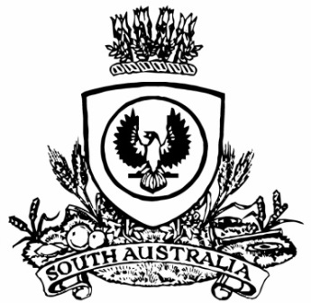
SUPPLEMENTARY GAZETTE
THE SOUTH AUSTRALIAN
GOVERNMENT GAZETTE
Published by Authority

Adelaide, Sunday, 26 March 2023

Governor’s Instruments
ACTS
Department of the Premier and Cabinet
Adelaide, 26 March 2023
Her Excellency the Governor directs it to be notified for general information that she has in the name and on behalf of His Majesty The King, this day assented to the undermentioned Bill passed by the Legislative Council and House of Assembly in Parliament assembled, viz.:
No. 9 of 2023—First Nations Voice Bill 2023
An Act to give First Nations people a voice that will be heard by the Parliament of South Australia, the Government of South Australia and other persons and bodies, to establish Local First Nations Voices and the State First Nations Voice, to repeal the Aboriginal Lands Parliamentary Standing Committee Act 2003, to amend the Constitution Act 1934, and for other purposes.
By command,
Peter Bryden Malinauskas
Premier

