No. 21 p. 621
THE SOUTH AUSTRALIAN
GOVERNMENT GAZETTE
Published by Authority

Adelaide, Thursday, 30 March 2023

Contents

Governor’s Instruments
Acts—No. 10-13 of 2023 622
Appointments 622
Proclamations—
Youth Court (Designation and Classification of
Magistrate) Proclamation 2023 624
Regulations—
Primary Industry Funding Schemes (Adelaide Hills Wine Industry Fund) (Prescribed Period) Amendment Regulations 2023—No. 11 of 2023 625
Primary Industry Funding Schemes (Barossa Wine
Industry Fund) (Prescribed Period) Amendment Regulations 2023—No. 12 of 2023 626
Primary Industry Funding Schemes (Clare Valley Wine
Industry Fund) (Prescribed Period) Amendment Regulations 2023—No. 13 of 2023 627
Primary Industry Funding Schemes (Langhorne Creek
Wine Industry Fund) (Prescribed Period) Amendment Regulations 2023—No. 14 of 2023 628
Primary Industry Funding Schemes (McLaren Vale Wine Industry Fund) (Prescribed Period) Amendment Regulations 2023—No. 15 of 2023 629
Primary Industry Funding Schemes (Riverland Wine
Industry Fund) (Prescribed Period) Amendment Regulations 2023—No. 16 of 2023 630
Primary Industry Funding Schemes (SA Grape Growers Industry Fund) (Prescribed Period) Amendment Regulations 2023—No. 17 of 2023 631
State Government Instruments
Associations Incorporation Act 1985 632
Correctional Services Act 1982 633
Fisheries Management (Prawn Fisheries) Regulations 2017 633
Fisheries Management Act 2007 634
Gambling Administration Act 2019 635
Health Care Act 2008 743
Housing Improvement Act 2016 744
Land Acquisition Act 1969 744
Local Government (Elections) Act 1999 745
Mining Act 1971 747
Motor Vehicles Act 1959 747
Petroleum and Geothermal Energy Act 2000 749
Planning, Development and Infrastructure Act 2016 749
Plant Health Act 2009 754
Shop Trading Hours Act 1977 758
Supreme Court Act 1935 758
The District Court of South Australia—
Port Augusta Circuit Court 758
Public Notices
Trustee Act 1936 760
Unclaimed Moneys Act 1891 760

Governor’s Instruments

Acts
Department of the Premier and Cabinet
Adelaide, 30 March 2023
Her Excellency the Governor directs it to be notified for general information that she has in the name and on behalf of His Majesty The King, this day assented to the undermentioned Bills passed by the Legislative Council and House of Assembly in Parliament assembled, viz.:
No. 10 of 2023—Fair Work (Family and Domestic Violence Leave) Amendment Bill 2023
An Act to amend the Fair Work Act 1994
No. 11 of 2023—Gene Technology (Adoption of Commonwealth Amendments) Amendment Bill 2023
An Act to amend the Gene Technology Act 2001
No. 12 of 2023—Statutes Amendment (Civil Enforcement) Bill 2023
An Act to amend the Enforcement of Judgments Act 1991 and the Sheriffs Act 1978
No. 13 of 2023—Courts Administration (Miscellaneous) Amendment Bill 2023
An Act to amend the Courts Administration Act 1993
By command,
Kyam Joseph Maher, MLC
For Premier

Appointments
Department of the Premier and Cabinet
Adelaide, 30 March 2023
Her Excellency the Governor in Executive Council has been pleased to appoint the undermentioned to the South Australian Forestry Corporation Board, pursuant to the provisions of the South Australian Forestry Corporation Act 2000:
Director: from 1 April 2023 until 30 September 2023
June Ruby Roache
Chair: from 1 April 2023 until 30 September 2023
June Ruby Roache
Director: from 1 April 2023 until 30 September 2025
Hayley Barelds Neumann
By command,
Kyam Joseph Maher, MLC
For Premier
MPIRD F2023/000132CS

Department of the Premier and Cabinet
Adelaide, 30 March 2023
Her Excellency the Governor in Executive Council has been pleased to appoint the undermentioned to the Architectural Practice Board of South Australia, pursuant to the provisions of the Architectural Practice Act 2009:
Member: from 5 April 2023 until 4 April 2026
Mariano De Duonni
Member: from 23 April 2023 until 22 April 2026
Dario Salvatore
Sarah Jane Burge
Stephen Ward
By command,
Kyam Joseph Maher, MLC
For Premier
23MPCS01471

Department of the Premier and Cabinet
Adelaide, 30 March 2023
Her Excellency the Governor in Executive Council has been pleased to appoint the undermentioned to the Police Disciplinary Tribunal, pursuant to the provisions of the Police Complaints and Discipline Act 2016:
Magistrate in Charge: from 29 April 2023 until 28 April 2026
David John White
Deputy Magistrate in Charge: from 29 April 2023 until 28 April 2026
Karim Wardhana Soetratma
Panel Member: from 29 April 2023
Alison Frances Adair
Jayne Samia Basheer
Paul Bennett
Michael James Barnett
Natalie Rose Browne
Melanie Kate Burton
Lana Lee Chester
Luke Anthony Davis
Brett Jonathon Dixon
Lynette Catherine Duncan
Gregory Charles Fisher
Paul Marvin Foley
Michael Alexander Fotheringham
Todd Matthew Grant
Kathryn Hodder
Mary-Louise Hribal
Anna Jackson
Roderick Neil Jensen
Briony Kennewell
Oliver Rudolf Gerhard Koehn
Koula Kossiavelos
Joanna Leigh Martin
David Hamilton Bruce McLeod
Kym Andrew Millard
Brian Malcolm Nitschke
Rodney Oates
Maria Panagiotidis
Jayanthi Pandya
Benjamin James Sale
Kylie Sue Schulz
Mark Steven Semmens
Simon James Smart
Christopher Jeremy Smolicz
Edward Paul Stratton-Smith
Antonietta Vozzo
John Cardale Wells
Ian Lansell White
Kathryn Ann White
Justin Peter Wickens
By command,
Kyam Joseph Maher, MLC
For Premier
AGO0049-23CS

Department of the Premier and Cabinet
Adelaide, 30 March 2023
Her Excellency the Governor in Executive Council has been pleased to appoint the Honourable Zoe Lee Bettison, MP, to be also Acting Minister for Small and Family Business, Acting Minister for Consumer and Business Affairs and Acting Minister for Arts, from 4 April 2023 until 12 April 2023 inclusive, during the absence of the Honourable Andrea Michaels, MP.
By command,
Kyam Joseph Maher, MLC
For Premier
23SFB0004CS

Proclamations
South Australia

Youth Court (Designation and Classification of Magistrate) Proclamation 2023
under section 9 of the Youth Court Act 1993
1—Short title
This proclamation may be cited as the Youth Court (Designation and Classification of Magistrate) Proclamation 2023.
2—Commencement
This proclamation comes into operation on 19 April 2023.
3—Designation and classification of magistrate
Magistrate Oliver Rudolf Gerhard Koehn is—
(a) designated as a magistrate of the Youth Court of South Australia; and
(b) classified as a member of the Court's principal judiciary; and
(c) declared to be a member of the Court's principal judiciary for a term commencing on the day on which this proclamation comes into operation and ending on 30 June 2023.
Made by the Governor
with the advice and consent of the Executive Council
on 30 March 2023

Regulations
South Australia

Primary Industry Funding Schemes (Adelaide Hills Wine Industry Fund) (Prescribed Period) Amendment Regulations 2023
under the Primary Industry Funding Schemes Act 1998

Contents
Part 1—Preliminary
1 Short title
2 Commencement
Part 2—Amendment of Primary Industry Funding Schemes (Adelaide Hills Wine Industry Fund) Regulations 2017
3 Amendment of regulation 3—Interpretation

Part 1—Preliminary
1—Short title
These regulations may be cited as the Primary Industry Funding Schemes (Adelaide Hills Wine Industry Fund) (Prescribed Period) Amendment Regulations 2023.
2—Commencement
These regulations come into operation on the day on which they are made.
Part 2—Amendment of Primary Industry Funding Schemes (Adelaide Hills Wine Industry Fund) Regulations 2017
3—Amendment of regulation 3—Interpretation
Regulation 3(1), definition of prescribed period, (b)—delete "up to and including the period of 12 months commencing on 1 June 2023"
Editorial note—
As required by section 10AA(2) of the Legislative Instruments Act 1978, the Minister has certified that, in the Minister's opinion, it is necessary or appropriate that these regulations come into operation as set out in these regulations.
Made by the Governor
with the advice and consent of the Executive Council
on 30 March 2023
No 11 of 2023

South Australia

Primary Industry Funding Schemes (Barossa Wine Industry Fund) (Prescribed Period) Amendment Regulations 2023
under the Primary Industry Funding Schemes Act 1998

Contents
Part 1—Preliminary
1 Short title
2 Commencement
Part 2—Amendment of Primary Industry Funding Schemes (Barossa Wine Industry Fund) Regulations 2021
3 Amendment of regulation 3—Interpretation

Part 1—Preliminary
1—Short title
These regulations may be cited as the Primary Industry Funding Schemes (Barossa Wine Industry Fund) (Prescribed Period) Amendment Regulations 2023.
2—Commencement
These regulations come into operation on the day on which they are made.
Part 2—Amendment of Primary Industry Funding Schemes (Barossa Wine Industry Fund) Regulations 2021
3—Amendment of regulation 3—Interpretation
Regulation 3(1), definition of prescribed period, (b)—after "1 June 2022" insert:
or on 1 June in any subsequent year
Editorial note—
As required by section 10AA(2) of the Legislative Instruments Act 1978, the Minister has certified that, in the Minister's opinion, it is necessary or appropriate that these regulations come into operation as set out in these regulations.
Made by the Governor
with the advice and consent of the Executive Council
on 30 March 2023
No 12 of 2023

South Australia

Primary Industry Funding Schemes (Clare Valley Wine Industry Fund) (Prescribed Period) Amendment Regulations 2023
under the Primary Industry Funding Schemes Act 1998

Contents
Part 1—Preliminary
1 Short title
2 Commencement
Part 2—Amendment of Primary Industry Funding Schemes (Clare Valley Wine Industry Fund) Regulations 2021
3 Amendment of regulation 3—Interpretation

Part 1—Preliminary
1—Short title
These regulations may be cited as the Primary Industry Funding Schemes (Clare Valley Wine Industry Fund) (Prescribed Period) Amendment Regulations 2023.
2—Commencement
These regulations come into operation on the day on which they are made.
Part 2—Amendment of Primary Industry Funding Schemes (Clare Valley Wine Industry Fund) Regulations 2021
3—Amendment of regulation 3—Interpretation
Regulation 3(1), definition of prescribed period, (b)—after "1 June 2022" insert:
or on 1 June in any subsequent year
Editorial note—
As required by section 10AA(2) of the Legislative Instruments Act 1978, the Minister has certified that, in the Minister's opinion, it is necessary or appropriate that these regulations come into operation as set out in these regulations.
Made by the Governor
with the advice and consent of the Executive Council
on 30 March 2023
No 13 of 2023

South Australia

Primary Industry Funding Schemes (Langhorne Creek Wine Industry Fund) (Prescribed Period) Amendment Regulations 2023
under the Primary Industry Funding Schemes Act 1998

Contents
Part 1—Preliminary
1 Short title
2 Commencement
Part 2—Amendment of Primary Industry Funding Schemes (Langhorne Creek Wine Industry Fund) Regulations 2016
3 Amendment of regulation 3—Interpretation

Part 1—Preliminary
1—Short title
These regulations may be cited as the Primary Industry Funding Schemes (Langhorne Creek Wine Industry Fund) (Prescribed Period) Amendment Regulations 2023.
2—Commencement
These regulations come into operation on the day on which they are made.
Part 2—Amendment of Primary Industry Funding Schemes (Langhorne Creek Wine Industry Fund) Regulations 2016
3—Amendment of regulation 3—Interpretation
Regulation 3(1), definition of prescribed period—delete "up to and including the period of 12 months ending on 31 May 2023"
Editorial note—
As required by section 10AA(2) of the Legislative Instruments Act 1978, the Minister has certified that, in the Minister's opinion, it is necessary or appropriate that these regulations come into operation as set out in these regulations.
Made by the Governor
with the advice and consent of the Executive Council
on 30 March 2023
No 14 of 2023

South Australia

Primary Industry Funding Schemes (McLaren Vale Wine Industry Fund) (Prescribed Period) Amendment Regulations 2023
under the Primary Industry Funding Schemes Act 1998

Contents
Part 1—Preliminary
1 Short title
2 Commencement
Part 2—Amendment of Primary Industry Funding Schemes (McLaren Vale Wine Industry Fund) Regulations 2017
3 Amendment of regulation 3—Interpretation

Part 1—Preliminary
1—Short title
These regulations may be cited as the Primary Industry Funding Schemes (McLaren Vale Wine Industry Fund) (Prescribed Period) Amendment Regulations 2023.
2—Commencement
These regulations come into operation on the day on which they are made.
Part 2—Amendment of Primary Industry Funding Schemes (McLaren Vale Wine Industry Fund) Regulations 2017
3—Amendment of regulation 3—Interpretation
Regulation 3(1), definition of prescribed period, (c)— delete "up to an including the period of 12 months commencing on 1 June 2022"
Editorial note—
As required by section 10AA(2) of the Legislative Instruments Act 1978, the Minister has certified that, in the Minister's opinion, it is necessary or appropriate that these regulations come into operation as set out in these regulations.
Made by the Governor
with the advice and consent of the Executive Council
on 30 March 2023
No 15 of 2023

South Australia

Primary Industry Funding Schemes (Riverland Wine Industry Fund) (Prescribed Period) Amendment Regulations 2023
under the Primary Industry Funding Schemes Act 1998

Contents
Part 1—Preliminary
1 Short title
2 Commencement
Part 2—Amendment of Primary Industry Funding Schemes (Riverland Wine Industry Fund) Regulations 2016
3 Amendment of regulation 3—Interpretation

Part 1—Preliminary
1—Short title
These regulations may be cited as the Primary Industry Funding Schemes (Riverland Wine Industry Fund) (Prescribed Period) Amendment Regulations 2023.
2—Commencement
These regulations come into operation on the day on which they are made.
Part 2—Amendment of Primary Industry Funding Schemes (Riverland Wine Industry Fund) Regulations 2016
3—Amendment of regulation 3—Interpretation
Regulation 3(1), definition of prescribed period—delete "up to and including the period of 12 months commencing on 1 June 2022"
Editorial note—
As required by section 10AA(2) of the Legislative Instruments Act 1978, the Minister has certified that, in the Minister's opinion, it is necessary or appropriate that these regulations come into operation as set out in these regulations.
Made by the Governor
with the advice and consent of the Executive Council
on 30 March 2023
No 16 of 2023

South Australia

Primary Industry Funding Schemes (SA Grape Growers Industry Fund) (Prescribed Period) Amendment Regulations 2023
under the Primary Industry Funding Schemes Act 1998

Contents
Part 1—Preliminary
1 Short title
2 Commencement
Part 2—Amendment of Primary Industry Funding Schemes (SA Grape Growers Industry Fund) Regulations 2021
3 Amendment of regulation 3—Interpretation

Part 1—Preliminary
1—Short title
These regulations may be cited as the Primary Industry Funding Schemes (SA Grape Growers Industry Fund) (Prescribed Period) Amendment Regulations 2023.
2—Commencement
These regulations come into operation on the day on which they are made.
Part 2—Amendment of Primary Industry Funding Schemes (SA Grape Growers Industry Fund) Regulations 2021
3—Amendment of regulation 3—Interpretation
Regulation 3(1), definition of prescribed period, (b)—after "1 June 2022" insert:
or on 1 June in any subsequent year
Editorial note—
As required by section 10AA(2) of the Legislative Instruments Act 1978, the Minister has certified that, in the Minister's opinion, it is necessary or appropriate that these regulations come into operation as set out in these regulations.
Made by the Governor
with the advice and consent of the Executive Council
on 30 March 2023
No 17 of 2023

State Government Instruments

Associations Incorporation Act 1985
Order Pursuant to Section 42(2)
Dissolution of Association
WHEREAS the CORPORATE AFFAIRS COMMISSION (the Commission) pursuant to section 42(1) of the Associations Incorporation Act 1985 (the Act) is of the opinion that the undertaking or operations of S.A. VIPASSANA MEDITATION ASSOCIATION INCORPORATED (the Association) being an incorporated association under the Act are being carried on, or would more appropriately be carried on by a Company Limited by Guarantee incorporated under the Corporations Act 2001 (Cth) AND WHEREAS the Commission was on 8 FEBRUARY 2023 requested by the Association to transfer its undertaking to VIPASSANA CENTRE SOUTH AUSTRALIA LIMITED (Australian Company Number 666 647 936, the Commission pursuant to section 42(2) of the Act DOES HEREBY ORDER that on 30 MARCH 2023, the Association will be dissolved, the property of the Association becomes the property of VIPASSANA CENTRE SOUTH AUSTRALIA LIMITED and the rights and liabilities of the Association become the rights and liabilities of VIPASSANA CENTRE SOUTH AUSTRALIA LIMITED.
Given under the seal of the Commission at Adelaide this 24th day of MARCH 2023
Melissa Matthews
A delegate of the Corporate Affairs Commission

Associations Incorporation Act 1985
Section 43A
Deregistration of Associations
NOTICE is hereby given that the Corporate Affairs Commission approves the applications for deregistration received from the associations named below pursuant to section 43A of the Associations Incorporation Act 1985 (SA). Deregistration takes effect on the date of publication of this notice.
AIR CADETS ASSOCIATION INCORPORATED (A9722)
AUSTRALIAN RHODODOENDRON SOCIETY INCORPORATED (A12036)
BE GENEROUS INCORPORATED (A39703)
BEDFORD INDUSTRIES HOUSING CO-OPERATIVE ASSOCIATION INCORPORATED (A11636)
BLANCHETOWN PROGRESS ASSOCIATION INCORPORATED (A23744)
CAMPBELLTOWN CHRISTIAN REFORMED CHURCH INCORPORATED (A1640)
CAREER PARTNERS PLUS INCORPORATED (A42620)
COROMAL CARAVAN CLUB OF SA INCORPORATED (A36190)
COVENANT LIFE MINISTRY INCORPORATED (A36965)
DIAL BEFORE YOU DIG SA/NT INCORPORATED (A24490)
EUDUNDA HOTEL PATRONS CLUB INCORPORATED (A42198)
FRIENDS OF THE WALKERVILLE LIBRARY INCORPORATED (A19654)
GAWLER GP INCORPORATED (A39443)
GAWLER INTERCHURCH COUNCIL INCORPORATED (A23692)
HAMLEY BRIDGE AGED CARE INCORPORATED (A901)
HARVET FESTIVAL MCLAREN VALE ASSOCAITION INCORPORATED (A41367)
HETA INCORPORATED (A11076)
JET AEROSPORT ASSOCIATION OF AUSTRALIA INCORPORATED (A36349)
KAPUNDA AND DISTRICTS KENNEL AND OBEDIENCE DOG CLUB INCORPORATED (A11356)
KINGSTON S.E. PROBUS CLUB INCORPORATED (A38719)
KIWANIS CLUB OF MODBURY INCORPORATED (A9593)
LIONS CLUB OF MINLATON AND DISTRICT INCORPORATED (A4490)
THE LIONS CLUB OF MITCHAM INCORPORATED (A4885)
MURRAY BRIDGE POLICE SOCIAL CLUB INCORPORATED (A39883)
NATIONAL YOUTH COALITION FOR HOUSING INCORPORATED (A11028)
NORTH EAST NILS INCORPORATED (A39068)
OUT OF THE BLUE SUICIDE PREVENTION NETWORK INFORPORATED (A43279)
PORT MACDONNELL TOURIST ASSOCIATION INCORPORATED (A10228)
PORT NOARLUNGA PETANQUE INCORPORATED (A36578)
RIDDOCH ART GALLERY INCORPORATED (A37063)
ROBERTSTOWN FOOTBALL CLUB INCORPORATED (A1252)
SAVE MY TIWI TREES INCORPORATED (A40677)
SNOWTOWN CROQUET CLUB INCORPORATED (A19290)
SOROPTIMIST INTERNATIONAL OF MOUNT GAMBIER INCORPORATED (A24270)
SOUTH AUSTRALIA UROLOGICAL NURSES SOCIETY INCORPORATED (A38009)
THE ABBEYTFIELD SOCIETY (MOUNT GAMBIER AND DISTRICT) INCORPORATED (A18722)
THE AFRICAN VIOLET SOCIETY OF SOUTH AUSTRALIA INCORPORATED (A4648)
THE ALDGATE COMBINED PROBUS CLUB INCORPORATED (A19473)
THE GLASS COLLECTORS SOCIETY INCORPORATED (A21259)
THE MARION HISTORICAL SOCIETY INCORPORATED (A10959)
THE POLIOMYELITIS WELFARE ASSOCATION SOUTH AUSTRALIA INCORPORATED (A1146)
THE SOUTH AUSTRALIAN CHILD AND FAMILY HEALTH NURSES INCORPORATED (A38867)
WILDCATCH FISHERIES SA INCORPORATED (A3381)
THE CMS CROWS AND MINLATON SPORTING CLUB INCORPORATED (A3572)
GIVEN under the seal of the Commission at Adelaide, this 22nd day of March 2023.
Natasha Tsourtos
Manager, Gambling and Associations
A delegate of the Corporate Affairs Commission

Correctional Services Act 1982
Notice of an Award of Damages to a Prisoner
In accordance with section 81E of the Correctional Services Act 1982, notice is given that an award of damages has been made to Aaron Daniele in a claim against the State. Award monies have been paid into the Prisoner Compensation Quarantine Fund, where it will be held until legal proceedings are finally determined, initially 12 months.
Victims in relation to the criminal acts of Aaron Daniele are invited to seek further information from the Chief Executive, Department for Correctional Services, South Australia. To do so, please contact the Chief Executive by writing to GPO Box 1747, Adelaide SA 5001.
Dated: 30 March 2023
Christian Thompson
Manager, Strategic Communications

Fisheries Management (Prawn Fisheries) Regulations 2017
Variation to Fishing Activities in the Spencer Gulf Prawn Fishery
TAKE NOTE that pursuant to regulation 10 of the Fisheries Management (Prawn Fisheries) Regulations 2017, the notice dated 20 September 2022 on page 6144 of the South Australian Government Gazette on 23 September 2022 prohibiting fishing activities in the Spencer Gulf Prawn Fishery, is hereby varied such that it will not be unlawful for a person fishing pursuant to a Spencer Gulf Prawn Fishery licence to use prawn trawl nets in the areas specified in Schedule 1, during the period specified in Schedule 2, and under the conditions specified in Schedule 3
Schedule 1
The waters of the Spencer Gulf Prawn Fishery:
- Except the Northern Closure area, which is defined as the area north of the following index points:
 | 33 | ° | 46.00 | S |  | 137 | ° | 44.00 | E
 | 33 | ° | 40.50 | S |  | 137 | ° | 37.30 | E
 | 33 | ° | 54.70 | S |  | 137 | ° | 29.20 | E
 | 33 | ° | 49.90 | S |  | 137 | ° | 20.50 | E
 | 33 | ° | 54.00 | S |  | 137 | ° | 11.80 | E
 | 33 | ° | 57.40 | S |  | 137 | ° | 14.10 | E
 | 34 | ° | 14.00 | S |  | 136 | ° | 58.30 | E
 | 34 | ° | 14.00 | S |  | 136 | ° | 55.60 | E
 | 34 | ° | 22.80 | S |  | 136 | ° | 51.20 | E
 | 34 | ° | 27.00 | S |  | 136 | ° | 51.20 | E
 | 34 | ° | 27.00 | S |  | 136 | ° | 46.00 | E
 | 34 | ° | 33.50 | S |  | 136 | ° | 40.30 | E
 | 34 | ° | 33.50 | S |  | 136 | ° | 39.00 | E
 | 34 | ° | 20.20 | S |  | 136 | ° | 39.40 | E
 | 34 | ° | 03.20 | S |  | 136 | ° | 50.00 | E
 | 33 | ° | 59.10 | S |  | 136 | ° | 57.60 | E
 | 33 | ° | 55.50 | S |  | 136 | ° | 53.80 | E
 | 34 | ° | 01.50 | S |  | 136 | ° | 41.60 | E
 | 33 | ° | 55.40 | S |  | 136 | ° | 33.80 | E
- Except the Wardang Closure area, which is defined as the waters contained within the following index points:
1. | 34 | ° | 10.00 | S |  | 137 | ° | 28.00 | E
2. | 34 | ° | 21.00 | S |  | 137 | ° | 12.00 | E
3. | 34 | ° | 45.00 | S |  | 137 | ° | 15.00 | E
4. | 34 | ° | 48.53 | S |  | 137 | ° | 09.45 | E
5. | 34 | ° | 48.53 | S |  | 137 | ° | 06.00 | E
6. | 34 | ° | 50.75 | S |  | 137 | ° | 06.00 | E
7. | 34 | ° | 54.00 | S |  | 137 | ° | 01.00 | E
- Except the Corny closure area, which is defined as the waters within and bounded by the following closure index points:
1. | 34 | ° | 27.00 | S |  | 136 | ° | 53.00 | E
2. | 34 | ° | 27.00 | S |  | 137 | ° | 02.00 | E
3. | 34 | ° | 35.00 | S |  | 136 | ° | 56.00 | E
4. | 34 | ° | 48.60 | S |  | 136 | ° | 52.00 | E
5. | 34 | ° | 54.00 | S |  | 136 | ° | 52.00 | E
6. | 34 | ° | 54.00 | S |  | 136 | ° | 48.50 | E
7. | 34 | ° | 49.50 | S |  | 136 | ° | 48.50 | E
8. | 34 | ° | 49.50 | S |  | 136 | ° | 40.50 | E
9. | 34 | ° | 39.50 | S |  | 136 | ° | 40.50 | E
Then back to point 1
- Except the Illusions closure area, which is defined as the waters contained within the following closure index points:
1. | 33 | ° | 28.80 | S |  | 137 | ° | 32.2 | E
2. | 33 | ° | 28.30 | S |  | 137 | ° | 33.2 | E
3. | 33 | ° | 28.85 | S |  | 137 | ° | 33.5 | E
4. | 33 | ° | 29.40 | S |  | 137 | ° | 32.5 | E
Then back to point 1

- Except the Jurassic Park closure area, which is defined as the waters contained within the following closure index points:
 |  | 33 | ° | 54.90 | S |  | 137 | ° | 17.60 | E
 |  | 33 | ° | 54.40 | S |  | 137 | ° | 19.40 | E
 |  | 33 | ° | 54.70 | S |  | 137 | ° | 19.60 | E
 |  | 33 | ° | 55.20 | S |  | 137 | ° | 17.80 | E
 | Then back to point 1
- Except the Estelle Star closure area, which is defined as the waters contained within the following closure index points:
 |  | 33 | ° | 58.8 | S |  | 136 | ° | 49.8 | E
 |  | 33 | ° | 58.2 | S |  | 136 | ° | 51 | E
 |  | 33 | ° | 59.1 | S |  | 136 | ° | 51.7 | E
 |  | 33 | ° | 59.8 | S |  | 136 | ° | 50.4 | E
 | Then back to point 1
Schedule 2
Commencing at sunset on 22 March 2023 and ending at sunrise on the 31 March 2023.
Schedule 3
- The coordinates in Schedule 1 are defined as degrees decimal minutes and are based on the World Geodetic System 1984 (WGS 84).
- No fishing activity may be undertaken between the prescribed times of sunrise and sunset for Adelaide (as published in the South Australian Government Gazette pursuant to the requirements of the Proof of Sunrise and Sunset Act 1923) during the period specified in Schedule 2.
- Fishing must cease:
  - in the fishing area known as the ‘Mid/North Gulf’ area (as described on page 40 of the Management Plan for the South Australian Commercial Spencer Gulf Prawn Fishery October 2020) if the average catch per vessel, per night (based on the best information available to the committee at sea) drops below 500kg; and
  - in the fishing area known as the ‘Southern Gulf’ area (as described on page 40 of the Management Plan for the South Australian Commercial Spencer Gulf Prawn Fishery October 2020) if the average catch per vessel over two consecutive nights (based on the best information available to the committee at sea) falls below 350kg.
- Based on the best information available from the fleet, fishing must cease in an area in the Mid/North Gulf if the average prawn bucket count exceeds 240 prawns per 7kg; or in an area in the Southern Gulf if the average prawn bucket count exceeds 260 prawns/7kg.
- No fishing activity may occur without the authorisation of Coordinator at Sea, Ashley Lukin, or other nominated Coordinator at Sea appointed by the Spencer Gulf and West Coast Prawn Fishermen’s Association.
- The authorisation of the Coordinator at Sea must be in writing, signed and record the day, date, and permitted fishing area within the waters of Schedule 1 in the form of a notice sent to the fishing fleet or vary an earlier authorisation issued by the Coordinator at Sea.
- The Coordinator at Sea must cause a copy of any authorisation for fishing activity or variation of same, made under this notice to be emailed to the Prawn Fisheries Manager immediately after it is made.
- The Spencer Gulf and West Coast Prawn Fishermen’s Association must keep records of all authorisations issued pursuant to this notice.
Dated: 22 March 2023
Ashley Lukin
Coordinator at Sea, Spencer Gulf & West Coast Prawn Fishermen’s Association Inc.
Delegate of the Minister for Primary Industries and Regional Development

Fisheries Management Act 2007
Section 80(7)(b)
Revocation of Appointment as a Fisheries Officer
I, Benn Gramola, Director of Operations Fisheries and Aquaculture, pursuant to the powers conferred upon me under the Instrument of Delegation dated 31 January 2022, revoke the appointment of the following persons as fisheries officers for the purposes of the Fisheries Management Act 2007:
- Gregory Brodie
- William Sinnott
Dated: 28 March 2023
Benn Gramola
Director of Operations
PIRSA, Fisheries and Aquaculture

Fisheries Management Act 2007
Section 115
Ministerial Exemption: ME9903234
TAKE NOTICE that pursuant to section 115 of the Fisheries Management Act 2007, Dr Connor Gervais of the Murraylands and Riverland Landscape Board, 110A Mannum Road, MURRAY BRIDGE SA 5253 (the ‘exemption holder’) and his nominated agents, are exempt from section 70 and 71(1) and 71(2) of the Fisheries Management Act 2007 and regulation 5 and clauses 40 and 44 of schedule 6 of the Fisheries Management (General) Regulations 2017 but only insofar as the exemption holder or nominated agents may engage in activities supporting the monitoring and collection of native fish in the South Australian River Murray wetlands from the waters described in schedule 1, using the gear specified in schedule 2 (the 'exempted activity'), subject to the conditions set out in schedule 3, from 29 March 2023 until 28 March 2024, unless varied or revoked earlier.

Schedule 1
Wetlands within the SA Murray-Darling Basin between the South Australian border and Goolwa; and the fringing wetlands of Lakes Alexandrina and Albert.
Schedule 2
- 18 x fyke nets (6 mm mesh, 7 m wing)
- 18 x fyke nets (4 mm mesh, 7 m and/or 4 m wing)
- 6 x double wing fyke nets (4 mm mesh, 5 m wings)
- 1 x seine net (5 m length, 4 mm mesh)
- 1 x dip net
- 10 x Shrimp traps
Schedule 3
1. The exemption holder will be deemed responsible for the conduct of all persons conducting the exempted activities under this notice. Any person conducting activities under this exemption must be provided with a copy of this notice, which they must have signed as an indication that they have read and understood the conditions under it.
2. During the exempted activity a maximum of 5,000 Southern Pygmy Perch (Nannoperca australis), and a maximum of 30,000 Murray Hardyhead (Craterocephalus fluviatilis) may be retained.
3. Other than the fish listed at condition 2, all native fish taken pursuant to the exempted activity must be returned to the water in the locations where they were captured.
4. Subject to condition 2, any specimens collected or retained by the exemption holder must be translocated in accordance with the conditions of Ministerial Permit 0193, or be held in accordance with MP0192 for scientific and research purposes only and must not be sold.
5. All non-native species of fish caught during the exempted activity must be destroyed and disposed of appropriately.
6. The following persons are nominated agents under this exemption ME9903234:
• Sam Hardy – Mannum Road, Murray Bridge SA
- Stephanie Robinson – Vaughan Terrace, Berri SA
- Annie Kriesl – Vaughan Terrace, Berri SA
- Tiffany Nay – Mannum Road, Murray Bridge SA
- Olly Circco – Vaughan Terrace, Berri SA
- Aleisha Casson – Sturt Reserve Rd, Murray Bridge SA
• Kate Mason – Sturt Reserve Rd, Murray Bridge SA
7. The exemption holder must notify the Department of Primary Industries and Regions (PIRSA) Fishwatch on 1800 065 522 at least 2 hours prior to conducting the exempted activity and answer a series of questions about the exempted activity. The exemption holder will need to have a copy of the exemption notice at the time of making the call and be able to provide information about the area and time of the exempted activity, the vehicles and boats involved, the number of agents undertaking the exempted activity and other related questions.
8. The exemption holder must provide a written report detailing the outcomes of the collection of organisms pursuant to this notice to PIRSA, Fisheries and Aquaculture, (PIRSA.Ministerialexemptionsandpermits@sa.gov.au) upon completion, giving the following details:
• the date, soak time and location of collection;
- the number of nets or traps used;
- the description of all species collected;
- the number of each species collected; and
• any other relevant information.
9. While engaging in the exempted activity, the exemption holder must be in possession of a copy of this notice. Such notice must be produced to a Fisheries Officer if requested.
10. The exemption holder must not contravene or fail to comply with the Fisheries Management Act 2007 or any regulations made under that Act, except where specifically exempted by this notice.
This notice does not purport to override the provisions or operation of any other Act including but not limited to the River Murray Act 2003.
Dated: 28 March 2023
Prof Gavin Begg
Executive Director, Fisheries and Aquaculture
Delegate of the Minister for Primary Industries and Regional Development

Gambling Administration Act 2019
South Australia
Authorised Betting Operations Gambling Code of Practice Variation Notice 2023 (No.1)
under section 15 of the Gambling Administration Act 2019
1—Short title
This notice may be cited as the Authorised Betting Operations Gambling Code of Practice Variation Notice 2023 (No.1)
(Variation Notice).
2—Commencement
This Variation Notice comes into operation on 30 March 2023.
The Authorised Betting Operations Gambling Code of Practice Variation Notice 2022 remains in force until that date.
3—Variation of existing Authorised Betting Operations Gambling Code of practice
This Variation Notice will have the effect that the Authorised Betting Operations Gambling Code of Practice contained in this notice will supersede the Authorised Betting Operations Code of Practice published in the Gazette on 31 July 2022.
4—Authorised Betting Operations Gambling Code of practice
The Authorised Betting Operations Gambling Code set out in this notice is varied for the purposes of s15 of the Gambling Administration Act 2019, for the purposes of the Authorised Betting Operations Act 2000.
In accordance with ss 48, 49, 60A, 60B, 62B and 62C of the Authorised Betting Operations Act 2000, an authorised betting operator must ensure, in the performance of its functions, that it conforms with the provisions of the applicable responsible gambling codes of practice or the applicable advertising codes of practice prescribed under the Gambling Administration Act 2019.
Dated: 30 March 2023
Dini Soulio
Liquor and Gambling Commissioner

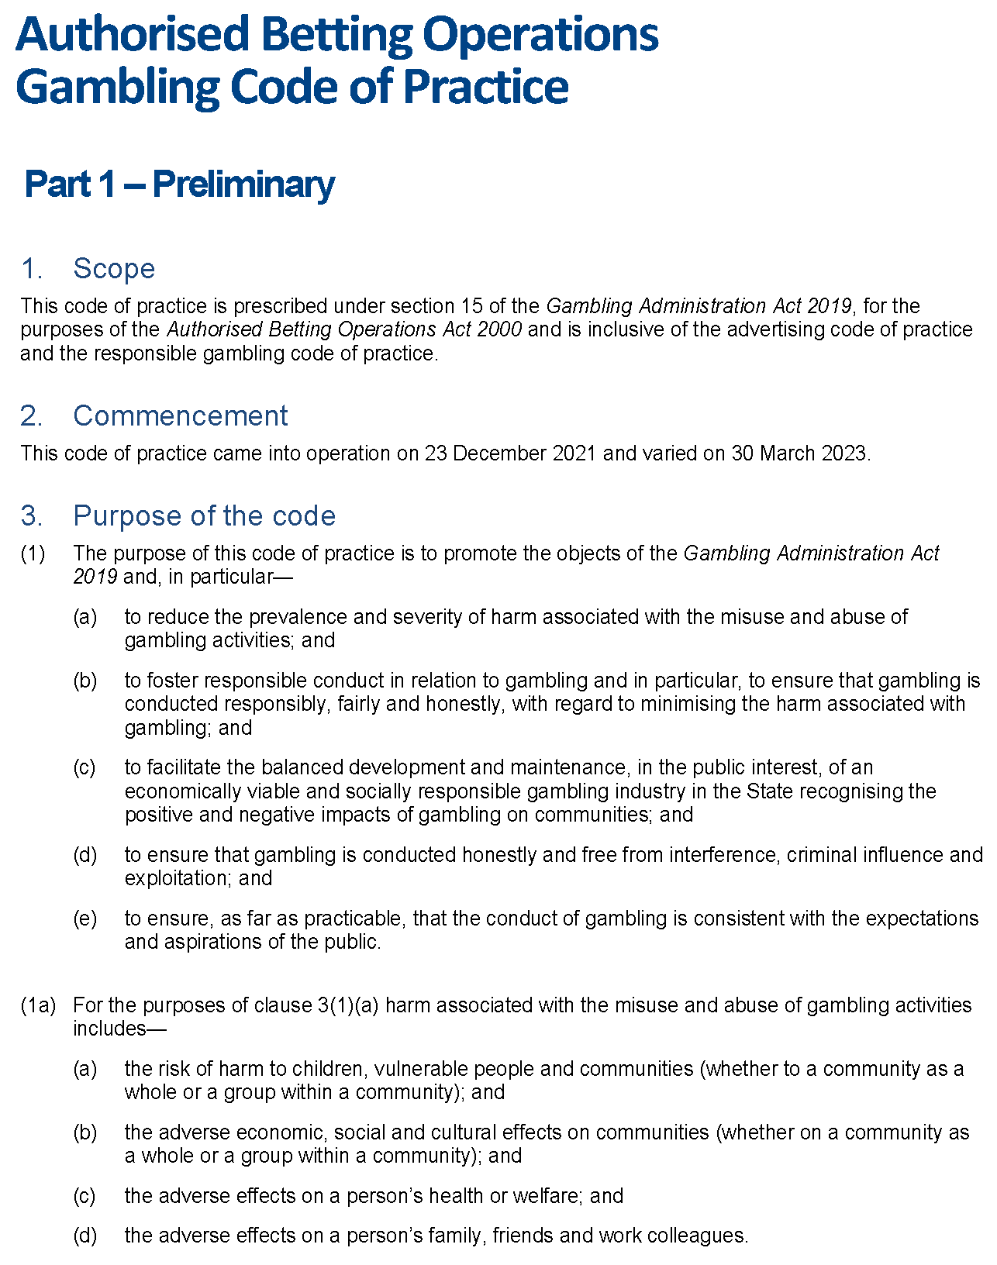

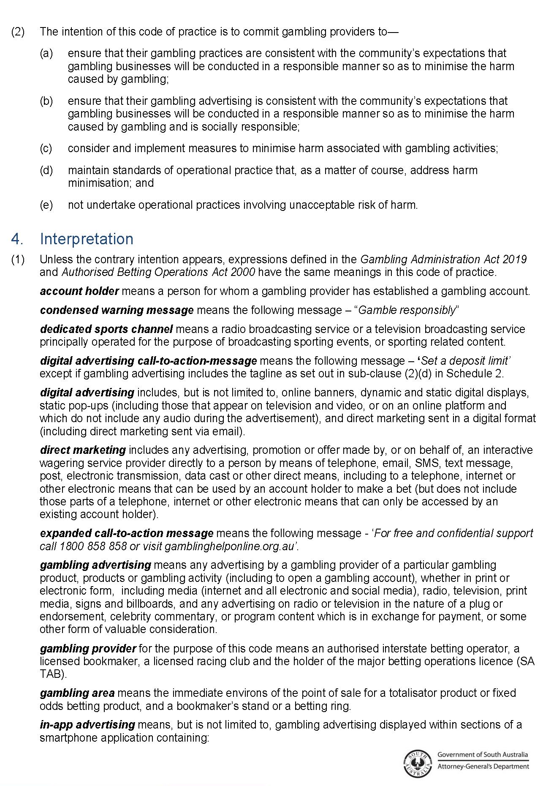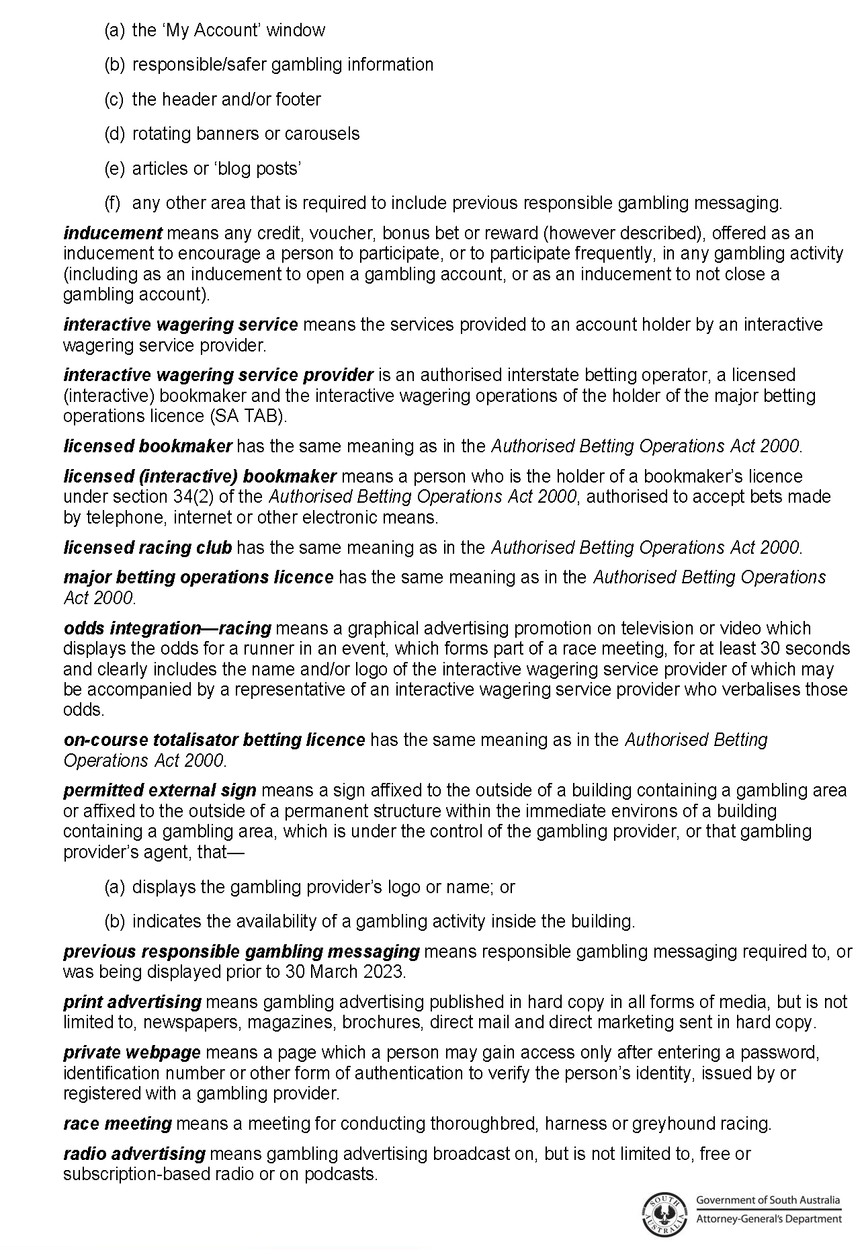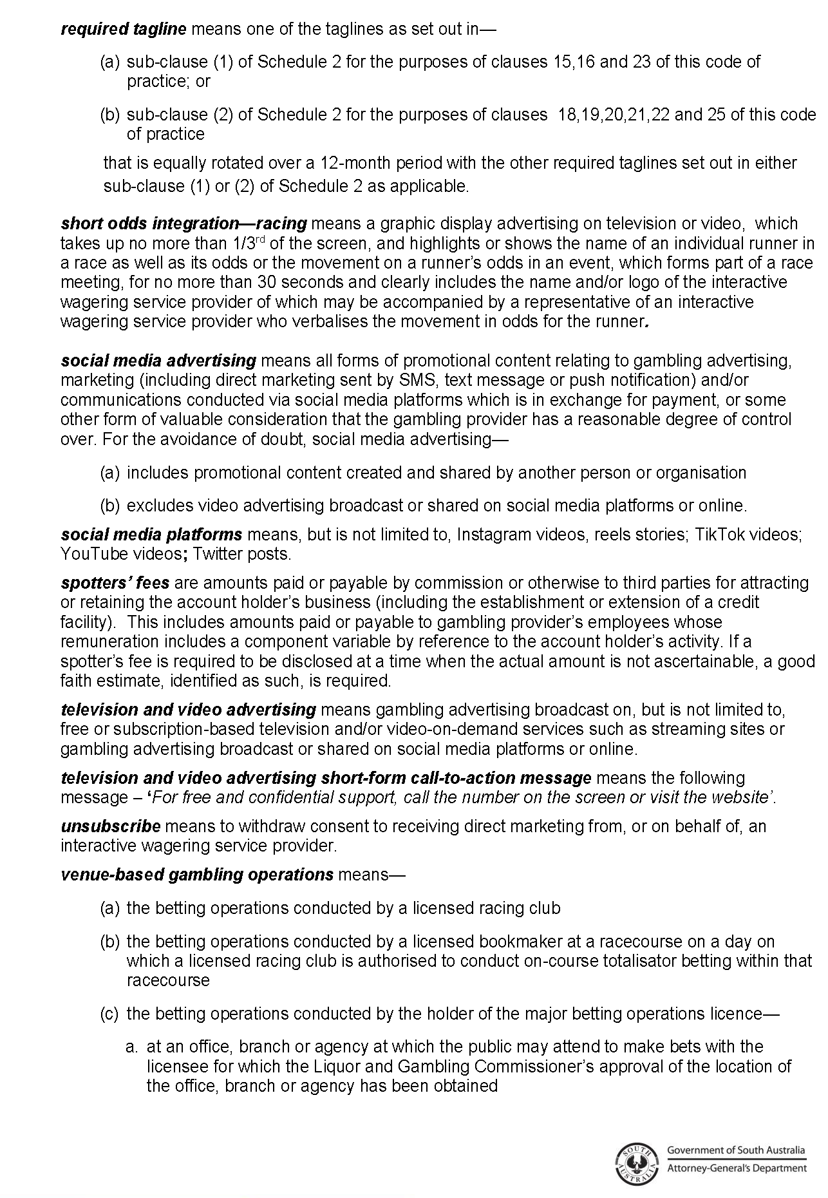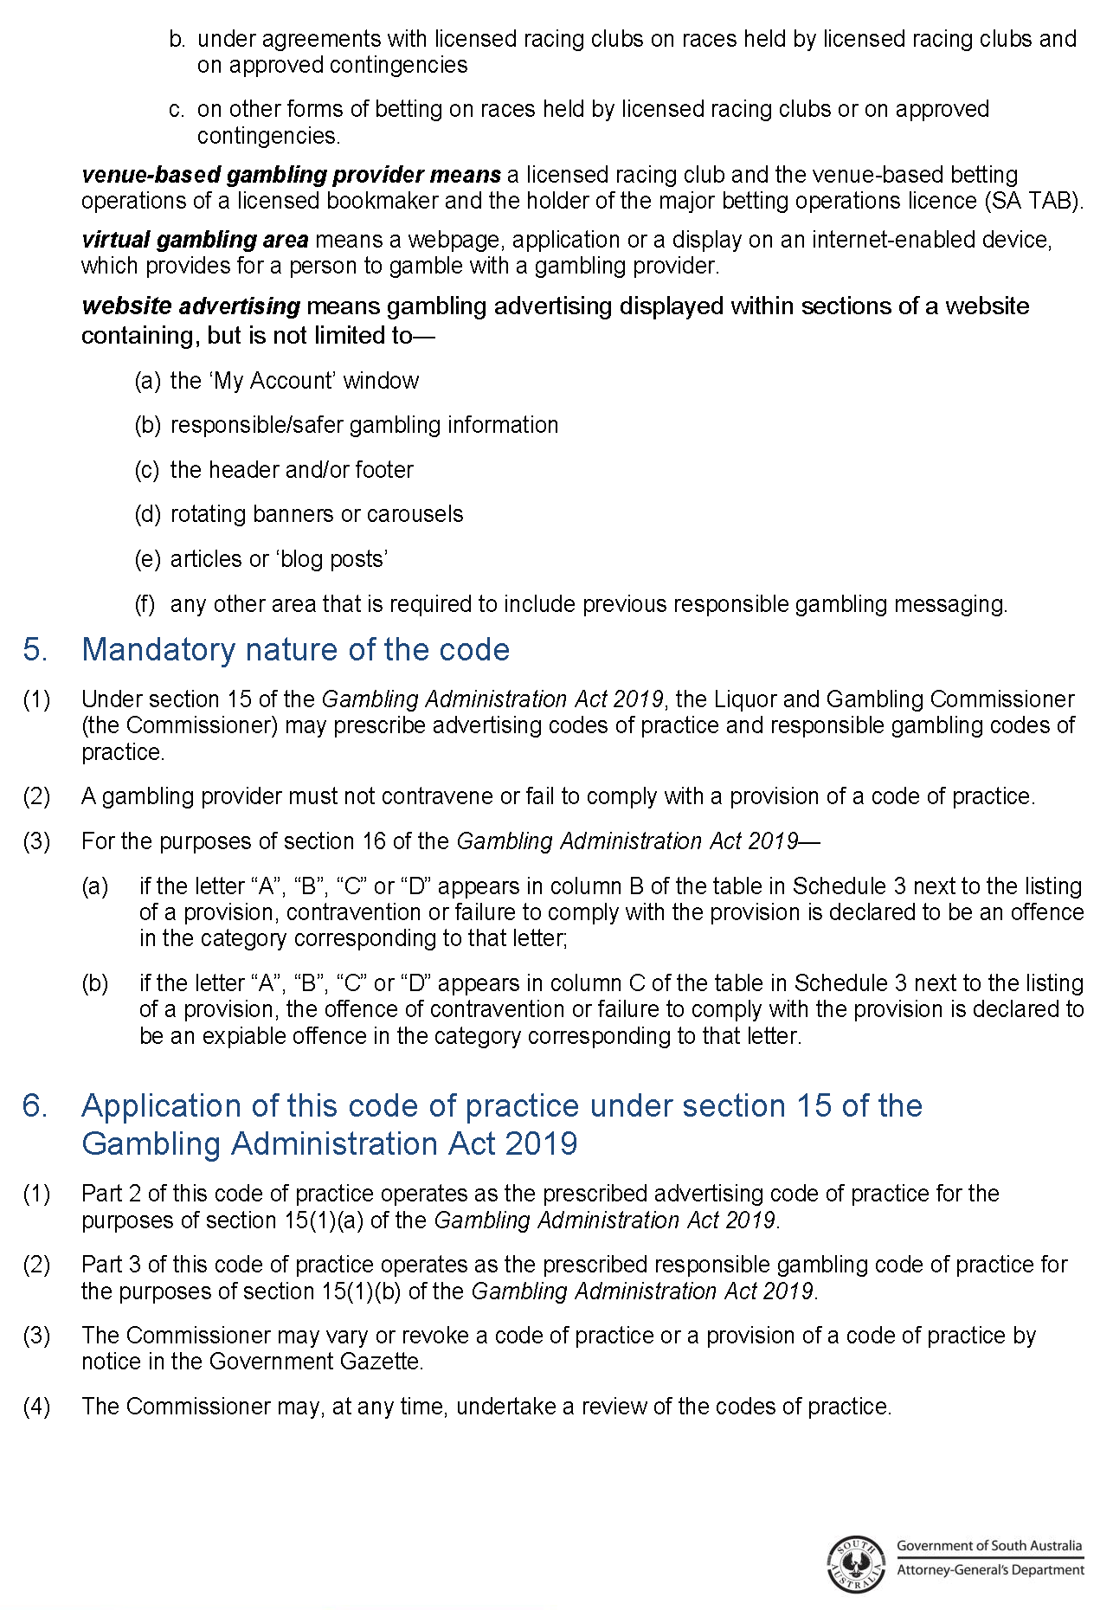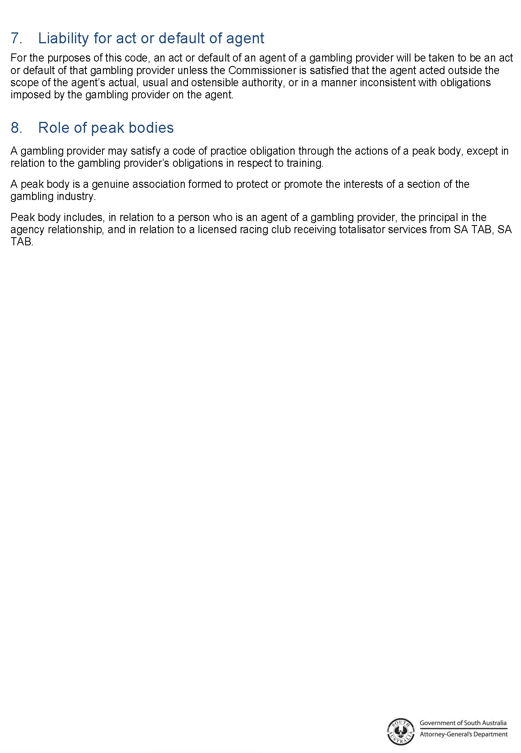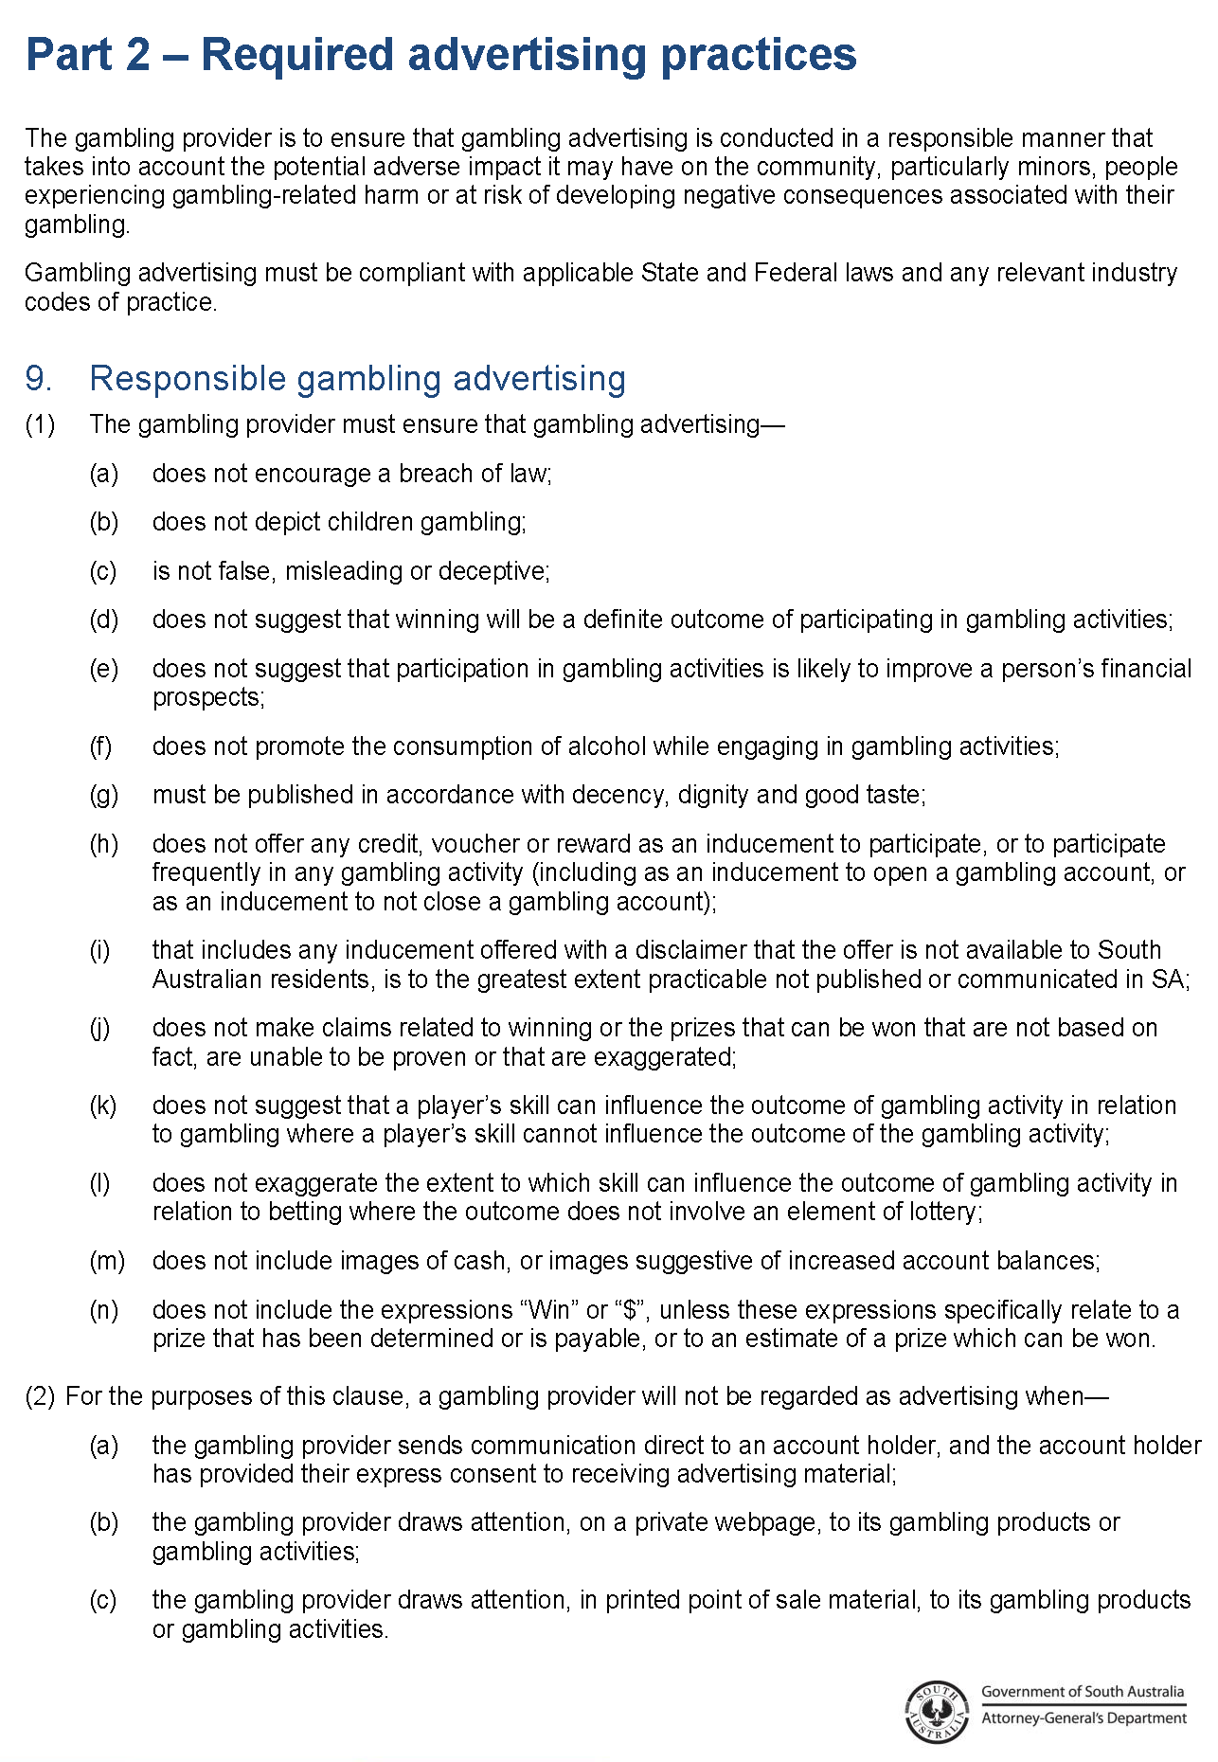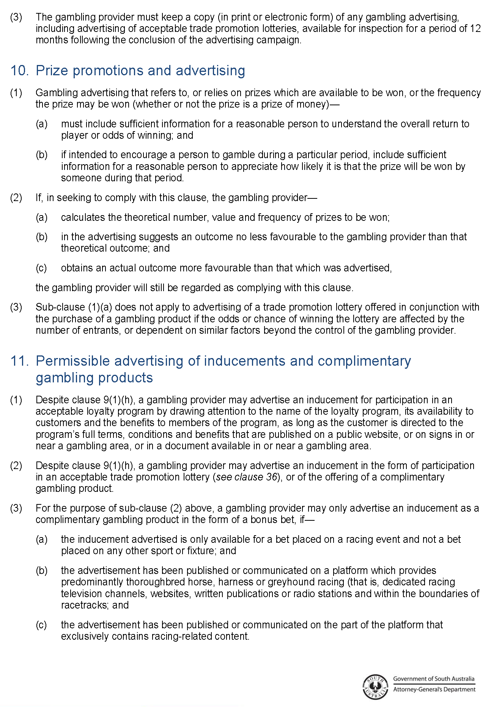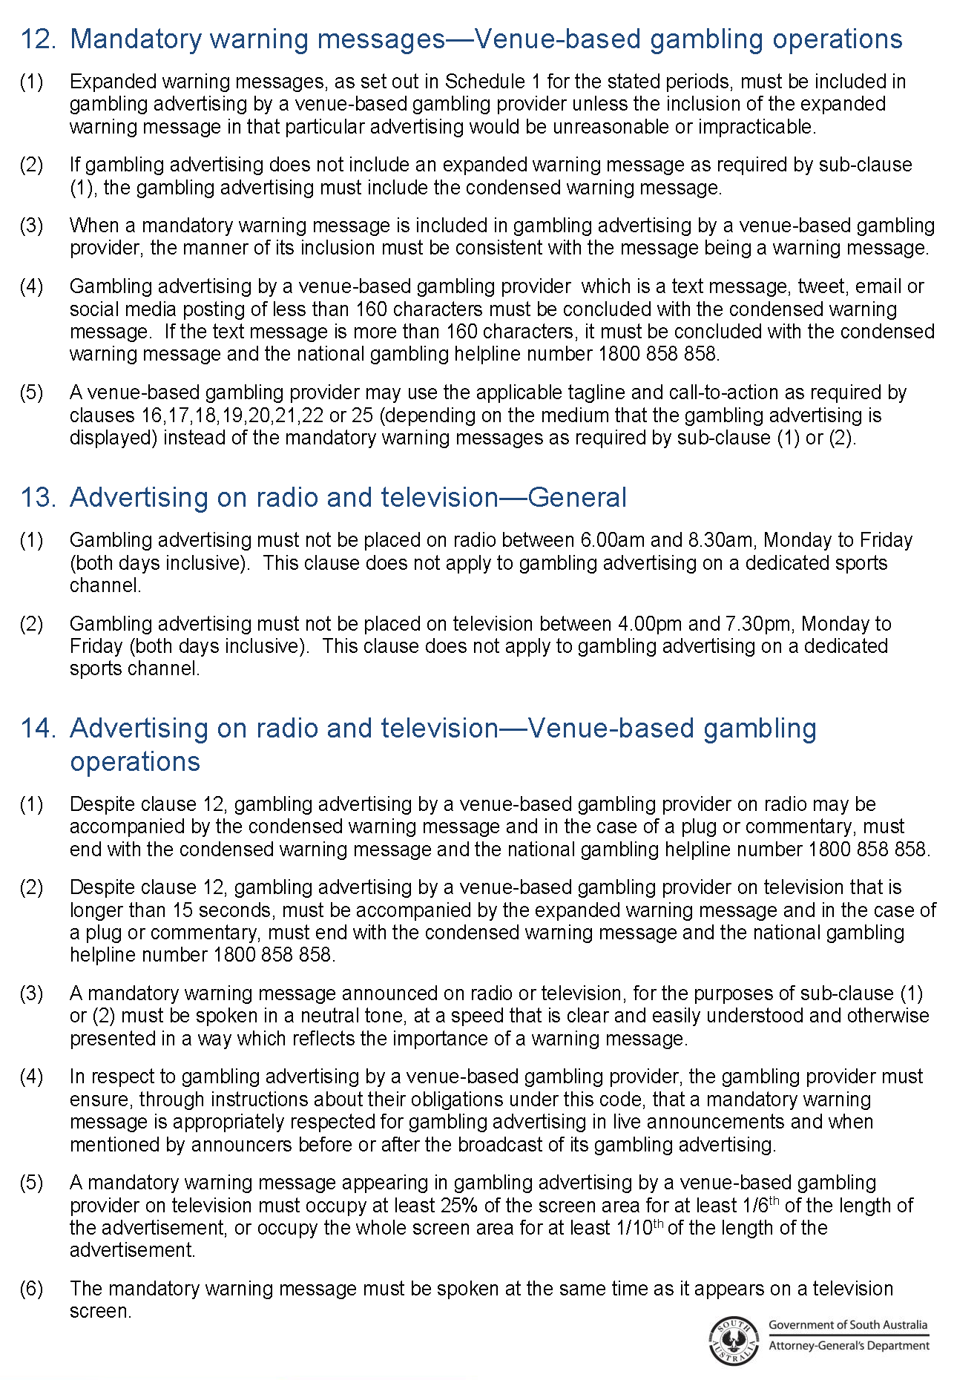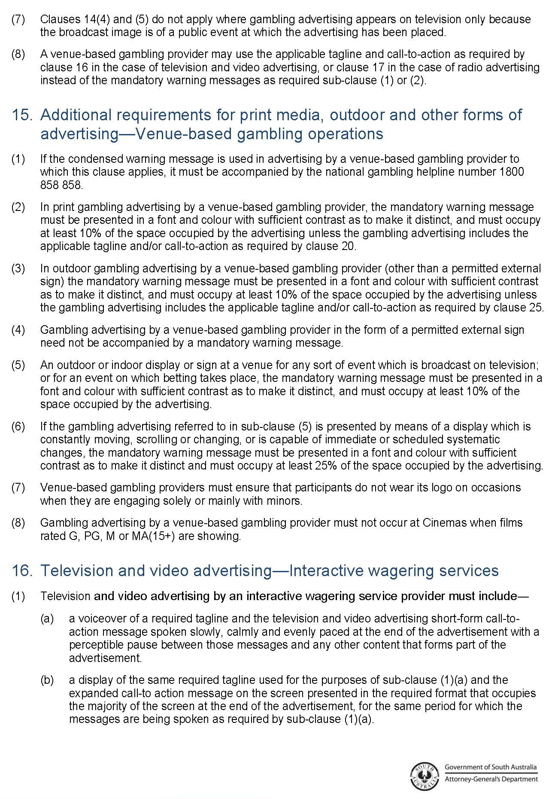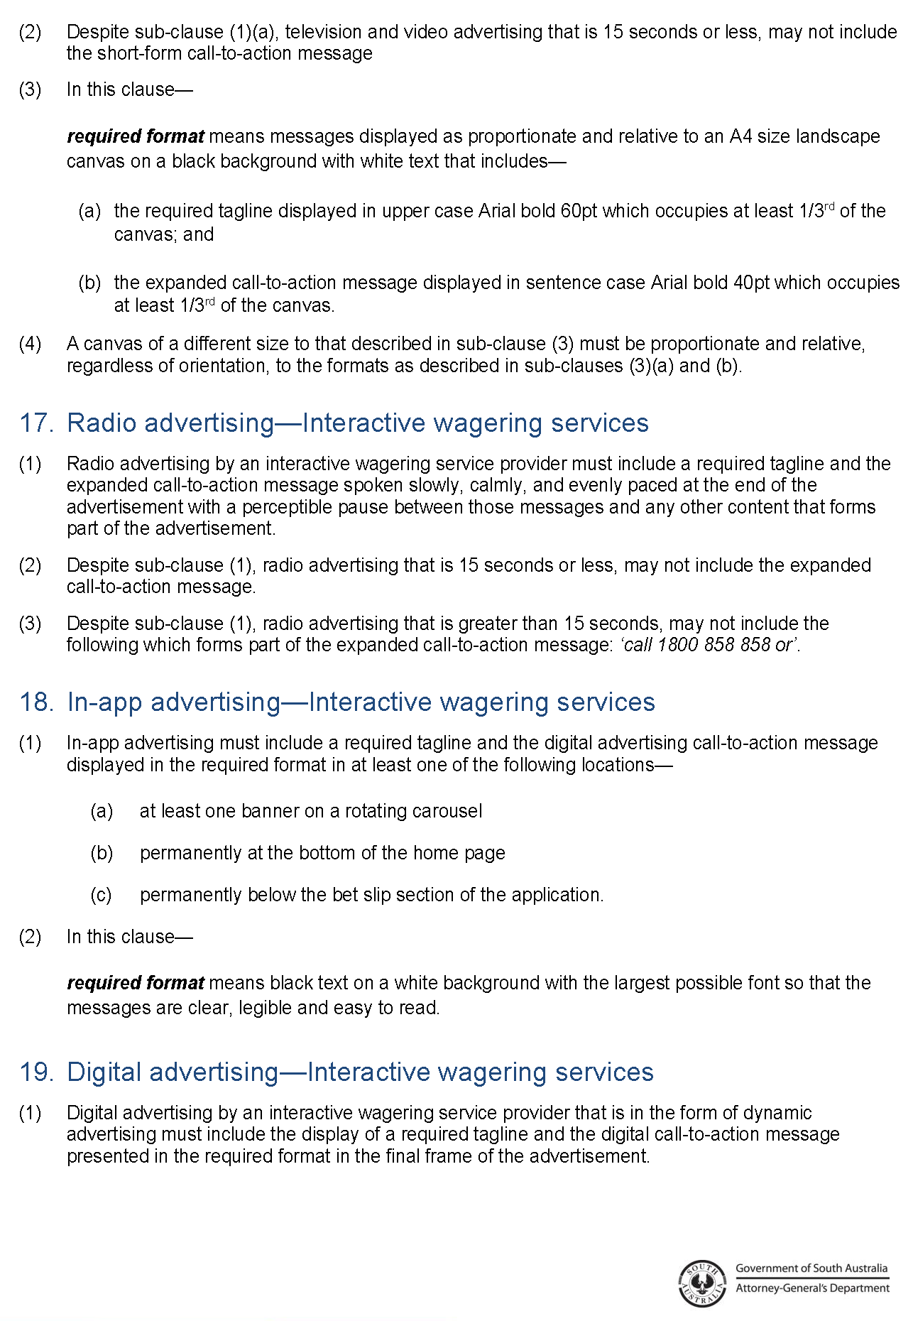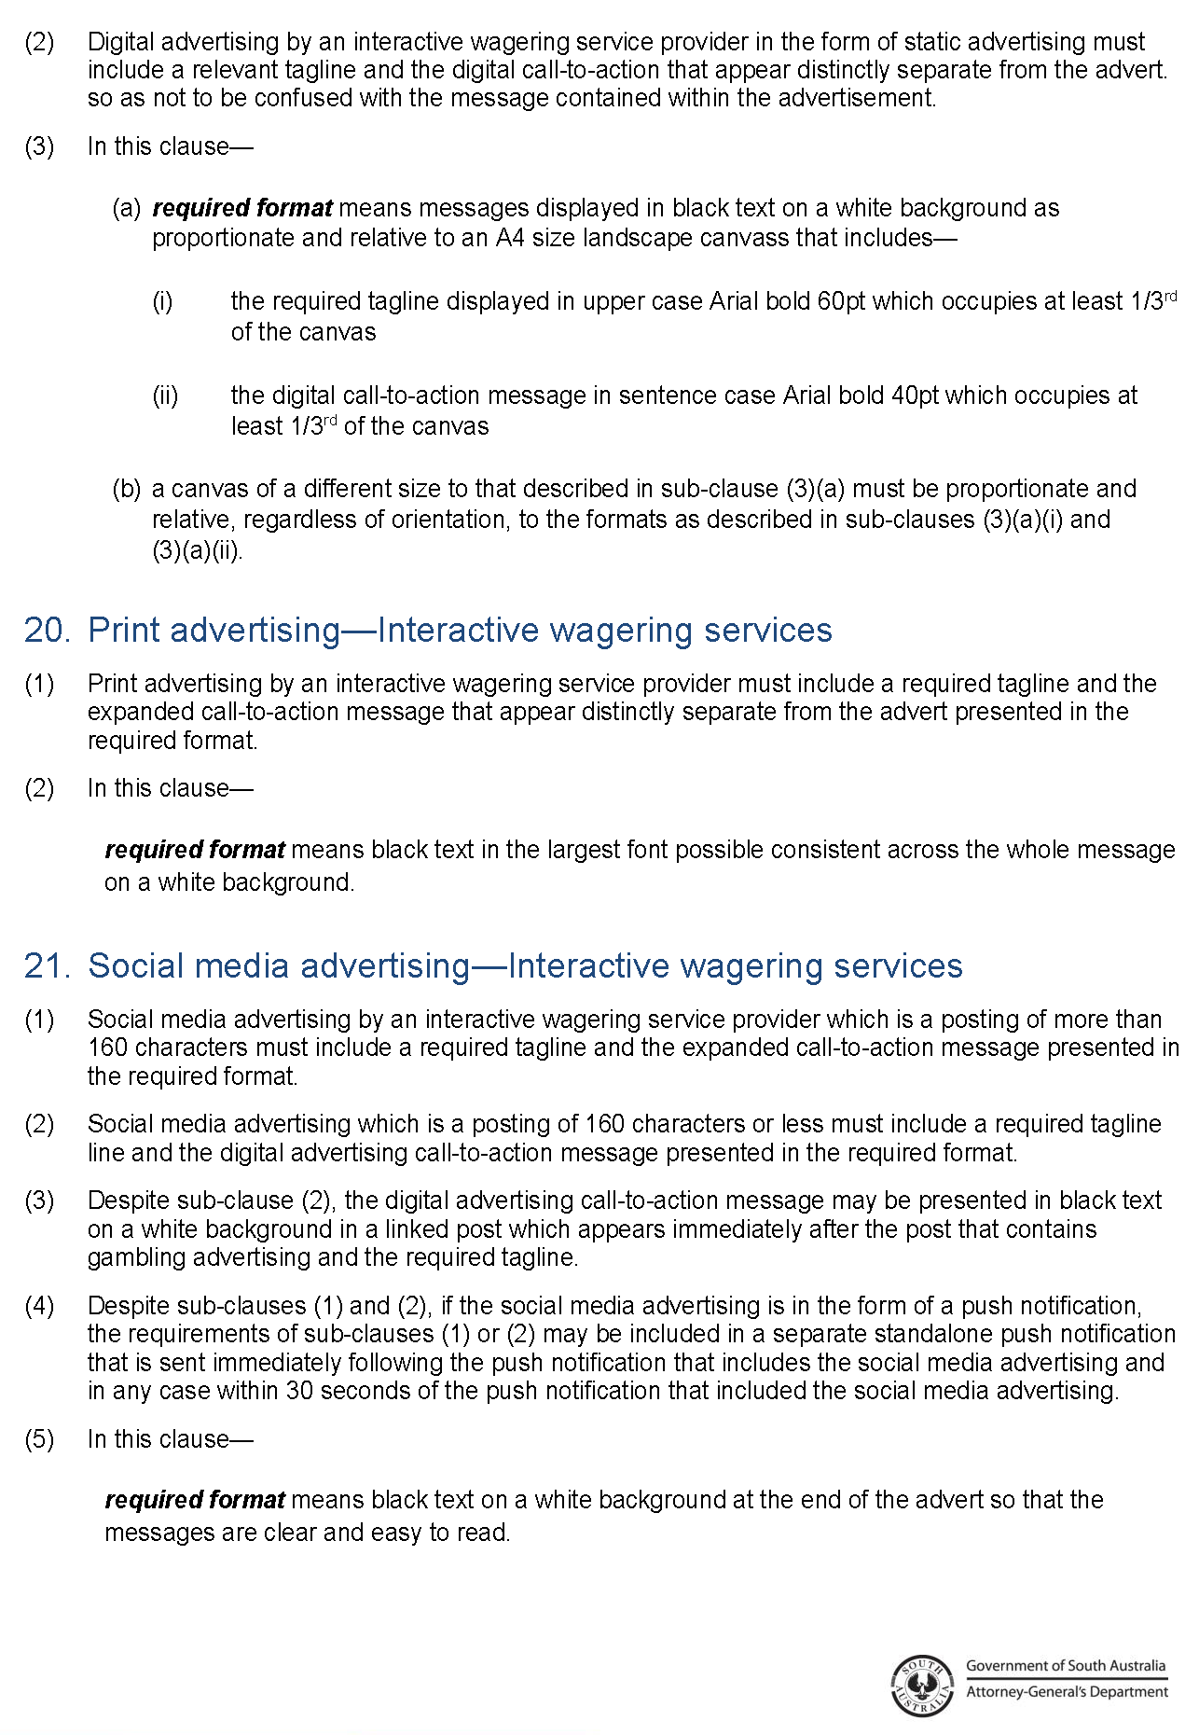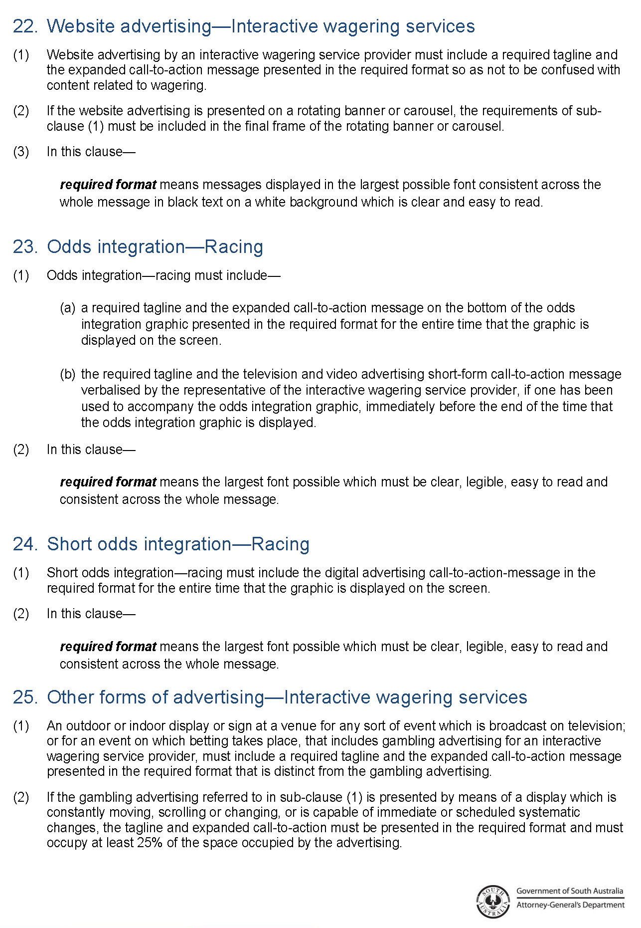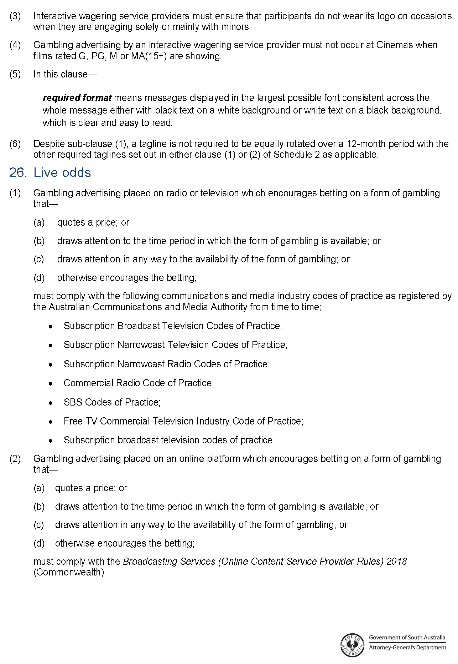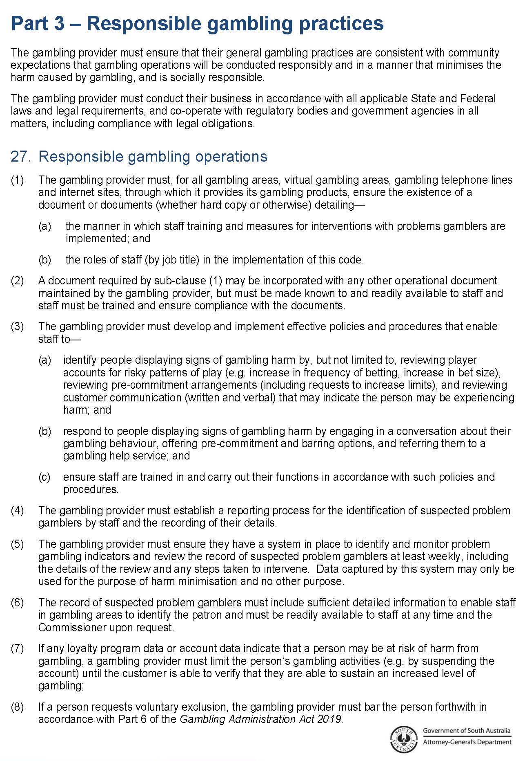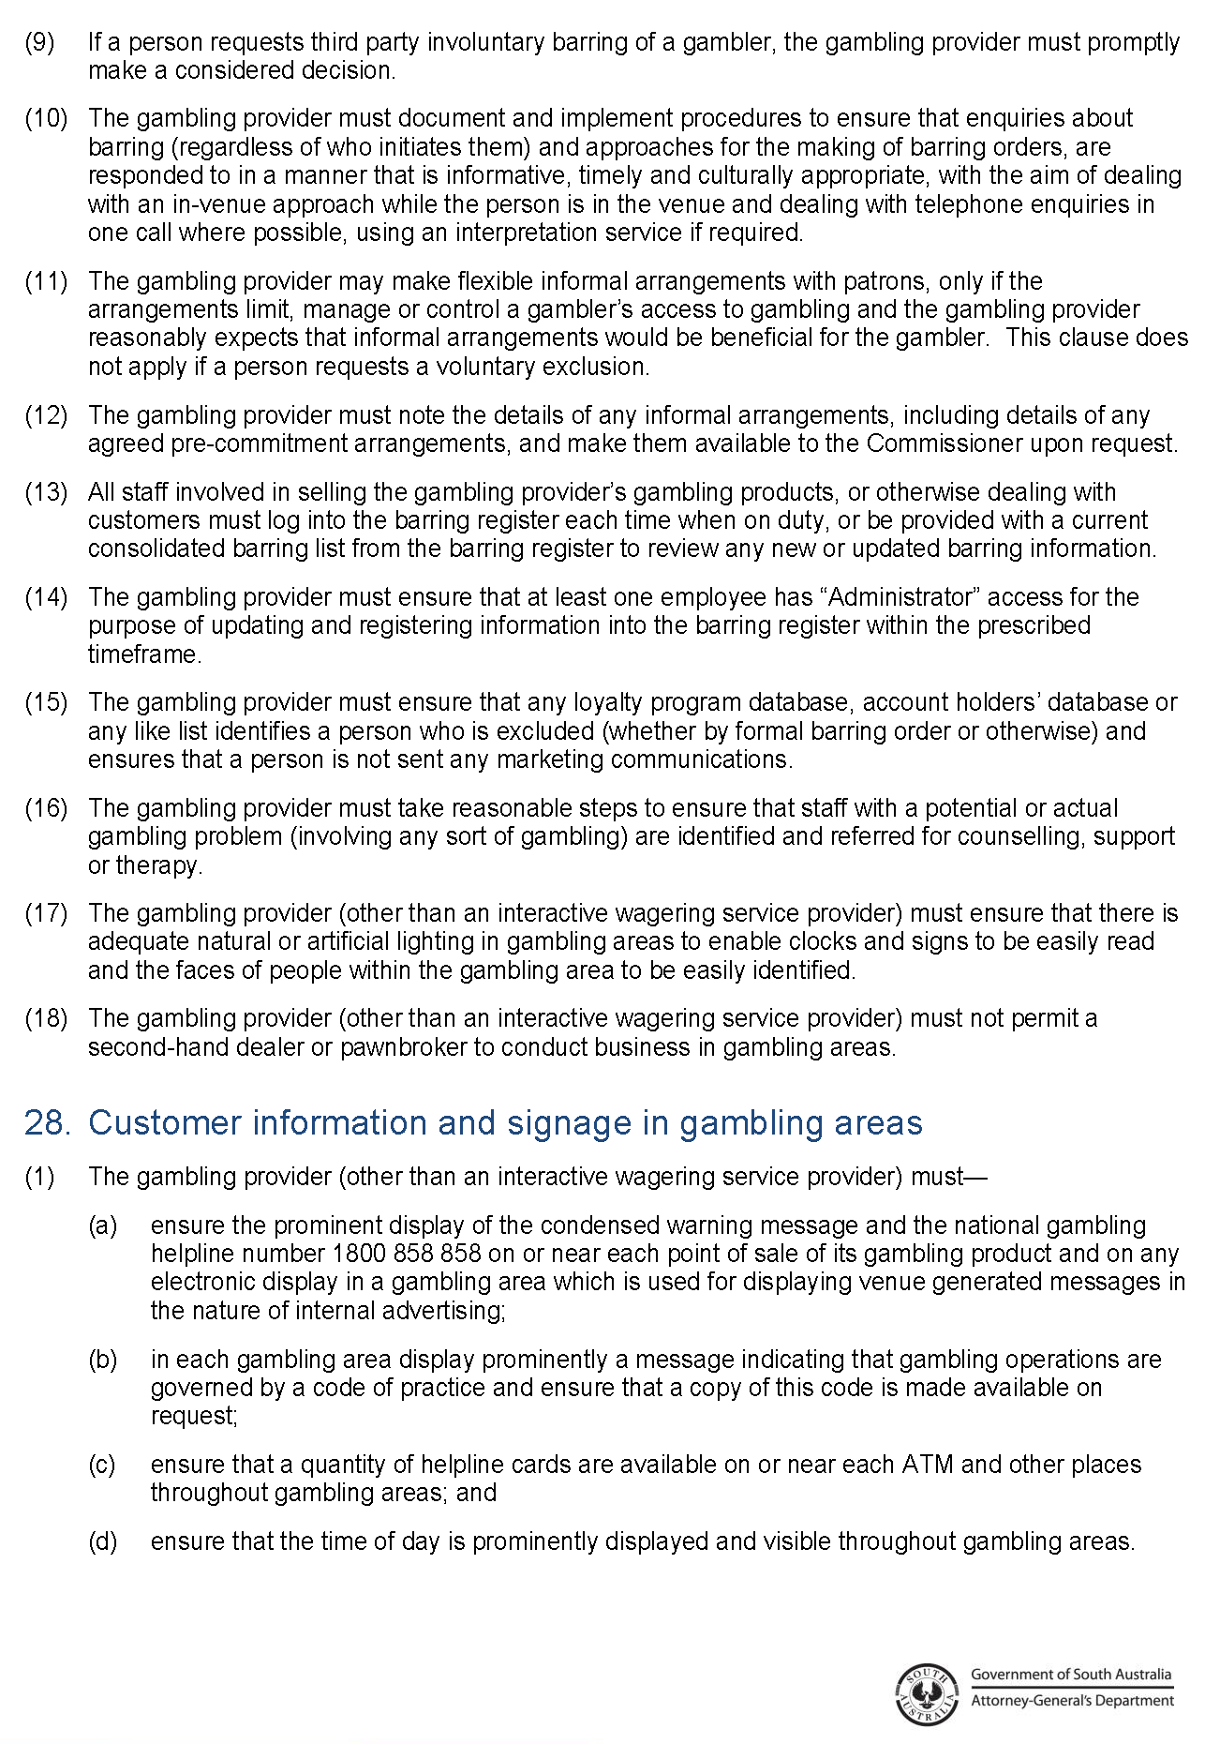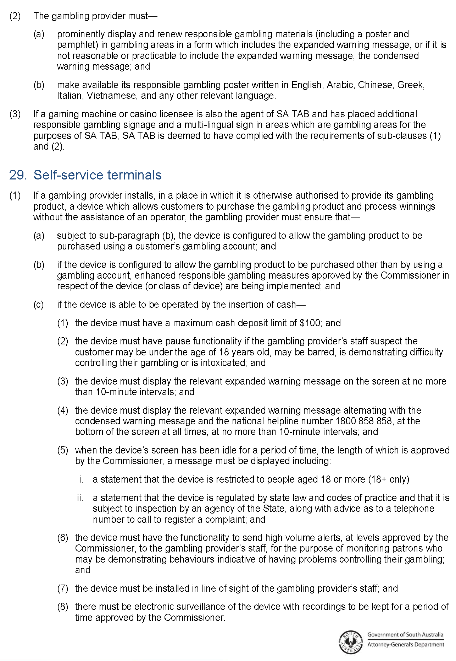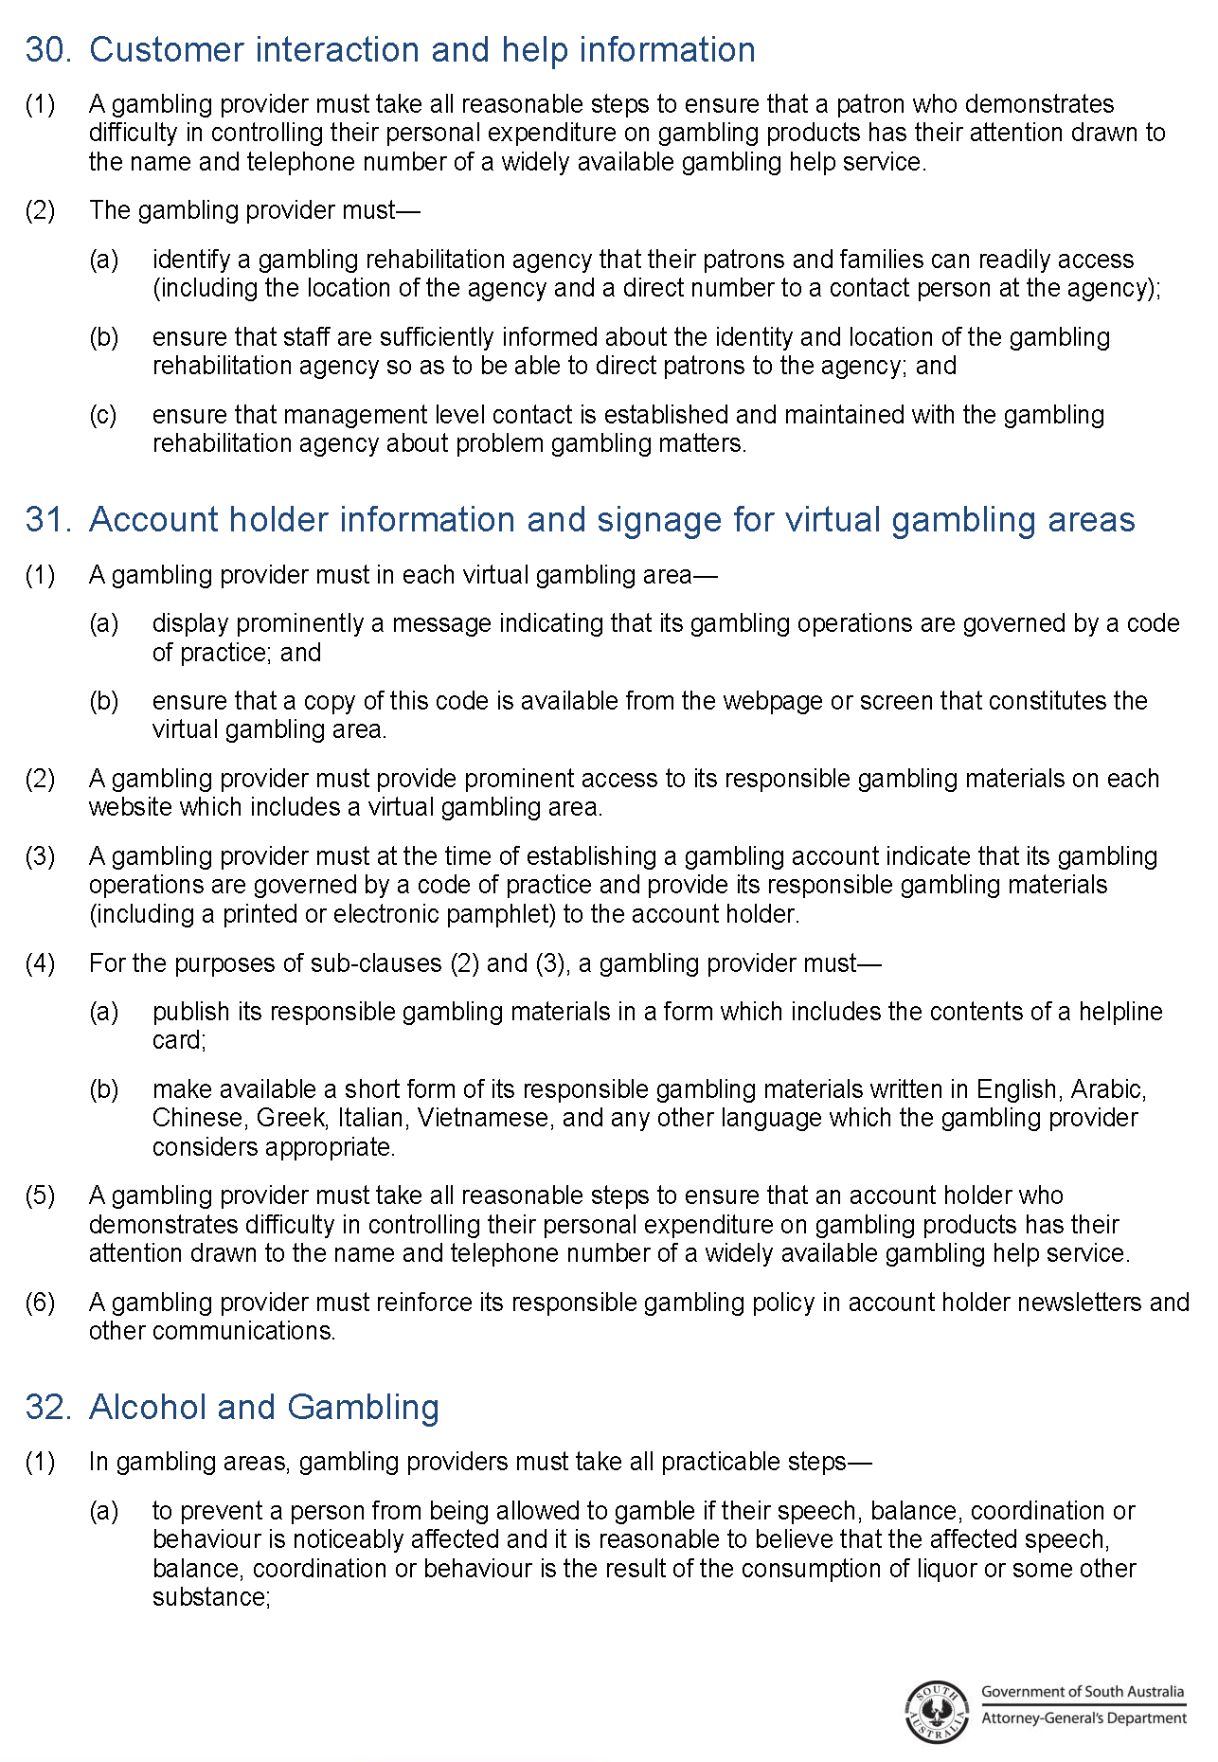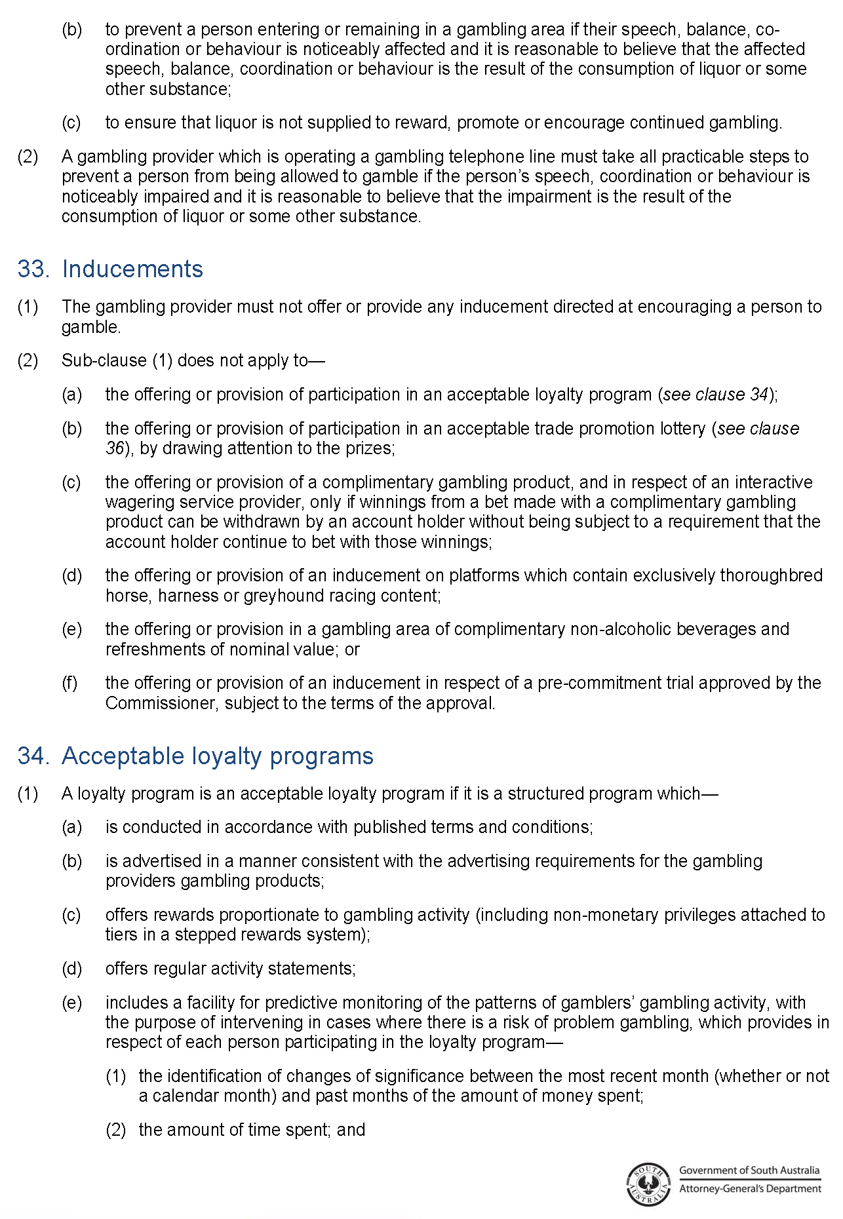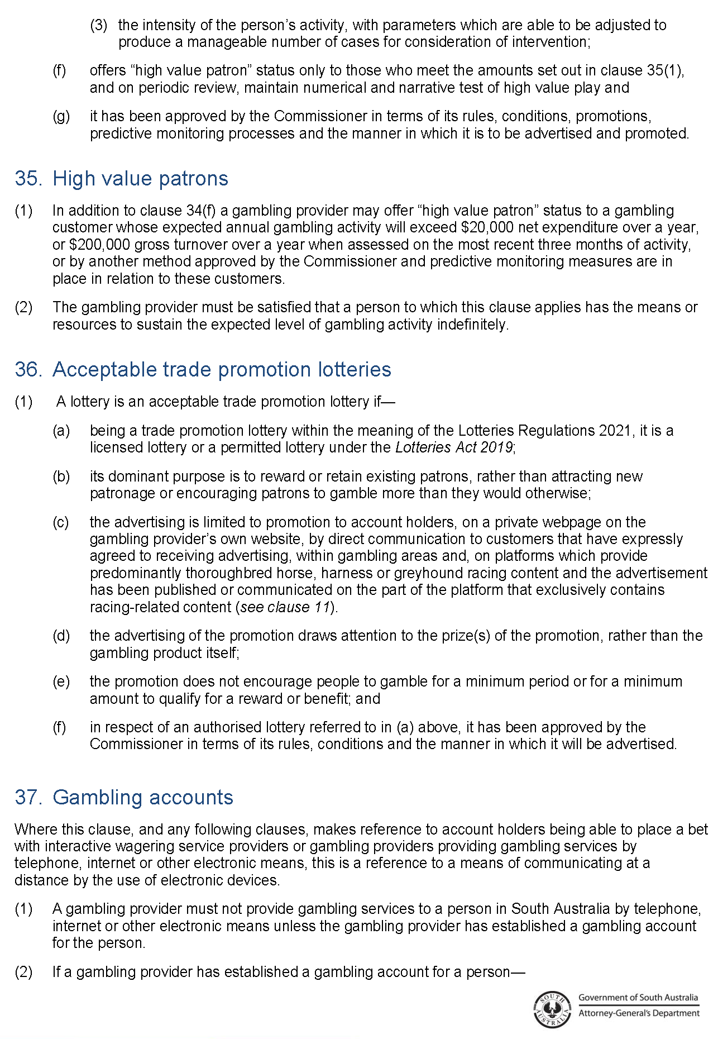
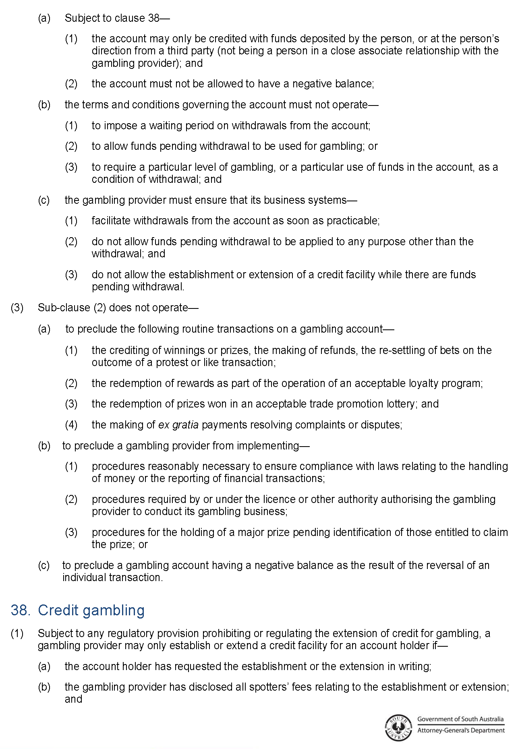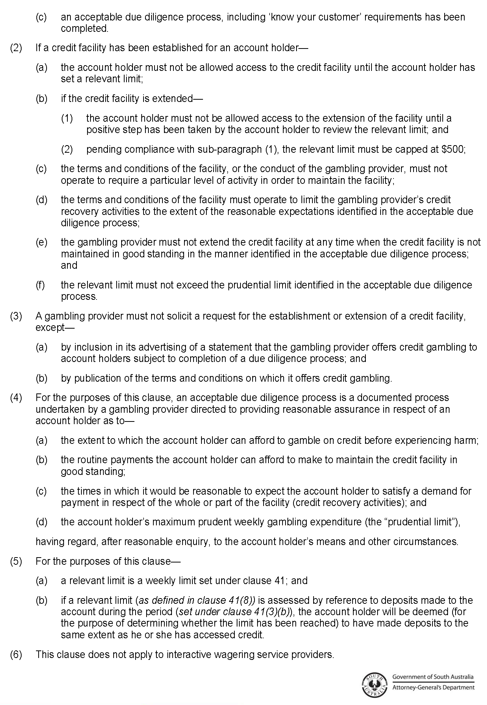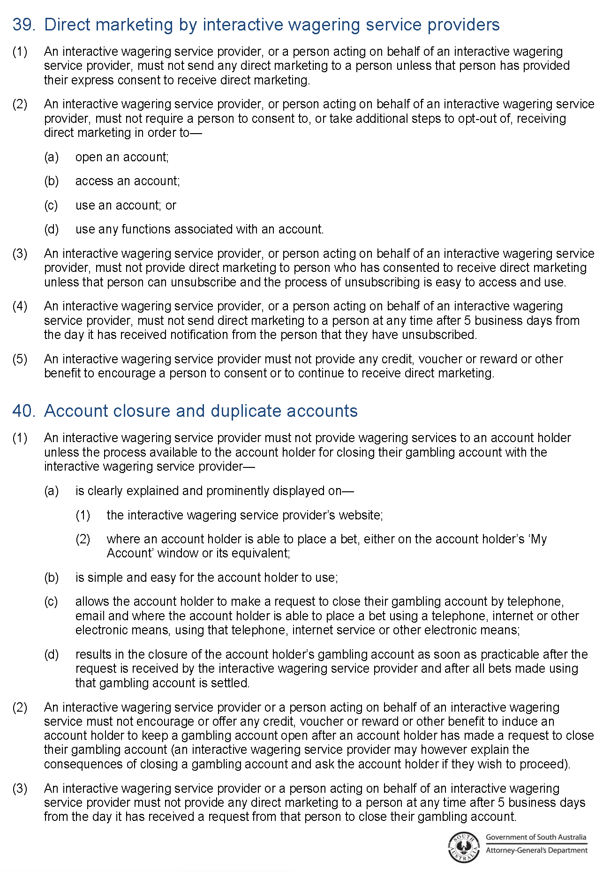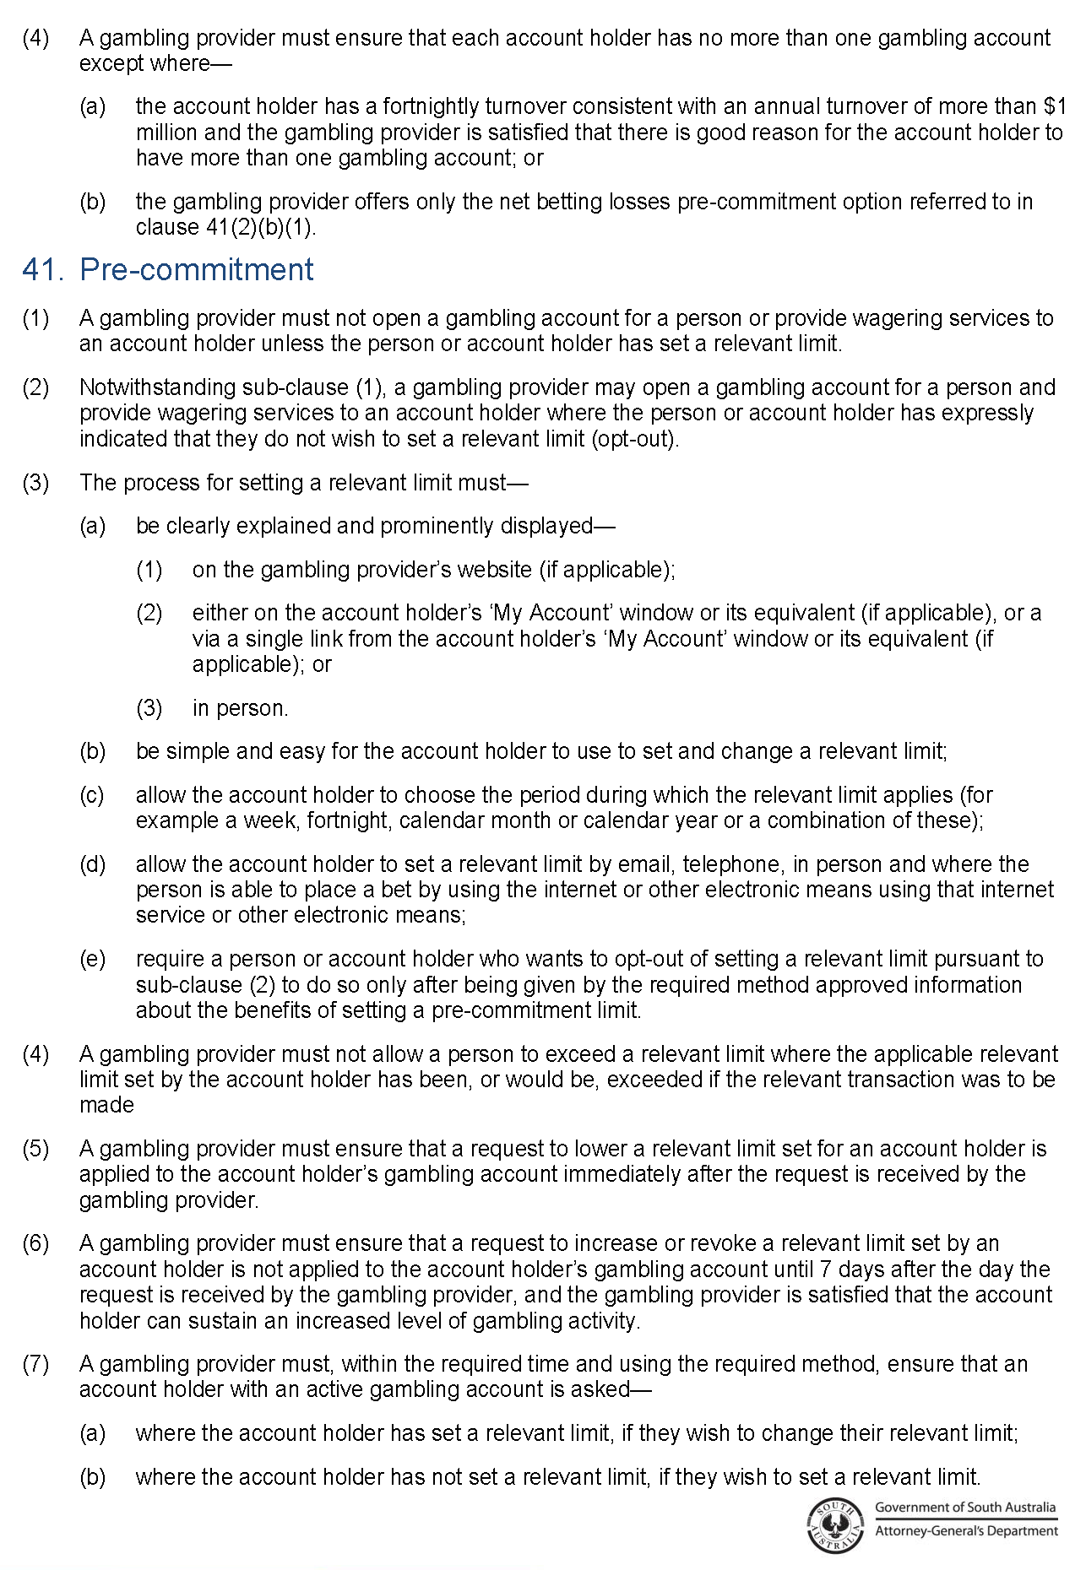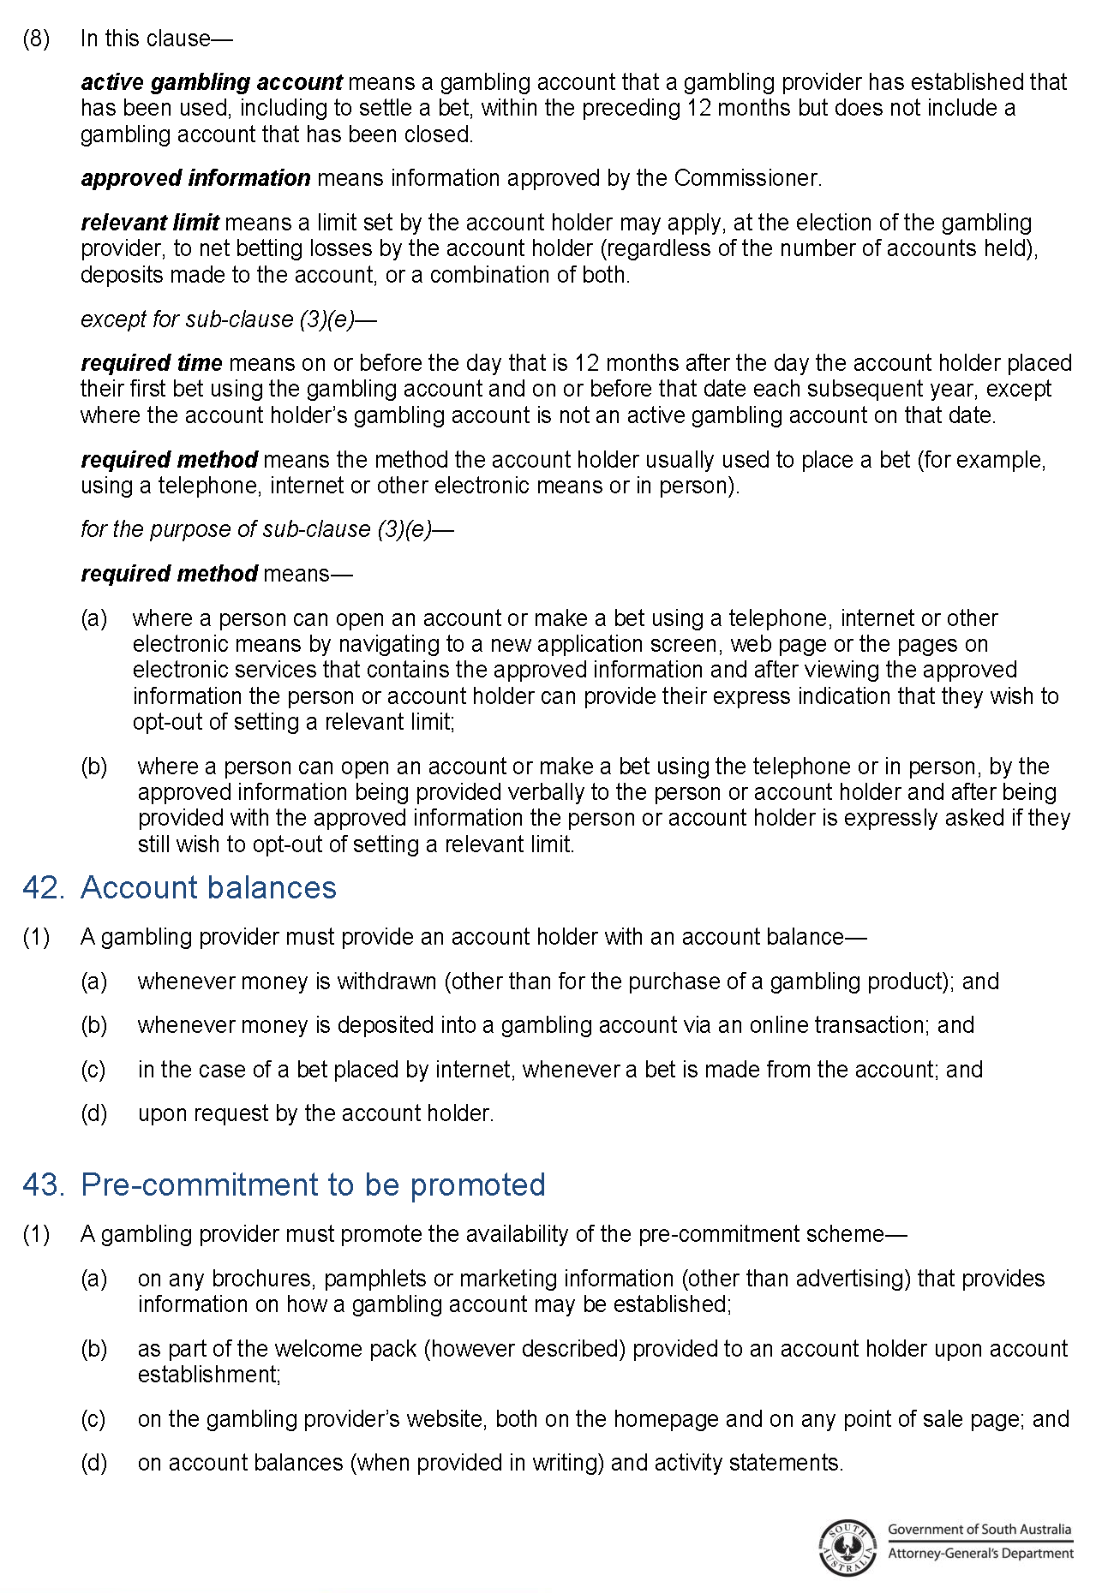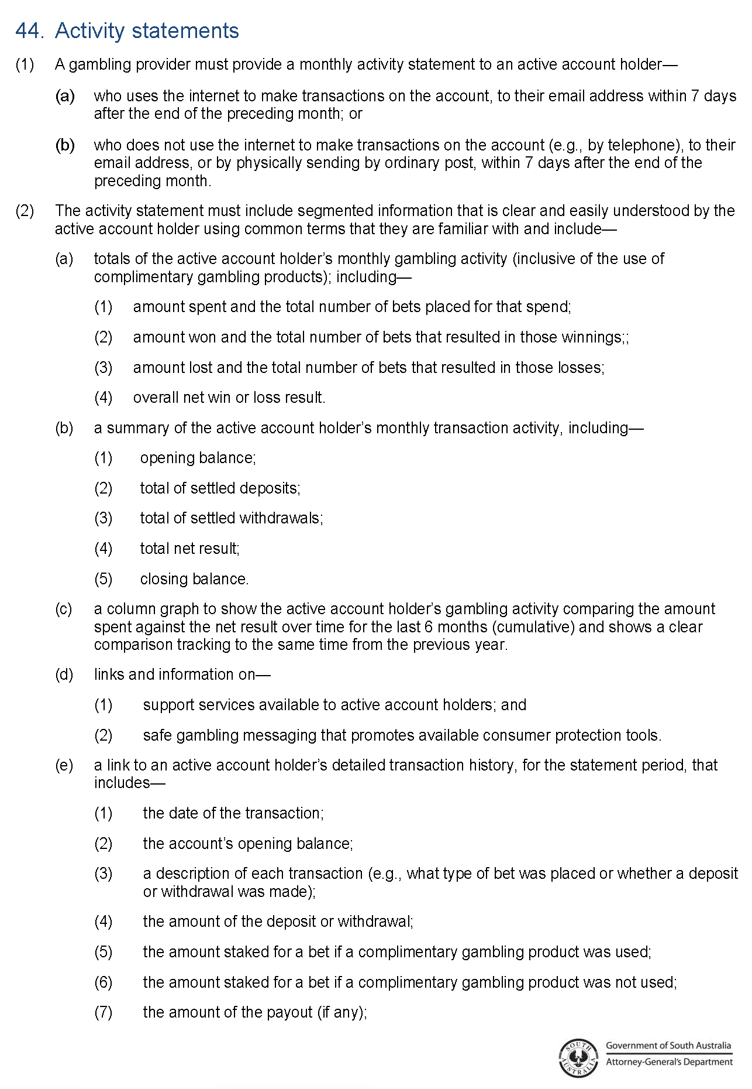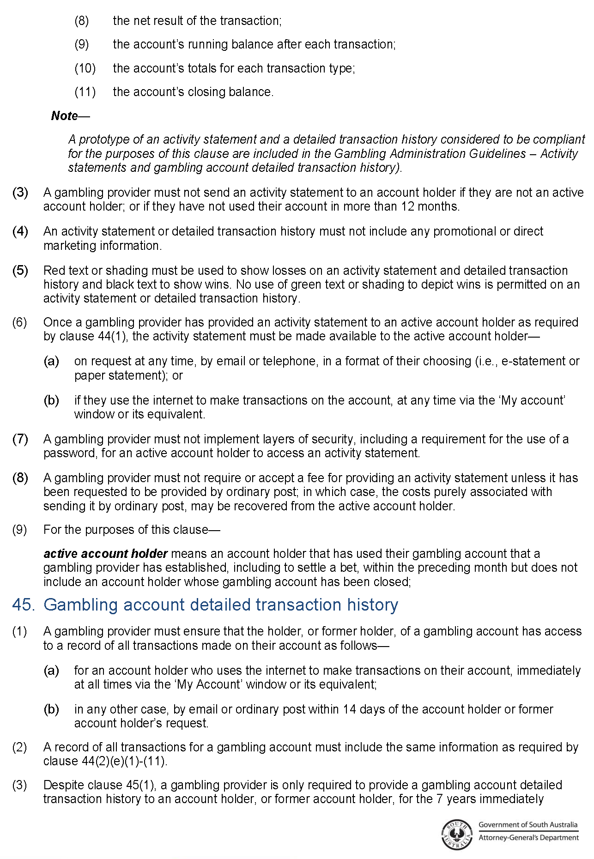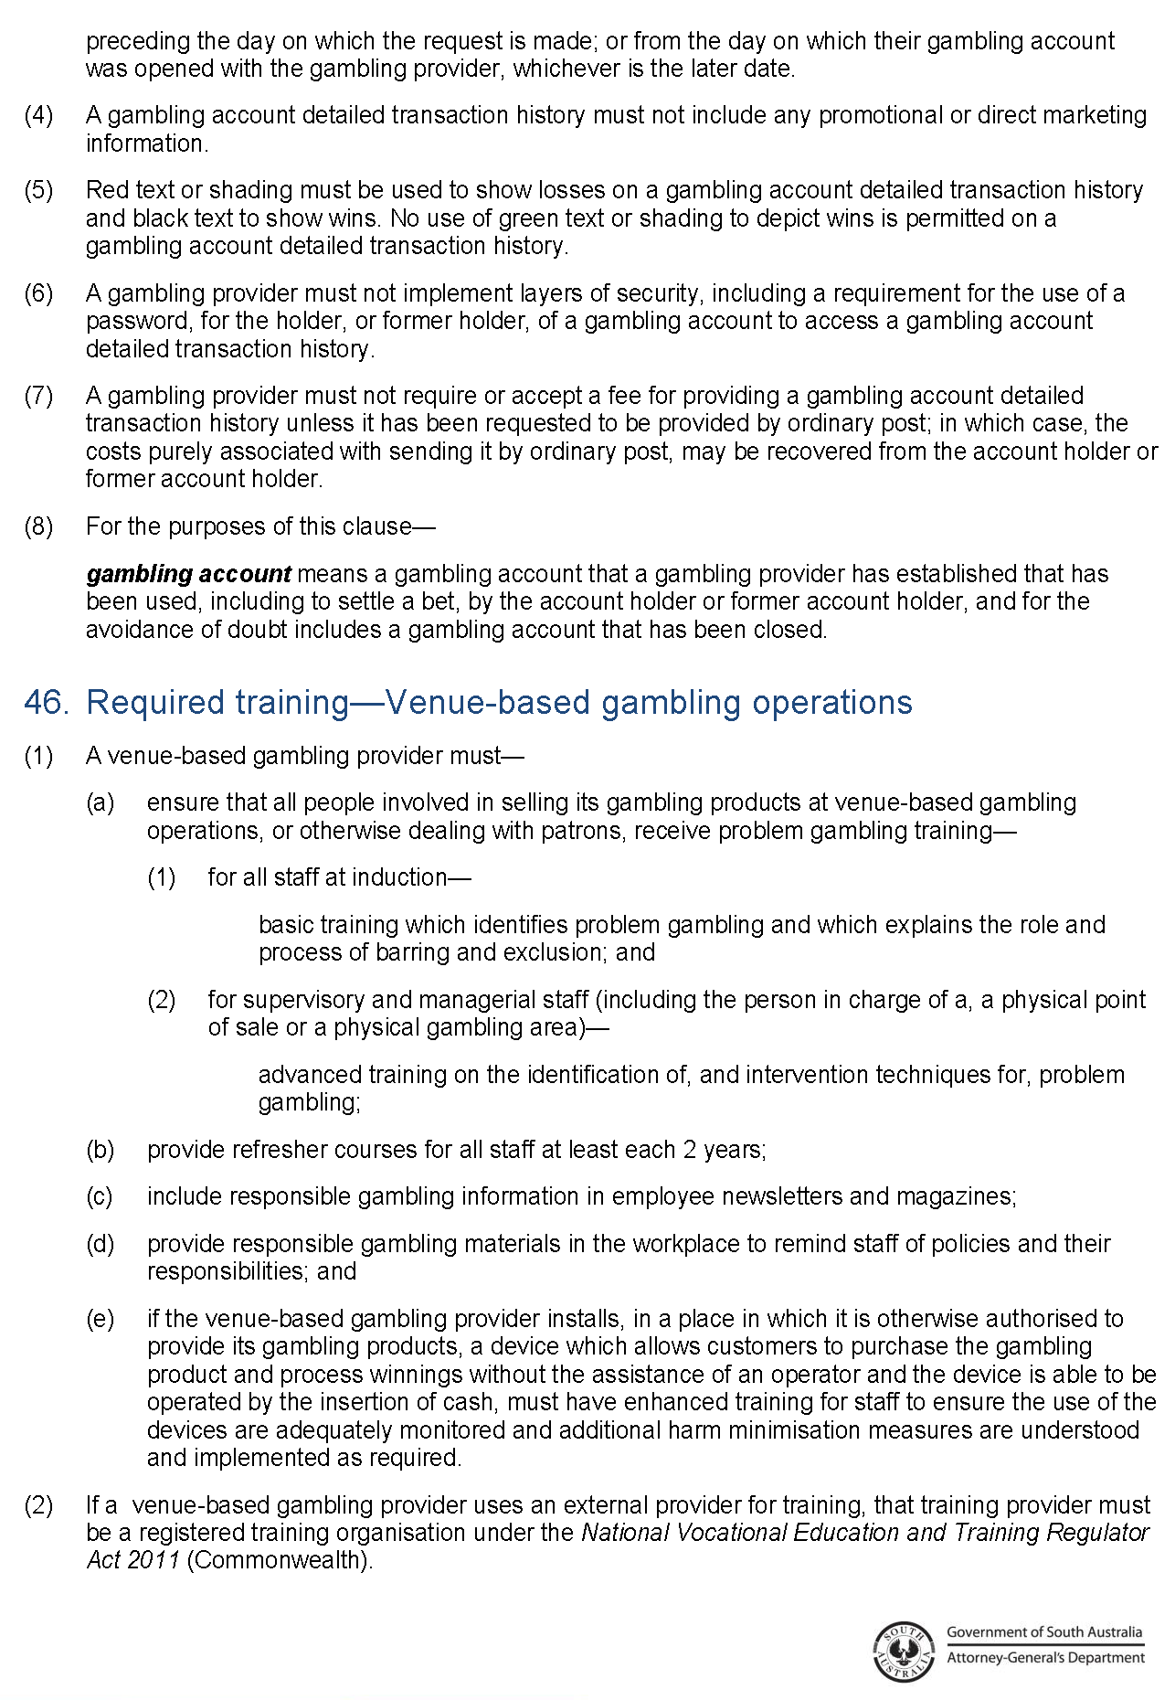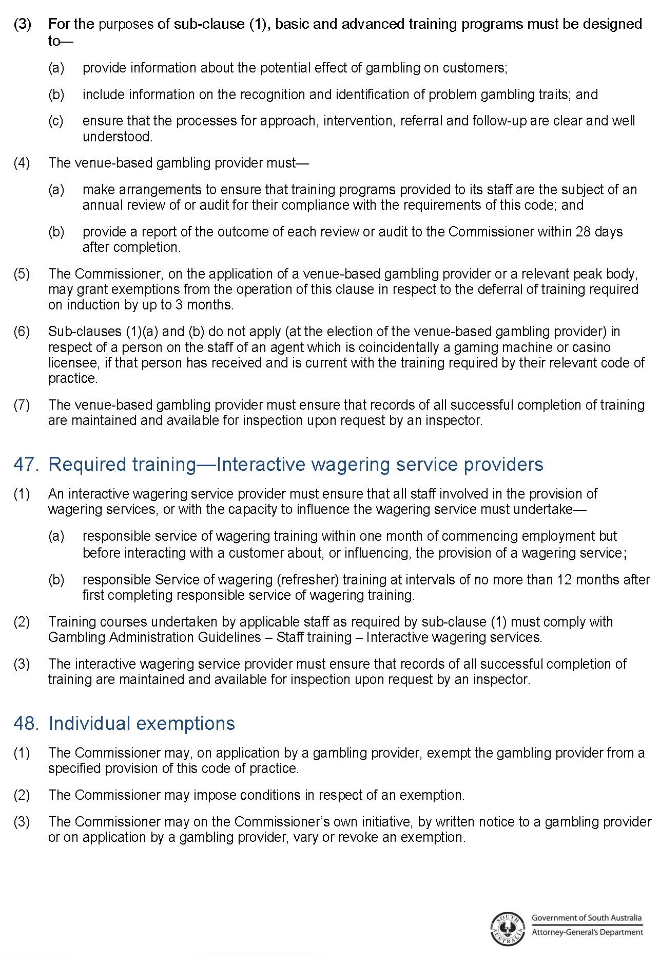
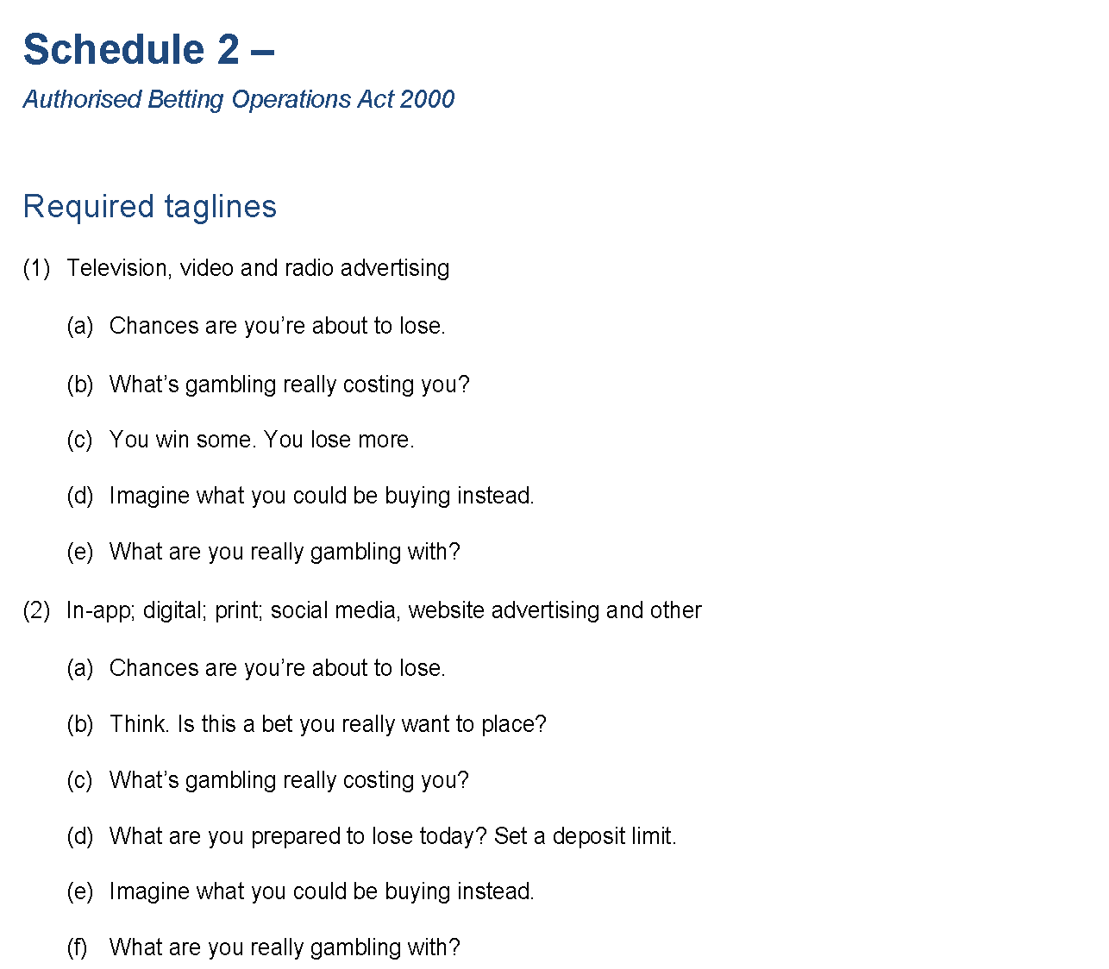
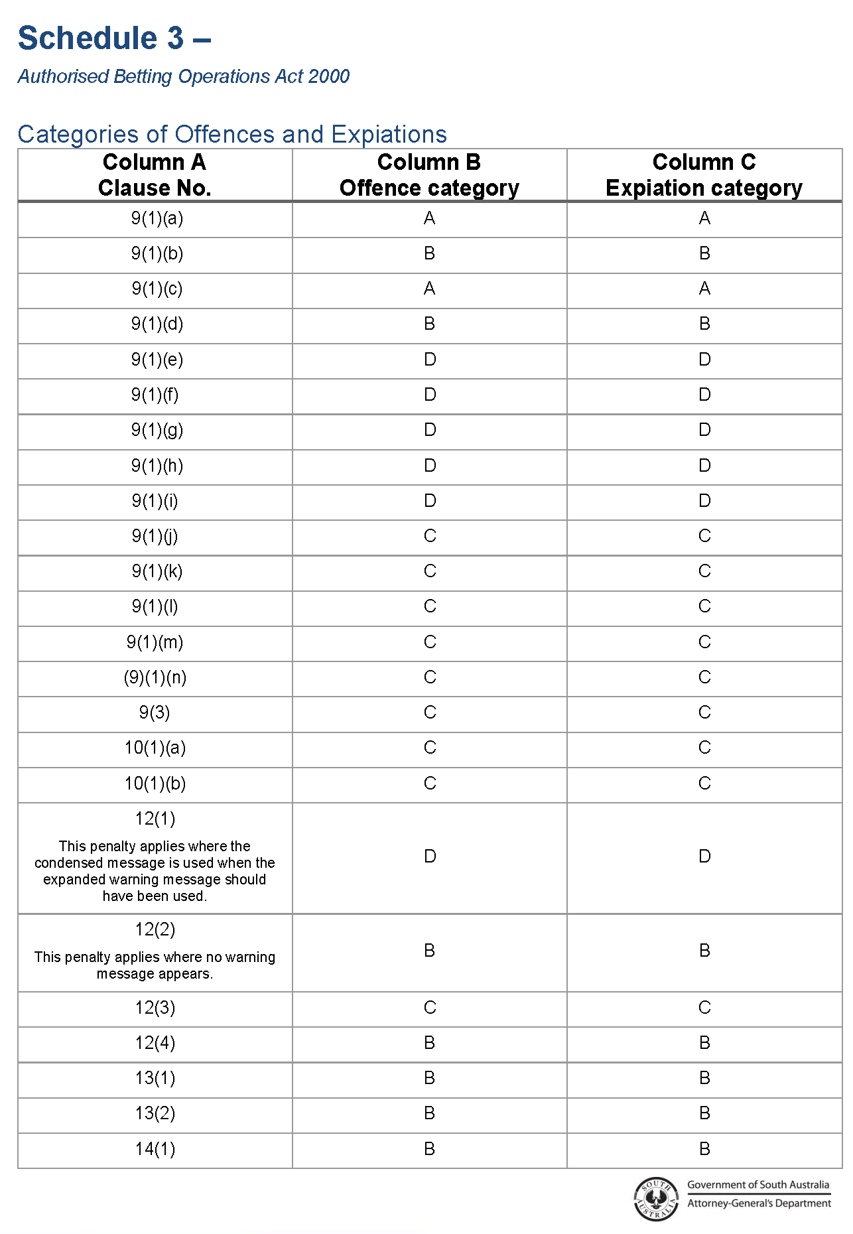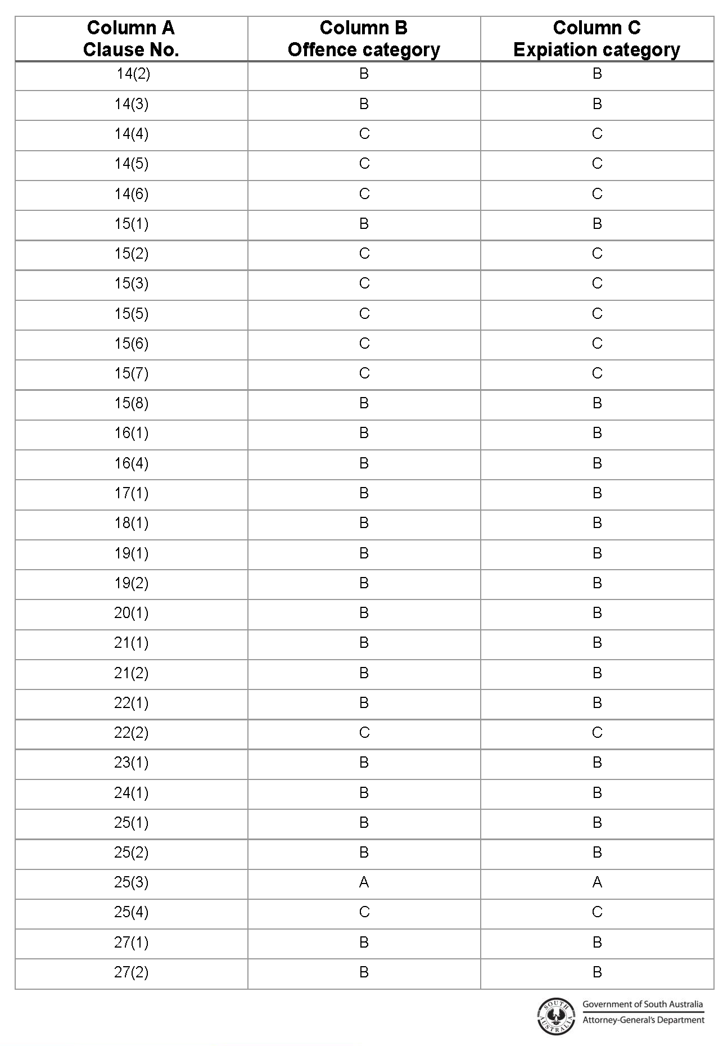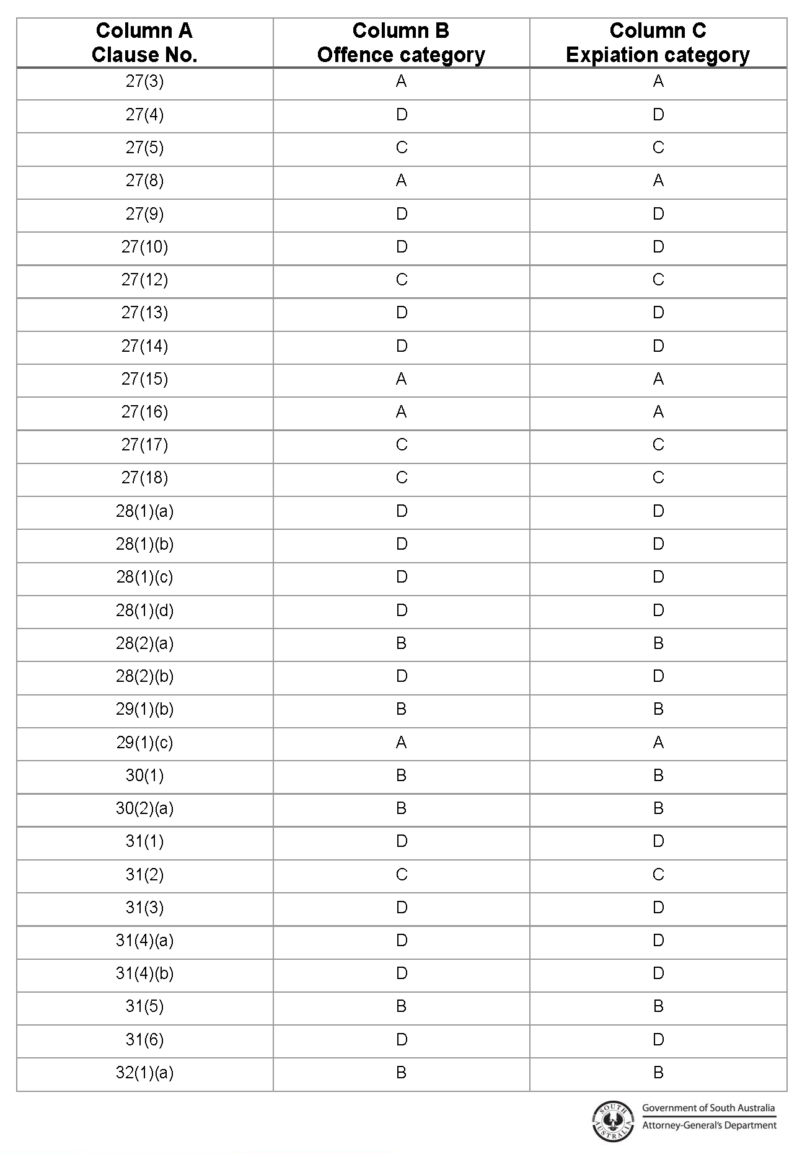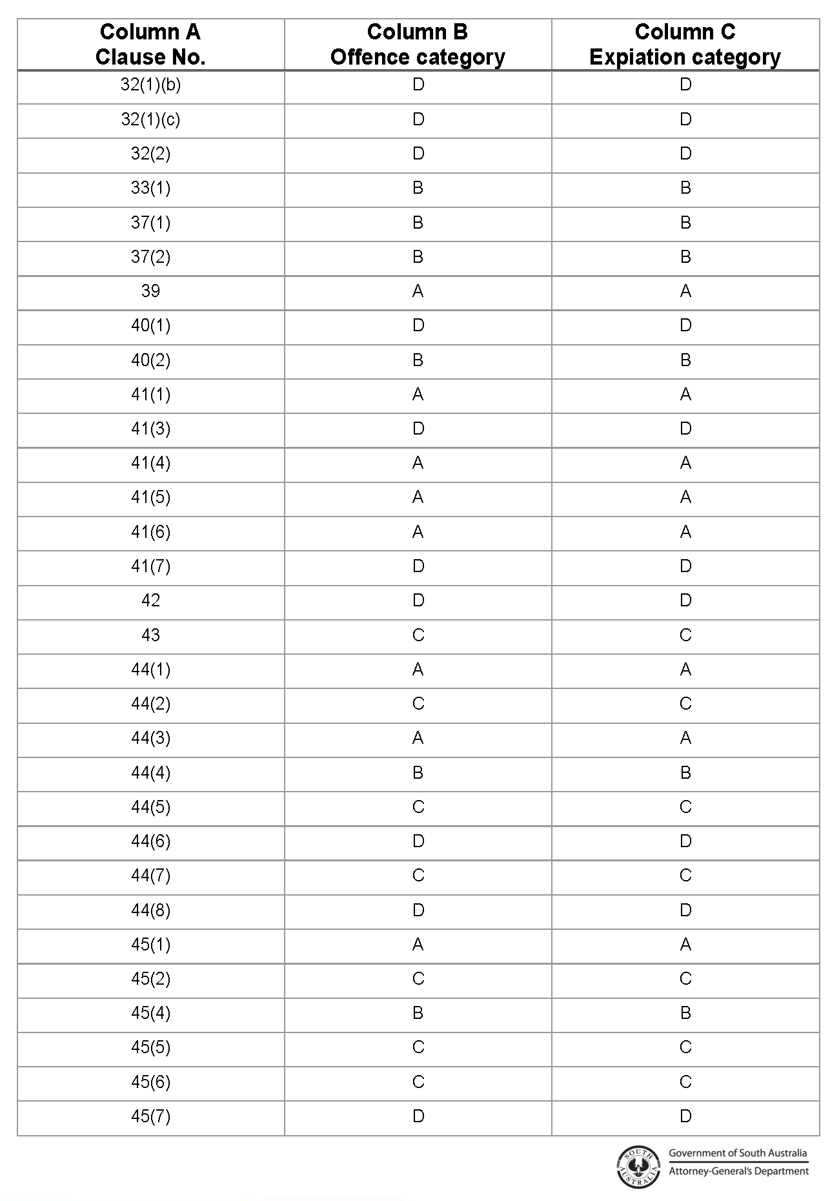

Gambling Administration Act 2019
South Australia
Authorised Betting Operations (Consistent Gambling Messaging – Interactive Wagering Services Guidelines) Notice 2023
under section 17 of the Gambling Administration Act 2019
1—Short title
This notice may be cited as the Authorised Betting Operations (Consistent Gambling Messaging – Interactive Wagering Services Guidelines) Notice 2023.
2—Commencement
This Variation Notice comes into operation on 30 March 2023.
3—Consistent Gambling Messaging - Interactive Wagering Services Guidelines
The guidelines set out in this notice are prescribed by the Liquor and Gambling Commissioner under section 17 of the Gambling Administration Act 2019 for the purpose of the Authorised Betting Operations Gambling Code of Practice, prescribed under section 15 of the Gambling Administration Act 2019.
Dated: 30 March 2023
Dini Soulio
Liquor and Gambling Commissioner

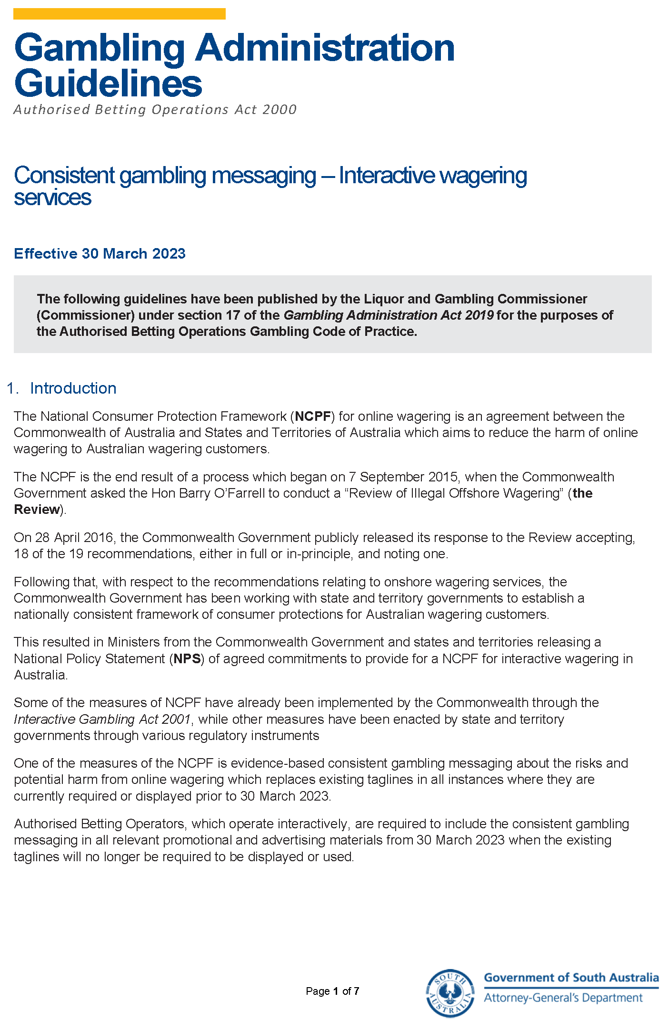
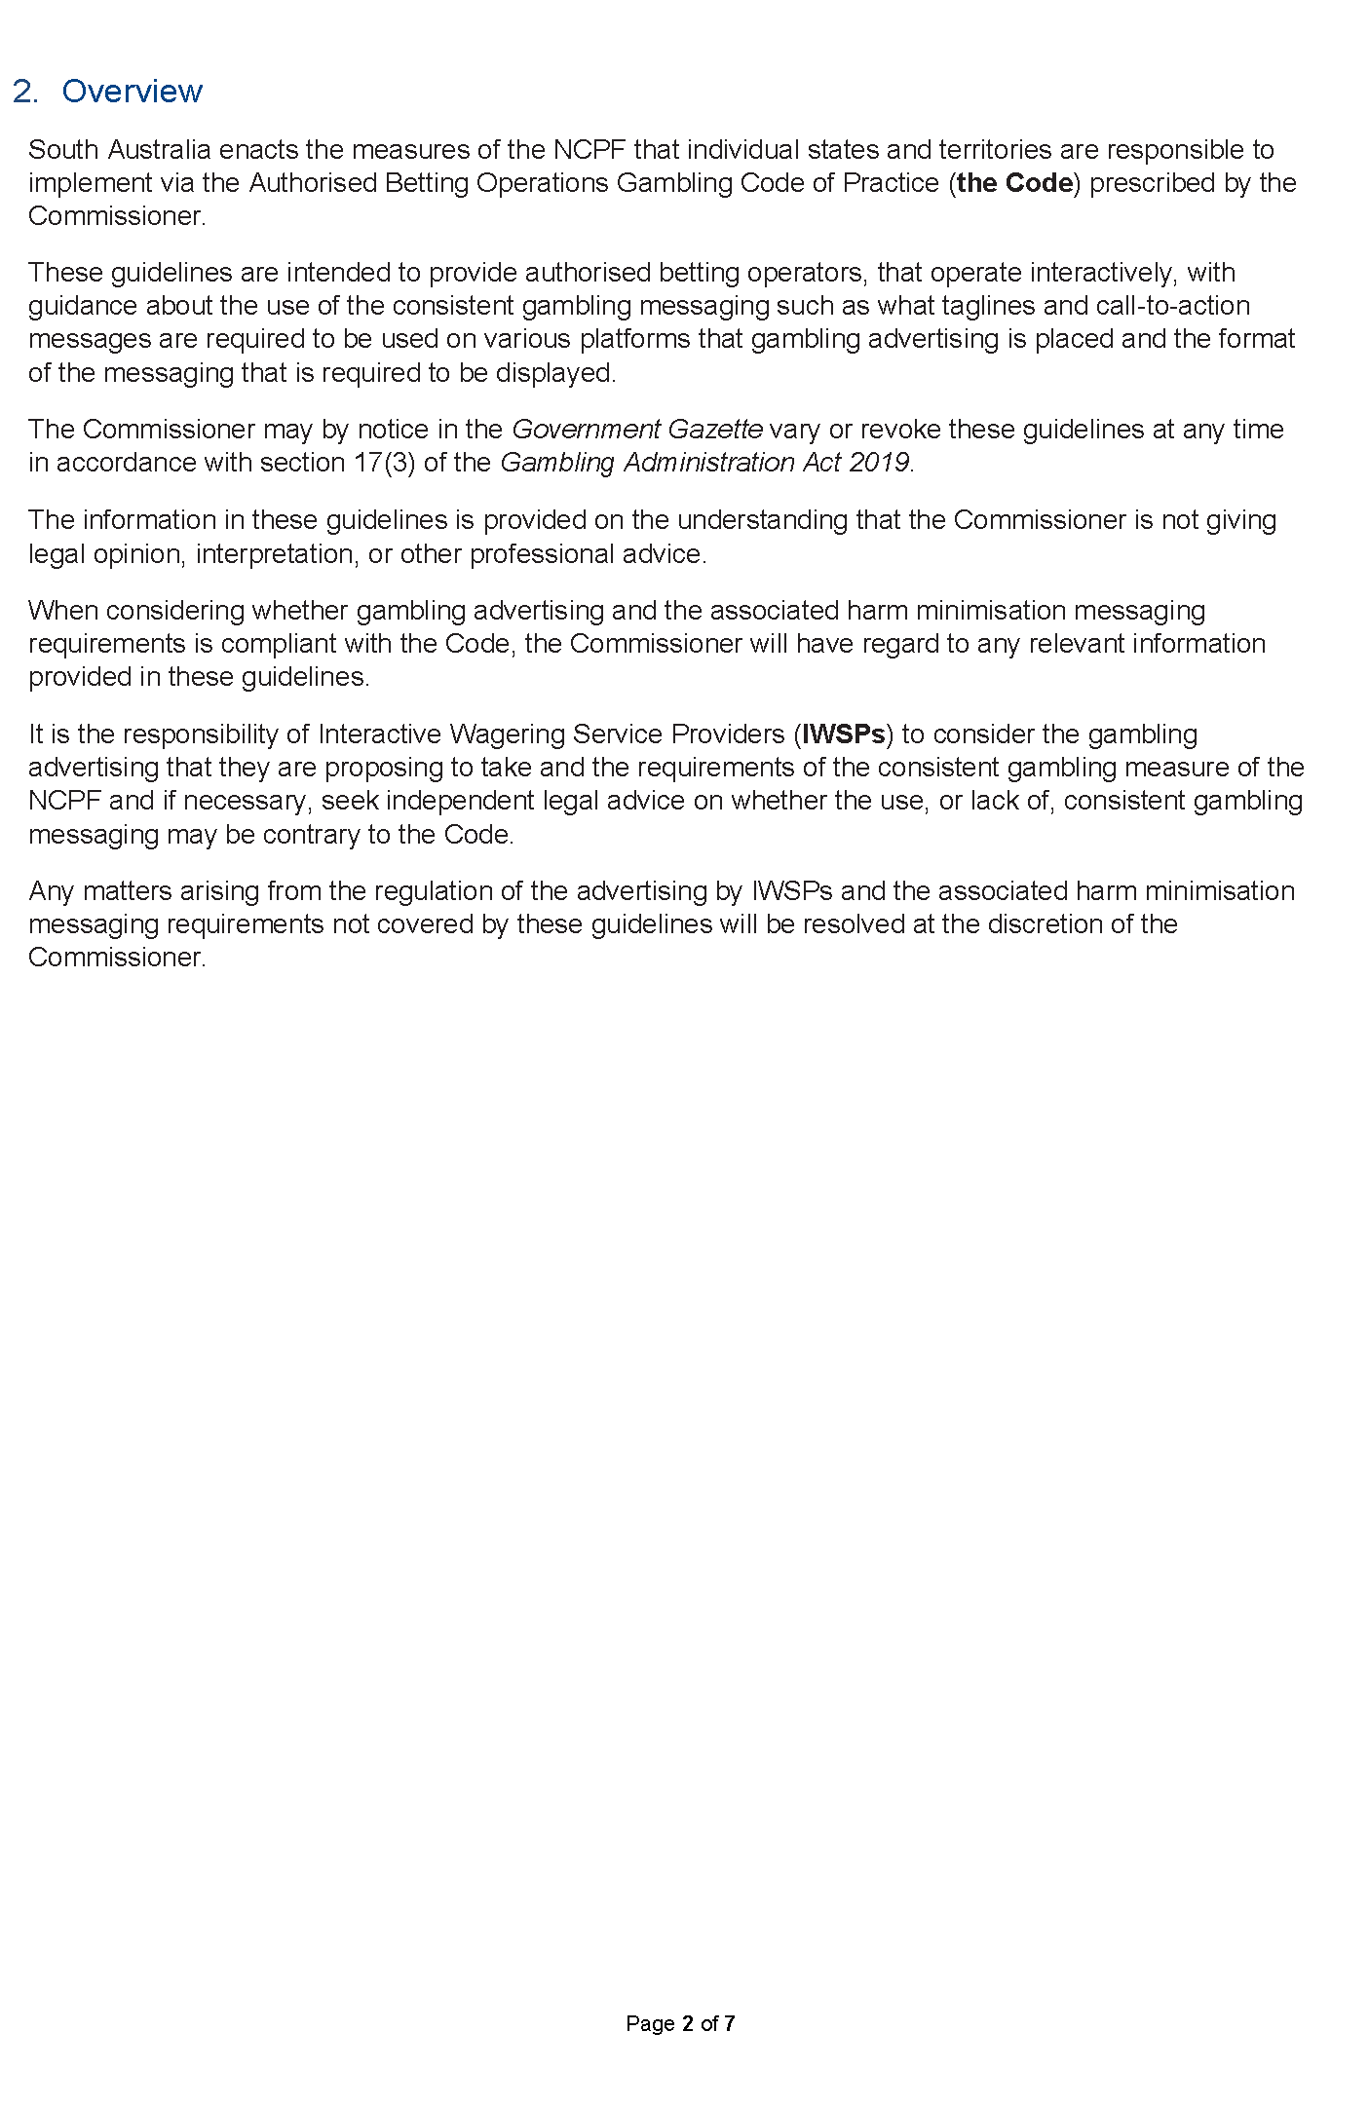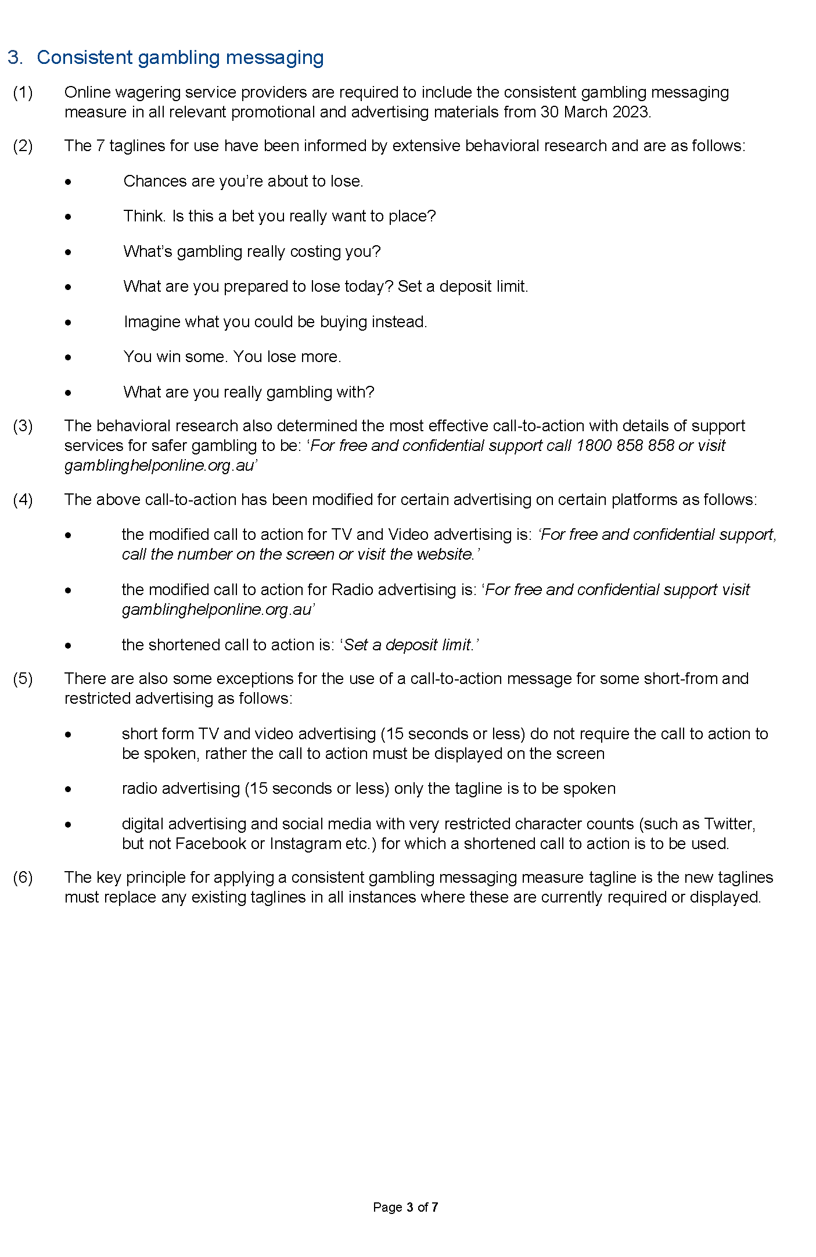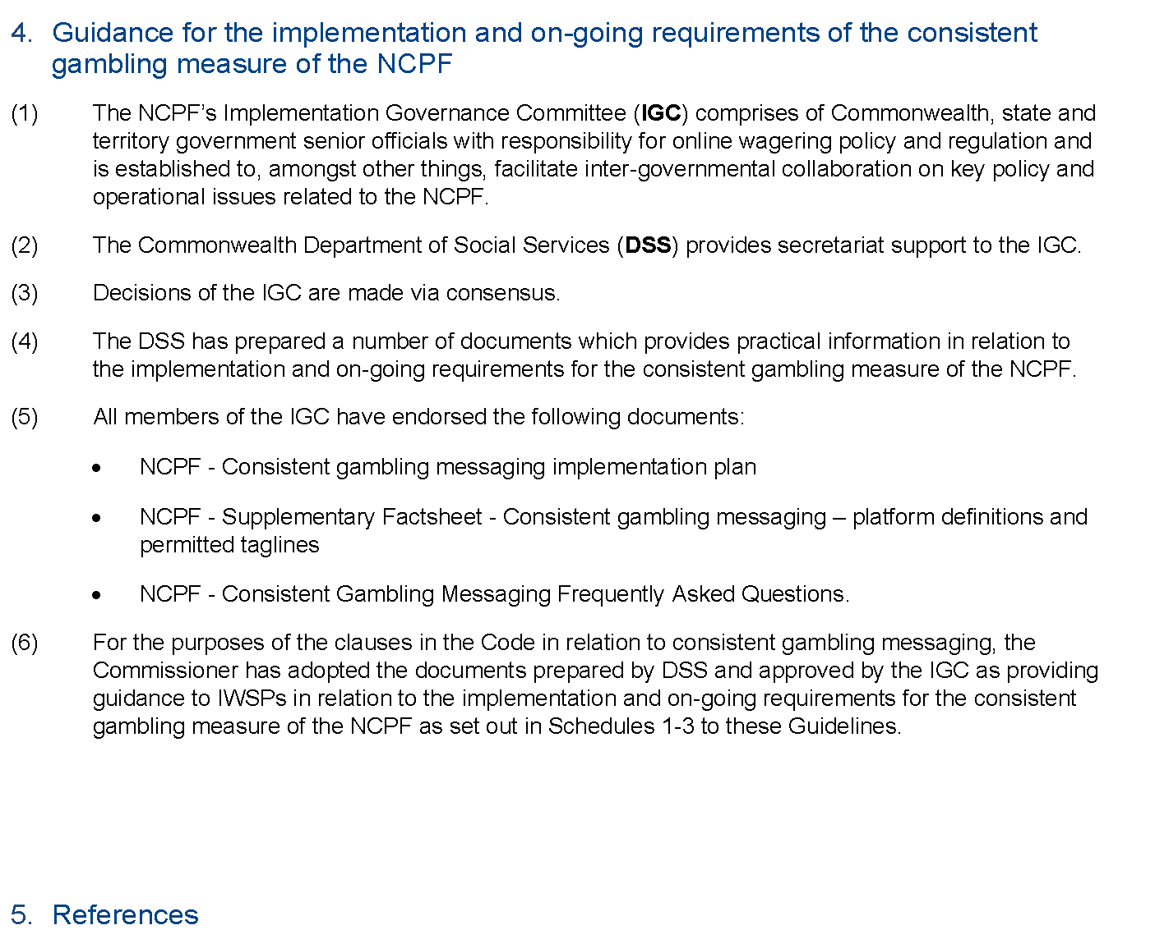
Gambling Administration Act 2019
Authorised Betting Operations Act 2000
Authorised Betting Operations Gambling Codes of Practice
National Consumer Protection Framework for Online Gambling

Schedule 1
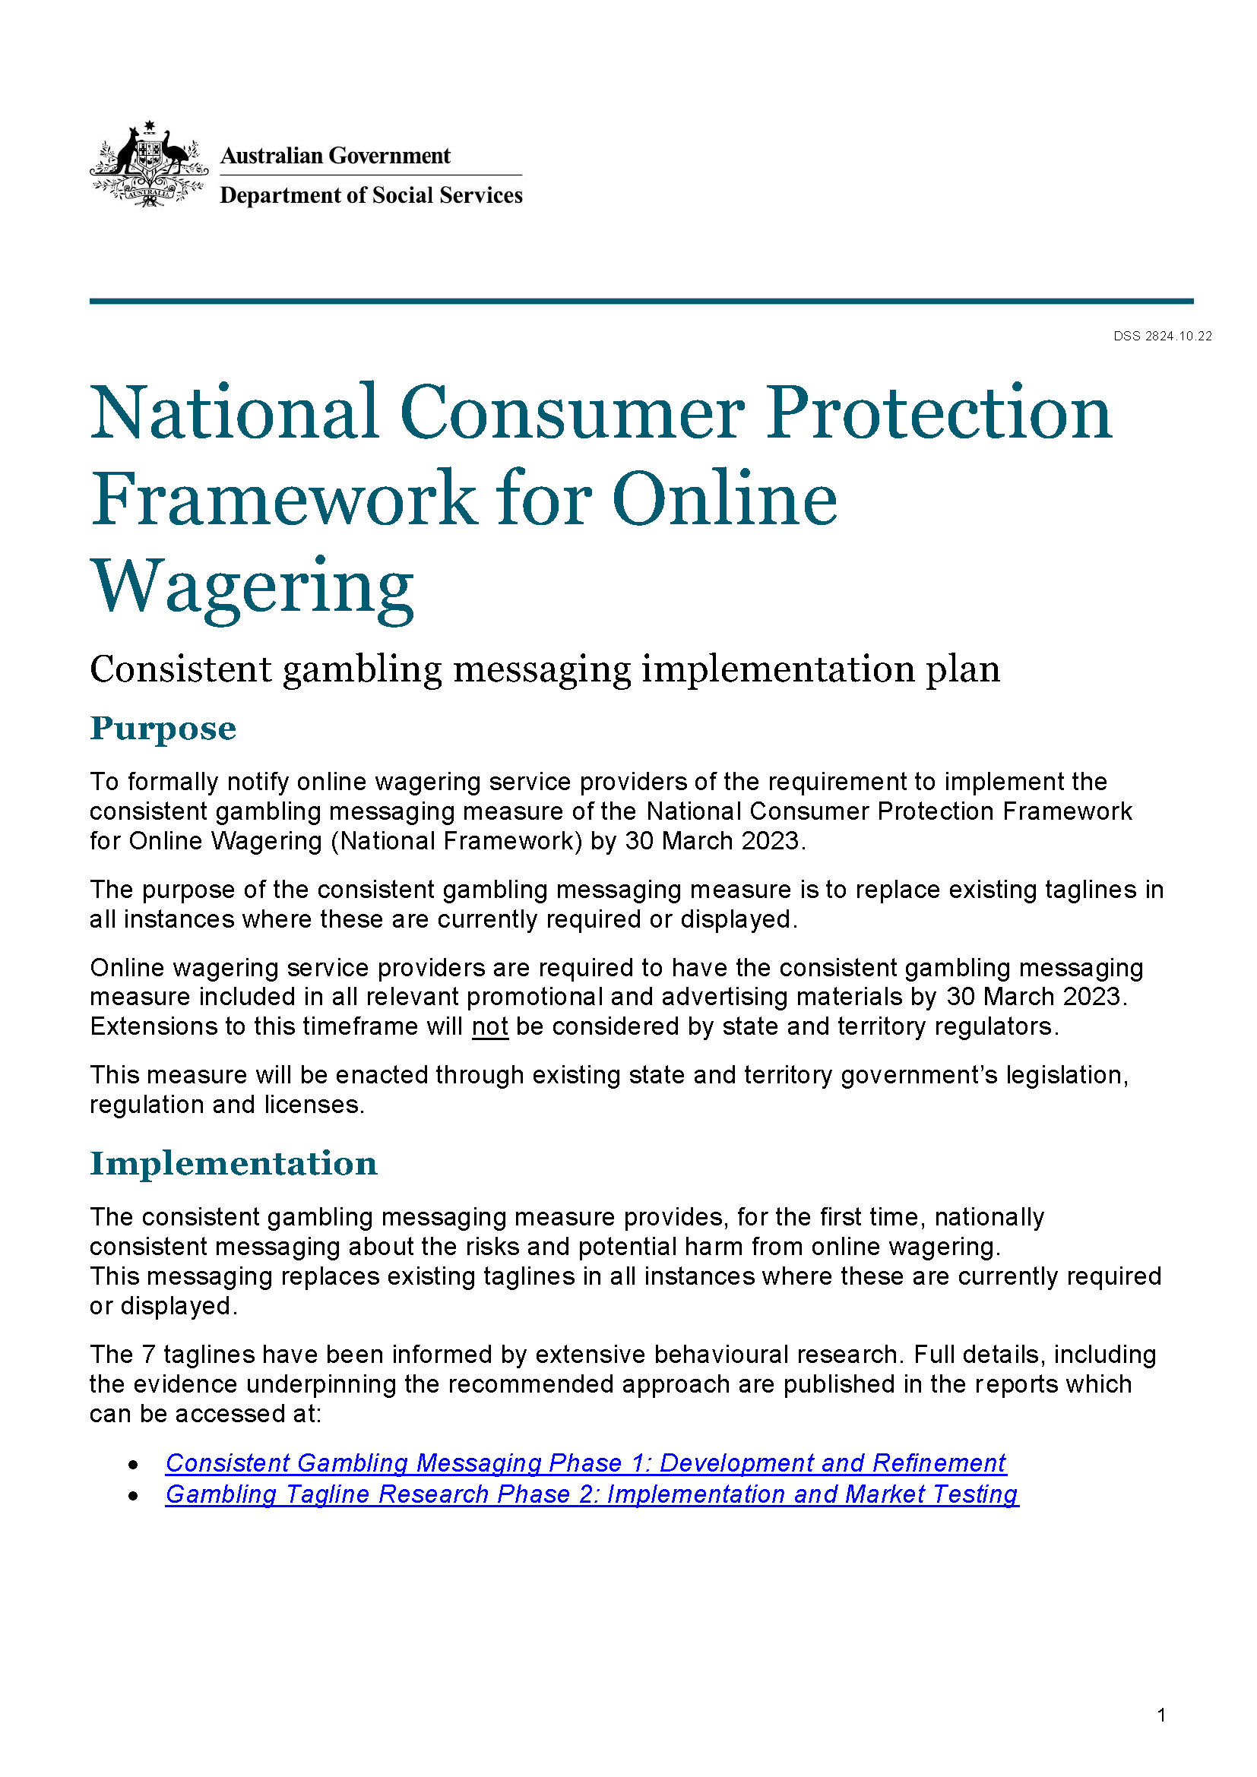
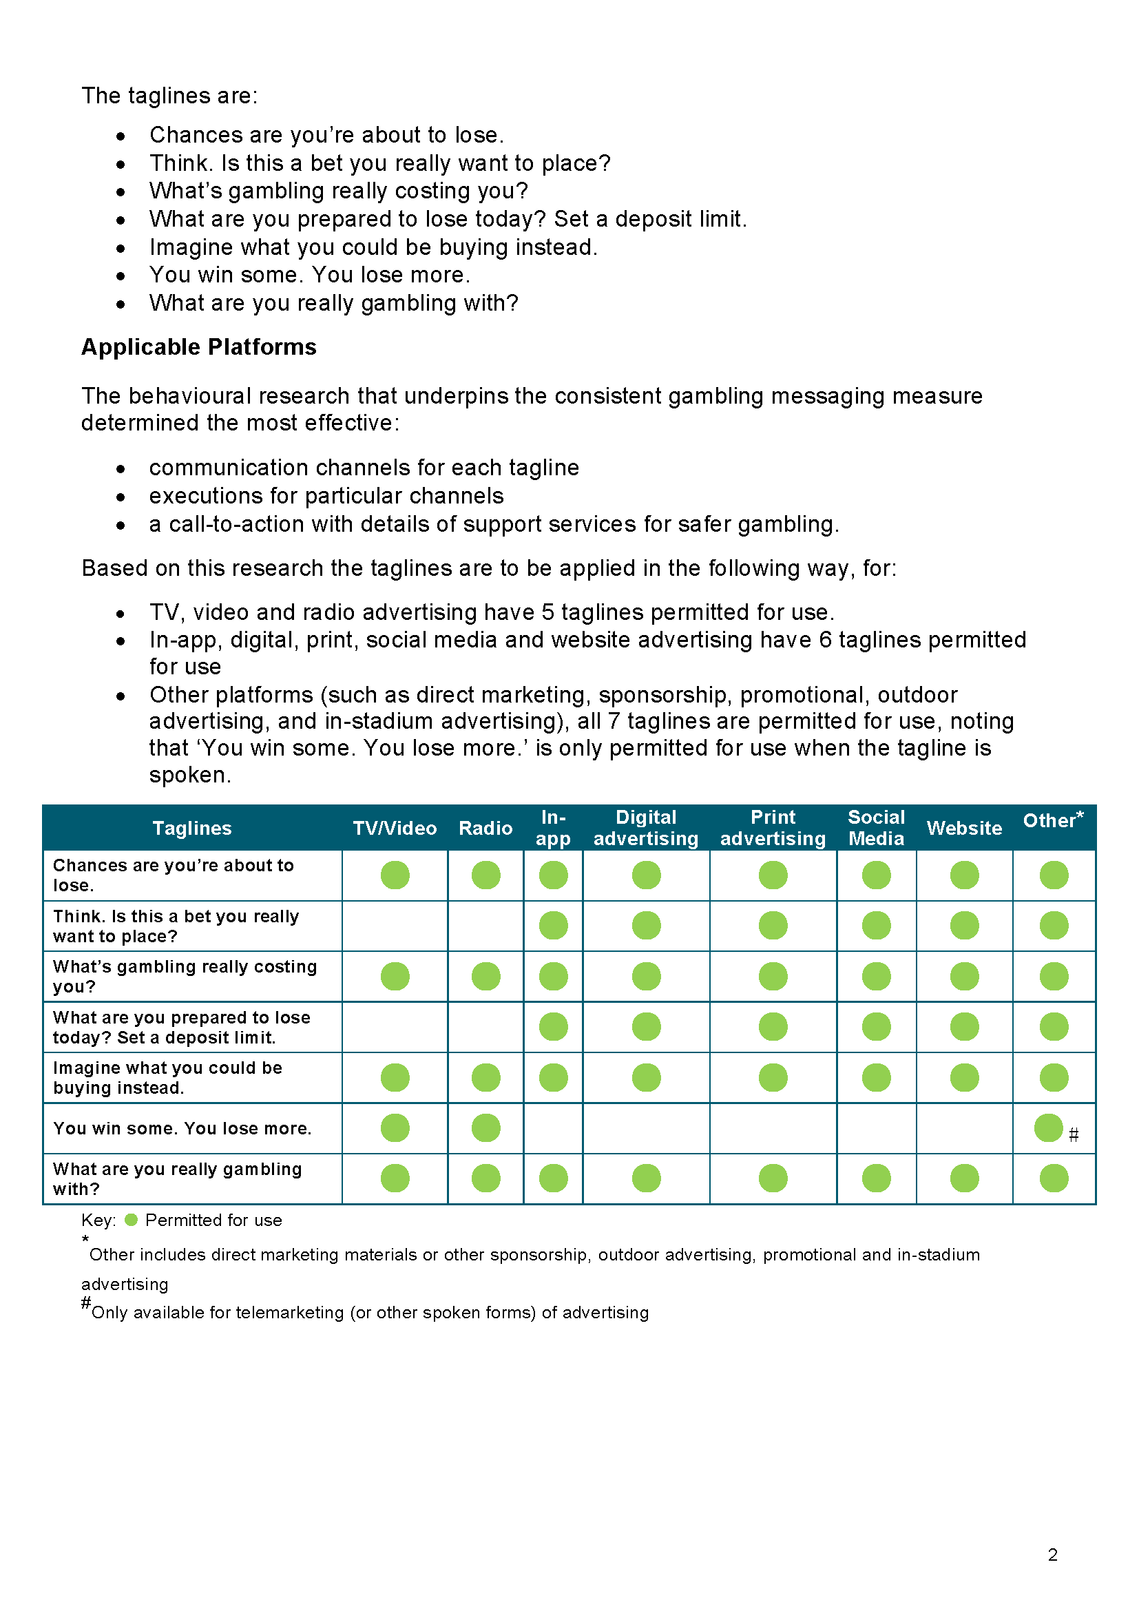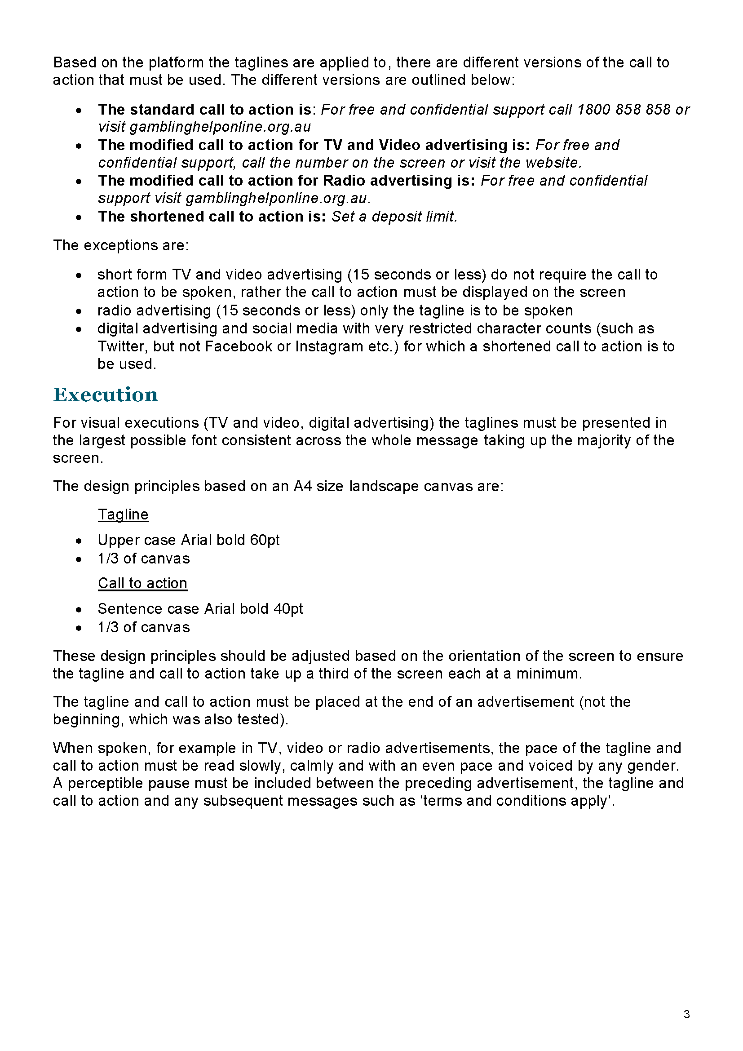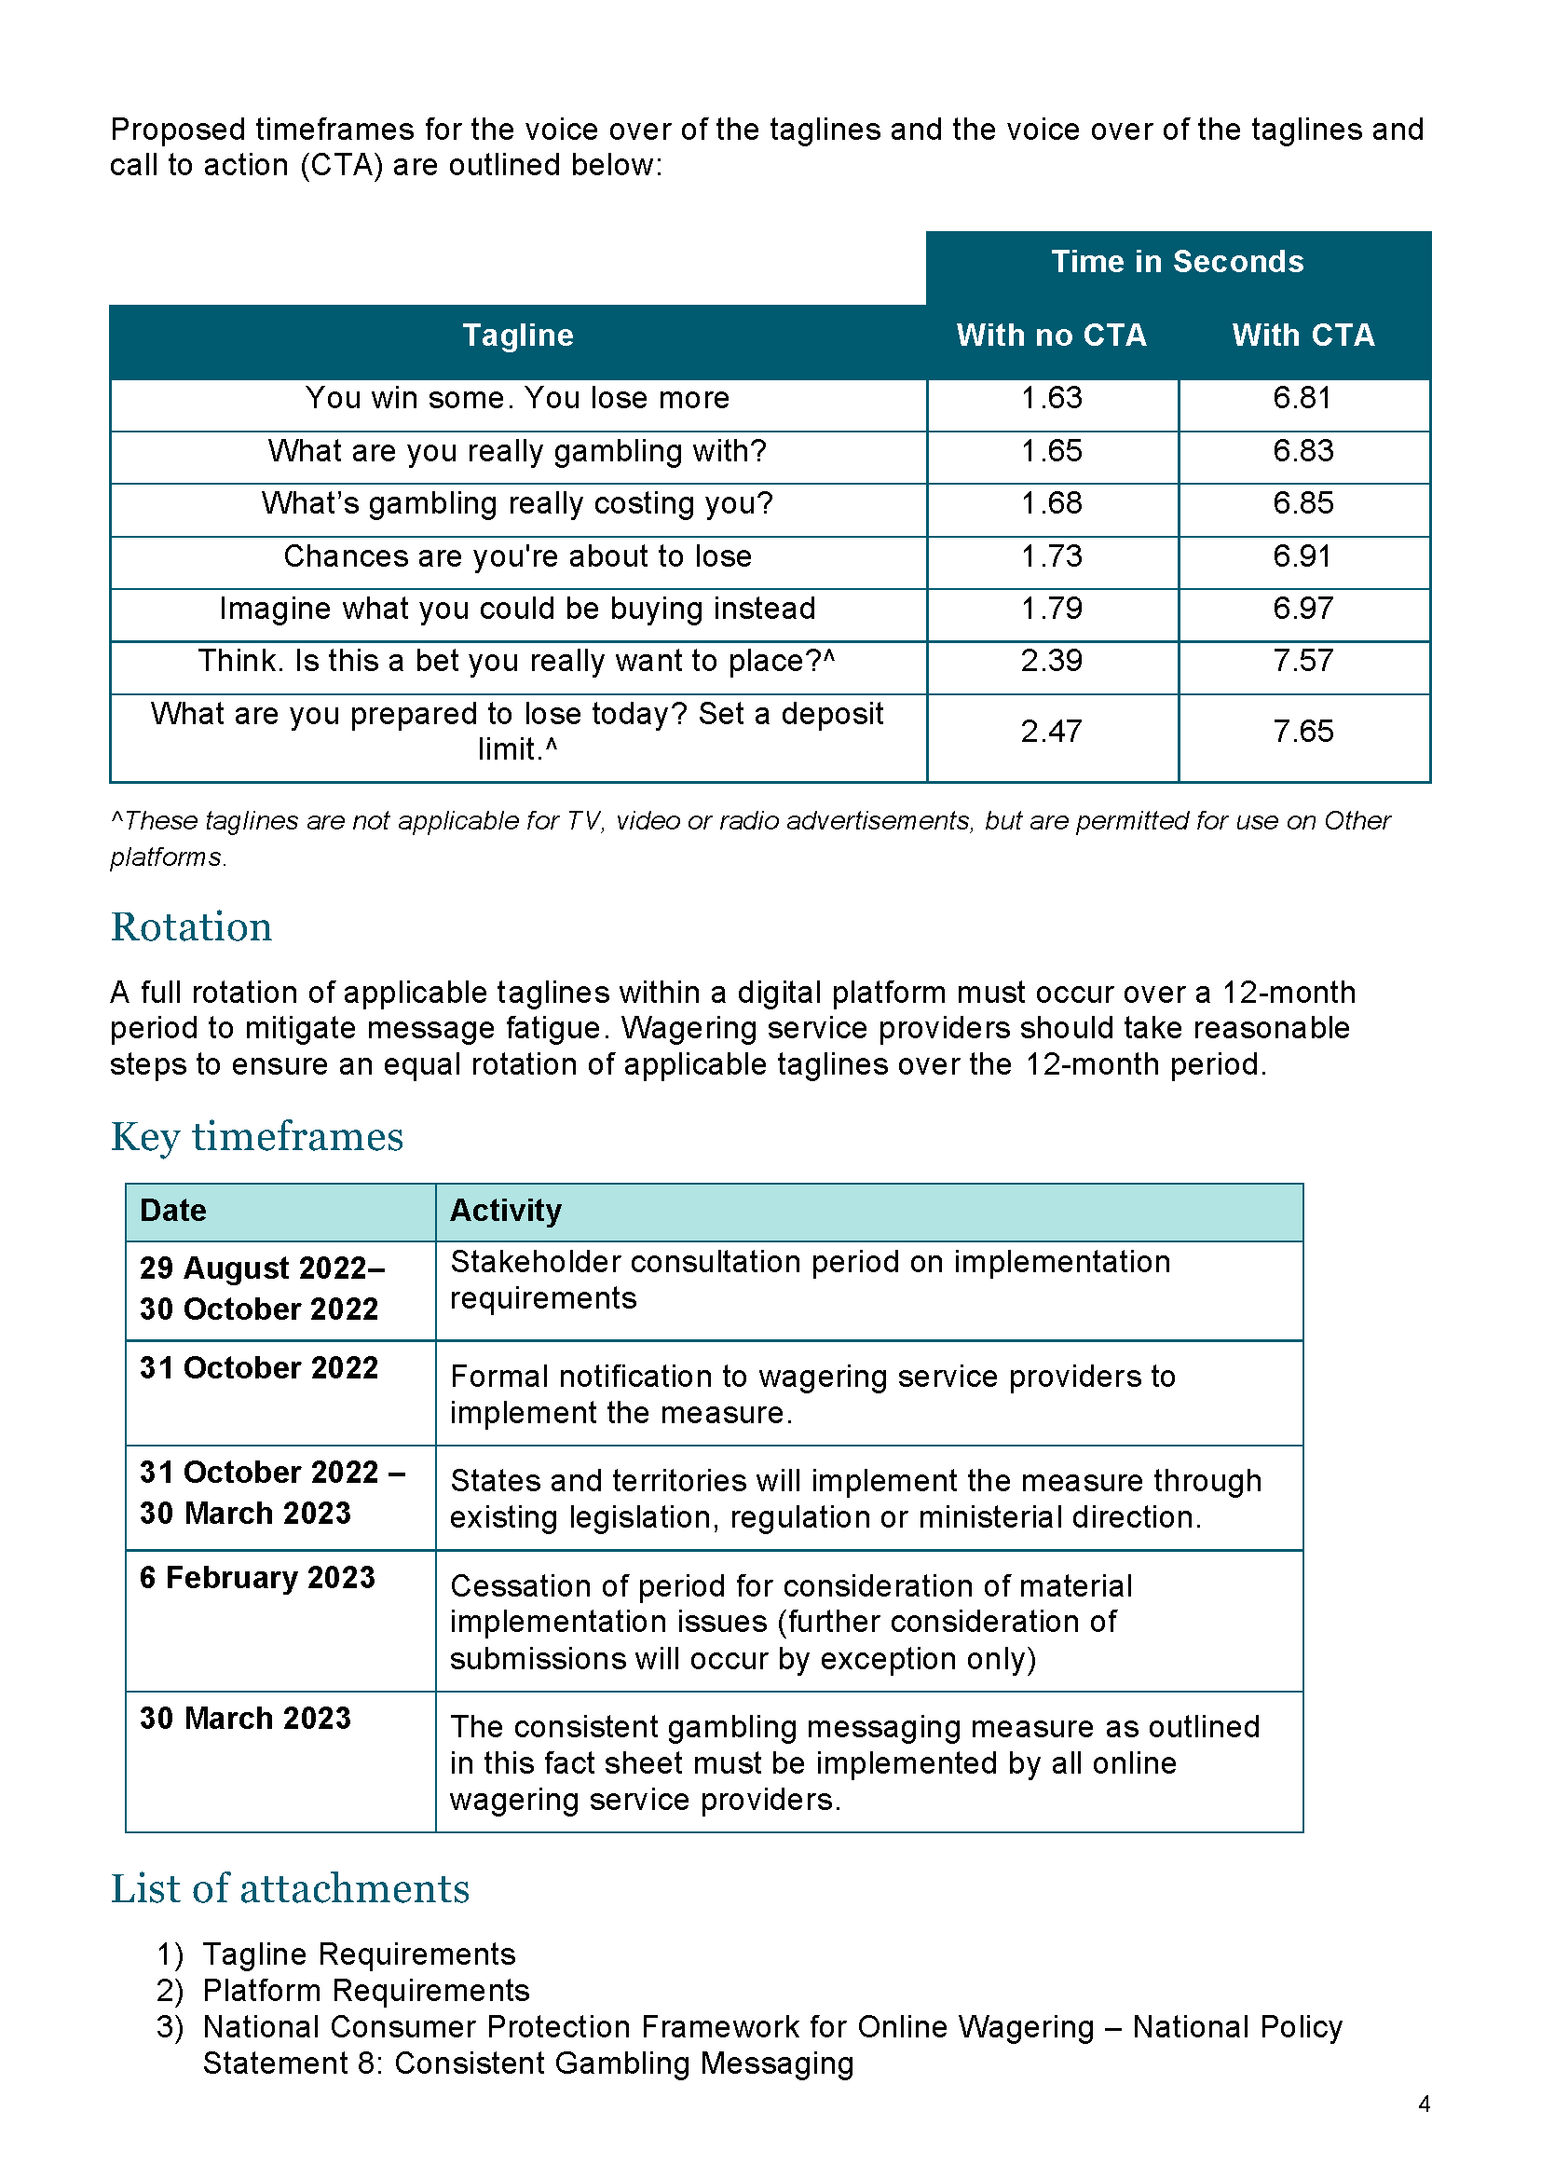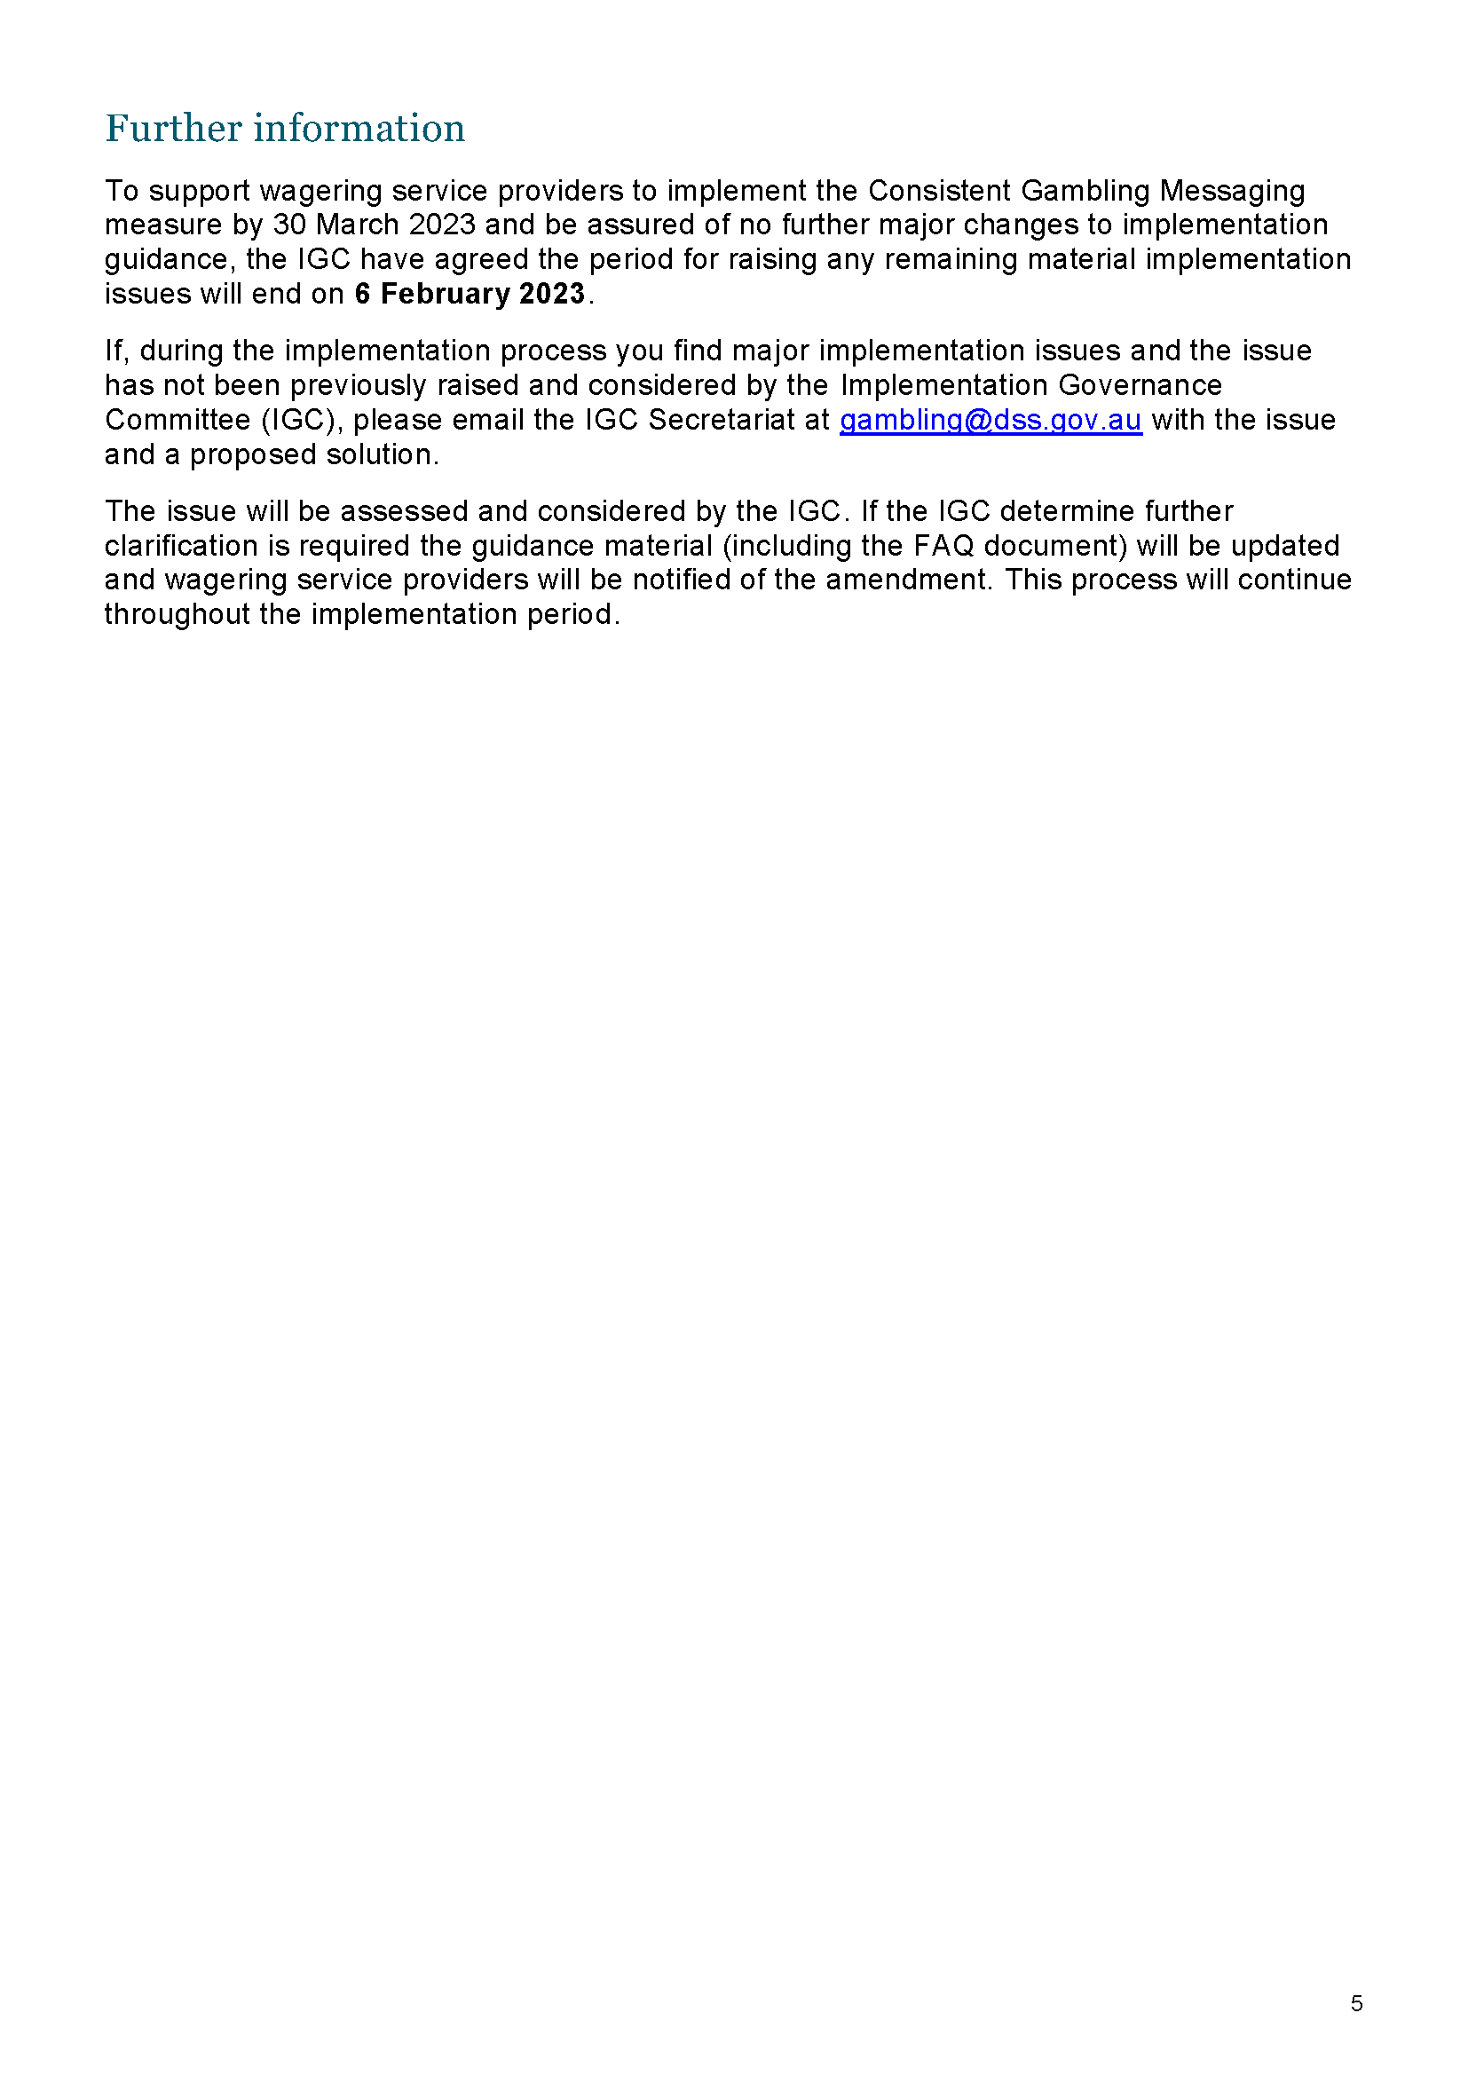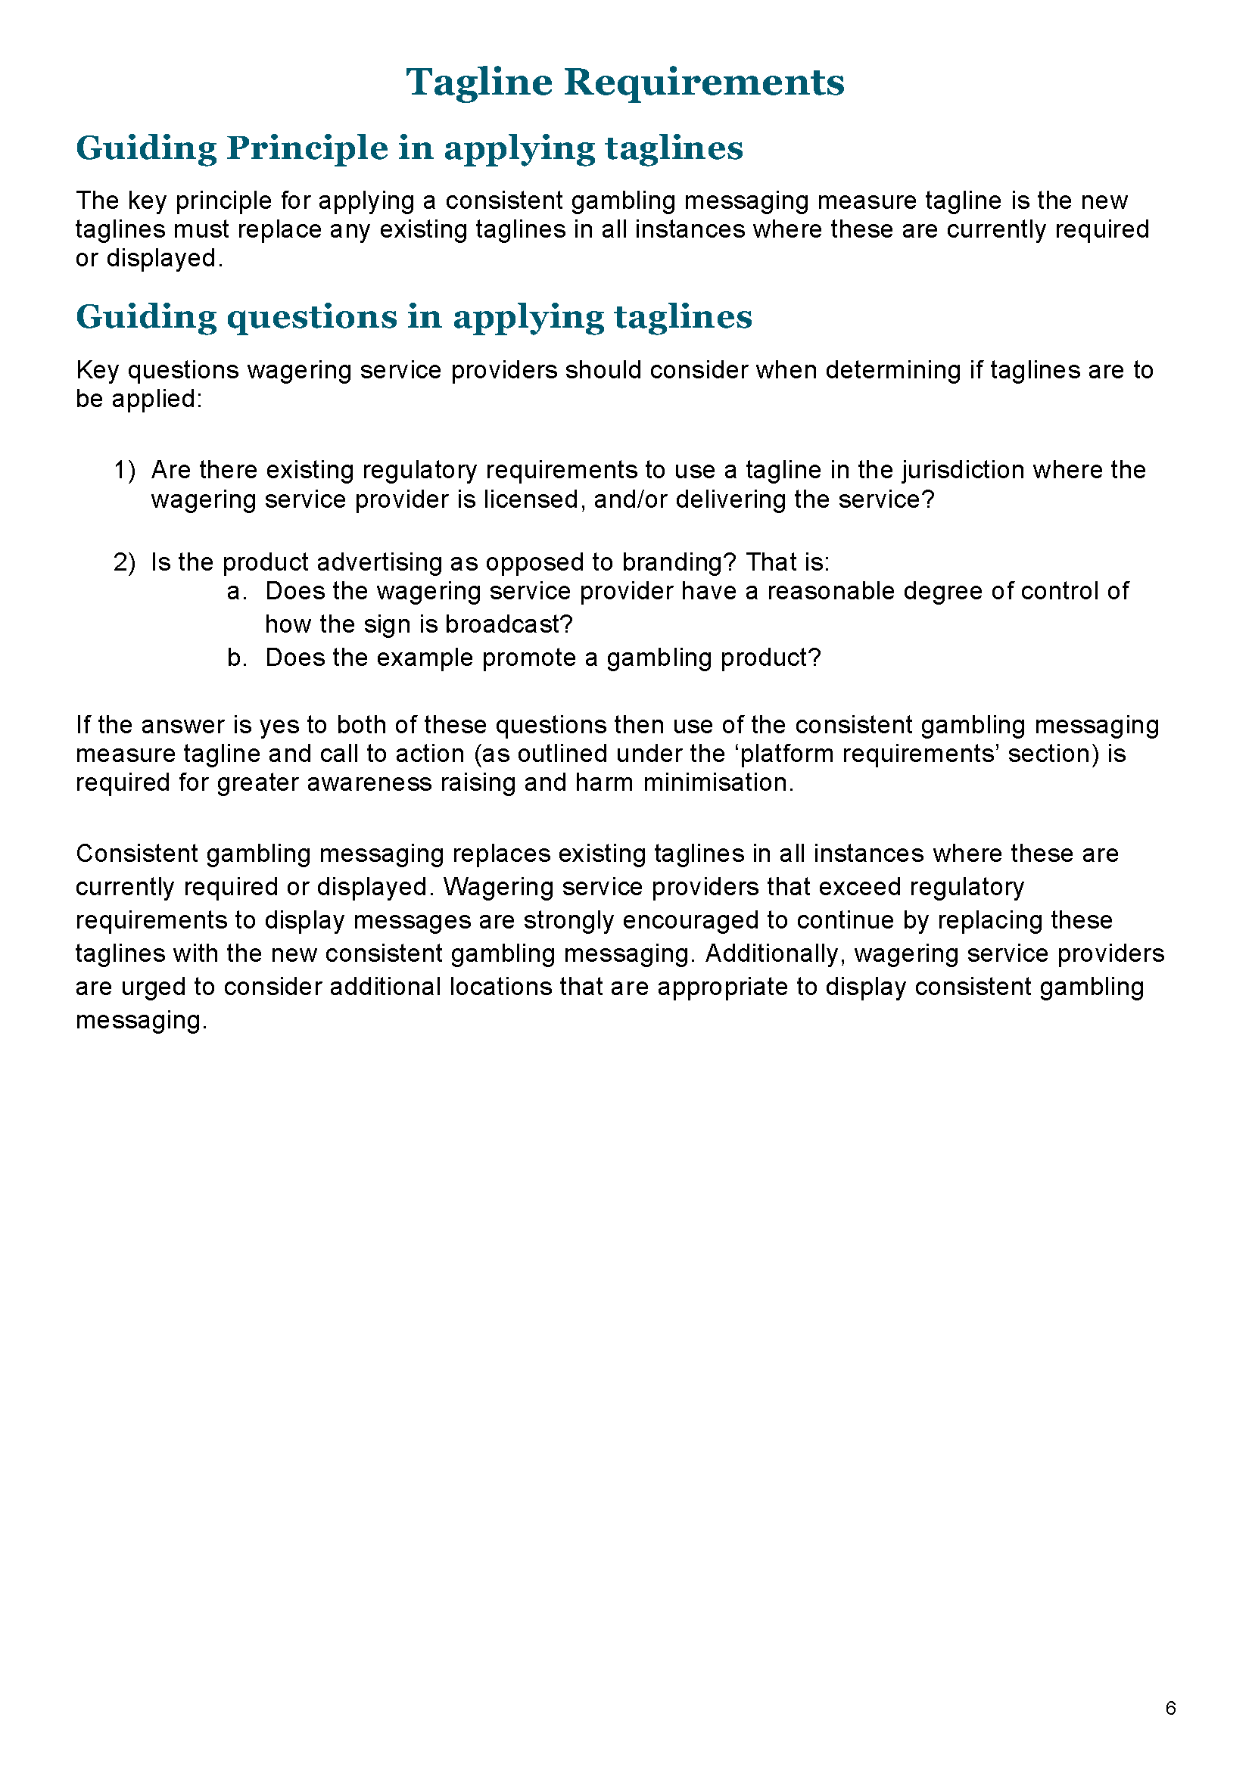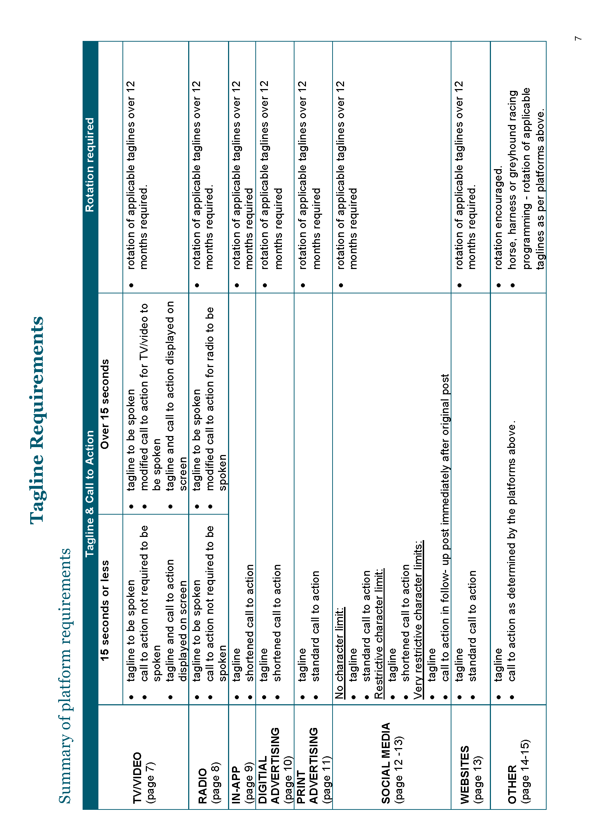
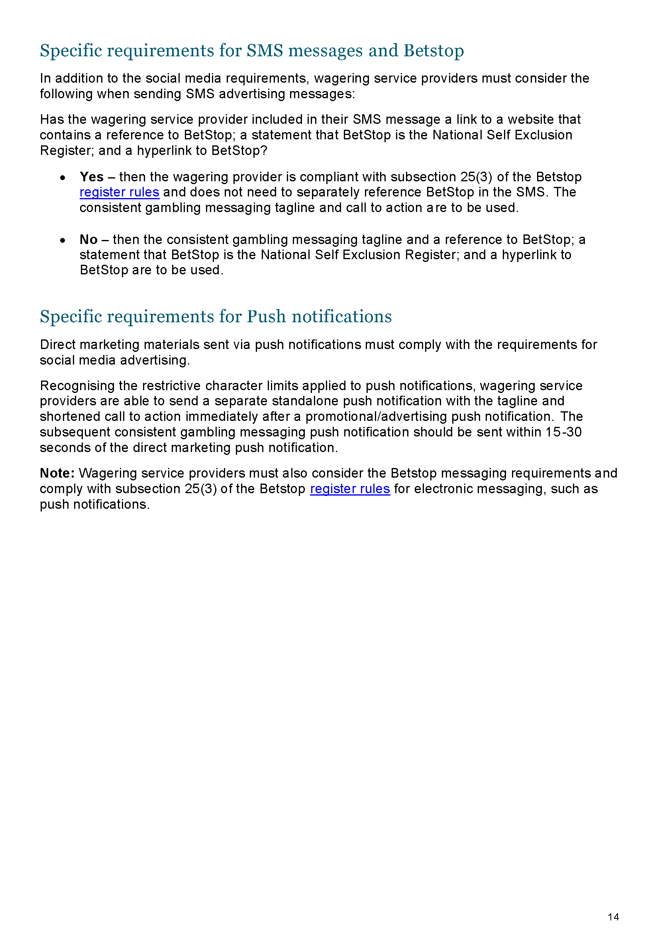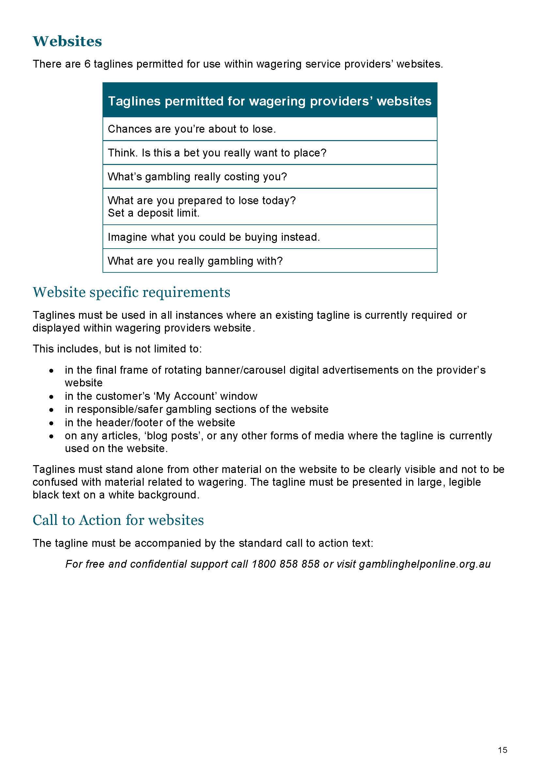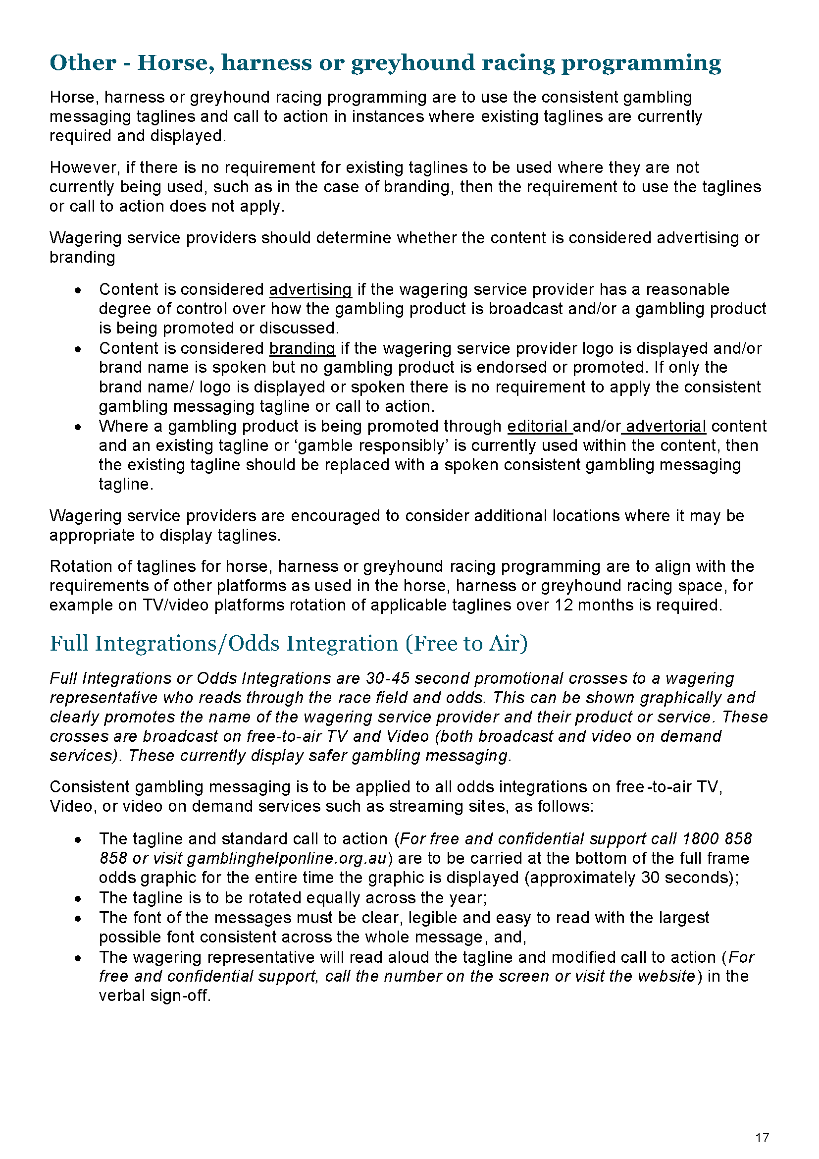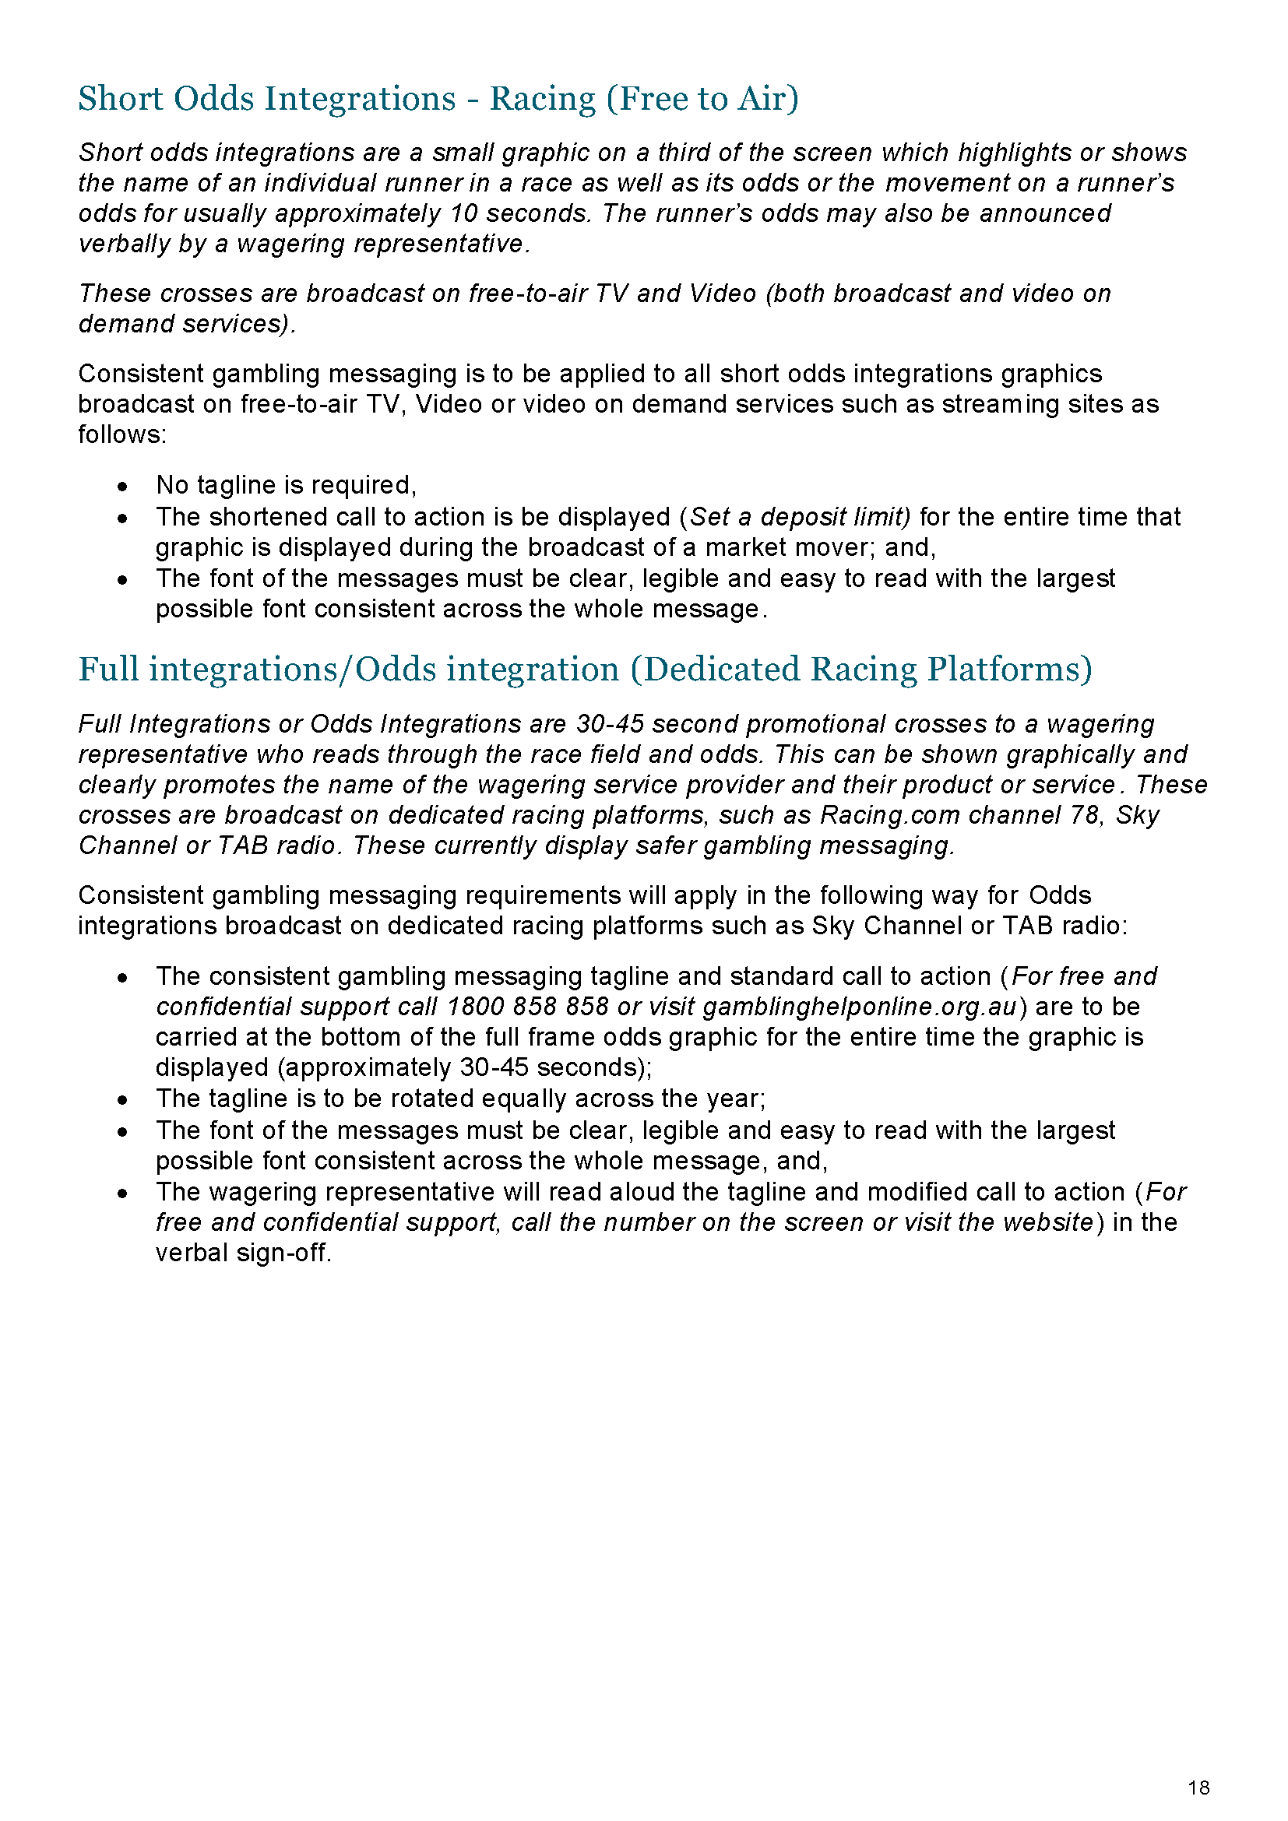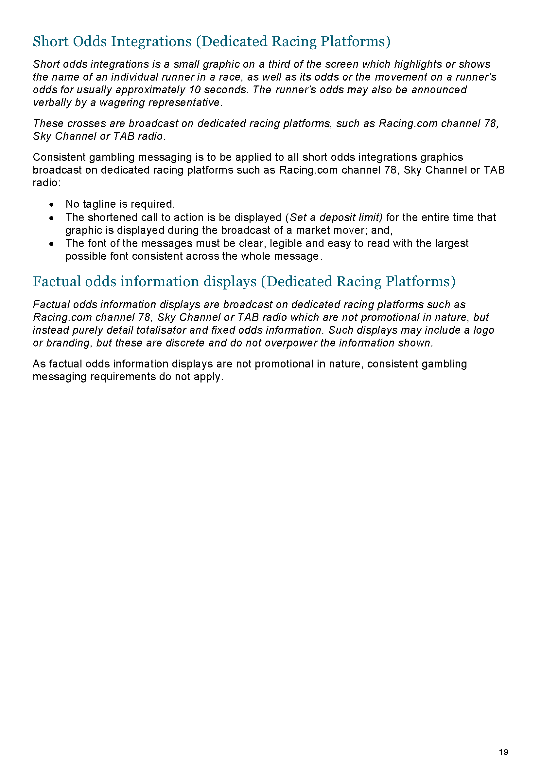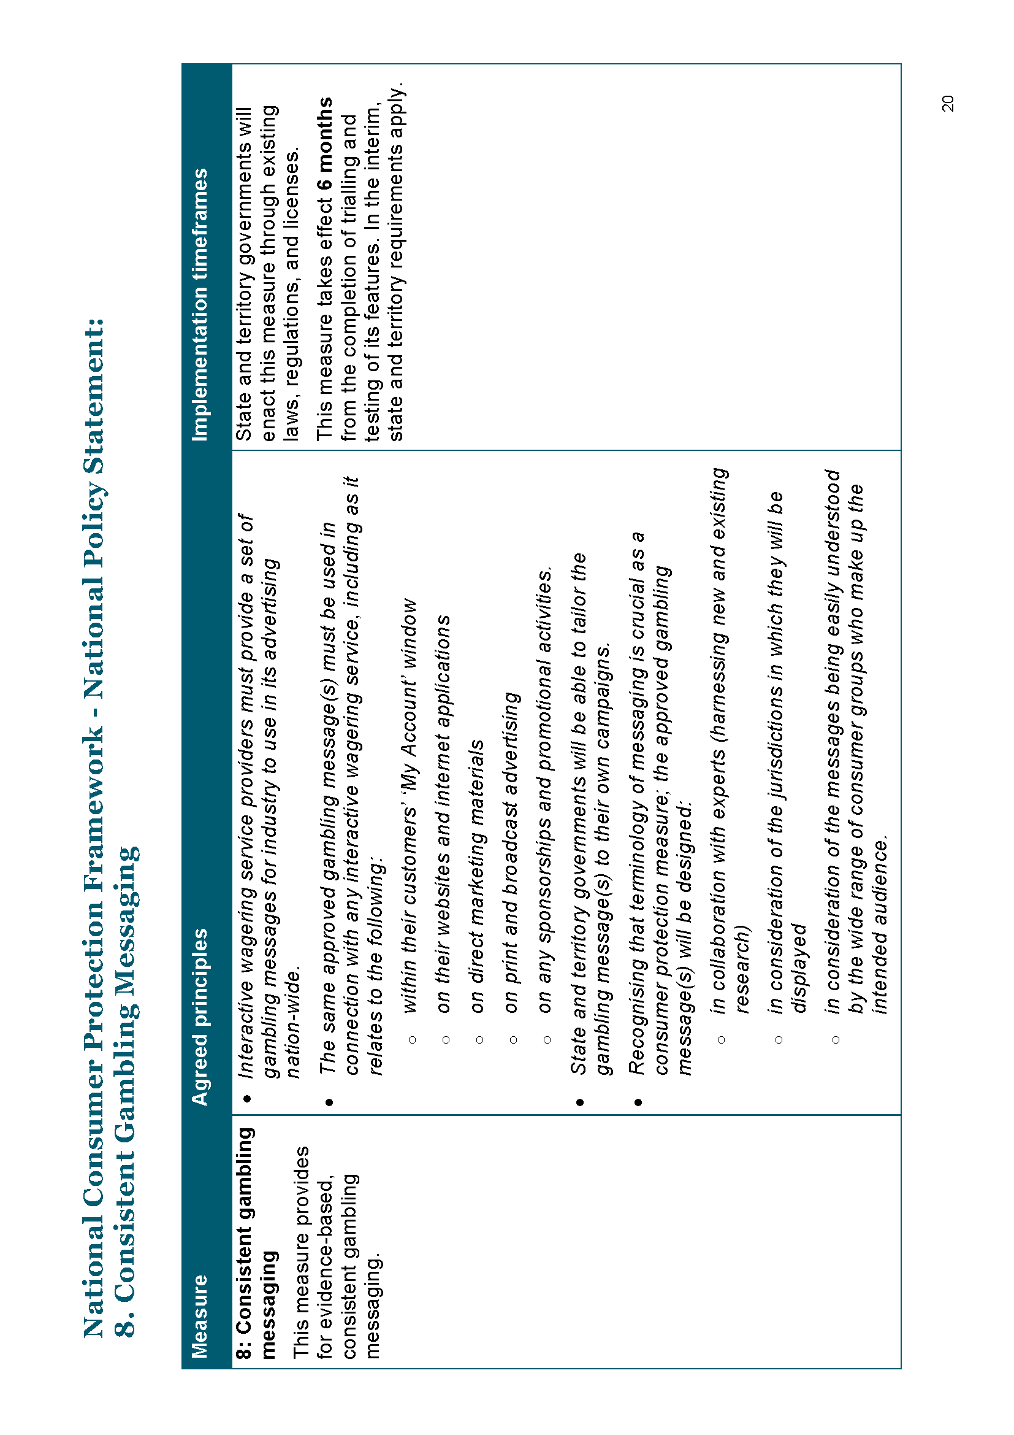

Schedule 2
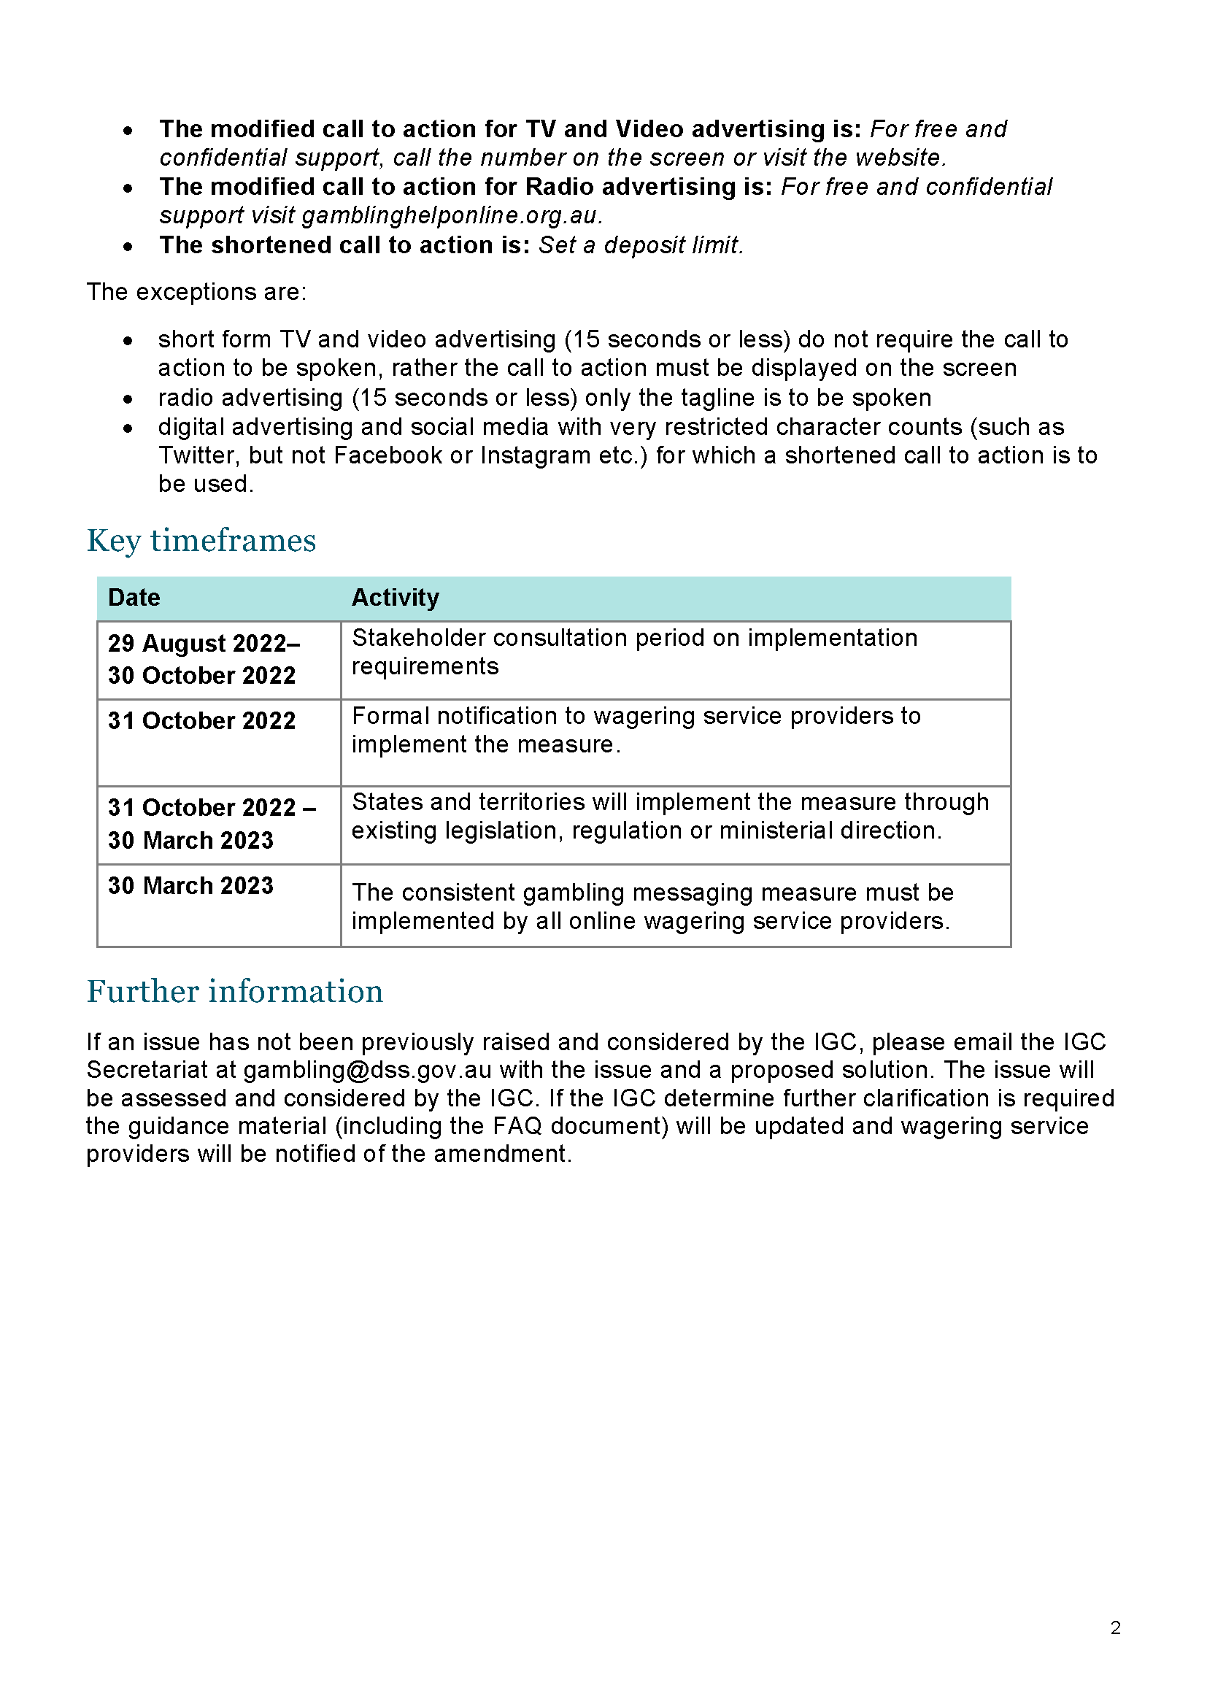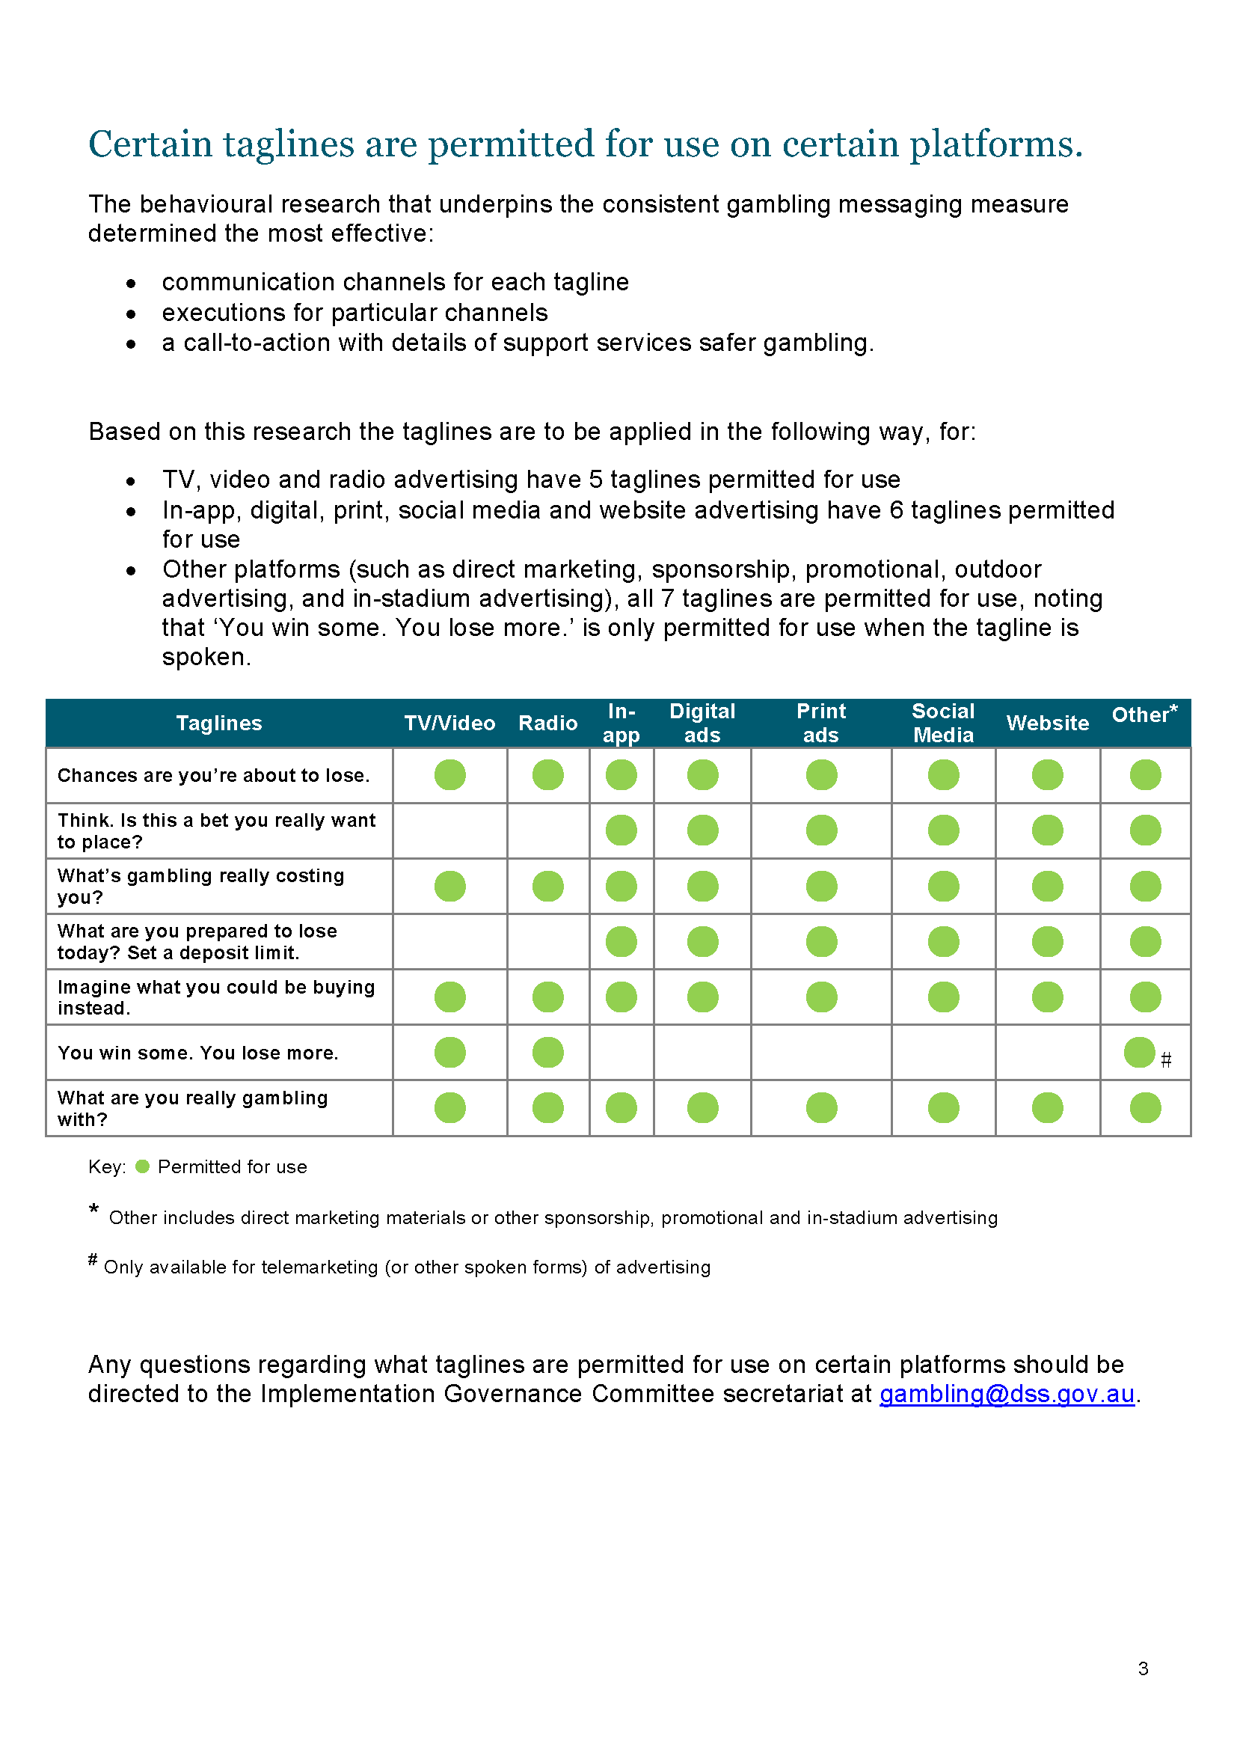

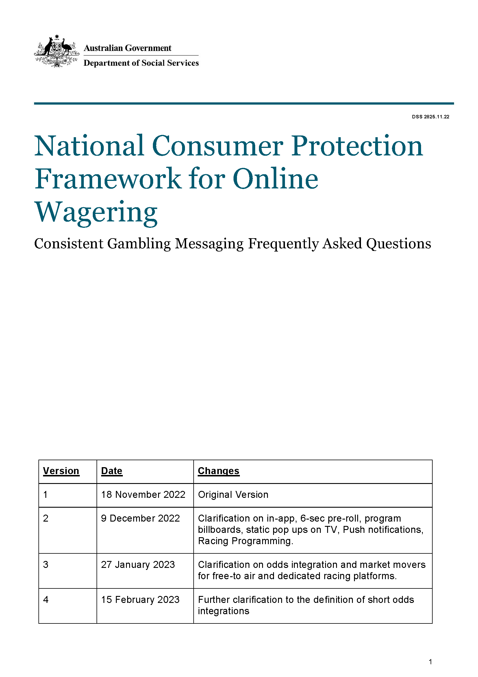
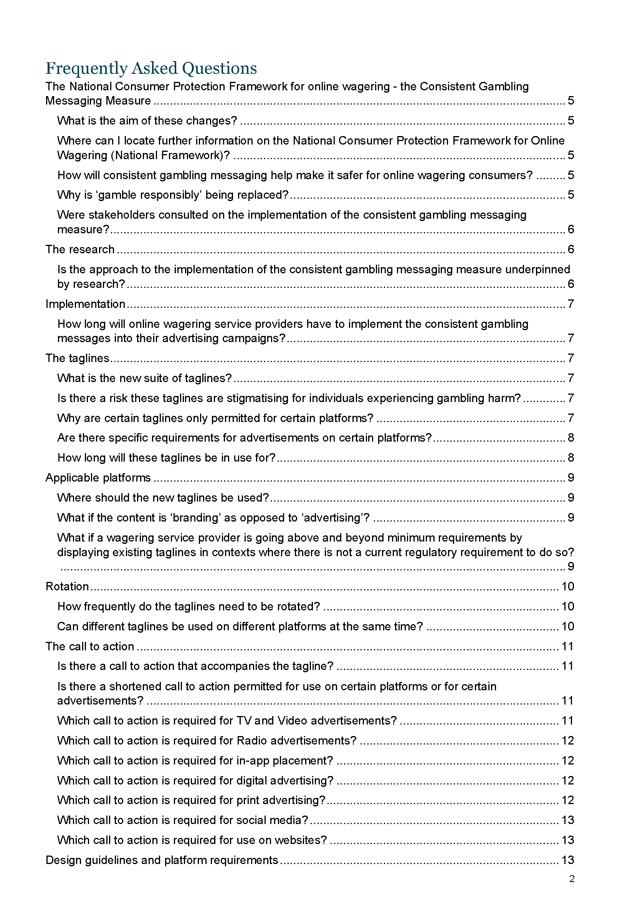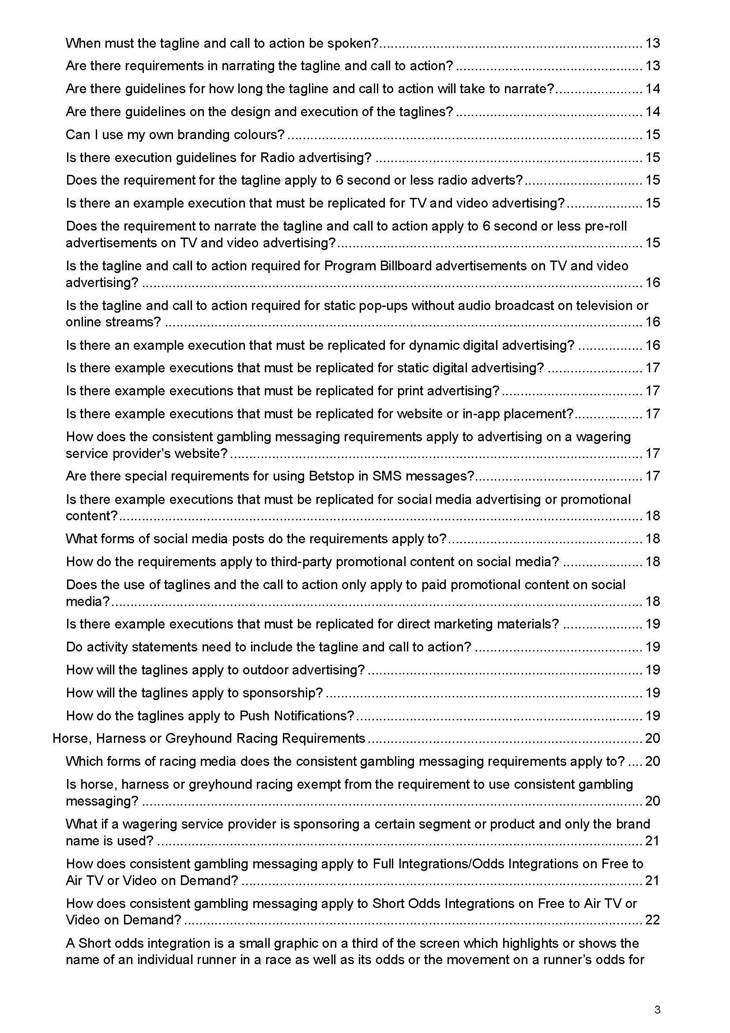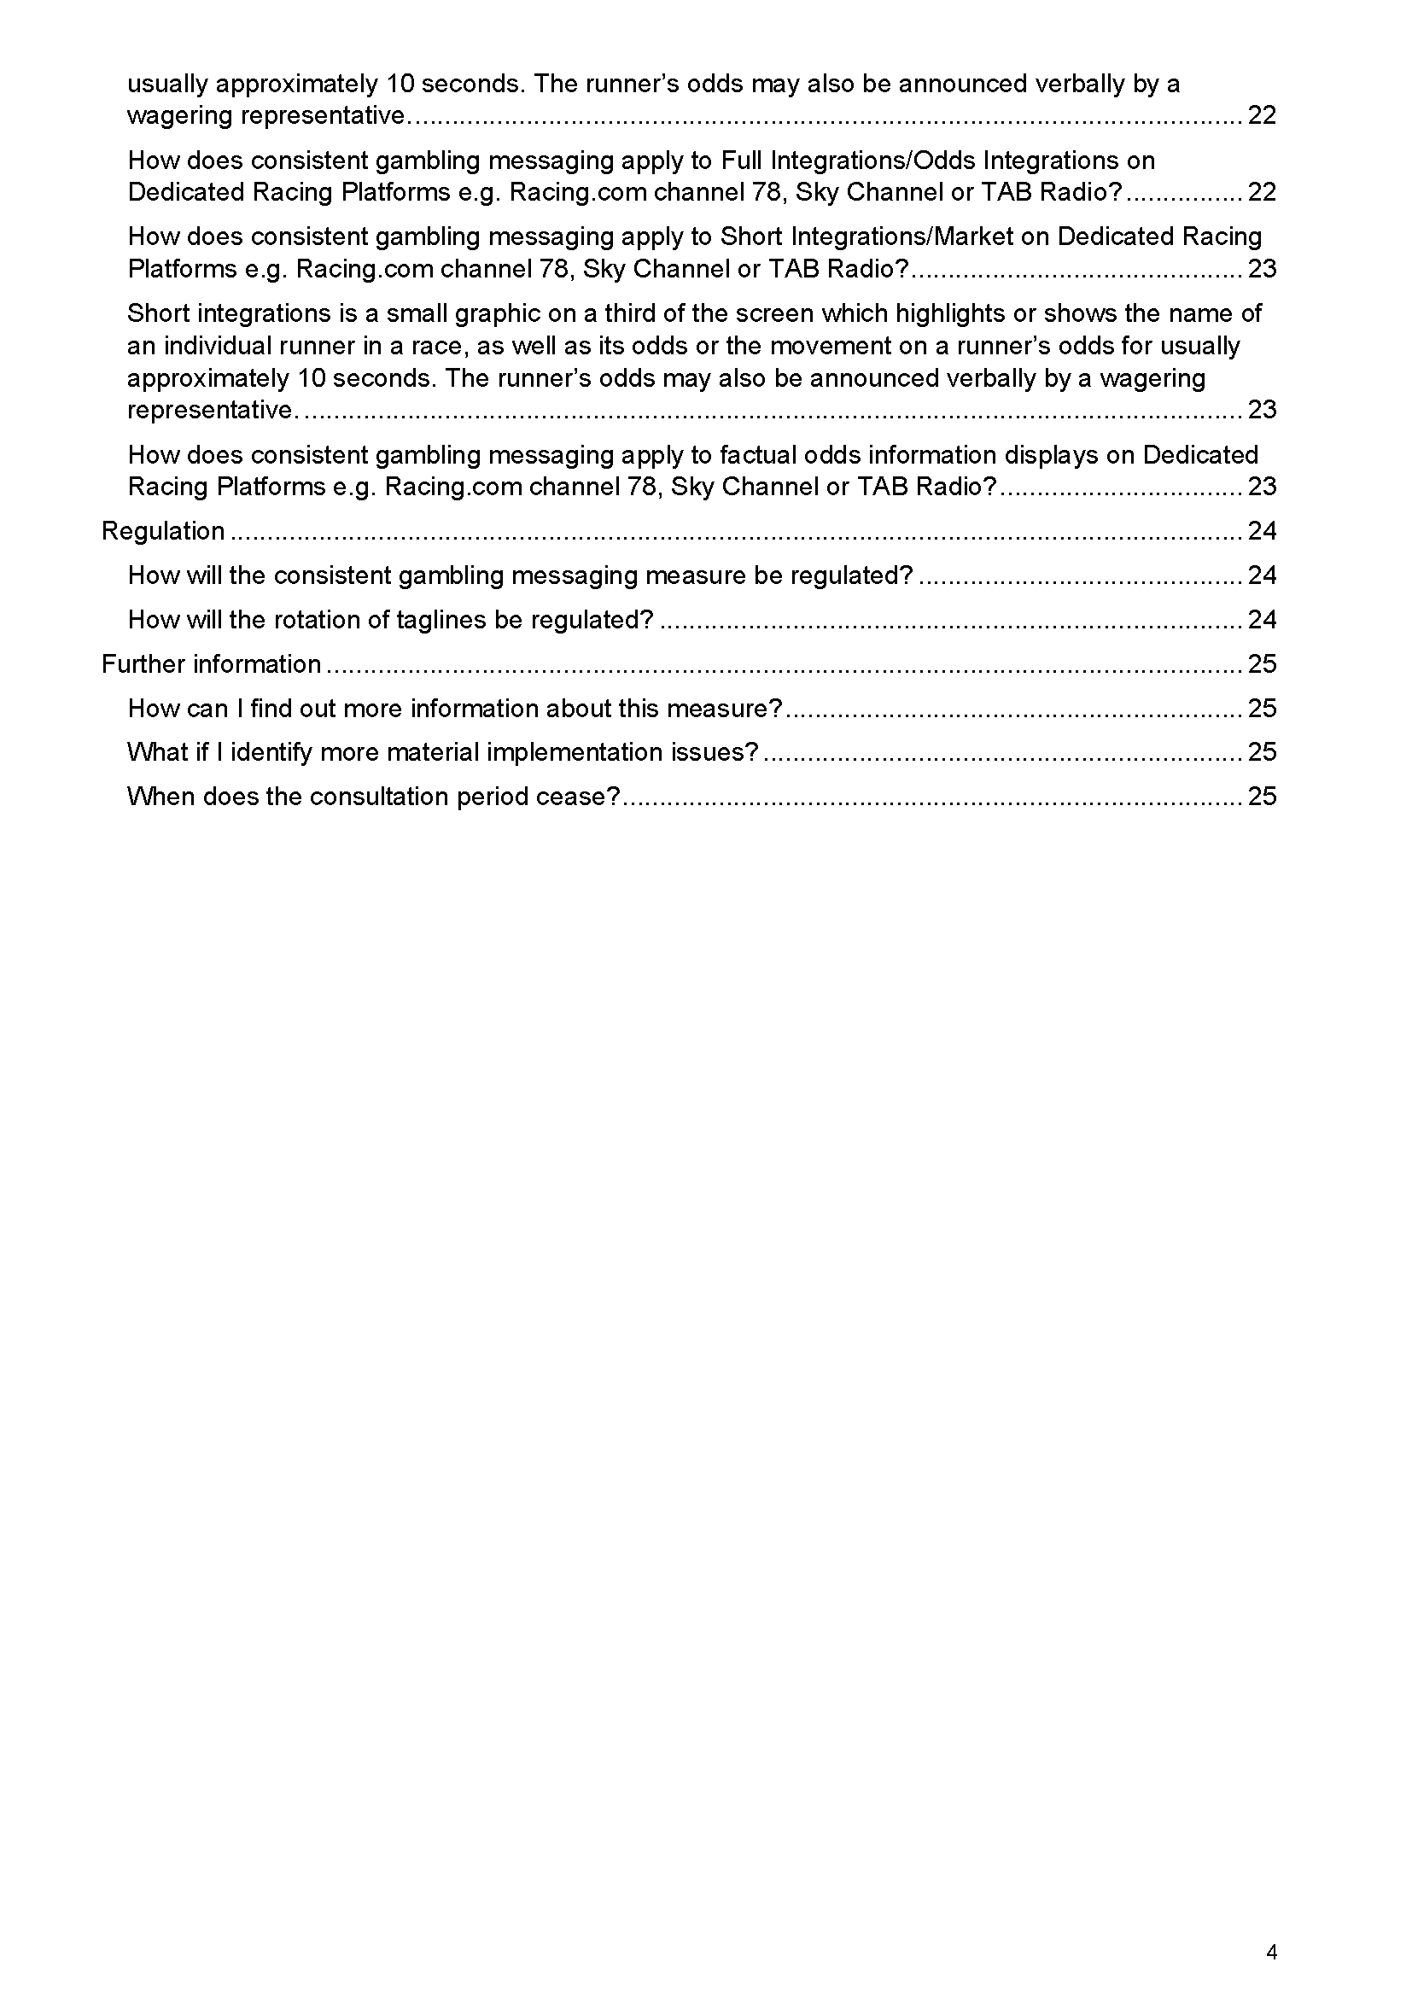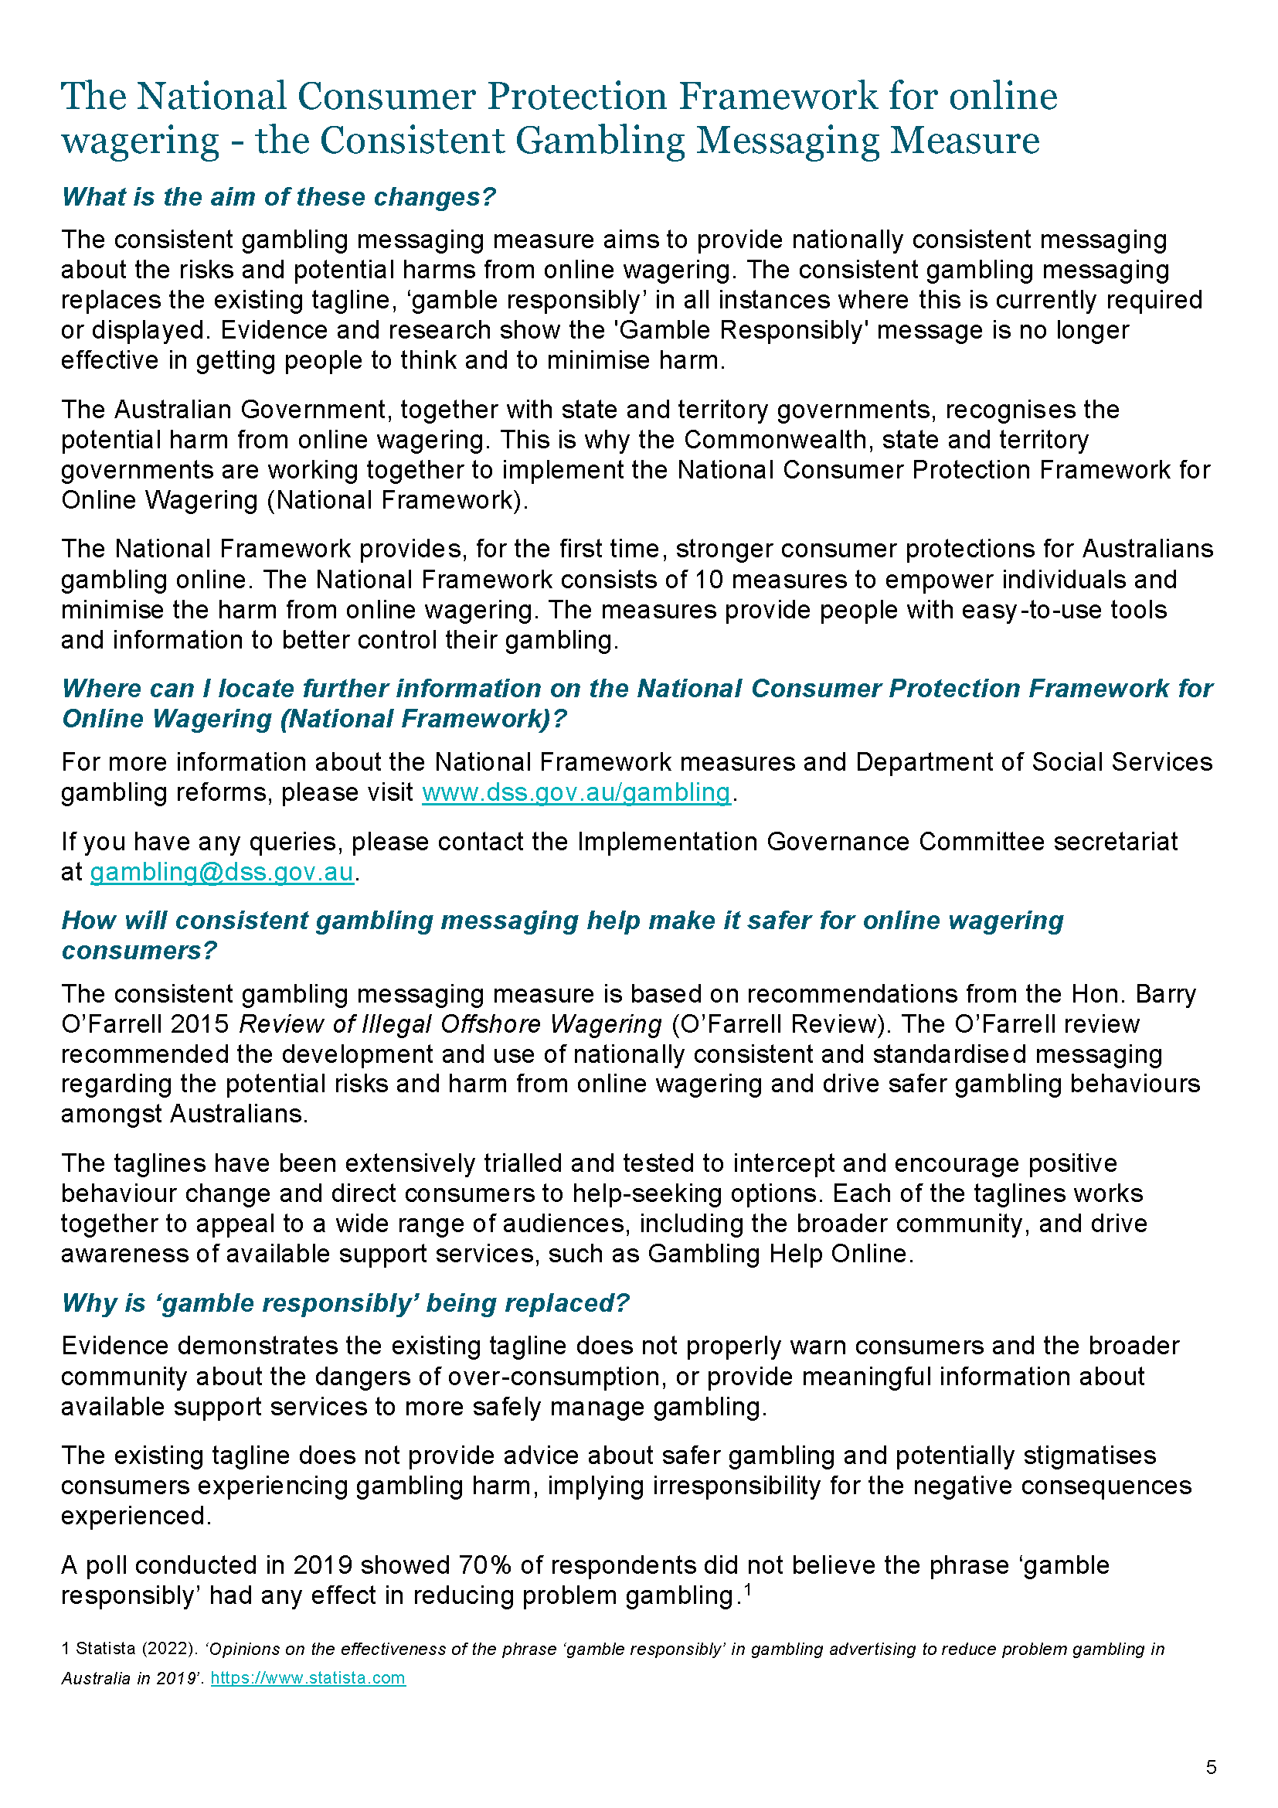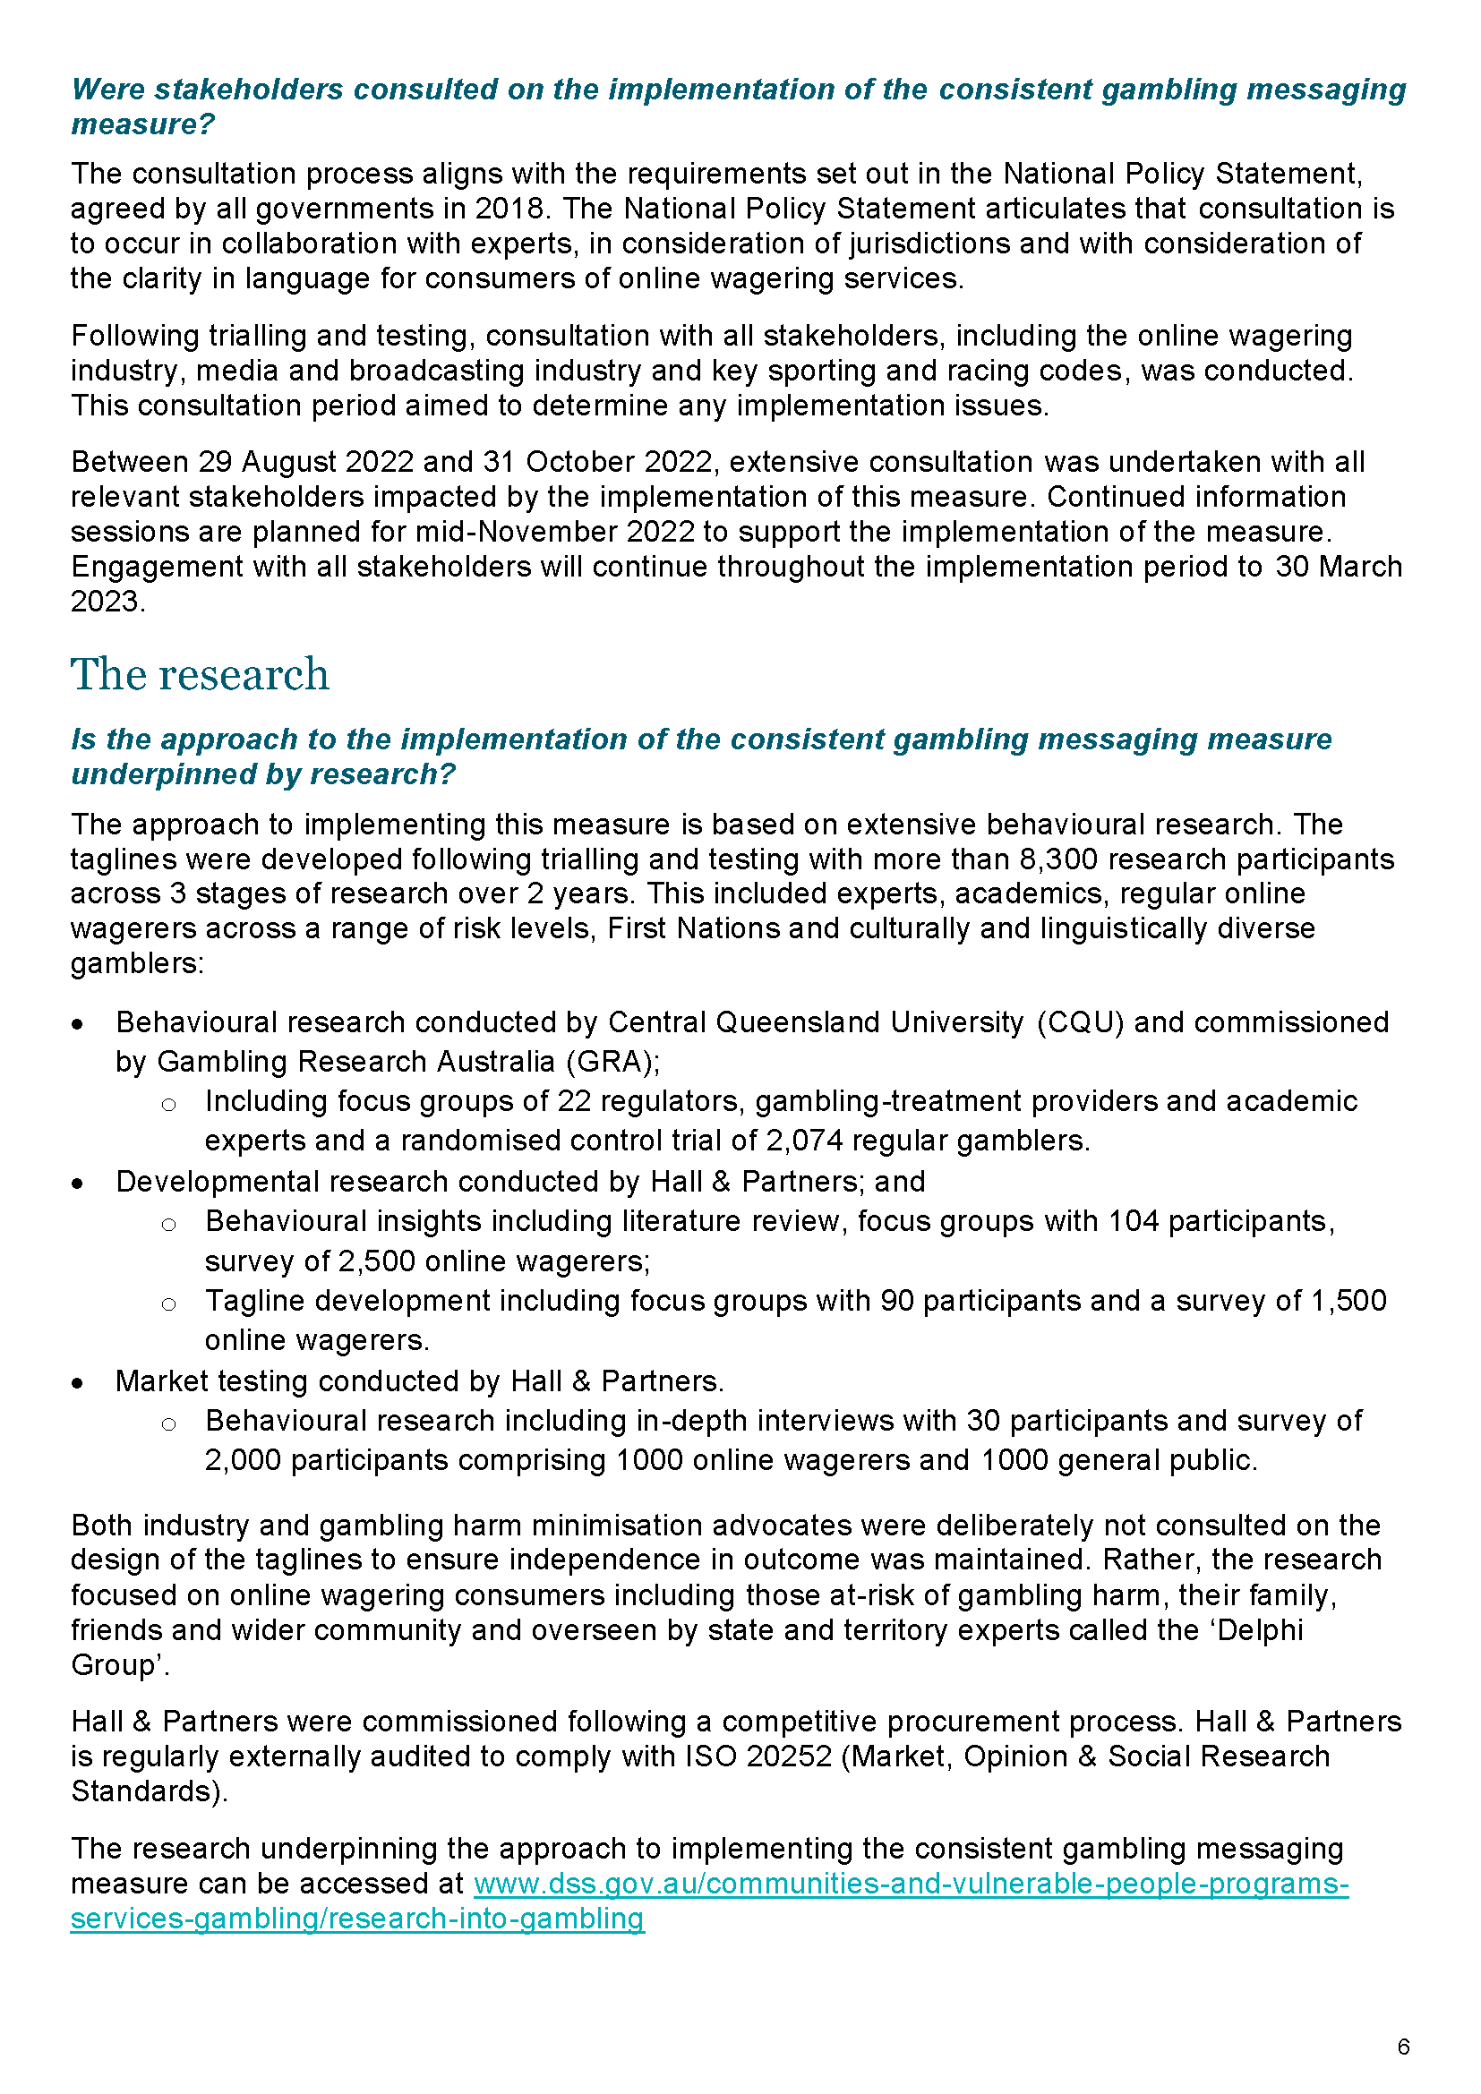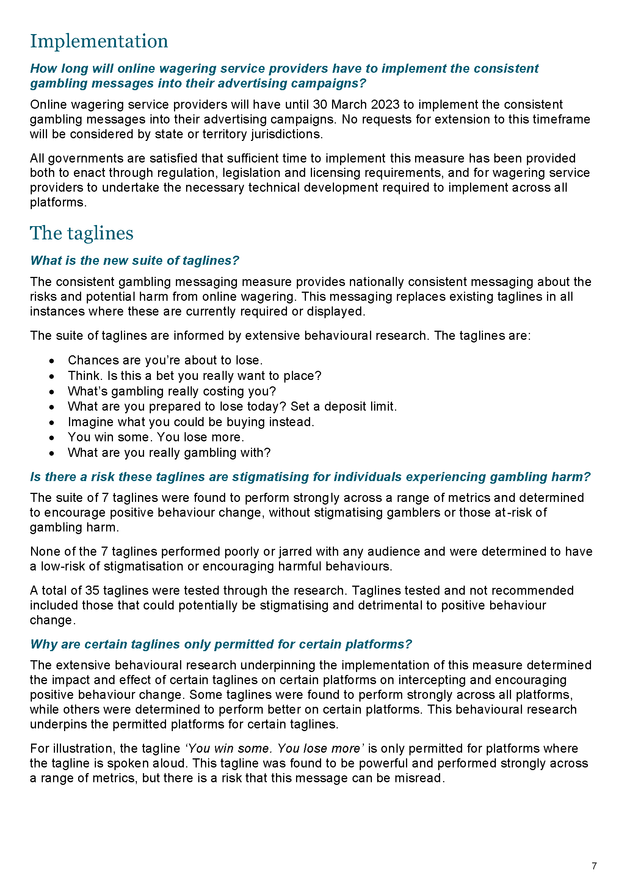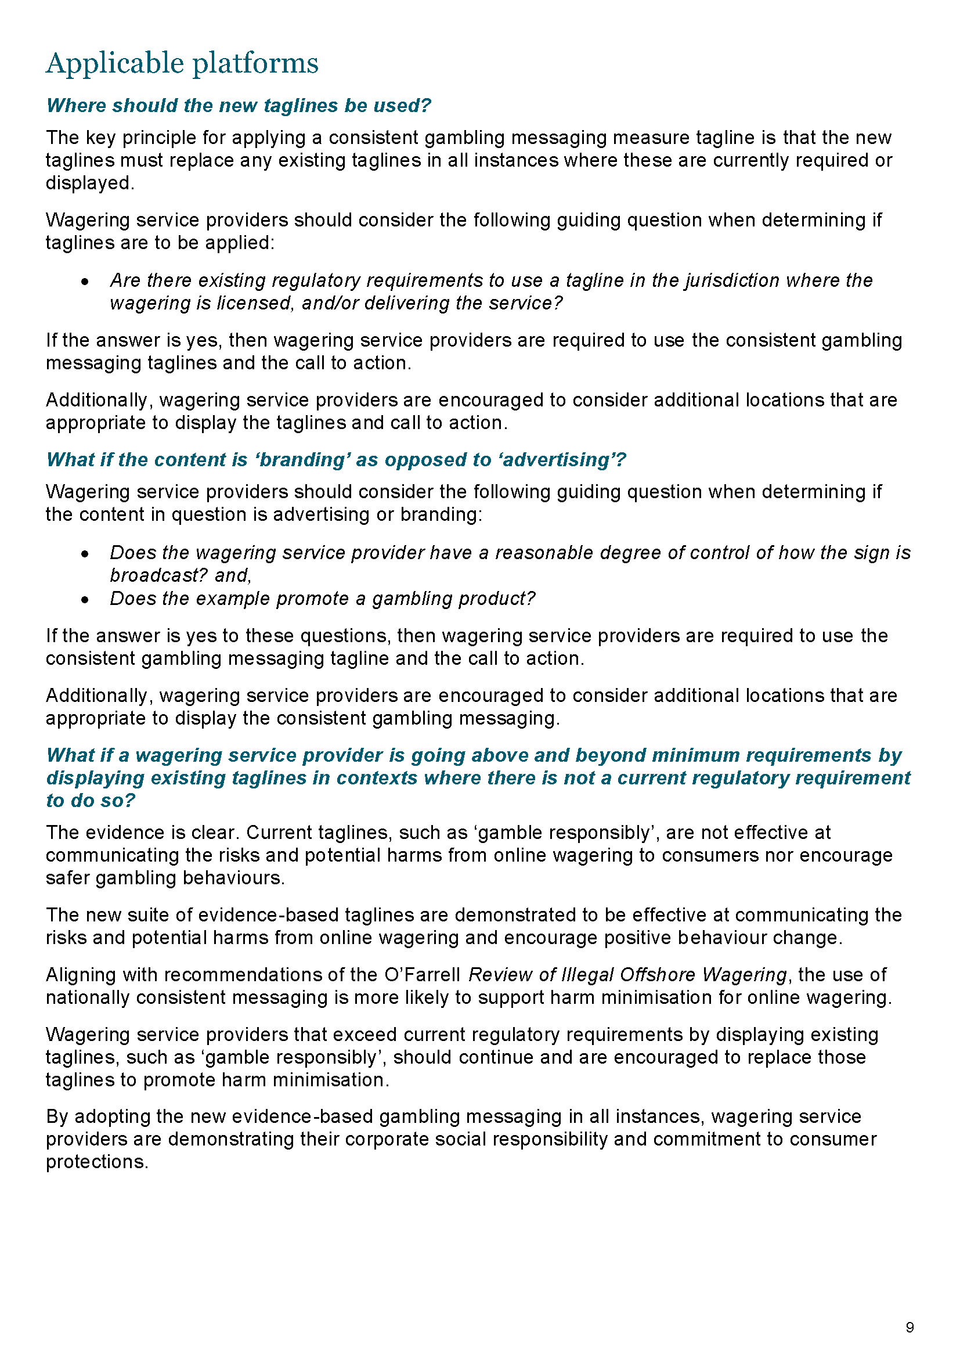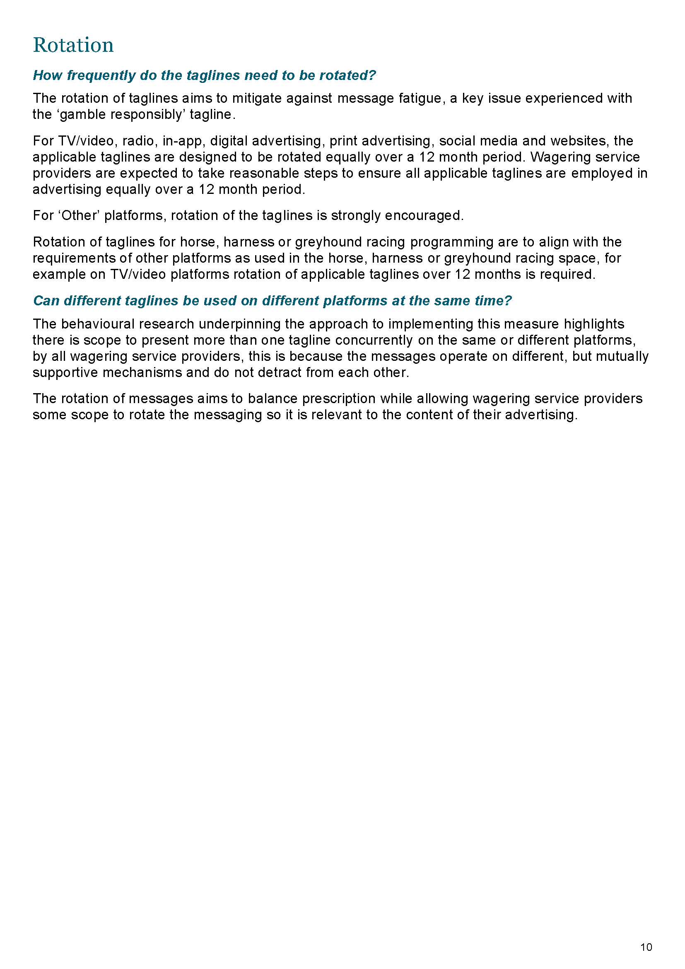
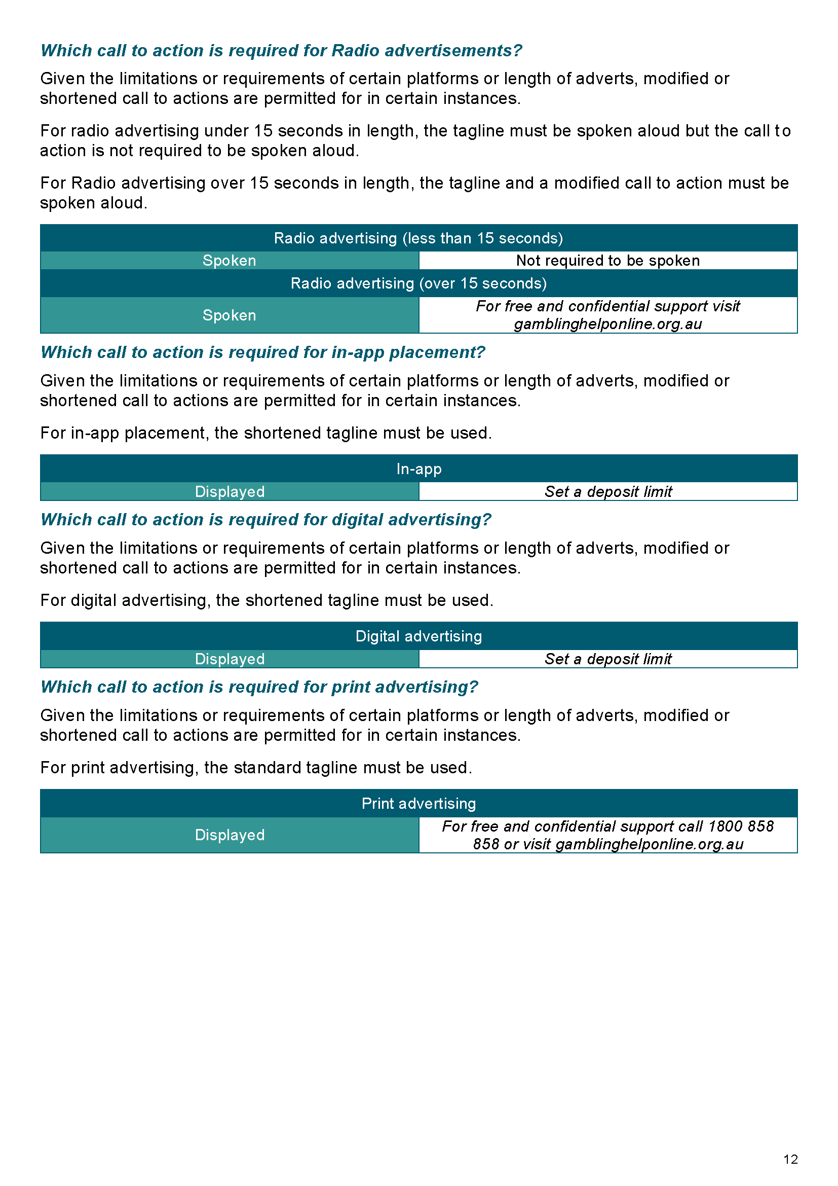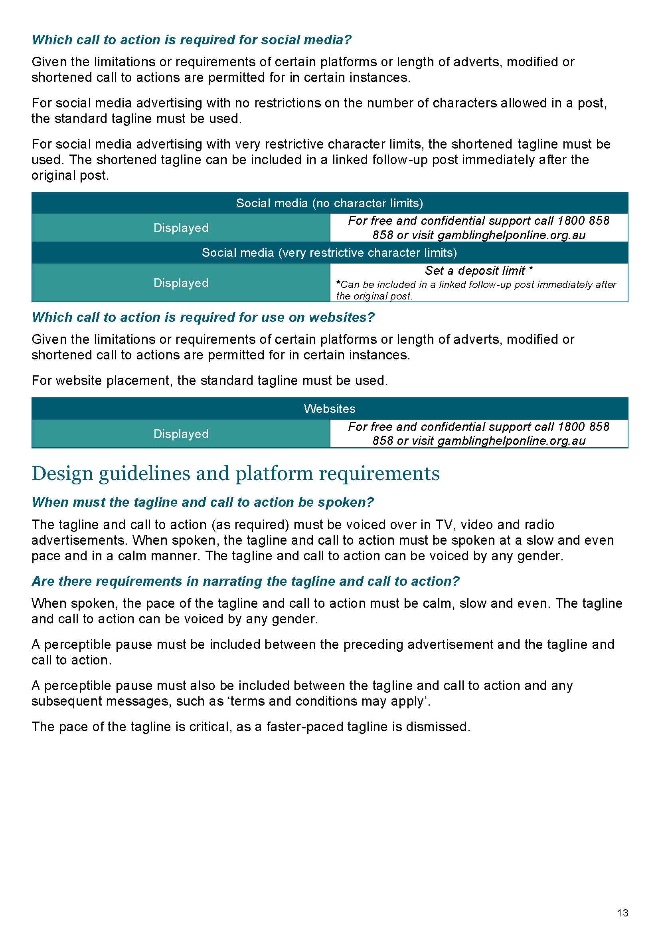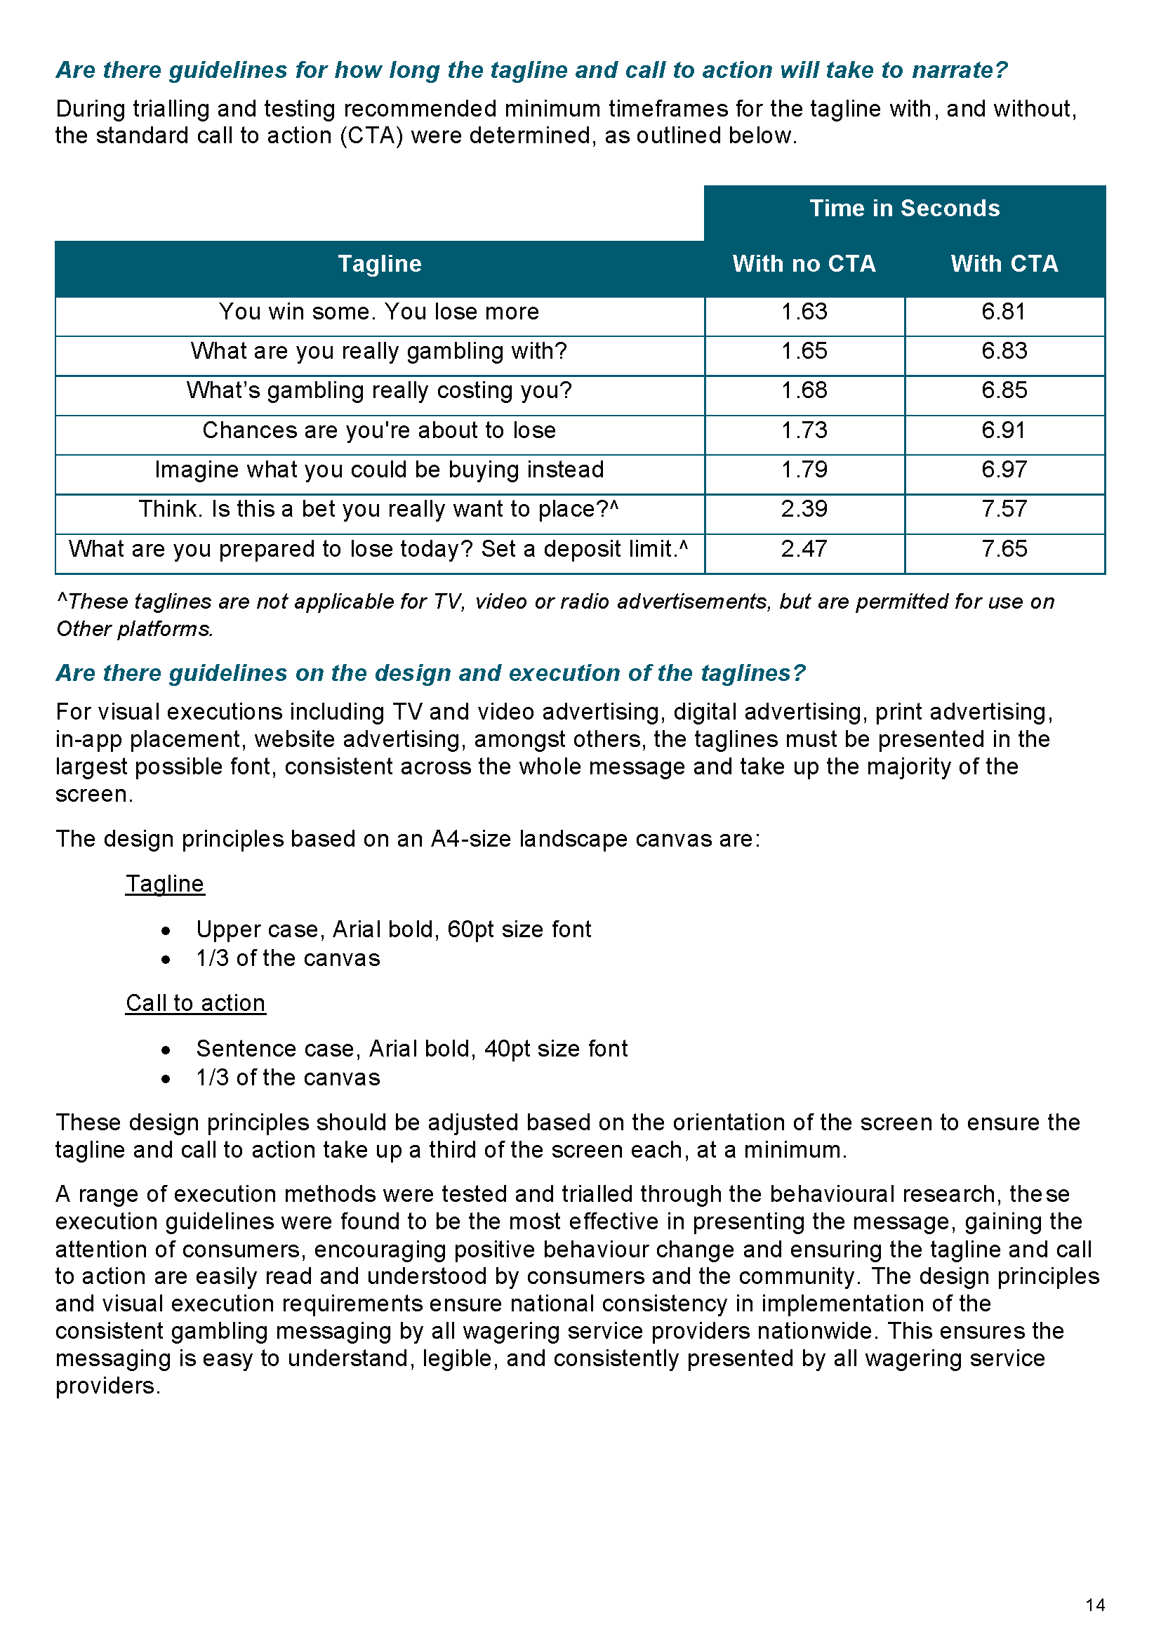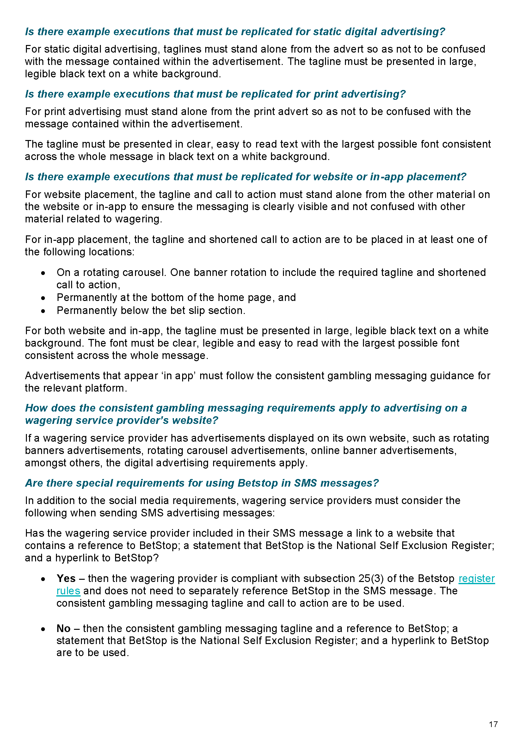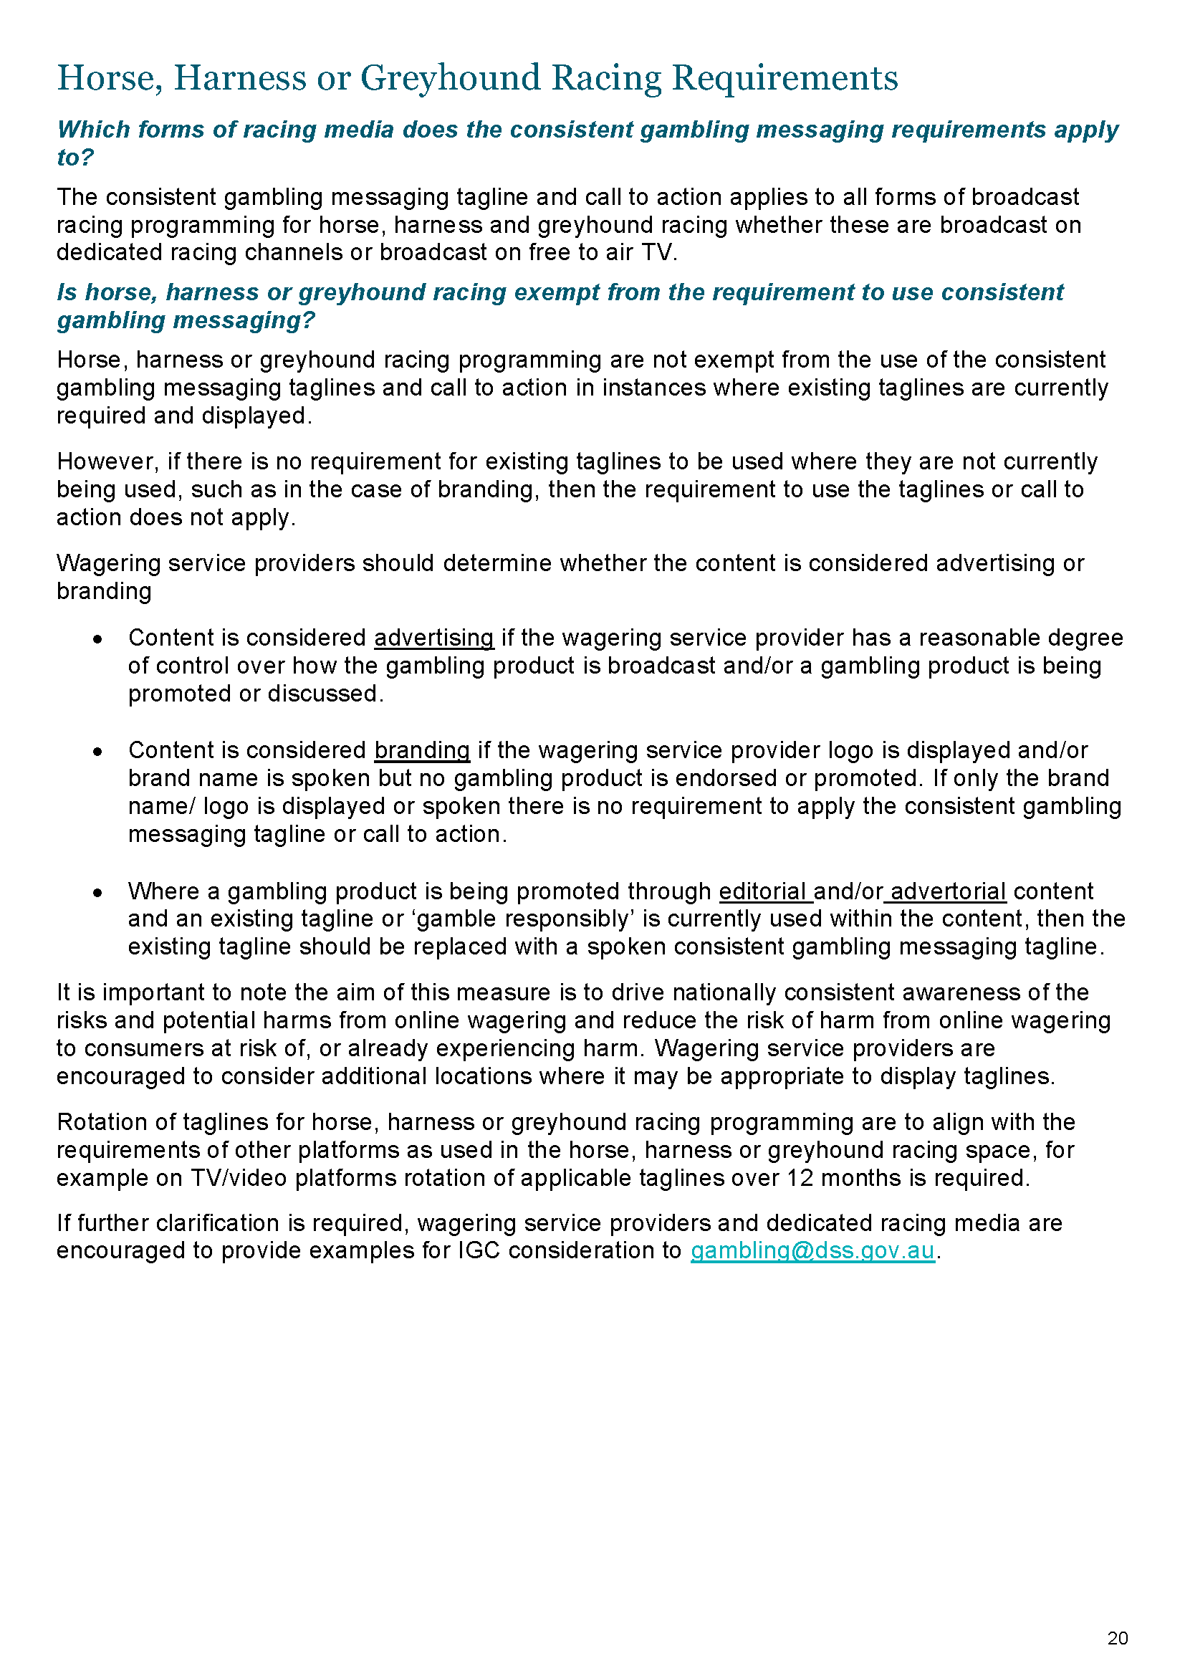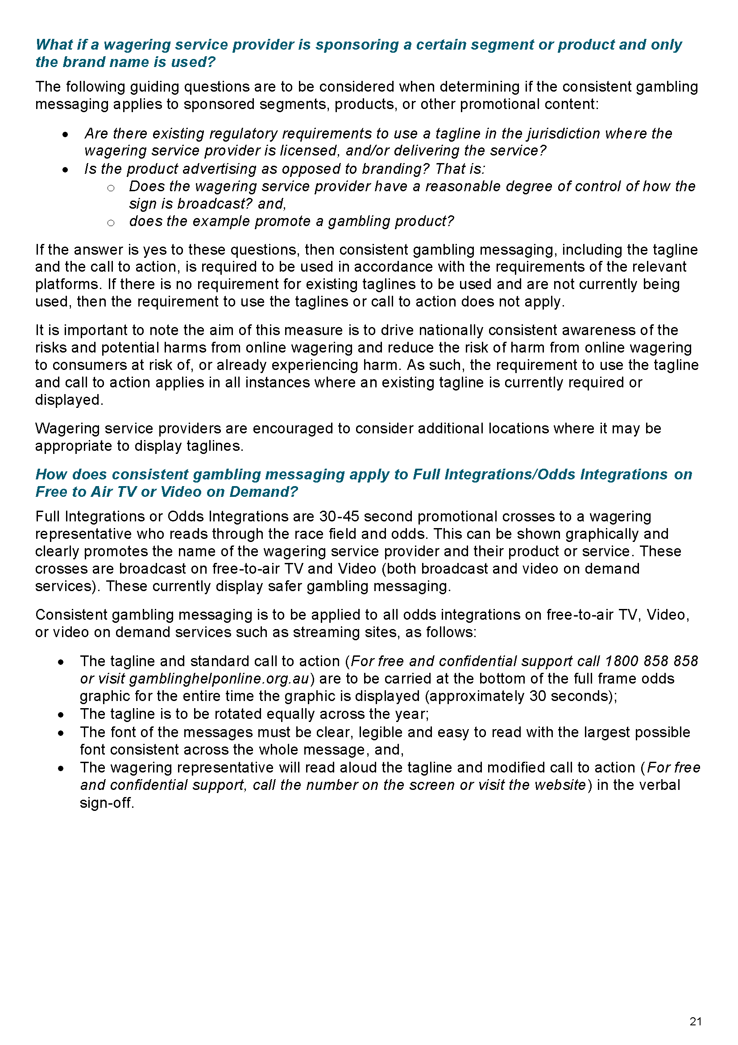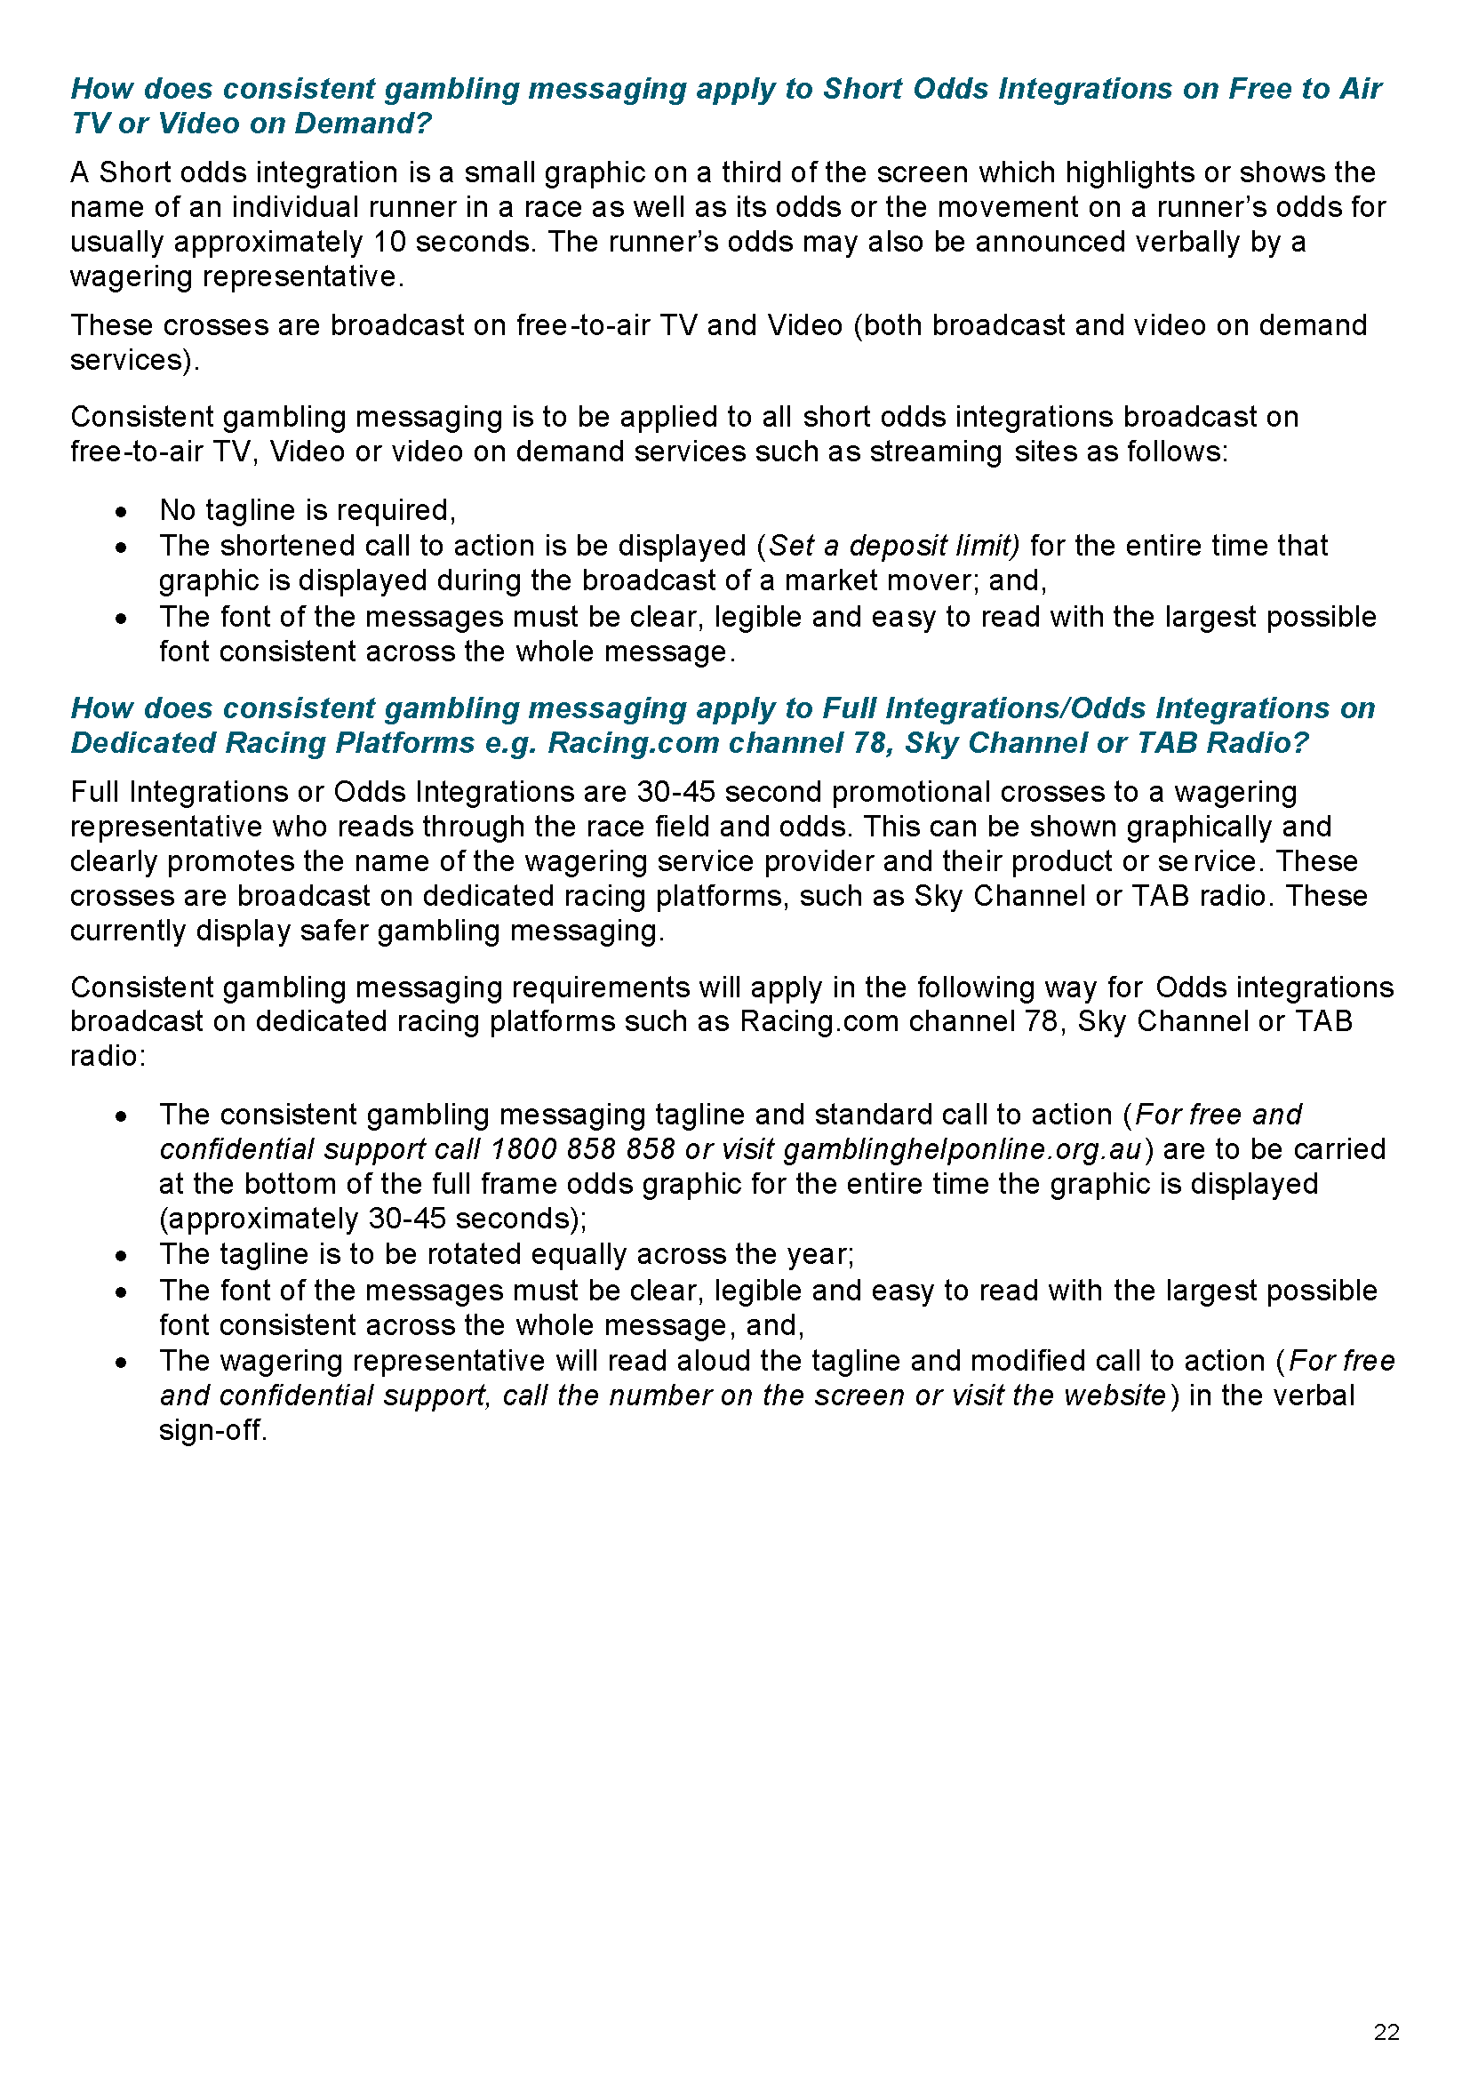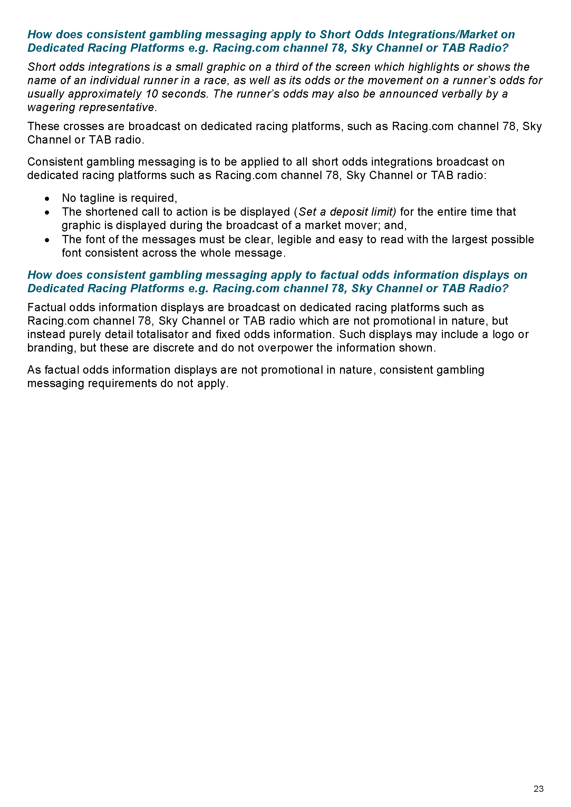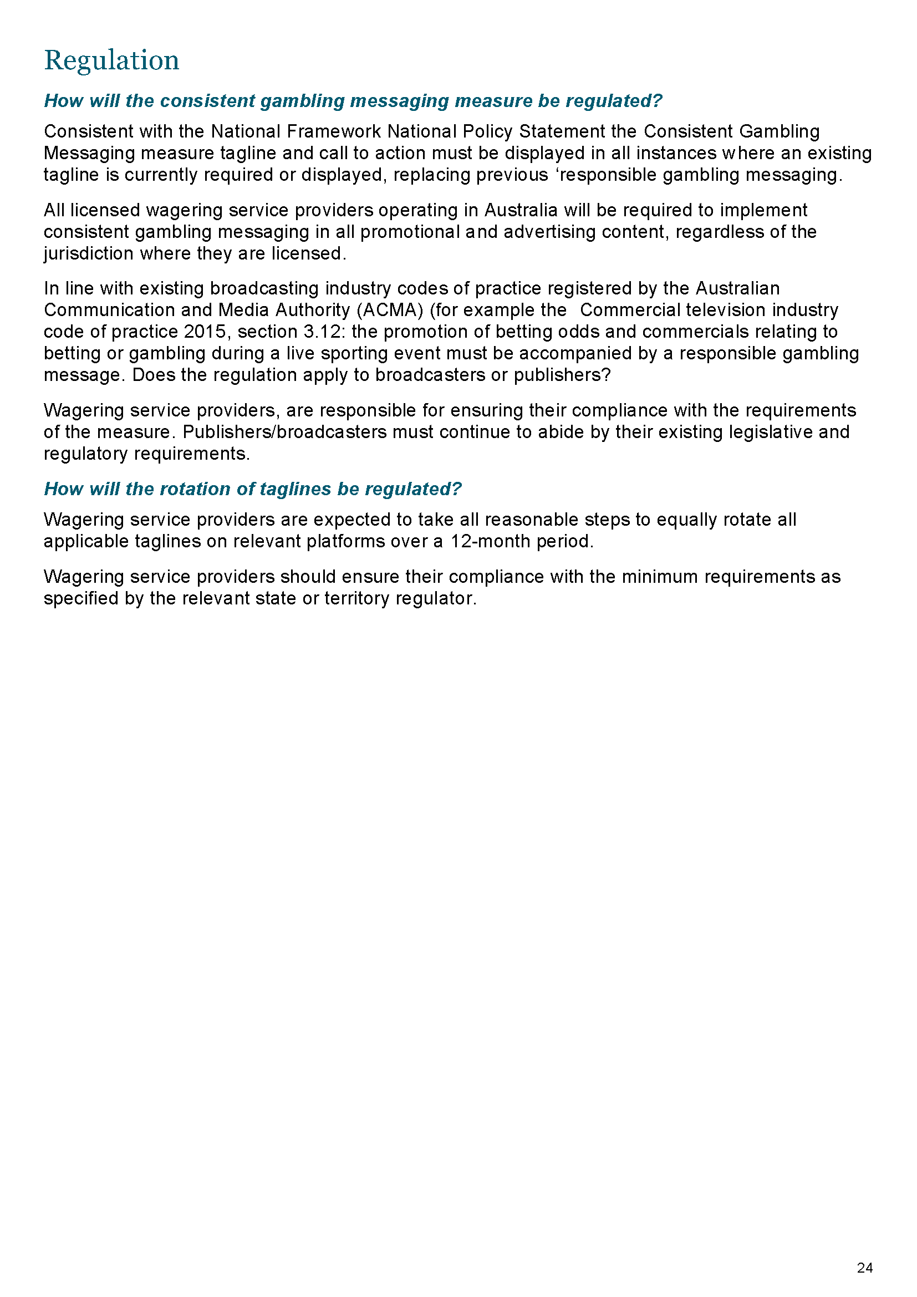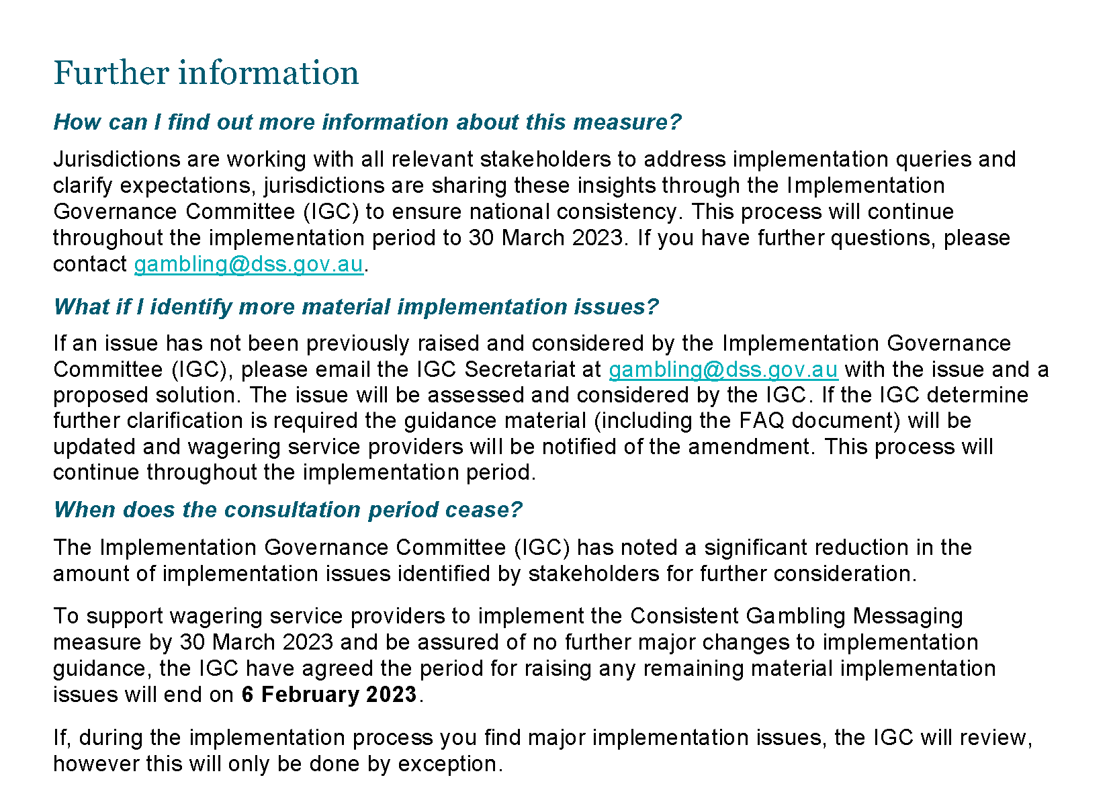

Gambling Administration Act 2019
South Australia
Authorised Betting Operations (Staff Training – Interactive Wagering Services Guidelines) Notice 2023
under section 17 of the Gambling Administration Act 2019
1—Short title
This notice may be cited as the Authorised Betting Operations (Staff Training – Interactive Wagering Services Guidelines) Notice 2023.
2—Commencement
This Variation Notice comes into operation on 30 March 2023.
3—Staff Training – Interactive Wagering Services Guidelines
The guidelines set out in this notice are prescribed by the Liquor and Gambling Commissioner under section 17 of the Gambling Administration Act 2019 for the purpose of the Authorised Betting Operations Gambling Code of Practice, prescribed under section 15 of the Gambling Administration Act 2019.
Dated: 30 March 2023
Dini Soulio
Liquor and Gambling Commissioner

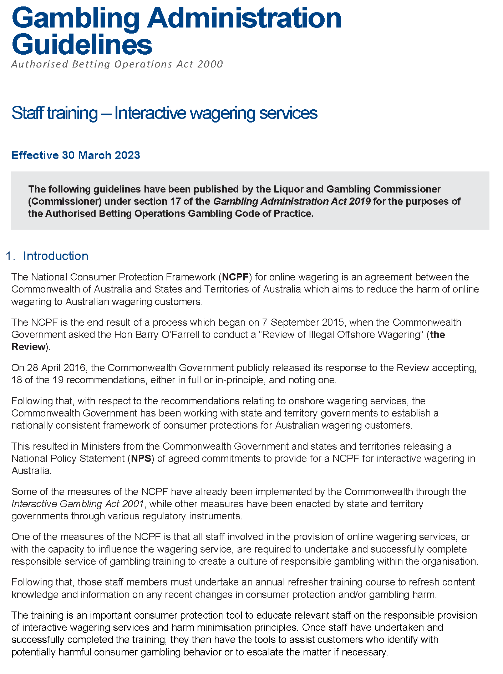

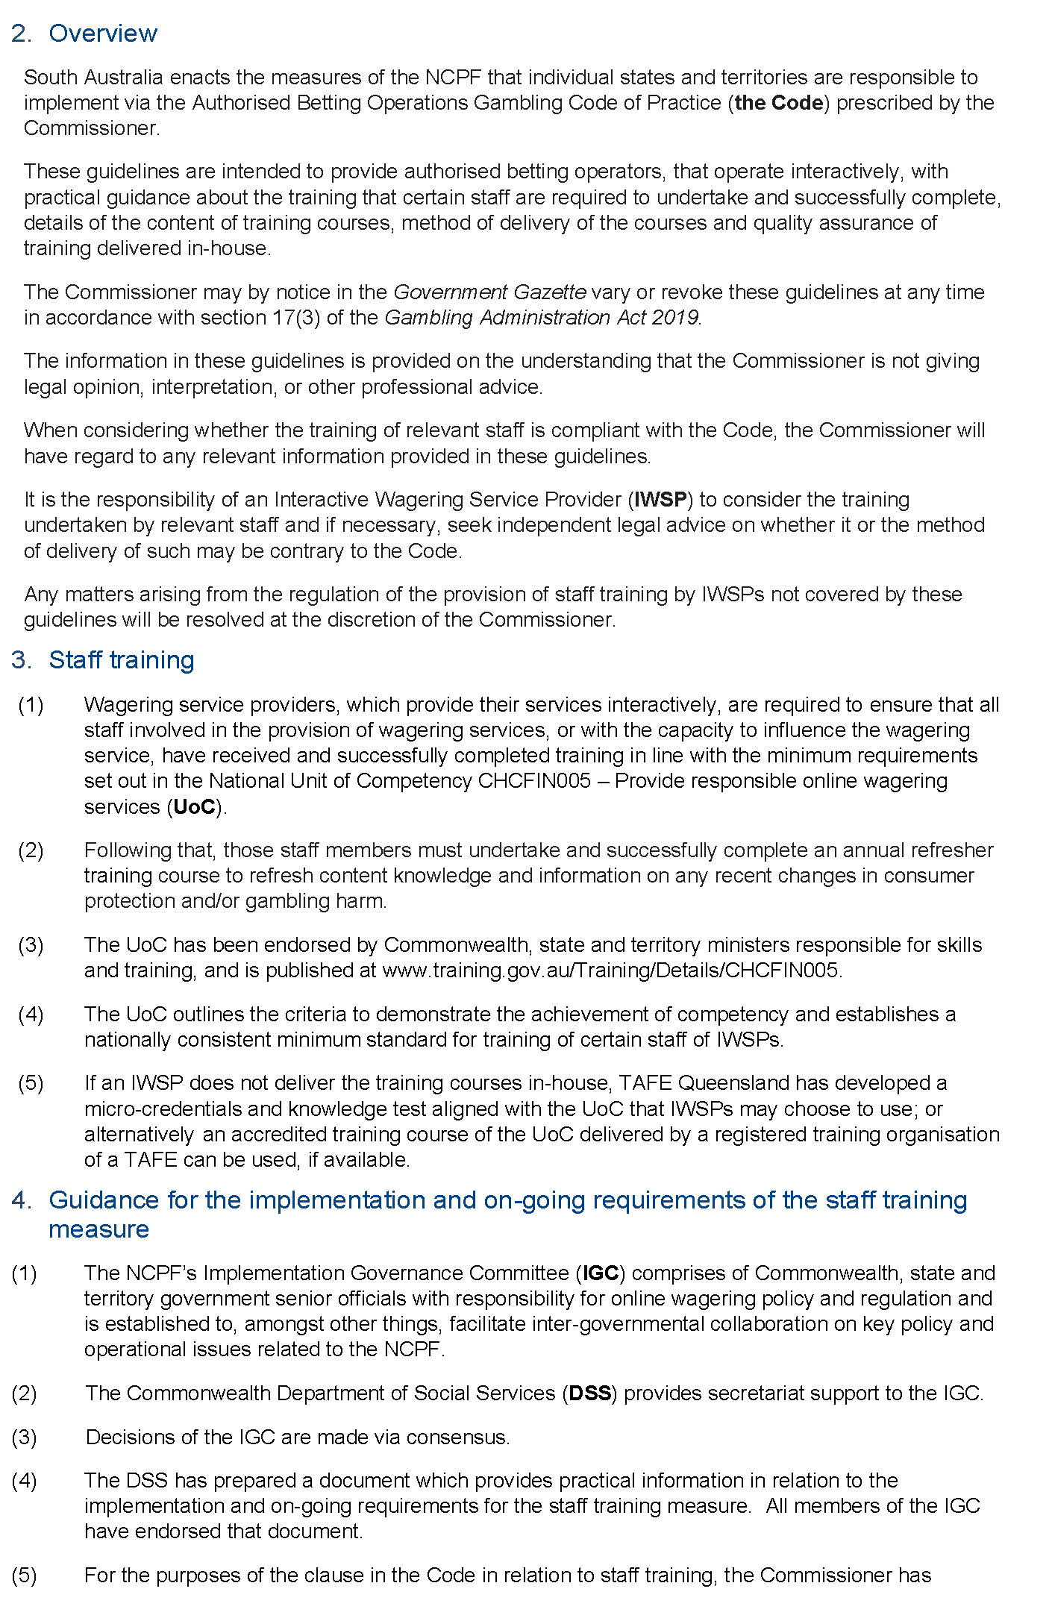
Gambling Administration Act 2019
Authorised Betting Operations Act 2000
Authorised Betting Operations Gambling Codes of Practice
National Consumer Protection Framework for Online Gambling

Schedule 1
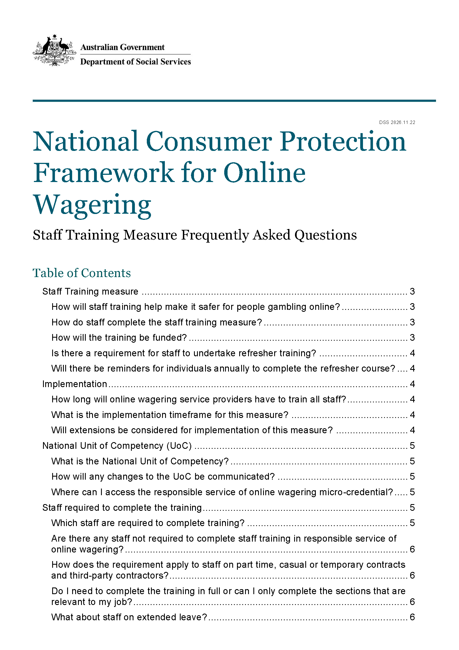
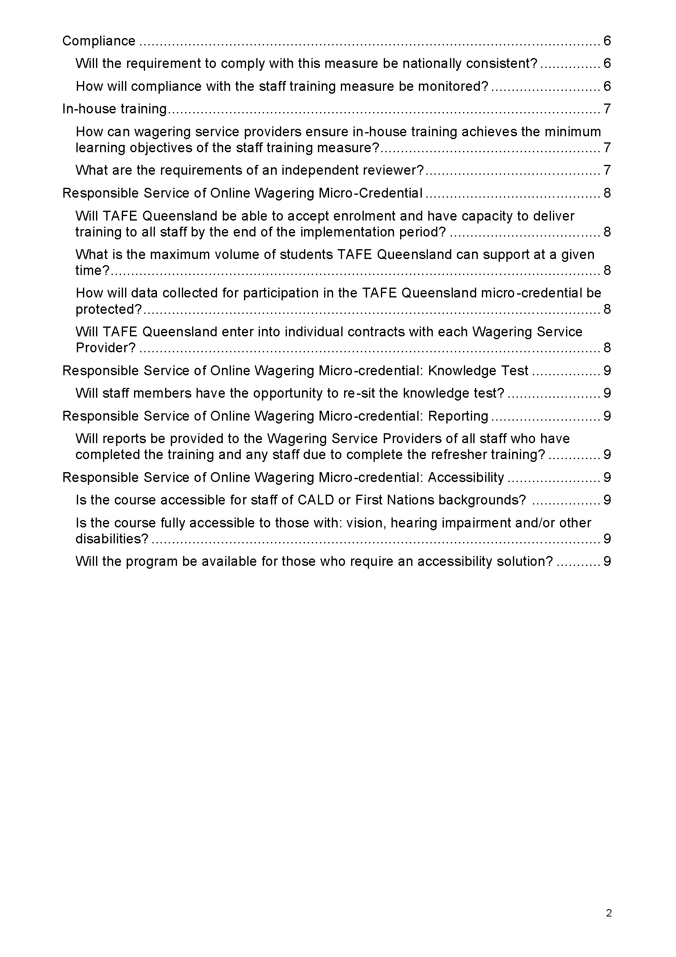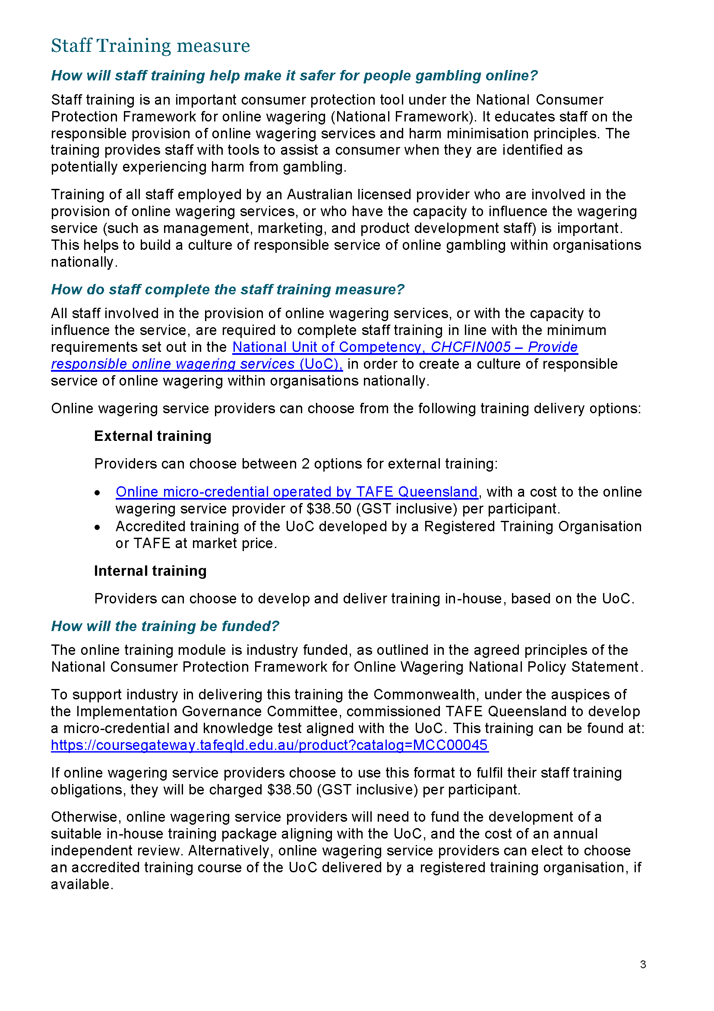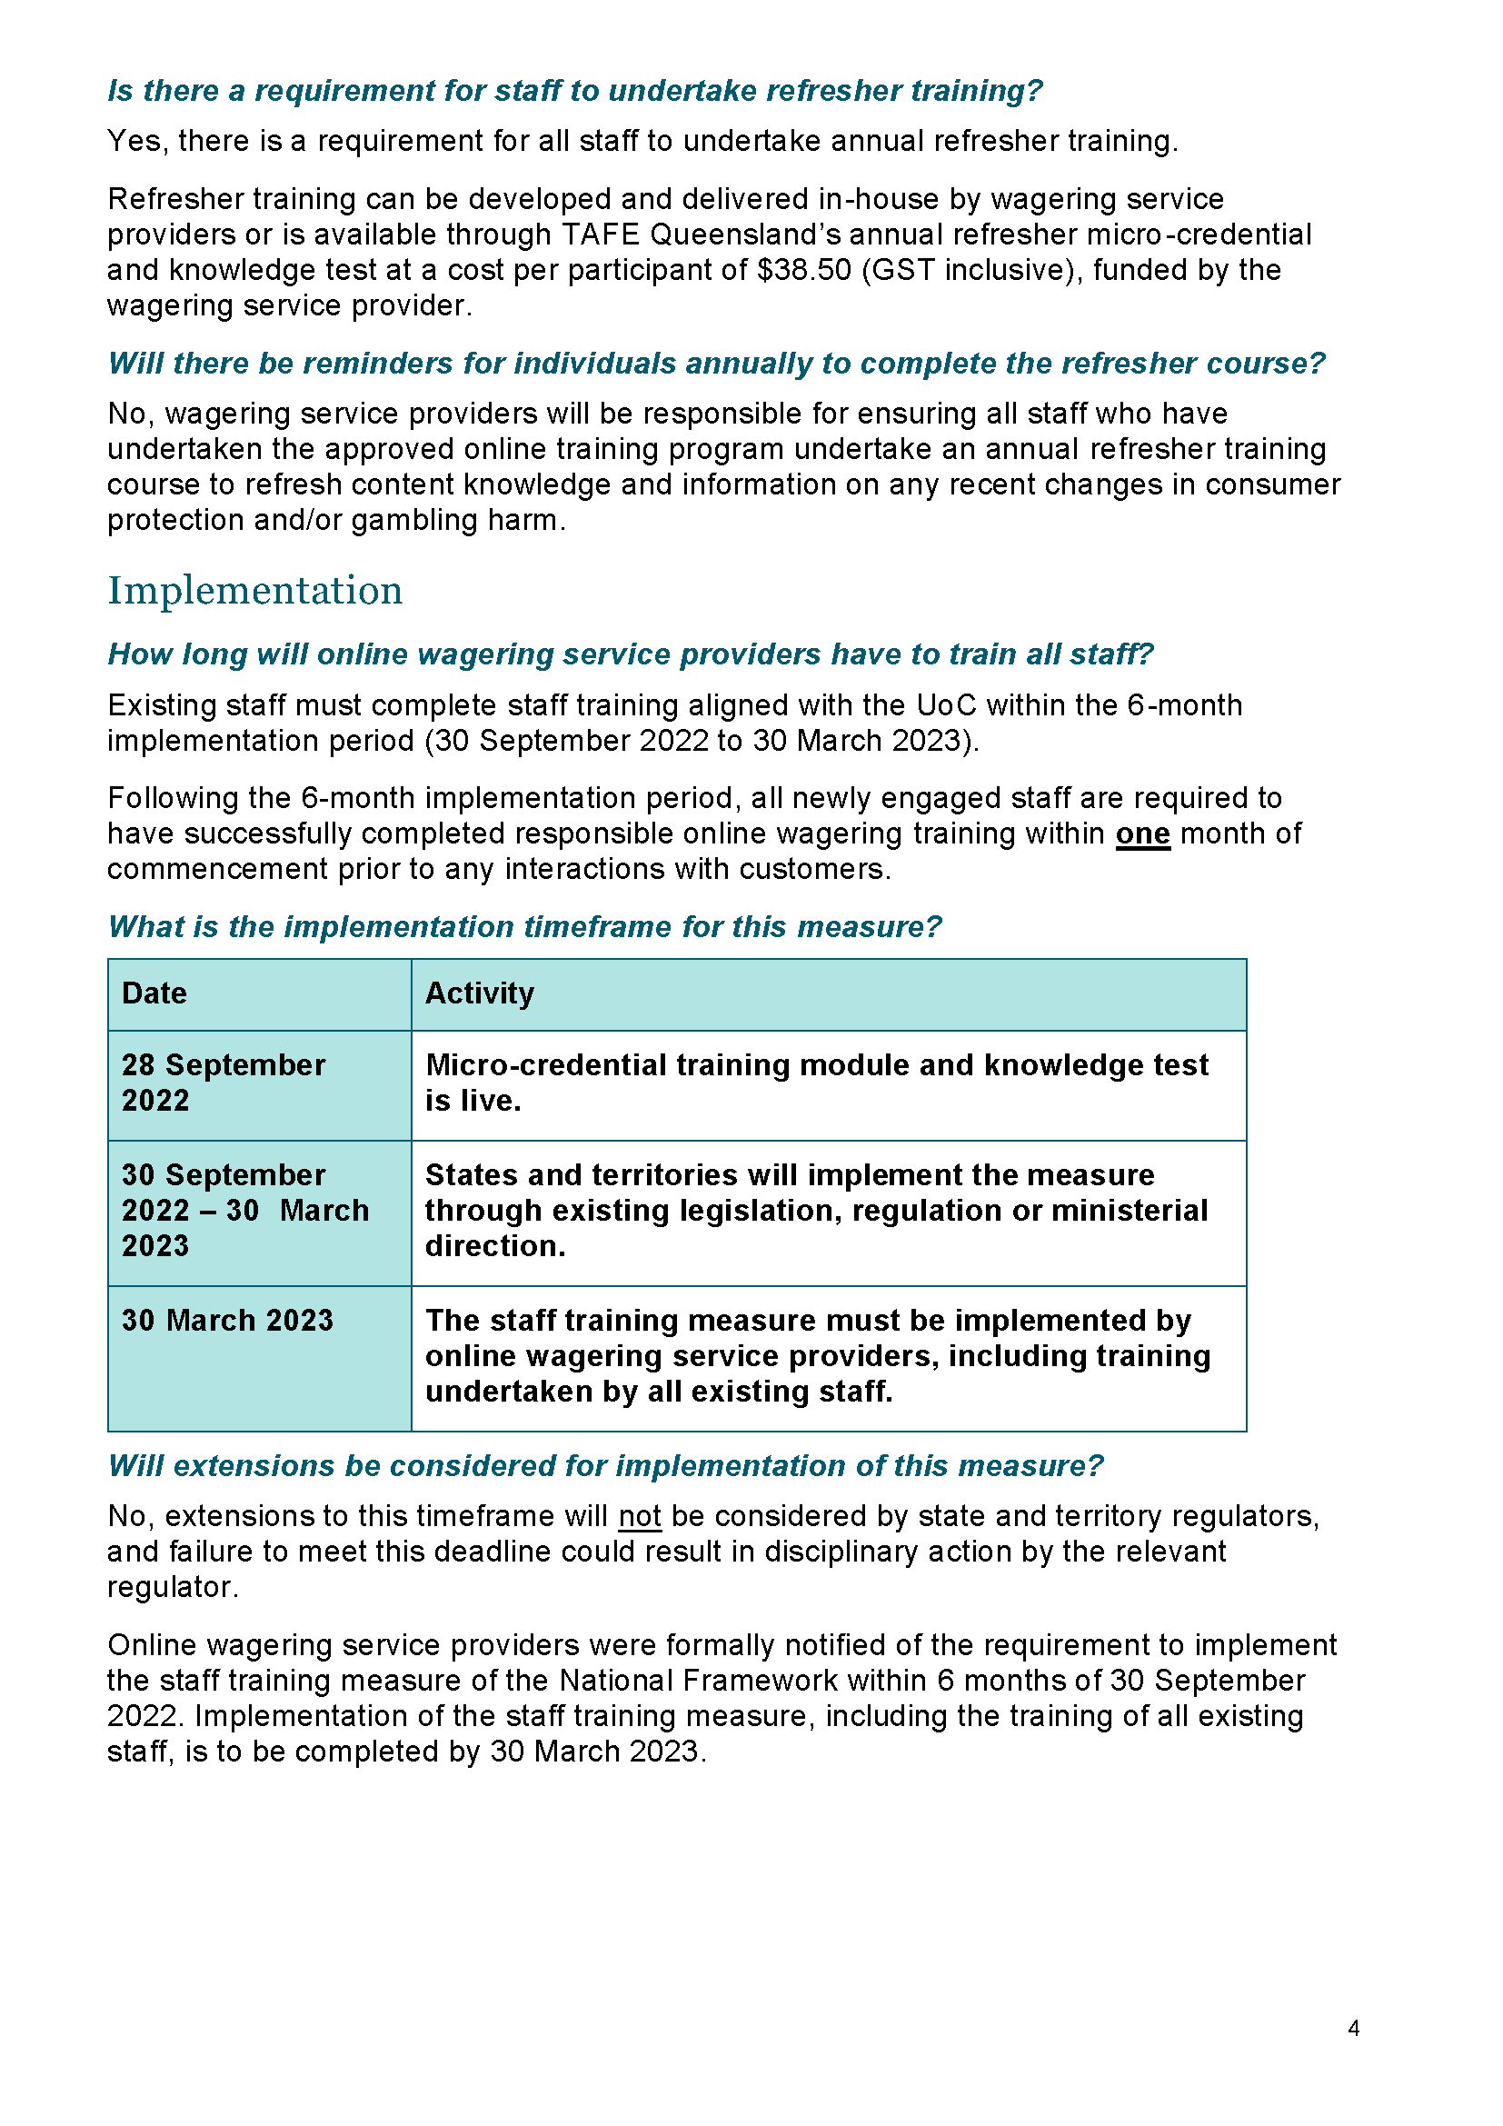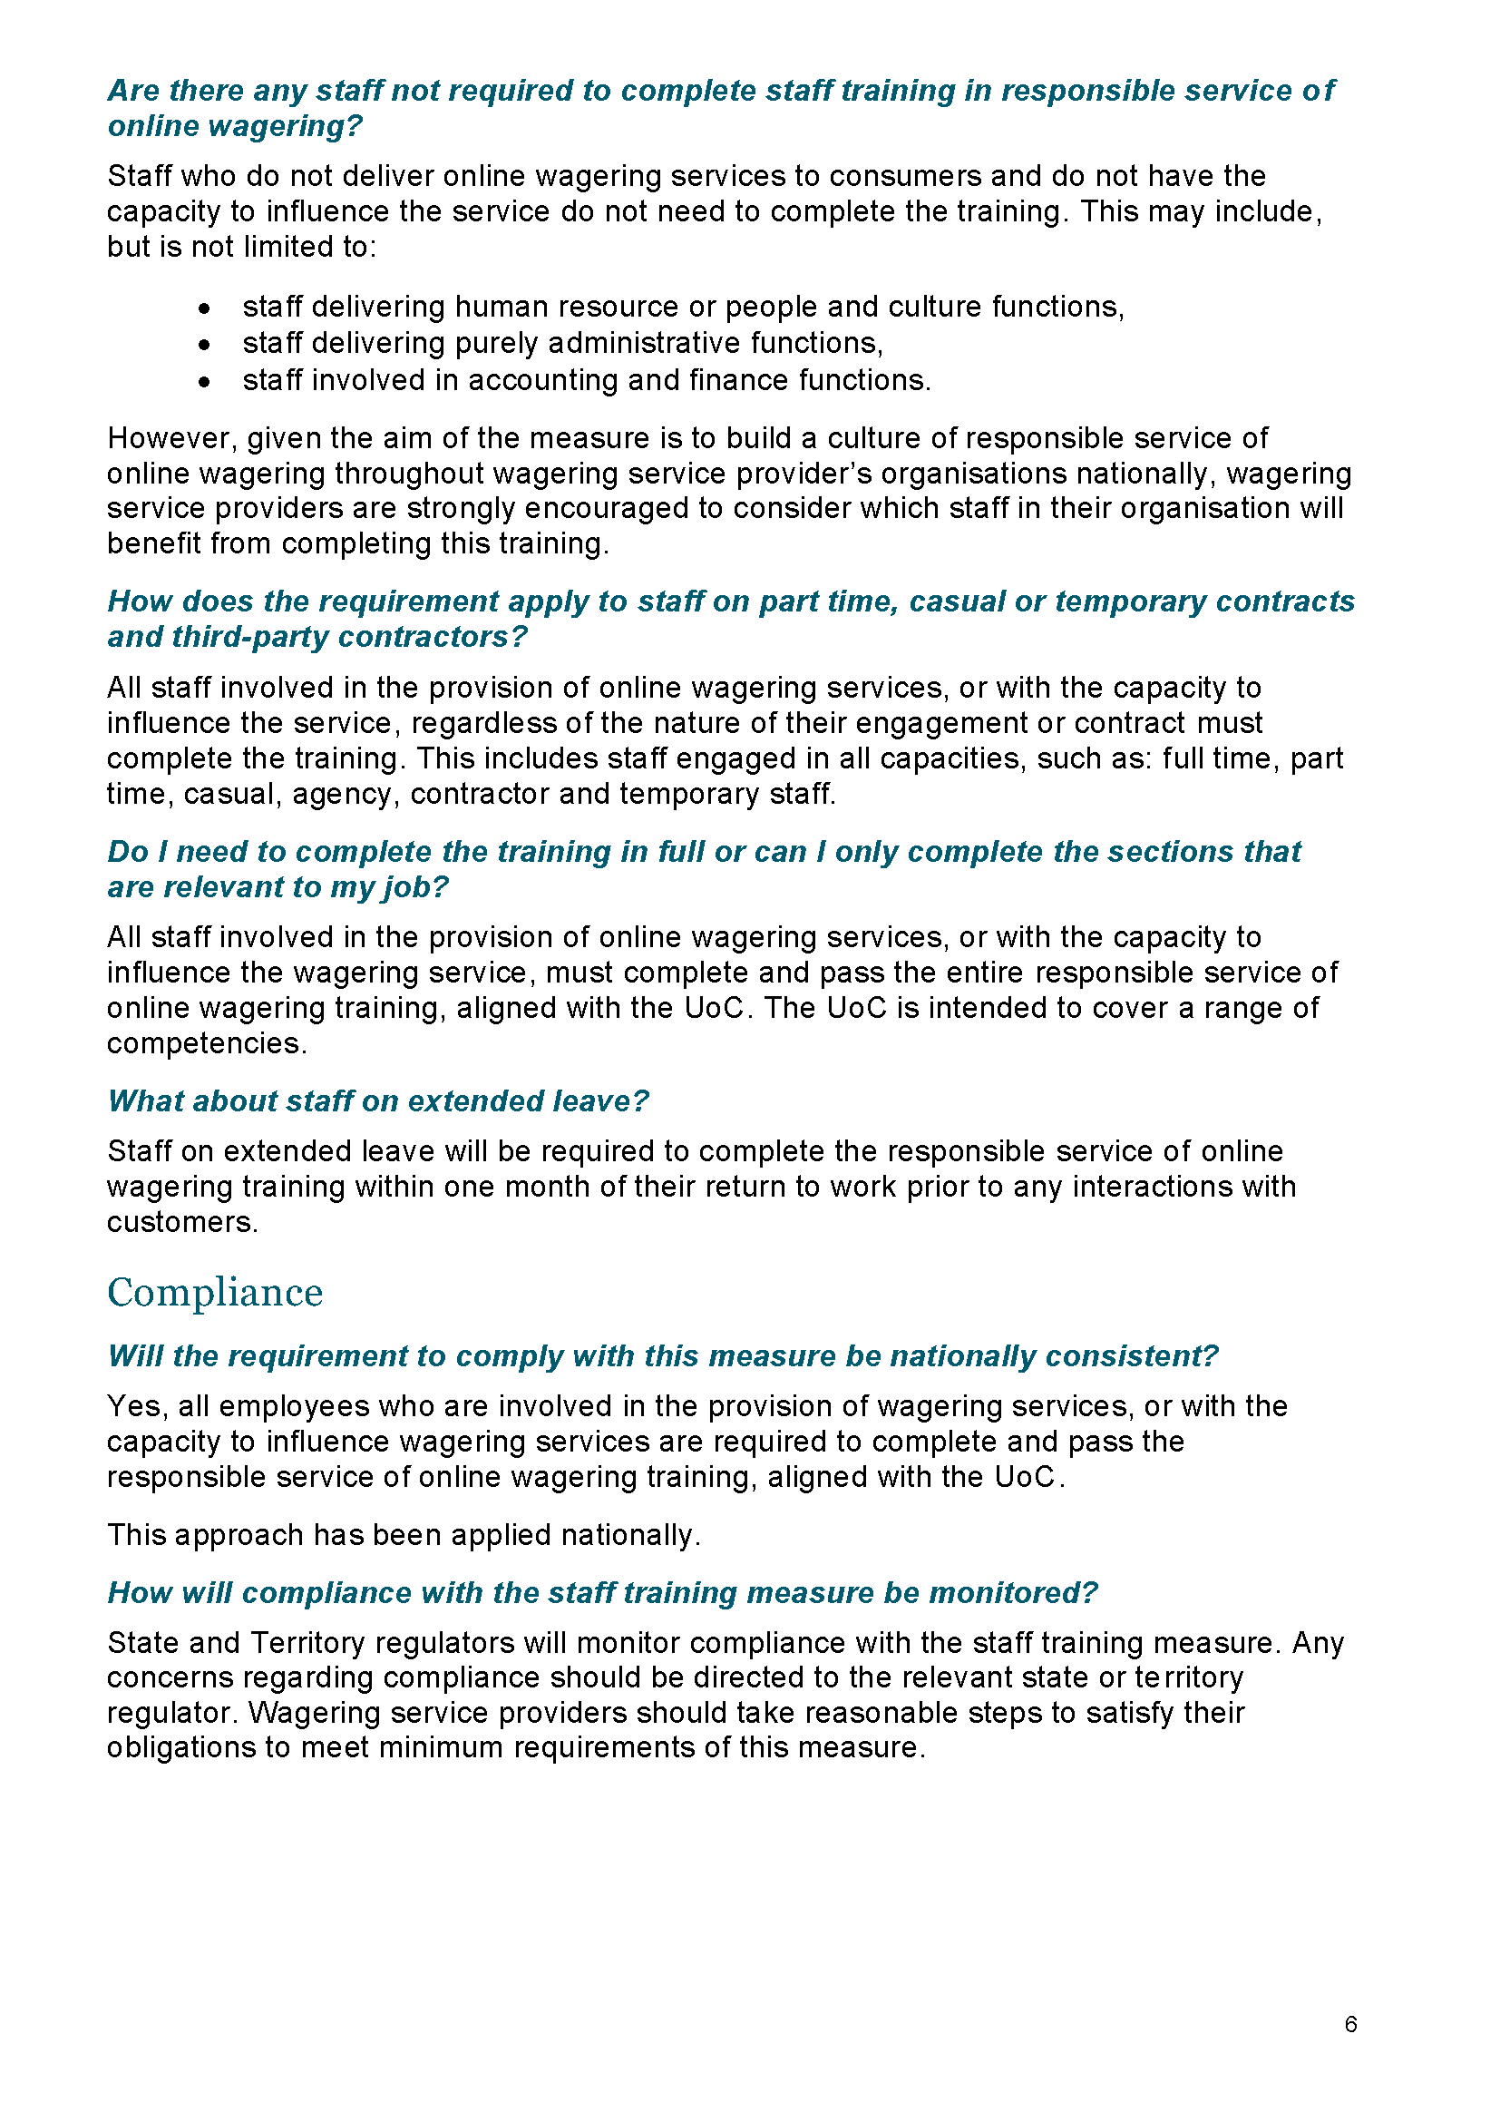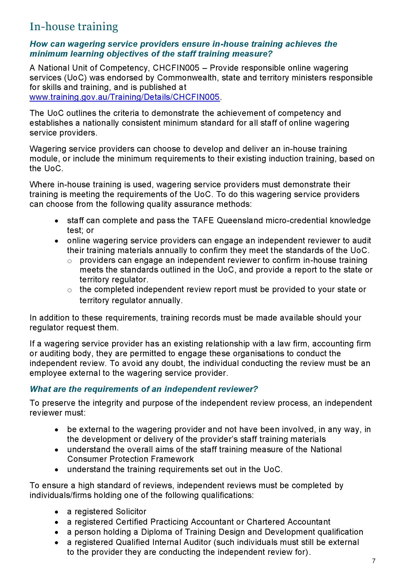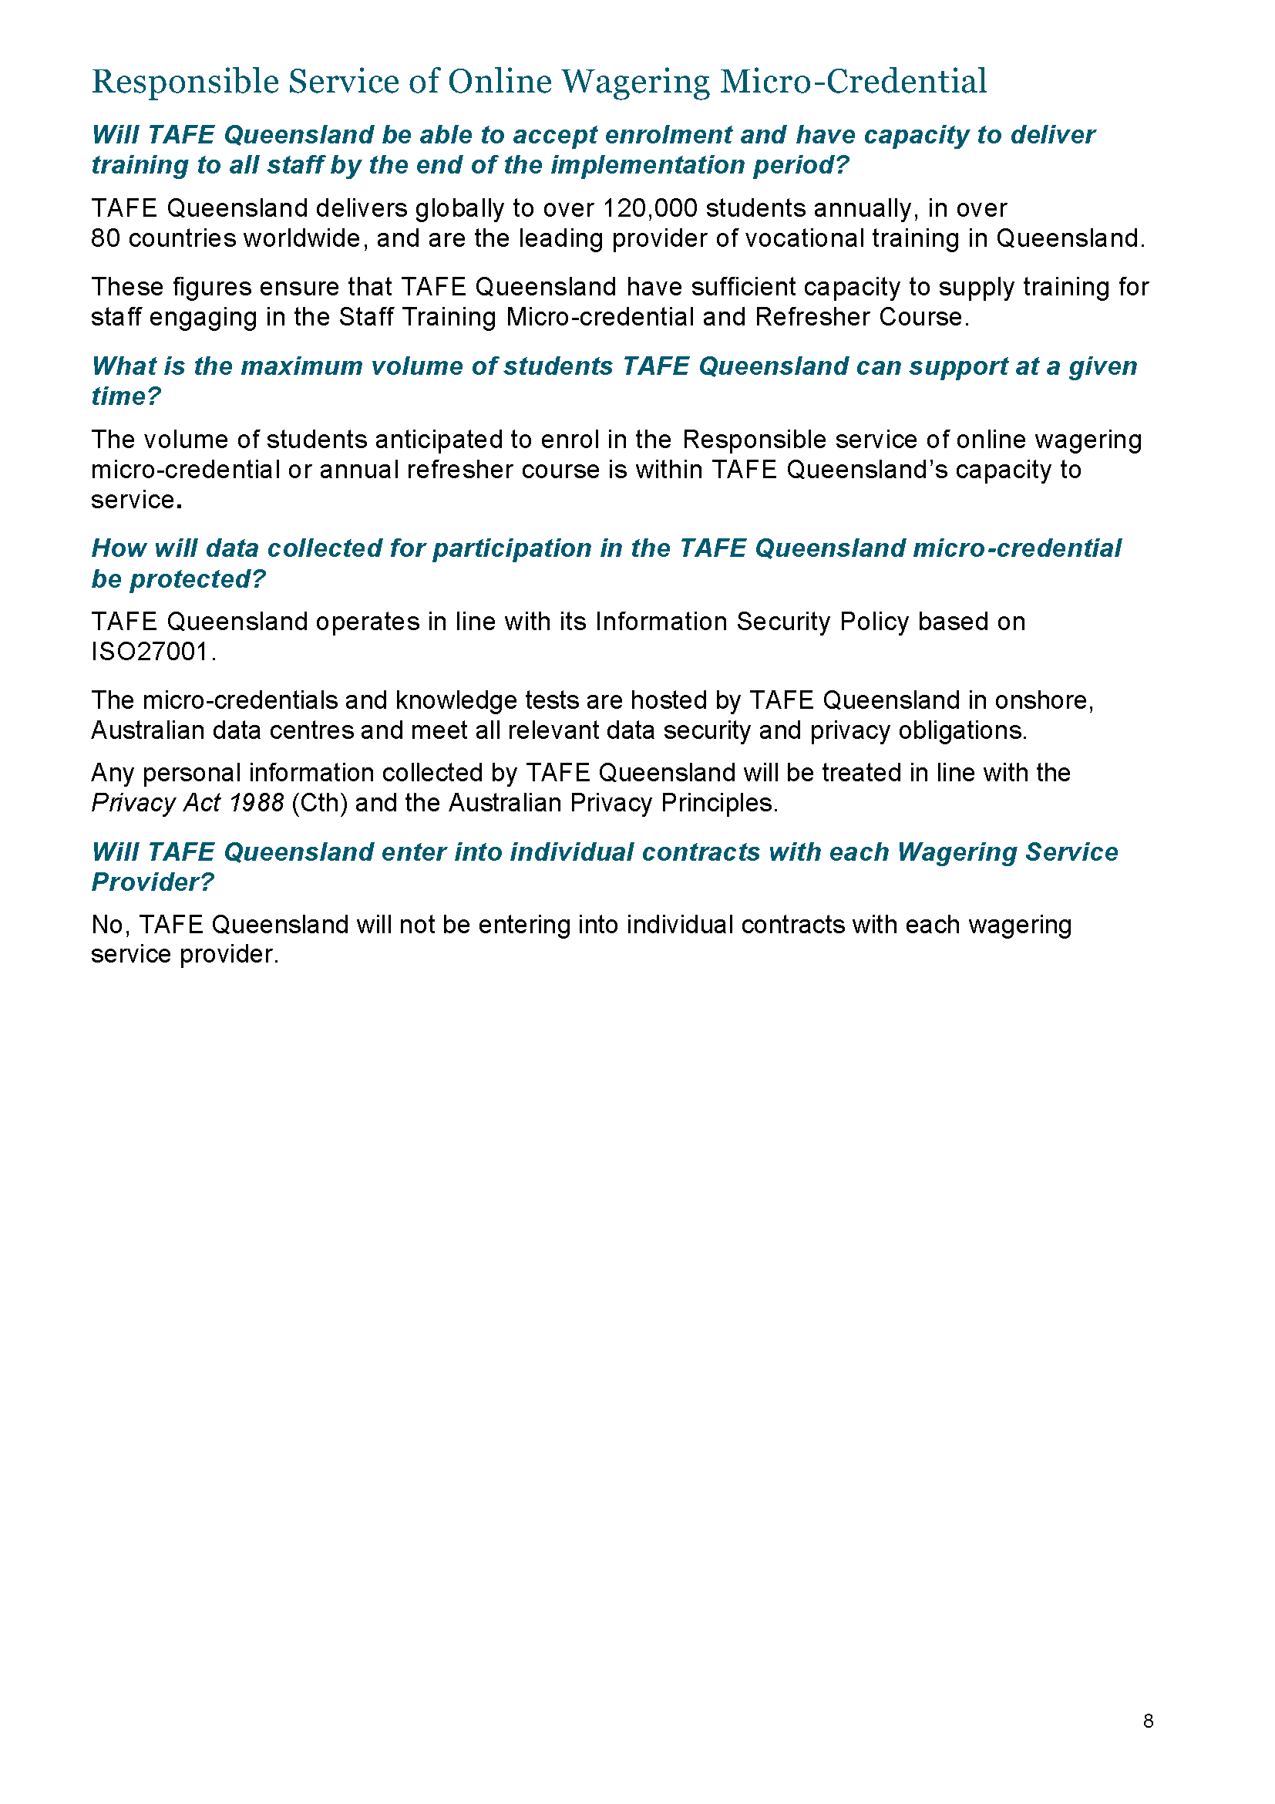

Gambling Administration Act 2019
South Australia
Casino Gambling Code of Practice Variation Notice 2023 (No.1)
under section 15 of the Gambling Administration Act 2019

Part 1—Preliminary

1—Short title
This notice may be cited as the Casino Gambling Code of Practice Variation Notice 2023 (No.1) (Variation Notice).
2—Commencement
This Variation Notice comes into operation on 30 March 2023.
3—Variation of existing codes of practice
This notice varies the Casino Gambling Code of Practice published in the Gazette on 29 July 2022 and is made by the Liquor and Gambling Commissioner under section 15 of the Gambling Administration Act 2019.
4—Variation provisions
In this notice, a provision under a heading referring to a variation of a specified clause of the Casino Gambling Code of Practice made under the Gambling Administration Act 2019 varies the clause so specified.

Part 2—Variation of Casino Gambling Code of Practice

5—Variation of clause 17 – Help information in gaming areas
- Clause 17—delete clause 17 and substitute:
17. Help information in gaming areas
- The licensee must ensure that—
    - each automatic teller machine (ATM) which is available for operation by patrons operates so that when the ATM is idle, the screen displays a responsible gambling message approved by the welfare agency at least 20% of the time, or if there is no current approval the condensed warning message and the national helpline number 1800 858 858 at least 20% of the time;
    - when the ATM prints a transaction slip (however described) the transaction record includes the condensed warning message and national gambling helpline number 1800 858 858.
- The licensee must ensure that—
    - each cashable ticket redemption terminal (CRT) which is available for operation by patrons operates so that when the CRT is idle, at least half of the available screen space displays a responsible gambling message approved by the welfare agency, or if there is no current approval the condensed warning message and the national gambling helpline number 1800 858 858;
    - when the CRT prints a transaction slip (however described) the transaction record includes the condensed warning message and national gambling helpline number 1800 858 858.
- The licensee must ensure—
    - that the condensed warning message and national gambling helpline number 1800 858 858 are prominently displayed on or near—
      - each automated coin dispensing machine; and
      - each customer service point at which money is exchanged for cash, tickets or credit on an approved account based cashless gaming system; and
    - that a quantity of helpline cards are available at or near—
      - each ATM, EFTPOS facility and CRT;
      - each automated coin dispensing machine;
      - each customer service point at which money is exchanged for cash, tickets or credit on an approved account based cashless gaming system;
      - each gaming machine; and
      - each automated table game equipment.
- Sub-clauses (1), (2) and (3) apply to any ATM, EFTPOS facility or CRT, in or near a gaming area, over which the licensee could reasonably be expected to exercise control.
- An expanded warning message, as set out in Schedule 1 for the stated period, must be used to populate a message field on tickets issued from gaming machines and automated table game equipment being operated in connection with a ticket-in ticket-out (TITO) system.
- Despite sub-clause (5), if batches of pre-printed tickets are used for this purpose, the expanded warning message must be replaced with the relevant expanded warning message for that period on each subsequent batch of tickets re-ordered. It is acceptable for any stocks of tickets which were pre-printed to comply immediately before the commencement of the required period, to be exhausted.
- The licensee must ensure that the time of day is prominently displayed and visible throughout gaming areas.
- The licensee must ensure that a copy of this code is available on request.
6—Variation of Schedule 2 – Categories of Offences and Expiations
- Schedule 2—delete Schedule 2 and substitute:

Schedule 2—
Casino Act 1997

Categories of Offences and Expiations
Column A  Clause No. | Column B  Offence category | Column C  Expiation category
8(1)(a) | A | A
8(1)(b) | B | B
8(1)(c) | A | A
8(1)(d) | B | B
8(1)(e) | D | D
8(1)(f) | D | D
8(1)(g) | D | D
8(1)(h) | C | C
8(1)(i) | C | C
8(1)(j) | C | C
8(1)(k) | C | C
8(1)(l) | C | C
8(3) | C | C
9(1)(a) | C | C
9(1)(b) | C | C
11(1)  This penalty applies where the condensed message is used when the expanded warning message should have been used. | D | D
11(2)  This penalty applies where no warning message appears. | B | B
11(3) | C | C
11(4) | B | B
12(1) | B | B
12(2) | B | B
12(3) | B | B
12(4) | B | B
12(5) | C | C
12(6) | B | B
12(7) | C | C
12(8) | C | C
13(1) | B | B
13(2) | C | C
13(3) | C | C
13(5) | C | C
13(6) | C | C
13(7) | B | B
13(9) | C | C
14(1) | B | B
14(2) | B | B
14(3) | A | A
14(4) | D | D
14(5) | C | C
14(6) | A | A
14(7) | D | D
14(8) | D | D
14(10) | C | C
14(11) | D | D
14(12) | A | A
14(13) | A | A
14(14) | C | C
14(15) | C | C
15(1) | A | A
15(3) | D | D
16(1)(a) | B | B
16(1)(b) | B | B
17(1) | D | D
17(2) | D | D
17(4) | D | D
17(5) | D | D
17(6) | D | D
17(7) | D | D
17(8) | D | D
18 | D | D
19(2) | B | B
20(1) | B | B
20(2) | C | C
21(1) | A | A
22(1) | B | B
22(2)(a) | B | B
22(3) | D | D
23(1)(a) | B | B
23(1)(b) | D | D
23(1)(c) | D | D
23(2) | D | D
24(1) | B | B
27(1) | D | D
27(3) | C | C

Dated: 30 March 2023
Dini Soulio
Liquor and Gambling Commissioner

Gambling Administration Act 2019
South Australia
Gaming Machines Gambling Code of Practice Variation Notice 2023 (No.1)
under section 15 of the Gambling Administration Act 2019

Part 1—Preliminary

1—Short title
This notice may be cited as the Gaming Machines Gambling Code of Practice Variation Notice 2023 (No.1) (Variation Notice).
2—Commencement
This Variation Notice comes into operation on 30 March 2023.
3—Variation of existing codes of practice
This notice varies the Gaming Machines Gambling Code of Practice published in the Gazette on 29 July 2022 and is made by the Liquor and Gambling Commissioner under section 15 of the Gambling Administration Act 2019.
4—Variation provisions
In this notice, a provision under a heading referring to a variation of a specified clause of the Gaming Machines Gambling Code of Practice made under the Gambling Administration Act 2019 varies the clause so specified.

Part 2—Variation of Gaming Machines Gambling Code of Practice

5—Variation of clause 17 – Help information in gaming areas
- Clause 17—delete subclause and substitute:
17. Help information in gaming areas
- Licensees must ensure that—
    - each automatic teller machine (ATM) which is available for operation by patrons operates so that when the ATM is idle, the screen displays a responsible gambling message approved by the welfare agency at least 20% of the time, or if there is no current approval the condensed warning message and the national helpline number 1800 858 858 at least 20% of the time;
    - when the ATM prints a transaction slip (however described) the transaction record includes the condensed warning message and national gambling helpline number 1800 858 858
- Licensees must ensure that—
    - each cashable ticket redemption terminal (CRT) which is available for operation by patrons operates so that when the CRT is idle at least half of the available screen space displays a responsible gambling message approved by the welfare agency, or if there is no current approval the condensed warning message and the national gambling helpline number 1800 858 858;
    - when the CRT prints a transaction slip (however described) the transaction record includes the condensed warning message and national gambling helpline number 1800 858 858.
- Licensees must ensure—
    - that the condensed warning message and national gambling helpline number 1800 858 858 and website address are prominently displayed on or near—
      - each automated coin dispensing machine; and
      - each customer service point at which money is exchanged for coin, banknotes, tickets or credit on an approved account based cashless gaming system; and
    - that a quantity of helpline cards are available at or near—
      - each ATM, EFTPOS facility and CRT;
      - each automated coin dispensing machine;
      - each customer service point at which money is exchanged for coin, banknotes, tickets or credit on an approved account based cashless gaming system; and
      - each gaming machine.
- Sub-clauses (1), (2) and (3) apply to any ATM, EFTPOS facility or CRT, in or near a gaming area, over which the licensee could reasonably be expected to exercise control.
- An expanded warning message, as set out in Schedule 1, must be used to populate the dynamic message field on tickets issued from gaming machines being operated in connection with a ticket-in ticket-out (TITO) system.
- Licensees must ensure that the time of day is prominently displayed and visible throughout gaming areas.
- Licensees must ensure that a copy of this code is available within the gaming area.
6—Variation of clause 25 – Acceptable loyalty programs
- Clause 25—delete clause 25 and substitute:
25. Acceptable loyalty programs
- A loyalty program is an acceptable loyalty program if it is a structured program which—
    - is conducted in accordance with published terms and conditions;
    - is advertised in a manner consistent with the advertising requirements for the licensees gambling products;
    - offers rewards proportionate to gambling activity (including non-monetary privileges attached to tiers in a stepped rewards system);
    - provides periodic activity statements to active members at least quarterly to their email address or by ordinary post within 7 days after the end of the activity period; and
    - it has been approved by the Commissioner in terms of its rules and conditions, promotions, risk monitoring processes and the manner in which it is to be advertised and promoted.
- The activity statement must include segmented information that is clear and easily understood by the active member using common terms that they are likely to be familiar with and include—
    - totals of the active customer’s monthly gambling activity; including—
      - total amount bet;
      - total amount won;
      - overall net win (illustrated as a (+) amount) or loss (illustrated as a (-) amount);
      - total number of days gambled during the activity period; and
      - total amount of time the loyalty card was used during the activity period
    - a column graph (or some other diagrammatic representation) to show the active member’s gambling activity comparing the total amount bet against the net result over time for the last 6 months (cumulative) and show a clear comparison tracking to the same time from the previous year.
    - links and information on—
      - support services available to active customers
      - safe gambling messaging that promotes available consumer protection tools
      - a hyperlink, QR code or information on how to obtain, the member’s detailed transaction history for the statement period.
- Activity statements must not be sent to a person who is barred under section 44 of the Gambling Administration Act 2019, a person whose loyalty account has been cancelled, locked, disabled or deactivated, or if they have not used their account in more than 12 months.
- An activity statement or detailed transaction history must not include any promotional or direct marketing information.
- Activity statements must be made available to a member, whether active or not, at any time on request.
- The provider of an acceptable loyalty program must within 7 days at the request of the Commissioner provide activity statements, detailed transaction history and any other relevant information sought by the Commissioner that may assist in determining a request for barring of a person under section 44 of the Gambling Administration Act 2019.
- For the purposes of this clause—
active member means a member of the acceptable loyalty program that has used their loyalty card within the preceding 12 months but does not include a member whose membership has been cancelled, locked, disabled or deactivated or is barred under section 44 of the Gambling Administration Act 2019.
7—Variation of Schedule 2 – Categories of Offences and Expiations
- Schedule 2—delete Schedule 2 and substitute:
Schedule 2—
Gaming Machines Act 1992

Categories of Offences and Expiations
Column A  Clause No. | Column B  Offence category | Column C  Expiation category
8(1)(a) | A | A
8(1)(b) | B | B
8(1)(c) | A | A
8(1)(d) | B | B
8(1)(e) | D | D
8(1)(f) | D | D
8(1)(g) | D | D
8(1)(h) | C | C
8(1)(i) | C | C
8(1)(j) | C | C
8(1)(k) | C | C
8(3) | C | C
9(1)(a) | C | C
9(1)(b) | C | C
11(1)  This penalty applies where the condensed message is used when the expanded warning message should have been used. | D | D
11(2)  This penalty applies where no warning message appears. | B | B
11(3) | C | C
11(4) | B | B
12(1) | B | B
12(2) | B | B
12(3) | B | B
12(4) | B | B
12(5) | C | C
12(6) | B | B
12(7) | C | C
12(8) | C | C
13(1) | B | B
13(2) | C | C
13(3) | C | C
13(5) | C | C
13(6) | C | C
13(7) | B | B
13(9) | C | C
13(10) | B | B
14(1) | B | B
14(2) | B | B
14(3) | A | A
14(4) | D | D
14(5) | C | C
14(6) | A | A
14(7) | D | D
14(8) | D | D
14(10) | C | C
14(11) | D | D
14(12) | D | D
14(13) | A | A
14(14) | A | A
14(15) | C | C
14(16) | C | C
15(1) | A | A
15(3) | D | D
16(1)(a) | B | B
16(1)(b) | B | B
17(1) | D | D
17(2) | D | D
17(4) | D | D
17(5) | D | D
17(6) | D | D
17(7) | D | D
18 | D | D
19(2) | B | B
20(1) | B | B
20(2) | B | B
21(1) | A | A
22(1) | B | B
22(2)(a) | B | B
22(3) | D | D
23(1)(a) | B | B
23(1)(b) | D | D
23(1)(c) | D | D
23(2) | D | D
23(3) | A | A
24(1) | B | B
27(1) | D | D
27(2) | D | D

Dated: 30 March 2023
Dini Soulio
Liquor and Gambling Commissioner

HEALTH CARE ACT 2008
Declaration of Authorised Quality Improvement Activity and Authorised Person under Section 64
Notice by the Minister
TAKE notice that I, Christopher James Picton, Minister for Health and Wellbeing, pursuant to sections 64 (1) (a) (i) and (b) (i) do hereby:
DECLARE the Activities described in the Schedule to this declaration (the Activities) to be authorised quality improvement activities to which Part 7 of the Act applies, and
DECLARE the Person or group of Persons (including a group formed as a committee) described in the Schedule to this declaration (the Persons) to be an authorised entity for the purposes of carrying out the authorised quality improvement activities to which Part 7 of the Act applies, being satisfied that:
    - the performance of the activities within the ambit of the declaration and the functions or activities of the person or group of persons within the ambit of the declaration, would be facilitated by the making of the declaration; and
    - that the making of the declaration is in the public interest.
Dated: 28 March 2023
Christopher James Picton
Minister for Health and Wellbeing

Schedule
Declaration of Authorised Quality Improvement Activity and Authorised Person under Section 64
ACTIVITY | PERSON OR GROUP OF PERSONS
Review of Mortality and Morbidity for  Quality Improvement | St Andrew's Hospital Mortality and Morbidity Committee

Housing Improvement Act 2016
Rent Control Revocations
Whereas the Minister for Human Services Delegate is satisfied that each of the houses described hereunder has ceased to be unsafe or unsuitable for human habitation for the purposes of the Housing Improvement Act 2016, notice is hereby given that, in exercise of the powers conferred by the said Act, the Minister for Human Services Delegate does hereby revoke the said Rent Control in respect of each property.
Address of Premises | Allotment Section | Certificate of Title  Volume/Folio
121 Calvengrove Road, Waterloo Corner SA 5110 | Allotment 11 Deposited Plan 4843 Hundred of Munno Para | CT 5342/381
Dated: 30 March 2023
Craig Thompson
Housing Regulator and Registrar
Housing Safety Authority, SAHA
(Delegate of Minister for Human Services)

Land Acquisition Act 1969
Section 16
Form 5—Notice of Acquisition
1. Notice of acquisition
The Commissioner of Highways (the Authority), of 83 Pirie Street, Adelaide SA 5000, acquires the following interests in the following land:
Comprising an unencumbered estate in fee simple in that piece of land being the whole of Allotment 52 in Filed Plan 7587 comprised in Certificate of Title Volume 5236 Folio 541.
This notice is given under section 16 of the Land Acquisition Act 1969.
2. Compensation
A person who has or had an interest consisting of native title or an alienable interest in the land that is divested or diminished by the acquisition or the enjoyment of which is adversely affected by the acquisition who does not receive an offer of compensation from the Authority may apply to the Authority for compensation.
2A. Payment of professional costs relating to acquisition (section 26B)
If you are the owner in fee simple of the land to which this notice relates, you may be entitled to a payment of up to $10 000 from the Authority for use towards the payment of professional costs in relation to the acquisition of the land.
Professional costs include legal costs, valuation costs and any other costs prescribed by the Land Acquisition Regulations 2019.
3. Inquiries
Inquiries should be directed to: Petrula Pettas
GPO Box 1533
Adelaide SA 5001
Telephone: (08) 7133 2457
Dated: 28 March 2023
The Common Seal of the COMMISSIONER OF HIGHWAYS was hereto affixed by authority of the Commissioner in the presence of:
Rocco Caruso
Manager, Property Acquisition (Authorised Officer)
Department for Infrastructure and Transport
DIT 2021/13413/01

Land Acquisition Act 1969
Section 16
Form 5—Notice of Acquisition
1. Notice of acquisition
The Commissioner of Highways (the Authority), of 83 Pirie Street, Adelaide SA 5000, acquires the following interests in the following land:
Comprising an unencumbered estate in fee simple in that piece of land being the whole of Allotment 122 in Filed plan No 14262 comprised in Certificate of Title Volume 5304 Folio 135.
This notice is given under section 16 of the Land Acquisition Act 1969.
2. Compensation
A person who has or had an interest consisting of native title or an alienable interest in the land that is divested or diminished by the acquisition or the enjoyment of which is adversely affected by the acquisition who does not receive an offer of compensation from the Authority may apply to the Authority for compensation.
2A. Payment of professional costs relating to acquisition (section 26B)
If you are the owner in fee simple of the land to which this notice relates, you may be entitled to a payment of up to $10 000 from the Authority for use towards the payment of professional costs in relation to the acquisition of the land.
Professional costs include legal costs, valuation costs and any other costs prescribed by the Land Acquisition Regulations 2019.
3. Inquiries
Inquiries should be directed to: Petrula Pettas
GPO Box 1533
Adelaide SA 5001
Telephone: (08) 7133 2457
Dated: 28 March 2023
The Common Seal of the COMMISSIONER OF HIGHWAYS was hereto affixed by authority of the Commissioner in the presence of:
Rocco Caruso
Manager, Property Acquisition (Authorised Officer)
Department for Infrastructure and Transport
DIT 2021/15299/01

Local Government (Elections) Act 1999
Area Councillor Elected
Kingston District Council
A casual vacancy occurred in the office of area councillor in the Kingston District Council, effective Friday 27 January 2023. The vacancy was filled in accordance with section 6A of the Local Government (Elections) Act 1999. As a single candidate was willing and eligible to be elected to the vacancy, James PARKINS was declared elected to the vacancy on 20 February 2023.
District Council of Robe
A casual vacancy occurred in the office of area councillor in the District Council of Robe, effective Friday 27 January 2023. The vacancy was filled in accordance with section 6A of the Local Government (Elections) Act 1999. As multiple candidates were willing and eligible to be elected to the vacancy, a recount of the votes cast at the periodic elections was conducted on Friday 24 February 2023. At the conclusion, David Park LAURIE was declared elected to the vacancy.
Formal ballot papers 923
New Exhaust Ballot Papers 20
Informal Ballot Papers 0
Quota 462
Candidates | First preferences | Elected or excluded
WASSON, Fred | 144 | Excluded
MURPHY, Mark Francis | 216
FRIED, Peter Anthony | 186 | Excluded
BAKER, Mark Andrew | 136 | Excluded
LAURIE, David Park | 241 | Elected
Mick Sherry
Returning Officer

Local Government (Elections) Act 1999
2023 Local Government Supplementary Elections—Results
Copper Coast Council
Area Councillor, 1 vacancy
Formal ballot papers 3,822
Informal ballot papers 24
Quota 1,912
Candidates First preferences Elected or excluded Votes at election or exclusion
MACDONALD, Robyn 220 Excluded 239
STOCK, Matthew Colin 949 Elected 1 1,495
THOMSON, Dominica May 554 994
SHULTS, Bernard 242 Excluded 290
MILEWICH, Nick 350 Excluded 432
DERNEDDE, Grant 49 Excluded 49
LADNER, Adrian 120 Excluded 123
DAVIS, Robert 326 Excluded 378
CAMPOREALE, Phil 439 Excluded 600
CHAPPELL, Brenton 478 Excluded 779
SEMMLER, Daryl Wayne 95 Excluded 95
District Council of Kimba
Area Councillor, 1 vacancy
Formal ballot papers 423
Informal ballot papers 2
Quota 212
Candidates First preferences Elected or excluded Votes at election or exclusion
McDONALD, Dianne 45 45
FRANCIS, Francene Jennifer 378 Elected 1 Quota
District Council of Mount Remarkable
Willochra Ward Councillor, 1 vacancy
Formal ballot papers 734
Informal ballot papers 1
Quota 368
Candidates First preferences Elected or excluded Votes at election or exclusion
KELLER, Susan Doreen 73 73
MCGREGOR, Sheila 8 8
VAN HOLST PELLEKAAN, Dan 551 Elected 1 Quota
HARRIS, Matt 10 10
PRESTRIDGE, Gregory James 14 14
BORNHOLM, Trevor 78 78
Northern Areas Council
Broughton Ward Councillor, 1 vacancy
Formal ballot papers 178
Informal ballot papers 0
Quota 90
Candidates First preferences Elected or excluded Votes at election or exclusion
PLUCKROSE, Keith 106 Elected 1 Quota
FITZGERALD, Brendan 72 72
Southern Mallee District Council
Area Councillor, 5 vacancies
Formal ballot papers 799
Informal ballot papers 19
Quota 134
Candidates First preferences Elected or excluded Votes at election or exclusion
POCOCK, Trevor Charles 51 Elected 5 130
KENNEDY, Luke 33 Elected 4 Quota
SMITH, David Ian 93 Elected 3 Quota
ROONEY, Dan 59 Excluded 98
TORCETTI, Brett James 10 Excluded 14
BROWN, Kieren Nicholas 17 Excluded 23
CODDINGTON, Dean Michael 20 Excluded 47
TUCKER, Gary 4 Excluded 4
WILLOUGHBY, Barry Dean 32 Excluded 75
MEAD, Christopher Darren 293 Elected 1 Quota
BROADBENT, Shona 29 Excluded 56
SCHRODER, Olaf 17 Excluded 28
MICHELL, Campbell 141 Elected 2 Quota
District Council of Tumby Bay
Area Councillor, 4 vacancies
Formal ballot papers 1,160
Informal ballot papers 9
Quota 233
Candidates First preferences Elected or excluded Votes at election or exclusion
SMITH, Trevor 210 Elected 2 Quota
ELLIOTT, Julie Ann 416 Elected 1 Quota
HUDSON, William (Ross) 91 Elected 4 215
KOTZ, Christian 55 Excluded 69
BRYSON, Andree 56 Excluded 111
WARD, Fiona 140 Elected 3 Quota
GILES, Geoff 72 Excluded 90
POWELL, Ross Edward 120 189
Wudinna District Council
Area Councillor, 1 vacancy
Formal ballot papers 409
Informal ballot papers 0
Quota 205
Candidates First preferences Elected or excluded Votes at election or exclusion
PETTY, Dennis Colin 265 Elected 1 Quota
WALLADGE, Craig Andrew 144 144
Mick Sherry
Returning Officer

Mining Act 1971
Section 56H
Application for a Mining Lease
Notice is hereby given in accordance with Section 56H of the Mining Act 1971, that an application for a Mining Lease over the undermentioned Exploration Licence has been received:
Applicant: Iluka (Eucla Basin) Pty Ltd (ACN 115 300 242)
Exploration Licence: 5947, Iluka Resources Limited (ACN 008 675 018)
Location: CR 5957/384 alienated crown land, D67929 AL100 in the named ‘Yellabinna Regional Reserve’ Yellabinna, approx 140km northwest of Penong.
Area: 6951 hectares approximately
Purpose: Minerals (Heavy Mineral Sands)
Reference: MER-2023/0057
To arrange an inspection of the proposal at the Department for Energy and Mining, please call the Department on 08 8463 3103.
An electronic copy of the proposal can be found on the Department for Energy and Mining website: https://www.energymining.sa.gov.au/industry/minerals-and-mining/mining/community-engagement-opportunities.
Written submissions in relation to this application are invited to be received at the Department for Energy and Mining, Mining Regulation, Attn: Business Support Officer, GPO Box 320 ADELAIDE SA 5001 or dem.miningregrehab@sa.gov.au by no later than 27 April 2023.
The delegate of the Minister for Energy and Mining is required to have regard to these submissions in determining whether to grant or refuse the application and, if granted, the terms and conditions on which it should be granted.
When you make a written submission, that submission becomes a public record. Your submission will be provided to the applicant and may be made available for public inspection.
Dated: 30 March 2023
C. Andrews
Acting Mining Registrar as delegate for the Minister for Energy and Mining
Department for Energy and Mining

Motor Vehicles Act 1959
South Australia
Motor Vehicles (Conditional Registration—Recognition of Motor Vehicle Clubs) Notice 2023 – Bus Preservation Association of South Australia Inc.
under the Motor Vehicles Act 1959
1—Short title
This notice may be cited as the Motor Vehicles (Conditional Registration—Recognition of Motor Vehicle Clubs) Notice 2023 – Bus Preservation Association of South Australia Inc.
2—Commencement
This notice takes effect from the date it is published in the Gazette.
3—Interpretation
In this notice—
Act means the Motor Vehicles Act 1959;
Code of Practice means the ‘Code of Practice for Club Registration - a 90 day conditional registration scheme for historic, left hand drive and street rod vehicles’ published by the Department for Infrastructure and Transport;

Conditional Registration Scheme or Scheme means the scheme for conditional registration of historic, prescribed left hand drive and street rod motor vehicles under section 25 of the Act and regulations 15 and 16 of the Motor Vehicles Regulations 2010;

Department means the Department for Infrastructure and Transport;

Federation means the Federation of Historic Motoring Clubs SA Incorporated;

MR334 form means an ‘Approval for Registration of Vehicle on the Club Registration Scheme (MR334)’;

Prescribed log book means a log book in a form approved by the Registrar;

Registrar means the Registrar of Motor Vehicles;

Regulations means the Motor Vehicles Regulations 2010.
4—Recognition of motor vehicles clubs
The motor vehicle clubs specified in Schedule 1 are, subject to the conditions set out in clause 5, recognised for the purposes of regulation 16 of the Regulations.
5—Conditions of recognition
A motor vehicle club specified in Schedule 1 must comply with the following conditions:
  - the club must maintain a constitution approved by the Registrar;
(b) the club must nominate and have members authorised by the Registrar (authorised persons). The club’s authorised person(s) are responsible for approving applicants and motor vehicles for registration under the Scheme. This includes confirming that Scheme applicants are financial members of a club; any other details as required by the Registrar on the MR334 form; and to inspect members’ vehicles when requested to do so by the Registrar;
(c) the club must issue a prescribed log book to club members for each of their vehicles to record vehicle use;
(d) the club must cancel a member’s prescribed log book when a member resigns, must ensure that a statutory declaration is provided when a member’s log book is lost or destroyed, must keep details of members’ prescribed log book return sheets and forward copies of the same to the Registrar or Federation annually as required;
(e) the club must create and maintain records detailing all its financial members, its authorised persons, all vehicles for which an MR334 form has been issued, all statutory declarations received and prescribed log books issued and returned to the club;
(f) the club must keep records for a period of 5 years from the date of the document and these records must include all duplicate MR334 forms, all records of motor vehicle inspections undertaken in accordance with paragraph (b), all statutory declarations provided by members for the purposes of paragraphs (d), all prescribed log books issued by reference to their serial number, the member’s name and the vehicle for which it was issued, and to make all such records available for inspection or provide copies of the records at the request of the Registrar for audit purposes;
(g) the club must ensure, as far as practicable, that all members comply with the Code of Practice;
(h) the club, as far as practicable, must report to the Registrar or the Federation details of members and motor vehicles not complying with the conditions and criteria set out in the Code of Practice for the Scheme;
(i) the club must provide to the Registrar, within 2 months after the end of the club’s financial year, an annual report detailing members from that financial year with vehicles registered under the Scheme who are no longer financial members of the club;
(j) the club must notify the Registrar, in writing, within 14 days of resolution to cease operation as a club and must provide the club records specified in paragraph (f) to the Registrar within 14 days of its dissolution.
Note—
Under regulation 16(3)(c) of the Motor Vehicles Regulations 2010, the Registrar may, by notice in the Gazette, withdraw the recognition of a motor vehicle club if satisfied that the club has contravened or failed to comply with a condition applying to its recognition by the Registrar, or if there is other good cause to withdraw the recognition.
Schedule 1—Recognised motor vehicle clubs
Historic vehicle clubs
Bus Preservation Association of South Australia Inc.
Made by the Deputy Registrar of Motor Vehicles
On 24 March 2023

Petroleum and Geothermal Energy Act 2000
Suspension of Petroleum Exploration Licences—PELs 112, 444 and 677
Suspension of Petroleum Retention Licences—PRLs 50, 51, 52, 53, 54, 55, 56, 57,
58, 59, 60, 61, 62, 63, 64, 65, 66, 67, 68, 69, 70, 71, 72, 74, 75 and 248
Pursuant to Section 90 of the Petroleum and Geothermal Energy Act 2000, notice is hereby given that the abovementioned Licences have been suspended for the periods indicated below pursuant to delegated powers dated 29 June 2018.
- PELs 112 and 444 for the period from and including 1 February 2023 to 31 January 2024;
- PEL 677 for the period from and including 3 February 2023 to 31 January 2024;
- PRLs 50, 51, 52, 53, 54, 55, 56, 57, 58, 59, 60, 61, 62, 63, 64, 65, 66, 67, 68, 69, 70, 71, 72, 74 and 75 for the period from and including 12 May 2023 to 31 January 2024;
- PRL 124 for the period from and including 24 July 2023 to 31 January 2024 and
- PRL 248 for the period from and including 3 June 2023 to 31 January 2024.
The expiry date of these licences are now determined to be:
- PEL 112 – 12 July 2025;
- PEL 444 – 14 July 2026;
- PEL 677 – 2 April 2028;
- PRLs 50, 58, 59, 67, 68, 69, 70, 71, 72 and 74 – 31 July 2024;
- PRLs 51, 52, 53, 54, 55, 56, 57, 60, 61, 62, 63, 64, 65 and 66 – 1 February 2026;
- PRL 75 – 1 February 2025;
- PRL 124 – 3 December 2024; and
- PRL 248 – 22 January 2025.
Dated: 22 March 2023
NICK PANAGOPOULOS
A/Executive Director
Energy Resources Division
Department for Energy and Mining
Delegate of the Minister for Energy and Mining

Planning, Development and Infrastructure Act 2016
Section 76
Amendment to the Planning and Design Code
Preamble
It is necessary to amend the Planning and Design Code (the Code) in operation at 16 March 2023 (Version 2023.4) in order to make changes of form relating to the Code’s spatial layers and their relationship with land parcels. NOTE: There are no changes to the application of zone, subzone or overlay boundaries and their relationship with affected parcels or the intent of policy application as a result of this amendment.
- PURSUANT to section 76 of the Planning, Development and Infrastructure Act 2016 (the Act), I hereby amend the Code in order to make changes of form (without altering the effect of underlying policy), correct errors and make operational amendments as follows:
- Undertake minor alterations to the geometry of the spatial layers and data in the Code to maintain the current relationship between the parcel boundaries and Code data as a result of the following:
  - New plans of division deposited in the Land Titles Office between 8 March 2023 and 20 March 2023 affecting the following spatial and data layers in the Code:
    - Zones and subzones
    - Technical and Numeric Variations
      - Building Heights (Levels)
      - Building Heights (Metres)
      - Minimum Dwelling Allotment Size
      - Minimum Frontage
      - Minimum Site Area
      - Minimum Primary Street Setback
      - Minimum Side Boundary Setback
      - Future Local Road Widening Setback
    - Overlays
      - Affordable Housing
      - Character Area
      - Heritage Adjacency
      - Historic Area
      - Local Heritage Place
      - State Heritage Place
      - Stormwater Management
      - Urban Tree Canopy
  - Improved spatial data for existing land parcels in the following locations (as described in Column A) that affect data layers in the Code (as shown in Column B):
Location (Column A) | Layers (Column B)
Kohinoor  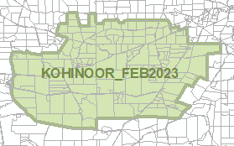 | Overlays  - Airport Building Heights (Regulated)

- In Part 13 of the Code – Table of Amendments, update the publication date, Code version number, amendment type and summary of amendments within the ‘Table of Planning and Design Code Amendments’ to reflect the amendments to the Code as described in this Notice.
- PURSUANT to section 76(5)(a) of the Act, I further specify that the amendments to the Code as described in this Notice will take effect upon the date those amendments are published on the SA planning portal.
Dated: 28 March 2023
Greg Van Gaans
Director, Land and Built Environment
Department for Trade and Investment
Delegate of the Minister for Planning

Planning, Development and Infrastructure Act 2016
Section 76
Amendment to the Planning and Design Code
Preamble
It is necessary to amend the Planning and Design Code (the Code) in operation at 16 March 2023 (Version 2023.4) in order to make the following minor or operational amendments:
- to correct the misapplication of the Local Heritage Place Overlay over properties at Aldinga, Gilberton, Callington, O’Halloran Hill and Penwortham.
- to apply the State Heritage Place Overlay to several State Heritage Places that have been added to the South Australian Heritage Register.
- PURSUANT to section 76 of the Planning, Development and Infrastructure Act 2016 (the Act), I hereby amend the Code in order to make the following minor or operational amendments as follows:
- Amend the spatial layer of the Local Heritage Place Overlay so that it does not apply to the following properties and update the spatial layer of the Heritage Adjacency Overlay to reflect these changes:
  - 186-196 Port Road, Aldinga (Lot 102, CT6274/361)
  - 13 James Street, Gilberton (Lot 101, CT6190/832)
  - 34 North Terrace, Callington (Lot 386, CT6177/258)
  - 36 North Terrace, Callington (Lot 349, CT6177/260)
  - 5B Majors Road, O’Halloran Hill (Lot 1, CT6110/936)
  - Lot 429 Horrocks Road, Penwortham (Lot 429, CT5899/961).
- Amend the spatial layer of the Local Heritage Place Overlay so that it applies to the area at Aldinga bounded by the red line in the map contained in Attachment A and is linked to Local Heritage Place, Heritage ID 5545 (being ‘Memorial Avenue of Trees’ Port Road, Aldinga). Update the spatial layer of the Heritage Adjacency Overlay to reflect this change.
- Amend the spatial layer of the Local Heritage Place Overlay so that:
  - Local Heritage Place, Heritage ID 8431 (being ‘Former Stables; Original external form, materials and details of the former stables’) is linked to 1 Edwin Terrace, Gilberton (Lot 13, CT6279/915).
  - Local Heritage Place, Heritage ID 18329 (being ‘Barn, Neptune Depot, fr Jaensch garage’) is unlinked from 36 North Terrace, Callington (Lot 248, CT6177/259) and is linked instead to 5 Montefiore Street, Callington (Lot 849, CT5694/198).
  - Local Heritage Place, Heritage ID 18330 (being ‘Cottage, fr Spinks cottage & tank) is unlinked from 5 Montefiore Street, Callington (Lot 849, CT5694/198) and is linked instead to 36 North Terrace, Callington (Lot 248, CT6177/259).
- Amend the spatial layer of the Local Heritage Place Overlay so that it applies to the area at O’Halloran Hill bounded by the red line in the map contained in Attachment B and is linked to Local Heritage Place, Heritage ID 4344 (being ‘Dwelling (Weblyn); Exclusions:- latter additions and outbuildings’). Update the spatial layer of the Heritage Adjacency Overlay to reflect this change.
- Amend the spatial layer of the Local Heritage Place Overlay so that it applies to 7867 Horrocks Highway, Penwortham (Lots 20 and 21, CT5808/21) and is linked to Local Heritage Place, Heritage ID 14527 (being ‘Cottage (Apple Shed)’. Update the spatial layer of the Heritage Adjacency Overlay to reflect this change.
- In Part 11 of the Code, in the section applicable to ‘Onkaparinga’, replace the words ‘Memorial Avenue of Pine Tress’ with the words ‘Memorial Avenue of Pine Trees’.
- In Part 11 of the Code, in the section applicable to ‘Walkerville’, delete the following row from the table of Local Heritage Places:
13 James Street (original stables to 1 Edwin Tce) GILBERTON | Former Stables; Original external form, materials and details of the former stables. | a d e | 8431
- In Part 11 of the Code, in the section applicable to ‘Walkerville’, insert the following row in the table of Local Heritage Places immediately after the row applying to 1 Edwin Terrace GILBERTON:
1 Edwin Terrace GILBERTON | Former Stables; Original external form, materials and details of the former stables. | a d e | 8431
- In Part 11 of the Code, in the section applicable to ‘Mount Barker’, delete the following row from the table of Local Heritage Places:
North Terrace CALLINGTON | Barn, Neptune Depot, fr Jaensch garage; Stone walls with stone dressings, hipped cgi roof and timber-framed openings | a c d | 18329
- In Part 11 of the Code, in the section applicable to ‘Mount Barker’, insert the following row immediately after the row applying to 2-4 Montefiore Street CALLINGTON:
5 Montefiore Street CALLINGTON | Barn, Neptune Depot, fr Jaensch garage; Stone walls with stone dressings, hipped cgi roof and timber-framed openings | a c d | 18329
- In Part 11 of the Code, in the section applicable to ‘Mount Barker’, replace the words ‘32-36 North Terrace CALLINGTON’ with the words ‘36 North Terrace (Lot 248) CALLINGTON’.
- Amend the spatial layer of the State Heritage Place Overlay so that it applies to the area at Callana via Marree bounded by the red line in the map contained in Attachment C and is linked to State Heritage Place, State Heritage ID 26546 (being Nelly Creek Fossil Flora Complex – CL 6178/960). Update the spatial layer of the Heritage Adjacency Overlay to reflect this change.
- Amend the spatial layer of the State Heritage Place Overlay so that it applies to the area at Callana via Marree bounded by the red line in the map contained in Attachment D and is linked to State Heritage Place, State Heritage ID 26547 (being Poole Creek Fossil Flora Complex – CL 6178/960, CL 6234/961). Update the spatial layer of the Heritage Adjacency Overlay to reflect this change.
- Amend the spatial layer of the State Heritage Place Overlay so that it applies to the following properties:
  - 39 Jetty Road NORMANVILLE (CT 5381/437) and is linked to State Heritage Place, State Heritage ID 26558 (being ‘Yankalilla Bay Homestead’)
  - Esplanade SEMAPHORE (CR 6230/172) and is linked to State Heritage Place, State Heritage ID 26552 (being ‘Semaphore Carousel’)
  - 3-57 Capper Steet & 28-48 Rundle Street KENT TOWN (CT 5400/161) and is linked to State Heritage Place, State Heritage ID 26514 (being ‘Dr Kent's Paddock Housing Complex’)
  - 46-48 Anzac Highway EVERARD PARK (CT 5867/503, CT 5867/504, CT 5867/505, CT 5867/506, CT 6123/858, CT 5867/508, CT 5867/509, CT 5867/510, CT 5867/511, CT 5867/512, CT 5867/513, CT 5867/514, CT 5867/515, CT 5867/516, CT 5867/517) and is linked to State Heritage Place, State Heritage ID 26529 (being Everard Court (Flats), Everard Park)
and update the spatial layer of the Heritage Adjacency Overlay to reflect these changes.
- In Part 13 of the Code – Table of Amendments, update the publication date, Code version number, amendment type and summary of amendments within the ‘Table of Planning and Design Code Amendments’ to reflect the amendments to the Code as described in this Notice.
- PURSUANT to section 76(5)(a) of the Act, I further specify that the amendments to the Code as described in this Notice will take effect upon the date those amendments are published on the SA planning portal.
Dated: 28 March 2023
Sally Smith
Executive Director, Planning and Land Use Services
Department for Trade and Investment
Delegate of the Minister for Planning

Attachment A
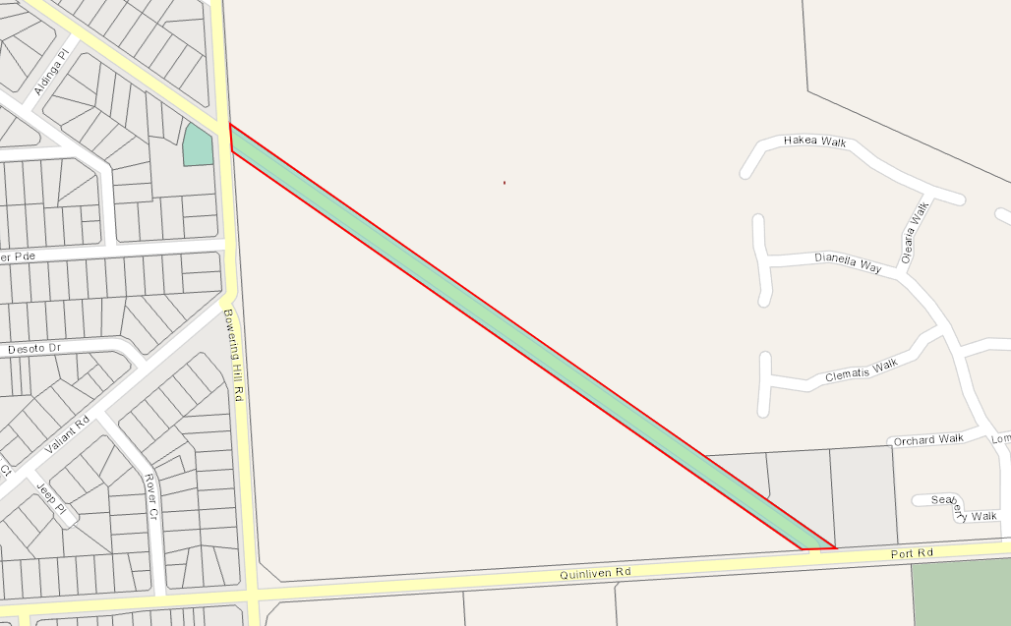

Attachment B
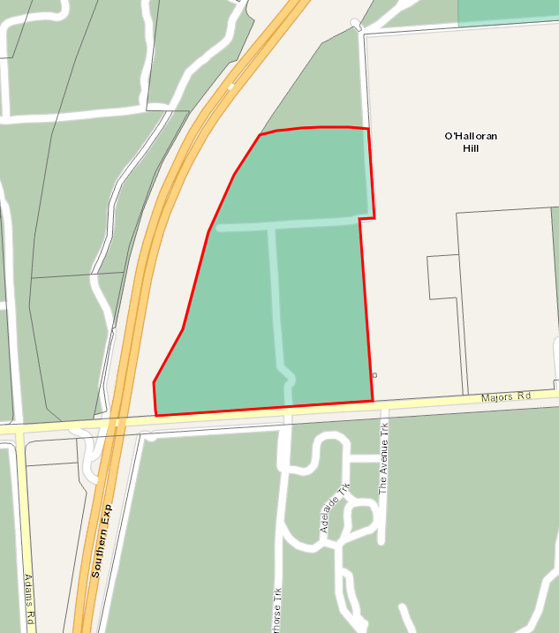
Attachment C
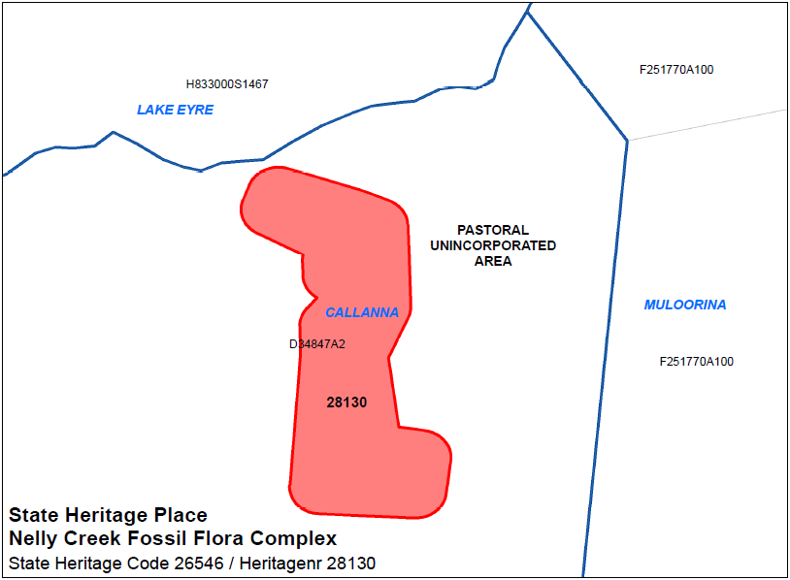
Attachment D
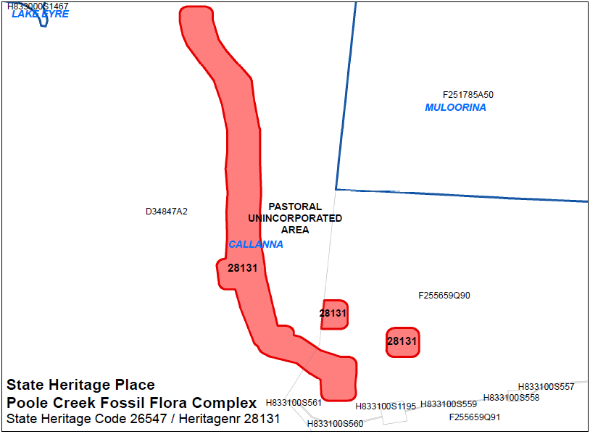

Plant Health Act 2009
Section 4
Declaration of Pests
PURSUANT to Sections 4 and 8 of the Plant Health Act 2009, I, Ross Meffin, Chief Inspector, delegate of the Minister for Primary Industries and Regional Development, make the following Notice:
- Application
All previous notices made pursuant to Sections 4 and 8 of the Plant Health Act 2009 are hereby revoked.
- Declaration of Pests - Pursuant to Section 4 of the Act
  - The following are declared to be pests for the purposes of the Act:
    - The pests specified by common name and scientific name immediately below:
Common Name(s) | Scientific Name(s)
African citrus psyllid | Trioza erytreae
American serpentine leaf miner | Liriomyza trifolii
Anthracnose of Brassica crops | Colletotrichum higginsianum
Asian citrus psyllid | Diaphorina citri
Asian longicorn beetle | Anaplophora glabripennis
Asian subterranean termite | Cryptotermes gestroi
Australian plague locust | Chortoicetes terminifera
Bacterial wilt of potato | Ralstonia solanacearum Race 3
Barley stem gall midge | Mayetiola hordei
Barley stripe rust | Puccinia striiformis f. sp. hordei
Blueberry rust | Thekopsora minima
Boil smut of maize | Ustilago maydis
Brown marmorated stink bug | Halyomorpha halys
Browsing ant | Lepisiota frauenfeldi
Burning moth | Hylesia nigricans
Caracollina lenticula | Caracollina lenticula
Ceratocystis wilt | Ceratocystis manginecans, Ceratocystis spp. (exotic species)
Chestnut blight | Cryphonectria parasitica
Chickpea leaf miner | Liriomyza cicerina
Chocolate-band snail | Eobania vermiculata
Citrus blight | (unknown causal agent)
Citrus canker | Xanthomonas citri subsp. citri
Citrus longicorn beetle | Anaplophora chinensis
Citrus red mite | Panonychus citri
Citrus tristeza virus – sweet orange stem pitting strain | Citrus tristeza closterovirus – sweet orange stem pitting strain
Citrus variegated chlorosis | Xylella fastidiosa
Columnea latent viroid (CLVd) | Columnea latent viroid
Cucumber fruit mottle mosaic virus (CFMMV) | Cucumber fruit mottle mosaic tobamovirus
Cucumber green mottle mosaic virus (CGMMV) | Cucumber green mottle mosaic tobamovirus
Drywood termite | Cryptotermes dudleyi
Electric ant | Wasmannia auropunctata
European House Borer | Hylotrupes bajulus
Exotic gypsy moth | Lymantria spp. (L. dispar and sub-species, L. monacha)
Fire blight | Erwinia amylovora
Fruit flies | Pest species of Tephritidae family
Fusarium wilt of tomatoes | Fusarium oxysporum f.sp. lycopersicon Race 3
Giant African snail | Lissachatina fulica
Giant pine scale | Marchalina hellenica
Glassy-winged sharpshooter | Homalodisca vitripennis
Golden apple snail | Pomacea canaliculata
Grape phylloxera | Daktulosphaira vitifolliae
Grapevine leaf rust | Phakopsora euvitis
Grapevine red blotch-associated virus | Grapevine red blotch-associated geminivirus
Green snail | Cantareus apertus
Guava Root Knot Nematode | Meloidogyne enterolobii
Harlequin lady beetle | Harmonia axyridis
Hessian fly | Mayetiola destructor
Huanglongbing disease of citrus | ‘Candidatus liberibacter’ spp.
Karnal bunt | Tilletia indica
Khapra beetle | Trogoderma granarium
Kyuri green mottle mosaic virus (KGMMV) | Kyuri green mottle mosaic tobamovirus
Melon necrotic spot virus (MNSV) | Melon necrotic spot carmovirus
Melon thrips | Thrips palmi
Myrtle rust | Puccinia psidii (syn. Uredo rangelii)
Myrtle rust (exotic strains) | Austropuccinia psidii (syn. Puccinia psidii, Uredo rangelii) – exotic strains
Parlatoria date scale | Parlatoria blanchardi
Pepino mosaic virus (PepMV) | Pepino mosaic potexvirus
Pepper chat fruit viroid (PCFVd) | Pepper chat fruit viroid
Phoney peach disease | Xylella fastidiosa
Phytophthora blight | Phytophthora kernoviae
Pierce’s disease of grapevines | Xylella fastidiosa
Pine wilt nematode | Bursaphelenchus spp. including B. xylophilus
Pitch canker | Fusarium circinatum
Polyphagous shot hole borer | Euwallacea fornicatus
Polyphagous shot hole borer-associated fusarium wilt | Fusarium euwallaceae
Potato blackleg and soft rot | Dickeya spp. Including D. dianthicola,  D. dadantii and D. solani
Potato cyst nematode | Globodera pallida
Potato cyst nematode | Globodera rostochiensis
Potato late blight | Phytophthora infestans (A2 mating type)
Potato spindle tuber viroid (PSTVd) | Potato spindle tuber pospiviroid
Pyriform scale | Protopulvinaria pyriformis
Red imported fire ant | Solenopsis invicta
Sawyer beetles | Monochamus spp. including  M. alternatus, M. galloprovincialis,  M. scutellatus, M. titillator
Serpentine leaf miner | Liriomyza huidobrensis
Sharka | Plum pox potyvirus
Small plague grasshopper | Austroicetes cruciata
Spotted-winged drosophila (fruit fly) | Drosophila suzukii
Strawberry latent ringspot virus (SLRSV) | Strawberry latent ringspot virus
Stubborn disease of citrus | Spiroplasma citri
Subterranean termite | Coptotermes formosanus
Sudden oak death | Phytophthora ramorum
Tarnished plant bug | Lygus lineolaris
Teratosphaeria canker | Teratosphaeria destructans and T. zuluensis
Tomato apical stunt viroid (TASVd) | Tomato apical stunt viroid
Tomato black ring virus (TBRV) | Tomato black ring nepovirus
Tomato brown rugose fruit virus (ToBRFV) | Tomato brown rugose fruit tobamovirus
Tomato chlorotic dwarf viroid (TCDVd) | Tomato chlorotic dwarf viroid
Tomato leaf miner | Liriomyza bryoniae
Tomato mottle mosaic virus (ToMMV) | Tomato mottle mosaic tobamovirus
Tomato planta macho viroid (TPMVd) | Tomato planta macho viroid
Tomato-potato psyllid | Bactericera cockerelli
Tropical fire ant | Solenopsis geminata
Vegetable leaf miner | Liriomyza sativae
Watermelon green mottle mosaic virus (WGMMV) | Watermelon green mottle mosaic tobamovirus
West Indian drywood termite | Cryptotermes brevis
Western plant bug | Lygus hesperus
Wheat stem rust (exotic strains) | Puccinia graminis f. sp. tritici (exotic strains)
Wheat stem sawfly | Cephus spp. (C. cinctus, C. pygmeaus)
Yellow crazy ant | Anoplolepis gracilipes
Zebra chip of potatoes, ‘yellows’ and other diseases of solanaceous and apiaceous plants | ‘Candidatus Liberibacter solanacearum’ (all Haplotypes)
Zucchini green mottle mosaic virus (ZGMMV) | Zucchini green mottle mosaic tobamovirus
    - Any emergent pest that warrants immediate application of the Act and subsequent declaration under sub-paragraph (1).
- Quarantine Areas – Pursuant to Section 8 of the Act
  - The following portions of the State are declared to be quarantine areas:
    - with respect to pest fruit flies, for the purposes of control and eradication, a “Fruit Fly Affected Area” (as defined in Section 4 of this Notice).
    - with respect to pest fruit flies, for the purpose of excluding fruit flies from the Riverland of South Australia (“Riverland Pest Free Area”), the:
      - County of Hamley; and
      - Hundreds of Bookpurnong, Cadell, Gordon, Holder, Katarapko, Loveday, Markaranka, Moorook, Murtho, Parcoola, Paringa, Pooginook, Pyap, Stuart, Waikerie, Eba, Fisher, Forster, Hay, Murkbo, Nildottie, Paisley, Ridley and Skurray.
    - the whole of Kangaroo Island with respect to the declared diseases of potatoes, namely bacterial wilt (Ralstonia solanacearum Race 3) and potato cyst nematodes (Globodera rostochinesis and Globodera pallida). This quarantine area is to be known as the ‘Kangaroo Island Protected Production Area’.
    - with respect to Caracollina lenticula, the following are declared to be quarantine areas:
      - 9 Creswell Road, Largs North, Certificate of Title Volume 5781 Folio 919; and
      - 10 Creswell Road, Largs North, Certificate of Title Volume 5208 Folio 532; and
      - 1- 4 / 2 Elder Road, Largs North, Certificates of Title Volume 6129 Folio 124 and Volume 6129 Folio 125.
  - Measures to be taken in Quarantine Areas
    - For the purposes of control and eradication of fruit flies, unless permitted within the Standard, host fruit grown in or introduced into a Fruit Fly Affected Area must not be moved within or removed from the Fruit Fly Affected Area without approval from the Chief Inspector or delegate; and
    - the owner or occupier of any premises within a portion of the State declared to be a:
      - fruit fly outbreak zone (as defined in Section 4 of this Notice) must take the measures prescribed in the Standard for the control and eradication of such flies from a fruit fly outbreak zone; and
      - fruit fly outbreak area (as defined in Section 4 of this Notice) must take the measures prescribed in the Standard for the control and eradication of such flies from a fruit fly outbreak area; and
      - fruit fly suspension area (as defined in Section 4 of this Notice) must take the measures prescribed in the Standard for the control and eradication of such flies from a fruit fly suspension area.
    - The owner or occupier of any premises within the ‘Kangaroo Island Protected Production Area’ established under Section 1.1(3) must take the measures prescribed in the Standard for eradication of the declared diseases of potatoes.
    - Measures for the exclusion of fruit flies from the Riverland of South Australia (“Riverland Pest Free Area”):
      - Introduction of host fruits, as specified under Section 7 of the Act, into the Riverland Pest Free Area is prohibited unless:
        - in transit through the Riverland Pest Free Area; or
        - if the host fruit was produced in a State or Territory other than South Australia: the host fruit complies with the treatments described within 1.1(1)(iii) below and is accompanied with plant health certification; or
        - if the host fruit was produced in any part of South Australia outside the Riverland Pest Free Area, the host fruit has been certified by an inspector as having been either;
              - grown in an area free of fruit flies as defined by the Standard; or
              - treated in compliance with the treatments described in 1.1(1)(iii) below; or
        - moved under an accreditation arrangement as approved by the Minister under Part 4 Division 2 of the Act and regulation 7 of the Plant Health Regulations 2009; or
        - accompanied by an itemised retail purchase docket applicable to that produce and issued by an Approved PFA suitable retail store.
      - if the host fruit was originally produced in the Riverland Pest Free Area, but has moved outside that area and is now proposed to be re-introduced into the area, the produce must either be;
        - certified by an inspector that it has been maintained under secure conditions throughout the duration that it was outside the Riverland Pest Free Area; or
        - moved under an accreditation arrangement as approved by the Minister under Part 4 Division 2 of the Act and regulation 7 of the Plant Health Regulations 2009; or
        - Treated in compliance with the treatments described in 1.1(1)(iii) below and is accompanied with plant health certification.
      - The following treatments are prescribed for the purpose of moving produce into the Riverland Pest Free Area:
        - Treatment in accordance with Condition 9 (Area Freedom for fruit flies / secure transportation) as described in the Standard
        - Treatment in accordance with Condition 10.1 (Hard green or similar condition for Fruit Fly) as described in the Standard
        - Treatment in accordance with Condition 11 (Disinfestation by Cold Storage) as described in the Standard
        - Treatment in accordance with Condition 12 (Disinfestation using Dimethoate – Queensland fruit fly) as described in the Standard
        - Treatment in accordance with Condition 12E (Winegrapes Secure Transportation – Queensland Fruit Fly / Mediterranean Fruit Fly – Systems Approach – ICA 33) as described in the Standard
        - Treatment in accordance with Condition 13 (Disinfestation by Methyl Bromide fumigation) as described in the Standard
        - Treatment in accordance with Condition 14 (Disinfestation by Irradiation) as described in the Standard
        - Treated or consigned under conditions approved by the Chief Inspector.
    - The owner or occupier of any premises within the quarantine area with respect to Caracollina lenticula, must take the following measures
      - all outdoor areas must be treated with the following molluscicide bait treatments in accordance with label specifications:
        - a metaldehyde-based bait (e.g. Metarex Inov Slug and Snail Bait, Axcela Slug and Snail Bait) at least once during the months of March, April, May, September, October and November; and,
        - an iron-based bait (e.g. Protect Us Snail and Slug Killer, Eradicate Snail and Slug Bait) at least once during the months of June, July and August of each year.
        - bait applications must occur at regular intervals over the twelve months (e.g. every 30 days plus (+) or minus (–) 3 days).
      - all annual vegetative ground cover must be destroyed but retained within the premises.
      - any item from the quarantine area that may harbour Caracollina lenticula is prohibited from leaving the quarantine area unless it meets the conditions laid out in1.1(1)(iii)a) to 1.1(1)(iii)d) below:
        - the item is inspected by an inspector and the inspector is satisfied that the item is free of Caracollina lenticula; or
        - a staff member nominated by the affected business who is authorised by an inspector to do the inspections is satisfied that the item is free of len Caracollina lenticula, and,
        - if Caracollina lenticula are found during inspection, or the item cannot be inspected to satisfy that the item is free of Caracollina lenticula, the item must be cleaned or treated in a method approved by the Department of Primary Industries and Regions, South Australia, and,
        - the item is removed from the quarantine area immediately upon being inspected in accordance with Section 1.1(1)(iii)a) or b) above; or immediately upon being cleaned or treated in accordance with Section 1.1(1)(iii)c) above.

- In this Notice:
- “the Act” means the Plant Health Act 2009.
- “annual vegetation” means plants that grow for only a single year and not purposely grown for amenity reasons.
- “Approved PFA suitable retail store” means a retail store who holds an accreditation arrangement as approved by the Minister under Part 4 Division 2 of the Act and regulation 7 of the Plant Health Regulations 2009, and as having verified systems for the management and traceability of host fruit, and does not receive, display or sell any host fruit that does not meet the requirements of 3.2(3)(iii) of this Notice.
- “Discovery Point” means the physical location where:
  - One or move suspect adult flies have been collected during a single inspection of a trap (regardless of whether the detection triggers and outbreak or not); or
  - Host material containing fruit fly larvae was grown.
- “Fruit Fly Affected Area” (also known as the Controlled Movement Zone) means the entire area within a circle of pre-determined radius surrounding a fruit fly outbreak centre in which area freedom status is suspended and movement controls are applied.
  - Unless otherwise determined by the Chief Inspector, the pre-determined radius of the Fruit Fly Affected Area is 15 kilometres in the case of an outbreak of Queensland fruit fly.
  - Unless otherwise determined by the Chief Inspector, the pre-determined radius of the Fruit Fly Affected Area is 7.5 kilometres in the case of an outbreak of Mediterranean fruit fly.
- “fruit fly outbreak area” (also known as the Corrective Action Zone) means an area within 1.5 kilometres radius of a fruit fly outbreak centre, unless otherwise determined by the Chief Inspector.
- “fruit fly outbreak centre” (also known as the Epicentre) means the means the location related to each single detection or grouping of detections that triggers an outbreak. An outbreak centre may be:
  - the Discovery Point where the first larvae or gravid female was detected; or
  - a location between a grouping of male flies that precipitated the outbreak.
- “fruit fly outbreak trigger” means the detection of fruit fly larvae in locally grown fruit, the detection of one gravid female fruit fly, or the detection of a predetermined number of male fruit flies or non-gravid female fruit flies within a 1-kilometre radius within a consecutive fourteen-day period
  - The pre-determined number of male fruit flies or non-gravid female fruit flies is five for Queensland fruit fly
  - The pre-determined number of male fruit flies or non-gravid female fruit flies is three for Mediterranean fruit fly.
- “fruit fly outbreak zone” (also known as the Delimitation Zone) means all of the land within a 200-metre radius around each fruit fly Discovery Point once the outbreak trigger has been met, unless otherwise determined by the Chief Inspector.
- “fruit fly suspension area” (also known as the Export Assurance Zone) means the area starting at the outer boundary of the outbreak area to the pre-determined radius surrounding a fruit fly outbreak centre in which area freedom status is suspended and movement controls are applied.
  - The pre-determined radius of the fruit fly suspension area is 15 kilometres in the case of an outbreak of Queensland fruit fly, unless otherwise determined by the Chief Inspector.
  - he pre-determined radius of the fruit fly suspension area is 7.5 kilometres in the case of an outbreak of Mediterranean fruit fly, unless otherwise determined by the Chief Inspector.
- “host fruit” means the host fruits of fruit flies as specified under Section 7 of the Act.
- “inspector” means an inspector appointed pursuant to section 41 of the Act
- “introduced into”, for the purposes of control and eradication of fruit flies only, excludes host fruit in transit.
- an “item that may harbour Caracollina lenticula” includes any vehicle, machinery or equipment, whether or not it is a plant-related product.
- “the Minister” means the Minister for Primary Industries and Regional Development.
- “molluscicide” means a pesticide that will kill snails and slugs.
- “plant-related product” has the same meaning as in the Act.
- "plant health certification” means assurance certificate or plant health certificate certifying the consignment as treated with the requirements described in 1.1(1)(iii).
- “quarantine area” means the area described in Section 3 of this Notice.
- “retail purchase docket” means a sale provided by an Approved PFA suitable retail store for fruit or fruiting vegetables sold to the public for personal consumption rather than for resale.
- “the Standard” means the document published by the Department of Primary Industries and Regions entitled the “Plant Quarantine Standard South Australia”.
- “transiting” or “in transit” means the movement of securely contained plant product, either directly through South Australia or through another quarantine area for a plant pest, that is accompanied by documentation that can demonstrate both the origin and destination of product, and, whilst in South Australia or another quarantine area, is not subject to off-loading, reloading or storage.
- “securely contained” means transported in a manner that prevents infestation of product with a quarantine pest and/or release of a quarantine pest and, for fruit fly purposes, meets the requirements of Condition 9 of the Standard.
This Notice will remain in force until revoked by subsequent Notice.
Dated: 23 March 2023
Ross Meffin
Chief Inspector
Delegate of the Minister for Primary Industries and Regional Development

Shop Trading Hours Act 1977
Trading Hours—Exemption
NOTICE is hereby given that pursuant to section 5(9)(b) of the Shop Trading Hours Act 1977 (the Act), I, Kyam Maher MLC, Minister for Industrial Relations and Public Sector, do hereby declare:
- Shops within the ambit of sections 13 (5a) and 13 (5b) of the Act, situated within the Greater Adelaide Shopping District, are exempt from the provisions of the Act between the hours of:
  - 9.00 am and 5.00 pm on Saturday, 8 April 2023
This exemption is subject to the following conditions:
- Normal trading hours prescribed by section 13 of the Act shall apply at all other times.
- Each employee who works in a shop during the extended hours has voluntarily accepted an offer by the shopkeeper to work.
- Any and all relevant industrial instruments are to be complied with.
- All work health and safety issues (in particular those relating to extended trading hours) must be appropriately addressed.
Dated: 28 March 2023
Hon Kyam Maher MLC
Minister for Industrial Relations and Public Sector

SUPREME COURT ACT 1935
Notice of Vexatious Litigant
In The Supreme Court of South Australia
In The Civil Jurisdiction
No. CIV 010913 of 2021
File Document Number—27
BETWEEN: Attorney-General for the State of South Australia (Applicant) and Stephen Barry Groom (Respondent).

JUDGMENT
Judicial Officer: The Honourable Justice Blue
Date of Application: 23 September 2021

Date of Judgment: 10 February 2023
Date of Order: 10 February 2023
Appearances: B Garnaut for the Applicant
Respondent in person

The Court orders that:
1. On the Attorney-General’s application, order that Mr Groom be prohibited without the prior leave of this Court from instituting proceedings in a prescribed court relating to the intervention order made against him on 19 October 2011 (which was confirmed on 10 December 2013).
2. Mr Groom’s cross action is dismissed.
Leah McLay
Registrar of the Supreme Court

The District Court of South Australia
Port Augusta Circuit Court
Sheriff’s Office, Adelaide, 3 April 2023
In pursuance of a precept from the District Court to me directed, I do hereby give notice that the said Court will sit as a Court of Oyer and Terminer and General Gaol Delivery at the Courthouse at Port Augusta on the day and time undermentioned and all parties bound to prosecute and give evidence and all jurors summoned and all others having business at the said Court are required to attend the sittings thereof and the order of such business will be unless a Judge otherwise orders as follows:
Monday, 3 April at 10 am on the first day of the sittings the only business taken will be the arraignment of prisoners in gaol and the passing of sentences on prisoners in gaol committed for sentence; the surrender of prisoners on bail committed for sentence; the surrender of persons in response to ex officio informations or of persons on bail and committed for trial who have signified their intentions to plead guilty and the passing of sentences for all matters listed for disposition by the District Court.
Juries will be summoned for 3 April 2023 and persons will be tried on this and subsequent days of the sittings.
Prisoners in H.M. Gaol and on bail for sentence and for trial at the sittings
of the Port Augusta Courthouse, commencing 3 April 2023.
Acton, Cameron | Rape | On bail
Beaumont, Kevin Thomas Cyril | Indecent assault (5); Aggravated indecent assault (3) | On bail
Bishop, Stephen Graham | Maintaining an unlawful sexual relationship with a child | On bail
Brady, Arnold Cecil | Aggravated making a child amenable to sexual activity | On bail
Brown, Leeroy James | Damage property (2); Aggravated threatening to cause harm; Aggravated assault (2); Aggravated threatening life; Aggravated serious criminal trespass in a place of residence. | On bail
Brumby, Nigel | Attempting to dissuade a witness | In gaol
Burgoyne, Kristin Dianne | Attempted aggravated theft | On bail
Burgoyne, Ralph Anthony  Burgoyne, Jason | Unlawful sexual intercourse with a person under 17 years (4); Supply or administer a controlled drug to a child (4); produce child exploitation material (2) | In gaol  In gaol
Burk, Ryan Stephen | Maintaining an unlawful sexual relationship with a child | On bail
Coombe, Simon Geoffrey | Unlawfully choking, suffocating or strangling another; Aggravated assault (2); Aggravated assault causing harm | On bail
Drage, Heath Jonathon | Communication to make a child amendable to sexual activity (3) | On bail
Ferguson, Phillip | Maintaining an unlawful sexual relationship with a child (2); Indecent assault | On bail
Fleming, Matthew Ian | Aggravated causing harm with intent to cause harm | In gaol
Gray, Thomas Matthew | Aggravated serious criminal trespass in a place of residence; Aggravated endangering life; Discharge firearm to injure, annoy or frighten person; Assault causing harm; Aggravated possess prescribed firearm without a licence; Acquire, own or possess ammunition without licence or permit | In gaol
Haberman, Zackery Alexander | Arson; Damaging property | On bail
Hill, Jacsyn Douglas | Maintaining an unlawful sexual relationship with a child; Aggravated assault (7); Unlawful sexual intercourse with a person under 17 years; Rape; Knowingly distribute invasive image of person under 17 years | On bail
H, T R | Maintaining an unlawful sexual relationship with a child | On bail
Holman, Angas | Aggravated threaten to cause harm to another; Assault causing harm; Choke, suffocate or strangle a person | In gaol
Jenke, Michael | Traffic in a controlled drug | On bail
Ken, Daniel | Aggravated threaten to endanger life; Endangering life | In gaol
Kumer, Steven Anthony | Aggravated indecent assault (2); Gross indecency | On bail
Lambourne, Rodney  Hoosan, Jacob | Rape (2); Rape (1) | On bail On bail
Longman, Daniel Robert Wayne | Attempted rape; Aggravated indecent assault (2); Maintaining an unlawful sexual relationship with a child | On bail
Longman, Daniel Robert Wayne | Unlawful sexual intercourse with a person under 17 years; Rape (2) | On bail
Mcclelland, Jake William | Rape | On bail
Mcinnis, Angus David | Rape; Unlawful sexual intercourse; Indecent assault; Indecent assault | In gaol
Mcinnis, Angus David | Maintaining an unlawful sexual relationship with a child | In gaol
McNamme, Brian Anthony John, | Rape | On bail
Milera, Jarman Phillip | Unlawfully choking, suffocating or strangling another; Assault; Aggravated assault causing harm; Aggravated assault | In gaol
Milera, Jarman Phillip  Miller, Liam Darcy | Aggravated recklessly causing serious harm | In gaol  On bail
Mohi, Sonny Ngawhakatoki | Attempting to dissuade a witness (3) | On bail
Mundy, Scott Aaron  Cardy, Blake Michael | Aggravated assault causing harm; Aggravated causing harm with intent to cause harm | In gaol In gaol
Olds, Mark David | Aggravated assault causing harm; Unlawfully choking suffocating or strangling another (2) | On bail
Pennicott, Joanne Lee | Trafficking in a controlled drug (2) | On bail
Reese, Corey Allan | Persistent sexual exploitation of a child | On bail
Salmoni, Robert Heath | Unlawfully choking, suffocating or strangling another; Aggravated assault | On bail
Salter, Jordan Brian  Meldrum, Amy | Traffic in a large commercial quantity of a controlled drug | In gaol  On bail
Sawyer, Chuck | Trafficking in a controlled drug (3); Money laundering | In gaol
Schmerl, Darren Wayne | Aggravated causing harm with intent; Aggravated assault causing harm | On bail
Silva, Joel Luis | Trafficking in a controlled drug | On bail
Simic, Andre | Maintaining an unlawful sexual relationship with a child | On bail
Simmons, Francis Louis | Persistent exploitation of a child | On bail
Smith, Shane Andrew | Aggravated indecent assault (2) | On bail
Spargo, Dwayne Kenneth | Aggravated indecent assault (2) | In gaol
Spargo, Dwayne Kenneth | Procure Child for Sexual activity | In gaol
Spirat, Nicholas Richard | Communicate to make child amenable to sexual activity; Aggravated communicate to make child amenable to sexual activity; Possess child exploitation material (3); Aggravated possess child exploitation material | On bail
Wardle, Nicholas James  Allsopp, Dean David | Trafficking in a controlled drug; Deliver, introduce, have possession of controlled drug in a correctional institution | In gaol On bail
W, D A | Maintaining an unlawful sexual relationship with a child | In gaol
Waye, Douglas Matthew | Indecent assault; Rape (2) | On bail
West, Christopher John | Sell a controlled drug | On bail
Willis, Jason Thomas | Strangulation; Aggravated assault causing harm | In gaol
Willis, Jason Thomas | Aggravated Recklessly causing serious harm | In gaol
Yeend, Damien | Aggravated recklessly causing harm to another; Aggravated assault that causes harm; Aggravated assault with intent | In gaol
Young, Mark Gregory | Maintaining an unlawful sexual relationship with a child. | On bail

Prisoners on bail must surrender at 10 am of the day appointed for their respective trials. If they do not appear when called upon their recognizances and those of their bail will be estreated and a bench warrant will be issued forthwith.
By order of the Court,
A. Gransden
Sheriff

Public Notices

Trustee Act 1936
Deceased Estate
Notice to Creditors and Claimants
Estate of PATRICK ALOYSIUS HARFORD, deceased.
Creditors, next-of-kin and all others having claims against the Estate of PATRICK ALOYSIUS HARFORD, late of Poggio, Isola d’Elba, Italy, and of 37 Varden Street, Kalgoorlie, Western Australia, and formerly of 13 Bartlett Crescent, Karrinyup, Western Australia, Entrepreneur, deceased, who died on 8 October 2022, are to send particulars of such claims to the executor care of the undermentioned solicitors, within 60 (sixty) days from the date of publication of this notice, after which date the executor will distribute the assets, having regard only to the claims of which they then have notice.
KPA Lawyers, Legal Practitioners, 37 Melrose Street, Sandringham, Victoria 3191.
Dated: 30 March 2022
Amy Yu
Solicitor, KPA Lawyers

Trustee Act 1936
Public Trustee
Estates of Deceased Persons
In the matter of the estates of the undermentioned deceased persons:
BURFORD Sylvia May late of 39 Shelton St Mount Gambier Retired Administrative Officer who died 20 November 2022
DAVIES Una Bernice late of 3 Westall Ave Flinders Park Retired Retail Manager who died 18 September 2022
DEE Terence John late of 19 Avoca Street Goolwa Retired Line Serviceman who died 24 November 2022
DOOREY Gwenda Joyce late of 28 Huntington Ave Fulham Retired Computer Clerk who died 9 September 2022
DRAKE David Arnold late of 160-168 OG Road Felixstow Retired Computer Graphics Designer who died 8 September 2022
GRIFFITHS Helene Joy late of 67-69 Maesbury Street Kensington Retired Secretary who died 28 September 2022
HOLDEN Charles Martin late of 40 Cronin Street Jamestown Retired Orderly who died 14 August 2022
LORD Kenneth John late of 6 Hammond Street Clarence Park Retired Telecom Clerk who died 31 August 2022
MILLAR Peter Brian late of 27 Pembroke Drive Reynella Retired Panel Beater/Carer who died 14 December 2022
PITTAWAY Mignon Coralie late of 23 Austral Terrace Morphettville Retired Store Manager who died 8 September 2022
Notice is hereby given pursuant to the Trustee Act 1936, the Inheritance (Family Provision) Act 1972 and the Family Relationships Act 1975 that all creditors, beneficiaries, and other persons having claims against the said estates are required to send, in writing, to the office of Public Trustee at GPO Box 1338, Adelaide 5001, full particulars and proof of such claims, on or before the 28 April 2023 otherwise they will be excluded from the distribution of the said estate; and notice is also hereby given that all persons indebted to the said estates are required to pay the amount of their debts to the Public Trustee or proceedings will be taken for the recovery thereof; and all persons having any property belonging to the said estates are forthwith to deliver same to the Public Trustee.
Dated: 30 March 2023
N. S. Rantanen
Public Trustee

Unclaimed Moneys Act 1891
E&A Limited
Register of Unclaimed Moneys held for the years ended 2012-2014
 | Name and Address of Owner |  |  |  | Amount $ |  | Description of Unclaimed Money |  |  |  | Date
Adam David Jenkins |  | Annangrove, NSW 2156 |  | 54.54 |  | Unclaimed Dividend |  |  |  | 29/06/2012
Alistair John Macdonald |  | Beaumont, SA 5066 |  | 472.50 |  | Unclaimed Dividend |  |  |  | 16/06/2014
Axiomax Pty Ltd |  | Coombs, ACT 2611 |  | 694.74 |  | Unclaimed Dividend |  |  |  | 9/11/2012
Cathryne Jessie Southeron |  | Deception Bay, QLD 4508 |  | 231.50 |  | Unclaimed Dividend |  |  |  | 16/06/2014
Christine Watson |  | Modbury Heights, SA 5092 |  | 1279.48 |  | Unclaimed Dividend |  |  |  | 16/06/2014
Chrys William Hill |  | Whanganui 4500, New Zealand |  | 27.50 |  | Unclaimed Dividend |  |  |  | 28/11/2014
Eva Kortvelyesy |  | Dee Why, NSW 2099 |  | 105.00 |  | Unclaimed Dividend |  |  |  | 16/06/2014
Graeme Clifford Guthrie |  | Capel, WA 6271 |  | 53.80 |  | Unclaimed Dividend |  |  |  | 16/06/2014
Hayley Ann Cebulski & Robert Matthew Cebulski |  | Albert Park, SA 5014 |  | 290.00 |  | Unclaimed Dividend |  |  |  | 16/06/2014
Heather May Spencer |  | Bray Park, QLD 4500 |  | 377.00 |  | Unclaimed Dividend |  |  |  | 16/06/2014
Jacqueline Nicole Cox |  | South Brisbane BC, QLD 4101 |  | 80.00 |  | Unclaimed Dividend |  |  |  | 29/06/2012
John Lobb |  | Lavender Bay, NSW 2060 |  | 899.72 |  | Unclaimed Dividend |  |  |  | 16/06/2014
John Mccoy |  | Kent Town DC, SA 5071 |  | 137.50 |  | Unclaimed Dividend |  |  |  | 28/11/2014
Lathos Pty Ltd |  | Adelaide, SA 5001 |  | 400.00 |  | Unclaimed Dividend |  |  |  | 29/06/2012
Lathos Pty Ltd |  | Adelaide, SA 5000 |  | 1600.00 |  | Unclaimed Dividend |  |  |  | 29/06/2012
Madeleine Mary Fogarty |  | St Kilda, VIC 3182 |  | 12.61 |  | Unclaimed Dividend |  |  |  | 14/06/2013
Manuel Schulgen |  | Heatherton, VIC 3202 |  | 121.20 |  | Unclaimed Dividend |  |  |  | 29/06/2012
Navigator Australia Ltd |  | Docklands, VIC 3008 |  | 150.00 |  | Unclaimed Dividend |  |  |  | 22/11/2013
Norma Murnane |  | Bundaberg, QLD 4670 |  | 414.28 |  | Unclaimed Dividend |  |  |  | 16/06/2014
Pambula Investments Pty Ltd |  | Gulgong, NSW 2852 |  | 192.50 |  | Unclaimed Dividend |  |  |  | 28/11/2014
Ronald Ernest Burrows |  | Adelaide, SA 5000 |  | 145.00 |  | Unclaimed Dividend |  |  |  | 16/06/2014
Shane Anthony Quinn |  | Ascot Park, SA 5043 |  | 250.00 |  | Unclaimed Dividend |  |  |  | 24/06/2013
Shaun William Henry |  | Lockleys, SA 5032 |  | 96.50 |  | Unclaimed Dividend |  |  |  | 22/11/2013
Thomas Scott Parkin |  | Beulah Park, SA 5067 |  | 1025.64 |  | Unclaimed Dividend |  |  |  | 29/06/2012
William George Burrows |  | Parkdale, VIC 3195 |  | 39.00 |  | Unclaimed Dividend |  |  |  | 29/06/2012

Notice Submission

The South Australian Government Gazette is published each Thursday afternoon.
Notices must be emailed by 4 p.m. Tuesday, the week of publication.
Submissions are formatted per the gazette style and a proof will be supplied prior to publication, along with a quote if applicable. Please allow one day for processing notices.
Alterations to the proof must be returned by 4 p.m. Wednesday.

Gazette notices must be submitted as Word files, in the following format:
• Title—the governing legislation
• Subtitle—a summary of the notice content
• Body—structured text, which can include numbered lists, tables, and images
• Date—day, month, and year of authorisation
• Signature block—name, role, and department/organisation authorising the notice

Please provide the following information in your email:
• Date of intended publication
• Contact details of the person responsible for the notice content
• Name and organisation to be charged for the publication—Local Council and Public notices only
• Purchase order, if required—Local Council and Public notices only

Email: governmentgazettesa@sa.gov.au
Phone: (08) 7109 7760
Website: www.governmentgazette.sa.gov.au

All instruments appearing in this gazette are to be considered official, and obeyed as such

Printed and published weekly by authority of M. Dowling, Government Printer, South Australia
$8.15 per issue (plus postage), $411.00 per annual subscription—GST inclusive
Online publications: www.governmentgazette.sa.gov.au

