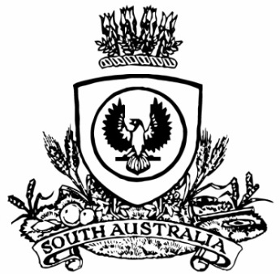
SUPPLEMENTARY GAZETTE
THE SOUTH AUSTRALIAN
GOVERNMENT GAZETTE
Published by Authority

Adelaide, Monday, 1 May 2023

Contents

State Government Instruments

Fisheries Management (General) Regulations 2017 890

State Government Instruments

Fisheries Management (General) Regulations 2017
Abalone Fishing Areas in the Southern Zone
For the purpose of regulation 3(1) relating to abalone fishing areas - I declare the following areas in the Southern Zone Abalone Fishery described in this notice to be abalone fishing areas as of 1 May 2023.
Abalone Fishing Areas
Area 1 - Cape Jaffa
The waters of or near Lacepede Bay contained within and bounded by a line commencing at Point 1 (36°35'5.954" South, 139°40'28.031" East), then easterly to the line of Mean High Water Springs closest to Point 2 (36°35'5.954" South, 139°49'52.299" East), then beginning south-easterly along the line of Mean High Water Springs to the location closest to Point 3 (37°13' 48.849" South, 139°46' 56.488" East), then westerly to Point 4 (37°13' 43.951"South, 139°37' 34.027" East), then north-westerly to Point 5 (37°9' 49.951" South, 139°34' 8.028" East), then northerly to Point 6 (36°50' 52.952" South, 139°34'8.025" East), then easterly to Point 7 (36°50' 52.952" South, 139°40' 28.025" East), then northerly to the point of commencement.
Area 2 - Nora Creina
The waters of or near Robe contained within and bounded by a line commencing at Point 4 (37°13' 43.951"South, 139°37' 34.027" East), then easterly to the line of Mean High Water Springs closest to Point 3 (37°13' 48.849" South, 139°46' 56.488" East), then beginning south-easterly along the line of Mean High Water Springs to the location closest to Point 8 (37°26'1.868" South, 139°57'0.224" East), then west south-westerly to Point 9 (37°26'59.951" South, 139°49'17.027" East), then north-westerly to the point of commencement.
Area 3 - Beachport
The waters of or near Beachport contained within and bounded by a line commencing at Point 9 (37°26' 59.951" South 139°49'17.027" East), then east north-easterly to the line of Mean High Water Springs closest to Point 8 (37°26'1.868" South 139°57'0.224" East), then beginning south-easterly along the line of Mean High Water Springs to the location closest to Point 10 (37°29'9.096" South 140°3'41.603" East), then south-westerly to Point 11 (37°31'58.951" South 139°53'55.027" East), then north-westerly to the point of commencement.
Area 4 - Rivoli Bay
The waters of or near Beachport contained within and bounded by a line commencing at Point 11 (37°31'58.951" South 139°53'55.027" East), then north-easterly to the line of Mean High Water Springs closest to Point 10 (37°29'9.096" South 140°3'41.603" East), then beginning south-easterly along the line of Mean High Water Springs to the location closest to Point 12 (37°33'54.548" South 140°6'28.085" East), then south-westerly to Point 13 (37°35'43.951" South 139°57'29.027" East), then north-westerly to the point of commencement.
Area 5 - Southend
The waters of or near Southend contained within and bounded by a line commencing at Point 13 (37°35'43.951" South 139°57'29.027" East), then north-easterly to the line of Mean High Water Springs closest to Point 12 (37°33'54.548" South 140°6'28.085" East), then beginning south-easterly along the line of Mean High Water Springs to the location closest to Point 14 (37°38'30.932" South 140°12'18.510" East), then west south-westerly to Point 15 (37°39'36.952" South 140°1'11.028" East), then north-westerly to the point of commencement.
Area 6 - Number 2 Rocks
The waters of or near Millicent contained within and bounded by a line commencing at Point 15 (37°39'36.952" South 140°1'11.028" East), then east north-easterly to the line of Mean High Water Springs closest to Point 14 (37°38'30.932" South 140°12'18.510" East), then beginning south-easterly along the line of Mean High Water Springs to the location closest to Point 16 (37°51'16.428" South 140°21'25.402" East), then westerly to Point 17 (37°51'17.949" South 140°16'25.025" East), then north-westerly to Point 18 (37°45' 32.949" South 140°10'34.026" East), then north-westerly to Point 19 (37°43'36.951" South 140°5'48.028" East), then north-westerly to the point of commencement.
Area 7 - Admella
The waters of or near Tantanoola contained within and bounded by a line commencing at Point 17 (37°51'17.949" South 140°16'25.025" East), then easterly to the line of Mean High Water Springs closest to Point 16 (37°51'16.428" South 140°21'25.402" East), then beginning south-easterly along the line of Mean High Water Springs to the location closest to Point 20 (37°53'54.825" South 140°22'31.501" East), then south-westerly to Point 21 (37°56'51.948" South 140°17'48.024" East) then north north-westerly to the point of commencement.
Area 8 - Carpenters Rocks
The waters of or near Tantanoola contained within and bounded by a line commencing at Point 21 (37°56'51.948" South 140°17'48.024" East)), then north-easterly to the line of Mean High Water Springs closest to Point 20 (37°53'54.825" South 140°22'31.501" East), then beginning south-easterly along the line of Mean High Water Springs to the location closest to Point 23 (37°55'9.000" South 140°23'48.185" East), then south-westerly to Point 24 (38°0'12.950" South 140°18'52.023" East), then north north-westerly to the point of commencement.
Area 9 - Gerloffs Bay
The waters of or near Tantanoola contained within and bounded by a line commencing at Point 24 (38°0'12.950" South 140°18'52.023" East) then north-easterly to the line of Mean High Water Springs closest to Point 23 (37°55'9.000" South 140°23'48.185" East), then beginning south-easterly along the line of Mean High Water Springs to the location closest to Point 25 (37°56'58.243" South 140°27'58.619" East), then south-westerly to Point 26 (38°1'23.949" South 140°22'46.023" East), then west north-westerly to the point of commencement.
Area 10 - Blackfellows Caves
The waters of or near Tantanoola contained within and bounded by a line commencing at Point 26 (38°1'23.949" South 140°22'46.023" East), then north-easterly to the line of Mean High Water Springs closest to Point 25 (37°56'58.243" South 140°27'58.619" East), then beginning south-easterly along the line of Mean High Water Springs to the location closest to Point 27 (37°59'23.571" South 140°31'1.744" East), then south-westerly to Point 28 (38°2'48.951" South 140°27'27.023" East), then west north-westerly to the point of commencement.
Area 11A - Nene Valley
The waters of or near Nene Valley contained within and bounded by a line commencing at Point 28 (38°2'48.951" South 140°27'27.023" East), then north-easterly to the line of Mean High Water Springs closest to Point 27 (37°59'23.571" South 140°31'1.744" East), then beginning south-easterly along the line of Mean High Water Springs to the location closest to Point 35 (38°1'14.810" South 140°34'14.150" East), then south-westerly to Point 36 (38°4'23.095" South 140°31'52.618" East), then north-westerly to the point of commencement.
Area 11 - Middle Point
The waters of or near Blanche Bay contained within and bounded by a line commencing at Point 36 (38°4'23.095" South 140°31'52.618" East), then north-easterly to the line of Mean High Water Springs closest to Point 35 (38°1'14.810" South 140°34'14.150" East), then beginning south-easterly along the line of Mean High Water Springs to the location closest to Point 29 (38°3'30.001" South 140°40'20.025" East), then south to Point 30 (38°7'22.952" South 140°40'20.025" East), then north-westerly to the point of commencement.
Area 12 - Port MacDonnell
The waters of or near Port MacDonnell contained within and bounded by a line commencing on the line of Mean High Water Springs closest to Point 29 (38°3'30.001" South 140°40'20.025" East), then beginning easterly along the line of Mean High Water Springs to the location closest to Point 31 (38°3'32.770" South 140°46'13.861" East), then south to Point 32 (38°7'22.952" South 140°46'14.026" East), then west to Point 30 (38°7'22.952" South 140°40'20.025" East), then north to the point of commencement.
Area 13 - East Port MacDonnell
The waters of or near Port MacDonnell contained within and bounded by a line commencing on the line of Mean High Water Springs closest to Point 31 (38°3'32.770" South 140°46'13.861" East), then beginning easterly along the line of Mean High Water Springs to the eastern border of the State of South Australia closest to Point 33 (38°3' 23.129" South 140°57'57.736" East), then southerly along the border of the State to the boundary of the State waters, then southerly along that boundary to Point 34 (38°7' 22.952" South 140°57'56.942" East) then west to Point 32 (38°7'22.952" South 140°46'14.026" East), then north to the point of commencement.
Please note for the purposes of this declaration, all coordinates are provided in Geocentric Datum of Australia 2020 (GDA2020)
Dated: 28 April 2023
Prof Gavin Begg
Executive Director, Fisheries and Aquaculture
Delegate of the Minister for Primary Industries and Regional Development

Note: This map is provided for convenience of reference only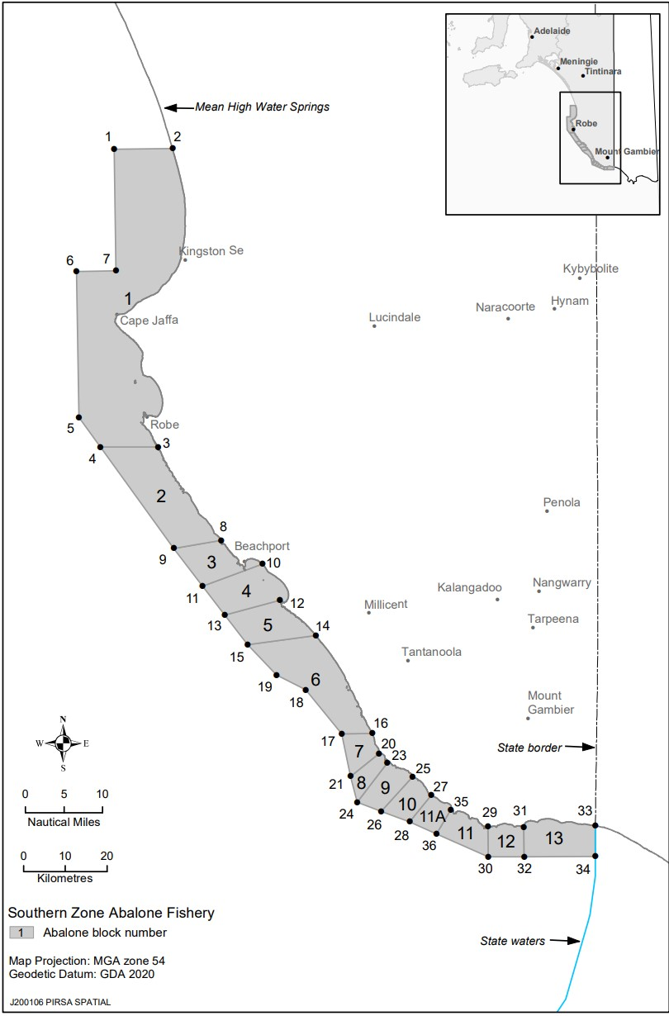

Fisheries Management (General) Regulations 2017
Section 115
Ministerial Exemption ME9903224
TAKE NOTICE that the Ministerial exemption notice issued pursuant to section 115 of the Fisheries Management Act 2007 to the holder of a Southern Zone Abalone Fishery licence or their registered masters dated 26 September 2022 being the first notice on page 6300 of the South Australian Government Gazette dated 6 October 2022 is REVOKED effective 1 May 2023.
Dated: 28 April 2023
Prof Gavin Begg
Executive Director, Fisheries and Aquaculture
Delegate of the Minister for Primary Industries and Regional Development

Fisheries Management (General) Regulations 2017
Undersized Blacklip Abalone—Southern Zone Abalone Fishery
TAKE notice that for the purposes of clause 5(2)(a) of Part 2 of Schedule 2 of the Fisheries Management (General) Regulations 2017 I hereby revoke the notice dated 10 September 2021 declaring undersized lengths of Blacklip Abalone in the Southern Zone Abalone Fishery being the third notice published on page 3596 in the South Australian Government Gazette dated 16 September 2021 and hereby declare that Blacklip Abalone (Haliotis rubra) taken in an abalone fishing area of the Southern Zone Abalone Fishery is undersized if its length is less than that specified below:
Abalone Fishing area* | Location | Minimum legal length (mm)
1 | Cape Jaffa | 125
2 | Nora Creina | 125
3 | Beachport | 125
4 | Rivoli Bay | 110
5 | South End | 125
6 | Number 2 Rocks | 125
7 | Admella | 125
8 | Carpenters Rocks | 125
9 | Gerloff Bay | 112
10 | Blackfellows Caves | 125
11A | Nene Valley | 110
11 | Middle Point | 120
12 | Port MacDonnell | 122
13 | East Port MacDonnell | 100

* As defined in regulation 3 (1) of the Fisheries Management (General) Regulations 2017.
Dated: 28 April 2023
Prof Gavin Begg
Executive Director, Fisheries and Aquaculture
Delegate of the Minister for Primary Industries and Regional Development

All instruments appearing in this gazette are to be considered official, and obeyed as such

Printed and published weekly by authority of M. Dowling, Government Printer, South Australia
$8.15 per issue (plus postage), $411.00 per annual subscription—GST inclusive
Online publications: www.governmentgazette.sa.gov.au

