No. 83 p. 3651
THE SOUTH AUSTRALIAN
GOVERNMENT GAZETTE
Published by Authority

Adelaide, Thursday, 2 November 2023

Contents

Governor’s Instruments
Acts—No. 31 of 2023 3652
Appointments 3652
Regulations—
Southern State Superannuation (Miscellaneous)
Amendment Regulations 2023—No. 107 of 2023 3654
Native Vegetation (Yoorndoo Ilga Solar Project)
Amendment Regulations 2023—No. 108 of 2023 3656
State Government Instruments
Agricultural and Veterinary Products (Control of Use) Regulations 2017 3660
Aquaculture Act 2001 3660
Fisheries Management (Prawn Fisheries) Regulations 2017 3694
Housing Improvement Act 2016 3695
Justices of the Peace Act 2005 3695
Land Acquisition Act 1969 3696
Livestock Act 1997 3697
Petroleum and Geothermal Energy Act 2000 3700
Retail and Commercial Leases Act 1995 3707
Road Traffic Act 1961 3707
South Australian Skills Act 2008 3708
The District Court of South Australia—
Port Augusta Circuit Court 3708
Local Government Instruments
City of Playford 3710
Barossa Council 3710
District Council of Cleve 3711
Yorke Peninsula Council 3711
Public Notices
Trustee Act 1936 3713

Governor’s Instruments

ACTS
Department of the Premier and Cabinet
Adelaide, 2 November 2023
Her Excellency the Governor directs it to be notified for general information that she has in the name and on behalf of His Majesty The King, this day assented to the undermentioned Bill passed by the Legislative Council and House of Assembly in Parliament assembled, viz.:
No. 31 of 2023—Statutes Amendment (Ombudsman and Auditor-General) Bill 2023
An Act to amend the Ombudsman Act 1972 and the Public Finance and Audit Act 1987
By command,
Peter Bryden Malinauskas
Premier

APPOINTMENTS
Department of the Premier and Cabinet
Adelaide, 2 November 2023
Her Excellency the Governor in Executive Council has been pleased to appoint the undermentioned to the Police Superannuation Board, pursuant to the provisions of the Police Superannuation Act 1990:
Member: from 2 November 2023 until 1 November 2026
Graeme Arthur Barton
Julie-anne Holmes
Michael Anthony Kent
Wade Thomas Burns
Deputy Member: from 2 November 2023 until 1 November 2026
Alannah Mary Pearce (Deputy to Barton)
Julie Elizabeth Thomas (Deputy to Holmes)
Leonie Joy Schulz (Deputy to Kent)
Daryl Wayne Mundy (Deputy to Burns)
Presiding Member: from 2 November 2023 until 1 November 2026
Graeme Arthur Barton
By command,
Peter Bryden Malinauskas
Premier
T&F23/081CS

Department of the Premier and Cabinet
Adelaide, 2 November 2023
Her Excellency the Governor in Executive Council has been pleased to appoint Dr James Muecke AM as Governor's Deputy of South Australia for the periods from 3.30pm on Sunday, 5 November 2023 until 12.30pm on Wednesday, 8 November 2023, and 9.00am on Tuesday, 14 November 2023 until 7.00pm on Thursday, 16 November 2023.
By command,
Peter Bryden Malinauskas
Premier

Department of the Premier and Cabinet
Adelaide, 2 November 2023
Her Excellency the Governor in Executive Council has been pleased to appoint the Honourable Chief Justice Christopher John Kourakis as Governor's Deputy of South Australia from 7.45am on Thursday, 23 November 2023 until 12.00pm on Friday, 24 November 2023.
By command,
Peter Bryden Malinauskas
Premier

Department of the Premier and Cabinet
Adelaide, 2 November 2023
Her Excellency the Governor in Executive Council has been pleased to appoint the people listed as Community Visitors for the terms specified - pursuant to the provisions of the Mental Health Act 2009:
Dianne Catherine Wheeler for a term of three years commencing on 2 November 2023 and expiring on 1 November 2026
Juliet Soila Koikai for a term of three years commencing on 2 November 2023 and expiring on 1 November 2026
Lisa Ann Chua for a term of three years commencing on 2 November 2023 and expiring on 1 November 2026
Muyang Amy Li for a term of three years commencing on 2 November 2023 and expiring on 1 November 2026
Tanya Seslija for a term of three years commencing on 2 November 2023 and expiring on 1 November 2026
Terence Hernen for a term of three years commencing on 2 November 2023 and expiring on 1 November 2026
Vicki Anne Toovey for a term of three years commencing on 2 November 2023 and expiring on 1 November 2026
Cecil Stephen Camilleri for a term of three years commencing on 20 December 2023 and expiring on 19 December 2026
Jacy Bree Arthur for a term of three years commencing on 15 December 2023 and expiring on 14 December 2026
Mary Stewart Hollard for a term of three years commencing on 7 February 2024 and expiring on 6 February 2027.
By command,
Peter Bryden Malinauskas
Premier
HEAC-2023-00033

Regulations
South Australia

Southern State Superannuation (Miscellaneous) Amendment Regulations 2023
under the Southern State Superannuation Act 2009

Contents
Part 1—Preliminary
1 Short title
2 Commencement
Part 2—Amendment of Southern State Superannuation Regulations 2009
3 Amendment of regulation 18—Prescribed rate of contributions (section 20 of Act)
4 Amendment of regulation 79—Inactive low balance and lost member accounts
5 Insertion of regulation 80
80 Voluntary payments by Board to Commissioner of Taxation

Part 1—Preliminary
1—Short title
These regulations may be cited as the Southern State Superannuation (Miscellaneous) Amendment Regulations 2023.
2—Commencement
These regulations come into operation on 30 November 2023.
Part 2—Amendment of Southern State Superannuation Regulations 2009
3—Amendment of regulation 18—Prescribed rate of contributions (section 20 of Act)
(1) Regulation 18(1)—delete "subregulation (2)" and substitute:
subregulations (2) and (3)
(2) Regulation 18—after subregulation (2) insert:
(3) Subregulation (1) does not apply to a member who is making salary sacrifice contributions at a rate of at least 5.3% of salary.
(4) If subregulation (1) ceases to apply to a member, the member will be taken to have made an election under section 20(1)(a) of the Act to make contributions to the Treasurer at the rate at which the member was contributing immediately before that cessation (and, accordingly, regulation 17 will apply as if such an election had been made).
4—Amendment of regulation 79—Inactive low balance and lost member accounts
Regulation 79(3)—after "Consolidated Account" insert:
(or, if the payment was made from a special deposit account, that account)
5—Insertion of regulation 80
After regulation 79 insert:
80—Voluntary payments by Board to Commissioner of Taxation
(1) The Treasurer may, on behalf of a member, spouse member or former member, pay an amount equal to the balance of an account maintained by the Board for the member, former member or spouse member to the Commissioner of Taxation if—
(a) the Board has determined that payment of the amount to the Commissioner is in the best interests of the member, spouse member or former member; and
(b) the payment is permitted under section 22 of the Superannuation (Unclaimed Money and Lost Members) Act 1999 of the Commonwealth.
(2) If a payment is made under subregulation (1), the Treasurer must reimburse the Consolidated Account (or, if the payment was made from a special deposit account, that account) by charging the Fund with an amount equal to the amount of the payment.
(3) The Board must then close the account in respect of which the payment was made, after which—
(a) if the Board maintains no other account in the name of the member, former member or spouse member—
(i) their membership or spouse membership of the scheme will cease (if it hasn't already done so); and
(ii) any rights in relation to superannuation under the Act will be taken to have been exhausted and no derivative rights will exist in relation to the member or spouse member under the Act; and
(b) in any other case—any rights in relation to superannuation in respect of the account will be taken to have been exhausted.
Editorial note—
As required by section 10AA(2) of the Legislative Instruments Act 1978, the Minister has certified that, in the Minister's opinion, it is necessary or appropriate that these regulations come into operation as set out in these regulations.
Made by the Governor
with the approval of the Treasurer and following consultation with the South Australian Superannuation Board and with the advice and consent of the Executive Council
on 2 November 2023
No 107 of 2023

South Australia

Native Vegetation (Yoorndoo Ilga Solar Project) Amendment Regulations 2023
under the Native Vegetation Act 1991

Contents
Part 1—Preliminary
1 Short title
2 Commencement
Part 2—Amendment of Native Vegetation Regulations 2017
3 Insertion of regulation 23A
23A Clearance on Yoorndoo Ilga Solar Project area land
4 Insertion of Schedule 2A
Schedule 2A—Yoorndoo Ilga Solar Project map

Part 1—Preliminary
1—Short title
These regulations may be cited as the Native Vegetation (Yoorndoo Ilga Solar Project) Amendment Regulations 2023.
2—Commencement
These regulations come into operation on the day on which they are made.
Part 2—Amendment of Native Vegetation Regulations 2017
3—Insertion of regulation 23A
After regulation 23 insert:
23A—Clearance on Yoorndoo Ilga Solar Project area land
(1) Pursuant to section 27(1)(b) of the Act, native vegetation may, subject to any other Act or law to the contrary, be cleared if—
(a) the land on which the vegetation is situated is in the Yoorndoo Ilga Solar Project area; and
(b) the clearance is incidental to a development that has been authorised under the Planning, Development and Infrastructure Act 2016; and
(c) the clearance is undertaken in accordance with a management plan that has been approved by the Council; and
(d) the Council is satisfied, after taking into account the full nature and extent of clearance that is to be undertaken on the relevant land and any commitments that have been made with respect to the establishment, restoration or maintenance of native vegetation, that the holder of a development authorisation (or a person acting on their behalf) has, on application to the Council to proceed with clearing the vegetation in accordance with this provision, made a payment into the Fund or, if the Council is satisfied that it is appropriate in the circumstances, agreed to make a payment into the Fund, of an amount considered by the Council to be sufficient to achieve a significant environmental benefit, in the manner contemplated by section 21(6) or (6a) of the Act, which outweighs the value of retaining the vegetation.
(2) In this regulation—
Yoorndoo Ilga Solar Project area means the land within the shaded area in the map set out in Schedule 2A and described as the "Yoorndoo Ilga Solar Project Development Site".
4—Insertion of Schedule 2A
After Schedule 2 insert:
Schedule 2A—Yoorndoo Ilga Solar Project map
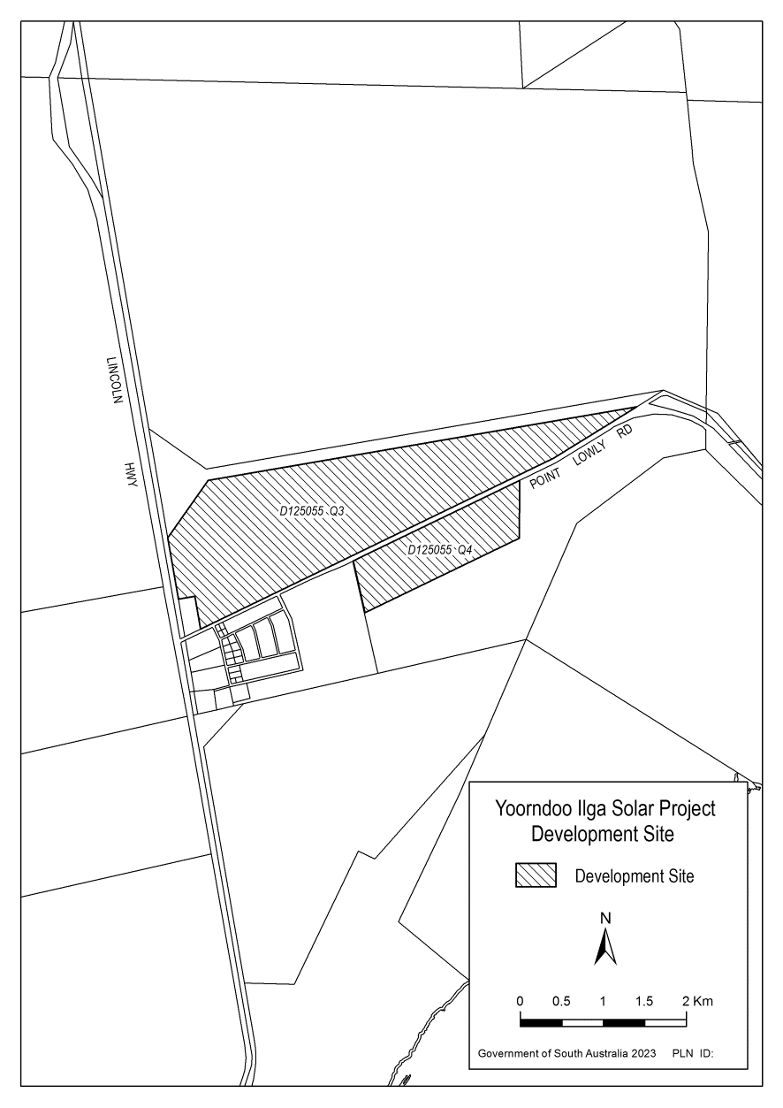
Editorial note—
As required by section 10AA(2) of the Legislative Instruments Act 1978, the Minister has certified that, in the Minister's opinion, it is necessary or appropriate that these regulations come into operation as set out in these regulations.
Made by the Governor
with the advice and consent of the Executive Council
on 2 November 2023
No 108 of 2023

State Government Instruments

Agricultural and Veterinary Products (Control of Use) Regulations 2017
Regulations 7(2)
Approval of Quality Assurance Schemes
I, Nicholas Mark Secomb, Chief Inspector under the Plant Health Act 2009, for and on behalf of the Minister for Primary Industries and Regional Development, hereby approve, pursuant to Regulation 7(2) of the Agricultural and Veterinary Products (Control of Use) Regulations 2017 the quality assurance schemes listed in Column A for the specified crops listed opposite in Column B. Pursuant to Regulation 7(3) a person is an accredited participant of an approved quality assurance scheme only if he or she satisfies the corresponding requirements for that scheme specified in Column C.
This notice revokes previous notices made by the Chief Inspector (Plant Health Act 2009) pursuant to Regulation 7 on 5 October 2022, published on 13 October 2022 page 6315 and on 18 December 2020, published on 7 January 2021 page 4.

Column A | Column B | Column C
The schemes established by Freshcare; Food Safety & Quality Standard Edition 4.2 published by Freshcare Ltd, NSW, Australia. | Carrot, basil, beetroot, chives, parsley – continental, coriander, dill, kale, lemon thyme, mint, oregano, parsley, pomegranate, radish, rocket, rosemary, sage, silverbeet, spinach, spring onions, tarragon, thai basil, thyme, watercress. | A current certification of Freshcare for the supply of a crop of a kind for which the scheme is approved, issued by Freshcare Ltd.
A scheme established by the Harmonised Australian Retailer Produce Scheme Standard Version  2.0 | Carrot, beetroot, parsley – continental, coriander, kale, parsley, pomegranate, radish, silverbeet, spinach, spring onions. | A current certification meeting the requirements of the Harmonised Australian Retailer Produce Scheme for the supply of a crop of a kind for which the scheme is approved.
A scheme established by the Recommended International Code of Practice General Principles of Food Hygiene CAC/RCP 1- 1969 including Annex on Hazard Analysis  and Critical Control Point (HACCP) System and Guidelines for its Application, as adopted by the Codex Alimentarius Commission in 1997 | Carrot | A current certification meeting the requirements of Codex Alimentarius Alinorm:97/13A for the supply of a crop of a kind for which the scheme is approved.

Dated: 27 October 2023
Nicholas Mark Secomb
Chief Inspector (Plant Health 2009)
Under authority of the Minister for Primary Industries and Regional Development

Aquaculture Act 2001
South Australia
Aquaculture (Approval of Lower Eyre Peninsula Zones Policy) Notice 2023
under section 12 of the Aquaculture Act 2001
1—Short title
This notice may be cited as the Aquaculture (Approval of Lower Eyre Peninsula Zones Policy) Notice 2023.

2—Approval of aquaculture policy
(1) The Aquaculture (Zones—Lower Eyre Peninsula) Policy 2023 is approved.
(2) The policy comes into operation on the day on which this notice is published in the Gazette.
Made by the Minister for Primary Industries and Regional Development
with the concurrence of the Minister for Climate, Environment and Water
on 2 November 2023

Aquaculture Act 2001
South Australia
Aquaculture (Zones—Lower Eyre Peninsula) Policy 2023
under the Aquaculture Act 2001

Contents
Part 1—Preliminary
1 Short title
2 Interpretation
3 Object of policy
4 Aquaculture permitted in aquaculture zone
5 Prescription of criteria does not limit matters that may be taken into account
6 Certain amendments may be made by Gazette notice only
Part 2—Boston Bay aquaculture zone
7 Identification of aquaculture zone
8 Designation of aquaculture zone as public call area
9 Prescribed criteria
Part 3—Buffalo Reef aquaculture exclusion zone
10 Identification of aquaculture exclusion zone
Part 4—Dangerous Reef aquaculture exclusion zone
11 Identification of aquaculture exclusion zone
Part 5—Lincoln aquaculture exclusion zone
12 Identification of aquaculture exclusion zone
Part 6—Lincoln aquaculture zone
13 Lincoln aquaculture zone
14 Designation of aquaculture zone as public call area
15 Classes of permitted aquaculture
16 Prescribed criteria
Part 7—Louth Bay aquaculture zone
17 Identification of aquaculture zone
18 Designation of aquaculture zone as public call area
19 Class of permitted aquaculture
20 Prescribed criteria
Part 8—Murray Point aquaculture zone
21 Identification of aquaculture zone
22 Designation of aquaculture zone as public call area
23 Classes of permitted aquaculture
24 Prescribed criteria
Part 9—Point Boston aquaculture zone
25 Identification of aquaculture zone
26 Designation of aquaculture zone as public call area
27 Class of permitted aquaculture
28 Prescribed criteria
Part 10—Proper Bay aquaculture zone
29 Identification of aquaculture zone
30 Designation of aquaculture zone as public call area
31 Classes of permitted aquaculture
32 Prescribed criteria
Part 11—Sir Joseph Banks aquaculture exclusion zone
33 Sir Joseph Banks aquaculture exclusion zone
Part 12—Tod River aquaculture zone
34 Identification of aquaculture zone
35 Designation of aquaculture zone as public call area
36 Class of permitted aquaculture
37 Prescribed criteria
Part 13—Miscellaneous
38 Prescribed criteria for all aquaculture zones
Schedule 1—Descriptions of zones
1 Description of Boston Bay aquaculture zone
2 Description of Buffalo Reef aquaculture exclusion zone
3 Description of Dangerous Reef aquaculture exclusion zone
4 Description of Lincoln aquaculture exclusion zone
5 Description of Lincoln aquaculture zone
6 Description of Louth Bay aquaculture zone
7 Description of Murray Point aquaculture zone
8 Description of Point Boston aquaculture zone
9 Description of Proper Bay aquaculture zone
10 Description of Sir Joseph Banks aquaculture exclusion zone
11 Description of Tod River aquaculture zone
Schedule 2—Maps of zones
Schedule 3—Amendment of policy by Gazette notice (Lincoln aquaculture zone)
1 Amendment of clause 2—Interpretation
2 Amendment of clause 13—Lincoln aquaculture zone
3 Amendment of clause 16—Prescribed criteria
4 Amendment of Schedule 1—Descriptions of zones
5 Amendment of Schedule 2—Maps of zones

Schedule 4—Repeal of Aquaculture (Zones—Lower Eyre Peninsula) Policy 2013

Part 1—Preliminary
1—Short title
This policy may be cited as the Aquaculture (Zones—Lower Eyre Peninsula) Policy 2023.
2—Interpretation
(1) In this policy—
Act means the Aquaculture Act 2001;
algae means eukaryotic macroalgae;
Bicker Isles sector means the area within the Boston Bay aquaculture zone described in Schedule 1 clause 1(a);
bivalve molluscs includes clams, cockles, mussels, oysters, pipis, scallops and razorfish;
Boston Bay (outer) sector means the area within the Boston Bay aquaculture zone described in Schedule 1 clause 1(c);
Boston Bay sector means the area within the Boston Bay aquaculture zone described in Schedule 1 clause 1(b);
conservation park has the same meaning as in the National Parks and Wildlife Act 1972;
finfish means all members of the classes Actinopterygii, Elasmobranchii and Myxini;
leased area, in an aquaculture zone or a sector in an aquaculture zone, means the total area in the zone or sector subject to lease;
Lincoln (inner) sector means the area within the Lincoln aquaculture zone described in Schedule 1 clause 5(a);
Lincoln (outer) sector means the area within the Lincoln aquaculture zone described in Schedule 1 clause 5(b);
national park has the same meaning as in the National Parks and Wildlife Act 1972;
Point Boston (north) sector means the area within the Point Boston aquaculture zone described in Schedule 1 clause 8(b);
Point Boston (south) sector means the area within the Point Boston aquaculture zone described in Schedule 1 clause 8(a);
prescribed wild caught tuna means members of the genera Allothunnus, Auxis, Euthunnus, Katsuwonus, and Thunnus that have been taken from the wild;
Proper Bay (east) sector means the area within the Proper Bay aquaculture zone described in Schedule 1 clause 9(b);
Proper Bay (west) sector means the area within the Proper Bay aquaculture zone described in Schedule 1 clause 9(a).
(2) For the purposes of the descriptions of aquaculture zones or aquaculture exclusion zones in this policy, unless the contrary intention appears, all lines in spatial descriptions are geodesics based on the Geocentric Datum of Australia 2020 (GDA2020) as defined in the determination under section 8A of the National Measurement Act 1960 of the Commonwealth for the recognised-value standard of measurement position, and all coordinates are expressed in terms of GDA2020.
(3) The point references given in a description identifying an aquaculture zone or aquaculture exclusion zone in Schedule 1 are references to the corresponding points in the map of that zone in Schedule 2.
3—Object of policy
Pursuant to section 11 of the Act, this policy—
(a) identifies aquaculture zones in which aquaculture or specified classes of aquaculture are permitted; and
(b) identifies aquaculture exclusion zones in which aquaculture is not permitted; and
(c) designates aquaculture zones or parts of aquaculture zones as public call areas; and
(d) specifies for an aquaculture zone prescribed criteria to be taken into account in the determination of applications for licences or in the making of other decisions under the Act in relation to the zone.
4—Aquaculture permitted in aquaculture zone
(1) Subject to subclause (2), aquaculture is permitted in an aquaculture zone identified in this policy.
(2) If this policy specifies a class of aquaculture that is permitted in a zone, then only the specified class of aquaculture is permitted in that zone.
5—Prescription of criteria does not limit matters that may be taken into account
This policy does not limit the matters that may be taken into account in the determination of applications for licences or in the making of other decisions under the Act.
6—Certain amendments may be made by Gazette notice only
Pursuant to section 14 of the Act, the Minister may, by notice in the Gazette, amend this policy as prescribed in Schedule 3.
Part 2—Boston Bay aquaculture zone
7—Identification of aquaculture zone
The Boston Bay aquaculture zone (consisting of the Bicker Isles sector, the Boston Bay sector and the Boston Bay (outer) sector) comprises the State waters described in Schedule 1 clause 1.
8—Designation of aquaculture zone as public call area
The Boston Bay aquaculture zone is designated as a public call area.
9—Prescribed criteria
(1) In the determination of applications for licences and in the making of other decisions under the Act in relation to the Boston Bay aquaculture zone, the following prescribed criteria must be taken into account:
(a) in the area comprised of the Boston Bay sector and Bicker Isles sector, the biomass of the aquatic animals (other than prescribed wild caught tuna) being farmed in the zone in a manner that involves supplementary feeding must not exceed—
(i) an amount that would, in the opinion of the Minister, have an environmental impact on the zone equivalent to the environmental impact that 1 696 tonnes of finfish would have on the zone; or
(ii) if some other amount is specified by the Minister by notice in the Gazette, that other amount;
(b) in the Boston Bay sector—
(i) the leased area must not exceed 273 hectares; and
(ii) prescribed wild caught tuna must not be farmed other than for the purposes of—
(A) research; or
(B) a business constituted of education; or
(C) a business constituted of tourism; and
(iii) the biomass of prescribed wild caught tuna being farmed must not exceed 38 tonnes or, if some other amount is specified by the Minister by notice in the Gazette, that other amount; and
(iv) the area for the farming of bivalve molluscs must not exceed 149 hectares or, if some other area is specified by the Minister by notice in the Gazette, that other area; and
(v) the biomass of bivalve molluscs being farmed must not exceed 2 980 tonnes or, if some other amount is specified by the Minister by notice in the Gazette, that other amount;
(c) in the Boston Bay (outer) sector—
(i) the leased area must not exceed 2 000 hectares; and
(ii) prescribed wild caught tuna must not be farmed; and
(iii) the biomass of the aquatic animals being farmed in the zone in a manner that involves supplementary feeding must not exceed—
(A) an amount that would, in the opinion of the Minister, have an environmental impact on the zone equivalent to the environmental impact that 23 080 tonnes of finfish would have on the zone; or
(B) if some other amount is specified by the Minister by notice in the Gazette, that other amount; and
(iv) the biomass of bivalve molluscs being farmed must not exceed 40 000 tonnes or, if some other amount is specified by the Minister by notice in the Gazette, that other amount;
(d) in the Bicker Isles sector—
(i) the leased area must not exceed 80 hectares; and
(ii) the area for the farming of bivalve molluscs must not exceed 20 hectares or, if some other area is specified by the Minister by notice in the Gazette, that other area; and
(iii) the biomass of bivalve molluscs being farmed must not exceed 400 tonnes or, if some other amount is specified by the Minister by notice in the Gazette, that other amount; and
(iv) prescribed wild caught tuna must not be farmed.
(2) However, a notice under subclause (1)(b)(v), (c)(iv) or (d)(iii) must not increase the biomass of bivalve molluscs that may be farmed in a sector unless the Minister is satisfied that the increase would not compromise the overall productivity of the bivalve mollusc industry being carried on in the sector.
Part 3—Buffalo Reef aquaculture exclusion zone
10—Identification of aquaculture exclusion zone
The Buffalo Reef aquaculture exclusion zone comprises the State waters described in Schedule 1 clause 2.
Part 4—Dangerous Reef aquaculture exclusion zone
11—Identification of aquaculture exclusion zone
The Dangerous Reef aquaculture exclusion zone comprises the State waters described in Schedule 1 clause 3.
Part 5—Lincoln aquaculture exclusion zone
12—Identification of aquaculture exclusion zone
The Lincoln aquaculture exclusion zone comprises the State waters described in Schedule 1 clause 4.
Part 6—Lincoln aquaculture zone
13—Lincoln aquaculture zone
The Lincoln aquaculture zone (consisting of the Lincoln (inner) sector and the Lincoln (outer) sector) comprises the State waters described in Schedule 1 clause 5.
14—Designation of aquaculture zone as public call area
The Lincoln aquaculture zone is designated as a public call area in relation to the farming of algae.
15—Classes of permitted aquaculture
The classes of aquaculture permitted in the Lincoln aquaculture zone are—
(a) the farming of prescribed wild caught tuna; and
(b) the farming of algae.
16—Prescribed criteria
In the determination of applications for licences and in the making of other decisions under the Act in relation to the Lincoln aquaculture zone, the following prescribed criteria must be taken into account:
(a) in the Lincoln (inner) sector—
(i) the leased area must not exceed 2 100 hectares; and
(ii) the area for the farming of prescribed wild caught tuna must not exceed 2 000 hectares or, if some other area is specified by the Minister by notice in the Gazette, that other area; and
(iii) the area for the farming of algae must not exceed 100 hectares or, if some other area is specified by the Minister by notice in the Gazette, that other area; and
(iv) the biomass of prescribed wild caught tuna being farmed must not exceed 16 955 tonnes or, if some other amount is specified by the Minister by notice in the Gazette, that other amount;
(b) in the Lincoln (outer) sector—
(i) the leased area must not exceed 3 500 hectares; and
(ii) the biomass of prescribed wild caught tuna being farmed must not exceed 34 384 tonnes or, if some other amount is specified by the Minister by notice in the Gazette, that other amount.
Part 7—Louth Bay aquaculture zone
17—Identification of aquaculture zone
The Louth Bay aquaculture zone comprises the State waters described in Schedule 1 clause 6.
18—Designation of aquaculture zone as public call area
The Louth Bay aquaculture zone is designated as a public call area.
19—Class of permitted aquaculture
The class of aquaculture permitted in the Louth Bay aquaculture zone is the farming of aquatic organisms other than prescribed wild caught tuna.
20—Prescribed criteria
(1) In the determination of applications for licences and in the making of other decisions under the Act in relation to the Louth Bay aquaculture zone, the following prescribed criteria must be taken into account:
(a) the leased area in the zone must not exceed 530 hectares;
(b) the biomass of the aquatic animals being farmed in the zone in a manner that involves supplementary feeding must not exceed—
(i) an amount that would, in the opinion of the Minister, have an environmental impact on the zone equivalent to the environmental impact that 7 953 tonnes of finfish would have on the zone; or
(ii) if some other amount is specified by the Minister by notice in the Gazette, that other amount;
(c) the area in the zone for the farming of bivalve molluscs must not exceed 155 hectares or, if some other area is specified by the Minister by notice in the Gazette, that other area;
(d) the biomass of bivalve molluscs being farmed in the zone must not exceed 3 100 tonnes or, if some other amount is specified by the Minister by notice in the Gazette, that other amount.
(2) However, a notice under subclause (1)(d) must not increase the biomass of bivalve molluscs that may be farmed in the zone unless the Minister is satisfied that the increase would not compromise the overall productivity of the bivalve mollusc industry being carried on in the zone.
Part 8—Murray Point aquaculture zone
21—Identification of aquaculture zone
The Murray Point aquaculture zone comprises the State waters described in Schedule 1 clause 7.
22—Designation of aquaculture zone as public call area
The Murray Point aquaculture zone is designated as a public call area.
23—Classes of permitted aquaculture
The classes of aquaculture permitted in the Murray Point aquaculture zone are—
(a) the farming of bivalve molluscs other than mussels; and
(b) the farming of algae.
24—Prescribed criteria
In the determination of applications for licences and in the making of other decisions under the Act in relation to the Murray Point aquaculture zone, it must be taken into account that the leased area in the zone must not exceed 4 hectares.
Part 9—Point Boston aquaculture zone
25—Identification of aquaculture zone
The Point Boston aquaculture zone (consisting of the Point Boston (north) sector and the Point Boston (south) sector) comprises the State waters described in Schedule 1 clause 8.
26—Designation of aquaculture zone as public call area
The Point Boston aquaculture zone is designated as a public call area.
27—Class of permitted aquaculture
The class of aquaculture permitted in the Point Boston aquaculture zone is the farming of aquatic organisms other than finfish and prescribed wild caught tuna.
28—Prescribed criteria
(1) In the determination of applications for licences and in the making of other decisions under the Act in relation to the Point Boston aquaculture zone, the following prescribed criteria must be taken into account:
(a) the biomass of the aquatic animals being farmed in the zone in a manner that involves supplementary feeding must not exceed—
(i) an amount that would, in the opinion of the Minister, have an environmental impact on the zone equivalent to the environmental impact that 1 191 tonnes of finfish would have on the zone; or
(ii) if some other amount is specified by the Minister by notice in the Gazette, that other amount;
(b) in the Point Boston (north) sector—
(i) the leased area must not exceed 161 hectares; and
(ii) the area for the farming of bivalve molluscs must not exceed 141 hectares or, if some other area is specified by the Minister by notice in the Gazette, that other area; and
(iii) the biomass of bivalve molluscs being farmed must not exceed 2 820 tonnes or, if some other amount is specified by the Minister by notice in the Gazette, that other amount;
(c) in the Point Boston (south) sector—
(i) the leased area must not exceed 100 hectares; and
(ii) the area for the farming of bivalve molluscs must not exceed 60 hectares or, if some other area is specified by the Minister by notice in the Gazette, that other area; and
(iii) the biomass of bivalve molluscs being farmed must not exceed 1 200 tonnes or, if some other amount is specified by the Minister by notice in the Gazette, that other amount.
(2) However, a notice under subclause (1)(b)(iii) or (c)(iii) must not increase the biomass of bivalve molluscs that may be farmed in the zone unless the Minister is satisfied that the increase would not compromise the overall productivity of the bivalve mollusc industry being carried on in the zone.
Part 10—Proper Bay aquaculture zone
29—Identification of aquaculture zone
The Proper Bay aquaculture zone (consisting of the Proper Bay (east) sector and the Proper Bay (west) sector) comprises the State waters described in Schedule 1 clause 9.
30—Designation of aquaculture zone as public call area
The Proper Bay aquaculture zone is designated as a public call area.
31—Classes of permitted aquaculture
The classes of aquaculture permitted in the Proper Bay aquaculture zone are—
(a) the farming of bivalve molluscs; and
(b) the farming of algae.
32—Prescribed criteria
(1) In the determination of applications for licences and in the making of other decisions under the Act in relation to the Proper Bay aquaculture zone, the following prescribed criteria must be taken into account:
(a) the area in the zone for the farming of bivalve molluscs must not exceed 60 hectares or, if some other area is specified by the Minister by notice in the Gazette, that other area;
(b) the biomass of bivalve molluscs being farmed in the zone must not exceed 1 200 tonnes or, if some other amount is specified by the Minister by notice in the Gazette, that other amount;
(c) in the Proper Bay (east) sector—the leased area must not exceed 60 hectares;
(d) in the Proper Bay (west) sector—the leased area must not exceed 40 hectares.
(2) However, a notice under subclause (1)(b) must not increase the biomass of bivalve molluscs that may be farmed in the zone unless the Minister is satisfied that the increase would not compromise the overall productivity of the bivalve mollusc industry being carried on in the zone.
Part 11—Sir Joseph Banks aquaculture exclusion zone
33—Sir Joseph Banks aquaculture exclusion zone
The Sir Joseph Banks aquaculture exclusion zone comprises the State waters described in Schedule 1 clause 10.
Part 12—Tod River aquaculture zone
34—Identification of aquaculture zone
The Tod River aquaculture zone comprises the State waters described in Schedule 1 clause 11.
35—Designation of aquaculture zone as public call area
The Tod River aquaculture zone is designated as a public call area.
36—Class of permitted aquaculture
The class of aquaculture permitted in the Tod River aquaculture zone is the farming of bivalve molluscs other than mussels.
37—Prescribed criteria
(1) In the determination of applications for licences and in the making of other decisions under the Act in relation to the Tod River aquaculture zone, the following prescribed criteria must be taken into account:
(a) the leased area in the zone must not exceed 38 hectares;
(b) bivalve molluscs may only be introduced into an area within the zone from an area outside the zone if—
(i) the 2 areas are located within the same disease management area; or
(ii) the area outside the zone from which the molluscs originate is a certified biosecure area;
(c) the period for which a bivalve mollusc is farmed in the zone must not exceed 6 months.
(2) In this clause—
certified biosecure area means an area where measures are applied to mitigate the risks of introduction and spread of disease that has been annually inspected and certified as being biosecure by a competent authority of the State or Territory where the area is located;
competent authority, of a State or Territory of the Commonwealth, means a veterinary authority or government authority having the responsibility in that State or Territory for ensuring the implementation of animal health measures or veterinary health certification;
disease management area means—
(a) if the Minister, by notice in the Gazette, has defined disease management areas for the purposes of this clause—an area so defined; or
(b) in any other case—a disease management area as defined in Improving early detection surveillance and emergency disease response to Ostreid herpesvirus using a hydrodynamic dispersion model: Updating disease management areas for the South Australian oyster industry. FRDC Project No 2018-090 published by the Fisheries Research and Development Corporation.
Part 13—Miscellaneous
38—Prescribed criteria for all aquaculture zones
In the determination of applications for licences and in the making of other decisions under the Act in relation to the aquaculture zones in this policy, the following prescribed criteria must be taken into account:
(a) of the aggregated area leased or available for lease in those zones, at least 40 hectares must be used or available for use for the farming of aquatic organisms for the purposes of research or for the purposes of a business constituted of education or tourism (or both);
(b) the aggregated area in those zones used for the placement of unstocked farming structures must not exceed 105 hectares or, if some other area is specified by the Minister by notice in the Gazette, that other area.
Schedule 1—Descriptions of zones
1—Description of Boston Bay aquaculture zone
The Boston Bay aquaculture zone is, for the purposes of this policy, comprised of sectors identified as follows:
(a) the Bicker Isles sector, comprising the State waters contained within and bounded by a line commencing at 34°44′40.70″ South, 135°56′13.18″ East (Point 1), then north-easterly to 34°43'58.69" South, 135°57'53.91" East (Point 2), then south-easterly to 34°44'21.98" South, 135°58'08.61" East (Point 3), then south-westerly to 34°44'53.98" South, 135°57'32.54" East (Point 4), then north-westerly to a location on a line 250 metres seaward of Lincoln National Park boundary closest to 34°44'43.97" South, 135°57'26.67" East (Point 5), then beginning north-easterly following the line 250 metres seaward of Lincoln National Park boundary to the location closest to 34°44'42.32" South, 135°57'14.32" East (Point 6), then south-westerly to 34°45'18.80" South, 135°56'37.82" East (Point 7), then north-westerly to the point of commencement;
(b) the Boston Bay sector, comprising the State waters contained within and bounded by—
(i) a line commencing at mean high water springs closest to 34°44'00.18" South, 135°55'47.22" East (Point 8), then beginning north-easterly following the line of mean high water springs to the location closest to 34°43'36.38″ South, 135°56'54.73" East (Point 9), then south-westerly to the point of commencement; and
(ii) a line commencing at 34°40'52.55" South, 135°54'02.33" East (Point 10), then north-easterly to 34°40'41.56" South, 135°54'18.84" East (Point 11), then south-easterly to 34°40'45.33" South, 135°54'36.89" East (Point 12), then south-westerly to 34°42'05.38" South, 135°54'26.41" East (Point 13), then south-easterly to 34°43'37.79" South, 135°55'09.14" East (Point 14), then north-easterly to 34°43'31.34" South, 135°55'29.23" East (Point 15), then south-easterly to 34°43'43.30" South, 135°55'34.98" East (Point 16), then southerly to 34°43'56.18" South, 135°55'36.15" East (Point 17), then north-westerly to 34°43'31.80" South, 135°54'22.38" East (Point 18), then north-westerly to 34°42'55.10" South, 135°54'03.65" East (Point 19), then northerly to the point of commencement; and
(iii) a line commencing at a location on a line 1 000 metres seaward of mean high water springs closest to 34°39'16.56" South, 135°55'18.33" East (Point 20), then south-westerly to 34°39'51.10" South, 135°53'53.73" East (Point 21), then south-westerly to 34°40'51.24" South, 135°52'59.13" East (Point 22), then south-westerly to 34°41'56.78" South, 135°52'25.83" East (Point 23), then south-westerly to a location on a line 1 000 metres seaward of mean high water springs closest to 34°42'00.93" South, 135°51'56.96" East (Point 24), then beginning northerly following the line 1 000 metres seaward of mean high water springs to the point of commencement;
(c) the Boston Bay (outer) sector, comprising the State waters contained within and bounded by a line commencing at a location on a line 15 000 metres seaward from a point closest to 34°48′54.71″ South, 136°12′45.48″ East (Dangerous Reef) closest to 34°47'29.76" South, 136°22'26.54" East (Point 88), then easterly to 34°47'34.52" South, 136°32'32.02" East, (Point 87), then southerly to 34°50'25.95" South, 136°32'32.03" East (Point 89), then south-westerly to 34°53'16.95" South, 136°29'00.83" East (Point 90), then westerly to 34°53'16.95" South, 136°21'05.87" East (Point 91), then beginning northerly following a line 15 000 metres seaward from a point closest to 34°48′54.71″ South, 136°12′45.48″ East (Dangerous Reef) to the point of commencement.
2—Description of Buffalo Reef aquaculture exclusion zone
The Buffalo Reef aquaculture exclusion zone comprises the State waters contained within and bounded by circle of radius 2 000 metres centred on a point near Buffalo Reef closest to 34°43'07.81"South, 136°27'45.52" East (Point 31).
3—Description of Dangerous Reef aquaculture exclusion zone
The Dangerous Reef aquaculture exclusion zone comprises the State waters contained within and bounded by a line commencing at a location on the line 5 000 metres seaward from a point closest to 34°48′54.71″ South, 136°12′45.48″ East (Dangerous Reef) closest to 34°47′08.02″ South, 136°10′16.99″ East (Point 115), then northerly to 34°46′53.41″ South, 136°10′17.00″ East (Point 116), then easterly to a location on the line 5 000 metres seaward from a point closest to 34°48′54.71″ South, 136°12′45.48″ East (Dangerous Reef) closest to 34°46′53.41″ South, 136°10′34.53″ East (Point 117), then beginning north-easterly following the line 5 000 metres seaward from a point closest to 34°48′54.71″ South, 136°12′45.48″ East (Dangerous Reef) closest to 34°46′16.44″ South, 136°13′29.16″ East (Point 118), then south-easterly following the line 5 000 metres seaward from a point closest to 34°48′54.71″ South, 136°12′45.48″ East (Dangerous Reef) to a location closest to 34°47′20.23″ South, 136°15′25.34″ East (Point 111), then generally south-easterly following the line 5 000 metres seaward from a point closest to 34°48′54.71″ South, 136°12′45.48″ East (Dangerous Reef) to a location closest to 34°48′07.37″ South, 136°15′53.55″ East (Point 112), then generally south-westerly to a location on the line 5 000 metres seaward from a point closest to 34°48′54.71″ South, 136°12′45.48″ East (Dangerous Reef) to a location closest to 34°49′42.73″ South, 136°15′53.29″ East (Point 114), then beginning south-westerly following the line 5 000 metres seaward from a point closest to 34°48′54.71″ South, 136°12′45.48″ East (Dangerous Reef) to point of commencement.
4—Description of Lincoln aquaculture exclusion zone
The Lincoln aquaculture exclusion zone comprises the State waters contained within and bounded by—
(a) a line commencing at mean high water springs closest to 34°34′32.25″ South, 135°54′34.16″ East (Point 32), then beginning north-easterly following the line of mean high water springs to a point closest to 34°32′37.70″ South, 136°05′19.96″ East (Point 53), then north-westerly to 34°32′19.95″ South, 136°01′33.27″ East (Point 52), then north-easterly to 34°32′11.91″ South, 136°01′55.72″ East (Point 51), then easterly to 34°32′10.74″ South, 136°02′26.31″ East (Point 50), then north-easterly to 34°31′50.29″ South, 136°03′06.24″ East (Point 49), then easterly to a point 1 000 metres seaward of mean high water springs closest to 34°31′47.85″ South, 136°04′22.60″ East (Point 48), then beginning north-easterly following the line 1 000 metres seaward of mean high water springs to the location closest to 34°31′05.21″ South, 136°04′27.74″ East (Point 47), then easterly to 34°31′05.20″ South, 136°04′27.82″ East (Point 46), then north-westerly to a point 1 000 metres seaward of mean high water springs closest to 34°31′04.89″ South, 136°04′27.61″ East (Point 45), then generally north-westerly following the line 1 000 metres seaward of mean high water springs to the location closest to 34°30′59.09″ South, 136°04′24.48″ East (Point 44),
then north-westerly to 34°30′58.99″ South, 136°04′23.70″ East (Point 43), then north-westerly to 34°30′58.14″ South, 136°04′23.14″ East (Point 42), then westerly to a point 1 000 metres seaward of mean high water springs closest to 34°30′58.13″ South, 136°04′18.95″ East (Point 41), then generally north-westerly following the line 1 000 metres seaward of mean high water springs to the location closest to 34°30′49.06″ South, 136°03′55.53″ East (Point 40), then westerly to a point 1 000 metres seaward of mean high water springs closest to 34°30′50.36″ South, 136°02′04.71″ East (Point 39), then beginning south-easterly following the line 1 000 metres seaward of mean high water springs to the location closest to 34°31′22.75″ South, 136°00′40.13″ East (Point 38), then south-westerly to a point 1 000 metres seaward of mean high water springs closest to 34°31′33.92″ South, 136°00′02.04″ East (Point 37), then generally south-westerly following the line 1 000 metres seaward of mean high water springs to the location closest to 34°31′41.91″ South, 135°59′34.74″ East (Point 36), then south-westerly to 34°32′30.92″ South, 135°56′47.33″ East (Point 35), then southerly to a point 1 000 metres seaward of mean high water springs closest to 34°33′33.39″ South, 135°56′46.09″ East (Point 34), then beginning south-easterly following the line 1 000 metres seaward of mean high water springs to the location closest to 34°35′08.40″ South, 135°58′17.57″ East (Point 92), then south-westerly following the line 1 000 metres seaward of mean high water springs to the location closest to 34°35′59.91″ South, 135°57′43.84″ East (Point 63), then south-westerly to 34°37′30.79″ South, 135°56′51.69″ East (Point 62), then south-easterly to 34°38′44.15″ South, 135°59′44.47″ East (Point 61), then north-easterly to a point 1 000 metres seaward of Sir Joseph Banks Group Conservation Park boundary closest to 34°37′55.98″ South, 136°07′49.65″ East (Point 120), then beginning south-westerly following the line 1 000 metres seaward of Sir Joseph Banks Group Conservation Park boundary to a point closest to 34°39′50.00″ South, 136°07′59.42″ East (Point 64), then south-westerly to 34°42′43.32″ South, 136°01′09.31″ East (Point 65), then south-easterly to 34°43′32.10″ South, 136°01′29.13″ East (Point 66), then westerly to a point on the line of mean high water springs closest to 34°43′31.61″ South, 135°59′43.64″ East (Point 67), then beginning westerly following the line of mean high water springs to the eastern boundary of Lincoln National Park, then beginning north-westerly following the said National Park boundary to the line of mean high water springs, then generally north-easterly following the said line of mean high water springs to a point closest to 34°45′14.35″ South, 135°50′38.37″ East (Point 100), then south-easterly to a location on a line 1 000 metres seaward of mean high water springs closest to 34°45′44.27″ South, 135°50′58.30″ East (Point 99), then south-westerly following the line 1 000 metres seaward of mean high water springs to the intersection of 1 000 metres seaward of Lincoln National Park boundary closest to 34°48′12.18″ South, 135°48′22.06″ East (Point 103), then beginning south-easterly following the line 1 000 metres seaward of Lincoln National Park boundary to a location closest to 34°47′38.40″ South, 135°51′34.99″ East (Point 102), then beginning south-easterly following the line 1 000 metres seaward of Lincoln National Park boundary to a location closest to 34°46′41.27″ South, 135°54′16.93″ East (Point 108), then north-westerly to 34°45′49.64″ South, 135°53′27.88″ East (Point 107), then south-westerly to 34°46′03.26″ South, 135°52′50.94″ East (Point 106), then south-westerly to a location on the mean high water springs line closest to 34°46′08.83″ South, 135°52′41.52″ East (Point 105, Grantham Island), then beginning south-westerly following the line of mean high water springs (Grantham Island) to a location closest to 34°46′23.26″ South, 135°52′21.78″ East (Point 104, Grantham Island), then south-westerly following a line 700 metres seaward of mean high water springs to a location closest to 34°46′31.92″ South, 135°51′39.45″ East (Point 101), then beginning north-westerly following the line 700 metres seaward of mean high water springs to a location closest to 34°45′42.39″ South, 135°51′19.31″ East (Point 98), then easterly to a location on the mean high water springs line closest to 34°45′41.90″ South, 135°51′49.82″ East (Point 97), then beginning southerly following the mean high water springs line to a location closest to 34°36′29.99″ South, 135°55′30.81″ East (Point 58), then north-easterly to 34°36′16.08″ South, 135°55′41.86″ East (Point 57), then north-easterly to a location on a line 1 000 metres seaward of mean high water springs closest to 34°35′36.09″ South, 135°56′26.87″ East (Point 33), then north-westerly to the point of commencement; and
(b) a line commencing at mean high water springs closest to 34°35′07.66″ South, 135°54′14.30″ East (Point 54), then south-easterly to 34°35′30.16″ South, 135°54′55.71″ East (Point 55), then south-westerly to the location on mean high water springs closest to 34°35′49.80″ South, 135°54′10.64″ East (Point 56), then generally northerly following the line of mean high water springs to the point of commencement; and
(c) a line commencing 1 000 metres seaward of Lincoln National Park boundary closest to 34°35′55.51″ South, 135°59′41.69″ East (Point 59), then beginning south-easterly following the line 1 000 metres seaward of the National Park boundary to the location closest to 34°36′46.70″ South, 135°59′42.09″ East (Point 60), then beginning south-westerly following the line 1 000 metres seaward of the national park boundary to the point of commencement; and
(d) a line commencing at mean high water springs closest to 34°45′06.23″ South, 135°50′55.43″ East (Point 94), then beginning north-easterly following the line of mean high water springs to 34°45′36.84″ South, 135°51′49.80″ East (Point 96), then westerly to 34°45′37.42″ South, 135°51′16.29″ East (Point 95), then north-westerly to the point of commencement; and
(e) a line commencing at a location on the line 1 000 metres seaward of Sir Joseph Banks Group Conservation Park boundary closest to 34°41′27.84″ South, 136°10′33.24″ East (Point 109), then easterly following the said line 1 000 metres seaward of Sir Joseph Banks Group Conservation Park boundary to the location closest to 34°41′24.03″ South, 136°11′52.53″ East (Point 110), then south-easterly to the line 5 000 metres seaward from a point closest to 34°48′54.71″ South, 136°12′45.48″ East (Dangerous Reef) to a location closest to 34°47′20.23″ South, 136°15′25.34″ East (Point 111), then north-westerly following the line 5 000 metres seaward from a point closest to 34°48′54.71″ South, 136°12′45.48″ East (Dangerous Reef) to a location closest to 34°46′16.44″ South, 136°13′29.16″ East (Point 118), then north-westerly to 34°43′30.55″ South, 136°11′47.99″ East (Point 119), then north-westerly to the point of commencement; and
(f) a line commencing at a location on the line 5 000 metres seaward from a point closest to 34°48′54.71″ South, 136°12′45.48″ East (Dangerous Reef) closest to 34°48′07.37″ South, 136°15′53.55″ East (Point 112), then south-easterly to 34°49′36.80″ South, 136°16′47.10″ East (Point 113), then westerly to the line 5 000 metres seaward from a point closest to 34°48′54.71″ South, 136°12′45.48″ East (Dangerous Reef) to a location closest to 34°49′42.73″ South, 136°15′53.29″ East (Point 114), then beginning north-easterly following the line 5 000 metres seaward from a point closest to 34°48′54.71″ South, 136°12′45.48″ East (Dangerous Reef) to point of commencement,
but does not include the aquaculture zones identified in this policy.
5—Description of Lincoln aquaculture zone
The Lincoln aquaculture zone is, for the purposes of this policy, comprised of sectors identified as follows:
(a) the Lincoln (inner) sector, comprising the State waters contained within and bounded by—
(i) a line commencing at 34°34′40.98″ South, 135°59′40.95″ East (Point 68), then easterly to 34°34′36.77″ South, 136°07′44.98″ East (Point 69), then easterly to 34°34′35.81″ South, 136°10′03.20″ (Point 70), then south-easterly to a location on the line 1 000 metres seaward of the Sir Joseph Banks Group Conservation Park boundary closest to 34°34′36.45″ South, 136°10′04.62″ East (Point 122), then beginning south-easterly following the line 1 000 metres seaward of the Sir Joseph Banks Conservation Park boundary to the location 34°37′55.98″ South, 136°07′49.65″ East (Point 120), then south-westerly to 34°38′44.15″ South, 135°59′44.47″ East (Point 61), then northerly to a location on the line 1 000 metres seaward of Lincoln National Park boundary closest to 34°36′46.70″ South, 135°59′42.09″ East (Point 60), then beginning north-easterly following the line 1 000 metres seaward of the Lincoln National Park boundary to 34°35′55.51″ South, 135°59′41.69″ East (Point 59), then northerly to 34°35′08.60″ South, 135°59′41.22″ East (Point 93), then northerly to the point of commencement; and
(ii) a line commencing at 34°40′00.12″ South, 135°58′23.11″ East (Point 27), then north-easterly to 34°39′55.88″ South, 135°59′01.02″ East (Point 71), then easterly to 34°39′54.79″ South, 136°01′17.06″ East (Point 72), then north-easterly to 34°39′38.09″ South, 136°01′59.69″ East (Point 73), then north-easterly to 34°39′06.60″ South, 136°07′27.24″ East (Point 74), then south-easterly to 34°39′13.99″ South, 136°07′37.65″ East (Point 75), then south-westerly to 34°41′16.40″ South, 136°02′55.81″ East (Point 76), then westerly to 34°41′19.02″ South, 136°02′21.16″ East (Point 77), then south-westerly to 34°42′52.43″ South, 135°58′37.52″ East (Point 28), then northerly to the point of commencement; and
(iii) a line commencing at 34°42′43.32″ South, 136°01′09.31″ East (Point 65), then north-easterly to a location on the line 1 000 metres seaward of the Sir Joseph Banks Group Conservation Park boundary closest to 34°39′50.00″ South, 136°07′59.42″ East (Point 64), then generally south-easterly following the line 1 000 metres seaward of the Sir Joseph Banks Group Conservation Park boundary to the location closest to 34°41′13.52″ South, 136°09′36.01″ East (Point 78), then generally south-westerly following a line 15 000 metres seaward from a point closest to 34°48′54.67″ South, 136°12′44.23″ East (Dangerous Reef) to the location closest to 34°43′30.54″ South, 136°05′25.01″ East (Point 79), then westerly to 34°43′32.10″ South, 136°01′29.13″ East (Point 66), then north-westerly to the point of commencement;
(b) the Lincoln (outer) sector, comprising the State waters contained within and bounded by—
(i) a line commencing at 34°37′05.95″ South, 136°28′12.03″ East (Point 80), then easterly to 34°37′05.95″ South, 136°30′08.03″ East (Point 81), then south-easterly to 34°40′08.95″ South, 136°31′49.03″ East (Point 82), then westerly to 34°40′07.95″ South, 136°28′12.03″ East (Point 83), then northerly to the point of commencement; and
(ii) a line commencing at a location on the line 15 000 metres seaward from a point closest to 34°48′54.71″ South, 136°12′45.48″ East (Dangerous Reef) closest to 34°42′49.58″ South, 136°19′15.69″ East (Point 84), then north-easterly to 34°41′42.03″ South, 136°22′32.75″ East (Point 85), then easterly to 34°41′38.95″ South, 136°32′32.03″ East (Point 86), then southerly to 34°47′34.52″ South, 136°32′32.02″ East (Point 87), then westerly to a line 15 000 metres seaward from a point closest to 34°48′54.71″ South, 136°12′45.48″ East (Dangerous Reef) to the location closest to 34°47′29.76″ South, 136°22′26.54″ East (Point 88), then generally north-westerly following the line 15 000 metres seaward from a point closest to 34°48′54.71″ South, 136°12′45.48″ East (Dangerous Reef) to the point of commencement,
(but excluding the Buffalo Reef aquaculture exclusion zone).
6—Description of Louth Bay aquaculture zone
The Louth Bay aquaculture zone comprises the State waters contained within and bounded by a line commencing at a location on a line 1 000 metres seaward of mean high water springs closest to 34°35′08.40″ South, 135°58′17.57″ East (Point 92), then beginning north-easterly following the line 1 000 metres seaward of mean high water springs (Louth Island) to the location closest to 34°33′33.39″ South, 135°56′46.09″ East (Point 34), then northerly to 34°32′30.92″ South, 135°56′47.33″ East (Point 35), then north-easterly to a line 1 000 metres seaward of mean high water springs closest to 34°31′41.91″ South, 135°59′34.74″ East (Point 36), then generally north-easterly following the line 1 000 metres seaward of mean high water springs to a location closest to 34°31′33.92″ South, 136°00′02.04″ East (Point 37), then north-easterly to a line 1 000 metres seaward of mean high water springs closest to 34°31′22.75″ South, 136°00′40.13″ East (Point 38), then beginning south-easterly following the line 1 000 metres seaward of mean high water springs to the location closest to 34°30′50.36″ South, 136°02′04.71″ East (Point 39), then easterly to a line 1 000 metres seaward of mean high water springs closest to 34°30′49.06″ South, 136°03′55.53″ East (Point 40), then generally south-easterly following the line 1 000 metres seaward of mean high water springs to the location closest to 34°30′58.13″ South, 136°04′18.95″ East (Point 41), then easterly to 34°30′58.14″ South, 136°04′23.14″ East (Point 42), then south-easterly to 34°30′58.99″ South, 136°04′23.70″ East (Point 43), then south-easterly to a line 1 000 metres seaward of mean high water springs closest to 34°30′59.09″ South, 136°04′24.48″ East (Point 44), then generally south-easterly following the line 1 000 metres seaward of mean high water springs to a location closest to 34°31′04.89″ South, 136°04′27.61″ East (Point 45), then south-easterly to 34°31′05.20″ South, 136°04′27.82″ East (Point 46), then westerly to a line 1 000 metres seaward of mean high water springs closest to 34°31′05.21″ South, 136°04′27.74″ East (Point 47), then beginning south-easterly following the line 1 000 metres seaward of mean high water springs to the location closest to 34°31′47.85″ South, 136°04′22.60″ East (Point 48), then westerly to 34°31′50.29″ South, 136°03′ 06.24″ East (Point 49), then south-westerly to 34°32′10.74″ South, 136°02′26.31″ East (Point 50), then westerly to 34°32′11.91″ South, 136°01′55.72″ East (Point 51), then south-westerly to 34°32′19.95″ South, 136°01′33.27″ East (Point 52), then south-easterly to the location on mean high water springs closest to 34°32′37.70″ South, 136°05′19.96″ East (Point 53), then beginning south-westerly following the line of mean high water springs to the location closest to 34°32′37.96″ South, 136°05′20.48″ East (Point 121), then south-easterly to 34°34′36.77″ South, 136°07′44.98″ East (Point 69), then westerly to 34°34′40.98″ South, 135°59′40.95″ East (Point 68), then southerly to 34°35′08.60″ South, 135°59′41.22″ East (Point 93), then westerly to the point of commencement.
7—Description of Murray Point aquaculture zone
The Murray Point aquaculture zone comprises the State waters contained within and bounded by a line commencing at mean high water springs closest to 34°45′06.23″ South, 135°50′55.43″ East (Point 94), then south-easterly to 34°45′37.42″ South, 135°51′16.29″ East (Point 95), then easterly to the location on mean high water springs closest to 34°45′36.84″ South, 135°51′49.80″ East (Point 96), then southerly following the line of mean high water springs to the location closest to 34°45′41.90″ South, 135°51′49.82″ East (Point 97), then westerly to a line 700 metres seaward of mean high water springs closest to 34°45′42.39″ South, 135°51′19.31″ East (Point 98), then westerly to 34°45′44.27″ South, 135°50′58.30″ East (Point 99), then north-westerly to the location on mean high water springs closest to 34°45′14.35″ South, 135°50′38.37″ East (Point 100), then generally north-easterly following the line of mean high water springs to the point of commencement.
8—Description of Point Boston aquaculture zone
The Point Boston aquaculture zone is, for the purposes of this policy, comprised of sectors identified as follows:
(a) the Point Boston (south) sector, comprising the State waters contained within and bounded by a line commencing at 34°40′26.65″ South, 135°55′40.00″ East (Point 25), then north-easterly to 34°40′03.68″ South, 135°57′51.31″ East (Point 26), then north-easterly to 34°40′00.12″ South, 135°58′23.11″ East (Point 27), then southerly to 34°42′52.43″ South, 135°58′37.52″ East (Point 28), then south-westerly to 34°43′21.74″ South, 135°57′27.25″ East (Point 29), then north-westerly to 34°41′28.16″ South, 135°56′49.87″ East (Point 30), then north-westerly to the point of commencement;
(b) the Point Boston (north) sector, comprising the State waters contained within and bounded by a line commencing 1 000 metres seaward of mean high water springs closest to 34°35′08.40″ South, 135°58′17.57″ East (Point 92), then easterly to 34°35′08.60″ South, 135°59′41.22″ East (Point 93), then southerly to a location on a line 1 000 metres seaward of Lincoln National Park boundary closest to 34°35′55.51″ South, 135°59′41.69″ East (Point 59), then beginning north-westerly following the line 1 000 metres seaward of Lincoln National Park boundary to the location closest to 34°36′46.70″ South, 135°59′42.09″ East (Point 60), then southerly to 34°38′44.15″ South, 135°59′44.47″ East (Point 61), then north-westerly to 34°37′30.79″ South, 135°56′51.69″ East (Point 62 ), then north-easterly to 34°35′59.91″ South, 135°57′43.84″ East (Point 63), then beginning north-easterly following a line 1 000 metres seaward of mean high water springs to the point of commencement.
9—Description of Proper Bay aquaculture zone
The Proper Bay aquaculture zone is, for the purposes of this policy, comprised of sectors identified as follows:
(a) the Proper Bay (west) sector, comprising the State waters contained within and bounded by a line commencing at a location on a line 700 metres seaward of mean high water springs closest to 34°45′42.39″ South, 135°51′19.31″ East (Point 98), then beginning southerly following the line 700 metres seaward of mean high water springs to the location closest to 34°46′31.92″ South, 135°51′39.45″ East (Point 101), then southerly to a location 1 000 metres seaward of Lincoln National Park boundary closest to 34°47′38.40″ South, 135°51′34.99″ East (Point 102), then beginning westerly following the line 1 000 metres seaward of Lincoln National Park boundary to the location closest to 34°48′12.18″ South, 135°48′22.06″ East (Point 103), then generally north-easterly following the line 1 000 metres seaward of mean high water springs to the location closest to 34°45′44.27″ South, 135°50′58.30″ East (Point 99), then north-easterly to the point of commencement; and
(b) the Proper Bay (east) sector, comprising the State waters contained within and bounded by a line commencing at a location on a line 700 metres seaward of mean high water springs closest to 34°46′31.92″ South, 135°51′39.45″ East (Point 101), then beginning south-easterly following the line 700 metres seaward of mean high water springs to the intersection with mean high water springs closest to 34°46′23.26″ South, 135°52′21.78″ East (Point 104, Grantham Island), then beginning northerly following the line of mean high water springs to the location closest to 34°46′08.83″ South, 135°52′41.52″ East (Point 105 , Grantham Island), then north-easterly to 34°46′03.26″ South, 135°52′50.94″ East (Point 106), then north-easterly to 34°45′49.64″ South, 135°53′27.88″ East (Point 107), then south-easterly to a location on the line 1 000 metres seaward of Lincoln National Park boundary closest to 34°46′41.27″ South, 135°54′16.93″ East (Point 108), then beginning south-westerly following the line 1 000 metres seaward of Lincoln National Park boundary to the location closest to 34°47′38.40″ South, 135°51′34.99″ East (Point 102), then northerly to the point of commencement.
10—Description of Sir Joseph Banks aquaculture exclusion zone
The Sir Joseph Banks aquaculture exclusion zone comprises the State waters contained within and bounded by a line commencing at a location on the line 1 000 metres seaward of Sir Joseph Banks Group Conservation Park closest to 34°41′24.03″ South, 136°11′52.53″ East (Point 110), then following the line 1 000 metres seaward of Sir Joseph Banks Group Conservation Park to a location closest to 34°41′27.84″ South, 136°10′33.24″ East (Point 109), then following the line 1 000 metres seaward of Sir Joseph Banks Group Conservation Park to a location closest to 34°41′13.52″ South, 136°09′36.01″ East (Point 78), then following the line 1 000 metres seaward of Sir Joseph Banks Group Conservation Park to a location closest to 34°39′50.00″ South, 136°07′59.42″ East (Point 64), then following the line 1 000 metres seaward of Sir Joseph Banks Group Conservation Park to a location closest to 34°37′55.98″ South, 136°07′49.65″ East (Point 120), then following the line 1 000 metres seaward of Sir Joseph Banks Group Conservation Park to a location closest to 34°34′36.45″ South, 136°10′04.62″ East (Point 122), then commencing north-easterly following the line 1 000 metres seaward of Sir Joseph Banks Group Conservation Park to point of commencement.
11—Description of Tod River aquaculture zone
The Tod River aquaculture zone comprises the State waters contained within and bounded by a line commencing at mean high water springs closest to 34°34′32.25″ South, 135°54′34.16″ East (Point 32), then south-easterly to a line 1 000 metres seaward of mean high water springs closest to 34°35′36.09″ South, 135°56′26.87″ East (Point 33), then south-westerly to 34°36′16.08″ South, 135°55′41.86″ East (Point 57), then south-westerly to the location on mean high water springs closest to 34°36′29.99″ South, 135°55′30.81″ East (Point 58), then beginning north-westerly following the line of mean high water springs to the location closest to 34°35′49.80″ South, 135°54′10.64″ East (Point 56), then north-easterly to 34°35′30.16″ South, 135°54′55.71″ East (Point 55), then north-westerly to the location on mean high water springs closest to 34°35′07.66″ South, 135°54′14.30″ East (Point 54), then generally north-easterly following the line of mean high water springs to the point of commencement.

Schedule 2—Maps of zones
The maps in this Schedule are provided for convenience of reference only.
Overview
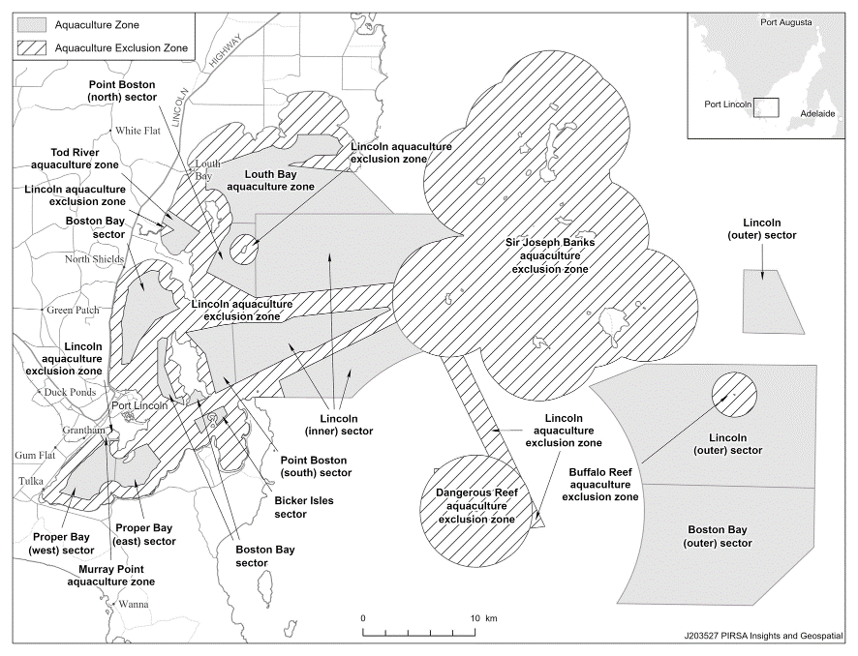
Boston Bay aquaculture zone (Bicker Isles sector and Boston Bay sector)
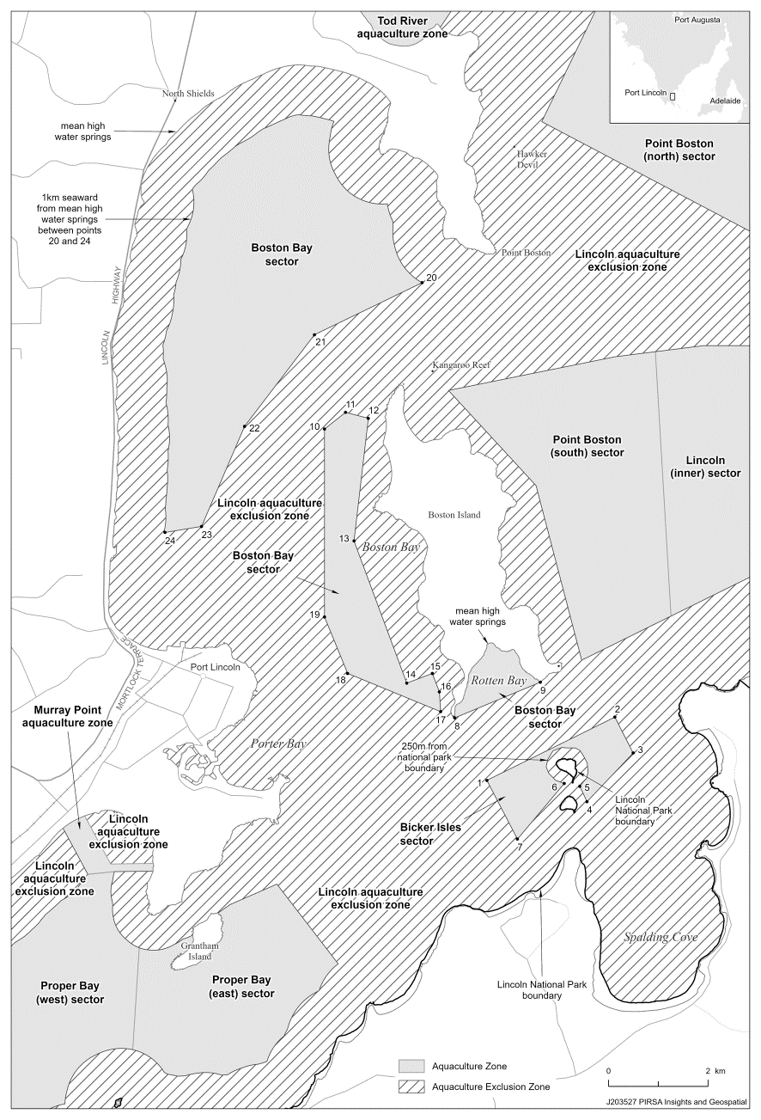
Boston Bay aquaculture zone (Boston Bay (outer) sector) and Lincoln aquaculture zone (Lincoln (outer) sector)
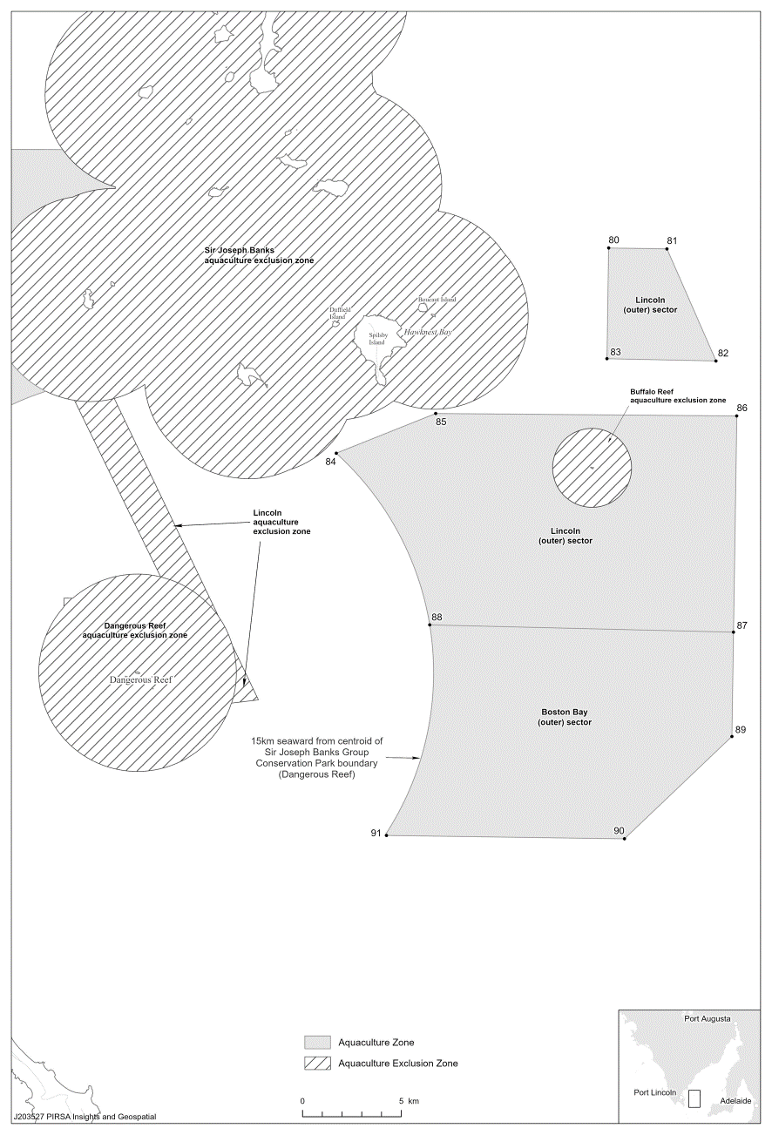
Buffalo Reef aquaculture exclusion zone, Dangerous Reef aquaculture exclusion zone and Sir Joseph Banks aquaculture exclusion zone
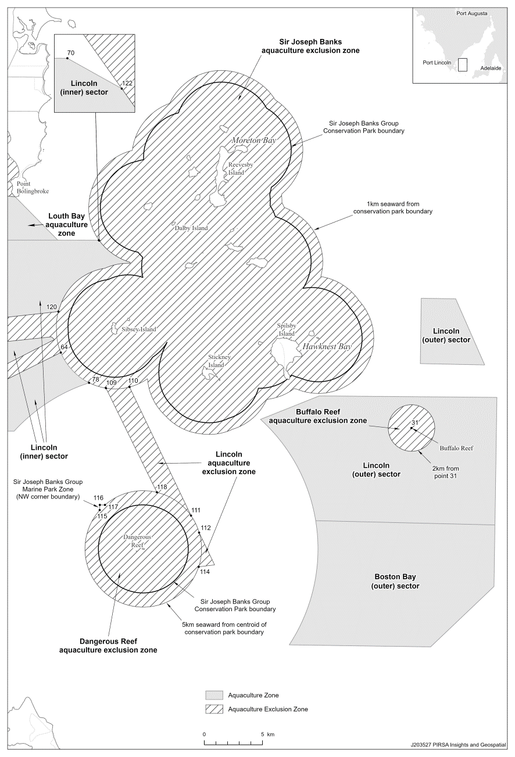
Lincoln aquaculture exclusion zone
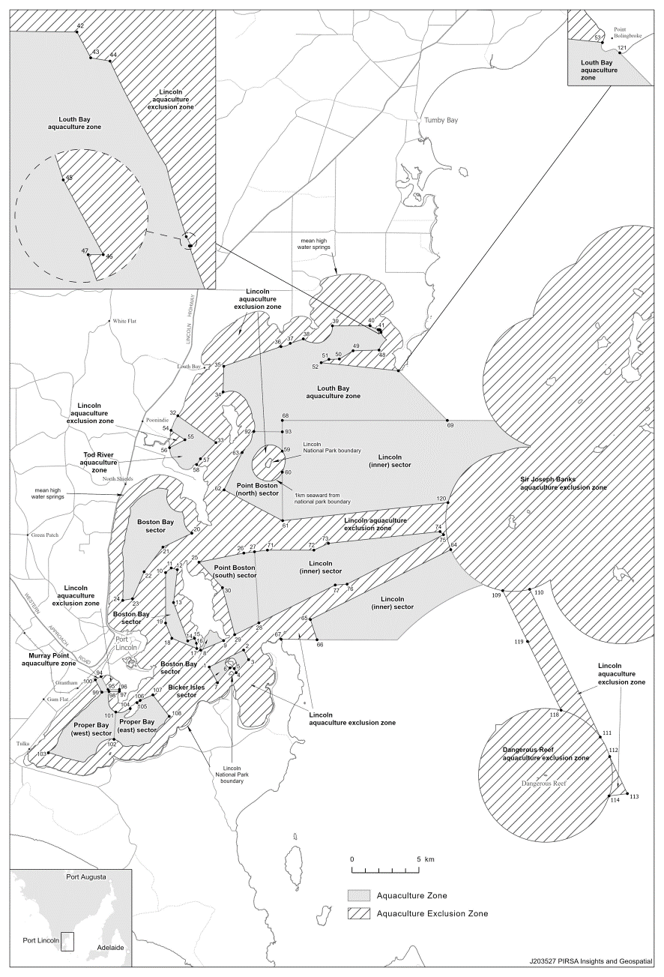
Lincoln aquaculture zone (Lincoln (inner) sector)
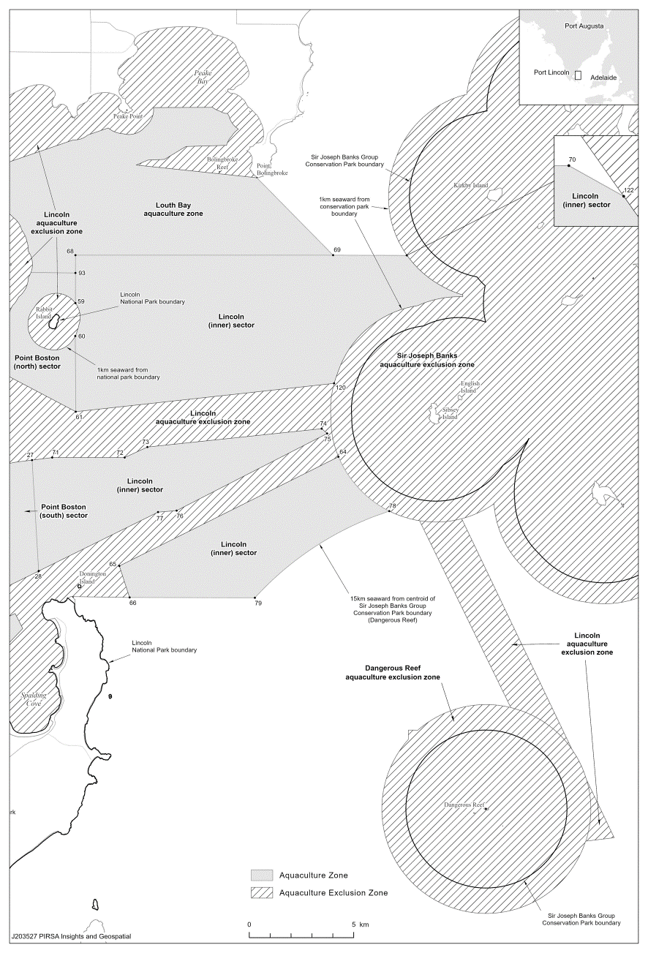
Louth Bay aquaculture zone and Point Boston aquaculture zone
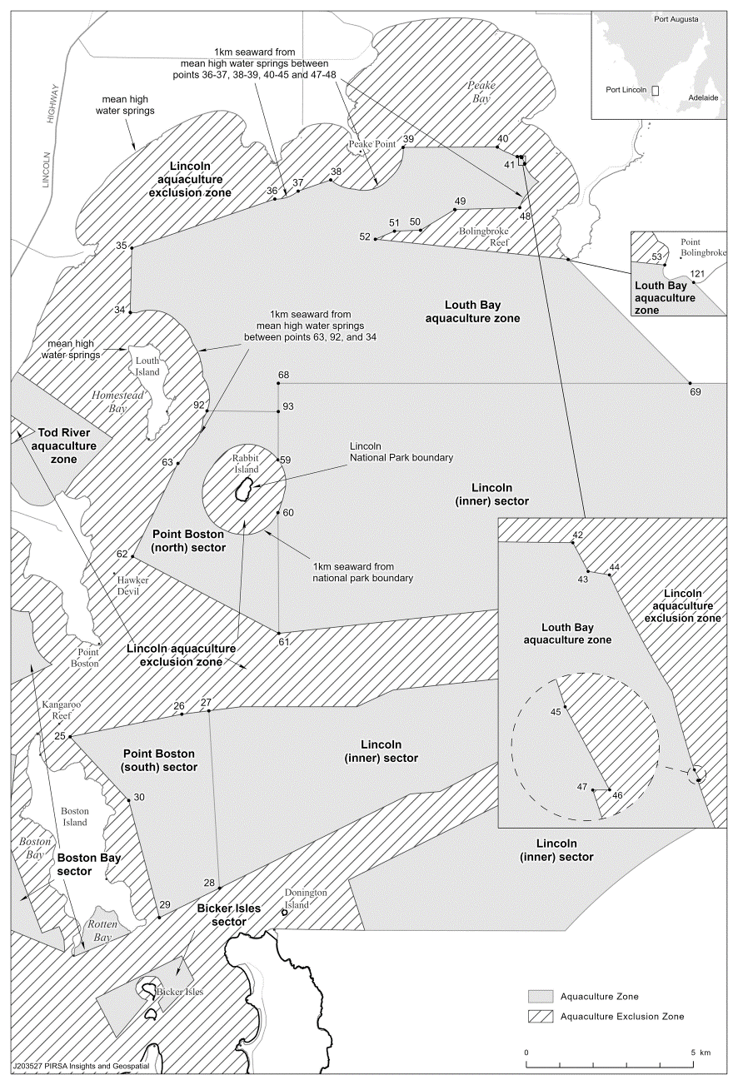
Murray Point aquaculture zone and Proper Bay aquaculture zone
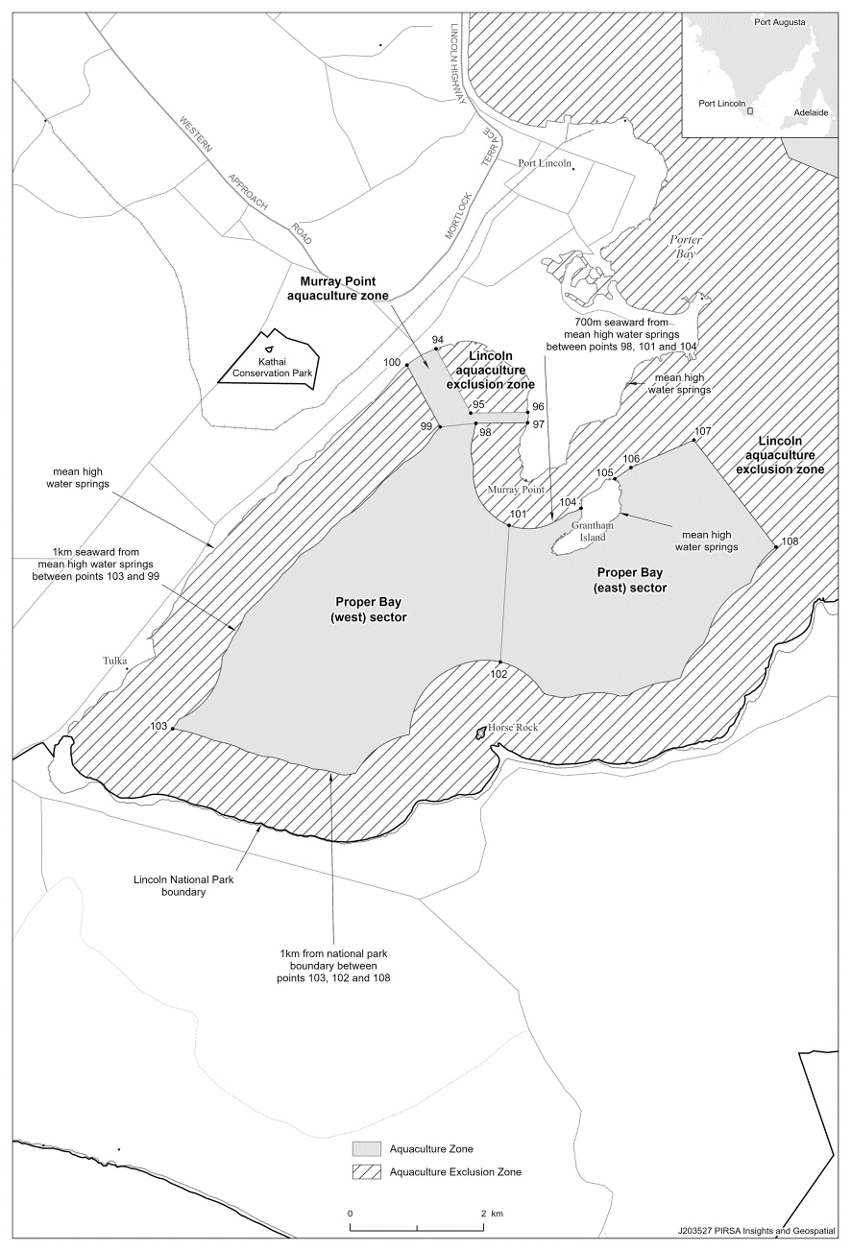
Tod River aquaculture zone
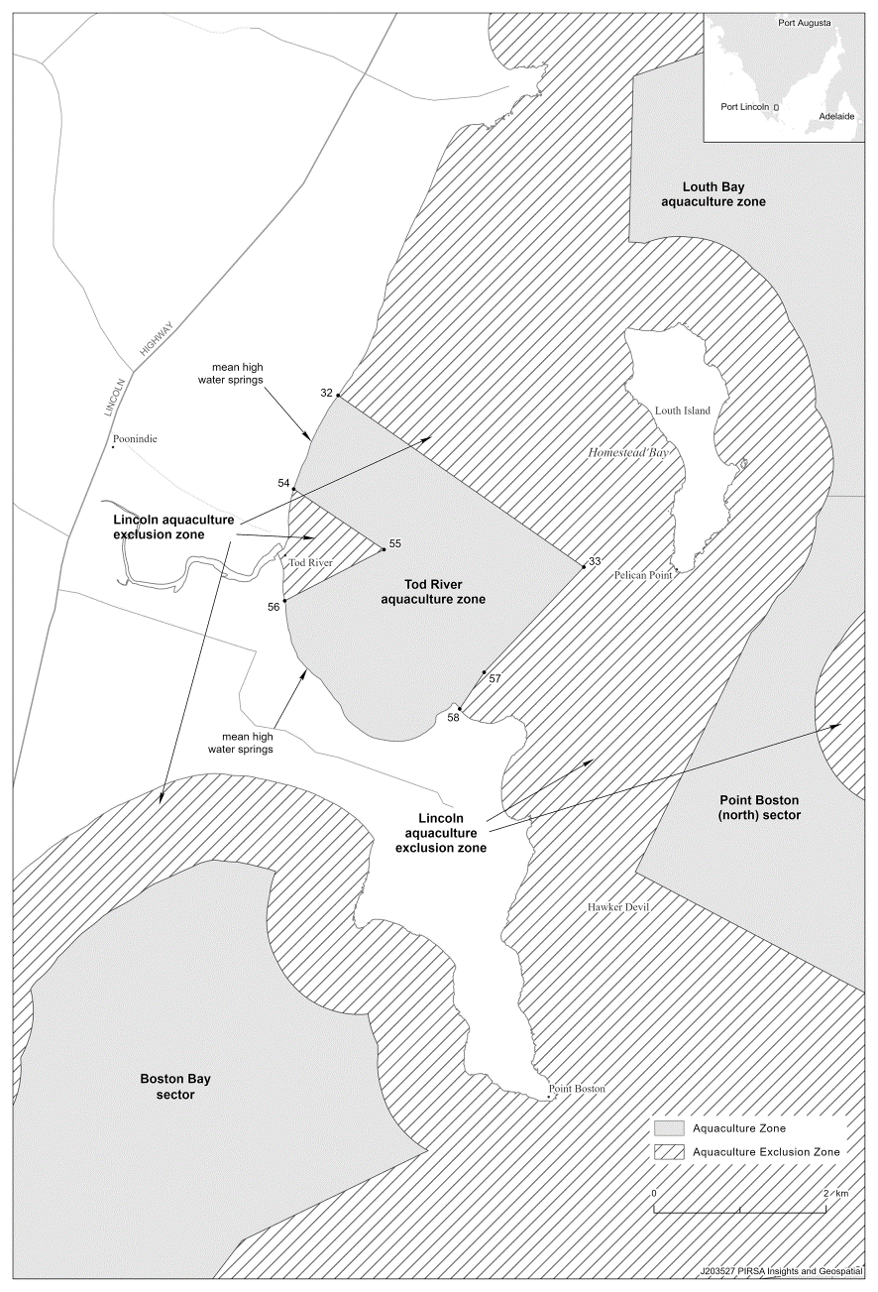
Schedule 3—Amendment of policy by Gazette notice (Lincoln aquaculture zone)
1—Amendment of clause 2—Interpretation
Clause 2(1)—after the definition of Lincoln (inner) sector insert:
Lincoln (inner south) sector means the area within the Lincoln aquaculture zone described in Schedule 1 clause 5(ab);
2—Amendment of clause 13—Lincoln aquaculture zone
Clause 13—after "Lincoln (inner) sector" insert:
, the Lincoln (inner south) sector
3—Amendment of clause 16—Prescribed criteria
Clause 16—after paragraph (a) insert:
(ab) in the Lincoln (inner south) sector—
(i) the leased area must not exceed 375 hectares; and
(ii) the biomass of prescribed wild caught tuna being farmed must not exceed 3 859 tonnes or, if some other amount is specified by the Minister by notice in the Gazette, that other amount;
4—Amendment of Schedule 1—Descriptions of zones
Schedule 1 clause 5—after paragraph (a) insert:
(ab) the Lincoln (inner south) sector, comprising the State waters contained within and bounded by a line commencing at a location on the line 15 000 metres seaward from a point closest to 34°48′54.71″ South, 136°12′45.48″ East (Dangerous Reef) closest to 34°43′30.54″ South, 136°05′25.01″ East (Point 79), then generally north-easterly following the said line 15 000 metres seaward from a point closest to 34°48′54.71″ South, 136°12′45.48″ East (Dangerous Reef) to the intersection of the line 1 000 metres seaward of the Sir Joseph Banks Group Conservation Park boundary closest to 34°41′13.52″ South, 136°09′36.01″ East (Point 78), then generally south-easterly following the line 1 000 metres seaward of the Sir Joseph Banks Group Conservation Park boundary to the location closest to 34°41′27.84″ South, 136°10′33.24″ East (Point 109), then south-easterly to the location closest to 34°43′30.55″ South, 136°11′47.99″ East (Point 119), then westerly to the point of commencement;
5—Amendment of Schedule 2—Maps of zones
(1) Schedule 2, overview map—delete the map and substitute:
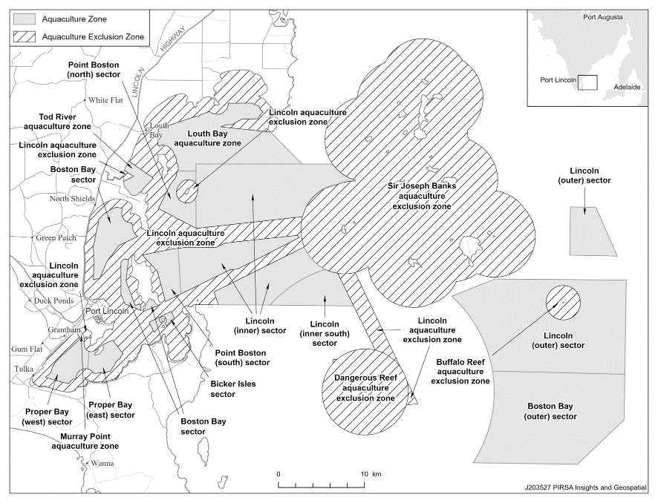
(2) Schedule 2—after the map relating to the Lincoln aquaculture zone (Lincoln (inner) sector) insert:
Lincoln aquaculture zone (Lincoln (inner south) sector)
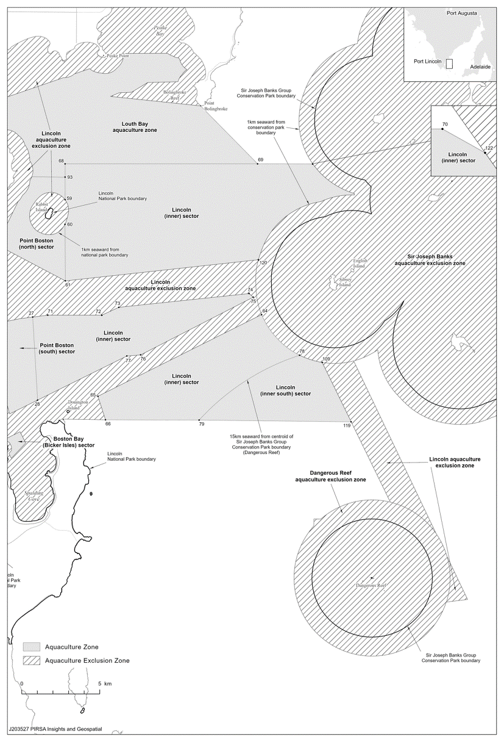
Schedule 4—Repeal of Aquaculture (Zones—Lower Eyre Peninsula) Policy 2013
The Aquaculture (Zones—Lower Eyre Peninsula) Policy 2013 is repealed.

Fisheries Management (Prawn Fisheries) Regulations 2017
November 2023 fishing for the West Coast Prawn Fishery
TAKE notice that pursuant to regulation 10 of the Fisheries Management (Prawn Fisheries) Regulations 2017, the notice dated 22 September 2023 on page 3296 of the South Australian Government Gazette of 28 September 2023, prohibiting fishing activities in the West Coast Prawn Fishery is HEREBY varied such that it will not be unlawful for a person fishing pursuant to a West Coast Prawn Fishery licence to use prawn trawl nets in the areas specified in Schedule 1, during the period specified in Schedule 2, and under the conditions specified in Schedule 3.
Schedule 1
The waters of the West Coast Prawn Fishery excluding Ceduna and Venus Bay as defined in the West Coast Prawn Fishery Harvest Strategy.
Schedule 2
Commencing at sunset on 5 November 2023 and ending at sunrise on 21 November 2023.
Schedule 3
- Each licence holder of a fishing licence undertaking fishing activities pursuant to this notice must ensure that a representative sample of catch (a ‘bucket count’) is taken at least 3 times per night during the fishing activity.
- Each ‘bucket count’ sample must be accurately weighed to 7 kg where possible and the total number of prawns contained in the bucket must be recorded on the daily catch and effort return.
- Fishing must cease if one of the following limits is reached:
- A total of 14 nights of fishing are completed.
- The average catch per vessel, per night (for all 3 vessels) drops below 300 kg for two consecutive nights.
- The average ‘bucket count’ for all vessels exceeds 240 prawns per 7 kg bucket on any single fishing night in the Coffin Bay area for two consecutive nights.
- The average ‘bucket count’ for all vessels exceeds 270 prawns per 7 kg bucket on any single fishing night in the Corvisart Bay area for two consecutive nights.
- Each licence holder, or registered master of a fishing license undertaking fishing activities must provide a daily report by telephone or SMS message, via a nominated representative, to the Department of Primary Industries and Regions, Prawn Fishery Manager, providing the following information for all vessels operating in the fishery from the previous nights fishing:
- average prawn catch; and
- the average prawn ‘bucket count’.
- No fishing activity may be undertaken after the expiration of 30 minutes from the prescribed time of sunrise and no fishing activity may be undertaken before the prescribed time of sunset for Adelaide (as published in the South Australian Government Gazette pursuant to the requirements of the Proof of Sunrise and Sunset Act 1923) during the period specified in Schedule 2.
Dated: 27 October 2023
Prof Gavin Begg
Executive Director
Fisheries and Aquaculture
Delegate of the Minister for Primary Industries and Regional Development

Fisheries Management (Prawn Fisheries) Regulations 2017
Temporary prohibition on fishing activities in the Gulf St Vincent Prawn Fishery
TAKE notice that pursuant to regulation 10 of the Fisheries Management (Prawn Fisheries) Regulations 2017, the activities of the class specified in Schedule 1 are prohibited in the waters of the Gulf St Vincent Prawn Fishery during the period specified in Schedule 2 except for the licences listed in Schedule 3 undertaking the activities described in Schedule 4 unless this notice is varied or revoked.
Schedule 1
The act of taking or an act preparatory to or involved in the taking of King Prawns (Melicertus latisulcatus).
Schedule 2
Between sunset on 5 November 2023 and sunrise on 7 November 2023.
Schedule 3
Licence Number | Licence Holder | Boat Name
V03 | Josephine K Fisheries P/L | Josephine K
V04 | Ledo P/L | Brianna-Rene-Adele
V06 | Todreel P/L | Anna Pearl
V10 | Ledo P/L | Frank Cori
V14 | WJ Fountain P/L | Zadar
Schedule 4
- For the purposes of this schedule the trawl survey areas cannot include any waters of a habitat protection zone or a sanctuary zone of a marine park established under the Marine Parks Act 2007 or depths less than 10 metres.
- The licence holders listed in Schedule 3 or their registered master must comply with all regulations and conditions that apply to fishing activities undertaken pursuant to their Gulf St Vincent Prawn Fishery licence, in addition to the conditions imposed by this notice.
- All fishing activity pursuant to this fishing notice must be conducted in the area of Fishery Independent Survey stations identified on page 16 of the “Gulf St Vincent Prawn Penaeus (Melicertus) latisulcatus Fishery 2019/20” (McLeay and Hooper 2020).
- Fishing activity pursuant to this fishing notice must not exceed more than one survey shot at each of the Fishery Independent Survey stations.
- While engaged in fishing activities or unloading the survey catch, the licence holders listed in Schedule 3 or their registered master must have a copy of this notice on board the boat or near his person. This notice must be produced to a Fisheries Officer if requested.
- No fishing activity may be undertaken between the prescribed times of sunrise and sunset for Adelaide (as published in the South Australian Government Gazette).
- The licence holders listed in Schedule 3 or their register master must not contravene or fail to comply with the Fisheries Management Act 2007, or any other regulations made under that Act except where specifically exempted by this notice.
- This notice does not purport to override the provisions or operation of any other Act including, but not limited to, the Marine Parks Act 2007. The notice holder and his agents must comply with any relevant regulations, permits, requirements and directions from the Department for Environment and Water when undertaking activities within a marine park.
Dated: 31 October 2023
Hamish Telfer
GSV Prawn Fisheries Manager
Delegate of the Minister for Primary Industries and Regional Development

Housing Improvement Act 2016
Rent Control
The Minister for Human Services Delegate in the exercise of the powers conferred by the Housing Improvement Act 2016, does hereby fix the maximum rental per week which shall be payable subject to Section 55 of the Residential Tenancies Act 1995, in respect of each house described in the following table. The amount shown in the said table shall come into force on the date of this publication in the Gazette.
Address of Premises | Allotment Section | Certificate of Title Volume/Folio | Maximum Rental per week payable
515 Churchill Road, Kilburn SA 5084 | 126 Filed Plan 39877 Hundred of Yatala | CT 5647/585 | $150.00
Dated: 2 November 2023
Craig Thompson
Housing Regulator and Registrar
Housing Safety Authority, SAHA
Delegate of Minister for Human Services

Housing Improvement Act 2016
Rent Control Revocations
Whereas the Minister for Human Services Delegate is satisfied that each of the houses described hereunder has ceased to be unsafe or unsuitable for human habitation for the purposes of the Housing Improvement Act 2016, notice is hereby given that, in exercise of the powers conferred by the said Act, the Minister for Human Services Delegate does hereby revoke the said Rent Control in respect of each property.
Address of Premises | Allotment Section | Certificate of Title Volume/Folio
18 Kanowna RD, LARGS BAY SA 5016 | Allotment 36 Filed Plan 16131 Hundred of Port Adelaide | CT5488/152, CT6086/712
11 Tod Street, Kapunda SA 5373 | Allotment 105 Filed Plan 198958 Hundred of Kapunda | CT5524/861
19 Bright Street, Willaston SA 5118 | Allotment 593 Filed Plan 211379 Hundred of Mudla Wirra | CT5829/184
Lot 32 March ST, BOWMANS SA 5550 | Allotment 32 Deposited Plan 3870 Hundred of Inkerman | CT5594/134
58 Emilie ST, SEFTON PARK SA 5083 | Allotment 33 Filed Plan 18675 Hundred of Yatala | CT1697/108, CT5727/294
10 Charles Street, Balaklava SA 5461 | Allotment 623 Filed Plan 175943 Hundred of Balaklava | CT5730/411
43 Janet Street, Maylands SA 5069 | Allotment 7 Deposited Plan 1262 Hundred of Adelaide | CT2725/162, CT5636/499
Dated: 2 November 2023
Craig Thompson
Housing Regulator and Registrar
Housing Safety Authority, SAHA
Delegate of Minister for Human Services

Justices of the Peace Act 2005
Section 4
Notice of Appointment of Justices of the Peace for South Australia
by the Commissioner for Consumer Affairs
I, Dini Soulio, Commissioner for Consumer Affairs, delegate of the Attorney-General, pursuant to section 4 of the Justices of the Peace Act 2005, do hereby appoint the people listed as Justices of the Peace for South Australia as set out below.
For a period of ten years for a term commencing on 14 November 2023 and expiring on 13 November 2033:
Ennio Michael ZANFAGNA
Janice Margaret WOODWARD
Mary Jane WHITE
Albert Mcintosh WEBSTER
Kim Phuong TRAN
Kho Kean TEO
Robert Andrew SHEPHERD
Melissa Anne ROWLEY
Lynette Eleanor NEUMANN
Ricky Dean HENKE
Kathleen Elizabeth HALLIDAY
John Howard GATLEY
Bruce Alfred FRANCIS
Geoffrey Albert DODD
Philip John DENNER
Wayne Malcolm COLEBATCH
Katrina Ann CHANNON
Elisa CENTOFANTI
Mark Kennion BRINDAL
Lucian Anthony BARTELETTI
Dated: 27 October 2023
Dini Soulio
Commissioner for Consumer Affairs
Delegate of the Attorney-General

Justices of the Peace Act 2005
Section 4
Notice of Appointment of Justices of the Peace for South Australia
by the Commissioner for Consumer Affairs
I, Dini Soulio, Commissioner for Consumer Affairs, delegate of the Attorney-General, pursuant to section 4 of the Justices of the Peace Act 2005, do hereby appoint the people listed as Justices of the Peace for South Australia as set out below.
For a period of ten years for a term commencing on 7 November 2023 and expiring on 6 November 2033:
Stephen John WILSON-SHAW
David Charles WHITING
Rocco URSIDA
Heather Margaret TURNBRIDGE
Donald Mcpherson THORPE
Gigliola Julie TAYLOR
Grant Herbert SCHMERL
Clive Allen SCARMAN
Raymond John QUINN
Sarah Therese O'DRISCOLL
Natalie Claire NUSKE
Stephen Eugen MICHALAK
Shane Leigh MACLEAN
Barry John FLETCHER
Brian John Alan EVES
Jan CENTOFANTI
David John CAPPO
Alfredo BORRILLO
Jeffery John BETTENS
Trevor Raymond Collins BELLCHAMBERS
For a period of ten years for a term commencing on 28 November 2023 and expiring on 27 November 2033:
Dean Melvyn RAMSEY
Dated: 27 October 2023
Dini Soulio
Commissioner for Consumer Affairs
Delegate of the Attorney-General

Land Acquisition Act 1969
Section 16
Form 5—Notice of Acquisition
1. Notice of acquisition
The Commissioner of Highways (the Authority), of 83 Pirie Street, Adelaide SA 5000, acquires the following interests in the following land:
Comprising an unencumbered estate in fee simple in that piece of land being the whole of Allotment 7 in Filed Plan 7056 comprised in Certificate of Title Volume 5797 Folio 427.
This notice is given under Section 16 of the Land Acquisition Act 1969.
2. Compensation
A person who has or had an interest consisting of native title or an alienable interest in the land that is divested or diminished by the acquisition or the enjoyment of which is adversely affected by the acquisition who does not receive an offer of compensation from the Authority may apply to the Authority for compensation.
2A. Payment of professional costs relating to acquisition (Section 26B)
If you are the owner in fee simple of the land to which this notice relates, you may be entitled to a payment of up to $10,000 from the Authority for use towards the payment of professional costs in relation to the acquisition of the land.
Professional costs include legal costs, valuation costs and any other costs prescribed by the Land Acquisition Regulations 2019.

3. Inquiries
Inquiries should be directed to: Petrula Pettas
GPO Box 1533
Adelaide SA 5001
Telephone: 08 7133 2457
Dated: 1 November 2023
The Common Seal of the COMMISSIONER OF HIGHWAYS was hereto affixed by authority of the Commissioner in the presence of:
Rocco Caruso
Manager, Property Acquisition
(Authorised Officer)
Department for Infrastructure and Transport
DIT 2022/02706/01

Land Acquisition Act 1969
Section 16
Form 5—Notice of Acquisition
1. Notice of acquisition
The Commissioner of Highways (the Authority), of 83 Pirie Street, Adelaide SA 5000, acquires the following interests in the following land:
Comprising an estate in fee simple in that piece of land being the whole of Section 364 in Hundred of Adelaide comprised in Certificate of Title Volume 5258 Folio 823, subject to an encroachment pursuant to section 7(7) of the Strata Titles Act, 1988 vide SP 13374.
This notice is given under Section 16 of the Land Acquisition Act 1969.
2. Compensation
A person who has or had an interest consisting of native title or an alienable interest in the land that is divested or diminished by the acquisition or the enjoyment of which is adversely affected by the acquisition who does not receive an offer of compensation from the Authority may apply to the Authority for compensation.
2A. Payment of professional costs relating to acquisition (Section 26B)
If you are the owner in fee simple of the land to which this notice relates, you may be entitled to a payment of up to $10,000 from the Authority for use towards the payment of professional costs in relation to the acquisition of the land.
Professional costs include legal costs, valuation costs and any other costs prescribed by the Land Acquisition Regulations 2019.
3. Inquiries
Inquiries should be directed to: William Ridgway
GPO Box 1533
Adelaide SA 5001
Telephone: 08 7133 2465
Dated: 2 November 2023
The Common Seal of the COMMISSIONER OF HIGHWAYS was hereto affixed by authority of the Commissioner in the presence of:
Rocco Caruso
Manager, Property Acquisition
(Authorised Officer)
Department for Infrastructure and Transport
DIT: 2023/01355/01

Livestock Act 1997
Section 33
Prohibition of Entry into and Movement within South Australia
of Decapod Crustaceans (Order Decapoda) and Polychaete Worms (Class Polychaeta)
PURSUANT to Section 87 of the Livestock Act 1997, I, Mary Ruth Carr, Chief Inspector of Stock, delegate of the Minister for Primary Industries and Regional Development, revoke the notice made pursuant to Section 33 of the Livestock Act 1997 on 5 September 2022, published in the Gazette on 7 September 2022 at p.5884.
PURSUANT to Section 33 of the Livestock Act 1997 and for the purposes of controlling and eradicating White Spot Disease, an exotic disease of decapod crustaceans, I, Mary Ruth Carr, Chief Inspector of Stock, delegate of the Minister for Primary Industries and Regional Development, prohibit the entry into, and movement within, South Australia of:
- live decapod crustaceans and/ or polychaete worms, whether wild-caught or cultivated, originating from, or which have moved through:
  - the Queensland White Spot Disease movement restriction area; or
  - the New South Wales White Spot Disease Clarence River Control Zone; and
- dead decapod crustaceans and/ or polychaete worms, whether wild-caught or cultivated, originating from, or which have moved through:
  - the Queensland White Spot Disease movement restriction area or the New South Wales White Spot Disease Clarence River Control Zone that are intended for human consumption unless the conditions of the Australian Biosecurity Import Conditions are met; or
  - the Queensland White Spot Disease movement restriction area or the State of New South Wales that are intended for fishing bait; and

- fittings used in connection with cultivation or commercial catch of decapod crustaceans or polychaete worms described in subclauses (1) and (2); and
- live or dead decapod crustaceans and/ or polychaete worms, not being decapod crustaceans or polychaete worms described in subclauses (1) and (2), that have been in contact with any of the following:
  - live or dead decapod crustaceans or polychaete worms described in subclauses (1) and (2); or
  - water that had previously held live or dead decapod crustaceans or polychaete worms described in subclauses (1) and (2); or
  - fittings that had previously been used in connection with decapod crustaceans or polychaete worms described in subclauses (1) and (2),
except to the extent, and subject to the conditions, set out in Parts A to F below. Except as expressly provided, the exceptions in Parts A to F are independent of one another.
Part A: cooked decapod crustaceans for human consumption
The entry into, and movement within, South Australia of dead decapod crustaceans described in subclause (2) or subclause (3) above is permitted if:
- they have been processed as cooked product before entering South Australia; and
- they were securely packaged upon being processed as cooked product and remain so at the time of entering South Australia and thereafter until after they have been delivered to a point of sale in South Australia; and
- upon entering South Australia they are transported directly to a point of sale in South Australia.
Part B: uncooked decapod crustaceans for human consumption
The entry into, and movement within, South Australia of uncooked dead decapod crustaceans which originated from outside the Queensland White Spot Disease movement restriction area or the New South Wales White Spot Disease Clarence River Control Zone but have moved through the Queensland White Spot Disease movement restriction area or the New South Wales White Spot Disease Clarence River Control Zone is permitted if:
- they were moved through the Queensland White Spot Disease movement restriction area or the New South Wales White Spot Disease Clarence River Control Zone in sealed bins, containers or packaging and remain in the secured bins, containers, or packaging at the time of entering South Australia and thereafter until after they have been delivered to a point of sale in South Australia and sold for human consumption; and
- the name, address, postcode and State or Territory of the grower and/or the commercial fisher and the packer are clearly displayed on the outer surface of each individual bin, container, or packaging; and
- upon entering South Australia they are transported directly to a point of sale in South Australia for human consumption.
Part C: gamma irradiated product for processing and/or distribution as fishing bait
The entry into, and movement within, South Australia of uncooked dead decapod crustaceans or polychaete worms originating from, or which have moved through the State of New South Wales or the Queensland White Spot Disease movement restriction area (in Parts C and D, “the product”) is permitted if:
- the product was subject to gamma irradiation treatment within the Queensland White Spot Disease movement restriction area or the State of New South Wales; and
- upon entering South Australia, the product is transported directly to a processing/distribution facility; and
- an inspector is notified no less than 48 business hours prior to the planned time of arrival of the product at the processing/ distribution facility of:
- the name, address and contact details (telephone and email) of the person importing the product into South Australia; and
- the description of the product including species, weight, type of packaging and number of packages; and
- the estimated date and time of arrival of the product; and
- the product did not come into contact with any untreated decapod crustaceans or polychaete worms described in subclauses (1), (2) or (4) above after the gamma irradiation treatment; and
- the product is moved into South Australia and transported to the processing/distribution facility:
- in refrigerated transport; and
- in sealed containers that only contain individually sealed packets of gamma irradiated product that are labelled with:
    - date of capture, and
    - origin of capture, and
    - the symbols “50kGy” to indicate the product was irradiated with this dose, and
    - the relevant gamma irradiation lot number,
and the outer containers are clearly marked as containing gamma irradiated product; and
- accompanied by a copy of the relevant Certificate of Irradiation; and
- as soon as possible after the arrival of the product at the processing/distribution facility, the SA Chief Inspector of Stock is informed in writing via email by the first person receiving the product in South Australia of the date and time of the arrival of the product at its destination (email details of SA Chief Inspector of Stock: pirsa.biosecuritysa@sa.gov.au); and
- unless sold by retail at the processing/distribution facility for use as fishing bait in the individually sealed packets in which it was transported there, or intended for distribution in the individually sealed packets in which it was transported to the processing/distribution facility, the product is processed and/or packaged at the processing/distribution facility for distribution for use as fishing bait in accordance with the requirements of Part D; and
- unless sold by retail at the processing/distribution facility for use as fishing bait, either in the individually sealed packets in which it was transported there or, as applicable, in the individual containers into which it was finally packaged there, the product is transported directly from the processing/distribution facility to a retail point of sale in South Australia for use as fishing bait; and
- the product to which Part C paragraph (g) applies is transported to the point of sale either in the individually sealed packets in which it was transported to the processing/distribution facility, or, as applicable, in the containers into which it was finally packaged there, and in either case remains in the applicable packaging until sold by retail; and
- the product is accompanied at all times by documentation that contains a statement to the effect that the product originated from the State of New South Wales or the Queensland White Spot Disease movement restriction area and as a result, must be dealt with in accordance with the requirements in Part C paragraphs (a) to (i) and Part D paragraphs (a) to (d) of this Notice.
Part D: requirements for processing and packaging
The requirements that apply for the purposes of Part C paragraph (f) are that:
- the product remains identifiable with appropriate marks on containers and boxes with the lot number allocated to the product by the Treatment Facility and with the name of the Treatment Facility; and
- a copy of the Certificate of Irradiation is kept with the product at all times prior to it being finally packaged; and
- without limiting paragraph (a) each individual container into which the product is finally packaged is clearly labelled with:
- the name of the Treatment Facility; and
- the relevant lot number; and
- the details of the volume of product that was irradiated in that lot; and
- the symbols “50kGy” to indicate that the product was irradiated with this dose; and
- any waste product produced during processing or packaging (for example, water or organic matter) is disposed of to either the public sewer (for water) or to a Waste Depot (for waste other than water).
Part E: cleaned and disinfected fittings
The entry into, and movement within, South Australia of fittings used in connection with cultivation or commercial catch of decapod crustaceans or polychaete worms described in subclauses (1) and (2) is permitted on the condition that:
- the fittings have been cleaned and disinfected to remove all traces of live or dead decapod crustaceans or polychaete worms; and
- a record of the cleaning date is made available to an inspector upon request.
Part F: product previously coming into contact with cleaned and disinfected fittings
The entry into, and movement within, South Australia of live or dead decapod crustaceans or polychaete worms, not being decapod crustaceans or polychaete worms described in subclause (1(b)), (in Part C, “the product”) that have been in contact with fittings that had previously been used in connection with decapod crustaceans or polychaete worms described in subclauses (1) and (2) is permitted on the condition that:
- the fittings had been cleaned and disinfected to remove all traces of live or dead decapod crustaceans or polychaete worms before the product was in contact with the fittings; and
- a record of the cleaning date is made available to an inspector upon request.
Definitions
In this Notice:
Australian Biosecurity Import Conditions means the conditions for the intended product as described in the Department of Agriculture, Fisheries and Forestry’s Australian Biosecurity Import Conditions which can be found at https://bicon.agriculture.gov.au/
Certificate of Irradiation, in relation to a product, means a certificate that:
- certifies that gamma irradiation treatment was applied to the product at the Treatment Facility on the date stated on the certificate; and
- bears an individual lot number assigned by the Treatment Facility; and
- describes the product that was treated including the species and total weight of the product; and
- is signed by an employee of the Treatment Facility who is authorised to sign the certificate on behalf of the Treatment Facility.
Cleaned and disinfected means to clean and disinfect in accordance with the Queensland Department of Agriculture and Fisheries Recommended procedure for decontaminating fishing apparatus and vessels which can be found at www.daf.qld.gov.au/business- priorities/biosecurity/animal-biosecurity-welfare/animal-health-pests-diseases/a-z-list-of-significant-animal-pests-and-diseases/white- spot-disease/decontamination
Cooked product means product comprising or containing decapod crustaceans that has been cooked, in premises approved by and under the control of the relevant state government agency that regulates food safety, to a minimum time and temperature standard where all the protein in the decapod crustaceans is coagulated and no uncooked meat remains.
Decapod crustacean means any crustacean of the Order Decapoda and includes, but is not limited to school, tiger and banana prawns, yabbies or pink nippers, shrimp, slipper lobsters, crabs, and hermit crabs.
Exotic disease has the same meaning as in the Livestock Act 1997.
Gamma irradiation treatment means treatment by irradiation at a gamma irradiation dose of at least 50 kilo Gray (kGy).
Gamma irradiated product means product treated by irradiation at a gamma irradiation dose of at least 50 kilo Gray (kGy).
Inspector means an inspector appointed under the Livestock Act 1997.
Point of sale means a place at which product is processed and/or sold, whether by wholesale or retail, on a commercial basis.
New South Wales White Spot Disease Clarence River Control Zone means the zone described in Schedule 2 of this Notice.
Polychaete worm means any worm of the Class Polychaeta and includes, but is not limited to, bristle worms.
Processing/distribution facility means a facility in South Australia which undertakes the processing and/or on-selling of uncooked decapod crustaceans and/or polychaete worms that have been subject to gamma irradiation treatment within the Queensland White Spot Disease movement restriction area for use as fishing bait.
Public sewer means a sewer operated by a council or any other authority established under the Local Government Act 1999, a water supply authority (within the meaning of the Water Industry Act 2012), a State-owned corporation (South Australian Water Corporation Act 1994 or a subsidiary of such a corporation) or any other public or local authority.
Queensland White Spot Disease movement restriction area means the area described in Schedule 1 of this Notice.
Treatment Facility means a treatment facility that applies gamma irradiation treatment to decapod crustaceans and/or polychaete worms.
Waste Depot means a place at which waste may be treated or stored in accordance with an approval under the Local Government Act 1999 or a place approved as a Waste Depot or waste facility under any other Act.
White Spot Disease means the disease that is caused by the virus Whispovirus (Family Nimaviridae), also known as infection with white spot syndrome virus.
A reference to dead animals of a particular kind includes a reference to parts of animals of that kind and to a product consisting of parts of, or which is derived from, animals of that kind.
Schedule 1
- The Queensland White Spot Disease movement restriction area comprises that portion of the State of Queensland, as currently defined in the Queensland Department of Agriculture and Fisheries Notice under Section 129 and Regulation 94 of the Biosecurity Act 2014 (QLD) and the Biosecurity Regulation 2016 (QLD) for White Spot Disease as in force from time to time, as the area within the White Spot Biosecurity Zone outside Biosecurity Area 1. Mapping and spatial points can be found at www.daf.qld.gov.au
Note: Any decapod crustaceans or polychaete worms originating from, or which have moved through, the Queensland White Spot Disease movement restriction area are likely to be subject to a permit or other regulatory requirement under Queensland law. The requirements in this Notice apply within South Australia and are separate and additional to any regulatory requirements under Queensland law.
SCHEDULE 2
- The New South Wales White Spot Disease Clarence River Control Zone comprises that portion of the State of New South Wales, as currently defined in the New South Wales Department of Primary Industries Control Order under Section 62 of the Biosecurity Act 2015 (NSW) for White Spot Disease as in force from time to time. Mapping and spatial points are available from NSW Department of Primary Industries and Regions www.dpi.nsw.gov.au
Note: Any decapod crustaceans or polychaete worms originating from, or which have moved through, the New South Wales White Spot Disease Clarence River Control Zone are likely to be subject to a permit or other regulatory requirement under NSW law. The requirements in this Notice apply within South Australia and are separate and additional to any regulatory requirements under NSW law.
This Notice will remain in force (as it may be varied from time to time by subsequent Notice) until revoked by a subsequent Notice.
Dated: 27 October 2023
Mary Ruth Carr
Chief Inspector of Stock
Delegate of the Minister for Primary Industries and Regional Development

Petroleum and Geothermal Energy Act 2000
Grant of Associated Activities Licence—AAL 309
(Adjunct to Petroleum Exploration Licence PEL 444)
Notice is hereby given that the undermentioned Associated Activities Licence has been granted with effect from 25 October 2023, under the provisions of the Petroleum and Geothermal Energy Act 2000, pursuant to delegated powers dated 29 June 2018.
Licence number | Licensees | Locality | Area in km² | Reference
AAL 309 | Holloman Petroleum Pty Ltd | Cooper Basin | 623 | MER-2023/0146

Description of Area
All that part of the State of South Australia, bounded as follows:
All coordinates MGA2020, Zone 54
AREA A
366671.04mE 6971063.17mN
377818.32mE 6970948.34mN
377747.85mE 6959436.81mN
366232.83mE 6959258.57mN
366671.04mE 6971063.17mN
AREA B
352648.52mE 6957549.50mN
361438.30mE 6957873.70mN
361662.34mE 6945994.79mN
352673.61mE 6945941.38mN
352648.52mE 6957549.50mN
AREA C
338201.76mE 6942012.13mN
344056.80mE 6942049.46mN
344265.71mE 6930240.78mN
341623.72mE 6930149.60mN
342219.91mE 6904392.38mN
334600.20mE 6904320.83mN
334132.96mE 6935867.34mN
338105.09mE 6935976.29mN
338201.76mE 6942012.13mN

AREA D
360190.40mE 6891321.50mN
368599.95mE 6891654.27mN
368932.64mE 6880031.10mN
360476.02mE 6879746.67mN
360190.40mE 6891321.50mN
AREA: 623 square kilometres approximately
Dated: 25 October 2023
Nick Panagopoulos
A/Executive Director
Energy Resources Division
Department for Energy and Mining
Delegate of the Minister for Energy and Mining

Petroleum and Geothermal Energy Act 2000
Grant of Associated Activities Licence—AAL 310
(Adjunct to Petroleum Retention Licence PRL 124)
Notice is hereby given that the undermentioned Associated Activities Licence has been granted with effect from 25 October 2023, under the provisions of the Petroleum and Geothermal Energy Act 2000, pursuant to delegated powers dated 29 June 2018.
Licence number | Licensees | Locality | Area in km² | Reference
AAL 310 | Cordillo Energy Pty Ltd | Cooper Basin | 485 | MER-2023/0147
Description of Area
All that part of the State of South Australia, bounded as follows:
All coordinates MGA2020, Zone 54
AREA A
465023.59mE 6992607.47mN
464632.83mE 7011610.81mN
476083.76mE 7011918.91mN
475844.13mE 6993015.39mN
465023.59mE 6992607.47mN
AREA B
499956.78mE 6992337.11mN
499956.86mE 6986043.38mN
495448.04mE 6986042.50mN
495447.92mE 6986350.10mN
496272.70mE 6986350.38mN
496272.61mE 6986658.19mN
496547.54mE 6986658.27mN
496547.45mE 6986965.88mN
496822.39mE 6986965.95mN
496822.14mE 6987888.96mN
496272.23mE 6987888.81mN
496272.13mE 6988196.41mN
495997.16mE 6988196.32mN
495997.06mE 6988504.13mN
495172.14mE 6988503.83mN
495172.02mE 6988811.43mN
494347.08mE 6988811.07mN
494347.50mE 6987888.06mN
494072.54mE 6987887.93mN
494072.84mE 6987272.52mN
493797.90mE 6987272.38mN
493798.14mE 6986797.43mN
494033.10mE 6986797.55mN
494032.99mE 6987012.92mN
494088.00mE 6987012.95mN
494087.95mE 6987105.25mN
494170.46mE 6987105.29mN
494170.41mE 6987197.59mN
494610.44mE 6987197.79mN
494610.68mE 6986643.97mN
494858.18mE 6986644.08mN
494858.01mE 6987044.06mN
494940.52mE 6987044.09mN
494940.39mE 6987351.77mN
495325.42mE 6987351.92mN
495325.40mE 6987413.45mN
495407.90mE 6987413.48mN
495407.87mE 6987505.79mN
495682.89mE 6987505.88mN
495682.92mE 6987413.58mN
495902.94mE 6987413.66mN
495902.97mE 6987321.35mN
496150.48mE 6987321.43mN
496150.61mE 6986921.46mN
496233.11mE 6986921.48mN
496233.20mE 6986613.81mN
496068.20mE 6986613.75mN
496068.14mE 6986798.36mN
495600.63mE 6986798.20mN
495600.69mE 6986644.36mN
495188.18mE 6986644.21mN
495188.24mE 6986490.37mN
495050.74mE 6986490.32mN
495050.78mE 6986398.02mN
494500.79mE 6986397.79mN
494500.81mE 6986336.25mN
493798.38mE 6986335.92mN
493798.53mE 6986041.77mN
483638.85mE 6986032.42mN
483630.55mE 6992326.33mN
499956.78mE 6992337.11mN
AREA C
497801.23mE 6983722.03mN
495051.85mE 6983721.24mN
495051.36mE 6984951.94mN
497801.01mE 6984952.74mN
497801.23mE 6983722.03mN
AREA D
493131.74mE 6975720.69mN
493132.26mE 6974797.65mN
492582.78mE 6974797.33mN
492583.15mE 6974181.97mN
491484.24mE 6974181.26mN
491484.88mE 6973258.22mN
490660.76mE 6973257.62mN
490661.46mE 6972334.58mN
490386.78mE 6972334.37mN
490387.74mE 6971103.64mN
489838.42mE 6971103.20mN
489838.93mE 6970487.84mN
489289.64mE 6970487.37mN
489290.45mE 6969564.33mN
488741.20mE 6969563.84mN
488741.76mE 6968948.47mN
487917.94mE 6968947.69mN
487918.84mE 6968024.64mN
487369.66mE 6968024.09mN
487370.30mE 6967408.73mN
486821.15mE 6967408.15mN
486822.13mE 6966485.10mN
486273.03mE 6966484.50mN
486273.71mE 6965869.13mN
485724.63mE 6965868.51mN
485725.34mE 6965253.14mN
485176.29mE 6965252.49mN
485177.40mE 6964329.44mN
484353.88mE 6964328.42mN
484355.06mE 6963405.36mN
485453.00mE 6963406.71mN
485451.48mE 6954483.52mN
482995.01mE 6954480.62mN
482990.73mE 6957557.50mN
482442.02mE 6957556.72mN
482441.14mE 6958172.10mN
478874.34mE 6958166.47mN
478871.69mE 6959704.91mN
479420.50mE 6959705.84mN
479419.98mE 6960013.53mN
481066.45mE 6960016.18mN
481063.12mE 6962169.98mN
481612.04mE 6962170.82mN
481611.12mE 6962786.19mN
482160.06mE 6962787.00mN
482159.17mE 6963402.37mN
482708.14mE 6963403.15mN
482707.28mE 6964018.52mN
483256.28mE 6964019.28mN
483255.44mE 6964634.65mN
483804.47mE 6964635.39mN
483800.82mE 6967404.54mN
480505.91mE 6967399.76mN
480506.40mE 6967092.08mN
479133.55mE 6967089.83mN
479135.64mE 6965859.09mN
478312.02mE 6965857.66mN
478315.28mE 6964011.55mN
477217.27mE 6964009.57mN
477217.84mE 6963701.88mN
476119.87mE 6963699.80mN
476118.67mE 6964315.17mN
476667.69mE 6964316.22mN
476666.52mE 6964931.59mN
476941.04mE 6964932.11mN
476938.16mE 6966470.53mN
477487.27mE 6966471.55mN
477486.14mE 6967086.92mN
477760.71mE 6967087.42mN
477759.04mE 6968010.47mN
478033.63mE 6968010.97mN
478031.98mE 6968934.02mN
478306.59mE 6968934.50mN
478305.51mE 6969549.87mN
478854.76mE 6969550.83mN
478853.17mE 6970473.87mN
479402.46mE 6970474.81mN
479401.43mE 6971090.17mN
479676.09mE 6971090.63mN
479674.57mE 6972013.67mN
480223.92mE 6972014.57mN
480221.95mE 6973245.29mN
479672.54mE 6973244.40mN
479672.03mE 6973552.08mN
479664.58mE 6979310.44mN
482135.98mE 6979401.84mN
482139.54mE 6976940.40mN
483788.27mE 6976942.68mN
483787.05mE 6977865.71mN
486535.14mE 6977869.01mN
486536.83mE 6976330.61mN
486262.05mE 6976330.31mN
486263.42mE 6975099.59mN
487911.90mE 6975101.32mN
487911.30mE 6975716.68mN
489559.86mE 6975718.18mN
489559.34mE 6976333.54mN
490383.66mE 6976334.21mN
490383.18mE 6976949.57mN
491482.33mE 6976950.38mN
491481.90mE 6977565.74mN
492855.91mE 6977566.61mN
492855.56mE 6978181.96mN
493954.82mE 6978182.55mN
493954.52mE 6978797.91mN
495053.83mE 6978798.40mN
495053.58mE 6979413.75mN
495878.11mE 6979414.06mN
495877.90mE 6980029.41mN
498076.74mE 6980029.95mN
498076.84mE 6979414.60mN
497252.32mE 6979414.44mN
497252.39mE 6979106.76mN
496702.72mE 6979106.63mN
496702.80mE 6978798.95mN
496153.14mE 6978798.79mN
496153.24mE 6978491.11mN
495603.60mE 6978490.93mN
495603.71mE 6978183.25mN
494779.26mE 6978182.93mN
494779.52mE 6977567.57mN
494229.92mE 6977567.32mN
494230.35mE 6976644.29mN
493680.79mE 6976644.02mN
493681.26mE 6975720.98mN
493131.74mE 6975720.69mN
AREA E
477106.71mE 6954642.66mN
477068.80mE 6953709.22mN
476798.73mE 6953714.86mN
476815.25mE 6953400.20mN
476256.85mE 6953392.03mN
476253.62mE 6953097.09mN
474867.27mE 6953086.00mN
474869.11mE 6953390.58mN
474598.98mE 6953415.08mN
474588.46mE 6953998.88mN
474885.88mE 6954023.10mN
474875.59mE 6954340.41mN
475438.64mE 6954338.43mN
475420.85mE 6954636.81mN
477106.71mE 6954642.66mN
AREA: 485 square kilometres approximately
Dated: 25 October 2023
Nick Panagopoulos
A/Executive Director
Energy Resources Division
Department for Energy and Mining
Delegate of the Minister for Energy and Mining

Petroleum and Geothermal Energy Act 2000
Grant of Gas Storage Retention Licence—GSRL 250
Notice is hereby given that the undermentioned Gas Storage Retention Licence has been granted under the provisions of the Petroleum and Geothermal Energy Act 2000, pursuant to delegated powers dated 29 June 2018.
No. of Licence | Licensees | Locality | Area in km² | Reference
GSRL 250 | Santos Limited  Vamgas Pty Ltd  Alliance Petroleum  Australia Pty Ltd  Reef Oil Pty Ltd  Santos Petroleum Pty Ltd  Bridge Oil Developments Pty Ltd  Santos (BOL) Pty Ltd  Beach Energy  (Operations) Limited  Delhi Petroleum Pty Ltd  Basin Oil Pty Ltd  Santos (NARNL Cooper) Pty Ltd | Cooper Basin | 448 | MER-2022/0490
Description of Area
All that part of the State of South Australia, bounded as follows:
Commencing at a point being the intersection of latitude 28°07′00″S Clarke1858 and longitude 140°02′00″E Clarke1858, thence east to longitude 140°04′00″E Clarke1858, south to latitude 28°10′00″S Clarke1858, east to longitude 140°06′00″E Clarke1858, south to latitude 28°11′00″S Clarke1858, east to longitude 140°07′00″E Clarke1858, south to latitude 28°12′00″S Clarke1858, east to longitude 140°08′00″E Clarke1858, south to latitude 28°14′00″S Clarke1858, east to longitude 140°09′00″E Clarke1858, south to latitude 28°15′00″S Clarke1858, east to longitude 140°10′00″E Clarke1858, south to latitude 28°16′00″S Clarke1858, east to longitude 140°11′00″E Clarke1858, south to latitude 28°20′10″S AGD66, west to longitude 140°10′30″E AGD66, north to latitude 28°20′00″S AGD66, west to longitude 140°10′20″E AGD66, north to latitude 28°19′40″S AGD66, west to longitude 140°08′40″E AGD66, south to latitude 28°20′20″S AGD66, west to longitude 140°08′30″E AGD66, south to latitude 28°20′40″S AGD66, west to longitude 140°06′10″E AGD66, south to latitude 28°20′50″S AGD66, west to longitude 140°05′50″E AGD66, south to latitude 28°20′45″S GDA2020, west to longitude 140°04′55″E GDA2020, south to latitude 28°20′55″S GDA2020, west to longitude 140°04′00″E Clarke1858, north to latitude 28°18′00″S Clarke1858, west to longitude 140°01′00″E Clarke1858, north to latitude 28°17′00″S Clarke1858, west to longitude 140°00′00″E Clarke1858, south to latitude 28°18′00″S Clarke1858, west to longitude 139°59′25″E AGD66, north to latitude 28°17′20″S AGD66, west to longitude 139°59′00″E AGD66, south to latitude 28°17′25″S AGD66, west to longitude 139°58′55″E AGD66, south to latitude 28°17′35″S AGD66, west to longitude 139°58′50″E AGD66, south to latitude 28°17′40″S AGD66, west to longitude 139°58′45″E AGD66, south to latitude 28°17′50″S AGD66, west to longitude 139°58′40″E AGD66, south to latitude 28°18′00″S Clarke1858, west to longitude 139°56′40″E AGD66, north to latitude 28°17′40″S AGD66, east to longitude 139°57′00″E AGD66, north to latitude 28°17′30″S AGD66, east to longitude 139°57′10″E AGD66, north to latitude 28°17′20″S AGD66, east to longitude 139°58′40″E AGD66, north to latitude 28°16′30″S AGD66, west to longitude 139°55′30″E AGD66, south to latitude 28°16′40″S AGD66, west to longitude 139°52′20″E AGD66, south to latitude 28°19′00″S Clarke1858, west to longitude 139°52′00″E Clarke1858, south to latitude 28°22′35″S GDA2020, west to longitude 139°50′05″E GDA2020, north to latitude 28°15′00″S AGD66, east to longitude 139°51′40″E AGD66, north to latitude 28°13′40″S AGD66, east to longitude 139°52′10″E AGD66, north to latitude 28°13′30″S AGD66, east to longitude 139°52′50″E AGD66, north to latitude 28°13′20″S AGD66, east to longitude 139°53′10″E AGD66, north to latitude 28°13′10″S AGD66, east to longitude 139°53′30″E AGD66, north to latitude 28°13′00″S AGD66, east to longitude 139°53′50″E AGD66, north to latitude 28°12′50″S AGD66, east to longitude 139°54′00″E AGD66, north to latitude 28°12′30″S AGD66, east to longitude 139°54′20″E AGD66, north to latitude 28°12′10″S AGD66, east to longitude 139°54′30″E AGD66, south to latitude 28°12′20″S AGD66, east to longitude 139°55′10″E AGD66, north to latitude 28°12′10″S AGD66, east to longitude 139°55′20″E AGD66, north to latitude 28°12′00″S AGD66, east to longitude 139°55′30″E AGD66, north to latitude 28°11′50″S AGD66, east to longitude 139°55′50″E GDA94, north to latitude 28°11′25″S GDA94, east to longitude 139°56′00″E GDA94, north to latitude 28°10′50″S GDA94, east to longitude 139°56′10″E GDA94, north to latitude 28°10′00″S GDA94, west to longitude 139°56′00″E GDA94, north to latitude 28°09′50″S GDA94, west to longitude 139°55′45″E GDA94, south to latitude 28°10′00″S GDA94, west to longitude 139°55′20″E GDA94, south to latitude 28°10′15″S GDA94, west to longitude 139°55′15″E GDA94, south to latitude 28°10′25″S GDA94, west to longitude 139°55′00″E GDA94, south to latitude 28°10′35″S GDA94, west to longitude 139°54′40″E GDA94, south to latitude 28°11′00″S AGD66, west to longitude 139°53′30″E AGD66, north to latitude 28°08′40″S AGD66, east to longitude 139°54′00″E AGD66, north to latitude 28°08′30″S AGD66, east to longitude 139°54′10″E AGD66, north to latitude 28°08′20″S AGD66, east to longitude 139°54′20″E AGD66, north to latitude 28°08′10″S AGD66, east to longitude 139°54′25″E AGD66, north to latitude 28°06′30″S AGD66, east to longitude 139°54′50″E AGD66, north to latitude 28°06′00″S Clarke1858, east to longitude 140°02′00″E Clarke1858 and south to the point of commencement, but excluding the areas bounded as follows -
Commencing at a point being the intersection of latitude 28°07′30″S AGD66 and longitude 140°01′10″E AGD66, thence east to longitude 140°02′30″E AGD66, south to latitude 28°08′50″S AGD66, west to longitude 140°02′20″E AGD66, south to latitude 28°09′00″S AGD66, west to longitude 140°01′10″E AGD66, north to latitude 28°08′50″S AGD66, west to longitude 140°01′00″E AGD66, north to latitude 28°08′30″S AGD66, west to longitude 140°00′50″E AGD66, north to latitude 28°07′50″S AGD66, east to longitude 140°01′00″E AGD66, north to latitude 28°07′40″S AGD66, east to longitude 140°01′10″E AGD66, and north to the point of commencement
and
Commencing at a point being the intersection of latitude 28°08′20″S AGD66 and longitude 139°58′45″E AGD66, thence east to longitude 139°59′50″E AGD66, south to latitude 28°10′50″S AGD66, east to longitude 140°00′00″E Clarke 1858, south to latitude 28°12′00″S AGD66, west to longitude 139°58′40″E AGD66, north to latitude 28°11′10″S AGD66, west to longitude 139°57′40″E AGD66, north to latitude 28°11′00″S AGD66, west to longitude 139°57′20″E AGD66, north to latitude 28°10′50″S AGD66, west to longitude 139°57′10″E AGD66, north to latitude 28°08′40″S GDA94, east to longitude 139°58′00″E GDA94, north to latitude 28°08′25″S GDA94, east to longitude 139°58′45″E AGD66 and north to the point of commencement
and
Commencing at a point being the intersection of latitude 28°12′40″S AGD66 and longitude 140°00′30″E AGD66, thence west to longitude 140°00′00″E Clarke1858, north to latitude 28°12′00″S AGD66, east to longitude 140°00′40″E AGD66, north to latitude 28°11′50″S AGD66, east to longitude 140°01′20″E AGD66, south to latitude 28°12′30″S AGD66, east to longitude 140°01′30″E AGD66, south to latitude 28°12′40″S AGD66, east to longitude 140°02′10″E AGD66, north to latitude 28°12′20″S AGD66, east to longitude 140°02′40″E AGD66, south to latitude 28°12′30″S AGD66, east to longitude 140°03′00″E AGD66, south to latitude 28°12′40″S AGD66, east to longitude 140°03′20″E AGD66, south to latitude 28°12′50″S AGD66, east to longitude 140°03′30″E AGD66, south to latitude 28°13′20″S AGD66, east to longitude 140°03′40″E AGD66, south to latitude 28°13′30″S AGD66, east to longitude 140°04′10″E AGD66, south to latitude 28°13′40″S AGD66, east to longitude 140°04′30″E AGD66, south to latitude 28°14′30″S AGD66, east to longitude 140°05′20″E AGD66, south to latitude 28°15′00″S AGD66, west to longitude 140°05′00″E AGD66, south to latitude 28°15′10″S AGD66, west to longitude 140°04′40″E AGD66, south to latitude 28°15′20″S AGD66, west to longitude 140°04′20″E AGD66, south to latitude 28°15′30″S AGD66, west to longitude 140°04′00″E AGD66, south to latitude 28°15′40″S AGD66, east to longitude 140°04′10″E AGD66, south to latitude 28°16′50″S AGD66, west to longitude 140°03′40″E AGD66, north to latitude 28°16′20″S AGD66, west to longitude 140°03′30″E AGD66, north to latitude 28°16′10″S AGD66, west to longitude 140°03′20″E AGD66, north to latitude 28°16′00″S AGD66, west to longitude 140°03′10″E AGD66, south to latitude 28°16′10″S AGD66, west to longitude 140°02′50″E AGD66, south to latitude 28°16′20″S AGD66, west to longitude 140°02′30″E AGD66, south to latitude 28°16′30″S AGD66, west to longitude 140°02′10″E AGD66, south to latitude 28°16′40″S AGD66, west to longitude 140°01′50″E AGD66, north to latitude 28°16′30″S AGD66, west to longitude 140°01′40″E AGD66, north to latitude 28°16′10″S AGD66, west to longitude 140°01′30″E AGD66, north to latitude 28°15′50″S AGD66, west to longitude 140°01′20″E AGD66, north to latitude 28°15′40″S AGD66, west to longitude 140°01′00″E AGD66, south to latitude 28°15′50″S AGD66, west to longitude 140°00′50″E AGD66, south to latitude 28°16′00″S AGD66, west to longitude 140°00′40″E AGD66, south to latitude 28°16′10″S AGD66, west to longitude 140°00′30″E AGD66, south to latitude 28°16′20″S AGD66, west to longitude 140°00′10″E AGD66, north to latitude 28°16′10″S AGD66, west to longitude 140°00′00″E AGD66, north to latitude 28°15′30″S AGD66, east to longitude 140°00′10″E AGD66, north to latitude 28°15′00″S AGD66, east to longitude 140°00′30″E AGD66, north to latitude 28°14′50″S AGD66, east to longitude 140°00′50″E AGD66, north to latitude 28°13′40″S AGD66, west to longitude 140°00′30″E AGD66, and north to the point of commencement
and
Commencing at a point being the intersection of latitude 28°12′50″S AGD66 and longitude 139°57′10″E AGD66, thence west to longitude 139°56′20″E AGD66, south to latitude 28°13′00″S AGD66, east to longitude 139°56′40″E AGD66, south to latitude 28°13′10″S AGD66, east to longitude 139°56′50″E AGD66, south to latitude 28°13′30″S AGD66, east to longitude 139°57′00″E AGD66, south to latitude 28°13′50″S AGD66, west to longitude 139°55′40″E GDA94, south to latitude 28°14′30″S AGD66, west to longitude 139°55′00″E AGD66, south to latitude 28°15′20″S AGD66, west to longitude 139°53′40″E AGD66, north to latitude 28°14′20″S AGD66, west to longitude 139°53′30″E AGD66, north to latitude 28°13′20″S AGD66, east to longitude 139°54′10″E AGD66, south to latitude 28°13′40″S AGD66, east to longitude 139°54′30″E AGD66, south to latitude 28°14′20″S AGD66, east to longitude 139°54′40″E AGD66, north to latitude 28°14′05″S GDA94, east to longitude 139°54′55″E GDA94, north to latitude 28°13′55″S GDA94, east to longitude 139°55′00″E GDA94, north to latitude 28°13′50″S GDA94, east to longitude 139°55′05″E GDA94, north to latitude 28°13′50″S AGD66, east to longitude 139°55′10″E AGD66, north to latitude 28°13′40″S AGD66, west to longitude 139°55′00″E AGD66, north to latitude 28°13′30″S AGD66, west to longitude 139°54′50″E AGD66, north to latitude 28°13′20″S AGD66, west to longitude 139°54′40″E AGD66, north to latitude 28°12′40″S AGD66, east to longitude 139°55′20″E AGD66, north to latitude 28°12′30″S AGD66, east to longitude 139°55′30″E AGD66, north to latitude 28°12′20″S AGD66, east to longitude 139°55′40″E AGD66, north to latitude 28°12′10″S AGD66, east to longitude 139°56′00″E AGD66, north to latitude 28°11′50″S AGD66, east to longitude 139°57′10″E AGD66, and south to the point of commencement
and
Commencing at a point being the intersection of latitude 28°15′00″S AGD66 and longitude 139°58′30″E AGD66, thence west to longitude 139°57′30″E AGD66, north to latitude 28°14′20″S AGD66, east to longitude 139°57′40″E AGD66, north to latitude 28°14′00″S AGD66, east to longitude 139°58′00″E AGD66, north to latitude 28°13′50″S AGD66, east to longitude 139°58′10″E AGD66, north to latitude 28°13′30″S AGD66, east to longitude 139°58′20″E AGD66, north to latitude 28°13′20″S AGD66, east to longitude 139°58′30″E AGD66, north to latitude 28°13′00″S AGD66, east to longitude 139°58′40″E AGD66, north to latitude 28°12′50″S AGD66, east to longitude 139°59′20″E AGD66, south to latitude 28°13′50″S AGD66, west to longitude 139°59′10″E AGD66, south to latitude 28°14′00″S AGD66, west to longitude 139°59′00″E AGD66, south to latitude 28°14′20″S AGD66, west to longitude 139°58′50″E AGD66, south to latitude 28°14′40″S AGD66, west to longitude 139°58′30″E AGD66, and south to the point of commencement
and
Commencing at a point being the intersection of latitude 28°18′10″S AGD66 and longitude 140°06′30″E AGD66, thence east to longitude 140°07′20″E AGD66, south to latitude 28°19′30″S AGD66, west to longitude 140°06′00″E AGD66, north to latitude 28°19′20″S AGD66, west to longitude 140°05′50″E AGD66, north to latitude 28°18′30″S AGD66, east to longitude 140°06′20″E AGD66, north to latitude 28°18′20″S AGD66, east to longitude 140°06′30″E AGD66 and north to the point of commencement.
AREA: 448 square kilometres approximately.
Dated: 27 October 2023
Nick Panagopoulos
A/Executive Director
Energy Resources Division
Department for Energy and Mining
Delegate of the Minister for Energy and Mining

Petroleum and Geothermal Energy Act 2000
Grant of Preliminary Survey Licence—PSL 42
Notice is hereby given that the undermentioned Preliminary Survey Licence has been granted under the provisions of the Petroleum and Geothermal Energy Act 2000, pursuant to delegated powers dated 29 June 2018.
No. of Licence | Licensee | Locality | Area in km² | Reference
PSL 42 | Epic Energy South Australia Pty Ltd | Port Bonython | 65 | MER-2023/0237
Description of Area
All that part of the State of South Australia, bounded as follows:
-32.9153 137.5670
-32.9196 137.5750
-32.9100 137.6339
-32.9124 137.6410
-32.9181 137.6469
-32.9550 137.6900
-32.9581 137.6959
-32.9606 137.7118
-32.9499 137.7458
-32.9402 137.7420
-32.9374 137.7530
-32.9493 137.7593
-32.9803 137.7770
-32.9905 137.7710
-32.9868 137.7550
-32.9923 137.7490
-32.9884 137.7250
-32.9837 137.7210
-32.9771 137.7200
-32.9722 137.7140
-32.9649 137.7110
-32.9604 137.6940
-32.9375 137.6480
-32.9375 137.6190
-32.9680 137.6000
-32.9952 137.5800
-32.9922 137.5590
-32.9670 137.5530
-32.9621 137.5770
-32.9467 137.5740
-32.9431 137.5900
-32.9316 137.5880
-32.9380 137.5720
-32.9153 137.5670
All coordinates in GDA2020
AREA: 65 square kilometres approximately.
Dated: 25 October 2023
Nick Panagopoulos
A/Executive Director
Energy Resources Division
Department for Energy and Mining
Delegate of the Minister for Energy and Mining

Petroleum and Geothermal Energy Act 2000
Surrender of Petroleum Exploration Licences—PELs 118, 119, 124
Notice is hereby given that I have accepted the surrender of the abovementioned licences under the provisions of the Petroleum and Geothermal Energy Act 2000, pursuant to delegated powers dated 29 June 2018 -
No. of Licence | Licensee | Locality | Effective Date of Surrender | Reference
PEL 118 | SAPEX Pty Limited | Arckaringa Basin | 24/11/2021 | MER-2017/0490
PEL 119 |  |  |  | F2013/000847
PEL 124 |  |  |  | F2013/000423

Dated: 25 October 2023
Nick Panagopoulos
A/Executive Director
Energy Resources Division
Department for Energy and Mining
Delegate of the Minister for Energy and Mining

Petroleum and Geothermal Energy Act 2000
Temporary Cessation of Suspension
Petroleum Retention Licences—PRLs 82 And 84
Pursuant to Section 90 of the Petroleum and Geothermal Energy Act 2000, notice is hereby given that the suspension of PRLs 82 and 84 has been temporarily ceased, for the period 26 October 2023 to 31 October 2023 inclusive, pursuant to delegated powers dated 29 June 2018.
The expiry date of PRLs 82 and 84 suspended on 17 July 2023 remains as 8 November 2025.
Dated: 26 October 2023
Nick Panagopoulos
A/Executive Director
Energy Resources Division
Department for Energy and Mining
Delegate of the Minister for Energy and Mining

Retail and Commercial Leases Act 1995
Exemption
PURSUANT to section 77(2) of the Retail and Commercial Leases Act 1995 (SA) I, Nerissa Kilvert, Small Business Commissioner for the State of South Australia,
EXEMPT the extension of lease agreement between Westpark Developments Pty Ltd (ACN 007 744 381) and Idameneo (No 123) Pty Ltd (ACN 002 968 185) from section 30 of the Act, for a portion of the land comprised in Certificate of Title Volume 5909 Folio 760, being the portion marked “D” in GP No.579 of 1996 (the Lease).
Dated: 26 October 2023
Nerissa Kilvert
Small Business Commissioner

Road Traffic Act 1961
South Australia
Road Traffic (Electric Personal Transporters) Notice No 5 2023
under section 161A of the Road Traffic Act 1961
1 Citation
This Notice may be cited as the Road Traffic (Western Alliance Councils Scooter Trial) Notice 2023.
2 Commencement
This Notice comes into operation on the day on which it is made, and will cease operation on 31 October 2024. This Notice revokes the Road Traffic (Western Alliance Councils Scooter Trial) Notice 2022, published on 31 October 2022.
3 Interpretation
In this Notice—
Act means the Road Traffic Act 1961;
Council means severally the City of Port Adelaide Enfield, the City of Charles Sturt, the City of West Torrens, and the City of Holdfast Bay;
electric personal transporter has the same meaning as in the Road Traffic (Miscellaneous) Regulations 2014;
Minister means the Minister to whom the administration of the Act is committed;
recreation path means a path that is open to the public for walking, cycling or similar recreational activities, without payment of a charge, and includes a boardwalk.

4 Approval
In accordance with the power under section 161A of the Act, I hereby APPROVE an electric personal transporter to be driven on or over a road.
5 Conditions
An electric personal transporter may only be driven:
- on a recreation path adjacent the metropolitan foreshore as permitted for use by Council;
- if supplied by an operator permitted by Council, or otherwise authorised or accredited;
- by a driver aged 18 years old or older;
- if the electric personal transporter meets the criteria in paragraphs (a) to (d) of the definition of scooter in rule 244A(1) of the Australian Road Rules;
- if the maximum speed of the electric personal transporter cannot exceed 15km/h;
- if the unladen mass of the electric personal transporter does not exceed 25kg.
6 Revocation
This Notice may be revoked by the Minister or his delegate at any time.
7 Execution
Dated: 29 October 2023
Hon Tom Koutsantonis MP
Minister for Infrastructure and Transport

SOUTH AUSTRALIAN SKILLS ACT 2008
Part 4—Apprenticeships, traineeships and training contracts
PURSUANT to the provision of the South Australian Skills Act 2008, the South Australian Skills Commission (SASC) gives notice that determines the following qualification and training contract conditions for the Higher Education Trade of Software Engineer aligned to the University of SA (UniSA) course titled Bachelor of Software Engineering (Honours), in addition to those published in past gazette notices.
*Trade/ #Declared Vocation/ Other Occupation | Qualification Code | Qualification Title | Nominal Term of Training Contract | Probationary Period | Supervision Level Rating
Software Engineer * | LHSG  (UniSA) | Bachelor of Software Engineering (Honours) | 60 | 180 | Medium
Dated: 2 November 2023
John Evangelista
Director, Traineeship and Apprenticeship Services
Department for Education

The District Court of South Australia
Port Augusta Circuit Court
Sheriff’s Office, Adelaide, 6 November 2023
In pursuance of a precept from the District Court to me directed, I do hereby give notice that the said Court will sit as a Court of Oyer and Terminer and General Gaol Delivery at the Courthouse at Port Augusta on the day and time undermentioned and all parties bound to prosecute and give evidence and all jurors summoned and all others having business at the said Court are required to attend the sittings thereof and the order of such business will be unless a Judge otherwise orders as follows:
Monday, 6 November 2023 at 10 am on the first day of the sittings the only business taken will be the arraignment of prisoners in gaol and the passing of sentences on prisoners in gaol committed for sentence; the surrender of prisoners on bail committed for sentence; the surrender of persons in response to ex officio informations or of persons on bail and committed for trial who have signified their intentions to plead guilty and the passing of sentences for all matters listed for disposition by the District Court.
Juries will be summoned for 6 November 2023 and persons will be tried on this and subsequent days of the sittings.
Prisoners in H.M. Gaol and on bail for sentence and for trial at the sittings
of the Port Augusta Courthouse, commencing 6 November 2023.
Baric, Drazen | Engage in sexual intercourse with a person without consent. | On bail
Bates, Andrew Lyall | Maintaining an unlawful sexual relationship with a child. | On bail
Bishop, Stephen Graham | Maintaining an unlawful sexual relationship with a child. | On bail
Brady, Matthew James | Aggravated possess firearm; Possess ammunition without licence; Possess  dangerous article; Use or possess prohibited weapon; Possess category C,D,H Firearm without licence; Possess prescribed firearm without identifying mark; Aggravated possess sound moderator; Possess other firearm without licence (4); Contravene provision of code, category C; Take part in manufacture-prescribed firearm. | On bail
Brown, Leeroy James | Damage property (2); Aggravated threatening to cause harm; Aggravated assault (2); Aggravated threatening life; Aggravated serious criminal trespass in a place of residence. | In gaol
Buzzacott, Betty Anne | Aggravated cause harm. | In gaol
Chimney, Bevan Evans | Assault; Aggravated assault; Serious criminal trespass; Indecent assault. | In gaol
Collins, Luke James | Aggravated cause harm. | In gaol
Collins, Luke James | Application for enforcement of breached bond. | In gaol
Colson, Dennis Edward Lee | Aggravated cause serious harm. | In gaol
Coulthard, Alexander  Bromley, Arthur Charles Everett | Aggravated Cause serious harm (with intent) other circumstances; Aggravated cause serious harm. | On bail In gaol
Cox, Daniel Gwynn | Aggravated possess firearm without licence. | In gaol
Ferguson, Phillip | Maintaining an unlawful sexual relationship with a child (2); Indecent assault. | On bail
Ham, Christopher | Maintaining an unlawful sexual relationship with a child. | In gaol
H, T R | Maintaining an unlawful sexual relationship with a child. | On bail
Holman, Angus | Maintaining an unlawful sexual relationship; Aggravated assault. | In gaol
Kake, Veea Junior Joseph Eli | Cause harm; Resist Police and in doing so cause harm. | On bail
Kells, James Patrick | Trafficking in a large commercial quantity of a controlled drug. | In gaol
Kelly, Richard John | Aggravated serious criminal trespass in a place of residence; Commit theft using force; Aggravated assault causing harm. | In gaol
Kenny, Mark Ben | Aggravated assault (7); Unlawfully choking, suffocating or strangling another (3). | In gaol
Lambourne, Rodney  Hoosan, Jacob | Rape (2).  Rape (1). | On bail On bail
Lang, Ricky Henry | Rape; Attempted rape. | In gaol
Lemon Steven James | Threaten to kill or endanger life (3). | In gaol
Mason, Blake | Trafficking in a controlled drug. | In gaol
Matthews-Rudolph, Vincent  De Paul Corey | Aggravated cause serious harm. | On bail
McClelland, Jake William | Rape. | On bail
McCormick, Cameron Dwayne | Engage in sexual intercourse with a person without consent (3); Commit assault; Aggravated commit assault against own child/spouse; Unlawfully on premises; Arson of building or motor vehicle. | In gaol
McManus Timothy James | Aggravated commit assault; Aggravated threaten to kill or endanger life. | In gaol
Milera, Jarman Phillip  Miller, Liam Darcy | Aggravated recklessly causing serious harm; Aggravated recklessly causing serious harm. | In gaol On bail
Morris, Anthony | Supply or administer controlled drug to child (2). | On bail
Naylon, Billy | Aggravated indecently assault a person. | On bail
Nicholls, Donald Josef | Aggravated serious criminal trespass in a place of residence; Aggravated assault; Unlawfully choking, suffocating or strangling another; Damaging property. | On bail
Nicholls, Donald Josef | Aggravated serious criminal trespass, Aggravated commit assault; Choke suffocate or strangle a person; Damage property. | On bail
Olds, Mark David | Aggravated assault causing harm; Unlawfully choking, suffocating or strangling another (2). | On bail
Quinn, Robert Ian John | Aggravated assault, choke, suffocate or strangle another; Aggravated cause harm; Engage in sexual intercourse without consent. | In gaol
Richards-Barrett, Blake  Adam Bryce | Aggravated commit assault against own child/spouse; Choke suffocate or strangle a person in a domestic setting. | On bail
Salter, Jordan Brian  Meldrum, Amy | Traffic in a large commercial quantity of a controlled drug. | In gaol On bail
Simic, Andre | Maintaining an unlawful sexual relationship with a child. | On bail
Spargo, Dwayne Kenneth | Procure child for sexual activity. | On bail
Spargo, Dwayne Kenneth | Unlawful sexual relationship with a person under 17 years (2). | On bail
Spargo, Dwayne Kenneth | Aggravated indecent assault (2). | On bail
Spargo, Dwayne Kenneth | Procure child for sexual activity. | On bail
Spirat, Nicholas Richard | Communicate to make child amenable to sexual activity; Aggravated communicate to make child amenable to sexual activity; Possess child exploitation material (3); Aggravated possess child exploitation material. | On bail
Staines, Daniel John | Drive dangerously to escape Police (3); Act to cause serious harm (2). | In gaol
Stevens, Cody James | Unlawful sexual intercourse with person under 17 years. | On bail
Ward, Buddy Chase | Aggravated cause serious harm; Threaten person in judicial proceedings to influence outcome. | On bail
Wright, Graham | Aggravated endanger life. | On bail
Yakupiti, Gayan Asanka | Indecent Assault (2). | On bail
Prisoners on bail must surrender at 10 am of the day appointed for their respective trials. If they do not appear when called upon their recognizances and those of their bail will be estreated and a bench warrant will be issued forthwith.
By order of the Court,
I. Browne
Sheriff

Local Government Instruments

CITY OF PLAYFORD
By-law made under the Local Government Act 1999
City of Playford (Miscellaneous) Amendment By-Law 2023—By-law No. 9
To vary the Council’s Permits and Penalties By-law 2022, Moveable Signs By-law 2022, Roads By-law 2022, Local Government Land By-law 2022 and Dogs By-law 2022 and for related purposes.
Part 1 - Preliminary
- Short title
This by-law may be cited as the City of Playford (Miscellaneous) Amendment By-law 2023.
- Commencement
This by-law will come into operation four months after the day on which it is published in the Gazette in accordance with Section 249(5) of the Local Government Act 1999.
- Amendment provisions
In this by-law, a provision under a heading referring to the amendment of a specified by-law amends the by-law so specified.
Part 2 - Amendment of Permits and Penalties By-law 2022
- Amendment of Paragraph 7
  - Paragraph 7.4 – delete ‘section’ and substitute ‘paragraph 7’.
  - Paragraph 7.4.2 – delete ‘he or she was’ and substitute ‘they were’.
Part 3 - Amendment of Moveable Signs By-law 2022
- Amendment of Paragraph 8
  - Paragraph 8 – after ‘at the’ insert ‘reasonable’.
  - Paragraph 8.1 – after ‘in the’ insert ‘reasonable’.
  - Paragraph 8.2 – delete ‘so’ and insert ‘reasonably’.
  - Paragraph 8.2 – after ‘which, in the’ insert ‘reasonable’.
Part 4 – Amendment of Roads By-law 2022
- Amendment of Paragraph 4
Paragraph 4.8 – delete ‘he or she desires’ and substitute ‘they desire’.
- Amendment of Paragraph 6
7.1 Paragraph 6.1 – after ‘on the’ insert ‘reasonable’.
7.2 Paragraph 6.2 – after ‘or if’ insert ‘the authorised person reasonably believes that’.
Part 5 – Amendment of Local Government Land By-law 2022
- Amendment of Paragraph 4
  - Paragraph 4.6.1.3 – delete ‘his or her’ and substitute ‘their’.
  - Paragraph 4.17 – delete ‘he or she desires’ and substitute ‘they desire’.
  - Paragraph 4.23 – after ‘local government’ insert ‘land’.
- Amendment of Paragraph 7
  - Paragraph 7.1.1 – after ‘on the’ insert ‘reasonable’.
  - Paragraph 7.1.2 – after ‘or if’ insert ‘the authorised person reasonably believes that’.
  - Paragraph 7.2 – after ‘may’ insert ‘reasonably’.
- Amendment of Paragraph 8
  - Paragraph 8 – after ‘at the’ insert ‘reasonable’.
- Amendment of Paragraph 9
  - Paragraph 9.1 – after ‘with a’ insert ‘reasonable’.
Part 6 – Amendment of Dogs By-law 2022
- Amendment of Paragraph 6
  - Paragraph 6.1 – delete ‘his or her’ and substitute ‘their’.
  - Paragraph 6.2 – delete 'he or she’ and substitute 'they’.
  - Paragraph 6.2 – delete ‘his or her’ and substitute 'their’.
The foregoing by-law was duly made and passed at a meeting of the Council of the City of Playford held on the 24th day of October 2023 by an absolute majority of the members for the time being constituting the Council, there being at least two thirds of the members present.
Sam Green
Chief Executive Officer

BAROSSA COUNCIL
Naming of Road
Notice is hereby given that pursuant to Section 219 of the Local Government Act 1999, The Barossa Council on 17 October 2023 resolved that the private road within the land division at Lot 204 Memorial Drive, Williamstown, be named Acacia Court.
Dated 17 October 2023
Martin McCarthy
Chief Executive Officer

District Council of Cleve
Local Government Act 1999
Resignation of Councillor
Notice is hereby given in accordance with section 54(6) of the Local Government Act 1999, that a vacancy has occurred in the office of Councillor, due to the resignation of Councillor Jacob Hendrikus Emans, effective from Monday 30 October 2023.
D. J. Penfold
Chief Executive Officer

Yorke Peninsula Council
Liquor Licensing (Dry Area) Notice 2023
Under section 131 (1ab) of the Liquor Licensing Act 1977
- Short title
This notice may be cited as the Liquor Licensing (Dry Area) Notice 2023.
- Commencement
This notice comes into operation on 31 December 2023
- Interpretation
- Pursuant to section 131 (1ab) of the Act, the Yorke Peninsula Council has declared that consumption and possession of liquor in the area described in the Schedule is prohibited in accordance with the provisions of the Schedule.
- The prohibition has effect during the periods specified in the Schedule.
- The prohibition does not extend to private land in the area described in the Schedule.
- Unless the contrary intention appears, the prohibition of the possession of liquor in the area does not extend to-
- A person who is genuinely passing through the area if-
- the liquor is in the original container in which it was purchased from licensed premises; and
- the container has not been opened; or
(b) a person who has possession of the liquor in the course of carrying on a business or in the course of his or her employment by another person in the course of carrying on a business: or
(c) a person who is permanently or temporarily residing in premises within the area or on the boundary of the area and who enters the area solely for the purpose of passing through it to enter those premises or who enters the area from those premises for the purpose of leaving the area.
Schedule – Stansbury Area 1 and Area 2
- Extent of prohibition
The consumption of liquor and the possession of liquor is prohibited.
- Period of prohibition
From 10pm on 31 December 2023 to 8am on 1 January 2024.
- Description of area.
The Area 1 in Stansbury is bounded as follows: commencing at the point at which the prolongation in a straight line of the south-eastern boundary of Stormbird Street intersects the low water mark on the western side of Gulf St. Vincent, then south-westerly along that prolongation to the southwestern boundary of Anzac Parade, then north-westerly along that boundary of Anzac Parade to the northern boundary of Towler Street, then westerly along that that boundary of Towler Street to the western boundary of Weaver Street, the northerly along that boundary of Weaver Street and the prolongation in a straight line of that boundary to the south-western boundary of Anzac Parade, then generally north-westerly and westerly along that boundary of Anzac Parade and the southern boundary of North Terrace to the western boundary of Parrington Street, then along the prolongation in a straight line of then western boundary of Parrington Street to the southern boundary of Dalrymple Terrace, the easterly along that boundary of Dalrymple Terrace to the western boundary of Adelaide Road, then in a straight line by the shortest route to the point at which the southern boundary of Bayview Road meets the eastern boundary of Adelaide Road, then generally easterly and north easterly along that boundary of Bayview Road to the point at which it meets the southern corner of Lot 17 DP 5864, then north-easterly and northerly along the western boundary of Lot 1 DP 37028 to the northern boundary of the Lot, then easterly along the northern boundary of Lot 1 and the prolongation in a straight line of the boundary to the low water mark on the western side of Gulf St. Vincent, then generally south-easterly along the low water mark to the northern side of Stansbury Jetty, then north-easterly south-easterly and southwesterly around the outer boundary of the jetty back to the low water mark on the southern side of the jetty (so as to include in the area the whole of the jetty and any area beneath the jetty), then southeasterly along the low water mark to the northern side of the breakwater that forms the northern wall of the enclosed boat launching facility immediately to the south-east of the jetty, then generally north-easterly, south-easterly and south-westerly around the outer boundary of the boat launching facility back to the low water mark on the shore on the southern side of the facility (so as to include in the area the whole of the facility, including the breakwaters and the area between them), then generally south-westerly and south-easterly along the low water mark on the point of commencement.
Area 2 will include the area bounded on the north by South Terrace, on the east by Weaver Street, on the south by Park Terrace and on the west by the prolongation in a straight line of the western boundary of Lot 692 FP 196114.

Dry Area Location – Area 1 and Area 2
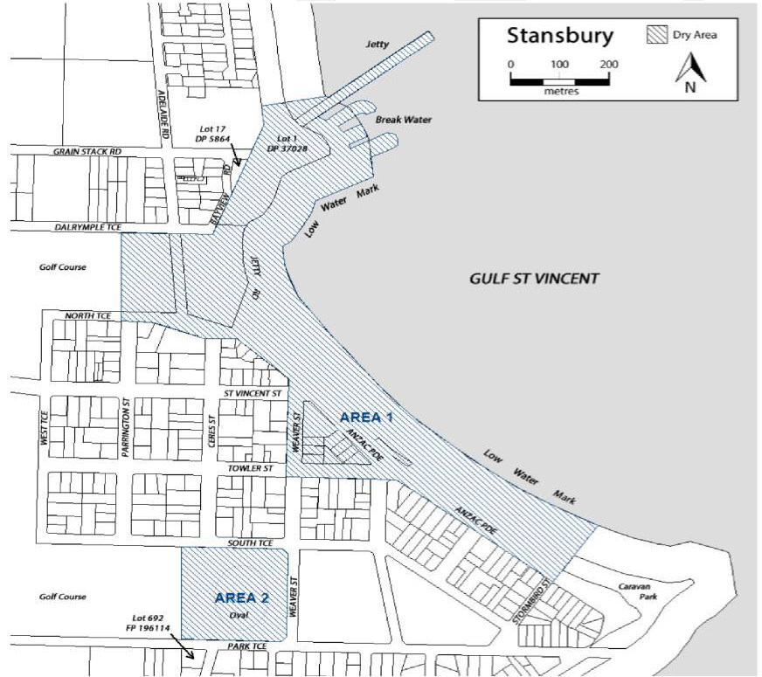

Public Notices

Trustee Act 1936
Public Trustee
Estates of Deceased Persons
In the matter of the estates of the undermentioned deceased persons:
BOWKETT William Keith late of 53 Austral Terrace Morphettville Retired Diesel Mechanic who died 27 April 2023
GREGORI Vittorio late of 117 Diagonal Road Warradale Retired Refrigeration Mechanic who died 8 May 2023
HANSEN Patricia Elizabeth late of 8 Fletcher Road Mount Barker Retired School Principal who died 1 February 2023
KOTZ Judith Kaye late of 1 Meadow Way Hackham of no occupation who died 9 March 2023
LANGTON Joan Merle late of 2 The Strand Mawson Lakes of no occupation who died 26 December 2021
RICHARDS Ronald Joseph late of 4 Jasper Court Banksia Park Retired Armed Forces who died 13 July 2023
VATER Joan Janet late of 84 Wilpena Street Eden Hills Retired Post Office Employee who died 10 August 2023
Notice is hereby given pursuant to the Trustee Act 1936, the Inheritance (Family Provision) Act 1972 and the Family Relationships Act 1975 that all creditors, beneficiaries, and other persons having claims against the said estates are required to send, in writing, to the office of Public Trustee at GPO Box 1338, Adelaide SA 5001, full particulars and proof of such claims, on or before 1 December 2023 otherwise they will be excluded from the distribution of the said estate; and notice is also hereby given that all persons indebted to the said estates are required to pay the amount of their debts to the Public Trustee or proceedings will be taken for the recovery thereof; and all persons having any property belonging to the said estates are forthwith to deliver same to the Public Trustee.
Dated: 2 November 2023
N. S. Rantanen
Public Trustee

Notice Submission

The South Australian Government Gazette is published each Thursday afternoon.
Notices must be emailed by 4 p.m. Tuesday, the week of publication.
Submissions are formatted per the gazette style and a proof will be supplied prior to publication, along with a quote if applicable. Please allow one day for processing notices.
Alterations to the proof must be returned by 4 p.m. Wednesday.

Gazette notices must be submitted as Word files, in the following format:
• Title—the governing legislation
• Subtitle—a summary of the notice content
• Body—structured text, which can include numbered lists, tables, and images
• Date—day, month, and year of authorisation
• Signature block—name, role, and department/organisation authorising the notice

Please provide the following information in your email:
• Date of intended publication
• Contact details of the person responsible for the notice content
• Name and organisation to be charged for the publication—Local Council and Public notices only
• Purchase order, if required—Local Council and Public notices only

Email: governmentgazettesa@sa.gov.au
Phone: (08) 7133 3552
Website: www.governmentgazette.sa.gov.au

All instruments appearing in this gazette are to be considered official, and obeyed as such

Printed and published weekly by authority of M. Dowling, Government Printer, South Australia
$8.55 per issue (plus postage), $430.00 per annual subscription—GST inclusive
Online publications: www.governmentgazette.sa.gov.au

