No. 87 p. 3971
THE SOUTH AUSTRALIAN
GOVERNMENT GAZETTE
Published by Authority

Adelaide, Thursday, 30 November 2023

Contents

Governor’s Instruments
Appointments 3972
Regulations—
Australian Road Rules (Miscellaneous) Amendment
Rules 2023—No. 113 of 2023 3974
Road Traffic (Road Rules—Ancillary and Miscellaneous Provisions) (Road Rules) Amendment
Regulations 2023—No. 114 of 2023 3996
Road Traffic (Miscellaneous) (Road Rules and Other
Matters) Amendment Regulations 2023—
No. 115 of 2023 4000
Motor Vehicles (Road Rules) Amendment
Regulations 2023—No. 116 of 2023 4002
Planning, Development and Infrastructure (General) (Certificates of Occupancy) Amendment
Regulations 2023—No. 117 of 2023 4004
Aquaculture (Miscellaneous) Amendment
Regulations 2023—No. 118 of 2023 4006
State Government Instruments
Associations Incorporation Act 1985 4016
Building Work Contractors Act 1995 4016
Environment Protection Act 1993 4016
Geographical Names Act 1991 4017
Harbors and Navigation Regulations 2023 4018
Housing Improvement Act 2016 4018
Justices of the Peace Act 2005 4019
Land Acquisition Act 1969 4020
Local Government (Elections) Act 1999 4026
Mental Health Act 2009 4027
Pastoral Land Management and Conservation Act 1989 4027
Proof of Sunrise and Sunset Act 1923 4027
Road Traffic (Miscellaneous) Regulations 2014 4028
Roads (Opening and Closing) Act 1991 4029
Summary Offences Act 1953 4031
The Remuneration Tribunal 4031
Local Government Instruments
City of Adelaide 4033
City of Mitcham 4033
City of Port Adelaide Enfield 4033
City of Salisbury 4034
Adelaide Plains Council 4034
Alexandrina Council 4037
Kangaroo Island Council 4041
District Council of Streaky Bay 4041
Wattle Range Council 4045
Public Notices
National Electricity Law 4046
National Gas Law 4046
Trustee Act 1936 4046

Governor’s Instruments

Appointments
Department of the Premier and Cabinet
Adelaide, 30 November 2023
Her Excellency the Governor in Executive Council has been pleased to appoint the undermentioned to the Board of the Environment Protection Authority, pursuant to the provisions of the Environment Protection Act 1993:
Member: from 1 December 2023 until 30 November 2024
Helen Anne Macdonald
Member: from 1 December 2023 until 30 November 2026
Susan Barbara Jeanes
By command,
Clare Michele Scriven MLC
For Premier
CAB23/00127

Department of the Premier and Cabinet
Adelaide, 30 November 2023
Her Excellency the Governor in Executive Council has been pleased to appoint the undermentioned to the South Australian Film Corporation, pursuant to the provisions of the South Australian Film Corporation Act 1972:
Member: from 30 November 2023 until 29 November 2026
Clara Joan Reeves
By command,
Clare Michele Scriven MLC
For Premier
23ART0025CS

Department of the Premier and Cabinet
Adelaide, 30 November 2023
Her Excellency the Governor in Executive Council has been pleased to appoint the undermentioned to the Art Gallery Board, pursuant to the provisions of the Art Gallery Act 1939:
Member: from 30 November 2023 until 29 November 2026
Ali Gumillya Baker
By command,
Clare Michele Scriven MLC
For Premier
23ART0029CS

Department of the Premier and Cabinet
Adelaide, 30 November 2023
Her Excellency the Governor in Executive Council has been pleased to appoint the undermentioned to the Outback Communities Authority, pursuant to the provisions of the Outback Communities (Administration and Management) Act 2009:
Member: from 1 January 2024 until 31 December 2026
Andrea Christine Triggs
William James Fennell
Anthony Ross Vaughan
By command,
Clare Michele Scriven MLC
For Premier
23MINCAB-0013

Department of the Premier and Cabinet
Adelaide, 30 November 2023
Her Excellency the Governor in Executive Council has been pleased to appoint the undermentioned to the Aquaculture Tenure Allocation Board, pursuant to the provisions of the Aquaculture Act 2001:
Member: from 1 August 2024 until 20 January 2027
Katherine Ngaire Shierlaw
Alexander Cameron Thamm
Member: from 21 January 2024 until 20 January 2027
Kyra Natalie Reznikov
Peter Raymond Lauer
Zoe Anne Doubleday
Ananth Subramanian Narayan

Deputy Member: from 21 January 2024 until 20 January 2027
Johan Wessel Elferink (Deputy to Reznikov and Narayan)
Lauren Giorgio (Deputy to Shierlaw and Thamm)
Presiding Member: from 1 August 2024 until 20 January 2027
Katherine Ngaire Shierlaw
By command,
Clare Michele Scriven MLC
For Premier
MPIRDF2023/000224

Department of the Premier and Cabinet
Adelaide, 30 November 2023
Her Excellency the Governor in Executive Council has been pleased to appoint Emily Rachel Strickland to be the Ombudsman, commencing on 1 January 2024 and expiring on 31 December 2030 - pursuant to the Ombudsman Act 1972.
By command,
Clare Michele Scriven MLC
For Premier
AGO0228-23CS

Regulations
South Australia

Australian Road Rules (Miscellaneous) Amendment Rules 2023
under the Road Traffic Act 1961

Contents
Part 1—Preliminary
1 Short title
2 Commencement
Part 2—Amendment of Australian Road Rules
3 Amendment of rule 28—Starting a left turn from a multi-lane road
4 Amendment of rule 32—Starting a right turn from a multi-lane road
5 Substitution of rule 38
38 Giving way when making a U-turn
6 Insertion of rules 43 and 43A
43 Making a U-turn at certain crossings
43A Making a U-turn on a road-related area with traffic lights
7 Amendment of rule 44—Division does not apply to entering or leaving a roundabout or lane filtering
8 Amendment of rule 62—Giving way when turning at an intersection with traffic lights
9 Amendment of rule 64—Giving way at a flashing yellow traffic arrow at an intersection
10 Amendment of rule 67—Stopping and giving way at a stop sign or stop line at an intersection without traffic lights
11 Amendment of rule 69—Giving way at a give way sign or give way line at an intersection (except a roundabout)
12 Amendment of rule 72—Giving way at an intersection (except a T-intersection or roundabout)
13 Amendment of rule 73—Giving way at a T-intersection
14 Amendment of rule 74—Giving way when entering a road from a road-related area or adjacent land
15 Amendment of rule 85—Giving way on a painted island
16 Amendment of rule 111—Entering a roundabout from a multi-lane road or a road with 2 or more lines of traffic travelling in the same direction
17 Amendment of rule 128A—Entering blocked crossings
18 Amendment of rule 129—Keeping to the far left side of a road
19 Amendment of rule 154—Bus lanes
20 Insertion of rule 154A
154A Bus only lanes
21 Amendment of rule 174—Stopping at or near bicycle crossing lights (except at an intersection)
22 Amendment of rule 187—Stopping in a bicycle lane, bus lane, tram lane, tramway, transit lane, truck lane or on tram tracks
23 Amendment of rule 189—Double parking
24 Insertion of rules 203B and 203C
203B Stopping in a parking area for electric-powered vehicles
203C Stopping in a parking area for the charging of electric-powered vehicles
25 Amendment of rule 206—Time extension for people with disabilities
26 Amendment of rule 207—Parking where fees are payable
27 Substitution of rule 221
221 Using hazard warning lights
28 Amendment of rule 224—Using horns and similar warning devices
29 Amendment o rule 225—Using radar detectors and similar devices
30 Amendment of rule 232—Crossing a road at traffic lights
31 Amendment of rule 233—Crossing a road to or from a tram
32 Amendment of rule 235—Crossing a level crossing
33 Amendment of rule 235A—Crossing a pedestrian level crossing that has a red pedestrian light
34 Amendment of rule 244B—Wearing of helmets by users of motorised scooters
35 Amendment of rule 261—Stopping for a yellow bicycle crossing light
36 Amendment of rule 262—Proceeding when bicycle crossing at an intersection or another place on a road
37 Substitution of rule 264
264 Wearing of seatbelts by drivers
38 Amendment of rule 265—Wearing of seatbelts by passengers 16 years old or older
39 Amendment of rule 267—Exemptions from wearing seatbelts
40 Amendment of rule 268—How persons must travel in or on a motor vehicle
41 Amendment of rule 270—Wearing motor bike helmets
42 Amendment of rule 271—Riding on motor bikes
43 Amendment of rule 280—Application of Division
44 Amendment of rule 299—Television receivers and visual display units in vehicles
45 Amendment of rule 300—Use of mobile phones
46 Insertion of rule 300A
300A Interfering with or interrupting funeral procession
47 Amendment of rule 307—Stopping and parking exemption for police and emergency vehicles and authorised persons
48 Amendment of rule 308—Exemption for police officers and emergency workers on foot
49 Amendment of rule 313B—Exemption for breakdown vehicles
50 Amendment of Schedule 2—Standard or commonly used traffic signs
51 Amendment of Schedule 3—Other permitted traffic signs
52 Amendment of Schedule 4—Symbols and traffic-related items
53 Amendment of Dictionary

Part 1—Preliminary
1—Short title
These rules may be cited as the Australian Road Rules (Miscellaneous) Amendment Rules 2023.
2—Commencement
These rules come into operation 4 months after the day on which they are made (see Legislative Instruments Act 1978 section 10AA).
Part 2—Amendment of Australian Road Rules
3—Amendment of rule 28—Starting a left turn from a multi-lane road
(1) Rule 28(1)—after paragraph (c) insert:
or
(d) the lane is a bus only lane.
(2) Rule 28(1), note 1—delete "and left lane is defined in subrule (3)" and substitute:
left lane is defined in subrule (3) and bus only lane is defined in rule 154A
4—Amendment of rule 32—Starting a right turn from a multi-lane road
(1) Rule 32(1)—after paragraph (c) insert:
or
(d) the lane is a bus only lane.
(2) Rule 32(1), note 1—delete "and right lane is defined in subrule (3)" and substitute:
right lane is defined in subrule (3) and bus only lane is defined in rule 154A
5—Substitution of rule 38
Rule 38—delete the rule and substitute:
38—Giving way when making a U-turn
(1) A driver making a U-turn must give way to all vehicles and pedestrians.
Offence provision.
Note—
For this rule, give way means the driver must slow down and, if necessary, stop to avoid a collision—see the definition in the dictionary.
(2) Despite subrule (1), a driver does not have to give way to a driver entering the road from a road-related area or adjacent land.
Note—
Adjacent land is defined in the dictionary and road-related area is defined in rule 13.
(3) In this rule—
road does not include a road-related area.
Note—
A road-related area includes any shoulder of a road—see rule 13.
6—Insertion of rules 43 and 43A
After rule 42 insert:
43—Making a U-turn at certain crossings
A driver must not make a U-turn at any of the following crossings, with or without traffic lights, unless there is a U-turn permitted sign at the crossing:
(a) children's crossing;
(b) level crossing;
(c) marked foot crossing;
(d) pedestrian crossing.
Offence provision.
Note—
Children's crossing is defined in rule 80, level crossing is defined in rule 120, pedestrian crossing is defined in rule 81 and marked foot crossing and traffic lights are defined in the dictionary.
43A—Making a U-turn on a road-related area with traffic lights
A driver must not make a U-turn at a place with traffic lights where a road and road-related area intersect unless there is a U-turn permitted sign at the place.
Offence provision.
Note 1—
Road includes a road-related area—see rule 11(2).
Note 2—
Traffic lights is defined in the dictionary and road-related area is defined in rule 13.
7—Amendment of rule 44—Division does not apply to entering or leaving a roundabout or lane filtering
(1) Rule 44, heading—delete "or lane filtering" and substitute:
, lane filtering or repositioning
(2) Rule 44—after paragraph (b) insert:
or
(c) the rider of a motor bike while repositioning the motor bike within the same lane in order to avoid a hazard or reduce the risk of a crash.
8—Amendment of rule 62—Giving way when turning at an intersection with traffic lights
(1) Rule 62(1)(a)—after "pedestrian" insert:
or rider of a bicycle
(2) Rule 62(1)(b)(ii)—delete "at or near the intersection who is on" and substitute:
or rider of a bicycle at or near the intersection who is crossing
(3) Rule 62(1), SA NOTE—delete the SA NOTE
(4) Rule 62(1), note 1—delete "Intersection," and substitute:
Bicycle, intersection,
9—Amendment of rule 64—Giving way at a flashing yellow traffic arrow at an intersection
(1) Rule 64(b)—after "pedestrian" insert:
or rider of a bicycle
(2) Rule 64, SA NOTE—delete the SA NOTE
(3) Rule 64, note 1—delete "Intersection," and substitute:
Bicycle, intersection,
10—Amendment of rule 67—Stopping and giving way at a stop sign or stop line at an intersection without traffic lights
(1) Rule 67(4)—after "pedestrian" insert:
or rider of a bicycle
(2) Rule 67(4), note—delete the note and substitute:
Note 1—
Bicycle is defined in the dictionary.
Note 2—
Rule 353(1) specifies that a driver is not required to give way to a pedestrian who is crossing the road that the driver is leaving, and rule 353(2) provides that a pedestrian who is only crossing a part of a road is considered to be crossing the road.
11—Amendment of rule 69—Giving way at a give way sign or give way line at an intersection (except a roundabout)
(1) Rule 69(2A)(b)—after "on" insert:
or entering
(2) Rule 69(3)—after "pedestrian" insert:
or rider of a bicycle
(3) Rule 69(3), SA NOTE—delete the SA NOTE
(4) Rule 69(3), note—delete the note and substitute:
Note 1—
Bicycle is defined in the dictionary.
Note 2—
Rule 353(1) specifies that a driver is not required to give way to a pedestrian who is crossing the road that the driver is leaving, and rule 353(2) provides that a pedestrian who is only crossing a part of a road is considered to be crossing the road.
12—Amendment of rule 72—Giving way at an intersection (except a T-intersection or roundabout)
(1) Rule 72(3)(b)—after "pedestrian" insert:
or rider of a bicycle
(2) Rule 72(3), note 1—delete "Slip lane is" and substitute:
Bicycle and slip lane are
(3) Rule 72(4)(b)—after "pedestrian" insert:
or rider of a bicycle
(4) Rule 72(4), SA NOTE—delete the SA NOTE
(5) Rule 72(4A)—after "pedestrian" insert:
or rider of a bicycle
(6) Rule 72(4A), SA NOTE—delete the SA NOTE
(7) Rule 72(5)(c)—after "pedestrian" insert:
or rider of a bicycle
13—Amendment of rule 73—Giving way at a T-intersection
(1) Rule 73(2)(b)—after "pedestrian" insert:
or rider of a bicycle
(2) Rule 73(2), note 1—delete "Continuing road," and substitute:
Bicycle, continuing road,
(3) Rule 73(3)(b)—delete "on" and substitute:
or rider of a bicycle on or entering
(4) Rule 73(3), SA NOTE—delete the SA NOTE
(5) Rule 73(4)—after "pedestrian" insert:
or rider of a bicycle
(6) Rule 73(5)(b)—after "pedestrian" insert:
or rider of a bicycle
(7) Rule 73(5), SA NOTE—delete the SA NOTE
(8) Rule 73(5)—at the end of subrule (5) insert:
Example—
Example 3A
Driver turning left using a slip lane giving way to a vehicle that is turning right into the road the driver is entering
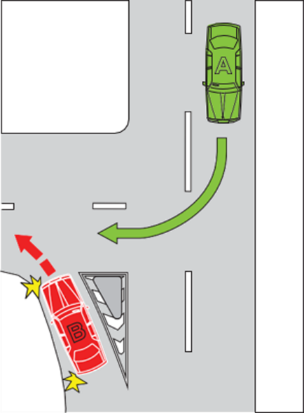
(9) Rule 73(6)(b)—after "pedestrian" insert:
or rider of a bicycle
14—Amendment of rule 74—Giving way when entering a road from a road-related area or adjacent land
(1) Rule 74(1)—after paragraph (a) insert:
(aa) a driver making a U-turn on the road; and
(2) Rule 74(1)(d)(i)—after "pedestrian" insert:
or rider of a bicycle
(3) Rule 74(1), note 1—after "Adjacent land," insert:
bicycle,
(4) Rule 74(1), note 1—delete "and traffic lights" and substitute:
, traffic lights and U-turn
15—Amendment of rule 85—Giving way on a painted island
Rule 85, examples at the end of rule 85—delete the examples and substitute:
Examples—

Example 1 | Example 2
Driver entering a turning lane from a painted island giving way to a vehicle entering the turning lane from the marked lane immediately to the right of the turning lane.  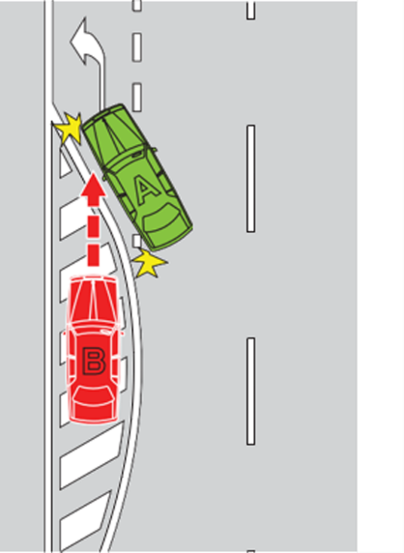 | Driver entering a turning lane from a painted island giving way to a vehicle entering the turning lane from the marked lane immediately to the left of the turning lane.  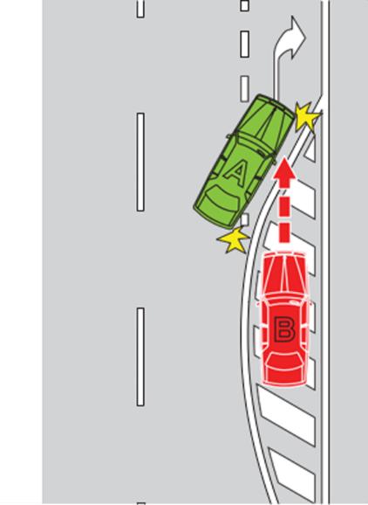
In the examples, vehicle B must give way to vehicle A.
16—Amendment of rule 111—Entering a roundabout from a multi-lane road or a road with 2 or more lines of traffic travelling in the same direction
(1) Rule 111(2)—delete "enter the roundabout from the left marked lane or, if the road is not a multi-lane road, as near as practicable to the left side of the road." and substitute:
enter the roundabout—
(a) from the left marked lane; or
(b) if the road is not a multi-lane road—as near as practicable to the left side of the road.
(2) Rule 111—after subrule (5) insert:
(5A) Subrule (2)(b) does not apply to the rider of a bicycle.
Note—
Bicycle is defined in the dictionary.
17—Amendment of rule 128A—Entering blocked crossings
(1) Rule 128A(2)(c)—after "pedestrian" insert:
or rider of a bicycle
(2) Rule 128A(2), SA NOTE—delete "regulations 9A and 9B" and substitute:
regulation 9B
(3) Rule 128A—at the end of subrule (2), after the SA NOTE, insert:
Note—
Bicycle is defined in the dictionary.
18—Amendment of rule 129—Keeping to the far left side of a road
Rule 129(2)—delete subrule (2), including the note, and substitute:
(2) This rule does not apply to—
(a) the rider of a motor bike; or
(b) the rider of a bicycle when approaching, entering or riding in a roundabout.
Note—
Approaching, bicycle, motor bike and roundabout are defined in the dictionary.
19—Amendment of rule 154—Bus lanes
(1) Rule 154(3), definition of bus lane road marking, (c)—delete paragraph (c)
(2) Rule 154, SA NOTE at the end of the rule—delete the SA NOTE
20—Insertion of rule 154A
After rule 154 insert:
154A—Bus only lanes
(1) A driver (except the driver of a public bus) must not drive in a bus only lane, unless the driver is permitted to drive in the bus only lane under subrule (2).
Offence provision.
Note—
Bus and public bus are defined in the dictionary and bus only lane is defined in subrule (6).
(2) A driver may drive in a bus only lane if—
(a) it is necessary for the driver to drive in the bus only lane to avoid an obstruction; and
(b) the driver does not obstruct the path of a public bus travelling in the bus only lane; and
(c) where the driver is approaching the bus only lane from the same direction as a vehicle in a bus only lane—the driver approaches the bus only lane from the lane nearest to the bus only lane; and
(d) the driver gives way to any vehicles driving in the bus only lane.
(3) A driver must not drive across a bus only lane, unless the driver is permitted to drive across the bus only lane under subrule (4).
Offence provision.
(4) A driver may drive across a bus only lane only if—
(a) the driver is driving across the bus only lane to—
(i) enter or leave a road; or
(ii) enter a part of the road of one kind from a part of the road of another kind (for example, moving to or from a service road, the shoulder of the road or an emergency stopping lane); and
(b) where the driver is approaching the bus only lane from the same direction as a vehicle in a bus only lane—the driver approaches the bus only lane from the lane nearest to the bus only lane; and
(c) the driver gives way to any vehicles driving in the bus only lane.
(5) A driver turning at an intersection immediately after a bus only lane must—
(a) if the driver is approaching the bus only lane from the same direction as a vehicle in a bus only lane—approach the bus only lane from the lane nearest to the bus only lane; and
(b) give way to any vehicles driving in the bus only lane.
Offence provision.
(6) A bus only lane is a marked lane or the part of a marked lane—
(a) beginning at a bus only lane sign (whether or not there is also a bus only lane road marking) and ending at the nearest of the following:
(i) an end bus only lane sign;
(ii) a traffic sign that indicates the beginning of a special purpose lane;
(iii) a traffic sign that indicates drivers of vehicles may drive in the lane beyond the sign;
(iv) an intersection with traffic lights or traffic arrows; or
(b) beginning at a bus only lane road marking (if there is no bus only lane sign) and ending at the next intersection; or
(c) that is marked with a continuous line starting at the beginning of a bus only lane road marking and ending at an end bus only lane road marking.
SA NOTE—
For South Australia, see regulation 13 of the Road Traffic (Road Rules—Ancillary and Miscellaneous Provisions) Regulations 2014.
Note—
Bus only lane road marking, marked lane, special purpose lane and traffic sign are defined in the dictionary.

Bus only lane sign | End bus only lane sign  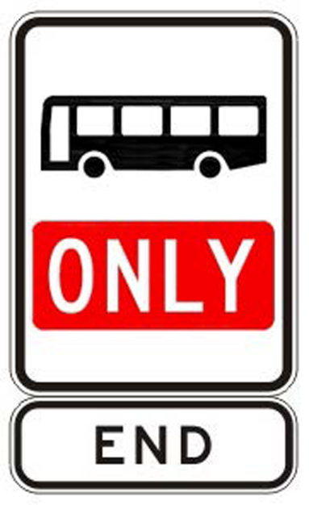
21—Amendment of rule 174—Stopping at or near bicycle crossing lights (except at an intersection)
(1) Rule 174, heading—delete "at or near bicycle crossing lights" and substitute:
on or near a bicycle crossing
(2) Rule 174(1)—delete subrule (1), including the note
(3) Rule 174(2)—after "not stop" insert:
on a bicycle crossing or
(4) Rule 174(2)—delete "the place" and substitute:
the bicycle crossing
(5) Rule 174(2), note 1—delete the note
(6) Rule 174(2), note 2—delete "Note 2" and substitute:
Note
(7) Rule 174(4)—before the definition of road insert:
bicycle crossing means an area of road—
(a) with bicycle crossing lights facing bicycle riders crossing the road; and
(b) with traffic lights facing traffic travelling on the road; and
(c) that is not at an intersection.
(8) Rule 174(4), note—delete the note and substitute:
Note—
Intersection, parking control sign and traffic lights are defined in the dictionary, road-related area is defined in rule 13 and shoulder is defined in rule 12.
22—Amendment of rule 187—Stopping in a bicycle lane, bus lane, tram lane, tramway, transit lane, truck lane or on tram tracks
(1) Rule 187, heading—after "bus lane," insert:
bus only lane,
(2) Rule 187(1), SA NOTE at the foot of subrule (1)—delete the SA NOTE and substitute:
Note—
Bus lane is defined in rule 154, transit lane is defined in rule 156, truck lane is defined in rule 157, and public bus, public minibus and taxi are defined in the dictionary.
(3) Rule 187(2)—after the offence provision insert:
Note 1—
Bicycle lane is defined in rule 153.
Note 2—
Part 11, Division 6 deals with driving in bicycle lanes, bus lanes, tram lanes, tramways, transit lanes and truck lanes.
(4) Rule 187(3), notes 1 to 3—delete notes 1 to 3 (inclusive) and substitute:
Note 1—
Tram lane is defined in rule 155, tramway is defined in rule 155A, and tram and tram tracks are defined in the dictionary.
Note 2—
Rule 76 deals with drivers keeping clear of trams travelling in tram lanes or on tram tracks marked on each side by a yellow line.
(5) Rule 187—after subrule (3) insert:
(4) A driver must not stop in a bus only lane unless the driver is driving a public bus and is dropping off, or picking up, passengers.
Offence provision.
Note—
Public bus is defined in the dictionary and Bus only lane is defined in rule 154A.
23—Amendment of rule 189—Double parking
Rule 189(1)—delete "he or she" and substitute:
the driver
24—Insertion of rules 203B and 203C
After rule 203A insert:
203B—Stopping in a parking area for electric-powered vehicles
(1) A driver of a vehicle that is not an electric-powered vehicle must not stop in a parking area for electric-powered vehicles.
Offence provision.
(2) A parking area for electric-powered vehicles is a length or area of a road—
(a) to which a permissive parking sign displaying an electric-powered vehicle symbol applies; or
(b) to which an electric-powered vehicle parking sign applies; or
(c) indicated by a road marking that consists of, or includes, an electric-powered vehicle symbol.
Note—
Road marking is defined in the dictionary.
(3) An electric-powered vehicle means a vehicle that—
(a) is powered by 1 or more electric motors or traction motors, regardless of whether the vehicle is also powered by another form of propulsion; and
(b) can be recharged from an external source of electricity.
Electric-powered vehicle symbol
SA NOTE—
For South Australia, see regulation 19A of the Road Traffic (Road Rules—Ancillary and Miscellaneous Provisions) Regulations 2014.
203C—Stopping in a parking area for the charging of electric-powered vehicles
(1) A driver must not stop in a parking area for the charging of electric-powered vehicles unless—
(a) the driver's vehicle is an electric-powered vehicle; and
(b) the electric-powered vehicle is plugged in to an external source of electricity.
Offence provision.
Note—
Electric-powered vehicle is defined in rule 203B.
(2) A parking area for the charging of an electric-powered vehicle is a length or area of a road—
(a) to which a permissive parking sign displaying an electric-powered vehicle charging symbol applies; or
(b) to which an electric-powered vehicle charging parking sign applies; or
(c) indicated by a road marking that consists of, or includes, an electric-powered vehicle charging symbol.
Note—
Road marking is defined in the dictionary.
Electric-powered vehicle charging symbol
SA NOTE—
For South Australia, see regulation 19A of the Road Traffic (Road Rules—Ancillary and Miscellaneous Provisions) Regulations 2014.
25—Amendment of rule 206—Time extension for people with disabilities
Rule 206(2)—delete "his or her" and substitute:
the driver's
26—Amendment of rule 207—Parking where fees are payable
(1) Rule 207(1)—delete "by buying a ticket or putting money into a parking meter"
(2) Rule 207(2)(b)—delete paragraph (b) and substitute:
(b) obey instructions (if any)—
(i) on or with the sign or a meter, ticket or ticket-vending machine; and
(ii) in a mobile app or other electronic method used for the payment of fees under this rule, being an app or method indicated on or with the sign or a meter, ticket or ticket-vending machine.
27—Substitution of rule 221
Rule 221—delete the rule and substitute:
221—Using hazard warning lights
The driver of a vehicle fitted with hazard warning lights must not use the hazard warning lights, or allow them to be used, unless—
(a) the vehicle is stopped and is obstructing, or is likely to obstruct, the path of other vehicles or pedestrians; or
(b) the vehicle is a slow-moving vehicle and is obstructing, or is likely to obstruct, the path of other vehicles or pedestrians; or
(c) the vehicle is stopped in an emergency stopping lane; or
(d) the driver stops the vehicle to sell a product (for example, ice creams) that may attract children onto the road; or
(e) the driver is driving in hazardous weather conditions (for example, fog or smoke); or
(f) the vehicle is a bus carrying children, and the driver stops the vehicle to drop off or pick up a child and is required or permitted to operate the hazard warning lights under another law of this jurisdiction; or
(g) the hazard warning lights are operating as part of an anti-theft device, or an alcohol interlock device, fitted to the vehicle.
Offence provision.
SA NOTE—
For South Australia, see regulation 26 of the Road Traffic (Road Rules—Ancillary and Miscellaneous Provisions) Regulations 2014.
Note 1—
Alcohol interlock device, bus and hazard warning lights are defined in the dictionary, and emergency stopping lane is defined in rule 95.
Note 2—
Driver includes a person in control of a vehicle—see the definition of drive in the dictionary.
Note 3—
A vehicle does not obstruct another vehicle only because the vehicle is stopped in traffic or is travelling more slowly than other vehicles—see the definition of obstruction in the dictionary.
28—Amendment of rule 224—Using horns and similar warning devices
Rule 224, note 1—delete the note and substitute:
Note 1—
Alcohol interlock device and driver's vehicle are defined in the dictionary and road user is defined in rule 14.
29—Amendment o rule 225—Using radar detectors and similar devices
Rule 225(2)—delete "his or her" and substitute:
the person's
30—Amendment of rule 232—Crossing a road at traffic lights
(1) Rule 232(3A)—delete "he or she has" and substitute:
the pedestrian has
(2) Rule 232(3A)(a)—delete "him or her than the side or safety area (whichever is the closer) that he or she" and substitute:
the pedestrian than the side or safety area (whichever is the closer) that the pedestrian
(3) Rule 232(3A)(b)—delete "he or she" and substitute:
the pedestrian
31—Amendment of rule 233—Crossing a road to or from a tram
Rule 233(4)(b)—delete "his or her" and substitute:
the employee's
32—Amendment of rule 235—Crossing a level crossing
Rule 235(2A)—delete "he or she" and substitute:
the pedestrian
33—Amendment of rule 235A—Crossing a pedestrian level crossing that has a red pedestrian light
(1) Rule 235A(2)—delete "he or she" and substitute:
the pedestrian
(2) Rule 235A(3)—delete "he or she" and substitute:
the pedestrian
34—Amendment of rule 244B—Wearing of helmets by users of motorised scooters
Rule 244B—delete "his or her head, unless he or she" and substitute:
the person's head, unless the person
35—Amendment of rule 261—Stopping for a yellow bicycle crossing light
Rule 261(1), note—delete "is defined" and substitute:
and intersection are defined
36—Amendment of rule 262—Proceeding when bicycle crossing at an intersection or another place on a road
(1) Rule 262(2A)—delete "he or she has" and substitute:
the rider has
(2) Rule 262(2A)(a)—delete "him or her than the side or safety area (whichever is the closer) that he or she" and substitute:
the rider than the side or safety area (whichever is the closer) that the rider
(3) Rule 262(2A)(b)—delete "he or she" and substitute:
the rider
37—Substitution of rule 264
Rule 264—delete the rule and substitute:
264—Wearing of seatbelts by drivers
The driver of a motor vehicle that is moving, or is stationary but not parked—
(a) must occupy a driver's seating position that is fitted with an approved seatbelt; and
(b) must not occupy the same seating position as another passenger (whether or not the other passenger is exempt from wearing a seatbelt under rule 267); and
(c) must wear the seatbelt properly adjusted and fastened, unless the driver is reversing the vehicle or exempt from wearing a seatbelt under rule 267.
Offence provision.
Examples of seatbelts being properly adjusted and fastened—
1 A lap and sash seatbelt is properly adjusted and fastened for a driver if—
(a) the seatbelt is secured in the buckle with the lap portion of the belt sitting low and firmly over the driver's hips; and
(b) the sash portion of the belt is positioned firmly over the driver's shoulder and not under the driver's arm furthest from the secured buckle or behind the driver's back.
2 A lap belt is properly adjusted and fastened for a driver if the seatbelt is secured in the buckle with the belt sitting low and firmly over the driver's hips.
SA NOTE—
For South Australia, see regulation 34A of the Road Traffic (Road Rules—Ancillary and Miscellaneous Provisions) Regulations 2014.
Note 1—
Driver is defined in rule 16, and approved seatbelt, motor vehicle and park are defined in the dictionary.
Note 2—
Rule 267 provides exemptions from wearing seatbelts.
38—Amendment of rule 265—Wearing of seatbelts by passengers 16 years old or older
(1) Rule 265(1)—delete "he or she" and substitute:
the passenger
(2) Rule 265(2)—after paragraph (c) and before note 1 insert:
Examples of seatbelts being properly adjusted and fastened—
1 A lap and sash seatbelt is properly adjusted and fastened for a passenger if—
(a) the seatbelt is secured in the buckle with the lap portion of the belt sitting low and firmly over the passenger's hips; and
(b) the sash portion of the belt is positioned firmly over the passenger's shoulder and not under the passenger's arm furthest from the secured buckle or behind the passenger's back.
2 A lap belt is properly adjusted and fastened for a passenger if the seatbelt is secured in the buckle with the belt sitting low and firmly over the passenger's hips.
39—Amendment of rule 267—Exemptions from wearing seatbelts
(1) Rule 267(1A)(a)—delete "he or she" and substitute:
the person
(2) Rule 267(6)—delete "he or she" and substitute:
the person
(3) Rule 267(7)—delete "he or she" and substitute:
the driver
40—Amendment of rule 268—How persons must travel in or on a motor vehicle
Rule 268(2)(b)—delete "he or she" and substitute:
the person
41—Amendment of rule 270—Wearing motor bike helmets
Rule 270(3), definition of approved motor bike helmet, (a)(iii)—delete "(the UN standard); and" and substitute:
; or
(iv) the United Nations Economic Commission for Europe standard 22.06; and
42—Amendment of rule 271—Riding on motor bikes
(1) Rule 271(1)—delete subrule (1) (other than the note) and substitute:
(1) Unless subrule (1A) applies, the rider of a motor bike that is moving (other than a motor bike that is being pushed by a rider who is walking beside it), or the rider of a motor bike that is stationary but not parked, must—
(a) sit astride the rider's seat facing forwards; and
(b) if the motor bike is moving—
(i) keep at least 1 hand on the handlebars; and
(ii) keep both feet on the footrests or footboard designed for the rider's use.
Offence provision.
(2) Rule 271(1A)—delete "Also, the" and substitute:
The
(3) Rule 271(1A)—after paragraph (b) before the note insert:
or
(c) remove both feet from the footrests or footboard designed for the rider's use if the motor bike is moving at less than 10 kilometres per hour and—
(i) the rider is manoeuvring the motor bike in order to park the motor bike; or
(ii) the motor bike is decelerating to come to a stop; or
(iii) the motor bike is accelerating from being stopped.
43—Amendment of rule 280—Application of Division
(1) Rule 280(1)—after "lane" insert:
or bus only lane
(2) Rule 280(2)(b)—after "lane" insert:
or bus only lane
44—Amendment of rule 299—Television receivers and visual display units in vehicles
Rule 299—after subrule (3) insert:
(4) For the purpose of this rule, a vehicle may be parked even though—
(a) the key to the vehicle is located in the vehicle's ignition lock; or
(b) the engine of the vehicle is running.
45—Amendment of rule 300—Use of mobile phones
Rule 300—after subrule (3) insert:
(3A) For the purpose of this rule, a vehicle may be parked even though—
(a) the key to the vehicle is located in the vehicle's ignition lock; or
(b) the engine of the vehicle is running.
46—Insertion of rule 300A
After rule 300, including the SA NOTE, insert:
300A—Interfering with or interrupting funeral procession
A driver must not interfere with, or interrupt, the free passage along any length of road of—
(a) any funeral procession; or
(b) any vehicle or person apparently forming part of the procession.
Offence provision.
47—Amendment of rule 307—Stopping and parking exemption for police and emergency vehicles and authorised persons
Rule 307(2)—delete "his or her" and substitute:
the driver's
48—Amendment of rule 308—Exemption for police officers and emergency workers on foot
Rule 308—delete "his or her" and substitute:
the police officer's or emergency worker's
49—Amendment of rule 313B—Exemption for breakdown vehicles
(1) Rule 313B(1)(a)—delete "his or her" and substitute:
the person's
(2) Rule 313B(3), definition of breakdown vehicle, (b)—delete "his or her" and substitute:
the person's
50—Amendment of Schedule 2—Standard or commonly used traffic signs
(1) Schedule 2—after the item headed "Buses must enter sign" insert:
Bus only lane sign
(rule 154A)
(2) Schedule 2—after the item headed "End bus lane sign" insert:
End bus only lane sign
(rule 154A)
51—Amendment of Schedule 3—Other permitted traffic signs
(1) Schedule 3—delete each item headed "Bus lane sign (rule 154)" and substitute:

Bus lane sign  (rule 154)  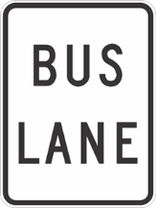 | Bus lane sign  (rule 154)  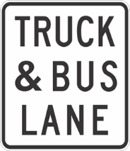
Bus lane sign  (rule 154)  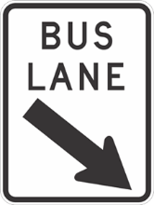 | Bus lane sign  (rule 154)  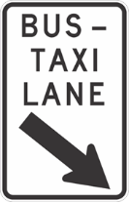
Bus lane sign
(rule 154)
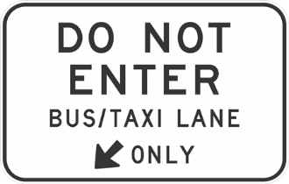
(2) Schedule 3—after the item headed "Buses must enter sign (rule 107)" insert:

Bus only lane sign  (rule 154A) | Bus only lane sign  (rule 154A)
Bus only lane sign
(rule 154A)
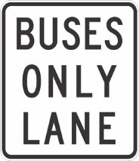
(3) Schedule 3—delete each item headed "End bus lane sign (rule 154)" and substitute:

End bus lane sign  (rule 154)  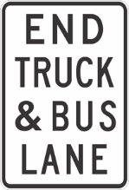 | End bus only lane sign  (rule 154A)
End bus only lane sign  (rule 154A)  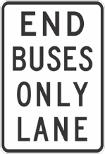 | End bus only lane sign  (rule 154A)  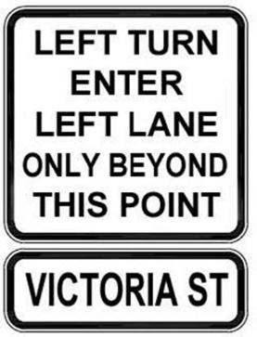
52—Amendment of Schedule 4—Symbols and traffic-related items
Schedule 4—after the items headed "Do not overtake turning vehicle sign" insert:
Electric-powered vehicle charging symbol
(rule 203C)
Electric-powered vehicle symbol
(rule 203B)
53—Amendment of Dictionary
(1) Dictionary, definition of alcohol interlock device—delete the definition and substitute:
alcohol interlock device means a device in a vehicle that is designed to prevent the vehicle from being started or driven unless the device is supplied with a breath sample that contains either no alcohol or less than a certain concentration of alcohol.
(2) Dictionary—after the definition of bus lane insert:
bus only lane see rule 154A.
bus only lane road marking means a road marking consisting of the words "bus only".
Note—
Road marking is defined in this dictionary.
(3) Dictionary, definition of correctional vehicle, (b)—delete "his or her" and substitute:
the person's
(4) Dictionary—after the definition of edge line insert:
electric-powered vehicle see rule 203B.
(5) Dictionary, definition of emergency vehicle, (b)—delete "his or her" and substitute:
the person's
(6) Dictionary—before the definition of end no filtering sign insert:
end bus only lane road marking means a road marking consisting of the words "end bus only".
Note—
Road marking is defined in this dictionary.
(7) Dictionary, definition of juvenile justice vehicle, (b)—delete "his or her" and substitute:
the person's
(8) Dictionary, definition of parking control sign—at the foot of the definition after (o) insert:
SA NOTE—
For South Australia, see regulation 58A of the Road Traffic (Road Rules—Ancillary and Miscellaneous Provisions) Regulations 2014.
(9) Dictionary, definition of police vehicle, (b)—delete "his or her" and substitute:
the person's
(10) Dictionary, definition of postal vehicle, (b)—delete "his or her" and substitute:
the person's
(11) Dictionary, definition of sheriff's vehicle, (b)—delete "his or her" and substitute:
the person's
Made by the Governor
with the advice and consent of the Executive Council
on 30 November 2023
No 113 of 2023

South Australia

Road Traffic (Road Rules—Ancillary and Miscellaneous Provisions) (Road Rules) Amendment Regulations 2023
under the Road Traffic Act 1961

Contents
Part 1—Preliminary
1 Short title
2 Commencement
Part 2—Amendment of Road Traffic (Road Rules—Ancillary and Miscellaneous Provisions) Regulations 2014
3 Substitution of regulation 9A
9A Giving way, etc, to riders of bicycles on crossings or slip lanes
4 Amendment of regulation 9B—Giving way to pedestrians, or riders of bicycles, entering crossings or slip lanes
5 Amendment of regulation 12—Vehicles permitted in bus lanes
6 Substitution of regulation 13
13 Bus only lanes
7 Insertion of regulation 19A
19A Electric-powered vehicle symbols and signs
8 Insertion of regulation 34A
34A Wearing of seatbelts by drivers
9 Insertion of regulation 58A
58A Parking control sign

Part 1—Preliminary
1—Short title
These regulations may be cited as the Road Traffic (Road Rules—Ancillary and Miscellaneous Provisions) (Road Rules) Amendment Regulations 2023.
2—Commencement
These regulations come into operation on the day on which the Australian Road Rules (Miscellaneous) Amendment Rules 2023 come into operation.
Part 2—Amendment of Road Traffic (Road Rules—Ancillary and Miscellaneous Provisions) Regulations 2014
3—Substitution of regulation 9A
Regulation 9A—delete the regulation and substitute:
9A—Giving way, etc, to riders of bicycles on crossings or slip lanes
Despite anything in—
(a) rule 63 (Giving way at an intersection with traffic lights not operating or only partly operating); or
(b) rule 69 (Giving way at a give way sign or give way line at an intersection (except a roundabout)); or
(c) rule 73 (Giving way at a T-intersection); or
(d) the definition of a pedestrian in rule 18 (Who is a pedestrian) and the dictionary at the end of the Rules,
a reference to a pedestrian in rules 63, 69(2A) or 73(5A) will be taken to include a reference to the rider of a bicycle.
4—Amendment of regulation 9B—Giving way to pedestrians, or riders of bicycles, entering crossings or slip lanes
Regulation 9B(d)—delete paragraph (d)
5—Amendment of regulation 12—Vehicles permitted in bus lanes
Regulation 12—delete ", other than a bus lane or portion of a bus lane referred to in regulation 13"
6—Substitution of regulation 13
Regulation 13—delete the regulation and substitute:
13—Bus only lanes
(1) Despite anything in rule 154A (Bus only lanes) and the Rules, for the purposes of the definition of bus only lane in rule 154A(6) and the Rules, a bus only lane includes the following:
(a) a marked lane, or a part of a marked lane, painted red in colour and marked with a bus only lane road marking—
(i) beginning at the commencement of the red painted area; and
(ii) ending at the end of that painted area;
(b) a marked lane, or a part of a marked lane—
(i) that is painted red in colour for a distance of at least 12.5 metres and marked on that red painted area with a bus only lane road marking; and
(ii) that thereafter has—
(A) a red line at least 150 mm in width marked on or immediately inside the lane boundary on each side of the lane; and
(B) further lengths of the lane painted red in colour and marked with a bus only lane road marking in accordance with subparagraph (i) at regular intervals (being intervals not exceeding 200 metres from the end of 1 painted length of lane to the commencement of the next),
beginning at the commencement of the red painted area referred to in subparagraph (i) and ending at the nearest of the following:
(iii) the end of the red lines referred to in subparagraph (ii)(A);
(iv) an end bus only lane road marking;
(v) an end bus only lane sign.
(2) Part 20 (Traffic control devices and traffic-related items) of the Rules applies in relation to a road marking described in subregulation (1) as if this regulation formed part of the Rules.
7—Insertion of regulation 19A
After regulation 19 insert:
19A—Electric-powered vehicle symbols and signs
(1) For the purposes of rule 203B and the Rules—
(a) the following symbol consisting of a car and power cord is an electric-powered vehicle symbol:
(b) a traffic sign, other than a permissive parking sign, containing an electric-powered vehicle symbol is an electric-powered vehicle parking sign.
(2) For the purposes of rule 203C and the Rules—
(a) the following symbol consisting of a car and power cord, together with the words "While Charging", is an electric-powered vehicle charging symbol:
WHILE CHARGING
(b) a traffic sign, other than a permissive parking sign, containing an electric-powered vehicle charging symbol is an electric-powered vehicle charging parking sign.
(3) Subject to subregulation (4), Part 20 (Traffic control devices and traffic-related items) of the Rules applies in relation to a symbol or sign referred to in subregulations (1) and (2) as if the symbols and signs formed part of the Rules.
(4) Despite rule 314(3) and (4) (Diagrams of traffic control devices, traffic-related items and symbols), the symbols in subregulations (1)(a) and (2)(a) may consist of a black, red or green car and power cord on a white background.
8—Insertion of regulation 34A
After regulation 34 insert:
34A—Wearing of seatbelts by drivers
Despite anything in rule 264 (Wearing of seatbelts by drivers), the driver of a motor vehicle that is moving, or is stationary but not parked, is not required to comply with that rule if the driver is occupying a driver's seating position but is exempt from wearing a seatbelt under rule 267 (Exemptions from wearing seatbelts).
9—Insertion of regulation 58A
After Regulation 58 insert:
58A—Parking control sign
For the purposes of the Rules and the definition of parking control sign in the dictionary at the end of the Rules, an electric-powered vehicle parking sign and an electric-powered vehicle charging parking sign are parking control signs.
Made by the Governor
with the advice and consent of the Executive Council
on 30 November 2023
No 114 of 2023

South Australia

Road Traffic (Miscellaneous) (Road Rules and Other Matters) Amendment Regulations 2023
under the Road Traffic Act 1961

Contents
Part 1—Preliminary
1 Short title
2 Commencement
Part 2—Amendment of Road Traffic (Miscellaneous) Regulations 2014
3 Amendment of regulation 50—Child restraints, safety harnesses, booster seats etc
4 Amendment of regulation 63—Prescribed provisions (sections 174A, 174B, 174C and 174D of Act)
5 Amendment of Schedule 4—Expiation of offences

Part 1—Preliminary
1—Short title
These regulations may be cited as the Road Traffic (Miscellaneous) (Road Rules and Other Matters) Amendment Regulations 2023.
2—Commencement
These regulations come into operation on the day on which the Australian Road Rules (Miscellaneous) Amendment Rules 2023 come into operation.
Part 2—Amendment of Road Traffic (Miscellaneous) Regulations 2014
3—Amendment of regulation 50—Child restraints, safety harnesses, booster seats etc
Regulation 50(5)—delete subregulation (5)
4—Amendment of regulation 63—Prescribed provisions (sections 174A, 174B, 174C and 174D of Act)
Regulation 63(1)—after paragraph (e) insert:
(f) section 86A of the Act (Parking where ticket required without payment of fee).
5—Amendment of Schedule 4—Expiation of offences
(1) Schedule 4, Part 3, table, item relating to rule 38—delete "38" and substitute:
38(1)
(2) Schedule 4 Part 3—after the item relating to rule 42 insert:

43 | Making a U-turn at children's crossing, level crossing, marked foot crossing or pedestrian crossing without a U-turn permitted sign | $423
43A | Making a U-turn at a place with traffic lights where road and road-related area intersect without a U-turn permitted sign | $423
(3) Schedule 4, Part 3, table—after the item relating to rule 154(1) insert:

154A(1) | Driving in bus only lane | $310
154A(3) | Driving across bus only lane | $310
154A(5) | Turning at intersection immediately after bus only lane—failing to comply with rule | $310
(4) Schedule 4, Part 3, table, item relating to rule 174(2)—delete "at or near bicycle crossing lights" and substitute:
on or near bicycle crossing
(5) Schedule 4, Part 3, table—after the item relating to rule 187(3) insert:

187(4) | Stopping in bus only lane | $310
(6) Schedule 4, Part 3, table—after the item relating to rule 203A insert:

203B(1) | Stopping in parking area for electric-powered vehicles | $75
203C(1) | Stopping in parking area for charging of electric-powered vehicles | $111
(7) Schedule 4, Part 3, table, item relating to rule 221(1)—delete "221(1)" and substitute:
221
(8) Schedule 4, Part 3, table, item relating to rule 264(1)—delete the item and substitute:

264 | Failing to wear approved seatbelt, and be seated, in accordance with rule—driver | $422
(9) Schedule 4, Part 3, table—after the item relating to rule 300(1) insert:

300A | Interfering with or interrupting funeral procession | $121
(10) Schedule 4, Part 4, table, item relating to regulation 50(5) of the Road Traffic (Miscellaneous) Regulations 2014—delete the item
(11) Schedule 4, Part 5, table, item relating to regulation 13(1) of the Road Traffic (Road Rules—Ancillary and Miscellaneous Provisions) Regulations 2014—delete the item
Made by the Governor
with the advice and consent of the Executive Council
on 30 November 2023
No 115 of 2023

South Australia

Motor Vehicles (Road Rules) Amendment Regulations 2023
under the Motor Vehicles Act 1959

Contents
Part 1—Preliminary
1 Short title
2 Commencement
Part 2—Amendment of Motor Vehicles Regulations 2010
3 Amendment of Schedule 4—Demerit points

Part 1—Preliminary
1—Short title
These regulations may be cited as the Motor Vehicles (Road Rules) Amendment Regulations 2023.
2—Commencement
These regulations come into operation on the day on which the Australian Road Rules (Miscellaneous) Amendment Rules 2023 come into operation.
Part 2—Amendment of Motor Vehicles Regulations 2010
3—Amendment of Schedule 4—Demerit points
(1) Schedule 4, Part 1, clause 2, table, item relating to rule 38—delete "38" and substitute:
38(1)
(2) Schedule 4, Part 1, clause 2, table, item relating to rule 264(1)—delete the item and substitute:

264 | Failing to wear approved seatbelt, and be seated, in accordance with rule—driver | 3
(3) Schedule 4, Part 2, clause 5, table—after the item relating to rule 32(2A) insert:

43 | Making a U-turn at children's crossing, level crossing, marked foot crossing or pedestrian crossing without a U-turn permitted sign | 2
43A | Making a U-turn at a place with traffic lights where road and road-related area intersect without a U-turn permitted sign | 2
Made by the Governor
with the advice and consent of the Executive Council
on 30 November 2023
No 116 of 2023

South Australia

Planning, Development and Infrastructure (General) (Certificates of Occupancy) Amendment Regulations 2023
under the Planning, Development and Infrastructure Act 2016

Contents
Part 1—Preliminary
1 Short title
2 Commencement
Part 2—Amendment of Planning, Development and Infrastructure (General) Regulations 2017
3 Amendment of regulation 103—Exclusions
4 Amendment of regulation 103A—Required documentation
5 Amendment of regulation 103B—Prescribed requirements
6 Amendment of regulation 103G—Other matters
7 Amendment of Schedule 4—Exclusions from definition of development—general
8 Amendment of Schedule 6A—Accepted development
9 Amendment of Schedule 7—Complying building work

Part 1—Preliminary
1—Short title
These regulations may be cited as the Planning, Development and Infrastructure (General) (Certificates of Occupancy) Amendment Regulations 2023.
2—Commencement
These regulations come into operation on the day on which they are made.
Part 2—Amendment of Planning, Development and Infrastructure (General) Regulations 2017
3—Amendment of regulation 103—Exclusions
Regulation 103(2)—delete "31 December 2023" and substitute:
30 September 2024
4—Amendment of regulation 103A—Required documentation
Regulation 103A(2)—delete "1 January 2024" and substitute:
1 October 2024
5—Amendment of regulation 103B—Prescribed requirements
Regulation 103B—delete "1 January 2024" and substitute:
1 October 2024
6—Amendment of regulation 103G—Other matters
Regulation 103G(2)—delete subregulation (2) and substitute:
(2) Pursuant to section 152(1)(a) of the Act, if an appropriate notice in respect of an application for building consent in relation to a Class 1a building under the Building Code is provided under regulation 31(1)(d)(iii) before 1 October 2024, a certificate of occupancy is not required in respect of the building (but a certificate of occupancy is required in respect of the building if such a notice is given on or after that date).
7—Amendment of Schedule 4—Exclusions from definition of development—general
Schedule 4, clause 5(2)(fa)(ii)—delete "regulation 103" and substitute:
Part 11 Division 3 or 4
8—Amendment of Schedule 6A—Accepted development
(1) Schedule 6A, clause 2(1)(b)—after "Division 3" insert:
or 4
(2) Schedule 6A, clause 2(2)(b)—after "Division 3" insert:
or 4
9—Amendment of Schedule 7—Complying building work
Schedule 7, clause 12(d)(ii)—delete "regulation 103" and substitute:
Part 11 Division 3 or 4
Editorial note—
As required by section 10AA(2) of the Legislative Instruments Act 1978, the Minister has certified that, in the Minister's opinion, it is necessary or appropriate that these regulations come into operation as set out in these regulations.
Made by the Governor
with the advice and consent of the Executive Council
on 30 November 2023
No 117 of 2023

South Australia

Aquaculture (Miscellaneous) Amendment Regulations 2023
under the Aquaculture Act 2001

Contents
Part 1—Preliminary
1 Short title
2 Commencement
Part 2—Amendment of Aquaculture Regulations 2016
3 Amendment of regulation 3—Interpretation
4 Amendment of regulation 4—Approvals by Minister
5 Amendment of regulation 5—Procedures for making aquaculture policies
6 Substitution of regulation 6
6 Certain amendments may be made by Gazette notice only
7 Amendment of regulation 7—Reference of matters to EPA
8 Amendment of regulation 10—Use of chemical substances
9 Amendment of regulation 15—Stock register
10 Amendment of regulation 18—Aquaculture strategies
11 Amendment of regulation 22—Annual reporting on general environmental matters
12 Amendment of regulation 24—Marking-off lease areas
13 Insertion of regulation 24A
24A Navigational Markers
14 Insertion of Part 3A
Part 3A—Regulation of aquaculture tourism development activities
31A Aquaculture tourism waste
31B Recovery of aquaculture tourism equipment or waste blown, washed or swept off-site
31C Stock register
31D Control of aquatic organisms affected with disease
31E Notification of unusually high mortality rate and duty to isolate unaffected organisms
31F Notification of entanglement or confinement of protected animals
31G Mitigation of impacts on and interactions with seabirds and large marine vertebrates
31H Power to require or carry out work
15 Amendment of regulation 43—Defects in applications

Part 1—Preliminary
1—Short title
These regulations may be cited as the Aquaculture (Miscellaneous) Amendment Regulations 2023.
2—Commencement
These regulations come into operation on the day on which the Aquaculture (Tourism Development) Amendment Act 2021 comes into operation.
Part 2—Amendment of Aquaculture Regulations 2016
3—Amendment of regulation 3—Interpretation
(1) Regulation 3(1)—after the definition of aquaculture strategy insert:
aquaculture tourism development has the same meaning as in Part 7A of the Act;
aquaculture tourism development authorisation has the same meaning as in Part 7A of the Act;
aquaculture tourism site means the site of aquaculture tourism development as specified under the aquaculture tourism development authorisation for the development;
(2) Regulation 3(1)—after the definition of aquaculture waste insert:
building work has the same meaning as in Part 7A of the Act;
(3) Regulation 3(1)—after the definition of category A licence, category B licence, category C licence or category D licence insert:
commercial tourism activity has the same meaning as in Part 7A of the Act;
(4) Regulation 3(1), definition of GDA94—delete the definition
(5) Regulation 3(1), definition of large marine vertebrate—after "sea lions" insert:
turtles,
(6) Regulation 3(1)—after the definition of sector-based aquaculture strategy insert:
tourism lease has the same meaning as in Part 7A of the Act;
tourism licence has the same meaning as in Part 7A of the Act;
(7) Regulation 3(1), definition of WGS84—delete the definition
(8) Regulation 3(2)—after "farmed under a licence" insert:
or held on an aquaculture tourism site for the purposes of a commercial tourism activity
(9) Regulation 3(2)(a)—after "farmed under the licence" insert
or held on the site (as the case requires)
4—Amendment of regulation 4—Approvals by Minister
Section 4—delete "licensee" wherever occurring and substitute in each case:
person
5—Amendment of regulation 5—Procedures for making aquaculture policies
(1) Regulation 5(c)—delete "RecFishSA" and substitute:
South Australian Recreational Fishing Advisory Council Incorporated (RecFish SA)
(2) Regulation 5(d)—delete paragraph (d)
(3) Regulation 5(f)—delete paragraph (f) and substitute:
(f) Seafood Industry South Australia Incorporated;
(4) Regulation 5(g)—after subparagraph (ii) insert:
(iia) any person holding a tourism lease or tourism licence over an area to which the policy applies; and
(5) Regulation 5(g)(iii)—delete "NRM Board (within the meaning of the Natural Resources Management Act 2004)" and substitute:
landscape board (within the meaning of the Landscape South Australia Act 2019)
(6) Regulation 5(h)—delete "NRM Boards (within the meaning of the Natural Resources Management Act 2004)" and substitute:
landscape boards (within the meaning of the Landscape South Australia Act 2019)
(7) Regulation 5—after paragraph (h) insert:
(i) a person or body that, in the opinion of the Minister, promotes tourism within South Australia.
(8) Regulation 5—after its present contents as amended by this regulation (now to be designated as subregulation (1)) insert:
(2) The Minister must, if a body referred to in subregulation (1)(a) to (f) has ceased to exist, specify, by notice in the Gazette, a body that in the opinion of the Minister has the same or similar functions as the body that has ceased to exist, and a body so specified is prescribed for the purposes of section 12(4)(a) of the Act.
6—Substitution of regulation 6
Regulation 6—delete the regulation and substitute:
6—Certain amendments may be made by Gazette notice only
For the purposes of section 14(1)(c) of the Act, the Minister, by notice in the Gazette under that section, may amend an aquaculture policy—
(a) if of the opinion that there is ambiguity as to the boundary of an aquaculture zone or aquaculture exclusion zone, to remove the ambiguity; or
(b) to prescribe the maximum or minimum area that is to be available for use for the purposes of aquaculture tourism development in aquaculture zones in the policy.
7—Amendment of regulation 7—Reference of matters to EPA
Regulation 7—delete "6 weeks" and substitute:
30 business days
8—Amendment of regulation 10—Use of chemical substances
(1) Regulation 10(1)—delete "or as an antifoulant"
(2) Regulation 10(3), definition of antifoulant—delete the definition
9—Amendment of regulation 15—Stock register
Regulation 15(1), expiation fee—delete "315" and substitute:
500
10—Amendment of regulation 18—Aquaculture strategies
(1) Regulation 18(2)(b)(ii)—delete subparagraph (ii) and substitute:
(ii) a strategy for avoiding or minimising disease of aquaculture stock;
(iia) a strategy for avoiding or minimising the escape of aquaculture stock;
(iib) a strategy for avoiding or minimising adverse impacts on, or adverse interactions with, seabirds and large marine vertebrates;
(2) Regulation 18(2)(b)(iii)—delete subparagraph (iii) and substitute:
(iii) a response plan for dealing with the escape of aquaculture stock;
(iiia) a response plan for dealing with adverse impacts on, or adverse interactions with, seabirds and large marine vertebrates;
(3) Regulation 18(2)(c)—delete paragraph (c)
11—Amendment of regulation 22—Annual reporting on general environmental matters
Regulation 22(a)(i)—delete subparagraph (i) and substitute:
(i) the location of farming structures in the licence area (in the form required by the Minister);
12—Amendment of regulation 24—Marking-off lease areas
(1) Regulation 24—delete "or a corresponding licence" wherever occurring
(2) Regulation 24(a)—delete "; or" and substitute:
; and
13—Insertion of regulation 24A
After regulation 24 insert:
24A—Navigational Markers
The holder of an aquaculture lease must ensure that—
(a) navigational markers are installed in the manner required under the conditions of the lease; and
(b) structures or equipment comprising the navigational markers are maintained in good working condition.
Maximum penalty: $5 000.
Expiation fee: $500.
14—Insertion of Part 3A
After Part 3 insert:
Part 3A—Regulation of aquaculture tourism development activities
31A—Aquaculture tourism waste
A person carrying on a commercial tourism activity at an aquaculture tourism site must ensure that waste generated in the course of the activity—
(a) does not cause an unsightly or offensive condition at the site; and
(b) is secured or treated in a manner designed to prevent it being blown, washed or swept off the site; and
(c) is disposed of in a lawful manner.
Maximum penalty: $5 000.
Expiation fee: $500.
31B—Recovery of aquaculture tourism equipment or waste blown, washed or swept off-site
A person carrying on a commercial tourism activity at an aquaculture tourism site must ensure that, if any waste, structure, equipment or goods are blown, washed, or swept off the site, the waste, structure, equipment or goods are recovered as soon as practicable, but in any event within 7 days.
Maximum penalty: $5 000.
Expiation fee: $500.
31C—Stock register
(1) A person (the operator) carrying on a commercial tourism activity at an aquaculture tourism site must maintain a stock register in accordance with this regulation.
Maximum penalty: $5 000.
Expiation fee: $500.
(2) The stock register must contain (in a clear and legible form)—
(a) the following information in respect of live aquatic organisms brought to the site for the purposes of the tourism activity:
(i) details identifying the place at which the aquatic organisms were last reared before being brought to the site or the place at which the aquatic organisms were collected;
(ii) the date on which the aquatic organisms were received or collected by the operator;
(iii) the name and address of the person who supplied the aquatic organisms;
(iv) the species and number or biomass of aquatic organisms; and
(b) the following information in respect of the movement of live aquatic organisms from 1 aquaculture tourism site to another (whether or not the 2 sites are used by the same operator):
(i) the date of the movement of the aquatic organisms;
(ii) the name and address of the person (if any) receiving the aquatic organisms;
(iii) the species and the number or biomass of the aquatic organisms; and
(c) the following information in respect of aquatic organisms brought to the site for the purposes of the tourism activity that have died at the site (except where the aquatic organisms have died in the course of being consumed or in preparation for being consumed):
(i) the species of the aquatic organisms;
(ii) the date (or an estimate of the date) the aquatic organisms died;
(iii) the number or biomass (or an estimate of the number or biomass) of aquatic organisms that have died;
(iv) the date on which the aquatic organisms were last checked;
(v) a description of how and where the aquatic organisms were disposed of.
(3) A record required to be entered in the stock register must, subject to subregulation (4), be entered within 7 days after the event to which it relates.
(4) However, if an operator has notified the Minister of an unusually high mortality rate under regulation 31E, the Minister may require the operator to update the stock register as required within 24 hours after the notification.
(5) A record entered in the stock register must be retained for 5 years from the date on which it was entered.
(6) A person who is required to keep a record under this regulation must, at the request of a person authorised in writing by the Minister, produce the record for inspection.
31D—Control of aquatic organisms affected with disease
(1) If a person carrying on a commercial tourism activity at an aquaculture tourism site knows, or ought reasonably to know, that an aquatic organism proposed to be introduced into the site for the purposes of the tourism activity is or may be affected with a disease, the person must ensure that the aquatic organism is not introduced into the site without the prior written approval of the Minister.
Maximum penalty: $10 000.
(2) If a person carrying on a commercial tourism activity at an aquaculture tourism site knows, or ought reasonably to know, that an aquatic organism held on the site for the purposes of the tourism activity is or may be affected with a disease, the person must ensure that the aquatic organism is not removed from the site unless—
(a) it is removed for testing for disease; or
(b) it is removed for disposal (other than disposal by sale or supply to another person); or
(c) it is removed in accordance with the written approval of the Minister obtained by the person.
Maximum penalty: $10 000.
(3) For the purposes of this regulation, if the cause of an unusually high mortality rate for aquatic organisms held on an aquaculture tourism site for the purposes of a commercial tourism activity is not immediately apparent, the person carrying on the tourism activity at the site will be taken to know that the aquatic organisms may be affected with a disease.
31E—Notification of unusually high mortality rate and duty to isolate unaffected organisms
(1) If the mortality rate for aquatic organisms held for the purposes of a commercial tourism activity on an aquaculture tourism site is unusually high (see regulation 3(2)) and the person carrying on the commercial tourism activity at the site knows, or ought reasonably to know, that the organisms are or may be affected with a disease, then—
(a) the person must, immediately after becoming aware of the unusually high mortality rate, notify the Minister of that fact and of as many of the prescribed details are known at the time of the notification; and
(b) the person must, as soon as practicable—
(i) take all reasonable measures to isolate aquatic organisms apparently affected from aquatic organisms not apparently affected; and
(ii) give notice in writing of the prescribed details to the Minister.
Maximum penalty: $10 000.
Expiation fee: In the case of an offence against paragraph (a) or (b)(ii)—$1 000.
(2) In this regulation—
prescribed details, in relation to the mortality of aquatic organisms held on an aquaculture tourism development site, means—
(a) the name of the species of aquatic organisms;
(b) the number or biomass (or an estimate of the number or biomass) of aquatic organisms that have died;
(c) details of any clinical signs observable in the organisms prior to death;
(d) the number or biomass (or an estimate of the number or biomass) of aquatic organisms that show similar clinical signs but have not died;
(e) any known or suspected cause of death;
(f) details of the measures taken to control or eradicate the disease;
(g) details of all measures taken to isolate aquatic organisms apparently affected from aquatic organisms not apparently affected;
(h) details of any other circumstances known or suspected to be contributing factors such as extreme weather conditions, power failures, poor water quality or water temperature.
(3) For the purposes of subregulation (1), if the cause of an unusually high mortality rate for aquatic organisms held on an aquaculture tourism development site for the purposes of a commercial tourism activity is not immediately apparent, the person carrying on the tourism activity at the site will be taken to know that the aquatic organisms may be affected with a disease.
31F—Notification of entanglement or confinement of protected animals
(1) If a protected animal becomes entangled or otherwise confined in building work, infrastructure or other equipment at an aquaculture tourism site, a person carrying on a commercial tourism activity at the site must—
(a) immediately after becoming aware of the entanglement or confinement, notify the Minister of so many of the prescribed details in relation to the entanglement or confinement as are known at the time of the notification; and
(b) within 2 days after becoming aware of the entanglement or confinement, give the Minister written notice of the prescribed details in relation to the entanglement or confinement.
Maximum penalty: $7 500.
Expiation fee: In the case of an offence against paragraph (b)—$500.
(2) In this regulation—
prescribed details, in relation to the entanglement or confinement of an animal, means the following:
(a) the species of animal;
(b) the expected period of entanglement or confinement;
(c) the condition of the animal (to the extent known or reasonably ascertainable);
(d) details of the circumstances in which the entanglement took place;
(e) any action taken to free the animal and the outcome of that action;
protected animal means—
(a) a protected animal within the meaning of the National Parks and Wildlife Act 1972; or
(b) a white shark (Carcharadon carcharias).
31G—Mitigation of impacts on and interactions with seabirds and large marine vertebrates
A person carrying on a commercial tourism activity at an aquaculture tourism site must take all reasonable measures to minimise any adverse impacts on, or adverse interactions with, seabirds and large marine vertebrates on the site resulting from the activity.
Maximum penalty: $5 000.
Expiation fee: $500.
31H—Power to require or carry out work
(1) If a person fails to take any action required to be taken by the person under this Part, the Minister may, by written notice to the person, direct the person to take the relevant action.
(2) A person to whom a direction is given under subregulation (1) must comply with the direction within the time allowed in the notice.
Maximum penalty: $10 000.
(3) If a person fails to comply with a direction under subregulation (1) within the time allowed in the notice, the Minister may cause the required action to be taken, and may recover the cost, as a debt, from the person.
(4) Any property removed by action taken by the Minister under subregulation (3) is forfeited to the Crown and may be sold or otherwise disposed of as the Minister sees fit.
15—Amendment of regulation 43—Defects in applications
Regulation 43(2)—delete subregulation (2) and substitute:
(2) The Minister may, in connection with an application under the Act or these regulations relating to an aquaculture lease or licence, tourism lease or licence or aquaculture tourism development authorisation (other than an application for a grant of such a lease, licence or authorisation), request the applicant—
(a) to pay any outstanding fee or other amount payable under the Act or these regulations in respect of the aquaculture lease or licence, tourism lease or licence or aquaculture tourism development authorisation (as the case requires); or
(b) to provide any outstanding report, return or other information required to be provided under the Act or these regulations by the applicant in respect of the aquaculture lease or licence, tourism lease or licence or aquaculture tourism development authorisation (as the case requires).
Editorial note—
As required by section 10AA(2) of the Legislative Instruments Act 1978, the Minister has certified that, in the Minister's opinion, it is necessary or appropriate that these regulations come into operation as set out in these regulations.
Made by the Governor
with the advice and consent of the Executive Council
on 30 November 2023
No 118 of 2023

State Government Instruments

Associations Incorporation Act 1985
Order Pursuant to Section 42(2)
Dissolution of Association
WHEREAS the CORPORATE AFFAIRS COMMISSION (the Commission) pursuant to section 42(1) of the Associations Incorporation Act 1985 (the Act) is of the opinion that the undertaking or operations of SAMMY D FOUNDATION INCORPORATED (the Association) being an incorporated association under the Act are being carried on, or would more appropriately be carried on by a Company Limited by Guarantee incorporated under the Corporations Act 2001 (Cth) AND WHEREAS the Commission was on 16 NOVEMBER 2023 requested by the Association to transfer its undertaking to SAMMY D FOUNDATION LIMITED (Australian Company Number 672 783 167), the Commission pursuant to section 42(2) of the Act DOES HEREBY ORDER that on 1 JANUARY 2024 Association will be dissolved, the property of the Association becomes the property of SAMMY D FOUNDATION LIMITED and the rights and liabilities of the Association become the rights and liabilities of SAMMY D FOUNDATION LIMITED.
Given under the seal of the Commission at Adelaide this 28th day of November 2023.
Lisa Berry
A delegate of the Corporate Affairs Commission

Building Work Contractors Act 1995
Exemption
TAKE notice that, pursuant to section 45 of the Building Work Contractors Act 1995, I, Rita McPhail as a delegate for the Minister for Consumer and Business Affairs, do hereby exempt the licensee named in Schedule 1 from the application of Division 3 of Part 5 of the above Act in relation to domestic building work described in Schedule 2 and subject to the conditions specified in Schedule 3.
Schedule 1
MICHAEL ANDREW GEORGIOU (BLD 56146)
Schedule 2
Construction of a single storey detached dwelling with three bedrooms and two bathrooms at Allotment 61 in Filed Plan 153962 being a portion of the land described in Certificate of Title Volume 6284 Folio 267, more commonly known as 98 Clifford Road, Hillier SA 5116.
Schedule 3
1. This exemption is limited to domestic building work personally performed by the licensee in relation to the building work described in Schedule 2.
2. This exemption does not apply to any domestic building work the licensee contracts to another building work contractor, for which that contractor is required by law to hold building indemnity insurance.
3. That the licensee does not transfer his interest in the land prior to five years from the date of completion of the building work the subject of this exemption, without the prior authorisation of Consumer and Business Services (CBS). Before giving such authorisation, CBS may require the licensee to take any reasonable steps to protect the future purchaser(s) of the property, including but not limited to:
- Providing evidence that an adequate policy of building indemnity insurance is in force to cover the balance of the five-year period from the date of completion of the building work the subject of this exemption;
- Providing evidence of an independent expert inspection of the building work the subject of this exemption;
- Making an independent expert report available to prospective purchasers of the property;
- Giving prospective purchasers of the property notice of the absence of a policy of building indemnity insurance.
Dated: 28 November 2023
Rita McPhail
Director Customer Service and Transformation
Delegate for the Minister for Consumer and Business Affairs

Environment Protection Act 1993
Section 68
Revocation of Approval of Category B Containers
I, Nicholas Stewart, Delegate of the Environment Protection Authority (the Authority), pursuant to section 68 of the Environment Protection Act 1993 (SA) (‘the Act’) hereby revoke the approvals of the classes of category B containers sold in South Australia as identified by reference to the following matters, which are described in the first 4 columns of Schedule 1 of this Notice:
(a) the product which each class of containers shall contain;
(b) the size of the containers;
(c) the type of containers;
(d) the name of the holders of these approvals.
These approvals are revoked as the Authority is satisfied that the waste management arrangement between the approval holder and the party named in column 5 of Schedule 1 of this Notice has been cancelled.
Dated: 30 November 2023
Nicholas Stewart
Delegate of the Environment Protection Authority

Schedule
Product  Name | Container Size | Container  Type | Approval  Holder | Collection Arrangements
Akasha Brewing Company Fire Within Amber Ale | 375 ml | Can - Aluminium | Akasha Brewing Company Pty Ltd | Statewide Recycling
Akasha Brewing Company Freshwater Pale Ale | 375 ml | Can - Aluminium | Akasha Brewing Company Pty Ltd | Statewide Recycling
Akasha Brewing Company Hopsmith IPA | 375 ml | Can - Aluminium | Akasha Brewing Company Pty Ltd | Statewide Recycling
Akasha Brewing Company Korben D Double IPA | 375 ml | Can - Aluminium | Akasha Brewing Company Pty Ltd | Statewide Recycling
Akasha Brewing Company Mosaic IPA | 375 ml | Can - Aluminium | Akasha Brewing Company Pty Ltd | Statewide Recycling
Akasha Brewing Company Tradewind Lager | 375 ml | Can - Aluminium | Akasha Brewing Company Pty Ltd | Statewide Recycling
Aqua Essence 8 + Alkaline Water Guy Leech | 600 ml | Flexible Pouch - PE/PET | Aquaessence Pty Ltd | Statewide Recycling
Aqua Essence Alka 8 Water For Life | 500 ml | PET | Aquaessence Pty Ltd | Statewide Recycling
Aqua Essence Alka 8 Water For Life | 300 ml | PET | Aquaessence Pty Ltd | Statewide Recycling
Aqua Essence Alka 8 Water For Life | 2000 ml | PET | Aquaessence Pty Ltd | Statewide Recycling
Aqua Essence Alka 8 Water For Life | 1000 ml | PET | Aquaessence Pty Ltd | Statewide Recycling
Aqua Essence Alka 8 Water For Life | 1500 ml | PET | Aquaessence Pty Ltd | Statewide Recycling
Aquaessence Long Life Emergency Drinking Water | 600 ml | Flexible Pouch - PE/PET | Aquaessence Pty Ltd | Statewide Recycling
Ei8h + Volcanic Alkaline Water | 500 ml | PET | Aquaessence Pty Ltd | Statewide Recycling
Ei8h + Volcanic Alkaline Water | 1000 ml | PET | Aquaessence Pty Ltd | Statewide Recycling
Flinders Private Hospital Sparkling | 500 ml | PET | Aquaessence Pty Ltd | Statewide Recycling
Flinders Private Hospital Spring | 1000 ml | PET | Aquaessence Pty Ltd | Statewide Recycling
Flinders Private Hospital Spring | 600 ml | PET | Aquaessence Pty Ltd | Statewide Recycling
PH8 Aqua Essence High Alkaline Spring Water | 600 ml | PET | Aquaessence Pty Ltd | Statewide Recycling
PH8 Aqua Essence High Alkaline Spring Water | 1000 ml | PET | Aquaessence Pty Ltd | Statewide Recycling
PH8 Aqua Essence High Alkaline Spring Water | 1500 ml | PET | Aquaessence Pty Ltd | Statewide Recycling
Tennyson Centre Day Hospital Spring Water | 600 ml | PET | Aquaessence Pty Ltd | Statewide Recycling
Performance Inspired Energy Water Go Time! Fruit Punch Pow Flavour | 500 ml | PET | BSPS Aust Pty Ltd | Statewide Recycling
Performance Inspired Protein Water Ready 2 Go Whey Protein Isolate Blueberry Lemonade Flavour | 500 ml | PET | BSPS Aust Pty Ltd | Statewide Recycling
Blanc Coco 100% Coconut Water Lemonade Flavor | 275 ml | Glass | Global Food Distributors Pty Ltd | Statewide Recycling
Blanc Coco 100% Coconut Water Mango & Pineapple Flavor | 275 ml | Glass | Global Food Distributors Pty Ltd | Statewide Recycling
Blanc Coco 100% Coconut Water Natural Flavor | 275 ml | Glass | Global Food Distributors Pty Ltd | Statewide Recycling
Blanc Coco 100% Coconut Water Pomegranate Flavor | 275 ml | Glass | Global Food Distributors Pty Ltd | Statewide Recycling
Applelation Apple Cider | 330 ml | Glass | Patrick Of Coonawarra Pty Ltd | Statewide Recycling
Applelation Apple Cider | 375 ml | Glass | Patrick Of Coonawarra Pty Ltd | Statewide Recycling
Applelation Apple Cider | 500 ml | Glass | Patrick Of Coonawarra Pty Ltd | Statewide Recycling
Hush Hush Apple Pear Cider | 330 ml | Glass | Patrick Of Coonawarra Pty Ltd | Statewide Recycling
Stolen Recipe Freshly Brewed Ice Tea #03 Watermelon Raspberry | 1000 ml | PET | Stolen Recipe Pty Ltd | Marine Stores Ltd
Stolen Recipe Freshly Brewed Ice Tea #33 Blackberry Lemonade | 1000 ml | PET | Stolen Recipe Pty Ltd | Marine Stores Ltd
Stolen Recipe Freshly Brewed Ice Tea #88 Coconut Pineapple | 1000 ml | PET | Stolen Recipe Pty Ltd | Marine Stores Ltd
FREE Brewing Co Organic Lager | 375 ml | Aluminium | Struman's Organic Beer Co Pty Ltd | Statewide Recycling
Strumans Organic Beer Co Dry | 330 ml | Glass | Struman's Organic Beer Co Pty Ltd | Statewide Recycling
Strumans Organic Beer Co Premium Lager | 330 ml | Glass | Struman's Organic Beer Co Pty Ltd | Statewide Recycling

Geographical Names Act 1991
Notice to Alter the Boundary of a Place
NOTICE is hereby given that, pursuant to section 11B(1)(b) of the Geographical Names Act 1991, I, BRADLEY SLAPE, Surveyor-General and Delegate appointed by the Honourable Nick Champion MP, Minister for Planning, Minister of the Crown to whom the administration of the Geographical Names Act 1991 is committed, DO HEREBY;
- Alter the locality boundary between Cockatoo Valley and Barossa Goldfields to exclude that area marked (A), highlighted in green as shown on the plan, from the bounded locality of COCKATOO VALLEY and include that area in the locality of BAROSSA GOLDFIELDS.
- Alter the locality boundary between Cockatoo Valley and Barossa Goldfields to exclude that area marked (B), highlighted in orange as shown on the plan, from the bounded locality of BAROSSA GOLDFIELDS and include that area in the locality of COCKATOO VALLEY.
This notice is to take effect immediately upon its publication in the Government Gazette.
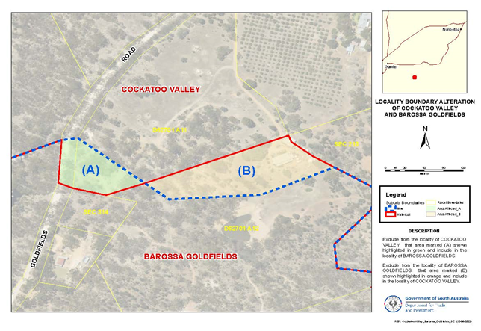
Dated: 30 November 2023
B. J. Slape
Surveyor-General
DTI: 2021/03842/01

Harbors and Navigation Regulations 2023
Schedule 3 - Definition Of Harbor Boundaries: Port Adelaide
Schedule 4 - Ports: Port Adelaide
Notice of "prescribed day"
I, TOM KOUTSANTONIS, Minister for Infrastructure and Transport:
(a) specify 15 December 2023 as the prescribed day for the purposes of the item relating to Port Adelaide in Schedule 3 of the Harbors and Navigation Regulations 2023; and
(b) specify 15 December 2023 as the prescribed day for the purposes of the item relating to Port Adelaide in Schedule 4 of the Harbors and Navigation Regulations 2023.
Dated: 23 November 2023
Tom Koutsantonis
Minister for Infrastructure and Transport

Housing Improvement Act 2016
Rent Control Revocations
Whereas the Minister for Human Services Delegate is satisfied that each of the houses described hereunder has ceased to be unsafe or unsuitable for human habitation for the purposes of the Housing Improvement Act 2016, notice is hereby given that, in exercise of the powers conferred by the said Act, the Minister for Human Services Delegate does hereby revoke the said Rent Control in respect of each property.
Address of Premises | Allotment Section | Certificate of Title Volume/Folio
2 Howard Street, Peterborough SA 5422 | Allotment 273 Deposited Plan 1302 Hundred of Yongala | CT5908/906
3/ 39 Elizabeth Street, Mount Gambier  SA 5290 | Allotment 7 Filed Plan 106170 Hundred of Blanche | CT5168/819
25 Douglas Street, Mount Gambier SA 5290 | Allotment 14 Filed Plan 36931 Hundred of Gambier | CT5329/427
Dated: 30 November 2023
Craig Thompson
Housing Regulator and Registrar
Housing Safety Authority, SAHA
Delegate of Minister for Human Services

Justices of the Peace Act 2005
Section 4
Notice of Appointment of Justices of the Peace for South Australia
by the Commissioner for Consumer Affairs
I, Dini Soulio, Commissioner for Consumer Affairs, delegate of the Attorney-General, pursuant to section 4 of the Justices of the Peace Act 2005, do hereby appoint the people listed as Justices of the Peace for South Australia as set out below:
For a period of ten years for a term commencing on 12 December 2023 and expiring on 11 December 2033:
Frederick ZOLLO
Francis Kevin SMITH
Mark Christopher REINCKE
Oswald Marino PETRUCCO
Sylvia Joan NEWTON
Robert Keith MAYNARD
Ian Grant LANYON
Debra Sharon KUTCHER
John William George KERSHAW
David Harold HUGHES
Howard William HILL
Mark Clayton HENLEY
Mark Andrew HAYES
John Ronald HART
Colin Aleck GOLDING
Denis Lloyd GILES
Dimitrios DOUNAS
Graham Robert BURNS
Dated: 24 November 2023
Dini Soulio
Commissioner for Consumer Affairs
Delegate of the Attorney-General

Justices of the Peace Act 2005
Section 4
Notice of Appointment of Justices of the Peace for South Australia
by the Commissioner for Consumer Affairs
I, Dini Soulio, Commissioner for Consumer Affairs, delegate of the Attorney-General, pursuant to section 4 of the Justices of the Peace Act 2005, do hereby appoint the people listed as Justices of the Peace for South Australia as set out below:
For a period of ten years for a term commencing on 19 December 2023 and expiring on 18 December 2033:
Simone Elizabeth ZRNA
Deborah May WHITE
Genevieve Mary WELLS
Paul Andrew TEMBY
Andre Marcus TAYE
Harminder Kaur SROA
Patricia Ann SHILLINGFORD
Deepti SETHI
Danielle Chloe SCHMAAL
Briohny POWELL
Esperanza Jane ONUZANS
Tamara Lee O'MALLEY
Kaye Lynette NAYDA
Mandy Jane MILLER
David MEDLOCK
Matthew Leonard KENNEDY
Mark Edward JOHNSON
Kathryn Marie JARRETT
Ena Mary HARVEY
Ajay Kumar GUPTA
Linda GOLOTTA
Janet FROST
Marc Benjamin FORSTER
Stephanie Lynn EGLINTON-WARNER
Susan Monique DODSON
Robert Joseph DALY
Constantinos DALAS
Christopher Julian CLARE
Helena BOLINGBROKE
Birendra Jawaharsingh BHANDARI
Jane Karen BEST
Rhea BARR
Dated: 24 November 2023
Dini Soulio
Commissioner for Consumer Affairs
Delegate of the Attorney-General

Justices of the Peace Act 2005
Section 4
Notice of Appointment of Justices of the Peace for South Australia
by the Commissioner for Consumer Affairs
I, Dini Soulio, Commissioner for Consumer Affairs, delegate of the Attorney-General, pursuant to section 4 of the Justices of the Peace Act 2005, do hereby appoint the people listed as Justices of the Peace for South Australia as set out below:
For a period of ten years for a term commencing on 5 December 2023 and expiring on 4 December 2033:
Barry Roger WRIGHT
Monica Eileen WANDEL
Joanne Kay THIELE
Donald Leslie SMITH
Janet SCOTT
Peta Michelle RUSTON
Kevin Clifton PROSSER
Julie Anne PRESSER
Arthur NEWLEY
Malcolm Edward KING
Ian Andrew JOHNSTON
Robert James HAY
Malcolm Robert DOYLE
Shane Francis DALY
Nicholas Mark BROWN
David James BRIGGS
Geoffrey Wayne BOWELS
James BIRCH
Dated: 28 November 2023
Dini Soulio
Commissioner for Consumer Affairs
Delegate of the Attorney-General

Land Acquisition Act 1969
Section 16
Form 5—Notice of Acquisition
1. Notice of acquisition
The Commissioner of Highways (the Authority), of 83 Pirie Street, Adelaide SA 5000, acquires the following interests in the following land:
Comprising an unencumbered estate in fee simple in that piece of land being portion of Allotment 19 in Filed Plan 152195 comprised in Certificate of Title Volume 5650 Folio 308, and being the whole of the land identified as Allotment 50 in D133052 lodged in the Lands Titles Office.
This notice is given under Section 16 of the Land Acquisition Act 1969.
2. Compensation
A person who has or had an interest consisting of native title or an alienable interest in the land that is divested or diminished by the acquisition or the enjoyment of which is adversely affected by the acquisition who does not receive an offer of compensation from the Authority may apply to the Authority for compensation.
2A. Payment of professional costs relating to acquisition (Section 26B)
If you are the owner in fee simple of the land to which this notice relates, you may be entitled to a payment of up to $10,000 from the Authority for use towards the payment of professional costs in relation to the acquisition of the land.
Professional costs include legal costs, valuation costs and any other costs prescribed by the Land Acquisition Regulations 2019.
3. Inquiries
Inquiries should be directed to: Daniel Tuk
GPO Box 1533
Adelaide SA 5001
Telephone: 08 7133 2479
Dated: 27 November 2023
The Common Seal of the COMMISSIONER OF HIGHWAYS was hereto affixed by authority of the Commissioner in the presence of:
Rocco Caruso
Manager, Property Acquisition
(Authorised Officer)
Department for Infrastructure and Transport
DIT: 2023/04843/01

Land Acquisition Act 1969
Section 16
Form 5—Notice of Acquisition
1. Notice of acquisition
The Commissioner of Highways (the Authority), of 83 Pirie Street, Adelaide SA 5000, acquires the following interests in the following land:
Comprising an unencumbered estate in fee simple in that piece of land being the whole of Allotment 69 in Filed Plan 19717 comprised in Certificate of Title Volume 5085 Folio 56.
This notice is given under Section 16 of the Land Acquisition Act 1969.
2. Compensation
A person who has or had an interest consisting of native title or an alienable interest in the land that is divested or diminished by the acquisition or the enjoyment of which is adversely affected by the acquisition who does not receive an offer of compensation from the Authority may apply to the Authority for compensation.
2A. Payment of professional costs relating to acquisition (Section 26B)
If you are the owner in fee simple of the land to which this notice relates, you may be entitled to a payment of up to $10,000 from the Authority for use towards the payment of professional costs in relation to the acquisition of the land.
Professional costs include legal costs, valuation costs and any other costs prescribed by the Land Acquisition Regulations 2019.
3. Inquiries
Inquiries should be directed to: William Ridgway
GPO Box 1533
Adelaide SA 5001
Telephone: 08 7133 2465
Dated: 27 November 2023
The Common Seal of the COMMISSIONER OF HIGHWAYS was hereto affixed by authority of the Commissioner in the presence of:
Rocco Caruso
Manager, Property Acquisition
(Authorised Officer)
Department for Infrastructure and Transport
DIT: 2023/01350/01

Land Acquisition Act 1969
Section 16
Form 5—Notice of Acquisition
1. Notice of acquisition
The Commissioner of Highways (the Authority), of 83 Pirie Street, Adelaide SA 5000, acquires the following interests in the following land:
Comprising an unencumbered estate in fee simple in that piece of land being the whole of Allotment 118 in Deposited Plan 32161 comprised in Certificate of Title Volume 5092 Folio 632.
This notice is given under Section 16 of the Land Acquisition Act 1969.
2. Compensation
A person who has or had an interest consisting of native title or an alienable interest in the land that is divested or diminished by the acquisition or the enjoyment of which is adversely affected by the acquisition who does not receive an offer of compensation from the Authority may apply to the Authority for compensation.
2A. Payment of professional costs relating to acquisition (Section 26B)
If you are the owner in fee simple of the land to which this notice relates, you may be entitled to a payment of up to $10,000 from the Authority for use towards the payment of professional costs in relation to the acquisition of the land.
Professional costs include legal costs, valuation costs and any other costs prescribed by the Land Acquisition Regulations 2019.
3. Inquiries
Inquiries should be directed to: Rob Gardner
GPO Box 1533
Adelaide SA 5001
Telephone: 08 7133 2415
Dated: 27 November 2023
The Common Seal of the COMMISSIONER OF HIGHWAYS was hereto affixed by authority of the Commissioner in the presence of:
Rocco Caruso
Manager, Property Acquisition
(Authorised Officer)
Department for Infrastructure and Transport
DIT: 2022/02812/01

Land Acquisition Act 1969
Section 16
Form 5—Notice of Acquisition
1. Notice of acquisition
The Commissioner of Highways (the Authority), of 83 Pirie Street, Adelaide SA 5000, acquires the following interests in the following land:
Comprising an unencumbered estate in fee simple in that piece of land being the whole of Allotment 80 in Filed Plan 19717 comprised in Certificate of Title Volume 5695 Folio 770.
This notice is given under Section 16 of the Land Acquisition Act 1969.
2. Compensation
A person who has or had an interest consisting of native title or an alienable interest in the land that is divested or diminished by the acquisition or the enjoyment of which is adversely affected by the acquisition who does not receive an offer of compensation from the Authority may apply to the Authority for compensation.
2A. Payment of professional costs relating to acquisition (Section 26B)
If you are the owner in fee simple of the land to which this notice relates, you may be entitled to a payment of up to $10,000 from the Authority for use towards the payment of professional costs in relation to the acquisition of the land.
Professional costs include legal costs, valuation costs and any other costs prescribed by the Land Acquisition Regulations 2019.
3. Inquiries
Inquiries should be directed to: Rob Gardner
GPO Box 1533
Adelaide SA 5001
Telephone: 08 7133 2415
Dated: 27 November 2023
The Common Seal of the COMMISSIONER OF HIGHWAYS was hereto affixed by authority of the Commissioner in the presence of:
Rocco Caruso
Manager, Property Acquisition
(Authorised Officer)
Department for Infrastructure and Transport
DIT: 2023/01337/01

Land Acquisition Act 1969
Section 16
Form 5—Notice of Acquisition
1. Notice of acquisition
The Commissioner of Highways (the Authority), of 83 Pirie Street, Adelaide SA 5000, acquires the following interests in the following land:
Comprising an unencumbered estate in fee simple in that piece of land being the whole of Allotment 79 in Filed Plan 19717 comprised in Certificate of Title Volume 5076 Folio 594.
This notice is given under Section 16 of the Land Acquisition Act 1969.
2. Compensation
A person who has or had an interest consisting of native title or an alienable interest in the land that is divested or diminished by the acquisition or the enjoyment of which is adversely affected by the acquisition who does not receive an offer of compensation from the Authority may apply to the Authority for compensation.
2A. Payment of professional costs relating to acquisition (Section 26B)
If you are the owner in fee simple of the land to which this notice relates, you may be entitled to a payment of up to $10,000 from the Authority for use towards the payment of professional costs in relation to the acquisition of the land.
Professional costs include legal costs, valuation costs and any other costs prescribed by the Land Acquisition Regulations 2019.
3. Inquiries
Inquiries should be directed to: Rob Gardner
GPO Box 1533
Adelaide SA 5001
Telephone: 08 7133 2415
Dated: 27 November 2023
The Common Seal of the COMMISSIONER OF HIGHWAYS was hereto affixed by authority of the Commissioner in the presence of:
Rocco Caruso
Manager, Property Acquisition
(Authorised Officer)
Department for Infrastructure and Transport
DIT: 2023/01336/01

Land Acquisition Act 1969
Section 16
Form 5—Notice of Acquisition
1. Notice of acquisition
The Commissioner of Highways (the Authority), of 83 Pirie Street, Adelaide SA 5000, acquires the following interests in the following land:
Comprising an estate in fee simple in that piece of land being the whole of Unit 5 in Strata Plan 10670 comprised in Certificate of Title Volume 5121 Folio 146, together with free and unrestricted right(s) of way over the land marked C on SP 10670.
This notice is given under Section 16 of the Land Acquisition Act 1969.
2. Compensation
A person who has or had an interest consisting of native title or an alienable interest in the land that is divested or diminished by the acquisition or the enjoyment of which is adversely affected by the acquisition who does not receive an offer of compensation from the Authority may apply to the Authority for compensation.
2A. Payment of professional costs relating to acquisition (Section 26B)
If you are the owner in fee simple of the land to which this notice relates, you may be entitled to a payment of up to $10,000 from the Authority for use towards the payment of professional costs in relation to the acquisition of the land.
Professional costs include legal costs, valuation costs and any other costs prescribed by the Land Acquisition Regulations 2019.

3. Inquiries
Inquiries should be directed to: Rob Gardner
GPO Box 1533
Adelaide SA 5001
Telephone: 08 7133 2415
Dated: 28 November 2023
The Common Seal of the COMMISSIONER OF HIGHWAYS was hereto affixed by authority of the Commissioner in the presence of:
Rocco Caruso
Manager, Property Acquisition
(Authorised Officer)
Department for Infrastructure and Transport
DIT: 2022/02786/01

Land Acquisition Act 1969
Section 16
Form 5—Notice of Acquisition
1. Notice of acquisition
The Commissioner of Highways (the Authority), of 83 Pirie Street, Adelaide SA 5000, acquires the following interests in the following land:
Comprising an estate in fee simple in that piece of land being the whole of Unit 9 in Strata Plan 10670 comprised in Certificate of Title Volume 5518 Folio 11, together with free and unrestricted right(s) of way over the land marked C on SP 10670.
This notice is given under Section 16 of the Land Acquisition Act 1969.
2. Compensation
A person who has or had an interest consisting of native title or an alienable interest in the land that is divested or diminished by the acquisition or the enjoyment of which is adversely affected by the acquisition who does not receive an offer of compensation from the Authority may apply to the Authority for compensation.
2A. Payment of professional costs relating to acquisition (Section 26B)
If you are the owner in fee simple of the land to which this notice relates, you may be entitled to a payment of up to $10,000 from the Authority for use towards the payment of professional costs in relation to the acquisition of the land.
Professional costs include legal costs, valuation costs and any other costs prescribed by the Land Acquisition Regulations 2019.
3. Inquiries
Inquiries should be directed to: Rob Gardner
GPO Box 1533
Adelaide SA 5001
Telephone: 08 7133 2415
Dated: 28 November 2023
The Common Seal of the COMMISSIONER OF HIGHWAYS was hereto affixed by authority of the Commissioner in the presence of:
Rocco Caruso
Manager, Property Acquisition
(Authorised Officer)
Department for Infrastructure and Transport
DIT: 2022/02782/01

Land Acquisition Act 1969
Section 16
Form 5—Notice of Acquisition
1. Notice of acquisition
The Commissioner of Highways (the Authority), of 83 Pirie Street, Adelaide SA 5000, acquires the following interests in the following land:
Comprising an estate in fee simple in that piece of land being the whole of Unit 4 in Strata Plan 10670 comprised in Certificate of Title Volume 5125 Folio 783, together with free and unrestricted right(s) of way over the land marked C on SP 10670.
This notice is given under Section 16 of the Land Acquisition Act 1969.
2. Compensation
A person who has or had an interest consisting of native title or an alienable interest in the land that is divested or diminished by the acquisition or the enjoyment of which is adversely affected by the acquisition who does not receive an offer of compensation from the Authority may apply to the Authority for compensation.
2A. Payment of professional costs relating to acquisition (Section 26B)
If you are the owner in fee simple of the land to which this notice relates, you may be entitled to a payment of up to $10,000 from the Authority for use towards the payment of professional costs in relation to the acquisition of the land.
Professional costs include legal costs, valuation costs and any other costs prescribed by the Land Acquisition Regulations 2019.

3. Inquiries
Inquiries should be directed to: Rob Gardner
GPO Box 1533
Adelaide SA 5001
Telephone: 08 7133 2415
Dated: 28 November 2023
The Common Seal of the COMMISSIONER OF HIGHWAYS was hereto affixed by authority of the Commissioner in the presence of:
Rocco Caruso
Manager, Property Acquisition
(Authorised Officer)
Department for Infrastructure and Transport
DIT: 2022/02787/01

Land Acquisition Act 1969
Section 16
Form 5—Notice of Acquisition
1. Notice of acquisition
The Commissioner of Highways (the Authority), of 83 Pirie Street, Adelaide SA 5000, acquires the following interests in the following land:
Comprising an estate in fee simple in that piece of land being the whole of Unit 8 in Strata Plan 10670 comprised in Certificate of Title Volume 5125 Folio 784, together with free and unrestricted right(s) of way over the land marked C on SP 10670.
This notice is given under Section 16 of the Land Acquisition Act 1969.
2. Compensation
A person who has or had an interest consisting of native title or an alienable interest in the land that is divested or diminished by the acquisition or the enjoyment of which is adversely affected by the acquisition who does not receive an offer of compensation from the Authority may apply to the Authority for compensation.
2A. Payment of professional costs relating to acquisition (Section 26B)
If you are the owner in fee simple of the land to which this notice relates, you may be entitled to a payment of up to $10,000 from the Authority for use towards the payment of professional costs in relation to the acquisition of the land.
Professional costs include legal costs, valuation costs and any other costs prescribed by the Land Acquisition Regulations 2019.
3. Inquiries
Inquiries should be directed to: Rob Gardner
GPO Box 1533
Adelaide SA 5001
Telephone: 08 7133 2415
Dated: 28 November 2023
The Common Seal of the COMMISSIONER OF HIGHWAYS was hereto affixed by authority of the Commissioner in the presence of:
Rocco Caruso
Manager, Property Acquisition
(Authorised Officer)
Department for Infrastructure and Transport
DIT: 2022/02783/01

Land Acquisition Act 1969
Section 16
Form 5—Notice of Acquisition
1. Notice of acquisition
The Commissioner of Highways (the Authority), of 83 Pirie Street, Adelaide SA 5000, acquires the following interests in the following land:
Comprising an estate in fee simple in that piece of land being the whole of Unit 6 in Strata Plan 10670 comprised in Certificate of Title Volume 5121 Folio 147, together with free and unrestricted right(s) of way over the land marked C on SP 10670.
This notice is given under Section 16 of the Land Acquisition Act 1969.
2. Compensation
A person who has or had an interest consisting of native title or an alienable interest in the land that is divested or diminished by the acquisition or the enjoyment of which is adversely affected by the acquisition who does not receive an offer of compensation from the Authority may apply to the Authority for compensation.
2A. Payment of professional costs relating to acquisition (Section 26B)
If you are the owner in fee simple of the land to which this notice relates, you may be entitled to a payment of up to $10,000 from the Authority for use towards the payment of professional costs in relation to the acquisition of the land.
Professional costs include legal costs, valuation costs and any other costs prescribed by the Land Acquisition Regulations 2019.

3. Inquiries
Inquiries should be directed to: Rob Gardner
GPO Box 1533
Adelaide SA 5001
Telephone: 08 7133 2415
Dated: 28 November 2023
The Common Seal of the COMMISSIONER OF HIGHWAYS was hereto affixed by authority of the Commissioner in the presence of:
Rocco Caruso
Manager, Property Acquisition
(Authorised Officer)
Department for Infrastructure and Transport
DIT: 2022/02785/01

Land Acquisition Act 1969
Section 16
Form 5—Notice of Acquisition
1. Notice of acquisition
The Commissioner of Highways (the Authority), of 83 Pirie Street, Adelaide SA 5000, acquires the following interests in the following land:
Comprising an estate in fee simple in that piece of land being the whole of Unit 7 in Strata Plan 10670 comprised in Certificate of Title Volume 5121 Folio 148, together with free and unrestricted right(s) of way over the land marked C on SP 10670.
This notice is given under Section 16 of the Land Acquisition Act 1969.
2. Compensation
A person who has or had an interest consisting of native title or an alienable interest in the land that is divested or diminished by the acquisition or the enjoyment of which is adversely affected by the acquisition who does not receive an offer of compensation from the Authority may apply to the Authority for compensation.
2A. Payment of professional costs relating to acquisition (Section 26B)
If you are the owner in fee simple of the land to which this notice relates, you may be entitled to a payment of up to $10,000 from the Authority for use towards the payment of professional costs in relation to the acquisition of the land.
Professional costs include legal costs, valuation costs and any other costs prescribed by the Land Acquisition Regulations 2019.
3. Inquiries
Inquiries should be directed to: Rob Gardner
GPO Box 1533
Adelaide SA 5001
Telephone: 08 7133 2415
Dated: 29 November 2023
The Common Seal of the COMMISSIONER OF HIGHWAYS was hereto affixed by authority of the Commissioner in the presence of:
Rocco Caruso
Manager, Property Acquisition
(Authorised Officer)
Department for Infrastructure and Transport
DIT: 2022/02784/01

Land Acquisition Act 1969
Section 16
Form 5—Notice of Acquisition
1. Notice of acquisition
The Commissioner of Highways (the Authority), of 83 Pirie Street, Adelaide SA 5000, acquires the following interests in the following land:
Comprising an unencumbered estate in fee simple in that piece of land being the whole of Allotment 22 in Filed Plan 7358 comprised in Certificate of Title Volume 5497 Folio 25.
This notice is given under Section 16 of the Land Acquisition Act 1969.
2. Compensation
A person who has or had an interest consisting of native title or an alienable interest in the land that is divested or diminished by the acquisition or the enjoyment of which is adversely affected by the acquisition who does not receive an offer of compensation from the Authority may apply to the Authority for compensation.
2A. Payment of professional costs relating to acquisition (Section 26B)
If you are the owner in fee simple of the land to which this notice relates, you may be entitled to a payment of up to $10,000 from the Authority for use towards the payment of professional costs in relation to the acquisition of the land.
Professional costs include legal costs, valuation costs and any other costs prescribed by the Land Acquisition Regulations 2019.

3. Inquiries
Inquiries should be directed to: Daniel Tuk
GPO Box 1533
Adelaide SA 5001
Telephone: 08 7133 2479
Dated: 29 November 2023
The Common Seal of the COMMISSIONER OF HIGHWAYS was hereto affixed by authority of the Commissioner in the presence of:
Rocco Caruso
Manager, Property Acquisition
(Authorised Officer)
Department for Infrastructure and Transport
DIT: 2023/05377/01

Local Government (Elections) Act 1999
District Council of Cleve
Casual Vacancy Filled
A casual vacancy occurred in the office of area councillor in the District Council of Cleve, effective Monday 30 October 2023. The vacancy was filled in accordance with section 6A of the Local Government (Elections) Act 1999. As multiple candidates were willing and eligible to be elected to the vacancy, a recount of the votes cast at the November 2022 periodic election was conducted on Thursday, 23 November 2023. At the conclusion, COLIN RAYSON was declared elected to the vacancy.
Formal Ballot Papers – 871
New Exhaust Ballot Papers – 33
Informal Ballot Papers – 11
Quota – 420
Candidates | First Preference Votes | Elected/Excluded
WETHERALL, Julie | 228
SIVIOUR, Grantley | 155
RAYSON, Colin | 455 | Elected over quota
Mick Sherry
Returning Officer

Local Government (Elections) Act 1999
District Council of Mount Remarkable
Close of Roll for Supplementary Elections
Due to the resignations of two members of the council, supplementary elections will be necessary to fill the vacancies of Councillor for Willochra Ward and Councillor for Telowie Ward.
The voters roll for these supplementary elections will close at 5pm on Wednesday 20 December 2023.
You are entitled to vote in the elections if you are enrolled on the State electoral roll for the council areas. If you have recently turned 18 or changed your residential or postal address, you must complete an electoral enrolment form available online at www.ecsa.sa.gov.au
If you are not eligible to enrol on the State electoral roll you may still be entitled to enrol to vote if you own or occupy a property in the council areas. Contact the council to find out how.
Nominations to fill the vacancies will open on Thursday 11 January 2024 and will be received until 12 noon on Thursday 25 January 2024.
The elections will be conducted entirely by post with the return of ballot material to reach the Returning Officer no later than 12 noon on polling day, Tuesday 12 March 2024.
Mick Sherry
Returning Officer

Local Government (Elections) Act 1999
Wattle Range Council
Close of Roll for Supplementary Election
Due to the resignation of a member of the council, a supplementary election will be necessary to fill the vacancy of Councillor for Corcoran Ward.
The voters roll for this supplementary election will close at 5pm on Wednesday 20 December 2023.
You are entitled to vote in the election if you are enrolled on the State electoral roll for the council area. If you have recently turned 18 or changed your residential or postal address, you must complete an electoral enrolment form available online at www.ecsa.sa.gov.au
If you are not eligible to enrol on the State electoral roll you may still be entitled to enrol to vote if you own or occupy a property in the council area. Contact the council to find out how.
Nominations to fill the vacancy will open on Thursday 11 January 2024 and will be received until 12 noon on Thursday 25 January 2024.
The election will be conducted entirely by post with the return of ballot material to reach the Returning Officer no later than 12 noon on polling day, Tuesday 12 March 2024.
Mick Sherry
Returning Officer

Mental Health Act 2009
Authorised Mental Health Professional
NOTICE is hereby given in accordance with Section 94(1) of the Mental Health Act 2009, that the Chief Psychiatrist has determined the following persons as an Authorised Mental Health Professional:
Melanie Gough
A person’s determination as an Authorised Mental Health Professional expires three years after the commencement date.
Dated: 28 November 2023
Dr J. Brayley
Chief Psychiatrist

Pastoral Land Management and Conservation Act 1989
Public Access Route Closures November 2023
Notice of Intent to Temporarily Close Public Access Route Number 8 Pedirka
Notice is hereby given of the intent to temporarily close the Pedirka Public Access Route from Hamilton Homestead to the Witjira National Park boundary, from 22 November 2023 until further notice, pursuant to section 45 (7) of the Pastoral Land Management and Conservation Act 1989. Notification of the re-opening of the Public Access Route will be provided on the Department for Infrastructure and Transport’s Outback Road Warnings website at https://www.dit.sa.gov.au/OutbackRoads/outback_road_warnings/special_notices.
Dated: 22 November 2023
Saravan Peacock
Pastoral Board delegate of section 45 (7) of the Pastoral Land Management and Conservation Act 1989
Manager Pastoral Unit, Department for Environment and Water

Proof of Sunrise and Sunset Act 1923
Almanac for January, February and March 2024
Pursuant to the requirements of the Proof of Sunrise and Sunset Act 1923, I Jon William Whelan, Chief Executive, Department for Infrastructure and Transport, at the direction of the Minister for Infrastructure and Transport, publish in the Schedule hereto an almanac setting out the times of sunrise and sunset on every day for the three calendar months January, February and March 2024.
Dated: 24 November 2023
Jon William Whelan
Chief Executive
Department for Infrastructure and Transport

Schedule
Sunrise & Sunset Times for Adelaide 2024
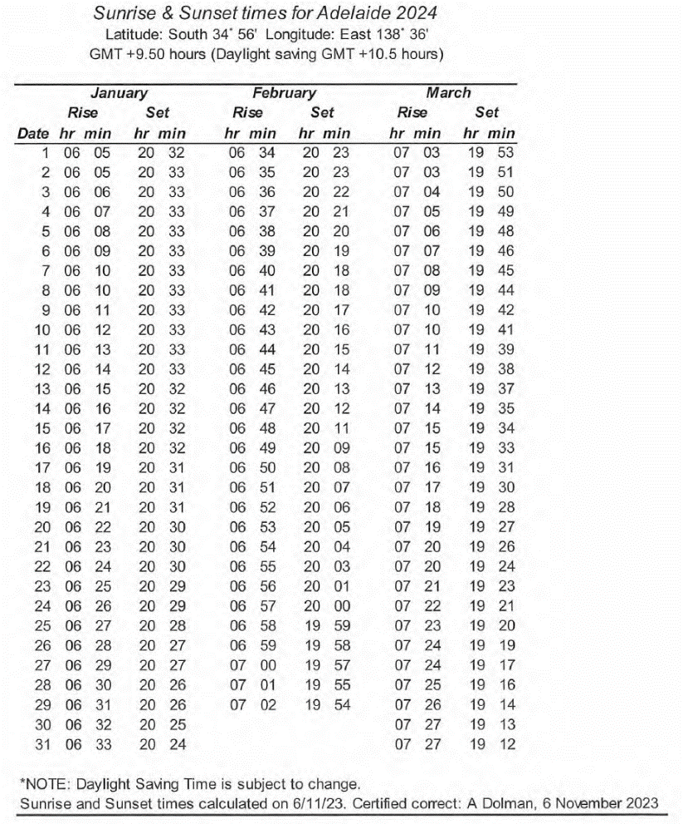

Road Traffic (Miscellaneous) Regulations 2014
South Australia
Road Traffic (RAA Towing Combination) Exemption Notice 2023
under regulation 71 of the Road Traffic (Miscellaneous) Regulations 2014
- COMMENCEMENT AND OPERATION
This Notice will come into operation on the day on which it is published in the South Australian Government Gazette.
- INTERPRETATION
In this Notice-
authorised officer means:
- a person appointed as an authorised officer under section 35 of the Road Traffic Act or a person or a class of persons appointed as authorised officers under that section; or
- a police officer;
compact recovery trailer means a compact car towing trailer as manufactured by Intertrade Engineering that:
- has two wheels, a single axle and tow hitch; and
- is designed to tow a light vehicle where the vehicle being towed is superimposed on the tow dolly by one axle; and
- is designed to be stowed within the towing vehicle when not in use; and
- complies with the National Code of Practice – Vehicle Standards Bulletin 1 Building Small Trailers – Information for Manufacturers and Importers;
high-speed dolly means a collapsible dolly manufactured by Collins Dollies, USA that:
- has four wheels and is adjustable for width and length; and
- is designed to support the trailing end of a towed vehicle when necessary;
light vehicle means a vehicle with a gross vehicle mass of 4.5 tonnes or less;
RAA means the Royal Automobile Association of South Australia Inc. ABN 90 020 001 807;
RAA Road Service Contractor means a person or entity who is contracted to provide services for and on behalf of the RAA;
Regulations means the Road Traffic (Miscellaneous) Regulations 2014;
tow dolly means a light vehicle that:
- has two wheels, a single axle and tow hitch; and
- incorporates a turntable that permits the dolly to turn relative to the loaded vehicle; and
- is designed to tow a light vehicle where the vehicle being towed is superimposed on the tow dolly by one axle; and
- complies with the National Code of Practice – Vehicle Standards Bulletin 1 Building Small Trailers – Information for Manufacturers and Importers.
- EXEMPTION
In accordance with the power under regulation 71 of the Regulations, I, Tom Koutsantonis, Minister for Infrastructure and Transport in the State of South Australia, hereby exempt a driver who is a direct employee of the RAA and/or a driver who is an RAA Service Contractor from regulation 65 of the Regulations, subject to the conditions specified in 4 below.
- CONDITIONS
The driver may drive a light vehicle towing more than 1 vehicle subject to the following conditions:
- the driver is driving the towing vehicle during the course of their employment with RAA or providing services for and on behalf of the RAA;
- the driver’s light vehicle is towing a compact recovery trailer which is towing a high-speed dolly;
- the combination is operated only by a direct employee of the RAA, or an RAA Road Service Contractor, who is trained in the operation of the compact recovery trailer and the high-speed dolly;
- the compact recovery trailer is operated at a gross trailer mass (GTM) of no more than 2 tonnes;
- the total mass of the combination of the vehicles being towed does not exceed the lesser of 1.5 times the unladen mass of the towing vehicle or the towing vehicle’s towing capacity as specified by the vehicle’s manufacturer;
- if the superimposed vehicle is loaded such that it faces towards the rear (i.e. with its rear wheels on the dolly), the steering on the towed vehicle is clamped in the straight ahead position;
- while the combination of vehicles is being towed, a maximum speed limit of 80 km/h applies;
- each vehicle forming part of the combination must be appropriately registered and meet all the requirements of the Road Traffic (Light Vehicle Standards) Rules 2018;
- a copy of this Notice can be produced to an authorised officer upon request.
- REVOCATION
This Notice will come into operation on the day on which it is published in the South Australian Government Gazette.
- EXECUTION
Dated: 29 November 2023
Hon Tom Koutsantonis MP
Minister for Infrastructure and Transport

Roads (Opening and Closing) Act 1991
Section 24
NOTICE OF CONFIRMATION OF ROAD
PROCESS ORDER
Road Closure—Appleby Road & Barham Avenue, Morphettville
By Road Process Order made on 26 June 2023, the City of Marion ordered that:
- Portions of Appleby Road, Morphettville, situated adjoining Allotment 225 and 230 in Deposited Plan 4731, Hundred of Adelaide, more particularly delineated and lettered ‘A’ and ‘B’ in Preliminary Plan 22/0049 be closed.
- Portions of Barham Avenue, Morphettville, situated adjoining Allotment 342 to 344 in Deposited Plan 4731 and Allotment 5004 in Deposited Plan 118791, Hundred of Adelaide, more particularly delineated and lettered ‘C’ and ‘D’ in Preliminary Plan 22/0049 be closed.
- Transfer the whole of the land subject to closure to South Australian Housing Trust in accordance with the Agreement for Transfer dated 26 June 2023 entered into between the City of Marion and South Australian Housing Trust.
On 28 November 2023 that order was confirmed by the Minister for Planning conditionally upon the deposit by the Registrar-General of Deposited Plan 133146 being the authority for the new boundaries.
Pursuant to Section 24 of the Roads (Opening and Closing) Act 1991, NOTICE of the order referred to above and its confirmation is hereby given.
Dated: 30 November 2023
B. J. Slape
Surveyor-General
2022/17652/01

Roads (Opening and Closing) Act 1991
Section 24
NOTICE OF CONFIRMATION OF ROAD
PROCESS ORDER
Road Closure—Pelican Point Road, Pelican Point
By Road Process Order made on 1 August 2023, the District Council of Grant ordered that:
- Portion of Pelican Point Road, Pelican Point, situated adjoining the eastern boundary of Allotment 78 in Deposited Plan 84065, Pelican Point, more particularly delineated and lettered ‘B’ in Preliminary Plan 23/0011 be closed.
- Transfer the whole of the land subject to closure to Robert Ian Koik and Donna Noelene Koik in accordance with the Agreement for Transfer dated 1 August 2023 entered into between the District Council of Grant and Robert Ian Koik and Donna Noelene Koik.
On 28 November 2023 that order was confirmed by the Minister for Planning conditionally upon the deposit by the Registrar-General of Deposited Plan 132779 being the authority for the new boundaries.
Pursuant to Section 24 of the Roads (Opening and Closing) Act 1991, NOTICE of the order referred to above and its confirmation is hereby given.
Dated: 30 November 2023
B. J. Slape
Surveyor-General
2023/03776/01

Roads (Opening and Closing) Act 1991
Section 24
NOTICE OF CONFIRMATION OF ROAD
PROCESS ORDER
Road Closure—Second Street, Bowden
By Road Process Order made on 9 October 2023, the City of Charles Sturt ordered that:
- Second Street, Bowden, being portion of Allotment 2 in Filed Plan 27210, Hundred of Yatala, more particularly delineated and lettered ‘A’ in Preliminary Plan 23/0008 be closed.
- Transfer the whole of the land subject to closure to Urban Renewal Authority in accordance with the Agreement for Transfer dated 28 August 2023 entered into between the City of Charles Sturt and Urban Renewal Authority.
On 28 November 2023 that order was confirmed by the Minister for Planning conditionally upon the deposit by the Registrar-General of Deposited Plan 133163 being the authority for the new boundaries.
Pursuant to Section 24 of the Roads (Opening and Closing) Act 1991, NOTICE of the order referred to above and its confirmation is hereby given.
Dated: 30 November 2023
B. J. Slape
Surveyor-General
2023/03333/01

Roads (Opening and Closing) Act 1991
Section 24
NOTICE OF CONFIRMATION OF ROAD
PROCESS ORDER
Road Opening and Closing
Upper Sturt Road, Crafers West
By Road Process Order made on 24 October 2023, the Adelaide Hills Council ordered that:
- Portion of Allotment 49 in Filed Plan 151349, Crafers West, Hundred of Adelaide, more particularly delineated as ‘C’ in Preliminary Plan 22/0047 be opened as road.
- Portion of Upper Sturt Road, Crafers West, situated adjoining the western boundary of Allotment 11 in Filed Plan 17156, Hundred of Adelaide, more particularly delineated and lettered ‘B’ in Preliminary Plan 22/0047 be closed.
- The road being opened in schedule 1 is being exchanged for the land being closed in schedule 2 accordance with the Agreement for Exchange dated 6 October 2023 entered into between the David James Mansfield and Tiyen Sue Manfield and Adelaide Hills Council.
On 28 November 2023 that order was confirmed by the Minister for Planning conditionally upon the deposit by the Registrar-General of Deposited Plan 133305 being the authority for the new boundaries.
Pursuant to Section 24 of the Roads (Opening and Closing) Act 1991, NOTICE of the order referred to above and its confirmation is hereby given.
Dated: 30 November 2023
B. J. Slape
Surveyor-General
2022/17323/01

Summary Offences Act 1953
Declared Public Precincts
Notice of Ministerial Determination
I, KYAM MAHER, Attorney-General in the State of South Australia, being the Minister responsible for the administration of Part 14B – Declared Public Precincts of the Summary Offences Act 1953, DO HEREBY DECLARE pursuant to the provisions of section 66N of the said Act that the area, comprised of more than one public place, within the following boundaries:
- Southern boundary of Pier Street taking a straight line west to the low tide shoreline of the Gulf St. Vincent.
- Low tide shoreline of the Gulf St-Vincent to the most northern point at low tide of the breakwater.
- The most northern point at low tide of the breakwater, to the southwest corner of the Holdfast Shores Marina (inclusive of Holdfast Promenade Plaza); the boundary of the southern end of the marina extending east to Anzac Highway (northern boundary); then extending east on Anzac Highway (northern boundary) to eastern boundary of Brighton Road.
- Eastern boundary of Brighton Road to southern boundary of Pier Street.
- Tram Stop 15, including the northern boundary of Dunbar Terrace to Service Road, south across the tram tracks 40 metres east of Brighton Road, to the southern side of Maxwell Terrace up to the intersection with Fortrose Street.
will be declared a public precinct for a period of 12 hours from 6:00pm on Sunday 31 December 2023 until 6:00am on Monday 1 January 2024.
References to boundaries identified by streets, roads, or terraces for the purpose of this declaration will be taken to mean and include the area up to the applicable building or fence lines, or the imagined projection thereof, on the relevant boundary.
I am satisfied that there is, during the period specified in this declaration, a reasonable likelihood of conduct posing a risk to public order and safety in the area specified.
I am satisfied that the inclusion of each public place in the area is reasonable having regard to that identified risk.
MADE at Adelaide on this 22nd day of November 2023
Kyam Maher
Attorney-General

The Remuneration Tribunal
Report—No. 8 of 2023
2023 Review of the Common Allowance for
Members of the Parliament of South Australia
Introduction
- The Remuneration Tribunal (Tribunal) has conducted a review of Determination 15 of 2022, which sets a common allowance for members of Parliament.
- The common allowance is set under section 4AA of the Parliamentary Remuneration Act 1990 (SA) (PR Act) and must be reviewed at least once every 12 months as required by section 4AA(3). It forms part of the basic salary of members of Parliament.
- There are two components to the common allowance. The first is an amount of remuneration that reasonably compensates members of Parliament for the abolition of the annual travel allowance, metrocard special pass and subsidised or free interstate rail travel that applied prior to 2015. The second component is an amount payable to all members of Parliament for their service as ordinary members on parliamentary committees.
- The aggregated amount of the two components cannot exceed $42,000.
- As explained in this report, the Tribunal has determined to increase the aggregated amount by 4.13%. The Tribunal has issued an accompanying determination, which applies from 1 December 2023.
The Review Rpocess
- In accordance with sections 10(2) and 10(4) of the Remuneration Act 1990 (SA) (Act), on 9 June 2023 the Tribunal invited submissions in respect of this review from:
- the Honourable Premier of South Australia – as the Minister responsible for the Act who may make submissions or introduce evidence in the public interest;
- members of Parliament;
- the Treasurer; and
- the Independent Commissioner Against Corruption.
- Submissions were due by 7 July 2023.
- The Tribunal also advertised its intention to review Determination 15 of 2022 on its website from 9 June 2023. Submissions were also invited by 7 July 2023.
- On 4 July 2023, the Premier’s representative confirmed that no submission would be made. No other submissions were received in respect of this review.
Background
- The common allowance was established by the Parliamentary Remuneration (Determination of Remuneration) Amendment Act 2015 (SA) (Amending Act) which amended the PR Act.
- The common allowance is comprised of two monetary amounts. The first amount is provided as compensation for the loss of the annual travel allowance, metrocard special pass and subsidised or free interstate rail travel. The second amount is provided as compensation for the loss of payments for service as ordinary members of parliamentary committees. In these respects, the Amending Act confirms that the common allowance represents compensation to members of Parliament for the loss of specified entitlements that operated before 2015.
- Section 4AB of the PR Act establishes that the common allowance forms part of the basic salary of a member of Parliament. This section states:
4AB—Basic salary
The basic salary payable to a member of Parliament is salary at a rate equal to the rate from time to time of the Commonwealth basic salary less $42 000 plus the common allowance for the relevant year.
Consideration and Conclusion
- The Tribunal is not able to alter the basis of the common allowance or its component parts.
- The current common allowance components comprise the following amounts:
- The amount of remuneration as reasonable compensation for the abolition of the annual travel allowance, metrocard special pass and subsidised or free interstate rail travel is $18,760 per annum.
- The amount of remuneration payable to all members of Parliament for service as ordinary members on parliamentary committees is $14,269 per annum.
- These amounts total $33,029 per annum.
- In accordance with section 4AA(3) of the PR Act the Tribunal may, if it considers it appropriate to do so, determine to increase an amount of remuneration payable by a specified amount.
- The Tribunal has adopted the position that the first component of the common allowance should be recognised on the basis of a reimbursement of the previous benefits that applied before 2015. Separately, the Tribunal has considered the second component of the common allowance, which is more directly related to normal remuneration payments.
- The Tribunal has considered movements in the Consumer Price Index (All groups Adelaide), the Australian Bureau of Statistics Wage Price Index (Public Sector South Australia), statistics concerning transport and domestic holiday travel and accommodation and has determined to apply an overall increase of 4.13% to the aggregated amount. The Tribunal has provided differential calculations to the two components that constitute the common allowance. The breakdown of the two components is provided for in the accompanying determination.
- This review therefore increases the total amount of the common allowance to $34,393 per annum. The increase will apply from 1 December 2023.
- The Tribunal makes the observation that the aggregated amount is moving closer to the statutory limit of $42,000. In the absence of any amending legislation, the Tribunal notes it will not be able to increase the common allowance amount.
- The Tribunal understands from the second reading speech for the Amending Act that the statutory limit of $42,000 was in 2015 the amount by which the Commonwealth basic salary exceeded the State basic salary. Whilst it does not affect this year’s review, it may impact reviews in future years.
Dated: 28 November 2023
Matthew O’Callaghan
President
Deborah Black
Member
Peter De Cure AM
Member

Determination—No. 8 of 2023
Common Allowance for
Members of the Parliament of South Australia
Determination
- Pursuant to section 4AA of the Parliamentary Remuneration Act 1990 (SA), the Remuneration Tribunal makes the following Determination:
- The amount of remuneration as reasonable compensation for the abolition of: annual travel allowance, metrocard special pass and subsidised or free interstate rail travel is $19,867 per annum.
- The amount of remuneration payable to all members of Parliament for their service as ordinary members on parliamentary committees is $14,526 per annum.
Date of Operation
- This Determination operates from 1 December 2023. It supersedes Determination 15 of 2022.
Dated: 28 November 2023
Matthew O’Callaghan
President
Deborah Black
Member
Peter De Cure AM
Member

Local Government Instruments

City of Adelaide
Local Government Act 1999
Adelaide Economic Development Agency Charter 2023
The City of Adelaide has resolved to amend the Charter for the Adelaide Economic Development Agency subsidiary, established pursuant to Section 42 of the Local Government Act 1999.
Pursuant to Clause 3(5)(c) of Schedule 2 of the Local Government Act 1999, the Charter of the Adelaide Economic Development Agency, as amended is available at www.aedasa.com.au/aeda-charter/.
Dated: 30 November 2023
Claire Mockler
Chief Executive Officer

City of Mitcham
Local Government Act 1999
Adoption of amended Community Land Management Plan
NOTICE is hereby given pursuant to Section 198(4) of the Local Government Act 1999, that the City of Mitcham at its Full Council Meeting on 21 November 2023 resolved to adopt the proposals for amended Community Land Management Plan for CC Hood Reserve at Panorama.
The adopted Community Land Management Plan can be viewed at www.mitchamcouncil.sa.gov.au.
Dated: 22 November 2023
Matthew Pears
Chief Executive Officer

City of Port Adelaide Enfield
Short Term Dry Area-Semaphore Road
Notice is hereby given that the City of Port Adelaide Enfield pursuant to 131(1ab) of the Liquor Licensing Act 1997 that Council declares Short Term Dry Areas on the following dates and times.
- From 12 noon on 31 December 2023 to 12 noon on 1 January 2024
- Pursuant to section 131 of the Act, the consumption and possession of liquor in the area described in the Schedule is prohibited in accordance with the provisions of the Schedule.
- The prohibition has effect during the periods specified in the Schedule.
- The prohibition does not extend to private land in the area described in the Schedule.
- Unless the contrary intention appears, the prohibition of the possession of liquor in the area does not extend to-
- A person who is genuinely passing through the areas if-
- The liquor is in the original container in which it was purchased from licensed premises; and
- The container has not been opened; or
- A person who has possession of the liquor in the course of carrying on a business or in the course of his or her employment by another person in the course of carrying on a business; or
- A person who is permanently or temporarily residing at premises within the area or on the boundary of the area and who enters the area solely for the purpose of passing through it to enter those premises or who enters the area from those premises for the purpose of leaving the area.
Description of Area
The area in Semaphore and Exeter comprising Semaphore Road between the eastern boundary of the Esplanade and the prolongation in a straight line of the marked centre line of Causeway Road.
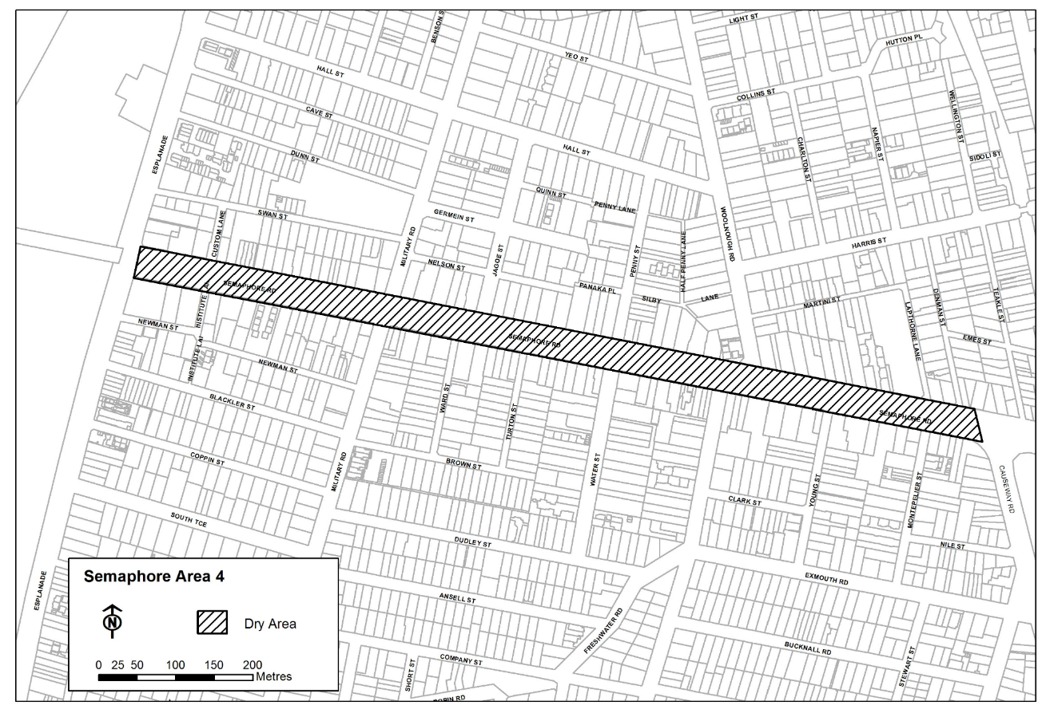
Dated: 27 November 2023
Mark Withers
Chief Executive Officer

City of Salisbury
Local Government Act 1999
Proposal to Lease Community Land
Notice is hereby given that at a meeting held on 25 September 2023, pursuant to Section 202 of the Local Government Act 1999, the Council of the City of Salisbury resolved to seek public comment on a proposal to lease the land known as Wynn Vale Gullies Reserve, Gulfview Heights identified as Allotment 102 in Deposited Plan 47620, for commercial purposes to TPG for a period of up to 14 years.
Details on this proposal are available for inspection at the Salisbury Community Hub, 34 Church Street, Salisbury.
Any person is entitled to object to the proposed lease. Such objections must set out the full name and address of the person making the objection and must be fully supported by reasons.
Council invites written submissions on the proposal which are to be received by close of business on Wednesday 3 January 2024 and addressed to the Chief Executive Officer, City of Salisbury, PO Box 8, SALISBURY SA 5108.
Any further information can be obtained from Emma Robinson, on (08) 8406 8216 or erobinson@salisbury.sa.gov.au
Dated: 30 November 2023
John Harry
Chief Executive Officer

Adelaide Plains Council
South Australia
Liquor Licensing (Dry Areas) Notice 2023
under section 131(1ab) of the Liquor Licensing Act 1997
1—Short title
This notice may be cited as the Liquor Licensing (Dry Areas) Notice 2023.
2—Commencement
This notice comes into operation on 15 December 2023
3—Interpretation
(1) In this notice—
principal notice means the Liquor Licensing (Dry Areas) Notice 2015 published in the Gazette on 5 January 2015, as in force from time to time.
(2) Clause 3 of the principal notice applies to this notice as if it were the principal notice.
4—Consumption etc of liquor prohibited in dry areas
(1) Pursuant to section 131 of the Act, the consumption and possession of liquor in the area described in the Schedule is prohibited in accordance with the provisions of the Schedule.
(2) The prohibition has effect during the periods specified in the Schedule.
(3) The prohibition does not extend to private land in the area described in the Schedule.
(4) Unless the contrary intention appears, the prohibition of the possession of liquor in the area does not extend to—
(a) a person who is genuinely passing through the place if—
(i) the liquor is in the original container in which it was purchased from licensed premises; and
(ii) the container has not been opened; or
(b) a person who has possession of the liquor in the course of carrying on a business or in the course of their employment by another person in the course of carrying on a business; or
(c) a person who is permanently or temporarily residing at premises near the public place and who enters the public place solely for the purpose of passing through it to enter those premises or who enters the public place from those premises for the purpose of leaving the place; or
(d) a person who possesses or consumes the liquor for sacramental or other similar religious purposes.

Schedule—Two Wells Area 1

1—Extent of prohibition
The consumption of liquor is prohibited and the possession of liquor is prohibited.
2—Period of prohibition
From 4pm on 15 December 2023 to 5am on 16 December 2023.
3—Description of area
Old Port Wakefield Road between Gawler Road and Chapman Street in Two Wells
Vacant land bounded by Windmill Road, Old Port Wakefield Road, Wells Road and Section 716 Deposited Plan H140800 Wells Road in Two Wells
Two Wells Village Green bounded by metal fencing, Adelaide Plains Library and Old Port Wakefield Road in Two Wells
Two Wells Memorial Gardens bounded by stone fencing and Old Port Wakefield Road in Two Wells

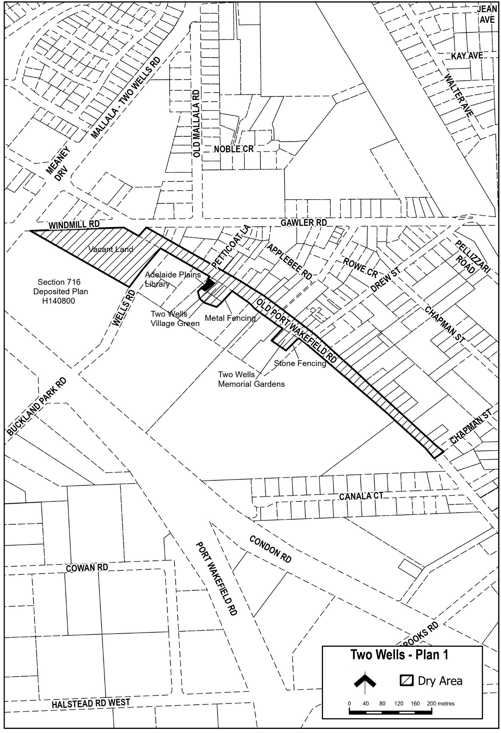
Dated: 28 November 2023
James Miller
Chief Executive Officer

Alexandrina Council
South Australia
Liquor Licensing (Dry Areas) Notice 2023
under section 131(1a) of the Liquor Licensing Act 1997
1—Short title
This notice may be cited as the Liquor Licensing (Dry Areas) Notice 2023.
2—Commencement
This notice has effect on the day on which it is published in the Gazette.
3—Interpretation
(1) In this notice—
principal notice means the Liquor Licensing (Dry Areas) Notice 2015 published in the Gazette on 5.1.15, as in force from time to time.
(2) Clause 3 of the principal notice applies to this notice as if it were the principal notice.
4—Consumption etc of liquor prohibited in dry areas
(1) Pursuant to section 131 of the Act, the consumption and possession of liquor in the area described in the Schedule is prohibited in accordance with the provisions of the Schedule.
(2) The prohibition has effect during the periods specified in the Schedule.
(3) The prohibition does not extend to private land in the area described in the Schedule.
(4) Unless the contrary intention appears, the prohibition of the possession of liquor in the area does not extend to—
(a) a person who is genuinely passing through the area if—
(i) the liquor is in the original container in which it was purchased from licensed premises; and
(ii) the container has not been opened; or
(b) a person who has possession of the liquor in the course of carrying on a business or in the course of his or her employment by another person in the course of carrying on a business; or
(c) a person who is permanently or temporarily residing at premises within the area or on the boundary of the area and who enters the area solely for the purpose of passing through it to enter those premises or who enters the area from those premises for the purpose of leaving the area.

Schedule 1 – Strathalbyn Area 1 and 2
1 – Extent of prohibition
The consumption of liquor is prohibited and the possession of liquor is prohibited.
2 – Period of prohibition
From 4.00pm on 15 December 2023 – 6.00am on 16 December 2023
3 – Description of area
Strathalbyn Area 1
The area in Strathalbyn bounded as follows: commencing at the point at which the south eastern boundary of North Parade meets the north eastern boundary of West Terrace, then south easterly along that boundary of West Terrace to the north western boundary of Adams Street, then north easterly along that boundary of Adams Street and the prolongation in a straight line of that boundary to the north eastern boundary of Edinburgh Road, then north westerly along that boundary of Edinburgh Road to the end of the road, then in a straight line by the shortest route to the point at which the south eastern boundary of South Terrace meets the south western boundary of Parker Avenue, then along the continuation of that straight line across South Terrace to the north western boundary of South Terrace, then north easterly along the north western boundary of South Terrace to the south western boundary of East Terrace, then north westerly along the south western boundary of East Terrace to the south eastern boundary of North Parade, then south westerly along the south eastern boundary of North Parade to the point of commencement.
Strathalbyn Area 2
Ashbourne Road between the south-western boundary of West Terrace and the prolongation in a straight line of the south-western boundary of Queen Street; Queen Street between Ashbourne Road and Coronation Road; Coronation Road between the prolongation in a straight line of the south-western boundary of Queen Street and the south-western boundary of West Terrace; Stowe Court between Coronation Road and West Terrace; West Terrace between the prolongation in a straight line of the south-eastern boundary of Coronation Road and the prolongation in a straight line of the north-western boundary of Ashbourne Road.

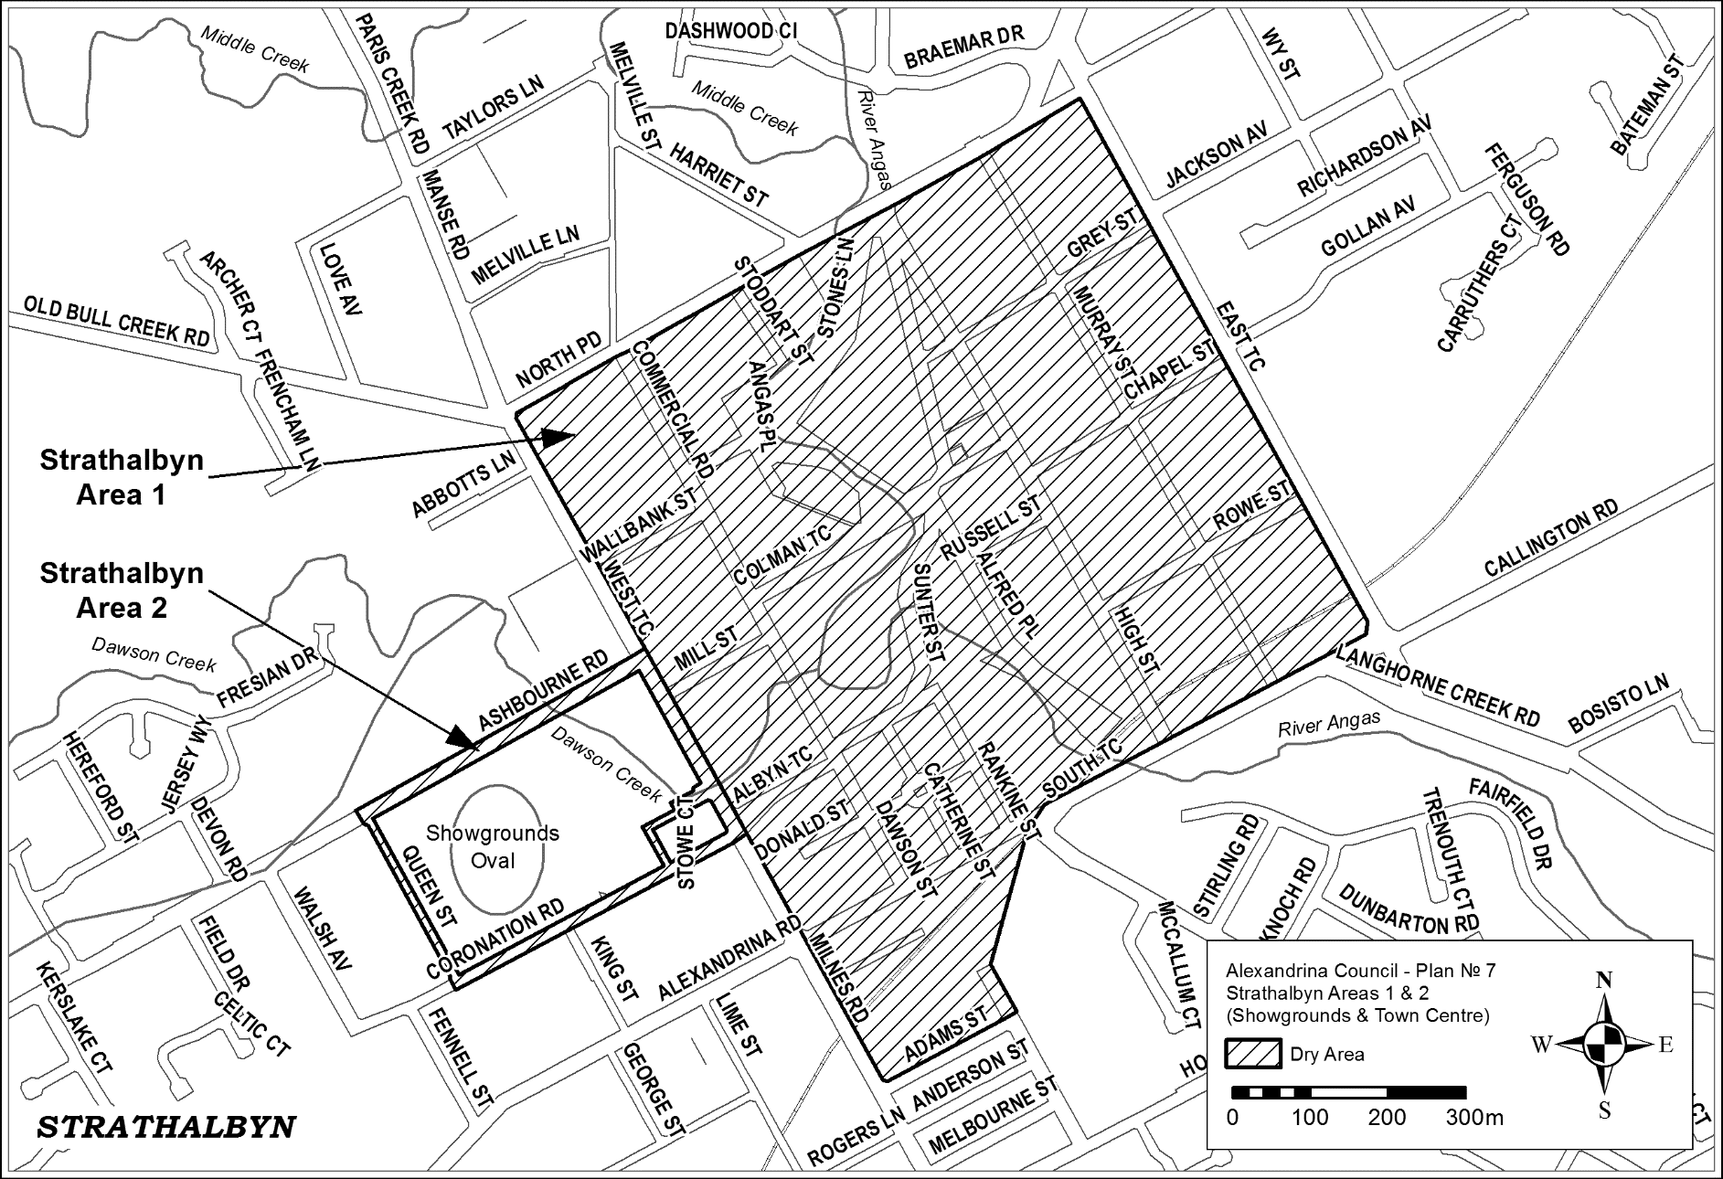

Schedule 2 – Goolwa Oval Recreation Precinct
1 – Extent of prohibition
The consumption of liquor is prohibited and the possession of liquor is prohibited.
2 – Period of prohibition
From 5.30pm on 17 December 2023 – 9.30pm on 17 December 2023
3 – Description of area
Goolwa Oval Recreation Precinct
The area within the Recreation Precinct bounded by Hutchinson Street from Wildman Street to Collingwood Street, Wildman Street from Hutchinson Street to Goyder Street, Goyder Street from Wildman Street to Dawson Street.
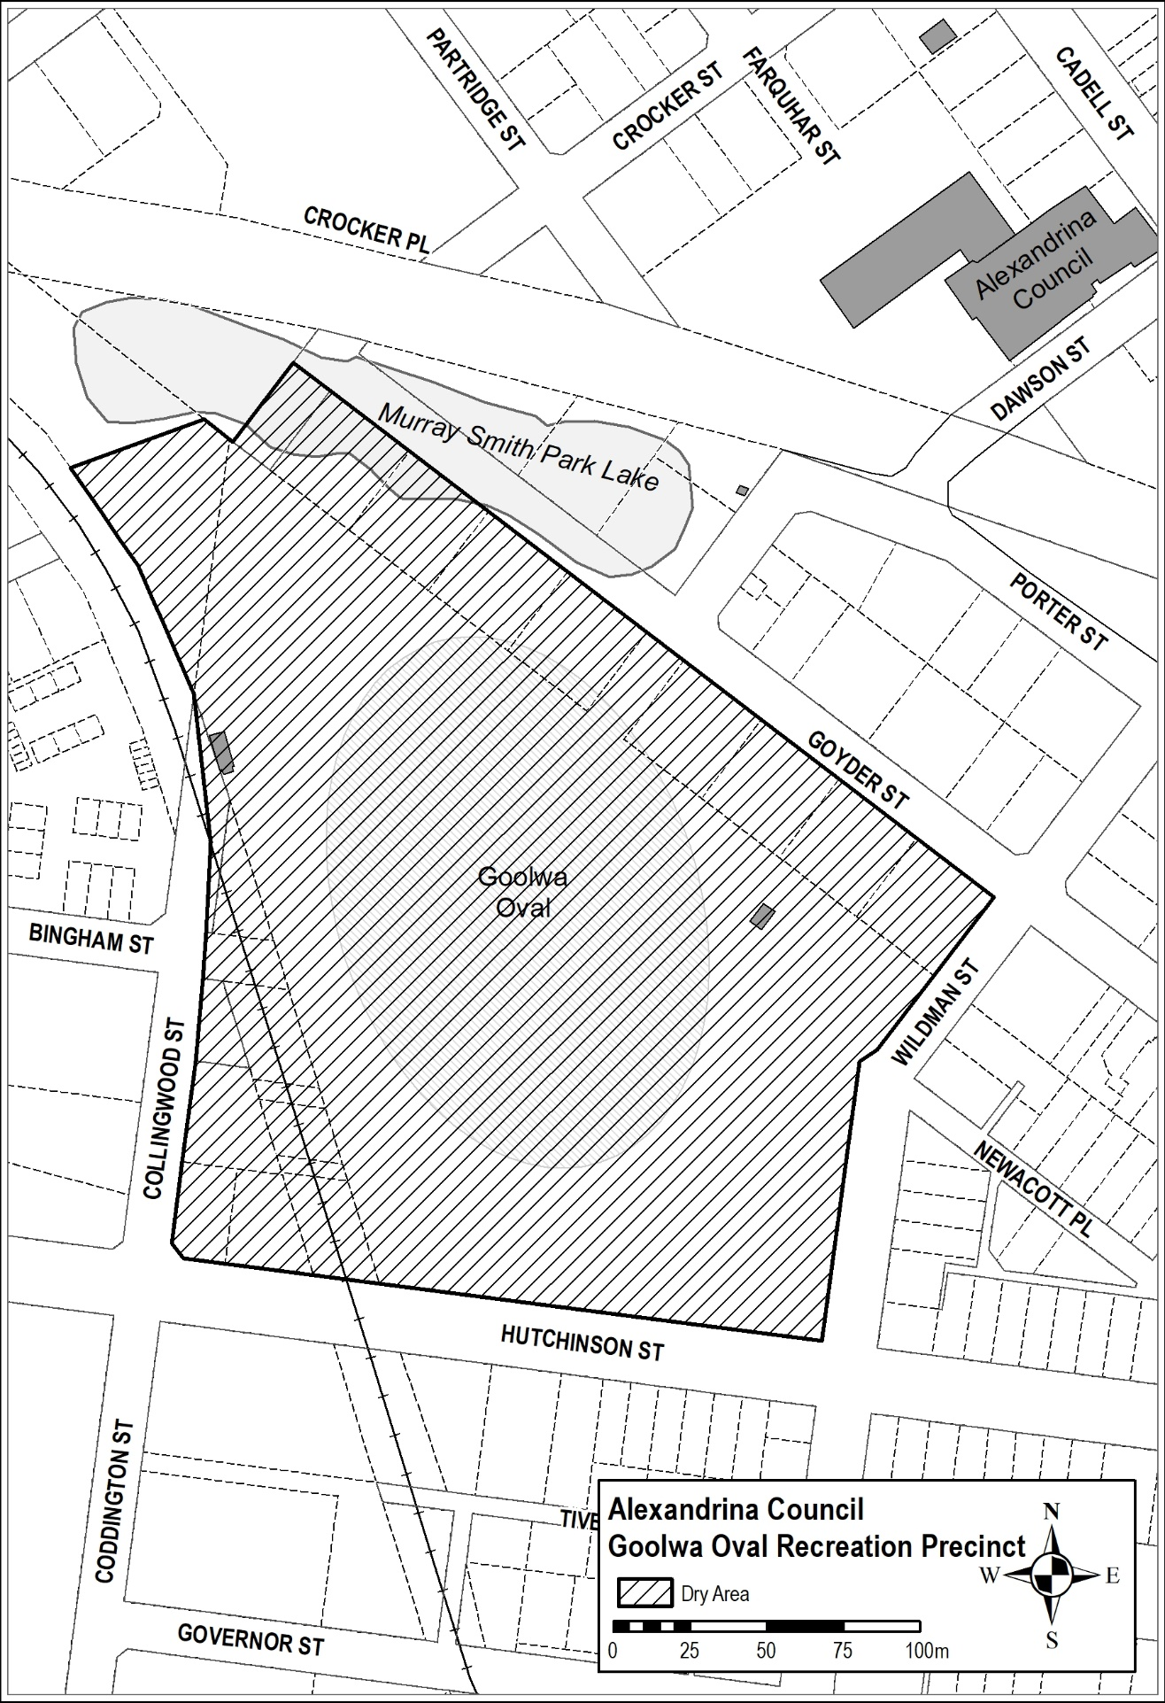
Nigel Morris
Chief Executive Officer

Kangaroo Island Council
Temporary Exclusion of Vehicles from Roads for Kangaroo Island Feature Film
NOTICE is hereby given that the Kangaroo Island Council at its meeting held on 23 November 2023:
- Resolved by absolute majority of the members of council, to exclude vehicles with the exception of vehicles involved in or associated with the production of the feature film “Kangaroo Island” and emergency service vehicles, from 7.30 am until 4.30 pm on 24 November 2023 from part of Charing Cross Road, Dudley East commencing 400 m from the intersection of Hog Bay Road until the intersection with Rifle Range Road for a maximum of 3 interspersed intervals of 15 minutes each, per hour, within the stated time period, in accordance with Section 234A of the Local Government Act 1999.
- Resolved by absolute majority of the members of council, to exclude vehicles with the exception of vehicles involved in or associated with the production of the feature film “Kangaroo Island” and emergency service vehicles, from 1.00 pm until 4.30 pm on 28 November 2023 from the intersection of Gap Road, Dune Road, Bates Road and Hamilton Drive at Emu Bay commencing 200 m back from the intersection on Gap Road and 100 m back from the intersection on each of Dune Road, Bates Road and Hamilton Drive for a maximum of 3 interspersed intervals of 15 minutes each, per hour, within the stated time period, in accordance with Section 234A of the Local Government Act 1999.
- Resolved by absolute majority of the members of council, to exclude vehicles with the exception of vehicles involved in or associated with the production of the feature film “Kangaroo Island” and emergency service vehicles, from 7.30 pm until 9.00 pm on 28 November 2023 from the whole of Chapman Terrace, Kingscote between Murray Street and Commercial Street and the whole of Commercial Street, Kingscote between Dauncey Street and Kingscote Terrace in accordance with Section 234A of the Local Government Act 1999.
- Resolved by absolute majority of the members of council, to exclude vehicles with the exception of vehicles involved in or associated with the production of the feature film “Kangaroo Island” and emergency service vehicles, from 11.00 am until 2.00 pm on 29 November 2023 from part of Pennington Bay Road, Pennington Bay commencing 900 m from the intersection of Hog Bay Road until 50 m from the dead end of Pennington Bay Road for a maximum of 3 interspersed intervals of 15 minutes each, per hour, within the stated time period, in accordance with Section 234A of the Local Government Act 1999.
- Resolved by absolute majority of the members of council, to exclude vehicles with the exception of vehicles involved in or associated with the production of the feature film “Kangaroo Island” and emergency service vehicles, from 8.00 am until 6.45 pm on 14 December 2023 from part of Pennington Bay Road, Pennington Bay commencing 900 m from the intersection of Hog Bay Road until 50 m from the dead end of Pennington Bay Road for a maximum of 3 interspersed intervals of 15 minutes each, per hour, within the stated time period, in accordance with Section 234A of the Local Government Act 1999.
Dated: 23 November 2023
Daryl Buckingham
Chief Executive Officer

District Council of Streaky Bay
Meeting Times
Notice is hereby given that the District Council of Streaky Bay resolved at its meeting held on 21 November 2023, that the Council shall meet on the third Tuesday of every month (except for the month December whereby it will be the second Tuesday) at 9.30am at the Council Chambers, 29 Alfred Terrace Streaky Bay, in accordance with the meeting schedule outlined below:
• Tuesday 16 January 2024
• Tuesday 20 February 2024
• Tuesday 19 March 2024
• Tuesday 16 April 2024
• Tuesday 21 May 2024
• Tuesday 18 June 2024
• Tuesday 16 July 2024
• Tuesday 20 August 2024
• Tuesday 17 September 2024
• Tuesday 15 October 2024
• Tuesday 19 November 2024
• Tuesday 10 December 2024
Dated: 24 November 2023
Damian Carter
Chief Executive Officer

District Council of Streaky Bay
South Australia
Liquor Licensing (Dry Areas) Notice 2023
Under section 131(1a) of the Liquor Licensing Act 1997
1—Short title
This notice may be cited as the Liquor Licensing (Dry Areas) Notice 2023.
2—Commencement
This notice comes into operation on 31 December 2023.
3—Interpretation
- In this notice—
Principal notice means the Liquor Licensing (Dry Areas) Notice 2015 published in the Gazette on 5.1.15, as in force from time to time.
- Clause 3 of the principal notice applies to this notice as if it were the principal notice.
4—Consumption etc of liquor prohibited in dry areas
- Pursuant to section 131 of the Act, the consumption and possession of liquor in the area described in the Schedule is prohibited in accordance with the provisions of the Schedule.
- The prohibition has effect during the periods specified in the Schedule.
- The prohibition does not extend to private land in the area described in the Schedule.
- Unless the contrary intention appears, the prohibition of the possession of liquor in the area does not extend to—
        - a person who is genuinely passing through the area if—
(i) the liquor is in the original container in which it was purchased from licensed premises; and
(ii) the container has not been opened; or
        - a person who has possession of the liquor in the course of carrying on a business or in the course of his or her employment by another person in the course of carrying on a business; or
        - a person who is permanently or temporarily residing at premises within the area or on the boundary of the area and who enters the area solely for the purpose of passing through it to enter those premises or who enters the area from those premises for the purpose of leaving the area.
- Schedule 1 and Schedule 2 are in substitution for Schedule—Streaky Bay Area 1 and Area 2 in the principal notice.
Schedule 1—Streaky Bay Area 1
1—Extent of prohibition
The consumption of liquor is prohibited and the possession of liquor is prohibited.
2—Period of prohibition
From 6.00pm on Sunday, 31 December 2023 to 8.00am on Monday, 1 January 2024.
3—Description of area
The area in and adjacent to the town of Streaky Bay bounded as follows: commencing at the point at which the prolongation in a straight line of the eastern boundary of Linklater Street intersects the low water mark on the southern side of Blanche Port, then generally easterly along the low water mark to the point at which it is intersected by the prolongation in a straight line of the western boundary of Philip Street, then south-easterly along that prolongation and boundary of Philip Street to the northern boundary of Wells Street, then south-westerly and westerly along that boundary of Wells Street to the eastern boundary of Linklater Street, then northerly along that boundary of Linklater Street and the prolongation in a straight line of that boundary to the point of commencement. The area includes the whole of any jetty, boat ramp, slipway or other structure that projects below the low water mark from within the area described (as well as any area beneath such a structure).
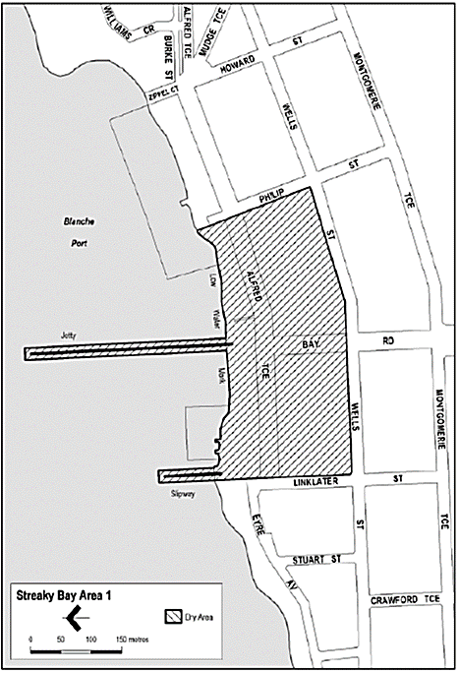
Schedule 2—Streaky Bay Area 2
1—Extent of prohibition
The consumption of liquor is prohibited and the possession of liquor is prohibited.
2—Period of prohibition
From 6.00pm on Sunday, 31 December 2023 to 8.00am on Monday, 1 January 2024.
3—Description of area
The area adjacent to Streaky Bay, generally known as the Little Islands car park and access road (together with adjoining land), comprising—

  - the whole of that part of the Government road (the access road between Little Islands Road and the Little Islands car park) that lies between the north-eastern boundary of Lot 101 DP 70670 and the south-western boundary of Lot 102 DP 70670; and

  - the area at the north-western end of that part of the Government road (including a car park and other land) bounded on the south-east by the south-eastern boundary of Lot 104 DP 70670 from a point 140 metres south-west of the north-eastern boundary of Lot 101 DP 70670 ("point A") to a point 140 metres north-east of the south-western boundary of Lot 102 DP 70670 ("point B"), on the north-east by a straight line along the shortest route from point B to the low water mark of Blanche Port, on the north-west by the low water mark of Blanche Port and on the south-west by a straight line along the shortest route from the low water mark of Blanche Port to point A.
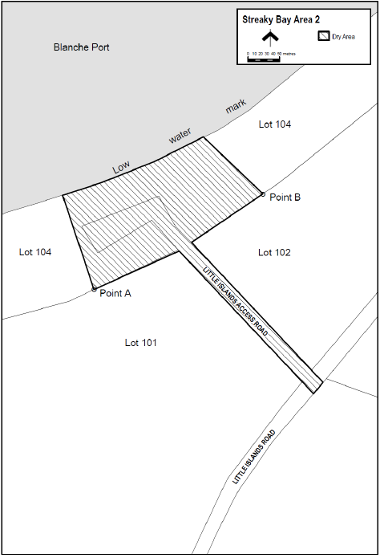
Damian Carter
Chief Executive Officer

Wattle Range Council
Resignation of Councillor
NOTICE is hereby given in accordance with section 54(6) of the Local Government Act 1999, that a vacancy has occurred in the office of Councillor for Corcoran Ward, due to the resignation of Councillor Moira Neagle, to take effect from Sunday, 19 November 2023.
Dated: 22 November 2023
B. J. Gower
Chief Executive Officer

Public Notices

National Electricity Law
Notice of Draft Determination
The Australian Energy Market Commission (AEMC) gives notice under the National Electricity Law as follows:
Under s 99, the making of a draft determination and related draft rule on the Calculation of system strength quantity proposal (Ref. ERC0375). Submissions must be received by 18 January 2024.
Under s 99, the making of a draft determination and related draft rule on the Clarifying mandatory primary frequency response obligations for bidirectional plant proposal (Ref. ERC0364). Submissions must be received by 25 January 2024.
Submissions can be made via the AEMC’s website. Before making a submission, please review the AEMC’s privacy statement on its website, and consider the AEMC’s Tips for making a submission. The AEMC publishes all submissions on its website, subject to confidentiality.
Documents referred to above are available on the AEMC’s website and are available for inspection at the AEMC’s office.
Australian Energy Market Commission
Level 15, 60 Castlereagh St
Sydney NSW 2000
Telephone: (02) 8296 7800
www.aemc.gov.au
Dated: 30 November 2023

National Gas Law
Notice of Draft Determination
The Australian Energy Market Commission (AEMC) gives notice under the National Gas Law as follows:
Under s 308, the making of a draft determination and related draft rule on the Compensation and dispute resolution frameworks (Ref. GRC0067) proposal. Submissions must be received by 25 January 2024.
Submissions can be made via the AEMC’s website. Before making a submission, please review the AEMC’s privacy statement on its website, and consider the AEMC’s Tips for making a submission. The AEMC publishes all submissions on its website, subject to confidentiality.
Documents referred to above are available on the AEMC’s website and are available for inspection at the AEMC’s office.
Australian Energy Market Commission
Level 15, 60 Castlereagh St
Sydney NSW 2000
Telephone: (02) 8296 7800
www.aemc.gov.au
Dated: 30 November 2023

Trustee Act 1936
Public Trustee
Estates of Deceased Persons
In the matter of the estates of the undermentioned deceased persons:
BARNES David John late of 105 McKenzie Road Elizabeth Downs Retired Taxi Driver who died 10 January 2021
DIVITO Ronald James late of 61 Silkes Road Paradise Retired Boiler Maker who died 1 September 2023
FIDLER Stuart Charles late of 14 Frew Street Fullarton Retired Sales Manager who died 14 August 2023
LEWIS Brenton Richard late of 31 Barcelona Road Noarlunga Downs Factory Worker who died 30 June 2023
MITCHELL Robert John late of 51 Marden Road Marden Retired Teacher who died 17 March 2023
O'LEARY Edward James late of 1809 Barna Bunora Road Kelly Retired Boiler Maker who died 18 February 2023
SLATER Thea Rosemary late of 43 Fisher Street Magill Retired School Teacher who died 3 June 2023
SOLTYS Wieslaw late of 216 Daws Road Daw Park Of no occupation who died 25 May 2023
STEWART Stephen late of 15 Linda Street Ascot Park Gardener who died 11 November 2022
Notice is hereby given pursuant to the Trustee Act 1936, the Inheritance (Family Provision) Act 1972 and the Family Relationships Act 1975 that all creditors, beneficiaries, and other persons having claims against the said estates are required to send, in writing, to the office of Public Trustee at GPO Box 1338, Adelaide SA 5001, full particulars and proof of such claims, on or before 29 December 2023 otherwise they will be excluded from the distribution of the said estate; and notice is also hereby given that all persons indebted to the said estates are required to pay the amount of their debts to the Public Trustee or proceedings will be taken for the recovery thereof; and all persons having any property belonging to the said estates are forthwith to deliver same to the Public Trustee.
Dated: 30 November 2023
N. S. Rantanen
Public Trustee

Notice Submission

The South Australian Government Gazette is published each Thursday afternoon.
Notices must be emailed by 4 p.m. Tuesday, the week of publication.
Submissions are formatted per the gazette style and a proof will be supplied prior to publication, along with a quote if applicable. Please allow one day for processing notices.
Alterations to the proof must be returned by 4 p.m. Wednesday.

Gazette notices must be submitted as Word files, in the following format:
• Title—the governing legislation
• Subtitle—a summary of the notice content
• Body—structured text, which can include numbered lists, tables, and images
• Date—day, month, and year of authorisation
• Signature block—name, role, and department/organisation authorising the notice

Please provide the following information in your email:
• Date of intended publication
• Contact details of the person responsible for the notice content
• Name and organisation to be charged for the publication—Local Council and Public notices only
• Purchase order, if required—Local Council and Public notices only

Email: governmentgazettesa@sa.gov.au
Phone: (08) 7133 3552
Website: www.governmentgazette.sa.gov.au

All instruments appearing in this gazette are to be considered official, and obeyed as such

Printed and published weekly by authority of M. Dowling, Government Printer, South Australia
$8.55 per issue (plus postage), $430.00 per annual subscription—GST inclusive
Online publications: www.governmentgazette.sa.gov.au

