No. 76 p. 3403
THE SOUTH AUSTRALIAN
GOVERNMENT GAZETTE
Published by Authority

Adelaide, Thursday, 5 October 2023

Contents

Governor’s Instruments
Acts—No. 28 of 2023 3404
Appointments 3404
Regulations—
Local Nuisance and Litter Control (Amendment of Act,
Schedule 1) Regulations 2023—No. 99 of 2023 3405
Local Nuisance and Litter Control (Guidelines)
Amendment Regulations 2023—No. 100 of 2023 3409
State Government Instruments
Aṉangu Pitjantjatjara Yankunytjatjara Land Rights Act 1981 3410
Crown Land Management Act 2009 3410
Fire and Emergency Services Act 2005 3410
Gaming Machines Act 1992 3411
Geographical Names Act 1991 3418
Housing Improvement Act 2016 3419
Justices of the Peace Act 2005 3420
Land Acquisition Act 1969 3420
Liquor Licensing Act 1997 3422
Roads (Opening and Closing) Act 1991 3430
Local Government Instruments
City of Norwood Payneham & St Peters 3431
District Council of Grant 3431
District Council of Orroroo Carrieton 3432
Public Notices
National Electricity Law 3447
National Energy Retail Law 3447
Trustee Act 1936 3447
Unclaimed Moneys Act 1891 3448

Governor’s Instruments

ACTS
Department of the Premier and Cabinet
Adelaide, 5 October 2023
Her Excellency the Governor directs it to be notified for general information that she has in the name and on behalf of His Majesty The King, this day assented to the undermentioned Bills passed by the Legislative Council and House of Assembly in Parliament assembled, viz.:
No. 28 of 2023—Environment Protection (Objects of Act and Board Attributes) Amendment Bill 2023
An Act to amend the Environment Protection Act 1993
By command,
Peter Bryden Malinauskas
Premier

APPOINTMENTS
Department of the Premier and Cabinet
Adelaide, 5 October 2023
Her Excellency the Governor in Executive Council has been pleased to appoint the undermentioned to the Industrial Relations Consultative Council, pursuant to the provisions of the Fair Work Act 1994:
Member: from 5 October 2023 until 16 March 2025
Paul James Scudds
Michaela Tippins
By command,
Peter Bryden Malinauskas
Premier
AGO0175-23CS

Department of the Premier and Cabinet
Adelaide, 5 October 2023
Her Excellency the Governor in Executive Council has been pleased to appoint the undermentioned to the TAFE SA Board of Directors, pursuant to the provisions of the TAFE SA Act 2012:
Director: from 15 October 2023 until 14 October 2026
Andrea Jane Broadfoot
Leah Helene Marrone
By command,
Peter Bryden Malinauskas
Premier
ME23/084

Department of the Premier and Cabinet
Adelaide, 5 October 2023
Her Excellency the Governor in Executive Council has been pleased to appoint the Honourable Zoe Lee Bettison, MP as Acting Minister for Primary Industries and Regional Development and Acting Minister for Forest Industries from 9 October 2023 until 13 October 2023 inclusive, during the absence of the Honourable Clare Michele Scriven, MLC.
By command,
Peter Bryden Malinauskas
Premier
MPIRD F2023/000165 CS

Regulations
South Australia

Local Nuisance and Litter Control (Amendment of Act, Schedule 1) Regulations 2023
under the Local Nuisance and Litter Control Act 2016

Contents
Part 1—Preliminary
1 Short title
2 Commencement
3 Amendment provisions
Part 2—Amendment of Local Nuisance and Litter Control Act 2016
4 Amendment of Schedule 1—Meaning of local nuisance (section 17)

Part 1—Preliminary
1—Short title
These regulations may be cited as the Local Nuisance and Litter Control (Amendment of Act, Schedule 1) Regulations 2023.
2—Commencement
(1) Subject to subregulation (2), these regulations come into operation on the day on which they are made.
(2) The following regulations come into operation on 1 April 2024:
(a) regulation 4(1) to (9) (inclusive); and
(b) regulation 4(11) and (12).
3—Amendment provisions
In these regulations, a provision under a heading referring to the amendment of a specified Act amends the Act so specified.
Part 2—Amendment of Local Nuisance and Litter Control Act 2016
4—Amendment of Schedule 1—Meaning of local nuisance (section 17)
(1) Schedule 1, Part 1, clause 1—after the definition of construction noise insert:
emergency services organisation means—
(a) an emergency services organisation within the meaning of the Fire and Emergency Services Act 2005; and
(b) in relation to a particular emergency within the meaning of the Emergency Management Act 2004—the control agency for the emergency under that Act; and
(c) SA Ambulance Service Inc; and
(d) South Australian Police; and
(e) a local government council engaged in duties in connection with an emergency; and
(f) an arm of the Australian Defence Force engaged in police, fire fighting, ambulance or search and rescue duties or duties in connection with an emergency;
essential services has the same meaning as in the Essential Services Commission Act 2002;
(2) Schedule 1, Part 1, clause 1—after the definition of promotional image insert:
public infrastructure means—
(a) infrastructure, equipment, structures, works and other facilities used in or in connection with the provision of essential services or telecommunications; and
(b) roads and their supporting structures and works;
public infrastructure works means works for the construction, installation, repair, maintenance or replacement of, or making of other physical changes to, public infrastructure;
(3) Schedule 1, Part 2, clause 2—delete clause 2 and substitute:
2—Declared agents (section 17(1)(a))
The following are declared agents for the purposes of section 17(1)(a):
(a) vibration;
(b) light.
(4) Schedule 1, Part 2, clause 4(a)—delete "generated on premises"
(5) Schedule 1, Part 2, clause 4(a)(i)—after subsubparagraph D insert:
(DA) in the case of noise from the operation of refrigeration equipment fitted on or in a vehicle that is parked and not being operated—the noise has travelled from the place where the vehicle is parked to neighbouring domestic premises between the hours of—
• 8pm and midnight on any day; or
• midnight and 9am on Sunday; or
• midnight and 8am on any other day; or
(6) Schedule 1, Part 2, clause 4—after paragraph (e) insert:
(ea) light emitted from a place, if an authorised officer forms the opinion that—
(i) the light has travelled from the place at which it was generated to neighbouring premises; and
(ii) the nature, intensity, colour, location, direction or extent of the light is such as to constitute an unreasonable interference with the enjoyment of the neighbouring premises by persons occupying those premises;
(7) Schedule 1, Part 3, clause 5(d)—before "noise" first occurring insert:
other than in the case of construction noise or other nuisance from construction activities carried out in accordance with a development authorisation within the meaning of the Development Act 1993 or the Planning, Development and Infrastructure Act 2016—
(8) Schedule 1, Part 3, clause 5(h)—delete paragraph (h) and substitute:
(h) noise, vibration and other nuisance from public infrastructure works where—
(a) the works are carried out because of an emergency or urgent public need; or
(b) the works are carried out in the circumstances in order to avoid or reduce inconvenience or disruption to traffic or pedestrians during normal business hours;
(9) Schedule 1, Part 3, clause 5(i)—delete "clause 4(1)(a)(i)(D)" and substitute:
clause 4(a)(i)(D) and (DA)
(10) Schedule 1, Part 3, clause 5(j)(iii)—delete subparagraph (iii)
(11) Schedule 1, Part 3, clause 5(n)—after "worship" insert:
, other than noise consisting of amplified music
(12) Schedule 1, Part 3, clause 5—after paragraph (r) insert:
(s) dust from unsealed public roads;
(t) light emitted by or from the following:
(i) public street lighting;
(ii) public infrastructure works;
(iii) airports;
(iv) harbours;
(v) vehicles;
(vi) railway premises (within the meaning of the Rail Safety National Law (South Australia) Act 2012);
(vii) bus stations and bus depots;
(viii) public transport operating centres and facilities;
(ix) goods vehicle operating and transport centres (including goods distribution centres);
(x) traffic control devices;
(xi) navigational aids (including lighthouses);
(xii) premises or facilities (including temporary premises or facilities) used by an emergency services organisation;
(xiii) correctional institutions (within the meaning of the Correctional Services Act 1982);
(xiv) premises or facilities of, or used by, an arm of the Australian Defence Force (including training areas);
(xv) business premises during the normal operating hours of the business provided that the lights are required for the reasonable and safe operation of the business and reasonable measures have been taken to reduce the impact of the light on neighbouring premises;
(xvi) public light displays (including laser light displays);
(xvii) Christmas light displays;
(xviii) natural sources, including the reflection of natural light (but not including where natural light is reflected by a device designed or intended to be used for the deliberate reflection of light (for example, a bird scaring device)).
Editorial note—
As required by section 10AA(2) of the Legislative Instruments Act 1978, the Minister has certified that, in the Minister's opinion, it is necessary or appropriate that these regulations come into operation as set out in these regulations.
Made by the Governor
with the advice and consent of the Executive Council
on 5 October 2023
No 99 of 2023

South Australia

Local Nuisance and Litter Control (Guidelines) Amendment Regulations 2023
under the Local Nuisance and Litter Control Act 2016

Contents
Part 1—Preliminary
1 Short title
2 Commencement
Part 2—Amendment of Local Nuisance and Litter Control Regulations 2017
3 Amendment of regulation 4—Functions of councils—guidelines

Part 1—Preliminary
1—Short title
These regulations may be cited as the Local Nuisance and Litter Control (Guidelines) Amendment Regulations 2023.
2—Commencement
These regulations come into operation on the day on which they are made.
Part 2—Amendment of Local Nuisance and Litter Control Regulations 2017
3—Amendment of regulation 4—Functions of councils—guidelines
Regulation 4(1)(a)(ii)—delete subparagraph (ii) and substitute:
(ii) in any other case—the guidelines set out in Managing unreasonable conduct by a complainant. A manual for frontline staff, supervisors and senior managers published by the New South Wales Ombudsman, March 2021, on the website of the New South Wales Ombudsman;
Editorial note—
As required by section 10AA(2) of the Legislative Instruments Act 1978, the Minister has certified that, in the Minister's opinion, it is necessary or appropriate that these regulations come into operation as set out in these regulations.
Made by the Governor
with the advice and consent of the Executive Council
on 5 October 2023
No 100 of 2023

State Government Instruments

Aṉangu Pitjantjatjara Yankunytjatjara Land Rights Act 1981
Aṉangu Pitjantjatjara Yankunytjatjara (APY)
Review of Electorates
What is the review?
Pursuant to section 9(8) of the Aṉangu Pitjantjatjara Yankunytjatjara Land Rights Act 1981 (“the Act”), the Electoral Commissioner is required to review the electorates in the APY Lands constituted in accordance with Schedule 3 of the Act not later than 3 months prior to each election.
As the next general elections of the APY Executive Board must be conducted between 1 May and 31 August 2024, the Electoral Commissioner has commenced a review which includes consultation with the APY community.
Following public consultation, the Electoral Commissioner will recommend whether the electorate boundaries should be modified for the 2024 APY Executive Board Elections.
How are the current electorates constituted?
There are seven electorates currently constituted of the following community groups:
- Pipalyatjara and Kalka
- Kanypi, Nyapari, Angatja and Watarru
- Amata and Tjurma
- Kaltjiti, Irintata and Watinuma
- Pukatja, Yunyarinyi, Anilalya and Turkey Bore
- Mimili
- Iwantja, Amuruna, Railway Bore, Witjintitja and Wallatinna
Who may make a submission?
The Act requires that the review includes consultation with APY members and the APY Executive Board.
The Electoral Commissioner also invites submissions from the APY Community Councils and other parties or individuals with an interest in the communities listed above.
Written submissions should be addressed to the Electoral Commissioner and can be sent via email to APY.Review@sa.gov.au or via post to GPO Box 646, Adelaide SA 5001.
Additionally, the Electoral Commission of SA will visit the APY Lands between 23-27 October 2023 to discuss the review. Details of the itinerary can be found at: www.ecsa.sa.gov.au
Submissions must be received by Tuesday 14 November 2023.
Please visit our website www.ecsa.sa.gov.au for more information on the review.
Mick Sherry
Electoral Commissioner

Crown Land Management Act 2009
Application to Purchase Property—Caurnamont Mooring
Notice is hereby given, pursuant to section 59 of the Crown Land Management Act 2009 that the Department for Environment and Water is considering an application to purchase the whole of Allotment 503 in Deposited Plan 126554 in the Hundred of Ridley, being portion of the land known as Caurnamont Mooring, 2972 Purnong Road Caurnamont SA.
Written comments may be submitted for consideration by the Minister for Climate, Environment and Water, no later than 26 October 2023.
Correspondence may be addressed to:
Lucy McMurtrie, Project and Property Officer, Crown Lands Disposals
GPO Box 1047, ADELAIDE SA 5001
Or lucy.mcmurtrie@sa.gov.au
Authority File: DL/3640/1982
Dated: 5 October 2023
Melanie Carson
Manager
Crown Land Operations

Fire and Emergency Services Act 2005
Section 78
Fire Danger Season
The South Australian Country Fire Service hereby:
1. Fixes the date of the Fire Danger Season within the part of the State defined as the Eastern Eyre Peninsula Fire Ban District so as to commence on the 1 November 2023 and to end on the 15 April 2024.
2. Fixes the date of the Fire Danger Season within the part of the State defined as the Flinders Fire Ban District so as to commence on the 16 October 2023 and to end on the 15 April 2024.
3. Fixes the date of the Fire Danger Season within the part of the State defined as the Lower Eyre Peninsula Fire Ban District so as to commence on the 15 November 2023 and to end on the 15 April 2024.
4. Fixes the date of the Fire Danger Season within the part of the State defined as the Mid North Fire Ban District so as to commence on the 1 November 2023 and to end on the 30 April 2024.
5. Fixes the date of the Fire Danger Season within the part of the State defined as the North East Pastoral Fire Ban District so as to commence on the 16 October 2023 and to end on the 31 March 2024.
6. Fixes the date of the Fire Danger Season within the part of the State defined as the North West Pastoral Fire Ban District so as to commence on the 16 October 2023 and to end on the 31 March 2024.
7. Fixes the date of the Fire Danger Season within the part of the State defined as the West Coast Fire Ban District so as to commence on the 16 October 2023 and to end on the 15 April 2024.
8. Fixes the date of the Fire Danger Season within the part of the State defined as the Yorke Peninsula Fire Ban District so as to commence on the 1 November 2023 and to end on the 30 April 2024.
Dated: 5 October 2023
Brett Loughlin AFSM
Chief Officer
SA Country Fire Service

Gaming Machines Act 1992
South Australia
Gaming Machines Community Impact Assessment Guidelines Variation Notice 2023/1
under section 17B of the Gaming Machines Act 1992
1—Short title
This notice may be cited as the Gaming Machines Community Impact Assessment Guidelines Variation Notice 2023/1 (Variation Notice).
2—Commencement
This Variation Notice comes into operation on 29 January 2024.
3—Variation of existing Community Impact Assessment Guidelines
This Variation Notice will have the effect that the Community Impact Assessment Guidelines prescribed by this notice will supersede the Community Impact Assessment Guidelines in effect prior to 29 January 2024.
4—Gaming Machines Community Impact Assessment Guidelines
The Community Impact Assessment Guidelines set out in this notice is varied under section 17B of the Gaming Machines Act 1992.

Gaming Machines Community Impact Assessment Guidelines
Gaming Machines Act 1992
1. Overview
1.1. Designated Applications
Under section 17B of the Act, the Commissioner may only grant a designated application if satisfied that to grant the application is in the community interest.
The types of applications which are classified as designated applications are set out in Schedule 1.
In determining whether or not a designated application is in the community interest, the Commissioner must have regard to:
- the harm that might be caused by gambling, whether to a community as a whole or a group within a community
- the cultural, recreational, employment or tourism impacts
- the social impact in, and the impact on the amenity of, the locality (see Schedule 2 for a description of locality) of the premises or proposed premises.
An applicant in respect of a designated application must comply with the requirements set out in these guidelines.
1.2. Community Impact Submission
The onus is on the applicant to satisfy the Commissioner that the grant of the application is in the community interest and to provide relevant evidence and submissions to discharge this onus.
In determining whether a designated application is in the community interest, the Commissioner will consider the Community Impact Submission prepared by the applicant in accordance with these Guidelines and may have regard to any other information, data, submissions, or research which the Commissioner considers relevant and appropriate to inform the decision.
2. Community Impact Considerations
In preparing their Community Impact Submission, applicants should consider the guidance provided under each of the following sub-headings and address each of the matters required, as relevant to the application.
2.1. The harm that might be caused by gambling, whether to a community as a whole or individuals within a community
An object of the Act is to ensure that gaming machine gambling is conducted responsibly, fairly and honestly, with regard to minimising the harm caused by gambling.
The Commissioner considers gambling harm to be any negative consequence experienced by an individual or members of their social network, family or the broader community, because of participation in gambling. This can be experienced on a spectrum, ranging from minor negative experiences to crises, and is not always proportionate to the amount of gambling participation.
Gambling harms can include:
- the risk of harm to children and vulnerable people,
- the adverse financial, social and cultural effects on communities or individuals within a community,
- the adverse effects on a person’s health or welfare, and
- the adverse effects on a person’s family, friends and work colleagues.
Applicants are required to:
- Identify the Net Gambling Revenue (NGR) data for the premises in comparison to the local council area and State, and consider whether the application has the potential to increase gambling related harm in the locality.
- Identify the socio-economic profile of the locality of the premises/proposed premises and consider whether there are any factors which might increase the risk of gambling harm, such as higher unemployment or social disadvantage.
This information may be obtained by reference to the Socio-Economic Indexes for Areas (SEIFA) scores at the Statistical Area Level 2 (SA2) for the SA2 area in which the premises is located, namely:
- Index of Relative Socio-Economic Advantage and Disadvantage;
- Index of Relative Socio-Economic Disadvantage;
- Index of Economic Resources; and
- Index of Education and Occupation.
- Identify whether there are any ‘at-risk’ groups or sub-communities within the locality of the premises/proposed premises and provide a description of how the applicant intends to minimise any potential harm to ‘at-risk’ groups and sub-communities in the locality of the premises/proposed premises.
- Identify whether there are any community buildings, facilities and areas of interest/concern within the locality which may include:
- schools and educational institutions
- hospitals, drug and alcohol treatment centres
- accommodation or refuges for young, vulnerable or disadvantaged people
- childcare centres
- recreational areas
- pawn brokers or credit providers
- other gaming premises, and
- any other areas where young, vulnerable or disadvantaged people may congregate or be attracted to.
- Identify and provide any policies and procedures that the applicant has implemented or intends to implement to address and minimise any potential harm that might be caused by gambling in the locality. It is expected that these policies and procedures should relate to issues such as, but not limited to:
- arrangements for the identification of persons who may be experiencing gambling harm in those premises
- arrangements to inform customers and their families of, and facilitate access to, barring (exclusion) arrangements
- enforcement and compliance with barring (exclusion) arrangements, and
- design/location of the gaming area or proposed gaming area so it would not be an attraction to minors.
It is important to note that reliance alone on a responsible gambling agreement with an approved industry body will not be considered sufficient to satisfy or discharge the harm minimisation requirements of an application, and each applicant should consider the specific circumstances of their venue when addressing this consideration.
Guidance as to how to locate data and information to assist applicants with completing this section of their Community Impact Submission, including identifying the socio-economic profile of the locality, is available at www.cbs.sa.gov.au/ciportal.
2.2. The cultural, recreational, employment or tourism impacts
Applicants must address:
- The economic benefits or employment opportunities the grant of the application will generate in the locality and the broader community, and
- The cultural, recreational or tourism benefits the grant of the application will generate for the locality and the broader community.
2.3. The social impact in, and the impact on the amenity of, the locality of the premises or proposed premises
Applicants must address the social impact the grant of the application may have in the locality, and the impact on the amenity of the locality of the premises or proposed premises.
Having regard to the relevant Net Gambling Revenue (NGR) data and social economic profile data outlined at 2.1 and any other information the applicant considers relevant, applicants are required to address:
- The social impact the grant of the application may have in the locality, with reference to any potential increase in crime and anti-social behaviour.
- How the grant of the application may impact positively or negatively on the amenity of the locality (being the pleasantness, attractiveness, desirability or utility of the locality), along with any impact on the character of the premises or locality.
- How the non-gaming related operations of the premises/proposed premises will contribute positively to the community such as providing a family-friendly environment or community meeting place, and
- Any steps that will be taken to address any negative social impact or negative impact on the amenity of the locality.
3. Completing a Community Impact Submission
3.1. General Guidance
Designated applications, at the time of lodgement, must be accompanied by a Community Impact Submission unless a waiver is provided (see below).
The Commissioner has developed a form to help guide applicants as to the type of information they need to provide in support of their application. Applicants may complete this form, or instead choose to prepare their own submission in support of the application addressing the matters outlined in these Guidelines. This form is available at www.cbs.sa.gov.au/ciportal.

There is no requirement for a Community Impact Submission to be prepared by legal counsel or industry consultants. Applicants can complete their own Community Impact Submission after consulting with the relevant key stakeholders and interest groups in the community, obtaining all other required information and providing a map showing the locality of their premises. A tool to assist applicants with the provision of a suitable map is available at www.cbs.sa.gov.au/ciportal.
When providing information to support their application, applicants should keep in mind that Community Impact Submissions will be made public. Any information that an applicant does not wish to be made public should be redacted or omitted from the Community Impact Submission.
As each application is different, the level of detail required in a Community Impact Submission may differ depending on the nature and complexity of the application and the impact the premises (including a variation to licence conditions) or the proposed premises will have on the surrounding community. If a Community Impact Submission does not adequately address each of these considerations, the Commissioner may require additional information to be provided.
Where a Community Impact Submission is being prepared in conjunction with a designated application under the Liquor Licensing Act 1997, information that is required under both Acts can be provided once to avoid duplication in the application process.
3.2. Other information that may be relevant to the application
Applicants should be aware that in determining whether the application is in the community interest, the Commissioner may, depending on the nature of the application, have regard to other relevant information or data, including (but not limited to):
- if the application seeks to authorise the applicant to conduct gaming at any time between midnight and 8am, or seeks an authorisation to extend gaming hours beyond those previously fixed in relation to the licence (being an extension between midnight and 8am on any day), the intra-day gaming figures for the premises (if applicable), which can be accessed by contacting the Independent Gaming Corporation (contact details can be found at www.cbs.sa.gov.au/ciportal)
- the length of time the licensee has held a gaming machine licence at the relevant premises and elsewhere
- the population of the locality (for example, this may be relevant to an application relating to a premises located in a country town)
- barring data relevant to the premises
- the licensee’s Self-Assessment Compliance Audit Checklist (if completed within the previous 12 months), and any evidence demonstrating the identification, monitoring and responses taken in relation to people displaying indicators of gambling harm (excluding Automated Risk Monitoring System alerts) during the previous 12 months
- the licensee’s compliance history, including with regard to responsible gambling requirements
- whether approved facial recognition technology is either in place or is proposed to be installed and operated at the premises.
Applicants are encouraged to address any of the above factors (as relevant), in their Community Impact Submission.
3.3. Community Consultation
Applicants are required to address as part of a Community Impact Submission, whether the community of the locality of the premises/proposed premises have concerns about the application. The applicant should consider the following options for community consultation and should address any identified concerns:
- Consultation with persons who reside within the locality of the premises/proposed premises and who may be affected by the grant of the application.
- Petitions, customer surveys or letters of support from existing or potential customers.
- Letters of support or evidence of consultation with local businesses.
- Evidence of consultation with relevant authorities and community organisations such as:
- the local community;
- the local council;
- gambling help groups (non-government) and community service organisations; and
- local community cultural and residential groups.
Where appropriate, the applicant is required to demonstrate what measures will be implemented to address or mitigate concerns raised through this consultation process.
Contact details for selected organisations is available at www.cbs.sa.gov.au/ciportal.
3.4. Other Considerations
As part of a Community Impact Submission, applicants are required to demonstrate the measures that have been implemented, or that they will implement, to ensure that the grant of the application would be unlikely to result in undue offence, annoyance, disturbance or inconvenience to those who reside, work or worship in the vicinity of the premises.
3.5. Can the requirement for a Community Impact Submission be waived?
The Commissioner may vary or waive the requirement for a Community Impact Submission if:
- the application does not propose a significant change to the licensed premises or the nature or extent of the business carried on from the licensed premises
- the purpose of the Community Impact Submission can be achieved by other means, or
- other special circumstances exist.
Applicants seeking a waiver from the requirement to provide a Community Impact Submission with their application must, at the time of lodging their application, provide a submission to the Commissioner outlining the reasons that a waiver ought to be granted. The submission should set out, at a minimum, the Data Relevant to Locality set out under clause 2.3 of these Guidelines, as it relates to the premises and locality, and the exceptional circumstances that would justify the waiving of the requirement to provide a Community Impact Submission.
In the event that the Commissioner decides to vary or waive the requirement for a Community Impact Submission, the application will remain a designated application for the purposes of determination under the Act.

Schedule 1
Designated Applications
For the purposes of section 17A of the Act, a designated application is:
- an application for the grant of a gaming machine licence, or
- any other application that the Commissioner has determined, in accordance with the Guidelines, to be a designated application.
In addition to an application for the grant of a gaming machine licence, the Commissioner has determined that the following applications are also designated applications for the purposes of the Act:
- an application for the removal of a gaming machine licence
- an application to vary the trading hours of a gaming machine licence
- to authorise the conduct of gaming at any time between midnight and 8am on any day, or
- if the licence already authorises gaming between midnight and 8am, to allow the conduct of gaming at later hours (being between midnight and 8am), on any day, than those previously fixed in relation to the licence
- where, if the application were granted, the trading hours authorised by the gaming machine licence would exceed the trading hours authorised by the liquor licence for the premises, and
- an application that if granted would result in an increase in the maximum number of gaming machines approved to be held under the licence by more than two machines within a 12 month period.
Under section 17A of the Act, the Commissioner also has a general discretion to designate any other application in accordance with the Guidelines. In determining whether an application is deemed to be a designated application for the purposes of section 17A of the Act, the Commissioner will have regard to, but is not limited to having regard to, the matters set out in these guidelines insofar as they are relevant.
If, after considering an application the Commissioner reaches the preliminary view that the application ought to be designated, the Commissioner will inform the applicant and provide the applicant with reasons as to why that view has been reached. The applicant will then be invited to make submissions as to why the application should not be deemed to be a designated application.
If the Commissioner is not persuaded by the applicant’s submission, or the applicant does not make submissions, the application will be deemed to be designated and the applicant will be required to complete a Community Impact Submission before the application is able to be determined.

Schedule 2
Locality Guidelines
As part of their Community Impact Submission, applicants are required to identify the locality of their premises/proposed premises. Applicants should consider:
- the area around the applicant’s premises/proposed premises which is most likely to be affected by the grant of the application, and
- the area from where the applicant draws or expects to draw their customers, having regard to the nature of the premises/proposed premises.
When considering the area from where the premises/proposed premises draws or expects to draw their customers, applicants should consider:
- any target customer groups or identifiable customer base and the areas they reside in, and
- anything that may attract customers to the premises/proposed premises and the areas from which these customers may be based, for example –
- where a premises/proposed premises is located/to be located on a main road, applicants may need to consider any areas which are serviced by that main road and include those areas in their locality, or
- where a premises/proposed premises is located/to be located near to a shopping complex, applicants may need to consider the customer base of the shopping complex and where those customers reside and include those areas in the locality of their premises/proposed premises.
The following is intended as a guide only. Applicants are expected to tailor the size of the areas set out below having regard to the locality guidelines. The Authority may exercise discretion in determining whether the locality identified in the Community Impact Submission is appropriate and may direct a variation with respect to the locality if necessary.
Adelaide Metropolitan Area: As a guide, the locality of a premises in the Adelaide Metropolitan Area would generally be considered to be the area within a 2km radius of the site of the relevant premises. A list of the suburbs considered to be in the Adelaide Metropolitan Area can be found below. The list is intended to be used as a guide only.
Outside the Metropolitan Area: As a guide, with regards to country cities, towns or communities, unless remotely located, the locality of the premises would generally be considered to be the area within a 5km radius of the site of the relevant premises.
Regional: Where a premises/proposed premises is remotely located, the applicant should choose an appropriate locality to address in their submission, keeping in mind that the locality of a premises is the area most likely to be affected by the grant of the application.
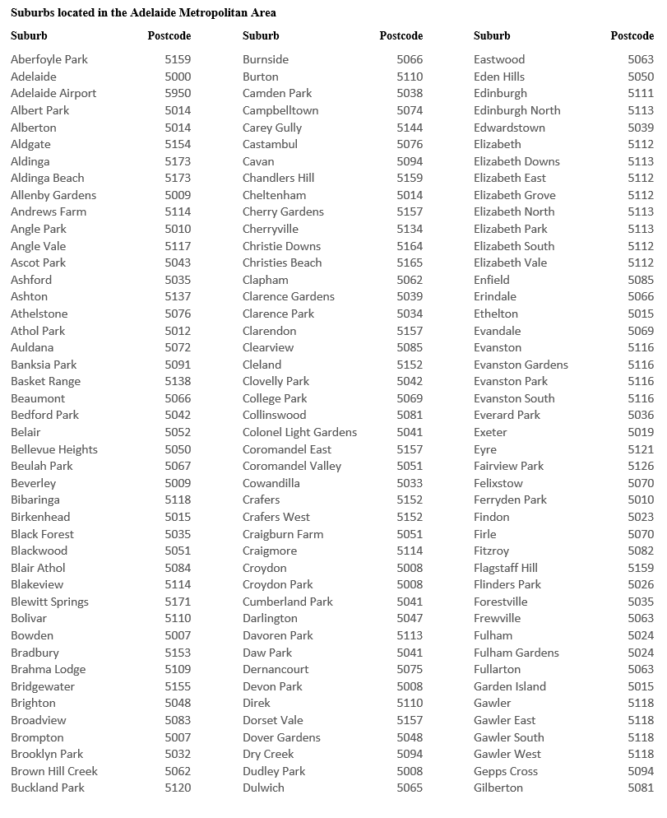
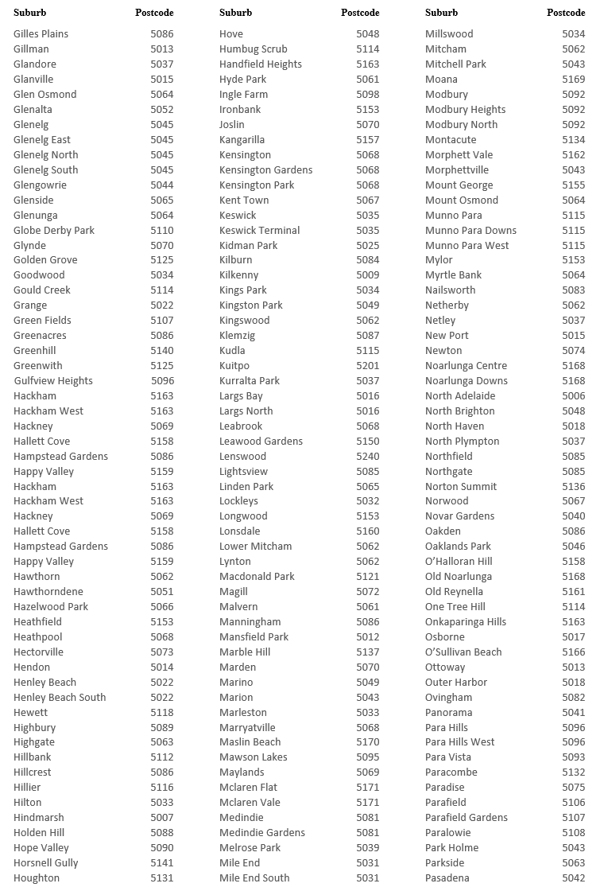
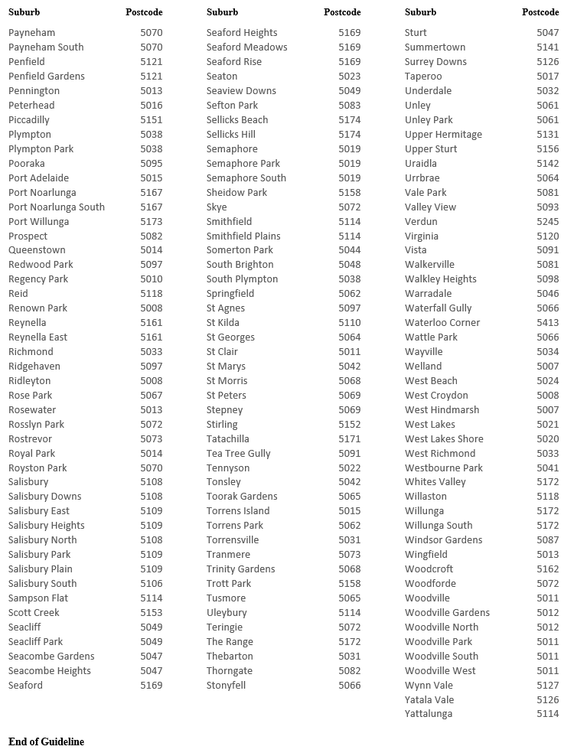
Dated: 5 October 2023
Dini Soulio
Liquor & Gambling Commissioner

Geographical Names Act 1991
Notice to Alter the Boundary of a Place
NOTICE is hereby given that, pursuant to section 11B(1)(b) of the Geographical Names Act 1991, I, BRADLEY SLAPE, Surveyor-General and Delegate appointed by the Honourable Nick Champion MP, Minister for Planning, Minister of the Crown to whom the administration of the Geographical Names Act 1991 is committed, DO HEREBY;
- Alter the locality boundary between Mil-Lel and Worrolong to exclude that area marked (A), highlighted in green as shown on the plan, from the bounded locality of WORROLONG and include that area in the locality of MIL-LEL.
- Alter the locality boundary between Mil-Lel and Worrolong to exclude that area marked (B), highlighted in orange as shown on the plan, from the bounded locality of MIL-LEL and include that area in the locality of WORROLONG.
This notice is to take effect immediately upon its publication in the Government Gazette.
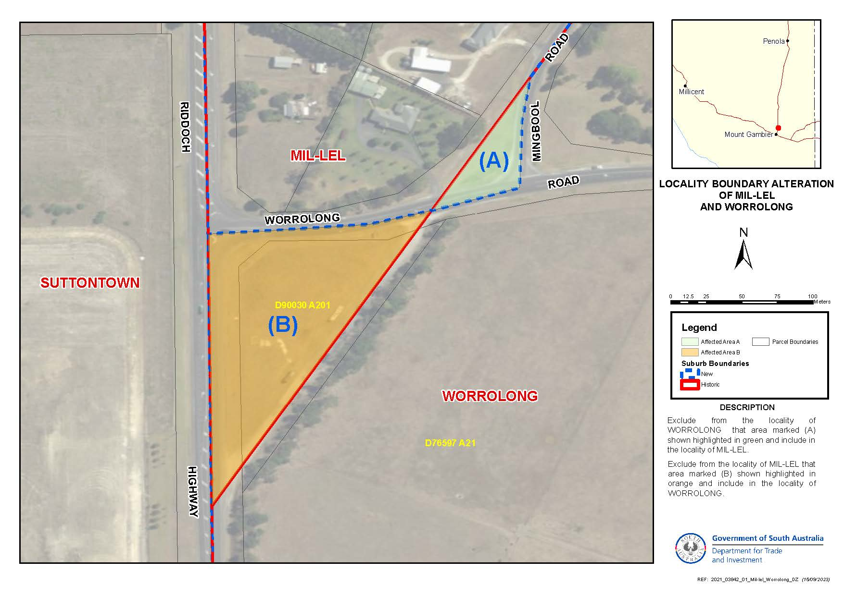
Dated: 5 October 2023
B.J. Slape
Surveyor General
2021/03842/01

Geographical Names Act 1991
Notice to Alter the Boundary of a Place
NOTICE is hereby given that, pursuant to section 11B(1)(b) of the Geographical Names Act 1991, I, BRADLEY SLAPE, Surveyor-General and Delegate appointed by the Honourable Nick Champion MP, Minister for Planning, Minister of the Crown to whom the administration of the Geographical Names Act 1991 is committed, DO HEREBY;
- Alter the locality boundary between Nurragi and Sandergrove to exclude that area marked (A), highlighted in green as shown on the plan, from the bounded locality of NURRAGI and include that area in the locality of SANDERGROVE.
This notice is to take effect immediately upon its publication in the Government Gazette.
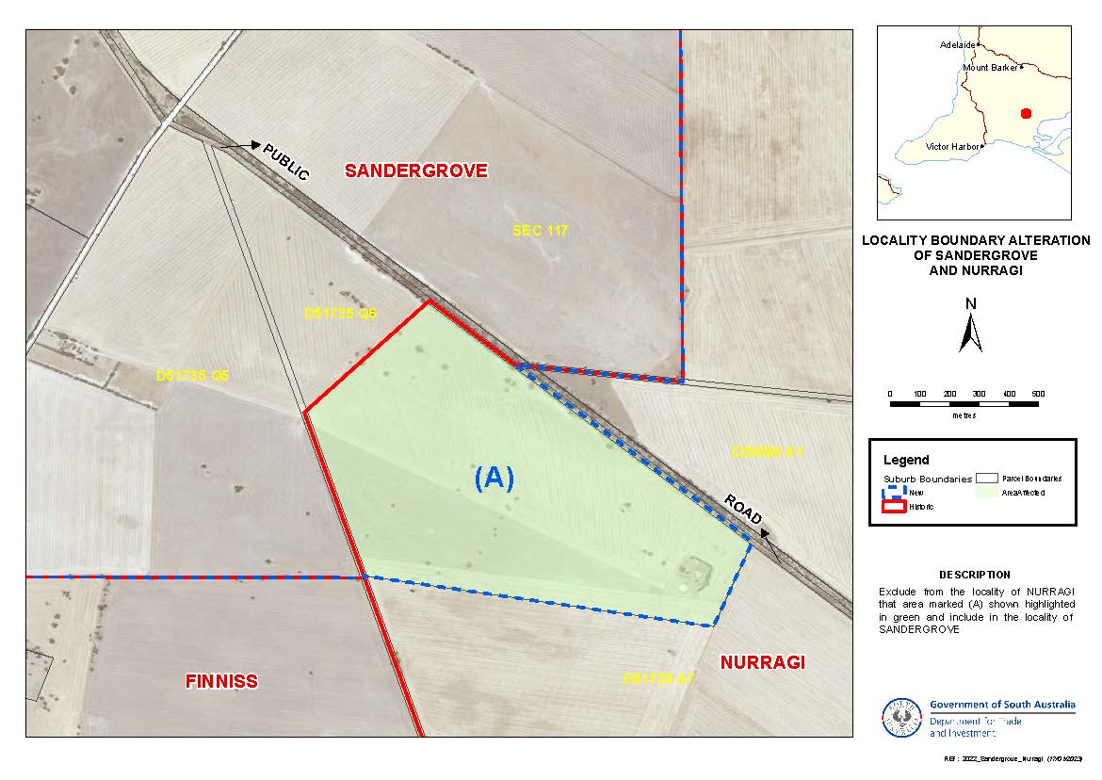
Dated: 5 October 2023
B.J. Slape
Surveyor General
2021/03842/01

Housing Improvement Act 2016
Rent Control
The Minister for Human Services Delegate in the exercise of the powers conferred by the Housing Improvement Act 2016, does hereby fix the maximum rental per week which shall be payable subject to Section 55 of the Residential Tenancies Act 1995, in respect of each house described in the following table. The amount shown in the said table shall come into force on the date of this publication in the Gazette.
Address of Premises | Allotment Section | Certificate of Title Volume/Folio | Maximum Rental per week payable
89 Senate Road, PORT PIRIE WEST SA 5540 | Allotment 12 Deposited Plan 1651  Hundred of Pirie | CT5702/898 | $140.00
37 Railway Terrace, Port Germein SA 5495 | Allotment 92 Filed Plan 209464  Hundred of Telowie | CT 6139/338 | $225.00
Dated: 5 October 2023
Craig Thompson
Housing Regulator and Registrar
Housing Safety Authority, SAHA
Delegate of Minister for Human Services

Housing Improvement Act 2016
Rent Control Revocations
Whereas the Minister for Human Services Delegate is satisfied that each of the houses described hereunder has ceased to be unsafe or unsuitable for human habitation for the purposes of the Housing Improvement Act 2016, notice is hereby given that, in exercise of the powers conferred by the said Act, the Minister for Human Services Delegate does hereby revoke the said Rent Control in respect of each property.
Address of Premises | Allotment Section | Certificate of Title Volume/Folio
20 Fordingbridge Road, Davoren Park  SA 5113 | Allotment 638 Deposited Plan 7394 Hundred of Munno Para | CT 6116/947
100 Old Port Wakefield Rd, Two Wells  SA 5501 | Allotment 9 Filed Plan 105539 Hundred of Port Gawler | CT5179/783
Dated: 5 October 2023
Craig Thompson
Housing Regulator and Registrar
Housing Safety Authority, SAHA
Delegate of Minister for Human Services

Justices of the Peace Act 2005
Section 4
Notice of Appointment of Justices of the Peace for South Australia
by the Commissioner for Consumer Affairs
I, Dini Soulio, Commissioner for Consumer Affairs, delegate of the Attorney-General, pursuant to section 4 of the Justices of the Peace Act 2005, do hereby appoint the people listed as Justices of the Peace for South Australia as set out below.
For a period of ten years for a term commencing on 10 October 2023 and expiring on 9 October 2033:
Rosemary Faye WOOD
Maurice VAN DER HOEVEN
David John THACKRAH
Malcolm Robert SPARGO
Mahen SINGH
Graham Desmond Joseph RABBETT
Ian Robert PRICE
John Kenneth Gibson OSWALD
Claire Margaret MICHALANNEY
Brett Ashley MAPLE
Paris Kay LEE
Richard David KESSNER
Robert Stanley KEARNEY
Darrelle Kay JOHNSON
Laurel May JARED
Julie Ming Ting HO
Kym Andrew GILLARD
Robert John FOX
Christine Ann ESPOSITO
Michael DIAKOMICHALIS
Pio Antonio DE CORSO
Carrol Anne COOPER
Cheryl Dianne COOK
William Dennis COAD
Dennis Edward BAXTER
Dated: 3 October 2023
Dini Soulio
Commissioner for Consumer Affairs
Delegate of the Attorney-General

Land Acquisition Act 1969
Section 16
Form 5—Notice of Acquisition
1. Notice of acquisition
The Commissioner of Highways (the Authority), of 83 Pirie Street, Adelaide SA 5000, acquires the following interests in the following land:
Comprising an encumbered estate in fee simple in that piece of land being the whole of Allotment 313 in Filed Plan 19503 comprised in Certificate of Title Volume 5919 Folio 728, subject to easement(s) over the land Marked D for Drainage Purposes (TG 9770529), subject to free and unrestricted right(s) of way over the land marked A, together with easement(s) over the land marked B for Drainage Purposes (TG 9770530), together with free and unrestricted right(s) of way over the land marked B.
This notice is given under Section 16 of the Land Acquisition Act 1969.
2. Compensation
A person who has or had an interest consisting of native title or an alienable interest in the land that is divested or diminished by the acquisition or the enjoyment of which is adversely affected by the acquisition who does not receive an offer of compensation from the Authority may apply to the Authority for compensation.

2A. Payment of professional costs relating to acquisition (Section 26B)
If you are the owner in fee simple of the land to which this notice relates, you may be entitled to a payment of up to $10,000 from the Authority for use towards the payment of professional costs in relation to the acquisition of the land.
Professional costs include legal costs, valuation costs and any other costs prescribed by the Land Acquisition Regulations 2019.
3. Inquiries
Inquiries should be directed to: Petrula Pettas
GPO Box 1533
Adelaide SA 5001
Telephone: 08 7133 2457
Dated: 3 October 2023
The Common Seal of the COMMISSIONER OF HIGHWAYS was hereto affixed by authority of the Commissioner in the presence of:
Rocco Caruso
Manager, Property Acquisition
(Authorised Officer)
Department for Infrastructure and Transport
DIT 2022/02742/01

Land Acquisition Act 1969
Section 16
Form 5—Notice of Acquisition
1. Notice of acquisition
The Commissioner of Highways (the Authority), of 83 Pirie Street, Adelaide SA 5000, acquires the following interests in the following land:
First: Comprising an unencumbered estate in fee simple in that piece of land being the whole of Allotment 87 in Filed Plan 19717 comprised in Certificate of Title Volume 5085 Folio 57, and
Secondly: Comprising an unencumbered estate in fee simple in that piece of land being the whole of Allotment 88 in Filed Plan 19717 comprised in Certificate of Title Volume 5085 Folio 58.
This notice is given under Section 16 of the Land Acquisition Act 1969.
2. Compensation
A person who has or had an interest consisting of native title or an alienable interest in the land that is divested or diminished by the acquisition or the enjoyment of which is adversely affected by the acquisition who does not receive an offer of compensation from the Authority may apply to the Authority for compensation.
2A. Payment of professional costs relating to acquisition (Section 26B)
If you are the owner in fee simple of the land to which this notice relates, you may be entitled to a payment of up to $10,000 from the Authority for use towards the payment of professional costs in relation to the acquisition of the land.
Professional costs include legal costs, valuation costs and any other costs prescribed by the Land Acquisition Regulations 2019.
3. Inquiries
Inquiries should be directed to: William Ridgway
GPO Box 1533
Adelaide SA 5001
Telephone: 08 7133 2465
Dated: 3 October 2023
The Common Seal of the COMMISSIONER OF HIGHWAYS was hereto affixed by authority of the Commissioner in the presence of:
Rocco Caruso
Manager, Property Acquisition
(Authorised Officer)
Department for Infrastructure and Transport
DIT 2023/01346/01

Land Acquisition Act 1969
Section 16
Form 5—Notice of Acquisition
1. Notice of acquisition
The Commissioner of Highways (the Authority), of 83 Pirie Street, Adelaide SA 5000, acquires the following interests in the following land:
Comprising an estate in fee simple in that piece of land being the whole of Lot 6 in Primary Community Plan 22411 comprised in Certificate of Title Volume 6005 Folio 890, together with free and unrestricted right(s) of way over the land marked A on CP 22411.
This notice is given under Section 16 of the Land Acquisition Act 1969.
2. Compensation
A person who has or had an interest consisting of native title or an alienable interest in the land that is divested or diminished by the acquisition or the enjoyment of which is adversely affected by the acquisition who does not receive an offer of compensation from the Authority may apply to the Authority for compensation.

2A. Payment of professional costs relating to acquisition (Section 26B)
If you are the owner in fee simple of the land to which this notice relates, you may be entitled to a payment of up to $10,000 from the Authority for use towards the payment of professional costs in relation to the acquisition of the land.
Professional costs include legal costs, valuation costs and any other costs prescribed by the Land Acquisition Regulations 2019.
3. Inquiries
Inquiries should be directed to: Rob Gardner
GPO Box 1533
Adelaide SA 5001
Telephone: 08 7133 2415
Dated: 3 October 2023
The Common Seal of the COMMISSIONER OF HIGHWAYS was hereto affixed by authority of the Commissioner in the presence of:
Rocco Caruso
Manager, Property Acquisition
(Authorised Officer)
Department for Infrastructure and Transport
DIT 2022/02830/01

Liquor Licensing Act 1997
South Australia
Liquor Licensing Community Impact Assessment Guidelines Variation Notice 2023/1
under section 53B of the Liquor Licensing Act 1997
1—Short title
This notice may be cited as the Liquor Licensing Community Impact Assessment Guidelines Variation Notice 2023/1 (Variation Notice).
2—Commencement
This Variation Notice comes into operation on 29 January 2024.
3—Variation of existing Community Impact Assessment Guidelines
This Variation Notice will have the effect that the Community Impact Assessment Guidelines prescribed by this notice will supersede the Community Impact Assessment Guidelines in effect prior to 29 January 2024.
4—Liquor Licensing Community Impact Assessment Guidelines
The Community Impact Assessment Guidelines set out in this notice is varied under section 53B of the Liquor Licensing Act 1997.

Liquor Licensing Community Impact Assessment Guidelines
Liquor Licensing Act 1997
1. Overview
1.1. Designated Applications
Under section 53A of the Act, the licensing authority (the Authority) may only grant a designated application if satisfied that to grant the application is in the community interest.
The types of applications which are classified as designated applications are set out in Schedule 1.
In determining whether or not a designated application is in the community interest, the Authority must have regard to:
- the harm that might be caused (whether to a community as a whole or a group within a community) due to the excessive or inappropriate consumption of liquor
- the cultural, recreational, employment or tourism impacts
- the social impact in, and the impact on the amenity of, the locality (see Schedule 2 for a description of locality) of the premises or proposed premises
- the nature of the business conducted or to be conducted under the licence
- licence density considerations, and
- competition and balance of industry considerations.
An applicant in respect of a designated application must comply with the requirements set out in these guidelines.
1.2. Community Impact Submission
The onus is on the applicant to satisfy the Authority that the grant of the application is in the community interest and to provide relevant evidence and submissions to discharge this onus.
In determining whether a designated application is in the community interest, the Authority will consider the Community Impact Submission prepared by the applicant in accordance with these Guidelines and may have regard to any other information, data, submissions or research which the Authority considers relevant and appropriate to inform the decision.

2. Community Impact Considerations
In preparing their Community Impact Submission, applicants should consider the guidance provided under each of the following sub-headings and address each of the matters required, as relevant to the application.
2.1. The nature of the business to be conducted under the licence
The Authority must understand how the business operates, or will operate, under the licence to assess the potential impact of the grant of the application on the community and to determine whether the grant of the application would be in the community interest.
Applicants are required to describe how the business will operate if the application is granted by reference to such matters as:
- the nature of trade, e.g. the consumption of liquor on the premises or the sale of liquor for consumption off the premises (takeaway)
- the products/services to be provided at the premises and the potential customer base,
- a general description of the facilities and services, including information about the liquor services to be provided at the premises/proposed premises, e.g. bar, bottle shop, etc.
- the range of liquor sold or to be sold under the licence
- any food available, or to be made available, at the premises/proposed premises – applicants are encouraged to provide a menu/proposed menu as part of their submission (if applicable)
- details of proposed entertainment that is or will be available at the premises/proposed premises (if applicable)
- details of accommodation that is or will be available at the premises/proposed premises (if applicable)
- a physical description of the premises/proposed premises, including size in square metres, materials used/to be used in the construction of the premises, internal and external finishes, acoustic treatment, etc. Applicants are encouraged to provide photos or artists impressions of the premises/proposed premises
- safety/security features, e.g. alarms, closed-circuit television (CCTV) surveillance, lighting, security officers, anti-theft devices
- staffing, responsible persons and responsible service of alcohol training
- approach taken/to be taken to the responsible service and consumption of liquor, and
- the applicant’s business/professional experience, in particular relevant knowledge, experience and competency in relation to the service of liquor.
Applicants are also required to provide a completed licensee risk assessment and management plan with their Community Impact Submission. A template risk assessment and management plan is available at www.cbs.sa.gov.au/ciportal.
2.2. The harm that might be caused (whether to a community as a whole or a group within a community) due to the excessive or inappropriate consumption of liquor
The objects of the Act include:
- to ensure that the sale and supply of liquor occurs in a manner that minimises the harm and potential for harm caused by the excessive or inappropriate consumption of liquor
- to ensure that the sale, supply and consumption of liquor is undertaken safely and responsibly, consistent with the principle of responsible service and consumption of liquor, and
- to ensure as far as practicable that the sale and supply of liquor is consistent with the expectations and aspirations of the public.
Harm caused by the excessive or inappropriate consumption of liquor includes:
- the risk of harm to children, vulnerable people and communities (whether to a community as a whole or a group within a community)
- the adverse economic, social and cultural effects on communities (whether to a community as a whole or a group within a community)
- the adverse effects on a person’s health
- alcohol abuse or misuse, and
- domestic violence or anti-social behaviour, including causing personal injury and property damage.
The Authority will often have regard to, but is not limited to, the following data relevant to the locality:
- the Socio-Economic Indexes for Areas (SEIFA) scores at the Statistical Area Level 2 (SA2) for each SA2 area within the locality in relation to:
- index of Relative Socio-Economic Advantage and Disadvantage
- index of Relative Socio-Economic Disadvantage
- the population of the locality, and
- crime statistics relevant to the locality.
Guidance as to how to locate this information is available at www.cbs.sa.gov.au/ciportal.

All applicants are required to:
- Consider the socio-economic profile of the locality and identify any issues of social disadvantage, and any vulnerable or ‘at-risk’ groups or sub-communities in the locality and address:
- how the grant of the application may adversely impact upon those vulnerable or ‘at-risk’ groups or sub-communities (including minors), and
- what steps will be taken to mitigate the risk of any liquor related harm, including any policies and procedures that the applicant has implemented or intends to implement.
- Identify any community buildings, facilities and areas of interest/concern within the locality which may include:
- schools and educational institutions
- hospitals, drug and alcohol treatment centres
- accommodation or refuges for young or disadvantaged people
- child care centres
- nursing homes and aged care facilities,
- recreational areas
- other licensed premises, particularly other licensed premises of the same licence category
- dry areas, and
- any other areas where young people may congregate or be attracted.
- Consider, and address, how they will manage the potential for harm associated with the consumption or sale of liquor at the premises, such as:
- violent, disorderly or other anti-social behaviour,
- driving under the influence of alcohol,
- theft of liquor,
- if the premises is or will be located in close proximity to other similar licensed premises, e.g. pubs/hotels and nightclubs/entertainment venues, how the applicant will manage the potential for conflict and harm associated with this clustering,
- how will queueing operate and be managed,
- how will minors on the licensed premises be manage, and
- how will the licensee prevent intoxication on the licensed premises.
- Consider, and address, any specific challenges which might arise for their premises/proposed premises. These might include for example, longer response times for police or emergency health services, or the reduced availability of public and other transport services, for premises who are located regionally.
Guidance as to how to locate information to assist applicants with completing this section of their Community Impact Submission is available at www.cbs.sa.gov.au/ciportal.
2.3. The cultural, recreational, employment or tourism impacts
An object of the Act is to facilitate the responsible development of the licensed liquor industry and associated industries, including the live music industry, tourism and the hospitality industry.
Applicants are required to address the following matters:
- the economic benefits or employment opportunities the grant of the application will generate in the locality and the broader community, and
- the cultural, recreational or tourism benefits the grant of the application will generate in the locality and the broader community.
2.4. The social impact in, and the impact on the amenity of, the locality of the premises or proposed premises
Applicants are required to address the following matters:
- the social impact the grant of the application may have in the locality, with reference to any potential increase in crime and anti-social behaviour
- how the grant of the application may impact positively or negatively on the amenity of the locality (being the pleasantness, attractiveness, desirability or utility of the locality), along with any impact on the character of the premises or locality
- any steps that will be taken to address any negative social impact or negative impact on the amenity of the locality, and
- any benefits or points of difference the premises will offer the locality, such as unique features or customer experiences and how the proposed offering would differ from other offerings in the locality.
2.5. Licence density considerations
If the application includes or relates to an authorisation to sell liquor for consumption off the premises, licence density is a relevant consideration for the Authority when considering whether the grant of an application is in the community interest.
The Authority will consider the number and nature of existing licences in the locality, and in particular will have regard to licences relevant to the category of licence sought.
For example, if an applicant is seeking a Packaged Liquor Sales Licence, it will be relevant for the applicant to address as part of their Community Impact Submission the number of existing take away liquor outlets operating in the locality (i.e. the total number of Packaged Liquor outlets and General and Hotel outlets that sell take away liquor).
Applicants are required to address licence density for the locality and why, in light of the various licensed premises already approved and trading in the locality, it would be in the community interest for the Authority to grant their application.
3. Completing a Community Impact Submission
3.1. General Guidance
Designated applications, at the time of lodgement, must be accompanied by a Community Impact Submission unless a waiver is provided (see below).
The Authority has developed a form to help guide applicants as to the type of information they need to provide in support of their application. Applicants may complete this form, or instead choose to prepare their own submission in support of the application addressing the matters outlined in these Guidelines. This form is available at www.cbs.sa.gov.au/ciportal.
There is no requirement for a Community Impact Submission to be prepared by legal counsel or industry consultants. Applicants can complete their own Community Impact Submission after consulting with the relevant key stakeholders and interest groups in the community, obtaining all other required information and providing a map showing the locality of their premises. A tool to assist applicants with the provision of a suitable map is available at www.cbs.sa.gov.au/ciportal.
When providing information to support their application, applicants should keep in mind that Community Impact Submissions will be made public. Any information that an applicant does not wish to be made public should be redacted or omitted from the Community Impact Submission.
As each application is different, the level of detail required in a Community Impact Submission may differ depending on the nature and complexity of the application and the impact the premises (including a variation to licence conditions) or the proposed premises will have on the surrounding community. If a Community Impact Submission does not adequately address each of these considerations, the Commissioner may require additional information to be provided.
3.2. Community Consultation
Applicants are required to address as part of a Community Impact Submission, whether the community of the locality of the premises/proposed premises have concerns about the application. The applicant should consider the following options for community consultation and should address any identified concerns:
- Consultation with persons who reside within the locality of the premises/proposed premises and who may be affected by the grant of the application, e.g. by noise emanating from the premises, or other disturbance.
- Petitions, customer surveys or letters of support from existing or potential customers.
- Letters of support or evidence of consultation with local businesses.
- Evidence of consultation with relevant authorities and community organisations such as:
- SA Health or specific local health services
- drug and alcohol related services or organisations
- recognised leaders or representatives from local indigenous or other communities, and/or prominent local community service organisations.
Where appropriate, the applicant is required to demonstrate what measures will be implemented to address or mitigate concerns raised through this consultation process.
Contact details for selected organisations is available at www.cbs.sa.gov.au/ciportal.
3.3. Other Considerations
As part of a Community Impact Submission, applicants are required to demonstrate the measures that have been implemented, or that they will implement, to ensure that the grant of the application would be unlikely to result in undue offence, annoyance, disturbance or inconvenience to those who reside, work or worship in the vicinity of the premises.
3.4. Can the requirement for a Community Impact Submission be waived?
The Authority may vary or waive the requirement for a Community Impact Submission if:
- the application does not propose a significant change to the licensed premises, or the nature or extent of the business carried on from the licensed premises
- the purpose of the Community Impact Submission can be achieved by other means, or
- other special circumstances exist.
In the event that the Authority decides to vary or waive the requirement for a Community Impact Submission, the application will remain a designated application for the purposes of determination under the Act.

Schedule 1
Designated Applications
For the purposes of section 532 of the Act, a designated application is:
- an application for the grant or removal of:
- a general and hotel licence
- an on premises licence, unless –
  - the premises to which the proposed licence relates is a public conveyance, or
  - the licence is, or is proposed to be, subject to a condition that the business conducted at the licensed premises be such that at all times the primary service provided to the public at the premises is the provision of accommodation.
- a club licence, if –
- the licence is, or is proposed to be, subject to a condition authorising –
- the sale of liquor to persons (other than a resident) for consumption off the licensed premises, or
- the sale of liquor after 2am on any day, or
- in the opinion of the Authority, the business conducted under the licence and activities on the premises or proposed premises will have a substantial adverse impact on the amenity of the locality in which those premises are, or are to be, situated, taking into account –
- the size of the premises or proposed premises
- the trading hours or proposed trading hours under the licence, and
- any other matter the Authority considers relevant.
- a packaged liquor sales licence, other than if the licence is, or is proposed to be, subject to a condition authorising the licensee to only sell liquor through direct sales transactions.
- any other application that the Authority has determined, in accordance with these guidelines, to be a designated application (see below).
The Authority has determined that the following applications are also designated applications for the purposes of the Act:
- an application to vary the trading hours of an on premises licence (other than a licence that only relates to a public conveyance) –
- to authorise the sale or supply of liquor after 2am on any day, or
- if the licence already authorises the sale or supply of liquor after 2am, to authorise the sale or supply of liquor at later hours than those previously fixed in relation to the licence (being later than 2am).
- an application to vary the conditions of a club licence to authorise –
- the sale or supply of liquor to persons (other than a resident) for consumption off the licensed premises
- the sale or supply of liquor after 2am on any day, or
- if the licence already authorises the sale or supply of liquor after 2am, to authorise the sale or supply of liquor at later hours than those previously fixed in relation to the licence (being later than 2am).
- an application to redefine the licensed area of a packaged liquor sales licence.
- an application to vary the conditions of a packaged liquor sales licence to –
- remove a condition restricting the licensee to the sale of liquor through direct sales transactions only, or
- remove or vary a condition restricting the type of liquor that the licensee can sell or supply under the licence.
Under section 53A of the Act, the Authority also has a general discretion to designate any other application in accordance with the Guidelines. In determining whether an application is deemed to be a designated application for the purposes of section 53A of the Act, the Authority will have regard to, but is not limited to having regard to:
- The potential for harm that the grant of the application may have on the locality of the premises or the community as a whole.
- The business conducted or proposed to be conducted under the licence.
- The activities taken or proposed to be undertaken on the premises or proposed premises.
- The effect the grant of the application will have on the amenity of the locality in which those premises are, or are to be, situated.
- The size of the premises or proposed premises.
- The trading hours or proposed trading hours under the licence.
- Social profile information, such as the Socio-Economic Indexes for Areas (SEIFA) scores.

Schedule 2
Locality Guidelines
As part of their Community Impact Submission, applicants are required to identify the locality of their premises/proposed premises. Applicants should consider:
- the area around the applicant’s premises/proposed premises which is most likely to be affected by the grant of the application, and
- the area from where the applicant draws or expects to draw their customers, having regard to the nature of the premises/proposed premises.
When considering the area from where the premises/proposed premises draws or expects to draw their customers, applicants should consider:
- any target customer groups or identifiable customer base and the areas they reside in, and
- anything that may attract customers to the premises/proposed premises and the areas from which these customers may be based, for example –
- where a premises/proposed premises is located/to be located on a main road, applicants may need to consider any areas which are serviced by that main road and include those areas in their locality, or
- where a premises/proposed premises is located/to be located near to a shopping complex, applicants may need to consider the customer base of the shopping complex and where those customers reside and include those areas in the locality of their premises/proposed premises.
The following is intended as a guide only. Applicants are expected to tailor the size of the areas set out below having regard to the locality guidelines. The Authority may exercise discretion in determining whether the locality identified in the Community Impact Submission is appropriate and may direct a variation with respect to the locality if necessary.
Adelaide Metropolitan Area: As a guide, the locality of a premises in the Adelaide Metropolitan Area would generally be considered to be the area within a 2km radius of the site of the relevant premises. A list of the suburbs considered to be in the Adelaide Metropolitan Area can be found below. The list is intended to be used as a guide only.
Outside the Metropolitan Area: As a guide, with regards to country cities, towns or communities, unless remotely located, the locality of the premises would generally be considered to be the area within a 5km radius of the site of the relevant premises.
Regional: Where a premises/proposed premises is remotely located, the applicant should choose an appropriate locality to address in their submission, keeping in mind that the locality of a premises is the area most likely to be affected by the grant of the application.
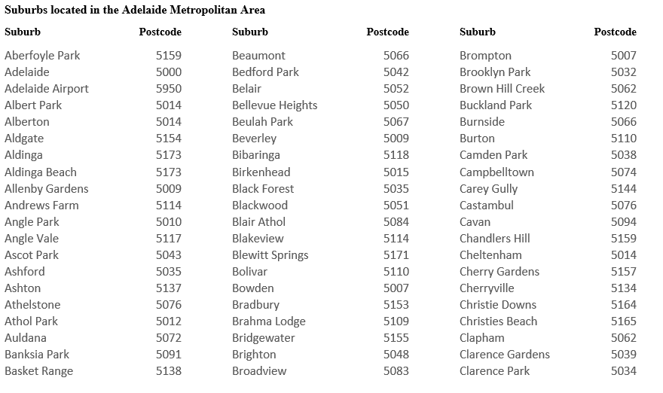

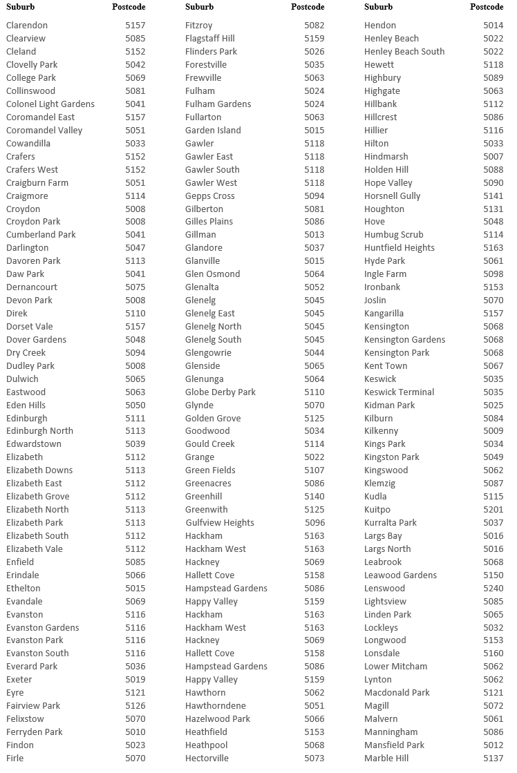
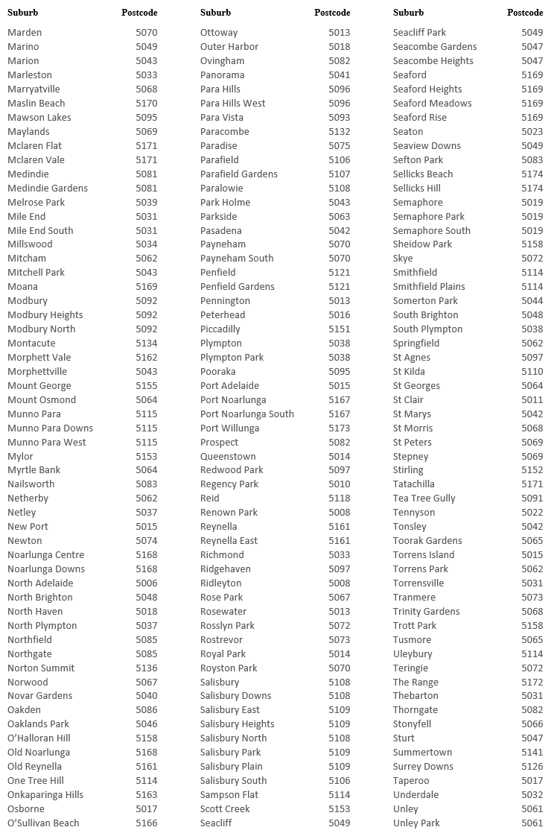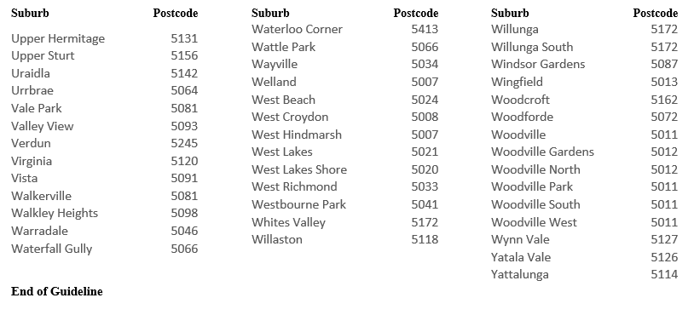
Dated: 5 October 2023
Dini Soulio
Liquor & Gambling Commissioner

Roads (Opening and Closing) Act 1991
Section 24
NOTICE OF CONFIRMATION OF
ROAD PROCESS ORDER
Road Opening and Closing
Noack Road, Lyndoch and Rosedale
By Road Process Order made on 17 April 2023, the Barossa Council ordered that:
- Portion of the Allotment comprising Pieces 91 and 92 in Filed Plan 204098, Lyndoch and Rosedale, Hundred of Barossa, more particularly delineated and numbered ‘1’ in Preliminary Plan 22/0048 be opened as road.
- Portion of Noack Road, Lyndoch and Rosedale, situated adjoining the Allotment comprising Pieces 91 and 92 in Filed Plan 204098, Hundred of Barossa, more particularly delineated and lettered ‘A’ in Preliminary Plan 22/0048 be closed.
- Transfer the whole of the land subject to closure to CC Pocock Pty Ltd (ACN: 149 568 374) in accordance with the Agreement for Exchange dated 17 April 2023 entered into between the Barossa Council and CC Pocock Pty Ltd (ACN: 149 568 374).
On 26 September 2023 that order was confirmed by the Minister for Planning, conditionally upon the deposit by the Registrar-General of Deposited Plan 132416 being the authority for the new boundaries.
Pursuant to section 24 of the Roads (Opening and Closing) Act 1991, NOTICE of the order referred to above and its confirmation is hereby given.
Dated: 5 October 2023
B. J. Slape
Surveyor-General
2022/17538/01

Roads (Opening and Closing) Act 1991
Section 24
NOTICE OF CONFIRMATION OF
ROAD PROCESS ORDER
Road Opening and Closing
Wharff Drive, Perlubie
By Road Process Order made on 27 May 2021, the District Council of Streaky Bay ordered that:
- Portion of the Allotment comprising Pieces 102, 103 and 104 in Deposited Plan 54084 and portion of Section 26, Perlubie, Hundred of Scott, more particularly delineated and numbered ‘1’ and ‘2’ (respectively) in Preliminary Plan 22/0029 be opened as road.
- Portion of the Public Road, Perlubie, Hundred of Finlayson, situated adjoining the Allotment comprising Pieces 102, 103 and 104 in Deposited Plan 54084, Hundred of Scott, more particularly delineated and lettered ‘A’ in Preliminary Plan 22/0029 be closed.
- Transfer the whole of the land subject to closure to John Phillip Wharff and Patricia Ann Wharff in accordance with the Agreement for Exchange dated 27 May 2021 entered into between the District Council of Streaky Bay and John Phillip Wharff and Patricia Ann Wharff.
On 26 September 2023 that order was confirmed by the Minister for Planning, conditionally upon the deposit by the Registrar-General of Deposited Plan 131871 being the authority for the new boundaries.
Pursuant to section 24 of the Roads (Opening and Closing) Act 1991, NOTICE of the order referred to above and its confirmation is hereby given.
Dated: 5 October 2023
B. J. Slape
Surveyor-General
2022/06727/01

Local Government Instruments

City of Norwood Payneham & St Peters
Proposed Declaration Under Section 210(1) of the Local Government Act 1999
Public Notice—Private Road, Kent Town
The Corporation of the City of Norwood Payneham & St Peters hereby gives notice that it proposes to make a declaration under Section 210(1) of the Local Government Act 1999 (SA) converting the following private road within its Council area into a public road three months after the date of the notice or thereafter:
The private road comprising Allotment 37 in FP 3654 in the area named Kent Town in the legal ownership of Thomas Bourne of Kent Town SA 5067.
Dated: 3 October 2023
Lisa Mara
Acting Chief Executive Officer

District Council of Grant
Roads (Opening and Closing) Act 1991
Re-Advertised: Road Closing—Pelican Point
NOTICE is hereby given, pursuant to Section 10 of the Roads (Opening and Closing) Act 1991 that the District Council of Grant proposes to make a Road Process Order to close and merge a portion of road and merge with Certificate of Title 5847/262, more particularly delineated and lettered ‘B’ on Preliminary Plan 23/0011.
The Preliminary Plan and statement of persons affected s available for public inspection at the offices of the District Council of Grant at 324 Commercial Street West, Mt Gambier and the Adelaide Office of the Surveyor-General, during normal office hours. The Preliminary Plan can also be viewed at www.sa.gov.au/roadsactproposals.
Any application for easement or objection must set out the full name, address and details of the submission and must be fully supported by reasons. The application for easement or objection must be made in writing to the District Council of Grant at PO Box 724, Mt Gambier SA 5290 WITHIN 28 DAYS OF THIS NOTICE, and a copy must be forwarded to the Surveyor-General at PO Box 1815, Adelaide 5001. Where a submission is made, the Council will give notification of a meeting at which the matter will be considered.
Dated: 5 October 2023
Darryl whicker
Chief Executive Officer

District Council of Orroroo Carrieton
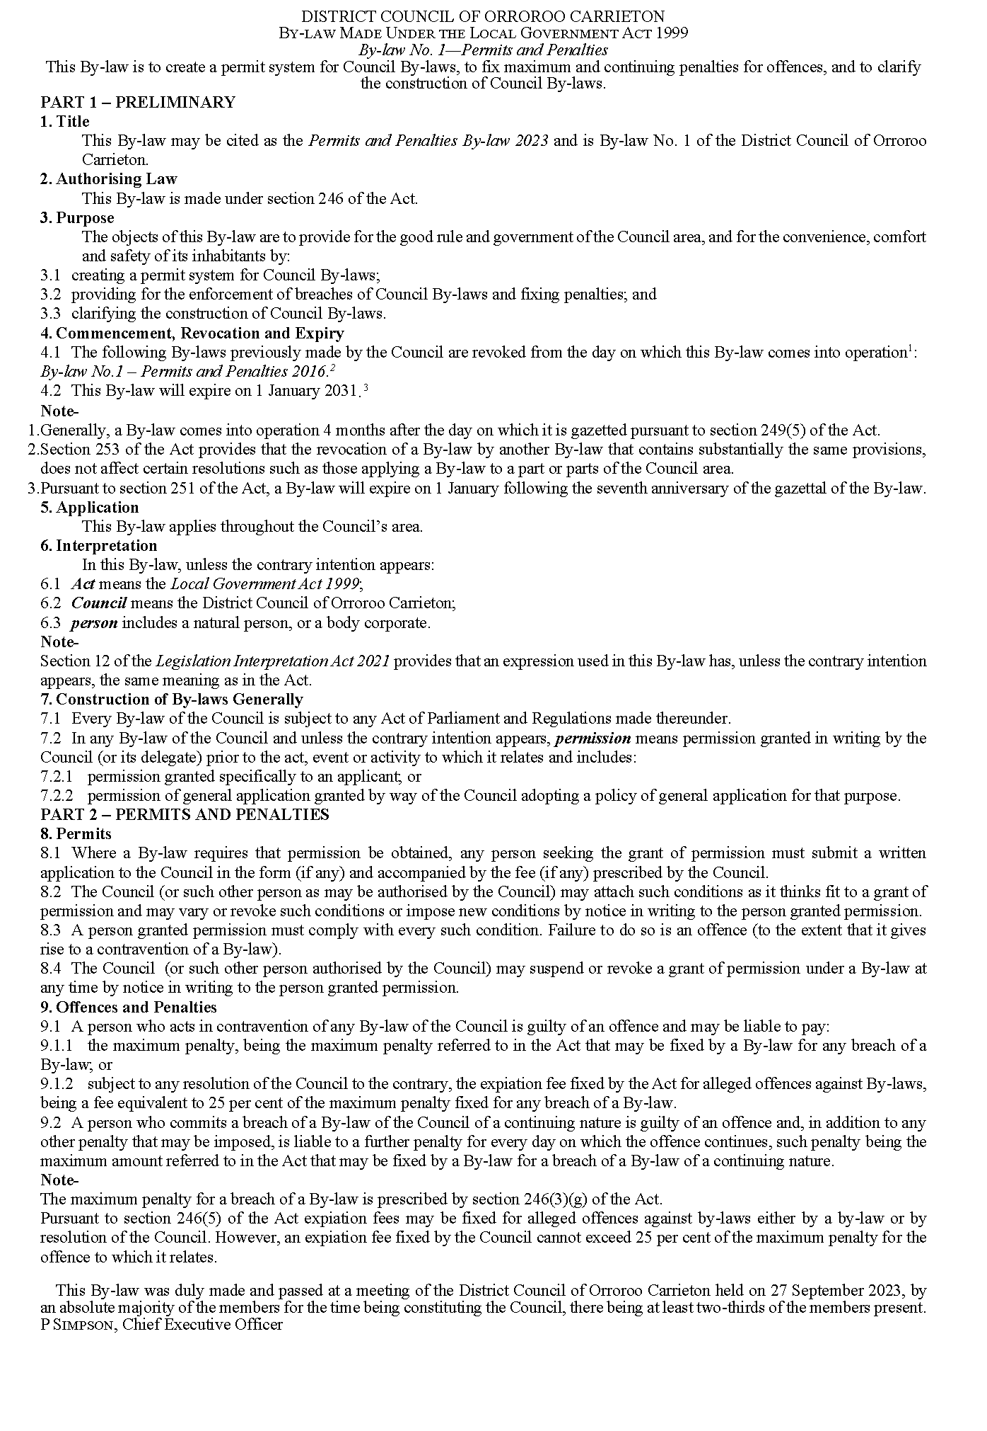

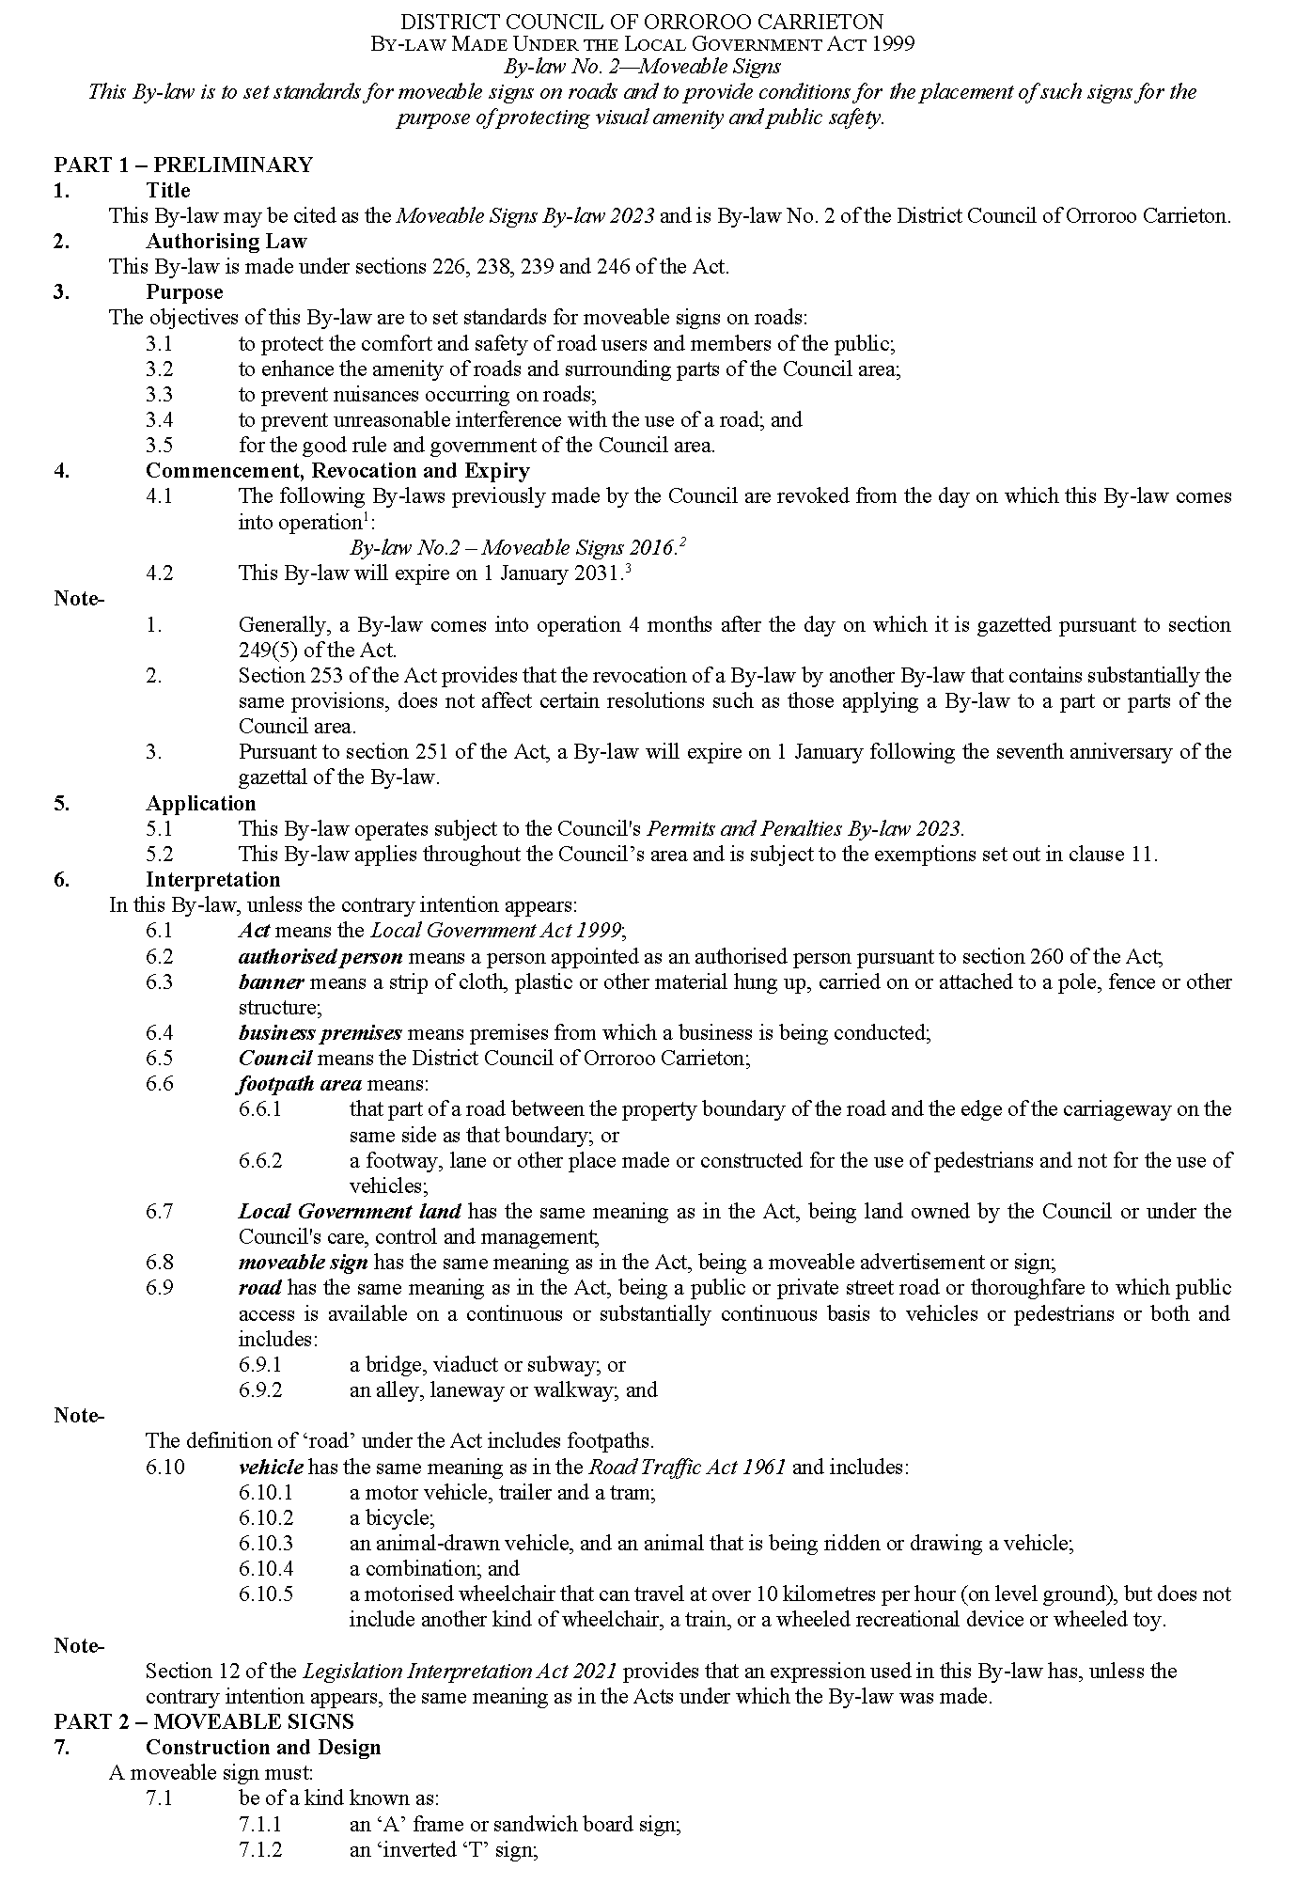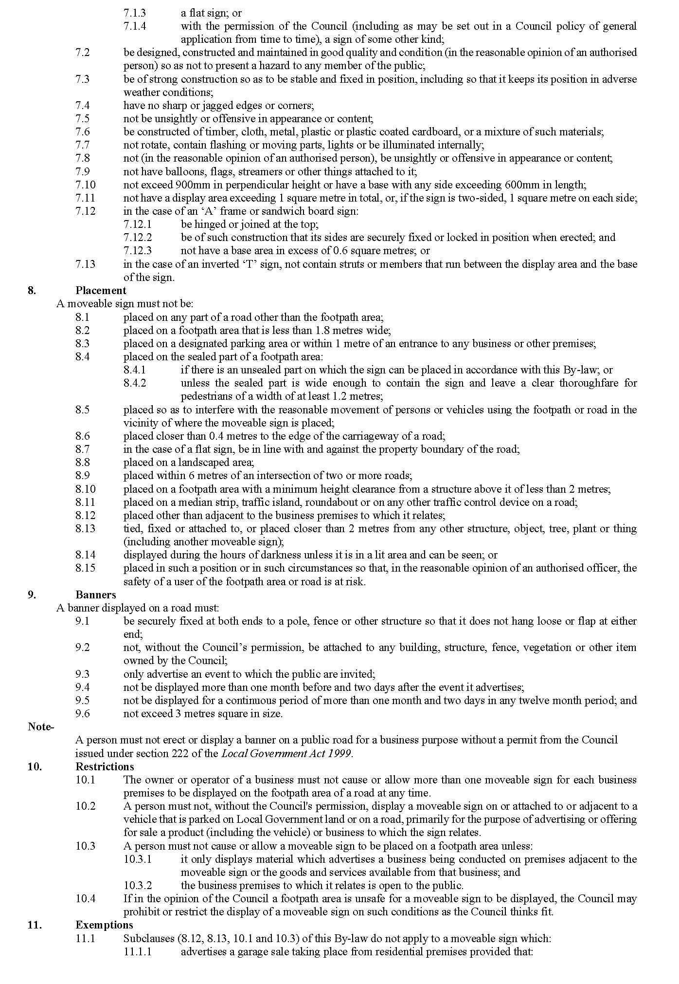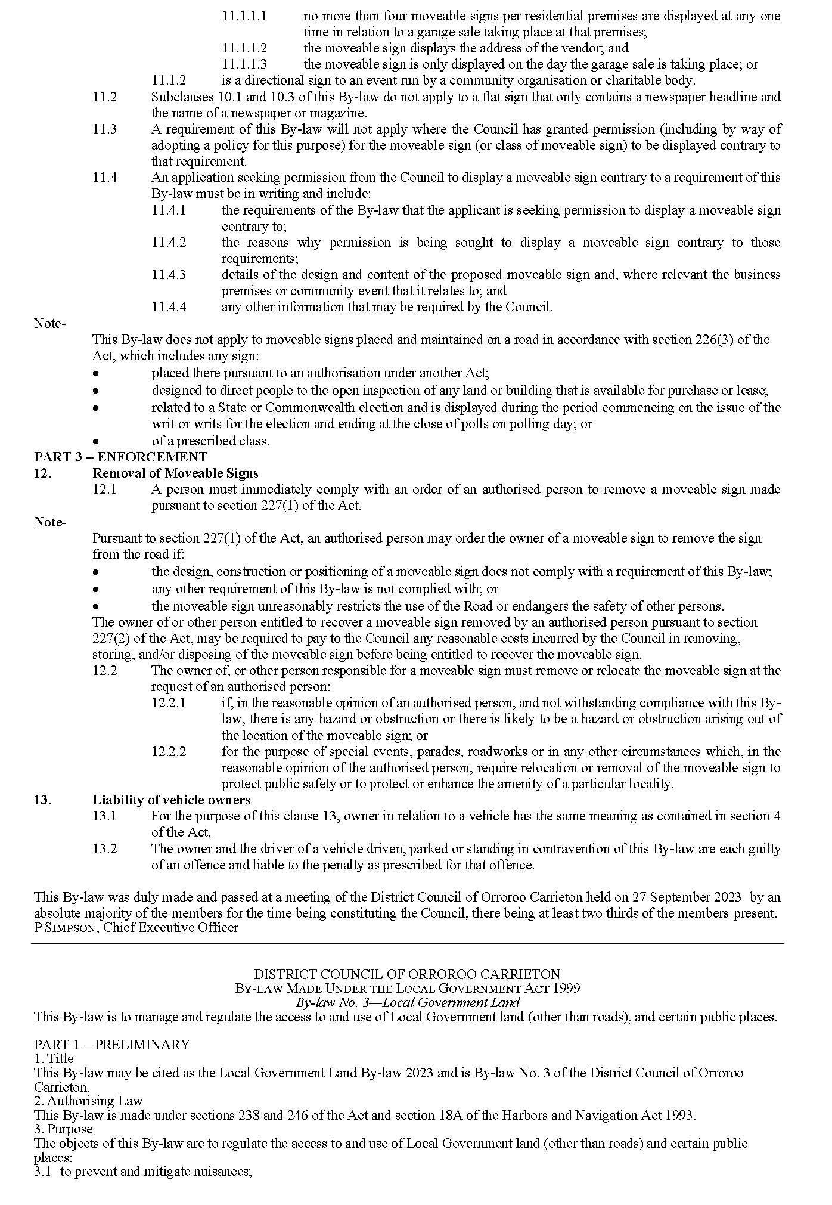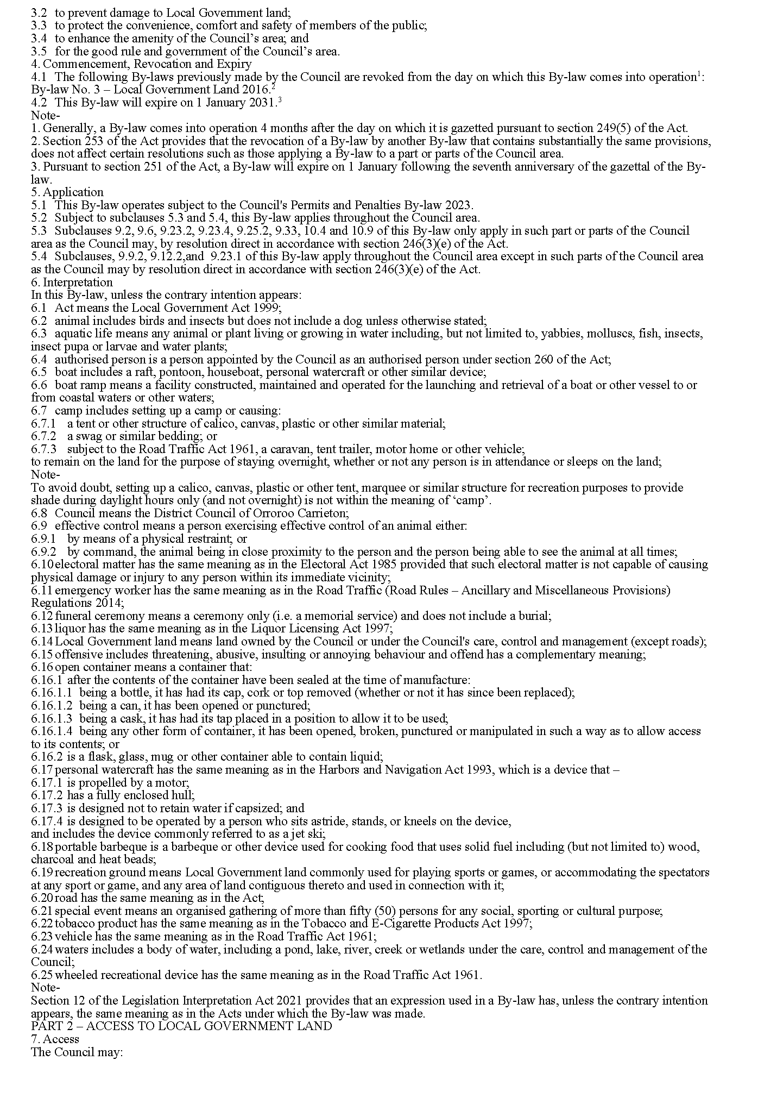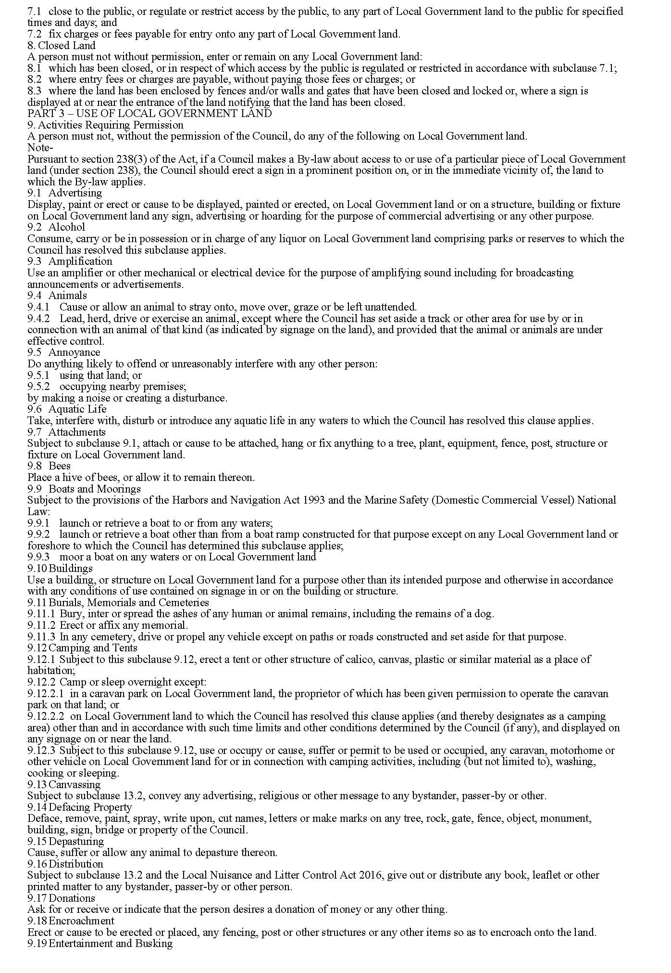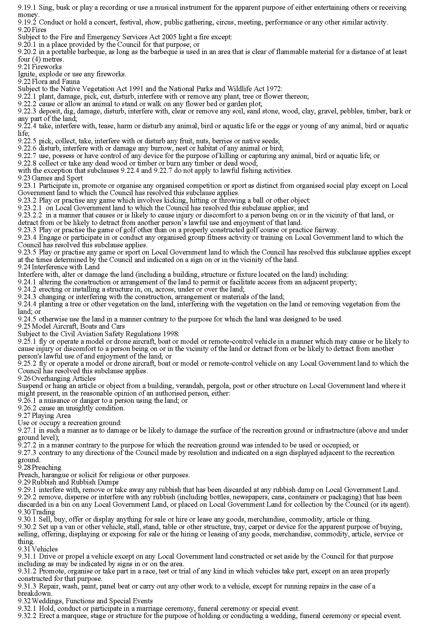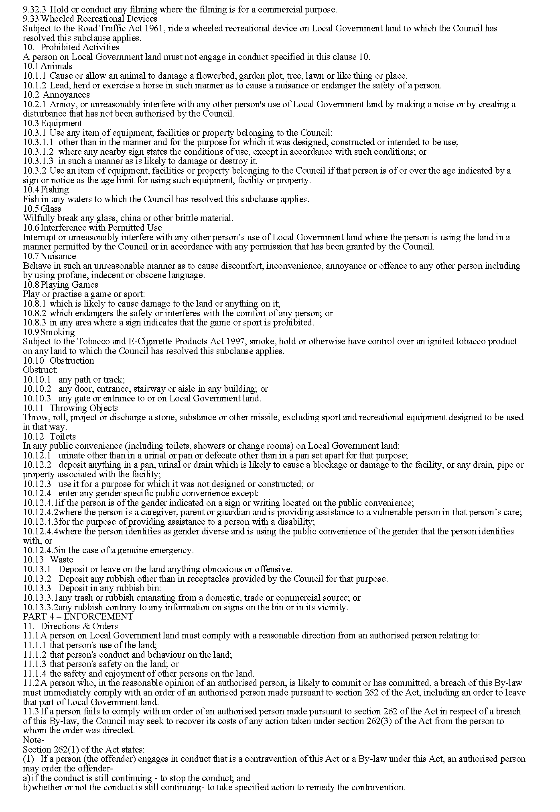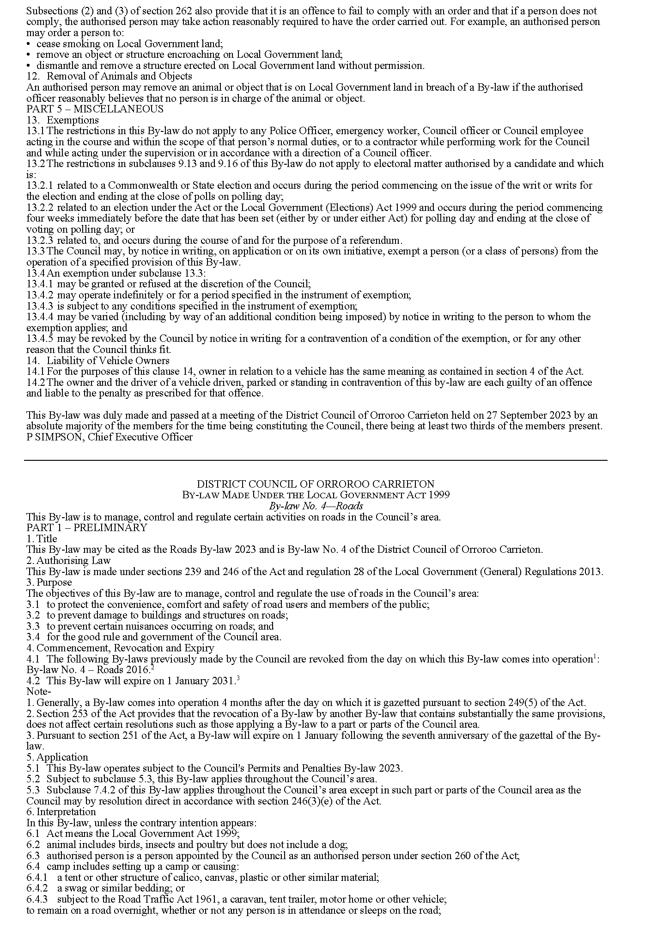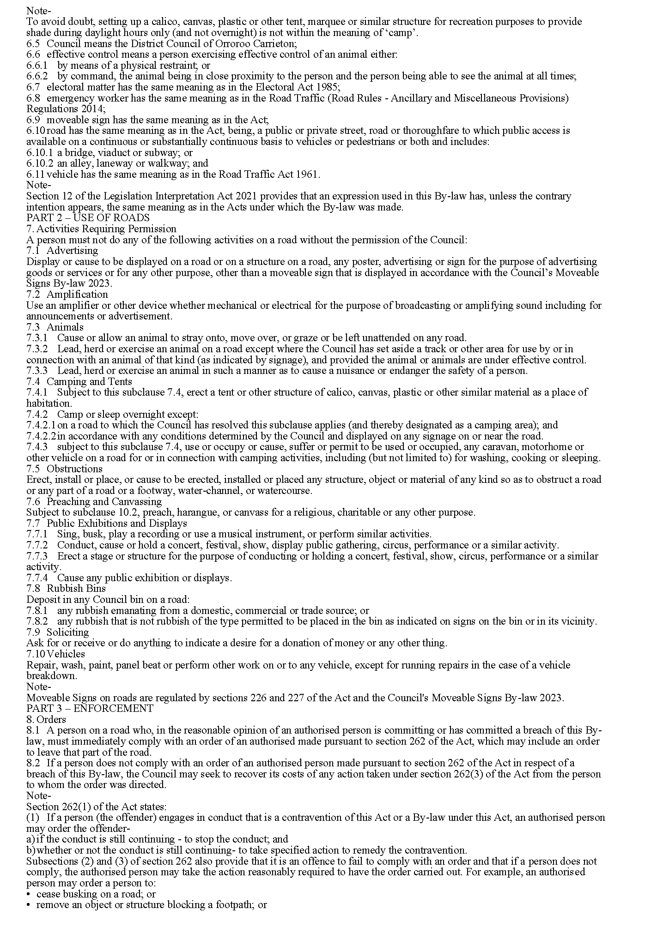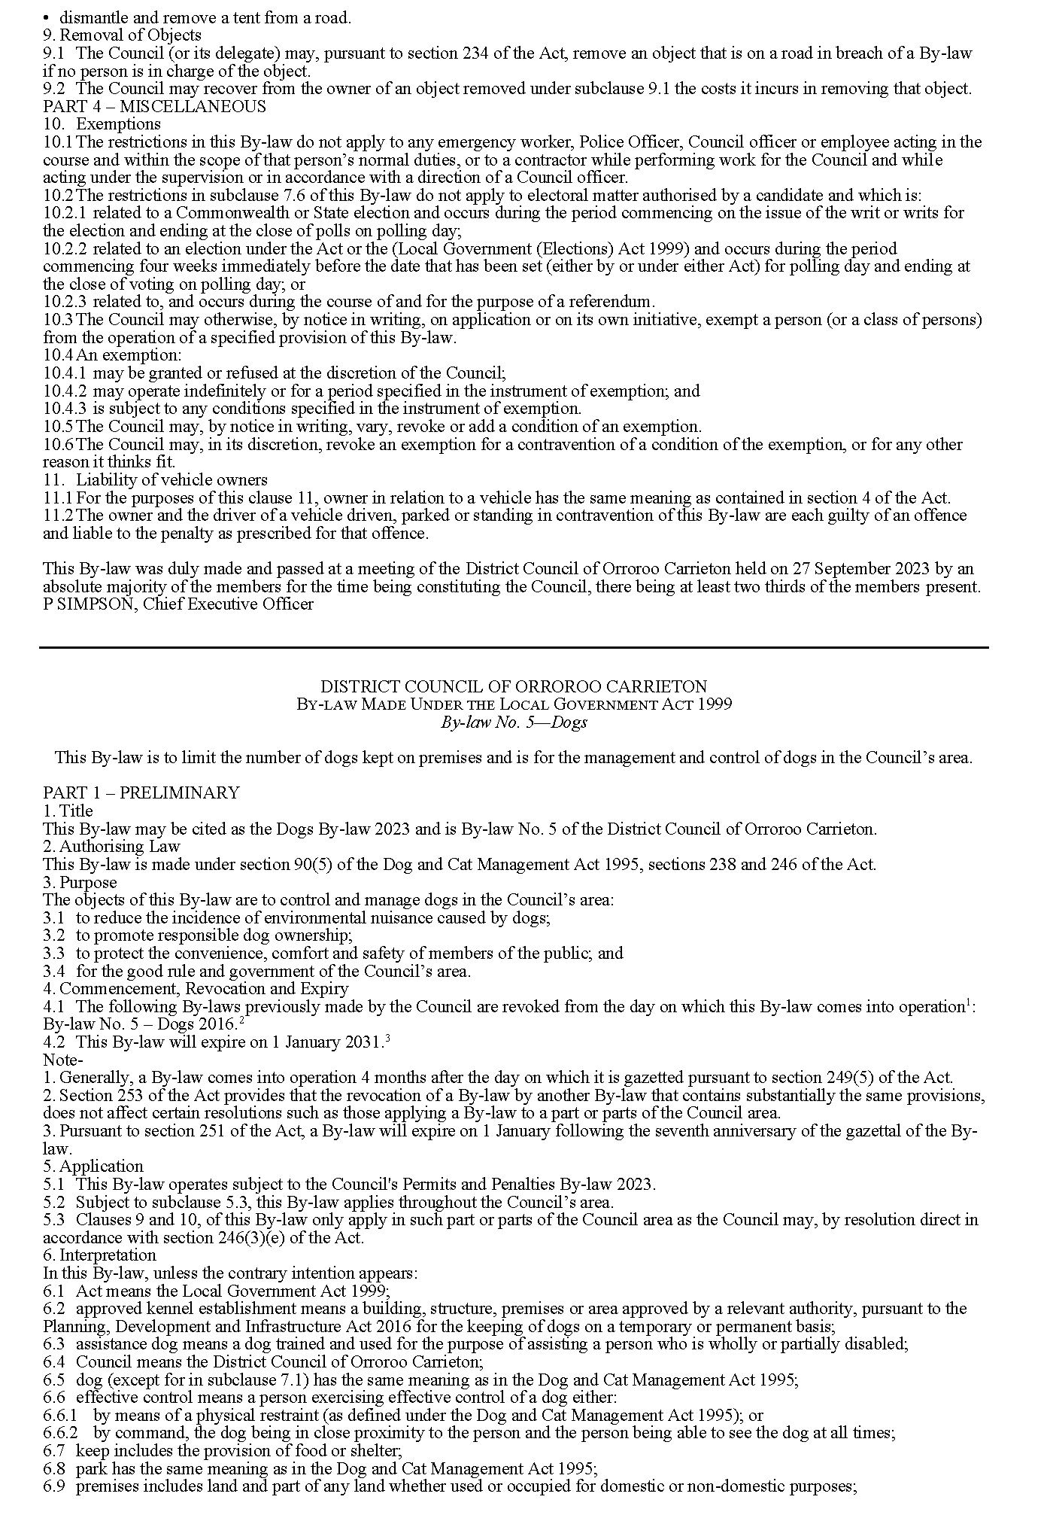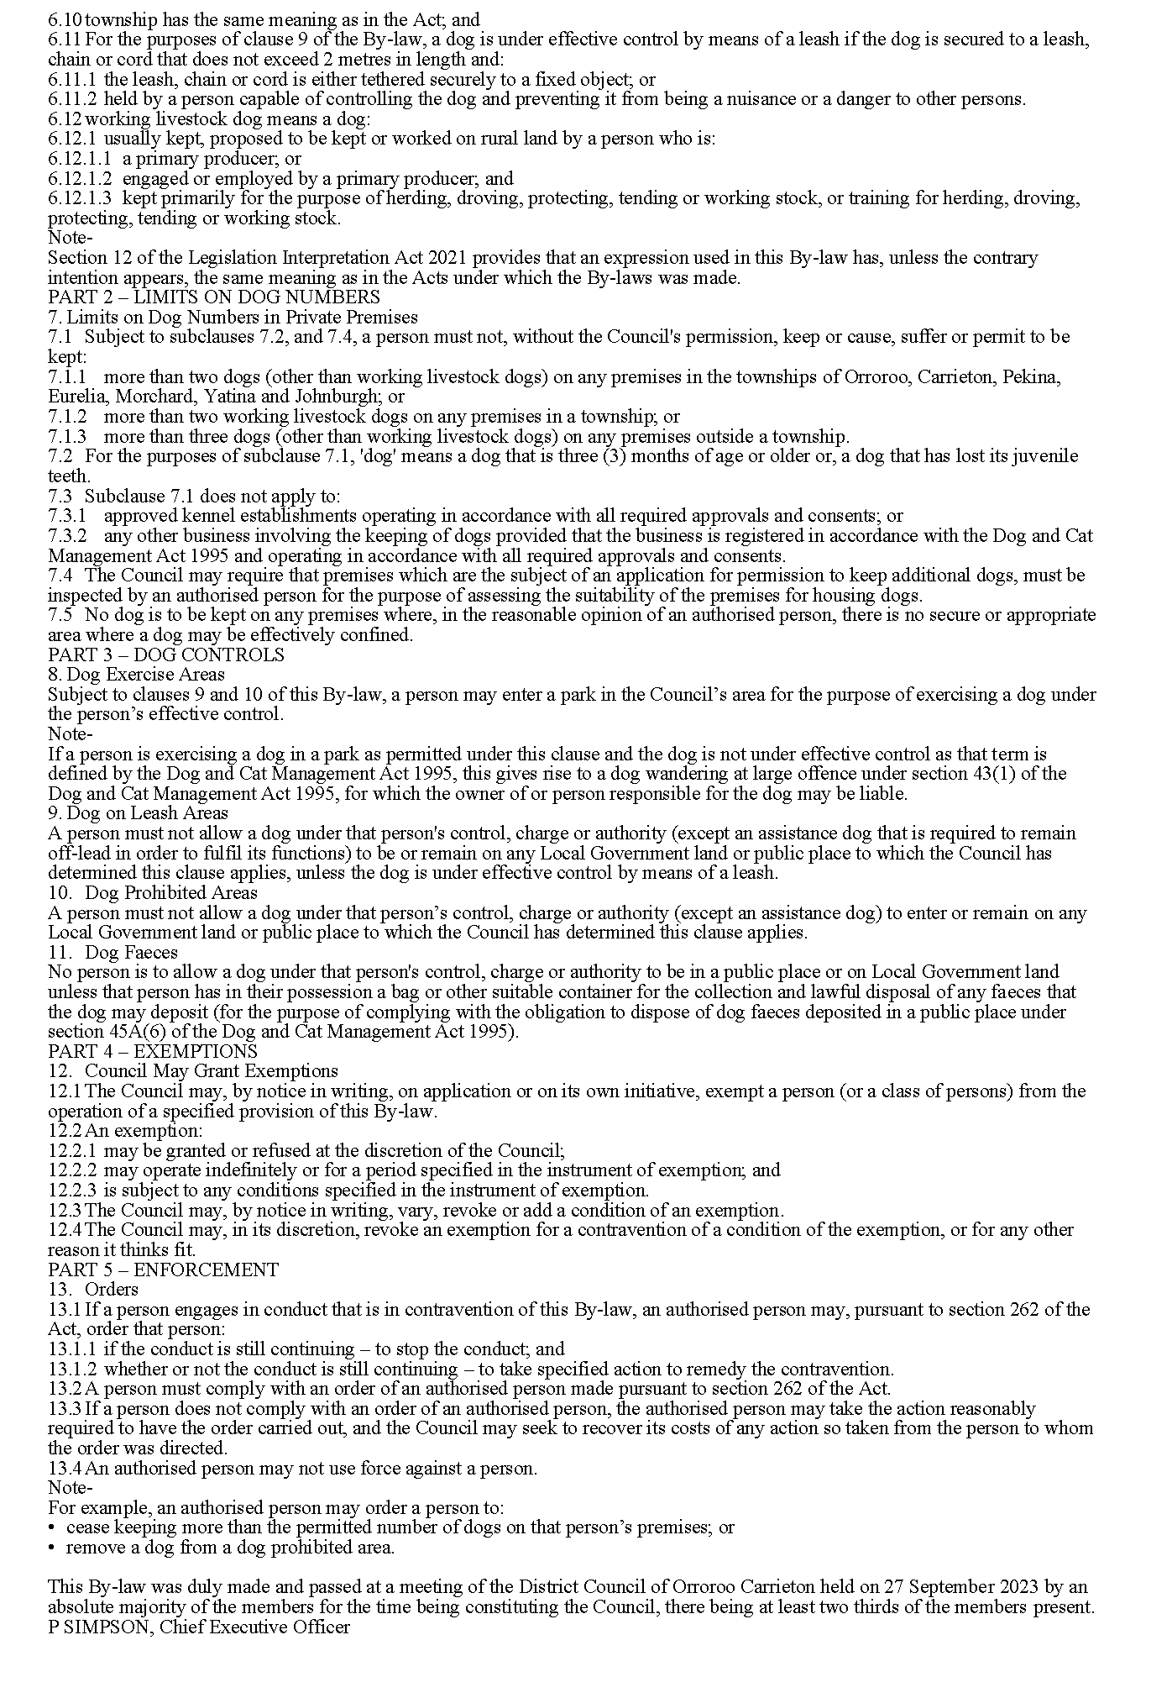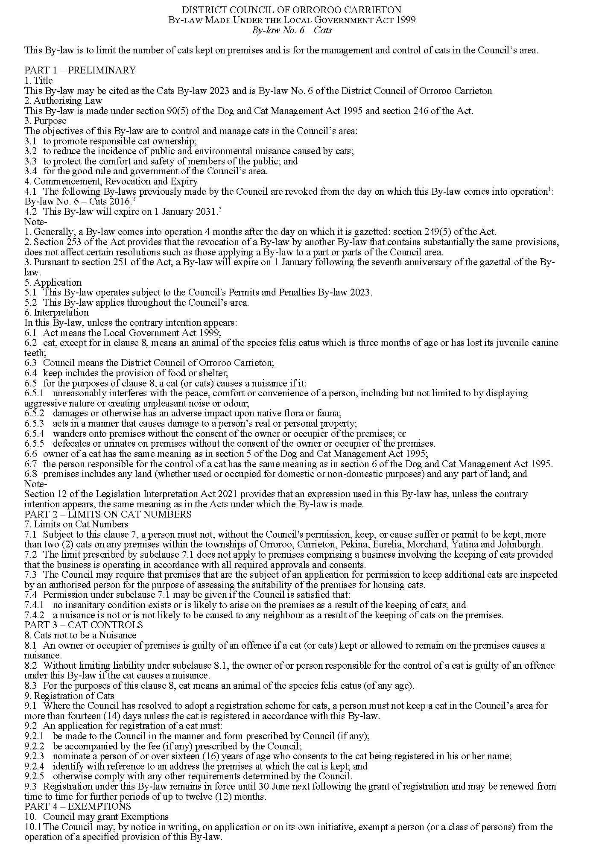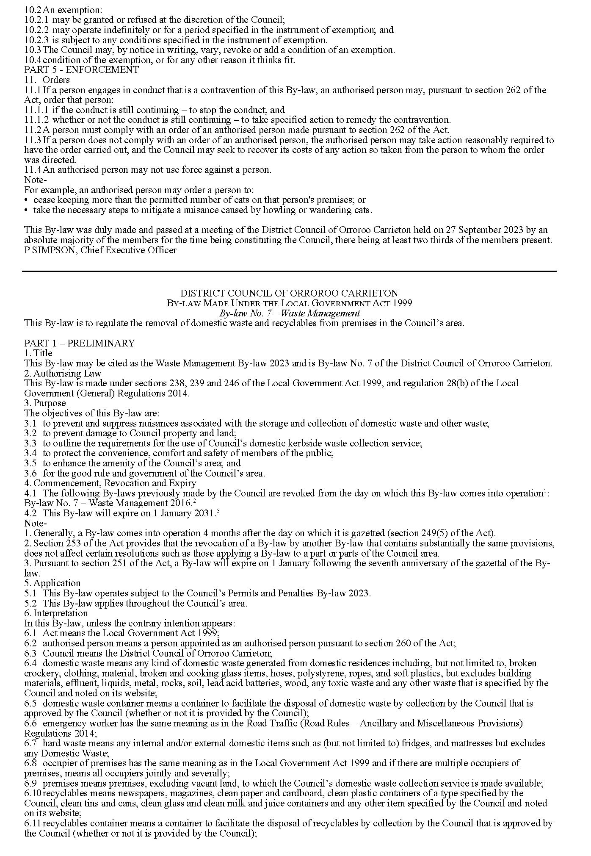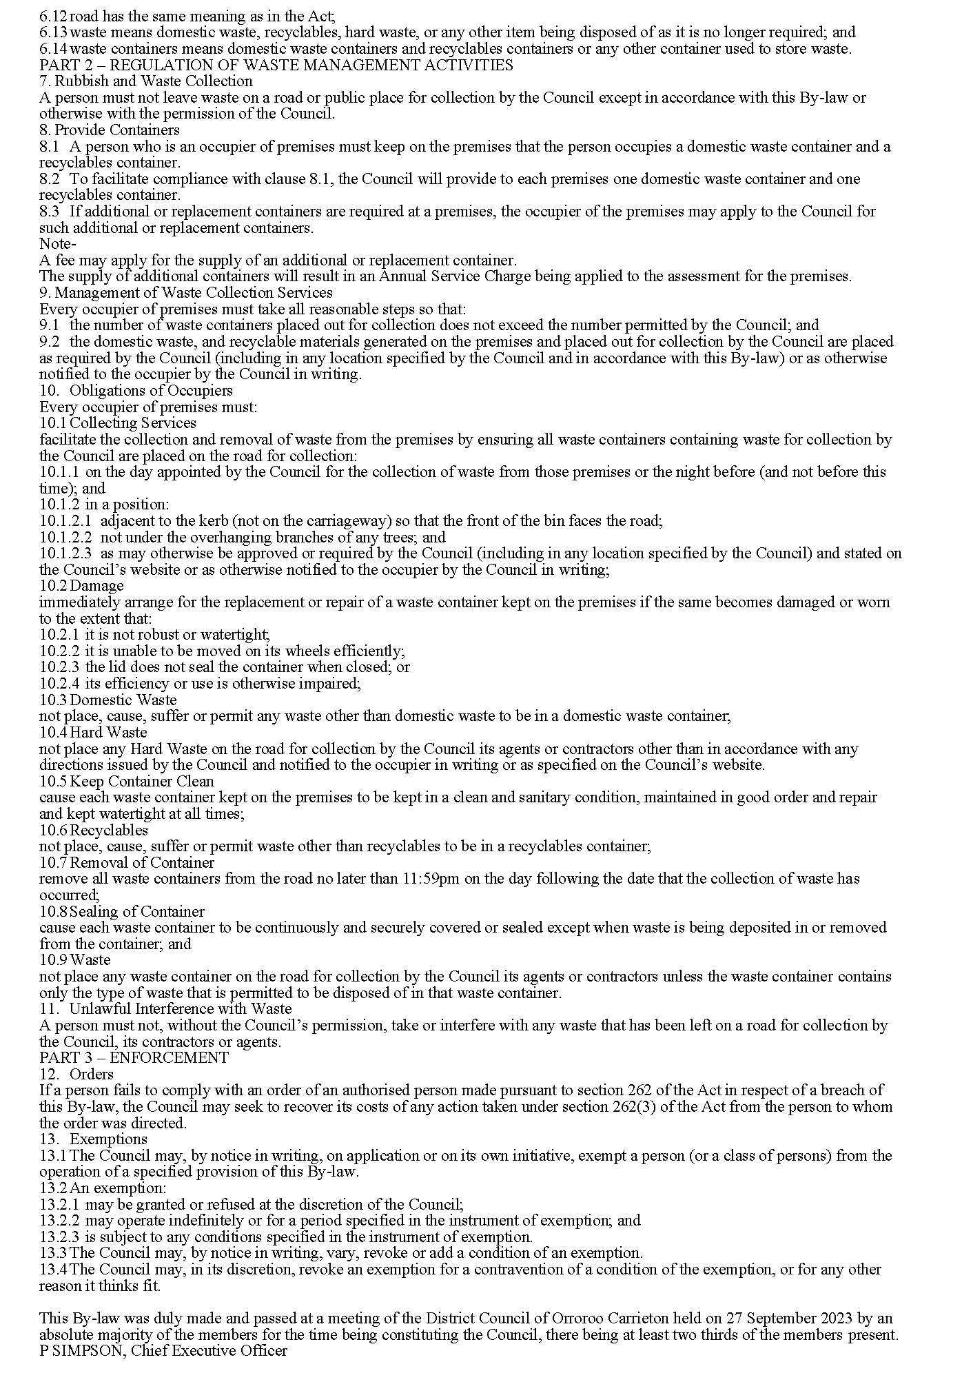

Public Notices

National Electricity Law
Notice of Extension of Draft Determination
The Australian Energy Market Commission (AEMC) gives notice under the National Electricity Law as follows:
Under s 107, the time for making the draft determination on the Operating reserves and ramping services (Ref. ERC0295 and ERC0307) proposal has been extended to 14 December 2023.
Documents referred to above are available on the AEMC’s website and are available for inspection at the AEMC’s office.
Australian Energy Market Commission
Level 15, 60 Castlereagh St
Sydney NSW 2000
Telephone: (02) 8296 7800
www.aemc.gov.au
Dated: 5 October 2023

National Electricity Law
Notice of Extension of Draft Determination
The Australian Energy Market Commission (AEMC) gives notice under the National Electricity Law as follows:
Under s 107, the time for making the draft determination on the Integrating price-responsive resources into the NEM (Ref. ERC0352) proposal has been extended to 29 February 2024.
Documents referred to above are available on the AEMC’s website and are available for inspection at the AEMC’s office.
Australian Energy Market Commission
Level 15, 60 Castlereagh St
Sydney NSW 2000
Telephone: (02) 8296 7800
www.aemc.gov.au
Dated: 5 October 2023

National Energy Retail Law
Notice of Extension of Draft Determination
The Australian Energy Market Commission (AEMC) gives notice under the National Energy Retail Law as follows:
Under s 266, the time for making the draft determination on the Integrating price-responsive resources into the NEM (Ref. RRC0051) proposal has been extended to 29 February 2024.
Documents referred to above are available on the AEMC’s website and are available for inspection at the AEMC’s office.
Australian Energy Market Commission
Level 15, 60 Castlereagh St
Sydney NSW 2000
Telephone: (02) 8296 7800
www.aemc.gov.au
Dated: 5 October 2023

Trustee Act 1936
Public Trustee
Estates of Deceased Persons
In the matter of the estates of the undermentioned deceased persons:
AHEARN Timothy George late of 66 de Sassenay Crescent Modbury Heights Of no occupation who died 19 September 2022
BARRY Vincent late of 40 Skyline Drive Flagstaff Hill Retired Plumber who died 7 August 2023
CLARKE Helmi Alma late of 45 Mahoneys Road Warnambool in the State of Victoria Of no occupation who died 24 February 2023
HALLE Gordon Lionel late of 1 Steele Street Campbelltown Retired Truck Driver who died 17 March 2022
HEIDRICH John David late of 67 Peachey Road Davoren Park Retired Butcher who died 5 July 2023
HILL Cecilia Jane also known as HILL Cecelia Jane late of 65 Windsor Grove Klemzig Of no occupation who died 21 July 2022
KOVALENKO Wayne James late of 84 Reservoir Road Modbury Packer who died 2 August 2023
LYONS Patricia Joan late of 31 Malin Street Albert Park Retired Public Servant who died 1 April 2023
MADDISON Robert Francis late of 6 Davidson Avenue Hendon Retired Commonwealth Public Servant who died 6 August 2022
ROBERTS Doris late of 35 Washington Street Goolwa Of no occupation who died 19 June 2022
SLATER David John late of 3 Grant Avenue Gilles Plains Retired Storeman who died 13 May 2023
VAN MOOK William Cornelius late of 13 Robe Street Kidman Park Retired Researcher who died 10 June 2023
Notice is hereby given pursuant to the Trustee Act 1936, the Inheritance (Family Provision) Act 1972 and the Family Relationships Act 1975 that all creditors, beneficiaries, and other persons having claims against the said estates are required to send, in writing, to the office of Public Trustee at GPO Box 1338, Adelaide SA 5001, full particulars and proof of such claims, on or before 3 November 2023 otherwise they will be excluded from the distribution of the said estate; and notice is also hereby given that all persons indebted to the said estates are required to pay the amount of their debts to the Public Trustee or proceedings will be taken for the recovery thereof; and all persons having any property belonging to the said estates are forthwith to deliver same to the Public Trustee.
Dated: 5 October 2023
N. S. Rantanen
Public Trustee

Unclaimed Moneys Act 1891
My Budget Pty Ltd
Register of Unclaimed Moneys for the year ended 2015
Name and Address of Owner |  |  |  |  |  |  | Amount | Date | Description
Aaron James Engle | Aspendale Gardens |  | VIC |  |  |  | 111.02 | 28/08/2015 | Funds received
Aaron Robert Lucas & Rebecca Leigh Lucas | Wakerley |  | QLD |  |  |  | 173.04 | 2/11/2015 | Funds received
Aaron Shane Gramberg | Warneet |  | VIC |  |  |  | 14.06 | 28/08/2015 | Funds received
Adrian Simon Micklethwaite | Camden Park |  | SA |  |  |  | 12.39 | 28/08/2015 | Funds received
Alison Mary Jean Ritchie | Moggill |  | QLD |  |  |  | 117.41 | 2/11/2015 | Funds received
Alma Isabel Weetra | Burton |  | SA |  |  |  | 83.20 | 28/08/2015 | Funds received
Amanda Louise Badger | Cheltenham |  | VIC |  |  |  | 431.67 | 28/08/2015 | Funds received
Andrew Bougioukos | Hampton East |  | VIC |  |  |  | 2,400.48 | 28/08/2015 | Funds received
Annette Lee Nicholls | Angle Park |  | SA |  |  |  | 141.56 | 28/08/2015 | Funds received
Anthony John Eathorne | Prospect |  | NSW |  |  |  | 14.35 | 28/08/2015 | Funds received
Anthony Vincent Shadforth | Kingston |  | QLD |  |  |  | 1,170.10 | 28/08/2015 | Funds received
April Elizabeth Hart | Brahma Lodge |  | SA |  |  |  | 13.96 | 28/08/2015 | Funds received
Ashley Maree Christian & Daniel Kenneth Christian | Ringwood |  | VIC |  |  |  | 40.17 | 2/11/2015 | Funds received
Barbara Jayne Wilson | Munno Para West |  | SA |  |  |  | 120.00 | 28/08/2015 | Funds received
Benjamin Mark Perry | Narre Warren |  | VIC |  |  |  | 131.80 | 28/08/2015 | Funds received
Brendan Matthew Maurer | Hampton Park |  | VIC |  |  |  | 45.00 | 28/08/2015 | Funds received
Carly Lee Kearney | Paralowie |  | SA |  |  |  | 20.00 | 28/08/2015 | Funds received
Casey Anne Leeson | Seaton |  | SA |  |  |  | 16.00 | 28/08/2015 | Funds received
Cathy Ehlers | Pennigton |  | SA |  |  |  | 60.00 | 28/08/2015 | Funds received
Christene April Alomes | Findon |  | SA |  |  |  | 918.98 | 28/08/2015 | Funds received
Christine Palmer | Clifton Springs |  | VIC |  |  |  | 28.08 | 2/11/2015 | Funds received
Colin Douglas Cooper | Norwood |  | SA |  |  |  | 158.88 | 28/08/2015 | Funds received
Corinne Louise Tickle | Nundah |  | QLD |  |  |  | 34.32 | 28/08/2015 | Funds received
Damian Mark Vincent | Berwick |  | VIC |  |  |  | 170.64 | 28/08/2015 | Funds received
Darren Daniel Struan Robertson & Jason David Cocksey | East Perth |  | WA |  |  |  | 17.36 | 2/11/2015 | Funds received
Dean Arthur Goldsmith | Flinders Park |  | SA |  |  |  | 80.74 | 28/08/2015 | Funds received
Debra Ann Briggs | Nairne |  | SA |  |  |  | 16.00 | 28/08/2015 | Funds received
Dewayne William Baldry | Beenleigh |  | QLD |  |  |  | 2,742.44 | 28/08/2015 | Funds received
Donna Emmee Puig & Julito Tabumpama | Acacia Gardens |  | NSW |  |  |  | 12.19 | 28/08/2015 | Funds received
Edmund Colin Campbell | Smithfield Plains |  | SA |  |  |  | 30.00 | 28/08/2015 | Funds received
Eric Maxwell Swift | St Kilda |  | VIC |  |  |  | 131.92 | 28/08/2015 | Funds received
Esther Bernadette Priestley & Stephen Barry Priestley | Gembrook |  | VIC |  |  |  | 36.90 | 28/08/2015 | Funds received
Garth Christopher Talagi & Chrystal Totagina Monomai | Sunshine West |  | VIC |  |  |  | 16.50 | 28/08/2015 | Funds received
Giancarlo Gagliardi | Glenroy |  | VIC |  |  |  | 18.39 | 28/08/2015 | Funds received
Graham Cameron Farr & Aimee Edwards | Pakenham |  | VIC |  |  |  | 86.54 | 28/08/2015 | Funds received
Harold Julian Ross Stapleton | Ridgehaven |  | SA |  |  |  | 41.09 | 28/08/2015 | Funds received
Hayden Corrie Legg | Aspendale |  | VIC |  |  |  | 88.68 | 28/08/2015 | Funds received
Heather Cirocco | Murray Bridge |  | SA |  |  |  | 146.04 | 28/08/2015 | Funds received
Heather Marie Tilley | Mount Gambier |  | SA |  |  |  | 55.93 | 28/08/2015 | Funds received
Herbert Tossmann & Elizabeth Tossmann | Parkwood |  | QLD |  |  |  | 62.16 | 28/08/2015 | Funds received
Jacinda Stephens | Footscray |  | VIC |  |  |  | 417.69 | 28/08/2015 | Funds received
Jamie Paul Benson | Caboolture |  | QLD |  |  |  | 81.83 | 28/08/2015 | Funds received
Janine Thelma Bugeja | Cleveland |  | QLD |  |  |  | 388.20 | 28/08/2015 | Funds received
Jeff Raymond Perkins | Andrews Farm |  | SA |  |  |  | 115.00 | 28/08/2015 | Funds received
Jessica Heffernan (Ex Staff Budget) | Adelaide |  | SA |  |  |  | 30.00 | 28/08/2015 | Funds received
Joanna Ellen Slater | Baronia |  | VIC |  |  |  | 84.80 | 28/08/2015 | Funds received
Jodie Marie Muir | Dundas |  | NSW |  |  |  | 35.00 | 28/08/2015 | Funds received
Josefina Dizon Quiazon | Altona Meadows |  | VIC |  |  |  | 1,351.86 | 28/08/2015 | Funds received
Joseph Cook & Tracey-Christine Adams | Endeavour Hills |  | VIC |  |  |  | 184.59 | 28/08/2015 | Funds received
Julie Anne Hanns | Hamley Bridge |  | SA |  |  |  | 21.65 | 28/08/2015 | Funds received
Julie Rae Plunkett & Craig John Plunkett | Deer Park |  | VIC |  |  |  | 27.75 | 28/08/2015 | Funds received
Justin Raymond Blackman & Brooke Ryan | Molendinar |  | QLD |  |  |  | 73.73 | 28/08/2015 | Funds received
Karen Julie Mears | Glynde |  | SA |  |  |  | 13.89 | 28/08/2015 | Funds received
Karen Marie Atkinson | Leanyer |  | SA |  |  |  | 156.50 | 28/08/2015 | Funds received
Kegan Wilson Scherf & Elise Margaret Wall | Bardon |  | QLD |  |  |  | 38.90 | 2/11/2015 | Funds received
Kirstin Katie Whalen | Blackburn |  | VIC |  |  |  | 130.00 | 2/11/2015 | Funds received
Kiyomi Thompson | Christies Beach |  | SA |  |  |  | 29.21 | 28/08/2015 | Funds received
Kristy Lee James & Damien James | Langhorne Creek |  | SA |  |  |  | 160.30 | 28/08/2015 | Funds received
Krystal Jade Ferguson | Melton |  | VIC |  |  |  | 39.76 | 28/08/2015 | Funds received
Kylie Marie Hillier & Damien Wayne Whitmarsh | Aldinga Beach |  | SA |  |  |  | 30.00 | 28/08/2015 | Funds received
Lance Wayne Shepherd | Elizabeth Grove |  | SA |  |  |  | 10.00 | 28/08/2015 | Funds received
Latoya Marie Su'a & Brendon Averill Dalley | Tingalpa |  | QLD |  |  |  | 370.00 | 28/08/2015 | Funds received
Leon Thomas Riley | Moffat Beach |  | QLD |  |  |  | 276.16 | 28/08/2015 | Funds received
Lindy Ann Poke | Smithton |  | TAS |  |  |  | 24.02 | 28/08/2015 | Funds received
Louise Caroline Witte | Katherine |  | NT |  |  |  | 35.46 | 28/08/2015 | Funds received
Maciek Robert Murzo & Kylie Jane Ellis | Rowville |  | VIC |  |  |  | 35.50 | 28/08/2015 | Funds received
Margaret Wood & Graeme Abraham Harris | Cranbourne West |  | VIC |  |  |  | 19.29 | 28/08/2015 | Funds received
Marlaine Leechee | Golden Beach |  | QLD |  |  |  | 13.00 | 28/08/2015 | Funds received
Matthew David Jones | Potts Point |  | NSW |  |  |  | 20.28 | 28/08/2015 | Funds received
Maureen Patricia Brewer & David Patrick Brewer | Kallangur |  | QLD |  |  |  | 1,613.85 | 28/08/2015 | Funds received
Megan Rose Brown | St Kilda |  | VIC |  |  |  | 133.40 | 28/08/2015 | Funds received
Melanie Jane Gough & Adam John Gough | Craigieburn |  | VIC |  |  |  | 85.01 | 28/08/2015 | Funds received
Melissa Nicole Gooley & Daniel Claude Morgan | Seaford Rise |  | SA |  |  |  | 10.16 | 2/11/2015 | Funds received
Melody Kate Feder | Walkerville |  | SA |  |  |  | 129.29 | 28/08/2015 | Funds received
Michael John Parr & Janine Margaret Gill | Thorneside |  | QLD |  |  |  | 247.84 | 28/08/2015 | Funds received
Michelle Maree Morris & Christopher Lee Morris | Redcliffe |  | WA |  |  |  | 280.00 | 2/11/2015 | Funds received
Millicent Amy Mackintosh | Shailer Park |  | QLD |  |  |  | 91.19 | 28/08/2015 | Funds received
Muriel Dawn O'Loughlin | Salisbury |  | SA |  |  |  | 75.00 | 28/08/2015 | Funds received
Nathan David Whitton | Port Melbourne |  | VIC |  |  |  | 19.17 | 28/08/2015 | Funds received
Nicholas Roger Maxwell | Redbank Plains |  | QLD |  |  |  | 103.38 | 28/08/2015 | Funds received
Nicole Lee Pancione ( Savelli ) | Parafield Gardens |  | SA |  |  |  | 62.40 | 2/11/2015 | Funds received
Nicole Patrice Powell | Kilsyth |  | VIC |  |  |  | 10.22 | 28/08/2015 | Funds received
Osvaldo Acevedo | Albanvale |  | VIC |  |  |  | 320.72 | 28/08/2015 | Funds received
Pamela Faye Adam | Burton |  | SA |  |  |  | 100.00 | 28/08/2015 | Funds received
Paul John Robinson & Jessica Anne Moloney | Hornsby |  | NSW |  |  |  | 135.71 | 28/08/2015 | Funds received
Paul Patrick Faaaifili | Roxburgh Park |  | VIC |  |  |  | 294.30 | 28/08/2015 | Funds received
Peter Desmond Page | Somerton Park |  | SA |  |  |  | 58.97 | 28/08/2015 | Funds received
Phillippa Louise Cleaves | Stanhope Gardens |  | NSW |  |  |  | 151.38 | 28/08/2015 | Funds received
Prashant Pal | Springfield |  | QLD |  |  |  | 311.29 | 28/08/2015 | Funds received
Priscilla Parker | Latrobe |  | TAS |  |  |  | 29.15 | 28/08/2015 | Funds received
Rachael Jennifer Kendal & Helen Karena Blyth | Hamlyn Heights |  | VIC |  |  |  | 76.00 | 28/08/2015 | Funds received
Rebecca Jane Webb | South Geelong |  | VIC |  |  |  | 66.80 | 28/08/2015 | Funds received
Renata Colella | Croydon |  | VIC |  |  |  | 59.63 | 28/08/2015 | Funds received
Richard Bradley Reichstein | Woodside |  | SA |  |  |  | 36.97 | 28/08/2015 | Funds received
Richard Paul Marsh & Karen Elva Marsh | Inala |  | QLD |  |  |  | 50.00 | 28/08/2015 | Funds received
Ricky David Ferguson & Deborah Joy Ferguson | Coomera |  | QLD |  |  |  | 14.68 | 28/08/2015 | Funds received
Robyn Allison Basford | Darling Point |  | NSW |  |  |  | 10.00 | 28/08/2015 | Funds received
Roslian Mary Blachard & Richard Paul Blanchard | Benalla |  | VIC |  |  |  | 33.88 | 28/08/2015 | Funds received
Roxanne Herbert | Cranbourne |  | VIC |  |  |  | 498.89 | 28/08/2015 | Funds received
Russell James | Sydney |  | NSW |  |  |  | 10.00 | 28/08/2015 | Funds received
Samantha Lyn Tanner & James Adair Tanner | Meadows |  | SA |  |  |  | 30.00 | 28/08/2015 | Funds received
Sanda Thompson & Michael Thomps | Mawson Lakes |  | SA |  |  |  | 66.00 | 28/08/2015 | Funds received
Sarah Ann Chadwick & Shane Adam Welch | Munno Para |  | SA |  |  |  | 25.00 | 28/08/2015 | Funds received
Sarah Joye Williams | Bahrs Scrub |  | QLD |  |  |  | 32.00 | 28/08/2015 | Funds received
Schanara Bulsey | Kirwan |  | QLD |  |  |  | 50.09 | 2/11/2015 | Funds received
Scott William Ferdinands | Highett |  | VIC |  |  |  | 55.89 | 28/08/2015 | Funds received
Sharne Lynette Van Kruyssen | Elizabeth North |  | SA |  |  |  | 270.00 | 28/08/2015 | Funds received
Shaylene Elizabeth Victoria Stratton &Lorenzo Nino Cucchi | Clayfield |  | QLD |  |  |  | 16.34 | 28/08/2015 | Funds received
Simon James Flannery | Robina |  | QLD |  |  |  | 32.90 | 28/08/2015 | Funds received
Simone Hahn | Findon |  | SA |  |  |  | 1,759.55 | 28/08/2015 | Funds received
Sonshine Africa | Fitzroy |  | VIC |  |  |  | 743.70 | 28/08/2015 | Funds received
Steffanie Jade Milland | Berwick |  | VIC |  |  |  | 78.20 | 2/11/2015 | Funds received
Stephanie Maree Shepherd | Brunswick West |  | VIC |  |  |  | 13.99 | 28/08/2015 | Funds received
Stephen Christopher | Melton |  | VIC |  |  |  | 30.00 | 28/08/2015 | Funds received
Stephen John Donald & Alicia Skye Chapman | Para Hills |  | SA |  |  |  | 28.56 | 28/08/2015 | Funds received
Stephen Kenneth Baker | Marsden |  | QLD |  |  |  | 10.00 | 28/08/2015 | Funds received
Steven Ronald Hodges | Davoren Park |  | SA |  |  |  | 100.00 | 28/08/2015 | Funds received
Susan Margaret Gerrard & Thomas Gerrard | Highland Park |  | QLD |  |  |  | 82.97 | 2/11/2015 | Funds received
Syazliana Hamzah | Adelaide |  | SA |  |  |  | 1,585.30 | 28/08/2015 | Funds received
Sylwia Longina Zagraba | Springfield Lakes |  | QLD |  |  |  | 226.29 | 28/08/2015 | Funds received
Tanya Mary Braun | Cape Woolamai |  | VIC |  |  |  | 19.28 | 28/08/2015 | Funds received
Tawanda Gordon Dhlakama | Chadstone |  | VIC |  |  |  | 21.00 | 28/08/2015 | Funds received
Timothy Shane Barkla | Willaston |  | SA |  |  |  | 31.50 | 28/08/2015 | Funds received
Wayne Joseph Reicha | Carlton |  | VIC |  |  |  | 26.62 | 28/08/2015 | Funds received
Yvonne Sweeney | Craigmore |  | SA |  |  |  | 73.00 | 28/08/2015 | Funds received
Zachariah James Rodwell | Kallista |  | VIC |  |  |  | 285.00 | 28/08/2015 | Funds received

Unclaimed Moneys Act 1891
My Budget Pty Ltd
Register of Unclaimed Moneys for the year ended 2016
Name and Address of Owner |  |  |  |  |  |  | Amount |  | Date | Description
Akush Atar | Point Cook |  | VIC |  |  |  | 1,291.87 | 26/02/2016 |  |  | Funds received
Alison Mary Jean Ritchie | Moggill |  | QLD |  |  |  | 58.22 | 11/01/2016 |  |  | Funds received
Ana Anarosa Sagote-Mikaele & Oneonemanogi Betham | Smithfield |  | NSW |  |  |  | 234.64 | 31/10/2016 |  |  | Funds received
Andrew Mitchell Garrard | Narara |  | NSW |  |  |  | 558.98 | 29/09/2016 |  |  | Funds received
Anita Joanne Kunzel | Norwood |  | SA |  |  |  | 70.00 | 29/11/2016 |  |  | Funds received
Brittany Mary Byrnes | Kiama |  | NSW |  |  |  | 35.00 | 31/10/2016 |  |  | Funds received
Cameron Ronald Peake | Sippy Downs |  | QLD |  |  |  | 522.69 | 29/11/2016 |  |  | Funds received
Charlotte Jane Thomson | Kangaroo Point |  | QLD |  |  |  | 20.00 | 30/06/2016 |  |  | Funds received
Christine Palmer | Clifton Springs |  | VIC |  |  |  | 30.03 | 31/10/2016 |  |  | Funds received
Daniel Anthony Rodriguez | Woy Woy |  | NSW |  |  |  | 36.00 | 31/10/2016 |  |  | Funds received
Daren James Polo | Dee Why |  | NSW |  |  |  | 470.00 | 26/02/2016 |  |  | Funds received
Darren Troy Jaffer | Parafield Gardens |  | SA |  |  |  | 838.88 | 31/10/2016 |  |  | Funds received
Grant Instone | Hackham West |  | SA |  |  |  | 127.87 | 29/11/2016 |  |  | Funds received
Heidi Eva Antal | Kirwan |  | QLD |  |  |  | 313.32 | 26/04/2016 |  |  | Funds received
Jackie Santella Ohide & Toby Awatere | Hackham West |  | SA |  |  |  | 788.65 | 31/10/2016 |  |  | Funds received
Judith Matilda Alice Felton | Fulham Gardens |  | SA |  |  |  | 94.63 | 29/09/2016 |  |  | Funds received
Karyn Calvert | Carrum Downs |  | VIC |  |  |  | 120.12 | 31/10/2016 |  |  | Funds received
Kathleen Ferris | Alexander Hills |  | QLD |  |  |  | 455.80 | 26/02/2016 |  |  | Funds received
Kenneth Lance Walters | Greenslopes |  | QLD |  |  |  | 7,900.00 | 29/09/2016 |  |  | Funds received
Kimberley Jane Visser & Jason Frank Bresick | Cranbourne North |  | VIC |  |  |  | 1,400.00 | 31/10/2016 |  |  | Funds received
Kinisimere Salavuki | Pascoe Vale |  | VIC |  |  |  | 405.84 | 31/10/2016 |  |  | Funds received
Kym Tracey Walmsley | Forest Lake |  | QLD |  |  |  | 102.00 | 31/10/2016 |  |  | Funds received
Lance Waretini Herbert | Hackham West |  | SA |  |  |  | 2,510.46 | 29/09/2016 |  |  | Funds received
Leanne Randle & Anthony Craig Randle | Seville |  | VIC |  |  |  | 39.16 | 31/10/2016 |  |  | Funds received
Lisa Marie Cross | Mount Druitt |  | NSW |  |  |  | 460.94 | 29/09/2016 |  |  | Funds received
Megan Susan VanDenhoogen | Mount Gambier |  | SA |  |  |  | 50.00 | 26/05/2016 |  |  | Funds received
Melissa Kaye Bell & Clint Alexander James Jackson | Strathpine |  | QLD |  |  |  | 62.42 | 29/11/2016 |  |  | Funds received
Michael James Brewer | Burleigh Heads |  | QLD |  |  |  | 40.96 | 31/10/2016 |  |  | Funds received
Mikhail Helou & Patricia Yaacoub Sanyour | Merrylands West |  | NSW |  |  |  | 991.86 | 29/11/2016 |  |  | Funds received
Mona-Lisa Blochowiak | Hermit Park |  | QLD |  |  |  | 29.42 | 31/10/2016 |  |  | Funds received
Neil Desmond Littmann & Briony Leigh Martin | White Rock |  | QLD |  |  |  | 906.30 | 29/11/2016 |  |  | Funds received
Paul David Mesecke | Banksia Park |  | SA |  |  |  | 123.95 | 29/11/2016 |  |  | Funds received
Rhyian Anderson- Morley | Point Cook |  | VIC |  |  |  | 15.50 | 31/10/2016 |  |  | Funds received
Robert Geoffrey Clews | Midland |  | WA |  |  |  | 25.06 | 29/09/2016 |  |  | Funds received
Robert James Hall | Gulliver |  | QLD |  |  |  | 117.10 | 29/11/2016 |  |  | Funds received
Sally Sade | Wynnum North |  | QLD |  |  |  | 23.76 | 31/10/2016 |  |  | Funds received
Samiuela Lee & Lavani Lee | Leumeah |  | NSW |  |  |  | 63.11 | 26/02/2016 |  |  | Funds received
Schanara Bulsey | Kirwan |  | QLD |  |  |  | 259.36 | 26/02/2016 |  |  | Funds received
Sebastian Nieminen | Grovedale |  | VIC |  |  |  | 330.68 | 31/10/2016 |  |  | Funds received

Notice Submission

The South Australian Government Gazette is published each Thursday afternoon.
Notices must be emailed by 4 p.m. Tuesday, the week of publication.
Submissions are formatted per the gazette style and a proof will be supplied prior to publication, along with a quote if applicable. Please allow one day for processing notices.
Alterations to the proof must be returned by 4 p.m. Wednesday.

Gazette notices must be submitted as Word files, in the following format:
• Title—the governing legislation
• Subtitle—a summary of the notice content
• Body—structured text, which can include numbered lists, tables, and images
• Date—day, month, and year of authorisation
• Signature block—name, role, and department/organisation authorising the notice

Please provide the following information in your email:
• Date of intended publication
• Contact details of the person responsible for the notice content
• Name and organisation to be charged for the publication—Local Council and Public notices only
• Purchase order, if required—Local Council and Public notices only

Email: governmentgazettesa@sa.gov.au
Phone: (08) 7133 3552
Website: www.governmentgazette.sa.gov.au

All instruments appearing in this gazette are to be considered official, and obeyed as such

Printed and published weekly by authority of M. Dowling, Government Printer, South Australia
$8.55 per issue (plus postage), $430.00 per annual subscription—GST inclusive
Online publications: www.governmentgazette.sa.gov.au

A public conveyance means an aeroplane, vessel, bus, train, tram or other vehicle used for public transport or available for hire by members of the public but does not include a conveyance hired on a self-drive basis if all passengers (if any) are to be transported free of charge or other consideration.
The Authority will inform an applicant if their application is a designated application. Unless the conditions set out under (i) are satisfied and/or unless and until the Authority informs an applicant otherwise, applicants are to lodge and proceed with their applications as if they were not designated applications.

