No. 80 p. 3513
THE SOUTH AUSTRALIAN
GOVERNMENT GAZETTE
Published by Authority

Adelaide, Thursday, 19 October 2023

Contents

Governor’s Instruments
Appointments 3514
State Government Instruments
Associations Incorporation Act 1985 3515
Constitution Act 1934 3515
Dog Fence Act 1946 3515
Fisheries Management Act 2007 3516
Health Care Act 2008 3516
Housing Improvement Act 2016 3516
Justices of the Peace Act 2005 3517
Land Acquisition Act 1969 3517
Major Events Act 2013 3522
Petroleum and Geothermal Energy Act 2000 3525
Planning, Development and Infrastructure Act 2016 3526
Road Traffic Act 1961 3527
Public Notices
Trustee Act 1936 3528

Governor’s Instruments

Appointments
Department of the Premier and Cabinet
Adelaide, 19 October 2023
Her Excellency the Governor in Executive Council has been pleased to appoint the undermentioned to the Controlled Substances Advisory Council, pursuant to the provisions of the Controlled Substances Act 1984:
Member: from 19 October 2023 until 18 October 2026
Mark Hubbard
By command,
Stephen Campbell Mullighan, MP
For Premier
HEAC-2023-00051

Department of the Premier and Cabinet
Adelaide, 19 October 2023
Her Excellency the Governor in Executive Council has been pleased to appoint the undermentioned to the Teachers Registration Board of South Australia, pursuant to the provisions of the Teachers Registration and Standards Act 2004:
Presiding Member: from 19 October 2023 until 30 June 2024
Carolyn Edith Grantskalns
Deputy Presiding Member: from 19 October 2023 until 30 June 2024
Susan Pamela Boucher
By command,
Stephen Campbell Mullighan, MP
For Premier
ME23/100

Department of the Premier and Cabinet
Adelaide, 19 October 2023
Her Excellency the Governor in Executive Council has been pleased to appoint the Honourable Andrea Michaels, MP as Acting Minister for Tourism and Acting Minister for Multicultural Affairs, from 20 October 2023 until 30 October 2023 inclusive, during the absence of the Honourable Zoe Lee Bettison, MP.
By command,
Stephen Campbell Mullighan, MP
For Premier
TMACAB015

State Government Instruments

Associations Incorporation Act 1985
Order Pursuant to Section 42(2)
Dissolution of Association
WHEREAS the CORPORATE AFFAIRS COMMISSION (the Commission) pursuant to section 42(1) of the Associations Incorporation Act 1985 (the Act) is of the opinion that the undertaking or operations of PORT LINCOLN ABORIGINAL HEALTH SERVICE INCORPORATED (the Association) being an incorporated association under the Act are being carried on, or would more appropriately be carried on by a Company Limited by Guarantee incorporated under the Corporations Act 2001 (Cth) AND WHEREAS the Commission was on 23 MAY 2023 requested by the Association to transfer its undertaking to PORT LINCOLN ABORIGINAL HEALTH SERVICE LIMITED (Australian Company Number 665 444 897), the Commission pursuant to section 42(2) of the Act DOES HEREBY ORDER that on 19 OCTOBER 2023, the Association will be dissolved, the property of the Association becomes the property of PORT LINCOLN ABORIGINAL HEALTH SERVICE LIMITED and the rights and liabilities of the Association become the rights and liabilities of PORT LINCOLN ABORIGINAL HEALTH SERVICE LIMITED.
Given under the seal of the Commission at Adelaide this 16th day of October 2023.
Lisa Berry
A delegate of the Corporate Affairs Commission

Constitution Act 1934
Appointment of Chairman of the Electoral Districts Boundaries Commission
In exercise of the power conferred on me by section 78(1)(a) of the Constitution Act 1934, on 12 October 2023 I appointed the Honourable Justice Tim Stanley, a Judge of the Supreme Court of South Australia, to be Chairman of the Electoral Districts Boundaries Commission, the appointment to take effect from 30 October 2023.
Dated 12 October 2023
The Honourable Chris Kourakis
Chief Justice of South Australia

Dog Fence Act 1946
Statement of Receipts and Payments
Pursuant to the provision of Section 34 (3) of the Dog Fence Act 1946, the Dog Fence Board hereby publishes a copy of the receipts and payments for the financial year 2022-2023.
 | 2023 (Outflows) Inflows $’000 | 2022 (Outflows) Inflows $’000
Cash outflows from operating activities
Grants & subsidies | (733) | (856)
Payments for staffing and board expenses | (242) | (223)
Fence maintenance | (443) | (58)
Payments for supplies and services | (225) | (207)
Auditor’s remuneration | (19) | (18)
Cash used in operations | (1,662) | (1,362)
Cash inflows from operating activities
Interest received | 168 | -
Rates, contribution and subsidies | 5,892 | 4,678
Commonwealth receipts | 1,000 | 3,000
Net GST recovered from PIRSA | 117 | 85
Cash generated from operations | 7,177 | 7,763
Net cash provided by / (used in) operating activities | 5,515 | 6,401
Cash Flows from Investing Activities
Proceeds from the sale of property, plant and equipment | 16 | -
Purchase of property, plant and equipment | (7,804) | (6,728)
Net cash provided by / (used in) investing activities | (7,788) | (6,728)
Net increase / (decrease) in cash and cash equivalents | (2,273) | (327)
Cash and cash equivalents at the beginning of the reporting period | 8,462 | 8,789
Cash and cash equivalents at the end of the reporting period | 6,189 | 8,462
Dated: 11 October 2023
Geoff Power
Chair Dog Fence Board

Fisheries Management Act 2007
Section 115
Ministerial Exemption ME9903277
TAKE NOTICE that pursuant to section 115 of the Fisheries Management Act 2007 (the Act), Garry Warrick, of 1979 Kingston road New Residence 5333 (the ‘exemption holder’) is exempt from clauses 63, 64 and 113 of schedule 6 of the Fisheries Management (General) Regulations 2017 but only insofar as he may capture Murray Cod and Golden Perch in the waters specified in Schedule 1, using the gear specified in Schedule 2, (the 'exempted activity'), subject to the conditions specified in Schedule 3, valid from the date of this notice for a period of 12 months, unless varied or revoked earlier.
Schedule 1
- The SA Water Treatment Plant tanks in Palmer, South Australia.
Schedule 2
- Hand net with a hoop that does not exceed 1 metre in diameter as defined under the Fisheries Management (General) Regulations) 2017.
Schedule 3
- Fish captured under this exemption must not be sold.
- All native fish captured must be translocated as soon as possible to the River Murray, Mannum.
- Any equipment used to collect and hold fish during the activity must be decontaminated prior to and after undertaking the exempted activities.
- While engaging in the exempted activity, the exemption holder must be in possession of a copy of this exemption. Such exemption must be produced to a Department of Primary Industries and Regions (PIRSA) Fisheries Officer if requested.
- The exemption holder must not contravene or fail to comply with the Fisheries Management Act 2007 or any regulations made under that Act, except where specifically exempted by this notice.
- Noxious fish captured during the exempted activity must not be returned to the water and must be humanely destroyed.
- At least 1 hour before conducting activities under this exemption, the exemption holder must contact the PIRSA Fishwatch on 1800 065 522 and answer a series of questions about the exempted activity. The caller will need to have a copy of this notice in their possession at the time of making the call and be able to provide information about the area and time of the exempted activity, the vehicles and/or boats involved, the number of persons assisting with undertaking the exempted activity and other related questions.
This notice does not purport to override the provisions or operation of any other Act including, but not limited to, the River Murray Act 2003. The exemption holder must comply with any relevant regulations, permits, requirements and directions from the Department for Environment and Water when undertaking activities within a specially protected area.
Dated: 22 September 2023
Prof. Gavin Begg
Executive Director
Fisheries and Aquaculture
Delegate of the Minister for Primary Industries and Regional Development

Health Care Act 2008
Section 20
Notice by the Minister
TAKE note that I, Chris Picton, Minister for Health and Wellbeing, pursuant to section 20(2) of the Health Care Act 2008, acting at the request of the Limestone Coast Local Health Network Inc, do hereby transfer to and vest in the Keith and District Health Advisory Council Inc:
- 2012 Holden VE Commodore Station Wagon, registered number S664AVZ; and
- 2015 Renault Kangoo Wheelchair Accessible Van, registered number S194BGC.
Dated: 14 October 2023
Hon Chris Picton MP

Housing Improvement Act 2016
Rent Control Revocations
Whereas the Minister for Human Services Delegate is satisfied that each of the houses described hereunder has ceased to be unsafe or unsuitable for human habitation for the purposes of the Housing Improvement Act 2016, notice is hereby given that, in exercise of the powers conferred by the said Act, the Minister for Human Services Delegate does hereby revoke the said Rent Control in respect of each property.
Address of Premises | Allotment Section | Certificate of Title Volume/Folio
13 Gaelic Avenue, Holden Hill SA 5088 | Allotment 96 Deposited Plan 5455 Hundred of Yatala | CT5286/524
275 Wright Street, Adelaide SA 5000 | Allotment 2 Filed Plan 118979 Hundred of Adelaide | CT5214/275
278 Kingston Road, Moorook SA 5332 | SECTION 159 HUNDRED OF MOOROOK | CT5954/474
Dated: 19 October 2023
Craig Thompson
Housing Regulator and Registrar
Housing Safety Authority, SAHA
Delegate of Minister for Human Services

Justices of the Peace Act 2005
Section 4
Notice of Appointment of Justices of the Peace for South Australia
by the Commissioner for Consumer Affairs
I, Dini Soulio, Commissioner for Consumer Affairs, delegate of the Attorney-General, pursuant to section 4 of the Justices of the Peace Act 2005, do hereby appoint the people listed as Justices of the Peace for South Australia as set out below.
For a period of ten years for a term commencing on 31 October 2023 and expiring on 30 October 2033:
Melvin Kelford ZERNER
Robert Denis WIGHT
Minh Vuong TRAN
John Michael SYKES
Lynette Carol STOKES
Geoffrey Robert Nisbet SMITH
Anthony Peter SIMMONS
Sharon Kaye SEEDSMAN
Amanda Louise REARDON
John William POINTON
Peter Wayne PLACE
Janice Eileen PEARCE
Anthony John PARK
Jeffrey Charles MCEVOY
Brett Philip LYDEAMORE
Peter David KILLEY
Leslie Glenn KARUTZ
John Owen HUGHES
Brenton Leslie HENSCHKE
Maurice Mclaren GRANT
Graeme Ross GODDEN
Erna Gwyneth FRANKLIN
Michele Margaret DOYLE
Ivy Frances DIEGMANN
Gaetanino DI SISTO
Eva DEMOSTHENOUS
Harry Adam COUMI
Andrew John ALLEN
Dated: 17 October 2023
Dini Soulio
Commissioner for Consumer Affairs
Delegate of the Attorney-General

Land Acquisition Act 1969
Section 16
Form 5—Notice of Acquisition
1. Notice of acquisition
The Commissioner of Highways (the Authority), of 83 Pirie Street, Adelaide SA 5000, acquires the following interests in the following land:
Comprising the entirety of the right, title, estate or interest of Naomi Morandin, Pakaporn Buranasak and Ottar Roder whether as lessee, as sub-lessee or as licensee or otherwise in that piece of land being the whole of Lot 32 in Primary Community Plan 26353 comprised in Certificate of Title Volume 6065 Folio 791.
This notice is given under Section 16 of the Land Acquisition Act 1969.
2. Compensation
A person who has or had an interest consisting of native title or an alienable interest in the land that is divested or diminished by the acquisition or the enjoyment of which is adversely affected by the acquisition who does not receive an offer of compensation from the Authority may apply to the Authority for compensation.
2A. Payment of professional costs relating to acquisition (Section 26B)
If you are the owner in fee simple of the land to which this notice relates, you may be entitled to a payment of up to $10,000 from the Authority for use towards the payment of professional costs in relation to the acquisition of the land.
Professional costs include legal costs, valuation costs and any other costs prescribed by the Land Acquisition Regulations 2019.
3. Inquiries
Inquiries should be directed to: Petrula Pettas
GPO Box 1533
Adelaide SA 5001
Telephone: 08 7133 2457
Dated: 17 October 2023
The Common Seal of the COMMISSIONER OF HIGHWAYS was hereto affixed by authority of the Commissioner in the presence of:
Rocco Caruso
Manager, Property Acquisition
(Authorised Officer)
Department for Infrastructure and Transport
DIT 2023/03698/01

Land Acquisition Act 1969
Section 16
Form 5—Notice of Acquisition
1. Notice of acquisition
The Commissioner of Highways (the Authority), of 83 Pirie Street, Adelaide SA 5000, acquires the following interests in the following land:
Comprising an unencumbered estate in fee simple in that piece of land being portion of Allotment 2 in Deposited Plan 14525 comprised in Certificate of Title Volume 5747 Folio 445, and being the whole of the land identified as Allotment 2460 in D132695 lodged in the Lands Titles Office.
This notice is given under Section 16 of the Land Acquisition Act 1969.
2. Compensation
A person who has or had an interest consisting of native title or an alienable interest in the land that is divested or diminished by the acquisition or the enjoyment of which is adversely affected by the acquisition who does not receive an offer of compensation from the Authority may apply to the Authority for compensation.
2A. Payment of professional costs relating to acquisition (Section 26B)
If you are the owner in fee simple of the land to which this notice relates, you may be entitled to a payment of up to $10,000 from the Authority for use towards the payment of professional costs in relation to the acquisition of the land.
Professional costs include legal costs, valuation costs and any other costs prescribed by the Land Acquisition Regulations 2019.
3. Inquiries
Inquiries should be directed to: Daniel Tuk
GPO Box 1533
Adelaide SA 5001
Telephone: 08 7133 2479
Dated: 17 October 2023
The Common Seal of the COMMISSIONER OF HIGHWAYS was hereto affixed by authority of the Commissioner in the presence of:
Rocco Caruso
Manager, Property Acquisition
(Authorised Officer)
Department for Infrastructure and Transport
DIT 2022/15476/01

Land Acquisition Act 1969
Section 16
Form 5—Notice of Acquisition
1. Notice of acquisition
The Commissioner of Highways (the Authority), of 83 Pirie Street, Adelaide SA 5000, acquires the following interests in the following land:
Comprising an estate in fee simple in that piece of land being the whole of Allotment 532 in Deposited Plan 127352 comprised in Certificate of Title Volume 6259 Folio 134, subject to the easement(s) over the land marked ‘A’ on D127352 to Distribution Lessor Corporation (subject to Lease 8890000) (TG 6115349).
This notice is given under Section 16 of the Land Acquisition Act 1969.
2. Compensation
A person who has or had an interest consisting of native title or an alienable interest in the land that is divested or diminished by the acquisition or the enjoyment of which is adversely affected by the acquisition who does not receive an offer of compensation from the Authority may apply to the Authority for compensation.
2A. Payment of professional costs relating to acquisition (Section 26B)
If you are the owner in fee simple of the land to which this notice relates, you may be entitled to a payment of up to $10,000 from the Authority for use towards the payment of professional costs in relation to the acquisition of the land.
Professional costs include legal costs, valuation costs and any other costs prescribed by the Land Acquisition Regulations 2019.
3. Inquiries
Inquiries should be directed to: Daniel Tuk
GPO Box 1533
Adelaide SA 5001
Telephone: 08 7133 2479
Dated: 17 October 2023
The Common Seal of the COMMISSIONER OF HIGHWAYS was hereto affixed by authority of the Commissioner in the presence of:
Rocco Caruso
Manager, Property Acquisition
(Authorised Officer)
Department for Infrastructure and Transport
DIT 2022/15468/01

Land Acquisition Act 1969
Section 16
Form 5—Notice of Acquisition
1. Notice of acquisition
The Commissioner of Highways (the Authority), of 83 Pirie Street, Adelaide SA 5000, acquires the following interests in the following land:
First: Comprising an estate in fee simple in that piece of land being the whole of Allotment 132 in Deposited Plan 32445 comprised in Certificate of Title Volume 5214 Folio 945, subject to easement(s) over the land marked A to the Electricity Trust of South Australia (TG 7722977).
Secondly: Comprising an unencumbered estate in fee simple in that piece of land being the whole of Allotment 134 in Deposited Plan 32445 comprised in Certificate of Title Volume 5108 Folio 268.
Thirdly: Comprising an unencumbered estate in fee simple in that piece of land being the whole of Allotment 133 in Deposited Plan 32445 comprised in Certificate of Title Volume 5108 Folio 267.
This notice is given under Section 16 of the Land Acquisition Act 1969.
2. Compensation
A person who has or had an interest consisting of native title or an alienable interest in the land that is divested or diminished by the acquisition or the enjoyment of which is adversely affected by the acquisition who does not receive an offer of compensation from the Authority may apply to the Authority for compensation.
2A. Payment of professional costs relating to acquisition (Section 26B)
If you are the owner in fee simple of the land to which this notice relates, you may be entitled to a payment of up to $10,000 from the Authority for use towards the payment of professional costs in relation to the acquisition of the land.
Professional costs include legal costs, valuation costs and any other costs prescribed by the Land Acquisition Regulations 2019.
3. Inquiries
Inquiries should be directed to: William Ridgway
GPO Box 1533
Adelaide SA 5001
Telephone: 08 7133 2465
Dated: 17 October 2023
The Common Seal of the COMMISSIONER OF HIGHWAYS was hereto affixed by authority of the Commissioner in the presence of:
Rocco Caruso
Manager, Property Acquisition
(Authorised Officer)
Department for Infrastructure and Transport
DIT 2022/02880/01

Land Acquisition Act 1969
Section 16
Form 5—Notice of Acquisition
1. Notice of acquisition
The Commissioner of Highways (the Authority), of 83 Pirie Street, Adelaide SA 5000, acquires the following interests in the following land:
Comprising an unencumbered estate in fee simple in that piece of land being the whole of Allotment 4 in Filed Plan 145032 comprised in Certificate of Title Volume 5306 Folio 846.
This notice is given under Section 16 of the Land Acquisition Act 1969.
2. Compensation
A person who has or had an interest consisting of native title or an alienable interest in the land that is divested or diminished by the acquisition or the enjoyment of which is adversely affected by the acquisition who does not receive an offer of compensation from the Authority may apply to the Authority for compensation.
2A. Payment of professional costs relating to acquisition (Section 26B)
If you are the owner in fee simple of the land to which this notice relates, you may be entitled to a payment of up to $10,000 from the Authority for use towards the payment of professional costs in relation to the acquisition of the land.
Professional costs include legal costs, valuation costs and any other costs prescribed by the Land Acquisition Regulations 2019.
3. Inquiries
Inquiries should be directed to: William Ridgway
GPO Box 1533
Adelaide SA 5001
Telephone: 08 7133 2465
Dated: 17 October 2023
The Common Seal of the COMMISSIONER OF HIGHWAYS was hereto affixed by authority of the Commissioner in the presence of:
Rocco Caruso
Manager, Property Acquisition
(Authorised Officer)
Department for Infrastructure and Transport
DIT 2022/02925/01

Land Acquisition Act 1969
Section 16
Form 5—Notice of Acquisition
1. Notice of acquisition
The Commissioner of Highways (the Authority), of 83 Pirie Street, Adelaide SA 5000, acquires the following interests in the following land:
Comprising the entirety of the right, title, estate or interest of Alexandra Rogers as lessee, as sub-lessee or otherwise in that piece of land, being the whole of Unit 4 in Strata Plan 6085 comprised in Certificate of Title Volume 5011 Folio 441.
This notice is given under Section 16 of the Land Acquisition Act 1969.
2. Compensation
A person who has or had an interest consisting of native title or an alienable interest in the land that is divested or diminished by the acquisition or the enjoyment of which is adversely affected by the acquisition who does not receive an offer of compensation from the Authority may apply to the Authority for compensation.
2A. Payment of professional costs relating to acquisition (Section 26B)
If you are the owner in fee simple of the land to which this notice relates, you may be entitled to a payment of up to $10,000 from the Authority for use towards the payment of professional costs in relation to the acquisition of the land.
Professional costs include legal costs, valuation costs and any other costs prescribed by the Land Acquisition Regulations 2019.
3. Inquiries
Inquiries should be directed to: Rob Gardner
GPO Box 1533
Adelaide SA 5001
Telephone: 08 7133 2415
Dated: 17 October 2023
The Common Seal of the COMMISSIONER OF HIGHWAYS was hereto affixed by authority of the Commissioner in the presence of:
Rocco Caruso
Manager, Property Acquisition
(Authorised Officer)
Department for Infrastructure and Transport
DIT 2022/08355/01

Land Acquisition Act 1969
Section 16
Form 5—Notice of Acquisition
1. Notice of acquisition
The Commissioner of Highways (the Authority), of 83 Pirie Street, Adelaide SA 5000, acquires the following interests in the following land:
Comprising an unencumbered estate in fee simple in that piece of land being portion of Common Property in Strata Plan No. 10350 comprised in Certificate of Title Volume 6042 Folio 570 and being the whole of the land identified as Allotment 368 in D132712 lodged in the Land Titles Office, expressly excluding free and unrestricted right(s) of way over the land marked F on FP 52343 (TG 11117808).
This notice is given under Section 16 of the Land Acquisition Act 1969.
2. Compensation
A person who has or had an interest consisting of native title or an alienable interest in the land that is divested or diminished by the acquisition or the enjoyment of which is adversely affected by the acquisition who does not receive an offer of compensation from the Authority may apply to the Authority for compensation.
2A. Payment of professional costs relating to acquisition (Section 26B)
If you are the owner in fee simple of the land to which this notice relates, you may be entitled to a payment of up to $10,000 from the Authority for use towards the payment of professional costs in relation to the acquisition of the land.
Professional costs include legal costs, valuation costs and any other costs prescribed by the Land Acquisition Regulations 2019.
3. Inquiries
Inquiries should be directed to: Daniel Tuk
GPO Box 1533
Adelaide SA 5001
Telephone: 08 7133 2479
Dated: 17 October 2023
The Common Seal of the COMMISSIONER OF HIGHWAYS was hereto affixed by authority of the Commissioner in the presence of:
Rocco Caruso
Manager, Property Acquisition
(Authorised Officer)
Department for Infrastructure and Transport
DIT 2022/09665/01

Land Acquisition Act 1969
Section 16
Form 5—Notice of Acquisition
1. Notice of acquisition
The Commissioner of Highways (the Authority), of 83 Pirie Street, Adelaide SA 5000, acquires the following interests in the following land:
Comprising an unencumbered estate in fee simple in that piece of land being the whole of Allotment 138 in Deposited Plan 32302 comprised in Certificate of Title Volume 5329 Folio 573.
This notice is given under Section 16 of the Land Acquisition Act 1969.
2. Compensation
A person who has or had an interest consisting of native title or an alienable interest in the land that is divested or diminished by the acquisition or the enjoyment of which is adversely affected by the acquisition who does not receive an offer of compensation from the Authority may apply to the Authority for compensation.
2A. Payment of professional costs relating to acquisition (Section 26B)
If you are the owner in fee simple of the land to which this notice relates, you may be entitled to a payment of up to $10,000 from the Authority for use towards the payment of professional costs in relation to the acquisition of the land.
Professional costs include legal costs, valuation costs and any other costs prescribed by the Land Acquisition Regulations 2019.
3. Inquiries
Inquiries should be directed to: William Ridgway
GPO Box 1533
Adelaide SA 5001
Telephone: 08 7133 2465
Dated: 18 October 2023
The Common Seal of the COMMISSIONER OF HIGHWAYS was hereto affixed by authority of the Commissioner in the presence of:
Rocco Caruso
Manager, Property Acquisition
(Authorised Officer)
Department for Infrastructure and Transport
DIT 2022/02882/01

Land Acquisition Act 1969
Section 16
Form 5—Notice of Acquisition
1. Notice of acquisition
The Commissioner of Highways (the Authority), of 83 Pirie Street, Adelaide SA 5000, acquires the following interests in the following land:
Comprising an unencumbered estate in fee simple in that piece of land being the whole of Lot 2 in Primary Community Plan 26015 comprised in Certificate of Title Volume 6058 Folio 248.
This notice is given under Section 16 of the Land Acquisition Act 1969.
2. Compensation
A person who has or had an interest consisting of native title or an alienable interest in the land that is divested or diminished by the acquisition or the enjoyment of which is adversely affected by the acquisition who does not receive an offer of compensation from the Authority may apply to the Authority for compensation.
2A. Payment of professional costs relating to acquisition (Section 26B)
If you are the owner in fee simple of the land to which this notice relates, you may be entitled to a payment of up to $10,000 from the Authority for use towards the payment of professional costs in relation to the acquisition of the land.
Professional costs include legal costs, valuation costs and any other costs prescribed by the Land Acquisition Regulations 2019.
3. Inquiries
Inquiries should be directed to: Rob Gardner
GPO Box 1533
Adelaide SA 5001
Telephone: 08 7133 2415
Dated: 17 October 2023
The Common Seal of the COMMISSIONER OF HIGHWAYS was hereto affixed by authority of the Commissioner in the presence of:
Rocco Caruso
Manager, Property Acquisition
(Authorised Officer)
Department for Infrastructure and Transport
DIT 2022/02700/01

Major Events Act 2013
Section 6B
Declaration of a Major Event
PURSUANT to section 6B of the Major Events Act 2013, I, Hon. Zoe Bettison MP, Minister for Tourism South Australia declare the 2023 Shannons Adelaide Rally to be held from 16 to 19 November 2023 to be declared a major event.
By virtue of the provisions of the Major Events Act 2013, I do hereby:
- Declare the 2023 Shannons Adelaide Rally to be a major event.
- Specify the period for the event, being 5:00am on Thursday 16 to 11:59pm on 19 November 2023.
- Declare the major event venues to be the areas as shown in descriptions and maps specifically covering Gouger Street and the rally stage routes and any public place or a part of a public place that is within 250 metres of the boundary of Gouger Street or the rally stage route.
- Designate Massive Events Corp Pty Ltd (ABN 55 984 494 841) to be the event organiser for the event.
- Declare that the following provisions of Part 3 of the Act apply to the event, the major event venue for the event and the controlled area for the event:
  - Section 8.
  - Section 10.
  - Section 11.
  - Section 12.
  - Section 13.
  - Section 14.
- Being satisfied that the title “Shannons Adelaide Rally” and the logo as it appears below are sufficiently connected with the identity and conduct of the major event, and that the event has commercial arrangements that are likely to be adversely affected by unauthorised use of the title and logo, I hereby declare, pursuant to section 14(1) of the Act, “Shannons Adelaide Rally” is an official title and the logo as it appears below is an official logo in respect of the event.
Dated: 18 October 2023
Hon Zoe Bettison MP
Minister for Tourism

Map of Controlled Areas for 2023 Shannons Adelaide Rally
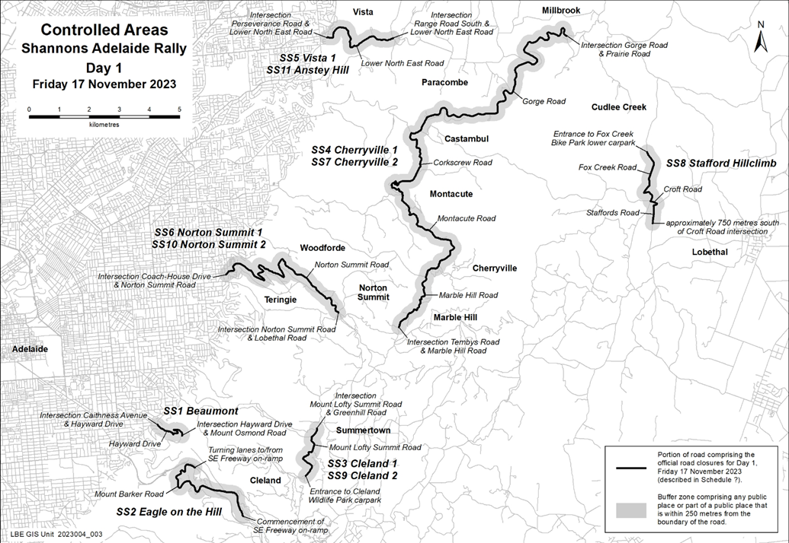
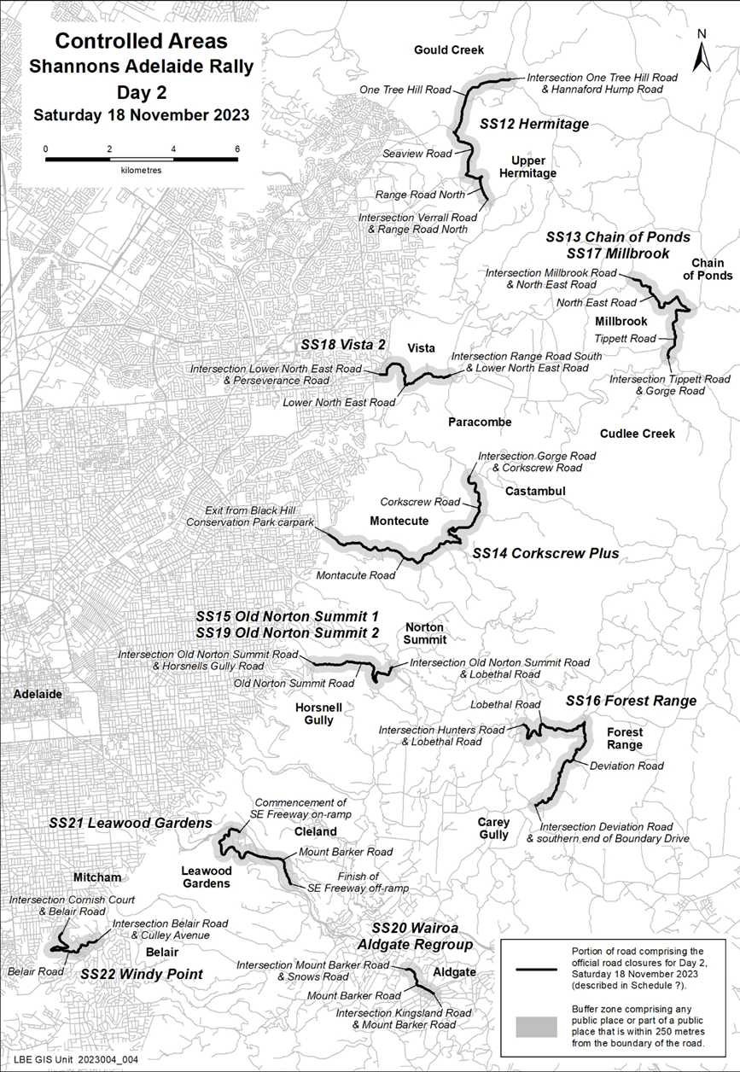
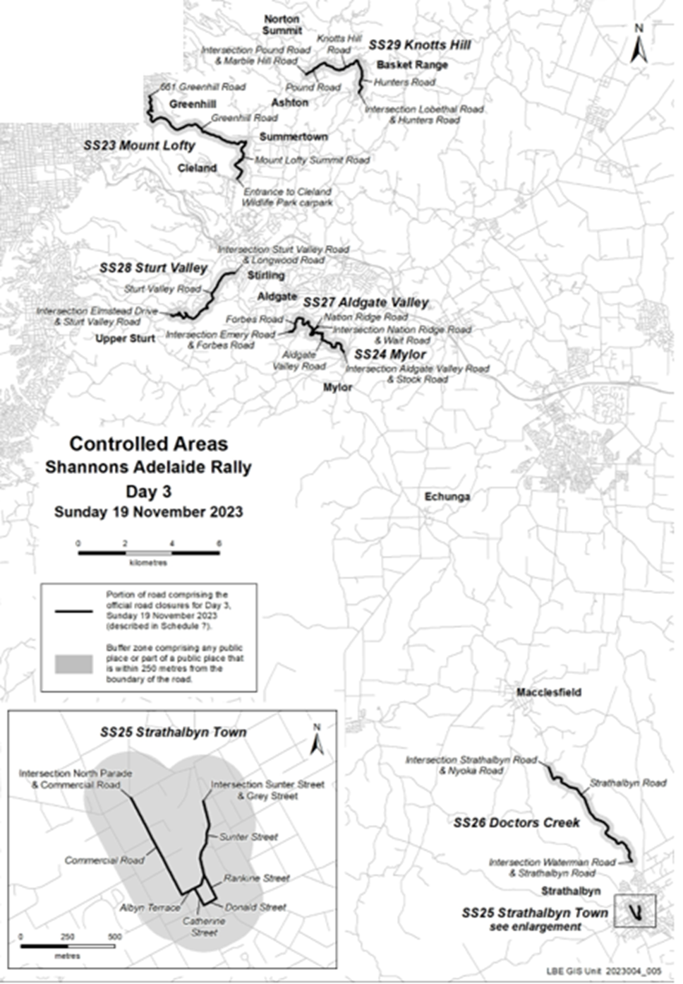
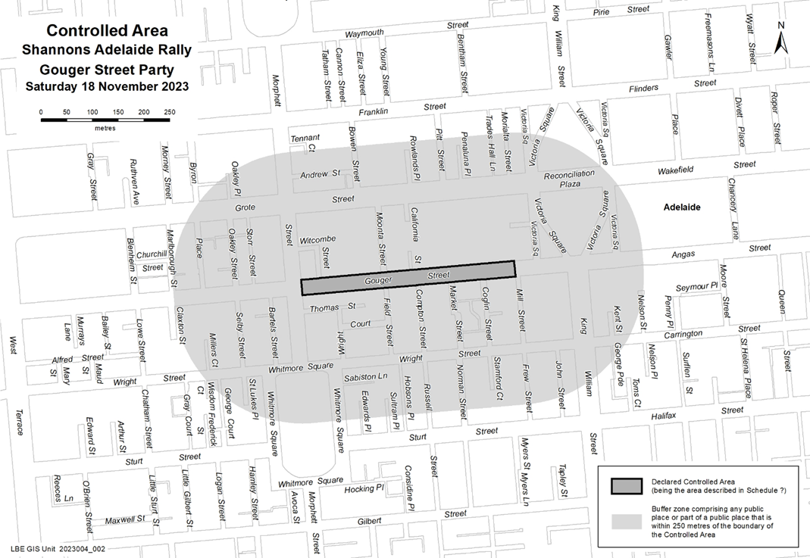

Petroleum and Geothermal Energy Act 2000
Grant of Petroleum Production Licence—PPL 277
Notice is hereby given that the undermentioned Petroleum Production Licence has been granted with effect from 12 October 2023, under the provisions of the Petroleum and Geothermal Energy Act 2000, pursuant to delegated powers dated 29 June 2018.
Licence number | Licensees | Locality | Area in km² | Reference
PPL 277 | Santos Limited | Cooper Basin | 0.45 | MER-2023/0039
Description of Area
All that part of the State of South Australia, bounded as follows:
Commencing at a point being the intersection of latitude 28°29'00"S GDA2020
and longitude 140°25'27"E GDA2020, thence east to longitude 140°25'45"E GDA94,
south to latitude 28°29'10"S GDA94, east to longitude 140°25'46"E GDA2020,
south to latitude 28°29'23"S GDA2020, west to longitude 140°25'21"E GDA2020,
north to latitude 28°29'05"S GDA2020, east to longitude 140°25'27"E GDA2020 and north to the point of commencement.
AREA: 0.45 square kilometres approximately
Dated: 12 October 2023
Nick Panagopoulos
A/Executive Director
Energy Resources Division
Department for Energy and Mining
Delegate of the Minister for Energy and Mining

Petroleum and Geothermal Energy Act 2000
Grant of Petroleum Production Licence—PPL 278
Notice is hereby given that the undermentioned Petroleum Production Licence has been granted with effect from 11 October 2023, under the provisions of the Petroleum and Geothermal Energy Act 2000, pursuant to delegated powers dated 29 June 2018.
Licence number | Licensees | Locality | Area in km² | Reference
PPL 278 | Santos QNT Pty Ltd  Drillsearch (513) Pty Limited | Cooper Basin | 6.64 | MER-2023/0080
Description of Area
All that part of the State of South Australia, bounded as follows:
Commencing at a point being the intersection of latitude 27°45′45″S GDA2020 and longitude 140°02′52″E AGD66, thence east to longitude 140°03′25″E GDA2020,
south to latitude 27°45′50″S GDA2020, east to longitude 140°03′45″E GDA2020,
south to latitude 27°46′00″S GDA2020, east to longitude 140°03′55″E GDA2020,
south to latitude 27°46′15″S GDA2020, east to longitude 140°04′00″E GDA2020,
south to latitude 27°46′50″S GDA2020, east to longitude 140°04′05″E GDA2020,
south to latitude 27°47′00″S GDA2020, east to longitude 140°04′15″E GDA2020,
south to latitude 27°47′20″S AGD66, west to longitude 140°03′40″E AGD66,
south to latitude 27°47′50″S AGD66, west to longitude 140°03′30″E AGD66,
south to latitude 27°48′00″S GDA94, west to longitude 140°02′50″E AGD66,
north to latitude 27°48′00″S AGD66, east to longitude 140°03′10″E AGD66,
north to latitude 27°47′50″S AGD66, east to longitude 140°03′20″E AGD66,
north to latitude 27°47′25″S GDA2020, east to longitude 140°03′35″E GDA2020,
north to latitude 27°46′30″S GDA2020, west to longitude 140°03′20″E GDA2020,
south to latitude 27°46′40″S GDA2020, west to longitude 140°03′14″E GDA2020,
south to latitude 27°47′10″S AGD66, west to longitude 140°02′05″E GDA2020,
north to latitude 27°47′00″S GDA94, east to longitude 140°02′05″E GDA94,
north to latitude 27°46′55″S GDA94, east to longitude 140°02′10″E GDA94
north to latitude 27°46′50″S GDA94, east to longitude 140°02′25″E GDA94
north to latitude 27°46′20″S GDA94, west to longitude 140°02′25″E GDA2020
north to latitude 27°46′00″S AGD66, east to longitude 140°02′52″E AGD66 and north to the point of commencement.
AREA: 6.64 square kilometres approximately
Dated: 11 October 2023
Nick Panagopoulos
A/Executive Director
Energy Resources Division
Department for Energy and Mining
Delegate of the Minister for Energy and Mining

Petroleum and Geothermal Energy Act 2000
Grant of Petroleum Production Licence—PPL 279
Notice is hereby given that the undermentioned Petroleum Production Licence has been granted with effect from 12 October 2023, under the provisions of the Petroleum and Geothermal Energy Act 2000, pursuant to delegated powers dated 29 June 2018.
Licence number | Licensees | Locality | Area in km² | Reference
PPL 279 | Santos Limited | Cooper Basin | 1.17 | MER-2023/0089
Description of Area
All that part of the State of South Australia, bounded as follows:
Commencing at a point being the intersection of latitude 28°28'19"S GDA2020
and longitude 140°24'20"E GDA94, thence east to longitude 140°24'50"E GDA2020,
south to latitude 28°28'36"S GDA2020, west to longitude 140°24'38"E GDA2020,
south to latitude 28°28'51"S GDA2020, west to longitude 140°24'00"E GDA2020,
north to latitude 28°28'30"S GDA94, east to longitude 140°24'00"E GDA94,
north to latitude 28°28'20"S GDA94, east to longitude 140°24'20"E GDA94 and north to the point of commencement.
AREA: 1.17 square kilometres approximately
Dated: 12 October 2023
Nick Panagopoulos
A/Executive Director
Energy Resources Division
Department for Energy and Mining
Delegate of the Minister for Energy and Mining

Planning, Development and Infrastructure Act 2016
Notice under Section 42
Practice Direction
Preamble
The State Planning Commission may issue a practice direction for the purposes of this Act.
A practice direction may specify procedural requirements or steps in connection with any matter arising under this Act.
A practice direction may be varied by the State Planning Commission from time to time by a further instrument notified in the Gazette and published on the South Australian Planning Portal.
Notice
PURSUANT to section 42 (4) of the Planning, Development and Infrastructure Act 2016, I, Stuart Moseley, Acting Chair of the State Planning Commission,
- vary the State Planning Commission Practice Direction 14 – Site Contamination Assessment 2021.
- fix the day on which this varied practice direction is published on the South Australian Planning Portal as the day on which the varied practice direction will come into operation.
Dated: 9 October 2023
Stuart Moseley
Acting Chair of the State Planning Commission

Road Traffic Act 1961
Authorisation to Operate Breath Analysing Instruments
I, GRANT STEVENS, Commissioner of Police, do hereby notify that on and from 25 September, 2023, the following persons were authorised by the Commissioner of Police to operate breath analysing instruments as defined in and for the purposes of the:
• Road Traffic Act 1961;
• Harbors and Navigation Act 1993;
• Security and Investigation Industry Act 1995; and
• Rail Safety National Law (South Australia) Act 2012.
PD Number | Officer Name
11940 | ARNEY, Lauren Kate
13294 | BONE - GEORGE, Joshua Michael
10560 | CALABRO, Savanna Marie
11936 | CASSIDY, Kaitlin
12110 | DRAKE, Jasmine Bree
11969 | EVRENIADIS, Zach Alexander
12799 | LINDNER, Jacob Robert
10154 | MULDOON, Laura Jean
12941 | VIDLER, Anton David
12527 | WILSON, Amy Patricia
Dated: 19 October 2023
Grant Stevens
Commissioner of Police
Reference: 2023-0138

Public Notices

Trustee Act 1936
Public Trustee
Estates of Deceased Persons
In the matter of the estates of the undermentioned deceased persons:
AHERN Mary Marcella late of 28 Liddell Drive Huntfield Heights of no occupation who died 12 February 2023
JAMES Robert Allan late of 18 Cudmore Terrace Marleston Retired Plumber who died 23 June 2022
LADILO Ruzica late of 41 Glen Eden Drive Gladstone Central Queensland Retired Registered Nurse who died 12 May 2023
PHIPPS Barry late of 11 Main North Road Willaston Diesel Mechanic who died 21 February 2023
RAMMELL John Barry late of 19 Windsor Avenue Pennington of no occupation who died 16 January 2023
SPENCER Marjorie Estelle late of 9 Brenchley Grove Kingswood of no occupation who died 26 April 2023
WILKINSON Grace Rose late of 1a Panton Crescent Somerton Park of no occupation who died 19 May 2023
ZIEPES Ruth Beatrice late of 6 Golding Street Risdon Park Retired Nurse who died 7 January 2023
Notice is hereby given pursuant to the Trustee Act 1936, the Inheritance (Family Provision) Act 1972 and the Family Relationships Act 1975 that all creditors, beneficiaries, and other persons having claims against the said estates are required to send, in writing, to the office of Public Trustee at GPO Box 1338, Adelaide SA 5001, full particulars and proof of such claims, on or before 17 November 2023 otherwise they will be excluded from the distribution of the said estate; and notice is also hereby given that all persons indebted to the said estates are required to pay the amount of their debts to the Public Trustee or proceedings will be taken for the recovery thereof; and all persons having any property belonging to the said estates are forthwith to deliver same to the Public Trustee.
Dated: 19 October 2023
N. S. Rantanen
Public Trustee

Notice Submission

The South Australian Government Gazette is published each Thursday afternoon.
Notices must be emailed by 4 p.m. Tuesday, the week of publication.
Submissions are formatted per the gazette style and a proof will be supplied prior to publication, along with a quote if applicable. Please allow one day for processing notices.
Alterations to the proof must be returned by 4 p.m. Wednesday.

Gazette notices must be submitted as Word files, in the following format:
• Title—the governing legislation
• Subtitle—a summary of the notice content
• Body—structured text, which can include numbered lists, tables, and images
• Date—day, month, and year of authorisation
• Signature block—name, role, and department/organisation authorising the notice

Please provide the following information in your email:
• Date of intended publication
• Contact details of the person responsible for the notice content
• Name and organisation to be charged for the publication—Local Council and Public notices only
• Purchase order, if required—Local Council and Public notices only

Email: governmentgazettesa@sa.gov.au
Phone: (08) 7133 3552
Website: www.governmentgazette.sa.gov.au

All instruments appearing in this gazette are to be considered official, and obeyed as such

Printed and published weekly by authority of M. Dowling, Government Printer, South Australia
$8.55 per issue (plus postage), $430.00 per annual subscription—GST inclusive
Online publications: www.governmentgazette.sa.gov.au

