No. 70 p. 3235

**THE SOUTH AUSTRALIAN**

**GOVERNMENT GAZETTE**

**Published by Authority**

Adelaide, Thursday, 14 September 2023

**Contents**

**Governor’s Instruments**

Appointments 3236

Proclamations—

[Statutes Amendment (Sexual Offences) Act   
(Commencement) Proclamation 2023 3237](#_Toc145579671)

Administrative Arrangements (Arts Institutions) Proclamation 2023 3238

[South Australian Film Corporation (Designation of   
Employing Authority) Proclamation 2023 3239](#_Toc145579673)

Regulations—

[Planning, Development and Infrastructure (General)   
(Schedule 13) Amendment Regulations 2023—  
No. 97 of 2023 3240](#_Toc145579675)

**State Government Instruments**

Associations Incorporation Act 1985 3242

Fisheries Management Act 2007 3242

Gaming Machines Regulations 2020 3243

Housing Improvement Act 2016 3244

Justices of the Peace Act 2005 3244

Land Acquisition Act 1969 3245

Legal Practitioners Act 1981 3246

Liquor Licensing Act 1997 3246

Lotteries Act 2019 3252

Major Events Act 2013 3253

Motor Vehicles Act 1959 3255

Offshore Minerals Act 1994 3257

Petroleum and Geothermal Energy Act 2000 3257

Retail and Commercial Leases Act 1995 3258

Road Traffic Act 1961 3258

South Australian Motor Sport Act 1984 3258

South Australian Motor Sport Regulations 2014 3259

L**ocal Government Instruments**

City of Playford 3260

City of Prospect 3260

City of Unley 3263

Renmark Paringa Council 3263

**Public Notices**

National Electricity Law 3264

Trustee Act 1936 3264

# Governor’s Instruments

## Appointments

Department of the Premier and Cabinet

Adelaide, 14 September 2023

Her Excellency the Governor in Executive Council has been pleased to appoint the undermentioned to the South Australian Tourism Commission Board, pursuant to the provisions of the South Australian Tourism Commission Act 1993:

Director: from 19 September 2023 until 18 September 2025

Jessica Kate Greatwich

Justyna Joanna Jochym

By command,

Zoe Lee Bettison, MP

For Premier

TMACAB012

Department of the Premier and Cabinet

Adelaide, 14 September 2023

Her Excellency the Governor in Executive Council has been pleased to appoint the undermentioned to the Aboriginal Lands Trust, pursuant to the provisions of the Aboriginal Lands Trust Act 2013:

Member: from 14 September 2023 until 13 September 2026

Karen Ann Sinclair

Edward Douglas Newchurch

Nirelle Ware

Teresa Brady

Dwayne Kemp

Darrien Sean Bromley

By command,

Zoe Lee Bettison, MP

For Premier

AGO0161-23CS

Department of the Premier and Cabinet

Adelaide, 14 September 2023

Her Excellency the Governor in Executive Council has been pleased to appoint the Honourable Natalie Fleur Cook, MP as Acting Minister for Child Protection and Acting Minister for Women and the Prevention of Domestic and Family Violence from 18 September 2023 until 4.00pm on 29 September 2023 inclusive, during the absence of the Honourable Katrine Anne Hildyard, MP.

By command,

Zoe Lee Bettison, MP

For Premier

MO-F2023009604

Department of the Premier and Cabinet

Adelaide, 14 September 2023

Her Excellency the Governor in Executive Council has been pleased to appoint the Honourable Andrea Michaels, MP as Acting Minister for Recreation, Sport and Racing from 18 September 2023 until 4.00pm on 29 September 2023 inclusive, during the absence of the Honourable Katrine Anne Hildyard, MP.

By command,

Zoe Lee Bettison, MP

For Premier

MO-F2023009604

## Proclamations

South Australia

### Statutes Amendment (Sexual Offences) Act (Commencement) Proclamation 2023

**1—Short title**

This proclamation may be cited as the *Statutes Amendment (Sexual Offences) Act (Commencement) Proclamation 2023*.

**2—Commencement of Act**

(1) Subject to subclause (2), the [*Statutes Amendment (Sexual Offences) Act 2023*](http://www.legislation.sa.gov.au/index.aspx?action=legref&type=act&legtitle=Statutes%20Amendment%20(Sexual%20Offences)%20Act%202023) (No 21 of 2023) comes into operation on 1 October 2023.

(2) Part 5 of the Act comes into operation on 1 January 2024.

**Made by the Governor**

with the advice and consent of the Executive Council

on 14 September 2023

South Australia

### Administrative Arrangements (Arts Institutions) Proclamation 2023

under sections 8 and 11 of the *Administrative Arrangements Act 1994*

**1—Short title**

This proclamation may be cited as the *Administrative Arrangements (Arts Institutions) Proclamation 2023*.

**2—Commencement**

This proclamation comes into operation on 1 October 2023.

**3—Interpretative provision**

A reference to the Minister for Industry, Innovation and Science in a contract, agreement, instrument or other document relating to the Adelaide Film Festival, JamFactory Contemporary Craft and Design Incorporated, the Music Development Office or the South Australian Film Corporation will have effect as if it were a reference to the Minister for Arts.

**Schedule 1—Repeal of proclamations**

**1—Repeal of proclamations**

(1) The [*Administrative Arrangements (References to Minister for the Arts) Proclamation 2018*](http://www.legislation.sa.gov.au/index.aspx?action=legref&type=subordleg&legtitle=Administrative%20Arrangements%20(References%20to%20Minister%20for%20the%20Arts)%20Proclamation%202018) (*Gazette 5.7.2018 p2735*) is repealed.

(2) The [*Administrative Arrangements (Conferral of Ministerial Functions and Powers) Proclamation 2018*](http://www.legislation.sa.gov.au/index.aspx?action=legref&type=subordleg&legtitle=Administrative%20Arrangements%20(Conferral%20of%20Ministerial%20Functions%20and%20Powers)%20Proclamation%202018) (*Gazette 2.8.2018 p2987*) is repealed.

**Made by the Governor**

with the advice and consent of the Executive Council

on 14 September 2023

South Australia

### South Australian Film Corporation (Designation of Employing Authority) Proclamation 2023

under section 4 of the *South Australian Film Corporation Act 1972*

**1—Short title**

This proclamation may be cited as the *South Australian Film Corporation (Designation of Employing Authority) Proclamation 2023*.

**2—Commencement**

This proclamation comes into operation on 1 October 2023.

**3—Designation of employing authority**

The person for the time being holding or acting in the position of Chief Executive of the Department of the Premier and Cabinet is designated as being the employing authority for the purposes of the definition of employing authority in section 4(1) of the [*South Australian Film Corporation Act 1972*](http://www.legislation.sa.gov.au/index.aspx?action=legref&type=act&legtitle=South%20Australian%20Film%20Corporation%20Act%201972).

**Schedule 1—Repeal of proclamation**

The [*South Australian Film Corporation (Designation of Employing Authority) Proclamation 2018*](http://www.legislation.sa.gov.au/index.aspx?action=legref&type=subordleg&legtitle=South%20Australian%20Film%20Corporation%20(Designation%20of%20Employing%20Authority)%20Proclamation%202018) (*Gazette 5.7.2018 p2736*) is repealed.

**Made by the Governor**

with the advice and consent of the Executive Council

on 14 September 2023

## Regulations

South Australia

### Planning, Development and Infrastructure (General) (Schedule 13) Amendment Regulations 2023

under the *Planning, Development and Infrastructure Act 2016*

**Contents**

Part 1—Preliminary

1 Short title

2 Commencement

Part 2—Amendment of *Planning, Development and Infrastructure (General) Regulations 2017*

3 Amendment of Schedule 13—State agency development exempt from approval

**Part 1—Preliminary**

**1—Short title**

These regulations may be cited as the *Planning, Development and Infrastructure (General) (Schedule 13) Amendment Regulations 2023*.

**2—Commencement**

These regulations come into operation on the day on which they are made.

**Part 2—Amendment of *Planning, Development and Infrastructure (General) Regulations 2017***

**3—Amendment of Schedule 13—State agency development exempt from approval**

Schedule 13, clause 2(1)(b)—after subparagraph (xix) insert:

or

(xx) the construction, reconstruction or alteration of, or addition to, buildings or structures that do not exceed 9 m in height on land comprised by Certificate of Title Volume 6282 Folio 519 for the purposes of the horses and dogs units of SAPOL and SAPOL operations associated with or ancillary to those purposes; or

(xxi) the construction, reconstruction or alteration of, or addition to, buildings or structures on land comprised by the following:

(A) Certificate of Title Volume 5883 Folio 454;

(B) Certificate of Title Volume 5883 Folio 426;

(C) Certificate of Title Volume 5827 Folio 252;

(D) Certificate of Title Volume 5883 Folio 424;

(E) Certificate of Title Volume 5283 Folio 663;

(F) Certificate of Title Volume 5897 Folio 901;

(G) Certificate of Title Volume 5883 Folio 450;

(H) Certificate of Title Volume 5894 Folio 532;

(I) Certificate of Title Volume 6250 Folio 938;

(J) Certificate of Title Volume 6257 Folio 136;

(K) Certificate of Title Volume 5883 Folio 420,

for the purposes of a muster, staging and storage facility for the horses unit of SAPOL and SAPOL operational resources involved in responding to, or assisting with, emergencies, major events and functions; or

(xxii) any infrastructure or works associated with or ancillary to development under subparagraph (xx) or (xxi), including a stormwater detention basin;

**Editorial note—**

As required by section 10AA(2) of the [*Legislative Instruments Act 1978*](http://www.legislation.sa.gov.au/index.aspx?action=legref&type=act&legtitle=Legislative%20Instruments%20Act%201978), the Minister has certified that, in the Minister's opinion, it is necessary or appropriate that these regulations come into operation as set out in these regulations.

**Made by the Governor**

with the advice and consent of the Executive Council

on 14 September 2023

No 97 of 2023

# 

# State Government Instruments

## Associations Incorporation Act 1985

Order Pursuant to Section 42(2)

*Dissolution of Association*

**WHEREAS** the CORPORATE AFFAIRS COMMISSION (the Commission) pursuant to section 42(1) of the *Associations Incorporation Act 1985* (the Act) is of the opinion that the undertaking or operations of **BEDFORD PHOENIX INCORPORATED** (the Association) being an incorporated association under the Act are being carried on, or would more appropriately be carried on by a Company Limited by Guarantee incorporated under the *Corporations Act 2001* (Cth) **AND WHEREAS** the Commission was on **4 JULY 2023** requested by the Association to transfer its undertaking to **BEDFORD SERVICES AND ADVISORY LIMITED** (Australian Company Number **667 167 811**), the Commission pursuant to section 42(2) of the Act **DOES** **HEREBY ORDER** that on **2 OCTOBER 2023,** the Association will be dissolved, the property of the Association becomes the property of **BEDFORD SERVICES AND ADVISORY LIMITED** and the rights and liabilities of the Association become the rights and liabilities of **BEDFORD SERVICES AND ADVISORY LIMITED.**

Given under the seal of the Commission at Adelaide this 8th day of **SEPTEMBER 2023.**

Lisa Berry

A delegate of the Corporate Affairs Commission

## Fisheries Management Act 2007

Section 114

Management Plan for the South Australian Commercial Sardine Fishery (2023)

TAKE notice that pursuant to Section 44(7) and (10) of the *Fisheries Management Act 2007* I hereby declare that I have adopted the *Management Plan for the South Australian Commercial Sardine Fishery (2023)* and fix 1 October 2023 as the date of on which the plan will take effect.

Dated: 8 September 2023

Hon Clare Scriven MLC

Minister for Primary Industries and Regional Development

Fisheries Management Act 2007

Section 115

Ministerial Exemption ME9903272—Variation

TAKE NOTICE that the Ministerial exemption notice number ME9903272 in the name of Mr Adam Harman of Lateral Environmental Pty Ltd, ACN: 643 816 782, made under section 115 of the *Fisheries Management Act 2007,* dated 10 August 2023, and published in the *South Australian Government Gazette* dated 17 August 2023, on page 3031, being the first notice on that page, relating to undertaking environmental studies is hereby varied by –

1. Inserting “*44*” immediately following the word “clauses” where it occurs in the first paragraph, being a clause within schedule 6 of the *Fisheries Management (General) Regulations 2017* which the exemption holder is also exempt during the remainder of the term of the notice.
2. Inserting the following gear that may be used under the exemption into Schedule 1:

* *4 x fyke nets – 5 m dual wings, 600 mm hoop with 6 mm mesh*
* *6 x opera house style nets designed and constructed for the purpose of taking Yabbies – oval in shape, 680 mm in length x 450 mm in width x 200 mm in height with 2 mm mesh and an exclusion ring no greater than 45 mm.*

1. Inserting the following conditions into Schedule 3:

*11. All nets left unattended must be clearly marked with name and Ministerial exemption number on a tag if set close to shore or on a 2 litre buoy if set away from shore.*

*12. All nets left unattended must be removed from the water and cleared every 16 hours.*

Dated: 6 September 2023

Prof. Gavin Begg

Executive Director

Fisheries and Aquaculture

Delegate of the Minister for Primary Industries and Regional Development

Fisheries Management Act 2007

Section 115

Ministerial Exemption ME9903273

TAKE NOTICE that pursuant to section 115 of the *Fisheries Management Act 2007* (the Act), Ms Leslie Morrison of Flinders University, Sturt Rd, Bedford Park (the ‘exemption holder’), and her nominated agents, are exempt from Section 70 of the *Fisheries Management Act 2007* and regulation 5(a), and clause 74 of Schedule 6 of the *Fisheries Management (General) Regulations 2017* within the waters specified in Schedule 1 but only insofar as the activities undertaken are consistent with the educational activities specified in Schedule 2, using the gear specified in Schedule 3 (the 'exempted activity'), subject to the conditions specified in Schedule 4, from 7 September 2023 until 6 September 2024, unless varied or revoked earlier.

Schedule 1

The waters of the State, excluding any aquatic reserves, the River Murray, the Adelaide Dolphin Sanctuary or any marine parks (unless otherwise authorised under the *Marine Parks Act 2007*).

Schedule 2

The teaching activities of Flinders University conducted as part of the provision of the following courses:

1. Marine Ecology BIOL 2742
2. Marine & Freshwater Biology BIOL 3702;
3. BIOL 3711: Plant and Algal Diversity;
4. BIOL 2712 Animal Diversity;
5. BIOL 1301 Introduction to Marine Biology;
6. Fisheries Management and Science;
7. BIOL3800: Class Marine Science Experience.

Schedule 3

The gear that may be used when undertaking activities under this exemption notice include:

* Up to 8 x plankton nets (maximum 1 m diameter, 1.6 m length and maximum 38 mm mesh)
* Up to 6 x niskin bottles
* Up to 30 Plastic corers (4 cm and 10 cm diameter x 20 cm length).

Schedule 4

1. The exemption holder will be deemed responsible for the conduct of all persons conducting the exempted activities under this notice. Any person conducting activities under this exemption must be provided with a copy of this notice, which they must have signed as an indication that they have read and understand the conditions under it.
2. Nominated agents of the Exemption Holder are teaching Staff of the College of Science and Engineering, Flinders University.
3. Nominated agents may be assisted by students undertaking studies related to the courses specified in Schedule 2 at Flinders University, under the conditions prescribed in this notice, providing those students are under the supervision of a nominated agent.
4. Any equipment used to collect fish during the exempted activity must be appropriately decontaminated prior to and after its use.
5. The exemption holder or nominated agent must not cause or permit the use of more than two (2) hand-held nets by any one person at any one time whilst undertaking the exempted activity.
6. Any species (other than noxious species) caught pursuant to this notice that is not being collected as part of the education or research program must be returned to the water as soon as practicable. Noxious species must not be returned to the water and must be disposed of appropriately.
7. Any protected species incidentally caught while undertaking the exempted activity must be returned to the water unencumbered as soon as reasonably practicable and cannot be retained.
8. The specimens collected by the exemption holder are for education or research purposes only and must not be used for any commercial purpose.
9. Organisms collected pursuant to this notice must not be released into waters of the State if they have been kept separate to their natural environment for any length of time.
10. The exemption holder or agent must not conduct any other fishing activity whilst undertaking the exempted activity.
11. At least 1 hour before conducting an activity under this notice, the exemption holder or nominated agent must contact the Department of Primary Industries and Regions (PIRSA) Fishwatch on **1800 065 522** and answer a series of questions about the exempted activity. The exemption holder or nominated agent will need to have a copy of this notice in their possession at the time of making the call and be able to provide information about the area and time of the exempted activity, the specific gear to be used, vehicles and/or boats involved, the number of permit holders undertaking the exempted activity and other related questions.
12. The exemption holder must provide a report in writing detailing the activities carried out pursuant to this notice to PIRSA, Fisheries and Aquaculture (GPO Box 1625, ADELAIDE SA 5001) within 14 days of the activity being completed with the following details:
    * + - the date and location of sampling;
        - the gear used;
        - the number and description of all species caught and their fate;
        - the number and description of any samples/biopsies collected;
        - any interactions with protected species and their fate; and
        - any other information regarding size, breeding or anything deemed relevant or of interest that is able to be volunteered.
13. While engaging in the exempted activity, the exemption holder and agents must be in possession of a signed copy of this notice and carry their identification card issued by Flinders University. Such notice and identification must be produced to a PIRSA Fisheries Officer if requested.
14. The exemption holder, or agent must not contravene or fail to comply with the Act or any regulations made under the Act, except where specifically exempted by this notice.

This notice does not purport to override the provisions or operation of any other Act including, but not limited to, the *Marine Parks Act 2007* and the *River Murray Act 2003*.

Dated: 6 September 2023

Prof. Gavin Begg

Executive Director

Fisheries and Aquaculture

Delegate of the Minister for Primary Industries and Regional Development

## Gaming Machines Regulations 2020

Notice pursuant to regulation 7 of the Gaming Machines Regulations 2020

PURSUANT to regulation 7 of the *Gaming Machines Regulations 2020*, I, Dini Soulio, Liquor and Gambling Commissioner, have established a trading round for the purchase and sale of gaming machine entitlements.

This trading round will commence on Thursday 14 September 2023 and will be known as Trading Round 23/2023.

Offers to purchase or sell gaming machine entitlements in Trading Round 23/2023 are invited from persons eligible to do so in accordance with the Gaming Machines Regulations 2020.

The closing date and time for the submission of offers in this trading round is Friday 13 October 2023 at 5.00pm.

The determination of offers that are to be regarded as accepted will occur on Wednesday 8 November 2023 (known as the Trading Day).

An administration fee of $120.00 (calculated per entitlement) has been fixed for Trading Round 23/2023 for the submission of offers to purchase entitlements. There is no fee for the submission of offers to sell entitlements.

Information about how to submit offers to purchase or sell gaming machine entitlements in this trading round is available at [www.sa.gov.au/gmetrade](http://www.sa.gov.au/gmetrade).

Dated 14 September 2023

Dini Soulio

Liquor and Gambling Commissioner

## Housing Improvement Act 2016

Rent Control Revocations

Whereas the Minister for Human Services Delegate is satisfied that each of the houses described hereunder has ceased to be unsafe or unsuitable for human habitation for the purposes of the *Housing Improvement Act 2016*, notice is hereby given that, in exercise of the powers conferred by the said Act, the Minister for Human Services Delegate does hereby revoke the said Rent Control in respect of each property.

|  |  |  |
| --- | --- | --- |
| **Address of Premises** | **Allotment Section** | **Certificate of Title Volume/Folio** |
|  |  |  |
| 6 Crozier Avenue, Modbury SA 5092 | Allotment 2 Deposited Plan 9269 Hundred of Yatala | CT5090/37 |
|  |  |  |

Dated: 14 September 2023

Craig Thompson

Housing Regulator and Registrar

Housing Safety Authority, SAHA

Delegate of Minister for Human Services

## Justices of the Peace Act 2005

Section 4

Notice of Appointment of Justices of the Peace for South Australia   
by the Commissioner for Consumer Affairs

I, Dini Soulio, Commissioner for Consumer Affairs, delegate of the Attorney-General, pursuant to section 4 of the *Justices of the Peace Act 2005*, do hereby appoint the people listed as Justices of the Peace for South Australia as set out below. It being a condition of appointment that the Justices of the Peace must take the oaths required of a justice under the *Oaths Act 1936* and return the oaths of office form to Justice of the Peace Services within three months after the date of appointment.

For a period of ten years for a term commencing on 19 September 2023 and expiring on 18 September 2033:

Meng YAO

Adele Carlita WYATT

Siobhan Anne WHELAN

Kara Jayne VOIGT

Shudarshan UPRETI

Sarah Eliza TAYLOR

John Mortimer STENING

Brittany Ann STANFORD

Roger Wayne READ

Anna PASSMORE

Kim Thu NGO

Ian Stuart MULLER

Victoria Marlene MONAHAN

Denis MILKIC

Zachary Ryan MATULIN

Kate Helen MARSHALL

Kira-Leigh LIDDELL

Shinjini KATIYAR

Dianne JOY

Kate Louise HOLMES

Joseph Anthony HOLMES

William HO

Stirling Phillip GRIFF

Kristy Lee GREIG

Heidi Jayne CAMPBELL

Emma CAIN

Eloise Helen Kathleen ATTERTON

Dated: 7 September 2023

Dini Soulio

Commissioner for Consumer Affairs

Delegate of the Attorney-General

Justices of the Peace Act 2005

Section 4

Notice of Appointment of Justices of the Peace for South Australia   
by the Commissioner for Consumer Affairs

I, Dini Soulio, Commissioner for Consumer Affairs, delegate of the Attorney-General, pursuant to section 4 of the *Justices of the Peace Act 2005*, do hereby appoint the people listed as Justices of the Peace for South Australia as set out below.

For a period of ten years for a term commencing on 19 September 2023 and expiring on 18 September 2033:

Charles Norman YOUNG

Ron WINKLER

Maxwell Arthur SLEE

Charles Peter Hedley SHELDRAKE

Kevin George RUSSELL

Brunetta Ondina QUAST

Donald Ivan PERRY

Dianne Jane PENNA

Barry Herbert PENNA

Dianne Mary PATTERSON

Gary Lovell MCLAUGHLIN

Daryl Scott MARSHALL

Eileen Rose LINDNER

Elizabeth Margaret JARRETT

Damian James HOLLAND

Christine Bernice FUSS

Leonard James FRANKHAM

Angela Mary DUIGAN

Dianne Joan DAWSON

Brenda BUTLER

Kathleen Frances BRADTKE

Bert BARGEUS

Geoffrey Robert BANKS

Michael Richard BALDWIN

Dated: 8 September 2023

Dini Soulio

Commissioner for Consumer Affairs

Delegate of the Attorney-General

## Land Acquisition Act 1969

Section 16

Form 5—Notice of Acquisition

1. **Notice of acquisition**

The Commissioner of Highways (the Authority), of 83 Pirie Street, Adelaide SA 5000, acquires the following interests in the following land:

Comprising an unencumbered estate in fee simple in that piece of land being portion of Allotment 52 in Deposited Plan 83582 comprised in Certificate of Title Volume 6057 Folio 801, and being the whole of the land identified as Allotment 2710 in D132301 lodged in the Lands Titles Office.

This notice is given under Section 16 of the *Land Acquisition Act 1969*.

2. **Compensation**

A person who has or had an interest consisting of native title or an alienable interest in the land that is divested or diminished by the acquisition or the enjoyment of which is adversely affected by the acquisition who does not receive an offer of compensation from the Authority may apply to the Authority for compensation.

2A. **Payment of professional costs relating to acquisition (Section 26B)**

If you are the owner in fee simple of the land to which this notice relates, you may be entitled to a payment of up to $10,000 from the Authority for use towards the payment of professional costs in relation to the acquisition of the land.

Professional costs include legal costs, valuation costs and any other costs prescribed by the *Land Acquisition Regulations 2019*.

3. **Inquiries**

Inquiries should be directed to:

Daniel Tuk

GPO Box 1533

Adelaide SA 5001

Telephone: (08) 7133 2479

Dated: 11 September 2023

The Common Seal of the COMMISSIONER OF HIGHWAYS was hereto affixed by authority of the Commissioner in the presence of:

Rocco Caruso

Manager, Property Acquisition

(Authorised Officer)

Department for Infrastructure and Transport

DIT 2022/15494/01

## Legal Practitioners Act 1981

*Amendments to  
Rules of the Legal Practitioners Education and Admission Council 2018*

Pursuant to the *Legal Practitioners Act 1981* the Legal Practitioners Education and Admission Council makes the following amendments to the rules:

1. The amendments made by these Rules come into effect four months after the day on which they are made.
2. Subparagraph 8(1)(b) is deleted and substituted as follows:

“(b) the successful completion, during its period of accreditation, of a course of study accredited by LPEAC and leading to the grant of the Graduate Diploma in Legal Practice.”

Dated: 5 September 2023

Chief Justice Kourakis

Chair, Legal Practitioners Education and Admission Council

## Liquor Licensing Act 1997

South Australia

**Liquor Licensing (Dry Areas) Notice 2023 (No.1)**

under section 131(1) of the *Liquor Licensing Act 1997*

**1—Short title**

This notice may be cited as the [*Liquor Licensing (Dry Areas) Notice 20*](http://www.legislation.sa.gov.au/index.aspx?action=legref&type=subordleg&legtitle=Liquor%20Licensing%20(Dry%20Areas)%20Notice%202015)*23 (No.1)*.

**2—Commencement**

This notice comes into operation on 22 September 2023.

**3—Interpretation**

(1) In this notice—

***principal notice*** means the [*Liquor Licensing (Dry Areas) Notice 2015*](http://www.legislation.sa.gov.au/index.aspx?action=legref&type=subordleg&legtitle=Liquor%20Licensing%20(Dry%20Areas)%20Notice%202015) published in the Gazette on 5.1.15, as in force from time to time.

(2) Clause 3 of the principal notice applies to this notice as if it were the principal notice.

**4—Consumption etc of liquor prohibited in dry areas**

(1) Pursuant to section 131 of the Act, the consumption and possession of liquor in the area described in the Schedule is prohibited in accordance with the provisions of the Schedule.

(2) The prohibition has effect during the periods specified in the Schedule.

(3) The prohibition does not extend to private land in the area described in the Schedule.

(4) Unless the contrary intention appears, the prohibition of the possession of liquor in the area does not extend to—

(a) a person who is genuinely passing through the place if—

(i) the liquor is in the original container in which it was purchased from licensed premises; and

(ii) the container has not been opened; or

(b) a person who has possession of the liquor in the course of carrying on a business or in the course of their employment by another person in the course of carrying on a business; or

(c) a person who is permanently or temporarily residing at premises near the public place and who enters the public place solely for the purpose of passing through it to enter those premises or who enters the public place from those premises for the purpose of leaving the place; or

(d) a person who possesses or consumes the liquor for sacramental or other similar religious purposes.

(5) The Schedule is in substitution for Schedule—Adelaide Park Lands Area 1 in the principal notice.

**Schedule 1—Adelaide Park Lands Area 1**

|  |  |
| --- | --- |
| **1—Extent of prohibition** | |
|  | The consumption of liquor is prohibited and the possession of liquor is prohibited. |
| **2—Period of prohibition** | |
|  | From 8 pm on each day to 11 am on the following day, until 11 am on 22 December 2023. |
| **3—Description of area** | |
|  | The area in and adjacent to Adelaide and North Adelaide, generally known as the Adelaide Park Lands, together with other land, bounded as follows: commencing at the point at which the western boundary of Fullarton Road, Adelaide, meets the northern boundary of Greenhill Road, Adelaide, then westerly along that northern boundary of Greenhill Road to where this intersects with the western side of Unley Road, Adelaide, then in a northerly direction along the western side of Unley Road to where this intersects with the southern side of South Terrace, Adelaide, then in a westerly direction along the southern boundary of South Terrace to where this intersects with the eastern boundary of Sir Lewis Cohen Avenue, Adelaide, then in a southerly direction along the eastern boundary of Sir Lewis Cohen Avenue to where this intersects the northern boundary of Greenhill Road, then westerly along that northern boundary of Greenhill Road and the prolongation in a straight line of that boundary to the point at which it intersects the western boundary of Lot 8 DP 83004, then generally northerly along that western boundary of Lot 8 and the western boundaries of Lot 50 FP 219636 and Lot 24 DP 90434 to the north‑western corner of Lot 24 DP 90434, then in a straight line by the shortest route to the south‑western corner of Lot 74 DP 56872, then generally northerly along the eastern boundary of James Congdon Drive, Adelaide, to the south‑western boundary of Port Road, Adelaide, then in a straight line by the shortest route across Port Road to the north‑eastern boundary of Port Road, then generally northerly along that boundary of Port Road to the point at which the eastern boundary of Port Road meets the south‑eastern boundary of Park Terrace, North Adelaide, then generally north‑easterly along that south‑eastern boundary of Park Terrace, easterly along the southern boundary of Fitzroy Terrace, North Adelaide, and south‑easterly along the south‑western boundary of Robe Terrace, North Adelaide, to the point at which the south‑western boundary of Robe Terrace meets the south‑western boundary of Mann Road, North Adelaide, then in a straight line by the shortest route to the point at which the south‑western boundary of Park Road, North Adelaide, meets the eastern boundary of Northcote Terrace, North Adelaide, then generally south‑easterly and southerly along that boundary of Park Road, southerly along the western boundary of Hackney Road, Adelaide, and southerly and south‑easterly along the south‑western boundary of Dequetteville Terrace, Adelaide, and the prolongation in a straight line of that boundary to the point at which the prolongation in a straight line of the south‑western boundary of Dequetteville Terrace meets the western boundary of Fullarton Road, Adelaide, then southerly along the western boundary of Fullarton Road to the point of commencement, but excluding any part of that area that is within—  (a) the area defined in Schedule—Adelaide Area 1 as the area to which the prohibition in that Schedule applies; or  (b) an area defined in Schedule—Adelaide Area 1 as an area excluded from the area to which the prohibition in that Schedule applies; or  (c) the area defined in Schedule—North Adelaide Area 1 as the area to which the prohibition in that Schedule applies. |

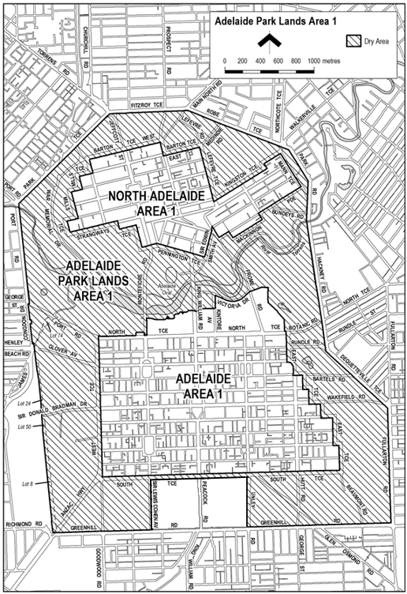

**Made by the Minister for Consumer and Business Affairs**

On 31 August 2023

Liquor Licensing Act 1997

South Australia

**Liquor Licensing (Dry Areas) Notice 2023**

under section 131(1) of the *Liquor Licensing Act 1997*

**1—Short title**

This notice may be cited as the *Liquor Licensing (Dry Areas) Notice 2023*.

**2—Commencement**

This notice comes into operation on 9 December 2023.

**3—Interpretation**

(1) In this notice—

***principal notice*** means the [*Liquor Licensing (Dry Areas) Notice 2015*](http://www.legislation.sa.gov.au/index.aspx?action=legref&type=subordleg&legtitle=Liquor%20Licensing%20(Dry%20Areas)%20Notice%202015) published in the Gazette on 5.1.15, as in force from time to time.

(2) Clause 3 of the principal notice applies to this notice as if it were the principal notice.

**4—Consumption etc of liquor prohibited in dry areas**

(1) Pursuant to section 131 of the Act, the consumption and possession of liquor in the area described in the Schedule is prohibited in accordance with the provisions of the Schedule.

(2) The prohibition has effect during the periods specified in the Schedule.

(3) The prohibition does not extend to private land in the area described in the Schedule.

(4) Unless the contrary intention appears, the prohibition of the possession of liquor in the area does not extend to—

(a) a person who is genuinely passing through the place if—

(i) the liquor is in the original container in which it was purchased from licensed premises; and

(ii) the container has not been opened; or

(b) a person who has possession of the liquor in the course of carrying on a business or in the course of their employment by another person in the course of carrying on a business; or

(c) a person who is permanently or temporarily residing at premises near the public place and who enters the public place solely for the purpose of passing through it to enter those premises or who enters the public place from those premises for the purpose of leaving the place; or

(d) a person who possesses or consumes the liquor for sacramental or other similar religious purposes.

|  |  |
| --- | --- |
| **Schedule—Lobethal Area 1** | |
| **1—Extent of prohibition** | |
|  | The consumption of liquor is prohibited and the possession of liquor is prohibited. |
| **2—Period of prohibition** | |
|  | From 7:00pm to 7:00am, 9 December 2023 to 1 January 2024. |
| **3—Description of area** | |
|  | The area in and adjacent to Lobethal bounded as follows: commencing at the point at  which the western boundary of Mill Road meets the north-western boundary of the  Adelaide to Lobethal Road, then generally northerly along that boundary of Mill Road  and the prolongation in a straight line of that boundary to the point at which it is  intersected by the prolongation in a straight line of the northern boundary of Pioneer  Avenue, then easterly along that prolongation and boundary of Pioneer Avenue to the  point at which it meets the north-western boundary of Main Street, then generally  north-easterly and easterly along that boundary of Main Street and the northern boundary  of the Lobethal to Mount Torrens Road to the point at which that northern boundary is  intersected by the prolongation in a straight line of the eastern boundary of Frick Street,  then southerly along that prolongation and boundary of Frick Street to the point at which  it is intersected by the prolongation in a straight line of the southern boundary of  Kumnick Street, then westerly along that prolongation and boundary of Kumnick Street  to the eastern boundary of Ridge Road, then southerly and south-westerly along that  boundary of Ridge Road to the point at which it meets the northern boundary of the  Lobethal to Woodside Road, then in a straight line by the shortest route to the point at  which the eastern boundary of Golf Links Road meets the southern boundary of the  Lobethal to Woodside Road, then generally south-westerly along that boundary of Golf  Links Road to the point at which it is intersected by the prolongation in a straight line of  the southern boundary of the sewage pond in Lot 200 of DP 71985, then westerly along  that prolongation to the eastern boundary of Lot 200, then generally north-easterly along  that eastern boundary to the north-eastern boundary of Lot 200, then north-westerly  along the north-eastern boundary of Lot 200 and the prolongation in a straight line of that  boundary across Jeffery Street to the north-western boundary of Jeffery Street, then  north-easterly along that boundary of Jeffery Street to the southern boundary of the  Lobethal to Woodside Road, then westerly along that boundary of the Lobethal to  Woodside Road to the south-eastern boundary of the Adelaide to Lobethal Road, then  south-westerly along that boundary of the Adelaide to Lobethal Road to the point at  which it is intersected by the prolongation in a straight line of the western boundary of Mill Road, then northerly along that prolongation to the point of commencement. |



**Made by the Minister for Consumer and Business Affairs**

On 31 August 2023

## Lotteries Act 2019

South Australia

**Lotteries (Fees) Notice 2023**

under the *Lotteries Act 2019*

**1—Short title**

This notice may be cited as the *Lotteries* [*(Fees) Notice 202*](http://www.legislation.sa.gov.au/index.aspx?action=legref&type=subordleg&legtitle=Lottery%20and%20Gaming%20(Fees)%20Notice%202020)*3*.

**Note—**

This is a fee notice made in accordance with the [*Legislation (Fees) Act 2019*](http://www.legislation.sa.gov.au/index.aspx?action=legref&type=act&legtitle=Legislation%20(Fees)%20Act%202019).

**2—Commencement**

This notice has effect on the day on which it is published in the Gazette.

**3—Revocation**

The Lotteries (Fees) Notice 2023 published in the Gazette on 24 August 2023 is revoked.

**4—Interpretation**

In this notice, unless the contrary intention appears—

***Act*** means the *Lotteries Act 2019*.

**5—Fees**

The fees set out in Schedule 1 are prescribed for the purposes of the Act.

**Schedule 1—Fees**

|  |  |  |
| --- | --- | --- |
| 1 | Application for lottery licence | $10.40 |
| 2 | Application for trade promotion lottery licence—standard fee calculated on the basis of the total value of all prizes in the lottery as follows: |  |
|  | (a) for a total value of not more than $10 000 | $238.00 |
|  | (b) for a total value of more than $10 000 but not more than $50 000 | $874.00 |
|  | (c) for a total value of more than $50 000 but not more than $100 000 | $1 529.00 |
|  | (d) for a total value of more than $100 000 but not more than $200 000 | $2 622.00 |
|  | (e) for a total value of more than $200 000 | $4 808.00 |
|  | However, if the terms of the lottery provide for allocation of prizes among a number of States or Territories of the Commonwealth, the fee is to be calculated on the basis of the total value of only those prizes that are capable of being awarded to winners in this State. |  |
| 3 | If an application for a trade promotion lottery licence requests that the licence be granted 5 business days or less from the day on which the application is received by the Minister—fee calculated on the basis of the total value of all prizes in the lottery as follows: |  |
|  | (a) for a total value of not more than $10 000 | $477.00 |
|  | (b) for a total value of more than $10 000 but not more than $50 000 | $1 751.00 |
|  | (c) for a total value of more than $50 000 but not more than $100 000 | $3 052.00 |
|  | (d) for a total value of more than $100 000 but not more than $200 000 | $5 242.00 |
|  | (e) for a total value of more than $200 000 | $9 617.00 |
|  | However, if the terms of the lottery provide for allocation of prizes among a number of States or Territories of the Commonwealth, the fee is to be calculated on the basis of the total value of only those prizes that are capable of being awarded to winners in this State. |  |
| 4 | Application by holder of trade promotion lottery licence to the Minister for variation of terms of lottery to which licence applies | $78.50 |
| 5 | Application for grant of supplier's licence | $2 209.00 |
| 6 | Application for renewal of supplier's licence | $219.00 |

**Signed by the Minister for Consumer and Business Affairs**

On 8 September 2023

## Major Events Act 2013

Section 6B

*Declaration of a Major Event*

PURSUANT to section 6B of the *Major Events Act 2013*, I, Hon Zoe Bettison MP, Minister for Tourism declare the 2023 Bridgestone World Solar Challenge to be held from 25 to 29 October 2023 to be declared a major event.

By virtue of the provisions of the *Major Events Act 2013*, I do hereby:

1. Declare the 2023 Bridgestone World Solar Challenge to be a major event.
2. Specify the period for the event, for which the declaration of the major event is in force to be 25 – 29 October 2023.
3. Declare the major event venue to be Victoria Square/Tarntanyangga and any public place or part of a public place that is within 200 metres of the boundary of this park.
4. Designate the South Australian Motor Sport Board (ABN 43 976 679 496) to be the event organisers for the event.
5. Declare that the following provisions of Part 3 of the Act apply to the event, the major event venue for the event and the controlled area for the event:
   1. section 8.
   2. section 10.
   3. section 11.
   4. section 12.
   5. section 13.
   6. section 14.
6. Being satisfied that the title “*Bridgestone World Solar Challenge*” and the logo as it appears below are sufficiently connected with the identity and conduct of the major event, and that the event has commercial arrangements that are likely to be adversely affected by unauthorised use of the title and logo, I hereby declare, pursuant to section 14(1) of the Act, “*Bridgestone World Solar Challenge*” is an official title and the logo as it appears below is an official logo in respect of the event.

Dated: 13 September 2023

Hon Zoe Bettison MP

Minister for Tourism

Map of Controlled Area for the 2023 Bridgestone World Solar Challenge

## Motor Vehicles Act 1959

South Australia

**Motor Vehicles (Conditional Registration—Recognition of Motor Vehicle Clubs) Notice 2023 – Mitsubishi 4WD Club SA Incorporated**

under the *Motor Vehicles Act 1959*

**1—Short title**

This notice may be cited as the [Motor Vehicles (Conditional Registration—Recognition of Motor Vehicle Clubs) Notice 20](http://www.legislation.sa.gov.au/index.aspx?action=legref&type=subordleg&legtitle=Motor%20Vehicles%20(Conditional%20Registration%E2%80%94Recognition%20of%20Motor%20Vehicle%20Clubs)%20Notice%202012)23 – Mitsubishi 4WD Club SA Incorporated

**2—Commencement**

This notice takes effect from the date it is published in the Gazette.

**3—Interpretation**

In this notice—

***Act*** means the [*Motor Vehicles Act 1959*](http://www.legislation.sa.gov.au/index.aspx?action=legref&type=act&legtitle=Motor%20Vehicles%20Act%201959);

***Code of Practice*** means the ‘Code of Practice for Club Registration - a 90 day conditional registration scheme for historic, left hand drive and street rod vehicles’ published by the Department for Infrastructure and Transport;

***Conditional Registration Scheme*** or ***Scheme*** means the scheme for conditional registration of historic, prescribed left hand drive and street rod motor vehicles under section 25 of the Act and regulations 15 and 16 of the Motor Vehicles Regulations 2010;

***Department*** means the Department for Infrastructure and Transport;

***Federation*** means the Federation of Historic Motoring Clubs SA Incorporated;

***MR334 form*** means an ‘Approval for Registration of Vehicle on the Club Registration Scheme (MR334)’;

***Prescribed log book*** means a log book in a form approved by the Registrar;

***Registrar*** means the Registrar of Motor Vehicles;

***Regulations*** means the Motor Vehicles Regulations 2010.

**4—Recognition of motor vehicles clubs**

The motor vehicle clubs specified in Schedule 1 are, subject to the conditions set out in clause 5, recognised for the purposes of regulation 16 of the Regulations.

**5—Conditions of recognition**

A motor vehicle club specified in Schedule 1 must comply with the following conditions:

* 1. the club must maintain a constitution approved by the Registrar;

(b) the club must nominate and have members authorised by the Registrar (authorised persons). The club’s authorised person(s) are responsible for approving applicants and motor vehicles for registration under the Scheme. This includes confirming that Scheme applicants are financial members of a club; any other details as required by the Registrar on the MR334 form; and to inspect members’ vehicles when requested to do so by the Registrar;

(c) the club must issue a prescribed log book to club members for each of their vehicles to record vehicle use;

(d) the club must cancel a member’s prescribed log book when a member resigns, must ensure that a statutory declaration is provided when a member’s log book is lost or destroyed, must keep details of members’ prescribed log book return sheets and forward copies of the same to the Registrar or Federation annually as required;

(e) the club must create and maintain records detailing all its financial members, its authorised persons, all vehicles for which an MR334 form has been issued, all statutory declarations received and prescribed log books issued and returned to the club;

(f) the club must keep records for a period of 5 years from the date of the document and these records must include all duplicate MR334 forms, all records of motor vehicle inspections undertaken in accordance with paragraph (b), all statutory declarations provided by members for the purposes of paragraphs (d), all prescribed log books issued by reference to their serial number, the member’s name and the vehicle for which it was issued, and to make all such records available for inspection or provide copies of the records at the request of the Registrar for audit purposes;

(g) the club must ensure, as far as practicable, that all members comply with the Code of Practice;

(h) the club, as far as practicable, must report to the Registrar or the Federation details of members and motor vehicles not complying with the conditions and criteria set out in the Code of Practice for the Scheme;

(i) the club must provide to the Registrar, within 2 months after the end of the club’s financial year, an annual report detailing members from that financial year with vehicles registered under the Scheme who are no longer financial members of the club;

(j) the club must notify the Registrar, in writing, within 14 days of resolution to cease operation as a club and must provide the club records specified in paragraph (f) to the Registrar within 14 days of its dissolution.

**Note—**

Under regulation 16(3)(c) of the [*Motor Vehicles Regulations 2010*](http://www.legislation.sa.gov.au/index.aspx?action=legref&type=subordleg&legtitle=Motor%20Vehicles%20Regulations%202010), the Registrar may, by notice in the Gazette, withdraw the recognition of a motor vehicle club if satisfied that the club has contravened or failed to comply with a condition applying to its recognition by the Registrar, or if there is other good cause to withdraw the recognition.

**Schedule 1—Recognised motor vehicle clubs**

**Historic and left-hand drive motor vehicle clubs**

Mitsubishi 4WD Club SA Incorporated

**Made by the Deputy Registrar of Motor Vehicles**

On 7 September 2023

## Offshore Minerals Act 1994

Offshore Minerals (Designated Authority) Delegation 2023

I, the Honourable Tom Koutsantonis MP, Minister for Energy and Mining, the responsible State Minister, as the South Australia Designated Authority, acting under section 419 of the *Offshore Minerals Act 1994* (Cth) (the Act) delegate all my powers and functions as Designated Authority under the Act, an associated revenue Act and the regulations made under the Act to the following:

1. The person from time to time holding, occupying, or performing the duties of Chief Executive, Department for Energy and Mining of the State of South Australia;
2. The person from time to time holding, occupying, or performing the duties of Executive Director Mineral Resources Division, Department for Energy and Mining of the State of South Australia; and
3. The person from time to time holding, occupying, or performing the duties of Executive Director Regulation and Compliance Division, Department for Energy and Mining of the State of South Australia.

This Instrument of Delegation does not prevent me from exercising any of the Designated Authority powers and functions, where desired, and is revocable at will.

Dated: 28 August 2023

Honourable Tom Koutsantonis MP

Minister for Energy and Mining

(the responsible State Minister)

## Petroleum and Geothermal Energy Act 2000

Grant of Gas Storage Exploration Licence—GSEL 774

Notice is hereby given that the undermentioned Gas Storage Exploration Licence has been granted under the provisions of the *Petroleum and Geothermal Energy Act 2000*, pursuant to delegated powers dated 29 June 2018.

|  |  |  |  |  |
| --- | --- | --- | --- | --- |
| **No of Licence** | **Licensee** | **Locality** | **Area in km2** | **Reference** |
| GSEL 774 | Cryptid Clean Storage Pty Ltd | Eyre Peninsula | 2,406 | MER-2022/0422 |

***Description of Areas***

All that part of the State of South Australia, bounded as follows:-

Area 1

Commencing at a point being the intersection of latitude 33°34′30″S GDA2020 and longitude 136°15′00″E GDA2020, thence east to longitude 136°50′00″E GDA2020, south to latitude 33°40′00″S GDA2020, west to longitude 136°44′50″E GDA2020, south to latitude 33°47′00″S GDA2020, west to longitude 136°15′00″E GDA2020 and north to the point of commencement.

But excluding Middlecamp Hills Conservation Park, Rudall Conservation Park, Yeldulknie Conservation Park.

Area 2

Commencing at a point being the intersection of latitude 34°12′00″S GDA2020 and longitude 135°58′00″E GDA2020, thence east to the line of lowest astronomical tide, then beginning south-westerly following the said line to latitude 34°45′00″S GDA2020, west to the northern boundary of Kathai Conservation Park, then beginning north-westerly along the boundary of the said Conservation Park to latitude 34°45′00″S GDA2020, west to the northern boundary of Kathai Conservation Park, then beginning north-westerly along the boundary of the said Conservation Park to latitude 34°45′00″S GDA2020, west to longitude 135°42′00″E GDA2020, north to latitude 34°31′55″S GDA2020, east to longitude 135°51′00″E GDA2020, north to latitude 34°19′00″S GDA2020, east to longitude 135°58′00″E GDA2020 and north to the point of commencement.

But excluding Sir Joseph Banks Group Marine Park, Wanilla Conservation Park

AREA: **2,406** square kilometres approximately.

Dated: 5 September 2023

Nick Panagopoulos

A/Executive Director

Energy Resources Division

Department for Energy and Mining

Delegate of the Minister for Energy and Mining

Petroleum and Geothermal Energy Act 2000

Suspension of  
Petroleum Exploration Licence—PEL 182  
Associated Activities Licence—AAL 224

Pursuant to section 90 of the *Petroleum and Geothermal Energy Act 2000*, notice is hereby given that the abovementioned Licences have been suspended for the period from 24 August 2023 until 23 February 2024 inclusive, pursuant to delegated powers dated 29 June 2018.

The expiry date of PEL 182 is now determined to be 18 May 2026 and the expiry date of AAL 224 is now determined to be 18 May 2024.

Dated: 6 September 2023

Nick Panagopoulos

A/Executive Director

Energy Resources Division

Department for Energy and Mining

Delegate of the Minister for Energy and Mining

## Retail and Commercial Leases Act 1995

Exemption

**PURSUANT** to section 77(2) of the *Retail and Commercial Leases Act 1995* (SA) I, Nerissa Kilvert, Small Business Commissioner for the State of South Australia,

**EXEMPT** the proposed lease agreement between Duxton Bushman’s Arms Custodian Pty Ltd as custodian for the Duxton Bushman’s Arms Joint Venture and Crafers Custodian Pty Ltd as custodian for Crafers Inn Joint Venture from the entirety of the Act, for the portion of the land comprised in Certificate of Title 5909 Volume 796, located at 1 Porter Street, Goolwa SA 5214, known as “The Australasian”.

Dated: 7 September 2023

Nerissa Kilvert

Small Business Commissioner

## Road Traffic Act 1961

Approval as a Courier

I, Grantley John Stevens, Commissioner of Police, pursuant to Schedule 1, Part 1A (a) of the *Road Traffic Act 1961*, approve the following persons as couriers for the purposes of Schedule 1 of the *Road Traffic Act 1961*:

1. Kenneth HOLM

Dated: 7 September 2023

G.J. Stevens

Commissioner of Police

## South Australian Motor Sport Act 1984

Section 20 (1)

*Declaration of Area, Period and Prescribed Works Period*

**Notice by the Minister**

PURSUANT to Section 20 (1) of the *South Australian Motor Sport Act 1984*, I, the Minister to whom the administration of that Act has been committed, in respect of the motor sport event promoted by the South Australian Motor Sport Board under the name ‘2023 Bridgestone World Solar Challenge’, acting on the recommendation of the Board, declare:

* that the area delineated on the plan in the schedule will be the declared area under the Act for the purposes of the event;
* that the period commencing on 25 October 2023 and ending on 29 October 2023 (both days inclusive) will be the declared period under the Act for the purposes of the event; and
* that the prescribed works period in respect of works necessary for the purpose of staging the 2023 Bridgestone World Solar Challenge, be the period commencing on 20 October 2023 and concluding on 1 November 2023 inclusive.

Dated: 10 September 2023

Hon Peter Bryden Malinauskas MP

Premier

Schedule

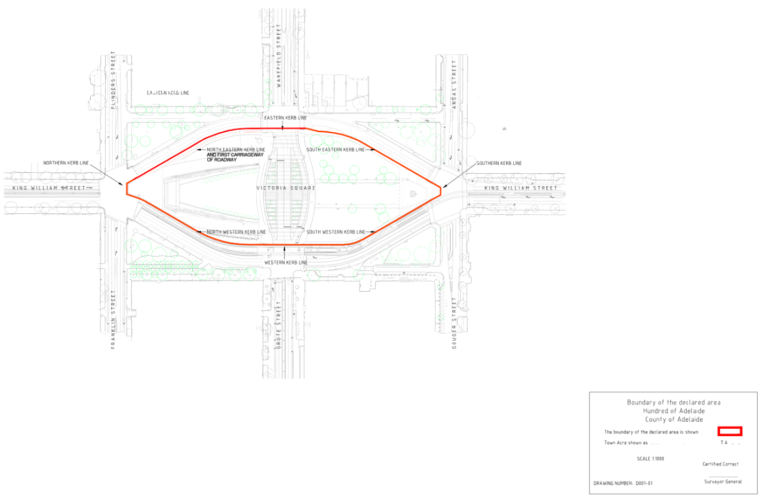

South Australian Motor Sport Act 1984

Section 26

Availability of Plans for Public Inspection

**Notice by the Minister**

PURSUANT to Section 26 of the *South Australian Motor Sport Act 1984*, I, the Minister to whom the administration of that Act has been committed, hereby designates the offices of the South Australian Motor Sport Board, Level 5, 182 Victoria Square Adelaide SA 5000, as the place at which may be inspected by members of the public plans of all works proposed to be carried out by the South Australian Motor Sport Board in relation to the event known as the ‘2023 Bridgestone World Solar Challenge’.

Dated: 10 September 2023

Hon Peter Bryden Malinauskas MP

Premier

## South Australian Motor Sport Regulations 2014

Regulation 10

Opening and Closing Time of the Declared Area

**Notice by the Board**

PURSUANT to Regulation 10 of the *South Australian Motor Sport Regulations 2014* I, Mark Warren, Chief Executive of the South Australian Motor Sport Board to whom the administration of that regulation has been committed, hereby fix the following opening and closing times in respect of declared areas for each day of the declared period for the 2023 Bridgestone World Solar Challenge:

|  |  |  |
| --- | --- | --- |
| **Day** | **Opening Time** | **Closing Time** |
| Thursday, 26 October 2023 | 8:00am | 10:00pm |
| Friday, 27 October 2023 | 8:00am | 10:00pm |
| Saturday, 28 October 2023 | 8:00am | 10:00pm |
| Sunday, 29 October 2023 | 8:00am | 10:00pm |

Dated: 5 September 2023

Mark Warren

Chief Executive, South Australian Motor Sport Board

# Local Government Instruments

## City of Playford

Change of Road Name—Ramsar Road, Munno Para

NOTICE is hereby given pursuant to Section 219 of the *Local Government Act 1999* of the change of road name of the section of road formerly known as The Parkway situated between Willow Drive and Union Avenue, to be changed to Ramsar Road, Munno Para, SA 5115 as per plan of division D129592.

Dated: 14 September 2023

Surya Prakash

Manager, Engineering Services

## City of Prospect

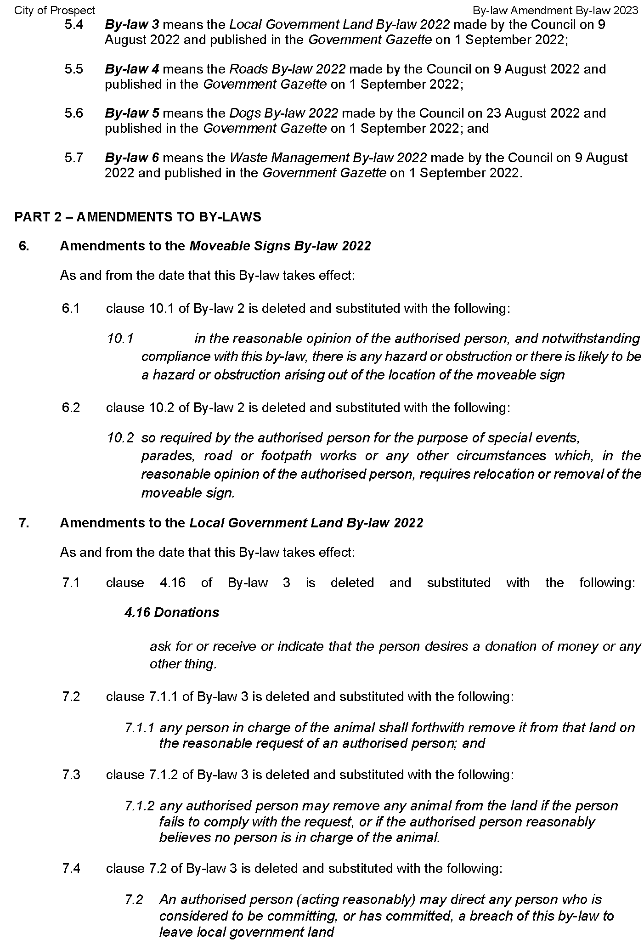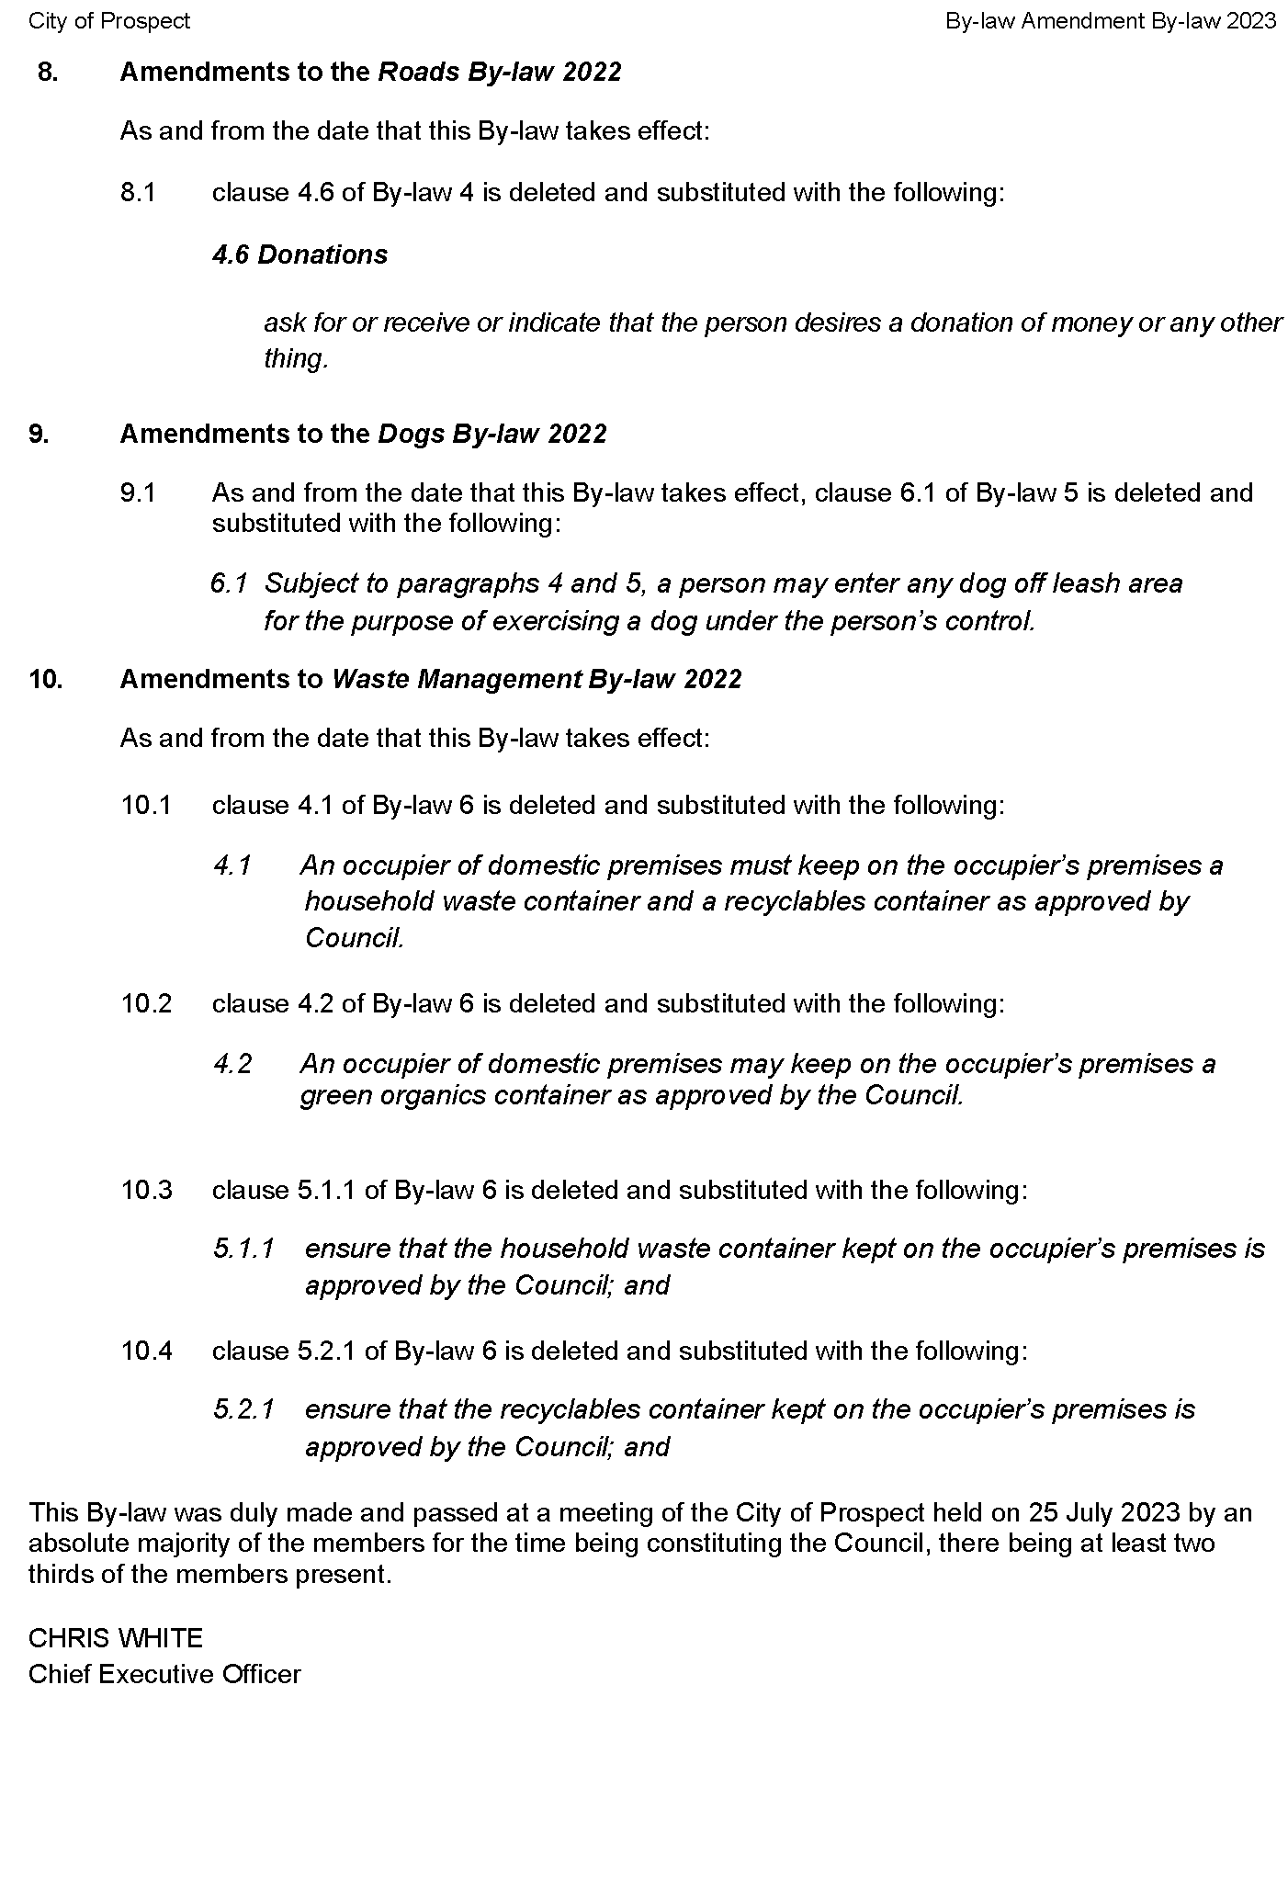

## City of Unley

## Renmark Paringa Council

Notice of classification of land as Community Land

The Renmark Paringa Council hereby gives notice that at its meeting on 25 July 2023, in exercise of its power under section 193(5) of the *Local Government Act 1999*, the Council resolved to classify the following parcels of land as community land:

The whole of the land comprised in:

1. Certificate of Title Volume 5403 Folio 346 located at 48 Para Street, RENMARK SA 5341;
2. Certificates of Title Volume 5485 Folio 700 located at 56 Nineteenth Street RENMARK SA 5341;
3. Certificate of Title Volume 5431 Folio 180 being Lot 12 Ral Ral Avenue RENMARK SA 5341;
4. Certificate of Title Volume 5673 Folio 963 being Lot 111 Twentieth Street, RENMARK SA 5341; and
5. Crown Record Volume 5747 Folio 55 located at Lot 105 Schmidt Drive, PARINGA SA 5340.

Further information regarding this matter can be obtained from contacting the Council by email at [council@renmarkparinga.sa.gov.au](mailto:council@renmarkparinga.sa.gov.au) or in person by attending at the Council’s offices at 61 Eighteenth Street, Renmark SA 5341

Tim Pfeiffer

Acting Chief Executive Officer

# Public Notices

## National Electricity Law

Notice of Draft Determination

The Australian Energy Market Commission (AEMC) gives notice under the National Electricity Law as follows:

Under s 99, the making of a draft determination and related draft rule on the *Amendment of the Market Price Cap, Cumulative Price Threshold and Administered Price Cap* proposal(Ref. ERC0353). Submissions must be received by **26 October 2023**.

Submissions can be made via the [AEMC’s website](https://www.aemc.gov.au/contact-us/lodge-submission). Before making a submission, please review the AEMC’s [privacy statement](https://www.aemc.gov.au/terms-use/terms-use-0) on its website, and consider the AEMC’s[Tips for making a submission](https://www.aemc.gov.au/our-work/changing-energy-rules-unique-process/making-rule-change-request/submission-tips). The AEMC publishes all submissions on its website, subject to confidentiality.

Documents referred to above are available on the AEMC’s website and are available for inspection at the AEMC’s office.

Australian Energy Market Commission

Level 15, 60 Castlereagh St

Sydney NSW 2000

Telephone: (02) 8296 7800

[www.aemc.gov.au](http://www.aemc.gov.au)

Dated: 14 September 2023

## Trustee Act 1936

Public Trustee

*Estates of Deceased Persons*

In the matter of the estates of the undermentioned deceased persons:

ABRAHAM Joan Helen late of 33 Catalina Road Elizabeth East Retired Shop Owner who died 11 July 2022

BOOTHBY Graham Edward late of 427 Codrington Road Mannum Of no occupation who died 28 February 2022

BUCKLEY Steven William late of 2 Heward street Whyalla Norrie Community Service Worker who died 20 January 2023

CHAMBERS Anne late of 23 Ann street Kalangadoo Retired School Teacher who died 19 February 2023

COOPER Ivoreen May late of 47 Eve Road Bellevue Heights Retired Librarian who died 15 Marh 2023

FITZROY Raymond late of 14 Frew Street Fullarton Retired Truck Driver who died 2 May 2023

FOWLER Ian Albert late of 6 Pridham Boulevard Aldinga Beach Retired Teacher who died 13 October 2022

HOGBEN Cathrine Penna late of 7A Wheaton Street South Plympton Retired Telephonist who died 24 May 2023

KINNAIRD Edith Ann Leslie late of 1 Warooka Drive Smithfield Of no occupation who died 26 April 2023

KURLAVICIUS Walburga late of 35 Washington Street Goolwa Of no occupation who died 13 February 2023

MARSHALL Katrina Maria late of 81 Edward Beck Drive Sheidow Park Retired Team Leader who died 13 April 2023

MCCLUSKEY John late of 100 Seaford Road Seaford Retired Bus Driver who died 16 March 2023

MCCULLAGH Raymond Geoffrey late of 80 Moseley Street Glenelg Retired Mechanic who died 22 April 2023

MCMAHON Robert Francis Xavier late of 148 Churchill Road Prospect Retired Farmer who died 4 January 2022

NORTON Betty Dawn late of 740 Torrens Road Rosewater Retired Dressmaker who died 13 June 2023

NORTON Cecil Vernon late of 740 Torrens Road Rosewater Retired Foreman Carpenter who died 24 June 2023

REILLY Peter Francis late of 591B Main North Road Elizabeth North Retired Public Servant who died 27 May 2023

SCOTT Audrey Marion late of 324 Military Road Semaphore Park Of no occupation who died 26 April 2023

TRASY Michael Janos late of 185 Ral Ral Avenue Renmark Retired Supervisor who died 12 February 2023

WHITEHEAD Leah Dora late of 740 Torrens Road Rosewater Of no occupation who died 17 March 2023

Notice is hereby given pursuant to the *Trustee Act 1936*, the *Inheritance (Family Provision) Act 1972* and the *Family Relationships Act 1975* that all creditors, beneficiaries, and other persons having claims against the said estates are required to send, in writing, to the office of Public Trustee at GPO Box 1338, Adelaide SA 5001, full particulars and proof of such claims, on or before 13 October 2023 otherwise they will be excluded from the distribution of the said estate; and notice is also hereby given that all persons indebted to the said estates are required to pay the amount of their debts to the Public Trustee or proceedings will be taken for the recovery thereof; and all persons having any property belonging to the said estates are forthwith to deliver same to the Public Trustee.

Dated: 14 September 2023

N. S. Rantanen

Public Trustee

**Notice Submission**

The South Australian Government Gazette is published each Thursday afternoon.

Notices must be emailed by 4 p.m. Tuesday, the week of publication.

Submissions are formatted per the gazette style and a proof will be supplied prior to publication, along with a quote if applicable. Please allow one day for processing notices.

Alterations to the proof must be returned by 4 p.m. Wednesday.

**Gazette notices must be submitted as Word files, in the following format:**

• Title—the governing legislation

• Subtitle—a summary of the notice content

• Body—structured text, which can include numbered lists, tables, and images

• Date—day, month, and year of authorisation

• Signature block—name, role, and department/organisation authorising the notice

**Please provide the following information in your email:**

• Date of intended publication

• Contact details of the person responsible for the notice content

• Name and organisation to be charged for the publication—Local Council and Public notices only

• Purchase order, if required—Local Council and Public notices only

Email: [governmentgazettesa@sa.gov.au](mailto:governmentgazettesa@sa.gov.au)

Phone: (08) 7109 7760

Website: [www.governmentgazette.sa.gov.au](http://www.governmentgazette.sa.gov.au)

**All instruments appearing in this gazette are to be considered official, and obeyed as such**

Printed and published weekly by authority of M. Dowling, Government Printer, South Australia

$8.55 per issue (plus postage), $430.00 per annual subscription—GST inclusive

Online publications: [www.governmentgazette.sa.gov.au](http://www.governmentgazette.sa.gov.au)