No. 73 p. 3291
THE SOUTH AUSTRALIAN
GOVERNMENT GAZETTE
Published by Authority

Adelaide, Thursday, 28 September 2023

Contents

Governor’s Instruments
Appointments 3292
Regulations—
Fire and Emergency Services (Permits) Amendment
Regulations 2023—No. 98 of 2023 3293
State Government Instruments
Explosives Act 1936 3296
Fisheries Management (General) Regulations 2017 3296
Fisheries Management (Prawn Fisheries) Regulations 2017 3296
Fisheries Management Act 2007 3297
Gambling Administration Act 2019 3297
Geographical Names Act 1991 3367
Housing Improvement Act 2016 3369
Justices of the Peace Act 2005 3370
Land Acquisition Act 1969 3370
Major Events Act 2013 3372
Mental Health Act 2009 3374
Mining Act 1971 3374
Passenger Transport Act 1994 3387
Petroleum and Geothermal Energy Act 2000 3387
Public Finance and Audit Act 1987 3388
Local Government Instruments
District Council of Mount Remarkable 3393
Public Notices
Trustee Act 1936 3397

Governor’s Instruments

APPOINTMENTS
Department of the Premier and Cabinet
Adelaide, 28 September 2023
His Excellency the Governor's Deputy in Executive Council has been pleased to appoint the undermentioned to the Lifetime Support Authority of South Australia Board, pursuant to the provisions of the Motor Vehicle Accidents (Lifetime Support Scheme) Act 2013:
Member: from 8 October 2023 until 7 October 2026
Nicole Sykes
Clare Sian Goodson
Member: from 8 October 2023 until 7 April 2024
Melinda Anne O'Leary
Chair: from 8 October 2023 until 7 April 2024
Melinda Anne O'Leary
By command,
Anastasios Koutsantonis MP
For Premier
T&F23/073CS

Department of the Premier and Cabinet
Adelaide, 28 September 2023
His Excellency the Governor's Deputy in Executive Council has been pleased to appoint the Honourable Nicholas David Champion, MP, as Acting Minister for Infrastructure and Transport and Acting Minister for Energy and Mining from 1 October 2023 until 10 October 2023 inclusive, during the absence of the Honourable Anastasios Koutsantonis, MP.
By command,
Anastasios Koutsantonis MP
For Premier
23MIT0031CS

Department of the Premier and Cabinet
Adelaide, 28 September 2023
His Excellency the Governor's Deputy in Executive Council has been pleased to appoint the Honourable Dr Susan Elizabeth Close, MP as Acting Minister for Health and Wellbeing from 3 October 2023 until 13 October 2023 inclusive, during the absence of the Honourable Christopher James Picton, MP.
By command,
Anastasios Koutsantonis MP
For Premier
HEAC-2023-00050

Department of the Premier and Cabinet
Adelaide, 28 September 2023
His Excellency the Governor's Deputy in Executive Council has been pleased to appoint Deborah Ann Black and Peter de Cure as Members of the Remuneration Tribunal for a term commencing on 2 October 2023 and expiring on 31 December 2023 - pursuant to the provisions of the Remuneration Act 1990.
By command,
Anastasios Koutsantonis MP
For Premier
DPC23/060CS

Department of the Premier and Cabinet
Adelaide, 28 September 2023
His Excellency the Governor's Deputy in Executive Council has been pleased to appoint Phuong My Chau as the Commissioner of the Lotteries Commission of South Australia for a term commencing on 29 September 2023 and expiring on 2 July 2026, or whenever Ms Chau ceases to hold an executive level position in the Department of Treasury and Finance, whichever is the earlier - pursuant to the provisions of the State Lotteries Act 1966.
By command,
Anastasios Koutsantonis MP
For Premier
T&F23/064CS

Regulations
South Australia

Fire and Emergency Services (Permits) Amendment Regulations 2023
under the Fire and Emergency Services Act 2005

Contents
Part 1—Preliminary
1 Short title
2 Commencement
Part 2—Amendment of Fire and Emergency Services Regulations 2021
3 Amendment of regulation 3—Interpretation
4 Amendment of regulation 29A—Certain acts to constitute lighting and maintaining fire
5 Amendment of regulation 31—Permits
6 Amendment of regulation 39—Gas welding, soldering, metal cutting, grinding and abrasion
7 Amendment of regulation 54—Prescribed activity
8 Amendment of regulation 70—Expiation of offences
9 Amendment of Schedule 9—Permit authorising person to light or maintain fire during fire danger season
10 Amendment of Schedule 10—Permit authorising person to light or maintain fire in open air contrary to terms of total fire ban

Part 1—Preliminary
1—Short title
These regulations may be cited as the Fire and Emergency Services (Permits) Amendment Regulations 2023.
2—Commencement
These regulations come into operation on the day on which they are made.
Part 2—Amendment of Fire and Emergency Services Regulations 2021
3—Amendment of regulation 3—Interpretation
Regulation 3(1)—after SA Water insert:
welding means all forms of welding, including gas, electrical and chemical welding.
4—Amendment of regulation 29A—Certain acts to constitute lighting and maintaining fire
Regulation 29A(1)(a)—delete "gas"
5—Amendment of regulation 31—Permits
Regulation 31(10)(b) and (c)—delete paragraphs (b) and (c) and substitute:
(b) the authorised officer must send a copy of the permit to the permit holder in such manner as is determined by the Chief Officer; and
(c) if the permit authorises the permit holder to light or maintain a fire contrary to the terms of a total fire ban, the authorised officer must give notice of the issue of the permit to the regional officer in whose region the fire will be lighted, and send a copy of the permit to that regional officer, in such manner as is determined by the Chief Officer.
6—Amendment of regulation 39—Gas welding, soldering, metal cutting, grinding and abrasion
(1) Regulation 39, heading—delete "Gas welding" and substitute:
Welding
(2) Regulation 39(1)(a)—delete "gas"
(3) Regulation 39—after subregulation (2) insert:
(2a) Subregulation (2) does not apply to a person who operates an appliance referred to in subregulation (1) in the open air in accordance with a permit issued under section 81 of the Act.
7—Amendment of regulation 54—Prescribed activity
Regulation 54(g)—delete "gas"
8—Amendment of regulation 70—Expiation of offences
Regulation 70(1), table, item relating to "Section 89", (d)—delete "gas"
9—Amendment of Schedule 9—Permit authorising person to light or maintain fire during fire danger season
Schedule 9—delete "(tick appropriate purpose):
— for the purpose of burning off land;
— for another purpose: [specify the purpose]" and substitute:
for the purpose of: [specify the purpose]
Note—
Certain acts constitute lighting and maintaining fire—see regulation 29A.
10—Amendment of Schedule 10—Permit authorising person to light or maintain fire in open air contrary to terms of total fire ban
Schedule 10—after "Pursuant to section 81 of the Fire and Emergency Services Act 2005 this permit is issued for the purpose of [insert purpose]." insert:
Note—
Certain acts constitute lighting and maintaining fire—see regulation 29A.

Editorial note—
As required by section 10AA(2) of the Legislative Instruments Act 1978, the Minister has certified that, in the Minister's opinion, it is necessary or appropriate that these regulations come into operation as set out in these regulations.
Made by the Governor’s Deputy
with the advice and consent of the Executive Council
on 28 September 2023
No 98 of 2023

State Government Instruments

Explosives Act 1936
Appointment
I, Kyam Joseph Maher, Minister for Industrial Relations and Public Sector in and for the State of South Australia, hereby appoint the following persons as an Inspector of explosives for the purposes of the Explosives Act 1936 pursuant to section 9(1) of that Act:
- Matthew John GIBSON
- Sayaka HARA
- Clare Margaret JANES
Dated: 12 September 2023
Hon Kyam Maher MLC
Minister for Industrial Relations and Public Sector

Fisheries Management (General) Regulations 2017
Regulation 23B
Taking of Murray Cod—SA Water maintenance operations—Treatment plant tanks at Palmer
For the purpose of regulation 23B of the Fisheries Management (General) Regulations 2017 regarding the taking of Murray Cod in certain waters, - I, Prof Gavin Begg, Executive Director, Fisheries and Aquaculture, delegate of the Minister for Primary Industries and Regional Development, make the following determination.
- Mr Garry Warrick may take Murray Cod (Maccullochella peelii) from the SA Water treatment plant tanks in Palmer within the waters of the Murray River proper but only in order to translocate them to the River Murray, Mannum.
- The taking of Murray Cod under this determination may only occur where consistent with Ministerial exemption ME9903277 and Ministerial permit MP0218.
- Murray Cod taken from the SA Water treatment plant tanks at Palmer must be translocated as soon as possible to the Murray River, Mannum consistent with Ministerial exemption ME9903277 and Ministerial permit MP0218.
- Murray Cod taken pursuant to this determination must not be sold.
- The activity under this determination may only occur for a period of twelve months from the date of signature.
Dated: 22 September 2023
Prof. Gavin Begg
Executive Director
Fisheries and Aquaculture
Delegate of the Minister for Primary Industries and Regional Development

Fisheries Management (Prawn Fisheries) Regulations 2017
Temporary Prohibition of Fishing Activities in the Spencer Gulf Prawn Fishery
TAKE NOTICE that pursuant to regulation 10 (a) of the Fisheries Management (Prawn Fisheries) Regulations 2017, the activities of the class specified in Schedule 1 are prohibited in the waters of the Spencer Gulf Prawn Fishery during the period specified in Schedule 2 unless this notice is varied or revoked.
Schedule 1
The act of taking, or an act preparatory to, or involved, in the taking of King Prawns (Melicertus latisulcatus) pursuant to a Spencer Gulf Prawn Fishery Licence.
Schedule 2
From 1800hrs on the 30 September 2023 to 1800hrs on the 30 September 2024.
Dated: 22 September 2023
Steve Shanks
A/Prawn Fisheries Manager
Delegate of the Minister for Primary Industries and Regional Development

Fisheries Management (Prawn Fisheries) Regulations 2017
Temporary Prohibition of Fishing Activities in the West Coast Prawn Fishery
TAKE NOTICE that pursuant to regulation 10 (a) of the Fisheries Management (Prawn Fisheries) Regulations 2017, the activities of the class specified in Schedule 1 are prohibited in the waters of the West Coast Prawn Fishery during the period specified in Schedule 2 unless this notice is varied or revoked.
Schedule 1
The act of taking, or an act preparatory to, or involved, in the taking of King Prawns (Melicertus latisulcatus) pursuant to a West Coast Prawn Fishery Licence.
Schedule 2
From 1800hrs on the 1 November 2023 to 1800hrs on the 1 November 2024.
Dated: 22 September 2023
Steve Shanks
A/Prawn Fisheries Manager
Delegate of the Minister for Primary Industries and Regional Development

Fisheries Management Act 2007
Section 115
Ministerial Exemption ME9903277
TAKE NOTICE that pursuant to section 115 of the Fisheries Management Act 2007 (the Act), Garry Warrick, of 1979 Kingston road New Residence 5333 (the ‘exemption holder’) is exempt from clauses 63, 64 and 113 of schedule 6 of the Fisheries Management (General) Regulations 2017 but only insofar as he may capture Murray Cod and Golden Perch in the waters specified in Schedule 1, using the gear specified in Schedule 2, (the 'exempted activity'), subject to the conditions specified in Schedule 3, valid from the date of this notice for a period of 12 months, unless varied or revoked earlier.
Schedule 1
- The SA Water Treatment Plant tanks in Palmer, South Australia.
Schedule 2
- Hand net with a hoop that does not exceed 1 metre in diameter as defined under the Fisheries Management (General) Regulations) 2017.
Schedule 3
- Fish captured under this exemption must not be sold.
- All native fish captured must be translocated as soon as possible to the River Murray, Mannum.
- Any equipment used to collect and hold fish during the activity must be decontaminated prior to and after undertaking the exempted activities.
- While engaging in the exempted activity, the exemption holder must be in possession of a copy of this exemption. Such exemption must be produced to a Department of Primary Industries and Regions (PIRSA) Fisheries Officer if requested.
- The exemption holder must not contravene or fail to comply with the Fisheries Management Act 2007 or any regulations made under that Act, except where specifically exempted by this notice.
- Noxious fish captured during the exempted activity must not be returned to the water and must be humanely destroyed.
- At least 1 hour before conducting activities under this exemption, the exemption holder must contact the PIRSA Fishwatch on 1800 065 522 and answer a series of questions about the exempted activity. The caller will need to have a copy of this notice in their possession at the time of making the call and be able to provide information about the area and time of the exempted activity, the vehicles and/or boats involved, the number of persons assisting with undertaking the exempted activity and other related questions.
This notice does not purport to override the provisions or operation of any other Act including, but not limited to, the River Murray Act 2003. The exemption holder must comply with any relevant regulations, permits, requirements and directions from the Department for Environment and Water when undertaking activities within a specially protected area.
Dated: 22 September 2023
Prof. Gavin Begg
Executive Director
Fisheries and Aquaculture
Delegate of the Minister for Primary Industries and Regional Development

Gambling Administration Act 2019
South Australia
Authorised Betting Operations Gambling Code of Practice Variation Notice 2023 (No.2)
under section 15 of the Gambling Administration Act 2019
1—Short title
This notice may be cited as the Authorised Betting Operations Gambling Code of Practice Variation Notice 2023 (No.2)
(Variation Notice).
2—Commencement
This Variation Notice comes into operation on 31 March 2024.
3—Variation of existing Authorised Betting Operations Gambling Code of Practice
This Variation Notice will have the effect that the Authorised Betting Gambling Code of Practice prescribed by this notice will supersede the Authorised Betting Gambling Code of Practice in effect prior to 31 March 2024.
4—Authorised Betting Operations Gambling Code of practice
The Authorised Betting Gambling Code of Practice set out in this notice is varied under s15 of the Gambling Administration Act 2019, for the purposes of the Authorised Betting Operations Act 2000.
Dated: 28 September 2023
Dini Soulio
Liquor and Gambling Commissioner

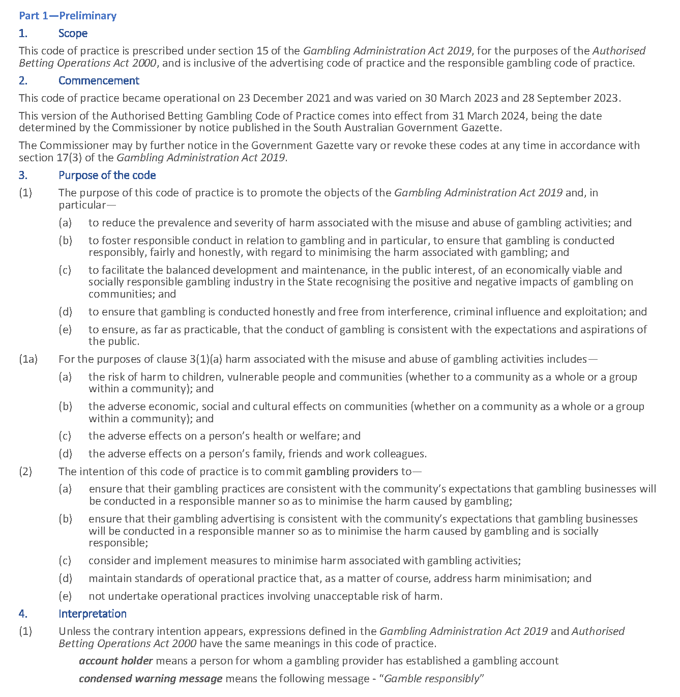
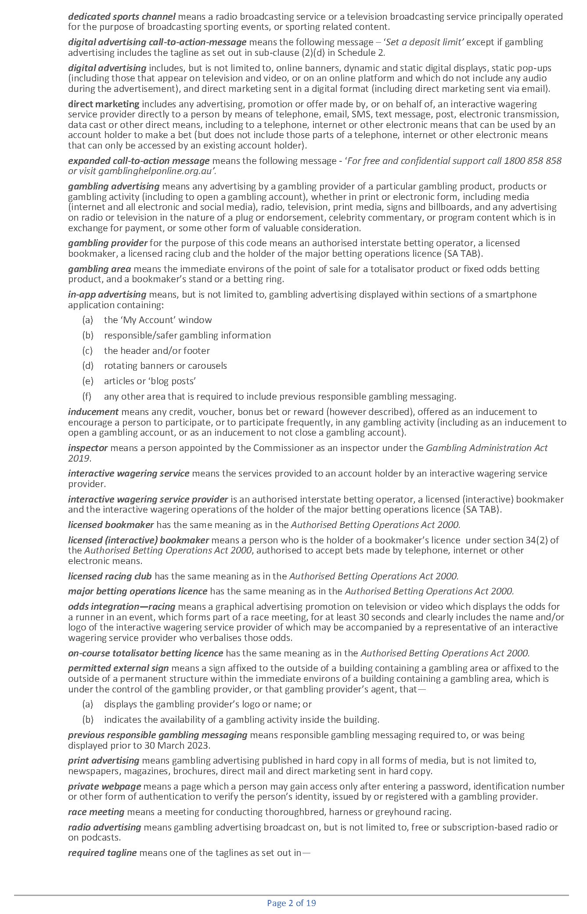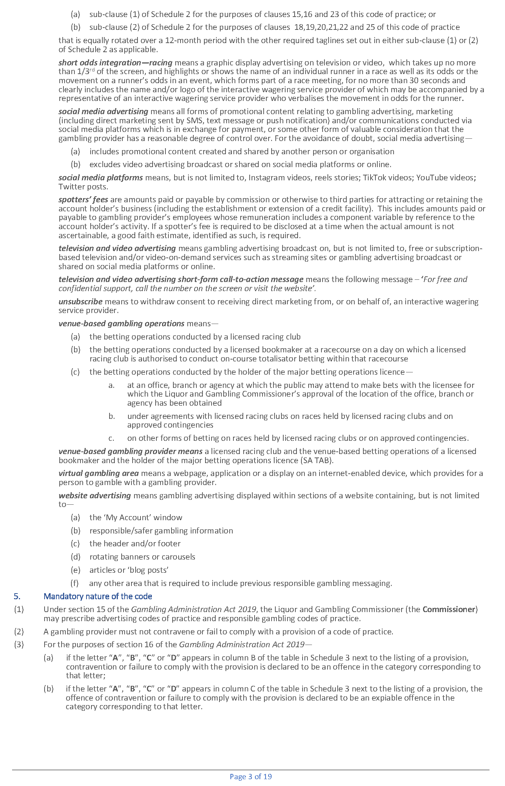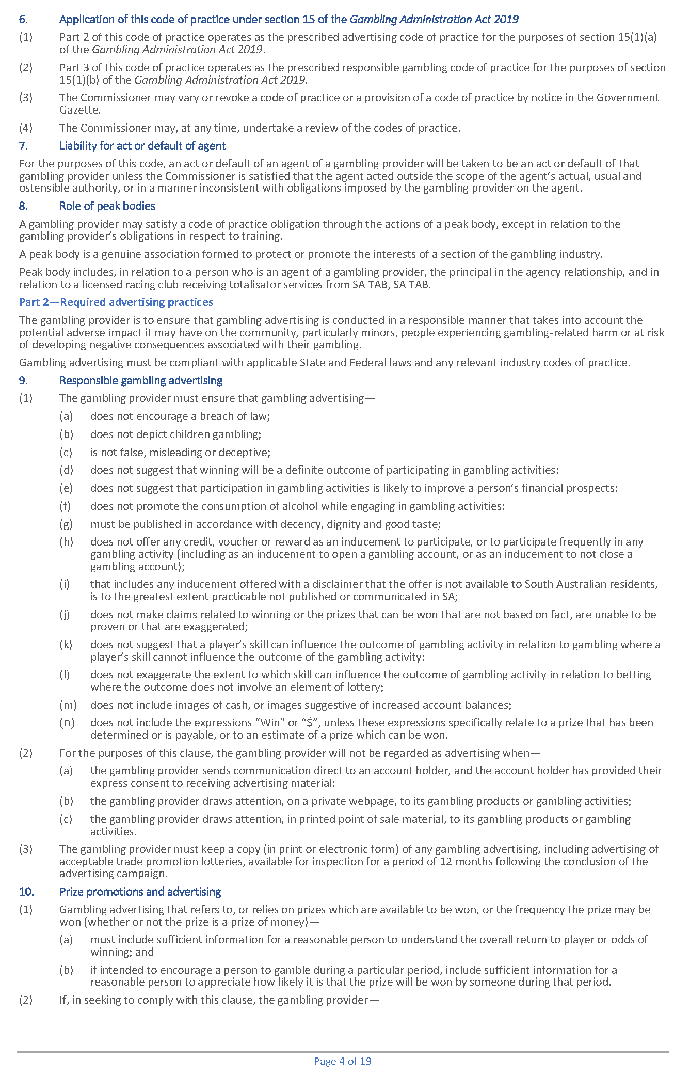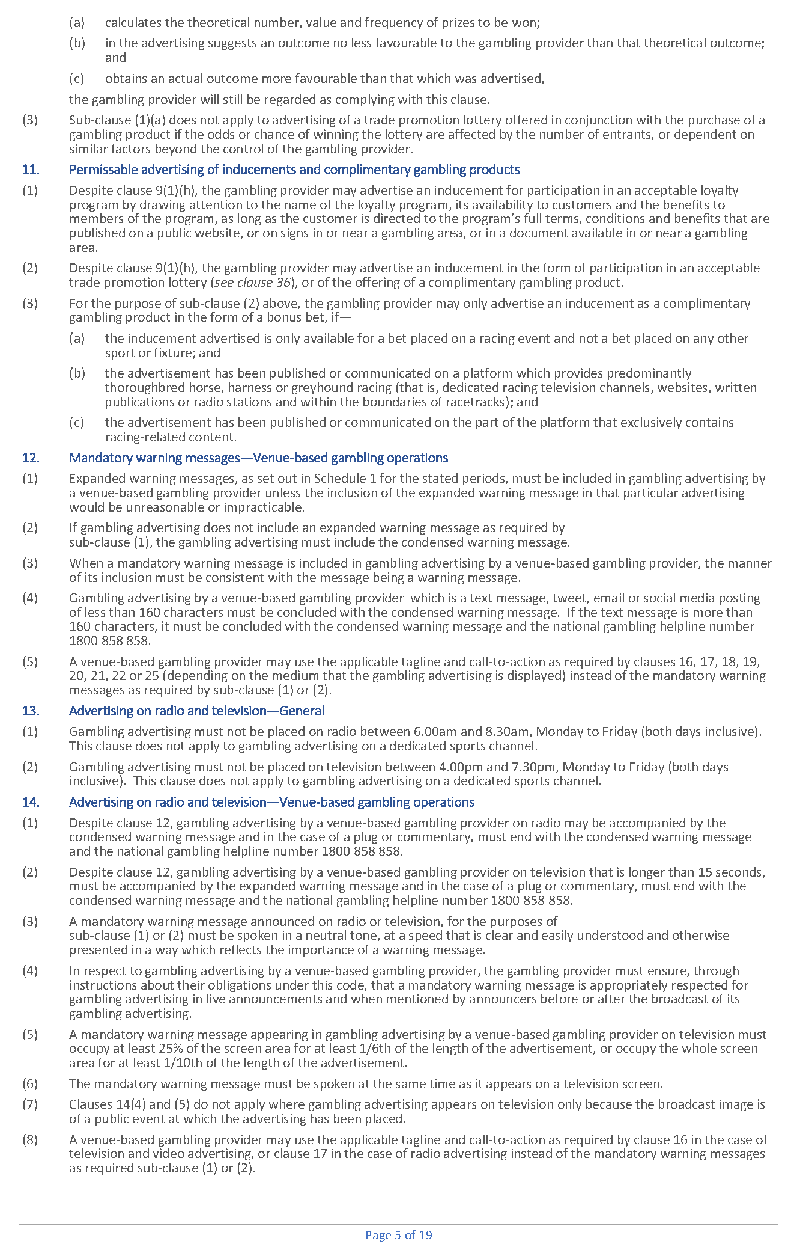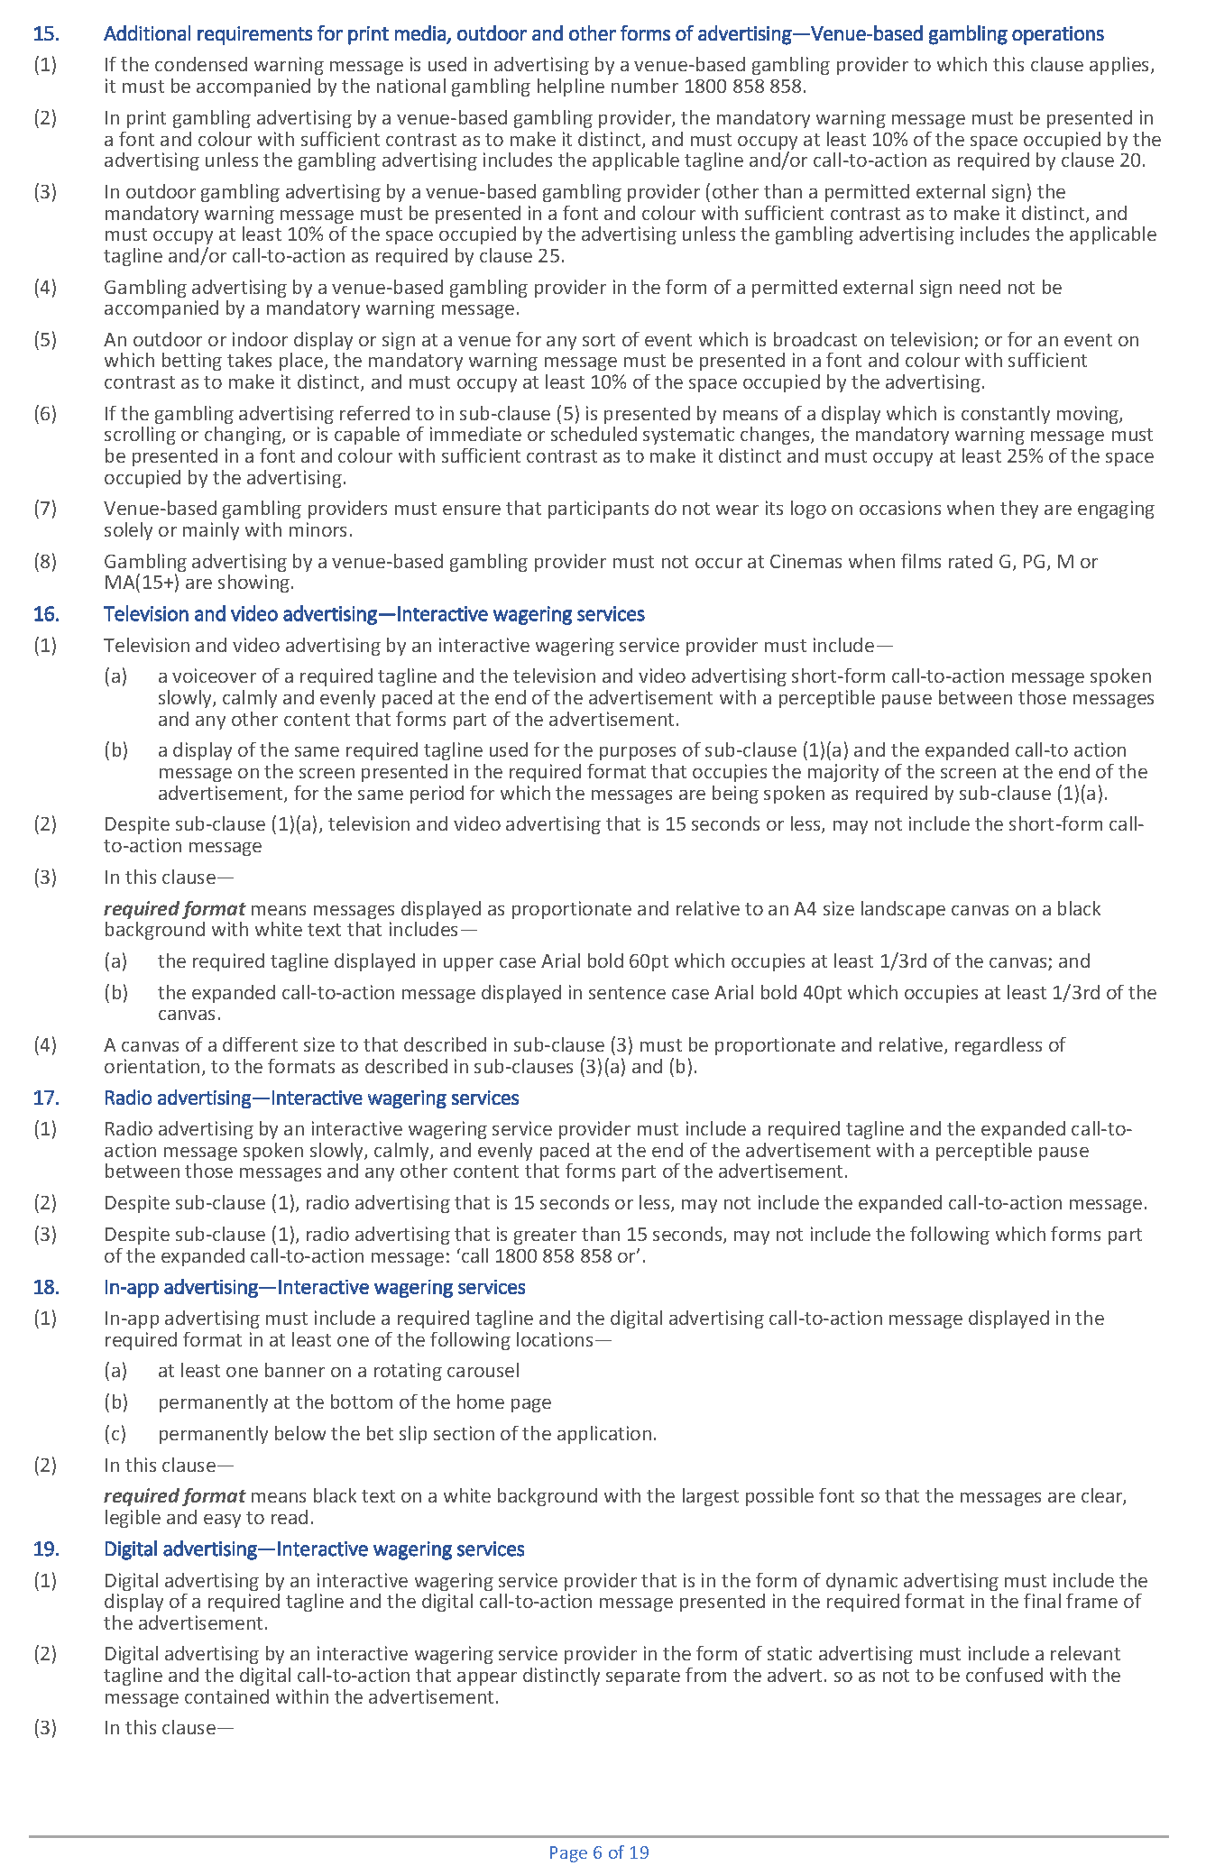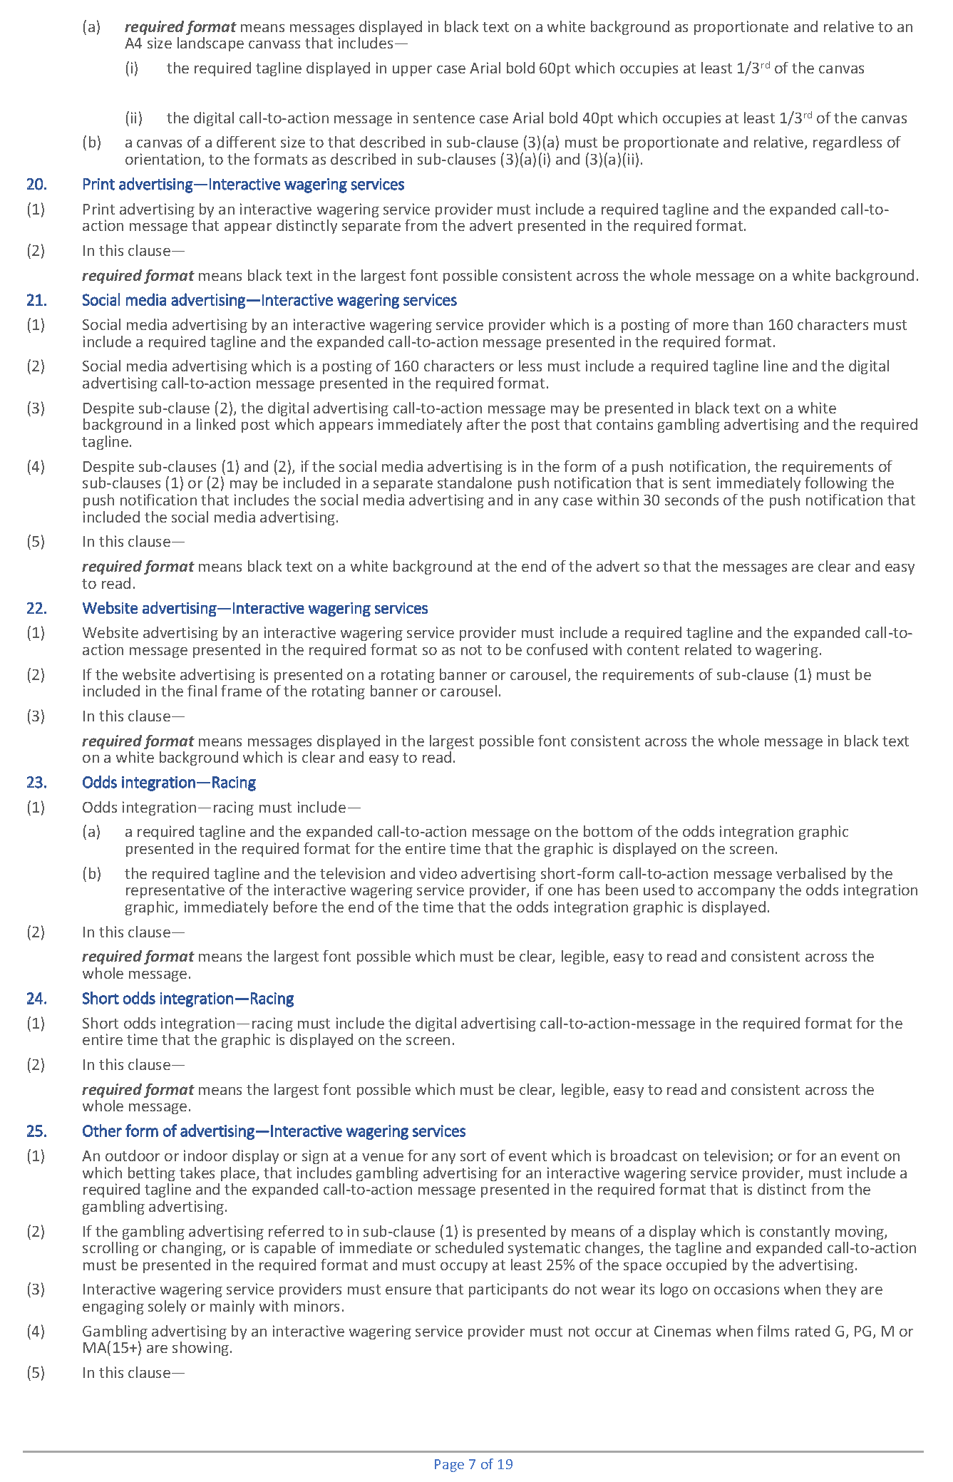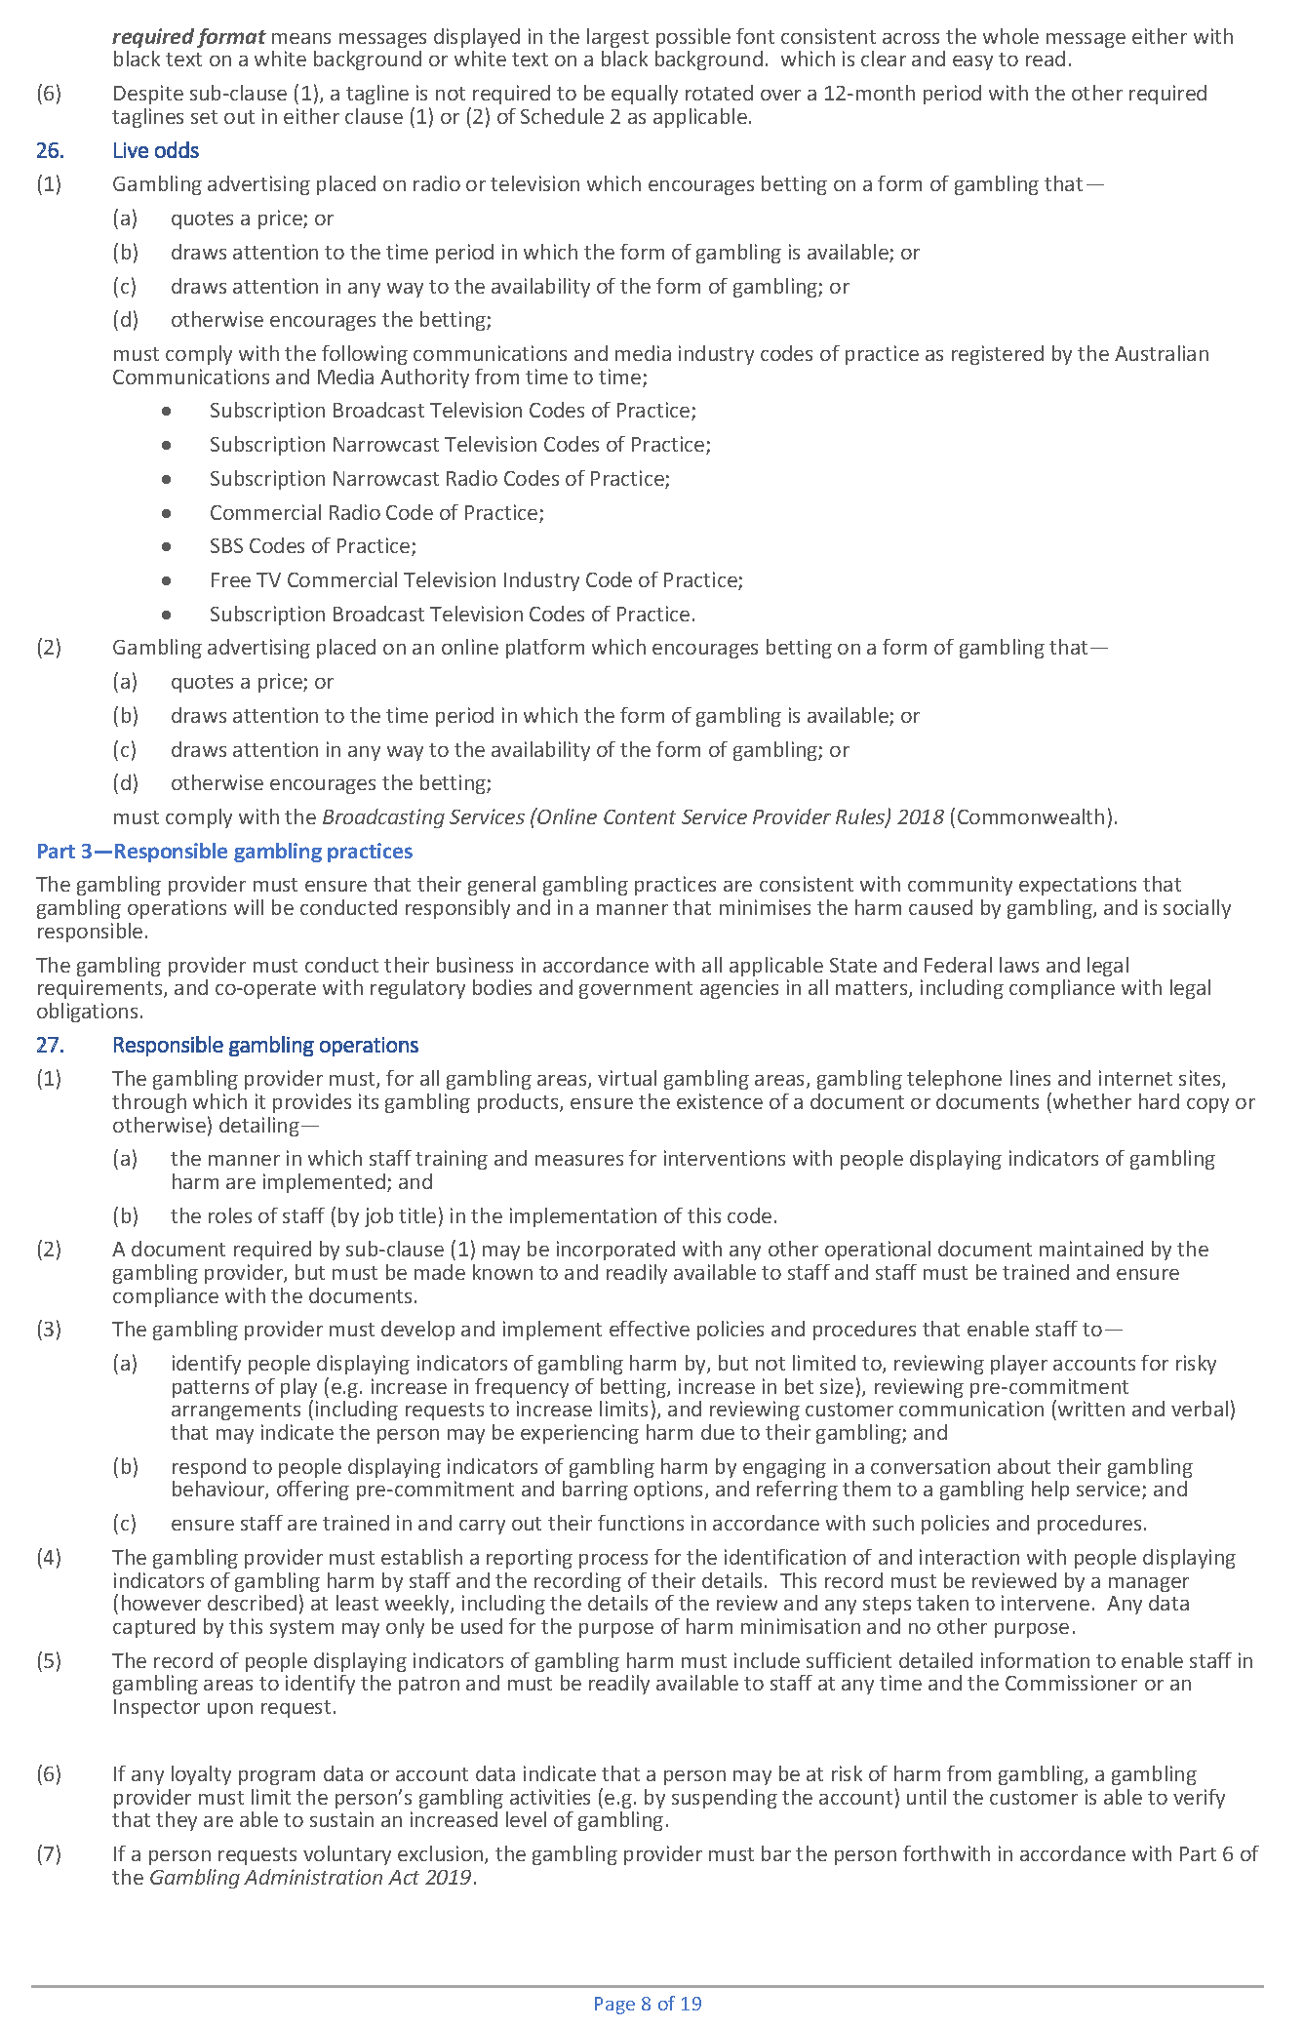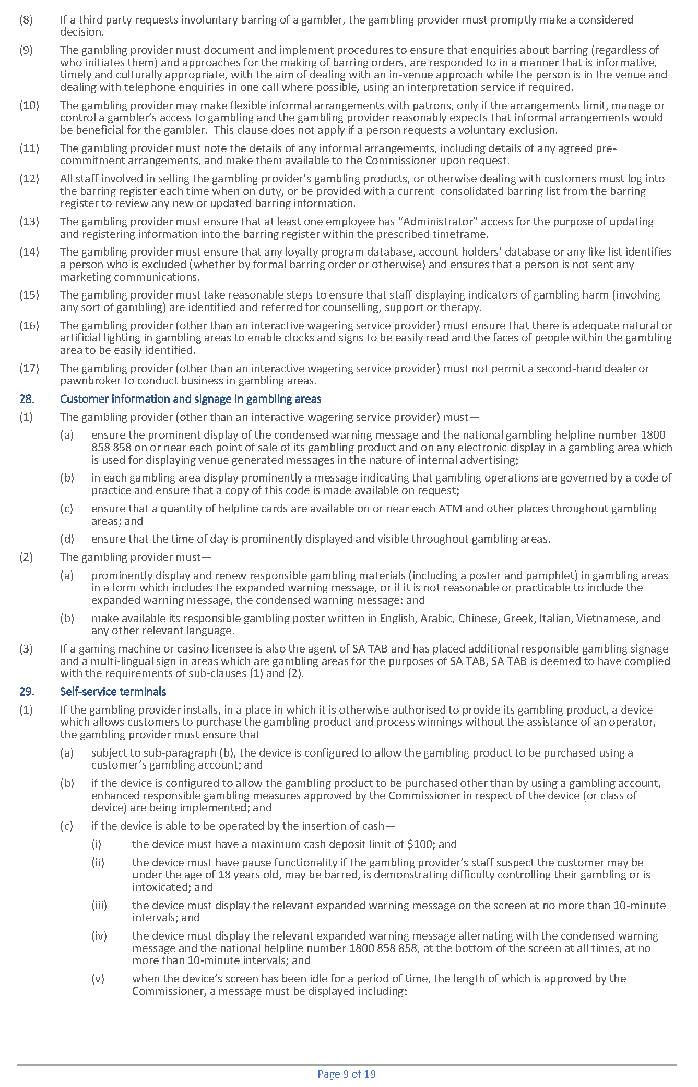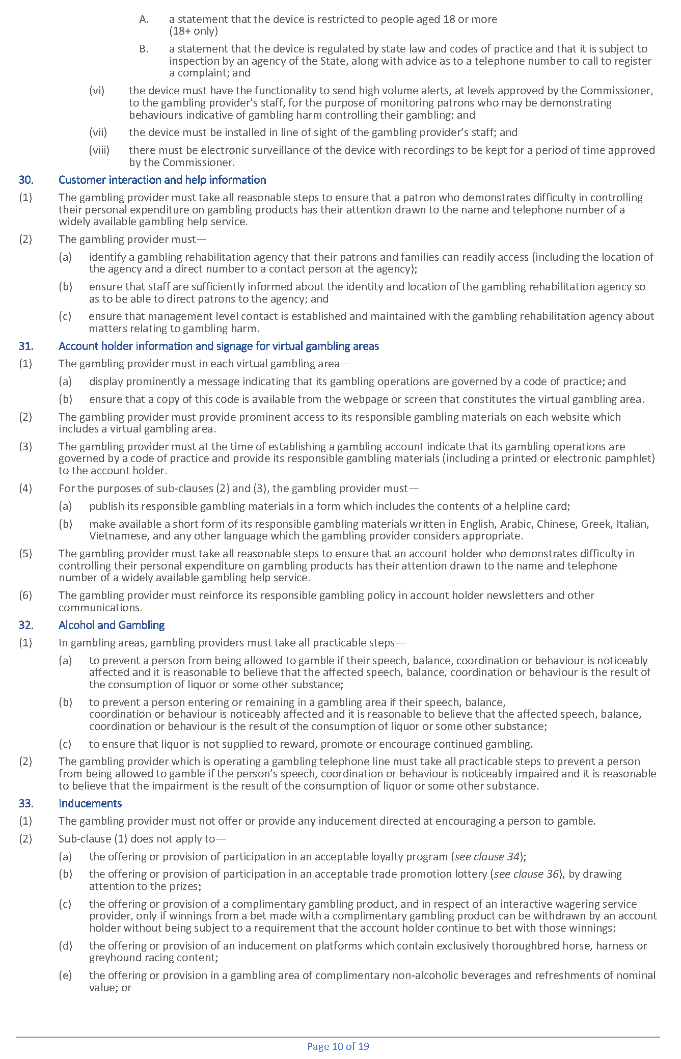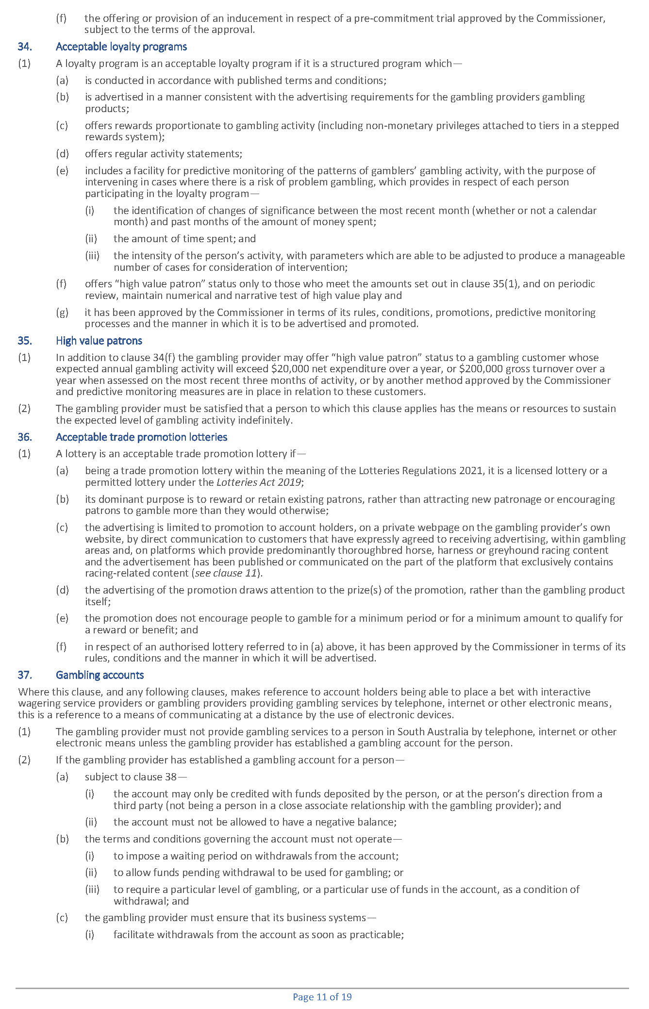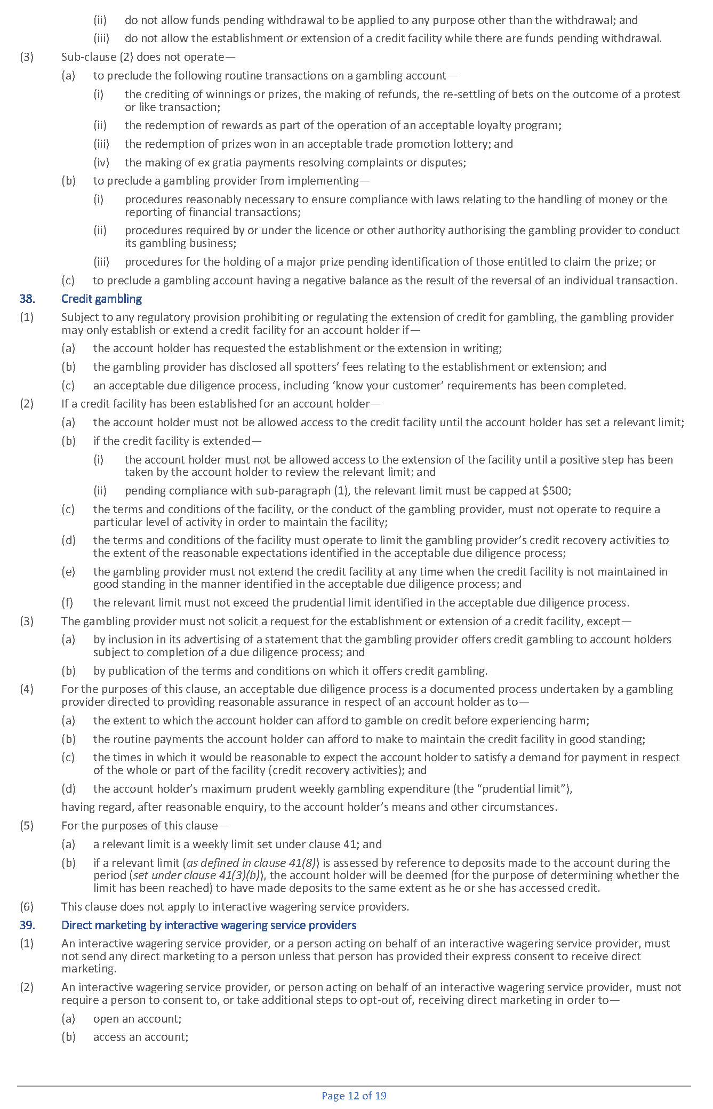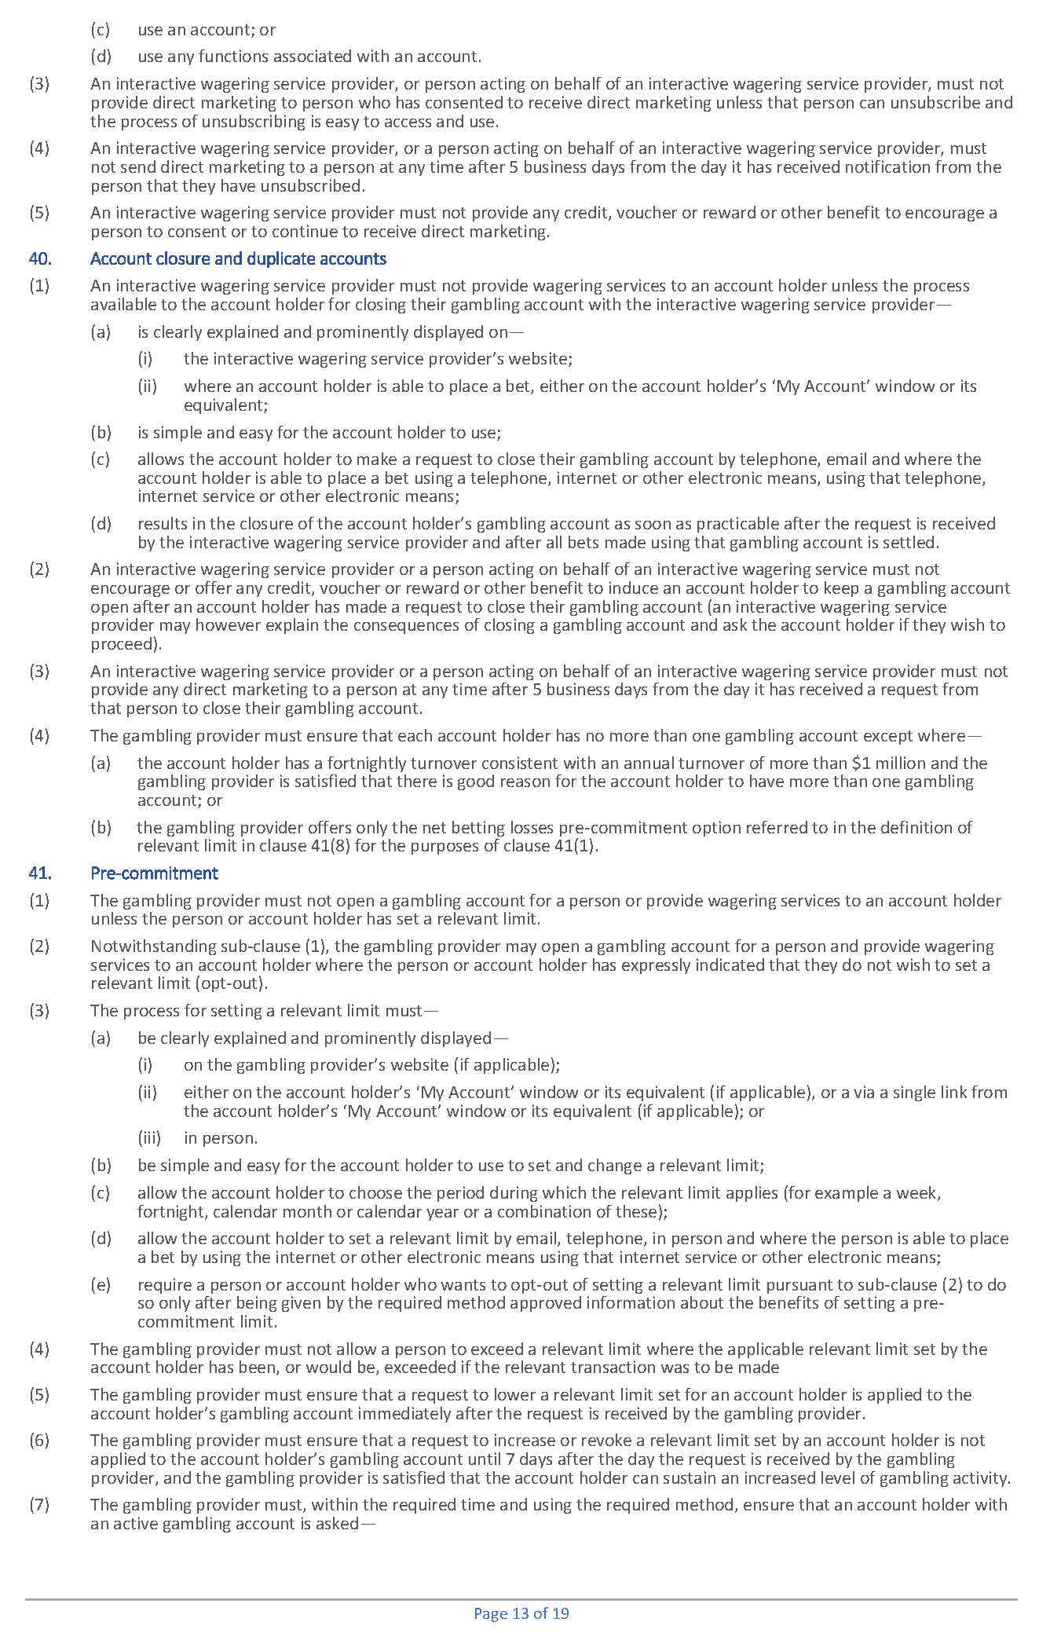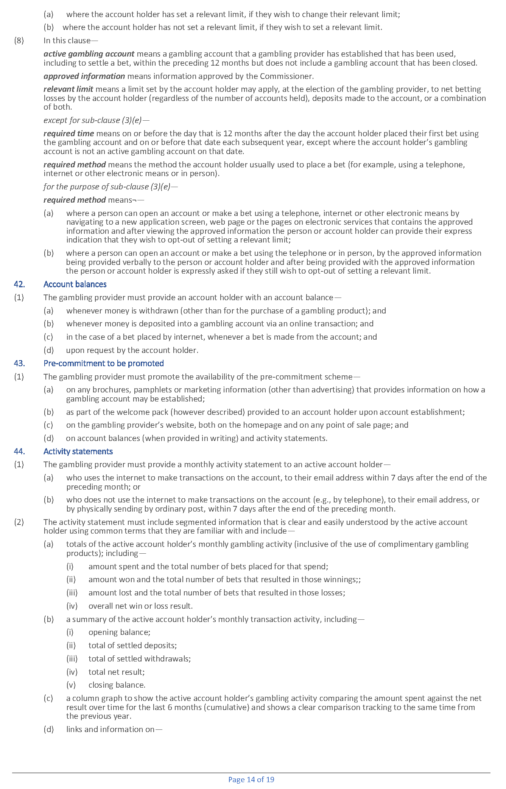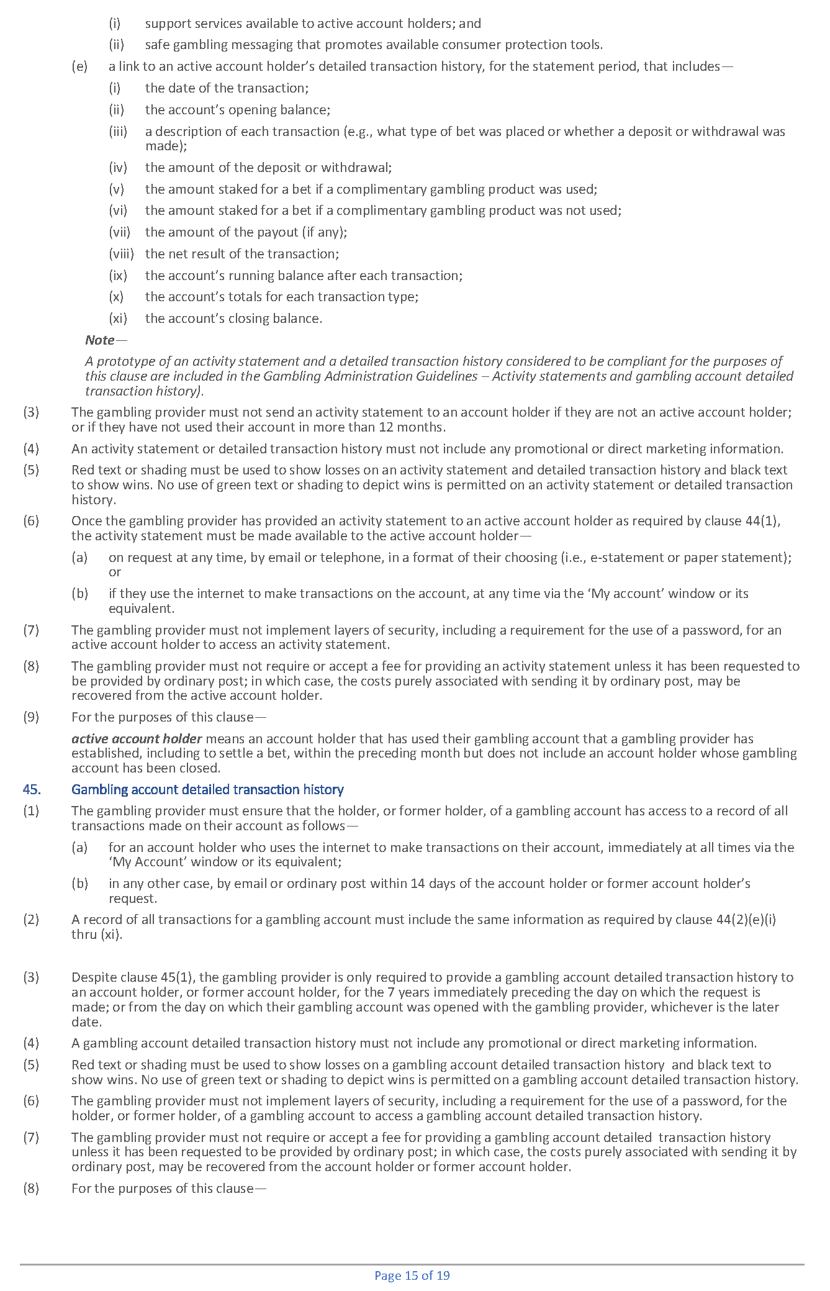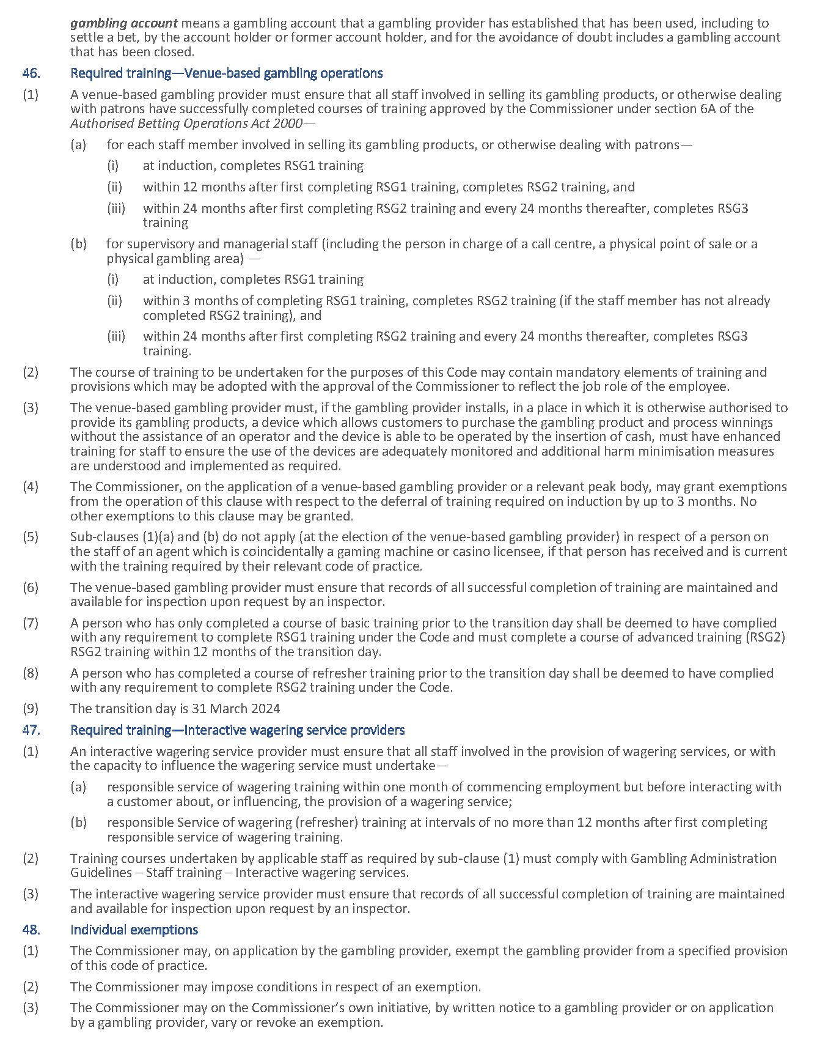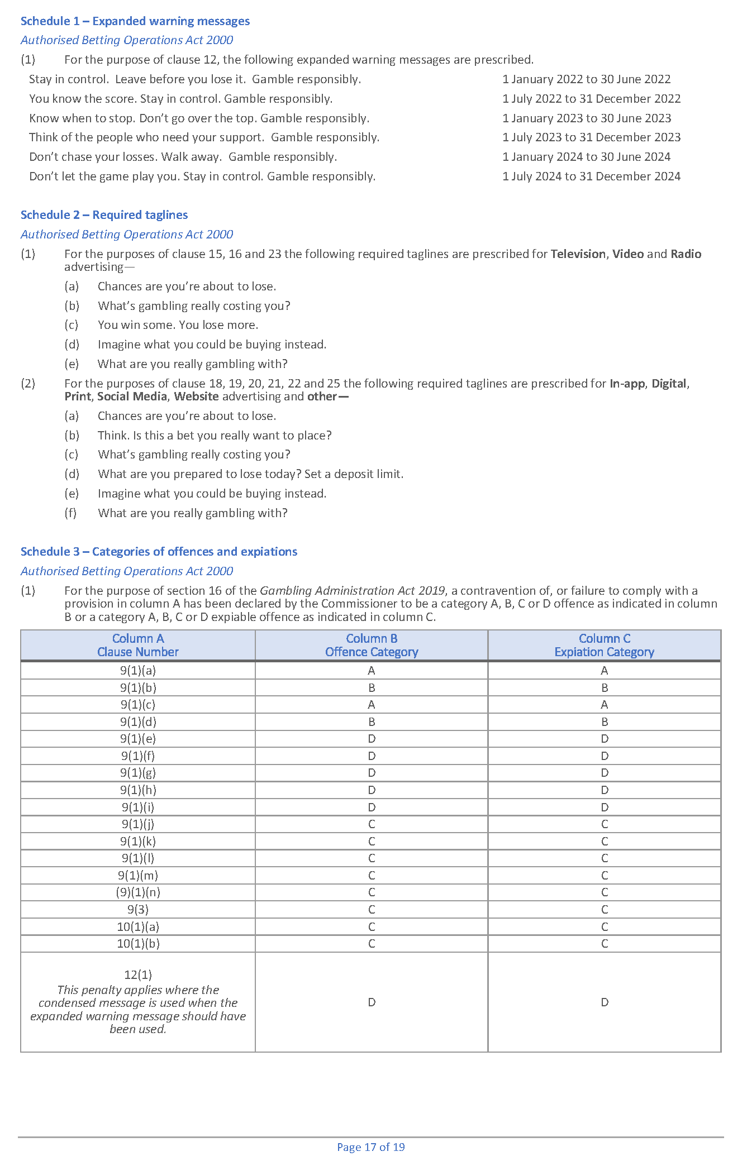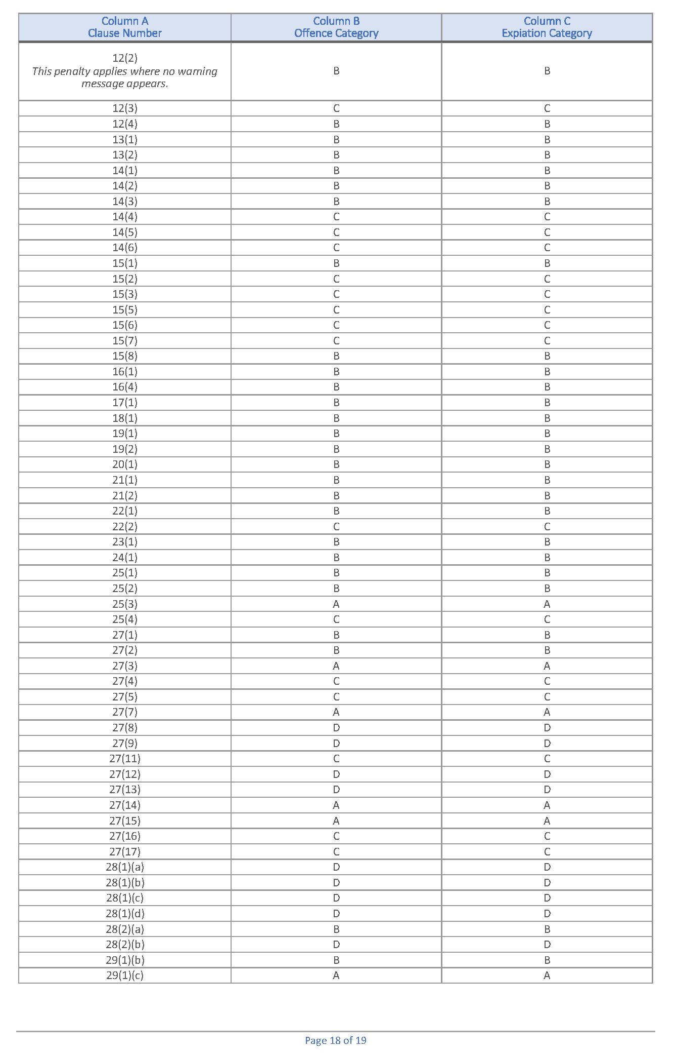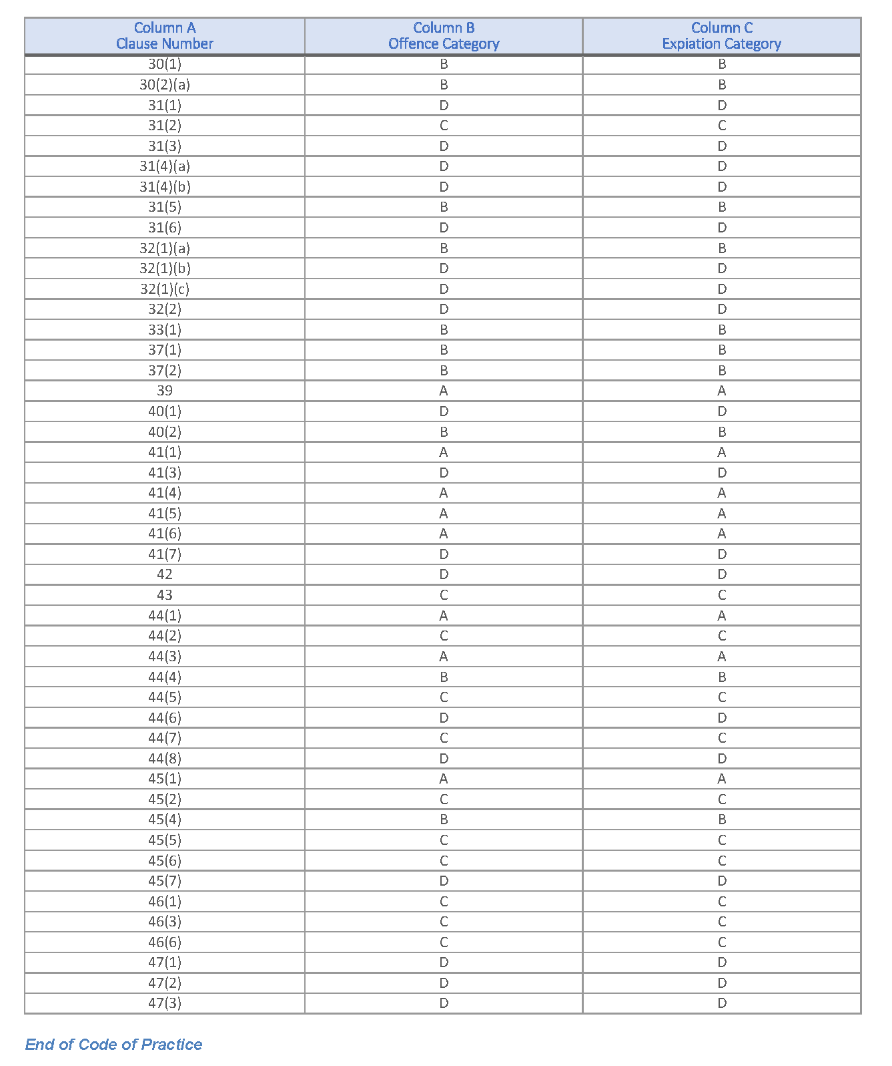

Gambling Administration Act 2019
South Australia
Casino Gambling Code of Practice Variation Notice 2023 (No 2)
under section 15 of the Gambling Administration Act 2019
1—Short title
This notice may be cited as the Casino Gambling Code of Practice Variation Notice 2023 (No 2) (Variation Notice).
2—Commencement
This Variation Notice comes into operation on 31 March 2024.
3—Variation of existing Casino Gambling Code of Practice
This Variation Notice will have the effect that the Casino Gambling Code of Practice prescribed by this notice will supersede the Casino Gambling Code of Practice in effect prior to 31 March 2024.
4—Casino Gambling Code of Practice
The Casino Gambling Code of Practice set out in this notice is varied under s15 of the Gambling Administration Act 2019, for the purposes of the Casino Act 1997.
Dated: 28 September 2023
Dini Soulio
Liquor and Gambling Commissioner

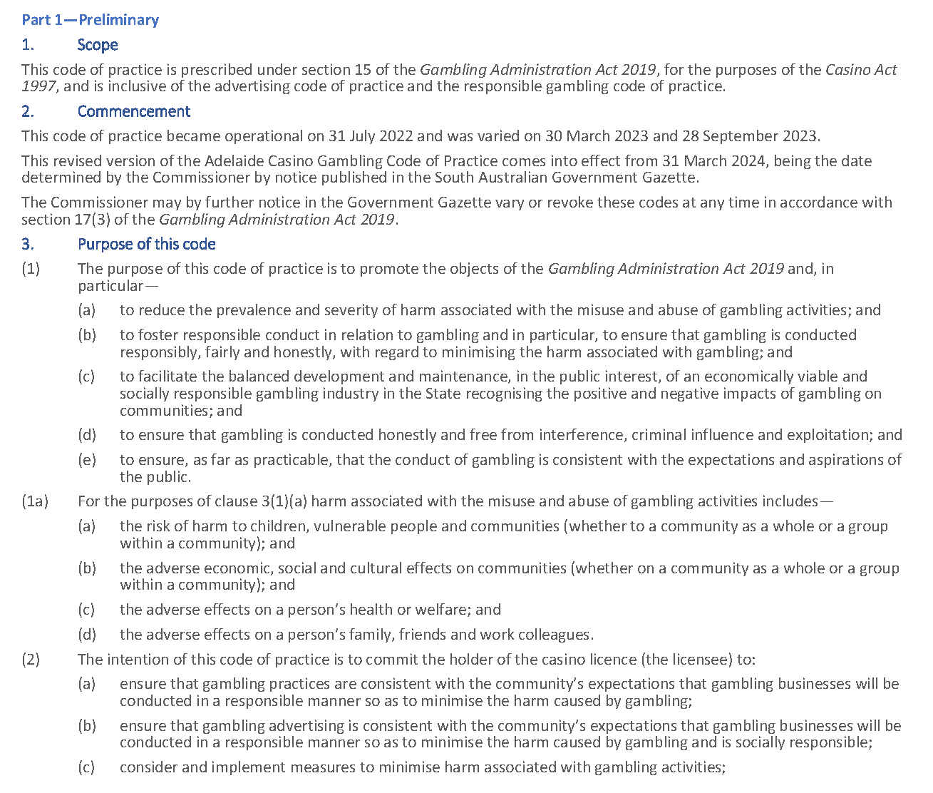
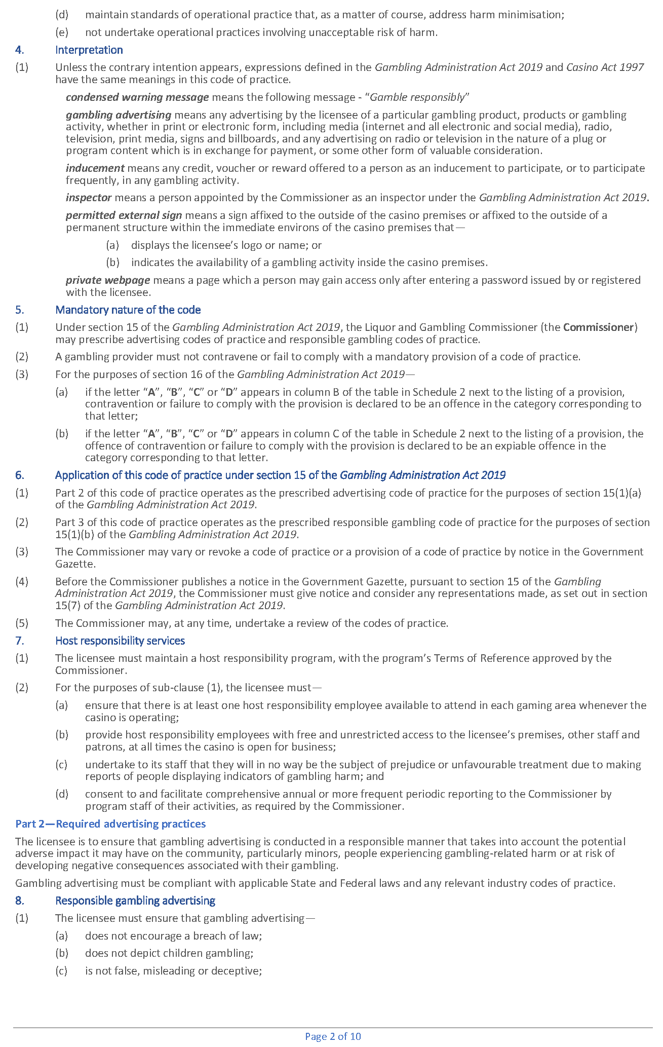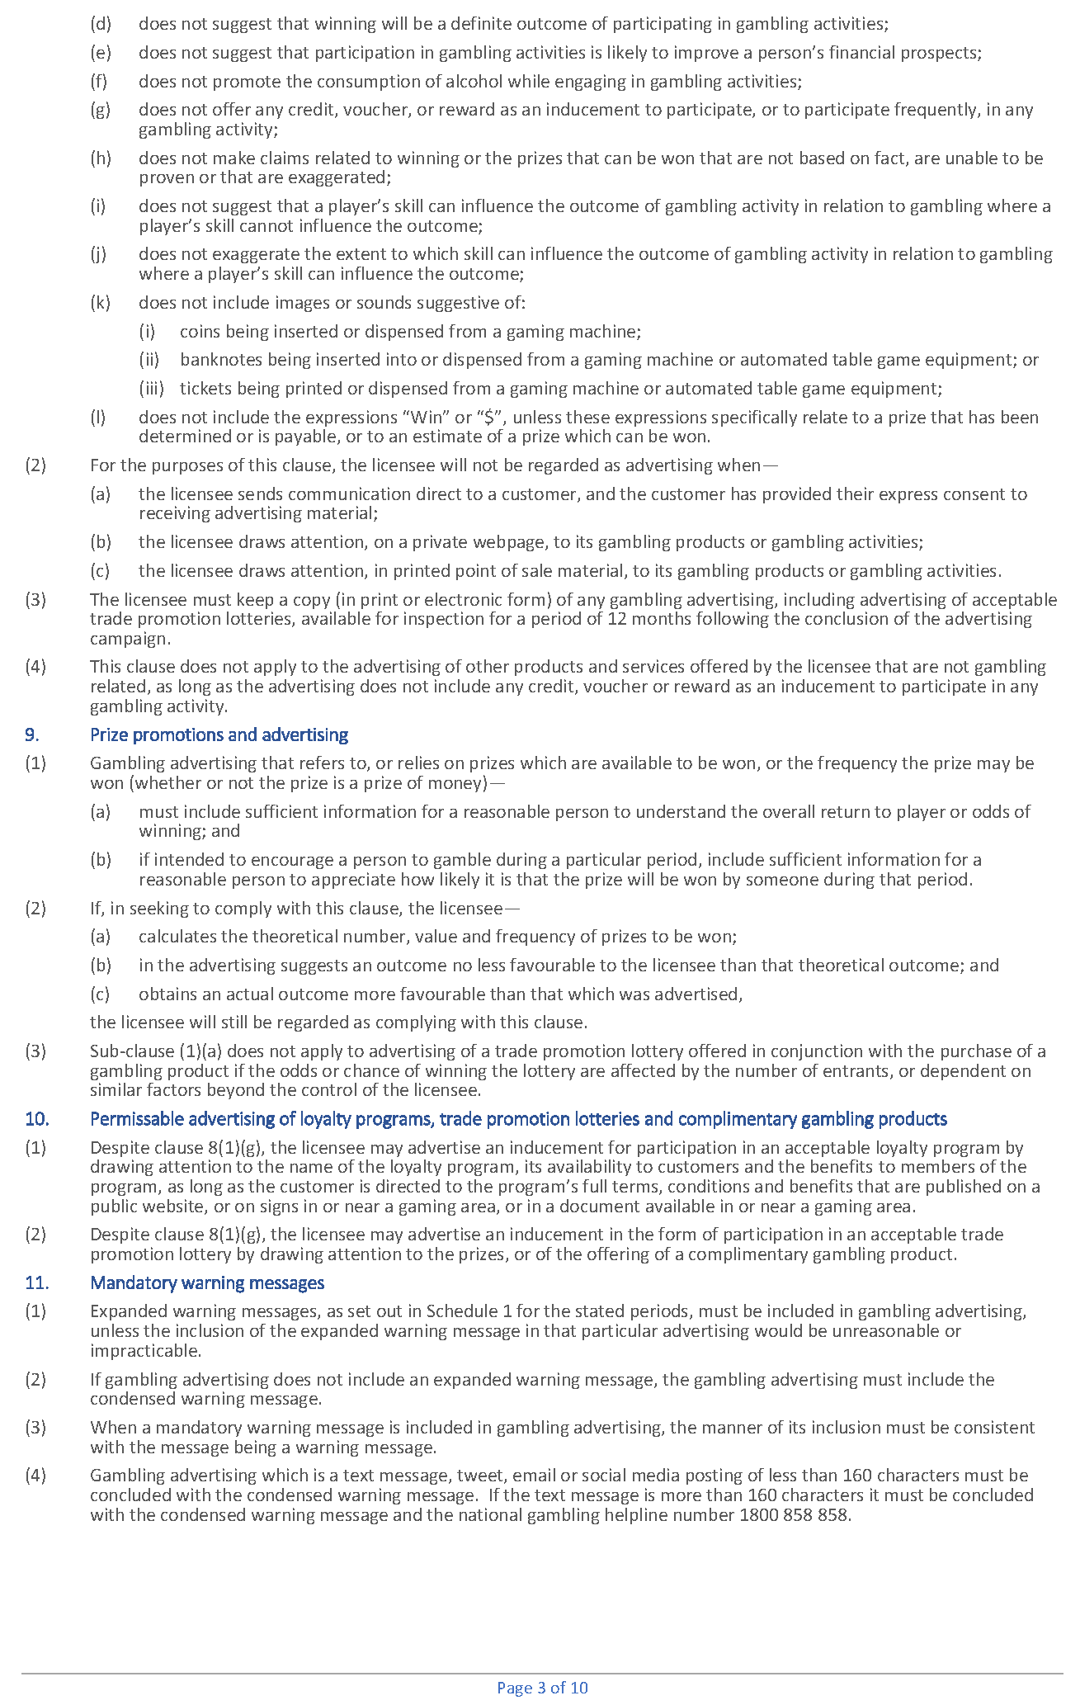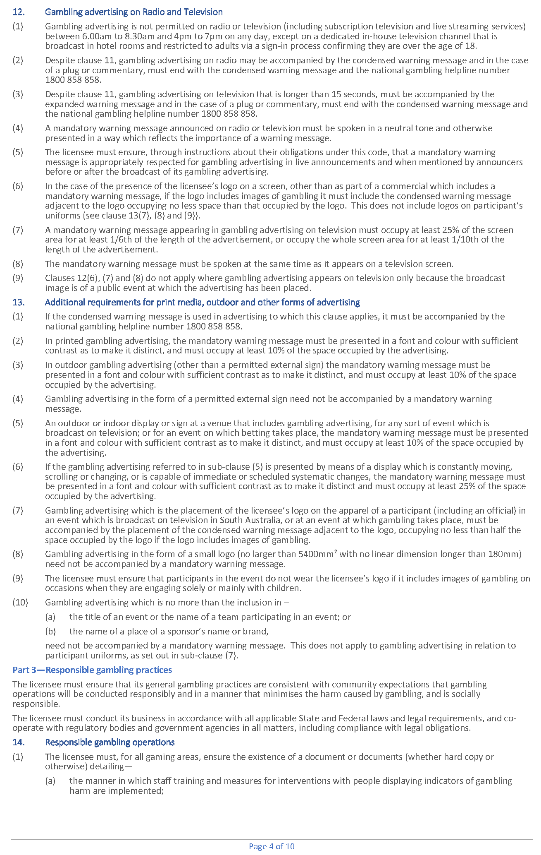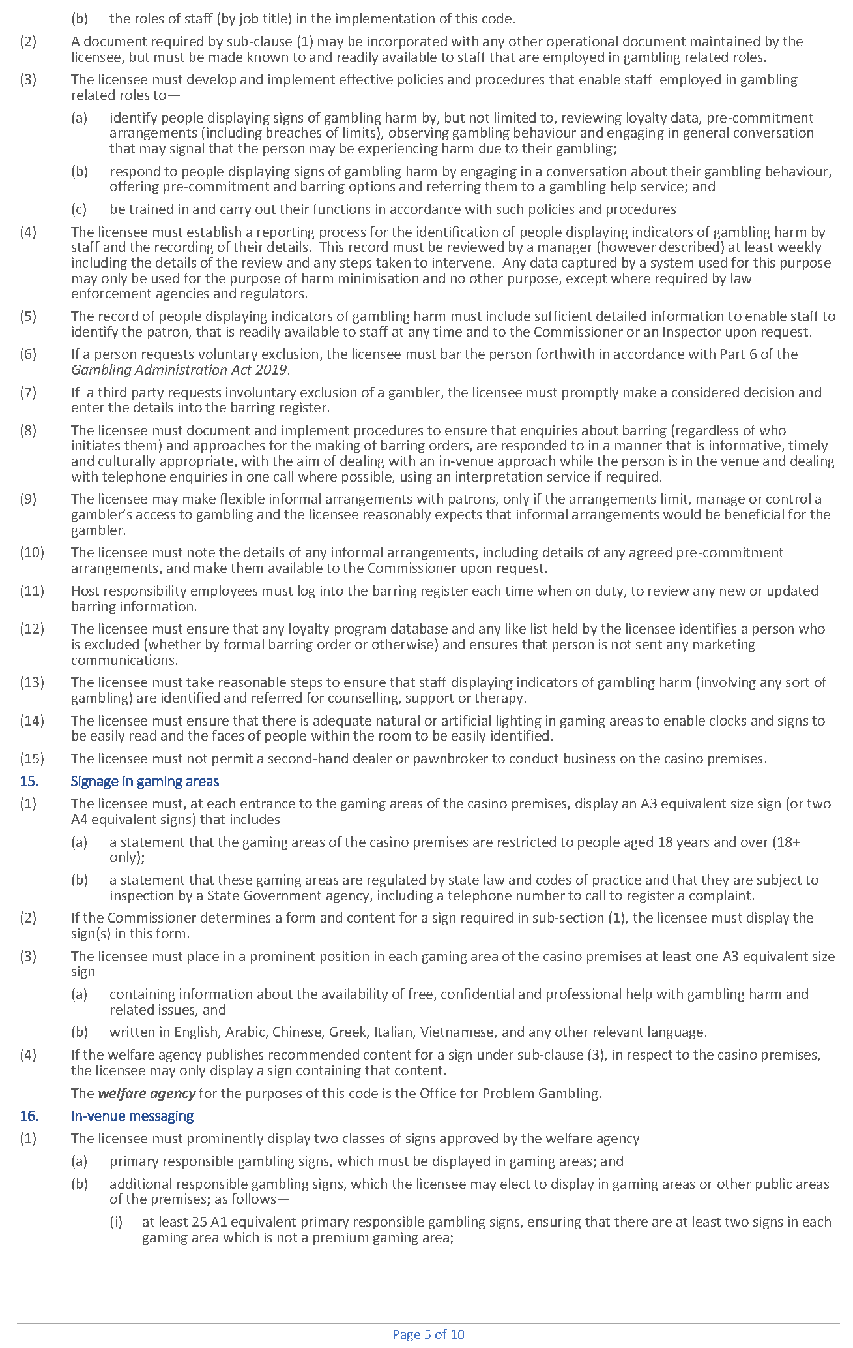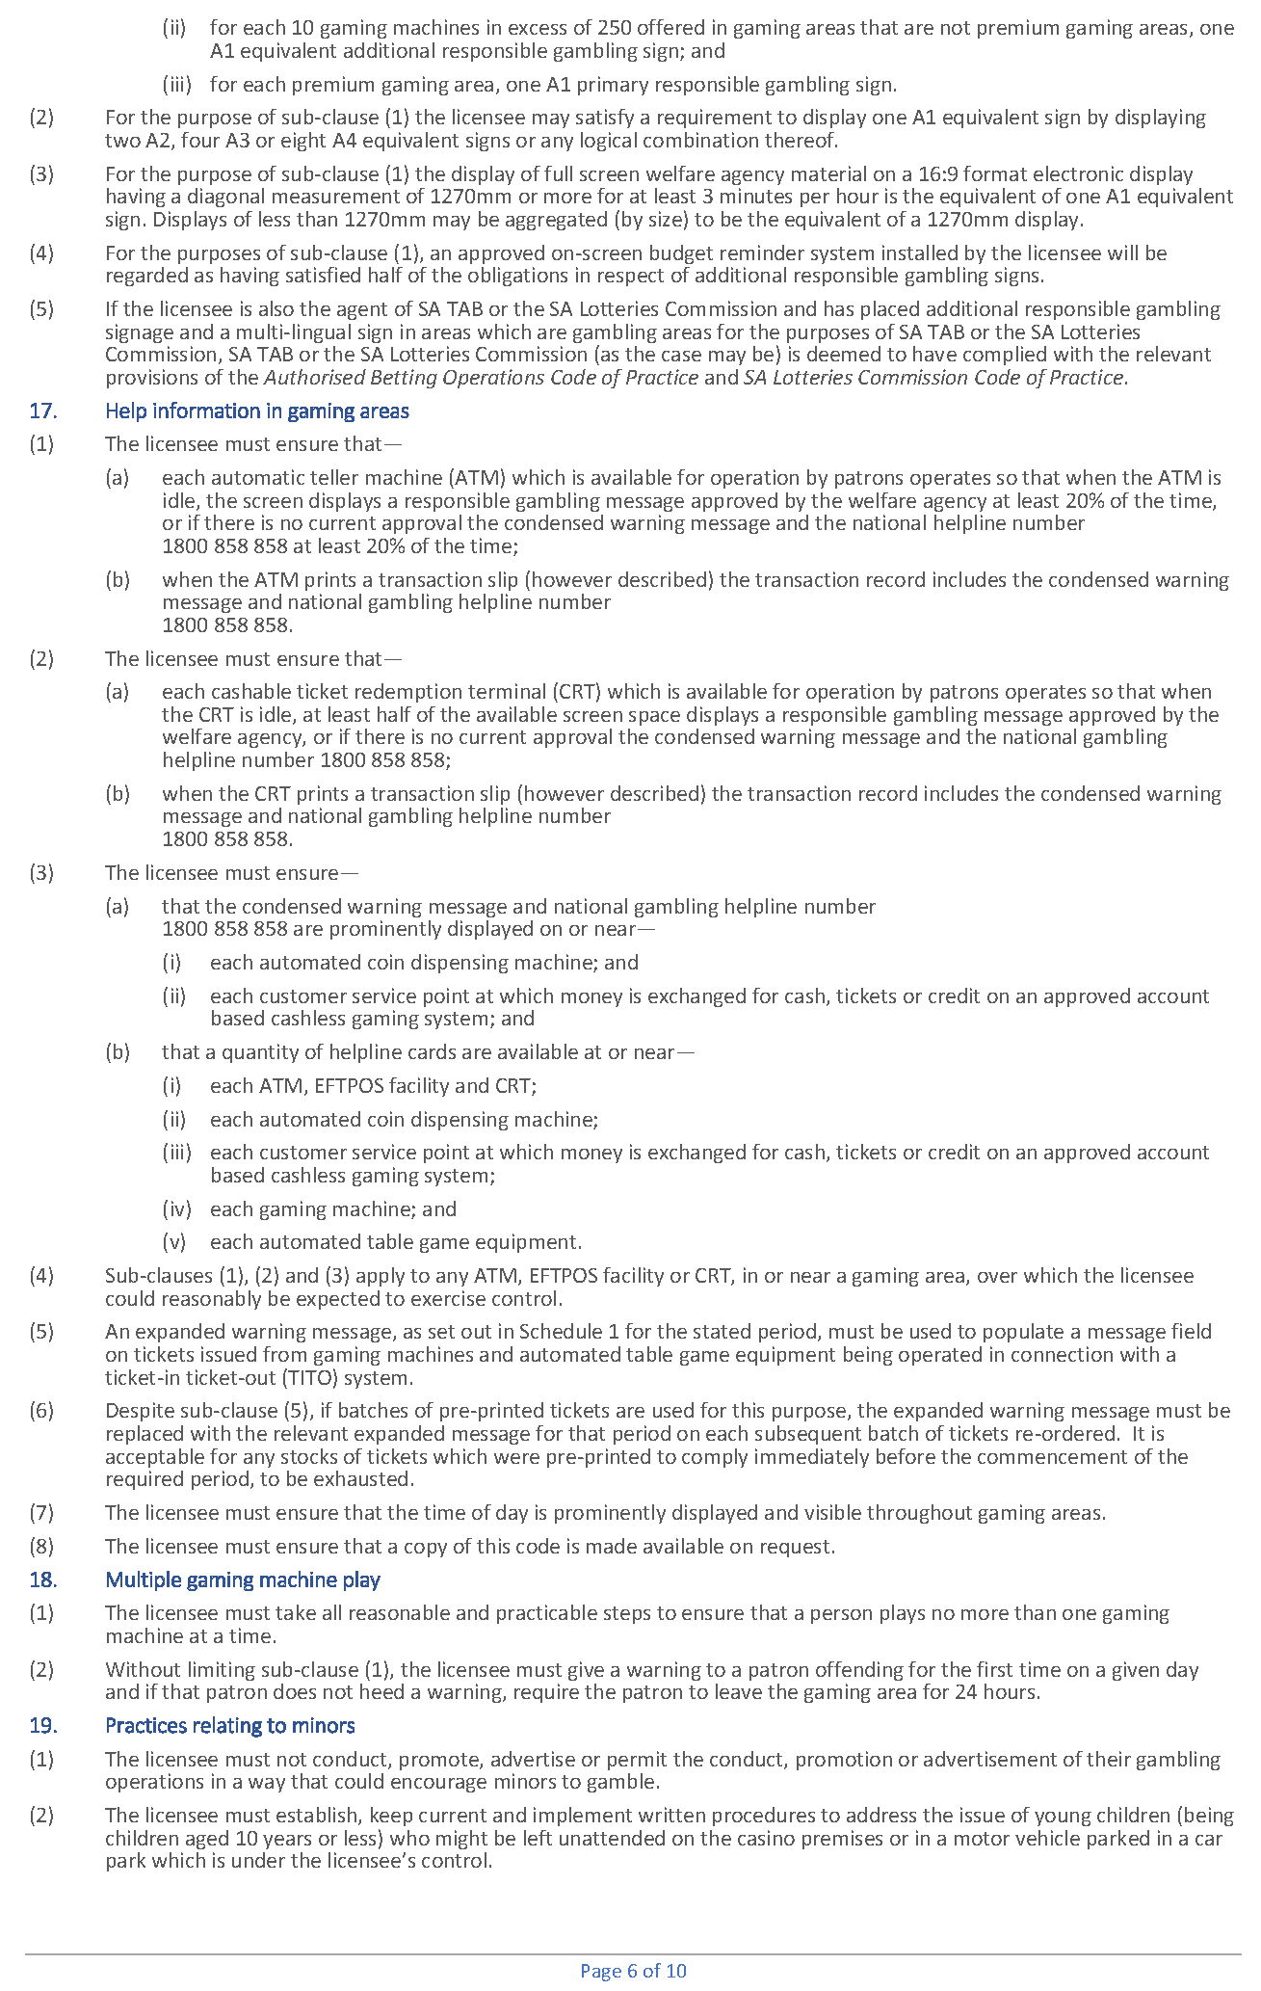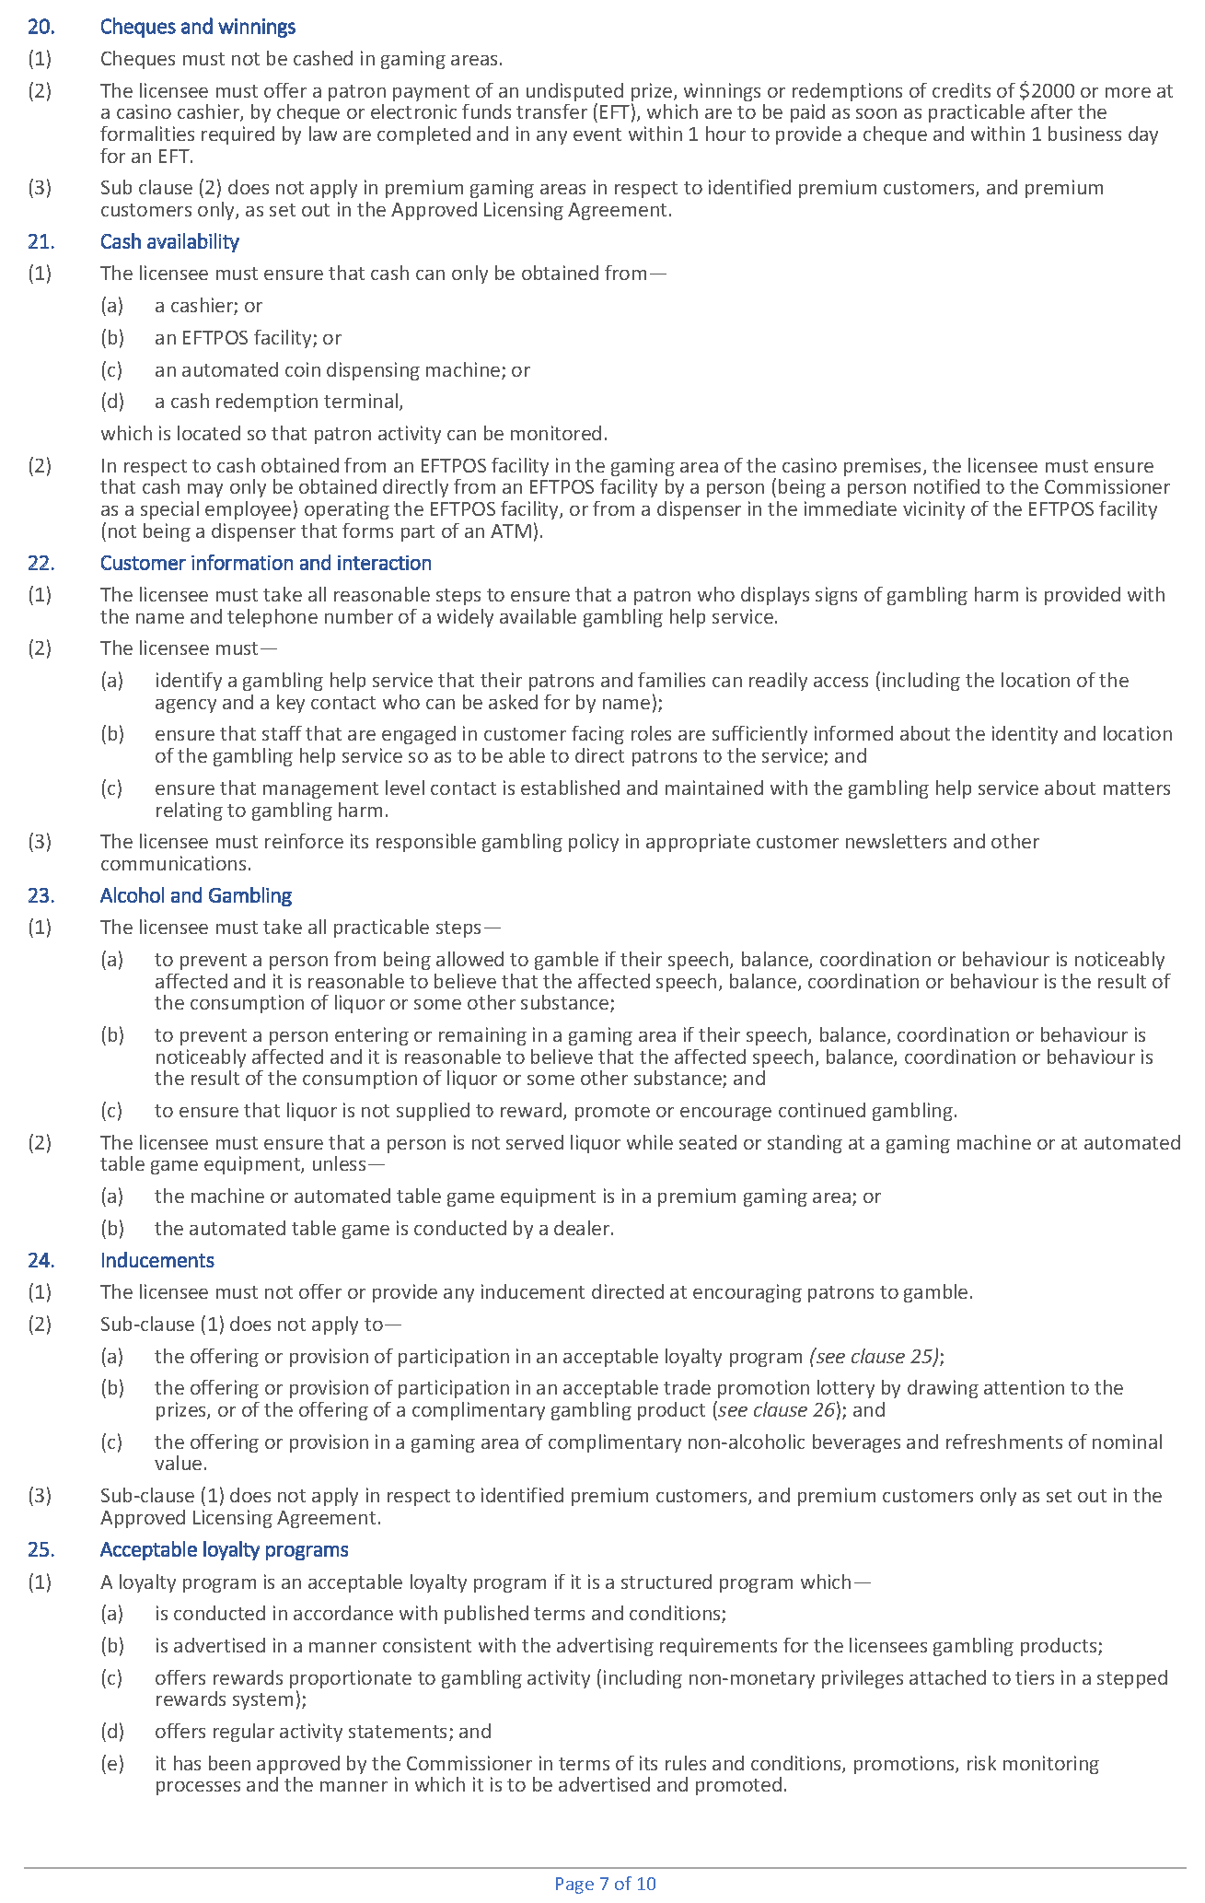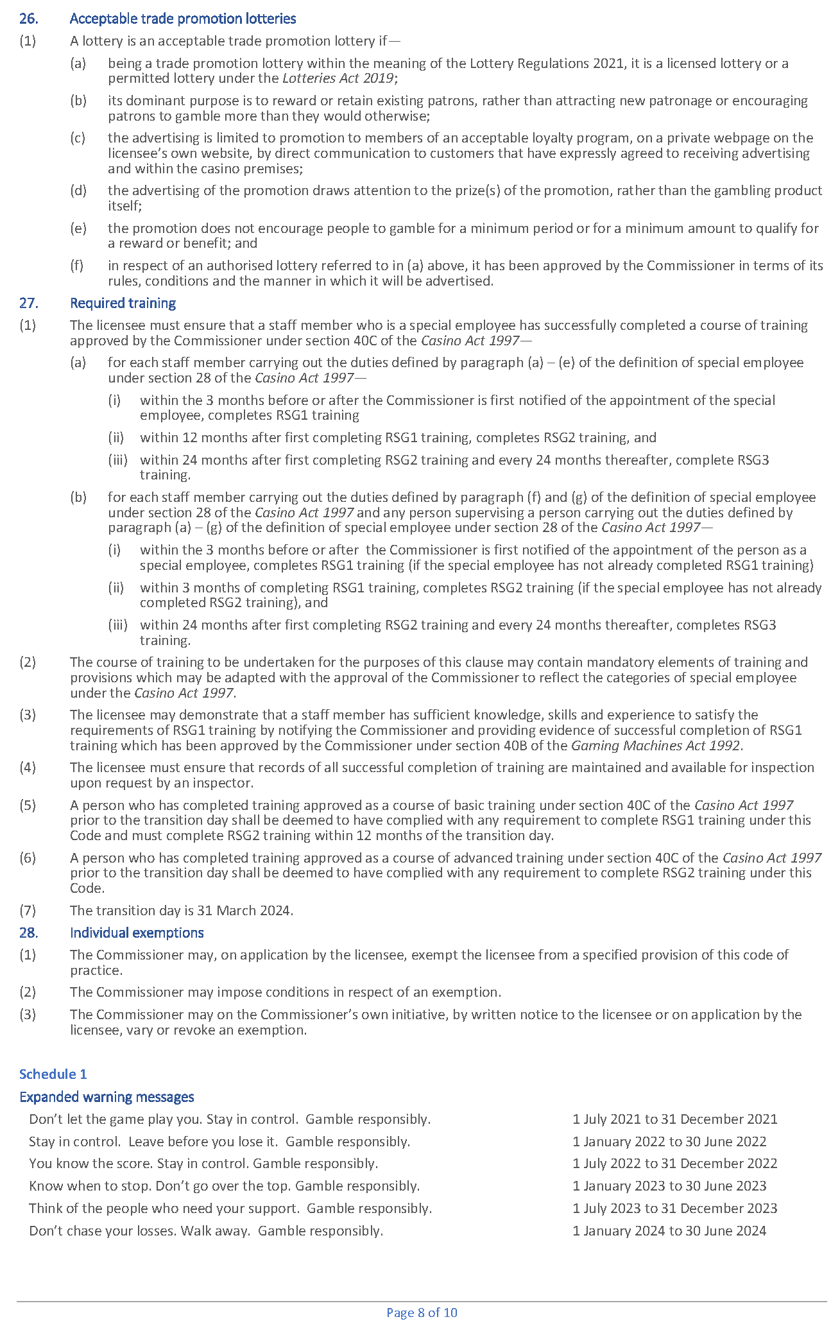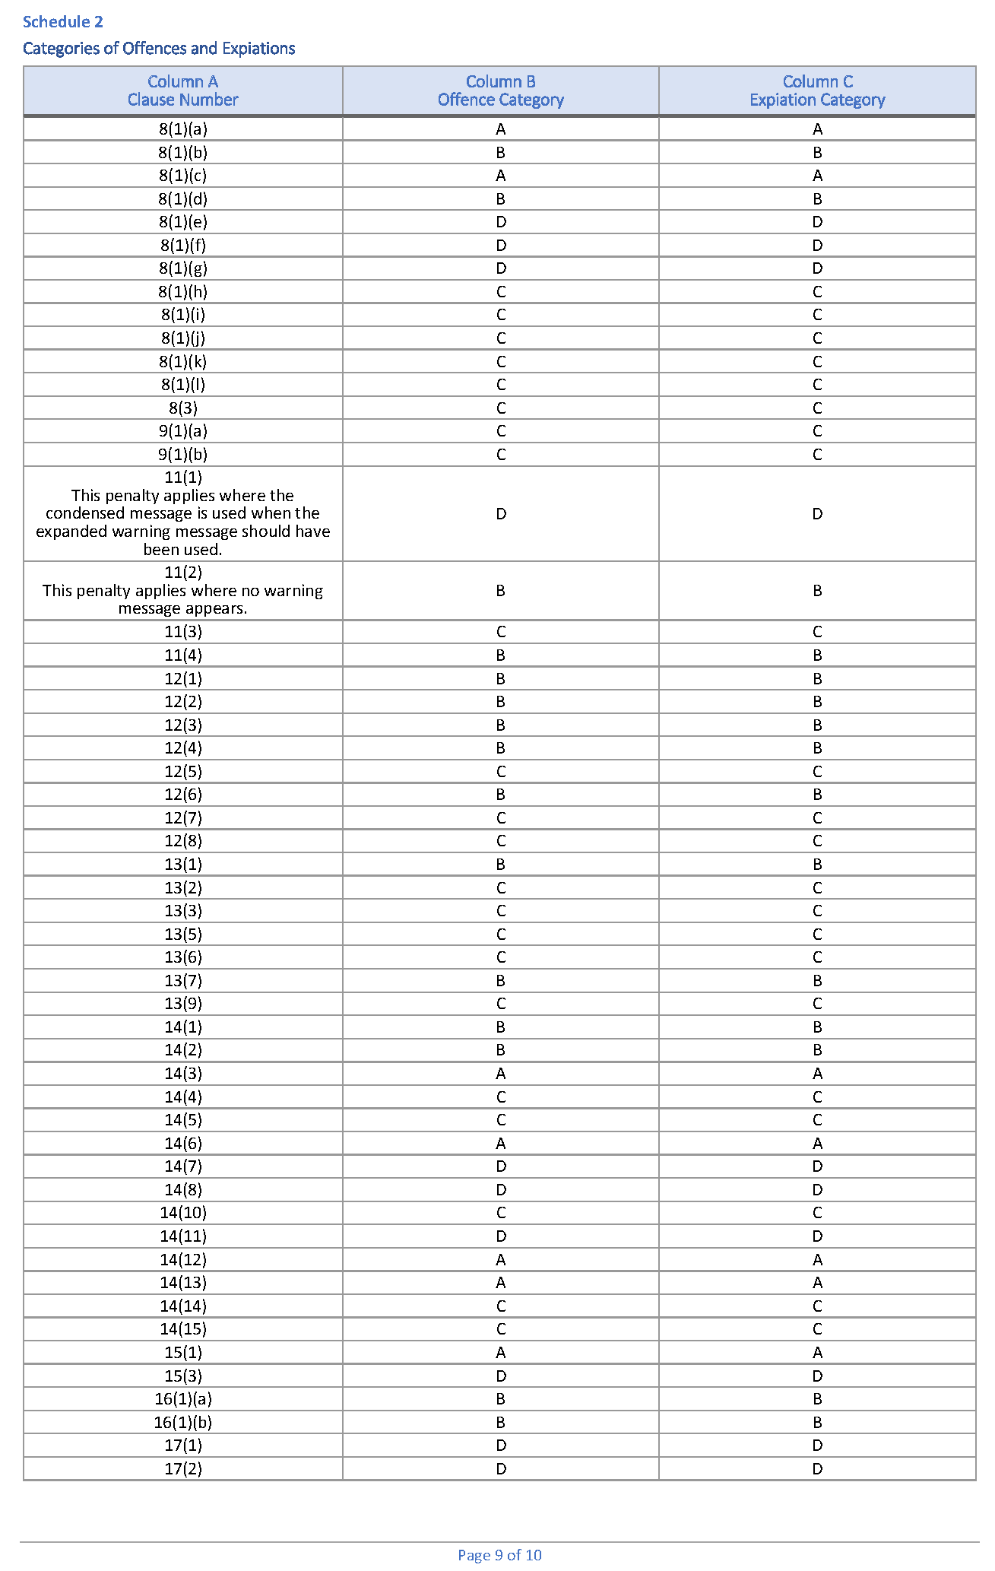

Gambling Administration Act 2019
South Australia
Gambling Administration Guidelines (Authorised Betting Operations Act 2000 - Prescribed training requirements for persons involved in betting operations) Notice 2023
under section 17 of the Gambling Administration Act 2019
1—Short title
This notice may be cited as the Gambling Administration Guidelines (Authorised Betting Operations Act 2000 - Prescribed training requirements for persons involved in betting operations) Notice 2023.
2—Commencement
This notice comes into operation on 31 March 2024.

3—Gambling Administration Guidelines
This notice sets out the requirements for the approval of a course of training to be undertaken by staff involved in betting operations and is made by the Liquor and Gambling Commissioner under section 17 of the Gambling Administration Act 2019 for the purposes of section 6A of the Authorised Betting Operations Act 2000.
Dated: 28 September 2023
Dini Soulio
Liquor and Gambling Commissioner

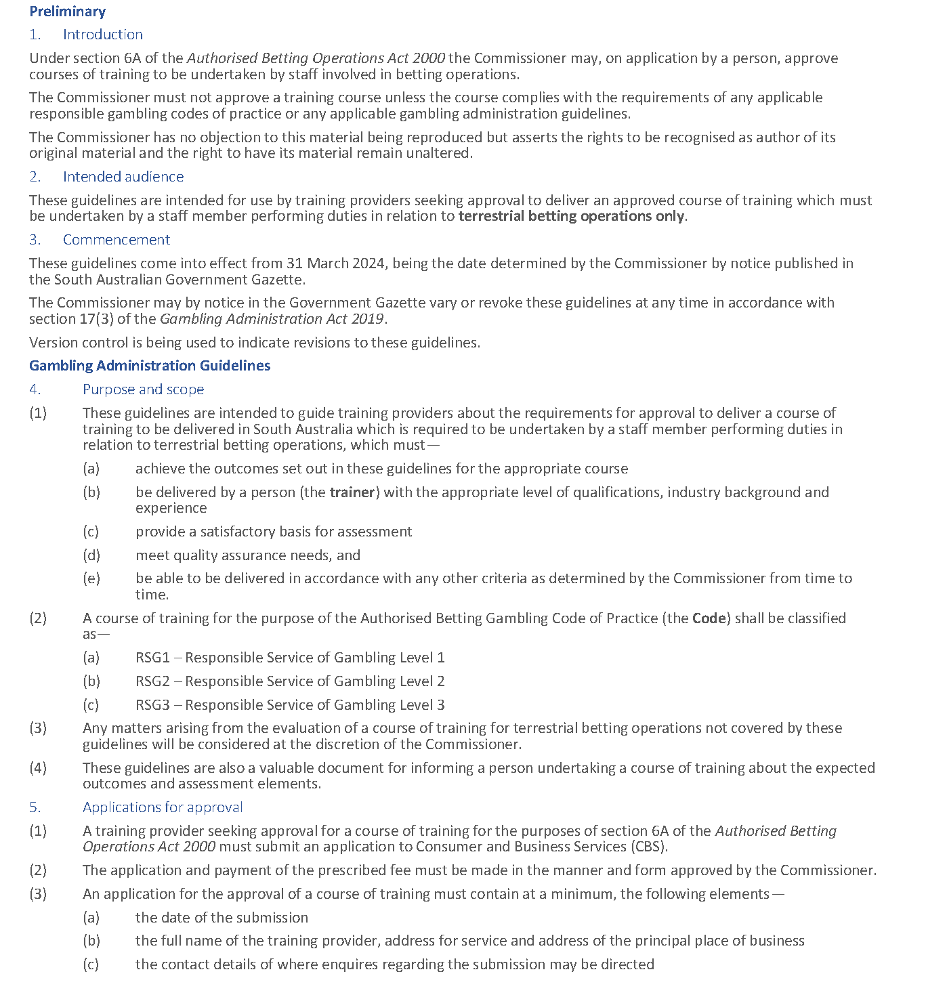
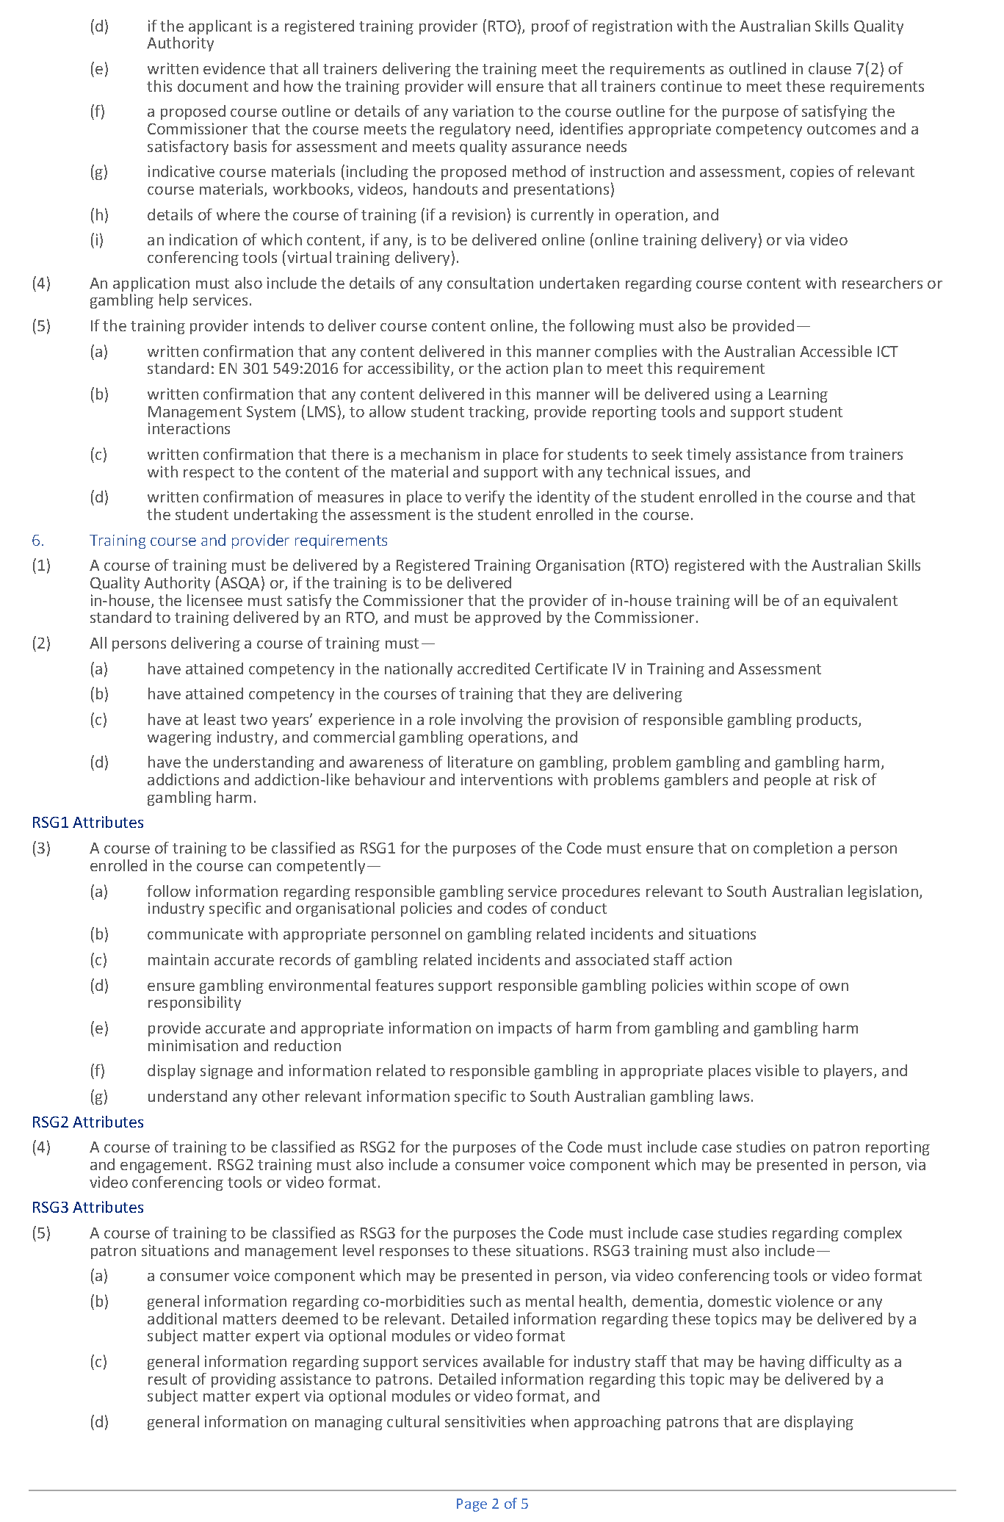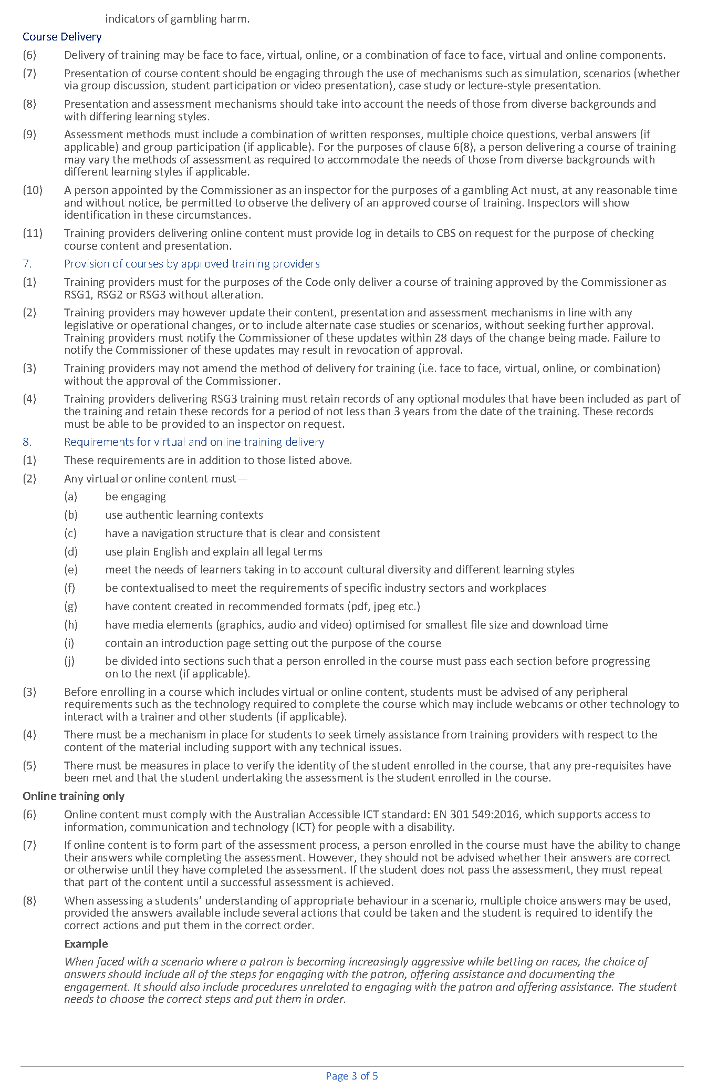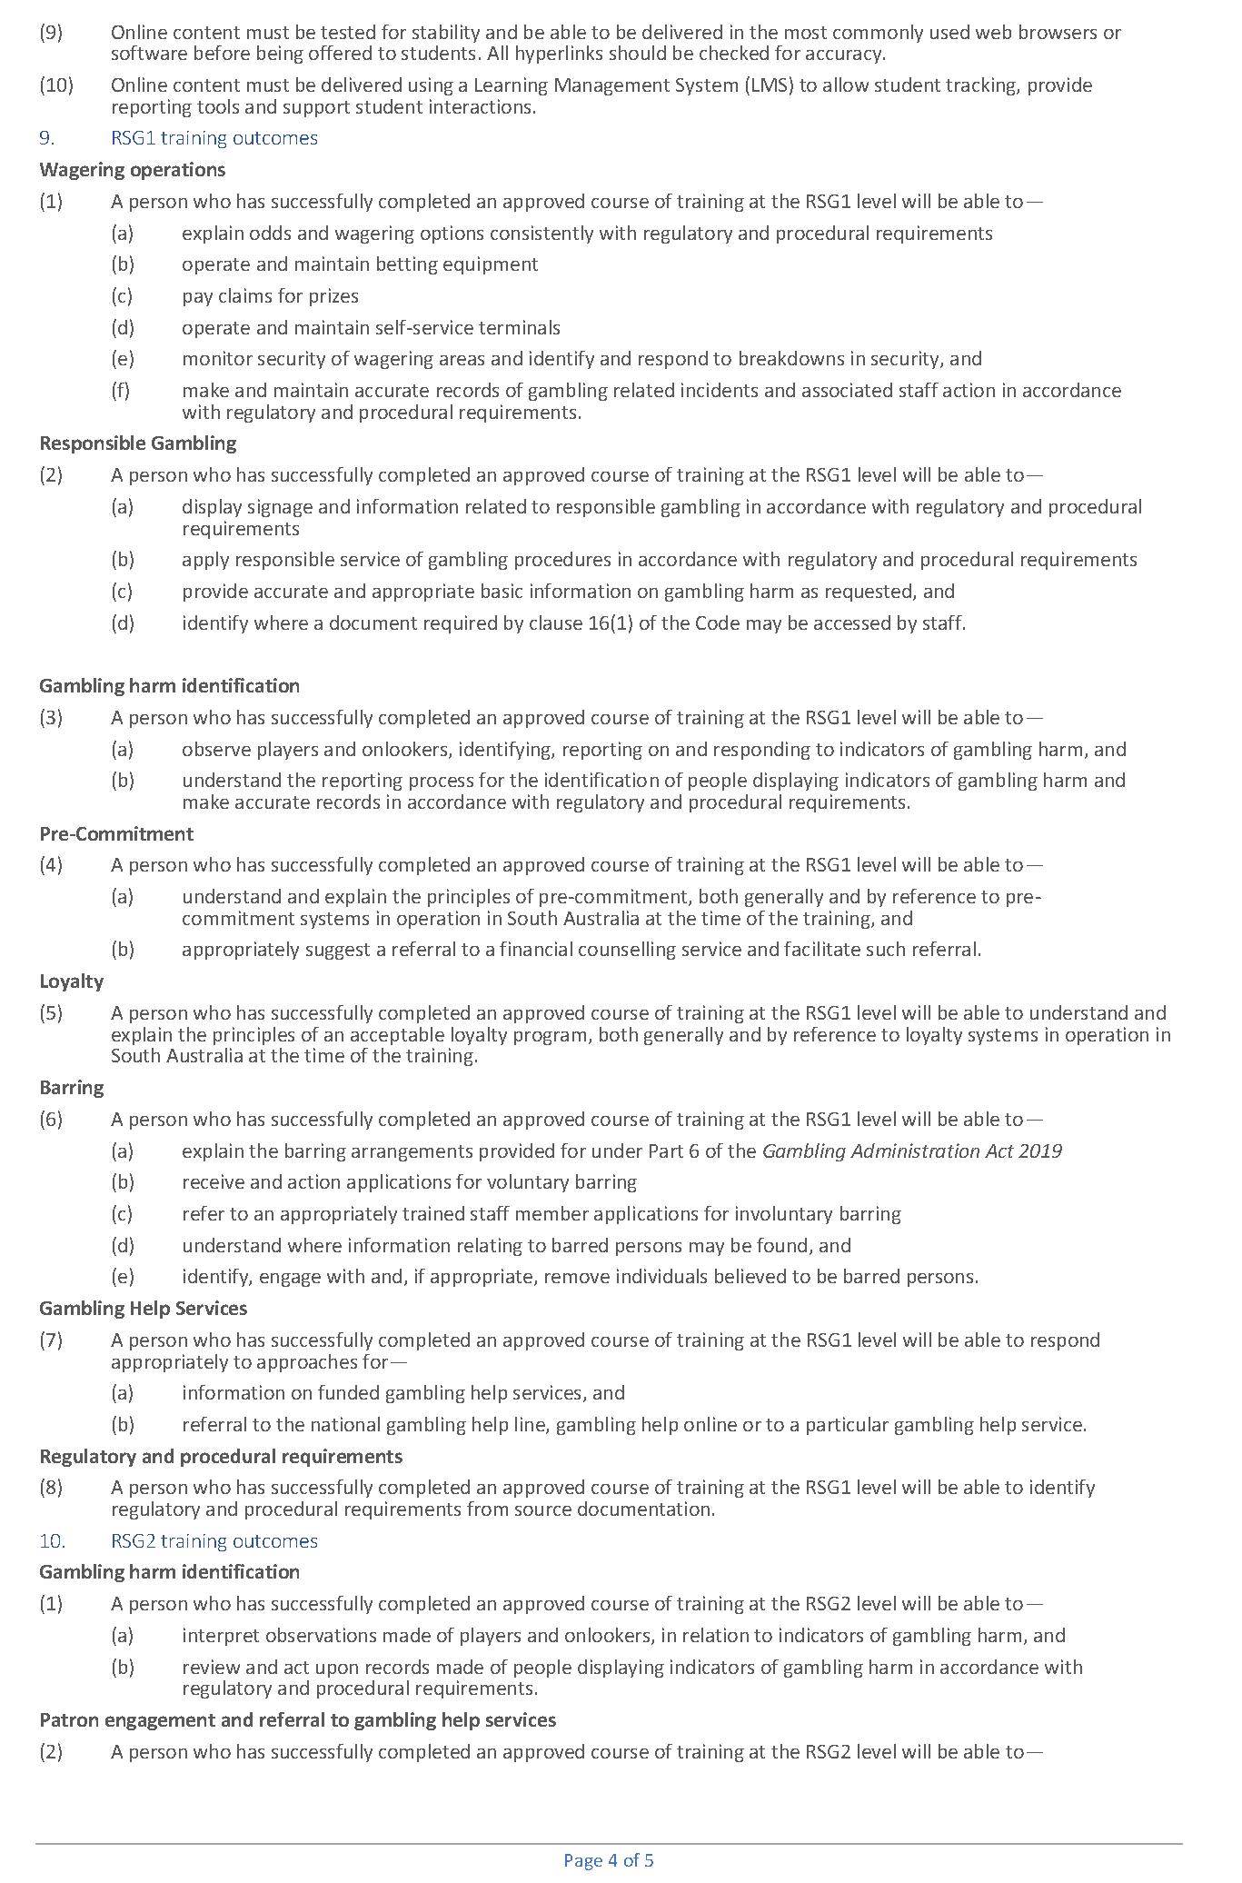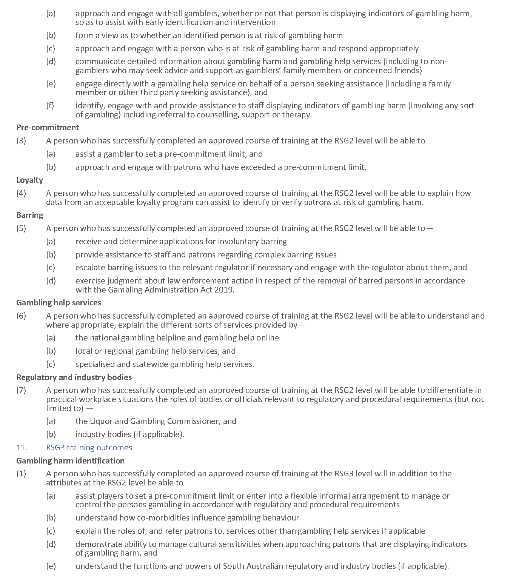

Gambling Administration Act 2019
South Australia
Gambling Administration Guidelines (Casino Act 1997 - Prescribed training requirements for persons involved in casino operations) Notice 2023
under section 17 of the Gambling Administration Act 2019
1—Short title
This notice may be cited as the Gambling Administration Guidelines (Casino Act 1997 - Prescribed training requirements for persons involved in casino operations) Notice 2023.
2—Commencement
This notice comes into operation on 31 March 2024.
3—Revocation of existing guidelines
The Gambling Administration Guidelines Notice 2020—Casino Act 1997 (Employee Training) published in the Government Gazette on 4 December 2020 are revoked effective from 31 March 2024.
4—Gambling Administration Guidelines
This notice sets out the requirements for the approval of a course of training to be undertaken by casino staff and is issued by the Liquor and Gambling Commissioner under section 17 of the Gambling Administration Act 2019 for the purposes of section 40C of the Casino Act 1997.
Dated: 28 September 2023
Dini Soulio
Liquor and Gambling Commissioner

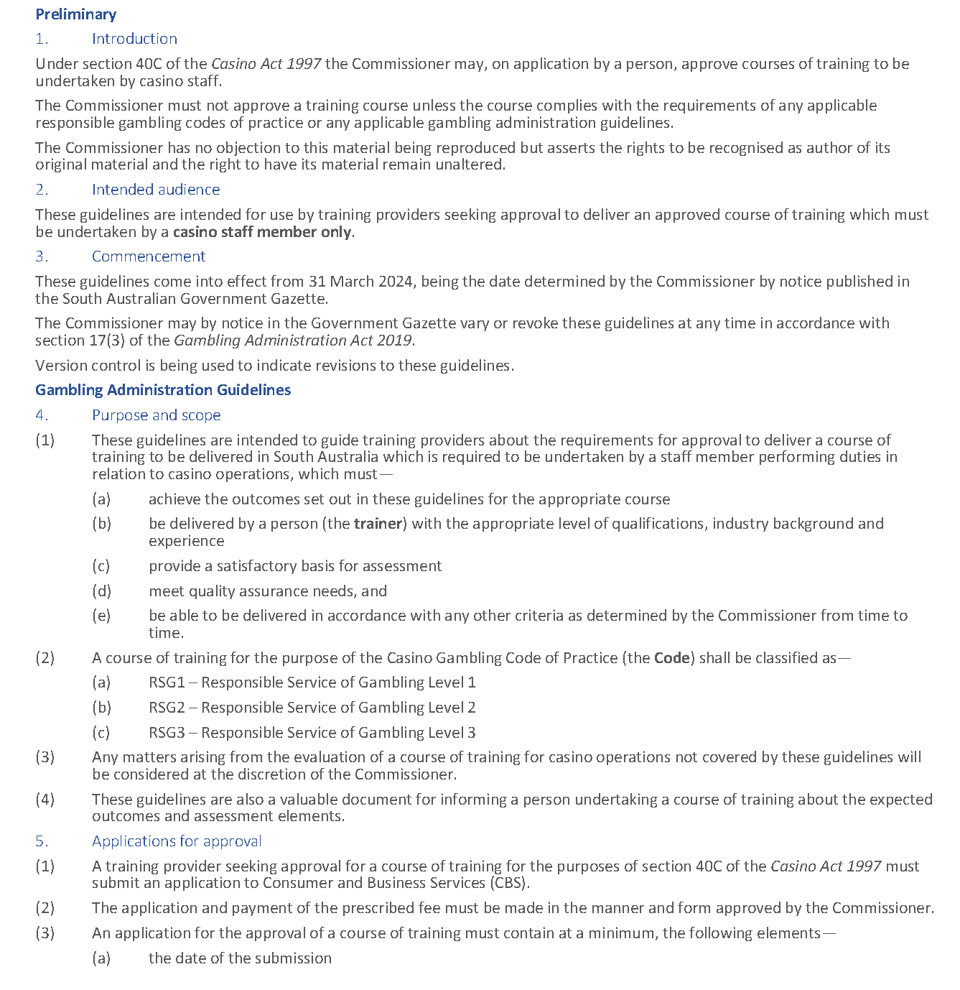
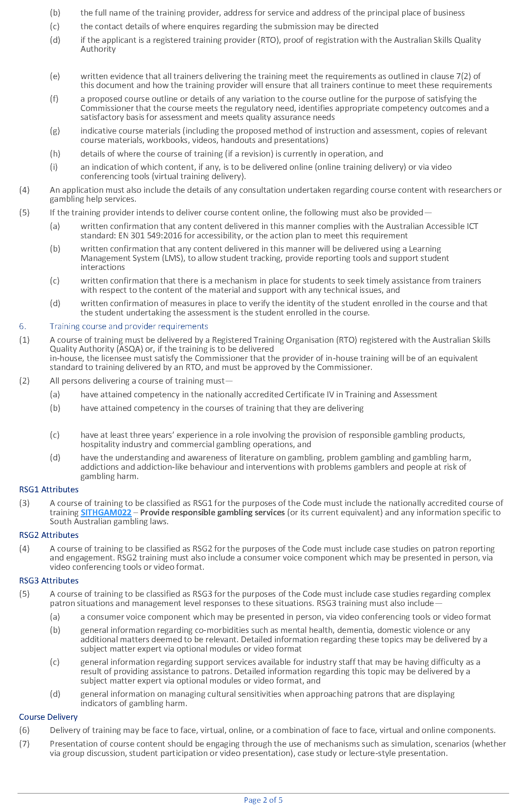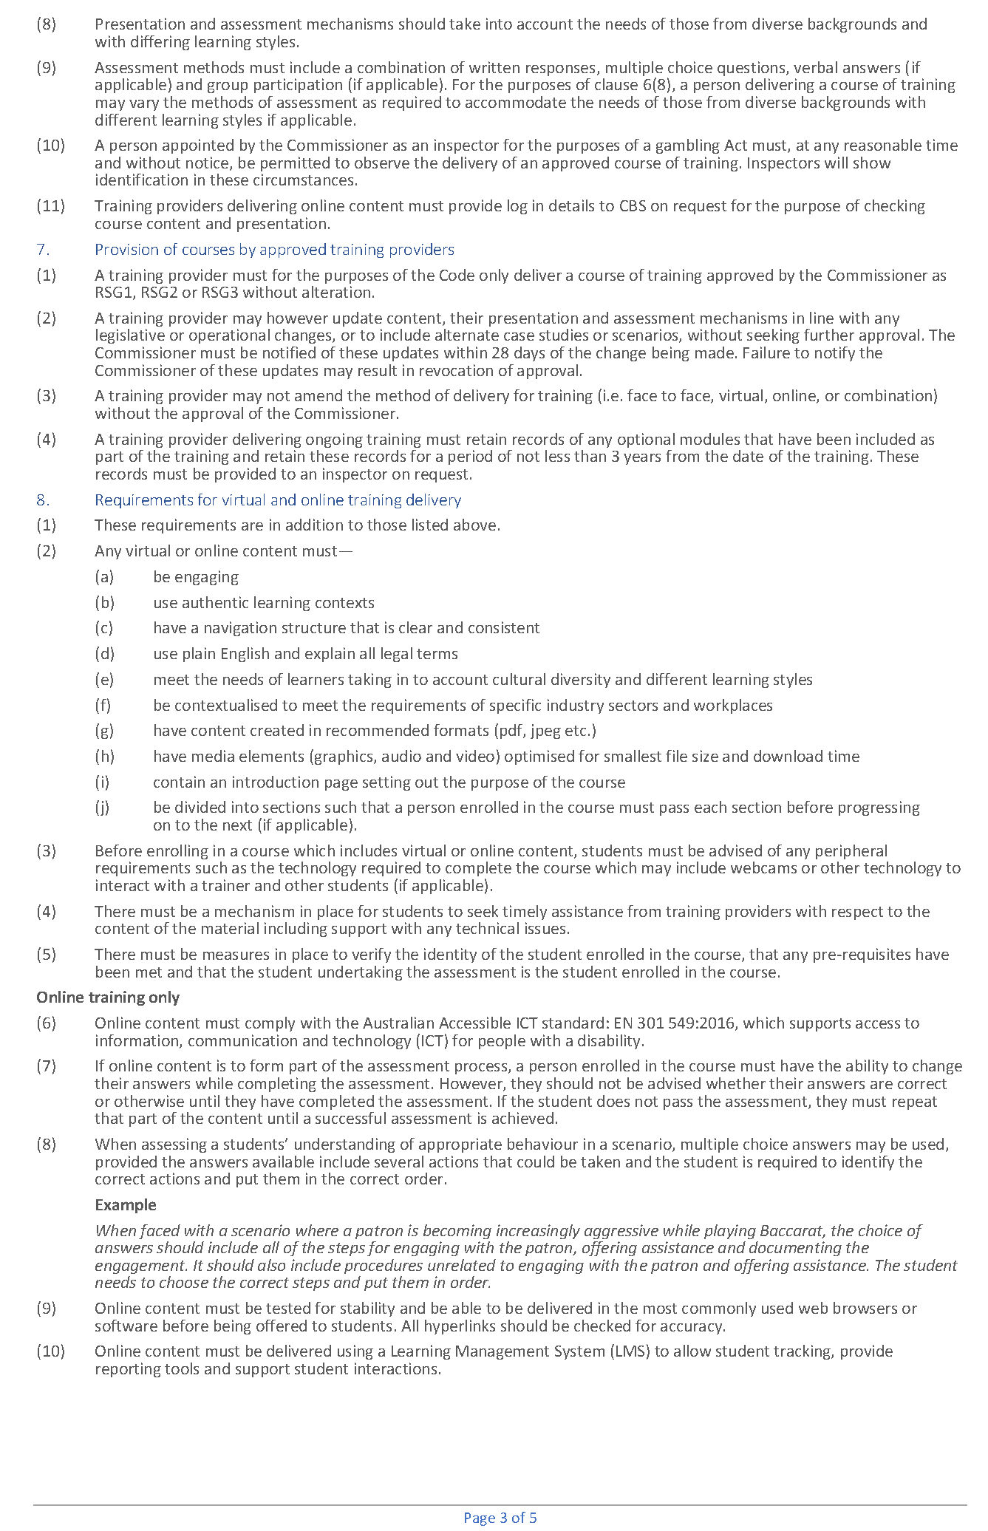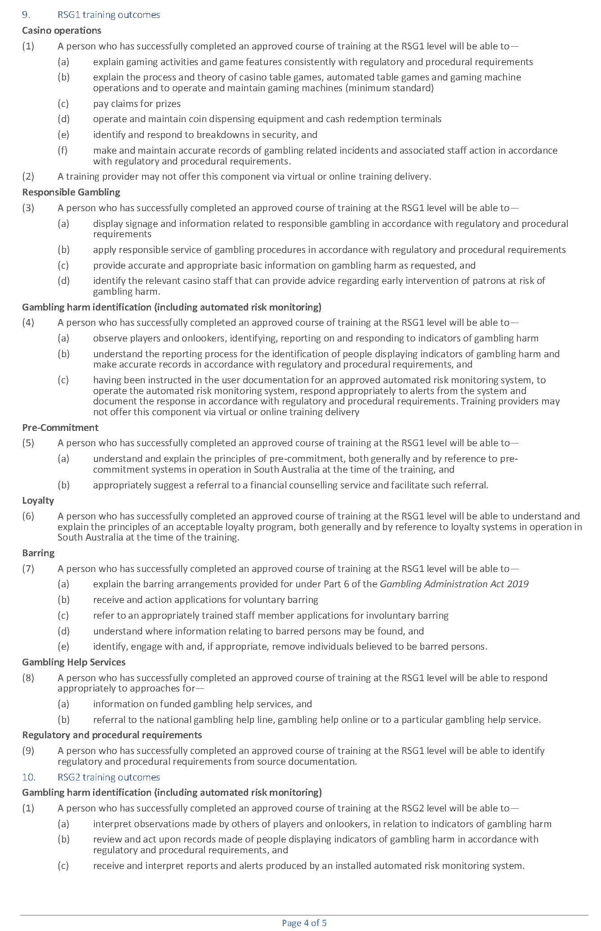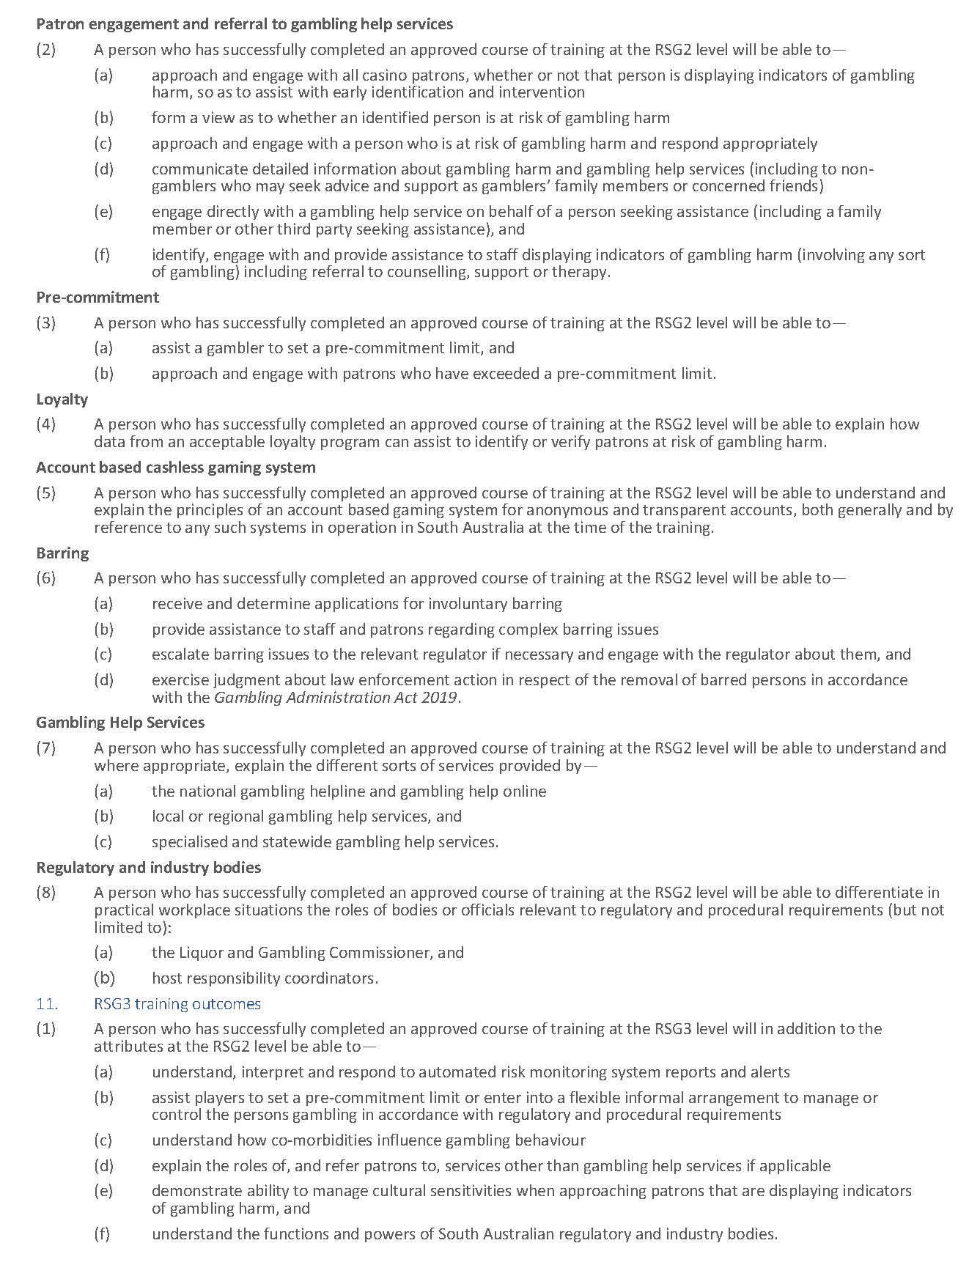

Gambling Administration Act 2019
South Australia
Gambling Administration Guidelines (Gaming Machines Act 1992 – Prescribed training requirements for persons involved in gaming machine operations) Notice 2023
under section 17 of the Gambling Administration Act 2019
1—Short title
This notice may be cited as the Gambling Administration Guidelines (Gaming Machines Act 1992 – Prescribed training requirements for persons involved in gaming machine operations) Notice 2023.
2—Commencement
This notice comes into operation on 31 March 2024.
3—Revocation of existing guidelines
The Gambling Administration Guidelines Notice 2020—Gaming Machines Act 1992 (Employee Training) published in the Government Gazette on 4 December 2020 are revoked effective from 31 March 2024.
4—Gambling Administration Guidelines
This notice sets out the requirements for the approval of a course of training to be undertaken by a person notified as a gaming employee or gaming manager and is made by the Liquor and Gambling Commissioner under section 17 of the Gambling Administration Act 2019 for the purposes of section 40B of the Gaming Machines Act 1992.
Dated: 28 September 2023
Dini Soulio
Liquor and Gambling Commissioner

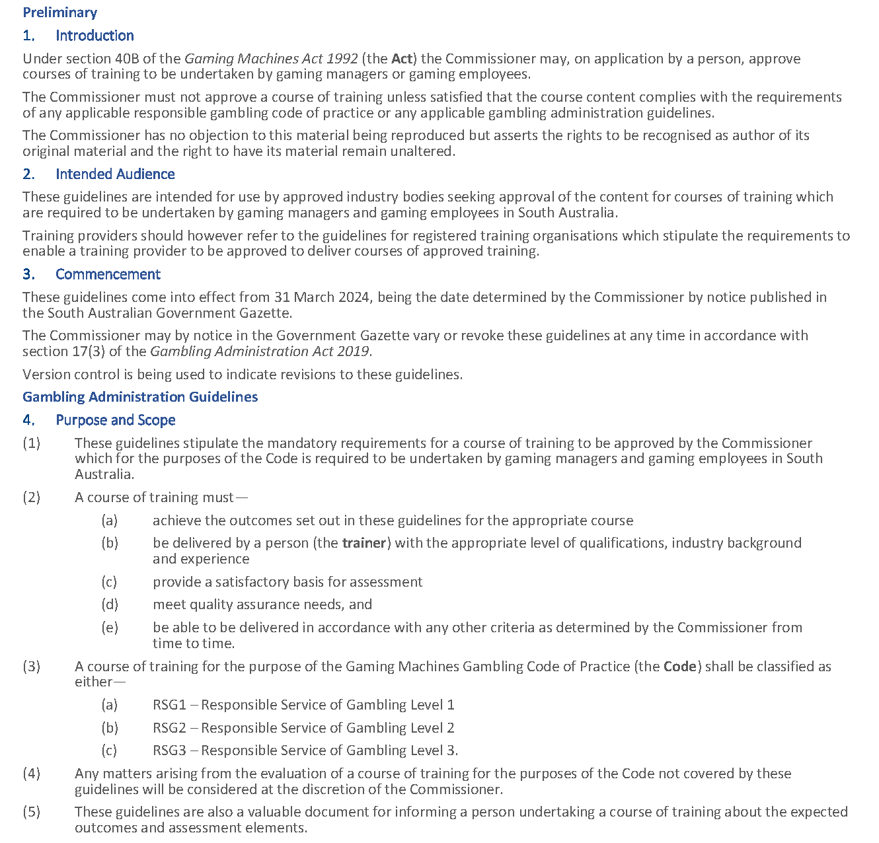
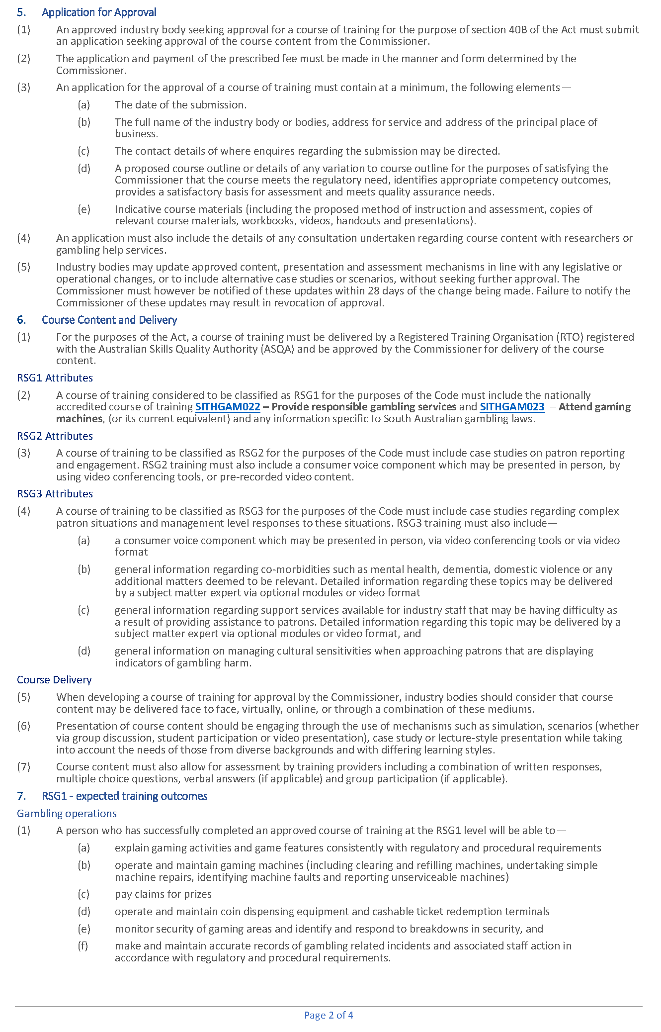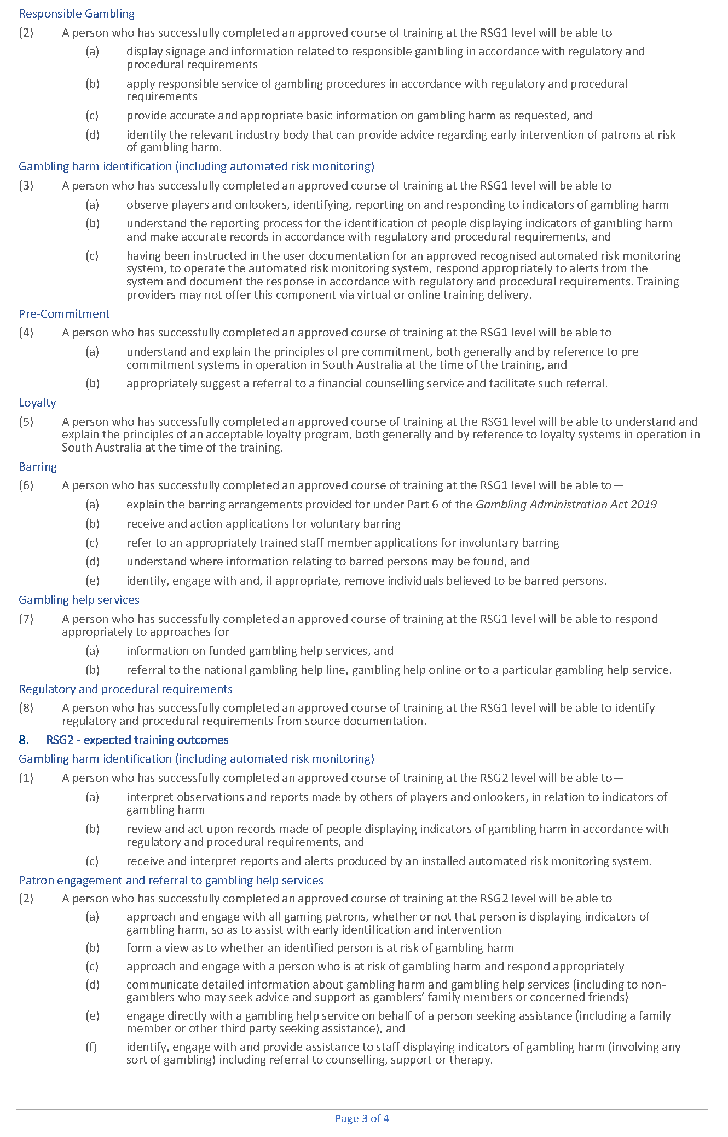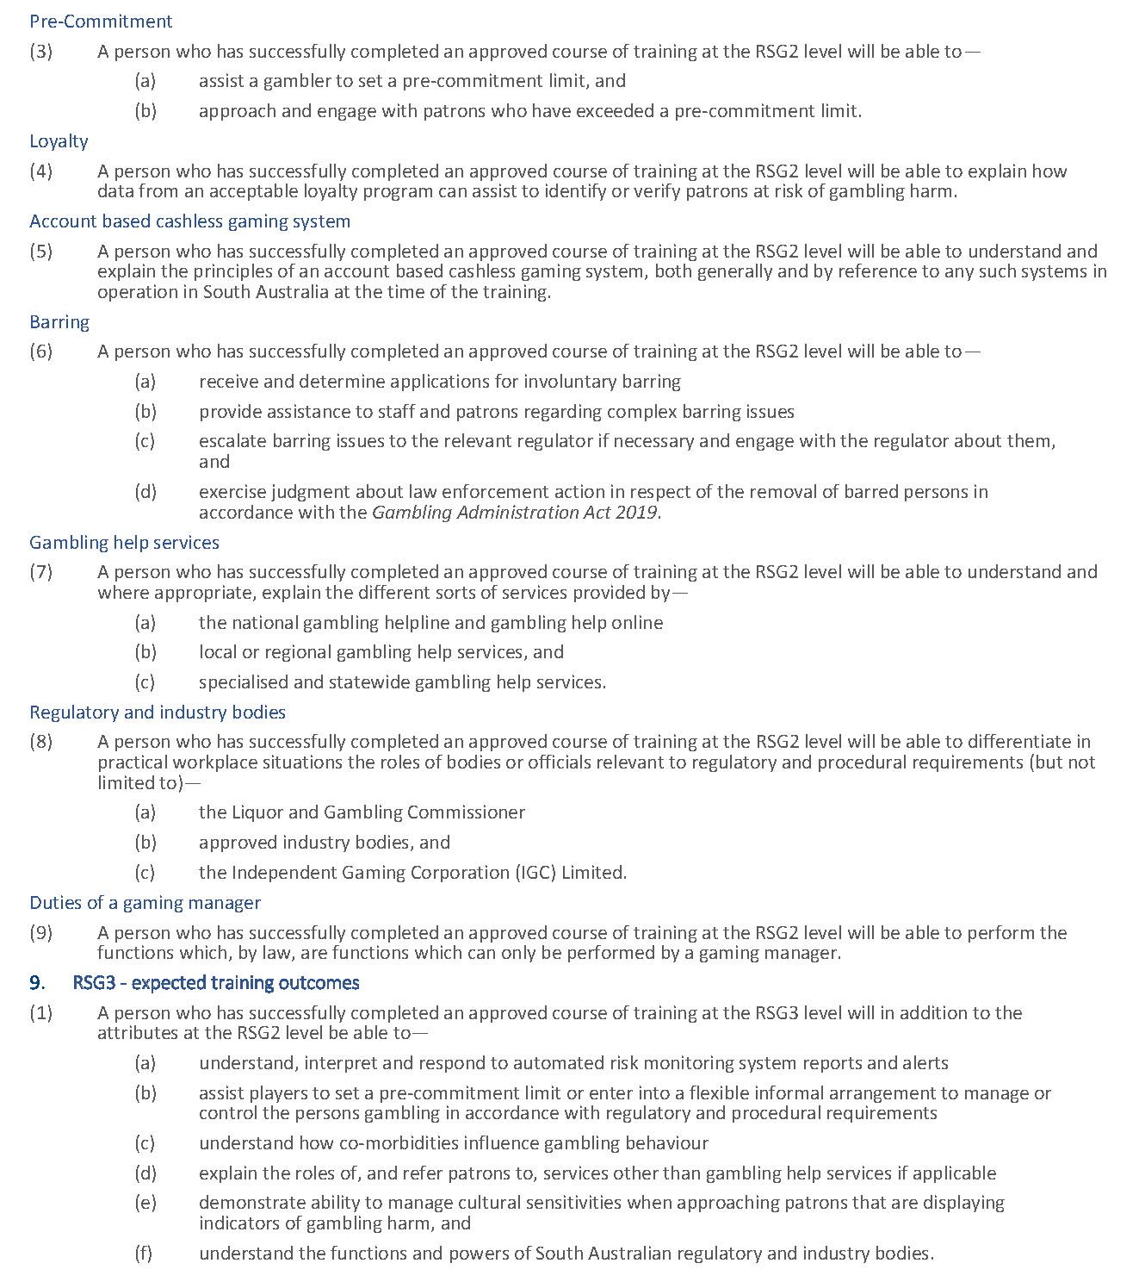

Gambling Administration Act 2019
South Australia
Gambling Administration Guidelines (Gaming Machines Act 1992 - Prescribed requirements for registered training organisations to deliver approved courses of training in relation to gaming machine operations) Notice 2023
under section 17 of the Gambling Administration Act 2019
1—Short title
This notice may be cited as the Gambling Administration Guidelines (Gaming Machines Act 1992 - Prescribed requirements for registered training organisations to deliver approved courses of training in relation to gaming machine operations) Notice 2023.
2—Commencement
This notice comes into operation on 31 March 2024.
3—Revocation of existing guidelines
The Gambling Administration Guidelines Notice 2020—Gaming Machines Act 1992 (Employee Training) published in the Government Gazette on 4 December 2020 are revoked effective from 31 March 2024.
4—Gambling Administration Guidelines
This notice sets out the requirements for a registered training organisation that seeks approval to deliver an approved course of training and is made by the Liquor and Gambling Commissioner under section 17 of the Gambling Administration Act 2019 for the purposes of section 40B of the Gaming Machines Act 1992.
Dated: 28 September 2023
Dini Soulio
Liquor and Gambling Commissioner

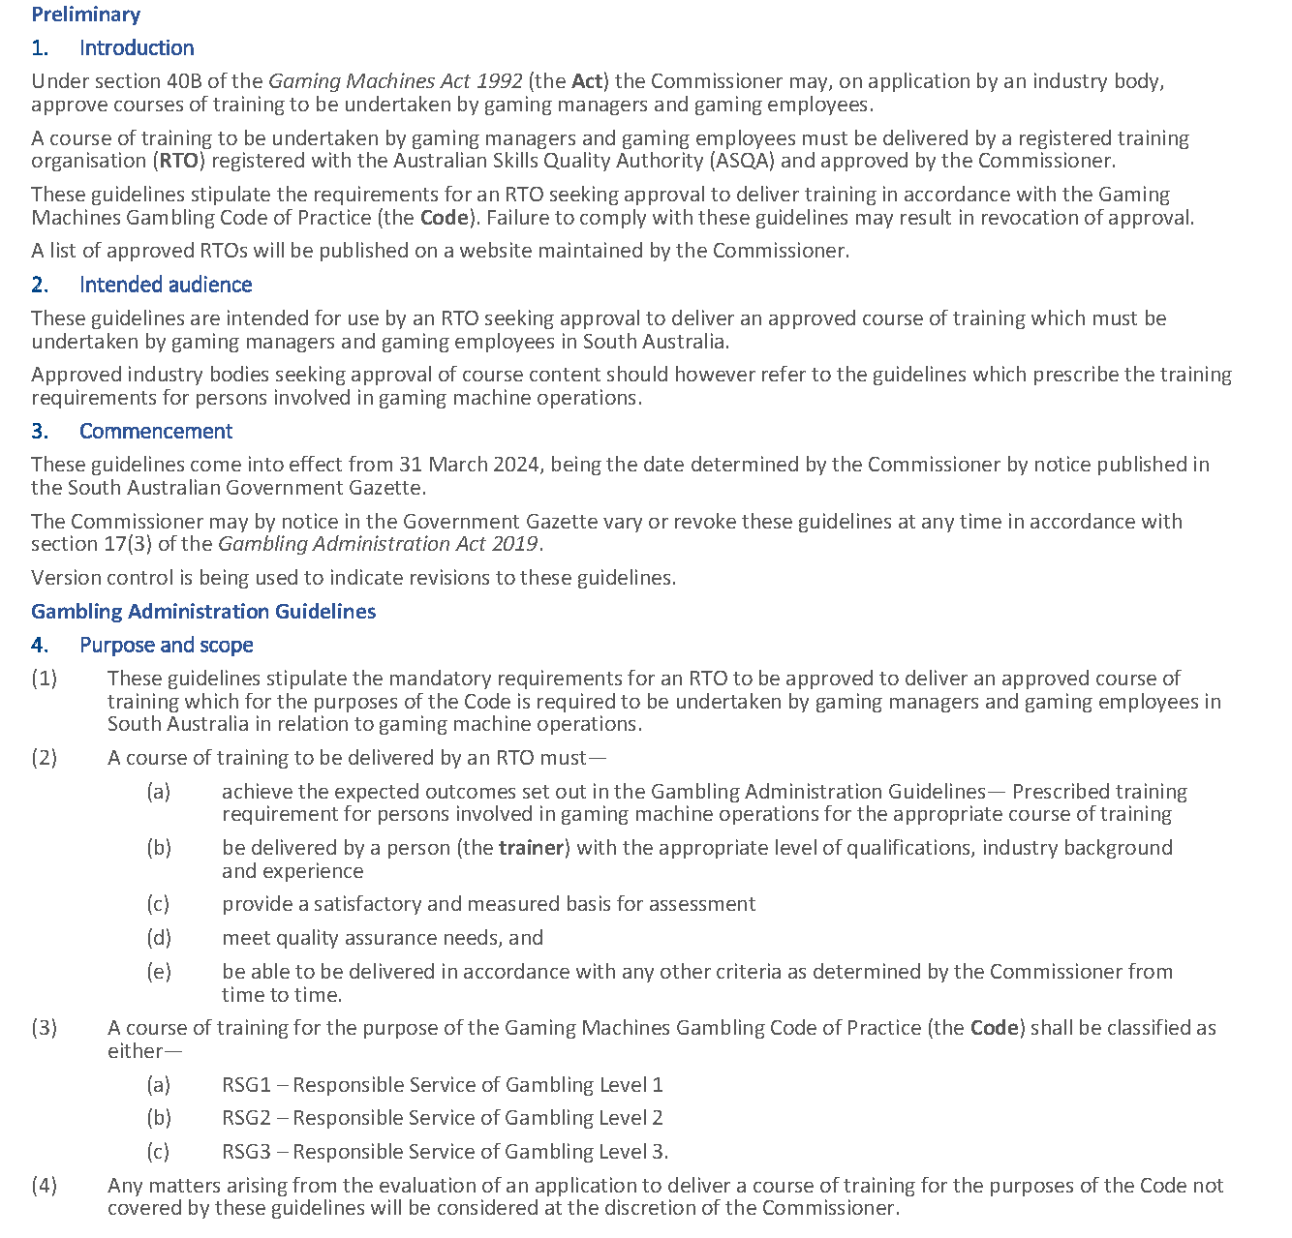
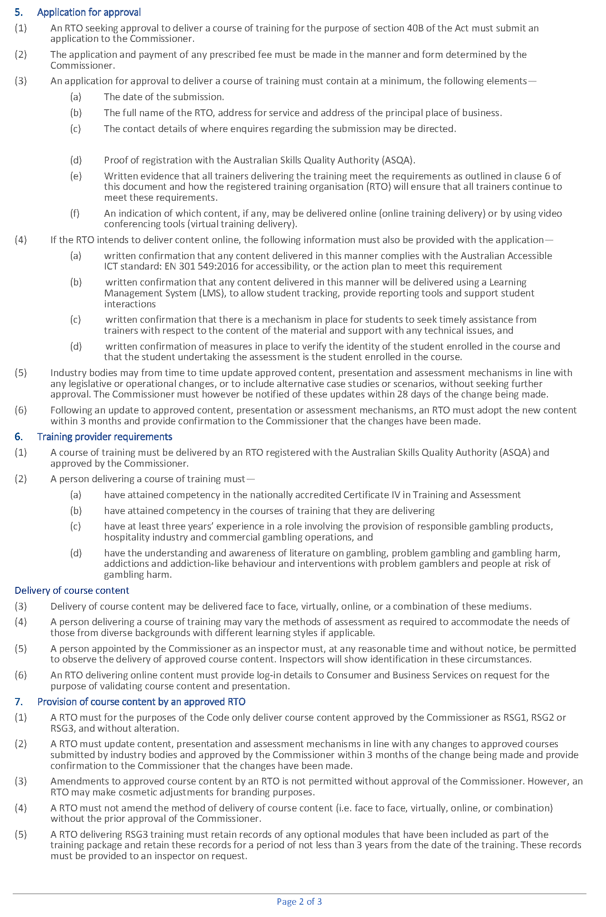
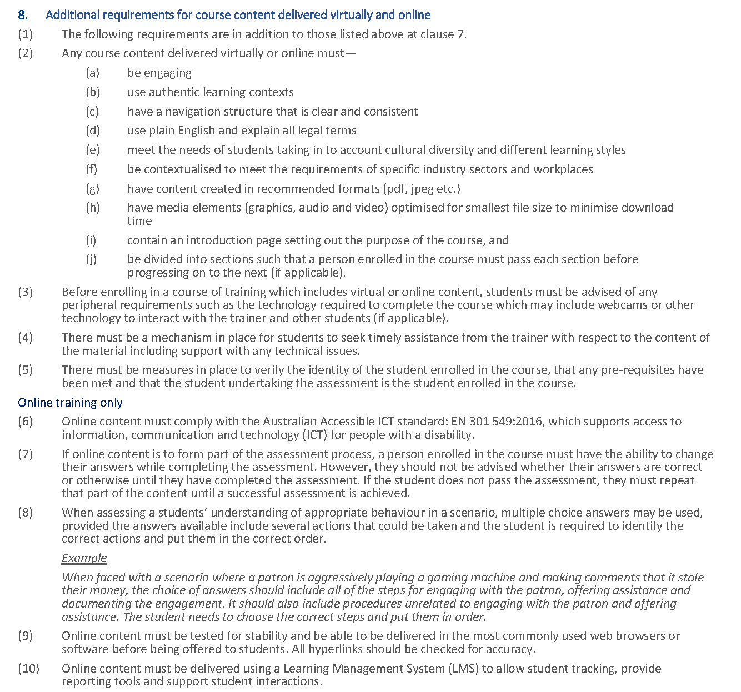

Gambling Administration Act 2019
South Australia
Gaming Machines Gambling Code of Practice Variation Notice 2023 (No 2)
under section 15 of the Gambling Administration Act 2019
1—Short title
This notice may be cited as the Gaming Machines Gambling Code of Practice Variation Notice 2023 (No 2) (Variation Notice).
2—Commencement
This Variation Notice comes into operation on 31 March 2024.
3—Variation of existing Authorised Betting Operations Gambling Code of Practice
This Variation Notice will have the effect that the Gaming Machines Gambling Code of Practice prescribed by this notice will supersede the Gaming Machines Gambling Code of Practice in effect prior to 31 March 2024.
4—Authorised Betting Operations Gambling Code of practice
The Gaming Machines Gambling Code of Practice set out in this notice is varied under s15 of the Gambling Administration Act 2019, for the purposes of the Gaming Machines Act 1992.
Dated: 28 September 2023
Dini Soulio
Liquor and Gambling Commissioner

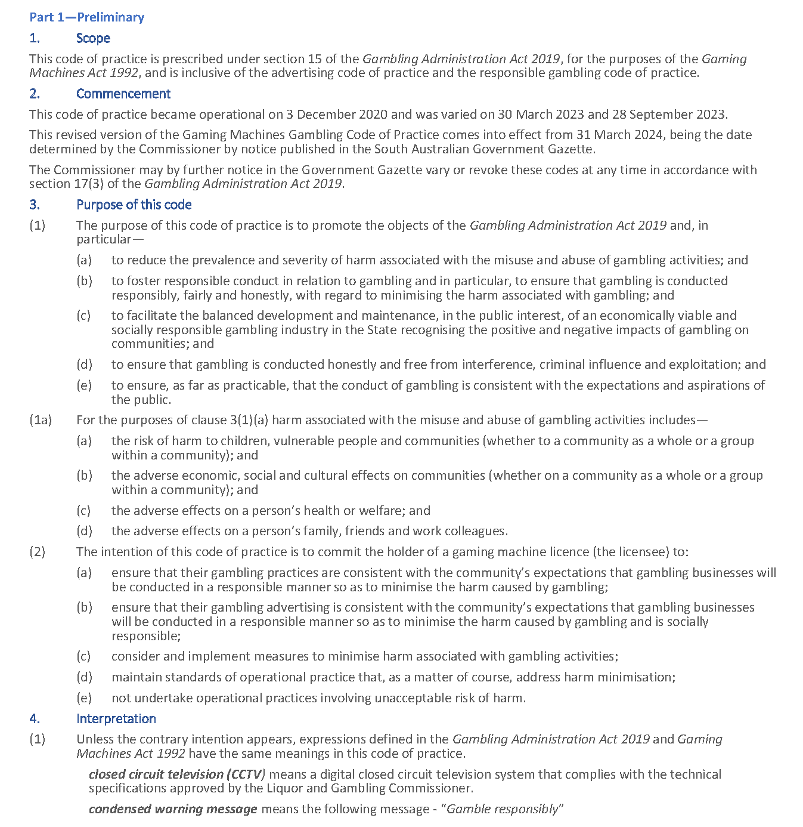
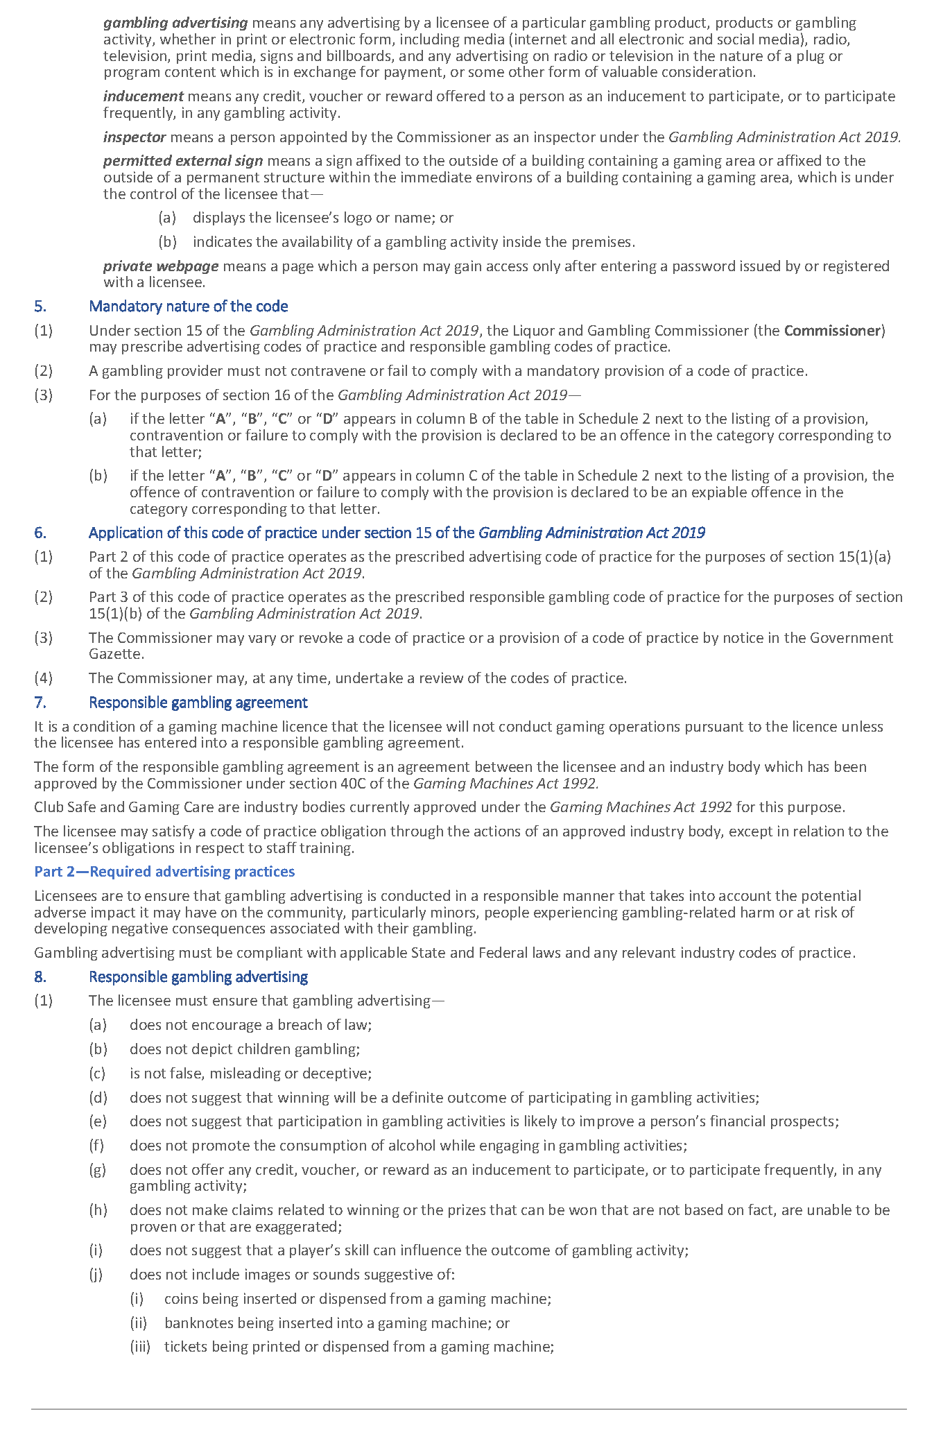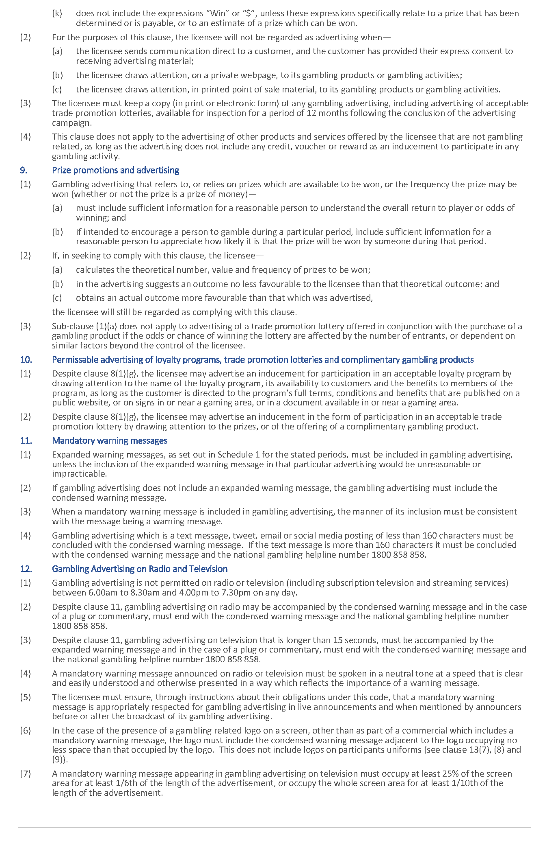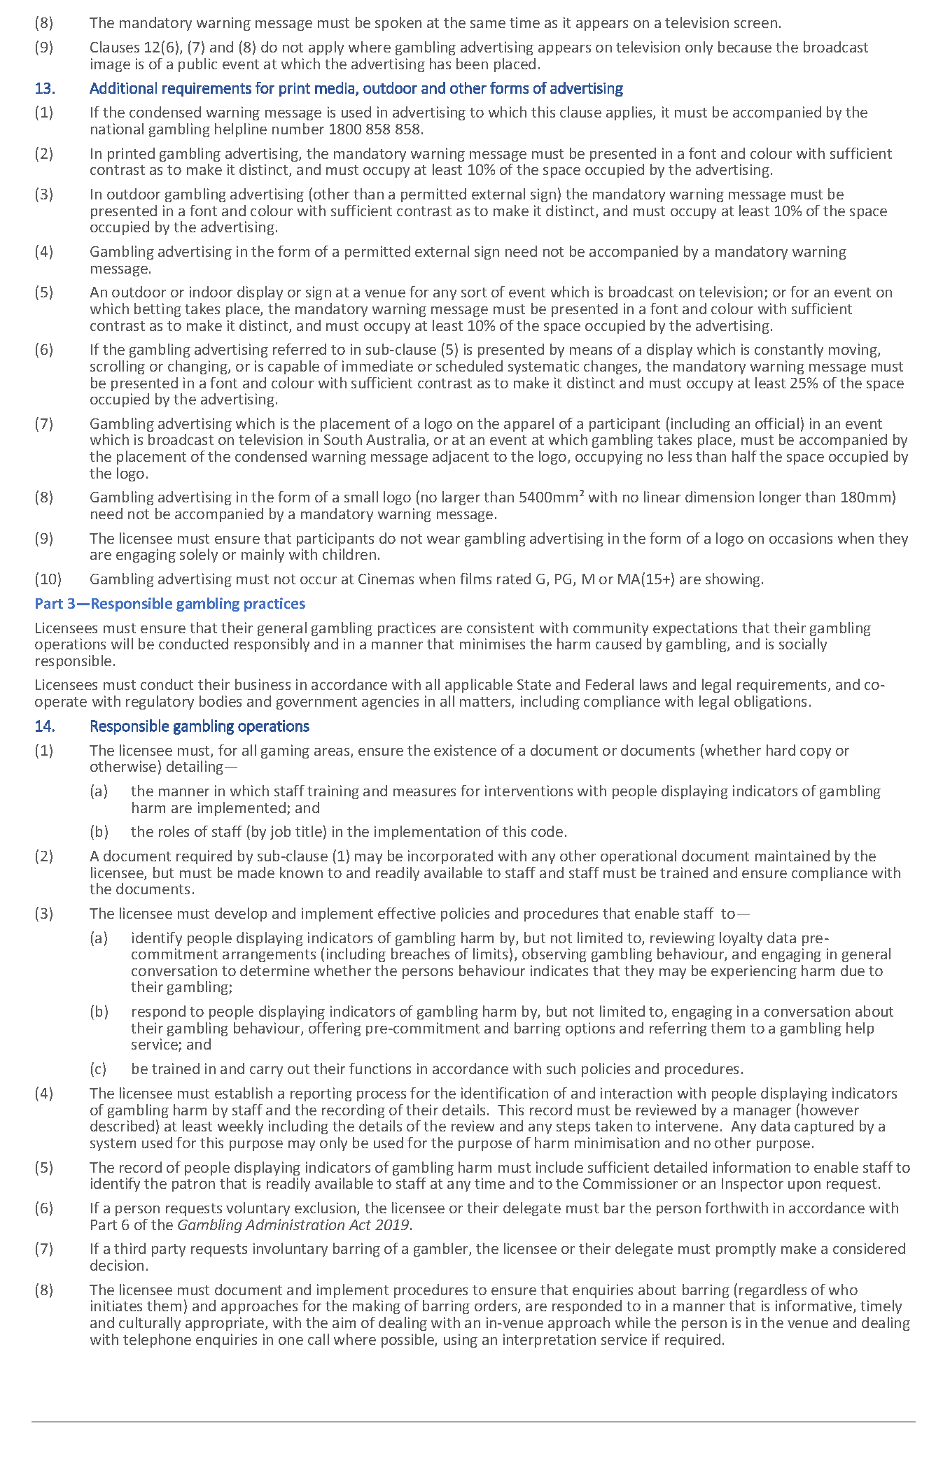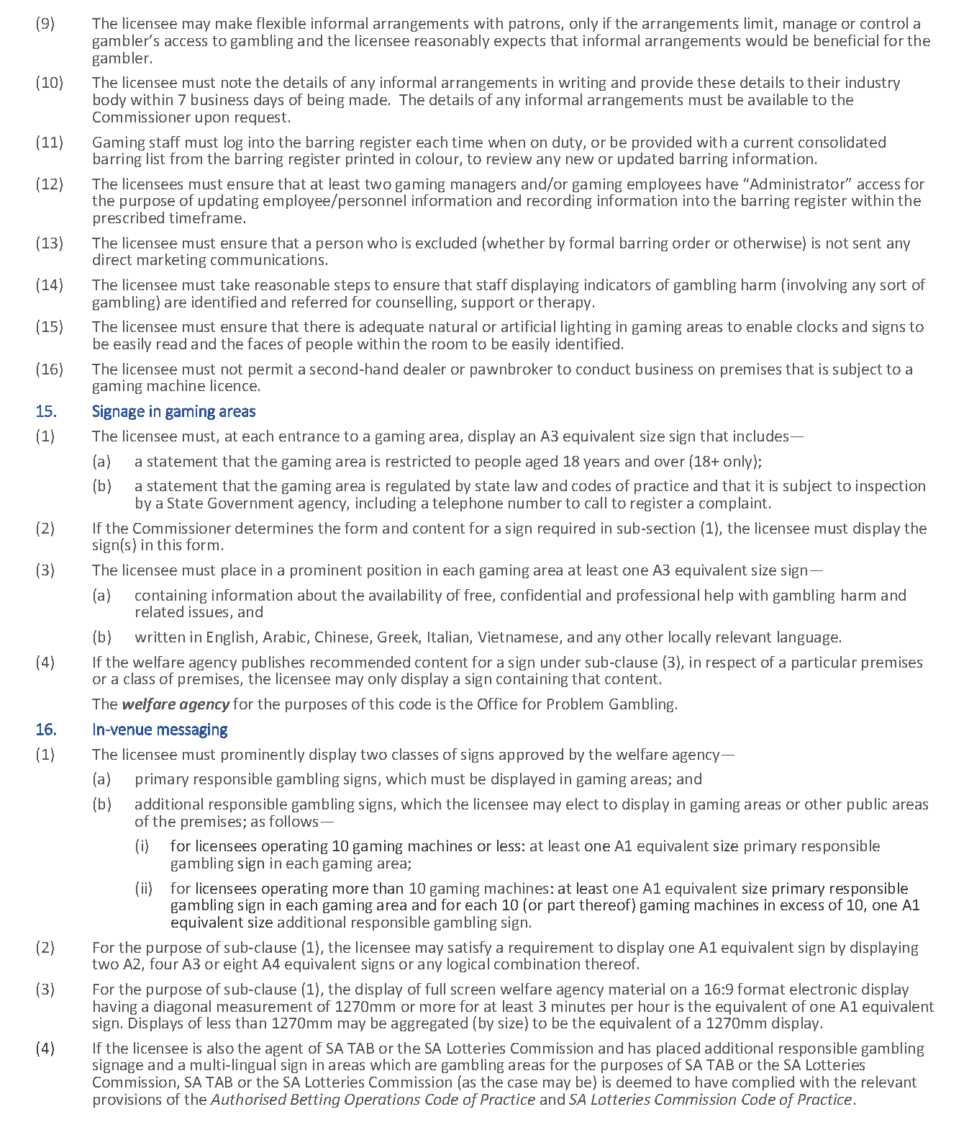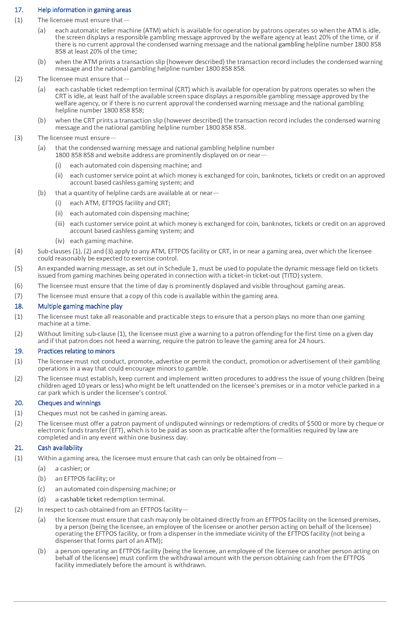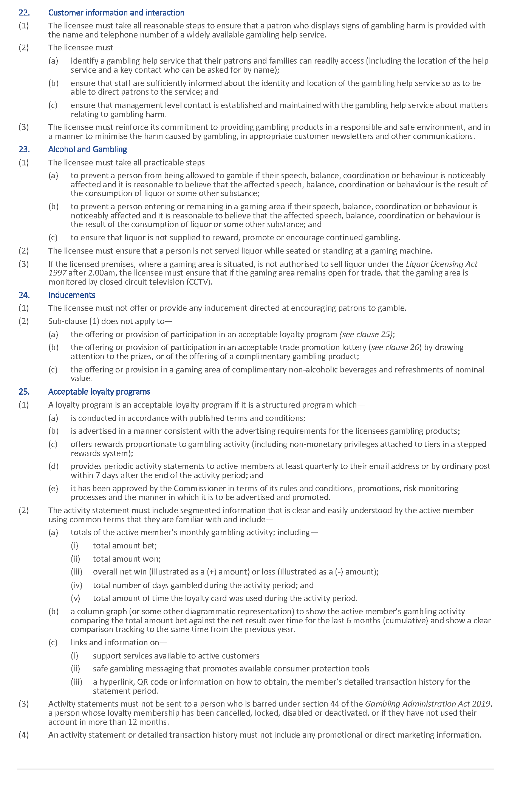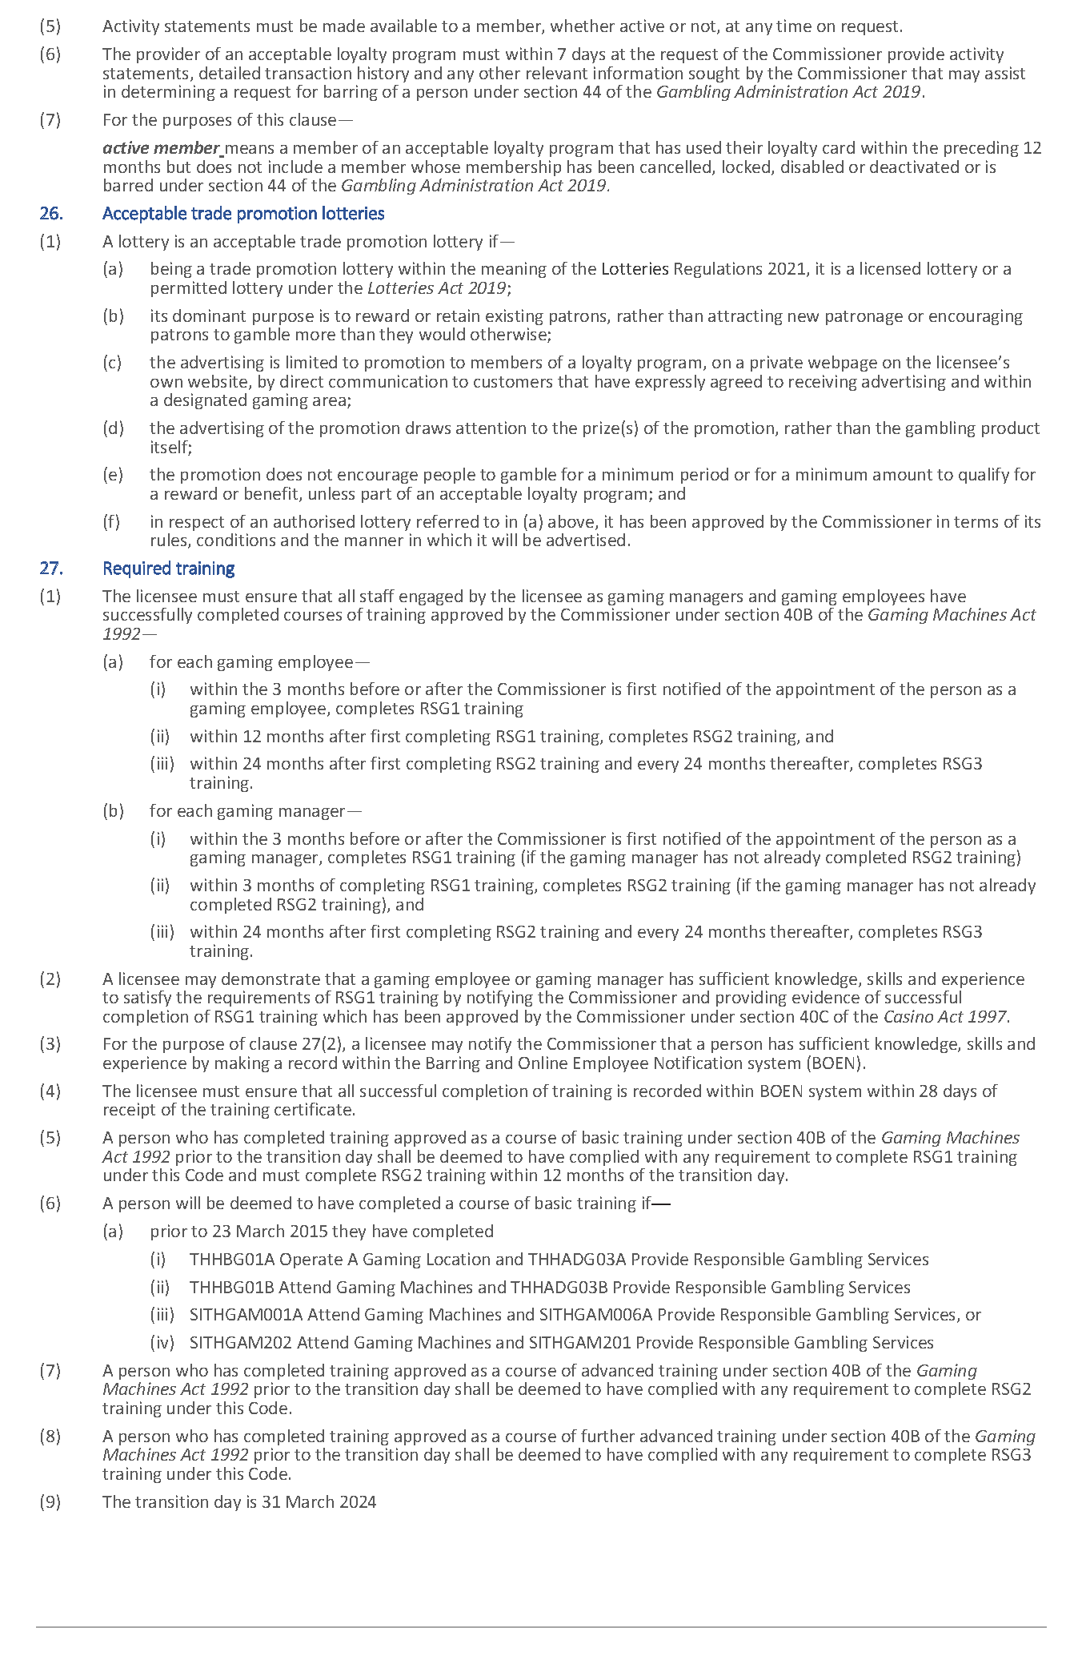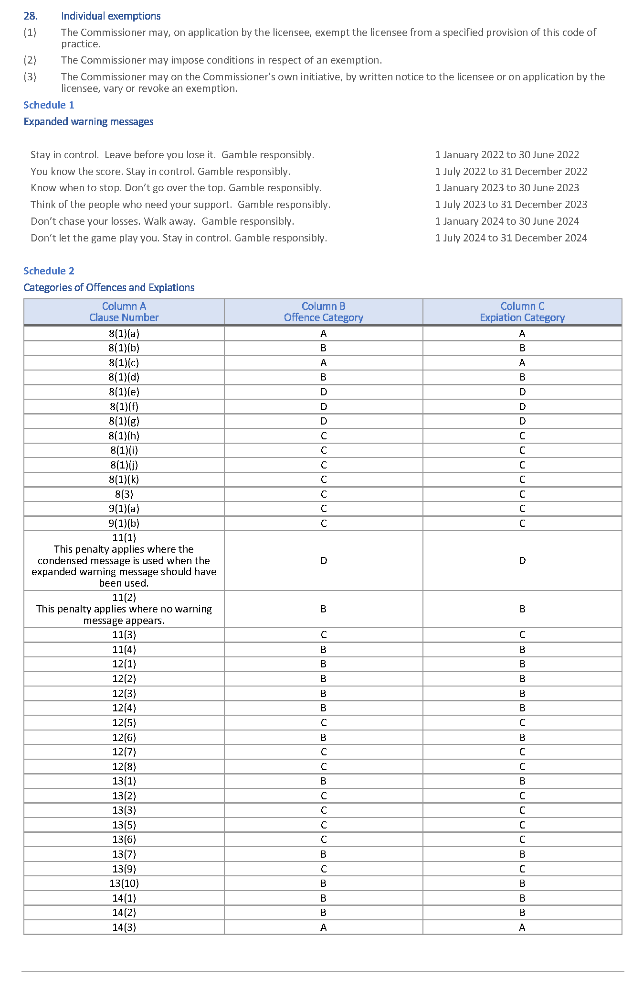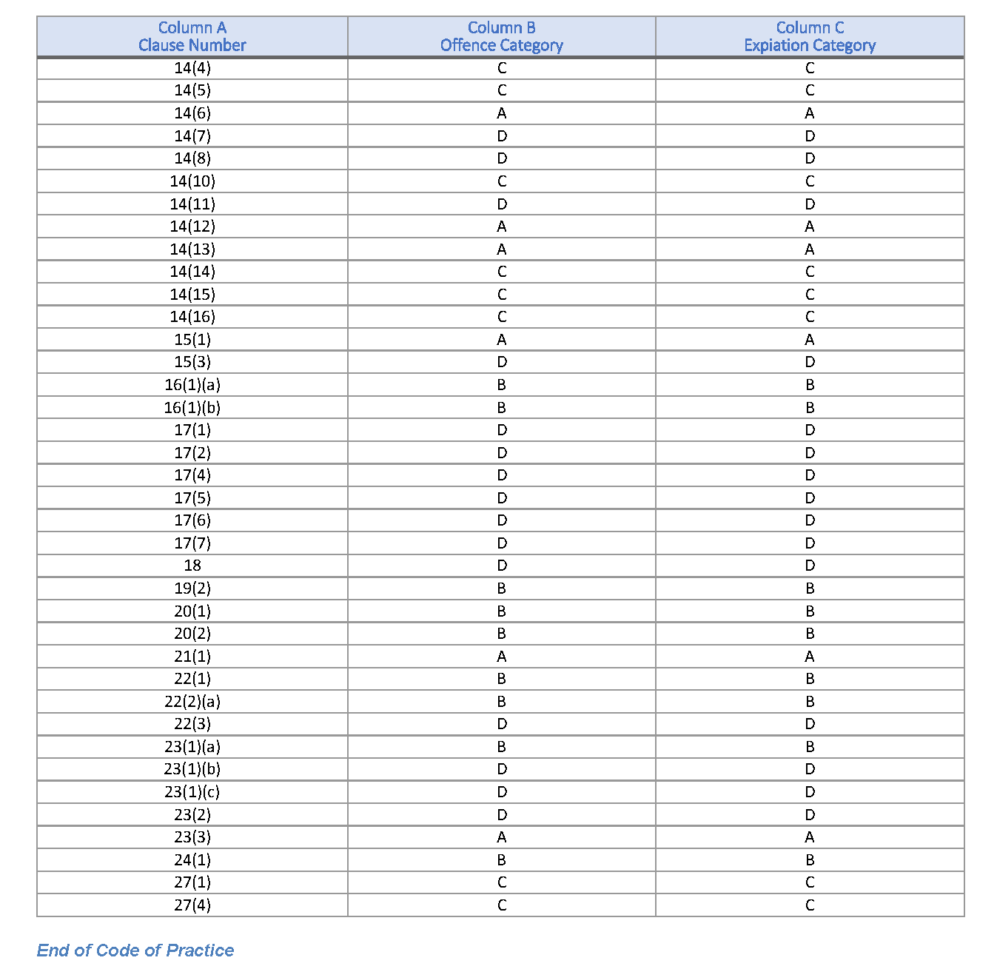

Gambling Administration Act 2019
South Australia
State Lotteries Gambling Code of Practice Variation Notice 2023 (No 1)
under section 15 of the Gambling Administration Act 2019
1—Short title
This notice may be cited as the State Lotteries Gambling Code of Practice Variation Notice 2023 (No 1) (Variation Notice).
2—Commencement
This Variation Notice comes into operation on 31 March 2024.
3—Variation of existing Authorised Betting Operations Gambling Code of Practice
This Variation Notice will have the effect that State Lotteries Gambling Code of Practice prescribed by this notice will supersede the State Lotteries Gambling Code of Practice in effect prior to 31 March 2024.
4—Authorised Betting Operations Gambling Code of practice
The State Lotteries Gambling Code of Practice set out in this notice is varied under s15 of the Gambling Administration Act 2019, for the purposes of the Gaming Machines Act 1992.
Dated: 28 September 2023
Dini Soulio
Liquor and Gambling Commissioner

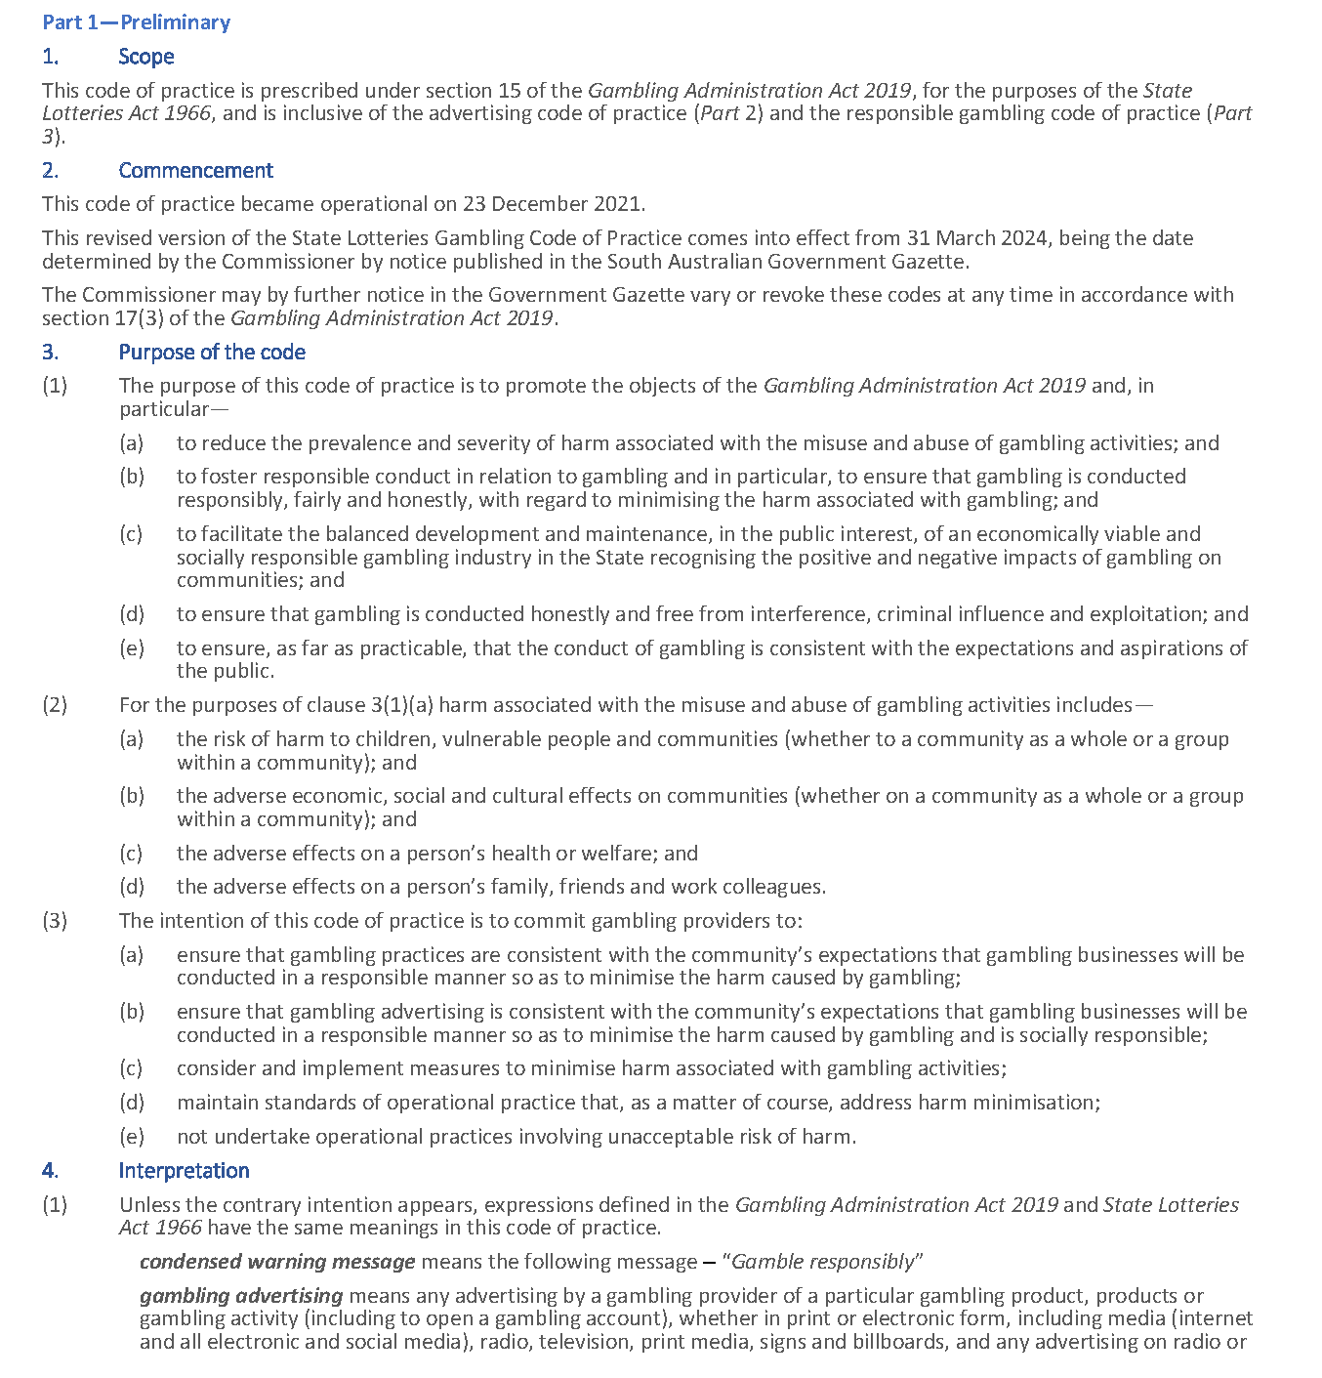
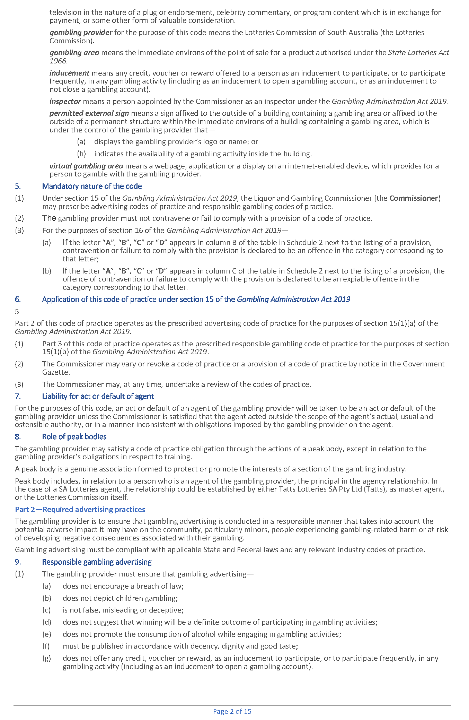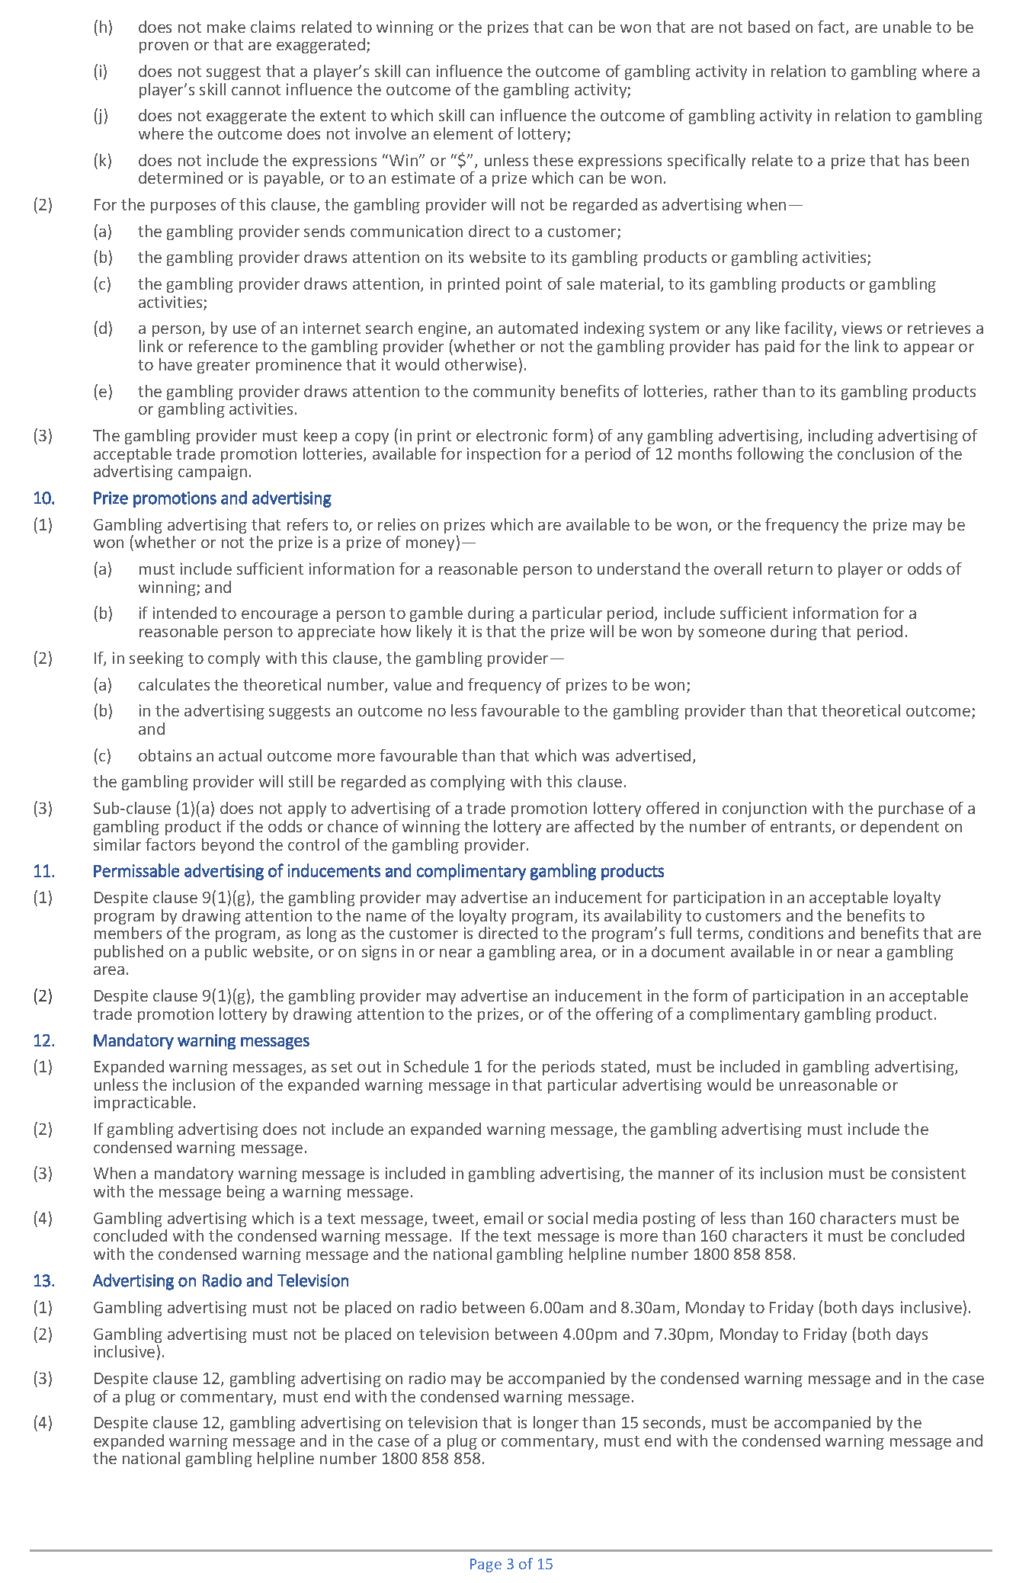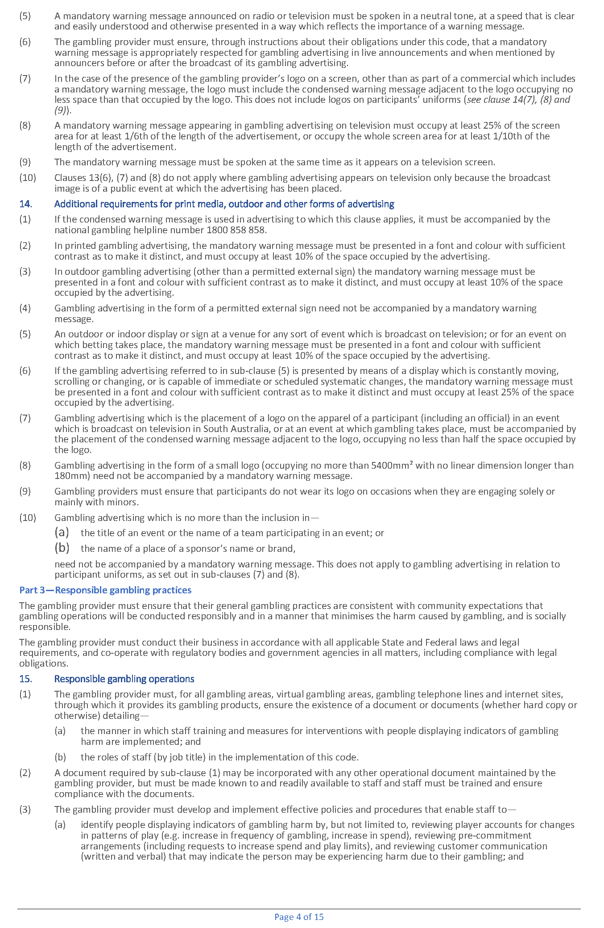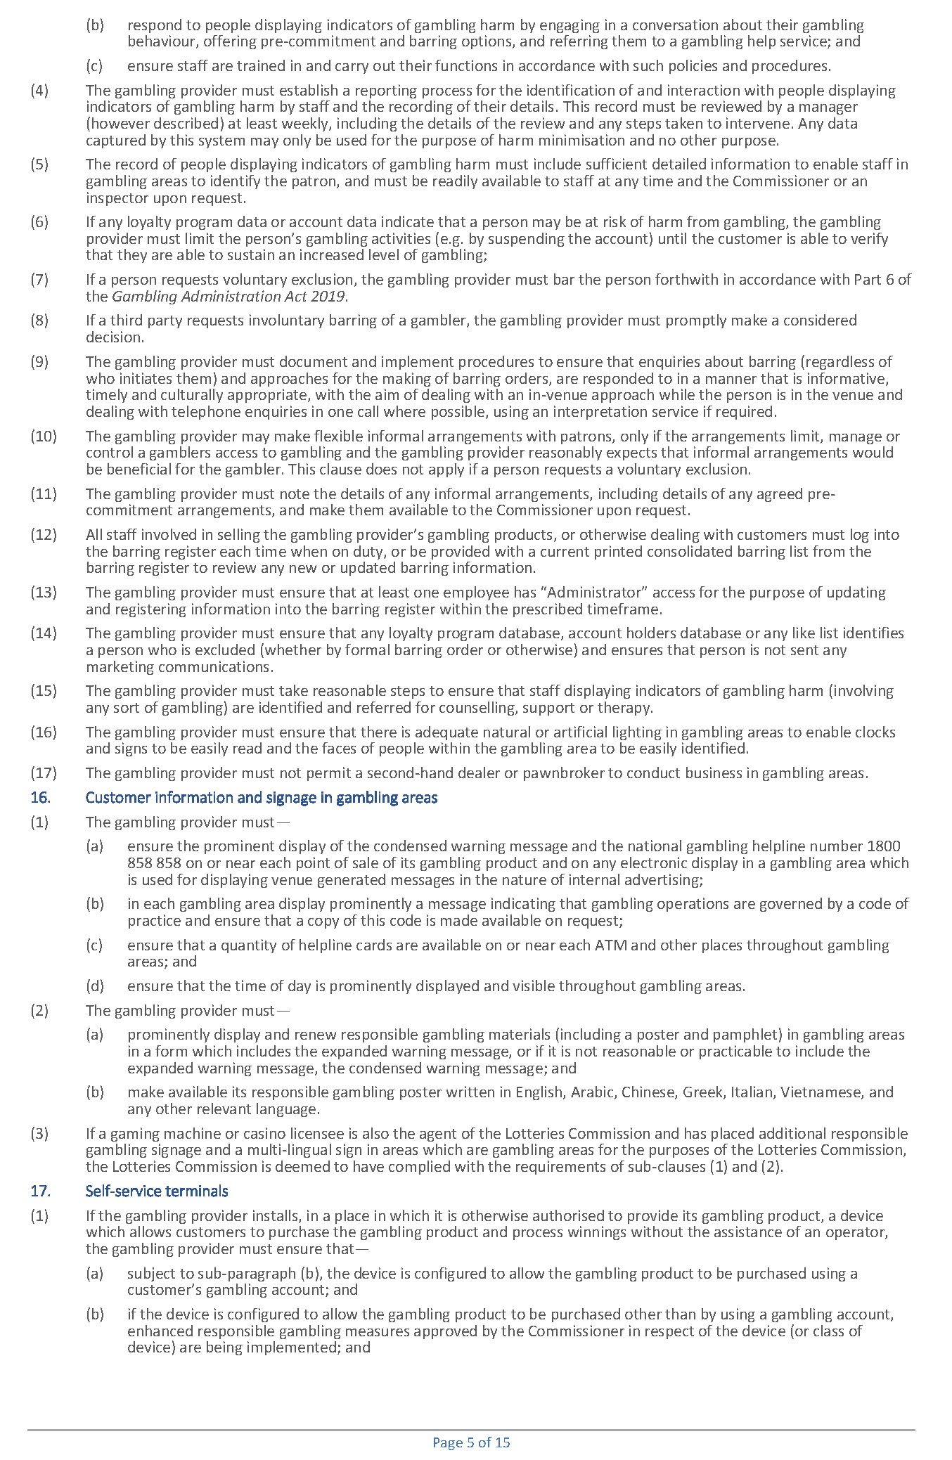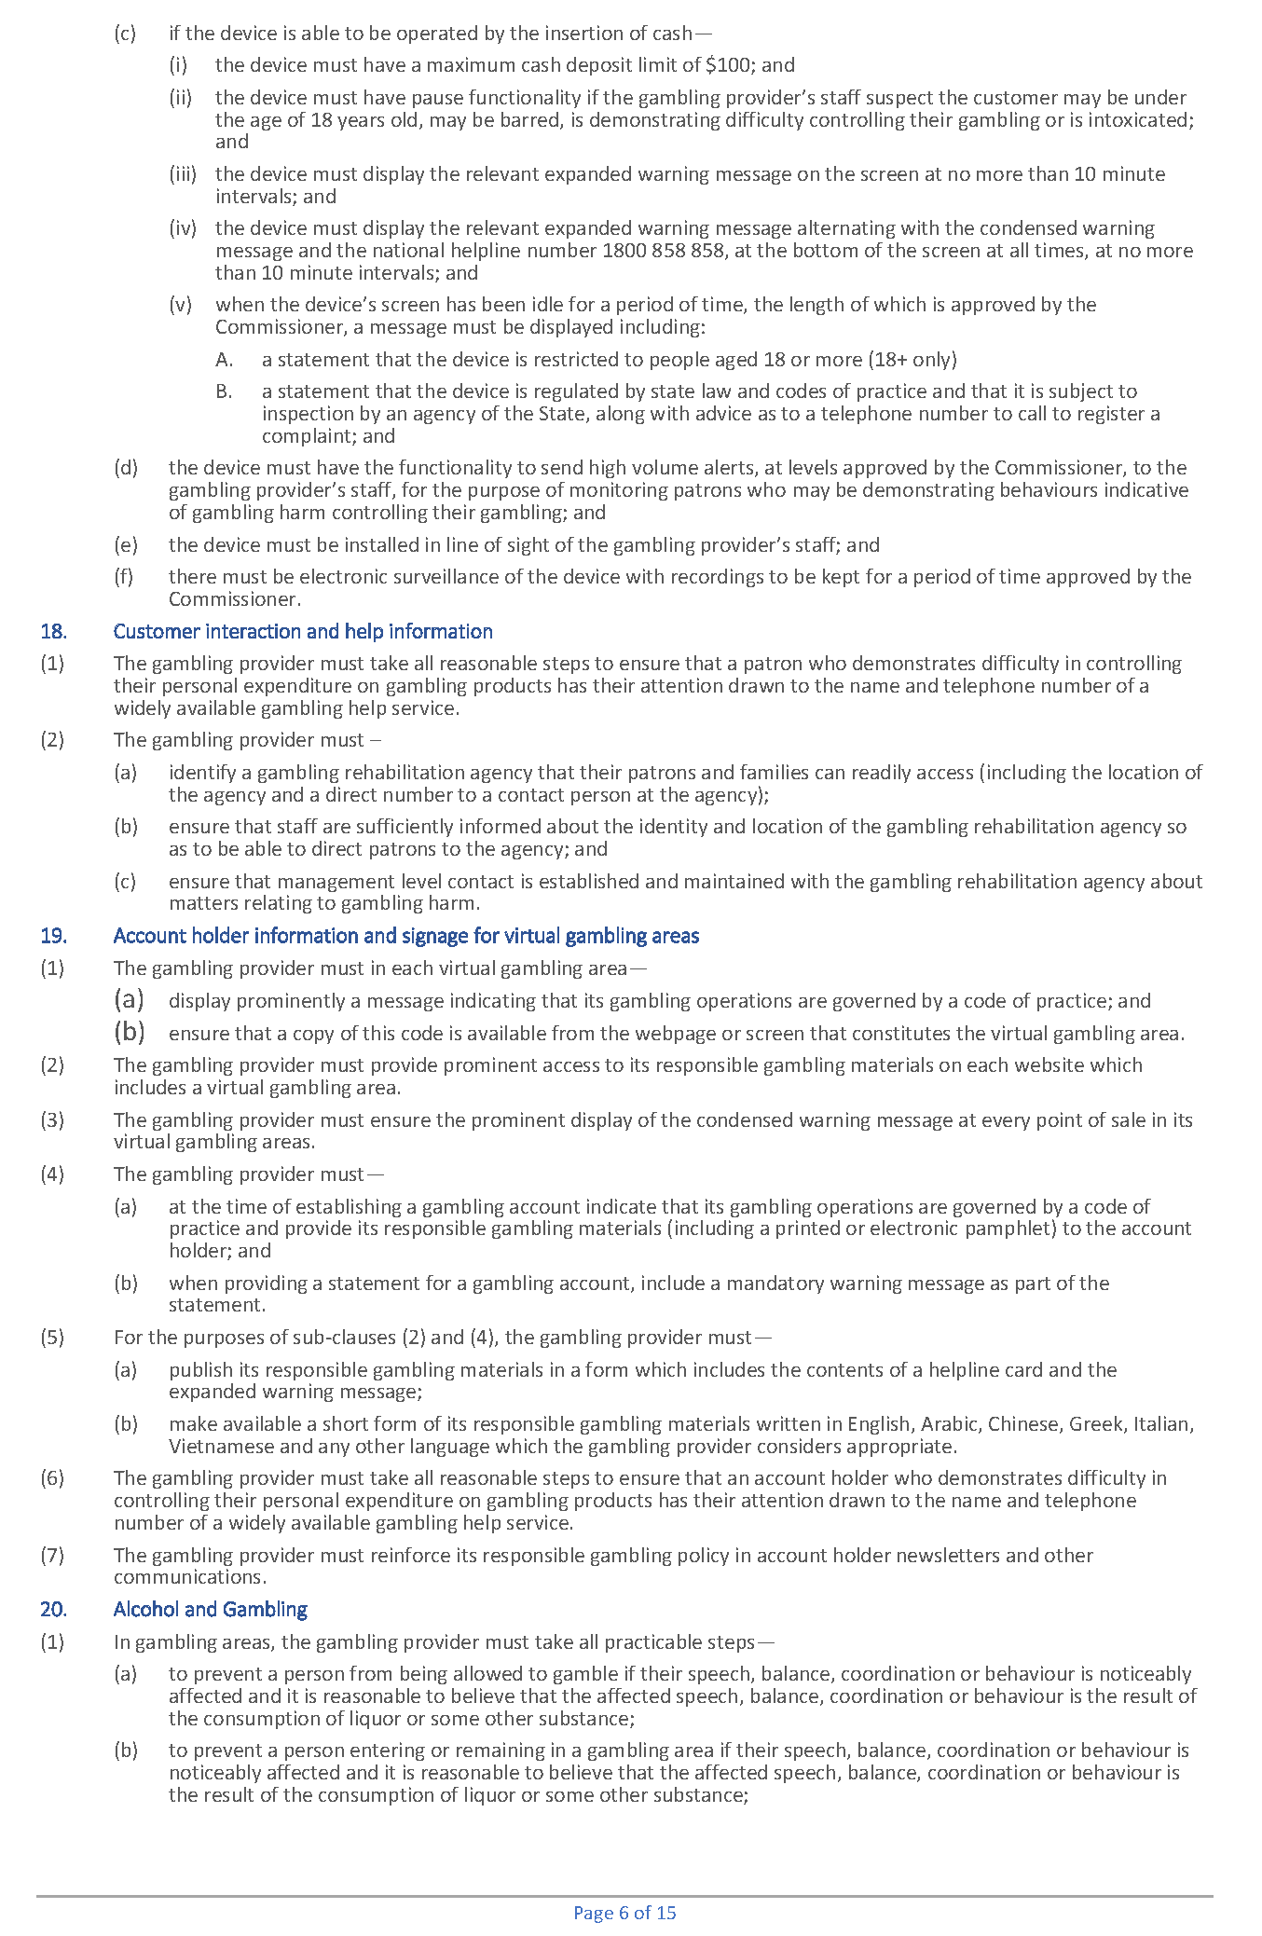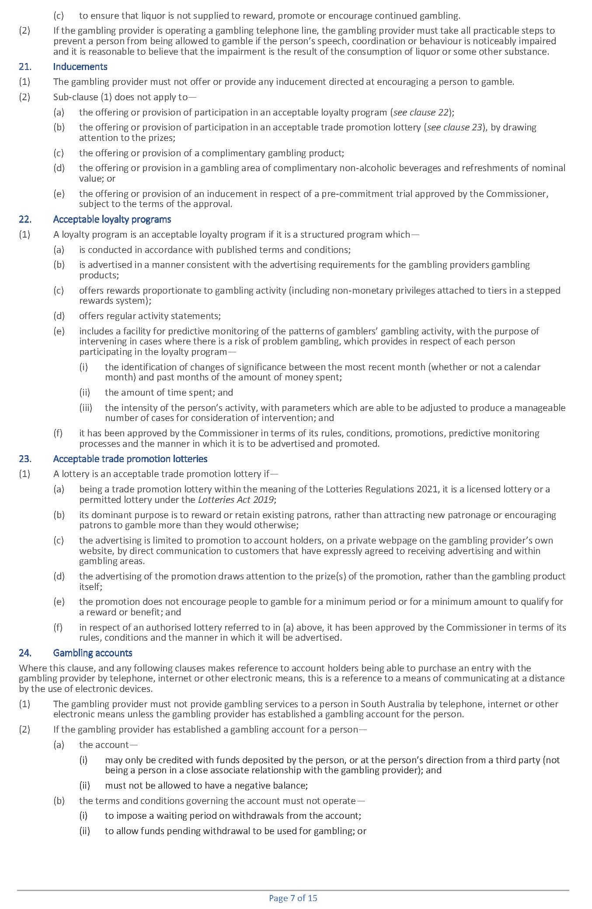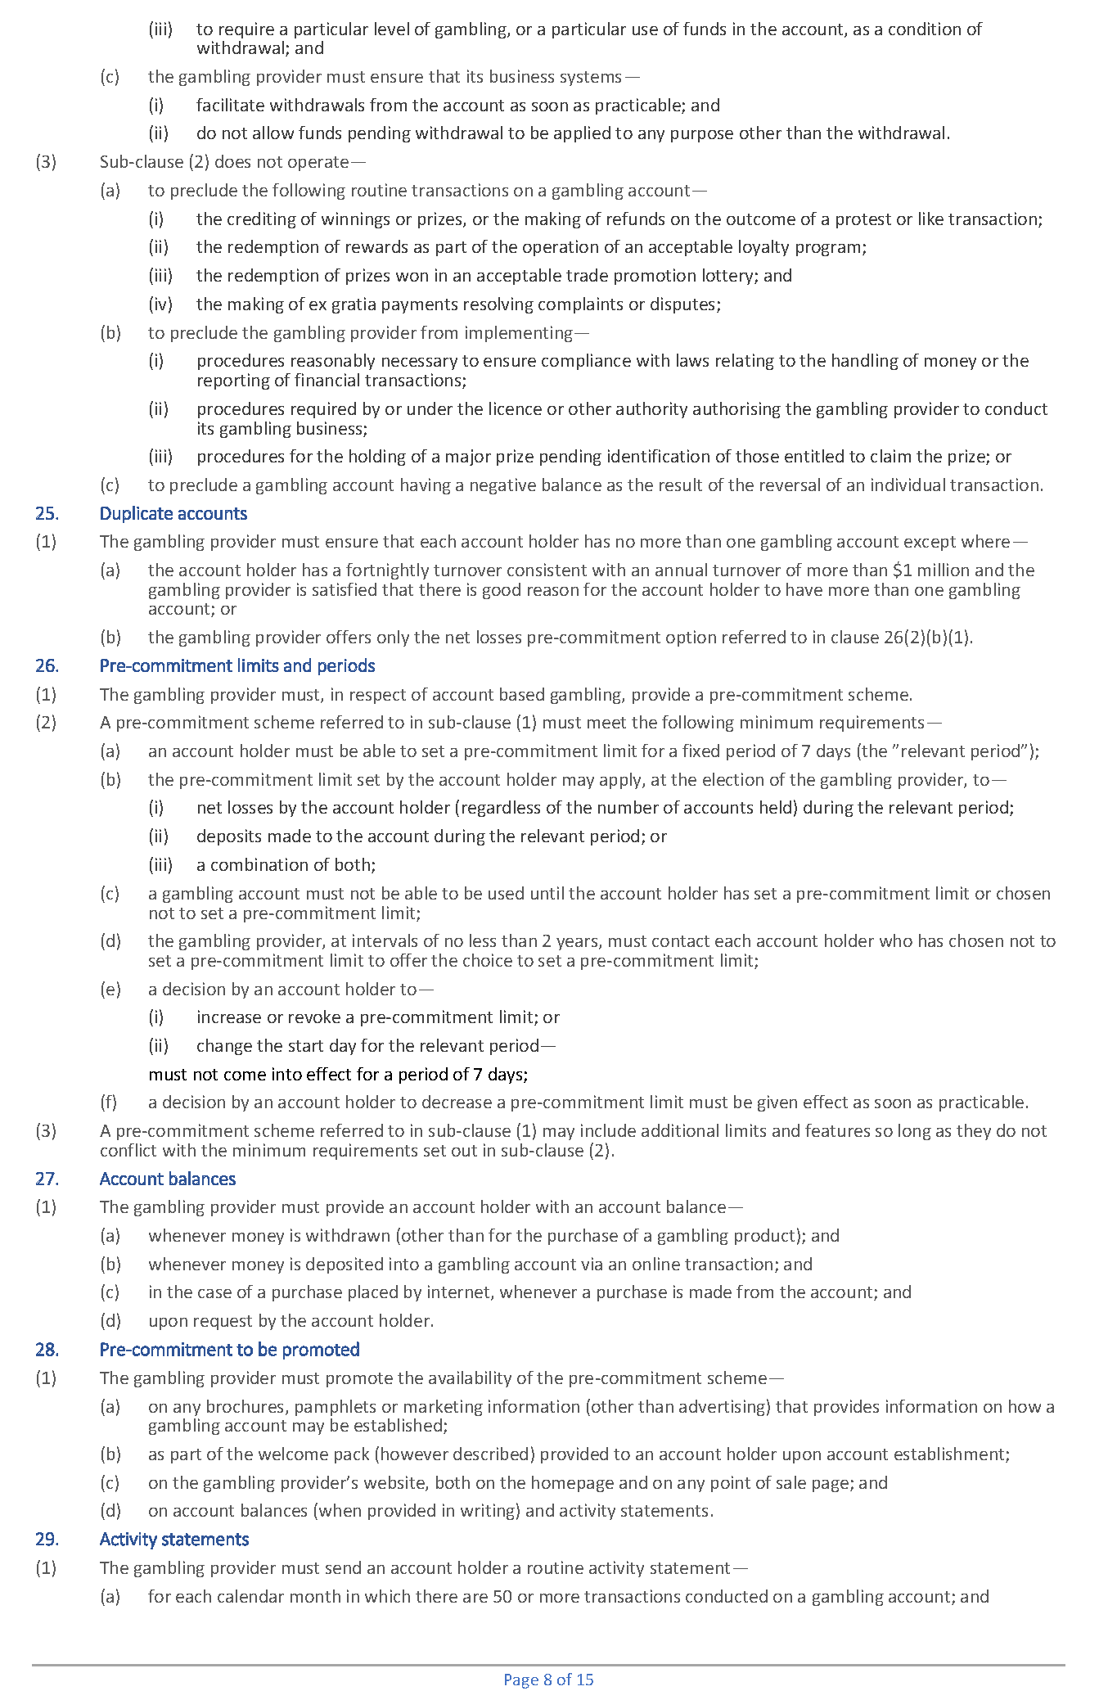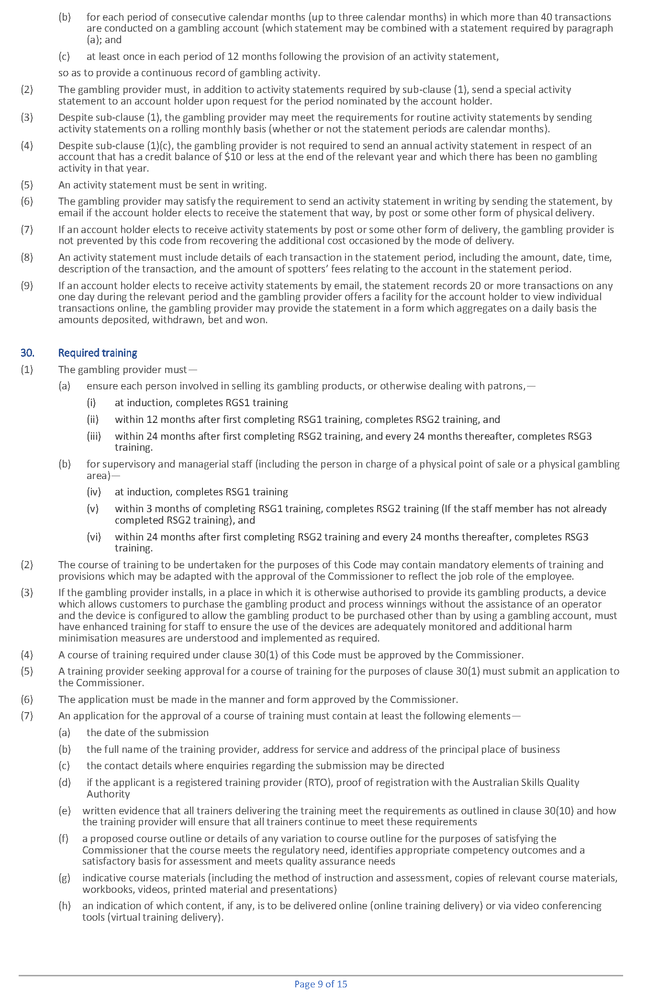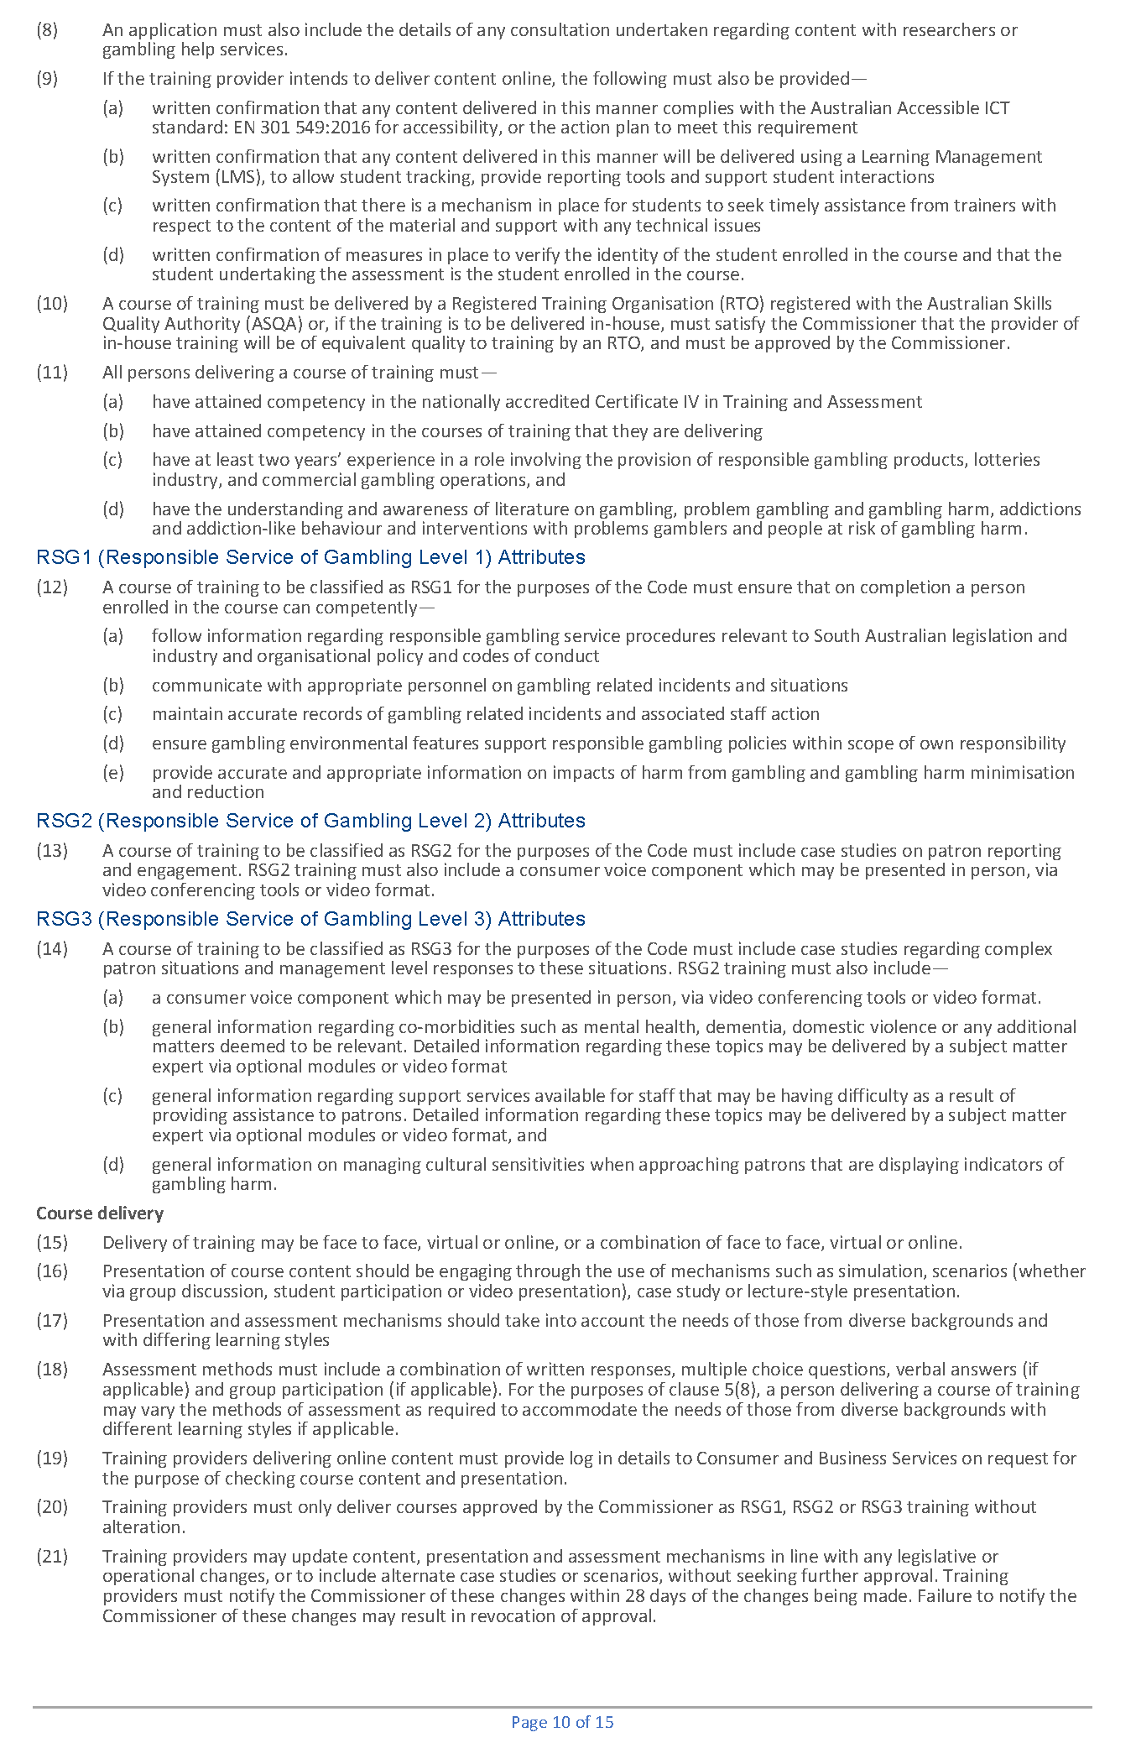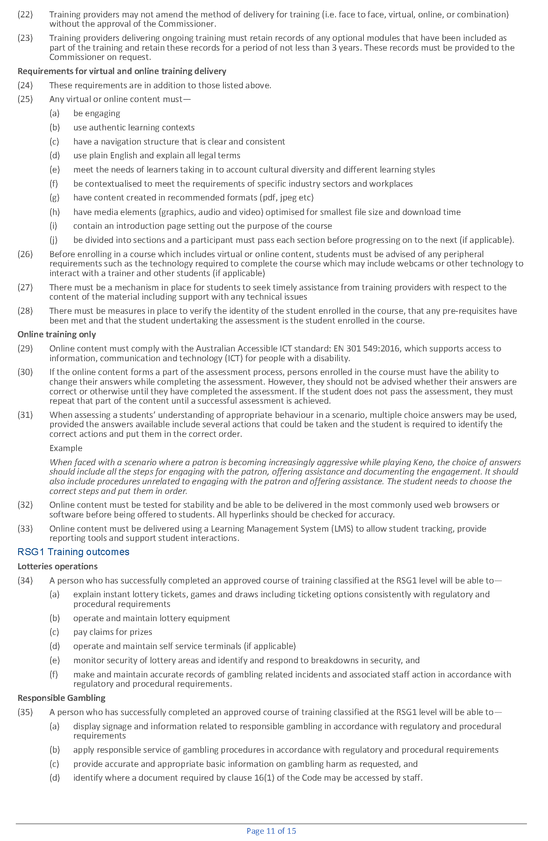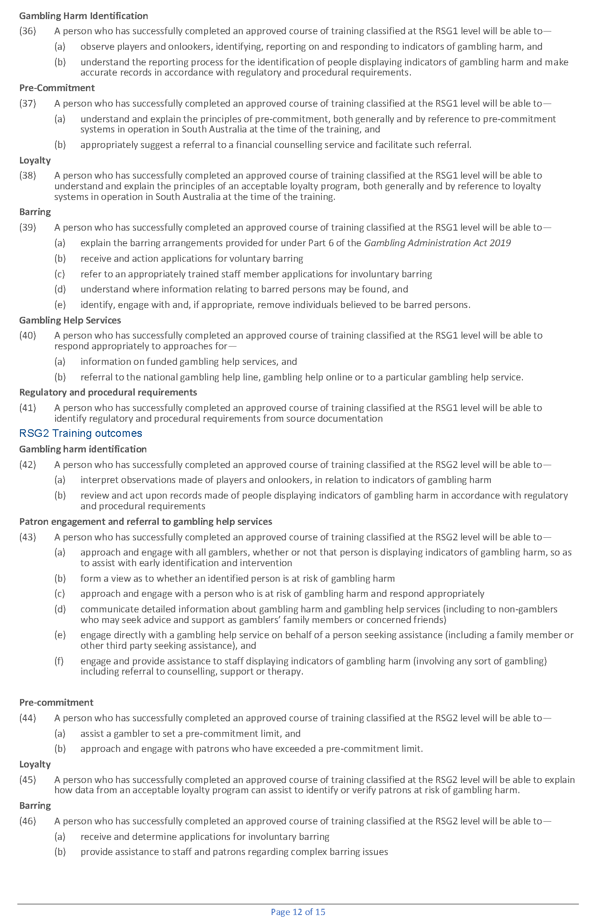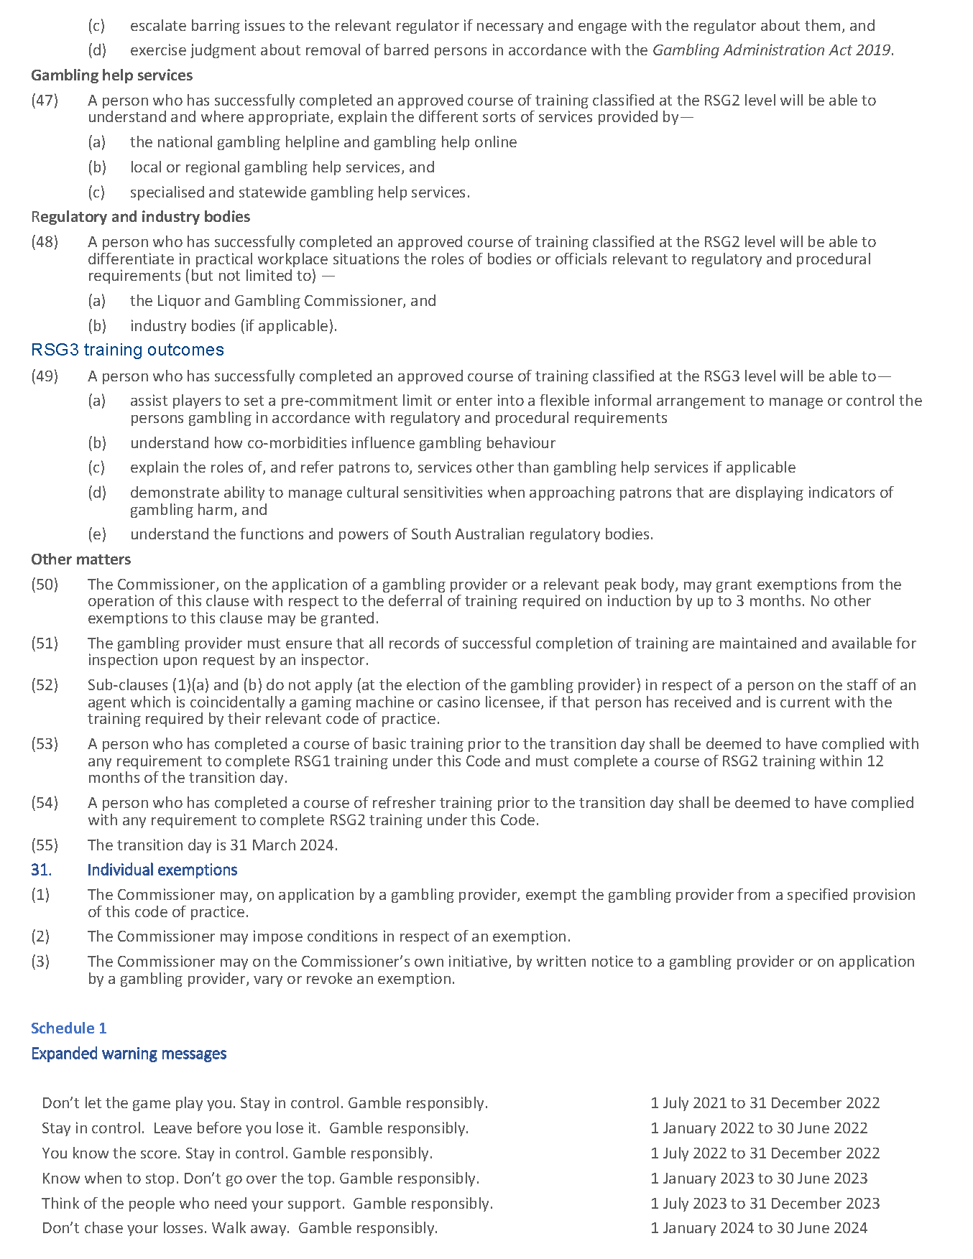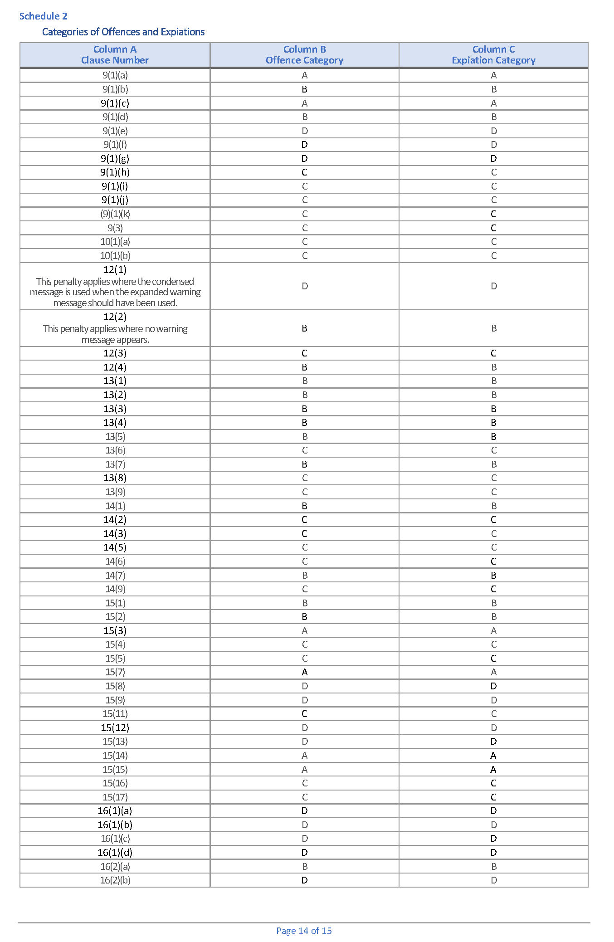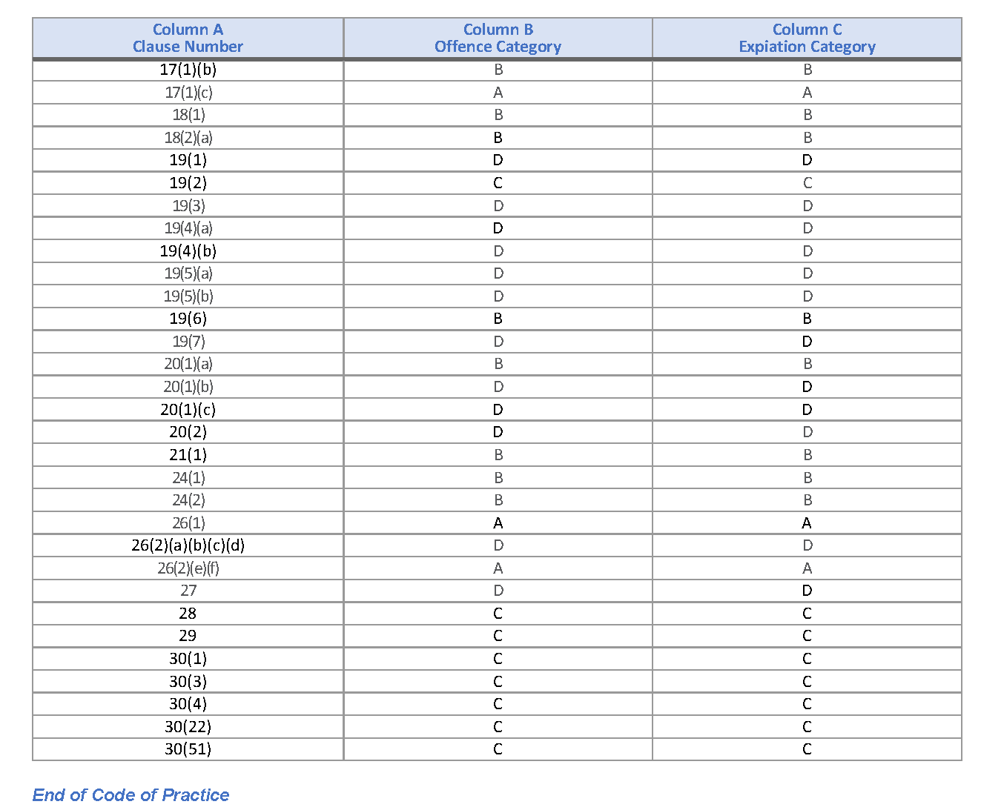

Geographical Names Act 1991
Notice to Alter the Boundary of a Place
NOTICE is hereby given that, pursuant to section 11B(1)(b) of the Geographical Names Act 1991, I, BRADLEY SLAPE, Surveyor-General and Delegate appointed by the Honourable Nick Champion MP, Minister for Planning, Minister of the Crown to whom the administration of the Geographical Names Act 1991 is committed, DO HEREBY;
- Alter the locality boundary between Hindmarsh Tiers and Mount Jagged to exclude that area marked (A), highlighted in green as shown on the plan, from the bounded locality of MOUNT JAGGED and include that area in the locality of HINDMARSH TIERS.
- Alter the locality boundary between Hindmarsh Tiers and Mount Jagged to exclude that area marked (B), highlighted in orange as shown on the plan, from the bounded locality of HINDMARSH TIERS and include that area in the locality of MOUNT JAGGED.
This notice is to take effect immediately upon its publication in the Government Gazette.
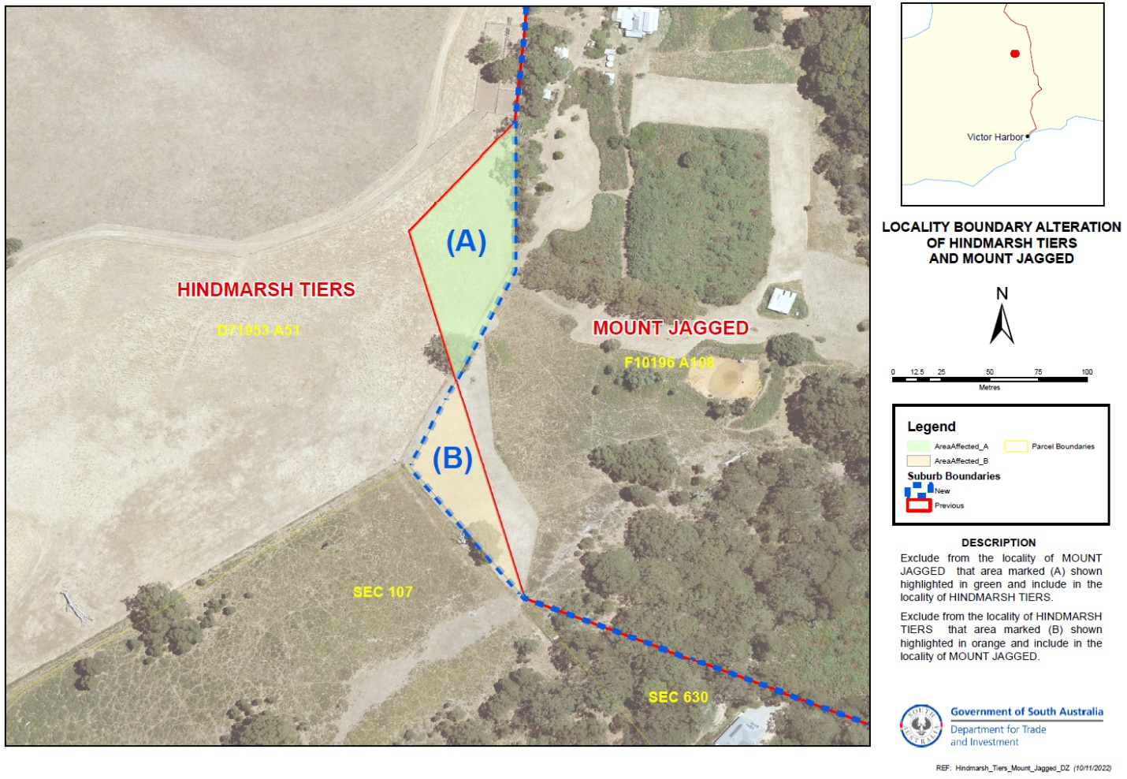
Dated: 28 September 2023
B.J. Slape
Surveyor General
2021/03842/01

Geographical Names Act 1991
Notice to Alter the Boundary of a Place
NOTICE is hereby given that, pursuant to section 11B(1)(b) of the Geographical Names Act 1991, I, BRADLEY SLAPE, Surveyor-General and Delegate appointed by the Honourable Nick Champion MP, Minister for Planning, Minister of the Crown to whom the administration of the Geographical Names Act 1991 is committed, DO HEREBY;
- Alter the locality boundary between Keyneton and Eden Valley to exclude that area marked (A), highlighted in green as shown on the plan, from the bounded locality of KEYNETON and include that area in the locality of EDEN VALLEY.
This notice is to take effect immediately upon its publication in the Government Gazette.
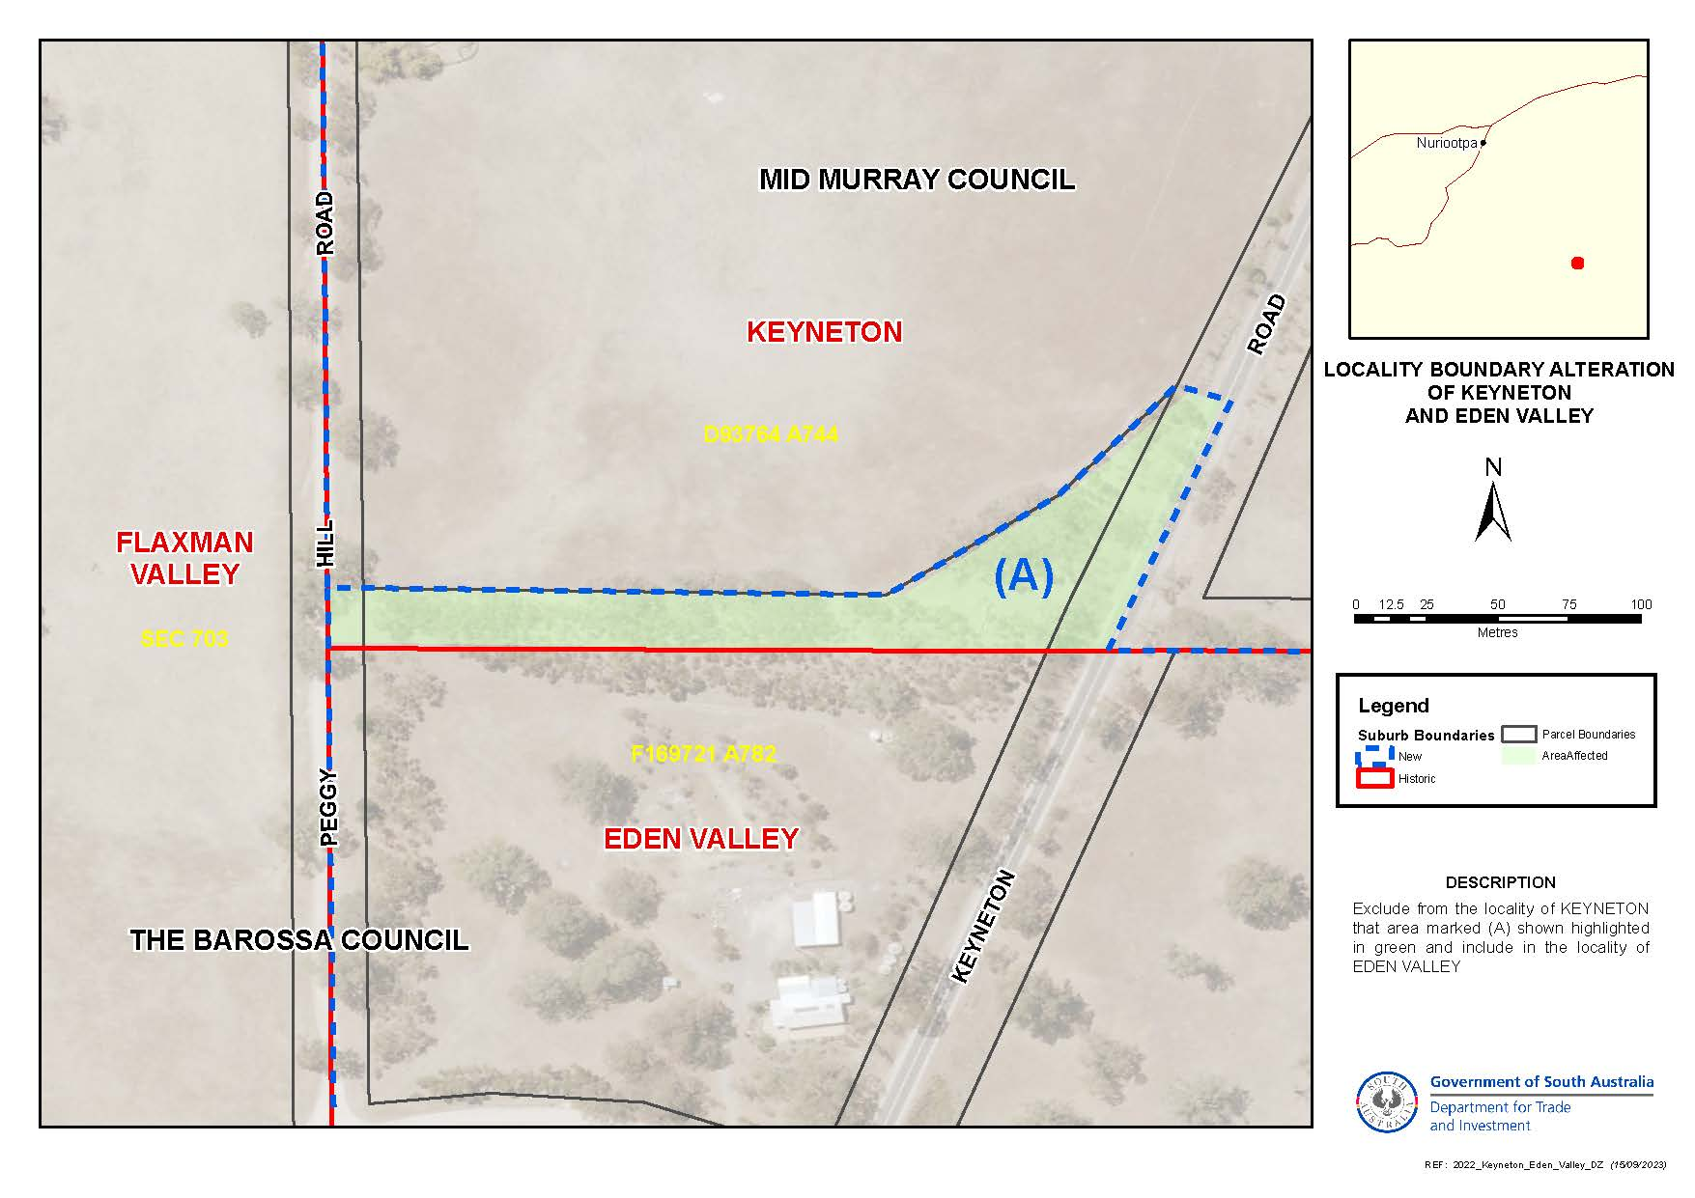
Dated: 28 September 2023
B.J. Slape
Surveyor General
2021/03842/01

Housing Improvement Act 2016
Rent Control
The Minister for Human Services Delegate in the exercise of the powers conferred by the Housing Improvement Act 2016, does hereby fix the maximum rental per week which shall be payable subject to Section 55 of the Residential Tenancies Act 1995, in respect of each house described in the following table. The amount shown in the said table shall come into force on the date of this publication in the Gazette.
Address of Premises | Allotment Section | Certificate of Title Volume/Folio | Maximum Rental per week payable
8 Hambridge Road, Davoren Park  SA 5113 | Allotment 10 Deposited Plan 52407  Hundred Munno Para | CT 5674/180 | $210.00
6 Cresdee Road, Campbelltown  SA 5074 | Allotment 273 Deposited Plan 3579  Hundred of Adelaide | CT 5575/231 | $170.00
Dated: 28 September 2023
Craig Thompson
Housing Regulator and Registrar
Housing Safety Authority, SAHA
Delegate of Minister for Human Services

Housing Improvement Act 2016
Rent Control Revocations
Whereas the Minister for Human Services Delegate is satisfied that each of the houses described hereunder has ceased to be unsafe or unsuitable for human habitation for the purposes of the Housing Improvement Act 2016, notice is hereby given that, in exercise of the powers conferred by the said Act, the Minister for Human Services Delegate does hereby revoke the said Rent Control in respect of each property.
Address of Premises | Allotment Section | Certificate of Title Volume/Folio
30 Stanley Street, Crystal Brook  SA 5523 | Allotment 23 Deposited Plan 486 Hundred of Crystal Brook | CT5797/646, CT5852/36
49 Ashley Street, Torrensville SA 5031 | Allotment 49 Filed Plan 123243 Hundred Adelaide | CT 5865/253
Dated: 28 September 2023
Craig Thompson
Housing Regulator and Registrar
Housing Safety Authority, SAHA
Delegate of Minister for Human Services

Justices of the Peace Act 2005
Section 4
Notice of Appointment of Justices of the Peace for South Australia
by the Commissioner for Consumer Affairs
I, Dini Soulio, Commissioner for Consumer Affairs, delegate of the Attorney-General, pursuant to section 4 of the Justices of the Peace Act 2005, do hereby appoint the people listed as Justices of the Peace for South Australia as set out below.
For a period of ten years for a term commencing on 3 October 2023 and expiring on 2 October 2033:
David Edward WOODS
Barrie Gilbert WOODHOUSE
Stephen John WEIR
Rene Alicia WEAL
Ian WALSH
Frederick John VON STANKE
William Peter TROWBRIDGE
Judith Ann TAYLOR
Megan Therese RICHARDS
John Wainman O'FLAHERTY
Keith Alan NEWELL
Costantino MELINO
Rodney Dennis MAY
Christine Hilda KELSALL
Maria Concetta GRANOZIO
Susan Pauline GALLINA
Antonio Vincenzo FINAMORE
Graeme Innes DODSWORTH
Perry Arnold DEAN
Ian John DALE
John James BROWN
Colin Francis BROWN
Kerri Lee BOLT
Gregory David BALNAVES
Dated: 26 September 2023
Dini Soulio
Commissioner for Consumer Affairs
Delegate of the Attorney-General

Land Acquisition Act 1969
Section 16
Form 5—Notice of Acquisition
1. Notice of acquisition
The Commissioner of Highways (the Authority), of 83 Pirie Street, Adelaide SA 5000, acquires the following interests in the following land:
Comprising an unencumbered estate in fee simple in that piece of land being portion of Allotment 8 in Filed Plan 102142 comprised in Certificate of Title Volume 5119 Folio 540, and being the whole of the land identified as Allotment 2410 in D132582 lodged in the Lands Titles.
This notice is given under Section 16 of the Land Acquisition Act 1969.
2. Compensation
A person who has or had an interest consisting of native title or an alienable interest in the land that is divested or diminished by the acquisition or the enjoyment of which is adversely affected by the acquisition who does not receive an offer of compensation from the Authority may apply to the Authority for compensation.
2A. Payment of professional costs relating to acquisition (Section 26B)
If you are the owner in fee simple of the land to which this notice relates, you may be entitled to a payment of up to $10,000 from the Authority for use towards the payment of professional costs in relation to the acquisition of the land.
Professional costs include legal costs, valuation costs and any other costs prescribed by the Land Acquisition Regulations 2019.
3. Inquiries
Inquiries should be directed to: Daniel Tuk
GPO Box 1533
Adelaide SA 5001
Telephone: 08 7133 2479
Dated: 25 September 2023
The Common Seal of the COMMISSIONER OF HIGHWAYS was hereto affixed by authority of the Commissioner in the presence of:
Rocco Caruso
Manager, Property Acquisition
(Authorised Officer)
Department for Infrastructure and Transport
DIT 2021/12974/01

Land Acquisition Act 1969
Section 16
Form 5—Notice of Acquisition
1. Notice of acquisition
The Commissioner of Highways (the Authority), of 83 Pirie Street, Adelaide SA 5000, acquires the following interests in the following land:
Comprising an unencumbered estate in fee simple in that piece of land being portion of Allotment 2 in Filed Plan 33784 comprised in Certificate of Title Volume 5118 Folio 624, and being the whole of the land identified as Allotment 362 in D131723 lodged in the Land Titles Office.
This notice is given under Section 16 of the Land Acquisition Act 1969.
2. Compensation
A person who has or had an interest consisting of native title or an alienable interest in the land that is divested or diminished by the acquisition or the enjoyment of which is adversely affected by the acquisition who does not receive an offer of compensation from the Authority may apply to the Authority for compensation.
2A. Payment of professional costs relating to acquisition (Section 26B)
If you are the owner in fee simple of the land to which this notice relates, you may be entitled to a payment of up to $10,000 from the Authority for use towards the payment of professional costs in relation to the acquisition of the land.
Professional costs include legal costs, valuation costs and any other costs prescribed by the Land Acquisition Regulations 2019.
3. Inquiries
Inquiries should be directed to: Daniel Tuk
GPO Box 1533
Adelaide SA 5001
Telephone: 08 7133 2479
Dated: 25 September 2023
The Common Seal of the COMMISSIONER OF HIGHWAYS was hereto affixed by authority of the Commissioner in the presence of:
Rocco Caruso
Manager, Property Acquisition
(Authorised Officer)
Department for Infrastructure and Transport
DIT 2022/08924/01

Land Acquisition Act 1969
Section 16
Form 5—Notice of Acquisition
1. Notice of acquisition
The Commissioner of Highways (the Authority), of 83 Pirie Street, Adelaide SA 5000, acquires the following interests in the following land:
Comprising an unencumbered estate in fee simple in that piece of land being the whole of Allotment 78 in Filed Plan 19717 comprised in Certificate of Title Volume 5069 Folio 342.
This notice is given under Section 16 of the Land Acquisition Act 1969.
2. Compensation
A person who has or had an interest consisting of native title or an alienable interest in the land that is divested or diminished by the acquisition or the enjoyment of which is adversely affected by the acquisition who does not receive an offer of compensation from the Authority may apply to the Authority for compensation.
2A. Payment of professional costs relating to acquisition (Section 26B)
If you are the owner in fee simple of the land to which this notice relates, you may be entitled to a payment of up to $10,000 from the Authority for use towards the payment of professional costs in relation to the acquisition of the land.
Professional costs include legal costs, valuation costs and any other costs prescribed by the Land Acquisition Regulations 2019.

3. Inquiries
Inquiries should be directed to: Rob Gardner
GPO Box 1533
Adelaide SA 5001
Telephone: 08 7133 2415
Dated: 26 September 2023
The Common Seal of the COMMISSIONER OF HIGHWAYS was hereto affixed by authority of the Commissioner in the presence of:
Rocco Caruso
Manager, Property Acquisition
(Authorised Officer)
Department for Infrastructure and Transport
DIT 2023/01335/01

Land Acquisition Act 1969
Section 16
Form 5—Notice of Acquisition
1. Notice of acquisition
The Commissioner of Highways (the Authority), of 83 Pirie Street, Adelaide SA 5000, acquires the following interests in the following land:
Comprising an estate in fee simple in that piece of land being the whole of Unit 5 in Strata Plan 10194 comprised in Certificate of Title Volume 5026 Folio 473, together with free and unrestricted right(s) of way over the land marked A on SP 10194.
This notice is given under Section 16 of the Land Acquisition Act 1969.
2. Compensation
A person who has or had an interest consisting of native title or an alienable interest in the land that is divested or diminished by the acquisition or the enjoyment of which is adversely affected by the acquisition who does not receive an offer of compensation from the Authority may apply to the Authority for compensation.
2A. Payment of professional costs relating to acquisition (Section 26B)
If you are the owner in fee simple of the land to which this notice relates, you may be entitled to a payment of up to $10,000 from the Authority for use towards the payment of professional costs in relation to the acquisition of the land.
Professional costs include legal costs, valuation costs and any other costs prescribed by the Land Acquisition Regulations 2019.
3. Inquiries
Inquiries should be directed to: William Ridgway
GPO Box 1533
Adelaide SA 5001
Telephone: 08 7133 2465
Dated: 26 September 2023
The Common Seal of the COMMISSIONER OF HIGHWAYS was hereto affixed by authority of the Commissioner in the presence of:
Rocco Caruso
Manager, Property Acquisition
(Authorised Officer)
Department for Infrastructure and Transport
DIT 2023/01360/01

Major Events Act 2013
Section 6B
Declaration of a Major Event
PURSUANT to section 6B of the Major Events Act 2013, I, Hon Zoe Bettison MP, Minister for Tourism South Australia declare the 2023 VAILO Adelaide 500 to be held on 23 to 26 November 2023 to be declared a major event.
By virtue of the provisions of the Major Events Act 2013, I do hereby:
- Declare the 2023 VAILO Adelaide 500 to be a major event.
- Specify the period for the event, for which the declaration of the major event is in force to be 23 – 26 November 2023.
- Declare the major event venue to be the King Rodney Park/Ityamai-itpina (Park 15), Rymill Park/Murlawirrapurka (Park 14) and Victoria Park/Pakapakanthi (Park 16) and any public place or part of a public place that is within 200 metres of the boundary of these parks.
- Designate the South Australian Motor Sport Board (ABN 43 976 679 496) to be the event organisers for the event.
- Declare that the following provisions of Part 3 of the Act apply to the event, the major event venue for the event and the controlled area for the event:
  - section 8.
  - section 10.
  - section 11.
  - section 12.
  - section 13.
  - section 14.
- Being satisfied that the title “VAILO Adelaide 500” and the logo as it appears below are sufficiently connected with the identity and conduct of the major event, and that the event has commercial arrangements that are likely to be adversely affected by unauthorised use of the title and logo, I hereby declare, pursuant to section 14(1) of the Act, that “VAILO Adelaide 500” is an official title and the logo as it appears below is an official logo in respect of the event.
Dated: 21 September 2023
Hon Zoe Bettison MP
Minister for Tourism

Map of Controlled Area for the VAILO Adelaide 500
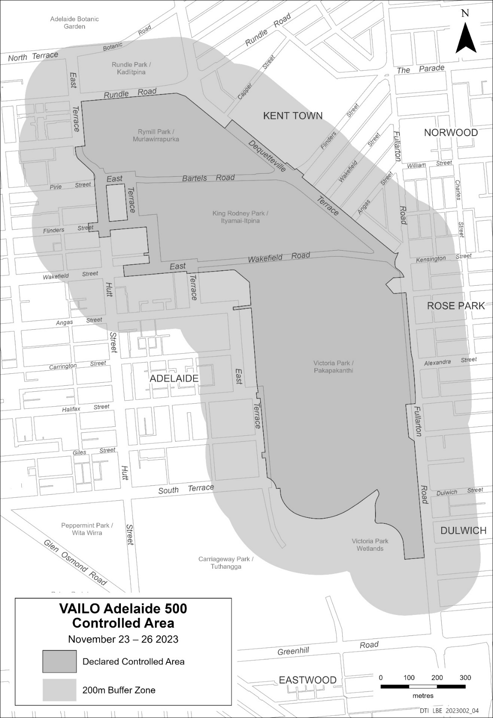

Mental Health Act 2009
Authorised Medical Practitioner
NOTICE is hereby given in accordance with Section 93(1) of the Mental Health Act 2009 that the Chief Psychiatrist has determined the following person as an Authorised Medical Practitioner:
Judith Keith
A determination will be automatically revoked upon the person being registered as a specialist psychiatrist with the Australian Health Practitioner Regulation Agency and as a fellow of the Royal Australian and New Zealand College of Psychiatrists.
Dated: 22 September 2023
Dr John Brayley
Chief Psychiatrist

MENTAL HEALTH ACT 2009
Authorised Mental Health Professional
NOTICE is hereby given in accordance with Section 94(1) of the Mental Health Act 2009, that the Chief Psychiatrist has determined the following persons as an Authorised Mental Health Professional:
Amanda Todd
A person’s determination as an Authorised Mental Health Professional expires three years after the commencement date.
Dated: 26 September 2023
Dr J Brayley
Chief Psychiatrist

Mining Act 1971
Application for a Mining Lease
Notice is hereby given in accordance with Section 56H of the Mining Act 1971, that an application for a Mining Lease over portion of the undermentioned Exploration Licence has been received:
Applicant: Alliance (Eyre) Pty Ltd (ACN 095 337 385)
Exploration Licence 6188
Location: CL 1290/4 and CL 1298/25, Wilcherry Hill area approximately 45km north of Kimba.
Area: 4716.21 hectares approximately
Purpose: Industrial Minerals (Gold, Iron ore, Silver and Copper)
Reference: 2023/000058
To arrange an inspection of the proposal at the Department for Energy and Mining, please call the Department on (08) 8463 3103.
An electronic copy of the proposal can be found on the Department for Energy and Mining website:
https://www.energymining.sa.gov.au/industry/minerals-and-mining/mining/community-engagement-opportunities
Written submissions in relation to this application are invited to be received at the Department for Energy and Mining, Mining Regulation, Attn: Business Support Officer, GPO Box 320, Adelaide SA 5001 or dem.miningregrehab@sa.gov.au by no later than 26 October 2023.
The delegate of the Minister for Energy and Mining is required to have regard to these submissions in determining whether to grant or refuse the application and, if granted, if there is a requirement to add, vary or revoke a term or condition of the relevant mineral tenement(s) under section 56U of the Mining Act 1971.
When you make a written submission, that submission becomes a public record. Your submission will be provided to the applicant and may be made available for public inspection.
Dated: 28 September 2023
C Andrews
Acting Mining Registrar
as Delegate for the Minister for Energy and Mining
Department for Energy and Mining

Mining Act 1971
Section 44
Terms of Reference for the Oak Dam Retention Lease Application in accordance with the Mining Act 1971
An application for a retention lease (RL) must be accompanied by:
- a proposal that complies with section 44 of the Mining Act 1971, regulations 46 and 47 of the Mining Regulations 2020 and any determinations set out in this Terms of Reference; and
- information that complies with regulation 31 of the Mining Regulations 2020 and any determinations set out in this Terms of Reference; and a declaration of accuracy that complies with regulation 84 of the Mining Regulations 2020; and
- the relevant application fee.
In accordance with section 44 of the Mining Act 1971 this Terms of Reference will have effect from 28 September 2023.
FORM OF APPLICATION
In accordance with section 44(1)(a) of the Mining Act 1971 an application for a RL must be made in the form and contain such information as set out in this Terms of References, unless otherwise specified by the Director of Mines or an authorised officer.
For the purposes of section 44(1)(a) of the Mining Act 1971, it is determined that an application for a RL must contain the information as follows:

- Applicant name(s) (company and/or individual and/or related body corporate) and each applicants percentage share in the application
- Name of project
- Mineral type
- Proposed lease area details including a detailed map/plan (if required)
- Purpose of retention lease
- Details of the tenement(s) giving authority to apply for the Retention Lease
- Native title land details
- Details of relevant land ownership, notices, consents and agreements
- Operations on the land details
- Declaration of accuracy
- Applicant(s) details including:
- Name of company and/or individual ABN (if applicable)
- ACN (if applicable)
- Registered address
- Applicant contact details including:
  - Postal Address
  - Email
  - Website
  - Phone number(s)
- Contact Person details including:
  - Name
  - Position Title
  - Email
  - Phone number(s)
  - Consent to receive electronic correspondence (or otherwise)
  - Certificate of correctness
An application for an RL must in accordance with section 44(1)(a) of the Mining Act 1971 be in the following form, unless otherwise specified by the Director of Mines or an authorised officer:
- an electronic version of the Proposal must be submitted; hardcopies must be submitted upon request; the information in all must be identical;
- each page, plan or other separate sheet of the Proposal must include the mineral claim, or exploration licence number(s), date of the application submission and sequential page numbering;
- the electronic version of the Proposal must be submitted in one single Acrobat PDF file or if requested by the Director of Mines or an authorised officer, Microsoft Word compatible files must be submitted;
- alternative electronic versions of the Proposal may be submitted with the prior agreement of the Director of Mines or an authorised officer.
PROPOSAL
An application for an RL must be accompanied by a proposal that complies with section 44 of the Mining Act 1971 and regulations 46 and 47 of the Mining Regulations 2020, and must comply with the following determinations of this Terms of Reference as set out below:
- DESCRIPTION OF THE EXISTING ENVIRONMENT
In setting out an assessment of the environmental impacts of the proposed authorised operations in accordance with section 44(1)(c)(ii)(A) of the Mining Act 1971 and regulation 46(2) of the Mining Regulations 2020, the Minister determines in accordance with regulation 46(7)(e) of the Mining Regulations 2020 that a proposal must include a description and assessment of the environment as set out in this Terms of Reference. Each of the elements of the existing environment (as defined in section 6(4) of the Mining Act 1971) listed in clauses 1.1-1.20 must be described only to the extent that they may need to be considered in assessing the potential impacts of the proposed retention lease operations. If the element is not likely to be impacted by the operation, a statement to that effect must be included.
  - Topography and Landscape
Provide a description and map (as per 6.1.1.1) of the topography and landscape, detailing the:
- application area; and
- general surroundings.
  - Climate
Provide:
- a summary of rainfall and temperature patterns, evaporation rates, and wind directions and speed (including maximum wind gusts); and
- details of the maximum average recurrence interval or annual exceedance probability rainfall event used for the operational and closure design of the project, and the justification for the value(s) selected.
  - Topsoil and Subsoil
Provide:
- a description of the soil profile (type and depth), and the characteristics and/or productivity of all soils on the application area (show this information on a map as per 6.1.1.2 if there is a variation in soils over the application area); and
- identify any soil characteristics, including (but not limited to) erodibility, acid sulfate, sodic or non-wettable soils, that may require control measures to reduce environmental impacts during operations or rehabilitation.

  - Geological Environment
Provide a description of the following, as a minimum: regional geology;
  - local geology within the application area and geological map(s) (as per 6.1.1.2), including but not limited to;
    - location, dimensions and orientation (dip and strike), and known extent of the deposit;
    - location and composition of all rock types and rock units that are proposed to be disturbed;
  - interpretation of the stratigraphy of the rocks hosting the deposit as well as any overlying and adjacent rock units; and an indication of the potential for extension to the deposit;
  - representative cross-sections and long section (as per 6.2.1.1) of the geology of the application area; and the exploration data on which the geological interpretation was based on.
  - Geochemistry and Geohazards
Provide:
  - a geochemical assessment of all rock types that are proposed to be disturbed, based on representative sampling and analysis that includes the identification and quantification of, but not limited to, sulfide minerals that have the potential to generate acid or mobilise metals into the environment; and
  - a mineralogical assessment of all the rock types that are proposed to be disturbed, based on representative sampling and analysis for the presence and quantification of (but not limited to) radioactive minerals, asbestiform minerals or minerals that have the potential to produce respirable silica.
  - Describe the potential for any of the following natural geohazards to be present in the application area and show on a map: structural instability, including slips, faults, karst features or geological discontinuities; and
  - major seismic events (based on historical data).
  - Groundwater
Provide:
  - a statement describing if the application area is within an area where the water resources are prescribed under the Landscape South Australia Act 2019 and details on the current availability of groundwater resources within the prescribed area;
  - a description of the local and regional hydrogeology, detailing both the stratigraphy and hydrostratigraphy;
  - a detailed baseline description of the groundwater characteristics and flow dynamics for aquifers within the application area which includes:
    - static water levels and groundwater heads/groundwater elevations, including seasonal fluctuations for each aquifer;
    - baseline groundwater hydrochemistry and mineralogy, including any seasonal fluctuations and spatial variability for each aquifer;
    - aquifer properties including hydraulic conductivity, transmissivity, specific yield, storage coefficient, total porosity, effective porosity and aquifer thickness;
    - recharge and discharge mechanisms;
    - hydrogeological characteristics of confining strata, including hydraulic conductivity and thickness;
    - connectivity between lateral, overlying or underlying aquifers and surface water;
    - conceptualisation of the hydrogeology inclusive of conceptual diagram: a summary of all above and a description
      - of the hydrogeological setting considered important for impact assessment; and
      - a preliminary impact assessment/numerical model of groundwater flow (and contaminant transport model, if applicable), based on the conceptual hydrogeology.
  - local and regional potentiometric surface/groundwater elevation map(s) (as per 6.1.1.3) for each aquifer within the application area;
  - cross-section(s) (as per 6.2.1.2) of the hydrostratigraphy;
  - the environmental value of each aquifer determined according to the Environment Protection (Water Quality) Policy 2015, or any subsequent updates;
  - a description of the existence, location, condition and value of all aquatic, terrestrial and subterranean Groundwater Dependent Ecosystems (GDEs) within the application area and within and immediately surrounding the extent of predicted hydrogeological impact of the proposed advanced exploration operations; and
  - an assessment of any current, proposed or historical use of local groundwater by the landowner(s) and other users which includes a baseline survey of bores, including depth to groundwater, groundwater quality, bore construction details, status and purpose and collar/ground elevations.
  - Surface water
Provide a topographic map (as per 6.1.1.1) and description of the current drainage patterns for the application area and water catchment including:
  - location of watercourses, drains, dams and wetlands; surface water catchment boundaries;
  - direction of drainage and discharge from the application area;
  - a statement describing if the application area is within an area where the water resources are prescribed under the Landscapes South Australia Act 2019, and provide details on the current availability of water resources within the prescribed area;
  - a statement if the application area is within a water protection area including areas under the River Murray Act 2003; a statement as to whether the application falls within the Murray Darling Basin; and
  - groundwater surface water interactions.

  - Provide water quality data for identified watercourses, where there is potential for discharge into that watercourse from the proposed operation (whether intentional or not). Should identified watercourses be ephemeral, and it is not possible to collect water samples, provide a characterisation of sediments sampled from the watercourse bed upstream and downstream of the application area.
  - If there is potential for changing a flow regime (including change in flow volume) or discharge into these watercourses from the proposed operations, an assessment of the use of this water by the landowner, downstream users and water dependent ecosystems must be included.
  - Vegetation, Weeds and Plant Pathogens
Provide:
- a description and map (as per 6.1.1.1) of existing flora (native and introduced) in the application area and surroundings;
- the State conservation status and habitat value of native vegetation present in the application area;
- a description of the presence of Commonwealth Environment Protection and Biodiversity Conservation Act 1999, listed species and ecological communities;
- a description of the extent the application area and adjoining land is affected or potentially affected by pathogens and declared weeds; and
- if known, a description of the history of land use to identify if the existing vegetation is the result of deliberate cultivation or natural regrowth arising from previous clearance.
  - Fauna
Provide:
- a description of the native and feral fauna that may be present in the application area;
- the State conservation status of native fauna that may be present in the application area; and
- a description of the presence of Commonwealth Environment Protection and Biodiversity Conservation Act 1999 listed species.
  - Caves
Provide:
- a description of the presence of any known caves or significant karst (limestone) areas within, or near to, the application area and show on a map (as per 6.1.1.5).
  - Local Community
Provide:
- a description of the local population, the economy, services and employment; and
- details of nearest town or urban areas, with a summary of the demographics of the local population.
  - Landowners and Land Use
Provide a description of:
  - land ownership for all titles within and adjacent to the application area;
  - land use (historical, current and potential) for the application area and the surrounding areas;
  - the zoning as defined by the Planning and Design Code or relevant council development plans;
  - policies relevant to the application area, including region or council wide, zone specific and sub areas within a zone; known plans for potential future land use changes by other parties; and
  - any other interests or restrictions on the application area, including:
    - public utility easements;
    - if the application is within land used for defence purposes, including (but not limited to) the Woomera Prohibited Area or the Cultana Army Training Area;
    - any overlapping or adjacent tenements under the Mining Act 1971, or Petroleum and Geothermal Energy Act 2000.
  - Proximity to Infrastructure and Housing
Provide information and a map (as per 6.1.1.4):
  - identifying residences within and near the application area;
  - identifying other human infrastructure such as (but not limited to) schools, hospitals, commercial or industrial sites, roads, sheds, bores, dams, ruins, pumps, cemeteries, scenic lookouts, roads, railway lines, fences, transmission lines, gas and water pipelines, and telephone lines (both underground and above ground); and
  - identifying public and private roads to be utilised or affected as part of proposed operations, including an estimate of the existing traffic movements.
  - Exempt Land
Provide:
  - a description and map (as per 6.1.1.4) of any applicable exempt land under Section 9 of the Mining Act 1971; and
  - a description of any waivers of exemption obtained, and/or information on the status of waivers of exemption yet to be negotiated/finalised under Section 9AA of the Mining Act 1971.
  - Amenity
Provide:
- a description of scenic or aesthetic values for the application area and immediate surrounds, including features of community, tourist or visitor interest.

  - Air Quality
Provide:
- a description of the existing levels of dust and contributors to air quality including odour (both natural and anthropogenic).
  - Noise
Provide
- a description and measurement data of the existing levels of noise and contributors to noise (both natural and anthropogenic).
  - Heritage (Aboriginal, European, Geological)
Detail and show on a map (as per 6.1.1.1):
- any registered heritage sites in or adjacent to the application areas that are protected under legislation (in so far as may be permitted under the relevant legislation); and
- include a statement concerning whether or not an Aboriginal cultural heritage survey has been conducted by the proponent and if so, the results of the survey.
  - Proximity to Conservation Areas
Provide:
- information and a map (as per 6.1.1.1) showing proximity to national parks and reserves, private conservation areas, indigenous protected areas, State or Commonwealth recognised conservation areas, heritage agreement areas and geological heritage sites; and
- a statement as to whether the application area falls within the Adelaide Dolphin Sanctuary, Adelaide International Bird Sanctuary or a Marine Park.
  - Pre-existing Site Contamination and Previous Disturbance
Provide
- information and a map (as per 6.1.1.1) showing any known existing contamination of the site and of any disturbance by previous operations or other activities, including mineral exploration activities.
- DESCRIPTION OF THE PROPOSED OPERATIONS
In specifying the nature and extent of the authorised operations that are proposed in accordance with section 44(1)(c)(i) of the Mining Act 1971, the Minister determines in accordance with regulation 46(7)(e) of the Mining Regulations 2020 that a proposal must include a description of the proposed operations as set out in this Terms of Reference. Each of the elements listed in clauses 2.1- 2.10 must be described only to the extent that they apply to the proposed operation.
  - Work Program to conduct authorised operations
If applying for a Retention Lease for the reason stated in section 43(1)(a) of the Mining Act 1971) the following information must be provided:
- A statement outlining the operations and/or steps proposed to be carried out in order for the applicant to be in a position to make an application for a mining lease.
- A proposed schedule for undertaking the above-described operations and/or steps.
  - General Description and Maps/Plans of Operations
Provide a summary description of all elements of the proposed advanced exploration and ancillary operations (include maps/plans and cross sections as per 6.1.2 and 6.2.2).
    - Options
Provide a summary description of relevant options considered for advanced exploration and ancillary operations, and provide justification for the chosen strategies, including a description of any elimination or substitution strategies that have been adopted to control a hazard in order to protect the environment.
  - Ore Reserves or Mineral Resources (or both)
Provide:
- a statement that provides detailed information about the mineral resource or ore reserve, or both; and
- a statement declaring that the mineral resource or ore reserve, or both, has been appropriately identified and estimated.
Provide steps that have been taken to ensure proposed advanced exploration operations will not sterilise/prevent future extraction of mineral resources.
  - Retention Lease Activities
    - Type or Types of Proposed Operations to be Carried Out
Provide a clear statement on the type or types of advanced exploration operation proposed to be carried out, such as:
- the advanced exploration method(s) to be adopted (decline construction).
    - Extractive Operations
- Provide a description of the extractive materials to be recovered and used in the proposed operations.
- Provide a statement of the estimated resource and details of the basis of the estimate.
Where extractive borrow pits are proposed, describe proposed extractive pit workings, including (but not limited to):
- dimensions and depth of pit;
- pit wall angles and batter angles; and
- maps, plans and cross-sections (as per 6.1.2 and 6.2.2).

    - Underground Workings (conceptual)
Describe proposed underground workings, including (but not limited to):
- potential surface disturbance resulting from underground operations;
- declines, shafts, tunnels, bore holes, ventilation intakes and exhausts; and
- maps, plans and cross-sections (as per 6.1.2 and 6.2.2).
    - Life of Proposed Operations
Provide:
- expected life of advanced exploration operations (including scope for extension);
- schedule of ore and waste rock movement over the life of operations.
    - Stockpiles
Describe for all ore, product, subsoil and topsoil stockpiles the: location, size, shape and height of all stockpiles the;
- method of placement;
- method of stabilisation and erosion control of all stockpiles; and water movement through stockpiles.
- location, maximum height and extent of all stockpiles must be shown on a map (as per 6.1.2.1).
    - Use of Explosives
If explosives are proposed to be used, describe:
- type of explosives used on the site; proposed timing and frequency of blasting; size of blasts; and
  - storage of explosives (amount, type, detailed location and method of storage).
    - Type of Advanced Exploration Equipment
Provide a description of the equipment (fixed and mobile) proposed to be used in the advanced exploration operation in terms of:
- type, size and capacity of machines;
- approximate number of units; noise outputs;
- exhaust outputs; and fire ignition sources.
  - The location of fixed equipment must be shown on a map (as per 6.1.2.1).
    - Advanced Exploration Dewatering
Provide:
- estimated inflows of groundwater, stormwater and water from any other advanced exploration activities into workings; details of proposed dewatering infrastructure, and site water management and disposal;
- contingency measures for greater than planned water inflows into workings; and
  - a water balance of water inflows and water outflows during operations and at completion (if not included in the water balance in clause 2.5.4).
    - Sequence of Advanced Exploration and Rehabilitation Operations
- Provide the following information on the sequence of operations in both text and map form (as per 6.1.2.2):
- description of the sequence of advanced exploration stages;
- proposed sequencing of progressive and final rehabilitation, including demonstration that progressive rehabilitation has been integrated with the development plan;
- an estimation of the quantities of sulfide minerals that have the potential to generate acid or mobilise metals, or other hazardous minerals to be removed at each development stage; and
  - any mineral resource that may be sterilised from future mining by the proposed advanced exploration operations.
    - Rehabilitation Strategies and Timing
Describe all activities, strategies and designs relating to closure for rehabilitation of extractive operations, underground workings, stockpiles, explosives storage, advanced exploration equipment and dewatering infrastructure. Include timing of these activities and all opportunities for progressive rehabilitation. Include (but not limited to) the maximum area of land disturbed by proposed advanced exploration operations at any time, void backfilling, abandonment bunds, soil management, revegetation and expected water infill rates.
    - Modes and Hours of Operation
State if the proposed advanced exploration operation will be worked on a continuous (24 hour, 7 days a week), regular periodical or campaign basis.
If the proposed advanced exploration operation is to be worked on a regular periodical basis, specify:
- proposed period(s) (daily, weekly and public holidays) to be worked; and
  - proposed start and finish hours the site is to be worked per period.
  - Crushing, Grinding, and Product Storage
    - Material Processing and Testing
- Provide a statement that no mineral processing will be undertaken on site.
- Provide a description of any material testing and analysis, if any, to be undertaken off site.
    - Crushing and Grinding Plant
Provide a description of the crushing/grinding plant including:
- area, size, type of construction and location;
- throughput rate;
- noise sources;
- dust sources and composition; fie ignition sources; and
- plans (as per 6.1.2.3)
    - Water Management
Provide a water balance including:
- approximate water volumes required;
- a summary of the inputs and outputs (with consideration of any purge requirements); determination of net surplus or deficit; and
- process flowsheet showing all streams including stormwater management and dewatering.
Provide a description of all water ponds, including:
- size, capacity, layout and location of ponds; design and construction methods;
- chemical composition of the solution to be stored in each pond; minimum freeboard to be maintained; and
- plans (as per 6.1.2.1).
    - Type of Mobile Equipment
For mobile equipment to be used in crushing and grinding, describe:
- type, size and capacity of machines; approximate number of units;
- noise outputs; exhaust outputs; and fire ignition sources.
    - Hours of Operation
Describe the proposed hours of operation of crushing/grinding activities.
    - Product Storage
For mineral product to be produced as a result of advanced exploration operations, provide details of:
- how product is to be stored during the life of operations;
- how product is to be disposed of following completion of advanced exploration operations; and
- a process for accounting for the volumes of product produced, stored and disposed of as a result of advanced exploration operations.
    - Rehabilitation Strategies and Timing
Detail all activities, strategies and designs relating to closure for removal, disposal and rehabilitation of facilities, including timing of these activities.
  - Wastes
    - Waste Rock Storage Facilities
For waste rock provide:
- the estimated tonnes and volumes of all waste rock to be stored;
- the type, location, size, shape, height and method of construction of permanent and temporary waste storage facilities;
- a geochemical and geotechnical assessment of the waste rock based on the geochemical and geotechnical properties determined from the analysis of representative sampling of all waste rock types to be disposed;
- an assessment on the weathering and erosive potential of waste rock to be disposed;
- conceptual specifications, drawings and plans for the design, construction, operation and completion of all facilities (as per 6.1.2.5);
- the method and rate of waste rock/ disposal;
- where relevant, a description and plan (as per 6.1.2.5) of the placement and encapsulation of waste material deemed to be hazardous, including potentially acid forming material (PAF);
- the method of stabilisation and erosion control of waste storage facilities, both during operations and post completion;
- surface water runoff control on disturbed and rehabilitated areas; a geotechnical stability assessment and a factor of safety analysis;
- an assessment of seepage of liquids through the waste rock storage facilities; strategies for the containment of any seepage that has the potential to impact the environment;
- an assessment of the post completion chemical and physical stability of the structure following rehabilitation, including the expected extent of erosion;
- an assessment of the source, pathway and ultimate fate of any potential mobile contaminants; and
  - a description of the governance arrangements for the design, construction, operation and closure including when it is proposed to use third party verification.
    - Other Wastes
Provide:
- the volumes and composition of all solid and liquid wastes produced;
- estimated volumes of waste water, reverse osmosis reject water, water content of solid wastes, and method of disposal or recycling;
- waste water composition;
- disposal and management of any hazardous material or contaminants within waste including radioactive, toxic, corrosive or flammable materials; and
  - the source, pathway and ultimate fate of any potential mobile contaminants.

    - Industrial and Commercial Wastes
List any industrial and commercial wastes generated including, but not limited to:
- putrescible waste, including sewage;
- oils and other hydrocarbons; and
- tyres.
For each waste type, describe the method of disposal including:
- offsite disposal;
- provide a clear statement that there will be no on site waste disposal;
- recycling (either on or offsite);
- the type, area and layout of sewage systems to be installed at the site; and
  - describe what, if any approvals are required for the disposal of waste, including sewage systems.
    - Rehabilitation Strategies and Timing
Detail all activities, strategies and designs relating to closure, including timing of these activities and all opportunities for progressive rehabilitation of waste rock and any other waste to be left on site.
  - Supporting Surface Infrastructure
    - Access and Roads
Describe:
- access route to the proposed operations and show on a map (as per 6.1.2.1 and 6.1.2.6);
- indicate if any new roads are to be constructed, or if existing roads or intersections (public and private) are to be upgraded;
- transport system(s) used to and from the proposed operations and the estimated number of vehicle movements per day; and
- airport/airstrips to be constructed.
    - Accommodation and Offices
Describe onsite personnel accommodation and offices, including (but not limited to):
- number, area, size, type of construction and location of accommodation, office, meals or laboratory buildings, caravans or camp, and associated structures to be used on site; and
  - state if temporary or permanent.
    - Public and Private Services and Utilities Used by the Operation
Describe:
- sources of services or utilities that are, or are to be supplied to the proposed site, including but not limited to power, water, telecommunications;
- if new connections to services and utilities are required, the proposed routes for connection; and
  - the effects to any existing services or utilities that have been or may be affected by the proposed operations.
    - Visual Screening
Describe the type of screening, including existing or proposed vegetation (i.e. species and density of plantings) and show on a map (as per 6.1.2.1).
    - Fuel and Chemical Storage
For all fuels and chemicals proposed to be stored on site show the proposed location of storage on a map (as per 6.1.2.1) and provide detail on:
- types of bulk chemicals and the volumes of each; and
- proposed storage, bunding and containment for all chemical and fuel storage vessels.
    - Site Security
Describe and show on a map (as per 6.1.2.1) infrastructure and measures that will be adopted to prevent unauthorised access by the public, including but not limited to:
- fencing; and
- signage.
    - Erosion, Sediment and Silt Control
Describe and show on a plan (as per 6.1.2.1):
- location and design of silt management structures; management and disposal of silt;
- strategies to control runoff on disturbed and rehabilitated areas;
- storage, diversion and release of clean water (discharge water must comply with the current Environment Protection (Water Quality) Policy; and
- a whole of site stormwater balance, if not included in the water balance in clause 2.5.4.
    - Rehabilitation Strategies and Timing
Detail all activities, strategies and designs relating to closure for rehabilitation of supporting surface infrastructure. Provide details for timing of closure activities, including all opportunities for progressive rehabilitation.
  - Vegetation Clearance
    - Description of Vegetation Clearance
If clearing of native vegetation is proposed, a map (as per 6.1.2.2) and description of the vegetation present in the application area must be provided, showing:
- the extent of any proposed vegetation clearance; and
- the likelihood of the presence of threatened flora.
State the estimated quantum of State significant environmental benefit (SEB) to be gained in exchange for the proposed clearance and describe how the SEB will be provided.
  - Completion
    - Description of Site at Completion
Provide a description, plans and cross sections (as per 6.1.2.7 and 6.2.2.2) of the site as it will be at completion after all rehabilitation and closure activities have been completed, including:
- potential land use options;
- landforms;
- proposed vegetation covers (including native vegetation that will not be disturbed due to proposed operations); natural contours of land not to be disturbed by proposed operations;
- any infrastructure that will remain on site and will become the responsibility of the landowner; location, description and management of waste disposal areas;
- location of reshaped and rehabilitated areas showing proposed surface contours and revegetation; voids;
- location of stored and/or exposed PAF material and/or other hazardous materials; expected final groundwater level and pit level water and time to reach this level, and water quality of voids;
- location of surface water infrastructure including ponds and diversions; and
- representative plans and cross-sections (as per 6.1.2.7 and 6.2.2.2) that show:
  - pre-disturbance natural surface;
  - emplacement areas, waste disposal areas and disturbed areas; final rehabilitated surface;
  - where relevant, predicted final groundwater elevations; and interpreted geology including all rock types.
Provide a description of the proposed mechanism for transferring responsibility for any potential residual liability (i.e. ongoing maintenance or monitoring) subsequent to surrender of the tenement.
  - Resource Inputs
    - Workforce and local procurement
For the proposed workforce (for all operations including advanced exploration, processing, waste management and supporting surface infrastructure) describe:
- how operations on the site will be managed; number and workforce breakdown by job type;
- number of full-time employee positions that would be directly created by the proposal (not to include existing positions);
- the proportion of the workforce that would reside in the local community and the estimated impact on local employment;
- any programs to target and assist Indigenous or local employment at the quarry; training to be provided to employees and potential employees;
- approximate timelines for creation of the positions; and
- potential for local business participation, and procurement of local goods and services.
    - Energy Sources
For the proposed energy sources and usage provide:
- estimates of total annual energy usage from all sources;
- expected sources of energy; potential for efficiency gains;
- amount and percentage of zero emission energy to be utilised;
- equivalent annual CO2 generated;
- any carbon offsets proposed; and
- any other action(s) proposed to be taken towards the South Australian Government goal of:
      - reducing net greenhouse gas emissions by more than 50% by 2030; and
      - achieving net zero emissions by 2050.
    - Water Sources
Provide details on the source(s) of water to be used at the mine, expected usage and any discharge, including:
- expected annual water usage by source;
- indicate if any water usage by source will be more than 5% of the total annual water withdrawal for that source;
- percentage of water that will be recycled; and
  - water discharge by quality and destination.
- CONSULTATION
In setting out the result of the consultation undertaken in connection with the proposed operations in accordance with section 44(1)(c)(iv) of the Mining Act 1971 and regulation 47 of the Mining Regulations 2020, the Minister determines in accordance with regulation 46(7)(e) of the Mining Regulations 2020 that a proposal must include:
A description of:
- the process undertaken for identifying stakeholders with an interest in, or stakeholders likely to be directly affected by the proposed operation;
- the process undertaken for the delivery of information to, gathering of feedback from, and responding to those identified stakeholders;

- if any individual or group of similar affected persons were not able to be consulted, what steps were taken to consult with them; and
- the extent to which the outcomes proposed in clause 5.2.2 have been developed in consultation with the landowner and any other person who may be directly affected by the proposed advanced exploration operations.
The results of the consultation undertaken with those identified stakeholders, including:
- the persons consulted;
- any concerns/issues raised; and
- the response and steps (if any) taken or proposed to address those concerns.
- ONGOING STAKEHOLDER ENGAGEMENT PLAN
Include details for an ongoing community engagement plan that:
- Identifies all community stakeholders likely to be affected by proposed advanced exploration operations;
- Sets out the tools and techniques that the proponent intends to use for:
  - identifying community attitudes and expectations;
  - providing information to the community;
  - receiving feedback from the community;
  - analysing community feedback and considering community concerns or expectations;
  - registering, documenting and responding to communications from members of the community
- MANAGEMENT OF ENVIRONMENTAL IMPACTS
  - Assessment of Environmental Impacts
In setting out an assessment of the environmental impacts of the proposed authorised operations in accordance with section 44(1)(c)(ii)(A) of the Mining Act 1971 and regulation 46(2) of the Mining Regulations 2020, the Minister determines in accordance with regulation 46(7)(e) of the Mining Regulations 2020 that a proposal must include an assessment of the environment as set out in this Terms of Reference.
    - Elements of the Environment
Describe the specific elements of the environment (the environment is defined in Section 6(4) of the Mining Act 1971) that may reasonably be expected to be impacted by the proposed operation during construction, operation, and indefinitely post completion.
For each element of the environment identified:
  - provide a summary of any issues or considerations raised by stakeholders, and any relevant legislated or recognised standards in relation to the element of the environment;
  - describe all potential environmental receptors; and
  - undertake an impact assessment of how the element could be potentially impacted by proposed operations (during construction, operation and post completion) through the provision of the information listed in the following clause 5.1.2.
    - Potential Impact Events
Describe potential impact events associated with each phase of the proposed operations (construction, operation and post completion) and relevant to each element of the environment.
For the purpose of the impact assessment, a potential impact event is the combination of a source, a pathway and an environmental receptor.
The source, pathway and environmental receptor of each potential impact event must be described prior to the implementation of engineering or administrative control measures.
For each potential impact event identified in clause 5.1.2, provide:
      - Source
A description of the source of the potential impact event which alone or in combination has the potential to cause harm to an environmental receptor.
      - Pathway
A description of the potential pathway means or route (with consideration of any natural barriers) by which an identified environmental receptor can be exposed to, or may reasonably be expected to be impacted by an identified source.
      - Environmental Receptor
A description of the environmental receptors that may reasonably be expected to be adversely impacted by the source, taking into account the considerations for the element of the environment described under 5.1.1.
      - Description of Uncertainty
Describe any significant degree of uncertainty pertaining to the evaluation of sources, pathways and environmental receptors, including (but not limited to) lack of site specific information, limitations on modelling and quality of data. Describe any assumptions connected with the identified uncertainty.
So far as is relevant, identify the sensitivity to change of any assumption that has been made, including whether a change in assumption may result in a new environmental impact.
      - Confirmation of Impact Events
For each potential impact event provide:
- an analysis of whether a source, pathway and receptor does exist (and if not, or if it remains uncertain, provide an explanation for the conclusion); and
- a description of the likely impact from the source on the environmental receptor.
  - Control and Management Strategies, Uncertainty Assessment, Statement of Environmental Outcomes and Criteria
For each impact event confirmed in clause 5.1.2.5, the information listed in clauses 5.2.1-5.2.4 must be provided:
    - Control and Management Strategies
In setting out an outline of the measures that the applicant intends to take to manage, limit or remedy environmental impacts as confirmed in clause 5.1.2.5 in accordance with section 44(1)(c)(ii)(B) of the Mining Act 1971 and regulation 46(3) of the Mining Regulations 2020, the Minister determines in accordance with regulation 46(7)(e) of the Mining Regulations 2020 that a proposal must:
- Include a description of the strategies proposed to manage, limit or remedy each impact event;
- Demonstrate that the control and management strategies proposed are commensurate with the potential impacts, achieve compliance with other applicable statutory requirements and promote progressive rehabilitation;
- Include a description of any significant degree of uncertainty pertaining to the likely effectiveness of proposed control and management strategies, including (but not limited to) lack of site-specific information, limitations on modelling and quality of data;
- Include a description of any assumptions connected with the identified uncertainty; and
- So far as is relevant, identify the sensitivity to change of any assumption that has been made and assess the likelihood of an outcome not being achieved if an assumption is later found to be incorrect.
    - Statement of Proposed Environmental Outcomes
Statements of the environmental outcomes that are expected to occur are required in accordance with section 44(1)(c)(ii)(C) of the Mining Act 1971 and regulation 46(4) of the Mining Regulations 2020 and must be made for each impact event confirmed in clause 5.1.2.5. The Minister determines in accordance with regulation 46(7)(e) of the Mining Regulations 2020 that a proposal must:
- Provide a statement of the proposed environmental outcome(s) (including completion outcomes assessed on a long-term basis) for each impact event confirmed in clause 5.1.2.5.
- Ensure that the statement of environmental outcome(s) describe the likely consequence of the expected impact on the environment by the proposed advanced exploration operations subsequent to the implementation of the control measures described in clause 5.2.1.
- Provide a statement that demonstrates the environmental outcomes would be able to be achieved taking into consideration the effectiveness of the control strategies (clause 5.2.1) and description of uncertainty (clause 5.2.2).
    - Draft Measurement Criteria
In preparing a draft statement of the criteria to be adopted to measure each of the proposed environmental outcomes in accordance with section 44(1)(c)(iii) of the Mining Act 1971 and regulation 46(5) of the Mining Regulations 2020, the Minister determines in accordance with regulation 46(7)(e) of the Mining Regulations 2020 that the draft criteria must:
- as far as practical comply with the five elements set out in regulation 46(5) of the Mining Regulations 2020;
- include demonstration of the successful implementation for the State significant environmental benefit, if native vegetation is proposed to be cleared and an on-ground off-set proposed in accordance with the Native Vegetation Act;
- be developed separately for construction, operation and completion, as appropriate; and
- where appropriate, recognised industry standards, codes of practice or legislative provisions from other Acts should be used as criteria.
    - Draft Leading Indicator Criteria
Where there is a high level of reliance on control measures strategies to achieve an environmental outcome, provide a draft statement of leading indicator criteria that will be used to give an early warning that a control measure strategy may fail or be failing.
- MAPS, PLANS AND CROSS SECTIONS
In preparing a proposal in accordance with section 44(1)(c) of the Mining Act 1971 and regulation 46 of the Mining Regulations 2020, the Minister determines in accordance with regulation 46(7)(e) of the Mining Regulations 2020 that all maps and plans must comply with the following requirements relating to the amount of detail or information to be provided:
- state and show the relevant datum (Australian Height Datum (AHD) is preferred); metric units;
- title, north arrow, scale bar, text and legend; date prepared and author;
- be of appropriate resolution and scale for represented information; and
- be legible in both the hardcopy and electronic versions of the submission.
All cross-sections must conform to the following standards:
- state and show the relevant datum (Australian Height Datum (AHD) is preferred); metric units;
- title, scale bar, text and legend; date prepared and author;
- be of appropriate resolution and scale for represented information; and
- be legible in both the hardcopy and electronic versions of the submission; and be accompanied by a map showing the orientation of the cross-sections.
  - List of Maps
    - Maps required for Description of the Existing Environment (as per clause 2)
      - Topographic Map showing:
- application area boundaries;
- existing surface contours;
- existing vegetation;

- location of watercourses, including ephemeral and permanent rivers, creeks, swamps, streams, wetlands and any man-made water management structures;
- surface water catchment boundaries;
- direction of drainage and discharge from the application area;
- location and extent of all previously disturbed areas associated with previous exploration and mining;
- location and extent of any known existing contamination; and
- location and extent of any adjacent conservation reserves, heritage sites (in so far as may be permitted by the relevant legislation) or any other significant areas.
      - Local Geological Map showing:
- application area boundaries;
- geology within the application area, including but not limited to location, dimensions and orientation (dip and strike), and extent of the mineral resource and ore reserve;
- topsoil/subsoil variation if there is a variation in soils over the application area; and
- natural geohazards in the application area.
      - Aquifer Potentiometric Surface Map(s) showing:
- application area boundaries;
- potentiometric surface contours/groundwater elevation contours and the time (or time period) the contours relate to;
- interpreted direction(s) of groundwater flow; and
- location of representative bores (where measurements were obtained of which the contours are based on) used to establish this information.
      - Land Access Map showing:
- application area boundaries;
- cadastral information for the Tenement (including land title(s) and ownership);
- any exempt land;
- location of residences within and near the application area; and
- human infrastructure as per 1.13.
    - Map(s) and Plan(s) required for Description of Proposed Retention Lease Operations (as per clause 3)
      - Site Layout Map showing all components of the proposed operation including (but not limited to):
- application area boundaries;
- location of surface water and sediment management infrastructure;
- location of process water dams;
- location of fuel and chemical storage areas;
- location of haul/access roads;
- location of fixed plant;
- location of mobile plant for stage 1 of advanced exploration;
- location of visual screening measures; location of fencing;
- location and extent of topsoil/subsoil and product stockpiles.
- location and extent of all areas proposed to be disturbed from operations including waste rock, silt/slime dams, infrastructure, water ponds, waste disposal facilities; and
- location and extent of underground workings.
- location of key environmental features that are within or in close proximity to the Tenement and that are relevant to the design of the Site Layout Plan, including but not limited to housing and infrastructure, existing heritage sites, existing ephemeral and permanent rivers, watercourses, creeks or dams and/or existing native vegetation.
      - Sequence of Operations and Progressive Rehabilitation Map showing:
- application area boundaries;
- staging of each progressive stage of progressive rehabilitation; proposed native vegetation clearance;
- location and applicable buffer zones for protection of native vegetation that will not be cleared; and
- conceptual staging of each progressive rehabilitation stage.
      - Crushing, Grinding Plant Plan
- application area boundaries;
- layout of crushing, and grinding and ancillary plant and infrastructure; and if required; including lining and drainage systems.
      - Access Route Map showing:
- application area boundaries;
- access route for heavy vehicles;
- exit route for heavy vehicles; and
- any road upgrades or new roads to be constructed.

      - Completion Map showing:
- application area boundaries;
- conceptual final landforms (including rehabilitated and non-disturbed areas);
- proposed topographical contours of the entire site (including rehabilitated and non-disturbed areas);
- location of waste disposal areas (including waste rock dumps, tailings storage facilities and paf encapsulation); and
- interpreted geology including all rock types.
  - Summary of Cross-Sections and Long Sections
Following is a summary of all cross-sections and long sections required in the proposal:
    - Cross-Sections required for Description of the Existing Environment (as per clause 2)
      - Long Section and Geological Cross-Section(s) showing:
- a representation of the geological profile within the application area; and
- depth of the resource and any overlying overburden.
      - Hydrogeological Cross-Section(s) showing:
Include a series of hydrogeological cross-sections that represent the following at a regional scale and/or tenement application scale, as specified:
- application area boundaries;
- major geological units (regional scale);
- geological units showing aquifer and confining units (tenement scale); aquifer systems (regional and tenement scale) including any palaeochannels;
- interpreted hydrostratigraphy showing the known and inferred groundwater heads/groundwater elevations, interpreted groundwater flow direction, recharge and discharge mechanisms (if applicable);
- location of GDEs and other groundwater dependent receptors and users;
- interpreted faults (regional and tenement scale);
- mineralised zone (tenement scale);
- location of representative drill log sites from which geological information was obtained (regional and tenement scale); and
- location of representative monitoring bores from which baseline groundwater information was obtained.
    - Cross-Sections required for Description of Operations (as per clause 3)
      - Operation Cross-Section(s) showing:
- pre-operational natural surface; and
- proposed underground workings; and
- any stages of operation.
      - Completion Cross Section(s) showing:
- pre operation natural surface;
- proposed conceptual final rehabilitated surface; and
- predicted final groundwater elevations.
ADDITIONAL INFORMATION TO ACCOMPANY APPLICATION
An application for an RL must be accompanied by additional information as set out in regulations 31 of the Mining Regulations 2020, and must comply with the following determinations of this Terms of Reference as set out below:
- Reason(s) for retention lease application
The Minister determines in accordance with regulation 31(1)(f), that an application for a retention lease must be accompanied by a statement specifying the nature of the retention lease application as set out in section 43(1) of the Mining Act 1971 as being one of the following:
  - to seek an authorisation to carry out authorised operations to obtain information required to support an application for a mining lease where those authorised operations are not suited to being conducted under an exploration licence; and/or
  - for economic or other reasons the applicant is justified in not proceeding immediately to mine the land under a mining lease.
- Applicant Capability and Resources
In setting out the technical, operational and financial capabilities of the applicant to carry out the proposed authorised operations in accordance with section 44(2) of the Mining Act 1971 and regulation 31(1)(c) of Mining Regulations 2020, the Minister determines in accordance with regulation 31(2) of the Mining Regulations 2020 that a proposal must include:
The operator’s technical capability:
- Information demonstrating the ability to achieve regulatory requirements under the Act and progress the application for a mining lease;
- Corporate or operational policies that address regulatory requirements and environmental outcomes of the Act;
- Information on practices and procedures in place to communicate compliance matters with external parties;
- A statement outlining the applicant’s history of any non-compliance in relation to authorised operations carried out under a corresponding law.

The operator’s financial capability:
- Provide a statement of the financial resources available to the applicant at the time of the application supported by acceptable evidence.
- The evidence must clearly demonstrate the existence of the financial resource, its availability to the applicant and be no more than 6-months old.
Dated: 28 September 2023
P. Thompson
A/Manager Mining Assessments
Mineral Resources Division
Department for Energy and Mining
Delegate of the Minister for Energy and Mining

Passenger Transport Act 1994
Passenger Transport Regulations 2009
Exemption
Stretch Limousine Vehicles
I, the Hon Tom Koutsantonis, Minister for Infrastructure and Transport:
- Pursuant to section 5(2) of the Act hereby EXEMPT vehicle attached to number plate 809-SV as of 30 September 2023 from the requirements under Regulation 135.
- Pursuant to section 5(3) of the Act hereby REQUIRE number plate 809-SV:
  - Can not transfer, affix or attach number plate 809-SV onto another vehicle, while this exemption remains in force.
Interpretation
Any terms defined in the Act and the Regulations have the same meaning in this instrument.
The ‘attached vehicle’, is the vehicle attached to number plate 809-SV as of 30 September 2023.
This exemption will take effect from the date published in the South Australian Government Gazette and will remain in force for 2 years from its execution or until varied or revoked by a subsequent notice issued pursuant to section 5(4) of the Act.
Dated: 25 September 2023
Hon Tom Koutsantonis MP
Minister for Infrastructure and Transport

Petroleum and Geothermal Energy Act 2000
Application for the Renewal of Pipeline Licence—PL 2
Pursuant to section 65(6) of the Petroleum and Geothermal Energy Act 2000 (the Act) and delegation dated 29 June 2018, notice is hereby given that an application for the renewal of Pipeline Licence PL 2 has been received from:
Santos Limited
Alliance Petroleum Australia Pty Ltd
Basin Oil Pty Ltd
Beach Energy (Operations) Limited
Bridge Oil Developments Pty Ltd
Delhi Petroleum Pty Ltd
Reef Oil Pty Ltd
Santos (BOL) Pty Ltd
Santos (NARNL Cooper) Pty Ltd
Santos Petroleum Pty Ltd
Vamgas Pty Ltd
The application for renewal will be determined after 27 October 2023.
Pipeline Licence 2 extends from Moomba to Port Bonython. It is approximately 659 kilometres in length.
Further information regarding the pipeline and its location can be found on the Department for Energy and Mining website at:
https://www.energymining.sa.gov.au/industry/energy-resources/licensing-and-land-access/onshore-licensing/registers
Dated: 20 September 2023
Nick Panagopoulos
A/Executive Director
Energy Resources Division
Department for Energy and Mining
Delegate of the Minister for Energy and Mining

Public Finance and Audit Act 1987
Treasurer’s Quarterly Statement
Summary of the Statement on the Consolidated Account for the Quarters and
9 Months Ended 31 March 2023 and 31 March 2022
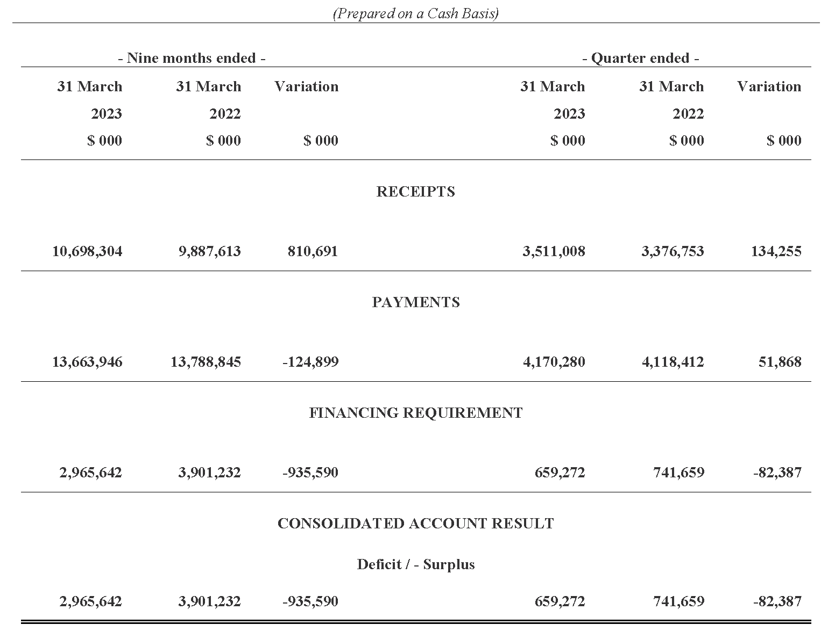

Statement of the Receipts and Borrowings on the Consolidated Account
Quarters and 9 Months Ended 31 March 2023 and 31 March 2022
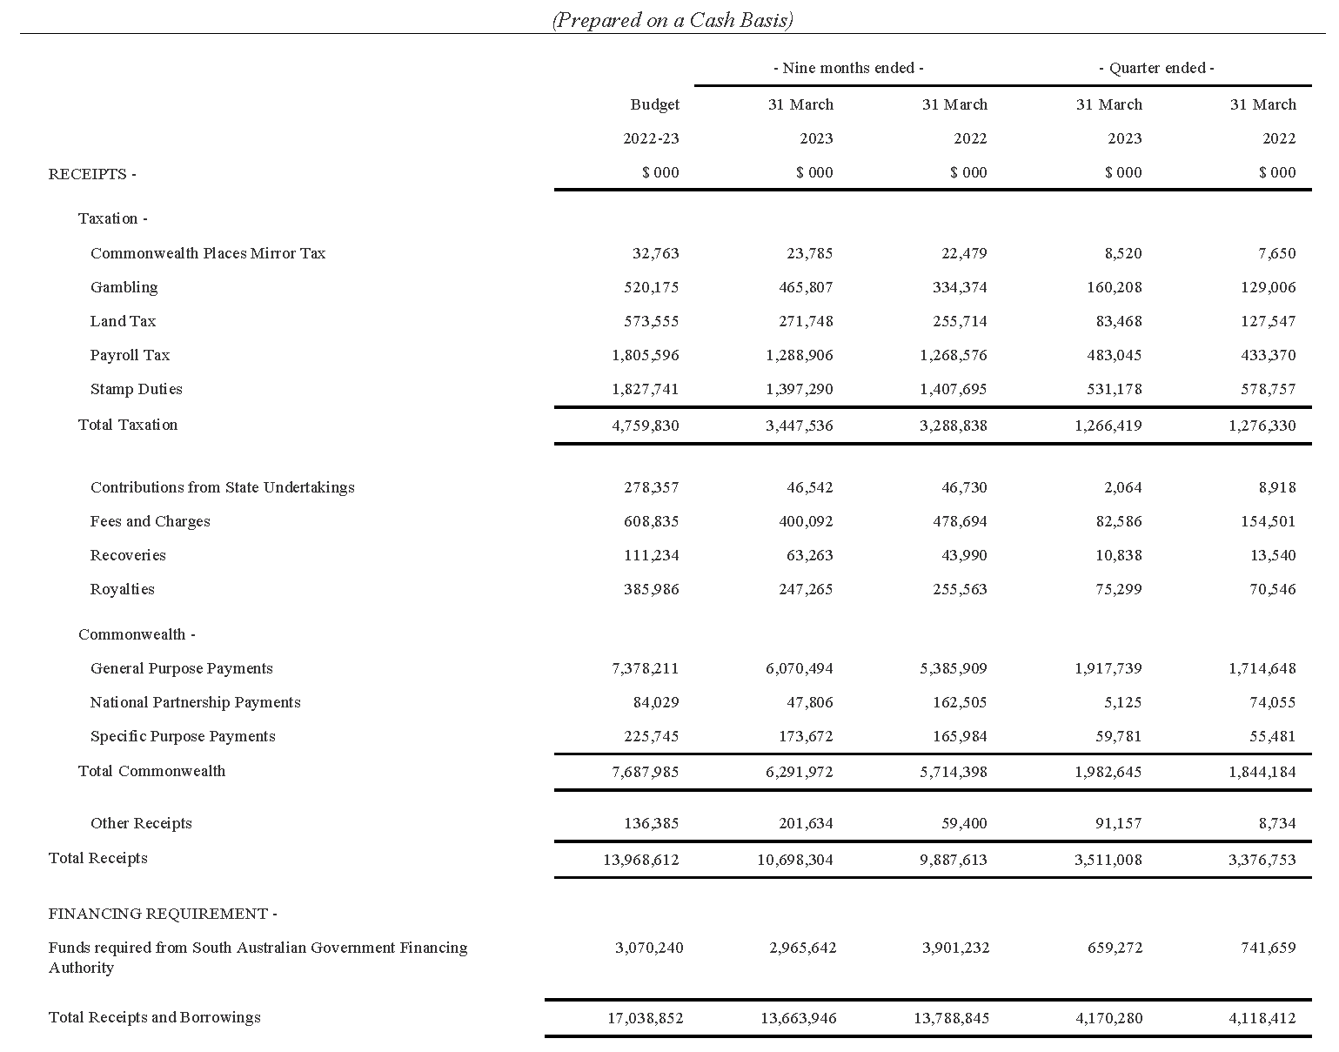

Statement of Payments on the Consolidated Account
Quarters and 9 Months Ended 31 March 2023 and 31 March 2022
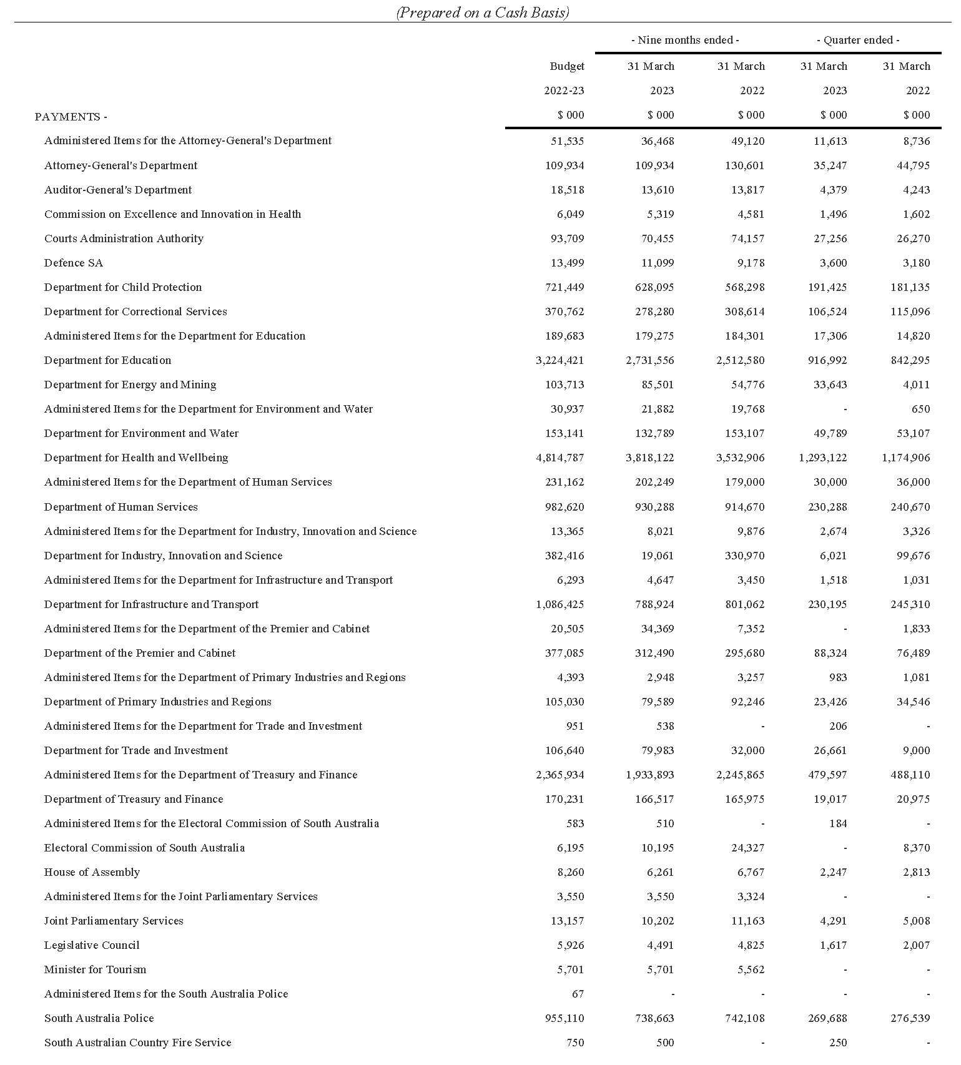

Statement of Payments on the Consolidated Account
Quarters and 3 Months Ended 31 March 2023 and 31 March 2022

Commentary to the Statement of the Amounts Credited to and Issued from the Consolidated Account
for the Quarters Ended 31 March 2023 and 31 March 2022
Receipts
Taxation
Gambling tax receipts are impacted by the timing of receipts into the consolidated account. Excluding timing impacts, underlying gambling tax collections in the March quarter 2023 and the nine months ended March 2023 were higher compared to the corresponding prior year periods largely due to growth in net gambling revenue from gaming machines in hotels and clubs and the betting operations tax. Receipts from the betting operation tax also include once-off revenue collections from compliance investigations relating to activity in previous years.
Land tax receipts in the March quarter 2023 were lower than the corresponding prior year period mainly due to the timing of collections associated with private land tax liabilities.
Land tax receipts in the nine months ended March 2023 were higher compared to the corresponding prior year period reflecting the timing of collections associated with government land tax liabilities.
Payroll tax receipts in the March quarter 2023 and nine months ended March 2023 were higher than the corresponding prior year periods mainly reflecting growth in taxable payrolls. Payroll tax collections in the nine months ended March 2023 were also impacted by the timing of collections.
Stamp duty receipts in the March quarter 2023 and nine months ended March 2023 were lower than the corresponding prior year periods largely reflecting a decline in conveyance duty receipts on the transfer of properties, partially offset by higher duty from general insurance premiums and motor vehicle registration transfers.
Royalties
Royalty payments in the March quarter 2023 were higher than the corresponding prior year period due to higher commodity prices combined with a weaker Australian dollar. Royalty payments in the nine months ended March 2023 were lower than the corresponding prior year period due to the timing of collections.
Fees and Charges
Fees and Charges in the March quarter 2023 and nine months ended March 2023 were lower than the corresponding prior year periods due to lower regulatory fees. This is due to the timing of the collection of receipts from Department of Trade and Investment. This was received in the June quarter 2023.
Commonwealth—General Purpose Payments
Growth in general purpose grant receipts in 2022-23 compared to 2021-22 is not indicative of underlying movements in Goods and Services Tax (GST) revenue. This is because monthly grants are paid according to a payment schedule prepared by the Commonwealth Government rather than actual emerging monthly GST collections.
Based on the growth in the national GST pool and population estimates as well as South Australia’s relativity in 2022-23, the Commonwealth Government estimated in its 2023-24 Budget that South Australia’s GST entitlement grant will increase by 10.1 per cent in 2022-23.
Commonwealth—Specific Purpose Payments
Specific Purpose Payments received in the March quarter 2023 and nine months ended March 2023 were higher than the corresponding prior year periods mainly due to higher receipts under the National Housing and Homelessness Agreement and National Agreement for Skills and Workforce Development.
Commonwealth—National Partnership Payments
National Partnership Payments received in the March quarter 2023 and nine months ended March 2023 were lower than the corresponding prior year period mainly due to lower reimbursements for Commonwealth HomeBuilder grants that are being administered by the state on behalf of the Commonwealth Government.
Other Receipts
Other Receipts in the March quarter 2023 and nine months ended March 2023 were higher than the corresponding prior year period mainly due to higher interest on investments. This is due to higher interest rates applied on the Treasurer’s deposits placed with the South Australian Government Financing Authority.
Payments
Payments were made pursuant to the Appropriation Act 2022 and also in accordance with other Acts for which specific appropriation has been authorised. The timing of the payments is based on agreed agency drawdown schedules and may change from period to period based on specific agency requirements.
All appropriations were paid within approved limits established under the various Acts.
Effective from 1 July 2022, the Department for Innovation and Skills was renamed to the Department for Industry, Innovation and Science.
Note
The following points should be considered when reviewing the quarterly statement of Consolidated Account transactions:
- Unlike the State Budget which comprises transactions on an accrual basis, the information reflected in the quarterly statement is limited to cash transactions.
- The Consolidated Account does not capture all the transactions undertaken by the general government sector. In particular, it does not record receipts to, and payments from Agency deposit and special deposit accounts.
- The timing of receipts and payments can fluctuate within a financial year and between financial years. As a result, apparently large movements between quarters or financial years may only be due to changes in the timing of receipts and payments and therefore may not have consequences for the underlying budget position.
Dated: 18 September 2023
Hon. Stephen Mullighan MP
Treasurer of South Australia

Local Government Instruments

District Council of Mount Remarkable
Local Government Land By-Law 2023
By-law No. 4
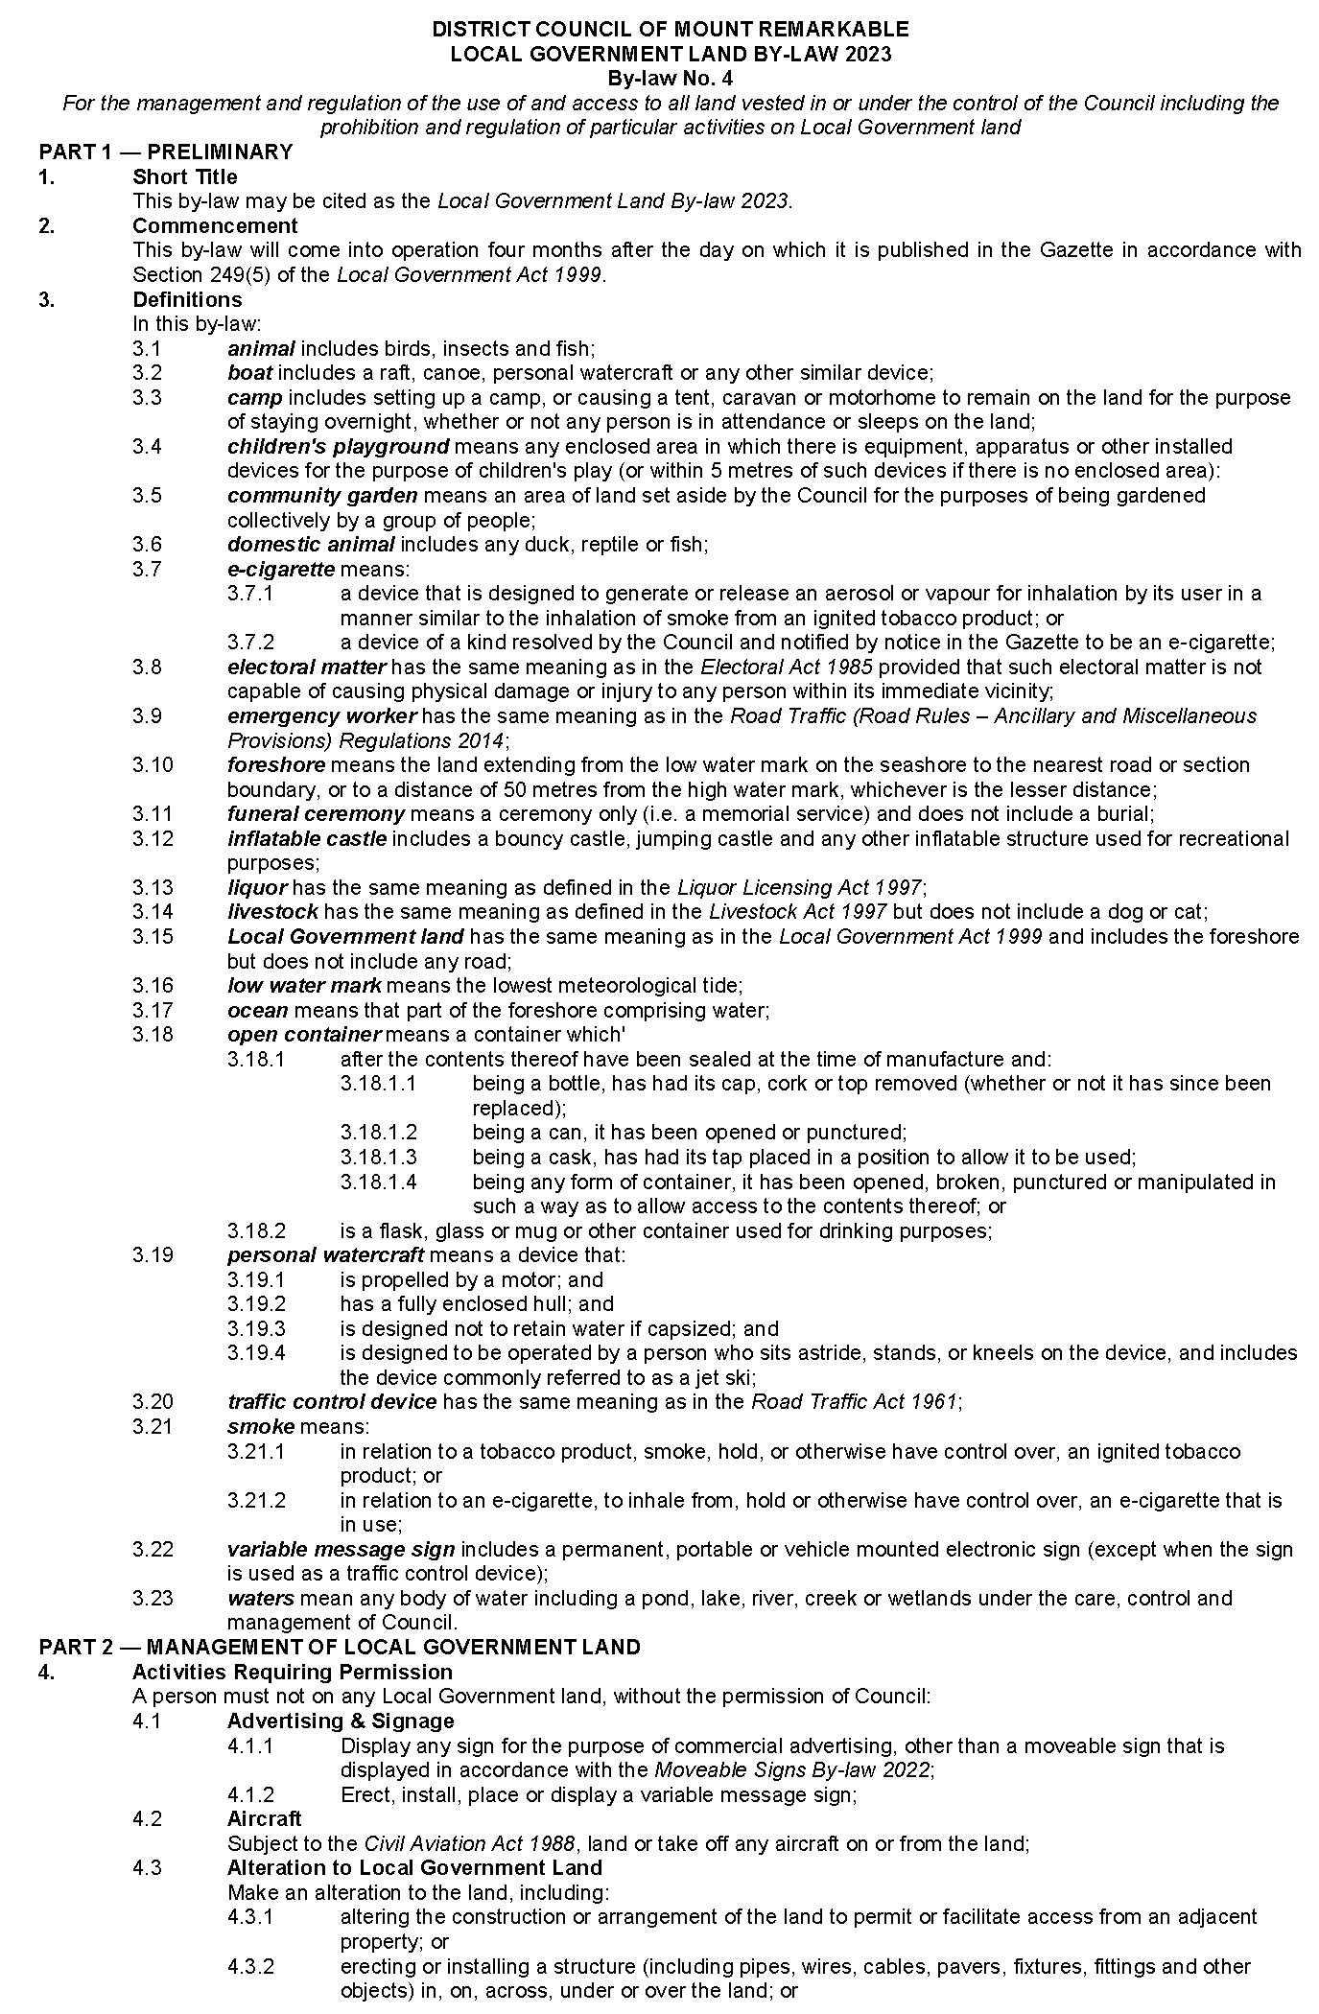
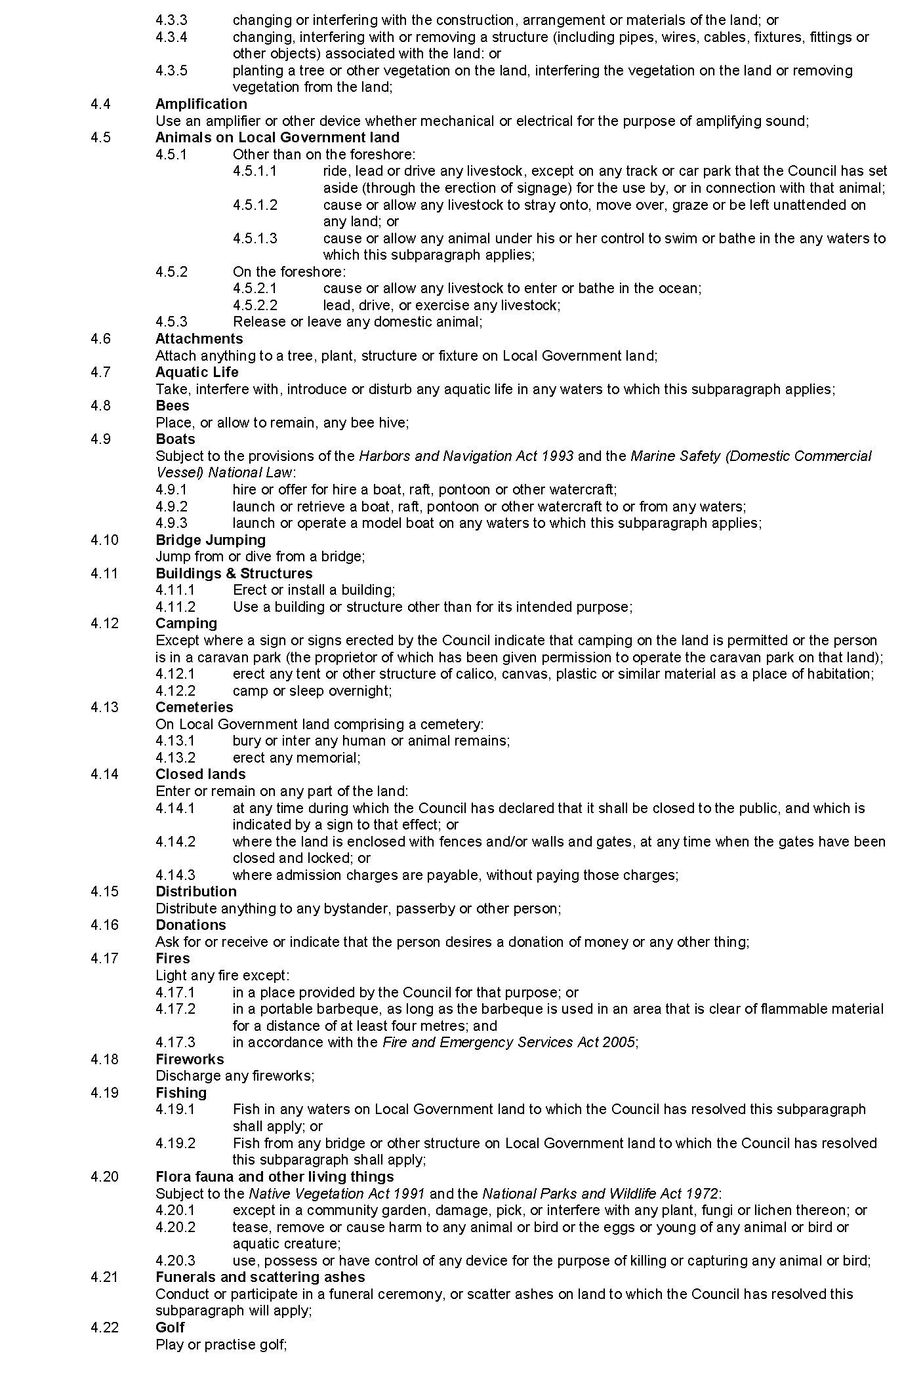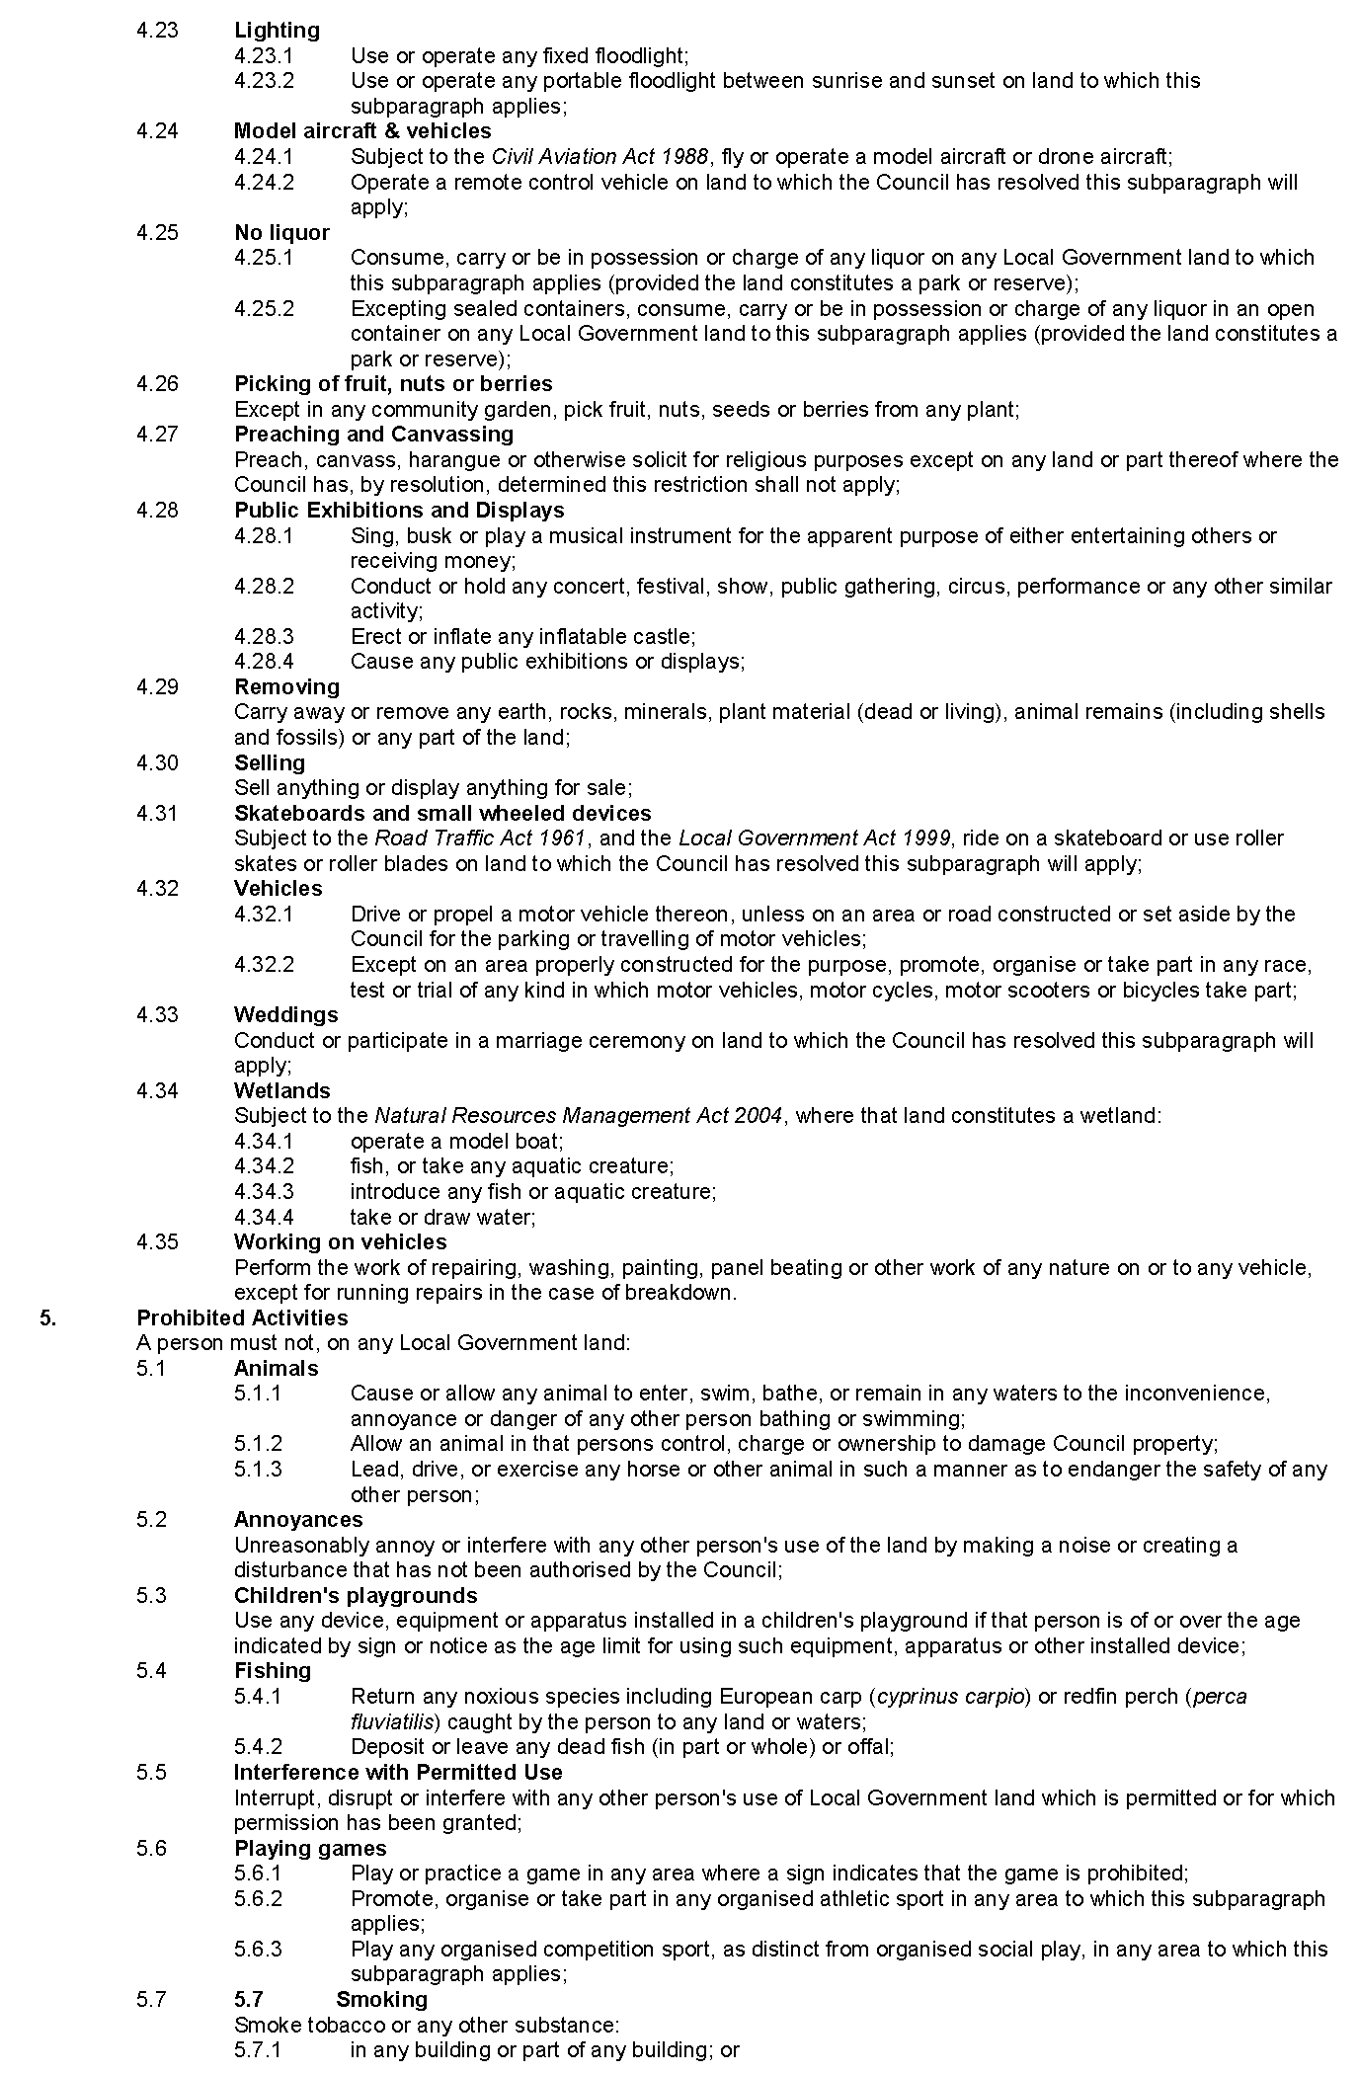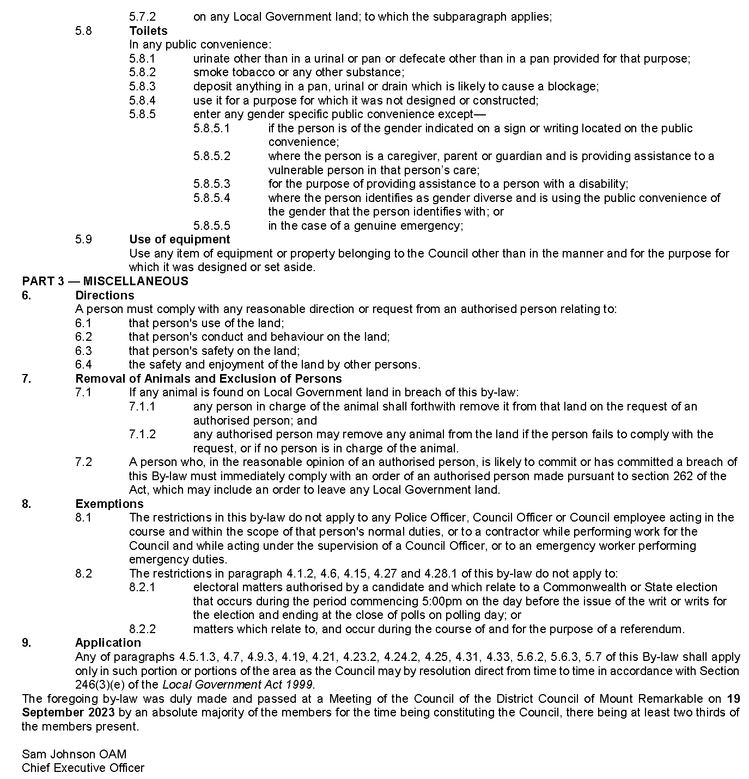

Public Notices

Trustee Act 1936
Public Trustee
Estates of Deceased Persons
In the matter of the estates of the undermentioned deceased persons:
BRABBAN Paul Thomas late of 8 Kingsford Street Victor Harbor Of no occupation who died Between 10 August 2022 - 12 August 2022
CORRIE Lionel Alec late of 106-112 Florence Street Port Pirie Retired Yard Master who died 2 April 2023
CRAMMOND Claire late of 17 Rockville Avenue Daw Park Of no occupation who died 2 June 2023
DRUMMOND Marie Leslie late of 324 Military Road Semaphore Park Of no occupation who died 16 July 2023
HALL Peter John late of 14 Smith Street Millicent Seaman who died 3 March 2023
LANCASTER Joyce otherwise Marie Joyce late of 53 Swanport Road Murray Bridge Retired Cleaner who died 14 January 2021
LEE Denis late of 71 Stokes Terrace Port Augusta West Of no occupation who died 17 October 2022
O'DONNELL Raymond Sydney late of 23 Wayford street Elizabeth Vale Retired Draftsman who died 2 June 2023
ROE Elaine Marjorie late of 1 East Parkway Lightsview Retired Canteen Manager who died 30 September 2022
SCHNAARS John Anthony late of 11 Mawson Road Salisbury Of no occupation who died 2 June 2023
STOCKFISCH Friederich Wilhelm Karl late of 18-20 Cudmore Terrace Marleston Of no occupation who died 4 January 2023
TINGLEY George James late of No fixed address last know to be 35kms South of Pimba Of no occupation who died 19 June 2022
Notice is hereby given pursuant to the Trustee Act 1936, the Inheritance (Family Provision) Act 1972 and the Family Relationships Act 1975 that all creditors, beneficiaries, and other persons having claims against the said estates are required to send, in writing, to the office of Public Trustee at GPO Box 1338, Adelaide SA 5001, full particulars and proof of such claims, on or before 27 October 2023 otherwise they will be excluded from the distribution of the said estate; and notice is also hereby given that all persons indebted to the said estates are required to pay the amount of their debts to the Public Trustee or proceedings will be taken for the recovery thereof; and all persons having any property belonging to the said estates are forthwith to deliver same to the Public Trustee.
Dated: 28 September 2023
N. S. Rantanen
Public Trustee

Notice Submission

The South Australian Government Gazette is published each Thursday afternoon.
Notices must be emailed by 4 p.m. Tuesday, the week of publication.
Submissions are formatted per the gazette style and a proof will be supplied prior to publication, along with a quote if applicable. Please allow one day for processing notices.
Alterations to the proof must be returned by 4 p.m. Wednesday.

Gazette notices must be submitted as Word files, in the following format:
• Title—the governing legislation
• Subtitle—a summary of the notice content
• Body—structured text, which can include numbered lists, tables, and images
• Date—day, month, and year of authorisation
• Signature block—name, role, and department/organisation authorising the notice

Please provide the following information in your email:
• Date of intended publication
• Contact details of the person responsible for the notice content
• Name and organisation to be charged for the publication—Local Council and Public notices only
• Purchase order, if required—Local Council and Public notices only

Email: governmentgazettesa@sa.gov.au
Phone: (08) 7133 3552
Website: www.governmentgazette.sa.gov.au

All instruments appearing in this gazette are to be considered official, and obeyed as such

Printed and published weekly by authority of M. Dowling, Government Printer, South Australia
$8.55 per issue (plus postage), $430.00 per annual subscription—GST inclusive
Online publications: www.governmentgazette.sa.gov.au

Proposed groundwater use includes where groundwater is proposed to be utilised in any relevant future projects including changes to existing projects, approved projects, and projects currently under assessment under relevant SA legislation.

