SUPPLEMENTARY GAZETTE
THE SOUTH AUSTRALIAN
GOVERNMENT GAZETTE
Published by Authority

Adelaide, Wednesday, 10 April 2024

Contents

State Government Instruments

Summary Offences Act 1953 624

State Government Instruments
SUMMARY OFFENCES ACT 1953
Declared Public Precincts
Notice of Ministerial Declaration
I, KYAM JOSEPH MAHER, Attorney-General in the State of South Australia, being the Minister responsible for the administration of Part 14B - Declared Public Precincts of the Summary Offences Act 1953, DO HEREBY DECLARE pursuant to the provisions of section 66N of the said Act that the area, comprised of more than one public place, within the following boundaries:
• Northern boundary of North Terrace to western boundary of Montefiore Road;
• Western Boundary of Montefiore Road to the southern bank of the River Torrens;
• Southern bank of the River Torrens to eastern boundary of King William Road (adjacent to the King William Road Bridge);
• Eastern boundary of King William Road to the northern boundary of North Terrace;
• Northern boundary of North Terrace to the eastern boundary of Pulteney Street;
• Eastern boundary of Pulteney Street to the southern boundary of Grenfell Street;
• Southern boundary of Grenfell Street and Currie Street to the Western boundary of West Terrace; and
• Western boundary of West Terrace to northern boundary of North Terrace
will be a declared public precinct for a period of 12 hours from 1 0.00am on each Monday, Tuesday, Wednesday and Thursday, commencing on Wednesday 10 April 2024.
will be a declared public precinct for a period of 12 hours from 6.00pm on each Friday and Saturday, commencing on Friday 12 April 2024.
will be a declared public precinct for a period of 4 hours from 6.00pm on each Sunday commencing on Sunday 14 April 2024.
This declaration will cease to have effect at 10.00 pm on Wednesday 10 July 2024.
References to boundaries identified by streets, roads or terraces for the purpose of this declaration will be taken to mean and include the area up to applicable building or fence lines, or the imagined projection thereof, on the relevant boundary.
I am satisfied that there is, during the period specified in this declaration, a reasonable likelihood of conduct in the area posing a risk to public order and safety.
I am satisfied that the inclusion of each public place in the area is reasonable having regard to that identified risk.
Made at Adelaide on this 9th Day of April 2024.
Kyam Maher
Attorney-General
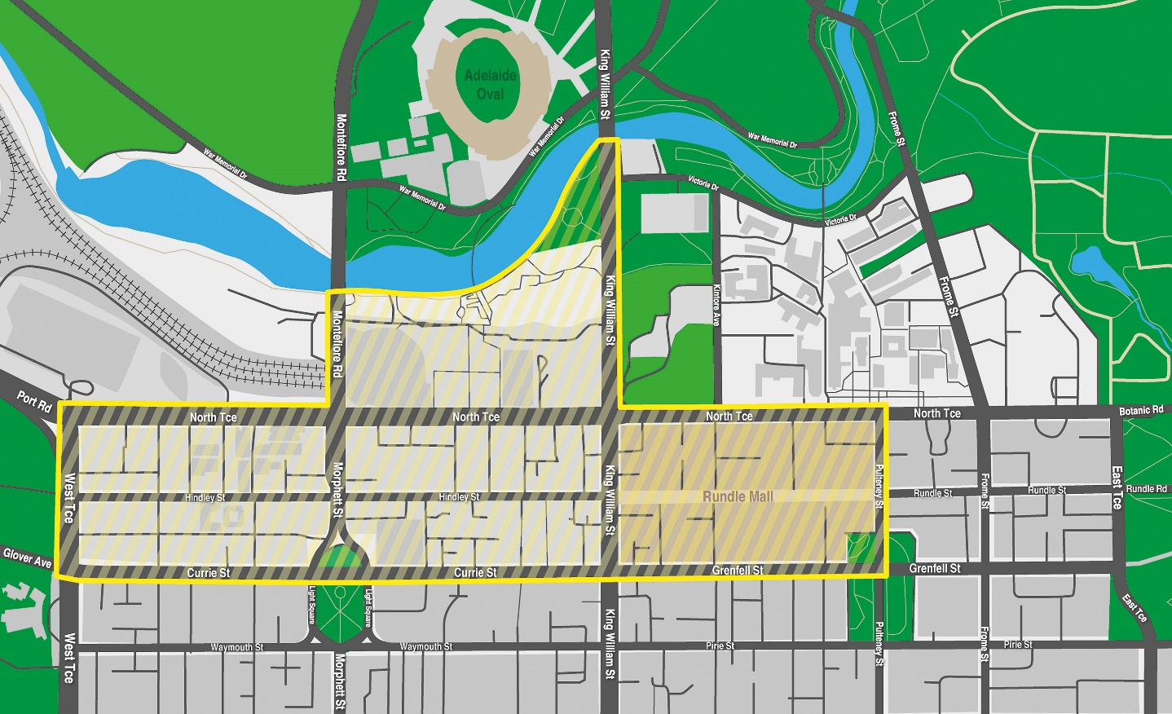

All instruments appearing in this gazette are to be considered official, and obeyed as such

Printed and published weekly by authority of T. Foresto, Government Printer, South Australia
$8.55 per issue (plus postage), $430.00 per annual subscription—GST inclusive
Online publications: www.governmentgazette.sa.gov.au

