No. 28 p. 685
THE SOUTH AUSTRALIAN
GOVERNMENT GAZETTE
Published by Authority

Adelaide, Thursday, 18 April 2024

Contents

Governor’s Instruments
Acts 686
Appointments, Resignations and General Matters 686
State Government Instruments
Advance Care Directives Act 2013 688
Building Work Contractors Act 1995 720
Education and Children’s Services Act 2019 720
Fisheries Management (General) Regulations 2017 721
Fisheries Management (Prawn Fisheries) Regulations 2017 722
Fisheries Management Act 2007 723
Housing Improvement Act 2016 728
Land Acquisition Act 1969 728
Major Events Act 2013—[Republished] 732
Mental Health Act 2009 734
Motor Vehicles Act 1959 734
National Parks and Wildlife Act 1972 736
Petroleum and Geothermal Energy Act 2000 736
Planning, Development and Infrastructure Act 2016 737
Professional Standards Act 2004 738
Roads (Opening and Closing) Act 1991 738
State Lotteries Act 1966 (SA) 739
Local Government Instruments
City of Adelaide 740
City of Mitcham 740
Lower Eyre Council 740
Public Notices
National Electricity Law 741
Trustee Act 1936 741
University of Adelaide Act 1971 741

Governor’s Instruments

Acts
Department of the Premier and Cabinet
Adelaide, 18 April 2024
Her Excellency the Governor directs it to be notified for general information that she has in the name and on behalf of His Majesty The King, this day assented to the undermentioned Bills passed by the Legislative Council and House of Assembly in Parliament assembled, viz.:
No. 10 of 2024—Constitution (Countersigning) Amendment Bill 2024
An Act to amend the Constitution Act 1934.
No. 11 of 2024—Ayers House Bill 2024
An Act to grant ongoing rights in relation to Ayers House to the National Trust of South Australia, to make related amendments to the National Trust of South Australia Act 1955, and for other purposes.
No. 12 of 2024—Statutes Amendment (National Energy Laws) (Wholesale Market Monitoring) Bill 2024
An Act to amend the National Electricity (South Australia) Act 1996 and the National Gas (South Australia) Act 2008.
By command,
Stephen Campbell Mullighan, MP
For Premier

Appointments, Resignations and General Matters
Department of the Premier and Cabinet
Adelaide, 18 April 2024
Her Excellency the Governor in Executive Council has been pleased to appoint the undermentioned to the Construction Industry Long Service Leave Board, pursuant to the provisions of the Construction Industry Long Service Leave Act 1987:
Deputy Member: from 18 April 2024 until 28 September 2027
Holly Catharine Grace Gardner (Deputy to Minuzzo)
By command,
Stephen Campbell Mullighan, MP
For Premier
AGO0062-24CS

Department of the Premier and Cabinet
Adelaide, 18 April 2024
Her Excellency the Governor in Executive Council has been pleased to appoint the undermentioned to the South Australian Country Arts Trust, pursuant to the provisions of the South Australian Country Arts Trust Act 1992:
Member: from 18 April 2024 until 17 April 2027
Stephanie Julia Toole
By command,
Stephen Campbell Mullighan, MP
For Premier
24ART0006CS

Department of the Premier and Cabinet
Adelaide, 18 April 2024
Her Excellency the Governor in Executive Council has been pleased to appoint the undermentioned to the State Theatre Company of South Australia Board, pursuant to the provisions of the State Theatre Company of South Australia Act 1972:
Member: from 18 April 2024 until 17 April 2027
Gavin Adrian Wanganeen
By command,
Stephen Campbell Mullighan, MP
For Premier
24ART0007CS

Department of the Premier and Cabinet
Adelaide, 18 April 2024
Her Excellency the Governor in Executive Council has been pleased to appoint the undermentioned to the Adelaide Festival Centre Trust, pursuant to the provisions of the Adelaide Festival Centre Trust Act 1971:
Member: from 18 April 2024 until 17 April 2027
Karlene Ann Maywald
Alexandrea Cannon
Presiding Member: from 18 April 2024 until 17 April 2027
Karlene Ann Maywald
By command,
Stephen Campbell Mullighan, MP
For Premier
24ART0008CS

Department of the Premier and Cabinet
Adelaide, 18 April 2024
Her Excellency the Governor in Executive Council has been pleased to appoint Dr Richard James Dunbar Harris SC OAM as Governor’s Deputy of South Australia for the periods from 6.00am on Sunday, 21 April 2024 until 12.30pm on Saturday, 27 April 2024 and from 9.00am on Tuesday, 7 May 2024 until 6.30pm on Saturday, 11 May 2024.
By command,
Stephen Campbell Mullighan, MP
For Premier

Department of the Premier and Cabinet
Adelaide, 18 April 2024
Her Excellency the Governor in Executive Council has been pleased to appoint the Honourable Chief Justice Christopher John Kourakis as Governor’s Deputy of South Australia from 7.00am on Monday, 13 May 2024 until 6.00pm on Tuesday, 14 May 2024.
By command,
Stephen Campbell Mullighan, MP
For Premier

Department of the Premier and Cabinet
Adelaide, 18 April 2024
Her Excellency the Governor in Executive Council has been pleased to appoint the undermentioned as Community Visitors commencing on 18 April 2024 and expiring on 17 April 2027 - pursuant to the provisions of the Mental Health Act 2009:
Sabrina Ottaviano
Jennifer Kristine Singh
Meredyth Karen Taylor
Andrew John Bain Crowther
By command,
Stephen Campbell Mullighan, MP
For Premier
HEAC-2024-00008

Department of the Premier and Cabinet
Adelaide, 18 April 2024
Her Excellency the Governor in Executive Council has been pleased to appoint the undermentioned as Community Visitors - pursuant to the provisions of the Mental Health Act 2009:
From 4 June 2024 until 3 June 2027:
Margaret Edith Behn
Anne Gordon Burgess
From 21 June 2024 until 20 June 2027:
Ingrid Lily Davies
Judith Mary Harvey
By command,
Stephen Campbell Mullighan, MP
For Premier
HEAC-2024-00008

State Government Instruments

Advance Care Directives Act 2013
Advance Care Directives Forms
I, CHRIS PICTON MP, Minister for Health and Wellbeing, in accordance with Section 3(1) of the Advance Care Directives Act 2013, publish the forms for giving Advance Care Directives.
Dated: 16 April 2024
Hon Chris Picton MP
Minister for Health and Wellbeing

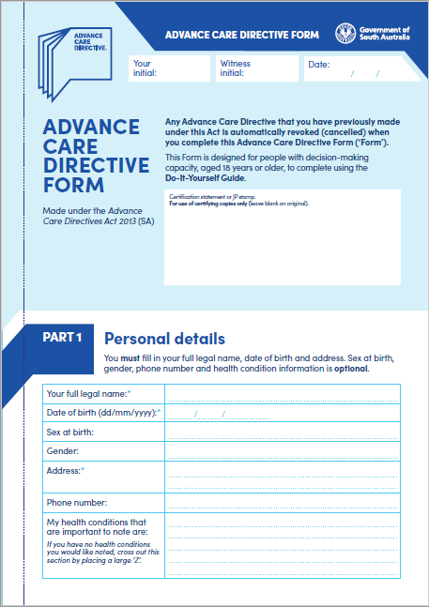
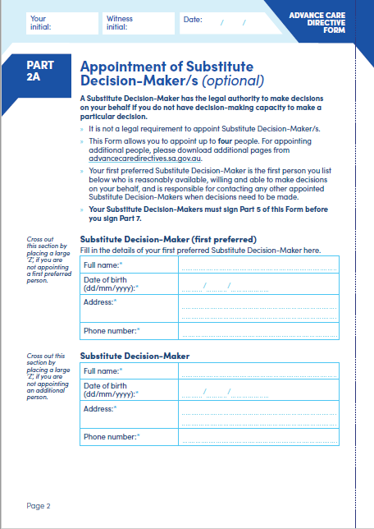
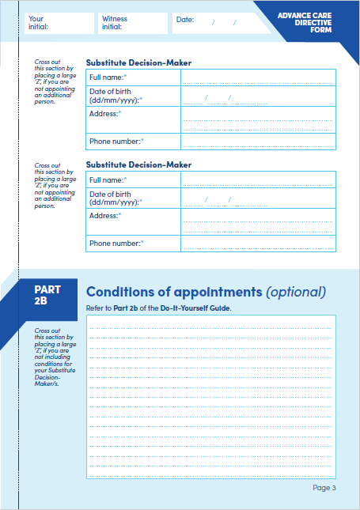
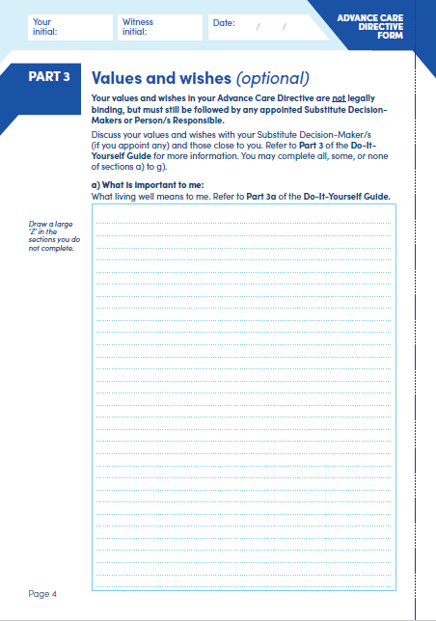
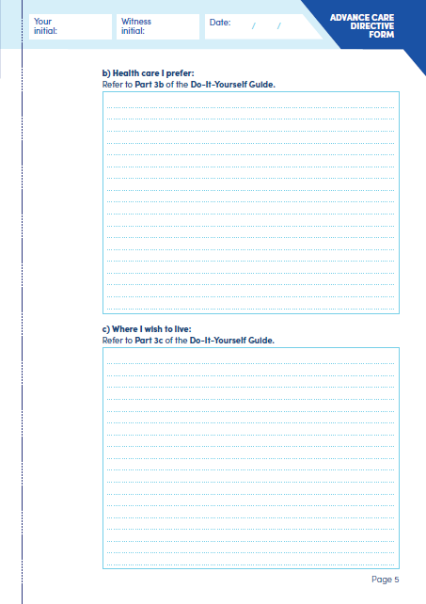
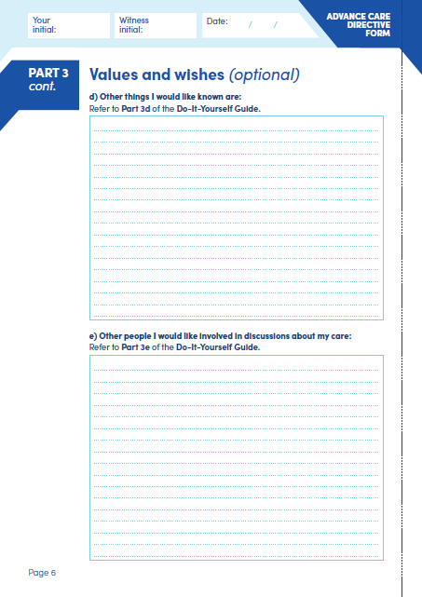
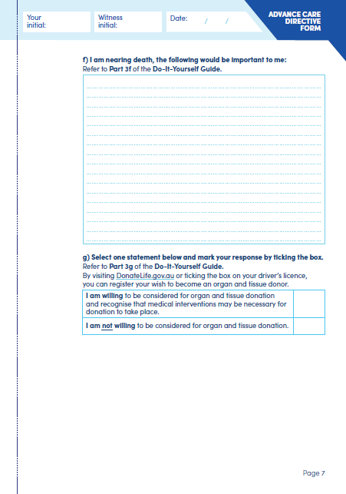
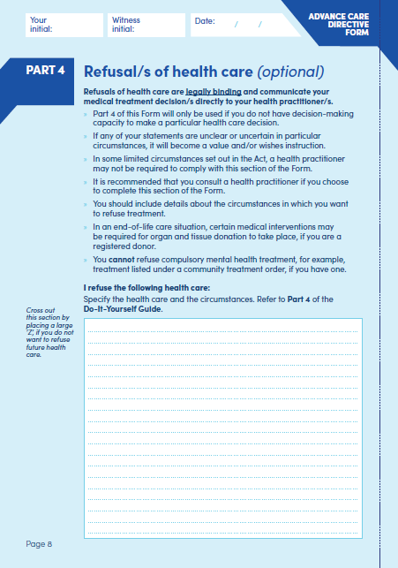
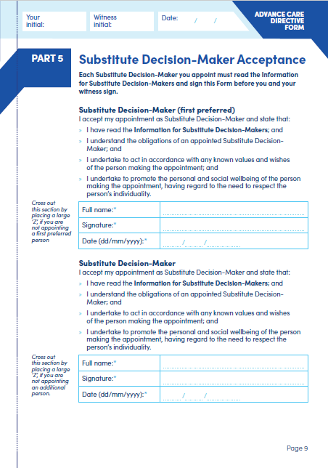
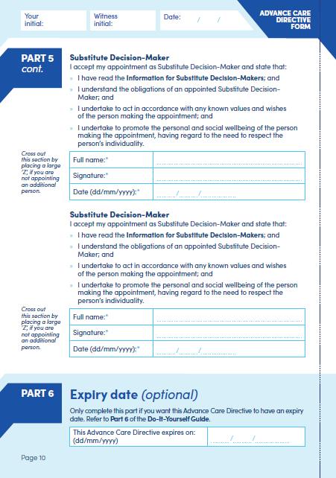
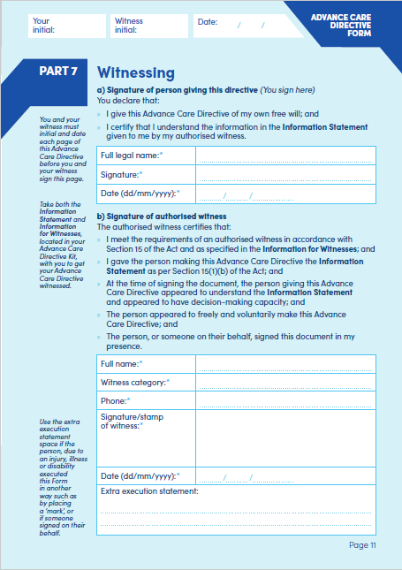
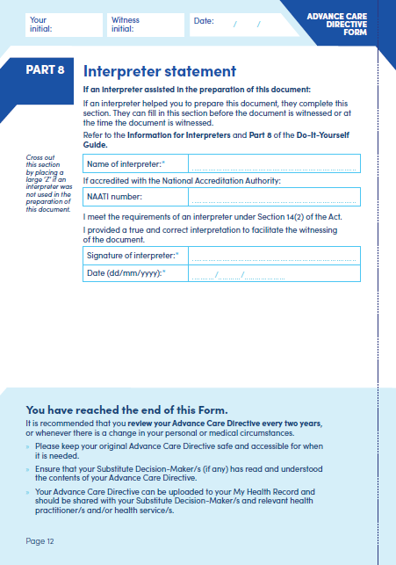
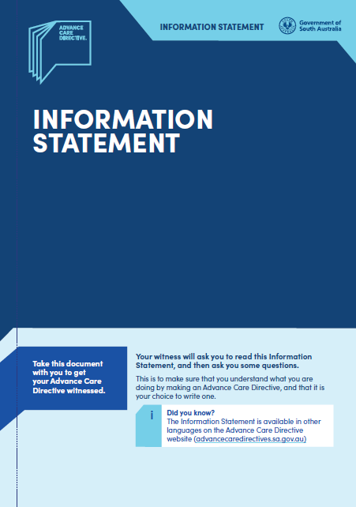
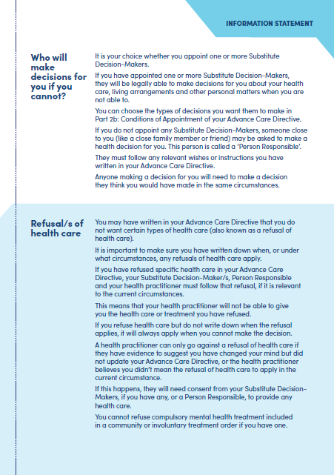
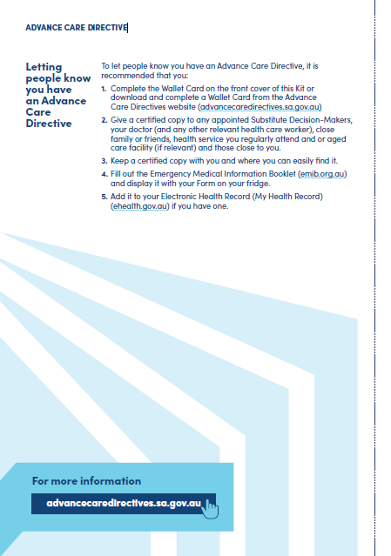
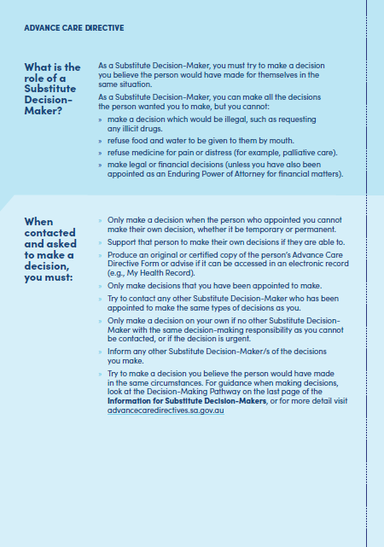
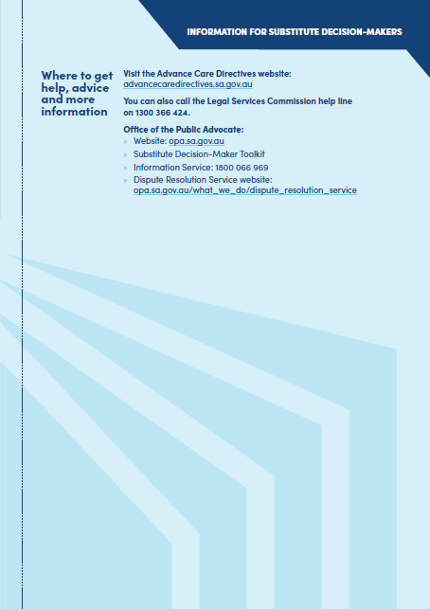
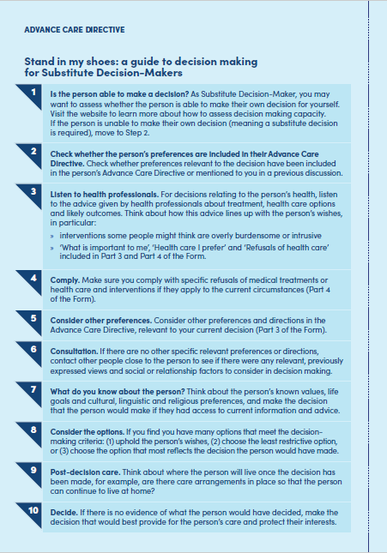
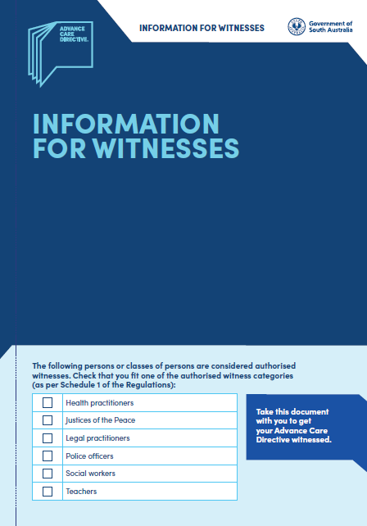
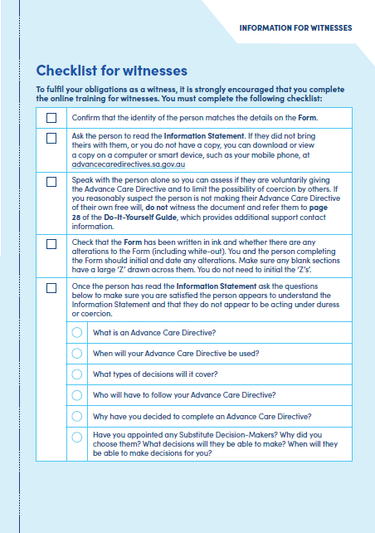
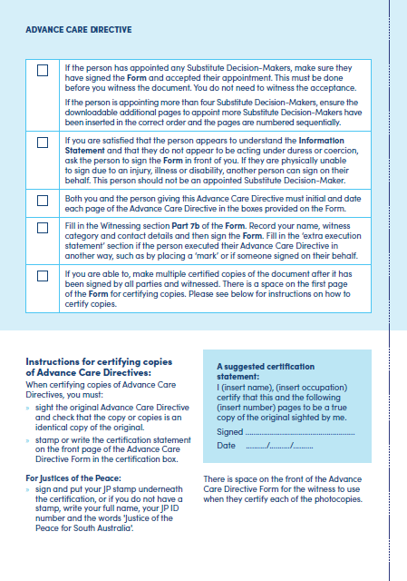
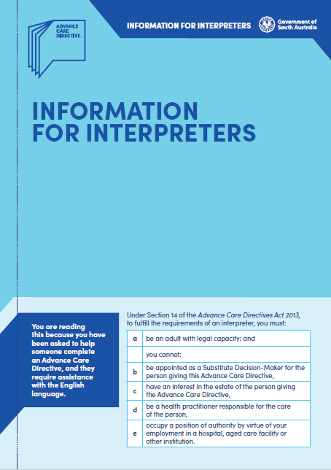
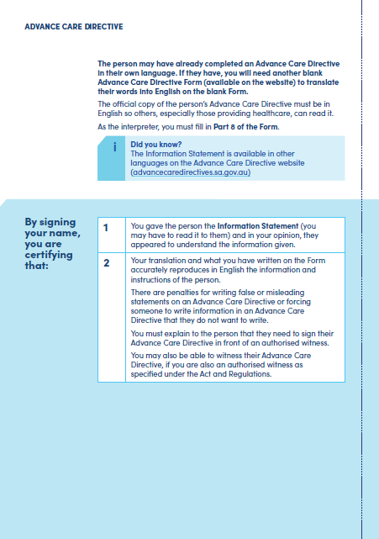
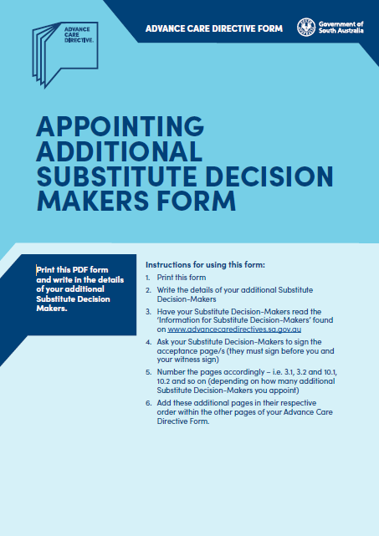
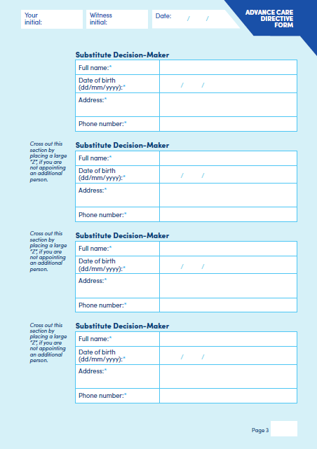
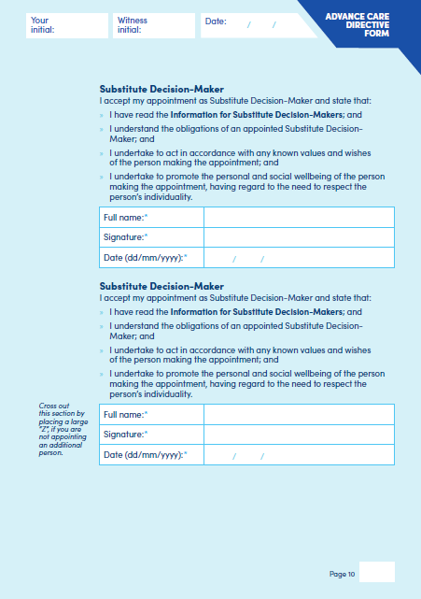

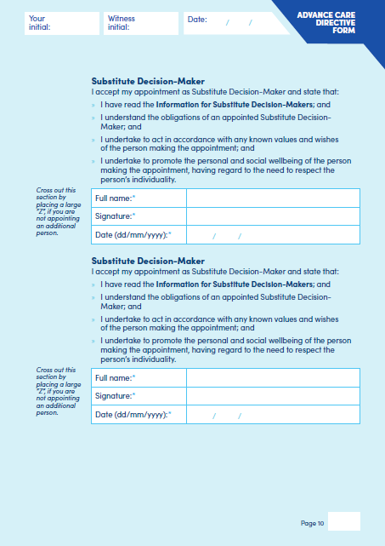
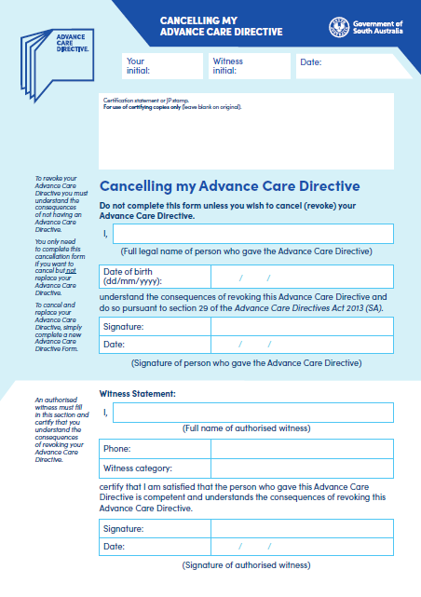

Building Work Contractors Act 1995
Exemption
TAKE notice that, pursuant to Section 45 of the Building Work Contractors Act 1995, I, Rita McPhail as a delegate for the Minister for Consumer and Business Affairs, do hereby exempt the licensee named in Schedule 1 from the application of Division 3 of Part 5 of the above Act in relation to domestic building work described in Schedule 2 and subject to the conditions specified in Schedule 3.
Schedule 1
KERRY AIFANDIS (BLD 181427)
Schedule 2
Construction of single storey residential dwelling and swimming pool at Allotment 16 Filed Plan 15156 being a portion of the land described in Certificate of Title Volume 5163 Folio 65, more commonly known as 4 Clinton Avenue, Myrtle Bank SA 5064.
Schedule 3
1. This exemption is limited to domestic building work personally performed by the licensee in relation to the building work described in Schedule 2.
2. This exemption does not apply to any domestic building work the licensee contracts to another building work contractor, for which that contractor is required by law to hold building indemnity insurance.
3. That the licensee does not transfer his interest in the land prior to five years from the date of completion of the building work the subject of this exemption, without the prior authorisation of Consumer and Business Services (CBS). Before giving such authorisation, CBS may require the licensee to take any reasonable steps to protect the future purchaser(s) of the property, including but not limited to:
• Providing evidence that an adequate policy of building indemnity insurance is in force to cover the balance of the five-year period from the date of completion of the building work the subject of this exemption;
• Providing evidence of an independent expert inspection of the building work the subject of this exemption;
• Making an independent expert report available to prospective purchasers of the property;
• Giving prospective purchasers of the property notice of the absence of a policy of building indemnity insurance.
Dated: 12 April 2024
Rita McPhail
Director, Customer and Transformation
Delegate for the Minister for Consumer and Business Affairs

Education and Children’s Services Act 2019
Notice Fixing Charges for Dependants of Subclass 500, 572, 573 and 574 Visa Holders
PURSUANT to Section 130(1)(c) of the Education and Children’s Services Act 2019, I, Chief Executive of the Department for Education, fix the following charges payable in respect of a dependant of a person who is the subject of a student visa for education in a Government school.
For the purposes of this notice, student visa means a student visa that is:
(1) a Subclass 500 (Student) visa that relates to study in the vocational education and training, higher education or postgraduate research sectors;
(2) a Subclass 572 (Vocational Education and Training Sector) visa;
(3) a Subclass 573 (Higher Education Sector) visa; or
(4) a Subclass 574 (Postgraduate Research Sector) visa,
issued under the Migration Act 1958 of the Commonwealth.
Fees commencing from 1 January 2025 per school year:
(1) The administration charge for application processing and school enrolment is—
(a) for the first school year of enrolment—$700;
(b) for each subsequent school year of enrolment—$360.
(2) The tuition charge for a full school year for a dependant of a person who is the subject of a student visa is—
(a) for tuition in primary courses—$6,920;
(b) for tuition in secondary courses or in an intensive English course at secondary level (years 7 to 12)—$8,200;
(3) The tuition charge for a part of a school year for a dependant of a person who is the subject of a student visa is such proportion of the tuition charge that would be payable if the dependant were enrolled for the full school year (being the proportion that the number of school terms for the whole or part of which the student is enrolled bears to 4).
Dated: 18 April 2024
M. Westwell
Chief Executive

Education and Children’s Services Act 2019
Notice Fixing Charges for Full Fee Paying Overseas Students
PURSUANT to Section 130(1)(a) of the Education and Children’s Services Act 2019, I, Chief Executive of the Department for Education, fix the following charges payable by a full fee paying overseas student (defined in Section 130(6) of the Education and Children’s Services Act 2019) of a Government school.
Fees commencing from 1 January 2025 per school year:
(1) The administration charge for application processing and school enrolment in relation to a full fee paying overseas student is—
(a) in the case of a student holding a temporary visa under the Migration Act 1958 of the Commonwealth that is valid for a total period of 12 months or less and who is enrolled for the whole or part of school year—$1,250;
(b) in any other case.
(i) for the first school year of enrolment—$700;
(ii) for each subsequent school year of enrolment—$360.
(2) The tuition charge for a full school year for a full fee paying overseas student is—
(a) for tuition in primary courses or in an intensive English course at primary level—$12,600;
(b) for tuition in secondary courses or in an intensive English course at secondary level—
(i) for years 7 to 10—$15,120;
(ii) for years 11 to 12—$16,600.
(3) The tuition charge for a part of a school year for a full fee paying overseas student is to be determined as follows:
(a) in the case of a student who is enrolled for a period of less than 9 weeks—the tuition charge is as specified in the following table:
Weeks | Primary | Junior Secondary (Years 7 to 10) | Senior Secondary (Years 11 to 12)
1 to 5 | $1,825.00 | $2,140.00 | $2,325.00
6 | $2,190.00 | $2,568.00 | $2,790.00
7 | $2,555.00 | $2,996.00 | $3,255.00
8 | $2,920.00 | $3,424.00 | $3,720.00
(b) in any other case—the tuition charge is such proportion of the tuition charge that would be payable if the student were enrolled for the full school year (being the proportion that the number of school terms for the whole or part of which the student is enrolled bears to 4).
Dated: 18 April 2024
M. Westwell
Chief Executive

Fisheries Management (General) Regulations 2017
Regulation 23A(1)
Determination—Taking of Bivalve Filter-Feeding Molluscs in Port Adelaide River Estuary
AS delegate of the Minister for Primary Industries and Regional Development, I Professor Gavin Begg, Executive Director of Fisheries and Aquaculture make the following determination for the purposes of Regulation 23A(1) of the Fisheries Management (General) Regulations 2017 in regard to the taking of bivalve molluscs in the Port Adelaide River estuary, unless this notice is otherwise varied or revoked:
Professor Sabine Dittmann of Flinders University and her nominated agents (Professor James Stangoulis, Dr Kieren Beaumont and research assistants and research students under direct supervision of Professor Dittmann, Professor Stangoulis or Dr Beaumont) may take bivalve filter-feeding molluscs within the waters of the Port Adelaide River Estuary, excluding the waters of aquatic reserves (unless otherwise authorised under the Fisheries Management Act 2007), but only to the extent that it is incidental to the sampling of macroinvertebrates and fish as part of the South Australian Blue Carbon Ecosystem Restoration Project or Mudflat Biodiversity and Condition Monitoring Project.
This determination is made subject to the following conditions:
(1) All equipment used for bivalve molluscs must be appropriately decontaminated in accordance with the ‘AQUAVETPLAN Operational Procedures Manual—Decontamination’.
(2) All bivalve molluscs collected incidentally during benthic sampling must be disposed of appropriately in accordance with AQUAVETPLAN Operational Procedures Manual—Disposal.
(3) The incidental taking of bivalve filter-feeding molluscs as contemplated by this determination may only occur within 12 months of the signing of this notice unless this notice is otherwise varied or revoked.
Dated: 12 April 2024
Professor Gavin Begg
Executive Director
Fisheries and Aquaculture
Delegate of the Minister for Primary Industries and Regional Development

Fisheries Management (Prawn Fisheries) Regulations 2017
Variation on Prohibition of Fishing Activities
in the Spencer Gulf Prawn Fishery
TAKE note that pursuant to Regulation 10 of the Fisheries Management (Prawn Fisheries) Regulations 2017, the notice dated 28 September 2023 on page 3296 of the South Australian Government Gazette on 22 September 2023 prohibiting fishing activities in the Spencer Gulf Prawn Fishery, is hereby varied such that it will not be unlawful for a person fishing pursuant to a Spencer Gulf Prawn Fishery licence to use prawn trawl nets in the areas specified in Schedule 1, during the period specified in Schedule 2, and under the conditions specified in Schedule 3.
Schedule 1
The waters of the Spencer Gulf Prawn Fishery:
(a) Except the Northern Closure area, which is defined as the area north of the following index points until amended:
1. 33°29.30S 137°16.00E
2. 33°29.30S 137°28.50E
3. 33°34.00S 137°28.50E
4. 33°34.00S 137°30.00E
5. 33°29.30S 137°30.00E
6. 33°29.30S 137°34.70E
7. 33°37.00S 137°33.00E
8. 33°46.00S 137°44.00E
(b) Except for Channel Closure area, which is defined as the waters contained within the following index points:
1. 33°44.20S 137°24.65E
2. 33°44.20S 137°25.70E
3. 33°47.50S 137°25.10E
4. 33°47.50S 137°23.26E
Then back to point 1
(c) Except for the Southern Closure area, which is defined as the waters contained within the following index points:
1. 33°41.00S 137°10.00E
2. 33°49.40S 137°19.90E
3. 33°54.00S 137°09.00E
4. 33°59.30S 137°09.70E
5. 34°18.00S 136°59.00E
6. 34°36.00S 136°59.00E
7. 34°36.00S 136°36.50E
8. 34°07.50S 136°45.50E
9. 34°05.00S 136°49.90E
10. 34°02.40S 136°47.50E
11. 33°59.50S 136°53.20E
12. 34°01.70S 136°55.50E
13. 33°58.00S 137°01.00E
14. 33°55.50S 136°59.50E
15. 33°57.40S 136°55.70E
16. 33°56.50S 136°55.00E
17. 33°58.00S 136°52.00E
18. 33°49.40S 136°43.50E
(d) Except the Wardang Closure area, which is defined as the waters contained within the following index points:
1. 34°10.00S 137°28.00E
2. 34°21.00S 137°12.00E
3. 34°45.00S 137°15.00E
4. 34°48.53S 137°09.45E
5. 34°48.53S 137°06.00E
6. 34°50.75S 137°06.00E
7. 34°54.00S 137°01.00E
(e) Except the Corny closure area, which is defined as the waters within and bounded by the following closure index points:
1. 34°27.00S 136°53.00E
2. 34°27.00S 137°02.00E
3. 34°35.00S 136°56.00E
4. 34°48.60S 136°52.00E
5. 34°54.00S 136°52.00E
6. 34°54.00S 136°48.50E
7. 34°49.50S 136°48.50E
8. 34°49.50S 136°40.50E
9. 34°39.50S 136°40.50E
Then back to point 1

(f) Except the Illusions Park closure area, which is defined as the waters contained within the following closure index points:
1. 33°28.80S 137°32.20E
2. 33°28.30S 137°33.20E
3. 33°28.85S 137°33.50E
4. 33°29.40S 137°32.50E
Then back to point 1
(g) Except the Jurassic Park closure area, which is defined as the waters contained within the following closure index points:
1. 33°54.90S 137°17.60E
2. 33°54.40S 137°19.40E
3. 33°54.70S 137°19.60E
4. 33°55.20S 137°17.80E
Then back to point 1
(h) Except the Estelle Star closure area, which is defined as the waters contained within the following closure index points:
1. 33°58.80S 136°49.80E
2. 33°58.20S 136°51.00E
3. 33°59.10S 136°51.70E
4. 33°59.80S 136°50.40E
Then back to point 1
Schedule 2
Commencing at sunset on 10 April 2024 and ending at sunrise on the 19 April 2024.
Schedule 3
1. The coordinates in Schedule 1 are defined as degrees decimal minutes and are based on the World Geodetic System 1984 (WGS 84).
2. No fishing activity may be undertaken between the prescribed times of sunrise and sunset for Adelaide (as published in the South Australian Government Gazette pursuant to the requirements of the Proof of Sunrise and Sunset Act 1923) during the period specified in Schedule 2.
3. Fishing must cease:
(a) in the fishing area known as the ‘Mid/North Gulf’ area (as described on page 40 of the Management Plan for the South Australian Commercial Spencer Gulf Prawn Fishery October 2020) if the average catch per vessel, per night (based on the best information available to the committee at sea) drops below 500kg; and
(b) in the fishing area known as the ‘Southern Gulf’ area (as described on page 40 of the Management Plan for the South Australian Commercial Spencer Gulf Prawn Fishery October 2020) if the average catch per vessel over two consecutive nights (based on the best information available to the committee at sea) falls below 350kg.
4. Based on the best information available from the fleet, fishing must cease in an area in the Mid/North Gulf if the average prawn bucket count exceeds 240 prawns per 7kg; or in an area in the Southern Gulf if the average prawn bucket count exceeds 240 prawns/7kg.
5. No fishing activity may occur without the authorisation of Coordinator at Sea, Ashley Lukin, or other nominated Coordinator at Sea appointed by the Spencer Gulf and West Coast Prawn Association.
6. The authorisation of the Coordinator at Sea must be in writing, signed and record the day, date, and permitted fishing area within the waters of Schedule 1 in the form of a notice sent to the fishing fleet or vary an earlier authorisation issued by the Coordinator at Sea.
7. The Coordinator at Sea must cause a copy of any authorisation for fishing activity or variation of same, made under this notice to be emailed to the Prawn Fisheries Manager immediately after it is made.
8. The Spencer Gulf and West Coast Prawn Association must keep records of all authorisations issued pursuant to this notice.
Dated: 10 April 2024
Ashley Lukin
Coordinator at Sea, Spencer Gulf & West Coast Prawn Association Inc.
Delegate of the Minister for Primary Industries and Regional Development

Fisheries Management Act 2007
Section 115
Ministerial Exemption ME9903295
TAKE notice that pursuant to Section 115 of the Fisheries Management Act 2007, Nick Secomb, Director, Plant and Invasive Species Biosecurity, the Department of Primary Industries and Regions, (the ‘exemption holder’) or his nominated agents defined in this notice, are exempt from Sections 70, 72(2)(c), 73 and 79(9) of the Fisheries Management Act 2007, but only to the extent that the activities are necessary to prevent, respond to and control the introduction and spread of exotic aquatic organisms or as part of educational activities related to identification and management of exotic aquatic organisms in the waters described in Schedule 1 subject to the conditions specified in Schedule 2, from 13 April 2024 until 12 April 2025, unless varied or revoked earlier.
Schedule 1
Activities undertaken pursuant to this notice may be undertaken within waters of the State excluding sanctuary and restricted access zones of marine parks (unless otherwise authorised under the Marine Parks Act 2007) and Aquatic reserves (unless otherwise authorised under the Fisheries Management Act 2007).

Schedule 2
1. All activities undertaken under this notice must be consistent with the National System for the Prevention and Management of Marine Pest Incursions and may include activities involving:
• Surveillance of exotic aquatic organisms for early detection, understanding the extent of an incursion, assessment of the effectiveness of control activities and improving the understanding of pest status, dispersal vectors and pathways to inform marine pest management.
• Species identification of suspect exotic aquatic organisms.
• Removal and disposal as part of control activities during a response to contain or eradicate the exotic species.
• Removal and disposal as part of clean-up activities.
• Collection of exotic aquatic organisms for educational displays.
2. The exemption holder will be deemed responsible for the conduct of all nominated agents conducting the exempted activities under this notice. Any agents conducting activities under this exemption must be provided with a copy of this notice, which they must have signed as an indication that they have read and understand the conditions under it. Such notice must be produced to a Fisheries Officer if requested.
3. The nominated agents of the exemption holder may be any of the following:
• Staff, contractors and registered volunteers of PIRSA Biosecurity Division
• Staff, contractors and registered volunteers of PIRSA Fisheries and Aquaculture
• Staff, contractors and registered volunteers of SARDI Aquatic and Livestock Sciences
• Staff, contractors and registered volunteers of Department for Environment and Water South Australia
• Staff, contractors and registered volunteers of the South Australian Museum
• Staff, contractors and registered volunteers of Local Councils of South Australia
• Staff, contractors and registered volunteers of Landscape Boards of South Australia
• Commercial Fishing Licence Holders in South Australia
4. The exemption holder or nominated agents may take any species of exotic aquatic organisms using any type of device reasonably required to undertake the exempted activities, other than explosives, from the waters of the State.
5. Commercial Fishing Licence Holders acting as an agent under this exemption must only do so in the presence of, and under the direct supervision, of the permit holder or an employee of PIRSA Biosecurity or PIRSA Fisheries and Aquaculture.
6. Whilst engaged in the exempted activity nominated agents must not engage in commercial fishing activities. Where commercial fishing vessels are used they must be deregistered prior to being used by calling Fishwatch or via the commercial fishing app.
7. Any species other than noxious or exotic aquatic organisms caught pursuant to this notice must be returned to the water as soon as practicable.
8. The specimens can only be retained by the exemption holder for identification, education, monitoring or research purposes.
9. Any equipment used to collect and hold exotic aquatic organisms during the exempted activity must be decontaminated prior to and after undertaking the exempted activities.
10. At least 1 hour before conducting the exempted activity, the exemption holder or nominated agent must contact PIRSA Fishwatch on 1800 065 522 and answer a series of questions about the exempted activity. The exemption holder or agent will need to have a copy of this notice in their possession at the time of making the call and be able to provide information about who will be involved in the exempted activity, including area and time of the exempted activity, the vehicles and/or boats involved, and other related issues.
11. Before commencing any exempted activity under this notice within the Adelaide Dolphin Sanctuary, the exemption holder or their agents must provide notification of intended dates and times of the activity to:
• Jon Emmett, Regional Coordinator Marine Parks: jon.emmett@sa.gov.au
12. The exemption holder must keep a record of the names of all nominated agents used under the exemption and when they were engaged in activities pursuant to this notice.
13. The exemption holder must not contravene or fail to comply with the Fisheries Management Act 2007 or any regulations made under that Act, except where specifically exempted by this notice.
14. This notice does not purport to override the provisions or operation of any other Act including, but not limited to, the Marine Parks Act 2007, the Adelaide Dolphin Sanctuary Act 2005 or River Murray Act 2003. The exemption holder and nominated agents must comply with any relevant regulations, permits, requirements and directions from the Department for Environment and Water when undertaking activities within a specially protected area.
Dated: 12 April 2024
Professor Gavin Begg
Executive Director
Fisheries and Aquaculture
Delegate of the Minister for Primary Industries and Regional Development

Fisheries Management Act 2007
Section 115
Ministerial Exemption: ME9903299
TAKE notice that pursuant to Section 115 of the Fisheries Management Act 2007, Dr Connor Gervais of the Murraylands and Riverland Landscape Board, 110A Mannum Road, Murray Bridge SA 5253 (the ‘exemption holder’) and his nominated agents, are exempt from Section 70, 71(1) and 71(2) of the Fisheries Management Act 2007 and Regulation 5 and Clauses 40 and 44 of Schedule 6 of the Fisheries Management (General) Regulations 2017 but only insofar as the exemption holder or nominated agents may engage in activities of the Murraylands and Riverland Landscape Board supporting the monitoring and collection of native fish in the South Australian River Murray wetlands from the waters described in Schedule 1, using the gear specified in Schedule 2 (the ‘exempted activity’), subject to the conditions set out in Schedule 3, from 13 April 2024 until 12 April 2025, unless varied or revoked earlier.
Schedule 1
Wetlands within the SA Murray-Darling Basin between the South Australian border and the Murray Mouth, including the fringing wetlands of Lakes Alexandrina and Albert and the Murray Mouth, and sites listed under Ministerial permit MP0239 and MP0240.

Schedule 2
• 18 x fyke nets (6mm mesh, 7m wing)
• 18 x fyke nets (4mm mesh, 7m and/or 4m wing)
• 6 x double wing fyke nets (4mm mesh, 5m wings)
• 1 x seine net (5m length, 4mm mesh)
• 1 x dip net
• 10 x Shrimp traps
Schedule 3
1. The exemption holder will be deemed responsible for the conduct of all persons undertaking the exempted activities under this notice. Any person conducting activities under this exemption must be provided with a copy of this notice, which they must have signed as an indication that they have read and understood the conditions under it.
2. During the exempted activity a maximum of 5,000 Southern Pygmy Perch (Nannoperca australis), and a maximum of 30,000 Murray Hardyhead (Craterocephalus fluviatilis) may be retained.
3. Other than the fish listed at condition 2 that may be retained, all native fish taken pursuant to the exempted activity must be returned to the water in the locations where they were captured.
4. Any specimens collected or retained by the exemption holder must be translocated in accordance with the conditions of Ministerial permit MP0240 or be held in accordance with MP0239 for scientific and research purposes only and must not be sold.
5. All non-native species of fish caught during the exempted activity must be destroyed and disposed of appropriately.
6. The following persons are nominated agents under this exemption ME9903299:
• Sam Hardy—Mannum Road, Murray Bridge SA
• Stephanie Robinson—Vaughan Terrace, Berri SA
• Annie Kriesl—Vaughan Terrace, Berri SA
• Connor Gervais—Sturt Reserve Rd, Murray Bridge SA
• Olly Circco—Vaughan Terrace, Berri SA
• Aleisha Casson—Sturt Reserve Rd, Murray Bridge SA
• Kate Mason—Sturt Reserve Rd, Murray Bridge SA
• Pheobe McInerney—Sturt Reserve Rd, Murray Bridge SA
7. The exemption holder must notify the Department of Primary Industries and Regions (PIRSA) Fishwatch on 1800 065 522 at least 2 hours prior to conducting any exempted activities and answer a series of questions about the exempted activity. The exemption holder will need to have a copy of the exemption notice at the time of making the call and be able to provide information about the area and time of the exempted activity, the vehicles and boats involved, the number of agents undertaking the exempted activity and other related questions.
8. The exemption holder must provide a written report detailing the outcomes of the collection of organisms pursuant to this notice to PIRSA, Fisheries and Aquaculture, (PIRSA.Ministerialexemptionsandpermits@sa.gov.au) upon completion, giving the following details:
• the date, soak time and location of collection;
• the number of nets or traps used;
• the description of all species collected;
• the number of each species collected; and
• any other relevant information.
9. While engaging in the exempted activity, the exemption holder must be in possession of a copy of this notice. Such notice must be produced to a Fisheries Officer if requested.
10. The exemption holder must not contravene or fail to comply with the Fisheries Management Act 2007 or any regulations made under that Act, except where specifically exempted by this notice.
This notice does not purport to override the provisions or operation of any other Act including but not limited to the River Murray Act 2003.
Dated: 12 April 2024
Professor Gavin Begg
Executive Director, Fisheries and Aquaculture
Delegate of the Minister for Primary Industries and Regional Development

Fisheries Management Act 2007
Section 115
Ministerial Exemption ME9903303
TAKE notice that pursuant to Section 115 of the Fisheries Management Act 2007, I Professor Gavin Begg, Executive Director Fisheries and Aquaculture, delegate of the Minister for Primary Industries and Regional Development, hereby declare that commercial and recreational fishers (the ‘exemption holders’) are exempt from Section 70 of the Fisheries Management Act 2007, Regulation 5, and Clause 113(2) of Schedule 6 of the Fisheries Management (General) Regulations 2017 but only to the extent that they shall not be guilty of an offence when taking Wrasse species (Family Labridae other than Western Blue Groper) that are greater than 35cm in length (the exempted activity) from the area described in Schedule 1, subject to the conditions specified in Schedule 2 from 00:01 hrs on 21 April 2024 to 23:59 hrs on 20 April 2025, unless varied or revoked earlier.
Schedule 1
Coastal waters of the State excluding waters within a Sanctuary Zone or Restricted Access Zone of a Marine Park.
Schedule 2
1. The exemption holders may take Wrasse species (other than Western Blue Groper) that are greater than 35cm in length when measured from the foremost part of the head to the end of the tail (the exempted activity) where it is otherwise lawful to do so.
2. The exemption holder who is the holder of a fishery licence that allows for the taking of Wrasse species (other than Western Blue Groper), must continue to comply with all requirements under their licence, including the reporting of all catch taken within the terms of this notice in a South Australian Daily Catch and Effort Logbook provided by the Department of Primary Industries and Regions in respect of the fishery the exemption holder is operating in.
3. Except where specifically exempted by this notice the exemption holders must otherwise comply with the applicable provisions of Fisheries Management Act 2007, or any relevant regulations made under that Act.
This notice does not purport to override the provisions or operation of any other Act including, but not limited to, the Marine Parks Act 2007. The exemption holders and their agents must comply with any relevant regulations, permits, requirements and directions from the Department for Environment and Water when undertaking activities within a marine park.
Dated: 17 April 2024
Professor Gavin Begg
Executive Director
Fisheries and Aquaculture
Delegate of the Minister for Primary Industries and Regional Development

Fisheries Management Act 2007
Section 115
Ministerial Exemption ME9903305
TAKE notice that pursuant to Section 115 of the Fisheries Management Act 2007 (the Act), Dr Dion Ievasi, Director of Austral Research and Consulting, 23 Buntings Road, Kirkstall Victoria 3283 is exempt from Section 70 of the Fisheries Management Act 2007, and Regulations 5 and 10, and Clause 74 of Schedule 6 and ‘other waters’ as defined in Schedule 7 of the Fisheries Management (General) Regulations 2017, but only insofar as he may use the fishing devices specified in Schedule 1, in the waters specified in Schedule 2 to take non-native species including Carp, subject to the conditions specified in Schedule 3, from 16 April 2024 until 15 April 2025, unless varied or revoked earlier.
Schedule 1
• Up to 4 single wing fyke nets (20-100mm mesh);
• Up to 4 gill nets (up to 50m length, 50-175mm mesh size); and
• 1 x Grassl boat mounted Electrofishing device.
Schedule 2
• Valley Lake, Mount Gambier.
Schedule 3
1. Authorised agents of the exemption holder are employees of Austral Research and Consulting.
2. The exempted activity may only be conducted by the exemption holder or their nominated agents.
3. The exemption holder may only retain non-native species and must immediately destroy them humanely.
4. Non-native species of fish taken under this exemption cannot be sold and must be disposed of appropriately at an approved waste facility and must not be used for any commercial purpose.
5. Any native fish species captured incidentally while undertaking this exempted activity must immediately be returned to the water.
6. All fyke nets and gill nets that are set overnight must be checked and cleared the following morning.
7. All fyke nets left and gill nets unattended must be clearly marked with name and Ministerial exemption number on a tag if set close to shore or on a 2L buoy if set away from shore.
8. At least 1 hour before conducting activities under this exemption, the exemption holder or nominated agent must contact the Department of Primary Industries and Regions (PIRSA) Fishwatch on 1800 065 522 and answer a series of questions about the exempted activity. The caller will need to have a copy of this notice in their possession at the time of making the call and be able to provide information about the area and time of the exempted activity, the vehicles and/or boats involved, the number of persons assisting with undertaking the exempted activity and other related questions.
9. The exemption holder must provide a report in writing detailing the activities carried out pursuant to this notice to the Executive Director, Fisheries and Aquaculture (GPO Box 1625, Adelaide SA 5001) within 30 days of the expiry of this exemption that includes the following details:
• date and location of sampling;
• gear used;
• number and description of all species collected;
• any interactions with protected species; and
• other information regarding size, breeding or anything deemed relevant or of interest that is able to be volunteered.
10. While engaging in the exempted activity, the exemption holder must be in possession of a copy of this exemption and the exemption must be produced to a PIRSA Fisheries Officer if requested.
11. The exemption holder must not contravene or fail to comply with the Fisheries Management Act 2007 or any regulations made under that Act, except where specifically exempted by this notice.
Dated: 15 April 2024
Professor Gavin Begg
Executive Director
Fisheries and Aquaculture
Delegate of the Minister for Primary Industries and Regional Development

Fisheries Management Act 2007
Section 115
Ministerial Exemption ME9903308
TAKE notice that pursuant to Section 115 of the Fisheries Management Act 2007 (the Act), Dr Scotte Wedderburn of the School of Biological Sciences, University of Adelaide SA 5005 (the ‘exemption holder’) or his nominated agents, are exempt from Section 70 of the Fisheries Management Act 2007, Schedule 6, Regulation 5, Clauses 40 and 74 of the Fisheries Management (General) Regulations 2017 but only insofar as he may use the fishing gear specified in Schedule 1, in the waters specified in Schedule 2 to survey Thukabi (short-necked and long-necked turtles), subject to the conditions specified in Schedule 3, from 16 April 2024 until 28 March 2025, unless varied or revoked earlier.
Schedule 1
• Up to 12 fyke nets that comply with the following dimensions:
◦ 6m long, 1m height hoops, 28mm 20 ply nylon mesh. Single-winged with a front ‘D’ hoop and 4 other hoops, 2 funnels, fitted with three floats and two bait bags.
Schedule 2
• In wetland habitats associated with the River Murray Proper, Lake Albert and Lake Alexandrina, South Australia.
Schedule 3
1. The exemption holder will be deemed responsible for the conduct of all persons conducting the exempted activities under this notice. Any person conducting activities under this exemption must be provided with a copy of this notice, which they must have signed as an indication that they have read and understand the conditions under it.
2. The nominated agents of the exemption holder are the following members of the Ngarrindjeri Aboriginal Corporation:
• Tyreen Gollan
• Gerald Rigney
• Trevor Sumner
• Tina Kartinyeri
3. Any native fish that may be caught incidentally during the exempted activity must be immediately returned to the water in the location where they were caught.
4. Any noxious fish captured during the exempted activity must be humanely destroyed and disposed of.
5. A maximum of three (3) fyke nets may be set at any one site on any day after 3 pm but must all be retrieved and cleared the following morning.
6. Fyke nets must be deployed with a minimum of two floats >10 cm diameter in the cod end (final chamber) to permit surface access of >3cm for air-breathing by-catch.
7. Any equipment used to collect and hold noxious fish or turtles during the exempted activity must be decontaminated prior to and after undertaking the research activities.
8. At least 1 hour before conducting activities under this exemption, the exemption holder or nominated agent must contact the Department of Primary Industries and Regions (PIRSA) Fishwatch on 1800 065 522 and answer a series of questions about the exempted activity. The exemption holder will need to have a copy of this notice in their possession at the time of making the call and be able to provide information about the area and time of the exempted activity, the vehicles and/or boats involved, the number of persons assisting with undertaking the exempted activity and other related questions.
9. The exemption holder must provide a report in writing detailing the activities carried out pursuant to this notice to the Executive Director, Fisheries and Aquaculture (GPO Box 1625, Adelaide SA 5001) within 30 days of the expiry of this exemption that includes the following details:
• the date and location of sampling;
• the gear used;
• the number and description of all species collected;
• any interactions with protected species and marine mammals; and
• other information regarding size, breeding or anything deemed relevant or of interest that is able to be volunteered.
10. While engaging in the exempted activity, the exemption holder must be in possession of a copy of this exemption. Such exemption must be produced to a PIRSA Fisheries Officer if requested.
11. The exempted activities may only occur where consistent with authorised activities under Scientific Research permit E27357-1 or a subsequent permit issued under the National Parks and Wildlife Act 1972.
12. The exemption holder must not contravene or fail to comply with the Fisheries Management Act 2007 or any regulations made under that Act, except where specifically exempted by this notice.
This notice does not purport to override the provisions or operation of any other Act including, but not limited to, the River Murray Act 2003 or the exercise of any existing native title right. The exemption holder must comply with any relevant regulations, permits, requirements and directions from the Department for Environment and Water to the extent that they may apply when undertaking activities within a specially protected area.
Dated: 15 April 2024
Professor Gavin Begg
Executive Director
Fisheries and Aquaculture
Delegate of the Minister for Primary Industries and Regional Development

Housing Improvement Act 2016
Rent Control Revocations
WHEREAS the Minister for Human Services Delegate is satisfied that each of the houses described hereunder has ceased to be unsafe or unsuitable for human habitation for the purposes of the Housing Improvement Act 2016, notice is hereby given that, in exercise of the powers conferred by the said Act, the Minister for Human Services Delegate does hereby revoke the said Rent Control in respect of each property.
Address of Premises | Allotment Section | Certificate of Title  Volume/Folio
6 Pamir Court, Port Lincoln, SA 5606 (AKA 6-8) | Allotment 225, Deposited Plan 7972,  Hundred of Lincoln | CT5443/96, CT6004/923
331 Eighth Street, Renmark North, SA 5341  (AKA Lot 2, PKA Lot 199, Corner Block E) | Allotment 2, Deposited Plan 23702,  Renmark Irrigation District | CT5274/89
Dated: 18 April 2024
Craig Thompson
Housing Regulator and Registrar
Housing Safety Authority
Delegate of the Minister for Human Services

Housing Improvement Act 2016
Rent Control Variations
THE Minister for Human Services Delegate in the exercise of the powers conferred by the Housing Improvement Act 2016, does hereby vary the rent control notice in respect of each house described in the following table. Variation in the maximum rental per week which shall be payable subject to Section 55 of the Residential Tenancies Act 1995. The varied amount shown in the said table shall come into force on the date of this publication in the Gazette.
Address of Premises | Allotment Section | Certificate of Title  Volume/Folio | Reason for  Variation | Maximum Rent per Week Payable
57 Moloney Road, Virginia, SA 5120 AKA Lot 4, Section 3009 Roberts Road | Allotment 4, Filed Plan 29490, Hundred of Munno Para | CT5712/294 |  | $450.00
Dated 18 April 2024
Craig Thompson
Housing Regulator and Registrar
Housing Safety Authority
Delegate of the Minister for Human Services

Land Acquisition Act 1969
Section 16
Form 5—Notice of Acquisition
1. Notice of acquisition
The Commissioner of Highways (the Authority), of 83 Pirie Street, Adelaide SA 5000, acquires the following interests in the following land:
Comprising an unencumbered estate in fee simple in that piece of land being the whole of Allotment 321 in Filed Plan 19503 comprised in Certificate of Title Volume 5422 Folio 685.
This notice is given under Section 16 of the Land Acquisition Act 1969.
2. Compensation
A person who has or had an interest consisting of native title or an alienable interest in the land that is divested or diminished by the acquisition or the enjoyment of which is adversely affected by the acquisition who does not receive an offer of compensation from the Authority may apply to the Authority for compensation.
2A. Payment of professional costs relating to acquisition (Section 26B)
If you are the owner in fee simple of the land to which this notice relates, you may be entitled to a payment of up to $10,000 from the Authority for use towards the payment of professional costs in relation to the acquisition of the land.
Professional costs include legal costs, valuation costs and any other costs prescribed by the Land Acquisition Regulations 2019.
3. Inquiries
Inquiries should be directed to: Petrula Pettas
GPO Box 1533
Adelaide SA 5001
Telephone: (08) 7133 2457
Dated: 9 April 2024
The Common Seal of the COMMISSIONER OF HIGHWAYS was hereto affixed by authority of the Commissioner in the presence of:
Rocco Caruso
Manager, Property Acquisition
(Authorised Officer)
Department for Infrastructure and Transport
File Reference: 2022/02716/01

Land Acquisition Act 1969
Section 16
Form 5—Notice of Acquisition
1. Notice of acquisition
The Commissioner of Highways (the Authority), of 83 Pirie Street, Adelaide SA 5000, acquires the following interests in the following land:
Comprising an unencumbered estate in fee simple in that piece of land being the whole of Allotment 19 in Deposited Plan 1999 comprised in Certificate of Title Volume 6131 Folio 868.
This notice is given under Section 16 of the Land Acquisition Act 1969.
2. Compensation
A person who has or had an interest consisting of native title or an alienable interest in the land that is divested or diminished by the acquisition or the enjoyment of which is adversely affected by the acquisition who does not receive an offer of compensation from the Authority may apply to the Authority for compensation.
2A. Payment of professional costs relating to acquisition (Section 26B)
If you are the owner in fee simple of the land to which this notice relates, you may be entitled to a payment of up to $10,000 from the Authority for use towards the payment of professional costs in relation to the acquisition of the land.
Professional costs include legal costs, valuation costs and any other costs prescribed by the Land Acquisition Regulations 2019.
3. Inquiries
Inquiries should be directed to: William Ridgway
GPO Box 1533
Adelaide SA 5001
Telephone: (08) 7133 2465
Dated this 15 April 2024
The Common Seal of the COMMISSIONER OF HIGHWAYS was hereto affixed by authority of the Commissioner in the presence of:
Rocco Caruso
Manager, Property Acquisition
(Authorised Officer)
Department for Infrastructure and Transport
File Reference: 2022/02877/01

Land Acquisition Act 1969
Section 16
Form 5—Notice of Acquisition
1. Notice of acquisition
The Commissioner of Highways (the Authority), of 83 Pirie Street, Adelaide SA 5000, acquires the following interests in the following land:
Comprising an unencumbered estate in fee simple in that piece of land being the whole of Allotment 20 in Deposited Plan 1999 comprised in Certificate of Title Volume 6131 Folio 867.
This notice is given under Section 16 of the Land Acquisition Act 1969.
2. Compensation
A person who has or had an interest consisting of native title or an alienable interest in the land that is divested or diminished by the acquisition or the enjoyment of which is adversely affected by the acquisition who does not receive an offer of compensation from the Authority may apply to the Authority for compensation.
2A. Payment of professional costs relating to acquisition (Section 26B)
If you are the owner in fee simple of the land to which this notice relates, you may be entitled to a payment of up to $10,000 from the Authority for use towards the payment of professional costs in relation to the acquisition of the land.
Professional costs include legal costs, valuation costs and any other costs prescribed by the Land Acquisition Regulations 2019.
3. Inquiries
Inquiries should be directed to: William Ridgway
GPO Box 1533
Adelaide SA 5001
Telephone: (08) 7133 2465
Dated this 15 April 2024
The Common Seal of the COMMISSIONER OF HIGHWAYS was hereto affixed by authority of the Commissioner in the presence of:
Rocco Caruso
Manager, Property Acquisition
(Authorised Officer)
Department for Infrastructure and Transport
File Reference: 2022/02878/01

Land Acquisition Act 1969
Section 16
Form 5—Notice of Acquisition
1. Notice of acquisition
The Commissioner of Highways (the Authority), of 83 Pirie Street, Adelaide SA 5000, acquires the following interests in the following land:
Comprising an unencumbered estate in fee simple in that piece of land being the whole of Allotment 136 in Deposited Plan 32239 comprised in Certificate of Title Volume 5089 Folio 820.
This notice is given under Section 16 of the Land Acquisition Act 1969.
2. Compensation
A person who has or had an interest consisting of native title or an alienable interest in the land that is divested or diminished by the acquisition or the enjoyment of which is adversely affected by the acquisition who does not receive an offer of compensation from the Authority may apply to the Authority for compensation.
2A. Payment of professional costs relating to acquisition (Section 26B)
If you are the owner in fee simple of the land to which this notice relates, you may be entitled to a payment of up to $10,000 from the Authority for use towards the payment of professional costs in relation to the acquisition of the land.
Professional costs include legal costs, valuation costs and any other costs prescribed by the Land Acquisition Regulations 2019.
3. Inquiries
Inquiries should be directed to: William Ridgway
GPO Box 1533
Adelaide SA 5001
Telephone: (08) 7133 2465
Dated: 16 April 2024
The Common Seal of the COMMISSIONER OF HIGHWAYS was hereto affixed by authority of the Commissioner in the presence of:
Rocco Caruso
Manager, Property Acquisition
(Authorised Officer)
Department for Infrastructure and Transport
File Reference: 2022/02881/01

Land Acquisition Act 1969
Section 16
Form 5—Notice of Acquisition
1. Notice of acquisition
The Commissioner of Highways (the Authority), of 83 Pirie Street, Adelaide SA 5000, acquires the following interests in the following land:
Comprising an unencumbered estate in fee simple in that piece of land being the whole of Allotment 16 in Deposited Plan 1999 comprised in Certificate of Title Volume 6143 Folio 564.
This notice is given under Section 16 of the Land Acquisition Act 1969.
2. Compensation
A person who has or had an interest consisting of native title or an alienable interest in the land that is divested or diminished by the acquisition or the enjoyment of which is adversely affected by the acquisition who does not receive an offer of compensation from the Authority may apply to the Authority for compensation.
2A. Payment of professional costs relating to acquisition (Section 26B)
If you are the owner in fee simple of the land to which this notice relates, you may be entitled to a payment of up to $10,000 from the Authority for use towards the payment of professional costs in relation to the acquisition of the land.
Professional costs include legal costs, valuation costs and any other costs prescribed by the Land Acquisition Regulations 2019.
3. Inquiries
Inquiries should be directed to: William Ridgway
GPO Box 1533
Adelaide SA 5001
Telephone: (08) 7133 2465
Dated this 15 April 2024
The Common Seal of the COMMISSIONER OF HIGHWAYS was hereto affixed by authority of the Commissioner in the presence of:
Rocco Caruso
Manager, Property Acquisition
(Authorised Officer)
Department for Infrastructure and Transport
File Reference: 2022/02884/01

Land Acquisition Act 1969
Section 16
Form 5—Notice of Acquisition
1. Notice of acquisition
The Commissioner of Highways (the Authority), of 83 Pirie Street, Adelaide SA 5000, acquires the following interests in the following land:
Comprising an unencumbered estate in fee simple in that piece of land being the whole of Allotment 15 in Deposited Plan 1999 comprised in Certificate of Title Volume 6143 Folio 611.
This notice is given under Section 16 of the Land Acquisition Act 1969.
2. Compensation
A person who has or had an interest consisting of native title or an alienable interest in the land that is divested or diminished by the acquisition or the enjoyment of which is adversely affected by the acquisition who does not receive an offer of compensation from the Authority may apply to the Authority for compensation.
2A. Payment of professional costs relating to acquisition (Section 26B)
If you are the owner in fee simple of the land to which this notice relates, you may be entitled to a payment of up to $10,000 from the Authority for use towards the payment of professional costs in relation to the acquisition of the land.
Professional costs include legal costs, valuation costs and any other costs prescribed by the Land Acquisition Regulations 2019.
3. Inquiries
Inquiries should be directed to: William Ridgway
GPO Box 1533
Adelaide SA 5001
Telephone: (08) 7133 2465
Dated: 16 April 2024
The Common Seal of the COMMISSIONER OF HIGHWAYS was hereto affixed by authority of the Commissioner in the presence of:
Rocco Caruso
Manager, Property Acquisition
(Authorised Officer)
Department for Infrastructure and Transport
File Reference: 2022/02885/01

Land Acquisition Act 1969
Section 16
Form 5—Notice of Acquisition
1. Notice of acquisition
The Commissioner of Highways (the Authority), of 83 Pirie Street, Adelaide SA 5000, acquires the following interests in the following land:
Comprising an unencumbered estate in fee simple in that piece of land being the whole of Unit 4 in Strata Plan 2339 comprised in Certificate of Title Volume 5040 Folio 220.
This notice is given under Section 16 of the Land Acquisition Act 1969.
2. Compensation
A person who has or had an interest consisting of native title or an alienable interest in the land that is divested or diminished by the acquisition or the enjoyment of which is adversely affected by the acquisition who does not receive an offer of compensation from the Authority may apply to the Authority for compensation.
2A. Payment of professional costs relating to acquisition (Section 26B)
If you are the owner in fee simple of the land to which this notice relates, you may be entitled to a payment of up to $10,000 from the Authority for use towards the payment of professional costs in relation to the acquisition of the land.
Professional costs include legal costs, valuation costs and any other costs prescribed by the Land Acquisition Regulations 2019.
3. Inquiries
Inquiries should be directed to: Daniel Tuk
GPO Box 1533
Adelaide SA 5001
Telephone: (08) 7133 2479
Dated this 11 April 2024
The Common Seal of the COMMISSIONER OF HIGHWAYS was hereto affixed by authority of the Commissioner in the presence of:
Rocco Caruso
Manager, Property Acquisition
(Authorised Officer)
Department for Infrastructure and Transport
File Reference: 2022/11122/01

Land Acquisition Act 1969
Section 16
Form 5—Notice of Acquisition
1. Notice of acquisition
The Commissioner of Highways (the Authority), of 83 Pirie Street, Adelaide SA 5000, acquires the following interests in the following land:
First: Comprising an unencumbered estate in fee simple in that piece of land being portion of Allotment 49 in Deposited Plan 2050 comprised in Certificate of Title Volume 6126 Folio 897 and being the whole of the land identified as Allotment 15 in D133986 lodged in the Lands Titles Office.
Secondly: Comprising an unencumbered estate in fee simple in that piece of land being portion of Allotment 48 in Deposited Plan 2050 comprised in Certificate of Title Volume 6126 Folio 897 and being the whole of the land identified as Allotment 14 in D133986 lodged in the Lands Titles Office.
This notice is given under Section 16 of the Land Acquisition Act 1969.
2. Compensation
A person who has or had an interest consisting of native title or an alienable interest in the land that is divested or diminished by the acquisition or the enjoyment of which is adversely affected by the acquisition who does not receive an offer of compensation from the Authority may apply to the Authority for compensation.
2A. Payment of professional costs relating to acquisition (Section 26B)
If you are the owner in fee simple of the land to which this notice relates, you may be entitled to a payment of up to $10,000 from the Authority for use towards the payment of professional costs in relation to the acquisition of the land.
Professional costs include legal costs, valuation costs and any other costs prescribed by the Land Acquisition Regulations 2019.
3. Inquiries
Inquiries should be directed to: Philip Cheffirs
GPO Box 1533
Adelaide SA 5001
Telephone: (08) 7133 2395
Dated: 16 April 2024
The Common Seal of the COMMISSIONER OF HIGHWAYS was hereto affixed by authority of the Commissioner in the presence of:
Rocco Caruso
Manager, Property Acquisition
(Authorised Officer)
Department for Infrastructure and Transport
File Reference: 2023/05294/01

[Republished]
The notice under the heading Major Events Act 2013 from the South Australian Government Gazette No. 22, dated 4 April 2024, on page 602, being the last notice on that page, required additional information and should be replaced with the following:

Major Events Act 2013
Section 6B
Declaration of a Major Event
PURSUANT to Section 6B of the Major Events Act 2013, I, Hon. Zoe Bettison MP, Minister for Tourism declare the 2024 Tasting Australia presented by RAA Travel to be held from 3 to 12 May 2024 to be declared a major event.
By virtue of the provisions of the Major Events Act 2013, I do hereby:
1. Specify the period for the event, being Friday, 3 May to Sunday, 12 May 2024.
2. Declaring the 2024 Tasting Australia to be a major event.
3. Declaring the major event venue to be the northern end of Victoria Square/Tarntanyangga as shown as the ‘Major Event Venue’ in the map.
4. Declaring that any public place or part of a public place that is within 250 metres of the boundary of the northern end of Victoria Square/Tarntanyangga is a controlled area for the event and shown as ‘Declared Controlled Area’ in the map.
5. Designate the South Australian Tourism Commission (ABN 80 485 623 691) to be the event organiser for the event.
6. Declare that the following provisions of Part 3 of the Act apply to the event, the major event venue for the event and the controlled area for the event:
(a) Section 8
(b) Section 10
(c) Section 11
(d) Section 12
(e) Section 13

7. Being satisfied that the title ‘2024 Tasting Australia presented by RAA Travel’ and the logo as it appears below are sufficiently connected with the identity and conduct of the major event, and that the event has commercial arrangements that are likely to be adversely affected by the sue of the title and logo, I hereby declare, pursuant to Section 14(1) of the Act, that ‘2024 Tasting Australia presented by RAA Travel’ is an official title and the logo as it appears below is an official logo in respect of the event.
Dated: 15 April 2024
Hon Zoe Bettison MP
Minister for Tourism
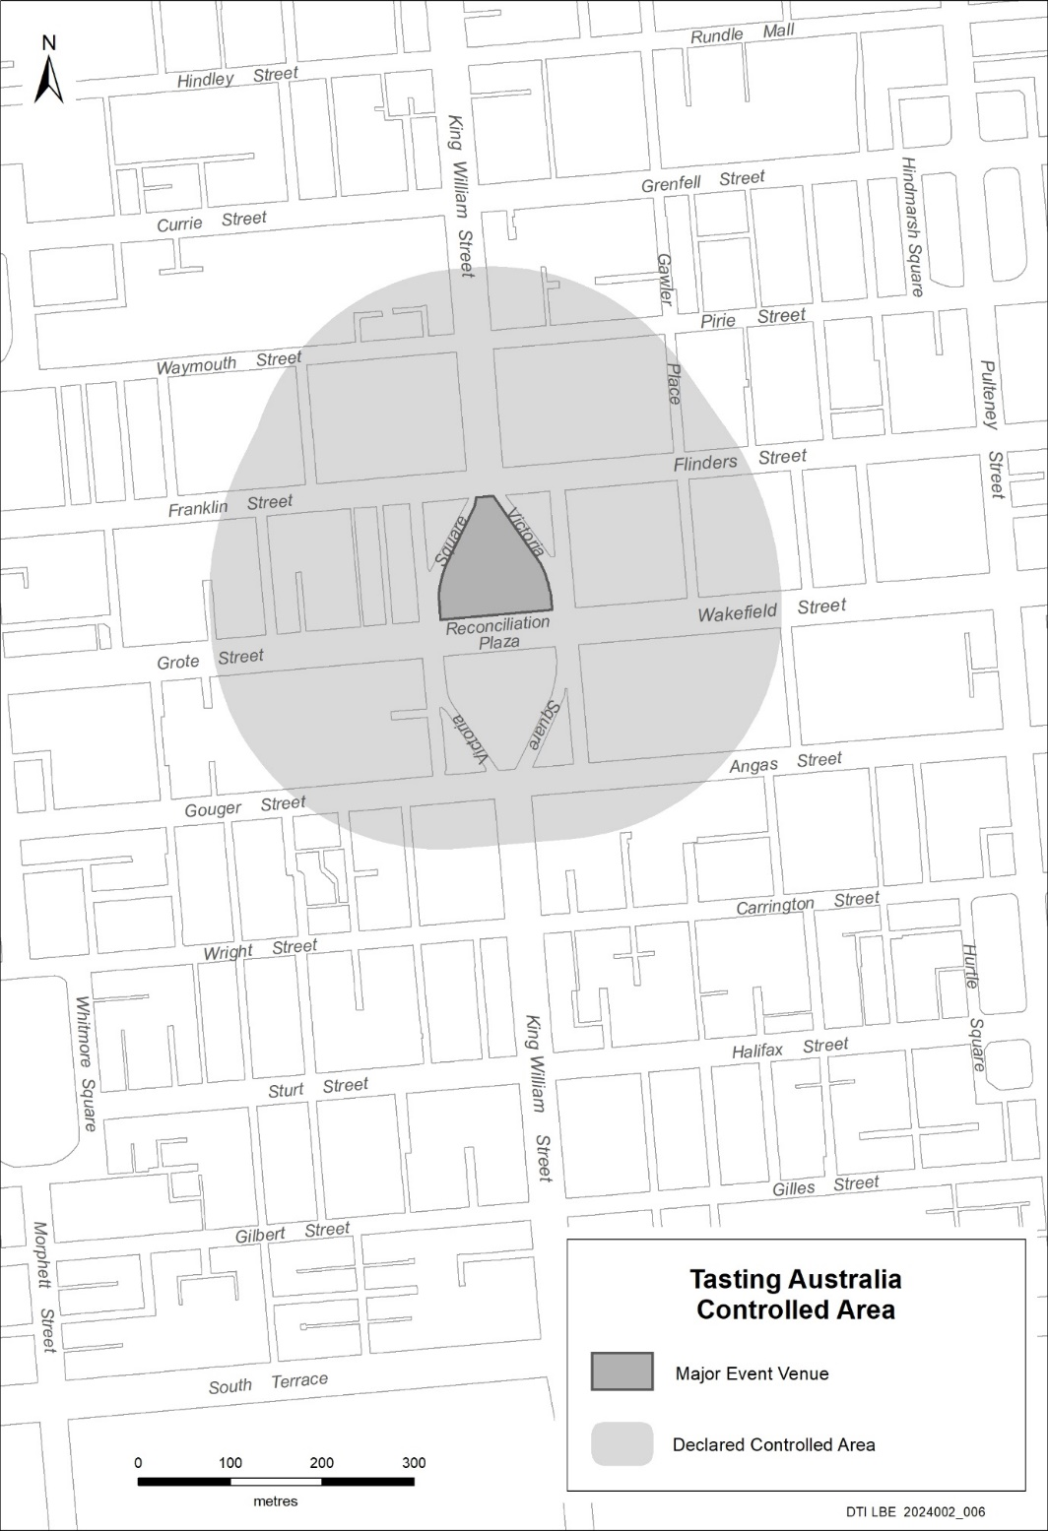

Mental Health Act 2009
Authorised Medical Practitioner
NOTICE is hereby given in accordance with Section 93(1) of the Mental Health Act 2009 that the Chief Psychiatrist has determined the following person as an Authorised Medical Practitioner:
Achal Reema
Robin Stringer
Cian Tuohy
Xinhui Lim
A determination will be automatically revoked upon the person being registered as a specialist psychiatrist with the Australian Health Practitioner Regulation Agency and as a fellow of the Royal Australian and New Zealand College of Psychiatrists.
Dated: 15 April 2024
Dr John Brayley
Chief Psychiatrist

Mental Health Act 2009
Approved Mental Health Professional
NOTICE is hereby given in accordance with Section 94(1) of the Mental Health Act 2009, that the Chief Psychiatrist has re-determined the following persons as an Authorised Mental Health Professional:
Sharon Madden
A person’s determination as an Authorised Mental Health Professional expires three years after the commencement date.
Dated: 15 April 2024
Dr J. Brayley
Chief Psychiatrist

Motor Vehicles Act 1959
South Australia
Motor Vehicles (Conditional Registration—Recognition of Motor Vehicle Clubs) Notice 2024—Triumph Riders Club Incorporated
under the Motor Vehicles Act 1959
1—Short title
This notice may be cited as the Motor Vehicles (Conditional Registration—Recognition of Motor Vehicle Clubs) Notice 2024—Triumph Riders Club Incorporated.
2—Commencement
This notice takes effect from the date it is published in the Gazette and replaces any previous recognition made by the Registrar of a motor vehicle club that is specified in Schedule 1 of this notice.
3—Interpretation
In this notice—
Act means the Motor Vehicles Act 1959;
Code of Practice means the ‘Code of Practice—Conditional Registration Scheme for Historic, Individually Constructed, Left-Hand Drive and Street Rod Vehicles’ published by the Department for Infrastructure and Transport;
Conditional Registration Scheme or Scheme means the scheme for conditional registration of historic, individually constructed, left hand drive, street rod and vehicles under Section 25 of the Act and Regulations 15 and 16 of the Motor Vehicles Regulations 2010;
Department means the Department for Infrastructure and Transport;
Federation means the Federation of Historic Motoring Clubs SA Incorporated;
MR334 form means an ‘Approval for Registration of Vehicle on the Conditional Registration Scheme (MR334)’;
Prescribed log book means a log book in a form approved by the Registrar;
Registrar means the Registrar of Motor Vehicles;
Regulations means the Motor Vehicles Regulations 2010.
4—Recognition of motor vehicles clubs
The motor vehicle club specified in Schedule 1 is, subject to the conditions set out in Clause 5, recognised for the purposes of Regulation 16 of the Regulations.
5—Conditions of recognition
A motor vehicle club specified in Schedule 1 must comply with the following conditions:
  - the club must maintain a constitution approved by the Registrar;
(b) the club must nominate and have members authorised by the Registrar (authorised persons). The club’s authorised person(s) are responsible for approving applicants and motor vehicles for registration under the Scheme. This includes confirming that Scheme applicants are financial members of a club; any other details as required by the Registrar on the MR334 form; and to inspect members’ vehicles when requested to do so by the Registrar;
(c) the club must issue a prescribed log book to club members for each of their vehicles to record vehicle use;
(d) the club must cancel a member’s prescribed log book when a member resigns, must ensure that a statutory declaration is provided when a member’s log book is lost or destroyed, must keep details of members’ prescribed log book return sheets and forward copies of the same to the Registrar or Federation annually as required;
(e) the club must create and maintain records detailing all its financial members, its authorised persons, all vehicles for which an MR334 form has been issued, all statutory declarations received and prescribed log books issued and returned to the club;
(f) the club must keep records for a period of 5 years from the date of the document and these records must include all duplicate MR334 forms, all records of motor vehicle inspections undertaken in accordance with paragraph (b), all statutory declarations provided by members for the purposes of paragraphs (d), all prescribed log books issued by reference to their serial number, the member’s name and the vehicle for which it was issued, and to make all such records available for inspection or provide copies of the records at the request of the Registrar for audit purposes;
(g) the club must ensure, as far as practicable, that all members comply with the Code of Practice;
(h) the club, as far as practicable, must report to the Registrar or the Federation details of members and motor vehicles not complying with the conditions and criteria set out in the Code of Practice for the Scheme;
(i) the club must provide to the Registrar, within 2 months of the end of the club’s financial year, an annual report detailing members from that financial year with vehicles registered under the Scheme who are no longer financial members of the club;
(j) the club must notify the Registrar, in writing, within 14 days of resolution to cease operation as a club and must provide the club records specified in paragraph (f) to the Registrar within 14 days of its dissolution;
Note—
Under Regulation 16(3)(c) of the Motor Vehicles Regulations 2010, the Registrar may, by notice in the Gazette, withdraw the recognition of a motor vehicle club if satisfied that the club has contravened or failed to comply with a condition applying to its recognition by the Registrar, or if there is other good cause to withdraw the recognition.
Schedule 1—Recognised motor vehicle clubs
Historic, individually constructed, left-hand drive and street rod vehicles motor vehicle clubs
Triumph Riders Club Incorporated
Made by the Deputy Registrar of Motor Vehicles
On 15 April 2024

National Parks and Wildlife Act 1972
Kati Thanda-Lake Eyre National Park Management Plan—Draft
I, MICHAEL JOSEPH WILLIAMS, Director of National Parks and Wildlife, hereby give notice under the provisions of Section 38 of the National Parks and Wildlife Act 1972 that a draft Management Plan has been prepared for Kati Thanda-Lake Eyre National Park and Elliot Price Conservation Park. Copies of the draft plan may be obtained from:
• Department for Environment and Water Customer Service Centre, Ground Floor, 81-95 Waymouth Street, Adelaide SA 5000
• Port Augusta National Parks and Wildlife Service Office, 9 Mackay Street, Port Augusta 5700
Or online at:
• https://yoursay.sa.gov.au/
• https://www.parks.sa.gov.au/park-management/management-plans
Any person may make representations in connection with the draft plan during the period up to and including 5pm Friday, 19 July 2024.
Written comments should be forwarded to National Parks and Protected Area Program Unit, Department for Environment and Water, GPO Box 1047, Adelaide SA 5001 or e-mailed to DEWProtectedAreaManagement@sa.gov.au.
Dated: 18 April 2024
M. J. Williams
Director of National Parks and Wildlife
Delegate of the Minister for Climate, Environment and Water

Petroleum and Geothermal Energy Act 2000
Grant of Preliminary Survey Licence—PSL 43
PURSUANT to Section 92(1) of the Petroleum and Geothermal Energy Act 2000, notice is hereby given that the undermentioned Preliminary Survey Licence has been granted under the provisions of the Petroleum and Geothermal Energy Act 2000, pursuant to delegated powers dated 27 November 2023.
No of Licence | Licensee | Locality | Area in km² | Reference
PSL 43 | Epic Energy South Australia Pty Ltd | LeFevre Peninsula | 3.17 | MER-2023/0348
Description of Area
All that part of the State of South Australia, bounded as follows:
-34.76440 138.497922
-34.76314 138.504741
-34.76469 138.510439
-34.76621 138.513428
-34.76841 138.514663
-34.77388 138.515041
-34.77680 138.514328
-34.77864 138.524799
-34.78056 138.524055
-34.78321 138.520940
-34.77875 138.497984
-34.76440 138.497922
All coordinates in GDA2020
AREA: 3.17 square kilometres approximately.
Dated: 10 April 2024
Benjamin Zammit
Executive Director
Regulation and Compliance Division
Department for Energy and Mining
Delegate of the Minister for Energy and Mining

Planning, Development and Infrastructure Act 2016
Section 76
Amendment to the Planning and Design Code
Preamble
It is necessary to amend the Planning and Design Code (the Code) in operation at 4 April 2024 (Version 2024.6) in order to make changes of form relating to the Code’s spatial layers and their relationship with land parcels. NOTE: There are no changes to the application of zone, subzone or overlay boundaries and their relationship with affected parcels or the intent of policy application as a result of this amendment.
1. PURSUANT to Section 76 of the Planning, Development and Infrastructure Act 2016 (the Act), I hereby amend the Code in order to make changes of form (without altering the effect of underlying policy), correct errors and make operational amendments as follows:
(a) Undertake minor alterations to the geometry of the spatial layers and data in the Code to maintain the current relationship between the parcel boundaries and Code data as a result of the following:
(i) New plans of division deposited in the Land Titles Office between 27 March 2024 and 9 April 2024 affecting the following spatial and data layers in the Code:
A. Zones and subzones
B. Technical and Numeric Variations
• Building Heights (Levels)
• Building Heights (Metres)
• Concept Plan
• Finished ground and floor levels
• Gradient Minimum Frontage
• Gradient Minimum Site Area
• Interface Height
• Minimum Frontage
• Minimum Site Area
• Minimum Primary Street Setback
• Minimum Side Boundary Setback
• Future Local Road Widening Setback
C. Overlays
• Affordable Housing
• Coastal Areas
• Coastal Flooding
• Defence Aviation Area
• Design
• Future Road Widening
• Hazards (Bushfire—High Risk)
• Hazards (Bushfire—Medium Risk)
• Hazards (Bushfire—General Risk)
• Hazards (Bushfire—Urban Interface)
• Hazards (Bushfire—Regional)
• Hazards (Bushfire—Outback)
• Heritage Adjacency
• Historic Area
• Local Heritage Place
• Limited Land Division
• Noise and Air Emissions
• State Heritage Place
• Stormwater Management
• Urban Tree Canopy
(b) In Part 13 of the Code—Table of Amendments, update the publication date, Code version number, amendment type and summary of amendments within the ‘Table of Planning and Design Code Amendments’ to reflect the amendments to the Code as described in this Notice.
2. Pursuant to Section 76(5)(a) of the Act, I further specify that the amendments to the Code as described in this Notice will take effect upon the date those amendments are published on the SA planning portal.
Dated: 12 April 2024
Greg Van Gaans
Director, Land and Built Environment
Department for Trade and Investment
Delegate of the Minister for Planning

Professional Standards Act 2004
The Bar Association of Queensland Professional Standards Scheme
PURSUANT to Section 14 of the Professional Standards Act 2004, I authorise the publication in the Gazette of the Bar Association of Queensland Professional Standards Scheme.
Pursuant to Section 15(1)(a) of the Professional Standards Act 2004, I specify 1 July 2024 as the date of commencement of the Bar Association of Queensland Professional Standards Scheme.
Dated: 18 April 2024
Kyam Maher
Attorney-General

Professional Standards Act 2004
The Chartered Accountants Australia and New Zealand Professional Standards Scheme
PURSUANT to Section 34(2) of the Professional Standards Act 2004, I Kyam Maher, Attorney General for the State of South Australia, hereby extend the period for which the Chartered Accountants Australia and New Zealand Professional Standards Scheme is in force in South Australia to 12 July 2025.
Dated: 18 April 2024
Kyam Maher
Attorney-General

Professional Standards Act 2004
The CPA Australia Ltd Professional Standards (Accountants) Scheme
PURSUANT to Section 34(2) of the Professional Standards Act 2004, I Kyam Maher, Attorney-General for the State of South Australia, hereby extend the period for which The CPA Australia Ltd Professional Standards (Accountants) Scheme is in force in South Australia to 20 August 2025.
Dated: 18 April 2024
Kyam Maher
Attorney-General

Professional Standards Act 2004
The Law Society of Western Australia Professional Standards Scheme
PURSUANT to Section 14 of the Professional Standards Act 2004, I authorise the publication in the Gazette of the Law Society of Western Australia Professional Standards Scheme.
Pursuant to Section 15(1)(a) of the Professional Standards Act 2004, I specify 1 July 2024 as the date of commencement of the Law Society of Western Australia Professional Standards Scheme.
Dated: 18 April 2024
Kyam Maher
Attorney-General

Roads (Opening and Closing) Act 1991
Section 24
NOTICE OF CONFIRMATION OF
ROAD PROCESS ORDER
Road Closure—Rann Place, Port Adelaide
BY Road Process Order made on 22 August 2022, the City of Port Adelaide Enfield ordered that:
1. Whole of Rann Place, Port Adelaide, situated between Allotment 21 in Filed Plan 3514 and Allotment 23 in Filed Plan 3514, Hundred of Port Adelaide, more particularly delineated and lettered ‘A’ in Preliminary Plan 22/0001 be closed.
2. Issue a Certificate of Title to the City of Port Adelaide Enfield for the whole of the land subject to closure in accordance with the Application for Document of Title dated 22 August 2022.
On 8 April 2024 that order was confirmed by the Minister for Planning conditionally upon the deposit by the Registrar-General of Deposited Plan 130513 being the authority for the new boundaries.
Pursuant to Section 24(5) of the Roads (Opening and Closing) Act 1991, NOTICE of the Order referred to above and its confirmation is hereby given.
Dated: 18 April 2024
B. J. Slape
Surveyor-General
2022/02329/01

State Lotteries Act 1966 (SA)
Lotteries (Saturday X Lotto) Rules
1. Preliminary
1.1 These Rules may be cited as the Lotteries (Saturday X Lotto) Amendment Rules, 2024 (No. 1).
1.2 The Lotteries (Saturday X Lotto) Rules made under the State Lotteries Act, 1966 and published in the Government Gazette on 18 June 2020 are herein after referred to as the “Principal Rules”.
1.3 The Principal Rules are hereby amended effective from 6 May 2024 and these Rules will take effect immediately thereafter, except as provided in these Rules.
2. Amendment of Rules
2.1 The Principal Rules are deleted and the Rules as annexed are to be substituted therefor.
The Common Seal of the Lotteries Commission of South Australia was affixed pursuant to a resolution of the Commissioner,
Dated: 25 March 2024
Phuong Chau
Commissioner
Approved,
Hon Stephen Mullighan MP
Treasurer

State Lotteries Act 1966 (SA)
LOTTERIES (SUPER 66) RULES
1. Preliminary
1.1 These Rules may be cited as the Lotteries (Super 66) Amendment Rules, 2024 (No. 1 ).
1.2 The Lotteries (Super 66) Rules made under the State Lotteries Act, 1966 and published in the Government Gazette on 27 October 2016 are herein after referred to as the “Principal Rules”.
1.3 The Principal Rules are hereby amended effective from 19 May 2024 and these Rules will take effect immediately thereafter, except as provided in these Rules.
2. Amendment of Rules
2.1 The Principal Rules are deleted and the Rules as annexed are to be substituted therefor.
The Common Seal of the Lotteries Commission of South Australia was affixed pursuant to a resolution of the Commissioner,
Dated: 25 March 2024
Phuong Chau
Commissioner
Approved,
Hon Stephen Mullighan MP
Treasurer

State Lotteries Act 1966 (SA)
Lotteries (Weekday Windfall) Rules
Replacing
Lotteries (Monday and Wednesday X Lotto) Rules
1. Preliminary
1.1 These Rules may be cited as the Lotteries (Monday and Wednesday X Lotto) Amendment Rules, 2024 (No. 1).
1.2 The Lotteries (Monday and Wednesday X Lotto) Rules made under the State Lotteries Act, 1966 and published in the Government Gazette on 27 October 2016 shall be withdrawn from 19 May 2024.
1.3 The amended rules are hereby referred to as the Lotteries (Weekday Windfall) Rules or “Principal Rules” will take effect from 6 May 2024, except as provided in the Rules.
2. Amendment of Rules
2.1 Following the transition period (6 May 2024 to 19 May 2024), the Principal Rules as annexed will exclusively replace the existing Lotteries (Monday and Wednesday X Lotto) Rules from 20 May 2024 onwards.
The Common Seal of the Lotteries Commission of South Australia was affixed pursuant to a resolution of the Commissioner,
Dated: 25 March 2024
Phuong Chau
Commissioner
Approved,
Hon Stephen Mullighan MP
Treasurer

Local Government Instruments

City of Adelaide
Roads (Opening and Closing) Act 1991
Road Closing—Public Road (off Toms Court), Adelaide
NOTICE is hereby given, pursuant to Section 10 of the Roads (Opening and Closing) Act 1991 that the City of Adelaide proposes to make a Road Process Order to close and merge with allotment 654 in F182306 the northern portion of the unnamed public road off Toms Court, more particularly delineated and lettered ‘A’ on Preliminary Plan 24/0011.
The Preliminary Plan and statement of persons affected are available for public inspection at the offices of the City of Adelaide, 25 Pirie Street, Adelaide and the Adelaide Office of the Surveyor-General located at Level 10, 83 Pirie Street Adelaide, during normal office hours. The Preliminary Plan can also be viewed at www.sa.gov.au/roadsactproposals.
Any application for easement or objection must set out the full name, address and details of the submission and must be fully supported by reasons. The application for easement or objection must be made in writing to the City of Adelaide, GPO Box 2252, Adelaide SA 5001, within 28 days of this notice and a copy must be forwarded to the Surveyor-General at GPO Box 1815, Adelaide SA 5001. Where a submission is made, the applicant must be prepared to support their submission in person upon council giving notification of a meeting at which the matter will be considered.
Dated: 18 April 2024
Michael Sedgman
A/Chief Executive Officer

City of Mitcham
Local Government Act 1999
Adoption of Amended Community Land Management Plan
NOTICE is hereby given pursuant to Section 198(4) of the Local Government Act 1999, that the City of Mitcham at its Full Council Meeting on 9 April 2024 resolved to adopt the proposal for an amended Community Land Management Plan for Drainage Reserves.
The adopted Community Land Management Plan can be viewed at www.mitchamcouncil.sa.gov.au.
Dated: 18 April 2024
Matthew Pears
Chief Executive Officer

City of Mitcham
Local Government Act 1999
Adoption of a Community Land Management Plan
NOTICE is hereby given pursuant to Section 197(3) of the Local Government Act 1999, that the City of Mitcham at its Full Council Meeting on 9 April 2024 resolved to adopt a Community Land Management Plan for the Pasadena Community Centre.
The adopted Community Land Management Plan can be viewed at www.mitchamcouncil.sa.gov.au.
Dated: 18 April 2024
Matthew Pears
Chief Executive Officer

Lower Eyre Council
Amendment to Community Land Management Plan
NOTICE is hereby given that the Lower Eyre Council at its meeting held on 21 February 2024 resolved pursuant to Section 198 of the Local Government Act 1999 to amend the Community Land Management Plan:
• To allow for the construction of an ephemeral wetland on the Council Reserve situated at 35-43 Penny Lane, Coffin Bay and identified as Plan D19159 Parcel A51 Title ID CT 4284/641.
A copy of the amended Community Land Management Plan can be obtained by written request to mail@dclep.sa.gov.au.
Dated: 11 April 2024
D. L. Lanzilli
Chief Executive Officer

Public Notices

National Electricity Law
Notice of Initiation for Fast-Track Rule Change Request
The Australian Energy Market Commission (AEMC) gives notice under the National Electricity Law as follows:
Under s 95, The Honourable Chris Bowen, Minister for Climate Change and Energy has requested the Managing ISP project uncertainty through targeted ex post reviews (Ref. ERC0381) proposal. The proposal seeks to better enable the Australian Energy Regulator to undertake separate, targeted ex post reviews on capital expenditure for integrated system plan (ISP) projects and non-ISP capital expenditure. Under s 96A, the AEMC has decided to fast track this proposal.
Documents referred to above are available on the AEMC’s website and are available for inspection at the AEMC’s office.
Australian Energy Market Commission
Level 15, 60 Castlereagh St
Sydney NSW 2000
Telephone: (02) 8296 7800
www.aemc.gov.au
18 April 2024

Trustee Act 1936
Public Trustee
Estates of Deceased Persons
In the matter of the estates of the undermentioned deceased persons:
BUCHANAN Cheryl Eugenie late of 83 Muddy Lane North Moonta of no occupation who died 8 May 2023
DRECKOW Helen Rae late of Section 101 Hundred of Yadnarie Cleve of no occupation who died 2 December 2023
ELESICS Heather late of 18 Trafford Street Angle Park Of no occupation who died 15 October 2022
FALLON Mary Patricia late of 580 Brighton Road South Brighton of no occupation who died 20 December 2023
GALANT Kazimiera Krystyna late of 172 Trimmer Parade Seaton of no occupation who died 9 August 2023
GILLARD Jeanette Mavis late of 470 Churchill Road Kilburn Retired Sales Representative who died 20 October 2023
LAKE Robert William late of 11 Columba Street Morphett Vale Retired Maintenance Fitter who died 14 October 2023
MATEJ Marianne Anneliese late of 6 Pridham Boulevard Aldinga Beach of no occupation who died 13 January 2021
SKOMRLJ Toma late of 21 Farncomb Road Fulham of no occupation who died 28 September 2023
THOMSON William John Alick late of 21 Hart Street Semaphore Retired Teacher who died 21 September 2023
TWITCHEN Ronald William late of 200 Adams Road Craigmore Retired storeman who died 4 January 2024
VAISANEN Ulla late of 79 Gordon Street Albert Park of no occupation who died 5 January 2023
WARD Julien Richard late of 13 Bakers Road Marleston Retired Office Clerk who died 29 March 2023
Notice is hereby given pursuant to the Trustee Act 1936, the Inheritance (Family Provision) Act 1972 and the Family Relationships Act 1975 that all creditors, beneficiaries, and other persons having claims against the said estates are required to send, in writing, to the office of Public Trustee at GPO Box 1338, Adelaide SA 5001, full particulars and proof of such claims, on or before the 17 May 2024 otherwise they will be excluded from the distribution of the said estate; and notice is also hereby given that all persons indebted to the said estates are required to pay the amount of their debts to the Public Trustee or proceedings will be taken for the recovery thereof; and all persons having any property belonging to the said estates are forthwith to deliver same to the Public Trustee.
Dated: 18 April 2024
N. S. Rantanen
Public Trustee

University of Adelaide Act 1971
Authority of Council for Authorisations under the By-laws of the University of Adelaide
1. Background
The University is responsible for the management, preservation and protection of its campuses at North Terrace, Roseworthy and Waite. The campuses include the land and grounds on which the campuses are built.
Section 23 of the University of Adelaide Act 1971 (SA) (the Act) provides the power to Council to make by-laws for a range of purposes.
Under By-law 1.1 an “authorised person” means “a person or class of persons authorised in writing by the Council for the purposes of these by-laws or a part of these by-laws”.
The Council has previously issued authorisations under the By-laws of the University of Adelaide which it now seeks to update and replace.
2. Authority
With the approval of Council:
(i) All previous authorisations made under the By-laws of the University of Adelaide are revoked.
(ii) The following authorisations are made and replace all previous authorisations made under the By-laws of the University of Adelaide:
1. Campus Managers and Security Officers shall be authorised persons for the purposes of By-laws 4.8, 4.11, 7.2, 7.3, 8.2, 10.2, 11.2, 11.3, 13.1 and 13.2.
2. Parking Officers shall be authorised persons for the purposes of By-laws 4.8 and 4.11.

3. The following persons shall be authorised persons for the purposes of By-law 4.11:
(i) Chief Operating Officer
(ii) Executive Director, Infrastructure
(iii) Facilities Manager, Roseworthy
(iv) Facilities Manager, Waite
(v) Facilities Co-ordinator, Roseworthy
(vi) Site Supervisor, Waite
(vii) Manager, Security Services
(viii) Security Supervisor
4. The following persons shall be authorised persons for the purpose of expedited enforcement of the University of Adelaide’s By-laws under the Expiation of Offences Act 1996 (SA) and the Fines Enforcement and Debt Recovery Act 2017 (SA) and specifically authorised to exercise the powers and functions under Sections 5(1), 6(3)(b)(ii), 8A(2), 8A(3), 11(1), 11A(1), 12, 16(1), 16(5), and 18 of the Expiation of Offences Act 1996 (SA), and Section 22(1) of the Fines Enforcement and Debt Recovery Act 2017 (SA) for alleged offences against the University of Adelaide’s By-laws:
(i) Chief Operating Officer
(ii) Executive Director, Infrastructure
(iii) Campus Manager
(iv) Facilities Manager, Roseworthy
(v) Facilities Manager, Waite
(vi) Facilities Co-ordinator, Roseworthy
(vii) Site Supervisor, Waite
(viii) Manager, Security Services
(ix) Security Supervisor
(x) Security Officers
(xi) Parking Officers
5. A general permission is granted under By-law 10.1 to the Chancellor, members of Council, members of Council Committees and staff to bring, keep and consume alcoholic liquor upon University of Adelaide grounds, provided it is in accord with University of Adelaide policy and Workplace Health and Safety obligations and provided that the by-laws are otherwise observed.
6. A general permission is granted under By-law 10.1 to tenants of the University of Adelaide to bring, keep and consume alcoholic liquor upon the grounds which are the subject of the lease or similar agreement, subject to the terms of any such lease and provided that the by-laws are otherwise observed.
7. Pursuant to By-law 4.7, a 30-day time limit is established for bike parking at all areas designated for bicycle parking on University of Adelaide grounds in accordance with the Traffic Management Plan.
8. A general permission is granted under By-law 4.4 to the Chancellor, members of Council, members of Council Committees, staff, students and visitors to the University of Adelaide to park or leave a vehicle in a designated space on University of Adelaide grounds, provided it is in obeyance with parking signage, rules and conditions (including control devices) and provided that the by-laws are otherwise observed.
Definitions
For the purpose of this authorisation:
Campus Managers shall be the staff members holding the following positions:
For the North Terrace Campus, the position of Director, Capital Projects & Facilities Management
For the Roseworthy and Waite Campuses, the position of Campus Estate Manager, Roseworthy & Waite
or successor positions responsible for the same or similar functions as the positions identified above.
Security Officers shall be staff members, contractors, or employees or sub-contractors of contractors, of the University of Adelaide, who are engaged in roles as Security Officers.
Parking Officers shall be employees or sub-contractors of such contractor as is contracted by the University of Adelaide to manage parking on its campus or campuses.
3. Revocation
Any Authorities under the By-laws of the University of Adelaide in force immediately before the commencement of this Authority are hereby revoked.
4. Commencement
This Authority comes into full force and effect on the date it is signed by the Chancellor.
Approved by Council.
Dated: 8 April 2024
Signed by the Chancellor.
Dated: 8 April 2024
Andrew Lee
Director, Governance Services
Office of the Chancellor and Council Secretariat

Notice Submission

The South Australian Government Gazette is published each Thursday afternoon.
Notices must be emailed by 4 p.m. Tuesday, the week of publication.
Submissions are formatted per the gazette style and a proof will be supplied prior to publication, along with a quote if applicable. Please allow one day for processing notices.
Alterations to the proof must be returned by 4 p.m. Wednesday.

Gazette notices must be submitted as Word files, in the following format:
• Title—the governing legislation
• Subtitle—a summary of the notice content
• Body—structured text, which can include numbered lists, tables, and images
• Date—day, month, and year of authorisation
• Signature block—name, role, and department/organisation authorising the notice

Please provide the following information in your email:
• Date of intended publication
• Contact details of the person responsible for the notice content
• Name and organisation to be charged for the publication—Local Council and Public notices only
• Purchase order, if required—Local Council and Public notices only

Email: governmentgazettesa@sa.gov.au
Phone: (08) 7109 7760
Website: www.governmentgazette.sa.gov.au

All instruments appearing in this gazette are to be considered official, and obeyed as such

Printed and published weekly by authority of T. Foresto, Government Printer, South Australia
$8.55 per issue (plus postage), $430.00 per annual subscription—GST inclusive
Online publications: www.governmentgazette.sa.gov.au

