No. 29 p. 745
THE SOUTH AUSTRALIAN
GOVERNMENT GAZETTE
Published by Authority

Adelaide, Wednesday, 24 April 2024

Contents

Governor’s Instruments
Appointments, Resignations and General Matters 746
State Government Instruments
Education and Children’s Services Regulations 2020 747
Electoral Act 1985 748
Environment Protection Act 1993 749
Housing Improvement Act 2016 756
Local Government (Elections) Act 1999 756
Local Government Instruments
City of Adelaide 758
Corporation of the Town of Walkerville 758
Barunga West Council 758
District Council of Kimba 761
Public Notices
Trustee Act 1936 774

Governor’s Instruments

Appointments, Resignations and General Matters
Department of the Premier and Cabinet
Adelaide, 24 April 2024
His Excellency the Governor’s Deputy in Executive Council has been pleased to appoint the undermentioned to the Superannuation Funds Management Corporation of South Australia Board, pursuant to the provisions of the Superannuation Funds Management Corporation of South Australia Act 1995:
Director: from 24 April 2024 until 23 April 2025
Paul Alexander Kenneth Laband
By command,
Katrine Anne Hildyard, MP
For Premier
T&F24/026CS

Department of the Premier and Cabinet
Adelaide, 24 April 2024
His Excellency the Governor’s Deputy in Executive Council has determined that eligible members of the Superannuation Funds Management Corporation of South Australia Board and its subcommittees, being those members who are eligible for remuneration according to the terms of Premier and Cabinet Circular PC016, are entitled to remuneration, allowances and expenses, effective from 24 April 2024 - pursuant to the Superannuation Funds Management Corporation of South Australia Act 1995.
By command,
Katrine Anne Hildyard, MP
For Premier
T&F24/026CS

State Government Instruments

Education and Children’s Services Regulations 2020
Notice of Policy by the Minister for Education, Training and Skills
PURSUANT to Regulation 12(1) of the Education and Children’s Services Regulations 2020, I, the Minister for Education, Training and Skills publish the following Capacity Management Plan in relation to the enrolment of a child of compulsory school age at Morialta Secondary College:
Capacity Management Plan
Morialta Secondary College
This Capacity Management Plan sets out the conditions for enrolment at Morialta Secondary College (“the school”) effective for the enrolment of a child to attend in 2025.
Morialta Secondary College zone
A school zone is a defined area from which the school accepts its core intake of students. Morialta Secondary College operates a school zone within the area bounded by:
Glynburn Road, Montacute Road, Black Hill Track, Black Hill Road, Church Road, Montacute Road, Hill Road, Montacute Road, Marble Hill Road, Moores Road, Colonial Track, Norton Summit Road, Kintyre Road, Glen Stuart Road, Koongarra Avenue, St Bernard’s Road and Shakespeare Avenue.
An online map of the Morialta Secondary College zone and a search tool to indicate if an applicant’s home address is within the school zone is available at: https://www.education.sa.gov.au/findaschool.
Student Enrolment Numbers
As a new school, Morialta Secondary College will have a progressive enrolment process. This process will introduce a new Year 7 cohort at the start of each school year, beginning in 2023 until the school has all year levels in 2028. In 2025, Morialta Secondary College will have offerings of Year 7-Year 9.
Year 7
The student enrolment ceiling for Year 7 is limited to 200, unless there are more applications that have met the enrolment criteria below.
Inclusive Learning Community
The Inclusive Learning Community at Morialta Secondary College includes special options classes and a disability unit, providing facilities for students requiring adjustments to engage and learn alongside their similar aged peers.
Disability Unit
Placement in the disability unit is determined through the department’s state-wide Special Education Options panel process. The placement of students in the disability unit must align with the school’s progressive enrolment process, which includes year 7-year 9 enrolments in 2025.
In 2025, the school can cater for a maximum of 4 students in the disability unit.
Special Options Classes
Placement in the special options class is determined through the department’s state-wide Special Education Options panel process. The placement of students in the special options class s must align with the school’s progressive enrolment process, which includes year 7-year 9 enrolments in 2025.
In 2025, the school’s special options class can cater for a maximum of 12 students.
International Education Program
No International Education Program places will be offered at the school.
Enrolment Criteria—By Year Level
YEAR LEVEL: 7
Applications for enrolment from parents of prospective Year 7 students require that the student must be enrolled in a government or
non-government school in South Australia at the time the parents apply for enrolment through the statewide registration of interest process (coordinated by the Department for Education).
The applicant must meet one of the following requirements to be eligible for a Year 7 allocation through the statewide registration of interest process for the coming school year:
• the child is living in the Morialta Secondary College zone
• the child identifies as Aboriginal and/or Torres Strait Islander through the Enter for Success strategy
• the child has been granted enrolment due to special or extenuating circumstances, including but not limited to a child in care where there is a custody or guardianship order made under the Children and Young People (Safety) Act 2017.
Late applications for Year 7 from students living in the school zone
Families who move into the school zone, or who are already living in the school zone but lodge their application for enrolment after the department’s registration of interest process is completed (end of term 2), will have their applications considered if or when vacancies exist.
In these cases, applications will be considered based on the distance of the child’s residence from the school and any other personal needs, such as curriculum, transportation/location convenience, and social/family links to the school.
The school will notify parents by the beginning of week 3, term 4 if a vacancy is available for their child to attend the following school year.
If no vacancies exist, the school will support the family to enrol at a neighbouring school and upon request, the applicant will be added to the enrolment register.
Applications for Year 7 from students living outside the secondary campus zone with siblings currently at the secondary campus
There is no automatic entry to the school for Year 7 students who live outside the school’s zone and have siblings who currently attend the school, however they will be considered for enrolment if places are available.
Enter for Success Year 7 students
Through nominating Morialta Secondary College via the Enter for Success strategy, a child who identifies as Aboriginal and/or Torres Strait Islander will be offered a Year 7 place at the school for the following year. Families enrolling through Enter for Success can do so until the end of term 4 in the year prior to starting Year 7.

YEAR LEVELS: 8 and 9
Applications for year 8 and 9 from students living inside the secondary campus school zone
Applications for enrolment from parents of prospective students living in the secondary campus school zone will be considered if or when vacancies exist, with priority consideration afforded to those applicants already on the enrolment register.
In these cases, applications will be considered based on siblings at the secondary campus, the distance of the child’s residence from the secondary campus and any other personal needs, such as curriculum, transportation/location convenience, and social/family links.
The school will notify parents by the beginning of week 3, term 4 if a vacancy is available for their child to attend the following school year.
If no vacancies exist the applicant will be encouraged to remain at their current high school, or the school will support the family to enrol at a neighbouring school and upon request, the applicant will be placed on the enrolment register.
YEAR LEVEL: 10 to 12
Applications for enrolment in year levels 10 to 12 will not be accepted for 2025.
The applicant will be encouraged to remain at their current school or the school will support the family to enrol at a neighbouring school.
OUT OF ZONE APPLICATIONS
There is no automatic entry to the school for any year level for students who live outside of the school’s zone and have siblings who attend the school, however they will be considered for enrolment if places are available.
Applications from parents of prospective students, who live outside the school zone will only be given consideration for enrolment if the school is under its year level student enrolment numbers.
Enrolment Criteria—General
Special Circumstances
Enrolment applications for consideration based on special or extenuating circumstances, including but not limited to a child in care where there is custody or guardianship orders made under the Children and Young People (Safety) Act 2017, may be granted by the Principal in consultation with the Education Director. These applications will be assessed on a case-by-case basis.
Enrolment Process
Enrolment Register
Parents whose child’s name has been placed on the enrolment register will be contacted by the school by the beginning of week 3, term 4 if a vacancy is available for the following school year.
The enrolment register will be reviewed and updated annually by the school.
The position that a child’s name appears on the register is confidential and will only be disclosed as required by law.
Monitoring and enforcement
It is the responsibility of the parents applying for enrolment to be able to verify to the satisfaction of the school that the information provided is true and factual.
If a child was enrolled at the school on the basis of false or misleading information (including residential address) the Chief Executive may direct that the child be instead enrolled at another Government school pursuant to Section 63(1) of the Education and Children’s Services Act 2019.
The Principal is responsible for the implementation of this Capacity Management Plan.
This Capacity Management Plan will be reviewed annually.
Dated: 18 April 2024
Hon Blair Boyer MP
Minister for Education, Training and Skills

Education and Children’s Services Regulations 2020
Notice of Revocation of Policy by the Minister for Education, Training and Skills
PURSUANT to Regulation 12(3) of the Education and Children’s Services Regulations 2020, I, the Minister for Education, Training and Skills revoke the Morialta Secondary College Capacity Management Plan, published in the Gazette on 31 August 2023.
Dated: 18 April 2024
Blair Boyer
Minister for Education, Training and Skills

Electoral Act 1985
Results of the By-election for the House of Assembly District of Dunstan
THE Writ for the election of a member of the House of Assembly Districts of Dunstan was issued on 16 February 2024. Polling took place on Saturday, 23 March 2024, and the Writ was returned on Friday, 5 April 2024.
The results of the by-election are as follows:
District: Dunstan
Elected Candidate: O’HANLON, Cressida
Affiliation: Australian Labor Party
Pursuant to Section 96(11) of the Electoral Act 1985, the following are the votes attributed to the two unexcluded candidates in the by-election for the District of Dunstan.
District of Dunstan: Final Votes After Distribution of Preferences of Excluded Candidates
Candidate | Number | Percentage | Affiliation
O’HANLON, Cressida (elected) | 10,914 | 50.8% | Australian Labor Party
FINIZIO, Anna | 10,554 | 49.2% | Liberal Party
Dated: 25 April 2024
M. Sherry
Electoral Commissioner

Environment Protection Act 1993
Section 68
Approval of Category B Containers
I, NICHOLAS STEWART, Team Leader, Container Deposit Legislation and Delegate of the Environment Protection Authority (the Authority), pursuant to Section 68 of the Environment Protection Act 1993 (SA) (the Act) hereby:
Approve as Category B Containers, subject to the conditions in subclauses 1, 2, 3 and 4 below, each of the classes of containers identified by reference to the following matters described in the first 4 columns of Schedule 1 of this Notice which are sold in South Australia:
(a) the product which each class of containers shall contain;
(b) the size of the containers;
(c) the type of containers;
(d) the name of the holders of these approvals.
1. That containers of the class to which the approval relates must bear the refund marking specified by the Authority for containers of that class. The Authority specifies the following refund markings for Category B containers:
(1) “10c refund at collection depots when sold in SA”; or
(2) “10c refund at SA/NT collection depots in State/Territory of purchase”; or
(3) “10c refund at collection depots/points in participating state/territory of purchase”.
2. The holder of the approval must have in place an effective and appropriate waste management arrangement in relation to containers of that class. For the purpose of this approval notice the company named in column 5 of Schedule 1 of this Notice is the nominated super collector.
3. In the case of an approval in relation to category B containers that the waste management arrangement must require the holder of the approval to provide specified super collectors with a declaration in the form determined by the Authority in relation to each sale of such containers by the holder of the approval as soon as practicable after the sale;
4. The holder of these approvals must ensure that if a sticker bearing the refund marking has been approved, and is applied to the container, then the sticker must not be placed on any portion of the opening mechanism or in any other place that would require complete or partial removal of the sticker before the contents may be consumed.
Dated: 24 April 2024
Nicholas Stewart
Team Leader, Container Deposit Legislation
Delegate of the Environment Protection Authority

Schedule 1
Column 1 | Column 2 | Column 3 | Column 4 | Column 5
Product Name | Container  Size | Container  Type | Approval Holder | Collection  Arrangements
Schweppes Classic Bitter Lemon Premium Mixers | 1,100ml | PET | Asahi Beverages Pty Ltd | Statewide Recycling
Schweppes Gelato Messina Passionfruit Lemonade Flavour | 1,100ml | PET | Asahi Beverages Pty Ltd | Statewide Recycling
Schweppes Gelato Messina Passionfruit Lemonade Flavour | 600ml | PET | Asahi Beverages Pty Ltd | Statewide Recycling
Schweppes Gelato Messina Peach & Mango Flavour | 1,100ml | PET | Asahi Beverages Pty Ltd | Statewide Recycling
Schweppes Gelato Messina Pineapple & Lime Flavour | 1,100ml | PET | Asahi Beverages Pty Ltd | Statewide Recycling
Solo Original Lemon | 275ml | Aluminium | Asahi Beverages Pty Ltd | Statewide Recycling
Sunkist Orange | 275ml | Aluminium | Asahi Beverages Pty Ltd | Statewide Recycling
BigM Limited Edition Pine Lime Flavour | 600ml | LPB—  Gable Top | BDD Australia Pty Ltd | Marine Stores Ltd
BigM Limited Edition Salted Caramel Popcorn Flavoured Milk | 500ml | PET | BDD Australia Pty Ltd | Marine Stores Ltd
Dairy Farmers Classic Pink Marshmallow Flavoured Milk | 500ml | PET | BDD Australia Pty Ltd | Marine Stores Ltd
Dairy Farmers Classic Salted Caramel Popcorn Flavoured Milk | 500ml | PET | BDD Australia Pty Ltd | Marine Stores Ltd
Dare Intense Espresso Robusta & Arabica Coffee | 500ml | PET | BDD Australia Pty Ltd | Marine Stores Ltd
Dare Intense Espresso Robusta & Arabica Coffee | 300ml | PET | BDD Australia Pty Ltd | Marine Stores Ltd
Dare Oat Milk Dairy Free Double Espresso Robusta & Arabica Coffee | 400ml | PET | BDD Australia Pty Ltd | Marine Stores Ltd
Dare Oat Milk Dairy Free Mocha Robusta & Arabica Coffee | 400ml | PET | BDD Australia Pty Ltd | Marine Stores Ltd
Beechworth Honey Honey + Ginger | 750ml | Glass | Beechworth Honey Pty Ltd | Statewide Recycling
Beechworth Honey Honey + Lemon | 250ml | Glass | Beechworth Honey Pty Ltd | Statewide Recycling
Beechworth Honey Honey + Lemon | 750ml | Glass | Beechworth Honey Pty Ltd | Statewide Recycling
Beechworth Honey Honey Nectar | 750ml | Glass | Beechworth Honey Pty Ltd | Statewide Recycling
Beechworth Honey Honey Nectar | 250ml | Glass | Beechworth Honey Pty Ltd | Statewide Recycling
Beechworth Honey Honey+ Ginger | 250ml | Glass | Beechworth Honey Pty Ltd | Statewide Recycling
Beer No Evil The Delirium Trigger Hazy IIPA | 375ml | Aluminium | Beernoevil Pty Ltd | Marine Stores Ltd
Beer No Evil Tiny Fish Brew Co A Tiny Bit  Evil IIPA | 375ml | Aluminium | Beernoevil Pty Ltd | Marine Stores Ltd
Beer No Evil x Six Twelve Brewing Head Crusher Triple WC IIPA | 375ml | Aluminium | Beernoevil Pty Ltd | Marine Stores Ltd
Billson’s Beechworth Bad Apple Double Vodka | 250ml | Aluminium | Billson’s Beverages Pty Ltd | Statewide Recycling
Billson’s Beechworth Galaxy Wet Hop IPA | 355ml | Aluminium | Billson’s Beverages Pty Ltd | Statewide Recycling
Billson’s Beechworth Imperial Stout | 355ml | Aluminium | Billson’s Beverages Pty Ltd | Statewide Recycling
Billson’s Beechworth Wildberry Double Vodka | 250ml | Aluminium | Billson’s Beverages Pty Ltd | Statewide Recycling
Gluttony Still Water | 450ml | Aluminium | Bluesky Beverages Pty Ltd | Statewide Recycling
Savvy Brain Boost+ Lemon Lime Zero Sugar | 330ml | Aluminium | Bright Idea Nutrition Pty Ltd | Marine Stores Ltd
Savvy Brain Boost+ Mixed Berry Zero Sugar | 330ml | Aluminium | Bright Idea Nutrition Pty Ltd | Marine Stores Ltd
Savvy Brain Boost+ Passionfruit Zero Sugar | 330ml | Aluminium | Bright Idea Nutrition Pty Ltd | Marine Stores Ltd
Campari Soda | 98ml | Glass | Campari Australia Pty Ltd | Statewide Recycling
Espolon Sparkling Margarita Tequila Cocktail | 330ml | Aluminium | Campari Australia Pty Ltd | Statewide Recycling
Espolon Sparkling Paloma Tequila Cocktail | 330ml | Aluminium | Campari Australia Pty Ltd | Statewide Recycling
Coca Cola K Wave Zero Sugar Cola | 250ml | Aluminium | Coca-Cola Europacific Partners Australia | Statewide Recycling
Fanta Zero Sugar Raspberry | 300ml | PET | Coca-Cola Europacific Partners Australia | Statewide Recycling
Kirks Lemonade | 330ml | Glass | Coca-Cola Europacific Partners Australia | Statewide Recycling
Kirks Orange | 375ml | Aluminium | Coca-Cola Europacific Partners Australia | Statewide Recycling
Kirks Pasito Passionfruit Flavour | 330ml | Glass | Coca-Cola Europacific Partners Australia | Statewide Recycling
Monster Energy Taurine + Zero Sugar + Guarana | 500ml | Aluminium | Coca-Cola Europacific Partners Australia | Statewide Recycling
Monster Energy Taurine + Zero Sugar + Guarana Ultra Peachy Keen | 500ml | Aluminium | Coca-Cola Europacific Partners Australia | Statewide Recycling
Powerade Grape Zero Sugar ION4 | 600ml | PET | Coca-Cola Europacific Partners Australia | Statewide Recycling
Pump Watermelon Hit | 750ml | PET | Coca-Cola Europacific Partners Australia | Statewide Recycling
Alani Energy Drink Dream Float Flavour | 355ml | Aluminium | Congo Brands Australia Pty Ltd | Marine Stores Ltd
Prime Hydration Strawberry Banana Flavour | 500ml | PET | Congo Brands Australia Pty Ltd | Marine Stores Ltd
Kirkland Signature Coconut Water | 414ml | PET | Costco Wholesale Australia Pty Ltd | Statewide Recycling
Nutrigen Daily Probiotic Lychee | 125ml | HDPE | Costco Wholesale Australia Pty Ltd | Statewide Recycling
Nutrigen Daily Probiotic Red Dragon Fruit | 125ml | HDPE | Costco Wholesale Australia Pty Ltd | Statewide Recycling
One Soul Smoothie Greenie Apple Peach  Mango Kiwi | 250ml | Glass | Costco Wholesale Australia Pty Ltd | Statewide Recycling
The Man Shake Fuel Chocolate | 375ml | PET | Cranky Health Pty Ltd | Statewide Recycling
The Man Shake Fuel Iced Coffee | 375ml | PET | Cranky Health Pty Ltd | Statewide Recycling
Desperados Original Beer | 330ml | Glass | DBG Australia Pty Ltd t/as Drinkworks | Marine Stores Ltd
Tiger Lager Beer | 640ml | Glass | DBG Australia Pty Ltd t/as Drinkworks | Marine Stores Ltd
Tiger Soju Infused Lager Gutsy Grape | 320ml | Aluminium | DBG Australia Pty Ltd t/as Drinkworks | Marine Stores Ltd
Gordons Premium Pink Gin & Soda Double 6% | 375ml | Aluminium | Diageo Australia Ltd | Statewide Recycling
Smirnoff Hard Soda Vodka Black Raspberry 6% | 330ml | Aluminium | Diageo Australia Ltd | Statewide Recycling
Smirnoff Ice Double Black Raspberry Crush 6.5% | 375ml | Aluminium | Diageo Australia Ltd | Statewide Recycling
Smirnoff Soda Vodka Strawberry & Kiwi 3.5% | 330ml | Aluminium | Diageo Australia Ltd | Statewide Recycling
OxyShred Energy Juicy Watermelon Zero Sugar | 355ml | Aluminium | EHP Holdings Pty Ltd | Statewide Recycling
OxyShred Ultra Energy ECTO Freeze No Sugar | 355ml | Aluminium | EHP Holdings Pty Ltd | Statewide Recycling
OxyShred Ultra Energy Frosty Big Apple No Sugar | 355ml | Aluminium | EHP Holdings Pty Ltd | Statewide Recycling
Eclectic Brewing Campbelltowner Session Ale | 375ml | Aluminium | Eclectic Brewing | Statewide Recycling
Eclectic Brewing Delicieux Hazy DDH IPA | 375ml | Aluminium | Eclectic Brewing | Statewide Recycling
Eclectic Brewing Jeepney Mango Cream Ale | 375ml | Aluminium | Eclectic Brewing | Statewide Recycling
Eclectic Brewing Kaos Amber Ale | 375ml | Aluminium | Eclectic Brewing | Statewide Recycling
Eclectic Brewing Kayak Sea of Tranquility Pale Ale | 375ml | Aluminium | Eclectic Brewing | Statewide Recycling
Fruitage by Rodenbach | 330ml | Aluminium | Endeavour Group Limited | Marine Stores Ltd
Mishka Distilled Vodka | 350ml | PET—  Bottle with Aluminium Lid | Endeavour Group Limited | Marine Stores Ltd
Nelson County Kentucky Bourbon | 350ml | PET—  Bottle with Aluminium Lid | Endeavour Group Limited | Marine Stores Ltd
Sushi Sushi Bubble Tea Lychee Flavour + Lychee Popping Pearls | 250ml | LDPE | Entyce Food Ingredients P/L | Statewide Recycling
Sushi Sushi Bubble Tea Mango Flavour + Mango Popping Pearls | 250ml | LDPE | Entyce Food Ingredients P/L | Statewide Recycling
Sushi Sushi Bubble Tea Peach Flavour + Strawberry Popping Pearls | 250ml | LDPE | Entyce Food Ingredients P/L | Statewide Recycling
Fever Tree Lime & Yuzu Soda Zesty & Fresh | 250ml | Aluminium | Fever-Tree AUS | Statewide Recycling
Fever Tree Pink Grapefruit Soda Bright & Zesty | 250ml | Aluminium | Fever-Tree AUS | Statewide Recycling
Fever Tree Premium Ginger Beer Strong & Spicy | 250ml | Aluminium | Fever-Tree AUS | Statewide Recycling
Fever Tree Sicilian Lemon Soda Juicy & Zesty | 250ml | Aluminium | Fever-Tree AUS | Statewide Recycling
Fever Tree Wild Raspberry & Rhubarb  Tonic Water Delicate & Fruity | 150ml | Aluminium | Fever-Tree AUS | Statewide Recycling
Gangurru Seltzer Native Lime & Strawberry | 375ml | Aluminium | Gangurru Beverages Pty Ltd | Statewide Recycling
Gangurru Seltzer Native River Mint & Watermelon | 375ml | Aluminium | Gangurru Beverages Pty Ltd | Statewide Recycling
Alchemy & Tonic Blood Orange & Bitters Soda | 250ml | Aluminium | Global Endeavours Australia Pty Ltd | Statewide Recycling
Alchemy & Tonic Grapefruit & Thyme  Tonic Water | 600ml | Glass | Global Endeavours Australia Pty Ltd | Statewide Recycling
Alchemy & Tonic Grapefruit & Thyme  Tonic Water | 250ml | Aluminium | Global Endeavours Australia Pty Ltd | Statewide Recycling
Alchemy & Tonic Hibiscus Pink Lemonade | 250ml | Aluminium | Global Endeavours Australia Pty Ltd | Statewide Recycling
Alchemy & Tonic Indian Tonic Water | 250ml | Aluminium | Global Endeavours Australia Pty Ltd | Statewide Recycling
Alchemy & Tonic Indian Tonic Water | 600ml | Glass | Global Endeavours Australia Pty Ltd | Statewide Recycling
Alchemy & Tonic Rhubarb & Smashed  Mandarin Tonic | 600ml | Glass | Global Endeavours Australia Pty Ltd | Statewide Recycling
Alchemy & Tonic Rhubarb & Smashed  Mandarin Tonic | 250ml | Aluminium | Global Endeavours Australia Pty Ltd | Statewide Recycling
Alchemy & Tonic Sonic Light Indian Tonic Water | 250ml | Aluminium | Global Endeavours Australia Pty Ltd | Statewide Recycling
Alchemy & Tonic Yuzu & Lemongrass Tonic | 250ml | Aluminium | Global Endeavours Australia Pty Ltd | Statewide Recycling
Club Sola Sparkling Pineapple And Chilli Margarita | 250ml | Aluminium | Global Endeavours Australia Pty Ltd | Statewide Recycling
Club Sola Sparkling The Classic Margarita | 250ml | Aluminium | Global Endeavours Australia Pty Ltd | Statewide Recycling
Club Sola Sparkling Watermelon And Lime Margarita | 250ml | Aluminium | Global Endeavours Australia Pty Ltd | Statewide Recycling
No Ordinary Ice Tea Bay of Plenty Raspberry | 330ml | Aluminium | Global Endeavours Australia Pty Ltd | Statewide Recycling
No Ordinary Ice Tea Hawke’s Bay Peach | 330ml | Aluminium | Global Endeavours Australia Pty Ltd | Statewide Recycling
No Ordinary Ice Tea Passionfruit | 330ml | Aluminium | Global Endeavours Australia Pty Ltd | Statewide Recycling
Sammies Creaming Soda A Kiwi Fizzer | 330ml | Aluminium | Global Endeavours Australia Pty Ltd | Statewide Recycling
Sammies Golden Crush A Kiwi Fizzer | 330ml | Aluminium | Global Endeavours Australia Pty Ltd | Statewide Recycling
Sammies Tropical Punch A Kiwi Fizzer | 330ml | Aluminium | Global Endeavours Australia Pty Ltd | Statewide Recycling
Cane Juice Co Sugarcane Juice | 330ml | Aluminium | H2coco Pty Ltd | Statewide Recycling
H2coco Young Green Coconut Water & Lychee | 500ml | Aluminium | H2coco Pty Ltd | Statewide Recycling
Hakushika Hana Kohaku Plum | 300ml | Glass | JFC Australia Co Pty Ltd | Marine Stores Ltd
Hakushika Hana Kohaku Sakuranbo Cherry | 300ml | Glass | JFC Australia Co Pty Ltd | Marine Stores Ltd
Hakushika Hana Kohaku Yuzu & Hyuganatsu Orange | 300ml | Glass | JFC Australia Co Pty Ltd | Marine Stores Ltd
Hakushika Sake Sparkling | 720ml | Glass | JFC Australia Co Pty Ltd | Marine Stores Ltd
Hakutsuru Blanc | 720ml | Glass | JFC Australia Co Pty Ltd | Marine Stores Ltd
Meiri Syurui Non-Alc Umeshu Hyakunen Zero | 500ml | Glass | JFC Australia Co Pty Ltd | Marine Stores Ltd
Nippon Ninja Lager Non-Alcoholic | 350ml | Aluminium | JFC Australia Co Pty Ltd | Marine Stores Ltd
Pokka Aloe Vera Juice Drink with Pulp Bits Peach | 300ml | Aluminium | JFC Australia Co Pty Ltd | Marine Stores Ltd
Sangaria Hajikete Grape Soda | 250ml | Aluminium | JFC Australia Co Pty Ltd | Marine Stores Ltd
Jiva Lightly Sparkling Water Bright Focus Pomegranate Apple Adaptogens | 300ml | Glass | Jiva Products Pty Ltd | Marine Stores Ltd
Jiva Lightly Sparkling Water Daily Greens  Green Apple Lemon Supergreens | 300ml | Glass | Jiva Products Pty Ltd | Marine Stores Ltd
Jiva Lightly Sparkling Water Hydration Boost Watermelon Cucumber Electrolytes | 300ml | Glass | Jiva Products Pty Ltd | Marine Stores Ltd
Jump Ship Brewing Pig Face Raspberry And Lemon Seltzer | 375ml | Aluminium | Jump Ship Brewing | Statewide Recycling
KIB Kangaroo Island Brewery 2023 Ginger Beer | 330ml | Glass | Kangaroo Island Brewery | Statewide Recycling
KIB Kangaroo Island Brewery Amber Ale | 650ml | Glass | Kangaroo Island Brewery | Statewide Recycling
KIB Kangaroo Island Brewery Coastal Lager | 375ml | Aluminium | Kangaroo Island Brewery | Statewide Recycling
KIB Kangaroo Island Brewery Double IPA | 375ml | Aluminium | Kangaroo Island Brewery | Statewide Recycling
KIB Kangaroo Island Brewery Premium Pale | 375ml | Aluminium | Kangaroo Island Brewery | Statewide Recycling
KIB Kangaroo Island Brewery Sheoak Stout | 650ml | Glass | Kangaroo Island Brewery | Statewide Recycling
KIB Kangaroo Island Brewery Sparkling Ale | 375ml | Aluminium | Kangaroo Island Brewery | Statewide Recycling
KIB Kangaroo Island Brewery XP Lager | 375ml | Aluminium | Kangaroo Island Brewery | Statewide Recycling
Byron Bay Brewery Ultra Zero Carb Lager | 330ml | Glass | Lion Beer Spirits & Wine Pty Ltd T/as Lion Beer Australia | Marine Stores Ltd
Castlemaine Brewery XXXX Ultra Zero Carb | 330ml | Glass | Lion Beer Spirits & Wine Pty Ltd T/as Lion Beer Australia | Marine Stores Ltd
James Squire Limited Edition XPA | 330ml | Glass | Lion Beer Spirits & Wine Pty Ltd T/as Lion Beer Australia | Marine Stores Ltd
Little Creatures The Hotchkiss Six Domestic Stout | 375ml | Aluminium | Lion Beer Spirits & Wine Pty Ltd T/as Lion Beer Australia | Marine Stores Ltd
Stone & Wood Stone Beer 2024 Vintage Release | 375ml | Aluminium | Lion Beer Spirits & Wine Pty Ltd T/as Lion Beer Australia | Marine Stores Ltd
Tooheys Ultra Zero Carb | 330ml | Glass | Lion Beer Spirits & Wine Pty Ltd T/as Lion Beer Australia | Marine Stores Ltd
Pure Origin Tasmanian Pink Gin & Soda | 250ml | Aluminium | Liquorland Australia Pty Ltd | Statewide Recycling
Cocobella Hydrate Raspberry | 500ml | PET | Made Brands Pty Ltd | Statewide Recycling
Cocobella Hydrate Tropical | 500ml | PET | Made Brands Pty Ltd | Statewide Recycling
Yomilk Grape Flavoured Dairy Drink | 80ml | HDPE | Manassen Foods Australia Pty Ltd | Statewide Recycling
A&W Root Beer Zero | 355ml | Aluminium | Manna Confectionery Pty Ltd | Statewide Recycling
A&W Zero Creme Soda | 355ml | Aluminium | Manna Confectionery Pty Ltd | Statewide Recycling
Americana Huckleberry | 355ml | Glass | Manna Confectionery Pty Ltd | Statewide Recycling
Arizona All Natural Kiwi Strawberry Fruit Juice Cocktail | 680ml | Aluminium | Manna Confectionery Pty Ltd | Statewide Recycling
Arizona Black & White Iced Tea with  Ginseng & Honey | 680ml | Aluminium | Manna Confectionery Pty Ltd | Statewide Recycling
Arizona Fruit Punch Fruit Juice Cocktail | 680ml | Aluminium | Manna Confectionery Pty Ltd | Statewide Recycling
Arizona Iced Tea with Cranberry Juice | 680ml | Aluminium | Manna Confectionery Pty Ltd | Statewide Recycling
Arizona Orangeade With All Natural Flavors | 680ml | Aluminium | Manna Confectionery Pty Ltd | Statewide Recycling
Arizona RX Energy Herbal Tonic | 680ml | Aluminium | Manna Confectionery Pty Ltd | Statewide Recycling
Arizona Red Apple Green Tea with  Ginseng & Apple Juice | 680ml | Aluminium | Manna Confectionery Pty Ltd | Statewide Recycling
Arizona Southern Style Sweet Tea | 680ml | Aluminium | Manna Confectionery Pty Ltd | Statewide Recycling
Brooklyn Cherry Juicy Rickey Sparkling Cherry Lime | 695ml | Aluminium | Manna Confectionery Pty Ltd | Statewide Recycling
Brownie Caramel Cream Root Beer | 355ml | Glass | Manna Confectionery Pty Ltd | Statewide Recycling
Cactus Cooler Orange Pineapple Soda | 355ml | Aluminium | Manna Confectionery Pty Ltd | Statewide Recycling
Canada Dry Bold Ginger Ale Caffeine Free | 355ml | Aluminium | Manna Confectionery Pty Ltd | Statewide Recycling
Canada Dry Ginger Ale | 355ml | Aluminium | Manna Confectionery Pty Ltd | Statewide Recycling
Canada Dry Ginger Ale and Lemonade | 355ml | Aluminium | Manna Confectionery Pty Ltd | Statewide Recycling
Canada Dry Ginger Ale and Raspberry Lemonade | 355ml | Aluminium | Manna Confectionery Pty Ltd | Statewide Recycling
Canada Dry Zero Sugar Ginger Ale | 355ml | Aluminium | Manna Confectionery Pty Ltd | Statewide Recycling
Candy Can Sparkling Birthday Cake Drink Zero Sugar | 330ml | Aluminium | Manna Confectionery Pty Ltd | Statewide Recycling
Candy Can Sparkling Bubble Gum Zero Sugar | 330ml | Aluminium | Manna Confectionery Pty Ltd | Statewide Recycling
Candy Can Sparkling Cotton Candy Drink  Zero Sugar | 330ml | Aluminium | Manna Confectionery Pty Ltd | Statewide Recycling
Candy Can Sparkling Marsh Mallow Zero Sugar | 330ml | Aluminium | Manna Confectionery Pty Ltd | Statewide Recycling
Candy Can Sparkling Rocket Ice Lolly Drink Zero Sugar | 330ml | Aluminium | Manna Confectionery Pty Ltd | Statewide Recycling
Candy Can Sparkling Sour Apple Drink Zero Sugar | 330ml | Aluminium | Manna Confectionery Pty Ltd | Statewide Recycling
Candy Cane Soda Peppermint | 355ml | Glass | Manna Confectionery Pty Ltd | Statewide Recycling
Coca Cola Cherry Vanilla | 355ml | Aluminium | Manna Confectionery Pty Ltd | Statewide Recycling
Coca Cola Refresco | 355ml | Glass | Manna Confectionery Pty Ltd | Statewide Recycling
Crush Grape | 355ml | Aluminium | Manna Confectionery Pty Ltd | Statewide Recycling
Crush Peach | 355ml | Aluminium | Manna Confectionery Pty Ltd | Statewide Recycling
Crush Strawberry | 355ml | Aluminium | Manna Confectionery Pty Ltd | Statewide Recycling
Dr Jekylls Pepper Elixir | 355ml | Glass | Manna Confectionery Pty Ltd | Statewide Recycling
Dr Pepper & Cream Soda | 355ml | Aluminium | Manna Confectionery Pty Ltd | Statewide Recycling
Dr Pepper & Cream Soda Zero sugar | 355ml | Aluminium | Manna Confectionery Pty Ltd | Statewide Recycling
Dr Pepper & Strawberry & Cream | 355ml | Aluminium | Manna Confectionery Pty Ltd | Statewide Recycling
Dr Pepper 10 2 4 | 355ml | Glass | Manna Confectionery Pty Ltd | Statewide Recycling
Dr Pepper Cherry Zero Sugar | 355ml | Aluminium | Manna Confectionery Pty Ltd | Statewide Recycling
Dr Pepper Dark Berry Jurassic World  Limited Edition | 355ml | Aluminium | Manna Confectionery Pty Ltd | Statewide Recycling
Dr Pepper Dark Berry Zero Sugar Jurassic World Limited Edition | 355ml | Aluminium | Manna Confectionery Pty Ltd | Statewide Recycling
Dr Pepper Zero Sugar | 355ml | Aluminium | Manna Confectionery Pty Ltd | Statewide Recycling
Fanta Peach | 355ml | Aluminium | Manna Confectionery Pty Ltd | Statewide Recycling
Fanta Pineapple & Grapefruit | 330ml | Aluminium | Manna Confectionery Pty Ltd | Statewide Recycling
Fanta Zero Sugar Mystery Flavour | 355ml | Aluminium | Manna Confectionery Pty Ltd | Statewide Recycling
Fentimans Apple and Blackberry | 275ml | Glass | Manna Confectionery Pty Ltd | Statewide Recycling
Fentimans Cherry Cola | 275ml | Glass | Manna Confectionery Pty Ltd | Statewide Recycling
Fentimans Curiosity Cola | 275ml | Glass | Manna Confectionery Pty Ltd | Statewide Recycling
Fentimans Dandelion & Burdock | 275ml | Glass | Manna Confectionery Pty Ltd | Statewide Recycling
Fentimans Ginger Beer | 275ml | Glass | Manna Confectionery Pty Ltd | Statewide Recycling
Fentimans Lemon Shandy | 275ml | Glass | Manna Confectionery Pty Ltd | Statewide Recycling
Fentimans Mandarin And Seville Orange Jigger | 275ml | Glass | Manna Confectionery Pty Ltd | Statewide Recycling
Fentimans Rose Lemonade | 275ml | Glass | Manna Confectionery Pty Ltd | Statewide Recycling
Fentimans Sparkling Raspberry | 275ml | Glass | Manna Confectionery Pty Ltd | Statewide Recycling
Fentimans Victorian Lemonade | 275ml | Glass | Manna Confectionery Pty Ltd | Statewide Recycling
Frostie Blue Cream Soda | 355ml | Glass | Manna Confectionery Pty Ltd | Statewide Recycling
Frostie Cherry Limeade Soda | 355ml | Glass | Manna Confectionery Pty Ltd | Statewide Recycling
Frostie Concord Grape Soda | 355ml | Glass | Manna Confectionery Pty Ltd | Statewide Recycling
Frostie Diet Root Beer | 355ml | Glass | Manna Confectionery Pty Ltd | Statewide Recycling
Frostie Orange Soda | 355ml | Glass | Manna Confectionery Pty Ltd | Statewide Recycling
Frostie Root Beer | 355ml | Glass | Manna Confectionery Pty Ltd | Statewide Recycling
Frostie Strawberry Soda | 355ml | Glass | Manna Confectionery Pty Ltd | Statewide Recycling
Frostie Strawberry Watermelon Soda | 355ml | Glass | Manna Confectionery Pty Ltd | Statewide Recycling
Frostie Vanilla Root Beer | 355ml | Glass | Manna Confectionery Pty Ltd | Statewide Recycling
Goody Berry Cream | 355ml | Glass | Manna Confectionery Pty Ltd | Statewide Recycling
Hawaiian Punch Fruit Juicy Red | 355ml | Aluminium | Manna Confectionery Pty Ltd | Statewide Recycling
Julmust Holiday Soda | 355ml | Glass | Manna Confectionery Pty Ltd | Statewide Recycling
Marvel Super LXR Acai Blueberry | 473ml | Aluminium | Manna Confectionery Pty Ltd | Statewide Recycling
Marvel Super LXR Citrus Lemon Lime | 473ml | Aluminium | Manna Confectionery Pty Ltd | Statewide Recycling
Marvel Super LXR Dragon Fruit Watermelon | 473ml | Aluminium | Manna Confectionery Pty Ltd | Statewide Recycling
Marvel Super LXR Peach Mango | 473ml | Aluminium | Manna Confectionery Pty Ltd | Statewide Recycling
Medio Litro Coca Cola | 500ml | Glass | Manna Confectionery Pty Ltd | Statewide Recycling
Mega Sour Blue Raspberry Brain Licker | 500ml | Aluminium | Manna Confectionery Pty Ltd | Statewide Recycling
Mega Sour Strawberry Brain Licker | 500ml | Aluminium | Manna Confectionery Pty Ltd | Statewide Recycling
Mtn Dew Baja Blast | 355ml | Aluminium | Manna Confectionery Pty Ltd | Statewide Recycling
Mtn Dew Baja Caribbean Splash | 355ml | Aluminium | Manna Confectionery Pty Ltd | Statewide Recycling
Mtn Dew Baja Passionfruit Punch | 355ml | Aluminium | Manna Confectionery Pty Ltd | Statewide Recycling
Mtn Dew Diet | 355ml | Aluminium | Manna Confectionery Pty Ltd | Statewide Recycling
Mtn Dew Energy Orange Breeze | 355ml | Aluminium | Manna Confectionery Pty Ltd | Statewide Recycling
Mtn Dew Major Melon | 355ml | Aluminium | Manna Confectionery Pty Ltd | Statewide Recycling
Mtn Dew Pitch Black | 355ml | Aluminium | Manna Confectionery Pty Ltd | Statewide Recycling
Mtn Dew Spark Raspberry Lemonade | 355ml | Aluminium | Manna Confectionery Pty Ltd | Statewide Recycling
Mtn Dew Thrashed Apple | 355ml | Aluminium | Manna Confectionery Pty Ltd | Statewide Recycling
Mtn Dew Voo Dew Mystery Flavor Soda | 355ml | Aluminium | Manna Confectionery Pty Ltd | Statewide Recycling
O-So Key Lime | 355ml | Glass | Manna Confectionery Pty Ltd | Statewide Recycling
Pumpkin Spice Tonic | 355ml | Glass | Manna Confectionery Pty Ltd | Statewide Recycling
Salem Sisters Bad Apple | 355ml | Glass | Manna Confectionery Pty Ltd | Statewide Recycling
Sipping Cherry Cola Spider Venom | 355ml | Glass | Manna Confectionery Pty Ltd | Statewide Recycling
Sunkist Berry Lemonade | 355ml | Aluminium | Manna Confectionery Pty Ltd | Statewide Recycling
Sunkist Cherry Limeade | 355ml | Aluminium | Manna Confectionery Pty Ltd | Statewide Recycling
Sunkist Grape | 355ml | Aluminium | Manna Confectionery Pty Ltd | Statewide Recycling
Sunkist Mango Orange | 355ml | Aluminium | Manna Confectionery Pty Ltd | Statewide Recycling
Sunkist Orange | 355ml | Aluminium | Manna Confectionery Pty Ltd | Statewide Recycling
Sunkist Strawberry | 355ml | Aluminium | Manna Confectionery Pty Ltd | Statewide Recycling
Sunkist Strawberry Lemonade | 355ml | Aluminium | Manna Confectionery Pty Ltd | Statewide Recycling
Sunkist Watermelon Lemonade | 355ml | Aluminium | Manna Confectionery Pty Ltd | Statewide Recycling
Twix Iced Coffee Milk | 237ml | Aluminium | Manna Confectionery Pty Ltd | Statewide Recycling
Vimto | 500ml | PET | Manna Confectionery Pty Ltd | Statewide Recycling
Vimto Blackberry Raspberry & Blueberry  No Added Sugar | 500ml | PET | Manna Confectionery Pty Ltd | Statewide Recycling
Wicked Apple Brew | 355ml | Glass | Manna Confectionery Pty Ltd | Statewide Recycling
Arcana Chocolate Bochet Meddlesome Meadery Mead | 375ml | Glass | Meddlesome Meadery | Statewide Recycling
Mismatch Brewing Co Hazy Lager | 375ml | Aluminium | Mighty Craft Operations Pty Ltd | Statewide Recycling
Mismatch Brewing Co IIPA Super Pine | 500ml | Aluminium | Mighty Craft Operations Pty Ltd | Statewide Recycling
Mismatch Brewing Co Lagerita | 375ml | Aluminium | Mighty Craft Operations Pty Ltd | Statewide Recycling
Nudie Coco Juice Apple Mixed Berries & Coconut Water | 400ml | PET | Monde Nissin Australia Pty Ltd  T/As Nudie Foods | Statewide Recycling
Nudie Coco Juice Pear Orange Pineapple Passionfruit & Coconut Water | 400ml | PET | Monde Nissin Australia Pty Ltd  T/As Nudie Foods | Statewide Recycling
Nudie Coco Juice Pear Pineapple Lemon & Coconut Water | 400ml | PET | Monde Nissin Australia Pty Ltd  T/As Nudie Foods | Statewide Recycling
Nudie Nothing But Watermelon Crush Watermelon Pear Lychee Lime | 400ml | PET | Monde Nissin Australia Pty Ltd  T/As Nudie Foods | Statewide Recycling
Hachii Super Freeze Artic Lemon Vodka & Soda 9% | 350ml | Aluminium | Monta Group Holdings Pty Ltd | Statewide Recycling
Hachii Super Freeze Bold Mandarin Vodka & Soda 9% | 350ml | Aluminium | Monta Group Holdings Pty Ltd | Statewide Recycling
Hachii Super Freeze Sparkling Grape Vodka & Soda 9% | 350ml | Aluminium | Monta Group Holdings Pty Ltd | Statewide Recycling
Musclenation EBT Energy Drink Summer Kick Zero Sugar | 500ml | Aluminium | Muscle Nation Supplements Pty Ltd | Statewide Recycling
Musclenation Energy Drink Lemon Crush  Zero Sugar | 500ml | Aluminium | Muscle Nation Supplements Pty Ltd | Statewide Recycling
Musclenation Energy Drink Mango Passion Zero Sugar | 500ml | Aluminium | Muscle Nation Supplements Pty Ltd | Statewide Recycling
Musclenation Energy Drink Raspberry Lemonade Zero Sugar | 500ml | Aluminium | Muscle Nation Supplements Pty Ltd | Statewide Recycling
Musclenation Sparkling Protein Water Citrus Crush Zero Sugar | 330ml | Aluminium | Muscle Nation Supplements Pty Ltd | Statewide Recycling
Musclenation Sparkling Protein Water Strawberry Apple Zero Sugar | 330ml | Aluminium | Muscle Nation Supplements Pty Ltd | Statewide Recycling
Nedds Choccy Milk | 500ml | PET | Nedds Milk Pty Ltd | Marine Stores Ltd
Nedds Iced Coffee | 500ml | PET | Nedds Milk Pty Ltd | Marine Stores Ltd
Nexus Super Protein + Sparkling Energy  Sour Grape | 355ml | Aluminium | Nexus Sports Nutrition Pty Ltd | Statewide Recycling
Nexba Naturally Sugar Free Better Soda Cherry Cola | 330ml | Aluminium | Nexba Beverages Pty Ltd | Statewide Recycling
Nexba Naturally Sugar Free Better Soda Creaming Soda | 330ml | Aluminium | Nexba Beverages Pty Ltd | Statewide Recycling
Nexba Naturally Sugar Free Better Soda Passionfruit | 330ml | Aluminium | Nexba Beverages Pty Ltd | Statewide Recycling
Nexba Naturally Sugar Free Better Soda Raspberry Kiwi | 330ml | Aluminium | Nexba Beverages Pty Ltd | Statewide Recycling
Nexba Naturally Sugar Free Calm Sparkling Nootropic Blueberry | 330ml | Glass | Nexba Beverages Pty Ltd | Statewide Recycling
Nexba Naturally Sugar Free Detox Sparkling Nootropic Cranberry Apple | 330ml | Glass | Nexba Beverages Pty Ltd | Statewide Recycling
Nexba Naturally Sugar Free Kombucha  Ginger & Lemon | 330ml | Glass | Nexba Beverages Pty Ltd | Statewide Recycling
Nippys Fruitylicious Pineapple Juice | 375ml | PET | Nippys Fruit Juices Pty Ltd | Statewide Recycling
Aqua Peak Natural Australian Spring Water | 600ml | PET | Nu Pure Beverages | Statewide Recycling
Aquench Pure Aussie Spring Water | 1,500ml | PET | Nu Pure Beverages | Statewide Recycling
Aquench Pure Aussie Spring Water | 600ml | PET | Nu Pure Beverages | Statewide Recycling
Coles Australian Natural Spring Water | 1,500ml | PET | Nu Pure Beverages | Statewide Recycling
Nu Pure Spring Water | 350ml | PET | Nu Pure Beverages | Statewide Recycling
The Good Stuff Aussie Spring Water Mini | 250ml | PET | Nu Pure Beverages | Statewide Recycling
The Good Stuff Lightly Sparkling Aussie Spring Water | 500ml | PET | Nu Pure Beverages | Statewide Recycling
Woolworths Pure Australian Spring Water Mini | 250ml | PET | Nu Pure Beverages | Statewide Recycling
Superboost Energy Grape Low Sugar | 500ml | PET | Our Purpose Co Pty Ltd  T/As Superboost Performance | Marine Stores Ltd
Superboost Immunity Strawberry Banana  Low Sugar | 500ml | PET | Our Purpose Co Pty Ltd  T/As Superboost Performance | Marine Stores Ltd
Jameson Irish Whiskey & Cola | 330ml | Aluminium | Pernod Ricard Winemakers Pty Ltd | Marine Stores Ltd
Jameson Irish Whiskey Dry & Lime | 330ml | Aluminium | Pernod Ricard Winemakers Pty Ltd | Marine Stores Ltd
Pikes Beer Co Hard Lemonade | 375ml | Aluminium | Pikes Beer Company Pty Ltd | Statewide Recycling
Pikes Beer Co Limited Release Barrel-Aged Smoked Rye Stout | 375ml | Aluminium | Pikes Beer Company Pty Ltd | Statewide Recycling
Prancing Pony Brewery Hop Water Sparkling | 375ml | Aluminium | Prancing Pony Brewery Pty Ltd | Statewide Recycling
FLIPPA Orange Juice | 250ml | Aluminium | Quest Beverages | Statewide Recycling
AMAYA Ice Tea White Peach Flavoured | 500ml | PET | Refresco Australia Pty Ltd | Flagcan Distributors
AMAYA Ice Tea Yuzu Flavoured | 500ml | PET | Refresco Australia Pty Ltd | Flagcan Distributors
Glee Sours Blue Lemon Flavoured Sparkling Fruit Juice | 250ml | Aluminium | Refresco Australia Pty Ltd | Flagcan Distributors
P&N Cranberry 25% Fruit Drink | 1,000ml | PET | Refresco Australia Pty Ltd | Flagcan Distributors
P&N Sparkling Apple Juice | 750ml | Glass | Refresco Australia Pty Ltd | Flagcan Distributors
Remedy Kombucha Organic Lemonade No Sugar | 250ml | Aluminium | Remedy Kombucha Pty Ltd | Marine Stores Ltd
Remedy Organic Kombucha Ginger Pear No Sugar | 750ml | Glass | Remedy Kombucha Pty Ltd | Marine Stores Ltd
Remedy Organic Kombucha Pineapple Lime No Sugar | 250ml | Aluminium | Remedy Kombucha Pty Ltd | Marine Stores Ltd
Remedy Organic Kombucha Pomegranate  No Sugar | 750ml | Glass | Remedy Kombucha Pty Ltd | Marine Stores Ltd
Remedy Sodaly Pineapple No Sugar | 250ml | Aluminium | Remedy Kombucha Pty Ltd | Marine Stores Ltd
Remedy Sodaly Yuzu Lemon No Sugar | 250ml | Aluminium | Remedy Kombucha Pty Ltd | Marine Stores Ltd
Shapeshifter Brewing Co Divide By Zero Barrel Aged Stout | 440ml | Aluminium | Shapeshifter Brewing Company Pty Ltd | Statewide Recycling
Shapeshifter Brewing Co Fast And Furious Hazy Pale | 440ml | Aluminium | Shapeshifter Brewing Company Pty Ltd | Statewide Recycling
Shapeshifter Brewing Co Hoodie Weather Oatmeal Stout | 440ml | Aluminium | Shapeshifter Brewing Company Pty Ltd | Statewide Recycling
Shapeshifter Brewing Co Low and Slow Hazy Pale | 440ml | Aluminium | Shapeshifter Brewing Company Pty Ltd | Statewide Recycling
Shapeshifter Brewing Co Make Your Move Dark Lager | 375ml | Aluminium | Shapeshifter Brewing Company Pty Ltd | Statewide Recycling
Shapeshifter Brewing Co Pivot Point  Chocolate Stout | 440ml | Aluminium | Shapeshifter Brewing Company Pty Ltd | Statewide Recycling
Shapeshifter Brewing Co Sticky Icky  Key Lime Pie Hard Lemonade | 440ml | Aluminium | Shapeshifter Brewing Company Pty Ltd | Statewide Recycling
Shapeshifter Brewing Co The Craic Irish Stout | 440ml | Aluminium | Shapeshifter Brewing Company Pty Ltd | Statewide Recycling
Snow Monkey Sake Sparkling Lemon & Yuzu | 330ml | Aluminium | Slades Beverages Pty Ltd | Statewide Recycling
Snow Monkey Sake Sparkling Passionfruit & Yuzu | 330ml | Aluminium | Slades Beverages Pty Ltd | Statewide Recycling
Grind Espresso Shot Double Espresso  Coffee Liqueur | 50ml | PET | Southtrade International Pty Ltd | Statewide Recycling
Hard Fizz Extra Strength Orange | 330ml | Aluminium | Southtrade International Pty Ltd | Statewide Recycling
Straight Up Green Apple No Sugar | 330ml | Aluminium | Straight Up Energy | Statewide Recycling
Straight Up Mango Passionfruit No Sugar | 330ml | Aluminium | Straight Up Energy | Statewide Recycling
Straight Up Watermelon Pineapple No Sugar | 330ml | Aluminium | Straight Up Energy | Statewide Recycling
StrangeLove Lo-Cal Soda The Passionfruit | 300ml | Glass | StrangeLove Beverage Co Pty Ltd | Flagcan Distributors
Warheads Sour Grape Soda | 355ml | Aluminium | Sweet Season Pty Ltd | Marine Stores Ltd
Berry Beautiful Smoothie | 500ml | PET | Tharos Corporation Pty Ltd & Empros Corporation Pty Ltd | Statewide Recycling
Big Green Energy | 500ml | PET | Tharos Corporation Pty Ltd & Empros Corporation Pty Ltd | Statewide Recycling
Choc Gainz Smoothie | 500ml | PET | Tharos Corporation Pty Ltd & Empros Corporation Pty Ltd | Statewide Recycling
Cold Press Beet Bomb | 500ml | PET | Tharos Corporation Pty Ltd & Empros Corporation Pty Ltd | Statewide Recycling
Cold Press Juice Detox | 500ml | PET | Tharos Corporation Pty Ltd & Empros Corporation Pty Ltd | Statewide Recycling
Cold Press Juice Something Green | 500ml | PET | Tharos Corporation Pty Ltd & Empros Corporation Pty Ltd | Statewide Recycling
Cold Press Juice Spring Kick | 500ml | PET | Tharos Corporation Pty Ltd & Empros Corporation Pty Ltd | Statewide Recycling
Cold Pressed Apple & Ginger Juice | 500ml | PET | Tharos Corporation Pty Ltd & Empros Corporation Pty Ltd | Statewide Recycling
Cold Pressed Watermelon | 500ml | PET | Tharos Corporation Pty Ltd & Empros Corporation Pty Ltd | Statewide Recycling
Vanilla Happy Gut Smoothie | 500ml | PET | Tharos Corporation Pty Ltd & Empros Corporation Pty Ltd | Statewide Recycling
Spritz Abstinence Sparkling Blood Orange Aperitivo Alcohol Free | 300ml | Aluminium | The Curious Spirit Pty Ltd | Statewide Recycling
Spritz Abstinence Sparkling Lemon Aperitivo Alcohol Free | 300ml | Aluminium | The Curious Spirit Pty Ltd | Statewide Recycling
La Trappe Trappist Blond | 330ml | Glass | The Tetley’s Company Pty Ltd | Statewide Recycling
La Trappe Trappist Quadrupel | 330ml | Glass | The Tetley’s Company Pty Ltd | Statewide Recycling
Hawthorn Juice | 310ml | Aluminium | The Trustee for LYSH family Trust | Marine Stores Ltd
Ryde Energy Shot Tropical | 60ml | Bottle—Aluminium | The Water Street Collective Limited | Statewide Recycling
Ryde Focus Shot Orange | 60ml | Bottle—Aluminium | The Water Street Collective Limited | Statewide Recycling
Ryde Relax Shot Raspberry | 60ml | Bottle—Aluminium | The Water Street Collective Limited | Statewide Recycling
Tiny Fish Brew Co IPA | 375ml | Aluminium | Tiny Fish Brew Co | Statewide Recycling
Tiny Fish Brew Co Imperial Stout | 375ml | Aluminium | Tiny Fish Brew Co | Statewide Recycling
Tiny Fish Brew Co Lager | 375ml | Aluminium | Tiny Fish Brew Co | Statewide Recycling
Travla Australian Lager Full Strength Low Carb | 375ml | Aluminium | Travla Pty Ltd | Statewide Recycling
Vitis Virgin Spritzer Naturally Alcohol Free Adelaide Hills | 750ml | Glass | Vitis Drinks Pty Ltd | Flagcan Distributors
Vitis Virgin Spritzer Naturally Alcohol Free Adelaide Hills | 250ml | Aluminium | Vitis Drinks Pty Ltd | Flagcan Distributors
Vitis Virgin Spritzer Naturally Alcohol Free Fleurieu Peninsula | 250ml | Aluminium | Vitis Drinks Pty Ltd | Flagcan Distributors
Vitis Virgin Spritzer Naturally Alcohol Free Fleurieu Peninsula | 750ml | Glass | Vitis Drinks Pty Ltd | Flagcan Distributors
Vodka Pro Protein Vodka Seltzer Lime & Soda | 330ml | Aluminium | Vodka Pro Pty Ltd | Statewide Recycling
Cocktails by Vok Blue Lagoon | 2,000ml | Cask—  cardboard box & PE/Metal/  Polyester bag | Vok Beverages Pty Ltd | Statewide Recycling
Cocktails by Vok Lime Mojito | 2,000ml | Cask—  cardboard box & PE/Metal/  Polyester bag | Vok Beverages Pty Ltd | Statewide Recycling
Cocktails by Vok Long Island | 2,000ml | Cask—cardboard box & PE/Metal/  Polyester bag | Vok Beverages Pty Ltd | Statewide Recycling
Cocktails by Vok Passion Martini | 2,000ml | Cask—cardboard box & PE/Metal/  Polyester bag | Vok Beverages Pty Ltd | Statewide Recycling
Cocktails by Vok Pina Colada | 2,000ml | Cask—cardboard box & PE/Metal/  Polyester bag | Vok Beverages Pty Ltd | Statewide Recycling
Mocktails by Vok Peach Daiquiri Non Alcoholic | 250ml | Aluminium | Vok Beverages Pty Ltd | Statewide Recycling
Mocktails by Vok Raspberry Mojito Non Alcoholic | 250ml | Aluminium | Vok Beverages Pty Ltd | Statewide Recycling
Five Eleven Distilling Hard Lemonade | 375ml | Aluminium | W & A Reid Pty Ltd | Marine Stores Ltd
YF Smoothie Mango Banana Kale Spinach Pineapple Apple + Vitamin C Give Me Greens | 350ml | PET | Youjuice Pty Ltd | Statewide Recycling
YF Smoothie Strawberry Raspberry Banana Apple + Vitamin C Berry Bliss | 350ml | PET | Youjuice Pty Ltd | Statewide Recycling
YJ Youjuice Orange Apple Pineapple Beetroot + Vitamin C Ruby Refresh | 350ml | PET | Youjuice Pty Ltd | Statewide Recycling
YJ Youjuice Pineapple Papaya Lime Carrot  Apple + Vitamin C Paradise Punch | 350ml | PET | Youjuice Pty Ltd | Statewide Recycling
Youfoodz Coffee Iced Caramel Latte | 250ml | Aluminium | Youjuice Pty Ltd | Statewide Recycling
Youfoodz Coffee Iced Mocha Latte | 250ml | Aluminium | Youjuice Pty Ltd | Statewide Recycling

Housing Improvement Act 2016
Rent Control
THE Minister for Human Services Delegate in the exercise of the powers conferred by the Housing Improvement Act 2016, does hereby fix the maximum rental per week which shall be payable subject to Section 55 of the Residential Tenancies Act 1995, in respect of each house described in the following table. The amount shown in the said table shall come into force on the date of this publication in the Gazette.
Address of Premises | Allotment Section | Certificate of Title  Volume/Folio | Maximum Rental  per week payable
13 Mary Crescent, Newton, SA 5074  “This property has been flagged on SAILIS  as a clandestine drug laboratory” | Allotment 66, Deposited Plan 7833,  Hundred of Adelaide | CT 5326/155 | $0.00
28 McInerney Avenue, Mitchell Park, SA 5043 | Allotment 4, Deposited Plan 32938,  Hundred of Adelaide | CT 5421/794 | $277.50
9 Holmes Street, Port Adelaide, SA 5015 | Allotment 272, Deposited Plan 3,  Hundreds of Port Adelaide and Yatala | CT 5589/931 | $0.00
Dated: 24 April 2024
Craig Thompson
Housing Regulator and Registrar
Housing Safety Authority
Delegate of the Minister for Human Services

Housing Improvement Act 2016
Rent Control Revocations
WHEREAS the Minister for Human Services Delegate is satisfied that each of the houses described hereunder has ceased to be unsafe or unsuitable for human habitation for the purposes of the Housing Improvement Act 2016, notice is hereby given that, in exercise of the powers conferred by the said Act, the Minister for Human Services Delegate does hereby revoke the said Rent Control in respect of each property.
Address of Premises | Allotment Section | Certificate of Title  Volume/Folio
359 Salt Creek Road, Stanley, SA 5415  (AKA Section 274, Merildin-Farrell Flat Road, Farrell Flat) | Section 274, Hundred Plan 231300, Hundred of Stanley | CT2543/164,  CT5360/74
42 Gilles Street, Adelaide, SA 5000 | Lot 7, Community Plan 21438, Hundred of Adelaide | CT 5882/73
177 South Road, Ridleyton, SA 5008 | Allotment 14, Filed Plan 121461, Hundred of Yatala | CT 5221/548
Dated: 24 April 2024
Craig Thompson
Housing Regulator and Registrar
Housing Safety Authority
Delegate of the Minister for Human Services

Local Government (Elections) Act 1999
City of Onkaparinga
Supplementary Election—Nominations Received
AT the close of nominations at 12 noon on Thursday, 18 April 2024, the following people have been accepted as candidates and are listed below in the order in which they will appear on the ballot paper.
Pimpala Ward Councillor—1 Vacancy
McMAHON, Simon
DE JONGE, Rob
NIELSEN, Mark
SIMATOS, Alexander
PIVNIK, Sofia
O’BRIEN, Michael John
RAYMOND, Krystal
BROWN, Danika Rose
KUMAR, Deepak
CAVAIUOLO, Dominic
DAVIS, Kim
Campaign Disclosure Returns
Candidates must lodge the following returns with the Electoral Commissioner:
• Campaign donation return
◦ Return no. 1—lodgement from Thursday, 25 April to Thursday, 2 May 2024
◦ Return no. 2—within 30 days of the conclusion of the election
• Large gift return
◦ Return lodgement within 5 days after receipt, only required for gifts in excess of $2,500
Detailed information about candidate disclosure return requirements can be found at www.ecsa.sa.gov.au.
Voting Conducted by Post
The election is conducted entirely by post and no polling booths will be open for voting. Ballot papers and reply-paid envelopes are mailed out between Tuesday, 7 May and Monday, 13 May 2024 to every person, body corporate and group listed on the voters roll at the close of rolls on Thursday, 29 February 2024. Voting is voluntary.
A person who has not received voting material by Wednesday, 22 May 2024, and believes they are entitled to vote, should contact the deputy returning officer on 1300 655 232 before 5pm, Monday, 27 May 2024.
Completed voting material must be sent to reach the returning officer no later than 12 noon on polling day, Monday, 3 June 2024.
Assisted Voting
Prescribed electors under Section 41A(8) of the Local Government (Elections) Act 1999, may vote via the telephone assisted voting method by calling the Electoral Commission on:
• 1300 655 232 within South Australia only
• 08 7424 7400 from interstate
• +61 8 7424 7400 from overseas
The Telephone Assisted Voting Centre will operate for the following times and days:
• 9am-5pm, Wednesday, 29 May to Friday, 31 May 2024
• 9am-12 noon, Monday, 3 June 2024 (close of voting)
Vote Counting Location
The scrutiny and count will take place from 9am on Tuesday, 4 June 2024 at the following location:
• Electoral Commission SA temporary office
◦ Ground floor, 81-95 Waymouth Street, Adelaide
A provisional declaration will be made at the conclusion of the election count.
Dated: 24 April 2024
Mick Sherry
Returning Officer

Local Government (Elections) Act 1999
Tatiara District Council
Supplementary Election—Nominations Received
AT the close of nominations at 12 noon on Thursday, 18 April 2024, the following people have been accepted as candidates and are listed below in the order in which they will appear on the ballot paper.
Area Councillor—1 Vacancy
BROWN, Debbie
GOLDING, Tiffany
WENDT, Ruben
FIELKE, Gavin
Campaign Disclosure Returns
Candidates must lodge the following returns with the Electoral Commissioner:
• Campaign donation return
◦ Return no. 1—lodgement from Thursday, 25 April to Thursday, 2 May 2024
◦ Return no. 2—within 30 days of the conclusion of the election
• Large gift return
◦ Return lodgement within 5 days after receipt, only required for gifts in excess of $2,500
Detailed information about candidate disclosure return requirements can be found at www.ecsa.sa.gov.au
Voting Conducted by Post
The election is conducted entirely by post and no polling booths will be open for voting. Ballot papers and reply-paid envelopes are mailed out between Tuesday, 7 May and Monday, 13 May 2024 to every person, body corporate and group listed on the voters roll at the close of rolls on Thursday, 29 February 2024. Voting is voluntary.
A person who has not received voting material by Wednesday, 22 May 2024, and believes they are entitled to vote, should contact the deputy returning officer on 1300 655 232 before 5pm, Monday, 27 May 2024.
Completed voting material must be sent to reach the returning officer no later than 12 noon on polling day, Monday, 3 June 2024.
Assisted Voting
Prescribed electors under Section 41A(8) of the Local Government (Elections) Act 1999, may vote via the telephone assisted voting method by calling the Electoral Commission on:
• 1300 655 232 within South Australia only
• 08 7424 7400 from interstate
• +61 8 7424 7400 from overseas
The Telephone Assisted Voting Centre will operate for the following times and days:
• 9am-5pm, Wednesday, 29 May to Friday, 31 May 2024
• 9am-12 noon, Monday, 3 June 2024 (close of voting)
Vote Counting Location
The scrutiny and count will take place from 9am on Wednesday, 5 June 2024 at the following location:
• Electoral Commission SA temporary office
◦ Ground floor, 81-95 Waymouth Street, Adelaide
A provisional declaration will be made at the conclusion of the election count.
Dated: 24 April 2024
Mick Sherry
Returning Officer

Local Government Instruments

City of Adelaide
Local Government Act 1999: Section 123
Annual Business Plans and Budgets
Draft 2024/25 Business Plan and Budget for Public Consultation
The City of Adelaide is consulting on its Draft 2024/25 Business Plan and Budget.
Pursuant to the provisions of Section 123 of the Local Government Act 1999, the City of Adelaide is required to conduct public consultation on its Draft 2024/25 Business Plan and Budget before it can be formally adopted.
A copy of the Draft 2024/25 Business Plan and Budget will be available for inspection at the Council’s principal office (25 Pirie Street, Adelaide SA 5000), and at its libraries and community centres.
For further information on the consultation process or to provide feedback you can visit yoursay.cityofadelaide.com.au at any time, or Council’s principal office, its libraries and community centres during ordinary office hours.
Consultation is open from Friday, 26 April 2024.
A Public Hearing will be held during the meeting of Council on Tuesday, 14 May 2024 at 5:30pm at Adelaide Town Hall.
All submissions on the Draft 2024/25 Business Plan and Budget must be received by midnight, Sunday, 19 May 2024.
Dated: 24 April 2024
Michael Sedgman
Acting Chief Executive Officer

Corporation of the Town of Walkerville
Selection of Road Names Policy
NOTICE is hereby given that at its meeting on 15 April 2024, the Corporation of the Town of Walkerville resolved to adopt an updated Selection of Road Names Policy pursuant to Section 219 of the Local Government Act 1999.
A copy of this policy is available for inspection on Council’s website, www.walkerville.sa.gov.au or at the Council Office, 66 Walkerville Terrace, Gilberton.
Written comment to be received no later than 5:00pm, 23 May 2024 via walkerville@walkerville.sa.gov.au or PO Box 55, Walkerville 5081.
Dated: 25 April 2024
Andrew MacDonald
Chief Executive Officer

Barunga West Council
Local Government Act 1999
Declaration of a Separate Rate—Fisherman Bay Plumbing Connections
NOTICE is hereby given that in accordance with Section 154(2)(b) of the Local Government Act 1999, Council, at its meeting held on 9 April 2024, resolved to declare a separate rate on a proportional basis calculated with reference to the works required to be undertaken on owners land at Fisherman Bay to connect their property to the Community Wastewater Management System. Ratepayers will repay Council the full cost of works, including associated costs and interest, over 4 years (16 instalments) commencing July 2024.
List of Properties to which the Separate Rate applies:
Assess No. | Quarterly Separate Rate | Total Separate Rate
A12542 | $298.70 | $4,779.33
A14550 | $292.02 | $4,672.40
A11752 | $291.74 | $4,667.99
A12281 | $281.00 | $4,496.01
A13495 | $255.50 | $4,088.12
A14758 | $235.52 | $3,768.43
A14429 | $281.34 | $4,501.52
A13742 | $283.89 | $4,542.31
A13530 | $295.81 | $4,733.03
A10809 | $319.24 | $5,107.84
A11027 | $261.70 | $4,187.34
A11293 | $293.74 | $4,699.96
A14352 | $285.13 | $4,562.16
A14348 | $442.57 | $7,081.14
A10994 | $383.66 | $6,138.59
A14154 | $301.46 | $4,823.42
A14334 | $175.85 | $2,813.75
A12849 | $357.82 | $5,725.19
A11275 | $303.18 | $4,850.98
A10827 | $276.17 | $4,418.84
A13427 | $230.49 | $3,687.95
A12655 | $210.03 | $3,360.54
A15697 | $194.53 | $3,112.50
A11081 | $267.56 | $4,281.04
A14960 | $279.62 | $4,473.96
A11766 | $268.94 | $4,303.09
A14217 | $296.84 | $4,749.56
A13445 | $278.24 | $4,451.92
A13904 | $268.94 | $4,303.09
A12231 | $334.05 | $5,344.86
A12277 | $285.82 | $4,573.18
A13201 | $122.53 | $1,960.49
A11356 | $256.54 | $4,104.66
A13328 | $441.53 | $7,064.60
A12885 | $292.71 | $4,683.42
A14726 | $236.28 | $3,780.55
A13166 | $270.04 | $4,320.73
A12966 | $407.43 | $6,518.92
A13526 | $279.62 | $4,473.96
A11491 | $280.31 | $4,484.99
A14249 | $326.13 | $5,218.08
A11978 | $395.03 | $6,320.48
A13558 | $275.48 | $4,407.82
A11342 | $401.23 | $6,419.70
A12772 | $173.86 | $2,781.78
A14843 | $282.10 | $4,513.65
A14091 | $255.16 | $4,082.61
A13922 | $282.37 | $4,518.06
A13918 | $267.91 | $4,286.56
A11095 | $254.47 | $4,071.59
A14415 | $430.16 | $6,882.71
A11126 | $293.81 | $4,701.06
A12100 | $236.21 | $3,779.45
A13346 | $395.03 | $6,320.48
A12182 | $303.53 | $4,856.50
A10976 | $270.45 | $4,327.34
A13819 | $283.41 | $4,534.60
A12605 | $378.49 | $6,055.91
A13021 | $150.43 | $2,406.96
A12920 | $436.37 | $6,981.92
A13396 | $176.96 | $2,831.39
A14695 | $305.18 | $4,882.95
A13477 | $306.28 | $4,900.59
A14681 | $440.50 | $7,048.07
A14578 | $432.37 | $6,917.98
A13625 | $279.27 | $4,468.45
A11306 | $182.47 | $2,919.58
A12259 | $229.32 | $3,669.21
A14483 | $281.34 | $4,501.52
A12330 | $310.28 | $4,964.53
A13788 | $377.32 | $6,037.17
A12029 | $262.39 | $4,198.36
A14019 | $287.54 | $4,600.74
A14730 | $287.20 | $4,595.23
A12209 | $296.15 | $4,738.54
A12740 | $386.76 | $6,188.20
A33138 | $306.14 | $4,898.39
A12970 | $386.76 | $6,188.20
A10700 | $337.15 | $5,394.47
A14889 | $236.62 | $3,786.07
A36607 | $284.44 | $4,551.13
A14370 | $236.56 | $3,784.96
A11176 | $253.44 | $4,055.05
A11540 | $267.91 | $4,286.56
A13873 | $250.34 | $4,005.44
A11685 | $282.65 | $4,522.47
A14596 | $250.82 | $4,013.16
A12803 | $281.13 | $4,498.22
A11784 | $293.40 | $4,694.44
A13099 | $264.25 | $4,228.13
A13378 | $256.88 | $4,110.17
A14299 | $294.43 | $4,710.98
A14122 | $323.16 | $5,170.68
A14776 | $264.46 | $4,231.44
A12853 | $272.04 | $4,352.70
A14023 | $397.09 | $6,353.56
A11392 | $487.14 | $7,794.39
A35641 | $269.97 | $4,319.63
A14465 | $262.88 | $4,206.08
A11536 | $274.24 | $4,387.98
A14861 | $330.60 | $5,289.74
A13639 | $287.54 | $4,600.74
A12132 | $357.27 | $5,716.37
A11699 | $238.97 | $3,823.55
A14564 | $315.45 | $5,047.21
A12736 | $269.97 | $4,319.63
A13972 | $328.54 | $5,256.67
A11289 | $291.12 | $4,658.06
A12227 | $175.92 | $2,814.85
A10796 | $405.50 | $6,488.05
A11900 | $195.22 | $3,123.52
A13085 | $268.59 | $4,297.58
A13936 | $307.73 | $4,923.74
A14956 | $237.59 | $3,801.50
A13760 | $248.96 | $3,983.40
A14794 | $260.33 | $4,165.29
A12506 | $297.88 | $4,766.10
A13463 | $193.49 | $3,095.96
Dated: 22 April 2024
Maree Wauchope
Chief Executive Officer

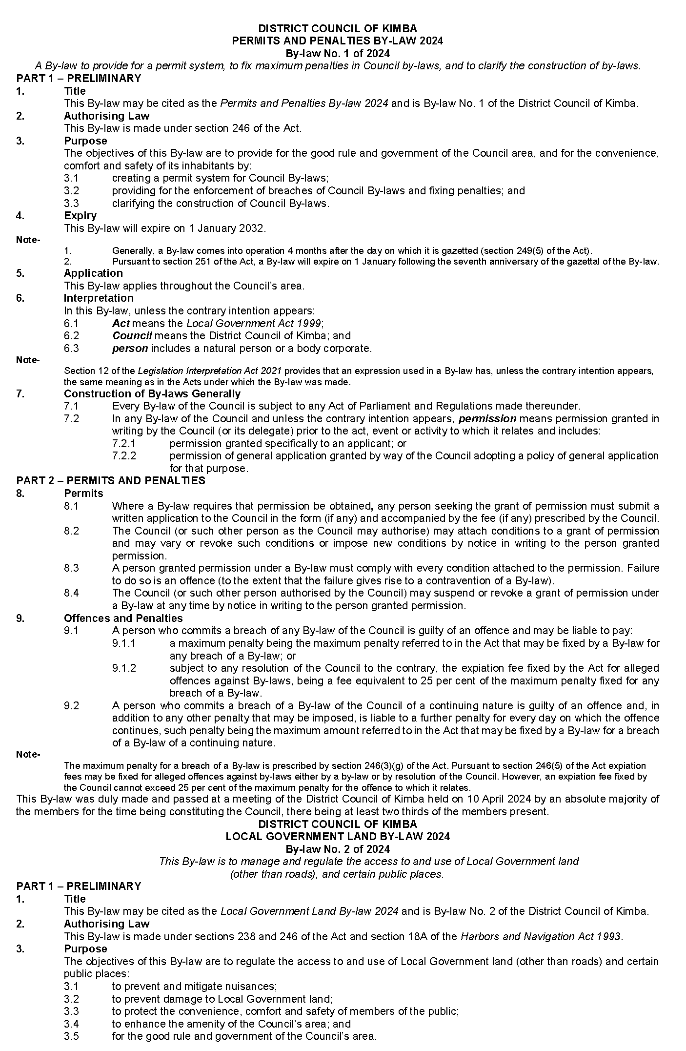
District Council of Kimba

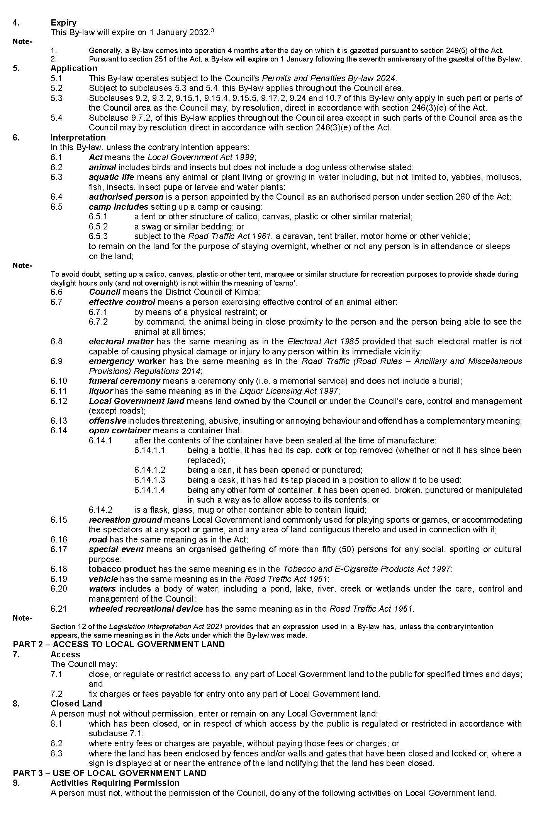
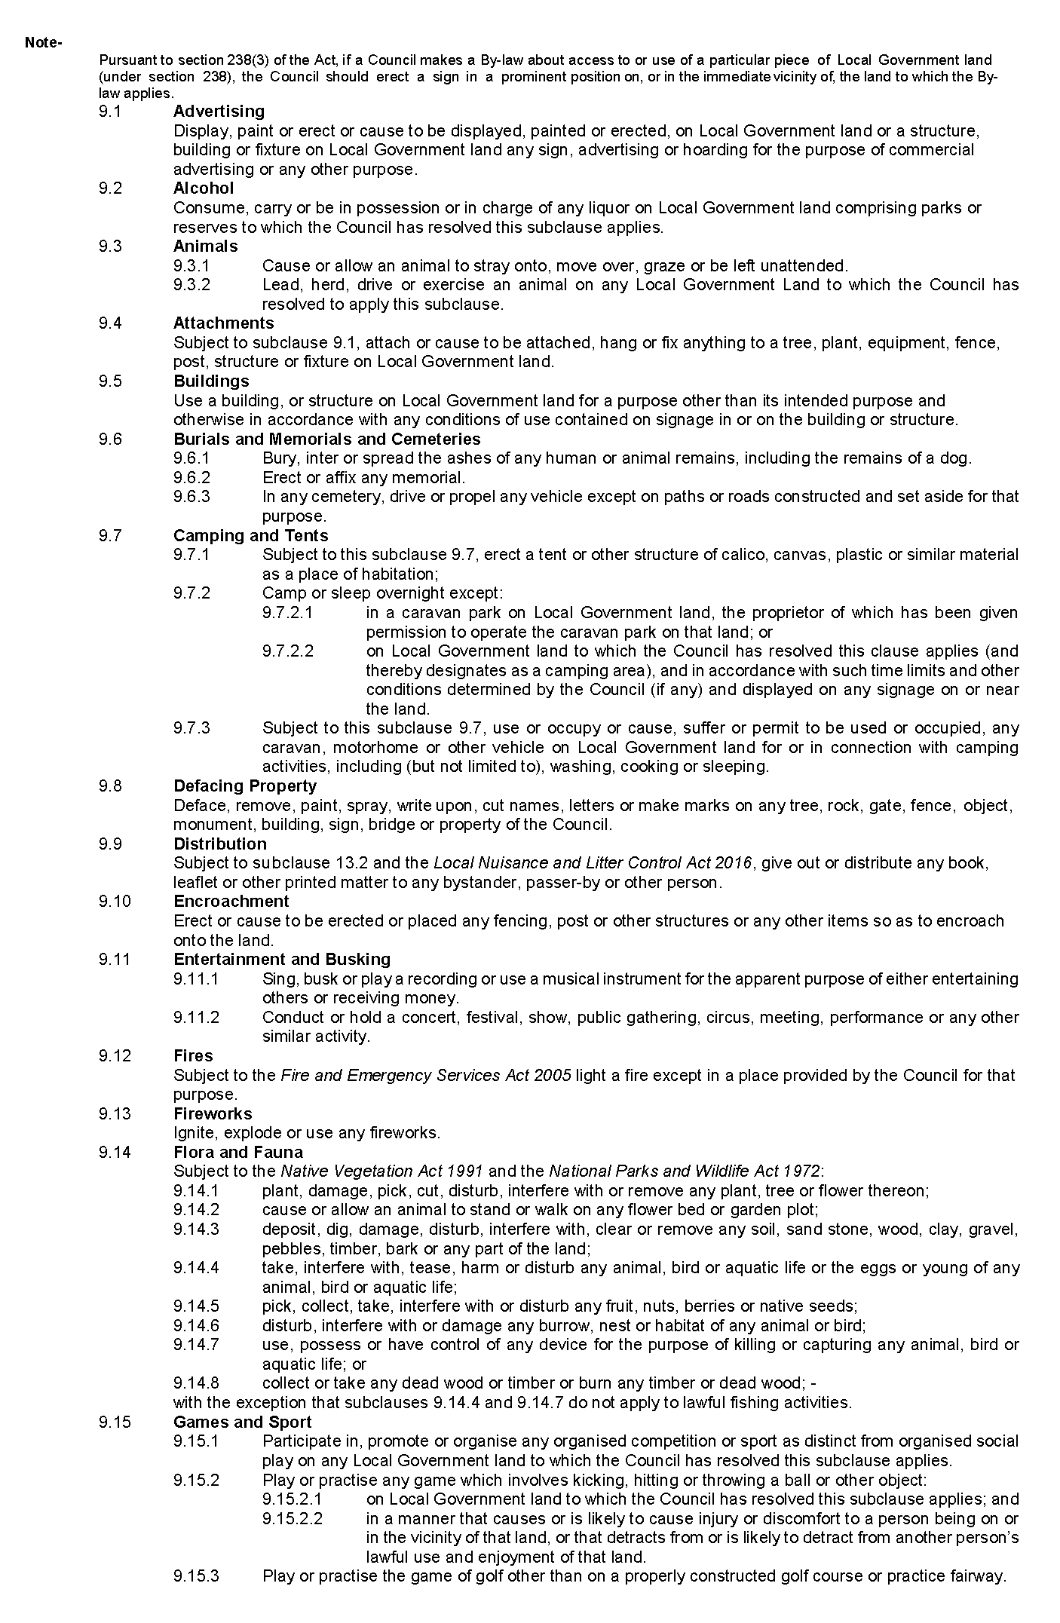
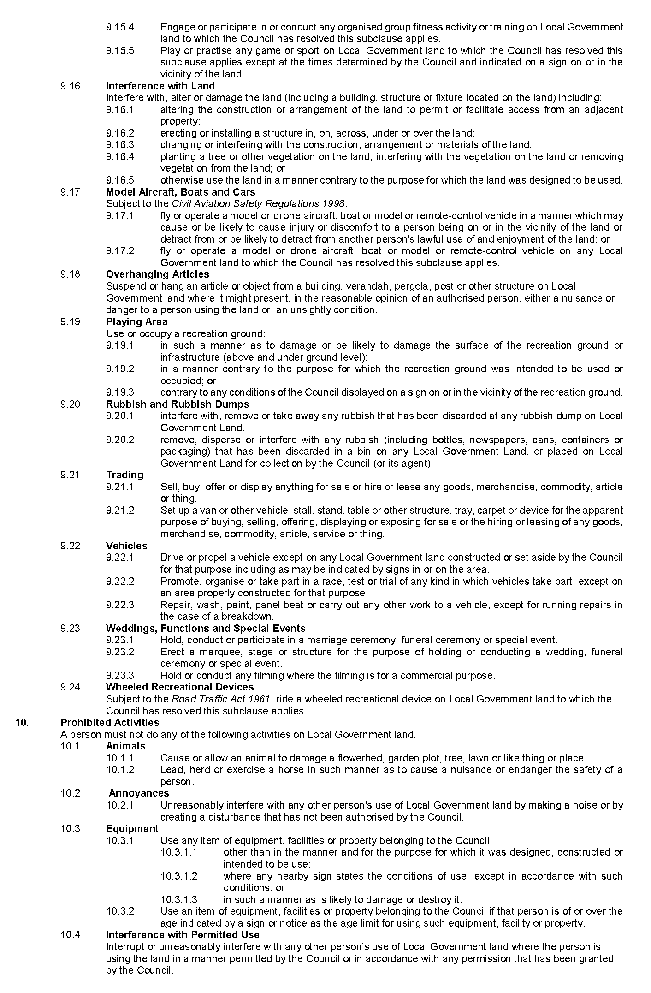
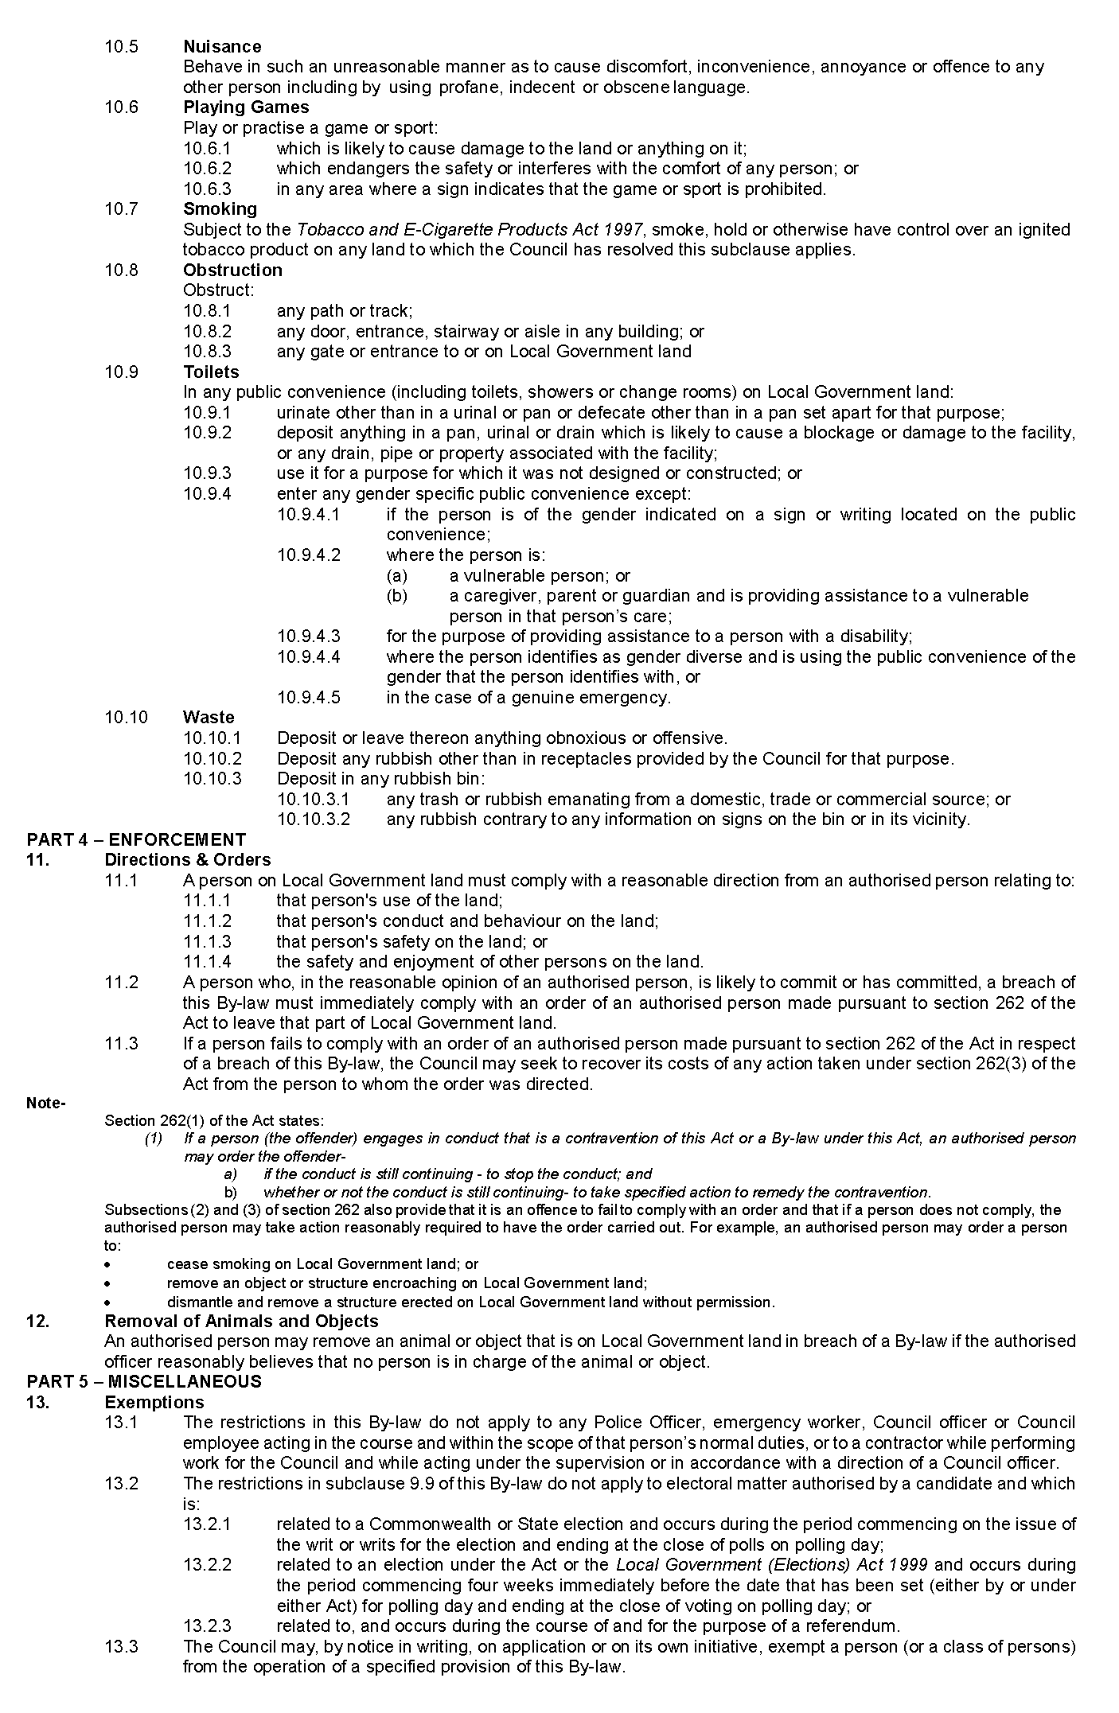
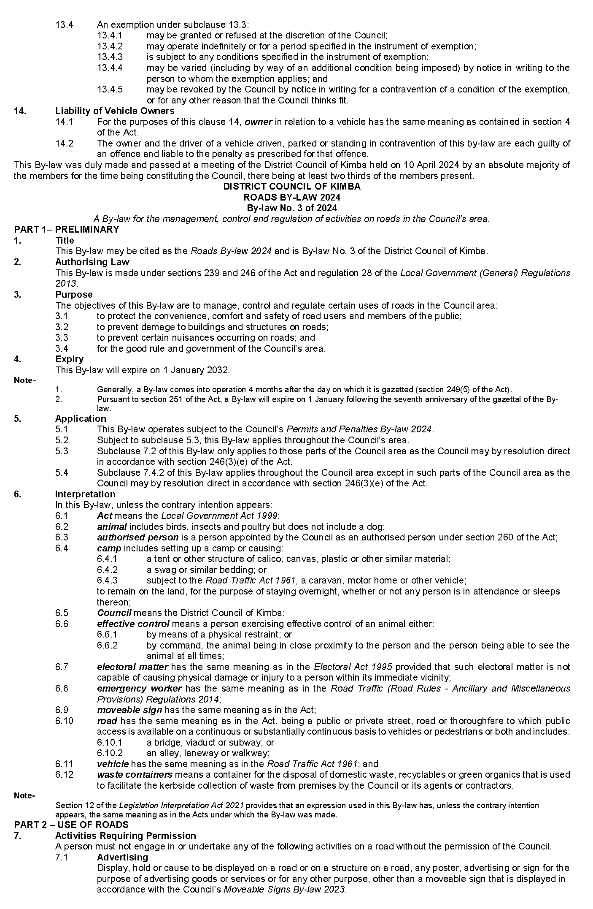
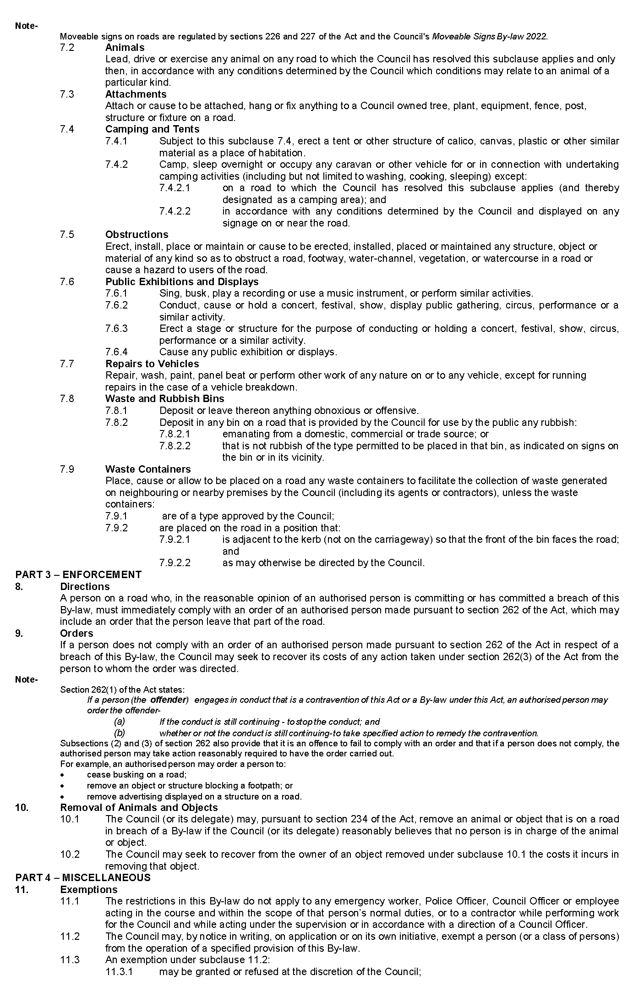
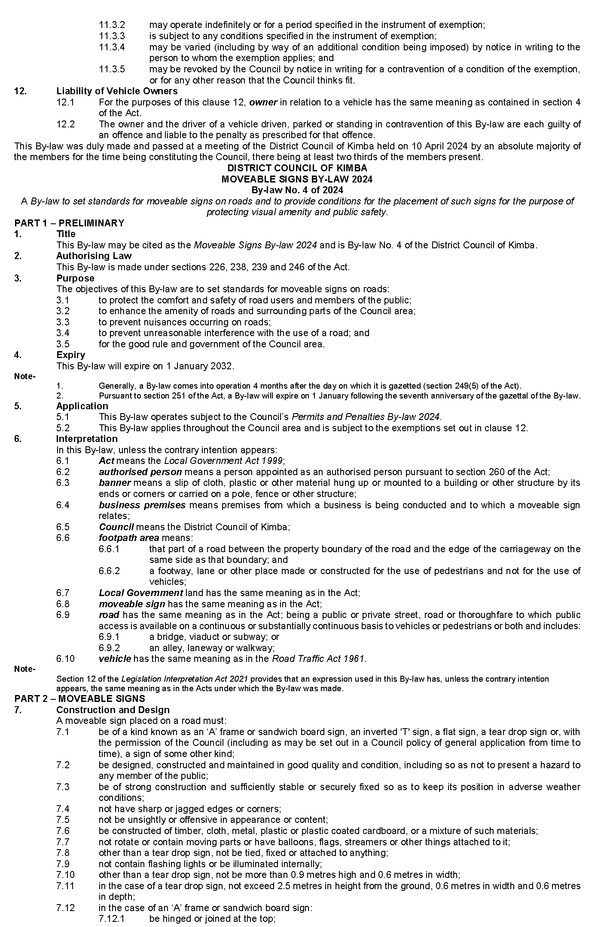
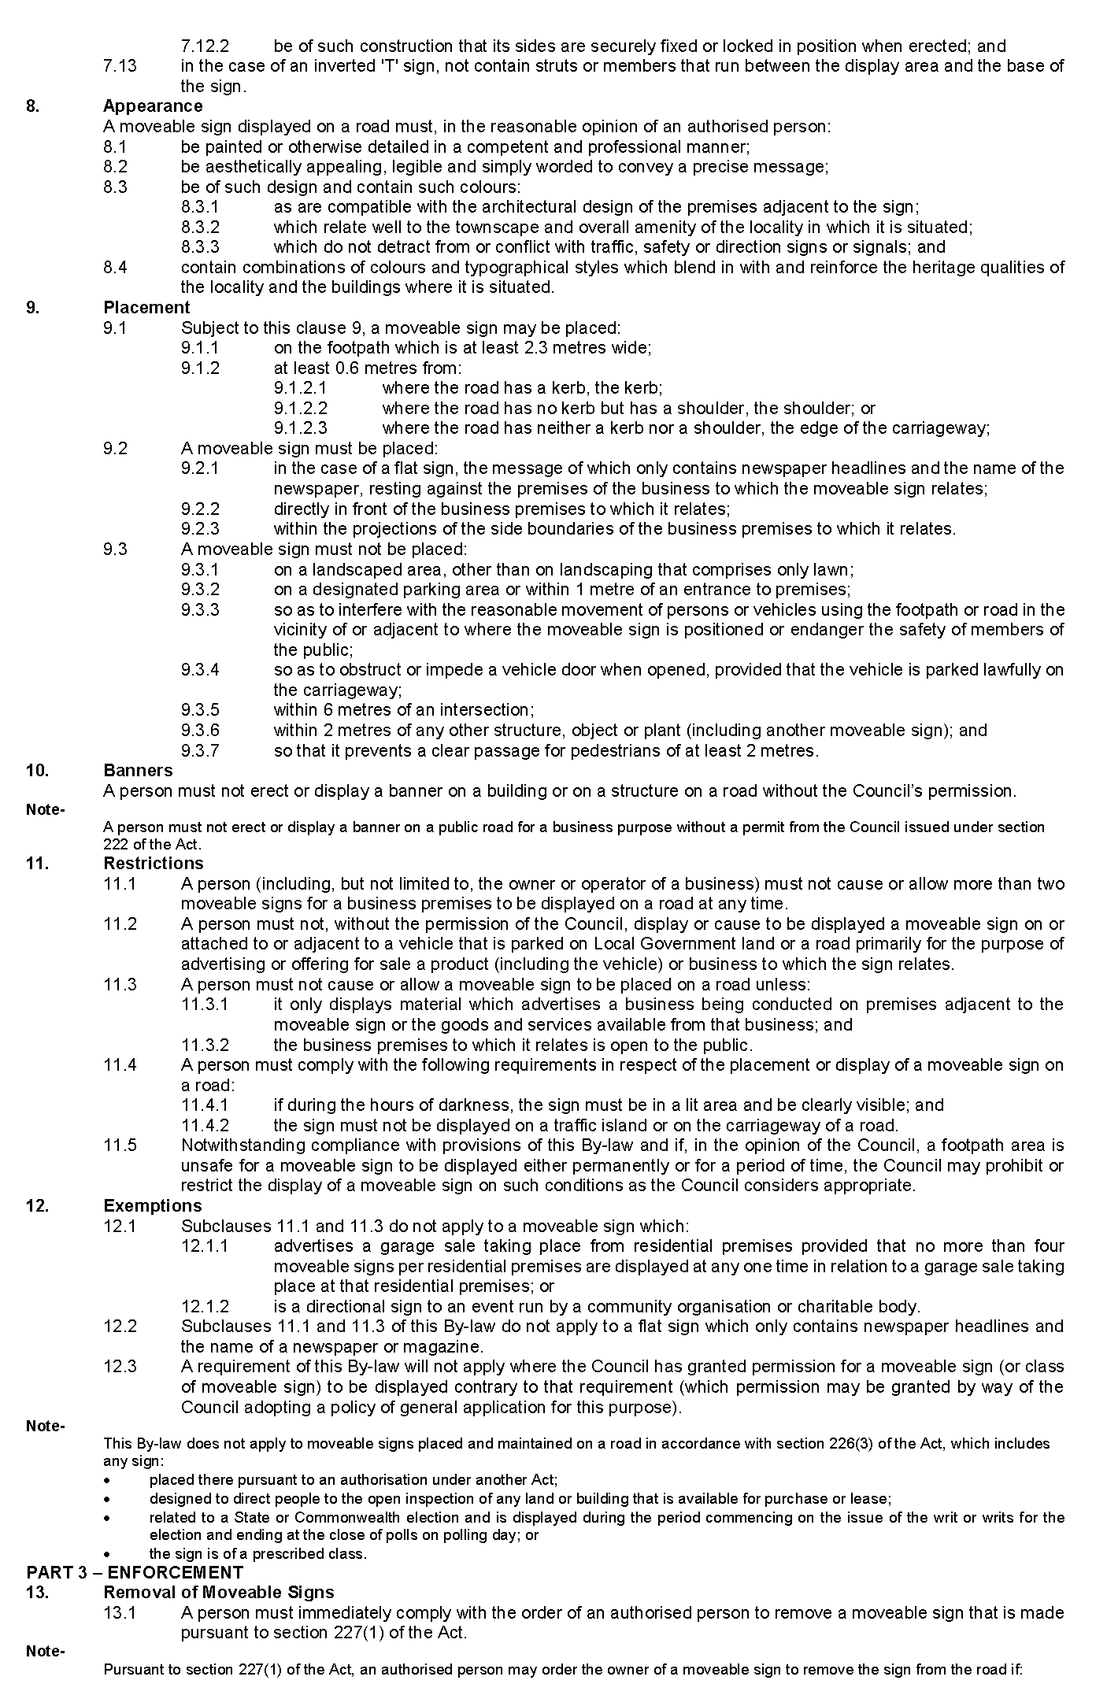
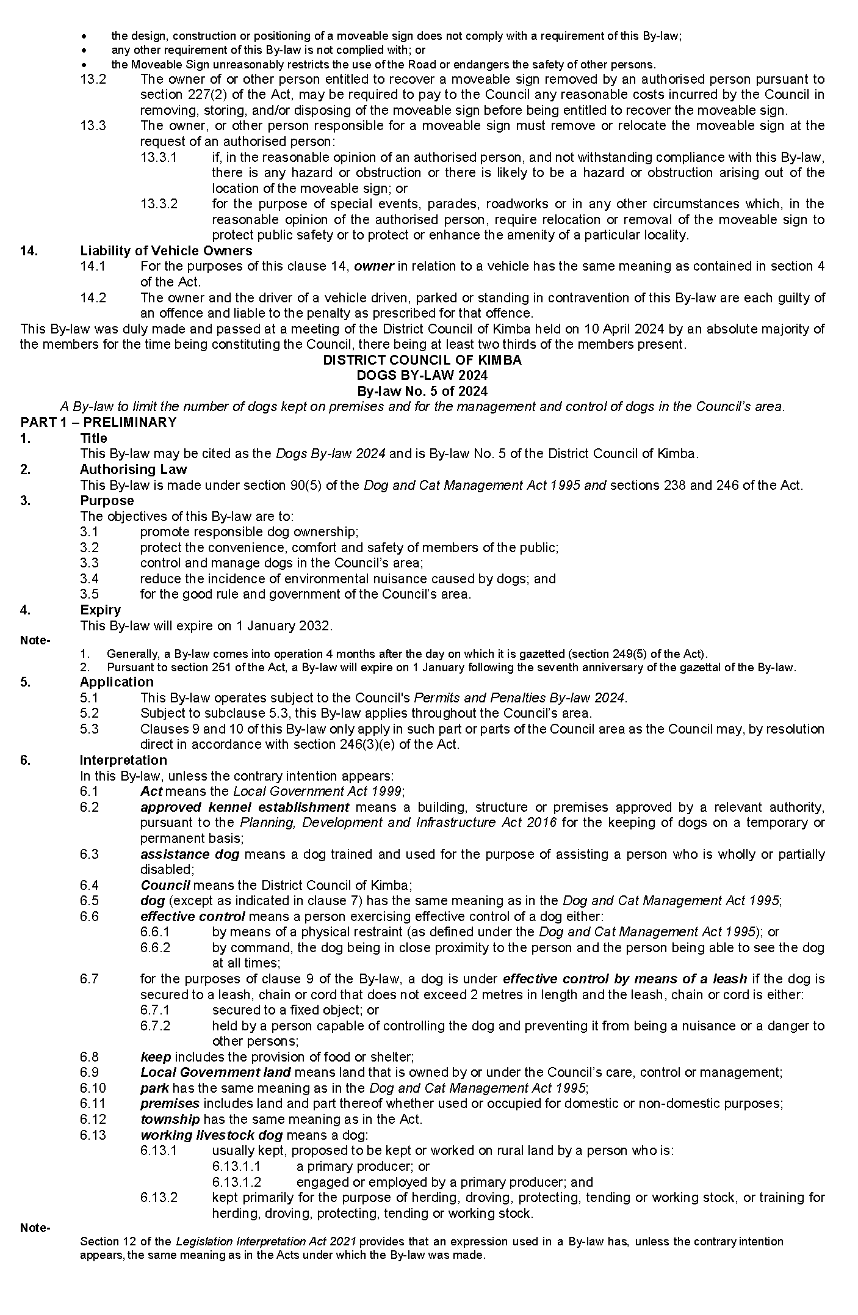
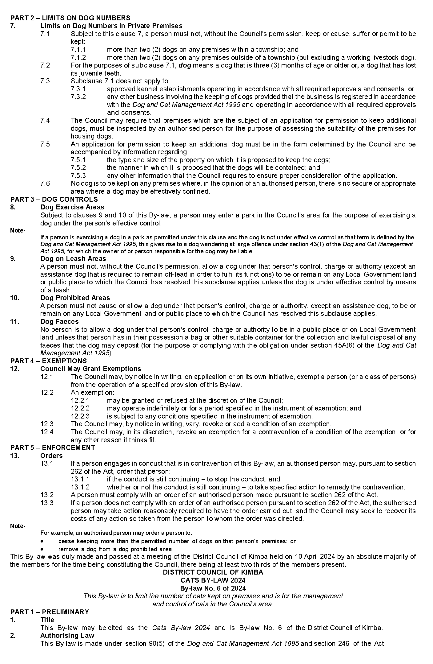
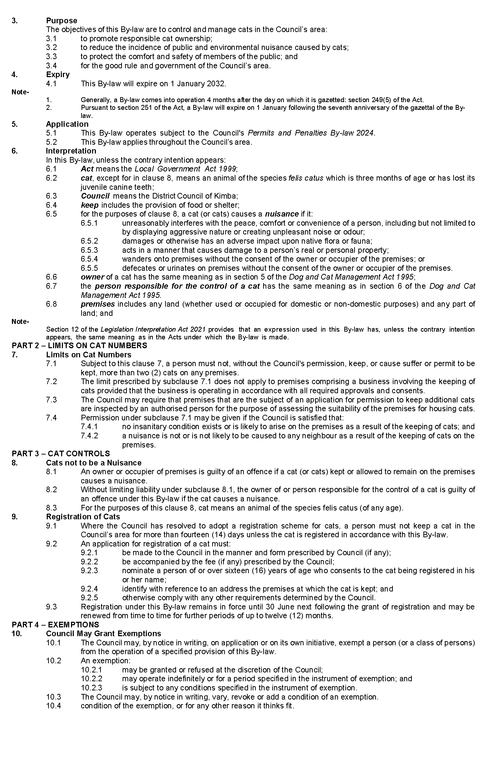

Public Notices

Trustee Act 1936
Public Trustee
Estates of Deceased Persons
IN the matter of the estates of the undermentioned deceased persons:
CADD Vivienne Joy late of 60-66 States Road Morphett Vale of no occupation who died 5 July 2023
CHYNOWETH John Howard late of 655-671 Burbridge Road West Beach Retired Mine Worker who died 3 December 2023
CRIDLAND David Alan late of 56 South Pacific Drive Seaford Meadows Retired Union Representative Advocate who died 9 November 2021
CRIDLAND Elizabeth Douglas late of 60-66 States Road Morphett Vale Retired Cook who died 19 June 2023
DONOGHUE Ronald Herbert late of 82 Hoads Fire Track Road Tungkillo Farmer who died 13 April 2023
EDKINS James Alexander late of 14 Adelaide Road Mannum Retired Truck Driver who died 21 January 2024
HOOK James Brian late of 50 Gulfview Road Christies Beach Retired Chartered Accountant who died 6 October 2024
HOPEWELL Edward Wallace late of 14-24 King William Road Wayville Retired Pharmacist who died 3 June 2019
LEGGATE Carlyne Meta late of 14 Story Road Cowell who died Retired Telephonist
MURPHY Mavis late of 7 Spence Avenue Myrtle Bank Retired Manager who died 30 October 2023
PANUCCIO Anthony Giuseppe late of 14 Aldershot Avenue Salisbury Retired Tool Maker who died 22 January 2024
TAYLOR Allan Maurice late of Unit 1, 53 Dunrobin Road Hove Retired Geologist who died 16 September 2023
Notice is hereby given pursuant to the Trustee Act 1936, the Inheritance (Family Provision) Act 1972 and the Family Relationships Act 1975 that all creditors, beneficiaries, and other persons having claims against the said estates are required to send, in writing, to the office of Public Trustee at GPO Box 1338, Adelaide SA 5001, full particulars and proof of such claims, on or before the 24 May 2024 otherwise they will be excluded from the distribution of the said estate; and notice is also hereby given that all persons indebted to the said estates are required to pay the amount of their debts to the Public Trustee or proceedings will be taken for the recovery thereof; and all persons having any property belonging to the said estates are forthwith to deliver same to the Public Trustee.
Dated: 24 April 2024
N. S. Rantanen
Public Trustee

Notice Submission

The South Australian Government Gazette is published each Thursday afternoon.
Notices must be emailed by 4 p.m. Tuesday, the week of publication.
Submissions are formatted per the gazette style and a proof will be supplied prior to publication, along with a quote if applicable. Please allow one day for processing notices.
Alterations to the proof must be returned by 4 p.m. Wednesday.

Gazette notices must be submitted as Word files, in the following format:
• Title—the governing legislation
• Subtitle—a summary of the notice content
• Body—structured text, which can include numbered lists, tables, and images
• Date—day, month, and year of authorisation
• Signature block—name, role, and department/organisation authorising the notice

Please provide the following information in your email:
• Date of intended publication
• Contact details of the person responsible for the notice content
• Name and organisation to be charged for the publication—Local Council and Public notices only
• Purchase order, if required—Local Council and Public notices only

Email: governmentgazettesa@sa.gov.au
Phone: (08) 7109 7760
Website: www.governmentgazette.sa.gov.au

All instruments appearing in this gazette are to be considered official, and obeyed as such

Printed and published weekly by authority of T. Foresto, Government Printer, South Australia
$8.55 per issue (plus postage), $430.00 per annual subscription—GST inclusive
Online publications: www.governmentgazette.sa.gov.au

