SUPPLEMENTARY GAZETTE
THE SOUTH AUSTRALIAN
GOVERNMENT GAZETTE
Published by Authority

Adelaide, Friday, 26 April 2024

Contents

State Government Instruments

Land Acquisition Act 1969 778

Motor Vehicles Act 1959 779

Road Traffic Act 1961 781

State Government Instruments

Land Acquisition Act 1969
Section 16
Form 5—Notice of Acquisition
1. Notice of acquisition
The Commissioner of Highways (the Authority), of 83 Pirie Street, Adelaide SA 5000, acquires the following interests in the following land:
Comprising an unencumbered estate in fee simple in that piece of land being the whole of Allotment 130 in Deposited Plan 32501 comprised in Certificate of Title Volume 5086 Folio 352.
This notice is given under Section 16 of the Land Acquisition Act 1969.
2. Compensation
A person who has or had an interest consisting of native title or an alienable interest in the land that is divested or diminished by the acquisition or the enjoyment of which is adversely affected by the acquisition who does not receive an offer of compensation from the Authority may apply to the Authority for compensation.
2A. Payment of professional costs relating to acquisition (Section 26B)
If you are the owner in fee simple of the land to which this notice relates, you may be entitled to a payment of up to $10,000 from the Authority for use towards the payment of professional costs in relation to the acquisition of the land.
Professional costs include legal costs, valuation costs and any other costs prescribed by the Land Acquisition Regulations 2019.
3. Inquiries
Inquiries should be directed to: William Ridgway
GPO Box 1533
Adelaide SA 5001
Telephone: (08) 7133 2465
Dated: 22 April 2024
The Common Seal of the COMMISSIONER OF HIGHWAYS was hereto affixed by authority of the Commissioner in the presence of:
Rocco Caruso
Manager, Property Acquisition
(Authorised Officer)
Department for Infrastructure and Transport
File Reference: 2022/02879/01

Land Acquisition Act 1969
Section 16
Form 5—Notice of Acquisition
1. Notice of acquisition
The Commissioner of Highways (the Authority), of 83 Pirie Street, Adelaide SA 5000, acquires the following interests in the following land:
Comprising an unencumbered estate in fee simple in that piece of land being the whole of Allotment 1 in Deposited Plan 69095 comprised in Certificate of Title Volume 5962 Folio 50.
This notice is given under Section 16 of the Land Acquisition Act 1969.
2. Compensation
A person who has or had an interest consisting of native title or an alienable interest in the land that is divested or diminished by the acquisition or the enjoyment of which is adversely affected by the acquisition who does not receive an offer of compensation from the Authority may apply to the Authority for compensation.
2A. Payment of professional costs relating to acquisition (Section 26B)
If you are the owner in fee simple of the land to which this notice relates, you may be entitled to a payment of up to $10,000 from the Authority for use towards the payment of professional costs in relation to the acquisition of the land.
Professional costs include legal costs, valuation costs and any other costs prescribed by the Land Acquisition Regulations 2019.
3. Inquiries
Inquiries should be directed to: Petrula Pettas
GPO Box 1533
Adelaide SA 5001
Telephone: (08) 7133 2457
Dated: 22 April 2024
The Common Seal of the COMMISSIONER OF HIGHWAYS was hereto affixed by authority of the Commissioner in the presence of:
Rocco Caruso
Manager, Property Acquisition
(Authorised Officer)
Department for Infrastructure and Transport
File Reference: 2022/17841/01

Motor Vehicles Act 1959
South Australia
Motor Vehicles (2024 Backbone Hillclimb) Notice
under section 6 of the Motor Vehicles Act 1959
1 Operation and expiry
This Notice comes into operation at 8:30am on 3 May 2024 and expires at 6:00pm on 5 May 2024.
2 Interpretation
In this Notice—
2024 Backbone Hillclimb means the Backbone Hillclimb Event promoted by Hillclimb SA Incorporated Registration Number A44852 and held under Motorsport Australia Permit Number 524/0505/01;
Minister means the Minister to whom the administration of the Motor Vehicles Act 1959 is committed.
3 Exemption
In accordance with the power under section 6 of the Motor Vehicles Act 1959 I declare that the whole of the Act does not apply to roads within the area designated in the Schedule to this Notice during the operation of this Notice.
4 Revocation
This Notice may be revoked or varied by the Minister or their delegate at any time.
5 Execution
Dated: 23 April 2024
Hon Anastasios Koutsantonis MP
Minister for Infrastructure and Transport

Motor Vehicles (2024 Backbone Hillclimb) Notice (Schedule)
Under Section 6 of the Motor Vehicles Act 1959
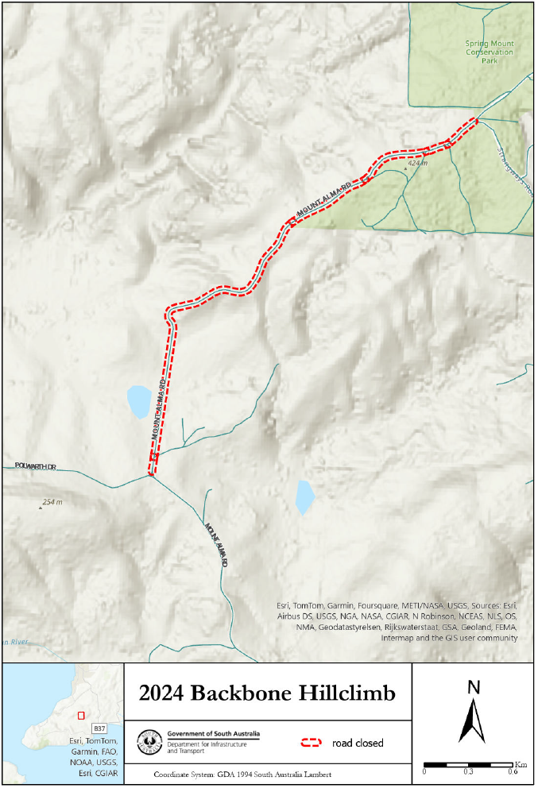

Road Traffic Act 1961
South Australia
Road Traffic (2024 Backbone Hillclimb) Notice
under section 163AA of the Road Traffic Act 1961
1 Operation and expiry
This Notice comes into operation at 8:30am on 3 May 2024 and expires at 6:00pm 5 May 2024.
2 Interpretation
In this Notice—
2024 Backbone Hillclimb means the Backbone Hillclimb Event promoted by Hillclimb SA Incorporated Registration Number A44852 and held under Motorsport Australia Permit Number 524/0505/01;
Minister means the Minister to whom the administration of the Road Traffic Act 1961 is committed.
3 Exemption
In accordance with the power under section 163AA of the Road Traffic Act 1961 I declare that the whole of Part 4 of the Act does not apply to a vehicle within the area designated in the Schedule to this Notice during the operation of this Notice.
4 Revocation
This Notice may be revoked or varied by the Minister or their delegate at any time.
5 Execution
Dated: 23 April 2024
Hon Anastasios Koutsantonis MP
Minister for Infrastructure and Transport

Road Traffic (2024 Backbone Hillclimb) Notice (Schedule)
Under Section 163AA of the Road Traffic Act 1961

Road Traffic Act 1961
South Australia
Road Traffic (Electric Personal Transporters) Notice No 1 of 2024
under section 161A of the Road Traffic Act 1961
1 Operation and revocation
This Notice comes into operation on the day on which it is made and will cease operation on 30 April 2025. This Notice revokes the Road Traffic (Electric Personal Transporters) Notice No 2 of 2023 of 6 July 2023.
2 Interpretation
In this Notice—
Act means the Road Traffic Act 1961;
Council means the Corporation of the City of Adelaide;
electric personal transporter has the same meaning as in the Road Traffic (Miscellaneous) Regulations 2014;
Minister means the Minister to whom the administration of the Act is committed;
path means a bicycle path, footpath, separated footpath or shared path.
3 Approval
In accordance with the power under section 161A of the Act, I hereby APPROVE an electric personal transporter to be driven on or over a road.
4 Conditions
An electric personal transporter may only be driven:
- within the Council area designated in the Schedule to this Notice;
- on roads and paths not prohibited for use by Council;
- if supplied by an operator permitted by Council, or otherwise authorised or accredited;
- by a driver aged 18 years old or older;
- if the electric personal transporter meets the criteria in paragraphs (a) to (d) of the definition of scooter in rule 244A(1) of the Australian Road Rules;
- if the maximum speed of the electric personal transporter cannot exceed 15km/h;
- if the unladen mass of the electric personal transporter does not exceed 25kg.
5 Revocation
This Notice may be revoked by the Minister or his delegate at any time.
6 Execution
Dated: 23 April 2024
Hon Anastasios Koutsantonis MP
Minister for Infrastructure and Transport

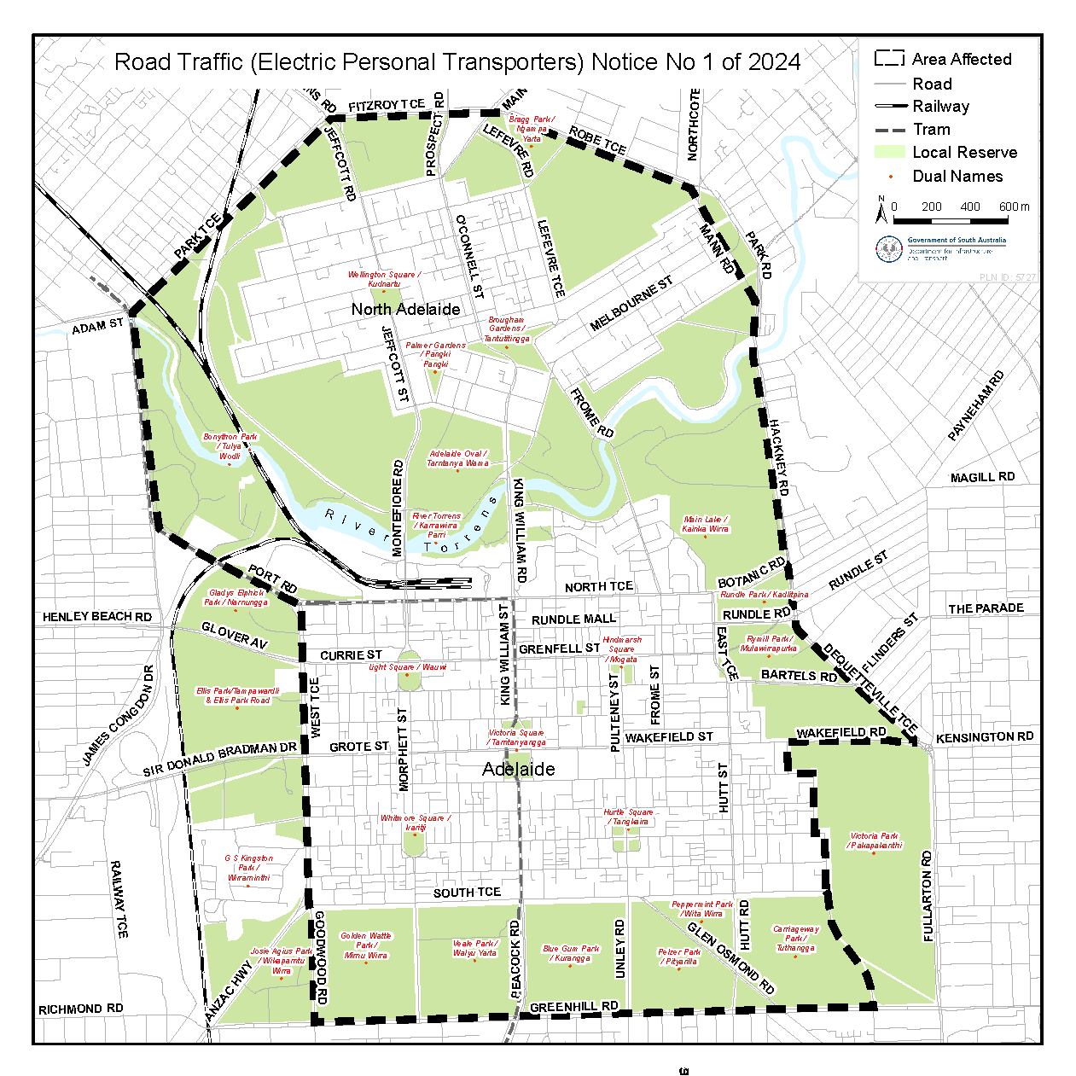

All instruments appearing in this gazette are to be considered official, and obeyed as such

Printed and published weekly by authority of T. Foresto, Government Printer, South Australia
$8.55 per issue (plus postage), $430.00 per annual subscription—GST inclusive
Online publications: www.governmentgazette.sa.gov.au

