No. 9 p. 187
THE SOUTH AUSTRALIAN
GOVERNMENT GAZETTE
Published by Authority

Adelaide, Thursday, 22 February 2024

Contents

Governor’s Instruments
Appointments 188
Proclamations—
National Parks and Wildlife (Flinders Chase National Park) Proclamation 2024 190
National Parks and Wildlife (Kelly Hill Conservation Park) Proclamation 2024 191
Wilderness Protection (Cape Torrens Wilderness Protection Area) Proclamation 2024 192
Regulations—
Planning, Development and Infrastructure (General)
(Outline Consent) Amendment Regulations 2024—No. 6 of 2024 193
State Government Instruments
Building Work Contractors Act 1995 196
Coorong Environmental Trust Act 2021 196
Education and Children's Services Act 2019 196
Housing Improvement Act 2016 209
Land Acquisition Act 1969 210
Motor Vehicles Act 1959 212
Planning, Development and Infrastructure
(General) Regulations 2017 218
Planning, Development and Infrastructure Act 2016 221
Retirement Villages Act 2016 229
Road Traffic Act 1961 229
The Remuneration Tribunal 229
Work Health and Safety Act 2012 235
Local Government Instruments
City of Adelaide 236
City of Norwood, Payneham & St Peters 236
City of Port Adelaide Enfield 236
Alexandrina Council 237
Copper Coast Council 237
Kangaroo Island Council 254
Port Pirie Regional Council 255
Public Notices
National Electricity Law 273
Trustee Act 1936 273

Governor’s Instruments

Appointments
Department of the Premier and Cabinet
Adelaide, 22 February 2024
Her Excellency the Governor in Executive Council has been pleased to appoint the undermentioned to the TAFE SA Board of Directors, pursuant to the provisions of the TAFE SA Act 2012:
Director: from 1 March 2024 until 14 October 2026
Ingrid Kristina Haythorpe
By command,
Anastasios Koutsantonis, MP
For Premier
ME24/001

Department of the Premier and Cabinet
Adelaide, 22 February 2024
Her Excellency the Governor in Executive Council has been pleased to appoint the undermentioned to the South Australian Country Arts Trust, pursuant to the provisions of the South Australian Country Arts Trust Act 1992:
Member: from 22 February 2024 until 21 February 2027
Kathleen Mary Mainland
Simone Bailey
Member: from 25 February 2024 until 24 February 2027
Ella Stephanie Winnall
Presiding Member: from 22 February 2024 until 21 February 2027
Kathleen Mary Mainland
By command,
Anastasios Koutsantonis, MP
For Premier
24ART0003CS

Department of the Premier and Cabinet
Adelaide, 22 February 2024
Her Excellency the Governor in Executive Council has been pleased to appoint the undermentioned to the State Opera of South Australia Board, pursuant to the provisions of the State Opera of South Australia Act 1976:
Member: from 22 February 2024 until 21 February 2027
Imelda Tanya Alexopoulos
By command,
Anastasios Koutsantonis, MP
For Premier
24ART0002CS

Department of the Premier and Cabinet
Adelaide, 22 February 2024
Her Excellency the Governor in Executive Council has been pleased to appoint Alexandra Louise Whittaker as a member of the Veterinary Surgeons Board of South Australia for a term commencing on 1 March 2024 and expiring on 30 June 2025 - pursuant to the provisions of the Veterinary Practice Act 2003.
By command,
Anastasios Koutsantonis, MP
For Premier
MPIRD F2024/000088

Department of the Premier and Cabinet
Adelaide, 22 February 2024
Her Excellency the Governor in Executive Council has approved the flag known as the Blue Ensign, decorated with the badge of the State of South Australia (namely, the Piping Shrike on a gold background), surmounted by the Tudor Crown, to be the flag of the Governor of South Australia and direct that it be flown in or from any vessel, vehicle of place as the Governor may from time to time direct, and may be flown by any vessel in which the Governor may have embarked.
By command,
Anastasios Koutsantonis, MP
For Premier
DPC24/013CS

Department of the Premier and Cabinet
Adelaide, 22 February 2024
Her Excellency the Governor in Executive Council has approved the Tudor Crown to be used on flags, badges and other such places, replacing St. Edward's Crown, to align with the preference of His Majesty King Charles.
By command,
Anastasios Koutsantonis, MP
For Premier
DPC24/013CS

Proclamations
South Australia

National Parks and Wildlife (Flinders Chase National Park) Proclamation 2024
under section 27(3) of the National Parks and Wildlife Act 1972
1—Short title
This proclamation may be cited as the National Parks and Wildlife (Flinders Chase National Park) Proclamation 2024.
2—Commencement
This proclamation comes into operation on the day on which it is made.
3—Alteration of boundaries of Flinders Chase National Park
The boundaries of the Flinders Chase National Park are altered by adding to the Park the following Crown land:
Section 41, Hundred of Gosse, County of Carnarvon;
Allotment 1 in Deposited Plan 18009, Hundred of McDonald, County of Carnarvon;
Allotment 4 in Deposited Plan 120120, Hundred of McDonald, County of Carnarvon;
Section 18, Hundred of McDonald, County of Carnarvon;
Section 20, Hundred of McDonald, County of Carnarvon.
Made by the Governor
with the advice and consent of the Executive Council
on 22 February 2024

South Australia

National Parks and Wildlife (Kelly Hill Conservation Park) Proclamation 2024
under section 29(3) of the National Parks and Wildlife Act 1972
1—Short title
This proclamation may be cited as the National Parks and Wildlife (Kelly Hill Conservation Park) Proclamation 2024.
2—Commencement
This proclamation comes into operation on the day on which it is made.
3—Alteration of boundaries of Kelly Hill Conservation Park
The boundaries of the Kelly Hill Conservation Park are altered by adding to the Park the following Crown land:
Section 15, Hundred of Ritchie, County of Carnarvon;
Section 39, Hundred of Ritchie, County of Carnarvon;
Section 50, Hundred of Ritchie, County of Carnarvon.
Made by the Governor
with the advice and consent of the Executive Council
on 22 February 2024

South Australia

Wilderness Protection (Cape Torrens Wilderness Protection Area) Proclamation 2024
under section 22(2) of the Wilderness Protection Act 1992
1—Short title
This proclamation may be cited as the Wilderness Protection (Cape Torrens Wilderness Protection Area) Proclamation 2024.
2—Commencement
This proclamation comes into operation on the day on which it is made.
3—Alteration of boundaries of Cape Torrens Wilderness Protection Area
The boundaries of the Cape Torrens Wilderness Protection Area are altered by adding to the Protection Area the following Crown land:
Allotment 1 in Deposited Plan 119843, Hundred of Borda, County of Carnarvon.
Made by the Governor
on the recommendation of the Minister for Climate, Environment and Water and with the advice and consent of the Executive Council
on 22 February 2024

Regulations
South Australia

Planning, Development and Infrastructure (General) (Outline Consent) Amendment Regulations 2024
under the Planning, Development and Infrastructure Act 2016

Contents
Part 1—Preliminary
1 Short title
2 Commencement
Part 2—Amendment of Planning, Development and Infrastructure (General) Regulations 2017
3 Amendment of regulation 31—Verification of application
4 Amendment of regulation 33—Application and further information
5 Amendment of regulation 41—Referrals
6 Amendment of regulation 53—Time within which decision must be made (section 125(1))
7 Amendment of regulation 57—Notice of decision (section 126(1))
8 Amendment of regulation 103G—Other matters
9 Amendment of regulation 120—Record of applications

Part 1—Preliminary
1—Short title
These regulations may be cited as the Planning, Development and Infrastructure (General) (Outline Consent) Amendment Regulations 2024.
2—Commencement
These regulations come into operation on the day on which they are made.
Part 2—Amendment of Planning, Development and Infrastructure (General) Regulations 2017
3—Amendment of regulation 31—Verification of application
(1) Regulation 31(1)(d)(iii)—delete subparagraph (iii) and substitute:
(iii) —
(A) in the case of an application for outline consent—provide notice of the determination under paragraph (c) in writing to the applicant; or
(B) in any other case—provide an appropriate notice via the SA planning portal; and
(2) Regulation 31(1)(e)(ii)—delete subparagraph (ii) and substitute:
(ii) —
(A) in the case of an application for outline consent—provide notice of the determination under paragraph (c) in writing to the applicant and the entity that it considers to be the correct relevant authority; or
(B) in any other case—provide an appropriate notice via the SA planning portal.
(3) Regulation 31(2)(b)—delete "under subregulation (1)(e) (or a notice provided via the SA planning portal)" and substitute:
or notice under subregulation (1)(e)
4—Amendment of regulation 33—Application and further information
Regulation 33—after subregulation (2) insert:
(2a) Development the subject of an application for outline consent does not constitute development of a class prescribed by subregulation (1) or (2).
5—Amendment of regulation 41—Referrals
(1) Regulation 41(1a)—after "planning consent" wherever occurring insert:
or outline consent
(2) Regulation 41(1b)—delete "extend to an application which is relevant to a matter that has been reserved for further consideration by the prescribed body." and substitute:
—
(a) extend to an application which is relevant to a matter that has been reserved for further consideration by the prescribed body; or
(b) limit any further notification and consultation required in accordance with section 120(4)(c) of the Act.
(3) Regulation 41(2)—delete subregulation (2) and substitute:
(2) A prescribed body must, immediately after making a request under section 122(3) of the Act—
(a) in the case of an application for outline consent—notify the relevant authority of the request in writing; or
(b) in any other case—notify the relevant authority of the request via the SA planning portal,
(and, in doing so, provide reasonable information about what is requested).
6—Amendment of regulation 53—Time within which decision must be made (section 125(1))
(1) Regulation 53(1)—after paragraph (c) insert:
(ca) if the application seeks outline consent—20 business days;
(2) Regulation 53(1)(f)—after "paragraph (b)" insert:
or (ca)
(3) Regulation 53(1)(f)—delete "that paragraph" and substitute:
paragraph (b) or (ca)
(4) Regulation 53(1)(g) and (h)—delete "or (c)" wherever occurring and substitute in each case:
, (c) or (ca)
(5) Regulation 53(1)(j) and (ja)—after "(c)," wherever occurring insert:
(ca),
7—Amendment of regulation 57—Notice of decision (section 126(1))
(1) Regulation 57(2)—delete subregulation (2) and substitute:
(2) A notice under subregulation (1) must be given—
(a) within 2 business days after the decision is made on the application; and
(b) except in the case of a notice in relation to an application for outline consent—by providing notice via the SA planning portal (and, if it appears necessary, by giving notice to the applicant in some other way determined to be appropriate by the relevant authority).
(2) Regulation 57(3)—delete "or building consent" and substitute:
, building consent or outline consent
(3) Regulation 57(4)(b)—delete "via the SA planning portal under subregulation (2)" and substitute:
under this regulation
8—Amendment of regulation 103G—Other matters
Regulation 103G(2)—delete "regulation 31(1)(d)(iii)" and substitute:
regulation 31(1)(d)(iii)(B)
9—Amendment of regulation 120—Record of applications
Regulation 120(1)—after "section 102 of the Act" insert:
and each application for outline consent under section 120 of the Act
Editorial note—
As required by section 10AA(2) of the Legislative Instruments Act 1978, the Minister has certified that, in the Minister's opinion, it is necessary or appropriate that these regulations come into operation as set out in these regulations.
Made by the Governor
with the advice and consent of the Executive Council
on 22 February 2024
No 6 of 2024

State Government Instruments

Building Work Contractors Act 1995
Exemption
TAKE notice that, pursuant to section 45 of the Building Work Contractors Act 1995, I, Rita McPhail as a delegate for the Minister for Consumer and Business Affairs, do hereby exempt the licensee named in Schedule 1 from the application of Division 3 of Part 5 of the above Act in relation to domestic building work described in Schedule 2 and subject to the conditions specified in Schedule 3.
Schedule 1
STEPHEN JAMES EVANS (BLD 326535)
Schedule 2
Construction of a kit shed at Allotment 152 Deposited Plan 72962 being a portion of the land described in Certificate of Title Volume 5986 Folio 534, more commonly known as Lot 152 Playford Highway, Kingscote SA 5223.
Schedule 3
1. This exemption is limited to domestic building work personally performed by the licensee in relation to the building work described in Schedule 2.
2. This exemption does not apply to any domestic building work the licensee contracts to another building work contractor, for which that contractor is required by law to hold building indemnity insurance.
3. That the licensee does not transfer his interest in the land prior to five years from the date of completion of the building work the subject of this exemption, without the prior authorisation of Consumer and Business Services (CBS). Before giving such authorisation, CBS may require the licensee to take any reasonable steps to protect the future purchaser(s) of the property, including but not limited to:
- Providing evidence that an adequate policy of building indemnity insurance is in force to cover the balance of the five-year period from the date of completion of the building work the subject of this exemption;
- Providing evidence of an independent expert inspection of the building work the subject of this exemption;
- Making an independent expert report available to prospective purchasers of the property;
- Giving prospective purchasers of the property notice of the absence of a policy of building indemnity insurance.
Dated: 14 February 2024
Rita McPhail
Director Customer Service and Transformation
Delegate for the Minister for Consumer and Business Affairs

Coorong Environmental Trust Act 2021
Appointment of initial members of the Trust
PURSUANT to section 5(2) of the Coorong Environmental Trust Act 2021, I, Susan Close, Minister for Climate, Environment and Water (The Minister) in the State of South Australia and the Minister to whom the administration of the Act is committed, hereby appoint the following persons as initial members of the Coorong Environmental Trust.
Ms Janette Brooks – representative of the River Lakes and Coorong Action Group
Ms Faith Coleman – representative of EcoProTem
Ms Peri Coleman – representative of Delta Environmental Consulting
Ms Tia Harding – representative of Spirit of the Coorong
Mr Garry Hera-Singh – representative of Garry and Christine Hera-Singh
Professor Patrick Hesp – representative of Beach and Dune System Laboratory, Flinders University
Mr Ken Sawers – representative of K M Sawers.
Dated: 21 February 2024
Hon Susan Close MP
Minister for Climate, Environment and Water

Education and Children's Services Act 2019
Amending the Constitution of a Governing Council for a Government School
I, KATHRYN BRUGGEMAN, Deputy Chief Executive, Schools and Preschools, consider it necessary to amend the constitution of the Basket Range Primary School Governing Council to ensure that it takes the form of the model constitution for schools without a school-based preschool, and therefore in accordance with section 40(1) and (2) of the Education and Children’s Services Act 2019, I amend that governing council’s constitution such that it now reads as follows:

BASKET RANGE PRIMARY SCHOOL GOVERNING COUNCIL INCORPORATED CONSTITUTION
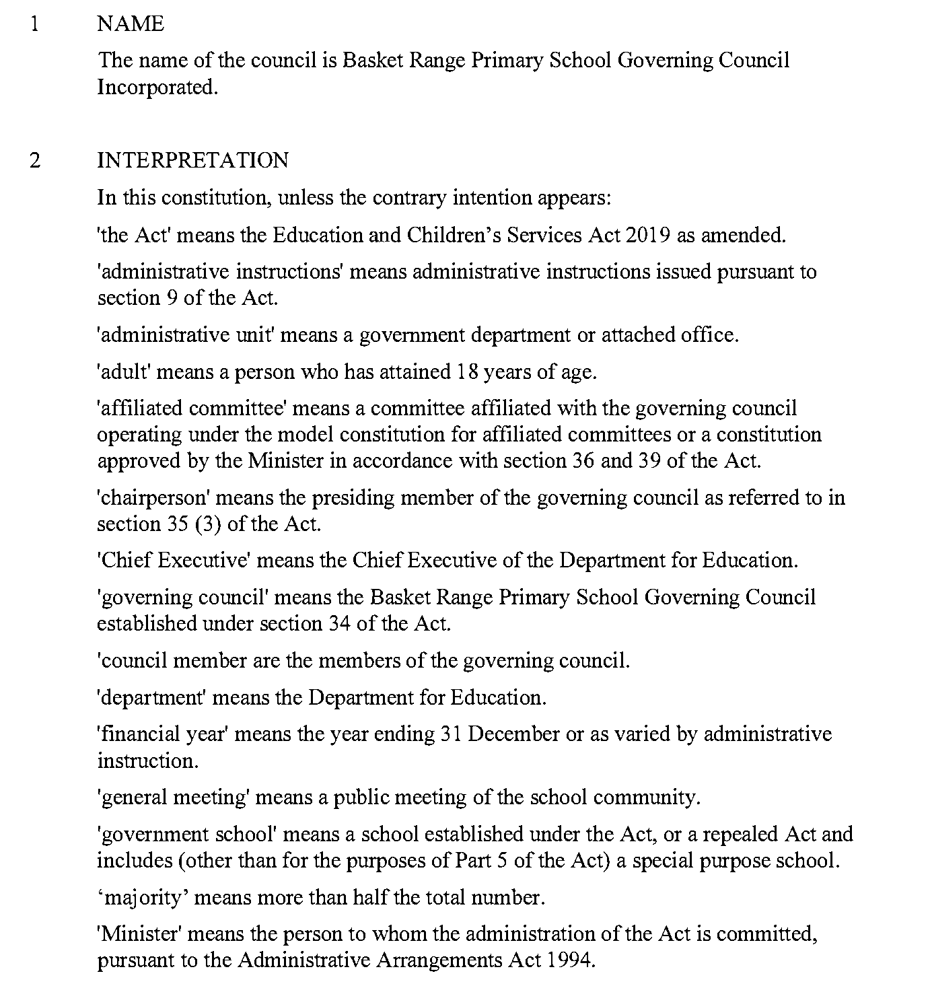
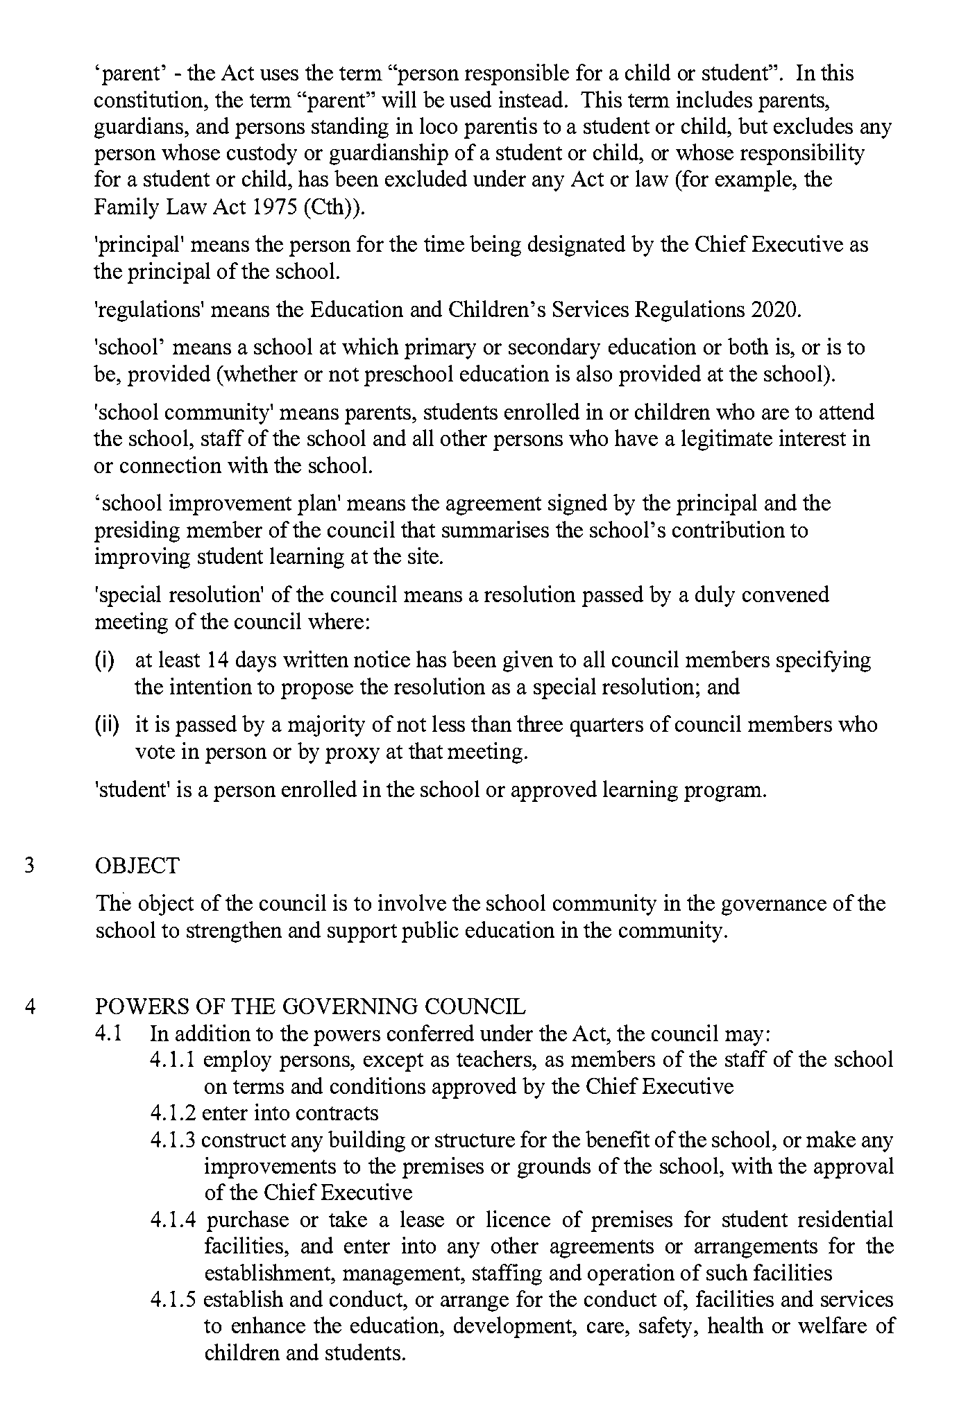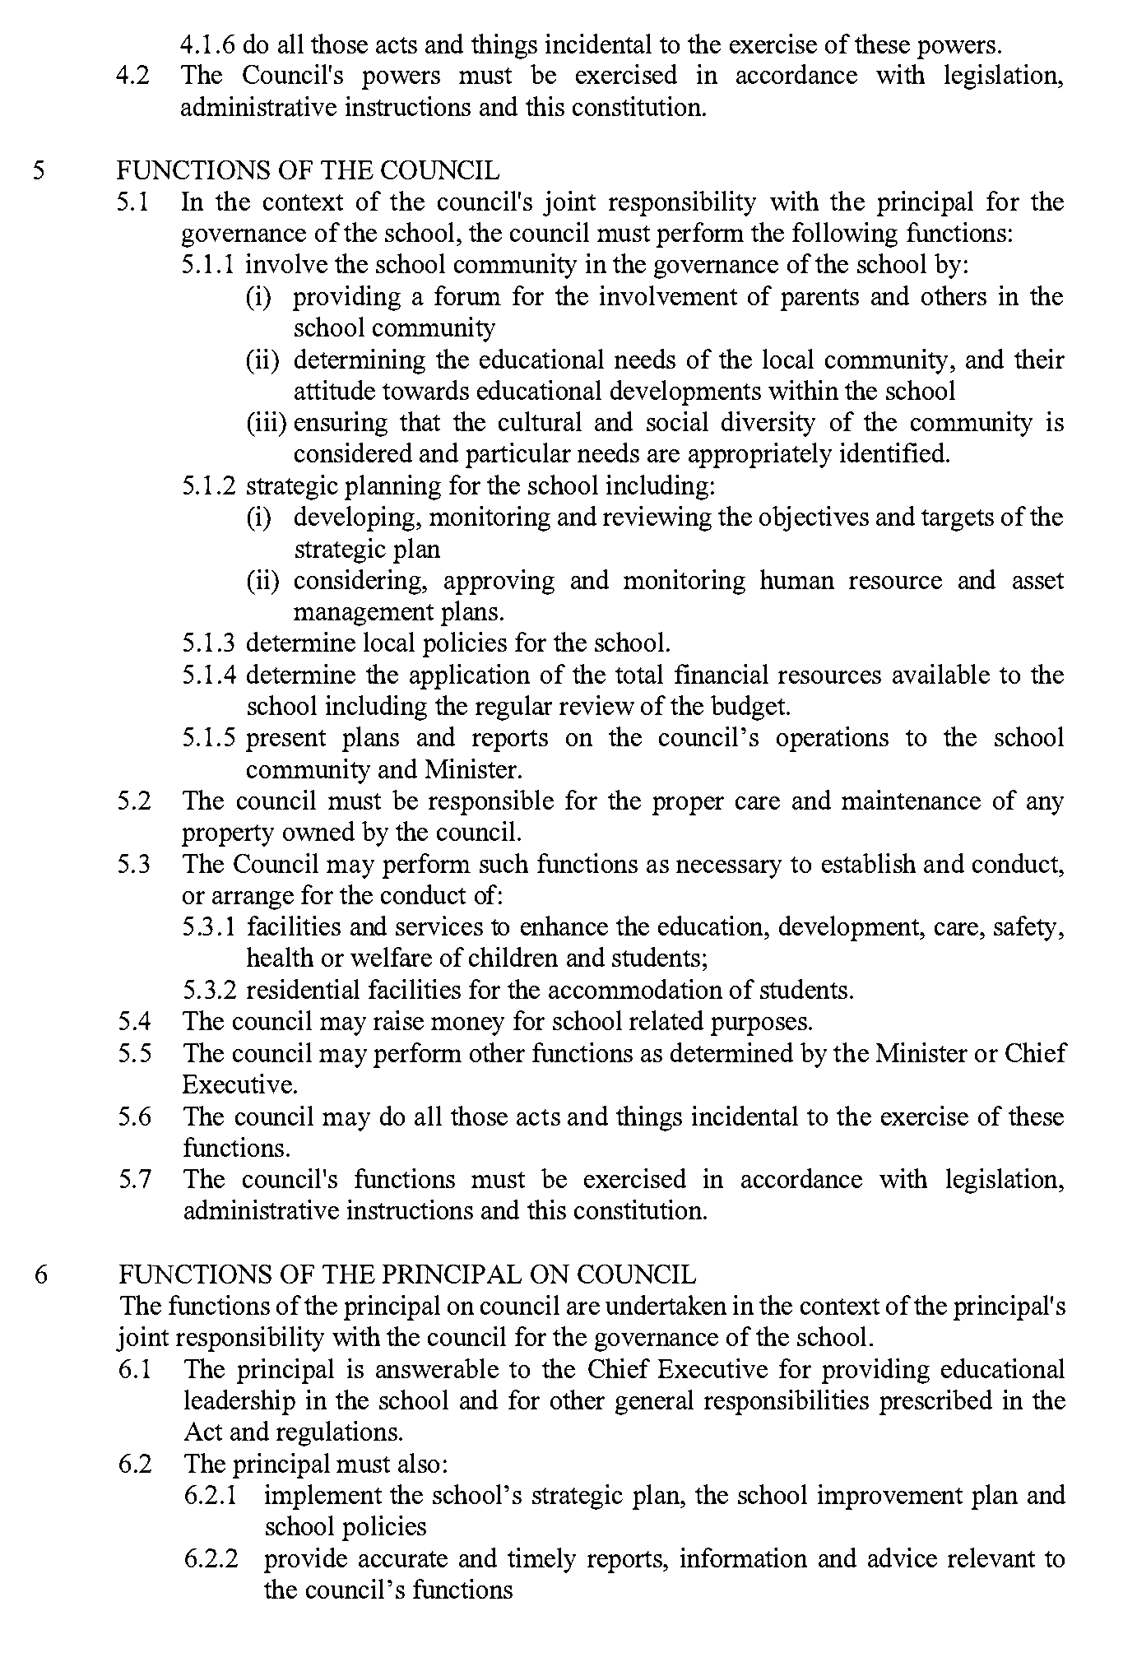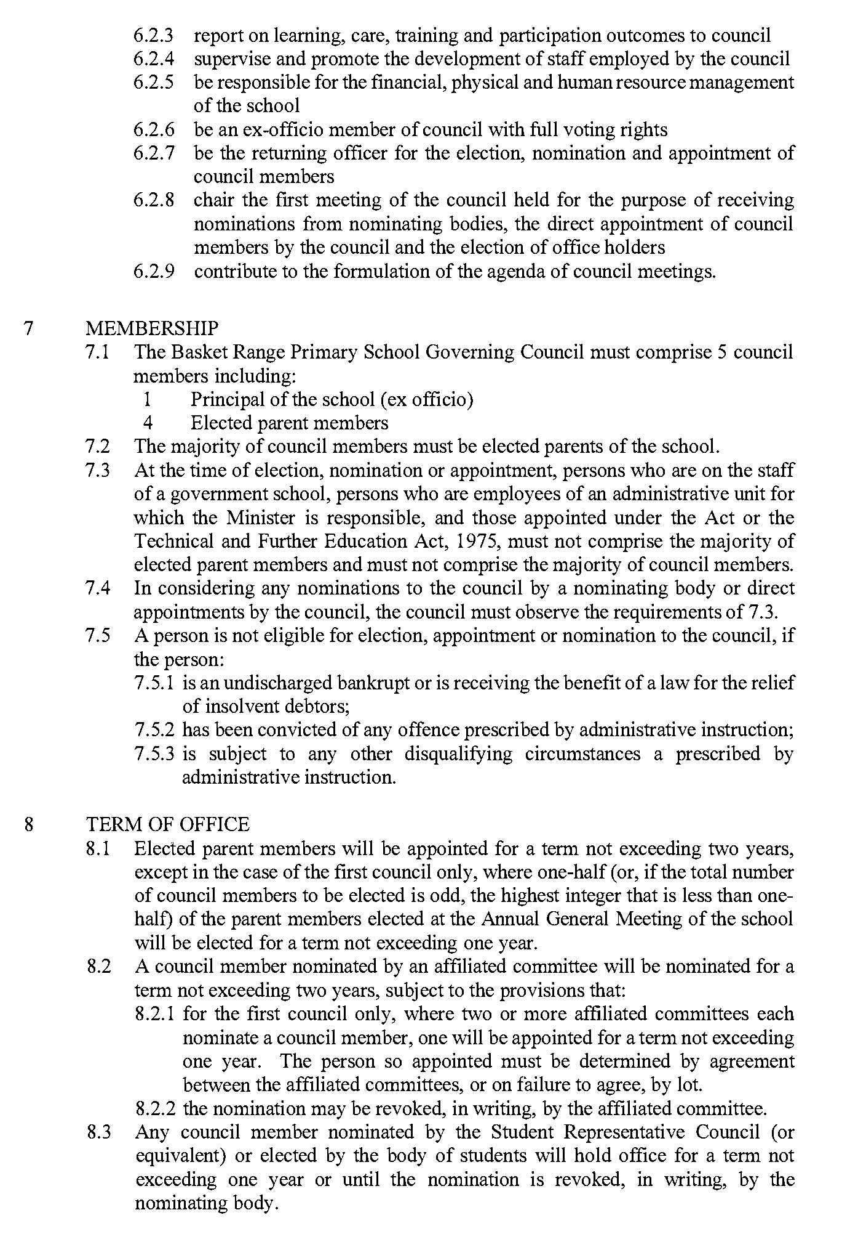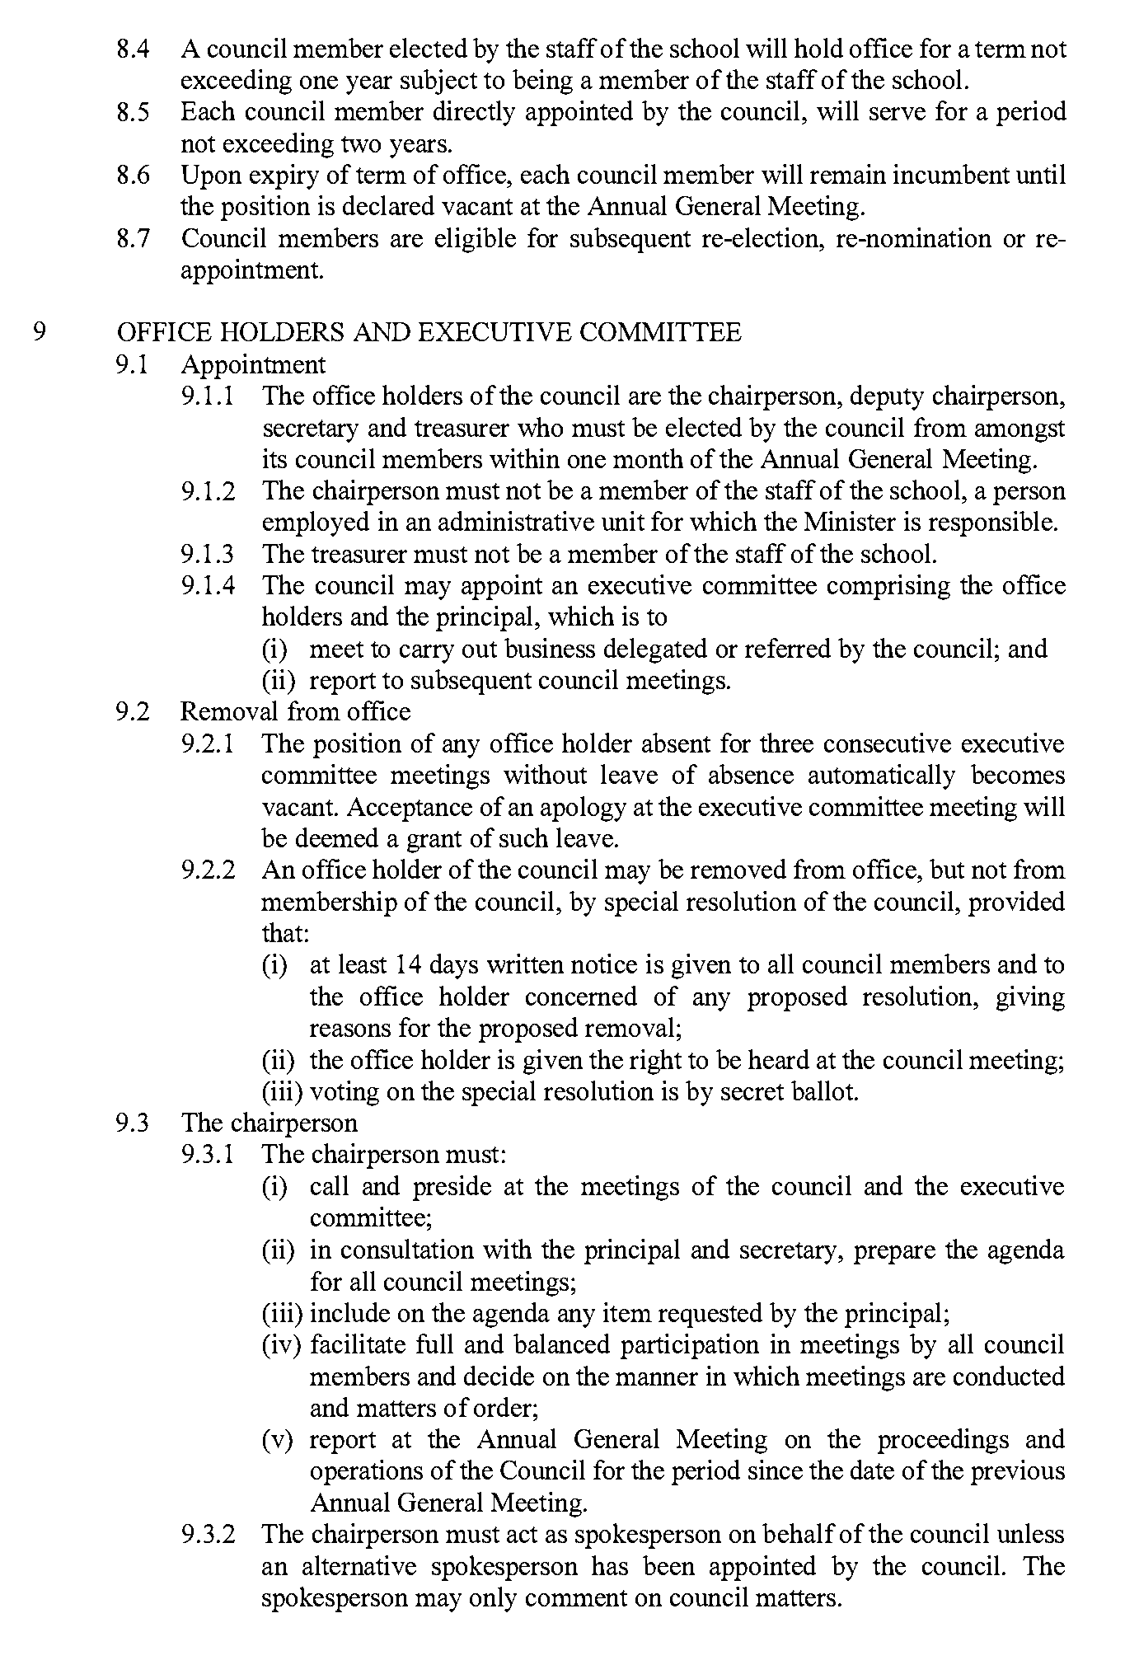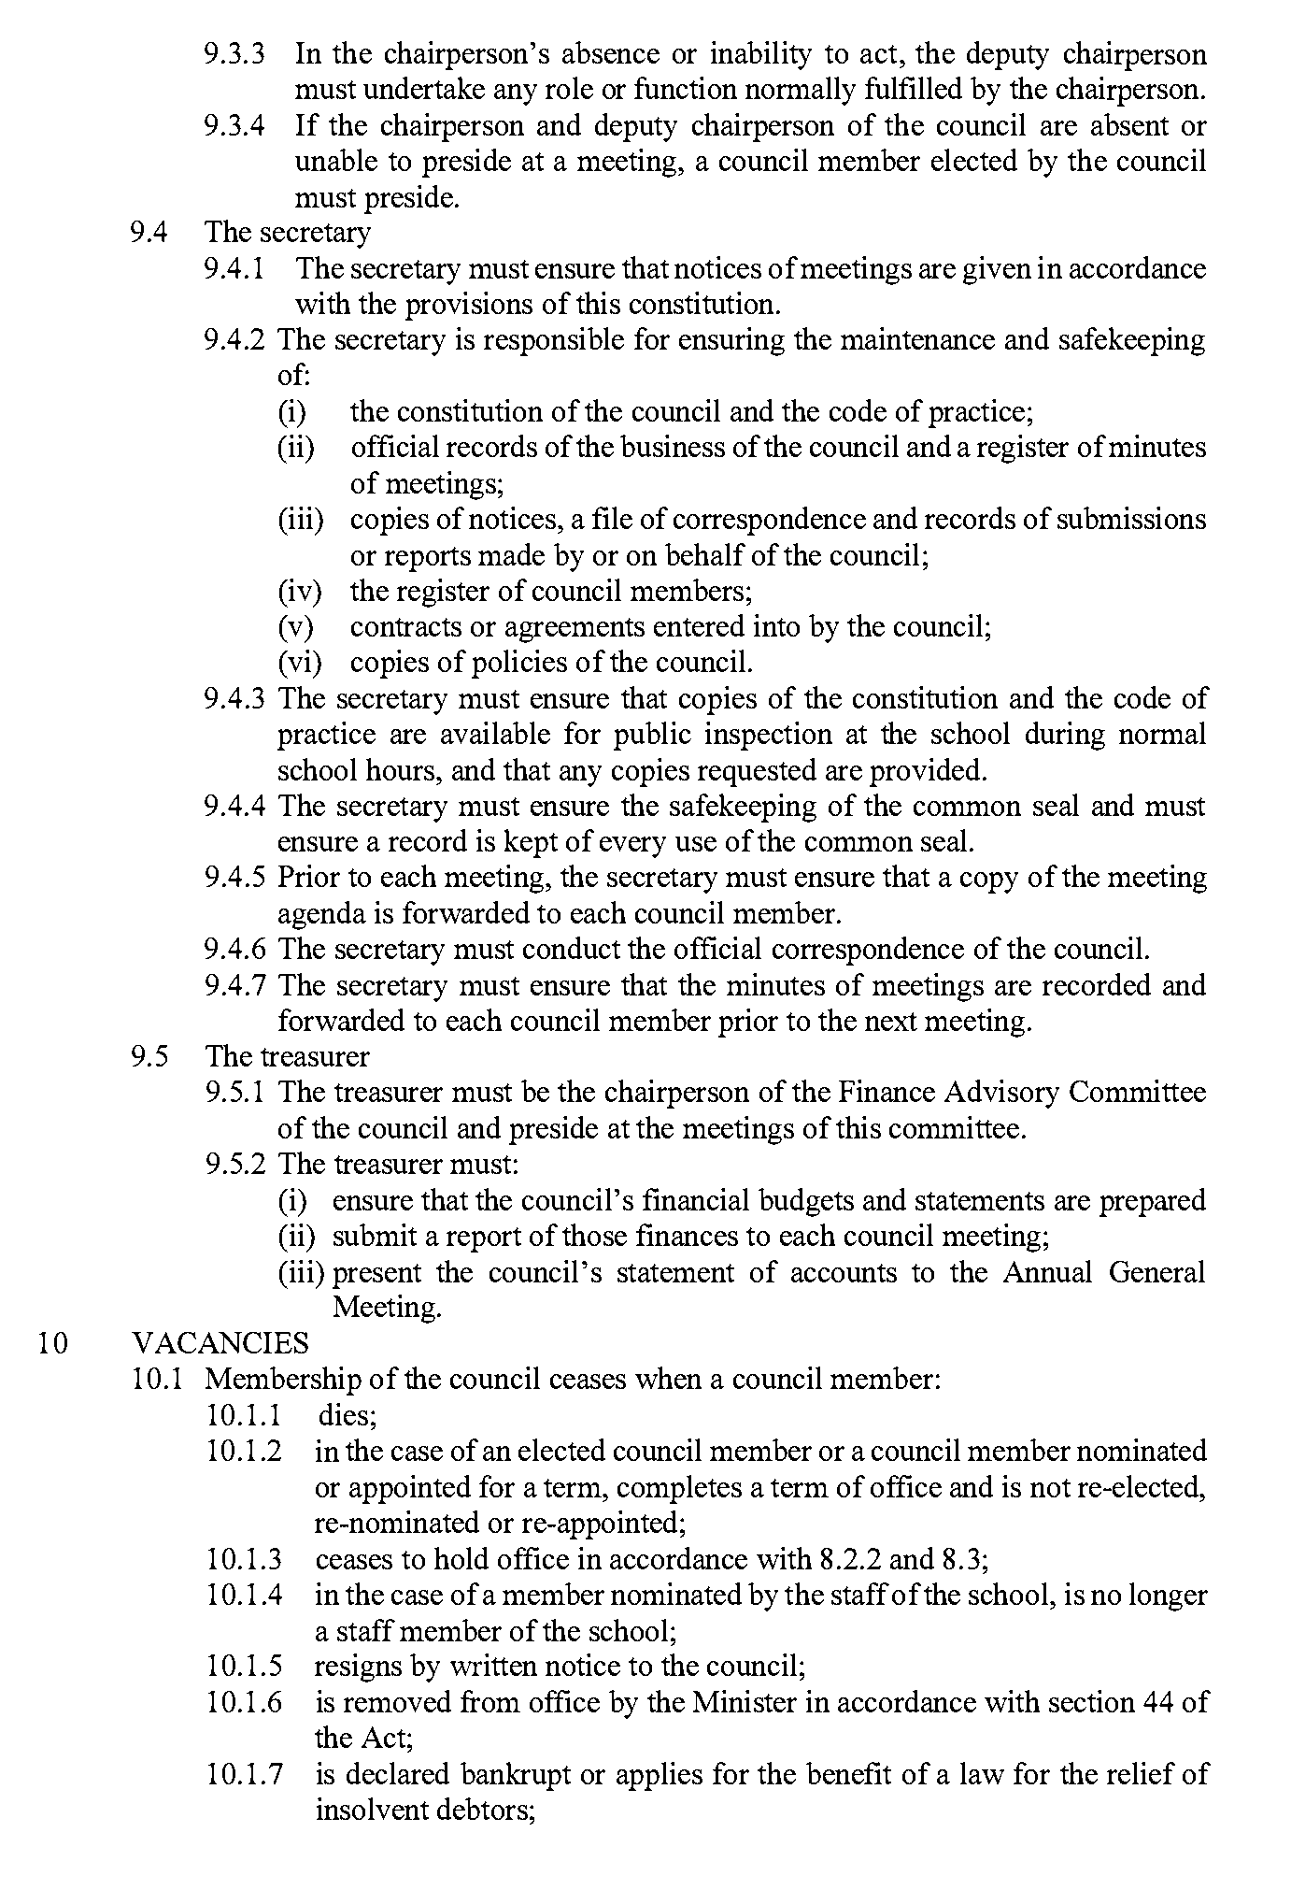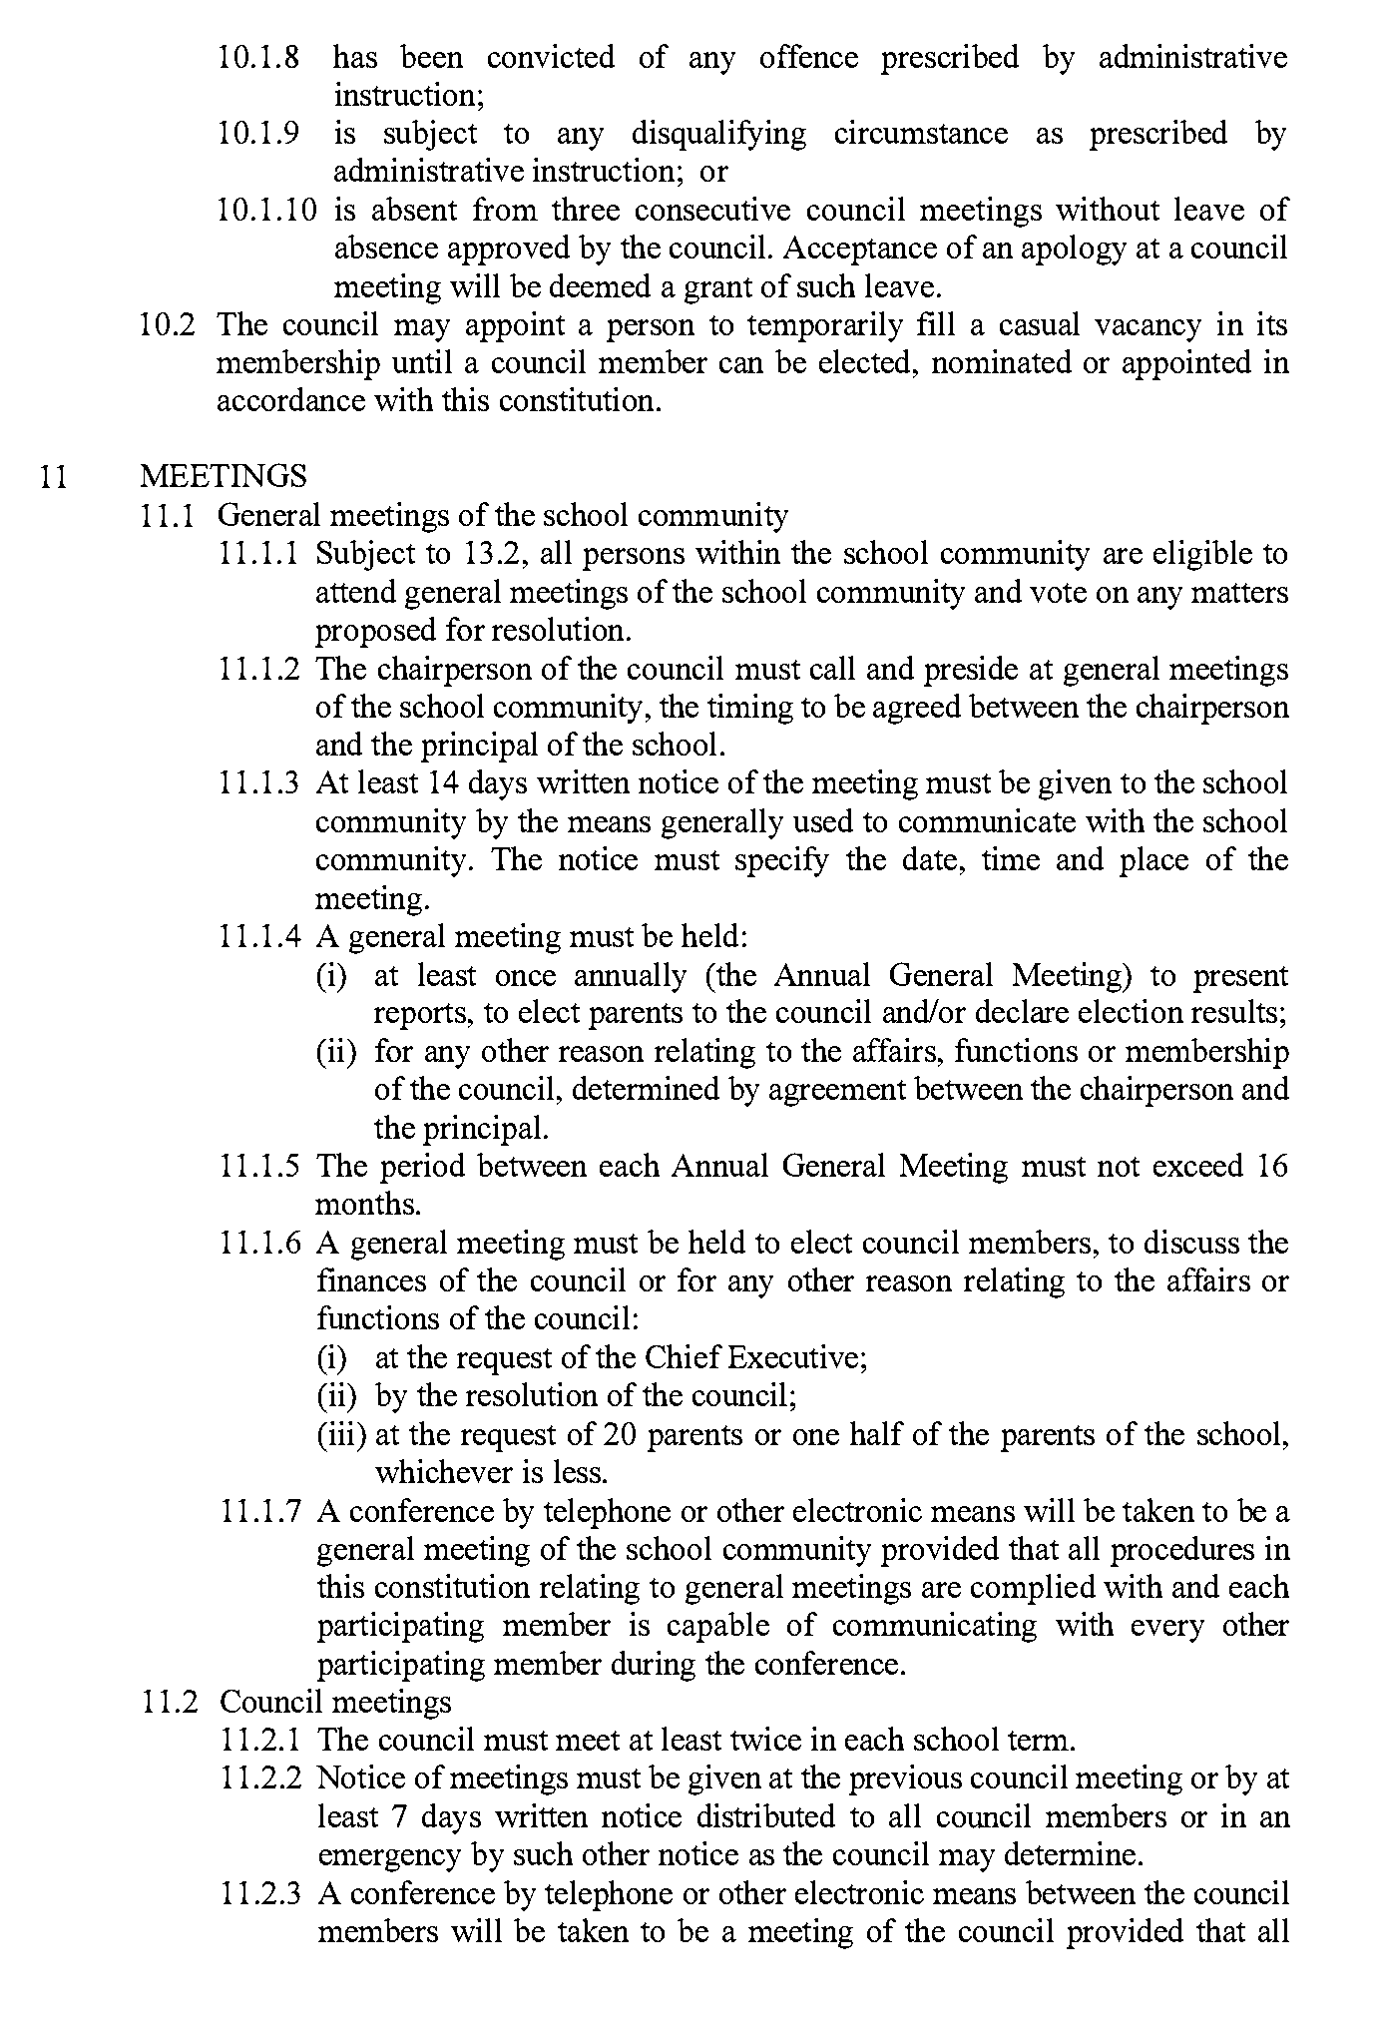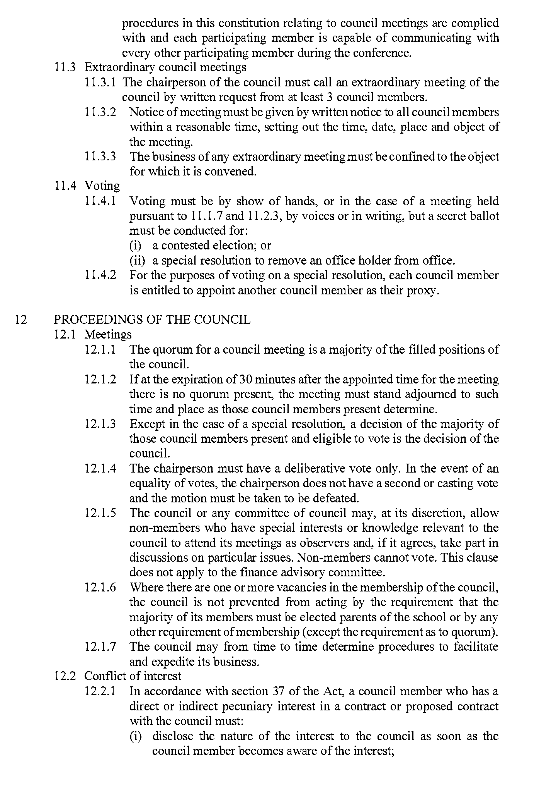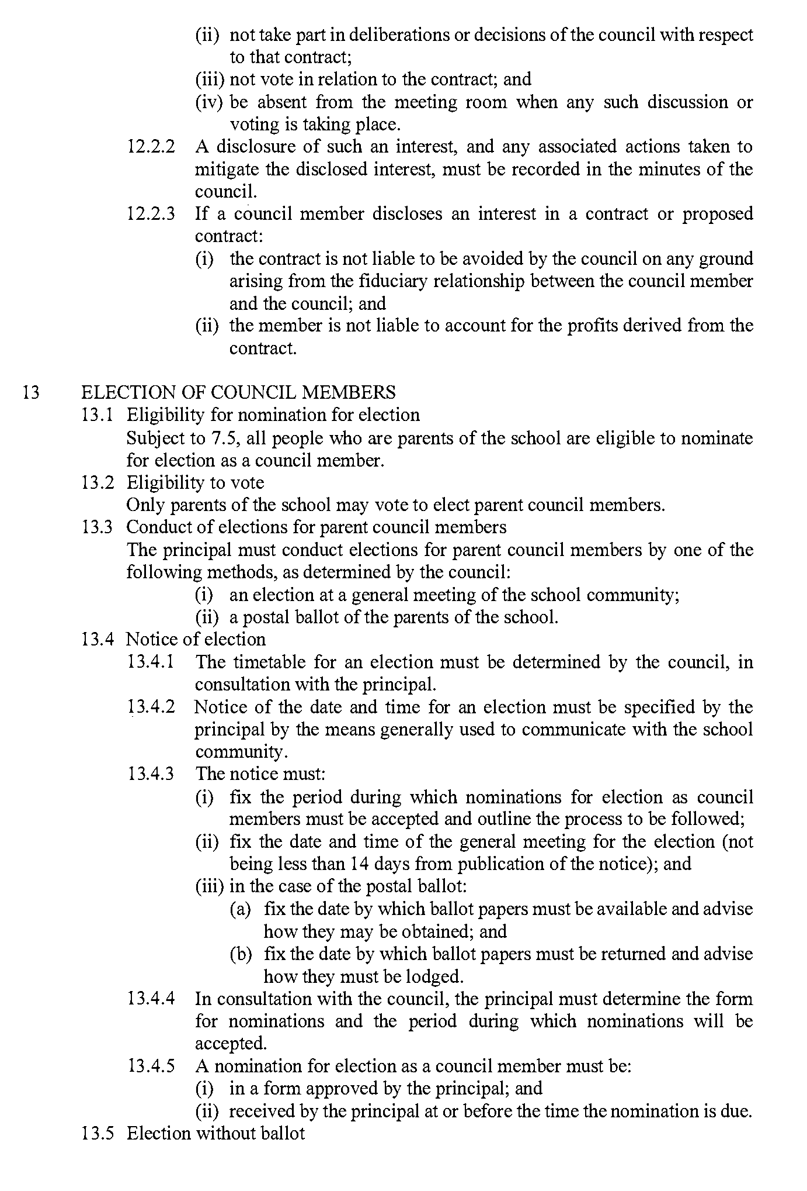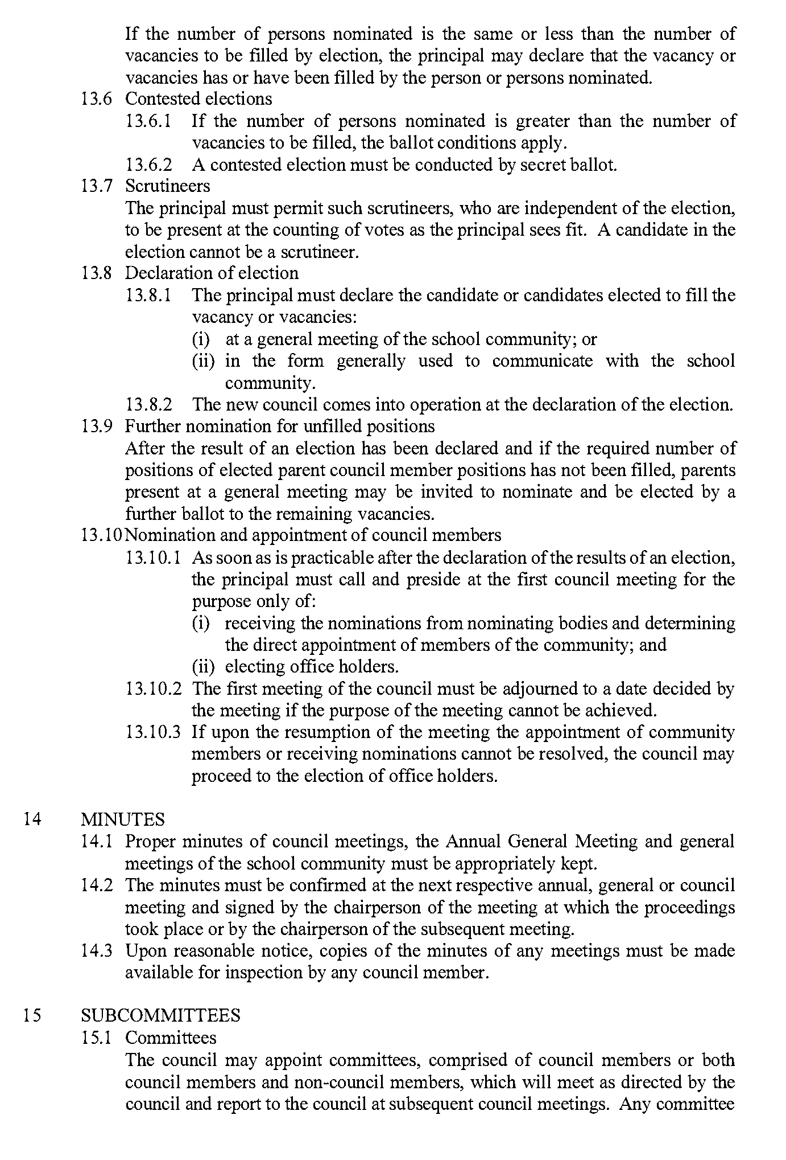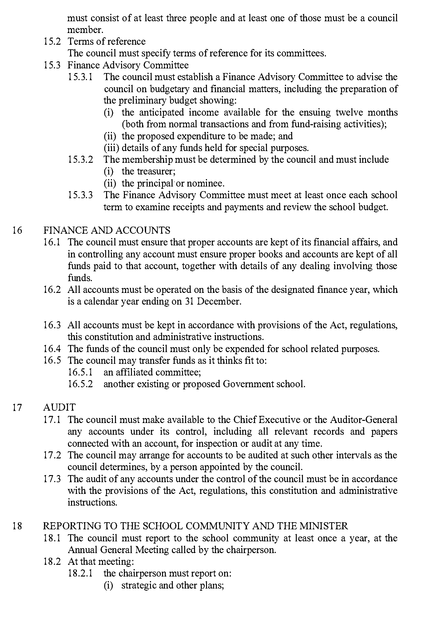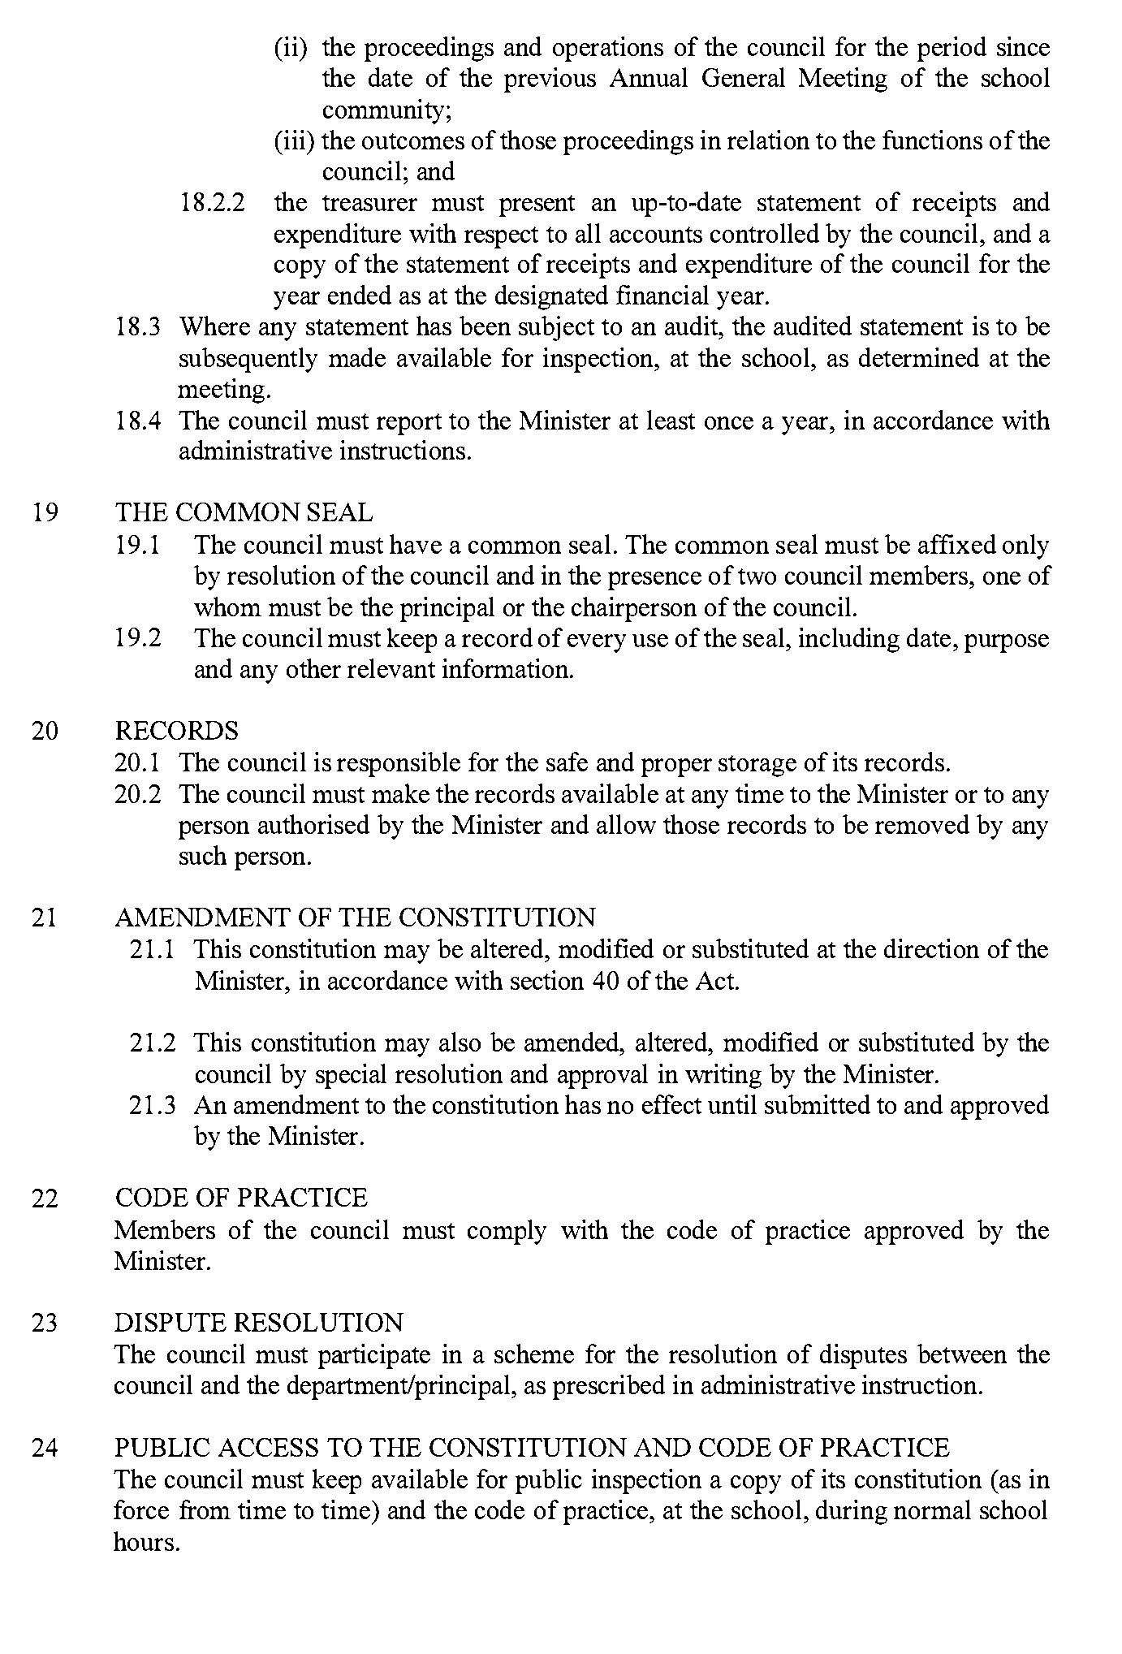
Dated: 21 February 2022
Kathryn Bruggeman
Deputy Chief Executive, Schools and Preschools
Delegate of the Minister for Eduction

Housing Improvement Act 2016
Rent Control
The Minister for Human Services Delegate in the exercise of the powers conferred by the Housing Improvement Act 2016, does hereby fix the maximum rental per week which shall be payable subject to Section 55 of the Residential Tenancies Act 1995, in respect of each house described in the following table. The amount shown in the said table shall come into force on the date of this publication in the Gazette.
Address of Premises | Allotment Section | Certificate of Title Volume/Folio | Maximum Rental per week payable
76A Garrett Road, Glossop SA 5344 | Section 386 Berri Irrigation Area | CT 5457/343 | $0.00
82 Stakes Crescent, Elizabeth Downs  SA 5113 | Allotment 19 Deposited Plan 48810  Hundred of Munno Para | CT 5511/278 | $0.00
84 Stakes Crescent, Elizabeth Downs  SA 5113 | Allotment 18 Deposited Plan 48810  Hundred of Munno Para | CT 5511/277 | $0.00
Dated: 22 February 2024
Craig Thompson
Housing Regulator and Registrar
Housing Safety Authority, SAHA
Delegate of Minister for Human Services

Housing Improvement Act 2016
Rent Control Revocations
Whereas the Minister for Human Services Delegate is satisfied that each of the houses described hereunder has ceased to be unsafe or unsuitable for human habitation for the purposes of the Housing Improvement Act 2016, notice is hereby given that, in exercise of the powers conferred by the said Act, the Minister for Human Services Delegate does hereby revoke the said Rent Control in respect of each property.
Address of Premises | Allotment Section | Certificate of Title Volume/Folio
61 Kitchener Street, Peterborough SA 5422 | Allotment 105 Deposited Plan 58947  Hundred of Yongala | CT5874/976
16 Oakley Street, Adelaide SA 5000  (Main house - rear flat) | Allotment 91 Filed Plan 207381 Hundred of Adelaide | CT5834/484
57 Park Street, Hyde Park SA 5061 | Allotment 2 Deposited Plan 915 Hundred of Adelaide | CT5642/528
36 Cavendish Avenue, Devon Park SA 5008 | Allotment 361 Deposited Plan 44312 Hundred of Yatala | CT6122/542
281 Gilbert Street, Adelaide SA 5000 | Allotment 136 Filed Plan 182598 Hundred of Yatala | CT6159/149
Dated: 22 February 2024
Craig Thompson
Housing Regulator and Registrar
Housing Safety Authority, SAHA
Delegate of Minister for Human Services

Land Acquisition Act 1969
Section 16
Form 5—Notice of Acquisition
1. Notice of acquisition
The Commissioner of Highways (the Authority), of 83 Pirie Street, Adelaide SA 5000, acquires the following interests in the following land:
Comprising an unencumbered estate in fee simple in that piece of land being the whole of Allotment 84 in Filed Plan 19717 comprised in Certificate of Title Volume 5749 Folio 728.
This notice is given under Section 16 of the Land Acquisition Act 1969.
2. Compensation
A person who has or had an interest consisting of native title or an alienable interest in the land that is divested or diminished by the acquisition or the enjoyment of which is adversely affected by the acquisition who does not receive an offer of compensation from the Authority may apply to the Authority for compensation.
2A. Payment of professional costs relating to acquisition (Section 26B)
If you are the owner in fee simple of the land to which this notice relates, you may be entitled to a payment of up to $10,000 from the Authority for use towards the payment of professional costs in relation to the acquisition of the land.
Professional costs include legal costs, valuation costs and any other costs prescribed by the Land Acquisition Regulations 2019.
3. Inquiries
Inquiries should be directed to: William Ridgway
GPO Box 1533
Adelaide SA 5001
Telephone: 08 7133 2465
Dated: 19 February 2024
The Common Seal of the COMMISSIONER OF HIGHWAYS was hereto affixed by authority of the Commissioner in the presence of:
Rocco Caruso
Manager, Property Acquisition
(Authorised Officer)
Department for Infrastructure and Transport
DIT 2023/01342/01

Land Acquisition Act 1969
Section 16
Form 5—Notice of Acquisition
1. Notice of acquisition
The Commissioner of Highways (the Authority), of 83 Pirie Street, Adelaide SA 5000, acquires the following interests in the following land:
Comprising an unencumbered estate in fee simple in that piece of land being the whole of Allotment 23 in Deposited Plan 1999 comprised in Certificate of Title Volume 5776 Folio 380.
This notice is given under Section 16 of the Land Acquisition Act 1969.
2. Compensation
A person who has or had an interest consisting of native title or an alienable interest in the land that is divested or diminished by the acquisition or the enjoyment of which is adversely affected by the acquisition who does not receive an offer of compensation from the Authority may apply to the Authority for compensation.
2A. Payment of professional costs relating to acquisition (Section 26B)
If you are the owner in fee simple of the land to which this notice relates, you may be entitled to a payment of up to $10,000 from the Authority for use towards the payment of professional costs in relation to the acquisition of the land.
Professional costs include legal costs, valuation costs and any other costs prescribed by the Land Acquisition Regulations 2019.
3. Inquiries
Inquiries should be directed to: Rob Gardner
GPO Box 1533
Adelaide SA 5001
Telephone: 08 7133 2415
Dated: 19 February 2024
The Common Seal of the COMMISSIONER OF HIGHWAYS was hereto affixed by authority of the Commissioner in the presence of:
Rocco Caruso
Manager, Property Acquisition
(Authorised Officer)
Department for Infrastructure and Transport
DIT 2022/02874/01

Land Acquisition Act 1969
Section 16
Form 5—Notice of Acquisition
1. Notice of acquisition
The Commissioner of Highways (the Authority), of 83 Pirie Street, Adelaide SA 5000, acquires the following interests in the following land:
Comprising an unencumbered estate in fee simple in that piece of land being the whole of Allotment 27 in Deposited Plan 1563 comprised in Certificate of Title Volume 5479 Folio 302.
This notice is given under Section 16 of the Land Acquisition Act 1969.
2. Compensation
A person who has or had an interest consisting of native title or an alienable interest in the land that is divested or diminished by the acquisition or the enjoyment of which is adversely affected by the acquisition who does not receive an offer of compensation from the Authority may apply to the Authority for compensation.
2A. Payment of professional costs relating to acquisition (Section 26B)
If you are the owner in fee simple of the land to which this notice relates, you may be entitled to a payment of up to $10,000 from the Authority for use towards the payment of professional costs in relation to the acquisition of the land.
Professional costs include legal costs, valuation costs and any other costs prescribed by the Land Acquisition Regulations 2019.
3. Inquiries
Inquiries should be directed to: Petrula Pettas
GPO Box 1533
Adelaide SA 5001
Telephone: 08 7133 2457
Dated: 20 February 2024
The Common Seal of the COMMISSIONER OF HIGHWAYS was hereto affixed by authority of the Commissioner in the presence of:
Rocco Caruso
Manager, Property Acquisition
(Authorised Officer)
Department for Infrastructure and Transport
DIT 2022/17845/01

Land Acquisition Act 1969
Section 16
Form 5—Notice of Acquisition
1. Notice of acquisition
The Commissioner of Highways (the Authority), of 83 Pirie Street, Adelaide SA 5000, acquires the following interests in the following land:
Comprising an unencumbered estate in fee simple in that piece of land being the whole of Allotment 88 Filed plan 122235 comprised in Certificate of Title Volume 5999 Folio 372.
This notice is given under Section 16 of the Land Acquisition Act 1969.
2. Compensation
A person who has or had an interest consisting of native title or an alienable interest in the land that is divested or diminished by the acquisition or the enjoyment of which is adversely affected by the acquisition who does not receive an offer of compensation from the Authority may apply to the Authority for compensation.
2A. Payment of professional costs relating to acquisition (Section 26B)
If you are the owner in fee simple of the land to which this notice relates, you may be entitled to a payment of up to $10,000 from the Authority for use towards the payment of professional costs in relation to the acquisition of the land.
Professional costs include legal costs, valuation costs and any other costs prescribed by the Land Acquisition Regulations 2019.
3. Inquiries
Inquiries should be directed to: Daniel Tuk
GPO Box 1533
Adelaide SA 5001
Telephone: 08 7133 2479
Dated: 20 February 2024
The Common Seal of the COMMISSIONER OF HIGHWAYS was hereto affixed by authority of the Commissioner in the presence of:
Rocco Caruso
Manager, Property Acquisition
(Authorised Officer)
Department for Infrastructure and Transport
DIT 2023/05392/01

Land Acquisition Act 1969
Section 16
Form 5—Notice of Acquisition
1. Notice of acquisition
The Commissioner of Highways (the Authority), of 83 Pirie Street, Adelaide SA 5000, acquires the following interests in the following land:
First: Comprising an unencumbered estate in fee simple in that piece of land being the whole of Allotment 87 in Filed Plan 122234 comprised in Certificate of Title Volume 5798 Folio 528.
Secondly: Comprising an unencumbered estate in fee simple in that piece of land being the whole of Allotment 89 in Filed Plan 122236 comprised in Certificate of Title Volume 5798 Folio 527.
This notice is given under Section 16 of the Land Acquisition Act 1969.
2. Compensation
A person who has or had an interest consisting of native title or an alienable interest in the land that is divested or diminished by the acquisition or the enjoyment of which is adversely affected by the acquisition who does not receive an offer of compensation from the Authority may apply to the Authority for compensation.
2A. Payment of professional costs relating to acquisition (Section 26B)
If you are the owner in fee simple of the land to which this notice relates, you may be entitled to a payment of up to $10,000 from the Authority for use towards the payment of professional costs in relation to the acquisition of the land.
Professional costs include legal costs, valuation costs and any other costs prescribed by the Land Acquisition Regulations 2019.
3. Inquiries
Inquiries should be directed to: Daniel Tuk
GPO Box 1533
Adelaide SA 5001
Telephone: 08 7133 2479
Dated: 20 February 2024
The Common Seal of the COMMISSIONER OF HIGHWAYS was hereto affixed by authority of the Commissioner in the presence of:
Rocco Caruso
Manager, Property Acquisition
(Authorised Officer)
Department for Infrastructure and Transport
DIT 2023/05391/01

Motor Vehicles Act 1959
South Australia
Motor Vehicles (Conditional Registration—Recognition of Motor Vehicle Clubs) Notice 2024
under the Motor Vehicles Act 1959
1—Short title
This notice may be cited as the Motor Vehicles (Conditional Registration—Recognition of Motor Vehicle Clubs) Notice 2024
2—Commencement
This notice takes effect from the date it is published in the Gazette and replaces any previous recognition made by the Registrar of a motor vehicle club that is specified in Schedule 1 of this notice.
3—Interpretation
In this notice—
Act means the Motor Vehicles Act 1959;
Code of Practice means the ‘Code of Practice – Conditional Registration Scheme for Historic, Individually Constructed, Left-Hand Drive and Street Rod Vehicles’ published by the Department for Infrastructure and Transport;
Conditional Registration Scheme or Scheme means the scheme for conditional registration of historic, individually constructed, left hand drive, street rod and vehicles under section 25 of the Act and regulations 15 and 16 of the Motor Vehicles Regulations 2010;
Department means the Department for Infrastructure and Transport;
Federation means the Federation of Historic Motoring Clubs SA Incorporated;
MR334 form means an ‘Approval for Registration of Vehicle on the Conditional Registration Scheme (MR334)’;
Prescribed log book means a log book in a form approved by the Registrar;
Registrar means the Registrar of Motor Vehicles;
Regulations means the Motor Vehicles Regulations 2010.
4—Recognition of motor vehicles clubs
The motor vehicle clubs specified in Schedule 1 are, subject to the conditions set out in clause 5, recognised for the purposes of regulation 16 of the Regulations.
5—Conditions of recognition
A motor vehicle club specified in Schedule 1 must comply with the following conditions:
  - the club must maintain a constitution approved by the Registrar;
(b) the club must nominate and have members authorised by the Registrar (authorised persons). The club’s authorised person(s) are responsible for approving applicants and motor vehicles for registration under the Scheme. This includes confirming that Scheme applicants are financial members of a club; any other details as required by the Registrar on the MR334 form; and to inspect members’ vehicles when requested to do so by the Registrar;
(c) the club must issue a prescribed log book to club members for each of their vehicles to record vehicle use;
(d) the club must cancel a member’s prescribed log book when a member resigns, must ensure that a statutory declaration is provided when a member’s log book is lost or destroyed, must keep details of members’ prescribed log book return sheets and forward copies of the same to the Registrar or Federation annually as required;
(e) the club must create and maintain records detailing all its financial members, its authorised persons, all vehicles for which an MR334 form has been issued, all statutory declarations received and prescribed log books issued and returned to the club;
(f) the club must keep records for a period of 5 years from the date of the document and these records must include all duplicate MR334 forms, all records of motor vehicle inspections undertaken in accordance with paragraph (b), all statutory declarations provided by members for the purposes of paragraphs (d), all prescribed log books issued by reference to their serial number, the member’s name and the vehicle for which it was issued, and to make all such records available for inspection or provide copies of the records at the request of the Registrar for audit purposes;
(g) the club must ensure, as far as practicable, that all members comply with the Code of Practice;
(h) the club, as far as practicable, must report to the Registrar or the Federation details of members and motor vehicles not complying with the conditions and criteria set out in the Code of Practice for the Scheme;
(i) the club must provide to the Registrar, within 2 months of the end of the club’s financial year, an annual report detailing members from that financial year with vehicles registered under the Scheme who are no longer financial members of the club;
(j) the club must notify the Registrar, in writing, within 14 days of resolution to cease operation as a club and must provide the club records specified in paragraph (f) to the Registrar within 14 days of its dissolution;
Note—
Under regulation 16(3)(c) of the Motor Vehicles Regulations 2010, the Registrar may, by notice in the Gazette, withdraw the recognition of a motor vehicle club if satisfied that the club has contravened or failed to comply with a condition applying to its recognition by the Registrar, or if there is other good cause to withdraw the recognition.
Schedule 1—Recognised motor vehicle clubs
Historic, individually constructed, left-hand drive and street rod vehicles motor vehicle clubs
48 FJ HOLDEN CLUB OF SA
ACES ROD & CUSTOM CLUB INCORPORATED
ADELAIDE ANTIQUE AUTOMOBILE CLUB INC
ADELAIDE CAR CLUB INCORPORATED
ADELAIDE CRUISIN' CLASSICS INCORPORATED
ADELAIDE HILLS MOTOR RESTORERS CLUB INC
ADELAIDE HOT RODDERS INCORPORATED
ADELAIDE REV HEADS INCORPORATED
ALFA ROMEO OWNERS CLUB OF AUST INC SA DIV
ALL MAKES HISTORIC CAR CLUB INC
AMC RAMBLER CLUB OF AUSTRALIA INC
ARMS AND MILITARIA FEDERATION OF AUSTRALIA INC
ARMSTRONG SIDDELEY CAR CLUB
ATUJARA MOTOR CYCLE CLUB INC
AUSTIN 7 CLUB SA INC
AUSTIN HEALEY OWNERS CLUB OF SA INC
AUSTRALIAN MUSCLE CAR CLUB OF SOUTH AUSTRALIA INC
AUSTRALIAN STREET ROD FEDERATION INC
AUTO ENTHUSIASTS OF ADELAIDE
BAROSSA VALLEY CLASSIC MOTORCYCLE CLUB INC
BAROSSA VALLEY FORD CLUB INC
BAROSSA VALLEY GENERAL MOTORS OWNERS CLUB INC
BAROSSA VALLEY HISTORICALVEHICLE CLUB INC
BAROSSA VALLEY MACHINERY PRESERVATION SOCIETY INC
BENTLEY DRIVERS CLUB OF SOUTH AUSTRALIA INC
BLACK TOP CRUISERS HOT ROD CLUB INCORPORATED
BMW DRIVERS CLUB OF SA INC
BOLWELL CAR CLUB OF SOUTH AUSTRALIA INC
BORDERTOWN VEHICLE RESTORERS CLUB INC
BSA OWNERS CLUB OF SOUTH AUSTRALIA INC
BUS PRESERVATION ASSOCIATION OF SA INC
CADILLAC-LA SALLE CAR CLUB OF SA INC
CBX-6 OWNERS CLUB OF AUSTRALIA INC
CHEVROLET PERFORMANCE ASSOCIATION OF SA INC
CHRYSLER CAR CLUB OF SA INC
CHRYSLER RESTORERS CLUB OF AUSTRALIA SA INC
CITROEN SOCIETE SOUTH AUSTRALIA INC
CLASSIC AND MUSCLE CAR CLUB OF SA INC
CLUB AUTOMOBILE FRANCAIS INCORPORATED
CLUB CITROEN OF SOUTH AUSTRALIA INC
COAST RODDERS INCORPORATED
COFFEE N CHROME INCORPORATED
COMMODORE & CLASSIC HOLDEN ENTHUSIASTS
COMPACT FAIRLANE OWNERS CLUB OF AUSTRALIA INC
COORONG MECHANICAL RESTORATION CLUB INC
CORTINA CAPRI CAR CLUB OF SA INCORPORATED
CORVETTE CLUB OF SOUTH AUSTRALIA
DIRTY DEVILS CAR CLUB INCORPORATED
DUCATI OWNERS CLUB SA
E H HOLDEN CLUB SA INC
EARLY FORD V8 CLUB OF AMERICA SA CHAPTER 94 INC
EASTERN DISTRICTS HOT ROD CLUB INC
EASTERN HILLS ANTIQUE TRACTOR SOCIETY INC
FALCON CAR CLUB OF SOUTH AUSTRALIA
FALCON GT CLUB OF SOUTH AUSTRALIA INC
FB-EK HOLDEN CAR CLUB OF SOUTH AUSTRALIA INC
FE-FC HOLDEN CAR CLUB OF SA INCORPORATED
FERRARI CLUB AUSTRALIA INC
FIAT-LANCIA CAR CLUB OF SA
FORD 8 & 10 SIDEVALVE CLUB INC
FORD OWNERS CAR CLUB OF SOUTH AUSTRALIA INC
FORD RALLYE SPORT OWNERS CLUB OF SA INC
FORD T REGISTER OF AUSTRALIA INC
FX-HZ HOLDEN CAR CLUB OF SA INC
GAWLER TRACTOR AND ENGINE ASSOCIATION
GAWLER VETERAN VINTAGE & CLASSIC VEHICLE CLUB INC
GENERALS FX-FJ CLUB OF SA
HD/HR HOLDEN CAR CLUB OF SA INCORPORATED
HDT OWNERS CLUB (S.A.) INC
HILLMAN CAR CLUB OF SA INC
HISTORIC COMMERCIAL MOTORVEHICLE CLUB INCORPORATED
HISTORIC COMMERCIAL VEHICLE CLUB OF AUST SA BRANCH
HISTORIC MOTOR VEHICLES CLUB INC
HK-HT-HG OWNERS CAR CLUB OF SA INC
HOLDEN TORANA CLUB OF SA INC
HOLDENS OF AGE MOUNT GAMBIER
HONDA CAR CLUB OF SA INC
HSV OWNERS CLUB OF SA INCORPORATED
ILMO-INTERNATIONAL LIKE MINDED OWNERS INCORPORATED
ITALIAN MADE CARS CLUB INC
JAGUAR CLASSIC CAR CLUB INCORPORATED
JAGUAR DRIVERS CLUB OF SOUTH AUSTRALIA INC
JENSEN CAR CLUB AUSTRALIA
JUVENTUS MOTORCYCLE CLUB INCORPORATED
KANGAROO ISLAND MOTOR CLUB INCORPORATED
KAWASAKI Z OWNERS CLUB SA INC
KIMBA VINTAGE CAR CLUB INC
LAKE CITY ROD AND CUSTOM CLUB INCORPORATED
LAND ROVER HERITAGE SOCIETY INCORPORATED
LAND ROVER REGISTER OF SA INC
LEVIS MOTORCYCLE CLUB INCORPORATED
LEYLAND P76 OWNERS CLUB SA INCORPORATED
LINCOLN AUTO CLUB INC
LOWER MURRAY VINTAGE ENGINE & MACHINERY CLUB INC
M G CAR CLUB OF SA INCORPORATED
MAITLAND AUTOMOTIVE PRESERVATION SOCIETY INC
MANNUM CLASSIC VEHICLE CLUB INCORPORATED
MAZDA MX-5 CLUB OF SOUTH AUSTRALIA INCORPORATED
MERCEDES-BENZ CLUB OF SOUTH AUSTRALIA INC
MERCEDES-BENZ MOTORSPORT AND RESTORERS CLUB
MID-MURRAY CAR CLUB
MIL-LEL STEAM AND MACHINERY ASSOCIATION INC
MILANG VINTAGE MACHINERY CLUB INC
MILITARY VEHICLE PRESERVATION SOCIETY OF SA INC
MINI CLUB OF SA INC
MITSUBISHI 4WD CLUB SA INCORPORATED
MODEL A FORD CLUB OF SOUTH AUSTRALIA INC
MODEL T FORD CLUB OF AUSTRALIA INC
MODIFIED MINI CAR CLUB OF SA INC
MONARCHS HOT ROD CLUB INCORPORATED
MONARO CAR CLUB OF SA INCORPORATED
MORGAN CLASSIC AND CUSTOM VEHICLES CLUB INC
MORGAN OWNERS CLUB OF AUSTRALIA INCORPORATED
MORRIS CAR CLUB & MORRIS MINOR CAR CLUB OF SA INC
MORRIS REGISTER OF SA INC
MOTO ITALIA SA INC
MOUNT GAMBIER VETERAN & VINTAGE CAR CLUB INC
MOUNT LOFTY RANGERS 4WD CLUB
MR2 OWNERS' CLUB OF AUSTRALIA (SA CHAPTER) INC
MURRAY.MALLEE AUTO CLUB INCORPORATED
MUSTANG OWNERS CLUB OF AUST SOUTH AUSTRALIA INC
MUSTANGS ON THE MOVE INC
NARACOORTE HISTORIC VEHICLE CLUB INC
NATIONAL CADILLAC CLUB OF AUSTRALIA INCORPORATED
NISSAN DATSUN CAR CLUB OF SOUTH AUSTRALIA INC
NORTHERN DISTRICT MOTORSPORT ASSOCIATION INC
NORTHERN MUSCLE CAR CLUB OF SA INCORPORATED
NORTON MOTORCYCLE CLUB OF SA INC
OLDSMOBILE CLUB OF AUSTRALIA INCORPORATED
PEUGEOT CAR CLUB OF SOUTH AUSTRALIA INC
PIRIE AND DISTRICTS AUTOMOTIVE RESTORERS CLUB INC
PONTIAC CAR CLUB OF AUSTRALIA SA CHAPTER INC
PORSCHE CLUB OF SOUTH AUSTRALIA
PORT AUGUSTA VEHICLE RESTORERS CLUB INC
PUSH RODZ ROD & KUSTOM CLUB
R & S SERIES VALIANT CAR CLUB OF SA INCORPORATED
RAMRODDERS HOTROD CLUB INCORPORATED
RANGE ROVER CLUB OF AUSTRALIA - SA BRANCH INC
REBELS HOT ROD CLUB
RIVERLAND CUSTOMS & CLASSICS INC
RIVERLAND VINTAGE AND CLASSIC CAR CLUB INC
RIVERSIDE RODDERS INCORPORATED
ROAD RUNNERS CAR CLUB INC
ROADSTERS OF PORT ADELAIDE
ROLLS ROYCE OWNERS CLUB OF AUST SA BRANCH INC
ROVER CAR CLUB OF SOUTH AUSTRALIA INC
RS OWNERS CLUB SA
S.Y.P. HISTORIC VEHICLE CLUB INCORPORATED.
SA 4WD AND TOURING CLUB INCORPORATED
SCUDERIA ITALIAN CAR CLUB INCORPORATED
SEDAN HISTORIC ENTHUSIASTS DEN INC
SINGER CAR CLUB OF SOUTH AUSTRALIA INC
SOUTH AUSTRALIAN CHEV AND PONTIAC CLUB
SOUTH AUSTRALIAN DRAG RACERS ASSOCIATION INC
SOUTH AUSTRALIAN MOKE CLUB INC
SOUTH AUSTRALIAN ROD AND CUSTOM CLUB INC
SOUTH AUSTRALIAN SUPRA CLUB INCORPORATED
SOUTH EAST CLASSIC & UNIQUE CAR CLUB INC
SOUTH EAST DRAG RACING ASSOCIATION INC
SOUTH EAST STREET MACHINES INC
SOUTH EASTERN AUTOMOBILE CLUB OF SA INC
SOUTHERN DISTRICTS CAR CLUB INCORPORATED
SOUTHERN EARLYS FX-FJ CAR CLUB INCORPORATED
SOUTHERN PORTS VEHICLE & MOTOR RESTORERS CLUB INC
SOUTHERN ROD RUNNERS INCORPORATED
SOUTHERN STATE STREET RODDERS
SPEED KINGS HOT ROD CLUB
SPORTING CAR CLUB OF S A INCORPORATED
SPRITE CLUB OF SOUTH AUSTRALIA INC
STAG OWNERS CLUB OF AUSTRALIA SA BRANCH INC
STEEL CITY DRAG CLUB INCORPORATED
STRATHALBYN AUTO COLLECTORS CLUB INC
STREET MACHINE ASSOC OF SOUTH AUSTRALIA INC
STREET OUTLAWS CAR CLUB INCORPORATED
STUDEBAKER CAR CLUB OF AUSTRALIA SA INC
SUNBEAM CAR OWNERS CLUB OF SA INC
SWAMP RAT RODDERS INC
TAILEM BEND AUTO CLUB INCORPORATED
TEA TREE GULLY HISTORIC & CLASSIC VEHICLE CLUB
THE AMERICAN GM DRIVERS CLUB OF AUSTRALIA
THE AUSTRALIAN PORSCHE 356 REGISTER INC
THE AUTO COLLECTORS CLUB OF MURRAY BRIDGE INC.
THE BMW OWNERS CLUB OF SOUTH AUSTRALIA INC
THE CLASSIC OWNERS MOTORCYCLE CLUB INC SOUTH AUST
THE FORD F100 CLUB (AUST) INCORPORATED
THE HUMBER CLUB OF SOUTH AUSTRALIA INC
THE LAMBRETTA CLUB OF AUSTRALIA INCORPORATED
THE MAJESTIC VANNERS AUSTRALIA CLUB
THE NORTHERN AUTOMOTIVE RESTORATION CLUB SA INC
THE OLD MOTOR COMPANY OF SOUTH AUSTRALIA
THE PETERBOROUGH UNITED MACHINE PRESERVATION SOC
THE REAPERS HOT ROD & CUSTOM CAR CLUB ADEL AUST
THE RILEY MOTOR CLUB OF SA INC
THE VETERAN AND VINTAGE MOTOR CYCLE CLUB OF SA INC
THE VETERAN CAR CLUB OF SOUTH AUSTRALIA INC
THE VINTAGE SPORTS CAR CLUB OF SOUTH AUSTRALIA INC
TIN MEN CRUZERS' CLUB INCORPORATED
TORANA MOTORSPORT CLUB OF SA INC
TOYOTA LANDCRUISER CLUB OF AUSTRALIA (S.A.) INC
TR REGISTER AUSTRALIA INCORPORATED
TRI FIVE CLASSICS ASSOCIATION INCORPORATED
TRIUMPH SPORTS OWNERS ASSOCIATION SA BRANCH INC
ULYSSES CLUB INCORPORATED
UNITED MOTORCYCLE AND CAR CLUB INCORPORATED
UPPER SNUGGERY RACING TEAM CLUB
V8 STREETRODS AND CUSTOMS INC
VALLEY HOT RODDERS INC
VAUXHALL OWNERS CLUB OF AUSTRALIA SA BRANCH INC
VELOCETTE MOTOR CYCLE CLUB INCORPORATED
VET & VINT CHEVROLET AUTO ASSOC OF AUST SA BRANCH
VETERAN & VINTAGE MOTORCYCLE CLUB OF NYP INC
VINCENT HRD CLUB OF SOUTH AUSTRALIA INC
VINTAGE JAPANESE MOTORCYCLE CLUB
VOLKS ENTHUSIASTS CLUB SA INC
VOLKSWAGEN CLUB OF SA INC
VOLVO CAR CLUB OF SOUTH AUSTRALIA INC
WALKERVILLE ALL CARS CLUB INC
WANDERERS MOTOR CLUB ON EYRE INCORPORATED
WANDERERS ROCK N ROLL CAR CLUB INCORPORATED
WARTIME VEHICLE CONSERVATION GROUP INC
WESTERN DISTRICTS VINTAGE CAR CLUB
WHYALLA VINTAGE AND CLASSIC CAR CLUB INCORPORATED
WIDE FIVE ROLLERS INCORPORATED
ZEPHYR & ZODIAC OWNERS CLUB OF SA INC
Made by the Deputy Registrar of Motor Vehicles

On 15 February 2024

PLANNING, DEVELOPMENT AND INFRASTRUCTURE (GENERAL) REGULATIONS 2017
Notice of Decision—Regulation 57(1)
Determination of the form for a notice of a decision under Regulation 57(1)
Preamble
Regulation 57(1) of the Planning, Development and Infrastructure (General) Regulations 2017 provides that notice of a decision on an application under Part 7 of the Planning, Development and Infrastructure Act 2016 (other than Subdivision 4 of Division of that Part) must be given in a form determined by the Minister for Planning (being a form published by the Minister in the Gazette).
Notice
PURSUANT to Regulation 57(1) of the Planning, Development and Infrastructure (General) Regulations 2017, I, Troy Fountain, as the delegate of the Minister administering this regulation under the Planning, Development and Infrastructure Act 2016 (the Act), have determined that the form contained in ‘Attachment A’ comprises the form for a notice of a decision on an application for outline consent under section 120 of the Act given under Part 7 of that Act.
The form may be adapted into a digital format for use on the SA planning portal.
This notice will come into force on the date of its publication in the Government Gazette.
Dated: 22 February 2024
Troy Fountain
Manager, Commission Assessment
delegate of the Minister for Planning

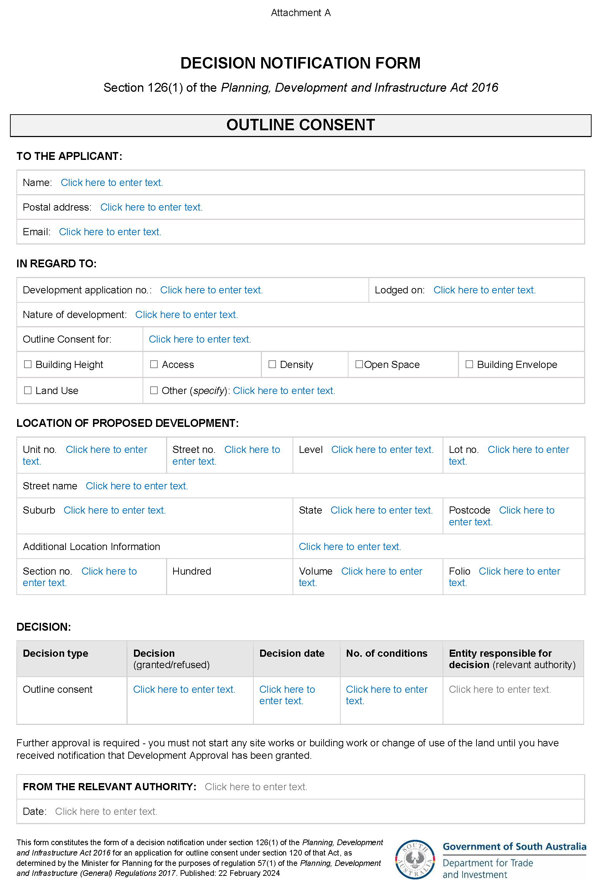

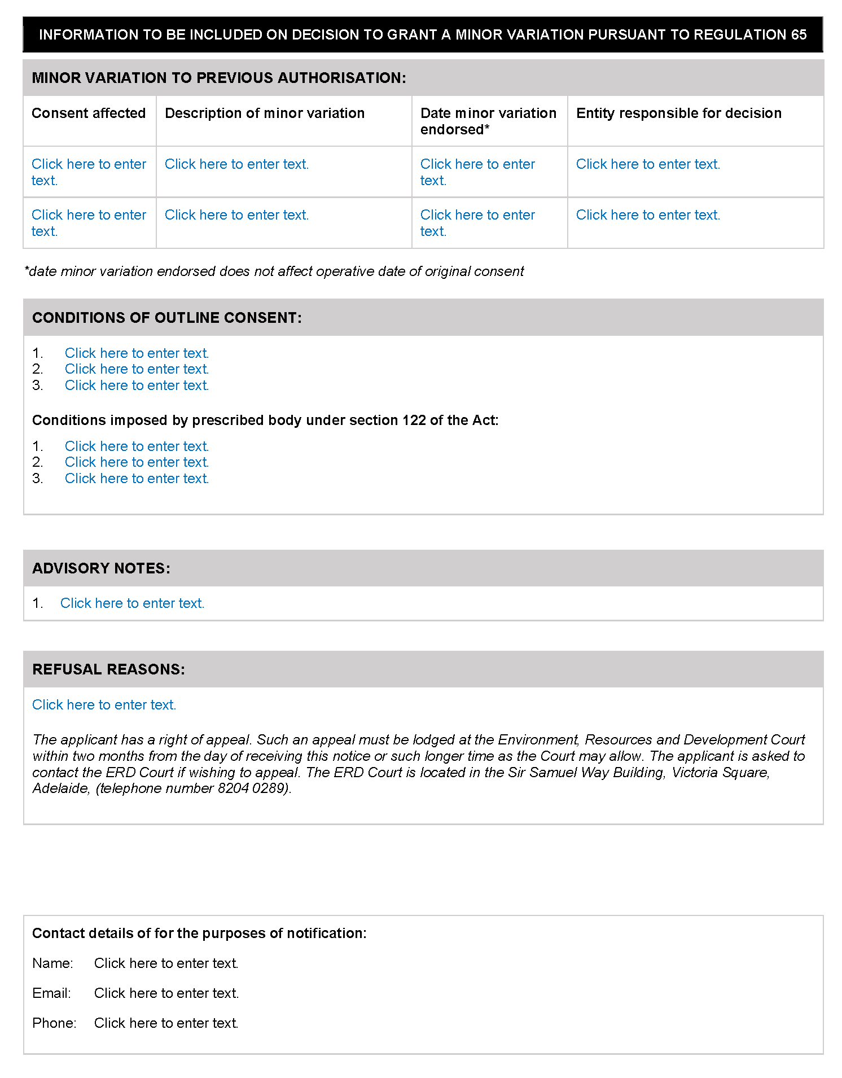

PLANNING, DEVELOPMENT AND INFRASTRUCTURE ACT 2016
Section 42
Practice Directions
Preamble
The State Planning Commission may issue a practice direction for the purposes of this Act.
A practice direction may specify procedural requirements or steps in connection with any matter arising under this Act.
A practice direction must be notified in the Gazette and published on the SA Planning Portal.
Notice
PURSUANT to Section 42(4)(a) of the Planning, Development and Infrastructure Act 2016, I, Marc Voortman, Director for Planning, as delegate of the State Planning Commission:
- give notice of new State Planning Commission Practice Direction 18 Outline Consent 2023; and
- fix the day on which State Planning Commission Practice Direction 18 Outline Consent 2023 is published on the SA Planning Portal as the day on which it will come into operation.
Dated: 9 February 2024
Marc Voortman
Director for Planning
delegate of the State Planning Commission

Planning, Development and Infrastructure Act 2016
South Australia
Planning, Development and Infrastructure (Fees) Notice 2024
under the Planning, Development and Infrastructure Act 2016
1—Short title
This notice may be cited as the Planning, Development and Infrastructure (Fees) Notice 2024.
Note—
This is a fee notice made in accordance with the Legislation (Fees) Act 2019.
2—Commencement
This notice has effect on the date of publication in the Gazette.
3—Interpretation
(1) In this notice, unless the contrary intention appears—
Act means the Planning, Development and Infrastructure Act 2016;
allotment does not include an allotment for road or open space requirements;
development cost does not include any fit-out costs;
regulations means the following:
(a) the Planning, Development and Infrastructure (Accredited Professionals) Regulations 2019;
(b) the Planning, Development and Infrastructure (Fees, Charges and Contributions) Regulations 2019;
(c) the Planning, Development and Infrastructure (General) Regulations 2017.
(2) Words and expressions used in the regulations and in this fee notice have the same respective meanings in this notice as they have in the regulations.
(3) Subclause (2) does not apply to the extent that the context or subject matter otherwise indicates or requires.
4—Fees payable
(1) The fees set out in Schedule 1 are prescribed for the purposes of the Act and the regulations and are payable as specified in that Schedule.
(2) A fee set out in Schedule 1 item 8 is payable to the body specified in relation to the fee.
(3) Subject to subclauses (4) and (5), if an application, matter or circumstance falls within more than 1 item under Schedule 1, then the fee under each such item applies and those fees in total will be payable.
(4) If planning consent is sought for development comprising more than 1 element—
(a) a fee is not payable under Schedule 1 item 6 for each element of the development; and
(b) the fee payable under Schedule 1 item 6 is the highest fee applying to a single element of the development; and
(c) if the relevant fee is based on the total development cost, the fee payable will be based on the total cost of all elements of the development.
(5) If an application for planning consent must be referred to the same body under more than 1 item of Schedule 9 of the Planning, Development and Infrastructure (General) Regulations 2017, then only 1 prescribed fee under Schedule 1 item 8 is payable with respect to the referral of the application to that body.
(6) A reference in subclause (5) to a prescribed fee extends to a prescribed fee that, although payable, was waived (in whole or in part) by a relevant authority.
(7) Subject to subclause (8) if a lodgement fee has been paid in respect of an application for planning consent or building consent for a development, no lodgement fee is payable for any other consents related to that application or for the issue of the final development approval in respect of that development.
(8) If a lodgement fee has been paid in respect of an application under the repealed Act, a lodgement fee under this notice is payable in respect of the first application for consent related to the application under the repealed Act that is lodged electronically via the SA planning portal.
5—Assessment requirements—water and sewerage
(1) A prescribed fee under Schedule 1 item 27 is payable to the South Australian Water Corporation or any other water industry entity identified for the purposes of section 102(1)(c)(iii) and (1)(d)(vii) of the Act.
(2) The prescribed fee is payable by the person who makes the application to divide the land.
6—Applications relating to certain electricity infrastructure—issue of certificate by Technical Regulator
The prescribed fee under Schedule 1 item 32 is payable to the Technical Regulator for the issue of a certificate required by the Planning, Development and Infrastructure (General) Regulations 2017 to accompany an application in respect of a proposed development for the purposes of the provision of electricity generating plant with a generating capacity of more than 5 MW that is to be connected to the State's power system.

Schedule 1—Fees
Part 1—Fees under Planning, Development and Infrastructure (Accredited Professionals) Regulations 2019
The following fees are payable for the purposes of the Planning, Development and Infrastructure (Accredited Professionals) Regulations 2019:

1 | Application to the accreditation authority for accreditation under the Planning, Development and Infrastructure (Accredited Professionals) Regulations 2019, other than where item 2 Applies—
 | (a) in the case of an application for accreditation as an accredited professional—planning level 1; and | $827.00
 | (b) in any other case | $610.00
2 | Application to the accreditation authority for accreditation under the Planning, Development and Infrastructure (Accredited Professionals) Regulations 2019 where the person is a member of a professional association or body recognised by the Chief Executive for the purposes of regulation 16(2)(a) of the Planning, Development and Infrastructure (Accredited Professionals) Regulations 2019 and the person is applying as a member of that association or body for a corresponding level of accreditation under regulation 16(2)(a)(ii) of those regulations | $294.00
3 | Application to the accreditation authority under regulation 19 of the Planning, Development and Infrastructure (Accredited Professionals) Regulations 2019 | $196.00
4 | Late application fee under regulation 19(3) of the Planning, Development and Infrastructure (Accredited Professionals) Regulations 2019 | $65.00

Part 2—Fees relating to development assessment
The following fees are payable in relation to development assessment under the Act (including in connection with the Planning, Development and Infrastructure (General) Regulations 2017):

5 | Application for outline consent, planning consent or building consent (the base amount)—
 | (a) a lodgement fee; and | $193.00
 | (b) if the application is lodged at the principal office of the relevant authority—a processing fee | $87.00
5a | Application for outline consent under section 120 of the Act | $6,000.00
6 | Application for planning consent—
 | (a) if the proposed development is to be assessed as deemed-to-satisfy development under section 106 of the Act—
 | (i) if the total development cost is no more than $10 000 | $138.00
 | (ii) in any other case | $228.00
 | (b) if the proposed development is to be assessed on its merits under section 107 of the Act | $272.00 or 0.125% of the total development cost up to a maximum of $200 000, whichever is the greater
 | (c) if the proposed development is restricted development under section 108(1)(a) of the Act
 | (i) if the proposed development is the division of land | $534.00
 | (ii) in any other case | 0.25% of the total development cost up to a maximum of $300 000
 | (d) if the applicant applies for a review of the decision under section 110(15) of the Act | $556.00
 | (e) if the proposed development is to be assessed as impact assessed development under section 111 of the Act—
 | (i) if the proposed development is declared as being impact assessed development by the Minister | $1,906.00 plus 0.25% of the total development cost up to a maximum of $500 000
 | (ii) in any other case | 0.25% of the total development cost up to a maximum of $500 000
7 | Application for planning consent that must be notified—
 | (a) if section 107(3)(a) applies | $272.00
 | (b) if section 110(2)(a) applies | $272.00
7a | Application for outline consent that must be notified | $272.00
8 | Application for outline consent or planning consent that must be referred to 1 or more prescribed bodies under Schedule 9 of the Planning, Development and Infrastructure (General) Regulations 2017—
 | (a) for referral to the Commissioner of Highways—
 | (i) if the proposed development involves a change in the use of land | $434.00
 | (ii) if the proposed development involves the division of land | $434.00
 | (b) for referral to the Environment Protection Authority  (i) non-licensable  (ii) licensable  (iii) site contamination | $807.00  $1,816.00  $1,494.00
 | (c) for referral to the Minister responsible for the administration of the Heritage Places Act 1993 | $434.00
 | (d) for referral to the Minister responsible for the administration of the River Murray Act 2003 | $434.00
 | (e) for referral to the Relevant authority under the Landscape South Australia Act 2019 | $434.00
 | (f) for referral to the Chief Executive of the Department of the Minister responsible for the administration of the Landscape South Australia Act 2019 | $434.00
 | (g) for referral to the Coast Protection Board | $434.00
 | (h) for referral to the Minister responsible for the administration of the Historic Shipwrecks Act 1981 | $434.00
 | (i) for referral to the Commonwealth Minister responsible for the administration of the Underwater Cultural Heritage Act 2018 of the Commonwealth | $434.00
 | (j) for referral to the Native Vegetation Council | $696.00
 | (k) for referral to the Government Architect or Associate Government Architect | $530.00
 | (l) for referral to Minister responsible for the administration of the South Australian Housing Trust Act 1995 | $262.00 plus $163.00 per stage
 | (m) for referral to the Minister responsible for the administration of the Aquaculture Act 2001 | $450.00
 | (n) for referral to the South Australian Country Fire Service | $434.00
 | (o) for referral to Chief Executive of the Department of the Minister responsible for the administration of the Petroleum and Geothermal Energy Act 2000 | $356.00
 | (p) for referral to the Minister responsible for the administration of the Mining Acts | $356.00
 | (q) for referral to the Technical Regulator | $182.00
 | (r) for referral to the Airport-operator company for the relevant airport within the meaning of the Airports Act 1996 of the Commonwealth or, if there is no airport-operator company, Secretary of the Department of the Minister responsible for the administration of the Airports Act 1996 of the Commonwealth | $434.00
9 | Application for building consent (a building assessment fee)—
 | (a) for a Class 1 building under the Building Code | $490.00 or 0.25% of the total development cost, whichever is the greater
 | (b) for a Class 10 building under the Building Code | $141.00 or 0.25% of the total development cost, whichever is the greater
 | (c) for any other class of building under the Building Code—
 | (i) if the total development cost is no more than $20 000 | $730.00
 | (ii) if the total development cost is greater than $20 000 and no more than $200 000 | $730.00 plus 0.4% of the amount determined by subtracting $20 000 from the total development cost
 | (iii) if the total development cost is greater than $200 000 and no more than $1 000 000 | $1,513.00 plus 0.25% of the amount determined by subtracting $200 000 from the total development cost
 | (iv) if the total development cost is greater than $1 000 000 | $3,692.00 plus 0.15% of the amount determined by subtracting $1 000 000 from the total development cost
10 | Application for building consent (a compliance fee)—
 | (a) for a Class 1 building under the Building Code or a swimming pool or swimming pool safety features | $262.00
 | (b) for a Class 1 building under the Building Code if the building comprises multiple dwellings | $262.00 for each dwelling
 | (c) for a Class 10 building under the Building Code—
 | (i) if the total development cost is no more than $10 000 | no fee
 | (ii) if the total development cost is greater than $10 000 | $87.00
 | (d) for any other class of building under the Building Code | Once per building – $262.00 or 0.075% of the total development cost up to a maximum of $2,724.00, whichever is the greater
11 | Application for building consent for the demolition of a building | $158.00
12 | Application for the concurrence of the Commission under section 118(2)(a) of the Act | $376.00
13 | Referral of application to the Commission for an opinion under section 118(4) of the Act | $376.00
14 | Application for a development authorisation under section 102(1)(c) or (d) of the Act—
 | (a) if the number of allotments resulting from the division is equal to or less than the existing number of allotments, or creates no more than 4 additional allotments and does not involve the creation of a public road | $191.00
 | (b) if the division creates more than 4 additional allotments | $191.00 plus $17.40 for each additional allotment created
 | (c) if the division involves the creation of a public road (regardless of the number of additional allotments created) | $191.00 plus $17.40 for each additional allotment created
15 | Application for final development approval in respect of HomeBuilder development (fee payable to the council for the area in which the proposed development is to be undertaken) | $128.00
16 | Advice of the Commission under regulation 76 of the Planning, Development and Infrastructure (General) Regulations 2017 (payable by the applicant at the time of lodgement of the application) | $218.00
17 | A Certificate of Approval Fee for the purposes of section 138 of the Act | $1,120.00
18 | Application under section 130 or 131 of the Act (fee payable to the Commission) | $193.00 plus 0.25% of the total development cost up to a maximum of $300 000
19 | Amount for public notice under section 131(13)(a) of the Act (amount payable to the Commission) | An amount determined by the Commission as being appropriate to cover its reasonable costs in giving public notice of the application under section 131(13)(a) of the Act
20 | Application for a variation of a development authorisation previously given that is minor in nature | $138.00
21 | Application to assessment panel for review of a prescribed matter under section 202(1)(b)(i)(A) of the Act | $556.00

Part 3—Fees relating to building activity and use
The following fees are payable in relation to building activity and use (including in connection with the Planning, Development and Infrastructure (General) Regulations 2017):

22 | Issue of a certificate relating to essential safety provisions under regulation 94 of the Planning, Development and Infrastructure (General) Regulations 2017 | $262.00
23 | Application for assignment of a classification to a building or a change in the classification of a building under section 151 of the Act | $184.00
24 | Application for a certificate of occupancy under section 152 of the Act | $54.50

Part 4—Funds and off-set schemes
The following fees are payable in relation to funds and off-set schemes:

25 | Rates of contribution under section 198(1)(d), (2)(c) or (8) of the Act—
 | (a) where the land to be divided is within Greater Adelaide | $8,453.00 for each new allotment or strata lot delineated by the relevant plan that does not exceed 1 hectare in area
 | (b) where the land to be divided is within any other part of South Australia | $3,394.00 for each new allotment or strata lot delineated by the relevant plan that does not exceed 1 hectare in area
26 | Rates of contribution for the purposes of section 199(1) of the Act—
 | (a) where the prescribed building is within Greater Adelaide | $8,453.00 for each apartment or allotment delineated by the relevant plan
 | (b) where the prescribed building is within any other part of South Australia | $3,394.00 for each apartment or allotment delineated by the relevant plan
Part 5—Other fees
The following fees are also payable:

27 | An assessment, or the update of an assessment, under regulation 79 of the Planning, Development and Infrastructure (General) Regulations 2017—
 | (a) in relation to an original assessment | $438.00
 | (b) in relation to an updating of the original or a subsequent assessment (including where the update is required because of an amended plan of division) | $126.00
28 | Application for design review under section 121 of the Act | $107.00 plus the reasonable costs of the design panel to provide advice on the application
29 | Amount for the purposes of section 127(6) of the Act | $163.00 for each replacement tree that is not planted
29A | Amount for the purposes of the Urban Tree Canopy Offset Scheme established under section 197 of the Act—
 | - in relation to a small tree | $314.00
 | - in relation to a medium tree | $629.00
 | - in relation to a large tree | $1,258.00
30 | Application for the extension of a development authorisation under section 126(3) of the Act—
 | (a) if the development authorisation relates to development assessed as restricted development under section 108(1)(a) of the Act or impact assessed development under section 111 of the Act, or relates to development assessed under section 130 or 131 of the Act | $138.00
 | (b) in any other case | $116.00
31 | Request for initiation of infrastructure scheme under section 163(3)(b) of the Act | $3,999.00
32 | Certificate from Technical Regulator | $438.00
33 | Application to register an agreement under section 192 or 193 of the Act | $87.00
34 | Fee for the purposes of section 192(7) or 193(7) of the Act | $16.20
35 | Fee for approval under section 197(5) of the Act | $406.00
36 | Application for the approval of the Minister under section 235 of the Act | $173.00
37 | Application for approval of building envelope plan under regulation 19A(1) of the Planning, Development and Infrastructure (General) Regulations 2017 | $191.00 plus $17.40 for each allotment delineated under the building envelope plan
38 | Fee for consideration and publication of building envelope plan under regulation 19A(3) and (4) of the Planning, Development and Infrastructure (General) Regulations 2017 (payable by applicant at the time of making application for approval of building envelope plan) | $218.00
39 | Fee for registration as a Local Design Review Administrator under the Minister’s Design Review scheme established under section 121 of the Act | $588.00
40 | Fee for registration an Independent Design Review Administrator under the Minister’s Design Review scheme established under section 121 of the Act | $342.00
41 | Fee for consideration of a proposal to initiate an amendment to the Planning and Design Code under section 73(2)(b) of the Act | $5,879.00
42 | Fee for the publication of consultation of a proposed amendment of the Planning and Design Code under section 73(2)(b) of the Act | $9,300.00
43 | Fee for the consideration by the Minister of a proposed amendment to the Planning and Design Code under section 73(2)(b) of the Act | $8,979.00
44 | Fee for administration of implementing a code amendment adopted to by the Minister under section 73(2)(b) of the Act | $10,476.00
Made by the Minister for Planning
On 22 February 2024

Retirement Villages Act 2016
Section 5(2)
Exemption from the Application of Section 57(1)
TAKE NOTICE that I, Chris Picton, Minister for Health and Wellbeing, pursuant to section 5(2) of the Retirement Villages Act 2016 (the Act), hereby exempt the Helping Hand North Adelaide Retirement Village, operated by Helping Hand Inc, from the requirements of section 57(1) of the Act, subject to the following conditions:
- this exemption applies only in respect of the units at 58 – 64 Buxton Street NORTH ADELAIDE (Roy Carter Court West).
- the exemption expires on 30 June 2024.
Dated: 15 February 2024
Chris Picton
Minister for Health and Wellbeing

Road Traffic Act 1961
Authorisation to Operate Breath Analysing Instruments
I, GRANT STEVENS, Commissioner of Police, do hereby notify that on and from 8 February, 2024, the following persons were authorised by the Commissioner of Police to operate breath analysing instruments as defined in and for the purposes of the:
• Road Traffic Act 1961;
• Harbors and Navigation Act 1993;
• Security and Investigation Industry Act 1995; and
• Rail Safety National Law (South Australia) Act 2012.
PD Number | Officer Name
12105 | AMMANN, Sharnie Renee
12766 | BALIC - BRETHERTON, Alana Jade
10450 | BRAIN, Laura Alexandra
76016 | CASSAR, Jacob Alexander
12470 | CLONAN, Ryan Thomas
10554 | FISHER, Lianne Marie
75636 | GOWLING, James Stuart
77056 | ISHERWOOD, Harrison Wright
76953 | MARTSCHINK, Alicia Kate
11954 | MCDONALD, Cain Jaden
77347 | MCLYNN, Darwin Timothy
76677 | SPINIELLO, Aaron James
Dated: 22 February 2024
Grant Stevens
Commissioner of Police
Reference: 2024-0001

The Remuneration Tribunal
Report—No. 18 of 2023
2023 Review of Remuneration for Official Visitors of Correctional Institutions
Introduction
- Section 14 of the Remuneration Act 1990 (SA) (Act) provides that the Remuneration Tribunal (Tribunal) has jurisdiction to determine the remuneration, or a specified part of the remuneration, payable in respect of certain offices, if such jurisdiction is conferred upon the Tribunal by any other Act or by the Governor by proclamation.
- Section 20B of the Correctional Services Act 1982 (SA) (CS Act) confers jurisdiction upon the Tribunal to make determinations of remuneration, allowances and expenses for Official Visitors of correctional institutions (Official Visitors).
Background
- Following amendments to the CS Act in 2021, the Tribunal made its inaugural Determination of remuneration for Official Visitors. The Tribunal determined full-day and half-day rates of pay. In 2022, having received an application from the Department for Correctional Services (DCS), the Tribunal included expenses for Official Visitors in its Determination.

Procedural History
- Section 10(2) of the Act provides that prior to the Tribunal making a Determination affecting the remuneration of a particular person, or persons of a particular class, the Tribunal must allow that person, or the persons of that class, a reasonable opportunity to make submissions orally or in writing to the Tribunal.
- Section 10(4) of the Act provides that the Minister responsible for the Act may intervene, personally or by counsel or other representative, in proceedings before the Tribunal for the purpose of introducing evidence, or making submissions, on any question relevant to the public interest.
- On 28 April 2023, the Tribunal wrote to Official Visitors, the Honourable Premier of South Australia (Premier), as the Minister responsible for the Act, and the Minister for Police, Emergency Services and Correctional Services, notifying of the Tribunal’s intent to conduct a review of its previous Determination in relation to Official Visitors. The Tribunal invited written submissions with a closing date of 26 May 2023.
- In addition, on 28 April 2023, a notification of the review was placed on the Tribunal’s public website.
The Review
- The Tribunal received the following submissions.
Department for Correctional Services Initial Submission
- DCS advised it has been able to observe and review the progress and functionality of the scheme, which commenced over twelve months ago.
- DCS provided three examples of inconsistencies it contended applied to the rates charged by Official Visitors.
- The first being that DCS provide Official Visitors with a report from the Prisoner Complaints Advice Line, which lists complaints for a one-month period. DCS submits there have been irregularities in rates charged with some Official Visitors charging a half-day rate to review the report, whilst others charge a half-day rate for a range of administrative functions, including review of the report.
- The second inconsistency relates to the rates charged for self-initiated research.
- The third inconsistency relates to what appears to be an isolated occasion where one Official Visitor sought reimbursement for an event they were invited to as a guest. DCS submitted that given the event did not relate to the performance of the Official Visitors role as described under the CS Act, remuneration was not provided.
- DCS proposed a fixed allowance per week be provided for preparation for an upcoming site visit, including self-initiated research and reading material. DCS consider the current half-day rate ($258) to be an adequate session per week to focus on preparatory tasks.
- DCS further advised that the ‘DCS Standard Operating Procedure 120 – Official Visitors Scheme’ states the General Manager or delegate officer has responsibility to support the Official Visitor in the performance of their functions. Given the various resources provided through the scheme, DCS proposed a fixed allowance for completion of necessary functions required as a result of a site visit. DCS considers the current half-day rate ($258) to be an adequate session per site visit to finalise and complete any necessary follow up.
- In previous submissions made to the Tribunal, DCS sought a determination of expenses consistent with standard public sector employment provisions, referring to Commissioner Determination 3.2 (Employment Conditions – Remuneration – Allowances and Reimbursements) as one reference point to determine reasonable allowances and expenses. DCS again proposed to use public sector conditions as a basis to determine reasonable allowances and expenses that Official Visitors may incur through travelling as part of carrying out their duties, being:
- when Government transport is available (fleet vehicle), that transport is to be the first preference. However, where the Official Visitor is satisfied that there are grounds for the use of a private motor vehicle despite Government transport being available, submissions must be made the Executive Director detailing those grounds prior to the actual use of the private motor vehicle by the Official Visitor; and
- the payment of the allowance per kilometre travelled for the use of a private motor vehicle for purposes related to the Official Visitors functions will occur where prior notification has been made.
Tristan Colmer, Official Visitor Initial Submission
- Mr Colmer provided a written submission dated 18 May 2023. He was appointed as an Official Visitor on 19 January 2022. His role involves inspecting prisons in South Australia and investigating complaints from prisoners. As a result of the various functions Mr Colmer undertakes he travels across South Australia.
- Mr Colmer noted that the previous Determination of the Tribunal provides the sole remuneration for Official Visitors as they do not receive any superannuation payment or leave entitlements in the role. He advised that Official Visitors are expected to be informed about a broad range of legislation, internal DCS policies, international treaties and Commonwealth National Preventative Mechanism (NPM) issues. From his perspective the volume of the work has far exceeded the forecast of a one day a month commitment.
- He submits that Official Visitors are expected to form part of the Commonwealth Ombudsman’s NPM group, which produces a large volume of material. Furthermore, to engage in this effectively is another significant time commitment, which adds a quasi-secondary role on top of Official Visitor responsibilities.
- Mr Colmer drew the Tribunal’s attention to the fact that Australia is suffering high levels of inflation, with the cost of living increasing substantially. He notes wage growth for Official Visitors has not kept up with these increases and therefore seeks that the Tribunal re-determine the reimbursement rates for Official Visitors to reflect the current economic environment. Mr Colmer requested that the Tribunal consider the qualifications required for the role, the potentially dangerous nature of the role and specialised knowledge base required to perform the role.
- In relation to motor vehicle allowances, Mr Colmer submitted that all kilometres when performing Official Visitor duties should be reimbursable. He noted that a key principle of the United Nations Optional Protocol for the Convention Against Torture (OPCAT) is that inspections or attendances at prisons should be both announced and unannounced. Furthermore, whilst Official Visitors have access to cab vouchers through DCS, they would not contact DCS if they were planning a surprise inspection.
- The current Determination provides $1.00 per kilometre for intra-day official travel where the total travelling distance on a single day is expected to be 100 kilometres or more as measured by return trip from the Official Visitor’s principal place of residence to the place or places of duty for that day. Mr Colmer submits that this is a disadvantage to Official Visitors who are metropolitan based and that with the current price of petrol fluctuating between record prices, he is of the view that travel costs should be reimbursable.
- In relation to submitting invoices to DCS for reimbursement, Mr Colmer advised that DCS has taken a narrow view of Official Visitor’s roles when reviewing invoices, with DCS frequently referring to section 20D of the CS Act.
- Mr Colmer submits that Official Visitors should be able to seek reimbursement for administrative work, research, educational opportunities, subject matter development, engagement with the NPM network and attending DCS workshops and related conferences incurred as a result of Official Visitor duties.
- Mr Colmer sought to make oral submissions, so a hearing was conducted on 8 June 2023.
- In oral submissions, Mr Colmer discussed the recruitment process, including the induction and set up of the Official Visitor scheme. He advised that the CS Act is very broad, providing Official Visitors with large powers of investigation and access.
- Mr Colmer advised that site visits vary substantially due to the different characteristics of each site.
- When asked who has oversight of Official Visitors, Mr Colmer advised that ultimately it is the Minister.
- On request, Mr Colmer also provided information in relation to the invoicing system. He advised that each Official Visitor has an ABN and invoices DCS, generally at the end of each month. There is inconsistency in how tasks and activities are invoiced. Originally, he would invoice for the work undertaken on each day; for example, there may be three separate days when he has undertaken tasks following a site visit and therefore he would bill three half day rates. However, DCS have advised that in those instances he should bundle the tasks together and bill one half day rate. This is now the practice that he has adopted.
- Mr Colmer advised that an overarching allowance could be provided to remunerate Official Visitors for time throughout the year that is administrative, with there then being rates for conducting visits.
- Mr Colmer advised that the time commitment to undertake the role is quite substantial, prisoners know their rights and internal policies and therefore Official Visitors need to keep up to date.
- Official Visitors also meet periodically with each other for 1-3 hours at a time. Mr Colmer advised he is hesitant to charge a full day rate for such meetings and therefore will ensure he completes work on that day as well so he can bundle it together when invoicing.
- The Tribunal asked Mr Colmer whether its original assessment of the Official Visitor role being comparable to a level LEC4 in the South Australian public sector was accurate. He advised it likely was, however, someone in the Crown Solicitor’s Office would be working on a salary basis and would have leave entitlements, superannuation and the security of having a fixed income.
- He explained the Official Visitor role further in that it is a dual role as Official Visitors have an underlying obligation to achieve the functions under section 20D of the CS Act, they are part of the Commonwealth network of NPMs and state appointed NPMs are expected to be involved with that network. He recognised their engagement in this regard is limited and there were difficulties in charging the state for work that the Commonwealth Ombudsman asks them to undertake.
Requests for Further Information
- On 16 June 2023, the Tribunal separately wrote to the Minister for Police, Emergency Services and Correctional Services, the Chief Executive of DCS and each Official Visitor requesting further information.
- In this correspondence, the Tribunal explained its jurisdiction and its concerns that the information available to it created uncertainty about the status of Official Visitors as persons who appeared, in part, to be subject to the direction of the Department but were not regarded as employees. The Tribunal sought clarification of the standing of the Official Visitors.
- The Tribunal sought advice about whether there is a person or authority who oversees or coordinates the work of Official Visitors. The Tribunal sought clarification about reporting and charging arrangements and observed that the information available to it indicates a lack of structure, control and accountability mechanisms within the overall scheme. These issues made determination of remuneration arrangements difficult. Further, the Tribunal had been advised that there is no overall documented strategy provided to Official Visitors for making visits to a facility and that Official Visitors manage these processes themselves. The Tribunal noted that its role did not extend to determination of the parameters of the scheme or the tasks and activities to be undertaken by Official Visitors.
- The Minister, after being granted an extension, provided the following documents:
- A ‘Proposed Model’, outlining the key elements of the scheme and the schedule of activities as endorsed by the DCS Executive on 14 July 2021.
- A ‘Manual of Practice’, provided to the Official Visitors (as a draft). Noting the Official Visitors were encouraged to update and amend it as they wished, DCS was not provided with an updated copy.
- Job and Person specifications to support further context for the roles, noting these were provided to Official Visitors to review and adjust as they saw fit.
- The Tribunal requested from the Official Visitors, specific information about their functions and duties as well as copies of invoices that had been provided to DCS for reimbursement. In response, five of the Official Visitors advised of the facilities they are assigned to, which includes prisons, police cells, court cells and holding cells, their time commitment to the role over the past year, which ranged depending on the size and various factors associated with the different facilities, the number of site visits they conducted over the past 6 months ranging from 12 to 27, the average hours of preparatory work required which depended on the site, the activities following site visits which ranged from 2 hours to 3 days and the total billings for the last financial year which were calculated differently by each Official Visitor.
- The Tribunal requested further information from the Chief Executive of DCS in relation to the invoicing system, the resources DCS provides to Official Visitors to assist them in undertaking their functions, who the Department considers the Official Visitors report to and whether there is any further documentation about the scheme or the role of Official Visitors. No information was provided, but the Tribunal noted that the Department assisted the Minister with his response.
- Because of the diverse information provided to the Tribunal it requested that the Chief Executive of DCS meet with the Tribunal to discuss the Official Visitor scheme, particularly concerning the structure, control and accountability mechanisms.
- In a letter dated 7 August 2023, the Chief Executive advised that a response was not provided to the Tribunal’s initial letter due to an administrative oversight. Information was also provided in relation to the invoicing system, resourcing provisions and reporting mechanisms under the CS Act. In response to the Tribunal’s invitation to meet, the Chief Executive delegated Mr William Kelsey, OCSR Executive Director, to attend and provide clarity, if needed, to the Tribunal. The scheduled meeting was deferred because of Mr Kelsey’s personal circumstances. Because of the degree of doubt over arrangements for Official Visitors, the Tribunal renewed its request to meet with the Chief Executive of DCS.
- This meeting occurred on 18 September 2023, and included the Chief Executive. The Tribunal sought confirmation about whether the current arrangement constituted an employment arrangement for the purpose of superannuation and workers compensation coverage and how the Official Visitors work is arranged, overseen, how the accountability lines operate and how workloads and outcomes are monitored.
- DCS advised that the CS Act established each Official Visitor was appointed by the Governor in Executive Council. The CS Act provides an obligation on Official Visitors to report to Parliament and to the Minister, with them being at liberty to raise issues with the Chief Executive. A real emphasis was placed on the independence of the Official Visitors who do not take any sort of direction from the Minister or Chief Executive. The manner in which Official Visitors work is arranged is a matter for them, due to their independence.
- In relation to the invoicing system, the Tribunal was advised that the legal advice was to the effect that the Official Visitors are not employees. The Chief Executive advised he would seek advice from the Crown Solicitor in relation to the application of normal employment obligations and advise the Tribunal accordingly.
- The Tribunal repeatedly expressed concern about delays in a response. On 24 November 2023, DCS provided a further submission to the effect that Official Visitors are not considered as employees, independent contractors or consultants. Rather, pursuant to section 20 of the CS Act, Official Visitors are appointed by the Governor on conditions determined by the Governor for a term specified in individual instruments of appointment.
- As a matter of procedural fairness, the Tribunal invited Official Visitors to provide any further comments in relation to the general approach the Tribunal should take to the remuneration of Official Visitors, allowances, expense reimbursements and any other matters.
- Two further submissions were received.
- Official Visitor, La Nina Clayton, outlined the role of Official Visitors, noting that since 2021 Official Visitors have successfully addressed and improved various areas by conducting monthly visits to prisons and the remand centres, monthly meetings between the Official Visitors, meetings with the SA Ombudsman, meetings with the DCS Operational Executive team and meetings with the Minister. Furthermore, that Official Visitors work from home to write reports, field calls, schedule appointments, respond to emails and attend online meetings. Ms Clayton noted the rise in the Australian Bureau of Statistics Consumer Price Index, particularly relating to Adelaide and costs that directly affect Official Visitors such as housing, fuel and electricity. Ms Clayton submitted that remuneration and travel allowances should be increased to be equitable and reasonable for the value that Official Visitors provide.
- Mr Colmer also provided an additional submission. In relation to the adequacy of the allowances (meals, incidentals and motor vehicle), he submitted that the Official Visitor role requires a significant amount of travel to regional sites, with the largest cost to Official Visitors being fuel for their vehicles. He submitted that the allowances per kilometre should be increased to reflect the increase in the price of fuel in South Australia and further that the meal allowances should be adjusted to reflect the rise in inflation.
- In relation to remuneration, he noted that it was his understanding that of all jurisdictions in Australia who have implemented OPCAT work, South Australian Official Visitors are the only ones that are not salaried employees. On this basis, the current remuneration arrangement should be replaced with a salaried remuneration, or monthly allowance. He asserted there was a fundamental conflict in an oversight body invoicing the department it oversees, which confused the independence of the role.
- Mr Colmer submitted that there have been substantial changes in the nature of the work. Initially the role was advertised as a one to two day a month commitment. However, Official Visitors are constantly contacted by DCS, prisons, prisoners, staff and the Commonwealth Ombudsman whilst performing the role and are expected to be consistently available. Furthermore, due to the multifaceted nature of the work, the level of skill and responsibility of Official Visitors is very high. Finally, the conditions in which the work is performed is challenging and dangerous. Mr Colmer also met with the Tribunal on 6 December 2023 and further discussed his submission.
Consideration and Conclusion
- The Tribunal made its inaugural Determination in 2021, by setting a half-day rate ($258) and a full-day rate ($483) with the operative date set as the commencement date of section 9 of the Correctional Services (Accountability and Other Measures) Amendment Act 2021 (SA). That Act came into operation on 19 January 2022. When conducting the 2022 review, the Tribunal took the view that it would be appropriate to defer any consideration of an increase to Official Visitors remuneration until the next review in 2023, as this would enable appropriate wage movements to be more accurately assessed.
- The Tribunal has been disappointed in the extensive delay of the 2023 review.
- In reaching its conclusions about the remuneration arrangements for Official Visitors, the Tribunal has recognised the unusual arrangements under which these persons operate and the extent to which they report to the Minister and to the Parliament. While the Tribunal has some reservations about the absence of accountability arrangements that would normally apply to persons who are required to review and report on public sector service provisions, these concerns are beyond the jurisdiction of the Tribunal. The remuneration arrangements adopted in this Report and the accompanying Determination cannot deal with matters of accountability and the effectiveness of Official Visitor functions.
Remuneration
- The Tribunal remains satisfied that the skills and functions undertaken by an Official Visitor are consistent with the LEC4 Legal Officer function in the South Australian Public Sector. This position is consistent with the inaugural position adopted by the Tribunal in 2021. The Tribunal has used this rate as the starting point but considers that it is appropriate to increase it to recognise that the Official Visitors are not regarded as employees and hence normal superannuation and worker’s compensation benefits are not recognised. Accordingly, the Tribunal has increased this amount by 11% to reflect normal superannuation payments. If, in the future, the Government decides to pay superannuation to the Official Visitors, the Tribunal expects to be notified and will review this provision.
- The Tribunal has noted that the Official Visitors are required to travel extensively to complete their functions, including to parts of regional South Australia, and undertake much of their work in environments which have the potential to be dangerous. Some form of accident compensation insurance is appropriate in these circumstances and would generally be a part of work in these environments. The Tribunal has determined that an additional amount should be payable to allow Official Visitors to meet those costs. Again, if accident insurance arrangements are made for Official Visitors in the future, the Tribunal will review this conclusion.
- The Tribunal acknowledges the substantial delay in concluding this review and the extent to which this delay is substantially due to delays in obtaining information from DCS. Consequently, the Tribunal has determined that a degree of retrospectivity is appropriate in this instance. The retrospective payments reflect increases in the LEC4 Legal Officer rate of remuneration that took effect in August 2023.
- The Tribunal has reviewed the current half and full day payment arrangement and noted DCS’ requirement for time worked to be accumulated until a half day is achieved. Such an approach appears inconsistent with normal industrial arrangements and the approach applied by the Government to members of advisory boards. Accordingly, the Tribunal has determined to change to an hourly rate system for the future. This approach recognises that work may be of varying duration and also acknowledges that travelling requirements may involve substantial time commitments in a given day. The Tribunal expects that Official Visitors will continue to provide descriptions of the charges for the work they undertake.
- The Tribunal notes that Official Visitors are required to travel to prisons throughout South Australia and considers that, if an Official Visitor is required to travel to a location which is greater than 20kms from their principal place of residence, they should be remunerated for that time. A corresponding payment entitlement should apply for return journeys.
- This revised payment arrangement will apply on a prospective basis.
Allowances and Expenses
- The Tribunal has determined that where an Official Visitor determines that it is impractical for them to return to their home after a prison visit, or where the Official Visitor determines that they need to travel to a country location in preparation for a prison visit the following morning, the Official Visitors should be entitled to reimbursement for accommodation and appropriate meal allowances.
- Having reviewed accommodation and meal costs, the Tribunal has decided that if overnight accommodation is required on this basis, reimbursement of up to $230 per night for accommodation is appropriate as well as the applicable meal allowances.
- The Tribunal has increased the incidentals allowance to recognise cost of living increases. It has also removed the ‘other travel expenses’ category as no evidence was provided to the Tribunal to indicate that such expenses remain relevant.
- The Tribunal has considered motor vehicle usage information provided by both DCS and some of the Official Visitors. It has adopted the position that there are likely to be occasions when usage of a Departmental vehicle represents the most convenient and appropriate means of traveling to a prison. On other occasions it may be more convenient and appropriate for the Official Visitor to use their own vehicle. This may be to facilitate unannounced visits or it may be simply more convenient given locations. It seems to the Tribunal that this is substantially a matter of election on the part of the Official Visitor.
- The Tribunal is satisfied that the private vehicle cost reimbursement arrangements established in 2022 remain appropriate.
- The Tribunal notes that travel to some country prison locations may be more efficiently undertaken by air travel. It appears to the Tribunal that this is more efficiently arranged through DCS but that there may be occasions, such as unannounced visits, where the Official Visitor may need to arrange and pay for that travel, including any associated taxi or hire car expenses.
Dated: 13 February 2024
Matthew O’Callaghan
President
Donny Walford
Member
Mark Young
Member

Determination—No. 18 of 2023
2023 Review of Remuneration for Official Visitors of Correctional Institutions
Scope of Determination
- This Determination applies to Official Visitors of correctional institutions of South Australia appointed under the Correctional Services Act 1982 (SA).
Remuneration
1 August 2023 to 18 February 2024
- The Tribunal hereby determines the following rates of pay shall be payable to Official Visitors as compensation for the discharge of their Official Visitor duties from 1 August 2023 to 18 February 2024:
Office Holder | Rate
Official Visitor of Correctional Institutions (half-day rate) | $305
Official Visitor of Correctional Institutions (full-day rate) | $572
- For the purposes of the remuneration at clause 2 of this Determination:
  - The half-day rate shall be payable where an Official Visitor is required to discharge their Official Visitor duties for up to and including four hours on a single day; and
  - The full-day rate shall be payable where an Official Visitor is required to discharge their Official Visitor duties for greater than four hours on a single day.
From 19 February 2024
- The Tribunal hereby determines that Official Visitors shall be paid $76.22 per hour as compensation for the discharge of their Official Visitor duties from 19 February 2024.
Allowances and Expenses
- Should an Official Visitor undertake official travel in the discharge of their duties as an Official Visitor, he or she will be entitled to any applicable allowances and reimbursements as per the table below:
Allowances
Meal allowance | For official travel that necessitates absence from the Official Visitor’s principal place of residence overnight:  - Breakfast $32.10 per meal  - Lunch $36.10 per meal  - Dinner $61.50 per meal

Incidentals allowance | For official travel that necessitates absence from the Official Visitor’s principal place of residence overnight:  - $8.84 per day.  Tax invoices or receipts are not required.  For intra-day official travel where the total travelling distance on a single day is expected to be 100 kilometres or more as measured by return trip from the Official Visitor’s principal place of residence to the place or places of duty for that day:  - Lunch $36.10 per meal
Motor vehicle allowance | For official travel that necessitates absence from the Official Visitor’s principal place of residence overnight; or  For intra-day official travel where the total travelling distance on a single day is expected to be 100 kilometres or more as measured by return trip from the Official Visitor’s principal place of residence to the place or places of duty for that day;  Where an Official Visitor will be using their own private vehicle for official purposes, the Official Visitor will be paid an allowance per kilometre travelled as follows:  - Motor car, station wagons and utilities – 1.00 dollar per kilometre  - Motorcycles/scooters – 40 cents per kilometre
Expense Reimbursements
Accommodation | For official travel that necessitates absence from the Official Visitor’s principal place of residence overnight:  - up to $230.00 per night.  Reimbursement of expenditure for accommodation at bona fide hotels, motels or boarding houses (No entitlement to reimbursement of expenses in relation to Airbnb or similar accommodation sharing services). Tax invoices or receipts are required.  The relevant agency chief executive or the chief executive’s delegate has the authority to approve where necessary, reimbursements for Official Visitors at a higher rate than detailed above, prior to the travel being undertaken, if sufficient justification exists for a higher amount
Vehicle hire | South Australian Government Financing Authority (SAFA) Hire  SAFA provides government vehicles for short-term and long-term hire, in accordance with the authorisation of the chief executive.  Agencies are issued with SAFA cards for the short-term hire of government vehicles according to their service arrangements with SAFA.  Vehicle Hire – Private Providers  Where an agency’s short term vehicle requirements cannot be met by SAFA, or travel interstate is required, a vehicle may be hired from an alternative provider. An Official Visitor must comply with requirements of the government’s travel contract and hire a vehicle from a company specified in this contract.  Upgrades on vehicle hire can be accepted where no additional cost is incurred, except where the receipt of such upgrades could be perceived as a conflict of interest with the Official Visitor’s duties.
Taxi fares | Cab Charge vouchers / cards will be issued to Official Visitors from the Department for Correctional Services (DCS) to cover the cost of taxi fares and to enable their travel to and from each site without the need for reimbursement.  The use of Uber and other ride-sharing services will not be supported for the Official Visitors due to the limited ability of these services to provide receipts required for reimbursement.
Air travel | DCS or the relevant agency will meet the cost of any air fares required in connection with an Official Visitor discharging his or her official duties.  Official Visitors must book the lowest logical fare compatible with their air travel needs when booking their air travel.  This will mainly apply to non-programmed visits. For scheduled visits, these may be booked through DCS.
- For the purposes of the above allowances and expenses, any definitions of words will have the same meaning as in Commissioner’s Determination 3.2 or its successor instrument.
Date of Operation
- This Determination shall come into operation on and from 19 February 2024, with the exception of clause 2 which operates from 1 August 2023 to 18 February 2024. This Determination supersedes any previous Determination of remuneration for Official Visitors.
Dated: 13 February 2024
Matthew O’Callaghan
President
Donny Walford
Member
Mark Young
Member

WORK HEALTH AND SAFETY ACT 2012
Approved Codes of Practice
I, Kyam Maher MLC, Minister for Industrial Relations and Public Sector, hereby approve the following varied Codes of Practice as approved Codes of Practice in South Australia pursuant to section 274 of the Work Health and Safety Act 2012, which will operate from 22 February 2024
- Abrasive blasting
- Confined spaces
- How to manage and control asbestos in the workplace
- How to safely remove asbestos
- Labelling of workplace hazardous chemicals
- Managing noise and preventing hearing loss at work
- Managing risks of hazardous chemicals in the workplace
- Preparation of safety data sheets for hazardous chemicals
- Spray painting and powder coating
- Welding processes
Dated: 12 February 2024
Hon Kyam Maher MLC
Minister for Industrial Relations and Public Sector

Local Government Instruments

City of Adelaide
Adelaide Park Lands Authority (a Subsidiary of the City of Adelaide)
Notice of Appointments
The City of Adelaide, pursuant to Division 2 of Part 2 of the Adelaide Park Lands Act 2005 (the Act) and Council resolution of 30 January 2024, having undertaken the required consultation with the Minister for Planning, appoints the following people as members of the Board of Management of the Adelaide Park Lands Authority:
For the purposes of section 6 (1) (a) (ii) of the Act:
Justyna Jochym as Member of the Board
Pursuant to section 7 (2) of the Act, Council appoints the above persons until 31 December 2025.
Dated: 14 February 2024
Michael Sedgman
Acting Chief Executive Officer

City of Adelaide
Local Government Act 1999—Sections 197 & 198
Proposal to amend Community Land Management Plan—Community Open Space
The City of Adelaide gives notice of its proposal to amend a Community Land Management Plan (CLMP), for the community land parcel identified as Allotment 21 Deposited Plan 55398, Certificate of Title Volume 5861 Folio 864 at 8 Catherine Helen Spence Street, Adelaide.
Under the Local Government Act 1999 Council is required to undertake public consultation in accordance with its public consultation policy before it amends a CLMP.
Copies of the draft proposal are available for inspection at the Council’s principal office, 25 Pirie Street Adelaide SA 5000 and the following Council libraries/centres: City Library; Hutt Street Library; North Adelaide Library and Community Centre; Minor Works Building Community Centre and Box Factory Community Centre.
For further information in relation to the consultation process or to provide feedback on the proposal you can visit: yoursay.cityofadelaide.com.au anytime or the locations listed above during their hours of operation.
Consultation is open from Friday 23 February 2024. All submissions must be received by 5.00pm, on Monday, 18 March 2024.
M. Sedgman
Acting Chief Executive Officer

City of Norwood, Payneham & St Peters
Local Government Act 1999—Section 198
Proposal to Amend Community Land Management Plan
The Corporation of the City of Norwood Payneham & St Peters (“the Council”) gives notice of its proposal to amend a Community Land Management Plan (CLMP) for Borthwick Park, Kensington.
Under the Local Government Act 1999 (“the Act”), the Council is required to undertake public consultation in accordance with its public consultation policy before it amends a CLMP.
The amendment to the CLMP relates to severing of Heanes Lane from Borthwick Park, so that Heanes Lane can be formally vested as a public road under the Act.
Copies of the proposed CLMP are available for inspection and purchase at the Council’s principal office, 175 The Parade Norwood SA 5067 and the following Council centres and libraries:
- The Norwood Library situated at 110 The Parade, Norwood SA 5067
- The Payneham Library situated at 2 Turner Street Felixstow SA 5070
- St Peters Library situated at 101 Payneham Road, St Peters SA 5069
For further information in relation to the consultation process or to provide feedback on the proposal you can visit www.npsp.sa.gov.au anytime or the Council’s principal office during ordinary office hours.
Consultation opens on 26 February 2024 and all submissions must be received by 5:00pm on 22 March 2024 inclusive.
Mario Barone PSM
Chief Executive Officer

CITY OF PORT ADELAIDE ENFIELD
Roads (Opening and Closing) Act 1991
Road Closing—Hamley Street, Peterhead
NOTICE is hereby given, pursuant to Section 10 of the Roads (Opening and Closing) Act 1991 that the council proposes to make a Road Process Order to close and merge with the adjoining landowners a portion of the western side of Hamley Street adjoining allotments 1 to 4 in D1113 and allotments 58 to 60 in F4425, more particularly delineated and lettered ‘A’ to ‘G’ inclusive on Preliminary Plan 24/0001.
The Preliminary Plan is available for public inspection at the Civic Centre, 163 St Vincent St, Port Adelaide, and the Adelaide Office of the Surveyor-General located at Level 10, 83 Pirie Street Adelaide, during normal office hours. The Preliminary Plan can also be viewed at www.sa.gov.au/roadsactproposals.

Any application for easement or objection must set out the full name, address and details of the submission and must be fully supported by reasons. The application for easement or objection must be made in writing to the City of Port Adelaide Enfield, PO Box 110 Port Adelaide SA 5015, within 28 days from this publication and a copy must be forwarded to the Surveyor-General at GPO Box 1815, Adelaide 5001. Where a submission is made, the applicant must be prepared to support their submission in person upon council giving notification of a meeting at which the matter will be considered.
Dated: 21 February 2024
Mark Withers
Chief Executive Officer

Alexandrina Council
Notice of Application of Dogs 2023 By-law
Pursuant to Section 246(4a) of the Local Government Act 1999, notice is hereby given that at its meeting on 19 February 2024 and in exercise of its powers under Section 246(3)(e) of the Act, the Council resolved,
- for the purposes of clause 9.1 of the Dogs By-law 2023 exempts the following areas of Local Government Land or public places so that they are ‘dog off leash’ areas.
  - Between 1 February and 30 April the following foreshore area. (Where foreshore is defined as the beach area comprising of land extending from the low water mark on the sea shore to the nearest road or section boundary; and any part of reserve that is adjacent to the beach area) between 6pm and 10am:
- the area between an imaginary line extending south from the end of Beach Road Goolwa Beach west to an imaginary line extending south from the end of Bradford Road Goolwa Beach;
- the area between an imaginary line extending south from the end of Chapman Road Middleton west to an imaginary line extending south from the end of Mill Terrace Middleton;
- the area known as Horseshoe Bay.
  - Between 1 May and 30 November the areas listed above at 1.1 can be off leash at all times, but under effective control as defined under clause 6.7.2 of the Dogs By-law (except where there are active Hooded Plover breeding areas).
  - All other parks and foreshore areas excluding those that are designed as dog prohibited areas under clause 10 or dog on leash areas under clause 9 of the Dogs By-law and those listed below as being exempt at 1.3.1 and 1.3.2 (under clause 8), between hours of 6pm and 10am all year round.
    - the fenced park located on Kurramin Court, Port Elliot on the land comprised in the Certificate of Title Volume/Folio 5956/521 known as the ‘Port Elliot Dog Park’;
    - the foreshore area (where foreshore is defined as the beach area comprising of land extending from the low water mark on the sea shore to the nearest road or section boundary; and any park or reserve that is adjacent to a beach area) between an imaginary line extending south from Trelevan Place Goolwa Beach to an imaginary line extending south from Tongan Way.
  - All other parks and foreshore areas excluding those that are designated as dog prohibited areas under clause 10 or dog on leash areas under clause 9 of the By-law and those listed above being exempt at 1.3.1 and 1.3.2, between 6pm and 10am under effective control as defined under clause 6.7.2 all year round.
Council noted at the 18 December 2023 Council Meeting that the resolutions previously made on 16 October 2017 by Council in relation to the Dog By-law 2016 to declare dog on-leash and dog prohibited areas will continue in operation under the Dogs By-law 2023 pursuant to Section 253 of the Local Government Act 1999 until any future decision of the Council to vary the same.
All maps referring to designated areas listed above as well as Council’s By-laws 2023 are available for inspection on the Council’s website www.alexandrina.sa.gov.au.
Nigel Morris
Chief Executive Officer

Copper Coast Council
By-law made under the Local Government Act 1999
Permits and Penalties By-Law 2024—By-law No. 1 of 2024
To provide for a permit system, to fix maximum penalties in Council by-laws, to clarify the construction of such by-laws, and to repeal certain by-laws.
Part 1 – Preliminary
1. Short Title
This by-law may be cited as the Permits and Penalties By-law 2024.
2. Commencement
This by-law will come into operation four months after the day on which it is published in the Gazette in accordance with Section 249(5) of the Local Government Act 1999.
3. Definitions
3.1 In any by-law of the Council, unless the contrary intention is clearly indicated:
3.1.1 authorised person means a person appointed as an authorised person pursuant to Section 260 of the Local Government Act 1999;
3.1.2 Council means the Copper Coast Council;
3.1.3 drive a vehicle means to be in control of the steering, movement or propulsion of the vehicle;
3.1.4 driver of a vehicle means the person driving the vehicle;
3.1.5 motor vehicle has the same meaning as in the Road Traffic Act 1961;
3.1.6 person includes a natural person, a body corporate or incorporated association;
3.1.7 road has the same meaning as in the Local Government Act 1999;
3.1.8 vehicle has the same meaning as in the Road Traffic Act 1961 and the Australian Road Rules and includes a motor vehicle.
3.2 In this by-law:
3.2.1 owner has the same meaning as in the Road Traffic Act 1961;
3.2.2 prescribed offence means an offence against a by-law of the Council relating to the driving, parking or standing of vehicles.
4. Construction
Every by-law of the Council shall be subject to any Act of Parliament and Regulations made thereunder.
Part 2 – Permits
5. Council May Grant Permits
If any by-law of the Council states that a person needs a ‘permit’ or ‘permission’ to do a specified thing, then the following provisions apply:
5.1 the permit must be in writing;
5.2 a person may apply for permission by:
5.2.1 making a written application for permission to the Council or its duly authorised agent;
5.2.2 making application by way of a website established by the Council for the purpose of issuing a permit of a particular kind;
5.3 the Council may:
5.3.1 provide that the permit applies for a particular term;
5.3.2 attach conditions to the permit the Council considers appropriate;
5.3.3 change or revoke a condition, by notice in writing; or
5.3.4 add new conditions, by notice in writing;
5.4 a person who holds a permit must comply with every condition attached to it. Failure to do so constitutes a breach of this by-law;
5.5 the Council may revoke a permit, by notice in writing, if:
5.5.1 the holder of the permit fails to comply with a condition attached to it; or
5.5.2 the permit is of a continuing nature, and the Council has reasonable grounds for revoking it;
5.6 the Council may, by resolution, fix, vary or revoke fees or charges for the granting of a permit to do a specified thing;
5.7 a person who applies for permission by way of subparagraph 5.2.1 or 5.2.2 is taken to have been granted permission when the following steps have been completed:
5.7.1 the person pays the permit fee (if any) by (as the case may be) by:
5.7.1.1 credit or debit card; or
5.7.1.2 such other method of payment that may be approved by the Council by resolution;
5.7.2 the person receives a notice identifying itself as a permit from the Council to undertake the activity specified in the permit.
Part 3 – Enforcement
6. Penalties
6.1 A person who contravenes or fails to comply with any by-law of the Council is guilty of an offence and is liable to a maximum penalty, being the maximum penalty referred to in the Local Government Act 1999, which may be fixed for offences against a by-law.
6.2 A person who is convicted of an offence against any by-law of the Council in respect of a continuing act or omission is liable, in addition to the penalty otherwise applicable, to a further penalty, being the maximum penalty referred to in the Local Government Act 1999 which may be fixed for offences of a continuing nature against a by-law.
7. Liability of Vehicles Owners and Expiation of Certain Offences
7.1 Without derogating from the liability of any other person, but subject to this paragraph, if a vehicle is involved in a prescribed offence, the owner of the vehicle is guilty of an offence and liable to the same penalty as is prescribed for the principal offence and the expiation fee that is fixed for the principal offence applies in relation to an offence against this paragraph.
7.2 The owner and driver of a vehicle are not both liable through the operation of this paragraph to be convicted of an offence arising out of the same circumstances, and consequently conviction of the owner exonerates the driver and conversely conviction of the driver exonerates the owner.
7.3 An expiation notice or expiation reminder notice given under the Expiation of Offences Act 1996 to the owner of a vehicle for an alleged prescribed offence involving the vehicle must be accompanied by a notice inviting the owner, if they were not the driver at the time of the alleged prescribed offence, to provide the Council or officer specified in the notice, within the period specified in the notice, with a nomination:
7.3.1 setting out the name and address of the driver; or
7.3.2 if they had transferred ownership of the vehicle to another prior to the time of the alleged offence and has complied with the Motor Vehicles Act 1959 in respect of the transfer - setting out details of the transfer (including the name and address of the transferee).
7.4 Before proceedings are commenced against the owner of a vehicle for an offence against this section involving the vehicle, the Informant must send the owner a notice:
7.4.1 setting out particulars of the alleged prescribed offence; and
7.4.2 inviting the owner, if they were not the driver at the time of the alleged prescribed offence, to provide the Informant, within 21 days of the date of the notice, with a nomination setting out the matters referred to in subparagraph 7.3.
7.5 Subparagraph 7.4 does not apply to:
7.5.1 proceedings commenced where an owner has elected under the Expiation of Offences Act 1996 to be prosecuted for the offence; or
7.5.2 proceedings commenced against an owner of a vehicle who has been named in a nomination under this paragraph 7 as the driver of the vehicle.
7.6 The Council, Informant or officer to whom a nomination is provided in response to a notice under subparagraphs 7.3 or 7.4 may require the person who made the nomination to verify the information contained in the nomination by statutory declaration.
7.7 If the Council, Informant or officer specified in the notice under subparagraphs 7.3 or 7.4 believes that a nomination made in response to the notice has been made in error, the Council, Informant or officer (as the case may be) may permit the nomination to be withdrawn and a new nomination to be made.
7.8 Subject to subparagraph 7.9, in proceedings against the owner of a vehicle for an offence against this paragraph, it is a defence to prove:
7.8.1 that, in consequence of some unlawful act, the vehicle was not in the possession or control of the owner at the time of the alleged prescribed offence; or
7.8.2 that the owner provided the Informant with a statutory declaration in accordance with an invitation under this paragraph.
7.9 The defence in paragraph 7.8.2 does not apply if it is proved that the owner made the declaration knowing it to be false in a material particular.
7.10 If:
7.10.1 an expiation notice is given to a person named as the alleged driver in a statutory declaration under this paragraph; or
7.10.2 proceedings are commenced against a person named as the alleged driver in such a nomination, the notice or Information, as the case may be, must be accompanied by a notice setting out particulars of the nomination that named the person as the alleged driver.
7.11 The particulars of the nomination provided to the person named as the alleged driver must not include the address of the person who provided the nomination.
7.12 A nomination made under this paragraph must be made in a manner and form approved by the Council.
7.13 A person must not, in making a nomination for the purposes of this paragraph, make a statement that is false or misleading in a material particular.
8. Evidence
In proceedings for a prescribed offence, an allegation in an Information that:
8.1 a specified place was a road or local government land; or
8.2 a specified vehicle was driven, parked or left standing in a specified place; or
8.3 a specified vehicle was parked or left standing for the purposes of soliciting business from a person or offering or exposing goods for sale; or
8.4 a specified place was not formed or otherwise set aside by the Council for the purposes of the driving, parking or standing of vehicles; or
8.5 a specified person was an authorised person; or
8.6 a specified provision was a condition of a specified permit granted under paragraph 5 of this by-law; or
8.7 a specified person was the owner or driver of a specified vehicle; or
8.8 a person named in a statutory declaration under paragraph 7 of this by-law for the prescribed offence to which the declaration relates was the driver of the vehicle at the time at which the alleged offence was committed; or
8.9 an owner or driver of a vehicle for a prescribed offence was given notice under paragraph 7 of this by-law on a specified day,
is proof of the matters so alleged in the absence of proof to the contrary.
The foregoing by-law was duly made and passed at a meeting of the Council of the Copper Coast Council held on the 7th day of February 2024 by an absolute majority of the members for the time being constituting the Council, there being at least two thirds of the members present.
Dylan Strong
Chief Executive Officer

Copper Coast Council
By-law made under the Local Government Act 1999
Local Government Land 2024—By-law No. 2 of 2024
For the management and regulation of the use of and access to all land vested in or under the control of the Council including the prohibition and regulation of particular activities on local government land.
Part 1 – Preliminary
- Short Title
This by-law may be cited as the Local Government Land By-law 2024.
- Commencement
This by-law will come into operation four months after the day on which it is published in the Gazette in accordance with Section 249(5) of the Local Government Act 1999.

- Definitions
In this by-law:
  - animal includes birds, insects and fish;
  - boat includes a raft, canoe, personal watercraft or any other similar device;
  - camp includes setting up a camp, or cause a tent, caravan or motorhome to remain on the land for the purpose of staying overnight, whether or not any person is in attendance or sleeps on the land;
  - children’s playground means any enclosed area in which there is equipment, apparatus or other installed devices for the purpose of children’s play (or within 5 metres of such devices if there is no enclosed area);
  - community garden means an area of land set aside by the Council for the purposes of being gardened collectively by a group of people;
  - domestic animal includes any duck, reptile or fish;
  - e-cigarette means:
    - a device that is designed to generate or release an aerosol or vapour for inhalation by its user in a manner similar to the inhalation of smoke from an ignited tobacco product; or
    - a device of a kind resolved by the Council and notified by notice in the Gazette to be an e-cigarette;
  - electoral matter has the same meaning as in the Electoral Act 1985 provided that such electoral matter is not capable of causing physical damage or injury to any person within its immediate vicinity;
  - emergency worker has the same meaning as in the Road Traffic (Road Rules – Ancillary and Miscellaneous Provisions) Regulations 2014;
  - foreshore means the area between the low water mark on the seashore and the nearest boundary of:
    - a road;
    - a section;
    - a public reserve; or
    - land comprised in a land grant, Crown Land or Crown License;
  - funeral ceremony means a ceremony only (ie, a memorial service) and does not include a burial;
  - inflatable castle includes a bouncy castle, jumping castle and any other inflatable structure used for recreational purposes;
  - liquor has the same meaning as defined in the Liquor Licensing Act 1997;
  - livestock has the same meaning as defined in the Livestock Act 1997 but does not include a dog or cat;
  - local government land has the same meaning as in the Local Government Act 1999 and includes the foreshore but does not include any road;
  - low water mark means the lowest meteorological tide;
  - model aircraft includes a drone;
  - ocean means that part of the foreshore comprising water;
  - open container means a container which:
    - after the contents thereof have been sealed at the time of manufacture and:
      - being a bottle, has had its cap, cork or top removed (whether or not it has since been replaced);
      - being a can, it has been opened or punctured;
      - being a cask, has had its tap placed in a position to allow it to be used;
      - being any form of container, it has been opened, broken, punctured or manipulated in such a way as to allow access to the contents thereof; or
    - is a flask, glass or mug or other container used for drinking purposes;
  - personal watercraft means a device that:
    - is propelled by a motor; and
    - has a fully enclosed hull; and
    - is designed not to retain water if capsized; and
    - is designed to be operated by a person who sits astride, stands, or kneels on the device,
and includes the device commonly referred to as a jet ski;
  - smoke means:
    - in relation to a tobacco product, smoke, hold, or otherwise have control over, an ignited tobacco product; or
    - in relation to an e-cigarette, to inhale from, hold or otherwise have control over, an e-cigarette that is in use;
  - traffic control device has the same meaning as in the Road Traffic Act 1961;
  - variable message sign includes a permanent, portable or vehicle mounted electronic sign (except when the sign is used as a traffic control device);
  - waters means any body of water including a pond, lake, river, creek or wetlands under the care, control and management of Council, but does not include the ocean.

Part 2 – Management of Local Government Land
- Activities Requiring Permission
A person must not on any local government land, without the permission of Council:
  - Access to Waters
subject to the provisions of the Harbors and Navigation Act 1993 and the Marine Safety (Domestic Commercial Vessel) National Law enter any waters, or swim or use a boat in or on waters except:
    - in an area where a nearby sign erected by the Council states that one or more of these activities is permitted; and
    - in accordance with any condition stated in the sign;
  - Advertising & Signage
    - display any sign for the purpose of commercial advertising, other than a moveable sign that is displayed in accordance with the Moveable Signs By-law 2024;
    - erect, install, place or display a variable message sign;
  - Aircraft
subject to the Civil Aviation Act 1988 (Cth), land or take off any aircraft on or from the land;
  - Alteration to Local Government Land
make an alteration to the land, including:
    - altering the construction or arrangement of the land to permit or facilitate access from an adjacent property; or
    - erecting or installing a structure (including pipes, wires, cables, pavers, fixtures, fittings and other objects) in, on, across, under or over the land; or
    - changing or interfering with the construction, arrangement or materials of the land; or
    - changing, interfering with or removing a structure (including pipes, wires, cables, fixtures, fittings or other objects) associated with the land; or
    - planting a tree or other vegetation on the land, interfering with the vegetation on the land or removing vegetation from the land;
    - erect, place, use or allow any object to remain;
  - Amplification
use an amplifier or other device whether mechanical or electrical for the purpose of amplifying sound to the public;
  - Animals
    - other than the foreshore:
      - ride, lead or drive any livestock, except on any track or car park on local government land that the Council has set aside (through the erection of signage) for the use by, or in connection with that animal;
      - cause or allow any livestock to stray onto, move over, graze or be left unattended on any land;
      - cause or allow any animal under their control to swim or bathe in the any waters to which the Council has resolved this subparagraph shall apply;
    - release or leave any domestic animal;
  - Attachments
attach anything to:
    - a tree or plant; or
    - a structure or fixture;
  - Aquatic Life
take, interfere with, introduce or disturb any aquatic life in any waters to which the Council has resolved this subparagraph shall apply;
  - Bees
place, or allow to remain, any bee hive;
  - Boats
subject to the provisions of the Harbors and Navigation Act 1993 and the Marine Safety (Domestic Commercial Vessel) National Law:
    - hire or offer for hire a boat, raft, pontoon or other watercraft;
    - launch or retrieve a boat, raft, pontoon or other watercraft to or from any waters;
    - propel, float, install, maintain or otherwise use any boat, raft, pontoon, steps, jetty or other watercraft or similar structure on any waters;
    - launch or operate a model boat on any waters;
to which the Council has resolved this subparagraph shall apply;
  - Boat Ramps
    - launch a boat from any boat ramp on local government land to which the Council has determined this clause applies:
      - without having been granted a permit or ticket; and
      - other than in accordance with the conditions attaching to a permit or ticket (as the case may be);
    - for the purposes of this clause 4.11, the following definitions apply:
      - permit or ticket means a permit or ticket issued by the Council and/or its agent as resolved by Council upon application and which authorises the launch of a boat from a boat ramp in accordance with the conditions determined by the Council;
      - ticket or permit means a ticket or permit purchased from an electronic application as notified by nearby signage in accordance with the conditions determined by the Council and which is valid until midnight of the date of purchase;
  - Bridge Jumping
jump from or dive from a bridge or jetty;
  - Buildings & Structures
    - erect or install a building;
    - use a building or structure other than for its intended purpose;
  - Camping
    - erect any tent or other structure of calico, canvas, plastic or similar material as a place of habitation;
    - camp or sleep overnight;
except where a sign or signs erected by the Council indicate that camping on the land is permitted or where the person is in a caravan park (the proprietor of which has been given permission to operate the caravan park on that land);
  - Cemeteries
Comprising a cemetery:
    - bury or inter any human or animal remains;
    - erect any memorial;
  - Closed Lands
enter or remain on any part of the land:
    - at any time during which the Council has declared that it shall be closed to the public, and which is indicated by a sign to that effect; or
    - where the land is enclosed with fences and/or walls and gates, at any time when the gates have been closed and locked; or
    - where admission charges are payable, without paying those charges;
  - Distribution
distribute anything to any bystander, passerby or other person;
  - Donations
ask for or receive or indicate that they desire a donation of money or any other thing;
  - Fires
light any fire except:
    - in a place provided by the Council for that purpose; or
    - in a portable barbeque, as long as the barbeque is used in an area that is clear of flammable material for a distance of at least four metres; and
    - in accordance with the Fire and Emergency Services Act 2005;
  - Fireworks
discharge any fireworks;
  - Fishing
    - fish in any waters on local government land to which the Council has resolved this subparagraph shall apply; or
    - fish from any bridge or other structure on local government land to which the Council has resolved this subparagraph shall apply;
  - Flora, fauna and other living things
subject to the Native Vegetation Act 1991 and the National Parks and Wildlife Act 1972:
    - except in a community garden, damage, pick, or interfere with any plant, fungi or lichen thereon; or
    - tease, remove or cause harm to any animal or bird or the eggs or young of any animal or bird or aquatic creature;
    - use, possess or have control of any device for the purpose of killing or capturing any animal or bird;
  - Foreshore
comprising the foreshore
    - drive or propel a vehicle onto or from the foreshore other than by a ramp or thoroughfare constructed or set aside by the Council for that purpose;
    - drive or propel a vehicle on the foreshore except on an area or road that is constructed or set aside for that purpose;
    - launch or retrieve a boat from the foreshore without using a boat ramp or thoroughfare constructed or set aside by the Council for that purpose; or
    - allow a vehicle to remain stationary on a boat ramp longer than is necessary to launch or retrieve a boat;
  - Funerals, burials and scattering ashes
    - bury, inter or scatter the ashes of any human or animal remains;
    - erect any memorial;
    - conduct or participate in a funeral ceremony;
on land to which the Council has resolved this subparagraph will apply;
  - Golf
play or practice golf, except on local government land where a nearby sign erected by the Council states that the playing or practicing of golf is permitted;
  - Lighting
    - use or operate any fixed floodlight;
    - use or operate any portable floodlight between sunrise and sunset on land to which the Council has resolved this subparagraph shall apply;
  - Model aircraft, boats and cars
    - subject to the Civil Aviation Act 1988, fly or operate a model aircraft, model boat or model/remote control car which by the use thereof may cause or be likely to cause injury or discomfort to any person being on or in the vicinity of local government land or detract from or be likely to detract from another person's lawful use and enjoyment of the land;
    - fly or operate a model aircraft, model boat or model/remote control car on land to which the Council has resolved this subparagraph shall apply;
  - No Liquor
    - consume, carry or be in possession or charge of any liquor on any local government land to which the Council has resolved this subparagraph shall apply (provided the land constitutes a park or reserve);
    - excepting sealed containers, consume, carry or be in possession or charge of any liquor in an open container on any local government land to which the Council has resolved this subparagraph shall apply (provided the land constitutes a park or reserve);
  - Overhanging Articles
suspend or hang an article or object from a building, veranda, pergola, post or other structure where it might present a nuisance or danger to a person using the land or be of an unsightly nature;
  - Picking of fruit, nuts or berries
except in any community garden, pick fruit, nuts, seeds or berries from any plant;
  - Playing Games
    - play or practice a game in any area where a sign indicates that the game is prohibited;
    - promote, organise or take part in any organised athletic sport in any area to which the Council has resolved this subparagraph shall apply;
    - play any organised competition sport, as distinct from organised social play, in any area to which the Council has resolved this subparagraph shall apply;
  - Pontoons
install or maintain a pontoon, steps, jetty or similar structure in any waters;
  - Preaching and Canvassing
preach, canvass, harangue or otherwise solicit for religious purposes except on any land or part thereof where the Council has, by resolution, determined this restriction shall not apply;
  - Public Exhibitions and Displays
    - sing, busk or play a musical instrument for the apparent purpose of either entertaining others or receiving money;
    - conduct or hold any concert, festival, show, public gathering, circus, performance or any other similar activity;
    - erect or inflate any inflatable castle;
    - cause any public exhibitions or displays;
  - Removing and Depositing
carry away or deposit any earth, rocks, minerals, plant material (dead or living), animal remains (including shells and fossils) or any part of the land;
  - Ropes
place a buoy, cable, chain, hawser, rope, net or other similar object in or across any waters;
  - Sand Dunes
    - use a sand board or other item to slide down a sand dune, coastal slope, or cliff;
    - ride a horse on a sand dune or coastal slope;
    - carry out an activity on a sand dune, coastal slope or cliff that may threaten its integrity;
  - Selling, Hiring, Leasing
sell, offer or display anything for sale, hire or lease;
  - Skateboards and Small Wheeled Devices
subject to the Road Traffic Act 1961, and the Local Government Act 1999, ride on a skateboard, e-scooters, segways, other motorised transport or use roller skates or roller blades on land to which the Council has resolved this subparagraph will apply;
  - Trading
sell, buy, offer or display anything for sale;

  - Vehicles
    - drive or propel a motor vehicle thereon, unless on an area or road constructed or set aside by the Council for the parking or travelling of motor vehicles;
    - take part in any race, test or trial of any kind utilising a motor vehicle except in an area that has been properly constructed or set aside by the Council for that purpose; or
    - promote or organise any race, test or trial of any kind in which motor vehicles take part unless the race, test or trial is to take place on an area that has been properly constructed or set aside by the Council for that purpose;
  - Weddings, Functions and Special Events
    - hold, conduct or participate in a marriage ceremony, funeral or special event;
    - erect a marquee, stage or structure;
    - conduct any commercial filming;
on land to which the Council has resolved this subparagraph will apply;
  - Wetlands
subject to the Natural Resources Management Act 2004, where that land constitutes a wetland:
    - operate a model boat;
    - fish, or take any aquatic creature;
    - introduce any fish or aquatic creature;
    - take or draw water;
  - Working on Vehicles
perform the work of repairing, washing, painting, panel beating or other work of any nature on or to any vehicle, except for running repairs in the case of breakdown.
- Prohibited Activities
A person must not, on any local government land:
  - Animals
    - cause or allow any animal to enter, swim, bathe, or remain in any waters to the inconvenience, annoyance or danger of any other person bathing or swimming;
    - allow an animal in that persons control, charge or ownership to damage Council property;
    - lead, drive, or exercise any horse or other animal in such a manner as to endanger the safety of any other person;
  - Annoyances
unreasonably annoy, offend, cause a nuisance or interfere with any other person’s use of the land by making a noise or creating a disturbance that has not been authorised by the Council;
  - Children’s Playgrounds
use any device, equipment or apparatus installed in a children's playground if that person is of or over the age indicated by sign or notice as the age limit for using such equipment, apparatus or other installed device;
  - Defacing Property
deface, paint, write, cut marks or affix bills or advertisements to any tree, rock, gate, fence, building, sign or property of the Council;
  - Fishing
    - fish, including with a hand spear or spear gun in any waters to which the Council has determined this subparagraph applies;
    - return any noxious species including European carp (Cyprinus carpio) or redfin perch (Perca fluviatilis) caught by the person to any land or waters;
    - deposit or leave any dead fish (in part or whole) or offal;
  - Glass
wilfully break any glass, china or any other brittle material;
  - Interference with Permitted Use
interrupt, disrupt or interfere with any other person’s use of local government land which is permitted or for which permission has been granted;
  - Smoking
smoke any substance:
    - in any building or part of any building; or
    - on any local government land; or
to which the Council has resolved this subparagraph shall apply;
  - Swim
    - swim, dive, scuba dive or snorkel in any waters to which the Council has determined this subparagraph applies; and
    - in accordance with any conditions that the Council may have determined by resolution apply to such usedive, scuba dive or snorkel in any waters to which the Council has determined this subparagraph applies;
  - Toilets
in any public convenience:
    - smoke any substance;
    - deposit anything in a pan, urinal or drain which is likely to cause a blockage;
    - use it for a purpose or manner for which it was not designed or constructed;
    - subject to clause 5.10.5, enter the public convenience unless the person is of the gender indicated in writing or on a sign located on the public convenience;
    - clause 5.10.4 does not apply:
5.10.5.1 in a genuine emergency; or
5.10.5.2 to a vulnerable person being assisted by the vulnerable person’s caregiver, parent or guardian; or
5.10.5.3 to a person that is intersex, transgender or gender diverse; or
5.10.5.4 to a person with a disability; or
5.10.5.5 to a person assisting a person with a disability;
  - Use of Council Rubbish Bins
deposit any residential or commercial waste or other rubbish emanating from residential or commercial premises in any Council rubbish bin;
  - Use of Equipment
use any item of equipment or property belonging to the Council other than in the manner and for the purpose for which it was designed or set aside.
Part 3 – Miscellaneous
- Directions
A person must comply with any reasonable direction or request from an authorised person relating to:
  - that person’s use of the land;
  - that person’s conduct and behaviour on the land;
  - that person’s safety on the land;
  - the safety and enjoyment of the land by other persons.
- Removal of Animals and Exclusion of Persons
  - If any animal is found on local government land in breach of this by-law:
    - any person in charge of the animal shall forthwith remove it from that land on the reasonable request of an authorised person; and
    - any authorised person may remove any animal from the land if the person fails to comply with the request, or if the authorised person reasonably believes that no person is in charge of the animal.
  - An authorised person may direct any person who is reasonably considered to be committing, or has committed, a breach of this by-law to leave local government land.
- Removal of Encroachment or Interference
Any person who encroaches onto, interferes with, or alters local government land contrary to this by‐law must at the request in writing of an authorised person:
  - cease the encroachment or interference; and
  - remove the source of the encroachment or interference; and
  - reinstate the land to the same standard it was prior to the encroachment, interference or alteration.
- Council May do Work
If a person:
  - fails to remove an encroachment or interference on local government land in accordance with a request of an authorised person pursuant to paragraph 8 of this by-law; or
  - intentionally or negligently damages local government land,
an authorised person may:
  - undertake the work to comply with the request pursuant to paragraph 8 and/or repair the damage; and
  - recover the cost of completing the work from the person.
- Exemptions
  - The restrictions in this by-law do not apply to any Police Officer, Council Officer or Council employee acting in the course and within the scope of that person’s normal duties, or to a contractor while performing work for the Council and while acting under the supervision of a Council Officer, or to an emergency worker performing emergency duties.
  - The restrictions in paragraph 4.4.2, 4.7.2, 4.17, 4.33, 4.34.1, 4.34.2, 4.34.4 and 4.42.2 of this by-law do not apply to:
    - electoral matters authorised by a candidate and which relate to a Commonwealth or State election that occurs during the period commencing at 5:00pm on the day before on the issue of the writ or writs for the election and ending at the close of polls on polling day; or
    - matters which relate to, and occur during the course of and for the purpose of a referendum.
- Application
Any of paragraphs 4.6.1.3, 4.8, 4.10, 4.11, 4.21, 4.23, 4.26.2,4.27.2, 4.28, 4.31.2, 4.31.3, 4.39, 4.42, 5.5.1, 5.8 and 5.9 of this by-law shall apply only in such portion or portions of the area as the Council may by resolution direct from time to time in accordance with Section 246(3)(e) of the Local Government Act 1999.

The foregoing by-law was duly made and passed at a meeting of the Council of the Copper Coast Council on the 7th day of February 2024 by an absolute majority of the members for the time being constituting the Council, there being at least two thirds of the members present.
Dylan Strong
Chief Executive Officer

Copper Coast Council
By-law made under the Local Government Act 1999
Roads By-Law 2024—By-law No. 3 of 2024
For the management of public roads.
Part 1 – Preliminary
1. Short Title
This by-law may be cited as the Roads By-law 2024.
2. Commencement
This by-law will come into operation four months after the day on which it is published in the Gazette in accordance with Section 249(5) of the Local Government Act 1999.
3. Definitions
In this by-law, unless the contrary intention appears:
3.1 animal includes birds and poultry but does not include a dog;
3.2 camp includes setting up a camp, or causing a tent, caravan or motorhome to remain on the road for the purpose of staying overnight, whether or not any person is in attendance or sleeps on the road;
3.3 dog has the same meaning as in the Dog and Cat Management Act 1995;
3.4 electoral matter has the same meaning as in the Electoral Act 1985 provided that such electoral matter is not capable of causing physical damage or injury to any person within its immediate vicinity;
3.5 emergency vehicle means a vehicle driven by a person who is an emergency worker;
3.6 emergency worker has the same meaning as in the Road Traffic (Road Rules – Ancillary and Miscellaneous Provisions) Regulations 2014;
3.7 road has the same meaning as in the Local Government Act 1999.
Part 2 – Management of Roads
4. Activities Requiring Permission
A person must not on any road, without the permission of the Council:
4.1 Advertising
display any sign for the purpose of commercial advertising, other than a moveable sign which is displayed on a public road in accordance with the Council’s Moveable Signs By-law 2024;
4.2 Amplification
use an amplifier or other device whether mechanical or electrical for the purpose of amplifying sound or broadcasting announcements or advertisements;
4.3 Animals
4.3.1 cause or allow any animal, to stray onto, graze, wander on or be left unattended on any road except where the Council has set aside a track or other area for use by or in connection with an animal of that kind and, then only if under the effective control of a person;
4.3.2 lead, drive or exercise any animal in such a manner as to endanger the safety of any person;
4.4 Bicycles
chain, lock or affix a bicycle to any pole, fence or other structure on a Road where the bicycle may cause an obstruction or damage the structure, other than on a structure specifically designed and set aside by the Council for that purpose;
4.5 Bridge Jumping
jump or dive from any bridge or other structure;
4.6 Camping
4.6.1 erect any tent or other structure of calico, canvas, plastic or similar material as a place of habitation;
4.6.2 camp or sleep overnight;
4.6.3 camp or sleep overnight in a motorhome, except where a sign or signs erected by the Council indicate that camping on the road in such a vehicle is permitted;
4.7 Canvassing
convey any advertising, religious or other message to any bystander, passerby or other person;
4.8 Donations
ask for or receive or indicate that they desire a donation of money or any other thing;
4.9 Preaching
preach, canvass, harangue or otherwise solicit for religious purposes except on any road or part thereof where the Council has, by resolution, determined this restriction shall not apply;
4.10 Public Exhibitions and Displays
4.10.1 sing, busk or play a musical instrument for the apparent purpose of either entertaining others or receiving money;
4.10.2 conduct or hold any concert, festival, public gathering, show, street party, circus, performance or any other similar activity;
4.10.3 erect a stage or structure for the purpose of conducting or holding a concert, festival, show, circus, performance or a similar activity;
4.10.4 cause any public exhibitions or displays;
4.11 Touting for Business
tout for business;
4.12 Use of Council Rubbish Bins
deposit any residential or commercial waste or other rubbish emanating from residential or commercial premises in any Council rubbish bin;
4.13 Working on Vehicles
perform the work of repairing, washing, painting, panel beating or other work of any nature on or to any vehicle, except for running repairs in the case of breakdown.
Part 3 – Miscellaneous
5. Directions
A person must comply with any reasonable direction or request from an authorised person relating to:
5.1 that person's use of the road;
5.2 that person's conduct and behaviour on the road;
5.3 that person's safety on the road;
5.4 the safety and enjoyment of the road by other persons.
6. Removal of Animals
If any animal is found on a road in breach of this by-law:
6.1 any person in charge of the animal shall forthwith remove it from that land on the reasonable request of an authorised person;
6.2 any authorised person may remove any animal from the road if the person fails to comply with the request, or if no person is in charge of the animal; and
7. Exemptions
7.1 The restrictions in this by-law do not apply to any Police Officer, Council Officer or Council employee acting in the course and within the scope of that person’s normal duties, or to a contractor while performing work for the Council and while acting under the supervision of a Council Officer, or to an emergency worker when driving an emergency vehicle.
7.2 The restrictions in paragraph 4.7, 4.9 and 4.10 of this by-law do not apply to:
7.2.1 electoral matters authorised by a candidate and which relate to a Commonwealth or State election that occurs during the period commencing at 5:00pm on the day before the issue of the writ or writs for the election and ending at the close of polls on polling day; or
7.2.2 matters which relate to, and occur during the course of and for the purpose of a referendum.
The foregoing by-law was duly made and passed at a meeting of the Council of the Copper Coast Council held on the 7th day of February 2024 by an absolute majority of the members for the time being constituting the Council, there being at least two thirds of the members present.
Dylan Strong
Chief Executive Officer

Copper Coast Council
By-law made under the Local Government Act 1999
Moveable Signs By-Law 2024—By-law No. 4 of 2024
To set standards for moveable signs on roads, to provide conditions for and the placement of such signs, to protect public safety and to protect or enhance the amenity of the area of the Council.
Part 1 – Preliminary
1. Short Title
This by-law may be cited as the Moveable Signs By-law 2024.
2. Commencement
This by-law will come into operation four months after the day on which it is published in the Gazette in accordance with Section 249(5) of the Local Government Act 1999.
3. Definitions
3.1 ‘A’ frame sign means a moveable sign that is hinged or joined at the top and is of such construction that its sides are securely fixed or locked in position when in position, and includes a sandwich board sign or inverted ‘T’ sign;
3.2 banner means a moveable sign constituted of a strip of cloth, plastic or other material hung or attached to a pole, fence or other structure, but does not include an ‘A’ frame sign;
3.3 event has the same meaning as in Section 33 of the Road Traffic Act 1961;
3.4 footpath means:
3.4.1 a footway, lane or other place made or constructed for the use of pedestrians; or
3.4.2 that part of road between the property boundary of the road and the edge of the carriageway on the same side as that boundary;
3.5 local government land has the same meaning as in the Local Government Act 1999;
3.6 moveable sign has the same meaning as the Local Government Act 1999;
3.7 road has the same meaning as in the Local Government Act 1999;
3.8 road related area has the same meaning as in the Road Traffic Act 1961;
3.9 vehicle has the same meaning as in the Road Traffic Act 1961.
Part 2 – Moveable Signs on Roads
4. ‘A’ Frame Signs
A person may, without permission, display an ‘A’ frame sign on a road provided that it complies with subparagraphs 4.1, 4.2, 4.3 and 4.4 of this by-law.
4.1 Design and Construction
An ‘A’ frame sign displayed on a road must:
4.1.1 be constructed so as not to present a hazard to any member of the public;
4.1.2 be constructed so as to be stable when in position and to be able to keep its position in adverse weather conditions;
4.1.3 not be unsightly or offensive in appearance;
4.1.4 not contain flashing or moving parts;
4.1.5 be not more than 90cm high, 60cm in width or 60cm in depth;
4.1.6 in the case of an inverted ‘T’ sign, contain no struts or members that run between the display area of the sign and the base of the sign.
4.2 Placement
An ‘A’ frame sign displayed on a road must:
4.2.1 not be placed anywhere except on the footpath;
4.2.2 not be placed on a sealed footpath, unless the sealed part is wide enough to contain the sign and still leave a clear thoroughfare at least 1.8 metres wide;
4.2.3 be placed at least 1.5 metres from the kerb (or if there is no kerb, from the edge of the roadway);
4.2.4 not be placed on a landscaped area, other than on landscaping that comprises only lawn;
4.2.5 not be placed on a designated parking area;
4.2.6 not be placed within 1 metre of an entrance to any premises;
4.2.7 not be fixed, tied or chained to, leaned against or placed closer than 2 metres to any other structure, object or plant (including another moveable sign);
4.2.8 not be placed in a position that puts the safety of any person at risk;
4.2.9 not be placed on a median strip, roundabout, traffic island or on a carriageway; and
4.2.10 not be placed within 10 metres of an intersection of a road.
4.3 Restrictions
An ‘A’ frame sign displayed on a road must:
4.3.1 only contain material which advertises a business being conducted on commercial premises adjacent to the sign, or the goods and services available from that business;
4.3.2 be limited to one per business premises;
4.3.3 not be displayed unless the business to which it relates is open to the public;
4.3.4 be securely placed in position such that it cannot be blown over or swept away;
4.3.5 not be displayed during the hours of darkness unless it is clearly visible.
4.4 Appearance
An ‘A’ frame sign displayed on a road must:
4.4.1 be painted or otherwise detailed in a competent and professional manner;
4.4.2 be legible and simply worded to convey a precise message;
4.4.3 be of such design and contain such colours that are compatible with the architectural design of the premises adjacent to the sign and are compatible with the townscape and overall amenity of the locality in which the sign is situated;
4.4.4 contain a combination of colours and typographical styles that blend in with and reinforce the heritage qualities of the locality and the buildings in which the sign is situated;
4.4.5 not have any balloons, flags, streamers or other things attached to it.
5. Banners and Signs
A person must not, without permission, display a banner or sign on any road or road related area.
5.1 Design and Construction
A banner or sign must:
5.1.1 only be displayed on a road or road related area;
5.1.2 be securely fixed to a pole, fence or other structure so that it does not hang loose or flap;
5.1.3 not be attached to any building, structure, fence, vegetation or other item owned by the Council on a road, or other improvement to a road owned by the Council;
5.1.4 be constructed so as not to present a hazard to any member of the public;
5.1.5 not be unsightly or offensive in appearance;
5.1.6 not contain flashing or moving parts;
5.1.7 not exceed 2m² in size.
5.2 Placement
A banner or sign displayed on a road must:
5.2.1 be placed at least 40cm from the kerb (or if there is no kerb, from the edge of the roadway);
5.2.2 not be placed on a landscaped irrigated area;
5.2.3 not be placed on a designated parking area;
5.2.4 not be placed within 1 metre of an entrance to any premises;
5.2.5 not be placed in a position that puts the safety of any person or road user at risk;
5.2.6 not be placed on a median strip, roundabout, traffic island or on a carriageway;
5.2.7 not be placed within 50 metres of an intersection of a road with a posted speed limit of not more than 60km/h;
5.2.8 not be placed within 80 metres of an intersection of a road with a posted speed limit of more than 60km/h but less than 100km/h; and
5.2.9 not be displayed more than 21 days before and two days after the event it advertises.
5.3 Appearance
A banner or sign displayed on a road must:
5.3.1 be printed or otherwise detailed in competent and professional manner;
5.3.2 be legible and simply worded to convey a precise message;
5.3.3 not have any balloons, flags, streamers or other things attached to it.
Part 3 – Moveable Signs on Local Government Land
6. Requirement to Obtain Permission
A person must not, without the Council’s permission display or cause to be displayed a moveable sign on any local government land or resting on or attached to a vehicle on any local government land except a moveable sign:
6.1 attached to a licensed taxi;
6.2 on or attached to a vehicle belonging to any Council and which has been placed on or attached to the vehicle with the consent of the Council to which the vehicle belongs;
6.3 on or attached to a bus greater than 6 metres in length;
6.4 on or attached to a vehicle which only has a sign or signs painted on or glued to it the main purpose of which is to identify it as belonging to a business; and
6.5 comprising a sunscreen on a vehicle, where any message or trade name or mark on the sunscreen does not advertise a business being carried on in the vicinity of the place the vehicle.
Part 4 – Enforcement
7. Removal of Unauthorised Moveable Signs
7.1 If:
7.1.1 a moveable sign has been placed on any road or footpath in contravention of this by-law or of Section 226 of the Local Government Act 1999, an authorised person may order the owner of the sign to remove the moveable sign from the road or footpath;
7.1.2 the authorised person cannot find the owner, or the owner fails to comply immediately with the order, the authorised person may remove and dispose of the sign;
7.1.3 a moveable sign is removed under subparagraph 7.1.2 of this by-law and is not claimed within 30 days of such removal the authorised person may sell, destroy or otherwise dispose of the moveable sign as the authorised person thinks fit.
7.2 Any person who displays an unauthorised moveable sign or who is the owner of an unauthorised moveable sign which has been removed under subparagraph 7.1 of this by-law must pay the Council any reasonable costs incurred in removing, storing or attempting to dispose of the moveable sign before being entitled to recover the moveable sign.
8. Removal of Authorised Moveable Signs
A moveable sign must be removed or relocated by the person who placed the moveable sign on a road or footpath or the owner of the sign, at the reasonable request of an authorised person if:
8.1 in the reasonable opinion of the authorised person, and notwithstanding compliance with this by-law, there is any hazard or obstruction or there is likely to be a hazard or obstruction arising out of the location of the moveable sign; or
8.2 so required by the authorised person for the purpose of special events, parades, road or footpath works or any other circumstances which, in the reasonable opinion of the authorised person, requires relocation or removal of the moveable sign.
Part 5 – Miscellaneous
9. Specified Exemptions
9.1 This by-law does not apply to a moveable sign which:
9.1.1 is a moveable sign that is placed on a public road pursuant to an authorisation under the Local Government Act 1999 or another Act;
9.1.2 directs people to the open inspection of any land or building that is available for purchase or lease;
9.1.3 directs people to a garage sale that is being held on residential premises provided that:
9.1.4 is related to a State or Commonwealth election and is displayed during the period commencing at 5:00pm on the day before the issue of the writ or writs for the election and ending at the close of polls on polling day;
9.1.5 is related to a referendum and is displayed during the course and for the purpose of that referendum;
9.1.6 is displayed with permission of the Council and in accordance with any conditions attached to that permission;
9.1.7 is a sign of a class prescribed in regulations; or
9.1.8 directs people to a charitable function.
9.2 Paragraphs 4.2.6, 4.3.2, 4.3.3 and 5.2.4 of this by-law do not apply to a flat sign containing only the banner or headlines of a newspaper or magazine.
The foregoing by-law was duly made and passed at a meeting of the Council of the Copper Coast Council on the 7th day of February 2024 by an absolute majority of the members for the time being constituting the Council, there being at least two thirds of the members present.
Dylan Strong
Chief Executive Officer

Copper Coast Council
By-law made under the Local Government Act 1999
Dogs By-Law 2024—By-law No. 5 of 2024
For the management and control of dogs within the Council’s area.
Part 1 – Preliminary
1. Short Title
This by-law may be cited as the Dogs By-law 2024.
2. Commencement
This by-law will come into operation four months after the day on which it is published in the Gazette in accordance with Section 249(5) of the Local Government Act 1999.
3. Definitions
In this by-law:
3.1 approved kennel establishment means a building, structure or area approved by the relevant authority, pursuant to the Development Act 1993 or Planning, Development and Infrastructure Act 2016 for the keeping of dogs on a temporary or permanent basis;
3.2 assistance dog means a dog trained and used for the purpose of assisting a person who is wholly or partially disabled and includes a dog undergoing training of a kind approved by the Board for assistance dogs;
3.3 Board has the same meaning as in the Dog and Cat Management Act 1995;
3.4 children’s playground means any enclosed area in which there is equipment, apparatus or other installed devices for the purpose of children’s play (or within 5 metres of such devices if there is no enclosed area);
3.5 control, in relation to a dog, includes the person having ownership, possession or charge of, or authority over, the dog;
3.6 dog has the same meaning as in the Dog and Cat Management Act 1995;
3.7 effective control means a person exercising effective control of a dog either:
3.7.1 by means of a physical restraint;
3.7.2 by command, the dog being in close proximity to the person, and the person being able to see the dog at all times;
3.8 keep includes the provision of food or shelter;
3.9 local government land has the same meaning as in the Local Government Act 1999;
3.10 park has the same meaning as in the Local Government Act 1999;
3.11 reserve has the same meaning as in the Local Government Act 1999;
3.12 wetland area includes any park, reserve, scrub, trail or other land adjacent to a wetland;
3.13 working livestock dog has the same meaning as in the Dog and Cat Management Act 1995.
Part 2 – Dog Management and Control
4. Dog Free Areas
4.1 A person must not on any local government land to which this paragraph applies allow a dog in that person’s control to be in or remain in that place unless the dog is an assistance dog;
4.2 A person must not allow a dog under that person’s control to be or remain on any local government land that has been identified as a Hooded Plover breeding site by a temporary fenced exclusion zone with a sign at least 50 metres away from the fence to indicate a Hooded Plover nest is or may be present on the land or in the vicinity.
5. Dog on Leash Areas
A person must not allow a dog under that person’s control to be or remain:
5.1 on local government land or public place to which the Council has resolved that this subparagraph applies;
5.2 on any park or reserve during times when organised sport is being played;
5.3 within 5 metres of children’s playground equipment;
5.4 in any wetland area;
unless the dog is secured by a strong leash not exceeding 2 metres in length which is either tethered securely to a fixed object capable of securing the dog or held by a person capable of controlling the dog and preventing it from being a nuisance or a danger to other persons.
6. Dog Exercise Areas
6.1 A person may enter upon any part of local government land identified by the Council as a dog exercise area in accordance with paragraph 8 for the purpose of exercising a dog under his or her control.
6.2 Where a person enters upon such part of local government land for that purpose, they must ensure that the dog under their control remains under effective control while on that land.
7. Limit on Dog Numbers
7.1 The limit on the number of dogs kept on any premises in a township shall be two dogs.
7.2 The limit on the number of dogs kept on any premises outside of a township shall be three dogs (other than any working livestock dog).
7.3 A person must not, without obtaining written permission of the Council, keep any dog on any premises where the number of dogs exceeds the limit unless the premises is an approved kennel establishment.
Part 3 – Miscellaneous
8. Application
Any of paragraphs 4.1, 5.1 and 6.1 of this by-law shall apply only in such portion or portions of the area as the Council may by resolution direct from time to time in accordance with Section 246 of the Local Government Act 1999 and as are denoted by signs erected by the Council and information provided to the public in a manner determined by the Council's Chief Executive Officer.
The foregoing by-law was duly made and passed at a meeting of the Council of the Copper Coast Council held on the 7th day of February 2024 by an absolute majority of the members for the time being constituting the Council, there being at least two thirds of the members present.
Dylan Strong
Chief Executive Officer

Copper Coast Council
By-law made under the Local Government Act 1999
Cats By-Law 2024—By-law No. 6 of 2024
For the management and control of cats within the Council’s area.
Part 1 – Preliminary
1. Short Title
This by-law may be cited as the Cats By-law 2024.
2. Commencement
This by-law will come into operation four months after the day on which it is published in the Gazette in accordance with Section 249(5) of the Local Government Act 1999.
3. Definitions
3.1 In this by-law:
3.1.1 authorised person has the same meaning as in the Dog and Cat Management Act 1995;
3.1.2 cattery means a building, structure, premises or area approved by the relevant authority pursuant to the Development Act 1993 or the Planning, Development and Infrastructure Act 2016 for the keeping of cats on a temporary or permanent basis;
3.1.3 cat means an animal of the species Felis catus over three months of age;
3.1.4 keep includes the provision of food or shelter;
3.1.5 premises includes:
3.1.5.1 land;
3.1.5.2 a part of any premises or land;
3.1.6 prescribed premises means:
3.1.6.1 a cattery;
3.1.6.2 a veterinary practice;
3.1.6.3 a pet shop; or
3.1.6.4 any premises for which the Council has granted an exemption;
3.1.7 public notice has the same meaning as in Section 4(1aa) of the Local Government Act 1999;
3.1.8 responsible for the control means a person who has possession or control of the cat;
3.2 For the purposes of this by-law:
3.2.1 the prescribed limit, in respect of the number of cats to be kept on premises, is two cats;
3.2.2 the prescribed manner in which a cat is to be identified at all times while the cat is not effectively confined to premises of which the owner of the cat is the occupier is by means of a collar around its neck to which a tag is attached legibly setting out:
3.2.2.1 the name of the owner of the cat, or of a person entitled to possession of the cat; and
3.2.2.2 either:
(a) the address of the owner or other person; or
(b) the telephone number of the owner or other person.
Part 2 – Registration and Identification of Cats
4. Cats Must be Registered
4.1 Every cat must be registered under this by-law.
4.2 If a cat is unregistered, any person who owns or is responsible for the control of the cat is guilty of an offence.
4.3 If a person is guilty of an offence by reason of a cat being unregistered, the person is guilty of a continuing offence for each day that the cat remains unregistered.
4.4 A person is not guilty of an offence by reason of the fact that the cat is unregistered if:
4.4.1 less than 14 days has elapsed since the person first owned or became responsible for the control of the cat; or
4.4.2 the cat:
4.4.2.1 is travelling with the person; and
4.4.2.2 is not usually kept within the area of the Council; or
4.4.3 the person is responsible for the control of the cat only by reason of the cat being kept for business purposes at prescribed premises.
5. Registration Procedure for Cats
5.1 An application for registration of a cat must:
5.1.1 be made to the Council in the manner and form approved by the Council; and
5.1.2 nominate a person of or over 16 years of age who consents to the cat being registered in their own name; and
5.1.3 nominate, with reference to an address of premises, the place at which the cat will usually be kept; and
5.1.4 include the unique identification number assigned to the microchip implanted in the cat; and
5.1.5 be accompanied by the registration fee and, if applicable, any late payment fee set by resolution of the Council for the cat.
5.2 Subject to subparagraph 5.3, on application and payment of the registration fee and any fee for late payment of the registration fee, the Council must register the cat in the name of the person nominated and issue to that person a certificate of registration in the form approved by Council.
5.3 The Council may refuse to register a cat under this by-law if:
5.3.1 the number of cats kept or proposed to be kept at premises exceeds the prescribed limit;
5.3.2 keeping a cat at the proposed premises would be contrary to any Act, Regulation or By-law.
5.3.3 A cat registered in the name of a particular person must, on application to the Council, be registered in the name of some other person who is stated in the application and is of or over 16 years of age and consents to the cat being registered in their name.
6. Duration and Renewal of Registration
6.1 Registration under this by-law remains in force until 30 June next ensuing after registration was granted and may be renewed from time to time for further periods of 12 months.
6.2 If an application for renewal of registration is made before 31 August of the year in which the registration expired, the renewal operates retrospectively from the date of expiry.
7. Accuracy of Records
7.1 The person in whose name a cat is individually registered must inform the Council as soon as practicable after any of the following occurs:
7.1.1 the cat is removed from the place recorded in the register as the place at which the cat is usually kept with the intention that it will be usually kept at some other place (whether in the area of the Council, in a different Council area or outside the State);
7.1.2 the cat dies;
7.1.3 the cat has been missing for more than 72 hours;
7.1.4 the residential address or telephone number of the owner of the cat change;
7.1.5 the ownership of the cat is transferred to another person.
7.2 Information given to the Council under this paragraph must include such details as may be reasonably required for the purposes of ensuring the accuracy of records kept under the Dog and Cat Management Act 1995 and this by-law.
7.3 If ownership of a cat is transferred from the person in whose name the cat is individually registered, the person must give to the new owner the certificate of registration last issued in respect of the cat.
8. Identification of Cats
8.1 Every cat must be identified in the prescribed manner at all times while the cat is not effectively confined to premises of which the owner of the cat is the occupier.
8.2 If a cat is not identified in the prescribed manner required by paragraph 8.1, any person who owns or is responsible for the control of the cat is guilty of an offence.
8.3 A person is not guilty of an offence by reason of the fact that the cat is not identified in the prescribed manner if:
8.3.1 the cat:
8.3.1.1 is travelling with the person; and
8.3.1.2 is not usually kept within the area of the Council; or
8.3.1.3 is suffering from injury, disease or sickness to the extent that the wearing of a collar would be injurious to the health of the cat; or
8.3.2 the person is responsible for the control of the cat only by reason of the cat being kept, for business purposes, at prescribed premises; or
8.3.3 the Council has granted the owner of the cat an exemption from the requirements of this paragraph or an extension of time within which to comply with the requirements.

Part 3 – Cat Management and Control
9. Limit on Cat Numbers
9.1 A person must not, without permission, keep any cat on any premises where the number of cats on the premises exceeds the prescribed limit.
9.2 Permission under this paragraph may be given if the Council is satisfied that:
9.2.1 no insanitary condition exists on the premises as a result of the keeping of cats;
9.2.2 a nuisance is not caused to any neighbour as a result of the keeping of cats on the premises;
9.2.3 all cats kept on the premises are desexed and microchipped in accordance with any requirements of the Dog and Cat Management Act 1995.
9.3 The prescribed limit does not apply to prescribed premises.
The foregoing by-law was duly made and passed at a meeting of the Council of the Copper Coast Council held on the 7th day of February 2024 by an absolute majority of the members for the time being constituting the Council, there being at least two thirds of the members present.
Dylan Strong
Chief Executive Officer

Copper Coast Council
By-law made under the Local Government Act 1999
Waste Management By-Law 2024—By-law No. 7 of 2024
To regulate and control the removal of general waste, recyclables and organics from premises, for the prevention and suppression of nuisances, and for regulating the management of property of the Council.
Part 1 – Preliminary
1. Short Title
This by-law may be cited as the Waste Management By-law 2024.
2. Commencement
This by-law will come into operation four months after the day on which it is published in the Gazette in accordance with Section 249(5) of the Local Government Act 1999.
3. Definitions
In this by-law:
3.1 Council means the Copper Coast Council;
3.2 general waste means any kind of waste generated from premises, but excludes organics, liquids, metals, recyclables, building materials, stones, bricks, soil, lead, batteries and any hazardous or toxic waste;
3.3 general waste container means a container for the reception of general waste;
3.4 organics means any organic matter, free of any excess soil, consisting of lawn clippings, plants, vegetables, eggs, shells, noxious weeds, food, bones, leaves, prunings, animal waste or other materials as specified by the Council;
3.5 organics container means a container for the reception of organics;
3.6 recyclables means newspapers, magazines, paper, cardboard, plastic containers of a type specified by the Council, tins, cans, glass, milk and juice containers, solid plastic material and other materials as specified by the Council;
3.7 recyclables container means a container for the reception of recyclables.
Part 2 – Waste Collection
4. Containers
Every occupier of premises must keep on the premises a general waste container, recyclables container and organics container, as approved by the Council.
5. Management of Waste Collection Service
An occupier of premises must:
5.1 General Waste
5.1.1 ensure that the general waste container kept on the premises is approved by the Council; and
5.1.2 ensure that the general waste container contains only general waste;
5.2 Recyclables
5.2.1 ensure that the recyclables container kept on the premises is approved by the Council; and
5.2.2 ensure that the recyclables container contains only recyclables;
5.3 Organics
5.3.1 ensure that the organics container kept on the premises is approved by the Council; and
5.3.2 ensure that the organics container contains only organics;
5.4 Keep Container Clean
cause each container to be kept in a clean and sanitary condition, maintained in good order and repair, and kept waterproof at all times;
5.5 Sealing of Container
cause the lid of each container to continuously and securely cover the container body, except when waste is being deposited in or removed from the container;
5.6 Damage
ensure that each container is maintained so that it is not damaged or worn to the extent that:
5.6.1 it is not robust;
5.6.2 the container body is not watertight;
5.6.3 it is unable to be moved on its wheels efficiently;
5.6.4 the lid does not seal on the container when closed;
5.6.5 its efficiency or use is otherwise impaired;
5.7 Collection Services
5.7.1 facilitate the collection and removal of general waste, recyclables or organics from the premises on the day of or the night before (and not before these times) the scheduled collection day; and
5.7.2 ensure that, prior to the time appointed by the Council for the collection of a particular kind of general waste, recyclables or organics from the premises, the container containing that kind of waste is placed out for collection in a position:
5.7.2.1 on the street in front of and on the same side as the premises, abutting the edge of (but not on) the carriageway and positioned so that the side of the container on which the hinges of the lid are situated faces the premises; and
5.7.2.2 as approved or directed by the Council or its contractor; and
5.7.2.3 not under the overhanging branches of street trees; and
5.7.2.4 clear of parked cars; and
5.7.2.5 so that each container is 1.5 metres apart;
5.7.3 remove the container from that position on the same day after the collection has taken place.
6. Interference With Waste
A person must not remove, disturb or interfere with any general waste, recyclables or organics that has been placed for disposal in a general waste container, recyclables container or organics container.
7. Revocation
Council’s Waste Management By-law 2022, published in the Gazette on 19 May 2022, is revoked on the day on which this by-law comes into operation.
The foregoing by-law was duly made and passed at a meeting of the Council of the Copper Coast Council held on the 7th day of February 2024 by an absolute majority of the members for the time being constituting the Council, there being at least two thirds of the members present.
Dylan Strong
Chief Executive Officer

KANGAROO ISLAND COUNCIL
Assignment of Road Names
Notice is hereby given pursuant to Section 219(1) of the Local Government Act 1999, to assign the new street names of:
- Dashwood Track to the currently unnamed government road in the Hundred of Cassini (H110100P2) intersecting with North Coast Road and located between lots 150 and 151, effective from 1 March 2024
- Ritchie Terrace to the currently unnamed government road in Town Plan of Vivonne (H110900P48), located in the same road reserve as Jetty Road, and intersecting with Jetty Road and between lots 18 and 31, effective from 1 March 2024
- Tinline Track to the currently unnamed government road described as lot 307 Public Road in Deposited Plan 46996 intersecting with D’Estrees Bay Road and located between lots 301 and 302 effective from 1 March 2024
- Ellen Track to the currently unnamed government road in Deposited Plan 3744 intersecting with South Coast Road and located between lots 105 and 106 effective from 1 March 2024
- Tiggemann Track to the currently unnamed government road in Hundred of Menzies (H110800P20) between lots 6 and 138 on Links Road and Lots 11 and 137 on Samphire Road effective from 1 March 2024
- Sanctuary Track to the currently unnamed government road in the Hundred of Dudley (H110200P52) intersecting with Ratcliff Track and located between lots 404 and 406 effective from 1 March 2024
- Northcott Road to the currently unnamed government road in Hundred of Menzies (H110800P4) intersecting with Hog Bay Road and located between lots 13 and 455 effective from 1 March 2024
- Encounter Track to the currently unnamed government road in Hundred of Dudley (H110200P38) and Deposited Plan 83049 intersecting with Cape Willoughby Road and located between lots 1 and 2 effective from 1 March 2024
- Tammar Track to the currently unnamed government road in Deposited Plan 71647 and Filed Plans 214727, 214999 and 214726, located within the same road reserve as Hog Bay Road and intersecting with Hog Bay Road at lot 101 effective from 1 March 2024.
Daryl Buckingham
Chief Executive Officer

KANGAROO ISLAND COUNCIL
Roads (Opening and Closing) Act 1991
Road Closing—Cape Willoughby Road, Willoughby
NOTICE is hereby given, pursuant to Section 10 of the Roads (Opening and Closing) Act 1991 that the Kangaroo Island Council proposes to make a Road Process Order to close and be retained by the Crown the Eastern end of Cape Willoughby Road adjoining allotments 51 & 52 in D65167, allotment 2 in D69677 and Section 412 Hundred of Dudley, more particularly delineated and lettered ‘A’ on Preliminary Plan 24/0006.
The Preliminary Plan is available for public inspection at the offices of the Kangaroo Island Council, 43 Dauncey Street Kingscote, and the Adelaide Office of the Surveyor-General located at Level 10, 83 Pirie Street Adelaide, during normal office hours. The Preliminary Plan can also be viewed at www.sa.gov.au/roadsactproposals.
Any application for easement or objection must set out the full name, address and details of the submission and must be fully supported by reasons. The application for easement or objection must be made in writing to the Kangaroo Island Council, PO Box 121 Kingscote SA 5223, within 28 days of the publication of this notice and a copy must be forwarded to the Surveyor-General at GPO Box 1815, Adelaide 5001. Where a submission is made, the applicant must be prepared to support their submission in person upon council giving notification of a meeting at which the matter will be considered.
Dated: 22 February 2024
Daryl Buckingham
Chief Executive Officer

Port Pirie Regional Council
By-law made under the Local Government Act 1999
Permits and Penalties By-Law 2024—By-law No. 1 of 2024
To provide for a permit system, to fix maximum penalties in Council by-laws, to clarify the construction of such by-laws, and to repeal certain by-laws.
Part 1 – Preliminary
1. Short Title
This by-law may be cited as the Permits and Penalties By-law 2024.
2. Commencement
This by-law will come into operation four months after the day on which it is published in the Gazette in accordance with Section 249(5) of the Local Government Act 1999.
3. Definitions
3.1 In any by-law of the Council, unless the contrary intention is clearly indicated:
3.1.1 authorised person means a person appointed as an authorised person pursuant to Section 260 of the Local Government Act 1999;
3.1.2 Council means the Port Pirie Regional Council;
3.1.3 drive a vehicle means to be in control of the steering, movement or propulsion of the vehicle;
3.1.4 driver of a vehicle means the person driving the vehicle;
3.1.5 motor vehicle has the same meaning as in the Road Traffic Act 1961;
3.1.6 person includes a natural person, a body corporate or incorporated association;
3.1.7 road has the same meaning as in the Local Government Act 1999;
3.1.8 vehicle has the same meaning as in the Road Traffic Act 1961 and the Australian Road Rules and includes a motor vehicle.
3.2 In this by-law:
3.2.1 owner has the same meaning as in the Road Traffic Act 1961;
3.2.2 prescribed offence means an offence against a by-law of the Council relating to the driving, parking or standing of vehicles.
4. Construction
Every by-law of the Council shall be subject to any Act of Parliament and Regulations made thereunder.
Part 2 – Permits
5. Council May Grant Permits
If any by-law of the Council states that a person needs a ‘permit’ or ‘permission’ to do a specified thing, then the following provisions apply:
5.1 the permit must be in writing;
5.2 a person may apply for permission by:
5.2.1 making a written application for permission to the Council or its duly authorised agent;
5.2.2 making application by way of a website established by the Council for the purpose of issuing a permit of a particular kind;
5.3 the Council may:
5.3.1 provide that the permit applies for a particular term;
5.3.2 attach conditions to the permit the Council considers appropriate;
5.3.3 change or revoke a condition, by notice in writing; or
5.3.4 add new conditions, by notice in writing;
5.4 a person who holds a permit must comply with every condition attached to it. Failure to do so constitutes a breach of this by-law;
5.5 the Council may revoke a permit, by notice in writing, if:
5.5.1 the holder of the permit fails to comply with a condition attached to it; or
5.5.2 the permit is of a continuing nature, and the Council has reasonable grounds for revoking it;
5.6 the Council may, by resolution, fix, vary or revoke fees or charges for the granting of a permit to do a specified thing;
5.7 a person who applies for permission by way of subparagraph 5.2.1 or 5.2.2 is taken to have been granted permission when the following steps have been completed:
5.7.1 the person pays the permit fee (if any) by (as the case may be) by:
5.7.1.1 credit or debit card; or
5.7.1.2 such other method of payment that may be approved by the Council by resolution;
5.7.2 the person receives a notice identifying itself as a permit from the Council to undertake the activity specified in the permit.
Part 3 – Enforcement
6. Penalties
6.1 A person who contravenes or fails to comply with any by-law of the Council is guilty of an offence and is liable to a maximum penalty, being the maximum penalty referred to in the Local Government Act 1999, which may be fixed for offences against a by-law.
6.2 A person who is convicted of an offence against any by-law of the Council in respect of a continuing act or omission is liable, in addition to the penalty otherwise applicable, to a further penalty, being the maximum penalty referred to in the Local Government Act 1999 which may be fixed for offences of a continuing nature against a by-law.
7. Liability of Vehicles Owners and Expiation of Certain Offences
7.1 Without derogating from the liability of any other person, but subject to this paragraph, if a vehicle is involved in a prescribed offence, the owner of the vehicle is guilty of an offence and liable to the same penalty as is prescribed for the principal offence and the expiation fee that is fixed for the principal offence applies in relation to an offence against this paragraph.
7.2 The owner and driver of a vehicle are not both liable through the operation of this paragraph to be convicted of an offence arising out of the same circumstances, and consequently conviction of the owner exonerates the driver and conversely conviction of the driver exonerates the owner.
7.3 An expiation notice or expiation reminder notice given under the Expiation of Offences Act 1996 to the owner of a vehicle for an alleged prescribed offence involving the vehicle must be accompanied by a notice inviting the owner, if they were not the driver at the time of the alleged prescribed offence, to provide the Council or officer specified in the notice, within the period specified in the notice, with a nomination:
7.3.1 setting out the name and address of the driver; or
7.3.2 if they had transferred ownership of the vehicle to another prior to the time of the alleged offence and has complied with the Motor Vehicles Act 1959 in respect of the transfer - setting out details of the transfer (including the name and address of the transferee).
7.4 Before proceedings are commenced against the owner of a vehicle for an offence against this section involving the vehicle, the Informant must send the owner a notice:
7.4.1 setting out particulars of the alleged prescribed offence; and
7.4.2 inviting the owner, if they were not the driver at the time of the alleged prescribed offence, to provide the Informant, within 21 days of the date of the notice, with a nomination setting out the matters referred to in subparagraph 7.3.
7.5 Subparagraph 7.4 does not apply to:
7.5.1 proceedings commenced where an owner has elected under the Expiation of Offences Act 1996 to be prosecuted for the offence; or
7.5.2 proceedings commenced against an owner of a vehicle who has been named in a nomination under this paragraph 7 as the driver of the vehicle.
7.6 The Council, Informant or officer to whom a nomination is provided in response to a notice under subparagraphs 7.3 or 7.4 may require the person who made the nomination to verify the information contained in the nomination by statutory declaration.
7.7 If the Council, Informant or officer specified in the notice under subparagraphs 7.3 or 7.4 believes that a nomination made in response to the notice has been made in error, the Council, Informant or officer (as the case may be) may permit the nomination to be withdrawn and a new nomination to be made.
7.8 Subject to subparagraph 7.9, in proceedings against the owner of a vehicle for an offence against this paragraph, it is a defence to prove:
7.8.1 that, in consequence of some unlawful act, the vehicle was not in the possession or control of the owner at the time of the alleged prescribed offence; or
7.8.2 that the owner provided the Informant with a statutory declaration in accordance with an invitation under this paragraph.
7.9 The defence in paragraph 7.8.2 does not apply if it is proved that the owner made the declaration knowing it to be false in a material particular.
7.10 If:
7.10.1 an expiation notice is given to a person named as the alleged driver in a statutory declaration under this paragraph; or
7.10.2 proceedings are commenced against a person named as the alleged driver in such a nomination, the notice or Information, as the case may be, must be accompanied by a notice setting out particulars of the nomination that named the person as the alleged driver.
7.11 The particulars of the nomination provided to the person named as the alleged driver must not include the address of the person who provided the nomination.
7.12 A nomination made under this paragraph must be made in a manner and form approved by the Council.
7.13 A person must not, in making a nomination for the purposes of this paragraph, make a statement that is false or misleading in a material particular.

8. Evidence
In proceedings for a prescribed offence, an allegation in an Information that:
8.1 a specified place was a road or local government land; or
8.2 a specified vehicle was driven, parked or left standing in a specified place; or
8.3 a specified vehicle was parked or left standing for the purposes of soliciting business from a person or offering or exposing goods for sale; or
8.4 a specified place was not formed or otherwise set aside by the Council for the purposes of the driving, parking or standing of vehicles; or
8.5 a specified person was an authorised person; or
8.6 a specified provision was a condition of a specified permit granted under paragraph 5 of this by-law; or
8.7 a specified person was the owner or driver of a specified vehicle; or
8.8 a person named in a statutory declaration under paragraph 7 of this by-law for the prescribed offence to which the declaration relates was the driver of the vehicle at the time at which the alleged offence was committed; or
8.9 an owner or driver of a vehicle for a prescribed offence was given notice under paragraph 7 of this by-law on a specified day,
is proof of the matters so alleged in the absence of proof to the contrary.
Part 4 – Miscellaneous
9. Revocation
Council’s By-law No. 1 – Permits and Penalties, published in the Gazette on 30 June 2016, is revoked on the day on which this by-law comes into operation.
The foregoing by-law was duly made and passed at a meeting of the Council of the Port Pirie Regional Council held on the 24th day of January 2024 by an absolute majority of the members for the time being constituting the Council, there being at least two thirds of the members present.
Peter Ackland
Chief Executive Officer

Port Pirie Regional Council
By-law made under the Local Government Act 1999
Moveable Signs By-Law 2024—By-law No. 2 of 2024
To set standards for moveable signs on roads, to provide conditions for and the placement of such signs, to protect public safety and to protect or enhance the amenity of the area of the Council.
Part 1 – Preliminary
1. Short Title
This by-law may be cited as the Moveable Signs By-law 2024.
2. Commencement
This by-law will come into operation four months after the day on which it is published in the Gazette in accordance with Section 249(5) of the Local Government Act 1999.
3. Definitions
3.1 ‘A’ frame sign means a moveable sign that is hinged or joined at the top and is of such construction that its sides are securely fixed or locked in position when in position, and includes a sandwich board sign or inverted ‘T’ sign;
3.2 banner means a moveable sign constituted of a strip of cloth, plastic or other material hung or attached to a pole, fence or other structure, but does not include an ‘A’ frame sign;
3.3 event has the same meaning as in Section 33 of the Road Traffic Act 1961;
3.4 footpath means:
3.4.1 a footway, lane or other place made or constructed for the use of pedestrians; or
3.4.2 that part of road between the property boundary of the road and the edge of the carriageway on the same side as that boundary;
3.5 local government land has the same meaning as in the Local Government Act 1999;
3.6 moveable sign has the same meaning as the Local Government Act 1999;
3.7 road has the same meaning as in the Local Government Act 1999;
3.8 road related area has the same meaning as in the Road Traffic Act 1961;
3.9 vehicle has the same meaning as in the Road Traffic Act 1961.
Part 2 – Moveable Signs on Roads
4. ‘A’ Frame Signs
A person may, without permission, display an ‘A’ frame sign on a road provided that it complies with subparagraphs 4.1, 4.2, 4.3 and 4.4 of this by-law.
4.1 Design and Construction
An ‘A’ frame sign displayed on a road must:
4.1.1 be constructed so as not to present a hazard to any member of the public;
4.1.2 be constructed so as to be stable when in position and to be able to keep its position in adverse weather conditions;
4.1.3 not be unsightly or offensive in appearance;
4.1.4 not contain flashing or moving parts;
4.1.5 be not more than 90cm high, 60cm in width or 60cm in depth;
4.1.6 in the case of an inverted ‘T’ sign, contain no struts or members that run between the display area of the sign and the base of the sign.
4.2 Placement
An ‘A’ frame sign displayed on a road must:
4.2.1 not be placed anywhere except on the footpath;
4.2.2 not be placed on a sealed footpath, unless the sealed part is wide enough to contain the sign and still leave a clear thoroughfare at least 1.8 metres wide;
4.2.3 be placed at least 40cm from the kerb (or if there is no kerb, from the edge of the roadway);
4.2.4 not be placed on a landscaped area, other than on landscaping that comprises only lawn;
4.2.5 not be placed on a designated parking area;
4.2.6 not be placed within 1 metre of an entrance to any premises;
4.2.7 not be fixed, tied or chained to, leaned against or placed closer than 2 metres to any other structure, object or plant (including another moveable sign);
4.2.8 not be placed in a position that puts the safety of any person at risk;
4.2.9 not be placed on a median strip, roundabout, traffic island or on a carriageway; and
4.2.10 not be placed within 6 metres of an intersection of a road.
4.3 Restrictions
An ‘A’ frame sign displayed on a road must:
4.3.1 only contain material which advertises a business being conducted on commercial premises adjacent to the sign, or the goods and services available from that business;
4.3.2 be limited to one per business premises;
4.3.3 not be displayed unless the business to which it relates is open to the public;
4.3.4 be securely placed in position such that it cannot be blown over or swept away;
4.3.5 not be displayed during the hours of darkness unless it is clearly visible.
4.4 Appearance
An ‘A’ frame sign displayed on a road must:
4.4.1 be painted or otherwise detailed in a competent and professional manner;
4.4.2 be legible and simply worded to convey a precise message;
4.4.3 be of such design and contain such colours that are compatible with the architectural design of the premises adjacent to the sign and are compatible with the townscape and overall amenity of the locality in which the sign is situated;
4.4.4 contain a combination of colours and typographical styles that blend in with and reinforce the heritage qualities of the locality and the buildings in which the sign is situated;
4.4.5 not have any balloons, flags, streamers or other things attached to it.
5. Banners and Signs
A person must not, without permission, display a banner or sign on any road or road related area.
5.1 Design and Construction
A banner or sign must:
5.1.1 only be displayed on a road or road related area;
5.1.2 be securely fixed to a pole, fence or other structure so that it does not hang loose or flap;
5.1.3 not be attached to any building, structure, fence, vegetation or other item owned by the Council on a road, or other improvement to a road owned by the Council;
5.1.4 be constructed so as not to present a hazard to any member of the public;
5.1.5 only advertise an event to which the public are invited;
5.1.6 not be unsightly or offensive in appearance;
5.1.7 not contain flashing or moving parts;
5.1.8 not exceed 2m² in size.
5.2 Placement
A banner or sign displayed on a road must:
5.2.1 be placed at least 40cm from the kerb (or if there is no kerb, from the edge of the roadway);
5.2.2 not be placed on a landscaped irrigated area;
5.2.3 not be placed on a designated parking area;
5.2.4 not be placed within 1 metre of an entrance to any premises;
5.2.5 not be placed in a position that puts the safety of any person or road user at risk;
5.2.6 not be placed on a median strip, roundabout, traffic island or on a carriageway;
5.2.7 not be placed within 50 metres of an intersection of a road with a posted speed limit of not more than 60km/h;
5.2.8 not be placed within 80 metres of an intersection of a road with a posted speed limit of more than 60km/h but less than 100km/h; and
5.2.9 not be displayed more than 30 days before and two days after the event it advertises.
5.3 Appearance
A banner or sign displayed on a road must:
5.3.1 be printed or otherwise detailed in competent and professional manner;
5.3.2 be legible and simply worded to convey a precise message;
5.3.3 not have any balloons, flags, streamers or other things attached to it.
5.4 Restrictions
A banner or sign displayed on a road must:
5.4.1 only contain material which advertises a business being conducted on commercial premises adjacent to the sign, or the goods and services available from that business;
5.4.2 be limited to one per business premises;
5.4.3 not be displayed unless the business to which it relates is open to the public;
5.4.4 be securely placed in position such that it cannot be blown over or swept away;
5.4.5 not be displayed during the hours of darkness unless it is clearly visible.
Part 3 – Moveable Signs on Local Government Land
6. Requirement to Obtain Permission
A person must not, without the Council’s permission display or cause to be displayed a moveable sign on any local government land or resting on or attached to a vehicle on any local government land except a moveable sign:
6.1 attached to a licensed taxi;
6.2 on or attached to a vehicle belonging to any Council and which has been placed on or attached to the vehicle with the consent of the Council to which the vehicle belongs;
6.3 on or attached to a bus greater than 6 metres in length;
6.4 on or attached to a vehicle which only has a sign or signs painted on or glued to it the main purpose of which is to identify it as belonging to a business; and
6.5 comprising a sunscreen on a vehicle, where any message or trade name or mark on the sunscreen does not advertise a business being carried on in the vicinity of the place the vehicle.
Part 4 – Enforcement
7. Removal of Unauthorised Moveable Signs
7.1 If:
7.1.1 a moveable sign has been placed on any road or footpath in contravention of this by-law or of Section 226 of the Local Government Act 1999, an authorised person may order the owner of the sign to remove the moveable sign from the road or footpath;
7.1.2 the authorised person cannot find the owner, or the owner fails to comply immediately with the order, the authorised person may remove and dispose of the sign;
7.1.3 a moveable sign is removed under subparagraph 7.1.2 of this by-law and is not claimed within 30 days of such removal the authorised person may sell, destroy or otherwise dispose of the moveable sign as the authorised person thinks fit.
7.2 Any person who displays an unauthorised moveable sign or who is the owner of an unauthorised moveable sign which has been removed under subparagraph 7.1 of this by-law must pay the Council any reasonable costs incurred in removing, storing or attempting to dispose of the moveable sign before being entitled to recover the moveable sign.
8. Removal of Authorised Moveable Signs
A moveable sign must be removed or relocated by the person who placed the moveable sign on a road or footpath or the owner of the sign, at the reasonable request of an authorised person if:
8.1 in the reasonable opinion of the authorised person, and notwithstanding compliance with this by-law, there is any hazard or obstruction or there is likely to be a hazard or obstruction arising out of the location of the moveable sign; or
8.2 so required by the authorised person for the purpose of special events, parades, road or footpath works or any other circumstances which, in the reasonable opinion of the authorised person, requires relocation or removal of the moveable sign.
Part 5 – Miscellaneous
9. Specified Exemptions
9.1 This by-law does not apply to a moveable sign which:
9.1.1 is a moveable sign that is placed on a public road pursuant to an authorisation under the Local Government Act 1999 or another Act;
9.1.2 directs people to the open inspection of any land or building that is available for purchase or lease;
9.1.3 directs people to a garage sale that is being held on residential premises provided that:
9.1.3.1 no more than four moveable signs per residential premises are displayed at any one time in relation to a garage sale taking place at that residence;
9.1.3.2 the moveable sign displays the address of the vendor;
9.1.4 is related to a State or Commonwealth election and is displayed during the period commencing at 5:00pm on the day before the issue of the writ or writs for the election and ending at the close of polls on polling day;
9.1.5 is related to a referendum and is displayed during the course and for the purpose of that referendum;
9.1.6 is displayed with permission of the Council and in accordance with any conditions attached to that permission;
9.1.7 is a sign of a class prescribed in regulations; or
9.1.8 directs people to a charitable function.
9.2 Paragraphs 4.2.6, 4.3.2, 4.3.3 and 5.2.4 of this by-law do not apply to a flat sign containing only the banner or headlines of a newspaper or magazine.
10. Revocation
Council’s By-law No. 2 – Moveable Signs, published in the Gazette on 30 June 2016, is revoked on the day on which this by-law comes into operation.
The foregoing by-law was duly made and passed at a meeting of the Council of the Port Pirie Regional Council on the 24th day of January 2024 by an absolute majority of the members for the time being constituting the Council, there being at least two thirds of the members present.
Peter Ackland
Chief Executive Officer

Port Pirie Regional Council
By-law made under the Local Government Act 1999
Local Government Land 2024—By-law No. 3 of 2024
For the management and regulation of the use of and access to all land vested in or under the control of the Council including the prohibition and regulation of particular activities on local government land.
Part 1 – Preliminary
- Short Title
This by-law may be cited as the Local Government Land By-law 2024.
- Commencement
This by-law will come into operation four months after the day on which it is published in the Gazette in accordance with Section 249(5) of the Local Government Act 1999.
- Definitions
In this by-law:
3.1 animal includes birds, insects and fish;
3.2 aquatic life means any animal or plant living or growing in water including but not limited to yabbies, fish, insects, insect pupa or larvae and water plants;
3.3 boat includes a raft, canoe, personal watercraft or any other similar device;
3.4 boat ramps means a facility constructed, maintained and operated for the launching and/or retrieval of a boat;
3.5 camp includes setting up a camp, or cause a tent, caravan or motorhome to remain on the land for the purpose of staying overnight, whether or not any person is in attendance or sleeps on the land;
3.6 children’s playground means any enclosed area in which there is equipment, apparatus or other installed devices for the purpose of children’s play (or within 5 metres of such devices if there is no enclosed area);
3.7 community garden means an area of land set aside by the Council for the purposes of being gardened collectively by a group of people;
3.8 domestic animal includes any duck, reptile or fish;
3.9 e-cigarette means:
3.9.1 a device that is designed to generate or release an aerosol or vapour for inhalation by its user in a manner similar to the inhalation of smoke from an ignited tobacco product; or
3.9.2 a device of a kind resolved by the Council and notified by notice in the Gazette to be an e-cigarette;
3.10 electoral matter has the same meaning as in the Electoral Act 1985 provided that such electoral matter is not capable of causing physical damage or injury to any person within its immediate vicinity;
3.11 emergency worker has the same meaning as in the Road Traffic (Road Rules – Ancillary and Miscellaneous Provisions) Regulations 2014;
3.12 foreshore means the area between the low water mark on the seashore and the nearest boundary of:
3.12.1 a road;
3.12.2 a section;
3.12.3 a public reserve; or
3.12.4 land comprised in a land grant, Crown Land or Crown License;
3.13 funeral ceremony means a ceremony only (ie, a memorial service) and does not include a burial;
3.14 inflatable castle includes a bouncy castle, jumping castle and any other inflatable structure used for recreational purposes;
3.15 liquor has the same meaning as defined in the Liquor Licensing Act 1997;
3.16 livestock has the same meaning as defined in the Livestock Act 1997 but does not include a dog or cat;
3.17 local government land has the same meaning as in the Local Government Act 1999 and includes the foreshore but does not include any road;
3.18 low water mark means the lowest meteorological tide;
3.19 model aircraft includes a drone;
3.20 ocean means that part of the foreshore comprising water;
3.21 open container means a container which:
3.21.1 after the contents thereof have been sealed at the time of manufacture and:
3.21.1.1 being a bottle, has had its cap, cork or top removed (whether or not it has since been replaced);
3.21.1.2 being a can, it has been opened or punctured;
3.21.1.3 being a cask, has had its tap placed in a position to allow it to be used;
3.21.1.4 being any form of container, it has been opened, broken, punctured or manipulated in such a way as to allow access to the contents thereof; or
3.21.2 is a flask, glass or mug or other container used for drinking purposes;
3.22 personal watercraft means a device that:
3.22.1 is propelled by a motor; and
3.22.2 has a fully enclosed hull; and
3.22.3 is designed not to retain water if capsized; and
3.22.4 is designed to be operated by a person who sits astride, stands, or kneels on the device,
and includes the device commonly referred to as a jet ski;
3.23 smoke means:
3.23.1 in relation to a tobacco product, smoke, hold, or otherwise have control over, an ignited tobacco product; or
3.23.2 in relation to an e-cigarette, to inhale from, hold or otherwise have control over, an e-cigarette that is in use;
3.24 traffic control device has the same meaning as in the Road Traffic Act 1961;
3.25 variable message sign includes a permanent, portable or vehicle mounted electronic sign (except when the sign is used as a traffic control device);
3.26 waters means any body of water including a pond, lake, river, creek or wetlands under the care, control and management of Council, but does not include the ocean.
Part 2 – Management of Local Government Land
- Activities Requiring Permission
A person must not on any local government land, without the permission of Council:
4.1 Access to Waters
subject to the provisions of the Harbors and Navigation Act 1993 and the Marine Safety (Domestic Commercial Vessel) National Law enter any waters, or swim or use a boat in or on waters except:
4.1.1 in an area where a nearby sign erected by the Council states that one or more of these activities is permitted; and
4.1.2 in accordance with any condition stated in the sign;
4.2 Advertising & Signage
4.2.1 display any sign for the purpose of commercial advertising, other than a moveable sign that is displayed in accordance with the Moveable Signs By-law 2024;
4.2.2 erect, install, place or display a variable message sign;
4.3 Aircraft
subject to the Civil Aviation Act 1988 (Cth), land or take off any aircraft on or from the land;
4.4 Alteration to Local Government Land
make an alteration to the land, including:
4.4.1 altering the construction or arrangement of the land to permit or facilitate access from an adjacent property; or
4.4.2 erecting or installing a structure (including pipes, wires, cables, pavers, fixtures, fittings and other objects) in, on, across, under or over the land; or
4.4.3 changing or interfering with the construction, arrangement or materials of the land; or
4.4.4 changing, interfering with or removing a structure (including pipes, wires, cables, fixtures, fittings or other objects) associated with the land; or
4.4.5 planting a tree or other vegetation on the land, interfering with the vegetation on the land or removing vegetation from the land;
4.4.6 erect, place, use or allow any object to remain;
4.5 Amplification
use an amplifier or other device whether mechanical or electrical for the purpose of amplifying sound to the public;
4.6 Animals
4.6.1 ride, lead or drive any livestock, except on any track or car park on local government land that the Council has set aside (through the erection of signage) for the use by, or in connection with that animal;
4.6.2 cause or allow any livestock to stray onto, move over, graze or be left unattended on any land;
4.6.3 cause or allow any animal under their control to swim or bathe in the any waters to which the Council has resolved this subparagraph shall apply;
4.6.4 release or leave any animal;
4.7 Attachments
attach anything to:
4.7.1 a tree or plant; or
4.7.2 a structure or fixture;
4.8 Aquatic Life
take, interfere with, introduce or disturb any aquatic life in any waters to which the Council has resolved this subparagraph shall apply;
4.9 Bees
place, or allow to remain, any bee hive;
4.10 Boats
subject to the provisions of the Harbors and Navigation Act 1993 and the Marine Safety (Domestic Commercial Vessel) National Law:
4.10.1 hire or offer for hire a boat, raft, pontoon or other watercraft;
4.10.2 launch or retrieve a boat, raft, pontoon or other watercraft to or from any waters;
4.10.3 propel, float, install, maintain or otherwise use any boat, raft, pontoon, steps, jetty or other watercraft or similar structure on any waters;
4.10.4 launch or operate a model boat on any waters;
to which the Council has resolved this subparagraph shall apply;
4.11 Boat Ramps
4.11.1 launch a boat from any boat ramp on local government land to which the Council has determined this clause applies without having:
4.11.1.1 purchased a short term ticket; or
4.11.1.2 been granted a launch permit;
4.11.2 allow any vehicle or boat to remain stationary on any boat ramp longer than is necessary to launch or retrieve a boat;
4.11.3 launch a boat from any boat ramp on local government land to which the Council has determined this clause applies other than in accordance with the conditions specified on any sign displayed on or in the vicinity of the boat ramp;
4.11.4 for the purposes of clause 4.11, the following definitions apply:
4.11.4.1 launch permit means a permit issued by the Council and/or its agent upon application and which authorises the launch of a nominated boat from a boat ramp in accordance with the conditions determined by the Council;
4.11.4.2 nominated boat means the boat specified in an application for an annual launch permit, in respect of which a launch permits is granted; and
4.11.4.3 short term ticket means a ticket purchased from a vending machine located at or in the vicinity of a boat ramp that authorises a single launch of a boat from the boat ramp in accordance with the conditions determined by the Council and displayed at the site of the vending machine and, which is valid for a period of 24 hours from the time of purchase;
4.12 Bridge Jumping
jump from or dive from a bridge or jetty;
4.13 Buildings & Structures
4.13.1 erect or install a building;
4.13.2 use a building or structure other than for its intended purpose;
4.14 Camping
4.14.1 erect any tent or other structure of calico, canvas, plastic or similar material as a place of habitation;
4.14.2 camp or sleep overnight;
except where a sign or signs erected by the Council indicate that camping on the land is permitted or where the person is in a caravan park (the proprietor of which has been given permission to operate the caravan park on that land);
4.15 Cemeteries
Comprising a cemetery:
4.15.1 bury or inter any human or animal remains;
4.15.2 erect any memorial;
4.16 Closed Lands
enter or remain on any part of the land:
4.16.1 at any time during which the Council has declared that it shall be closed to the public, and which is indicated by a sign to that effect; or
4.16.2 where the land is enclosed with fences and/or walls and gates, at any time when the gates have been closed and locked; or
4.16.3 where admission charges are payable, without paying those charges;
4.17 Distribution
distribute anything to any bystander, passerby or other person;
4.18 Donations
ask for or receive or indicate that they desire a donation of money or any other thing;
4.19 Encroachment
erect or place any fencing, posts or other structures or any other terms or substances such as to encroach onto the land;
4.20 Fires
light any fire except:
4.20.1 in a place provided by the Council for that purpose; or
4.20.2 in a portable barbeque, as long as the barbeque is used in an area that is clear of flammable material for a distance of at least four metres; and
4.20.3 in accordance with the Fire and Emergency Services Act 2005;
4.21 Fireworks
discharge any fireworks;
4.22 Fishing
4.22.1 fish in any waters on local government land to which the Council has resolved this subparagraph shall apply; or
4.22.2 fish from any bridge or other structure on local government land to which the Council has resolved this subparagraph shall apply;
4.23 Flora, fauna and other living things
subject to the Native Vegetation Act 1991 and the National Parks and Wildlife Act 1972:
4.23.1 except in a community garden, damage, pick, or interfere with any plant, fungi or lichen thereon; or
4.23.2 tease, remove or cause harm to any animal or bird or the eggs or young of any animal or bird or aquatic creature;
4.23.3 use, possess or have control of any device for the purpose of killing or capturing any animal or bird;
4.24 Foreshore
4.24.1 drive or propel a vehicle on any foreshore area to which the Council has determined this subclause applies;
4.24.2 drive or propel a vehicle onto or from the foreshore other than by a ramp or thoroughfare constructed or provided by the Council for that purpose;
4.24.3 hire out a boat on or from any part of the foreshore;
4.25 Funerals, burials and scattering ashes
4.25.1 bury, inter or scatter the ashes of any human or animal remains;
4.25.2 erect any memorial;
4.25.3 conduct or participate in a funeral ceremony;
4.25.4 in an area comprising a cemetery, drive or propel ant vehicle except on paths or roads constructed and set aside for that purpose and in compliance with any signs that have been erected,
on land to which the Council has resolved this subparagraph will apply;
4.26 Golf
play or practice golf, except on local government land where a nearby sign erected by the Council states that the playing or practicing of golf is permitted;
4.27 Lighting
4.27.1 use or operate any fixed floodlight;
4.27.2 use or operate any portable floodlight between sunrise and sunset on land to which the Council has resolved this subparagraph shall apply;
4.28 Model aircraft, boats and cars
4.28.1 subject to the Civil Aviation Act 1988, fly or operate a model aircraft, model boat or model/remote control car which by the use thereof may cause or be likely to cause injury or discomfort to any person being on or in the vicinity of local government land or detract from or be likely to detract from another person's lawful use and enjoyment of the land;
4.28.2 fly or operate a model aircraft, model boat or model/remote control car on land to which the Council has resolved this subparagraph shall apply;
4.29 No Liquor
4.29.1 consume, carry or be in possession or charge of any liquor on any local government land to which the Council has resolved this subparagraph shall apply (provided the land constitutes a park or reserve);
4.29.2 excepting sealed containers, consume, carry or be in possession or charge of any liquor in an open container on any local government land to which the Council has resolved this subparagraph shall apply (provided the land constitutes a park or reserve);
4.30 Picking of fruit, nuts or berries
except in any community garden, pick fruit, nuts, seeds or berries from any plant;
4.31 Playing Games
4.31.1 play or practice a game in any area where a sign indicates that the game is prohibited;
4.31.2 promote, organise or take part in any organised athletic sport in any area to which the Council has resolved this subparagraph shall apply;
4.31.3 play any organised competition sport, as distinct from organised social play, in any area to which the Council has resolved this subparagraph shall apply;
4.32 Pontoons
install or maintain a pontoon, steps, jetty or similar structure in any waters;

4.33 Preaching and Canvassing
preach, canvass, harangue or otherwise solicit for religious purposes except on any land or part thereof where the Council has, by resolution, determined this restriction shall not apply;
4.34 Public Exhibitions and Displays
4.34.1 sing, busk or play a musical instrument for the apparent purpose of either entertaining others or receiving money;
4.34.2 conduct or hold any concert, festival, show, public gathering, circus, performance or any other similar activity;
4.34.3 erect or inflate any inflatable castle;
4.34.4 cause any public exhibitions or displays;
4.35 Removing and Depositing
carry away or deposit any earth, rocks, minerals, plant material (dead or living), animal remains (including shells and fossils) or any part of the land;
4.36 Sand Dunes
4.36.1 use a sand board or other item to slide down a sand dune, coastal slope, or cliff;
4.36.2 ride a horse on a sand dune or coastal slope;
4.36.3 carry out an activity on a sand dune, coastal slope or cliff that may threaten its integrity;
4.37 Selling, Hiring, Leasing
sell, offer or display anything for sale, hire or lease;
4.38 Skateboards and Small Wheeled Devices
subject to the Road Traffic Act 1961, and the Local Government Act 1999, ride on a skateboard, e-scooters, segways, other motorised transport or use roller skates or roller blades on land to which the Council has resolved this subparagraph will apply;
4.39 Vehicles
4.39.1 drive or propel a motor vehicle thereon, unless on an area or road constructed or set aside by the Council for the parking or travelling of motor vehicles;
4.39.2 take part in any race, test or trial of any kind utilising a motor vehicle except in an area that has been properly constructed or set aside by the Council for that purpose; or
4.39.3 promote or organise any race, test or trial of any kind in which motor vehicles take part unless the race, test or trial is to take place on an area that has been properly constructed or set aside by the Council for that purpose;
4.40 Weddings, Functions and Special Events
4.40.1 hold, conduct or participate in a marriage ceremony, funeral or special event;
4.40.2 erect a marquee, stage or structure;
4.40.3 conduct any commercial filming;
on land to which the Council has resolved this subparagraph will apply;
4.41 Wetlands
subject to the Natural Resources Management Act 2004, where that land constitutes a wetland:
4.41.1 operate a model boat;
4.41.2 fish, or take any aquatic creature;
4.41.3 introduce any fish or aquatic creature;
4.41.4 take or draw water;
4.42 Working on Vehicles
perform the work of repairing, washing, painting, panel beating or other work of any nature on or to any vehicle, except for running repairs in the case of breakdown.
- Prohibited Activities
A person must not, on any local government land:
5.1 Animals
5.1.1 cause or allow any animal to enter, swim, bathe, or remain in any waters to the inconvenience, annoyance or danger of any other person bathing or swimming;
5.1.2 allow an animal in that persons control, charge or ownership to damage Council property;
5.1.3 lead, drive, or exercise any horse or other animal in such a manner as to endanger the safety of any other person;
5.2 Annoyances
unreasonably annoy, offend, cause a nuisance or interfere with any other person’s use of the land by making a noise or creating a disturbance that has not been authorised by the Council;
5.3 Children’s Playgrounds
use any device, equipment or apparatus installed in a children's playground if that person is of or over the age indicated by sign or notice as the age limit for using such equipment, apparatus or other installed device;
5.4 Defacing and Damaging Property
deface, damage, paint, write, cut, mark or affix bills or advertisements to any tree, rock, gate, fence, building, sign or property of the Council;
5.5 Fishing
5.5.1 fish, including with a hand spear or spear gun in any waters to which the Council has determined this subparagraph applies;
5.5.2 return any noxious species including European carp (Cyprinus carpio) or redfin perch (Perca fluviatilis) caught by the person to any land or waters;
5.5.3 deposit or leave any dead fish (in part or whole) or offal;
5.5.4 fish without complying with the conditions indicated by signage at that location;
5.6 Glass
wilfully break any glass, china or any other brittle material;
5.7 Interference with Land
interfere with, alter or damage the land (including a building, structure or fixture located on the land) including:
5.7.1 altering the construction or arrangement of the land to permit or facilitate access from an adjacent property;
5.7.2 erecting or installing a structure in, on, across, under or over the land;
5.7.3 changing or interfering with the construction, arrangement or materials of the land;
5.7.4 planting a tree or other vegetation on the land, interfering with the vegetation on the land or removing vegetation from the land; or
5.7.5 otherwise use the land in a matter contrary to the purpose for which the land was designed to be used;
5.8 Interference with Permitted Use
interrupt, disrupt or interfere with any other person’s use of local government land which is permitted or for which permission has been granted;
5.9 Smoking
smoke any substance:
5.9.1 in any building or part of any building;
5.9.2 on any local government land; or
5.9.3 in any children’s playground
to which the Council has resolved this subparagraph shall apply;
5.10 Swim
swim, dive, scuba dive or snorkel in any waters to which the Council has determined this subparagraph applies;
5.11 Toilets
in any public convenience:
5.11.1 urinate other than in a urinal or pan or defecate other than in a pan set apart for that purpose;
5.11.2 smoke any substance;
5.11.3 deposit anything in a pan, urinal or drain which is likely to cause a blockage;
5.11.4 use it for a purpose or manner for which it was not designed or constructed;
5.11.5 subject to clause 5.11.6, enter the public convenience unless the person is of the gender indicated in writing or on a sign located on the public convenience;
5.11.6 clause 5.11.5 does not apply:
5.11.6.1 in a genuine emergency; or
5.11.6.2 to a vulnerable person being assisted by the vulnerable person’s caregiver, parent or guardian; or
5.11.6.3 to a person that is intersex, transgender or gender diverse; or
5.11.6.4 to a person with a disability; or
5.11.6.5 to a person assisting a person with a disability;
5.12 Use of Council Rubbish Bins
deposit any residential or commercial waste or other rubbish emanating from residential or commercial premises in any Council rubbish bin;
5.13 Use of Equipment
use any item of equipment or property belonging to the Council other than in the manner and for the purpose for which it was designed or set aside.
Part 3 – Miscellaneous
- Directions
A person must comply with any reasonable direction or request from an authorised person relating to:
6.1 that person’s use of the land;
6.2 that person’s conduct and behaviour on the land;
6.3 that person’s safety on the land;
6.4 the safety and enjoyment of the land by other persons.
- Removal of Animals and Exclusion of Persons
7.1 If any animal is found on local government land in breach of this by-law:
7.1.1 any person in charge of the animal shall forthwith remove it from that land on the reasonable request of an authorised person; and
7.1.2 any authorised person may remove any animal from the land if the person fails to comply with the request, or if the authorised person reasonably believes that no person is in charge of the animal.
7.2 An authorised person may direct any person who is reasonably considered to be committing, or has committed, a breach of this by-law to leave local government land.
- Removal of Encroachment or Interference
Any person who encroaches onto, interferes with, or alters local government land contrary to this by‐law must at the request in writing of an authorised person:
8.1 cease the encroachment or interference; and
8.2 remove the source of the encroachment or interference; and
8.3 reinstate the land to the same standard it was prior to the encroachment, interference or alteration.
- Council May do Work
If a person:
9.1 fails to remove an encroachment or interference on local government land in accordance with a request of an authorised person pursuant to paragraph 8 of this by-law; or
9.2 intentionally or negligently damages local government land,
an authorised person may:
9.3 undertake the work to comply with the request pursuant to paragraph 8 and/or repair the damage; and
9.4 recover the cost of completing the work from the person.
- Exemptions
10.1 The restrictions in this by-law do not apply to any Police Officer, Council Officer or Council employee acting in the course and within the scope of that person’s normal duties, or to a contractor while performing work for the Council and while acting under the supervision of a Council Officer, or to an emergency worker performing emergency duties.
10.2 The restrictions in paragraph 4.2.2, 4.7.2, 4.17, 4.33, 4.34.1, 4.34.2 and 4.34.4 of this by-law do not apply to:
10.2.1 electoral matters authorised by a candidate and which relate to a Commonwealth or State election that occurs during the period commencing at 5:00pm on the day before on the issue of the writ or writs for the election and ending at the close of polls on polling day; or
10.2.2 matters which relate to, and occur during the course of and for the purpose of a referendum.
- Application
Any of paragraphs 4.6.3, 4.8, 4.10, 4.22, 4.24.1, 4.27.2, 4.28.2, 4.29, 4.31.2, 4.31.3, 4.38, 4.40, 5.5.1, 5.9 and 5.10 of this by-law shall apply only in such portion or portions of the area as the Council may by resolution direct from time to time in accordance with Section 246(3)(e) of the Local Government Act 1999.
- Revocation
Council’s By-law No. 3 – Local Government Land, published in the Gazette on 30 June 2016, is revoked on the day on which this by-law comes into operation.
The foregoing by-law was duly made and passed at a meeting of the Council of the Port Pirie Regional Council on the 24th day of January 2024 by an absolute majority of the members for the time being constituting the Council, there being at least two thirds of the members present.
Peter Ackland
Chief Executive Officer

Port Pirie Regional Council
By-law made under the Local Government Act 1999
Roads By-Law 2024—By-law No. 4 of 2024
For the management of public roads.
Part 1 – Preliminary
1. Short Title
This by-law may be cited as the Roads By-law 2024.
2. Commencement
This by-law will come into operation four months after the day on which it is published in the Gazette in accordance with Section 249(5) of the Local Government Act 1999.
3. Definitions
In this by-law, unless the contrary intention appears:
3.1 animal includes birds and poultry but does not include a dog;
3.2 camp includes setting up a camp, or causing a tent, caravan or motorhome to remain on the road for the purpose of staying overnight, whether or not any person is in attendance or sleeps on the road;
3.3 dog has the same meaning as in the Dog and Cat Management Act 1995;
3.4 electoral matter has the same meaning as in the Electoral Act 1985 provided that such electoral matter is not capable of causing physical damage or injury to any person within its immediate vicinity;
3.5 emergency vehicle means a vehicle driven by a person who is an emergency worker;
3.6 emergency worker has the same meaning as in the Road Traffic (Road Rules – Ancillary and Miscellaneous Provisions) Regulations 2014;
3.7 moveable sign has the same meaning as in the Local Government Act 1999;
3.8 road has the same meaning as in the Local Government Act 1999.
Part 2 – Management of Roads
4. Activities Requiring Permission
A person must not on any road, without the permission of the Council:
4.1 Advertising
display any sign for the purpose of commercial advertising, other than a moveable sign which is displayed on a public road in accordance with the Council’s Moveable Signs By-law 2024;
4.2 Amplification
use an amplifier or other device whether mechanical or electrical for the purpose of amplifying sound or broadcasting announcements or advertisements;
4.3 Animals
4.3.1 cause or allow any animal, to stray onto, graze, wander on or be left unattended on any road except where the Council has set aside a track or other area for use by or in connection with an animal of that kind and, then only if under the effective control of a person;
4.3.2 lead, drive or exercise any animal in such a manner as to endanger the safety of any person;
4.4 Bicycles
chain, lock or affix a bicycle to any pole, fence or other structure on a Road where the bicycle may cause an obstruction or damage the structure, other than on a structure specifically designed and set aside by the Council for that purpose;
4.5 Bridge Jumping
jump or dive from any bridge or other structure;
4.6 Camping
4.6.1 erect any tent or other structure of calico, canvas, plastic or similar material as a place of habitation;
4.6.2 camp or sleep overnight;
4.6.3 camp or sleep overnight in a motorhome, except where a sign or signs erected by the Council indicate that camping on the road in such a vehicle is permitted;
4.7 Canvassing
convey any advertising, religious or other message to any bystander, passerby or other person;
4.8 Donations
ask for or receive or indicate that they desire a donation of money or any other thing;
4.9 Preaching
preach, canvass, harangue or otherwise solicit for religious purposes except on any road or part thereof where the Council has, by resolution, determined this restriction shall not apply;
4.10 Public Exhibitions and Displays
4.10.1 sing, busk or play a musical instrument for the apparent purpose of either entertaining others or receiving money;
4.10.2 conduct or hold any concert, festival, public gathering, show, street party, circus, performance or any other similar activity;
4.10.3 erect a stage or structure for the purpose of conducting or holding a concert, festival, show, circus, performance or a similar activity;
4.10.4 cause any public exhibitions or displays;
4.11 Touting for Business
tout for business;
4.12 Use of Council Rubbish Bins
deposit any residential or commercial waste or other rubbish emanating from residential or commercial premises in any Council rubbish bin;
4.13 Working on Vehicles
perform the work of repairing, washing, painting, panel beating or other work of any nature on or to any vehicle, except for running repairs in the case of breakdown.
Part 3 – Miscellaneous
5. Directions
A person must comply with any reasonable direction or request from an authorised person relating to:
5.1 that person's use of the road;
5.2 that person's conduct and behaviour on the road;
5.3 that person's safety on the road;
5.4 the safety and enjoyment of the road by other persons.
6. Removal of Animals
If any animal is found on a road in breach of this by-law:
6.1 any person in charge of the animal shall forthwith remove it from that land on the reasonable request of an authorised person;
6.2 any authorised person may remove any animal from the road if the person fails to comply with the request, or if no person is in charge of the animal; and
6.3 the Council may recover from the owner of an animal, the costs it incurs in removing an animal in accordance with subparagraph 6.2 of this by-law.
7. Exemptions
7.1 The restrictions in this by-law do not apply to any Police Officer, Council Officer or Council employee acting in the course and within the scope of that person’s normal duties, or to a contractor while performing work for the Council and while acting under the supervision of a Council Officer, or to an emergency worker when driving an emergency vehicle.
7.2 The restrictions in paragraph 4.7, 4.9 and 4.10 of this by-law do not apply to:
7.2.1 electoral matters authorised by a candidate and which relate to a Commonwealth or State election that occurs during the period commencing at 5:00pm on the day before the issue of the writ or writs for the election and ending at the close of polls on polling day; or
7.2.2 matters which relate to, and occur during the course of and for the purpose of a referendum.
8. Revocation
Council’s By-law No. 4 – Roads, published in the Gazette on 30 June 2016, is revoked on the day on which this by-law comes into operation.
The foregoing by-law was duly made and passed at a meeting of the Council of the Port Pirie Regional Council held on the 24th day of January 2024 by an absolute majority of the members for the time being constituting the Council, there being at least two thirds of the members present.
Peter Ackland
Chief Executive Officer

Port Pirie Regional Council
By-law made under the Local Government Act 1999
Dogs By-Law 2024—By-law No. 5 of 2024
For the management and control of dogs within the Council’s area.
Part 1 – Preliminary
1. Short Title
This by-law may be cited as the Dogs By-law 2024.
2. Commencement
This by-law will come into operation four months after the day on which it is published in the Gazette in accordance with Section 249(5) of the Local Government Act 1999.
3. Definitions
In this by-law:
3.1 approved kennel establishment means a building, structure or area approved by the relevant authority, pursuant to the Development Act 1993 or Planning, Development and Infrastructure Act 2016 for the keeping of dogs on a temporary or permanent basis;
3.2 assistance dog means a dog trained and used for the purpose of assisting a person who is wholly or partially disabled and includes a dog undergoing training of a kind approved by the Board for assistance dogs;
3.3 Board has the same meaning as in the Dog and Cat Management Act 1995;
3.4 children’s playground means any enclosed area in which there is equipment, apparatus or other installed devices for the purpose of children’s play (or within 5 metres of such devices if there is no enclosed area);
3.5 control, in relation to a dog, includes the person having ownership, possession or charge of, or authority over, the dog;
3.6 dog has the same meaning as in the Dog and Cat Management Act 1995;
3.7 effective control means a person exercising effective control of a dog either:
3.7.1 by means of a physical restraint;
3.7.2 by command, the dog being in close proximity to the person, and the person being able to see the dog at all times;
3.8 keep includes the provision of food or shelter;
3.9 local government land has the same meaning as in the Local Government Act 1999;
3.10 park has the same meaning as in the Local Government Act 1999;
3.11 reserve has the same meaning as in the Local Government Act 1999;
3.12 wetland area includes any park, reserve, scrub, trail or other land adjacent to a wetland.
Part 2 – Dog Management and Control
4. Dog Free Areas
A person must not allow a dog under that person’s control:
4.1 on any local government land to which the Council has resolved that this subparagraph applies allow a dog in that person’s control to be in or remain in that place unless the dog is an assistance dog;
4.2 to be or remain on local government land that has been identified as a Hooded Plover breeding site by a temporary fenced exclusion zone with a sign at least 50 metres away from the fence to indicate a Hooded Plover nest is or may be present on the land or in the vicinity.
5. Dog on Leash Areas
A person must not allow a dog under that person’s control to be or remain:
5.1 on local government land or public place to which the Council has resolved that this subparagraph applies;
5.2 on any park or reserve during times when organised sport is being played;
5.3 within 10 metres of children’s playground equipment;
5.4 in any wetland area;
unless the dog is secured by a strong leash not exceeding 2 metres in length which is either tethered securely to a fixed object capable of securing the dog or held by a person capable of controlling the dog and preventing it from being a nuisance or a danger to other persons.
6. Dog Exercise Areas
6.1 A person may enter upon any part of local government land identified by the Council as a dog exercise area in accordance with paragraph 8 for the purpose of exercising a dog under his or her control.
6.2 Where a person enters upon such part of local government land for that purpose, they must ensure that the dog under their control remains under effective control while on that land.
7. Limit on Dog Numbers
7.1 The limit on the number of dogs kept on any premises in a township shall be two dogs.
7.2 The limit on the number of dogs kept on any premises outside of a township shall be three dogs (other than any working livestock dog).
7.3 A person must not, without obtaining written permission of the Council, keep any dog on any premises where the number of dogs exceeds the limit unless the premises is an approved kennel establishment.
Part 3 – Miscellaneous
8. Application
Any of paragraphs 4.1, 5.1 and 6.1 of this by-law shall apply only in such portion or portions of the area as the Council may by resolution direct from time to time in accordance with Section 246 of the Local Government Act 1999 and as are denoted by signs erected by the Council and information provided to the public in a manner determined by the Council's Chief Executive Officer.
The foregoing by-law was duly made and passed at a meeting of the Council of the Copper Coast Council held on the 7th day of February 2024 by an absolute majority of the members for the time being constituting the Council, there being at least two thirds of the members present.
Dylan Strong
Chief Executive Officer

Port Pirie Regional Council
By-law made under the Local Government Act 1999
Cats By-Law 2024—By-law No. 6 of 2024
For the management and control of cats within the Council’s area.
Part 1 – Preliminary
1. Short Title
This by-law may be cited as the Cats By-law 2024.
2. Commencement
This by-law will come into operation four months after the day on which it is published in the Gazette in accordance with Section 249(5) of the Local Government Act 1999.
3. Definitions
3.1 In this by-law:
3.1.1 authorised person has the same meaning as in the Dog and Cat Management Act 1995;
3.1.2 cattery means a building, structure, premises or area approved by the relevant authority pursuant to the Development Act 1993 or the Planning, Development and Infrastructure Act 2016 for the keeping of cats on a temporary or permanent basis;
3.1.3 cat means an animal of the species Felis catus over three months of age;
3.1.4 effective control by means of physical restraint, with respect to a cat, means:
3.1.4.1 the person is exercising effective control of the cat by means of a chain, cord or leash that does not exceed two metres in length restraining the cat;
3.1.4.2 the person has effectively secured the cat by placing it in a cage, vehicle or other object or structure;
3.1.5 keep includes the provision of food or shelter;
3.1.6 nuisance means:
3.1.6.1 unreasonably interfering with the peace, comfort or convenience of a person, including but not limited to a cat(s) displaying aggressive nature or creating unpleasant noise or odour;
3.1.6.2 injurious to a person’s real or personal property;
3.1.6.3 obnoxious, offensive or hazardous to health; or
3.1.6.4 wandering onto land without the consent of the owner or occupier of the land;
3.1.7 premises includes:
3.1.7.1 land;
3.1.7.2 a part of any premises or land;
3.1.8 prescribed premises means:
3.1.8.1 a cattery;
3.1.8.2 a veterinary practice;
3.1.8.3 a pet shop; or
3.1.8.4 any premises for which the Council has granted an exemption;
3.1.9 responsible for the control means a person who has possession or control of the cat;
3.1.10 wander at large means, with respect to a cat, the cat is in a public place or a private place without the consent of the occupier, and no person is exercising effective control by means of physical restraint.
3.2 For the purposes of this by-law:
3.2.1 the prescribed limit, in respect of the number of cats to be kept on premises, is two cats;
3.2.2 the prescribed manner in which a cat is to be identified at all times while the cat is not effectively confined to premises of which the owner of the cat is the occupier is by means of a collar around its neck to which a tag is attached legibly setting out:
3.2.2.1 the name of the owner of the cat, or of a person entitled to possession of the cat; and
3.2.2.2 either:
(a) the address of the owner or other person; or
(b) the telephone number of the owner or other person.
Part 2 – Identification of Cats
4. Accuracy of Records
4.1 The person in whose name a cat is individually registered must inform the Council as soon as practicable after any of the following occurs:
4.1.1 the cat is removed from the place recorded in the register as the place at which the cat is usually kept with the intention that it will be usually kept at some other place (whether in the area of the Council, in a different Council area or outside the State);
4.1.2 the cat dies;
4.1.3 the cat has been missing for more than 72 hours;
4.1.4 the residential address or telephone number of the owner of the cat change;
4.1.5 the ownership of the cat is transferred to another person.
4.2 Information given to the Council under this paragraph must include such details as may be reasonably required for the purposes of ensuring the accuracy of records kept under the Dog and Cat Management Act 1995 and this by-law.
4.3 If ownership of a cat is transferred from the person in whose name the cat is individually registered, the person must give to the new owner the certificate of registration last issued in respect of the cat.
5. Identification of Cats
5.1 Every cat must be identified in the prescribed manner at all times while the cat is not effectively confined to premises of which the owner of the cat is the occupier.
5.2 If a cat is not identified in the prescribed manner required by paragraph 5.1, any person who owns or is responsible for the control of the cat is guilty of an offence.
5.3 A person is not guilty of an offence by reason of the fact that the cat is not identified in the prescribed manner if:
5.3.1 the cat:
5.3.1.1 is travelling with the person; and
5.3.1.2 is not usually kept within the area of the Council; or
5.3.1.3 is suffering from injury, disease or sickness to the extent that the wearing of a collar would be injurious to the health of the cat; or
5.3.2 the person is responsible for the control of the cat only by reason of the cat being kept, for business purposes, at prescribed premises; or
5.3.3 the Council has granted the owner of the cat an exemption from the requirements of this paragraph or an extension of time within which to comply with the requirements.
Part 3 – Cat Management and Control
6. Cats Not to Wander at Large
6.1 A person who owns or is responsible for the control of a cat must not allow the cat to wander at large.
6.2 A person is not guilty of an offence by reason of the fact that a cat is wandering at large if the cat:
6.2.1 was born on or before the designated day; or
6.2.2 was born after the designated day and the cat is wandering at large before 1 January 2025.
6.3 In this paragraph designated day means 1 January 2024.
7. Limit on Cat Numbers
7.1 A person must not, without permission, keep any cat on any premises where the number of cats on the premises exceeds the prescribed limit.
7.2 Permission under this paragraph may be given if the Council is satisfied that:
7.2.1 no insanitary condition exists on the premises as a result of the keeping of cats;
7.2.2 a nuisance is not caused to any neighbour as a result of the keeping of cats on the premises;
7.2.3 all cats kept on the premises are desexed and microchipped in accordance with any requirements of the Dog and Cat Management Act 1995; and
7.2.4 any other conditions contained within the permit.
7.3 The prescribed limit does not apply to prescribed premises.
Part 4 – Miscellaneous
8. Revocation
Council’s By-law No. 6 – Cats, published in the Gazette on 30 June 2016, is revoked on the day on which this by-law comes into operation.
The foregoing by-law was duly made and passed at a meeting of the Council of the Port Pirie Regional Council held on the 24th day of January 2024 by an absolute majority of the members for the time being constituting the Council, there being at least two thirds of the members present.
Peter Ackland
Chief Executive Officer

Port Pirie Regional Council
By-law made under the Local Government Act 1999
Waste Management By-Law 2024—By-law No. 7 of 2024
To regulate and control the removal of general waste, recyclables and organics from premises, for the prevention and suppression of nuisances, and for regulating the management of property of the Council.
Part 1 – Preliminary
1. Short Title
This by-law may be cited as the Waste Management By-law 2024.
2. Commencement
This by-law will come into operation four months after the day on which it is published in the Gazette in accordance with Section 249(5) of the Local Government Act 1999.
3. Definitions
In this by-law:
3.1 general waste means any kind of waste generated from premises, but excludes organics, liquids, metals, recyclables, building materials, stones, bricks, soil, lead, batteries and any hazardous or toxic waste;
3.2 general waste container means a container for the reception of general waste;
3.3 organics means any organic matter, free of any excess soil, consisting of lawn clippings, plants, vegetables, eggs, shells, noxious weeds, food, bones, leaves, prunings, animal waste or other materials as specified by the Council;
3.4 organics container means a container for the reception of organics;
3.5 recyclables means newspapers, magazines, paper, cardboard, plastic containers of a type specified by the Council, tins, cans, glass, milk and juice containers, solid plastic material and other materials as specified by the Council;
3.6 recyclables container means a container for the reception of recyclables.
Part 2 – Waste Collection
4. Containers
Every occupier of premises must keep on the premises a general waste container, recyclables container and organics container, as approved by the Council.
5. Management of Waste Collection Service
An occupier of premises must:
5.1 General Waste
5.1.1 ensure that the general waste container kept on the premises is approved by the Council; and
5.1.2 ensure that the general waste container contains only general waste;
5.2 Recyclables
5.2.1 ensure that the recyclables container kept on the premises is approved by the Council; and
5.2.2 ensure that the recyclables container contains only recyclables;
5.3 Organics
5.3.1 ensure that the organics container kept on the premises is approved by the Council; and
5.3.2 ensure that the organics container contains only organics;
5.4 Keep Container Clean
cause each container to be kept in a clean and sanitary condition, maintained in good order and repair, and kept waterproof at all times;
5.5 Sealing of Container
cause the lid of each container to continuously and securely cover the container body, except when waste is being deposited in or removed from the container;
5.6 Damage
ensure that each container is maintained so that it is not damaged or worn to the extent that:
5.6.1 it is not robust;
5.6.2 the container body is not watertight;
5.6.3 it is unable to be moved on its wheels efficiently;
5.6.4 the lid does not seal on the container when closed;
5.6.5 its efficiency or use is otherwise impaired;
5.7 Collection Services
5.7.1 facilitate the collection and removal of general waste, recyclables or organics from the premises on the day of or the night before (and not before these times) the scheduled collection day; and
5.7.2 ensure that, prior to the time appointed by the Council for the collection of a particular kind of general waste, recyclables or organics from the premises, the container containing that kind of waste is placed out for collection in a position:
5.7.2.1 on the street in front of and on the same side as the premises, abutting the edge of (but not on) the carriageway and positioned so that the side of the container on which the hinges of the lid are situated faces the premises; and
5.7.2.2 as approved or directed by the Council or its contractor; and
5.7.2.3 not under the overhanging branches of street trees; and
5.7.2.4 clear of parked cars; and
5.7.2.5 so that each container is 1.5 metres apart;
5.7.3 remove the container from that position on the same day after the collection has taken place.
6. Interference With Waste
A person must not remove, disturb or interfere with any general waste, recyclables or organics that has been placed for disposal in a general waste container, recyclables container or organics container.
The foregoing by-law was duly made and passed at a meeting of the Council of the Port Pirie Regional Council held on the 24th day of January 2024 by an absolute majority of the members for the time being constituting the Council, there being at least two thirds of the members present.
Peter Ackland
Chief Executive Officer

Public Notices

National Electricity Law
Notice of Making of Draft Rule Determination
Notice of Initiation of Request
The Australian Energy Market Commission (AEMC) gives notice under the National Electricity Law as follows:
Under s 99, the making of a draft determination and related draft rule on the Expanding the transmission ring-fencing framework proposal (Ref. ERC0371). Submissions must be received by 4 April 2024.
Under s 95, GloBird Energy Pty Ltd has requested the Shortening the settlement cycle (Ref. ERC0384) proposal. The proposal seeks to shorten the settlement cycle from 20 business days following the end of a billing period, to 10 business days. Submissions must be received by 4 April 2024.
Submissions can be made via the AEMC’s website. Before making a submission, please review the AEMC’s privacy statement on its website, and consider the AEMC’s Tips for making a submission. The AEMC publishes all submissions on its website, subject to confidentiality.
Documents referred to above are available on the AEMC’s website and are available for inspection at the AEMC’s office.
Australian Energy Market Commission
Level 15, 60 Castlereagh St
Sydney NSW 2000
Telephone: (02) 8296 7800
www.aemc.gov.au
Dated: 22 February 2024

Trustee Act 1936
Public Trustee
Estates of Deceased Persons
In the matter of the estates of the undermentioned deceased persons:
ALEXANDER June Sylvia late of 30 Shillabeer Road Elizabeth Park Retired Liaison Officer who died 3 July 2023
BROCKLEBANK Frank Edward late of 26 River Road Noarlunga Of no occupation who died 11 August 2023
HODUNOV Flaavi late of 16-24 Penneys Hill Road Hackham retired train driver who died 27 November 2023
KELL Dorothy Anne late of 95-97 Awoonga Road Hope Valley Of no occupation who died 29 September 2023
KING William late of 60-66 States Road Morphett Vale Of no occupation who died 21 May 2023
LINDEN Suzanna Josephine late of 2 Douglas Avenue Reynella Registered Nurse who died 6 October 2023
MEGENS Alphons Joseph Maria late of 3 Plymouth Avenue Devon Park Of no occupation who died 5 April 2022
OLS Louis Edward late of 110 Strathfield Terrace Largs North Of no occupation who died 14 August 2023
PHILLIS Robert Milton late of 3-5 Sutcliffe Street Whyalla Stuart Retired Electrician who died 17 September 2023
RITCHIE Anne late of 60-66 States Road Morphett Vale of no occupation who died 4 September 2023
STAPLES Flora late of 6 Pridham Boulevard Aldinga Beach Of no occupation who died 27 November 2023
WARMINGTON Gerald Gaden late of 7 Barrington Crescent Salisbury East Retired Public Servant who died 5 September 2023
Notice is hereby given pursuant to the Trustee Act 1936, the Inheritance (Family Provision) Act 1972 and the Family Relationships Act 1975 that all creditors, beneficiaries, and other persons having claims against the said estates are required to send, in writing, to the office of Public Trustee at GPO Box 1338, Adelaide SA 5001, full particulars and proof of such claims, on or before 22 March 2024 otherwise they will be excluded from the distribution of the said estate; and notice is also hereby given that all persons indebted to the said estates are required to pay the amount of their debts to the Public Trustee or proceedings will be taken for the recovery thereof; and all persons having any property belonging to the said estates are forthwith to deliver same to the Public Trustee.
Dated: 22 February 2024
N. S. Rantanen
Public Trustee

Notice Submission

The South Australian Government Gazette is published each Thursday afternoon.
Notices must be emailed by 4 p.m. Tuesday, the week of publication.
Submissions are formatted per the gazette style and a proof will be supplied prior to publication, along with a quote if applicable. Please allow one day for processing notices.
Alterations to the proof must be returned by 4 p.m. Wednesday.

Gazette notices must be submitted as Word files, in the following format:
• Title—the governing legislation
• Subtitle—a summary of the notice content
• Body—structured text, which can include numbered lists, tables, and images
• Date—day, month, and year of authorisation
• Signature block—name, role, and department/organisation authorising the notice

Please provide the following information in your email:
• Date of intended publication
• Contact details of the person responsible for the notice content
• Name and organisation to be charged for the publication—Local Council and Public notices only
• Purchase order, if required—Local Council and Public notices only

Email: governmentgazettesa@sa.gov.au
Phone: (08) 7133 3552
Website: www.governmentgazette.sa.gov.au

All instruments appearing in this gazette are to be considered official, and obeyed as such

Printed and published weekly by authority of T. Foresto, Government Printer, South Australia
$8.55 per issue (plus postage), $430.00 per annual subscription—GST inclusive
Online publications: www.governmentgazette.sa.gov.au

