No. 12 p. 299
THE SOUTH AUSTRALIAN
GOVERNMENT GAZETTE
Published by Authority

Adelaide, Thursday, 29 February 2024

Contents

Governor’s Instruments
Acts—No. 2-5 of 2024 300
State Government Instruments
Advance Care Directives Act 2013 301
Associations Incorporation Act 1985 331
Environment Protection Act 1993 332
Fisheries Management (General) Regulations 2017 344
Housing Improvement Act 2016 345
Land Acquisition Act 1969 345
Livestock Act 1997 348
Major Events Act 2013 348
National Parks and Wildlife Act 1972 351
Petroleum and Geothermal Energy Act 2000 352
Planning, Development and Infrastructure Act 2016 352
Professional Standards Act 2004 353
Proof of Sunrise and Sunset Act 1923 354
The District Court of South Australia—
Mount Gambier Circuit Court 354
Wilderness Protection Act 1992 355
Local Government Instruments
City of Adelaide 356
Rural City of Murray Bridge 356
Light Regional Council 356
District Council of Yankalilla 357
Public Notices
Local Government Act 1999 358
National Electricity Law 358
National Energy Retail Law 358
Trustee Act 1936 358

Governor’s Instruments

ACTS
Department of the Premier and Cabinet
Adelaide, 29 February 2024
Her Excellency the Governor directs it to be notified for general information that she has in the name and on behalf of His Majesty The King, this day assented to the undermentioned Bills passed by the Legislative Council and House of Assembly in Parliament assembled, viz.:
No. 2 of 2024—Statutes Amendment (Industrial Relations Portfolio) Bill 2024
An Act to amend the Fair Work Act 1994, the Public Holidays Act 2023 and the Work Health and Safety Act 2012
No. 3 of 2024—Criminal Law (High Risk Offenders) (Additional High Risk Offenders) Amendment Bill 2024
An Act to amend the Criminal Law (High Risk Offenders) Act 2015
No. 4 of 2024—Botanic Gardens and State Herbarium (Miscellaneous) Amendment Bill 2024
An Act to amend the Botanic Gardens and State Herbarium Act 1978
No. 5 of 2024—State Assets (Privatisation Restrictions) Bill 2024
An Act to prohibit the privatisation of certain state-owned assets without the approval of Parliament, and for other purposes
By command,
Stephen Campbell Mullighan, MP
For Premier

State Government Instruments

Advance Care Directives Act 2013
Advance Care Directives Forms
I, CHRIS PICTON MP, Minister for Health and Wellbeing, in accordance with Section 3 (1) of the Advance Care Directives Act 2013, publish the forms for giving Advance Care Directives.
Dated: 23 January 2024
Hon Chris Picton MP
Minister for Health and Wellbeing

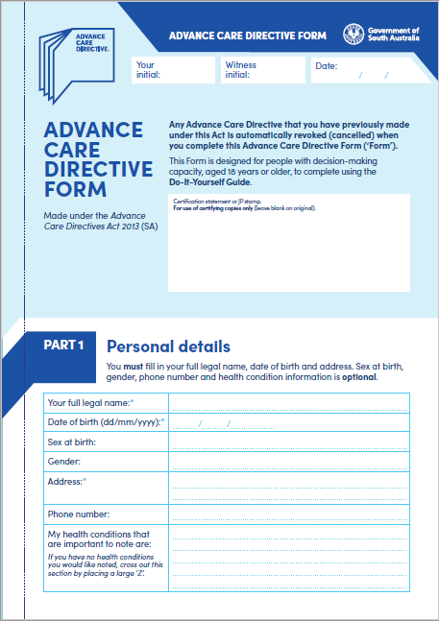

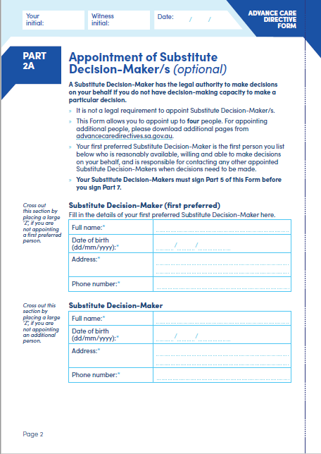

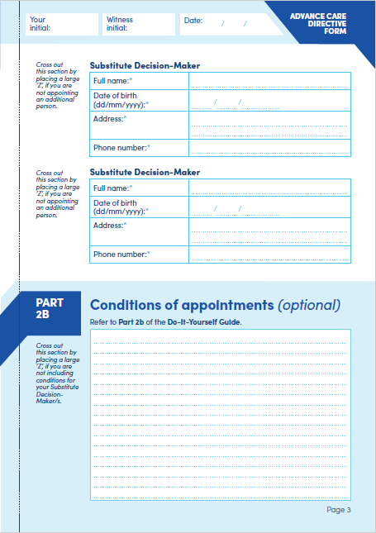

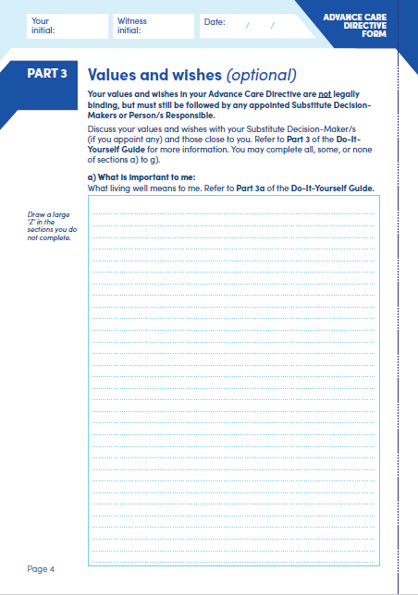
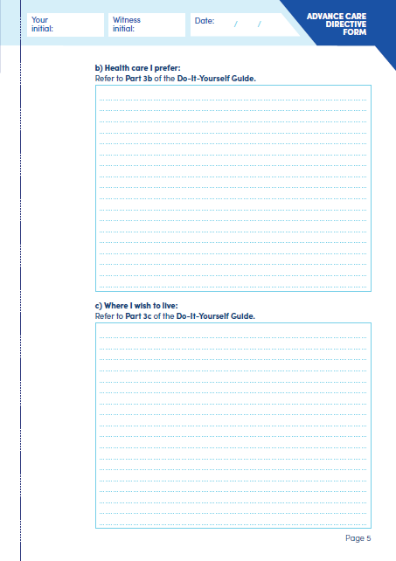

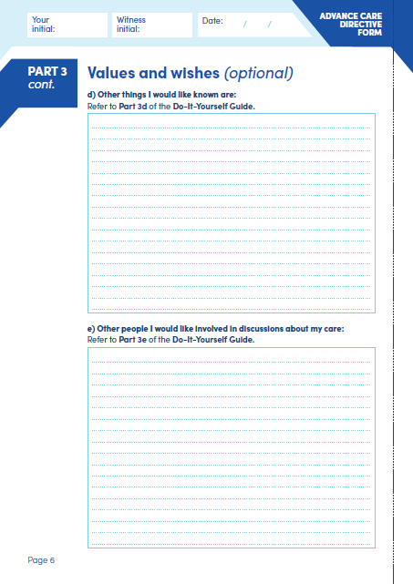

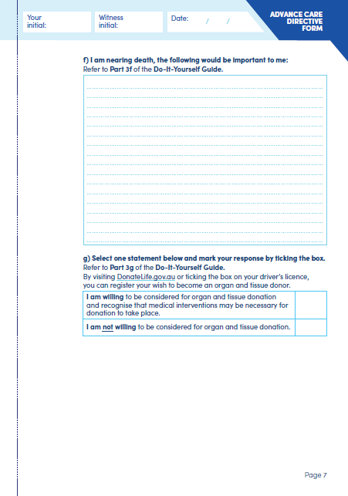

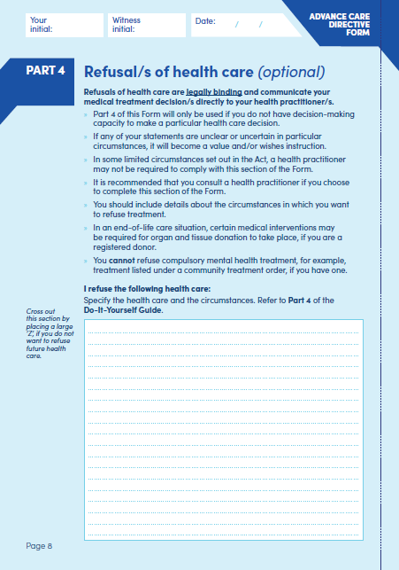

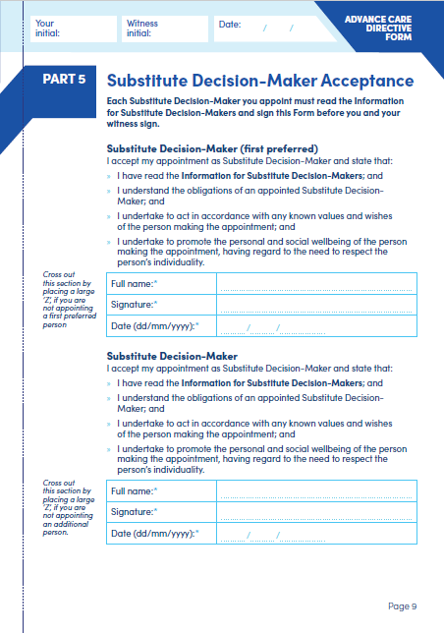

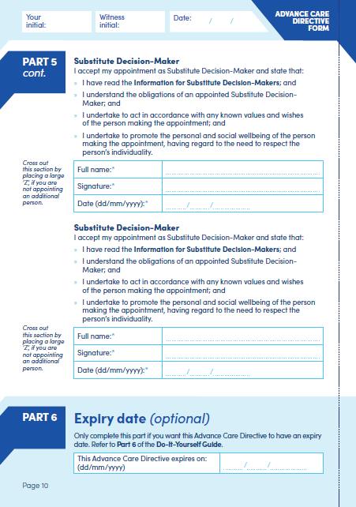

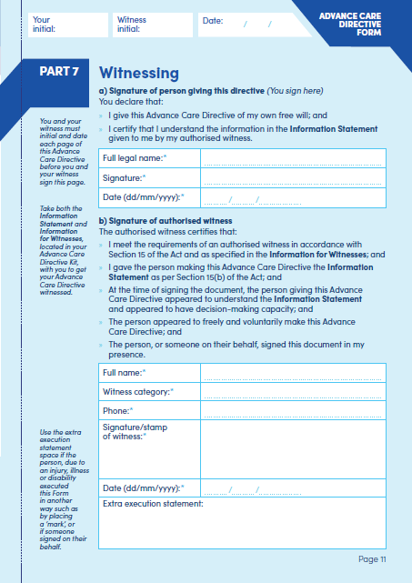

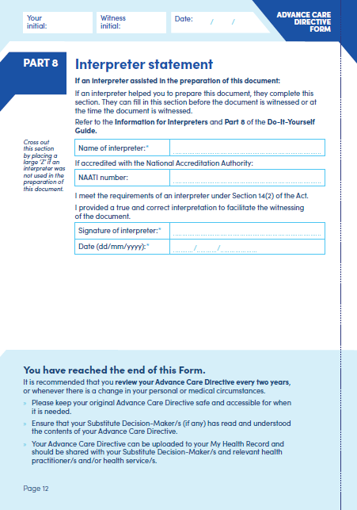

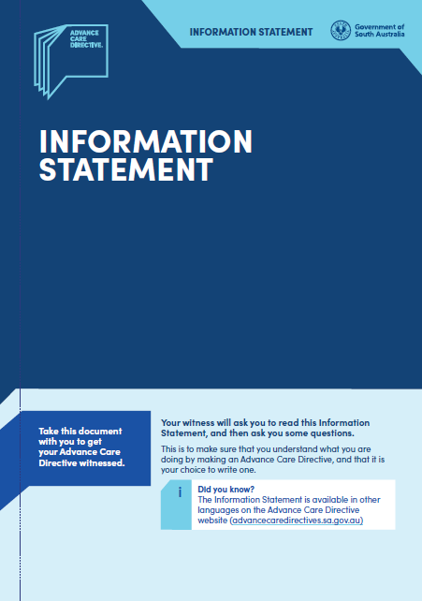

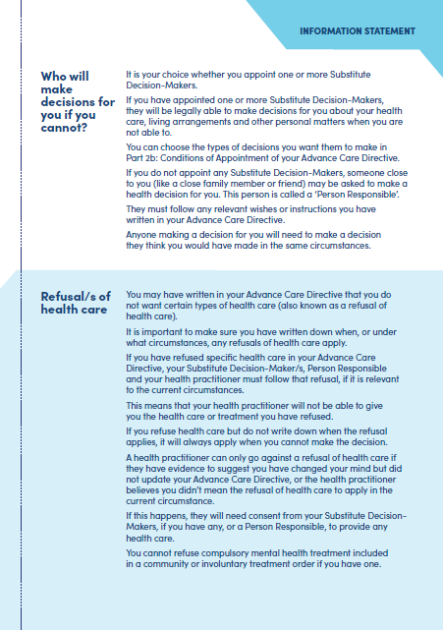

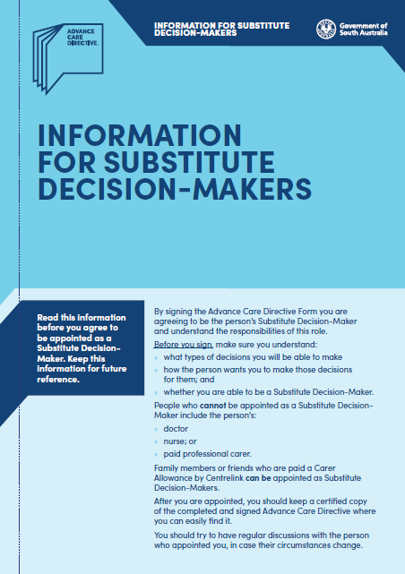

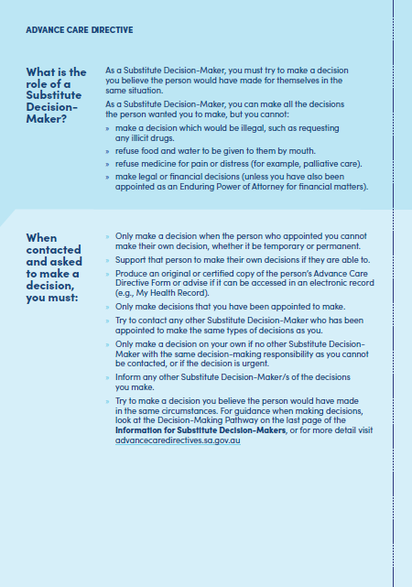

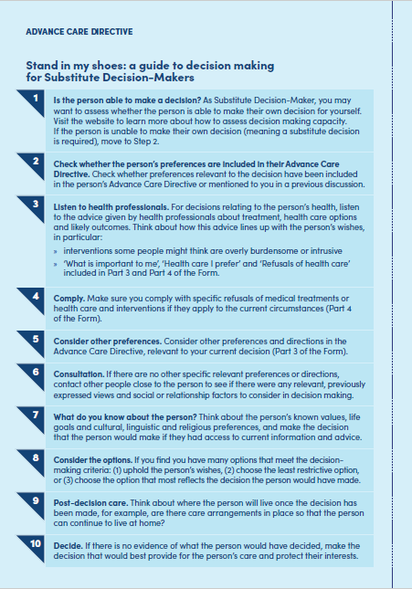

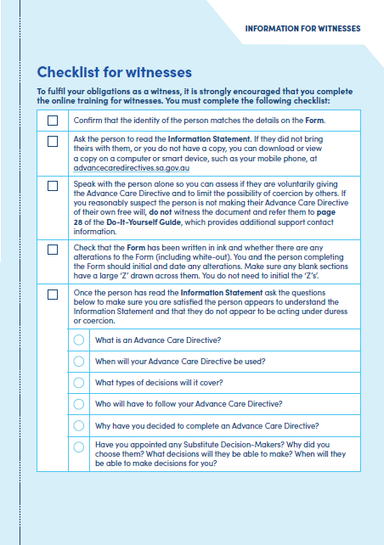

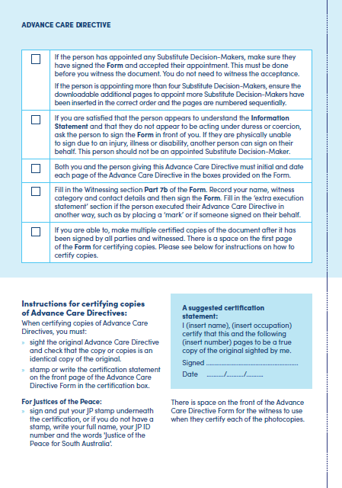

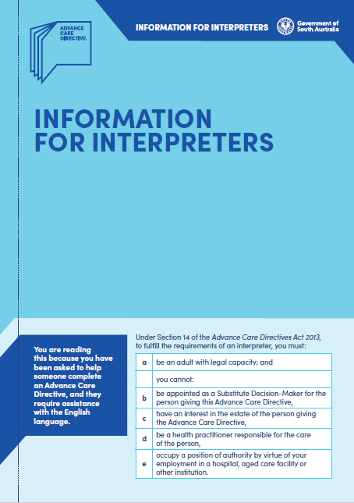

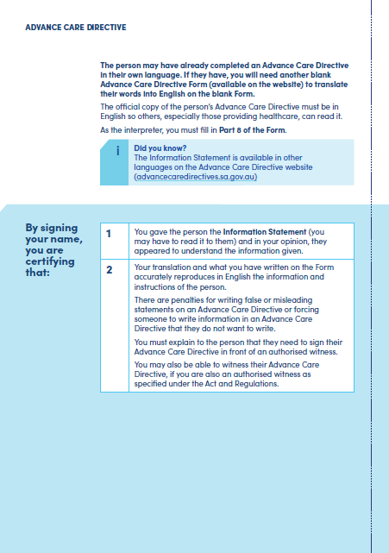

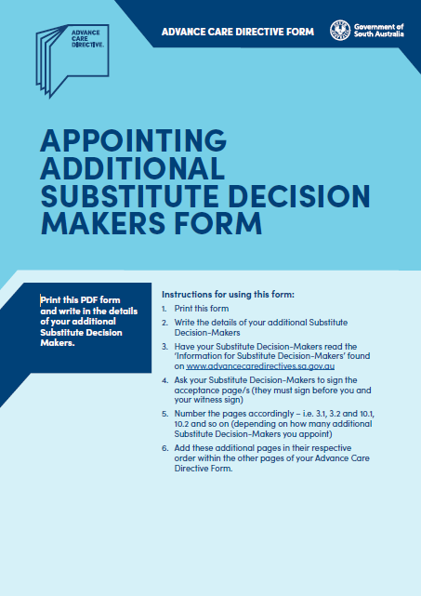

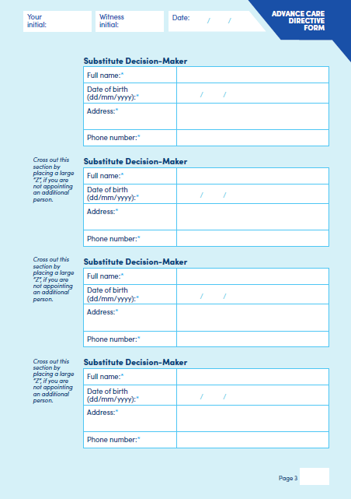

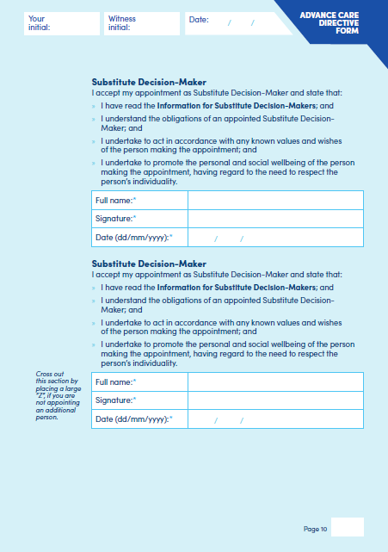

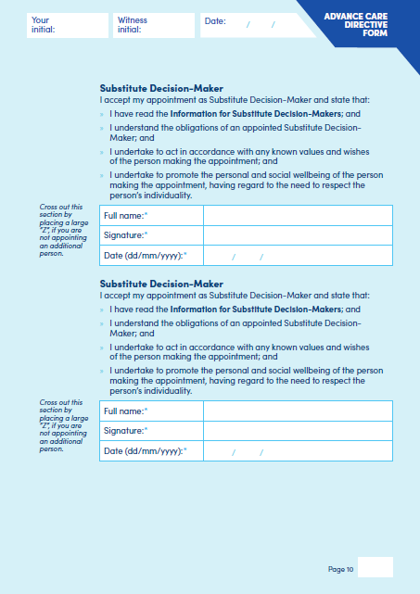

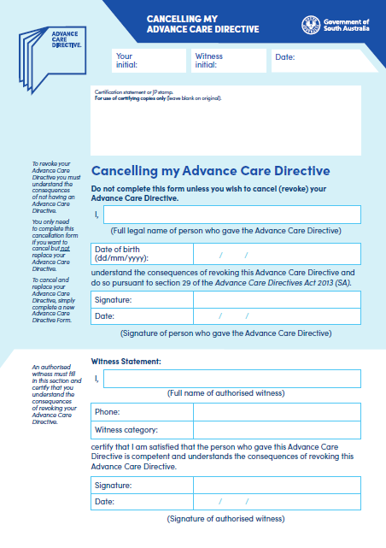

Associations Incorporation Act 1985
Section 43A
Deregistration of Associations
NOTICE is hereby given that the Corporate Affairs Commission approves the applications for deregistration received from the associations named below pursuant to section 43A of the Associations Incorporation Act 1985 (SA). Deregistration takes effect on the date of publication of this notice.
FILIPINA NETWORK OF SOUTH AUSTRALIAN INCORPORATED [A36500]
NORTHERN FUTURES INCORPORATED [A37264]
MURRAY MALLEE LOCAL ACTION PLANNING ASSOCIATION INCORPORATED [A23921]
KEITH AND DISTRICT HOSPITAL INCORPORATED [A1411]
Given under the seal of the Commission at Adelaide this 27th day of February 2024.
Lisa Berry
Team Leader, Lotteries & Associations
A delegate of the Corporate Affairs Commission

Environment Protection Act 1993
Section 68
Approval of Category B Containers
I, Nicholas Stewart, Team Leader, Container Deposit Legislation and Delegate of the Environment Protection Authority (‘the Authority’), pursuant to Section 68 of the Environment Protection Act 1993 (SA) (‘the Act’) hereby:
Approve as Category B Containers, subject to the conditions in subclauses 1, 2, 3 and 4 below, each of the classes of containers identified by reference to the following matters described in the first 4 columns of Schedule 1 of this Notice which are sold in South Australia:
(a) the product which each class of containers shall contain;
(b) the size of the containers;
(c) the type of containers; and
(d) the name of the holders of these approvals.
1. That containers of the class to which the approval relates must bear the refund marking specified by the Authority for containers of that class. The Authority specifies the following refund markings for Category B containers:
(1) “10c refund at collection depots when sold in SA”; or
(2) “10c refund at SA/NT collection depots in State/Territory of purchase”; or
(3) “10c refund at collection depots/points in participating state/territory of purchase”.
2. The holder of the approval must have in place an effective and appropriate waste management arrangement in relation to containers of that class. For the purpose of this approval notice the company named in Column 5 of Schedule 1 of this Notice is the nominated super collector.
3. In the case of an approval in relation to Category B containers that the waste management arrangement must require the holder of the approval to provide specified super collectors with a declaration in the form determined by the Authority in relation to each sale of such containers by the holder of the approval as soon as practicable after the sale.
4. The holder of these approvals must ensure that if a sticker bearing the refund marking has been approved, and is applied to the container, then the sticker must not be placed on any portion of the opening mechanism or in any other place that would require complete or partial removal of the sticker before the contents may be consumed.
Dated: 29 February 2024
Nicholas Stewart
Team Leader, Container Deposit Legislation
Delegate of the Environment Protection Authority

Schedule 1
Column 1 | Column 2 | Column 3 | Column 4 | Column 5
Product Name | Container  Size | Container Type | Approval Holder | Collection Arrangements
Brookvale Union Bourbon & Cola 6.0% | 330 ml | Aluminium | 4 Pines Brewing Company Wholesale Pty Ltd | Marine Stores Ltd
Brookvale Union Rum & Cola 6.0% | 330 ml | Aluminium | 4 Pines Brewing Company Wholesale Pty Ltd | Marine Stores Ltd
Brookvale Union Whisky & Dry 6.0% | 330 ml | Aluminium | 4 Pines Brewing Company Wholesale Pty Ltd | Marine Stores Ltd
Brookvale Union and 4 Pines Brewing Company Lemon Shandy | 375 ml | Aluminium | 4 Pines Brewing Company Wholesale Pty Ltd | Marine Stores Ltd
The Hidden Sea Spritz Pinot Grigio | 250 ml | Aluminium | A. G. Oatley Wines Pty Ltd | Marine Stores Ltd
The Hidden Sea Spritz Rose | 250 ml | Aluminium | A. G. Oatley Wines Pty Ltd | Marine Stores Ltd
AJ COCONUT MILK DRINK LYCHEE | 290 ml | Glass | AJ FRESH FOODS PTY LTD | Statewide Recycling
AJ COCONUT MILK DRINK MANGO | 290 ml | Glass | AJ FRESH FOODS PTY LTD | Statewide Recycling
AJ GUAVA JUICE DRINK | 330 ml | Aluminium | AJ FRESH FOODS PTY LTD | Statewide Recycling
AJ LYCHEE JUICE DRINK | 330 ml | Aluminium | AJ FRESH FOODS PTY LTD | Statewide Recycling
AJ MANGO JUICE DRINK | 330 ml | Aluminium | AJ FRESH FOODS PTY LTD | Statewide Recycling
AJ ORANGE JUICE DRINK | 330 ml | Aluminium | AJ FRESH FOODS PTY LTD | Statewide Recycling
Hard Rated Alcoholic Lemon | 375 ml | Aluminium | Asahi Beverages Pty Ltd | Marine Stores Ltd
Hard Rated Alcoholic Lemon Zero Sugar | 375 ml | Aluminium | Asahi Beverages Pty Ltd | Marine Stores Ltd
Vodka Cruiser State Of Origin Bold Berry | 275 ml | Glass | Asahi Beverages Pty Ltd | Marine Stores Ltd
Vodka Cruiser State Of Origin Wild Berry | 275 ml | Glass | Asahi Beverages Pty Ltd | Marine Stores Ltd
Sparkly Sugar Free Raspberry | 350 ml | Glass | Ausbev Pty Ltd | Statewide Recycling
Nosh Boozy Seltzer Mango + Pineapple 89 Calories Zero Sugar Zero Carbs Gluten Free Vegan | 330 ml | Aluminium | Australian Beer Company Pty Ltd | Marine Stores Ltd
Nosh Boozy Seltzer Peach 89 Calories Zero Sugar Zero Carbs Gluten Free Vegan | 330 ml | Aluminium | Australian Beer Company Pty Ltd | Marine Stores Ltd
Nosh Boozy Seltzer With A Hint of Citrus Crush | 330 ml | Aluminium | Australian Beer Company Pty Ltd | Marine Stores Ltd
Ranga Tangle Mixed Fruit Vodka | 375 ml | Aluminium | Australian Beer Company Pty Ltd | Marine Stores Ltd
Son of A Nun Mid Strength | 375 ml | Aluminium | Australian Beer Company Pty Ltd | Marine Stores Ltd
Rover Nil Non-Alc XPA | 375 ml | Aluminium | Australian Brewers Guild Pty Ltd | Marine Stores Ltd
Tangent Hard Sparkling One For Yuzu Alcoholic Sparkling Beverage Yuzu & Sake | 330 ml | Aluminium | Australian Brewers Guild Pty Ltd | Marine Stores Ltd
Tangent Hard Sparkling Smokin Aces Alcoholic Sparkling Beverage Cola With A Hint Of Smoke | 330 ml | Aluminium | Australian Brewers Guild Pty Ltd | Marine Stores Ltd
Tangent Hard Sparkling Vive Le French Tini Alcoholic Sparkling Beverage Raspberry & Pineapple | 330 ml | Aluminium | Australian Brewers Guild Pty Ltd | Marine Stores Ltd
TNT Sour Fizz Cola Flavoured Sparkling Drink | 250 ml | Aluminium | Australian International Traders Pty Ltd | Statewide Recycling
TNT Sour Fizz Drink Lemonade Sparkling Drink | 250 ml | Aluminium | Australian International Traders Pty Ltd | Statewide Recycling
TNT Sour Fizz Drink Bubblegum Sparkling Drink | 250 ml | Aluminium | Australian International Traders Pty Ltd | Statewide Recycling
TNT Sour Fizz Grape Flavoured Sparkling Drink | 250 ml | Aluminium | Australian International Traders Pty Ltd | Statewide Recycling
Original Spirit Co GinN Juice Grapefruit | 330 ml | Aluminium | Australian Spirit Company Pty Ltd | Flagcan Distributors
Original Spirit Co GinN Juice Lime | 330 ml | Aluminium | Australian Spirit Company Pty Ltd | Flagcan Distributors
Original Spirit Co GinN Juice Mandarin | 330 ml | Aluminium | Australian Spirit Company Pty Ltd | Flagcan Distributors
Barry Shochu Vodka Soda Crushed Lemon | 330 ml | Aluminium | Barrys Drink | Statewide Recycling
Barry Shochu Vodka Soda Watermelon & Lemon | 330 ml | Aluminium | Barrys Drink | Statewide Recycling
Vintage Vibes Vale Lager | 375 ml | Aluminium | Bickford's Australia Pty Ltd | Statewide Recycling
Billson's Banana with Rum | 355 ml | Aluminium | Billson's Beverages Pty Ltd | Statewide Recycling
Billson's Beechworth Creamy Paradise Triple Distilled Vodka | 355 ml | Aluminium | Billson's Beverages Pty Ltd | Statewide Recycling
Billson's Beechworth Gin & Cucumber Soda Perfectly Sparkling | 355 ml | Aluminium | Billson's Beverages Pty Ltd | Statewide Recycling
Billson's Beechworth Green Melon Triple Distilled Vodka | 355 ml | Aluminium | Billson's Beverages Pty Ltd | Statewide Recycling
Billson's Beechworth Twister Classic Soda | 355 ml | Aluminium | Billson's Beverages Pty Ltd | Statewide Recycling
Billson's Coconut and Lime with Rum | 355 ml | Aluminium | Billson's Beverages Pty Ltd | Statewide Recycling
Billson's Peanut Brittle With Whisky | 355 ml | Aluminium | Billson's Beverages Pty Ltd | Statewide Recycling
Billson's Pineapple and Jalapeno With Rum | 355 ml | Aluminium | Billson's Beverages Pty Ltd | Statewide Recycling
Billson's Thai with Whisky | 355 ml | Aluminium | Billson's Beverages Pty Ltd | Statewide Recycling
Billson's Triple Distilled Vodka with Jumbleberry Splash | 355 ml | Aluminium | Billson's Beverages Pty Ltd | Statewide Recycling
Bobby Prebiotic Doctor Bobby | 330 ml | Aluminium | Bobby's Drinks Pty Ltd | Statewide Recycling
Bobby Prebiotic Grape | 330 ml | Aluminium | Bobby's Drinks Pty Ltd | Statewide Recycling
Bobby Prebiotic Lemon Lime | 330 ml | Aluminium | Bobby's Drinks Pty Ltd | Statewide Recycling
Bobby Prebiotic Vanilla Cola | 330 ml | Aluminium | Bobby's Drinks Pty Ltd | Statewide Recycling
Tops Draught | 375 ml | Aluminium | Boozy Quatro Pty Ltd T/As Tops Beer | Marine Stores Ltd
Bowden Brewing Collab Sour Cherry Gin Seltzer | 375 ml | Aluminium | Bowden Brewing Pty Ltd | Statewide Recycling
Bowden Brewing Limited Battle Ducks Red IPA | 375 ml | Aluminium | Bowden Brewing Pty Ltd | Statewide Recycling
Bowden Brewing Limited Cosmic Touch Hazy IPA | 375 ml | Aluminium | Bowden Brewing Pty Ltd | Statewide Recycling
Bowden Brewing Limited Formula Dolphin Pale Ale | 375 ml | Aluminium | Bowden Brewing Pty Ltd | Statewide Recycling
Bowden Brewing Limited Up Dog DDH Pale Ale | 375 ml | Aluminium | Bowden Brewing Pty Ltd | Statewide Recycling
Bowden Brewing Santa Slay Christmas Sour | 375 ml | Aluminium | Bowden Brewing Pty Ltd | Statewide Recycling
Alfa Hellenic Lager | 330 ml | Glass | Brady Road Cellars Pty Ltd | Statewide Recycling
Fix Hellas Premium Lager Beer | 330 ml | Glass | Brady Road Cellars Pty Ltd | Statewide Recycling
Arizona All Natural Mucho Mango Fruit Juice Cocktail | 650 ml | Aluminium | British Provender Pty Ltd | Statewide Recycling
Arizona Southern Style Real Brewed Sweet Tea | 650 ml | Aluminium | British Provender Pty Ltd | Statewide Recycling
Brooklyn Original Juicy Rickey Sparkling Cherry Lime | 650 ml | Aluminium | British Provender Pty Ltd | Statewide Recycling
La Croix Sparkling Water Hibiscus | 355 ml | Aluminium | British Provender Pty Ltd | Statewide Recycling
La Croix Sparkling Water Lime | 355 ml | Aluminium | British Provender Pty Ltd | Statewide Recycling
La Croix Sparkling Water Pamplemousse | 355 ml | Aluminium | British Provender Pty Ltd | Statewide Recycling
La Croix Sparkling Water Passionfruit | 355 ml | Aluminium | British Provender Pty Ltd | Statewide Recycling
La Croix Sparkling Water Razz Cranberry | 355 ml | Aluminium | British Provender Pty Ltd | Statewide Recycling
La Croix Sparkling Water Tangerine | 355 ml | Aluminium | British Provender Pty Ltd | Statewide Recycling
Carlton Draught With A Splash Of Lemonade | 330 ml | Glass | Carlton & United Breweries Pty Ltd | Marine Stores Ltd
Pure Blonde Ultra Low Carb Lager | 330 ml | Glass | Carlton & United Breweries Pty Ltd | Marine Stores Ltd
VB Victoria Bitter Low Carb | 375 ml | Glass | Carlton & United Breweries Pty Ltd | Marine Stores Ltd
VB Victoria Bitter Low Carb | 375 ml | Aluminium | Carlton & United Breweries Pty Ltd | Marine Stores Ltd
VX Victoria Bitter Xtra 6% | 375 ml | Glass | Carlton & United Breweries Pty Ltd | Marine Stores Ltd
Cass Fresh | 355 ml | Aluminium | Castle Hill International Pty Ltd | Marine Stores Ltd
GOODDAY Apple | 360 ml | Glass | Castle Hill International Pty Ltd | Marine Stores Ltd
GOODDAY Cherry | 360 ml | Glass | Castle Hill International Pty Ltd | Marine Stores Ltd
GOODDAY Grapefruit | 360 ml | Glass | Castle Hill International Pty Ltd | Marine Stores Ltd
GOODDAY Mango | 360 ml | Glass | Castle Hill International Pty Ltd | Marine Stores Ltd
GOODDAY Melon | 360 ml | Glass | Castle Hill International Pty Ltd | Marine Stores Ltd
GOODDAY Pomegranate | 360 ml | Glass | Castle Hill International Pty Ltd | Marine Stores Ltd
GOODDAY Strawberry | 360 ml | Glass | Castle Hill International Pty Ltd | Marine Stores Ltd
GOODDAY Tropical | 360 ml | Glass | Castle Hill International Pty Ltd | Marine Stores Ltd
FANTA PINEAPPLE ZERO SUGAR | 1250 ml | PET | Coca-Cola Europacific Partners Australia | Statewide Recycling
FANTA PINEAPPLE ZERO SUGAR | 600 ml | PET | Coca-Cola Europacific Partners Australia | Statewide Recycling
FANTA PINEAPPLE ZERO SUGAR | 250 ml | Aluminium | Coca-Cola Europacific Partners Australia | Statewide Recycling
MONSTER ENERGY ULTRA STRAWBERRY DREAMS ZERO SUGAR | 500 ml | Aluminium | Coca-Cola Europacific Partners Australia | Statewide Recycling
MONSTER ENERGY ULTRA STRAWBERRY DREAMS ZERO SUGAR | 500 ml | Aluminium | Coca-Cola Europacific Partners Australia | Statewide Recycling
MOTHER ZERO SUGAR RAZZLE BERRY | 375 ml | Aluminium | Coca-Cola Europacific Partners Australia | Statewide Recycling
MOUNT FRANKLIN LIGHTLY SPARKLING PEACH NO SUGAR | 375 ml | Aluminium | Coca-Cola Europacific Partners Australia | Statewide Recycling
POWERADE ACTIVE WATER LEMON + LIME NO SUGAR | 600 ml | PET | Coca-Cola Europacific Partners Australia | Statewide Recycling
POWERADE ZERO SUGAR GRAPE ION4 | 600 ml | PET | Coca-Cola Europacific Partners Australia | Statewide Recycling
Suntory 196 DOUBLE PEACH Shochu Vodka & Soda 6% | 330 ml | Aluminium | Coca-Cola Europacific Partners Australia | Statewide Recycling
Coopers Brewery Botanic Ale | 375 ml | Aluminium | Coopers Brewery Limited | Marine Stores Ltd
Thatchers Gold Apple Cider Medium Dry | 375 ml | Aluminium | Coopers Brewery Limited | Marine Stores Ltd
JR Jetty Road Brewery & Jimmy Rum Jimmy Road Imperial Amber Ale | 375 ml | Aluminium | Craft Revolution Pty Ltd | Statewide Recycling
JR Jetty Road Brewery Blue Berry Gose Sweet Salty & Sour | 375 ml | Aluminium | Craft Revolution Pty Ltd | Statewide Recycling
JR Jetty Road Brewery Blueberry Sour Beer Sweet Salty & Sour | 375 ml | Aluminium | Craft Revolution Pty Ltd | Statewide Recycling
JR Jetty Road Brewery Draught | 375 ml | Aluminium | Craft Revolution Pty Ltd | Statewide Recycling
JR Jetty Road Brewery IPA | 375 ml | Aluminium | Craft Revolution Pty Ltd | Statewide Recycling
JR Jetty Road Brewery Milk Choc Stout Rich And Silky | 375 ml | Aluminium | Craft Revolution Pty Ltd | Statewide Recycling
JR Jetty Road Brewery Pale Ale | 375 ml | Aluminium | Craft Revolution Pty Ltd | Statewide Recycling
JR Jetty Road Brewery The Haze Hazy Pale Ale | 375 ml | Aluminium | Craft Revolution Pty Ltd | Statewide Recycling
JR Jetty Road Brewery XPA | 375 ml | Aluminium | Craft Revolution Pty Ltd | Statewide Recycling
JR Jetty Road The Pig Pen Traditional German Pilsner | 375 ml | Aluminium | Craft Revolution Pty Ltd | Statewide Recycling
ReDrinks ReCharge Bulk and Build Citrus Berry | 330 ml | Aluminium | Creative Holdings (Aust) Pty Ltd | Statewide Recycling
ReDrinks ReCover Heal and Protect Mixed Berry | 330 ml | Aluminium | Creative Holdings (Aust) Pty Ltd | Statewide Recycling
ReDrinks ReDuce Slim and Trim Lemon Crush | 330 ml | Aluminium | Creative Holdings (Aust) Pty Ltd | Statewide Recycling
ReDrinks ReSist Mend and Defend Traditional Lemonade | 330 ml | Aluminium | Creative Holdings (Aust) Pty Ltd | Statewide Recycling
Lost Phoenix Spirits Gin Soda Tonic | 355 ml | Aluminium | Cut Hill Wall Pty Ltd | Statewide Recycling
Lost Phoenix Spirits Whisky Dry | 355 ml | Aluminium | Cut Hill Wall Pty Ltd | Statewide Recycling
Lost Phoenix Spirits Whisky and Chinotto | 355 ml | Aluminium | Cut Hill Wall Pty Ltd | Statewide Recycling
King Coffee Saigon Iced Milk Coffee | 238 ml | Aluminium | DHN Trading Import & Export Pty Ltd | Marine Stores Ltd
Dainton Beer Bayside Easy Lager | 355 ml | Aluminium | Daicom Australia Pty Ltd t/a Dainton Brewery | Statewide Recycling
Dainton Beer Bayside Easy Pale | 355 ml | Aluminium | Daicom Australia Pty Ltd t/a Dainton Brewery | Statewide Recycling
Dainton Beer Choctail Espresso Mocha Stout | 355 ml | Aluminium | Daicom Australia Pty Ltd t/a Dainton Brewery | Statewide Recycling
Dainton Beer Dort German Lager | 375 ml | Aluminium | Daicom Australia Pty Ltd t/a Dainton Brewery | Statewide Recycling
Dainton Beer Major Tom Light IPA | 375 ml | Aluminium | Daicom Australia Pty Ltd t/a Dainton Brewery | Statewide Recycling
Departed Spirits Green Apple Vodka | 500 ml | Bottle - Aluminium | Departed Spirits Co | Flagcan Distributors
Departed Spirits Pineapple Agave | 500 ml | Bottle - Aluminium | Departed Spirits Co | Flagcan Distributors
Departed Spirits Yuzu Gin | 500 ml | Bottle - Aluminium | Departed Spirits Co | Flagcan Distributors
Derrimut Nutrition Power Surge Berry Crush Zero Sugar | 500 ml | Aluminium | Derrimut 247 Gyms (SA) PTY Ltd | Statewide Recycling
Derrimut Nutrition Power Surge Grape Soda Zero Sugar | 500 ml | Aluminium | Derrimut 247 Gyms (SA) PTY Ltd | Statewide Recycling
Derrimut Nutrition Power Surge Peach Mango Zero Sugar | 500 ml | Aluminium | Derrimut 247 Gyms (SA) PTY Ltd | Statewide Recycling
Derrimut Nutrition Power Surge Vanilla Cola Zero Sugar | 500 ml | Aluminium | Derrimut 247 Gyms (SA) PTY Ltd | Statewide Recycling
UPS Ultimate Protein Plus Banana | 375 ml | PET | Derrimut 247 Gyms (SA) PTY Ltd | Statewide Recycling
UPS Ultimate Protein Plus Chocolate | 375 ml | PET | Derrimut 247 Gyms (SA) PTY Ltd | Statewide Recycling
UPS Ultimate Protein Plus Vanilla | 375 ml | PET | Derrimut 247 Gyms (SA) PTY Ltd | Statewide Recycling
Chingu Blueberry | 360 ml | Glass | Divas Beverages Australia Ltd | Statewide Recycling
Chingu Green Grape | 360 ml | Glass | Divas Beverages Australia Ltd | Statewide Recycling
Chingu Lychee | 360 ml | Glass | Divas Beverages Australia Ltd | Statewide Recycling
Chingu Original | 360 ml | Glass | Divas Beverages Australia Ltd | Statewide Recycling
Chingu Peach | 360 ml | Glass | Divas Beverages Australia Ltd | Statewide Recycling
Chingu Tropical | 360 ml | Glass | Divas Beverages Australia Ltd | Statewide Recycling
Chingu Watermelon | 360 ml | Glass | Divas Beverages Australia Ltd | Statewide Recycling
Chilled Choc Chocolate With Oat Milk | 250 ml | Aluminium | Don't Dairy Pty Ltd | Statewide Recycling
Chilled Coffee Mocha With Oat Milk | 250 ml | Aluminium | Don't Dairy Pty Ltd | Statewide Recycling
Chilled Coffee Original With Oat Milk Double Shot | 250 ml | Aluminium | Don't Dairy Pty Ltd | Statewide Recycling
OxyShred & Slime Slimer No Sugar | 355 ml | Aluminium | EHP Holdings Pty Ltd | Statewide Recycling
OxyShred Ultra Energy Bahama Breeze Zero Sugar | 355 ml | Aluminium | EHP Holdings Pty Ltd | Statewide Recycling
OxyShred Ultra Energy Cali Cola Zero Sugar | 355 ml | Aluminium | EHP Holdings Pty Ltd | Statewide Recycling
OxyShred Ultra Energy Cotton Candy Zero Sugar | 355 ml | Aluminium | EHP Holdings Pty Ltd | Statewide Recycling
OxyShred Ultra Energy Gummy Snake Zero Sugar | 355 ml | Aluminium | EHP Holdings Pty Ltd | Statewide Recycling
OxyShred Ultra Energy Proton Plasma No Sugar | 355 ml | Aluminium | EHP Holdings Pty Ltd | Statewide Recycling
ENRGPRO Protein Water + Caffeine Arctic Rush No Added Sugar | 500 ml | PET | ENRG PRO PTY LTD | Marine Stores Ltd
ENRGPRO Protein Water + Caffeine Rapid Charge No Added Sugar | 500 ml | PET | ENRG PRO PTY LTD | Marine Stores Ltd
ENRGPRO Protein Water Superberry No Added Sugar | 500 ml | PET | ENRG PRO PTY LTD | Marine Stores Ltd
ENRGPRO Protein Water Tropical Storm No Added Sugar | 500 ml | PET | ENRG PRO PTY LTD | Marine Stores Ltd
Balter & Craft Coast USA Mouth Holiday West Coast IPA | 375 ml | Aluminium | Emencee Pty Ltd t/as Balter Brewing | Statewide Recycling
Big Things Brewing Co Alcoholic Shandy Beer & Lemonade | 375 ml | Aluminium | Endeavour Group Limited | Marine Stores Ltd
DAB Dortmunder Export | 500 ml | Aluminium | Endeavour Group Limited | Marine Stores Ltd
Kopparberg Alcoholic Brewed Hard Ginger 8.3% | 375 ml | Aluminium | Endeavour Group Limited | Marine Stores Ltd
McAllister Reserve Blended Scotch Whisky | 350 ml | PET | Endeavour Group Limited | Marine Stores Ltd
Monsuta Okinawa Dark Premium Lager | 350 ml | Aluminium | Endeavour Group Limited | Marine Stores Ltd
Noble Fellows Pinot Gris White Peach Spritzer | 250 ml | Aluminium | Endeavour Group Limited | Marine Stores Ltd
Noble Fellows Sauvignon Blanc Passionfruit Spritzer | 250 ml | Aluminium | Endeavour Group Limited | Marine Stores Ltd
Old Fat Unicorn Moscato Spritzer Musk | 300 ml | Glass | Endeavour Group Limited | Marine Stores Ltd
Old Fat Unicorn Prosecco Spritzer Crisp Apple | 300 ml | Glass | Endeavour Group Limited | Marine Stores Ltd
Zytho Brewing Superdelic Hazy Pale Ale | 375 ml | Aluminium | Endeavour Group Limited | Marine Stores Ltd
Ghost Energy Zero Sugar Blue Raspberry | 500 ml | Aluminium | Export Corporation Australia T/AS Nutrition System Pty Ltd | Statewide Recycling
Ghost Energy Zero Sugar Orange Cream | 500 ml | Aluminium | Export Corporation Australia T/AS Nutrition System Pty Ltd | Statewide Recycling
Ghost Energy Zero Sugar Orginal Lemon Lime | 500 ml | Aluminium | Export Corporation Australia T/AS Nutrition System Pty Ltd | Statewide Recycling
Ghost Energy Zero Sugar Sour Watermelon | 500 ml | Aluminium | Export Corporation Australia T/AS Nutrition System Pty Ltd | Statewide Recycling
FELLR Blood Orange Messina Sorbet Seltzer | 330 ml | Aluminium | FELLA DRINKS PTY LTD | Statewide Recycling
FELLR DOUBLE Green Apple Alcoholic Soda | 330 ml | Aluminium | FELLA DRINKS PTY LTD | Statewide Recycling
FELLR DOUBLE Lemon Squash Alcoholic Soda | 330 ml | Aluminium | FELLA DRINKS PTY LTD | Statewide Recycling
FELLR DOUBLE Passionfruit Alcoholic Soda | 330 ml | Aluminium | FELLA DRINKS PTY LTD | Statewide Recycling
FELLR DOUBLE Raspberry Alcoholic Soda | 330 ml | Aluminium | FELLA DRINKS PTY LTD | Statewide Recycling
FELLR Peach Brewed Alcoholic Seltzer | 330 ml | Aluminium | FELLA DRINKS PTY LTD | Statewide Recycling
FELLR Salted Coconut & Mango Messina Sorbet Seltzer | 330 ml | Aluminium | FELLA DRINKS PTY LTD | Statewide Recycling
FELLR Yuzu Messina Sorbet Seltzer | 330 ml | Aluminium | FELLA DRINKS PTY LTD | Statewide Recycling
Fever Tree Classic Margarita Mixer | 500 ml | Glass | Fever-Tree AUS | Statewide Recycling
Fever Tree Classic Mojito Mixer | 500 ml | Glass | Fever-Tree AUS | Statewide Recycling
Fever Tree Italian Blood Orange Soda | 200 ml | Glass | Fever-Tree AUS | Statewide Recycling
Fever Tree Pink Grapefruit Soda | 500 ml | Glass | Fever-Tree AUS | Statewide Recycling
Fever Tree Refreshingly Light Ginger Ale | 500 ml | Glass | Fever-Tree AUS | Statewide Recycling
Fever Tree Wild Raspberry Tonic Water | 200 ml | Glass | Fever-Tree AUS | Statewide Recycling
Patritti Non Alcoholic Sparkling Natural Canada Muscat Grape Juice | 750 ml | Glass | G Patritti & Company Pty Ltd t/as Dover Wine | Statewide Recycling
Patritti Non Alcoholic Sparkling Natural Shiraz Grape Juice | 750 ml | Glass | G Patritti & Company Pty Ltd t/as Dover Wine | Statewide Recycling
Patritti Sparkling Non Alcoholic Dark Grape & Cherry | 750 ml | Glass | G Patritti & Company Pty Ltd t/as Dover Wine | Statewide Recycling
Gather Brewing Sweet Sunshine Passionfruit Kombucha | 350 ml | Glass | Gather Holdings Pty Ltd | Statewide Recycling
Coco Health Bio Active Korean Ginseng Apple Pear | 60 ml | Glass | Globe Consultancy Services Pty Ltd | Statewide Recycling
Lipovitan Honey | 250 ml | Aluminium | Golden Star Alliance Pty Ltd | Statewide Recycling
Heaps Normal Cheeky IPA | 375 ml | Aluminium | Heaps Normal Pty Ltd | Statewide Recycling
Doozy Half & Half Vodka Iced Tea & Lemonade with Raspberry | 330 ml | Aluminium | How Pty Ltd | Statewide Recycling
Doozy Half & Half Vodka Iced Tea and Lemonade | 330 ml | Aluminium | How Pty Ltd | Statewide Recycling
Wildah Hard Apple Cider | 375 ml | Aluminium | Idyll Wine Co Pty Ltd | Statewide Recycling
Wildah Hard Berry Cider | 375 ml | Aluminium | Idyll Wine Co Pty Ltd | Statewide Recycling
Wildah Hard Ginger Beer | 375 ml | Aluminium | Idyll Wine Co Pty Ltd | Statewide Recycling
Wildah Hard Ginger Beer Lower Sugar | 375 ml | Aluminium | Idyll Wine Co Pty Ltd | Statewide Recycling
Breaka Chupa Chups Raspberry & Vanilla Flavoured Milk | 600 ml | LPB - Gable Top | Lactalis Australia Pty Ltd | Statewide Recycling
Breaka Limited Edition Chupa Chups Choco Banana Flavoured Milk | 600 ml | LPB - Gable Top | Lactalis Australia Pty Ltd | Statewide Recycling
Ice Break Strong Espresso | 500 ml | HDPE | Lactalis Australia Pty Ltd | Statewide Recycling
OAK Mini Chocolate 25% Less Sugar | 300 ml | PET | Lactalis Australia Pty Ltd | Statewide Recycling
OAK Mini Strawberry 25% Less Sugar | 300 ml | PET | Lactalis Australia Pty Ltd | Statewide Recycling
OAK Violet Crumble Flavoured Milk | 600 ml | LPB - Gable Top | Lactalis Australia Pty Ltd | Statewide Recycling
Level Lemonade & Cola | 300 ml | Aluminium | Level Beverages Pty Ltd | Statewide Recycling
Level Lemonade & Pineapple | 300 ml | Aluminium | Level Beverages Pty Ltd | Statewide Recycling
Level Lemonade & Raspberry | 300 ml | Aluminium | Level Beverages Pty Ltd | Statewide Recycling
Guinness Draught Stout | 470 ml | Aluminium | Lion Beer Spirits & Wine Pty Ltd T/as Lion Beer Australia | Marine Stores Ltd
Kilkenny Irish Style Red Ale | 470 ml | Aluminium | Lion Beer Spirits & Wine Pty Ltd T/as Lion Beer Australia | Marine Stores Ltd
Stone & Wood Brewing Northern Rivers Beer | 330 ml | Aluminium | Lion Beer Spirits & Wine Pty Ltd T/as Lion Beer Australia | Marine Stores Ltd
Stone & Wood Hinterland Big Pale Ale | 375 ml | Aluminium | Lion Beer Spirits & Wine Pty Ltd T/as Lion Beer Australia | Marine Stores Ltd
Stone & Wood Mango Pale Ale Limited Release | 375 ml | Aluminium | Lion Beer Spirits & Wine Pty Ltd T/as Lion Beer Australia | Marine Stores Ltd
White Claw Hard Seltzer Raspberry | 330 ml | Aluminium | Lion Beer Spirits & Wine Pty Ltd T/as Lion Beer Australia | Marine Stores Ltd
Lorry Boys Jim & Joes Hazy Pale Mid Strength | 375 ml | Aluminium | Liquorland Australia Pty Ltd | Statewide Recycling
Lorry Boys Jim & Joes Lager Low Carb | 375 ml | Aluminium | Liquorland Australia Pty Ltd | Statewide Recycling
Tinnies Black Hops Brewery Session Hazy | 375 ml | Aluminium | Liquorland Australia Pty Ltd | Statewide Recycling
Little Hampton Hepburn Spring Water Pure Natural Sparkling Spring Water | 440 ml | Aluminium | Little Hampton Spring Pty Ltd | Statewide Recycling
Little Hampton Hepburn Spring Water Pure Natural Still Spring Water | 440 ml | Aluminium | Little Hampton Spring Pty Ltd | Statewide Recycling
Skull Water Sparkling Water from Deep Downunder | 440 ml | Aluminium | Little Hampton Spring Pty Ltd | Statewide Recycling
Skull Water Still Water from Deep Downunder | 440 ml | Aluminium | Little Hampton Spring Pty Ltd | Statewide Recycling
Breezy Cocktails Sparkling Aperitif Spritz Blood Orange | 250 ml | Aluminium | Local Beverages Pty LTD | Statewide Recycling
The Collective Kefir Mango Turmeric | 700 ml | PET | MOO Premium Foods PTY LTD | Marine Stores Ltd
The Collective Kefir Natural | 700 ml | PET | MOO Premium Foods PTY LTD | Marine Stores Ltd
The Collective Kefir Vanilla Bean | 700 ml | PET | MOO Premium Foods PTY LTD | Marine Stores Ltd
COCOBELLA FUSIONS BLACKBERRY ACAI | 400 ml | PET | Made Brands Pty Ltd | Statewide Recycling
COCOBELLA FUSIONS MANGO PASSION | 400 ml | PET | Made Brands Pty Ltd | Statewide Recycling
COCOBELLA FUSIONS RASPBERRY LEMONADE | 400 ml | PET | Made Brands Pty Ltd | Statewide Recycling
Missy Sippy Juicy Watermelon Seltzer | 330 ml | Aluminium | Missy Sippy Pty Ltd | Marine Stores Ltd
Missy Sippy Pop's Passionfruit | 330 ml | Aluminium | Missy Sippy Pty Ltd | Marine Stores Ltd
My Muscle Chef My Fuel Energy Drink Blue Raspberry Trance | 355 ml | Aluminium | My Muscle Chef Pty Ltd | Flagcan Distributors
My Muscle Chef My Fuel Energy Drink Cosmic Cola | 355 ml | Aluminium | My Muscle Chef Pty Ltd | Flagcan Distributors
My Muscle Chef My Fuel Energy Drink Electric Apple | 355 ml | Aluminium | My Muscle Chef Pty Ltd | Flagcan Distributors
My Muscle Chef My Fuel Energy Drink Grape Thunder | 355 ml | Aluminium | My Muscle Chef Pty Ltd | Flagcan Distributors
My Muscle Chef My Fuel Energy Drink Mango Peach Sunset | 355 ml | Aluminium | My Muscle Chef Pty Ltd | Flagcan Distributors
My Muscle Chef My Fuel Energy Drink Tropical Beats | 355 ml | Aluminium | My Muscle Chef Pty Ltd | Flagcan Distributors
RAW C Pure Natural Coconut Water | 350 ml | PET | Natural Raw C Pty Ltd | Statewide Recycling
The Good Brekkie Chocolate | 250 ml | LiquidPaperBoard | Nexba Beverages Pty Ltd | Statewide Recycling
The Good Brekkie Vanilla | 250 ml | LiquidPaperBoard | Nexba Beverages Pty Ltd | Statewide Recycling
Nippy's Apple & Blackcurrant Juice | 350 ml | Glass | Nippys Fruit Juices Pty Ltd | Statewide Recycling
Nippy's Apple Juice | 350 ml | Glass | Nippys Fruit Juices Pty Ltd | Statewide Recycling
Nippy's Fruitylicious Apple & Blackcurrant Juice | 375 ml | PET | Nippys Fruit Juices Pty Ltd | Statewide Recycling
Nippy's Fruitylicious Apple & Blackcurrant Juice | 375 ml | PET | Nippys Fruit Juices Pty Ltd | Statewide Recycling
Nippy's Fruitylicious Breakfast Juice | 375 ml | PET | Nippys Fruit Juices Pty Ltd | Statewide Recycling
Nippy's Fruitylicious Orange Juice | 375 ml | PET | Nippys Fruit Juices Pty Ltd | Statewide Recycling
Nippy's Orange juice | 350 ml | Glass | Nippys Fruit Juices Pty Ltd | Statewide Recycling
No Eye Deer | 330 ml | Aluminium | No Eye Deer Brewing | Statewide Recycling
Woolworths Australian Spring Water | 1500 ml | PET | Nu Pure Beverages | Statewide Recycling
Woolworths Australian Spring Water | 1500 ml | PET | Nu Pure Beverages | Statewide Recycling
Woolworths Lightly Sparkling Spring Water | 500 ml | PET | Nu Pure Beverages | Statewide Recycling
Ragazzi E Succo Spritz | 250 ml | Aluminium | Old Fashioned Hospitality Pty Ltd | Marine Stores Ltd
Yoosh Aloe Tea Black Tea Flavour With A Hint of Honey | 500 ml | PET | Oriental Merchant Pty Ltd | Statewide Recycling
Yoosh Aloe Tea Citron Flavour With A Hint of Honey | 500 ml | PET | Oriental Merchant Pty Ltd | Statewide Recycling
Yoosh Aloe Yogurt Flavoured Drink Peach | 500 ml | PET | Oriental Merchant Pty Ltd | Statewide Recycling
Parachilna Brew Project PBP Amarillo By Morning Pale Ale | 375 ml | Aluminium | Parachilna Brew Project T/A Prairie Hotel | Statewide Recycling
Parachilna Brew Project PBP Nilpena Ediacara Hazy IPA Hazy | 375 ml | Aluminium | Parachilna Brew Project T/A Prairie Hotel | Statewide Recycling
Parachilna Brew Project PBP Sadie Jane Stout | 375 ml | Aluminium | Parachilna Brew Project T/A Prairie Hotel | Statewide Recycling
Parachilna Brew Project PBP Search & Destroy Mid Pilsner | 375 ml | Aluminium | Parachilna Brew Project T/A Prairie Hotel | Statewide Recycling
Prairie Hotel Parachilna Fargher Lager | 375 ml | Aluminium | Parachilna Brew Project T/A Prairie Hotel | Statewide Recycling
Brightstar Brewing Extra Special Bitter Malty English Ale | 375 ml | Aluminium | Parker's Brewing Co Pty Ltd Trading As Brightstar Brewing | Marine Stores Ltd
Jameson Triple Distilled Irish Whiskey Natural Raw Cola | 375 ml | Aluminium | Pernod Ricard Winemakers Pty Ltd | Marine Stores Ltd
Jurkovic Group Jurkovic Draught | 375 ml | Aluminium | Pikes Beer Company Pty Ltd | Statewide Recycling
Meechi Brewing Company Lager | 375 ml | Aluminium | Pikes Beer Company Pty Ltd | Statewide Recycling
Meechi Brewing Company Pale Ale | 375 ml | Aluminium | Pikes Beer Company Pty Ltd | Statewide Recycling
Meechi Brewing Company Stout | 375 ml | Aluminium | Pikes Beer Company Pty Ltd | Statewide Recycling
Pikes Beer Co. Limited Release Pineapple Berliner Weisse | 375 ml | Aluminium | Pikes Beer Company Pty Ltd | Statewide Recycling
Pikes Beer Co. Limited Release Strawberries & Cream Sour | 375 ml | Aluminium | Pikes Beer Company Pty Ltd | Statewide Recycling
Stump Brewing Session Kolsch | 375 ml | Aluminium | Pikes Beer Company Pty Ltd | Statewide Recycling
Stump Brewing Wheat Ale | 375 ml | Aluminium | Pikes Beer Company Pty Ltd | Statewide Recycling
Tenafeate Creek Toffs Pilsner Craft Beer | 375 ml | Aluminium | Pikes Beer Company Pty Ltd | Statewide Recycling
Yorke Premium Malbro Mid | 375 ml | Aluminium | Pikes Beer Company Pty Ltd | Statewide Recycling
Pirate Life Brewing Pineapple Margarita Sour Ale | 500 ml | Aluminium | Pirate Life Brewing Pty Ltd | Statewide Recycling
Something & Nothing Cucumber Premium Soda | 330 ml | Aluminium | Really Good People Pty Ltd | Statewide Recycling
Something & Nothing Hibiscus & Rose Premium Soda | 330 ml | Aluminium | Really Good People Pty Ltd | Statewide Recycling
Something & Nothing Yuzu Premium Soda | 330 ml | Aluminium | Really Good People Pty Ltd | Statewide Recycling
Coles Apple & Mango Juice | 250 ml | LPB - Aseptic | Refresco Australia Pty Ltd | Flagcan Distributors
Diet Rite Orange Mango No Sugar | 1250 ml | PET | Refresco Australia Pty Ltd | Flagcan Distributors
FLYING POWER ENERGY DRINK ORIGINAL | 500 ml | Aluminium | Refresco Australia Pty Ltd | Flagcan Distributors
FLYING POWER ENERGY DRINK SUGAR FREE | 500 ml | Aluminium | Refresco Australia Pty Ltd | Flagcan Distributors
Attica X Remedy Apple & Rhubarb Crumble | 330 ml | Glass | Remedy Kombucha Pty Ltd | Marine Stores Ltd
Attica X Remedy Lime Spider | 330 ml | Glass | Remedy Kombucha Pty Ltd | Marine Stores Ltd
Remedy Organic Kombucha Pink Grapefruit No Sugar | 250 ml | Aluminium | Remedy Kombucha Pty Ltd | Marine Stores Ltd
Riot Spritz Cooler Citrus Classic | 150 ml | Aluminium | Riot Wine Co Pty Ltd | Marine Stores Ltd
Riot Wine Co Ephemeral Contact Rose Limited Release | 250 ml | Aluminium | Riot Wine Co Pty Ltd | Marine Stores Ltd
Riot Wine Co Grenache Rose 2021 | 150 ml | Aluminium | Riot Wine Co Pty Ltd | Marine Stores Ltd
Riot Wine Co Pinot G 2023 | 150 ml | Aluminium | Riot Wine Co Pty Ltd | Marine Stores Ltd
Riot Wine Co Sagacious Placement Grenache Limited Release | 250 ml | Aluminium | Riot Wine Co Pty Ltd | Marine Stores Ltd
Riot Wine Co Sauvignon Blanc 2022 | 150 ml | Aluminium | Riot Wine Co Pty Ltd | Marine Stores Ltd
Riot Wine Co Shiraz 2021 | 150 ml | Aluminium | Riot Wine Co Pty Ltd | Marine Stores Ltd
Heaps Good Tinnies Heaps Good Gin & Tonic | 250 ml | Aluminium | SA Distilling Co Trading As Heaps Good Spirits | Marine Stores Ltd
Heaps Good Tinnies Native Pink Gin + Quandong Soda | 250 ml | Aluminium | SA Distilling Co Trading As Heaps Good Spirits | Marine Stores Ltd
Earthly Abundance Organic Pear Cider | 330 ml | Glass | SA Organics Pty Ltd | Statewide Recycling
St. Ali Orthodox Oat Milk Latte | 250 ml | Aluminium | ST ALi Coffee Roasters PTY LTD | Statewide Recycling
Sunraysia 100% Apple Juice | 250 ml | Glass | Sabrands Australia Management Pty Ltd | Statewide Recycling
Sunraysia 100% Orange Juice | 250 ml | Glass | Sabrands Australia Management Pty Ltd | Statewide Recycling
Sunraysia 100% Pineapple Juice | 250 ml | Glass | Sabrands Australia Management Pty Ltd | Statewide Recycling
Sunraysia 100% Prune Juice Gut Health Boost | 250 ml | Glass | Sabrands Australia Management Pty Ltd | Statewide Recycling
Sunraysia Apple & Peach Juice | 200 ml | Flexible Pouch - PE/PET | Sabrands Australia Management Pty Ltd | Statewide Recycling
Sunraysia Cranberry Juice Drink | 250 ml | Glass | Sabrands Australia Management Pty Ltd | Statewide Recycling
Sunraysia Cranberry Juice Drink | 250 ml | Glass | Sabrands Australia Management Pty Ltd | Statewide Recycling
Sunraysia Cranberry Juice Drink | 1000 ml | Glass | Sabrands Australia Management Pty Ltd | Statewide Recycling
Sunraysia Mango Juice Drink | 250 ml | Glass | Sabrands Australia Management Pty Ltd | Statewide Recycling
Sunraysia Pear Juice Drink | 250 ml | Glass | Sabrands Australia Management Pty Ltd | Statewide Recycling
Shapeshifter Brewing Co Creatures from Above Oat Cream DIPA | 440 ml | Aluminium | Shapeshifter Brewing Company Pty Ltd | Statewide Recycling
Shapeshifter Brewing Co Culture Shock Japanese Rice Lager | 440 ml | Aluminium | Shapeshifter Brewing Company Pty Ltd | Statewide Recycling
Shapeshifter Brewing Co Don't Threaten Me With a Good Time West Coast Pilsner | 440 ml | Aluminium | Shapeshifter Brewing Company Pty Ltd | Statewide Recycling
Shapeshifter Brewing Co Eclipse West Coast IPA | 440 ml | Aluminium | Shapeshifter Brewing Company Pty Ltd | Statewide Recycling
Shapeshifter Brewing Co Findon's Finest Helles Lager | 375 ml | Aluminium | Shapeshifter Brewing Company Pty Ltd | Statewide Recycling
Shapeshifter Brewing Co Leaps & Bounds Hazy IPA | 440 ml | Aluminium | Shapeshifter Brewing Company Pty Ltd | Statewide Recycling
Shapeshifter Brewing Co Lemon Haze Hard Lemonade | 375 ml | Aluminium | Shapeshifter Brewing Company Pty Ltd | Statewide Recycling
Shapeshifter Brewing Co New World Pilsner | 375 ml | Aluminium | Shapeshifter Brewing Company Pty Ltd | Statewide Recycling
Shapeshifter Brewing Co Nordic Hazy IPA | 375 ml | Aluminium | Shapeshifter Brewing Company Pty Ltd | Statewide Recycling
Shapeshifter Brewing Co Open Your Eyes Mexican Lager | 440 ml | Aluminium | Shapeshifter Brewing Company Pty Ltd | Statewide Recycling
Shapeshifter Brewing Co Party Shirt Session Hazy | 375 ml | Aluminium | Shapeshifter Brewing Company Pty Ltd | Statewide Recycling
Shapeshifter Brewing Co Riptide Session Sour | 375 ml | Aluminium | Shapeshifter Brewing Company Pty Ltd | Statewide Recycling
Shapeshifter Brewing Co Sports Mode Hazy Pale | 440 ml | Aluminium | Shapeshifter Brewing Company Pty Ltd | Statewide Recycling
Shapeshifter Brewing Co Sun Showers California Pale | 375 ml | Aluminium | Shapeshifter Brewing Company Pty Ltd | Statewide Recycling
Shapeshifter Brewing Co The Craic Irish Stout | 440 ml | Aluminium | Shapeshifter Brewing Company Pty Ltd | Statewide Recycling
333 Premium Export Beer | 330 ml | Glass | Singhaus Pty Ltd | Flagcan Distributors
Singha Beer | 330 ml | Aluminium | Singhaus Pty Ltd | Flagcan Distributors
Singha Lemon Soda No Sugar | 330 ml | Aluminium | Singhaus Pty Ltd | Flagcan Distributors
Singha Soda Water | 325 ml | Glass | Singhaus Pty Ltd | Flagcan Distributors
Singha Yuzu Lemon Soda No Sugar | 330 ml | Aluminium | Singhaus Pty Ltd | Flagcan Distributors
Tradie Alcoholic Ginger Beer | 375 ml | Aluminium | Sojo Pty Ltd | Flagcan Distributors
Liquid Death Mango Chainsaw Naturally Flavored Sparkling Water | 500 ml | Aluminium | Soulfresh Group APAC Pty Ltd | Statewide Recycling
Liquid Death Mountain Water | 500 ml | Aluminium | Soulfresh Group APAC Pty Ltd | Statewide Recycling
Liquid Death Severed Lime Naturally Flavored Sparkling Water | 500 ml | Aluminium | Soulfresh Group APAC Pty Ltd | Statewide Recycling
Liquid Death Sparkling Water | 500 ml | Aluminium | Soulfresh Group APAC Pty Ltd | Statewide Recycling
Warheads Sour Peach Soda | 355 ml | Aluminium | Sweet Season Pty Ltd | Marine Stores Ltd
West Winds Grapefruit Gin & Tonic | 250 ml | Aluminium | The Tailor Made Spirits Company Limited | Statewide Recycling
BAVARIA HOLLAND PREMIUM BEER | 440 ml | Aluminium | The Tetleys Company Pty Ltd | Statewide Recycling
100 Mile Water Natural Spring Water | 500 ml | PET | The Trustee For The Blossom Trust Trading As Karton Kulture | Marine Stores Ltd
7 Up Cherry | 355 ml | Aluminium | The Trustee For The Blossom Trust Trading As Karton Kulture | Marine Stores Ltd
A&W Cream Soda | 355 ml | Aluminium | The Trustee For The Blossom Trust Trading As Karton Kulture | Marine Stores Ltd
A&W Root Beer | 355 ml | Aluminium | The Trustee For The Blossom Trust Trading As Karton Kulture | Marine Stores Ltd
A&W Zero Sugar Root Beer | 355 ml | Aluminium | The Trustee For The Blossom Trust Trading As Karton Kulture | Marine Stores Ltd
Arizona All Natural Flavour Watermelon Fruit Juice Cocktail | 650 ml | Aluminium | The Trustee For The Blossom Trust Trading As Karton Kulture | Marine Stores Ltd
Arizona All Natural Fruit Punch Fruit Juice Cocktail | 680 ml | Aluminium | The Trustee For The Blossom Trust Trading As Karton Kulture | Marine Stores Ltd
Arizona All Natural Grapeade Fruit Juice Cocktail | 650 ml | Aluminium | The Trustee For The Blossom Trust Trading As Karton Kulture | Marine Stores Ltd
Arizona All Natural Kiwi Strawberry Fruit Juice Cocktail | 680 ml | Aluminium | The Trustee For The Blossom Trust Trading As Karton Kulture | Marine Stores Ltd
Arizona All Natural Mucho Mango Fruit Juice Cocktail | 680 ml | Aluminium | The Trustee For The Blossom Trust Trading As Karton Kulture | Marine Stores Ltd
Arizona Georgia Peach Green Tea with Ginseng & Peach Juice | 680 ml | Aluminium | The Trustee For The Blossom Trust Trading As Karton Kulture | Marine Stores Ltd
Arizona Green Tea with Ginseng and Honey | 680 ml | Aluminium | The Trustee For The Blossom Trust Trading As Karton Kulture | Marine Stores Ltd
Asahi Water | 335 ml | Aluminium | The Trustee For The Blossom Trust Trading As Karton Kulture | Marine Stores Ltd
Brooklyn Original Juicy Rickey Sparkling Cherry Lime | 650 ml | Aluminium | The Trustee For The Blossom Trust Trading As Karton Kulture | Marine Stores Ltd
Cactus Cooler Orange Pineapple Soda | 355 ml | Aluminium | The Trustee For The Blossom Trust Trading As Karton Kulture | Marine Stores Ltd
Canada Dry Ginger Ale | 355 ml | Aluminium | The Trustee For The Blossom Trust Trading As Karton Kulture | Marine Stores Ltd
Chupa Chups Sparkling Grape Flavour | 345 ml | Aluminium | The Trustee For The Blossom Trust Trading As Karton Kulture | Marine Stores Ltd
Chupa Chups Sparkling Strawberry & Cream Flavour | 345 ml | Aluminium | The Trustee For The Blossom Trust Trading As Karton Kulture | Marine Stores Ltd
Coca Cola Cherry | 355 ml | Aluminium | The Trustee For The Blossom Trust Trading As Karton Kulture | Marine Stores Ltd
Coconut Groove Pure Premium Young Green Coconut Water | 520 ml | Aluminium | The Trustee For The Blossom Trust Trading As Karton Kulture | Marine Stores Ltd
Colombiana La Nuestra | 300 ml | Glass | The Trustee For The Blossom Trust Trading As Karton Kulture | Marine Stores Ltd
Dr Pepper | 355 ml | Aluminium | The Trustee For The Blossom Trust Trading As Karton Kulture | Marine Stores Ltd
Dr Pepper & Cream Soda | 355 ml | Aluminium | The Trustee For The Blossom Trust Trading As Karton Kulture | Marine Stores Ltd
Dr Pepper Cherry | 355 ml | Aluminium | The Trustee For The Blossom Trust Trading As Karton Kulture | Marine Stores Ltd
Dr Pepper Cherry Vanilla | 355 ml | Aluminium | The Trustee For The Blossom Trust Trading As Karton Kulture | Marine Stores Ltd
Dr Pepper Diet | 355 ml | Aluminium | The Trustee For The Blossom Trust Trading As Karton Kulture | Marine Stores Ltd
Dr Pepper Made with Sugar | 355 ml | Aluminium | The Trustee For The Blossom Trust Trading As Karton Kulture | Marine Stores Ltd
Dr Pepper Zero Sugar | 355 ml | Aluminium | The Trustee For The Blossom Trust Trading As Karton Kulture | Marine Stores Ltd
Fanta Berry | 355 ml | Aluminium | The Trustee For The Blossom Trust Trading As Karton Kulture | Marine Stores Ltd
Fanta Grape | 355 ml | Aluminium | The Trustee For The Blossom Trust Trading As Karton Kulture | Marine Stores Ltd
Fanta Pineapple | 355 ml | Aluminium | The Trustee For The Blossom Trust Trading As Karton Kulture | Marine Stores Ltd
Fanta Strawberry | 355 ml | Aluminium | The Trustee For The Blossom Trust Trading As Karton Kulture | Marine Stores Ltd
Frostie Blue Cream Soda | 355 ml | Glass | The Trustee For The Blossom Trust Trading As Karton Kulture | Marine Stores Ltd
Frostie Cherry Limeade Soda | 355 ml | Glass | The Trustee For The Blossom Trust Trading As Karton Kulture | Marine Stores Ltd
Frostie Concord Grape Soda | 355 ml | Glass | The Trustee For The Blossom Trust Trading As Karton Kulture | Marine Stores Ltd
Frostie Orange Soda | 355 ml | Glass | The Trustee For The Blossom Trust Trading As Karton Kulture | Marine Stores Ltd
Inca Kola The Golden Kola | 355 ml | Aluminium | The Trustee For The Blossom Trust Trading As Karton Kulture | Marine Stores Ltd
Jelly Belly French Vanilla Sparkling Water | 355 ml | Aluminium | The Trustee For The Blossom Trust Trading As Karton Kulture | Marine Stores Ltd
Jelly Belly Juicy Pear Sparkling Water | 355 ml | Aluminium | The Trustee For The Blossom Trust Trading As Karton Kulture | Marine Stores Ltd
Jelly Belly Orange Sherbet Sparkling Water | 355 ml | Aluminium | The Trustee For The Blossom Trust Trading As Karton Kulture | Marine Stores Ltd
Jelly Belly Very Cherry Sparkling Water | 355 ml | Aluminium | The Trustee For The Blossom Trust Trading As Karton Kulture | Marine Stores Ltd
Jelly Belly Watermelon Sparkling Water | 355 ml | Aluminium | The Trustee For The Blossom Trust Trading As Karton Kulture | Marine Stores Ltd
OKF Aloe Organic Aloe Vera Drink | 500 ml | PET | The Trustee For The Blossom Trust Trading As Karton Kulture | Marine Stores Ltd
OKF Aloe Vera King Premium Zero Sugar | 500 ml | PET | The Trustee For The Blossom Trust Trading As Karton Kulture | Marine Stores Ltd
OKF Aloe Vera King Premium Blueberry | 500 ml | PET | The Trustee For The Blossom Trust Trading As Karton Kulture | Marine Stores Ltd
OKF Aloe Vera King Premium Cranberry | 500 ml | PET | The Trustee For The Blossom Trust Trading As Karton Kulture | Marine Stores Ltd
OKF Aloe Vera King Premium Gold Kiwi | 500 ml | PET | The Trustee For The Blossom Trust Trading As Karton Kulture | Marine Stores Ltd
OKF Aloe Vera King Premium Lychee | 500 ml | PET | The Trustee For The Blossom Trust Trading As Karton Kulture | Marine Stores Ltd
OKF Aloe Vera King Premium Mango | 500 ml | PET | The Trustee For The Blossom Trust Trading As Karton Kulture | Marine Stores Ltd
OKF Aloe Vera King Premium Original | 500 ml | PET | The Trustee For The Blossom Trust Trading As Karton Kulture | Marine Stores Ltd
OKF Aloe Vera King Premium Peach | 500 ml | PET | The Trustee For The Blossom Trust Trading As Karton Kulture | Marine Stores Ltd
OKF Aloe Vera King Premium Pineapple | 500 ml | PET | The Trustee For The Blossom Trust Trading As Karton Kulture | Marine Stores Ltd
OKF Aloe Vera King Premium Pomegranate | 500 ml | PET | The Trustee For The Blossom Trust Trading As Karton Kulture | Marine Stores Ltd
OKF Aloe Vera King Premium Raspberry | 500 ml | PET | The Trustee For The Blossom Trust Trading As Karton Kulture | Marine Stores Ltd
OKF Aloe Vera King Premium Strawberry | 500 ml | PET | The Trustee For The Blossom Trust Trading As Karton Kulture | Marine Stores Ltd
OKF Aloe Vera King Premium Watermelon | 500 ml | PET | The Trustee For The Blossom Trust Trading As Karton Kulture | Marine Stores Ltd
Pocari Sweat Ion Supply Drink | 340 ml | Aluminium | The Trustee For The Blossom Trust Trading As Karton Kulture | Marine Stores Ltd
Pony Malta | 355 ml | Glass | The Trustee For The Blossom Trust Trading As Karton Kulture | Marine Stores Ltd
Simple Juicery Whole Fruit Australian Orange | 325 ml | Glass | The Trustee For The Blossom Trust Trading As Karton Kulture | Marine Stores Ltd
Simple Juicery Whole Fruit Dark Heart Apple Beetroot Purple Carrot Ginger Lemon | 325 ml | Glass | The Trustee For The Blossom Trust Trading As Karton Kulture | Marine Stores Ltd
Simple Juicery Whole Fruit Glow Bright Apple Carrot Ginger Lemon | 325 ml | Glass | The Trustee For The Blossom Trust Trading As Karton Kulture | Marine Stores Ltd
Simple Juicery Whole Fruit Green Smoothie Kiwifruit Pear Lime Mango | 325 ml | Glass | The Trustee For The Blossom Trust Trading As Karton Kulture | Marine Stores Ltd
Simple Juicery Whole Fruit Mango Smoothie Mango Banana Pear Lime | 325 ml | Glass | The Trustee For The Blossom Trust Trading As Karton Kulture | Marine Stores Ltd
Simple Juicery Whole Fruit Pineapple Bliss Apple Pineapple Lime | 325 ml | Glass | The Trustee For The Blossom Trust Trading As Karton Kulture | Marine Stores Ltd
Simple Juicery Whole Fruit Pressed Apple Cloudy Apple Juice | 325 ml | Glass | The Trustee For The Blossom Trust Trading As Karton Kulture | Marine Stores Ltd
Simple Organic Blood Orange Lower Sugar | 330 ml | Glass | The Trustee For The Blossom Trust Trading As Karton Kulture | Marine Stores Ltd
Simple Organic Cola Lower Sugar | 330 ml | Glass | The Trustee For The Blossom Trust Trading As Karton Kulture | Marine Stores Ltd
Simple Organic Ginger Beer Lower Sugar | 330 ml | Glass | The Trustee For The Blossom Trust Trading As Karton Kulture | Marine Stores Ltd
Simple Organic Lemon Lime & Bitters Lower Sugar | 330 ml | Glass | The Trustee For The Blossom Trust Trading As Karton Kulture | Marine Stores Ltd
Simple Organic Lemonade Lower Sugar | 330 ml | Glass | The Trustee For The Blossom Trust Trading As Karton Kulture | Marine Stores Ltd
Simple Sparkling Water With Probiotics Orange Zero Sugar Or Sweeteners | 350 ml | Glass | The Trustee For The Blossom Trust Trading As Karton Kulture | Marine Stores Ltd
Simple Sparkling Water With Probiotics Peach Zero Sugar or Sweeteners | 350 ml | Glass | The Trustee For The Blossom Trust Trading As Karton Kulture | Marine Stores Ltd
Simple Sparkling Water With Probiotics Watermelon Zero Sugar Or Sweeteners | 350 ml | Glass | The Trustee For The Blossom Trust Trading As Karton Kulture | Marine Stores Ltd
Simple Superfood Juice Plus Prebiotics Renew Apple Carrot Lime Turmeric Ginger Prebiotics | 325 ml | Glass | The Trustee For The Blossom Trust Trading As Karton Kulture | Marine Stores Ltd
Simple Superfood Juices Plus Prebiotics Cleanse Passion Hit Pear Mango Passionfruit Lime Rosella Prebiotics | 325 ml | Glass | The Trustee For The Blossom Trust Trading As Karton Kulture | Marine Stores Ltd
Simple Superfood Juices Plus Prebiotics Cleanse Radiance Beetroot Purple Carrot Apple Ginger Rose Hip Prebiotics | 325 ml | Glass | The Trustee For The Blossom Trust Trading As Karton Kulture | Marine Stores Ltd
Simple Superfood Smoothie Plus Prebiotics Afterglow Mango Lime Ginger Turmeric Hibiscus Prebiotics | 325 ml | Glass | The Trustee For The Blossom Trust Trading As Karton Kulture | Marine Stores Ltd
Simple Superfood Smoothie Plus Prebiotics Cleanse Hemp Power Pear Kiwifruit Lime Ginger Hemp Protein Prebiotics | 325 ml | Glass | The Trustee For The Blossom Trust Trading As Karton Kulture | Marine Stores Ltd
Simple Superfood Smoothie Plus Prebiotics Cleanse Kiwifruit Mango Chlorella Barley Grass Wheat Grass Prebiotics | 325 ml | Glass | The Trustee For The Blossom Trust Trading As Karton Kulture | Marine Stores Ltd
Sunkist Grape | 355 ml | Aluminium | The Trustee For The Blossom Trust Trading As Karton Kulture | Marine Stores Ltd
Sunkist Strawberry | 355 ml | Aluminium | The Trustee For The Blossom Trust Trading As Karton Kulture | Marine Stores Ltd
TAB | 355 ml | Aluminium | The Trustee For The Blossom Trust Trading As Karton Kulture | Marine Stores Ltd
Calypso Southern Peach Lemonade | 473 ml | Glass | The Trustee For Trident Unit Trust TA Sunroad Food Beverage | Statewide Recycling
Jarritos Fruit Punch Tutifruti | 370 ml | Glass | The Trustee For Trident Unit Trust TA Sunroad Food Beverage | Statewide Recycling
Jarritos Mineragua Club Soda | 370 ml | Glass | The Trustee For Trident Unit Trust TA Sunroad Food Beverage | Statewide Recycling
Jarritos Strawberry | 370 ml | Glass | The Trustee For Trident Unit Trust TA Sunroad Food Beverage | Statewide Recycling
Jarritos Tamarind | 370 ml | Glass | The Trustee For Trident Unit Trust TA Sunroad Food Beverage | Statewide Recycling
San D'Aqua Sparkling Natural Mineral Water | 750 ml | Glass | The Trustee For Trident Unit Trust TA Sunroad Food Beverage | Statewide Recycling
San D'Aqua Still Natural Mineral Water | 750 ml | Glass | The Trustee For Trident Unit Trust TA Sunroad Food Beverage | Statewide Recycling
Mount Compass SA SPARKLING Spring Water | 350 ml | Glass | The Trustee for Allanson Family Trust T/As Mount Compass Spring Water | Marine Stores Ltd
Mount Compass SA STILL Spring Water | 350 ml | Glass | The Trustee for Allanson Family Trust T/As Mount Compass Spring Water | Marine Stores Ltd
Mount Compass SA STILL Spring Water Still | 750 ml | Glass | The Trustee for Allanson Family Trust T/As Mount Compass Spring Water | Marine Stores Ltd
Six Twelve Brewing Draught | 375 ml | Aluminium | The Trustee for SixTwelve Brewing T/as Sixtwelve Brewing Pty Ltd | Marine Stores Ltd
Biocult Probiotic Cultured Drink Peach Flavour | 65 ml | HDPE | Trangs Food Pty Ltd | Statewide Recycling
Turkey Flat Vineyards Rose | 250 ml | Aluminium | Turkey Flat Vineyards | Statewide Recycling
Fanta Pineapple & Grapefruit | 330 ml | Aluminium | VB STORE Pty Ltd | Statewide Recycling
Expressi Chilled Brew Coffee | 240 ml | Aluminium | Veneziano Coffee Roasters Pty Ltd | Marine Stores Ltd
Expressi Oat Latte Coffee | 240 ml | Aluminium | Veneziano Coffee Roasters Pty Ltd | Marine Stores Ltd
Little Edon Almond Mylk Distilled Water Almond Date Ceremonial Cacao Maple Syrup Vanilla | 300 ml | PET | Vicky Jane Ackland Trading As Little Edon | Flagcan Distributors
Little Edon Beet Lime Cider Beetroot Red Apple Lime Mint | 150 ml | PET | Vicky Jane Ackland Trading As Little Edon | Flagcan Distributors
Little Edon Ginger Shot Lemon Coconut Water Ginger Cayenne Pepper | 150 ml | PET | Vicky Jane Ackland Trading As Little Edon | Flagcan Distributors
Little Edon Heart Beet Orange Red Apple Carrot Celery Beetroot Ginger | 450 ml | PET | Vicky Jane Ackland Trading As Little Edon | Flagcan Distributors
Little Edon Jamu Tonic Orange Celery Turmeric Ginger | 150 ml | PET | Vicky Jane Ackland Trading As Little Edon | Flagcan Distributors
Little Edon Lean Green Pear Apple Cucumber Celery Lemon | 450 ml | PET | Vicky Jane Ackland Trading As Little Edon | Flagcan Distributors
Little Edon Sweet Refresher Watermelon Red Apple Orange Lemon | 450 ml | PET | Vicky Jane Ackland Trading As Little Edon | Flagcan Distributors
Vitadrop Energy + Electrolytes Berry Blast | 330 ml | Aluminium | Vitadrop Pty Ltd | Marine Stores Ltd
Vitadrop Energy + Electrolytes Citrus Punch | 330 ml | Aluminium | Vitadrop Pty Ltd | Marine Stores Ltd
Vitadrop Hydrate + Energy Lime Citrus | 330 ml | Aluminium | Vitadrop Pty Ltd | Marine Stores Ltd
Vitadrop Hydrate + Focus Tropical Breeze | 330 ml | Aluminium | Vitadrop Pty Ltd | Marine Stores Ltd
Vitadrop Hydrate + Glow Summer Berry | 330 ml | Aluminium | Vitadrop Pty Ltd | Marine Stores Ltd
Vitadrop Hydrate + Sleep Passion Fruit | 330 ml | Aluminium | Vitadrop Pty Ltd | Marine Stores Ltd
Vale Half Day Lager Knockoff Lager | 375 ml | Aluminium | Vok Beverages Pty Ltd | Statewide Recycling
Vale Parched AZ Pilsner NZ Pilsner | 375 ml | Aluminium | Vok Beverages Pty Ltd | Statewide Recycling
Vale Sticke Altbier German Amber Ale | 375 ml | Aluminium | Vok Beverages Pty Ltd | Statewide Recycling
Blue Swimmer Brew Mid Strength Ale | 375 ml | Aluminium | Watsacowie Brewing Company Pty Ltd | Marine Stores Ltd
Watsacowie Brewing Company Caltowie 2024 Chilled Out N Fired Up Hazed and Confused Hazy Pale Ale | 375 ml | Aluminium | Watsacowie Brewing Company Pty Ltd | Marine Stores Ltd
Watsacowie Brewing Company Party Wave Juicy IPA | 375 ml | Aluminium | Watsacowie Brewing Company Pty Ltd | Marine Stores Ltd
Woolshed Brewery Outback Amber Australian Amber Ale | 375 ml | Aluminium | Wilkadene Pty Ltd T/AS Woolshed Brewery | Marine Stores Ltd
Woolshed Brewery Riverfun RSA | 375 ml | Aluminium | Wilkadene Pty Ltd T/AS Woolshed Brewery | Marine Stores Ltd
Woolshed Brewery Twelve Foot Ginger Alcoholic Ginger Beer | 375 ml | Aluminium | Wilkadene Pty Ltd T/AS Woolshed Brewery | Marine Stores Ltd
XO Tea Iced Tea Classic Iced Tea & Lemon Myrtle Zero Sugar | 330 ml | Aluminium | Xotea Pty Ltd | Marine Stores Ltd
XO Tea Iced Tea Organic Ginger Tea & Lemon Myrtle Zero Sugar | 330 ml | Aluminium | Xotea Pty Ltd | Marine Stores Ltd
XO Tea Iced Tea Organic Jasmine Tea & Lemon Myrtle Zero Sugar | 330 ml | Aluminium | Xotea Pty Ltd | Marine Stores Ltd
XO Tea Iced Tea Organic Rosella Tea & Lemon Myrtle Zero Sugar | 330 ml | Aluminium | Xotea Pty Ltd | Marine Stores Ltd

Environment Protection Act 1993
Section 69
Revocation of Collection Depot Approval
I, NICHOLAS STEWART, Delegate of the Environment Protection Authority (‘the Authority’), pursuant to Section 69 of the Environment Protection Act 1993 (SA) (‘the Act’) hereby:
1. Revocation of collection depot approval:
Revoke the approval of the collection depot identified by reference to the following matters, which previously received all containers belonging to a class of containers that were approved as Category B Containers:
(a) the name of the collection depot described in Column 1 of Schedule 1 of this Notice;
(b) the name of the proprietor of the depot identified in Column 3 of Schedule 1 of this Notice;
(c) the location of the depot described in Columns 4-6 of Schedule 1 of this Notice.
Dated: 29 February 2024
Nicholas Stewart
Delegate of the Environment Protection Authority

Schedule 1
Column 1 | Column 2 | Column 3 | Column 4 | Column 5 | Column 6
Depot Name | Company Name | Proprietors | Depot Location | Certificate of Title/Volume | Collection Area
BowHill General Store | Manickhill Pty Ltd | Michael Caines | Lot 50,Chucka Bend Road | BOWHILL | n/a
Tumby Bay Recycling Depot | GC & KM Holliday | Tumby Bay Recycling Depot | 8 Bratten Road | TUMBY BAY | Lot 91 FP 209805 CT 5776/290

Environment Protection Act 1993
Section 69
Variation to Existing Approval of Collection Depot
I, Nicholas Stewart, Delegate of the Environment Protection Authority (‘the Authority’), pursuant to Section 69 of the Environment Protection Act 1993 (SA) (‘the Act’) hereby:
1. Variation to Existing Approval of Collection Depot:
Vary the approval of the collection depot listed at Schedule 1 of this notice, that was granted under the Act prior to the date of this Notice and impose the conditions of this approval to be as follows:

1.1 Approval of Collection Depot:
The collection depot identified by reference to the following matters is approved:
(a) the name of the collection depot described in Column 1 of Schedule 1 of this Notice;
(b) the name of the company identified in Column 2 of Schedule 1 of this notice;
(c) the name of the proprietor of the depot identified in Column 3 of Schedule 1 of this Notice;
(d) the location of the depot described in Columns 4-7 of Schedule 1 of this Notice.
The collection depot listed at Schedule 1 of this Notice is approved in relation to all classes of containers, which were approved under the Act, at or subsequent to the date of this Notice, as Category B Containers.
1.2 Conditions of Approval:
Impose the following conditions on the approval:
1. If the Approval Holder’s name or postal address (or both) changes, then the Approval Holder must inform the Authority in writing, within 28 days of the change occurring.
2. If the collection depot is sold to another party, the Approval Holder must inform the Authority in writing, within 28 days of settlement.
3. The Approval Holder who wishes to cease operation of the depot shall notify the Authority in writing no less than 14 days from the date of closing.
4. The Approval Holder, or a person acting on his or her behalf, must not pay a refund on, or seek reimbursement for, containers that the Approval Holder, or the person acting on his or her behalf, knows were not purchased in South Australia.
5. The Approval Holder must ensure that prominent signage is displayed, detailing the offence and the penalties under Section 69 the Act, for presenting interstate containers for refund.
Dated: 29 February 2024
Nicholas Stewart
Delegate of the Environment Protection Authority

Schedule 1
Column 1 | Column 2 | Column 3 | Column 4 | Column 5 | Column 6 | Column 7
Depot Name | Company Name | Proprietors | Depot Location  Street | Depot Location  Suburb | Certificate of Title/Volume | Collection Area
Cummins Recyclers | Cummins Recyclers | District Council of Lower Eyre Peninsula | 40-48 Hayman Drive | CUMMINS | 6094/802 | Regional
Kamleh Can Depot | Cross Technology Pty Ltd | Xiaoyun Wang | 53B Sturt Road | BRIGHTON | 5686/118 | Metro
St Agnes Fuel & Recycling | Elite Recycling St Agnes Pty Ltd | Fayas Mohammed Abdul | 1272 North East Road | TEA TREE GULLY | CT-5594-191 | Metro

Fisheries Management (General) Regulations 2017
Regulation 23A (1)
Determination—Taking of Bivalve Filter-Feeding Molluscs in Port Adelaide River Estuary
As the delegate of the Minister for Primary Industries and Regional Development, I Professor Gavin Begg, Executive Director Fisheries and Aquaculture make the following determination for the purposes of regulation 23A(1) of the Fisheries Management (General) Regulations 2017:
(1) Mr Leon Mase, Department for Infrastructure and Transport, authorised employees or approved contractors of the Department for Infrastructure and Transport, and persons acting under supervision of authorised employees of the Department for Infrastructure and Transport may take bivalve filter-feeding molluscs within the waters of the Port Adelaide River Estuary excluding the waters of aquatic reserves, but only insofar as the taking of such aquatic organisms is incidental to or results from the cleaning of the West Lakes outlet gates located at Bower Road, New Port within Port Adelaide River.
(2) All equipment used in collecting or holding specimens during the cleaning process prior to disposal must be appropriately decontaminated in accordance with the “AQUAVETPLAN Operational Procedures Manual – Decontamination”.
(3) All bivalve molluscs that may be collected in the cleaning process must be disposed of appropriately in accordance with AQUAVETPLAN Operational Procedures Manual – Disposal.
(4) The incidental taking of bivalve filter-feeding molluscs as contemplated by this determination may only occur between from the date of this notice until 31 August 2024 unless this notice is otherwise varied of revoked.
Dated: 17 February 2024
Prof Gavin Begg
Executive Director
Fisheries And Aquaculture
Delegate of the Minister for Primary Industries and Regional Development

Housing Improvement Act 2016
Rent Control
The Minister for Human Services Delegate in the exercise of the powers conferred by the Housing Improvement Act 2016, does hereby fix the maximum rental per week which shall be payable subject to Section 55 of the Residential Tenancies Act 1995, in respect of each house described in the following table. The amount shown in the said table shall come into force on the date of this publication in the Gazette.
Address of Premises | Allotment Section | Certificate of Title Volume/Folio | Maximum Rental per week payable
33 Surrey Road, Keswick SA 5035 | Allotment 267 Filed Plan 19502  Hundred of Adelaide | CT 5427/911 | $290.00
Dated: 29 February 2024
Craig Thompson
Housing Regulator and Registrar
Housing Safety Authority, SAHA
Delegate of Minister for Human Services

Housing Improvement Act 2016
Rent Control Revocations
Whereas the Minister for Human Services Delegate is satisfied that each of the houses described hereunder has ceased to be unsafe or unsuitable for human habitation for the purposes of the Housing Improvement Act 2016, notice is hereby given that, in exercise of the powers conferred by the said Act, the Minister for Human Services Delegate does hereby revoke the said Rent Control in respect of each property.
Address of Premises | Allotment Section | Certificate of Title Volume/Folio
32 Hunters Road, Lower Light SA 5501 | Allotment 821 Filed Plan 175288 Hundred of Dublin | CT5690/161
26 Clarence St, Exeter SA 5019 | Allotment 3 Deposited Plan 80976  Hundred of Port Adelaide | CT6047/82
65 Chief Street, Brompton SA 5007 | Allotment 52 Filed Plan 122099 Hundred of Yatala | CT5809/539
68 Main Street, Yankalilla SA 5203 | Allotment 442 Filed Plan 165161 Hundred of Yankalilla | CT5872/362
2 Dew Street, Kent Town SA 5067 | Allotment 2 Filed Plan 40654 Hundred of Adelaide | CT5703/547, CT5703/548
Dated: 29 February 2024
Craig Thompson
Housing Regulator and Registrar
Housing Safety Authority, SAHA
Delegate of Minister for Human Services

Land Acquisition Act 1969
Section 16
Form 5—Notice of Acquisition
1. Notice of acquisition
The Commissioner of Highways (the Authority), of 83 Pirie Street, Adelaide SA 5000, acquires the following interests in the following land:
Comprising an unencumbered estate in fee simple in that piece of land being portion of Allotment 100 in Deposited Plan 15618 comprised in Certificate of Title Volume 5402 Folio 483, and being the whole of the land identified as Allotment 2810 in D133732 lodged in the Lands Titles.
This notice is given under Section 16 of the Land Acquisition Act 1969.
2. Compensation
A person who has or had an interest consisting of native title or an alienable interest in the land that is divested or diminished by the acquisition or the enjoyment of which is adversely affected by the acquisition who does not receive an offer of compensation from the Authority may apply to the Authority for compensation.
2A. Payment of professional costs relating to acquisition (Section 26B)
If you are the owner in fee simple of the land to which this notice relates, you may be entitled to a payment of up to $10,000 from the Authority for use towards the payment of professional costs in relation to the acquisition of the land.
Professional costs include legal costs, valuation costs and any other costs prescribed by the Land Acquisition Regulations 2019.
3. Inquiries
Inquiries should be directed to: Daniel Tuk
GPO Box 1533
Adelaide SA 5001
Telephone: 08 7133 2479
Dated: 23 February 2024
The Common Seal of the COMMISSIONER OF HIGHWAYS was hereto affixed by authority of the Commissioner in the presence of:
Rocco Caruso
Manager, Property Acquisition
(Authorised Officer)
Department for Infrastructure and Transport
DIT 2023/04617/01

Land Acquisition Act 1969
Section 16
Form 5—Notice of Acquisition
1. Notice of acquisition
The Commissioner of Highways (the Authority), of 83 Pirie Street, Adelaide SA 5000, acquires the following interests in the following land:
Comprising an unencumbered estate in fee simple in that piece of land being portion of Allotment 352 in Deposited Plan 45667 comprised in Certificate of Title Volume 5362 Folio 682, and being the whole of the land identified as Allotment 2380 in D 132581 lodged in the Lands Titles Office.
This notice is given under Section 16 of the Land Acquisition Act 1969.
2. Compensation
A person who has or had an interest consisting of native title or an alienable interest in the land that is divested or diminished by the acquisition or the enjoyment of which is adversely affected by the acquisition who does not receive an offer of compensation from the Authority may apply to the Authority for compensation.
2A. Payment of professional costs relating to acquisition (Section 26B)
If you are the owner in fee simple of the land to which this notice relates, you may be entitled to a payment of up to $10,000 from the Authority for use towards the payment of professional costs in relation to the acquisition of the land.
Professional costs include legal costs, valuation costs and any other costs prescribed by the Land Acquisition Regulations 2019.
3. Inquiries
Inquiries should be directed to: Philip Cheffirs
GPO Box 1533
Adelaide SA 5001
Telephone: 08 7133 2395
Dated: 23 February 2024
The Common Seal of the COMMISSIONER OF HIGHWAYS was hereto affixed by authority of the Commissioner in the presence of:
Rocco Caruso
Manager, Property Acquisition
(Authorised Officer)
Department for Infrastructure and Transport
DIT 2021/12976/01

Land Acquisition Act 1969
Section 16
Form 5—Notice of Acquisition
1. Notice of acquisition
The Commissioner of Highways (the Authority), of 83 Pirie Street, Adelaide SA 5000, acquires the following interests in the following land:
First: Comprising an unencumbered estate in fee simple in that piece of land being the whole of Allotment 301 in Filed Plan 38778 comprised in Certificate of Title Volume 5471 Folio 743.
Secondly: Comprising an unencumbered estate in fee simple in that piece of land being the whole of Allotment 302 in Filed Plan 38778 comprised in Certificate of Title Volume 5471 Folio 744.
Thirdly: Comprising an unencumbered estate in fee simple in that piece of land being the whole of Allotment 303 in Filed Plan 38778 comprised in Certificate of Title Volume 5471 Folio 745.
This notice is given under Section 16 of the Land Acquisition Act 1969.
2. Compensation
A person who has or had an interest consisting of native title or an alienable interest in the land that is divested or diminished by the acquisition or the enjoyment of which is adversely affected by the acquisition who does not receive an offer of compensation from the Authority may apply to the Authority for compensation.
2A. Payment of professional costs relating to acquisition (Section 26B)
If you are the owner in fee simple of the land to which this notice relates, you may be entitled to a payment of up to $10,000 from the Authority for use towards the payment of professional costs in relation to the acquisition of the land.
Professional costs include legal costs, valuation costs and any other costs prescribed by the Land Acquisition Regulations 2019.
3. Inquiries
Inquiries should be directed to: Petrula Pettas
GPO Box 1533
Adelaide SA 5001
Telephone: 08 7133 2457
Dated: 28 February 2024
The Common Seal of the COMMISSIONER OF HIGHWAYS was hereto affixed by authority of the Commissioner in the presence of:
Rocco Caruso
Manager, Property Acquisition
(Authorised Officer)
Department for Infrastructure and Transport
DIT 2022/02936/01

Land Acquisition Act 1969
Section 16
Form 5—Notice of Acquisition
1. Notice of acquisition
The Commissioner of Highways (the Authority), of 83 Pirie Street, Adelaide SA 5000, acquires the following interests in the following land:
Comprising an unencumbered estate in fee simple in that piece of land being the whole of Allotments 311, 312, 313, 314, 315, 316, 317, 318, 319 and 320 in Deposited Plan 1243 comprised in Certificate of Title Volume 5238 Folio 701.
This notice is given under Section 16 of the Land Acquisition Act 1969.
2. Compensation
A person who has or had an interest consisting of native title or an alienable interest in the land that is divested or diminished by the acquisition or the enjoyment of which is adversely affected by the acquisition who does not receive an offer of compensation from the Authority may apply to the Authority for compensation.
2A. Payment of professional costs relating to acquisition (Section 26B)
If you are the owner in fee simple of the land to which this notice relates, you may be entitled to a payment of up to $10,000 from the Authority for use towards the payment of professional costs in relation to the acquisition of the land.
Professional costs include legal costs, valuation costs and any other costs prescribed by the Land Acquisition Regulations 2019.
3. Inquiries
Inquiries should be directed to: Petrula Pettas
GPO Box 1533
Adelaide SA 5001
Telephone: 08 7133 2457
Dated: 27 February 2024
The Common Seal of the COMMISSIONER OF HIGHWAYS was hereto affixed by authority of the Commissioner in the presence of:
Rocco Caruso
Manager, Property Acquisition
(Authorised Officer)
Department for Infrastructure and Transport
DIT 2022/02990/01

Land Acquisition Act 1969
Section 16
Form 5—Notice of Acquisition
1. Notice of acquisition
The Commissioner of Highways (the Authority), of 83 Pirie Street, Adelaide SA 5000, acquires the following interests in the following land:
Comprising an unencumbered estate in fee simple in that piece of land being the whole of Allotment 86 in Filed Plan 122233 comprised in Certificate of Title Volume 5668 Folio 854.
This notice is given under Section 16 of the Land Acquisition Act 1969.
2. Compensation
A person who has or had an interest consisting of native title or an alienable interest in the land that is divested or diminished by the acquisition or the enjoyment of which is adversely affected by the acquisition who does not receive an offer of compensation from the Authority may apply to the Authority for compensation.
2A. Payment of professional costs relating to acquisition (Section 26B)
If you are the owner in fee simple of the land to which this notice relates, you may be entitled to a payment of up to $10,000 from the Authority for use towards the payment of professional costs in relation to the acquisition of the land.
Professional costs include legal costs, valuation costs and any other costs prescribed by the Land Acquisition Regulations 2019.
3. Inquiries
Inquiries should be directed to: Daniel Tuk
GPO Box 1533
Adelaide SA 5001
Telephone: 08 7133 2479
Dated: 28 February 2024
The Common Seal of the COMMISSIONER OF HIGHWAYS was hereto affixed by authority of the Commissioner in the presence of:
Rocco Caruso
Manager, Property Acquisition
(Authorised Officer)
Department for Infrastructure and Transport
DIT 2023/05378/01

Livestock Act 1997
Section 33
Prohibitions on the Movement of Marine Benthic Species to Control or Eradicate Abalone Herpes Virus-1
Pursuant to Section 33 of the Livestock Act 1997 and for the purposes of controlling or eradicating Abalone Herpes Virus-1 (AbHV-1), I, Dr Elise Spark, deputy Chief Inspector of Stock, delegate of the Minister for Primary Industries and Regional Development, hereby prohibit the movement within South Australia of live or dead marine benthic species originating (whether before or after the commencement of this notice) from the area described in Schedule 1, unless prior written approval for such movement has been obtained from the deputy or Chief Inspector of Stock.
Definitions
In this Notice:
Marine benthic species includes but is not limited to abalone, turbos and southern rock lobster.
Schedule 1
The coastal waters of the south east of South Australia contained within and bounded by a line commencing at the point closest to 38°02'49.3454" South 140°27'27.2593" East, then north-easterly to the line of Mean High Water Springs closest to the point 37°59'23.26788" South 140°31'02.7223" East, then beginning south-easterly along the line of Mean High Water Springs to the location closest to the point 38°03'21.9838" South 140°57'57.0451" East, then south-westerly to the point 38°07'19.1451" South 140°57'55.5041" East, then north-westerly to the point 38°07'22.7498" South 140°40'19.5476" East then north-westerly to the point 38°06'30.2557" South 140°36'40.0541" East then further north-westerly to the point of commencement. (GDA2020).
Map of area described:
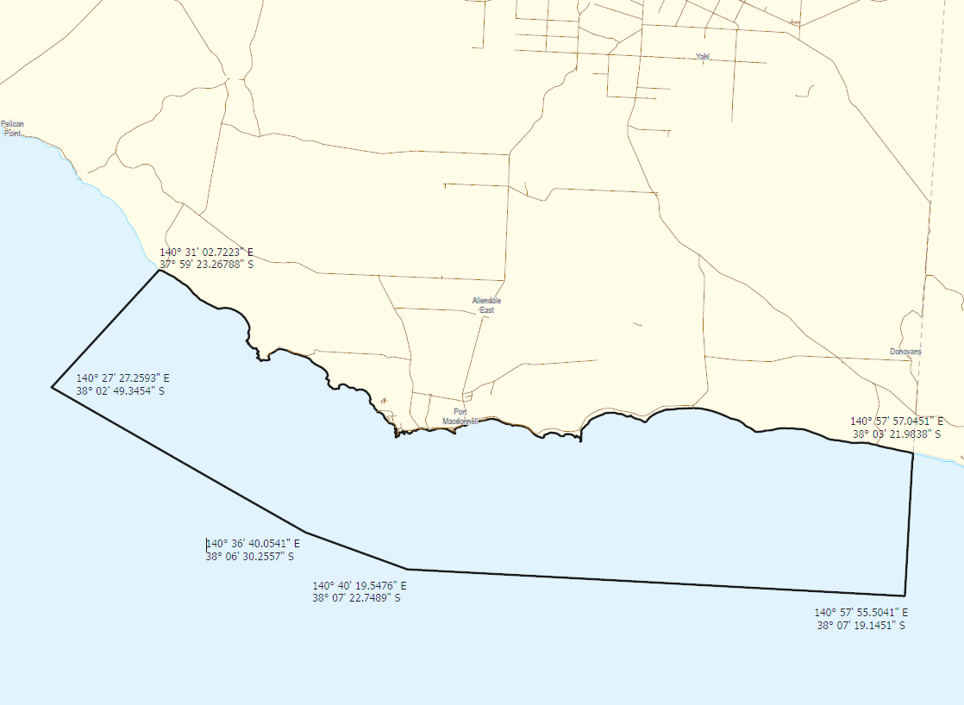
This Notice will come into effect from 22:00 on 23 February 2024.
Dated: 23 February 2024
Dr Elise Spark
Deputy Chief Inspector of Stock
Delegate of the Minister for Primary Industries and Regional Development

Major Events Act 2013
Section 6B
Declaration of a Major Event
PURSUANT to section 6B of the Major Events Act 2013, I, Hon. Zoe Bettison MP, Minister for Tourism South Australia declare the 2024 WOMADelaide to be held from 8 to 11 March 2024 to be declared a major event.
By virtue of the provisions of the Major Events Act 2013, I do hereby:
- Declare the 2024 WOMADelaide to be a major event.
- Specify the period for the event, for which the declaration of the major event is in force to be 7.00am Friday 8 March 2024 to 2.00am Tuesday 12 March.
- Declare the major event venue to be Botanic Park / Tainmuntilla and Frome Park / Nellie Raminyemmerin Park and any public place or part of a public place that is within 250 metres of the boundary of this park.
- Designate WOMADelaide Foundation Ltd (ABN 55 106 584 230) to be the event organisers for the event.
  - Section 8.
  - Section 10.
  - Section 11.
  - Section 12.
  - Section 13.
- Being satisfied that the title ‘WOMADelaide’ and the logo as it appears below are sufficiently connected with the identity and conduct of the major event, and that the event has commercial arrangements that are likely to be adversely affected by the sue of the title and logo, I hereby declare, pursuant to section 14(1) of the Act, that ‘WOMADelaide’ is an official title and the logo as it appears below is an official logo in respect of the event.
Dated: 26 February 2024
Hon Zoe Bettison MP
Minister for Tourism

Map of Controlled Area for the WOMADelaide
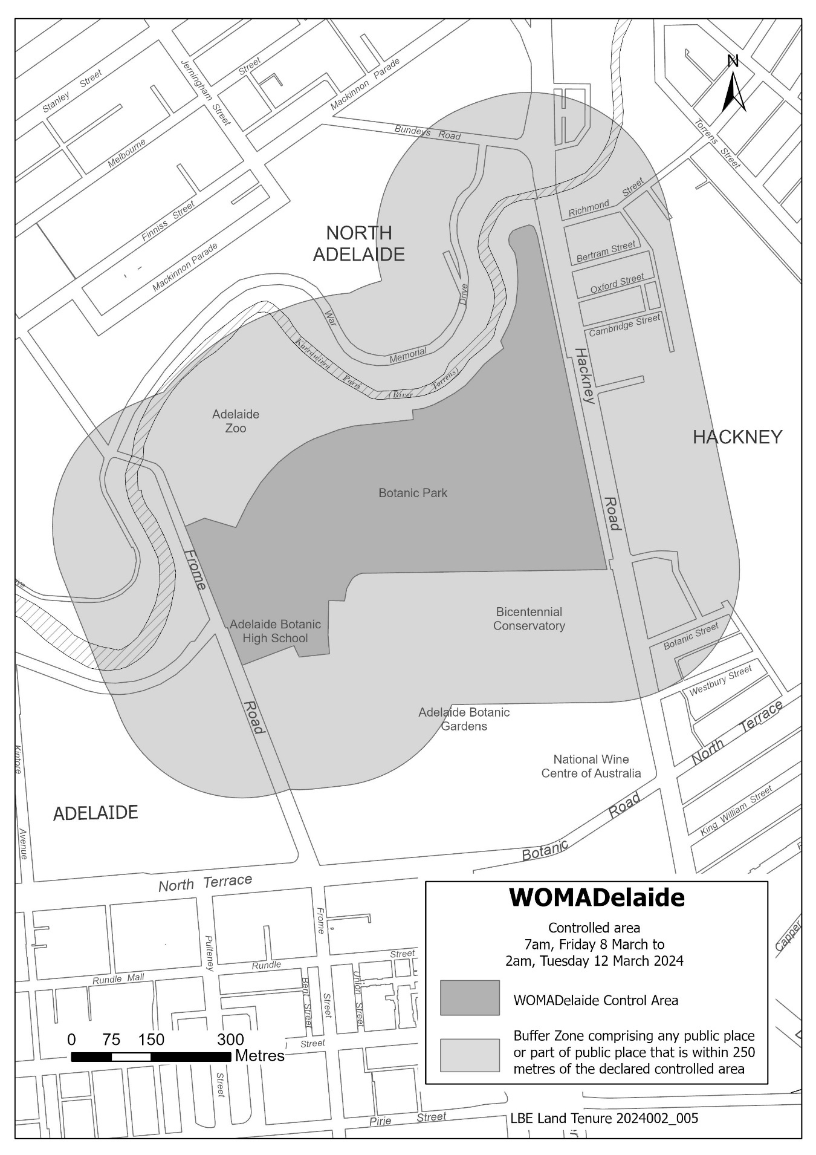

NATIONAL PARKS AND WILDLIFE ACT 1972
WILDERNESS PROTECTION ACT 1992
Managing Total Grazing Pressure in Reserves | Management plan amendments 2024—Draft
I, MICHAEL JOSEPH WILLIAMS, Director of National Parks and Wildlife, hereby give notice under the provisions of section 38 of the National Parks and Wildlife Act 1972 and section 31 of the Wilderness Protection Act 1992 that draft amendments to the following park management plans have been prepared:
Adelaide & Mount Lofty Ranges Region
• Newland Head Conservation Park Management Plan 2004
• Scott Creek Conservation Park Management Plan 1999
• Morialta and Black Hill Conservation Parks Management Plan 2001
• Porter Scrub Conservation Park Management Plan 2007
• Anstey Hill Conservation Park Management Plan 2006
Eyre & Far West Region
• Gawler Ranges National Park Management Plan 2017
• Parks of the Coffin Bay Area Management Plan 2004
• Coffin Bay National Park
• Kellidie Bay Conservation Park
• Avoid Bay Islands Conservation Park
• Whidbey Isles Conservation Park
• Mt Dutton Bay Conservation Park
• Venus Bay Conservation Park Management Plan 2006
• Lake Newland Conservation Park Management Plan 2003
• Calpatanna Waterhole Conservation Park Management Plan 1987
• Eastern Eyre Peninsula Parks Management Plan 2014
• Munyaroo Conservation Park
• Ironstone Hill Conservation Park
• Lake Gilles Conservation Park
• Malgra Conservation Park
• Heggaton Conservation Park
• The Plug Range Conservation Park
• Sheoak Hill Conservation Park
• Mallee Parks of the Central Eyre Peninsula Management Plan 2007
• Barwell Conservation Park
• Bascombe Well Conservation Park
• Hambidge Wilderness Protection Area
• Hincks Conservation Park
• Hincks Wilderness Protection Area
• Peachna Conservation Park
• Shannon Conservation Park
• Verran Tanks Conservation Park
• Wharminda Conservation Park
• Yellabinna and Warna Manda Parks Management Plan 2019
• Acraman Creek Conservation Park
• Chadinga Conservation Park
• Fowlers Bay Conservation Park
• Laura Bay Conservation Park
• Point Bell Conservation Park
• Wahgunyah Conservation Park
• Wittelbee Conservation Park
Riverland & Murraylands Region
• Danggali Wilderness Protection Area and Conservation Park Management Plan 2011
• Brookfield Conservation Park Management Plan 2005
• Reserves of the Billiatt District Management Plan 2011
• Conservation Parks of the Murraylands (Western Plains) Management Plans 1984
• Ridley Conservation Park
• Swan Reach Conservation Park
• Conservation Parks of the Murraylands (North West Zone) Management Plan 1994
• Pooginook Conservation Park
• Pandappa Conservation Park
• White Dam Conservation Park

• Maize Island Lagoon Conservation Park and Marne Valley Conservation Park Management Plan 1994
• Morgan Conservation Park Management Plan 1992
• Moorook-Loch Luna Game Reserve Park Management Plan 1994
Yorke & Mid North Region
• Mokota Conservation Park Management Plan 2003
• Bimbowrie Conservation Park Management Plan 2012
• Mount Brown Conservation Park Management Plan 1999
• The Dutchmans Stern Conservation Park Management Plan 1999
Limestone Coast Region
• Coorong National Park Management Plan 1991
• Naracoorte Caves National Park Management Plan 2001
• Piccaninnie Ponds Conservation Park Management Plan 1992
• Lake St Clair Conservation Park Management Plan 2011
• Bool Lagoon Game Reserve and Hacks Lagoon Conservation Parks Management Plan 2006
• Carpenter Rocks Conservation Park and Bucks Lake Game Reserve Management Plan 2007
Copies of the draft plans may be obtained from:
- Department for Environment and Water Customer Service Centre, Ground Floor, 81-95 Waymouth Street, Adelaide SA 5000
- Black Hill National Parks and Wildlife Service Office, 115 Maryvale Road, Athelstone SA 5076
- Port Lincoln National Parks and Wildlife Service Office. 86 Tasman Terrace, Port Lincoln SA 5606
- National Parks and Wildlife Service South Australia Riverland and Murraylands Regional Office, 28 Vaughan Tce, Berri SA 5343
- National Parks and Wildlife Service, Yorke and Mid North Office, 115 Main North Road, Clare SA 5453
- National Parks and Wildlife Service, Limestone Coast Office, 152 Jubilee Highway East, Mt Gambier SA 5290
Or online at:
- https://yoursay.sa.gov.au/
- https://www.parks.sa.gov.au/park-management/management-plans
Any person may make representations in connection with the draft plan during the period up to and including 5pm 26 May 2024.
Written comments should be forwarded to National Parks and Protected Area Program Unit, Department for Environment and Water, GPO Box 1047 ADELAIDE SA 5001 or e-mailed to DEWProtectedAreaManagement@sa.gov.au
Dated: 16 February 2024
M.J. Williams
Director of National Parks and Wildlife
Delegate of the Minister for Climate, Environment and Water

Petroleum and Geothermal Energy Act 2000
Suspension of
Petroleum Exploration Licence—PEL 676
Associated Activities Licence—AAL 308
Pursuant to section 90 of the Petroleum and Geothermal Energy Act 2000, notice is hereby given that the abovementioned Licences have been suspended for the period from 22 December 2023 to 21 June 2024 inclusive, pursuant to delegated powers dated 27 November 2023.
The expiry date of PEL 676 is now determined to be 1 September 2027 and the expiry date of AAL 308 is now determined to be 6 March 2025.
Dated: 22 February 2024
Benjamin Zammit
Executive Director
Regulation and Compliance Division
Department for Energy and Mining
Delegate of the Minister for Energy and Mining

PLANNING, DEVELOPMENT AND INFRASTRUCTURE ACT 2016
Section 78
Amendment to the Planning and Design Code
Preamble
It is necessary to amend the Planning and Design Code (the Code) in operation at 15 February 2024 (Version 2024.3) in the interests of the orderly and proper development of an area of the State, and in order to counter applications for undesirable development within the area affected by the Ancillary Accommodation and Student Accommodation Definitions Review Code Amendment (the Amendment).
PURSUANT to section 78 of the Planning, Development and Infrastructure Act 2016 (the Act), I hereby declare that the Amendment will come into operation on an interim basis on the day it is published on the SA planning portal.
Dated: 23 February 2024
Nick Champion
Minister for Planning

Planning, Development and Infrastructure Act 2016
Section 76
Amendment to the Planning and Design Code
Preamble
It is necessary to amend the Planning and Design Code (the Code) in operation at 15 February 2024 (Version 2024.3) in order to make changes of form relating to the Code’s spatial layers and their relationship with land parcels. NOTE: There are no changes to the application of zone, subzone or overlay boundaries and their relationship with affected parcels or the intent of policy application as a result of this amendment.
- PURSUANT to section 76 of the Planning, Development and Infrastructure Act 2016 (the Act), I hereby amend the Code in order to make changes of form (without altering the effect of underlying policy), correct errors and make operational amendments as follows:
- Undertake minor alterations to the geometry of the spatial layers and data in the Code to maintain the current relationship between the parcel boundaries and Code data as a result of the following:
  - New plans of division deposited in the Land Titles Office between 7 February 2024 and 20 February 2024 affecting the following spatial and data layers in the Code:
    - Zones and subzones
    - Technical and Numeric Variations
      - Building Heights (Levels)
      - Building Heights (Metres)
      - Concept Plan
      - Finished Ground and Floor Levels
      - Gradient Minimum Site Area
      - Minimum Dwelling Allotment Size
      - Minimum Frontage
      - Minimum Site Area
    - Overlays
      - Affordable Housing
      - Coastal Areas
      - Coastal Flooding
      - Defence Aviation Area
      - Dwelling Excision
      - Future Road Widening
      - Hazards (Acid Sulfate Soils)
      - Hazards (Bushfire - High Risk)
      - Hazards (Bushfire - Medium Risk)
      - Hazards (Bushfire - General Risk)
      - Hazards (Bushfire - Urban Interface)
      - Hazards (Bushfire - Regional)
      - Hazards (Bushfire - Outback)
      - Heritage Adjacency
      - Historic Shipwrecks
      - Local Heritage Place
      - Limited Land Division
      - Noise and Air Emissions
      - State Heritage Place
      - Stormwater Management
      - Urban Tree Canopy
- In Part 13 of the Code – Table of Amendments, update the publication date, Code version number, amendment type and summary of amendments within the ‘Table of Planning and Design Code Amendments’ to reflect the amendments to the Code as described in this Notice.
- PURSUANT to section 76(5)(a) of the Act, I further specify that the amendments to the Code as described in this Notice will take effect upon the date those amendments are published on the SA planning portal.
Dated: 26 February 2024
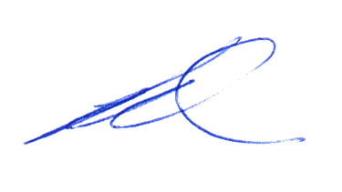Greg Van Gaans
Director, Land and Built Environment,
Department for Trade and Investment
Delegate of the Minister for Planning

Professional Standards Act 2004
The Victorian Bar Professional Standards Scheme
PURSUANT to section 34(2) of the Professional Standards Act 2004, I Kyam Maher, Attorney-General for the State of South Australia, hereby extend the period for which the Victorian Bar Professional Standards Scheme is in force in South Australia to 30 June 2025.
Dated: 12 December 2023
Kyam Maher MLC
Attorney-General

Proof of Sunrise and Sunset Act 1923
Almanac for April, May and June 2024
Pursuant to the requirements of the Proof of Sunrise and Sunset Act 1923, I Jon William Whelan, Chief Executive, Department for Infrastructure and Transport, at the direction of the Minister for Infrastructure and Transport, publish in the Schedule hereto an almanac setting out the times of sunrise and sunset on every day for the three calendar months April, May and June 2024.
Dated: 26 February 2024
Jon William Whelan
Chief Executive
Department for Infrastructure and Transport

Schedule
Sunrise & Sunset Times for Adelaide 2024
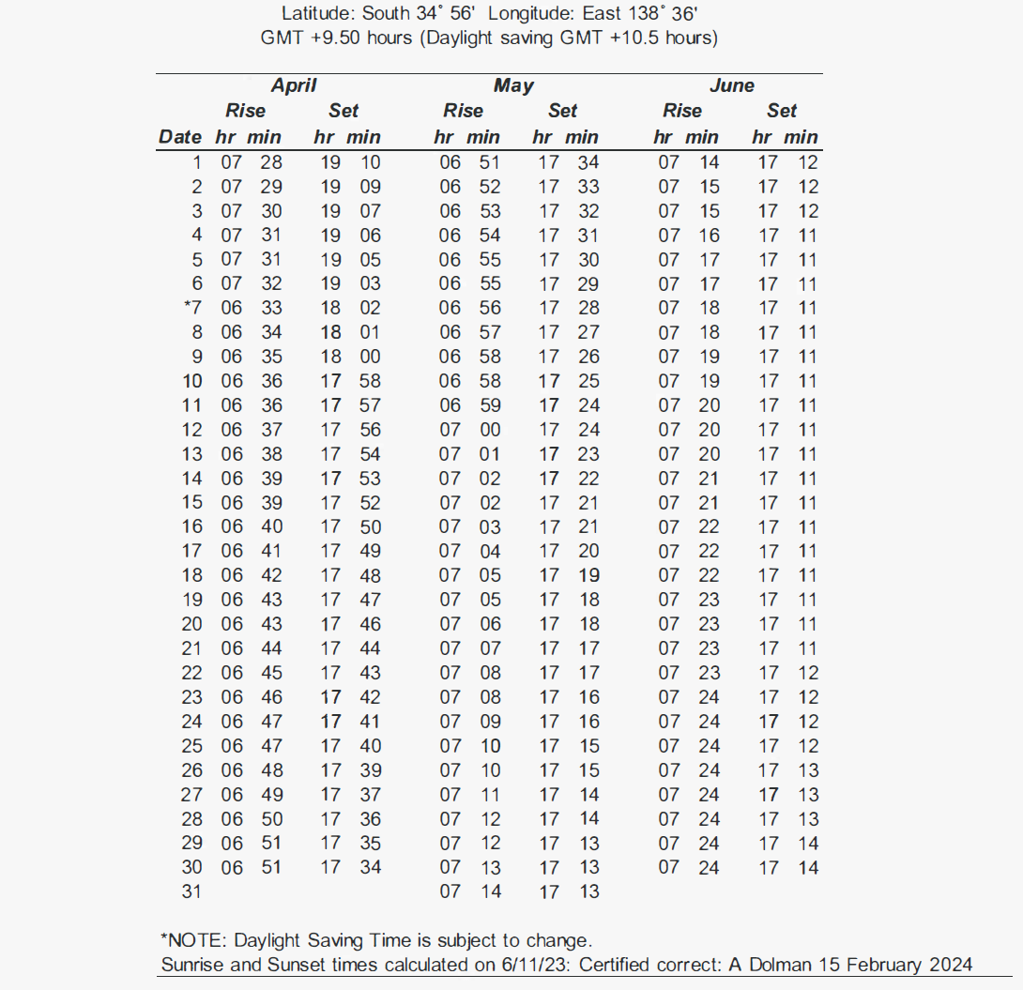

The District Court of South Australia
Mount Gambier Circuit Court
Sheriff’s Office, Adelaide, 5 March 2024
In pursuance of a precept from the District Court to me directed, I do hereby give notice that the said Court will sit as a Court of Oyer and Terminer and General Gaol Delivery at the Courthouse at Mount Gambier on the day and time undermentioned and all parties bound to prosecute and give evidence and all jurors summoned and all others having business at the said Court are required to attend the sittings thereof and the order of such business will be unless a Judge otherwise orders as follows:
Tuesday 5 March 2024 at 10 a.m. on the first day of the sittings the only business taken will be the arraignment of prisoners in gaol and the passing of sentences on prisoners in gaol committed for sentence; the surrender of prisoners on bail committed for sentence; the surrender of persons in response to ex officio informations or of persons on bail and committed for trial who have signified their intentions to plead guilty and the passing of sentences for all matters listed for disposition by the District Court.
Juries will be summoned for 4 March 2024 and persons will be tried on this and subsequent days of the sittings.

Prisoners in H.M. Gaol and on bail for sentence and for trial at the sittings
of the Mount Gambier Courthouse, commencing 5 March 2024.
Arthur, Trevor Sean Victor |  | Traffic in a controlled drug. | On bail
Black, Kelvin James |  | Persistent sexual exploitation of a child. | On bail
Braddock, Nathan Walter |  | Traffic in a controlled drug (2). | On bail
Broadbent, William Joseph  Lovegrove, Adrian Clarke |  | Aggravated serious criminal trespass in a place of residence; Aggravated assault causing harm (2); Aggravated assault (3). | In gaol  On bail
Carter, Paul David |  | Indecently assault a person (3); Engage in sexual intercourse with a person without consent; Assault (3). | On bail
Childs, Joshua James |  | Aggravated threaten to cause harm; Contravene intervention order (4). | In gaol
Courbois, Ezekiel Albertus Thomas |  | Possess drug for supply to another person; Aggravated possess prescribed firearm without licence. | On bail
Donges, Ian Francis |  | Acquire, own or possess ammunition without licence or permit; Possess prescribed firearm without licence. | On bail
Graetz, Gerard Henry |  | Unlawful sexual intercourse with person under 17 years; Maintaining an unlawful sexual relationship with a child. | On bail
H, M C |  | Knowingly be in possession of child exploitation material (6). | In gaol
Mitakiki, Anita Francine |  | Deliver, introduce, have possession of prescribed item. | On bail
Nakacia, Kolinio Saukuru |  | Commit assault (2); Engage in sexual intercourse with a person without consent (3); False Imprisonment. | In gaol
Nakacia, Kolinio Saukuru |  | Serious criminal trespass; Assault with intent to commit offence; Indecently assault a person. | In gaol
N, T J |  | Persistent sexual exploitation of a child (9). | In gaol
Payne, Damien Ashley |  | Be armed at night to commit offence against person. | On bail
Payne, Damien Ashley |  | Aggravated possess prescribed firearm without licence; Possess any other firearm without licence (2); Contravene a provision of the code of practice (3). | On bail
Pitts, Dennis John |  | Traffic in a controlled drug; Possess or use a dangerous article. | In gaol
Schofield, Sebastian James Swamkian |  | Aggravated threatening to cause harm; Aggravated threaten to cause harm to another | In gaol
Sleep, Paul Bradley |  | Aggravated possess any other firearm without licence. | On bail
Stokes, Brenton Craig Peter |  | Have sexual intercourse with a person under 14 years; Indecently assault a person. | On bail
Whitaker, Mark |  | Knowingly be in possession of child exploitation material. | In gaol
Young, Darius Ace |  | Obtain access to child exploitation material (2). | In gaol
Prisoners on bail must surrender at 10 a.m. of the day appointed for their respective trials. If they do not appear when called upon their recognizances and those of their bail will be estreated and a bench warrant will be issued forthwith.
By order of the Court;
L. Turner
Sheriff

Wilderness Protection Act 1992
Public Submissions—Proposal to Proclaim an Addition to the Cape Torrens Wilderness Protection Area
I, SUSAN CLOSE, Minister for Climate, Environment and Water, hereby give notice under the provisions of section 22(6)(e) of the Wilderness Protection Act 1992, that the public submissions regarding the proposal to proclaim an addition to the Cape Torrens Wilderness Protection Area are now available for public viewing.
The land to be added to the wilderness protection area is Allotment 1 in Deposited Plan 119843, Hundred of Borda.
Copies of the submissions may be viewed at or obtained from the offices of the Department for Environment and Water at:
- Adelaide: Reception, Ground Floor, 81-95 Waymouth Street, Adelaide, SA 5000.
- Kingscote: 37 Dauncey Street, Kingscote, SA 5223.
Or by contacting Andrew Burnell, Team Leader, Park Strategy and Establishment, Department for Environment and Water at andrew.burnell@sa.gov.au.
Dated: 27 February 2024
Susan Close MP
Minister for Climate, Environment and Water

Local Government Instruments

CITY OF ADELAIDE
Local Government Act 1999: Section 122
and
City of Adelaide Act 1998: Section 30
Draft Buildings Asset Management Plan for public consultation
The City of Adelaide is consulting on its Draft Buildings Asset Management Plan.
Pursuant to the provisions of section 122 of the Local Government Act 1999, and section 30 of the City of Adelaide Act 1998, the City of Adelaide is required to conduct public consultation on its Asset Management Plans before they can be formally adopted.
A copy of each draft Asset Management Plan will be available for inspection at the Council’s principal office (25 Pirie Street, Adelaide SA 5000), and at its libraries and community centres.
For further information on the consultation process or to provide feedback you can visit yoursay.cityofadelaide.com.au at any time, or Council’s principal office, its libraries and community centres during ordinary office hours.
Consultation is open from Monday 4 March 2024.
All submissions on the Draft Buildings Asset Management Plan must be received by 5:00 pm, Friday 12 April 2024.
Michael Sedgman
Acting Chief Executive Officer

Rural City of Murray Bridge
Notice of Exclusion of Land from Classification as Community Land
NOTICE is hereby given that the Rural City of Murray Bridge at its meeting held on 9 September 2013 resolved, pursuant to section 193 (4) of the Local Government Act 1999, to exclude the following parcel of land from classification as community land:
Allotment 6 in the Deposited Plan D1819, Adelaide Road, Hundred of Mobilong, being the whole of the land comprised in Certificate of Title Register Book Volume 6126, Folio 233.
H. Barcley
Chief Executive Officer

Light Regional Council
Local Government Act 1999
Land Division—Allotment 1 Moyle Road, Allotment 1 Kapunda Street,
Allotment 2 Kapunda Street and Allotment 102 Kapunda Street, Kapunda—Street Names
Notice is hereby given that in accordance with the provisions of Section 219 of the Local Government Act 1999, at the meeting held on 15 September 2009, Council resolved to approve street names associated with land division development at Stephenson, Schuster and Gray Street, Freeling that has created the following public roads:
- Sir Sidney Kidman Boulevard
- Brumby Court
- Butler Crescent
The previously mentioned Council minutes and street naming report can be viewed on the Light Regional Council website.
Dated: 26 February 2024
Richard Dodson
Chief Executive Officer

Light Regional Council
Local Government Act 1999
Land Division—Allotment 454 and 455 Kangaroo Flat Road, Roseworthy—Street Names
Notice is hereby given that in accordance with the provisions of Section 219 of the Local Government Act 1999, at the meeting held on 26 May 2020, Council resolved to approve street names associated with land division development at Allotment 454 and 455 Kangaroo Flat Road, Roseworthy that has created the following public roads:
- Birks Avenue
- Rankine Road
- Ludbrook Drive
- Beckwith Street
- Buring Road
The previously mentioned Council minutes and street naming report can be viewed on the Light Regional Council website.
Dated: 26 February 2024
Richard Dodson
Chief Executive Officer

District Council of Yankalilla
Assignment of Name for Un-named Road
Notice is herby given that the District Council of Yankalilla at its meeting held on 20 February 2024 resolved pursuant to Section 219 of the Local Government Act 1999 and its Road Naming Policy to adopt Hewett Crescent as the name of the previously un-named public road in Myponga Beach taking effect from 20 February 2024.
A plan that delineates the un-named public road can be found on Council’s website www.yoursayyankalilla.com.au
Nathan Cunningham
Chief Executive Officer

Public Notices

LOCAL GOVERNMENT ACT 1999
Central Local Government Region of South Australia
Adoption of Amended Charter
Notice is hereby given of the adoption of an Amended Charter by the Central Local Government Region of South Australia (referred to as Northern and Yorke Local Government Association) on 23 February 2024. In accordance with the Local Government Act 1999, Schedule 2 (2) Clause 19 (5) (c), full details of the Amended Charter are available at www.legatus.sa.gov.au.
Dated: 26 February 2024
Simon Millcock
Chief Executive Officer
Northern and Yorke Local Government Association

National Electricity Law
Notice of Extension for Draft Determination
Notice of Making of Final Rule Determination and Final Rule
Notice of Making of Draft Rule Determination and Draft Rule
The Australian Energy Market Commission (AEMC) gives notice under the National Electricity Law as follows:
Under s 107, the time for making the draft determination on the Integrating price-responsive resources into the NEM (Ref. ERC0352) proposal has been extended to 25 July 2024.
Under ss 102 and 103, the making of the National Electricity Amendment (Calculation of system strength quantity) Rule 2024 No. 2 (Ref. ERC0375) and related final determination. Schedule 1 will commence on 1 July 2024 and Schedule 2 will commence on 8 March 2024.
Under s 99, the making of a draft determination and related draft rule on the Unlocking CER benefits through flexible trading proposal (Ref. ERC0346). Submissions must be received by 11 April 2024.
Submissions can be made via the AEMC’s website. Before making a submission, please review the AEMC’s privacy statement on its website, and consider the AEMC’s Tips for making a submission. The AEMC publishes all submissions on its website, subject to confidentiality.
Documents referred to above are available on the AEMC’s website and are available for inspection at the AEMC’s office.
Australian Energy Market Commission
Level 15, 60 Castlereagh St
Sydney NSW 2000
Telephone: (02) 8296 7800
www.aemc.gov.au
Dated: 29 February 2024

National Energy Retail Law
Notice of Extension for Draft Determination
Notice of Making of Draft Rule Determination and Draft Rule
The Australian Energy Market Commission (AEMC) gives notice under the National Energy Retail Law as follows:
Under s 266, the time for making the draft determination on the Integrating price-responsive resources into the NEM (Ref. RRC0051) proposal has been extended to 25 July 2024.
Under s 256, the making of a draft determination and related draft rule on the Unlocking CER benefits through flexible trading (Ref. RRC0045) proposal. Submissions must be received by 11 April 2024.
Submissions can be made via the AEMC’s website. Before making a submission, please review the AEMC’s privacy statement on its website, and consider the AEMC’s Tips for making a submission. The AEMC publishes all submissions on its website, subject to confidentiality.
Documents referred to above are available on the AEMC’s website and are available for inspection at the AEMC’s office.
Australian Energy Market Commission
Level 15, 60 Castlereagh St
Sydney NSW 2000
Telephone: (02) 8296 7800
www.aemc.gov.au
Dated: 29 February 2024

Trustee Act 1936
Public Trustee
Estates of Deceased Persons
In the matter of the estates of the undermentioned deceased persons:
CHRISTIE Eleanor McCloud late of 52 Dunrobin Road Hove Retired Teacher who died 12 November 2023
EVANS David John late of 7A Wheaton Street South Plympton of no occupation who died 30 April 2023
LOCH Julie Eleanor late of 30B Maldon Avenue Mitchell Park Retired Stenographer who died 13 March 2023
NYARI Wendy Jeanette late of 8 Elmgrove Road Salisbury North of no occupation who died 11 June 2020
OCHRYN Michalina late of 13 Keith Avenue North Plympton Retired Cook who died 23 September 2023
PALMGREN Hans Olof late of 14 Heading Street Whyalla Stuart Retired Technical Officer who died 4 October 2023
SCHMIDT Trevor Kenneth late of 31 Upcher Street Blanchetown Carpenter who died 16 September 2023
WHITE Lorraine Kathleen late of 14 Tapping Crescent North Haven Retired Telephonist who died 18 September 2023
Notice is hereby given pursuant to the Trustee Act 1936, the Inheritance (Family Provision) Act 1972 and the Family Relationships Act 1975 that all creditors, beneficiaries, and other persons having claims against the said estates are required to send, in writing, to the office of Public Trustee at GPO Box 1338, Adelaide SA 5001, full particulars and proof of such claims, on or before 29 March 2024 otherwise they will be excluded from the distribution of the said estate; and notice is also hereby given that all persons indebted to the said estates are required to pay the amount of their debts to the Public Trustee or proceedings will be taken for the recovery thereof; and all persons having any property belonging to the said estates are forthwith to deliver same to the Public Trustee.
Dated: 29 February 2024
N. S. Rantanen
Public Trustee

Notice Submission

The South Australian Government Gazette is published each Thursday afternoon.
Notices must be emailed by 4 p.m. Tuesday, the week of publication.
Submissions are formatted per the gazette style and a proof will be supplied prior to publication, along with a quote if applicable. Please allow one day for processing notices.
Alterations to the proof must be returned by 4 p.m. Wednesday.

Gazette notices must be submitted as Word files, in the following format:
• Title—the governing legislation
• Subtitle—a summary of the notice content
• Body—structured text, which can include numbered lists, tables, and images
• Date—day, month, and year of authorisation
• Signature block—name, role, and department/organisation authorising the notice

Please provide the following information in your email:
• Date of intended publication
• Contact details of the person responsible for the notice content
• Name and organisation to be charged for the publication—Local Council and Public notices only
• Purchase order, if required—Local Council and Public notices only

Email: governmentgazettesa@sa.gov.au
Phone: (08) 7133 3552
Website: www.governmentgazette.sa.gov.au

All instruments appearing in this gazette are to be considered official, and obeyed as such

Printed and published weekly by authority of T. Foresto, Government Printer, South Australia
$8.55 per issue (plus postage), $430.00 per annual subscription—GST inclusive
Online publications: www.governmentgazette.sa.gov.au

