No. 3 p. 39
THE SOUTH AUSTRALIAN
GOVERNMENT GAZETTE
Published by Authority

Adelaide, Thursday, 18 January 2024

Contents

Governor’s Instruments
Appointments 40
Proclamations—
Youth Court (Designation and Classification of Magistrate)
Proclamation 2024 41
Youth Court (Designation and Classification of Magistrate)
Proclamation 2024 42
Regulations—
Controlled Substances (Poisons) (Exemptions) Amendment
Regulations 2024—No. 1 of 2024 43
State Government Instruments
Associations Incorporation Act 1985 45
Electricity Act 1996 45
Fisheries Management (General) Regulations 2017 46
Fisheries Management Act 2007 47
Housing Improvement Act 2016 48
Justices of the Peace Act 2005 49
Land Acquisition Act 1969 50
Local Government Act 1999 55
Major Events Act 2013 55
Motor Vehicles Act 1959 57
Offshore Minerals Act 2000 59
Petroleum and Geothermal Energy Act 2000 66
Phylloxera And Grape Industry Act 1995 68
Planning, Development and Infrastructure Act 2016 68
Roads (Opening and Closing) Act 1991 69
Local Government Instruments
District Council of Kimba 70
Public Notices
National Electricity Law 71
National Energy Retail Law 71
National Gas Law 71

Governor’s Instruments

Appointments
Department of the Premier and Cabinet
Adelaide, 18 January 2024
Her Excellency the Governor in Executive Council has been pleased to appoint the undermentioned to the South Australian Museum Board, pursuant to the provisions of the South Australian Museum Act 1976:
Member: from 18 January 2024 until 17 January 2027
Brett Charles Miller
By command,
Zoe Lee Bettison, MP
For Premier
23ART0022CS

Department of the Premier and Cabinet
Adelaide, 18 January 2024
Her Excellency the Governor in Executive Council has been pleased to appoint the undermentioned to the Adelaide Festival Corporation Board, pursuant to the provisions of the Adelaide Festival Corporation Act 1998:
Member: from 18 January 2024 until 17 January 2027
Leesa Anne Chesser
By command,
Zoe Lee Bettison, MP
For Premier
23ART0031CS

Department of the Premier and Cabinet
Adelaide, 18 January 2024
Her Excellency the Governor in Executive Council has been pleased to appoint the undermentioned to the Legal Practitioners Disciplinary Tribunal, pursuant to the provisions of the Legal Practitioners Act 1981:
Member: from 18 January 2024 until 17 January 2027
Michelle Faye Crichton
Thomas Andrew Besanko
By command,
Zoe Lee Bettison, MP
For Premier
AGO0007-24CS

Department of the Premier and Cabinet
Adelaide, 18 January 2024
Her Excellency the Governor in Executive Council has been pleased to appoint Dr James Muecke AM as Governor's Deputy of South Australia for the period from 4.00pm on Friday, 26 January 2024 until 8.30pm on Sunday, 28 January 2024.
By command,
Zoe Lee Bettison, MP
For Premier

Department of the Premier and Cabinet
Adelaide, 18 January 2024
Her Excellency the Governor in Executive Council has determined remuneration for members of the Local First Nations Voices and State First Nations Voice, effective from 16 March 2024 - pursuant to sections 13(2) and 26(2) of the First Nations Voice Act 2023.
By command,
Zoe Lee Bettison, MP
For Premier
AGO0006-24CS

Proclamations
South Australia

Youth Court (Designation and Classification of Magistrate) Proclamation 2024
under section 9 of the Youth Court Act 1993

Preamble
1 His Honour Michael John Jandy, a magistrate holding office under the Magistrates Act 1983, is designated under section 9 of the Youth Court Act 1993 as a magistrate of the Youth Court of South Australia and classified as a member of the Court's ancillary judiciary (Gazette 16.11.2023 p3892).
2 It is now intended that, by this proclamation, His Honour continue to be designated as a magistrate of the Youth Court of South Australia but that he now be classified as a member of the Court's principal judiciary.
3 For that purpose, it is intended that, by this proclamation, the designation and classification referred to in clause 1 above be revoked and replaced by a designation and classification in accordance with clause 2 above.

1—Short title
This proclamation may be cited as the Youth Court (Designation and Classification of Magistrate) Proclamation 2024.
2—Commencement
This proclamation comes into operation on the day on which it is made.
3—Repeal of proclamation
The Youth Court (Designation and Classification of Magistrate) Proclamation 2023 (Gazette 16.11.2023 p3892) is repealed.
4—Designation and classification of magistrate
Magistrate Michael John Jandy is—
(a) designated as a magistrate of the Youth Court of South Australia; and
(b) classified as a member of the Court's principal judiciary.
Made by the Governor
with the advice and consent of the Executive Council
on 18 January 2024

South Australia

Youth Court (Designation and Classification of Magistrate) Proclamation 2024
under section 9 of the Youth Court Act 1993
1—Short title
This proclamation may be cited as the Youth Court (Designation and Classification of Magistrate) Proclamation 2024.
2—Commencement
This proclamation comes into operation on the day on which it is made.
3—Designation and classification of magistrate
Magistrate Alison Frances Adair is—
(a) designated as a magistrate of the Youth Court of South Australia; and
(b) classified as a member of the Court's principal judiciary; and
(c) declared to be a member of the Court's principal judiciary for a term commencing on the day on which this proclamation comes into operation and ending on 23 November 2024.
Made by the Governor
with the advice and consent of the Executive Council
on 18 January 2024

Regulations
South Australia

Controlled Substances (Poisons) (Exemptions) Amendment Regulations 2024
under the Controlled Substances Act 1984

Contents
Part 1—Preliminary
1 Short title
2 Commencement
Part 2—Amendment of Controlled Substances (Poisons) Regulations 2011
3 Amendment of regulation 21—Exemptions from section 18 of Act

Part 1—Preliminary
1—Short title
These regulations may be cited as the Controlled Substances (Poisons) (Exemptions) Amendment Regulations 2024.
2—Commencement
These regulations come into operation on the day on which they are made.
Part 2—Amendment of Controlled Substances (Poisons) Regulations 2011
3—Amendment of regulation 21—Exemptions from section 18 of Act
Regulation 21(2)—after paragraph (g) insert:
or
(h) the drug is sold or supplied to a person in accordance with a scheme determined by the Minister from time to time for the purposes of this paragraph by notice in the Gazette.
Editorial note—
As required by section 10AA(2) of the Legislative Instruments Act 1978, the Minister has certified that, in the Minister's opinion, it is necessary or appropriate that these regulations come into operation as set out in these regulations.
Made by the Governor
after consultation by the Minister with the Controlled Substances Advisory Council and with the advice and consent of the Executive Council
on 18 January 2024
No 1 of 2024

State Government Instruments

Associations Incorporation Act 1985
Order Pursuant to Section 42(2)
Dissolution of Association
WHEREAS the CORPORATE AFFAIRS COMMISSION (the Commission) pursuant to section 42(1) of the Associations Incorporation Act 1985 (the Act) is of the opinion that the undertaking or operations of HERTECHPATH INCORPORATED (the Association) being an incorporated association under the Act are being carried on, or would more appropriately be carried on by a Company Limited by Guarantee incorporated under the Corporations Act 2001 (Cth) AND WHEREAS the Commission was on 6 FEBRUARY 2023 requested by the Association to transfer its undertaking to HERTECHPATH LIMITED (Australian Company Number 671 761 489), the Commission pursuant to section 42(2) of the Act DOES HEREBY ORDER that on 19 JANUARY 2024, the Association will be dissolved, the property of the Association becomes the property of HERTECHPATH LIMITED and the rights and liabilities of the Association become the rights and liabilities of HERTECHPATH LIMITED.
Given under the seal of the Commission at Adelaide this 15th day of January 2024.
Lisa Berry
A delegate of the Corporate Affairs Commission

Electricity Act 1996
Gas Act 1997
Retailer Energy Productivity Scheme
Minimum Specifications for Energy Productivity Activities
Pursuant to Regulation 28(5) of the Electricity (General) Regulations 2012 under the Electricity Act 1996, and Regulation 22(5) of the Gas Regulations 2012 under the Gas Act 1997, I revoke the Ministerial Notice— Replace or Upgrade Water Heater; Residential and Small Energy Consuming Customers Only, Activity No. WH1 in the South Australian Government Gazette No.6 dated 27 January 2023 on pages 100-102.
Pursuant to Regulation 28 of the Electricity (General) Regulations 2012 and Regulation 22 of the Gas Regulations 2012, I determine the activities within the following document to be an energy productivity activity for the purposes of Part 4 of the Electricity (General) Regulations 2012 and Part 4 of the Gas Regulations 2012.
This notice will take effect on 18 January 2024.
Tom Koutsantonis
Minister for Energy and Mining

Replace or Upgrade Water Heater; Residential and Small Energy Consuming Customers Only
Activity No. WH1
1. Activity Specific Definitions
Gas water heater or solar gas means a water heater that has a primary or boost fuel source of natural gas (methane) or LPG.
Class 1 and class 2 dwellings are as defined by the National Construction Code.
2. Activity Description (Summary)
Install or replace a water heater.
3. Activity Eligibility Requirements
A new or replacement water heater installed to service a South Australian
- established class 1 dwelling, or
- class 2 dwelling (new or established), or
- Small energy consuming customer
The following is excluded:
- Installation of a water heater undertaken as part of class 1 building work requiring approval under the Development Act 1993 or the Planning, Development and Infrastructure Act 2016. This includes water heaters installed to service a new class 1 dwelling.
4. Installed Product Requirements
- Only gas, solar electric, solar gas or heat pump water heaters are included in the specification.
- Gas water heaters shall be rated at a minimum of 5 stars in accordance with AS4552 and listed in the Directory of AGA Certified Products.
(3)(a) Solar electric and gas boosted solar systems with a tank size ≤ 220 litres installed before 1 January 2024 shall earn ≥ 13 STCs for Zone 3.
(3)(b) Solar electric and gas boosted solar systems with a tank size ≤ 220 litres installed on or after 1 January 2024 shall earn ≥ 11 STCs for Zone 3.
(4)(a) Solar electric and gas boosted solar systems 220 < tank size ≤ 400 litres installed before 1 January 2024 shall earn ≥ 21 STCs for Zone 3.
(4)(b) Solar electric and gas boosted solar systems 220 < tank size ≤ 400 litres installed on or after 1 January 2024 shall earn ≥ 18 STCs for Zone 3.
(5)(a) Solar electric and gas boosted solar systems 400 < tank size ≤ 700 litres installed before 1 January 2024 shall earn ≥ 30 STCs for Zone 3.
(5)(b) Solar electric and gas boosted solar systems 400 < tank size ≤ 700 litres installed on or after 1 January 2024 shall earn ≥ 26 STCs for Zone 3.
(6)(a) Heat pump water heaters installed before 1 January 2024 shall earn ≥ 21 STCs when assessed under AS/NZS 4234 for Zone 3 and shall earn ≥ 20 STCs when assessed under AS/NZS 4234 for Zone 4.
(6)(b) Heat pump water heaters installed on or after 1 January 2024 shall earn ≥ 18 STCs when assessed under AS/NZS 4234 for Zone 3 and shall earn ≥ 18 STCs when assessed under AS/NZS 4234 for Zone 4.
5. Minimum Installation Requirements
- The water heater must be installed in accordance with relevant installation standards including, but not limited, to AS/NZS 3500:2018 (plumbing and drainage standards); AS/NZS 3500.4:2018 (Plumbing and drainage - Heated water services), AS 4552:2010 (gas hot water systems); AS/NZS 60335.2.21:2013 (electric storage water heaters); AS/NZS 60335.2.35:2004 (instantaneous water heaters).
- All products shall be installed in accordance with the manufacturers’ installation instructions and specifications.
- Any replaced water heater must be removed from the premises.
- The activity must be completed and certified in accordance with any relevant code or codes of practice and other relevant legislation applying to the activity, including any licensing, registration, statutory approval, activity certification, health, safety, environmental or waste disposal requirements.
- Where required, a Certificate of Compliance must be provided and retained for verification purposes.
6. Normalised Reps Gigajoules
The normalised REPS gigajoules achieved from undertaking this activity is equal to:
Normalised REPS Gigajoules = Productivity factor, as per the table below:
Activity Description | Productivity Factor
 | For a water heater installed to service an established class 1 dwelling that is not connected to a reticulated gas supply or a class 2 dwelling (new or established) or a Small energy consuming customer | For a water heater installed to service an established class 1 dwelling that is connected to a reticulated gas supply
Install gas water heater with a rating of 5-stars or more | 53 | 0
Install a gas water heater with a rating of 6-stars or more | 58 | 5
Install a solar electric water heater | 129 | 50
Install a solar gas water heater | 146 | 66
Install a heat pump water heater | 113 | 33
7. Guidance Notes (Informative Only—Not Mandatory)
- This activity is to encourage households and small energy consuming customers to exceed, where applicable, water heater installation requirements. These requirements are given effect by the South Australian Water Heater Installation Requirements under the National Construction Code Volume Three - Plumbing Code of Australia.
- There may be restrictions on the use of roof mounted systems that use ethylene glycol (or other anti-freeze agents) where roof water is collected for human consumption.
- Products listed by the Clean Energy Regulator can be found on http://www.cleanenergyregulator.gov.au/
- All reasonable endeavours should be used to recycle removed water heaters.
- Main gas, LPG and other gas systems as included in this specification are permitted under this specification.
- AGA Directory, refer to http://www.aga.asn.au/product_directory.
For the solar water heater calculator, refer to Clean Energy Regulator’s web site:
https://www.rec-registry.gov.au/rec-registry/app/calculators/swh-stc-calculator

Fisheries Management (General) Regulations 2017
Regulation 23B
Taking of Murray Cod in Certain Waters
For the purposes of regulation 23B of the Fisheries Management (General) Regulations 2017 regarding the taking of Murray Cod in certain waters, – I, Benn Gramola, A/Executive Director, Fisheries and Aquaculture, delegate of the Minister for Primary Industries and Regional Development make the following determination–
(1) Nick Secomb, Director, Plant and invasive species, PIRSA Biosecurity and his nominated agents may take dead and dying Murray Cod (Maccullochella peelii) from the waters of the River Murray proper and Lakes Albert and Alexandrina, consistent with activities under Ministerial exemption ME9903295 and consistent with the “Operational Response Plan – River Murray flood events: management of fish kills 2002-2023”.
(2) The nominated agents of Mr Secomb are:
a. Garry Warrick, 1979 Kingston Road, Loxton, SA, 5333
b. Timothy Hoad, PO Box 2178, Murray Bridge, SA, 5253
c. Nicholas Cuconits, 4 Sherwood Avenue, Valley View, SA, 5093
d. Zane Skrypek, PO Box 811, Goolwa, SA, 5214
e. Perry Robinson 2-6 Kent Street, Murray Bridge, SA, 5253
f. Staff and registered volunteers of the Murrayland and Riverland Landscape Board, 110A Kent Street, Murray Bridge, SA, 5253.
g. Staff and registered volunteers of PIRSA Biosecurity, 33 Flemington Street Glenside, SA, 5065
h. Staff and registered volunteers of Department of Environment and Water 81-95 Waymouth Street, Adelaide, SA 5000 and 28 Vaughan Terrace, Berri, SA, 5343
(3) The dead and dying Murray cod taken pursuant to this determination must not be sold.
(4) The dead and dying Murray cod taken pursuant to this determination must be transferred as soon as possible to a composting or landfill facility.
(5) If the exemption holder varies the list of nominated agents or requires more agents than what is described in this notice, written advice listing names of the additional agents must be provided to the Department by email on PIRSA.MinisterialExemptionsandPermits@sa.gov.au as soon as is practicable.
(6) The activity under this determination may only occur from 11 January 2024 until 31 December 2024.
Dated: 11 January 2024
Benn Gramola
A/Executive Director
Fisheries And Aquaculture
Delegate of the Minister for Primary Industries and Regional Development

Fisheries Management Act 2007
Section 115
Ministerial Exemption ME9903291
TAKE NOTICE that pursuant to section 115 of the Fisheries Management Act 2007, the class of persons listed in Schedule 1 (the ‘exemption holders') are exempt from section 71(2) of the Fisheries Management Act 2007 and regulation 14 of the Fisheries Management (General) Regulations 2017, but only insofar as they may use the device described in Schedule 2 to deter Long-nosed Fur Seals from interacting with fishing gear that is being lawfully used under their fishery licences (the ‘exempted activity’), during the period specified in Schedule 3 (unless varied or revoked earlier), subject to the conditions specified in Schedule 4.
Schedule 1
The holder of a Lakes and Coorong Fishery licence that is subject to a net endorsement or their registered masters or agents, who also hold a current permit from the Department for Environment and Water to use non-lethal seal deterrents within the Lakes and Coorong Commercial fishery.
Schedule 2
Underwater percussion device comprising of a wound kraft paper tube 83mm long and 16mm in diameter which contains a maximum of 2.5g of flash powder and Visco fuse (2 mm) with maximum length of 102mm inserted within the tube with 70mm extending out of the paper tube, and which conforms with the classification of United Nations number 0428, CLASS 1.1G.
Schedule 3
From 12:01 am on 13 January 2024 until 11:59 on 12 January 2025.
Schedule 4
- This exemption may only be used in conjunction with a current permit issued by the Department for Environment and Water authorising the use of Seal Control Units.
- The device as described in Schedule 2 may only be used in the waters of the Lakes and Coorong Fishery as defined in the Fisheries Management (Lakes and Coorong Fishery) Regulations 2009, subject to any existing restrictions under the Fisheries Management Act 2007, the National Parks and Wildlife Act 1972 or other applicable legislation.
- While engaging in the exempted activity, the exemption holder, registered masters and/or agents must be in possession of a copy of this notice and a copy of a current permit issued by the Department for Environment and Water authorising the use of Seal Control Units. This notice and the permit must be produced to a Fisheries Officer or Warden appointed under the National Parks and Wildlife Act 1972 if requested.
- The exemption holder must not contravene or fail to comply with the Fisheries Management Act 2007, licence conditions or any regulations made under that Act, except where specifically exempted by this notice.
Dated: 12 January 2024
Benn Gramola
A/Executive Director
Fisheries And Aquaculture
Delegate of the Minister for Primary Industries and Regional Development

Fisheries Management Act 2007
Section 115
Ministerial Exemption ME9903295
TAKE NOTICE that pursuant to section 115 of the Fisheries Management Act 2007 (the Act), Nick Secomb, Director, Plant and Invasive Species Biosecurity, (the ‘exemption holder’) and his nominated agents, are exempt from Sections 70 and 71 of the Fisheries Management Act 2007, and regulation 5, Schedule 2, and clauses 39, 40, 41, 44, 46, 47, 50, 51, 63, 64, 113(1) of Schedule 6 of the Fisheries Management (General) Regulations 2017 but only insofar as they may use the gear specified in Schedule 1 to take dead and dying fish from the waters specified in Schedule 2, subject to the conditions specified in Schedule 3, from 11 January 2024 until 31 December 2024, unless varied or revoked earlier –
Schedule 1
- Landing net / hand / dab net as defined under the Fisheries Management (General) Regulations) 2017; or
- Hauling Net; or
- Rake
Schedule 2
- The River Murray System from the South Australian border with Victoria to the mouth of the Murray River and associated tributaries including the Lakes and Coorong and;
- Coastal waters of South Australia between Wirrina Cove and Kingston South East Jetty.
Schedule 3
- The exemption holder will be deemed responsible for the conduct of all nominated agents conducting the exempted activities under this notice. Any agents conducting activities under this exemption must be provided with a copy of this notice, which they must have signed as an indication that they have read and understand the conditions under it.
- The nominated agents of the exemption holder are the following:
- Garry Warrick, 1979 Kingston Road, Loxton, SA, 5333
- Timothy Hoad, PO Box 2178, Murray Bridge, SA, 5253
- Nicholas Cuconits, 4 Sherwood Avenue, Valley View, SA, 5093
- Zane Skrypek, PO Box 811, Goolwa, SA, 5214
- Perry Robinson 2-6 Kent Street, Murray Bridge, SA, 5253
- Staff and registered volunteers of the Murrayland and Riverland Landscape Board, 110A Kent Street, Murray Bridge, SA, 5253.
- Staff and registered volunteers of PIRSA Biosecurity, 33 Flemington Street Glenside, SA,
- Staff and registered volunteers of Department of Environment and Water 81-95 Waymouth Street, Adelaide, SA 5000 and 28 Vaughan Terrace Berri, SA, 5343
- The exempted activity may only be undertaken consistent with the PIRSA Operational Response Plan – River Murray flood event: management of fish kills 2022-2023 and Ministerial Permits MP0233 and MP0235.
- Only dead and dying fish may be collected as part of the exempted activity.
- Any live noxious species caught during the exempted activity must be destroyed humanly.
- Fish collected under this exemption must not be sold and must be transferred as soon as possible to a composting or landfill facility.
- All fish collected must be disposed of in accordance with specific guidelines outlined in the Australian Aquatic Veterinary Emergency Plan (AQUAVETPLAN).
- Whilst engaged in the exempted activity nominated agents who also hold fishery authorities must not engage in commercial fishing activities under their fishery authority. Commercial vessels registered to fishery authorities must be deregistered prior to being used by calling FISHWATCH or via the commercial fishing app.
- In conducting the exempted activity, the following boats may be used:
- Boats de-registered from fishery licence R27 – 4.5m and 6m
- Boats de-registered from fishery licence L41 – 4.8m and 5.2m
- Boats de-registered from fishery licence L21 – 5.2m and 4.8 m (TCB and RV Congoli)
- Boats de-registered from fishery licence L37 – 5.2m and 6m (Optimus)
- Boats de-registered from fishery licence L12 – 5.5m, 4.3m and 5m
- Landscapes SA – Murraylands and Riverlands – 4.9 m, NC266S
- Jimbo (tri-hull - Z0017)
- Bulyong (Quintrex – 30720)
- Punkah (Rivermate - 30722)
- Swift (RIB 4m – RU147S)
- Coorong 2 (30723)
- Innamincka CK218S – 4.43m
- Dodder 414528
- Any equipment used to collect and hold fish during the exempted activity must be decontaminated prior to and after undertaking the exempted activities.
- If the exemption holder varies the list of nominated agents or requires more agents or boats than what is described in this notice, written advice listing the additional names of agents and describing additional boats must be provided to the Department by email on PIRSA.MinisterialExemptionsandPermits@sa.gov.au as soon as is practicable.
- While engaging in the exempted activity, the exemption holder or listed agents must be in possession of a copy of this exemption. Such exemption must be produced to a PIRSA Fisheries Officer if requested.
- Hauling nets may not be used in the boating channel of Coorong Area 1 near the Murray Mouth.
- The exemption holder must not contravene or fail to comply with the Fisheries Management Act 2007 or any regulations made under that Act, except where specifically exempted by this notice.
- This notice does not purport to override the provisions or operation of any other Act including, but not limited to, the River Murray Act 2003. The exemption holder and nominated agents must comply with any relevant regulations, permits, requirements and directions from the Department for Environment and Water when undertaking activities within a specially protected area.
Dated: 11 January 2024
Benn Gramola
A/Executive Director
Fisheries And Aquaculture
Delegate of the Minister for Primary Industries and Regional Development

Housing Improvement Act 2016
Rent Control Revocations
Whereas the Minister for Human Services Delegate is satisfied that each of the houses described hereunder has ceased to be unsafe or unsuitable for human habitation for the purposes of the Housing Improvement Act 2016, notice is hereby given that, in exercise of the powers conferred by the said Act, the Minister for Human Services Delegate does hereby revoke the said Rent Control in respect of each property.
Address of Premises | Allotment Section | Certificate of Title Volume/Folio
48 Old Willunga Hill Road, Willunga  SA 5172 | Allotment 395 Filed Plan 164218 Hundred of Willunga | CT5767/897
151 Woolshed Road, Mount Torrens  SA 5244 | Allotment 6 Filed Plan 13130 Hundred of Talunga | CT5485/398
13 Langman Avenue, Magill SA 5072 | Allotment 94 Deposited Plan 3375 Hundred of Adelaide | CT5718/529
32 Marlborough Avenue, Woodville Park  SA 5011 | Allotment 100 Deposited Plan 1884 Hundred of Yatala | CT5516/823
12 Amber Avenue, Clearview SA 5085 | Allotment 33 Deposited Plan 4648 Hundred of Yatala | CT5682/37
Dated: 18 January 2024
Craig Thompson
Housing Regulator and Registrar
Housing Safety Authority, SAHA
Delegate of Minister for Human Services

Justices of the Peace Act 2005
Section 4
Notice of Appointment of Justices of the Peace for South Australia
by the Commissioner for Consumer Affairs
I, Dini Soulio, Commissioner for Consumer Affairs, delegate of the Attorney-General, pursuant to section 4 of the Justices of the Peace Act 2005, do hereby appoint the people listed as Justices of the Peace for South Australia as set out below. It being a condition of appointment that the Justices of the Peace must take the oaths required of a justice under the Oaths Act 1936 and return the oaths of office form to Justice of the Peace Services within three months after the date of appointment:
For a period of ten years for a term commencing on 6 February 2024 and expiring on 5 February 2034:
Catherine Anne WHITINGTON
Elaine Frances WADDELL
Margaret Eileen SKENE
Megan Danielle MURPHY
Joseph MORELLI
Georgina Mary MCKEON
Jonathan Edward MCINTYRE
Anna-Maria MAFFEI
Zhenhua LEI
Chloe Paige JOHNSON
Cezanne Marie GREEN
Johnny Lewis FRICKE
Jake FEDCZYSZYN
Senthil Rajan CHIDAMBARANATHAN
Noelene Anne CHAPPELL
Susan Melita CAVIC
Carolyn Claire BISHOP
Monjurul ALAM
Dated: 16 January 2024
Dini Soulio
Commissioner for Consumer Affairs
Delegate of the Attorney-General

Justices of the Peace Act 2005
Section 4
Notice of Appointment of Justices of the Peace for South Australia
by the Commissioner for Consumer Affairs
I, Dini Soulio, Commissioner for Consumer Affairs, delegate of the Attorney-General, pursuant to section 4 of the Justices of the Peace Act 2005, do hereby appoint the people listed as Justices of the Peace for South Australia as set out below:
For a period of ten years for a term commencing on 23 January 2024 and expiring on 22 January 2034:
George ZILLANTE
Jillian Marie-Therese WHEATLEY
Fiona Allison SAGE
Garifalia RIEDE
David Garth POINTON
Jane Marie PICKERING
Anthony Walter PICK
Tadeusz John PACHOLSKI
Paul Ignatius O'LEARY
Anthony NEMER
Robert Deane NANKIVELL
Rodney George NANCARROW
John Charles MITCHELL
Albino Umberto MIOTTO
William Raymond MCINTOSH
Glen Vernon MARTIN
John Ivan Peter KOZNEDELEV
Christopher Michael KIMPTON
Karen Julie KELLY
Warren Beresford Bastian JOHNSTON
Julie Ann HARTEN
Luisa HALACAS
Brian William GUILD
Franco FILOSI
Beverley Hilda FAIRWEATHER
David Anthony EITZEN
Patrick Myles COX
Philip Edward BROWNE
Dated: 16 January 2024
Dini Soulio
Commissioner for Consumer Affairs
Delegate of the Attorney-General

Land Acquisition Act 1969
Section 16
Form 5—Notice of Acquisition
1. Notice of acquisition
The Commissioner of Highways (the Authority), of 83 Pirie Street, Adelaide SA 5000, acquires the following interests in the following land:
Comprising an unencumbered estate in fee simple in that piece of land being the whole of Unit 4 in Strata Plan 10194 comprised in Certificate of Title Volume 5893 Folio 863, together with free and unrestricted right(s) of way over the land marked A on SP 10194.
This notice is given under Section 16 of the Land Acquisition Act 1969.
2. Compensation
A person who has or had an interest consisting of native title or an alienable interest in the land that is divested or diminished by the acquisition or the enjoyment of which is adversely affected by the acquisition who does not receive an offer of compensation from the Authority may apply to the Authority for compensation.
2A. Payment of professional costs relating to acquisition (Section 26B)
If you are the owner in fee simple of the land to which this notice relates, you may be entitled to a payment of up to $10,000 from the Authority for use towards the payment of professional costs in relation to the acquisition of the land.
Professional costs include legal costs, valuation costs and any other costs prescribed by the Land Acquisition Regulations 2019.
3. Inquiries
Inquiries should be directed to: William Ridgway
GPO Box 1533
Adelaide SA 5001
Telephone: 08 7133 2465
Dated: 17 January 2024
The Common Seal of the COMMISSIONER OF HIGHWAYS was hereto affixed by authority of the Commissioner in the presence of:
Rocco Caruso
Manager, Property Acquisition
(Authorised Officer)
Department for Infrastructure and Transport
DIT 2023/01359/01

Land Acquisition Act 1969
Section 16
Form 5—Notice of Acquisition
1. Notice of acquisition
The Commissioner of Highways (the Authority), of 83 Pirie Street, Adelaide SA 5000, acquires the following interests in the following land:
Comprising the entirety of the right, title, estate or interest of the Registered Lessee in that piece of land comprising an unencumbered estate in fee simple being portion of Allotment 18 in Deposited Plan 14111 comprised in Certificate of Title Volume 5347 Folio 832, and being the whole of the land identified as Allotment 2200 in plan D132288 lodged in the Lands Titles Office.
This notice is given under Section 16 of the Land Acquisition Act 1969.
2. Compensation
A person who has or had an interest consisting of native title or an alienable interest in the land that is divested or diminished by the acquisition or the enjoyment of which is adversely affected by the acquisition who does not receive an offer of compensation from the Authority may apply to the Authority for compensation.
2A. Payment of professional costs relating to acquisition (Section 26B)
If you are the owner in fee simple of the land to which this notice relates, you may be entitled to a payment of up to $10,000 from the Authority for use towards the payment of professional costs in relation to the acquisition of the land.
Professional costs include legal costs, valuation costs and any other costs prescribed by the Land Acquisition Regulations 2019.
3. Inquiries
Inquiries should be directed to: Philip Cheffirs
GPO Box 1533
Adelaide SA 5001
Telephone: 08 7133 2395

Dated: 16 January 2024
The Common Seal of the COMMISSIONER OF HIGHWAYS was hereto affixed by authority of the Commissioner in the presence of:
Rocco Caruso
Manager, Property Acquisition
(Authorised Officer)
Department for Infrastructure and Transport
DIT 2022/15471/01

Land Acquisition Act 1969
Section 16
Form 5—Notice of Acquisition
1. Notice of acquisition
The Commissioner of Highways (the Authority), of 83 Pirie Street, Adelaide SA 5000, acquires the following interests in the following land:
Comprising an unencumbered estate in fee simple in that piece of land being the whole of Allotment 342 in Filed Plan 19503 comprised in Certificate of Title Volume 5840 Folio 691.
This notice is given under Section 16 of the Land Acquisition Act 1969.
2. Compensation
A person who has or had an interest consisting of native title or an alienable interest in the land that is divested or diminished by the acquisition or the enjoyment of which is adversely affected by the acquisition who does not receive an offer of compensation from the Authority may apply to the Authority for compensation.
2A. Payment of professional costs relating to acquisition (Section 26B)
If you are the owner in fee simple of the land to which this notice relates, you may be entitled to a payment of up to $10,000 from the Authority for use towards the payment of professional costs in relation to the acquisition of the land.
Professional costs include legal costs, valuation costs and any other costs prescribed by the Land Acquisition Regulations 2019.
3. Inquiries
Inquiries should be directed to: Petrula Pettas
GPO Box 1533
Adelaide SA 5001
Telephone: 08 7133 2457
Dated: 16 January 2024
The Common Seal of the COMMISSIONER OF HIGHWAYS was hereto affixed by authority of the Commissioner in the presence of:
Rocco Caruso
Manager, Property Acquisition
(Authorised Officer)
Department for Infrastructure and Transport
DIT 2022/02753/01

Land Acquisition Act 1969
Section 16
Form 5—Notice of Acquisition
1. Notice of acquisition
The Commissioner of Highways (the Authority), of 83 Pirie Street, Adelaide SA 5000, acquires the following interests in the following land:
Comprising the entirety of the right, estate or interest of Sam Esposito, whether as lessee, as sub-lessee or as licensee or otherwise in that piece of land being the whole of Unit 9 in Strata Plan 3507 comprised in Certificate of Title Volume 5031 Folio 759.
This notice is given under Section 16 of the Land Acquisition Act 1969.
2. Compensation
A person who has or had an interest consisting of native title or an alienable interest in the land that is divested or diminished by the acquisition or the enjoyment of which is adversely affected by the acquisition who does not receive an offer of compensation from the Authority may apply to the Authority for compensation.
2A. Payment of professional costs relating to acquisition (Section 26B)
If you are the owner in fee simple of the land to which this notice relates, you may be entitled to a payment of up to $10,000 from the Authority for use towards the payment of professional costs in relation to the acquisition of the land.
Professional costs include legal costs, valuation costs and any other costs prescribed by the Land Acquisition Regulations 2019.
3. Inquiries
Inquiries should be directed to: Petrula Pettas
GPO Box 1533
Adelaide SA 5001
Telephone: 08 7133 2457

Dated: 16 January 2024
The Common Seal of the COMMISSIONER OF HIGHWAYS was hereto affixed by authority of the Commissioner in the presence of:
Rocco Caruso
Manager, Property Acquisition
(Authorised Officer)
Department for Infrastructure and Transport
DIT 2023/05894/01

Land Acquisition Act 1969
Section 16
Form 5—Notice of Acquisition
1. Notice of acquisition
The Commissioner of Highways (the Authority), of 83 Pirie Street, Adelaide SA 5000, acquires the following interests in the following land:
Comprising the entirety of the right, estate or interest of Breanna Davies, whether as lessee, as sub-lessee or as licensee or otherwise in that piece of land being the whole of Unit 8 in Strata Plan 3507 comprised in Certificate of Title Volume 5031 Folio 758.
This notice is given under Section 16 of the Land Acquisition Act 1969.
2. Compensation
A person who has or had an interest consisting of native title or an alienable interest in the land that is divested or diminished by the acquisition or the enjoyment of which is adversely affected by the acquisition who does not receive an offer of compensation from the Authority may apply to the Authority for compensation.
2A. Payment of professional costs relating to acquisition (Section 26B)
If you are the owner in fee simple of the land to which this notice relates, you may be entitled to a payment of up to $10,000 from the Authority for use towards the payment of professional costs in relation to the acquisition of the land.
Professional costs include legal costs, valuation costs and any other costs prescribed by the Land Acquisition Regulations 2019.
3. Inquiries
Inquiries should be directed to: Petrula Pettas
GPO Box 1533
Adelaide SA 5001
Telephone: 08 7133 2457
Dated: 16 January 2024
The Common Seal of the COMMISSIONER OF HIGHWAYS was hereto affixed by authority of the Commissioner in the presence of:
Rocco Caruso
Manager, Property Acquisition
(Authorised Officer)
Department for Infrastructure and Transport
DIT 2023/03247/01

Land Acquisition Act 1969
Section 16
Form 5—Notice of Acquisition
1. Notice of acquisition
The Commissioner of Highways (the Authority), of 83 Pirie Street, Adelaide SA 5000, acquires the following interests in the following land:
Comprising the entirety of the right, estate or interest of Douglas Tovar, whether as lessee, as sub-lessee or as licensee or otherwise in that piece of land being the whole of Unit 2 in Strata Plan 3965 comprised in Certificate of Title Volume 5045 Folio 921.
This notice is given under Section 16 of the Land Acquisition Act 1969.
2. Compensation
A person who has or had an interest consisting of native title or an alienable interest in the land that is divested or diminished by the acquisition or the enjoyment of which is adversely affected by the acquisition who does not receive an offer of compensation from the Authority may apply to the Authority for compensation.
2A. Payment of professional costs relating to acquisition (Section 26B)
If you are the owner in fee simple of the land to which this notice relates, you may be entitled to a payment of up to $10,000 from the Authority for use towards the payment of professional costs in relation to the acquisition of the land.
Professional costs include legal costs, valuation costs and any other costs prescribed by the Land Acquisition Regulations 2019.
3. Inquiries
Inquiries should be directed to: Petrula Pettas
GPO Box 1533
Adelaide SA 5001
Telephone: 08 7133 2457
Dated: 16 January 2024
The Common Seal of the COMMISSIONER OF HIGHWAYS was hereto affixed by authority of the Commissioner in the presence of:
Rocco Caruso
Manager, Property Acquisition
(Authorised Officer)
Department for Infrastructure and Transport
DIT 2022/02803/01

Land Acquisition Act 1969
Section 16
Form 5—Notice of Acquisition
1. Notice of acquisition
The Commissioner of Highways (the Authority), of 83 Pirie Street, Adelaide SA 5000, acquires the following interests in the following land:
Comprising the entirety of the right, estate or interest of Aastha Girdhar and Abhinav Girdhar, whether as lessee, as sub-lessee or as licensee or otherwise in that piece of land being the whole of Unit 5 in Strata Plan 3507 comprised in Certificate of Title Volume 5031 Folio 755.
This notice is given under Section 16 of the Land Acquisition Act 1969.
2. Compensation
A person who has or had an interest consisting of native title or an alienable interest in the land that is divested or diminished by the acquisition or the enjoyment of which is adversely affected by the acquisition who does not receive an offer of compensation from the Authority may apply to the Authority for compensation.
2A. Payment of professional costs relating to acquisition (Section 26B)
If you are the owner in fee simple of the land to which this notice relates, you may be entitled to a payment of up to $10,000 from the Authority for use towards the payment of professional costs in relation to the acquisition of the land.
Professional costs include legal costs, valuation costs and any other costs prescribed by the Land Acquisition Regulations 2019.
3. Inquiries
Inquiries should be directed to: Petrula Pettas
GPO Box 1533
Adelaide SA 5001
Telephone: 08 7133 2457
Dated: 16 January 2024
The Common Seal of the COMMISSIONER OF HIGHWAYS was hereto affixed by authority of the Commissioner in the presence of:
Rocco Caruso
Manager, Property Acquisition
(Authorised Officer)
Department for Infrastructure and Transport
DIT 2023/03691/01

Land Acquisition Act 1969
Section 16
Form 5—Notice of Acquisition
1. Notice of acquisition
The Commissioner of Highways (the Authority), of 83 Pirie Street, Adelaide SA 5000, acquires the following interests in the following land:
First: Comprising an unencumbered estate in fee simple in that piece of land being the whole of Allotment 171 in Filed Plan 8365 comprised in Certificate of Title Volume 5482 Folio 595.
Secondly: Comprising an unencumbered estate in fee simple in that piece of land being the whole of Allotment 170 in Filed Plan 8365 comprised in Certificate of Title Volume 5482 Folio 627.
This notice is given under Section 16 of the Land Acquisition Act 1969.
2. Compensation
A person who has or had an interest consisting of native title or an alienable interest in the land that is divested or diminished by the acquisition or the enjoyment of which is adversely affected by the acquisition who does not receive an offer of compensation from the Authority may apply to the Authority for compensation.
2A. Payment of professional costs relating to acquisition (Section 26B)
If you are the owner in fee simple of the land to which this notice relates, you may be entitled to a payment of up to $10,000 from the Authority for use towards the payment of professional costs in relation to the acquisition of the land.
Professional costs include legal costs, valuation costs and any other costs prescribed by the Land Acquisition Regulations 2019.
3. Inquiries
Inquiries should be directed to: Daniel Tuk
GPO Box 1533
Adelaide SA 5001
Telephone: 08 7133 2479
Dated: 17 January 2024
The Common Seal of the COMMISSIONER OF HIGHWAYS was hereto affixed by authority of the Commissioner in the presence of:
Rocco Caruso
Manager, Property Acquisition
(Authorised Officer)
Department for Infrastructure and Transport
DIT 2023/02643/01

Land Acquisition Act 1969
Section 16
Form 5—Notice of Acquisition
1. Notice of acquisition
The Commissioner of Highways (the Authority), of 83 Pirie Street, Adelaide SA 5000, acquires the following interests in the following land:
Comprising an unencumbered estate in fee simple in that piece of land being the whole of Allotment 128 in Deposited Plan 32163 comprised in Certificate of Title Volume 5097 Folio 972.
This notice is given under Section 16 of the Land Acquisition Act 1969.
2. Compensation
A person who has or had an interest consisting of native title or an alienable interest in the land that is divested or diminished by the acquisition or the enjoyment of which is adversely affected by the acquisition who does not receive an offer of compensation from the Authority may apply to the Authority for compensation.
2A. Payment of professional costs relating to acquisition (Section 26B)
If you are the owner in fee simple of the land to which this notice relates, you may be entitled to a payment of up to $10,000 from the Authority for use towards the payment of professional costs in relation to the acquisition of the land.
Professional costs include legal costs, valuation costs and any other costs prescribed by the Land Acquisition Regulations 2019.
3. Inquiries
Inquiries should be directed to: Rob Gardner
GPO Box 1533
Adelaide SA 5001
Telephone: 08 7133 2415
Dated: 17 January 2024
The Common Seal of the COMMISSIONER OF HIGHWAYS was hereto affixed by authority of the Commissioner in the presence of:
Rocco Caruso
Manager, Property Acquisition
(Authorised Officer)
Department for Infrastructure and Transport
DIT 2022/02869/01

Land Acquisition Act 1969
Section 16
Form 5—Notice of Acquisition
1. Notice of acquisition
The Commissioner of Highways (the Authority), of 83 Pirie Street, Adelaide SA 5000, acquires the following interests in the following land:
Comprising an unencumbered estate in fee simple in that piece of land being the whole of Allotment 21 in Deposited Plan 1999 comprised in Certificate of Title Volume 5699 Folio 300.
This notice is given under Section 16 of the Land Acquisition Act 1969.
2. Compensation
A person who has or had an interest consisting of native title or an alienable interest in the land that is divested or diminished by the acquisition or the enjoyment of which is adversely affected by the acquisition who does not receive an offer of compensation from the Authority may apply to the Authority for compensation.
2A. Payment of professional costs relating to acquisition (Section 26B)
If you are the owner in fee simple of the land to which this notice relates, you may be entitled to a payment of up to $10,000 from the Authority for use towards the payment of professional costs in relation to the acquisition of the land.
Professional costs include legal costs, valuation costs and any other costs prescribed by the Land Acquisition Regulations 2019.
3. Inquiries
Inquiries should be directed to: Rob Gardner
GPO Box 1533
Adelaide SA 5001
Telephone: 08 7133 2415
Dated: 17 January 2024
The Common Seal of the COMMISSIONER OF HIGHWAYS was hereto affixed by authority of the Commissioner in the presence of:
Rocco Caruso
Manager, Property Acquisition
(Authorised Officer)
Department for Infrastructure and Transport
DIT 2022/02873/01

Land Acquisition Act 1969
Section 16
Form 5—Notice of Acquisition
1. Notice of acquisition
The Commissioner of Highways (the Authority), of 83 Pirie Street, Adelaide SA 5000, acquires the following interests in the following land:
Comprising an unencumbered estate in fee simple in that piece of land being the whole of Allotment 22 in Deposited Plan 1999 comprised in Certificate of Title Volume 5776 Folio 242.
This notice is given under Section 16 of the Land Acquisition Act 1969.
2. Compensation
A person who has or had an interest consisting of native title or an alienable interest in the land that is divested or diminished by the acquisition or the enjoyment of which is adversely affected by the acquisition who does not receive an offer of compensation from the Authority may apply to the Authority for compensation.
2A. Payment of professional costs relating to acquisition (Section 26B)
If you are the owner in fee simple of the land to which this notice relates, you may be entitled to a payment of up to $10,000 from the Authority for use towards the payment of professional costs in relation to the acquisition of the land.
Professional costs include legal costs, valuation costs and any other costs prescribed by the Land Acquisition Regulations 2019.
3. Inquiries
Inquiries should be directed to: Rob Gardner
GPO Box 1533
Adelaide SA 5001
Telephone: 08 7133 2415
Dated: 17 January 2024
The Common Seal of the COMMISSIONER OF HIGHWAYS was hereto affixed by authority of the Commissioner in the presence of:
Rocco Caruso
Manager, Property Acquisition
(Authorised Officer)
Department for Infrastructure and Transport
DIT 2022/02871/01

Local Government Act 1999
Section 32(1)
Notification of Outcome of Inquiries
The Minister for Local Government determined on 18 September 2023 that the Tickera Township Boundary Change Proposal not proceed.
Pursuant to Section 32(1) of the Local Government Act 1999, NOTICE of the Minister’s determination is hereby given.
Dated: 18 January 2024
Robert Donaldson
Presiding Member
South Australian Local Government Boundaries Commission

Major Events Act 2013
Section 6B
Declaration of a Major Event
PURSUANT to section 6B of the Major Events Act 2013, I, Hon. Zoe Bettison MP, Minister for Tourism declare the 2024 Adelaide Motorsport Festival held from Friday 15 March to Sunday 17 March 2024 to be declared a major event.
By virtue of the provisions of the Major Events Act 2013, I do hereby:
- Specify the period for the event, being 15 March 2024 to 17 March 2024.
- Declare the 2024 Adelaide Motorsport Festival to be a major event.
- Declare the major event venues to be the areas as shown in descriptions and maps specifically covering Gouger Street between Mill Street and Morphett Street, Wakefield Road between East Terrace and Dequetteville Terrace, Park 16 (Victoria Park/Pakapakanthi) and any public place or a part of a public place that is within 250 metres of the boundary of these locations.
- Designate Massive Events Corp P/L (ABN 55 984 494 841) to be the event organiser for the event.
- Declare that the following provisions of Part 3 of the Act apply to the event, the major event venue for the event and the controlled area for the event:
- Section 8.
- Section 10.
- Section 11.
- Section 12.
- Section 13.
- Section 14.

- Being satisfied that the title “Adelaide Motorsport Festival” and the logo as it appears below are sufficiently connected with the identity and conduct of the major event, and that the event has commercial arrangements that are likely to be adversely affected by unauthorised use of the title and logo, I hereby declare, pursuant to section 14(1) of the Act, that “Adelaide Motorsport Festival” is an official title and the logo as it appears below is an official logo in respect of the event.
Dated: 9 January 2024
Hon Zoe Bettison MP
Minister for Tourism

Map of Controlled Areas for the 2024 Adelaide Motorsport Festival
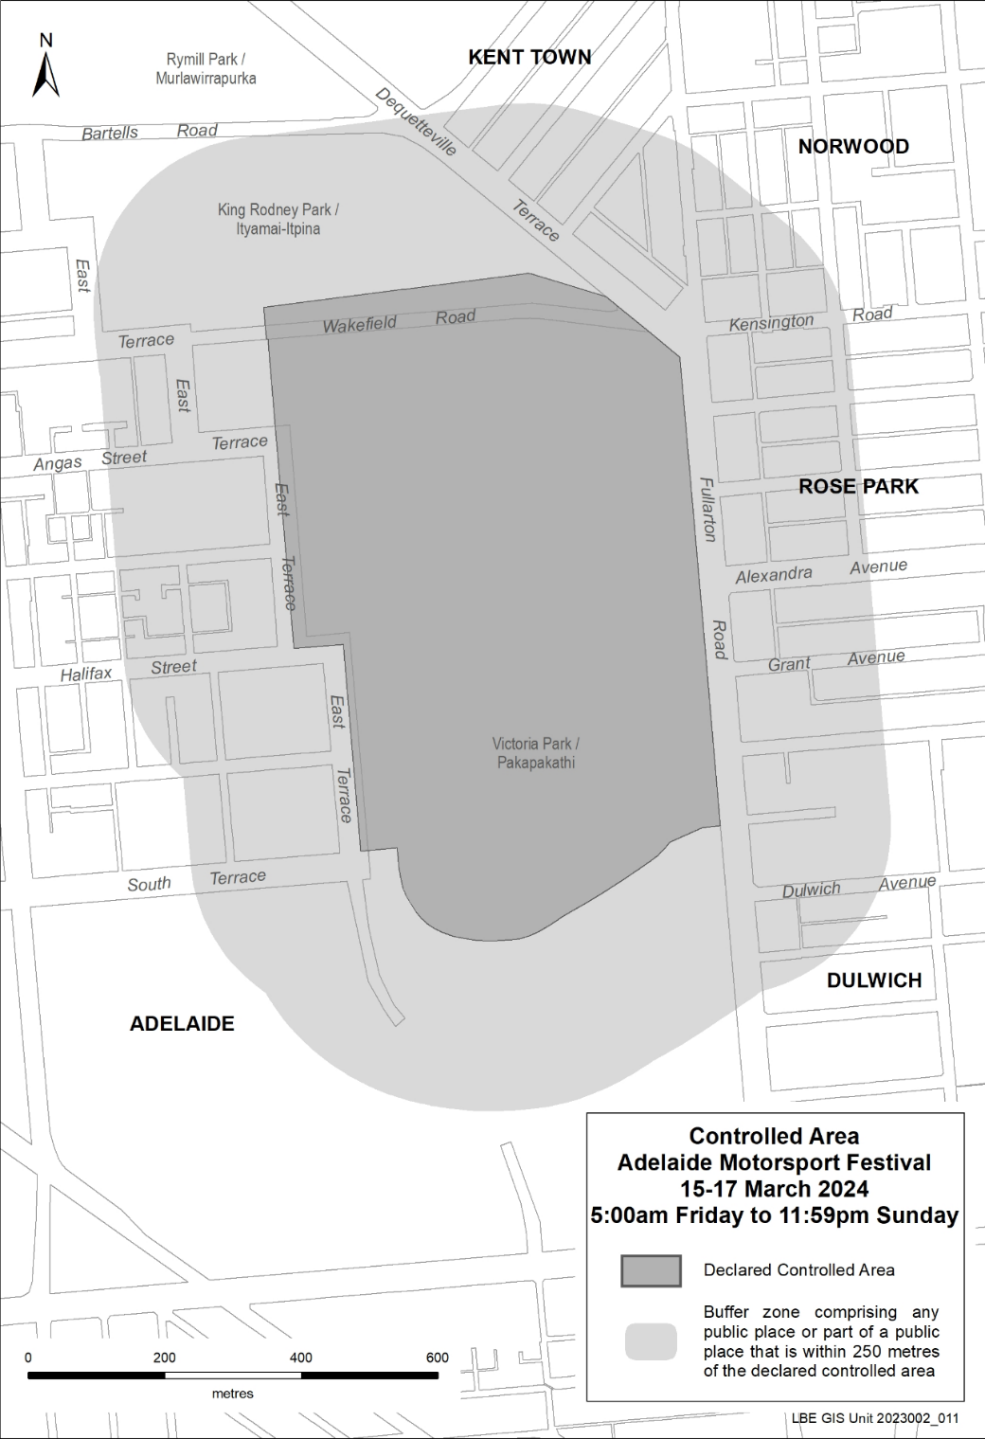
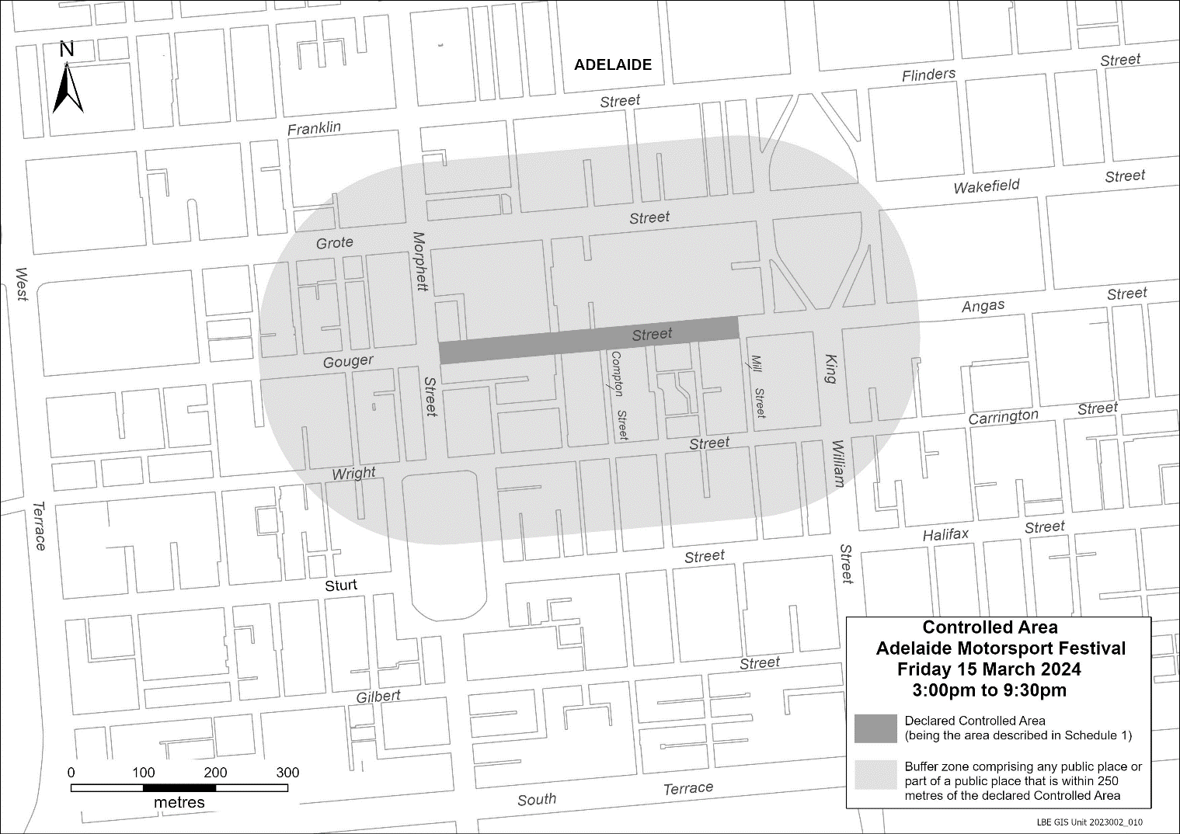

Motor Vehicles Act 1959
South Australia
Motor Vehicles (Conditional Registration—Recognition of Motor Vehicle Clubs) Notice 2023 – Sports Car Drivers South Australia Incorporated
under the Motor Vehicles Act 1959
1—Short title
This notice may be cited as the Motor Vehicles (Conditional Registration—Recognition of Motor Vehicle Clubs) Notice 2023 – Sports Car Drivers South Australia Incorporated.
2—Commencement
This notice takes effect from the date it is published in the Gazette.
3—Interpretation
In this notice—
Act means the Motor Vehicles Act 1959;
Code of Practice means the ‘Code of Practice – Conditional Registration Scheme for Historic, Individually Constructed, Left-Hand Drive and Street Rod Vehicles’ published by the Department for Infrastructure and Transport;
Conditional Registration Scheme or Scheme means the scheme for conditional registration of historic, individually constructed, left hand drive, street rod and vehicles under section 25 of the Act and regulations 15 and 16 of the Motor Vehicles Regulations 2010;
Department means the Department for Infrastructure and Transport;
Federation means the Federation of Historic Motoring Clubs SA Incorporated;
MR334 form means an ‘Approval for Registration of Vehicle on the Conditional Registration Scheme (MR334)’;
Prescribed log book means a log book in a form approved by the Registrar;
Registrar means the Registrar of Motor Vehicles;
Regulations means the Motor Vehicles Regulations 2010.
4—Recognition of motor vehicles clubs
The motor vehicle clubs specified in Schedule 1 are, subject to the conditions set out in clause 5, recognised for the purposes of regulation 16 of the Regulations.
5—Conditions of recognition
A motor vehicle club specified in Schedule 1 must comply with the following conditions:
  - the club must maintain a constitution approved by the Registrar;
(b) the club must nominate and have members authorised by the Registrar (authorised persons). The club’s authorised person(s) are responsible for approving applicants and motor vehicles for registration under the Scheme. This includes confirming that Scheme applicants are financial members of a club; any other details as required by the Registrar on the MR334 form; and to inspect members’ vehicles when requested to do so by the Registrar;
(c) the club must issue a prescribed log book to club members for each of their vehicles to record vehicle use;
(d) the club must cancel a member’s prescribed log book when a member resigns, must ensure that a statutory declaration is provided when a member’s log book is lost or destroyed, must keep details of members’ prescribed log book return sheets and forward copies of the same to the Registrar or Federation annually as required;
(e) the club must create and maintain records detailing all its financial members, its authorised persons, all vehicles for which an MR334 form has been issued, all statutory declarations received and prescribed log books issued and returned to the club;
(f) the club must keep records for a period of 5 years from the date of the document and these records must include all duplicate MR334 forms, all records of motor vehicle inspections undertaken in accordance with paragraph (b), all statutory declarations provided by members for the purposes of paragraphs (d), all prescribed log books issued by reference to their serial number, the member’s name and the vehicle for which it was issued, and to make all such records available for inspection or provide copies of the records at the request of the Registrar for audit purposes;
(g) the club must ensure, as far as practicable, that all members comply with the Code of Practice;
(h) the club, as far as practicable, must report to the Registrar or the Federation details of members and motor vehicles not complying with the conditions and criteria set out in the Code of Practice for the Scheme;
(i) the club must provide to the Registrar, within 2 months after the end of the club’s financial year, an annual report detailing members from that financial year with vehicles registered under the Scheme who are no longer financial members of the club;
(j) the club must notify the Registrar, in writing, within 14 days of resolution to cease operation as a club and must provide the club records specified in paragraph (f) to the Registrar within 14 days of its dissolution;
Note—
Under regulation 16(3)(c) of the Motor Vehicles Regulations 2010, the Registrar may, by notice in the Gazette, withdraw the recognition of a motor vehicle club if satisfied that the club has contravened or failed to comply with a condition applying to its recognition by the Registrar, or if there is other good cause to withdraw the recognition.
Schedule 1—Recognised motor vehicle clubs
Historic, left-hand drive, street rod and individually constructed motor vehicle clubs
Sports Car Drivers South Australia Incorporated
Made by the Deputy Registrar of Motor Vehicles
On 21 December 2023

Offshore Minerals Act 2000
Delegation under Section 439
The Minister for Energy and Mining has revoked previous delegations and further delegated powers and functions under the Offshore Minerals Act 2000 (“the Act”) pursuant to Section 439 of the Act to:
- Chief Executive, the Department for Energy and Mining
- Deputy Chief Executive, the Department for Energy and Mining
- Executive Director, Regulation and Compliance Division, the Department for Energy and Mining.
The delegated powers and functions are specified in the Schedule to the Instrument of Delegation approved by the Minister on 27 December 2023.

Schedule to the Instrument of Delegation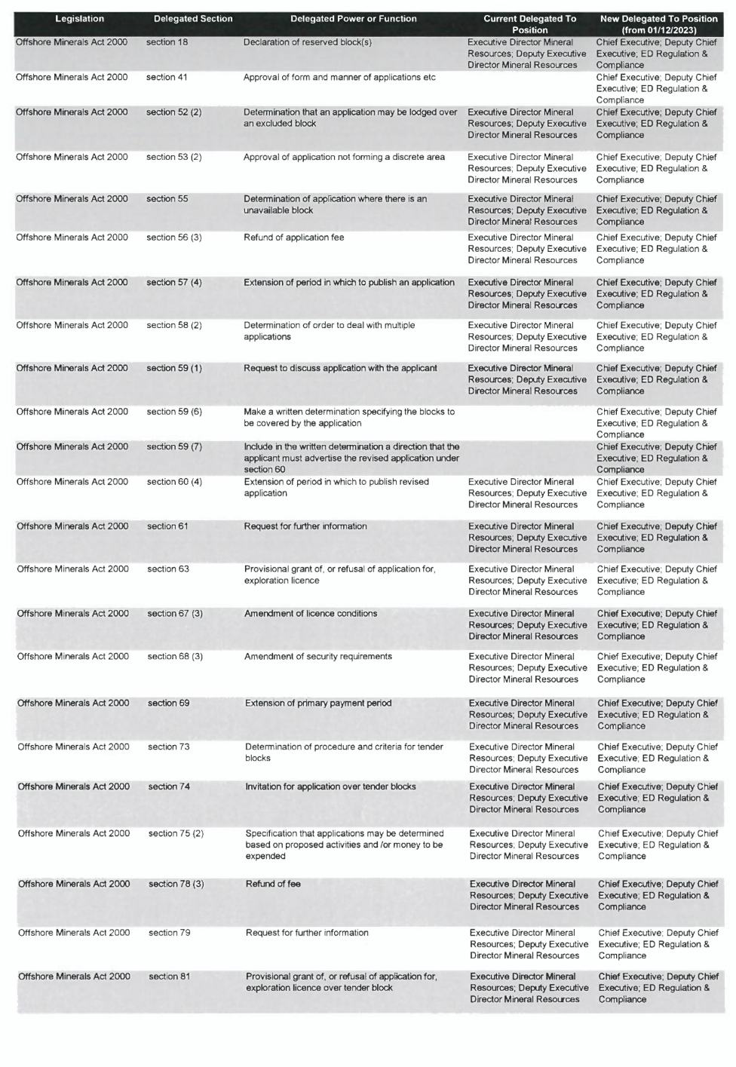
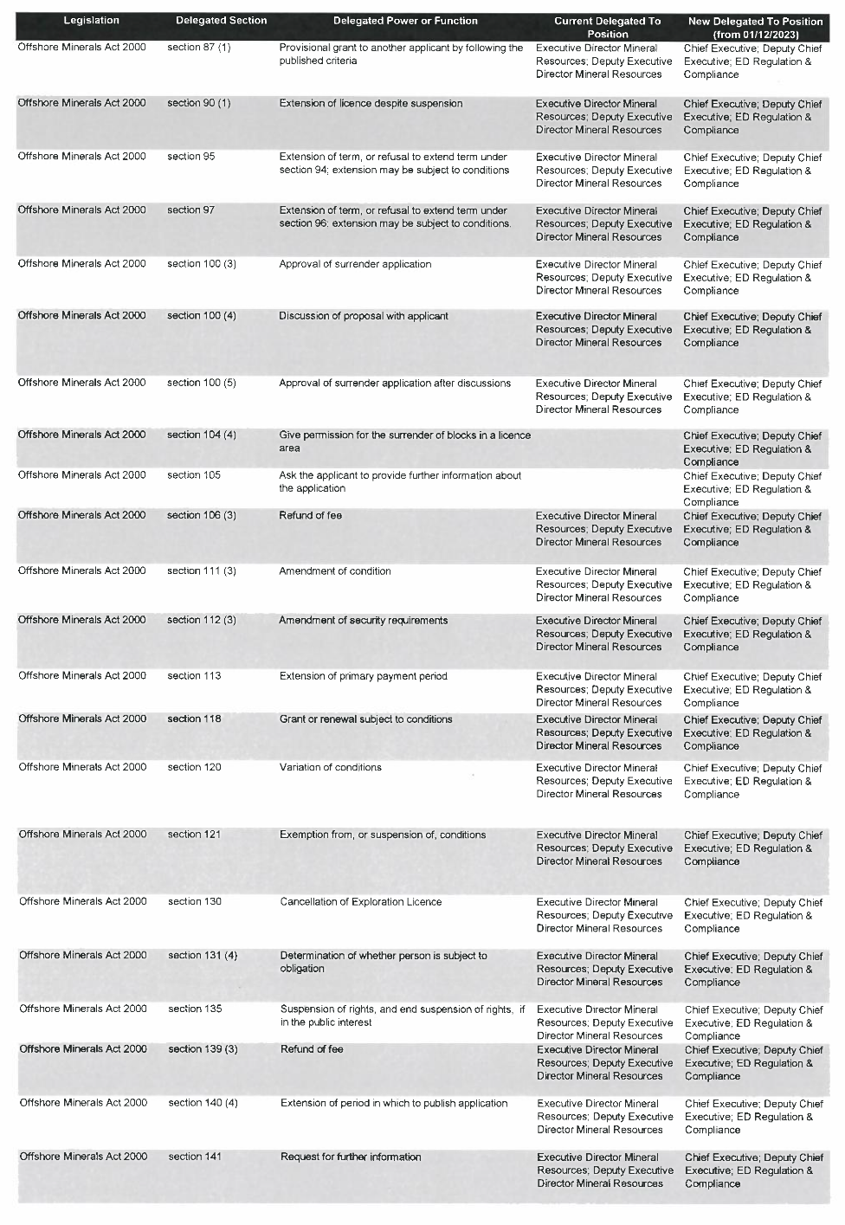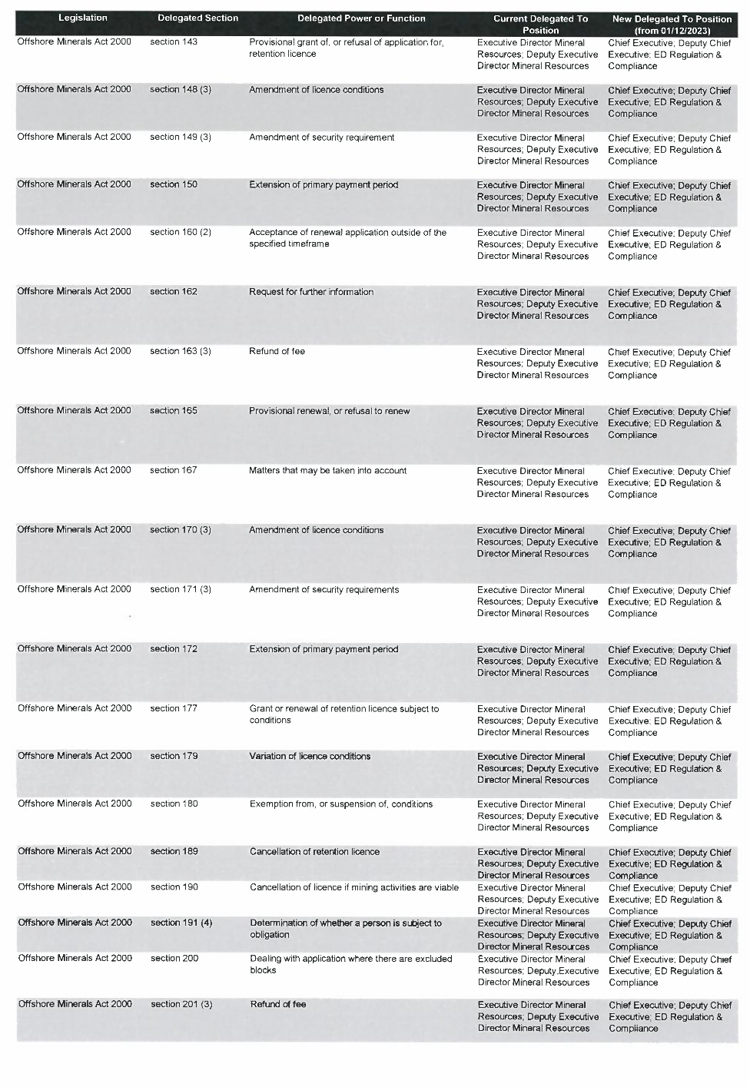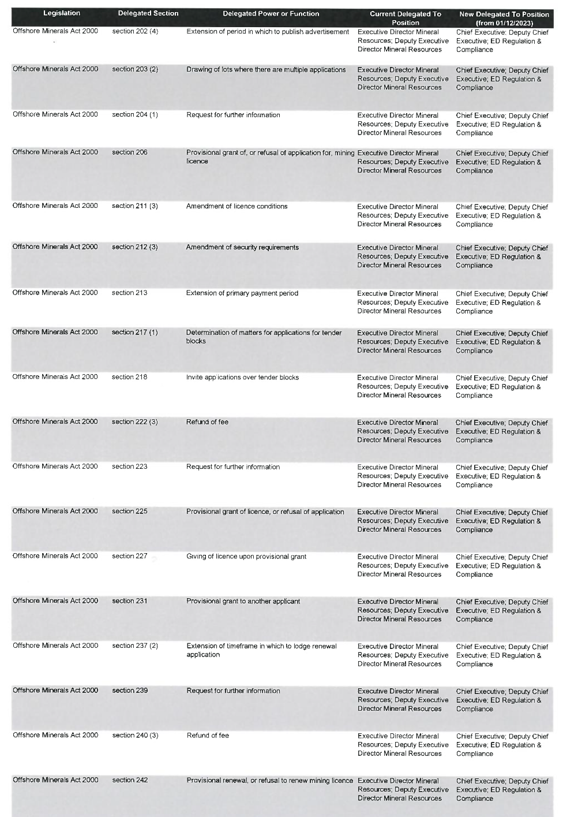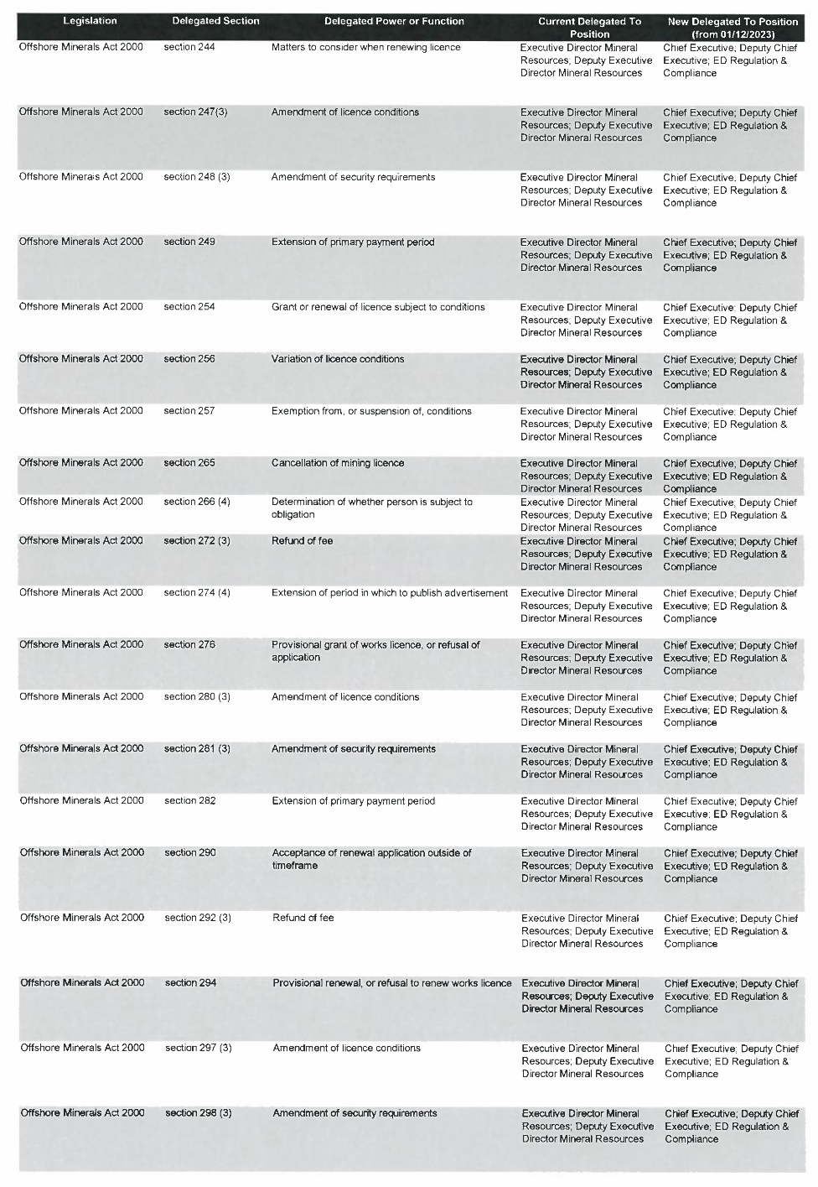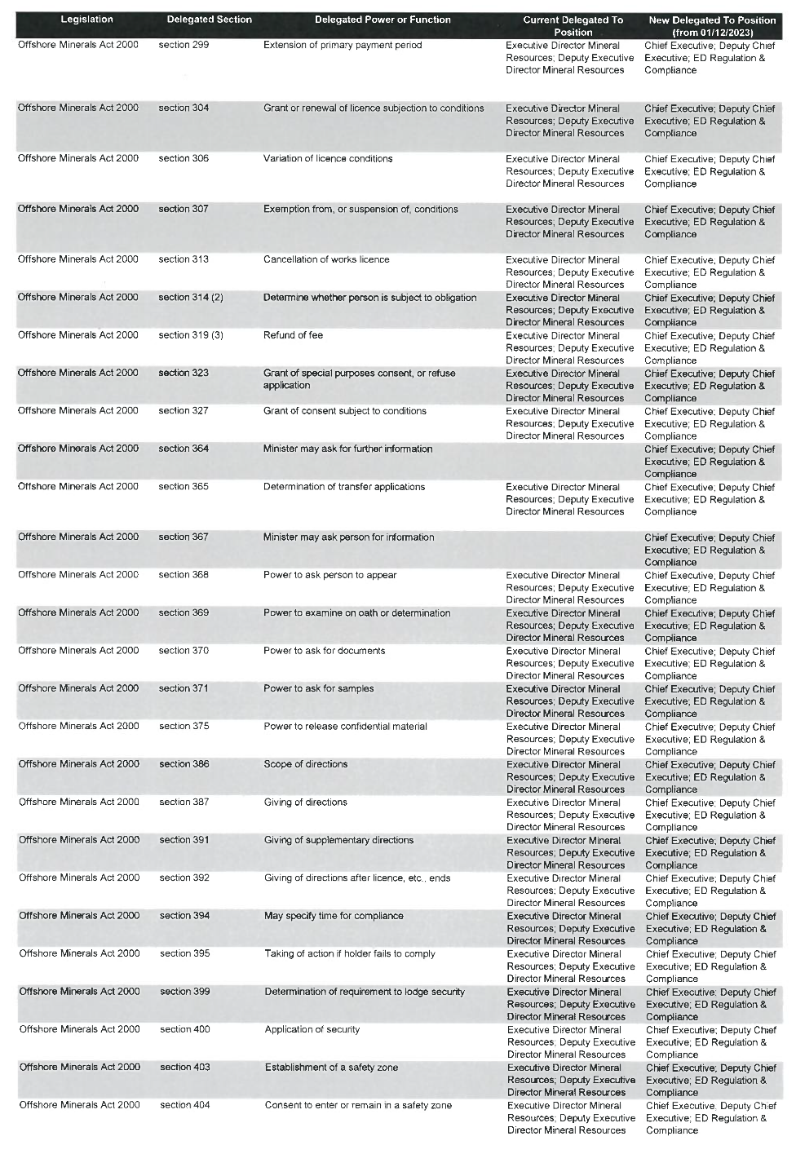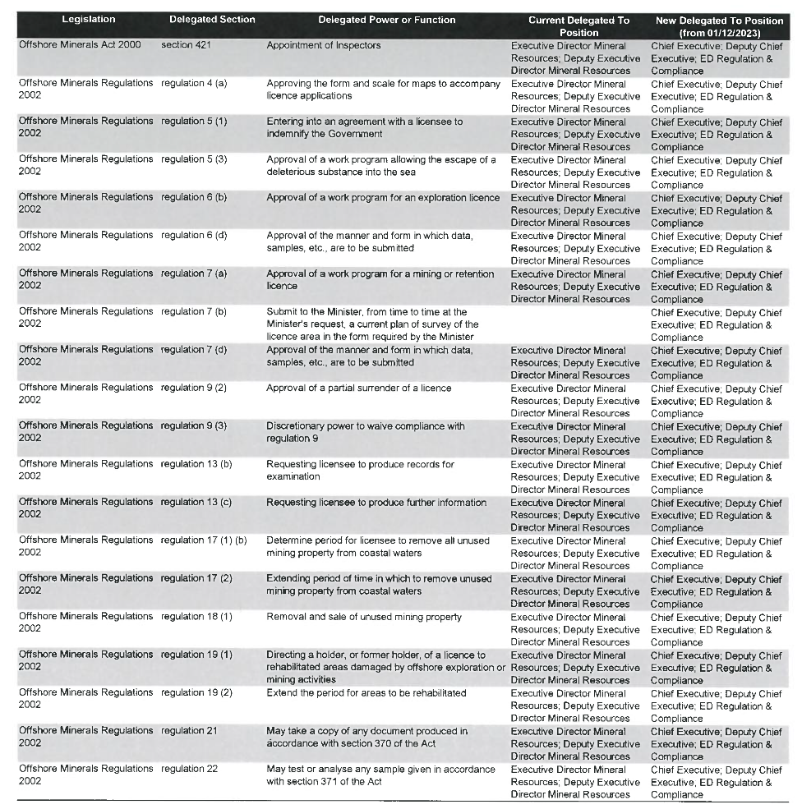

Petroleum and Geothermal Energy Act 2000
Delegation under Section 7(1a)
The Treasurer has revoked previous delegations and further delegated powers and functions under the Petroleum and Geothermal Energy Act 2000 (“the Act”) pursuant to Section 7 (1a) of the Act to:
- Chief Executive, the Department for Energy and Mining
- Deputy Chief Executive, the Department for Energy and Mining
- Executive Director, Regulation and Compliance Division, the Department for Energy and Mining
- Executive Director Corporate and Commercial, the Department for Energy and Mining.
The delegated powers and functions are specified in the Schedule to the Instrument of Delegation approved by the Treasurer on 15 December 2023.

Petroleum and Geothermal Energy Act 2000
Delegation under Section 7(1)(a)
The Minister for Energy and Mining has revoked previous delegations and further delegated powers and functions under the Petroleum and Geothermal Energy Act 2000 (“the Act”) pursuant to Section 7 (1) of the Act to:
- Chief Executive, the Department for Energy and Mining
- Deputy Chief Executive, the Department for Energy and Mining
- Executive Director, Regulation and Compliance Division, the Department for Energy and Mining.
The delegated powers and functions are specified in the Schedule to the Instrument of Delegation approved by the Minister on 27 November 2023.

Petroleum and Geothermal Energy Act 2000
Sub-delegation under Section 7(2)
The Executive Director Regulation and Compliance, the Department for Energy and Mining has revoked previous sub-delegations and further delegated powers and functions under the Petroleum and Geothermal Energy Act 2000 (“the Act”) pursuant to Section 7 (2) to persons from time-to-time holding or acting in the offices and positions identified in the Schedule to the Instrument of Delegation approved by the Executive Director on 8 December 2023.

Petroleum and Geothermal Energy Act 2000
Surrender of Petroleum Retention Licences—PRLs 183, 184, 185, 186 and 187
Notice is hereby given that I have accepted the surrender of the abovementioned licences under the provisions of the Petroleum and Geothermal Energy Act 2000, pursuant to delegated powers dated 27 November 2023.
No. of Licence | Licensee | Locality | Effective Date of Surrender | Reference
PRL 183 | Bass Oil Cooper Basin Pty Ltd | Cooper Basin | 8 January 2024 | F2015/000527
PRL 184
PRL 185
PRL 186
PRL 187
Dated: 11 January 2024
Benjamin Zammit
Executive Director
Regulation and Compliance Division
Department for Energy and Mining
Delegate of the Minister for Energy and Mining

Petroleum and Geothermal Energy Act 2000
Temporary Cessation of Suspension
Petroleum Exploration Licence—PEL 677
Petroleum Retention Licences—PRLs 50, 51, 52, 53, 54, 55, 56, 57, 58, 59, 60,
61, 62, 63, 64, 65, 66, 67, 68, 69, 70, 71, 72, 74, 75, 124 and 248
Pursuant to Section 90 of the Petroleum and Geothermal Energy Act 2000, notice is hereby given that the suspensions of PEL 677 and PRLs 50, 51, 52, 53, 54, 55, 56, 57, 58, 59, 60, 61, 62, 63, 64, 65, 66, 67, 68, 69, 70, 71, 72, 74, 75, 124 and 248 have been temporarily ceased, for the period 13 January 2024 to 20 January 2024 inclusive, pursuant to delegated powers dated 27 November 2023.
The expiry date of PEL 677 remains as 2 April 2028.
The expiry date of PRLs 50, 58, 59, 67, 68, 69, 70, 71, 72 and 74 remains as 31 July 2024.
The expiry date of PRLs 51, 52, 53, 54, 55, 56, 57, 60, 61, 62, 63, 64, 65 and 66 remains as 1 February 2026.
The expiry date of PRL 75 remains as 1 February 2025.
The expiry date of PRL 124 remains as 3 December 2024.
The expiry date of PRL 248 remains as 22 January 2025.
Dated: 12 January 2024
Benjamin Zammit
Executive Director
Regulation and Compliance Division
Department for Energy and Mining
Delegate of the Minister for Energy and Mining

Petroleum and Geothermal Energy Act 2000
Temporary Cessation of Suspension
Petroleum Exploration Licences—PELs 112 and 444
Pursuant to Section 90 of the Petroleum and Geothermal Energy Act 2000, notice is hereby given that the suspension of PELs 112 and 444 have been temporarily ceased, for the period 16 January 2024 to 23 January 2024 inclusive, pursuant to delegated powers dated 27 November 2023.
The expiry date of PEL 112 remains as 12 July 2025.
The expiry date of PEL 444 remains as 14 July 2026.
Dated: 15 January 2024
Benjamin Zammit
Executive Director
Regulation and Compliance Division
Department for Energy and Mining
Delegate of the Minister for Energy and Mining

Phylloxera And Grape Industry Act 1995
Notice by the Phylloxera and Grape Industry Board
Contributions Towards Primary Functions Under the Act for Contribution Year 2023/2024
PURSUANT to section 23 of the Phylloxera and Grape Industry Act 1995 (“Act”), the Phylloxera and Grape Industry Board of South Australia (“Board”), trading as Vinehealth Australia, gives notice that Registered Persons must contribute to the costs of the Board's primary functions for the contribution year ending 30 April 2024.
In accordance with the rules approved by the Minister and published in this notice, the contributions payable by a Registered Person for the 2023-2024 contribution year, are:
- A contribution of $150, and a
- A contribution of $9.98 per hectare of planted vines owned by the Registered Person
In this notice:
Registered Person has the meaning in the Act.
Contribution year means the period 1 May in one calendar year to 30 April in the following calendar year.
Rules approved by the Minister for Contributions Payable under the Act
- A fixed contribution per Registered Person will apply.
  - The fixed contribution for the 2023/24 contribution year will be no greater than $150, and for the 2024/25 contribution year no greater than $200.
  - From the 2025/26 contribution year onwards, the fixed fee gazetted for the prior contribution year will be adjusted each year by no greater than the annual indexation factor determined by the South Australian government and notified to the Board by the Minister in that contribution year, the adjustment to consider industry conditions alongside funding required to deliver statutory functions.
- A variable contribution, based on a rate per hectare of vines planted for each Registered Person, will apply.
  - The hectares of vines upon which the variable fee is calculated will be based on the area of vines recorded in the Vinehealth Australia Register as being owned by a Registered Person as at 30 April each year.
  - The variable fee gazetted for the prior contribution year will be adjusted each year by no greater than the annual indexation factor determined by the South Australian government in that contribution year and notified to the Board by the Minister, from and including the 2023/24 contribution year.
  - The variable fee for the 2023/24 contribution year will be $9.98 per hectare.
- The Board will by notice in the gazette in accordance with section 23 of the Act specify the rates for the fixed fee and variable fee for a contribution year as soon as practically possible after the annual indexation factor is determined by the South Australia government.
- The contribution will be collected or recovered by the Commissioner of Land Tax on behalf of the Board as if the contribution were land tax and will be subject to the same penalties for delay or default in payment (section 23 (3) of the Act).
Dated: 18 January 2024
Suzanne McLoughlin
A/Chief Executive Officer
Phylloxera and Grape Industry Board of South Australia, trading as Vinehealth Australia

Planning, Development and Infrastructure Act 2016
Section 76
Amendment to the Planning and Design Code
Preamble
It is necessary to amend the Planning and Design Code (the Code) in operation at 21 December 2023 (Version 2023.19) in order to make changes of form relating to the Code’s spatial layers and their relationship with land parcels. NOTE: There are no changes to the application of zone, subzone or overlay boundaries and their relationship with affected parcels or the intent of policy application as a result of this amendment.
- PURSUANT to section 76 of the Planning, Development and Infrastructure Act 2016 (the Act), I hereby amend the Code in order to make changes of form (without altering the effect of underlying policy), correct errors and make operational amendments as follows:
- Undertake minor alterations to the geometry of the spatial layers and data in the Code to maintain the current relationship between the parcel boundaries and Code data as a result of the following:
  - New plans of division deposited in the Land Titles Office between 13 December 2023 and 9 January 2024 affecting the following spatial and data layers in the Code:
    - Zones and subzones
    - Technical and Numeric Variations
      - Building Heights (Levels)
      - Building Heights (Metres)
      - Concept Plan
      - Interface Height
      - Minimum Frontage
      - Minimum Site Area
      - Minimum Primary Street Setback
      - Minimum Side Boundary Setback
      - Future Local Road Widening Setback
    - Overlays
      - Affordable Housing
      - Character Area
      - Coastal Areas
      - Defence Aviation Area
      - Environment and Food Production Area
      - Future Road Widening
      - Hazards (Bushfire - High Risk)
      - Hazards (Bushfire - Medium Risk)
      - Hazards (Bushfire - General Risk)
      - Hazards (Bushfire - Urban Interface)
      - Hazards (Bushfire - Regional)
      - Hazards (Bushfire - Outback)
      - Heritage Adjacency
      - Limited Dwelling
      - Limited Land Division
      - Local Heritage Place
      - Noise and Air Emissions
      - State Heritage Place
      - Stormwater Management
      - Urban Tree Canopy
- In Part 13 of the Code – Table of Amendments, update the publication date, Code version number, amendment type and summary of amendments within the ‘Table of Planning and Design Code Amendments’ to reflect the amendments to the Code as described in this Notice.
- PURSUANT to section 76(5)(a) of the Act, I further specify that the amendments to the Code as described in this Notice will take effect upon the date those amendments are published on the SA planning portal.
Dated: 10 January 2024
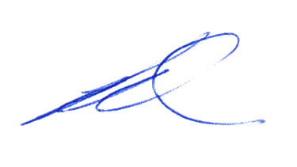Greg Van Gaans
Director, Land and Built Environment,
Department for Trade and Investment
Delegate of the Minister for Planning

Roads (Opening and Closing) Act 1991
Section 24
NOTICE OF CONFIRMATION OF ROAD
PROCESS ORDER
Road Closure—Public Road, Sellicks Hill
By Road Process Order made on 17 February 2022, the City of Onkaparinga ordered that:
- The whole of the public road, Sellicks Hill, situated adjoining the Allotment comprising Pieces 52 and 53 in Deposited Plan 73607, Hundred of Willunga, more particularly delineated and lettered ‘A’ in Preliminary Plan 21/0024 be closed.
- Transfer the whole of the land subject to closure to Southern Quarries Pty Ltd (ACN: 007 726 909) in accordance with the Agreement for Transfer dated 17 February 2022 entered into between the City of Onkaparinga and Southern Quarries Pty Ltd (ACN: 007 726 909).
- The following easement is to be granted over portion of the land subject to closure:
Grant a free and unrestricted right of way in favour of Certificate of Title Volume 6244 Folio 137 for stock movement purposes over the land marked ‘B’ in Deposited Plan 131543.
On 14 December 2023 that order was confirmed by the Minister for Planning conditionally upon the deposit by the Registrar-General of Deposited Plan 131543 being the authority for the new boundaries.
Pursuant to Section 24 of the Roads (Opening and Closing) Act 1991, NOTICE of the order referred to above and its confirmation is hereby given.
Dated: 18 January 2024
B. J. Slape
Surveyor-General
2021/17670/01

Local Government Instruments

District Council of Kimba
Change of Meeting Date
Notice is hereby given that the District Council of Kimba resolved at its meeting held on 10 January 2024, to change the scheduled February 2024 Council Meeting from Wednesday, 14 February, 2024 commencing at 2 pm to Tuesday, 13 February, 2024 commencing at 2 pm.
Dated: 16 January 2024
Deb Larwood
Chief Executive Officer

Public Notices

National Electricity Law
Notice of Initiation of Non-controversial Rule Change Request
Notice of Fast Track Rule Change Initiation
Notice of Extension of Final Determination
The Australian Energy Market Commission (AEMC) gives notice under the National Electricity Law as follows:
Under s 95, Powerlink Queensland has requested the Resetting Powerlink’s system strength unit prices (Ref. ERC0382) proposal. The proposal seeks to amend the National Electricity Rules (NER) to allow it to reset the system strength unit prices (SSUPs), a component of the system strength charge, for Queensland’s nodes. The AEMC intends to expedite the proposal under s 96 as it considers the proposed Rule is non-controversial, subject to requests not to do so. Written requests not to expedite the proposal must be received by 1 February 2024. Submissions must be received by 15 February 2024.
Under s 95, the Australian Energy Regulator has requested the Expanding the transmission ring-fencing framework (Ref. ERC0371) proposal. The proposal seeks to expand the transmission ring-fencing framework to include negotiated transmission services. Under s 96A, the AEMC has decided to fast track this proposal.
Under s 107, the time for the making of the final determination on the Harmonising the national energy rules with the updated national energy objectives (Ref. ERC0362) proposal has been extended to 1 February 2024.
Submissions can be made via the AEMC’s website. Before making a submission, please review the AEMC’s privacy statement on its website, and consider the AEMC’s Tips for making a submission. The AEMC publishes all submissions on its website, subject to confidentiality.
Documents referred to above are available on the AEMC’s website and are available for inspection at the AEMC’s office.
Australian Energy Market Commission
Level 15, 60 Castlereagh St
Sydney NSW 2000
Telephone: (02) 8296 7800
www.aemc.gov.au
Dated: 18 January 2024

National Energy Retail Law
Notice of Extension of Final Determination
The Australian Energy Market Commission (AEMC) gives notice under the National Energy Retail Law as follows:
Under s 266, the time for the making of the final determination on the Harmonising the national energy rules with the updated national energy objectives (Ref. RRC0050) proposal has been extended to 1 February 2024.
Australian Energy Market Commission
Level 15, 60 Castlereagh St
Sydney NSW 2000
Telephone: (02) 8296 7800
www.aemc.gov.au
Dated: 18 January 2024

National Gas Law
Notice of Extension for Final Determination
The Australian Energy Market Commission (AEMC) gives notice under the National Gas Law as follows:
Under s 317, the time for the making of the final determination on the Harmonising the national energy rules with the updated national energy objectives (Ref. GRC0069) proposal has been extended to 1 February 2024.
Australian Energy Market Commission
Level 15, 60 Castlereagh St
Sydney NSW 2000
Telephone: (02) 8296 7800
www.aemc.gov.au
Dated: 18 January 2024

Notice Submission

The South Australian Government Gazette is published each Thursday afternoon.
Notices must be emailed by 4 p.m. Tuesday, the week of publication.
Submissions are formatted per the gazette style and a proof will be supplied prior to publication, along with a quote if applicable. Please allow one day for processing notices.
Alterations to the proof must be returned by 4 p.m. Wednesday.

Gazette notices must be submitted as Word files, in the following format:
• Title—the governing legislation
• Subtitle—a summary of the notice content
• Body—structured text, which can include numbered lists, tables, and images
• Date—day, month, and year of authorisation
• Signature block—name, role, and department/organisation authorising the notice

Please provide the following information in your email:
• Date of intended publication
• Contact details of the person responsible for the notice content
• Name and organisation to be charged for the publication—Local Council and Public notices only
• Purchase order, if required—Local Council and Public notices only

Email: governmentgazettesa@sa.gov.au
Phone: (08) 7133 3552
Website: www.governmentgazette.sa.gov.au

All instruments appearing in this gazette are to be considered official, and obeyed as such

Printed and published weekly by authority of T. Foresto, Government Printer, South Australia
$8.55 per issue (plus postage), $430.00 per annual subscription—GST inclusive
Online publications: www.governmentgazette.sa.gov.au

