No. 15 p. 369
THE SOUTH AUSTRALIAN
GOVERNMENT GAZETTE
Published by Authority

Adelaide, Thursday, 7 March 2024

Contents

Governor’s Instruments
Appointments, Resignations and General Matters 370
Proclamations—
Gas (Other Gases) Amendment Act (Commencement) Proclamation 2024 371
Statutes Amendment (National Energy Laws) (Other
Gases) Act (Commencement) Proclamation 2024 371
Work Health and Safety (Industrial Manslaughter)
Amendment Act (Commencement) Proclamation 2024 372
National Parks and Wildlife (Shepherds Hill
Recreation Park) Proclamation 2024 372
Regulations—
Public Finance and Audit (Public Authority)
Amendment Regulations 2024—No. 7 of 2024 373
National Gas (South Australia) (Other Gases)
Amendment Regulations 2024—No. 8 of 2024 374
National Energy Retail (Other Gases) Amendment Regulations 2024—No. 9 of 2024 377
National Energy Retail Law (Local Provisions)
Amendment Regulations 2024—No. 10 of 2024 379
Disability Inclusion (Exemptions) Amendment Regulations 2024—No. 11 of 2024 381
National Parks and Wildlife (Wildlife) (Protected Animals) Amendment Regulations 2024—No. 12 of 2024 383
State Government Instruments
Electoral Act 1985 385
Electoral Commission of South Australia 385
Fisheries Management (General) Regulations 2017 389
Geographical Names Act 1991 391
Housing Improvement Act 2016 392
Land Acquisition Act 1969 392
Livestock Act 1997 394
Mental Health Act 2009 397
Mining Act 1971 398
Motor Vehicles Act 1959 398
Petroleum and Geothermal Energy Act 2000 413
Road Traffic Act 1961 413
South Australian Skills Act 2008 415
Water Industry Act 2012 427
Local Government Instruments
City of Adelaide 429
City of Port Adelaide Enfield 429
City of Salisbury 429
City of Victor Harbor 430
Public Notices
National Electricity Law 431
National Gas Law 431
Trustee Act 1936 431

Governor’s Instruments

Appointments, Resignations and General Matters
Department of the Premier and Cabinet
Adelaide, 7 March 2024
Her Excellency the Governor in Executive Council has been pleased to appoint the undermentioned to the State Bushfire Coordination Committee, pursuant to the provisions of the Fire and Emergency Services Act 2005:
Deputy Member: from 7 March 2024 until 13 November 2026
Gayle Robin Grieger (Deputy to Henderson)
By command,
Susan Elizabeth Close, MP
For Premier
24MES0001CS

Department of the Premier and Cabinet
Adelaide, 7 March 2024
Her Excellency the Governor in Executive Council has been pleased to appoint the Honourable Andrea Michaels, MP as Acting Minister for Primary Industries and Regional Development and Acting Minister for Forest Industries from 10 March 2024 until 18 March 2024 inclusive, during the absence of the Honourable Clare Michele Scriven, MLC.
By command,
Susan Elizabeth Close, MP
For Premier
MPIRD F2024/000087CS

Department of the Premier and Cabinet
Adelaide, 7 March 2024
Her Excellency the Governor in Executive Council has been pleased to appoint Sarah Rachel Jhunjhunwala to the position of Deputy Registrar of the South Australian Employment Tribunal for a term of five years commencing on 22 March 2024 and expiring on 21 March 2029 - pursuant to the provisions of the South Australian Employment Tribunal Act 2014.
By command,
Susan Elizabeth Close, MP
For Premier
AGO0011-24CS

Department of the Premier and Cabinet
Adelaide, 7 March 2024
Her Excellency the Governor in Executive Council has been pleased to appoint Shirley Anne Burchell to the position of Deputy Registrar of the South Australian Employment Tribunal for a term of five years commencing on 9 June 2024 and expiring on 8 June 2029 - pursuant to the provisions of the South Australian Employment Tribunal Act 2014.
By command,
Susan Elizabeth Close, MP
For Premier
AGO0011-24CS

Department of the Premier and Cabinet
Adelaide, 7 March 2024
Her Excellency the Governor in Executive Council has been pleased to appoint Brian Thomas Morris and Tahnya Fleur Barnett Donaghy as independent members of the State Courts Administration Council for a term commencing on 7 March 2024 and expiring on 8 March 2027 - pursuant to the provisions of the Courts Administration Act 1993.
By command,
Susan Elizabeth Close, MP
For Premier
AGO0010-23CS

Department of the Premier and Cabinet
Adelaide, 7 March 2024
Her Excellency the Governor in Executive Council has determined that eligible members of the Construction Industry Long Service Leave Board, being those members who are eligible for remuneration according to the terms of Premier and Cabinet Circular PC016, are entitled to the fees and allowances, effective from 7 March 2024 - pursuant to the provisions of the Construction Industry Long Service Leave Act 1987.
By command,
Susan Elizabeth Close, MP
For Premier
AGO0023-24CS

Proclamations
South Australia

Gas (Other Gases) Amendment Act (Commencement) Proclamation 2024
1—Short title
This proclamation may be cited as the Gas (Other Gases) Amendment Act (Commencement) Proclamation 2024.
2—Commencement of Act
The Gas (Other Gases) Amendment Act 2023 (No 33 of 2023) comes into operation on 7 March 2024.
Made by the Governor
with the advice and consent of the Executive Council
on 7 March 2024

South Australia

Statutes Amendment (National Energy Laws) (Other Gases) Act (Commencement) Proclamation 2024
1—Short title
This proclamation may be cited as the Statutes Amendment (National Energy Laws) (Other Gases) Act (Commencement) Proclamation 2024.
2—Commencement of Act
The Statutes Amendment (National Energy Laws) (Other Gases) Act 2023 (No 36 of 2023) comes into operation on 7 March 2024.
Made by the Governor
with the advice and consent of the Executive Council
on 7 March 2024

South Australia

Work Health and Safety (Industrial Manslaughter) Amendment Act (Commencement) Proclamation 2024
1—Short title
This proclamation may be cited as the Work Health and Safety (Industrial Manslaughter) Amendment Act (Commencement) Proclamation 2024.
2—Commencement of Part
Part 2 of the Work Health and Safety (Industrial Manslaughter) Amendment Act 2023 (No 43 of 2023) (other than section 7(2) and (3)) comes into operation on 1 July 2024.
Made by the Governor
with the advice and consent of the Executive Council
on 7 March 2024

South Australia

National Parks and Wildlife (Shepherds Hill Recreation Park) Proclamation 2024
under section 33(3) of the National Parks and Wildlife Act 1972
1—Short title
This proclamation may be cited as the National Parks and Wildlife (Shepherds Hill Recreation Park) Proclamation 2024.
2—Commencement
This proclamation comes into operation on the day on which it is made.
3—Alteration of boundaries of Shepherds Hill Recreation Park
The boundaries of the Shepherds Hill Recreation Park are altered by excluding from the Park the following land:
Allotments 40 and 41 in approved Plan No D133081, Hundred of Adelaide, lodged in the Lands Titles Registration Office at Adelaide.
Made by the Governor
with the advice and consent of the Executive Council
on 7 March 2024

Regulations
South Australia

Public Finance and Audit (Public Authority) Amendment Regulations 2024
under the Public Finance and Audit Act 1987

Contents
Part 1—Preliminary
1 Short title
2 Commencement
Part 2—Amendment of Public Finance and Audit Regulations 2014
3 Amendment of regulation 4—Public authority (section 4 of Act)

Part 1—Preliminary
1—Short title
These regulations may be cited as the Public Finance and Audit (Public Authority) Amendment Regulations 2024.
2—Commencement
These regulations come into operation on 8 March 2024.
Part 2—Amendment of Public Finance and Audit Regulations 2014
3—Amendment of regulation 4—Public authority (section 4 of Act)
Regulation 4—after paragraph (c) insert:
(d) Adelaide University.
Editorial note—
As required by section 10AA(2) of the Legislative Instruments Act 1978, the Minister has certified that, in the Minister's opinion, it is necessary or appropriate that these regulations come into operation as set out in these regulations.
Made by the Governor
with the advice and consent of the Executive Council
on 7 March 2024
No 7 of 2024

South Australia

National Gas (South Australia) (Other Gases) Amendment Regulations 2024
under the National Gas (South Australia) Act 2008

Contents
Part 1—Preliminary
1 Short title
2 Commencement
Part 2—Amendment of National Gas (South Australia) Regulations
3 Amendment of regulation 5—Definition of pipeline
4 Amendment of regulation 10—Maximum civil monetary liabilities
5 Amendment of Schedule 3—Civil penalty provisions
6 Amendment of Schedule 4—Conduct provisions

Part 1—Preliminary
1—Short title
These regulations may be cited as the National Gas (South Australia) (Other Gases) Amendment Regulations 2024.
2—Commencement
These regulations come into operation on the day on which the Statutes Amendment (National Energy Laws) (Other Gases) Act 2023 comes into operation.
Part 2—Amendment of National Gas (South Australia) Regulations
3—Amendment of regulation 5—Definition of pipeline
Regulation 5(b)—delete "natural gas" and substitute:
covered gas
4—Amendment of regulation 10—Maximum civil monetary liabilities
(1) Regulation 10(1)—after "91FEH," insert:
91FEM,
(2) Regulation 10(1)(de) and (df)—before "GSOO information" wherever occurring insert:
DWGM information or
(3) Regulation 10(1a)—after "Bulletin Board information" first occurring insert:
, DWGM information
(4) Regulation 10(1a)—before "GSOO information" second occurring insert:
DWGM information and
(5) Regulation 10(2)—before "GSOO information" wherever occurring insert:
DWGM information,
(6) Regulation 10(3)—before the definition of prescribed amount insert:
DWGM information means information that a person gives to AEMO to comply with section 91FEJ of the NGL;
(7) Regulation 10(3), definition of prescribed amount, (e)—before "GSOO information" insert:
DWGM information or
(8) Regulation 10(3), definition of relevant event, (a)(ii)—delete "National Gas Services" and substitute:
Gas
(9) Regulation 10(3), definition of relevant event, (bc)—before "GSOO information" wherever occurring insert:
DWGM information or
5—Amendment of Schedule 3—Civil penalty provisions
(1) Schedule 3, Part 1—after "Section 91DD" insert:
Section 91FEJ
Section 91FEL
(2) Schedule 3, Part 1—delete "Section 143(6)"
(3) Schedule 3, Part 1—after "Section 170(1)(a)" insert:
Section 201
Section 202
Section 203
(4) Schedule 3, Part 1—before "Rule 43(1)" insert:
Rule 34(6)
Rule 35(2)
(5) Schedule 3, Part 1—after "Schedule 1, clause 80(2)" insert:
Schedule 6, Part 5, clause 3(2)
(6) Schedule 3, Part 2—before "Rule 33(1)" insert:
Rule 32A(1)
6—Amendment of Schedule 4—Conduct provisions
Schedule 4—before "Rule 33(1)" insert:
Rule 32A(1)
Made by the Governor
on the unanimous recommendation of the Ministers of the participating jurisdictions and with the advice and consent of the Executive Council
on 7 March 2024
No 8 of 2024

South Australia

National Energy Retail (Other Gases) Amendment Regulations 2024
under the National Energy Retail Law (South Australia) Act 2011

Contents
Part 1—Preliminary
1 Short title
2 Commencement
Part 2—Amendment of National Energy Retail Regulations
3 Amendment of regulation 13—Retailers
4 Amendment of Schedule 1—Civil penalty provisions
5 Amendment of Schedule 2—Retailers under transitional provisions
6 Amendment of Schedule 3—Exempt sellers under transitional provisions
7 Amendment of Schedule 4—Retailers of last resort under transitional provisions

Part 1—Preliminary
1—Short title
These regulations may be cited as the National Energy Retail (Other Gases) Amendment Regulations 2024.
2—Commencement
These regulations come into operation on the day on which the Statutes Amendment (National Energy Laws) (Other Gases) Act 2023 comes into operation.
Part 2—Amendment of National Energy Retail Regulations
3—Amendment of regulation 13—Retailers
Regulation 13(2)—delete "gas" wherever occurring and substitute in each case:
natural gas and natural gas equivalents
4—Amendment of Schedule 1—Civil penalty provisions
Schedule 1, Part 3—after "Rule 132(1)" insert:
Rule 147D(1)
Rule 147F
5—Amendment of Schedule 2—Retailers under transitional provisions
(1) Schedule 2, table, column 2—delete "Electricity and gas" wherever occurring and substitute in each case:
(a) Electricity; and
(b) Natural gas and natural gas equivalents
(2) Schedule 2, table, column 2—delete "Gas" wherever occurring and substitute in each case:
Natural gas and natural gas equivalents
6—Amendment of Schedule 3—Exempt sellers under transitional provisions
(1) Schedule 3, table, column 2—delete "Electricity and gas" wherever occurring and substitute in each case:
(a) Electricity; and
(b) Natural gas and natural gas equivalents
(2) Schedule 3, table, column 2—delete "Gas" wherever occurring and substitute in each case:
Natural gas and natural gas equivalents
7—Amendment of Schedule 4—Retailers of last resort under transitional provisions
Schedule 4, table, column 2—delete "Gas" wherever occurring and substitute in each case:
Natural gas and natural gas equivalents
Made by the Governor
on the unanimous recommendation of the Ministers of the participating jurisdictions and with the advice and consent of the Executive Council
on 7 March 2024
No 9 of 2024

South Australia

National Energy Retail Law (Local Provisions) Amendment Regulations 2024
under the National Energy Retail Law (South Australia) Act 2011

Contents
Part 1—Preliminary
1 Short title
2 Commencement
Part 2—Amendment of National Energy Retail Law (Local Provisions) Regulations 2013
3 Amendment of regulation 3—Interpretation
4 Insertion of regulation 5A
5A Natural gas equivalent
5 Amendment of regulation 6—Local area retailers

Part 1—Preliminary
1—Short title
These regulations may be cited as the National Energy Retail Law (Local Provisions) Amendment Regulations 2024.
2—Commencement
These regulations come into operation on the day on which the Statutes Amendment (National Energy Laws) (Other Gases) Act 2023 comes into operation.
Part 2—Amendment of National Energy Retail Law (Local Provisions) Regulations 2013
3—Amendment of regulation 3—Interpretation
Regulation 3—after definition of the Act insert:
Hydrogen Park South Australia project or HyP SA project means the hydrogen production and blending project delivered by Australian Gas Networks Limited (ACN 078 551 685) located at Tonsley Innovation District, Adelaide, South Australia.
4—Insertion of regulation 5A
After regulation 5 insert:
5A—Natural gas equivalent
Pursuant to section 2A(1)(a) of the National Energy Retail Law (South Australia), covered gas produced and supplied by the HyP SA project through a distribution pipeline (within the meaning of the NGL) is prescribed as a natural gas equivalent for use in this jurisdiction.
5—Amendment of regulation 6—Local area retailers
Regulation 6(1)(b)—delete "gas" and substitute:
natural gas and natural gas equivalents
Editorial note—
As required by section 10AA(2) of the Legislative Instruments Act 1978, the Minister has certified that, in the Minister's opinion, it is necessary or appropriate that these regulations come into operation as set out in these regulations.
Made by the Governor
with the advice and consent of the Executive Council
on 7 March 2024
No 10 of 2024

South Australia

Disability Inclusion (Exemptions) Amendment Regulations 2024
under the Disability Inclusion Act 2018

Contents
Part 1—Preliminary
1 Short title
2 Commencement
Part 2—Amendment of Disability Inclusion Regulations 2019
3 Insertion of regulation 12
12 Exemptions

Part 1—Preliminary
1—Short title
These regulations may be cited as the Disability Inclusion (Exemptions) Amendment Regulations 2024.
2—Commencement
These regulations come into operation on the day on which they are made.
Part 2—Amendment of Disability Inclusion Regulations 2019
3—Insertion of regulation 12
After regulation 11 insert:
12—Exemptions
(1) Pursuant to section 33(2)(a) of the Act, the Chief Executive is, subject to the following provisions, exempt from the operation of section 14(1) of the Act in respect of the annual report on the operation of the State Disability Inclusion Plan for the financial year ending on 30 June 2023:
(a) the Chief Executive must instead prepare a report on the operation of the State Disability Inclusion Plan for the period commencing on 1 January 2023 and ending on 31 December 2023;
(b) the report must contain such information as may be required by the Minister and must be provided to the Minister on or before 30 June 2024.
(2) Pursuant to section 33(2)(a) of the Act, a State authority is, subject to the following provisions, exempt from the operation of section 17(1) of the Act in respect of the State authority's report on the operation of its disability access and inclusion plan for the financial year ending on 30 June 2023:
(a) the State authority must instead prepare a report on the operation of its disability access and inclusion plan for the period commencing on 1 January 2023 and ending on 31 December 2023;
(b) the report must contain such information as may be required by the Minister and must be provided to the Minister on or before 30 June 2024.
(3) Pursuant to section 33(2)(a) of the Act, the Chief Executive is exempt from the operation of section 17(2) of the Act in respect of the financial year ending 30 June 2023 (however, the Chief Executive must instead provide to the Minister a report summarising any reports made by State authorities under section 17(1) of the Act or subregulation (2) during the period commencing on 1 January 2023 and ending on 31 December 2023).
(4) Pursuant to section 33(2)(a) of the Act, a State authority is exempt from the operation of section 18 of the Act during the period—
(a) beginning on the commencement of this subregulation; and
(b) ending—
(i) when a new State Disability Inclusion Plan, or a variation of the plan, is published in the Gazette under section 13 of the Act; or
(ii) 4 years after the commencement of this subregulation,
whichever is the sooner.
(5) To avoid doubt, nothing in this regulation affects the operation of sections 14(2) and 17(3) and (4) of the Act.
Editorial note—
As required by section 10AA(2) of the Legislative Instruments Act 1978, the Minister has certified that, in the Minister's opinion, it is necessary or appropriate that these regulations come into operation as set out in these regulations.
Made by the Governor
with the advice and consent of the Executive Council
on 7 March 2024
No 11 of 2024

South Australia

National Parks and Wildlife (Wildlife) (Protected Animals) Amendment Regulations 2024
under the National Parks and Wildlife Act 1972

Contents
Part 1—Preliminary
1 Short title
2 Commencement
Part 2—Amendment of National Parks and Wildlife (Wildlife) Regulations 2019
3 Insertion of regulation 44A
44A Acts or activities in relation to protected animals

Part 1—Preliminary
1—Short title
These regulations may be cited as the National Parks and Wildlife (Wildlife) (Protected Animals) Amendment Regulations 2024.
2—Commencement
These regulations come into operation on the day on which they are made.
Part 2—Amendment of National Parks and Wildlife (Wildlife) Regulations 2019
3—Insertion of regulation 44A
Before regulation 45 insert:
44A—Acts or activities in relation to protected animals
(1) For the purposes of this regulation, the Minister must, by notice in the Gazette, determine what activities will constitute controlled activities in relation to protected animals, or a class of protected animals.
(2) For the purposes of section 68(1)(c) of the Act, a person undertaking or continuing a controlled activity in relation to protected animals, or a class of protected animals, must do so in compliance with a plan (a controlled activity management plan) approved by the Minister in accordance with this regulation.
(3) For the purposes of subregulation (2), a person who proposes to undertake or continue a controlled activity in relation to protected animals, or a class of protected animals must, in accordance with any requirements specified by the Minister, prepare and submit to the Minister a controlled activity management plan relating to the controlled activity and containing the information required by the Minister.
(4) The Minister may approve a controlled activity management plan submitted under this regulation.
(5) A controlled activity management plan approved under this regulation must be published on a website determined by the Minister.
(6) The Minister may revoke an approval of a controlled activity management plan by written notice to the person who submitted the plan in accordance with subregulation (3) (and the controlled activity management plan will cease to have effect for the purposes of this regulation from the date of the revocation).
Editorial note—
As required by section 10AA(2) of the Legislative Instruments Act 1978, the Minister has certified that, in the Minister's opinion, it is necessary or appropriate that these regulations come into operation as set out in these regulations.
Made by the Governor
with the advice and consent of the Executive Council
on 7 March 2024
No 12 of 2024

State Government Instruments

Electoral Act 1985
Part 9, Division 5
Declared Institutions
PURSUANT to section 83 of the Electoral Act 1985, I, Mick Sherry, Electoral Commissioner, pronounce the following as Declared Institutions:
The Schedule
Eldercare Trowbridge House 9 Luhrs Road, PAYNEHAM SOUTH 5070
Estia Health Kensington Gardens 421 The Parade, KENSINGTON GARDENS 5068
Gaynes Park Suites 247 Payneham Road, JOSLIN 5070
Dated: 7 March 2024
M. Sherry
Electoral Commissioner

Electoral Commission of South Australia
2024 First Nations Voice to South Australian Parliament Nominations Received
At the declaration of nominations at 12 noon Monday, 26 February 2024, the following people have been declared as candidates in the First Nations Voice to South Australian Parliament Election.
The candidates are listed below by the regions they have nominated and in the order in which they will appear on the ballot paper.
Region 1—Central :
11 vacancies (5 male/5 female plus 1 person of any gender)
COLEMAN, Rosalind
WATERS, Sonia
LEIDIG, Robert
O'MEARA, Marnie
RIGNEY-THYER, Chris
SAUNDERS, Cheryl Lynn
WILSON, Scott
SUMNER, Moogy
AGIUS, Yvonne
LAWRIE, April
TELFER, Jakirah
THOMAS, Khatija
WANGANEEN, Tahlia L
RIGNEY, Isaiah
MINNIECON, Tony Wayne
WARIA-READ, Patricia
CAIRNS, Cheryl
BATES, Stacey
O'DONNELL, Kim
SUMNER-GRAHAM, Phillip
LOCHOWIAK, John
AXLEBY, Cheryl
WANGANEEN, Kimberley
CARBINE, John
MILLER, Sandy
AXLEBY, Debra Rose
NELSON, Jane
HICKS, Naomi Marie
SUMNER, Raymond
SCHKABARYN, Anna
VARCOE, Evelyn
CARUSO, Jennifer
DYER (BONNEY-WILLIAMS), Sherrell
DIXON, Susan
FERNANDES, Gloria
HUNTER-HEBBERMAN, Courtney
MOYLE, Deb
O'LOUGHLIN, Kylie
CLINCH, Douglas
STEWART, Harold
TURNER, Michael S

Region 2—Far North :
7 vacancies (3 male/3 female plus 1 person of any gender)
LYONS, Johnathon
WALKER, Dean Robin
DODD, Christopher
DUCASSE-SINGER, Dharma
CROMBIE, Ian
CAMPBELL, Mark
STRZELECKI, Anna
FATT-CLIFTON, Jonathon
BROWN, Dawn
FRASER, Donald
TAYLOR, Sandra
THOMPSON, Melissa
AH CHEE, Sharon E

Region 3 – Flinders and Upper North :
7 vacancies (3 male/3 female plus 1 person of any gender)
COULTHARD, Darcy
SINGLETON, Rob
JACKSON, Charles
BURGOYNE, Garry Victor
REID, John
THOMAS, TJ
NEWLAND, Tataka Stella
NGATOKORUA, Lavene
COULTHARD, Ralph
LIKOURESIS, Dawn
COULTHARD, Kerri
CHAMPION, Candace
MILERA, Janette

Region 4—Riverland and South East :
7 vacancies (3 male/3 female plus 1 person of any gender)
SMITH, Danni
RIGNEY, Lisa
HARRIS, Michael
MITCHELL-MATTHEWS, Dan
LETTON, Lauren
SAUNDERS, Cheryle
WRIGHT, Rob
MILLS, Freda
CROMPTON, David Paul
ABDULLA, Christine
GILES, Sheryl
ASTON, Eunice
BARNES, Darryle
HARTMAN, Tim

Region 5—West and West Coast :
7 vacancies (3 male/3 female plus 1 person of any gender)
HASELDINE, Lorraine
QUEAMA, Dora
BRIDLEY, Cameron
JOHNCOCK, Jack
LARKING, Robert
GARAY, Lorraine
WALSH, Rob
MILLER, Rebecca
BILNEY, Leeroy
RICHARDS, Shania
SMITH, Keenan
COX, Cecelia
YOUNG, Mark
PETERS, Roslyn
MILLER, Robert
MAY, Fiona
BAKER, Denise
WALKER, Evelyn
EDWARDS, Duane

Region 6—Yorke and Mid-North :
7 vacancies (3 male/3 female plus 1 person of any gender)
MAKEPEACE, Joy
WANGANEEN, Raymond
RIGNEY, Robert
KARPANY, Lorraine
BRICE, Mathew
NEWCHURCH, Eddie
ANGIE, Rex
TILBROOK, Ken
MILERA, Doug
WANGANEEN, Denise
O'LOUGHLIN, Kaylene
JENNER, Josh
AGIUS, Quentin

Polling day for the 2024 First Nations Voice to South Australian Parliament Election is Saturday, 16 March. 2024.
Only Aboriginal and Torres Strait Islanders on the South Australian Electoral Roll are eligible to vote in the First Nations Voice to South Australian Parliament Election.
Eligible electors can vote at any polling booth, mobile polling location or early voting centre, across the state. Eligible electors may also apply for a postal vote before Friday, 8 March 2024.
Polling booth and mobile polling locations, early voting centres and postal vote applications can be found at savoice.election.sa.gov.au.
Mick Sherry
Returning Officer

Electoral Commission of South Australia
First Nations Voice to South Australian Parliament Election
I, Mick Sherry, Electoral Commissioner, appoint the following places to be polling places for the First Nations Voice to South Australian Parliament Election:
Region 1—Central:
Early Voting Centres:
Adelaide Early Voting Centre Electoral Commission SA Level 6, 60 Light Square. Adelaide
Christie Downs Early Voting Centre Christie Downs Community House Cnr Flaxmill and Morton Rds. Christie Downs
Elizabeth Early Voting Centre Playford Civic Centre Function Room 1, 10 Playford Bvd Elizabeth
Port Adelaide Early Voting Centre Taoundi College Elders Room, 1 Lipson St Port Adelaide
Polling Booths:
Adelaide Electoral Commission SA Level 6, 60 Light Square Adelaide
Aldinga Aldinga Community Centre Symonds Reserve Hall 7 Stewart Ave Aldinga
Christie Downs Christie Downs Community House Cnr Flaxmill and Morton Rds Christie Downs
Elizabeth Playford Civic Centre Function Room 1 10 Playford Bvd Elizabeth
Lightsview Wiltja Anangu Secondary College 111-125 Folland Ave Lightsview
Morphett Vale Coorara Primary School Taylors Ave Morphett Vale
Mount Barker Country Health Connect 87 Wellington Rd Mount Barker
Port Adelaide Taoundi College Elders Room, 1 Lipson St Port Adelaide
Cheltenham Cheltenham Community Centre 62 Stroud St North Cheltenham
Salisbury North Bagster Road Community Centre 6 Bagster Rd Salisbury North
South Brighton Lou Kesting Community Hall Broadway South Brighton
Surrey Downs Surrey Downs R-7 School 16-24 Vine St Surrey Downs

Region 2—Far North:
Early Voting Centre:
Coober Pedy Early Voting Centre AMYAC office Lot 715, Hutchison St Coober Pedy
Mobile Polling:
Amata Amata PY Ku Purara St Amata
Indulkana (Iwantja) Indulkana PY Ku Indulkana Bvd Indulkana
Kalka Ninuku Arts Centre 46 Kalka Rd Kalka
Kaltjiti (Fregon) Kaltjiti PY Ku 8 Malu Pl Kaltjiti
Marla Marla Town Hall Cockatoo Cres Marla
Marree Marree Community Hall Second St Marree
Mimili Mimili PY Ku 2 Itara St Mimili PY Ku
Mimili TAFE SA Mimili St Mimili TAFE
Oodnadatta (Dunjiba) Oodnadatta Memorial Hall Ikartuka Tce Oodnadatta
Pipalyatjara Pipalyatjara PY Ku 6 Patilpa St Pipalyatjara
Pukatja (Ernabella) Community Office Ernabella Ave Pukatja
Umuwa APY Land Management 2 Kuniya St Umuwa
Polling Booths:
Coober Pedy Early Voting Centre AMYAC office Lot 715, Hutchison St Coober Pedy
Roxby Downs Roxby Downs Area School School Hall 7 Richardson Pl Roxby Downs

Region 3—Flinders and Upper North :
Early Voting Centres:
Port Augusta Early Voting Centre Cultural Centre - Yarta Purtli Gallery 1, 6 Beauchamp Lane Port Augusta
Whyalla Early Voting Centre TAFE SA Building 3, 141 Nicolson Ave Whyalla
Mobile Polling :
Copley Copley Community Hall Railway Tce W Copley
Davenport Tji Tji Wiru Youth Centre 18 Simmons St Davenport
Hawker Hawker Institute 58 Elder Tce Hawker
Nepabunna (Nipapanha) Community Hall Gammon Ranges Rd Nepabunna
Quorn Quorn Town Hall 20 Railway Tce Quorn

Polling Booths:
Port Augusta Cultural Centre - Yarta Purtli Gallery 1, 6 Beauchamp Lane Port Augusta
Whyalla TAFE SA Building 3, 141 Nicolson Ave Whyalla

Region 4—Riverland and South East :
Early Voting Centres:
Berri Early Voting Centre Berri Bowling Club (Glassey Park) 25 Chilton Rd Berri
Mount Gambier Early Voting Centre Pangula Mannamurna Community Hall at rear, 191 Commercial St West Mount Gambier
Murray Bridge Early Voting Centre ac.care Murraylands Centre 29 Bridge St Murray Bridge
Mobile Polling:
Bordertown Bordertown Community Centre 2 Woolshed St Bordertown
Coorong Long Point Dupang Pangari Festival site, Long Point Rd Coorong
Kingscote The Cook Community Centre Kangaroo Island Health Service, The Esplanade Kingscote
Kingston Town Hall Make Meet Create Space, 51 Agnes St Kingston
Loxton Loxton Lutheran Peace Hall 62 Bookpurnong Tce Loxton
Meningie Meningie Uniting Church Princes Highway Meningie
Millicent Millicent Civic and Arts Centre Ridge Tce Millicent
Naracoorte Naracoorte Town Hall Supper Room, 95 Smith St Naracoorte
Narrung Narrung Hall 133 Alexandrina Dr Narrung
Parndana Parndana Town Hall 192 Wedgewood Rd Parndana
Penneshaw Penneshaw Town Hall 99 Middle Terrace Penneshaw
Victor Harbor Christian Gospel Centre 2 George Main Rd Victor Harbor
Waikerie Waikerie Lutheran Social Centre. 4 Cates St Waikerie
Yankalilla Yankalilla Cultural Centre and Library Meeting Room, 181 Main South Road Yankalilla
Polling Booths:
Barmera Barmera Primary School 1 Rumbold Dr Barmera
Berri Berri Bowling Club (Glassey Park) 25 Chilton Rd Berri
Goolwa Goolwa Primary School 4 Gardiner St Goolwa
Mount Gambier Pangula Mannamurna Community Hall at rear, 191 Commercial St West Mount Gambier
Murray Bridge ac.care Murraylands Centre 29 Bridge St Murray Bridge
Renmark Community & Civic Centre 61 Eighteenth St Renmark
Strathalbyn Strathalbyn Neighbourhood Centre 6 Parker Ave Strathalbyn

Region 5—West and West Coast :
Early Voting Centres:
Ceduna Ceduna Memorial Hall 31 Poynton St Ceduna
Port Lincoln Port Lincoln Aboriginal Community Council 30 Ravendale Rd Port Lincoln
Mobile Polling:
Koonibba Community Hall 2 Burgoyne St Koonibba
Oak Valley Boardroom 16 Kali St Oak Valley
Scotdesco (Bookabie) Scotdesco Community Eyre Highway Scotdesco
Yalata Community Hall 9 Yalata Sq Yalata
Polling Booths:
Ceduna Ceduna Memorial Hall 31 Poynton St Ceduna
Port Lincoln Port Lincoln Aboriginal Community Council Via rear entrance, 30 Ravendale Rd Port Lincoln

Region 6—Yorke and Mid-North :
Early Voting Centre:
Maitland Early Voting Centre Maitland Information Centre 3 Robert St Maitland
Mobile Polling:
Clare Clare Town Hall Barbara J Long Function Room, 229 Main North Rd Clare
Jamestown Jamestown Memorial Hall 73 Ayr St Jamestown
Moonta Moonta Town Hall 71 George St Moonta
Point Pearce Community Hall Narungga Ave Point Pearce
Polling Booths:
Gawler Country Health Connect Entry off carparks 4 & 5, 21 Hutchinson Rd Gawler
Kadina Copper Coast Sport & Leisure Centre 1 Doswell Tce Kadina
Nuriootpa Nuriootpa High School Front building, entry via courtyard, 1 Penrice Rd Nuriootpa
Peterborough Uniting Country SA - Peterborough Hub 205 Main St Peterborough
Port Victoria Port Victoria Institute (Memorial Hall) 18 Main St Port Victoria
Port Pirie John Pirie Secondary School 40 Mary Elie St Port Pirie
Two Wells Two Wells Primary School Gawler Rd Two Wells
Dates and times for polling at these locations can be found at www.savoice.election.sa.gov.au.
Dated: 7 March 2024
Mick Sherry
Returning Officer

Fisheries Management (General) Regulations 2017
March 2024 Fishing for the West Coast Prawn Fishery
TAKE notice that pursuant to regulation 10 of the Fisheries Management (Prawn Fisheries) Regulations 2017, the notice dated 22 September 2023 on page 3296 of the South Australian Government Gazette of 28 September 2023, prohibiting fishing activities in the West Coast Prawn Fishery is HEREBY varied such that it will not be unlawful for a person fishing pursuant to a West Coast Prawn Fishery licence to use prawn trawl nets in the areas specified in Schedule 1, during the period specified in Schedule 2, and under the conditions specified in Schedule 3.
Schedule 1
The waters of the West Coast Prawn Fishery excluding Ceduna as defined in the West Coast Prawn Fishery Harvest Strategy.
Schedule 2
Commencing at sunset on 7 March 2024 and ending at sunrise on 19 March 2024.
Schedule 3
- The Each licence holder of a fishing licence undertaking fishing activities pursuant to this notice must ensure that a representative sample of catch (a 'bucket count') is taken at least 3 times per night during the fishing activity.
- Each 'bucket count' sample must be accurately weighed to 7kg where possible and the total number of prawns contained in the bucket must be recorded on the daily catch and effort return.
- Fishing must cease if one of the following limits is reached:
- A total of 14 nights of fishing are completed.
- The average catch per vessel, per night (for all 3 vessels) drops below 300 kg for two consecutive nights.
- The average 'bucket count' for all vessels exceeds 240 prawns per 7kg bucket on any single fishing night in the Coffin Bay area.
- The average 'bucket count' for all vessels exceeds 250 prawns per 7kg bucket on any single fishing night in the Venus Bay area.
- The average 'bucket count' for all vessels exceeds 270 prawns per 7kg bucket on any single fishing night in the Corvisart Bay area.
- The average catch for all three vessels exceeds the 6 tonne catch cap in the Corvisart Bay area.
- Each licence holder, or registered master of a fishing license undertaking fishing activities must provide a daily report by telephone or SMS message, via a nominated representative, to the Department of Primary Industries and Regions, Prawn Fishery Manager, providing the following information for all vessels operating in the fishery from the previous nights fishing:
- average prawn catch; and
- the average prawn 'bucket count'
- No fishing activity may be undertaken after the expiration of 30 minutes from the prescribed time of sunrise and no fishing activity may be undertaken before the prescribed time of sunset for Adelaide (as published in the South Australian Government Gazette pursuant to the requirements of the Proof of Sunrise and Sunset Act 1923) during the period specified in Schedule 2.
Dated: 1 March 2024
Steve Shanks
A/Prawn Fishery Manager
Delegate of the Minister for Primary Industries and Regional Development

Fisheries Management (General) Regulations 2017
March 2024 Survey in the West Coast Prawn Fishery
TAKE notice that pursuant to regulation 10 of the Fisheries Management (Prawn Fisheries) Regulations 2017, the notice dated 22 September 2023 on page 3296 of the South Australian Government Gazette of 28 September 2023, prohibiting fishing activities in the West Coast Prawn Fishery is HEREBY varied such that it will not apply to the holders of a West Coast Prawn Fishery licence issued pursuant to the Fisheries Management (Prawn Fisheries) Regulations 2017 listed in Schedule 1 or their register master insofar as they may use prawn trawl nets in accordance with the conditions of their fishery licence for the purpose of undertaking a prawn survey during the period specified in Schedule 2, subject to the conditions contained in Schedule 3 unless this notice is varied or revoked.
Schedule 1
Licence Number | Licence Holder / Master | Boat Name | Trawl Survey Area
D02 | Kontias Developments /Danny Reid | Lincoln Lady | Venus Bay
D01 | Bosanquet Bay Pty Ltd/Steve Paleologoudias | Bosanquet Bay | Ceduna

Schedule 2
Commencing at sunset on 5 March 2024 and ending at sunrise on 7 March 2024.
Schedule 3
- The licence holder listed in Schedule 1 or their registered master must operate within the trawl survey area nominated in the table in Schedule 1.
- For the purposes of this notice the trawl survey areas cannot include any waters of a habitat protection zone or a sanctuary zone of a marine park established under the Marine Parks Act 2007.
- The registered master must keep a ‘skippers log’ to record catch information during the survey.
- All fish, other than King Prawns, Southern Calamari, Gould’s Squid, Scallops, Octopus and Balmain Bugs taken during the exempted activity for survey purposes, are to be returned to the water immediately after capture.
- The licence holders listed in Schedule 1 or their registered master must comply with all regulations and conditions that apply to fishing activities undertaken pursuant to their licence, in addition to the conditions imposed by this exemption.
- While engaged in fishing activities or unloading the survey catch, the licence holder listed in Schedule 1 or their register master must have a copy of this notice on board the boat or near his person. This notice must be produced to a Fisheries Officer if requested.
- The licence holders listed in Schedule 1 or their registered master must not contravene or fail to comply with the Fisheries Management Act 2007, or any other regulations made under that Act except where specifically exempted by this notice.
This notice does not purport to override the provisions or operation of any other Act including, but not limited to, the Marine Parks Act 2007. The notice holder and his agents must comply with any relevant regulations, permits, requirements and directions from the Department for Environment and Water when undertaking activities within a marine park.
Dated: 1 March 2024
Steve Shanks
A/Prawn Fishery Manager
Delegate of the Minister for Primary Industries and Regional Development

Fisheries Management (General) Regulations 2017
Temporary Prohibition on Fishing Activities in the Gulf St Vincent Prawn Fishery
TAKE notice that pursuant to Regulation 10 of the Fisheries Management (Prawn Fisheries) Regulations 2017, the activities of the class specified in Schedule 1 are prohibited in the waters of the Gulf St Vincent Prawn Fishery during the period specified in Schedule 2 unless this notice is varied or revoked.
Schedule 1
The act of taking or an act preparatory to or involved in the taking of King Prawns (Melicertus latisulcatus) pursuant to a Gulf St Vincent Prawn Fishery Licence
Schedule 2
From sunset on 6 March 2024 to sunrise on 8 March 2024.
Dated: 6 March 2024
Steve Shanks
A/Prawn Fishery Manager
Delegate of the Minister for Primary Industries and Regional Development

Fisheries Management (General) Regulations 2017
Temporary Prohibition on Fishing Activities in the Gulf St Vincent Prawn Fishery
TAKE notice that pursuant to regulation 10 of the Fisheries Management (Prawn Fisheries) Regulations 2017, the activities of the class specified in Schedule 1 are prohibited in the waters of the Gulf St Vincent Prawn Fishery during the period specified in Schedule 2 except for the licences listed in Schedule 3 undertaking the activities described in Schedule 4 unless this notice is varied or revoked.
Schedule 1
The act of taking or an act preparatory to or involved in the taking of King Prawns (Melicertus latisulcatus).
Schedule 2
Between sunset on 8 March 2024 and sunrise on 10 March 2024.
Schedule 3
Licence Number | Licence Holder | Boat Name
V03 | Josephine K Fisheries P/L | Josephine K
V06 | Todreel P/L | Anna Pearl
V10 | Ledo P/L | Frank Cori
V14 | WJ Fountain P/L | Zadar

Schedule 4
- For the purposes of this schedule the trawl survey areas cannot include any waters of a habitat protection zone or a sanctuary zone of a marine park established under the Marine Parks Act 2007 or depths less than 10 metres.
- The licence holders listed in Schedule 3 or their registered master must comply with all regulations and conditions that apply to fishing activities undertaken pursuant to their Gulf St Vincent Prawn Fishery licence, in addition to the conditions imposed by this notice.
- All fishing activity pursuant to this fishing notice must be conducted in the area of Fishery Independent Survey stations identified on page 16 of the “Gulf St Vincent Prawn Penaeus (Melicertus) latisulcatus Fishery 2019/20” (McLeay and Hooper 2020).
- Fishing activity pursuant to this fishing notice must not exceed more than one survey shot at each of the Fishery Independent Survey stations.
- While engaged in fishing activities or unloading the survey catch, the licence holders listed in Schedule 3 or their registered master must have a copy of this notice on board the boat or near his person. This notice must be produced to a Fisheries Officer if requested.
- No fishing activity may be undertaken between the prescribed times of sunrise and sunset for Adelaide (as published in the South Australian Government Gazette).
- The licence holders listed in Schedule 3 or their register master must not contravene or fail to comply with the Fisheries Management Act 2007, or any other regulations made under that Act except where specifically exempted by this notice.
- This notice does not purport to override the provisions or operation of any other Act including, but not limited to, the Marine Parks Act 2007. The notice holder and his agents must comply with any relevant regulations, permits, requirements and directions from the Department for Environment and Water when undertaking activities within a marine park.
- A report (including the raw survey data) is to be provided to SARDI by the Saint Vincent Gulf Prawn Boat Owner’s Association detailing the outcomes of the survey as soon as practicable on the survey completion.
Dated: 6 March 2024
Steve Shanks
A/Prawn Fishery Manager
Delegate of the Minister for Primary Industries and Regional Development

Geographical Names Act 1991
Notice to Intention to Assign a Name to a Feature
NOTICE is hereby given that, pursuant to section 11B(2)(d) of the Geographical Names Act 1991, I, the Honourable Nick Champion MP, Minister for Planning, Minister of the Crown to whom the administration of the Geographical Names Act 1991 is committed, seeks public comment on a proposal to:
- Assign the name NGALTINGGA to the new Port Road Bridge located at Aldinga.
The location for this naming proposal is shown by the red circle on the image below.
Further information can be found at www.sa.gov.au/placenameproposals.
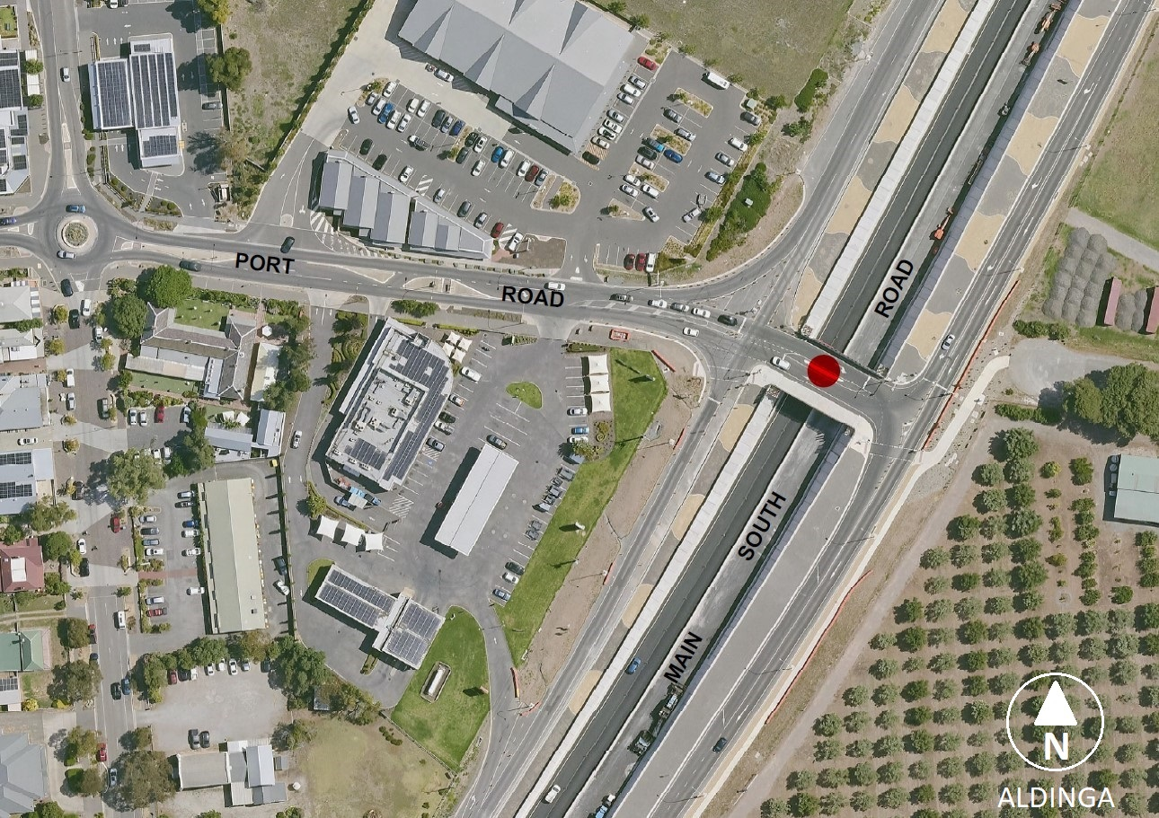
Submissions in writing regarding this proposal may be lodged with the Surveyor-General, GPO Box 1815, Adelaide SA 5001, or DTI.PlaceNames@sa.gov.au within one month of the publication of this notice.
Dated:4 March 2024
Hon Nick Champion MP
Minister for Planning
DTI: 2023/07098/01

Housing Improvement Act 2016
Rent Control Revocations
Whereas the Minister for Human Services Delegate is satisfied that each of the houses described hereunder has ceased to be unsafe or unsuitable for human habitation for the purposes of the Housing Improvement Act 2016, notice is hereby given that, in exercise of the powers conferred by the said Act, the Minister for Human Services Delegate does hereby revoke the said Rent Control in respect of each property.
Address of Premises | Allotment Section | Certificate of Title Volume/Folio
129 New Street, Queenstown SA 5014 | Allotment 6 Filed Plan 142647 Hundred of Yatala | CT5855/223
28 Daly Street, East Moonta SA 5558 | Section 2712 Hundred Plan 211100 Hundred of Wallaroo | CT5162/870
Lot 77 Penfield Road, Virginia SA 5120  (AKA 136 Penfield Road, Virginia) | Allotment 77 Filed Plan 114891 Hundred of Munno Para | CT5498/597
30 Wilson Terrace, Port Victoria  SA 5573 | Allotment 18 Town Plan 131601 Hundred of Wauraltee | CT5413/38
74-76 Robert Street, Moonta SA 5558  (AKA 74 Robert Street, Moonta) | Allotment 514 Filed Plan 198695 Hundred of Wallaroo | CT5550/493, CT5637/207
31 Canopus Avenue, Hope Valley  SA 5090 | Allotment 93 Deposited Plan 6658 Hundred of Yatala | CT5561/322
Dated: 7 March 2024
Craig Thompson
Housing Regulator and Registrar
Housing Safety Authority, SAHA
Delegate of Minister for Human Services

Housing Improvement Act 2016
Rent Control Variations
The Minister for Human Services Delegate in the exercise of the powers conferred by the Housing Improvement Act 2016, does hereby vary the rent control notice in respect of each house described in the following table. Variation in the maximum rental per week which shall be payable subject to Section 55 of the Residential Tenancies Act 1995. The varied amount shown in the said table shall come into force on the date of this publication in the Gazette.
Address of Premises | Allotment Section | Certificate of Title  Volume/Folio |  | Reason for variation | Maximum Rental per week payable
78 Port Road, Alberton SA 5014 | Allotment 33 Filed Plan 40027 Hundred of Yatala | CT 5078/857 |  |  | $307.50
Dated: 7 March 2024
Craig Thompson
Housing Regulator and Registrar
Housing Safety Authority, SAHA
Delegate of Minister for Human Services

Land Acquisition Act 1969
Section 16
Form 5—Notice of Acquisition
1. Notice of acquisition
The Commissioner of Highways (the Authority), of 83 Pirie Street, Adelaide SA 5000, acquires the following interests in the following land:
Comprising the entirety of the right, estate or interest of Lexie Johnson and Haydn Jack Weber, whether as lessee, as sub-lessee or as licensee or otherwise in that piece of land being the whole of Unit 2 in Strata Plan 13624 comprised in Certificate of Title Volume 5288 Folio 131.
This notice is given under Section 16 of the Land Acquisition Act 1969.
2. Compensation
A person who has or had an interest consisting of native title or an alienable interest in the land that is divested or diminished by the acquisition or the enjoyment of which is adversely affected by the acquisition who does not receive an offer of compensation from the Authority may apply to the Authority for compensation.
2A. Payment of professional costs relating to acquisition (Section 26B)
If you are the owner in fee simple of the land to which this notice relates, you may be entitled to a payment of up to $10,000 from the Authority for use towards the payment of professional costs in relation to the acquisition of the land.
Professional costs include legal costs, valuation costs and any other costs prescribed by the Land Acquisition Regulations 2019.

3. Inquiries
Inquiries should be directed to: Petrula Pettas
GPO Box 1533
Adelaide SA 5001
Telephone: 08 7133 2457
Dated: 1 March 2024
The Common Seal of the COMMISSIONER OF HIGHWAYS was hereto affixed by authority of the Commissioner in the presence of:
Rocco Caruso
Manager, Property Acquisition
(Authorised Officer)
Department for Infrastructure and Transport
DIT 2023/07307/01

Land Acquisition Act 1969
Section 16
Form 5—Notice of Acquisition
1. Notice of acquisition
The Commissioner of Highways (the Authority), of 83 Pirie Street, Adelaide SA 5000, acquires the following interests in the following land:
Comprising the entirety of the right, estate or interest of Matthew Roberts, Luke Butcher and Joshua Caryl Deluao, whether as lessee, as sub-lessee or as licensee or otherwise in that piece of land being the whole of Allotment 310 in Deposited Plan 1243 comprised in Certificate of Title Volume 5648 Folio 100.
This notice is given under Section 16 of the Land Acquisition Act 1969.
2. Compensation
A person who has or had an interest consisting of native title or an alienable interest in the land that is divested or diminished by the acquisition or the enjoyment of which is adversely affected by the acquisition who does not receive an offer of compensation from the Authority may apply to the Authority for compensation.
2A. Payment of professional costs relating to acquisition (Section 26B)
If you are the owner in fee simple of the land to which this notice relates, you may be entitled to a payment of up to $10,000 from the Authority for use towards the payment of professional costs in relation to the acquisition of the land.
Professional costs include legal costs, valuation costs and any other costs prescribed by the Land Acquisition Regulations 2019.
3. Inquiries
Inquiries should be directed to: Petrula Pettas
GPO Box 1533
Adelaide SA 5001
Telephone: 08 7133 2457
Dated: 1 March 2024
The Common Seal of the COMMISSIONER OF HIGHWAYS was hereto affixed by authority of the Commissioner in the presence of:
Rocco Caruso
Manager, Property Acquisition
(Authorised Officer)
Department for Infrastructure and Transport
DIT 2022/03058/01

Land Acquisition Act 1969
Section 16
Form 5—Notice of Acquisition
1. Notice of acquisition
The Commissioner of Highways (the Authority), of 83 Pirie Street, Adelaide SA 5000, acquires the following interests in the following land:
Comprising an unencumbered estate in fee simple in that piece of land being the whole of Allotment 85 in Filed Plan 122232 comprised in Certificate of Title Volume 5846 Folio 655.
This notice is given under Section 16 of the Land Acquisition Act 1969.
2. Compensation
A person who has or had an interest consisting of native title or an alienable interest in the land that is divested or diminished by the acquisition or the enjoyment of which is adversely affected by the acquisition who does not receive an offer of compensation from the Authority may apply to the Authority for compensation.
2A. Payment of professional costs relating to acquisition (Section 26B)
If you are the owner in fee simple of the land to which this notice relates, you may be entitled to a payment of up to $10,000 from the Authority for use towards the payment of professional costs in relation to the acquisition of the land.
Professional costs include legal costs, valuation costs and any other costs prescribed by the Land Acquisition Regulations 2019.

3. Inquiries
Inquiries should be directed to: Daniel Tuk
GPO Box 1533
Adelaide SA 5001
Telephone: 08 7133 2479
Dated: 1 March 2024
The Common Seal of the COMMISSIONER OF HIGHWAYS was hereto affixed by authority of the Commissioner in the presence of:
Rocco Caruso
Manager, Property Acquisition
(Authorised Officer)
Department for Infrastructure and Transport
DIT 2023/05368/01

Land Acquisition Act 1969
Section 16
Form 5—Notice of Acquisition
1. Notice of acquisition
The Minister for Health and Wellbeing (the Authority), of 11 Hindmarsh Square, Adelaide SA 5000, acquires the following interests in the following land:
Comprising an unencumbered estate in fee simple in that piece of land being portion of Allotment (Reserve) 2 in Deposited Plan 71484 comprised in Certificate of Title Volume 5974 Folio 42, and being the whole of the land identified as Allotment 101 in D132964 lodged in the Lands Titles Office.
This notice is given under Section 16 of the Land Acquisition Act 1969.
2. Compensation
A person who has or had an interest consisting of native title or an alienable interest in the land that is divested or diminished by the acquisition or the enjoyment of which is adversely affected by the acquisition who does not receive an offer of compensation from the Authority may apply to the Authority for compensation.
2A. Payment of professional costs relating to acquisition (Section 26B)
If you are the owner in fee simple of the land to which this notice relates, you may be entitled to a payment of up to $10,000 from the Authority for use towards the payment of professional costs in relation to the acquisition of the land.
Professional costs include legal costs, valuation costs and any other costs prescribed by the Land Acquisition Regulations 2019.
3. Inquiries
Inquiries should be directed to: Daniel Tuk
GPO Box 1533
Adelaide SA 5001
Telephone: 08 7133 2479
Dated: 29 February 2024
The Common Seal of the MINISTER FOR HEALTH AND WELLBEING was hereto affixed by authority of the Minister in the presence of:
Amanda Lloyd
Witness
DIT 2023/01744/01

Livestock Act 1997
Section 37
Requirements for the control of Abalone Herpes Virus-1 (AbHV-1)
Pursuant to Section 37 of the Livestock Act 1997 and for the purposes of controlling or eradicating Abalone Herpes Virus-1 (AbHV-1), I Dr Elise Spark, deputy Chief Inspector of Stock, delegate of the Minister for Primary Industries and Regional Development, hereby require that:
- activities listed in Schedule 1 are prohibited within South Australia, and
- activities listed in Schedule 2 are prohibited within the Control Area, and
- activities listed in Schedule 3 Column A may be undertaken in accordance with requirements in Schedule 3 Column B in the area(s) specified in Schedule 3 Column C
Pursuant to Section 87 of the Livestock Act 1997, this notice revokes the following notices made by the deputy Chief Inspector of Stock, delegate of the Minister for Primary Industries and Regional Development:
- Section 37 notice - Requirements for the control of Abalone Herpes Virus-1 (AbHV-1) in effect from 15:00 on 5 March 2024 and published on the Department of Primary Industries and Regions South Australia website (https://www.pir.sa.gov.au) on 5 March 2024.
Definitions
In this Notice:
Buffer Zone means the area specified in Schedule 5.
marine benthic species includes but is not limited to southern rock lobster, gastropods and macroalgae, but does not include pipis collected in the intertidal zone.
Control Area means the area specified in Schedule 4.
rock lobster pot has the same meaning as the Fisheries Management (Rock Lobster Fisheries) Regulations 2017.
Schedule 1—Activities prohibited within South Australia
Keeping of abalone originating (whether before or after the commencement of this notice) from the Control Area or Buffer Zone in the same holding system (water, tanks or aquaria, equipment) as abalone from other South Australian State waters.
Keeping of non-abalone marine benthic species originating (whether before or after the commencement of this notice) from the Control Area or Buffer Zone in the same holding system (water, tanks or aquaria, equipment) as abalone.
Schedule 2—Activities prohibited within Control Area
Activities that interact with the marine benthic zone including but not limited to:
- Movement of marine benthic species
- Setting or retrieval of rock lobster pots
- Anchoring
- Reef diving
Schedule 3—Activities subject to requirements
Column A | Column B | Column C
Activities | Requirements | Area
Activities that interact with the marine benthic zone including but not limited to:  - Movement of marine benthic species  - Setting or retrieval of rock lobster pots  - Reef diving  - Anchoring | - Any equipment coming into contact with the marine benthic zone must be decontaminated in accordance with the “PIRSA Guideline Decontamination requirements for Abalone Viral Ganglioneuritis” | Buffer Zone
Line fishing – whether by shore or boat | - Any equipment coming into contact with the marine benthic zone must be decontaminated in accordance with the “PIRSA Guideline Decontamination requirements for Abalone Viral Ganglioneuritis”  - Any marine benthic species caught must be returned at point of catch.  - Any catch that is not marine benthic species must be either:  - returned at site of catch, or  - consumed or disposed of on land, or  - used as bait within the Control Area. | Control Area
Line fishing – whether by shore or boat | - Any equipment coming into contact with the Marine benthic zone must be decontaminated in accordance with the “PIRSA Guideline Decontamination requirements for Abalone Viral Ganglioneuritis”  - Any catch must be either:  - returned at site of catch, or  - consumed or disposed of on land, or  - used as bait within the Buffer Zone*  *Note abalone must not be used as bait or berley in South Australia in accordance with the Gazette notice made on 10 July 2023, published in the Gazette on 13 July 2023, page 2206. | Buffer Zone
Removal of anything other than pipis from the intertidal zone | - Must be undertaken in accordance with other relevant laws.  - Anything removed must not be returned to other South Australian waters. | Control Area and Buffer Zone

Schedule 4—Control Area
The coastal waters of the south east of South Australia contained within and bounded by a line commencing at the point 38°03'21.9838" South 140°57'57.0451" East, then southerly to the point 38°07'19.1451" South 140°57'55.5040" East, then westerly to the point 38°07'22.7489" South 140°40'19.5476" East, then north-westerly to the point 38°02'49.3454" South 140°27'27.2593" East, then further north-westerly to the point 38°00'12.7146" South 140°18'52.0293" East then further north-westerly to the point 37°51'17.9382" South 140°16'24.5464" East then further north-westerly to the point 37°45'32.9664" South 140°10'33.6039" East then further north-westerly to the point 37°43'38.1163" South 140°05'48.9097" East then further north-westerly to the point 37°35'44.0199" South 139°57'28.9763" East then north-easterly to the point closest to Mean High Water Springs at 37°34'01.7910" South 140°06'29.4295 then south-easterly along the line of Mean High Water Springs to the point of commencement (GDA2020).
Map of Area Described
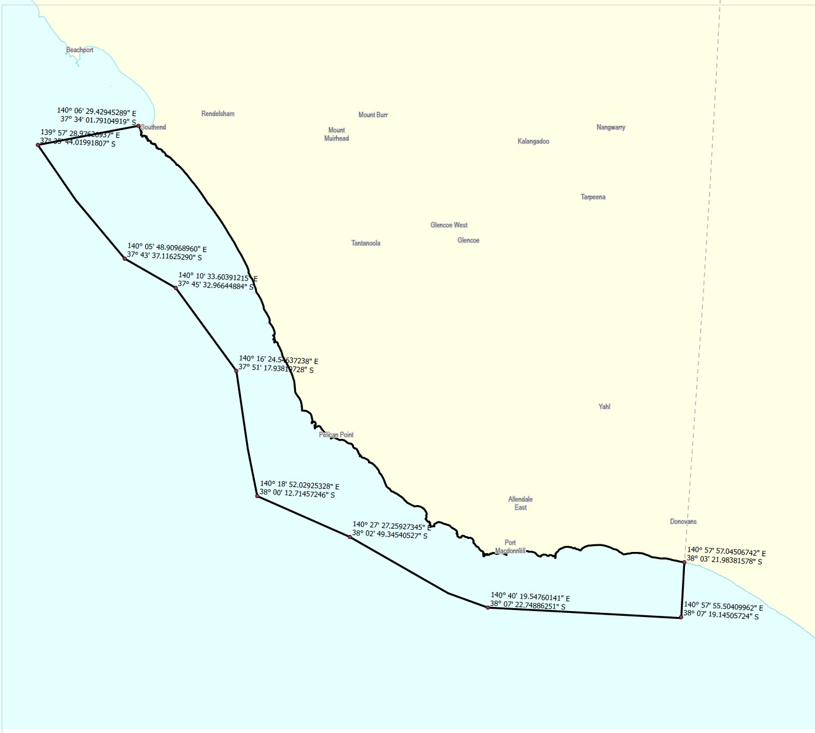

Schedule 5—Buffer Zone
The coastal waters of the south east of South Australia contained within and bounded by a line commencing at the point 37°34'01.5713" South 140°06'28.5239" East, then south-westerly to the point 37°35'44.0199" South 139°57'28.9763" East, then north-westerly to the point 37°09'49.0991" South 139°34'08.2996" East, then northerly to the point 36°50'53.0000" South 139°34'08.0000" East, then easterly to the point 36°50'53.0000" South 139°40'28.0000" East then northerly to the point 36°35'06.0000" South 139°40'28.0000" East then north-westerly to the point 36°06'59.0043" South 139°23'52.8632" East then further north-westerly to the point 35°40'25.1599" South 138°50'52.4762" East then northerly to the point closest to Mean High Water Springs at 35°33'51.9441" South 138°53'32.5573 then south-easterly along the line of Mean High Water Springs to the point of commencement (GDA2020).
Map of Area Described
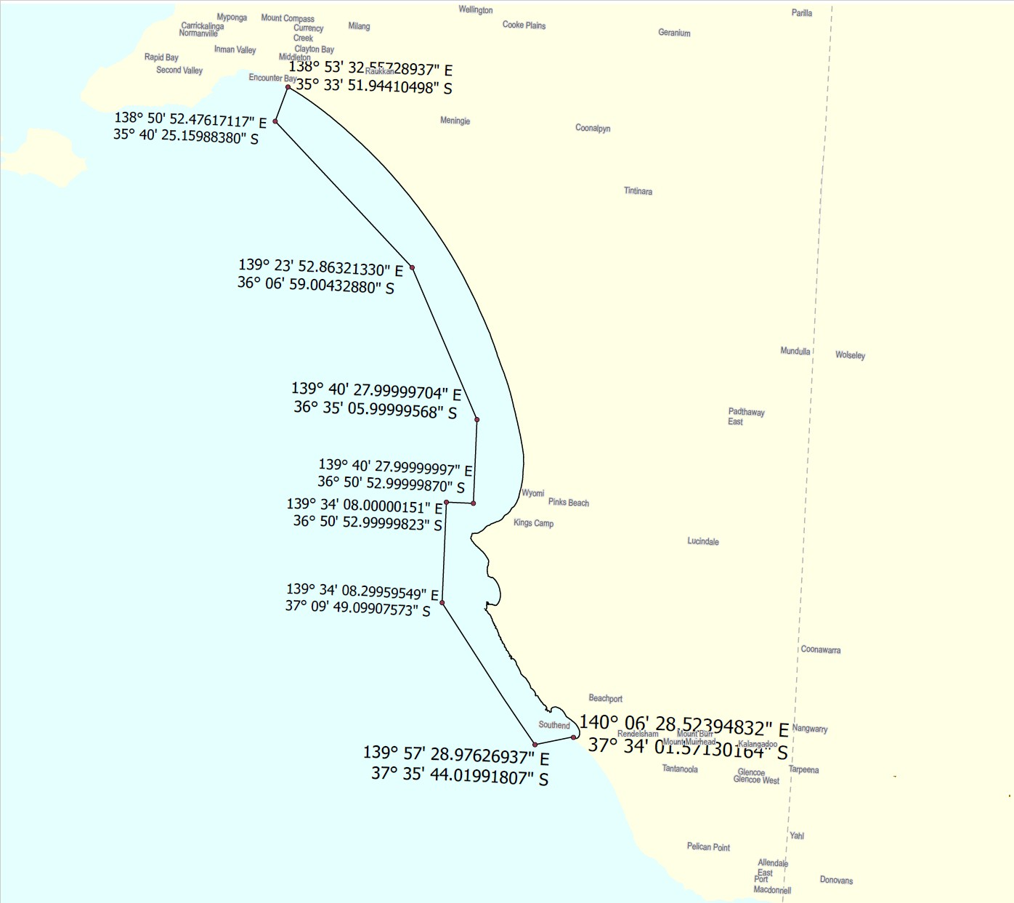
This Notice will be in effect from 23:59 5 March 2024 and remain in force until 23:59 27 March 2024 unless amended or revoked by a subsequent Notice
Dated: 5 March 2024
Dr Elise Sparks
Deputy Chief Inspector of Stock
Delegate of the Minister for Primary Industries and Regional Development

Mental Health Act 2009
Authorised Medical Practitioner
NOTICE is hereby given in accordance with Section 93(1) of the Mental Health Act 2009 that the Chief Psychiatrist has determined the following person as an Authorised Medical Practitioner:
Vicki Christodoulou
A determination will be automatically revoked upon the person being registered as a specialist psychiatrist with the Australian Health Practitioner Regulation Agency and as a fellow of the Royal Australian and New Zealand College of Psychiatrists.
Dated: 28 February 2024
Dr John Brayley
Chief Psychiatrist

Mining Act 1971
Section 70
Declaration of Forfeiture of Mineral Tenement
Notice is hereby given that the exploration licence described below is declared forfeited to the Crown.
Mineral Tenement: Exploration Licence 5890 (Copper and Gold)
Location: Eucolo Creek area approx. 25km west of Woomera
Licence Holder: Riversgold (Australia) Pty Ltd (ACN 619 424 592)
Reason for Forfeiture: By way of an order of the Wardens Court* of 12 January 2024 recommending forfeiture, and upon an application made by U Minerals Pty. Limited, the Minister for Energy and Mining by this notice forfeits the mineral tenement to the Crown entitling U Minerals Pty. Limited (ACN 671 955 963) to a transfer of the mineral tenement from the Crown for the balance of its term (Section 70(3) of the Act).

Section 70(4)
Notice of Transfer
Notice is hereby given that the exploration licence described above is transferred to U Minerals Pty. Limited (ACN 671 955 963).
* CIV23-013047 U Minerals Pty. Limited v Riversgold (Australia) Pty Ltd
Dated: 7 March 2024
Paul De Ionno
A/Executive Director
Regulation and Compliance
Department for Energy and Mining

Motor Vehicles Act 1959
South Australia
Motor Vehicles (2024 Adelaide Motorsport Festival) Notice
under section 6 of the Motor Vehicles Act 1959
1 Operation and expiry
This Notice comes into operation at 5:00am on 15 March 2024 and expires at 11.59pm on 17 March 2024.
2 Interpretation
In this Notice—
2024 Adelaide Motorsport Festival means the Victoria Park Sprint Event promoted by Massive Events Corp Pty Ltd ACN 633 659 999 and held under Motorsport Australia Permit Number 824/1703/01;
Minister means the Minister to whom the administration of the Motor Vehicles Act 1959 is committed.
3 Exemption
In accordance with the power under section 6 of the Motor Vehicles Act 1959 I declare that the whole of the Act does not apply to roads within the area designated in the Schedule to this Notice during the operation of this Notice.
4 Revocation
This Notice may be revoked or varied by the Minister or their delegate at any time.
5 Execution
Dated: This 28th day of February 2024
Hon Anastasios Koutsantonis MP
Minister for Infrastructure and Transport

Schedule
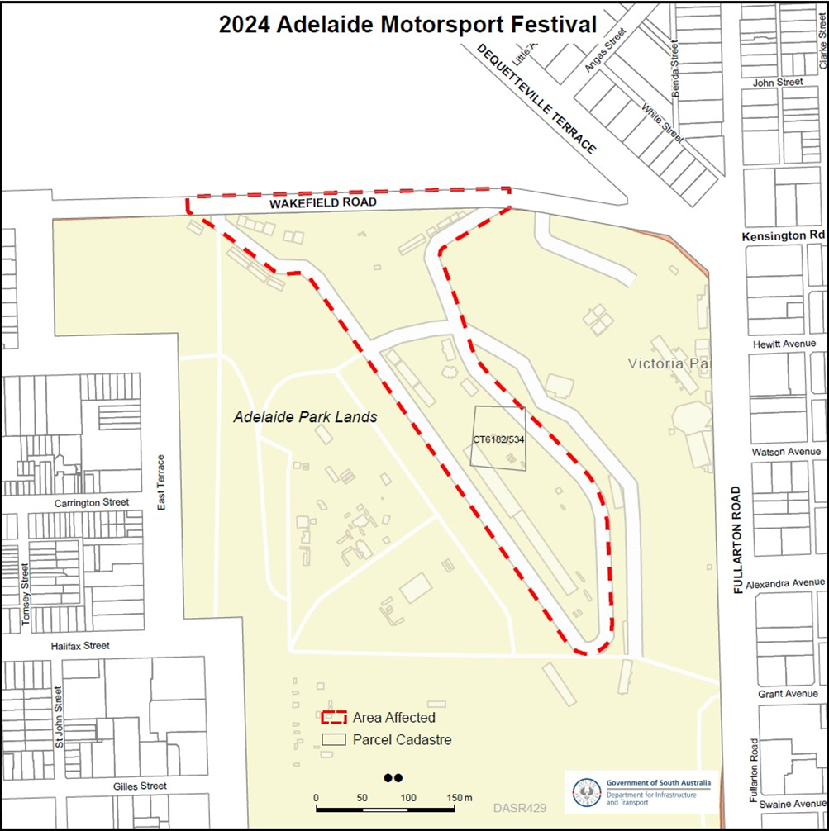

Motor Vehicles Act 1959
South Australia
Motor Vehicles (Approval of Motor Bikes and Motor Trikes) Notice 2024 No 1
under the Motor Vehicles Act 1959
1—Short title
This notice may be cited as the Motor Vehicles (Approval of Motor Bikes and Motor Trikes) Notice 2024.
2—Commencement
This notice will come into operation on the date of publication in this Gazette.
3—Approved motor bikes and motor trikes
For the purposes of Schedules 2 and 3 of the Motor Vehicles Regulations 2010 and the transitional provisions of the Motor Vehicles Variation Regulations 2005 (No 233 of 2005), the motor bikes and motor trikes specified in Schedule 1 are approved.
Schedule 1—Approved motor bikes and motor trikes
The following are approved:
- All motor bikes and motor trikes built before December 1960 with an engine capacity not exceeding 660ml
- All motor bikes and motor trikes with an engine capacity not exceeding 260 milliliters and a power to weight ratio not exceeding 150 kilowatts per tonne, except the following:
Suzuki RGV250
Kawasaki KR250 (KR-1 and KR1s models)
Honda NSR250
Yamaha TZR250
Aprilia RS250
- All motor bikes and motor trikes with electric powered engines, with a power output not in excess of 25 kw
Motor bikes and Motor trikes with electric powered engines listed in the table below are approved:
MAKE | MODEL | VARIANT NAME | YEAR(S) | CAPACITY
BRAAAP | MotoE | 5000w | 2022-current | Electric
 | MotoE | 8000w | 2022-current | Electric
 | MotoE | 10000w | 2022-current | Electric
EVOKE | URBAN S |  | 2020-current | Electric
 | URBAN CLASSIC |  | 2020-current | Electric
FONZARELLI | 125 | 125 | 2014-2015 | Electric
KAWASAKI | NX011A | NR011A (Ninja e-1)  NX011A (Ninja e-1) | 2023 | Electric
KYBURZ | DXP | KYBURZ | 2017 | Electric
ZERO | DS | Zero DS | Unit 2015 | Electric
 | S | Zero S | Until 2015 | Electric

Motor trikes with an engine capacity not less than 261ml and not exceeding 660ml listed in the table below are approved:

MAKE | MODEL | VARIANT NAME | YEAR(S) | CAPACITY
BRP | Can am Ryker | Rotax 600 ACE | 2018 | 599
GILERA | FUOCO 500 | FUOCO 500 | 2007-13 | 493
LAMBRETTA | All model | Lambretta | pre 2008 | under 660
OZ TRIKE | FUN 500 | FUN 500 | pre 2008 | 500
METROPOLIS | AA | 2018 | 399 | METROPOLIS
PGO | All models | All models under 220 | All | 220
PIAGGIO | All Models | All models | 2010-17 | under 350

Motor bikes with an engine capacity not less than 261ml and not exceeding 660ml listed in the table below are approved:

MAKE | MODEL | VARIANT NAME | YEAR(S) | CAPACITY
AJP | PR7 | PR7 | 2017-19 | 600
AJS | MODEL 18 | MODEL 18 | pre 1963 | 497
 | MODEL 20 | MODEL 20 | 1955-61 | 498
APRILIA | KV | RS 660 LAMS & Tuono 660 LAMS | 2020-on | 659
 | Moto 6.5 | Moto 6.5 | 1998-99 | 649
 | M35 | SR MAX 300 | 2012 | 278
 | PEGASO 650 | DUAL SPORTS | 1994-01 | 652
 | PEGASO 650 | OUTBACK | 2000-01 | 652
 | PEGASO 650 | Factory 650 | 2007-08 | 660
 | PEGASO 650 I.E. | OUTBACK | 2001-02 | 652
 | PEGASO 650 I.E. | DUAL SPORTS | 2001-06 | 652
 | SCARABEO 300 | VRG | 2009 | 278
 | SCARABEO 400 | SCARABEO 400 | 2007 | 399
 | SCARABEO 500 | SCARABEO 500 | 2007-08 | 460
 | SPORTCITY300 | SPORTCITY300 | 2010-12 | 300
 | STRADA 650 | ROAD | 2006-08 | 659
 | STRADA 650 | TRAIL | 2006-08 | 659
 | VP (RXV 450) | VPV-VPT-VPH 18.3kW | 2006-10 | 449
 | VP (RXV 550) | VPZ- VPX- VPL 20kW | 2006-10 | 553
 | VS (SXV 450) | SXV 450 (VSR-VSH) 14kW | 2006-08 | 449
 | VS (SXV 550) | SXV 550 (VSS-VSL) 14.5kW | 2006-08 | 553
 | XC | Tuareg 660 (LAMS) | 2022-on | 659
ASIAWING | LD450 | ODES MCF450 | 2011-13 | 449
ATK | 605 | 605 | 1995 | 598
BENELLI | LEON | Leoncino, Leoncino Trail | 2018-on | 500
 | VELVET DUSK | Velvet 400 Dusk, Velvet Touring 400 | 2002-06 | 383
 | P10 | BN 302 | 2015 on | 300
 | P16 | TRK 502X | 2018 on | 500
 | P18 | LEONCINO 500 | 2017 on | 500
 | P18 | LEONCINO 500 TRAIL | 2018 on | 500
 | P18  P16 | BENELLI  TRK502 | 2017  2017 | 500  500
 | P25 | GT600 RESTRICTED | 2014-15 | 600
 | P25 | BN 600 RESTRICTED | 2013-on | 600
 | P36 | 502C | 2019 | 500
 | VELVET DUSK | VELVET DUSK | 2003-05 | 383
BETA | BETA | FUPA RR E3 | 2018 | 293
 | BMA RR | RR350 15 | 2018 | 349
 | BMA RR | RR390 16 | 2018 | 386
 | BMA RR | RR430 17 | 2018 | 431
 | BMA RR | RR480 18 | 2018 | 478
 | FUPA E5 | E5 00 | 2015 | 293
 | FUPA E5 | E8/03 | 2016-on | 293
 | FUPA RR E3 | RR 2T 300 | 2012-on | 293
 | FUPA RR E3 | RR350 20 & RR350 15 | 2016-on | 349
 | FUPA RR E3 | RR390 31 & RR390 16 | 2016-on | 386
 | FUPA RR E3 | RR430 32 & RR430 17 | 2016-on | 431
 | FUPA RR E3 | RR480 33 & RR480 18 | 2016-on | 478
 | RR E3 | RR350 | 2011-on | 349
 | RR E3 | RR400 | 2010-14 | 398
 | RR E3 | RR450 | 2010-14 | 449
 | RR E3 | RR520 | 2010-11 | 498
 | RR300 2T | RR300 2T | 2018-on | 293
 | RR350 4T | RR350 4T | 2019-on | 349
 | RR390 4T | RR390 4T | 2019-on | 386
 | RR430 4T | RR430 4T | 2019-on | 431
 | RR450 | RR450 | 2000-08 | 448
 | RR480 4T | RR480 4T | 2019-on | 478
 | RR525 | RR525 | 2000-08 | 510
 | XTRAINER 300 2T | XTRAINER 300 2T | 2019-on | 293
BMW | C400X | 0C09/C400X | 2018-on | 350
 | C400GT | 0C06, C400GT | 2018-on | 350
 | C650 | C600 SPORT | All | 647
 | C650 | C650 GT/Sport | All | 647
 | F650 | FUNDURO | 1995-00 | 652
 | F650 | G650 GS | 2009-16 | 652
 | F650 | G650 GS Sertao | 2012-16 | 652
 | F650CS | SCARVER | 2002-06 | 652
 | F650CS | SE ROAD | 2004-06 | 652
 | F650GS | DAKAR | 2000-08 | 652
 | F650GS | F650GS | 2000-10 | 652
 | F650ST | F650ST | 1998 | 652
 | G 450 X | G 450 X | 2008-10 | 450
 | G310 | G310R-0G01 | 2016-on | 313
 | G310GS | G310GS-0G02 | 2016-on | 313
 | G650GS | Sertao | All | 650
 | R45 | R45 | All | 453
 | R50 | R50 | All | 499
 | R60 | R60 | 1960-78 | 590
 | R65 | R65 | 1978-88 | 650
 | R65LS | R65LS | 1981-86 | 650
 | R69 | R69S | 1961-67 | 600
BOLWELL | LM25W | FIRENZE | 2009 | 263
BOLLINI | All models | All models under 250 | All | 250
BRAAAP | Moto4 | Moto Range, Cruiser 400 | 2021-on | 400
 | ST | 450 | 2016-on | 450
 | ST400 | Shadow | 2022-on | 367
BSA | A50 | A50 | 1964-70 | 500
 | A65 | A65 | 1966-69 | 650
 | A7 | A7 | 1961 | 500
 | B40 | B40 | 1969 | 350
 | B44 | B44 | 1967-71 | 440
 | B50 | B50 | 1971 | 495
 | B50SS GOLDSTAR | B50SS GOLDSTAR | 1971 | 498
 | GOLD STAR | GOLD STAR | 1938-63 | 500
 | LIGHTNING | LIGHTNING | 1964 | 654
 | SPITFIRE MKIII | SPITFIRE MKIII | 1967 | 650
 | THUNDERBOLT | THUNDERBOLT | 1968 | 499
BUELL | Blast | STREET FIGHTER | 2002-07 | 491
BUG | SEE KYMCO
BULTACO | ALPINA | ALPINA | 1974 | 350
 | FRONTERA | FRONTERA | 1974 | 360
 | SHERPA | SHERPA | 1974 | 350
CAGIVA | 360WR | 360WR | 1998-02 | 348
 | 410TE | 410TE | 1996 | 399
 | 610TEE | 610TEE | 1998 | 576
 | 650 ALAZZURA | 650 ALAZZURA | 1984-88 | 650
 | 650 ELFANT | 650 ELFANT | 1985-88 | 650
 | CANYON 500 | DUAL SPORTS | 1999-06 | 498
 | CANYON 600 | DUAL SPORTS | 1996-98 | 601
 | RIVER 600 | RIVER 600 | 1995-98 | 601
 | W16 600 | W16 600 | 1995-97 | 601
CAN-AM | CAN-AM RYKER | ROTAX 600 ACE | 2019-on | 599
CCM | GP Series | GP450-1(A1 30kW) | 2015-16 | 450
 | GP Series | GP450-2(A1 30kW) | 2015-16 | 450
CFMOTO | CF300-7F | 300CL-X | 2023-on | 292
 | CF 400-6F | 450SR | 2022-on | 449
 | CF 650 | CF650NK-LAM | 2012-on | 649
 | CF 650 | CF650TK-LAM | 2013-17 | 649
 | CF 650 | 650NK-LAM | 2016-18 | 649
 | CF 650 | 650MT | 2016-on | 649
 | CF 650 | 650GT | 2019-on | 649
 | CF 650 (400NK) | 400NK | 2016-17 | 400
CHANGJIANG | CJ650B with sidecar | Nomad, Tourer | 2023-on | 649
COSSCK | 650 | Ural | 1974 | 649
DERBI | MULHACEN | MULHACEN | 2008 | 659
 | RAMBLA | RA 300 | 2010 | 278
DNEPR | K650 | K650 | 1972 | 650
 | K650 | K650 DNEPR | 1967-74 | 650
 | MT9 | MT9 | 1974 | 650
DUCATI | 400 MONSTER | 400 MONSTER | 2002 | 398
 | 400 SIE | 400 S I E monster |  | 398
 | 400 SS JUNIOR | 400 SS | 1989-96 | 398
 | 400SS | 400SS | 1992-95 | 398
 | 500 DESMO | 500 Sport Desmo | 1977-83 | 497
 | 500GTL | 500GTL | 1975-77 | 497
 | 500SL | PANTAH | 1984 | 499
 | 600 MONSTER | 600 MONSTER | 1994-01 | 583
 | 600 MONSTER | DARK | 1998-01 | 583
 | 600 S | 600 SUPERSPORT | 1994-97 | 583
 | 600M | 600M | 1994-01 | 583
 | 600SL | PANTAH | 1980-84 | 583
 | 600SS | 600SS | 1994-98 | 583
 | 620 MONSTER LITE | M620 LITE | 2003-07 | 618
 | 620 MULTISTRADA LITE | MTS620 24.5Kw | 2005-07 | 618
 | 659 Monster | Monster 659 | All | 659
 | DM 350 | 350 | pre 85 | 350
 | DM 450 | 450 | pre 85 | 448
 | DM450 | DM450 | 1972 | 450
 | DM500 | DM500 | 1981-84 | 498
 | F3 | 350 F3 | 1986-89 | 349
 | F4 | 400 F4 | 1986 | 400
 | KA (Scrambler) | 00AA Sixty2 | 2015-on | 399
 | M4 | M620ie LITE | 2003-04 | 620
 | M5 | Monster 659 | 2011 | 659
 | MD | 02AU | 2017 | 659
ELSTAR SHINERAY | XY400 | CAFÉ RACER | 2018 | 397
 | XY400 | CAFÉ RACER F | 2018 | 397
 | XY400 | CLASSIC C | 2018 | 397
 | XY400 | SCRAMBLER C | 2018 | 397
 | XY400 | WB400 & WB400c | 2015-17 | 397
ENFIELD | BULLET | CLASSIC | 1993-08 | 499
 | BULLET | DELUXE | 1993-08 | 499
 | BULLET | ELECTRA ROAD | 2006-08 | 499
 | BULLET 350 | DELUXE | 1988-01 | 346
 | BULLET 350 | SUPERSTAR | 1988-95 | 346
 | BULLET 350 | CLASSIC | 1993-01 | 346
 | BULLET 500 | 500 | 1995-08 | 499
 | BULLET 65 | ROAD | 2003-04 | 499
 | LIGHTNING | ROAD | 2000-08 | 499
 | MILITARY | ROAD | 2002-08 | 499
 | TAURUS | DIESEL | 2001 | 325
FANTIC | CA50 | Flat Track | 2020-on | 449
 | CA50 | Scrambler | 2020-on | 449
 | CA50 | Rally | 2020-on | 449
 | TZ | EC300 | 2011-12 | 300
 | TZ | Gas Gas EC30 | 2012 | 300
GAS-GAS | 4E | EC 30 | 2017 | 299
 | 4E | EC25 | 2017 | 299
 | 4E (IPA 48807) | EC 30 | 2018 | 299
 | CONTACT ES | 280 ES | 2018 | 272
 | EC ENDURO | EC30 | 2016-17 | 299
 | EC Series | EC300 | 2001-on | 293
 | EC Series | EC350F | 2021-on | 350
 | EC400 | FSE ENDURO | 2002-03 | 399
 | EC450 | FSE ENDURO | 2003-05 | 449
 | EC450 | FSE SUPERMOTARD | 2003-08 | 449
 | EC450 | FSR ENDURO | 2006-12 | 449
 | FS 400 | FS40A | 2006 | 398
 | FS 450 | FS45 | 2006 | 443
 | FS 500 | FS50 (503) | 2006-2009 | 503
 | FSE 400 | 400 | 2002 | 398
 | FSE 450 | 450 | 2003-08 | 398
 | PAMPERA | 320 TRAIL | 1998-02 | 333
 | PAMPERA | 400 TRAIL | 2006-08 | 399
 | PAMPERA | 450 | 2007-09 | 443
 | SM400 | SUPERMOTARD | 2003-08 | 399
 | SM450 | SUPERMOTARD | 2003-08 | 443
 | TT300 | EC300 | 1998-08 | 295
GILERA | NEXUS 500 | NEXUS 500 | 2003-08 | 460
HARLEY DAVIDSON | LWZ Series | X350 | 2023-on | 353
 | LWZ Series | X500 | 2023-on | 500
 | SS350 | Sprint | 1969-74 | 350
 | XGS SERIES | Street 500 -XG500 16MY | 2014-15 | 494
 | XGS SERIES | Street 500 | 2015-on | 494
HONDA | 600V TRANSALP | 600V | 1988 | 583
 | BROS400 | BROS400 | 1988 | 399
 | C70 | DREAM | pre 1970 | 305
 | CB300 (FA) | CB300FA | 2014-18 | 286
 | CB300R | CBF300NA | 2018-on | 286
 | CB350 | CB350 | 1969-72 | 348
 | CB350F | CB350F | 1972-74 | 325
 | CB360 | CB360 | 1973-76 | 360
 | CB400 | CB400 | 1981-14 | 395
 | CB400 ABS | CB400 ABS | 2008 -16 | 399
 | CB400F | CB400F | 1975-77 | 408
 | CB400N | CB400N | 1981 | 395
 | CB400T | CB400T | 1977 | 408
 | CB450 | CB450 | 1967-75 | 450
 | CB500 FOUR | CB500-FOUR K,K1,K2 | 1971-73 | 498
 | CB500 TWIN | CB500T | 1974-78 | 498
 | CB500F | CB500FA/F | 2012-on | 471
 | CB500X | CB500XA | 2013-on | 471
 | CB550 | CB550 | 1974-78 | 544
 | CB650 | CB650 | All | 650
 | CB650F | CB650FA-LTD-16ym | 2015-017 | 649
 | CBR300R | CBR300R | 2014-16 | 286
 | CBR300R | CBR300RA | 2014-18 | 286
 | CBR500R | CBR500RA | 2012-on | 471
 | CBR650F | CBR650F LAMS (CBR650FL) | 2015-19 | 649
 | CBR650R | CBR650R | 2019-on | 649
 | CBX550 | CBX550F | 1982-85 | 572
 | CJ360 | CJ360 | 1976 | 356
 | CL450 | CL450 | 1965-77 | 444
 | CL500A | CL500 | 2023-on | 471
 | CMX500 | CMX500 | 2016-on | 471
 | CMX500A | CMX500A | 2016-20 | 471
 | CRF300 | CRF300 Rally | 2020-on | 286
 | CRF300 | CRF300L | 2020-on | 286
 | CRF400R | CRF400R | 2013 | 399
 | CRF450L | CRF450L | 2018-on | 449
 | CRF450L | CRF450L2019YM | 2018-on | 449
 | CRF450X | CRF450X | 2005-09 | 449
 | CX500 | CX500 | 1977-82 | 495
 | DEAUVILLE | NT650V | 2000-07 | 647
 | FJS400A | SW-T400 | 2009 | 399
 | Fortza 300 | NSS300 Forza | All | 279
 | FT500 | FT500 | 1982-84 | 498
 | FTS600D | SILVERWING | 2006-08 | 582
 | GB400 | GB400 | All | 399
 | GB500 | GB500 TT | 1975-91 | 498
 | GL400 | GL400 | 1985 | 396
 | NF02 | SH300 | 2009 | 279
 | NSS300 | NSS300 Forza | 2013-on | 279
 | NSS350 | NSS350 Forza | 2020-on | 330
 | NT400 | NT400 | 1989-92 | 400
 | NT650V | DEAUVILLE | 2003-07 | 647
 | NTV650 | REVERE | 1989-92 | 647
 | NX650 | DOMINATOR | 1988-00 | 644
 | OBI RVF400 VFR400 | OBI RVF400 Otobai import model only | All | 400
 | REVERE | REVERE | 1990 | 647
 | SL350 | SL350 | 1972 | 348
 | Steed | steed | 2002 | 398
 | VT400 | VT 400 | All | 398
 | VT400C | SHADOW | All | 399
 | VT500 | VT500 | 1983-87 | 491
 | VT600C | VT600C | 1993-00 | 583
 | VT600C | SHADOW VLX | 1988-08 | 583
 | XBR500 | XBR500 | 1986-89 | 499
 | XBR500SH | XBR500 | 1986-89 | 499
 | XL350 | XL350 | 1984-87 | 339
 | XL500 | XL500 | 1979-84 | 498
 | XL600R | XL600R | 1984-87 | 589
 | XL600RMG | XL600RMG | 1986-88 | 591
 | XL600VH | TRANSALP | 1987-89 | 583
 | XL650 | TRANSALP | 2005 | 647
 | XL650V | TRANSALP | 2002-08 | 647
 | XR350 | XR350 | 1983 | 339
 | XR350R | XR350R | 1983-84 | 339
 | XR350R | XR350R | 1985-86 | 353
 | XR400 | XR400 | 1996-08 | 397
 | XR400 MOTARD | XR400M | 1996-08 | 397
 | XR400R | XR400R | 1996-08 | 397
 | XR500R | XR500R | 1983-84 | 498
 | XR600R | XR600R | 1985-00 | 591
 | XR650L | XR650L/ XR650R | 2001-06 | 644
 | XR650R | XR650R Kss and Mss (only) | 2004-05 | 649
 | XR650R | XR650R (Australian version only) | 1999-2001 | 649
HUNTER | DD350E-2 | BOBBER | 2011-13 | 320
 | DD350E-6C | DAYTONA | 2010-13 | 320
 | DD350E-6C | SPYDER | 2010-13 | 320
HUSABERG | FE01 | FE450 MY05 (Ab) | 2004 | 449
 | FE01 | FS650 MY05 (Db) | 2004 | 628
 | FE350 | ENDURO | All | 350
 | FE400 | ENDURO | All | 399
 | FE450 | ENDURO | 2008-14 | 449
 | FE501 | ENDURO | 2012-14 | 510
 | FE501E | ENDURO | 1997-12 | 501
 | FE570 | ENDURO | 2008-10 | 565
 | FE600E | ENDURO | 1997-00 | 595
 | FE650E | ENDURO | 2004-08 | 628
 | FE650E | ENDURO | 2000-04 | 644
 | FS450 | SUPERMOTARD | 2008-10 | 449
 | FS450E | ENDURO | 2004 | 449
 | FS570 | SUPERMOTARD | 2009-10 | 565
 | FS650C/E | SUPERMOTARD | 2004-08 | 628
 | FS650E | SUPERMOTARD | 2002-04 | 644
 | TE300 | TE Series | 2010-14 | 293
HUSQVARNA | 300WR | WR300 | 2008-12 | 298
 | 310TE | TE310 A3 | 2009-13 | 303
 | 310TE | TE310 A2 | 2008-10 | 298
 | 350TE | TE350 | 1995 | 349
 | 400SM | SUPERMOTARD | 2002-04 | 400
 | 400TE | ENDURO | 2000-01 | 400
 | 410TE | ENDURO | 1998-00 | 400
 | 410TE | ENDURO | 1994-97 | 415
 | 450SM/R/RR | SUPERMOTARD | 2003-08 | 449
 | 450TC | MOTOCROSS | 2001-08 | 449
 | 450TE | ENDURO | 2001-10 | 449
 | 450TE-IE | ENDURO | 2007-08 | 449
 | 450TXC | TRAIL | 2007-08 | 449
 | 510SM | SUPERMOTARD | 2006-10 | 501
 | 510TC | MOTOCROSS | 2004-07 | 501
 | 510TE | ENDURO | 1986-2008 | 510
 | 510TE-IE | TE510IE | 2008 | 510
 | 570TE | 570TE(RP) | 2000 | 577
 | 610SM | SUPERMOTARD | 2000-08 | 577
 | A6 SMR 449 | A600AB | 2010-12 | 450
 | A6 SMR 511 | A601AB | 2010-12 | 478
 | A6 SMR 511 | A602AB | 2012 | 478
 | A6 TE 449 | A600AATE449 | 2010-13 | 450
 | A6 TE 511 | A601AATE511 | 2010-13 | 478
 | A8 | 0H11B 35kW | 2013 | 652
 | AE430 | ENDURO | 1986-88 | 430
 | FE | FE350 | 2014-on | 350
 | FE | FE450 | 2014 on | 449
 | FE | FE450 | 2016-on | 450
 | FE | FE501 | 2014 on | 501
 | FE | FE501 | 2016-on | 510
 | Pilen Series | VP 401 | 2018-on | 373
 | Pilen Series | SP 401 | 2018-on | 373
 | SMR449 | SMR449 | 2011 | 449.6
 | SMR511 | SMR511 | 2012 | 447.5
 | SMS630 | A401AB SMS630 | 2010-on | 600
 | TE | TE300 | 2014 on | 298
 | TE | TE300 | 2016-17 | 293
 | TE449 | Enduro 2014 | 2013 | 449.6
 | TE510 (A2) | Enduro 2013 | 2006-13 | 477.5
 | TE610 | TE610(RP), dual sports | 2000 on | 577
 | TE630 | A401AA TE630 | 2010-on | 600
 | TR650 | TR650 Terra | 2013 | 652
 | TR650 Strada | 0H11F 35kW | 2013-on | 652
 | TR650 Terra | 0H11B 35kW and 0H11D 35kW | 2013-on | 652
 | WR260 | ENDURO | 1990-91 | 260
 | WR300 | ENDURO | 2010-13 | 293
 | WR360 | ENDURO | 1991-03 | 349
 | WR400 | ENDURO | 1984-88 | 396
 | WR430 | ENDURO | 1988 | 430
HYOSUNG | GT650 EFI | GT650EFI Lams | All | 647
 | GT650R EFI | GT650R EFI Learner | All | 647
 | GV650C/S | Lams model | All | 647
INDIAN | VELO | VELO | 1969 | 500
JAWA | 350 | 350 | 1974 | 350
 | 634 ROAD | 634 ROAD | 1984-85 | 343
 | 638 ROAD | 638 ROAD | 1985-86 | 343
JONWAY | MALIBU | MALIBU 320 | 2012 | 320
KAWASAKI | EL450A | EL450A L, EL450B L, Eliminator, Eliminator SE | 2023-on | 451
 | EN400 | Vulcan | 1986 | 400
 | EN450 | 450LTD | 1985-87 | 454
 | EN500 | Vulcan | 1990-02 | 500
 | EN650B | Vulcan S ABS/ABS L | 2014-on | 649
 | EN650B | EN650E ABS L 1&2 | 2016-17 | 649
 | EN650C | VULCAN S, VULCAN S L | 2016-on | 649
 | ER300B | ER300B (Z300 ABS) | 2015-on | 296
 | ER-5 | ER500 | 1999-06 | 498
 | ER-650C | ER-6nL | 2009 | 649
 | ER-650C | ER-6nL ABS | 2009-11 | 649
 | ER650F | ER-6nl ABS learner model | 2012-2016 | 649
 | ER650H | ER650H LAMS (Z650L) | 2016-17 | 649
 | ER650H | ER659K LAM (Z650L) | 2019-on | 649
 | ER650H | ER650M LAMS (Z650RS) | 2021-on | 649
 | ER650H | ER650R L | 2023-on | 649
 | ER650H | ER650S L | 2021-on | 649
 | EX300A (Ninja 300) | EX300B Ninja/ special (A&B) | 2012-18 | 296
 | EX300B | EX300B | 2015-on | 296
 | EX400 | GPX 400R | 1987-94 | 399
 | EX400G | Ninja 400 & EX400G | 2018 - on | 399
 | EX400G | KAWASAKI | 2018 | 399
 | EX400G | Z400 and ER400G | 2019 | 399
 | EX400G | Ninja 500 & Z500 | 2024-on | 451
 | EX650F | Ninja 650L (2012) | 2012 | 649
 | EX650K | EX650S L | 2021-on | 649
 | EX650K (LAMS) | Ninja 650 L | 2016-on | 649
 | GPZ550 | GPZ550 | 1981-90 | 553
 | GT550 | Z550 | 1984-88 | 553
 | KL600 | KLR600 | 1984-87 | 564
 | KL650 | KLR650 | 1987-99 | 651
 | KL650E | KLR650 | 2013-2016 | 651
 | KLE300C | KLE300C VERSYS-X 300 | 2017-on | 295
 | KLE500 | DUAL SPORTS | 1992-08 | 498
 | KLE500 | KLE500 | 1992-2008 | 498
 | KLE650F | Versys 650L ABS | 2014-on | 649
 | KLE650F | KLE650F ABS L & ABS L MY17 | 2016-on | 649
 | KLE650F | KLE650H L | 2021-on | 649
 | KLR600 | KL600 | 1984-87 | 564
 | KLR650E | KL650E | 1987-12 | 651
 | KLX300R | KLX300R | 1996-04 | 292
 | KLX400 | KLX400 | 2003 | 400
 | KLX450R | KLX450R | 2007-on | 449
 | KLX650 | KLX650 | 1989-95 | 651
 | KLX650R | ENDURO | 1993-04 | 651
 | KZ400 | KZ400 | 1974-84 | 398
 | KZ440 | KZ440 | 1985 | 443
 | KZ500 | KZ500 | 1979 | 497
 | KZ550 | KZ550 | 1986 | 547
 | LE650D | Versys 650L ABS | 2010 | 649
 | LE650D | Versys 650L ABS | 2011-on | 649
 | LTD440 | LTD440 | 1982 | 443
 | LX400 | LX400 Eliminator | 1989 | 398
 | Ninja 650 | Ninja 650RL ABS | 2009-11 | 649
 | Ninja 650 | Ninja 650L ABS | 2011-16 | 649
 | Ninja 650 L model | Ninja 650RL | 2009 | 649
 | S2 | S2 | 1972 | 346
 | S3 | S3 | 1974 | 400
 | W400 | EJ400AE | 2006-09 | 399
 | Z400B2 | KZ400B2 | 1979 | 398
 | Z400D | KZ400D | 1975 | 398
 | Z500 | Z500 | 1980 | 498
 | ZR550 | ZEPHYR | 1991-99 | 553
 | ZZR400 | ZZR400 | 1991 | 399
 | ZZR400 | ZZR400 | 1992 | 399
KTM | 2T-EXC | 300 EXC | 2012-17 | 293
 | 300 exc | 300exc | All | 300
 | 300EXC | ENDURO | 1984-2011 | 293
 | 300EXC-E | ENDURO | 2007-08 | 293
 | 300GS | ENDURO | 1990-95 | 280
 | 350EXC Special-R | ENDURO | 2005-06 | 350
 | 350EXC-F | ENDURO | 2011-on | 347
 | 360EXC | ENDURO | 1996-98 | 360
 | 380EXC | ENDURO | 2000 | 368
 | 390 Duke | 390 Duke | All | 390
 | 400EXC | ENDURO | 2008-11 | 393
 | 400GS | ENDURO | 1993-99 | 400
 | 400SC | 400SC | 1996-98 | 400
 | 400TE | 400TE | 2001 | 400
 | 450EXC | ENDURO | 2002-07 | 448
 | 450EXC | ENDURO | 2005-11 | 449
 | 450EXC | ENDURO | 2011-on | 449
 | 4T-EXC RACING | 350 EXC-F | 2012-on | 350
 | 4T-EXC RACING | 450 EXC | 2012-on | 449
 | 4T-EXC RACING | 500 EXC | 2012-on | 510
 | 500EXC | ENDURO | 2011-on | 510
 | 500GS | ENDURO | 1984-91 | 553
 | 510EXC | ENDURO | 1999-02 | 510
 | 520EXC | ENDURO | 2000-02 | 510
 | 525EXC | ENDURO | 2002-05 | 510
 | 525EXC-R | ENDURO | 2005-07 | 510
 | 530EXC | ENDURO | 2008-11 | 510
 | 600 ENDURO | ENDURO | 1987-93 | 553
 | 600 ENDURO INCAS | ENDURO | 1989-90 | 553
 | 625SMC | 625SMC | 2004 | 609
 | 640 4T -EGS | 640 LC4-EMY04 | 2004-05 | 625
 | 640 4T -EGS | 640 LC4-MY05 | 2004-05 | 625
 | 660 SMC | 4T-EGS | 2004 | 654
 | Adventure | 390 Adventure | 2020-on | 373
 | Freeride | Freeride (MY12 on) | 2012 | 350
 | IS DUKE | 390 DUKE (C3) | 2013 | 373
 | IS RC | RC 390 | 2016-on | 373
 | Rally | 450 RALLY | 2017-on | 449
 | Rally | 690 RALLY | 2017 | 654
 | RC390 | RC390 | all | 390
KYMCO | AGILITY 300 | T4 (300) | 2020 | 276
 | AK Series | AK 550 | 2017-on | 550
 | DT Series | DT X360/E70000 | 2021-on | 321
 | V2 | Downtown 350i (V200010, V20020, V20030, V23010-V23000, C71100)) | 2015-on | 321
 | XCITING S 400 | D62001 & D62000 | 2019-on | 400
 | X-Town | KS60A (300i) | 2016-on | 276
LAMBRETTA | All model | Lambretta | pre 2008 | under 660
LARO | DD350E-6C | Pro Street 350 | 2011 | 320
 | SPT series | SPT350 | 2011 | 320
LAVERDA | 500 | 500 | 1979 | 497
LIFAN | All model | All models | 2009-10 | under 300
LIFENG | Regal Raptor | CRUISER 350 | 2011 | 320
MAICO | Enduro | 500E | 1984-88 | 488
MATCHLESS | G12 | G12 | pre 1966 | 646
 | G80 | HARRIS | 1988-90 | 494
 | G80 | G80 | pre 1963 | 497
MBK | FALCONE | YAMAHA XT660R/X | 2005-08 | 660
MONTESA | COTA 330 | TRIAL | 1985-86 | 328
 | COTA 335 | TRIAL | 1986-88 | 327
 | COTA 348T | TRIAL | 1984-87 | 305
 | COTA 350 | TRIAL | 1984-85 | 349
MOTO GUZZI | 350 GT | 350 GT | 1992 | 350
 | Falcone | Falcone | 1972 | 498
 | V35 | V35 | 1977-90 | 346
 | V50 | V50 | 1977-79 | 490
 | V50 | Monza | 1980-85 | 490
 | V65 | V65 | 1982-94 | 643
 | V65 | Lario | 1984-89 | 643
MOTO MORINI | 3.5 ROAD | 3.5 ROAD | 1984-85 | 344
 | 350 SPORT | 350 SPORT | 1974-85 | 344
 | 500 CAMEL | TRAIL | 1984-86 | 479
 | 500 SEI | 500 SEI | 1984-85 | 479
 | 500 STRADA | 500 STRADA | 1977-85 | 479
MUZ | BAGHIRA | ENDURO | 1999-02 | 660
 | MASTIFF | SUPERMOTARD | 1999-02 | 660
 | SKORPION | REPLICA | 1998-02 | 660
 | SKORPION | SPORT | 1998-02 | 660
 | SKORPION | TRAVELLER | 1998-02 | 660
 | SKORPION | TOUR | 1998-02 | 660
MV AGUSTA | 350 | 350 | 1972-76 | 349
NORTON | 650SS | 650SS | 1961-68 | 650
 | ES2 | ES2 | pre 1963 | 490
 | MANX | MANX | All | Under 660
 | MODEL 50 | MODEL 50 | 1933-63 | 348
 | MODEL 88 | DOMINATOR | pre 1966 | 497
 | NAVIGATOR | NAVIGATOR | 1964 | 350
PANTHER | MODEL 100 | 600 | pre 1963 | 598
 | MODEL 120 | 650 | pre 1966 | 645
PEUGEOT | GEOPOLIS | AEAA | 2007-08 | 399
 | METROPOLIS | AA | 2018-on | 399
 | SATELIS | AEAA | 2007-08 | 399
 | SATELIS | AFAA | 2007-08 | 493
PIAGGIO | All Models | All models | 2010-17 | under 350
 | PSI M59 (MP3 400) | M59101 (400ie RL) | 2006-08 | 399
 | PSI M52 | M52101 XEVO 400ie | 2006-08 | 399
QJ MOTORCYCLES | BJ60 | BJ60 | All | 600
 | P25 | BJ600 | All | 600
RICKMAN | 650 | Triumph | 1964 | 649
RIEJU | MR5E | MR300 ENDURO | 2020-on | 293
 | MR5E | MR300 ENDURO PRO | 2020-on | 293
RIYA | RY300T (RY) | RY300T | 2012-15 | 288
ROYAL ALLOY | GP300 | GP300 | 2020-on | 278
ROYAL ENFIELD | All models | All models under 660 | till 2014 | under660
 | CLASSIC | Classic 350 | 2016-on | 349
 | CNEX | CNEG | 2018-on | 648
 | CNEX | CNEH | 2018-on | 648
 | CNEX | CNEG (CONTINENTAL GT 650) | 2018-on | 648
 | CNEX | CNEH (INTERCEPTOR GT 650) | 2018-on | 648
 | CNEX | Super Meteor 650 | 2023-on | 648
 | CNEX | Super Meteor 650 Touring | 2023-on | 648
 | D4A5C | Himalayan | 2016-on | 411
 | D4A5C EFI | Himalayan | 2016-on | 411
 | D4A5C or D4A5C EFI | Scram 411 | 2022-on | 411
 | HUNTER | Hunter 350 | 2022-on | 349
 | J1 | Bullet 350 | 2023-on | 349
 | Meteor | Meteor 350 | 2020-on | 349
 | UMI BULLET | U3S | 2015-19 | 346
 | UMI BULLET | BULLET 500 CKE | 2015-19 | 499
 | UMI CONTINENTAL | CONTINENTAL GT | 2015 | 535
RS HONDA | XR400M | MOTARD | 2005-08 | 397
RUDGE WHITWORTH | 650 | Rudge | pre 1961 | 650
SHERCO | S4 | ENDURO 450 | 2007-10 | 448
 | S4 | ENDURO 510 | 2007-10 | 510
 | S4 | ENDURO 300 | 2010 | 290
 | S6 | 300 2ST | 2014-on | 293
 | S6 | 300 4ST | 2015-on | 303
 | S6 | 450 4ST | 2015-on | 449
 | S6 | 480ST | 2021-on | 479
 | S6 | 500 4ST | 2018-on | 510
SUZUKI | AN400 | AN 400 | 2004-on | 400
 | AN400 | BURGMAN | 2008-18 | 400
 | AN400 | AN400 | 2008-18 | 400
 | AN650 | BURGMAN | 2008-18 | 638
 | Burgman | Burgman 400ABS (AN400A) | 2014-on | 400
 | DL650 | DL650 AUE & DL650X AUE | 2016-20 | 645
 | DL650AUE | V Strom | 2014-on | 645
 | DL650XAUE | V-Strom 650 XT learner approved | 2015-on | 645
 | DR350 | All | 1991-98 | 349
 | DR400 | DR400 | 1999 | 400
 | DR500 | All | 1981-84 | 498
 | DR600R | DR600R | 1985-90 | 598
 | DR650 | All | 1990-08 | 644
 | DR650SE | DR650SE | 1997-on | 644
 | DR-Z400E | DR-Z400E | All | 398
 | DR-Z400E | DR-Z400 (2006 MY~) | All | 398
 | DR-Z400E | DR-Z400 | All
 | DR-Z400S | DR-Z400S | 2005-14 | 398
 | DR-Z400SM | DR-Z400SM | 2005-on | 398
 | GN400 | GN400 | 1980-81 | 400
 | GR650 | All | 1983-88 | 651
 | GS400 | GS400 | 1976-82 | 400
 | GS450 | All | 1981-89 | 450
 | GS500 | GS500 | 2000-13 | 487
 | GS500E | GS500E | 1976-99 | 492
 | GS500F | GS500F | 2003-13 | 487
 | GS550 | All | 1977-82 | 549
 | GSR400 | GSR400 | 2006-08 | 398
 | GSX400 | F | 1981-04 | 398
 | GSX400 | E | 1981-84 | 398
 | GSX650F | GSX650 /FU | 2008-12 | 656
 | GT380 | GT380 | 1973-78 | 380
 | GT500 | GT500 | 1976-78 | 500
 | GT550 | GT550 | 1973-78 | 550
 | KATANA 550 | KATANA 550 | 1981-83 | 550
 | LS650 | Boulevard S40 | 2015-on | 652
 | LS650 | SAVAGE | 1986-89 | 652
 | LS650 | LS650 | 2018 | 652
 | PE400 | PE400 | 1980-81 | 400
 | RE5 | ROTARY | 1974 | 500
 | RMX450  (market name RMX450Z) | RMX450 | 2014-15 | 449
 | SFV650U | SFV650U | 2009-17 | 645
 | SP370 | ENDURO | 1978 | 370
 | SV650-3 | SV650 UA | 2015-2017 | 645
 | SV650S LAMS | SV650SU LAMs Gladdius | 2008/2013 | 645
 | SVF650  (Market name-Gladius) | SVF650 U/UA | 2009-14 | 645
 | T500 | T500 | 1970-74 | 500
 | TS400 | TS400 | 1976 | 400
 | XF650 | FREEWIND | 1997-01 | 644
SWM | A1 | 01/AA and 01/AB | 2015-17 | 600
 | A2 | 01/AA | 2016 | 300
 | A2 | 03/AA and 03/AB | 2016 | 500
 | A3 | 00-01-02 | 2016 | 445
 | B3 | Silver Vase, Gran Milano | 2019-20 | 445
SYM | All Models | All models under 400 | 2008-12 | 400
 | LN | GTS 300i Sport | 2015-16 | 278
 | LX | MaxSYM 400i | 2012-on | 399
TGB | All Models | All models under 300 | 2012 | 300
TM | 3002T | ENDURO | 2010 | 297
 | 300E | ENDURO | 2000-08 | 294
 | 400E | ENDURO | 2002-03 | 400
 | 4504T | ENDURO | 2010 | 450
 | 450E | ENDURO | 2003-08 | 449
 | 450MX | 450MX | 2008 | 449
 | 5304T | ENDURO | 2010 | 528
 | 530E | ENDURO | 2003-08 | 528
 | 530MX | 530MX | 2008 | 528
TRIUMPH | 21 | 21 | 1963 | 350
 | DAYTONA 500 | DAYTONA 500 | 1970 | 490
 | HD Series | HD418MY | 2017 | 660
 | L Series | TRIDENT 660 | 2020-on | 660
 | L Series | TIGER SPORT 660 | 2022-on | 660
 | Street triple | LAMs Street Triple 659 L67Ls7 | 2014-on | 659
 | T010 | Speed 400 | 2023-on | 398
 | T010 | Scrambler 400 X | 2023-on | 398
 | T100 | TIGER | pre-1970 | 498
 | T120 | BONNEVILLE | 1959-1974 | 649
 | TR5 | TROPHY | 1969 | 449
 | TR6 | TROPHY | 1961 - 73 | 649
 | TR7 | TIGER | 1971 | 649
 | TRIBSA | TRIBSA | 1960-70 | 650
UBCO | 2018 2X2 | UBCO | 2018
URAL | DNEPR | DNIEPNER | 1974 | 650
 | K650 | K650 | 1967-74 | 650
 | MT9 | MT9 | 1974 | 650
 | THRUXTON | THRUXTON | 1965-67 | 499
VESPA | All Models | All models | until 1/09/2013 | 50-300
 | GTS 300 | GTS 300 (Super/Sport/Super Sport/Tech) | 2008-on | 278
 | GTV 300 | MD3109 | All | 278
 | PSI M45 | M45200 300 S/SS | 2016-on | 278
 | PSI M45 | M45202 300 ABS | 2018-on | 278
 | PSI M45 | M45710 300 S/SS | 2018-on | 278
 | PSI M45 | M45715 300 S/TECH | 2019-on | 278
 | PSI M45 | M45710 300 | 2018 | 278
 | PSI M45 | M45719 GTS 300 SS HPE | 2020-on | 278
 | PSI M45 | M45724 GTS 300 SG | 2020-on | 278
 | PSI M45 | M45200 300 S/SS | 2016-on | 278
 | PSI M45 | M45202 300 ABS | 2018-on | 278
 | PSI M45 | M45710 300 S/SS | 2018-on | 278
 | PSI MA3 | MA330 300 E4 (GTS/SUPER/SS) | 2016-17 | 278
VOR | 400 ENDURO | 400 ENDURO | 2000 | 399
 | 450 ENDURO | 450 ENDURO | 2002 | 450
 | 500 ENDURO | 500 ENDURO | 2001 | 503
 | 530 ENDURO | 530 ENDURO | 2001 | 530
 | VOR ENDURO | 400SM | 2000-01 | 399
 | VOR ENDURO | 500SM | 2000-01 | 503
XINGYUE | XY400Y | XY400Y | 2008-09 | 400
YAMAHA | CZD300 (X-Max300) | CZD300-A | 2016-on | 292
 | DT400 | DT400 | 1976-77 | 400
 | FZ600 | FZ600 | All | 600
 | FZ6R | FZ6R | All | 600
 | IT426 | IT426 | 1987 | 426
 | IT465 | IT465 | 1987 | 465
 | IT490 | IT490 | 1983 | 490
 | MT 07 | MT07 LAMS, MTN660-A | 2015-on | 655
 | MT 07 | MT07, MTN660 | 2015-on | 655
 | MT-03 | MT03 | 2011 on | 660
 | MT-07 | MT-07 LAMs | 2015-on | 655
 | MTM660 | XSR700 | 2016-on | 655
 | MTN320 | MTN320-A | All | 321
 | MTT660-A | RM 161 | 2016-17 | 655
 | MX400 | MX400 | 1976 | 400
 | RD350 | RD350 | 1975 | 350
 | RD400 | RD400 | 1976 | 398
 | RT2 | RT2 | 1970 | 360
 | RT350 | RT350 | 1972 | 347
 | SR400 | SR400 | All | 400
 | SR500 | SR500 | 1978-81 | 499
 | SRX400 | SRX400 | 1985-90 | 400
 | SRX600 | SRX600 | 1986-96 | 608
 | SZR660 | SZR660 | 1997 | 659
 | T MAX | Tmax 530 | All | 530
 | Tenere | Tener | All | 660
 | Tricity 300 (MWD300) | Tricity 300 (MWD300) | 2020-on | 292
 | TT350 | TT350 | 1986-01 | 346
 | TT500 | TT500 | 1975 | 500
 | TT600 | TT600 | All | 595
 | TT600E | TT600E | All | 595
 | TT600R | TT600R | All | 595
 | TX650 | TX650 | 1976 | 653
 | WR400F | WR400F | 1998-00 | 399
 | WR426F | Belgarda import ONLY | 2001 | 426
 | WR450F | WR450F | All | 450
 | WR450F | WR450F (2GC) | All | 449
 | XJ550 | XJ550 | 1981-82 | 528
 | XJ6 | XJ6FL/NL (25kW & 35kW) | All | 600
 | XJ6 | XJ6SL (25kW) | All | 600
 | XJR400 | ZJR400 | 1999 | 400
 | XJR400 | 4HM | 2003 | 399
 | XP500 | XP500 | All | 499
 | XP500 | XP500 | All | 530
 | XS360 | XS360 | All | 359
 | XS400 | XS400 | All | 391
 | XS650 | XS650 | 1972-84 | 653
 | XSR700 | RM131 | 2015-17 | 655
 | XT350 | XT350 | All | 346
 | XT500 | XT500 | All | 499
 | XT550 | XT550 | All | 552
 | XT600 | XT600 | All | 590
 | XT660R | XT660R | All | 659
 | XT660X | XT660X | All | 659
 | XT660Z T N R | XT660Z | All | 660
 | XTZ660 | XT660Z Tenere | All | 659
 | XV400 | XV400 Virago | 1983 | 399
 | XV535 | XV535 Virago | All | 535
 | XVS400 | XVS400 Dragstar | 2001-08 | 399
 | XVS650A/custom | XVS650 custom and classic | All | 649
 | XZ400 | XZ400 | 1982 | 399
 | XZ550 | XZ550 | 1982-83 | 550
 | YP400 | MAJESTY | All | 395
 | YZF R3 | YZF R3A | All | 321
 | YZF320-A | YZF320-A | 2022-on | 321
 | YZF660 | YZF660 | 2021-on | 649
ZHEJIANG | HT300T | Base | 2015 | 275

An approved motor bike and motor trike must:
- Be the standard model and variant as specified on the above list; and
- Not be modified in any way that increases its power-to-weight ratio.

Schedule 2—Revocation
The Motor Vehicles (Approval of Motor Bikes and Motor Trikes) Notice 2023 No 3 made on 9 November 2023.
(Gazette no.84, p.3864) is revoked.
Dated: 1 March 2024
Stuart Gilbert
Deputy Registrar of Motor Vehicles

Petroleum and Geothermal Energy Act 2000
Application for Renewal of Associated Activities Licence—AAL 195
Pursuant to section 65(6) of the Petroleum and Geothermal Energy Act 2000 and delegation dated 27 November 2023, notice is hereby given that an application for the renewal of associated activities licence (AAL) 195 over the area described below has been received from:
Santos Limited
The application will be determined on or after 5 April 2024.
Description of application area
All that part of the State of South Australia, bounded as follows:
28°26'00"S 140°28'08.29"E GDA94
28°26'00"S 140°28'10.20"E GDA94
28°26'17.57"S 140°28'04.45"E GDA94
28°27'33.41"S 140°27'41.75"E GDA94
28°27'46.41"S 140°27'38.68"E GDA94
28°27'46.07"S 140°27'36.88"E GDA94
28°27'33.05"S 140°27'39.96"E GDA94
28°26'17.13"S 140°28'02.67"E GDA94
AREA: 0.17 square kilometres approximately
Dated: 5 March 2024
Benjamin Zammit
Executive Director
Regulation and Compliance Division
Department for Energy and Mining
Delegate of the Minister for Energy and Mining

Road Traffic Act 1961
Authorisation to Operate Breath Analysing Instruments
I, GRANT STEVENS, Commissioner of Police, do hereby notify that on and from 26 February, 2024, the following persons were authorised by the Commissioner of Police to operate breath analysing instruments as defined in and for the purposes of the:
• Road Traffic Act 1961;
• Harbors and Navigation Act 1993;
• Security and Investigation Industry Act 1995; and
• Rail Safety National Law (South Australia) Act 2012.
PD Number | Officer Name
12480 | CONNOR, Charlotte - Rose Molly
74665 | EMMANUEL, Christopher Luke
10493 | EVANS, Brendan Ronald
11937 | IRELAND, Rhiannon Brooke
12783 | LINKE, Hannah Alice
12459 | MACKENZIE, Jesse Thomas
12541 | MARTIN, Jack Edward Stuart
10936 | MASTIN, Georgina Rose
12530 | VIDURA, Kimberley Anne
13887 | WOODS, Tom
10503 | WRIGHT, Madeleine Christine
Dated: 7 March 2024
Grant Stevens
Commissioner of Police
Reference: 2024-0003

Road Traffic Act 1961
South Australia
Road Traffic (2024 Adelaide Motorsport Festival) Notice
under section 163AA of the Road Traffic Act 1961
1 Operation and expiry
This Notice comes into operation at 5:00am on 15 March 2024 and expires at 11:59pm 17 March 2024.
2 Interpretation
In this Notice—
2024 Adelaide Motorsport Festival means the Victoria Park Sprint Event promoted by Massive Events Corp Pty Ltd ACN 633 659 999 and held under Motorsport Australia Permit Number 824/1703/01;
Minister means the Minister to whom the administration of the Road Traffic Act 1961 is committed.
3 Exemption
In accordance with the power under section 163AA of the Road Traffic Act 1961 I declare that the whole of Part 4 of the Act does not apply to a vehicle within the area designated in the Schedule to this Notice during the operation of this Notice.
4 Revocation
This Notice may be revoked or varied by the Minister or their delegate at any time.
5 Execution
Dated: This 28th day of February 2024
Hon Anastasios Koutsantonis MP
Minister for Infrastructure and Transport

Schedule
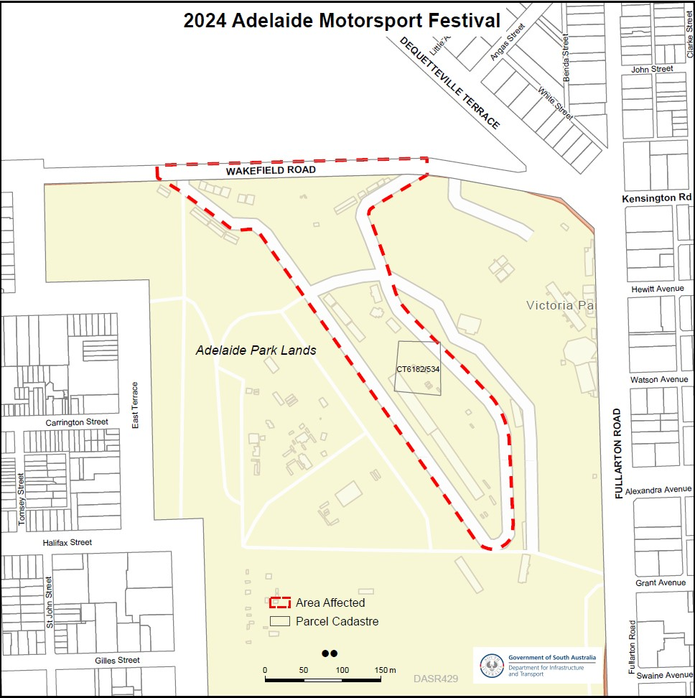

South Australian Skills Act 2008
Publication of the Standard Form Contract for Apprenticeships and Traineeships
Aligned to Higher Education Qualifications
Pursuant to the provisions of Part 4 Division 1, Section 45(2) of the South Australian Skills Act 2008, the South Australian Skills Commission (SASC) gives notice of the publication of the standard form contract for apprenticeships and traineeships aligned to higher education qualifications.
South Australia’s apprenticeship and traineeship system is underpinned by the South Australian Skills Act 2008 (the SAS Act), the South Australian Skills Regulations 2021 (the Regulations), and the South Australian Skills Standards (Standards).
With the enactment of the SAS Act on the 1 July 2021 and as defined in Section 6(3)(c) the SASC can declare a higher qualification as a trade or declared vocation.
This is the standard form contract for the purposes of Part 4 of the SAS Act for all apprenticeships and traineeships aligned to higher qualifications.
In addition to the requirements under the SAS Act, employers must comply with such other laws, professional standards or regulatory frameworks as may apply to their business and industry sector.
Dated: 7 March 2024
Commissioner Cameron Baker
Chair of the South Australian Skills Commission

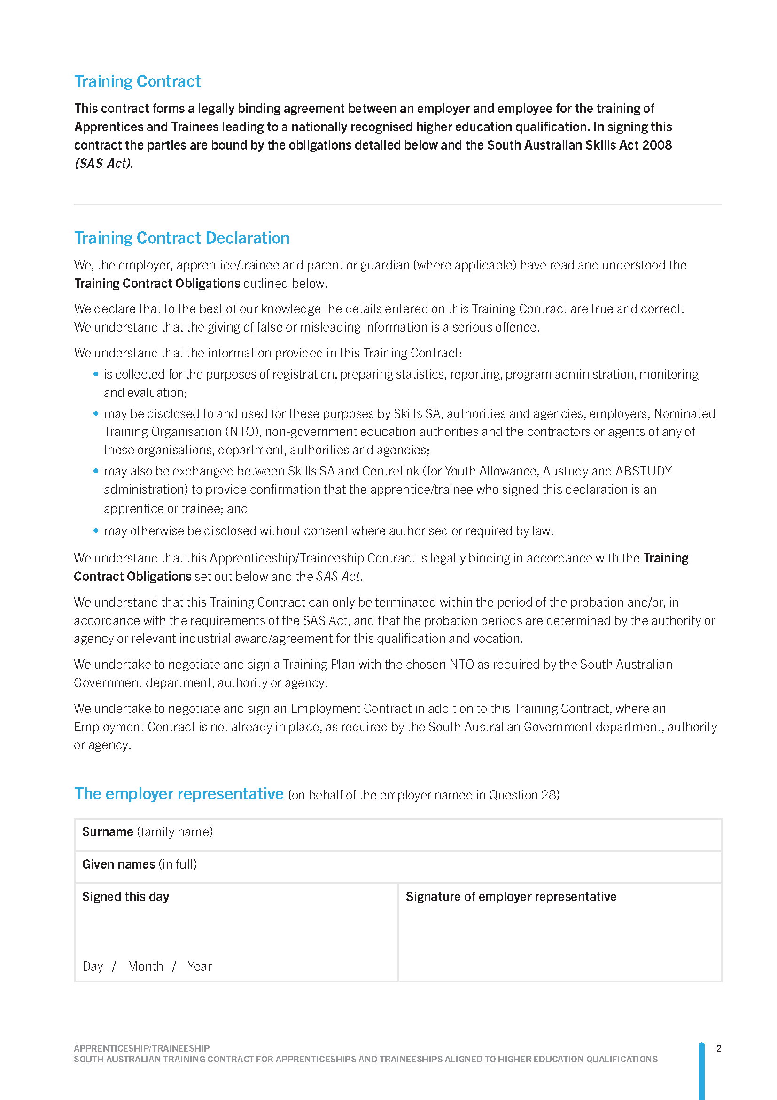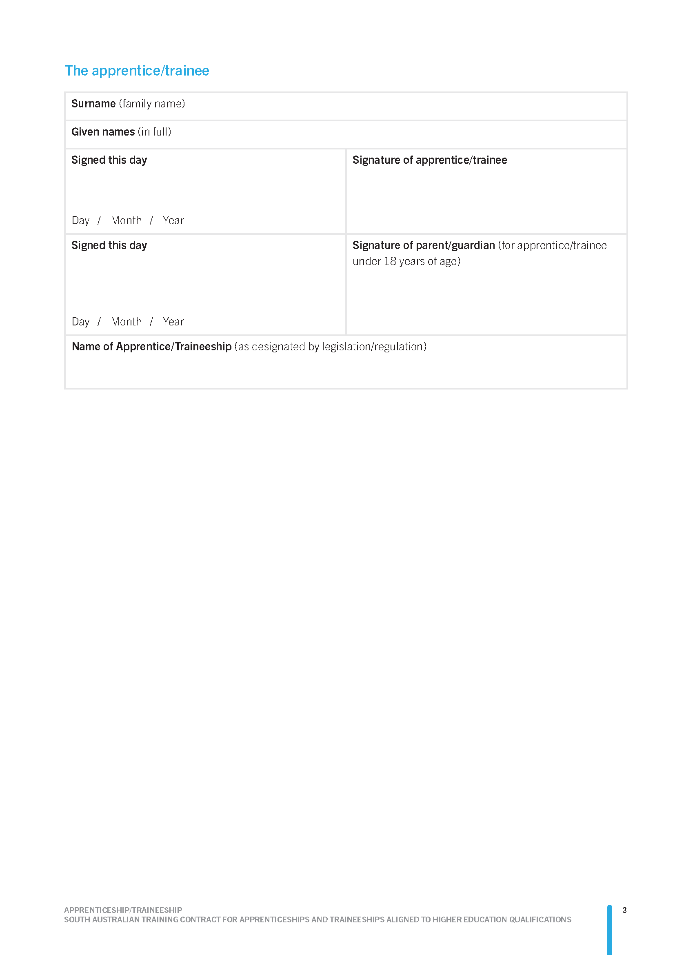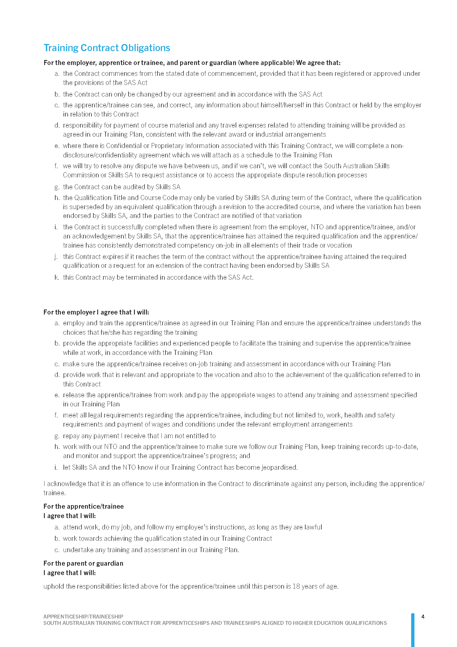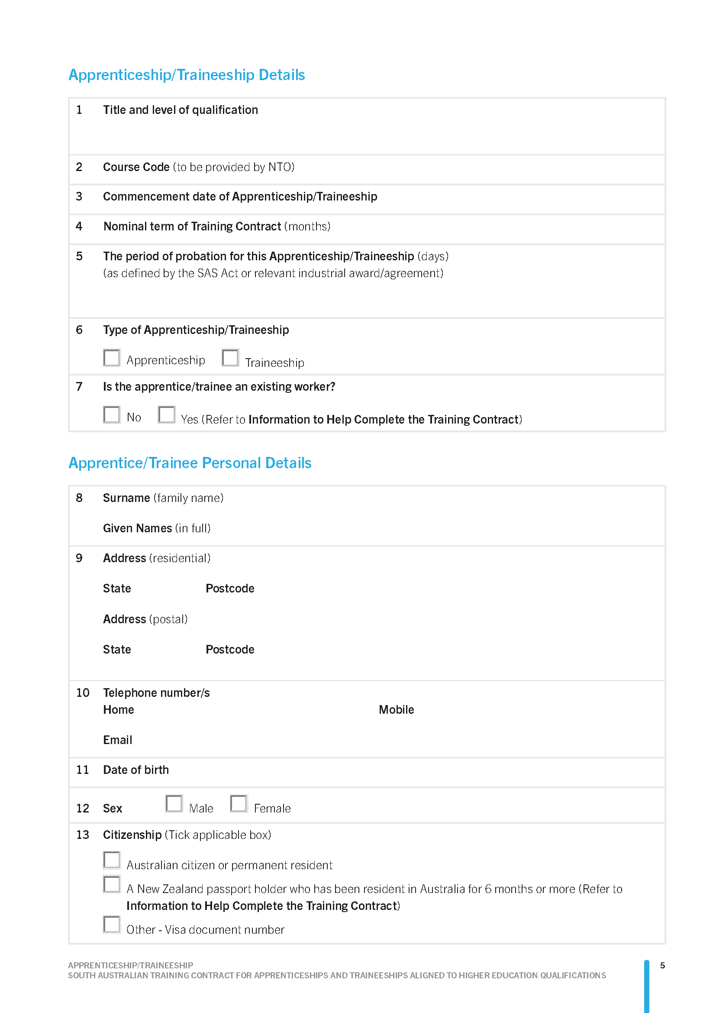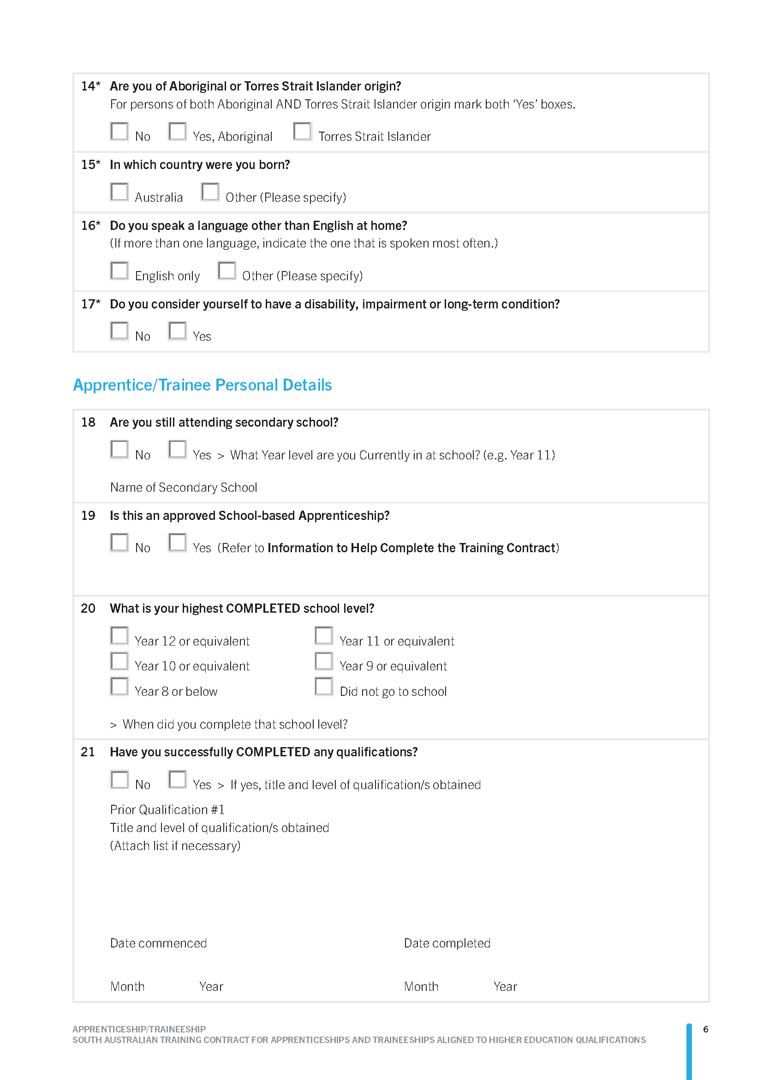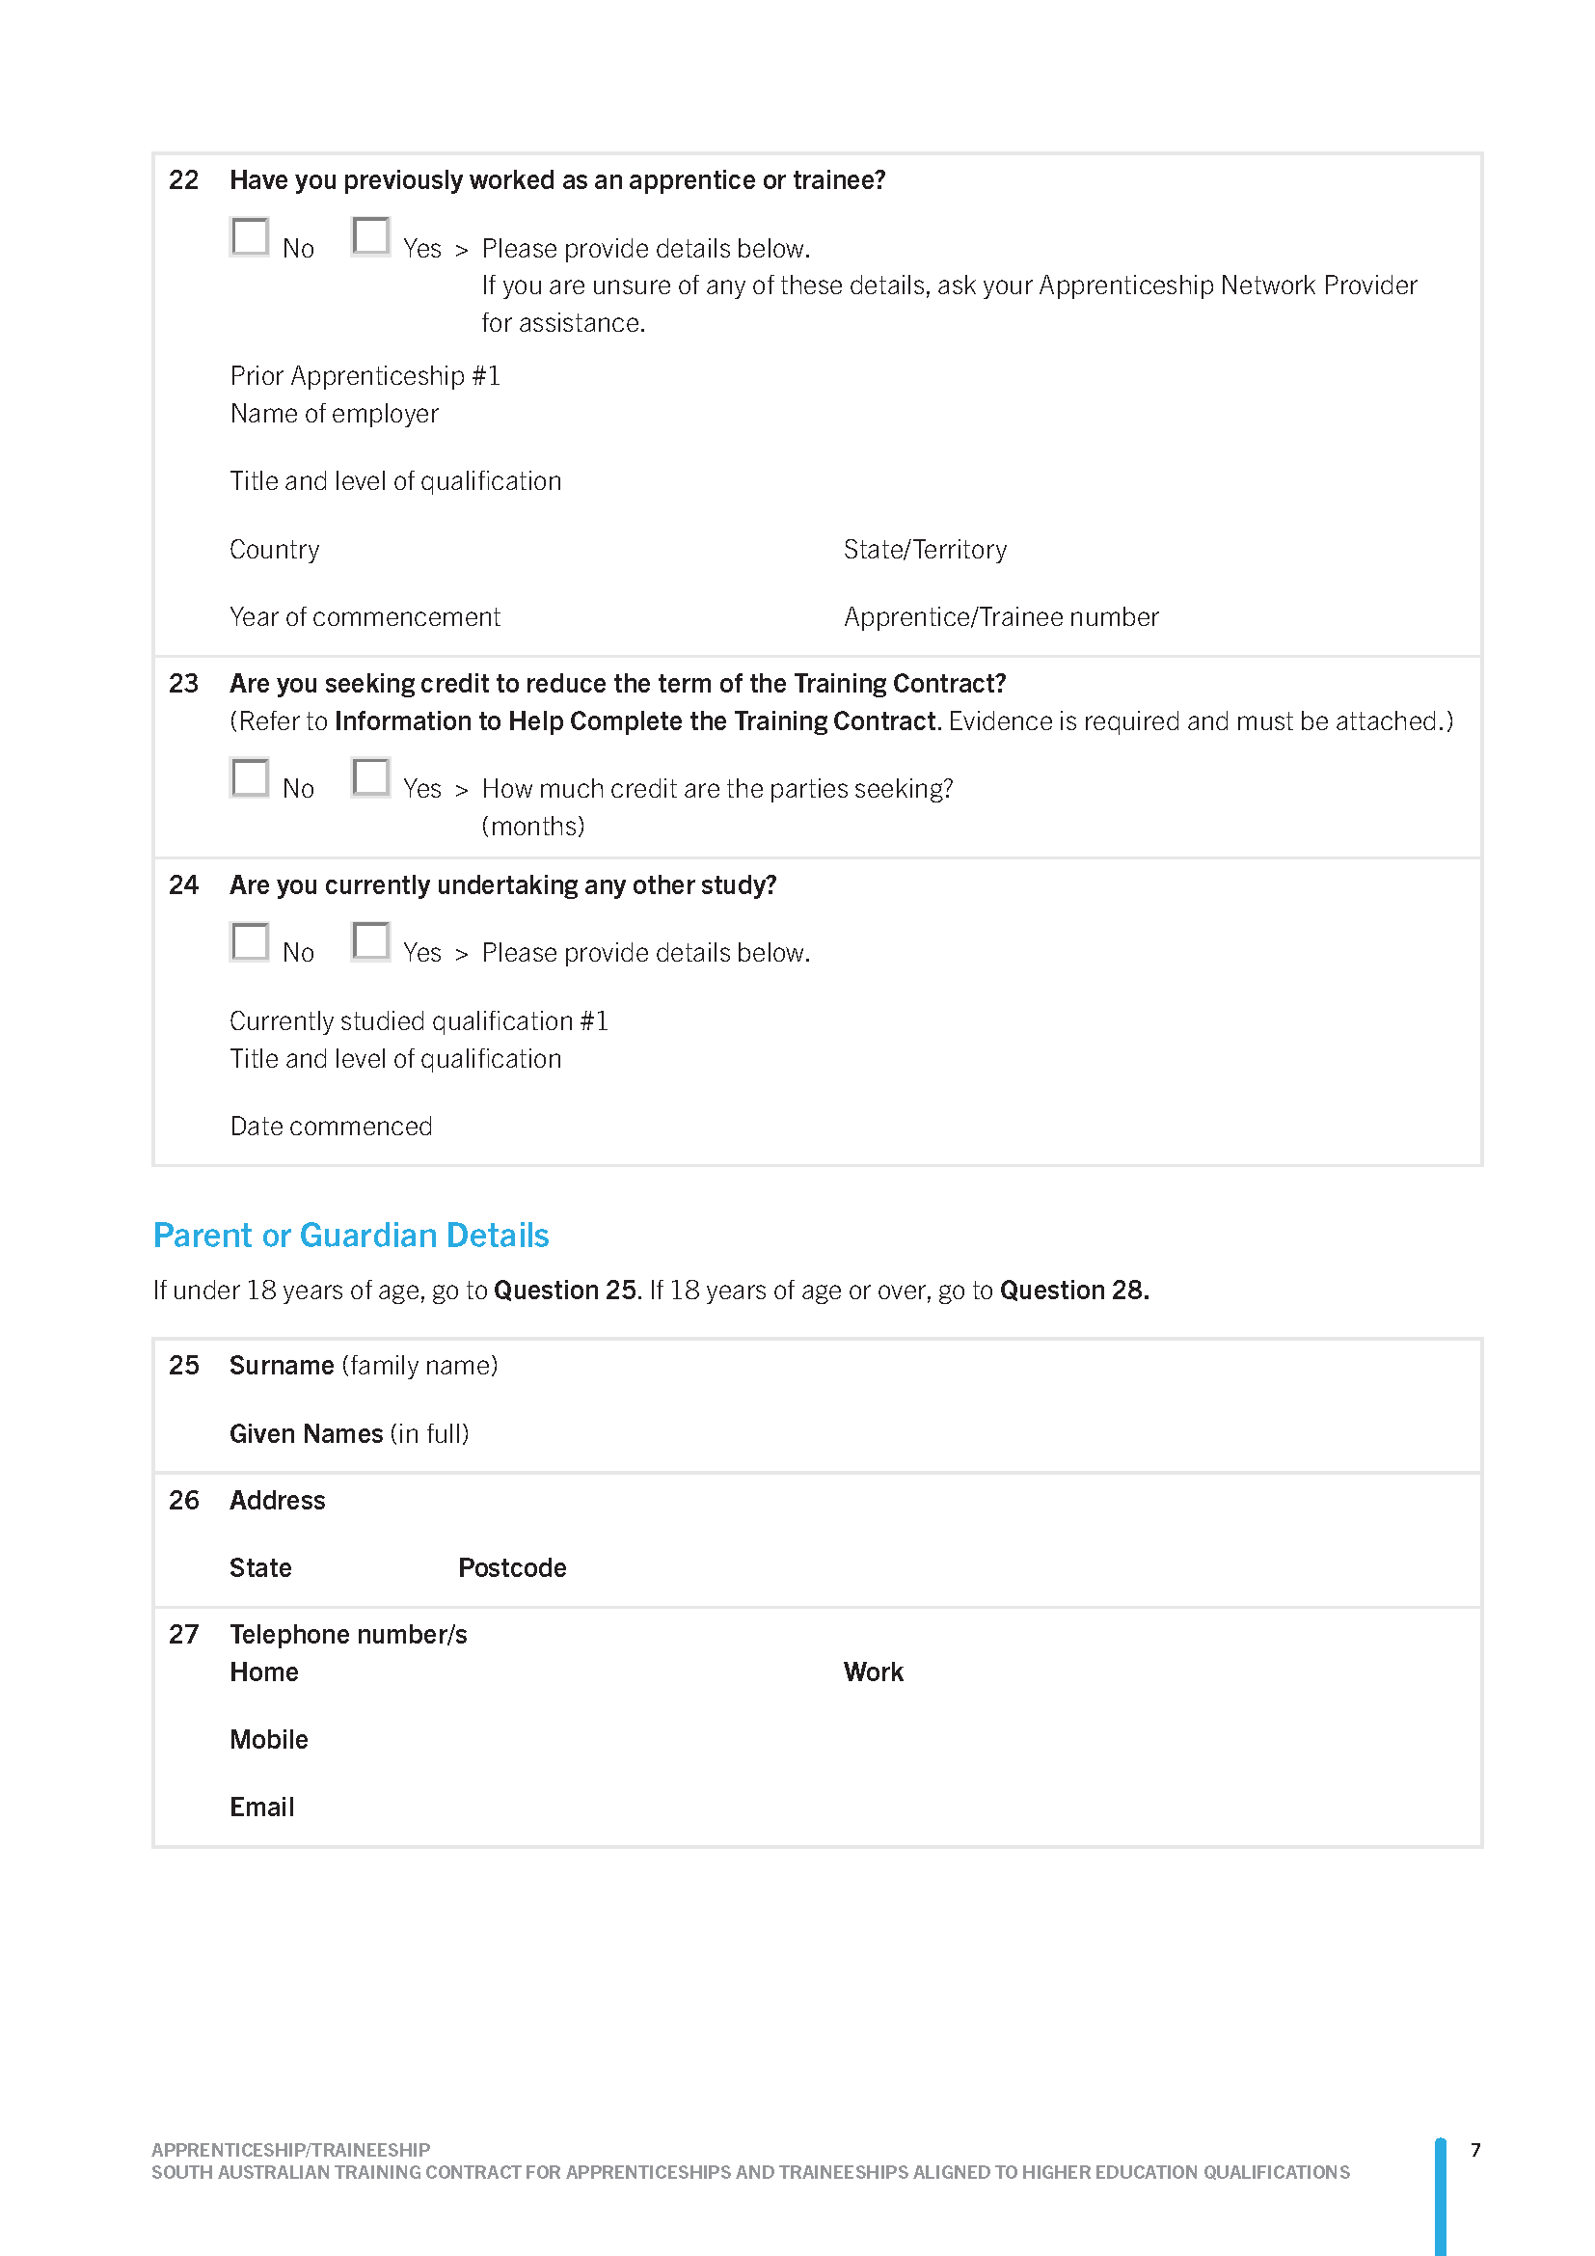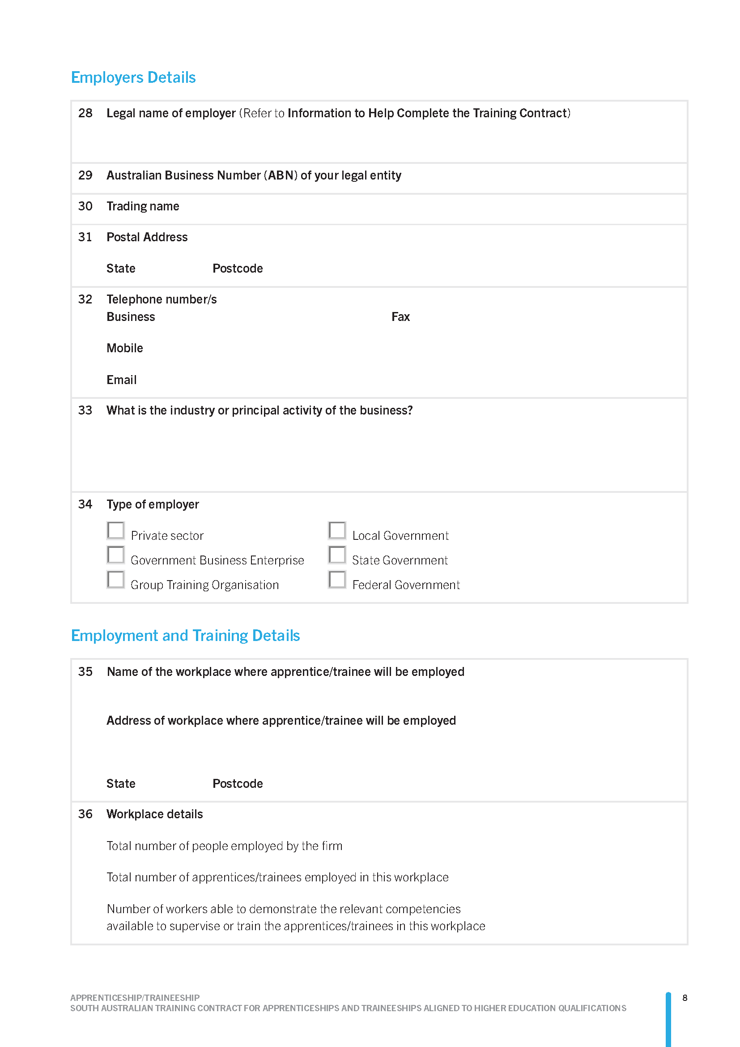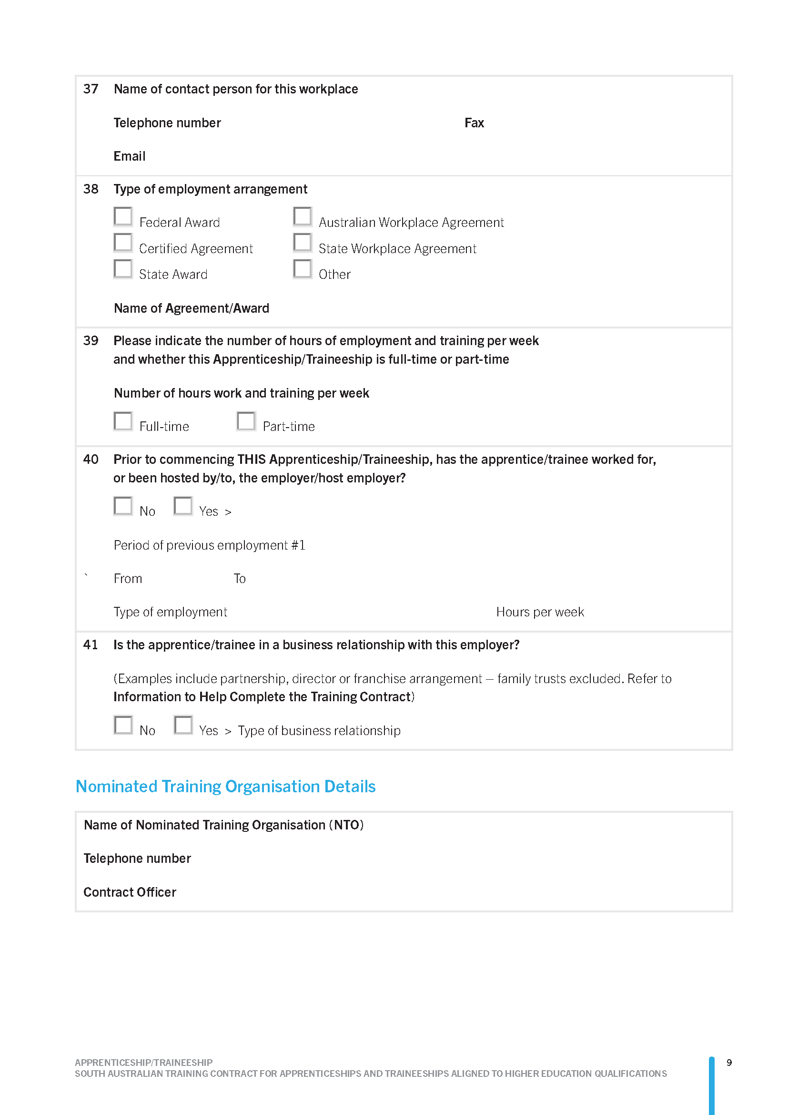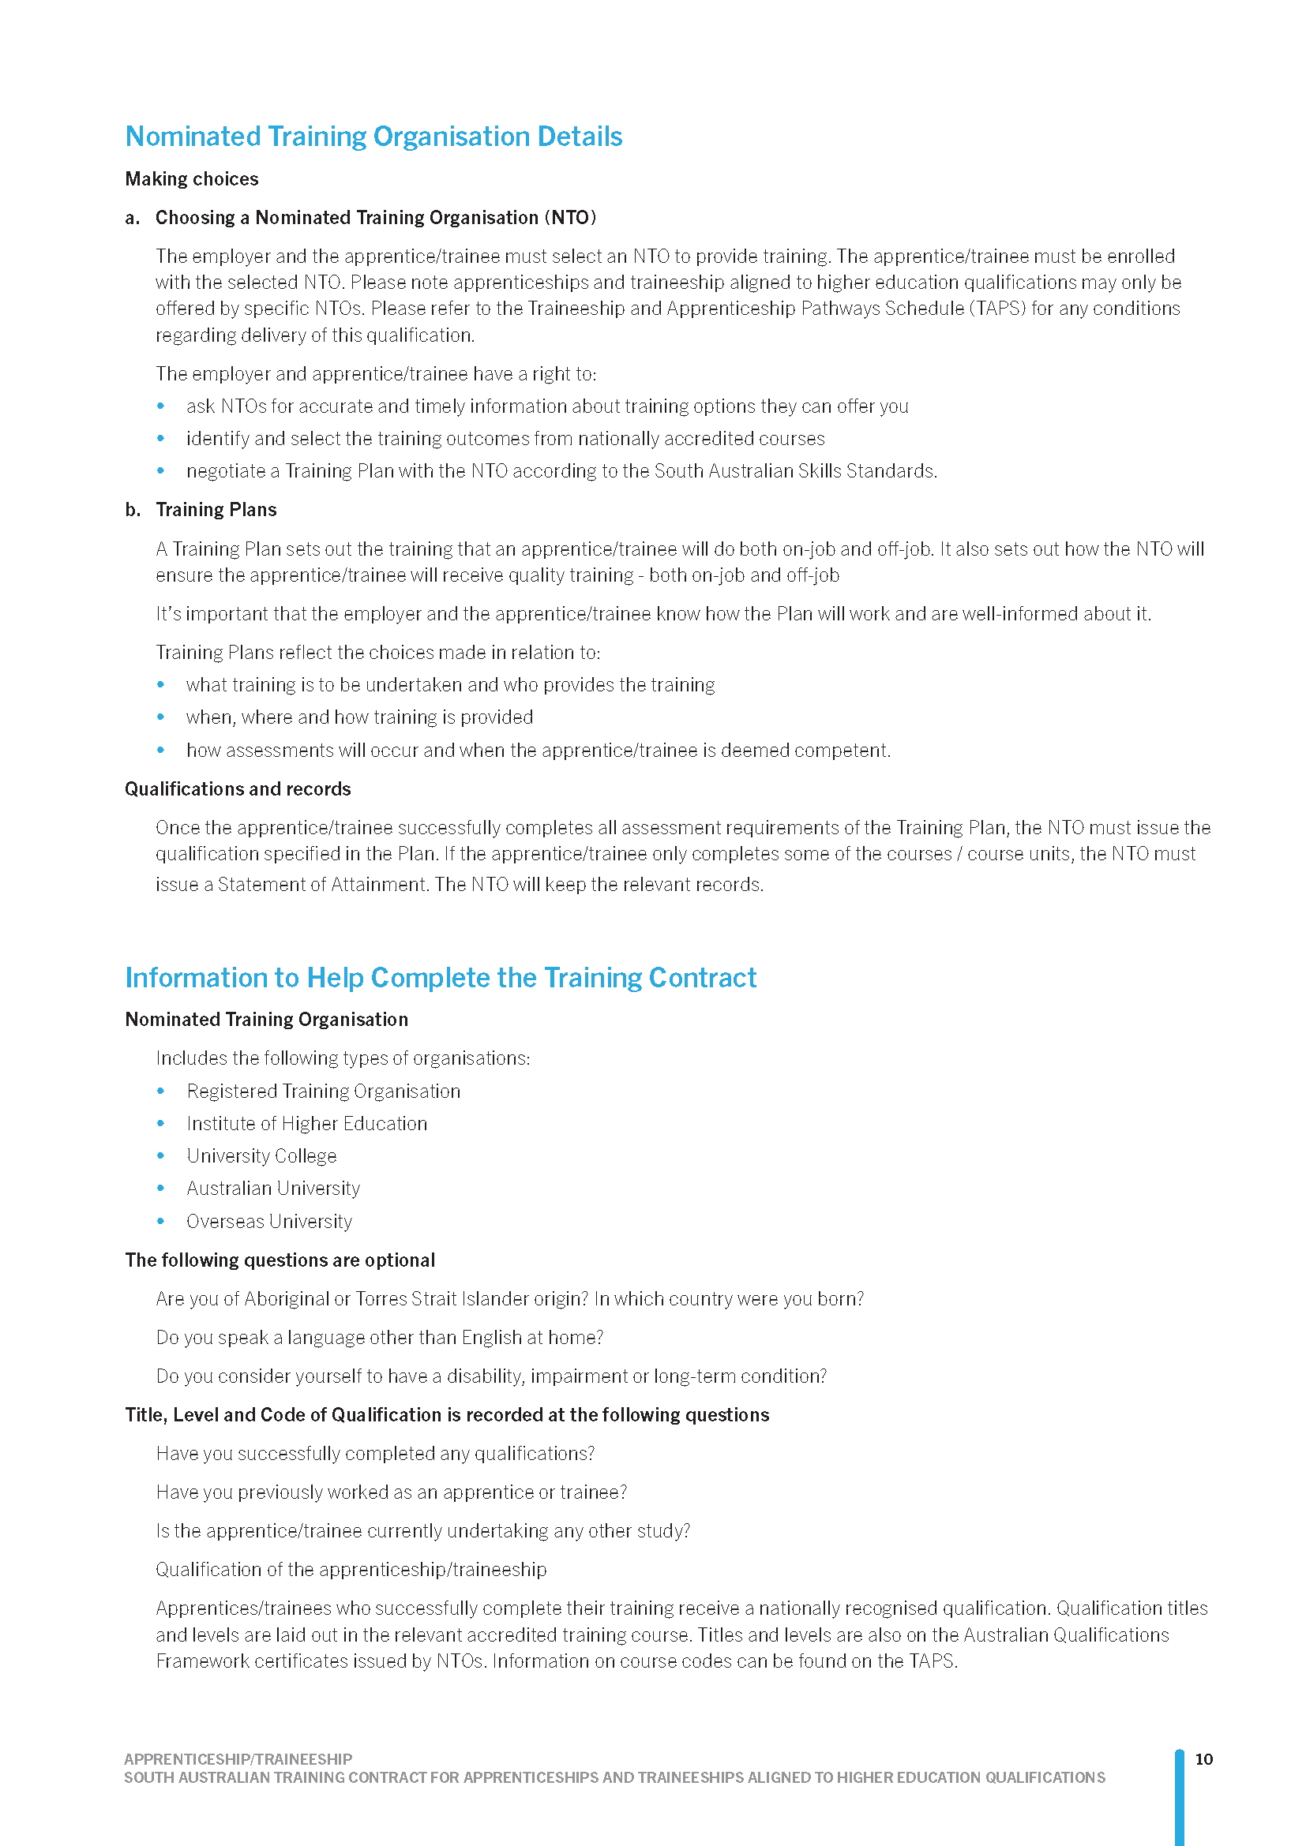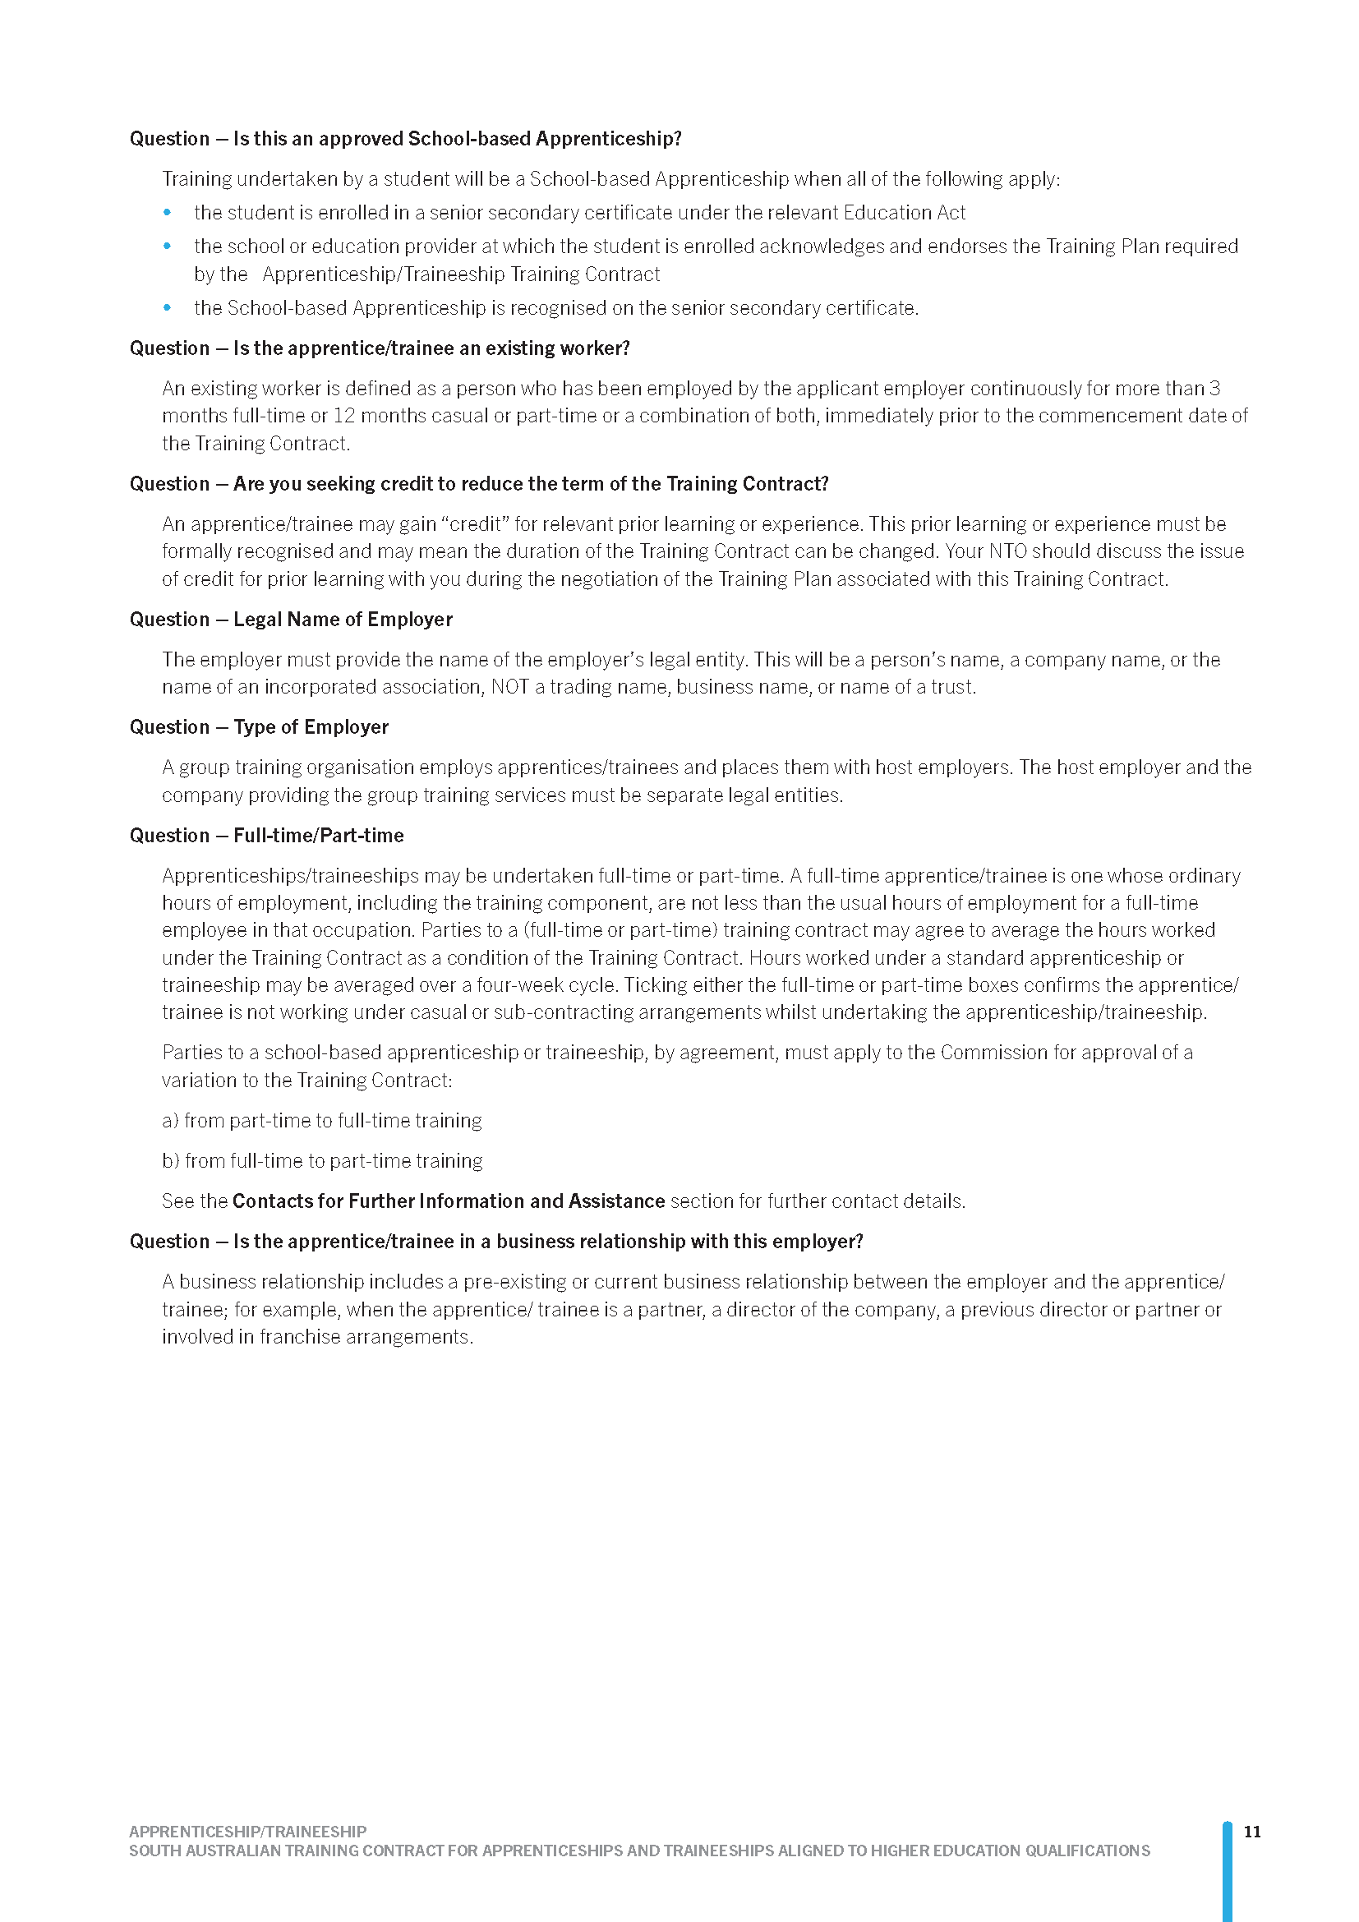

Water Industry Act 2012
Section 35
Pricing Order—For the Regulatory Period 1 July 2024 – 30 June 2028
Preamble
This pricing order has been prepared in order to provide information that would assist the Essential Services Commission of South Australia (ESCOSA) to prepare its Draft Determination for SA Water’s water and sewerage services for the regulatory period 1 July 2024 to 30 June 2028.
A further pricing order may be issued to vary this pricing order prior to ESCOSA issuing its Final Determination. These variations may be required in response to matters raised by ESCOSA in its Draft Determination.
Pursuant to section 35(4) of the Water Industry Act 2012 (the Act), the Treasurer hereby issues the following pricing order (this Order).
- INTERPRETATION
  - Where a term is used in this Order is defined in the Act, it has the meaning given in the Act.
  - In this Order, unless the contrary intention appears:
determination means a determination of the Commission under section 35 of the Act and Part 3 of the Essential Services Commission Act 2002 (the ESC Act) made in respect of retail services;
water retail service means a retail service constituted by the sale and supply of water but does not include a recycled water retail service and/or an excluded retail service;
recycled water retail service means the sale and supply of water which has been generated from sewage, greywater or stormwater and treated to a standard that is appropriate for its intended use;
sewerage retail service means the sale and supply of sewerage services for the removal of sewage but does not include an excluded retail service;
excluded retail service means:
- standard and non-standard connection services (including developer services)
- trade waste services
- non-domestic hauled waste services
- easement extinguishment and encumbrance services
- hydrant and fire plug services
- meter services
- network analysis and audit services
NWI Principles means the National Water Initiative Pricing Principles 2010 agreed by Australian governments as the basis for setting water prices / charges in their jurisdictions, as amended or replaced from time to time;
NWI Principles for Recovering the Costs of Water Planning and Management Activities means the Principles for recovering the costs of water planning and management activities which form part of the NWI Pricing Principles, as amended or replaced from time to time;
NWI Principles for the Recovery of Capital Expenditure means the Principles for the recovery of capital expenditure which form part of the NWI Pricing Principles, as amended or replaced from time to time;
NWI Principles for Urban Water Tariffs means the Principles for urban water tariffs which form part of the NWI Pricing Principles, as amended or replaced from time to time;
fourth regulatory period means the four year period commencing 1 July 2024.
- APPLICATION
  - This Order is to take effect from the date that it is signed.
  - Parts 3, 4 and 5 of this Order are to apply to a determination for the fourth regulatory period in respect of water retail services and sewerage retail services provided by SA Water.
  - For the avoidance of doubt, the Commission must ensure that any draft of a determination to which this Order will apply and which is provided to any person in accordance with section 26(1) of the ESC Act is prepared consistently with, and complies with, all applicable requirements of this Order.
- ADOPTION OF NWI PRINCIPLES
  - Subject to Parts 4 and 5 of this Order, the Commission must adopt or apply the NWI Pricing Principles (other than the Principles for Recovering the Costs of Water Planning and Management Activities) when making a determination, to the extent that those, or any of those, principles are relevant to the determination in question.
- SA WATER - WATER AND SEWERAGE RETAIL SERVICES
The Commission must adopt or apply the following parameters, principles or factors when making a determination to which this Order applies:
  - The fourth regulatory period must be adopted as part of the determination.
  - The determination must only determine the total revenue which may be derived from the provision of water retail services and sewerage retail services.
  - The determination must apply separate total revenue controls for water retail services and sewerage retail services (respectively), each expressed as a single dollar value in real terms. The determination must not provide for or permit total revenue controls to vary in real terms during the regulatory period, except as required by clauses 4.5 and 4.6, or where such variation would allow SA Water to recover during the regulatory period such costs (less any relevant contributions) as are provided for in clause 4.8.2 of the Pricing Order.
  - The determination must not establish, or require the establishment of, a revenue control for a water retail service or a sewerage retail service based on customer class or location.
  - The determination must include a mechanism which allows for the adjustment of the total revenue which may be derived where the Commission determines there to be a relevant and material variation between forecast and actual rates of water consumption or sewerage connections. The adjustment mechanism must operate on the basis of efficient costs associated with variations in demand, and so as to promote a stable price path for retail services.
  - The determination must include a mechanism which allows for the adjustment of the total revenue which may be derived where the Commission determines appropriate as a result of the occurrence of an event beyond the control of SA Water which has or will have a material impact on the cost of provision of a water retail service or a sewerage retail service during the regulatory period. The adjustment mechanism must operate on the basis of efficient costs attributable to the event, and so as to promote a stable price path for retail services.
  - The determination must adopt or apply the NWI Principles for the Recovery of Capital Expenditure, subject to the determination allowing SA Water to recover the efficient cost of assets acquired (or to be acquired), which are required to support activities that SA Water is required to provide in accordance with a direction under section 6 of the Public Corporations Act 1993.
  - The determination must adopt or apply Principle 1 of the NWI Principles for Urban Water Tariffs, subject to the following:
    - in relation to costs relating to externalities (including water planning and management), the determination must only allow SA Water to recover such costs as are attributable to and payable by SA Water in accordance with the law, including a direction under section 6 of the Public Corporations Act 1993;
    - the determination must allow SA Water to recover such costs (less any relevant contributions to such costs that it receives) that are attributable to activities that SA Water is required to provide in accordance with a direction under section 6 of the Public Corporations Act 1993 and are either:
      - specified in the relevant direction, or if not specified,
      - determined by the Commission to be efficient.
- PREPARATION AND PRESENTATION
  - The determination must be prepared and presented consistently with “the Regulated Asset Base (RAB), or building blocks approach” as described in the NWI Principles for the Recovery of Capital Expenditure (subject to clause 4.7 above).
  - In particular, the determination must identify the assumptions on which it is based, including the method of calculation of, and monetary value assigned to, each of the following parameters for the purposes of the determination:
    - the RAB is to be rolled forward consistently with Principle 5 of the NWI Principles for the Recovery of Capital Expenditure;
    - the rate of return of the RAB (which should be consistent with Principle 1 of the NWI Principles for the Recovery of Capital Expenditure);
    - any allowance for working capital (i.e. any allowance considered appropriate to adjust for the lead or lag in cash flow as a result of incurring costs in providing services and receiving payment for those services);
    - the rate of return of capital (depreciated), including its method of calculation, and any adopted classifications of, or remaining life attributable to, the regulatory assets of which it is based;
    - operating expenditure (which should include efficient operational, maintenance and administrative costs);
    - the costs of externalities, consistent with clause 4.8.1; and
    - any allowance for tax paid (which should be identified separately from the rate of return on the RAB where the weighted average cost of capital (WACC) is calculated on a post-tax basis).
  - Where the Commission anticipates a likely material variation in either the method of calculation of, or monetary value assigned to, any of the parameters identified in clause 5.2 as between any draft of the determination to which this Order will apply in accordance with clause 2.3, and the relevant final determination, then the draft of the determination must identify, in relation to any such anticipated likely material variation:
    - the relevant parameter;
    - the likely causes;
    - where the anticipated variation is to the monetary value assigned to a parameter, the likely magnitude and direction.
  - The Commission must prepare and provide to the Treasurer, on or before 30 March 2024, separate advice setting out the Commission’s calculation of the rate of return on the RAB to apply to the fourth regulatory period (which should be consistent with Principle 1 of the NWI Principles for the Recovery of Capital Expenditure).
- VARIATION
This order may be varied by a subsequent pricing order issued under section 35 of the Act.
Dated: 5 February 2024
Hon. Stephen Mullighan MP
Treasurer

Local Government Instruments

City of Adelaide
Local Government Act 1999—Sections 197 and 198
Proposed Amendment to the Community Land Management Plan—
Hilton Hotel Site and a Lease of the Land for a Term Longer than 5 Years.
The City of Adelaide gives notice of its proposal to amend the Community Land Management Plan (CLMP) and for a lease longer than 5 years for the community land parcels identified as Allotment 11 Filed Plan 112202, Allotments 1 and 2 Filed Plan 11611, Certificates of Title Volume 6135 Folio 747, Volume 6135 Folio 746 and Volume 6135 Folio 748 (the Land) at 221-237 Victoria Square, Adelaide.
Under the Local Government Act 1999 Council is required to undertake public consultation in accordance with its public consultation policy before it amends a CLMP.
Copies of the draft proposal are available for inspection at the Council’s principal office, 25 Pirie Street Adelaide SA 5000 and the following Council libraries/centres: City Library; Hutt Street Library; North Adelaide Library and Community Centre; Minor Works Building Community Centre and Box Factory Community Centre.
For further information in relation to the consultation process or to provide feedback on the proposal you can visit: yoursay.cityofadelaide.com.au anytime or the locations listed above during their hours of operation.
Consultation is open from Friday 8 March 2024. All submissions must be received by 5.00pm, on Friday 5 April 2024.
M. Sedgman
Acting Chief Executive Officer

City of Port Adelaide Enfield
Assignment of Names for Public Roads
NOTICE is hereby given that the City of Port Adelaide Enfield under Delegated Authority resolved pursuant to Section 219(1) of the Local Government Act 1999 that new roads located in the suburbs of Hillcrest and Oakden be assigned the street names as detailed below:
- New roads be assigned the names Education Way, Bromley Court, Penrith Avenue, Alliance Road, Hall Street & Compass Road, Hillcrest
- New roads be assigned the names Oakden Avenue, Bluegum Way, Sheoak Lane, Correa Walk, Melaleuca Way, Flaxlily Lane, Hakea Avenue & Sedge Walk, Oakden
- New roads be assigned the names Goodenia Walk, Hollyhock Walk, Cramond Parkway, Bottlebrush Walk, Paperbark Place, Trefoil Place, Myrtle Walk & Banksia Way, Oakden
- New roads be assigned the names Shard Lane, Edinburgh Crescent, Shea Lane, Covernton Parkway, Dibden Way, Clayer Drive, Woodley Lane, Legana Lane, Sidmouth Lane, Kayena Lane, Rowella Lane & Windermere Street, Oakden
Plans that delineate the public roads that have been assigned street names in line with Council’s Street Naming & Numbering Policy are available for inspection on Council’s website: https://www.cityofpae.sa.gov.au/connect/media-hub/public-notices
Mark Withers
Chief Executive Officer

City of Salisbury
Erratum
Declaration of Public Road
NOTICE is hereby given pursuant to section 210 of the Local Government Act 1999, that at a Council meeting held on 26 October 2020, Council resolved:
That the following roads are hereby declared to be Public Roads:
Road Name | Plan Reference
Chapel Street | GRO 515/1856
Church Street | GRO 380/1854
Gawler Street (Northern Portion) | GRO 129/1857
James Lane (Western Portion) | GRO 129/1857
James Street | GRO 380/1854,  GRO 129/1857
John Street | GRO 380/1854
Lawrie Avenue | GRO 515/1856
Mary Street | GRO 380/1854
North Lane | GRO 83/1857
Old John Street (Eastern Portion) | GRO 380/1854
Robert Street | GRO 515/1856
Union Street | GRO 515/1856
William Street | GRO 515/1856
Dated: 7 March 2024
John Harry
Chief Executive Officer

City of Victor Harbor
Local Government Act 1999
Naming of Road
The City of Victor Harbor hereby gives NOTICE pursuant to section 219(1) of the Local Government Act 1999, and in accordance with the Council’s Resolution OC532024 of 26 February 2024, that the unnamed road, as part of the Bartel Boulevard Land Division, be named Tikvah Place.
A copy of this notice and further information can be obtained from the Council’s offices at 1 Bay Road, Victor Harbor SA 5211, during ordinary business hours or on the Council’s website at www.victor.sa.gov.au
Victoria MacKirdy
Chief Executive Officer

City of Victor Harbor
Local Government Act 1999
Naming of Reserve
The City of Victor Harbor hereby gives NOTICE pursuant to section 219(1) of the Local Government Act 1999, and in accordance with the Council’s Resolution OC342024 of 26 February 2024, that the unnamed reserve, within the Greenhills Park Development, be named Bruce Henderson Reserve.
A copy of this notice and further information can be obtained from the Council’s offices at 1 Bay Road, Victor Harbor SA 5211, during ordinary business hours or on the Council’s website at www.victor.sa.gov.au
Victoria MacKirdy
Chief Executive Officer

Public Notices

National Electricity Law
Notice of Making of Draft Rule Determination and Draft Rule
Notice of Making of Final Rule Determination and Final Rule
Notice of Making of Final Rule Determination and Final Rule
The Australian Energy Market Commission (AEMC) gives notice under the National Electricity Law as follows:
Under s 99, the making of a draft determination and related draft rule on the Enhancing investment certainty in the R1 process proposal (Ref. ERC0363). Submissions must be received by 18 April 2024.
Under ss 102 and 103, the making of the National Electricity Amendment (Improving the workability of the feedback loop) Rule 2024 No. 4 (Ref. ERC0369) and related final determination. All provisions commence on 14 March 2024.
Under ss 102 and 103, the making of the National Electricity Amendment (Clarifying mandatory primary frequency response obligations for bidirectional plant) Rule 2024 No. 3 (Ref. ERC0364) and related final determination. Schedule 1 will commence on 3 June 2024 and Schedule 2 will commence on 8 June 2025.
Submissions can be made via the AEMC’s website. Before making a submission, please review the AEMC’s privacy statement on its website, and consider the AEMC’s Tips for making a submission. The AEMC publishes all submissions on its website, subject to confidentiality.
Documents referred to above are available on the AEMC’s website and are available for inspection at the AEMC’s office.
Australian Energy Market Commission
Level 15, 60 Castlereagh St
Sydney NSW 2000
Telephone: (02) 8296 7800
www.aemc.gov.au
Dated: 7 March 2024

National Gas Law
Notice of Making of Final Rule Determination and Final Rule
The Australian Energy Market Commission (AEMC) gives notice under the National Gas Law as follows:
Under ss 311 and 313, the making of the National Gas Amendment (Gas compensation and dispute resolution frameworks) Rule 2024 No. 2 (Ref. GRC0067) and related final determination. All provisions commence on 31 July 2024.
Documents referred to above are available on the AEMC’s website and are available for inspection at the AEMC’s office.
Australian Energy Market Commission
Level 15, 60 Castlereagh St
Sydney NSW 2000
Telephone: (02) 8296 7800
www.aemc.gov.au
Dated: 7 March 2024

Trustee Act 1936
Public Trustee
Estates of Deceased Persons
In the matter of the estates of the undermentioned deceased persons:
DAWSON Jeffrey Bruce late of 122 Bray Street Morphettville 5043 Retired Garbage Collector who died 15 July 2023
DUNN Glenda Joyce late of 53 Dudley Avenue Daw Park 5041 Retired Factory Worker who died 3 August 2006
KELLY Rachel Mary late of 6A Lindsay Street Sturt 5047 Retired Nurse who died 23 November 2023
KLAVINS Skaidrite Vaidelote Laima late of 470 Churchill Road Kilburn Retired Machinist who died 9 October 2023
LOCK Julie Eleanor late of 30B Maldon Avenue Mitchell Park Retired Stenographer who died 13 March 2023
MORGAN Queenie May late of 27-31 Captain Robertson Avenue Golden Grove 5124 Retired Administration Officer who died 29 June 2023
ROYALS Joan Patricia late of 1 Charles Street West Lakes Retired Supervisor who died 8 October 2023
THOMAS Dennis James late of 17 Rockville Avenue Daw Park 5041 Of no occupation who died 21 November 2022
Notice is hereby given pursuant to the Trustee Act 1936, the Inheritance (Family Provision) Act 1972 and the Family Relationships Act 1975 that all creditors, beneficiaries, and other persons having claims against the said estates are required to send, in writing, to the office of Public Trustee at GPO Box 1338, Adelaide SA 5001, full particulars and proof of such claims, on or before 5 April 2024 otherwise they will be excluded from the distribution of the said estate; and notice is also hereby given that all persons indebted to the said estates are required to pay the amount of their debts to the Public Trustee or proceedings will be taken for the recovery thereof; and all persons having any property belonging to the said estates are forthwith to deliver same to the Public Trustee.
Dated: 7 March 2024
N. S. Rantanen
Public Trustee

Notice Submission

The South Australian Government Gazette is published each Thursday afternoon.
Notices must be emailed by 4 p.m. Tuesday, the week of publication.
Submissions are formatted per the gazette style and a proof will be supplied prior to publication, along with a quote if applicable. Please allow one day for processing notices.
Alterations to the proof must be returned by 4 p.m. Wednesday.

Gazette notices must be submitted as Word files, in the following format:
• Title—the governing legislation
• Subtitle—a summary of the notice content
• Body—structured text, which can include numbered lists, tables, and images
• Date—day, month, and year of authorisation
• Signature block—name, role, and department/organisation authorising the notice

Please provide the following information in your email:
• Date of intended publication
• Contact details of the person responsible for the notice content
• Name and organisation to be charged for the publication—Local Council and Public notices only
• Purchase order, if required—Local Council and Public notices only

Email: governmentgazettesa@sa.gov.au
Phone: (08) 7133 3552
Website: www.governmentgazette.sa.gov.au

All instruments appearing in this gazette are to be considered official, and obeyed as such

Printed and published weekly by authority of T. Foresto, Government Printer, South Australia
$8.55 per issue (plus postage), $430.00 per annual subscription—GST inclusive
Online publications: www.governmentgazette.sa.gov.au

