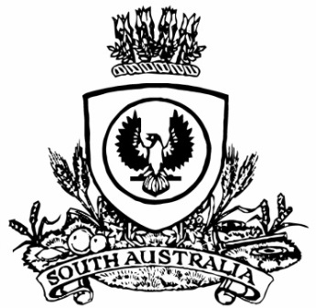
SUPPLEMENTARY GAZETTE
THE SOUTH AUSTRALIAN
GOVERNMENT GAZETTE
Published by Authority

Adelaide, Thursday, 7 March 2024

State Government Instruments
National Parks and Wildlife Act 1972
Notice by the Minister
Pursuant to Regulation 44A of the National Parks and Wildlife (Wildlife) Regulations 2019 under the National Parks and Wildlife Act 1972, I, the Hon Susan Close MP, Minister for Climate, Environment and Water, being the Minister for the Crown to whom the administration of the National Parks and Wildlife Act 1972 is for the time being committed, declare the felling of plantation Tasmanian Blue Gum (Eucalyptus globulus subsp globulus) on Kangaroo Island, South Australia) to be a controlled activity in relation to the protected animal species koala (Phascolarctos cinereus).
Dated: 7 March 2024
Hon Susan Close MP
Minister for Climate, Environment and Water

