No. 18 p. 439
THE SOUTH AUSTRALIAN
GOVERNMENT GAZETTE
Published by Authority

Adelaide, Thursday, 14 March 2024

Contents

Governor’s Instruments
Appointments, Resignations and General Matters 440
Proclamations—
Youth Court (Designation and Classification of
Cross-border Magistrate) Proclamation 2024 441
Regulations—
Planning, Development and Infrastructure (General) (Miscellaneous) Amendment Regulations 2024—
No. 13 of 2024 442
Electricity (General) (Planning and Forecasting Function) Amendment Regulations 2024—No. 14 of 2024 447
Public Sector (Data Sharing) (Relevant Entities)
Amendment Regulations 2024—No. 15 of 2024 449
State Government Instruments
Aquaculture Act 2001 450
Building Work Contractors Act 1995 450
First Nations Voice Act 2023 451
Fisheries Management (Prawn Fisheries) Regulations 2017 455
Fisheries Management Act 2007 458
Geographical Names Act 1991 460
Housing Improvement Act 2016 461
Land Acquisition Act 1969 462
Major Events Act 2013 464
Mental Health Act 2009 466
Petroleum and Geothermal Energy Act 2000 466
Planning, Development and Infrastructure Act 2016 466
Local Government Instruments
City of Port Adelaide Enfield 468
City of Victor Harbor 468
Kangaroo Island Council 468
Light Regional Council—
Corrigendum 470
Public Notices
National Electricity Law 471
National Energy Retail Law 471

Governor’s Instruments

Appointments, Resignations and General Matters
Department of the Premier and Cabinet
Adelaide, 14 March 2024
Her Excellency the Governor in Executive Council has been pleased to appoint the undermentioned to the Teachers Registration Board of South Australia, pursuant to the provisions of the Teachers Registration and Standards Act 2004:
Member: from 14 March 2024 until 13 March 2027
Susan Kate Raymond
Lynne Rutherford
By command,
Susan Elizabeth Close, MP
For Premier
ME24/012

Department of the Premier and Cabinet
Adelaide, 14 March 2024
Her Excellency the Governor in Executive Council has been pleased to appoint the undermentioned to the South Australian Local Government Grants Commission, pursuant to the provisions of the South Australian Local Government Grants Commission Act 1992:
Member: from 14 March 2024 until 13 March 2027
Erika Johanna Vickery
By command,
Susan Elizabeth Close, MP
For Premier
23MINCAB-0014

Department of the Premier and Cabinet
Adelaide, 14 March 2024
Her Excellency the Governor in Executive Council has been pleased to appoint Magistrate Paul Ian Lyons as a cross-border magistrate for a term of five years commencing on 14 March 2024 and expiring on 13 March 2029 - pursuant to section 5A(1) of the Magistrates Act 1983.
By command,
Susan Elizabeth Close, MP
For Premier
AGO0043-24CS

Department of the Premier and Cabinet
Adelaide, 14 March 2024
Her Excellency the Governor in Executive Council has been pleased to appoint the people listed as Ordinary Members of the South Australian Civil and Administrative Tribunal, on a sessional basis, commencing on 31 March 2024 and expiring on 30 March 2029 - pursuant to the provisions of the South Australian Civil and Administrative Tribunal Act 2013:
John Irving
Joanna Catherine Richardson
Alicia Mary Devitt Bills
Maria Demosthenous
Mark Ewart Fuller
Graeme Brian Kirkham
Anne Veronica Moroney
Matt Murphy
Kylie-Ann Pligl
Kelly Anne Ryan
Joseph Hugh Ramsay Sanders
Margaret Terese Lovell
By command,
Susan Elizabeth Close, MP
For Premier
AGO0028-24CS

Department of the Premier and Cabinet
Adelaide, 14 March 2024
Her Excellency the Governor in Executive Council has approved the arrangements for the appointment by the Attorney-General of the Commonwealth of Her Honour Judge Liesl Kudelka, a Judge of the District Court of South Australia, as a part-time Commissioner of the Australian Law Reform Commission - pursuant to section 11 of the Australian Law Reform Commission Act 1996.
By command,
Susan Elizabeth Close, MP
For Premier
AGO0041-24CS

Proclamations
South Australia

Youth Court (Designation and Classification of Cross-border Magistrate) Proclamation 2024
under section 9 of the Youth Court Act 1993
1—Short title
This proclamation may be cited as the Youth Court (Designation and Classification of Cross-border Magistrate) Proclamation 2024.
2—Commencement
This proclamation comes into operation on the day on which it is made.
3—Designation and classification of Magistrate
The magistrate named in Schedule 1 (being a cross-border magistrate within the meaning of section 5A of the Magistrates Act 1983 as inserted by the Cross-border Justice Regulations 2009) is—
(a) designated as a magistrate of the Youth Court of South Australia; and
(b) classified as a member of the Court's ancillary judiciary.
Schedule 1—Magistrate of the Court
Paul Ian Lyons
Made by the Governor
with the advice and consent of the Executive Council
on 14 March 2024

Regulations
South Australia

Planning, Development and Infrastructure (General) (Miscellaneous) Amendment Regulations 2024
under the Planning, Development and Infrastructure Act 2016

Contents
Part 1—Preliminary
1 Short title
2 Commencement
Part 2—Amendment of Planning, Development and Infrastructure (General) Regulations 2017
3 Amendment of regulation 19A—Building envelope plans
4 Amendment of regulation 21—Minor or operational amendments (section 76)
5 Amendment of regulation 53—Time within which decision must be made (section 125(1))
6 Amendment of regulation 67—Lapse of consents or approvals (section 126(2))
7 Amendment of regulation 93—Notifications during building work
8 Amendment of regulation 104—Statement of Compliance
9 Amendment of regulation 112—Authorised officers and inspections
10 Amendment of regulation 113—Fire safety
11 Insertion of regulation 113A
113A Designated authority—accreditation authority
12 Amendment of Schedule 3—Additions to definition of development
11 Transshipment points
13 Amendment of Schedule 6—Relevant authority—Commission
14 Amendment of Schedule 6A—Accepted development
15 Amendment of Schedule 13—State agency development exempt from approval
Schedule 1—Transitional provisions
1 Transitional provisions

Part 1—Preliminary
1—Short title
These regulations may be cited as the Planning, Development and Infrastructure (General) (Miscellaneous) Amendment Regulations 2024.
2—Commencement
These regulations come into operation on the day on which they are made.
Part 2—Amendment of Planning, Development and Infrastructure (General) Regulations 2017
3—Amendment of regulation 19A—Building envelope plans
(1) Regulation 19A(5), definition of designated authority, (a)—delete paragraph (a)
(2) Regulation 19A(5), definition of designated authority, (b)—delete "division of land authority" and substitute:
relevant authority for the application for development authorisation for the division of land under section 102(1)(c) or (d) of the Act (the division of land authority)
4—Amendment of regulation 21—Minor or operational amendments (section 76)
Regulation 21—after paragraph (h) insert:
(i) the Adelaide Dolphin Sanctuary Management Plan (or part of that plan) adopted under the Adelaide Dolphin Sanctuary Act 2005;
(j) the Register of Historic Shipwrecks kept under the Historic Shipwrecks Act 1981.
5—Amendment of regulation 53—Time within which decision must be made (section 125(1))
(1) Regulation 53(1)(ja)—before "if a" insert:
subject to subregulation (10),
(2) Regulation 53(8)—after "portal" insert:
, or part of the portal,
(3) Regulation 53(9)—after paragraph (b) insert:
and
(c) if the prescribed outage is in relation to part of the SA planning portal and a particular class of applications is affected by the outage—the class of applications affected.
(4) Regulation 53—after subregulation (9) insert:
(10) If a prescribed outage is in relation to part of the SA planning portal and a particular class of applications is specified to be affected by the outage in a notice under subregulation (9), subregulation (1)(ja) only applies in respect of applications of that class.
6—Amendment of regulation 67—Lapse of consents or approvals (section 126(2))
(1) Regulation 67(1)(a)—delete "—2 years from the operative date of the consent or approval;" and substitute:
—
(i) subject to subparagraph (ii), if development approval for the development to which the consent or approval relates is subsequently granted—2 years from the operative date of the development approval; or
(ii) if development approval for the development to which the consent or approval relates is subsequently granted and an extension is granted under section 126(3) of the Act in respect of the development approval—the extended period in respect of that approval; or
(iii) in any other case—2 years from the operative date of the consent or approval;
(2) Regulation 67(1)(b)(i)—after "operative date of the" wherever occurring insert:
development
(3) Regulation 67(1)(b)(ii)—delete "relevant consent" and substitute:
development approval
(4) Regulation 67(1)(b)(ii)—delete "the consent" and substitute:
the development approval
(5) Regulation 67(2)—delete subregulation (2)
(6) Regulation 67(3), definition of operative consent—after "of a consent or approval" insert:
(including a development approval)
7—Amendment of regulation 93—Notifications during building work
Regulation 93(1)(c)—delete paragraph (c) and substitute:
(c) in relation to the intended completion of any stage of the building work specified by the council by notice in writing to the building owner on the granting of development approval in respect of the work—
(i) in the case of development being undertaken in an area that is not within the area of a council—5 business day's notice; and
(ii) in any other case—1 business day's notice;
8—Amendment of regulation 104—Statement of Compliance
Regulation 104(8)(d)—delete paragraph (d) and substitute:
(d) a communications facility required under the Telecommunications Act 1997 of the Commonwealth;
9—Amendment of regulation 112—Authorised officers and inspections
Regulation 112(3)—delete subregulation (3) and substitute:
(3) For the purposes of section 155(2) of the Act, the prescribed qualifications are accreditation as an Accredited professional—building level 1 or an Accredited professional—building level 2.
10—Amendment of regulation 113—Fire safety
Regulation 113(a)—delete paragraph (a) and substitute:
(a) accreditation as an Accredited professional—building level 1 or an Accredited professional—building level 2; or
11—Insertion of regulation 113A
Before regulation 114 insert:
113A—Designated authority—accreditation authority
The accreditation authority under the Planning, Development and Infrastructure (Accredited Professionals) Regulations 2019 is brought within the definition of designated authority under section 212(1) of the Act.
12—Amendment of Schedule 3—Additions to definition of development
Schedule 3—after clause 10 insert:
11—Transshipment points
The establishment of a transshipment point associated with a proposed or existing port facility for the transfer of bulk commodities within coastal waters.
13—Amendment of Schedule 6—Relevant authority—Commission
(1) Schedule 6, clause 4, heading—delete "Inner"
(2) Schedule 6, clause 8(2)(a)—delete "by the Commission" and substitute:
and the Commission is the relevant authority in respect of the authorisation
(3) Schedule 6, clause 8(2)(b)—delete "by the Commission" and substitute:
if the Commission is the relevant authority in respect of the authorisation
(4) Schedule 6, clause 17, heading—after "authorisations" insert:
and ancillary or associated development
(5) Schedule 6, clause 17(a) and (b)—delete "given by the Commission under this Schedule" wherever occurring and substitute in each case:
in respect of which the Commission is the relevant authority
14—Amendment of Schedule 6A—Accepted development
Schedule 6A, clause 3(3)—after paragraph (a) insert:
(ab) where paragraph (a) does not apply and the allotment is in the Master Planned Neighbourhood Zone under the Planning and Design Code—3 m; or
15—Amendment of Schedule 13—State agency development exempt from approval
(1) Schedule 13, clause 2(1)(b)(ii)—delete subparagraph (ii) and substitute:
(ii) the construction, reconstruction or alteration of a building or equipment, if only of a local nature, used for or associated with the supply, disposal or treatment of water or waste water (other than a desalination plant, wastewater treatment plant or wastewater lagoon); or
(2) Schedule 13, clause 2(1)—after paragraph (s) insert:
(sa) the construction, reconstruction or alteration of, or addition to, an amenities facility with a floor area of 50 m² or less associated with the construction of a road on land which is—
(i) adjacent to the road; and
(ii) associated with the construction of the road;
(3) Schedule 13, clause 2(1)(u)—after "Electricity Act 1996" insert:
, or of existing water/sewerage infrastructure within the meaning of the Water Industry Act 2012,
(4) Schedule 13, clause 2(1)—after paragraph (x) insert:
(y) the installation of flood hazard or water monitoring equipment alongside a prescribed watercourse, lake or well under section 101 of the Landscape South Australia Act 2019;
(z) the construction, reconstruction or alteration of, or addition to, an air quality monitoring station, provided that—
(i) any building or structure associated with the station (other than a mast) does not exceed 1 storey in height; and
(ii) the relevant work will not result in a mast associated with the station exceeding 11 m in height, measured at natural ground level; and
(iii) no part of any building or structure being constructed, added to or altered in connection with the station is situated within the setback distance of the allotment prescribed under the Planning and Design Code (or, if no setback distance is so prescribed, within 900 mm of a boundary of the allotment); and
(iv) the relevant work will not affect a local heritage place; and
(v) the building work will not result in the total floor area of a building or structure associated with the station exceeding 50 m².
Schedule 1—Transitional provisions
1—Transitional provisions
(1) The amendments to regulation 19A of the principal regulations effected by regulation 3 do not apply to or in relation to an application for approval of a building envelope plan made before the commencement of regulation 3.
(2) The amendments to regulation 67 of the principal regulations effected by regulation 6 apply to or in relation to a consent or approval under Part 7 of the Act granted or approved, but not yet lapsed, before the commencement of regulation 6.
(3) In this clause—
principal regulations means the Planning, Development and Infrastructure (General) Regulations 2017.
Editorial note—
As required by section 10AA(2) of the Legislative Instruments Act 1978, the Minister has certified that, in the Minister's opinion, it is necessary or appropriate that these regulations come into operation as set out in these regulations.
Made by the Governor
with the advice and consent of the Executive Council
on 14 March 2024
No 13 of 2024

South Australia

Electricity (General) (Planning and Forecasting Function) Amendment Regulations 2024
under the Electricity Act 1996

Contents
Part 1—Preliminary
1 Short title
2 Commencement
Part 2—Amendment of Electricity (General) Regulations 2012
3 Insertion of regulation 13B
13B Functions of Technical Regulator—planning and forecasting

Part 1—Preliminary
1—Short title
These regulations may be cited as the Electricity (General) (Planning and Forecasting Function) Amendment Regulations 2024.
2—Commencement
These regulations come into operation on the day on which they are made.
Part 2—Amendment of Electricity (General) Regulations 2012
3—Insertion of regulation 13B
After regulation 13A insert:
13B—Functions of Technical Regulator—planning and forecasting
(1) For the purposes of section 8(d) of the Act, the Technical Regulator has (in addition to the Technical Regulator's functions under the Act) the following functions:
(a) undertaking planning and forecasting activities to assess the least cost pathway for the development of the South Australian power system;
(b) providing a report to the Minister on the least cost pathway for the development of the South Australian power system—
(i) at the frequency directed by the Minister under subregulation (2)(a); or
(ii) if no direction under subregulation (2)(a) is in effect—at least twice in each year;
(c) advising the Minister (on the Technical Regulator's own initiative or at the request of the Minister) on the development of the South Australian power system.
(2) The Minister may, in relation to the performance of the Technical Regulator's reporting function under subregulation (1)(b), by written notice, direct the Technical Regulator about—
(a) how frequently the Technical Regulator must provide a report to the Minister; and
(b) any objectives, principles, standards or targets which the Technical Regulator must take into account when preparing a report; and
(c) the period into the future that the Technical Regulator must consider in a report; and
(d) any constraints which the Technical Regulator must consider when preparing a report.
(3) In addition, the Technical Regulator must, on an annual basis, prepare and publish on a website maintained by the Technical Regulator a report on the least cost pathway for the development of the South Australian power system.
(4) The Minister may, by written notice, specify—
(a) the manner and form in which a report under subregulation (3) is to be prepared; and
(b) information which must be included in a report under subregulation (3); and
(c) the period within which a report under subregulation (3) is to be prepared and published.
Editorial note—
As required by section 10AA(2) of the Legislative Instruments Act 1978, the Minister has certified that, in the Minister's opinion, it is necessary or appropriate that these regulations come into operation as set out in these regulations.
Made by the Governor
with the advice and consent of the Executive Council
on 14 March 2024
No 14 of 2024

South Australia

Public Sector (Data Sharing) (Relevant Entities) Amendment Regulations 2024
under the Public Sector (Data Sharing) Act 2016

Contents
Part 1—Preliminary
1 Short title
2 Commencement
Part 2—Amendment of Public Sector (Data Sharing) Regulations 2017
3 Amendment of regulation 8A—Relevant entities (section 13)

Part 1—Preliminary
1—Short title
These regulations may be cited as the Public Sector (Data Sharing) (Relevant Entities) Amendment Regulations 2024.
2—Commencement
These regulations come into operation 4 months after the day on which they are made (see Legislative Instruments Act 1978 section 10AA).
Part 2—Amendment of Public Sector (Data Sharing) Regulations 2017
3—Amendment of regulation 8A—Relevant entities (section 13)
Regulation 8A(1)—after paragraph (f) insert:
(g) a registered higher education provider (within the meaning of the Tertiary Education Quality and Standards Agency Act 2011 of the Commonwealth).
Made by the Governor
with the advice and consent of the Executive Council
on 14 March 2024
No 15 of 2024

State Government Instruments

Aquaculture Act 2001
Section 14(1)(c)
Aquaculture (Standard Lease and Licence Conditions) Policy 2022
Amendment to clause 42-Maximum biomass-oyster
Pursuant to section 14(1)(c) of the Aquaculture Act 2001 and clause 5(1)(g)(iii) of the Aquaculture (Standard Lease and Licence Conditions) Policy 2022 I make the following change to subclause 42(5) in relation to the maximum permitted length of parallel longline between which culture units are hung perpendicular per hectare by removing subclause 42(5) and replacing it with the following:
- ‘The licensee, if farming oyster species using parallel longline between which culture units are hung perpendicular as authorised under the licence (see clause 41(3)(c)), must ensure that:
    - in the case of farming oyster species in an area within an aquaculture zone identified in the Aquaculture (Zones-Coffin Bay) Policy 2008-the length of parallel longline between which culture units are hung perpendicular does not exceed-
- 2 km per hectare where the minimum distance at the closest point between all culture units which are hung perpendicular is 15 cm or more; or
- 1.333 km per hectare in any other case; and
    - in the case of farming oyster species in any other area-the length of parallel longline between which culture units are hung perpendicular does not exceed-
- 1.5 km per hectare where the minimum distance at the closest point between all culture units which are hung perpendicular is 15 cm or more; or
- 1 km per hectare in any other case.
This amendment comes into operation on the day this notice is published in the Government Gazette.
Dated: 12 March 2024
Prof Gavin Begg
Executive Director
Fisheries and Aquaculture
Delegate of the Minister for Primary Industries and Regional Development

Building Work Contractors Act 1995
Exemption
TAKE notice that, pursuant to section 45 of the Building Work Contractors Act 1995, I, Rita McPhail as a delegate for the Minister for Consumer and Business Affairs, do hereby exempt the licensee named in Schedule 1 from the application of Division 3 of Part 5 of the above Act in relation to domestic building work described in Schedule 2 and subject to the conditions specified in Schedule 3.
Schedule 1
MICHAEL ALBAN CREAN (BLD 281132)
Schedule 2
Construction of a single storey detached residential dwelling at Allotment 200 Deposited Plan 128277 being a portion of the land described in Certificate of Title Volume 6271 Folio 512, more commonly known as Lot 200, 9 Abbotts Lane, Strathalbyn, SA 5255.
Schedule 3
1. This exemption is limited to domestic building work personally performed by the licensee in relation to the building work described in Schedule 2.
2. This exemption does not apply to any domestic building work the licensee contracts to another building work contractor, for which that contractor is required by law to hold building indemnity insurance.
3. That the licensee does not transfer his interest in the land prior to five years from the date of completion of the building work the subject of this exemption, without the prior authorisation of Consumer and Business Services (CBS). Before giving such authorisation, CBS may require the licensee to take any reasonable steps to protect the future purchaser(s) of the property, including but not limited to:
- Providing evidence that an adequate policy of building indemnity insurance is in force to cover the balance of the five-year period from the date of completion of the building work the subject of this exemption;
- Providing evidence of an independent expert inspection of the building work the subject of this exemption;
- Making an independent expert report available to prospective purchasers of the property;
- Giving prospective purchasers of the property notice of the absence of a policy of building indemnity insurance.
Dated: 8 March 2024
Rita McPhail
Director Customer Service and Transformation
Delegate for the Minister for Consumer and Business Affairs

Building Work Contractors Act 1995
Exemption
TAKE notice that, pursuant to section 45 of the Building Work Contractors Act 1995, I, Rita McPhail as a delegate for the Minister for Consumer and Business Affairs, do hereby exempt the licensee named in Schedule 1 from the application of Division 3 of Part 5 of the above Act in relation to domestic building work described in Schedule 2 and subject to the conditions specified in Schedule 3.
Schedule 1
ROGER JOHN BEAZLEY (BLD 216349)
Schedule 2
Construction of bathroom and rumpus room within an existing residential dwelling at Allotment 31 Deposited Plan 128404 being a portion of the land described in Certificate of Title Volume 6261 Folio 857, more commonly known as 61 Woodend Road, Sheidow Park SA 5158.
Schedule 3
1. This exemption is limited to domestic building work personally performed by the licensee in relation to the building work described in Schedule 2.
2. This exemption does not apply to any domestic building work the licensee contracts to another building work contractor, for which that contractor is required by law to hold building indemnity insurance.
3. That the licensee does not transfer his interest in the land prior to five years from the date of completion of the building work the subject of this exemption, without the prior authorisation of Consumer and Business Services (CBS). Before giving such authorisation, CBS may require the licensee to take any reasonable steps to protect the future purchaser(s) of the property, including but not limited to:
- Providing evidence that an adequate policy of building indemnity insurance is in force to cover the balance of the five-year period from the date of completion of the building work the subject of this exemption;
- Providing evidence of an independent expert inspection of the building work the subject of this exemption;
- Making an independent expert report available to prospective purchasers of the property;
- Giving prospective purchasers of the property notice of the absence of a policy of building indemnity insurance.
Dated: 8 March 2024
Rita McPhail
Director Customer Service and Transformation
Delegate for the Minister for Consumer and Business Affairs

First Nations Voice Act 2023
Sections 20 and 37
First Nations Voice Code of Conduct
Purpose
The First Nations Voice Act 2023 (the Act) provides for a Code of Conduct (the Code) for the Local First Nations Voices and for the State First Nations Voice.
This Code establishes standards for First Nations Voice members' behaviour and conduct, to ensure trust and confidence in the operation of the First Nations Voice from the Aboriginal and Torres Strait Islander people and communities they are elected to represent as well as other members of the public. The Code is also to ensure the safety and wellbeing of First Nations Voice members.
Legislative Basis
This Code, for members of the Voices, is published by the Minister under sections 20(1) and 37(1) of the Act.
Sections 20(2) and 37(2) of the Act states that members of the Local First Nations Voice (Local Voice) and State First Nations Voice (State Voice) must comply with the Code.
A reference in the Code to the "Voices" is a reference to both the State Voice and the Local Voices.
It is the personal responsibility of each member of the Voice to ensure that they are familiar with, and comply with, the standards in the Code at all times.
References
First Nations Voice Act 2023
Public Sector Act 2009
Work Health and Safety Act 2012

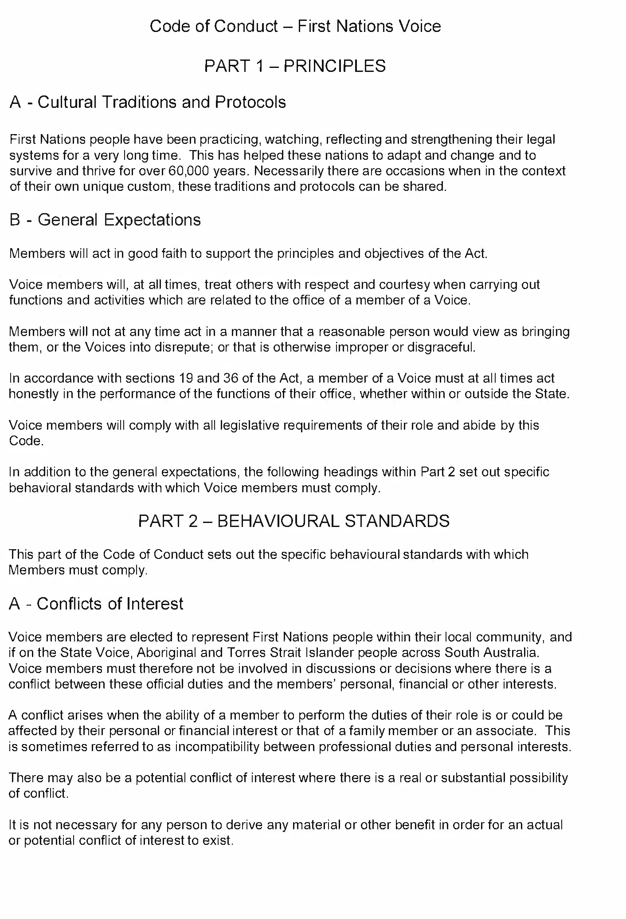
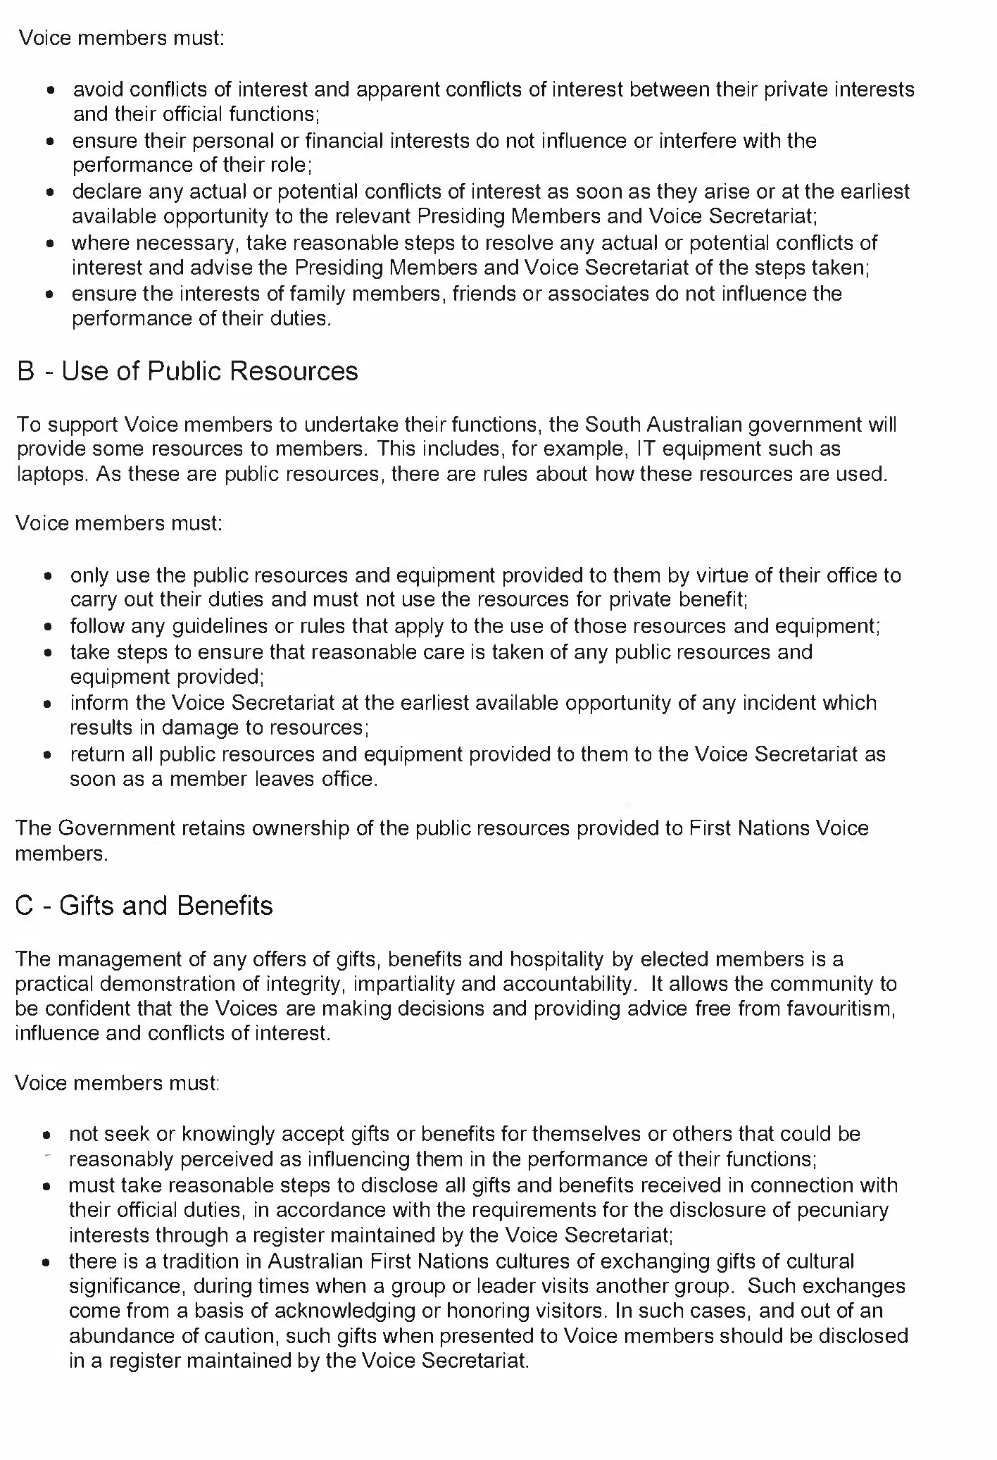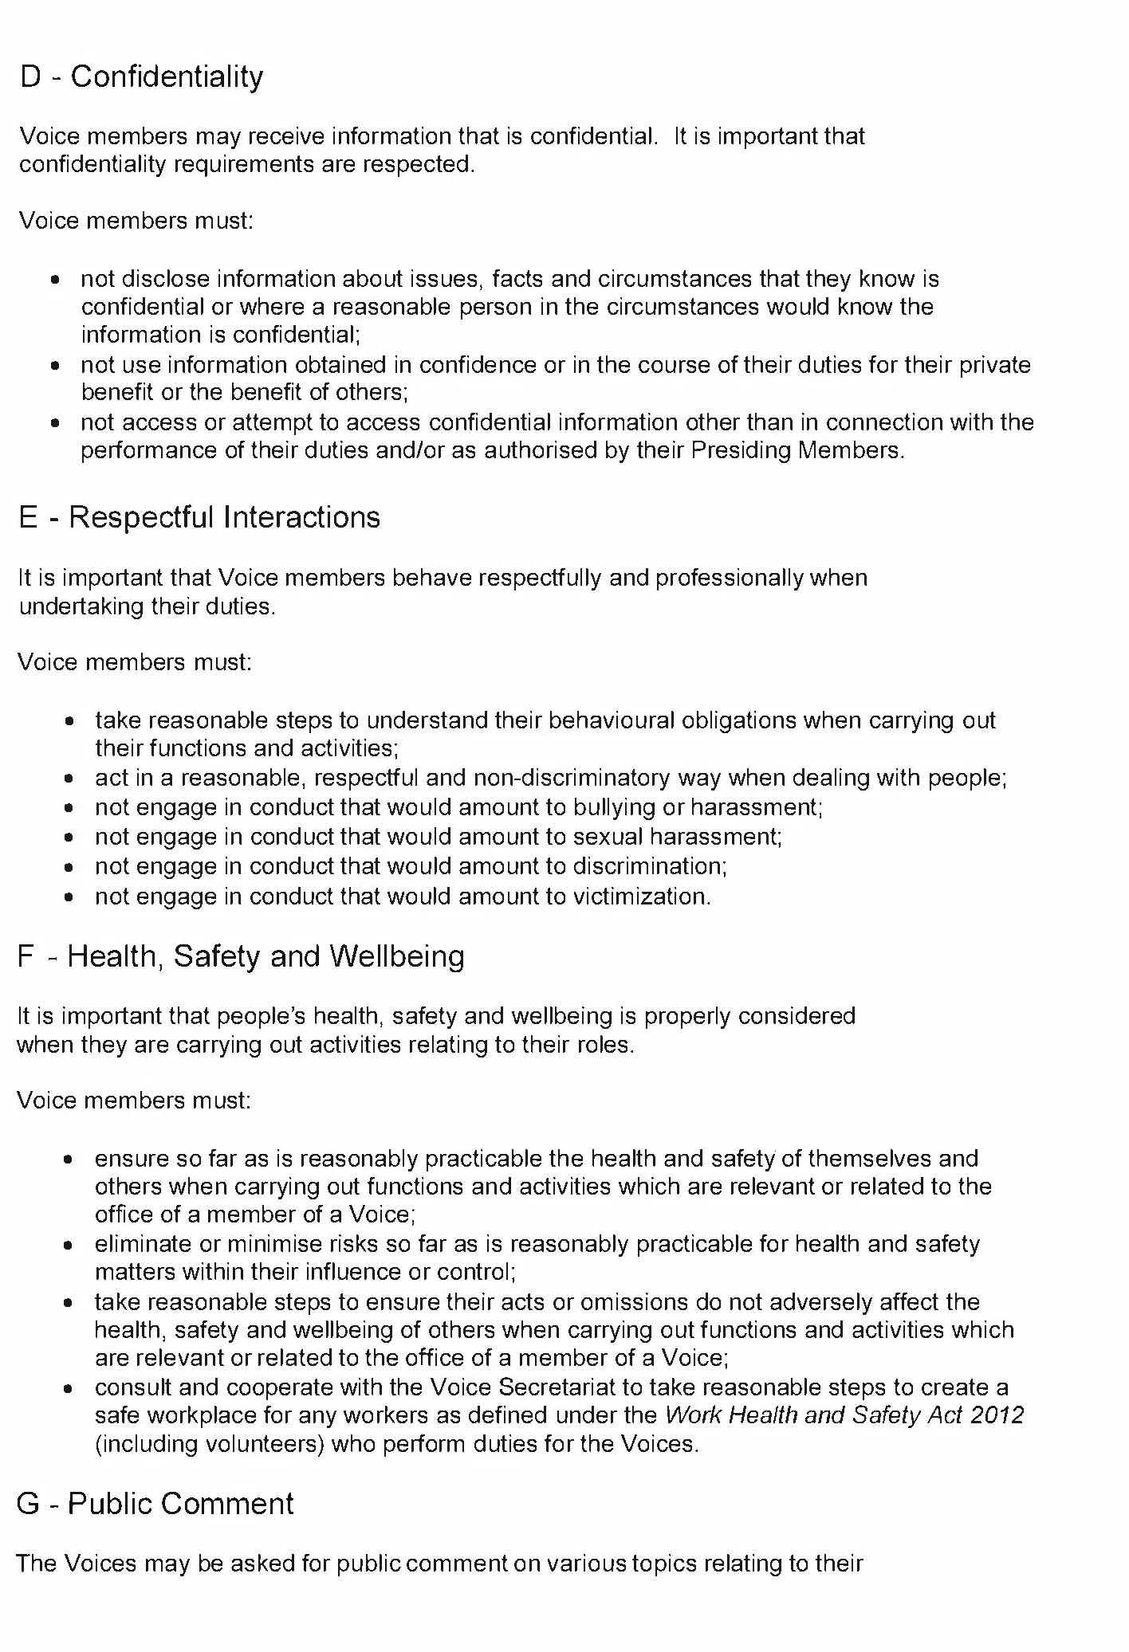
Dated: 12 March 2024
Hon Kyam Maher MLC
Minister for Aboriginal Affairs

Fisheries Management (Prawn Fisheries) Regulations 2017
Amended March 2024 Fishing for the Spencer Gulf Prawn Fishery
TAKE NOTE that pursuant to regulation 10 of the Fisheries Management (Prawn Fisheries) Regulations 2017, the notice dated 22 September 2023 on page 3296 of the South Australian Government Gazette on 28 September 2023 prohibiting fishing activities in the Spencer Gulf Prawn Fishery, is hereby varied such that it will not be unlawful for a person fishing pursuant to a Spencer Gulf Prawn Fishery licence to use prawn trawl nets in the areas specified in Schedule 1, during the period specified in Schedule 2, and under the conditions specified in Schedule 3.
Schedule 1
The waters of the Spencer Gulf Prawn Fishery:
- Except the Northern Closure area, which is defined as the area north of the following index points:
 | 33 | ° | 45.00 | S |  | 137 | ° | 44.00 | E
 | 33 | ° | 37.00 | S |  | 137 | ° | 32.70 | E
 | 33 | ° | 46.00 | S |  | 137 | ° | 29.25 | E
 | 33 | ° | 47.50 | S |  | 137 | ° | 32.00 | E
 | 33 | ° | 54.50 | S |  | 137 | ° | 29.50 | E
 | 33 | ° | 50.00 | S |  | 137 | ° | 21.00 | E
 | 33 | ° | 54.00 | S |  | 137 | ° | 09.00 | E
 | 33 | ° | 57.80 | S |  | 137 | ° | 11.40 | E
 | 34 | ° | 18.00 | S |  | 136 | ° | 59.00 | E
 | 34 | ° | 18.00 | S |  | 136 | ° | 55.00 | E
 | 34 | ° | 22.00 | S |  | 136 | ° | 52.00 | E
 | 34 | ° | 22.00 | S |  | 136 | ° | 42.00 | E
 | 34 | ° | 07.50 | S |  | 136 | ° | 45.50 | E
 | 34 | ° | 05.00 | S |  | 136 | ° | 49.90 | E
 | 34 | ° | 02.40 | S |  | 136 | ° | 47.50 | E
 | 33 | ° | 59.50 | S |  | 136 | ° | 53.20 | E
 | 34 | ° | 01.70 | S |  | 136 | ° | 55.50 | E
 | 33 | ° | 58.00 | S |  | 137 | ° | 01.00 | E
 | 33 | ° | 55.50 | S |  | 136 | ° | 59.50 | E
 | 33 | ° | 57.40 | S |  | 136 | ° | 55.70 | E
 | 33 | ° | 56.50 | S |  | 136 | ° | 55.00 | E
 | 33 | ° | 58.00 | S |  | 136 | ° | 52.00 | E
 | 33 | ° | 49.40 | S |  | 136 | ° | 43.50 | E
- Except the Arno Bay Closure area, which is defined as the waters contained within the following index points:
 | 33 | ° | 59.00 | S |  | 136 | ° | 42.24 | E
 | 33 | ° | 59.60 | S |  | 136 | ° | 42.60 | E
 | 34 | ° | 00.70 | S |  | 136 | ° | 40.60 | E
 | 34 | ° | 00.10 | S |  | 136 | ° | 40.10 | E

- Except the Wardang Closure area, which is defined as the waters contained within the following index points:
1. | 34 | ° | 10.00 | S |  | 137 | ° | 28.00 | E
2. | 34 | ° | 21.00 | S |  | 137 | ° | 12.00 | E
3. | 34 | ° | 45.00 | S |  | 137 | ° | 15.00 | E
4. | 34 | ° | 48.53 | S |  | 137 | ° | 09.45 | E
5. | 34 | ° | 48.53 | S |  | 137 | ° | 06.00 | E
6. | 34 | ° | 50.75 | S |  | 137 | ° | 06.00 | E
7. | 34 | ° | 54.00 | S |  | 137 | ° | 01.00 | E

- Except the Corny closure area, which is defined as the waters within and bounded by the following closure index points:
1. | 34 | ° | 27.00 | S |  | 136 | ° | 53.00 | E
2. | 34 | ° | 27.00 | S |  | 137 | ° | 02.00 | E
3. | 34 | ° | 35.00 | S |  | 136 | ° | 56.00 | E
4. | 34 | ° | 48.60 | S |  | 136 | ° | 52.00 | E
5. | 34 | ° | 54.00 | S |  | 136 | ° | 52.00 | E
6. | 34 | ° | 54.00 | S |  | 136 | ° | 48.50 | E
7. | 34 | ° | 49.50 | S |  | 136 | ° | 48.50 | E
8. | 34 | ° | 49.50 | S |  | 136 | ° | 40.50 | E
9. | 34 | ° | 39.50 | S |  | 136 | ° | 40.50 | E
Then back to point 1

- Except the Illusions closure area, which is defined as the waters contained within the following closure index points:
1. | 33 | ° | 28.80 | S |  | 137 | ° | 32.2 | E
2. | 33 | ° | 28.30 | S |  | 137 | ° | 33.2 | E
3. | 33 | ° | 28.85 | S |  | 137 | ° | 33.5 | E
4. | 33 | ° | 29.40 | S |  | 137 | ° | 32.5 | E
Then back to point 1

- Except the Jurassic Park closure area, which is defined as the waters contained within the following closure index points:
 | 33 | ° | 54.90 | S |  | 137 | ° | 17.60 | E
 | 33 | ° | 54.40 | S |  | 137 | ° | 19.40 | E
 | 33 | ° | 54.70 | S |  | 137 | ° | 19.60 | E
 | 33 | ° | 55.20 | S |  | 137 | ° | 17.80 | E
Then back to point 1

- Except the Estelle Star closure area, which is defined as the waters contained within the following closure index points:
 | 33 | ° | 58.8 | S |  | 136 | ° | 49.8 | E
 | 33 | ° | 58.2 | S |  | 136 | ° | 51 | E
 | 33 | ° | 59.1 | S |  | 136 | ° | 51.7 | E
 | 33 | ° | 59.8 | S |  | 136 | ° | 50.4 | E
Then back to point 1

Schedule 2
Commencing at sunset on 11 March 2024 and ending at sunrise on the 20 March 2024.
Schedule 3
- Each The coordinates in Schedule 1 are defined as degrees decimal minutes and are based on the World Geodetic System 1984 (WGS 84).
- No fishing activity may be undertaken between the prescribed times of sunrise and sunset for Adelaide (as published in the South Australian Government Gazette pursuant to the requirements of the Proof of Sunrise and Sunset Act 1923) during the period specified in Schedule 2.
- Fishing must cease:
- in the fishing area known as Northern & Inshore Wallaroo (the ‘Mid/North Gulf’ area, as described on page 40 of the Management Plan for the South Australian Commercial Spencer Gulf Prawn Fishery October 2020) if the average catch per vessel, per night (based on the best information available to the committee at sea) drops below 500kg or after three nights (whichever comes first); and
- in the fishing area known as Southern Wallaroo & North End (the ‘Mid/North Gulf’ area) if the average catch per vessel, per night (based on the best information available to the committee at sea) drops below 500kg or after five nights (whichever comes first); and
- in the fishing area known as the ‘Southern Gulf’ area (as described on page 40 of the Management Plan for the South Australian Commercial Spencer Gulf Prawn Fishery October 2020) if the average catch per vessel over two consecutive nights (based on the best information available to the committee at sea) falls below 350kg.
- Based on the best information available from the fleet, fishing must cease in an area in the Mid/North Gulf if the average prawn bucket count exceeds 240 prawns per 7kg; or in an area in the Southern Gulf if the average prawn bucket count exceeds 260 prawns per 7kg.
- No fishing activity may occur without the authorisation of Coordinator at Sea, Ashley Lukin, or other nominated Coordinator at Sea appointed by the Spencer Gulf and West Coast Prawn Association.
- The authorisation of the Coordinator at Sea must be in writing, signed and record the day, date, and permitted fishing area within the waters of Schedule 1 in the form of a notice sent to the fishing fleet or vary an earlier authorisation issued by the Coordinator at Sea.
- The Coordinator at Sea must cause a copy of any authorisation for fishing activity or variation of same, made under this notice to be emailed to the Prawn Fisheries Manager immediately after it is made.
- The Spencer Gulf and West Coast Prawn Association must keep records of all authorisations issued pursuant to this notice.
Dated: 11 March 2024
Ashley Lukin
Coordinator at Sea, Spencer Gulf & West Coast Prawn Association Inc.
Delegate of the Minister for Primary Industries and Regional Development.

Fisheries Management (Prawn Fisheries) Regulations 2017
Amended March 2024 Fishing for the West Coast Prawn Fishery
TAKE notice that pursuant to regulation 10 of the Fisheries Management (Prawn Fisheries) Regulations 2017, the notice dated 22 September 2023 on page 3296 of the South Australian Government Gazette of 28 September 2023, prohibiting fishing activities in the West Coast Prawn Fishery is HEREBY varied such that it will not be unlawful for a person fishing pursuant to a West Coast Prawn Fishery licence to use prawn trawl nets in the areas specified in Schedule 1, during the period specified in Schedule 2, and under the conditions specified in Schedule 3.
Schedule 1
The waters of the West Coast Prawn Fishery excluding Ceduna as defined in the West Coast Prawn Fishery Harvest Strategy.
Schedule 2
Commencing at sunset on 8 March 2024 and ending at sunrise on 19 March 2024.
Schedule 3
- Each licence holder of a fishing licence undertaking fishing activities pursuant to this notice must ensure that a representative sample of catch (a 'bucket count') is taken at least 3 times per night during the fishing activity.
- Each 'bucket count' sample must be accurately weighed to 7kg where possible and the total number of prawns contained in the bucket must be recorded on the daily catch and effort return.
- Fishing must cease if one of the following limits is reached:
- A total of 14 nights of fishing are completed.
- The average catch per vessel, per night (for all 3 vessels) drops below 300 kg for two consecutive nights.
- The average 'bucket count' for all vessels exceeds 240 prawns per 7kg bucket on any single fishing night in the Coffin Bay area.
- The average 'bucket count' for all vessels exceeds 250 prawns per 7kg bucket on any single fishing night in the Venus Bay area.
- The average 'bucket count' for all vessels exceeds 270 prawns per 7kg bucket on any single fishing night in the Corvisart Bay area.
- The average catch for all three vessels exceeds the 6 tonne catch cap in the Corvisart Bay area.
- Each licence holder, or registered master of a fishing license undertaking fishing activities must provide a daily report by telephone or SMS message, via a nominated representative, to the Department of Primary Industries and Regions, Prawn Fishery Manager, providing the following information for all vessels operating in the fishery from the previous nights fishing:
- average prawn catch; and
- the average prawn 'bucket count'
- No fishing activity may be undertaken after the expiration of 30 minutes from the prescribed time of sunrise and no fishing activity may be undertaken before the prescribed time of sunset for Adelaide (as published in the South Australian Government Gazette pursuant to the requirements of the Proof of Sunrise and Sunset Act 1923) during the period specified in Schedule 2.
Dated: 8 March 2024
Steve Shanks
A/Prawn Fishery Manager
Delegate of the Minister for Primary Industries and Regional Development

Fisheries Management (Prawn Fisheries) Regulations 2017
Amended March 2024 Survey in the West Coast Prawn Fishery
TAKE notice that pursuant to regulation 10 of the Fisheries Management (Prawn Fisheries) Regulations 2017, the notice dated 22 September 2023 on page 3296 of the South Australian Government Gazette of 28 September 2023, prohibiting fishing activities in the West Coast Prawn Fishery is HEREBY varied such that it will not apply to the holders of a West Coast Prawn Fishery licence issued pursuant to the Fisheries Management (Prawn Fisheries) Regulations 2017 listed in Schedule 1 or their register master insofar as they may use prawn trawl nets in accordance with the conditions of their fishery licence for the purpose of undertaking a prawn survey during the period specified in Schedule 2, subject to the conditions contained in Schedule 3 unless this notice is varied or revoked.
Schedule 1
Licence Number | Licence Holder / Master | Boat Name | Trawl Survey Area
D02 | Kontias Developments /Danny Reid | Lincoln Lady | Venus Bay
Schedule 2
Commencing at sunset on 7 March 2024 and ending at sunrise on 8 March 2024.

Schedule 3
- The licence holder listed in Schedule 1 or their registered master must operate within the trawl survey area nominated in the table in Schedule 1.
- For the purposes of this notice the trawl survey areas cannot include any waters of a habitat protection zone or a sanctuary zone of a marine park established under the Marine Parks Act 2007.
- The registered master must keep a ‘skippers log’ to record catch information during the survey.
- All fish, other than King Prawns, Southern Calamari, Gould’s Squid, Scallops, Octopus and Balmain Bugs taken during the exempted activity for survey purposes, are to be returned to the water immediately after capture.
- The licence holders listed in Schedule 1 or their registered master must comply with all regulations and conditions that apply to fishing activities undertaken pursuant to their licence, in addition to the conditions imposed by this exemption.
- While engaged in fishing activities or unloading the survey catch, the licence holder listed in Schedule 1 or their register master must have a copy of this notice on board the boat or near his person. This notice must be produced to a Fisheries Officer if requested.
- The licence holders listed in Schedule 1 or their registered master must not contravene or fail to comply with the Fisheries Management Act 2007, or any other regulations made under that Act except where specifically exempted by this notice.
This notice does not purport to override the provisions or operation of any other Act including, but not limited to, the Marine Parks Act 2007. The notice holder and his agents must comply with any relevant regulations, permits, requirements and directions from the Department for Environment and Water when undertaking activities within a marine park.
Dated: 7 March 2024
Steve Shanks
A/Prawn Fishery Manager
Delegate of the Minister for Primary Industries and Regional Development

Fisheries Management (Prawn Fisheries) Regulations 2017
Revocation notice: March 2024 West Coast Prawn Fishery Fishing Run
TAKE NOTE that the notice made under Section 10 of the Fisheries Management (Prawn Fisheries) Regulations 2017 dated 1 March 2024, on page 389 of the South Australian Government Gazette of 7 March 2024, being the second notice on this page, referring to the March 2024 fishing in the West Coast Prawn Fishery, is hereby revoked pursuant to Section 10(1)(b) of the Fisheries Management (Prawn Fisheries) Regulations 2017 effective as of 7 March 2024.
Dated: 7 March 2024
Steve Shanks
A/Prawn Fishery Manager
Delegate of the Minister for Agriculture, Food and Fisheries

Fisheries Management (Prawn Fisheries) Regulations 2017
Revocation notice: Survey in the West Coast Prawn Fishery
TAKE NOTE that the notice made under Section 10 of the Fisheries Management (Prawn Fisheries) Regulations 2017 dated 1 March 2024, on page 389 of the South Australian Government Gazette of 7 March 2024, being the third notice on this page, referring to the March 2024 survey in the West Coast Prawn Fishery, is hereby revoked pursuant to Section 10 (1)(b) of the Fisheries Management (Prawn Fisheries) Regulations 2017 effective as of 7 March 2024.
Dated: 7 March 2024
Steve Shanks
A/Prawn Fishery Manager
Delegate of the Minister for Agriculture, Food and Fisheries

Fisheries Management Act 2007
Section 115
Exemption No. ME9903297
TAKE NOTICE that pursuant to section 115 of the Fisheries Management Act 2007 (the Act), Professor Sabine Dittmann (the ‘exemption holder’) of Flinders University, Sturt Road, Bedford Park, and her nominated agents, are exempt from Section 70 of the Fisheries Management Act 2007, Regulation 5(a) and clauses 42, 74, 113(1)(a) and 116 of Schedule 6 of the Fisheries Management (General) Regulations 2017 in the waters specified in Schedule 1 but only insofar as they are for the purposes of activities specified in Schedule 2, using the gear specified in Schedule 3, (the 'exempted activity'), subject to the conditions specified in Schedule 4, from 9 March 2024 until 8 March 2025, unless varied or revoked earlier.
Schedule 1
All waters of South Australia, including the River Murray Protection Area, excluding aquatic reserves (unless otherwise authorised under the Act) and sanctuary and restricted access zones of marine parks (unless otherwise authorised under the Marine Parks Act 2007) and the Adelaide Dolphin Sanctuary (unless otherwise authorised by the Minister’s delegate under the Adelaide Dolphin Sanctuary Act 2005.
Schedule 2
The research activities entitled:
- Ecological assessments in the Coorong - Long-term monitoring of benthic macroinvertebrates as part of ‘The Living Murray Condition Monitoring’ and “Healthy Coorong – Healthy Basin” Program.
- Mudflat biodiversity and condition monitoring in Gulf St Vincent, South Australia.
- Biodiversity benefits of Blue Carbon ecosystem restoration in upper Gulf St Vincent, South Australia.
- Assessing the ecosystem health of Coffin Bay through sediment and benthic sampling.

Schedule 3
- 10 x Plastic Corer, Hand Held, PVC: 10 cm diameter, 20 cm height
- 1 x Ekman Grab: 15 cm x 15 cm, 20 cm height
- 10 x Emergence Traps: 20 cm by 20 cm
- 12 x Fyke Nets: 3 m wing, 5.6 m funnel, 0.6 m hoop diameter, 8 mm mesh size
- 1 x Sweep Net (hand held butterfly net): 45cm diameter, 1mm mesh size
- 12 x Box Traps: 47 cm length, 25 cm width, 2-3 mm mesh size
- 8 x UBRUV/BRUV (Remote underwater video): 35 cm x 35 cm
- 2 x Underwater Imaging Sonar: 12.5 cm (L) x 12.2 cm (W) x 6.2 cm (H)
Schedule 4
- The nominated agents of the exemption holder are:
- Laura Schroder – Flinders University
- Kieren Beaumont – Flinders University
- Anthony Newbery – Flinders University
- Noah Morris – Flinders University
- James Stangoulis – Flinders University
- Troy Gaston – University of Newcastle
- Qifeng Ye – SARDI
- David Short – SARDI
The nominated agents may be assisted by research assistants and students under their direct supervision.
- The exemption holder will be deemed responsible for the conduct of all persons conducting the research activities under this notice. Any person conducting research activities under this exemption must have been provided with a copy of this notice, and have signed it to confirm that they have read, understood it, and agreed to act in accordance with the conditions under it.
- Any equipment used to collect and hold marine organisms during the exempted activity must be decontaminated prior to and after undertaking the research activities.
- The exemption holder and their nominated agents may only retain the following fish species as part of the exempted activity:
Common name | Scientific name | Quantity (up to)
Small-mouth Hardyhead | Atherinosoma microstoma | 135
Yellow-eyed Mullet | Aldrichetta forsteri | 135
Congoli | Pseudaphritis urvillii | 45
Black Bream | Acanthopagrus butcheri | 45
King George Whiting | Sillginodes punctatus | 45
Mulloway | Argyrosomus japonicus | 45
- The exemption holder and their nominated agents may retain invertebrate species but only so far as they are relevant to a research project listed in Schedule 2.
- All species caught pursuant to this notice that are not being collected for scientific, education or research purposes must be returned to the water as soon as practicable, except for species declared as noxious under the Act. Noxious species must not be returned to the water and must be humanely destroyed.
- The exemption holder and their nominated agents may only take, possess, or control exotic organisms or noxious species in conjunction with a Ministerial permit issued under section 78 of the Fisheries Management Act 2007.
- All protected species incidentally taken while undertaking the exempted activity must be returned to the water as soon as practicable. Protected species must not be retained.
- Fyke nets and emergence traps must be retrieved at least every 15 hours.
- The specimens collected by the exemption holder are for scientific, education or research purposes only and must not be sold or consumed.
- The Ministerial exemption holder must not collect specimens for aquaculture research purposes pursuant to this notice.
- Specimens collected pursuant to this notice must not be released into waters of the State once they have been kept separate to their natural environment.
- The Ministerial exemption holder or agents must not conduct any other fishing activity, including recreational fishing whilst undertaking the exempted activity.
- The exemption holder and their nominated agents may only engage in research activities in an aquatic reserve in conjunction with a Ministerial permit issued under sections 76 or 77 of the Fisheries Management Act 2007.
- Before commencing any exempted activity under this notice within the Adelaide Dolphin Sanctuary, the exemption holder or her agents must provide notification of intended dates and times of the activity to:
- Jon Emmett, Regional Coordinator Marine Parks: jon.emmett@sa.gov.au
- At least 1 hour before conducting an exempted activity, the exemption holder or nominated agent must contact the Department of Primary Industries and Regions (PIRSA) Fishwatch on 1800 065 522 and answer a series of questions about the exempted activity. The exemption holder or nominated agent will need to have a copy of this notice in their possession at the time of making the call and be able to provide information about the area and time of the exempted activity, the specific gear to be used, vehicles and/or boats involved, the number of permit holders undertaking the exempted activity and other related questions.
- The exemption holder must provide a report in writing detailing the activities carried out pursuant to this notice to PIRSA, Fisheries and Aquaculture (GPO Box 1625, ADELAIDE SA 5001) within 14 days of the activity being completed with the following details:
- the date and location of sampling;
- the gear used;
- the number and description of all species caught and their fate;
- the number and description of any samples/biopsies collected;
- any interactions with protected species and their fate; and
- any other information regarding size, breeding or anything deemed relevant or of interest that is able to be volunteered.
- While engaging in the exempted activity, the exemption holder and nominated agents must be in possession of a signed copy of this exemption. Such exemption must be produced to a PIRSA Fisheries Officer if requested.
- The exemption holder, or agent must not contravene or fail to comply with the Act or any regulations made under the Act, except where specifically exempted by this notice.
This notice does not purport to override the provisions or operation of any other Act including, but not limited to, the Marine Parks Act 2007, the River Murray Act 2003 or the Adelaide Dolphin Sanctuary Act 2005. The exemption holder and her agents must comply with any relevant regulations, permits, requirements and directions from the Department for Environment and Water when undertaking activities within a marine park.
Dated: 8 March 2024
Prof Gavin Begg
Executive Director
Fisheries and Aquaculture
Delegate of the Minister for Primary Industries and Regional Development

Geographical Names Act 1991
Notice to Alter the Boundary of a Place
NOTICE is hereby given that, pursuant to section 11B(1)(b) of the Geographical Names Act 1991, I, BRADLEY SLAPE, Surveyor-General and Delegate appointed by the Honourable Nick Champion MP, Minister for Planning, Minister of the Crown to whom the administration of the Geographical Names Act 1991 is committed, DO HEREBY:
- Alter the locality boundary between Mount Compass and Nangkita to exclude that area marked (A), highlighted in green as shown on the plan, from the bounded locality of MOUNT COMPASS and include that area in the locality of NANGKITA.
- Alter the locality boundary between Mount Compass and Nangkita to exclude that area marked (B), highlighted in orange as shown on the plan, from the bounded locality of NANGKITA and include that area in the locality of MOUNT COMPASS.
This notice is to take effect immediately upon its publication in the Government Gazette.
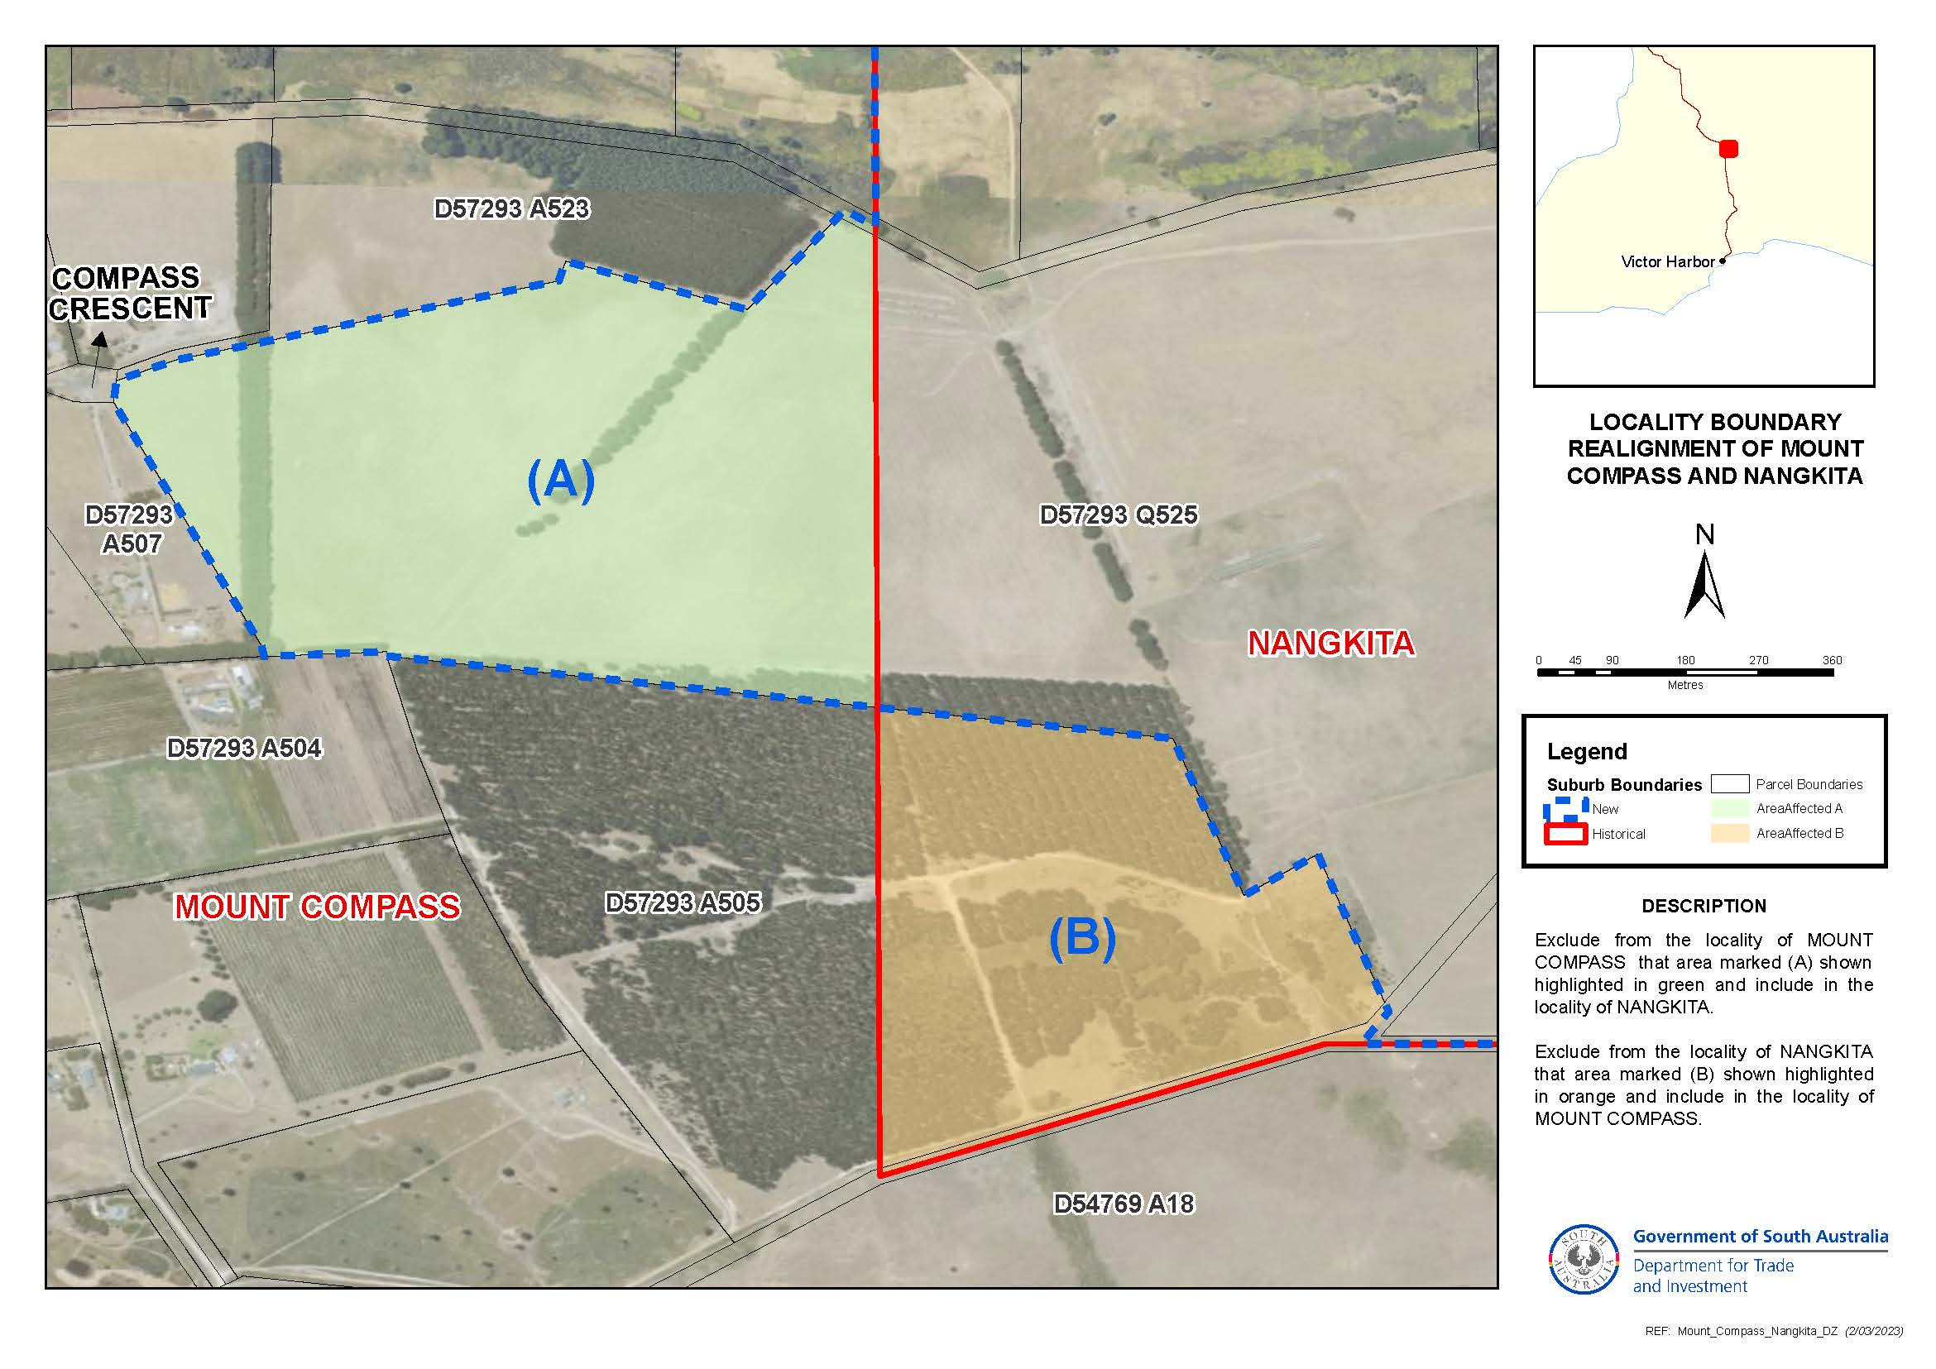
Dated: 14 March 2024
B. J. Slape
Surveyor-General
DTI: 2021/03842/01

Geographical Names Act 1991
Notice to Alter the Boundary of a Place
NOTICE is hereby given that, pursuant to section 11B(1)(b) of the Geographical Names Act 1991, I, BRADLEY SLAPE, Surveyor-General and Delegate appointed by the Honourable Nick Champion MP, Minister for Planning, Minister of the Crown to whom the administration of the Geographical Names Act 1991 is committed, DO HEREBY:
- Alter the locality boundary between Mount Compass and Tooperang to exclude that area marked (A), highlighted in green as shown on the plan, from the bounded locality of TOOPERANG and include that area in the locality of MOUNT COMPASS.
- Alter the locality boundary between Mount Compass and Tooperang to exclude that area marked (B), highlighted in orange as shown on the plan, from the bounded locality of MOUNT COMPASS and include that area in the locality of TOOPERANG.
This notice is to take effect immediately upon its publication in the Government Gazette.
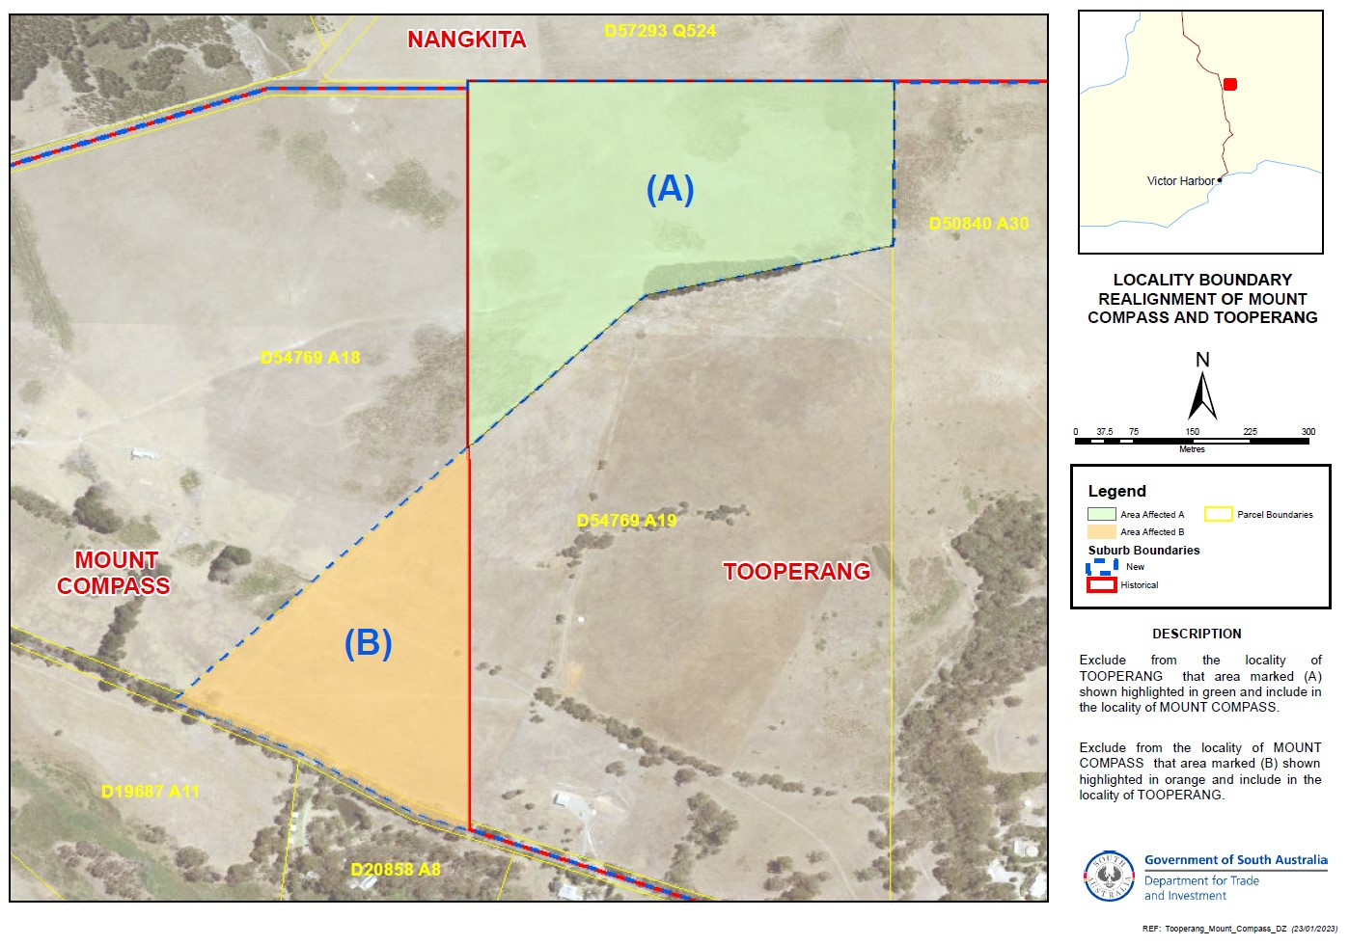
Dated: 14 March 2024
B. J. Slape
Surveyor-General
DTI: 2021/03842/01

Housing Improvement Act 2016
Rent Control
The Minister for Human Services Delegate in the exercise of the powers conferred by the Housing Improvement Act 2016, does hereby fix the maximum rental per week which shall be payable subject to Section 55 of the Residential Tenancies Act 1995, in respect of each house described in the following table. The amount shown in the said table shall come into force on the date of this publication in the Gazette.
Address of Premises | Allotment Section | Certificate of Title Volume/Folio | Maximum Rental per week payable
42 Gilles Street, Adelaide SA 5000 | Lot 7 Community Plan 21438 Hundred of Adelaide | CT 5882/73 | $405.00
Dated: 14 March 2024
Craig Thompson
Housing Regulator and Registrar
Housing Safety Authority, SAHA
Delegate of Minister for Human Services

Housing Improvement Act 2016
Rent Control Revocations
Whereas the Minister for Human Services Delegate is satisfied that each of the houses described hereunder has ceased to be unsafe or unsuitable for human habitation for the purposes of the Housing Improvement Act 2016, notice is hereby given that, in exercise of the powers conferred by the said Act, the Minister for Human Services Delegate does hereby revoke the said Rent Control in respect of each property.
Address of Premises | Allotment Section | Certificate of Title Volume/Folio
561A Paracombe Road, Paracombe  SA 5132 (PKA Lot 20) | Allotment 200 Deposited Plan 95203 Hundred of Yatala | CT6158/18
6 Cresdee Road, Campbelltown SA 5074 | Allotment 273 Deposited Plan 3579 Hundred of Adelaide | CT 5575/231
Dated: 14 March 2024
Craig Thompson
Housing Regulator and Registrar
Housing Safety Authority, SAHA
Delegate of Minister for Human Services

Land Acquisition Act 1969
Section 16
Form 5—Notice of Acquisition
1. Notice of acquisition
The Commissioner of Highways (the Authority), of 83 Pirie Street, Adelaide SA 5000, acquires the following interests in the following land:
Comprising an unencumbered estate in fee simple in that piece of land being the whole of Allotment 18 in Deposited Plan 1999 comprised in Certificate of Title Volume 5393 Folio 139.
This notice is given under Section 16 of the Land Acquisition Act 1969.
2. Compensation
A person who has or had an interest consisting of native title or an alienable interest in the land that is divested or diminished by the acquisition or the enjoyment of which is adversely affected by the acquisition who does not receive an offer of compensation from the Authority may apply to the Authority for compensation.
2A. Payment of professional costs relating to acquisition (Section 26B)
If you are the owner in fee simple of the land to which this notice relates, you may be entitled to a payment of up to $10,000 from the Authority for use towards the payment of professional costs in relation to the acquisition of the land.
Professional costs include legal costs, valuation costs and any other costs prescribed by the Land Acquisition Regulations 2019.
3. Inquiries
Inquiries should be directed to: William Ridgway
GPO Box 1533
Adelaide SA 5001
Telephone: 08 7133 2465
Dated: 12 March 2024
The Common Seal of the COMMISSIONER OF HIGHWAYS was hereto affixed by authority of the Commissioner in the presence of:
Rocco Caruso
Manager, Property Acquisition
(Authorised Officer)
Department for Infrastructure and Transport
DIT 2022/02876/01

Land Acquisition Act 1969
Section 16
Form 5—Notice of Acquisition
1. Notice of acquisition
The Commissioner of Highways (the Authority), of 83 Pirie Street, Adelaide SA 5000, acquires the following interests in the following land:
Comprising an estate in fee simple in that piece of land being the whole of Allotment 101 in Deposited Plan 29220 comprised in Certificate of Title Volume 6242 Folio 887, subject to right(s) of way with limitations over the land marked B (TG 10096712) together with free and unrestricted right(s) of way over the land marked A.
This notice is given under Section 16 of the Land Acquisition Act 1969.
2. Compensation
A person who has or had an interest consisting of native title or an alienable interest in the land that is divested or diminished by the acquisition or the enjoyment of which is adversely affected by the acquisition who does not receive an offer of compensation from the Authority may apply to the Authority for compensation.
2A. Payment of professional costs relating to acquisition (Section 26B)
If you are the owner in fee simple of the land to which this notice relates, you may be entitled to a payment of up to $10,000 from the Authority for use towards the payment of professional costs in relation to the acquisition of the land.
Professional costs include legal costs, valuation costs and any other costs prescribed by the Land Acquisition Regulations 2019.

3. Inquiries
Inquiries should be directed to: Petrula Pettas
GPO Box 1533
Adelaide SA 5001
Telephone: 08 7133 2457
Dated: 12 March 2024
The Common Seal of the COMMISSIONER OF HIGHWAYS was hereto affixed by authority of the Commissioner in the presence of:
Rocco Caruso
Manager, Property Acquisition
(Authorised Officer)
Department for Infrastructure and Transport
DIT 2022/02743/01

Land Acquisition Act 1969
Section 16
Form 5—Notice of Acquisition
1. Notice of acquisition
The Commissioner of Highways (the Authority), of 83 Pirie Street, Adelaide SA 5000, acquires the following interests in the following land:
Comprising an estate in fee simple in that piece of land being the whole of Unit 13 in Strata Plan 10194 comprised in Certificate of Title Volume 5026 Folio 481, together with free and unrestricted right(s) of way over the land marked A on SP 10194.
This notice is given under Section 16 of the Land Acquisition Act 1969.
2. Compensation
A person who has or had an interest consisting of native title or an alienable interest in the land that is divested or diminished by the acquisition or the enjoyment of which is adversely affected by the acquisition who does not receive an offer of compensation from the Authority may apply to the Authority for compensation.
2A. Payment of professional costs relating to acquisition (Section 26B)
If you are the owner in fee simple of the land to which this notice relates, you may be entitled to a payment of up to $10,000 from the Authority for use towards the payment of professional costs in relation to the acquisition of the land.
Professional costs include legal costs, valuation costs and any other costs prescribed by the Land Acquisition Regulations 2019.
3. Inquiries
Inquiries should be directed to: Rob Gardner
GPO Box 1533
Adelaide SA 5001
Telephone: 08 7133 2415
Dated: 12 March 2024
The Common Seal of the COMMISSIONER OF HIGHWAYS was hereto affixed by authority of the Commissioner in the presence of:
Rocco Caruso
Manager, Property Acquisition
(Authorised Officer)
Department for Infrastructure and Transport
DIT 2023/01368/01

Land Acquisition Act 1969
Section 16
Form 5—Notice of Acquisition
1. Notice of acquisition
The Commissioner of Highways (the Authority), of 83 Pirie Street, Adelaide SA 5000, acquires the following interests in the following land:
Comprising an estate in fee simple in that piece of land being the whole of Unit 6 in Strata Plan 10194 comprised in Certificate of Title Volume 5026 Folio 474, together with free and unrestricted right(s) of way over the land marked A on SP 10194.
This notice is given under Section 16 of the Land Acquisition Act 1969.
2. Compensation
A person who has or had an interest consisting of native title or an alienable interest in the land that is divested or diminished by the acquisition or the enjoyment of which is adversely affected by the acquisition who does not receive an offer of compensation from the Authority may apply to the Authority for compensation.
2A. Payment of professional costs relating to acquisition (Section 26B)
If you are the owner in fee simple of the land to which this notice relates, you may be entitled to a payment of up to $10,000 from the Authority for use towards the payment of professional costs in relation to the acquisition of the land.
Professional costs include legal costs, valuation costs and any other costs prescribed by the Land Acquisition Regulations 2019.

3. Inquiries
Inquiries should be directed to: William Ridgway
GPO Box 1533
Adelaide SA 5001
Telephone: 08 7133 2465
Dated: 12 March 2024
The Common Seal of the COMMISSIONER OF HIGHWAYS was hereto affixed by authority of the Commissioner in the presence of:
Rocco Caruso
Manager, Property Acquisition
(Authorised Officer)
Department for Infrastructure and Transport
DIT 2023/01361/01

Land Acquisition Act 1969
Section 16
Form 5—Notice of Acquisition
1. Notice of acquisition
The Commissioner of Highways (the Authority), of 83 Pirie Street, Adelaide SA 5000, acquires the following interests in the following land:
Comprising the entirety of the right, estate or interest of Elizabeth Stone whether as lessee, as sub-lessee or as licensee or otherwise in that piece of land, being the whole of Allotment 17 in Deposited Plan 1999 comprised in Certificate of Title Volume 6133 Folio 243.
This notice is given under Section 16 of the Land Acquisition Act 1969.
2. Compensation
A person who has or had an interest consisting of native title or an alienable interest in the land that is divested or diminished by the acquisition or the enjoyment of which is adversely affected by the acquisition who does not receive an offer of compensation from the Authority may apply to the Authority for compensation.
2A. Payment of professional costs relating to acquisition (Section 26B)
If you are the owner in fee simple of the land to which this notice relates, you may be entitled to a payment of up to $10,000 from the Authority for use towards the payment of professional costs in relation to the acquisition of the land.
Professional costs include legal costs, valuation costs and any other costs prescribed by the Land Acquisition Regulations 2019.
3. Inquiries
Inquiries should be directed to: Rob Gardner
GPO Box 1533
Adelaide SA 5001
Telephone: 08 7133 2465
Dated: 12 March 2024
The Common Seal of the COMMISSIONER OF HIGHWAYS was hereto affixed by authority of the Commissioner in the presence of:
Rocco Caruso
Manager, Property Acquisition
(Authorised Officer)
Department for Infrastructure and Transport
DIT 2022/02883/01

Major Events Act 2013
Section 6B
Declaration of a Major Event
PURSUANT to section 6B of the Major Events Act 2013, I, Hon. Zoe Bettison MP, Minister for Tourism declare the 2024 LIV Golf Adelaide tournament to be held from 24 to 28 April to be declared a major event.
By virtue of the provisions of the Major Events Act 2013, I do hereby:
- Declare the 2024 LIV Golf Adelaide tournament to be a major event for the purposes of the Act.
- Specify the major event period for the event to be 24 to 28 April 2024 inclusive.
- Declare the major event venue to be Grange Golf Club shown as the “Event Site” in the map.
- Declare that any public place or part of a public place that is within 350 metres from the boundary of the Grange Golf Club is a controlled area for the event, shown as “Declared Controlled Area” in the map.
- Designate LIV Golf Events Ltd to be the event organisers for the event.
- Declare that the following provisions of Part 3 of the Act apply to the event, the major event venue for the event and the controlled area for the event:
  - Section 8.
  - Section 10.
  - Section 11.
  - Section 12.
  - Section 13.
  - Section 14.

- Being satisfied that the title ‘LIV Golf Adelaide’ and the logo as it appears below are sufficiently connected with the identity and conduct of the major event, and that the event has commercial arrangements that are likely to be adversely affected by unauthorised use of the title and logo, I hereby declare, pursuant to section 14(1) of the Act, that ‘LIV Golf Adelaide’ is an official title and the logo as it appears below is an official logo in respect of the event.
Dated: 12 March 2024
Hon Zoe Bettison MP
Minister for Tourism

Map of Controlled Area for 2024 LIV Golf Adelaide tournament
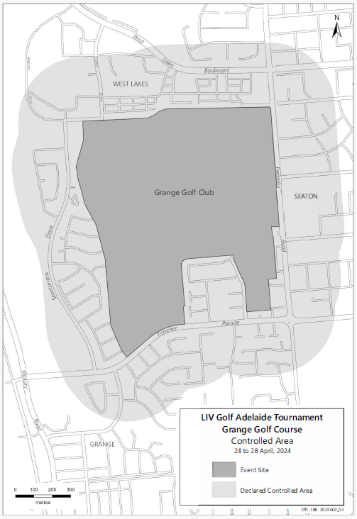

Mental Health Act 2009
Authorised Medical Practitioner
NOTICE is hereby given in accordance with Section 93(1) of the Mental Health Act 2009 that the Chief Psychiatrist has determined the following person as an Authorised Medical Practitioner:
Briah Victory
Edjoni Blackledge
Eleanor Clarke
James Bilogrevic
Natasha Priya
Stephen McManis
A determination will be automatically revoked upon the person being registered as a specialist psychiatrist with the Australian Health Practitioner Regulation Agency and as a fellow of the Royal Australian and New Zealand College of Psychiatrists.
Dated: 5 March 2024
Dr John Brayley
Chief Psychiatrist

Petroleum and Geothermal Energy Act 2000
Statement of Environmental Objectives—5 Year Review
PURSUANT to section 104(1) of the Petroleum and Geothermal Energy Act 2000 (the Act) I, Benjamin Zammit, Executive Director Regulation and Compliance Division, Department for Energy and Mining do hereby publish the following document as having been approved as a statement of environmental objectives under the Act.
Documents:
- Beach Energy, Cooper Basin Petroleum Production Operations Statement of Environmental Objectives, January 2024
This document is available for public inspection on the Environmental Register section of the following webpage - (https://www.energymining.sa.gov.au/industry/energy-resources/regulation/environmental-register) or at the Public Office determined pursuant to section 107 (1) of the Act to be at:
Energy Resources Division
Customer Services
Level 4
11 Waymouth Street
Adelaide SA 5000
Dated: 14 March 2024
Benjamin Zammit
Executive Director
Regulation and Compliance Division
Department for Energy and Mining
Delegate of the Minister for Energy and Mining

Planning, Development and Infrastructure Act 2016
Section 76
Amendment to the Planning and Design Code
Preamble
It is necessary to amend the Planning and Design Code (the Code) in operation at 29 February 2024 (Version 2024.4) in order to make changes of form relating to the Code’s spatial layers and their relationship with land parcels. NOTE: There are no changes to the application of zone, subzone or overlay boundaries and their relationship with affected parcels or the intent of policy application as a result of this amendment.
- PURSUANT to section 76 of the Planning, Development and Infrastructure Act 2016 (the Act), I hereby amend the Code in order to make changes of form (without altering the effect of underlying policy), correct errors and make operational amendments as follows:
- Undertake minor alterations to the geometry of the spatial layers and data in the Code to maintain the current relationship between the parcel boundaries and Code data as a result of the following:
  - New plans of division deposited in the Land Titles Office between 21 February 2024 and 5 March 2024 affecting the following spatial and data layers in the Code:
    - Zones and subzones
    - Technical and Numeric Variations
      - Building Heights (Levels)
      - Building Heights (Metres)
      - Concept Plan
      - Gradient Minimum Frontage
      - Gradient Minimum Site Area
      - Interface Height
      - Minimum Frontage
      - Minimum Site Area
    - Overlays
      - Affordable Housing
      - Character Area
      - Environment and Food Production Area
      - Future Road Widening
      - Hazards (Bushfire - High Risk)
      - Hazards (Bushfire - Medium Risk)
      - Hazards (Bushfire - General Risk)
      - Hazards (Bushfire - Urban Interface)
      - Hazards (Bushfire - Regional)
      - Hazards (Bushfire - Outback)
      - Heritage Adjacency
      - Historic Area
      - Local Heritage Place
      - Limited Land Division
      - Noise and Air Emissions
      - Regulated and Significant Tree
      - Scenic Quality
      - State Heritage Place
      - Stormwater Management
      - Urban Tree Canopy
- In Part 13 of the Code – Table of Amendments, update the publication date, Code version number, amendment type and summary of amendments within the ‘Table of Planning and Design Code Amendments’ to reflect the amendments to the Code as described in this Notice.
- PURSUANT to section 76(5)(a) of the Act, I further specify that the amendments to the Code as described in this Notice will take effect upon the date those amendments are published on the SA planning portal.
Dated: 12 March 2024
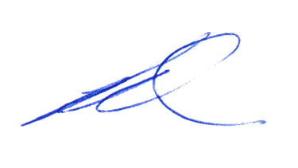Greg Van Gaans
Director, Land and Built Environment,
Department for Trade and Investment
Delegate of the Minister for Planning

Local Government Instruments

City of Port Adelaide Enfield
Roads (Opening and Closing) Act 1991
Road Closing—Princes Road, Greenacres
NOTICE is hereby given, pursuant to section 10 of the Roads (Opening and Closing) Act 1991, that Council proposes to make a Road Process Order to close and merge with the adjoining landowner portions of Princes Road, Greenacres adjacent allotments 73 to 76, 80, 85 & 88 in DP7922 delineated as ‘A’ & ‘B’ on Preliminary Plan 24/0012.
The Preliminary Plan is available for public inspection at the Civic Centre, 163 St Vincent St, Port Adelaide, and the Adelaide Office of the Surveyor-General located at Level 10, 83 Pirie Street Adelaide, during normal office hours. The Preliminary Plan can also be viewed at www.sa.gov.au/roadsactproposals.
Any application for easement or objection must set out the full name, address and details of the submission and must be fully supported by reasons. The application for easement or objection must be made in writing to the City of Port Adelaide Enfield, PO Box 110 Port Adelaide SA 5015, within 28 days of this notice and a copy must be forwarded to the Surveyor-General at GPO Box 1815, Adelaide 5001. Where a submission is made, the applicant must be prepared to support their submission in person upon council giving notification of a meeting at which the matter will be considered.
Dated: 14 March 2024
Mark Withers
Chief Executive Officer

City of Victor Harbor
Roads (Opening and Closing) Act 1991
Road Closing—Waitpinga Road, Waitpinga
Notice is hereby given, pursuant to section 10 of the Roads (Opening and Closing) Act 1991 that the City of Victor Harbor proposes to make a Road Process Order to close and merge with Piece Allotments 16 and 17 in Deposited Plan 131037, Hundred of Waitpinga the portion of the public road adjoining Piece Allotments 16 and 17 in Deposited Plan 131037, Hundred of Waitpinga, more particularly delineated and lettered “A” on preliminary plan PP 24/0010.
The preliminary plan and statement of persons affected is available for public inspection at the offices of the City of Victor Harbor and the Adelaide Office of the Surveyor-General during normal office hours. The preliminary plan can also be viewed at www.sa.gov.au/roadsactproposals.
Any application for easement or objection must set out the full name, address and details of the submission and must be fully supported by reasons. The application for easement or objection must be made in writing to City of Victor Harbor within 28 days of this notice and a copy must be forwarded to the Surveyor-General at GPO Box 1815, Adelaide SA 5001. Where a submission is made, the applicant must be prepared to support their submission in person upon council giving notification of a meeting at which the matter will be considered.
Dated: 14 March 2024
Victoria MacKirdy
Chief Executive Officer

Kangaroo Island Council
Local Government Act 1999
Adoption of Amended Community Land Management Plan
NOTICE is hereby given pursuant to Section 198(4) of the Local Government Act 1999, that the Kangaroo Island Council at its ordinary council meetings held on the dates as identified in the tables below, resolved to adopt the corresponding proposals for amendment of its community land management plan entitled Council Lands Management Plan:
Table 1: Substitution of Community Land Data Sheets
Meeting Date | Name of Substituted Community Land Data Sheet | Old Page No. | New Page No.
11 May 2021 | Brownlow Parklands (including Haney Reserve) Management Plan | 118, 119 | 118, 119
11 May 2021 | Kangaroo Island Sculpture Trail Reserve Management Plan | 262, 263 | 262, 263, 263A
11 May 2021 | Parndana Community Centre & Western KI Lions Park Management Plan | 91 | 91, 91A
11 May 2021 | Western Districts (Gosse) Sports Ground Management Plan | 103 | 103, 103A
8 March 2022 | Parndana Depot/ CFS Water Tank Management Plan | 86 | 86, 86A
8 March 2022 | The Sir Cecil Hincks Reserve Management Plan | 85 | 85, 85A
8 March 2022 | Penneshaw Health Centre and CWA Management Plan | 212 | 212, 212A
14 June 2022 | Kangaroo Island Yacht Club Reserve and adjoining Public Recreation Reserve Management Plan | 139,140,141 | 139, 140
9 August 2022 | American River Community and Sports Ground Management Plan | 165 | 165, 165A, 165B 165C
11 October 2022 | Water Reserve Lot 212 Emu Bay Road Emu Bay Management Plan | 158 | 158, 158A
8 November 2022 | Emu Bay Council Camping Ground Management Plan | 65, 66 | 65, 66
6 December 2022 | 13 Buick Drive American River Reserve Management Plan | 168 | 168, 168A
6 December 2022 | 13 Trethewey Court American River Reserve Management Plan | 169 | 169, 169A
14 March 2023 | Birchmore Hall and Sporting Complex Reserve Management Plan | 51 | 51, 51A
14 March 2023 | Lloyd Collins Reserve and Penneshaw Beach Foreshore Reserve Management Plan | 207 | 207, 207A
14 March 2023 | Frenchman's Rock Monument and Historic Reserve Management Plan | 207 | 207B, 207C
14 March 2023 | Duck Lagoon Reserve Management Plan | 70 | 70, 70A
14 March 2023 | Soldiers Memorial Park, Sporting Complex & Surrounds Management Plan | 248, 249 | 248, 249, 249A
11 April 2023 | Section 393 Three Chain Road Haines Management Plan | 43 | 43, 43A
11 April 2023 | Lots 2 and 84 Playford Hwy Parndana Management Plan | 87 | 87, 87A, 87B
11 April 2023 | Parndana Town Hall Management Plan | 89 | 89, 89A
11 April 2023 | Parndana Soldier Settlement Museum Management Plan | 88 | 88, 88A
9 May 2023 | Kangaroo Island Sculpture Trail Reserve Management Plan | 262, 263, 263A | 262, 263, 263A
9 May 2023 | Parndana Community Centre Western KI Lions Park Management Plan | 91, 91A | 91, 91A
13 June 2023 | Penneshaw Oval, Sporting & Recreation Complex Management Plan | 250, 251 | 250, 251, 251A
13 June 2023 | Penneshaw Northern Foreshore and Coastline Reserve Management Plan | 215, 216 | 215, 216, 216A, 216B
16 January 2024 | Part American River Wharf & Adjacent Northern Beach/Foreshore Management Plan | 178A, 178B, 178C | 178A, 178B, 178C
13 February 2024 | Bernie Davis Memorial Park Management Plan | 126 | 126, 126A
Table 2: Insertion of Community Land Data Sheets
Meeting Date | Name of Inserted Community Land Data Sheet | New Page No.
22 July 2021 | Parndana Oval & Reserve Management Plan | 91B, 91C
9 November 2021 | American River Boat Ramp Management Plan | 178F, 178G
9 November 2021 | American River Wharf Oyster Facility & Surrounds Management Plan | 178A, 178B, 178C
9 November 2021 | American River Wharf RIG Boat Shed & Surrounds Management Plan | 178D, 178E
11 April 2023 | Prospect Hill Management Plan | 198A, 198B
11 April 2023 | Emu Bay Day Visitor Amenities Management Plan | 71A, 71B
11 April 2023 | Vivonne Bay Bayview Road Car Park Management Plan | 113A, 113B, 113C
11 April 2023 | Lot 102 Hog Bay Road Pelican Lagoon Reserve Management Plan | 206A, 206B
Table 3: Deletion of Community Land Data Sheets
Meeting Date | Land Title Reference/Address of Deleted Community Land Data Sheet | Deleted Page No.
9 November 2021 | CR 5759/875 Section 357 Hundred of Haines | 288
9 November 2021 | CT 5856/801 Tangara Drive, American River | 286, 287
9 November 2021 | CT 5856/801 Tangara Drive, American River | 284, 285
13 February 2024 | CR 5241/498 Kingscote Terrace, Kingscote | 164
A copy of the Council Lands Management Plan incorporating all the above amendments may now be viewed by visiting Council’s website www.kangarooisland.sa.gov.au.
Dated: 12 March 2024
D. Buckingham
Chief Executive Officer

Kangaroo Island Council
Local Government Act 1999
Assignment of a Name to a Public Place
NOTICE is hereby given, that in accordance with Section 219(1) of the Local Government Act 1999, Council, at its meeting held on 14 November 2023, resolved to assign the name “Sabel Reserve” to the part of Allotment 147, Deposited Plan 7761, CT 6090/746, Baudin Beach, Hundred of Dudley, approximately 1.27 ha in size and with a perimeter boundary of approximately 490 m, bounded on the south and east by Collins Crescent, on the north by Beach Crescent and on the west by an unnamed private road which dissects Lot 147 and is maintained by Council., with an effective date of 1 December 2023.
Dated: 8 March 2024
D. Buckingham
Chief Executive Officer

Light Regional Council
Corrigendum
In Government Gazette No. 12 of 2024, halfway down page 356, the first notice for the Light Regional Council is to be disregarded and replaced with the following:
Light Regional Council
Land Division —Allotment 1 Moyle Road, Allotment 1 Kapunda Street, Allotment 2 Kapunda Street
and Allotment 102 Kapunda Street, Kapunda —Street Names
Notice is hereby given that in accordance with the provisions of Section 219 of the Local Government Act 1999, at the meeting held on 15 September 2009, Council resolved to approve street names associated with land division development at Allotment 1 Moyle Road, Allotment 1 Kapunda Street, Allotment 2 Kapunda Street and Allotment 102 Kapunda Street, Kapunda that has created the following public roads:
- Sir Sidney Kidman Boulevard
- Brumby Court
- Butler Crescent
The previously mentioned Council minutes and street naming report can be viewed on the Light Regional Council website.
Dated: 12 March 2024
Richard Dodson
Chief Executive Officer

Public Notices

National Electricity Law
Notice of Initiation for Rule Change Request
Notice of Initiation for Fast-Track Rule Change Request
Notice of Making of Final Rule Determination and Final Rule
The Australian Energy Market Commission (AEMC) gives notice under the National Electricity Law as follows:
Under s 95, The Honourable Chris Bowen MP, Minister for Climate Change and Energy, The Honourable Nick Duigan MLC, Minister for Energy and Resources and The Honourable Lily D’Ambrosio MP, Minister for Energy and Resources have requested the Providing flexibility in the allocation of interconnector costs (Ref. ERC0383) proposal. The proposal seeks to provide flexibility by giving effect to inter-governmental agreements on the cost allocation for transmission interconnectors. Submissions must be received by 11 April 2024.
Under s 95, SA PowerNetworks, Intellihub and Alinta Energy have requested the Accelerating smart meter deployment rule change (Ref. ERC0378) proposal. The proposal seeks to amend the framework for metering services to accelerate the deployment of smart meters. Under s 96A, the AEMC has decided to fast track this proposal.
Under ss 102 and 103, the making of the National Electricity Amendment (Resetting Powerlink’s system strength unit prices) Rule 2024 No. 5 (Ref. ERC0382) and related final determination. All provisions commence on 14 March 2024.
Submissions can be made via the AEMC’s website. Before making a submission, please review the AEMC’s privacy statement on its website, and consider the AEMC’s Tips for making a submission. The AEMC publishes all submissions on its website, subject to confidentiality.
Documents referred to above are available on the AEMC’s website and are available for inspection at the AEMC’s office.
Australian Energy Market Commission
Level 15, 60 Castlereagh St
Sydney NSW 2000
Telephone: (02) 8296 7800
www.aemc.gov.au
Dated: 14 March 2024

National Energy Retail Law
Notice of Initiation for Fast-Track Rule Change Request
The Australian Energy Market Commission (AEMC) gives notice under the National Energy Retail as follows:
Under s 251, SA PowerNetworks, Intellihub and Alinta Energy has requested the Accelerating smart meter deployment rule change (Ref. RRC0052) proposal. The proposal seeks to amend the framework for metering services to accelerate the deployment of smart meters. Under s 253, the AEMC has decided to fast track this proposal.
Documents referred to above are available on the AEMC’s website and are available for inspection at the AEMC’s office.
Australian Energy Market Commission
Level 15, 60 Castlereagh St
Sydney NSW 2000
Telephone: (02) 8296 7800
www.aemc.gov.au
Dated: 14 March 2024

Notice Submission

The South Australian Government Gazette is published each Thursday afternoon.
Notices must be emailed by 4 p.m. Tuesday, the week of publication.
Submissions are formatted per the gazette style and a proof will be supplied prior to publication, along with a quote if applicable. Please allow one day for processing notices.
Alterations to the proof must be returned by 4 p.m. Wednesday.

Gazette notices must be submitted as Word files, in the following format:
• Title—the governing legislation
• Subtitle—a summary of the notice content
• Body—structured text, which can include numbered lists, tables, and images
• Date—day, month, and year of authorisation
• Signature block—name, role, and department/organisation authorising the notice

Please provide the following information in your email:
• Date of intended publication
• Contact details of the person responsible for the notice content
• Name and organisation to be charged for the publication—Local Council and Public notices only
• Purchase order, if required—Local Council and Public notices only

Email: governmentgazettesa@sa.gov.au
Phone: (08) 7133 3552
Website: www.governmentgazette.sa.gov.au

All instruments appearing in this gazette are to be considered official, and obeyed as such

Printed and published weekly by authority of T. Foresto, Government Printer, South Australia
$8.55 per issue (plus postage), $430.00 per annual subscription—GST inclusive
Online publications: www.governmentgazette.sa.gov.au

