No. 21 p. 507
THE SOUTH AUSTRALIAN
GOVERNMENT GAZETTE
Published by Authority

Adelaide, Thursday, 28 March 2024

Contents

Governor’s Instruments
Acts—No. 7-9 of 2024 508
Appointments, Resignations And General Matters 508
Proclamations—
Statutes Amendment (Industrial Relations Portfolio) Act (Commencement) Proclamation 2024 510
Administrative Arrangements (Administration of Public Holidays Act) Proclamation 2024 510
Administrative Arrangements (Administration of Social Workers Registration Act) Proclamation 2024 511
South Australian Civil and Administrative Tribunal (Designation of Magistrate as Member of Tribunal) Proclamation 2024 512
Youth Court (Designation and Classification of
Magistrate) Proclamation 2024 513
Regulations—
Harbors and Navigation (Port Adelaide) Amendment Regulations 2024—No. 17 of 2024 514
State Government Instruments
Associations Incorporation Act 1985 526
Casino Act 1997 526
Education and Children’s Services Regulations 2020 528
—Corrigendum 536
Environment Protection Act 1993 536
Fisheries Management (Prawn Fisheries) Regulations 2017 538
Fisheries Management Act 2007 538
Geographical Names Act 1991 539
Housing Improvement Act 2016 540
Land Acquisition Act 1969 541
Local Government (Elections) Act 1999 544
Mental Health Act 2009 545
Mining Act 1971 545
Planning, Development and Infrastructure Act 2016 546
Public Finance and Audit Act 1987 555
Return To Work Act 2014 563
Shop Trading Hours Act 1977 573
Local Government Instruments
City of Adelaide 574
District Council of Cleve 574
Mount Barker District Council 574
District Council of Streaky Bay 574
Tatiara District Council 575
Wattle Range Council 589
District Council of Yankalilla 589
Public Notices
National Electricity Law 590
Trustee Act 1936 590

Governor’s Instruments

ACTS
Department of the Premier and Cabinet
Adelaide, 28 March 2024
Her Excellency the Governor directs it to be notified for general information that she has in the name and on behalf of His Majesty The King, this day assented to the undermentioned Bills passed by the Legislative Council and House of Assembly in Parliament assembled, viz.:
No. 7 of 2024—Child Sex Offenders Registration (Child-Related Work) Amendment Bill 2024
An Act to amend the Child Sex Offenders Registration Act 2006
No. 8 of 2024—Assisted Reproductive Treatment (Posthumous Use of Material and Donor Conception Register) Amendment Bill 2024
An Act to amend the Assisted Reproductive Treatment Act 1988 and to make related amendments to the Births, Deaths and Marriages Registration Act 1996, the Family Relationships Act 1975 and the Surrogacy Act 2019
No. 9 of 2024—Pastoral Land Management and Conservation (Use of Pastoral Land) Amendment Bill 2024
An Act to amend the Pastoral Land Management and Conservation Act 1989
By command,
Anastasios Koutsantonis, MP
For Premier

APPOINTMENTS, RESIGNATIONS AND GENERAL MATTERS
Department of the Premier and Cabinet
Adelaide, 28 March 2024
Her Excellency the Governor in Executive Council has been pleased to appoint the undermentioned to the Police Disciplinary Tribunal, pursuant to the provisions of the Police Complaints and Discipline Act 2016:
Panel Member: from 2 April 2024
Tracee Ann Micallef
By command,
Anastasios Koutsantonis, MP
For Premier
AGO0058-24CS

Department of the Premier and Cabinet
Adelaide, 28 March 2024
Her Excellency the Governor in Executive Council has been pleased to appoint the undermentioned to the Social Workers Registration Board of South Australia, pursuant to the provisions of the Social Workers Registration Act 2021 and section 38(1) of the Legislation Interpretation Act 2021:
Member: from 1 May 2024 until 30 April 2027
Carmela Rosa Bastian
Kerry Yvonne Beck
Jane Cecily Mussared
Ruka Timothy Joseph Taite
Sarah Mary Alison Macdonald
Nicole Joanne Lancaster
Jodie Maree Stevens
By command,
Anastasios Koutsantonis, MP
For Premier
MO-F202400272

Department of the Premier and Cabinet
Adelaide, 28 March 2024
Her Excellency the Governor in Executive Council has been pleased to appoint Tracee Ann Micallef to the office of Magistrate, effective from 2 April 2024 - pursuant to section 5 of the Magistrates Act 1983.
By command,
Anastasios Koutsantonis, MP
For Premier
AGO0058-24CS

Department of the Premier and Cabinet
Adelaide, 28 March 2024
Her Excellency the Governor in Executive Council has been pleased to issue a Commission amending the terms of reference of the commission issued to Mr Naguib Kaldas APM, the Honourable James Sholto Douglas QC and Dr Peggy Brown AO, on 12 August 2021, as amended on 26 May 2022, to extend the reporting date of the Royal Commission into Defence and Veteran Suicide from 17 June 2024 to 9 September 2024 - pursuant to the Royal Commissions Act 1917.
By command,
Anastasios Koutsantonis, MP
For Premier
DPC24/017CS

HER EXCELLENCY THE HONOURABLE FRANCES JENNIFER ADAMSON, Companion of the Order of Australia, Governor in and over the State of South Australia:
TO
MR NAGUIB KALDAS APM
THE HONOURABLE JAMES SHOLTO DOUGLAS QC
DR PEGGY BROWN AO
Greeting:
WHEREAS, by Letters Patent and entered in the Register of the Commissions, Patents, Etc., on 12 August 2021, the Governor in and over the State of South Australia appointed you to be the Commissioners, and required and authorised you to inquire into certain matters, and required you to submit a report of the results of your inquiry, and your recommendations, not later than 15 June 2023.
AND WHEREAS those Letters Patent were amended on the 26th day of May 2022 to require you to submit to me a report of the results of your inquiry, and your recommendations, not later than 17 June 2024.
AND WHEREAS it is now desired to further amend those Letters Patent to require you to submit to me a report of the results of your inquiry, and your recommendations, not later than 9 September 2024.
NOW, with the advice and consent of the Executive Council and under the Royal Commissions Act 1917 and every other enabling power, I amend those Letters Patent issued to you on 12 August 2021 (as amended) by omitting from paragraph (zb) “17 June 2024” and substituting “9 September 2024”.
Given under my hand and the Public Seal of South Australia, at Adelaide this 28th day of March 2024.
By command,
Anastasios Koutsantonis, MP
For Premier

Recorded in Register of Commissions, Letters Patent, Etc., Vol. XXIX

Brooke harding
Clerk of Executive Council

GOD SAVE THE KING!

Department of the Premier and Cabinet
Adelaide, 28 March 2024
Her Excellency the Governor in Executive Council has determined that eligible members of the Social Workers Registration Board of South Australia, being those members who are eligible for remuneration according to the terms of Premier and Cabinet Circular PC016, are entitled to remuneration, allowances and expenses, effective from 1 May 2024 - pursuant to the provisions of the Social Workers Registration Act 2021 and section 38(1) of the Legislation Interpretation Act 2021.
By command,
Anastasios Koutsantonis, MP
For Premier
MO-F2024002772

Proclamations
South Australia

Statutes Amendment (Industrial Relations Portfolio) Act (Commencement) Proclamation 2024
1—Short title
This proclamation may be cited as the Statutes Amendment (Industrial Relations Portfolio) Act (Commencement) Proclamation 2024.
2—Commencement of Act
The Statutes Amendment (Industrial Relations Portfolio) Act 2024 (No 2 of 2024) comes into operation on 28 March 2024.
Made by the Governor
with the advice and consent of the Executive Council
on 28 March 2024

South Australia

Administrative Arrangements (Administration of Public Holidays Act) Proclamation 2024
under section 5 of the Administrative Arrangements Act 1994
1—Short title
This proclamation may be cited as the Administrative Arrangements (Administration of Public Holidays Act) Proclamation 2024.
2—Commencement
This proclamation comes into operation on the day on which it is made.
3—Administration of Act committed to Minister for Industrial Relations and Public Sector
The administration of the Public Holidays Act 2023 is committed to the Minister for Industrial Relations and Public Sector.
Made by the Governor
with the advice and consent of the Executive Council
on 28 March 2024

South Australia

Administrative Arrangements (Administration of Social Workers Registration Act) Proclamation 2024
under section 5 of the Administrative Arrangements Act 1994
1—Short title
This proclamation may be cited as the Administrative Arrangements (Administration of Social Workers Registration Act) Proclamation 2024.
2—Commencement
This proclamation comes into operation on the day on which it is made.
3—Administration of Act committed to Minister for Child Protection
The administration of the Social Workers Registration Act 2021 is committed to the Minister for Child Protection.
Made by the Governor
with the advice and consent of the Executive Council
on 28 March 2024

South Australia

South Australian Civil and Administrative Tribunal (Designation of Magistrate as Member of Tribunal) Proclamation 2024
under section 18 of the South Australian Civil and Administrative Tribunal Act 2013
1—Short title
This proclamation may be cited as the South Australian Civil and Administrative Tribunal (Designation of Magistrate as Member of Tribunal) Proclamation 2024.
2—Commencement
This proclamation comes into operation on 2 April 2024.
3—Designation of magistrate as member of Tribunal
The following magistrate holding office under the Magistrates Act 1983 is designated as a member of the South Australian Civil and Administrative Tribunal:
Tracee Ann Micallef
Made by the Governor
on the recommendation of the Attorney-General after consultation by the Attorney-General with the President of the South Australian Civil and Administrative Tribunal and the Chief Magistrate and with the advice and consent of the Executive Council
on 28 March 2024

South Australia

Youth Court (Designation and Classification of Magistrate) Proclamation 2024
under section 9 of the Youth Court Act 1993
1—Short title
This proclamation may be cited as the Youth Court (Designation and Classification of Magistrate) Proclamation 2024.
2—Commencement
This proclamation comes into operation on 2 April 2024.
3—Designation and classification of magistrate
Magistrate Tracee Ann Micallef is—
(a) designated as a magistrate of the Youth Court of South Australia; and
(b) classified as a member of the Court's principal judiciary.
Made by the Governor
with the advice and consent of the Executive Council
on 28 March 2024

Regulations
South Australia

Harbors and Navigation (Port Adelaide) Amendment Regulations 2024
under the Harbors and Navigation Act 1993

Contents
Part 1—Preliminary
1 Short title
2 Commencement
Part 2—Amendment of Harbors and Navigation Regulations 2023
3 Amendment of Schedule 3—Definition of harbor boundaries
4 Amendment of Schedule 4—Ports

Part 1—Preliminary
1—Short title
These regulations may be cited as the Harbors and Navigation (Port Adelaide) Amendment Regulations 2024.
2—Commencement
These regulations come into operation on the day on which they are made.
Part 2—Amendment of Harbors and Navigation Regulations 2023
3—Amendment of Schedule 3—Definition of harbor boundaries
Schedule 3, item relating to Port Adelaide—delete the item and substitute:
Port Adelaide
(1) The following areas:
(a) the subjacent land underlying, and the adjacent land extending from, the waters, rivers, creeks and inlets to the High Water Mark bounded as follows:
(i) on the north by a line extending due west for 5 nautical miles from a point on the Low Water Mark being the north-western corner of the Hundred of Port Adelaide (approximate latitude 34°40.42′S);
(ii) on the south by a line extending due west for 5 nautical miles from a point on the Low Water Mark being the south-western corner of the Hundred of Port Adelaide (approximate latitude 34°51.30′S);
(iii) on the west by a line extending north-north-westerly and connecting the western extremities of the southern and northern boundaries;
but excluding—
(iv) the area bounded on the south by a line being the production west of the southern side of Section 1048, Hundred of Port Adelaide, and on the north by a line running east and west 1 nautical mile north of the Largs Bay Jetty, except for—
(A) a strip of land 10 m wide on each side of the centreline of the Semaphore Jetty and extending easterly from the Low Water Mark to the eastern end of the approach to that jetty; and
(B) a strip of land 10 m wide on each side of the centreline of the Largs Bay Jetty and extending easterly from the Low Water Mark to the eastern end of the approach to that jetty;
(v) the area bounded on the south by a line running east and west 1 nautical mile north of the Largs Bay Jetty and on the north-west by a line extending south-westerly from the northern most corner of Section 389, Hundred of Port Adelaide, and at right angles to the north-eastern boundary of Section 389;
(vi) the area bounded as follows: commencing at a point on the northern boundary of the Hundred of Port Adelaide, being its intersection with the western edge of the mangroves along the eastern shore of Gulf St. Vincent, then southerly and generally south-easterly along portion of that western edge to intersect the production south-westerly of the north-western boundary of the road north-west of Section B, Hundred of Port Adelaide, then north-easterly along that production and portion of boundary to the High Water Mark, then generally north-westerly along that High Water Mark to that northern Hundred boundary, then generally westerly along portion of the latter boundary to the point of commencement;
(vii) that portion of the subjacent land underlying, and the adjacent land extending from, Old Port Reach (including Port Adelaide Canal), Port Adelaide River, Out of Hundreds (Adelaide) to the High Water Mark bounded as follows:
(A) on the north by a straight line between the bend on the eastern boundary of Section 661, Hundred of Port Adelaide, at corner 162°12′ and the bend on the western boundary of Section 7640, Hundred of Port Adelaide at corner 173°45′;
(B) on the south by the southern boundary of the Hundred of Port Adelaide;
(viii) the following parcels of land:
• Allotment 708 of Deposited Plan No 123204
• Allotment 807 of Deposited Plan No 128471;
(ix) on and after the designated day—the following parcels of land:
• Allotment 9 of Deposited Plan No 28523
• Allotment 40 of Deposited Plan No 133651
• Allotment 602 of Deposited Plan No 131998 to the extent it comprises subjacent land or adjacent land to the High Water Mark
• Allotment 501 of Deposited Plan No 87145 to the extent it comprises subjacent land or adjacent land to the High Water Mark
• Allotment 22 of Deposited Plan No 76309 to the extent it comprises subjacent land or adjacent land to the High Water Mark;
(b) the whole of the land comprised in Certificates of Title Register Book—
• Volume 1962 Folio 149
• Volume 1974 Folio 153
• Volume 1974 Folio 154
• Volume 2436 Folio 64
• Volume 2772 Folio 12
• Volume 3009 Folio 131
• Volume 4383 Folio 154
• Volume 5086 Folio 57
• Volume 5123 Folio 453
• Volume 5128 Folio 416
• Volume 5143 Folio 963
• Volume 5179 Folio 216
• Volume 5179 Folio 219
• Volume 5179 Folio 223
• Volume 5191 Folio 911
• Volume 5202 Folio 446
• Volume 5202 Folio 448
• Volume 5202 Folio 451
• Volume 5202 Folio 452
• Volume 5211 Folio 177;
(c) the following parcels of land:
• Allotments 1, 2, 7, 9, 10 and 12 of Deposited Plan No 40901
• Allotments 52, 55, 57 and 58 of Deposited Plan No 41580
• Allotments 1, 2, 4, 5 and 6 of Deposited Plan No 41006
• Allotments 1, 3, 4 and 7 of Deposited Plan No 41578
• Allotments 101 and 102 of Deposited Plan No 39922
• Allotment 2 of Deposited Plan No 31181
• Allotments 54 and 55 of Deposited Plan No 41577.
(2) In this clause—
designated day means the day specified by the Minister by notice in the Gazette as the designated day.
4—Amendment of Schedule 4—Ports
Schedule 4, item relating to Port Adelaide—delete the item and substitute:
Port Adelaide
(1) In this clause—
designated day means the day specified by the Minister by notice in the Gazette as the designated day.
(2) Before the designated day—the subjacent land underlying, and adjacent land extending from, the waters, rivers, creeks and inlets to the High Water Mark bounded as follows:
• commencing at Point Grey then due west along a line to its intersection with the western boundary of the harbor of Port Adelaide;
• then generally south-south-easterly along the harbor boundary for 3 nautical miles;
• then along a line due east to its intersection with the south-westerly production of the Number 4 Leading Lights;
• then generally north-easterly along the production to its intersection with the High Water Mark on the southern face of the southern breakwater;
• then generally north-easterly along the High Water Mark to its intersection with the south-western boundary of Section 694 Hundred of Port Adelaide;
• then generally north-westerly along that boundary of Section 694 Hundred of Port Adelaide to its intersection with the south-eastern boundary of easement E on FPX 43068;
• then generally north-easterly along that boundary of easement E on FPX 43068 to its intersection with the north-western boundary of Section 694 Hundred of Port Adelaide;
• then generally north-westerly along that boundary of Section 694 Hundred of Port Adelaide across the southern breakwater to its intersection with the High Water Mark on the northern face of the southern breakwater;
• then generally north-easterly along the High Water Mark to the northern extremity of Number 4 berth;
• then generally south-easterly along the High Water Mark to its intersection with the production southerly of the High Water Mark on the western face of the breakwater at the Royal South Australian Yacht Squadron (RSAYS);
• then generally north-easterly along the production across the RSAYS basin;
• then generally north-westerly and north-easterly along the High Water Mark to Pelican Point;
• then generally south-easterly and southerly along the High Water Mark to its intersection with the northern boundary of Allotment 807 in DP 128471;
• then generally easterly and southerly along the northern and eastern boundaries of Allotment 807 in DP 128471;
• then generally southerly along the eastern boundaries of Allotment 708 in DP 123204 and Allotment 707 in DP 76775 and westerly along the southern boundary of Allotment 707 in DP 76775 to its intersection with the High Water Mark;
• then generally southerly along the High Water Mark to the south-eastern corner of Allotment 29 in DP 75708;
• then generally southerly along a straight line connecting that corner of Allotment 29 in DP 75708 to the north-eastern corner of Allotment 70 in DP 114457;
• then generally south-westerly and southerly along the High Water Mark to its intersection with a line across the Port Adelaide River perpendicular to the western boundary of Allotment 4 in DP 73873 (face of Number 18 berth) and connecting the western side of the Port Adelaide River with the south-western corner of Allotment 4 in DP 73873;
• then generally easterly along that perpendicular line across the Port Adelaide River to its intersection with the High Water Mark;
• then generally northerly and north-easterly along the High Water Mark, including Number 3 dock, to its intersection with the Wave Screen in North Arm;
• then generally northerly along the western face of the Wave Screen and its northerly production to intersect with the High Water Mark on Torrens Island;
• then generally northerly along the High Water Mark to the point of commencement at Point Grey.
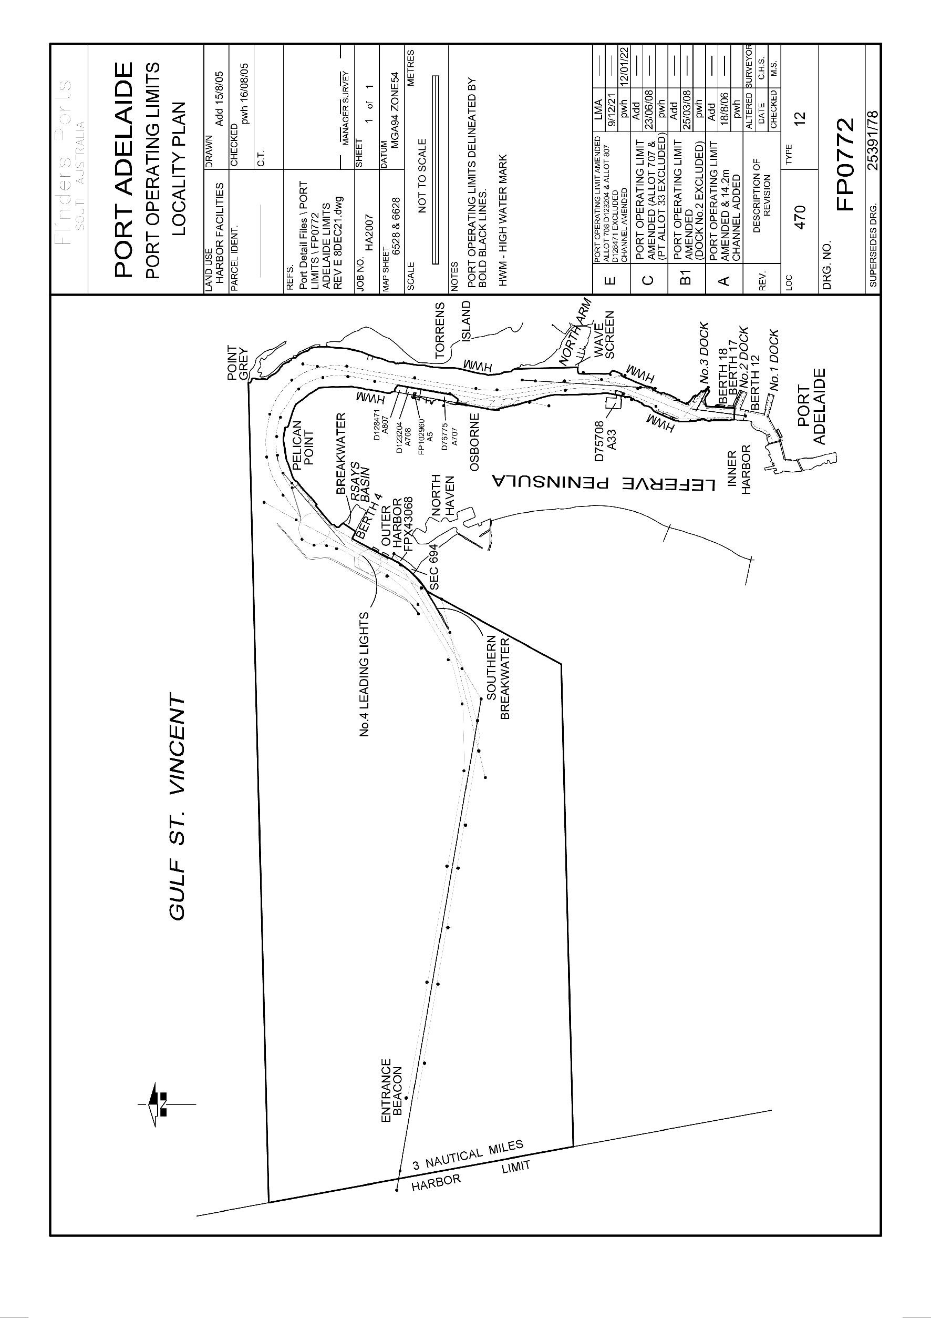
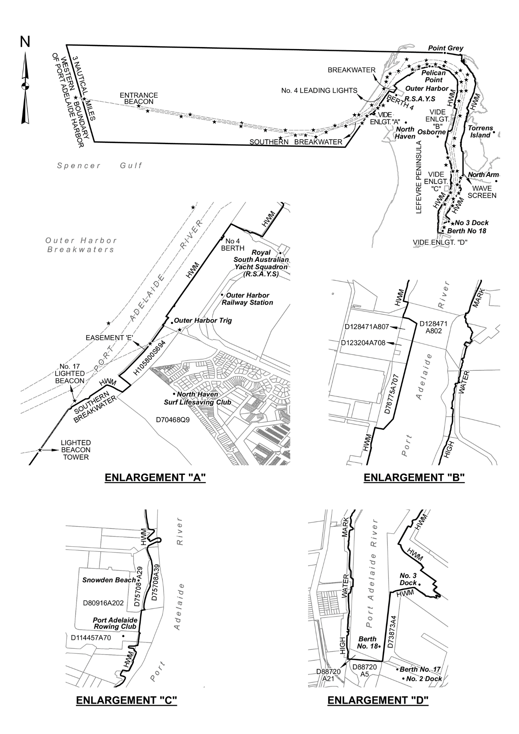
(3) On and after the designated day—the subjacent land underlying, and adjacent land extending from, the waters, rivers, creeks and inlets to the High Water Mark bounded as follows:
• commencing at Point Grey then due west along a line to its intersection with the western boundary of the harbor of Port Adelaide;
• then generally south-south-easterly along the harbor boundary for 3 nautical miles;
• then along a line due east to its intersection with the south-westerly production of the Number 4 Leading Lights;
• then generally north-easterly along the production to its intersection with the High Water Mark on the southern face of the southern breakwater;
• then generally north-easterly along the High Water Mark to its intersection with the south-western boundary of Section 694 Hundred of Port Adelaide;
• then generally north-westerly along that boundary of Section 694 Hundred of Port Adelaide to its intersection with the south-eastern boundary of easement E on FPX 43068;
• then generally north-easterly along that boundary of easement E on FPX 43068 to its intersection with the north-western boundary of Section 694 Hundred of Port Adelaide;
• then generally north-westerly along that boundary of Section 694 Hundred of Port Adelaide across the southern breakwater to its intersection with the High Water Mark on the northern face of the southern breakwater;
• then generally north-easterly along the High Water Mark to the northern extremity of Number 4 berth;
• then generally south-easterly along the High Water Mark to its intersection with the production southerly of the High Water Mark on the western face of the breakwater at the Royal South Australian Yacht Squadron (RSAYS);
• then generally north-easterly along the production across the RSAYS basin;
• then generally north-westerly and north-easterly along the High Water Mark to Pelican Point;
• then generally south-easterly along the High Water Mark to its intersection with the northern boundary of Allotment 40 in DP 133651;
• then generally south-easterly and southerly along the northern and eastern boundaries of Allotment 40 in DP 133651 and westerly along the southern boundary of Allotment 40 in DP 133651 to its intersection with the eastern boundary of Allotment 9 in D28523;
• then generally southerly along the eastern boundary of Allotment 9 in D28523 and westerly along the southern boundary of Allotment 9 in D28523 and its production to its intersection with the High Water Mark;
• then generally southerly along the High Water Mark to its intersection with the northern boundary of Allotment 807 in DP 128471;
• then generally easterly and southerly along the northern and eastern boundaries of Allotment 807 in DP 128471;
• then generally southerly along the eastern boundaries of Allotment 708 in DP 123204 and Allotment 707 in DP 76775 and westerly along the southern boundary of Allotment 707 in DP 76775 to its intersection with the High Water Mark;
• then generally southerly along the High Water Mark to the south-eastern corner of Allotment 29 in DP 75708;
• then generally southerly along a straight line connecting that corner of Allotment 29 in DP 75708 to the north-eastern corner of Allotment 70 in DP 114457;
• then generally south-westerly and southerly along the High Water Mark to its intersection with a line across the Port Adelaide River perpendicular to the western boundary of Allotment 4 in DP 73873 (face of Number 18 berth) and connecting the western side of the Port Adelaide River with the south-western corner of Allotment 4 in DP 73873;
• then generally easterly along that perpendicular line across the Port Adelaide River to its intersection with the High Water Mark;
• then generally northerly and north-easterly along the High Water Mark, including Number 3 dock, to its intersection with the Wave Screen in North Arm;
• then generally northerly along the western face of the Wave Screen and its northerly production to intersect with the High Water Mark on Torrens Island;
• then generally northerly along the High Water Mark to the point of commencement at Point Grey.
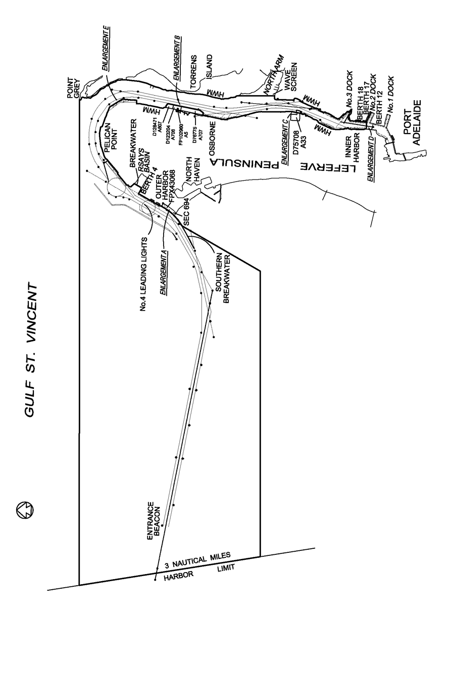
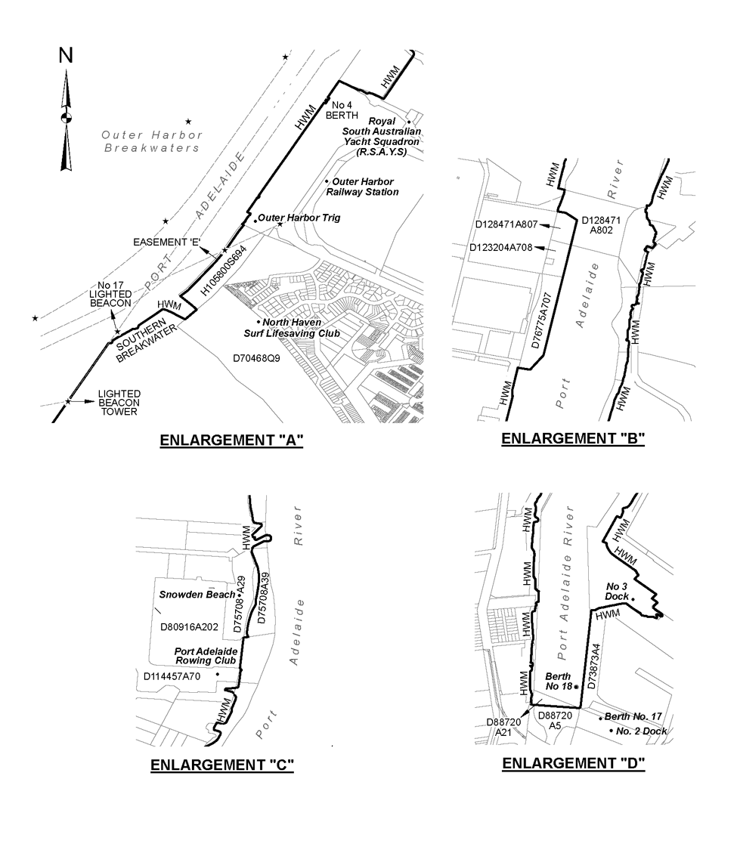
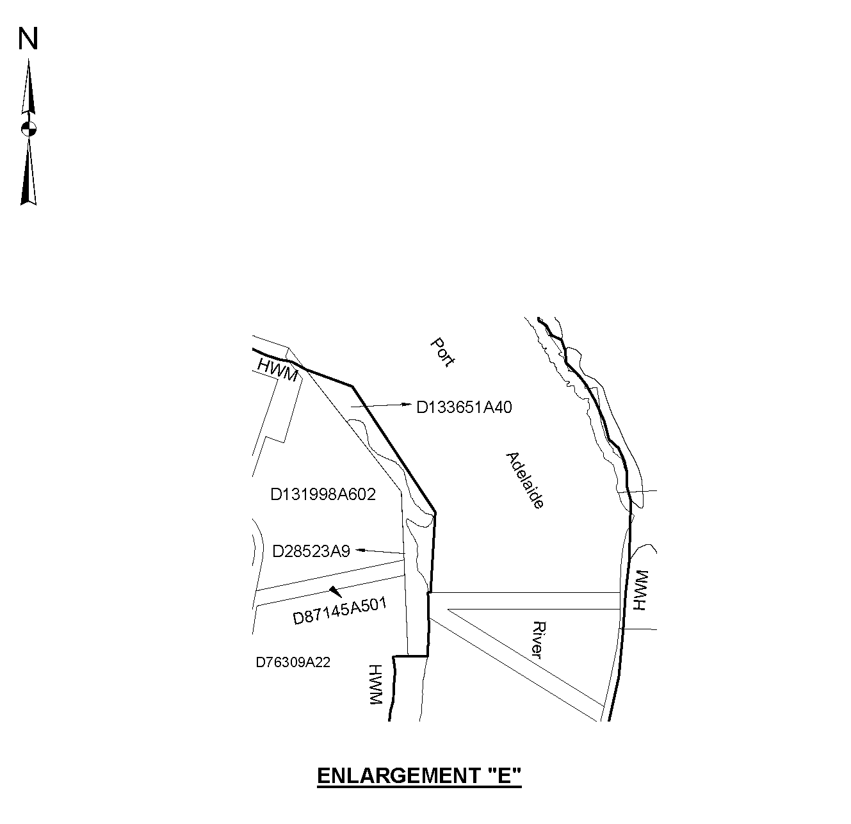
Editorial note—
As required by section 10AA(2) of the Legislative Instruments Act 1978, the Minister has certified that, in the Minister's opinion, it is necessary or appropriate that these regulations come into operation as set out in these regulations.
Made by the Governor
with the advice and consent of the Executive Council
on 28 March 2024
No 17 of 2024

State Government Instruments

Associations Incorporation Act 1985
Section 43A
Deregistration of Associations
NOTICE is hereby given that the Corporate Affairs Commission approves the applications for deregistration received from the associations named below pursuant to section 43A of the Associations Incorporation Act 1985 (SA). Deregistration takes effect on the date of publication of this notice.
ADELAIDE LUTHERAN FOOTBALL CLUB INCORPORATED [A6919]
PORT KENNY PUBLIC HALL INCORPORATED [A3225]
LADIES' PROBUS CLUB OF GLENELG INCORPORATED [A11392]
BRIGHTON HISTORICAL SOCIETY INCORPORATED [A11972]
DRUK INTERNATIONAL SHITO-RYU KARATE DO ASSOCIATION - AUSTRALIA INCORPORATED [A44032]
SERBIAN COMMUNITY RADIO PROGRAM INCORPORATED [A38688]
TENNISRAY TENNIS CLUB INCORPORATED [A43583]
THE NORWOOD COMMUNITY CLUB INCORPORATED [A139]
WESTERN NETWORKING INCORPORATED [A43193]
AUSTRALIAN METEOROLOGICAL ASSOCIATION INCORPORATED [A5207]
Given under the seal of the Commission at Adelaide this 25th day of March 2024.
Lisa Berry
Team Leader, Lotteries & Associations
A delegate of the Corporate Affairs Commission

Associations Incorporation Act 1985
Order Pursuant to Section 42(2)
Dissolution of Association
WHEREAS the CORPORATE AFFAIRS COMMISSION (the Commission) pursuant to section 42(1) of the Associations Incorporation Act 1985 (the Act) is of the opinion that the undertaking or operations of THE HUMAN GENETICS SOCIETY OF AUSTRALASIA INCORPORATED (the Association) being an incorporated association under the Act are being carried on, or would more appropriately be carried on by a Company Limited by Guarantee incorporated under the Corporations Act 2001 (Cth) AND WHEREAS the Commission was on 11 OCTOBER 2023 requested by the Association to transfer its undertaking to THE HUMAN GENETICS SOCIETY OF AUSTRALASIA LIMITED (Australian Company Number 675 684 616), the Commission pursuant to section 42(2) of the Act DOES HEREBY ORDER that on 28 MARCH 2024 the Association will be dissolved, the property of the Association becomes the property of THE HUMAN GENETICS SOCIETY OF AUSTRALASIA LIMITED and the rights and liabilities of the Association become the rights and liabilities of THE HUMAN GENETICS SOCIETY OF AUSTRALASIA LIMITED.
Given under the seal of the Commission at Adelaide this 25th day of March 2024.
Lisa Berry
A delegate of the Corporate Affairs Commission

Casino Act 1997
Section 3(1)
Re-definition of Gaming Area
TAKE notice that pursuant to Section 3(1) of the Casino Act 1997 (the Act), the gaming area (being a gaming area or premium gaming area within the casino premises as defined by the Act) will be re-defined by the Liquor and Gambling Commissioner.
The following plans indicate such parts of the casino premises (previously defined by her Excellency the Governor in Executive Council and depicted by a purple line for information purposes only) which are to be regarded as being a gaming area (defined and depicted by a green line), including those parts which are to be regarded as being a premium gaming area that are set aside for premium customers and are only accessible in accordance with Clause 8.7 of the Approved Licensing Agreement (defined and depicted by a yellow line).
This notice takes effect on 4 April 2024. This notice supersedes any previous notices published to define or re-define a gaming area or a premium gaming area within the casino premises.
Dated: 28 March 2024
Fraser Stroud
A/Liquor and Gambling Commissioner

Plan A – Adelaide Casino – Approved Gaming Area – Level 1
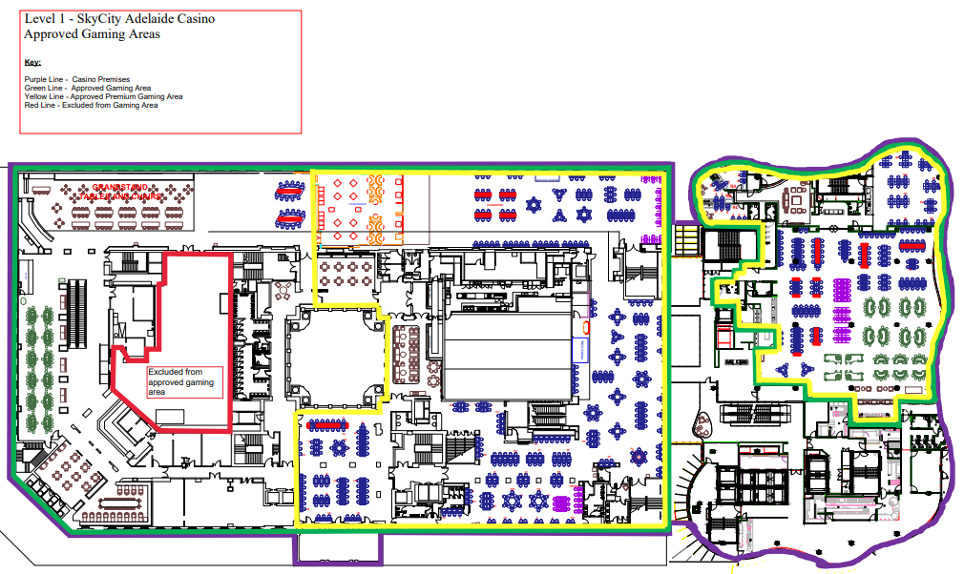

Plan B – Adelaide Casino – Approved Gaming Area – Level 9
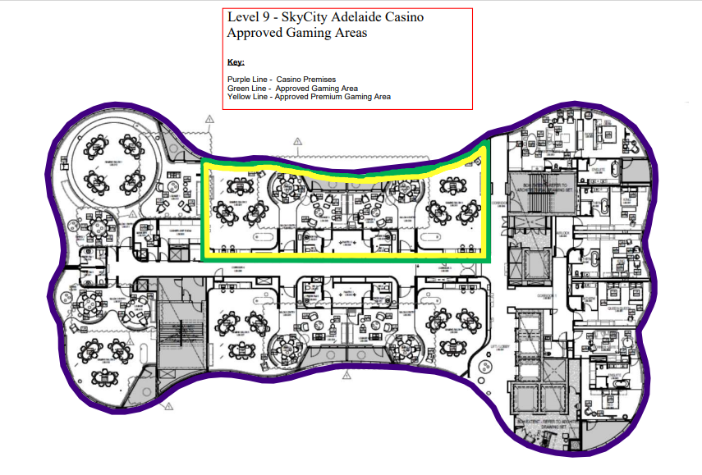

Education and Children’s Services Regulations 2020
Notice of Policy by the Minister for Education, Training and Skills
PURSUANT to Regulation 12(1) of the Education and Children’s Services Regulations 2020, I, the Minister for Education, Training and Skills publish the following Capacity Management Plan for the purposes of the enrolment of a child at Felixstow Primary School:
CAPACITY MANAGEMENT PLAN
Felixstow Primary School
This Capacity Management Plan sets out the conditions for enrolment at Felixstow Primary School (“the school”).
Felixstow Primary School zone
A school zone is a defined area from which the school accepts its core intake of students. Felixstow Primary School operates a school zone within the area bounded by:
The River Torrens, Riverside Drive, Langman Grove, Cardigan Avenue, Payneham Road, Glynburn Road, Allen Avenue, Scott Street, Davis Road, Almond Avenue, Castres Street, Barnes Road, Castres Street, Avenue Road, Rosella Street, Portrush Road, Payneham Road and O G Road.
An online map of the Felixstow Primary School zone and a search tool to indicate if an applicant’s home address is within the school zone is available at www.education.sa.gov.au/findaschool.
Student Enrolment Numbers
The number of students entering at reception in any given year is limited to 21 students.
International Education Program
If the total number of enrolments is under the school’s student enrolment ceiling, consideration can be given to offering international students enrolment at the school in the International Education Program.
The maximum number of students who can be offered enrolment at the school in the International Education Program in those circumstances is limited to 10 students across years Reception to year 6.
Enrolment Criteria - By Year Level
YEAR LEVEL: RECEPTION
Applications for enrolment from parents of prospective reception students must be eligible to start school in the following school year, as determined by the department’s school and preschool enrolment policy and apply for enrolment through the school’s registration of interest process for the coming school year:
The applicant must meet one of the following requirements to be eligible for a reception enrolment through the registration of interest process for the coming school year:
- the child is living in the Felixstow Primary School zone
- the child identifies as Aboriginal and/or Torres Strait Islander through the Enter for Success strategy.
- the child has been granted enrolment due to special or extenuating circumstances, including but not limited to a child in care where there is a custody or guardianship order made under the Children and Young People (Safety) Act 2017.
Application for reception from prospective students living in the school zone
Priority consideration will be given to applications for enrolment from parents of prospective reception students to attend the beginning of following school year (term 1) and mid-year of the same year (term 3), if they have been living inside the school zone prior to the end of week 10, term 2 and whose application is received by this date.
If more than 21 applications for enrolment are received from parents living in the primary campus school zone, a priority order may be applied to applications and places will be offered based on whether any, all or a combination of the following applies:
- the child has a sibling currently enrolled and will be attending the school in the same calendar year
- the distance of the child’s residence from the school the length of time the child has lived in the school zone
- other personal needs such as, transportation/location convenience, social/family links at the school.
For applications for enrolment for the beginning of the following school year (term 1), the school will notify parents of the outcome of this process from week 2, term 3. For applications for enrolment to start mid-year of the following school year (term 3), the school will notify parents of the outcome of this process from week 4, term 1 of the same school year.
Applicants not allocated to Felixstow Primary School will be placed on the enrolment register and the school will support the family to find an enrolment at a neighbouring school.
Enter for Success Strategy reception students
Through nominating Felixstow Primary School via the Enter for Success strategy, a child who identifies as Aboriginal and/ or Torres Strait Islander will automatically be offered a place at the school for the following year. Families can lodge their application for Reception up to the end of term 4 to start at the beginning of the following school year (term 1), or up to the end of term 2 to commence mid-year of the same school year (term 3).
Late applications for reception from prospective students living in the school zone
Families who move into the primary campus school zone or who are already living in the primary campus school zone but lodge their application for enrolment after the end of week 10, term 2 will only have their applications considered if vacancies exist.
If no vacancies exist, the applicants upon request, will be placed on the school’s enrolment register and the school will support the family to find an enrolment at a neighbouring school.
Intensive English Language Centre (IELC) Reception students
Any Reception student offered enrolment at the school and who is eligible to attend an Intensive English Language Centre (IELC), will be able to attend an IELC for the agreed period and return to the school upon exit from the program.

YEAR LEVELS: 1 TO 6
Applications for enrolment from parents of prospective students living inside the school zone will be considered if vacancies exist.
If no vacancies exist, the applicant will be encouraged to remain at their current primary school, or the school will support the family to find an enrolment at a neighbouring school, and upon an applicant’s request placed on the school’s enrolment register.
The school will notify parents of an applicant on the enrolment register by the end of week 5, term 4 if a vacancy is available for their child to attend the following school year.
If there are more applicants on the enrolment register than places are available, places will be offered based on the child identifying as Aboriginal and/or Torres Strait Islander, has siblings at the school, the distance of the child’s residence from the school, the length of time the child has lived in the school zone, and other personal needs such as transportation/location convenience and social/family links to the school.
Out of zone applications with siblings currently at the school
There is no automatic entry for siblings who live outside of the school zone to enrol in reception to year 6 at the school.
Enrolment Criteria – General
Special circumstances
Enrolment applications for special consideration based on compelling or unusual reasons, including but not limited to a child in care where there is custody or guardianship orders made under the Children and Young People (Safety) Act 2017, may be granted by the Principal in consultation with the Education Director. These applications will be assessed on a case-by-case basis.
Enrolment Process
Enrolment Register
Parents whose child’s name has been placed on the enrolment register will be contacted by the school by the end of week 5, Term 4 if a vacancy is available for the following school year.
The enrolment register will be reviewed and updated annually by the school.
The position that a child’s name appears on the register is confidential and will only be disclosed as required by law.
Monitoring and enforcement
It is the responsibility of the parents applying for enrolment to be able to verify to the satisfaction of the school that the information provided is true and factual.
If a child was enrolled at the school on the basis of false or misleading information (including residential address) the Chief Executive may direct that the child be instead enrolled at another Government school pursuant to section 63(1) of the Education and Children’s Services Act 2019.
The Principal is responsible for the implementation of this Capacity Management Plan.
This Capacity Management Plan will be reviewed as required.
Dated: 15 March 2024
Hon Blair Boyer MP
Minister for Education, Training and Skills

Education and Children’s Services Regulations 2020
Notice of Revocation of Policy by the Minister for Education, Training and Skills
PURSUANT to Regulation 12(3) of the Education and Children’s Services Regulations 2020, I, the Minister for Education, Training and Skills revoke the Felixstow Primary School Capacity Management Plan, published in the Gazette on 31 August 2023, effective 29 April 2024.
Dated: 15 March 2024
Hon Blair Boyer MP
Minister for Education, Training and Skills

Education and Children’s Services Regulations 2020
Notice of Policy by the Minister for Education, Training and Skills
PURSUANT to Regulation 12(1) of the Education and Children’s Services Regulations 2020, I, the Minister for Education, Training and Skills publish the following Capacity Management Plan for the purposes of the enrolment of a child at Linden Park Primary School:
CAPACITY MANAGEMENT PLAN
Linden Park Primary School
This Capacity Management Plan sets out the conditions for enrolment at Linden Park Primary School (“the school”).
Linden Park Primary School zone
A school zone is a defined area from which the school accepts its core intake of students. Linden Park Primary School operates a school zone within the area bounded by:
Fullarton Road, east along Greenhill Road, north along Portrush Road, east along Stafford Grove, Alnwick Terrace, Wooler Street, cross over Tusmore Avenue, east along Statenborough Street, south along Glynburn Road, east along Dashwood Road, southeast along Bayview Crescent, then west along Sherwood Terrace, south along Hayward Drive, west along Seaview Drive and then Gill Terrace to old Toll Gate at start of South Eastern Freeway, then back down Glen Osmond Road to Fullarton Road, then north back to Greenhill Road.
An online map of the Linden Park Primary School zone and a search tool to indicate if an applicant’s home address is within the school zone is available at www.education.sa.gov.au/findaschool.
Student Enrolment Numbers
The number of students entering at reception in any given year is limited to 156 students.
International Education Program
No International Education Program places will be offered at the school.
Enrolment Criteria - By Year Level
YEAR LEVEL: RECEPTION
Applications for enrolment from parents of prospective reception students must be eligible to start school in the following school year, as determined by the department’s school and preschool enrolment policy and apply for enrolment through the school’s registration of interest process for the coming school year:
The applicant must meet one of the following requirements to be eligible for a reception enrolment through the registration of interest process for the coming school year:
- the child is living in the Linden Park Primary School zone
- the child identifies as Aboriginal and/or Torres Strait Islander through the Enter for Success strategy.
- the child has been granted enrolment due to special or extenuating circumstances, including but not limited to a child in care where there is a custody or guardianship order made under the Children and Young People (Safety) Act 2017.
Application for reception from prospective students living in the school zone
Priority consideration will be given to applications for enrolment from parents of prospective reception students to attend the beginning of following school year (term 1) and mid-year of the same year (term 3), if they have been living inside the school zone prior to the end of week 10, term 2 and whose application is received by this date.
If more than 156 applications for enrolment are received from parents living in the primary campus school zone, a priority order may be applied to applications and places will be offered based on whether any, all or a combination of the following applies:
- the child has a sibling currently enrolled and will be attending the school in the same calendar year
- the distance of the child’s residence from the school
- the length of time the child has lived in the school zone
- other personal needs such as, transportation/location convenience, social/family links at the school.
For applications for enrolment for the beginning of the following school year (term 1), the school will notify parents of the outcome of this process from week 2, term 3. For applications for enrolment to start mid-year of the following school year (term 3), the school will notify parents of the outcome of this process from week 4, term 1 of the same school year.
Applicants not allocated to Linden Park Primary School will be placed on the enrolment register and the school will support the family to find an enrolment at a neighbouring school.
Enter for Success Strategy reception students
Through nominating Linden Park Primary School via the Enter for Success strategy, a child who identifies as Aboriginal and/ or Torres Strait Islander will be automatically offered a place at the school for the following year. Families can lodge their application for reception up to the end of term 4 to start at the beginning of the following school year (term 1), or up to the end of term 2 to commence mid-year of the same school year (term 3).
Late applications for reception from prospective students living in the school zone
Families who move into the primary campus school zone or who are already living in the primary campus school zone but lodge their application for enrolment after the end of week 10, term 2 will only have their applications considered if vacancies exist.
If no vacancies exist, the applicants upon request, will be placed on the school’s enrolment register and the school will support the family to find an enrolment at a neighbouring school.
Intensive English Language Centre (IELC) reception students
Any reception student offered enrolment at the school and who is eligible to attend an Intensive English Language Centre (IELC), will be able to attend an IELC for the agreed period and return to the school upon exit from the program.
YEAR LEVELS: 1 TO 6
Applications for enrolment from parents of prospective students living inside the school zone will be considered if vacancies exist.
If no vacancies exist, the applicants will be encouraged to remain at their current primary school, or the school will support them to enrol at a neighbouring school, and upon an applicant’s request placed on the school’s enrolment register.
The school will notify parents by the end of week 5, term 4 if a vacancy is available for their child to attend the following school year.
If there are more applicants on the enrolment register than places are available, places will be offered based on the child identifying as Aboriginal and/or Torres Strait Islander, has siblings at the school, the distance of the child’s residence from the school the length of time the child has lived in the school zone and other personal needs such as, transportation/location convenience and social/family links at the school.
Out of zone applications with siblings currently at the school
There is no automatic entry for siblings who live outside of the school zone to enrol in reception to year 6 at the school.
Enrolment Criteria – General
Special circumstances
Enrolment applications for special consideration based on compelling or unusual reasons, including but not limited to a child in care where there is custody or guardianship orders made under the Children and Young People (Safety) Act 2017, may be granted by the Principal in consultation with the Education Director. These applications will be assessed on a case-by-case basis.
Enrolment Process
Enrolment Register
Parents whose child’s name has been placed on the enrolment register will be contacted by the school by the beginning of week 5, Term 4 if a vacancy is available for the following school year.
The enrolment register will be reviewed and updated annually by the school.
The position that a child’s name appears on the register is confidential and will only be disclosed as required by law.
Monitoring and enforcement
It is the responsibility of the parents applying for enrolment to be able to verify to the satisfaction of the school that the information provided is true and factual.
If a child was enrolled at the school on the basis of false or misleading information (including residential address) the Chief Executive may direct that the child be instead enrolled at another Government school pursuant to section 63(1) of the Education and Children’s Services Act 2019.
The Principal is responsible for the implementation of this Capacity Management Plan.
This Capacity Management Plan will be reviewed as required.
Dated: 15 March 2024
Hon Blair Boyer MP
Minister for Education, Training and Skills

Education and Children’s Services Regulations 2020
Notice of Revocation of Policy by the Minister for Education, Training and Skills
PURSUANT to Regulation 12(3) of the Education and Children’s Services Regulations 2020, I, the Minister for Education, Training and Skills revoke the Linden Park Primary School Capacity Management Plan, published in the Gazette on 31 August 2023, effective 29 April 2024.
Dated: 15 March 2024
Hon Blair Boyer MP
Minister for Education, Training and Skills

Education and Children’s Services Regulations 2020
Notice of Policy by the Minister for Education, Training and Skills
PURSUANT to Regulation 12(1) of the Education and Children’s Services Regulations 2020, I, the Minister for Education, Training and Skills publish the following Capacity Management Plan for the purposes of the enrolment of a child at Magill School:
CAPACITY MANAGEMENT PLAN
Magill School
This Capacity Management Plan sets out the conditions for enrolment at Magill School (“the school”).
Magill School zone
A school zone is a defined area from which the school accepts its core intake of students. Magill School operates a school zone within the area bounded by:
The western boundary of the Hills Face zone, the southern boundary of Rosslyn Park, Kensington Road, Glynburn Road, Arthur Street, St Bernards Road, Moules Road, Glen Stuart Road and Kintyre Road
An online map of the Magill School zone and a search tool to indicate if an applicant’s home address is within the school zone is available at www.education.sa.gov.au/findaschool.
Student Enrolment Numbers
The number of students entering at reception in any given year is limited to 144 students.
International Education Program
No International Education Program places will be offered at the school.
Enrolment Criteria - By Year Level
YEAR LEVEL: RECEPTION
Applications for enrolment from parents of prospective reception students must be eligible to start school in the following school year, as determined by the department’s school and preschool enrolment policy and apply for enrolment through the school’s registration of interest process for the coming school year:
The applicant must meet one of the following requirements to be eligible for a reception enrolment through the registration of interest process for the coming school year:
- the child is living in the Magill Primary School zone
- the child identifies as Aboriginal and/or Torres Strait Islander through the Enter for Success strategy.
- the child has been granted enrolment due to special or extenuating circumstances, including but not limited to a child in care where there is a custody or guardianship order made under the Children and Young People (Safety) Act 2017.
Application for reception from prospective students living in the school zone
Priority consideration will be given to applications for enrolment from parents of prospective reception students to attend the beginning of following school year (term 1) and mid-year of the same year (term 3), if they have been living inside the school zone prior to the end of week 10, term 2 and whose application is received by this date.
If more than 144 applications for enrolment are received from parents living in the primary campus school zone, a priority order may be applied to applications and places will be offered based on whether any, all or a combination of the following applies:
- the child has a sibling currently enrolled and will be attending the school in the same calendar year
- the distance of the child’s residence from the school the length of time the child has lived in the school zone
- other personal needs such as transportation/location convenience, social/family links at the school.
For applications for enrolment for the beginning of the following school year (term 1), the school will notify parents of the outcome of this process from week 2, term 3. For applications for enrolment to start mid-year of the following school year (term 3), the school will notify parents of the outcome of this process from week 4, term 1 of the same school year.
Applicants not allocated to Magill Primary School will be placed on the enrolment register and the school will support the family to find an enrolment at a neighbouring school.

Enter for Success Strategy reception students
Through nominating Magill Primary School via the Enter for Success strategy a child who identifies as Aboriginal and/or Torres Strait Islander will automatically be offered a place at the school for the following year. Families can lodge their application for reception up to the end of term 4 to start at the beginning of the following school year (term 1), or up to the end of term 2 to commence mid-year of the same school year (term 3).
Late applications for reception from prospective students living in the school zone
Families who move into the primary campus school zone or who are already living in the primary campus school zone but lodge their application for enrolment after the end of week 10, term 2 will only have their applications considered if vacancies exist.
If no vacancies exist, the applicant upon request, will be placed on the school’s enrolment register and the school will support the family to find an enrolment at a neighbouring school.
Intensive English Language Centre (IELC) Reception students
Any Reception student offered enrolment at the school and who is eligible to attend an Intensive English Language Centre (IELC), will be able to attend an IELC for the agreed period and return to the school upon exit from the program.
YEAR LEVELS: 1 TO 6
Applications for enrolment from parents of prospective students living inside the school zone will be considered if vacancies exist.
If no vacancies exist, the applicants will be encouraged to remain at their current primary school, or the school will support them to find an enrolment at a neighbouring school, and upon an applicant’s request placed on the school’s enrolment register.
The school will notify parents of an applicant on the enrolment register by the end of week 5, term 4 if a vacancy is available for their child to attend the following school year.
If there are more applicants on the enrolment register than places are available, places will be offered based on the child identifying as Aboriginal and/or Torres Strait Islander, has siblings at the school, the distance of the child’s residence from the school, the length of time the child has lived in the school zone and other personal needs such as transportation/location convenience and social/family links to the school.
Out of zone applications with siblings currently at the school
There is no automatic entry for siblings who live outside of the school zone to enrol in reception to year 6 at the school.
Enrolment Criteria – General
Special circumstances
Enrolment applications for special consideration based on compelling or unusual reasons, including but not limited to a child in care where there is custody or guardianship orders made under the Children and Young People (Safety) Act 2017, may be granted by the Principal in consultation with the Education Director. These applications will be assessed on a case-by-case basis.
Enrolment Process
Enrolment Register
Parents whose child’s name has been placed on the enrolment register will be contacted by the school by the end of week 5, term 4 if a vacancy is available for the following school year.
The enrolment register will be reviewed and updated annually by the school.
The position that a child’s name appears on the register is confidential and will only be disclosed as required by law.
Monitoring and enforcement
It is the responsibility of the parents applying for enrolment to be able to verify to the satisfaction of the school that the information provided is true and factual.
If a child was enrolled at the school on the basis of false or misleading information (including residential address) the Chief Executive may direct that the child be instead enrolled at another Government school pursuant to section 63(1) of the Education and Children’s Services Act 2019.
The Principal is responsible for the implementation of this Capacity Management Plan.
This Capacity Management Plan will be reviewed as required.
Dated: 15 March 2024
Hon Blair Boyer MP
Minister for Education, Training and Skills

Education and Children’s Services Regulations 2020
Notice of Revocation of Policy by the Minister for Education, Training and Skills
PURSUANT to Regulation 12(3) of the Education and Children’s Services Regulations 2020, I, the Minister for Education, Training and Skills revoke the Magill School Capacity Management Plan, published in the Gazette on 31 August 2023, effective 29 April 2024.
Dated: 15 March 2024
Hon Blair Boyer MP
Minister for Education, Training and Skills

Education and Children’s Services Regulations 2020
Notice of Policy by the Minister for Education, Training and Skills
PURSUANT to Regulation 12(1) of the Education and Children’s Services Regulations 2020, I, the Minister for Education, Training and Skills publish the following Capacity Management Plan for the purposes of the enrolment of a child at Mawson Lakes School:
CAPACITY MANAGEMENT PLAN
Mawson Lakes School
This Capacity Management Plan sets out the conditions for enrolment at Mawson Lakes School (“the school”).
Mawson Lakes School zone
A school zone is a defined area from which the school accepts its core intake of students. Mawson Lakes School operates a school zone within the suburb boundary of Mawson Lakes.
An online map of the Mawson Lakes School zone and a search tool to indicate if an applicant’s home address is within the school zone is available at www.education.sa.gov.au/findaschool.
Student Enrolment Numbers
The number of students entering at reception in any given year is limited to 156 students.
International Education Program
No International Education Program places will be offered at the school.
Enrolment Criteria - By Year Level
YEAR LEVEL: RECEPTION
Applications for enrolment from parents of prospective reception students must be eligible to start school in the following school year, as determined by the department’s school and preschool enrolment policy and apply for enrolment through the school’s registration of interest process for the coming school year:
The applicant must meet one of the following requirements to be eligible for a reception enrolment through the registration of interest process for the coming school year:
- the child is living in the Mawson Lakes School zone
- the child identifies as Aboriginal and/or Torres Strait Islander through the Enter for Success strategy.
- the child has been granted enrolment due to special or extenuating circumstances, including but not limited to a child in care where there is a custody or guardianship order made under the Children and Young People (Safety) Act 2017.
Application for reception from prospective students living in the school zone
Priority consideration will be given to applications for enrolment from parents of prospective reception students to attend the beginning of following school year (term 1) and mid-year of the same year (term 3), if they have been living inside the school zone prior to the end of week 10, term 2 and whose application is received by this date.
If more than 156 applications for enrolment are received from parents living in the primary campus school zone, a priority order may be applied to applications and places will be offered based on whether any, all or a combination of the following applies:
- the child has a sibling currently enrolled at the school and will be attending the school in the same calendar year,
- the distance of the child’s residence from the school
- the length of time the child has lived in the school zone
- the child’s family has been relocated to the school zone by the defence force;
- other personal needs such as transportation/location convenience, social/family links at the school.
For applications for enrolment for the beginning of the following school year (term 1), the school will notify parents of the outcome of this process from week 2, term 3. For applications for enrolment to start mid-year of the following school year (term 3), the school will notify parents of the outcome of this process from week 4, term 1 of the same school year.
Applicants not allocated to Mawson Lakes School will be placed on the enrolment register and the school will support the family to find an enrolment at a neighbouring school.
Enter for Success Strategy reception students
Through nominating Mawson Lakes School via the Enter for Success strategy a child who identifies as Aboriginal and/or Torres Strait Islander will automatically be offered a place at the school for the following year. Families can lodge their application for reception up to the end of term 4 to start at the beginning of the following school year (term 1), or up to the end of term 2 to commence mid-year of the same school year (term 3).
Late applications for reception from prospective students living in the school zone
Families who move into the primary campus school zone or who are already living in the primary campus school zone but lodge their application for enrolment after the end of week 10, term 2 will only have their applications considered if vacancies exist.
If no vacancies exist, the applicant upon request, will be placed on the school’s enrolment register and the school will support the family to find an enrolment at a neighbouring school.
Intensive English Language Centre (IELC) reception students
Any reception student offered enrolment at the school and who is eligible to attend an Intensive English Language Centre (IELC), will be able to attend an IELC for the agreed period and return to the school upon exit from the program.
YEAR LEVELS: 1 TO 6
Applications for enrolment from parents of prospective students living inside the school zone will be considered if vacancies exist.
If no vacancies exist, the applicant will be encouraged to remain at their current primary school, or the school will support them to find an enrolment at a neighbouring school, and upon an applicant’s request placed on the school’s enrolment register.
The school will notify parents of an applicant on the enrolment register by the end of week 5, term 4 if a vacancy is available for their child to attend the following school year.
If there are more applicants on the enrolment register than places are available, places will be offered based on the child identifying as Aboriginal and/or Torres Strait Islander, has siblings at the school, the distance of the child’s residence from the school the length of time the child has lived in the school zone and other personal needs such as, transportation/location convenience and social/family links at the school.
Out of zone applications with siblings currently at the school
There is no automatic entry for siblings who live outside of the school zone to enrol in reception to year 6 at the school.
Enrolment Criteria – General
Special circumstances
Enrolment applications for special consideration based on compelling or unusual reasons, including but not limited to a child in care where there is custody or guardianship orders made under the Children and Young People (Safety) Act 2017, may be granted by the Principal in consultation with the Education Director. These applications will be assessed on a case-by-case basis.
Enrolment Process
Enrolment Register
Parents whose child’s name has been placed on the enrolment register will be contacted by the school by the beginning of week 5, term 4 if a vacancy is available for the following school year.
The enrolment register will be reviewed and updated annually by the school.
The position that a child’s name appears on the register is confidential and will only be disclosed as required by law.
Monitoring and enforcement
It is the responsibility of the parents applying for enrolment to be able to verify to the satisfaction of the school that the information provided is true and factual.
If a child was enrolled at the school on the basis of false or misleading information (including residential address) the Chief Executive may direct that the child be instead enrolled at another Government school pursuant to section 63(1) of the Education and Children’s Services Act 2019.
The Principal is responsible for the implementation of this Capacity Management Plan.
This Capacity Management Plan will be reviewed as required.
Dated: 15 March 2024
Hon Blair Boyer MP
Minister for Education, Training and Skills

Education and Children’s Services Regulations 2020
Notice of Revocation of Policy by the Minister for Education, Training and Skills
PURSUANT to Regulation 12(3) of the Education and Children’s Services Regulations 2020, I, the Minister for Education, Training and Skills revoke the Mawson Lakes School Capacity Management Plan, published in the Gazette on 31 August 2023, effective 29 April 2024.
Dated: 15 March 2024
Hon Blair Boyer MP
Minister for Education, Training and Skills

Education and Children’s Services Regulations 2020
Notice of Policy by the Minister for Education, Training and Skills
PURSUANT to Regulation 12(1) of the Education and Children’s Services Regulations 2020, I, the Minister for Education, Training and Skills publish the following Capacity Management Plan for the purposes of the enrolment of a child at North Adelaide Primary School:
CAPACITY MANAGEMENT PLAN
North Adelaide Primary School
This Capacity Management Plan sets out the conditions for enrolment at North Adelaide Primary School (“the school”).
North Adelaide Primary School zone
A school zone is a defined area from which the school accepts its core intake of students. North Adelaide Primary School operates a school zone within the area bounded by:
Clifton Street, Richman Avenue, Da Costa Avenue, Main North Road, Nottage Terrace, Northcote Terrace, Park Road, River Torrens and Gawler railway line.
An online map of the North Adelaide Primary School zone and a search tool to indicate if an applicant’s home address is within the school zone is available at www.education.sa.gov.au/findaschool.
Student Enrolment Numbers
The number of students entering at reception in any given year is limited to 50 students.
International Education Program
No International Education Program places will be offered at the school.
Enrolment Criteria - By Year Level
YEAR LEVEL: RECEPTION
Applications for enrolment from parents of prospective reception students must be eligible to start school in the following school year, as determined by the department’s school and preschool enrolment policy and apply for enrolment through the school’s registration of interest process for the coming school year:
The applicant must meet one of the following requirements to be eligible for a reception enrolment through the registration of interest process for the coming school year:
- the child is living in the North Adelaide Primary School zone
- the child identifies as Aboriginal and/or Torres Strait Islander through the Enter for Success strategy.
- the child has been granted enrolment due to special or extenuating circumstances, including but not limited to a child in care where there is a custody or guardianship order made under the Children and Young People (Safety) Act 2017.
Application for reception from prospective students living in the school zone
Priority consideration will be given to applications for enrolment from parents of prospective reception students to attend the beginning of following school year (term 1) and mid-year of the same year (term 3), if they have been living inside the school zone prior to the end of week 10, term 2 and whose application is received by this date.
If more than 50 applications for enrolment are received from parents living in the primary campus school zone, a priority order may be applied to applications and places will be offered based on whether any, all or a combination of the following applies:
- the child has siblings currently enrolled at the school and will be attending the school in the same calendar year
- the distance of the child’s residence from the school
- the length of time the child has lived in the school zone
- other personal needs such as transportation/location convenience, social/family links at the school.
For applications for enrolment for the beginning of the following school year (term 1), the school will notify parents of the outcome of this process from week 2, term 3. For applications for enrolment to start mid-year of the following school year (term 3), the school will notify parents of the outcome of this process from week 4, term 1 of the same school year.
Applicants not allocated to North Adelaide Primary School will be placed on the enrolment register and the school will support the family to find an enrolment at a neighbouring school.
Enter for Success Strategy reception students
Through nominating North Adelaide Primary School via the Enter for Success strategy a child who identifies as Aboriginal and/or Torres Strait Islander will automatically be offered a place at the school for the following year. Families can lodge their application for reception up to the end of term 4 to start at the beginning of the following school year (term 1), or up to the end of term 2 to commence mid-year of the same school year (term 3).
Late applications for reception from prospective students living in the school zone
Families who move into the primary campus school zone or who are already living in the primary campus school zone but lodge their application for enrolment after the end of week 10, term 2 will only have their applications considered if vacancies exist.
If no vacancies exist, the applicant upon request, will be placed on the school’s enrolment register and the school will support the family to find an enrolment at a neighbouring school.
Intensive English Language Centre (IELC) reception students
Any reception student offered enrolment at the school and who is eligible to attend an Intensive English Language Centre (IELC), will be able to attend an IELC for the agreed period and return to the school upon exit from the program.
]YEAR LEVELS: 1 TO 6
Applications for enrolment from parents of prospective students living inside the school zone will be considered if vacancies exist.
If no vacancies exist, the applicant will be encouraged to remain at their current primary school, or the school will support them to find an enrolment at a neighbouring school, and upon an applicant’s request placed on the school’s enrolment register.
The school will notify parents of an applicant on the enrolment register by the end of week 5, term 4 if a vacancy is available for their child to attend the following school year.
If there are more applicants on the enrolment register than places are available, places will be offered based on the child identifying as Aboriginal and/or Torres Strait Islander, has siblings at the school, the distance of the child’s residence from the school the length of time the child has lived in the school zone and other personal needs such as, transportation/location convenience and social/family links at the school.
Out of zone applications with siblings currently at the school
There is no automatic entry for siblings who live outside of the school zone to enrol in reception to year 6 at the school.
Enrolment Criteria – General
Special circumstances
Enrolment applications for special consideration based on compelling or unusual reasons, including but not limited to a child in care where there is custody or guardianship orders made under the Children and Young People (Safety) Act 2017, may be granted by the Principal in consultation with the Education Director. These applications will be assessed on a case-by-case basis.
Enrolment Process
Enrolment Register
Parents whose child’s name has been placed on the enrolment register will be contacted by the school by the beginning of week 5, term 4 if a vacancy is available for the following school year.
The enrolment register will be reviewed and updated annually by the school.
The position that a child’s name appears on the register is confidential and will only be disclosed as required by law.
Monitoring and enforcement
It is the responsibility of the parents applying for enrolment to be able to verify to the satisfaction of the school that the information provided is true and factual.
If a child was enrolled at the school on the basis of false or misleading information (including residential address) the Chief Executive may direct that the child be instead enrolled at another Government school pursuant to section 63(1) of the Education and Children’s Services Act 2019.
The Principal is responsible for the implementation of this Capacity Management Plan.
This Capacity Management Plan will be reviewed as required.
Dated: 15 March 2024
Hon Blair Boyer MP
Minister for Education, Training and Skills

Education and Children’s Services Regulations 2020
Notice of Revocation of Policy by the Minister for Education, Training and Skills
PURSUANT to Regulation 12(3) of the Education and Children’s Services Regulations 2020, I, the Minister for Education, Training and Skills revoke the North Adelaide Primary School Capacity Management Plan, published in the Gazette on 31 August 2023, effective 29 April 2024.
Dated: 15 March 2024
Hon Blair Boyer MP
Minister for Education, Training and Skills

EDUCATION AND CHILDREN’S SERVICES REGULATIONS 2020
Corrigendum
Notice of Policy by the Minister for Education, Training and Skills
In the South Australian Government Gazette No.19, dated 21 March 2024, regarding the notice Burnside Primary School on page 481, there was an error with the image and should be replaced with the following:
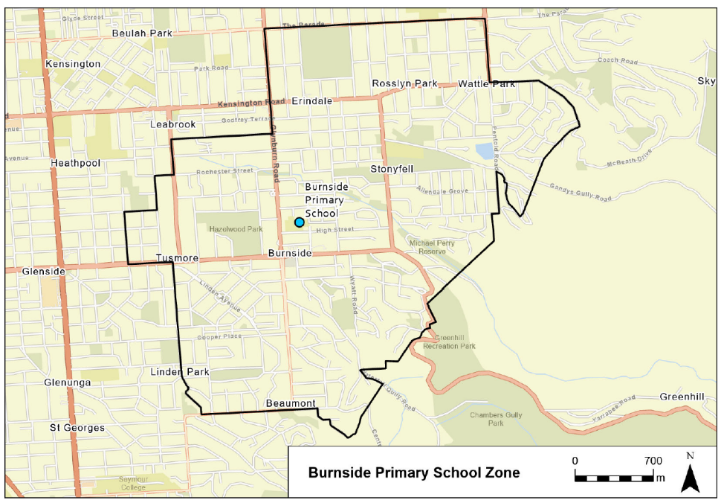

Environment Protection Act 1993
Prohibition on Taking Water affected by Site Contamination
I, REBECCA ANNE HUGHES, Manager Site Contamination and Delegate of the Environment Protection Authority (‘the Authority’), being satisfied that site contamination exists that affects or threatens groundwater and that action is necessary pursuant to section 103S of the Environment Protection Act 1993 to prevent actual or potential harm to human health or safety hereby prohibit the taking of groundwater (as defined below) within the area specified in the map to this notice, other than for environmental assessment or environmental monitoring purposes or as approved in writing by the Authority.
This Notice relates to groundwater in:
  - The watertable aquifer and any deeper water bearing zones hydraulically connected to the watertable aquifer, being the body of groundwater 0 to approximately 30 metres below ground surface within the specified area (see map)
The site contamination affecting the groundwater is in the form of petroleum hydrocarbons which represent actual or potential harm to human health or safety. This prohibition becomes official upon the gazettal of this notice.
Dated: 28 March 2024
R. Hughes
Manager Site Contamination
Environment Protection Authority

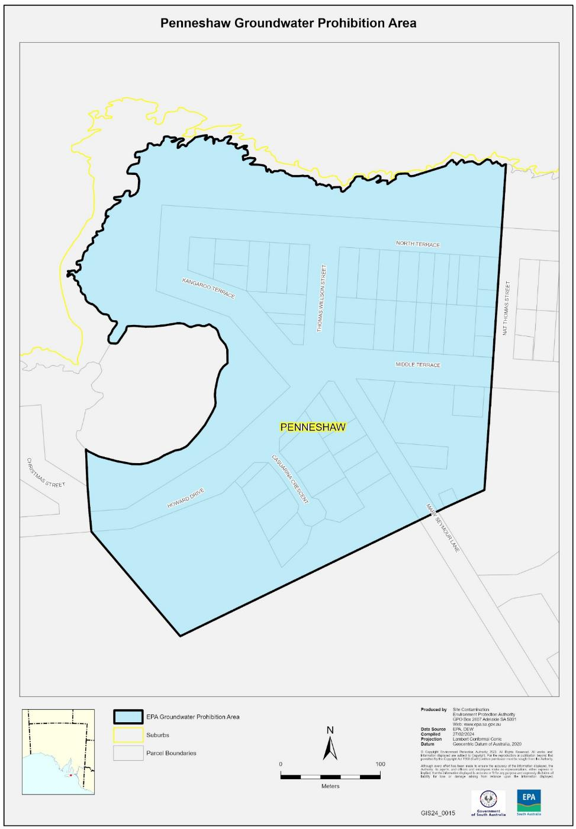

Fisheries MANAGEMENT (PRAWN FISHERIES) REGULATIONS 2017
April 2024 Fishing for the West Coast Prawn Fishery
TAKE notice that pursuant to regulation 10 of the Fisheries Management (Prawn Fisheries) Regulations 2017, the notice dated 22 September 2023 on page 3296 of the South Australian Government Gazette of 28 September 2023, prohibiting fishing activities in the West Coast Prawn Fishery is HEREBY varied such that it will not be unlawful for a person fishing pursuant to a West Coast Prawn Fishery licence to use prawn trawl nets in the areas specified in Schedule 1, during the period specified in Schedule 2, and under the conditions specified in Schedule 3.
Schedule 1
The waters of the West Coast Prawn Fishery excluding Ceduna as defined in the West Coast Prawn Fishery Harvest Strategy.
Schedule 2
Commencing at sunset on 4 April 2024 and ending at sunrise on 18 April 2024.
Schedule 3
- Each licence holder of a fishing licence undertaking fishing activities pursuant to this notice must ensure that a representative sample of catch (a 'bucket count') is taken at least 3 times per night during the fishing activity.
- Each 'bucket count' sample must be accurately weighed to 7kg where possible and the total number of prawns contained in the bucket must be recorded on the daily catch and effort return.
- Fishing must cease if one of the following limits is reached:
  - A total of 14 nights of fishing are completed.
  - The average catch per vessel, per night (for all 3 vessels) drops below 300 kg for two consecutive nights.
  - The average 'bucket count' for all vessels exceeds 240 prawns per 7kg bucket on any single fishing night in the Coffin Bay area.
  - The average 'bucket count' for all vessels exceeds 250 prawns per 7kg bucket on any single fishing night in the Venus Bay area.
  - The average 'bucket count' for all vessels exceeds 270 prawns per 7kg bucket on any single fishing night in the Corvisart Bay area.
  - The average catch for all three vessels exceeds the 6 tonne catch cap in the Corvisart Bay area.
- Each licence holder, or registered master of a fishing license undertaking fishing activities must provide a daily report by telephone or SMS message, via a nominated representative, to the Department of Primary Industries and Regions, Prawn Fishery Manager, providing the following information for all vessels operating in the fishery from the previous night’s fishing:
  - average prawn catch; and
  - the average prawn 'bucket count'
- No fishing activity may be undertaken after the expiration of 30 minutes from the prescribed time of sunrise and no fishing activity may be undertaken before the prescribed time of sunset for Adelaide (as published in the South Australian Government Gazette pursuant to the requirements of the Proof of Sunrise and Sunset Act 1923) during the period specified in Schedule 2.
Dated: 28 March 2024
Steve Shanks
A/ Prawn Fisheries Manager
Delegate of the Minister for Primary Industries and Regional Development

Fisheries Management Act 2007
Section 115
Ministerial Exemption ME9903304
TAKE NOTICE that, pursuant to section 115 of the Fisheries Management Act 2007, I Professor Gavin Begg, Executive Director Fisheries and Aquaculture, delegate of the Minister for Primary Industries and Regional Development, hereby exempt the holder of a Gulf St. Vincent Prawn Fishery licence (exemption holder) and their registered masters from regulation 5, clause 26 of schedule 6 of the Fisheries Management (General) Regulations 2017 but only insofar as they may operate nets with a total headline length greater than 27.43 metres but not exceeding 29.26 metres (exempted activity) when fishing under their licenses, subject to the conditions specified in Schedule 1, from 29 March 2024 until 28 March 2025, unless otherwise varied or revoked.
Schedule 1
- The exempted activity may only be undertaken from a registered vessel that has an overall length greater than 15.2 metres and less than 22 metres.
- When undertaking the exempted activity the exemption holder or their registered masters must adhere to the Fisheries Management (Prawn Fisheries) Regulations 2006.
- A copy of this exemption notice must be carried on board the vessel when undertaking the exempted activity.
Dated: 28 March 2024
Prof Gavin Begg
Executive Director
Fisheries and Aquaculture
Delegate of the Minister for Primary Industries and Regional Development

Geographical Names Act 1991
Notice to Alter the Boundary of a Place
NOTICE is hereby given that, pursuant to section 11B(1)(b) of the Geographical Names Act 1991, I, BRADLEY SLAPE, Surveyor-General and Delegate appointed by the Honourable Nick Champion MP, Minister for Planning, Minister of the Crown to whom the administration of the Geographical Names Act 1991 is committed, DO HEREBY:
- Alter the suburb boundary between Prospect and Ovingham to exclude that area marked (A), highlighted in green as shown on the plan, from the bounded suburb of OVINGHAM and include that area in the suburb of PROSPECT.
- Alter the suburb boundary between Prospect and Ovingham to exclude that area marked (B), highlighted in orange as shown on the plan, from the bounded suburb of PROSPECT and include that area in the suburb of OVINGHAM.
This notice is to take effect immediately upon its publication in the Government Gazette.
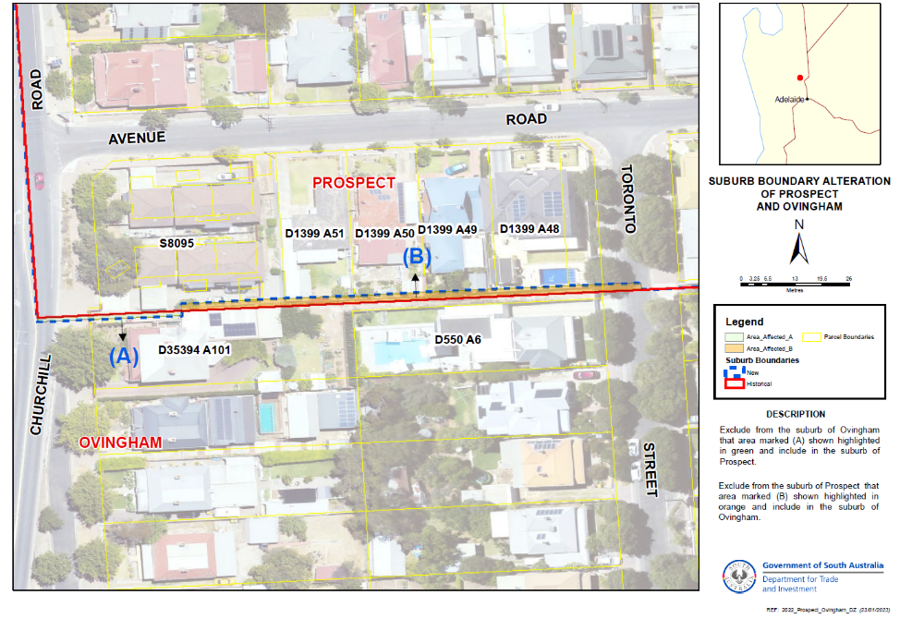
Dated: 28 March 2024
B. J. Slape
Surveyor-General
DTI: 2023/00525/01

Geographical Names Act 1991
Notice to Assign a Name to a Place
NOTICE is hereby given that, pursuant to section 11B(1)(a) of the Geographical Names Act 1991, I, the Honourable Nick Champion MP, Minister for Planning, Minister of the Crown to whom the administration of the Geographical Names Act 1991 is committed, DO HEREBY:
- Assign the name JARRETT CREEK to the geographical feature (creek) located within the Murray River National Park in the area named Winkie, as shown highlighted in orange on the location map.
This notice is to take effect immediately upon its publication in the Government Gazette.
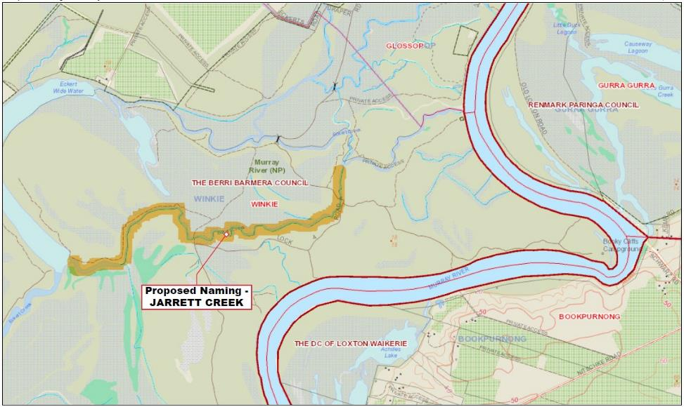
A copy of the location map for this naming proposal can also be viewed at;
- www.sa.gov.au/placenameproposals
Dated: 28 March 2024
Hon Nick Champion MP
Minister For Planning
DTI: 2023/08423/01

Housing Improvement Act 2016
Rent Control Revocations
Whereas the Minister for Human Services Delegate is satisfied that each of the houses described hereunder has ceased to be unsafe or unsuitable for human habitation for the purposes of the Housing Improvement Act 2016, notice is hereby given that, in exercise of the powers conferred by the said Act, the Minister for Human Services Delegate does hereby revoke the said Rent Control in respect of each property.
Address of Premises | Allotment Section | Certificate of Title Volume/Folio
25 Telford Road, Ingle Farm SA 5098  (Unit at rear) | Allotment 1391 Deposited Plan 9283 Hundred of Yatala | CT 6118/346
16 Little Sturt Street, Adelaide SA 5000 | Allotment 275 Filed Plan 182737 Hundred of Adelaide | CT6049/863
56 Springs Road, Port Macdonnell SA 5291  (AKA Section 794 Clarkes Park) | Section 794 Hundred Plan 421000  Hundred of MacDonnell | CT5177/230
Dated: 28 March 2024
Craig Thompson
Housing Regulator and Registrar
Housing Safety Authority, SAHA
Delegate of Minister for Human Services

Housing Improvement Act 2016
Rent Control Variations
The Minister for Human Services Delegate in the exercise of the powers conferred by the Housing Improvement Act 2016, does hereby vary the rent control notice in respect of each house described in the following table. Variation in the maximum rental per week which shall be payable subject to Section 55 of the Residential Tenancies Act 1995. The varied amount shown in the said table shall come into force on the date of this publication in the Gazette.
Address of Premises | Allotment Section | Certificate of Title  Volume/Folio |  | Reason for variation | Maximum Rental per week payable
4 Ernest Terrace, Wallaroo SA 5556 | Allotment 1 Filed Plan 131832 Hundred of Wallaroo | CT 5242/443 |  |  | $0.00
Dated: 28 March 2024
Craig Thompson
Housing Regulator and Registrar
Housing Safety Authority, SAHA
Delegate of Minister for Human Services

Land Acquisition Act 1969
Section 16
Form 5—Notice of Acquisition
1. Notice of acquisition
The Commissioner of Highways (the Authority), of 83 Pirie Street, Adelaide SA 5000, acquires the following interests in the following land:
Comprising an unencumbered estate in fee simple in that piece of land being the whole of Allotment 70 in Filed Plan 19717 comprised in Certificate of Title Volume 5719 Folio 319.
This notice is given under Section 16 of the Land Acquisition Act 1969.
2. Compensation
A person who has or had an interest consisting of native title or an alienable interest in the land that is divested or diminished by the acquisition or the enjoyment of which is adversely affected by the acquisition who does not receive an offer of compensation from the Authority may apply to the Authority for compensation.
2A. Payment of professional costs relating to acquisition (Section 26B)
If you are the owner in fee simple of the land to which this notice relates, you may be entitled to a payment of up to $10,000 from the Authority for use towards the payment of professional costs in relation to the acquisition of the land.
Professional costs include legal costs, valuation costs and any other costs prescribed by the Land Acquisition Regulations 2019.
3. Inquiries
Inquiries should be directed to: William Ridgway
GPO Box 1533
Adelaide SA 5001
Telephone: 08 7133 2465
Dated: 25 March 2024
The Common Seal of the COMMISSIONER OF HIGHWAYS was hereto affixed by authority of the Commissioner in the presence of:
Rocco Caruso
Manager, Property Acquisition
(Authorised Officer)
Department for Infrastructure and Transport
DIT 2023/01351/01

Land Acquisition Act 1969
Section 16
Form 5—Notice of Acquisition
1. Notice of acquisition
The Commissioner of Highways (the Authority), of 83 Pirie Street, Adelaide SA 5000, acquires the following interests in the following land:
Comprising an unencumbered estate in fee simple in that piece of land being the whole of Allotment 82 in Filed Plan 19717 comprised in Certificate of Title Volume 5843 Folio 143.
This notice is given under Section 16 of the Land Acquisition Act 1969.
2. Compensation
A person who has or had an interest consisting of native title or an alienable interest in the land that is divested or diminished by the acquisition or the enjoyment of which is adversely affected by the acquisition who does not receive an offer of compensation from the Authority may apply to the Authority for compensation.
2A. Payment of professional costs relating to acquisition (Section 26B)
If you are the owner in fee simple of the land to which this notice relates, you may be entitled to a payment of up to $10,000 from the Authority for use towards the payment of professional costs in relation to the acquisition of the land.
Professional costs include legal costs, valuation costs and any other costs prescribed by the Land Acquisition Regulations 2019.

3. Inquiries
Inquiries should be directed to: William Ridgway
GPO Box 1533
Adelaide SA 5001
Telephone: 08 7133 2465
Dated: 26 March 2024
The Common Seal of the COMMISSIONER OF HIGHWAYS was hereto affixed by authority of the Commissioner in the presence of:
Rocco Caruso
Manager, Property Acquisition
(Authorised Officer)
Department for Infrastructure and Transport
DIT 2023/01339/01

Land Acquisition Act 1969
Section 16
Form 5—Notice of Acquisition
1. Notice of acquisition
The Commissioner of Highways (the Authority), of 83 Pirie Street, Adelaide SA 5000, acquires the following interests in the following land:
Comprising an unencumbered estate in fee simple in that piece of land being the whole of Allotment 81 in Filed Plan 19717 comprised in Certificate of Title Volume 5397 Folio 366.
This notice is given under Section 16 of the Land Acquisition Act 1969.
2. Compensation
A person who has or had an interest consisting of native title or an alienable interest in the land that is divested or diminished by the acquisition or the enjoyment of which is adversely affected by the acquisition who does not receive an offer of compensation from the Authority may apply to the Authority for compensation.
2A. Payment of professional costs relating to acquisition (Section 26B)
If you are the owner in fee simple of the land to which this notice relates, you may be entitled to a payment of up to $10,000 from the Authority for use towards the payment of professional costs in relation to the acquisition of the land.
Professional costs include legal costs, valuation costs and any other costs prescribed by the Land Acquisition Regulations 2019.
3. Inquiries
Inquiries should be directed to: William Ridgway
GPO Box 1533
Adelaide SA 5001
Telephone: 08 7133 2465
Dated: 26 March 2024
The Common Seal of the COMMISSIONER OF HIGHWAYS was hereto affixed by authority of the Commissioner in the presence of:
Rocco Caruso
Manager, Property Acquisition
(Authorised Officer)
Department for Infrastructure and Transport
DIT 2023/01338/01

Land Acquisition Act 1969
Section 16
Form 5—Notice of Acquisition
1. Notice of acquisition
The Commissioner of Highways (the Authority), of 83 Pirie Street, Adelaide SA 5000, acquires the following interests in the following land:
Comprising an unencumbered estate in fee simple in that piece of land being the whole of Allotment 68 in Filed Plan 19717 comprised in Certificate of Title Volume 5843 Folio 142.
This notice is given under Section 16 of the Land Acquisition Act 1969.
2. Compensation
A person who has or had an interest consisting of native title or an alienable interest in the land that is divested or diminished by the acquisition or the enjoyment of which is adversely affected by the acquisition who does not receive an offer of compensation from the Authority may apply to the Authority for compensation.
2A. Payment of professional costs relating to acquisition (Section 26B)
If you are the owner in fee simple of the land to which this notice relates, you may be entitled to a payment of up to $10,000 from the Authority for use towards the payment of professional costs in relation to the acquisition of the land.
Professional costs include legal costs, valuation costs and any other costs prescribed by the Land Acquisition Regulations 2019.

3. Inquiries
Inquiries should be directed to: William Ridgway
GPO Box 1533
Adelaide SA 5001
Telephone: 08 7133 2465
Dated: 26 March 2024
The Common Seal of the COMMISSIONER OF HIGHWAYS was hereto affixed by authority of the Commissioner in the presence of:
Rocco Caruso
Manager, Property Acquisition
(Authorised Officer)
Department for Infrastructure and Transport
DIT 2023/01349/01

Land Acquisition Act 1969
Section 16
Form 5—Notice of Acquisition
1. Notice of acquisition
The Commissioner of Highways (the Authority), of 83 Pirie Street, Adelaide SA 5000, acquires the following interests in the following land:
Comprising an estate in fee simple in that piece of land being whole of Allotment 82 in Filed Plan 122229 comprised in Certificate of Title Volume 5850 Folio 47, subject to party wall right(s) over the land marked A (T 2316826), together with party wall right(s) over the land marked B (T 2316826).
This notice is given under Section 16 of the Land Acquisition Act 1969.
2. Compensation
A person who has or had an interest consisting of native title or an alienable interest in the land that is divested or diminished by the acquisition or the enjoyment of which is adversely affected by the acquisition who does not receive an offer of compensation from the Authority may apply to the Authority for compensation.
2A. Payment of professional costs relating to acquisition (Section 26B)
If you are the owner in fee simple of the land to which this notice relates, you may be entitled to a payment of up to $10,000 from the Authority for use towards the payment of professional costs in relation to the acquisition of the land.
Professional costs include legal costs, valuation costs and any other costs prescribed by the Land Acquisition Regulations 2019.
3. Inquiries
Inquiries should be directed to: Daniel Tuk
GPO Box 1533
Adelaide SA 5001
Telephone: 08 7133 2479
Dated: 27 March 2024
The Common Seal of the COMMISSIONER OF HIGHWAYS was hereto affixed by authority of the Commissioner in the presence of:
Rocco Caruso
Manager, Property Acquisition
(Authorised Officer)
Department for Infrastructure and Transport
DIT 2023/05390/01

Land Acquisition Act 1969
Section 16
Form 5—Notice of Acquisition
1. Notice of acquisition
The Commissioner of Highways (the Authority), of 83 Pirie Street, Adelaide SA 5000, acquires the following interests in the following land:
Comprising an unencumbered estate in fee simple in that piece of land being the whole of Allotment 11 in Deposited Plan 2678 comprised in Certificate of Title Volume 5161 Folio 93.
This notice is given under Section 16 of the Land Acquisition Act 1969.
2. Compensation
A person who has or had an interest consisting of native title or an alienable interest in the land that is divested or diminished by the acquisition or the enjoyment of which is adversely affected by the acquisition who does not receive an offer of compensation from the Authority may apply to the Authority for compensation.
2A. Payment of professional costs relating to acquisition (Section 26B)
If you are the owner in fee simple of the land to which this notice relates, you may be entitled to a payment of up to $10,000 from the Authority for use towards the payment of professional costs in relation to the acquisition of the land.
Professional costs include legal costs, valuation costs and any other costs prescribed by the Land Acquisition Regulations 2019.

3. Inquiries
Inquiries should be directed to: Daniel Tuk
GPO Box 1533
Adelaide SA 5001
Telephone: 08 7133 2479
Dated: 27 March 2024
The Common Seal of the COMMISSIONER OF HIGHWAYS was hereto affixed by authority of the Commissioner in the presence of:
Rocco Caruso
Manager, Property Acquisition
(Authorised Officer)
Department for Infrastructure and Transport
DIT 2023/05367/01

Land Acquisition Act 1969
Section 16
Form 5—Notice of Acquisition
1. Notice of acquisition
The Commissioner of Highways (the Authority), of 83 Pirie Street, Adelaide SA 5000, acquires the following interests in the following land:
First: Comprising an unencumbered estate in fee simple in that piece of land being the whole of Allotment 52 in Deposited Plan 45302 comprised in Certificate of Title Volume 6133 Folio 768.
Secondly: Comprising an unencumbered estate in fee simple in that piece of land being the whole of Allotment 95 in Filed Plan 19717 comprised in Certificate of Title Volume 6133 Folio 769.
This notice is given under Section 16 of the Land Acquisition Act 1969.
2. Compensation
A person who has or had an interest consisting of native title or an alienable interest in the land that is divested or diminished by the acquisition or the enjoyment of which is adversely affected by the acquisition who does not receive an offer of compensation from the Authority may apply to the Authority for compensation.
2A. Payment of professional costs relating to acquisition (Section 26B)
If you are the owner in fee simple of the land to which this notice relates, you may be entitled to a payment of up to $10,000 from the Authority for use towards the payment of professional costs in relation to the acquisition of the land.
Professional costs include legal costs, valuation costs and any other costs prescribed by the Land Acquisition Regulations 2019.
3. Inquiries
Inquiries should be directed to: Petrula Pettas
GPO Box 1533
Adelaide SA 5001
Telephone: 08 7133 2457
Dated: 27 March 2024
The Common Seal of the COMMISSIONER OF HIGHWAYS was hereto affixed by authority of the Commissioner in the presence of:
Rocco Caruso
Manager, Property Acquisition
(Authorised Officer)
Department for Infrastructure and Transport
DIT 2022/02921/01

Local Government (Elections) Act 1999
City of Onkaparinga
Call for Nominations—Supplementary Election of Councillor for Pimpala Ward
Nominations open on Thursday 4 April 2024 and close at 12 noon Thursday 18 April 2024. Candidates must submit a profile of not more than 1000 characters with their nomination and may also provide a photograph, predominantly head and shoulders, taken within the previous 12 months.
More information about nominating, including the candidate handbook that outlines the criteria and requirements for nominating, can be accessed at ecsa.sa.gov.au or by phoning 1300 655 232.
Nominate online at: ecsa.sa.gov.au
ECSA are holding an online briefing session for intending candidates at 6pm on Thursday 4 April 2024. Register online at ecsa.sa.gov.au
An in-person briefing session will be held by the City of Onkaparinga at 6.30pm on Wednesday 10 April 2024 in the Noarlunga Office, Ramsay Place, Noarlunga Centre. Intending candidates wishing to attend the in-person session are asked to register in advance by contacting the City of Onkaparinga on (08) 8384 0666 or by email to mail@onkaparinga.sa.gov.au.
Mick Sherry
Returning Officer

Local Government (Elections) Act 1999
Tatiara District Council
Call for Nominations—Supplementary Election of Area Councillor
Nominations open on Thursday 4 April 2024 and close at 12 noon Thursday 18 April 2024. Candidates must submit a profile of not more than 1000 characters with their nomination and may also provide a photograph, predominantly head and shoulders, taken within the previous 12 months.
More information about nominating, including the candidate handbook that outlines the criteria and requirements for nominating, can be accessed at ecsa.sa.gov.au or by phoning 1300 655 232.
Nominate online at: ecsa.sa.gov.au
ECSA are holding an online briefing session for intending candidates at 6pm on Thursday 4 April 2024. Register online at ecsa.sa.gov.au
An in-person briefing session will be held by the Tatiara District Council at 6pm on Wednesday 10 April 2024 in the Council Chambers, 43 Woolshed St, Bordertown. Intending candidates wishing to attend the in-person session are asked to register in advance by contacting the Tatiara District Council on (08) 8752 1044 or by email to office@tatiara.sa.gov.au.
Mick Sherry
Returning Officer

Local Government (Elections) Act 1999
Wattle Range Council
Election Results—Supplementary Election of Councillor for Corcoran Ward
Conducted on Wednesday 13 March 2024.
Formal Ballot Papers – 1490 | Informal Ballot Papers – 20 | Quota – 746
Candidates | First Preference Votes | Elected / Excluded
McCLURE, Joel | 174
HENLEY, Penelope | 293
SHELTON, John | 911 | Elected
TALIANA, Shaun | 112
Mick Sherry
Returning Officer

Mental Health Act 2009
Approved Mental Health Professional
NOTICE is hereby given in accordance with Section 94(1) of the Mental Health Act 2009, that the Chief Psychiatrist has re-determined the following persons as an Authorised Mental Health Professional:
Annaliese Gilles
Jacqueline Gardener
Braden Hill
Steven Cody
Prem Manuel
A person’s determination as an Authorised Mental Health Professional expires three years after the commencement date.
Dated: 26 March 2024
Dr J. Brayley
Chief Psychiatrist

Mining Act 1971
Application for a Mining Licence
Notice is hereby given in accordance with Section 56H of the Mining Act 1971, that an application for a Retention Lease over portion of the undermentioned Exploration Licence has been received:
Applicant: BHP Olympic Dam Corporation Pty Ltd (ACN 007 835 761)
Exploration Licence: 5941
Location: CL 6211/35, Arcoona area - Approximately 40 km northeast of Woomera.
Area: 8824.87 hectares approximately
Purpose: To enable the progression of advanced exploration activities at the Oak Dam Underground Access Project (OKDUGA Project) for the purposes of completing investigations that will determine the feasibility of potential future mining operations.
Reference: M2023/0161
Notice is hereby given in accordance with Section 56H of the Mining Act 1971, that an application for two Miscellaneous Purposes Licences over portion of the undermentioned Exploration Licences has been received:
Applicant: BHP Olympic Dam Corporation Pty Ltd (ACN 007 835 761)
Exploration Licence: 6109, 6122, 6183, 6654 and 6675
Location: CL 6166/900 and CL 6211/35, Arcoona area - Approximately 28 km northeast of Woomera.
Area: 2565.23 hectares approximately
Purpose: Site Infrastructure Corridor for the purposes of site access and ancillary infrastructure.
Reference: 2023/000338
Applicant: BHP Olympic Dam Corporation Pty Ltd (ACN 007 835 761)
Exploration Licence: 6528 and 6685
Location: CL 6211/35, Arcoona area - Approximately 50 km northeast of Woomera.
Area: 350.07 hectares approximately
Purpose: Water Infrastructure Corridor for the purposes of water supply and ancillary infrastructure.
Reference: 2023/000339
To arrange an inspection of the proposal at the Department for Energy and Mining, please call the Department on (08) 8463 3103.
An electronic copy of the proposal can be found on the Department for Energy and Mining website:
https://www.energymining.sa.gov.au/industry/minerals-and-mining/mining/community-engagement-opportunities
Written submissions in relation to this application are invited to be received at the Department for Energy and Mining, Mining Regulation, Attn: Business Support Officer, GPO Box 320, Adelaide SA 5001 or dem.miningregrehab@sa.gov.au by no later than 2 May 2024.
The delegate of the Minister for Energy and Mining is required to have regard to these submissions in determining whether to grant or refuse the application and, if granted, the terms and conditions on which it should be granted.
When you make a written submission, that submission becomes a public record. Your submission will be provided to the applicant and may be made available for public inspection.
Dated: 28 March 2024
C Andrews
Acting Mining Registrar
as Delegate for the Minister for Energy and Mining
Department for Energy and Mining

Planning, Development and Infrastructure Act 2016
South Australia
Planning, Development and Infrastructure (Fees) Notice
(No 2) 2024
under the Planning, Development and Infrastructure Act 2016
1—Short title
This notice may be cited as the Planning, Development and Infrastructure (Fees) Notice 2024.
Note—
This is a fee notice made in accordance with the Legislation (Fees) Act 2019.
2—Commencement
This notice has effect on the date of publication in the Gazette.
3—Interpretation
(1) In this notice, unless the contrary intention appears—
Act means the Planning, Development and Infrastructure Act 2016;
allotment does not include an allotment for road or open space requirements;
development cost does not include any fit-out costs;
regulations means the following:
(a) the Planning, Development and Infrastructure (Accredited Professionals) Regulations 2019;
(b) the Planning, Development and Infrastructure (Fees, Charges and Contributions) Regulations 2019;
(c) the Planning, Development and Infrastructure (General) Regulations 2017.
(2) Words and expressions used in the regulations and in this fee notice have the same respective meanings in this notice as they have in the regulations.
(3) Subclause (2) does not apply to the extent that the context or subject matter otherwise indicates or requires.
4—Fees payable
(1) The fees set out in Schedule 1 are prescribed for the purposes of the Act and the regulations and are payable as specified in that Schedule.
(2) A fee set out in Schedule 1 item 8 is payable to the body specified in relation to the fee.
(3) Subject to subclauses (4) and (5), if an application, matter or circumstance falls within more than 1 item under Schedule 1, then the fee under each such item applies and those fees in total will be payable.
(4) If planning consent is sought for development comprising more than 1 element—
(a) a fee is not payable under Schedule 1 item 6 for each element of the development; and
(b) the fee payable under Schedule 1 item 6 is the highest fee applying to a single element of the development; and
(c) if the relevant fee is based on the total development cost, the fee payable will be based on the total cost of all elements of the development.
(5) If an application for planning consent must be referred to the same body under more than 1 item of Schedule 9 of the Planning, Development and Infrastructure (General) Regulations 2017, then only 1 prescribed fee under Schedule 1 item 8 is payable with respect to the referral of the application to that body.
(6) A reference in subclause (5) to a prescribed fee extends to a prescribed fee that, although payable, was waived (in whole or in part) by a relevant authority.
(7) Subject to subclause (8) if a lodgement fee has been paid in respect of an application for planning consent or building consent for a development, no lodgement fee is payable for any other consents related to that application or for the issue of the final development approval in respect of that development.
(8) If a lodgement fee has been paid in respect of an application under the repealed Act, a lodgement fee under this notice is payable in respect of the first application for consent related to the application under the repealed Act that is lodged electronically via the SA planning portal.
5—Assessment requirements—water and sewerage
(1) A prescribed fee under Schedule 1 item 27 is payable to the South Australian Water Corporation or any other water industry entity identified for the purposes of section 102(1)(c)(iii) and (1)(d)(vii) of the Act.
(2) The prescribed fee is payable by the person who makes the application to divide the land.
6—Applications relating to certain electricity infrastructure—issue of certificate by Technical Regulator
The prescribed fee under Schedule 1 item 32 is payable to the Technical Regulator for the issue of a certificate required by the Planning, Development and Infrastructure (General) Regulations 2017 to accompany an application in respect of a proposed development for the purposes of the provision of electricity generating plant with a generating capacity of more than 5 MW that is to be connected to the State's power system.
Schedule 1—Fees
Part 1—Fees under Planning, Development and Infrastructure (Accredited Professionals) Regulations 2019
The following fees are payable for the purposes of the Planning, Development and Infrastructure (Accredited Professionals) Regulations 2019:

1 | Application to the accreditation authority for accreditation under the Planning, Development and Infrastructure (Accredited Professionals) Regulations 2019, other than where item 2 Applies—
 | (a) in the case of an application for accreditation as an accredited professional—planning level 1; and | $827.00
 | (b) in any other case | $610.00
2 | Application to the accreditation authority for accreditation under the Planning, Development and Infrastructure (Accredited Professionals) Regulations 2019 where the person is a member of a professional association or body recognised by the Chief Executive for the purposes of regulation 16(2)(a) of the Planning, Development and Infrastructure (Accredited Professionals) Regulations 2019 and the person is applying as a member of that association or body for a corresponding level of accreditation under regulation 16(2)(a)(ii) of those regulations | $294.00
3 | Application to the accreditation authority under regulation 19 of the Planning, Development and Infrastructure (Accredited Professionals) Regulations 2019 | $196.00
4 | Late application fee under regulation 19(3) of the Planning, Development and Infrastructure (Accredited Professionals) Regulations 2019 | $65.00
Part 2—Fees relating to development assessment
The following fees are payable in relation to development assessment under the Act (including in connection with the Planning, Development and Infrastructure (General) Regulations 2017):

5 | Application for outline consent, planning consent or building consent (the base amount)—
 | (a) a lodgement fee
 | - if the total development cost is no more than $10 000 | $90.00
 | - if the total development cost is greater than $10 000 and no more than $50 000 | $144.00
 | - if the total development cost is greater than $50 000 and no more than $100 000 | $162.00
 | - if the total development cost is greater than $100 000 and no more than $300 000 | $171.00
 | - if the total development cost is greater than $300 000 and no more than $500 000 | $180.00
 | - if the total development cost is greater than $500 000 and no more than $700 000 | $414.00
 | - if the total development cost is greater than $700 000 and no more than $1 000 000 | $720.00
 | - if the total development cost is greater than  $1 000 000 and no more than $5 000 000 | $1,620.00
 | - if the total development cost is greater than  $5 000 000 and no more than $10 000 000 | $2,160.00
 | - if the total development cost is greater than  $10 000 000; and | $2,970.00
 | (b) if the application is lodged at the principal office of the relevant authority—a processing fee | $87.00
5a | Application for outline consent under section 120 of the Act | $6,000.00
6 | Application for planning consent—
 | (a) if the proposed development is to be assessed as deemed-to-satisfy development under section 106 of the Act—
 | (i) if the total development cost is no more than $10 000 | $138.00
 | (ii) in any other case | $228.00
 | (b) if the proposed development is to be assessed on its merits under section 107 of the Act | $272.00 or 0.125% of the total development cost up to a maximum of $200 000, whichever is the greater
 | (c) if the proposed development is restricted development under section 108(1)(a) of the Act
 | (i) if the proposed development is the division of land | $534.00
 | (ii) in any other case | 0.25% of the total development cost up to a maximum of $300 000
 | (d) if the applicant applies for a review of the decision under section 110(15) of the Act | $556.00
 | (e) if the proposed development is to be assessed as impact assessed development under section 111 of the Act—
 | (i) if the proposed development is declared as being impact assessed development by the Minister | $1,906.00 plus 0.25% of the total development cost up to a maximum of $500 000
 | (ii) in any other case | 0.25% of the total development cost up to a maximum of $500 000
7 | Application for planning consent that must be notified—
 | (a) if section 107(3)(a) applies | $272.00
 | (b) if section 110(2)(a) applies | $272.00
7a | Application for outline consent that must be notified | $272.00
8 | Application for outline consent or planning consent that must be referred to 1 or more prescribed bodies under Schedule 9 of the Planning, Development and Infrastructure (General) Regulations 2017—
 | (a) for referral to the Commissioner of Highways—
 | (i) if the proposed development involves a change in the use of land | $434.00
 | (ii) if the proposed development involves the division of land | $434.00
 | (b) for referral to the Environment Protection Authority  (i) non-licensable  (ii) licensable  (iii) site contamination | $807.00  $1,816.00  $1,494.00
 | (c) for referral to the Minister responsible for the administration of the Heritage Places Act 1993 | $434.00
 | (d) for referral to the Minister responsible for the administration of the River Murray Act 2003 | $434.00
 | (e) for referral to the Relevant authority under the Landscape South Australia Act 2019 | $434.00
 | (f) for referral to the Chief Executive of the Department of the Minister responsible for the administration of the Landscape South Australia Act 2019 | $434.00
 | (g) for referral to the Coast Protection Board | $434.00
 | (h) for referral to the Minister responsible for the administration of the Historic Shipwrecks Act 1981 | $434.00
 | (i) for referral to the Commonwealth Minister responsible for the administration of the Underwater Cultural Heritage Act 2018 of the Commonwealth | $434.00
 | (j) for referral to the Native Vegetation Council | $696.00
 | (k) for referral to the Government Architect or Associate Government Architect | $530.00
 | (l) for referral to Minister responsible for the administration of the South Australian Housing Trust Act 1995 | $262.00 plus $163.00 per stage
 | (m) for referral to the Minister responsible for the administration of the Aquaculture Act 2001 | $450.00
 | (n) for referral to the South Australian Country Fire Service | $434.00
 | (o) for referral to Chief Executive of the Department of the Minister responsible for the administration of the Petroleum and Geothermal Energy Act 2000 | $356.00
 | (p) for referral to the Minister responsible for the administration of the Mining Acts | $356.00
 | (q) for referral to the Technical Regulator | $182.00
 | (r) for referral to the Airport-operator company for the relevant airport within the meaning of the Airports Act 1996 of the Commonwealth or, if there is no airport-operator company, Secretary of the Department of the Minister responsible for the administration of the Airports Act 1996 of the Commonwealth | $434.00
9 | Application for building consent (a building assessment fee)—
 | (a) for a Class 1 building under the Building Code | $490.00 or 0.25% of the total development cost, whichever is the greater
 | (b) for a Class 10 building under the Building Code | $141.00 or 0.25% of the total development cost, whichever is the greater
 | (c) for any other class of building under the Building Code—
 | (i) if the total development cost is no more than $20 000 | $730.00
 | (ii) if the total development cost is greater than $20 000 and no more than $200 000 | $730.00 plus 0.4% of the amount determined by subtracting $20 000 from the total development cost
 | (iii) if the total development cost is greater than $200 000 and no more than $1 000 000 | $1,513.00 plus 0.25% of the amount determined by subtracting $200 000 from the total development cost
 | (iv) if the total development cost is greater than $1 000 000 | $3,692.00 plus 0.15% of the amount determined by subtracting $1 000 000 from the total development cost
10 | Application for building consent (a compliance fee)—
 | (a) for a Class 1 building under the Building Code or a swimming pool or swimming pool safety features | $262.00
 | (b) for a Class 1 building under the Building Code if the building comprises multiple dwellings | $262.00 for each dwelling
 | (c) for a Class 10 building under the Building Code—
 | (i) if the total development cost is no more than $10 000 | no fee
 | (ii) if the total development cost is greater than $10 000 | $87.00
 | (d) for any other class of building under the Building Code | Once per building – $262.00 or 0.075% of the total development cost up to a maximum of $2,724.00, whichever is the greater
11 | Application for building consent for the demolition of a building | $158.00
12 | Application for the concurrence of the Commission under section 118(2)(a) of the Act | $376.00
13 | Referral of application to the Commission for an opinion under section 118(4) of the Act | $376.00
14 | Application for a development authorisation under section 102(1)(c) or (d) of the Act—
 | (a) if the number of allotments resulting from the division is equal to or less than the existing number of allotments, or creates no more than 4 additional allotments and does not involve the creation of a public road | $191.00
 | (b) if the division creates more than 4 additional allotments | $191.00 plus $17.40 for each additional allotment created
 | (c) if the division involves the creation of a public road (regardless of the number of additional allotments created) | $191.00 plus $17.40 for each additional allotment created
15 | Application for final development approval in respect of HomeBuilder development (fee payable to the council for the area in which the proposed development is to be undertaken) | $128.00
16 | Advice of the Commission under regulation 76 of the Planning, Development and Infrastructure (General) Regulations 2017 (payable by the applicant at the time of lodgement of the application) | $218.00
17 | A Certificate of Approval Fee for the purposes of section 138 of the Act | $1,120.00
18 | Application under section 130 or 131 of the Act (fee payable to the Commission) | $193.00 plus 0.25% of the total development cost up to a maximum of $300 000
19 | Amount for public notice under section 131(13)(a) of the Act (amount payable to the Commission) | An amount determined by the Commission as being appropriate to cover its reasonable costs in giving public notice of the application under section 131(13)(a) of the Act
20 | Application for a variation of a development authorisation previously given that is minor in nature | $138.00
21 | Application to assessment panel for review of a prescribed matter under section 202(1)(b)(i)(A) of the Act | $556.00
Part 3—Fees relating to building activity and use
The following fees are payable in relation to building activity and use (including in connection with the Planning, Development and Infrastructure (General) Regulations 2017):

22 | Issue of a certificate relating to essential safety provisions under regulation 94 of the Planning, Development and Infrastructure (General) Regulations 2017 | $262.00
23 | Application for assignment of a classification to a building or a change in the classification of a building under section 151 of the Act | $184.00
24 | Application for a certificate of occupancy under section 152 of the Act | $54.50
Part 4—Funds and off-set schemes
The following fees are payable in relation to funds and off-set schemes:

25 | Rates of contribution under section 198(1)(d), (2)(c) or (8) of the Act—
 | (a) where the land to be divided is within Greater Adelaide | $8,453.00 for each new allotment or strata lot delineated by the relevant plan that does not exceed 1 hectare in area
 | (b) where the land to be divided is within any other part of South Australia | $3,394.00 for each new allotment or strata lot delineated by the relevant plan that does not exceed 1 hectare in area
26 | Rates of contribution for the purposes of section 199(1) of the Act—
 | (a) where the prescribed building is within Greater Adelaide | $8,453.00 for each apartment or allotment delineated by the relevant plan
 | (b) where the prescribed building is within any other part of South Australia | $3,394.00 for each apartment or allotment delineated by the relevant plan
Part 5—Other fees
The following fees are also payable:

27 | An assessment, or the update of an assessment, under regulation 79 of the Planning, Development and Infrastructure (General) Regulations 2017—
 | (a) in relation to an original assessment | $438.00
 | (b) in relation to an updating of the original or a subsequent assessment (including where the update is required because of an amended plan of division) | $126.00
28 | Application for design review under section 121 of the Act | $107.00 plus the reasonable costs of the design panel to provide advice on the application
29 | Amount for the purposes of section 127(6) of the Act | $163.00 for each replacement tree that is not planted
29A | Amount for the purposes of the Urban Tree Canopy Offset Scheme established under section 197 of the Act—
 | - in relation to a small tree | $314.00
 | - in relation to a medium tree | $629.00
 | - in relation to a large tree | $1,258.00
30 | Application for the extension of a development authorisation under section 126(3) of the Act—
 | (a) if the development authorisation relates to development assessed as restricted development under section 108(1)(a) of the Act or impact assessed development under section 111 of the Act, or relates to development assessed under section 130 or 131 of the Act | $138.00
 | (b) in any other case | $116.00
31 | Request for initiation of infrastructure scheme under section 163(3)(b) of the Act | $3,999.00
32 | Certificate from Technical Regulator | $438.00
33 | Application to register an agreement under section 192 or 193 of the Act | $87.00
34 | Fee for the purposes of section 192(7) or 193(7) of the Act | $16.20
35 | Fee for approval under section 197(5) of the Act | $406.00
36 | Application for the approval of the Minister under section 235 of the Act | $173.00
37 | Application for approval of building envelope plan under regulation 19A(1) of the Planning, Development and Infrastructure (General) Regulations 2017 | $191.00 plus $17.40 for each allotment delineated under the building envelope plan
38 | Fee for consideration and publication of building envelope plan under regulation 19A(3) and (4) of the Planning, Development and Infrastructure (General) Regulations 2017 (payable by applicant at the time of making application for approval of building envelope plan) | $218.00
39 | Fee for registration as a Local Design Review Administrator under the Minister’s Design Review scheme established under section 121 of the Act | $588.00
40 | Fee for registration an Independent Design Review Administrator under the Minister’s Design Review scheme established under section 121 of the Act | $342.00
41 | Fee for consideration of a proposal to initiate an amendment to the Planning and Design Code under section 73(2)(b) of the Act | $5,879.00
42 | Fee for the administration and management of a proposed amendment to the Planning and Design Code, where approval of the Minister to initiate the amendment has been granted under section 73(2)(b) of the Act:
 | - if the proposed amendment is determined to be simple in nature | $4,490.00
 | - if the proposed amendment is determined to be moderately complex in nature | $21,807.00
 | - if the proposed amendment is determined to be complex in nature | $30,465.00
43 | Fee for the publication of consultation of a proposed amendment of the Planning and Design Code under section 73(2)(b) of the Act | $9,300.00
44 | Fee for the consideration by the Minister of a proposed amendment to the Planning and Design Code under section 73(2)(b) of the Act:
 | - where the proposed amendment is determined to be simple in nature | $4,489.00
 | - where the proposed amendment is determined to be moderately complex in nature | $21,806.00
 | - where the proposed amendment is determined to be complex in nature | $30,465.00
45 | Fee for administration of implementing a code amendment adopted to by the Minister under section 73(2)(b) of the Act | $10,476.00
46 | Fee for accredited professionals acting in a private capacity to use the SA Planning Portal to assess development applications | $50.00 per consent assessed in the preceding quarter
Made by the Minister for Planning
On 21 March 2024

Public Finance and Audit Act 1987
Treasurer’s Quarterly Statement
Summary of the Statement on the Consolidated Account for the Quarters and
12 Months Ended 30 June 2023 and 30 June 2022
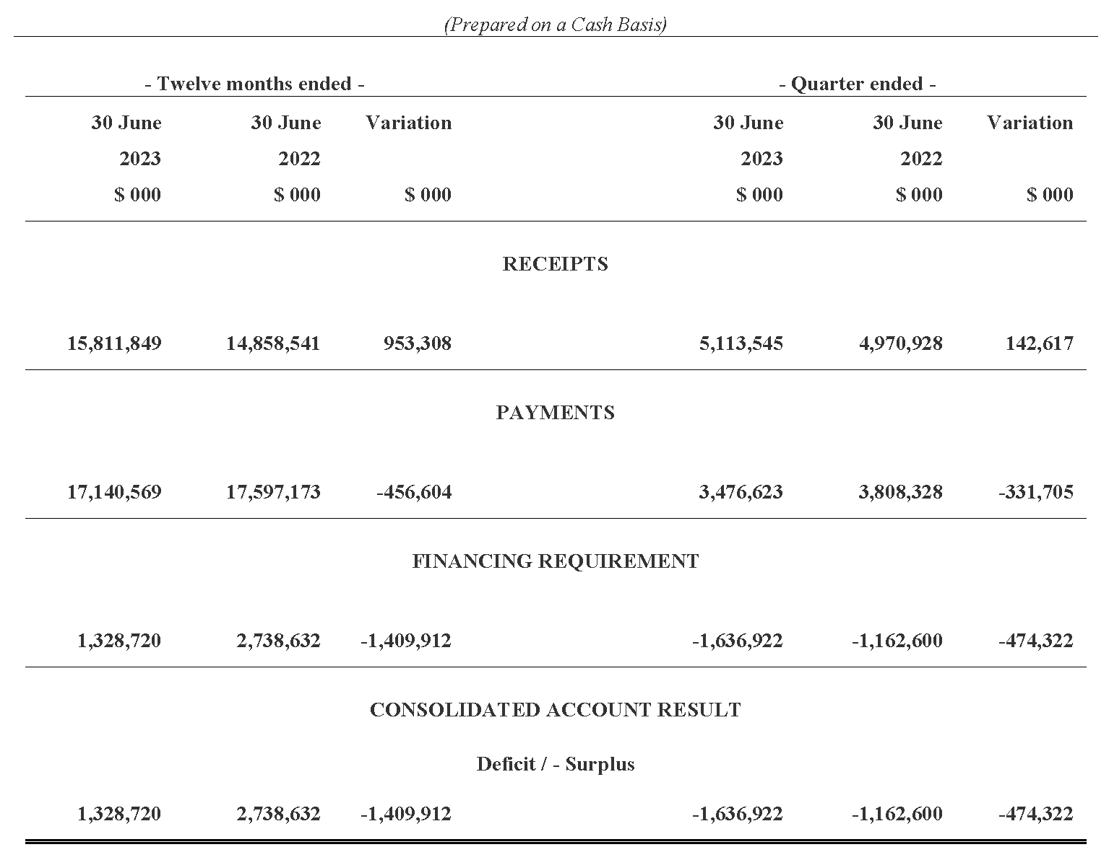

Statement of the Receipts and Borrowings on the Consolidated Account
Quarters and 12 Months Ended 30 June 2023 and 30 June 2022
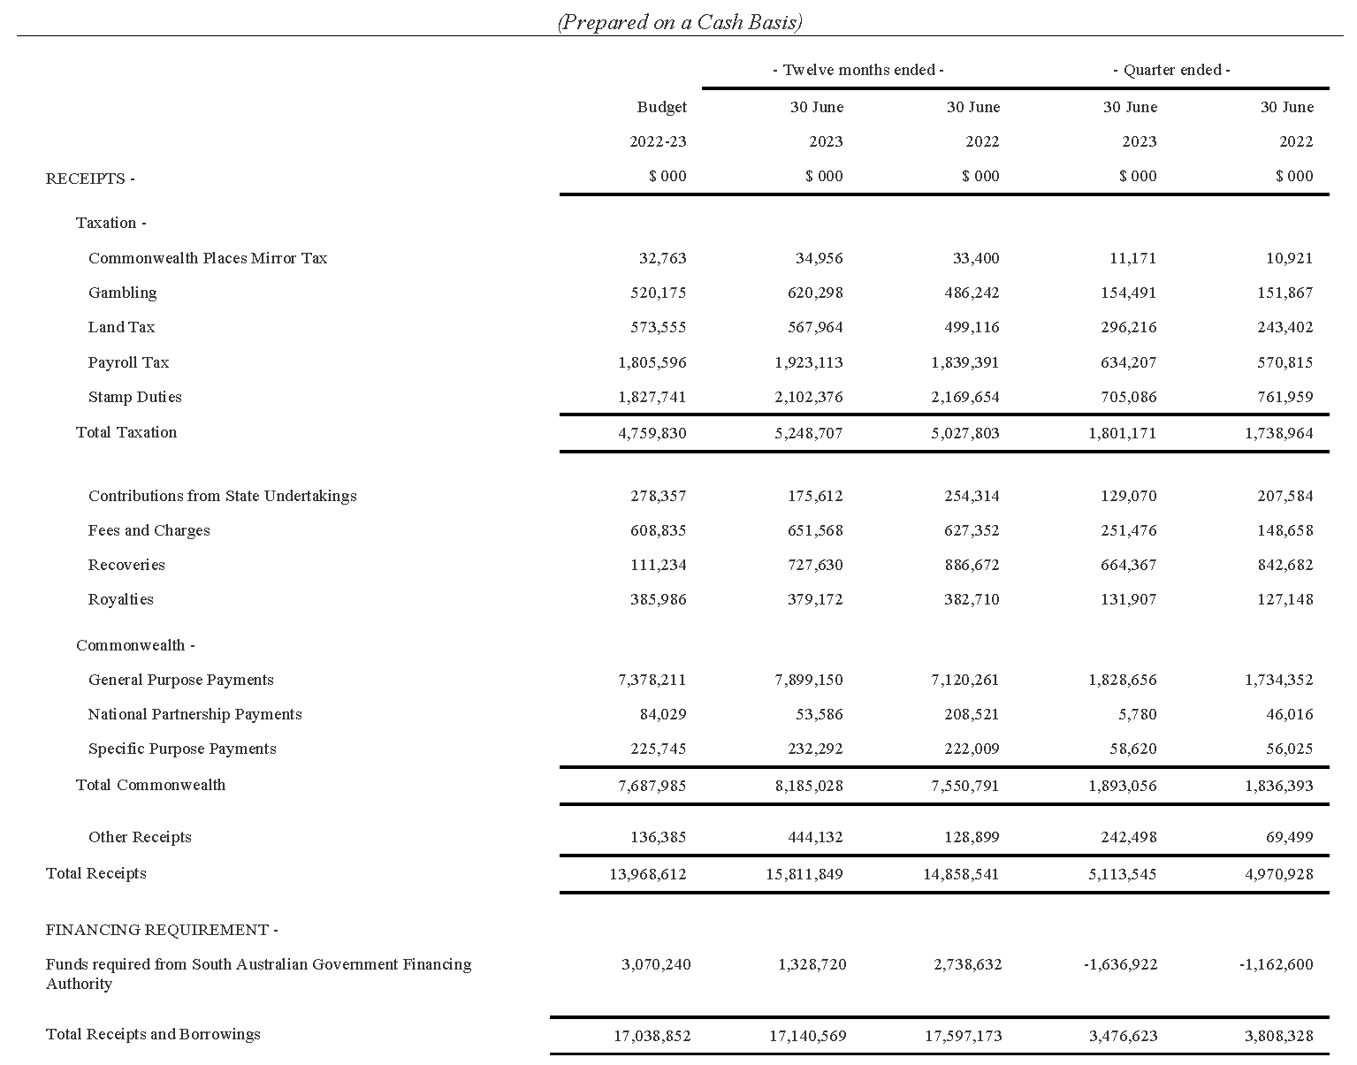

Statement of Payments on the Consolidated Account
Quarters and 12 Months Ended 30 June 2023 and 30 June 2022
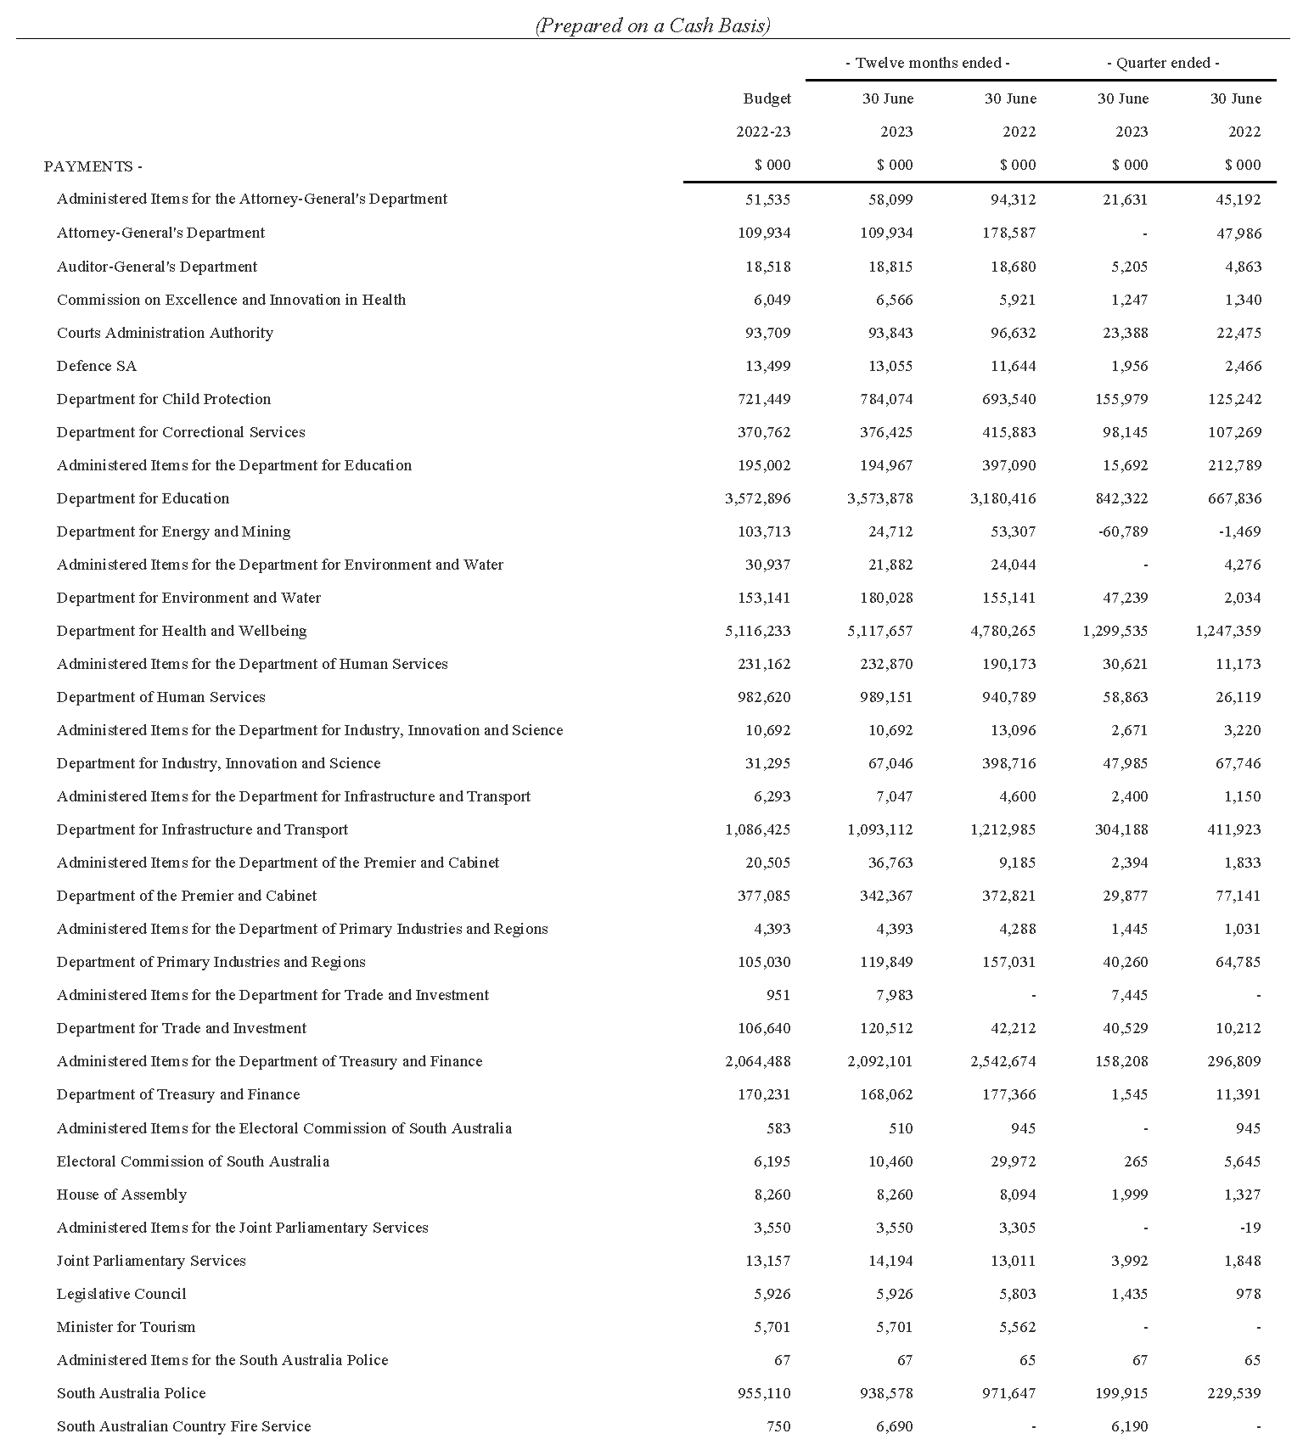

Statement of Payments on the Consolidated Account
Quarters and 12 Months Ended 30 June 2023 and 30 June 2022

Commentary to the Statement of the Amounts Credited to and Issued from the Consolidated Account
for the Quarters Ended 30 June 2023 and 30 June 2022
Receipts
Taxation
Gambling tax receipts are impacted by the timing of receipts into the consolidated account. Excluding timing impacts, underlying gambling tax collections in the June quarter 2023 and the twelve months ended June 2023 were higher compared to the corresponding prior year periods largely due to growth in net gambling revenue from gaming machines in hotels and clubs and the betting operations tax.
Land tax receipts in the June quarter 2023 and twelve months ended June 2023 were higher compared to the corresponding prior year periods mainly due to the timing of collections associated with government land tax liabilities.
Payroll tax receipts in the June quarter 2023 and twelve months ended June 2023 were higher than the corresponding prior year periods mainly reflecting growth in taxable payrolls. Payroll tax collections in the twelve months ended June 2023 were also impacted by the timing of collections.
Stamp duty receipts in the June quarter 2023 and twelve months ended June 2023 were lower than the corresponding prior year periods largely reflecting a decline in conveyance duty receipts on the transfer of properties, partially offset by higher duty from general insurance premiums and motor vehicle registration transfers.
Royalties
Royalty payments in the June quarter 2023 and twelve months ended June 2023 were broadly in line with the corresponding prior year periods.
Fees and Charges
Fees and charges in the June quarter 2023 and twelve months ended June 2023 were higher than the corresponding prior years periods mainly due to an increase in the collection of land regulatory fees.
Commonwealth—General Purpose Payments
Growth in general purpose grant receipts in 2022-23 compared to 2021-22 is not indicative of underlying movements in Goods and Services Tax (GST) revenue. This is because monthly grants are paid according to a payment schedule prepared by the Commonwealth Government rather than actual emerging monthly GST collections.
Based on actual growth in the national GST pool, population estimates as well as South Australia’s relativity in 2022-23, South Australia’s GST entitlement grant increased by 9.6 per cent in 2022-23 as published in the Commonwealth Government’s 2022-23 Final Budget Outcome.
Commonwealth—Specific Purpose Payments
Specific Purpose Payments received in the June quarter 2023 and twelve months ended June 2023 were higher than the corresponding prior year periods mainly due to higher receipts under the National Housing and Homelessness Agreement and National Agreement for Skills and Workforce Development.
Commonwealth—National Partnership Payments
National Partnership Payments received in the June quarter 2023 and twelve months ended June 2023 were lower than the corresponding prior year periods mainly due to lower reimbursements for Commonwealth HomeBuilder grants that are being administered by the state on behalf of the Commonwealth Government.
Other Receipts
Other Receipts in the June quarter 2023 and twelve months ended June 2023 were higher than the corresponding prior year period mainly due to higher interest on investments. This is due to higher interest rates applied on the Treasurer’s deposits placed with the South Australian Government Financing Authority.
Payments
Payments were made pursuant to the Appropriation Act 2022 and also in accordance with other Acts for which specific appropriation has been authorised. The timing of the payments is based on agreed agency drawdown schedules and may change from period to period based on specific agency requirements.
All appropriations were paid within approved limits established under the various Acts.

Note
The following points should be considered when reviewing the quarterly statement of Consolidated Account transactions:
- Unlike the State Budget which comprises transactions on an accrual basis, the information reflected in the quarterly statement is limited to cash transactions.
- The Consolidated Account does not capture all the transactions undertaken by the general government sector. In particular, it does not record receipts to, and payments from Agency deposit and special deposit accounts.
- The timing of receipts and payments can fluctuate within a financial year and between financial years. As a result, apparently large movements between quarters or financial years may only be due to changes in the timing of receipts and payments and therefore may not have consequences for the underlying budget position.
Dated: 20 March 2024
Hon. Stephen Mullighan MP
Treasurer of South Australia

Public Finance and Audit Act 1987
Treasurer’s Quarterly Statement
Summary of the Statement on the Consolidated Account for the Quarters and
3 Months Ended 30 September 2023 and 30 September 2022
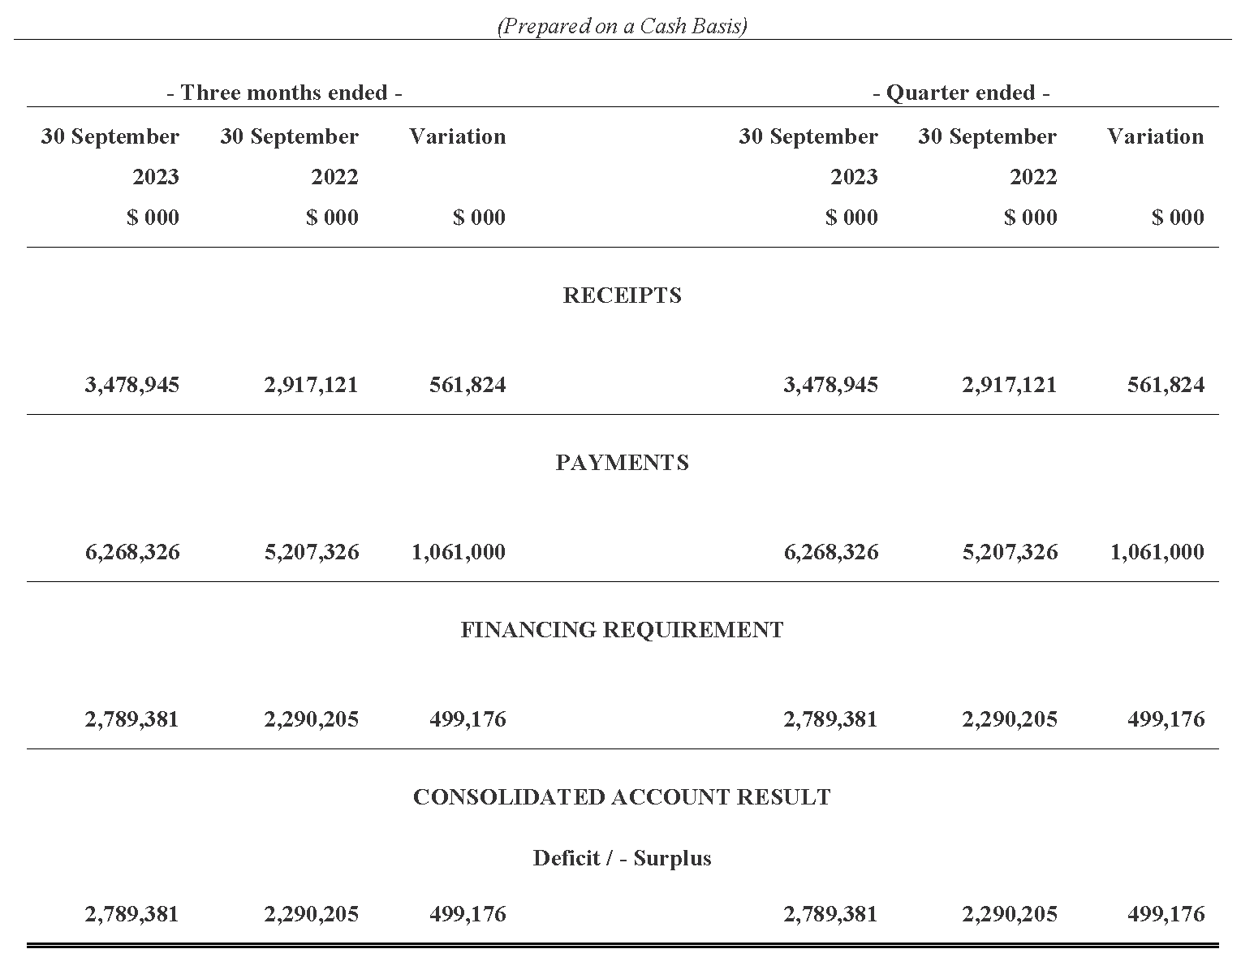

Statement of the Receipts and Borrowings on the Consolidated Account
Quarters and 3 Months Ended 30 September 2023 and 30 September 2022
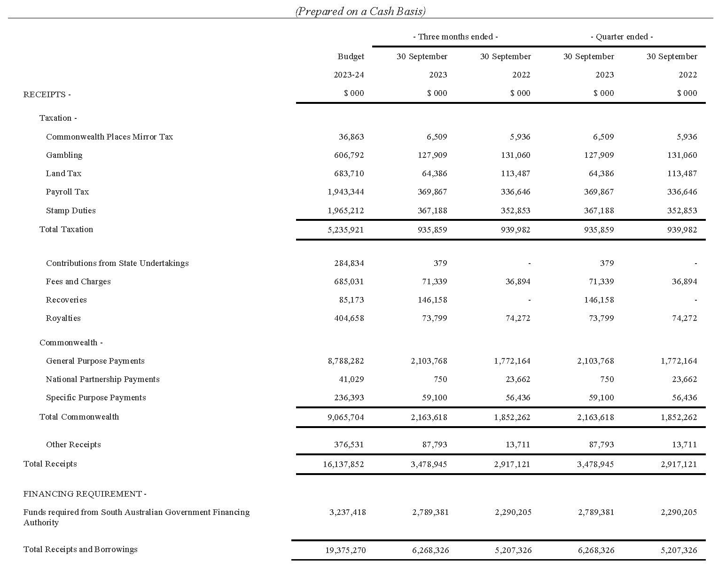

Statement of Payments on the Consolidated Account
Quarters and 3 Months Ended 30 September 2023 and 30 September 2022
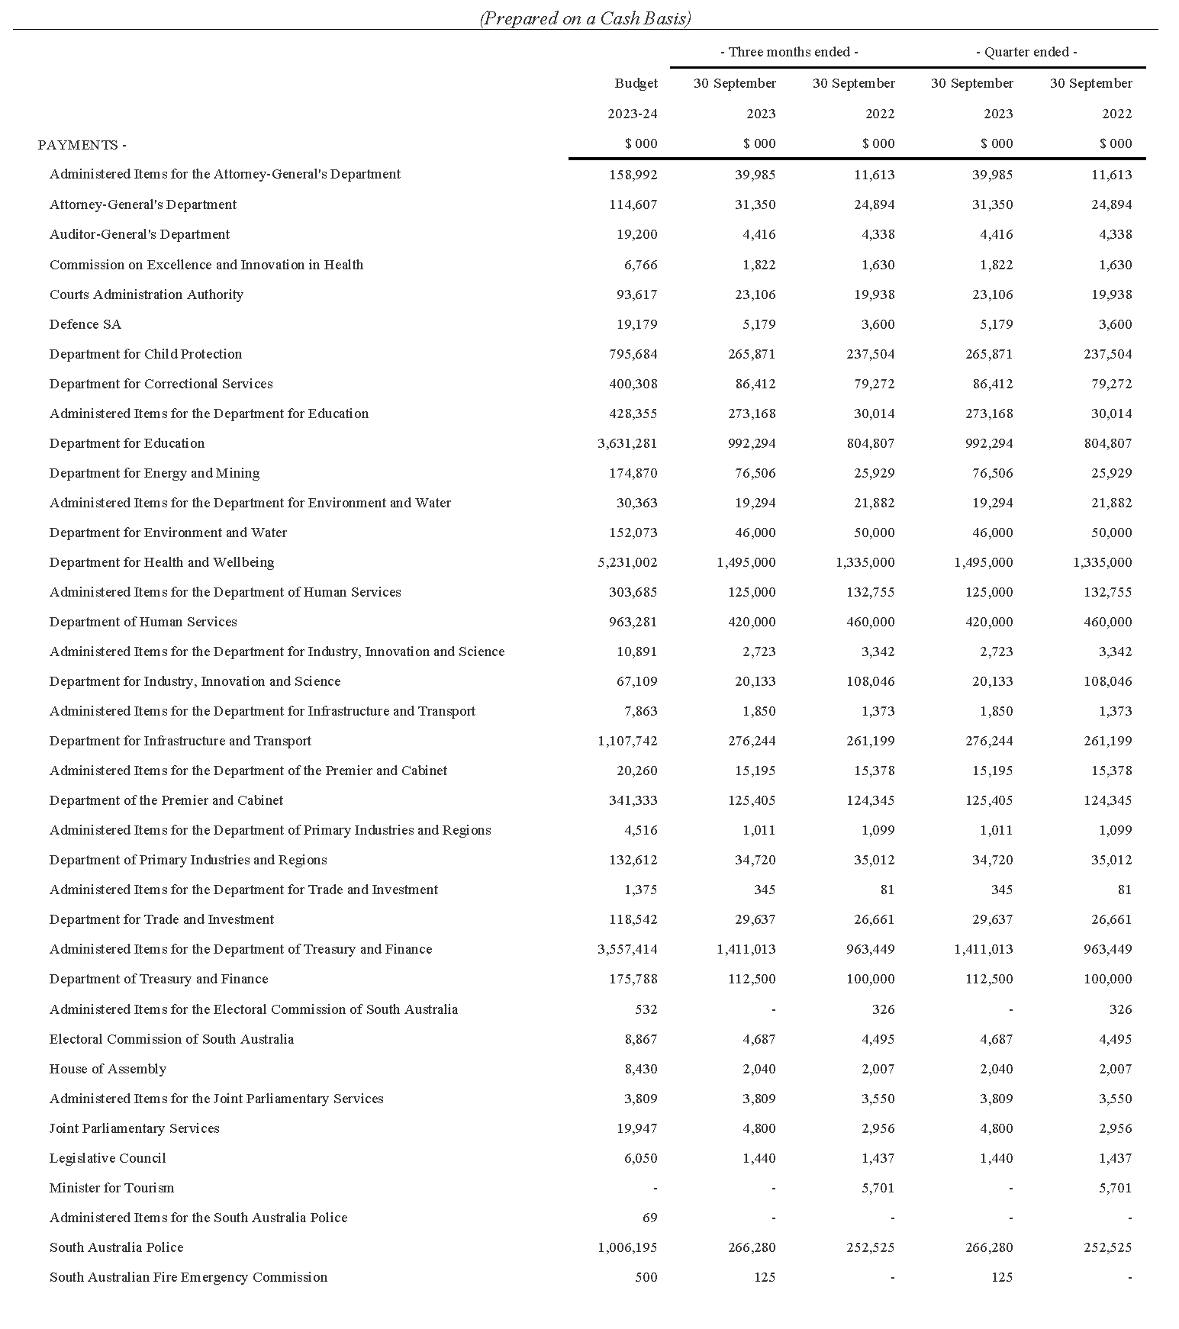

Statement of Payments on the Consolidated Account
Quarters and 3 Months Ended 30 September 2023 and 30 September 2022

Commentary to the Statement of the Amounts Credited to and Issued from the Consolidated Account
for the Quarters Ended 30 September 2023 and 30 September 2022
Receipts
Taxation
Gambling tax receipts in the September quarter 2023 were broadly in line with the corresponding prior year period.
Land tax receipts in the September quarter 2023 were lower than the corresponding prior year period mainly due to the timing of collections associated with government land tax liabilities.
Payroll tax receipts in the September quarter 2023 were higher than the corresponding prior year period primarily reflecting growth in taxable payrolls.
Stamp duty receipts in the September quarter 2023 were higher than the corresponding prior year period largely due to higher duty from motor vehicle registration transfers and general insurance premiums.
Royalties
Royalty receipts for the September quarter 2023 were broadly in line with the corresponding prior year period.
Fees and Charges
Fees and Charges in the September quarter 2023 were higher than the corresponding prior year period largely due to the timing of collection of fines for infringement notices.
Commonwealth—General Purpose Payments
Growth in general purpose grant receipts in 2023-24 compared to 2022-23 is not indicative of underlying movements in Goods and Services Tax (GST) revenue. This is because monthly grants are paid according to a payment schedule prepared by the Commonwealth Government rather than actual emerging monthly GST collections.
Based on the growth in the national GST pool and population estimates as well as South Australia’s relativity in 2023-24, the Commonwealth Government estimated in its 2023-24 Budget that South Australia’s GST entitlement grant will increase by 14.1 per cent in 2023-24.
Commonwealth—Specific Purpose Payments
Specific Purpose Payments received in the September quarter 2023 were broadly in line with the corresponding prior year period.
Commonwealth—National Partnership Payments
National Partnership Payments received in the September quarter 2023 were lower than the corresponding prior year period mainly due to lower reimbursements for Commonwealth HomeBuilder grants that are being administered by the state on behalf of the Commonwealth Government as well as lower recoveries associated with COVID-19 Business Support Payments.
Other Receipts
Other receipts in the September quarter 2023 were higher than the corresponding prior year period mainly due to higher interest on investments. This is due to higher interest rates applied on the Treasurer’s deposits placed with the South Australian Government Financing Authority.
Payments
Payments were made pursuant to the Appropriation Act 2023 and also in accordance with other Acts for which specific appropriation has been authorised. The timing of the payments is based on agreed agency drawdown schedules and may change from period to period based on specific agency requirements.
All appropriations were paid within approved limits established under the various Acts.
Note
The following points should be considered when reviewing the quarterly statement of Consolidated Account transactions:
- Unlike the State Budget which comprises transactions on an accrual basis, the information reflected in the quarterly statement is limited to cash transactions.
- The Consolidated Account does not capture all the transactions undertaken by the general government sector. In particular, it does not record receipts to, and payments from Agency deposit and special deposit accounts.
- The timing of receipts and payments can fluctuate within a financial year and between financial years. As a result, apparently large movements between quarters or financial years may only be due to changes in the timing of receipts and payments and therefore may not have consequences for the underlying budget position.
Dated: 20 March 2024
Hon. Stephen Mullighan MP
Treasurer of South Australia

Return To Work Act 2014
Publication of Forms and Manners for Making a Claim and an Employer Statement
Preamble
This Notice is given in accordance with the powers delegated to me, Michael Francis, Chief Executive Officer, by the Board of the Return to Work Corporation of South Australia (‘the Corporation’) under an Instrument of Delegations dated 2 February 2023.
Section 30(1)(a) of the Return to Work Act 2014 (‘the Act’) states that a claim must be made in a manner and form approved by the Corporation.
Section 30(5)(b) of the Act states that an employer must forward to the Corporation a copy of the claim and a statement in the designated form.
Section 4(15) of the Act provides that a reference in a provision of the Act to a designated form is a reference to a form designated for the purposes of that provision by the Corporation from time to time by notice in the Gazette.
Notice
- Forms for making a claim
Pursuant to section 30(1)(a) of the Act, I give notice that from 1 July 2015, the Claim form at Attachment 1 is the ‘form approved by the Corporation’ for the purposes of that section, to be completed jointly or separately by a worker (or a person on behalf of a worker) and their employer.
Further, pursuant to section 30(1)(a) of the Act, I give notice that from 3 April 2024, the Claim form at Attachment 2 is the online ‘form approved by the Corporation’ for the purposes of that section, to be completed by an employer on behalf of the worker.
The requirement to provide the Claim form may be dispensed with pursuant to Section 30(8) of the Act if a claim is made by telephone.
- Employer statement
Pursuant to section 30(5)(b) of the Act, I give notice that from 1 July 2015, the Claim form at Attachment 1 is also the ‘designated form’ for the purposes of that section, to be completed jointly or separately by an employer and the worker (or a person on behalf of a worker).
Further, pursuant to section 30(5)(b) of the Act, I give notice that from 3 April 2024, the Claim form at Attachment 2 is also the online ‘designated form’ for the purposes of that section, to be completed by an employer on behalf of the worker.
The requirement to provide a statement in the ‘designated form’ may be dispensed with pursuant to section 30(8) if a receipt of a worker’s claim is reported by the employer by telephone.
- Manner for making a claim
Pursuant to section 30(1)(a) of the Act, I give notice that from 1 July 2015, the manner outlined at Attachment 3 is the ‘manner approved by the Corporation’ for the purposes of that section.
Confirmed as a true and accurate record of the decision of the Corporation.
Dated: 22 March 2024
Michael Francis
Chief Executive Officer

Attachment 1
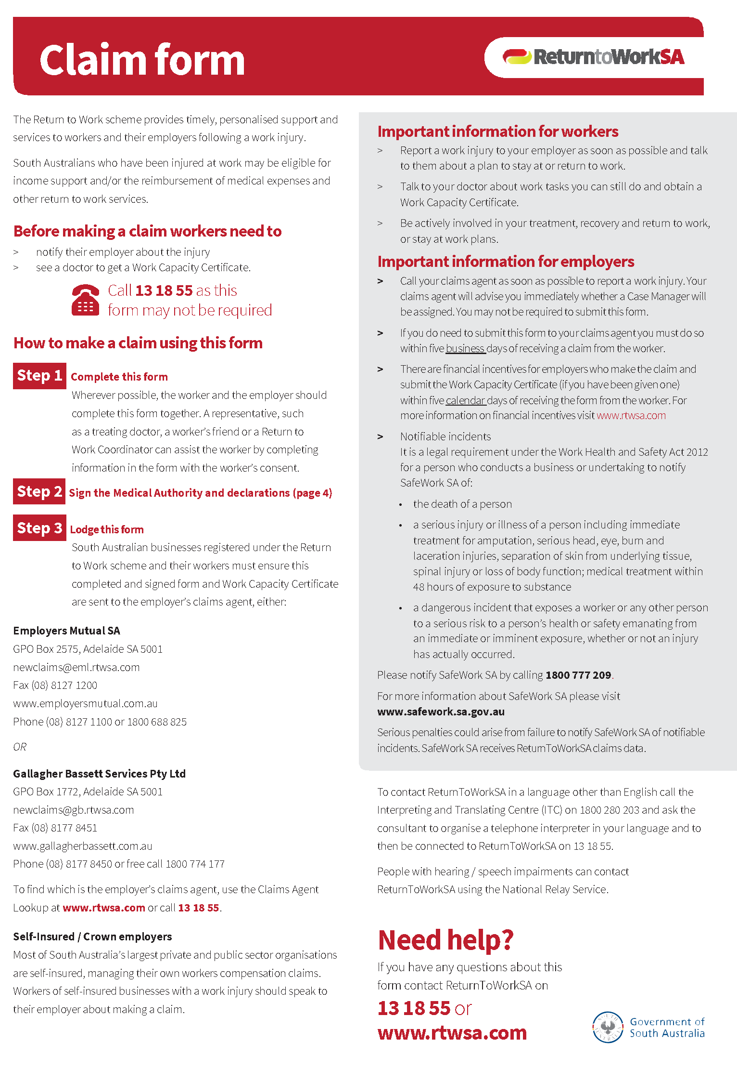
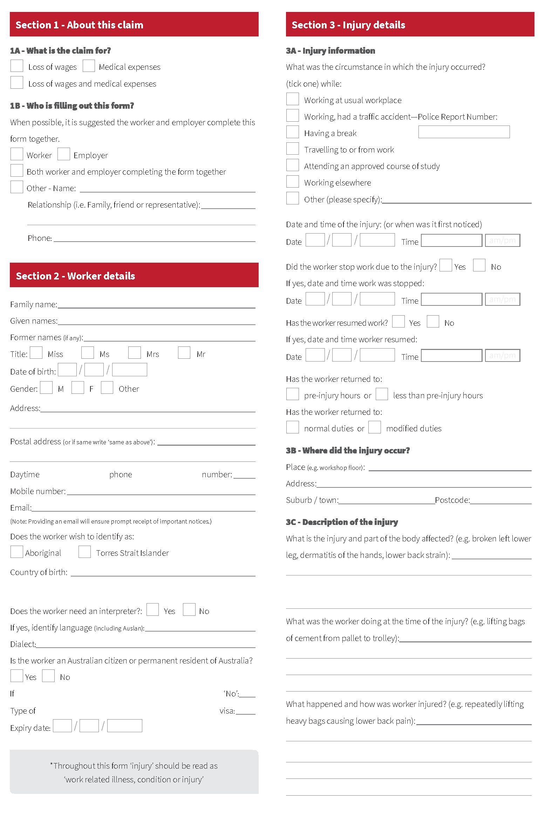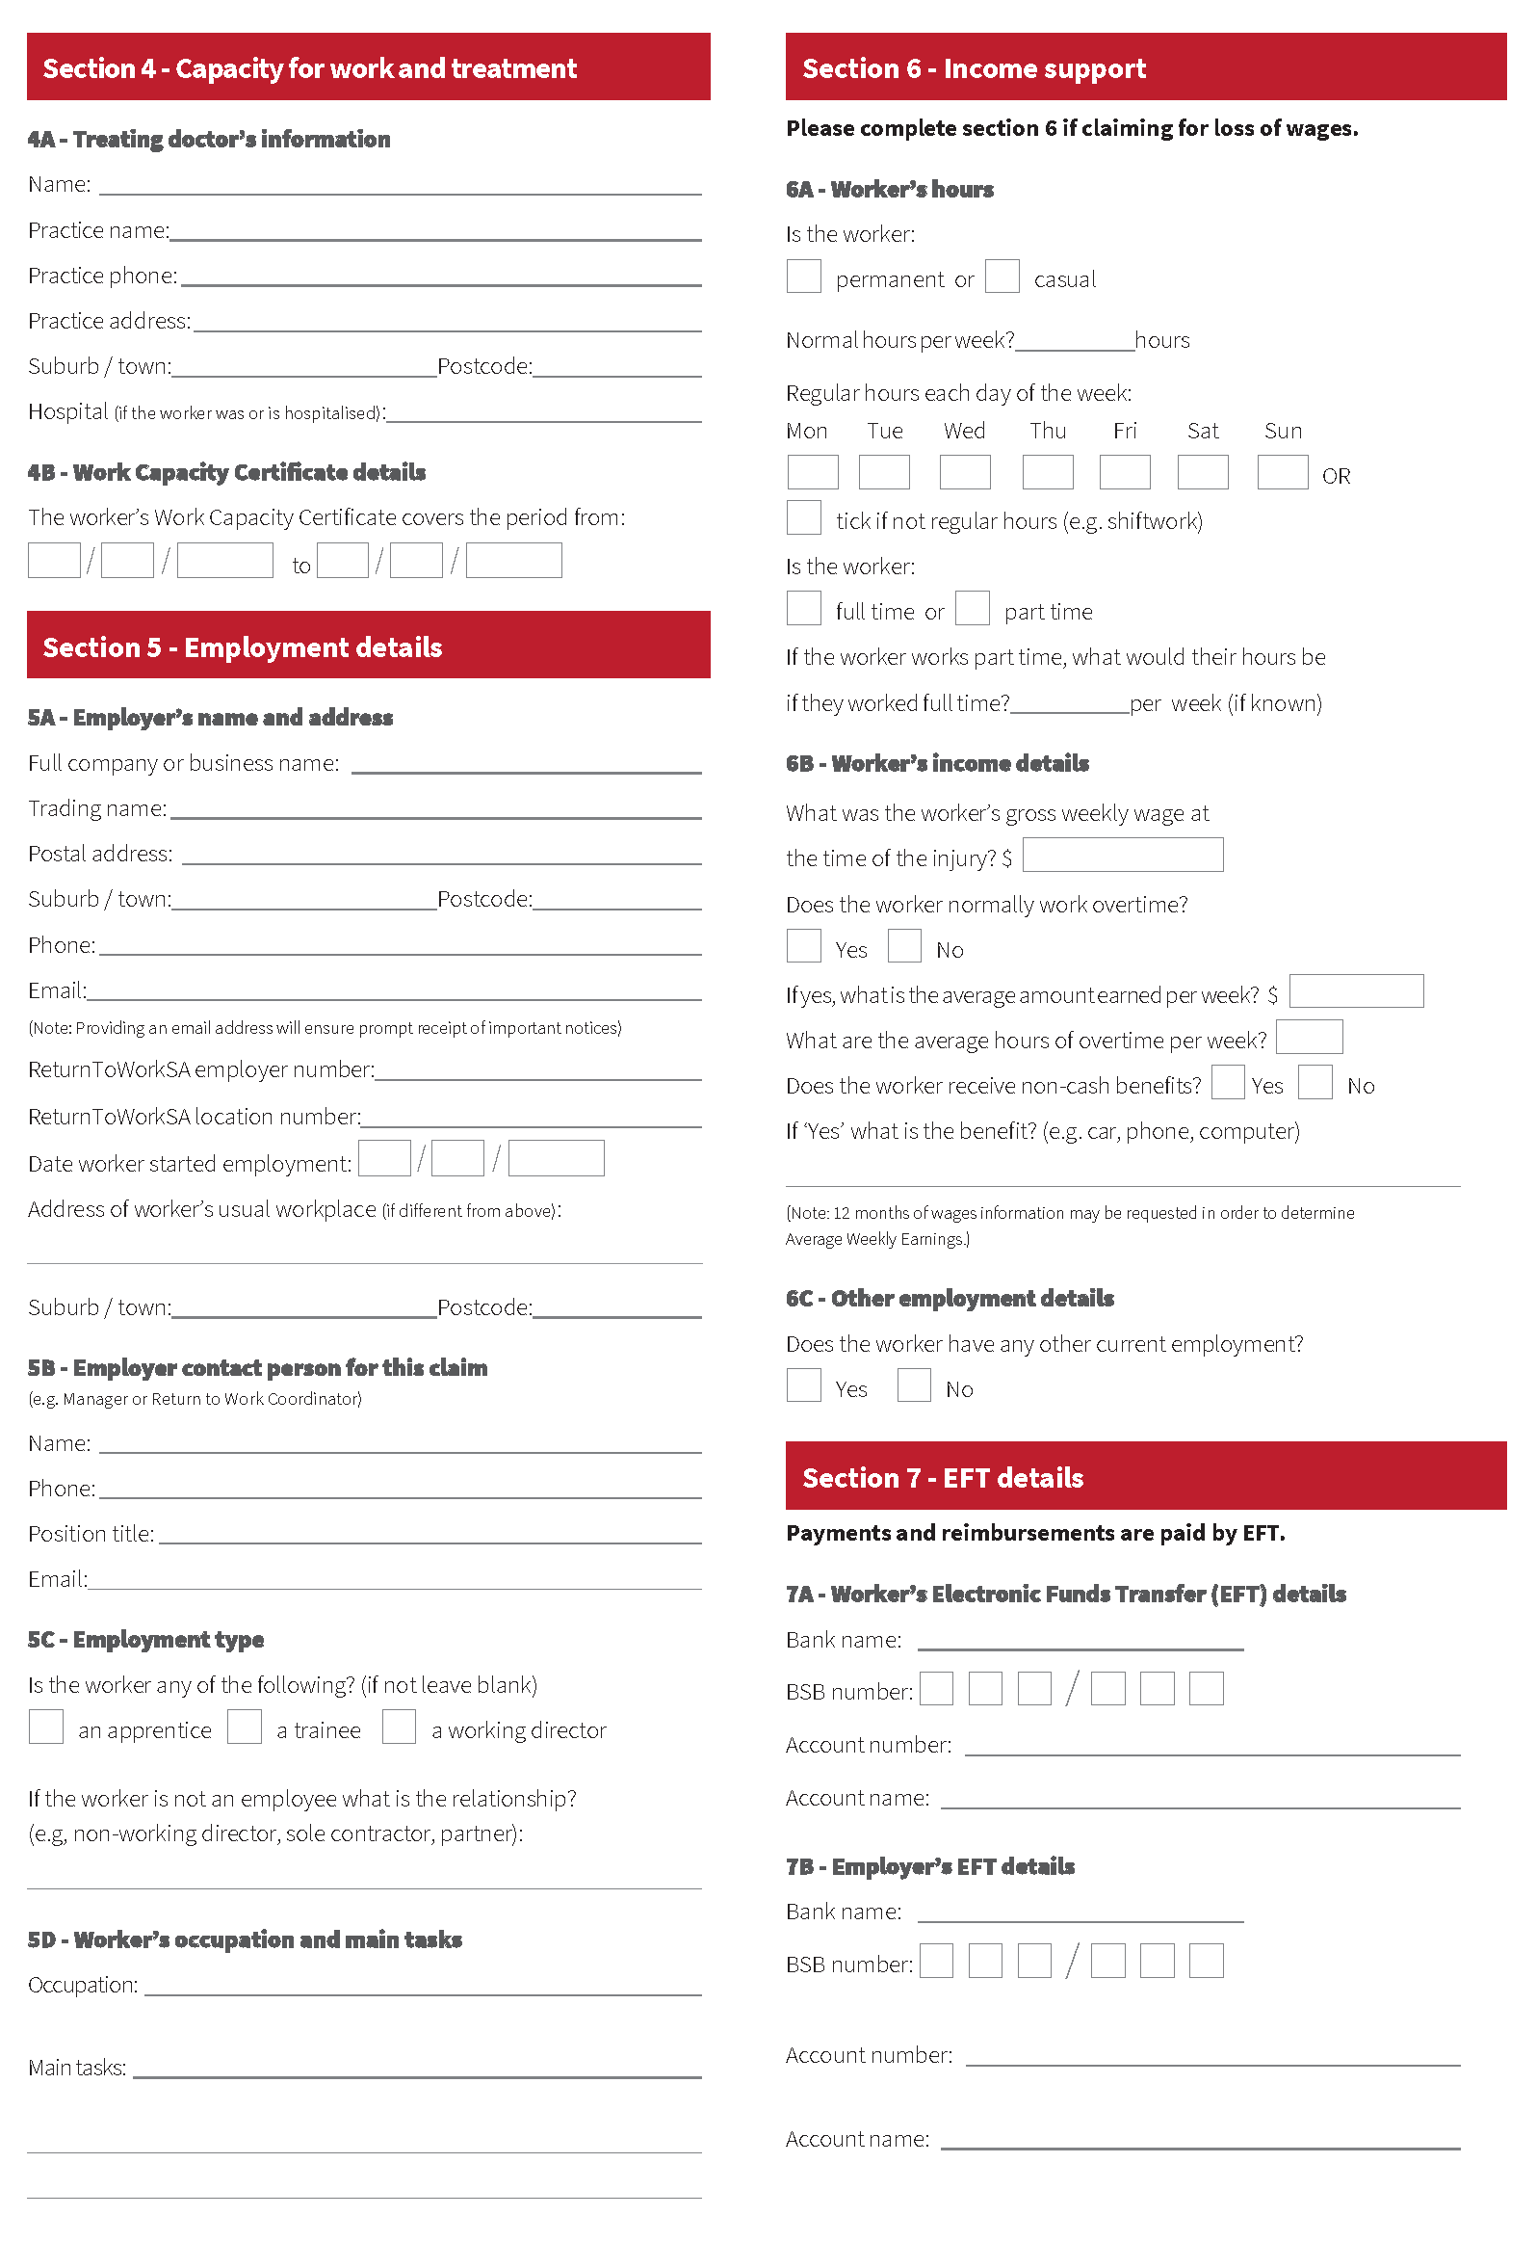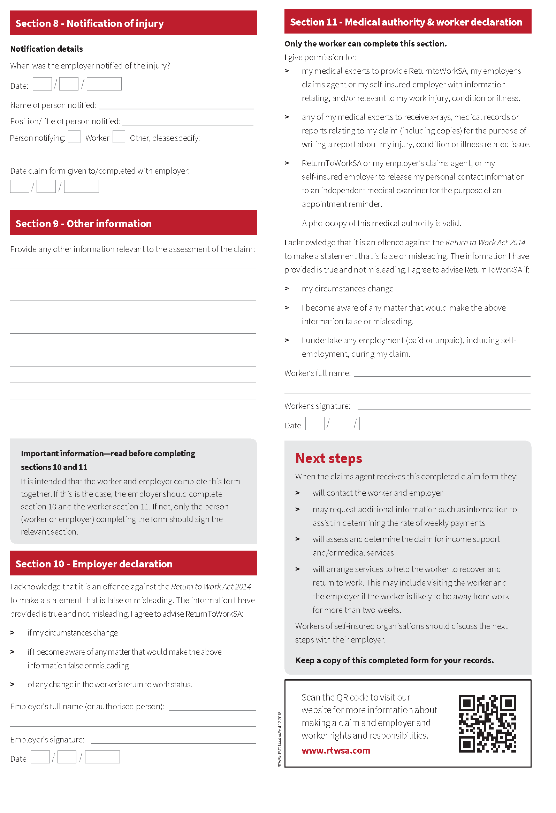
Attachment 2
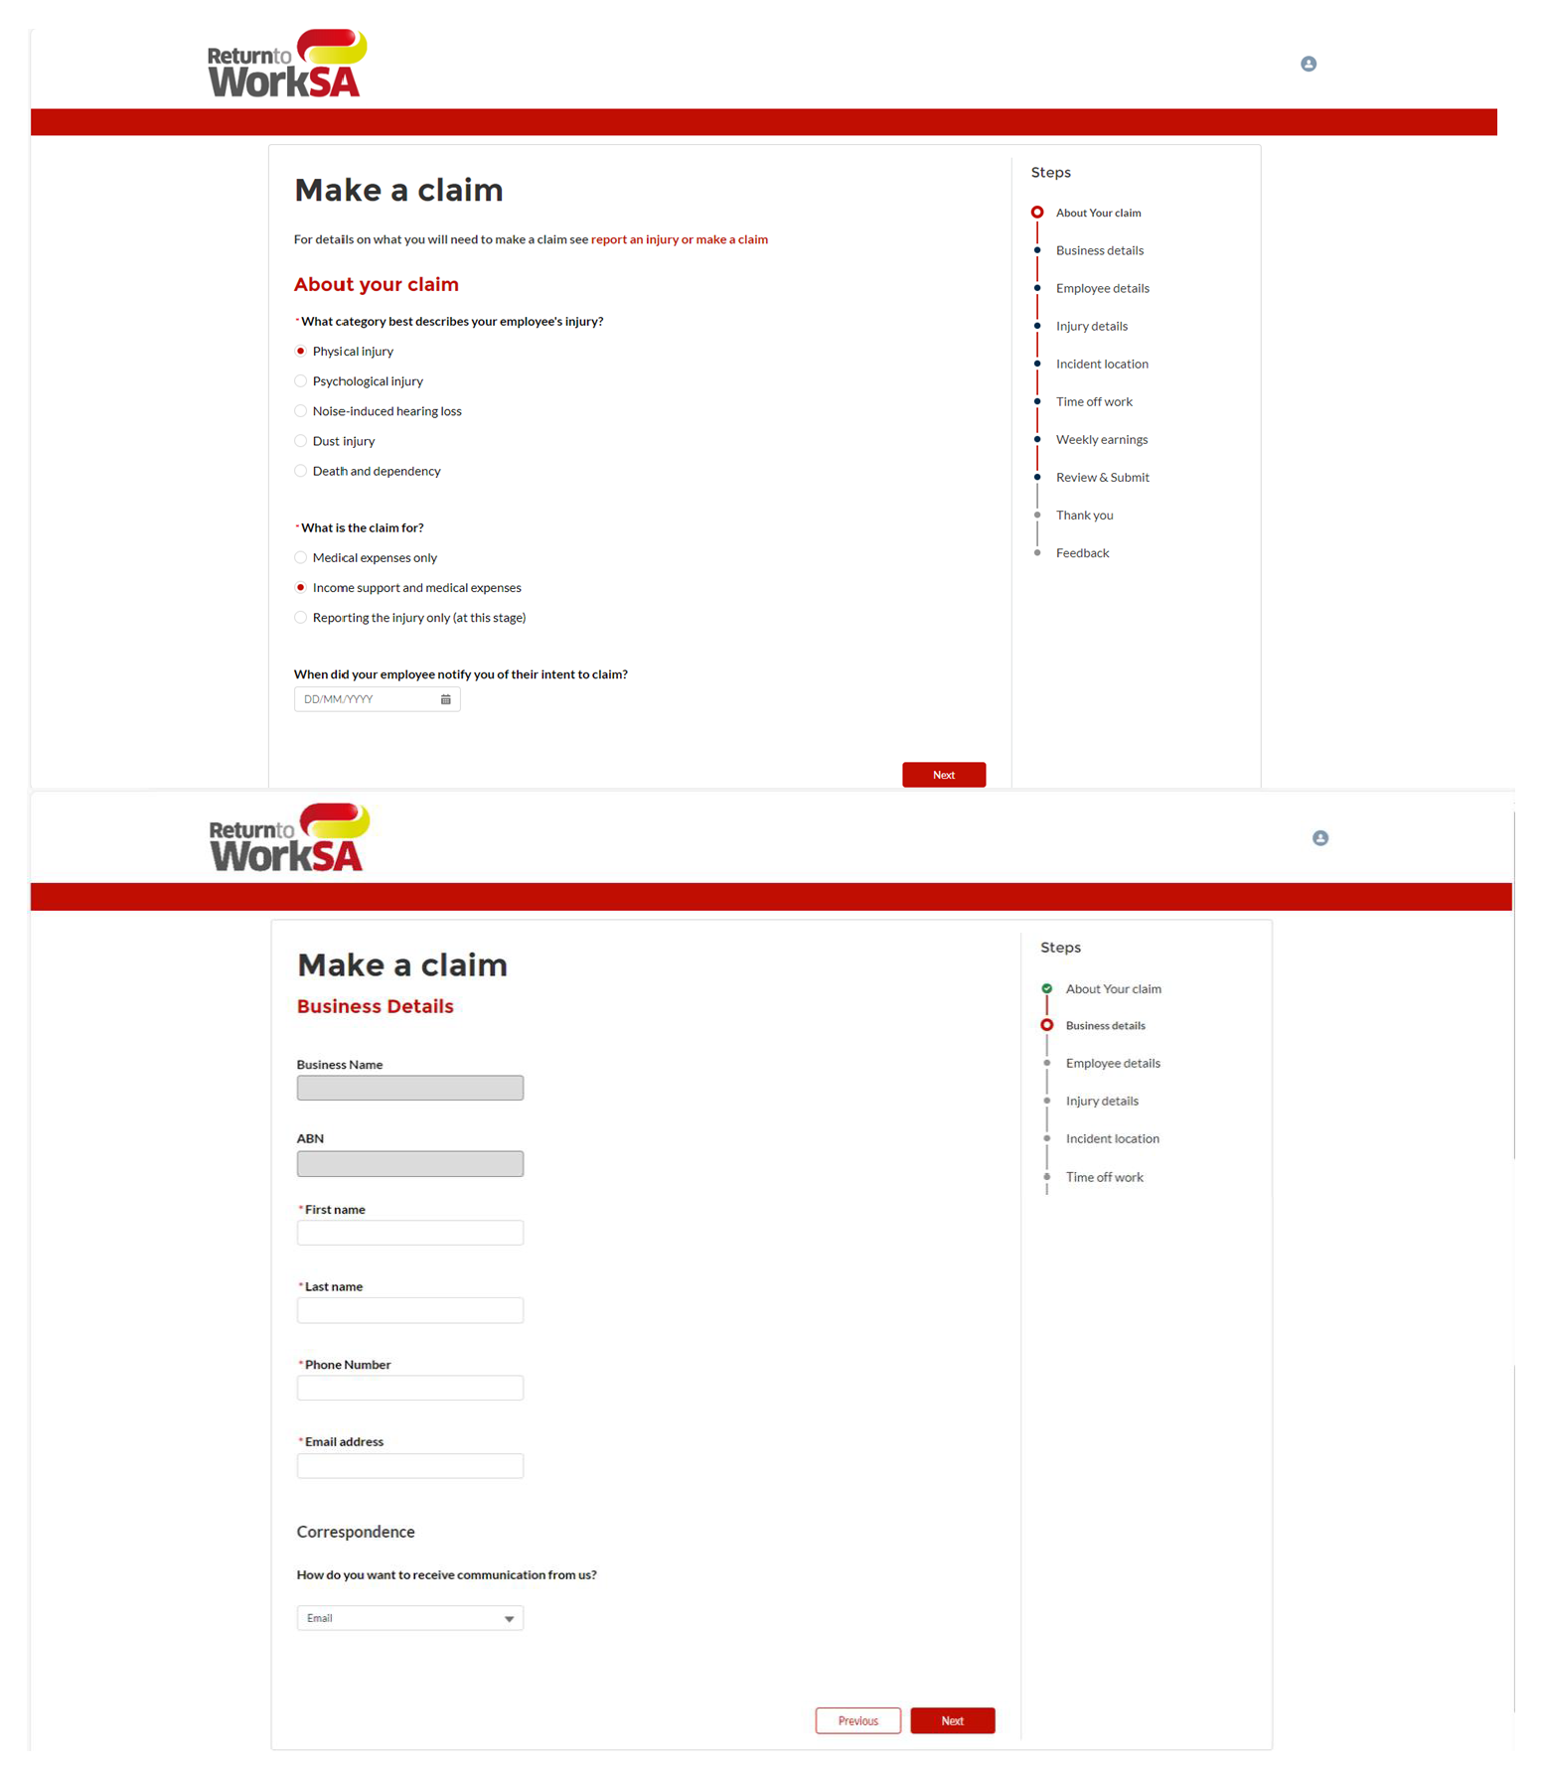
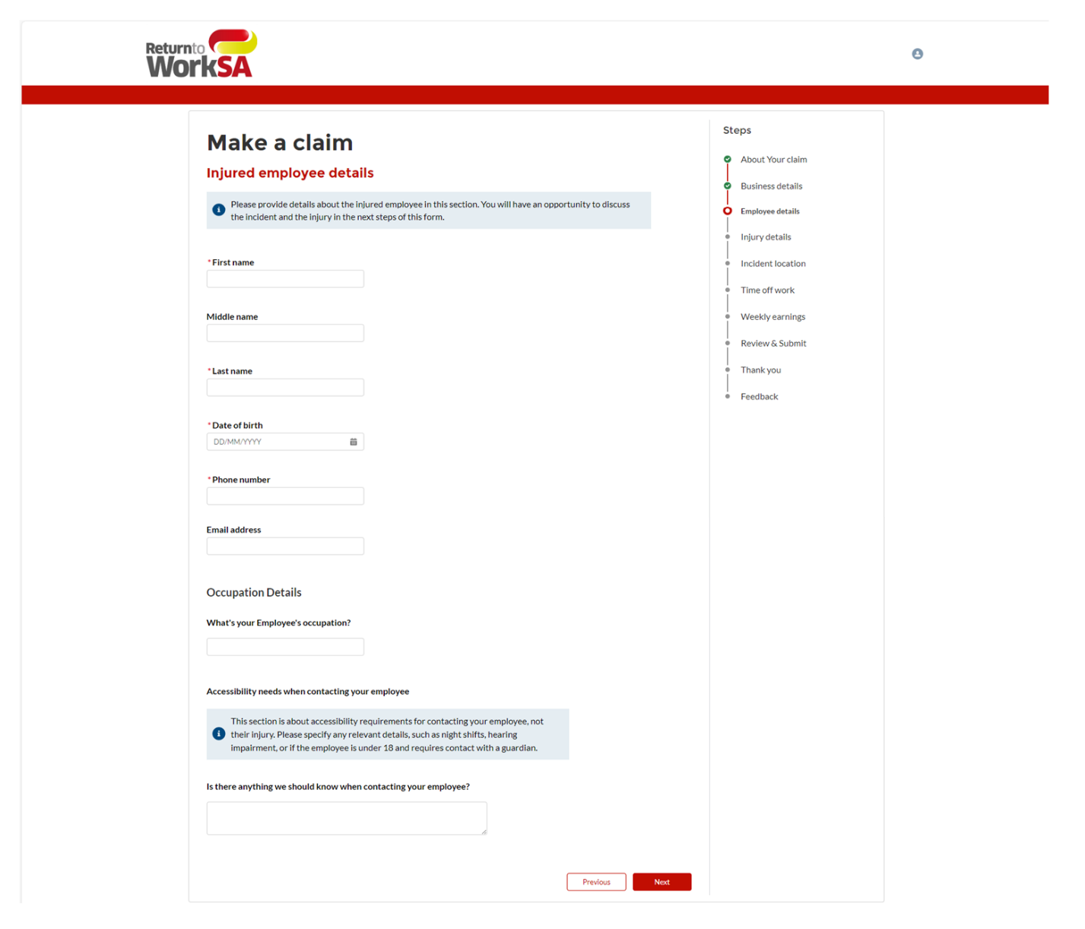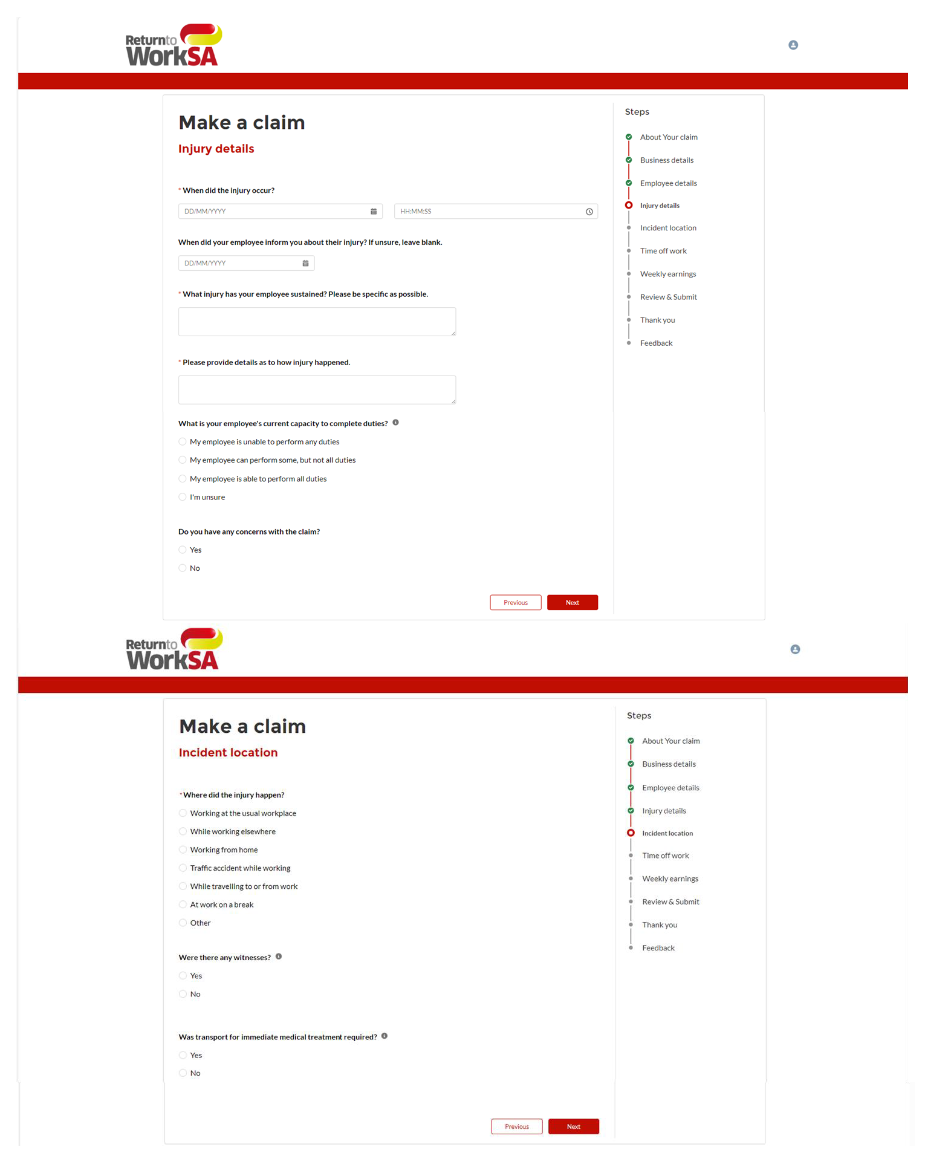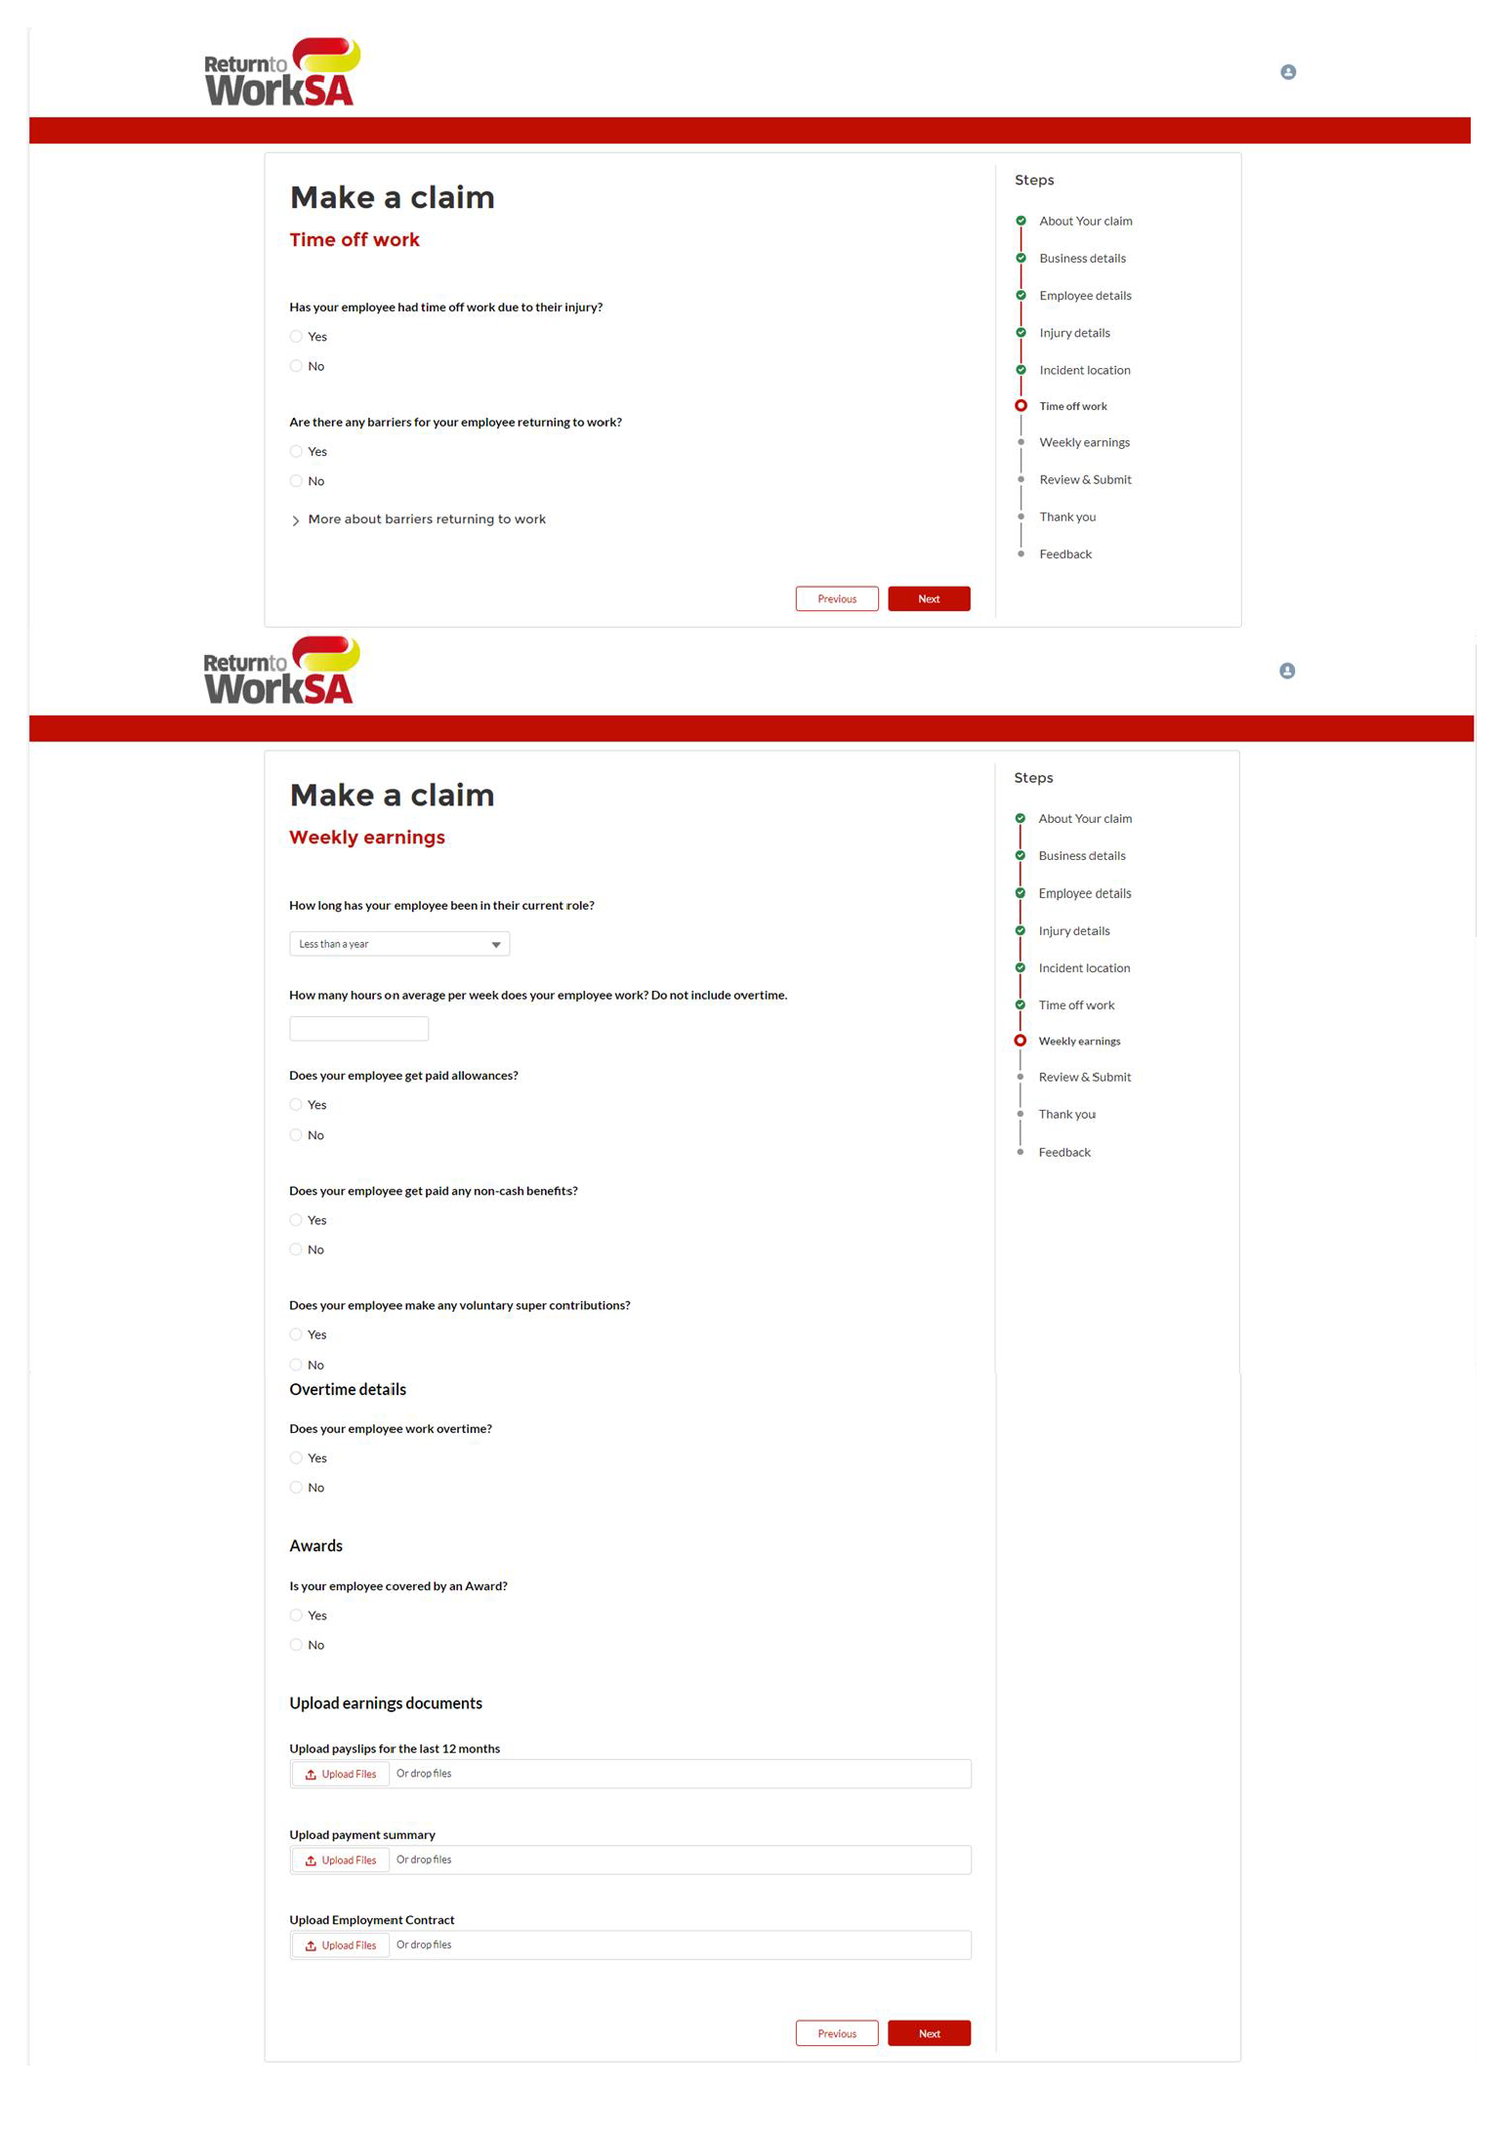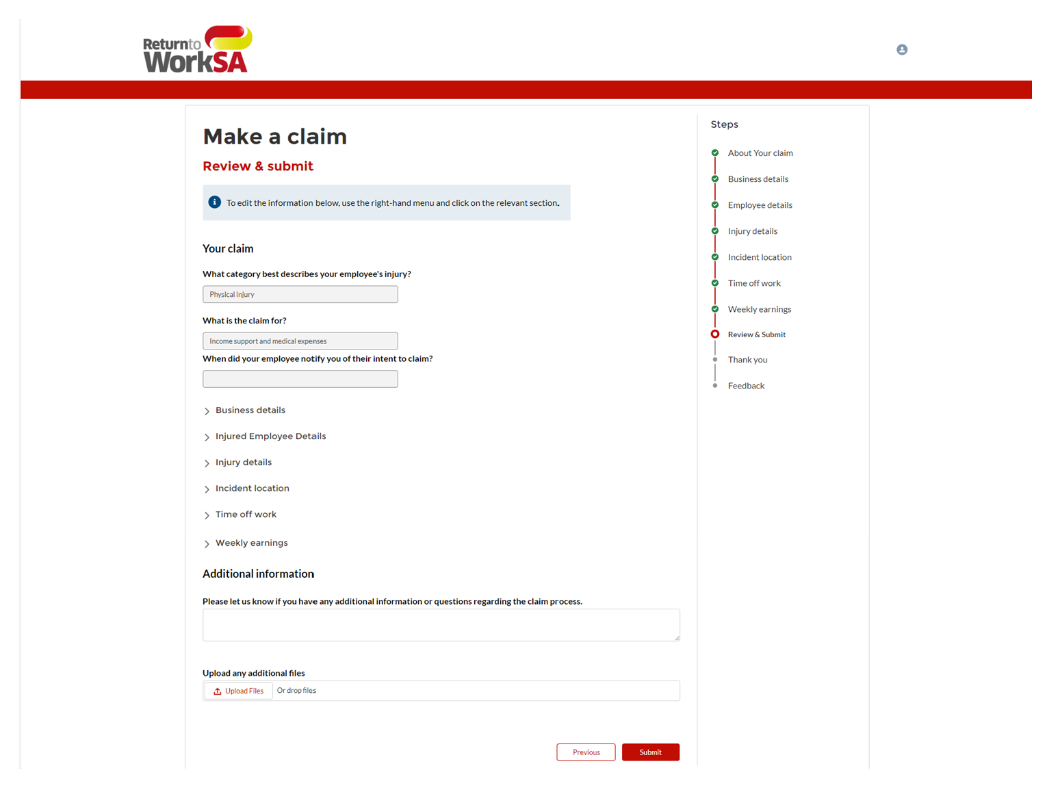

Attachment 3—Manners
1.1 For workers of an employer who is not a self-insured employer, the claim form must be given by the worker, or their representative, to
- their employer direct (if the worker is in employment at the commencement of incapacity),or
- the Corporation, or the employer’s claims agent (currently EML SA or Gallagher BassettServices),
in one of the following manners:
  - in person
  - via post
  - via facsimile
  - via telephone
  - via email
  - online.
1.2 The contact details as at the date of publishing these manners are as follows:
EML SA
In person: 15th Floor, 26 Flinders Street, Adelaide
Via post: GPO Box 2575, Adelaide SA 5001 or
15th Floor, 26 Flinders Street, Adelaide SA 5000
Via facsimile: (08)8127 1200
Via telephone: 1800 688 825 (free call)
Via email: newclaims@eml.rtwsa.com
Online: www.eml.com.au
Gallagher Bassett Services
In person: Level 3, 115 Grenfell Street, Adelaide
Via post: GPO Box 1772, Adelaide SA 5001 or
Level 3, 115 Grenfell Street, Adelaide SA 5000
Facsimile: (08)8177 8451
Via telephone: (08)8177 8450 or free call 1800 774 177
Via email: newclaims@gb.rtwsa.com.au
Online: www.gallagherbassett.com.au
The Corporation (ReturnToWorkSA)
In person: Ground Floor, 400 King William Street, Adelaide
Via post: GPO Box 2668, Adelaide SA 5001
400 King William Street, Adelaide SA 5000
Via facsimile: (08)8233 2466
Via telephone: 13 18 55
Via email: silicosis@rtwsa.com (for silicosis claims)
Note: Current contact details will be maintained on the employer’s claims agent’s website (currently EML SA at www.eml.com.au or Gallagher Bassett Services at www.gallagherbassett.com.au) or the Corporation’s website at www.rtwsa.com.
1.3 For workers of a self-insured employer, the claim form must be provided by the worker or their representative to the self-insured employer in such manner as decided by a worker’s employer.

Shop Trading Hours Act 1977
Trading Hours—Exemption
NOTICE is hereby given that pursuant to section 5(9)(b) of the Shop Trading Hours Act 1977 (the Act), I, Kyam Maher MLC, Minister for Industrial Relations and Public Sector, do hereby declare:
- Non-exempt shops situated on The Parade, Norwood (between Fullarton Road and Portrush Road) are exempt from the provisions of the Act between the hours of:
- 5.00 pm and 7.00 pm on Sunday, 7 April 2024
This exemption is subject to the following conditions:
- Normal trading hours prescribed by section 13 of the Act shall apply at all other times.
- Each employee who works in a shop during the extended hours has voluntarily accepted an offer by the shopkeeper to work.
- Any and all relevant industrial instruments are to be complied with.
- All work health and safety issues (in particular those relating to extended trading hours) must be appropriately addressed.
Dated: 20 March 2024
Hon Kyam Maher MLC
Minister for Industrial Relations and Public Sector

Local Government Instruments

City of Adelaide
Local Government Act 1999: Section 122
and
City of Adelaide Act 1998: Section 30
Draft Park Lands and Open Space, Water Infrastructure and Public Lighting Asset Management Plans for public consultation
The City of Adelaide is consulting on its Draft Park Lands and Open Space, Water Infrastructure and Public Lighting and Electrical Infrastructure Asset Management Plans.
Pursuant to the provisions of section 122 of the Local Government Act 1999, and section 30 of the City of Adelaide Act 1998, the City of Adelaide is required to conduct public consultation on its Asset Management Plans before they can be formally adopted.
A copy of each draft Asset Management Plan will be available for inspection at the Council’s principal office (25 Pirie Street, Adelaide SA 5000), and at its libraries and community centres.
For further information on the consultation process or to provide feedback you can visit yoursay.cityofadelaide.com.au at any time, or Council’s principal office, its libraries and community centres during ordinary office hours.
Consultation is open from Tuesday 2 April 2024.
All submissions on the Draft Park Lands and Open Space, Water Infrastructure and Public Lighting and Electrical Infrastructure Asset Management Plans must be received by 5:00 pm, Friday 10 May 2024.
Michael Sedgman
Acting Chief Executive Officer

District Council of Cleve
Local Government Act 1999—Section 196
Management Plan
The District Council of Cleve gives notice of its adoption of the below listed Environmental Management Plan (EMP) at its Ordinary Council Meeting held on 19 March 2024.
The document may be viewed on the District Council of Cleve Website under Management Plans at www.cleve.sa.gov.au/council/performances/plans and at the Council offices during normal office hours.
- Redbanks Environmental Management Plan
D.J. Penfold
Chief Executive Officer

District Council of Cleve
Local Government Act 1999
Resignation of Councillor
Notice is hereby given in accordance with Section 54(6) of the Local Government Act 1999, that a vacancy has occurred in the office of Councillor, due to the resignation of Councillor Bryan Sturt Trigg, effective from Monday 25 March 2024.
D.J. Penfold
Chief Executive Officer

Mount Barker District Council
Change of Road Name
NOTICE is hereby given that pursuant to Section 219(1) of the Local Government Act 1999, under delegation, Council has renamed a portion of the road named “Hertford Avenue” within DP129341—Mount Barker, (particularly the road allotment 2046) to “Robertson Parade”.
This road name will come into effect from 28 March 2024.
A. Stuart
Chief Executive Officer

District Council of Streaky Bay
Naming of Unnamed Roads
NOTICE is hereby given in accordance with Section 219 of the Local Government Act 1999, that at the Council meeting of 19 March 2024, Council resolved that the road commencing at Sceale Bay Road and ending at the Surfers Beach Carpark be formally named “Surfers Beach Road”.
Dated: 20 March 2024
Damian Carter
Chief Executive Officer

Tatiara District Council
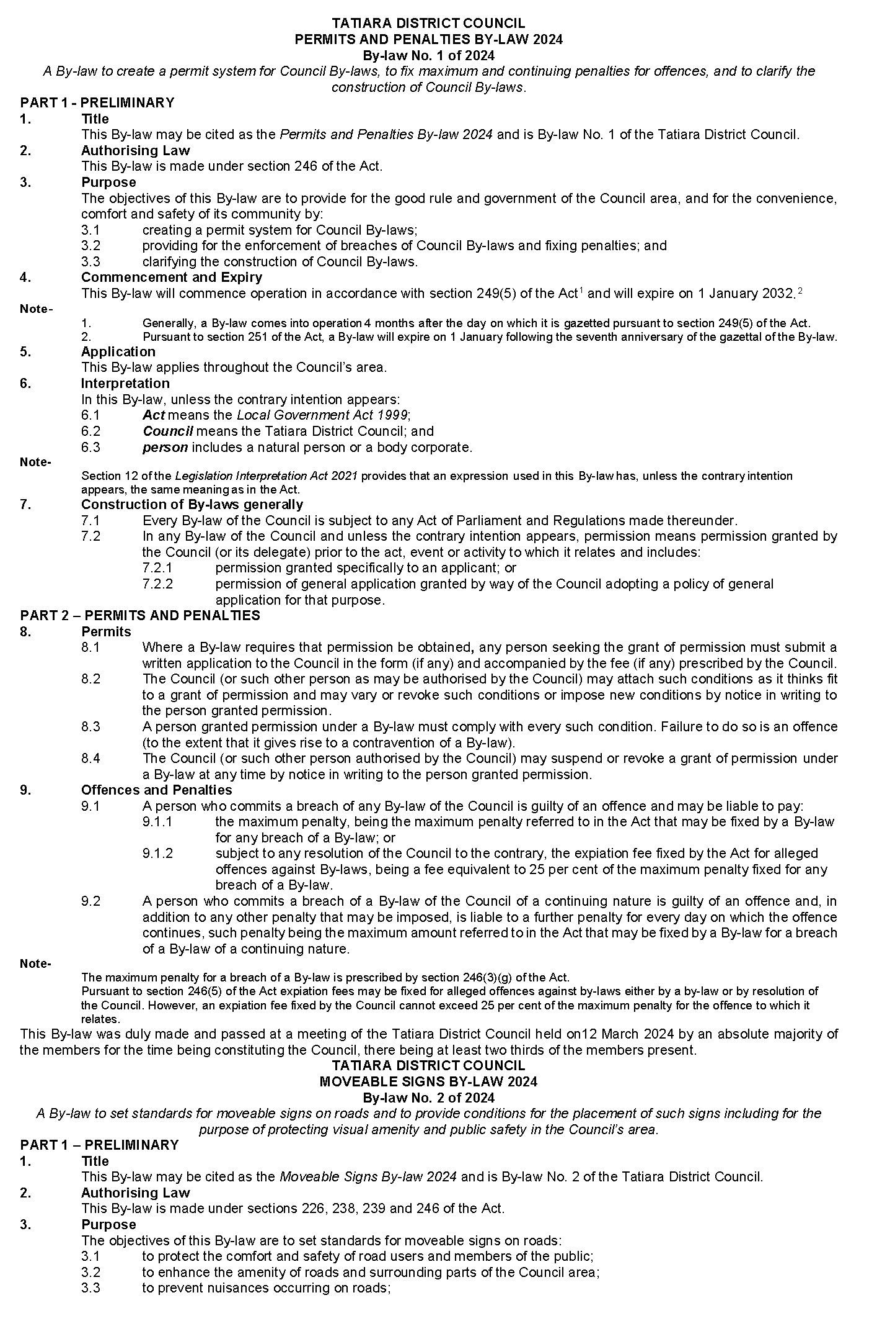
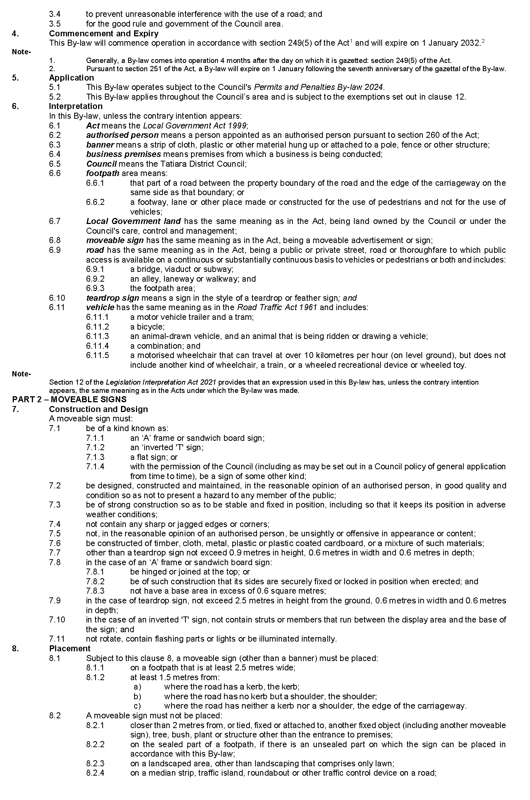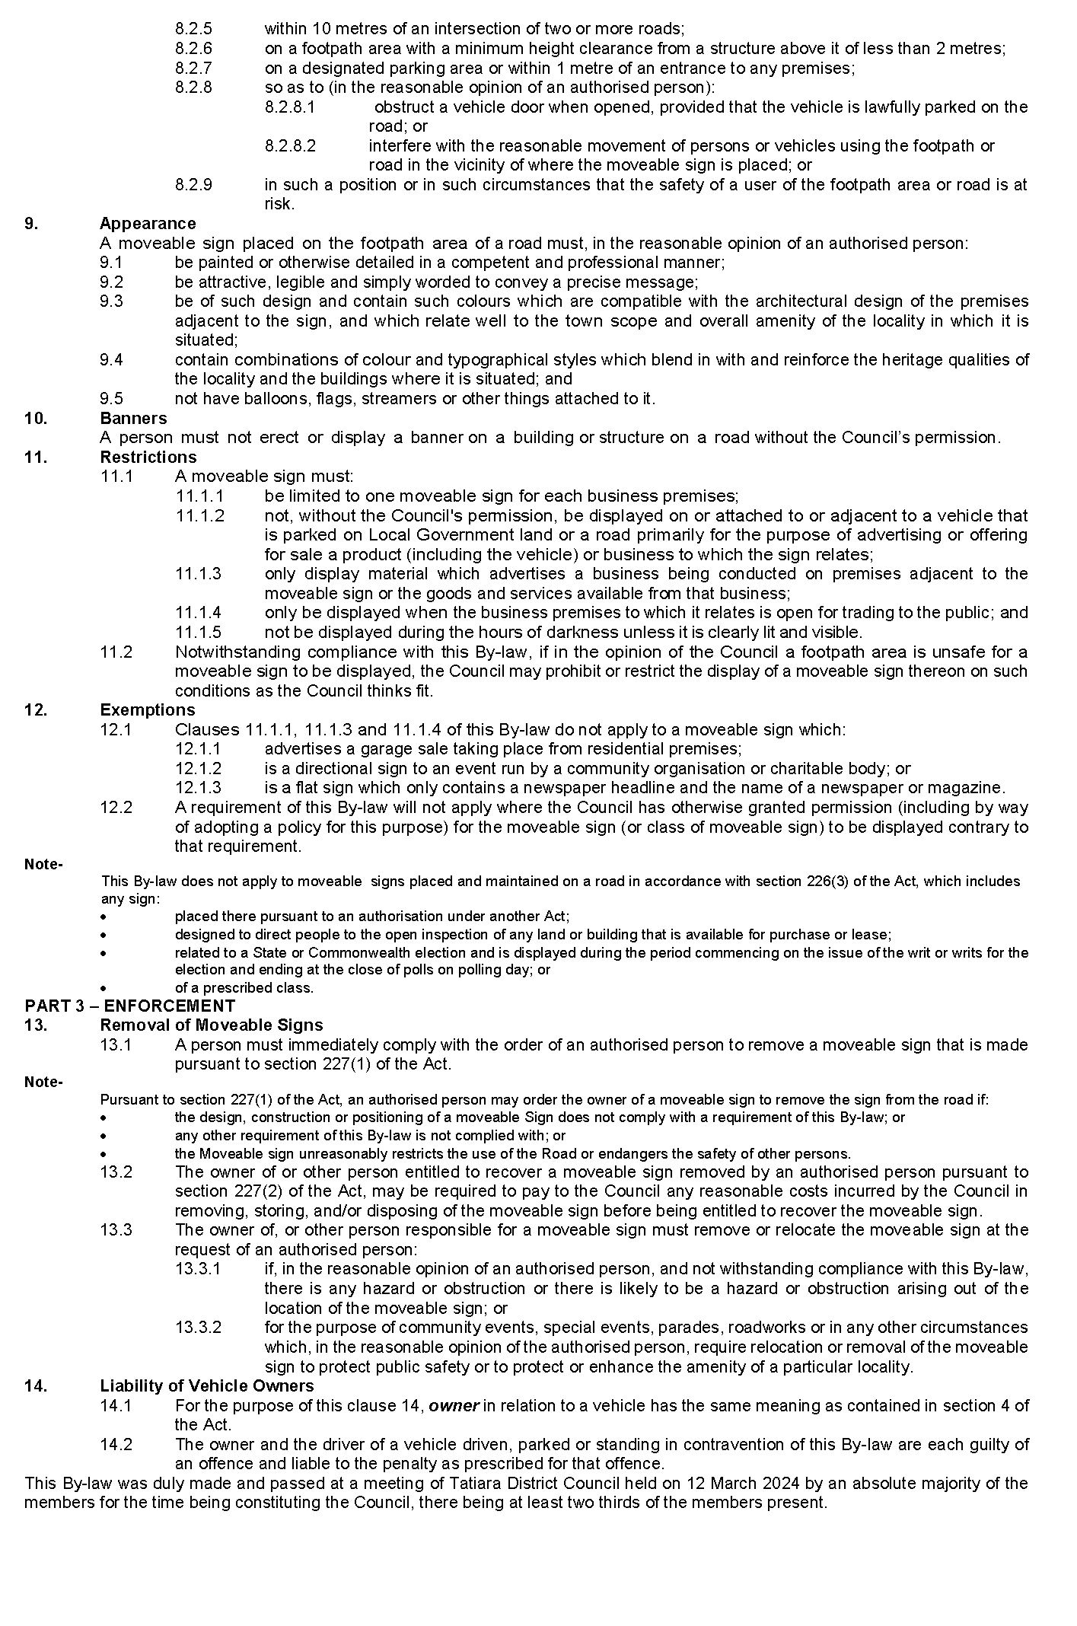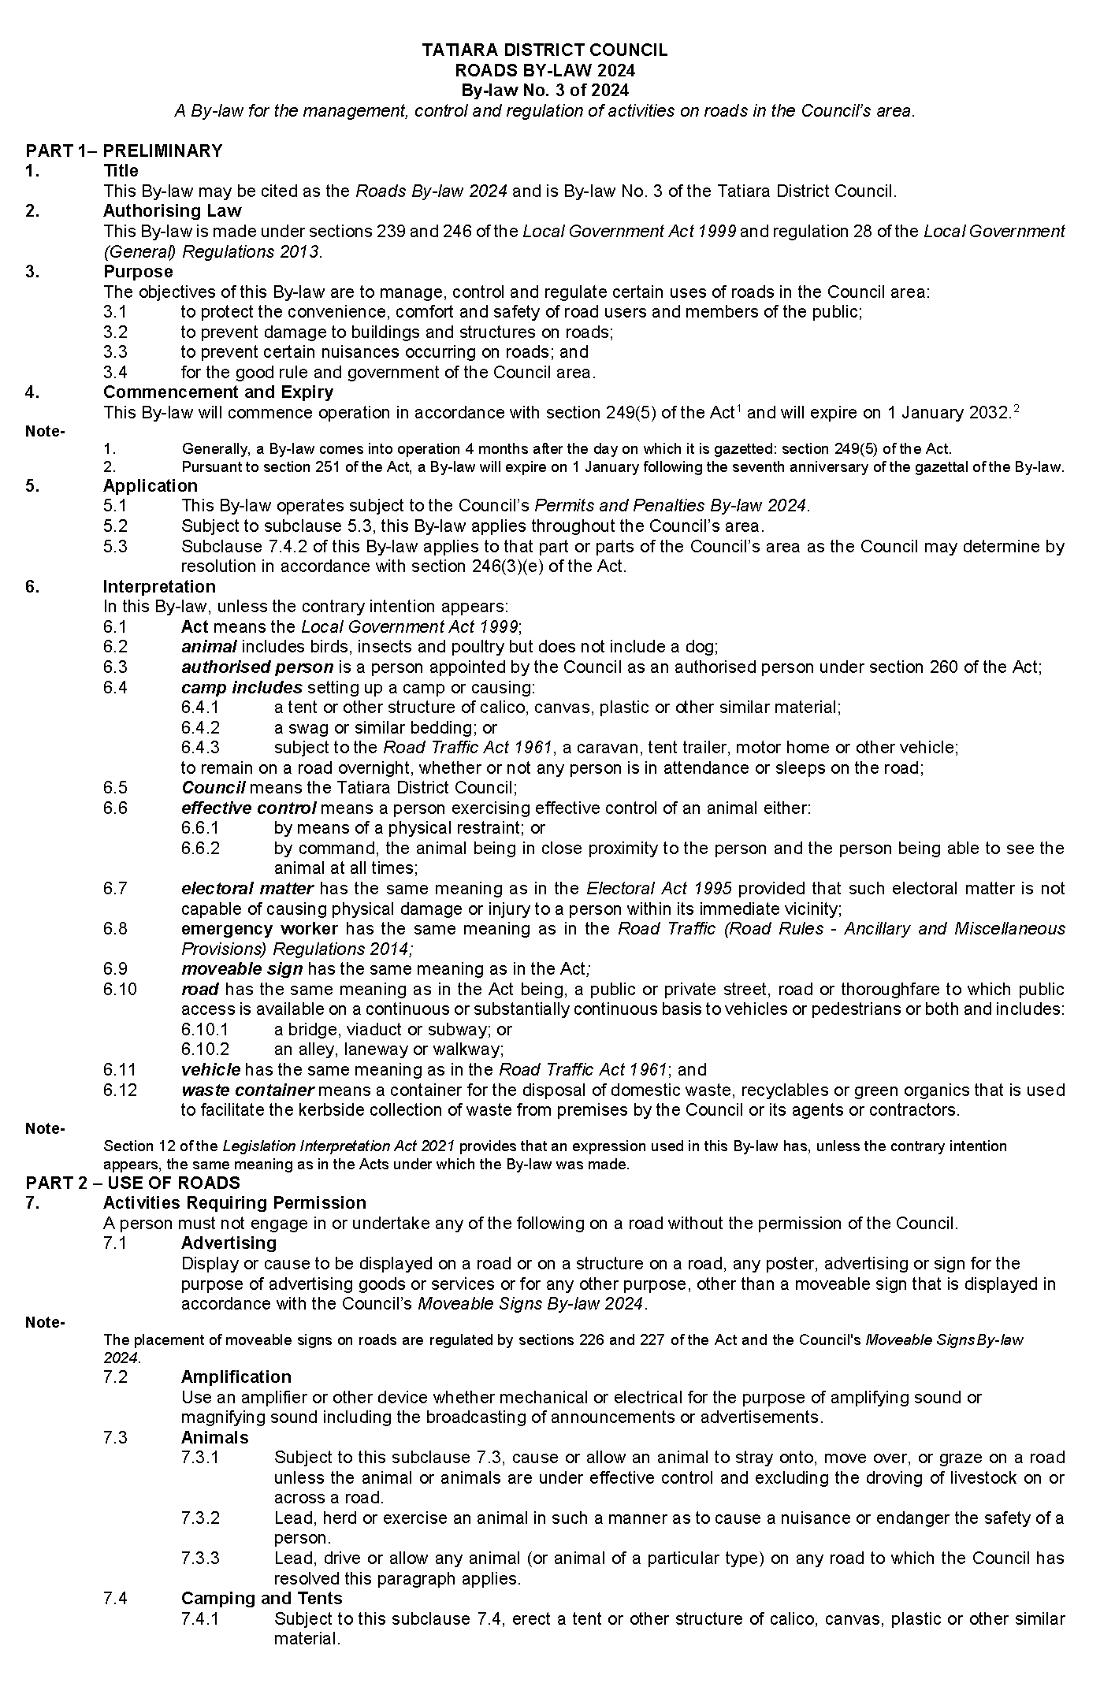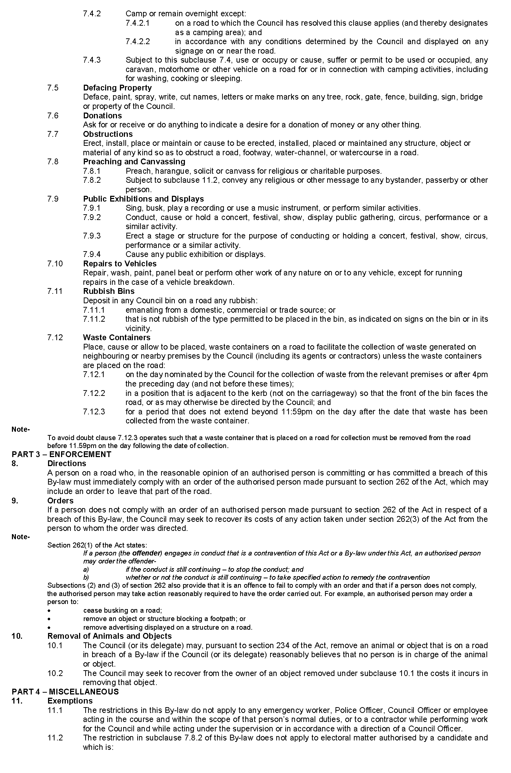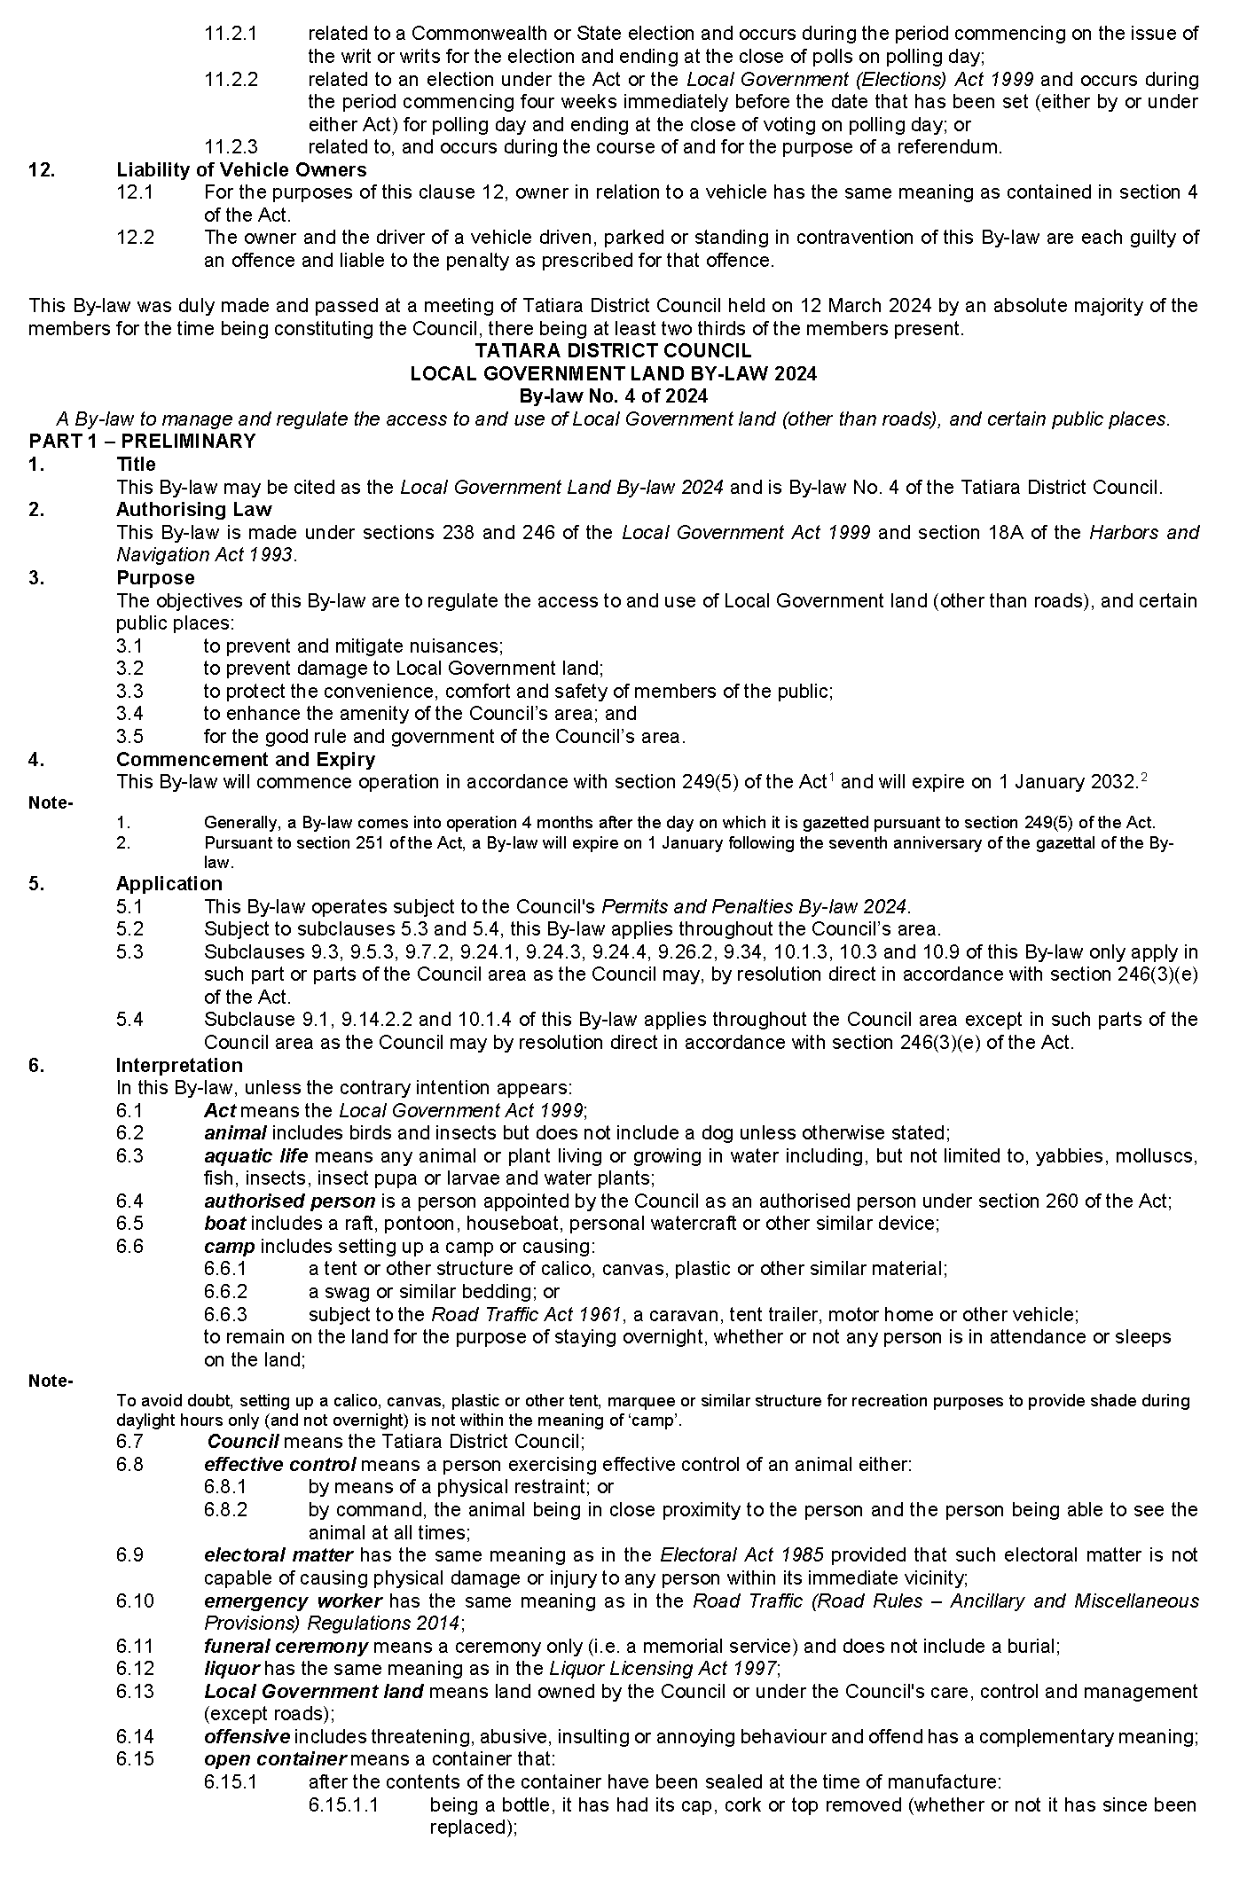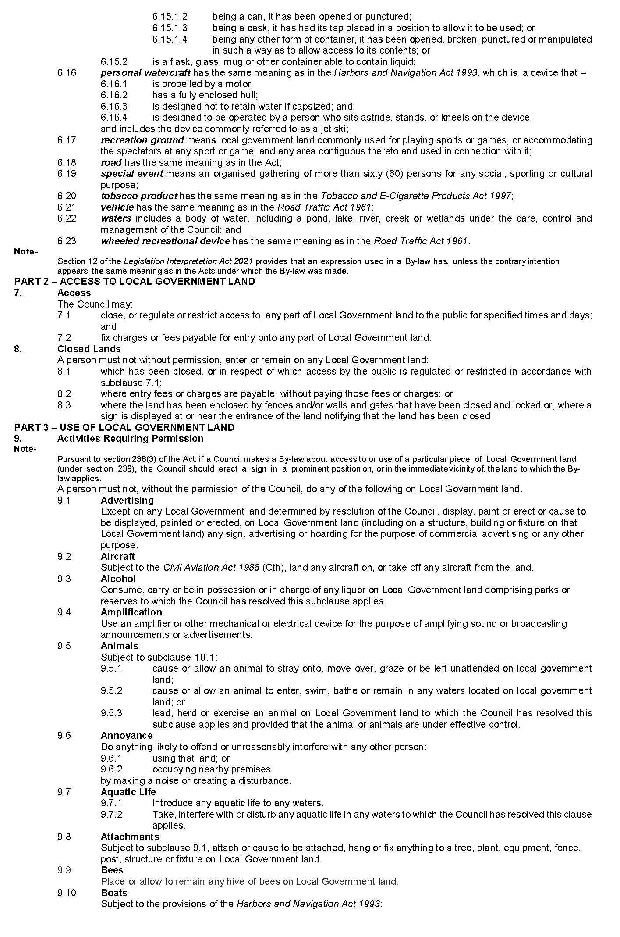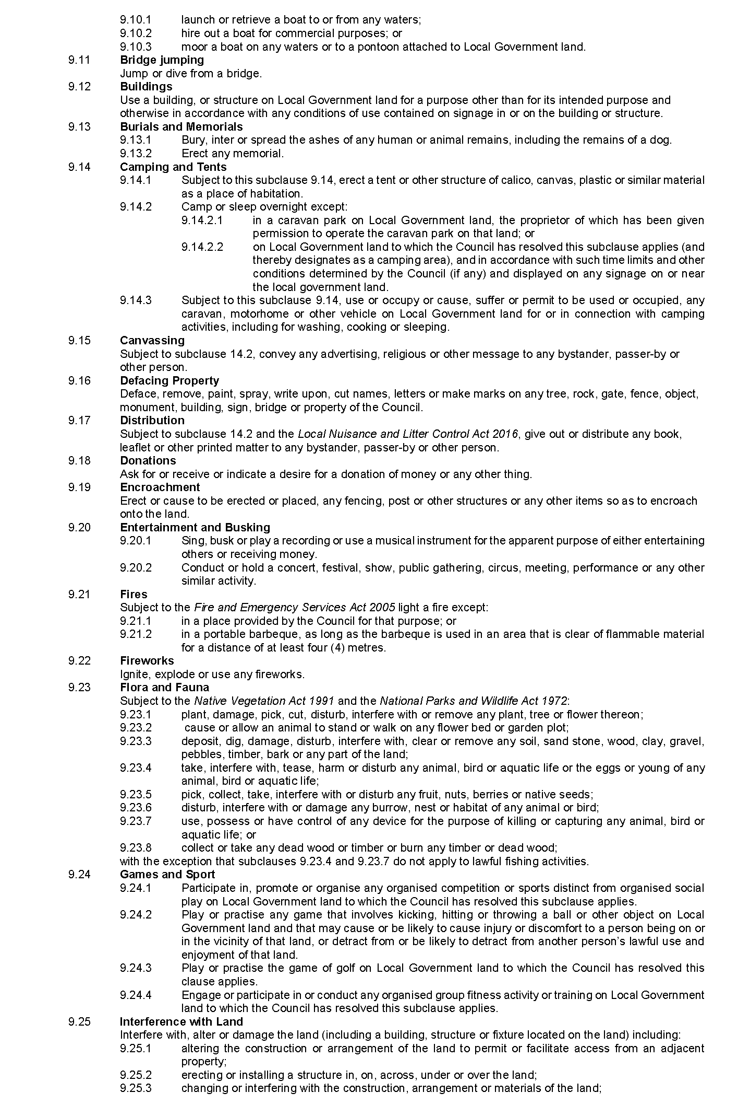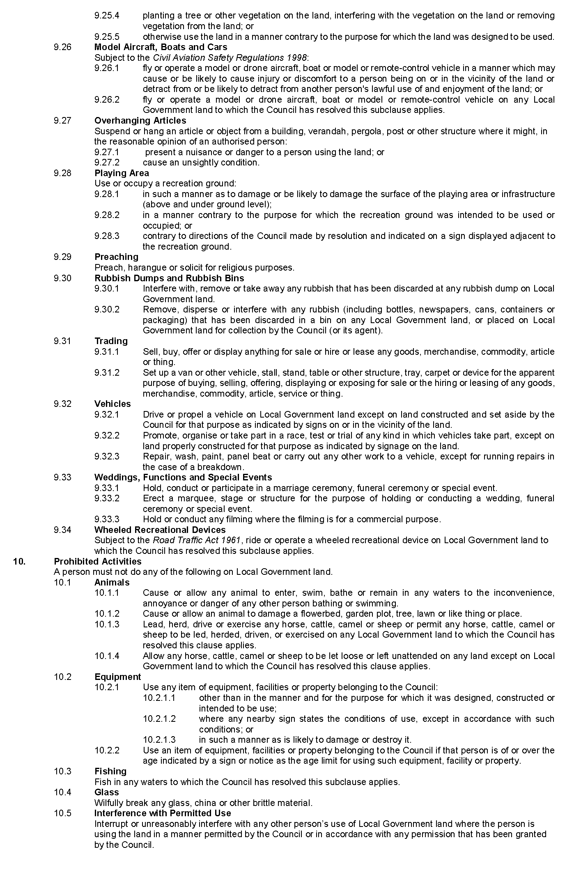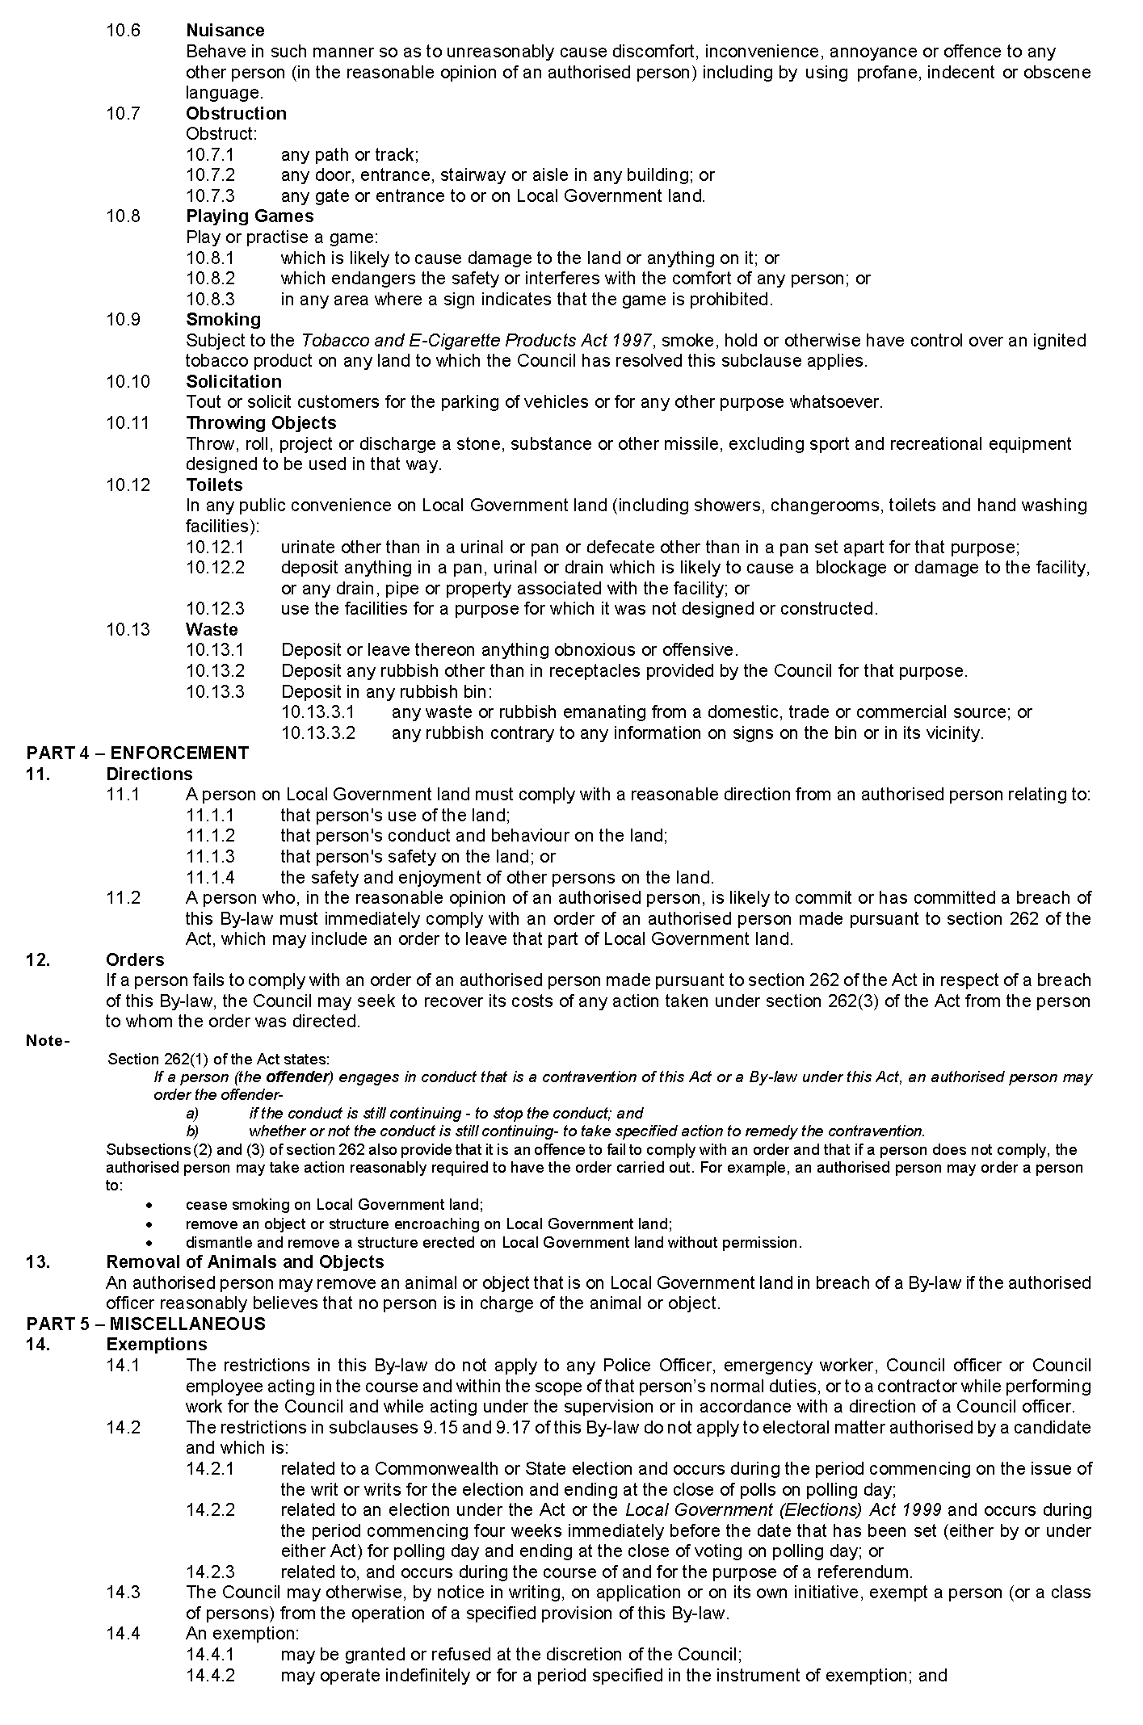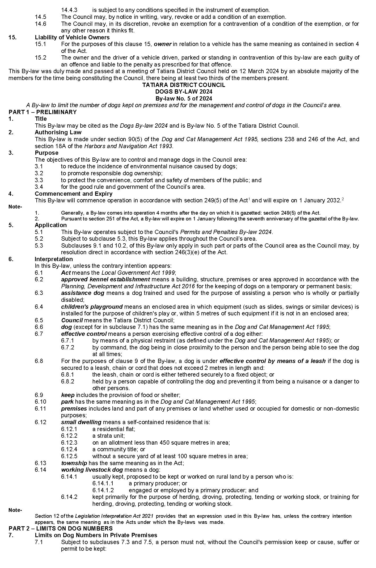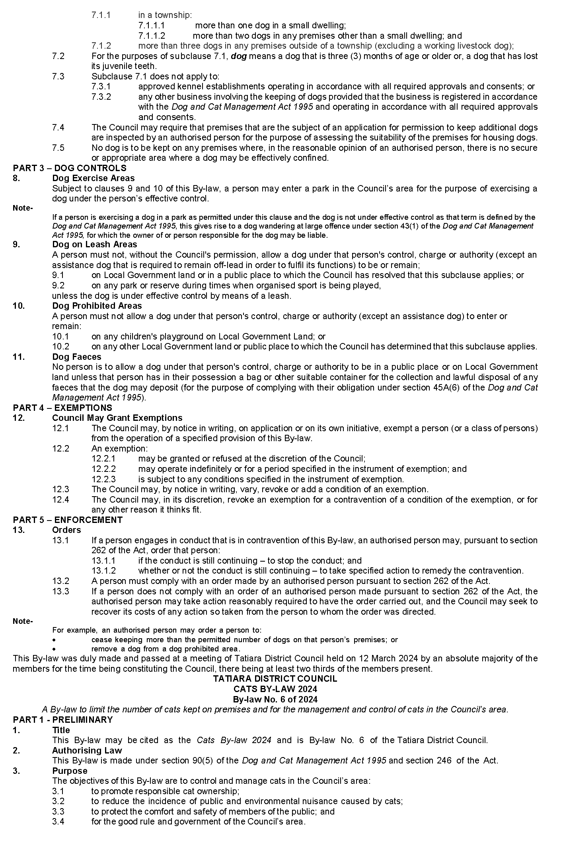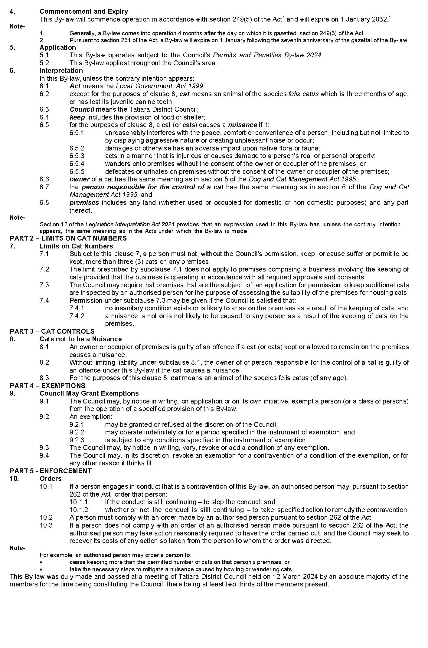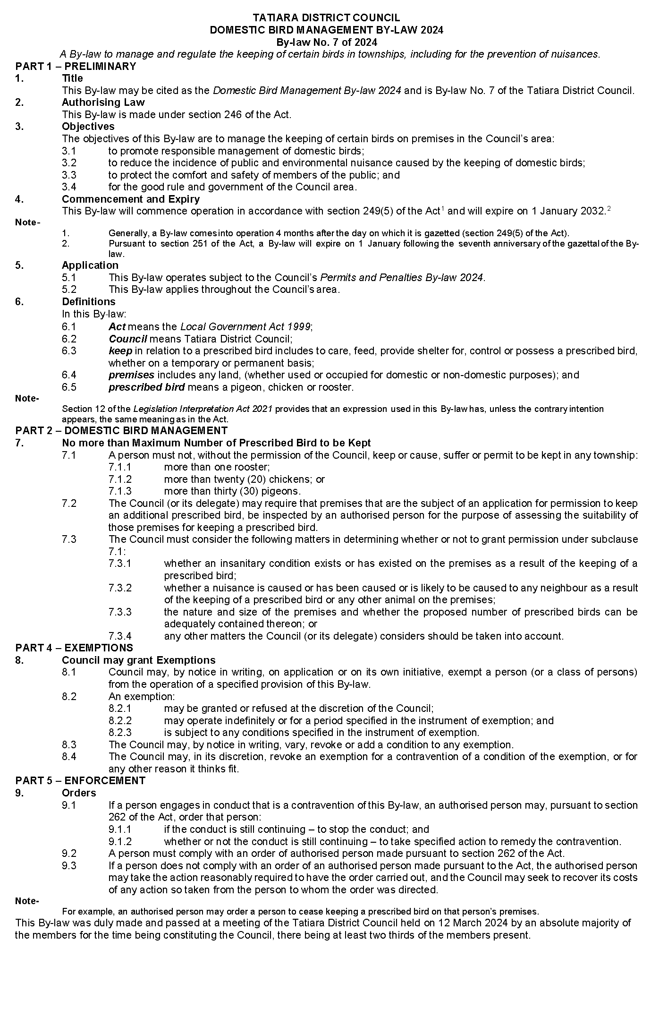

Wattle Range Council
Local Government Act 1999
Adoption of Community Land Management Plans
NOTICE is hereby given pursuant to Section 197(3) of the Local Government Act 1999 that the Wattle Range Council, at its Ordinary Meeting held 13 February 2024, resolved to adopt two new Community Land Management Plans, being the
Community Land Management Plan Penola Common – Crown Land, and
Community Land Management Plan Penola Common – Council Owned Land.
Copies of the Community Land Management Plans can be viewed by visiting Council’s website, www.wattlerange.sa.gov.au
Dated: 28 March 2024
Ben Gower
Chief Executive Officer

District Council of Yankalilla
Local Government Act 1999
Resignation of Councillor
NOTICE is hereby given in accordance with section 54 (1)(b) and 54 (6) of the Local Government Act 1999 that a vacancy has occurred in the office of Councillor for Light Ward, due to the resignation of Councillor Bill Verwey, effective Wednesday 13 March 2024.
Nathan Cunningham
Chief Executive Officer

Public Notices

National Electricity Law
Notice of Making of Final Rule Determination and Final Rule
The Australian Energy Market Commission (AEMC) gives notice under the National Electricity Law as follows:
Under ss 102 and 103, the making of the National Electricity Amendment (Improving security frameworks for the energy transition) Rule 2024 No. 9 (Ref. ERC0290) and related final determination. Provisions commence as follows Schedule 1 on 3 June 2024, Schedule 2 on 4 July 2024, Schedule 3, 4, 6 and 7 on 1 December 2024, Schedule 5 and 8 on 2 December 2025, and Schedule 9 on 4 April 2024.
Documents referred to above are available on the AEMC’s website and are available for inspection at the AEMC’s office.
Australian Energy Market Commission
Level 15, 60 Castlereagh St
Sydney NSW 2000
Telephone: (02) 8296 7800
www.aemc.gov.au
Dated: 28 March 2024

Trustee Act 1936
Public Trustee
Estates of Deceased Persons
In the matter of the estates of the undermentioned deceased persons:
BARLOW Lionel Edmund late of 15-21 Seymour Avenue Modbury Retired Public Servant who died 11 November 2023
BLACK Martin William late of 86 Oaklands Road Glengowrie Of no occupation who died 27 September 2023
BOLTON Henry James late of 187 Cold and Wet Road Coonalpyn Farmhand who died 24 June 2023
HAY Auriol Jean late of 40 South Terrace Jamestown Retired Labourer who died 8 February 2023
OAKLEY Bryan late of 367-379 Waterloo Corner Road Burton Retired Police Officer who died 7 May 2023
SCHLETER Sandra Anne late of 711 Glenelg River Road OB Flat Of no occupation who died 7 June 2019
SCHULTZE Dalton Thomas late of 78-96 Dumfries Avenue Northgate Of no occupation who died 3 September 2023
Notice is hereby given pursuant to the Trustee Act 1936, the Inheritance (Family Provision) Act 1972 and the Family Relationships Act 1975 that all creditors, beneficiaries, and other persons having claims against the said estates are required to send, in writing, to the office of Public Trustee at GPO Box 1338, Adelaide SA 5001, full particulars and proof of such claims, on or before 26 April 2024 otherwise they will be excluded from the distribution of the said estate; and notice is also hereby given that all persons indebted to the said estates are required to pay the amount of their debts to the Public Trustee or proceedings will be taken for the recovery thereof; and all persons having any property belonging to the said estates are forthwith to deliver same to the Public Trustee.
Dated: 28 March 2024
N. S. Rantanen
Public Trustee

Notice Submission

The South Australian Government Gazette is published each Thursday afternoon.
Notices must be emailed by 4 p.m. Tuesday, the week of publication.
Submissions are formatted per the gazette style and a proof will be supplied prior to publication, along with a quote if applicable. Please allow one day for processing notices.
Alterations to the proof must be returned by 4 p.m. Wednesday.

Gazette notices must be submitted as Word files, in the following format:
• Title—the governing legislation
• Subtitle—a summary of the notice content
• Body—structured text, which can include numbered lists, tables, and images
• Date—day, month, and year of authorisation
• Signature block—name, role, and department/organisation authorising the notice

Please provide the following information in your email:
• Date of intended publication
• Contact details of the person responsible for the notice content
• Name and organisation to be charged for the publication—Local Council and Public notices only
• Purchase order, if required—Local Council and Public notices only

Email: governmentgazettesa@sa.gov.au
Phone: (08) 7133 3552
Website: www.governmentgazette.sa.gov.au

All instruments appearing in this gazette are to be considered official, and obeyed as such

Printed and published weekly by authority of T. Foresto, Government Printer, South Australia
$8.55 per issue (plus postage), $430.00 per annual subscription—GST inclusive
Online publications: www.governmentgazette.sa.gov.au

