No. 31 p. 785
THE SOUTH AUSTRALIAN
GOVERNMENT GAZETTE
Published by Authority

Adelaide, Thursday, 2 May 2024

Contents

Governor’s Instruments
Appointments, Resignations and General Matters 786
Public Finance and Audit Act 1987 786
Proclamations—
Botanic Gardens and State Herbarium (Miscellaneous) Amendment Act (Commencement) Proclamation 2024 787
Forestry (Forest Reserve—Northern Forest District)
Amendment Proclamation 2024 787
State Government Instruments
Associations Incorporation Act 1985 789
Co-Operatives National Law (South Australia) Act 2013 789
Electricity Act 1996 789
Gas Act 1997 789
Geographical Names Act 1991 791
Housing Improvement Act 2016 795
Justices of the Peace Act 2005 795
Land Acquisition Act 1969 796
South Australian Housing Trust Regulations 2010 799
Local Government Instruments
City of Adelaide 801
City of Salisbury 801
District Council of Franklin Harbour 801
Southern Mallee District Council 801
Wakefield Regional Council 801
Public Notices
Trustee Act 1936 802

Governor’s Instruments

Appointments, Resignations and General Matters
Department of the Premier and Cabinet
Adelaide, 2 May 2024
Her Excellency the Governor in Executive Council has been pleased to appoint the undermentioned to the Return to Work Minister’s Advisory Committee, pursuant to the provisions of the Return to Work Act 2014:
Presiding Member: from 2 May 2024 until 30 November 2026
Edward Tuckseng Mah
By command,
Peter Bryden Malinauskas
Premier
AGO0074-24CS

Department of the Premier and Cabinet
Adelaide, 2 May 2024
Her Excellency the Governor in Executive Council has directed that, upon his retirement, a cash payment be made to His Honour Judge Paul Slattery, a Judge of the District Court of South Australia, in lieu of his unused leave entitlement - pursuant to section 13H(2) of the Supreme Court Act 1935 and section 14(1) of the District Court Act 1991.
By command,
Peter Bryden Malinauskas
Premier
AGO0070-24CS

Public Finance and Audit Act 1987
Governor’s Appropriation Fund
Approval to Appropriate Funds from the Consolidated Account
PURSUANT to Section 12 of the Public Finance and Audit Act 1987, I approve the appropriation from the Consolidated Account to the public purposes of the State an amount of $576,715,830 for the financial year ending 30 June 2025.
Given under my hand this 2nd day of May 2024.
Frances Adamson AC
Governor

Proclamations
South Australia

Botanic Gardens and State Herbarium (Miscellaneous) Amendment Act (Commencement) Proclamation 2024
1—Short title
This proclamation may be cited as the Botanic Gardens and State Herbarium (Miscellaneous) Amendment Act (Commencement) Proclamation 2024.
2—Commencement of Act
The Botanic Gardens and State Herbarium (Miscellaneous) Amendment Act 2024 (No 4 of 2024) comes into operation on 2 May 2024.
Made by the Governor
with the advice and consent of the Executive Council
on 2 May 2024

South Australia

Forestry (Forest Reserve—Northern Forest District) Amendment Proclamation 2024
under section 3(3) of the Forestry Act 1950

Preamble
1 The following land is forest reserve under the Forestry Act 1950 (see proclamation, Gazette 19.3.1992 p877, as amended) and forms part of the Northern Forest District:
Section 614, Hundred of Appila;
Section 285, Hundred of Belalie (now identified as Allotments 7 and 8 in Deposited Plan 117157);
Section 398, Hundred of Belalie;
Allotments 3 and 4 in Deposited Plan 117156;
Allotments 13 and 14 in Deposited Plan 117977;
Section 614, Hundred of Bundaleer;
Sections 9, 21, 27, 52, 53, 55, 56, 58, 335, 336, Hundred of Darling;
Pieces 2 and 5 in approved plan No. D117158 lodged in the Lands Titles Registration Office at Adelaide;
Allotment 15 in approved plan No. D118198 lodged in the Lands Titles Registration Office at Adelaide;
Sections 118, 143 and 165, Hundred of Yangya;
Section 347, Hundred of Yangya (now identified as Allotment 9 in Deposited Plan 117157).
2 It is now intended that the land described in clause 1 cease to be forest reserve.

Part 1—Preliminary
1—Short title
This proclamation may be cited as the Forestry (Forest Reserve—Northern Forest District) Amendment Proclamation 2024.
2—Commencement
This proclamation comes into operation at midday on the twenty-eighth day after the day on which it is made.
Part 2—Amendment of proclamation under Forestry Act 1950 declaring forest reserve (Gazette 19.3.1992 p877) as amended
3—Amendment of Schedule
(1) Clause 2(a)—delete paragraph (a)
(2) Clause 2(d)—delete paragraph (d)
(3) Clause 2(e)—delete paragraph (e)
(4) Clause 2(g)—delete paragraph (g)
(5) Clause 2(m)—delete paragraph (m)
Made by the Governor
with the advice and consent of the Executive Council
on 2 May 2024

State Government Instruments

Associations Incorporation Act 1985
Section 42(2)
Dissolution of Association
WHEREAS the Corporate Affairs Commission (the Commission) pursuant to Section 42(1) of the Associations Incorporation Act 1985 (the Act) is of the opinion that the undertaking or operations of GYPSY JOKERS MOTORCYCLE CLUB INCORPORATED (the Association) being an incorporated association under the Act are being carried on, or would more appropriately be carried on by a Company Limited by Guarantee incorporated under the Corporations Act 2001 (Cth) and whereas the Commission was on 23 October 2023 requested by the Association to transfer its undertaking to WILDCARD SA LIMITED (Australian Company Number 676 369 538), the Commission pursuant to Section 42(2) of the Act does hereby order that on 31 May 2024, the Association will be dissolved, the property of the Association becomes the property of WILDCARD SA LIMITED and the rights and liabilities of the Association become the rights and liabilities of WILDCARD SA LIMITED.
Given under the seal of the Commission at Adelaide this 2nd day of May 2024.
Alison Selleck
A Delegate of the Corporate Affairs Commission

Co-Operatives National Law (South Australia) Act 2013
Section 60(2)
Classes of Rule Amendments Requiring Prior Approval of the Registrar
TAKE notice that pursuant to Section 60(2) of the Co-operatives National Law (South Australia) Act 2013, the following classes of amendments must not be made to the rules of a co-operative without the prior approval of the Registrar of Co-operatives:
(a) Active membership provisions;
(b) Primary Activities;
(c) Conversion of a non-distributing to a distributing co-operative;
(d) How the co-operative may be wound up;
(e) Issue or sale of shares or Co-operative Capital Units (CCUs)
This notice takes effect on 2 May 2024.
Dated: 2 May 2024
Fraser Stroud
A/Registrar of Co-operatives

Electricity Act 1996

Gas Act 1997
Retailer Energy Productivity Scheme
Minimum Specifications for Energy Productivity Activities
Notice by Hon Anastasios Koutsantonis MP, Minister for Energy and Mining
PURSUANT to Regulation 28(5) of the Electricity (General) Regulations 2012 under the Electricity Act 1996, and Regulation 22(5) of the Gas Regulations 2012 under the Gas Act 1997, I revoke the Ministerial Notice—Install An Efficient New Ducted Evaporative Air Conditioner Residential and Small Energy Consuming Customers Only, Activity HC3 in the South Australian Government Gazette No. 82 dated 23 December 2021 on pages 4648-4649.
Pursuant to Regulation 28 of the Electricity (General) Regulations 2012 and Regulation 22 of the Gas Regulations 2012, I determine the activities within the following document to be an energy productivity activity for the purposes of Part 4 of the Electricity (General) Regulations 2012 and Part 4 of the Gas Regulations 2012.
This notice will take effect on 2 May 2024.
Hon Anastasios Koutsantonis MP
Minister for Energy and Mining

Install an Efficient New Ducted Evaporative Air Conditioner
Residential and Small Energy Consuming Customers Only
Activity No. HC3
1. Activity Specific Definitions
Ducted Evaporative Air-conditioner means a ducted evaporative air conditioner within the scope of AS 2913-2000. This can include either direct or indirect type ducted evaporative coolers provided they meet the installed product requirements.
Ducted Refrigerative Cooler means a ducted air conditioner with a cooling mode (can also have a heating mode) that is covered by the GEMS energy labelling and MEPS scheme under AS/NZS 3823.2 (2013) or GEMS Air Conditioners up to 65kW Determination 2019 as applicable.
Multi-split Refrigerative Cooler means a multi-split air conditioner with a cooling mode (can also have a heating mode) that is covered by the GEMS energy labelling and MEPS scheme under AS/NZS 3823.2 (2013) or GEMS Air Conditioners up to 65kW Determination 2019 as applicable.
Non-ducted Refrigerative Cooler means a non-ducted air conditioner with a cooling mode (can also have a heating mode) that is covered by the GEMS energy labelling and MEPS scheme under AS/NZS 3823.2 (2013) or GEMS Air Conditioners up to 65kW Determination 2019 as applicable.
Fixed Resistance Electric Heater means an electric heater that utilizes a resistance electric heating element (ACOP = 1) that is permanently fixed within the building. Portable electric heaters such as fan convectors radiant or oil column heaters that are not permanently fixed do not qualify as a “fixed resistance electric heater”.
Effective EER means the annual energy efficiency ratio as defined AS 2913-2000.
Inverter or Inverter Drive refers to a ducted evaporative air-conditioner that has a variable speed drive utilizing a frequency converter for regulating the power fed into the fan. The inverter sits between the electrical supply and the motor and allows the fan motor to run at a speed or torque commensurate with the cooling demand.
2. Activity Description (Summary)
Install an efficient new ducted evaporative air conditioner. This can take one of four forms:
• HC3(i)—Installation into a space with a pre-existing ducted refrigerative air-conditioner
• HC3(ii)—Installation into a space with a pre-existing multi-split refrigerative air-conditioner
• HC3(iii)—Installation into a space with a pre-existing non-ducted refrigerative air-conditioner
• HC3(iv)—Installation into a space with a pre-existing ducted non-inverter type evaporative air-conditioner
• HC3(v)—Installation into a space with no pre-existing air-conditioner of any type (e.g. into a new dwelling)
Note: In cases where a dwelling has multiple single split air-conditioners installed, provided that those multiple units serve at least 50% of the total floor area then such an arrangement shall be deemed to be a multi-split central refrigerative system i.e. type HC3(ii) rather than type HC3(iii).
3. Activity Eligibility Requirements
Any Residential building or Small Energy Consuming Customers in South Australia where the installed product requirements and minimum installation requirements can be met. This can include new or replacement systems.
This activity is not permitted in buildings where the main form of heating is fixed resistance electric heating (or specified to be fixed resistance electric heating in the case of buildings under construction or renovation).
In relation to activity HC3(i), HC3(ii) and HC3(iii) all the pre-existing refrigerative air-conditioning systems within the conditioned spaces of the building that are of the cooling only type, must be fully decommissioned, removed from the property and disposed of (note: this does not apply to reverse cycle type air-conditioners).
In relation to activity HC3(iv) the pre-existing evaporative cooler must be fully decommissioned, removed from the property and disposed of.
Wherever possible, a replacement system for a cooling only incumbent system should use the same circuit breakers in the switchboard as had been used by the replaced system. Where this is not possible the replaced system must be disconnected at the switchboard by a licenced electrician such that it cannot be re-activated by the householder.
4. Installed Product Requirements
The ducted evaporative cooler must:
(1) Have a minimum capacity of 7kW determined in accordance with AS 2913-2000
(2) Be compliant with all provisions within AS 2913-2000
(3) Have a warranty of at least 2 years
(4) Be installed using ductwork rated at a minimum of R1.0
5. Minimum Installation Requirements
(1) All electrical wiring must be undertaken in accordance with AS/NZS 3000:2018 by an electrical worker under the supervision of a licensed electrical contractor.
(2) All plumbing work must be undertaken by a licenced plumber in accordance with current South Australian plumbing regulations.
(3) All installation work must be undertaken by a person who has received a qualification commensurate with Work Safely at Heights CPCCCM2012 or RIIWHS204E.
(4) Where a pre-existing ducted system that is to be decommissioned is not to have its outlets reused by the replacement system then the outlets of that decommissioned system must be effectively sealed at ceiling level such that there is no transmission of conditioned air from a space into any adjoining unconditioned space e.g. into the ceiling space above.
(5) No water discharge from the new evaporative system may be to a potable water supply (e.g. to a household water tank)
(6) Removed pre-existing coolers shall have refrigerants and any other scheduled substances disposed of in accordance with the Australian and New Zealand refrigerant handling code of practice as established under the Ozone Protection and Synthetic Greenhouse Gas Management Act 1989 (Cth).
6. Normalised Reps Gigajoules
The normalised REPS gigajoules per appliance from undertaking this this activity is Normalised REPS Gigajoules = REPS Gigajoules (as per the first table below) x REPS Transition Factor (as per the final table below).
Separate values are provided for NCC climate zones 4 and 5 and zone 6.
Normalised REPS gigajoules are based on the installed products fan motor drive type (inverter or non-inverter).
HC3
Activity | Non-Inverter Drive | Inverter Drive
NCC Climate Zones 4 and 5
HC3(i) Installation into a space with a pre-existing Ducted Refrigerative Air-conditioner | 79.8 | 107.1
HC3(ii) Installation into a space with a pre -existing Multi-split Air-conditioner | 39.2 | 66.5
HC3(iii) Installation into a space with a pre-existing Non-Ducted Refrigerative  Air-conditioner | 31.4 | 58.7
HC3(iv) Installation into a space with a pre-existing Ducted Evaporative  Air-conditioner (non-inverter type) | Not applicable | 27.3
HC3(v) Installation into a space with no pre-existing Air-conditioner | 43.1 | 70.4
NCC Climate Zones 6
HC3(i) Installation into a space with a pre-existing Ducted Refrigerative Air-conditioner | 20.6 | 27.6
HC3(ii) Installation into a space with a pre -existing Multi-split Air-conditioner | 10.1 | 17.1
HC3(iii) Installation into a space with a pre-existing Non-Ducted Refrigerative  Air-conditioner | 8.1 | 15.1
HC3(iv) Installation into a space with a pre-existing Ducted Evaporative Air-conditioner (non-inverter type) | Not Applicable | 7.0
HC3(v) Installation into a space with no pre-existing Air-conditioner | 11.1 | 18.1

Activity HC3—Reps Transition Factors
Year of installation | REPS Transition Factor
2024 | 4
2025 | 4
7. Guidance Notes (Informative Only—Not Mandatory)
Persons installing heating/cooling systems should have regard to the “Air Conditioning Residential Best Practice Guideline” (2003) published by the Australian Institute of Refrigeration, Air Conditioning and Heating (AIRAH). All reasonable endeavours should be used to recycle removed systems.
Refrigerants and any other scheduled substances must be disposed of in accordance with the Australian and New Zealand refrigerant handling code of practice as established under the Ozone Protection and Synthetic Greenhouse Gas Management Act 1989 (Cth).
Transition factors have been applied to certain REPS activities to provide a pathway to transition the REPS toward delivery of a preferred mix of activities over the first five-year stage. Application of these factors provides a phased trajectory for retailers that addresses both the challenge of managing the downgrading of deemed gigajoules for lighting activities due to reducing additionality, as well as the pivot toward business models to deliver deeper retrofit activities and demand response activities.

Geographical Names Act 1991
Notice to Alter the Boundary of a Place
NOTICE is hereby given that, pursuant to Section 11B(1)(b) of the Geographical Names Act 1991, I, BRADLEY SLAPE, Surveyor-General and Delegate appointed by the Honourable Nick Champion MP, Minister for Planning, Minister of the Crown to whom the administration of the Geographical Names Act 1991 is committed, DO HEREBY;
• Alter the locality boundary between Inman Valley and Back Valley to exclude that area marked (A), highlighted in green as shown on the plan, from the bounded locality of BACK VALLEY and include that area in the locality of INMAN VALLEY.
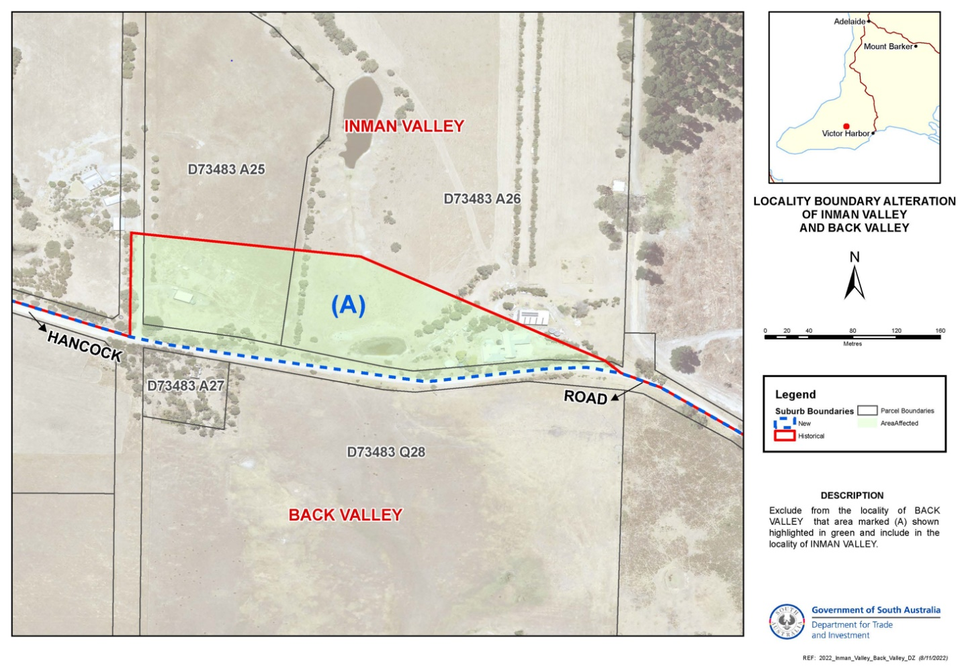
This notice is to take effect immediately upon its publication in the Government Gazette.
Dated: 2 May 2024
B. J. Slape
Surveyor-General
2023/00525/01

Geographical Names Act 1991
Notice to Alter the Boundary of a Place
NOTICE is hereby given that, pursuant to Section 11B(1)(b) of the Geographical Names Act 1991, I, BRADLEY SLAPE, Surveyor-General and Delegate appointed by the Honourable Nick Champion MP, Minister for Planning, Minister of the Crown to whom the administration of the Geographical Names Act 1991 is committed, DO HEREBY;
• Alter the locality boundary between Rapid Bay and Delamere to exclude that area marked (A), (B), (C), (D) and (E) highlighted in green as shown on the plan, from the bounded locality of DELAMERE and include that area in the locality of RAPID BAY.
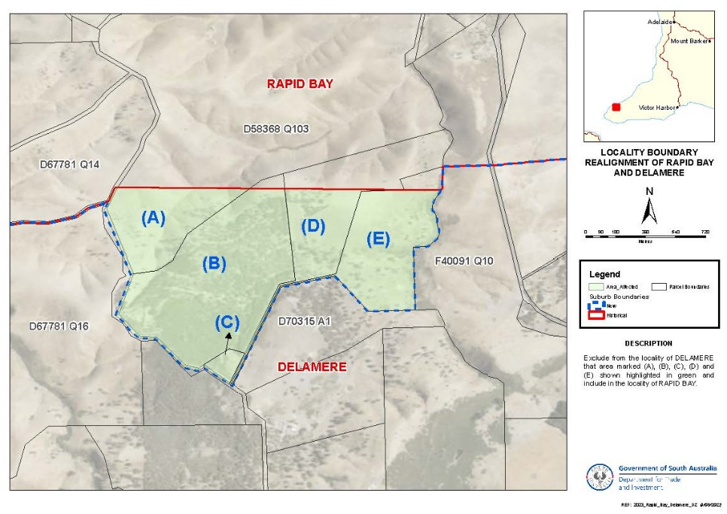
This notice is to take effect immediately upon its publication in the Government Gazette.
Dated: 2 May 2024
B. J. Slape
Surveyor-General
2023/00525/01

Geographical Names Act 1991
Notice to Alter the Boundary of a Place
NOTICE is hereby given that, pursuant to Section 11B(1)(b) of the Geographical Names Act 1991, I, BRADLEY SLAPE, Surveyor-General and Delegate appointed by the Honourable Nick Champion MP, Minister for Planning, Minister of the Crown to whom the administration of the Geographical Names Act 1991 is committed, DO HEREBY;
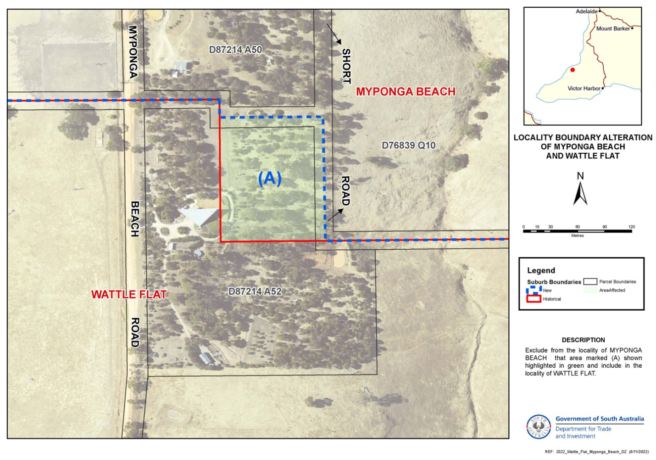
• Alter the locality boundary between Wattle Flat and Myponga Beach to exclude that area marked (A), highlighted in green as shown on the plan, from the bounded locality of MYPONGA BEACH and include that area in the locality of WATTLE FLAT.
This notice is to take effect immediately upon its publication in the Government Gazette.
Dated: 2 May 2024
B. J. Slape
Surveyor-General
2023/00525/01

Geographical Names Act 1991
Notice to Assign a Name to a Feature
NOTICE is hereby given that, pursuant to Section 11B(1)(a) of the Geographical Names Act 1991, I, the Honourable Nick Champion MP, Minister for Planning, Minister of the Crown to whom the administration of the Geographical Names Act 1991 is committed, DO HEREBY:
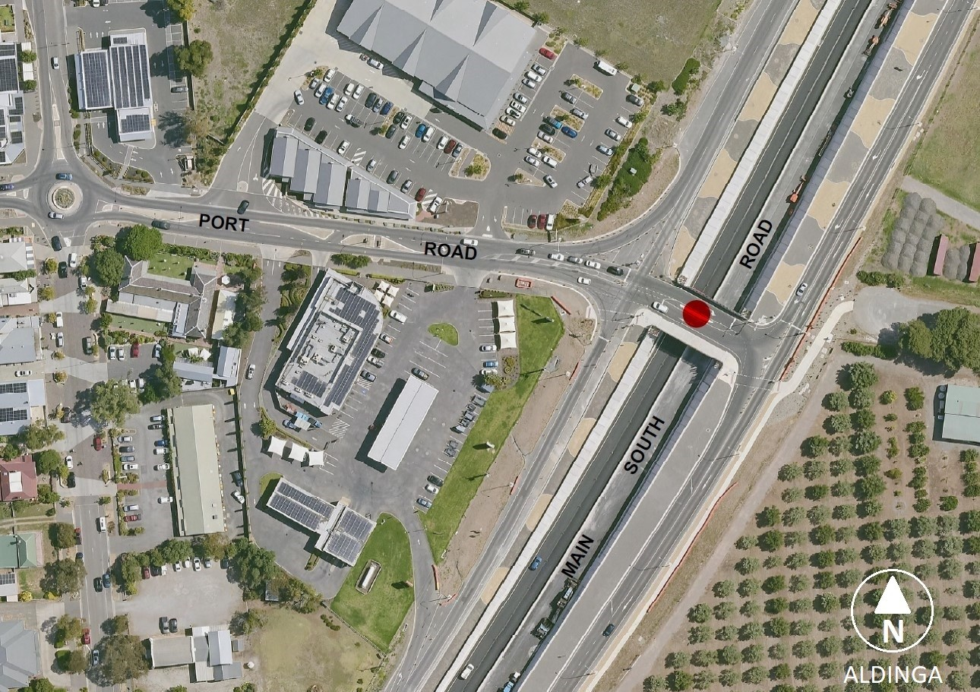
• Assign the name NGALTINGGA to the new Port Road bridge located at Aldinga, as shown highlighted on the location map.
This notice is to take effect immediately upon its publication in the Government Gazette.

A copy of the location map for this naming proposal can also be viewed at www.sa.gov.au/placenameproposals.
Dated: 2 May 2024
Hon Nick Champion MP
Minister For Planning
DTI: 2023/07098/01

Housing Improvement Act 2016
Rent Control
THE Minister for Human Services Delegate in the exercise of the powers conferred by the Housing Improvement Act 2016, does hereby fix the maximum rental per week which shall be payable subject to Section 55 of the Residential Tenancies Act 1995, in respect of each house described in the following table. The amount shown in the said table shall come into force on the date of this publication in the Gazette.
Address of Premises | Allotment Section | Certificate of Title  Volume/Folio | Maximum Rental per week payable
57 Nedland Crescent, Port Noarlunga South SA 5167 | Allotment 283, Deposited Plan 8395, Hundred of Willunga | CT 5461/910 | $0.00
18 Sizer Street, Lower Mitcham SA 5062 | Allotment 93, Filed Plan 13808, Hundred of Adelaide | CT 5809/348 | $371.25
Dated: 2 May 2024
Craig Thompson
Housing Regulator and Registrar
Housing Safety Authority
Delegate of the Minister for Human Services

Housing Improvement Act 2016
Rent Control Revocations
WHEREAS the Minister for Human Services Delegate is satisfied that each of the houses described hereunder has ceased to be unsafe or unsuitable for human habitation for the purposes of the Housing Improvement Act 2016, notice is hereby given that, in exercise of the powers conferred by the said Act, the Minister for Human Services Delegate does hereby revoke the said Rent Control in respect of each property.
Address of Premises | Allotment Section | Certificate of Title  Volume/Folio
40 Liddon Place, Port Adelaide SA 5015 | Allotment 44, Filed Plan 142385, Hundred of Port Adelaide | CT 5265/803
26 Vera Street, Port Pirie West SA 5540 | Allotment 73, Deposited Plan 1480, Hundred of Pirie | CT 5684/181
Dated: 2 May 2024
Craig Thompson
Housing Regulator and Registrar
Housing Safety Authority
Delegate of the Minister for Human Services

Justices of the Peace Act 2005
Section 4
Notice of Appointment of Justices of the Peace for South Australia
by the Acting Commissioner for Consumer Affairs
I, FRASER W. STROUD, Commissioner for Consumer Affairs, delegate of the Attorney-General, pursuant to Section 4 of the Justices of the Peace Act 2005, do hereby appoint the people listed as Justices of the Peace for South Australia as set out below.
For a period of ten years for a term commencing on 15 May 2024 and expiring on 14 May 2034:
Andrew Tadeusz SLECZKA
Mark Edwin SCHERER
Frederick Garry SAMPSON
Maria Anita RUBINI
David John RICHARDS
Richard Stanley POWERS
Richard Digby MIELS
David John MCKENZIE
Paul MCGRATH
Lee Anne KINNEAR
Suzan KERBAJ
Theodore IULIANO
Peter James HUNTER
Janice May HEDGER
Julienne Florence FEAST
Paul Denis CUDMORE
Trevor Robert COLLINS
Janeen COLEMAN
Kevin Neil BURROWES
Francis Newman BRENNAN
Geoffrey BLOOR
Dated: 29 April 2024
Fraser W. Stroud
Commissioner for Consumer Affairs
Delegate of the Attorney-General

Land Acquisition Act 1969
Section 16
Form 5—Notice of Acquisition
1. Notice of acquisition
The Commissioner of Highways (the Authority), of 83 Pirie Street, Adelaide SA 5000, acquires the following interests in the following land:
Comprising the entirety of the right, estate or interest of Divyanka Khanna and Vishal Khanna, whether as lessee, as sub-lessee or as licensee or otherwise in that piece of land being the whole of Allotment 527 in Deposited Plan 70355 comprised in Certificate of Title Volume 5965 Folio 506.
This notice is given under Section 16 of the Land Acquisition Act 1969.
2. Compensation
A person who has or had an interest consisting of native title or an alienable interest in the land that is divested or diminished by the acquisition or the enjoyment of which is adversely affected by the acquisition who does not receive an offer of compensation from the Authority may apply to the Authority for compensation.
2A. Payment of professional costs relating to acquisition (Section 26B)
If you are the owner in fee simple of the land to which this notice relates, you may be entitled to a payment of up to $10,000 from the Authority for use towards the payment of professional costs in relation to the acquisition of the land.
Professional costs include legal costs, valuation costs and any other costs prescribed by the Land Acquisition Regulations 2019.
3. Inquiries
Inquiries should be directed to: Daniel Tuk
GPO Box 1533
Adelaide SA 5001
Telephone: (08) 7133 2479
Dated: 29 April 2024
The Common Seal of the COMMISSIONER OF HIGHWAYS was hereto affixed by authority of the Commissioner in the presence of:
Rocco Caruso
Manager, Property Acquisition
(Authorised Officer)
Department for Infrastructure and Transport
File Reference: 2022/02769/01

Land Acquisition Act 1969
Section 16
Form 5—Notice of Acquisition
1. Notice of acquisition
The Commissioner of Highways (the Authority), of 83 Pirie Street, Adelaide SA 5000, acquires the following interests in the following land:
Comprising an unencumbered estate in fee simple in that piece of land being the whole of Allotment 61 in Filed Plan 145089 comprised in Certificate of Title Volume 5729 Folio 221.
This notice is given under Section 16 of the Land Acquisition Act 1969.
2. Compensation
A person who has or had an interest consisting of native title or an alienable interest in the land that is divested or diminished by the acquisition or the enjoyment of which is adversely affected by the acquisition who does not receive an offer of compensation from the Authority may apply to the Authority for compensation.
2A. Payment of professional costs relating to acquisition (Section 26B)
If you are the owner in fee simple of the land to which this notice relates, you may be entitled to a payment of up to $10,000 from the Authority for use towards the payment of professional costs in relation to the acquisition of the land.
Professional costs include legal costs, valuation costs and any other costs prescribed by the Land Acquisition Regulations 2019.
3. Inquiries
Inquiries should be directed to: Rob Gardner
GPO Box 1533
Adelaide SA 5001
Telephone: (08) 7133 2415
Dated: 29 April 2024
The Common Seal of the COMMISSIONER OF HIGHWAYS was hereto affixed by authority of the Commissioner in the presence of:
Rocco Caruso
Manager, Property Acquisition
(Authorised Officer)
Department for Infrastructure and Transport
File Reference: 2022/02890/01

Land Acquisition Act 1969
Section 16
Form 5—Notice of Acquisition
1. Notice of acquisition
The Commissioner of Highways (the Authority), of 83 Pirie Street, Adelaide SA 5000, acquires the following interests in the following land:
Comprising an unencumbered estate in fee simple in that piece of land being the whole of Allotment 62 in Filed Plan 145090 comprised in Certificate of Title Volume 5803 Folio 22.
This notice is given under Section 16 of the Land Acquisition Act 1969.
2. Compensation
A person who has or had an interest consisting of native title or an alienable interest in the land that is divested or diminished by the acquisition or the enjoyment of which is adversely affected by the acquisition who does not receive an offer of compensation from the Authority may apply to the Authority for compensation.
2A. Payment of professional costs relating to acquisition (Section 26B)
If you are the owner in fee simple of the land to which this notice relates, you may be entitled to a payment of up to $10,000 from the Authority for use towards the payment of professional costs in relation to the acquisition of the land.
Professional costs include legal costs, valuation costs and any other costs prescribed by the Land Acquisition Regulations 2019.
3. Inquiries
Inquiries should be directed to: Rob Gardner
GPO Box 1533
Adelaide SA 5001
Telephone: (08) 7133 2415
Dated: 29 April 2024
The Common Seal of the COMMISSIONER OF HIGHWAYS was hereto affixed by authority of the Commissioner in the presence of:
Rocco Caruso
Manager, Property Acquisition
(Authorised Officer)
Department for Infrastructure and Transport
File Reference: 2022/02892/01

Land Acquisition Act 1969
Section 16
Form 5—Notice of Acquisition
1. Notice of acquisition
The Commissioner of Highways (the Authority), of 83 Pirie Street, Adelaide SA 5000, acquires the following interests in the following land:
Comprising an unencumbered estate in fee simple in that piece of land being the whole of Unit 1 in Strata Plan 5275 comprised in Certificate of Title Volume 5021 Folio 290.
This notice is given under Section 16 of the Land Acquisition Act 1969.
2. Compensation
A person who has or had an interest consisting of native title or an alienable interest in the land that is divested or diminished by the acquisition or the enjoyment of which is adversely affected by the acquisition who does not receive an offer of compensation from the Authority may apply to the Authority for compensation.
2A. Payment of professional costs relating to acquisition (Section 26B)
If you are the owner in fee simple of the land to which this notice relates, you may be entitled to a payment of up to $10,000 from the Authority for use towards the payment of professional costs in relation to the acquisition of the land.
Professional costs include legal costs, valuation costs and any other costs prescribed by the Land Acquisition Regulations 2019.
3. Inquiries
Inquiries should be directed to: Petrula Pettas
GPO Box 1533
Adelaide SA 5001
Telephone: (08) 7133 2457
Dated: 30 April 2024
The Common Seal of the COMMISSIONER OF HIGHWAYS was hereto affixed by authority of the Commissioner in the presence of:
Rocco Caruso
Director, Property Acquisition
(Authorised Officer)
Department for Infrastructure and Transport
File Reference: 2022/02966/01

Land Acquisition Act 1969
Section 16
Form 5—Notice of Acquisition
1. Notice of acquisition
The Commissioner of Highways (the Authority), of 83 Pirie Street, Adelaide SA 5000, acquires the following interests in the following land:
First: Comprising an unencumbered estate in fee simple in that piece of land being portion of Allotment Comprising Pieces 95, 96, 97 and 98 in Filed Plan 174414 comprised in Certificate of Title Volume 5360 Folio 988 and being the whole of the land identified as Allotment 424 in D132338 lodged in the Lands Titles Office.
Secondly: Comprising an unencumbered estate in fee simple in that piece of land being portion of Allotment Comprising Pieces 95, 96, 97 and 98 in Filed Plan 174414 comprised in Certificate of Title Volume 5360 Folio 988 and being the whole of the land identified as Allotment 419 in D132338 lodged in the Lands Titles Office.
This notice is given under Section 16 of the Land Acquisition Act 1969.
2. Compensation
A person who has or had an interest consisting of native title or an alienable interest in the land that is divested or diminished by the acquisition or the enjoyment of which is adversely affected by the acquisition who does not receive an offer of compensation from the Authority may apply to the Authority for compensation.
2A. Payment of professional costs relating to acquisition (Section 26B)
If you are the owner in fee simple of the land to which this notice relates, you may be entitled to a payment of up to $10,000 from the Authority for use towards the payment of professional costs in relation to the acquisition of the land.
Professional costs include legal costs, valuation costs and any other costs prescribed by the Land Acquisition Regulations 2019.
3. Inquiries
Inquiries should be directed to: Philip Cheffirs
GPO Box 1533
Adelaide SA 5001
Telephone: (08) 7133 2395
Dated: 29 April 2024
The Common Seal of the COMMISSIONER OF HIGHWAYS was hereto affixed by authority of the Commissioner in the presence of:
Rocco Caruso
Manager, Property Acquisition
(Authorised Officer)
Department for Infrastructure and Transport
File Reference: 2022/09506/01

Land Acquisition Act 1969
Section 16
Form 5—Notice of Acquisition
1. Notice of acquisition
The Commissioner of Highways (the Authority), of 83 Pirie Street, Adelaide SA 5000, acquires the following interests in the following land:
Comprising an unencumbered estate in fee simple in that piece of land being the whole of Allotment 8 in Filed Plan 6846 comprised in Certificate of Title Volume 5670 Folio 293.
This notice is given under Section 16 of the Land Acquisition Act 1969.
2. Compensation
A person who has or had an interest consisting of native title or an alienable interest in the land that is divested or diminished by the acquisition or the enjoyment of which is adversely affected by the acquisition who does not receive an offer of compensation from the Authority may apply to the Authority for compensation.
2A. Payment of professional costs relating to acquisition (Section 26B)
If you are the owner in fee simple of the land to which this notice relates, you may be entitled to a payment of up to $10,000 from the Authority for use towards the payment of professional costs in relation to the acquisition of the land.
Professional costs include legal costs, valuation costs and any other costs prescribed by the Land Acquisition Regulations 2019.
3. Inquiries
Inquiries should be directed to: Rob Gardner
GPO Box 1533
Adelaide SA 5001
Telephone: (08) 7133 2415
Dated: 29 April 2024
The Common Seal of the COMMISSIONER OF HIGHWAYS was hereto affixed by authority of the Commissioner in the presence of:
Rocco Caruso
Manager, Property Acquisition
(Authorised Officer)
Department for Infrastructure and Transport
File Reference: 2022/10651/01

Land Acquisition Act 1969
Section 16
Form 5—Notice of Acquisition
1. Notice of acquisition
The Commissioner of Highways (the Authority), of 83 Pirie Street, Adelaide SA 5000, acquires the following interests in the following land:
Comprising the entirety of the right estate or interest of Qiang Wei and Liu Xia whether as lessee, as sub-lessee or as a licensee or otherwise in that piece of land, being the whole of Allotment 23 in Deposited Plan 2490 comprised in Certificate of Title Volume 5760 Folio 113.
This notice is given under Section 16 of the Land Acquisition Act 1969.
2. Compensation
A person who has or had an interest consisting of native title or an alienable interest in the land that is divested or diminished by the acquisition or the enjoyment of which is adversely affected by the acquisition who does not receive an offer of compensation from the Authority may apply to the Authority for compensation.
2A. Payment of professional costs relating to acquisition (Section 26B)
If you are the owner in fee simple of the land to which this notice relates, you may be entitled to a payment of up to $10,000 from the Authority for use towards the payment of professional costs in relation to the acquisition of the land.
Professional costs include legal costs, valuation costs and any other costs prescribed by the Land Acquisition Regulations 2019.
3. Inquiries
Inquiries should be directed to: Rob Gardner
GPO Box 1533
Adelaide SA 5001
Telephone: (08) 7133 2415
Dated: 29 April 2024
The Common Seal of the COMMISSIONER OF HIGHWAYS was hereto affixed by authority of the Commissioner in the presence of:
Rocco Caruso
Manager, Property Acquisition
(Authorised Officer)
Department for Infrastructure and Transport
File Reference: 2022/15357/01

South Australian Housing Trust Regulations 2010
Regulation 4
Determination of Criteria for the Purposes of Affordable Housing
1. Application
This Notice applies to:
(1) assessment of applications for development approval under the PDI Act; and
(2) policies under the Planning and Design Code pursuant to the PDI Act.
2. Determination of Criteria
(1) Land or a dwelling that is the subject of an application or policy to which this Notice applies will fall within the concept of affordable housing for the purposes of Regulation 4 of the Regulations if the developer/owner of the land or dwelling has a Legally Enforceable Obligation in place to ensure:
(a) that the land or dwelling is offered for sale to an Eligible Home Buyer at or below the Price (subject to any increase to the Price approved under paragraph 2(2)) and that the offer is listed on the HomeSeeker SA website; or
(b) that the land or dwelling will be sold to an Eligible Rental Provider for the purpose of that Eligible Rental Provider making the land or dwelling available for affordable lease or rent; or
(c) where the relevant developer/owner is an Eligible Rental Provider, that the land or dwelling will be provided for affordable lease or rent by that Eligible Rental Provider,
or the Minister otherwise determines, in the Minister’s absolute discretion, that the land or dwelling constitutes affordable housing for the purposes of Regulation 4 of the Regulations.
(2) Where the land or dwelling:
(a) has features which make it more energy efficient and environmentally sustainable; or
(b) is on a small allotment within close proximity to public transport; or
(c) is offered for sale in conjunction with a financing product that increases an Eligible Home Buyer’s purchasing capacity as outlined in the industry guidelines published from time to time by the South Australian Housing Trust,
(each, a “designated feature”), the developer/owner may seek approval from the Chief Executive of the South Australian Housing Trust, or their delegate, to increase the Price by up to 10% with respect to that land or dwelling, and up to 15% where two or more designated features have been satisfied in relation to the land or dwelling.
3. Definitions
For the purposes of this Notice:
(1) “Eligible Home Buyer” means a person:
(a) who satisfies the eligibility criteria to buy a home through HomeSeeker SA (which eligibility criteria are set out on the HomeSeeker SA website accessible at https://homeseeker.sa.gov.au/ and as updated from time to time); or
(b) who is otherwise assessed as being eligible by the Chief Executive of the South Australian Housing Trust, or their delegate.

(2) “Eligible Rental Provider” means:
(a) the South Australian Housing Trust; or
(b) a community housing provider (however described) that is registered under a law of, or under a scheme administered by, a State or Territory of the Commonwealth of Australia, including the Community Housing Providers National Law set out in Schedule 1 of the Community Housing Providers (National Law) (South Australia) Act 2013 (SA); or
(c) a person (natural or corporate) approved to provide affordable rental under the ‘National Rental Affordability Scheme’; or
(d) a person (natural or corporate) subject to an affordable housing facilitation agreement with a Minister, or an instrumentality of the Crown in right of the State of South Australia; or
(e) any class of persons, declared from time to time by the Minister.
(3) “HomeSeeker SA” means the state government initiative by that name which is administered by the South Australian Housing Trust for the purpose of helping more South Australians buy or rent an affordable property, and which is described on the HomeSeeker SA website accessible at https://homeseeker.sa.gov.au/.
(4) “Legally Enforceable Obligation” includes:
(a) a legally binding agreement entered into between the developer/owner and a Minister, instrumentality of the Crown in right of the State of South Australia or Council (constituted under the Local Government Act 1999 (SA)), and in the case of a Land Management Agreement (as defined in the PDI Act) registered against the relevant instrument of title;
(b) a condition imposed by a relevant authority (as defined in the PDI Act) in relation to a development that it consents to or approves under the PDI Act; and
(c) any other form of legally enforceable obligation approved by the Minister.
(5) “Minister” means the Minister responsible for administering the South Australian Housing Trust Act 1995 (SA).
(6) “PDI Act” means the Planning, Development and Infrastructure Act 2016 (SA).
(7) “Price” means:
Affordability Indicators (April 2024) |  | Greater Adelaide* | Rest of State**
Dwelling or house and land purchase price (inclusive of GST) |  | $495,000 | $381,000
Land purchase price (inclusive of GST) |  | $222,750 | $171,450
* | Greater Adelaide means: Greater Adelaide Planning Region as defined in Figure 1.1 The 30 Year Plan  for Greater Adelaide 2017 Update, a volume of the South Australian Planning Strategy.
** | Rest of State means: all areas in the State of South Australia excluding Greater Adelaide.
(8) “Regulations” means the South Australian Housing Trust Regulations 2010 under the South Australian Housing Trust Act 1995 (SA).
Dated: 28 April 2024
Hon Nick Champion MP
Minister for Housing and Urban Development

Local Government Instruments

City of Adelaide
Adelaide Park Lands Authority (a Subsidiary of the City of Adelaide)
Notice of Appointments
THE City of Adelaide, pursuant to Division 2 of Part 2 of the Adelaide Park Lands Act 2005 (the Act) and Council resolution of 9 April 2024, having undertaken the required consultation with the Minister for Planning, appoints the following people as members of the Board of Management of the Adelaide Park Lands Authority:
For the purposes of Section 6(1)(a)(ii) of the Act:
Frances (Mitzi) Nam as Member of the Board
Dennis Rigney as Deputy Member of the Board
Pursuant to Section 7(2) of the Act, Council appoints the above persons until 31 December 2025.
Dated: 24 April 2024
Michael Sedgman
Acting Chief Executive Officer

City of Salisbury
Have Your Say—The City of Salisbury’s Draft City Plan
THE City of Salisbury is seeking feedback on its Draft City Plan.
The City Plan is the Council’s strategic plan and guides the work and actions of the Council.
Feedback is welcomed and can be provided via an online survey, at drop in sessions around the City of Salisbury, email to city@salisbury.sa.gov.au or in writing to:
City Shaping Team
RE: City Plan Feedback
City of Salisbury
34 Church Street, Salisbury SA 5108
The Draft City Plan and more information, including how to provide feedback is available at www.salisbury.sa.gov.au/cityplan2040.
Consultation closes on Sunday, 26 May 2024.
Dated: 2 May 2024
John Harry
Chief Executive Officer

District Council of Franklin Harbour
Renaming of Maratta Road in the Hundred of Hawker, South Australia
THE District Council of Franklin Harbour hereby gives notice that, pursuant to Resolution No. 09/04/24 passed by Council on 10 April 2024, “Maratta Road” in the hundred of Hawker, South Australia shall be renamed “Beinke Road”.
Dated: 11 April 2024
Darren Zechner
Works Manager DCFH

Southern Mallee District Council
Naming of Roads, Reserves and Public Places Policy
NOTICE is hereby given pursuant to Section 219(7) of the Local Government Act 1999, that the Southern Mallee District Council at its Ordinary Council meeting on 20 March 2024 resolved to adopt the proposals for amendments to its previously titled Selection of Roads and Public Place Names Policy, now known as Naming of Roads, Reserves and Public Places Policy.
The adopted Naming of Roads, Reserves and Public Places Policy can be viewed at www.southernmallee.sa.gov.au.
Dated: 2 May 2024
Lachlan Miller
Chief Executive Officer

Wakefield Regional Council
Casual Vacancy
THE Chief Executive Officer of Wakefield Regional Council hereby gives notice pursuant to Section 54(6) of the Local Government Act 1999 that a casual vacancy of the office of a member of council has arisen by virtue of the resignation of Councillor Denni Agnew, to take effect from 16 April 2024.
Dated: 24 April 2024
Darren Starr
Chief Executive Officer

Public Notices

Trustee Act 1936
Public Trustee
Estates of Deceased Persons
In the matter of the estates of the undermentioned deceased persons:
BURGESS Eileen Elizabeth late of 34 Hardy Street Croydon Park of no occupation who died 28 July 2023
HARVEY Barbara Dawn late of 7 Water Street Old Noarlunga of no occupation who died 14 January 2024
MILLER Janet Margaret late of Unit 169 Evandale Court Happy Valley retired secretary who died 1 October 2023
SEARLE Stephen Robert late of 16 Acacia Street Mount Gambier Retired Public Servant who died 13 December 2023
STEANS Alec Raymond late of 52 Dunrobin Street Hove retired naval seaman who died 9 February 2024
SWENSON Mary Margaret late of 56 High Street Grange retired art teacher who died 20 September 2023
THOMAS Ernest Anthony late of 580 Lower North East Road Campbelltown of no occupation who died 7 October 2023
Notice is hereby given pursuant to the Trustee Act 1936, the Inheritance (Family Provision) Act 1972 and the Family Relationships Act 1975 that all creditors, beneficiaries, and other persons having claims against the said estates are required to send, in writing, to the office of Public Trustee at GPO Box 1338, Adelaide SA 5001, full particulars and proof of such claims, on or before the 31 May 2024 otherwise they will be excluded from the distribution of the said estate; and notice is also hereby given that all persons indebted to the said estates are required to pay the amount of their debts to the Public Trustee or proceedings will be taken for the recovery thereof; and all persons having any property belonging to the said estates are forthwith to deliver same to the Public Trustee.
Dated: 2 May 2024
N. S. Rantanen
Public Trustee

Notice Submission

The South Australian Government Gazette is published each Thursday afternoon.
Notices must be emailed by 4 p.m. Tuesday, the week of publication.
Submissions are formatted per the gazette style and a proof will be supplied prior to publication, along with a quote if applicable. Please allow one day for processing notices.
Alterations to the proof must be returned by 4 p.m. Wednesday.

Gazette notices must be submitted as Word files, in the following format:
• Title—the governing legislation
• Subtitle—a summary of the notice content
• Body—structured text, which can include numbered lists, tables, and images
• Date—day, month, and year of authorisation
• Signature block—name, role, and department/organisation authorising the notice

Please provide the following information in your email:
• Date of intended publication
• Contact details of the person responsible for the notice content
• Name and organisation to be charged for the publication—Local Council and Public notices only
• Purchase order, if required—Local Council and Public notices only

Email: governmentgazettesa@sa.gov.au
Phone: (08) 7109 7760
Website: www.governmentgazette.sa.gov.au

All instruments appearing in this gazette are to be considered official, and obeyed as such

Printed and published weekly by authority of T. Foresto, Government Printer, South Australia
$8.55 per issue (plus postage), $430.00 per annual subscription—GST inclusive
Online publications: www.governmentgazette.sa.gov.au

