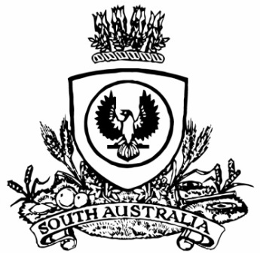**SUPPLEMENTARY GAZETTE**

**THE SOUTH AUSTRALIAN**

**GOVERNMENT GAZETTE**

**Published by Authority**

Adelaide, Friday, 29 August 2025

**Contents**

State Government Instruments

Marine Parks Act 2007 3770

# State Government Instruments

## Marine Parks Act 2007

*Temporary Prohibition Notice—Upper Spencer Gulf Marine Park*

Notice is hereby given pursuant to Section 18(2)(a) and (c) of the *Marine Parks Act 2007*, that it is prohibited for any member of the public to enter, remain in, or undertake any activity in the designated zone surrounding the air bubble curtain installed at Stony Point, near Port Bonython in Upper Spencer Gulf Marine Park.

The designated zone is located off the coast of Stony Point at the location marked in the attached Schedule.

This prohibition operates for a period of 90 days from the date of this notice.

The purpose of the prohibition is to ensure the protection of cuttlefish eggs and hatchlings against the potential impacts of a harmful algal bloom, and to ensure public safety during operation of the bubble curtain.

Failure to comply with this notice may result in liability for criminal prosecution with a maximum penalty of $100,000 or two years’ imprisonment.

Dated: 28 August 2025

J. Irving

Director, Park Planning and Visitor Experience

Delegate of the Minister for Climate, Environment and Water

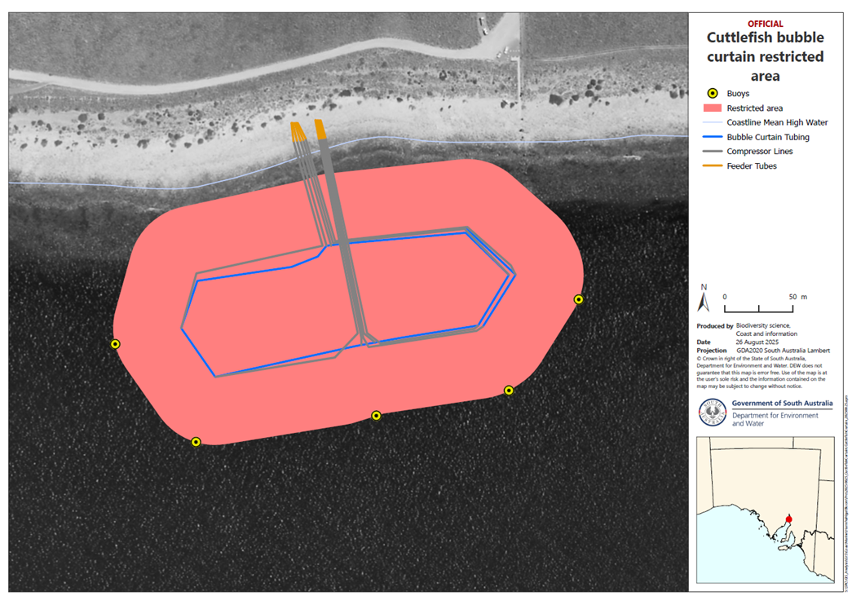Schedule

**All instruments appearing in this gazette are to be considered official, and obeyed as such**

Printed and published weekly by authority of T. Foresto, Government Printer, South Australia

$9.50 per issue (plus postage), $479.00 per annual subscription—GST inclusive

Online publications: [www.governmentgazette.sa.gov.au](http://www.governmentgazette.sa.gov.au)