
No. 70 p. 4711
THE SOUTH AUSTRALIAN
GOVERNMENT GAZETTE
Published by Authority

Adelaide, Thursday, 4 December 2025

Contents

Governor’s Instruments
Acts 4712
Appointments, Resignations and General Matters 4713
Proclamations—
Ageing and Adult Safeguarding (Review Recommendations) Amendment Act (Commencement) Proclamation 2025 4714
Regulations—
Planning, Development and Infrastructure (General) (Infrastructure Coordination Overlay) Amendment Regulations 2025—No. 134 of 2025 4715
Ageing and Adult Safeguarding (Review Recommendations) Amendment Regulations 2025—No. 135 of 2025 4717
Health Practitioner Regulation National Law
(South Australia) (Amendment of Law)
Regulations 2025—No. 136 of 2025 4719
State Government Instruments
Associations Incorporation Act 1985 4728
Building Work Contractors Act 1995 4728
Children and Young People (Oversight and Advocacy
Bodies) Act 2016 4730
Crown Land Management Act 2009 4748
Energy Resources Act 2000 4748
Housing Improvement Act 2016 4749
Justices of the Peace Act 2005 4750
Land Acquisition Act 1969 4751
Local Government (Elections) Act 1999 4762
Mining Act 1971 4763
Motor Vehicles Act 1959 4763
Passenger Transport Act 1994 4783
Pastoral Land Management and Conservation Act 1989 4791
Planning, Development and Infrastructure Act 2016 4792
Road Traffic Act 1961 4805
Local Government Instruments
City of Marion 4806
Alexandrina Council 4806
District Council of Cleve 4810
District Council of Loxton Waikerie 4813
Public Notices
National Electricity Law 4814
National Energy Retail Law 4814

Governor’s Instruments

Acts
Department of the Premier and Cabinet
Adelaide, 4 December 2025
Her Excellency the Governor directs it to be notified for general information that she has in the name and on behalf of His Majesty The King, this day assented to the undermentioned Bills passed by the Legislative Council and House of Assembly in Parliament assembled, viz.:
No. 65 of 2025—Education and Children's Services (Enrolment and Attendance) Amendment Bill 2025
An Act to amend the Education and Children's Services Act 2019
No. 66 of 2025—Help to Buy (Commonwealth Powers) Bill 2025
An Act to adopt specified provisions of the Help to Buy Act 2024 of the Commonwealth for the purposes of section 51(xxxvii) of the Constitution of the Commonwealth, to refer legislative power of the State in the form of an amendment reference to the Parliament of the Commonwealth to make amendments to the Help to Buy Act 2024 of the Commonwealth for the purposes of section 51(xxxvii) of the Constitution of the Commonwealth, to make related amendments to various Acts, and for other purposes
No. 67 of 2025—Waite Trust (Activities on and Use of Certain Trust Land) Bill 2025
An Act to allow for certain activities on, and use of, portions of the land that is subject to the terms of the Peter Waite Trust
No. 68 of 2025—Statutes Amendment (Building and Construction Industry Review—Penalties) Bill 2025
An Act to amend the Building Work Contractors Act 1995, the Fair Trading Act 1987, the Magistrates Court Act 1991 and the Plumbers, Gas Fitters and Electricians Act 1995
No. 69 of 2025—Statutes Amendment (Health and Wellbeing) Bill 2025
An Act to amend the Advance Care Directives Act 2013, the Assisted Reproductive Treatment Act 1988, the Automated External Defibrillators (Public Access) Act 2022, the Blood Contaminants Act 1985, the Controlled Substances Act 1984, the Food Act 2001, the Guardianship and Administration Act 1993, the Health and Community Services Complaints Act 2004, the Health Care Act 2008, the Mental Health Act 2009, the Research Involving Human Embryos Act 2003, the Suicide Prevention Act 2021 and the Termination of Pregnancy Act 2021
No. 70 of 2025—Residential Tenancies (Miscellaneous) Amendment Bill 2025
An Act to amend the Residential Tenancies Act 1995
No. 71 of 2025—Scrap Metal Dealers Bill 2025
An Act to regulate the scrap metal industry, and for other purposes
No. 72 of 2025—Labour Hire Licensing (Scope of Act) Amendment Bill 2025
An Act to amend the Labour Hire Licensing Act 2017
No. 73 of 2025—Carers Recognition (Miscellaneous) Amendment Bill 2025
An Act to amend the Carers Recognition Act 2005 and to make related amendments to the Criminal Law Consolidation Act 1935, the Evidence Act 1929 and the Intervention Orders (Prevention of Abuse) Act 2009
No. 74 of 2025—Fisheries Management (Cuttlefish—Northern Spencer Gulf) Amendment Bill 2025
An Act to amend the Fisheries Management Act 2007
No. 75 of 2025—Return to Work (Presumptive Firefighter Injuries) Amendment Bill 2025
An Act to amend the Return to Work Act 2014
No. 76 of 2025—Workplace Protection (Personal Violence) Bill 2025
An Act to protect people from personal violence in the workplace, to make a related amendment to the Youth Court Act 1993 and for other purposes
No. 77 of 2025—Unclaimed Goods (Miscellaneous) Amendment Bill 2025
An Act to amend the Unclaimed Goods Act 1987 and to make a related amendment to the Local Government Act 1999
No. 78 of 2025—Summary Offences (High Risk Missing Persons) Amendment Bill 2025
An Act to amend the Summary Offences Act 1953
No. 79 of 2025—Statutes Amendment (Superannuation and Other Payments) Bill 2025
An Act to amend the Electricity Corporations Act 1994, the Parliamentary Remuneration Act 1990, the Parliamentary Superannuation Act 1974, the Police Superannuation Act 1990, the Southern State Superannuation Act 2009, the Superannuation Act 1988 and the Superannuation Funds Management Corporation of South Australia Act 1995
By command,
Andrea Michaels, MP
For Premier

Appointments, Resignations and General Matters
Department of the Premier and Cabinet
Adelaide, 4 December 2025
Her Excellency the Governor in Executive Council has been pleased to appoint the undermentioned to the Parole Board of South Australia, pursuant to the provisions of the Correctional Services Act 1982:
Member: from 18 December 2025 until 17 December 2028
Eleanor Frances Nelson
William Penn Boucaut
Nicholas John Floreani
Garth Dodd
Susan Joan Macdonald
Presiding Member: from 18 December 2025 until 17 December 2028
Eleanor Frances Nelson
First Deputy Presiding Member: from 18 December 2025 until 17 December 2028
William Penn Boucaut
Second Deputy Presiding Member: from 18 December 2025 until 17 December 2028
Nicholas John Floreani
By command,
Andrea Michaels, MP
For Premier
25MCS0002CS

Department of the Premier and Cabinet
Adelaide, 4 December 2025
Her Excellency the Governor in Executive Council has been pleased to appoint the undermentioned to the Adelaide Festival Corporation Board, pursuant to the provisions of the Adelaide Festival Corporation Act 1998:
Member: from 4 December 2025 until 3 December 2028
Brenton Philip Vincent Cox
By command,
Andrea Michaels, MP
For Premier
25ART0023CS

Department of the Premier and Cabinet
Adelaide, 4 December 2025
Her Excellency the Governor in Executive Council has been pleased to appoint Anna Louise Collyer as a full-time Commissioner and the Chairperson of the Australian Energy Market Commission for a five year term commencing on 1 February 2026 until 31 January 2031, pursuant to sections 12 and 13 of the Australian Energy Market Commission Establishment Act 2004.
By command,
Andrea Michaels, MP
For Premier
25MEM0040CS

Department of the Premier and Cabinet
Adelaide, 4 December 2025
Her Excellency the Governor in Executive Council has directed that, upon his retirement, a cash payment be made to Deputy President Judge Brian Gilchrist, a Judge of the District Court of South Australia, in lieu of his unused leave entitlement - pursuant to section 13H(2) of the Supreme Court Act 1935 and section 14(1) of the District Court Act 1991.
By command,
Andrea Michaels, MP
For Premier
AGO0210-25CS

Proclamations
South Australia

Ageing and Adult Safeguarding (Review Recommendations) Amendment Act (Commencement) Proclamation 2025
1—Short title
This proclamation may be cited as the Ageing and Adult Safeguarding (Review Recommendations) Amendment Act (Commencement) Proclamation 2025.
2—Commencement of Act
The Ageing and Adult Safeguarding (Review Recommendations) Amendment Act 2025 (No 38 of 2025) comes into operation on 1 July 2026.
Made by the Governor
with the advice and consent of the Executive Council
on 4 December 2025

Regulations
South Australia

Planning, Development and Infrastructure (General) (Infrastructure Coordination Overlay) Amendment Regulations 2025
under the Planning, Development and Infrastructure Act 2016

Contents
Part 1—Preliminary
1 Short title
2 Commencement
Part 2—Amendment of Planning, Development and Infrastructure (General) Regulations 2017
3 Amendment of Schedule 9—Referrals

Part 1—Preliminary
1—Short title
These regulations may be cited as the Planning, Development and Infrastructure (General) (Infrastructure Coordination Overlay) Amendment Regulations 2025.
2—Commencement
These regulations come into operation on the day on which they are made.
Part 2—Amendment of Planning, Development and Infrastructure (General) Regulations 2017
3—Amendment of Schedule 9—Referrals
Schedule 9, clause 3, table, Part A—after item 8 insert:

8A—Infrastructure Coordination Overlay
Development that is—  (a) in the Infrastructure Coordination Overlay under the Planning and Design Code; and  (b) specified by the Planning and Design Code as development of a class to which this item applies. | The Scheme Coordinator established under section 165 of the Act in relation to an infrastructure delivery scheme under Part 13 Division 1 of the Act in operation in the relevant area of the Infrastructure Coordination Overlay under the Planning and Design Code. | Direction | 30 business days
Editorial note—
As required by section 10AA(2) of the Legislative Instruments Act 1978, the Minister has certified that, in the Minister's opinion, it is necessary or appropriate that these regulations come into operation as set out in these regulations.
Made by the Governor
with the advice and consent of the Executive Council
on 4 December 2025
No 134 of 2025

South Australia

Ageing and Adult Safeguarding (Review Recommendations) Amendment Regulations 2025
under the Ageing and Adult Safeguarding Act 1995

Contents
Part 1—Preliminary
1 Short title
2 Commencement
Part 2—Amendment of Ageing and Adult Safeguarding Regulations 2019
3 Amendment of regulation 5—Preparation of the Charter
4 Amendment of regulation 6—Prescribed State authorities—Charter
5 Amendment of regulation 7—Prescribed State authorities—Codes of Practice
6 Amendment of regulation 8—Consent
7 Substitution of regulation 9
9 Internal review
8 Amendment of regulation 10—Sharing of information

Part 1—Preliminary
1—Short title
These regulations may be cited as the Ageing and Adult Safeguarding (Review Recommendations) Amendment Regulations 2025.
2—Commencement
These regulations come into operation on the day on which the Ageing and Adult Safeguarding (Review Recommendations) Amendment Act 2025 comes into operation.
Part 2—Amendment of Ageing and Adult Safeguarding Regulations 2019
3—Amendment of regulation 5—Preparation of the Charter
Regulation 5—after its present contents (now to be designated as subregulation (1)) insert:
(2) For the purposes of section 20(4) of the Act, the Minister and the Adult Safeguarding Unit may vary the Charter without complying with the requirements of section 20(3) of the Act where the variations are minor and non-substantive.

4—Amendment of regulation 6—Prescribed State authorities—Charter
Regulation 6—delete "the Office for Ageing Well" and substitute:
the Department
5—Amendment of regulation 7—Prescribed State authorities—Codes of Practice
Regulation 7—delete "the Office for Ageing Well" and substitute:
the Department
6—Amendment of regulation 8—Consent
(1) Regulation 8(1)—delete subregulation (1)
(2) Regulation 8(2)—delete "section 24(5)" and substitute:
section 28(3)
7—Substitution of regulation 9
Regulation 9—delete the regulation and substitute:
9—Internal review
For the purposes of section 38(3a) of the Act, the prescribed time is 30 business days after—
(a) the application for internal review is made; or
(b) any additional information requested under section 38(2b)(a) of the Act is received,
whichever is later.
8—Amendment of regulation 10—Sharing of information
(1) Regulation 10(1)(b) and (2)—delete "section 25" wherever occurring and substitute in each case:
section 24 or 27(2)(e)
(2) Regulation 10(1)—after paragraph (b) insert:
(c) a person or body who is supporting a relevant adult as part of a safeguarding response being coordinated or monitored by the Adult Safeguarding Unit.
(3) Regulation 10(4)—delete "vulnerable" wherever occurring and substitute in each case:
relevant
Made by the Governor
with the advice and consent of the Executive Council
on 4 December 2025
No 135 of 2025

South Australia

Health Practitioner Regulation National Law (South Australia) (Amendment of Law) Regulations 2025
under the Health Practitioner Regulation National Law (South Australia) Act 2010

Contents
Preamble
Part 1—Preliminary
1 Short title
2 Commencement
3 Amendment provisions
Part 2—Amendment of Health Practitioner Regulation National Law (South Australia)
4 Amendment of section 5—Definitions
5 Insertion of section 77A
77A Restriction on disqualified persons applying for registration
6 Amendment of section 196—Decision by responsible tribunal about registered health practitioner
7 Amendment of section 197—Decision by responsible tribunal about student
8 Insertion of Part 8 Division 12A
Division 12A—Reinstatement orders
198A Application for reinstatement order
198B Hearing of application for reinstatement order
198C Parties to proceedings
198D Costs
198E Decision about application for reinstatement order
9 Insertion of sections 225A and 225B
225A Requirement for additional information to be recorded in National and Specialists Registers in certain circumstances
225B Additional information to be recorded in National and Specialists Registers for section 225A
10 Insertion of sections 237A and 237B
237A Protection from reprisals for persons making notifications or otherwise providing information, documents or assistance
237B Non-disclosure agreements
11 Insertion of Part 16
Part 16—Transitional provisions for Health Practitioner Regulation National Law (South Australia) (Amendment of Law) Regulations 2025
327 Application of section 77A
328 Application for reinstatement order
329 Application of section 237B

Preamble
1 Section 4 of the Health Practitioner Regulation National Law (South Australia) Act 2010 provides that if the Parliament of Queensland enacts an amendment to the Health Practitioner Regulation National Law set out in the Schedule to the Health Practitioner Regulation National Law Act 2009 of Queensland (the Queensland Act), the Governor may, by regulation, modify the Health Practitioner Regulation National Law (South Australia) text to give effect to that amendment as a law of South Australia.
2 The Parliament of Queensland has enacted the Health Practitioner Regulation National Law and Other Legislation Amendment Act 2025 to amend the Queensland Act and the amendments to the Health Practitioner Regulation National Law (South Australia) text set out in Part 2 of these regulations give effect to those Queensland amendments.

Part 1—Preliminary
1—Short title
These regulations may be cited as the Health Practitioner Regulation National Law (South Australia) (Amendment of Law) Regulations 2025.
2—Commencement
(1) Subject to this regulation, these regulations come into operation on the day on which they are made.
(2) The following regulations come into operation on the day on which section 17 of the Health Practitioner Regulation National Law and Other Legislation Amendment Act 2025 of Queensland (the Queensland Act) comes into operation:
(a) regulations 4 to 6 (inclusive);
(b) regulation 8;
(c) regulation 11, but only insofar as it inserts sections 327 and 328.
(3) Regulation 7 comes into operation on the day on which section 19 of the Queensland Act comes into operation.
(4) Regulation 9 comes into operation on the day on which section 21 of the Queensland Act comes into operation.
3—Amendment provisions
Pursuant to section 4(4) of the Health Practitioner Regulation National Law (South Australia) Act 2010, the Health Practitioner Regulation National Law (South Australia) text is amended as specified in Part 2 of these regulations.
Part 2—Amendment of Health Practitioner Regulation National Law (South Australia)
4—Amendment of section 5—Definitions
(1) Section 5—after the definition of criminal history law insert:
disqualified person means a person—
(a) whose registration has been cancelled by a responsible tribunal; or
(b) who has been disqualified by a responsible tribunal from applying for registration, or being registered, in a health profession;
(2) Section 5—after the definition of regulatory body insert:
reinstatement order means an order of a responsible tribunal that a disqualified person is eligible to apply to a National Board for registration under Part 7;
5—Insertion of section 77A
After section 77 insert:
77A—Restriction on disqualified persons applying for registration
Despite any other provision of this Law, a disqualified person cannot apply for registration under this Law unless a responsible tribunal has made a reinstatement order under this Law in relation to the disqualified person.
6—Amendment of section 196—Decision by responsible tribunal about registered health practitioner
(1) Section 196(4)(a)—delete "for a specified period"
(2) Section 196(4)—after paragraph (a) insert:
(aa) impose a period during which the person may not apply to a responsible tribunal for a reinstatement order;
7—Amendment of section 197—Decision by responsible tribunal about student
Section 197(2)—after "may decide" insert:
to
8—Insertion of Part 8 Division 12A
Part 8—after Division 12 insert:
Division 12A—Reinstatement orders
198A—Application for reinstatement order
(1) A disqualified person may apply to a responsible tribunal for a reinstatement order.
(2) For the purposes of subsection (1), the appropriate responsible tribunal for an application for a reinstatement order is the responsible tribunal for the participating jurisdiction in which the decision that resulted in the person becoming a disqualified person was made.
198B—Hearing of application for reinstatement order
(1) At a hearing of an application for a reinstatement order, the responsible tribunal must determine whether, at the time of the hearing, the making of a reinstatement order is appropriate.
(2) Without limiting subsection (1), in determining whether it is appropriate to make the reinstatement order, the tribunal may consider whether the person is—
(a) a fit and proper person to hold registration in the health profession; and
(b) able to practise the health profession competently and safely.
(3) The responsible tribunal must take into account a complaint or notification made about the person, whether the complaint or notification was made before or after the decision that resulted in the person becoming a disqualified person.
198C—Parties to proceedings
The parties to proceedings relating to the hearing of an application for a reinstatement order are—
(a) the disqualified person; and
(b) the National Board that registered the person before the decision that resulted in the person becoming a disqualified person.
198D—Costs
The responsible tribunal may make any order about costs the tribunal considers appropriate for the proceedings.
198E—Decision about application for reinstatement order
(1) A responsible tribunal that hears an application for a reinstatement order may—
(a) make an order dismissing the application; or
(b) grant the reinstatement order.
(2) If the responsible tribunal grants the reinstatement order, the tribunal may decide conditions to which the person’s registration must be subject if a National Board decides to re-register the person under this Law.
(3) If the responsible tribunal decides to impose a condition on the person’s registration, the tribunal must also decide a review period for the condition, commencing from the date of re-registration.
(4) Any condition imposed on a person’s registration by the National Board under Part 7 applies, but only to the extent it is not inconsistent with conditions imposed or changed by the responsible tribunal.

(5) If the responsible tribunal makes an order dismissing the application, the tribunal may impose a period during which the person cannot make another application for a reinstatement order.
(6) A person must not make an application for a reinstatement order in contravention of an order by the responsible tribunal under subsection (5).
9—Insertion of sections 225A and 225B
After section 225 insert:
225A—Requirement for additional information to be recorded in National and Specialists Registers in certain circumstances
(1) This section applies if a National Board is satisfied that, in relation to a health practitioner whose name is recorded in a National Register or Specialists Register kept by the Board—
(a) a responsible tribunal decided, on or after the participation day for the health profession, that the practitioner behaved in a way that constitutes professional misconduct; and
(b) a basis for the tribunal’s decision was that the practitioner engaged in sexual misconduct, whether occurring in connection with the practice of the practitioner’s profession or not.
(2) For the purposes of subsection (1)(b), it is immaterial that—
(a) sexual misconduct was not the sole or main basis for the tribunal’s decision; or
(b) if the matter involved other types of conduct—the tribunal did not consider or decide whether the sexual misconduct alone constituted professional misconduct.
Note—
See paragraph (b) of the definition of professional misconduct, which provides that professional misconduct may include more than one instance of unprofessional conduct in particular circumstances.
(3) The National Board may be satisfied for the purposes of subregulation (1)(b)—
(a) by necessary inference, taking into account the tribunal’s decision and the reasons for the decision; and
(b) regardless of whether or not the tribunal’s reasons for the decision expressly provide that sexual misconduct was a basis for the decision.
(4) The National Board must record the information (the additional information) mentioned in section 225B in the National Register or Specialists Register.
(5) However, the additional information must not be recorded in the National Register or Specialists Register, or must be removed from the register, if, on appeal, the responsible tribunal’s decision regarding professional misconduct is—
(a) stayed or overturned; or
(b) modified to the extent it is no longer a decision to which this section applies.
(6) Also, if recording the additional information in the National Register or Specialists Register would contravene an order of a court or tribunal, the National Board must not include, or must remove, the additional information to the extent the recording of the information in the register would contravene the order.
(7) Section 226(1) and (2) apply to the requirement to record information under this section.
(8) The additional information must remain on the National Register or Specialists Register permanently, unless otherwise authorised to be removed by this Law.
(9) To the extent of any inconsistency between the requirements of this section and section 225B (the relevant sections) and section 232(2), the relevant sections prevail.
225B—Additional information to be recorded in National and Specialists Registers for section 225A
(1) For the purposes of section 225A(4), the additional information is—
(a) a statement of the following—
(i) the date of the tribunal’s decision;
(ii) the name of the tribunal;
(iii) that the tribunal decided the person behaved in a way that constitutes professional misconduct;
(iv) that the professional misconduct included sexual misconduct;
(v) any sanction imposed by the tribunal that—
(A) relates solely to the sexual misconduct; or
(B) if the sanction relates to more than one type of conduct—relates to the sexual misconduct and other types of conduct; and
(b) if the tribunal decision has been published—a copy of the decision or a link to the decision.
(2) For the purposes of section 225A(4), if the tribunal decided to cancel the person’s registration on the grounds of the professional misconduct, or if the health practitioner no longer holds registration, the additional information is also a statement of the following—
(a) if the tribunal decided to disqualify the person from applying for registration under section 196(4)(a)—
(i) that the tribunal decided to disqualify the person; and
(ii) that the person may apply to the tribunal for a reinstatement order;
(b) if the tribunal decided to set a period for which the person may not apply for a reinstatement order—the period for which the person may not apply for the order;
(c) if the tribunal decided to prohibit the person from providing a health service or using a title under section 196(4)(b)—that the tribunal has prohibited the person from providing the service or using the title for a specified time or permanently;
(d) if the tribunal decided to restrict the person from providing a health service under section 196(4)(c)—
(i) that the tribunal has restricted the person from providing the service; and
(ii) the period of the restriction or that the restriction is permanent.
10—Insertion of sections 237A and 237B
After section 237 insert:
237A—Protection from reprisals for persons making notifications or otherwise providing information, documents or assistance
(1) A person must not—
(a) use threats or intimidation to attempt to persuade another person not to take protected action; or
(b) dismiss, or refuse to employ, another person because, or in the belief that, the other person has taken, or intends to take, protected action; or
(c) subject another person to other detriment or reprisal because, or in the belief that, the other person has taken, or intends to take, protected action.
Maximum penalty:
(a) in the case of an individual—$60 000;
(b) in the case of a body corporate—$120 000.

(2) In this section—
protected action means—
(a) making a notification, in good faith, under this Law; or
(b) giving information, documents or other assistance in the course of an investigation or for another purpose under this Law to a person exercising functions under this Law.
237B—Non-disclosure agreements
(1) A provision of a non-disclosure agreement is void to the extent it prevents or limits a person from—
(a) making a notification, in good faith, under this Law; or
(b) giving information, documents or other assistance in the course of an investigation or for another purpose under this Law to a person exercising functions under this Law.
(2) A relevant person must not enter into a non-disclosure agreement unless the agreement sets out, clearly and in writing, that the agreement does not limit a person from—
(a) making a notification, in good faith, under this Law; or
(b) giving information, documents or other assistance in the course of an investigation or for another purpose under this Law to a person exercising functions under this Law.
Maximum penalty:
(a) in the case of an individual—$5 000; or
(b) in the case of a body corporate—$10 000.
(3) In this section—
non-disclosure agreement means a contract or other agreement that prohibits or restricts the disclosure of information or documents by a person in relation to the health, conduct or performance of a registered health practitioner or former registered practitioner;
relevant person means the following—
(a) an employer or former employer of a registered health practitioner or a person who was registered under this Law;
(b) a health service provider whose services are provided by registered health practitioners;
(c) a registered health practitioner.
11—Insertion of Part 16
After Part 15 insert:
Part 16—Transitional provisions for Health Practitioner Regulation National Law (South Australia) (Amendment of Law) Regulations 2025
327—Application of section 77A
Section 77A—
(a) does not apply in relation to an application for registration made before the commencement of this section; but
(b) applies to a disqualified person who makes an application for registration after the commencement of this section, regardless of when a responsible tribunal made the decision that resulted in the person becoming a disqualified person.
328—Application for reinstatement order
(1) This section applies if, immediately before the commencement of this section—
(a) a person was disqualified from applying for registration as a registered practitioner for a specified period; and
(b) the period has not yet ended.
(2) The person cannot apply under section 198A for a reinstatement order until the specified period has ended.
329—Application of section 237B
Section 237B applies—
(a) to a non-disclosure agreement, within the meaning of section 237B(3), whether entered into before or after the commencement of this section; and
(b) in relation to the health, conduct or performance of a registered health practitioner or former registered health practitioner (the relevant issue), whether the relevant issue occurred before or after the commencement of this section.
Editorial note—
As required by section 10AA(2) of the Legislative Instruments Act 1978, the Minister has certified that, in the Minister's opinion, it is necessary or appropriate that these regulations come into operation as set out in these regulations.
Made by the Governor
with the advice and consent of the Executive Council
on 4 December 2025
No 136 of 2025

State Government Instruments

Associations Incorporation Act 1985
Section 43A
Deregistration of Associations
Notice is hereby given that the Corporate Affairs Commission approves the applications for deregistration received from the associations named below pursuant to Section 43A of the Associations Incorporation Act 1985 (SA). Deregistration takes effect on the date of publication of this notice:
EARLY EDUCTAION FOR SUSTAINABILITY SOUTH AUSTRALIA INCORPORATED (A42329)
MOUNT GAMBIER MARTIAL ARTS ACADEMY ASSOCIATION INCORPORATED (A20447)
ST. PAUL’S LUTHERAN CHURCH FERRYDEN PARK INCORPORATED (A3528)
DANCE ‘TIL YOU DROP INC. (A45394)
THE SMART INDUSTRIES ALLIANCE INCORPORATED (A44006)
SOUTHERN DISTRICTS MOTHER’S NETBALL ASSOCIATION INCORPORATED (A7389)
MCIS SPORTS INCORPORATED (A44794)
SOUTH AUSTRALIAN PARACHUTE COUNCIL INCORPORATED (A9050)
THE CLARINET AND SAXOPHONE NETWORK OF SOUTH AUSTRALIA INCORPORATED (A39416)
CHRISTIAN CITY CHURCH MARION INCORPORATED (A4775)
FLEURIEU POTTERS INCORPORATED (A45088)
GAWLER & DISTRICTS ELSIE EY TOY LIBRARY INCORPORATED (A41620)
EYRE PENINSULA GOAT PRODUCERS ASSOCIATION INCORPORATED (A22995)
ROCKLEIGH LAND CARE GROUP INCORPORATED (A23575)
RUBICON—THE CENTRE FOR ATTITUDINAL STUDIES INCORPORATED (A23483)
Given under the seal of the Commission at Adelaide.
Dated: 1 December 2025
Kirsty Lawrence
Team Leader, Gambling and Associations
A delegate of the Corporate Affairs Commission

Building Work Contractors Act 1995
Exemption
Take notice that, pursuant to Section 45 of the Building Work Contractors Act 1995, I, Brett Humphrey as a delegate for the Minister for Consumer and Business Affairs, do hereby exempt the licensee named in Schedule 1 from the application of Division 3 of Part 5 of the above Act in relation to domestic building work described in Schedule 2 and subject to the conditions specified in Schedule 3.
Schedule 1
JAMES RICHARD HARRIS (BLD 234685)
Schedule 2
Construction of a two-storey detached dwelling at Allotment 102 Deposited Plan 139074, being a portion of the land described in Certificate of Title Volume 6320 Folio 611, more commonly known as Lot 102 Valiant Road, Port Willunga SA 5173.
Schedule 3
1. This exemption is limited to domestic building work personally performed by the licensee in relation to the building work described in Schedule 2.
2. This exemption does not apply to any domestic building work the licensee contracts to another building work contractor, for which that contractor is required by law to hold building indemnity insurance.
3. That the licensee does not transfer his interest in the land prior to five years from the date of completion of the building work the subject of this exemption, without the prior authorisation of Consumer and Business Services (CBS). Before giving such authorisation, CBS may require the licensee to take any reasonable steps to protect the future purchaser(s) of the property, including but not limited to:
• Providing evidence that an adequate policy of building indemnity insurance is in force to cover the balance of the five-year period from the date of completion of the building work the subject of this exemption;
• Providing evidence of an independent expert inspection of the building work the subject of this exemption;
• Making an independent expert report available to prospective purchasers of the property;
• Giving prospective purchasers of the property notice of the absence of a policy of building indemnity insurance.
Dated: 28 November 2025
Brett Humphrey
Commissioner for Consumer Affairs
Delegate for the Minister for Consumer and Business Affairs

Building Work Contractors Act 1995
Exemption
Take notice that, pursuant to Section 45 of the Building Work Contractors Act 1995, I, Brett Humphrey as a delegate for the Minister for Consumer and Business Affairs, do hereby exempt the licensee named in Schedule 1 from the application of Division 3 of Part 5 of the above Act in relation to domestic building work described in Schedule 2 and subject to the conditions specified in Schedule 3.
Schedule 1
MARTIN RICHARD ROBINSON (BLD 224623)
Schedule 2
Construction of a single storey detached dwelling and carport at Allotment 5 Deposited Plan 63593, being a portion of the land described in Certificate of Title Volume 5910 Folio 709, more commonly known as 70 Brownlow Road, Kingscote SA 5223.
Schedule 3
1. This exemption is limited to domestic building work personally performed by the licensee in relation to the building work described in Schedule 2.
2. This exemption does not apply to any domestic building work the licensee contracts to another building work contractor, for which that contractor is required by law to hold building indemnity insurance.
3. That the licensee does not transfer his interest in the land prior to five years from the date of completion of the building work the subject of this exemption, without the prior authorisation of Consumer and Business Services (CBS). Before giving such authorisation, CBS may require the licensee to take any reasonable steps to protect the future purchaser(s) of the property, including but not limited to:
• Providing evidence that an adequate policy of building indemnity insurance is in force to cover the balance of the five-year period from the date of completion of the building work the subject of this exemption;
• Providing evidence of an independent expert inspection of the building work the subject of this exemption;
• Making an independent expert report available to prospective purchasers of the property;
• Giving prospective purchasers of the property notice of the absence of a policy of building indemnity insurance.
Dated: 1 December 2025
Brett Humphrey
Commissioner for Consumer Affairs
Delegate for the Minister for Consumer and Business Affairs

Building Work Contractors Act 1995
Exemption
Take notice that, pursuant to Section 45 of the Building Work Contractors Act 1995, I, Brett Humphrey as a delegate for the Minister for Consumer and Business Affairs, do hereby exempt the licensee named in Schedule 1 from the application of Division 3 of Part 5 of the above Act in relation to domestic building work described in Schedule 2 and subject to the conditions specified in Schedule 3.
Schedule 1
TIMOTHY JOHN BIGMORE (BLD 177894)
Schedule 2
Construction of a single storey addition to an existing dwelling at Allotment 83, Deposited Plan 18913, being a portion of the land described in Certificate of Title Volume 5456 Folio 86, more commonly known as 54 Emmerson Drive, Morphett Vale SA 5162.
Schedule 3
1. This exemption is limited to domestic building work personally performed by the licensee in relation to the building work described in Schedule 2.
2. This exemption does not apply to any domestic building work the licensee contracts to another building work contractor, for which that contractor is required by law to hold building indemnity insurance.
3. That the licensee does not transfer his interest in the land prior to five years from the date of completion of the building work the subject of this exemption, without the prior authorisation of Consumer and Business Services (CBS). Before giving such authorisation, CBS may require the licensee to take any reasonable steps to protect the future purchaser(s) of the property, including but not limited to:
• Providing evidence that an adequate policy of building indemnity insurance is in force to cover the balance of the five-year period from the date of completion of the building work the subject of this exemption;
• Providing evidence of an independent expert inspection of the building work the subject of this exemption;
• Making an independent expert report available to prospective purchasers of the property;
• Giving prospective purchasers of the property notice of the absence of a policy of building indemnity insurance.
Dated: 28 November 2025
Brett Humphrey
Delegate for the Minister for Consumer and Business Affairs

Children and Young People (Oversight and Advocacy Bodies) Act 2016
Substitution of South Australia’s Outcomes Framework for Children and Young People
Pursuant to Section 57(6) of the Children and Young People (Oversight and Advocacy Bodies) Act 2016 and Regulation 12(4) of the Children and Young People (Oversight and Advocacy Bodies) Regulations 2017, I, Blair Boyer, Minister for Education, Training and Skills, hereby approve substitution of South Australia’s Outcomes Framework for Children and Young People, as prepared by the Child Development Council which will come into effect from the date of this approval. I have determined that this document will also be published on the Child Development Council website.
Dated: 28 November 2025
Blair Boyer
Minister for Education, Training and Skills

Children and Young People (Oversight and Advocacy Bodies) Act 2016
South Australia’s Outcomes Framework for Children and Young People
Pursuant to Section 57(7) of the Children and Young People (Oversight and Advocacy Bodies) Act 2016, on behalf of the Child Development Council I hereby cause the publication of South Australia’s Outcomes Framework for Children and Young People with substitution approved by the Minister for Education, Training and Skills.
Dated: 28 November 2025
Victoria Whitington
Presiding Member

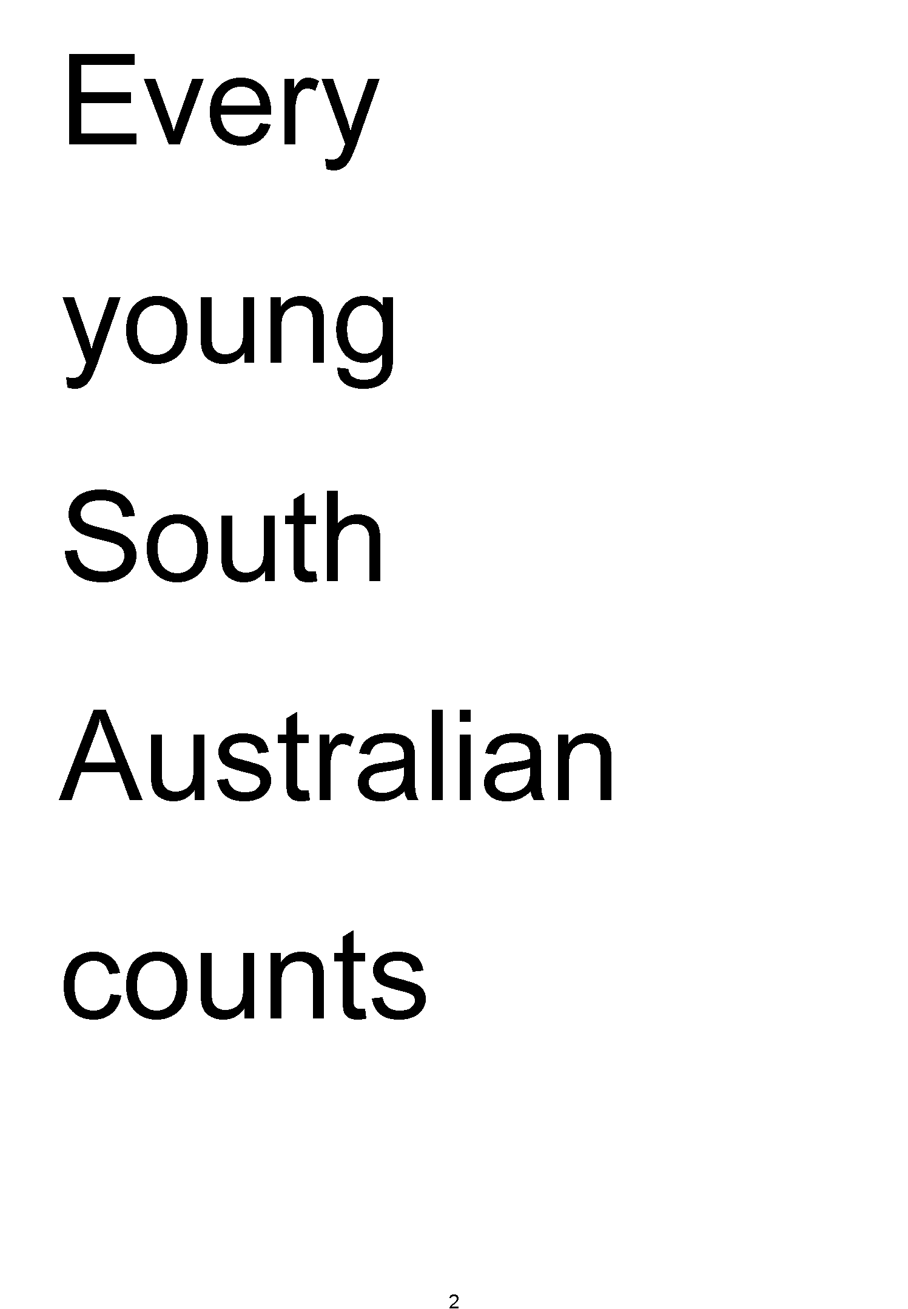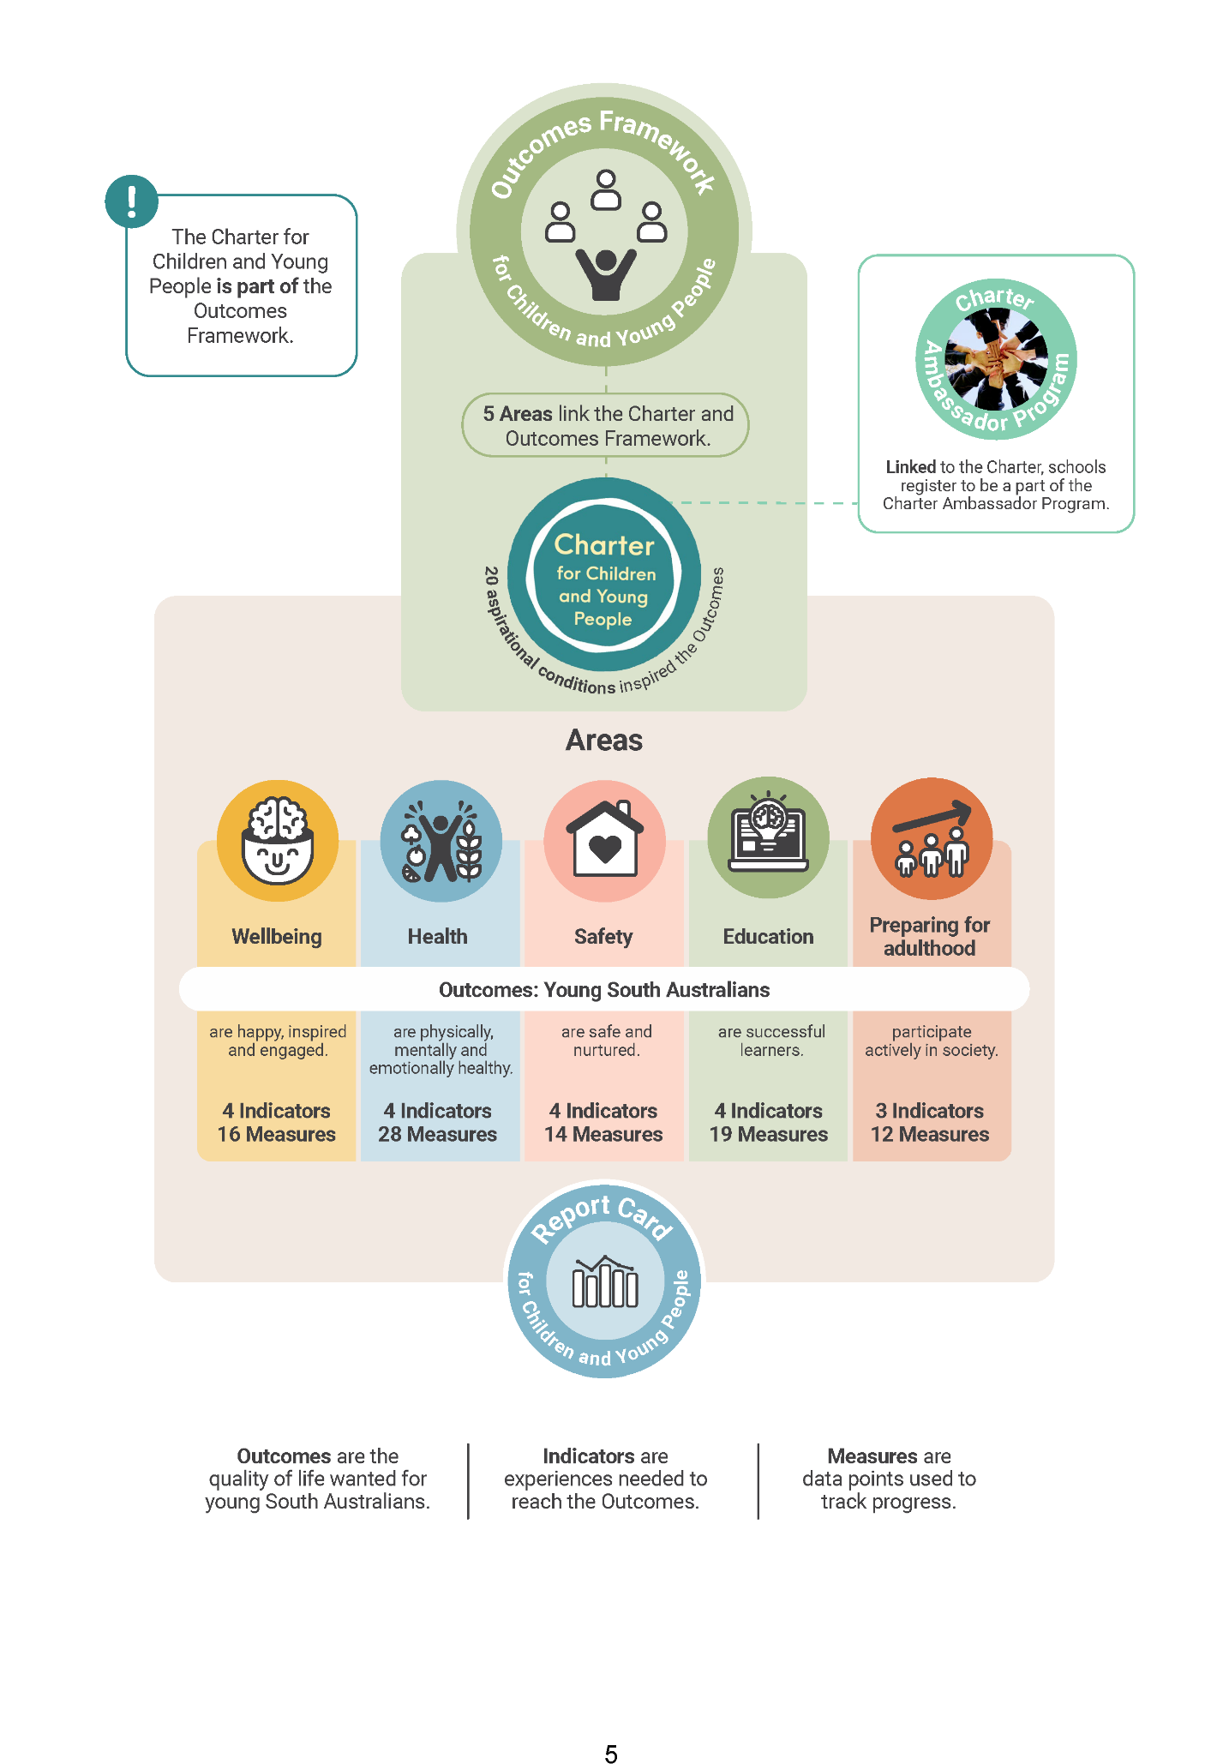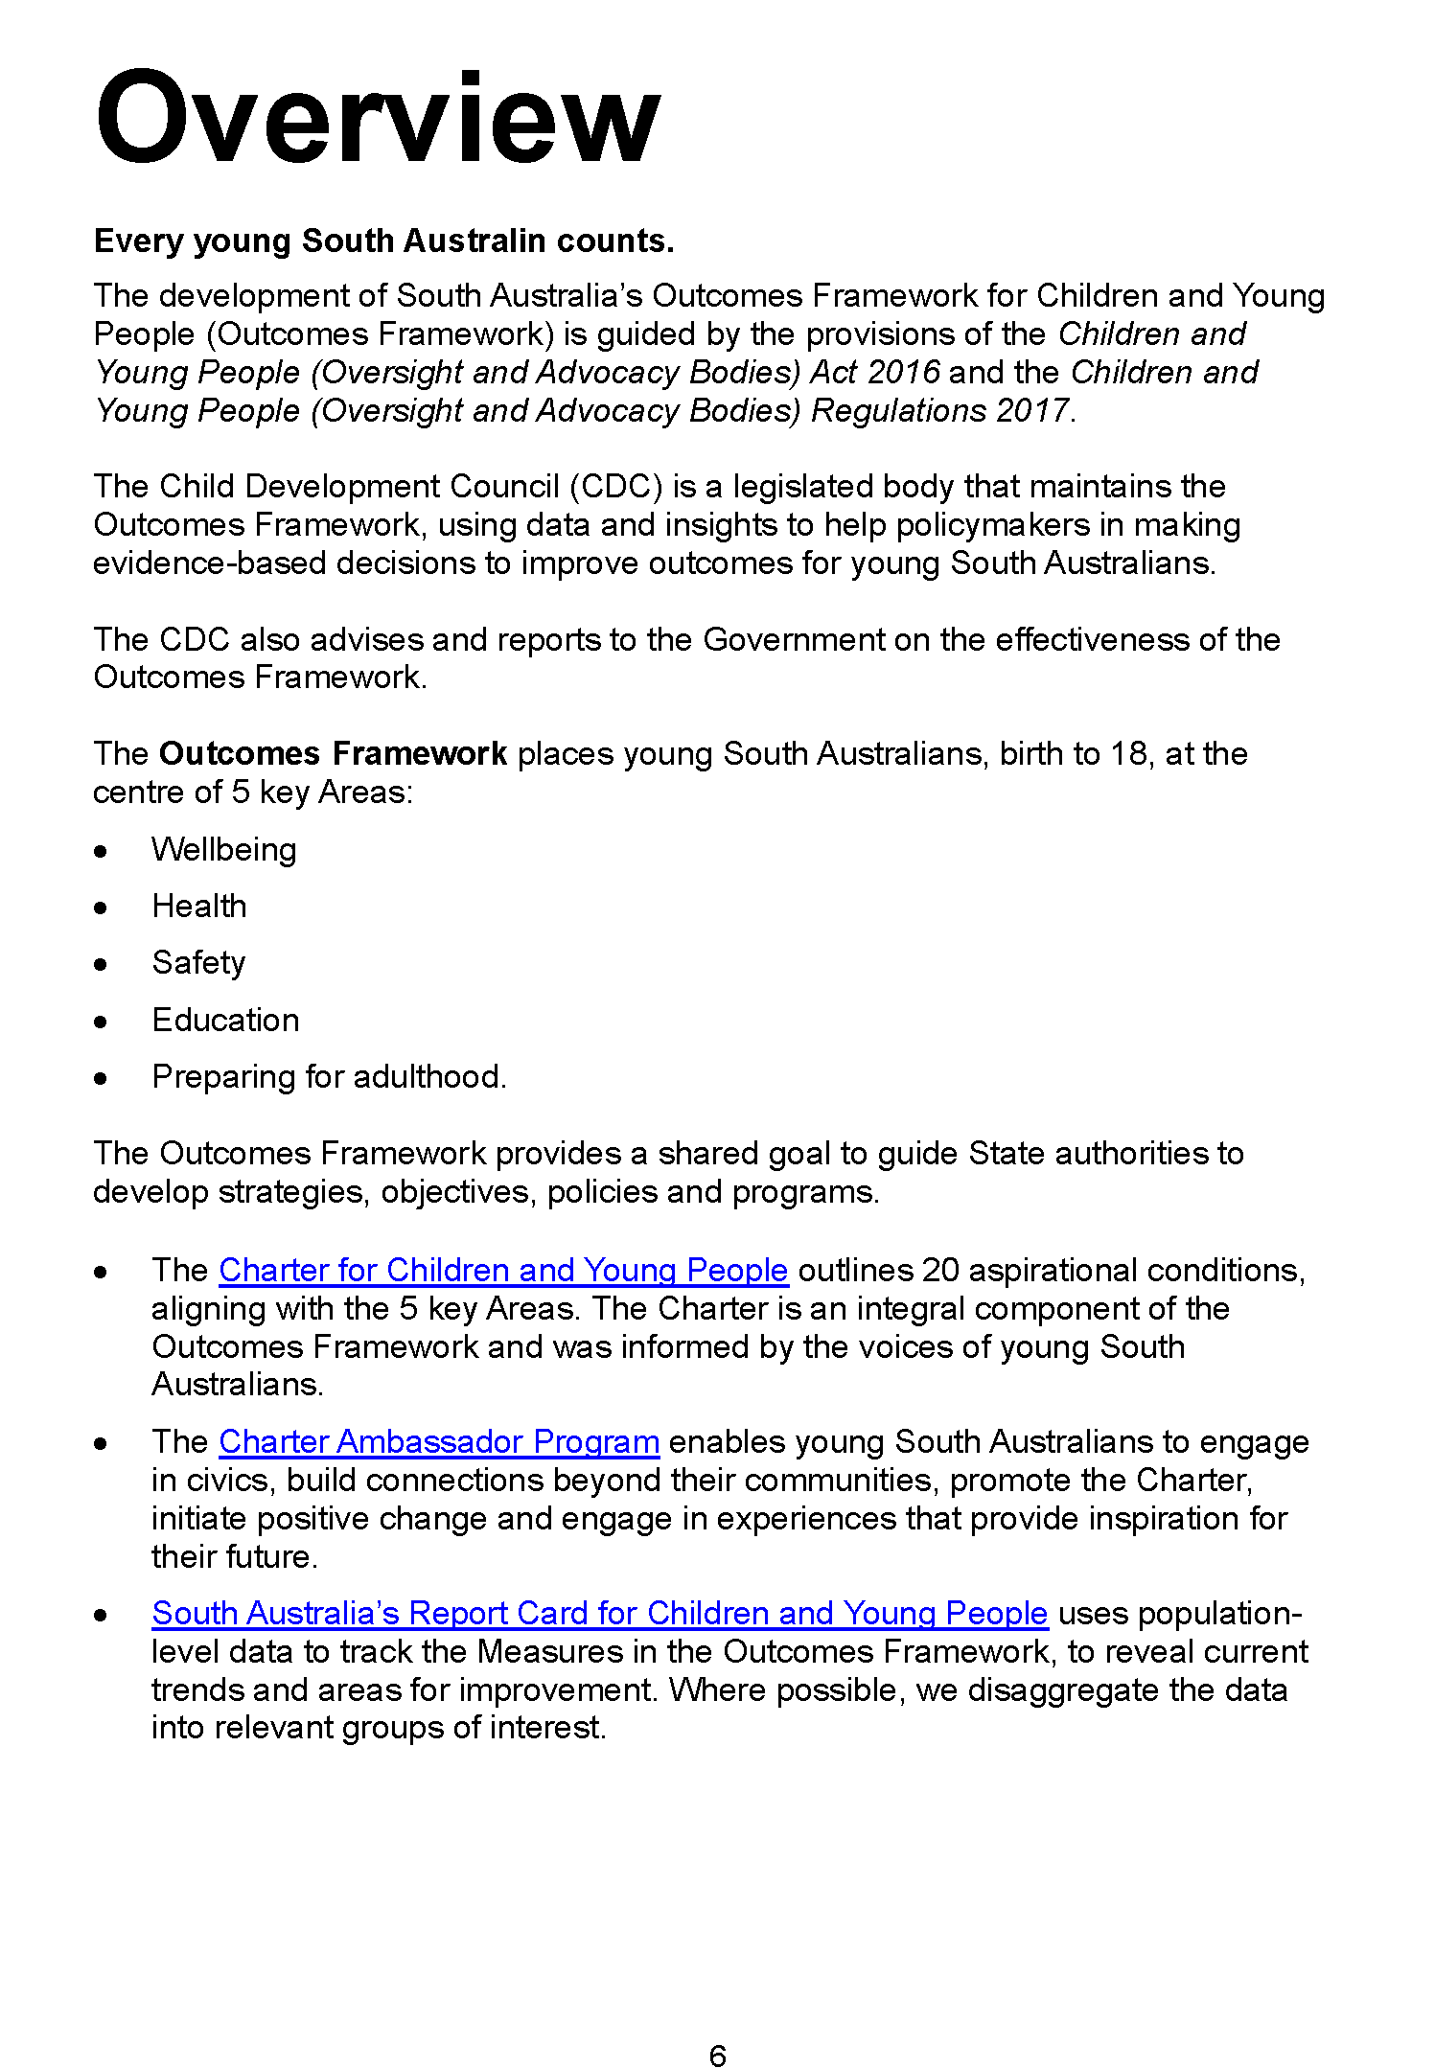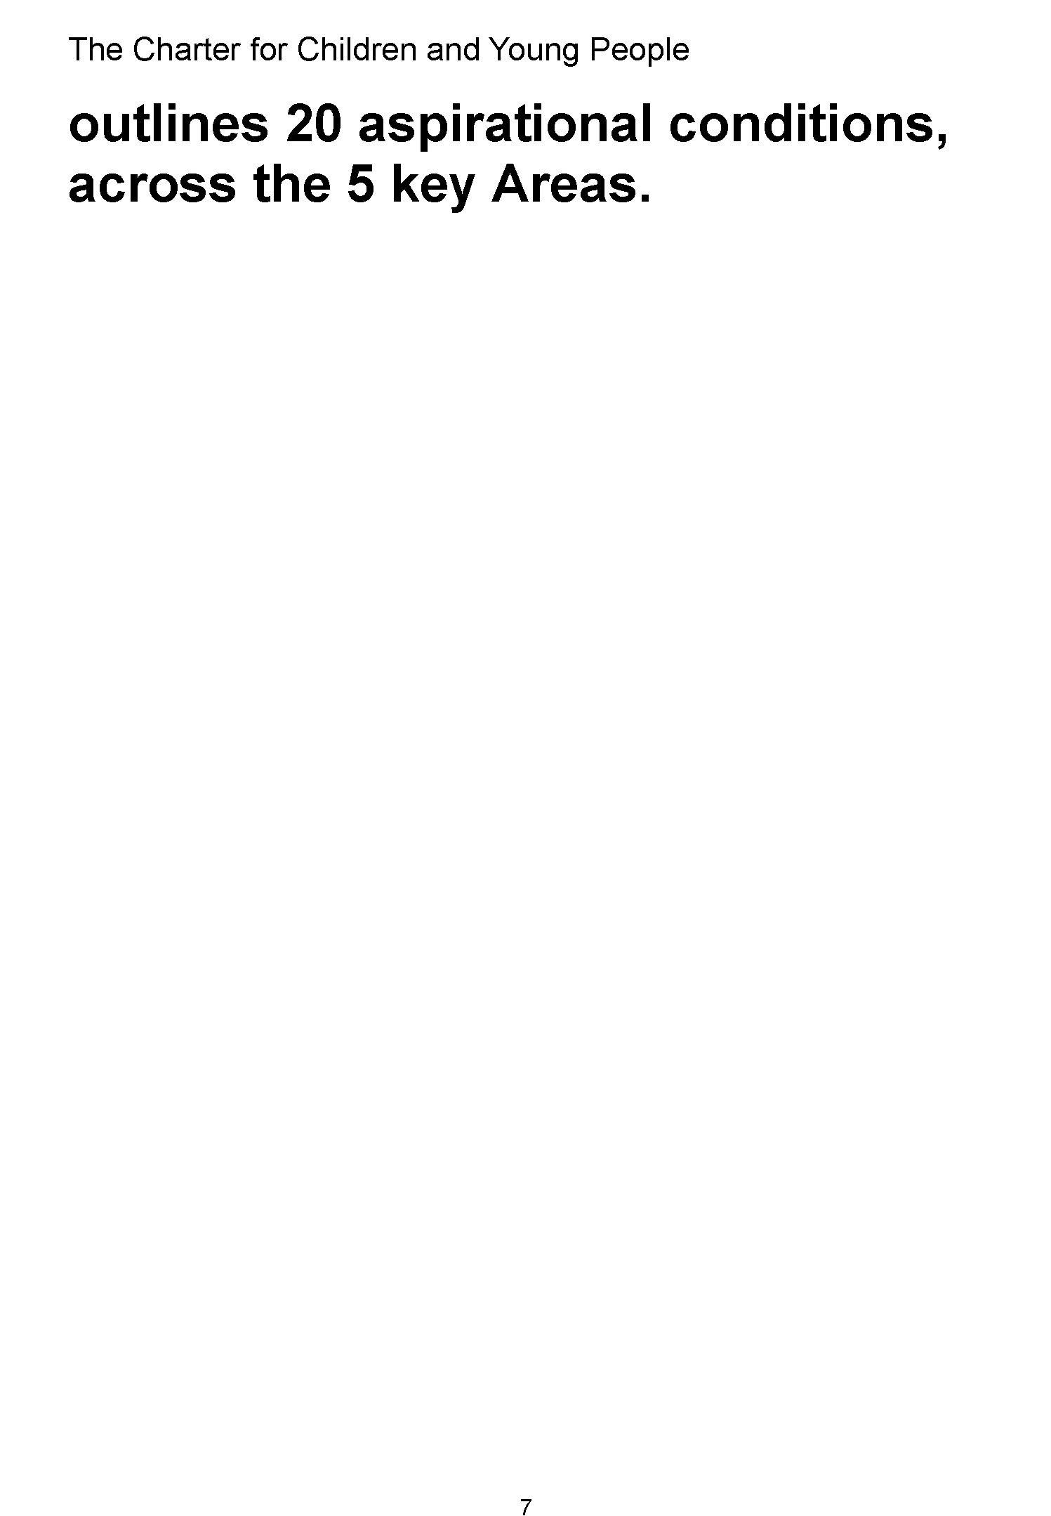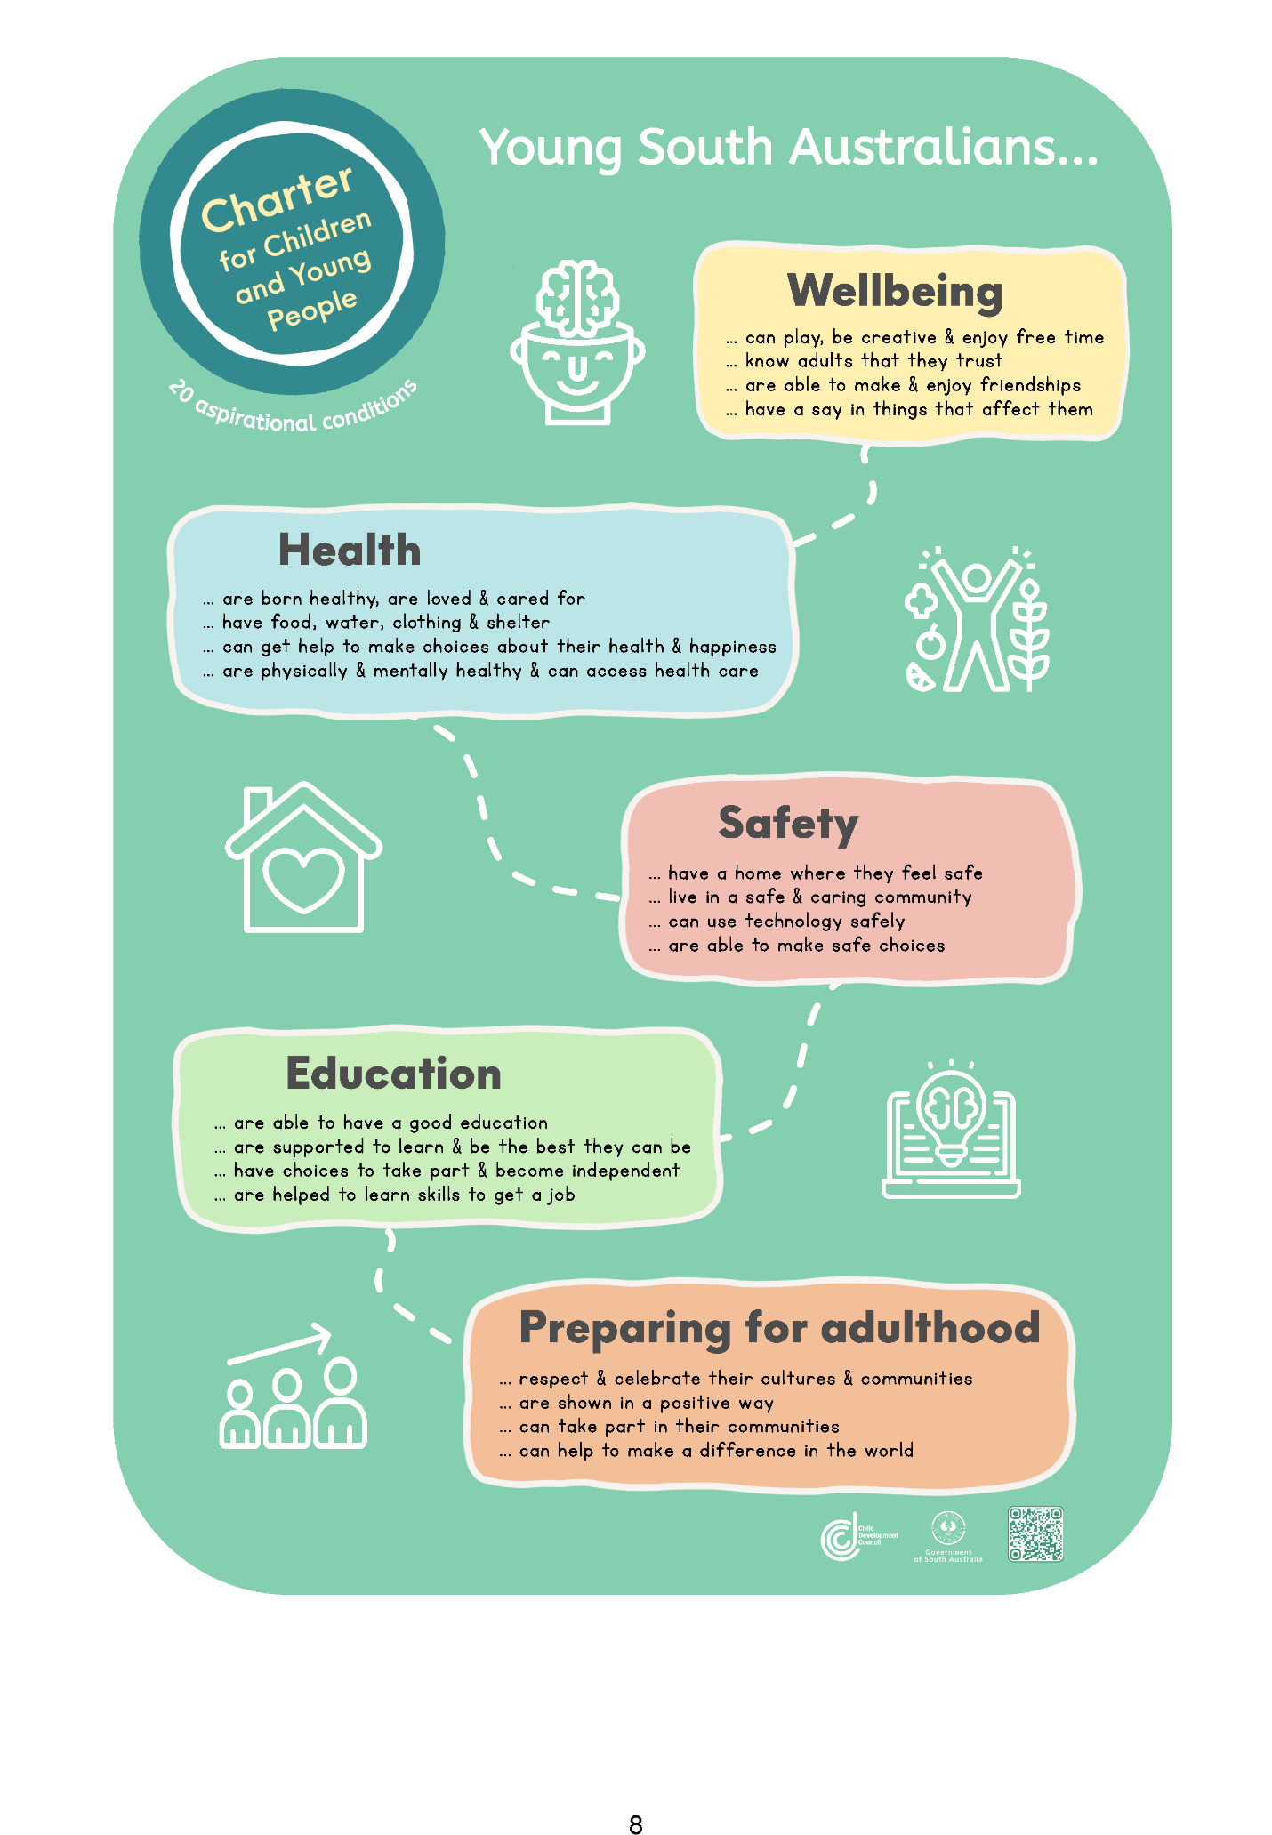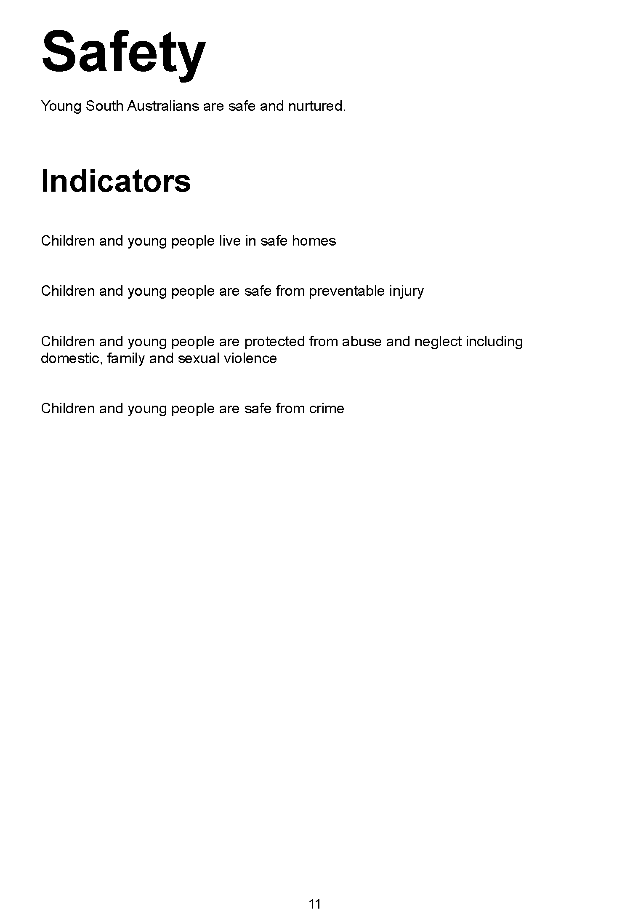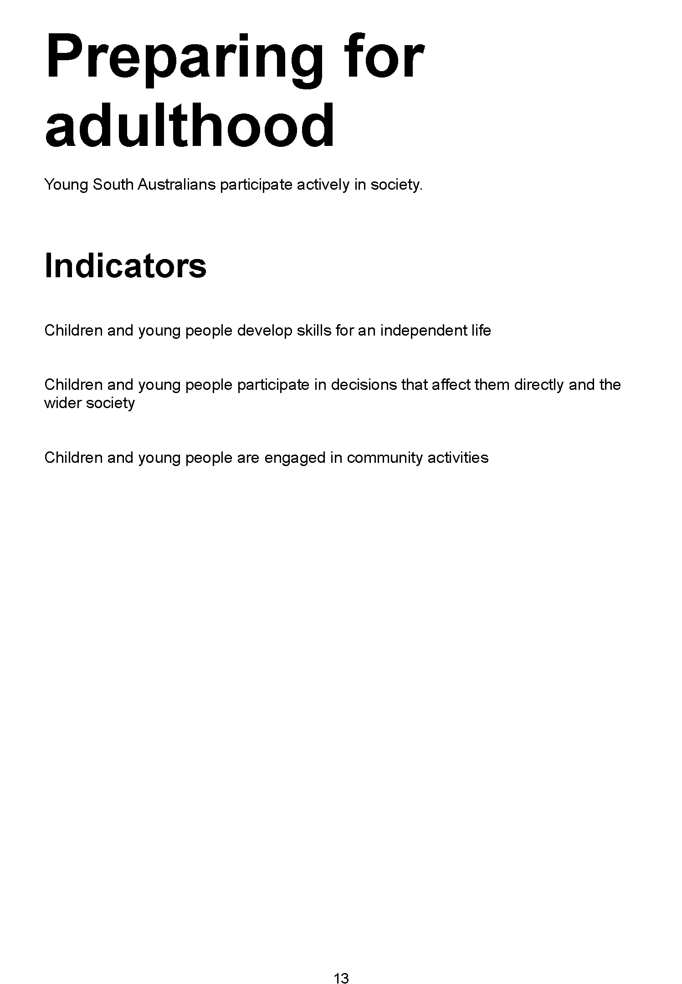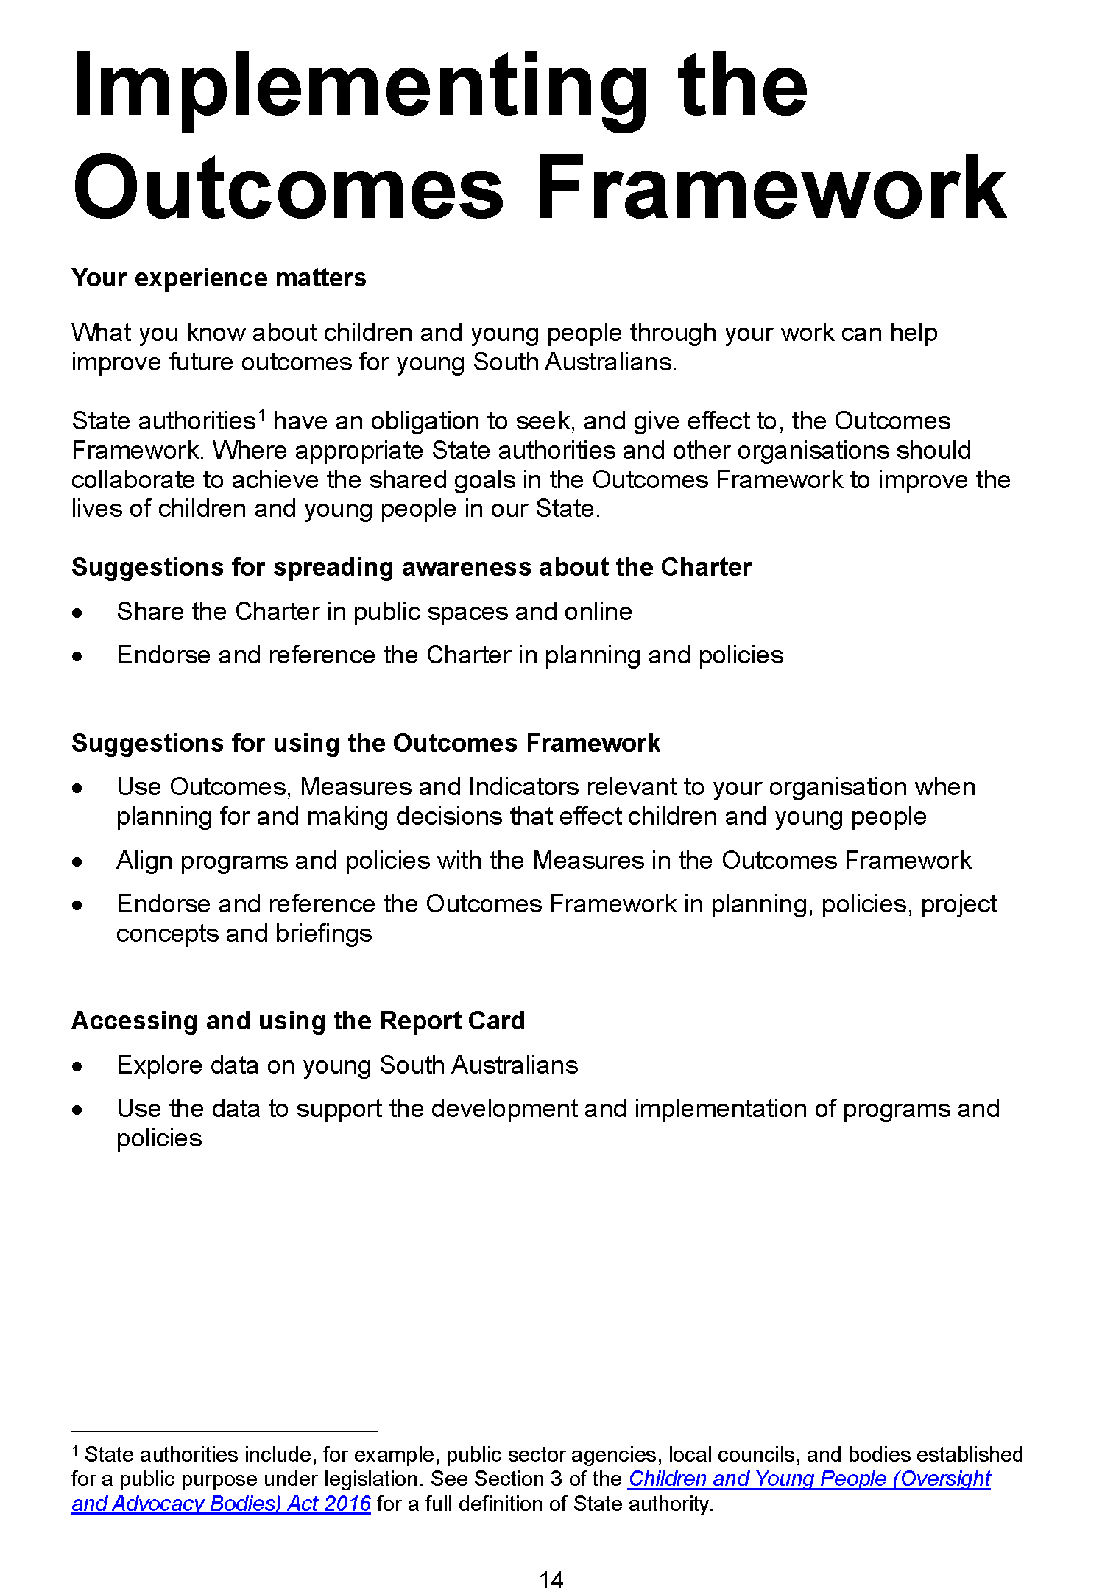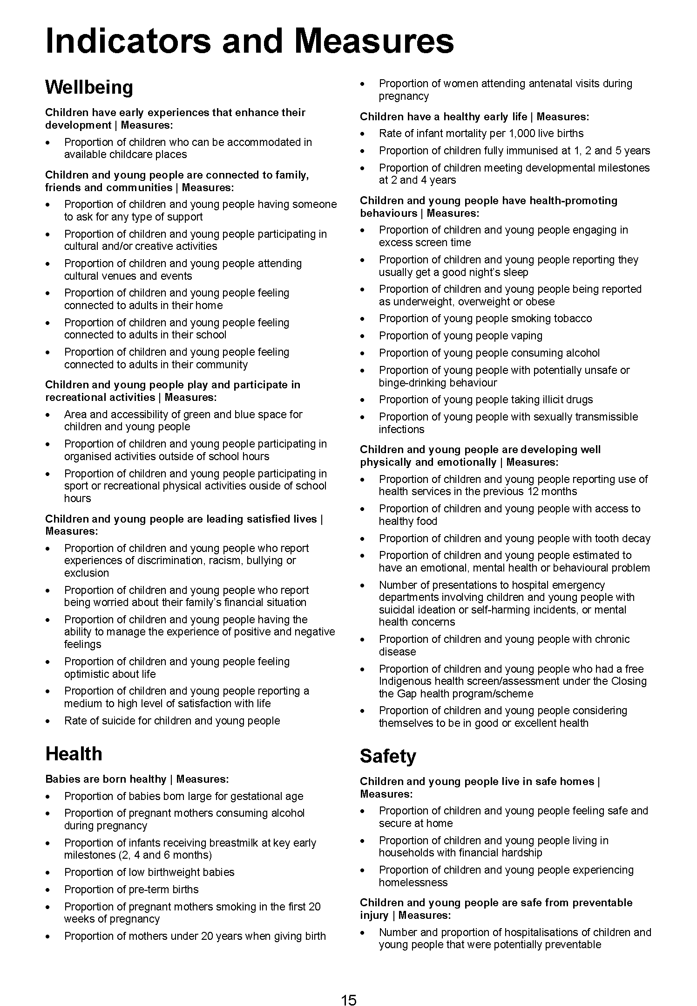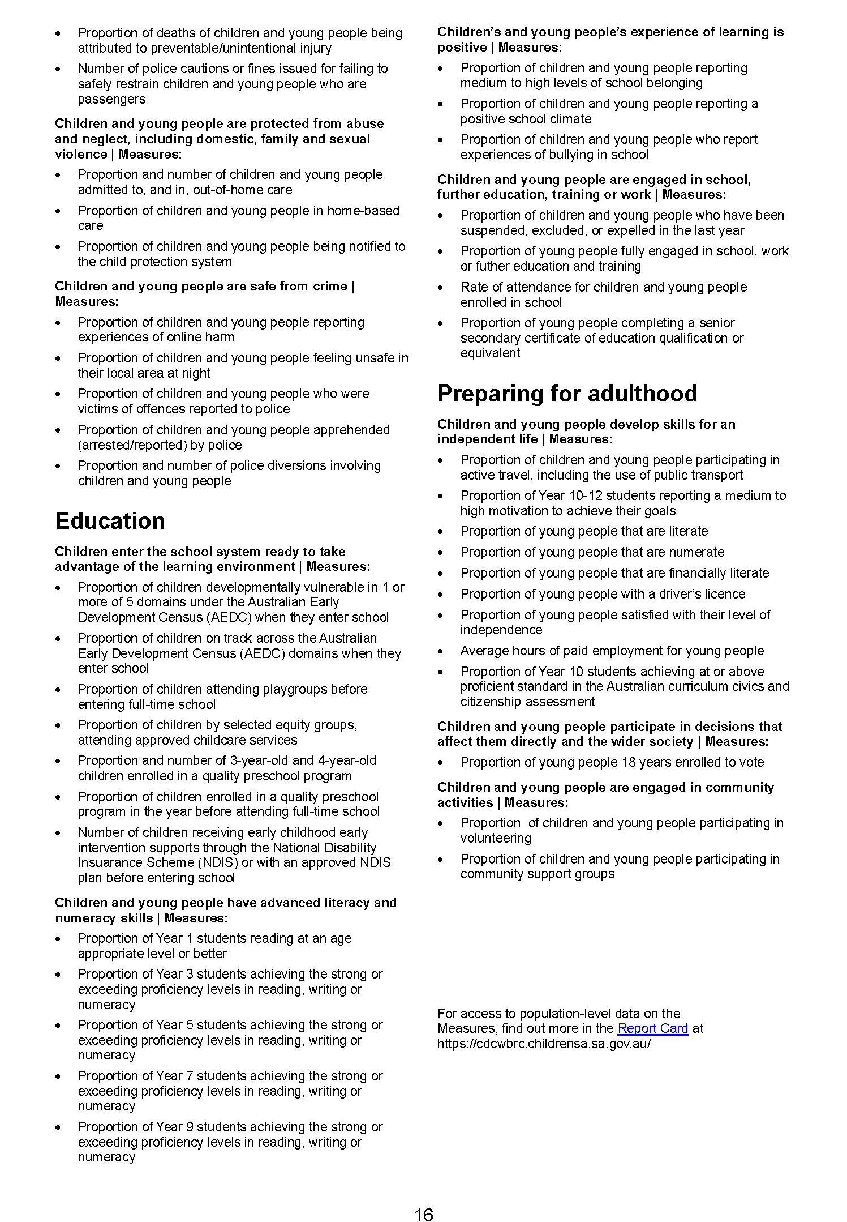
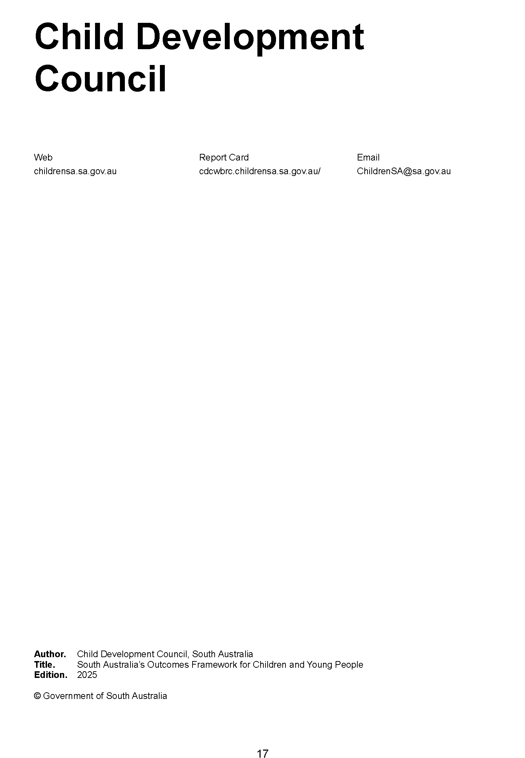

Crown Land Management Act 2009
Section 55
Declaration by the Minister in Relation to Land
I, Michael Joseph Williams, Director of National Parks and Wildlife and authorised delegate of the Minister for Climate, Environment and Water, being the Minister responsible for the Crown Land Management Act 2009, hereby declare under Section 55 of the Crown Land Management Act 2009 that—
(a) Sections 61, 62, 63 and 64 of the Crown Land Management Act 2009 will not apply to the land defined in The Schedule for a period of 24 months from the date of 23 December 2025, being the expiration of the previous notice,
(b) the following provisions apply to the land defined in The Schedule, during the period specified above, as if it were a national park constituted under the National Parks and Wildlife Act 1972:
• National Parks and Wildlife Act 1972, Sections 20-26, 43C, 45M, 47, 70, 70A, 72, 73A, 74, 75, 77, 78, 79, 80
• National Parks and Wildlife (National Parks) Regulations 2016, Regulations 6, 7, 9, 10, 11, 12 14, 15, 16, 17, 19, 22, 23, 25, 26, 27, 28, 29, 30, 32, 34, 35, 36, 37, 38, 39, 40, 41, 42
Dated: 4 December 2025
M. J. Williams
Director of National Parks and Wildlife
Delegate of the Minister for Climate, Environment and Water

The Schedule
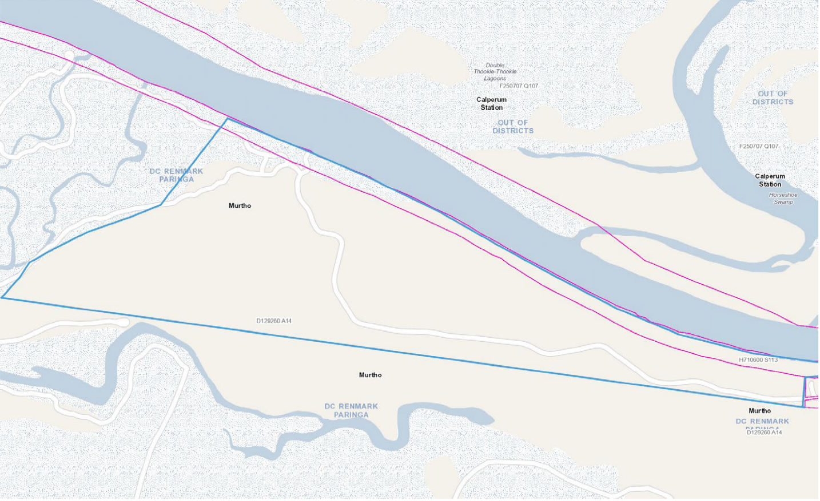
Those portions of Allotment 14 in Deposited Plan 129260 and Section 113 Hundred of Murtho, marked on the attached map.

Energy Resources Act 2000
Application for Variation of Pipeline Licence—PL 1
Pursuant to Section 65(6) of the Energy Resources Act 2000 (the Act) and Delegated powers dated 19 August 2024 notice is hereby given that Epic Energy South Australia Pty Limited has applied to vary pipeline licence PL 1.
The application will be determined on or after 18 December 2025.
Description of Application
Epic Energy South Australia Pty Limited has applied to vary pipeline licence (PL) 1 to construct a new pipeline lateral located within the vicinity of the Lefevre Peninsula.

Description of Area
Lefevre Lateral
273019.79mE 6148323.37mN
273008.66mE 6148347.74mN
272306.41mE 6148551.68mN
272259.96mE 6148581.72mN
272265.10mE 6148622.03mN
272059.68mE 6148787.98mN
272034.45mE 6148867.61mN
271934.22mE 6148887.43mN
271840.13mE 6148896.08mN
271808.79mE 6148896.52mN
271698.25mE 6148892.89mN
271580.89mE 6148894.41mN
271547.27mE 6148865.27mN
271375.25mE 6148862.21mN
271367.33mE 6149235.75mN
271363.72mE 6149240.98mN
271352.14mE 6149875.49mN
271383.60mE 6149903.25mN
271386.64mE 6149921.19mN
271629.65mE 6149858.20mN
271670.82mE 6149989.20mN
271784.20mE 6149953.05mN
271830.93mE 6149937.68mN
271888.95mE 6149906.37mN
271921.33mE 6149915.61mN
271995.37mE 6150139.66mN
272007.75mE 6150135.64mN
All coordinates MGA2020, Zone 54
Dated: 28 November 2025
Michael Smith
Director, Regulatory Risk and Resource Tenure
Regulation and Compliance Division
Department for Energy and Mining
Delegate of the Minister for Energy and Mining

Housing Improvement Act 2016
Rent Control
In the exercise of the powers conferred by the Housing Improvement Act 2016, the Delegate of the Minister for Housing and Urban Development hereby fixes the maximum rental amount per week that shall be payable subject to Section 55 of the Residential Tenancies Act 1995, in respect of each premises described in the following table. The amount shown in the said table shall come into force on the date of this publication in the Gazette.
Address of Premises | Allotment Section | Certificate of Title  Volume/Folio | Maximum Rental per week payable
192 Churchill Road, Prospect SA 5082 | Allotment 31 Filed Plan 110510 Hundred of Yatala | CT5355/667 | $150.00
Dated: 4 December 2025
Craig Thompson
Housing Regulator and Registrar
Housing Safety Authority
Delegate of the Minister for Housing and Urban Development

Housing Improvement Act 2016
Rent Control Revocations
In the exercise of the powers conferred by the Housing Improvement Act 2016, the Delegate of the Minister for Housing and Urban Development hereby revokes the maximum rental amount per week that shall be payable subject to Section 55 of the Residential Tenancies Act 1995, in respect of each premises described in the following table.
Address of Premises | Allotment Section | Certificate of Title  Volume/Folio
12 O’Brien Street, Adelaide SA 5000 | Allotment 264 Filed Plan 182726 Hundred of Adelaide | CT5521/119
155 Long Street, Queenstown SA 5014 | Allotment 82 Filed Plan 142723 Hundred of Yatala | CT5946/261
155 Long (3 rooms) Street, Queenstown SA 5014 (PKA 157) | Allotment 82 Filed Plan 142723 Hundred of Yatala | CT5946/261
3/6 Bingham Street, Goolwa SA 5214 | Unit 3 Strata Plan 3945 Hundred of Goolwa | CT5046/196
35 The Parade, Blair Athol SA 5084 AKA Flat 3/35 The Parade | Allotment 239 Deposited Plan 3448 Hundred of Yatala | CT5261/523
Dated: 4 December 2025
Craig Thompson
Housing Regulator and Registrar
Housing Safety Authority
Delegate of the Minister for Housing and Urban Development

HOUSING IMPROVEMENT ACT 2016
Rent Control Variations
In the exercise of the powers conferred by the Housing Improvement Act 2016, the Delegate of the Minister for Housing and Urban Development hereby varies the maximum rental amount per week that shall be payable subject to Section 55 of the Residential Tenancies Act 1995, in respect of each premises described in the following table. The amount shown in the said table shall come into force on the date of this publication in the Gazette.
Address of Premises |  | Allotment Section | Certificate of Title  Volume/Folio | Reason for Variation | Maximum Rental per week payable
12 Grandview Drive, Tea Tree Gully SA 5091 |  | Allotment 166 D6533  Hundred of Yatala | CT5257/782 |  | $0.00
21 Cassia Street, Surrey Downs SA 5126 |  | Allotment 13 Filed Plan 132604 Hundred of Yatala | CT5267/832 |  | $0.00
Dated: 4 December 2025
Craig Thompson
Housing Regulator and Registrar
Housing Safety Authority
Delegate of the Minister for Housing and Urban Development

Justices of the Peace Act 2005
Section 4
Notice of Appointment of Justices of the Peace for South Australia
by the Commissioner for Consumer Affairs
I, Brett Humphrey, Commissioner for Consumer Affairs, delegate of the Attorney-General, pursuant to Section 4 of the Justices of the Peace Act 2005, do hereby appoint the people listed as Justices of the Peace for South Australia as set out below.
For a period of ten years for a term commencing on 14 January 2026 and expiring on 13 January 2036:
Mathew Shane WILLIAMSON
Gaurav Rajeev VAGHMARE
Heidi Chantelle SMITH
Emma Jane Michell SARA-GLONEK
Darren Alexander RUSS
Patrick PULIS
Thomas Graham POINTON
Minh Tan PHAM
Gayle PEAK
Elena MULLER PINTO JUNQUEIRA
Belinda Jane MCDOWELL
Barrie MARSLAND
Frank LUCKS
Timothy Donald LOOKER
Mario LEUCI
Donna Louise JEFFERY
Rafie El Tayeb IBRAHIM
Richard Mark HUGHES
Natalie Karen HIGHETT
Blake Graham HALLIGAN
Damien John GITSHAM
Erin Kate EVERETT
Peter DIAMOND
Susanna Evelyn DEAN
Catherine Louise CRADDOCK
Amit CHUGH
David Mark CARWANA
Rocco Antonio CARPENTIERI
David Jack BOWDEN
Metekay BERIHUN MERSHA
Kristy Marie BARTEL
Dated: 1 December 2025
Brett Humphrey
Commissioner for Consumer Affairs
Delegate of the Attorney-General

Land Acquisition Act 1969
Section 16
Form 5—Notice of Acquisition
1. Notice of acquisition
The Minister for Infrastructure and Transport (the Authority), of 83 Pirie Street, Adelaide SA 5000, acquires the following interests in the following land:
Comprising an unencumbered estate in fee simple in that piece of land being portion of Allotment 87 in Deposited Plan No 3811 comprised in Certificate of Title Volume 6317 Folio 483 (prior to the Allotment 87 update to said plan and issuing of said title, said Allotment 87 was formerly described as public road known as Railway Terrace, Kilburn, between Allotment 22 in D12345 and Allotment 101 in D4630), and being the whole of the land identified as Allotment 10 in D135013 lodged in the Lands Titles Office
This notice is given under Section 16 of the Land Acquisition Act 1969.
2. Compensation
A person who has or had an interest consisting of native title or an alienable interest in the land that is divested or diminished by the acquisition or the enjoyment of which is adversely affected by the acquisition who does not receive an offer of compensation from the Authority may apply to the Authority for compensation.
2A. Payment of professional costs relating to acquisition (Section 26B)
If you are the owner in fee simple of the land to which this notice relates, you may be entitled to a payment of up to $10,000 from the Authority for use towards the payment of professional costs in relation to the acquisition of the land.
Professional costs include legal costs, valuation costs and any other costs prescribed by the Land Acquisition Regulations 2019.
3. Inquiries
Inquiries should be directed to: Philip Cheffirs
GPO Box 1533
Adelaide SA 5001
Telephone: (08) 7133 2395
Dated: 2 December 2025
Signed for and on behalf of the MINISTER FOR INFRASTRUCTURE AND TRANSPORT by her duly constituted Attorney, pursuant to Power of Attorney No. 14256314 (who certifies that he has not received notice of the revocation of that Power of Attorney) in the presence of:
Rocco Caruso
Director, Property Acquisition, Property, CCM
Department for Infrastructure and Transport
DIT: 2020/18010/01

LAND ACQUISITION ACT 1969
Section 16
Form 5—Notice of Acquisition
1. Notice of acquisition
The Commissioner of Highways (the Authority), of 83 Pirie Street, Adelaide SA 5000, acquires the following interests in the following land:
Comprising an estate in fee simple in that piece of land being the whole of the land identified as Allotment 53 in D136910 lodged in the Lands Titles Office, being:
First, portion of Allotment 700 in Deposited Plan 76484 comprised in Certificate of Title Volume 6321 Folio 461, subject to the easement(s) over the land marked S for the transmission of electricity by underground cable (TG 11809809), and subject to easement(s) over the land marked S for water supply purposes (TG 11809809), and subject to easement(s) over the land marked S for the transmission of telecommunication signals by underground cable (TG 11809809), and subject to free and unrestricted right(s) of way over the land marked CC (TG 11273776), expressly excluding the following: easement(s) over the land marked G for drainage purposes (TG 11273781), right(s) of way over the land marked F (TG 11273789) and free and unrestricted right(s) of way over the land marked LL.MM and G (TG 11273777 TG 11273780 and TG 11273781 respectively),
Secondly, portion of the land comprised in Certificate of Title Volume 6321 Folio 461, Volume 6066 Folio 618, Volume 6312 Folio 670 and Volume 6312 Folio 671, (being that portion of the free and unrestricted Right(s) of Way created by the registration of TG 11273774 over the land marked ‘CC’ on D76484 appurtenant to the Common Property and Lots 1 to 3 in Community Plan 25763 that is contained within, and forms portion of, the said Allotment 53), to the intent that that portion of the free and unrestricted Right(s) of Way will merge and be extinguished in the fee simple in the land marked Allotment 53 in D136910.
This notice is given under Section 16 of the Land Acquisition Act 1969.
2. Compensation
A person who has or had an interest consisting of native title or an alienable interest in the land that is divested or diminished by the acquisition or the enjoyment of which is adversely affected by the acquisition who does not receive an offer of compensation from the Authority may apply to the Authority for compensation.
2A. Payment of professional costs relating to acquisition (Section 26B)
If you are the owner in fee simple of the land to which this notice relates, you may be entitled to a payment of up to $10,000 from the Authority for use towards the payment of professional costs in relation to the acquisition of the land.
Professional costs include legal costs, valuation costs and any other costs prescribed by the Land Acquisition Regulations 2019.

3. Inquiries
Inquiries should be directed to: Daniel Tuk
GPO Box 1533
Adelaide SA 5001
Telephone: (08) 7133 2479
Dated: 2 December 2025
The Common Seal of the COMMISSIONER OF HIGHWAYS was hereto affixed by authority of the Commissioner in the presence of:
Rocco Caruso
Director, Property Acquisition
(Authorised Officer)
Department for Infrastructure and Transport
DIT: 2024/06270/01

LAND ACQUISITION ACT 1969
Section 16
Form 5—Notice of Acquisition
1. Notice of acquisition
The Commissioner of Highways (the Authority), of 83 Pirie Street, Adelaide SA 5000, acquires the following interests in the following land:
Comprising an unencumbered estate in fee simple in that piece of land being portion of Allotment 8 in Deposited Plan 89016 comprised in Certificate of Title Volume 6093 Folio 520, and being the whole of the land identified as Allotment 51 in D137247 lodged in the Lands Titles Office.
This notice is given under Section 16 of the Land Acquisition Act 1969.
2. Compensation
A person who has or had an interest consisting of native title or an alienable interest in the land that is divested or diminished by the acquisition or the enjoyment of which is adversely affected by the acquisition who does not receive an offer of compensation from the Authority may apply to the Authority for compensation.
2A. Payment of professional costs relating to acquisition (Section 26B)
If you are the owner in fee simple of the land to which this notice relates, you may be entitled to a payment of up to $10,000 from
the Authority for use towards the payment of professional costs in relation to the acquisition of the land.
Professional costs include legal costs, valuation costs and any other costs prescribed by the Land Acquisition Regulations 2019.
3. Inquiries
Inquiries should be directed to: Daniel Tuk
GPO Box 1533
Adelaide SA 5001
Telephone: (08) 7133 2479
Dated: 2 December 2025
The Common Seal of the COMMISSIONER OF HIGHWAYS was hereto affixed by authority of the Commissioner in the presence of:
Rocco Caruso
Director, Property Acquisition
(Authorised Officer)
Department for Infrastructure and Transport
DIT: 2024/07550/01

LAND ACQUISITION ACT 1969
Section 16
Form 5—Notice of Acquisition
1. Notice of acquisition
The Commissioner of Highways (the Authority), of 83 Pirie Street, Adelaide SA 5000, acquires the following interests in the following land:
Comprising an unencumbered estate in fee simple in that piece of land being the whole of Allotment 47 in Filed Plan 6860 comprised in Certificate of Title Volume 5724 Folio 301.
This notice is given under Section 16 of the Land Acquisition Act 1969.
2. Compensation
A person who has or had an interest consisting of native title or an alienable interest in the land that is divested or diminished by the acquisition or the enjoyment of which is adversely affected by the acquisition who does not receive an offer of compensation from the Authority may apply to the Authority for compensation.
2A. Payment of professional costs relating to acquisition (Section 26B)
If you are the owner in fee simple of the land to which this notice relates, you may be entitled to a payment of up to $10,000 from the Authority for use towards the payment of professional costs in relation to the acquisition of the land.
Professional costs include legal costs, valuation costs and any other costs prescribed by the Land Acquisition Regulations 2019.

3. Inquiries
Inquiries should be directed to: Rocco Caruso
GPO Box 1533
Adelaide SA 5001
Telephone: 08 7133 2393
Dated: 1 December 2025
The Common Seal of the COMMISSIONER OF HIGHWAYS was hereto affixed by authority of the Commissioner in the presence of:
Rocco Caruso
Director, Property Acquisition
(Authorised Officer)
Department for Infrastructure and Transport
File Reference: 2025/01220/01

Land Acquisition Act 1969
Section 26F
Form 6B—Notice of Acquisition of Underground Land
1. Notice of acquisition
The Commissioner of Highways (the Authority), of 83 Pirie Street, Adelaide SA 5000 acquires the following interests in the following land:
An unencumbered estate in fee simple in the whole of Allotment 704 in D138169 lodged in the Lands Titles Office, being portion of the land comprised in Certificate of Title Volume 5650 Folio 974.
This notice is given under Section 26F of the Land Acquisition Act 1969.
2. Compensation not payable unless certain water infrastructure or rights are affected
You are not entitled to compensation in relation to the acquisition of the underground land to which this notice relates, unless the following conditions are satisfied:
• you held at least one of the following interests in relation to the underground land immediately before the notice of acquisition was published in relation to the land—
◦ ownership of a lawful well that provides access to underground water in the underground land, and any underground infrastructure associated with the well; or
◦ a right to take underground water from the underground land by means of such a well;
• you notified the Authority of your interest in response to a notice given under Section 26G of the Land Acquisition Act 1969;
• the acquisition of the underground land either—
◦ involved the acquisition of your interest; or
◦ resulted in the discharge of your interest; or
◦ resulted in you being unable to take water by means of, or pursuant to, your interest;
• you make an application for compensation to the Authority under Section 26H of the Land Acquisition Act 1969.
3. Application for compensation under Section 26H
If you believe you are entitled to compensation, you must apply to the Authority for compensation within 6 months after the publication of the notice of acquisition in relation to the underground land to which this notice relates.
The application must be in the following manner and form:
“Application for Compensation for Acquisition of Underground Land” (enclosed) to be submitted by email to DIT.ULAapplications@sa.gov.au or by mail marked attention: Property Acquisition c/- GPO Box 1533, Adelaide SA 5001.
The application must be accompanied by the following information or documents:
Any relevant supporting documentation including, but not limited to water licences, bore licences etc.
After receiving your application, the Authority may (but is not required to) make you a written offer of compensation not exceeding $50,000.
See Section 26H(4) of the Land Acquisition Act 1969 for further details on the payment of compensation.
4. Inquiries
Inquiries should be directed to: T2D Project Team
GPO Box 1533
Adelaide SA 5001
Telephone: 1800 572 414
Dated: 1 December 2025
The Common Seal of the COMMISSIONER OF HIGHWAYS was hereto affixed by authority of the Commissioner in the presence of:
Rocco Caruso
Director, Property Acquisition
(Authorised Officer)
Department for Infrastructure and Transport
DIT: 2024/07252/01

Land Acquisition Act 1969
Section 26F
Form 6B—Notice of Acquisition of Underground Land
1. Notice of acquisition
The Commissioner of Highways (the Authority), of 83 Pirie Street, Adelaide SA 5000 acquires the following interests in the following land:
An unencumbered estate in fee simple in the whole of Allotment 1157 in D138071 lodged in the Lands Titles Office, being portion of the land comprised in Certificate of Title Volume 5448 Folio 278.
This notice is given under Section 26F of the Land Acquisition Act 1969.
2. Compensation not payable unless certain water infrastructure or rights are affected
You are not entitled to compensation in relation to the acquisition of the underground land to which this notice relates, unless the following conditions are satisfied:
• you held at least one of the following interests in relation to the underground land immediately before the notice of acquisition was published in relation to the land—
◦ ownership of a lawful well that provides access to underground water in the underground land, and any underground infrastructure associated with the well; or
◦ a right to take underground water from the underground land by means of such a well;
• you notified the Authority of your interest in response to a notice given under Section 26G of the Land Acquisition Act 1969;
• the acquisition of the underground land either—
◦ involved the acquisition of your interest; or
◦ resulted in the discharge of your interest; or
◦ resulted in you being unable to take water by means of, or pursuant to, your interest;
• you make an application for compensation to the Authority under Section 26H of the Land Acquisition Act 1969.
3. Application for compensation under Section 26H
If you believe you are entitled to compensation, you must apply to the Authority for compensation within 6 months after the publication of the notice of acquisition in relation to the underground land to which this notice relates.
The application must be in the following manner and form:
“Application for Compensation for Acquisition of Underground Land” (enclosed) to be submitted by email to DIT.ULAapplications@sa.gov.au or by mail marked Attention: Property Acquisition c/- GPO Box 1533, Adelaide SA 5001.
The application must be accompanied by the following information or documents:
Any relevant supporting documentation including, but not limited to water licences, bore licences etc.
After receiving your application, the Authority may (but is not required to) make you a written offer of compensation not exceeding $50,000.
See Section 26H(4) of the Land Acquisition Act 1969 for further details on the payment of compensation.
4. Inquiries
Inquiries should be directed to: T2D Project Team
GPO Box 1533
Adelaide SA 5001
Telephone: 1800 572 414
Dated: 1 December 2025
The Common Seal of the COMMISSIONER OF HIGHWAYS was hereto affixed by authority of the Commissioner in the presence of:
Rocco Caruso
Director, Property Acquisition
(Authorised Officer)
Department for Infrastructure and Transport
DIT: 2024/07303/01

Land Acquisition Act 1969
Section 26F
Form 6B—Notice of Acquisition of Underground Land
1. Notice of acquisition
The Commissioner of Highways (the Authority), of 83 Pirie Street, Adelaide SA 5000 acquires the following interests in the following land:
An unencumbered estate in fee simple in the whole of Allotment 1104 in D138045 lodged in the Lands Titles Office, being portion of the land comprised in Certificate of Title Volume 5184 Folio 918.
This notice is given under Section 26F of the Land Acquisition Act 1969.
2. Compensation not payable unless certain water infrastructure or rights are affected
You are not entitled to compensation in relation to the acquisition of the underground land to which this notice relates, unless the following conditions are satisfied:

• you held at least one of the following interests in relation to the underground land immediately before the notice of acquisition was published in relation to the land—
◦ ownership of a lawful well that provides access to underground water in the underground land, and any underground infrastructure associated with the well; or
◦ a right to take underground water from the underground land by means of such a well;
• you notified the Authority of your interest in response to a notice given under Section 26G of the Land Acquisition Act 1969;
• the acquisition of the underground land either—
◦ involved the acquisition of your interest; or
◦ resulted in the discharge of your interest; or
◦ resulted in you being unable to take water by means of, or pursuant to, your interest;
• you make an application for compensation to the Authority under Section 26H of the Land Acquisition Act 1969.
3. Application for compensation under Section 26H
If you believe you are entitled to compensation, you must apply to the Authority for compensation within 6 months after the publication of the notice of acquisition in relation to the underground land to which this notice relates.
The application must be in the following manner and form:
“Application for Compensation for Acquisition of Underground Land” (enclosed) to be submitted by email to DIT.ULAapplications@sa.gov.au or by mail marked attention: Property Acquisition c/- GPO Box 1533, Adelaide SA 5001.
The application must be accompanied by the following information or documents:
Any relevant supporting documentation including, but not limited to water licences, bore licences etc.
After receiving your application, the Authority may (but is not required to) make you a written offer of compensation not exceeding $50,000.
See Section 26H(4) of the Land Acquisition Act 1969 for further details on the payment of compensation.
4. Inquiries
Inquiries should be directed to: T2D Project Team
GPO Box 1533
Adelaide SA 5001
Telephone: 1800 572 414
Dated: 1 December 2025
The Common Seal of the COMMISSIONER OF HIGHWAYS was hereto affixed by authority of the Commissioner in the presence of:
Rocco Caruso
Director, Property Acquisition
(Authorised Officer)
Department for Infrastructure and Transport
DIT: 2024/07306/01

Land Acquisition Act 1969
Section 26F
Form 6B—Notice of Acquisition of Underground Land
1. Notice of acquisition
The Commissioner of Highways (the Authority), of 83 Pirie Street, Adelaide SA 5000 acquires the following interests in the following land:
An unencumbered estate in fee simple in the whole of Allotment 1106 in D138046 lodged in the Lands Titles Office, being portion of the land comprised in Certificate of Title Volume 5147 Folio 897.
This notice is given under Section 26F of the Land Acquisition Act 1969.
2. Compensation not payable unless certain water infrastructure or rights are affected
You are not entitled to compensation in relation to the acquisition of the underground land to which this notice relates, unless the following conditions are satisfied:
• you held at least one of the following interests in relation to the underground land immediately before the notice of acquisition was published in relation to the land—
◦ ownership of a lawful well that provides access to underground water in the underground land, and any underground infrastructure associated with the well; or
◦ a right to take underground water from the underground land by means of such a well;
• you notified the Authority of your interest in response to a notice given under Section 26G of the Land Acquisition Act 1969;
• the acquisition of the underground land either—
◦ involved the acquisition of your interest; or
◦ resulted in the discharge of your interest; or
◦ resulted in you being unable to take water by means of, or pursuant to, your interest;
• you make an application for compensation to the Authority under Section 26H of the Land Acquisition Act 1969.

3. Application for compensation under Section 26H
If you believe you are entitled to compensation, you must apply to the Authority for compensation within 6 months after the publication of the notice of acquisition in relation to the underground land to which this notice relates.
The application must be in the following manner and form:
“Application for Compensation for Acquisition of Underground Land” (enclosed) to be submitted by email to DIT.ULAapplications@sa.gov.au or by mail marked attention: Property Acquisition c/- GPO Box 1533, Adelaide SA 5001.
The application must be accompanied by the following information or documents:
Any relevant supporting documentation including, but not limited to water licences, bore licences etc.
After receiving your application, the Authority may (but is not required to) make you a written offer of compensation not exceeding $50,000.
See Section 26H(4) of the Land Acquisition Act 1969 for further details on the payment of compensation.
4. Inquiries
Inquiries should be directed to: T2D Project Team
GPO Box 1533
Adelaide SA 5001
Telephone: 1800 572 414
Dated: 1 December 2025
The Common Seal of the COMMISSIONER OF HIGHWAYS was hereto affixed by authority of the Commissioner in the presence of:
Rocco Caruso
Director, Property Acquisition
(Authorised Officer)
Department for Infrastructure and Transport
DIT: 2024/07310/01

Land Acquisition Act 1969
Section 26F
Form 6B—Notice of Acquisition of Underground Land
1. Notice of acquisition
The Commissioner of Highways (the Authority), of 83 Pirie Street, Adelaide SA 5000 acquires the following interests in the following land:
An unencumbered estate in fee simple in the whole of Allotment 1148 in D138067 lodged in the Lands Titles Office, being portion of the land comprised in Certificate of Title Volume 5786 Folio 281.
This notice is given under Section 26F of the Land Acquisition Act 1969.
2. Compensation not payable unless certain water infrastructure or rights are affected
You are not entitled to compensation in relation to the acquisition of the underground land to which this notice relates, unless the following conditions are satisfied:
• you held at least one of the following interests in relation to the underground land immediately before the notice of acquisition was published in relation to the land—
◦ ownership of a lawful well that provides access to underground water in the underground land, and any underground infrastructure associated with the well; or
◦ a right to take underground water from the underground land by means of such a well;
• you notified the Authority of your interest in response to a notice given under Section 26G of the Land Acquisition Act 1969;
• the acquisition of the underground land either—
◦ involved the acquisition of your interest; or
◦ resulted in the discharge of your interest; or
◦ resulted in you being unable to take water by means of, or pursuant to, your interest;
• you make an application for compensation to the Authority under Section 26H of the Land Acquisition Act 1969.
3. Application for compensation under Section 26H
If you believe you are entitled to compensation, you must apply to the Authority for compensation within 6 months after the publication of the notice of acquisition in relation to the underground land to which this notice relates.
The application must be in the following manner and form:
“Application for Compensation for Acquisition of Underground Land” (enclosed) to be submitted by email to DIT.ULAapplications@sa.gov.au or by mail marked attention: Property Acquisition c/- GPO Box 1533, Adelaide SA 5001.
The application must be accompanied by the following information or documents:
Any relevant supporting documentation including, but not limited to water licences, bore licences etc.
After receiving your application, the Authority may (but is not required to) make you a written offer of compensation not exceeding $50,000.
See Section 26H(4) of the Land Acquisition Act 1969 for further details on the payment of compensation.

4. Inquiries
Inquiries should be directed to: T2D Project Team
GPO Box 1533
Adelaide SA 5001
Telephone: 1800 572 414
Dated: 1 December 2025
The Common Seal of the COMMISSIONER OF HIGHWAYS was hereto affixed by authority of the Commissioner in the presence of:
Rocco Caruso
Director, Property Acquisition
(Authorised Officer)
Department for Infrastructure and Transport
DIT: 2024/07323/01

Land Acquisition Act 1969
Section 26F
Form 6B—Notice of Acquisition of Underground Land
1. Notice of acquisition
The Commissioner of Highways (the Authority), of 83 Pirie Street, Adelaide SA 5000 acquires the following interests in the following land:
An unencumbered estate in fee simple in the whole of Allotment 1142 in D138064 lodged in the Lands Titles Office, being portion of the land comprised in Certificate of Title Volume 5786 Folio 659.
This notice is given under Section 26F of the Land Acquisition Act 1969.
2. Compensation not payable unless certain water infrastructure or rights are affected
You are not entitled to compensation in relation to the acquisition of the underground land to which this notice relates, unless the following conditions are satisfied:
• you held at least one of the following interests in relation to the underground land immediately before the notice of acquisition was published in relation to the land—
◦ ownership of a lawful well that provides access to underground water in the underground land, and any underground infrastructure associated with the well; or
◦ a right to take underground water from the underground land by means of such a well;
• you notified the Authority of your interest in response to a notice given under Section 26G of the Land Acquisition Act 1969;
• the acquisition of the underground land either—
◦ involved the acquisition of your interest; or
◦ resulted in the discharge of your interest; or
◦ resulted in you being unable to take water by means of, or pursuant to, your interest;
• you make an application for compensation to the Authority under Section 26H of the Land Acquisition Act 1969.
3. Application for compensation under Section 26H
If you believe you are entitled to compensation, you must apply to the Authority for compensation within 6 months after the publication of the notice of acquisition in relation to the underground land to which this notice relates.
The application must be in the following manner and form:
“Application for Compensation for Acquisition of Underground Land” (enclosed) to be submitted by email to DIT.ULAapplications@sa.gov.au or by mail marked attention: Property Acquisition c/- GPO Box 1533, Adelaide SA 5001.
The application must be accompanied by the following information or documents:
Any relevant supporting documentation including, but not limited to water licences, bore licences etc.
After receiving your application, the Authority may (but is not required to) make you a written offer of compensation not exceeding $50,000.
See Section 26H(4) of the Land Acquisition Act 1969 for further details on the payment of compensation.
4. Inquiries
Inquiries should be directed to: T2D Project Team
GPO Box 1533
Adelaide SA 5001
Telephone: 1800 572 414
Dated: 1 December 2025
The Common Seal of the COMMISSIONER OF HIGHWAYS was hereto affixed by authority of the Commissioner in the presence of:
Rocco Caruso
Director, Property Acquisition
(Authorised Officer)
Department for Infrastructure and Transport
DIT: 2024/07327/01

Land Acquisition Act 1969
Section 26F
Form 6B—Notice of Acquisition of Underground Land
1. Notice of acquisition
The Commissioner of Highways (the Authority), of 83 Pirie Street, Adelaide SA 5000 acquires the following interests in the following land:
An unencumbered estate in fee simple in the whole of Allotment 1138 in D138062 lodged in the Lands Titles Office, being portion of the land comprised in Certificate of Title Volume 5546 Folio 227.
This notice is given under Section 26F of the Land Acquisition Act 1969.
2. Compensation not payable unless certain water infrastructure or rights are affected
You are not entitled to compensation in relation to the acquisition of the underground land to which this notice relates, unless the following conditions are satisfied:
• you held at least one of the following interests in relation to the underground land immediately before the notice of acquisition was published in relation to the land—
◦ ownership of a lawful well that provides access to underground water in the underground land, and any underground infrastructure associated with the well; or
◦ a right to take underground water from the underground land by means of such a well;
• you notified the Authority of your interest in response to a notice given under Section 26G of the Land Acquisition Act 1969;
• the acquisition of the underground land either—
◦ involved the acquisition of your interest; or
◦ resulted in the discharge of your interest; or
◦ resulted in you being unable to take water by means of, or pursuant to, your interest;
• you make an application for compensation to the Authority under Section 26H of the Land Acquisition Act 1969.
3. Application for compensation under Section 26H
If you believe you are entitled to compensation, you must apply to the Authority for compensation within 6 months after the publication of the notice of acquisition in relation to the underground land to which this notice relates.
The application must be in the following manner and form:
“Application for Compensation for Acquisition of Underground Land” (enclosed) to be submitted by email to DIT.ULAapplications@sa.gov.au or by mail marked attention: Property Acquisition c/- GPO Box 1533, Adelaide SA 5001.
The application must be accompanied by the following information or documents:
Any relevant supporting documentation including, but not limited to water licences, bore licences etc.
After receiving your application, the Authority may (but is not required to) make you a written offer of compensation not exceeding $50,000.
See Section 26H(4) of the Land Acquisition Act 1969 for further details on the payment of compensation.
4. Inquiries
Inquiries should be directed to: T2D Project Team
GPO Box 1533
Adelaide SA 5001
Telephone: 1800 572 414
Dated: 1 December 2025
The Common Seal of the COMMISSIONER OF HIGHWAYS was hereto affixed by authority of the Commissioner in the presence of:
Rocco Caruso
Director, Property Acquisition
(Authorised Officer)
Department for Infrastructure and Transport
DIT: 2024/07330/01

Land Acquisition Act 1969
Section 26F
Form 6B—Notice of Acquisition of Underground Land
1. Notice of acquisition
The Commissioner of Highways (the Authority), of 83 Pirie Street, Adelaide SA 5000 acquires the following interests in the following land:
An unencumbered estate in fee simple in the whole of Allotment 1134 in D138060 lodged in the Lands Titles Office, being portion of the land comprised in Certificate of Title Volume 5785 Folio 967.
This notice is given under Section 26F of the Land Acquisition Act 1969.
2. Compensation not payable unless certain water infrastructure or rights are affected
You are not entitled to compensation in relation to the acquisition of the underground land to which this notice relates, unless the following conditions are satisfied:

• you held at least one of the following interests in relation to the underground land immediately before the notice of acquisition was published in relation to the land—
◦ ownership of a lawful well that provides access to underground water in the underground land, and any underground infrastructure associated with the well; or
◦ a right to take underground water from the underground land by means of such a well;
• you notified the Authority of your interest in response to a notice given under Section 26G of the Land Acquisition Act 1969;
• the acquisition of the underground land either—
◦ involved the acquisition of your interest; or
◦ resulted in the discharge of your interest; or
◦ resulted in you being unable to take water by means of, or pursuant to, your interest;
• you make an application for compensation to the Authority under Section 26H of the Land Acquisition Act 1969.
3. Application for compensation under Section 26H
If you believe you are entitled to compensation, you must apply to the Authority for compensation within 6 months after the publication of the notice of acquisition in relation to the underground land to which this notice relates.
The application must be in the following manner and form:
“Application for Compensation for Acquisition of Underground Land” (enclosed) to be submitted by email to DIT.ULAapplications@sa.gov.au or by mail marked attention: Property Acquisition c/- GPO Box 1533, Adelaide SA 5001.
The application must be accompanied by the following information or documents:
Any relevant supporting documentation including, but not limited to water licences, bore licences etc.
After receiving your application, the Authority may (but is not required to) make you a written offer of compensation not exceeding $50,000.
See Section 26H(4) of the Land Acquisition Act 1969 for further details on the payment of compensation.
4. Inquiries
Inquiries should be directed to: T2D Project Team
GPO Box 1533
Adelaide SA 5001
Telephone: 1800 572 414
Dated:1 December 2025
The Common Seal of the COMMISSIONER OF HIGHWAYS was hereto affixed by authority of the Commissioner in the presence of:
Rocco Caruso
Director, Property Acquisition
(Authorised Officer)
Department for Infrastructure and Transport
DIT: 2024/07332/01

Land Acquisition Act 1969
Section 26F
Form 6B—Notice of Acquisition of Underground Land
1. Notice of acquisition
The Commissioner of Highways (the Authority), of 83 Pirie Street, Adelaide SA 5000 acquires the following interests in the following land:
An unencumbered estate in fee simple in the whole of Allotment 1861 in D138836 lodged in the Lands Titles Office, being portion of the land comprised in Certificate of Title Volume 5839 Folio 674.
This notice is given under Section 26F of the Land Acquisition Act 1969.
2. Compensation not payable unless certain water infrastructure or rights are affected
You are not entitled to compensation in relation to the acquisition of the underground land to which this notice relates, unless the following conditions are satisfied:
• you held at least one of the following interests in relation to the underground land immediately before the notice of acquisition was published in relation to the land—
◦ ownership of a lawful well that provides access to underground water in the underground land, and any underground infrastructure associated with the well; or
◦ a right to take underground water from the underground land by means of such a well;
• you notified the Authority of your interest in response to a notice given under Section 26G of the Land Acquisition Act 1969;
• the acquisition of the underground land either—
◦ involved the acquisition of your interest; or
◦ resulted in the discharge of your interest; or
◦ resulted in you being unable to take water by means of, or pursuant to, your interest;
• you make an application for compensation to the Authority under Section 26H of the Land Acquisition Act 1969.

3. Application for compensation under Section 26H
If you believe you are entitled to compensation, you must apply to the Authority for compensation within 6 months after the publication of the notice of acquisition in relation to the underground land to which this notice relates.
The application must be in the following manner and form:
“Application for Compensation for Acquisition of Underground Land” (enclosed) to be submitted by email to DIT.ULAapplications@sa.gov.au or by mail marked attention: Property Acquisition c/- GPO Box 1533, Adelaide SA 5001.
The application must be accompanied by the following information or documents:
Any relevant supporting documentation including, but not limited to water licences, bore licences etc.
After receiving your application, the Authority may (but is not required to) make you a written offer of compensation not exceeding $50,000.
See Section 26H(4) of the Land Acquisition Act 1969 for further details on the payment of compensation.
4. Inquiries
Inquiries should be directed to: T2D Project Team
GPO Box 1533
Adelaide SA 5001
Telephone: 1800 572 414
Dated: 1 December 2025
The Common Seal of the COMMISSIONER OF HIGHWAYS was hereto affixed by authority of the Commissioner in the presence of:
Rocco Caruso
Director, Property Acquisition
(Authorised Officer)
Department for Infrastructure and Transport
DIT: 2024/08115/01

Land Acquisition Act 1969
Section 26F
Form 6B—Notice of Acquisition of Underground Land
1. Notice of acquisition
The Commissioner of Highways (the Authority), of 83 Pirie Street, Adelaide SA 5000 acquires the following interests in the following land:
An unencumbered estate in fee simple in the whole of Allotment 1011 in D139278 lodged in the Lands Titles Office, being portion of the land comprised in Certificate of Title Volume 5445 Folio 104.
This notice is given under Section 26F of the Land Acquisition Act 1969.
2. Compensation not payable unless certain water infrastructure or rights are affected
You are not entitled to compensation in relation to the acquisition of the underground land to which this notice relates, unless the following conditions are satisfied:
• you held at least one of the following interests in relation to the underground land immediately before the notice of acquisition was published in relation to the land—
◦ ownership of a lawful well that provides access to underground water in the underground land, and any underground infrastructure associated with the well; or
◦ a right to take underground water from the underground land by means of such a well;
• you notified the Authority of your interest in response to a notice given under Section 26G of the Land Acquisition Act 1969;
• the acquisition of the underground land either—
◦ involved the acquisition of your interest; or
◦ resulted in the discharge of your interest; or
◦ resulted in you being unable to take water by means of, or pursuant to, your interest;
• you make an application for compensation to the Authority under Section 26H of the Land Acquisition Act 1969.
3. Application for compensation under Section 26H
If you believe you are entitled to compensation, you must apply to the Authority for compensation within 6 months after the publication of the notice of acquisition in relation to the underground land to which this notice relates.
The application must be in the following manner and form:
“Application for Compensation for Acquisition of Underground Land” (enclosed) to be submitted by email to DIT.ULAapplications@sa.gov.au or by mail marked attention: Property Acquisition c/- GPO Box 1533, Adelaide SA 5001.
The application must be accompanied by the following information or documents:
Any relevant supporting documentation including, but not limited to water licences, bore licences etc.
After receiving your application, the Authority may (but is not required to) make you a written offer of compensation not exceeding $50,000.
See Section 26H(4) of the Land Acquisition Act 1969 for further details on the payment of compensation.

4. Inquiries
Inquiries should be directed to: T2D Project Team
GPO Box 1533
Adelaide SA 5001
Telephone: 1800 572 414
Dated: 2 December 2025
The Common Seal of the COMMISSIONER OF HIGHWAYS was hereto affixed by authority of the Commissioner in the presence of:
Rocco Caruso
Director, Property Acquisition
(Authorised Officer)
Department for Infrastructure and Transport
DIT: 2024/08159/01

Land Acquisition Act 1969
Section 26F
Form 6B—Notice of Acquisition of Underground Land
1. Notice of acquisition
The Commissioner of Highways (the Authority), of 83 Pirie Street, Adelaide SA 5000 acquires the following interests in the following land:
An unencumbered estate in fee simple in the whole of Allotment 2531 in D139159 lodged in the Lands Titles Office, being portion of the land comprised in Certificate of Title Volume 5840 Folio 842.
This notice is given under Section 26F of the Land Acquisition Act 1969.
2. Compensation not payable unless certain water infrastructure or rights are affected
You are not entitled to compensation in relation to the acquisition of the underground land to which this notice relates, unless the following conditions are satisfied:
• you held at least one of the following interests in relation to the underground land immediately before the notice of acquisition was published in relation to the land—
◦ ownership of a lawful well that provides access to underground water in the underground land, and any underground infrastructure associated with the well; or
◦ a right to take underground water from the underground land by means of such a well;
• you notified the Authority of your interest in response to a notice given under Section 26G of the Land Acquisition Act 1969;
• the acquisition of the underground land either—
◦ involved the acquisition of your interest; or
◦ resulted in the discharge of your interest; or
◦ resulted in you being unable to take water by means of, or pursuant to, your interest;
• you make an application for compensation to the Authority under Section 26H of the Land Acquisition Act 1969.
3. Application for compensation under Section 26H
If you believe you are entitled to compensation, you must apply to the Authority for compensation within 6 months after the publication of the notice of acquisition in relation to the underground land to which this notice relates.
The application must be in the following manner and form:
“Application for Compensation for Acquisition of Underground Land” (enclosed) to be submitted by email to DIT.ULAapplications@sa.gov.au or by mail marked attention: Property Acquisition c/- GPO Box 1533, Adelaide SA 5001.
The application must be accompanied by the following information or documents:
Any relevant supporting documentation including, but not limited to water licences, bore licences etc.
After receiving your application, the Authority may (but is not required to) make you a written offer of compensation not exceeding $50,000.
See Section 26H(4) of the Land Acquisition Act 1969 for further details on the payment of compensation.
4. Inquiries
Inquiries should be directed to: T2D Project Team
GPO Box 1533
Adelaide SA 5001
Telephone: 1800 572 414
Dated: 2 December 2025
The Common Seal of the COMMISSIONER OF HIGHWAYS was hereto affixed by authority of the Commissioner in the presence of:
Rocco Caruso
Director, Property Acquisition
(Authorised Officer)
Department for Infrastructure and Transport
DIT: 2024/08285/01

Land Acquisition Act 1969
Section 26F
Form 6B—Notice of Acquisition of Underground Land
1. Notice of acquisition
The Commissioner of Highways (the Authority), of 83 Pirie Street, Adelaide SA 5000 acquires the following interests in the following land:
An unencumbered estate in fee simple in the whole of Allotment 971 in D139274 lodged in the Lands Titles Office, being portion of the land comprised in Certificate of Title Volume 5144 Folio 170.
This notice is given under Section 26F of the Land Acquisition Act 1969.
2. Compensation not payable unless certain water infrastructure or rights are affected
You are not entitled to compensation in relation to the acquisition of the underground land to which this notice relates, unless the following conditions are satisfied:
• you held at least one of the following interests in relation to the underground land immediately before the notice of acquisition was published in relation to the land—
◦ ownership of a lawful well that provides access to underground water in the underground land, and any underground infrastructure associated with the well; or
◦ a right to take underground water from the underground land by means of such a well;
• you notified the Authority of your interest in response to a notice given under Section 26G of the Land Acquisition Act 1969;
• the acquisition of the underground land either—
◦ involved the acquisition of your interest; or
◦ resulted in the discharge of your interest; or
◦ resulted in you being unable to take water by means of, or pursuant to, your interest;
• you make an application for compensation to the Authority under Section 26H of the Land Acquisition Act 1969.
3. Application for compensation under Section 26H
If you believe you are entitled to compensation, you must apply to the Authority for compensation within 6 months after the publication of the notice of acquisition in relation to the underground land to which this notice relates.
The application must be in the following manner and form:
“Application for Compensation for Acquisition of Underground Land” (enclosed) to be submitted by email to DIT.ULAapplications@sa.gov.au or by mail marked attention: Property Acquisition c/- GPO Box 1533, Adelaide SA 5001.
The application must be accompanied by the following information or documents:
Any relevant supporting documentation including, but not limited to water licences, bore licences etc.
After receiving your application, the Authority may (but is not required to) make you a written offer of compensation not exceeding $50,000.
See Section 26H(4) of the Land Acquisition Act 1969 for further details on the payment of compensation.
4. Inquiries
Inquiries should be directed to: T2D Project Team
GPO Box 1533
Adelaide SA 5001
Telephone: 1800 572 414
Dated: 1 December 2025
The Common Seal of the COMMISSIONER OF HIGHWAYS was hereto affixed by authority of the Commissioner in the presence of:
Rocco Caruso
Director, Property Acquisition
(Authorised Officer)
Department for Infrastructure and Transport
DIT: 2024/08289/01

Local Government (Elections) Act 1999
Light Regional Council
Supplementary Election of Councillor for Mudla Wirra Ward—Election Results
Conducted on Tuesday, 25 November 2025
Formal Ballot Papers—713
Informal Ballot Papers—0
Quota—357
Candidates | First Preference Votes | Elected or Excluded | Votes at Election or Exclusion
CHAMPION, Linda Jane | 200 |  | 275
MOULDS, Alan Wilfred | 98 | Excluded | 98
SERGEJEVS, Michelle | 174 | Excluded | 204
KENNEDY, Martin | 241 | Elected | 363
Dated: 4 December 2025
Mick Sherry
Returning Officer

Local Government (Elections) Act 1999
Mount Barker District Council
Supplementary Election of Councillor—Election Results
A casual vacancy occurred in the office of Councillor for South Ward in the Mount Barker District Council effective 3 November 2025.
The vacancy was filled in accordance with Section 6A of the Local Government (Elections) Act 1999. As multiple candidates were willing and eligible to be elected to the vacancy, a recount of the votes cast at the supplementary election for Councillor for South Ward for the Mount Barker District Council, which concluded 26 September 2025, was conducted on 25 November 2025. At the conclusion, Darren Kelly was declared elected to the vacancy.
Formal Ballot Papers—2141
New Exhaust Ballot Papers—287
Informal Ballot Papers—7
Quota—928
Candidates | First Preference Votes | Elected/Excluded
ATKINSON, Diane | 793
KELLY, Darren | 1061 | Elected
Exhausted | 287
Dated: 4 December 2025
Mick Sherry
Returning Officer

Mining Act 1971
Section 15(5) and 15(7)
Variation
Notice is hereby given of a variation to the notice published on pages 3958-3959 of the South Australian Government Gazette dated
23 November 2023 pursuant to Section 15(5) of the Mining Act 1971. The completion date for geoscientific investigations undertaken pursuant to Section 15(1) by the Department for Energy and Mining on land as described in the Notice is varied from 30 June 2026 to 5 December 2025.
Effective on 4 December 2025.
Caroline Andrews
Mining Registrar
Department for Energy and Mining
Delegate of the Minister for Energy and Mining

Motor Vehicles Act 1959
Section 47A
Classes, Specifications and Design of Number Plates—
Notice by the Registrar of Motor Vehicles
Pursuant to Section 47A of the Motor Vehicles Act 1959 (‘the Act’), I, Emma Kokar, Registrar of Motor Vehicles (Registrar):
(a) revoke the following notices made under Section 47A of the Act:
• notice dated 12 November 2025 published in the Gazette No. 68 on Thursday, 20 November 2025 (pages 4579-4598).
(b) establish the classes of number plates set out in Schedule 1 and numbered 1 to 13 and 15 to 23 (inclusive) for the purposes of Section 47(1) of the Act;
(c) prescribe the specifications and design set out in Schedule 2 to be the specifications and design to which number plates of each class established by this notice must conform;
(d) declare the classes of number plates set out in Schedule 3 to be classes of number plates that the Registrar may enter into an agreement pursuant to Section 47A(4) of the Act.
Schedule 1
Classes of Number Plates
Class 1—Numeric
Class 2—Alpha Numeric (non-slogan)
Class 3—Slogan
Class 4—Personalised
Class 5—Jubilee
Class 6—Australian Grand Prix
Class 7—Towtruck
Class 8—Government Vehicle
Class 9—Name Plates
Class 10—Custom
Class 11—Taxi Plates

Class 12—Chauffeured Vehicle
Class 13—Consular Corps
Class 15—Premium Number
Class 16—Bike Rack
Class 17—Centenary of Federation
Class 18—Country Taxi Plates
Class 19—SA – Heavy Vehicle
Class 20—Euro Vehicle
Class 21—National Heavy Vehicle
Class 22—Japanese Plates
Class 23—Motorsport
Schedule 2
Specifications and Design of Number Plates
Class 1—Numeric Number Plates
A numeric number plate must bear a number consisting entirely of a figure, or figures (except for the letters “SA” designating the State of issue), and may be issued under an agreement between the Registrar and the applicant. The plate must conform to the following additional specifications and designs:
 | 129mm Min./371mm Max.
Steel/Aluminium Embossed |  | 133mm Min
White Figures |  | Black Background
 | Motor Vehicles other than Motor Bikes | Motor Bikes
Height of figure | 77-80mm | 50mm
Width of every line in each figure | 12mm | 6mm
The dimensions of a motor bike plate must be 215 ± 1.0mm in length and 95 ± 1.0mm in height.
Class 2—Alpha Numeric Plates (Non-Slogan)
An alpha-numeric plate (non-slogan) must bear a number consisting of a combination of letters and figures and may be issued under an agreement between the Registrar and the applicant. The plate must conform to the following additional specifications and design:
2.1.1 Special Purpose Vehicle and Motor Bike (“S” 6 character set)
 | 215 ± 1.0mm
Steel/Aluminium Embossed |  |  | 100 ± 1.0mm
Black Letters and Figures |  |  | White Retroreflective Background
Height of figure or letter |  | 50mm
Width of every line in each figure or letter |  | 6-8mm
2.1.2 Special Purpose Vehicle and Motor Bike
 | 215 ± 1.0mm
Steel/Aluminium Embossed |  |  | 100 ± 1.0mm
Black Letters and Figures |  |  | White Retroreflective Background
Height of figure or letter |  | 50mm
Width of every line in each figure or letter |  | 6-8mm

2.2 Other Vehicles
 | 371 ± 1.0mm
Steel/Aluminium Embossed |  |  | 133 ± 1.0mm
Black Letters and Figures |  |  | White Retroreflective Background
Height of figure or letter |  | 70-77mm
Width of every line in each figure or letter |  | 12mm
2.3 Corporate Number Plates
Alpha numeric plates (non-slogan) in the corporate plate format (class 2.2 only) may contain a background, logo and/or slogan or other promotional pictures or information deemed appropriate, in accordance with an agreement between the Registrar and the applicant.
The plate must conform to the following specifications and design:
The height of the plate 133 + 1.0mm and width 371 + 1.0mm.
Height of figure or letter | 60mm
Width of every line in each figure or letter | 10mm
Class 3—Slogan Number Plates
A slogan number plate must bear a number consisting of a combination of letters and figures and may be issued under an agreement between the Registrar and the applicant. The plate must be of the type known as metal embossed and must conform to the following additional specifications and design:
3.1 South Australia Plate
 | 371 ± 1.0mm
Steel/Aluminium Embossed |  | 133 ± 1.0mm
Black Letters and Figures |  | White Retroreflective Background
Slogan (Black): SOUTH AUSTRALIA
 | Motor Vehicles other than Motor Bikes
Height of figure or letter | 70-77mm
Width of every line in each figure or letter | 10-12mm
3.1.1 South Australia Trailer Plate
 | 371 ± 1.0mm
Steel/Aluminium Embossed |  | 133 ± 1.0mm
Black Letters and Figures |  | White Retroreflective Background
Slogan (Black): SOUTH AUSTRALIA
Height of figure or letter | 70-77mm
Width of every line in each figure or letter | 10-12mm
3.1.2 South Australia Non-Standard Trailer Plate
 | 252 ± 1.0mm
Steel/Aluminium Embossed |  | 98 ± 1.0mm
Black Letters and Figures |  | White Retroreflective Background
Slogan (Black): SOUTH AUSTRALIA

Height of figure or letter | 50mm
Width of every line in each figure or letter | 6mm
3.1.3 Aerial Plate
 | 252 ± 1.0mm
Steel/Aluminium Embossed |  | 98 ± 1.0mm
Black Letters and Figure |  | White Background Retroreflective
Slogan (Black): SOUTH AUSTRALIA
Height of figure or letter | 50mm
Width of every line in each figure or letter | 6mm
The dimensions of an aerial mount plate must be 252 ± 1.0mm in length and 98 ± 1.0mm in width and are only available to vehicles granted registration under the Act.
3.2 Corporate Number Plates
Slogan number plates in the corporate plate format may contain a background, logo and/or slogan or other promotion pictures or information deemed appropriate, in accordance with an agreement between the Registrar and the applicant. The plate must conform to the following specifications and design:
The height of the plate 133mm + 1.0mm and length of the plate 371mm + 1.0mm.
Height of figure or letter | 60mm
Width of every line in each figure or letter | 10mm
3.3 Festival State (Discontinued)
 | 371 ± 1.0mm
Steel/Aluminium Embossed |  | 133 ± 1.0mm
Black Letters and Figures  Slogan Blue |  | White Retroreflective Background
Blue Slogan: SA • The Festival State
Black State Badge (Piping Shrike)
 | Motor Vehicles other than Motor Bikes
Height of figure or letter | 70-77mm
Width of every line in each figure or letter | 10-12mm
3.3.1 Festival State Trailer Plate (Discontinued)
 | 371 ± 1.0mm
Steel/Aluminium Embossed |  | 133 ± 1.0mm
Black Letters and Figures  Slogan Blue |  | White Retroreflective Background
Blue Slogan: SA • The Festival State
Black State Badge (Piping Shrike)
 | Motor Vehicles other than Motor Bikes
Height of figure or letter | 70-77mm
Width of every line in each figure or letter | 10-12mm
3.3.2 Festival State Non-Standard Trailer Plate (Discontinued)
 | 252 ± 1.0mm
Steel/Aluminium Embossed |  | 98 ± 1.0mm
Black Letters and Figures  Slogan Blue |  | White Retroreflective Background

Blue Slogan: SA • The Festival State
Black State Badge (Piping Shrike)
Height of figure or letter | 50mm
Width of every line in each figure or letter | 6mm
3.4.1 Wine State (remake only)
 | 371 ± 1.0mm
Steel/Aluminium Embossed |  | 133 ± 1.0mm
Black Letters and Figures  Slogan Purple |  | White Retroreflective Background
Slogan Purple: SOUTH AUSTRALIA – THE WINE STATE
Black State Badge (Piping Shrike)
Background: (Light Green, Green)—Design approved by the Registrar)
Height of figure or letter | 60mm
Width of every line in each figure or letter | 10mm
3.4.2 Rose State (remake only)
 | 371 ± 1.0mm
Steel/Aluminium Embossed |  | 133 ± 1.0mm
Black Letters and Figures  Slogan Pink |  | White Retroreflective Background
Slogan Pink: SOUTH AUSTRALIA – THE ROSE STATE
Black State Badge (Piping Shrike)
Background: (Light Green, Green, Pink, Red)—Design approved by the Registrar)
Height of figure or letter | 60mm
Width of every line in each figure or letter | 10mm
3.4.3 Creative State (remake only)
 | 371 ± 1.0mm
Steel/Aluminium Embossed |  | 133 ± 1.0mm
Black Letters and Figures  Slogan Black |  | Yellow Background
Slogan Black: SOUTH AUSTRALIA – THE CREATIVE STATE
Black State Badge (Piping Shrike)
Background: (White, Grey, Red)—Design approved by the Registrar)
Height of figure or letter | 60mm
Width of every line in each figure or letter | 10mm
3.4.4 Defence State (remake only)
 | 371 ± 1.0mm
Steel/Aluminium Embossed | 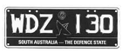 | 133 ± 1.0mm
White Letters and Figures  Slogan White with Black Background |  | Blue Background
Slogan White: SOUTH AUSTRALIA – THE DEFENCE STATE
Black State Badge (Piping Shrike)
Background: (Blue)—Design approved by the Registrar)
Height of figure or letter | 60mm
Width of every line in each figure or letter | 10mm

3.4.5 Gateway To The Outback (remake only)
 | 371 ± 1.0mm
Steel/Aluminium Embossed |  | 133 ± 1.0mm
Black Letters and Figures  Slogan White with Black Background |  | White Retroreflective Background
Slogan White: SOUTH AUSTRALIA – GATEWAY TO THE OUTBACK
Black State Badge (Piping Shrike)
Background: (Yellow, Purple)—Design approved by the Registrar)
Height of figure or letter | 60mm
Width of every line in each figure or letter | 10mm
3.4.6 The Electronics State (remake only)
 | 371 ± 1.0mm
Steel/Aluminium Embossed |  | 133 ± 1.0mm
Black Letters and Figures  Slogan White with Green Background |  | Green and White Retroreflective Background
Slogan White: SOUTH AUSTRALIA – THE ELECTRONICS STATE
Black State Badge (Piping Shrike)
Background: (White, Green)—Design approved by the Registrar)
Height of figure or letter | 60mm
Width of every line in each figure or letter | 10mm
3.4.7 SA The Koala State
 | 371 ± 1.0mm
Steel/Aluminium Embossed |  | 133 ± 1.0mm
Black Letters and Figures  Slogan White with Teal Background |  | White and Teal Retroreflective Background
Slogan White: SA THE KOALA STATE
Background: (White, Teal)—Design approved by the Registrar)
Height of figure or letter | 60mm
Width of every line in each figure or letter | 10mm
Class 4—Personalised Number Plates
A personalised number plate must bear a number consisting of a combination of letters and figures nominated by an applicant and approved by the Registrar, and issued under an agreement between the Registrar and the applicant.
The plate must be of the type known as metal embossed and must conform to the following additional specifications and design:
Option | Letters and Figures (colour) | Background (colour) | State Badge Piping Strike (colour)
1 | Retroreflective White | Blue | White
2 | Retroreflective White | Magenta | White
3 | Retroreflective White | Red | White
4 | Retroreflective White | Maroon | White
5 | Retroreflective White | Green | White
6 | Blue | Retroreflective White | Black
7 | Magenta | Retroreflective White | Black
8 | Red | Retroreflective White | Black
9 | Maroon | Retroreflective White | Black
10 | Green | Retroreflective White | Black
11 | Green | Retroreflective Yellow | Black
The Piping Shrike emblem will appear after the last letter and before the first number.
4.1 Standard Personalised
 | 371 ± 1.0mm
Aluminium Embossed | 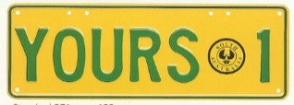 | 133 ± 1.0mm

 | Motor Vehicles and Trailers other than Motor Bikes and Non-Standard Trailers | Motor Bikes
Height of figure or letter | 70-72mm | 50mm
Width of every line in each figure or letter | 10-12mm | 6mm
The dimensions of a motor bike plate must be 252mm ± 1.0mm in length and 98mm ± 1.0mm in height.
4.2 Slim Personalised
 | 371 ± 1.0mm
Aluminium Embossed | 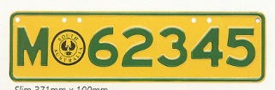 | 100 ± 1.0mm

 | Motor Vehicles other than  Motor Bikes or Trailers | Motor Bikes
Height of figure or letter | 54 or 60mm | 50mm
Width of every line in each figure or letter | 10mm | 6mm
The dimensions of a motor bike plate must be 252mm ± 1.0mm in length and 98mm ± 1.0mm in height.
4.3 Non-Standard Personalised Trailer
 | 252 ± 1.0mm
Aluminium Embossed |  |  | 98 ± 1.0mm
Height of figure or letter |  | 50mm
Width of every line in each figure or letter |  | 6mm
4.4 Corporate Number Plates
Personalised number plates in the corporate plate format may contain a background, logo and/or slogan or other promotion pictures or information deemed appropriate, in accordance with an agreement between the Registrar and the applicant. The plate must conform to the following specifications and design:
The height of the plate 133mm + 1.0mm and length of the plate 371mm + 1.0mm.
Height of figure or letter | 60mm
Width of every line in each figure or letter | 10mm
Class 5—Jubilee Number Plates
A limited series of number plates numbered 001J-999J and 001S-999S preceded by the J150 logo and has the words “SOUTH AUSTRALIA” printed under the numbers, were issued to commemorate South Australia’s 150th Jubilee. The plate is issued under an agreement between the Registrar and the applicant and must be of the type known as metal embossed and must conform to the following additional specifications and design:
 | 371 ± 1.0mm
Steel/Aluminium Embossed |  | 133 ± 1.0mm
Black Letters and Figures |  | Silver-White Retroreflective Background
Slogan Black: SOUTH AUSTRALIA
Jubilee Slogan (to the left of the characters) according to the copyright specifications
Height of figure or letter | 77mm
Width of every line in each figure or letter | 12mm

Class 6—Australian Grand Prix Number Plates
6.1 Special Series
A limited series of number plates numbered 1-199 preceded by the Grand Prix Logo, were issued to commemorate the Australian Formula 1 Grand Prix in Adelaide. The plate is issued under an agreement between the Registrar and the applicant and must be of the type known as metal embossed and must conform to the following additional specifications and design:
 | 371 ± 1.0mm
Steel/Aluminium Embossed | 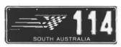 | 133 ± 1.0mm
White Figures |  | Black Background
Slogan White: SOUTH AUSTRALIA
Logo Green, Yellow, Black and White (to the left of the digits) according to the copyright specifications
Height of figure or letter | 77mm
Width of every line in each figure or letter | 12mm
6.2 Standard Series
A limited series of number plates numbered 200-9999 preceded by the Grand Prix Logo, was issued to commemorate the Australian Formula 1 Grand Prix in Adelaide. The plate is issued under an agreement between the Registrar and the applicant and must be of the type known as metal embossed and must conform to the following additional specifications and design:
 | 371 ± 1.0mm
Steel/Aluminium Embossed | 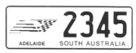 | 133 ± 1.0mm
Black Figures |  | White Retroreflective Background
Slogan Black: SOUTH AUSTRALIA
Logo Green, Yellow, Black and White (to the left of the digits) according to the copyright specifications
Height of figure or letter | 77mm
Width of every line in each figure or letter | 12mm
Class 7—Towtruck Number Plates
A Towtruck number plate must be issued to a Towtruck approved by the Registrar for use in the operation of the accident towing roster scheme. The number is preceded by the letters “ATT” and the plate must conform to the following additional specifications and design:
 | 371 ± 1.0mm
Steel/Aluminium Embossed |  | 133 ± 1.0mm
Blue Letters and Figures |  | Yellow Retroreflective Background
Slogan Blue: SA ACCIDENT TOWTRUCK
Height of figure or letter | 77mm
Width of every line in each figure or letter | 12mm
Class 8—Government Vehicle Number Plates
Vehicles owned by the State of South Australia may be issued with a number plate or plates consisting of a combination of letters and figures, which conform to the following additional specifications and design (unless otherwise authorised):
8.1.1 Government Vehicle or Trailer Number Plate (“S” 7 character set)
 | 371 ± 1.0mm
Steel/Aluminium Embossed |  | 133 ± 1.0mm
Blue Letters and Figures |  | White Retroreflective Background
Slogan Blue: SA GOVERNMENT
Height of figure or letter | 70-77mm
Width of every line in each figure or letter | 10-12mm

8.1.2 Government Motor Bike (“S” 6 character set)
 | 215 ± 1.0mm
Steel/Aluminium Embossed | 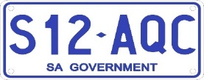 | 95 ± 1.0mm
Blue Letters and Figures |  | White Retroreflective Background
Slogan Blue: SA GOVERNMENT
Height of figure or letter | 50mm
Width of every line in each figure or letter | 6mm
8.1.3 Aerial Plate
 | 252 ± 1.0mm
Steel/Aluminium Embossed |  | 98 ± 1.0mm
Blue Letters and Figure |  | White Retroreflective Background
Slogan Blue: SA GOVERNMENT
Height of figure or letter | 50mm
Width of every line in each figure or letter | 6mm
The dimensions of an aerial mount plate must be 252 ± 1.0mm in length and 98 ± 1.0mm in width and are only available to vehicles granted registration under the Act.
8.2 Government Vehicle Number Plate (remake only)
 | 371 ± 1.0mm
Steel/Aluminium Embossed | 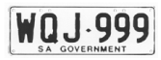 | 133 ± 1.0mm
Blue Letters and Figures |  | White Retroreflective Background
Slogan Blue: SA GOVERNMENT
 | Motor Vehicles other than Motor Bikes | Motor Bikes
Height of figure or letter | 77mm | 50mm
Width of every line in each figure or letter | 12mm | 6mm
The dimensions of a motor bike plate must be 215 ± 1.0mm in length and 95 ± 1.0mm in width.
Class 9—Name Plates
A name plate must bear a number which consists of all letters issued under an agreement between the Registrar and the applicant. The plate must be of the type known as retroreflective metal or acrylic.
The size of the plate and height and width of every figure appearing on the plate are at the discretion of the Registrar.
Class 10—Custom Number Plates
A custom number plate must bear a number nominated by an applicant and approved by the Registrar, which may consist of letters or a combination of letters and figures and issued under an agreement between the Registrar and the applicant authorising the applicant to display the number.
The plate must be of the type known as metal embossed and must conform to the following additional specifications and design:
Option | Letters and Figures  (colour) | Background  (colour)
1 | Retroreflective White | Blue
2 | Retroreflective White | Magenta
3 | Retroreflective White | Red
4 | Retroreflective White | Maroon
5 | Retroreflective White | Green
6 | Blue | Retroreflective White
7 | Magenta | Retroreflective White
8 | Red | Retroreflective White
9 | Maroon | Retroreflective White
10 | Green | Retroreflective White
11 | Black | Gold
12 | Black | Silver
13 | Gold | Black
14 | Silver | Black
15 | Black | Retroreflective White
16 | Black | Retroreflective Lemon
17 | Black | Retroreflective Yellow
18 | Green | Retroreflective Lemon
19 | Green | Retroreflective Yellow
20 | Blue | Retroreflective Lemon
21 | Blue | Retroreflective Yellow
22 | Black | Burnt Orange
23 | Burnt Orange | Black
24 | Black | Electric Blue
25 | Electric Blue | Black
26 | Black | Electric Green
27 | Electric Green | Black
28 | Black | Electric Red
29 | Electric Red | Black
30 | Black | Hot Pink
31 | Hot Pink | Black
10.1 Standard Custom
 | 371 ± 1.0mm
Aluminium Embossed |  | 133 ± 1.0mm

 | Motor Vehicles and Trailers other than Motor Bikes | Motor Bikes
Height of figure or letter 1 to 6 letters | 77mm | 50mm
Width of every line in each figure or letter for 1 to 6 letters | 12mm | 6mm
Height or figure or letter 7 letters or 6 letters with space | 70-72mm | 50mm
Width of every line in each figure or letter for 7 letters or 6 letters  with space | 10-12mm | 6mm
The dimensions of a motor bike plate must be:
1 to 6 digits 215mm ± 1.0mm in length and 95mm ± 1.0mm in width.
7 digits 252mm ± 1.0mm in length and 98mm ± 1.0mm in width.
10.2 Slim Custom
 | 371 ± 1.0mm
Aluminium Embossed | 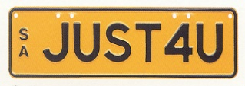 | 100 ± 1.0mm

 | Motor Vehicles other than Motor Bikes
Height of figure or letter | 54mm or 60mm
Width of every line in each figure or letter | 10mm

10.3 Square Two Line Custom
 | 306 ± 1.0mm
Aluminium Embossed |  | 150 ± 1.0mm

 | Motor Vehicles other than Motor Bikes
Height of figure or letter | 54mm or 60mm
Width of every line in each figure or letter | 10mm
10.4 Square Custom
 | 306 ± 1.0mm
Aluminium Embossed | 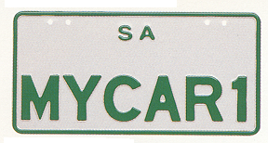 | 150 ± 1.0mm

 | Motor Vehicle other than Motor Bikes
Height of figure or letter | 54mm or 60mm
Width of every line in each figure or letter | 10mm
The dimensions of a motor bike plate must be:
1 to 6 digits 215mm ± 1.0mm in length and 95mm ± 1.0mm in width.
7 digits 252mm ± 1.0mm in length and 98mm ± 1.0mm in width.
10.5 Corporate Number Plates
Custom number plates in the corporate plate format may contain a background, logo and/or slogan or other promotional pictures or information deemed appropriate, in accordance with an agreement between the Registrar and the applicant. The plate must conform to the following specifications and design:
371mm + 1.0mm in length and 133mm + 1.0mm in height
Height of Figure or Letter | 60mm
Width of every line in each figure or letter | 10mm
Class 11—Taxi Plates
A taxi plate must be issued to taxis which are accredited by the Passenger Transport Act 1994 as general purpose metropolitan taxis, standby taxis or “special vehicle licence” vehicles (wheelchair accessible vehicle). The number is preceded by the letters ‘TAXI’ and the plate must conform to the following additional specifications and design:
11.1 Standard Taxi Plate
 | 371 ± 1.0mm
Steel/Aluminium Embossed | 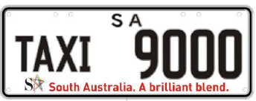 | 133 ± 1.0mm
Black Letters and Figures |  | White Retroreflective Background
Slogan: SA South Australia. A Brilliant Blend
(according to the copyright specifications of SA TOURISM COMMISSION)
 | Motor Vehicle
Height of figure  Height of letter | 70mm  51mm
Width of every line in each figure  Width of every line in each letter | 10mm  6mm

11.2 Standby/Access Taxi Plate
Standby taxi plates and “special vehicle licence” vehicle (wheelchair accessible vehicle) plates (accredited by the Passenger Transport Act 1994) may have letters “TAXI” displayed with white letters on a black background.
 | 371 ± 1.0mm
Steel/Aluminium Embossed |  | 133 ± 1.0mm
Black Figures  Retroreflective White Letters on a Black  60 x 120mm Background |  | White Retroreflective Background
Slogan: SA South Australia. A Brilliant Blend
(according to the copyright specifications of SA TOURISM COMMISSION)
 | Motor Vehicle
Height of figure  Height of letter | 70mm  51mm
Width of every line in each figure  Width of every line in each letter | 10mm  6mm
11.3 Taxi Licence Plate
 | 371 ± 1.0mm
Aluminium Embossed |  | 133 ± 1.0mm
White Retroreflective Letters and Figures |  | Blue Background
The piping shrike emblem will appear after the last letter and before the first number
Slogan: South Australia
 | Motor Vehicle
Height of figure  Height of letter | 70mm  51mm
Width of every line in each figure  Width of every line in each letter | 10mm  6mm
Class 12—Chauffeured Vehicle Plates
A Chauffeured Vehicle number plate must bear a number consisting of a combination of figures and letters and be issued to vehicles and bikes which are accredited to operate for hire under the Passenger Transport Act 1994. These plates must be of the type known as metal embossed and must conform to the following additional specifications and design:
12.1 Standard
 | 371 ± 1.0mm
Steel/Aluminium Embossed |  | 133 ± 1.0mm
Blue Letters and Figures |  | White Retroreflective Background
Blue Border with White Slogan: CHAUFFEURED VEHICLE (above plate number) and SOUTH AUSTRALIA (below plate number)
 | Motor Vehicles other than Motor Bikes
Height of figure or letter | 70-77mm
Width of every line in each figure or letter | 10-12mm

12.2 Square
 | 306 ± 1.0mm
Steel/Aluminium Embossed |  | 150 ± 1.0mm
Blue Letters and Figures |  | White Retroreflective Background
Blue Border with White Slogan: CHAUFFEURED VEHICLE (above plate number) and SOUTH AUSTRALIA (below plate number)
 | Motor Vehicles other than Motor Bikes
Height of figure or letter | 60mm
Width of every line in each figure or letter | 10mm
12.3 Motor Bike
 | 252 ± 1.0mm
Steel/Aluminium Embossed |  | 98 ± 1.0mm
Blue Letters and Figures |  | White Retroreflective Background
Blue Border with White Slogan: CHAUFFEURED VEHICLE (above plate number) and SOUTH AUSTRALIA (below plate number)
 | Motor Bikes
Height of figure or letter | 50mm
Width of every line in each figure or letter | 6mm
Class 13—Consular Corps Plates
Consular Corps number plates may only be issued to an accredited Diplomatic Officer or accredited Consular Officer de carriere, who is a national of a country which he or she represents and who resides in this State, or to an Honorary Consul accredited by the Department of Foreign Affairs and Trade, who also resides in this State. The plates must be of the type known as metal embossed and must conform to the following additional specifications and design:
 | 371 ± 1.0mm
Steel/Aluminium Embossed | 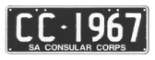 | 133 ± 1.0mm
White Letters and Figures |  | Black Background
Slogan White: SA CONSULAR CORPS
 | Motor Vehicles
Height of figure or letter | 77mm
Width of every line in each figure or letter | 12mm
Class 15—Premium Number Plates
A premium plate must bear a number consisting of two letters, three figures followed by a further letter and may be issued under an agreement between the Registrar and the applicant. The plate must be of the type known as metal embossed and must conform to the following additional specifications and design:
15.1 Front
 | 371 ± 1.0mm
Aluminium Embossed | 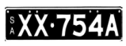  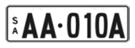 | 83 ± 1.0mm
Black Letters and Figures  OR  Retroreflective White Letters and Figures  OR  Opaque White Letters and Figures (discontinued) |  | White Retroreflective Background  OR  Black Background

 | Motor Vehicles other than Motor Bikes
Height of figure or letter | 53mm-54mm
Width of every line in each figure or letter | 8mm-10mm
15.1a Rear
 | 371 ± 1.0mm
Aluminium Embossed |  | 106 ± 1.0mm
Black Letters and Figures  OR  Retroreflective White Letters and Figures  OR  Opaque White Letters and Figures (discontinued) |  | White Retroreflective Background  OR  Black Background

 | Motor Vehicles other than Motor Bikes
Height of figure or letter | 70mm-75mm
Width of every line in each figure or letter | 10mm-12mm
15.2 Front
 | 371 ± 1.0mm
Aluminium Embossed | 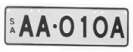 | 100 ± 1.0mm
Black Letters and Figures |  | White Retroreflective Background

 | Motor Vehicles other than Motor Bikes
Height of figure or letter | 60mm
Width of every line in each figure or letter | 10mm
15.2a Rear
 | 306 ± 1.0mm
Aluminium Embossed | 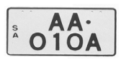 | 150 ± 1.0mm
Black Letters and Figures |  | White Retroreflective Background

 | Motor Vehicles other than Motor Bikes
Height of figure or letter | 60mm
Width of every line in each figure or letter | 10mm
15.3 Front and Rear Square
 | 306 ± 1.0mm
Aluminium Embossed |  | 150 ± 1.0mm
Black Letters and Figures |  | White Retroreflective Background

 | Motor Vehicles other than Motor Bikes
Height of figure or letter | 54-62mm
Width of every line in each figure or letter | 10mm

15.4 Corporate Number Plates
Premium number plates in the corporate plate format may contain a background, logo and/or slogan or other promotional pictures or information deemed appropriate, in accordance with an agreement between the Registrar and the applicant. The plate must conform to the following specifications and design:
371mm + 1.0mm in length and 133mm + 1.0mm in height
Height of figure or letter | 60mm
Width of every line in each figure or letter | 10mm
Class 16—Bike Rack Number Plates
A Bike Rack plate must bear the number allotted to the vehicle to which the bike rack is attached and must conform to the following additional specifications and design:
16.1 SA Better By Bike (discontinued)
 | 252 ± 1.0mm
Steel/Aluminium Embossed | 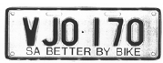 | 98 ± 1.0mm
Black Letters and Figures |  | White Retroreflective Background
Slogan: SA BETTER BY BIKE
Height of figure or letter | 50mm
Width of every line in each figure or letter | 6mm
16.2 SA Cycle instead
 | 252 ± 1.0mm
Steel/Aluminium Embossed |  | 98 ± 1.0mm
Black Letters and Figures |  | White Retroreflective Background
Slogan: SA Cycle instead and logo, as endorsed by the Registrar
Height of figure or letter | 50mm
Width of every line in each figure or letter | 6mm
Class 17—Centenary of Federation Number Plates
17.1 Centenary Limited Series Number Plates
A limited series of number plates numbered 1901 CF-2001 CF, with the Centenary of Federation logo between the letters and figures, were issued to commemorate the Centenary of Federation. The plate is issued under an agreement between the Registrar and the applicant and must be of the type known as metal embossed and must conform to the following additional specifications and design:
Steel/Aluminium Embossed  White Letters and Figures | 371 ± 1.0mm
  133 ± 1.0mm
  Black Background
Grey watermark of Rotunda in background
Slogan White: SA – Centenary of Federation
Centenary of Federation Logo (between the numbers and the letters) according to the registered trademark owned by the Commonwealth.
 | Motor Vehicles
Height of figure or letter | 60mm
Width of every line in each figure or letter | 10mm

17.2 Centenary Vogue Series Number Plates
A limited series of number plates numbered 000C-999C and 000F-999F with the Centenary of Federation logo between the letters and figures, were issued to commemorate the Centenary of Federation. The plate is issued under an agreement between the Registrar and the applicant and must be of the type known as metal embossed and must conform to the following additional specifications and design:
 |   371 ± 1.0mm
  Steel/Aluminium Embossed
  White Letters and Figures
  133 ± 1.0mm
  Yellow, Red, Green, Blue Retroreflective Background
Slogan White: SA – Centenary of Federation
Centenary of Federation Logo (between the numbers and the letters) according to the registered trademark owned by the Commonwealth.
 | Motor Vehicles
Height of figure or letter | 60mm
Width of every line in each figure or letter | 10mm
Class 18—Country Taxi Plates
A Country Taxi Plate must be issued to taxis which have country taxi accreditation under the Passenger Transport Act 1994. The number is preceded by the letters ‘TAXI’ and the plate must conform to the following additional specifications and design:
 | 371 ± 1.0mm
Steel/Aluminium Embossed |  | 133 ± 1.0mm
Black Letters and Figures |  | Lemon Retroreflective Background
Slogan Red: SOUTH AUSTRALIA (above plate number)
COUNTRY TAXI (below plate number)
Black State Badge (Piping Shrike) (between the word TAXI and figures).
 | Motor Vehicles
Height of figure | 70mm
Height of letter | 50mm
Width of every line in each figure | 10mm
Width of every line in each letter | 6mm
Class 19—SA – Heavy Vehicle
A SA Heavy Vehicle Plate may be issued to a vehicle with a mass or GVM over 4.5 tonnes. The plate must be of the type known as metal embossed and must conform to the following additional specifications and design:
19.1 Standard
 | 371 ± 1.0mm
Aluminium Embossed | 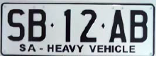 | 133 ± 1.0mm
Black Letters and Figures |  | White Retroreflective Background
Slogan Black: SA – HEAVY VEHICLE
 | Motor Vehicles
Height of figure or letter | 77mm
Width of every line in each figure or letter | 12mm

19.2 Trailer
A SA Heavy Trailer Plate may be issued to a vehicle with a mass or GTM over 4.5 tonnes. The plate must be of the type known as metal embossed and must conform to the following additional specifications and design:
 | 371 ± 1.0mm
Aluminium Embossed |  | 133 ± 1.0mm
Black Letters and Figures |  | White Retroreflective Background
Slogan Black: SA – HEAVY VEHICLE
 | Motor Vehicles
Height of figure or letter | 77mm
Width of every line in each figure or letter | 12mm
Class 20—Euro Number Plates
A Euro plate must bear a number consisting of the letter S followed by two letters, two figures followed by a further letter, with the State Coat of Arms of South Australia appearing between the letter S and the first two letters, and may be issued under an agreement between the Registrar and the applicant. The plate must be of the type known as metal embossed and must conform to the following additional specifications and design:
20.1 White Background Euro Plate
 | 522 ± 1.0mm
Steel/Aluminium Embossed |  | 113.6 ± 1.0mm
Black Letters and Figures  Logo—Sturt Desert Pea |  | White Retroreflective Background
Blue Sash on the left of the plate with the characters “SA” screen printed in white with the S printed directly above the A
The State Coat of Arms of South Australia (between the “S” and the first two letters) as endorsed by the Department of the Premier and Cabinet’s Protocol Branch.
 | Motor Vehicles
Height of figure or letter | 75.5mm
Width of every line in each figure or letter | 10mm
20.2 Black Background Euro Plate
 | 522 + 1.0mm
Steel/Aluminium  Embossed |  | 113.6 + 1.0mm
White Retroreflective  Letters and Figures  Logo—Sturt Desert Pea |  | Black  Background
On the left of the plate the characters “SA” screen printed in white with the S printed directly above the A
The State Coat of Arms of South Australia (white) (between the “S” and the first two letters) as endorsed by the Department of the Premier and Cabinet Protocol Branch.
 | Motor Vehicles
Height of figure or letter | 75.5mm
Width of every line in each figure or letter | 12mm
Class 21—National Heavy Vehicle Plate
A National Heavy Vehicle Plate may be issued to a vehicle with a mass or GVM over 4.5 tonnes. The plate must be of the type known as metal embossed and must conform to the following additional specifications and design:
21.1 Standard
 | 372 ± 1.0mm
Aluminium Embossed |  | 134 ± 1.0mm
Black Letters and Figures |  | White Retroreflective Background  Containing a Directional Security Mark (Kangaroo in circle)

Sash Colour Blue with White slogan and logo—National Heavy Vehicle
 | Motor Vehicles
Height of figure or letter | 77mm
Width of every line in each figure or letter | 12mm
21.2 Trailer
A Heavy Trailer Vehicle Plate may be issued to a vehicle with a mass or GTM over 4.5 tonnes. The plate must be of the type known as metal embossed and must conform to the following additional specifications and design
 | 372 ± 1.0mm
Aluminium Embossed |  | 134 ± 1.0mm
Black Letters and Figures |  | White Retroreflective Background  Containing a Directional Security Mark (Kangaroo in circle)
Sash Colour Blue with White slogan and logo—National Heavy Vehicle
 | Motor Vehicles
Height of figure or letter | 77mm
Width of every line in each figure or letter | 12mm
21.3 Bike Rack
A bike rack plate issued for a heavy vehicle or heavy trailer with a mass or GVM/GTM over 4.5 tonnes must bear the number allotted to the vehicle to which the bike rack is attached and must conform to the following additional specifications and design:
 | 254 ± 1.0mm
Aluminium Embossed |  | 100 ± 1.0mm
Black Letters and Figures |  | White Retroreflective Background
Sash Colour Blue with White slogan and logo—National Heavy Vehicle
 | Motor Vehicles
Height of figure or letter | 50mm
Width of every line in each figure or letter | 6mm
Class 22—Japanese Number Plates
A Japanese number plate may be issued under an agreement between the Registrar and the applicant.
The plate must be of the type known as metal embossed and must conform to the following additional specifications and design:
22.1 Standard
A Standard Japanese number plate consists of two numbers, followed by three letters.
The plate must be of the type known as metal embossed and must conform to the following additional specifications and design:
 | 330 ± 1.0mm
Aluminium Embossed | 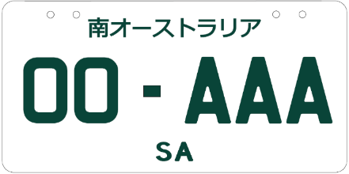 | 165 ± 1.0mm
Green Letters and Figures |  | White Retroreflective Background

Japanese text of ‘南オーストラリア’, meaning ‘South Australia’ located at the top of the number plate with ‘SA’ located in the bottom centre.
 | Motor Vehicles
Height of figure or letter | 58mm-60mm
Width of every line in each figure or letter | 8mm-10mm
22.2 Special Edition
A Special Edition Japanese number plate consists of two numbers, followed by three letters ‘JDM’.
The plate must be of the type known as metal embossed and must conform to the following additional specifications and design:
 | 330 ± 1.0mm
Aluminium Embossed | 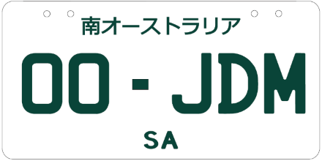 | 165 ± 1.0mm
Green Letters and Figures |  | White Retroreflective Background
Japanese text of ‘南オーストラリア’, meaning ‘South Australia’ located at the top of the number plate with ‘SA’ located in the bottom centre.
 | Motor Vehicles
Height of figure or letter | 58mm-60mm
Width of every line in each figure or letter | 8mm-10mm
22.3 Custom Japanese
A Custom Japanese must bear a number nominated by an applicant and approved by the Registrar, which may consist of letters or a combination of letters and figures and issued under an agreement between the Registrar and the applicant authorising the applicant to display the number.
The plate must be of the type known as metal embossed and must conform to the following additional specifications and design:
Option | Letters and Figures (colour) | Background (colour)
1 | Black | Retroreflective White
2 | Blue | Retroreflective White
3 | Green | Retroreflective White
4 | Maroon | Retroreflective White

 | 330 ± 1.0mm
Aluminium Embossed | 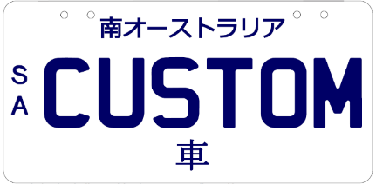 | 165 ± 1.0mm
Japanese text of ‘南オーストラリア’, meaning ‘South Australia’ located at the top of the number plate with ‘車’, meaning ‘car’, located in the bottom centre of the plate. ‘SA’ written vertically in the centre left of the number plate.
 | Motor Vehicles
Height of figure or letter | 58mm-60mm
Width of every line in each figure or letter | 8mm-10mm

Class 23—Motorsport Number Plates
23.1 Adelaide 500 Special Edition Series
A special edition Adelaide 500 series of number plates displaying the Adelaide 500 25-year anniversary logo before the SA, preceded by the number sequence 1ADL-25ADL. The plate is issued under an agreement between the Registrar and the applicant and must be of the type known as metal embossed and must conform to the following additional specifications and design:
 | 371 ± 1.0mm
Aluminium Embossed | 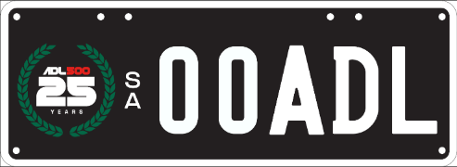 | 133 ± 1.0mm
White Letters and Figures. Adelaide 500 25th anniversary logo |  | Black Retroreflective Background
An Adelaide 500 25th anniversary logo in a green wreath is located to left of the number plate. ‘SA’ written vertically in the centre
 | Motor Vehicles
Height of figure or letter | 70mm
Width of every line in each figure or letter | 10mm
23.2 Adelaide Grand Final Set Series
A set series Adelaide Grand Final number plate must bear a number consisting of a letter followed by three figures, followed by a further letter and issued under an agreement between the Registrar and the applicant. The plate must be of the type known as metal embossed and must conform to the following additional specifications and design:
 | 371 ± 1.0mm
Aluminium Embossed | 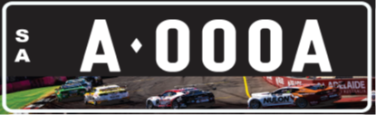 | 133 ± 1.0mm
White Retroreflective Letters & Figures. |  | Black Background
On the left of the plate the characters “SA” printed in white with the S printed directly above the A.
The banner depicting supercars racing on the Adelaide Street circuit is located on the bottom of the number plate.
 | Motor Vehicles
Height of figure or letter | 60mm
Width of every line in each figure or letter | 10mm
General Specifications and Design
1. The dimensions of the letters or words ‘SA’, ‘SOUTH AUSTRALIA’, ‘THE FESTIVAL STATE’ or any other slogan approved by the Registrar whether preceding the number or appearing in a central position above or below the registration number on which they are permitted, unless otherwise prescribed, must be as follows:
 | Motor Bikes  (except Class 12) | Motor Bikes  Class 12 | All Other Classes
Height of figure or letter | 10mm | 8mm | 8-20mm
Width of every line in all parts thereof | 2mm | 1-2mm | 1-3mm
(Except Corporate Number Plates which may vary at the discretion of the Registrar).
2. The dimensions of the State Badge (Piping Shrike) appearing on the number plates on which they are permitted, must be as follows:
 | Class 3 | Class 4 | Class 4 Motor Bike
Diameter | 24-30mm | 50mm | 27mm
3. The dimensions of the slogan “SA Cycle instead” appearing on the Bike Rack number plate must be as follows:
 | Class 16
Height of figure or letter | 13mm
Width of every line in all parts thereof | 2mm
4. A number plate will be taken to comply with the requirements of this notice relating to the size of the plate and the size of letters and figures on the plate if the size of the plate or of any figure or letter on the plate:
(a) does not exceed the size prescribed by this notice by more than 1.0mm; or
(b) is not more than 1.0mm less than the size prescribed by this notice.
5. Notwithstanding the prescribed design and specifications for number plates, a number plate (other than a trailer or bike rack plate) may bear a plate and/or label that complies with the relevant Australian Standard, if the vehicle to which the number plate is affixed, is equipped to be Electric, Hydrogen or uses LP Gas/Natural Gas (as detailed in the Road Traffic (Light Vehicle Standards) Rules 2018 or the Heavy Vehicle (Vehicle Standards) National Regulation (as applicable). However, the plate and label on the number plate must be placed in such a position so as not to obscure any letter, figure, logo or slogan appearing on the number plate.
Transitional Provision
A number plate that was manufactured before the date of this notice will be taken to comply with this notice if it complies with the notice under Section 47A of the Act published in the Gazette on 20 November 2025 (see Gazette No. 68, pages 4579-4598).
Schedule 3
Classes of Number Plates Which May Be Displayed
Pursuant to an Agreement Under Section 47A(4) of the Act
Class 1—Numeric
Class 2—Alpha Numeric (Non-slogan)
Class 3—Slogan
Class 4—Personalised
Class 5—Jubilee
Class 6—Australian Grand Prix
Class 9—Name Plates
Class 10—Custom
Class 15—Premium
Class 17—Centenary of Federation
Class 20—Euro
Class 22—Japanese
Class 23—Motorsport
Dated: 2 December 2025
Approved by
E. Kokar
Registrar of Motor Vehicles

Passenger Transport Act 1994
Section 32
Establishment of Classes of Accreditation
1. Interpretation
Any terms defined in the Passenger Transport Act 1994 (the Act) and the Passenger Transport Regulations 2024 have the same meaning in this Notice.
2. Revocation
This Notice revokes and replaces the Notice of 27 February 2025 published on p242 of the Government Gazette.
3. Establishment—Operators
Pursuant to Section 32(3) of the Act, I, Emily Bourke, Minister for Infrastructure and Transport, hereby establish the following classes of accreditation for the purposes of Section 27 of the Act (Accreditation of operators):
Country Taxi Accreditation, for the provision of a passenger transport service using a country taxi, any journey being not wholly within Metropolitan Adelaide;
Horse-drawn Vehicle Accreditation, for the provision of a passenger transport service using a horse-drawn vehicle;
Large Passenger Vehicle Accreditation, for the provision of a passenger transport service using a large passenger vehicle;
Metropolitan Taxi Accreditation, for the provision of a passenger transport service using a metropolitan taxi;
Small Passenger Vehicle (Metropolitan) Accreditation, for the provision of a passenger transport service using a small passenger vehicle;
Small Passenger Vehicle (Non-Metropolitan) Accreditation, for the provision of a passenger transport service using a small passenger vehicle, any journey being not wholly within Metropolitan Adelaide;
Small Passenger Vehicle (Special Purpose) Accreditation, for the provision of a passenger transport service using a small passenger vehicle under an approved limited plan of operation;
Small Passenger Vehicle (Traditional) Accreditation, for the provision of a passenger transport service using a small passenger vehicle under an approved limited plan of operation.
4. Establishment—Drivers
Pursuant to Section 32(3) of the Act, I, Emily Bourke, Minister for Infrastructure and Transport, hereby establish the following classes of accreditation for the purposes of Section 28 of the Act (Accreditation of drivers):
Horse-drawn Vehicle Driver Accreditation, for the provision of a passenger transport service using a horse-drawn vehicle;
Large Passenger Vehicle Driver Accreditation, for the provision of a passenger transport service using a large passenger vehicle;
Metropolitan Taxi Driver Accreditation, for the provision of a passenger transport service using a metropolitan taxi;
Motor Cycle Driver Accreditation, for the provision of a passenger transport service using a motor cycle;
Small Passenger Vehicle Driver Accreditation, for the provision of a passenger transport service using a small passenger vehicle.
5. Establishment—Centralised booking services
Pursuant to Section 32(3) of the Act, I, Emily Bourke, Minister for Infrastructure and Transport, hereby establish the following classes of accreditation for the purposes of Section 29 of the Act (Accreditation of centralised booking services):
Chauffeur Booking Service Accreditation, for the provision of a passenger transport service using chauffeur vehicle;
Taxi Booking Service Accreditation, for the provision of a passenger transport service using a taxi.
6. Execution
Dated: 30 November 2025
Hon Emily Bourke MLC
Minister for Infrastructure and Transport

Passenger Transport Act 1994
South Australia
Passenger Transport (Fees) Notice (No 2) 2025
under the Passenger Transport Act 1994
1—Short title
This notice may be cited as the Passenger Transport (Fees) Notice (No 2) 2025.
Note—
This is a fee notice made in accordance with the Legislation (Fees) Act 2019. Under Section 4(3) of that Act, this notice revokes the Passenger Transport (Fees) Notice 2025, as published in the Government Gazette on 15 May 2025 (p 1088).
2—Commencement
This notice has effect from the day on which it is published in the Gazette.
3—Interpretation
In this notice, unless the contrary intention appears—
Act means the Passenger Transport Act 1994;
Regulations means the Passenger Transport Regulations 2024;
revoked notice means the Passenger Transport (Fees) Notice 2025, as published in the Government Gazette on 15 May 2025 (p 1088).
4—Fees
The fees set out in Schedule 1 are prescribed for the purposes of the Act and the regulations.
5—Transitional provision
(1) The fees prescribed in respect of—
(a) the issue or renewal of an accreditation under Part 4 of the Act; or
(b) a period for which an accreditation is held under that Part (a periodical fee); or
(c) the issue or renewal of a licence under Part 6 of the Act; or
(d) the grant or renewal of a consent under Section 49 of the Act,
by Schedule 1 of this notice apply where the issue, grant or renewal takes effect, or the period commences, on or after 27 November 2025.

(2) All other fees prescribed by Schedule 1 of this notice apply from 27 November 2025.
(3) Despite Clause 4—
(a) the fees prescribed in respect of—
(i) the issue or renewal of an accreditation under Part 4 of the Act; or
(ii) a period for which an accreditation is held under that Part (a periodical fee); or
(iii) the issue or renewal of a licence under Part 6 of the Act; or
(iv) the grant or renewal of a consent under Section 49 of the Act,
by Schedule 1 of the revoked notice, as in force immediately before the commencement of this notice, continue to apply where the issue, grant or renewal is to take effect, or the period is to commence, before 27 November 2025; and
(b) all other fees prescribed by Schedule 1 of the revoked notice, as in force immediately before the commencement of this notice, continue to apply until 27 November 2025.
Schedule 1—Fees
 | Description | Fee
1 | Application fee for an accreditation under the Act—
 | (a) in respect of an accreditation under Part 4 Division 1—
 | (i) unless (ii) or (iii) applies | $551.00
 | (ii) in the case of a Small Passenger Vehicle (Traditional) Accreditation, a Small Passenger Vehicle (Special Purpose) Accreditation, a Small Passenger Vehicle (Non-Metropolitan) Accreditation or a Country Taxi Accreditation | $551.00 plus $110.00 for each vehicle that will initially be used for the purposes of a service operated under the accreditation
 | (iii) in the case of a Small Passenger Vehicle (Metropolitan) Accreditation | $551.00 plus $110.00 for each vehicle that will initially be used for the purposes of a service operated under the accreditation
 | (b) in respect of an accreditation under Part 4 Division 2 | nil
 | (c) in respect of an accreditation under Part 4 Division 3 | $1,224.00
2 | Periodical fee payable under Section 33(1)(b) of the Act—for each prescribed period (see Regulations 14(1) and 21(1) of the Regulations)—
 | (a) in respect of an accreditation under Part 4 Division 1—
 | (i) unless (ii) or (iii) applies | $551.00
 | (ii) in the case of a Small Passenger Vehicle (Traditional) Accreditation, a Small Passenger Vehicle (Special Purpose) Accreditation, a Small Passenger Vehicle (Non-Metropolitan) Accreditation or a Country Taxi Accreditation | $551.00 plus $110.00 for each vehicle used (or available for use) for the purposes of a service operated under the accreditation (as at the end of the relevant period)
 | (iii) in the case of a Small Passenger Vehicle (Metropolitan) Accreditation | $551.00 plus $110.00 for each vehicle used (or available for use) for the purposes of a service operated under the accreditation (as at the end of the relevant period)
 | (b) in respect of an accreditation under Part 4 Division 3 | $1,224.00
3 | Penalty for a default under Section 33(2) of the Act | $72.00
4 | Renewal fee under Section 34 of the Act—
 | (a) in respect of an accreditation under Part 4 Division 1—
 | (i) unless (ii) or (iii) applies | $551.00
 | (ii) in the case of a Small Passenger Vehicle (Traditional) Accreditation, a Small Passenger Vehicle (Special Purpose) Accreditation, a Small Passenger Vehicle (Non-Metropolitan) Accreditation or a Country Taxi Accreditation | $551.00 plus $110.00 for each vehicle used (or available for use) for the purposes of a service operated under the accreditation at the time of renewal
 | (iii) in the case of a Small Passenger Vehicle (Metropolitan) Accreditation | $551.00 plus $110.00 for each vehicle used (or available for use) for the purposes of a service operated under the accreditation at the time of renewal
 | (b) in respect of an accreditation under Part 4 Division 2 | nil
 | (c) in respect of an accreditation under Part 4 Division 3 | $1,224.00
5 | Application to vary an accreditation under Part 4 Division 2 | nil
6 | Notification to the Minister of—
 | (a) the introduction of a vehicle to a service—
 | (i) unless (ii) or (iii) applies | $25.00
 | (ii) in the case of a vehicle used for the purposes of a service operated under a Small Passenger Vehicle (Traditional) Accreditation, a Small Passenger Vehicle (Special Purpose) Accreditation, a Small Passenger Vehicle (Non-Metropolitan) Accreditation or a Country Taxi Accreditation | $110.00 per vehicle
 | (iii) in the case of a vehicle used for the purposes of a service operated under a Small Passenger Vehicle (Metropolitan) Accreditation | $110.00 per vehicle
 | However, if a vehicle is introduced to a service operated under an accreditation referred to in subparagraph (ii) or (iii) during a prescribed period for that accreditation under regulation 14 of the regulations the fee payable under subparagraph (ii) or (iii) may be adjusted on a pro rata basis by applying the proportion that the number of months that are left to run to the end of that prescribed period bears to 12 months (on the basis that parts of a month count as a full month)
 | (b) the withdrawal of a vehicle from a service | $25.00
7 | Application fee for a licence under Part 6 of the Act—
 | (a) in respect of a special vehicle licence | $110.00
 | (b) in respect of any other kind of licence | nil
8 | Renewal fee under Part 6 of the Act—
 | (a) in respect of a special vehicle licence | $110.00
 | (b) in respect of any other kind of licence | nil
9 | Application fee for the consent of the Minister under section 49 of the Act | $120.00
10 | Application fee for consent to the substitution of another vehicle for a licensed taxi | $49.00
11 | Fee for issue of a duplicate of an accreditation or licence that has been lost etc | $74.00
12 | Prescribed fee under section 54 of the Act—
 | (a) for a first inspection | $122.00
 | (b) for a subsequent inspection (if necessary) | $93.00
Made by the Minister for Infrastructure and Transport
On 30 November 2025

Passenger Transport Act 1994
Prescribed scheme—Section 52AB
Ministerial Notice
Part 1—Preliminary
1. Establishment of scheme
(1) This instrument constitutes the prescribed scheme to implement the South Australian Government’s cancellation of taxi licences under Section 52AB of the Passenger Transport Act 1994.
(2) A payment to a person under this scheme is made as compensation for the cost of a perpetual taxi licence on account of the cancellation of the licence by the Minister under Section 52AB of the Passenger Transport Act 1994.
2. Commencement
This scheme commences on the day on which it is published in the Gazette.
3. Interpretation
(1) In this scheme, unless the contrary intention appears—
access taxi has the same meaning as in the Passenger Transport Regulations 2024;
Act means the Passenger Transport Act 1994;
Chief Executive means the Chief Executive of the Department and includes, in respect of a particular Clause that refers to the Chief Executive, a member of the Department authorised by the Chief Executive to act under that Clause for the purposes of this scheme;
close family member—see Subclause (3);
Department means the administrative unit of the Public Service that, under the Minister, is responsible for the administration of the Act;
domestic partner means a person who is a domestic partner within the meaning of the Family Relationships Act 1975, whether declared under that Act or not;
Family Law agreement means an agreement approved or registered under the Family Law Act 1975 of the Commonwealth that relates to the financial affairs of 2 persons who have been the parties to a marriage or de facto relationship;
Family Law instrument means an instrument that gives effect to, or is consequential on, a Family Law agreement or a Family Law order;
Family Law order means an order of a court under the Family Law Act 1975 of the Commonwealth that relates to the financial affairs of 2 persons who have been the parties to a marriage or de facto relationship;
legally qualified representative means—
(a) a legal guardian; or
(b) the donee of a power of attorney; or
(c) the executor or administrator of the estate of a deceased person;

perpetual taxi licence means a licence for a taxi under Part 6 of the Act in force immediately before the scheme commencement day, other than—
(a) a licence for—
(i) an access taxi or a standby access taxi; or
(ii) a standby taxi; or
(b) a licence issued as a temporary licence;
person includes a company;
prescribed compensation amount means an amount payable under Clause 7(1);
prescribed qualifying day means 12 April 2016;
prescribed taxi licence means a perpetual taxi licence that was in force immediately before the prescribed qualifying day;
proprietary company means a proprietary company under the Corporations Act 2001 of the Commonwealth;
qualifying licence holder means a person who qualifies under Clause 4 in relation to a prescribed taxi licence;
scheme commencement day means the day on which this scheme is published in the Gazette;
spouse—a person is the spouse of another person if they are legally married;
standby taxi has the same meaning as in the Passenger Transport Regulations 2024; taxi means a vehicle for which a licence is required to be held under Part 6 of the Act; taxi database means the information—
(a) created, received or held by the Department for the purposes of the operation and administration of Part 6 of the Act; or
(b) created, received or held by the Department in connection with the operation of this scheme;
temporary taxi licence means a temporary licence under the Act;
terminal medical condition means a medical condition that has been diagnosed as being expected to cause death within 24 months;
this scheme means the scheme constituted by this instrument.
(2) In this scheme, a reference to a person being a resident of the State means—
(a) in the case of a natural person—that the person’s principal place of residence is in South Australia at the relevant time; and
(b) in the case of a company—that the place where the company is taken to be registered under the Corporations Act 2001 of the Commonwealth is South Australia.
(3) For the purposes of this scheme, a person is a close family member of another person if the person is a spouse, domestic partner, parent or child of the other person.
(4) For the purposes of this scheme, a reference to an application being made by a licence holder includes an application made on behalf of that licence holder or their estate by a legally qualified representative (and the Chief Executive may require the verification of an entitlement to act on behalf of a licence holder in such manner as the Chief Executive thinks fit).
(5) Words and expressions used in the Act and in this scheme have the same respective meanings in this scheme as they have in the Act.
4. Qualifying criteria—prescribed taxi licences
(1) A person qualifies under this Clause in relation to a prescribed taxi licence if the person—
(i) was the holder of the licence immediately before the prescribed qualifying day; and
(ii) is the holder of the licence on the scheme commencement day; and
(iii) has held the licence continuously between the prescribed qualifying day and the scheme commencement day.
(2) A person also qualifies under this Clause in relation to a prescribed taxi licence if—
(a) —
(i) the licence was held by a proprietary company immediately before the prescribed qualifying day; and
(ii) the licence was transferred by the company to the person on or after the prescribed qualifying day and before 30 August 2024; and
(iii) the person was a shareholder or director of the company at the time of the transfer; and
(iv) the licence is held by the person on the scheme commencement day; or
(b) —
(i) the licence was held by a person immediately before the prescribed qualifying day; and
(ii) the licence was transferred by the person to a proprietary company on or after the prescribed qualifying day and before 30 August 2024; and
(iii) the person was a shareholder or director of the company at the time of the transfer; and
(iv) the licence is held by the company on the scheme commencement day; or
(c) —
(i) the licence was held by a person immediately before the prescribed qualifying day; and
(ii) the licence was transferred by the person to a close family member on or after the prescribed qualifying day and before 30 August 2024; and
(iii) the licence is held by that close family member on the scheme commencement day; or
(d) —
(i) the licence was held by a person immediately before the prescribed qualifying day; and
(ii) the person died on or after the prescribed qualifying day while still holding the licence; and
(iii) the licence, on the scheme commencement day, is held—
(A) as part of the estate of the person who has died; or
(B) by a beneficiary of the estate of the person who has died; or
(e) —
(i) the licence was held by a person immediately before the prescribed qualifying day; and
(ii) the licence was transferred by the person to another person under a Family Law agreement, a Family Law order or a Family Law instrument; and
(iii) the licence is held by that other person on the scheme commencement day.
(3) For the purposes of this Clause, a person may hold a licence on their own or jointly with one or more other persons.
5. Relevant date
For the purposes of Section 52AB(2) of the Act, 4 December 2025 is specified.
Part 2—Perpetual Taxi Licences—Base Compensation Amount
6. Base compensation amount
(1) Subject to this Clause, an amount of $10,000 (the base compensation amount) is payable in relation to each perpetual taxi licence in connection with its cancellation by the Minister under Section 52AB(2) of the Act.
(2) In the case of a perpetual taxi licence held by one person only, the base compensation amount is payable to that person.
(3) In the case of a perpetual taxi licence held by two or more persons, the base compensation amount is payable to the person specified in the taxi database as the registered operator in relation to that licence at the time of payment.
(4) The base compensation amount will be paid under this scheme on a date determined by the Chief Executive.
Part 3—Prescribed Taxi Licences
7. Prescribed compensation amount
(1) Subject to the other provisions of this scheme and, in particular Clause 8, an additional amount of $190,000 (the prescribed compensation amount) is payable in relation to each prescribed taxi licence in connection with its cancellation by the Minister under Section 52AB(2) of the Act if—
(a) the licence is held by a qualifying licence holder in relation to the licence on the scheme commencement day; and
(b) the qualifying licence holder or, if there is more than one qualifying licence holder in relation to a particular licence, at least one of those qualifying licence holders, was a resident of the State immediately before the scheme commencement day; and
(c) an application for the payment of the prescribed compensation amount is made—
(i) by the qualifying licence holder in relation to the licence; or
(ii) if there is more than one qualifying licence holder in relation to the licence—jointly by all of them; and
(d) the application is made between 4 December 2025 and 16 March 2026 (both dates inclusive); and
(e) the application is made using the form published on the Department’s website by the Chief Executive for the purposes of this scheme and by providing that form to the Chief Executive in accordance with the requirements set out in the form or published on the website in conjunction with the form; and
(f) the application is approved by the Chief Executive and the qualifying licence holder is informed in writing by the Chief Executive that the Chief Executive has determined to make a payment under Clause 8.
(2) Subclause (1) is subject to the following qualifications:
(a) if, as at the scheme commencement day, a qualifying licence holder holds two or more prescribed taxi licences with no other person or company having an interest in any of those licences, the qualifying licence holder is only entitled to $190,000 in relation to one of those licences (and there is no entitlement for the other licence or licences); and
(b) —
(i) if, as at the scheme commencement day, two or more qualifying licence holders jointly hold one prescribed taxi licence, they are jointly entitled to $190,000 in relation to that licence; and
(ii) if, as at the scheme commencement day, two or more qualifying licence holders jointly hold two or more prescribed taxi licences, they are only entitled to $190,000 jointly in relation to one of those licences (and there is no entitlement for the other licence or licences),
with the effect that each unique combination of joint holdings by two or more qualifying licence holders in one or more prescribed taxi licences will only give rise to one entitlement to $190,000 under this scheme; and
(c) if—
(i) immediately before the prescribed qualifying day a person was the holder of two or more prescribed licences; and
(ii) the person transferred one or more of those licences to another person or persons on or after the prescribed qualifying day and before the scheme commencement day; and
(iii) that other person or those other persons are qualifying licence holders, the total amount payable in relation to those licences will be $190,000.
(3) In a case involving a deceased estate, Subclause (2) applies as if the person who has died still has an entitlement as a qualifying licence holder.
(4) If—
(a) a prescribed taxi licence was held by a person immediately before the prescribed qualifying day (the primary licence holder); and
(b) the primary licence holder died on or after the prescribed qualifying day while still holding the licence; and
(c) the primary licence holder was a resident of the State at the time of their death; and
(d) the person’s spouse or domestic partner (the secondary licence holder), as at the scheme commencement day—
(i) holds, or will be entitled to hold, the licence as a beneficiary of the estate of the person who has died; and
(ii) holds another prescribed taxi licence in relation to which the person is a qualifying licence holder by virtue of holding the prescribed taxi licence immediately before the prescribed qualifying day; and
(e) the secondary licence holder was a resident of the State immediately before the scheme commencement day,
the secondary licence holder is (subject to Clause 8) entitled to receive a prescribed compensation amount in relation to two prescribed taxi licences (and Subclause (2)(a) will not apply in relation to this case but will apply in relation to any licences in excess of two such licences).
(5) Despite Subclause (1)(d), the Chief Executive may allow a person to make an application—
(a) after 16 March 2026 and before 15 April 2026 if the Chief Executive is satisfied that there is a valid and exceptional reason why the person did not make the application by 16 March 2026; or
(b) after 16 March 2026 if the Chief Executive is satisfied that the application is being made by an executor or administrator on behalf of the estate of a qualifying licence holder who died before making an application under this Clause.
(6) Despite any other provision, the Chief Executive may exempt a person from the requirement to be a resident of the State immediately before the scheme commencement day if the Chief Executive is satisfied, on application under this Subclause, that the person—
(a) was a resident of the State at the time that they became a holder of the relevant licence; and
(b) subsequently became a resident of a place outside the State for—
(i) employment; or
(ii) family reasons; or
(iii) health or medical reasons; or
(iv) another compelling reason.
8. Order of payments
(1) An amount under Clause 7 does not crystalise, and therefore does not become due and payable, until the Chief Executive has determined that it is appropriate to make a payment under this Clause.
(2) For the purposes of Subclause (1), the Chief Executive may from time to time determine that it is appropriate to make a certain number of payments in a particular financial year.
(3) The first set of payments of amounts under Clause 7 must be made by the end of the 2026/2027 financial year.
(4) Subject to Subclause (6), the order of payments to be made during the duration of this scheme will be determined according to the licence number order of the licences in relation to which payments are to be made under this scheme, starting with the lowest number (using the licence numbers specified in the taxi database).
(5) The number of payments in any financial year will be determined by the Chief Executive, taking into account the amount of money that has become available for the implementation of this scheme under Schedule 2 of the Act or by an appropriation made for the purposes of this scheme.
(6) If:
(a) the Chief Executive receives an application under this Subclause from a person who is entitled to receive a payment under this scheme (but is yet to receive that payment); and
(b) the application is made on the basis that the person is suffering from a terminal medical condition; and
(c) the application:
(i) is made using a form determined by the Chief Executive (which may be combined with the form used under Clause 7); and
(ii) is supported by a certificate from a registered medical practitioner who is a specialist practising in an area related to the terminal medical condition confirming that the medical condition is expected to cause death within 24 months of the date of the certificate,
then the Chief Executive must ensure that the person receives the payment as soon as funding is reasonably available to make the payment under this scheme.
(7) A payment under this Clause may be made at any time during a financial year, as determined by the Chief Executive.
9. Indexing
The amount of $190,000 (the current payment amount) is to be adjusted for indexation in each financial year, beginning with the 2027/2028 financial year, according to the following formula:
Indexed Balance = Balance × Index_{t+1}

Index_{t}
where:
Indexed Balance is the indexed balance to be considered the current payment amount
Balance is the current payment amount
Index_{t+1} is the current June quarter index immediately preceding the date of the payment
Index_{t} is the 2026 June quarter index
The relevant indexes are Australian Bureau of Statistics catalogue reference Table 2b Quarterly Index:
All Sectors Australia 6401.0 Series ID A2325821J.
Part 4—Related matters
10 Payment arrangements
(1) A payment under this scheme will be made by the Chief Executive.
(2) For the purposes of making a payment under this scheme, information held on the taxi database or provided by an applicant under this scheme may be used by the Chief Executive to determine—
(a) to whom the payment should be made (after taking into account any specific provision made by this scheme or any other matter considered relevant by the Chief Executive); and
(b) the place or account to which a payment will be sent or made; and
(c) any other related or relevant matter.
(3) A payment under this scheme may be made by cheque, electronic funds transfer, or any other method determined to be appropriate by the Chief Executive.
11. Related provisions
(1) A person’s entitlement under this scheme (and therefore any payment) will be determined and fixed according to the circumstances as they exist on the scheme commencement day (subject to any express provision made by this scheme).
(2) The Chief Executive may make a payment—
(a) to the executor or administrator of a person who has been entitled to a payment under this scheme if they die while the scheme is in operation; or
(b) to the beneficiary of the estate of a person who has been entitled to a payment under this scheme if they die while the scheme is in operation.
(3) A payment under Subclause (2)(b) may be divided between two or more beneficiaries if the Chief Executive is satisfied that this reflects the division of the assets of the will or the administration of the estate of the person who has died.
(4) The Chief Executive may make a payment to the liquidator, creditor, shareholder or member of a company that has been entitled to a payment under this scheme if the company is placed into liquidation, wound up or dissolved while the scheme is in operation, after taking into account such matters the Chief Executive thinks fit.
(5) An amount payable under this scheme is inclusive of GST (if any).
(6) In Subclause (5), GST means tax payable under—
(a) A New Tax System (Goods and Services Tax) Act 1999 of the Commonwealth; and
(b) the related legislation of the Commonwealth dealing with the imposition of a tax on the supply of goods and services.
12. Additional information and statutory declarations
(1) A person who may be entitled to a payment under this scheme, or who is seeking a payment under this scheme, may be required by the Chief Executive to provide information specified by the Chief Executive and the Chief Executive may, until that information is provided in accordance with that requirement, withhold making the payment.
(2) The Chief Executive may require that any information provided for the purposes of this scheme is verified by statutory declaration.
This scheme is determined by the Minister for Infrastructure and Transport, being the Minister to whom the administration of the
Passenger Transport Act 1994 is committed, to be the prescribed scheme under Section 52AB of that Act.
Dated: 3 December 2025
Hon. Emily Bourke MLC
Minister for Infrastructure and Transport

Pastoral Land Management and Conservation Act 1989
Public Access Route Closure 2025/2026 Summer
Notice of Intent to Temporarily Close Public Access Route Number 22, Named Googs Track
Notice is hereby given of the intent to temporarily close the Googs Track Public Access Route from the southern end of track where Wilgena joins Yellabinna Regional Reserve and the northern end of track where Googs Track meets Tarcoola Road, from 1 December 2025 to and including 16 March 2026 until further notice, pursuant to Section 45(7) of the Pastoral Land Management and Conservation Act 1989. Notification of the re-opening of the Public Access Route will be provided on the Department for Infrastructure and Transport’s Outback Road Warnings website at https://www.dit.sa.gov.au/OutbackRoads/outback_road_warnings/special_notices.
Notice of Intent to Temporarily Close Public Access Route Number 13, Named Halligan Point
Notice is hereby given of the intent to temporarily close the Halligan Point Public Access Route from the Oodnadatta Track to Lake Eyre National Park, from 1 December 2025 to and including 16 March 2026 until further notice, pursuant to Section 45(7) of the Pastoral Land Management and Conservation Act 1989. Notification of the re-opening of the Public Access Route will be provided on the Department for Infrastructure and Transport’s Outback Road Warnings website at https://www.dit.sa.gov.au/OutbackRoads/outback_road_warnings/special_notices
Notice of Intent to Temporarily Close Public Access Route Number 2 Named Level Post Bay
Notice is hereby given of the intent to temporarily close the Level Post Bay Public Access Route from Muloorina to Kati Thanda-Lake Eyre National Park, from 1 December 2025 to and including 16 March 2026 until further notice, pursuant to Section 45(7) of the Pastoral Land Management and Conservation Act 1989. Notification of the re-opening of the Public Access Route will be provided on the Department for Infrastructure and Transport’s Outback Road Warnings website at:
https://www.dit.sa.gov.au/OutbackRoads/outback_road_warnings/special_notices
Dated: 1 December 2025
Mark May
Pastoral Board Delegate
Program Leader, Pastoral Operations
Department for Environment and Water

Planning, Development and Infrastructure Act 2016
Section 76
Amendment to the Planning and Design Code
Preamble
It is necessary to amend the Planning and Design Code (the Code) in operation at 23 October 2025 (Version 2025.20) in order to make changes of form relating to the Code’s spatial layers and their relationship with land parcels. Note: There are no changes to the application of zone, subzone or overlay boundaries and their relationship with affected parcels or the intent of policy application as a result of this amendment.
1. Pursuant to Section 76 of the Planning, Development and Infrastructure Act 2016 (the Act), I hereby amend the Code in order to make changes of form (without altering the effect of underlying policy), correct errors and make operational amendments as follows:
(a) Undertake minor alterations to the geometry of the spatial layers and data in the Code to maintain the current relationship between the parcel boundaries and Code data as a result of the following:
(i) New plans of division deposited in the Land Titles Office between 15 October 2025 and 25 November 2025 affecting the following spatial and data layers in the Code:
A. Zones and subzones
B. Technical and Numeric Variations
• Building Heights (Levels)
• Building Heights (Metres)
• Concept Plan
• Finished Ground and Floor Levels
• Interface Height
• Minimum Dwelling Allotment Size
• Minimum Frontage
• Minimum Site Area
• Minimum Primary Street Setback
• Minimum Side Boundary Setback
• Future Local Road Widening Setback
• Site Coverage
C. Overlays
• Affordable Housing
• Character Area
• Coastal Areas
• Defence Aviation Area
• Design
• Dwelling Excision
• Environment and Food Production Area
• Future Local Road Widening
• Future Road Widening
• Gateway
• Hazards (Acid Sulfate Soils)
• Hazards (Bushfire—High Risk)
• Hazards (Bushfire—Medium Risk)
• Hazards (Bushfire—General Risk)
• Hazards (Bushfire—Urban Interface)
• Hazards (Bushfire—Regional)
• Hazards (Bushfire—Outback)
• Heritage Adjacency
• Historic Area
• Limited Dwelling
• Limited Land Division
• Local Heritage Place
• Noise and Air Emissions
• Regulated and Significant Tree
• State Heritage Place
• Stormwater Management
• Urban Tree Canopy

(ii) Improved spatial data for existing land parcels in the following locations (as described in Column A) that affect data layers in the Code (as shown in Column B):
Location (Column A) | Layers (Column B)
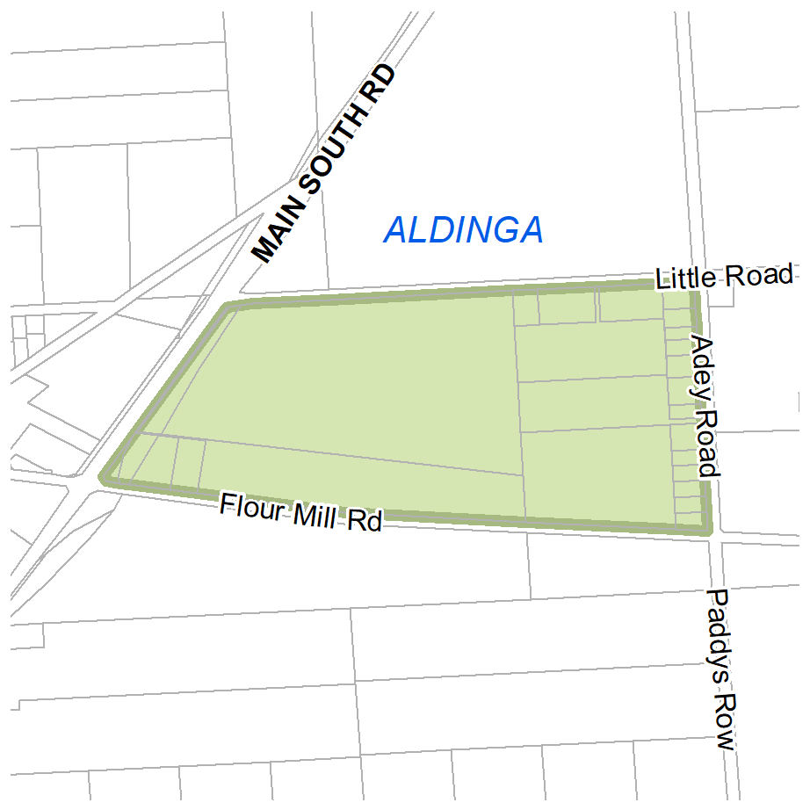  D127971 A642—Aldinga | Zones  Technical and Numeric Variations  - Minimum Site Area  Overlays  - Character Preservation District  - Future Road Widening  - Hazards (Bushfire—General Risk)  - Hazards (Bushfire—Urban Interface)  - Historic Area  - Major Urban Transport Routes  - Urban Tree Canopy
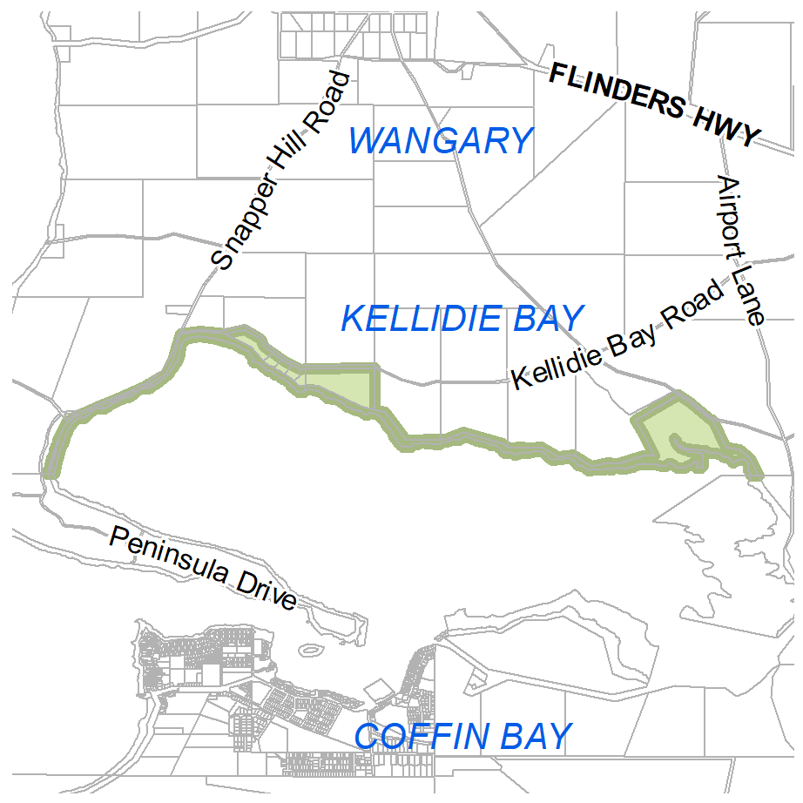  D85819—Kellidie Bay | Zones  Subzones
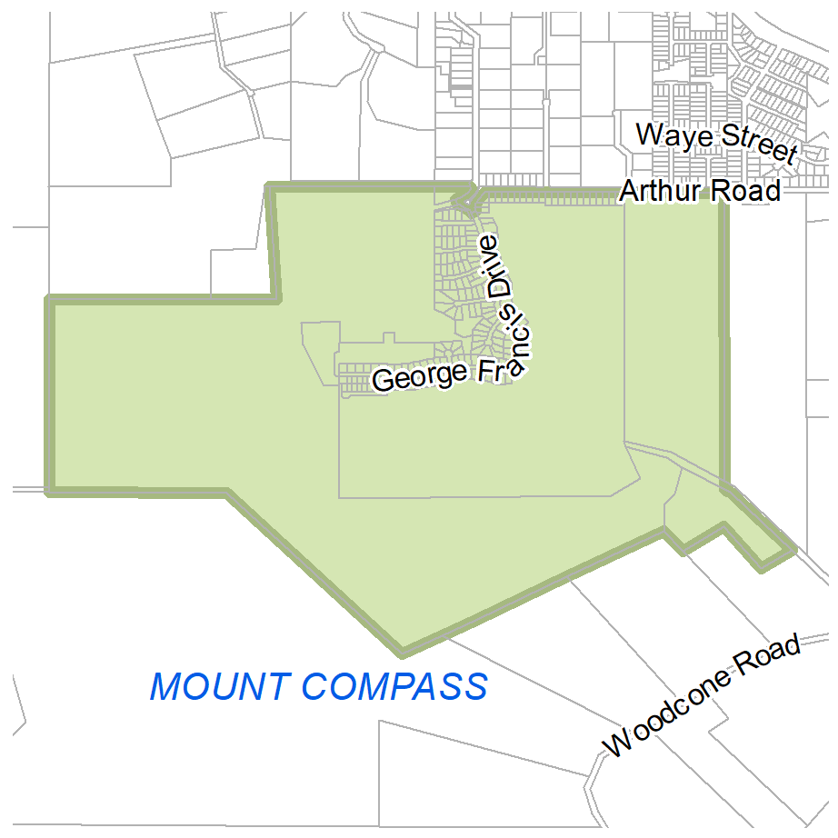  Mount Compass | Zones  Technical and Numeric Variations  - Concept Plan  Overlays  - Affordable Housing  - Environment and Food Production Area  - Hazards (Bushfire—High Risk)  - Hazards (Bushfire—Medium Risk)  - Limited Land Division
(b) In Part 13 of the Code—Table of Amendments, update the publication date, Code version number, amendment type and summary of amendments within the ‘Table of Planning and Design Code Amendments’ to reflect the amendments to the Code as described in this Notice.
2. Pursuant to Section 76(5)(a) of the Act, I further specify that the amendments to the Code as described in this Notice will take effect upon the date those amendments are published on the SA planning portal.
Dated: 28 November 2025
Greg Van Gaans
Director, Geospatial, Data Science and Analytics,
Department for Housing and Urban Development
Delegate of the Minister for Planning

PLANNING, DEVELOPMENT AND INFRASTRUCTURE ACT 2016
Section 76
Amendment to the Planning and Design Code
Preamble
It is necessary to amend the Planning and Design Code (the Code) in order to make the following minor or operational amendments:
• correct errors/inconsistencies relating to the adopted Concordia Code Amendment:
◦ update Table 5—Notification of the Master Planned Neighbourhood Zone to reference the new Emerging Main Street Subzone, and apply the same notification exemptions to this subzone as the existing Emerging Activity Centre Subzone
◦ amend the definition for ‘main street’ so that it is consistent with other terms that have spatially specific application
◦ correct erroneous policy linkages.
• update two concept plans applying to Buckland Park to provide consistency between the Code and the substantially commenced impact assessed Riverlea Development.
• correct errors/inconsistencies relating to the adopted Accommodation Diversity Code Amendment:
◦ include missing zone concept plan linkages to performance assessed ‘co-living’
◦ spatially remove the Significant Retirement Facility and Supported Accommodation Sites Overlay from locations where the State Heritage Areas Overlay applies.
• correct an error where the Local Heritage Place Overlay has been applied to the wrong property at Norwood.
Notice
1. Pursuant to Section 76 of the Planning, Development and Infrastructure Act 2016 (the Act), I hereby amend the Code in order to make the following minor or operational amendments:
(a) In Part 2—Zones and Subzones, in the Master Planned Neighbourhood Zone, amend Table 5—Procedural Matters (PM)—Notification in accordance with Attachment A.
(b) In Part 8—Administrative Terms and Definitions, in the Administrative Terms and Definitions Table, replace the definition for ‘Main street’ with the following:
Main street | Means, for the purposes of the Emerging Main Street Subzone in the Master Planned Neighbourhood Zone, land that is identified for the purposes of a ‘main street’ on an authorised plan of division or building envelope plan.
(c) In Part 2—Zones and Subzones, in Table 2—Deemed-to-Satisfy Development Classification of the Master Planned Neighbourhood Zone, remove from the ‘Overlay’ column, DTS/DPF 1.1 of the Infrastructure Coordination Overlay from applying to the following classes of development:
(i) Ancillary accommodation
(ii) Dwelling addition.
(d) In Part 12—Concept Plans, in the section applying to ‘Playford’, replace ‘Concept Plan 14 Buckland Park’ with ‘Concept Plan 14 Riverlea’ contained in Attachment B.
(e) Spatially amend Concept Plan Technical and Numeric Variation so the boundaries of Concept Plan 14 align with the ‘Concept Plan Boundary’ shown on new concept plan titled ‘Concept Plan 14 Riverlea’ in Attachment B.
(f) In Part 12—Concept Plans, in the section applying to ‘Playford’, replace ‘Concept Plan 13 Buckland Park’ with ‘Concept Plan 13 Riverlea’ contained in Attachment C.
(g) In Table 3—Applicable Policies for Performance Assessed Development for each of the zones contained in Column A of Attachment D, apply as applicable zone policy, the corresponding Performance Outcomes contained in Column B, for the class of development ‘co-living’.
(h) Spatially remove the Local Heritage Place Overlay from 41 The Parade, Norwood and update the Heritage Adjacency Overlay to reflect this change.
(i) In Part 11, in the section applying to ‘Norwood Payneham and St Peters’, delete the following row from the Table of Local Heritage Places:
41 The Parade NORWOOD | Red Brick Federation Warehouse Factory Building | a d | 6081
(j) Spatially remove the Significant Retirement Facility and Supported Accommodation Sites Overlay from where the State Heritage Area Overlay applies.
(k) In Part 13—Table of Amendments, update the publication date, Code version number, amendment type and summary of amendments within the ‘Table of Planning and Design Code Amendments’ to reflect the amendments to the Code as described in this Notice.
2. Pursuant to Section 76(5)(a) of the Act, I further specify that the amendments to the Code as described in this Notice will take effect upon the date those amendments are published on the SA planning portal.
Dated: 2 December 2025
Jason Bailey
Manager Planning and Design Code
Department for Housing and Urban Development
Delegate of the Minister for Planning

Attachment A
Class of Development  (Column A) | Exceptions  (Column B)
3. Any development involving any of the following  (or of any combination of any of the following) where not located in an activity centre within the Emerging Activity Centre Subzone or Emerging Main Street Subzone:  (a) ancillary accommodation  (b) childcare facility  (c) community facility  (d) display home  (e) dwelling  (f) dwelling addition  (g) educational facility  (h) indoor recreation facility  (i) residential flat building  (j) retirement facility  (k) supported accommodation | Except development that:  1. does not satisfy Master Planned Neighbourhood Zone DTS/DPF 5.1  or  2. involves a building wall (or structure) that is proposed to be situated on (or abut) an allotment boundary (not being a boundary with a primary street or secondary street or an excluded boundary) and:  (1) the length of the proposed wall (or structure) exceeds 11.5m (other than where in accordance with a building envelope plan or where the proposed wall abuts an existing wall or structure of greater length on the adjoining allotment)  or  (2) the height of the proposed wall (or post height) exceeds 3m measured from the top of footings (other than where in accordance with a building envelope plan or where the proposed wall (or post) abuts an existing wall or structure of greater height on the adjoining allotment).
4. Any development involving any of the following (or of any combination of any of the following) where not located in an activity centre within the Emerging Activity Centre Subzone or Emerging Main Street Subzone:  (a) consulting room  (b) office  (c) shop | Except development that:  1. does not satisfy any of the following:  (1) Master Planned Neighbourhood Zone DTS/DPF 1.4  (2) Master Planned Neighbourhood Zone DTS/DPF 5.1  or  2. involves a building wall (or structure) that is proposed to be situated on (or abut) an allotment boundary (not being a boundary with a primary street or secondary street or an excluded boundary) and:  (1) the length of the proposed wall (or structure) exceeds 11.5m (other than where in accordance with a building envelope plan or where the proposed wall abuts an existing wall or structure of greater length on the adjoining allotment)  or  (2) the height of the proposed wall (or post height) exceeds 3m measured from the top of footings (other than where in accordance with a building envelope plan or where the proposed wall (or post) abuts an existing wall or structure of greater height on the adjoining allotment).
5. Advertisement where not located in an activity centre within the Emerging Activity Centre Subzone or Emerging Main Street Subzone. | Except advertisement that does not satisfy Master Planned Neighbourhood Zone DTS/DPF 15.1.
6. Any development involving any of the following (or of any combination of any of the following) where located in an activity centre within the Emerging Activity Centre Subzone or Emerging Main Street Subzone:  (a) advertisement  (b) ancillary accommodation  (c) childcare facility  (d) cinema  (e) community facility  (f) consulting room  (g) display home  (h) dwelling located above a non-residential building level  (i) educational facility  (j) emergency services establishment  (k) health facility  (l) hotel  (m) indoor recreation facility  (n) library  (o) office  (p) place of worship  (q) public transport terminal  (r) retail fuel outlet  (s) service trade premises  (t) shop  (u) tourist accommodation | Except development that:  1. in the case of the Emerging Activity Centre Subzone:  (a) exceeds the maximum building height specified in Emerging Activity Centre Subzone DTS/DPF 2.1  or  (b) does not satisfy any of the following:  (i) Emerging Activity Centre Subzone DTS/DPF 2.2  (ii) Emerging Activity Centre Subzone DTS/DPF 2.3.  2. in the case of the Emerging Main Street Subzone:  (a) exceeds the maximum building height specified in Emerging Main Street Subzone DTS/DPF 3.1  or  (b) does not satisfy any of the following:  (i) Emerging Main Street Subzone DTS/DPF 3.2  (ii) Emerging Main Street Subzone DTS/DPF 3.3

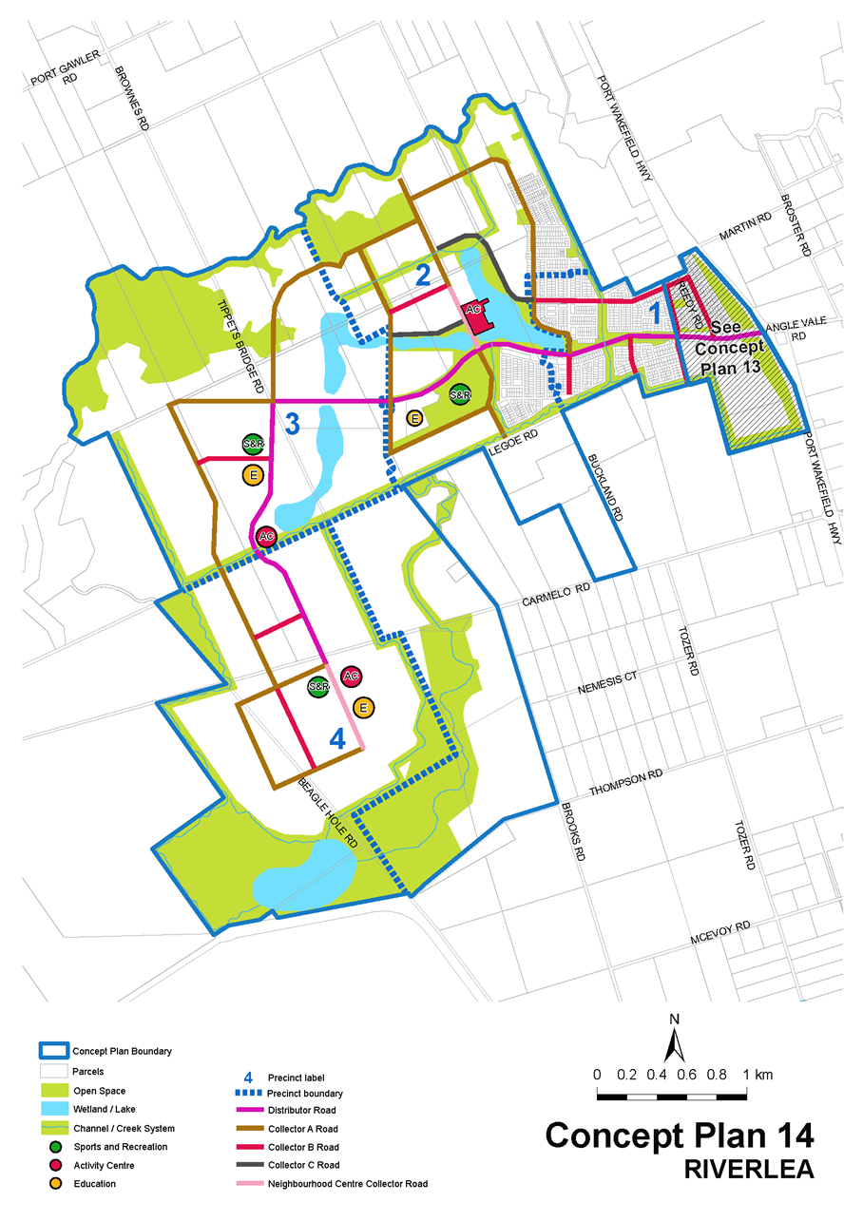
Attachment B

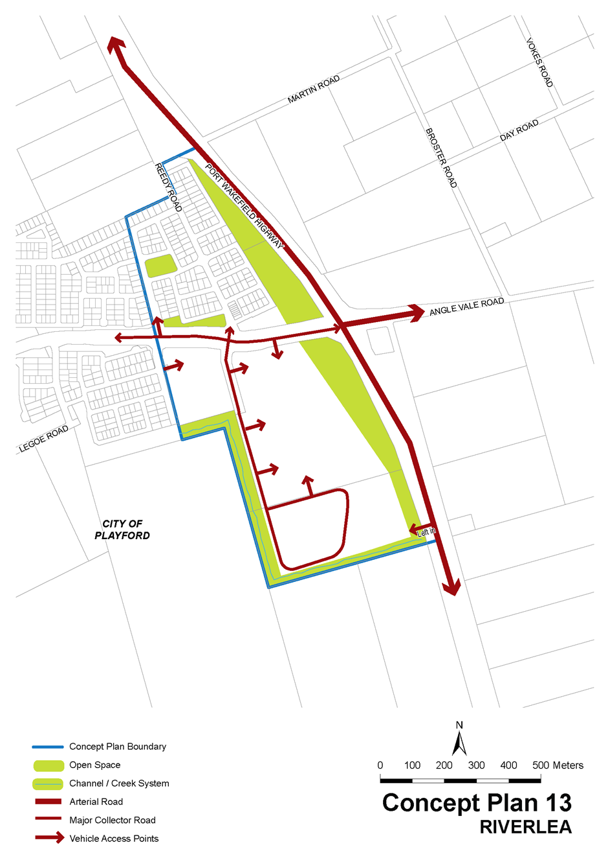
Attachment C

Attachment D
Applicable Zone  (Column A) | Applicable Performance Outcome  (Column B)
Business Neighbourhood Zone | PO 6.1
Capital City Zone | PO 9.1
City Living Zone | PO 7.1
General Neighbourhood Zone | PO 10.1
Golf Course Estate Zone | PO 12.1
Housing Diversity Neighbourhood Zone | PO 9.1
Master Planned Neighbourhood Zone | PO 14.1
Master Planned Renewal Zone | PO 12.1
Master Planned Township Zone | PO 14.1
Strategic Innovation Zone | PO 7.1
Suburban Business Zone | PO 6.1
Suburban Neighbourhood Zone | PO 10.1
Township Neighbourhood Zone | PO 12.1
Urban Activity Centre Zone | PO 7.1
Urban Corridor (Boulevard) Zone | PO 8.1
Urban Corridor (Business) Zone | PO 8.1
Urban Corridor (Living) Zone | PO 8.1
Urban Corridor (Main Street) Zone | PO 8.1
Urban Neighbourhood Zone | PO 6.1
Urban Renewal Neighbourhood Zone | PO 9.1
Waterfront Neighbourhood Zone | PO 10.1

Planning, Development and Infrastructure Act 2016
Section 126
Decision by the Minister for Planning
Preamble
1. By notice published in the South Australian Government Gazette on 15 February 2024 at pages 171-173, the Minister for Planning declared that Section 108(1)(c) of the Planning, Development and Infrastructure Act 2016 (the PDI Act) applied in respect of any development of a kind specified in the Schedule of that notice (the declaration).
2. On 5 April 2024, Australian Naval Infrastructure (the Proponent), lodged an application under Section 111(2)(d) of the PDI Act for development authorisation for the construction and operation of a Nuclear-Powered Submarine Construction Yard and related development within the ambit of the declaration (the development).
3. On 10 October 2024, a varied notice was published in the South Australian Government Gazette at pages 3931-3933, amending the declaration, with the deletion of certain development works from the ambit of the declaration.
4. The development has been the subject of an Environmental Impact Statement and an Assessment Report under Sections 111(2)(e) and 113 of the PDI Act.
5. I am satisfied that an appropriate Environmental Impact Statement and Assessment Report have been prepared in relation to the development, in accordance with the requirements of Part 7, Division 2, Subdivision 4 of the PDI Act, and I have had regard to all relevant matters under Section 115(5) of the PDI Act.
6. I have decided to grant a development authorisation for the development under Section 115(2)(b)(i) of the PDI Act, subject to conditions.
Decision
1. Pursuant to Section 115 of the Planning, Development and Infrastructure Act 2016 (the PDI Act), and having due regard to the matters set out in Section 115(5) of the Act and all other relevant matters, I:
(a) grant a development authorisation in relation to the development, subject to the conditions set out in Parts A, B and C of this notice.
(b) specify, for the purposes of Section 115(7)(b)(i) of the PDI Act, all matters which are the subject of conditions set out in Parts A, B and C of this notice as matters in respect of which the conditions of this authorisation may be varied or revoked, or new conditions attached; and
(c) specify, for the purposes of Section 115(9)(b) of the PDI Act, the period of ten (10) years from the date of this authorisation as the time within which substantial work must be commenced on site, failing which I may cancel this authorisation.

Part A: Prior to the Commencement of Construction Works
1. A Staging Plan that identifies the stages or phases of construction of the development (which may be varied from time to time), and a list of required management plan/s or sub-plan/s that would be provided for each stage or phase, shall be prepared and submitted to the reasonable satisfaction of the Minister
2. Plans for each stage or phase (as identified in the Staging Plan) shall be prepared and submitted to the reasonable satisfaction of the Minister. These may include one or more of the following as relevant to the stage or phase:
(a) bulk earthworks plan; and
(b) site (including AHD) levels; and
(c) detailed designs for all permanent components of the NPSCY facility and related civil infrastructure, including but not limited to site plans, building floor plans, elevations, roof plans, cross-sections, specifications and finished surface levels; and
(d) drainage design including civil drawings; and
(e) external materials selections and finishes/colours; and
(f) lighting plan for the development, demonstrating compliance with Australian/New Zealand Standard AS/NZS 4282:2023—Control of Obtrusive Effects of Outdoor Lighting; and
(g) landscaping plan; and
(h) temporary construction components (i.e. laydown areas, works compounds, storage areas, concrete batching plants etc.), unless otherwise exempted by Schedule 4 of the Planning Development and Infrastructure (General) Regulations 2017.
3. A Stormwater Management Plan (SWMP) shall be prepared and submitted to the reasonable satisfaction of the Minister. The plan must also consider and address any cumulative impacts connected with long-term flood risk, storm events, stormwater quality, sea level rise and sea flood inundation in the management of stormwater for the development site. The implementation of the plan may be staged for each Area (i.e. 1-3).
4. A Construction Environment Management Plan (CEMP) shall be prepared and submitted to the reasonable satisfaction of the Minister. The CEMP/s will (at a minimum) detail:
• The mitigation and management measures to be implemented for the works to be completed within that stage or phase; and
• How these measures will be monitored.
CEMP/s must include relevant sub-plans for construction, as applicable to the scope and nature of each stage or phase. These may include one or more of the following as relevant to the stage or phase:
(a) Site Contamination Management Plan
(b) Marine Construction Works Management Plan (which incorporates underwater noise for all construction and dredging activities)
(c) Noise and Vibration Management Plan
(d) Soil, Erosion, and Drainage Management Plan
(e) Fire and Emergency Management Plan
(f) Air Quality Management Plan
(g) Waste Management Plan
(h) Acid Sulphate Soil Management Plan
5. A Construction Traffic Management Plan (CTMP) shall be prepared and submitted to the reasonable satisfaction of the Minister. The CTMP/s may include one or more of the following as relevant to the stage or phase:
(a) Traffic volumes and distributions, and types of vehicles to be used in each phase of the development.
(b) Transport routes to be used for each phase of the development.
(c) Assessment of risks associated with the expected transport movements and determination of appropriate mitigation measures.
6. A Marine and Coastal Environmental Management Plan (MCEM) shall be prepared and submitted to the reasonable satisfaction of the Minister for Area 3, specifically in relation to the dredging works associated with the development. This plan will include a separate sub-plan related to sediment plume dispersion modelling to further understand potential impacts from dredging works on native vegetation and marine fauna.
7. A Construction Biosecurity Management Plan (CBMP) shall be prepared and submitted to the reasonable satisfaction of the Minister. Separate plans may be prepared to address terrestrial and marine environments.
8. A Terrestrial Flora and Fauna Management Plan (TFFMP) shall be prepared and submitted to the reasonable satisfaction of the Minister.
9. A Dredge Management Plan (DMP) shall be prepared and submitted to the reasonable satisfaction of the Minister prior to the commencement of dredging activities associated with Area 3. This plan will include one or more of the following:
(a) A clearly defined method of dredging and spoil disposal including approximate timing of dredge operations.
(b) A water quality monitoring plan to include monitoring of (but not limited to): Turbidity, Dissolved oxygen, and pH. The baseline data must include a minimum of 12 months water quality data. Specific requirements for the baseline data collection must be determined in consultation with the EPA.
(c) Clearly defined trigger values for monitored metrics and management actions for alarm and stop works.
(d) High resolution hydrodynamic modelling showing sediment plume magnitude and dispersion to predict potential zones of impact using the Western Australia Technical guidance-Environmental Impact Assessment of Marine Dredging Proposals and South Australian Dredge Guidelines. Modelling must incorporate accurate estimates of sediment release from the proposed dredge equipment and potential light disruption to sensitive habitats.
(e) For all proposed dredge areas, testing for contaminants according to the National Assessment Guidelines for Dredging.
(f) Beneficial use assessment for any proposed disposal of dredge spoil.
(g) Written approval by the Department for Infrastructure and Transport is required for any proposal to dispose dredge material at the dredge material disposal area offshore in Gulf St Vincent.
10. A Dewatering Management Plan (DWMP) shall be prepared and submitted to the reasonable satisfaction of the Minister in accordance with the EPA’s 1093/21 Environmental management of dewatering during construction activities and PFAS National Environmental Management Plan 3.0.
11. A Native Vegetation Clearance Data Report (NVCDR) for the removal of any native vegetation associated with dredging works in Area 3 shall be shall be prepared and submitted to the Minister in accordance with the requirements of the Native Vegetation Act 1991 and Native Vegetation Regulations 2017; and include further technical information as outlined in the correspondence of the Native Vegetation Council to the State Planning Commission dated 9 July 2025.
12. Building Rules compliance shall be assessed and certified for each stage, phase or component of the development by an accredited professional (or by a person determined by the Minister) and a copy of all relevant certification documentation must be provided to the Minister. In assessing Building Rules compliance, the accredited professional (or a person determined by the Minister) must refer to the relevant fire authority.
13. An Aboriginal Engagement Plan (AEP) shall be prepared and implemented prior to the commencement of construction works.
Part B: During Construction Works and Prior to Operation of the Development
14. An Operational Environmental Management Plan (OEMP) shall be prepared and submitted to the reasonable satisfaction of the Minister. The OEMP/s should include management and appropriate monitoring measures for the following operational matters (but are not limited to), provided that the operational matter is not dealt with under an environmental authorisation (licence) issued under the Environmental Protection Act 1993:
(a) drainage and surface water
(b) water quality
(c) weeds and pests
(d) waste and litter
(e) spill hazards, fuel and chemical storage
(f) traffic; and
(g) local community impacts.
The OEMP shall include the following sub-plans (for operation only), as applicable to the nature of the works within an area:
(a) Fire and Emergency Management Plan
(b) Waste Management and Minimisation Plan
(c) Biosecurity Management Plan
(d) Marine and Coastal Environmental Management Plan
15. Updated Transport Modelling, in partnership with Department for Infrastructure and Transport, shall be prepared and submitted to the reasonable satisfaction of the Minister for the development prior to first operations commencing. The Transport Modelling must address and identify the transport interventions and infrastructure required to support the transport impacts associated with the development, including offsite infrastructure and any timing/staging of interventions.
16. A Traffic Management Plan shall be prepared and submitted to the reasonable satisfaction of the Minister for each Area (Area 1, Area 2, and Area 3) prior to that Area becoming operational. Operational TMPs must be informed by the outcomes under Condition 15. Each TMP may include one or more of the following as relevant to the stage or phase:
(a) Traffic volumes and distributions, and types of vehicles to be used in each area of the development.
(b) Transport routes to be used for each area of the development.
(c) Assessment of risks associated with the expected transport movements and determination of appropriate mitigation measures.
17. A final consolidated SWMP for the full development shall be prepared and submitted to the reasonable satisfaction of the Minister prior to the development becoming fully operational, to confirm the stormwater infrastructure and management measures across the NPSCY are constructed.
18. An Operational Biosecurity Management Plan (OBMP) shall be prepared and submitted to the reasonable satisfaction of the Minister. Separate plans may be prepared to address terrestrial and marine environments.
Part C: General Conditions
19. Except where minor amendments may be required by other legislation or by conditions imposed herein, the construction, operation, use and maintenance of the development must be undertaken in accordance with the approved plans and details, drawings, designs and specifications:
(a) Set out in the application:
(i) Australian Naval Infrastructure-Submarine Construction Yard Environmental Impact Statement—dated November 2024 (including Appendices 1 to 3, noting Appendix 1 has multiple technical reports).
(ii) Department of Defence-KBR-RLB—Site Layout, Building, Elevation Plans for Areas 1-3 (57 sheets)—contained in Appendix D (SPC Agenda Report).
(iii) Australian Naval Infrastructure—Response Document—dated 8 August 2025 (including Appendices and additional technical information).
(b) Set out in the final and approved conditions within Part A and Part B.
To the extent of any inconsistency, and subject to any contrary intention, a later document will prevail over an earlier one.
20. The development shall be substantially commenced within ten (10) years from the date of the development authorisation being granted by the Minister.
21. The development (including all stages and components) shall be substantially completed within 15 years from the date of the development authorisation being granted by the Minister, failing which an extension of time may be sought from the Minister prior to the expiry of that period, or the authorisation may be cancelled.
22. Should the development not be substantially completed within fifteen (15) years of the date of this authorisation, and no extension of time is subsequently granted, the state and condition of the land and buildings shall be reinstated, so far as is reasonably practicable, to the state and condition that the land and buildings were in immediately before the commencement of the development.
23. The implementation of the CEMP/s and OEMP/s must be monitored and reviewed to ensure compliance with the measures to manage and monitor relevant impacts and the effectiveness of those measures and updated (with approval of the Minister) as necessary. Copies of monitoring reports will be provided to the Minister annually.
24. Prior to the commencement of site works, an Aboriginal Engagement Plan shall be prepared and implemented (in consultation
with Aboriginal Affairs and Reconciliation, Attorney-General’s Department) and to the reasonable satisfaction of the Minister.
Note: this engagement plan can be part of the CHMP at the construction and operational stages.
25. No damage, disturbance or interference with any Aboriginal site, object or remains (together, heritage), nor any excavation of land for the purpose of uncovering Aboriginal heritage, is permitted unless and until authorisations from the Minister for Aboriginal Affairs under Sections 21 and 23 of the Aboriginal Heritage Act 1988 (SA) have been obtained.
26. Council, utility or state agency-maintained infrastructure that is demolished, altered, removed or damaged without lawful authority in the implementation of the development, shall be reinstated to council, utility or state agency specifications as applicable. All costs associated with these works must be met by the proponent.
27. Any alteration or relocation of existing or installation of new maritime navigational aids shall meet all relevant marine standards and codes. These works shall be undertaken to the satisfaction of the Department for Infrastructure and Transport and Flinders Ports Corporation. All costs shall be borne by the proponent.
28. All road infrastructure upgrades delivered within the NPSCY development area shall be completed to the standard required to enable use of the identified vehicle type (as specified in the Traffic Management Plan).
29. All road infrastructure upgrades within the NPSCY development area, unless otherwise identified, are to be funded by the proponent. All land required to accommodate any transport infrastructure upgrades, including footpaths and verge shall be dedicated to road at nil cost to the City of Port Adelaide Enfield or the Department for Infrastructure and Transport.
30. Should the proponent or any subsequent owner or operator of the NPSCY facility intend that the operation of the facility or portion of it will cease, the Minister must be advised as soon as is reasonably practicable. Furthermore, a Decommissioning and Rehabilitation Plan (DRP) must be prepared in consultation with relevant government agencies and the local council and must be submitted to the reasonable satisfaction of the Minister.
The DRP must be prepared nine months prior to the time that the operation (or relevant portion of it) is scheduled to cease, and include information related to:
(a) identifying assets to be rehabilitated, remediated, decommissioned and/or removed, along with those that are proposed to be retained and the proposed tenure and management arrangements
(b) confirming responsibility for costs associated with rehabilitation, remediating, decommissioning and/or removing and retaining assets
(c) handover arrangements for useable assets
(d) responsibility for future management and maintenance of useable assets; and
(e) measures, if required, to remove fuel and chemical storage and wastewater treatment facilities in accordance with relevant legislation and standards.
31. Decommissioning of the development and rehabilitation of the site must be undertaken in accordance with the approved DRP.
32. All external lighting, including for car parking areas and buildings within the NPSCY facility must be designed and constructed to conform with Australian/New Zealand Standard AS/NZS 4282:2023—Control of Obtrusive Effects of Outdoor Lighting. Lighting must be located, directed and shielded, and of such limited intensity, as far as reasonably practicable, that no unreasonable nuisance is caused to any person beyond the boundary of the site.
33. All vehicle car parks, driveways and vehicle entry and manoeuvring areas at or providing access to and from the NPSCY facility must be designed and constructed in accordance with the relevant Australian Standards and appropriately line marked.
34. All loading and unloading, parking and manoeuvring areas at or providing access to and from the NPSCY facility must be designed and constructed to ensure that all vehicles can safely traffic the site and enter and exit the subject land in a forward direction.
35. All stormwater design and construction must be in accordance with Australian Standards and recognised engineering best practice to ensure that stormwater does not adversely affect any adjoining property or public road. Any alterations to road drainage infrastructure required to facilitate this shall be at the applicant’s cost.
36. All liquids or chemical substances that are to be stored at the NPSCY facility and that have the ability to cause environmental harm must be located within a bunded compound that has a capacity of at least 120% of the volume of the largest container or 133% if flammable, in accordance with the EPA Bunding and Spill Management Guidelines (2016).
37. The storage of any radioactive material (whether inert or otherwise) within the development or on-site is prohibited unless the relevant licence(s) have been obtained from the appropriate regulator under the applicable legislation, including but not limited to:
• Australian Naval Nuclear Power Safety Act 2024; and
• Australian Radiation Protection and Nuclear Safety Act 1998.
38. A water quality testing and monitoring program shall be developed and implemented during the operation of the NPSCY in accordance with the objectives of the approved SWMP. The program must be capable of providing data on key stormwater management indicators, including the volume and quality of water discharged to the Port River.
39. Finished surface levels to be set above a minimum level of 3.30m AHD and building floor levels set above a minimum level of 3.55 AHD.
40. Storage of hazardous materials outside of the 1% AEP flood extents or within a bunded area to prevent the ingress of 1% AEP floodwaters.
41. Unless otherwise specifically provided for in these conditions, or otherwise agreed to in writing with the Minister, all costs necessary for compliance with these conditions must be met solely by the proponent.

Part D: Advisory Notes
(a) In regard to the satisfaction or any conditions (as outlined in Parts A, B or C of this decision notice), documentation submitted by the proponent shall be considered by an across government Working Group, chaired by the Department for Housing and Urban Development. The Working Group shall comprise relevant state agency and local government representatives (plus the proponent), from which advice to the Department and/or Minister for Planning (the Minister) will be provided to determine whether the condition has been satisfactorily addressed, or whether further information is required.
(b) Any plans, information, management plan/s or sub-plan/s may be submitted in a staged manner for the discharge of conditions included within Parts A to C, with the ability for part-discharge where appropriate, to reflect the progressive rollout of the development.
(c) No construction activity may commence until a favourable decision has been notified to the proponent by the Minister in respect of the conditions within Part A, and until a development authorisation under Section 115(2) of the Planning, Development and Infrastructure Act 2016 is granted for the relevant stage or phase.
(d) The proponent is advised that all conditions must be met including monitoring, mitigation and reporting requirements as detailed in relevant management plans. Failure to comply with a condition is a breach of the Planning, Development and Infrastructure Act 2016 (as applicable), under which this authorisation is given.
(e) An accredited professional undertaking Building Rules assessments for each stage or component must ensure that the assessment and certification for any stage or component is consistent with this development authorisation, including any conditions or advisory notes that apply in relation to this development authorisation.
(f) Construction of each stage or component of the development may commence only after a Building Rules assessment and certification has been undertaken in relation to that stage, phase or component and has been issued by an accredited professional undertaking Building Rules assessments, and the Minister for Planning has received a copy of the relevant certification documentation.
(g) Pursuant to Regulation 45 and 103 of the Planning, Development and Infrastructure (General) Regulations 2017, a Certificate of Occupancy is required for all new buildings, excluding Class 10 structures. The Applicant must comply with all relevant requirements of Regulation 103 including a report from the relevant fire authority (Metropolitan Fire Service) per Regulation 103(D).
(h) In accordance with the National Heavy Vehicle Law (South Australia) Act 2013, the proponent must apply to the National Heavy Vehicle Regulator to obtain all necessary approvals and/or permits for use of Restricted Access Vehicles (including over-size and over-mass components) and/or High Productivity Vehicles on public roads, where access for such vehicles is currently not available. Further information is available at www.nhvr.gov.au.
(i) Prior to the use of any High Productivity Vehicles, the Department for Infrastructure and Transport requires that any additional road infrastructure upgrades required to facilitate this use, must be completed to the satisfaction of the relevant road authority.
(j) DEW has advised that there may be shipwrecks in the vicinity of Area 3, where dredging works are proposed. Care must be taken during any construction and/or clearance activities so as not to cause impacts to any shipwreck remains or associated material. Should evidence of a suspected shipwreck be encountered during the works in Area 3, disturbance should cease, and DEW notified immediately.
(k) The applicant should contact the Manager, Marine Safety and Compliance at the Department for Infrastructure and Transport to discuss navigational aid requirements.
(l) If any archaeological remains or artefact of heritage significance be discovered or located during project works, under Section 27(2) of the Heritage Places Act 1993, excavation or other disturbance in the vicinity of the object must cease and DEW notified immediately. No further action in relation to recovery or disturbance of the relevant object can be undertaken without a permit or other authorisation from the SA Heritage Council.
(m) The proponent, and all agents, employees and contractors, such as construction crew, are reminded of their obligations under the Aboriginal Heritage Act 1988 (AH Act) that excavation of land to uncover, damage, disturbance of, or interference with, any Aboriginal site, object or ancestral remains (known and unknown) is unlawful without ministerial authorisation under Sections 21 and 23 of the AH Act. Before commencing construction, the proponent should consider the amendments to the AH Act, which include increased penalties for breaches of the AH Act:
see https://www.agd.sa.gov.au/aboriginal-affairs-and-reconciliation/aboriginal-heritage/changes-to-the-aboriginal-heritage-act
(n) The proponent is reminded of requirements under the Native Vegetation Act 1991 and the Native Vegetation Regulations 2017, particularly that native vegetation clearance must be undertaken in accordance with a management plan that has been approved by the Native Vegetation Council that results in a significant environmental benefit on the property where the development is being undertaken, or a payment is made into the Native Vegetation Fund of an amount considered by the Native Vegetation Council to be sufficient to achieve a significant environmental benefit in the manner contemplated by Section 21(6) or (6a) of the Native Vegetation Act 1991, prior to any clearance occurring.
(o) An environmental authorisation (licence) may be required for this development. The applicant/operator should contact the Environment Protection Authority on (08) 8204 2058 or email EPALicensing@sa.gov.au for information about the licensing application process and requirements.
(p) The proponent/owner/operator is reminded of their general environmental duty, as required by Section 25 of the Environment Protection Act 1993, to take all reasonable and practicable measures to ensure that activities on the site and associated with the site (including during construction) to not pollute the environment in a way which causes or may cause environmental harm.
(q) The site contamination management plan within the CEMP should be prepared by a suitably qualified and experienced site contamination consultant in accordance with the Environment Protection Authority guideline, Construction Environmental Management Plan (CEMP) (2024), the Environment Protection Authority’s Guidelines for the assessment and remediation of site contamination (2019), the National Environment Protection (Assessment of Site Contamination) Measure (2013) and any other relevant guidelines issued by the EPA. The site contamination management plan should address site contamination, acid sulphate soils, and the range of potential issues likely to be encountered based on the site’s history and proposed land use.
(r) The marine construction works management plan within the CEMP must detail the proposed piling methodology (number, location, method, duration, timing etc) within the coastal or marine environment and assess the risk to dolphins within the Adelaide Dolphin Sanctuary.

(s) The Stormwater Management Plans should be prepared using hydrological and hydraulic modelling and detail stormwater management measures to ensure that all potential pollutants generated on site (such as metals, hydrocarbons, and soil) are captured and treated as far as reasonably practicable, and in accordance with the Environment Protection Policy (Water Quality) 2015. The proposed stormwater system should be sized for a 1% AEP rain event, where practicable.
(t) Dewatering Management Plans should be prepared in accordance with the EPA guideline, Environmental management of dewatering during construction activities (June 2021). Dewatering Management Plans should detail when and how groundwater may be encountered during construction on the site and how this water will be managed.
(u) A dredging licence must be obtained from the EPA under the Environment Protection Act 1993 prior to the commencement of dredging activities. As part of the licence application, a Dredge Management Plan (DMP), which includes a Noise and Vibration Management Plan for dredging works, must be submitted to the EPA for assessment and approval.
(v) Due to the risk of translocating the Pacific Oyster Mortality Syndrome virus which is known to be infected within the Port River, any dredging must be undertaken within water temperature constraints required by PIRSA Biosecurity.
(w) For any regulated tree to be retained, their critical root zones shall be fenced and protected to prevent accidental damage and to ensure material stockpiling or vehicle movements do not impact these trees during construction works. Where appropriate additional protection measures, which comply with the Australian Standard 4970:2009 Protection of Trees on Development Sites, must be implemented and complied with at all times.
(x) Should the proponent wish to vary the development or any portion of it, an application to the Minister must be submitted, provided that the development application variation remains within the ambit of the Environmental Impact Statement and Assessment Report referred to in this development authorisation. If an application variation involves substantial changes to the proposal, pursuant to Section 114 of the Planning, Development and Infrastructure Act 2016 (as applicable), the proponent may be required to prepare an amended Environmental Impact Statement for public consultation. An amended Assessment Report may also be required to assess any new issues not covered by the original Assessment Report and the decision made pursuant to Section 115 of the Planning, Development and Infrastructure Act 2016 (as applicable).
(y) The Minister has a specific power to require testing, monitoring and auditing under Section 117 of the Planning, Development and Infrastructure Act 2016 (as applicable).
(z) In regard to Conditions 4 and 14, the CEMP and OEMP must be prepared taking into consideration, and with explicit reference to, relevant Environment Protection Act 1993 policies and guidance documents, including but not limited to:
• the Landscape South Australia Act 2019
• the Environment Protection (Air Quality) Policy 2016
• the Environment Protection (Commercial and Industrial Noise) Policy 2023
• the Environment Protection (Water Quality) Policy 2015
• the Environment Protection (Waste to Resources) Policy 2010
• the Environment Protection (Used Packaging Materials) Policy 2012
• the Environment Protection Authority Bunding and Spill Management Guideline 2016
• Environment Protection Authority Handbooks for Pollution Avoidance
• the International Erosion Control Association Australasia ‘Field Guides for Construction Site Managers and Buildings’ and associated design fact sheets.
• the Environment Protection Authority guideline ‘Construction environmental management plan (CEMP) 2019’
• any other relevant legislative requirements, Guidelines and Australian Standards.
(aa) The requirement to prepare a Native Vegetation Clearance Data Report applies only to the dredging works proposed within Area 3, where potential removal of native vegetation may occur.
Dated: 26 November 2025
Hon Nick Champion MP
Minister for Planning

PLANNING, DEVELOPMENT AND INFRASTRUCTURE ACT 2016
Section 42
Practice Directions
Preamble
The State Planning Commission may issue a practice direction for the purposes of this Act.
A practice direction may specify procedural requirements or steps in connection with any matter arising under this Act.
A practice direction must be notified in the Gazette and published on the SA planning portal.
A practice direction may be varied or revoked by the State Planning Commission from time to time by a further instrument notified in the Gazette and published on the SA Planning Portal.
Notice
Pursuant to Section 42(4)(b) of the Planning, Development and Infrastructure Act 2016, I, Craig Holden, Chair, State Planning Commission:
(a) vary State Planning Commission Practice Direction 15—Building Envelope Plans 2021; and
- fix the day on which the varied State Planning Commission Practice Direction 15—Building Envelope Plans 2021 is published on the SA Planning Portal as the day on which the varied practice direction will come into operation.
Dated: 24 November 2025
Craig Holden
Chair, State Planning Commission

PLANNING, DEVELOPMENT AND INFRASTRUCTURE ACT 2016
Section 43
Practice Guidelines
Preamble
The Commission may, with the approval of the Minister, make practice guidelines with respect to the interpretation, use or application of the Planning and Design Code.
A practice guideline may make a declaration as to the effect of a provision of the Planning and Design Code in a particular set of circumstances.
A practice guideline must be notified in the Gazette and published on the SA planning portal.
Notice
Pursuant to Section 43(4)(a) of the Planning, Development and Infrastructure Act 2016, I, John Stimson, Acting Chair of the State Planning Commission, with the approval of the Minister for Planning:
(a) issue State Planning Commission Practice Guideline 4—Communal Recreation Spaces and Shared Facilities
(b) fix the day on which the practice guideline is published on the SA Planning Portal as the day on which the practice guideline will come into operation.
Dated: 27 October 2025
John Stimson
Acting Chair, State Planning Commission
Delegate of the State Planning Commission

Road Traffic Act 1961
Authorisation to Operate Breath Analysing Instruments
I, Grant Stevens, Commissioner of Police, do hereby notify that on and from 20 November 2025, the following persons were authorised by the Commissioner of Police to operate breath analysing instruments as defined in and for the purposes of the:
• Road Traffic Act 1961;
• Harbors and Navigation Act 1993;
• Security and Investigation Industry Act 1995; and
• Rail Safety National Law (South Australia) Act 2012.
PD Number | Officer Name
14937 | BACK, Ethan James
14813 | DOWIE, Harrison Adam
76223 | ESTON, Richard Anthony
15041 | JONES, Tamsin Dianne
15728 | KILMIER, Lachlan Robert
17551 | LAMB, Oliver Christiano
14497 | LOMBARDI, Sophia Grace
16080 | MARKS, Benjamin Daniel
11352 | NEWTON, Kara Elise
15228 | WARNEST, Laura Ellen
16077 | WERNER, Laura Emily
76957 | WINKLER, Matthew David
Dated: 4 December 2025
Grant Stevens
Commissioner of Police
Reference: 2025-0216

Local Government Instruments

City of Marion
Local Government Act 1999
Declaration of Public Roads
Notice is hereby given, pursuant to Section 210(1) of the Local Government Act 1999 (SA), that the City of Marion has resolved at its meeting held on 25 November 2025 to declare the roads delineated in Deposited Plan 2334 and known as Barry Road, Johnstone Road, Kearne’s Road, Crozier’s Terrace, and Murray Terrace to be public roads.
Dated: 25 November 2025
Tony Harrison
Chief Executive Officer

Alexandrina Council
South Australia
Liquor Licensing (Dry Areas) Notice 2025
under Section 131(1a) of the Liquor Licensing Act 1997
1—Short title
This notice may be cited as the Liquor Licensing (Dry Areas) Notice 2025.
2—Commencement
This notice has effect on the day on which it is published in the Gazette.
3—Interpretation
(1) In this notice—
principal notice means the Liquor Licensing (Dry Areas) Notice 2015 published in the Gazette on 5.1.15, as in force from time to time.
(2) Clause 3 of the principal notice applies to this notice as if it were the principal notice.
4—Consumption etc of liquor prohibited in dry areas
(1) Pursuant to Section 131 of the Act, the consumption and possession of liquor in the area described in the Schedule is prohibited in accordance with the provisions of the Schedule.
(2) The prohibition has effect during the periods specified in the Schedule.
(3) The prohibition does not extend to private land in the area described in the Schedule.
(4) Unless the contrary intention appears, the prohibition of the possession of liquor in the area does not extend to—
(a) a person who is genuinely passing through the area if—
(i) the liquor is in the original container in which it was purchased from licensed premises; and
(ii) the container has not been opened; or
(b) a person who has possession of the liquor in the course of carrying on a business or in the course of his or her employment by another person in the course of carrying on a business; or
(c) a person who is permanently or temporarily residing at premises within the area or on the boundary of the area and who enters the area solely for the purpose of passing through it to enter those premises or who enters the area from those premises for the purpose of leaving the area.
Schedule 1—Strathalbyn Area 1
1—Extent of prohibition
The consumption of liquor is prohibited, and the possession of liquor is prohibited.
2—Period of prohibition
From 2:00pm on 12 December 2025—6:00am on 13 December 2025
3—Description of area
Strathalbyn Area 1
The area in Strathalbyn bounded as follows:
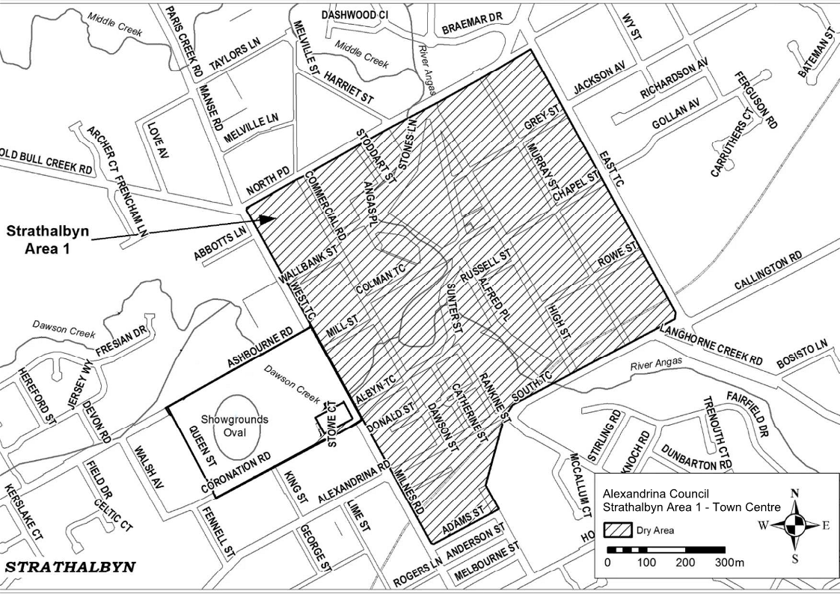
Commencing at the point at which the south-eastern boundary of North Parade meets the north-eastern boundary of West Terrace, then south-easterly along that boundary of West Terrace to the north-western boundary of Adams Street, then north-easterly along that boundary of Adams Street and the prolongation in a straight line of that boundary to the north-eastern boundary of Edinburgh Road, then north-westerly along that boundary of Edinburgh Road to the end of the road, then in a straight line by the shortest route to the point at which the south-eastern boundary of South Terrace meets the south-western boundary of Parker Avenue, then along the continuation of that straight line across South Terrace to the north western boundary of South Terrace, then north-easterly along the north-western boundary of South Terrace to the south-western boundary of East Terrace, then north westerly along the south-western boundary of East Terrace to the south-eastern boundary of North Parade, then south-westerly along the south-eastern boundary of North Parade to the point of commencement.

Schedule 2—Goolwa Wharf Precinct
1—Extent of prohibition
The consumption of liquor is prohibited, and the possession of liquor is prohibited.
2—Period of prohibition
From 4:00pm on 20 December 2025—6:00am on 21 December 2025
3—Description of area
Goolwa Wharf Precinct
The area in Goolwa Central and Port of Goolwa (generally known as the Wharf Precinct) and to be known as Goolwa Area 3 bounded as follows:
Commencing at the north eastern corner of Section 315, Hundred of Goolwa, and then due west to the eastern side of the railway reserve. Then follow the easterly side of the railway reserve until reaching the south western underside of the Goolwa and Hindmarsh Island Bridge. Head in a north westerly direction, along the south western side of Brooking Street, until the round-about intersection of Brooking Street, Liverpool Road and Goolwa Terrace. Follow the south-eastern side of Goolwa Terrace until the intersection of Cadell Street and Goolwa Terrace. Traversing the north-eastern side of Cadell Street, past the Cadell Street and Cutting Road intersection. Continue along Cadell Street and enter Hayes Street then to the Hayes Street and Porter Street intersection. Head south east to the Porter Street and Admiral Terrace intersection. Then head south-west and continue along the eastern side of Admiral Terrace past the intersections of Goyder Street, Hutchinson Street, Sidmouth Street until the Admiral Terrace and Baronet Street intersection. Head east south east and traverse around the jetty and return to the eastern side of the boardwalk. Head north-east along the eastern side of the boardwalk then a straight line, by the shortest route, to the southern side of the jetty. Then in a straight line by the shortest route to the south-eastern side of the Goolwa Wharf. Traverse the south-eastern side of the Goolwa Wharf under the Goolwa and Hindmarsh Island Bridge along the River Murray bank to the south-eastern side of Section 315 returning to the point of commencement.

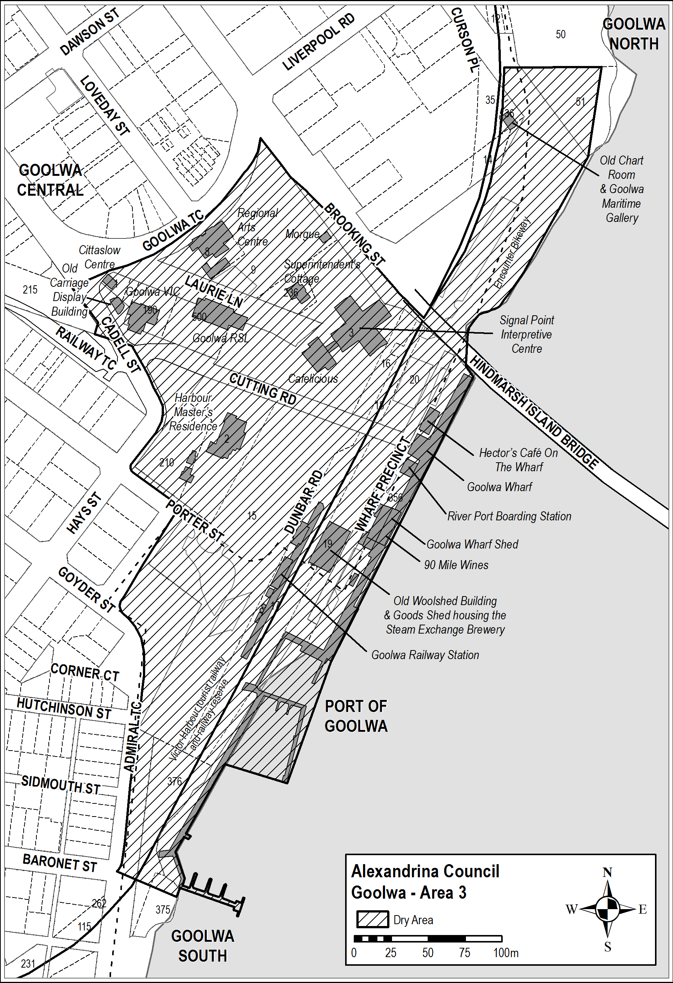
Dated: 4 December 2025
Natasha Hunt
Acting Chief Executive Officer

District Council of Cleve
South Australia
Liquor Licensing (Dry Areas) Notice 2025
under Section 131(1ab) of the Liquor Licensing Act 1997
1—Short title
This notice may be cited as the Liquor Licensing (Dry Areas) Notice 2025.
2—Commencement
This notice comes into operation on 31 December 2025.
3—Interpretation
(1) In this notice—
principal notice means the Liquor Licensing (Dry Areas) Notice 2015 published in the Gazette on 5 January 2015, as in force from time to time.
(2) Clause 3 of the principal notice applies to this notice as if it were the principal notice.
4—Consumption etc of liquor prohibited in dry areas
(1) Pursuant to Section 131 of the Act, the consumption and possession of liquor in the area described in the Schedule is prohibited in accordance with the provisions of the Schedule.
(2) The prohibition has effect during the periods specified in the Schedule.
(3) The prohibition does not extend to private land in the area described in the Schedule.
(4) Unless the contrary intention appears, the prohibition of the possession of liquor in the area does not extend to—
(a) a person who is genuinely passing through the area if—
(i) the liquor is in the original container in which it was purchased from licensed premises; and
(ii) the container has not been opened; or
(b) a person who has possession of the liquor in the course of carrying on a business or in the course of his or her employment by another person in the course of carrying on a business; or
(c) a person who is permanently or temporarily residing at premises within the area or on the boundary of the area and who enters the area solely for the purpose of passing through it to enter those premises or who enters the area from those premises for the purpose of leaving the area.
Schedule—Arno Bay Area 1
1—Extent of prohibition
The consumption of liquor is prohibited and the possession of liquor is prohibited.

2—Period of prohibition
From 11:00pm on 31 December 2025 to 8:00am on 1 January 2026.
3—Description of area
The area in and adjacent to Arno Bay bounded as follows: commencing at the point at which the low water mark on the western side of Spencer Gulf is intersected by the prolongation in a straight line of the south-eastern boundary of Section 320 Hundred of Boothby, then south westerly along that prolongation and boundary of Section 320, the south-eastern boundary of Lot 254 of FP 178666 and the prolongation in a straight line of the south-eastern boundary of Lot 254 to the south-western boundary of Piece 103 of DP 79319, then generally north westerly along that boundary of Piece 103 to the point at which it meets the south-eastern boundary of Lot 101 of DP 79319, then in a straight line by the shortest route to the point at which the northern boundary of Lot 254 of FP 178666 meets the western boundary of the Lot (the northernmost point of Lot 254), then easterly in a straight line along the portion of the boundary of Piece 103 of DP 79319 that extends easterly from that point, and easterly along the prolongation in a straight line of that portion of the boundary, to the eastern boundary of Creek Road, then south-westerly along that boundary of Creek Road to the point at which it meets the northern boundary of Lot 254 of FP 178666, then generally south-easterly and easterly along that boundary of Lot 254 to the point at which the northern boundary of Lot 254 meets the western boundary of Section 344 Hundred of Boothby, then northerly along that boundary of Section 344 to the southern boundary of Lot 7 of DP 35379, then north-westerly, north-easterly and south-easterly along the southern, western and northern boundaries of Lot 7 to the point at which the northern boundary of Lot 7 meets the western boundary of Lot 6 of DP 35379, then generally north-easterly and north-westerly along that boundary of Lot 6 to the north-western boundary of the Lot, then north-easterly along the north-western boundary of Lot 6, and the prolongation in a straight line of that boundary, to the point at which the prolongation intersects the south-western boundary of Lot 27 of DP 55099, then south-easterly along that boundary of Lot 27 to the south-eastern boundary of the Lot, then in a straight line by the shortest route to the point at which the north-western and south-western boundaries of Section 359 Hundred of Boothby meet, then south-easterly along the south-western boundary of Section 359, and the prolongation in a straight line of that boundary, to the point at which the prolongation intersects the north-western boundary of Section 317 Hundred of Boothby, then generally north-easterly along that boundary of Section 317 and the north-western boundary of Piece 3 of DP 68273 to the point at which the north-western boundary of Piece 3 meets the north-eastern boundary of Section 412 Hundred of Boothby, then north-westerly along that boundary of Section 412 and the prolongation in a straight line of that boundary to the south-eastern boundary of Piece 2 of DP 68273, then generally north-easterly along that boundary of Piece 2 to the point at which it meets the north-western boundary of Lot 1 of DP 68273, then north-easterly along that boundary of Lot 1 and the prolongation in a straight line of that boundary to the low water mark on the western side of Spencer Gulf, then generally southerly along the low water mark to the point at which it meets the commencement of the breakwater that forms the eastern wall of the Arno Bay marina, then southerly along the outer boundary of the breakwater to the end of the breakwater, then in a straight line by the shortest route (across the entrance to the marina) to the outer boundary of the eastern end of the breakwater that forms the southern and western walls of the marina, then generally southerly, westerly and north-westerly along the outer boundary of that breakwater back to the low water mark on the shore on the western side of the marina (so as to include the whole of the marina and each of the breakwaters in the area), then generally south-westerly along the low water mark to the north-eastern side of the Arno Bay jetty, then south-easterly, south-westerly and north-westerly around the outer boundary of the jetty (so as to include the whole of the jetty and any area below the jetty in the area) back to the low water mark on the south-western side of the jetty, then generally south-westerly and southerly along the low water mark to the point of commencement.

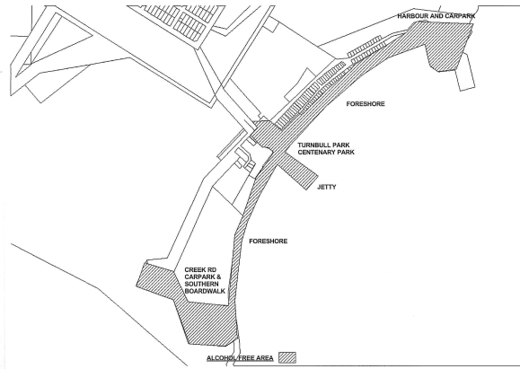
Dated: 4 December 2025
D.J. Penfold
Chief Executive Officer

DISTRICT COUNCIL OF CLEVE
Local Government Land Amendment By-law 2025
By-law No. 7 of 2025
A By-law to amend the Council’s Local Government Land By-law 2025 to correct a typographic error
Part 1—Preliminary
1. Title
This by-law may be cited as the ‘Local Government Land Amendment By-law 2025’ and is By-law No. 7 of the District Council of Cleve.
2. Authorising Law
This by-law is made under Sections 246 and 249 of the Act.
3. Purpose
The objective of this by-law is to make a minor amendment, as requested by the Legislative Review Committee and as set out in Part 2, to the LGL By-law.
4. Commencement, Revocation and Expiry
4.1 Pursuant to Section 249(6) of the Act, this by-law will take effect on 20 December 2025.
4.2 This by-law will expire on 1 January 2033.
5. Interpretation
In this By-law, unless the contrary intention appears:
5.1 Act means the Local Government Act 1999;
5.2 Council means the District Council of Cleve; and
5.3 LGL By-law means the Local Government Land By-law 2025 made by the Council on 19 August 2025 and published in the Government Gazette on 28 August 2025.

Part 2—Amendment To Local Government Land By-Law
6. Amendment to ‘Solicitation’ Clause
As and from the date that this by-law takes effect, subclause 10.11 of the LGL By-law is deleted and substituted with the following:
10.11 Solicitation
Subject to Clause 9.30, tout or solicit customers for the parking of vehicles or for any other purpose whatsoever.
This By-law was duly made and passed at a meeting of the District Council of Cleve held on 26 November 2025 by an absolute majority of the members for the time being constituting the Council, there being at least two thirds of the members present.
Dated: 4 December 2025
David Penfold
Chief Executive Officer
District Council of Cleve

District Council of Loxton Waikerie
Review of Representation
Notice is hereby given that the District Council of Loxton Waikerie has reviewed its composition and elector representation arrangements in accordance with the requirements of Section 12 of the Local Government Act 1999 (the Act). Pursuant to Section 12(13)(a) of the Act, the Electoral Commissioner has issued a certificate that the review undertaken by Council satisfies the requirements of Section 12 of the Act and may now be put into effect as from the day of the first periodic election held after the publication of this notice. The Council proposes to make no changes to its representation arrangements, with the following arrangement to take effect from polling day of the next periodic elections:
• The Principal Member of Council shall continue to be a Mayor, elected as a representative of the area as a whole.
• The area of the Council shall not be divided into wards.
• The elected body of the Council will be comprised of the eleven (11) elected members, being the Mayor and ten (10) Councillors.
Dated: 28 October 2025
David Beaton
Chief Executive Officer

Public Notices

National Electricity Law
Notice of Final Determination and Final Rule
The Australian Energy Market Commission (AEMC) gives notice under the National Electricity Law as follows:
Under ss 102, 102A and 103, the making of the National Electricity Amendment (Clarifying Registration for Non-Generating Units Providing System Security Services) Rule 2025 No. 11 (Ref. ERC0402) and related final determination. All provisions commence on 4 December 2025.
Documents referred to above are available on the AEMC’s website and are available for inspection at the AEMC’s office.
Australian Energy Market Commission
Level 15, 60 Castlereagh St
Sydney NSW 2000
Telephone: (02) 8296 7800
www.aemc.gov.au
Dated: 4 December 2025

National Electricity Law
Notice of Initiation and Consolidation
Notice of Final Determination and Final Rule
The Australian Energy Market Commission (AEMC) gives notice under the National Electricity Law as follows:
PLUS ES, Intellihub and AEMO have submitted proposals (Ref. ERC0419, ERC0422, ERC0423). The proposals seek to improve metering coordinators’ (MCs’) compliance with obligations relating to testing and inspection. Intellihub’s proposal also seeks to improve MCs’ compliance with obligations for repairing metering malfunctions.
Under s 95, the AEMC initiates these three Rule requests:
• ERC0419: PLUS ES—compliance with metering testing requirements;
• ERC0422: AEMO—supporting metering compliance; and
• ERC0423: Intellihub—improving the metering installation maintenance framework.
Under s 93, the AEMC consolidates these three Rule requests into one consolidated Rule request. The name of the consolidated Rule request is Supporting compliance with meter maintenance obligations. The consolidated Rule project code is ERC0419.
Submissions can be made via the AEMC’s website. Before making a submission, please review the AEMC’s privacy statement on its website, and consider the AEMC’s Tips for making a submission. The AEMC publishes submissions on its website, subject to confidentiality and other considerations. Submissions must be received by 15 January 2026.
Under ss 102, 102A and 103, the making of the National Electricity Amendment (Clarifying Registration for Non-Generating Units Providing System Security Services) Rule 2025 No. 11 (Ref. ERC0402) and related final determination. All provisions commence on 4 December 2025.
Documents referred to above are available on the AEMC’s website and are available for inspection at the AEMC’s office.
Australian Energy Market Commission
Level 15, 60 Castlereagh St
Sydney NSW 2000
Telephone: (02) 8296 7800
www.aemc.gov.au
Dated: 4 December 2025

National Energy Retail Law
Notice of Initiation and Consolidation
The Australian Energy Market Commission (AEMC) gives notice under the National Energy Retail Law as follows:
Yurika and Intellihub have submitted the proposals (Ref. RRC0070, RRC0071). The proposals seek to improve metering coordinators’ (MCs’) compliance with obligations relating to testing and inspection. Intellihub’s proposal also seeks to improve MCs’ compliance with obligations for repairing metering malfunctions.
Under s 251, the AEMC initiates these two Rule requests:
• RRC0070: Yurika Metering—changes to the meter testing framework for large customers; and
• RRC0071: Intellihub—improving the metering installation maintenance framework (Retail).
Under s 248, the AEMC consolidated these two Rule requests into one consolidated Rule request. The name of the consolidated Rule request is Supporting compliance with meter maintenance obligations. The consolidated Rule project code is (RRC0070).
Submissions can be made via the AEMC’s website. Before making a submission, please review the AEMC’s privacy statement on its website, and consider the AEMC’s Tips for making a submission. The AEMC publishes submissions on its website, subject to confidentiality and other considerations. Submissions must be received by 15 January 2026.
Documents referred to above are available on the AEMC’s website and are available for inspection at the AEMC’s office.
Australian Energy Market Commission
Level 15, 60 Castlereagh St
Sydney NSW 2000
Telephone: (02) 8296 7800
www.aemc.gov.au
Dated: 4 December 2025

Notice Submission

The South Australian Government Gazette is published each Thursday afternoon.
Notices must be emailed by 4 p.m. Tuesday, the week of publication.
Submissions are formatted per the gazette style and a proof will be supplied prior to publication, along with a quote if applicable. Please allow one day for processing notices.
Alterations to the proof must be returned by 4 p.m. Wednesday.

Gazette notices must be submitted as Word files, in the following format:
• Title—the governing legislation
• Subtitle—a summary of the notice content
• Body—structured text, which can include numbered lists, tables, and images
• Date—day, month, and year of authorisation
• Signature block—name, role, and department/organisation authorising the notice

Please provide the following information in your email:
• Date of intended publication
• Contact details of the person responsible for the notice content
• Name and organisation to be charged for the publication—Local Council and Public notices only
• Purchase order, if required—Local Council and Public notices only

Email: governmentgazettesa@sa.gov.au
Phone: (08) 7133 3552
Website: www.governmentgazette.sa.gov.au

All instruments appearing in this gazette are to be considered official, and obeyed as such

Printed and published weekly by authority of T. Foresto, Government Printer, South Australia
$9.50 per issue (plus postage), $479.00 per annual subscription—GST inclusive
Online publications: www.governmentgazette.sa.gov.au

