
No. 71 p. 4817
THE SOUTH AUSTRALIAN
GOVERNMENT GAZETTE
Published by Authority

Adelaide, Thursday, 11 December 2025

Contents

Governor’s Instruments
Appointments, Resignations and General Matters 4818
Proclamations—
Child Sex Offenders Registration (Public Register)
Amendment Act (Commencement) Proclamation 2025 4822
Defamation (Miscellaneous) Amendment Act
(Commencement) Proclamation 2025 4822
Electoral (Miscellaneous) Amendment Act
(Commencement) Proclamation 2025 4823
Fair Work (Worker Entitlements) Amendment Act (Commencement) Proclamation 2025 4823
Preventive Health SA Act (Commencement)
Proclamation 2025 4824
State Development Coordination and Facilitation Act (Commencement) Proclamation 2025 4824
Statutes Amendment (Local Government Review) Act (Commencement) Proclamation 2025 4825
Administrative Arrangements (Administration of
Preventive Health SA Act) Proclamation 2025 4826
Regulations—
Return to Work (Permanent Impairment Assessment Costs) Amendment Regulations 2025—No. 137 of 2025 4827
Local Government (Amendment of Schedule 5 of Act) Regulations 2025—No. 138 of 2025 4829
Local Government (General) (Public Consultation)
Amendment Regulations 2025—No. 139 of 2025 4831
Local Government (Transitional Provisions) (Public Consultation) Amendment Regulations 2025—
No. 140 of 2025 4833
State Development Coordination and Facilitation
(Relevant Interests) Amendment Regulations 2025—
No. 141 of 2025 4835
Electoral (Voting and Other Matters) Amendment Regulations 2025—No. 142 of 2025 4837
State Government Instruments
Associations Incorporation Act 1985 4851
Dangerous Substances Act 1979 4851
Education and Children’s Services Act 2019 4852
Employment Agents Registration Act 1993 4869
Energy Resources Act 2000 4870
Fisheries Management Act 2007 4870
Housing Improvement Act 2016 4873
Land Acquisition Act 1969 4874
Liquor Licensing Act 1997 4888
Local Government Act 1999 4898
Mental Health Act 2009 4901
Motor Vehicles Act 1959 4902
Proof of Sunrise and Sunset Act 1923 4904
Real Property Act 1886 4905
Remuneration Tribunal, The 4905
Retirement Villages Act 2016 4924
Return to Work Act 2014 4925
South Australian Skills Act 2008 4925
Teachers Registration and Standards Act 2004 4926
Local Government Instruments
City of Charles Sturt 4927
City of Playford 4936
Adelaide Hills Council 4939
Regional Council of Goyder 4945
District Council of Karoonda East Murray 4948
District Council of Mount Remarkable 4948
Yorke Peninsula Council 4951
Public Notices
National Electricity Law 4952
National Gas Law 4952
Partnership Act 1891 4952
Trustee Act 1936 4953

Governor’s Instruments

Appointments, Resignations and General Matters
Department of the Premier and Cabinet
Adelaide, 11 December 2025
Her Excellency the Governor in Executive Council has been pleased to appoint the undermentioned to the South Australian Museum Board, pursuant to the provisions of the South Australian Museum Act 1976:
Member: from 11 December 2025 until 10 December 2028
Christopher Brian Daniels
Kylie Michelle Bishop
By command,
Kyam Joseph Maher, MLC
For Premier
25ART0026CS

Department of the Premier and Cabinet
Adelaide, 11 December 2025
Her Excellency the Governor in Executive Council has been pleased to appoint the undermentioned to the State Opera of South Australia Board, pursuant to the provisions of the State Opera of South Australia Act 1976:
Member: from 11 December 2025 until 16 November 2028
Beatrice Maria Byok
By command,
Kyam Joseph Maher, MLC
For Premier
25ART0027CS

Department of the Premier and Cabinet
Adelaide, 11 December 2025
Her Excellency the Governor in Executive Council has been pleased to appoint the undermentioned to the Architectural Practice Board of South Australia, pursuant to the provisions of the Architectural Practice Act 2009:
Member: from 23 April 2026 until 22 April 2029
Stephen Philip Ward
Simon Frost
Kirstie Lorraine Coultas
By command,
Kyam Joseph Maher, MLC
For Premier
25MPCS08540

Department of the Premier and Cabinet
Adelaide, 11 December 2025
Her Excellency the Governor in Executive Council has been pleased to appoint the undermentioned to the Construction Industry Long Service Leave Board, pursuant to the provisions of the Construction Industry Long Service Leave Act 1987:
Member: from 11 December 2025 until 28 September 2027
Mark Douglas Plunkett
Adrian Valente
Deputy Member: from 11 December 2025 until 28 September 2027
Stuart Matthew Collins (Deputy to Knight)
Richard Joseph Cairney (Deputy to Minuzzo)
John Patrick Adley (Deputy to Valente)
Stuart Thomas William Gordon (Deputy to Plunkett)
By command,
Kyam Joseph Maher, MLC
For Premier
AGO0216-25CS

Department of the Premier and Cabinet
Adelaide, 11 December 2025
Her Excellency the Governor in Executive Council has been pleased to appoint the undermentioned to the Board of Green Industries SA, pursuant to the provisions of the Green Industries SA Act 2004:
Member: from 23 February 2026 until 22 August 2026
Nikki Kirsten Govan
Rebecca Wilson
Dougal Ross McOmish
Tracey Michelle Powell
Presiding Member: from 23 February 2026 until 22 August 2026
Nikki Kirsten Govan
By command,
Kyam Joseph Maher, MLC
For Premier
CABS25/00038

Department of the Premier and Cabinet
Adelaide, 11 December 2025
Her Excellency the Governor in Executive Council has been pleased to appoint the undermentioned to the South Australian Film Corporation, pursuant to the provisions of the South Australian Film Corporation Act 1972:
Member: from 11 December 2025 until 10 December 2028
Lauren Ann Hillman
Shouwn Tjalling Oosting
Member: from 16 March 2026 until 15 September 2026
Michael David Rann
Brian Robert Michael Hayes
Presiding Member: from 16 March 2026 until 15 September 2026
Michael David Rann
By command,
Kyam Joseph Maher, MLC
For Premier
25ART0025CS

Department of the Premier and Cabinet
Adelaide, 11 December 2025
Her Excellency the Governor in Executive Council has been pleased to appoint Lynne Coulson Barr as the Health and Community Services Complaints Commissioner for a term of three years commencing on 18 February 2026 until 17 February 2029, pursuant to the Health and Community Services Complaints Act 2004.
By command,
Kyam Joseph Maher, MLC
For Premier
HEAC-2025-00050

Department of the Premier and Cabinet
Adelaide, 11 December 2025
Her Excellency the Governor in Executive Council has been pleased to appoint Andrew Christopher McKeegan as a member and the principal member of the Coordinator General’s Office for a term commencing on 11 December 2025 and expiring on 6 October 2028, pursuant to the State Development Coordination and Facilitation Act 2025.
By command,
Kyam Joseph Maher, MLC
For Premier
DPC25/060CS

Department of the Premier and Cabinet
Adelaide, 11 December 2025
Her Excellency the Governor in Executive Council has been pleased to appoint Richard John Persse as a member of the Coordinator General’s Office for a term of one-year commencing on 11 December 2025 and expiring on 10 December 2026, pursuant to the State Development Coordination and Facilitation Act 2025.
By command,
Kyam Joseph Maher, MLC
For Premier
DPC25/060CS

Department of the Premier and Cabinet
Adelaide, 11 December 2025
Her Excellency the Governor in Executive Council has been pleased to appoint Nari Lea Chandler to the Coordinator General’s Office as deputy to Richard John Persse for a term of one-year commencing on 11 December 2025 and expiring on 10 December 2026, pursuant to the State Development Coordination and Facilitation Act 2025.
By command,
Kyam Joseph Maher, MLC
For Premier
DPC25/060CS

Department of the Premier and Cabinet
Adelaide, 11 December 2025
Her Excellency the Governor in Executive Council has been pleased to appoint independent land valuers to the Valuation Review Panels as set out below for a term of three-years commencing on 30 January 2026 and expiring on 29 January 2029 - pursuant to section 25A of the Valuation of Land Act 1971:
Name | Region
Christopher James Carter | Metropolitan Adelaide
James Liam Khabbaz | Metropolitan Adelaide  Adelaide Hills  Barossa, Light and Lower North  Fleurieu/Kangaroo Island  Murray and Mallee
Kelly Anne Mathews | Metropolitan Adelaide  Adelaide Hills  Barossa, Light and Lower North  Murray and Mallee  Yorke and Mid North
Matthew Leonard Singleton | Metropolitan Adelaide  Adelaide Hills  Fleurieu/Kangaroo Island  Murray and Mallee  Yorke and Mid North
Paul Anthony Szumski | Metropolitan Adelaide  Adelaide Hills  Barossa, Light and Lower North  Fleurieu/Kangaroo Island  Eyre and Western  Limestone Coast  Yorke and Mid North
Christopher David Wakeham | Metropolitan Adelaide  Adelaide Hills  Barossa, Light and Lower North  Fleurieu/Kangaroo Island  Eyre and Western  Far North  Limestone Coast  Murray and Mallee  Yorke and Mid North
Anina Botha | Metropolitan Adelaide  Adelaide Hills
Simon Byrne | Adelaide Hills
Jeremy Carter | Metropolitan Adelaide  Adelaide Hills  Barossa, Light and Lower North  Fleurieu/Kangaroo Island  Limestone Coast  Murray and Mallee  Yorke and Mid North
Barry Curzons | Metropolitan Adelaide  Adelaide Hills  Barossa, Light and Lower North  Fleurieu/Kangaroo Island  Eyre and Western  Far North  Limestone Coast  Murray and Mallee  Yorke and Mid North
Jack Gibson | Metropolitan Adelaide  Adelaide Hills  Fleurieu/Kangaroo Island  Limestone Coast
Tim Gleeson | Metropolitan Adelaide  Adelaide Hills  Barossa, Light and Lower North  Fleurieu/Kangaroo Island  Eyre and Western  Far North  Limestone Coast  Murray and Mallee
Paul O’Kelly | Metropolitan Adelaide  Adelaide Hills  Barossa, Light and Lower North  Fleurieu/Kangaroo Island  Eyre and Western  Far North  Limestone Coast  Murray and Mallee  Yorke and Mid North
John Richardson | Metropolitan Adelaide  Adelaide Hills  Barossa, Light and Lower North  Fleurieu/Kangaroo Island  Limestone Coast  Murray and Mallee  Yorke and Mid North
By command,
Kyam Joseph Maher, MLC
For Premier
25MPCS08517

Proclamations
South Australia

Child Sex Offenders Registration (Public Register) Amendment Act (Commencement) Proclamation 2025
1—Short title
This proclamation may be cited as the Child Sex Offenders Registration (Public Register) Amendment Act (Commencement) Proclamation 2025.
2—Commencement of certain provisions
(1) Subject to subclause (2), section 6 of the Child Sex Offenders Registration (Public Register) Amendment Act 2024 (No 45 of 2024) (the Act) comes into operation on 11 December 2025.
(2) The operation of section 6 of the Act insofar as it inserts the following provisions into the Child Sex Offenders Registration Act 2006 is suspended until a day and time or days and times to be fixed by subsequent proclamation or proclamations:
(a) section 66FA(2), (3), (4), (5), (6), (7) and (12);
(b) section 66FB.
Made by the Governor
with the advice and consent of the Executive Council
on 11 December 2025

South Australia

Defamation (Miscellaneous) Amendment Act (Commencement) Proclamation 2025
1—Short title
This proclamation may be cited as the Defamation (Miscellaneous) Amendment Act (Commencement) Proclamation 2025.
2—Commencement of Act
The Defamation (Miscellaneous) Amendment Act 2025 (No 32 of 2025) comes into operation on 15 December 2025.
Made by the Governor
with the advice and consent of the Executive Council
on 11 December 2025
South Australia

Electoral (Miscellaneous) Amendment Act (Commencement) Proclamation 2025
1—Short title
This proclamation may be cited as the Electoral (Miscellaneous) Amendment Act (Commencement) Proclamation 2025.
2—Commencement of suspended provisions
The following provisions of the Electoral (Miscellaneous) Amendment Act 2024 (No 67 of 2024) come into operation on 10 January 2026:
(a) section 3(2);
(b) section 4;
(c) section 6;
(d) section 13(1) and (7);
(e) sections 16 to 18 (inclusive);
(f) sections 20 to 24 (inclusive);
(g) sections 26 to 30 (inclusive);
(h) section 33;
(i) section 34(1).
Made by the Governor
with the advice and consent of the Executive Council
on 11 December 2025

South Australia

Fair Work (Worker Entitlements) Amendment Act (Commencement) Proclamation 2025
1—Short title
This proclamation may be cited as the Fair Work (Worker Entitlements) Amendment Act (Commencement) Proclamation 2025.
2—Commencement of Act
The Fair Work (Worker Entitlements) Amendment Act 2025 (No 43 of 2025) comes into operation on 1 January 2026.
Made by the Governor
with the advice and consent of the Executive Council
on 11 December 2025
South Australia

Preventive Health SA Act (Commencement) Proclamation 2025
1—Short title
This proclamation may be cited as the Preventive Health SA Act (Commencement) Proclamation 2025.
2—Commencement of Act
The Preventive Health SA Act 2024 (No 68 of 2024) comes into operation on 11 December 2025.
Made by the Governor
with the advice and consent of the Executive Council
on 11 December 2025

South Australia

State Development Coordination and Facilitation Act (Commencement) Proclamation 2025
1—Short title
This proclamation may be cited as the State Development Coordination and Facilitation Act (Commencement) Proclamation 2025.
2—Commencement of suspended provisions
The remaining provisions (other than section 6(3)) of the State Development Coordination and Facilitation Act 2025 (No 23 of 2025) come into operation on 11 December 2025.
Made by the Governor
with the advice and consent of the Executive Council
on 11 December 2025
South Australia

Statutes Amendment (Local Government Review) Act (Commencement) Proclamation 2025
1—Short title
This proclamation may be cited as the Statutes Amendment (Local Government Review) Act (Commencement) Proclamation 2025.
2—Commencement of suspended provisions
The following provisions of the Statutes Amendment (Local Government Review) Act 2021 (No 26 of 2021) come into operation on 11 December 2025:
(a) section 5(3), (5) and (10) to (12) (inclusive);
(b) section 10;
(c) section 13;
(d) section 16;
(e) section 79(6);
(f) section 80(1) and (2);
(g) section 94(2) to (4) (inclusive);
(h) sections 96 and 97;
(i) section 99(2);
(j) sections 101 to 104 (inclusive);
(k) section 106;
(l) section 109;
(m) section 117;
(n) section 120;
(o) section 121(2) and (3);
(p) section 122(2);
(q) section 123;
(r) section 125(1) and (2);
(s) section 155.
Made by the Governor
with the advice and consent of the Executive Council
on 11 December 2025

South Australia

Administrative Arrangements (Administration of Preventive Health SA Act) Proclamation 2025
under section 5 of the Administrative Arrangements Act 1994
1—Short title
This proclamation may be cited as the Administrative Arrangements (Administration of Preventive Health SA Act) Proclamation 2025.
2—Commencement
This proclamation comes into operation on the day on which it is made.
3—Administration of Act committed to Minister for Health and Wellbeing
The administration of the Preventive Health SA Act 2024 is committed to the Minister for Health and Wellbeing.
Made by the Governor
with the advice and consent of the Executive Council
on 11 December 2025

Regulations
South Australia

Return to Work (Permanent Impairment Assessment Costs) Amendment Regulations 2025
under the Return to Work Act 2014

Contents
Part 1—Preliminary
1 Short title
2 Commencement
Part 2—Amendment of Return to Work Regulations 2015
3 Insertion of regulation 13B
13B Costs associated with a permanent impairment assessment

Part 1—Preliminary
1—Short title
These regulations may be cited as the Return to Work (Permanent Impairment Assessment Costs) Amendment Regulations 2025.
2—Commencement
These regulations come into operation on the day on which they are made.
Part 2—Amendment of Return to Work Regulations 2015
3—Insertion of regulation 13B
After regulation 13A insert:
13B—Costs associated with a permanent impairment assessment
(1) Subject to this regulation, for the purposes of a permanent impairment assessment under section 22 of the Act, a relevant compensating authority is liable to pay—
(a) the reasonable costs for a diagnostic test or medical investigation required or recommended by the Impairment Assessment Guidelines for the purposes of a permanent impairment assessment; and
(b) any necessary costs reasonably incurred by the worker for accommodation and travel required by the worker so that the worker may attend any such test or investigation.
(2) For the purposes of subregulation (1)(b), the maximum amount payable for the cost of the accommodation (including meals) of a worker away from home is—
(a) if the amount relates to accommodation outside South Australia, $301 per day (indexed); and
(b) in any other case—$215 per day (indexed).
(3) In this regulation—
Impairment Assessment Guidelines have the same meaning as in section 22 of the Act.
Editorial note—
As required by section 10AA(2) of the Legislative Instruments Act 1978, the Minister has certified that, in the Minister's opinion, it is necessary or appropriate that these regulations come into operation as set out in these regulations.
Made by the Governor
with the advice and consent of the Executive Council
on 11 December 2025
No 137 of 2025

South Australia

Local Government (Amendment of Schedule 5 of Act) Regulations 2025
under the Local Government Act 1999

Contents
Part 1—Preliminary
1 Short title
2 Commencement
3 Amendment provisions
Part 2—Amendment of Local Government Act 1999
4 Amendment of Schedule 5—Documents to be made available by councils

Part 1—Preliminary
1—Short title
These regulations may be cited as the Local Government (Amendment of Schedule 5 of Act) Regulations 2025.
2—Commencement
These regulations come into operation on the day on which section 5(3) of the Statutes Amendment (Local Government Review) Act 2021 comes into operation.
3—Amendment provisions
In these regulations, a provision under a heading referring to the amendment of a specified Act amends the Act so specified.
Part 2—Amendment of Local Government Act 1999
4—Amendment of Schedule 5—Documents to be made available by councils
Schedule 5, provisions under the heading "Policy and administrative documents", 10th dot point—delete the 10th dot point and substitute:
• Community engagement policies

Editorial note—
As required by section 10AA(2) of the Legislative Instruments Act 1978, the Minister has certified that, in the Minister's opinion, it is necessary or appropriate that these regulations come into operation as set out in these regulations.
Made by the Governor
after consultation with the Local Government Association and with the advice and consent of the Executive Council
on 11 December 2025
No 138 of 2025

South Australia

Local Government (General) (Public Consultation) Amendment Regulations 2025
under the Local Government Act 1999

Contents
Part 1—Preliminary
1 Short title
2 Commencement
Part 2—Amendment of Local Government (General) Regulations 2013
3 Amendment of regulation 22—Exemption of certain leases or licences over community land from consultation requirements

Part 1—Preliminary
1—Short title
These regulations may be cited as the Local Government (General) (Public Consultation) Amendment Regulations 2025.
2—Commencement
These regulations come into operation on the day on which section 104(2) of the Statutes Amendment (Local Government Review) Act 2021 comes into operation.
Part 2—Amendment of Local Government (General) Regulations 2013
3—Amendment of regulation 22—Exemption of certain leases or licences over community land from consultation requirements
(1) Regulation 22(1)—delete "comply with its public consultation policy" and substitute:
undertake public consultation
(2) Regulation 22(2)—delete "comply with its public consultation policy" and substitute:
undertake public consultation

Editorial note—
As required by section 10AA(2) of the Legislative Instruments Act 1978, the Minister has certified that, in the Minister's opinion, it is necessary or appropriate that these regulations come into operation as set out in these regulations.
Made by the Governor
after consultation with the Local Government Association and with the advice and consent of the Executive Council
on 11 December 2025
No 139 of 2025

South Australia

Local Government (Transitional Provisions) (Public Consultation) Amendment Regulations 2025
under the Local Government Act 1999

Contents
Part 1—Preliminary
1 Short title
2 Commencement
Part 2—Amendment of Local Government (Transitional Provisions) Regulations 2021
3 Repeal of regulation 8
4 Insertion of Part 5
Part 5—Transitional provisions relating to public consultation
18 Public consultation

Part 1—Preliminary
1—Short title
These regulations may be cited as the Local Government (Transitional Provisions) (Public Consultation) Amendment Regulations 2025.
2—Commencement
These regulations come into operation on the day on which section 16 of the Statutes Amendment (Local Government Review) Act 2021 comes into operation.
Part 2—Amendment of Local Government (Transitional Provisions) Regulations 2021
3—Repeal of regulation 8
Regulation 8—delete the regulation

4—Insertion of Part 5
After Part 4 insert:
Part 5—Transitional provisions relating to public consultation
18—Public consultation
(1) A council need not adopt a community engagement policy under section 50A of the Act until 9 months after the prescribed day.
(2) Until the relevant day, a requirement in the Act for a council to undertake public consultation will be taken to be satisfied if the council follows the relevant steps set out in its public consultation policy.
(3) In connection with subregulation (2), the Act, as in force immediately before the prescribed day, will be taken to continue to apply to the extent necessary to give effect to consultation conducted in accordance with a council's public consultation policy.
(4) In this regulation—
prescribed day means the day on which section 16 of the Amendment Act comes into operation;
public consultation policy of a council means the council's public consultation policy that was in effect immediately before the prescribed day;
relevant day, in relation to a council, means the day falling 3 months after the council adopts a community engagement policy under section 50A of the Act.
Editorial note—
As required by section 10AA(2) of the Legislative Instruments Act 1978, the Minister has certified that, in the Minister's opinion, it is necessary or appropriate that these regulations come into operation as set out in these regulations.
Made by the Governor
after consultation with the Local Government Association and with the advice and consent of the Executive Council
on 11 December 2025
No 140 of 2025

South Australia

State Development Coordination and Facilitation (Relevant Interests) Amendment Regulations 2025
under the State Development Coordination and Facilitation Act 2025

Contents
Part 1—Preliminary
1 Short title
2 Commencement
Part 2—Amendment of State Development Coordination and Facilitation Regulations 2025
3 Substitution of regulation 4
4 Relevant interests

Part 1—Preliminary
1—Short title
These regulations may be cited as the State Development Coordination and Facilitation (Relevant Interests) Amendment Regulations 2025.
2—Commencement
These regulations come into operation on the day on which Schedule 2 of the State Development Coordination and Facilitation Act 2025 comes into operation.
Part 2—Amendment of State Development Coordination and Facilitation Regulations 2025
3—Substitution of regulation 4
Regulation 4—delete the regulation and substitute:
4—Relevant interests
(1) For the purposes of the definition of relevant interest in Schedule 2 clause 1(1) of the Act, a direct or indirect personal or pecuniary interest is prescribed.
(2) For the purposes of subregulation (1), a personal interest includes a role or membership with an entity where that role or membership is not remunerated.

Editorial note—
As required by section 10AA(2) of the Legislative Instruments Act 1978, the Minister has certified that, in the Minister's opinion, it is necessary or appropriate that these regulations come into operation as set out in these regulations.
Made by the Governor
with the advice and consent of the Executive Council
on 11 December 2025
No 141 of 2025

South Australia

Electoral (Voting and Other Matters) Amendment Regulations 2025
under the Electoral Act 1985

Contents
Part 1—Preliminary
1 Short title
2 Commencement
Part 2—Amendment of Electoral Regulations 2024
3 Amendment of regulation 7—Annual returns and other inquiries
4 Amendment of regulation 13—Applications for voting papers
5 Insertion of regulation 17A
17A Voting for eligible electors using telecommunications technology (section 84D)
6 Insertion of Part 5A
Part 5A—Scrutiny
18A Preliminary scrutiny—verification of identity
7 Amendment of regulation 19—Requirements for how-to-vote cards for inclusion in posters
8 Amendment of regulation 20—Prescribed requirements for how-to-vote cards
9 Amendment of regulation 26—Interpretation—definition of donation (section 130A)
10 Amendment of regulation 27—Interpretation—definition of political expenditure (section 130A)
11 Amendment of regulation 28—Interpretation—definition of political expenditure—third party employees (section 130A)
12 Insertion of regulation 33A
33A Requirement for certain certificates for advance payments (section 130PF)
13 Insertion of regulation 37A
37A Return of certain electoral donations
14 Insertion of regulation 45A
45A Application and modification of Part 13A until 31 December 2026 in relation to registration of agents (section 139)
15 Amendment of regulation 47—Application and modification of Part 13A until 31 December 2026 in relation to advance public funding (section 139)
16 Amendment of Schedule A1—Transitional provisions relating to Electoral (Accountability and Integrity) Amendment Act 2024
5A Half yearly entitlement for administrative funding
17 Amendment of Schedule 1—Forms

Part 1—Preliminary
1—Short title
These regulations may be cited as the Electoral (Voting and Other Matters) Amendment Regulations 2025.

2—Commencement
(1) Subject to subregulation (2), these regulations come into operation on 22 December 2025.
(2) Regulations 3 to 14 (inclusive) and regulation 17 come into operation the day on which section 24 of the Electoral (Miscellaneous) Amendment Act 2024 comes into operation.
Part 2—Amendment of Electoral Regulations 2024
3—Amendment of regulation 7—Annual returns and other inquiries
(1) Regulation 7, heading—delete "Annual returns" and substitute:
Returns
(2) Regulation 7(1)—delete "an annual" and substitute:
a
(3) Regulation 7(2)(a)(ii) and (b)(ii)—delete "annual" wherever occurring
4—Amendment of regulation 13—Applications for voting papers
Regulation 13(1)(a) and (b)—delete "Form 5, 6, 7 or 8" wherever occurring and substitute in each case:
Form 5, 6 or 7
5—Insertion of regulation 17A
After regulation 17 insert:
17A—Voting for eligible electors using telecommunications technology (section 84D)
(1) The method by which an eligible elector may vote using telecommunications technology is the following telephone assisted voting method:
(a) the eligible elector is to call the telephone number determined by the Electoral Commissioner for the purposes of this regulation, verify their identity in accordance with any requirements of the Electoral Commissioner and obtain a unique identifying number (being a number provided to the eligible elector for the purposes of their telecommunications technology vote);
(b) the eligible elector must then communicate their unique identifying number to another person, being the person before whom their vote is to be taken (a voting assistant) in accordance with any requirements of the Electoral Commissioner;
(c) the voting assistant must—
(i) if requested to do so by the eligible elector, read aloud the contents of the ballot paper for the relevant House of Assembly district to the eligible elector, including the list of candidates in the order they appear on the ballot paper; and

(ii) ask the eligible elector to communicate their order of preference for those candidates; and
(iii) mark the eligible elector's vote on the ballot paper;
(d) the voting assistant must then read the marked vote aloud to the eligible elector and confirm that the vote has been accurately marked;
(e) if the eligible elector does not confirm their vote but seeks to amend it, the voting assistant must mark the amendments and then read the amended vote aloud to the eligible elector and confirm that the amended vote has been accurately marked;
(f) if relevant, the voting assistant must then—
(i) if requested to do so by the eligible elector, read aloud the contents of the ballot paper for the Legislative Council district to the eligible elector; and
(ii) ask the eligible elector to communicate their order of preference for the groups or candidates (to the extent required under section 76(1) of the Act); and
(iii) mark the eligible elector's vote on the ballot paper,
and repeat the steps referred to in paragraphs (d) and (e) in respect of the telecommunications technology vote for the Legislative Council election;
(g) a person authorised by the Electoral Commissioner to witness telecommunications technology votes (an authorised witness) must—
(i) observe and listen to the entire telephone communication between the eligible elector and the voting assistant; and
(ii) observe the carrying out of the steps referred to in paragraphs (b) to (f) (inclusive) and ensure that they are properly performed by the voting assistant, including, in particular, that the eligible elector's vote is accurately marked; and
(iii) record the House of Assembly district in which the eligible elector is enrolled and unique identifying number on the declaration envelope; and
(iv) complete and sign the appropriate declaration on the declaration envelope on the eligible elector's behalf; and
(v) fold and place the ballot paper or papers (as the case requires) in the declaration envelope and seal the envelope; and
(vi) deposit the envelope in a ballot box; and
(vii) provide any other assistance as required and approved by the Electoral Commissioner.

(2) A person must, on request, provide to the Electoral Commissioner evidence that the person is an eligible elector and eligible to vote by means of the voting method under this regulation.
(3) In accordance with section 84D(3)(a) of the Act, an eligible elector on whose behalf an envelope with a declaration relating to the elector (a declaration envelope) is completed and signed in accordance with the voting method under this regulation will be taken for the purposes of the Act—
(a) to have been issued with declaration voting papers; and
(b) to have had the vote taken before an officer (being the person completing and signing the declaration envelope).
(4) The Electoral Commissioner must publish on a website maintained by the Electoral Commissioner the following for the purposes of the use of the voting method under this regulation in an election:
(a) the telephone number referred to in subregulation (1)(a);
(b) the days and times at which the voting method is to be available.
6—Insertion of Part 5A
After Part 5 insert:
Part 5A—Scrutiny
18A—Preliminary scrutiny—verification of identity
For the purposes of section 91(1)(b)(i)(A) of the Act, the identity of an elector is to be verified—
(a) in the case of an elector registered on the register of declaration voters maintained under section 74 of the Act—by verifying that the elector is registered on that register and (except in the case of an elector whose address has been suppressed from publication under Part 4 Division 2 of the Act) that the elector's address on the electoral roll corresponds to the address of the elector's principal place of residence on the register, and by verifying the identity of the elector by reference to any other details of the elector in accordance with any determination of the Electoral Commissioner; or
(b) in the case of an elector whose application for declaration voting papers was made in printed form—by verifying that the signature of the elector corresponds with the signature on the application for declaration voting papers; or
(c) in any other case—by verifying that the identity verification answer provided by the elector corresponds to an extent considered reasonable by the returning officer or deputy returning officer with the identity verification answer provided in response to the relevant question on the application for declaration voting papers.

7—Amendment of regulation 19—Requirements for how-to-vote cards for inclusion in posters
(1) Regulation 19(1)(a)(iii)(C) and (D)—delete subsubparagraphs (C) and (D) and substitute:
(C) the name and—
• in the case of a card authorised by a candidate who has been given an approval under section 112A(1a) of the Act—the post office box address for the candidate and the suburb in which the candidate resides; or
• in any other case—the address of the person who authorised the card,
which must appear at the bottom of the card;
(2) Regulation 19(1)(d)(ii)—delete "or such description followed by not more than 3 words"
8—Amendment of regulation 20—Prescribed requirements for how-to-vote cards
Regulation 20(3)(b)(iii) and (iv)—delete subregulations (iii) and (iv) and substitute:
(iii) the name and—
(A) in the case of a card authorised by a candidate who has been given an approval under section 112A(1a) of the Act—the post office box address for the candidate and the suburb in which the candidate resides; or
(B) in any other case—the address of the person who authorised the card,
which must appear at the bottom of the card;
9—Amendment of regulation 26—Interpretation—definition of donation (section 130A)
Regulation 26—after paragraph (b) insert:
(c) the provision of a venue or premises for no consideration or for inadequate consideration for an event held by a registered political party for the performance of administrative functions relating to communication with members of the party on administrative, operational or management matters;
(d) a subscription for membership of an associated entity of $250 (2026 indexed) or less per year, provided that the associated entity does not use any such amounts for political expenditure.
Note—
The use of allowances and expenses under Part 3 of the Parliamentary Business Resources Act 2017 of the Commonwealth by a member of the Parliament of the Commonwealth is not affected by Part 13A of the Electoral Act 1985.
Payments by an employer in respect of leave entitlements of an employee (including an employee of a third party) who engages in electoral campaigning for a participant in an election while on such leave are not donations to the participant under Part 13A of the Electoral Act 1985.

10—Amendment of regulation 27—Interpretation—definition of political expenditure (section 130A)
(1) Regulation 27(1)—after paragraph (d) insert:
(da) computer software that enables the electronic distribution of electoral matter (such as emails or text messages containing electoral matter) and services associated with that software;
(2) Regulation 27(3)(d)(viii)—after "software" insert:
(other than software referred to in subregulation (1)(da))
11—Amendment of regulation 28—Interpretation—definition of political expenditure—third party employees (section 130A)
Regulation 28—after its present contents insert:
Note—
Payments by an employer in respect of leave entitlements of an employee (including an employee of a third party) who engages in electoral campaigning for a participant in an election while on such leave are not political expenditure of the employer under Part 13A of the Electoral Act 1985.
12—Insertion of regulation 33A
After regulation 33 insert:
33A—Requirement for certain certificates for advance payments (section 130PF)
In connection with section 130PF(1)(i) of the Act, if the candidates intending to have their names grouped together on the ballot paper have not appointed an agent for the group, the certificate must also state the candidate whose name is to appear first in the group on the ballot papers (being the candidate who is to be taken to be the agent of the group for the purposes of Part 13A of the Act under section 130E(6)).
13—Insertion of regulation 37A
After regulation 37 insert:
37A—Return of certain electoral donations
(1) In connection with section 130ZCD(7)(a) of the Act, if a person cannot return an electoral donation that is not an amount of money (after taking all reasonable steps to return it), the person must give the electoral donation to the Electoral Commissioner.
(2) If the Electoral Commissioner is given an electoral donation under subregulation (1), the Electoral Commissioner may dispose of the electoral donation as the Electoral Commissioner thinks fit and pay any proceeds of the disposal (after deducting the Electoral Commissioner's costs of the disposal) into the Consolidated Account.

14—Insertion of regulation 45A
After regulation 45 insert:
45A—Application and modification of Part 13A until 31 December 2026 in relation to registration of agents (section 139)
Despite Part 13A of the Act, section 130G of the Act is modified in relation to the registration of agents as follows:
(a) section 130G(4) applies as if, after "party", the words "or appointment exempted by the Electoral Commissioner" were inserted;
15—Amendment of regulation 47—Application and modification of Part 13A until 31 December 2026 in relation to advance public funding (section 139)
(1) Regulation 47—after subregulation (3) insert:
(3a) Despite Part 13A of the Act, section 130PA of the Act is modified in relation to advance payments as follows:
(a) section 130PA(2)(d)(i) applies as if the words "at the previous general election" were deleted;
(b) section 130PA(2)(e)(i) applies as if the words "previous general election for the candidate at the previous election at which the candidate was elected" were deleted and replaced with the following:
previous election for the candidate
(c) section 130PA applies as if the following subsection was inserted after subsection (2):
(3) For the purposes of the payments referred to in item 4 of the table, an entitled candidate cannot elect to be treated as a recontesting candidate unless they contested the most recent election in the relevant district.
(2) Regulation 47—after subregulation (12) insert:
(12a) Despite Part 13A of the Act, section 130PF of the Act is modified in relation to certificates for advance payments as follows:
(a) section 130PF(2) applies as if the words "of a candidate" were deleted;
(b) section 130PF(2)(b) applies as if the words "by the candidate" were deleted;
(c) section 130PF(3) applies as if, after "subsection (1)" the words ", or under subsection (2) for an entitled registered political party," were inserted;

(3) Regulation 47—after subregulation (15) insert:
(16) Despite Part 13A of the Act, section 130PF of the Act is modified in relation to certificates for advance payments as follows:
(a) section 130PF applies as if the following subsection was inserted after subsection (7):
(8) Despite a preceding subsection, the agent of a registered political party for which a certificate has already been lodged under subsection (1) in relation to an election (the original certificate) may lodge a certificate in substitution for the original certificate on 1 occasion before the hour of nomination for the election if the number of candidates endorsed by the party in relation to the election is different from the number stated in the original certificate.
(9) If a certificate is lodged in accordance with subsection (8), the Electoral Commissioner must—
(a) pay any additional funding determined to be payable by the Electoral Commissioner to the agent as soon as reasonably practicable (and the funding payable will be taken to be an amount paid under section 130PA or section 130PC (as the case requires)); or
(b) give the agent of the registered political party a notice setting out the amount of funding required to be repaid based on the substituted certificate (which the agent must repay in accordance with any requirements of the Electoral Commissioner).
(10) The agent of a registered political party may only lodge a certificate in accordance with subsection (8) on 1 occasion, unless the Electoral Commissioner allows the agent to lodge a further certificate (before the hour of nomination) in accordance with subsection (8) (provided that the Electoral Commissioner may only allow an agent to lodge a further certificate once).
(11) A certificate lodged in accordance with subsection (8) cannot relate to whether an entitled registered political party elects to be treated as a recontesting party (so that the indication in the original certificate as to whether the party elects to be treated as a recontesting party cannot be varied).
16—Amendment of Schedule A1—Transitional provisions relating to Electoral (Accountability and Integrity) Amendment Act 2024
Schedule A1—after clause 5 insert:
5A—Half yearly entitlement for administrative funding
Despite section 130U(1)(b)(ii) of the Act, for the purposes of Part 13A Division 5 of the Act, a registered political party will be taken to have a half yearly entitlement for the half yearly period commencing on 1 July 2025 if the party was registered on or before 1 August 2025 and continued to be a registered political party for the remainder of that half yearly period.
Note—
Regulation 50(1) provides that section 130U(1)(b)(i) of the Act does not apply (until 31 December 2026).

17—Amendment of Schedule 1—Forms
(1) Schedule 1, Form 1, heading—delete "annual"
(2) Schedule 1, Forms 2 to 8 (inclusive)—delete Forms 2 to 8 and substitute:
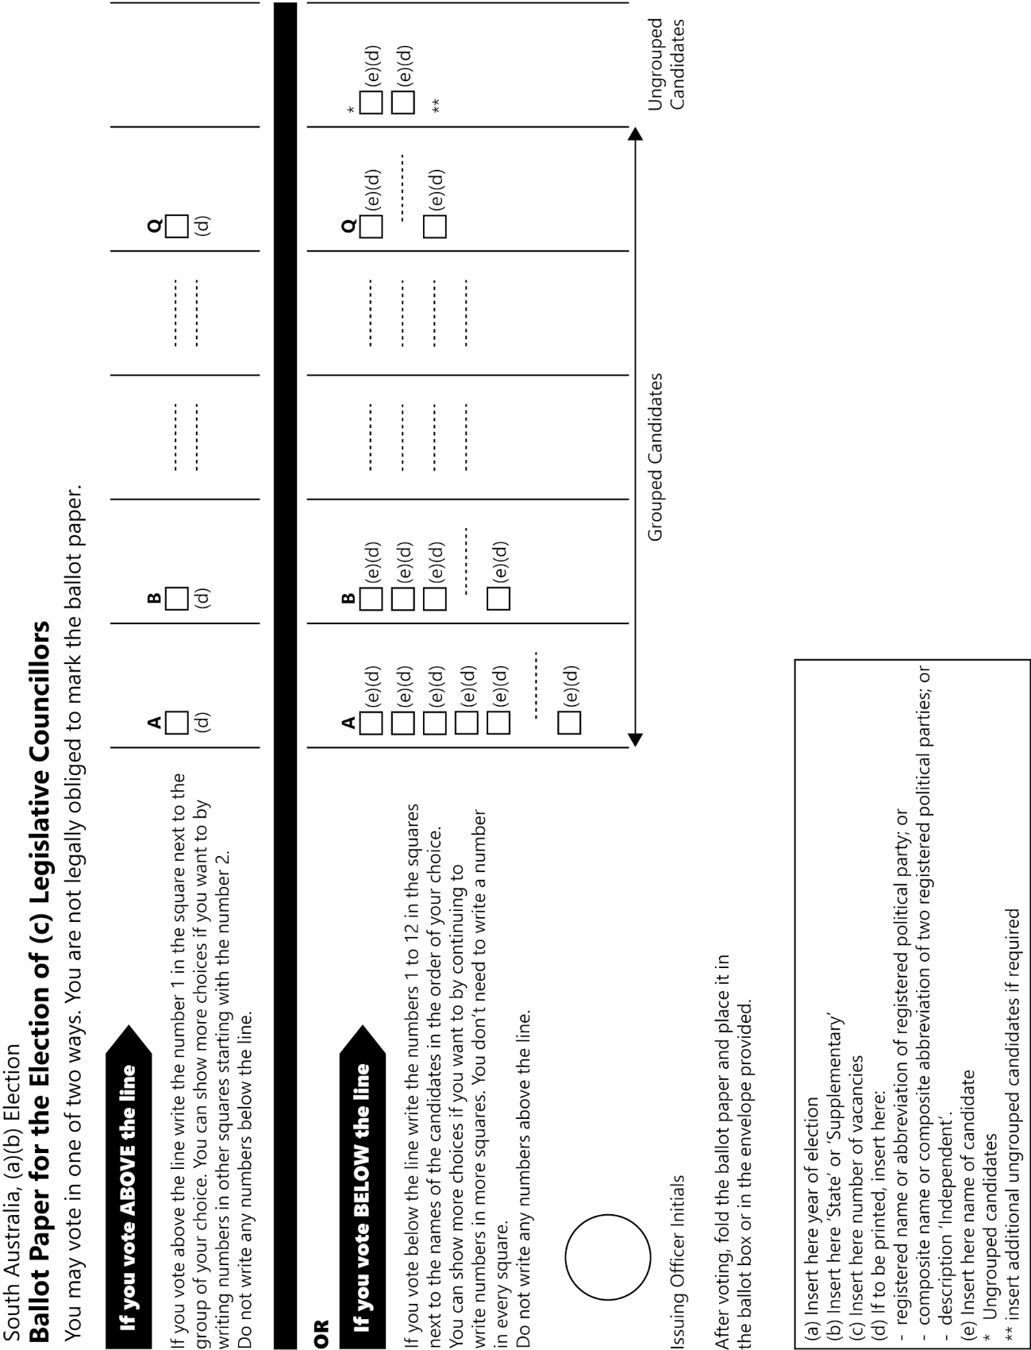
Form 2

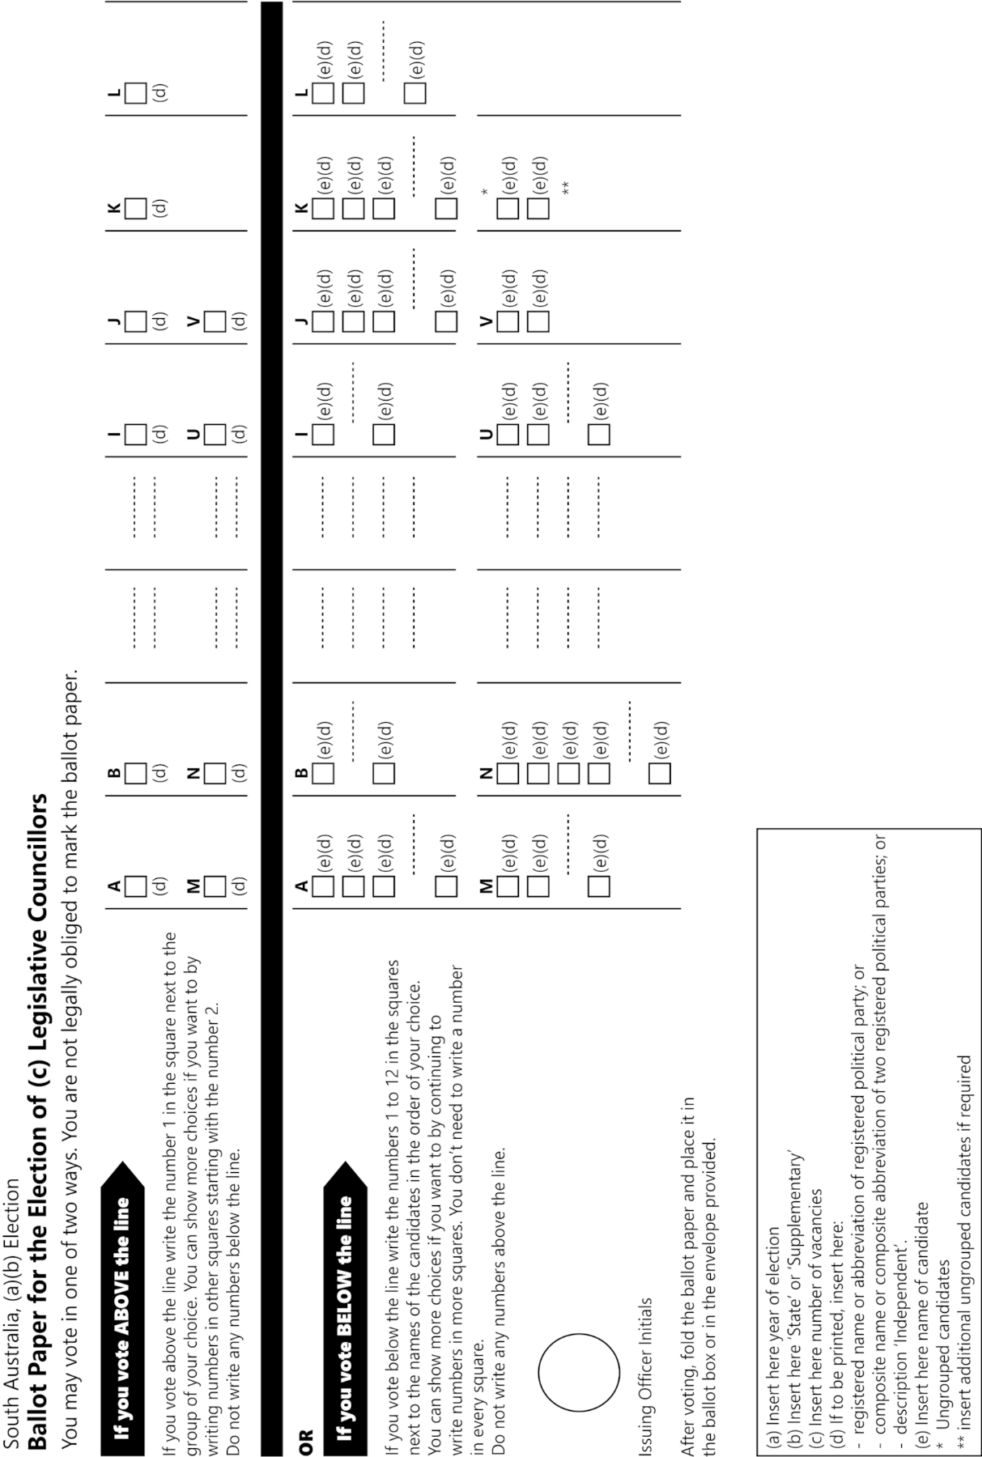
Form 3

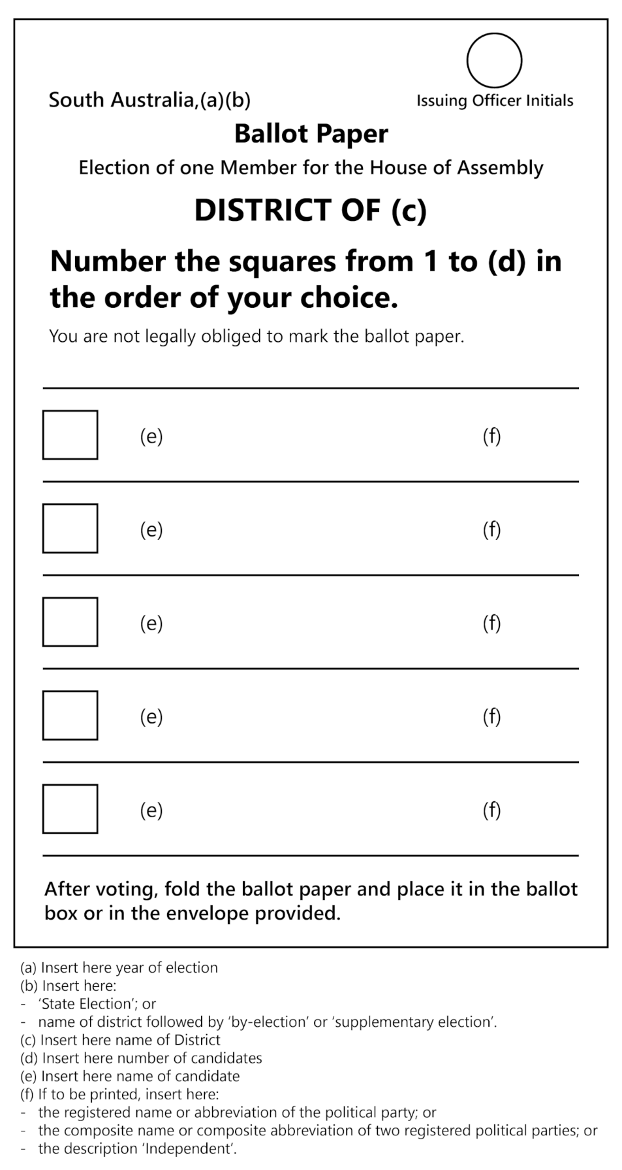
Form 4

Form 5
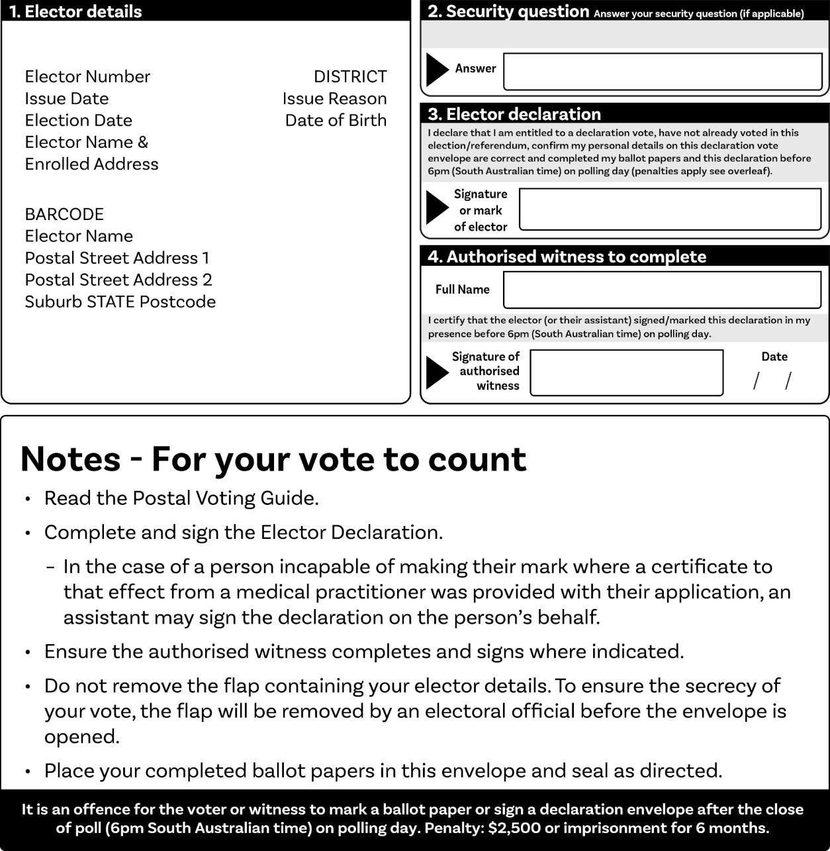
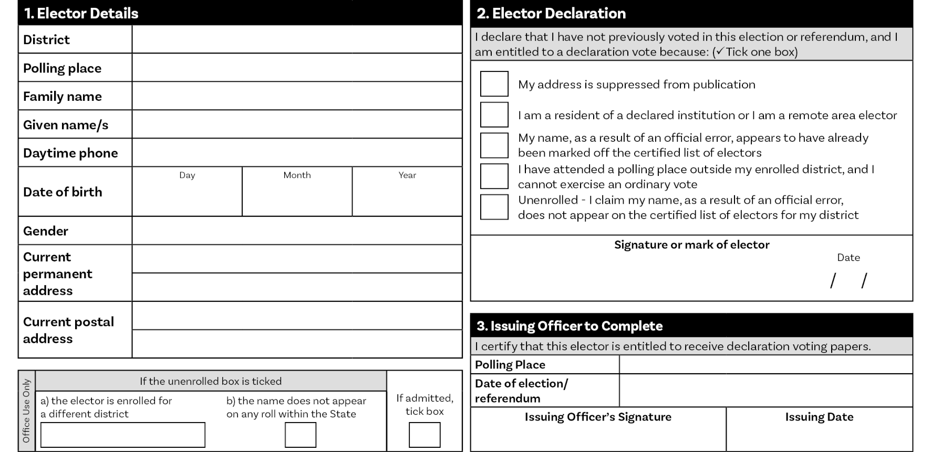
Form 6
Form 7
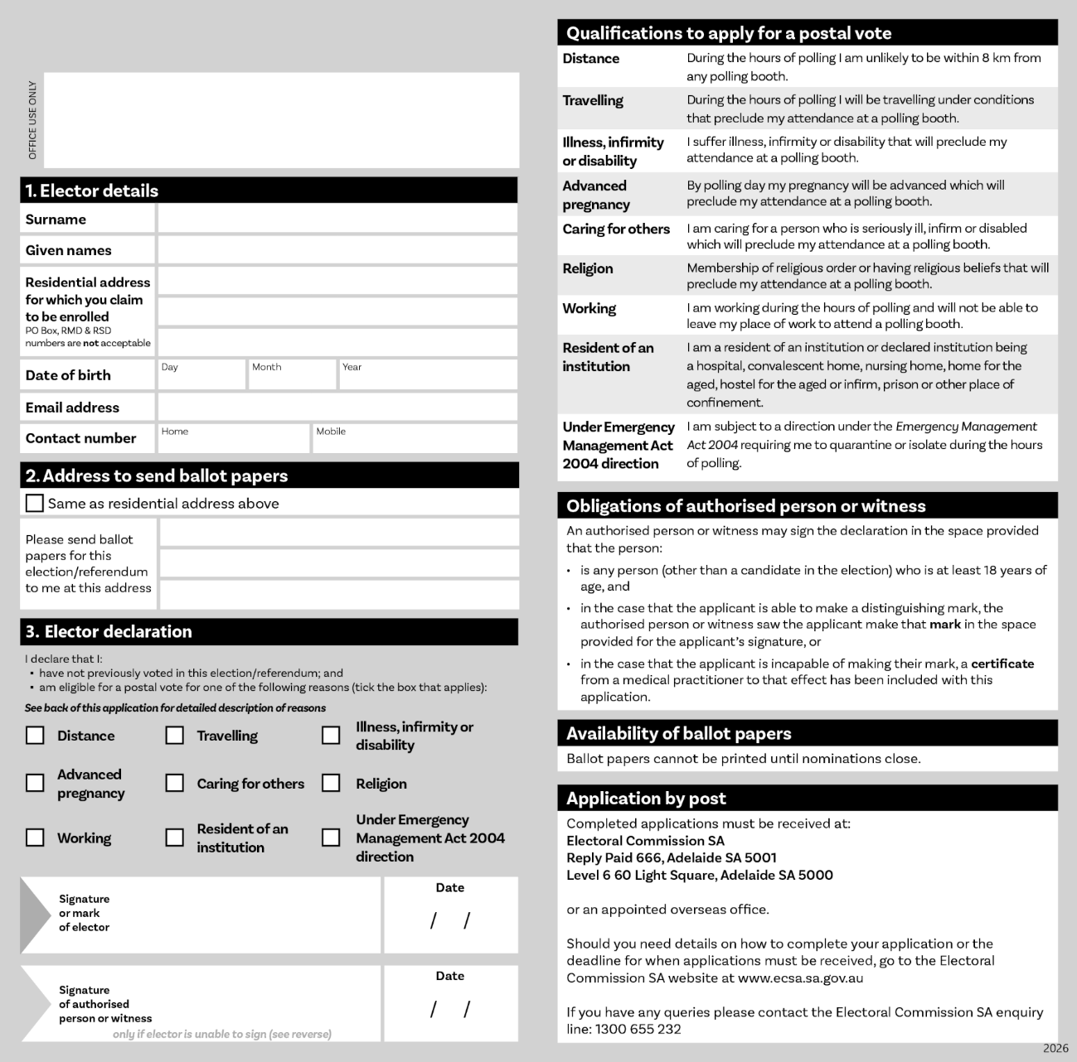
Editorial note—
As required by section 10AA(2) of the Legislative Instruments Act 1978, the Minister has certified that, in the Minister's opinion, it is necessary or appropriate that these regulations come into operation as set out in these regulations.
Made by the Governor
with the advice and consent of the Executive Council
on 11 December 2025
No 142 of 2025

State Government Instruments

Associations Incorporation Act 1985
Direction Pursuant to Sections 20, 22 and 24 of the Associations Incorporation Act 1985 (the Act)
I, the Honourable Andrea Michaels MP, Minister for Consumer and Business Affairs in and for the State of South Australia, being the Minister of the Crown to whom the administration of the Associations Incorporation Act 1985 has been committed to do, pursuant to the powers conferred by Subparagraph (1)(c)(iv) of Section 20, Subparagraph (4)(c)(iv) of Section 22 and Subparagraph (5)(a)(iv) of Section 24, of the said Act, hereby direct that the Corporate Affairs Commission shall not register any association by a name that is a name of a kind mentioned hereunder:
1. Names that are likely to be confused with or mistaken for:
(a) the name of an incorporated association, building society, registered co-operative, credit union, or friendly society; or
(b) a registered business name; or
(c) a name reserved or registered under the Corporations Law of the Commonwealth.
2. Names that are likely to be offensive to members of the public or members of any section of the public.
3. Names containing the following words or phrases or any abbreviation thereof or any words, phrases or abbreviation of like import:
‘Trust’, ‘Trustee’, ‘Chamber of Commerce’, ‘Chamber of Manufacturers’, ‘Chartered’, ‘Stock Exchange’, ‘Guarantee’, ‘Building Society’, ‘Made in Australia’, ‘Proprietary’, ‘Unlimited’, ‘Corporation’, ‘Executor’, ‘Order of St John’, ‘Credit Union’, ‘Friendly Society’, ‘Consumer’, ‘Savings’, ‘University’, ‘College of Advanced Education’ or ‘Institute of Advanced Education’, ‘Cooperative’, ‘Institute of Vocational Education’.
4. Names which in the context in which they are proposed to be used are capable of suggesting:
(a) connection with a member of the Royal Family when the connection suggested does not exist; or
(b) that Royal Patronage has been received when this is not the case.
5. Names which, in the context in which they are proposed to be used, are capable of suggesting connection with the Crown, the Government of the Commonwealth of Australia or of a State or Territory, or any other part of the Queen’s or King’s dominions, possessions or territories.
6. Names which include the words ‘Commonwealth’ or ‘Federal’.
7. Names which, in the context in which they are proposed to be used, are capable of suggesting connection with the Government of a foreign country.
8. Names which, in the context in which they are proposed to be used, are capable of suggesting connection with a department, authority or instrumentality of the Government of the Commonwealth of Australia or of a State or Territory or with a municipal or other local authority.
9. Names containing the abbreviation ‘R.S.L.’ or phrase ‘Returned and Services League’ where the abbreviation or phrase is capable of suggesting a connection with an ex-servicemen’s or ex-servicewomen’s organisation, or names which, in the context in which they are proposed to be used, are capable of suggesting:
(a) connection with ex-servicemen’s or ex-servicewomen’s organisations when the connection suggested does not exist; or
(b) that the members of an organisation are totally or partially incapacitated when this is not the case.
10. Names containing the phrases ‘returned servicemen’ or ‘returned servicewomen’, unless the applicant is a body that provides services of or engages in activities for:
(a) an educational, charitable or benevolent purpose for returned servicemen or servicewomen; or
(b) for a purpose promoting the interest of returned servicemen or servicewomen.
11. Names which, in the context in which they are proposed to be used, are capable of suggesting connection with Saint Mary MacKillop, where the connection does not exist.
The direction dated 29 January 2020 is hereby revoked.
Dated: 8 December 2025
Andrea Michaels MP
Minister for Consumer and Business Affairs

Dangerous Substances Act 1979
Authorised Officers
I, Glenn Stephen Farrell, Executive Director, SafeWork SA in my capacity as the Competent Authority, hereby appoint the following persons as an Authorised Officer for the purposes of the Dangerous Substances Act 1979 pursuant to Section 7(1) of the Dangerous Substances Act 1979:
Heidi Lee APPLEBEE
Jarryd Evan ATKINSON
MA. Carmen Suarez ESTRADA
Robert William Alex FAULDS
Marie Charlene Beatrice FLEURY
Jeremy Michael James FORBES
Kristopher Lee FULLER
Angas Hermann HARNACK
Simon James HOLSTEIN
Roger Charles INGERSON
Wan Poh LEE
Troy Richardson MANSFIELD
Cristian Andres PALACIO LUNA
Dale Patrick THATCHER
Michael Leigh WALTERS
Ryan Moore NICHOLLS
Trudy-Ann Louise WERTHEIM
Ashlee Sonia ROFFEY
Dylan WILBE
Dated: 2 December 2025
Glenn Farrell
Executive Director
Safework SA
Competent Authority

Education and Children’s Services Act 2019
Amending the Constitution of a Governing Council for a Government Preschool
I, Kathryn Jordan, Executive Director, Preschools and Early Childhood Services, Schools and Preschools, consider it necessary to amend the constitution of Sturt Street Community School Preschool to ensure that it takes the form of the proposed model constitution for children’s services centres, and to reflect the change of name to the Sturt Street Children’s Centre for Early Childhood Development and Parenting Preschool Incorporated. Therefore, in accordance with Section 22(1) and (2) of the Education and Children’s Services Act 2019, I amend the governing council’s constitution such that it now reads as follows:
Sturt Street Children’s Centre for Early Childhood Development
and Parenting Preschool Incorporated
Constitution
Table of Contents
1. Name
2. Interpretation
3. Object and Establishment
4. Powers of the Centre
5. Membership of the Centre
6. Meetings of the Centre
7. The Governing Council
8. Voting
9. Minutes
10. Finances and Accounts
11. Audit
12. Reporting
13. Seal
15. Amendment of Constitution and Rules
16. Dissolution
17. Liability
Children’s Services Centre Constitution
(Under Education and Children’s Services Act 2019)
1. Name
The name of the Children’s Services Centre is the Sturt Street Children’s Centre for Early Childhood Development and Parenting Preschool Incorporated (hereinafter called ‘the Centre’).
2. Interpretation
In this constitution, unless the contrary intention appears:
‘the Act’ means the Education and Children’s Services Act 2019
‘administrative instruction’ means an administrative instruction issued by the Chief Executive (or delegate) pursuant to Section 9 of the Act
‘Centre Staff’ means persons employed to work at the Centre who are employed by the Chief Executive or who are employed by the Centre on terms and conditions approved by the Chief Executive
‘Chairperson’ means the presiding member of the Council
‘Chief Executive’ means the Chief Executive of the administrative unit of the Public Service responsible for assisting the Minister with the administration of the Act
‘Child Care Service’ means Sturt Street Community Child Care Inc;
‘Children’s Services Centre’ means a stand-alone children’s services centre continuing in existence under Section 26 of the Act at which one or more children’s services are provided
‘children’s service provided by the Centre’ means a children’s service run by the Centre and funded by the department. To avoid doubt, this does not include children’s services offered by external agencies co-hosted at the Centre
‘Council’ means the Governing Council of the Centre
‘Council member’ means member of the Council
‘department’ means the Department for Education
‘Director’ means the person for the time being designated by the Chief Executive as the Director of the Centre
‘Governing Council’ of the Centre means the Governing Council of the Centre continued under Section 26 of the Act
‘meeting’ means an Annual General Meeting or a General Meeting or Special General Meeting of members of the Centre convened in accordance with this constitution
‘member’ means a member of the Centre and whose name appears in the register referred to in Clause 5.2 of this constitution
‘Minister’ means the person to whom the administration of the Act is committed pursuant to the Administrative Arrangements Act 1994
‘parent’—the Act uses the term “person responsible for a child or student”. In this constitution, the term “parent” will be used instead. This term includes parents, guardians, and persons standing in loco parentis to a child, but excludes any person whose custody or guardianship of a child, or whose responsibility for a child, has been excluded under any Act or law (for example, the Family Law Act 1975 (Cth)).
‘preschool’ means a place at which education services are provided to children who have not yet attained the compulsory school age (and preschool education will be taken to have a corresponding meaning) but a reference to a preschool, or to preschool education, will be taken not to include a reference to the provision of primary education to such children at a school.
‘Quality Improvement Plan’ means a document created by the Centre for the purposes of assessing its performance in delivering quality education and care and to plan future improvements
‘Regulations’ means the Education and Children’s Services Regulations 2020
‘School’ means the Sturt Street Community School;
‘special resolution’ of the Council means a resolution for the purposes of removing an office holder from office, passed by a duly convened meeting of the Council if—
(1) at least 14 days written notice has been given to all Council members specifying the intention to propose the resolution as a special resolution; and
(2) it is passed by a majority of not less than three quarters of Council members who vote in person or by proxy at that meeting.
3. Object and Establishment
3.1 The objects and purposes of the Centre are to provide preschool education and other services and activities to further the development, education, care and wellbeing of young children in the community. In provision of these services the Centre shall:
(i) ensure that the children’s services provided to children by the Centre are of a high quality
(ii) ensure the development of an accessible range of education and children’s services that meet the needs of all groups in the community
(iii) promote the involvement of and consultation with persons responsible for children attending, or who are to attend, the Centre and other members of the community in the provision of children’s services to children
(iv) evaluate and monitor the nature of these services to ensure that the highest standards are attained
(v) ensure, as far as possible, that special needs of individual groups of children are addressed by the provision of services from the Centre
(vi) ensure that the Centre, in providing services, does not unlawfully discriminate against a child on the ground of their, or their parents’, gender, mental or physical impairment, religion or race
(vii) do all other such things as may be incidental to the attainment of the objects of the Centre.
3.2 The Centre:
(i) is an incorporated body with perpetual succession and a common seal in accordance with Section 26 of the Act;
(ii) has the powers and functions set out in Section 23 of the Act; and
(iii) has such other powers and functions as may be conferred on it by or under the Act, by the Minister or the Chief Executive, or by this constitution.
4. Powers of the Centre
4.1 For the purposes of carrying out its objectives the Centre may, subject to the Act, to any other law, to this constitution and to any administrative instructions issued by the Chief Executive:
(i) with the written consent of the Minister, acquire, hold, deal with and dispose of any real property
(ii) acquire, hold, deal with and dispose of any personal property
(iii) administer any property on trust
(iv) open and operate bank accounts
(v) manage its finances in line with the administrative instruction issued by the Chief Executive under Section 9 of the Act
(vi) with the written consent of the Minister, borrow money
(vii) give such security for the discharge of liabilities incurred as it thinks fit
(viii) appoint agents to transact any business on its behalf
(ix) employ staff, except as teachers (in addition to those members of the Centre Staff who are employed by the Chief Executive), on such terms and conditions as are approved by the Chief Executive
(x) enter into any contract it considers necessary or desirable in accordance with the objects of the Centre in Clause 3 of this constitution.
4.2 The Centre will appoint a Governing Council to manage the Centre in accordance with this constitution, the provisions of the Act, other relevant legislation, and any administrative instructions issued by the Chief Executive.
5. Membership of the Centre
5.1 The following persons who have agreed to support the objects are eligible to be members:
(i) parents of children
(a) attending the Centre;
(b) who are to attend the Centre and are enrolled;
(c) who commenced attending the Centre as part of a mid-year intake, and who have completed their preschool program – in which case the parents retain membership for the remainder of the year in which the child completes their program and until the next Annual General Meeting;
(ii) Centre Staff;
(iii) persons who have applied in writing for membership and who are accepted as members by a majority vote at a General Meeting, and who retain membership until the next Annual General Meeting.
5.2 The Secretary of the Council must ensure that a register of the names and addresses of all members is kept and maintained.
5.3 The Council must ensure that persons who are eligible to be members pursuant to Clause 5.1(i) and (ii) of this constitution are notified of that eligibility as soon as practicable after the eligibility arises.
5.4 Membership of the Centre does not confer on members any right, title or interest in any real or personal property of the Centre.
5.5 Membership ceases when a member:
(i) dies
(ii) resigns from membership of the Centre by giving written notice delivered to the Centre
(iii) ceases to be a parent of a child attending, or who is to attend, the Centre, except where the child has completed a preschool program as part of a mid-year intake, as provided for in Clause 5.1(i)(c)
(iv) ceases to be employed as Centre Staff.
5.6 A member whose membership has ceased under 5.5(iii) or (iv) may reapply for membership under Clause 5.1(iii).
5.7 Each member is eligible to vote at annual, special and general meetings of the Centre and for nomination to the Governing Council.
6. Meetings of the Centre
6.1 Annual General Meeting
6.1.1 The Annual General Meeting must be held at least once in each calendar year and the period between each Annual General Meeting must not exceed 16 months.
6.1.2 Members are each entitled to one vote at any Annual General Meeting at which they are present.
6.1.3 The quorum is not less than ten (10) percent of the total members.
6.1.4 If at any Annual General Meeting there is no quorum within thirty (30) minutes of the time appointed for the meeting, the meeting will stand adjourned to a time and place determined by those members present.
6.1.5 The business of the Annual General Meeting will be:
(i) to confirm the minutes of the preceding Annual General Meeting
(ii) to receive the Chairperson’s report for the previous year. The Chairperson must report on:
• strategic and operational plans
• the proceedings and operations of the Council and Centre for the period since the date of the previous Annual General Meeting
• the outcomes of those proceedings in relation to the functions of the Council and the operation of the Centre.
(iii) to receive the Treasurer’s report including an up-to-date statement of receipts and expenditure with respect to all accounts of the Centre, which shall be prepared in accordance with the requirements of this constitution, the Minister, funding agreements in place and administrative instructions published by the Chief Executive.
(iv) where any statement has been subject to an audit, to determine when the audited statement is to be subsequently made available for inspection, at the Centre.
(v) to receive the Director’s report
(vi) to elect or re-elect the Council members, who must consent in writing or in person, and to announce the commencement of the term of nominated and representative members
(vii) to conduct any other business placed on the agenda before the commencement of the meeting.
6.1.6 The Centre must give notice and call for agenda items for the Annual General Meeting no less than fourteen (14) days before the meeting.
6.1.7 Written notice of the Annual General Meeting must be displayed at the premises of the Centre and distributed to all members and to users of the Centre who do not visit the premises regularly.
6.2 General Meeting
6.2.1 General Meetings of the Centre will be held at intervals determined at the Annual General Meeting.
6.2.2 A general meeting must be held:
(i) at least once annually (the Annual General Meeting) to present reports, to elect members to the Council and/or declare election results, as set out in Clause 6.1
(ii) for any other reason relating to the affairs, functions or membership of the Centre, determined by agreement between the Council Chairperson and the Director.

6.2.3 A conference by telephone or other electronic means will be taken to be a general meeting of the Centre community provided that all procedures in this constitution relating to general meetings are complied with and each participating member can communicate with every other participating member during the conference.
6.2.4 The Centre must give notice and call for agenda items for a General Meeting no less than fourteen (14) days prior to the meeting.
6.2.5 The Centre must display written notice of the meeting at the Centre and distribute it to all members and to users of the Centre who do not visit the premises regularly.
6.2.6 Members are each entitled to one vote at any General Meeting at which they are present.
6.2.7 A quorum at any General Meeting is ten (10) percent of members.
6.2.8 If at any General Meeting there is no quorum within thirty (30) minutes of the time appointed for the meeting, the meeting will stand adjourned to a time and place determined by those members present.
6.3 Special General Meeting
6.3.1 A Special General Meeting must be called by the Secretary within twenty-eight (28) days of receiving:
(i) a directive of the Council; or
(ii) a written request of three (3) Council members; or
(iii) a written request of six (6) Centre members;
to call a Special General Meeting that specifies the business to be conducted at that meeting.
7. The Governing Council
7.1 Membership
7.1.1 The Council must comprise no less than 5 Council members and no more than 12 Council members, all of whom must be members of the Centre.
7.1.2 The Council members must include:
(i) a majority of members who are parents of the Centre
(ii) the Director of the Centre
(iii) a staff representative for the preschool service, elected by the Centre Staff who are employed for the provision of the preschool service
(iv) one representative nominated by any other children’s service provided by the Centre.
7.1.3 The Council members may include up to three individuals:
(i) representing services provided at the Centre that are not children’s services provided by the Centre; and/or
(ii) appointed by the Council from the local community who have specific skills and expertise or perspectives that will contribute to the effectiveness of the Council and the Centre.
7.1.4 All Council members will have one vote each.
7.2 Functions of the Governing Council
7.2.1 The Council is responsible for involving the Centre community in the governance of the Centre by:
(i) providing a focus and forum for the involvement of parents and the Centre community
(ii) ensuring that the cultural and social diversity of the community is considered and particular needs are appropriately identified.
7.2.2 The Council is responsible for setting the broad direction and vision of the Centre and strategic planning for the Centre including:
(i) developing, monitoring and reviewing the objectives and targets of the Centre’s Quality Improvement Plan
(ii) determining the application of the total financial resources available to the Centre including the regular review of the budget
(iii) reporting to the Centre community and the Minister on:
(a) the finances of the Centre
(b) operational plans and the Council’s operations.
7.2.3 The Council is responsible for determining policies for the Centre.
7.2.4 The Council may appoint such officers and employees as are required to carry out the objects of the Centre.
7.2.5 The Council may in accordance with Clause 7.15 of this constitution establish sub committees as required from time to time to further the objectives of the Centre.
7.2.6 The Council may raise money for Centre-related purposes, in accordance with administrative instructions.
7.2.7 The Council may perform such functions as necessary to further and attain the objects of the Centre.
7.2.8 The Council may do all those acts and things incidental to the exercise of these functions.
7.3 Functions of the Director on the Governing Council
7.3.1 The functions of the Director on Council are undertaken in the context of the Director’s joint responsibility with the Council for the governance of the Centre.
7.3.2 The Director is answerable to the Chief Executive for providing educational leadership in the Centre and for other general responsibilities prescribed in the Act and Regulations.

7.3.3 The Director must also:
(i) implement the Centre’s Quality Improvement Plan and Centre policies
(ii) provide accurate and timely reports, information and advice relevant to the Council’s functions
(iii) report on learning and care outcomes
(iv) supervise and promote the development of Centre Staff
(v) be responsible for the financial, physical and human resource management of the Centre
(vi) be an ex-officio member of Council with full voting rights
(vii) be the returning officer for the election, nomination and appointment of councillors if called upon to do so
(viii) contribute to the formulation of the agenda of Council meetings.
7.4 Election of Council Members
7.4.1 The Secretary must call for nominations for membership of the Council no less than fourteen (14) days prior to the Annual General Meeting, by notice displayed on the premises occupied by the Centre.
7.4.2 Subject to Clause 7.4.3, any parent is eligible to nominate for election as a Council member.
7.4.3 A person is not eligible for election, appointment or nomination to the Council if the person:
(i) is an undischarged bankrupt or is receiving the benefit of a law for the relief of insolvent debtors; or
(ii) has been convicted of:
(a) any offence of dishonesty
(b) any offence of a sexual nature involving a minor or
(c) any offence of violence against a person; or
(iii) has been issued with a barring notice in accordance with Part 8 of the Act;
(iv) has had an intervention order has been issued against them in accordance with the Intervention Orders (Prevention of Abuse) Act 2009, or had a foreign intervention order as defined in that Act issued against them;
(v) is a prohibited person in accordance with the Child Safety (Prohibited Persons) Act 2016;
(vi) is not compliant with, or states that they will not comply with, directions issued under the Emergency Management Act 2004 or the South Australian Public Health Act 2011;
(vii) is serving a sentence of imprisonment (whether or not the sentence is suspended, or being served in the community on home detention or under an intensive correction order); or
(viii) has been removed from a governing council pursuant to Section 27 or Section 44 of the Act.
7.4.4 If at any election there are fewer nominations than vacancies to be filled, additional nominations will be called for and accepted at the meeting at which the election is to take place.
7.4.5 In the event of there being a greater number of nominations than required for a particular office, a ballot for election must be conducted.
7.4.6 All Council members must be elected by a majority vote of all those Centre members present and voting.
7.4.7 The new Council comes into operation at the declaration of the election.
7.5 Term of Office
7.5.1 Elected and appointed Council members will hold office for a term not exceeding two years.
7.5.2 Nominated staff representatives will hold office for a term not exceeding one year subject to being a member of the Centre Staff.
7.5.3 Upon expiry of the term of office, each Council member will remain incumbent until the position is declared vacant at the Annual General Meeting.
7.5.4 All Council members are eligible for subsequent re-election or appointment, unless they cease to be a member of the Centre or are not re-nominated as a representative of an eligible group as per Clause 7.1.2(iv).
7.5.5 The Council may appoint a person to temporarily fill a casual vacancy in its membership until a Council member can be elected, nominated or appointed in accordance with this constitution.
7.6 Removal of a Council Member
7.6.1 A Council member ceases to be a Council member if they:
(i) die
(ii) complete their term of office and they are not reelected, re-nominated or re-appointed
(iii) resign in writing
(iv) are removed as a Council member of the Centre in accordance with Clause 7.6.2
(v) in circumstances where they are a staff representative for the preschool service or a representative nominated by any other children’s service provided by the Centre, they are no longer a member of the Centre Staff or part of the other service
(vi) during their term as a Council member, are sentenced to or are serving a term of imprisonment (whether or not the sentence is suspended, or being served in the community on home detention or under an intensive correction order)

(vii) are a parent member and:
(a) they are no longer a parent of a child enrolled at or attending the preschool, except where the child has completed a preschool program as part of a mid-year intake, in which case the Council member may continue as a Council member for the remainder of the year of completion and until the next Annual General Meeting; or
(b) their guardianship or custody of, or responsibility for, a child enrolled at or attending the preschool is, during their term as a Council member, excluded under any Act or law
(viii) let their working with children check issued under the Child Safety (Prohibited Persons) Act 2016 lapse
(ix) become a prohibited person in accordance with the Child Safety (Prohibited Persons) Act 2016
(x) are issued with a barring notice under Part 8 of the Act
(xi) are removed from the Council by the Minister in accordance with Section 27 of the Act
(xii) have an intervention order issued against them in accordance with the Intervention Orders (Prevention of Abuse) Act 2009, or with a foreign intervention order as defined in that Act.
7.6.2 A Council member’s position will be vacated after absence for three consecutive Council meetings without leave. Acceptance of an apology at the Council meeting will be deemed a grant of such leave.
7.6.3 The Council may resolve to expel a Council member upon a charge of conduct detrimental to the interests of the Centre, subject to giving a Council member an opportunity to be heard or to make a written submission. Reasons for expulsion include, but are not limited to:
(i) being undischarged bankrupt or receiving the benefit of a law for the relief of insolvent debtors
(ii) conviction of:
(a) any offence of dishonesty
(b) any offence of a sexual nature involving a minor or
(c) any offence of violence against a person.
7.6.4 If there is a motion to expel a Council member, the Council must provide written particulars of the charge to the Council member concerned at least fourteen (14) days prior to the Council meeting at which the motion is to be considered.
7.6.5 Expulsion may only occur where the resolution is carried by a not less than two-thirds majority vote at a Council meeting.
7.6.6 Voting on expulsion must be by secret ballot.
7.6.7 Notice of any expulsion must be given in writing to the last known address of the Council member and will be deemed to have been received on the third business day following the posting of such notice. In addition, the Council member will be provided a written notice by electronic mail to the person’s last known electronic mail address.
7.6.8 A Council member may be expelled for such period as the Council may decide.
7.6.9 Any expelled Council member may require the expulsion to be reconsidered at a Special General Meeting called for that purpose. The Council member’s request for reconsideration at a Special General Meeting must be received no more than two weeks after the expelled Council member receives written notification of their expulsion.
7.6.10 An affirmative vote of at least two thirds of the members present at the Special General Meeting convened for the purposes of reconsidering the proposed expulsion must be recorded to rescind the expulsion.
7.6.11 A Council member may be removed from the Council, but not from membership of the Centre.
7.6.12 The Director of the Centre may not cease to be a member of the Council without the prior written approval of the Chief Executive.
7.7 Council Office Holders
7.7.1 The office holders of the Council are the Chairperson, Deputy Chairperson (if required), Secretary and Treasurer who must be elected by the Council from amongst its councillors within one month of the Annual General Meeting.
7.7.2 The Council may appoint an Executive Committee comprising the office holders and the Director to meet to carry out business delegated or referred by the Council and to report to subsequent Council meetings.
7.8 Chairperson
The Chairperson:
(i) must not be a member of the Centre Staff or a person employed in an administrative unit for which the Minister is responsible
(ii) must call and preside at the meetings of the Council and the Executive Committee. If the Chairperson and deputy Chairperson of the Council are absent or unable to preside at a meeting, a Council member elected by the Council must preside
(iii) must, in consultation with the Director and Secretary, prepare the agenda for all Council and general meetings
(iv) must include on the agenda any item requested by the Director
(v) must facilitate full and balanced participation in meetings by all Council members and decide on the manner in which meetings are conducted and matters of order
(vi) must report at the Annual General Meeting on the proceedings and operations of the Council for the period since the date of the previous Annual General Meeting
(vii) must act as spokesperson on behalf of the Council, unless an alternative spokesperson has been appointed by the Council, and may only comment on Council matters
(viii) at any meeting has a deliberative vote and does not have a casting vote if votes are equal.

7.9 Secretary
The Secretary must:
(i) ensure that notices of meetings are given in accordance with the provisions of this constitution
(ii) ensure, prior to each meeting, that a copy of the meeting agenda is forwarded to each Council member
(iii) ensure that the minutes of meetings are recorded and forwarded to each Council member prior to the next meeting
(iv) conduct the official correspondence of the Council
(v) be responsible for ensuring the maintenance and safekeeping of:
• the constitution and the code of practice of the Council
• official records of the business of the Council and a register of minutes of meetings
• copies of notices and a file of correspondence and records of submissions or reports made by or on behalf of the Council
• the register of members of the Centre and Council members
• contracts or agreements entered into by the Centre
• copies of policies of the Centre
• the Common Seal, and must record of every use of the Common Seal.
7.10 Treasurer
The Treasurer must:
(i) not be a member of the Centre Staff
(ii) be the Chairperson of, and preside at the meetings of, the Finance Advisory Committee of the Council (if the Centre has such a committee)
(iii) be aware of the bank accounts held by the Centre
(iv) ensure that the Centre’s financial budgets and statements are prepared
(v) submit a financial management report to each Council meeting
(vi) must at the Annual General Meeting provide a report including an up-to-date statement of receipts and expenditure with respect to all of the Centre’s accounts
(vii) ensure that, where the Centre has been subject to an audit, the most recent audited accounts are presented to the Annual General Meeting.
7.11 Removal of an Office Holder
7.11.1 The position of any office holder absent for three (3) consecutive executive committee meetings without leave automatically becomes vacant. Acceptance of an apology will be deemed a grant of such leave.
7.11.2 An office holder of the Council may be removed from office, but not from membership of the Council, by special resolution of the Council provided that:
(i) at least 14 days written notice is given to all Council members and to the office holder concerned, of any proposed resolution, giving reasons for the proposed removal
(ii) the office holder is given the right to be heard at the Council meeting
(iii) voting on the special resolution is by secret ballot.
7.12 Proceedings of the Council
7.12.1 The Council will meet as often as may be required to conduct the business of the Centre but not less than eight (8) times each calendar year at intervals not exceeding ninety (90) days.
7.12.2 Notice of meetings must be provided at the previous Council meeting or by at least seven (7) days written notice distributed to all Council members, or in an emergency by such other notice as shall be ratified by the Council. Notice of meetings must be posted in a prominent place on a notice board at the premises of the Centre.
7.12.3 A conference by telephone or other electronic means between the Council members will be taken to be a meeting of the Council provided that all procedures in this constitution relating to Council meetings are complied with and each participating member can communicate with every other participating member during the conference.
7.12.4 Where there are one or more vacancies in the membership of the Council, the Council is not prevented from acting.
7.12.5 The Council may from time to time determine procedures to facilitate and expedite its business.
7.12.6 All acts done or performed by the Council or a sub-committee or an officer or employee of the Centre will, notwithstanding that it is afterwards discovered that there was some defect in the appointment, be as valid as if the Council, sub-committee, officer or employee has been duly appointed and was properly qualified.
7.12.7 At Council meetings:
(i) a quorum will be the majority of the filled positions. If at the expiration of thirty (30) minutes after the appointed time for the meeting there is not a quorum present, the meeting will stand adjourned to a time and place determined by those members present
(ii) resolutions must be passed by a majority of the Council members present and voting
(iii) the Chairperson will have a deliberative vote only. In the event of a tied vote, the Chairperson does not have a second or casting vote and the motion must be taken to be defeated
(iv) any member of the Centre may attend any Council meeting as an observer without voting rights; however the Council has the right to determine that a particular meeting or part of it is closed to observers in order to deal with confidential business of the Centre.

7.13 Extraordinary Council Meetings
7.13.1 The Chairperson or two (2) other members of the Council, by written request, have the power to call an extraordinary meeting of the Council.
7.13.2 Written notice of the meeting must be given to all Council members within a reasonable time, setting out the time, date, place and object of the meeting.
7.13.3 The business of any extraordinary meeting must be confined to the object for which it is convened.
7.14 Conflict of Interest
7.14.1 Council members who are also employed at the Centre must not take part in decisions relating to their employment and, at the request of a majority of the Council, must absent themselves from any relevant deliberations.
7.14.2 A Council member who has a direct or indirect pecuniary interest in a contract or proposed contract with the Centre must:
(i) disclose the nature of the interest to the Council as soon as the Council member becomes aware of the interest
(ii) not take part in deliberations or decisions of the Council with respect to that contract
(iii) not vote in relation to that contract and
(iv) be absent from the meeting room when any such discussion or voting is taking place.
7.14.3 A disclosure of such interest must be recorded in the minutes of the Council.
7.14.4 If a Council member discloses an interest in a contract or proposed contract:
(i) the contract is not liable to be avoided by the Council on any ground arising from the fiduciary relationship between the Council member and the Council
(ii) the Council member is not liable to account for the profits derived from the contract.
7.14.5 This Clause does not apply in relation to a contract in which a Council member has an interest while the Council member remains unaware that they have an interest in the contract, but in any proceedings against the Council member the burden will lie on the Council member to prove that they were not, at the material time, aware of the interest.
7.15 Sub-committees
7.15.1 The Council may appoint sub-committees comprising Council members and non-Council members for specific purposes who shall meet as directed by the Council, and who shall report to the Council as required by the Council.
7.15.2 Any sub-committee must consist of at least three (3) people and at least one of those must be a Council member.
7.15.3 The Council must specify terms of reference for its sub-committees.
8. Voting
8.1 Members of the Centre and appointed Council members only are eligible to vote at any meeting of the Centre.
8.2 At the discretion of the Chairperson, persons with special interests or knowledge relevant to the Centre may be invited to attend any meeting and to speak, but such persons may not vote.
8.3 Voting at all meetings must be by a show of hands except when the majority of the meeting supports a secret ballot and in the case of:
(i) a contested election at an Annual General Meeting
(ii) a motion to remove a Council member or office holder
(iii) where the Centre is voting to close or amalgamate.
9. Minutes
9.1 Proper minutes of all meetings of the Centre and of the Council must be kept in a location created for that purpose. A copy of any reports presented must be kept with the minutes.
9.2 The minutes must be confirmed by members at the subsequent meeting, and signed by the Chairperson of the meeting at which the proceedings took place or by the Chairperson of the subsequent meeting.
9.3 Upon reasonable notice, the minutes of any meetings must be made available for inspection by any member.
9.4 A copy of any minutes required by the Chief Executive must be forwarded to the Chief Executive by the Council.
10. Finances and Accounts
10.1 Revenue additional to grants from the Minister must be derived from contributions by parents, donations from others, fundraising and any other arrangements allowed by the administrative instructions issued by the Chief Executive. The Centre may set the level of contribution for parents, as determined by the Council, in relation to the children’s services at the Centre.
10.2 No child will be excluded from the department-funded preschool service operated at the Centre because of the inability of the child’s parents to contribute financially or for non-payment.
10.3 The Centre may only borrow money with the Minister’s written consent.
10.4 The Centre is not able to hold and invest funds outside of banking arrangements outlined in this constitution without the approval of the Chief Executive.
10.5 The property and funds of the Centre must only be used towards the promotion of its objects and must not be paid or transferred to the members or relatives of members. Centre Staff and Council members and their associates must not personally benefit from purchases. This does not prevent any payment in good faith to any person in return for services actually rendered or to any person in the promotion of the objects of the Centre and without undue preference.
10.6 All accounts must be operated on the basis of the designated financial year as specified in Clause 11.1.
10.7 Accounts must be kept in accordance with the provisions of the Act, the Regulations, this constitution and administrative instructions issued by the Chief Executive.
10.8 The Chief Executive may mandate that the Centre maintains appropriate financial records using accounting systems approved by the Chief Executive.
11. Audit
11.1 The financial year for the Centre is 1 January to 31 December.
11.2 The Centre must make available to the Chief Executive or the Auditor-General any accounts under its control, including all relevant records and papers connected with an account, for inspection or audit at any time.
11.3 The Centre may arrange for accounts to be audited at such other intervals as the Council determines, by a person appointed by the Centre.
11.4 The audit of any of the Centre’s accounts must be in accordance with the provisions of the Act, the Regulations, administrative instructions and this constitution.
12. Reporting
12.1 The Council must report to the Centre members at least once a year, at the Annual General Meeting.
12.2 The Council must report to the Minister at least once a year, in accordance with administrative instructions.
13. Seal
13.1 The Council, through the Secretary, must provide for the safe custody of the Common Seal of the Centre.
13.2 The Seal must not be affixed other than pursuant to a resolution of the Council. The Seal must be affixed in the presence of at least two (2) members of the Council, one of whom must be an office bearer.
14. Records and Access
14.1 Staff of the department and any other person authorised by the Chief Executive must be given access to the records, environs and property of the Centre when requested.
14.2 The Council must provide any information concerning the operations of the Centre that may be required from time to time by the Chief Executive or his/her nominee.
15. Amendment of Constitution and Rules
15.1 This constitution may be amended by the Council subject to a resolution of two-thirds of Centre members present and voting at a general meeting of the Centre, provided that not less than fourteen (14) days written notice of the meeting, including notice of the proposed amendment, has been distributed to all members.
15.2 An amendment by the Council in accordance with 15.1 has no effect until approved by the Minister in accordance with Section 22 of the Act.
15.3 The Minister may, in accordance with Section 22 of the Act, amend this constitution or direct that it be amended.
15.4 Rules for the proper administration of meetings or business may be made, repealed or amended by a General Meeting, or by a Council Meeting subject to subsequent disallowance at a General Meeting, provided that not less than fourteen (14) days written notice of the meeting, including notice of the proposed new rule, repeal or amendment, has been distributed to all members.
16. Dissolution
16.1 The Centre cannot be dissolved except by:
16.1.1 approval of not less than two-thirds members present and voting at a Special General Meeting called for that purpose, for which at least one (1) month’s written notice, including notice of the proposed dissolution, has been given to all members; or
16.1.2 the Chief Executive who may, by one (1) month’s written notice, direct that the Centre be dissolved in the following circumstances:
(i) the Minister has withdrawn funding for the Centre
(ii) the Council has acted beyond the powers conferred by this constitution
(iii) the Centre has failed to comply with a notice to amend this constitution pursuant to a direction of the Minister in accordance with Section 22(3) of the Act
(iv) any other proper reason exists; or
16.1.3 the Minister in accordance with:
(i) Section 29(5) of the Act
(ii) a written notice published in the Gazette pursuant to Section 26A declaring the Centre to be established under Division 2 of the Act.
16.2 On dissolution, all property, rights and liabilities vested in or attached to the Centre will vest in the Minister.
16.3 The Council may provide recommendations to the Minister concerning the transfer and/or dispersal of all or part of the Centre’s assets to another children’s services centre or other entity having similar objectives to those of the Centre.
17. Liability
17.1 No member of the Centre will be liable for the debts and liabilities of the Centre.
17.2 Membership of the Centre does not confer on members any right, title or interest in any real or personal property of the Centre.
17.3 Persons who, by authority, accept or incur any pecuniary liability on behalf of the Centre will be held indemnified against any personal loss in respect of such liability.
17.4 Members of the Council, Council Office holders and subcommittees appointed pursuant to 7.2.5 will be indemnified against any civil liability which attaches for a bona fide act or omission in the exercise or purported exercise of their powers or functions under this constitution.
18. Code of Practice
Members of the Council must comply with the code of practice approved by the Minister.

19. Dispute Resolution
The Council must participate in a scheme for the resolution of disputes between the Council and the Director, as set out in Appendix 1 to this Constitution.
20. Public Access to the Constitution and Code of Practice
The Council must keep available for public inspection a copy of its constitution (as in force from time to time) and the code of practice, at the Centre, during the normal operating hours of the Centre.
Appendix 1
Scheme for the Resolution of Disputes Between the Council and the Director
Where the governing council considers it is in dispute with the Director, the chairperson will ensure the dispute is recorded appropriately in the minutes at a formal meeting of the council.
The governing council must be operating within the scope of its designated role and function, that is, the dispute must be in relation to the powers and functions of council.
At its next meeting, the governing council must move and pass a formal resolution by a majority of the council members present and eligible to vote that independent mediation is required.
The chairperson must then write to the Education Director with line management of the relevant Director detailing the nature of the and issues in dispute. The chairperson and Education Director will then jointly agree on the appointment of an independent mediator.
Once appointed, the independent mediator, in accordance with their professional conduct rules, will convene a meeting of representatives of both the governing council and the department to help them identify the issues, explore options, and, if possible, agree to a quick resolution of the dispute.

These amendments take effect from the 27 January 2026.
Dated: 11 December 2025
Kathryn Jordan
Executive Director, Preschools and Early Childhood Services, Schools and Preschools
Delegate of the Minister for Education, Training and Skills

Education And Children’s Services Act 2019
Amending the Constitution of a Governing Council for a Government School
I, Caroline Fishpool, Lead Director, Conditions for Learning, Schools and Preschools, consider it necessary to amend the constitution of Sturt Street Community School to ensure that it takes the form of the model constitution for a school without a school-based preschool, and therefore in accordance with Section 40(1) and (2) of the Education and Children’s Services Act 2019, I amend the governing council’s constitution such that they now read as follows:
Sturt Street Community School Governing Council Incorporated
Constitution
Table of Contents
1. Name
2. Interpretation
3. Object
4. Powers of the Governing Council
5. Functions of the Council
6. Functions of the Principal on Council
7. Membership
8. Term of Office
9. Office Holders and Executive Committee
9.1 Appointment
9.2 Removal from Office
9.3 The Chairperson
9.4 The Secretary
9.5 The Treasurer
10. Vacancies
11. Meetings
11.1 General Meetings of the School Community
11.2 Council Meetings
11.3 Extraordinary Council Meetings
11.4 Voting
12. Proceedings of the Council
12.1 Meetings
12.2 Conflict of Interest

13. Election of Council Members
13.1 Eligibility for Nomination for Election
13.2 Eligibility to Vote
13.3 Conduct of Elections for Parent Council Members
13.4 Notice of Election
13.5 Election without Ballot
13.6 Contested Elections
13.7 Scrutineers
13.8 Declaration of Election
13.9 Further Nomination for Unfilled Positions
13.10 Nomination and Appointment of Council Members
14. Minutes
15. Subcommittees
15.1 Committees
15.2 Terms of Reference
15.3 Finance Advisory Committee
16. Finance and Accounts
17. Audit
18. Reporting to the School Community and the Minister
19. The Common Seal
20. Records
21. Amendment of the Constitution
22. Code of Practice
23. Dispute Resolution
24. Public Access to the Constitution and Code of Practice
25. Dissolution
26. Prohibition against Securing Profits for Members
Governing Council Model Constitution
(School without a school-based preschool)
1. Name
The name of the council is Sturt Street Community School Governing Council Incorporated.
2. Interpretation
In this constitution, unless the contrary intention appears:
‘the Act’ means the Education and Children’s Services Act 2019 as amended.
‘administrative instructions’ means administrative instructions issued pursuant to Section 9 of the Act.
‘administrative unit’ means a government department or attached office.
‘adult’ means a person who has attained 18 years of age.
‘affiliated committee’ means a committee affiliated with the governing council operating under the model constitution for affiliated committees or a constitution approved by the Minister in accordance with Section 36 and 39 of the Act.
‘chairperson’ means the presiding member of the governing council as referred to in Section 35 (3) of the Act.
‘Chief Executive’ means the Chief Executive of the Department for Education.
‘governing council’ means the Sturt Street Community School Governing Council established under Section 34 of the Act.
‘council member are the members of the governing council.
‘department’ means the Department for Education.
‘financial year’ means the year ending 31 December or as varied by administrative instruction.
‘general meeting’ means a public meeting of the school community.
‘government school’ means a school established under the Act, or a repealed Act and includes (other than for the purposes of Part 5 of the Act) a special purpose school.
‘majority’ means more than half the total number.
‘Minister’ means the person to whom the administration of the Act is committed, pursuant to the Administrative Arrangements Act 1994.
‘parent’—the Act uses the term “person responsible for a child or student”. In this constitution, the term “parent” will be used instead. This term includes parents, guardians, and persons standing in loco parentis to a student or child, but excludes any person whose custody or guardianship of a student or child, or whose responsibility for a student or child, has been excluded under any Act or law (for example, the Family Law Act 1975 (Cth)).
‘principal’ means the person for the time being designated by the Chief Executive as the principal of the school.
‘regulations’ means the Education and Children’s Services Regulations 2020.
‘school’ means a school at which primary or secondary education or both is, or is to be, provided (whether or not preschool education is also provided at the school).
‘school community’ means parents, students enrolled in or children who are to attend the school, staff of the school and all other persons who have a legitimate interest in or connection with the school.
‘school improvement plan’ means the agreement signed by the principal and the presiding member of the council that summarises the school’s contribution to improving student learning at the site.
‘special resolution’ of the council means a resolution passed by a duly convened meeting of the council where:
(1) at least 14 days written notice has been given to all council members specifying the intention to propose the resolution as a special resolution; and
(2) it is passed by a majority of not less than three quarters of council members who vote in person or by proxy at that meeting.
‘student’ is a person enrolled in the school or approved learning program.
3. Object
The object of the council is to involve the school community in the governance of the school to strengthen and support public education in the community.
4. Powers of the Governing Council
4.1 In addition to the powers conferred under the Act, the council may:
4.1.1 employ persons, except as teachers, as members of the staff of the school on terms and conditions approved by the Chief Executive
4.1.2 enter into contracts
4.1.3 construct any building or structure for the benefit of the school, or make any improvements to the premises or grounds of the school, with the approval of the Chief Executive
4.1.4 purchase or take a lease or licence of premises for student residential facilities, and enter into any other agreements or arrangements for the establishment, management, staffing and operation of such facilities
4.1.5 establish and conduct, or arrange for the conduct of, facilities and services to enhance the education, development, care, safety, health or welfare of children and students.
4.1.6 do all those acts and things incidental to the exercise of these powers.
4.2 The Council’s powers must be exercised in accordance with legislation, administrative instructions and this constitution.
5. Functions of the Council
5.1 In the context of the council’s joint responsibility with the principal for the governance of the school, the council must perform the following functions:
5.1.1 involve the school community in the governance of the school by:
(i) providing a forum for the involvement of parents and others in the school community
(ii) determining the educational needs of the local community, and their attitude towards educational developments within the school
(iii) ensuring that the cultural and social diversity of the community is considered and particular needs are appropriately identified.
5.1.2 strategic planning for the school including:
(i) developing, monitoring and reviewing the objectives and targets of the strategic plan
(ii) considering, approving and monitoring human resource and asset management plans.
5.1.3 determine local policies for the school.
5.1.4 determine the application of the total financial resources available to the school including the regular review of the budget.
5.1.5 present plans and reports on the council’s operations to the school community and Minister.
5.2 The council must be responsible for the proper care and maintenance of any property owned by the council.
5.3 The council may perform such functions as necessary to establish and conduct, or arrange for the conduct of:
5.3.1 facilities and services to enhance the education, development, care, safety, health or welfare of children and students;
5.3.2 residential facilities for the accommodation of students.
5.4 The council may raise money for school related purposes.
5.5 The council may perform other functions as determined by the Minister or Chief Executive.
5.6 The council may do all those acts and things incidental to the exercise of these functions.
5.7 The council’s functions must be exercised in accordance with legislation, administrative instructions and this constitution.
6. Functions of the Principal on Council
The functions of the principal on council are undertaken in the context of the principal’s joint responsibility with the council for the governance of the school.
6.1 The principal is answerable to the Chief Executive for providing educational leadership in the school and for other general responsibilities prescribed in the Act and regulations.
6.2 The principal must also:
6.2.1 implement the school’s strategic plan, the school improvement plan and school policies
6.2.2 provide accurate and timely reports, information and advice relevant to the council’s functions

6.2.3 report on learning, care, training and participation outcomes to council
6.2.4 supervise and promote the development of staff employed by the council
6.2.5 be responsible for the financial, physical and human resource management of the school
6.2.6 be an ex-officio member of council with full voting rights
6.2.7 be the returning officer for the election, nomination and appointment of council members
6.2.8 chair the first meeting of the council held for the purpose of receiving nominations from nominating bodies, the direct appointment of council members by the council and the election of office holders
6.2.9 contribute to the formulation of the agenda of council meetings.
7. Membership
7.1 The Sturt Street Community School Governing Council must comprise 11 council members including:
1 | Principal of the school (ex-officio)
6 | Elected parent members
1 | Staff member nominated by the staff of the school (as per ratio in the administrative instructions)
3 | Community members appointed by the council
7.2 The majority of council members must be elected parents of the school.
7.3 At the time of election, nomination or appointment, persons who are on the staff of a government school, persons who are employees of an administrative unit for which the Minister is responsible, and those appointed under the Act or the Technical and Further Education Act 1975, must not comprise the majority of elected parent members and must not comprise the majority of council members.
7.4 In considering any nominations to the council by a nominating body or direct appointments by the council, the council must observe the requirements of 7.3.
7.5 A person is not eligible for election, appointment or nomination to the council, if the person:
7.5.1 is an undischarged bankrupt or is receiving the benefit of a law for the relief of insolvent debtors;
7.5.2 has been convicted of any offence prescribed by administrative instruction;
7.5.3 is subject to any other disqualifying circumstances a prescribed by administrative instruction.
8. Term of Office
8.1 Elected parent members will be appointed for a term not exceeding two years, except in the case of the first council only, where one-half (or, if the total number of council members to be elected is odd, the highest integer that is less than one-half) of the parent members elected at the Annual General Meeting of the school will be elected for a term not exceeding one year.
8.2 A council member nominated by an affiliated committee will be nominated for a term not exceeding two years, subject to the provisions that:
8.2.1 for the first council only, where two or more affiliated committees each nominate a council member, one will be appointed for a term not exceeding one year. The person so appointed must be determined by agreement between the affiliated committees, or on failure to agree, by lot.
8.2.2 the nomination may be revoked, in writing, by the affiliated committee.
8.3 Any council member nominated by the Student Representative Council (or equivalent) or elected by the body of students will hold office for a term not exceeding one year or until the nomination is revoked, in writing, by the nominating body.
8.4 A council member elected by the staff of the school will hold office for a term not exceeding one year subject to being a member of the staff of the school.
8.5 Each council member directly appointed by the council, will serve for a period not exceeding two years.
8.6 Upon expiry of term of office, each council member will remain incumbent until the position is declared vacant at the Annual General Meeting.
8.7 Council members are eligible for subsequent re-election, re-nomination or re-appointment.
9. Office Holders and Executive Committee
9.1 Appointment
9.1.1 The office holders of the council are the chairperson, deputy chairperson, secretary and treasurer who must be elected by the council from amongst its council members within one month of the Annual General Meeting.
9.1.2 The chairperson must not be a member of the staff of the school, a person employed in an administrative unit for which the Minister is responsible.
9.1.3 The treasurer must not be a member of the staff of the school.
9.1.4 The council may appoint an executive committee comprising the office holders and the principal, which is to
(i) meet to carry out business delegated or referred by the council; and
(ii) report to subsequent council meetings.
9.2 Removal from Office
9.2.1 The position of any office holder absent for three consecutive executive committee meetings without leave of absence automatically becomes vacant. Acceptance of an apology at the executive committee meeting will be deemed a grant of such leave.

9.2.2 An office holder of the council may be removed from office, but not from membership of the council, by special resolution of the council, provided that:
(i) at least 14 days written notice is given to all council members and to the office holder concerned of any proposed resolution, giving reasons for the proposed removal;
(ii) the office holder is given the right to be heard at the council meeting;
(iii) voting on the special resolution is by secret ballot.
9.3 The Chairperson
9.3.1 The chairperson must:
(i) call and preside at the meetings of the council and the executive committee;
(ii) in consultation with the principal and secretary, prepare the agenda for all council meetings;
(iii) include on the agenda any item requested by the principal;
(iv) facilitate full and balanced participation in meetings by all council members and decide on the manner in which meetings are conducted and matters of order;
(v) report at the Annual General Meeting on the proceedings and operations of the Council for the period since the date of the previous Annual General Meeting.
9.3.2 The chairperson must act as spokesperson on behalf of the council unless an alternative spokesperson has been appointed by the council. The spokesperson may only comment on council matters.
9.3.3 In the chairperson’s absence or inability to act, the deputy chairperson must undertake any role or function normally fulfilled by the chairperson.
9.3.4 If the chairperson and deputy chairperson of the council are absent or unable to preside at a meeting, a council member elected by the council must preside.
9.4 The Secretary
9.4.1 The secretary must ensure that notices of meetings are given in accordance with the provisions of this constitution.
9.4.2 The secretary is responsible for ensuring the maintenance and safekeeping of:
(i) the constitution of the council and the code of practice;
(ii) official records of the business of the council and a register of minutes of meetings;
(iii) copies of notices, a file of correspondence and records of submissions or reports made by or on behalf of the council;
(iv) the register of council members;
(v) contracts or agreements entered into by the council;
(vi) copies of policies of the council.
9.4.3 The secretary must ensure that copies of the constitution and the code of practice are available for public inspection at the school during normal school hours, and that any copies requested are provided.
9.4.4 The secretary must ensure the safekeeping of the common seal and must ensure a record is kept of every use of the common seal.
9.4.5 Prior to each meeting, the secretary must ensure that a copy of the meeting agenda is forwarded to each council member.
9.4.6 The secretary must conduct the official correspondence of the council.
9.4.7 The secretary must ensure that the minutes of meetings are recorded and forwarded to each council member prior to the next meeting.
9.5 The Treasurer
9.5.1 The treasurer must be the chairperson of the Finance Advisory Committee of the council and preside at the meetings of this committee.
9.5.2 The treasurer must:
(i) ensure that the council’s financial budgets and statements are prepared
(ii) submit a report of those finances to each council meeting;
(iii) present the council’s statement of accounts to the Annual General Meeting.
10. Vacancies
10.1 Membership of the council ceases when a council member:
10.1.1 dies;
10.1.2 in the case of an elected council member or a council member nominated or appointed for a term, completes a term of office and is not re-elected, re-nominated or re-appointed;
10.1.3 ceases to hold office in accordance with 8.2.2 and 8.3;
10.1.4 in the case of a member nominated by the staff of the school, is no longer a staff member of the school;
10.1.5 resigns by written notice to the council;
10.1.6 is removed from office by the Minister in accordance with Section 44 of the Act;
10.1.7 is declared bankrupt or applies for the benefit of a law for the relief of insolvent debtors;

10.1.8 has been convicted of any offence prescribed by administrative instruction;
10.1.9 is subject to any disqualifying circumstance as prescribed by administrative instruction; or
10.1.10 is absent from three consecutive council meetings without leave of absence approved by the council. Acceptance of an apology at a council meeting will be deemed a grant of such leave.
10.2 The council may appoint a person to temporarily fill a casual vacancy in its membership until a council member can be elected, nominated or appointed in accordance with this constitution.
11. Meetings
11.1 General Meetings of the School Community
11.1.1 Subject to 13.2, all persons within the school community are eligible to attend general meetings of the school community and vote on any matters proposed for resolution.
11.1.2 The chairperson of the council must call and preside at general meetings of the school community, the timing to be agreed between the chairperson and the principal of the school.
11.1.3 At least 14 days written notice of the meeting must be given to the school community by the means generally used to communicate with the school community. The notice must specify the date, time and place of the meeting.
11.1.4 A general meeting must be held:
(i) at least once annually (the Annual General Meeting) to present reports, to elect parents to the council and/or declare election results;
(ii) for any other reason relating to the affairs, functions or membership of the council, determined by agreement between the chairperson and the principal.
11.1.5 The period between each Annual General Meeting must not exceed 16 months.
11.1.6 A general meeting must be held to elect council members, to discuss the finances of the council or for any other reason relating to the affairs or functions of the council:
(i) at the request of the Chief Executive;
(ii) by the resolution of the council;
(iii) at the request of 20 parents or one half of the parents of the school, whichever is less.
11.1.7 A conference by telephone or other electronic means will be taken to be a general meeting of the school community provided that all procedures in this constitution relating to general meetings are complied with and each participating member is capable of communicating with every other participating member during the conference.
11.2 Council Meetings
11.2.1 The council must meet at least twice in each school term.
11.2.2 Notice of meetings must be given at the previous council meeting or by at least 7 days written notice distributed to all council members or in an emergency by such other notice as the council may determine.
11.2.3 A conference by telephone or other electronic means between the council members will be taken to be a meeting of the council provided that all procedures in this constitution relating to council meetings are complied with and each participating member is capable of communicating with every other participating member during the conference.
11.3 Extraordinary Council Meetings
11.3.1 The chairperson of the council must call an extraordinary meeting of the council by written request from at least 3 council members.
11.3.2 Notice of meeting must be given by written notice to all council members within a reasonable time, setting out the time, date, place and object of the meeting.
11.3.3 The business of any extraordinary meeting must be confined to the object for which it is convened.
11.4 Voting
11.4.1 Voting must be by show of hands, or in the case of a meeting held pursuant to 11.1.7 and 11.2.3, by voices or in writing, but a secret ballot must be conducted for:
(i) a contested election; or
(ii) a special resolution to remove an office holder from office.
11.4.2 For the purposes of voting on a special resolution, each council member is entitled to appoint another council member as their proxy.
12. Proceedings of the Council
12.1 Meetings
12.1.1 The quorum for a council meeting is a majority of the filled positions of the council.
12.1.2 If at the expiration of 30 minutes after the appointed time for the meeting there is no quorum present, the meeting must stand adjourned to such time and place as those council members present determine.
12.1.3 Except in the case of a special resolution, a decision of the majority of those council members present and eligible to vote is the decision of the council.
12.1.4 The chairperson must have a deliberative vote only. In the event of an equality of votes, the chairperson does not have a second or casting vote and the motion must be taken to be defeated.
12.1.5 The council or any committee of council may, at its discretion, allow non-members who have special interests or knowledge relevant to the council to attend its meetings as observers and, if it agrees, take part in discussions on particular issues. Non-members cannot vote. This clause does not apply to the finance advisory committee.
12.1.6 Where there are one or more vacancies in the membership of the council, the council is not prevented from acting by the requirement that the majority of its members must be elected parents of the school or by any other requirement of membership (except the requirement as to quorum).
12.1.7 The council may from time to time determine procedures to facilitate and expedite its business.
12.2 Conflict of Interest
12.2.1 In accordance with Section 37 of the Act, a council member who has a direct or indirect pecuniary interest in a contract or proposed contract with the council must:
(i) disclose the nature of the interest to the council as soon as the council member becomes aware of the interest;
(ii) not take part in deliberations or decisions of the council with respect to that contract;
(iii) not vote in relation to the contract; and
(iv) be absent from the meeting room when any such discussion or voting is taking place.
12.2.2 A disclosure of such an interest, and any associated actions taken to mitigate the disclosed interest, must be recorded in the minutes of the council.
12.2.3 If a council member discloses an interest in a contract or proposed contract:
(i) the contract is not liable to be avoided by the council on any ground arising from the fiduciary relationship between the council member and the council; and
(ii) the member is not liable to account for the profits derived from the contract.
13. Election of Council Members
13.1 Eligibility for Nomination for Election
Subject to 7.5, all people who are parents of the school are eligible to nominate for election as a council member.
13.2 Eligibility to Vote
Only parents of the school may vote to elect parent council members.
13.3 Conduct of Elections for Parent Council Members
The principal must conduct elections for parent council members by one of the following methods, as determined by the council:
(i) an election at a general meeting of the school community;
(ii) a postal ballot of the parents of the school.
13.4 Notice of Election
13.4.1 The timetable for an election must be determined by the council, in consultation with the principal.
13.4.2 Notice of the date and time for an election must be specified by the principal by the means generally used to communicate with the school community.
13.4.3 The notice must:
(i) fix the period during which nominations for election as council members must be accepted and outline the process to be followed;
(ii) fix the date and time of the general meeting for the election (not being less than 14 days from publication of the notice); and
(iii) in the case of the postal ballot:
(a) fix the date by which ballot papers must be available and advise how they may be obtained; and
(b) fix the date by which ballot papers must be returned and advise how they must be lodged.
13.4.4 In consultation with the council, the principal must determine the form for nominations and the period during which nominations will be accepted.
13.4.5 A nomination for election as a council member must be:
(i) in a form approved by the principal; and
(ii) received by the principal at or before the time the nomination is due.
13.5 Election without Ballot
If the number of persons nominated is the same or less than the number of vacancies to be filled by election, the principal may declare that the vacancy or vacancies has or have been filled by the person or persons nominated.
13.6 Contested Elections
13.6.1 If the number of persons nominated is greater than the number of vacancies to be filled, the ballot conditions apply.
13.6.2 A contested election must be conducted by secret ballot.
13.7 Scrutineers
The principal must permit such scrutineers, who are independent of the election, to be present at the counting of votes as the principal sees fit. A candidate in the election cannot be a scrutineer.
13.8 Declaration of Election
13.8.1 The principal must declare the candidate or candidates elected to fill the vacancy or vacancies:
(i) at a general meeting of the school community; or
(ii) in the form generally used to communicate with the school community.
13.8.2 The new council comes into operation at the declaration of the election.
13.9 Further Nomination for Unfilled Positions
After the result of an election has been declared and if the required number of positions of elected parent council member positions has not been filled, parents present at a general meeting may be invited to nominate and be elected by a further ballot to the remaining vacancies.
13.10 Nomination and Appointment of Council Members
13.10.1 As soon as is practicable after the declaration of the results of an election, the principal must call and preside at the first council meeting for the purpose only of:
(i) receiving the nominations from nominating bodies and determining the direct appointment of members of the community; and
(ii) electing office holders.
13.10.2 The first meeting of the council must be adjourned to a date decided by the meeting if the purpose of the meeting cannot be achieved.
13.10.3 If upon the resumption of the meeting the appointment of community members or receiving nominations cannot be resolved, the council may proceed to the election of office holders.
14. Minutes
14.1 Proper minutes of council meetings, the Annual General Meeting and general meetings of the school community must be appropriately kept.
14.2 The minutes must be confirmed at the next respective annual, general or council meeting and signed by the chairperson of the meeting at which the proceedings took place or by the chairperson of the subsequent meeting.
14.3 Upon reasonable notice, copies of the minutes of any meetings must be made available for inspection by any council member.
15. Subcommittees
15.1 Committees
The council may appoint committees, comprised of council members or both council members and non-council members, which will meet as directed by the council and report to the council at subsequent council meetings. Any committee must consist of at least three people and at least one of those must be a council member.
15.2 Terms of Reference
The council must specify terms of reference for its committees.
15.3 Finance Advisory Committee
15.3.1 The council must establish a Finance Advisory Committee to advise the council on budgetary and financial matters, including the preparation of the preliminary budget showing:
(i) the anticipated income available for the ensuing twelve months (both from normal transactions and from fund-raising activities);
(ii) the proposed expenditure to be made; and
(iii) details of any funds held for special purposes.
15.3.2 The membership must be determined by the council and must include
(i) the treasurer;
(ii) the principal or nominee.
15.3.3 The Finance Advisory Committee must meet at least once each school term to examine receipts and payments and review the school budget.
16. Finance and Accounts
16.1 The council must ensure that proper accounts are kept of its financial affairs, and in controlling any account must ensure proper books and accounts are kept of all funds paid to that account, together with details of any dealing involving those funds.
16.2 All accounts must be operated on the basis of the designated finance year, which is a calendar year ending on 31 December.
16.3 All accounts must be kept in accordance with provisions of the Act, regulations, this constitution and administrative instructions.
16.4 The funds of the council must only be expended for school related purposes.
16.5 The council may transfer funds as it thinks fit to:
16.5.1 an affiliated committee;
16.5.2 another existing or proposed Government school.
17. Audit
17.1 The Council must make available to the Chief Executive or the Auditor-General any accounts under its control, including all relevant records and papers connected with an account, for inspection or audit at any time.
17.2 The council may arrange for accounts to be audited at such other intervals as the council determines, by a person appointed by the council.
17.3 The audit of any accounts under the control of the council must be in accordance with the provisions of the Act, regulations, this constitution and administrative instructions.
18. Reporting to the School Community and the Minister
18.1 The council must report to the school community at least once a year, at the Annual General Meeting called by the chairperson.
18.2 At that meeting:
18.2.1 the chairperson must report on:
(i) strategic and other plans;
(ii) the proceedings and operations of the council for the period since the date of the previous Annual General Meeting of the school community;
(iii) the outcomes of those proceedings in relation to the functions of the council; and

18.2.2 the treasurer must present an up-to-date statement of receipts and expenditure with respect to all accounts controlled by the council, and a copy of the statement of receipts and expenditure of the council for the year ended as at the designated financial year.
18.3 Where any statement has been subject to an audit, the audited statement is to be subsequently made available for inspection, at the school, as determined at the meeting.
18.4 The council must report to the Minister at least once a year, in accordance with administrative instructions.
19. The Common Seal
19.1 The council must have a common seal. The common seal must be affixed only by resolution of the council and in the presence of two council members, one of whom must be the principal or the chairperson of the council.
19.2 The council must keep a record of every use of the seal, including date, purpose and any other relevant information.
20. Records
20.1 The council is responsible for the safe and proper storage of its records.
20.2 The council must make the records available at any time to the Minister or to any person authorised by the Minister and allow those records to be removed by any such person.
21. Amendment of the Constitution
21.1 This constitution may be altered, modified or substituted at the direction of the Minister, in accordance with Section 40 of the Act.
21.2 This constitution may also be amended, altered, modified or substituted by the council by special resolution and approval in writing by the Minister.
21.3 An amendment to the constitution has no effect until submitted to and approved by the Minister.
22. Code of Practice
Members of the council must comply with the code of practice approved by the Minister.
23. Dispute Resolution
The council must participate in a scheme for the resolution of disputes between the council and the department/principal, as prescribed in administrative instruction.
24. Public Access to the Constitution and Code of Practice
The council must keep available for public inspection a copy of its constitution (as in force from time to time) and the code of practice, at the school, during normal school hours.
25. Dissolution
In accordance with Section 43 of the Act, the Minister may dissolve the council.
26. Prohibition against Securing Profits for Members
The assets and income of the council must be applied exclusively for school related purposes and no portion may be paid or distributed directly or indirectly to council members in their role as a council member, except for expenses incurred on behalf of the council.

These amendments take effect from the 27 January 2026.
Dated: 11 December 2025
Caroline Fishpool
Lead Director, Conditions for Learning, Schools and Preschools
Delegate of the Minister for Education

Employment Agents Registration Act 1993
Exemption
Notice is hereby given that, pursuant to Section 4(1) of the Employment Agents Registration Act 1993, I, Kyam Maher MLC, Minister for Industrial Relations and Public Sector, hereby exempt Medrecruit of Queensland (PO Box 4499, Robina Town Centre, QLD 4230) from:
• Section 7(3) of the Employment Agents Registration Act 1993 (SA) in relation to the requirement that, in making an application for a licence, the applicant must furnish the name of a natural person, who is a resident of the State and is to act as manager of the business;
• Section 11(1) of the Employment Agents Registration Act 1993 (SA) in relation to the requirement that the business conducted in pursuance of the licence must be managed under the personal supervision of a natural person who is a resident of the State;
• Section 16(1) of the Employment Agents Registration Act 1993 (SA) in relation to the requirement that the holder of a licence must not carry on the business of an employment agent except at premises registered under this Section;
• Section 17 of the Employment Agents Registration Act 1993 (SA) in relation to the requirement that a person carrying on business as an employment agent in pursuance of a licence must maintain in a conspicuous position at any registered premise a notice clearly displaying the name of the agent as it appears in the licence or a registered business name in which the agent carries on business as an agent and if a manager has been appointed, the name of the manager of the business; and
• Section 19(1) of the Employment Agents Registration Act 1993 (SA) in relation to the requirement to display a notice clearly showing the scale of fees for the time being chargeable by the agent in respect of his or her business at the registered premises.
Dated: 8 December 2025
Hon Kyam Maher MLC
Deputy Premier
Minister for Industrial Relations and Public Sector

Energy Resources Act 2000
Cancellation of Petroleum Exploration Licence—PEL 512
Notice is hereby given that the abovementioned petroleum exploration licence was cancelled under the provisions of the Energy Resources
Act 2000, pursuant to delegated powers dated 19 August 2025.
No. of Licence | Licensee | Locality | Date of Cancellation | Area in  Km² | Reference
PEL 516 | Discovery Energy SA Pty Ltd | Cooper Basin | 4 December 2025 | 2,366 | F2010/000021
Date: 4 December 2025
Paul De Ionno
Executive Director
Regulation and Compliance Division
Department for Energy and Mining
Delegate of the Minister for Energy and Mining

Fisheries Management Act 2007
Items Seized—Ceduna Office
Notice is hereby given pursuant to Section 90(2) of the Fisheries Management Act 2007, that the following items have been seized by Officers of the Department of Primary Industries and Regions, Fisheries, at CAPE VIVONNE on 23 October 2024:
(1) 100m Long 50mm Mesh Net
The above items were suspected to have been used, or intended to be used, in contravention of the Fisheries Management Act 2007, and were taken into possession at:
CAPE VIVONNE
After the expiration of one month from the date of this notice the items listed above shall, on the order of the Minister for Primary Industries and Regional Development, be forfeited to the Crown and shall be either disposed of by sale or destruction.
The above items may be viewed at the Ceduna office of the Department of Primary Industries and Regions, Fisheries.
Dated: 28 November 2025
Bree Balmer
Prosecution Coordinator

Fisheries Management Act 2007
Items Seized—Kingscote Office
Notice is hereby given pursuant to Section 90(2) of the Fisheries Management Act 2007, that the following items have been seized by Officers of the Department of Primary Industries and Regions, Fisheries, at STUN SAIL BOOM RIVER on 19 March 2023:
(1) 2 x Opera House Pots. 670mm x 480mm. Green Mesh with white rope tied to the pots. 2 x entry holes 80mm diameter on either side of the pot. Blue metal cross members. No tag with name or address. 1 x pot was baited with ham. 1 x pot was baited with a full wallaby leg (bone and meat).
The above items were suspected to have been used, or intended to be used, in contravention of the Fisheries Management Act 2007,
and were taken into possession at:
STUN SAIL BOOM RIVER
After the expiration of one month from the date of this notice the items listed above shall, on the order of the Minister for Primary Industries and Regional Development, be forfeited to the Crown and shall be either disposed of by sale or destruction.
The above items may be viewed at the Kingscote office of the Department of Primary Industries and Regions, Fisheries.
Dated: 28 November 2025
Bree Balmer
Prosecution Coordinator

Fisheries Management Act 2007
Items Seized—Kingston Office
Notice is hereby given pursuant to Section 90(2) of the Fisheries Management Act 2007, that the following items have been seized by Officers of the Department of Primary Industries and Regions, Fisheries, at ROBE on 19 February 2024:
(1) Rock Lobster Pot with red plastic neck, metal frame, orange nylon mesh rope lining and blue rope with a yellow foam float, white and red float attached also.
The above items were suspected to have been used, or intended to be used, in contravention of the Fisheries Management Act 2007, and were taken into possession at:
ROBE
After the expiration of one month from the date of this notice the items listed above shall, on the order of the Minister for Primary Industries and Regional Development, be forfeited to the Crown and shall be either disposed of by sale or destruction.
The above items may be viewed at the Kingston office of the Department of Primary Industries and Regions, Fisheries.
Dated: 28 November 2025
Bree Balmer
Prosecution Coordinator

Fisheries Management Act 2007
Items Seized—Moonta Office
Notice is hereby given pursuant to Section 90(2) of the Fisheries Management Act 2007, that the following items have been seized by Officers of the Department of Primary Industries and Regions, Fisheries, at MOONTA BAY on 18 November 2024:
(1) brown cork floated mesh net
The above items were suspected to have been used, or intended to be used, in contravention of the Fisheries Management Act 2007, and were taken into possession at:
MOONTA BAY
After the expiration of one month from the date of this notice the items listed above shall, on the order of the Minister for Primary Industries and Regional Development, be forfeited to the Crown and shall be either disposed of by sale or destruction.
The above items may be viewed at the Moonta office of the Department of Primary Industries and Regions, Fisheries.
Dated: 28 November 2025
Bree Balmer
Prosecution Coordinator

Fisheries Management Act 2007
Items Seized—Moonta Office
Notice is hereby given pursuant to Section 90(2) of the Fisheries Management Act 2007, that the following items have been seized by Officers of the Department of Primary Industries and Regions, Fisheries, at SIMS COVE – MOONTA BAY on 1 November 2024:
- Blue/Green coloured mesh net with white coloured floats
The above items were suspected to have been used, or intended to be used, in contravention of the Fisheries Management Act 2007, and were taken into possession at:
SIMS COVE – MOONTA BAY
After the expiration of one month from the date of this notice the items listed above shall, on the order of the Minister for Primary Industries and Regional Development, be forfeited to the Crown and shall be either disposed of by sale or destruction.
The above items may be viewed at the Moonta office of the Department of Primary Industries and Regions, Fisheries.
Dated: 28 November 2025
Bree Balmer
Prosecution Coordinator

Fisheries Management Act 2007
Items Seized—Mount Gambier Office
Notice is hereby given pursuant to Section 90(2) of the Fisheries Management Act 2007, that the following items have been seized by Officers of the Department of Primary Industries and Regions, Fisheries, at BLACKFELLOWS CAVES – LIVINGSTON BAY on 30 April 2024:
(1) Mesh net with soft drink bottle float on each end. Net had blue rope. Metal Axe head as a weight on one end and metal unknown object on other end as weight
(2) Blue and white esky
The above items were suspected to have been used, or intended to be used, in contravention of the Fisheries Management Act 2007, and were taken into possession at:
BLACKFELLOWS CAVES – LIVINGSTON BAY
After the expiration of one month from the date of this notice the items listed above shall, on the order of the Minister for Primary Industries and Regional Development, be forfeited to the Crown and shall be either disposed of by sale or destruction.
The above items may be viewed at the Mount Gambier office of the Department of Primary Industries and Regions, Fisheries.
Dated: 28 November 2025
Bree Balmer
Prosecution Coordinator

Fisheries Management Act 2007
Items Seized—Mount Gambier Office
Notice is hereby given pursuant to Section 90(2) of the Fisheries Management Act 2007, that the following items have been seized by Officers of the Department of Primary Industries and Regions, Fisheries, at PORT MACDONNELL on 29 February 2024:
(1) rock lobster pot, red neck, white rope, black bait basket, no floats or rec tags
The above items were suspected to have been used, or intended to be used, in contravention of the Fisheries Management Act 2007,
and were taken into possession at:
PORT MACDONNELL
After the expiration of one month from the date of this notice the items listed above shall, on the order of the Minister for Primary Industries and Regional Development, be forfeited to the Crown and shall be either disposed of by sale or destruction.
The above items may be viewed at the Mount Gambier office of the Department of Primary Industries and Regions, Fisheries.
Dated: 28 November 2025
Bree Balmer
Prosecution Coordinator

Fisheries Management Act 2007
Items Seized—Port Lincoln Office
Notice is hereby given pursuant to Section 90(2) of the Fisheries Management Act 2007, that the following items have been seized by Officers of the Department of Primary Industries and Regions, Fisheries, at PROPER BAY on 12 May 2025:
(1) pronged spears handmade
(2) handmade dab nets
The above items were suspected to have been used, or intended to be used, in contravention of the Fisheries Management Act 2007, and were taken into possession at:
PROPER BAY
After the expiration of one month from the date of this notice the items listed above shall, on the order of the Minister for Primary Industries and Regional Development, be forfeited to the Crown and shall be either disposed of by sale or destruction.
The above items may be viewed at the Port Lincoln office of the Department of Primary Industries and Regions, Fisheries.
Dated: 28 November 2025
Bree Balmer
Prosecution Coordinator

Fisheries Management Act 2007
Items Seized—West Beach Office
Notice is hereby given pursuant to Section 90(2) of the Fisheries Management Act 2007, that the following items have been seized by Officers of the Department of Primary Industries and Regions, Fisheries, at BRIGHTON on 1 February 2024:
(1) 4 x double ring crab nets
(2) 1 x 21L white bucket
The above items were suspected to have been used, or intended to be used, in contravention of the Fisheries Management Act 2007,
and were taken into possession at:
BRIGHTON
After the expiration of one month from the date of this notice the items listed above shall, on the order of the Minister for Primary Industries and Regional Development, be forfeited to the Crown and shall be either disposed of by sale or destruction.
The above items may be viewed at the West Beach office of the Department of Primary Industries and Regions, Fisheries.
Dated: 28 November 2025
Bree Balmer
Prosecution Coordinator

Fisheries Management Act 2007
Items Seized—West Beach Office
Notice is hereby given pursuant to Section 90(2) of the Fisheries Management Act 2007, that the following items have been seized by Officers of the Department of Primary Industries and Regions, Fisheries, at PORT WAKEFIELD GPS S34 13.090 E138 06.067 on 21 July 2021:
(1) 1 x 50 metre 7” shark net has various holes throughout the entirety of its length due to FO’s cutting out entangled sharks.
(2) 1 x 5L oil container used as a singular float.
(3) 1 x 3-sided shoehorn used as a weight.
The above items were suspected to have been used, or intended to be used, in contravention of the Fisheries Management Act 2007,
and were taken into possession at:
PORT WAKEFIELD GPS S34 13.090 E138 06.067
After the expiration of one month from the date of this notice the items listed above shall, on the order of the Minister for Primary Industries and Regional Development, be forfeited to the Crown and shall be either disposed of by sale or destruction.
The above items may be viewed at the West Beach office of the Department of Primary Industries and Regions, Fisheries.
Dated: 28 November 2025
Bree Balmer
Prosecution Coordinator

Fisheries Management Act 2007
Items Seized—West Beach Office
Notice is hereby given pursuant to Section 90(2) of the Fisheries Management Act 2007, that the following items have been seized by Officers of the Department of Primary Industries and Regions, Fisheries, at SOUTHPORT on 16 December 2024:
(1) Cast net 2.5m diameter
The above items were suspected to have been used, or intended to be used, in contravention of the Fisheries Management Act 2007, and were taken into possession at:
SOUTHPORT
After the expiration of one month from the date of this notice the items listed above shall, on the order of the Minister for Primary Industries and Regional Development, be forfeited to the Crown and shall be either disposed of by sale or destruction.
The above items may be viewed at the West Beach office of the Department of Primary Industries and Regions, Fisheries.
Dated: 28 November 2025
Bree Balmer
Prosecution Coordinator

Fisheries Management Act 2007
Items Seized—Whyalla Office
Notice is hereby given pursuant to Section 90(2) of the Fisheries Management Act 2007, that the following items have been seized by Officers of the Department of Primary Industries and Regions, Fisheries, at LUCKY BAY on 1November 2021:
(1) 50 metre monofilament mesh net with white head and foot rope, reddish brown floats, 33 meshes deep at 1.5 metres, 50mm mesh size.
The above items were suspected to have been used, or intended to be used, in contravention of the Fisheries Management Act 2007, and were taken into possession at:
LUCKY BAY
After the expiration of one month from the date of this notice the items listed above shall, on the order of the Minister for Primary Industries and Regional Development, be forfeited to the Crown and shall be either disposed of by sale or destruction.
The above items may be viewed at the Whyalla office of the Department of Primary Industries and Regions, Fisheries.
Dated: 28 November 2025
Bree Balmer
Prosecution Coordinator

Housing Improvement Act 2016
Rent Control
In the exercise of the powers conferred by the Housing Improvement Act 2016, the Delegate of the Minister for Housing and Urban Development hereby fixes the maximum rental amount per week that shall be payable subject to Section 55 of the Residential Tenancies Act 1995, in respect of each premises described in the following table. The amount shown in the said table shall come into force on the date of this publication in the Gazette.
Address of Premises | Allotment Section | Certificate of Title  Volume/Folio | Maximum Rental per week payable
19 Amber Avenue, Clearview SA 5085 | Allotment 1 Deposited Plan 76933 Hundred of Yatala | CT6135/765 | $310.00
87 Days Road, Croydon Park SA 5008 | Allotment 458 Deposited Plan 3421 Hundred of Yatala | CT5155/151 | $160.00
Dated: 11 December 2025
Craig Thompson
Housing Regulator and Registrar
Housing Safety Authority
Delegate of the Minister for Housing and Urban Development

Housing Improvement Act 2016
Rent Control Revocations
In the exercise of the powers conferred by the Housing Improvement Act 2016, the Delegate of the Minister for Housing and Urban Development hereby revokes the maximum rental amount per week that shall be payable subject to Section 55 of the Residential Tenancies Act 1995, in respect of each premises described in the following table.
Address of Premises | Allotment Section | Certificate of Title  Volume/Folio
37 Minchington Road, Elizabeth North SA 5113 | Allotment 401 and 402 Deposited Plan 137875  Hundred of Munno Para | CT6324/524;  CT6324/525
65 Maria Street, Thebarton SA 5031 | Allotment 163 Filed Plan 6531 Hundred of Adelaide | CT5487/225
15 Pine Street, Peterborough SA 5422 | Allotment 607 Filed Plan 185499 Hundred of Yongala | CT5794/351
16 Lee Terrace, Rosewater SA 5013 | Allotment 602 Filed Plan 210578 Hundred of Port Adelaide | CT5779/836
107 Tunkin Road, Barmera SA 5345 | Allotment 302 Deposited Plan 61897 Hundred of Cobdogla IA | CT5901/319
88 Railway Terrace, Peterborough SA 5422 | Allotments 225, 226 and 227 Deposited Plan 1482 Hundred of Yongala | CT5421/689
Dated: 11 December 2025
Craig Thompson
Housing Regulator and Registrar
Housing Safety Authority
Delegate of the Minister for Housing and Urban Development

Housing Improvement Act 2016
Rent Control Variations
In the exercise of the powers conferred by the Housing Improvement Act 2016, the Delegate of the Minister for Housing and Urban Development hereby varies the maximum rental amount per week that shall be payable subject to Section 55 of the Residential Tenancies Act 1995, in respect of each premises described in the following table. The amount shown in the said table shall come into force on the date of this publication in the Gazette.

Address of Premises | Allotment Section | Certificate of Title  Volume/Folio | Reason for  Variation | Maximum Rental  per Week Payable
14A Marian Street, North Adelaide SA 5006  (AKA 10A Marian Street) | Allotment 92 Filed Plan 170745  Hundred of Yatala | CT5332/513 |  | $0.00
Dated: 11 December 2025
Craig Thompson
Housing Regulator and Registrar
Housing Safety Authority
Delegate of the Minister for Housing and Urban Development

Land Acquisition Act 1969
Section 16
Form 5—Notice of Acquisition
1. Notice of acquisition
The Commissioner of Highways (the Authority), of 83 Pirie Street, Adelaide SA 5000, acquires the following interests in the following land:
Comprising an estate in fee simple in that piece of land being the whole of the land identified as Allotment 53 in D136910 lodged in the Lands Titles Office, being:
First, portion of Allotment 700 in Deposited Plan 76484 comprised in Certificate of Title Volume 6122 Folio 472, subject to the easement(s) over the land marked S for the transmission of electricity by underground cable (TG 11809809), and subject to easement(s) over the land marked S for water supply purposes (TG 11809809), and subject to easement(s) over the land marked S for the transmission of telecommunication signals by underground cable (TG 11809809), and subject to free and unrestricted right(s) of way over the land marked CC (TG 11273776), expressly excluding the following: easement(s) over the land marked G for drainage purposes (TG 11273781), right(s) of way over the land marked F (TG 11273789) and free and unrestricted right(s) of way over the land marked LL.MM and G (TG 11273777 TG 11273780 and TG 11273781 respectively).
Secondly, portion of the land comprised in Certificate of Title Volume 6321 Folio 461, Volume 6066 Folio 618, Volume 6312 Folio 670 and Volume 6312 Folio 671, (being that portion of the free and unrestricted Right(s) of Way created by the registration of TG 11273774 over the land marked ‘CC’ on D76484 appurtenant to the Common Property and Lots 1 to 3 in Community Plan 25763 that is contained within, and forms portion of, the said Allotment 53), to the intent that that portion of the free and unrestricted Right(s) of Way will merge and be extinguished in the fee simple in the land marked Allotment 53 in D136910.
This notice is given under Section 16 of the Land Acquisition Act 1969.
2. Compensation
A person who has or had an interest consisting of native title or an alienable interest in the land that is divested or diminished by the acquisition or the enjoyment of which is adversely affected by the acquisition who does not receive an offer of compensation from the Authority may apply to the Authority for compensation.
2A. Payment of professional costs relating to acquisition (Section 26B)
If you are the owner in fee simple of the land to which this notice relates, you may be entitled to a payment of up to $10,000 from the Authority for use towards the payment of professional costs in relation to the acquisition of the land.
Professional costs include legal costs, valuation costs and any other costs prescribed by the Land Acquisition Regulations 2019.
3. Inquiries
Inquiries should be directed to: Daniel Tuk
GPO Box 1533
Adelaide SA 5001
Telephone: (08) 7133 2479
Dated: 9 December 2025
The Common Seal of the COMMISSIONER OF HIGHWAYS was hereto affixed by authority of the Commissioner in the presence of:
Rocco Caruso
Director, Property Acquisition
(Authorised Officer)
Department for Infrastructure and Transport
File Reference: 2024/06270/01

LAND ACQUISITION ACT 1969
Section 16
Form 5—Notice of Acquisition
1. Notice of acquisition
The Commissioner of Highways (the Authority), of 83 Pirie Street, Adelaide SA 5000, acquires the following interests in the following land:
Comprising an unencumbered estate in fee simple in that piece of land being the whole of Allotment 2 in Deposited Plan 29565 comprised in Certificate of Title Volume 5173 Folio 432.
This notice is given under Section 16 of the Land Acquisition Act 1969.
2. Compensation
A person who has or had an interest consisting of native title or an alienable interest in the land that is divested or diminished by the acquisition or the enjoyment of which is adversely affected by the acquisition who does not receive an offer of compensation from the Authority may apply to the Authority for compensation.
2A. Payment of professional costs relating to acquisition (Section 26B)
If you are the owner in fee simple of the land to which this notice relates, you may be entitled to a payment of up to $10,000 from the Authority for use towards the payment of professional costs in relation to the acquisition of the land.
Professional costs include legal costs, valuation costs and any other costs prescribed by the Land Acquisition Regulations 2019.
3. Inquiries
Inquiries should be directed to: Petrula Pettas
GPO Box 1533
Adelaide SA 5001
Telephone: 0439 743 183
Dated: 8 December 2025
The Common Seal of the COMMISSIONER OF HIGHWAYS was hereto affixed by authority of the Commissioner in the presence of:
Rocco Caruso
Director, Property Acquisition
(Authorised Officer)
Department for Infrastructure and Transport
File Reference: 2023/06497/01

Land Acquisition Act 1969
Section 26F
Form 6B—Notice of Acquisition of Underground Land
1. Notice of acquisition
The Commissioner of Highways (the Authority), of 83 Pirie Street, Adelaide SA 5000 acquires the following interests in the following land:
An unencumbered estate in fee simple in the whole of Allotment 1150 in D138068 lodged in the Lands Titles Office, being portion of the land comprised in Certificate of Title Volume 5756 Folio 887.
This notice is given under Section 26F of the Land Acquisition Act 1969.
2. Compensation not payable unless certain water infrastructure or rights are affected
You are not entitled to compensation in relation to the acquisition of the underground land to which this notice relates, unless the following conditions are satisfied:
• you held at least one of the following interests in relation to the underground land immediately before the notice of acquisition was published in relation to the land—
◦ ownership of a lawful well that provides access to underground water in the underground land, and any underground infrastructure associated with the well; or
◦ a right to take underground water from the underground land by means of such a well;
• you notified the Authority of your interest in response to a notice given under Section 26G of the Land Acquisition Act 1969;
• the acquisition of the underground land either—
◦ involved the acquisition of your interest; or
◦ resulted in the discharge of your interest; or
◦ resulted in you being unable to take water by means of, or pursuant to, your interest;
• you make an application for compensation to the Authority under Section 26H of the Land Acquisition Act 1969.
3. Application for compensation under Section 26H
If you believe you are entitled to compensation, you must apply to the Authority for compensation within 6 months after the publication of the notice of acquisition in relation to the underground land to which this notice relates.
The application must be in the following manner and form:
“Application for Compensation for Acquisition of Underground Land” (enclosed) to be submitted by email to DIT.ULAapplications@sa.gov.au or by mail marked attention: Property Acquisition c/- GPO Box 1533, Adelaide SA 5001.
The application must be accompanied by the following information or documents:
Any relevant supporting documentation including, but not limited to water licences, bore licences etc.
After receiving your application, the Authority may (but is not required to) make you a written offer of compensation not exceeding $50,000.
See Section 26H(4) of the Land Acquisition Act 1969 for further details on the payment of compensation.
4. Inquiries
Inquiries should be directed to: T2D Project Team
GPO Box 1533
Adelaide SA 5001
Telephone: 1800 572 414
Dated: 8 December 2025
The Common Seal of the COMMISSIONER OF HIGHWAYS was hereto affixed by authority of the Commissioner in the presence of:
Rocco Caruso
Director, Property Acquisition
(Authorised Officer)
Department for Infrastructure and Transport
DIT: 2024/07322/01

Land Acquisition Act 1969
Section 26F
Form 6B—Notice of Acquisition of Underground Land
1. Notice of acquisition
The Commissioner of Highways (the Authority), of 83 Pirie Street, Adelaide SA 5000 acquires the following interests in the following land:
An unencumbered estate in fee simple in the whole of Allotment 1146 in D138066 lodged in the Lands Titles Office, being portion of the land comprised in Certificate of Title Volume 5786 Folio 280.
This notice is given under Section 26F of the Land Acquisition Act 1969.
2. Compensation not payable unless certain water infrastructure or rights are affected
You are not entitled to compensation in relation to the acquisition of the underground land to which this notice relates, unless the following conditions are satisfied:
• you held at least one of the following interests in relation to the underground land immediately before the notice of acquisition was published in relation to the land—
◦ ownership of a lawful well that provides access to underground water in the underground land, and any underground infrastructure associated with the well; or
◦ a right to take underground water from the underground land by means of such a well;
• you notified the Authority of your interest in response to a notice given under Section 26G of the Land Acquisition Act 1969;
• the acquisition of the underground land either—
◦ involved the acquisition of your interest; or
◦ resulted in the discharge of your interest; or
◦ resulted in you being unable to take water by means of, or pursuant to, your interest;
• you make an application for compensation to the Authority under Section 26H of the Land Acquisition Act 1969.
3. Application for compensation under Section 26H
If you believe you are entitled to compensation, you must apply to the Authority for compensation within 6 months after the publication of the notice of acquisition in relation to the underground land to which this notice relates.
The application must be in the following manner and form:
“Application for Compensation for Acquisition of Underground Land” (enclosed) to be submitted by email to DIT.ULAapplications@sa.gov.au or by mail marked attention: Property Acquisition c/- GPO Box 1533, Adelaide SA 5001.
The application must be accompanied by the following information or documents:
Any relevant supporting documentation including, but not limited to water licences, bore licences etc.
After receiving your application, the Authority may (but is not required to) make you a written offer of compensation not exceeding $50,000.
See Section 26H(4) of the Land Acquisition Act 1969 for further details on the payment of compensation.
4. Inquiries
Inquiries should be directed to: T2D Project Team
GPO Box 1533
Adelaide SA 5001
Telephone: 1800 572 414
Dated: 8 December 2025
The Common Seal of the COMMISSIONER OF HIGHWAYS was hereto affixed by authority of the Commissioner in the presence of:
Rocco Caruso
Director, Property Acquisition
(Authorised Officer)
Department for Infrastructure and Transport
DIT: 2024/07325/01

Land Acquisition Act 1969
Section 26F
Form 6B—Notice of Acquisition of Underground Land
1. Notice of acquisition
The Commissioner of Highways (the Authority), of 83 Pirie Street, Adelaide SA 5000 acquires the following interests in the following land:
An unencumbered estate in fee simple in the whole of Allotment 1144 in D138065 lodged in the Lands Titles Office, being portion of the land comprised in Certificate of Title Volume 5656 Folio 755.
This notice is given under Section 26F of the Land Acquisition Act 1969.
2. Compensation not payable unless certain water infrastructure or rights are affected
You are not entitled to compensation in relation to the acquisition of the underground land to which this notice relates, unless the following conditions are satisfied:
• you held at least one of the following interests in relation to the underground land immediately before the notice of acquisition was published in relation to the land—
◦ ownership of a lawful well that provides access to underground water in the underground land, and any underground infrastructure associated with the well; or
◦ a right to take underground water from the underground land by means of such a well;
• you notified the Authority of your interest in response to a notice given under Section 26G of the Land Acquisition Act 1969;
• the acquisition of the underground land either—
◦ involved the acquisition of your interest; or
◦ resulted in the discharge of your interest; or
◦ resulted in you being unable to take water by means of, or pursuant to, your interest;
• you make an application for compensation to the Authority under Section 26H of the Land Acquisition Act 1969.
3. Application for compensation under Section 26H
If you believe you are entitled to compensation, you must apply to the Authority for compensation within 6 months after the publication of the notice of acquisition in relation to the underground land to which this notice relates.
The application must be in the following manner and form:
“Application for Compensation for Acquisition of Underground Land” (enclosed) to be submitted by email to DIT.ULAapplications@sa.gov.au or by mail marked attention: Property Acquisition c/- GPO Box 1533, Adelaide SA 5001.
The application must be accompanied by the following information or documents:
Any relevant supporting documentation including, but not limited to water licences, bore licences etc.
After receiving your application, the Authority may (but is not required to) make you a written offer of compensation not exceeding $50,000.
See Section 26H(4) of the Land Acquisition Act 1969 for further details on the payment of compensation.
4. Inquiries
Inquiries should be directed to: T2D Project Team
GPO Box 1533
Adelaide SA 5001
Telephone: 1800 572 414
Dated: 8 December 2025
The Common Seal of the COMMISSIONER OF HIGHWAYS was hereto affixed by authority of the Commissioner in the presence of:
Rocco Caruso
Director, Property Acquisition
(Authorised Officer)
Department for Infrastructure and Transport
DIT: 2024/07326/01

Land Acquisition Act 1969
Section 26F
Form 6B—Notice of Acquisition of Underground Land
1. Notice of acquisition
The Commissioner of Highways (the Authority), of 83 Pirie Street, Adelaide SA 5000 acquires the following interests in the following land:
An unencumbered estate in fee simple in the whole of Allotment 1140 in D138063 lodged in the Lands Titles Office, being portion of the land comprised in Certificate of Title Volume 5791 Folio 71.
This notice is given under Section 26F of the Land Acquisition Act 1969.
2. Compensation not payable unless certain water infrastructure or rights are affected
You are not entitled to compensation in relation to the acquisition of the underground land to which this notice relates, unless the following conditions are satisfied:
• you held at least one of the following interests in relation to the underground land immediately before the notice of acquisition was published in relation to the land—
◦ ownership of a lawful well that provides access to underground water in the underground land, and any underground infrastructure associated with the well; or
◦ a right to take underground water from the underground land by means of such a well;
• you notified the Authority of your interest in response to a notice given under Section 26G of the Land Acquisition Act 1969;
• the acquisition of the underground land either—
◦ involved the acquisition of your interest; or
◦ resulted in the discharge of your interest; or
◦ resulted in you being unable to take water by means of, or pursuant to, your interest;
• you make an application for compensation to the Authority under Section 26H of the Land Acquisition Act 1969.
3. Application for compensation under Section 26H
If you believe you are entitled to compensation, you must apply to the Authority for compensation within 6 months after the publication of the notice of acquisition in relation to the underground land to which this notice relates.
The application must be in the following manner and form:
“Application for Compensation for Acquisition of Underground Land” (enclosed) to be submitted by email to DIT.ULAapplications@sa.gov.au or by mail marked attention: Property Acquisition c/- GPO Box 1533, Adelaide SA 5001.

The application must be accompanied by the following information or documents:
Any relevant supporting documentation including, but not limited to water licences, bore licences etc.
After receiving your application, the Authority may (but is not required to) make you a written offer of compensation not exceeding $50,000.
See Section 26H(4) of the Land Acquisition Act 1969 for further details on the payment of compensation.
4. Inquiries
Inquiries should be directed to: T2D Project Team
GPO Box 1533
Adelaide SA 5001
Telephone: 1800 572 414
Dated: 8 December 2025
The Common Seal of the COMMISSIONER OF HIGHWAYS was hereto affixed by authority of the Commissioner in the presence of:
Rocco Caruso
Director, Property Acquisition
(Authorised Officer)
Department for Infrastructure and Transport
DIT: 2024/07328/01

Land Acquisition Act 1969
Section 26F
Form 6B—Notice of Acquisition of Underground Land
1. Notice of acquisition
The Commissioner of Highways (the Authority), of 83 Pirie Street, Adelaide SA 5000 acquires the following interests in the following land:
An unencumbered estate in fee simple in the whole of Allotment 1136 in D138061 lodged in the Lands Titles Office, being portion of the land comprised in Certificate of Title Volume 6110 Folio 951.
This notice is given under Section 26F of the Land Acquisition Act 1969.
2. Compensation not payable unless certain water infrastructure or rights are affected
You are not entitled to compensation in relation to the acquisition of the underground land to which this notice relates, unless the following conditions are satisfied:
• you held at least one of the following interests in relation to the underground land immediately before the notice of acquisition was published in relation to the land—
◦ ownership of a lawful well that provides access to underground water in the underground land, and any underground infrastructure associated with the well; or
◦ a right to take underground water from the underground land by means of such a well;
• you notified the Authority of your interest in response to a notice given under Section 26G of the Land Acquisition Act 1969;
• the acquisition of the underground land either—
◦ involved the acquisition of your interest; or
◦ resulted in the discharge of your interest; or
◦ resulted in you being unable to take water by means of, or pursuant to, your interest;
• you make an application for compensation to the Authority under Section 26H of the Land Acquisition Act 1969.
3. Application for compensation under Section 26H
If you believe you are entitled to compensation, you must apply to the Authority for compensation within 6 months after the publication of the notice of acquisition in relation to the underground land to which this notice relates.
The application must be in the following manner and form:
“Application for Compensation for Acquisition of Underground Land” (enclosed) to be submitted by email to DIT.ULAapplications@sa.gov.au or by mail marked attention: Property Acquisition c/- GPO Box 1533, Adelaide SA 5001.
The application must be accompanied by the following information or documents:
Any relevant supporting documentation including, but not limited to water licences, bore licences etc.
After receiving your application, the Authority may (but is not required to) make you a written offer of compensation not exceeding $50,000.
See Section 26H(4) of the Land Acquisition Act 1969 for further details on the payment of compensation.
4. Inquiries
Inquiries should be directed to: T2D Project Team
GPO Box 1533
Adelaide SA 5001
Telephone: 1800 572 414
Dated: 8 December 2025
The Common Seal of the COMMISSIONER OF HIGHWAYS was hereto affixed by authority of the Commissioner in the presence of:
Rocco Caruso
Director, Property Acquisition
(Authorised Officer)
Department for Infrastructure and Transport
DIT: 2024/07331/01

Land Acquisition Act 1969
Section 26F
Form 6B—Notice of Acquisition of Underground Land
1. Notice of acquisition
The Commissioner of Highways (the Authority), of 83 Pirie Street, Adelaide SA 5000 acquires the following interests in the following land:
An unencumbered estate in fee simple in the whole of Allotment 1132 in D138059 lodged in the Lands Titles Office, being portion of the land comprised in Certificate of Title Volume 5787 Folio 863.
This notice is given under Section 26F of the Land Acquisition Act 1969.
2. Compensation not payable unless certain water infrastructure or rights are affected
You are not entitled to compensation in relation to the acquisition of the underground land to which this notice relates, unless the following conditions are satisfied:
• you held at least one of the following interests in relation to the underground land immediately before the notice of acquisition was published in relation to the land—
◦ ownership of a lawful well that provides access to underground water in the underground land, and any underground infrastructure associated with the well; or
◦ a right to take underground water from the underground land by means of such a well;
• you notified the Authority of your interest in response to a notice given under Section 26G of the Land Acquisition Act 1969;
• the acquisition of the underground land either—
◦ involved the acquisition of your interest; or
◦ resulted in the discharge of your interest; or
◦ resulted in you being unable to take water by means of, or pursuant to, your interest;
• you make an application for compensation to the Authority under Section 26H of the Land Acquisition Act 1969.
3. Application for compensation under Section 26H
If you believe you are entitled to compensation, you must apply to the Authority for compensation within 6 months after the publication of the notice of acquisition in relation to the underground land to which this notice relates.
The application must be in the following manner and form:
“Application for Compensation for Acquisition of Underground Land” (enclosed) to be submitted by email to DIT.ULAapplications@sa.gov.au or by mail marked attention: Property Acquisition c/- GPO Box 1533, Adelaide SA 5001.
The application must be accompanied by the following information or documents:
Any relevant supporting documentation including, but not limited to water licences, bore licences etc.
After receiving your application, the Authority may (but is not required to) make you a written offer of compensation not exceeding $50,000.
See Section 26H(4) of the Land Acquisition Act 1969 for further details on the payment of compensation.
4. Inquiries
Inquiries should be directed to: T2D Project Team
GPO Box 1533
Adelaide SA 5001
Telephone: 1800 572 414
Dated: 8 December 2025
The Common Seal of the COMMISSIONER OF HIGHWAYS was hereto affixed by authority of the Commissioner in the presence of:
Rocco Caruso
Director, Property Acquisition
(Authorised Officer)
Department for Infrastructure and Transport
DIT: 2024/07334/01

Land Acquisition Act 1969
Section 26F
Form 6B—Notice of Acquisition of Underground Land
1. Notice of acquisition
The Commissioner of Highways (the Authority), of 83 Pirie Street, Adelaide SA 5000 acquires the following interests in the following land:
An unencumbered estate in fee simple in the whole of Allotment 1130 in D138058 lodged in the Lands Titles Office, being portion of the land comprised in Certificate of Title Volume 5785 Folio 963.
This notice is given under Section 26F of the Land Acquisition Act 1969.
2. Compensation not payable unless certain water infrastructure or rights are affected
You are not entitled to compensation in relation to the acquisition of the underground land to which this notice relates, unless the following conditions are satisfied:
• you held at least one of the following interests in relation to the underground land immediately before the notice of acquisition was published in relation to the land—
◦ ownership of a lawful well that provides access to underground water in the underground land, and any underground infrastructure associated with the well; or
◦ a right to take underground water from the underground land by means of such a well;
• you notified the Authority of your interest in response to a notice given under Section 26G of the Land Acquisition Act 1969;
• the acquisition of the underground land either—
◦ involved the acquisition of your interest; or
◦ resulted in the discharge of your interest; or
◦ resulted in you being unable to take water by means of, or pursuant to, your interest;
• you make an application for compensation to the Authority under Section 26H of the Land Acquisition Act 1969.
3. Application for compensation under Section 26H
If you believe you are entitled to compensation, you must apply to the Authority for compensation within 6 months after the publication of the notice of acquisition in relation to the underground land to which this notice relates.
The application must be in the following manner and form:
“Application for Compensation for Acquisition of Underground Land” (enclosed) to be submitted by email to DIT.ULAapplications@sa.gov.au or by mail marked attention: Property Acquisition c/- GPO Box 1533, Adelaide SA 5001.
The application must be accompanied by the following information or documents:
Any relevant supporting documentation including, but not limited to water licences, bore licences etc.
After receiving your application, the Authority may (but is not required to) make you a written offer of compensation not exceeding $50,000.
See Section 26H(4) of the Land Acquisition Act 1969 for further details on the payment of compensation.
4. Inquiries
Inquiries should be directed to: T2D Project Team
GPO Box 1533
Adelaide SA 5001
Telephone: 1800 572 414
Dated: 8 December 2025
The Common Seal of the COMMISSIONER OF HIGHWAYS was hereto affixed by authority of the Commissioner in the presence of:
Rocco Caruso
Director, Property Acquisition
(Authorised Officer)
Department for Infrastructure and Transport
DIT: 2024/07335/01

Land Acquisition Act 1969
Section 26F
Form 6B—Notice of Acquisition of Underground Land
1. Notice of acquisition
The Commissioner of Highways (the Authority), of 83 Pirie Street, Adelaide SA 5000 acquires the following interests in the following land:
An unencumbered estate in fee simple in the whole of Allotment 1128 in D138057 lodged in the Lands Titles Office, being portion of the land comprised in Certificate of Title Volume 5785 Folio 966.
This notice is given under Section 26F of the Land Acquisition Act 1969.
2. Compensation not payable unless certain water infrastructure or rights are affected
You are not entitled to compensation in relation to the acquisition of the underground land to which this notice relates, unless the following conditions are satisfied:
• you held at least one of the following interests in relation to the underground land immediately before the notice of acquisition was published in relation to the land—
◦ ownership of a lawful well that provides access to underground water in the underground land, and any underground infrastructure associated with the well; or
◦ a right to take underground water from the underground land by means of such a well;
• you notified the Authority of your interest in response to a notice given under Section 26G of the Land Acquisition Act 1969;
• the acquisition of the underground land either—
◦ involved the acquisition of your interest; or
◦ resulted in the discharge of your interest; or
◦ resulted in you being unable to take water by means of, or pursuant to, your interest;
• you make an application for compensation to the Authority under Section 26H of the Land Acquisition Act 1969.
3. Application for compensation under Section 26H
If you believe you are entitled to compensation, you must apply to the Authority for compensation within 6 months after the publication of the notice of acquisition in relation to the underground land to which this notice relates.
The application must be in the following manner and form:
“Application for Compensation for Acquisition of Underground Land” (enclosed) to be submitted by email to
DIT.ULAapplications@sa.gov.au or by mail marked attention: Property Acquisition c/- GPO Box 1533, Adelaide SA 5001.
The application must be accompanied by the following information or documents:
Any relevant supporting documentation including, but not limited to water licences, bore licences etc.
After receiving your application, the Authority may (but is not required to) make you a written offer of compensation not exceeding $50,000.
See Section 26H(4) of the Land Acquisition Act 1969 for further details on the payment of compensation.
4. Inquiries
Inquiries should be directed to: T2D Project Team
GPO Box 1533
Adelaide SA 5001
Telephone: 1800 572 414
Dated: 8 December 2025
The Common Seal of the COMMISSIONER OF HIGHWAYS was hereto affixed by authority of the Commissioner in the presence of:
Rocco Caruso
Director, Property Acquisition
(Authorised Officer)
Department for Infrastructure and Transport
DIT: 2024/07336/01

Land Acquisition Act 1969
Section 26F
Form 6B—Notice of Acquisition of Underground Land
1. Notice of acquisition
The Commissioner of Highways (the Authority), of 83 Pirie Street, Adelaide SA 5000 acquires the following interests in the following land:
An unencumbered estate in fee simple in the whole of Allotment 1126 in D138056 lodged in the Lands Titles Office, being portion of the land comprised in Certificate of Title Volume 5704 Folio 277.
This notice is given under Section 26F of the Land Acquisition Act 1969.
2. Compensation not payable unless certain water infrastructure or rights are affected
You are not entitled to compensation in relation to the acquisition of the underground land to which this notice relates, unless the following conditions are satisfied:
• you held at least one of the following interests in relation to the underground land immediately before the notice of acquisition was published in relation to the land—
◦ ownership of a lawful well that provides access to underground water in the underground land, and any underground infrastructure associated with the well; or
◦ a right to take underground water from the underground land by means of such a well;
• you notified the Authority of your interest in response to a notice given under Section 26G of the Land Acquisition Act 1969;
• the acquisition of the underground land either—
◦ involved the acquisition of your interest; or
◦ resulted in the discharge of your interest; or
◦ resulted in you being unable to take water by means of, or pursuant to, your interest;
• you make an application for compensation to the Authority under Section 26H of the Land Acquisition Act 1969.
3. Application for compensation under Section 26H
If you believe you are entitled to compensation, you must apply to the Authority for compensation within 6 months after the publication of the notice of acquisition in relation to the underground land to which this notice relates.
The application must be in the following manner and form:
“Application for Compensation for Acquisition of Underground Land” (enclosed) to be submitted by email to DIT.ULAapplications@sa.gov.au or by mail marked attention: Property Acquisition c/- GPO Box 1533, Adelaide SA 5001.
The application must be accompanied by the following information or documents:
Any relevant supporting documentation including, but not limited to water licences, bore licences etc.
After receiving your application, the Authority may (but is not required to) make you a written offer of compensation not exceeding $50,000.
See Section 26H(4) of the Land Acquisition Act 1969 for further details on the payment of compensation.
4. Inquiries
Inquiries should be directed to: T2D Project Team
GPO Box 1533
Adelaide SA 5001
Telephone: 1800 572 414
Dated: 8 December 2025
The Common Seal of the COMMISSIONER OF HIGHWAYS was hereto affixed by authority of the Commissioner in the presence of:
Rocco Caruso
Director, Property Acquisition
(Authorised Officer)
Department for Infrastructure and Transport
DIT: 2024/07337/01

Land Acquisition Act 1969
Section 26F
Form 6B—Notice of Acquisition of Underground Land
1. Notice of acquisition
The Commissioner of Highways (the Authority), of 83 Pirie Street, Adelaide SA 5000 acquires the following interests in the following land:
An unencumbered estate in fee simple in the whole of Allotment 1124 in D138055 lodged in the Lands Titles Office, being portion of the land comprised in Certificate of Title Volume 5787 Folio 337.
This notice is given under Section 26F of the Land Acquisition Act 1969.
2. Compensation not payable unless certain water infrastructure or rights are affected
You are not entitled to compensation in relation to the acquisition of the underground land to which this notice relates, unless the following conditions are satisfied:
• you held at least one of the following interests in relation to the underground land immediately before the notice of acquisition was published in relation to the land—
◦ ownership of a lawful well that provides access to underground water in the underground land, and any underground infrastructure associated with the well; or
◦ a right to take underground water from the underground land by means of such a well;
• you notified the Authority of your interest in response to a notice given under Section 26G of the Land Acquisition Act 1969;
• the acquisition of the underground land either—
◦ involved the acquisition of your interest; or
◦ resulted in the discharge of your interest; or
◦ resulted in you being unable to take water by means of, or pursuant to, your interest;
• you make an application for compensation to the Authority under Section 26H of the Land Acquisition Act 1969.
3. Application for compensation under Section 26H
If you believe you are entitled to compensation, you must apply to the Authority for compensation within 6 months after the publication of the notice of acquisition in relation to the underground land to which this notice relates.
The application must be in the following manner and form:
“Application for Compensation for Acquisition of Underground Land” (enclosed) to be submitted by email to DIT.ULAapplications@sa.gov.au or by mail marked attention: Property Acquisition c/- GPO Box 1533, Adelaide SA 5001.
The application must be accompanied by the following information or documents:
Any relevant supporting documentation including, but not limited to water licences, bore licences etc.
After receiving your application, the Authority may (but is not required to) make you a written offer of compensation not exceeding $50,000.
See Section 26H(4) of the Land Acquisition Act 1969 for further details on the payment of compensation.
4. Inquiries
Inquiries should be directed to: T2D Project Team
GPO Box 1533
Adelaide SA 5001
Telephone: 1800 572 414
Dated: 8 December 2025
The Common Seal of the COMMISSIONER OF HIGHWAYS was hereto affixed by authority of the Commissioner in the presence of:
Rocco Caruso
Director, Property Acquisition
(Authorised Officer)
Department for Infrastructure and Transport
DIT: 2024/07338/01

Land Acquisition Act 1969
Section 26F
Form 6B—Notice of Acquisition of Underground Land
1. Notice of acquisition
The Commissioner of Highways (the Authority), of 83 Pirie Street, Adelaide SA 5000 acquires the following interests in the following land:
An unencumbered estate in fee simple in the whole of Allotment 1122 in D138054 lodged in the Lands Titles Office, being portion of the land comprised in Certificate of Title Volume 5546 Folio 676.
This notice is given under Section 26F of the Land Acquisition Act 1969.
2. Compensation not payable unless certain water infrastructure or rights are affected
You are not entitled to compensation in relation to the acquisition of the underground land to which this notice relates, unless the following conditions are satisfied:
• you held at least one of the following interests in relation to the underground land immediately before the notice of acquisition was published in relation to the land—
◦ ownership of a lawful well that provides access to underground water in the underground land, and any underground infrastructure associated with the well; or
◦ a right to take underground water from the underground land by means of such a well;
• you notified the Authority of your interest in response to a notice given under Section 26G of the Land Acquisition Act 1969;
• the acquisition of the underground land either—
◦ involved the acquisition of your interest; or
◦ resulted in the discharge of your interest; or
◦ resulted in you being unable to take water by means of, or pursuant to, your interest;
• you make an application for compensation to the Authority under Section 26H of the Land Acquisition Act 1969.
3. Application for compensation under Section 26H
If you believe you are entitled to compensation, you must apply to the Authority for compensation within 6 months after the publication of the notice of acquisition in relation to the underground land to which this notice relates.
The application must be in the following manner and form:
“Application for Compensation for Acquisition of Underground Land” (enclosed) to be submitted by email to DIT.ULAapplications@sa.gov.au or by mail marked attention: Property Acquisition c/- GPO Box 1533, Adelaide SA 5001.
The application must be accompanied by the following information or documents:
Any relevant supporting documentation including, but not limited to water licences, bore licences etc.
After receiving your application, the Authority may (but is not required to) make you a written offer of compensation not exceeding $50,000.
See Section 26H(4) of the Land Acquisition Act 1969 for further details on the payment of compensation.
4. Inquiries
Inquiries should be directed to: T2D Project Team
GPO Box 1533
Adelaide SA 5001
Telephone: 1800 572 414
Dated: 8 December 2025
The Common Seal of the COMMISSIONER OF HIGHWAYS was hereto affixed by authority of the Commissioner in the presence of:
Rocco Caruso
Director, Property Acquisition
(Authorised Officer)
Department for Infrastructure and Transport
DIT: 2024/07339/01

Land Acquisition Act 1969
Section 26F
Form 6B—Notice of Acquisition of Underground Land
1. Notice of acquisition
The Commissioner of Highways (the Authority), of 83 Pirie Street, Adelaide SA 5000 acquires the following interests in the following land:
An unencumbered estate in fee simple in the whole of Allotment 1120 in D138053 lodged in the Lands Titles Office, being portion of the land comprised in Certificate of Title Volume 5158 Folio 721.
This notice is given under Section 26F of the Land Acquisition Act 1969.
2. Compensation not payable unless certain water infrastructure or rights are affected
You are not entitled to compensation in relation to the acquisition of the underground land to which this notice relates, unless the following conditions are satisfied:
• you held at least one of the following interests in relation to the underground land immediately before the notice of acquisition was published in relation to the land—
◦ ownership of a lawful well that provides access to underground water in the underground land, and any underground infrastructure associated with the well; or
◦ a right to take underground water from the underground land by means of such a well;
• you notified the Authority of your interest in response to a notice given under Section 26G of the Land Acquisition Act 1969;
• the acquisition of the underground land either—
◦ involved the acquisition of your interest; or
◦ resulted in the discharge of your interest; or
◦ resulted in you being unable to take water by means of, or pursuant to, your interest;
• you make an application for compensation to the Authority under Section 26H of the Land Acquisition Act 1969.
3. Application for compensation under Section 26H
If you believe you are entitled to compensation, you must apply to the Authority for compensation within 6 months after the publication of the notice of acquisition in relation to the underground land to which this notice relates.
The application must be in the following manner and form:
“Application for Compensation for Acquisition of Underground Land” (enclosed) to be submitted by email to DIT.ULAapplications@sa.gov.au or by mail marked attention: Property Acquisition c/- GPO Box 1533, Adelaide SA 5001.
The application must be accompanied by the following information or documents:
Any relevant supporting documentation including, but not limited to water licences, bore licences etc.
After receiving your application, the Authority may (but is not required to) make you a written offer of compensation not exceeding $50,000.
See Section 26H(4) of the Land Acquisition Act 1969 for further details on the payment of compensation.
4. Inquiries
Inquiries should be directed to: T2D Project Team
GPO Box 1533
Adelaide SA 5001
Telephone: 1800 572 414
Dated: 8 December 2025
The Common Seal of the COMMISSIONER OF HIGHWAYS was hereto affixed by authority of the Commissioner in the presence of:
Rocco Caruso
Director, Property Acquisition
(Authorised Officer)
Department for Infrastructure and Transport
DIT: 2024/07340/01

Land Acquisition Act 1969
Section 26F
Form 6B—Notice of Acquisition of Underground Land
1. Notice of acquisition
The Commissioner of Highways (the Authority), of 83 Pirie Street, Adelaide SA 5000 acquires the following interests in the following land:
An unencumbered estate in fee simple in the whole of Allotment 511 in D139341 lodged in the Lands Titles Office, being portion of the land comprised in Certificate of Title Volume 6101 Folio 868.
This notice is given under Section 26F of the Land Acquisition Act 1969.
2. Compensation not payable unless certain water infrastructure or rights are affected
You are not entitled to compensation in relation to the acquisition of the underground land to which this notice relates, unless the following conditions are satisfied:
• you held at least one of the following interests in relation to the underground land immediately before the notice of acquisition was published in relation to the land—
◦ ownership of a lawful well that provides access to underground water in the underground land, and any underground infrastructure associated with the well; or
◦ a right to take underground water from the underground land by means of such a well;
• you notified the Authority of your interest in response to a notice given under Section 26G of the Land Acquisition Act 1969;
• the acquisition of the underground land either—
◦ involved the acquisition of your interest; or
◦ resulted in the discharge of your interest; or
◦ resulted in you being unable to take water by means of, or pursuant to, your interest;
• you make an application for compensation to the Authority under Section 26H of the Land Acquisition Act 1969.
3. Application for compensation under Section 26H
If you believe you are entitled to compensation, you must apply to the Authority for compensation within 6 months after the publication of the notice of acquisition in relation to the underground land to which this notice relates.
The application must be in the following manner and form:
“Application for Compensation for Acquisition of Underground Land” (enclosed) to be submitted by email to DIT.ULAapplications@sa.gov.au or by mail marked attention: Property Acquisition c/- GPO Box 1533, Adelaide SA 5001.
The application must be accompanied by the following information or documents:
Any relevant supporting documentation including, but not limited to water licences, bore licences etc.
After receiving your application, the Authority may (but is not required to) make you a written offer of compensation not exceeding $50,000.
See Section 26H(4) of the Land Acquisition Act 1969 for further details on the payment of compensation.
4. Inquiries
Inquiries should be directed to: T2D Project Team
GPO Box 1533
Adelaide SA 5001
Telephone: 1800 572 414
Dated: 9 December 2025
The Common Seal of the COMMISSIONER OF HIGHWAYS was hereto affixed by authority of the Commissioner in the presence of:
Rocco Caruso
Director, Property Acquisition
(Authorised Officer)
Department for Infrastructure and Transport
DIT 2024/08099/01

Land Acquisition Act 1969
Section 26F
Form 6B—Notice of Acquisition of Underground Land
1. Notice of acquisition
The Commissioner of Highways (the Authority), of 83 Pirie Street, Adelaide SA 5000 acquires the following interests in the following land:
An unencumbered estate in fee simple in the whole of Allotment 521 in D139342 lodged in the Lands Titles Office, being portion of the land comprised in Certificate of Title Volume 6145 Folio 791.
This notice is given under Section 26F of the Land Acquisition Act 1969.
2. Compensation not payable unless certain water infrastructure or rights are affected
You are not entitled to compensation in relation to the acquisition of the underground land to which this notice relates, unless the following conditions are satisfied:
• you held at least one of the following interests in relation to the underground land immediately before the notice of acquisition was published in relation to the land—
◦ ownership of a lawful well that provides access to underground water in the underground land, and any underground infrastructure associated with the well; or
◦ a right to take underground water from the underground land by means of such a well;
• you notified the Authority of your interest in response to a notice given under Section 26G of the Land Acquisition Act 1969;
• the acquisition of the underground land either—
◦ involved the acquisition of your interest; or
◦ resulted in the discharge of your interest; or
◦ resulted in you being unable to take water by means of, or pursuant to, your interest;
• you make an application for compensation to the Authority under Section 26H of the Land Acquisition Act 1969.
3. Application for compensation under Section 26H
If you believe you are entitled to compensation, you must apply to the Authority for compensation within 6 months after the publication of the notice of acquisition in relation to the underground land to which this notice relates.
The application must be in the following manner and form:
“Application for Compensation for Acquisition of Underground Land” (enclosed) to be submitted by email to DIT.ULAapplications@sa.gov.au or by mail marked attention: Property Acquisition c/- GPO Box 1533, Adelaide SA 5001.
The application must be accompanied by the following information or documents:
Any relevant supporting documentation including, but not limited to water licences, bore licences etc.
After receiving your application, the Authority may (but is not required to) make you a written offer of compensation not exceeding $50,000.
See Section 26H(4) of the Land Acquisition Act 1969 for further details on the payment of compensation.
4. Inquiries
Inquiries should be directed to: T2D Project Team
GPO Box 1533
Adelaide SA 5001
Telephone: 1800 572 414
Dated: 9 December 2025
The Common Seal of the COMMISSIONER OF HIGHWAYS was hereto affixed by authority of the Commissioner in the presence of:
Rocco Caruso
Director, Property Acquisition
(Authorised Officer)
Department for Infrastructure and Transport
DIT 2024/08099/01

Land Acquisition Act 1969
Section 26F
Form 6B—Notice of Acquisition of Underground Land
1. Notice of acquisition
The Commissioner of Highways (the Authority), of 83 Pirie Street, Adelaide SA 5000 acquires the following interests in the following land:
First: An unencumbered estate in fee simple in the whole of Allotment 731 and 741 in D139356 lodged in the Lands Titles Office, being portion of the land comprised in Certificate of Title Volume 5794 Folio 464.
Secondly: An unencumbered estate in fee simple in the whole of Allotment 751 in D139355 lodged in the Lands Titles Office, being portion of the land comprised in Certificate of Title Volume 5794 Folio 463.
This notice is given under Section 26F of the Land Acquisition Act 1969.
2. Compensation not payable unless certain water infrastructure or rights are affected
You are not entitled to compensation in relation to the acquisition of the underground land to which this notice relates, unless the following conditions are satisfied:

• you held at least one of the following interests in relation to the underground land immediately before the notice of acquisition was published in relation to the land—
◦ ownership of a lawful well that provides access to underground water in the underground land, and any underground infrastructure associated with the well; or
◦ a right to take underground water from the underground land by means of such a well;
• you notified the Authority of your interest in response to a notice given under Section 26G of the Land Acquisition Act 1969;
• the acquisition of the underground land either—
◦ involved the acquisition of your interest; or
◦ resulted in the discharge of your interest; or
◦ resulted in you being unable to take water by means of, or pursuant to, your interest;
• you make an application for compensation to the Authority under Section 26H of the Land Acquisition Act 1969.
3. Application for compensation under Section 26H
If you believe you are entitled to compensation, you must apply to the Authority for compensation within 6 months after the publication of the notice of acquisition in relation to the underground land to which this notice relates.
The application must be in the following manner and form:
“Application for Compensation for Acquisition of Underground Land” (enclosed) to be submitted by email to DIT.ULAapplications@sa.gov.au or by mail marked attention: Property Acquisition c/- GPO Box 1533, Adelaide SA 5001.
The application must be accompanied by the following information or documents:
Any relevant supporting documentation including, but not limited to water licences, bore licences etc.
After receiving your application, the Authority may (but is not required to) make you a written offer of compensation not exceeding $50,000.
See Section 26H(4) of the Land Acquisition Act 1969 for further details on the payment of compensation.
4. Inquiries
Inquiries should be directed to: T2D Project Team
GPO Box 1533
Adelaide SA 5001
Telephone: 1800 572 414
Dated: 9 December 2025
The Common Seal of the COMMISSIONER OF HIGHWAYS was hereto affixed by authority of the Commissioner in the presence of:
Rocco Caruso
Director, Property Acquisition
(Authorised Officer)
Department for Infrastructure and Transport
DIT 2024/08139/01

Land Acquisition Act 1969
Section 26F
Form 6B—Notice of Acquisition of Underground Land
1. Notice of acquisition
The Commissioner of Highways (the Authority), of 83 Pirie Street, Adelaide SA 5000 acquires the following interests in the following land:
An unencumbered estate in fee simple in the whole of Allotment 981 in D139275 lodged in the Lands Titles Office, being portion of the land comprised in Certificate of Title Volume 5395 Folio 199.
This notice is given under Section 26F of the Land Acquisition Act 1969.
2. Compensation not payable unless certain water infrastructure or rights are affected
You are not entitled to compensation in relation to the acquisition of the underground land to which this notice relates, unless the following conditions are satisfied:
• you held at least one of the following interests in relation to the underground land immediately before the notice of acquisition was published in relation to the land—
◦ ownership of a lawful well that provides access to underground water in the underground land, and any underground infrastructure associated with the well; or
◦ a right to take underground water from the underground land by means of such a well;
• you notified the Authority of your interest in response to a notice given under Section 26G of the Land Acquisition Act 1969;
• the acquisition of the underground land either—
◦ involved the acquisition of your interest; or
◦ resulted in the discharge of your interest; or
◦ resulted in you being unable to take water by means of, or pursuant to, your interest;
• you make an application for compensation to the Authority under Section 26H of the Land Acquisition Act 1969.
3. Application for compensation under Section 26H
If you believe you are entitled to compensation, you must apply to the Authority for compensation within 6 months after the publication of the notice of acquisition in relation to the underground land to which this notice relates.
The application must be in the following manner and form:
“Application for Compensation for Acquisition of Underground Land” (enclosed) to be submitted by email to DIT.ULAapplications@sa.gov.au or by mail marked attention: Property Acquisition c/- GPO Box 1533, Adelaide SA 5001.

The application must be accompanied by the following information or documents:
Any relevant supporting documentation including, but not limited to water licences, bore licences etc.
After receiving your application, the Authority may (but is not required to) make you a written offer of compensation not exceeding $50,000.
See Section 26H(4) of the Land Acquisition Act 1969 for further details on the payment of compensation.
4. Inquiries
Inquiries should be directed to: T2D Project Team
GPO Box 1533
Adelaide SA 5001
Telephone: 1800 572 414
Dated: 9 December 2025
The Common Seal of the COMMISSIONER OF HIGHWAYS was hereto affixed by authority of the Commissioner in the presence of:
Rocco Caruso
Director, Property Acquisition
Authorised Officer
Department for Infrastructure and Transport
DIT: 2024/08172/01

Land Acquisition Act 1969
Section 26F
Form 6B—Notice of Acquisition of Underground Land
1. Notice of acquisition
The Commissioner of Highways (the Authority), of 83 Pirie Street, Adelaide SA 5000 acquires the following interests in the following land:
An unencumbered estate in fee simple in the whole of Allotment 991 in D139276 lodged in the Lands Titles Office, being portion of the land comprised in Certificate of Title Volume 5395 Folio 198.
This notice is given under Section 26F of the Land Acquisition Act 1969.
2. Compensation not payable unless certain water infrastructure or rights are affected
You are not entitled to compensation in relation to the acquisition of the underground land to which this notice relates, unless the following conditions are satisfied:
• you held at least one of the following interests in relation to the underground land immediately before the notice of acquisition was published in relation to the land—
◦ ownership of a lawful well that provides access to underground water in the underground land, and any underground infrastructure associated with the well; or
◦ a right to take underground water from the underground land by means of such a well;
• you notified the Authority of your interest in response to a notice given under Section 26G of the Land Acquisition Act 1969;
• the acquisition of the underground land either—
◦ involved the acquisition of your interest; or
◦ resulted in the discharge of your interest; or
◦ resulted in you being unable to take water by means of, or pursuant to, your interest;
• you make an application for compensation to the Authority under Section 26H of the Land Acquisition Act 1969.
3. Application for compensation under Section 26H
If you believe you are entitled to compensation, you must apply to the Authority for compensation within 6 months after the publication of the notice of acquisition in relation to the underground land to which this notice relates.
The application must be in the following manner and form:
“Application for Compensation for Acquisition of Underground Land” (enclosed) to be submitted by email to DIT.ULAapplications@sa.gov.au or by mail marked Attention: Property Acquisition c/- GPO Box 1533, Adelaide SA 5001.
The application must be accompanied by the following information or documents:
Any relevant supporting documentation including, but not limited to water licences, bore licences etc.
After receiving your application, the Authority may (but is not required to) make you a written offer of compensation not exceeding $50,000.
See Section 26H(4) of the Land Acquisition Act 1969 for further details on the payment of compensation.
4. Inquiries
Inquiries should be directed to: T2D Project Team
GPO Box 1533
Adelaide SA 5001
Telephone: 1800 572 414
Dated: 9 December 2025
The Common Seal of the COMMISSIONER OF HIGHWAYS was hereto affixed by authority of the Commissioner in the presence of:
Rocco Caruso
Director, Property Acquisition
(Authorised Officer)
Department for Infrastructure and Transport
DIT 2024/08172/01

Land Acquisition Act 1969
Section 26F
Form 6B—Notice of Acquisition of Underground Land
1. Notice of acquisition
The Commissioner of Highways (the Authority), of 83 Pirie Street, Adelaide SA 5000 acquires the following interests in the following land:
An unencumbered estate in fee simple in the whole of Allotment 1001 in D139277 lodged in the Lands Titles Office, being portion of the land comprised in Certificate of Title Volume 5395 Folio 197.
This notice is given under Section 26F of the Land Acquisition Act 1969.
2. Compensation not payable unless certain water infrastructure or rights are affected
You are not entitled to compensation in relation to the acquisition of the underground land to which this notice relates, unless the following conditions are satisfied:
• you held at least one of the following interests in relation to the underground land immediately before the notice of acquisition was published in relation to the land—
◦ ownership of a lawful well that provides access to underground water in the underground land, and any underground infrastructure associated with the well; or
◦ a right to take underground water from the underground land by means of such a well;
• you notified the Authority of your interest in response to a notice given under Section 26G of the Land Acquisition Act 1969;
• the acquisition of the underground land either—
◦ involved the acquisition of your interest; or
◦ resulted in the discharge of your interest; or
◦ resulted in you being unable to take water by means of, or pursuant to, your interest;
• you make an application for compensation to the Authority under Section 26H of the Land Acquisition Act 1969.
3. Application for compensation under Section 26H
If you believe you are entitled to compensation, you must apply to the Authority for compensation within 6 months after the publication of the notice of acquisition in relation to the underground land to which this notice relates.
The application must be in the following manner and form:
“Application for Compensation for Acquisition of Underground Land” (enclosed) to be submitted by email to DIT.ULAapplications@sa.gov.au or by mail marked attention: Property Acquisition c/- GPO Box 1533, Adelaide SA 5001.
The application must be accompanied by the following information or documents:
Any relevant supporting documentation including, but not limited to water licences, bore licences etc.
After receiving your application, the Authority may (but is not required to) make you a written offer of compensation not exceeding $50,000.
See Section 26H(4) of the Land Acquisition Act 1969 for further details on the payment of compensation.
4. Inquiries
Inquiries should be directed to: T2D Project Team
GPO Box 1533
Adelaide SA 5001
Telephone: 1800 572 414
Dated: 9 December 2025
The Common Seal of the COMMISSIONER OF HIGHWAYS was hereto affixed by authority of the Commissioner in the presence of:
Rocco Caruso
Director, Property Acquisition
(Authorised Officer)
Department for Infrastructure and Transport
DIT: 2024/08172/01

Liquor Licensing Act 1997
South Australia
Liquor Licensing (Dry Areas) Notice 2025
under Section 131(1) of the Liquor Licensing Act 1997
1—Short title
This notice may be cited as the Liquor Licensing (Dry Areas) Notice 2025.
2—Commencement
This notice comes into operation on the day on which it is published in the Gazette.
3—Interpretation
(1) In this notice—
principal notice means the Liquor Licensing (Dry Areas) Notice 2015 published in the Gazette on 5.1.15, as in force from time to time.
(2) Clause 3 of the principal notice applies to this notice as if it were the principal notice.
4—Consumption etc of liquor prohibited in dry areas
(1) Pursuant to Section 131 of the Act, the consumption and possession of liquor in the area described in the Schedule is prohibited in accordance with the provisions of the Schedule.
(2) The prohibition has effect during the periods specified in the Schedule.
(3) The prohibition does not extend to private land in the area described in the Schedule.
(4) Unless the contrary intention appears, the prohibition of the possession of liquor in the area does not extend to—
(a) a person who is genuinely passing through the place if—
(i) the liquor is in the original container in which it was purchased from licensed premises; and
(ii) the container has not been opened; or
(b) a person who has possession of the liquor in the course of carrying on a business or in the course of their employment by another person in the course of carrying on a business; or
(c) a person who is permanently or temporarily residing at premises near the public place and who enters the public place solely for the purpose of passing through it to enter those premises or who enters the public place from those premises for the purpose of leaving the place; or
(d) a person who possesses or consumes the liquor for sacramental or other similar religious purposes.
Schedule—Ovingham, Renown Park and adjacent areas described below Area 1
1—Extent of prohibition
The consumption of liquor is prohibited and the possession of liquor is prohibited.
2—Period of prohibition
Continuous.

3—Description of area
The areas in Bowden, Brompton, Fitzroy, Ovingham, Prospect and Renown Park bounded as follows:
The Dry Zone Boundary is intended to encompass Napier Reserve, land and associated road reserves, kerbs and footpaths beneath and near the Torrens Road Underpass in Bowden, Brompton, Fitzroy, Ovingham, Prospect and Renown Park, Brompton and Bowden, and public land along Torrens Road in Bowden, Brompton, Fitzroy, Ovingham, Prospect and Renown Park, and excludes private property.
The Dry Zone Boundary begins on Drayton Street, Bowden, level with the shop verandah of Lot 92 Torrens Road Bowden (including the footpath), and then follows the line of the verandah west, including the footpath. It continues along the southern edge of the footpath in a direct line along the fences of properties across Picton and East Streets toward Manintjeru Way.
This section of the Boundary encompasses Chief Street Pocket Park (and surrounds) in Brompton—
At the northern corner of Lot 1 Torrens Road Brompton (known as Unit 1/65 Torrens Road Brompton), the Boundary travels south-west along Manintjeru Way (including the footpath and the road reserve) to the north-western corner of Lot 8 Torrens Road (known as Unit 8/65 Torrens Road Brompton). It then travels north-west across the northern fence of Lot 5 Hayman Street (known as 26 Hayman Street Brompton) and continues north-west until the north-western corner of Lot 2 Chief Street (known as 99 Chief Street Brompton). It then travels north-west across Chief Street to the north-eastern corner of Lot 3 Chief Street (known as 130 Chief Street Brompton), and then travels north-east along Chief Street (including the footpath and road reserve) until the north-eastern corner of Lot 5 Torrens Road (known as 73-77 Torrens Road Brompton, On the Run Service Station). The Boundary then continues to the north-western corner of Lot 100 (known as 85 Torrens Road Brompton), before crossing Torrens Road north-east to the south-western corner of Lot 4 (known as 62 Torrens Road Renown Park).
This section of the Boundary encompasses Napier Reserve (and surrounds) in Ovingham and Renown Park—
The Boundary then travels south-east along the southern fence of Lots 4 and 3 (known as 23 Napier Street Renown Park), including the footpath and garden, toward Napier Street. At the western edge of the footpath on Napier Street, the boundary turns north-east in front of Lot 3 and follows the western edge of the footpath to the northern corner of Lot 1 Napier Street Renown Park (known as 19 Napier Street, Renown Park). At the corner, the Boundary then travels south-east across Napier Street in a direct line to the south-western corner of Lot 105 Napier Street Renown Park (known as 20 Napier Street Renown Park). It then follows the fences at the rear of the properties along McEwin Street Renown Park south-east, until the south-eastern corner of Lot 1 McEwin Street Renown Park (known as 1 McEwin Street Renown Park). The Boundary moves north-east along the fence (west of the playground) until it reaches the southern edge of the footpath on McEwin Street Renown Park. The Boundary moves in a direct line north across McEwin Street to meet the western edge of the footpath travelling north along Exeter Terrace Renown Park. It follows the eastern property boundary of Lot 2 McEwin Street Renown Park (known as 2C McEwin Street Renown Park) until the northern edge of the traffic control (slow speed) infrastructure on Exeter Terrace Renown Park. The Boundary then travels east in a direct line across Exeter Terrace and across the railway corridor toward the northern boundary of Lot 30 Devonport Terrace Ovingham (known as 21 Devonport Terrace Ovingham).
This section of the Boundary encompasses Churchill Road Pocket Park (and surrounds) in Ovingham—
The Boundary then travels south (including the footpath), crosses Avenue Road in a straight line and continues south along the western property boundaries of Devonport Terrace to the southern boundary of Lot 14 Devonport Terrace (known as 5 Devonport Terrace, Ovingham). It then travels east along the southern boundary of Lot 14, to the eastern boundary and then north along the eastern boundaries at the rear of properties on Devonport Terrace to the southern boundary of Lot 6 Avenue Road (known as 63 Avenue Road Ovingham). It then travels east along the southern boundary of Lot 6 and Lot 1 Avenue Road (known as 53 Avenue Road Ovingham) to the eastern boundary of Lot 1, then in a direct line north to the northern boundary of Lot 1. It then travels east across Churchill Road to the northern boundary of
27-29 Churchill Road and then south along the western property lines of Churchill Road (including the service road and footpath) to the south-western corner of 5 Churchill Road Ovingham.
The Boundary then travels east along the southern fence of 5 Churchill Road Ovingham to the western boundary of Lot 18 Toronto Street (known as 8 Toronto Street Ovingham). It then travels south along the western fence of Lot 18 and follows the fences at the rear of the properties on Toronto Street Ovingham south and south-east, before moving east along the southern boundary of Lot 29 Toronto Street (known as 2 Toronto Street Ovingham) until meeting the south-eastern corner of that property. It then travels south-east to the north-western corner of Lot 31 Toronto Street (known as 9 Toronto Street Ovingham), before travelling south along the western property boundaries of Toronto Street until the south-western corner of Lot 30 Toronto Street (known as 3 Toronto Street Ovingham). The Boundary then travels east along the southern fence of the property, until the eastern edge of the kerb of the road reserve. It then follows the eastern edge of the kerb (including the footpath) south until level with the southern edge of the driveway crossover over Lot 600 Fitzroy Terrace (known as the Church of Jesus Christ of Latter-Day Saints). It then crosses Cotton Street in a direct line to the western fence of Lot 600 before following the western and then southern fence of Lot 600 until level with the eastern edge of the pedestrian crossing. It then travels south along the eastern edge of the pedestrian crossing, then east at the pedestrian crossing at the traffic lights, before travelling south-west along the southern edge of the pedestrian crossing across Torrens Road. The Boundary then moves south-west along the southern edge of the pedestrian crossing to the eastern edge of the kerb of Park Terrace. The Boundary follows the eastern edge of the kerb south-west down Park Terrace until level with the northern kerb of Noble Street Ovingham. It then travels in a direct line to the northern kerb of Noble Street Ovingham until level with the eastern fence of Lot 1 Park Terrace Ovingham (known as Unit 1, 60 Park Terrace Ovingham), before following the front boundaries of the properties on the Park Terrace service road north (including the footpath and road reserve). The Boundary then follows the fence of Lot 4 Park Terrace (known as 63A Park Terrace Ovingham) north-west, before travelling west along the northern boundaries of the front of properties on Torrens Road (service road). It continues in a straight line across Gilbert Street Ovingham, following the northern boundary of Lots 7-11 Torrens Road (known as 28 Torrens Road Ovingham, The Ovingham Hotel; excluding its licenced area), across Guthrie Street to the north-eastern property boundary of Lot 17 Torrens Road Ovingham (known as 31 Torrens Road Ovingham). It then continues north-west in a direct line toward Drayton Street, Bowden, continuing along the northern property boundaries and across the railway corridor in a direct line.
This section of the Boundary encompasses the Drayton Street Pocket Park (and surrounds) in Bowden—
On the western edge of the railway corridor the Boundary travels south until it meets the northern corner of Lot 23 Gething Crescent (known as 6 Gething Crescent Bowden). The Boundary then travels down the western fence of Lot 23 until it meets the north-eastern corner of Lot 10 (known as 4 Gething Crescent Bowden) and then travels west along the rear of Lot 100 (known as 2 and 2A Gething Crescent Bowden) to the eastern fence of Lot 6 Drayton Street (known as 147 Drayton Street Bowden). The Boundary follows the fence north and then west along the northern fence of Lot 6 before crossing Drayton Street in a direct line to the south-eastern corner of Lot 49 (known as 156 Drayton Street Bowden). It then travels north-east along the front property boundaries (including the footpath) of Drayton Street towards Torrens Road before reaching the beginning, level with the verandah of Lot 92.

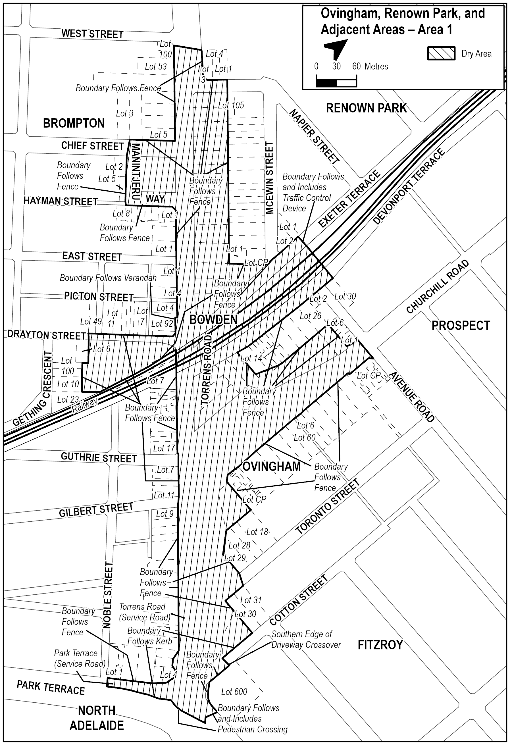
Schedule—Ovingham Area 1
1—Extent of prohibition
The consumption of liquor is prohibited and the possession of liquor is prohibited.
2—Period of prohibition
Continuous.
3—Description of area
The area in Ovingham, known as Turnbull Reserve, bounded as follows:
The Dry Zone Boundary begins south of the reserve on Telford Street Ovingham, at the northern edge of the driveway crossover at the rear of Lot 1 Gilbert Street (known as 25 Gilbert Street Ovingham). It travels north-east along the property boundaries of Telford Street (including the kerb, road reserve and footpath) until meeting the north-eastern corner of Lot 37 Noble Street (known as 12 Noble Street Ovingham). It then crosses Noble Street in a direct line to the western edge of Lot 42 Noble Street (known as 9 Noble Street Ovingham) and travels east along the front property boundaries of Noble Street (including the footpath) until the eastern edge of the driveway crossover of Lot 7 (known as 3 Noble Street Ovingham). The Boundary then travels in a direct line south-west across Noble Street meeting the north-western corner of Lot 55 Telford Street (known as 49 Telford Street Ovingham), before continuing then south along the front property boundaries of Telford Street (including the footpath) until the southern edge of the driveway crossover of Lot 66 (known as 29 Telford Street Ovingham). The Boundary then crosses Telford Street until meeting the northern edge of the driveway crossover of Lot 1 Gilbert Street where it started.

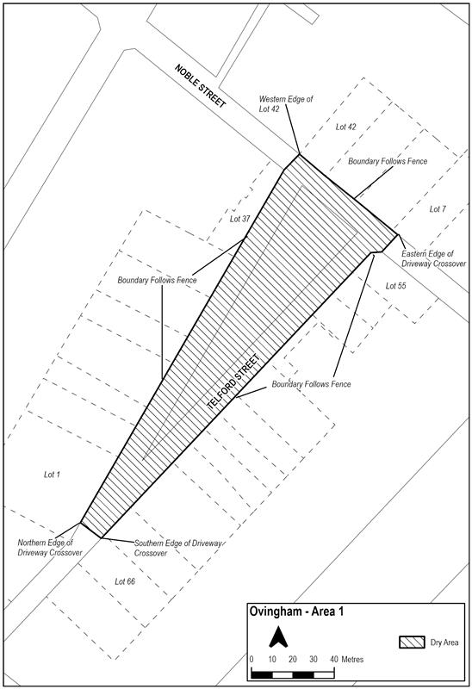
Schedule—Bowden Area 1
1—Extent of prohibition
The consumption of liquor is prohibited and the possession of liquor is prohibited.
2—Period of prohibition
Continuous.
3—Description of area
The area in Bowden, known as Parfitt Square (excluding private property), bounded as follows:
The Dry Zone Boundary begins at the eastern kerb of Drayton Street, Bowden, in line with the northern property boundary of Lot 1004 Drayton Street (known as 109 Drayton Street Bowden). It travels north-east along Drayton Street (including the kerb and footpath) until it meets Fourteenth Street. The Boundary then travels south-east along Fourteenth Street (including the kerb, carparks on the road reserve, and footpath) until reaching the north-western corner of Lot 3 Quin Street (known as 2 Quin Street Bowden). At that corner, it travels south-west along the rear fences of the properties on Quin Street until it meets the northern kerb of Thirteenth Street. The Boundary then travels north-west (including the kerb, carparks on the road reserve and footpath) along Thirteenth Street until meeting the eastern kerb of Drayton Street. It then travels north-east along Drayton Street (including the kerb and footpath) until the beginning, level with the northern property boundary of Lot 1004.

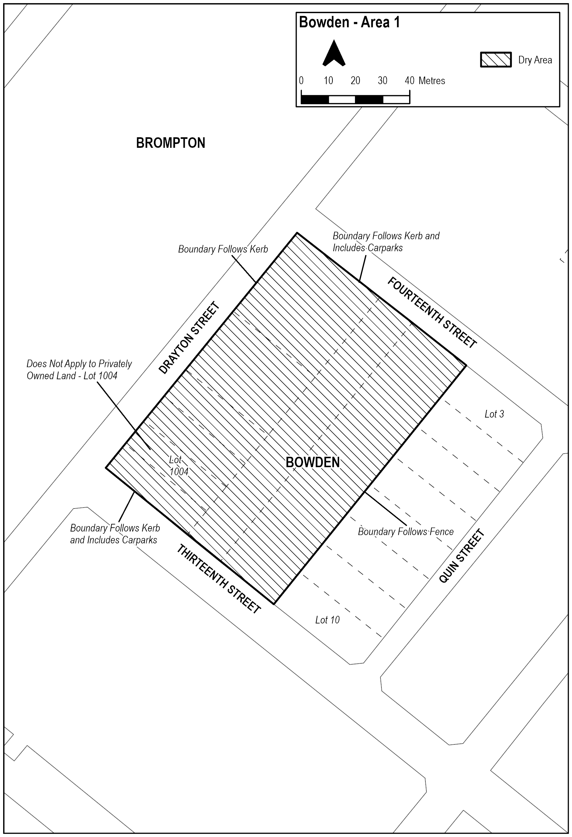
Made by the Minister for Consumer and Business Affairs
On 8 December 2025

Local Government Act 1999
Section 50 Community Engagement Charter
The Community Engagement Charter (the Charter) is established by the Minister for Local Government pursuant to Section 50 of the Local Government Act 1999 (the Act) for the purposes of this Act.
Principles
This charter has been prepared taking into account the following principles contained in Section 50(2) of the Local Government Act 1999—
(a) members of the community should have reasonable, timely, meaningful and ongoing opportunities to gain access to information about proposed decisions, activities and processes of councils and to participate in relevant processes;
(b) information about issues should be in plain language, readily accessible and in a form that facilitates community participation;
(c) participation methods should seek to foster and encourage constructive dialogue, discussion and debate in relation to proposed decisions, activities and processes of councils;
(d) participation methods should be appropriate having regard to the significance and likely impact of proposed decisions, activities and processes;
(e) insofar as is reasonable, communities should be provided with information about how community views have been taken into account and reasons for decisions or actions of councils.
Categories
In recognition of the fact that the matters included for community engagement in this Charter have differing levels of impact on councils’ communities, this Charter establishes the following categories of engagement and requirements that are appropriate to each group—
• Significant—annual business plan and rating policy: decisions related to a council’s adoption of its annual business plan or proposed changes to the basis of its council rates.
• Significant: decisions that a council makes that have a significant impact on most or all ratepayers and residents, or the wider community or area.
• Standard: decisions that a council makes that benefit from community input across the council area.
• Local: decisions that impact an identifiable smaller group of residents/ratepayers or a local area.
• Inform: matters where councils provide information to a community impacted by a decision.
Mandatory Requirements Definitions
Where the Charter includes a mandatory requirement, the following table provides more information about actions that must be taken at a minimum to meet that requirement for community engagement.
While these actions are mandatory, councils should actively consider all activities that should be undertaken for each matter that it is consulting on to give community members the best chance to make their views known. In particular, councils should undertake additional engagement for matters that have greater significance, greater community interest or a greater impact on communities.
In this Charter ‘community’ means individuals, groups or stakeholders that are impacted by or interested in a particular council decision or action. Councils should seek broad, diverse and representative views across its community.
Whenever a council is preparing information to support engagement, it should be in plain language, readily accessible and in a form that facilitates community participation.
Categories
Mandatory Requirement | Mandatory Minimum Actions to Achieve the Mandatory Requirements | Mandatory Requirement that Applies to Matters Categorised as:  (X indicates that the mandatory requirement applies)
Mandatory Requirement |  | Significant—Annual Business Plan and Rating Policy | Significant | Standard | Local | Inform
Website | Publish information about the matter that can be easily found on a council website. | X | X | X | X | X
News publication | Publish information about the matter in a local news publication (print where available, but otherwise digital) that circulates in the council area and is not produced by the council. | X | X
Consult with the whole council area | Consider appropriate forms of notifications to the council area.  Consider whether additional information or notification should be made available to the community to bring their attention to the matter and to support participation. | X | X | X
Invite submissions | Provide information about how the community can make a submission, including timeframe. | X | X
Explain decision-making process | In material prepared explain what the council proposes to do, why it proposes to do it, and what it seeks to achieve.  Explain how community feedback will inform the council’s decision. | X | X
Seek and consider feedback from the community—significant matters | Consider how best to invite feedback from the community.  Provide a minimum community engagement period of 21 days to enable the community to provide feedback.  Include a summary of community engagement feedback to the council ahead of the decision. | X | X
Public meeting | Hold a public meeting where the community is invited to provide submissions (written or verbal) on the matter.  The public meeting may be part of a council meeting or a separate event. | X
Council meeting invitation | Invite people who have made a written submission to attend a council meeting to speak to their submission before the decision is made. |  | X
Seek and consider feedback from the community | Consider how best to invite feedback from the community  Provide information about how community feedback will inform the council’s decision.  Ensure an appropriate period of time is provided to enable communities to provide feedback. |  |  | X | X
Consult with local community | Consider appropriate forms of notifications to the area within the council affected by the council decision or action.  Consider whether additional information or notification should be made available to the local community to bring their attention to the matter and to support participation. |  |  |  | X
Information to the whole council area | Provide information to the whole of the council’s community if it may be directly affected by the council decision or action. |  |  |  |  | X
Information to local community | Provide information to the local community that may be directly affected by the council decision or action. |  |  |  |  | X
Matters (in Legislative Order)
Category | Matter | Act Reference | Description
Significant | Representation reviews | Section 12(7) of the Local Government Act 1999 | Consultation that a council undertakes when it is doing a review of its internal representation (including possible changes to its ward structure, number of council members, change of council or ward names).
Inform | Minor changes to opening hours and place of council offices | Section 45(3) of the Local Government Act 1999 | A council’s decision about the manner, places and times at which its offices will be open to the public, where the impact of the decision would be minor.
Standard | Substantial changes to the opening hours and place of council offices | Section 45(3) of the Local Government Act 1999 | A council’s decision about the manner, places and times at which its offices will be open to the public, where the impact of the decision would be substantial.
Standard | Community engagement policy | Section 50A(6)(b) of the Local Government Act 1999 | Councils must consult before adopting its community engagement policy, which is the document that demonstrated how the council will consult in accordance with this charter and on other matters.
Standard | Council behavioural support policies | Section 75(F)(6) of the Local Government Act 1999 | Consultation that a council undertakes when it is proposing to adopt behavioural support policies.
Standard | Access to meetings and documents | Section 92(5) of the Local Government Act 1999 | How councils ensure that council documents are made available and accessible to community members.
Significant | Strategic Management Plans | Section 122(6) of the Local Government Act 1999 | The development and review of a council’s strategic management plan.  Strategic management plans lay out the council’s strategic directions for a future ten-year period, including council’s long-term financial plan and infrastructure and asset management plan.
Significant—annual business plan and rating policy | Annual Business Plan | Section 123(3)(b) of the Local Government Act 1999 | Adopting an annual business plan.  Annual business plans set out the decisions a council makes each year on the rates and income they will receive and how they will spend these funds.
Significant—annual business plan and rating policy | Basis of rating | Section 151(5)(e) of the Local Government Act 1999 | Consultation that a council takes when it is proposing changes to the basis of its council rates, including declaring differential rates; imposing a separate rate, service rate or service charge; changing the basis on which land is valued for the purposes of rating.
Significant | Differential rating and special adjustments | Section 156 (14a)(b) of the Local Government Act 1999 | Consultation that a council takes when it is proposing changes to its use of differential rating.
Significant | Revocation of classification of land as community land—in all other cases | Section 194(2)(b) of the Local Government Act 1999 | Consultation that councils must undertake before revoking the community land status of any land that is community land.
Significant | Community Land Management Plans—adoption | Section 197(1) of the Local Government Act 1999 | Before a council adopts a community land management plan, it must undertake consultation.
Significant | Community Land Management Plans—significant amendments | Section 198(3) of the Local Government Act 1999 | If a council amends a community land management plan, and the amendment has a significant impact on the community, it must undertake consultation.
Significant | Alienation of community land by lease or licence | Section 202(2) of the Local Government Act 1999 | Consultation that a council undertakes when it is proposing to lease or licence community land.
Inform | Council is proposing a permit or authorisation for alternation of a road or use of roads for business purposes | Section 223(1) of the Local Government Act 1999 | Consultation that a council takes when there are works on a road that require the council’s permit and authorisation, and where traffic will be impeded for less than 48 hours and the council ensures that a detour is in place.
Local | Council is proposing a permit or authorisation for alternation of a road or use of roads for business purposes | Section 223(1) of the Local Government Act 1999 | Consultation that a council takes when there are works on a road that require the council’s permit and authorisation, and where traffic will be impeded for more than 48 hours (with a detour in place) or where no detour will be available.
Local | Consultation on proposed planting of vegetation on a road | Section 232(b) of the Local Government Act 1999 | Consultation that a council takes when it proposes or authorises or permits for planting street trees or other vegetation on council roads, if the planting may have a significant impact on residents, nearby business or advertisers in the area.
Standard | Power to make orders | Section 259(2)(b) of the Local Government Act 1999 | Councils must have policies in place on how they make orders relating to hazards on land adjoining a public place and the inappropriate use of a caravan or vehicle as a place of habitation and must consult before they adopt these policies.
Inform | Election information | Section 13A(2) of the Local Government (Elections) Act 1999 | Councils must provide information, education and publicity for local government elections.
Commencement
The Community Engagement Charter comes into operation on the day on which it is published in the Gazette.
Dated: 2 December 2025
Hon Joe Szakacs MP
Minister for Local Government

Mental Health Act 2009
Authorised Mental Health Professional
Notice is hereby given in accordance with Section 94(1) of the Mental Health Act 2009, that the Chief Psychiatrist has determined the following persons as Authorised Mental Health Professionals:
Joy Zhou
Sumesh Jose
Hardeep Singh
Teagan Palmer
Kathryn Galbraith
Mary-Clare O’Dell
Bishakha Routray
Md Sahadat Hossain
Xiaoxi Liu
Katharine Taylor
Julius Ajayi
The determination will expire three years after the commencement date.
The Chief Psychiatrist make vary or revoke these determinations at any time.
Dated: 11 December 2025
Dr John Brayley
Chief Psychiatrist

Mental Health Act 2009
Conditions Placed on an Approved Treatment Centre
The Chief Psychiatrist pursuant to Section 96 of the Mental Health Act 2009 (‘the Act’), by notice in varies the determination that
Flinders Medical Centre, Flinders Drive, Bedford Park SA is an Approved Treatment Centre. Existing conditions remain in place on the operation of the Psychiatric Intensive Care Unit (published 21 November 2019) and Ward 2SW (published 20 November 2025).
The following new conditions apply to the operation of the Mental Health Short Stay Unit (MHSSU):
• The Mental Health Short Stay Unit is available for the admission of persons who require a crisis admission either on a voluntary or involuntary basis, who have care needs that can be managed in the MHSSU setting and do not require the higher level of care that can be delivered in a specialist mental health acute ward.
• Patients requiring acute ward care can only be admitted to the MHSSU when specialist acute beds or other more suitable settings are unavailable, following consideration of the physical limitations of the MHSSU setting that may apply to that person’s care and with necessary mitigations in place. This will require approval by the Clinical Director and Nursing Director (or by their delegates).
• A report must be provided to the Chief Psychiatrist each month detailing the operation of the MHSSU along with a progress report on the development of an updated Model of Care.
• These new conditions will remain in place until 8 June 2026, unless revoked earlier.
Dated: 11 December 2025
Dr John Brayley
Chief Psychiatrist

Motor Vehicles Act 1959
South Australia
Motor Vehicles (Conditional Registration—Recognition of Motor Vehicle Clubs) Notice 2025 – Friends of Vintage Motoring Incorporated
under the Motor Vehicles Act 1959
1—Short title
This notice may be cited as the Motor Vehicles (Conditional Registration—Recognition of Motor Vehicle Clubs) Notice 2025 – Friends of Vintage Motoring Incorporated.
2—Commencement
This notice takes effect from the date it is published in the Gazette.
3—Interpretation
In this notice—
Act means the Motor Vehicles Act 1959;
Code of Practice means the ‘Code of Practice—Conditional Registration Scheme for Historic, Individually Constructed, Left-Hand Drive and Street Rod Vehicles’ published by the Department for Infrastructure and Transport;
Conditional Registration Scheme or Scheme means the scheme for conditional registration of historic, individually constructed, left hand drive, street rod and vehicles under Section 25 of the Act and Regulation 23 of the Motor Vehicles Regulations 2025;
Department means the Department for Infrastructure and Transport;
Federation means the Federation of Historic Motoring Clubs SA Incorporated;
MR334 form means an ‘Approval for Registration of Vehicle on the Club Registration Scheme (MR334)’;

Prescribed log book means a log book in a form approved by the Registrar;
Registrar means the Registrar of Motor Vehicles;
Regulations means the Motor Vehicles Regulations 2025.
4—Recognition of motor vehicles clubs
The motor vehicle clubs specified in Schedule 1 are, subject to the conditions set out in Clause 5, recognised for the purposes of Regulation 23(3) of the Regulations.
5—Conditions of recognition
A motor vehicle club specified in Schedule 1 must comply with the following conditions:
(a) the club must maintain a constitution approved by the Registrar;
(b) the club must nominate and have members authorised by the Registrar (authorised persons). The club’s authorised person(s) are responsible for approving applicants and motor vehicles for registration under the Scheme. This includes confirming that Scheme applicants are financial members of a club; any other details as required by the Registrar on the MR334 form; and to inspect members’ vehicles when requested to do so by the Registrar;
(c) the club must issue a prescribed log book to club members for each of their vehicles to record vehicle use;
(d) the club must cancel a member’s prescribed log book when a member resigns, must ensure that a statutory declaration is provided when a member’s log book is lost or destroyed, must keep details of members’ prescribed log book return sheets and forward copies of the same to the Registrar or Federation annually as required;
(e) the club must create and maintain records detailing all its financial members, its authorised persons, all vehicles for which an MR334 form has been issued, all statutory declarations received and prescribed log books issued and returned to the club;
(f) the club must keep records for a period of 5 years from the date of the document and these records must include all duplicate MR334 forms, all records of motor vehicle inspections undertaken in accordance with paragraph (b), all statutory declarations provided by members for the purposes of paragraphs (d), all prescribed log books issued by reference to their serial number, the member’s name and the vehicle for which it was issued, and to make all such records available for inspection or provide copies of the records at the request of the Registrar for audit purposes;
(g) the club must ensure, as far as practicable, that all members comply with the Code of Practice;
(h) the club, as far as practicable, must report to the Registrar or the Federation details of members and motor vehicles not complying with the conditions and criteria set out in the Code of Practice for the Scheme;
(i) the club must provide to the Registrar, within 2 months after the end of the club’s financial year, an annual report detailing members from that financial year with vehicles registered under the Scheme who are no longer financial members of the club;
(j) the club must notify the Registrar, in writing, within 14 days of resolution to cease operation as a club and must provide the club records specified in paragraph (f) to the Registrar within 14 days of its dissolution.
Note—
Under Regulation 23(3)(c) of the Motor Vehicle Regulations 2025, the Registrar may, by notice in the Gazette, withdraw the recognition of a motor vehicle club if satisfied that the club has contravened or failed to comply with a condition applying to its recognition by the Registrar, or if there is other good cause to withdraw the recognition.
Schedule 1—Recognised motor vehicle clubs
Historic, individually constructed, left-hand drive and street rod vehicles motor vehicle clubs
Friends of Vintage Motoring Incorporated
Made by the Deputy Registrar of Motor Vehicles
On 3 December 2025

Proof of Sunrise and Sunset Act 1923
Almanac for January, February, March 2026
Pursuant to the requirements of the Proof of Sunrise and Sunset Act 1923, I Jon William Whelan, Chief Executive, Department for Infrastructure and Transport, at the direction of the Minister for Infrastructure and Transport, publish in the Schedule hereto an almanac setting out the times of sunrise and sunset on every day for the three calendar months January, February and March 2026.
Dated: 3 December 2025
Jon William Whelan
Chief Executive, Department for Infrastructure and Transport

Schedule
Sunrise and Sunset Times for Adelaide 2026
Latitude: South 34° 56′ Longitude: East 138° 36′
GMT+9.50 hours (Daylight saving GMT+l0.5 hours)
 |  | January |  |  |  |  |  | February |  |  |  |  |  | March
 |  | Rise |  |  | Set |  |  | Rise |  |  | Set |  |  | Rise |  |  | Set
Date |  | hr | min |  | hr | min |  | hr | min |  | hr | min |  | hr | min |  | hr | min
1 |  | 6 | 05 |  | 20 | 32 |  | 6 | 35 |  | 20 | 23 |  | 7 | 02 |  | 19 | 53
2 |  | 6 | 06 |  | 20 | 33 |  | 6 | 36 |  | 20 | 22 |  | 7 | 03 |  | 19 | 52
3 |  | 6 | 07 |  | 20 | 33 |  | 6 | 37 |  | 20 | 21 |  | 7 | 04 |  | 19 | 51
4 |  | 6 | 07 |  | 20 | 33 |  | 6 | 38 |  | 20 | 21 |  | 7 | 05 |  | 19 | 50
5 |  | 6 | 08 |  | 20 | 33 |  | 6 | 39 |  | 20 | 20 |  | 7 | 06 |  | 19 | 48
6 |  | 6 | 09 |  | 20 | 33 |  | 6 | 40 |  | 20 | 19 |  | 7 | 07 |  | 19 | 47
7 |  | 6 | 10 |  | 20 | 33 |  | 6 | 41 |  | 20 | 18 |  | 7 | 07 |  | 19 | 46
8 |  | 6 | 11 |  | 20 | 33 |  | 6 | 42 |  | 20 | 17 |  | 7 | 08 |  | 19 | 44
9 |  | 6 | 12 |  | 20 | 33 |  | 6 | 43 |  | 20 | 16 |  | 7 | 09 |  | 19 | 43
10 |  | 6 | 13 |  | 20 | 33 |  | 6 | 44 |  | 20 | 15 |  | 7 | 10 |  | 19 | 41
11 |  | 6 | 14 |  | 20 | 33 |  | 6 | 45 |  | 20 | 14 |  | 7 | 11 |  | 19 | 40
12 |  | 6 | 15 |  | 20 | 33 |  | 6 | 46 |  | 20 | 13 |  | 7 | 12 |  | 19 | 39
13 |  | 6 | 15 |  | 20 | 32 |  | 6 | 47 |  | 20 | 12 |  | 7 | 13 |  | 19 | 37
14 |  | 6 | 16 |  | 20 | 32 |  | 6 | 48 |  | 20 | 11 |  | 7 | 13 |  | 19 | 36
15 |  | 6 | 17 |  | 20 | 32 |  | 6 | 49 |  | 20 | 10 |  | 7 | 14 |  | 19 | 35
16 |  | 6 | 18 |  | 20 | 32 |  | 6 | 50 |  | 20 | 09 |  | 7 | 15 |  | 19 | 33
17 |  | 6 | 19 |  | 20 | 31 |  | 6 | 51 |  | 20 | 08 |  | 7 | 16 |  | 19 | 32
18 |  | 6 | 20 |  | 20 | 31 |  | 6 | 52 |  | 20 | 07 |  | 7 | 17 |  | 19 | 30
19 |  | 6 | 21 |  | 20 | 31 |  | 6 | 53 |  | 20 | 06 |  | 7 | 18 |  | 19 | 29
20 |  | 6 | 22 |  | 20 | 30 |  | 6 | 54 |  | 20 | 04 |  | 7 | 18 |  | 19 | 28
21 |  | 6 | 23 |  | 20 | 30 |  | 6 | 55 |  | 20 | 03 |  | 7 | 19 |  | 19 | 26
22 |  | 6 | 24 |  | 20 | 29 |  | 6 | 56 |  | 20 | 02 |  | 7 | 20 |  | 19 | 25
23 |  | 6 | 25 |  | 20 | 29 |  | 6 | 57 |  | 20 | 01 |  | 7 | 21 |  | 19 | 23
24 |  | 6 | 26 |  | 20 | 28 |  | 6 | 58 |  | 20 | 00 |  | 7 | 22 |  | 19 | 22
25 |  | 6 | 27 |  | 20 | 28 |  | 6 | 59 |  | 19 | 58 |  | 7 | 22 |  | 19 | 21
26 |  | 6 | 29 |  | 20 | 27 |  | 6 | 59 |  | 19 | 57 |  | 7 | 23 |  | 19 | 19
27 |  | 6 | 30 |  | 20 | 26 |  | 7 | 00 |  | 19 | 56 |  | 7 | 24 |  | 19 | 18
28 |  | 6 | 31 |  | 20 | 26 |  | 7 | 01 |  | 19 | 55 |  | 7 | 25 |  | 19 | 16
29 |  | 6 | 32 |  | 20 | 25 |  |  |  |  |  |  |  | 7 | 26 |  | 19 | 15
30 |  | 6 | 33 |  | 20 | 24 |  |  |  |  |  |  |  | 7 | 26 |  | 19 | 14
31 |  | 6 | 34 |  | 20 | 24 |  |  |  |  |  |  |  | 7 | 27 |  | 19 | 12
*NOTE: Daylight Saving Time is subject to change.
Sunrise and Sunset times calculated on 27/11/25. Certified correct: A. Dolman, 1 December 2025

Real Property Act 1886
Section 17
Caveat to be Lodged
Whereas the Applicant named at the foot hereof has for itself made application to have the land set forth and described before its name at the foot hereof brought under the operation of the Real Property Act 1886:
Notice is hereby given that unless caveat be lodged with the Registrar General by some person having estate or interest in the said land on or before the expiration of the period herein below for each case specified, the said land will be brought under the operation of the said Act as by law directed. Diagrams delineating this land may be inspected at the Land Titles Registration Office, Adelaide and in the offices of the several corporations or district councils in which the lands are situated.
The Schedule
No. of Application | Description of Property | Name | Residence | Date up to and inclusive of which caveat may be lodged
32085 | Allotment 3 in F255532  Hundred of Adelaide,  in the area named Adelaide. | Brenda Ann Barnett | 26 Stephens Street, Adelaide SA 5000 | 11 February 2026
Dated: 11 December 2025
B. Pike
Chief Executive Officer, Land Services SA
Acting under delegation of the Registrar-General

The Remuneration Tribunal
Report No. 8 of 2025
2025 Review of Remuneration of Members of the Judiciary, Presidential Members of the SAET,
Presidential Members of the SACAT, the State Coroner, and Commissioners of the Environment,
Resources and Development Court
Executive Summary
1. The Remuneration Tribunal (Tribunal) has conducted a review of Determination 5 of 2024 which sets salaries payable to the members of the judiciary and office holders listed in Section 13 of the Remuneration Act 1990 (SA) (Act), and salaries payable to certain other office holders as conferred under Section 14 of the Act. That determination also sets a communication allowance and security allowances which are payable to some of the above-mentioned office holders and judicial members.
2. As explained in this report, the Tribunal has decided to increase salaries by 2.4%. The Tribunal notes that there are minor variations in the percentage amounts as a consequence of its practice of specifying annual salaries in rounded figures.
3. The Tribunal has also determined not to increase the communication allowance and the security allowances.
4. The Tribunal has issued an accompanying determination, which applies from 1 September 2025.
Background
5. The Remuneration Act 1990 (SA) (Act) provides that the Tribunal has jurisdiction to set the remuneration payable to the members of the judiciary and other office holders listed in Section 13 of the Act, and the remuneration payable to other office holders as conferred under Section 14 of the Act.
6. The Tribunal has used this jurisdiction to determine the remuneration for:
(a) Members of the Judiciary;
(b) Presidential Members of the South Australian Employment Tribunal;
(c) Presidential Members of the South Australian Civil and Administrative Appeals Tribunal;
(d) The State Coroner; and
(e) Commissioners of the Environment, Resources and Development Court.
7. As required by Section 8 of the Act, the Tribunal has conducted an annual review of its current Determination regarding remuneration.
The Review Process
8. On 23 July 2025, in accordance with Sections 10(2) and 10(4) of the Act, the Tribunal wrote to and invited submissions by 20 August 2025
in respect of this review from:
(a) The Honourable Premier of South Australia—as the Minister responsible for the Act who may make submissions or introduce evidence in the public interest; and
(b) The Judicial Remuneration Coordinating Committee (JRCC).
9. The Tribunal also placed a notice on its website from 24 July 2025 inviting submissions from affected persons by 20 September 2025.
10. On 30 July, the Premier’s representative confirmed that the Premier did not intend to make a submission.
11. On 20 August the JRCC provided submissions on behalf of:
(a) The Chief Justice, the President of the Court of Appeal, Judges of Appeal, Judges and Associates Justices of the Supreme Court;
(b) The Chief Judge, Judges and Associate Judges of the District Court;

(c) The Chief Magistrate and the Magistrates of the Magistrates Court;
(d) The State Coroner and Deputy State Coroners;
(e) The Senior Judge and Commissioners of the Environment, Resources and Development Court;
(f) The President and Deputy Presidents of the South Australian Employment Tribunal; and
(g) The Judge of the Youth Court.
12. In summary, the JRCC submitted that:
(a) The Tribunal should continue to set judicial salaries in accordance with the national framework.
(b) In conformity with that policy the salary of a Puisne Judge of the Supreme Court of South Australia should be increased to $530,080 per annum.
(c) The salary of the other judicial members and officers should be increased by no less than the percentage increase applicable to the salary of a Puisne Judge of the Supreme Court.
(d) The increase should operate from 1 September 2025.
13. The JRCC did not provide submissions on the communications allowance or the security allowances.
14. No further submissions were received.
Consideration and Conclusion
15. The Tribunal has considered the current judicial salaries across the Commonwealth and States and Territories, as set out below.
Jurisdiction | Supreme Court Judge Salary | Operative Date
Commonwealth (Federal Court Judge used) | $530,080 | 1 July 2025
New South Wales | $517,650 | 1 July 2025
Northern Territory* | $530,080 | 1 July 2025
Australian Capital Territory** | $530,080 | 1 July 2025
Victoria** | $530,080 | 28 October 2025
Queensland** | $530,080 | 1 July 2025
Tasmania*** | $525,280 | 1 July 2025
Western Australia | $527,541 | 1 December 2025
SA (salary prior to this Determination) | $517,650 | 1 September 2024
*The salary is set by the Administrator of the Northern Territory under Section 41 of the Supreme Court Act (NT). The Administrator has not yet set the salary, but the Administrator usually follows the increase for a Federal Judge set by the Commonwealth Remuneration Tribunal and backdates the increase to 1 July.
**These salaries are directly linked by legislation to the salary of a Federal Court Judge, under Section 37U of the Supreme Court Act 1933 (ACT), Section 5 of the Judicial Entitlements Act 2015 (Vic) and Section 5 of the Judicial Remuneration Act 2007 (Qld).
***This salary is set by a statutory formula under Section 7 of the Supreme Court Act 1887 (Tas), being 90% of the average of the salaries of the Chief Justices of South Australia and Western Australia.
16. The Tribunal has considered the Commonwealth Remuneration Tribunal Determination issued on 18 June 2025 which applied a 2.4% increase to Judicial remuneration with effect from 1 July 2025.
17. The Tribunal has had regard to the principles, guidelines, conditions, practices and procedures adopted by the South Australian Employment Tribunal under Part 4 of the Fair Work Act 1994 (SA), as required by Section 101 of that Act.
18. The Tribunal has also taken the following economic data into account:
(a) The Consumer Price Index (All groups Adelaide) shows the following percentage changes from the corresponding quarters of previous years:
(i) 2.5% for December 2024
(ii) 2.2% for March 2025
(iii) 1.8% for June 2025
(iv) 2.4% for September 2025
(b) The Australian Bureau of Statistics Wage Price Index (Public Sector in South Australia) shows the following percentage changes from the corresponding quarters of previous years:
(i) 3.5% September 2024
(ii) 3.2% December 2024
(iii) 3.3% March 2025
(iv) 2.6% June 2025
(v) 2.7% September 2025
(c) As of November 2025, the Reserve Bank of Australia forecast of the Consumer Price Index was as follows:
(i) 2.1% for June 2025
(ii) 3.3% for December 2025
(iii) 3.7% for June 2026
(iv) 3.2% for December 2026
19. Inflationary movements remain matters of concern to the Tribunal.
20. The Tribunal has decided on this occasion, to preserve its long-standing practice of aligning judicial remuneration in South Australia with the national framework. As with previous determinations, the Tribunal preserves the discretion to adopt an independent position and recognises that there may be circumstances where national and South Australian circumstances differ in the future.
21. Notwithstanding the determination of salaries within the national framework, the Tribunal has considered the different factors impacting on the roles of different jurisdictions in South Australia. Consistent with its previous approach the Tribunal has confined its considerations to salary alone and has, consistent with previous years, determined that it is appropriate to increase the salary of a Puisne Judge of the Supreme Court from $517,650 to $530,080 which reflects the salary of a Judge of the Federal Court. Other judicial officers covered by this review will receive the same rate of increase. While this reflects the 2.4% increase applied by the Commonwealth Remuneration Tribunal, there are minor variations when salaries are rounded to $10 amounts.
Communication Allowance
22. The JRCC did not request a change to the current communication allowance.
23. The Tribunal has noted that the increase of 1.8% in the Consumer Price Index (Communications) since the last determination but given that communication costs remain at historic lows, the Tribunal does not consider that a change to the current communication allowance is warranted on this occasion.
Judicial Security
24. In Determination 5 of 2024 the Tribunal provided for an optional once off Security Installation Reimbursement to operate in conjunction with the Security Allowance.
25. The Tribunal notes that the JRCC and affected persons have not asked for a change in the rate of the allowance or reimbursement.
26. As there is no evidence before the Tribunal that these rates are insufficient, the Tribunal has determined not to modify the rates or terms. However, the Tribunal has clarified the naming of the reimbursement and allowance in the Determination.
27. The Tribunal remains open to considering increases to the Security Installation Reimbursement and Security Allowance in the future if there is evidence that increases are warranted. It is also prepared to consider expanding their application to other officers covered by this Determination if there is evidence that it is appropriate.
28. The Tribunal notes that a judicial officer can only claim the Security Establishment Installation Reimbursement once during their term of office unless they are required to relocate their principal place of residence for work purposes.
Operative Date
29. The Tribunal has determined that this increase will be applied from 1 September 2025, consistent with the approach adopted over the last three years.
Dated: 2 December 2025
Matthew O’Callaghan
President
Donny Walford
Member
Mark Young
Member

THE REMUNERATION TRIBUNAL
Determination No. 8 of 2025
Remuneration of Members of the Judiciary, Presidential Members of the SAET, Presidential Members of the SACAT,
the State Coroner, and Commissioners of the Environment, Resources and Development Court
Scope of Determination
1. This Determination sets out the remuneration payable to the holders of public offices listed in Section 13 of the Remuneration Act 1990 (SA) (Act), and the remuneration payable to certain specified statutory office holders where such jurisdiction is conferred under Section 14 of the Act.
Salary
2. Members of the Judiciary
2.1. Annual salaries for the following members of the judiciary will be:
per annum operative
1 September 2025
Chief Justice of the Supreme Court $593,640
President of the Court of Appeal $555,640
Puisne Judges of the Court of Appeal $545,970
Puisne Judges of the Supreme Court $530,080
Associate Justices of the Supreme Court $468,100
Chief Judge of the District Court $530,080
Other District Court Judges $468,100
Associate Judges of the District Court $413,410
Chief Magistrate* $448,720
Supervising Magistrates $407,930
Assistant Supervising Magistrate of the Adelaide Magistrates Court $399,760
Magistrates $380,280
Magistrate appointed Warden under the Mining Act 1971 as amended
and performing the duties of Senior Warden paid the salary shown for
as long as that person continues to perform such duties. $400,710
* A judicial officer who is appointed to the office of the Chief Magistrate whose primary office is a Judge of the District Court is entitled to the salary of a District Court Judge, as prescribed by Section 6A of the Magistrates Act 1983 and Section 6 of the Judicial Administration (Auxiliary Appointments and Powers) Act 1988.

2.2. Where a person is appointed as Acting Chief Justice of the Supreme Court or as Acting Chief Judge of the District Court and such appointment extends for a continuous period of more than one week, the person appointed shall be paid a salary equal to the salary specified herein for the Chief Justice or the Chief Judge, as appropriate, for the whole of the period the appointment is in effect.
2.3. Annual allowances for the following members of the judiciary will be as follows, and shall be payable in addition to any entitlement to salary under this Determination:
per annum operative
1 September 2025
Senior Judge, Environment Resources and Development Court, appointed as such,
paid the allowance shown for as long as that person continues to perform such duties
and is designated as ‘Senior’. $13,140
Judge of the Youth Court for as long as that person continues to perform such duties $13,140
Magistrate appointed to the position of Supervising Regional Manager by the Chief Magistrate
with the concurrence of the Attorney-General, to perform special duties as specified by the
Chief Magistrate, and associated with the role of Supervising Regional Manager, for as long
as that person continues in that position and performs the duties of that position. $37,340
Magistrate directed by the Chief Magistrate with the concurrence of the Attorney-General
to perform special administrative duties in a region (Regional Manager) or in a
residential country area (Country Resident Magistrate) paid the allowance shown
for as long as that person continues to perform such duties. $27,670
Magistrate appointed to the position of Manager Family Violence List by the Chief Magistrate
with the concurrence of the Attorney-General, to perform special duties, relating to
family violence state-wide, for as long as that person continues in that position and
performs the duties of the position. $27,670
Magistrate directed by the Chief Magistrate with the concurrence of the Attorney-General
to perform special administrative duties at a particular court (Magistrate-in-Charge)
paid the allowance shown for as long as that person continues to perform such duties. $10,800
Magistrate appointed as a Deputy State Coroner on a full-time ongoing basis paid the allowance
shown for as long as that person continues to perform such duties. $10,470
3. Statutory Office Holders
3.1. Annual salaries for the following statutory office holders will be:
per annum operative
1 September 2025
The State Coroner $430,790
Additional salary component for a Judge of the District Court
who holds the appointment, and performs the functions of, the
President of the South Australian Employment Tribunal. An amount equal to 10 per cent of the
salary of a judge of the District Court
Additional salary payable to Magistrate appointed as a Deputy President
of the South Australian Employment Tribunal under Section 13(1)(b) of
the South Australian Employment Tribunal Act 2014 $39,650
Additional salary payable to a puisne judge of the Supreme Court appointed as
President of the South Australian Civil and Administrative Tribunal, on account
of holding the office of President of the South Australian Civil and
Administrative Tribunal. An amount equal to 10 per cent of the salary
of a puisne judge of the Supreme Court.
Commissioners of the Environment, Resources and Development Court. $353,940
4. Deputy President of the SACAT
4.1. Annual salaries for the following office holders will be:
per annum operative
1 September 2025
Deputy President of the South Australian Civil and Administrative Tribunal
appointed under Section 14(1)(b) of the South Australian Civil and Administrative
Tribunal Act 2013. Should such an appointment be made on a part-time basis,
the salary shall be payable on a pro-rata basis. $380,280
Communication Allowance
5. A communication allowance of $1,254 per annum for expenditures for the purpose of mobile telephone, landline telephone and internet usage incurred in relation to the conduct of a judicial officer’s duties shall be payable to the following office holders:
The Chief Justice, Judges and Associate Justices of the Supreme Court;
The President and Judges of the Court of Appeal;
The Chief Judge, Judges and Associate Judges of the District Court;
The Judges and Magistrates of the South Australian Employment Tribunal;
The Chief Magistrate and the Magistrates of the Magistrates Court;

The State Coroner and the Deputy Coroner;
The Commissioners of the Environment, Resources and Development Court and Commission;
The President and Deputy Presidents of the South Australian Employment Tribunal; and
The President and Deputy President of the South Australian Civil and Administrative Tribunal.
6. The allowance is payable fortnightly and at a fortnightly rate of the annual amount payable at Clause 5 of this Determination.
7. Should an office holder at Clause 5 be appointed on a part-time basis, the communication allowance shall be payable on a pro-rata basis.
Judicial Security
Security Installation Reimbursement
8. Judicial officers listed in Clause 9 are entitled to be reimbursed for the cost of the installation of a home security system at their residence, up to a maximum amount of $1,600, if these costs are not met through other sources. Except for judicial officers who are required to relocate their principal place of residence to a different part of the State, this is to be a once-off reimbursement during their term of office.
Security Allowance
9. In addition, a Security Allowance of $1,025 per annum for expenditures for the purpose of personal security at the judicial officer’s residence shall be payable to the following office holders:
The Chief Justice, Judges and Associate Justices of the Supreme Court;
The President and Judges of the Court of Appeal;
The Chief Judge, Judges and Associate Judges of the District Court;
The Judges and Magistrates of the South Australian Employment Tribunal;
The Chief Magistrate and the Magistrates of the Magistrates Court;
The State Coroner and the Deputy Coroner;
The Commissioners of the Environment, Resources and Development Court and Commission;
The President and Deputy Presidents of the South Australian Employment Tribunal; and
The President and Deputy President of the South Australian Civil and Administrative Tribunal.
10. The allowance in Clause 9 is payable fortnightly and at a fortnightly rate of the annual amount payable at Clause 9 of this Determination.
11. Part-time office holders are entitled to the full amount of the reimbursement in Clause 8 and the allowance in Clause 9.
Date of Operation
12. This Determination operates from 1 September 2025. It supersedes Determination 5 of 2024.
Dated: 2 December 2025
Matthew O’Callaghan
President
Donny Walford
Member
Mark Young
Member

The Remuneration Tribunal
Report No. 9 of 2025
2025 Review of Accommodation and Meal Allowances—Judges, Court Officers and Statutory Officers
Executive Summary
1. The Remuneration Tribunal (Tribunal) has conducted a review of Determination 9 of 2024 which provides for accommodation and meal allowances for Judges, Court Officers and Statutory Officers covered by the determination.
2. As explained in this report, the Tribunal has decided to increase the rate of the allowances, excluding Sydney travel, by 1.17%. The increased allowances apply from 1 January 2026.
3. The Tribunal has also determined that the existing approach of considering applications for accommodation and meal allowances for overseas travel for members of the Judiciary covered by the determination on an ad hoc basis will continue.
Background
4. The Remuneration Act 1990 (SA) (Act) provides that the Tribunal has jurisdiction to set the remuneration payable to the members of the judiciary and other office holders listed in Section 13 of the Act, and the remuneration payable to other office holders as conferred under Section 14 of the Act.
5. The Tribunal has used this jurisdiction to provide accommodation and meal allowances for Judges and Court Officers, as well as the following Statutory Officers:
(a) The Auditor-General;
(b) The Electoral Commissioner;
(c) The Deputy Electoral Commissioner; and
(d) The Health and Community Services Complaints Commissioner.
6. As required by Section 8 of the Act, the Tribunal has conducted an annual review of its current Determination on accommodation and meal allowances.

The Review Process
7. On 23 July 2025, in accordance with Sections 10(2) and 10(4) of the Act, the Tribunal wrote to and invited submissions by 20 September 2025 in respect of this review from:
(a) the Honourable Premier of South Australia—as the Minister responsible for the Act who may make submissions or introduce evidence in the public interest;
(b) the Judicial Remuneration Coordinating Committee (JRCC); and
(c) members of the judiciary and relevant office holders.
8. The Tribunal also placed a notice on its website from 24 July 2025 inviting submissions from affected persons by 20 September 2025.
9. On 30 July 2025, the Premier’s representative confirmed that the Premier did not intend to make a submission with regard to the review of the rate of the accommodation and meal allowances but would reserve his right to make submissions on accommodation and meal allowances for overseas travel for the Judiciary once the Tribunal has made its determination.
10. On 20 August and the 19 September, the JRCC provided submissions on behalf of:
(a) The Chief Justice, the President of the Court of Appeal, Judges of Appeal, Judges and Associates Justices of the Supreme Court;
(b) The Chief Judge, Judges and Associate Judges of the District Court;
(c) The Chief Magistrate and the Magistrates of the Magistrates Court;
(d) The State Coroner and Deputy State Coroners;
(e) The Senior Judge and Commissioners of the Environment, Resources and Development Court;
(f) The President and Deputy Presidents of the South Australian Employment Tribunal; and
(g) The Judge of the Youth Court.
11. The JRCC submitted that the Tribunal should review the determination of the accommodation and meal allowances arrangements in the usual way and otherwise make a determination that reflects the terms of Determination 9 of 2024.
12. The JRCC further submitted that it supports the Tribunal maintaining the existing approach of issuing specific determinations for overseas accommodation and meal allowances on a case-by-case basis.
13. On 22 August the Electoral Commissioner confirmed that no submission would be made.
14. No other submissions were received.
Consideration and Conclusion
Accommodation and Meal Allowances
15. The determination under review sets allowances to cover the costs of commercial accommodation and meals associated with official travel.
16. In considering this matter, the Tribunal has had regard to the following economic data relevant to the costs of commercial accommodation and meals:
(a) The Consumer Price Index (All groups Adelaide) shows the following percentage changes from the corresponding quarters of previous years:
(i) 2.5% for December 2024
(ii) 2.2% for March 2025
(iii) 1.8% for June 2025
(iv) 2.4% for September 2025
(b) As at November 2025 the Reserve Bank of Australia forecast of the Consumer Price Index was as follows:
(i) 2.1% for June 2025
(ii) 3.3% for December 2025
(iii) 3.7% for June 2026
(iv) 3.2% for December 2026
(c) The Australian Taxation Office Taxation Determination TD 2025/4, which sets for taxation purposes reasonable accommodation, meal and incidental expenses for the 2025-26 income years. The Tribunal has noted the following percentage changes from the previous financial year, for the highest earners:
(i) 0% increase to accommodation costs for Adelaide, Brisbane, Canberra, Darwin, Hobart, Melbourne and Perth
(ii) 12% increase to accommodation costs for Sydney 2025/4
(iii) 2.55% increase to breakfast costs
(iv) 2.58% increase to lunch costs
(v) 2.58% increase to dinner costs
(vi) 2.33% increase to incidentals
(vii) overall, 1.07% to 7.80% increase for daily total (which includes accommodation, meals and incidentals)
17. Having regard to these factors, the Tribunal has decided that these allowances should be increased by 1.17% with effect from 1 January 2026. Consistent with the concern that the Tribunal expressed in Report 9 of 2024, the Tribunal has noted that the accommodation allowance for Sydney travel is substantially more than the ATO Determination. Even in relative terms, when contrasted with the other Capital Cities, it remains inconsistent. Consequently, the Tribunal has determined not to increase the Sydney accommodation allowance for this year. The Tribunal will review its position in this respect next year and is open to receiving submissions on this issue.

Travel and Accommodation Allowance for Overseas Travel for Members of the Judiciary
18. The Tribunal invited submissions on whether the Tribunal should issue a general determination to govern accommodation and meal allowances for overseas travel for members of the Judiciary. The Tribunal also invited suggestions on a framework and criteria to assess eligible travel, as well as governance and approval arrangements which maintain high levels of transparency.
19. The JRCC has highlighted that the predominant reason for these determinations is because a Judge wishes to attend a legal or judicial conference overseas and the cost of accommodation and meals will vary depending on the country where the conference is being held. Further, applications for these allowances are rare and there is significant complexity in designing a framework to determine fair entitlements which would appropriately consider the unique circumstances and costs associated with each travel application.
20. Notwithstanding the potential for efficiency dividends from a general determination, the Tribunal is satisfied that the existing method encourages transparency and accountability from all office holders who seek the allowance. It also allows for the consideration of the circumstances and costs of the travel.
21. Accordingly, the Tribunal has determined that the current approach of considering these applications on a case-by-case basis will be retained.
22. The Tribunal invites future submissions on expanding the range of accommodation available to the Judges, Court Officers and Statutory Officers covered by Determination 9 of 2025 to include sharing economy accommodation such as Airbnb or similar platforms. A change of this nature would create consistency with the range of accommodation available for Ministers of the Crown and Leader of the Opposition (Determination 7 of 2023) and Country Members of Parliament (Determination 9 of 2023).
23. Clause 3.6 of Determination 9 of 2025 reflects the terms of previous determinations, however its practical application may cause uncertainty and potential inequity. For example, questions arise about when the half-day allowance should apply and why it excludes South Australian travel. Because of these ambiguities, the Tribunal plans to review the clause in 2026 and will invite submissions on its operation and fairness, including whether the exclusion of South Australian travel remains appropriate.
24. An accompanying Determination has been issued and will operate from 1 January 2026.
Dated: 2 December 2025
Matthew O’Callaghan
President
Donny Walford
Member
Mark Young
Member

The Remuneration Tribunal
Determination No. 9 of 2025
Accommodation and Meal Allowances—Judges, Court Officers and Statutory Officers
Scope of Determination
1. This Determination applies to Judges, Court Officers, and Statutory Officers.
Interpretation
2. In this Determination, unless the contrary appears:
“Commercial Accommodation” means short term (not permanent) accommodation in a commercial establishment such as a hotel, motel or serviced apartment and must be a genuine arms-length commercial transaction. Commercial Accommodation does not include AirBnB or other “sharing economy” type accommodation.
“Court Officer” means a Commissioner of the Environment, Resources and Development Court.
“Incurs Actual Expenditure” means an amount of money spent by a Judge, Court Officer or Statutory Officer.
“Judge” means any of the following members of the judiciary:
the Chief Justice of the Supreme Court;
the President of the Court of Appeal;
the Judges of the Court of Appeal;
the Puisne Judges of the Supreme Court;
the Associate Justices of the Supreme Court;
the Chief Judge of the District Court;
the Judges of the Environment, Resources and Development Court;
the Associate Judges of the District Court;
the Other District Court Judges;
the Judges of the South Australian Employment Tribunal;
the Chief Magistrate;
the Magistrates;
the Magistrates of the South Australian Employment Tribunal;
the State Coroner; and
the Deputy State Coroner.
“Meals” means food or drink purchased by a Judge, Court Officer or Statutory Officer in connection with an allowance payable under this Determination.

“Metropolitan Adelaide” bears the same meaning as defined in the Development Act 1993.
“Official Duties” means activities undertaken by a Judge, Court Officer or Statutory Officer in relation to their duties as either a Judge, Court Officer or Statutory Officer.
“Statutory Officer” means any of the following statutory office holders:
the Auditor General;
the Electoral Commissioner;
the Deputy Electoral Commissioner;
the Health and Community Services Complaints Commissioner;
the Deputy President of the South Australian Civil and Administrative Tribunal.
“Sydney” means locations which are less then 10km by road from the Sydney General Post Office (by the most direct route), or less then 5km by road from Sydney’s principal airport (by the most direct route).
Accommodation and Meal Allowances
3. A Judge, Court Officer or Statutory Officer who incurs actual expenditure for both commercial accommodation and meals when travelling for the purpose of performing their official duties and which necessitates absence from home overnight shall be entitled to be paid a per day accommodation and meal allowance, as follows
3.1. Within Metropolitan Adelaide:
3.1.1. An allowance at the rate of $368.00 per day for the purpose of meeting expenditure in relation to commercial accommodation and meals.
3.2. Outside Metropolitan Adelaide, but within South Australia:
3.2.1. An allowance at the rate of $338.00 per day for the purpose of meeting expenditure in relation to commercial accommodation and meals.
3.3. Outside South Australia, but within Australia (other than Sydney):
3.3.1. An allowance at the rate of $515.00 per day for the purpose of meeting expenditure in relation to commercial accommodation and meals.
3.4. Sydney:
3.4.1. An allowance at the rate of $566.00 per day for the purpose of meeting expenditure in relation to commercial accommodation and meals.
3.5. Office holders who travel interstate and return on the same day may be reimbursed for lunch only on the basis of actual expenditure up to $27.13. Reimbursement is not to be made for lunch during single day absences within South Australia.
3.6. When an additional period of less than 24 hours absence occurs without overnight accommodation consecutive with and immediately following a period of absence in paragraph 3.1, 3.2, 3.3, or 3.4, then a further payment calculated at the rate of one half of the allowance shall be paid with respect to the excess hours.
Date of Operation
4. This Determination operates from 1 January 2026 and supersedes Determination 9 of 2024.
Dated: 2 December 2025
Matthew O’Callaghan
President
Donny Walford
Member
Mark Young
Member

The Remuneration Tribunal
Report No. 10 of 2025
2025 Review of Conveyance Allowances—Judges, Court Officers and Statutory Officers
Executive Summary
1. The Remuneration Tribunal (Tribunal) has conducted a review of Determination 2 of 2025 which provides for a Conveyance Allowance for Judges, Court Officers and Statutory Officers. Determination 2 of 2025 progressively implemented a restriction to the effect that if a Judge, Court Officer or Statutory Officer covered by the determination selects a vehicle which attracts a lower cost, the remnant component of the Conveyance Allowance remains unspent and is not payable to them.
2. That Determination also reaffirmed the increase in Conveyance Allowance set out in Determination 15 of 2024.
3. As explained in this report, the Tribunal has determined not to change the terms, or the rates of the Conveyance Allowance as set out in Determination 2 of 2025.
4. Accordingly, the Tribunal has determined that Determination 2 of 2025 will continue to apply.
5. The Tribunal has also considered the other issues it flagged in Report 2 of 2025 and has decided not to change the existing conveyance arrangements at this time.
Background
6. The Remuneration Act 1990 (SA) (Act) provides that the Tribunal has jurisdiction to set the remuneration payable to the members of the judiciary and other office holders listed in Section 13 of the Act, and the remuneration payable to other office holders as conferred under Section 14 of the Act.

7. The Tribunal has used this jurisdiction to provide conveyance allowance arrangements for Judges and Court Officers, as well as the following Statutory Officers:
(a) The Auditor-General;
(b) The Electoral Commissioner;
(c) The Deputy Electoral Commissioner; and
(d) The Health and Community Services Complaints Commissioner.
8. As required by Section 8 of the Act, the Tribunal has conducted an annual review of its current Determination on the Conveyance Allowance.
The Review Process
9. On 23 July 2025, in accordance with Sections 10(2) and 10(4) of the Act, the Tribunal wrote to and invited submissions by 20 September 2025 in respect of this review from:
(a) The Honourable Premier of South Australia—as the Minister responsible for the Act who may make submissions or introduce evidence in the public interest;
(b) The Judicial Remuneration Coordinating Committee (JRCC);
(c) The Auditor-General;
(d) The Electoral Commissioner; and
(e) The Interim Health and Community Services Complaints Commissioner.
10. The Tribunal also placed a notice on its website from 24 July 2025 inviting submissions from affected persons by 20 September 2025.
11. On 30 July, the Premier’s representative confirmed that the Premier did not intend to make a submission on the rate of the Conveyance Allowance but reserved his right to make submissions on broadening the Conveyance Allowance to include private leasing arrangements after the Tribunal has handed down its determination.
12. On 20 August and 19 September, the JRCC provided submissions on behalf of:
(a) The Chief Justice, the President of the Court of Appeal, Judges of Appeal, Judges and Associates Justices of the Supreme Court;
(b) The Chief Judge, Judges and Associate Judges of the District Court;
(c) The Chief Magistrate and the Magistrates of the Magistrates Court;
(d) The State Coroner and Deputy State Coroners;
(e) The Senior Judge and Commissioners of the Environment, Resources and Development Court;
(f) The President and Deputy Presidents of the South Australian Employment Tribunal; and
(g) The Judge of the Youth Court.
13. The JRCC submitted that the Tribunal should review the amount of the Conveyance Allowance in the usual way and otherwise make a determination that reflects the terms of Determination 2 of 2025.
14. The JRCC submitted that there is no need for the Tribunal to extend the scope of the Conveyance Allowance to include private leasing arrangements.
15. On 22 August the Electoral Commissioner confirmed that no submission would be made.
16. No further submissions were received.
17. The Tribunal has received significant information and assistance from the South Australian Financing Authority (SAFA), the vehicle provider under the scheme, as part of this review. The Tribunal thanks the SAFA for their assistance.
Consideration and Conclusion
The Conveyance Allowance
18. Determination 15 of 2024 set the rates of the Conveyance Allowances which are payable on a fortnightly basis, based on an annual amount of $19,356, $18,659, or $17,247 (depending on the office holder). These rates have applied since 1 January 2025 and Determination 15 of 2024 increased the amounts by 4.75% on the previous year.
19. In this regard, the Tribunal has considered the approach adopted in previous years where regard has been given to fluctuations in prices set by the SAFA for Judges, Court Officers and Statutory Officers to access vehicles as part of this scheme and the range of vehicles available to them within the specified Conveyance Allowance. When vehicles which attract higher costs are selected, these are met by the Judge or Officer concerned.
20. On this occasion, the Tribunal noted the large variation in prices for vehicles available from the SAFA. The Tribunal has considered the prices of like for like vehicles across the past two years. The changes in prices vary from reductions of over 14% to increases over 101%.
21. Broadly, the SAFA has advised that the reductions are because the Federal Government has maintained its Fringe Benefits Tax (FBT) exemption on fully electric vehicles. As is explained below, this exemption has had a significant impact on the prices of vehicles available from the SAFA under the scheme. However, the Tribunal has noted that some petrol and diesel vehicles have also experienced price reductions, ranging from 0.5% to 1.8%.
22. The vehicles which experienced the largest price increases are plug-in petrol/electric hybrids. The SAFA has advised that since the Tribunal last reviewed the Conveyance Allowance, the Federal Government has removed the FBT exemption from plug-in petrol/electric hybrids, resulting in price increases for them under the scheme. The increases range from 76% to over 101%. The Tribunal is advised that this is because the Federal Government is using the FBT exemption to encourage the take up of fully electric vehicles.
23. As the only price increases for vehicles under the scheme occur because of the Federal Government’s decision to remove the FBT exemption from plug-in petrol/electric hybrids, the Tribunal does not consider it is appropriate to increase the Conveyance Allowance to a level which offsets the Federal Government’s taxation decision.

24. The Tribunal has also had regard to the Commonwealth Remuneration Tribunal’s decision Remuneration Tribunal (Judicial and Related Offices—Remuneration and Allowances) Determination 2025 in which the Commonwealth Tribunal declined to increase the Vehicle Allowance for members of the Federal Judiciary.
25. In arriving at its determination not to increase the Conveyance Allowance, the Tribunal has had regard to the range of vehicles available to Judges, Court Officers and Statutory Officers from the SAFA without excess charges. The Tribunal considers that the range of vehicles remains appropriate without increasing the Conveyance Allowance.
26. Accordingly, the Tribunal has determined that the Conveyance Allowance rates within Determination 2 of 2025 continue to apply.
Alternative conveyance arrangements for the future
27. The Tribunal noted in Report 2 of 2025 that this review would consider reviewing Clause 3 of the Determination relative to the range of vehicles available for official and private use through leasing arrangements with the SAFA and the possible application of private leasing arrangements.
28. The Tribunal did not receive any submissions on a change to the range of vehicles and has determined that the current arrangements should continue.
29. The Tribunal has had regard to the JRCC’s submission that there was no need to extend the scope of the Conveyance Allowance to permit private leasing arrangements.
30. The Tribunal has determined that the range of vehicles which are currently available are appropriate and has not changed the SAFA leasing arrangement.
31. However, the Tribunal does invite future submissions on the arrangements that should apply in the event that a Judge, Court Officer, or Statutory Officer covered by the Determination is unable to access a vehicle in accordance with the Determination due to factors including disability and / or medical condition/s that may affect their ability to drive a motor vehicle. The Tribunal will also invite submissions on the arrangements that should apply if those covered by the Determination do not wish to access a vehicle in accordance with the Determination.
32. Accordingly, Determination 2 of 2025 will continue in operation.
Dated: 2 December 2025
Matthew O’Callaghan
President
Donny Walford
Member
Mark Young
Member

The Remuneration Tribunal
Report No. 11 of 2025
2025 Review of Salary Sacrifice Arrangements for
Judges, Court Officers and Statutory Officers
Executive Summary
1. The Remuneration Tribunal (Tribunal) has conducted a review of Determination 14 of 2024 which provides for salary sacrifice arrangements for Judges, Court Officers and Statutory Officers covered by the determination.
2. As explained in this report, the Tribunal has determined that Determination 14 of 2024 will continue to apply.
Background
3. The Remuneration Act 1990 (SA) (Act) provides that the Tribunal has jurisdiction to set the remuneration payable to the members of the judiciary and other office holders listed in Section 13 of the Act, and the remuneration payable to other office holders as conferred under Section 14 of the Act.
4. The Tribunal has used this jurisdiction to provide salary sacrifice arrangements for Judges and Court Officers, as well as the following Statutory Officers:
(a) The Auditor-General;
(b) The Electoral Commissioner;
(c) The Deputy Electoral Commissioner; and
(d) The Health and Community Services Complaints Commissioner.
5. As required by Section 8 of the Act, the Tribunal has conducted an annual review of its current Determination on salary sacrifice arrangements.
The Review Process
6. On 23 July 2025, in accordance with Sections 10(2) and 10(4) of the Act, the Tribunal wrote to and invited submissions by 20 September 2025 in respect of this review from:
(a) The Honourable Premier of South Australia—as the Minister responsible for the Act who may make submissions or introduce evidence in the public interest;
(b) The Judicial Remuneration Coordinating Committee (JRCC);
(c) The Auditor-General;
(d) The Electoral Commissioner; and
(e) The Interim Health and Community Services Complaints Commissioner.
7. The Tribunal also placed a notice on its website from 24 July 2025 inviting submissions from affected persons by 20 September 2025.
8. On 30 July, the Premier’s representative confirmed that the Premier did not intend to make a submission.

9. On 20 August the JRCC provided submissions on behalf of:
(a) The Chief Justice, the President of the Court of Appeal, Judges of Appeal, Judges and Associates Justices of the Supreme Court;
(b) The Chief Judge, Judges and Associate Judges of the District Court;
(c) The Chief Magistrate and the Magistrates of the Magistrates Court;
(d) The State Coroner and Deputy State Coroners;
(e) The Senior Judge and Commissioners of the Environment, Resources and Development Court;
(f) The President and Deputy Presidents of the South Australian Employment Tribunal; and
(g) The Judge of the Youth Court.
10. The JRCC submitted that the Tribunal should review the determination of the salary sacrifice arrangements in the usual way and otherwise make a determination that reflects the terms of Determination 14 of 2024.
11. On 22 August the Electoral Commissioner confirmed that no submission would be made.
12. No further submissions were received.
Consideration and Conclusion
13. Determination 14 of 2024 provides that the salary sacrifice arrangements provided in the South Australian Government Salary Sacrifice Arrangement (SAGSSA) Principal Agreement apply to the Judges, Court Officers and Statutory Officers covered by the Determination. This Determination was a departure from the previous Determination which set out the arrangements in detail within the Determination. The change however was made as the previous Determination duplicated (with one exception) the arrangements under the SAGSSA Principal Agreement, and this duplication was considered unnecessary.
14. In making the current Determination, the Tribunal invited affected persons to raise any issues or concerns regarding the operation of the Determination with the Tribunal before it commenced on 1 February 2025. No concerns were raised.
15. Further, no concerns have been raised since Determination 14 of 2024 came into effect, nor during this review. Neither has there been any submission advocating for a change to its terms.
16. The Tribunal has accordingly determined that Determination 14 of 2024 will continue to apply.
Dated: 2 December 2025
Matthew O’Callaghan
President
Donny Walford
Member
Mark Young
Member

The Remuneration Tribunal
Report No. 12 of 2025
2025 Review of Common Allowance for Members of the
Parliament of South Australia
Executive Summary
1. The Remuneration Tribunal (Tribunal) has conducted a review of Determination 7 of 2024, which provides for a Common Allowance for Members of the Parliament of South Australia.
2. As explained in this report, the Tribunal has determined to increase the two components of the Common Allowance in Determination 7 of 2024. The first component, which compensates Members for the loss of travel entitlements, will increase by 2.4%. The second component, payable to Members of Parliament for ordinary service on parliamentary committees, will increase by 2.7%.
3. The increased allowance applies from 1 December 2025.
Background
1. The Parliamentary Remuneration Act 1990 (SA) (PR Act) provides that the Tribunal has jurisdiction to set the Common Allowance for Members of the South Australian Parliament pursuant to Section 4AA of the PR Act.
2. As required by Section 4AA(3) of the PR Act, the Tribunal has conducted an annual review of the Common Allowance. It forms part of the Basic Salary of Members of Parliament pursuant to Section 4AB of the PR Act.
3. Section 4AA of the PR Act provides that there are two components to the Common Allowance. The first is an amount of remuneration that reasonably compensates Members of Parliament for the abolition of the annual travel allowance, metrocard special pass and subsidised or free interstate rail travel that applied prior to 2015. The second component is an amount payable to all Members of Parliament for their service as ordinary members on parliamentary committees.
4. The PR Act provides that the aggregated amount of the two components cannot exceed $42,000.
The Review Process
5. On 9 October 2025, in accordance with Sections 10(2) and 10(4) of the Remuneration Act 1990 (SA) (Act), the Tribunal wrote to and invited submissions by 30 October in respect of this review from:
(a) the Honourable Premier of South Australia—as the Minister responsible for the Act who may make submissions or introduce evidence on any question relevant to the public interest;
(b) Members of Parliament;
(c) the Treasurer; and
(d) the Independent Commissioner Against Corruption.
6. The Tribunal also placed a notice on its website from 9 October 2025 inviting submissions from affected persons by 30 October 2025.

7. On 10 October 2025, the Independent Commissioner Against Corruption confirmed that no submission would be made.
8. On 20 October 2025, the Premier’s representative confirmed that no submission would be made.
9. No further submissions were received.
Consideration and Conclusion
10. The Tribunal is not able to alter the basis of the Common Allowance or its component parts.
11. The current Common Allowance comprises the following amounts as set out in Determination 7 of 2024:
(a) The amount of remuneration as reasonable compensation for the abolition of the annual travel allowance, metrocard special pass and subsidised or free interstate rail travel is $20,503 per annum.
(b) The amount of remuneration payable to all Members of Parliament for service as ordinary members on parliamentary committees is $15,034 per annum.
12. These amounts total $35,537 per annum.
13. In accordance with Section 4AA(3) of the PR Act the Tribunal may, if it considers it appropriate to do so, determine to increase an amount of remuneration payable by a specified amount.
14. Consistent with the previous approach of the Tribunal, the first component of the Common Allowance should be recognised to be a reimbursement of the previous travel benefits that applied before 2015. Separately, the second component of the Common Allowance, is considered as being more directly related to normal remuneration payments.
15. As in previous determinations, Tribunal has had regard to the changes to the Consumer Price Index (All Groups Adelaide) (CPI) and the Australian Bureau of Statistics Wage Price Index (Public Sector South Australia) (WPI) since the last review when considering any increase to the Common Allowance.
16. The Tribunal is mindful of ensuring that the first component continues to compensate Members of the Parliament for the loss of the travel entitlements. Accordingly, the Tribunal has determined to increase that component of the Common Allowance by CPI being 2.4%.
17. The Tribunal has also determined to increase the second component of the Common Allowance by the WPI increase for the year to September 2025 being 2.7%.
18. The Tribunal has provided differential calculations to the two components that constitute the Common Allowance. The breakdown of the two components is provided for in the accompanying determination.
19. This review therefore increases the total amount of the Common Allowance to $36,435 per annum from 1 December 2025.
20. The aggregated amount continues to move closer to the statutory limit of $42,000. In the absence of any amending legislation, the Tribunal notes it will not be able to fully exercise its jurisdiction once the Common Allowance amount reaches $42,000.
21. As stated in Report 8 of 2023, The Tribunal understands from the second reading speech for the Amending Act that the statutory limit of $42,000 was in 2015 the amount by which the Commonwealth Basic Salary exceeded the State Basic Salary. Consideration may need to be given to the statutory limit to ensure that future reviews of the Tribunal are not impacted.
22. The Determination giving effect to this Report will come into effect on 1 December 2025.
Dated: 9 December 2025
Matthew O’Callaghan
President
Donny Walford
Member
Mark Young
Member

THE REMUNERATION TRIBUNAL
Determination No. 12 of 2025
Common Allowance for
Members of the Parliament of South Australia
Determination
- Pursuant to Section 4AA of the Parliamentary Remuneration Act 1990 (SA), the Remuneration Tribunal makes the following Determination:
- The amount of remuneration as reasonable compensation for the abolition of annual travel allowance, metrocard special pass and subsidised or free interstate rail travel is $20,995 per annum.
- The amount of remuneration payable to all Members of Parliament for their service as ordinary members on parliamentary committees is $15,440 per annum.
Date of Operation
- This Determination operates from 1 December 2025. It supersedes Determination 7 of 2024.
Dated: 9 December 2025
Matthew O’Callaghan
President
Donny Walford
Member
Mark Young
Member

The Remuneration Tribunal
Report No. 13 of 2025
2025 Review of Accommodation and Meal Allowances for Ministers of the Crown
and the Leader and Deputy Leader of the Opposition
Executive Summary
1. The Remuneration Tribunal (Tribunal) has conducted a review of Determination 8 of 2024 which provides for accommodation and meal allowances payable to Ministers of the Crown and the Leader and Deputy Leader of the Opposition.
2. As explained in this report, the Tribunal has determined to increase the rate of the allowances by 1.17%, excluding that relating to Sydney travel. The Tribunal has also determined to create a new reimbursable allowance which provides for lunch for same day interstate travel.
3. Accordingly, the Tribunal has issued a new Determination, effective 1 January 2026.
Background
4. Sections 3A(2), 3A(3) and 4(2)(a) of the Parliamentary Remuneration Act 1990 (SA) (PR Act) in conjunction with Section 14 of the Remuneration Act 1990 (SA) (Act) provide the Tribunal with the jurisdiction to set the remuneration payable to Members of Parliament.
5. These provisions have previously been used by the Tribunal to establish allowances to cover the costs of commercial accommodation and meals associated with official travel by Ministers, the Leader of the Opposition and Deputy Leader of the Opposition.
6. As required by section 8 of the Act, the Tribunal has conducted its annual review of these allowances.
The Review Process
7. On 9 October 2025, in accordance with Sections 10(2) and 10(4) of the Act, the Tribunal wrote to and invited submissions by 30 October in respect of this review from:
(a) The Honourable Premier of South Australia—as the Minister responsible for the Act who may make submissions or introduce evidence in the public interest;
(b) Members of Parliament;
(c) The Treasurer; and
(d) The Independent Commissioner Against Corruption.
8. The Tribunal also advertised its intention to review this, and other determinations applicable to Members of Parliament, on its website from 9 October 2025. Affected persons were invited to make submissions by 30 October 2025.
9. On 10 October 2025 the Independent Commissioner Against Corruption confirmed that no submission would be made.
10. On 20 October 2025, the Premier’s representative confirmed that no submission would be made.
11. No other submissions were received in respect of this review.
Consideration and Conclusion
12. In considering its review of the allowances, the Tribunal has had regard to the following economic data relevant to the costs of commercial accommodation and meals:
(a) The Consumer Price Index (All groups Adelaide) shows the following percentage changes from the corresponding quarters of previous years:
(i) 2.5% for December 2024
(ii) 2.2% for March 2025
(iii) 1.8% for June 2025
(iv) 2.5% for September 2025
(b) As at November 2025 the Reserve Bank of Australia forecast of the Consumer Price Index was as follows:
(i) 2.1% for June 2025
(ii) 3.3% for December 2025
(iii) 3.7% for June 2026
(iv) 3.2% for December 2026
(c) The Australian Taxation Office Taxation Determination TD 2025/4 (ATO Determination), which for taxation purposes sets reasonable accommodation, meal, and incidental expenses for the 2025-26 income year is also relevant. The Tribunal has noted the following percentage changes from the previous financial year’s taxation determination, for the highest earners:
(i) 0% increase to accommodation costs for Adelaide, Brisbane, Canberra, Darwin, Hobart, Melbourne and Perth
(ii) 12% increase to accommodation costs for Sydney
(iii) 2.55% increase to breakfast costs
(iv) 2.58% increase to lunch costs
(v) 2.58% increase to dinner costs
(vi) 2.33% increase to incidentals
(vii) Overall, 1.07% to 7.80% increase for daily total (which includes accommodation, meals and incidentals)

13. The Tribunal continues to adopt a cautionary approach to inflationary movements.
14. Having regard to these factors, the Tribunal has decided that the allowances should be increased by 1.17%, with effect from 1 January 2026. The exception to this general increase relates to Sydney travel which will remain unchanged.
15. Consistent with the concerns the Tribunal has expressed in previous reports, the travel allowance for Sydney travel remains higher than that provided in the ATO Determination. However, that disparity has narrowed because the ATO Determination increased the Sydney accommodation allowance by 12%.
16. The Tribunal has noted the increased meal allowances in the ATO Determination has also reduced the disparity between the allowances provided for by the ATO Determination and those available to Ministers of the Crown and the Leader and Deputy Leader of the Opposition.
17. The Tribunal will review its position on these allowances next year and is open to receiving submissions.
18. The Tribunal has also determined to create an allowance to reimburse Ministers, the Leader and Deputy Leader of the Opposition for lunch expenses when they undertake same day interstate travel. The allowance of up to $27.13 will be reimbursed based on actual expenditure and is only available for interstate travel where the departure and return is on the same day.
19. While submissions were not sought on this change, it was considered appropriate to create consistency between the meal and accommodation allowances available to the Judiciary, Statutory Officers and Ministers of the Crown and the Leader and Deputy Leader of the Opposition.
20. The Determination giving effect to this Report will come into effect on 1 January 2026.
Dated: 9 December 2025
Matthew O’Callaghan
President
Donny Walford
Member
Mark Young
Member

The Remuneration Tribunal
Determination No. 13 of 2025
Accommodation and Meal Allowances for Ministers of the Crown
and the Leader and Deputy Leader of the Opposition
Scope of Determination
1. This Determination applies to Ministers of the Crown, and to the Leader and Deputy Leader of the Opposition.
Interpretation
2. In this Determination, unless the contrary appears:
“Commercial Accommodation” means short term (not permanent) accommodation in a commercial establishment such as a hotel, motel or serviced apartment, Airbnb or similar platform and must be a genuine arms-length commercial transaction.
“Incurs Actual Expenditure” means an amount of money spent by a Minister, Member or Officer of the Parliament.
“Metropolitan Adelaide” bears the same meaning as defined in the Development Act 1993 (SA).
“Meals” means food or drink purchased by a Minister, Member or Officer of the Parliament in connection with an allowance payable under this Determination.
“Minister” means a Minister of the Crown in the right of the State of South Australia.
“Official Duties” means activities undertaken by a Member of Parliament in relation to their role as a Minister, or their role as the Leader or acting Leader of the Opposition.
“Sydney” means locations which are less than 10km by road from the Sydney General Post Office (by the most direct route), or less than 5km by road from Sydney’s principal airport (by the most direct route).
Accommodation and Meal Allowances
3. A Minister who incurs actual expenditure for both commercial accommodation and meals when travelling as part of their official duties and which necessitates absence from home overnight shall be entitled to be paid a per day accommodation and meal allowance, as follows:
3.1. Outside Metropolitan Adelaide, but within South Australia:
3.1.1. An allowance at the rate of $329 per day for the purpose of meeting expenditure in relation to commercial accommodation and meals.
3.2. Outside South Australia, but within Australia (other than Sydney):
3.2.1. An allowance at the rate of $489 per day for the purpose of meeting expenditure in relation to commercial accommodation and meals.
3.3. Sydney:
3.3.1. An allowance at the rate of $533 per day for the purpose of meeting expenditure in relation to commercial accommodation and meals.
3.4. Provided that, where it is necessary and appropriate, reasonable additional expenditure to that prescribed by the allowances in 3.1, 3.2 and 3.3 for the purposes of commercial accommodation and meals may be reimbursed on the basis of evidence being produced of that additional expenditure.
4. A Minister who travels interstate and return on the same day may be reimbursed for lunch only on the basis of actual expenditure up to $27.13. Reimbursement is not to be made for lunch during single day absences within South Australia.
5. The allowances provided by this Determination shall also be payable to the Leader of the Opposition, and to the Deputy Leader of the Opposition when he or she deputises, at the Leader’s request, for the Leader of the Opposition in his or her official capacity.
Date of Operation
6. This Determination operates from 1 January 2026. It supersedes Determination 8 of 2024.
Dated: 9 December 2025
Matthew O’Callaghan
President
Donny Walford
Member
Mark Young
Member

THE REMUNERATION TRIBUNAL
Report No. 14 of 2025
2025 Review of Accommodation Reimbursement and Allowances for
Country Members of Parliament
Executive Summary
- The Remuneration Tribunal (Tribunal) has reviewed Determination 16 of 2024, which provides for eligible members of Parliament to claim allowances or reimbursements for accommodation costs from commercial accommodation, a second residence accommodation payment or non-commercial accommodation in Metropolitan Adelaide (together, the Country Members’ Accommodation Reimbursable Allowance).
- As explained in this report, the Tribunal has determined to apply increases of 1.17% to the commercial accommodation and non-commercial accommodation components of the Country Members’ Reimbursable Allowance and 2.4% to the second residence accommodation payment.
- The Tribunal has amended Determination 16 of 2024 to make clear that the actual amount spent on accommodation by the Member of Parliament is reimbursed, including those applied because of the method of payment selected.
- Accordingly, the Tribunal has issued a new Determination which supersedes Determination 16 of 2024 and applies from 1 January 2026.
Background
- Sections 3A(2), 3A(3) and 4(2)(a) of the Parliamentary Remuneration Act 1990 (SA) (PR Act) in conjunction with Section 14 of the Remuneration Act 1990 (SA) (Act) provide that the Tribunal has jurisdiction to set different or unique allowances for Members of Parliament based upon their electorate. These provisions have been used previously by the Tribunal to establish the Country Members’ Accommodation Reimbursable Allowance.
- The Tribunal’s Report 9 of 2020 contains extensive information about the history of the Country Members’ Accommodation Reimbursable Allowance.
- This reimbursable allowance exists to facilitate journeys of an official nature from a country member’s principal place of residence to Adelaide. The determination operates such that country members are not disadvantaged for fully and properly carrying out their official parliamentary, electoral, community or ministerial duties in Adelaide.
- In its December 2023 Report, the Tribunal detailed amendments to the reimbursements and allowances to simplify and expedite the payment process. It changed the distance allowance calculation, introduced a streamlined reporting arrangement and introduced a new category of accommodation reimbursement relating to non-commercial accommodation. Other reimbursement rates were increased to recognise inflationary pressures.
- As required by Section 8 of the Act, the Tribunal has conducted its annual review of the Country Members’ Accommodation Reimbursable Allowance.
The Review Process
- On 9 October 2025, in accordance with Sections 10(2) and 10(4) of the Act, the Tribunal wrote to and invited submissions by 30 October 2025 in respect of this review from:
- The Honourable Premier of South Australia—as the Minister responsible for the Act who may make submissions or introduce evidence on any question relevant to the public interest;
- Members of Parliament;
- The Treasurer; and
- The Independent Commissioner Against Corruption.
- The Tribunal also placed a notice on its website from 9 October 2025 inviting submissions from affected persons by 30 October 2025.
- On 10 October 2025, the Independent Commissioner Against Corruption confirmed that no submission would be made.
- On 20 October 2025, the Premier’s representative confirmed that no submission would be made.
- No further submissions were received.
Consideration and Conclusion
- The Tribunal remains committed to a system that has a significant level of accountability. There have been no submissions during this review which have advocated for any changes to the approach taken by the Tribunal in 2022.
- The Tribunal reinforces its comments in Report 16 of 2024, that the Determination requires the actual amount spent on accommodation, within the various categories, up to the prescribed amount to be reimbursed, which includes any charges applied because of the method of payment selected by the Member of Parliament and/or any other accommodation associated expenses.
- The Tribunal has reviewed the determination amounts in the context of the following data on cost increases.
- The Consumer Price Index (All groups Adelaide) shows the following percentage changes from the corresponding quarters of previous years:
(i) 2.5% for December 2024
(ii) 2.2% for March 2025
(iii) 1.8% for June 2025
(iv) 2.4% for September 2025
- The Tribunal has also had regard to the Australian Taxation Office Taxation Determinations TD2024/3 and TD2025/4, which respectively set for taxation purposes reasonable accommodation, meal and incidental expenses for the 2024-25 and 2025-26 income years. The Tribunal has noted there was an overall increase of 1.07% to 1.28% for the daily total (which includes accommodation, meals, and incidentals), with the exception of Sydney which has experienced a 7.81% increase over the period. The Tribunal has also taken note of interest rate movements.
- Having regard to these factors, the Tribunal has decided to increase the component parts of the Country Members’ Accommodation Reimbursable Allowance by the following amounts, commercial accommodation reimbursement amount by 1.17%, the non-commercial rate by 1.17% and the second residence accommodation payment by 2.4% to be $255 per night, $93 per night and $214 per night respectively.
- The Determination giving effect to this Report will come into effect on 1 January 2026.
Dated: 9 December 2025
Matthew O’Callaghan
President
Donny Walford
Member
Mark Young
Member

The Remuneration Tribunal
Determination No. 14 of 2025
Accommodation Reimbursement and Allowances for Country Members of Parliament
Scope of Determination
1. This Determination applies to Members of Parliament who meet the eligibility criteria for a Part A or Part B accommodation reimbursement or allowance.
Purpose
2. The purpose of this Determination is to provide a mechanism for Country Members of Parliament who meet the eligibility criteria to make a claim for expenditure incurred when staying in Metropolitan Adelaide for the primary purpose of performing either parliamentary, electoral, community or ministerial duties.
Interpretation
3. In this Determination, unless the contrary appears:
“Actual Expenditure” means an amount of money spent by a Member of Parliament and includes any charges applied because of the method of payment selected by the Member of Parliament and/or any accommodation associated expenses.
“Clerk of the House” means a person who holds the office of, or is acting in the office of, either the Clerk of the Legislative Council or the Clerk of the House of Assembly.
“Commercial Accommodation” means short term (not permanent) accommodation in a commercial establishment such as a hotel, motel, serviced apartment, Airbnb or similar platform and must be a genuine arms-length commercial transaction.
“Community Duties” means any activities of the Member of Parliament in connection with their duty to be actively involved in community affairs, including attendance at community events and functions.
“Electoral Duties” means any activities of the Member of Parliament that support or serve their constituents. This includes the Member of Parliament’s duty to represent and assist their constituents in dealings with governmental and other public agencies and authorities.
“Member of Parliament” means a Member of the Parliament of South Australia, either of the Legislative Council or the House of Assembly.
“Metropolitan Adelaide” bears the same meaning as defined in the Development Act 1993 (SA).
“Ministerial Duties” means activities undertaken by a Member of Parliament in relation to their role as a Minister.
“Non-commercial Accommodation” means accommodation with family or friends.
“Parliamentary Duties” means any activities that relate directly to a Member of Parliament’s role as a Member of Parliament. This includes duties in connection with sittings of Parliament or sittings as a Member on parliamentary committees.
“Party Political Duties” means activities of the Member of Parliament in connection with both their political party and their own, or another Member of Parliament’s, membership of the Parliament.
“Principal Place of Residence” means the Member of Parliament’s home residence where the Member of Parliament is enrolled to vote on the electoral roll.
“Second Residence” means a residence where a Member of Parliament resides other than the Member of Parliament’s principal place of residence. The second residence must be owned by the Member of Parliament and/or the Member of Parliament’s spouse, or the Member of Parliament and/or the Member of Parliament’s spouse must have a rental agreement for the second residence for a period of six months or more.
“Spouse” means a person with whom a Member of Parliament is married or is in a registered relationship under the
Relationships Register Act 2016 (SA).
“Tribunal” means the Remuneration Tribunal of South Australia established by the Remuneration Act 1990 (SA).
Part A—Greater Than 75kms From Parliament House
4. Commercial Accommodation Reimbursement
4.1. A Member of Parliament:
4.1.1. whose principal place of residence is greater than 75kms by road from Parliament House (by the most direct route); and
4.1.2. who has a requirement to stay in Metropolitan Adelaide overnight for the primary purpose of performing either parliamentary, electoral, community or ministerial duties (but not for the primary purpose of party political duties); and

4.1.3. who has incurred actual expenditure for staying overnight in commercial accommodation within Metropolitan Adelaide
is, upon complying with the requirements in Part C, entitled to be reimbursed for the actual amount paid for commercial accommodation up to a maximum amount of $255 per night.
5. Second Residence Payment
5.1. A Member of Parliament:
5.1.1. whose principal place of residence is greater than 75kms by road from Parliament House (by the most direct route); and
5.1.2. who has a requirement to stay in Metropolitan Adelaide overnight for the primary purpose of performing either parliamentary, electoral, community or ministerial duties (but not for the primary purpose of party political duties); and
5.1.3. who has incurred actual expenditure for staying overnight at a second residence in Metropolitan Adelaide
is, upon complying with the requirements in Part C, entitled to a payment of $214 per night.
6. Non-commercial Accommodation Allowance
6.1. A Member of Parliament:
6.1.1. whose principal place of residence is greater than 75kms by road from Parliament House (by the most direct route); and
6.1.2. who has a requirement to stay in Metropolitan Adelaide overnight for the primary purpose of performing either parliamentary, electoral, community or ministerial duties (but not for the primary purpose of party political duties)
is, upon complying with the requirements in Part C, entitled to an allowance of $93 per night.
7. Part A Claim Limit
7.1. A Member of Parliament may claim up to 135 nights, per financial year, for any Part A claims, or combination of Part A claims, made within a financial year.
7.2. If a Member is not a Member of Parliament for a whole financial year, the maximum number of nights per financial year available under Part A shall be reduced on a pro-rata basis, based on the number of days served as a Member of Parliament in the relevant financial year, as a proportion of the total number of days in that financial year. The pro-rata amount shall be rounded to the nearest whole number.
Part B—Less Than 75km From Parliament House
8. Commercial Accommodation Reimbursement
8.1. A Member of Parliament:
8.1.1. whose principal place of residence is less than 75kms by road from Parliament House (by the most direct route), but is outside of Metropolitan Adelaide; and
8.1.2. who has a requirement to stay in Metropolitan Adelaide overnight for the primary purpose of performing either parliamentary, electoral, community or ministerial duties (but not for the primary purpose of party political duties); and
8.1.3. who has incurred actual expenditure for staying overnight in commercial accommodation within Metropolitan Adelaide
is, upon complying with the requirements in Part C, entitled to be reimbursed for the actual amount paid for commercial accommodation up to a maximum amount of $255 per night.
9. Part B Claim Limit
9.1. A Member of Parliament may claim up to 15 nights, per financial year, for Part B claims.
9.2. If a Member is not a Member of Parliament for a whole financial year, the maximum number of nights per financial year available under Part B shall be reduced on a pro-rata basis, based on the number of days served as a Member of Parliament in the relevant financial year, as a proportion of the total number of days in that financial year. The pro-rata amount shall be rounded to the nearest whole number.
Part C—Evidence Requirements
10. Commercial Accommodation Reimbursement
10.1. To receive a commercial accommodation reimbursement, under Part A or Part B, a Member of Parliament must provide to the Clerk of the House:
10.1.1. a signed statutory declaration stating the suburb, town or nearest town as appropriate of the Member of Parliament’s principal place of residence and confirming it is greater than 75kms from Parliament House (by the most direct route) for Part A or less than 75kms from Parliament House but outside Metropolitan Adelaide (by the most direct route) for Part B; and
10.1.2. a receipt as evidence of the amount of actual expenditure for each night of commercial accommodation; and
10.1.3. a claim form confirming any relevant particulars that the Clerk of the House deems necessary to ensure compliance with this Determination.
11. Second Residence Payment
11.1. To receive a second residence payment, under Part A, a Member of Parliament must provide the Clerk of the House with a signed statutory declaration confirming:
11.1.1. a second residence is maintained by the Member of Parliament in Metropolitan Adelaide; and
11.1.2. the suburb, town or nearest town as appropriate of the second residence; and
11.1.3. the suburb, town or nearest town as appropriate of the Member of Parliament’s principal place of residence and confirming it is greater than 75kms from Parliament House (by the most direct route); and
11.1.4. a certificate of title evidencing the Member of Parliament and/or the Member of Parliament’s spouse as the registered owner and confirming their principal place of residence or second residence is not commercially rented out; or

11.1.5. a rental agreement evidencing the Member of Parliament and/or the Member of Parliament’s spouse as the tenant of the second residence.
11.2. A Member of Parliament must provide a claim form confirming any relevant particulars that the Clerk of the House deems necessary to ensure compliance with this Determination.
12. Non-commercial Accommodation Allowance
12.1. To receive a non-commercial accommodation allowance, under Part A, a Member of Parliament must provide to the Clerk of the House:
12.1.1. a signed statutory declaration stating the suburb, town or nearest town as appropriate of the Member of Parliament’s principal place of residence and confirming it is greater than 75kms from Parliament House (by the most direct route); and
12.1.2. a claim form confirming any relevant particulars that the Clerk of the House deems necessary to ensure compliance with this Determination.
13. Change of Circumstances
13.1. If a Member of Parliament has provided a statutory declaration in relation to their principal place of residence or second residence and their circumstances change, then the Member of Parliament is responsible for notifying the Clerk of the House, by way of signed statutory declaration, of a change of circumstances within 30 days of such change occurring.
13.2. A change of circumstances includes establishing, changing or ceasing to maintain a second residence.
13.3. For the avoidance of doubt, there is no entitlement to a second residence payment or other claim under this Determination from the date eligibility ceases.
Date of Operation
14. This Determination operates from 1 January 2026. It supersedes Determination 16 of 2024.
Dated: 9 December 2025
Matthew O’Callaghan
President
Donny Walford
Member
Mark Young

The Remuneration Tribunal
Report No. 15 of 2025
2025 Review of Reimbursement of Expenses Applicable to the Electorate of Mawson—
Travel to and from Kangaroo Island by Ferry and Aircraft
Executive Summary
1. The Remuneration Tribunal (Tribunal) has conducted a review of Determination 6 of 2023, which allows the Member for the Electorate of Mawson to claim reimbursements for expenses necessarily incurred travelling by ferry or aircraft between Kangaroo Island and the Fleurieu Peninsula for electoral purposes (Reimbursable Allowance).
2. As explained in this report, the Tribunal has determined to index the Reimbursable Allowance in Determination 6 of 2023 by 2.4% and to issue a new Determination which supersedes Determination 6 of 2023.
Background
3. Sections 3A(2) and 3A(3) of the Parliamentary Remuneration Act 1990 (SA) (PR Act) in conjunction with Section 14 of the Remuneration Act 1990 (SA) (Act) provide that the Tribunal has jurisdiction to set different or unique electorate allowances for Members of Parliament based upon their electorate.
4. In Determination 6 of 2023 the Tribunal used this jurisdiction to provide for the Reimbursable Allowance of $4,100.
5. As required by Section 8 of the Act, the Tribunal has conducted its annual review of the Reimbursable Allowance.
The Review Process
6. On 9 October 2025, and in accordance with Sections 10(2) and 10(4) of the Act, the Tribunal wrote to and invited submissions by 30 October 2025 in respect of this review from:
(a) the Honourable Premier of South Australia—as the Minister responsible for the Act who may make submissions or introduce evidence in the public interest;
(b) Members of Parliament;
(c) the Treasurer; and
(d) the Independent Commissioner Against Corruption.
7. The Tribunal also placed a notice on its website from 9 October 2025 inviting submissions from affected persons by 30 October 2025.
8. On 10 October 2025, the Independent Commissioner Against Corruption confirmed that no submission would be made.
9. On 20 October 2025, the Premier’s representative confirmed that no submission would be made.
10. No other submissions were received in respect of this review.
Consideration and Conclusion
11. In reviewing this entitlement, the Tribunal has had due regard to the necessary statutory considerations under Section 4(2)(a) of the PR Act. That section of the PR Act provides that the Tribunal must, in determining electorate allowances and other remuneration for Members of Parliament, have regard not only to their parliamentary duties, but also to:
(a) Their duty to be actively involved in community affairs; and
(b) Their duty to represent and assist their constituents in dealings with governmental and other public agencies and authorities.
12. The Tribunal recognises that the Member for Mawson is in a unique situation, which warrants a separate reimbursable allowance to be payable for travel to and from Kangaroo Island.
13. The Tribunal has considered the cost of journeys between the Fleurieu Peninsula and Kangaroo Island. From information available to the Tribunal, the vehicle fare on the SeaLink Kangaroo Island Ferry Service (Ferry) has not increased since 1 September 2023, however, the passenger fare has increased by 7% per person.
14. The Tribunal has also observed that while air fare prices from Adelaide to Kangaroo Island have remained relatively stable since its last review, the Consumer Price Index (Adelaide) for the year to September 2025 has risen by 2.4%.
15. Despite the costs for air travel to Kangaroo Island and the vehicle fare on the Ferry have remained stable, the Tribunal is mindful of the increase in the passenger fare for the Ferry.
16. Accordingly, the Tribunal has determined to increase the Reimbursable Allowance by 2.4% to offset the increased passenger fare.
17. While the Member for Mawson may also, at their own discretion, use their electorate allowance for the same purpose, the Tribunal is open to the provision of any further information over the coming year, that the Member for Mawson considers relevant to the operation of this allowance.
18. The Tribunal notes that the allowance is paid upon the provision of a receipt, evidencing the travel expenses being claimed. This process will continue to apply.
19. The Determination giving effect to this Report will come into effect on 1 December 2025.
Dated: 9 December 2025
Matthew O’Callaghan
President
Donny Walford
Member
Mark Young
Member

The Remuneration Tribunal
Determination No. 15 of 2025
Reimbursement of Expenses Applicable to the Electorate of Mawson—
Travel to and from Kangaroo Island by Ferry and Aircraft
Scope of Determination
1. This Determination applies to the Member of the House of Assembly for the Electorate of Mawson.
Reimbursement of Expenses Applicable to the Electorate of Mawson
2. A member of the House of Assembly for the Electorate of Mawson shall be entitled to be reimbursed for expenses necessarily incurred travelling by ferry or aircraft between Kangaroo Island and the Fleurieu Peninsula, for electoral purposes, up to an amount of $4,199 per annum, in addition to any other remuneration, allowance or entitlement.
Date of Operation
3. This Determination shall operate on and from 1 December 2025 and supersedes Determination 6 of 2023.
Dated: 9 December 2025
Matthew O’Callaghan
President
Donny Walford
Member
Mark Young
Member

The Remuneration Tribunal
Report No. 16 of 2025
2025 Review of Electorate Allowances for Members of the Parliament of South Australia
Executive Summary
1. The Remuneration Tribunal (Tribunal) has conducted a review of Determination 17 of 2022 which sets Electorate Allowances for Members of Parliament.
2. As explained in this report, the Tribunal has determined not to increase the Electoral Allowances and Determination 17 of 2022 will continue to apply.
Background
3. Sections 3A(2) and 4(1)(c) of the Parliamentary Remuneration Act 1990 (SA) (PR Act) in conjunction with Section 14 of the Remuneration Act 1990 (SA) (Act) provide that the Tribunal has jurisdiction to set Electorate Allowances for Members of Parliament.
4. The Tribunal has used this jurisdiction to set Electorate Allowances for Members of Parliament and last increased the Allowances in Determination 17 of 2022.
5. The Allowances are intended to compensate Members of Parliament for the expenses they necessarily incur in the performance of their duties. However, since at least 2022, the Tribunal has held concerns about the basis of the Electorate Allowances because the Tribunal does not have current data on how members spend the Electorate Allowance. Accordingly, the Tribunal conducted an extensive review into these issues in 2023 (Report 16 of 2023).
6. In that review, the Tribunal noted that, while the cost of motor vehicles now provided to Members of Parliament on a fixed cost basis were met from the Electorate Allowances, these costs had not been reviewed and were not matters within the Tribunal’s jurisdiction.

7. In terms of the residual amounts, the Tribunal noted that information to clarify the continuing relevance of the categories of accommodation and travel, donations, subscriptions, telephone, stationery, and postage, which had been considered in the last substantive consideration of this allowance were not available.
8. The Tribunal’s survey of Members of Parliament, which sought information about how these allowances were expended did not provide reliable information in this regard.
9. Consequently, in Report 16 of 2023, the Tribunal confirmed its position that the absence of appropriate information about how these allowances were used meant that no basis for an increase to the Electorate Allowances had been established.
10. Similarly, in its 2024 review of the Electorate Allowances, the Tribunal again observed that no information was available to it to warrant a change to the Allowances. On publishing the review, the Tribunal invited Members of Parliament to make submissions on a sustainable basis for the Electorate Allowance.
11. As required by section 8 of the Act the Tribunal has conducted its annual review of the Electorate Allowances.
The Review Process
12. On 9 October 2025, and in accordance with Sections 10(2) and 10(4) of the Act, the Tribunal wrote to and invited submissions by
30 October 2025 in respect of this review from:
(a) The Honourable Premier of South Australia—as the Minister responsible for the Act who may make submissions or introduce evidence on any question relevant to the public interest;
(b) Members of Parliament;
(c) The Treasurer; and
(d) The Independent Commissioner Against Corruption.
13. The Tribunal also placed a notice on its website from 9 October 2025 inviting submissions from affected persons by 30 October 2025.
14. On 10 October 2025, the Independent Commissioner Against Corruption confirmed that no submission would be made.
15. On 20 October 2025, the Premier’s representative confirmed that no submission would be made.
16. No other submissions were received in respect of this review.
Consideration and Conclusion
17. In reviewing the Electorate Allowances, the Tribunal has had regard to the necessary statutory considerations provided for by
Section 4(2) of the PR Act which provides as follows:
“The Remuneration Tribunal must, in determining electorate allowances and other remuneration for members of Parliament—
(a) have regard not only to their parliamentary duties but also to—
(i) their duty to be actively involved in community affairs; and
(ii) their duty to represent and assist their constituents in dealings with governmental and other public agencies and authorities; and
(b) must not reduce an amount payable merely because there has been a change in basic salary.”
18. Not only was no information provided to the Tribunal which would allow it to determine a sustainable basis for the Electoral Allowances, no submissions were provided at all.
19. As in the past reviews discussed above, there is no information available to the Tribunal to warrant a change to the existing Electorate Allowance amounts. If Members of Parliament consider that there is a sustainable basis for the Tribunal to revise this allowance, the Tribunal is prepared to review this conclusion.
20. During this review, the Tribunal also considered the experience of remuneration tribunals in other Australian jurisdictions with respect to electorate allowances for Members of Parliament. In many of them, the basis and application of the electorate allowances are unclear to that jurisdiction’s tribunal.
21. The 2025 Report the New South Wales Parliamentary Remuneration Tribunal (PRT) provides a robust discussion of these difficulties. The PRT will reconsider the allowance in 2026.
22. In the absence of further information, the Tribunal finds that there is no justification for awarding an increase to the Electorate Allowances.
23. Accordingly, Determination 17 of 2022 will continue in operation.
Dated: 9 December 2025
Matthew O’Callaghan
President
Donny Walford
Member
Mark Young
Member

Retirement Villages Act 2016
Section 59(1)
Voluntary Termination of Retirement Village Scheme
Take Notice that I, Nat Cook, Minister for Seniors and Ageing Well, pursuant to Section 59(1) of the Retirement Villages Act 2016,
hereby terminate the Harwin Retirement Village retirement village scheme situated at 133 Frost Road, Salisbury, SA, 5108 and comprising all of the land and improvements in Certificate of Title Register Book Volume 6093 Folios 871 and 872. I do so being satisfied for the purposes of Section 59(2) of the Act that there are no retirement village residents in occupation. The termination will take effect on the day upon which the retirement village endorsements are cancelled.
Dated: 1 December 2025
Nat Cook
Minister for Seniors and Ageing Well

Return to Work Act 2014
Notice of Travel Allowance
Preamble
Section 33(8) of the Return to Work Act 2014 (the Act) states that:
If a worker travels in a private vehicle to or from any place for the purpose of receiving medical services, hospitalisation or approved recovery/return to work services, and the travel is reasonably necessary in the circumstances of the case, the worker is entitled to a travel allowance at rates fixed by a scale published by the Minister under this section.
Notice
I declare that the rate for travel allowance in 2026 is hereby fixed for the purposes of Section 33(8) of the Act at 0.581 cents per kilometre, and this notice supersedes all previous notices of the travel allowance rate published under Section 33(8) of the Act.
This Notice is effective for travel on or after 1 January 2026.
Dated: 8 December 2025
Hon Kyam Maher MLC
Minister for Industrial Relations and Public Sector
Deputy Premier

South Australian Skills Act 2008
Part 4—Apprenticeships, Traineeships and Training Contracts
Pursuant to the provision of the South Australian Skills Act 2008, the South Australian Skills Commission (SASC) gives notice that determines the following qualification and training contract conditions for Trades or Declared Vocations, in addition to those published in past Gazette notices.
*Trade/ #Declared Vocation/ Other Occupation | Qualification Code | Qualification Title | Nominal Term of Training Contract | Probationary Period | Supervision Level Rating
IAAP Pathway—Carpenter* | CPC30220 | Certificate III in Carpentry | 36 months | 90 days | H
Condition/s | Only available for delivery through the Industry Accelerated Apprenticeship Pilot.  The South Australian Skills Commission has mandated both the core and elective units of competency for this pathway. Apprentices training in this trade must undertake all mandated units of competency, or their equivalent.  Not suitable for a school-based apprenticeship.

*Trade/ #Declared Vocation/ Other Occupation | Qualification Code | Qualification Title | Nominal Term of Training Contract | Probationary Period | Supervision Level Rating
IAAP Pathway—  Painter and Decorator* | CPC30620 | Certificate III in Painting  and Decorating | 36 months | 90 days | H
Condition/s | Only available for delivery through the Industry Accelerated Apprenticeship Pilot.  The South Australian Skills Commission has mandated both the core and elective units of competency for this pathway. Apprentices training in this trade must undertake all mandated units of competency, or their equivalent.  Not suitable for a school-based apprenticeship.

*Trade/ #Declared Vocation/ Other Occupation | Qualification Code | Qualification Title | Nominal Term of Training Contract | Probationary Period | Supervision Level Rating
IAAP Pathway—Civil Construction Plant Operator* | RII30820 | Certificate III in Civil Construction Plant Operations | 18 months | 60 days | M
Condition/s | Only available for delivery through the Industry Accelerated Apprenticeship Pilot.  The South Australian Skills Commission has mandated both the core and elective units of competency for this pathway. Apprentices training in this trade must undertake all mandated units of competency, or their equivalent.  Not suitable for a school-based apprenticeship.

*Trade/ #Declared Vocation/ Other Occupation | Qualification Code | Qualification Title | Nominal Term of Training Contract | Probationary Period | Supervision Level Rating
IAAP Pathway—Civil Construction and  Maintenance Worker* | RII30920 | Certificate III in Civil Construction | 18 months | 60 days | M
Condition/s | Only available for delivery through the Industry Accelerated Apprenticeship Pilot.  The South Australian Skills Commission has mandated both the core and elective units of competency for this pathway. Apprentices training in this trade must undertake all mandated units of competency, or their equivalent.  Not suitable for school-based apprenticeship.

Dated: 11 December 2025
Commissioner Cameron Baker
Chair of the South Australian Skills Commission

South Australian Skills Act 2008
Part 4—Apprenticeships, Traineeships and Training Contracts
Pursuant to the provision of the South Australian Skills Act 2008, the South Australian Skills Commission (SASC) gives notice that determines the following qualification and training contract conditions published in the Government Gazette No.61 on 29 August 2024, have been varied as outlined below.
*Trade/ #Declared Vocation/ Other Occupation | Qualification Code | Qualification Title | Nominal Term of Training Contract | Probationary Period | Supervision Level Rating
Mechanical Engineer* | BENGMCAH | Bachelor of Engineering (Mechanical) (Honours) | 60 months | 180 days | H
Condition/s | Not suitable for school-based apprenticeships, except for students who attend a Department for Education South Australia Technical College with an engineering Industry Training Pathway.
Dated: 11 December 2025
Commissioner Cameron Baker
Chair of the South Australian Skills Commission

Teachers Registration and Standards Act 2004
Code of Conduct
Pursuant to Schedule 31B(1) of the Teachers Registration and Standards Act 2004, I Carolyn Grantskalns, Presiding Member, on behalf of the Teachers Registration Board of South Australia to whom the administration of the Act is committed, hereby give notice that I have adopted the Protective practices for staff in their interactions with children and young people: Guidelines for staff working or volunteering in education and care settings 2017 (5th Edition, revised 2025) and as edited or revised from time to time, to be observed by accredited professionals, to take effect from 6 November 2025. The guideline is available on the Teachers Registration Board of South Australia website: www.trb.sa.edu.au.
Dated: 5 December 2025
Carolyn Grantskalns
Presiding Member
Teachers Registration Board of South Australia

Local Government Instruments

City of Charles Sturt
Review of Representation
Notice is hereby given that the City of Charles Sturt has reviewed its composition in accordance with the requirements of Section 12 of the Local Government Act 1999.
Certification
Pursuant to Section 12(11b) of the Act the Electoral Commissioner has granted an exemption certificate and certified that the review undertaken by the Council satisfies the requirements of Section 12 and will be put into effect from the day of the first periodic election held after the publication of this notice.
The Council proposes to make no change to its representation arrangements, save to alter the boundaries set out in the Schedule to satisfy Ward tolerance quota requirements.
The following arrangements will therefore take effect from polling day of the next periodic elections:
• The Principal Member of the Council continue to be an elected Mayor;
• The Council area continue to be divided into eight (8) Wards, each to retain their existing names of Semaphore Park, Grange, Henley, Woodville, West Woodville, Findon, Hindmarsh and Beverley, but subject to boundary alterations to satisfy the Ward quota tolerance requirements;
• Each Ward to be represented by two (2) Ward Councillors;
• The future elected body of the Council will comprise of seventeen (17) elected members, these being the Mayor and sixteen (16) Ward Councillors, with two (2) elected from each Ward.
Dated: 11 December 2025
Paul Sutton
Chief Executive Officer

First Schedule
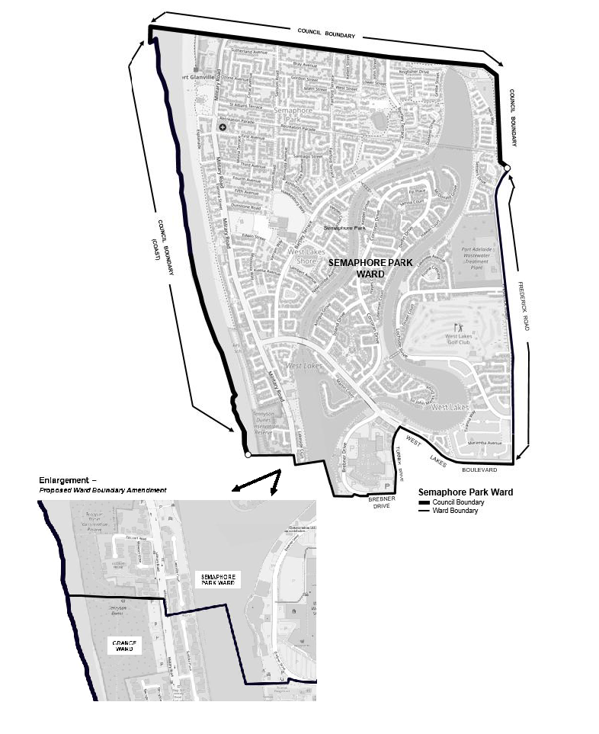
Semaphore Park Ward
Comprising the suburbs of Semaphore Park, Tennyson (part), West Lakes (part) and West Lakes Shore.

Second Schedule
Grange Ward
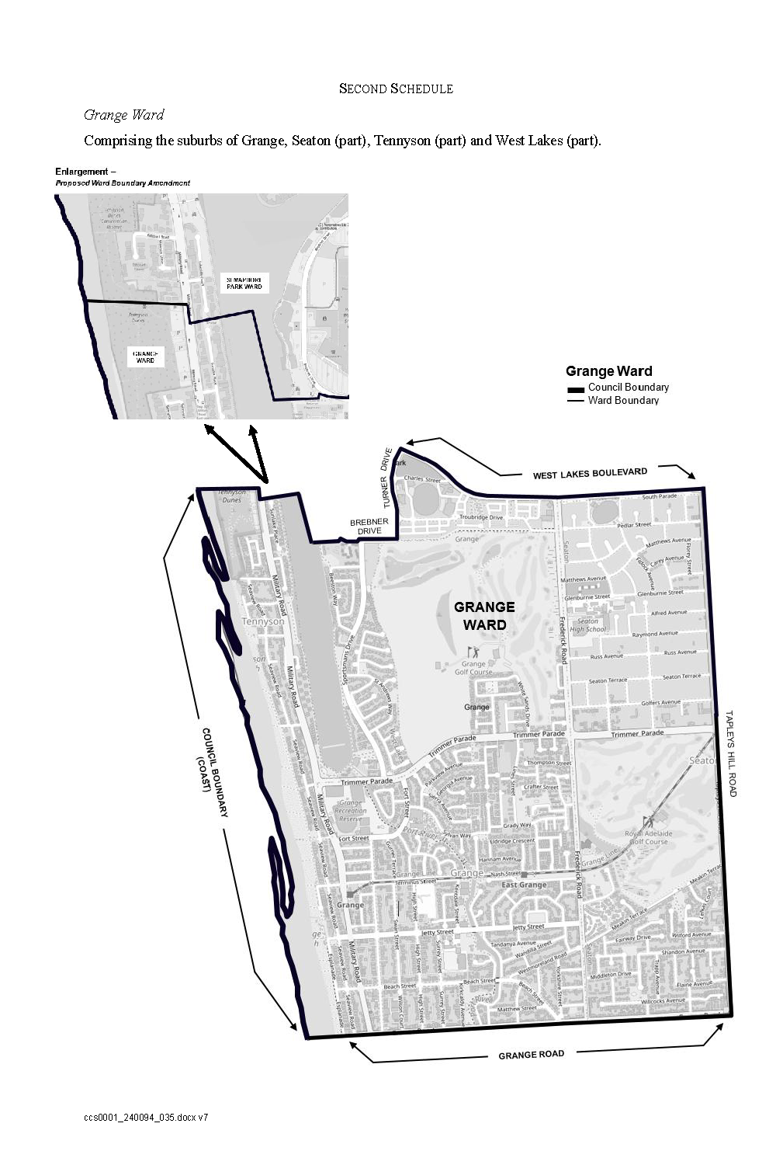
Comprising the suburbs of Grange, Seaton (part), Tennyson (part) and West Lakes (part).

Third Schedule
Henley Ward
Comprising the suburbs of Fulham Gardens (part), Henley Beach, Henley Beach South and West Beach (part).

Fourth Schedule
Woodville Ward
Comprising the suburbs of Athol Park, Cheltenham, Kilkenny (part), Pennington, Rosewater (part), St Clair, Woodville, Woodville North and Woodville Park.

Fifth Schedule
West Woodville Ward
Comprising the suburbs of Albert Park, Hendon, Royal Park, Seaton (part), Woodville South and Woodville West.

Sixth Schedule
Findon Ward
Comprising the suburbs of Findon (part), Fulham Gardens (part), Kidman Park and Seaton (part).

Seventh Schedule
Hindmarsh Ward
Comprising the suburbs of Bowden, Brompton, Croydon, Devon Park (part), Hindmarsh (part), Kilkenny (part), Ovingham (part), Renown Park, Ridleyton and West Croydon.

Eighth Schedule
Beverley Ward
Comprising the suburbs of Allenby Gardens, Beverly, Findon (part), Flinders Park, Hindmarsh (part), Welland and West Hindmarsh.

City of Playford
Review of Representation
Notice is hereby given that the City of Playford has reviewed its composition and elector representation arrangements in accordance with the requirements of Section 12 of the Local Government Act 1999 (the Act).
Pursuant to Section 12(13)(a) of the Act, the Electoral Commissioner has issued a certificate that the review undertaken by Council satisfies the requirements of Section 12 of the Act.
The following arrangements will therefore take effect from polling day of the next periodic Local Government election:
- The principal member of the Council will be a Mayor elected by the electors for the area.
- The future elected body of Council will comprise the Mayor and twelve (12) Ward Councillors.
- The Council area shall be divided into four (4) wards, as defined in Schedules One to Four inclusive.
- Each of the wards shall be represented by three (3) councillors.
- The wards shall be identified as Ward 1, Ward 2, Ward 3 and Ward 4.
Dated: 11 December 2025
Sam Green
Chief Executive Officer

Schedule 1
Ward 1
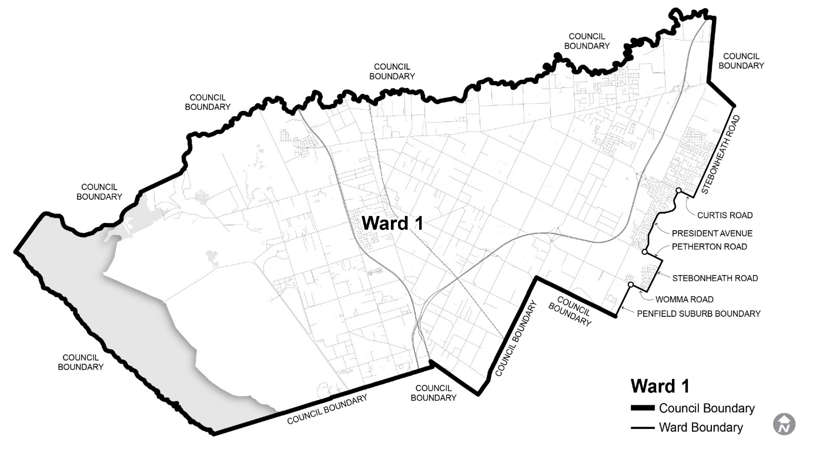
Comprising the suburbs of Angle Vale, Buckland Park, Eyre, Hillier, MacDonald Park, Munno Para West, Penfield, Penfield Gardens, Riverlea Park, Virginia and Waterloo Corner; part of the suburb of Andrews Farm to the west of President Avenue; and part of the suburb of Munno Para Downs to the west of Stebonheath Road.

Schedule 2
Ward 2
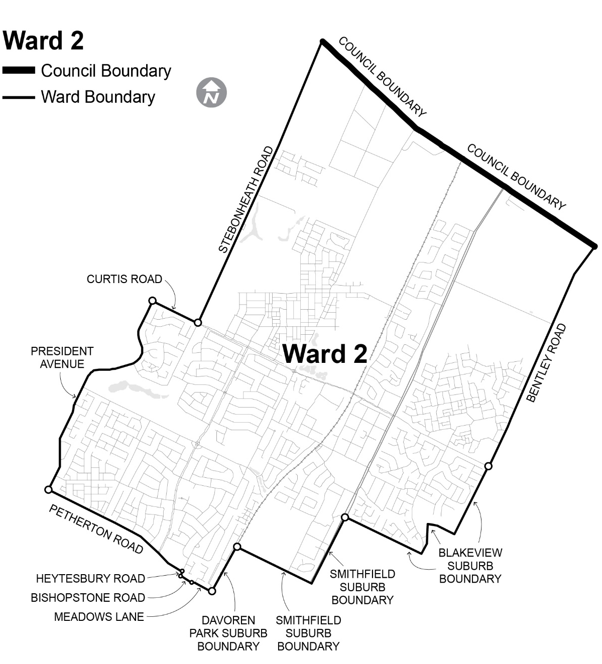
Comprising the suburbs of Munno Para, Smithfield and Smithfield Plains; part of the suburb of Munno Para Downs to the east of Stebonheath Road; part of the suburb of Andrews Farm to the east of President Avenue; part of the suburb of Davoren Park to the north of Petherton Road, Bishopstone Road and Meadows Lane; part of the suburb of Blakeview to the west of Bentley Road.

Schedule 3
Ward 3
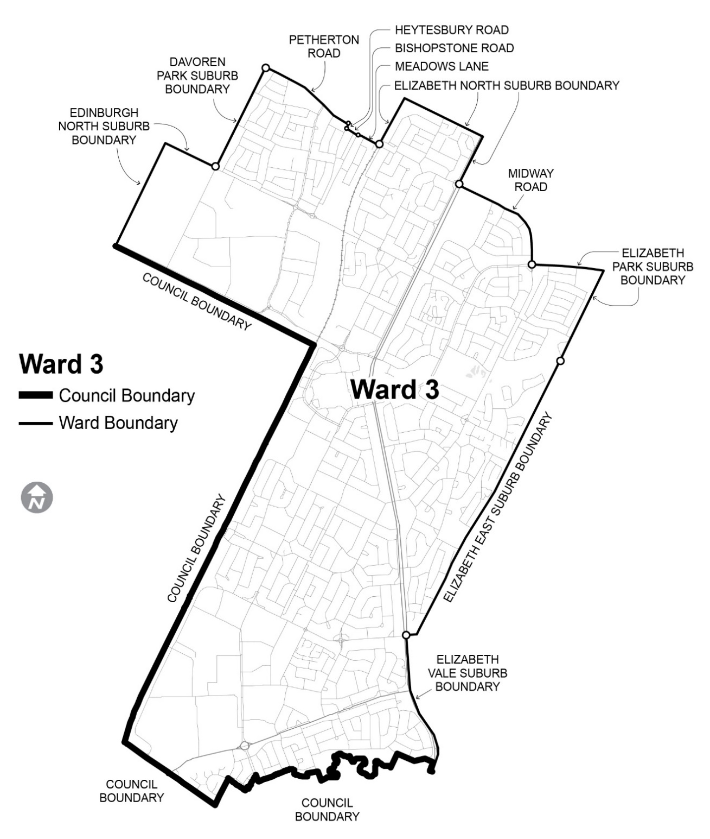
Comprising the suburbs of Edinburgh North, Elizabeth, Elizabeth East, Elizabeth Grove, Elizabeth North, Elizabeth Park, Elizabeth South and Elizabeth Vale; part of the suburb of Elizabeth Downs to the south of Midway Road; and part of the suburb of Davoren Park to the south of Petherton Road, Bishopstone Road and Meadows Lane.

Schedule 4
Ward 4
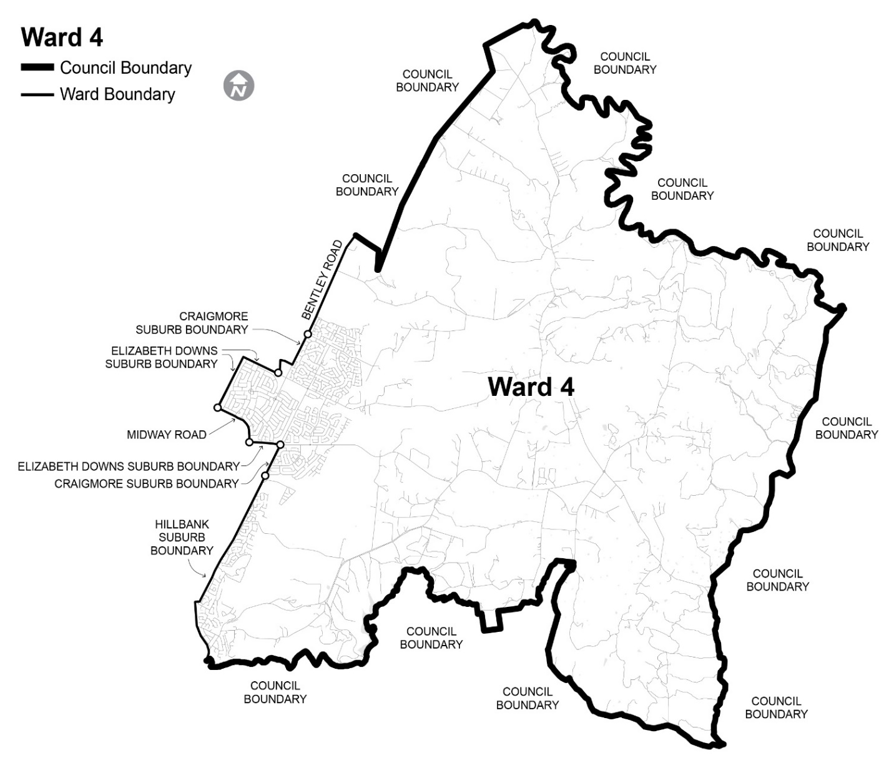
Comprising the suburbs of Bibaringa, Craigmore, Evanston Park, Gould Creek, Hillbank, Humbug Scrub, One Tree Hill, Sampson Flat, Uleybury and Yattalunga; part of the suburb of Blakeview to the east of Bentley Road; and part of the suburb of Elizabeth Downs to the north of Midway Road.

Adelaide Hills Council
Local Government Act 1999
By-law No. 4 of 2025—Roads By-law 2025
For the management of public roads.
Part 1—Preliminary
1. Short Title
This by-law may be cited as the Roads By-law 2025.
2. Commencement
This by-law will come into operation four months after the day on which it is published in the Gazette in accordance with Section 249(5) of the Local Government Act 1999.
3. Definitions
In this by-law, unless the contrary intention appears:
3.1 adjacent land has the same meaning as in the Australian Road Rules;

3.2 animal includes birds and poultry but does not include a dog;
3.3 camp includes setting up a camp, or cause a self-contained vehicle to remain on the land for the purpose of staying overnight, whether or not any person is in attendance or sleeps on the road;
3.4 dog has the same meaning as in the Dog and Cat Management Act 1995;
3.5 electoral matter has the same meaning as in the Electoral Act 1985 provided that such electoral matter is not capable of causing physical damage or injury to any person within its immediate vicinity;
3.6 emergency worker has the same meaning as in the Road Traffic (Road Rules—Ancillary and Miscellaneous Provisions) Regulations 2014;
3.7 road has the same meaning as in the Local Government Act 1999.
Part 2—Management of Roads
4. Activities Requiring Permission
A person must not on any road, without the permission of the Council:
4.1 Advertising
display any sign for the purpose of commercial advertising, other than a moveable sign which is displayed on a public road in accordance with the Council’s Moveable Signs By-law 2025;
4.2 Amplification
use an amplifier or other device whether mechanical or electrical for the purposes of amplifying sound;
4.3 Animals
4.3.1 cause or allow any animal, to stray onto, graze, wander on or be left unattended on any road;
4.3.2 lead, drive or exercise any animal in such a manner as to endanger the safety of any person;
4.4 Bridge Jumping
jump from or dive from a bridge;
4.5 Camping
4.5.1 erect any tent or other structure of calico, canvas, plastic or similar material as a place of habitation;
4.5.2 camp or sleep overnight;
4.5.3 camp or sleep overnight in a motorhome, except where a sign or signs erected by the Council indicate that camping on the road in such a vehicle is permitted;
4.6 Donations
ask for or receive or indicate that he or she desires a donation of money or any other thing;
4.7 Driving on Formed Surface
drive a motor vehicle other than on a portion of the road that has been formed or otherwise set aside by the Council for the driving of motor vehicles, unless it is not reasonably practical to do so;
4.8 Fishing
fish from any bridge or other structure on a road to which the Council has resolved this subparagraph shall apply;
4.9 Flora, Fauna and Other Living Things
subject to the Native Vegetation Act 1991 and the National Parks and Wildlife Act 1972:
4.9.1 damage, pick, or interfere with any plant, fungi or lichen thereon; or
4.9.2 remove, interfere with, tease, disturb or cause harm to any animal or bird or the eggs or young of any animal or bird or aquatic life;
4.9.3 use, possess or have control of any device for the purpose of killing or capturing any animal, bird or aquatic life;
4.9.4 plant, damage, pick, cut, disturb, interfere with or remove any plant, tree or flower;
4.9.5 cause or allow an animal to be present on any flowerbed or garden plot;
4.9.6 deposit, dig, damage, disturb, interfere with or remove any soil, stone, wood, clay, gravel, pebbles, timber, bark, shells or fossils or any part of the land;
4.9.7 disturb, interfere, damage or remove any burrow, nest or habitat of any animal, bird or aquatic life;
4.9.8 burn any timber or dead wood;
4.10 Obstructions
erect, install or place or cause to be erected, installed or placed any structure, object or material of any kind so as to obstruct a road, footway, water channel or water course;
4.11 Preaching
preach or harangue;
4.12 Public Exhibitions and Displays
4.12.1 sing, busk or play a recording or use a musical instrument for the apparent purpose of either entertaining others or receiving money;
4.12.2 conduct or hold any concert, festival, show, public gathering, circus, meeting, performance or any other similar activity;
4.12.3 cause any public exhibitions or displays;
4.13 Soliciting
ask for or receive or do anything to indicate a desire for a donation of money or any other thing;
4.14 Working on Vehicles
perform the work of repairing, washing, painting, panel beating or other work of any nature on or to any vehicle, except for running repairs in the case of breakdown;
4.15 Waste
deposit any domestic or commercial waste or other rubbish emanating from domestic or commercial premises in any Council rubbish bin;
4.16 Waste Collection
4.16.1 an occupier of premises must facilitate the collection and removal of domestic waste, recyclables or green organics from the premises by placing the container on the kerbside by 6:00am on the day of waste collection and not before 6:00am the day prior to collection;
4.16.2 ensure that, prior to the time appointed by the Council (but not outside the times provided in subparagraph 4.16.1) for the collection of a particular kind of domestic waste, recyclables or green organics from the premises, the container containing that kind of waste is placed out for collection in a position:
4.16.2.1 on the street in front of and on the same side as the premises, abutting the edge of (but not on) the carriageway and positioned so that the side of the container on which the hinges of the lid are situated faces the premises; or
4.16.2.2 as otherwise approved by the Council; and
4.16.2.3 it is not under the overhanging branches of street trees; and
4.16.2.4 the container is removed from that position on the kerbside within 24 hours of being emptied.
5. Prohibited Activities
A person who owns or is in charge of any horse or cattle must, if the horse or cattle defecates on a road, immediately remove the faeces and dispose of them in a lawful and suitable manner.
Part 3—Miscellaneous
6. Directions
A person must comply with any reasonable direction or request from an authorised person relating to:
6.1 that person’s use of the road;
6.2 that person’s conduct and behaviour on the road;
6.3 that person’s safety on the road;
6.4 the safety and enjoyment of the road by other persons.
7. Removal of Animals
If any animal is found on a road in breach of this by-law:
7.1 any person in charge of the animal shall forthwith remove it from that land on the request of an authorised person; and
7.2 any authorised person may remove any animal from the road if the person fails to comply with the request, or if no person is in charge of the animal.
8. Exemptions
8.1 The restrictions in this by-law do not apply to any Police Officer, Council Officer or Council employee acting in the course and within the scope of that person’s normal duties, or to a contractor while performing work for the Council and while acting under the supervision of a Council Officer, or to an emergency worker performing emergency duties.
8.2 The restrictions in paragraphs 4.12 and 4.13 of this by-law do not apply to:
8.2.1 electoral matters authorised by a candidate and which relate to a State or Commonwealth election and are otherwise authorised to be exhibited under Sections 226 and 226A of the Local Government Act 1999 or the Electoral Act 1985; or
8.2.2 electoral matters authorised by a candidate and which relate to an election held under the Local Government Act 1999 or the Local Government (Elections) Act 1999 and is otherwise authorised to be exhibited under Section 226 of the Local Government Act 1999; or
8.2.3 matters which relate to, and occur during the course of and for the purpose of a referendum.
8.3 Paragraph 4.7 of this by-law does not apply to a motor vehicle being driven to or from adjacent land by the shortest practical route.
9. Application
Paragraph 4.8 of this by-law shall apply only in such portion or portions of the area as the Council may by resolution direct from time to time in accordance with Section 246(3)(e) of the Local Government Act 1999.
10. Revocation
Council’s Roads By-law 2018, published in the Gazette on 9 August 2018, is revoked on the day on which this by-law comes into operation.
The foregoing by-law was duly made and passed at a meeting of the Council of the Adelaide Hills Council held on the 25th day of November 2025 by an absolute majority of the members for the time being constituting the Council, there being at least two thirds of the members present.
Dated: 11 December 2025
Greg Georgopoulos
Chief Executive Officer

ADELAIDE HILLS COUNCIL
Review of Representation
Notice is hereby given that the Adelaide Hills Council has reviewed its composition and elector representation arrangements in accordance with the requirements of Section 12 of the Local Government Act 1999 (the Act).
Pursuant to Section 12(13)(a) of the Act, the Electoral Commissioner has issued a certificate that the review undertaken by Council satisfies the requirements of Section 12 of the Act.
The following arrangements will therefore take effect from polling day of the next periodic Local Government election:
• The principal member of Council continues to be a Mayor, elected by the electors for the area.
• The Council elected body comprise a Mayor and twelve (12) councillors.
• The Council area be divided into three (3) wards, as defined in Schedules One to Three inclusive.
• The wards be identified as South Ward, Central Ward and North Ward, with each ward being represented by four (4) Councillors.
Dated: 11 December 2025
Greg Georgopoulos
Chief Executive Officer

Schedule 1
South Ward
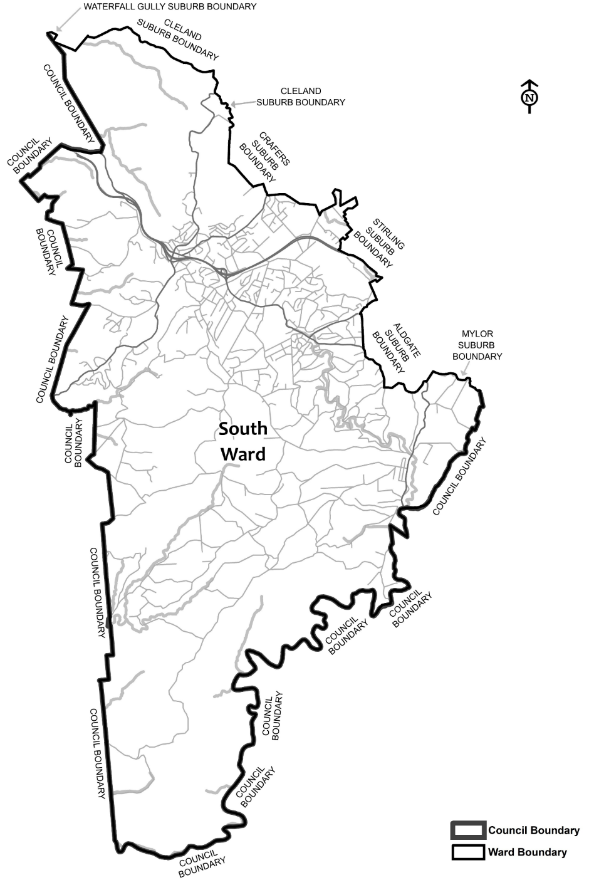
Comprising the suburbs/localities within the Council—Aldgate, Belair, Bradbury, Cleland, Crafers, Crafers West, Dorset Vale, Heathfield, Ironbank, Longwood, Mylor, Scott Creek, Stirling, Upper Sturt and Waterfall Gully.

Schedule 2
Central Ward
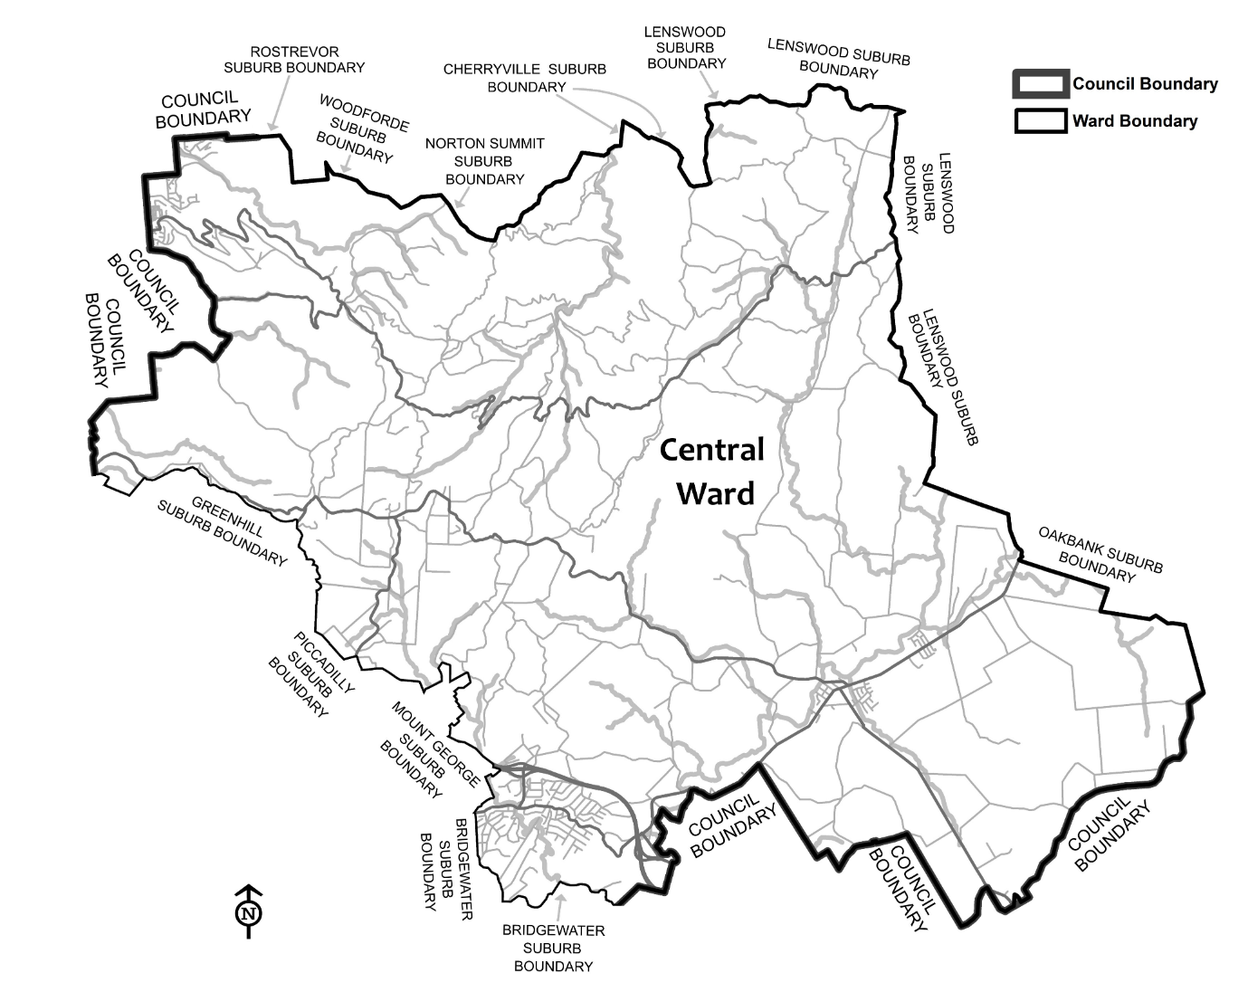
Comprising the suburbs/localities within the Council—Ashton, Balhannah, Basket Range, Bridgewater, Carey Gully, Cherryville, Forest Range, Greenhill, Hahndorf, Hay Valley, Horsnell Gully, Lenswood, Marble Hill, Mount George, Norton Summit, Oakbank, Piccadilly, Rostrevor, Summertown, Teringie, Uraidla, Verdun and Woodforde.

Schedule 3
North Ward
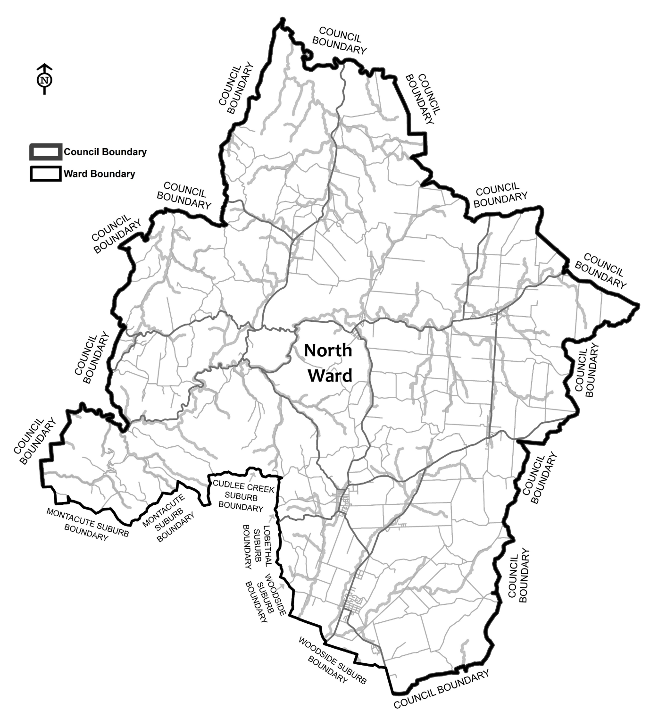
Comprising the suburbs/localities within the Council—Birdwood, Castambul, Chain of Ponds, Charleston, Cromer, Cudlee Creek, Forreston, Gumeracha, Houghton, Humbug Scrub, Inglewood, Kenton Valley, Kersbrook, Lobethal, Lower Hermitage, Millbrook, Montacute, Mount Crawford, Mount Torrens , Paracombe, Upper Hermitage and Woodside.

Adelaide Hills Council
Supplementary Election—Nominations Received
At the close of nominations at 12 noon on Thursday, 4 December 2025, the following people have been accepted as candidates and are listed below in the order in which they will appear on the ballot paper.
Mayor—1 Vacancy
DANIELL, Nathan
STRATFORD, Andrew Mark
McDONNELL, Georgia
Campaign Disclosure Returns
Candidates must lodge the following returns with the Electoral Commissioner:
• Campaign donation return
⸰ Return no. 1—lodgement from Friday, 12 December to Thursday, 18 December 2025
⸰ Return no. 2—within 30 days of the conclusion of the election
• Large gift return
⸰ Return lodgement within 5 days after receipt, only required for gifts in excess of $2,500
Detailed information about candidate disclosure return requirements can be found at www.ecsa.sa.gov.au
Voting Conducted by Post
The election is conducted entirely by post and no polling booths will be open for voting. Ballot papers and reply-paid envelopes are mailed out between Tuesday, 13 January and Monday, 19 January 2026 to every person, body corporate and group listed on the voters roll at the close of rolls on 5pm, Friday, 31 October 2025. Voting is voluntary.
A person who has not received voting material by Thursday, 22 January 2026, and believes they are entitled to vote, should contact the deputy returning officer on 1300 655 232 before 5pm, Monday, 2 February 2026.
Completed voting material must be sent to reach the returning officer no later than 12 noon on polling day Monday, 9 February 2026.
Assisted Voting
Prescribed electors under Section 41A(8) of the Local Government (Elections) Act 1999, may vote via the telephone assisted voting method by calling the Electoral Commission SA on:
• 1300 655 232 within South Australia only
• 08 7424 7400 from interstate
• +61 8 7424 7400 from overseas
The Telephone Assisted Voting Centre will operate for the following times and days:
• 9am—5pm, Thursday, 5 and Friday, 6 February 2026
• 9am—12 noon, Monday, 9 February 2026 (close of voting)
Vote Counting Location
The scrutiny and count will take place from 9:30am on Tuesday, 10 February 2026 at the following location:
• Electoral Commission SA
⸰ 60 Light Square, Adelaide 5000
A provisional declaration will be made at the conclusion of the election count.
Dated: 11 December 2025
Mick Sherry
Returning Officer

Regional Council of Goyder
Review of Representation
Notice is hereby given that the Regional Council of Goyder has reviewed its composition in accordance with the requirements of Section 12 of the Local Government Act 1999.
Certification
Pursuant to Section 12(13) of the Act the Electoral Commissioner has issued a certificate that the review undertaken by the Council satisfies the requirements of Section 12 and may now be put into effect as from the day of the first periodic election held after the publication of this notice.
The Council proposes to make the following changes to its representation arrangements, including an amendment to Ward boundaries, as set out in the Schedule.
The following arrangements will take effect from polling day of the next periodic elections:
- The Principal Member of the Council is to be a Mayor, elected from the Council area as a whole;
- The Council area continue to be divided into Wards, but reduced to two (2) Wards, to be called the Southern Ward and Northern Ward;
- Each Ward to be represented by three (3) Ward Councillors;
- The future elected body of the Council will comprise of seven (7) elected members, these being the Mayor and six (6) Ward Councillors, with three (3) elected from each Ward.
Dated: 11 December 2025
David Stevenson
Chief Executive Officer

First Schedule
Southern Ward
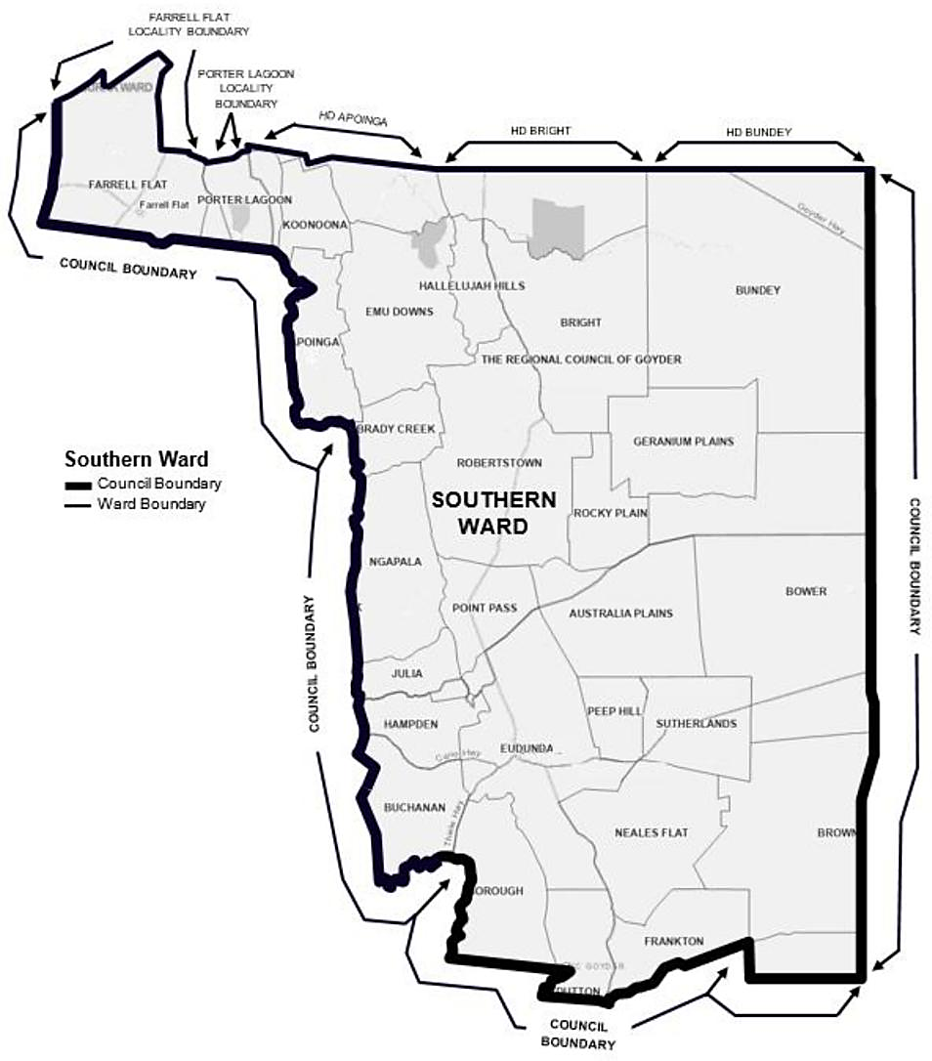
The Southern Ward, from the western council boundary following the northern boundaries of the localities of Farrell Flat and Porter Lagoon, the western and northern boundary of the Hundred of Apoinga, the northern boundaries of the Hundreds of Bright and Bundey to the eastern and southern council boundary, more particularly delineated on the plan published herewith.

Second Schedule
Northern Ward
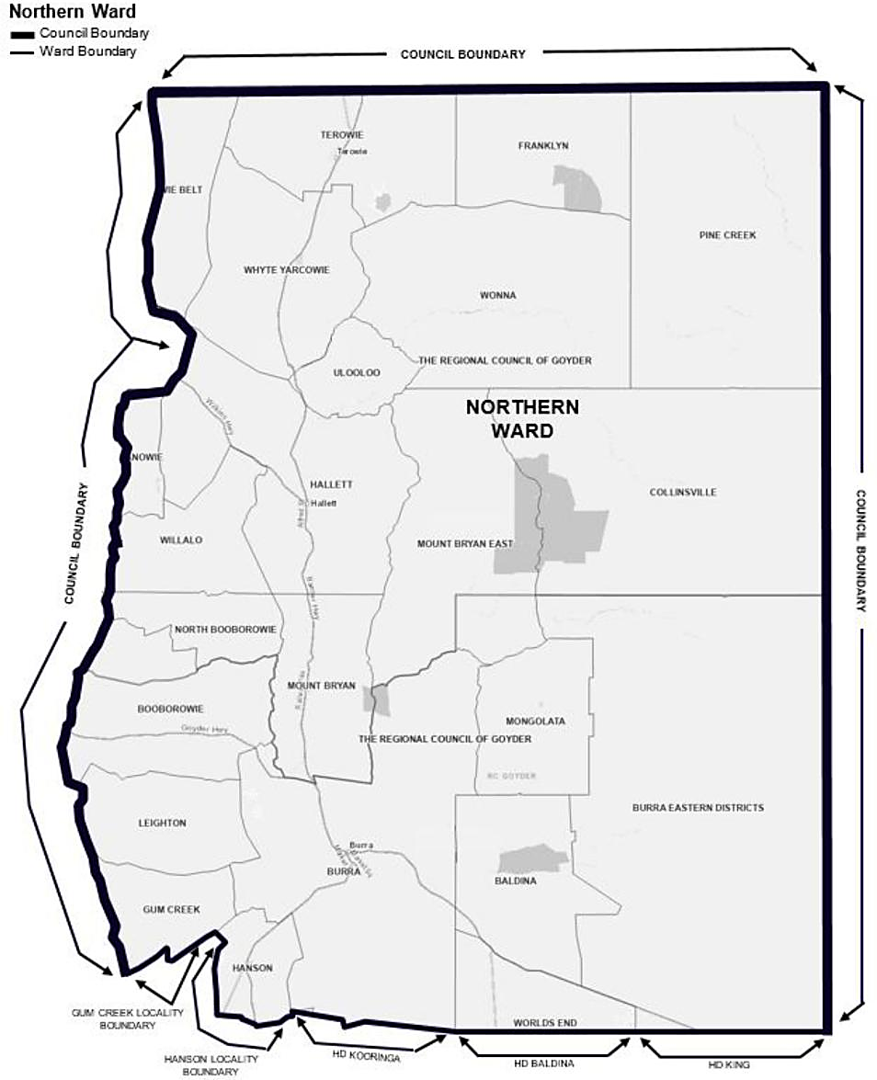
The Northern Ward, from the western council boundary following the southern boundary of the locality of Gum Creek, the western and southern boundary of the locality of Hanson, the southern boundaries of the Hundreds of Kooringa, Baldina and King to the eastern and northern council boundary, more particularly delineated on the plan published herewith.

District Council of Karoonda East Murray
Review of Representation
Notice is hereby given that the District Council of Karoonda East Murray has reviewed its composition in accordance with the requirements of Section 12 of the Local Government Act 1999.
Certification
Pursuant to Section 12(13)(a) of the Act the Electoral Commissioner issued a certificate that the review undertaken by the Council satisfies the requirements of Section 12 and may now be put into effect from the day of the first periodic election held after the publication of this notice.
The Council proposes to make no change to its representation arrangements, with the following arrangements to take effect from polling day of the next periodic elections:
• The name of the Council is to remain unchanged;
• The Principal Member of the Council continue to be an elected Mayor;
• The area of the Council shall not be divided into wards;
• The future elected body of the Council will comprise of six (6) Councillors, elected from the Council area as a whole and a Mayor elected from the Council area as a whole.
Dated: 9 December 2025
Scott Reardon
Chief Executive Officer

District Council of Mount Remarkable
Exclusion of Land as Community Land
Notice is hereby given that Council at its Special Meeting held on 27 November 2025, pursuant to Section 193(4) of the Local Government Act 1999 resolved to exclude Lot 217 as described within Certificate of Title Volume 5321, Folio 235 and locally known as an allotment within the Port Germein Caravan Park, from the classification as community land, prior to the property being acquired by Council.
Dated: 11 December 2025
Richard Dodson
Acting Chief Executive Officer

District COUNCIL OF MOUNT REMARKABLE
Review of Representation
Notice is hereby given that the District Council of Mount Remarkable has reviewed its composition in accordance with the requirements of Section 12 of the Local Government Act 1999.
Certification
Pursuant to Section 12(13) of the Act, the Electoral Commissioner has issued a certificate that the review undertaken by the Council satisfies the requirements of Section 12 and may now be put into effect as from the day of the first periodic election held after the publication of this notice.
The Council proposes to make the following changes to its representation arrangements, including to alter the Ward boundary set out in the Schedule, to satisfy Ward tolerance quota requirements.
The following arrangements will therefore take effect from polling day of the next periodic elections:
• the Principal Member of the Council will be a Mayor, elected as a representative of the area as a whole;
• the Council area continue to be divided into two (2) Wards, both to retain their existing names of Telowie and Willochra, but subject to a boundary alteration to satisfy the Ward quota tolerance requirements;
• each Ward to be represented by three (3) Ward Councillors;
• the future elected body of the Council will comprise of seven (7) Elected Members, these being the Mayor and six (6) Ward Councillors.
Dated: 11 December 2025
Richard Dodson
Acting Chief Executive Officer

First Schedule
Telowie Ward
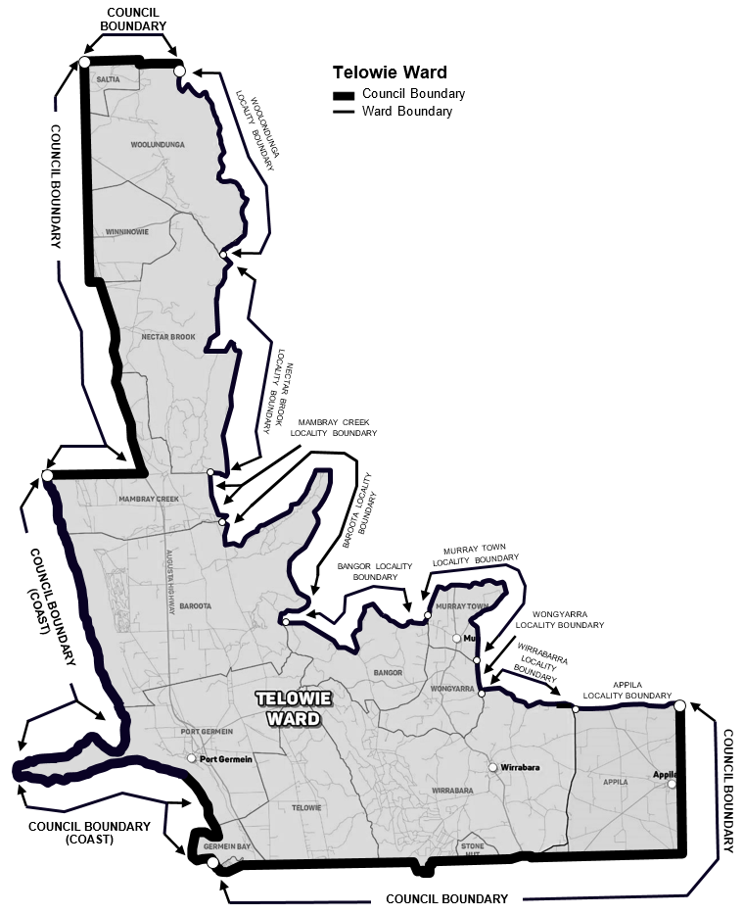
Comprising all the land contained within the bounds of the area defined as the Council boundaries in the south, west and north; and the eastern boundaries of the localities of Saltia, Woolundunga, Nectar Brook and Mambray Creek and the northern and eastern boundaries of the locality of Baroota, the northern boundary of the locality of Bangor, the western northern and eastern boundaries of the locality of Murray Town, the eastern boundary of the locality of Wongyarra, the northeastern, southern boundaries of the locality of Wirrabarra, and the northern and southern boundary of the locality of Appila.

Second Schedule
Willochra Ward
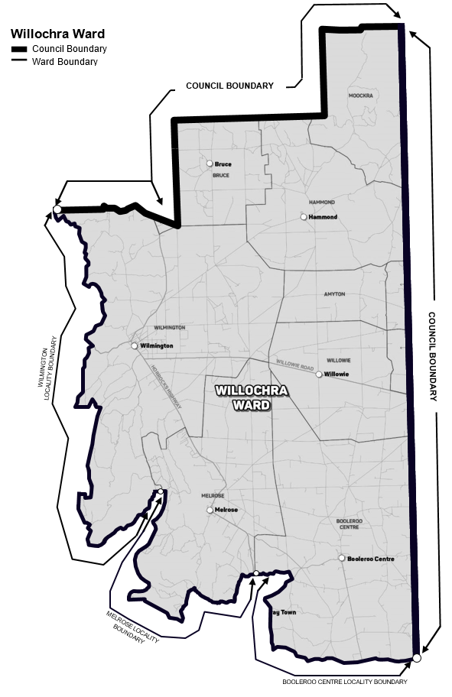
Comprising all the land contained within the bounds of the area defined as the Council boundaries in the east and north; and along the western and southern boundaries of the locality of Wilmington, the western and southern boundaries of the locality of Melrose, the western and southern boundaries of the locality of Booleroo Centre to the eastern council boundary.

Yorke Peninsula Council
Supplementary Election—Nominations Received
At the close of nominations at 12 noon on Thursday, 4 December 2025, the following people have been accepted as candidates and are listed below in the order in which they will appear on the ballot paper.
Councillor for Innes/Penton Vale Ward—1 Vacancy
GLAZBROOK, William
DINHAM, Phil
Campaign Disclosure Returns
Candidates must lodge the following returns with the Electoral Commissioner:
• Campaign donation return
◦ Return no. 1—lodgement from Friday, 12 December to Thursday, 18 December 2025
◦ Return no. 2—within 30 days of the conclusion of the election
• Large gift return
◦ Return lodgement within 5 days after receipt, only required for gifts in excess of $2,500
Detailed information about candidate disclosure return requirements can be found at www.ecsa.sa.gov.au
Voting Conducted by Post
The election is conducted entirely by post and no polling booths will be open for voting. Ballot papers and reply-paid envelopes are mailed out between Tuesday, 13 January and Monday, 19 January 2026 to every person, body corporate and group listed on the voters roll at the close of rolls on 5pm, Friday, 31 October 2025. Voting is voluntary.
A person who has not received voting material by Thursday, 22 January 2026, and believes they are entitled to vote, should contact the deputy returning officer on 1300 655 232 before 5pm, Monday, 2 February 2026.
Completed voting material must be sent to reach the returning officer no later than 12 noon on polling day Monday, 9 February 2026.
Assisted Voting
Prescribed electors under Section 41A(8) of the Local Government (Elections) Act 1999, may vote via the telephone assisted voting method by calling the Electoral Commission SA on:
• 1300 655 232 within South Australia only
• 08 7424 7400 from interstate
• +61 8 7424 7400 from overseas
The Telephone Assisted Voting Centre will operate for the following times and days:
• 9am-5pm, Thursday, 5 and Friday 6 February 2026
• 9am-12 noon, Monday, 9 February 2026 (close of voting)
Vote Counting Location
The scrutiny and count will take place from 9:30am on Tuesday, 10 February 2026 at the following location:
• Electoral Commission SA
◦ 60 Light Square, Adelaide 5000
A provisional declaration will be made at the conclusion of the election count.
Dated: 11 December 2025
Mick Sherry
Returning Officer

Public Notices

National Electricity Law
Notice of Draft Determination Extension
The Australian Energy Market Commission (AEMC) gives notice under the National Electricity Law as follows:
Under s 107, the time for making the draft determination on the Clarifying the treatment of policies and costs in the ISP (Ref. ERC0406) proposal has been extended to 16 April 2026.
Australian Energy Market Commission
Level 15, 60 Castlereagh St
Sydney NSW 2000
Telephone: (02) 8296 7800
www.aemc.gov.au
Dated: 11 December 2025

National Gas Law
Notice of Final Rule
The Australian Energy Market Commission (AEMC) gives notice under the National Gas Law as follows:
Under ss 311, 312 and 313, the making of the National Gas Amendment (Updating the regulatory framework for gas connections) Rule 2025 No. 4 (Ref. GRC0085) and related final determination. Provisions commence as follows: Schedule 2 commences on 18 December 2025 and Schedule 1 commences on 1 October 2026.
Documents referred to above are available on the AEMC’s website and are available for inspection at the AEMC’s office.
Australian Energy Market Commission
Level 15, 60 Castlereagh St
Sydney NSW 2000
Telephone: (02) 8296 7800
www.aemc.gov.au
Dated: 11 December 2025

Partnership Act 1891
Dissolution of Partnership
Notice is hereby given that the partnership between TUAN THANH NGUYEN as trustee for NGUYEN FAMILY TRUST, MUDAMUCKLA PTY LTD (A.C.N 128 402 675) as trustee for MANGALO INVESTMENT TRUST, BEATUS AUSTRALIS PTY LTD (A.C.N 647 870 111) as trustee for HA FAMILY TRUST, BENJAMIN LEWIS RICE & BELINDA LOUISE RICE as trustee for B & B RICE FAMILY TRUST and NICHOLAS LYNDSAY MURPHY as trustee for MURPHY FAMILY TRUST, the business of which traded under the name ‘Prodevelop Property Partnership’ was dissolved effective 1 December 2025.
Dated: 1 December 2025
Tuan Thanh Nguyen
as trustee for Nguyen Family Trust
Mudamuckla Pty Ltd
as trustee for Mangalo Investment Trust
Beatus Australis Pty Ltd
as trustee for Ha Family Trust
Benjamin Lewis Rice
as trustee for B & B Rice Family Trust
Belinda Louise Rice
as trustee for B & B Rice Family Trust
Nicholas Lyndsay Murphy
as trustee for Murphy Family Trust

Trustee Act 1936
Public Trustee
Estates of Deceased Persons
In the matter of the estates of the undermentioned deceased persons:
BENNETT Annis Autumn late of 43 Fisher Street Magill Retired School Teacher who died 10 March 2025
DAWSON Christopher John late of 1 Wilton Street Davoren Park of no occupation who died 23 December 2024
FRASER Samantha Elvira late of 35 Argyle Avenue Marleston of no occupation who died 3 March 2025
GARDINER Pauline Joan late of 17 Pattinson Close Whyalla Norrie Retired Medical Receptionist who died 15 March 2024
GROVES Alexander Stanley late of 18 Cudmore Terrace Marleston Retired Printer who died 5 June 2025
JOHNSTONE Harold late of 1 Steele Street Campbelltown Retired Retail Worker who died 4 July 2025
LENNARD Beryl Gladys late of 33 Alfred Street Peterhead of no occupation who died 24 July 2025
NERO Pauline Quentin late of 470 Churchill Road Kilburn Retired Nurse who died 17 October 2024
ROBERTS William Richard late of 1 East Parkway Lightsview Retired Mechanic who died 15 May 2025
SCHULZE Vivienne Sophie late of 19 South Terrace Cowell of no occupation who died 28 May 2025
SMITH Beryl Muriel late of 2-10 First Street Brompton of no occupation who died 21 July 2022
SULLIVAN Thomas Patrick late of 22 Bridge Street Balhannah Retired Senior Technical Officer who died 28 May 2025
WILLIAMS Barry Phillip late of 17 Clayton Drive Grange Retired Motor Trimmer who died 28 May 2025
WOLFE Noel Stuart late of 431 Anzac Highway Camden Park Retired Clerical Worker who died 4 May 2025
Notice is hereby given pursuant to the Trustee Act 1936 (SA), the Succession Act 2023 (SA) and the Family Relationships Act 1975 (SA)
that all creditors, beneficiaries, and other persons having claims against the said estates are required to send, in writing, to the office of
Public Trustee at GPO Box 1338, Adelaide, 5001, full particulars and proof of such claims, on or before the 9 January 2026 otherwise they will
be excluded from the distribution of the said estate; and notice is also hereby given that all persons indebted to the said estates are required to pay the amount of their debts to the Public Trustee or proceedings will be taken for the recovery thereof; and all persons having any property belonging to the said estates are forthwith to deliver same to the Public Trustee.
Dated: 11 December 2025
T. Brumfield
Public Trustee

Notice Submission

The South Australian Government Gazette is published each Thursday afternoon.
Notices must be emailed by 4 p.m. Tuesday, the week of publication.
Submissions are formatted per the gazette style and a proof will be supplied prior to publication, along with a quote if applicable. Please allow one day for processing notices.
Alterations to the proof must be returned by 4 p.m. Wednesday.

Gazette notices must be submitted as Word files, in the following format:
• Title—the governing legislation
• Subtitle—a summary of the notice content
• Body—structured text, which can include numbered lists, tables, and images
• Date—day, month, and year of authorisation
• Signature block—name, role, and department/organisation authorising the notice

Please provide the following information in your email:
• Date of intended publication
• Contact details of the person responsible for the notice content
• Name and organisation to be charged for the publication—Local Council and Public notices only
• Purchase order, if required—Local Council and Public notices only

Email: governmentgazettesa@sa.gov.au
Phone: (08) 7133 3552
Website: www.governmentgazette.sa.gov.au

All instruments appearing in this gazette are to be considered official, and obeyed as such

Printed and published weekly by authority of T. Foresto, Government Printer, South Australia
$9.50 per issue (plus postage), $479.00 per annual subscription—GST inclusive
Online publications: www.governmentgazette.sa.gov.au

