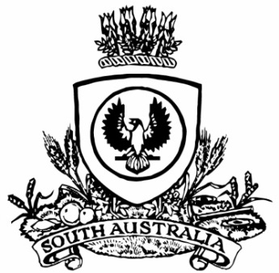
SUPPLEMENTARY GAZETTE
THE SOUTH AUSTRALIAN
GOVERNMENT GAZETTE
Published by Authority

Adelaide, Tuesday, 16 December 2025

Contents

State Government Instruments

Summary Offences Act 1953 4956

State Government Instruments

Summary Offences Act 1953
Declared Public Precincts
Ministerial Declaration
I, Kyam Joseph Maher, Attorney-General in the State of South Australia, being the Minister responsible for the administration of Part 14B—Declared Public Precincts of the Summary Offences Act 1953, DO HEREBY DECLARE pursuant to the provisions of Section 66N of the said Act that the area, comprised of more than one public place, within the following boundaries:
• northern boundary of Pennington Terrace from Montefiore Road to King William Street;
• eastern boundary of King William Road from Pennington Terrace to the southern River Torrens bank;
• southern boundary of the River Torrens to Montefiore Road;
• western boundary of Montefiore Road to Pennington Terrace;
will be a Declared Public Precinct for a period of 15 hours from 8am to 11pm every day, commencing 8 am Wednesday, 17 December 2025 until 11pm Sunday, 21 December 2025.
This Declaration period provides for a total of 15 hours in one 24 hour period. I am satisfied that special circumstances exist in this particular case to allow the extra hours.
References to boundaries identified by streets, roads or terraces for the purpose of this declaration will be taken to mean and include the area up to applicable building or fence lines, or the imagined projection thereof, on the relevant boundary.
I am satisfied that there is, during the period specified in this declaration, a reasonable likelihood of conduct in the area posing a risk to public order and safety.
I am satisfied that the inclusion of each public place in the area is reasonable having regard to that identified risk.
Dated: 16 December 2025
Kyam Joseph Maher
Attorney-General

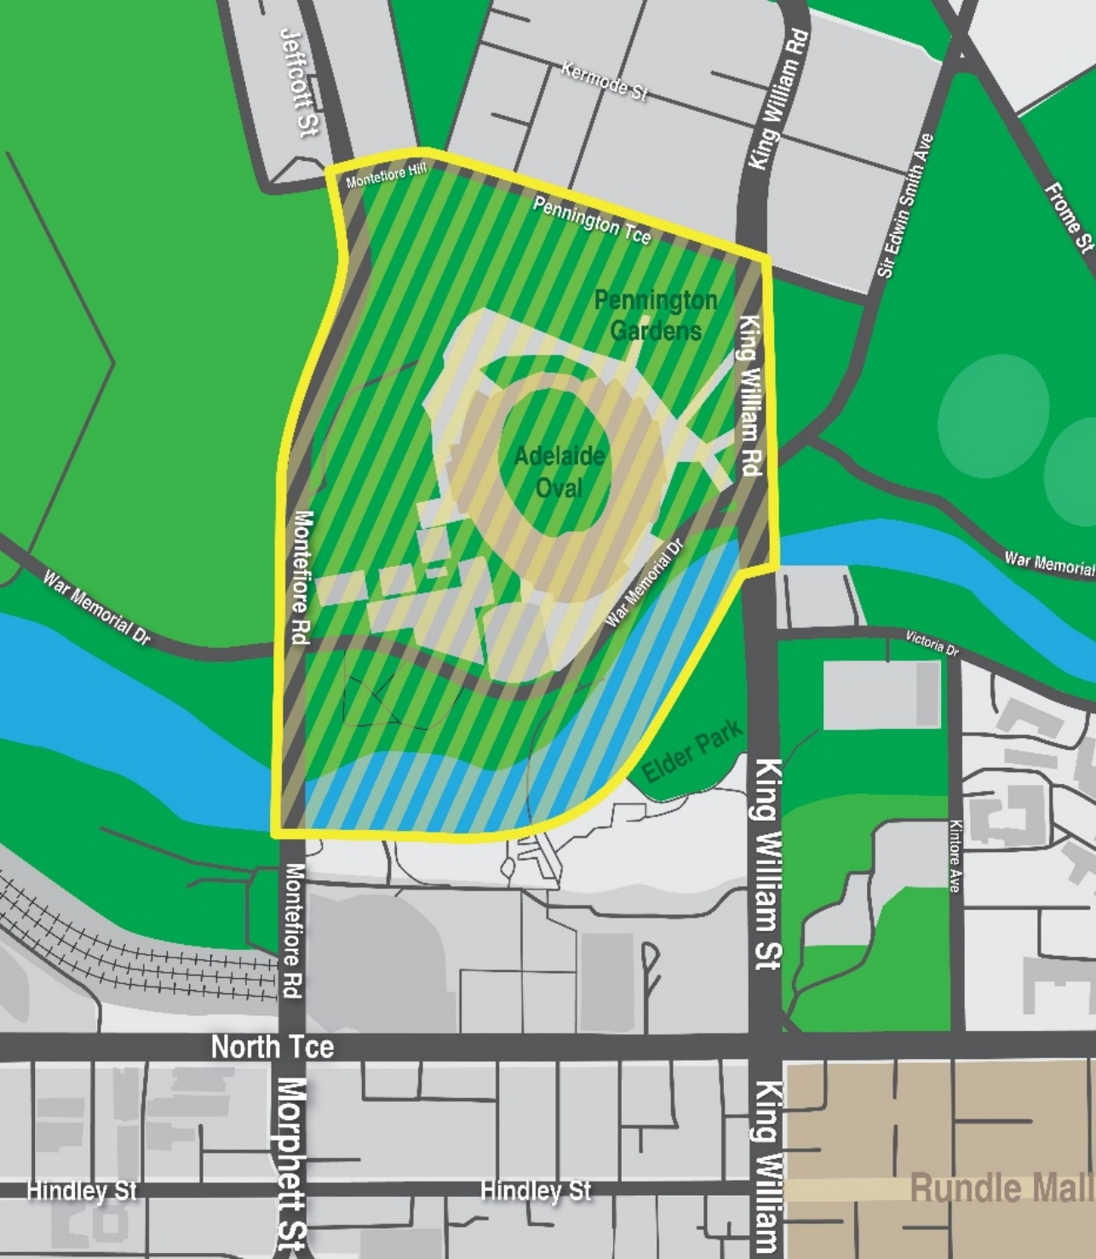

All instruments appearing in this gazette are to be considered official, and obeyed as such

Printed and published weekly by authority of T. Foresto, Government Printer, South Australia
$9.50 per issue (plus postage), $479.00 per annual subscription—GST inclusive
Online publications: www.governmentgazette.sa.gov.au

