
No. 73 p. 4959
THE SOUTH AUSTRALIAN
GOVERNMENT GAZETTE
Published by Authority

Adelaide, Thursday, 18 December 2025

Contents

Governor’s Instruments
Appointments, Resignations and General Matters 4960
Proclamations—
Fisheries Management (Cuttlefish—Northern Spencer Gulf) Amendment Act (Commencement) Proclamation 2025 4961
National Energy Retail Law (Retailer of Last Resort) Amendment Act (Commencement) Proclamation 2025 4961
Spicer Cottages Trust (Miscellaneous) Amendment Act (Commencement) Proclamation 2025 4962
Statutes Amendment (Local Government Elections Review)
Act (Commencement) Proclamation 2025 4962
Statutes Amendment (Local Government Review) Act (Commencement) Proclamation 2025 4963
Administrative Arrangements (Administration of North Adelaide Public Golf Course Act) Proclamation 2025 4963
North Adelaide Public Golf Course (Designated Minister) Proclamation 2025 4964
Regulations—
City of Adelaide (Elections and Polls)
(Local Government Elections Review) Amendment Regulations 2025—No. 143 of 2025 4965
Local Government (Elections)
(Local Government Elections Review) Amendment Regulations 2025—No. 144 of 2025 4968
Local Government (General)
(Local Government Elections Review) Amendment Regulations 2025—No. 145 of 2025 4970
National Energy Retail (Retailer of Last Resort)
Amendment Regulations 2025—No. 146 of 2025 4972
Fisheries Management (General) (Cuttlefish) Amendment Regulations 2025—No. 147 of 2025 4973
Fisheries Management (Demerit Points) (Cuttlefish) Amendment Regulations 2025—No. 148 of 2025 4974
Animal Welfare (Electrical Devices) Amendment Regulations 2025—No. 149 of 2025 4976
Education and Early Childhood Services
(Registration and Standards) (Amendment
of Education and Care Services National Law Text) Regulations 2025—No. 150 of 2025 4982
State Government Instruments
Agricultural and Veterinary Products
(Control of Use) Regulations 2017 5040
Construction Industry Training Fund Act 1993 5040
Dangerous Substances Act 1979 5074
Disability Inclusion Act 2018 5074
Electoral Act 1985 5074
Fisheries Management (Prawn Fisheries) Regulations 2017 5074
Fisheries Management Act 2007 5076
Health Care Act 2008 5077
Housing Improvement Act 2016 5077
Justices of the Peace Act 2005 5077
Landscape South Australia Act 2019 5078
Mental Health Act 2009 5080
National Electricity (South Australia) Act 1996 5080
Planning, Development and Infrastructure Act 2016 5080
Preventive Health SA Act 2024 5115
Summary Offences Act 1953 5115
Unclaimed Money Act 2021 5116
Local Government Instruments
City of Charles Sturt 5117
City of Port Lincoln 5117
City of West Torrens 5117
District Council of Kimba 5118
Lower Eyre Council 5118
District Council of Streaky Bay 5122
Wattle Range Council 5127
Yorke Peninsula Council 5127
Public Notices
National Electricity Law 5128
National Energy Retail Law 5128
National Gas Law 5128

Governor’s Instruments

Appointments, Resignations and General Matters
Department of the Premier and Cabinet
Adelaide, 18 December 2025
Her Excellency the Governor in Executive Council has been pleased to appoint the undermentioned to the South Australian Fire and Emergency Services Commission Board, pursuant to the provisions of the Fire and Emergency Services Act 2005:
Deputy Member: from 2 January 2026 until 17 July 2028
Mark Stratton (Deputy to Wandel)
By command,
Natalie Fleur Cook, MP
For Premier
25MES0008CS

Department of the Premier and Cabinet
Adelaide, 18 December 2025
Her Excellency the Governor in Executive Council has been pleased to appoint the undermentioned to the South Australian Tourism Commission Board, pursuant to the provisions of the South Australian Tourism Commission Act 1993:
Director: from 19 December 2025 until 18 December 2027
Sunita Gloster
By command,
Natalie Fleur Cook, MP
For Premier
25TMACAB044

Department of the Premier and Cabinet
Adelaide, 18 December 2025
Her Excellency the Governor in Executive Council has been pleased to appoint the undermentioned to the South Australian Country Arts Trust, pursuant to the provisions of the South Australian Country Arts Trust Act 1992:
Member: from 18 December 2025 until 17 December 2028
Lee-Ann Tjunypa Buckskin
Michael Waite
By command,
Natalie Fleur Cook, MP
For Premier
25ART0028CS

Department of the Premier and Cabinet
Adelaide, 18 December 2025
Her Excellency the Governor in Executive Council has been pleased to appoint the Honourable Zoe Lee Bettison MP as Acting Minister for Primary Industries and Regional Development and Acting Minister for Forest Industries from 22 December 2025 until 4 January 2026 inclusive, during the absence of the Honourable Clare Michele Scriven MLC.
By command,
Natalie Fleur Cook, MP
For Premier
DPC25/063CS

Department of the Premier and Cabinet
Adelaide, 18 December 2025
Her Excellency the Governor in Executive Council has been pleased to appoint the Honourable Clare Michele Scriven MLC as Acting Minister for Tourism and Acting Minister for Multicultural Affairs from 5 January 2026 until 8 January 2026 inclusive, during the absence of the Honourable Zoe Lee Bettison MP.
By command,
Natalie Fleur Cook, MP
For Premier
DPC25/063CS

Department of the Premier and Cabinet
Adelaide, 18 December 2025
Her Excellency the Governor in Executive Council has been pleased to appoint Leah Michelle McLay as the Deputy Electoral Commissioner for a term commencing on 14 January 2026 and expiring one year after polling day of the general election second occurring after the appointment is made - pursuant to the Electoral Act 1985.
By command,
Natalie Fleur Cook, MP
For Premier
AGO0227-25CS

Proclamations
South Australia

Fisheries Management (Cuttlefish—Northern Spencer Gulf) Amendment Act (Commencement) Proclamation 2025
1—Short title
This proclamation may be cited as the Fisheries Management (Cuttlefish—Northern Spencer Gulf) Amendment Act (Commencement) Proclamation 2025.
2—Commencement of Act
The Fisheries Management (Cuttlefish—Northern Spencer Gulf) Amendment Act 2025 (No 74 of 2025) comes into operation on 22 December 2025.
Made by the Governor
with the advice and consent of the Executive Council
on 18 December 2025

South Australia

National Energy Retail Law (Retailer of Last Resort) Amendment Act (Commencement) Proclamation 2025
1—Short title
This proclamation may be cited as the National Energy Retail Law (Retailer of Last Resort) Amendment Act (Commencement) Proclamation 2025.
2—Commencement of Act
The National Energy Retail Law (Retailer of Last Resort) Amendment Act 2025 (No 61 of 2025) comes into operation on 18 December 2025.
Made by the Governor
with the advice and consent of the Executive Council
on 18 December 2025

South Australia

Spicer Cottages Trust (Miscellaneous) Amendment Act (Commencement) Proclamation 2025
1—Short title
This proclamation may be cited as the Spicer Cottages Trust (Miscellaneous) Amendment Act (Commencement) Proclamation 2025.
2—Commencement of Act
The Spicer Cottages Trust (Miscellaneous) Amendment Act 2025 (No 56 of 2025) comes into operation on 1 January 2026.
Made by the Governor
with the advice and consent of the Executive Council
on 18 December 2025

South Australia

Statutes Amendment (Local Government Elections Review) Act (Commencement) Proclamation 2025
1—Short title
This proclamation may be cited as the Statutes Amendment (Local Government Elections Review) Act (Commencement) Proclamation 2025.
2—Commencement of Act
(1) Subject to subclause (2), the Statutes Amendment (Local Government Elections Review) Act 2025 (No 63 of 2025) comes into operation on 1 January 2026.
(2) Part 4 of the Act comes into operation immediately after section 190 of the Statutes Amendment (Local Government Review) Act 2021 comes into operation.
Made by the Governor
with the advice and consent of the Executive Council
on 18 December 2025

South Australia

Statutes Amendment (Local Government Review) Act (Commencement) Proclamation 2025
1—Short title
This proclamation may be cited as the Statutes Amendment (Local Government Review) Act (Commencement) Proclamation 2025.
2—Commencement of suspended provisions
The following provisions of the Statutes Amendment (Local Government Review) Act 2021 (No 26 of 2021) come into operation on 1 January 2026:
(a) section 190;
(b) section 196(1), (2), (8), (9), (12) and (14) to (16) (inclusive).
Made by the Governor
with the advice and consent of the Executive Council
on 18 December 2025

South Australia

Administrative Arrangements (Administration of North Adelaide Public Golf Course Act) Proclamation 2025
under section 5 of the Administrative Arrangements Act 1994
1—Short title
This proclamation may be cited as the Administrative Arrangements (Administration of North Adelaide Public Golf Course Act) Proclamation 2025.
2—Commencement
This proclamation comes into operation on the day on which it is made.
3—Administration of Act committed to Premier
The administration of the North Adelaide Public Golf Course Act 2025 is committed to the Premier.
Made by the Governor
with the advice and consent of the Executive Council
on 18 December 2025

South Australia

North Adelaide Public Golf Course (Designated Minister) Proclamation 2025
under the North Adelaide Public Golf Course Act 2025
1—Short title
This proclamation may be cited as the North Adelaide Public Golf Course (Designated Minister) Proclamation 2025.
2—Commencement
This proclamation comes into operation on the day on which it is made.
3—Designation of Minister
Pursuant to the definition of designated Minister in section 3(1) of the North Adelaide Public Golf Course Act 2025, the Minister for Recreation, Sport and Racing is designated as the Minister in whom the project site will vest under section 8 of that Act.
Made by the Governor
with the advice and consent of the Executive Council
on 18 December 2025

Regulations
South Australia

City of Adelaide (Elections and Polls) (Local Government Elections Review) Amendment Regulations 2025
under the City of Adelaide Act 1998

Contents
Part 1—Preliminary
1 Short title
2 Commencement
Part 2—Amendment of City of Adelaide (Elections and Polls) Regulations 2025
3 Amendment of regulation 3—Interpretation
4 Repeal of regulation 4
5 Substitution of regulation 6
6 Transitional provision for gifts received
6 Repeal of Schedule 1

Part 1—Preliminary
1—Short title
These regulations may be cited as the City of Adelaide (Elections and Polls) (Local Government Elections Review) Amendment Regulations 2025.
2—Commencement
These regulations come into operation on the day on which section 44 of the Statutes Amendment (Local Government Elections Review) Act 2025 comes into operation.
Part 2—Amendment of City of Adelaide (Elections and Polls) Regulations 2025
3—Amendment of regulation 3—Interpretation
Regulation 3(2)—delete subregulation (2)
4—Repeal of regulation 4
Regulation 4—delete the regulation

5—Substitution of regulation 6
Regulation 6—delete the regulation and substitute:
6—Transitional provision for gifts received
(1) Subject to this regulation, the application of old Schedule 1 Part 8 in relation to gifts received by candidates before the commencement day is not affected by the amendments effected by the Statutes Amendment (Local Government Elections Review) Act 2025.
(2) Despite subregulation (1)—
(a) if a candidate includes details relating to all gifts received by the candidate required to be included in a return under clause 24 of old Schedule 1 Part 8 in the first return relating to gifts furnished by the candidate under new Schedule 1 Part 8, the candidate will be taken to have complied with the requirements of old Schedule 1 Part 8 in relation to those gifts; and
(b) a failure to submit a return under old Schedule 1 Part 8 (including in accordance with paragraph (a)) will be taken to be a failure to comply with new Schedule 1 Part 8.
(3) For the purposes of the periodic elections to determine the membership of councils to be held in 2026, the special disclosure period and disclosure period under clauses 24 and 24A (respectively) of new Schedule 1 Part 8 in relation to a candidate who is not a new candidate will be taken to commence on the commencement day.
(4) For the purposes of subregulation (3), a candidate is a new candidate, in relation to an election, if the person had not been a candidate in the last general election of a council and had not been a candidate at a supplementary election held after the last general election of a council.
(5) In this regulation—
commencement day means the day on which section 44 of the Statutes Amendment (Local Government Elections Review) Act 2025 comes into operation;
new Schedule 1 Part 8 means Schedule 1 Part 8 of the Act (as in force on and after the commencement day);
old Schedule 1 Part 8 means Schedule 1 Part 8 of the Act (as in force immediately before the commencement day).
6—Repeal of Schedule 1
Schedule 1—delete the Schedule

Editorial note—
As required by section 10AA(2) of the Legislative Instruments Act 1978, the Minister has certified that, in the Minister's opinion, it is necessary or appropriate that these regulations come into operation as set out in these regulations.
Made by the Governor
with the advice and consent of the Executive Council
on 18 December 2025
No 143 of 2025

South Australia

Local Government (Elections) (Local Government Elections Review) Amendment Regulations 2025
under the Local Government (Elections) Act 1999

Contents
Part 1—Preliminary
1 Short title
2 Commencement
Part 2—Amendment of Local Government (Elections) Regulations 2025
3 Substitution of regulation 16
16 Transitional provision for gifts received

Part 1—Preliminary
1—Short title
These regulations may be cited as the Local Government (Elections) (Local Government Elections Review) Amendment Regulations 2025.
2—Commencement
These regulations come into operation on the day on which section 21 of the Statutes Amendment (Local Government Elections Review) Act 2025 comes into operation.
Part 2—Amendment of Local Government (Elections) Regulations 2025
3—Substitution of regulation 16
Regulation 16—delete the regulation and substitute:
16—Transitional provision for gifts received
(1) Subject to this regulation, the application of old Part 14 in relation to gifts received by candidates before the commencement day is not affected by the amendments effected by the Statutes Amendment (Local Government Elections Review) Act 2025.
(2) Despite subregulation (1)—
(a) if a candidate includes details relating to all gifts received by the candidate required to be included in a return under section 81 of old Part 14 in the first return relating to gifts furnished by the candidate under new Part 14, the candidate will be taken to have complied with the requirements of old Part 14 in relation to those gifts; and

(b) a failure to submit a return under old Part 14 (including in accordance with paragraph (a)) will be taken to be a failure to comply with new Part 14.
(3) For the purposes of the periodic elections to determine the membership of councils to be held in 2026, the special disclosure period and disclosure period under sections 81 and 81A (respectively) of new Part 14 in relation to a candidate who is not a new candidate will be taken to commence on the commencement day.
(4) For the purposes of subregulation (3), a candidate is a new candidate, in relation to an election, if the person had not been a candidate in the last general election of a council and had not been a candidate at a supplementary election held after the last general election of a council.
(5) In this regulation—
commencement day means the day on which section 21 of the Statutes Amendment (Local Government Elections Review) Act 2025 comes into operation;
new Part 14 means Part 14 of the Act (as in force on and after the commencement day);
old Part 14 means Part 14 of the Act (as in force immediately before the commencement day).
Editorial note—
As required by section 10AA(2) of the Legislative Instruments Act 1978, the Minister has certified that, in the Minister's opinion, it is necessary or appropriate that these regulations come into operation as set out in these regulations.
Made by the Governor
after consultation with the Local Government Association and with the advice and consent of the Executive Council
on 18 December 2025
No 144 of 2025

South Australia

Local Government (General) (Local Government Elections Review) Amendment Regulations 2025
under the Local Government Act 1999

Contents
Part 1—Preliminary
1 Short title
2 Commencement
Part 2—Amendment of Local Government (General) Regulations 2013
3 Insertion of regulation 5A
5A Suspension of member for failure to submit certain returns
4 Repeal of regulation 25A

Part 1—Preliminary
1—Short title
These regulations may be cited as the Local Government (General) (Local Government Elections Review) Amendment Regulations 2025.
2—Commencement
These regulations come into operation on the day on which section 28 of the Statutes Amendment (Local Government Elections Review) Act 2025 comes into operation.
Part 2—Amendment of Local Government (General) Regulations 2013
3—Insertion of regulation 5A
After regulation 5 insert:
5A—Suspension of member for failure to submit certain returns
For the purposes of section 55B(5) of the Act, the prescribed period is 12 months.
4—Repeal of regulation 25A
Regulation 25A—delete the regulation

Editorial note—
As required by section 10AA(2) of the Legislative Instruments Act 1978, the Minister has certified that, in the Minister's opinion, it is necessary or appropriate that these regulations come into operation as set out in these regulations.
Made by the Governor
after consultation with the Local Government Association and with the advice and consent of the Executive Council
on 18 December 2025
No 145 of 2025
South Australia

National Energy Retail (Retailer of Last Resort) Amendment Regulations 2025
under the National Energy Retail Law and section 12 of the National Energy Retail Law (South Australia) Act 2011

Contents
Part 1—Preliminary
1 Short title
2 Commencement
Part 2—Amendment of National Energy Retail Regulations
3 Amendment of Schedule 1—Civil penalty provisions

Part 1—Preliminary
1—Short title
These regulations may be cited as the National Energy Retail (Retailer of Last Resort) Amendment Regulations 2025.
2—Commencement
These regulations come into operation on the day on which section 8 of the National Energy Retail Law (Retailer of Last Resort) Amendment Act 2025 comes into operation.
Part 2—Amendment of National Energy Retail Regulations
3—Amendment of Schedule 1—Civil penalty provisions
(1) Schedule 1, Part 1—after "Section 143(2)(a)" insert:
Section 148A(5)(b)
(2) Schedule 1, Part 2—after "Section 63" insert:
Section 148A(4)(a)
Made by the Governor
on the unanimous recommendation of the Ministers of the participating jurisdictions and with the advice and consent of the Executive Council
on 18 December 2025
No 146 of 2025
South Australia

Fisheries Management (General) (Cuttlefish) Amendment Regulations 2025
under the Fisheries Management Act 2007

Contents
Part 1—Preliminary
1 Short title
2 Commencement
Part 2—Amendment of Fisheries Management (General) Regulations 2017
3 Repeal of regulation 23F

Part 1—Preliminary
1—Short title
These regulations may be cited as the Fisheries Management (General) (Cuttlefish) Amendment Regulations 2025.
2—Commencement
These regulations come into operation on the day on which the Fisheries Management (Cuttlefish—Northern Spencer Gulf) Amendment Act 2025 comes into operation.
Part 2—Amendment of Fisheries Management (General) Regulations 2017
3—Repeal of regulation 23F
Regulation 23F—delete the regulation
Editorial note—
As required by section 10AA(2) of the Legislative Instruments Act 1978, the Minister has certified that, in the Minister's opinion, it is necessary or appropriate that these regulations come into operation as set out in these regulations.
Made by the Governor
with the advice and consent of the Executive Council
on 18 December 2025
No 147 of 2025

South Australia

Fisheries Management (Demerit Points) (Cuttlefish) Amendment Regulations 2025
under the Fisheries Management Act 2007

Contents
Part 1—Preliminary
1 Short title
2 Commencement
Part 2—Amendment of Fisheries Management (Demerit Points) Regulations 2017
3 Amendment of Schedule 1—Demerit point offences and demerit points

Part 1—Preliminary
1—Short title
These regulations may be cited as the Fisheries Management (Demerit Points) (Cuttlefish) Amendment Regulations 2025.
2—Commencement
These regulations come into operation on the day on which the Fisheries Management (Cuttlefish—Northern Spencer Gulf) Amendment Act 2025 comes into operation.
Part 2—Amendment of Fisheries Management (Demerit Points) Regulations 2017
3—Amendment of Schedule 1—Demerit point offences and demerit points
(1) Schedule 1, Part 1, clause 1, table—after the item relating to section 75(2) insert:

75A(1) | Taking cuttlefish in certain waters of Spencer Gulf without permit—
 | (a) if the offence is expiated | 20
 | (b) in any other case—
 | (i) first offence | 60
 | (ii) second offence | 80
 | (iii) third or subsequent offence | 100
(2) Schedule 1, Part 2, clause 8, table, 2 items relating to regulation 23F of the Fisheries Management (General) Regulations 2017—delete each item

Editorial note—
As required by section 10AA(2) of the Legislative Instruments Act 1978, the Minister has certified that, in the Minister's opinion, it is necessary or appropriate that these regulations come into operation as set out in these regulations.
Made by the Governor
with the advice and consent of the Executive Council
on 18 December 2025
No 148 of 2025

South Australia

Animal Welfare (Electrical Devices) Amendment Regulations 2025
under the Animal Welfare Act 1985

Contents
Part 1—Preliminary
1 Short title
2 Commencement
Part 2—Amendment of Animal Welfare Regulations 2012
3 Amendment of regulation 8—Use of certain other electrical devices
4 Insertion of regulation 8A
8A Virtual fencing systems

Part 1—Preliminary
1—Short title
These regulations may be cited as the Animal Welfare (Electrical Devices) Amendment Regulations 2025.
2—Commencement
These regulations come into operation on the day on which they are made.
Part 2—Amendment of Animal Welfare Regulations 2012
3—Amendment of regulation 8—Use of certain other electrical devices
Regulation 8(1)(a)—delete paragraph (a) and substitute:
(a) use an electrical device that is capable of producing an electrical stimulus to an animal—
(i) unless it is for the purpose of carrying out research into the use of such a device as part of a research program approved by an animal ethics committee; or
(ii) otherwise than in accordance with regulation 8A; or

4—Insertion of regulation 8A
After regulation 8 insert:
8A—Virtual fencing systems
(1) A person may only use a device that is capable of producing an electrical stimulus to a designated animal if—
(a) the electrical stimulus is delivered in connection with a virtual fencing system approved by the Minister that—
(i) is appropriate to the type or kind of designated animal intended to be contained by the system; and
(ii) is capable of recording and retaining information and providing information to users of the system (such as, for example, alerts if the system is malfunctioning or if the system detects possible harm to an animal) (system communications) in accordance with any conditions of the approval; and
(iii) is designed and operates—
(A) to contain an animal in a designated area; and
(B) to allow an animal—
• to move into a designated area; and
• once the animal is within the designated area—to move freely in any direction within the designated area,
without receiving an electrical stimulus; and
(C) before any electrical stimulus is applied to an animal—
• to give the animal an audio warning or a warning by means of a vibration applied to the animal (or both); and
• to allow sufficient time to enable the animal to move away from the virtual boundary; and
(iv) does not allow a person to—
(A) manually apply an electrical stimulus to an animal; or
(B) deliver an electrical stimulus to an animal that does not comply with requirements determined by the Minister by notice in the Gazette (whether for virtual fencing systems generally or for a particular type, or class, of virtual fencing system); and
(v) allows a person to permanently or temporarily deactivate a device to prevent harm to an animal; and

(b) the person—
(i) has completed a course of training provided by the holder of the approval or is under the direct supervision of a person who has completed a course of training provided by the holder of the approval; and
(ii) is using the device for the purpose for which it was designed and is operating it in accordance with the training provided by the holder of the approval; and
(iii) is not using the device for herding designated animals by means of applying the electrical stimulus unless—
(A) the movement of virtual boundaries occurs gradually and allows sufficient time to enable the animals to react; and
(B) the animals are not required to move at a pace faster than their normal walking pace; and
(C) no single animal is intentionally separated from the herd by means of applying the electrical stimulus; and
(iv) is not using the device on a designated animal of or under—
(A) 6 months of age; or
(B) the age specified by the holder of the approval,
whichever is greater; and
(v) is only using the device on a designated animal that—
(A) has undergone system training for—
• a period of 3 days; or
• the period specified by the holder of the approval,
whichever is greater; and
(B) has, within the period of the system training, learnt to respond appropriately to the electrical stimuli produced by the device; and
(vi) is not using the device on an animal that is fitted with another relevant device; and
(vii) checks the device at regular intervals to ensure the device—
(A) is maintained in good working order; and
(B) fits the animal properly; and
(C) is not causing harm to the animal; and

(viii) has arrangements in place to monitor system communications and to ensure that a device that is not operating in accordance with the requirements of this regulation or that is causing harm to an animal can be removed from the animal or otherwise rectified as soon as reasonably practicable.
(2) The Minister may, on application by a manufacturer or supplier of virtual fencing systems and payment of the prescribed fee, by written notice to the manufacturer or supplier (as the case may be), approve a virtual fencing system that is commercially available (or that will, if approved, be commercially available) for the purposes of subregulation (1).
(3) An application for approval under subregulation (2) must—
(a) be made in a manner and form determined by the Minister; and
(b) be accompanied by such information or documents as may be required by the Minister.
(4) An approval under subregulation (2)—
(a) remains in force for such period (not exceeding 3 years) as is specified in the notice and may, on application made in a manner and form determined by the Minister and payment of the prescribed fee, be renewed; and
(b) is subject to the following conditions:
(i) a condition requiring the holder of the approval to notify the Minister of any significant change, or planned significant change, to the operation of the virtual fencing system that differs from the approval criteria;
(ii) a condition requiring the holder of the approval to, on the request of the Minister, provide a report or supply specified records to the Minister;
(iii) a condition requiring the holder of the approval to provide training to a user of the system (including training in relation to how to identify and manage any animal welfare risks associated with the system) and to keep records of such training in accordance with any directions of the Minister; and
(c) may be subject to such other conditions as the Minister thinks fit and specifies in the notice; and
(d) may, with the approval of the Minister, be transferred; and
(e) may be varied, suspended or revoked by the Minister at any time by subsequent written notice to the holder of the approval (because the holder of the approval has committed an offence or for any other reason the Minister thinks fit).

(5) If an approval of a virtual fencing system is varied, suspended or revoked under subregulation (4)(e), the holder of the approval must notify each person using the virtual fencing system of the variation, suspension or revocation as soon as reasonably practicable.
(6) If a holder of an approval contravenes any conditions of the approval, the holder of the approval is guilty of an offence.
Maximum penalty: $5 000.
Expiation fee: $315.
(7) If a person, other than the holder of the approval, sells, leases or supplies a virtual fencing system approved by the Minister under this regulation to another (the recipient), the person must—
(a) provide the following information to the holder of the approval of the virtual fencing system:
(i) the full name, address and telephone number of the recipient;
(ii) the address of the recipient's property where the system is intended to be used;
(iii) the date of the sale, lease or supply of the system; and
(b) inform the recipient of the training requirements for the system; and
(c) provide the recipient with the name and contact details of the holder of the approval.
(8) A person who—
(a) sells, leases or supplies a virtual fencing system that is not approved by the Minister; or
(b) sells, leases or supplies a virtual fencing system in contravention of subregulation (7),
is guilty of an offence.
Maximum penalty: $5 000.
Expiation fee: $315.
(9) A person who interferes or tampers with any device or other part of an approved virtual fencing system in a way that may result in—
(a) the device or system recording false or misleading information; or
(b) harm to an animal,
is guilty of an offence.
Maximum penalty: $5 000.
Expiation fee: $315.
(10) In this regulation—
approval—see subregulation (2);

designated animal means—
(a) cattle; or
(b) any other animal of a kind determined by the Minister by notice in the Gazette for the purposes of this definition;
relevant device means—
(a) a device that is capable of producing an electrical stimulus; or
(b) any other form of electrical device or collar,
but does not include a device of a kind declared by the Minister, by notice in the Gazette, to not constitute a relevant device for the purposes of this regulation.
Editorial note—
As required by section 10AA(2) of the Legislative Instruments Act 1978, the Minister has certified that, in the Minister's opinion, it is necessary or appropriate that these regulations come into operation as set out in these regulations.
Made by the Governor
with the advice and consent of the Executive Council
on 18 December 2025
No 149 of 2025

South Australia

Education and Early Childhood Services (Registration and Standards) (Amendment of Education and Care Services National Law Text) Regulations 2025
under the Education and Early Childhood Services (Registration and Standards) Act 2011

Contents
Part 1—Preliminary
1 Short title
2 Commencement
3 Interpretation
4 Amendment of Education and Care Services National Law text
Part 2—Amendment of Education and Care Services National Law text
Division 1—Amendments relating to offences, recruitment agencies and powers of Regulatory Authority
5 Amendment of section 5—Definitions
6 Amendment of section 188A—False or misleading information about prohibition notice
7 Insertion of section 188B
188B Offence to make false or misleading statement to recruitment agency about prohibition notice
8 Amendment of section 206—Power of authorised officers to obtain information documents and evidence
9 Insertion of section 206A
206A Power of authorised officers to obtain information, documents and evidence from recruitment agencies
10 Amendment of section 215—Power of Regulatory Authority to obtain information, documents and evidence by notice
11 Amendment of section 272—Disclosure of information to approved providers
12 Insertion of section 272A
272A Disclosure of information to recruitment agencies
13 Amendment of section 284—When proceedings may be brought
14 Insertion of section 324A
324A Regulations dealing with transitional matters—Early Childhood Legislation Amendment (Child Safety) Act 2025 of Victoria
Division 2—Amendments relating to penalties and infringement offences
15 Amendment of section 19—Conditions on provider approval
16 Amendment of section 36—Notice to parents of suspension or cancellation
17 Amendment of section 51—Conditions on service approval
18 Amendment of section 68—Confirmation of transfer
19 Amendment of section 69—Notice to parents
20 Amendment of section 84—Notice to parents of suspension or cancellation
21 Amendment of section 103—Offence to provide an education and care service without service approval
22 Amendment of section 103A—Offence relating to places where education and care is provided as part of a family day care service
23 Amendment of section 104—Offence to advertise education and care service without service approval

24 Amendment of section 161—Offence to operate education and care service without nominated supervisor
25 Amendment of section 161A—Offence for nominated supervisor not to meet prescribed minimum requirements
26 Amendment of section 162—Offence to operate education and care service unless responsible person is present
27 Amendment of section 163—Offence relating to appointment or engagement of family day care co-ordinators
28 Amendment of section 164—Offence relating to assistance to family day care educators
29 Amendment of section 164A—Offence relating to the education and care of children by family day care service
30 Amendment of section 165—Offence to inadequately supervise children
31 Amendment of section 166—Offence to use inappropriate discipline
32 Amendment of section 167—Offence relating to protection of children from harm and hazards
33 Amendment of section 168—Offence relating to required programs
34 Amendment of section 169—Offence relating to staffing arrangements
35 Amendment of section 170—Offence relating to unauthorised persons on education and care service premises
36 Amendment of section 171—Offence relating to direction to exclude inappropriate persons from education and care service premises
37 Amendment of section 172—Offence to fail to display prescribed information
38 Amendment of section 173—Offence to fail to notify certain circumstances to Regulatory Authority
39 Amendment of section 174—Offence to fail to notify certain information to Regulatory Authority
40 Amendment of section 174A—Family day care educator to notify certain information to approved provider
41 Amendment of section 175—Offence relating to requirement to keep enrolment and other documents
42 Amendment of section 176—Compliance directions
43 Amendment of section 177—Compliance notices
44 Amendment of section 178—Notice to suspend education and care by a family day care educator
45 Amendment of section 179—Emergency action notices
46 Amendment of section 187—Person must not contravene prohibition notice
47 Amendment of section 188—Offence to engage person to whom prohibition notice applies
48 Amendment of section 188A—False or misleading information about prohibition notice
49 Amendment of section 196—Identity card
50 Amendment of section 207—Offence to obstruct authorised officer
51 Amendment of section 208—Offence to fail to assist authorised officer
52 Amendment of section 209—Offence to destroy or damage notices or documents
53 Amendment of section 210—Offence to impersonate authorised officer
54 Amendment of section 217—Offence to fail to comply with notice or requirement
55 Amendment of section 218—Offence to hinder or obstruct Regulatory Authority
56 Amendment of section 269—Register of family day care educators, co-ordinators and assistants
57 Amendment of section 273—Duty of confidentiality
58 Amendment of section 291—Infringement offences
59 Amendment of section 295—False or misleading information or documents
60 Amendment of section 297—Protection from reprisal
61 Amendment of section 301—National regulations
62 Amendment of section 322—Information retention and sharing
Division 3—Other amendments
63 Insertion of section 2A
2A Paramount consideration—safety, rights, and best interests of children

64 Amendment of section 3—Objectives and guiding principles
65 Amendment of section 5—Definitions
66 Insertion of sections 5B, 5C and 5D
5B Who is a related provider?
5C Related provider determination
5D What is a systemic risk?
67 Amendment of section 13—Matters to be taken into account in assessing whether fit and proper person
68 Amendment of section 23—Amendment of provider approval by Regulatory Authority
69 Amendment of section 25—Grounds for suspension of provider approval
70 Amendment of section 27—Decision to suspend after show cause process
71 Amendment of section 31—Grounds for cancellation of provider approval
72 Amendment of section 45—Regulatory Authority may seek further information
73 Amendment of section 47—Determination of application
74 Amendment of section 49—Grounds for refusal
75 Amendment of section 55—Amendment of service approval by Regulatory Authority
76 Amendment of section 70—Grounds for suspension of service approval
77 Amendment of section 72—Decision in relation to suspension
78 Amendment of section 77—Grounds for cancellation of service approval
79 Amendment of section 90—Matters to be considered
80 Substitution of section 162A
162A Child protection training
162B Child safety training
81 Insertion of section 166A
166A Offences relating to inappropriate conduct
82 Amendment of section 173—Offence to fail to notify certain circumstances to Regulatory Authority
83 Insertion of Part 6A
Part 6A—Devices in education and care services
Division 1—Interpretation
175A Definitions
Division 2—Service-supplied devices and service-authorised devices
175B Approved provider may supply device for use in education and care service
175C Approved provider may authorise device for use in family day care services
175D Requirement to use service-supplied device in education and care service (other than family day care service)
175E Requirement to use service-authorised device or service-supplied device in family day care service
175F Offences relating to capturing, storing or transmitting images of children
Division 3—Personal devices
175G Meaning of working directly with children
175H Offences relating to possession or control of personal devices—approved providers and nominated supervisors
175I Offences relating to possession or control of personal devices—persons working directly with children
175J Authorisation to have possession or control of personal device while working directly with children
84 Amendment of section 176—Compliance directions
85 Amendment of section 177—Compliance notices
86 Insertion of sections 178A, 178B, 178C, 178D and 178E
178A Direction to suspend education and care by staff member (other than a family day care educator) or volunteer
178B Direction to suspend education and care by nominated supervisor
178C Direction requiring supervision of staff member (other than a family day care co-ordinator) or volunteer
178D Direction requiring nominated supervisor to complete training
178E Direction requiring staff member or volunteer to complete training
87 Amendment of section 179A—Enforceable undertakings
88 Amendment of section 179B—Certain actions prohibited while undertaking is in force

89 Amendment of section 180—Certain actions prohibited if undertaking is complied with
90 Amendment of section 181—Failure to comply with enforceable undertakings
91 Amendment of section 182—Grounds for giving prohibition notice
92 Amendment of section 185—Content of prohibition notice
93 Amendment of section 187—Person must not contravene prohibition notice
94 Amendment of section 190—Reviewable decision—internal review
95 Amendment of section 192—Reviewable decision—external review
96 Insertion of section 197A
197A Powers of entry to family day care service premises—monitoring compliance with prescribed requirement relating to the safety, health and wellbeing of children
97 Amendment of section 199—Powers of entry for investigating approved education and care service
98 Insertion of section 199A
199A Powers of entry to family day care service premises—investigation of offences
99 Amendment of section 200—Powers of entry to business premises
100 Insertion of section 206B
206B Power of authorised officers to obtain information, documents and evidence from former provider for purposes of related provider determinations
101 Amendment of section 211—Protection against self incrimination
102 Insertion of sections 216A, 216B and 216C
216A Power of Regulatory Authority to obtain information, documents and evidence from approved provider for the purposes of a related provider determination
216B Power of Regulatory Authority to obtain information, documents and evidence from specified person at education and care service for the purposes of a related provider determination
216C Approved provider that is a related provider must disclose certain information to Regulatory Authority
103 Amendment of section 217—Offence to fail to comply with notice or requirement
104 Amendment of section 218—Offence to hinder or obstruct Regulatory Authority
105 Amendment of section 219—Self incrimination not an excuse
106 Amendment of section 225—Functions of National Authority
107 Amendment of section 261—Powers of Regulatory Authority
108 Amendment of section 266—Register of approved providers
109 Insertion of Part 13 Division 4A
Division 4A—National Early Childhood Worker Register
269A Who is an education and care service worker?
269B National Early Childhood Worker Register
269C National Authority may access and use information on other registers
269D Access to National Early Childhood Worker Register
269E Approved provider must give information to the National Authority for the National Early Childhood Worker Register
269F Collection by National Authority of information for the purposes of maintaining the National Early Childhood Worker Register
269G Collection, use and disclosure by National Authority of information on the National Early Childhood Worker Register
269H Collection, use and disclosure by Regulatory Authority of information on the National Early Childhood Worker Register
110 Amendment of section 270—Publication of information
111 Amendment of section 271—Disclosure of information to other authorities

Part 1—Preliminary
1—Short title
These regulations may be cited as the Education and Early Childhood Services (Registration and Standards) (Amendment of Education and Care Services National Law Text) Regulations 2025.

2—Commencement
(1) Subject to this regulation, these regulations will be taken to have come into operation on the day on which Part 2 of the Early Childhood Legislation Amendment (Child Safety) Act 2025 of Victoria came into operation.
(2) Regulation 7 comes into operation on the day on which these regulations are made.
(3) Part 2 Division 2 comes into operation on 2 January 2026.
(4) Part 2 Division 3 comes into operation on the day on which Part 4 of the Early Childhood Legislation Amendment (Child Safety) Act 2025 of Victoria comes into operation.
3—Interpretation
In these regulations—
Act means the Education and Early Childhood Services (Registration and Standards) Act 2011.
4—Amendment of Education and Care Services National Law text
(1) Pursuant to section 11 of the Act, the Education and Care Services National Law text is amended as set out in Part 2 of these regulations.
(2) In these regulations, a provision referring to the amendment of a specified provision amends the provision of the Education and Care Services National Law text so specified.
Part 2—Amendment of Education and Care Services National Law text
Division 1—Amendments relating to offences, recruitment agencies and powers of Regulatory Authority
5—Amendment of section 5—Definitions
(1) Section 5(1)—after the definition of compliance notice insert:
education and care related work means work in or as part of an education and care service involving the provision of education and care;
(2) Section 5(1)—after the definition of receiving approved provider insert:
recruitment agency means a person that carries on (whether or not with a view to profit and whether or not in conjunction with any other business) the business of procuring education and care related work for individuals seeking such work, whether or not the business includes procuring any other kind of work for those individuals or any other individuals;
6—Amendment of section 188A—False or misleading information about prohibition notice
Section 188A, heading—delete "False or misleading information" and substitute:
Offence to give false or misleading information to approved provider

7—Insertion of section 188B
After section 188A insert:
188B—Offence to make false or misleading statement to recruitment agency about prohibition notice
(1) A specified person who is subject to a prohibition notice that is in force under this Law as applying in any participating jurisdiction must not make a statement to a recruitment agency about the content or existence of the prohibition notice that is false or misleading in any material particular because of—
(a) the inclusion in the statement of a false or misleading matter; or
(b) the omission from the statement of a material matter.
Penalty: $20 400.
(2) In this section—
specified person means an individual who has entered into an agreement with a recruitment agency for the agency to procure for that individual education and care related work.
8—Amendment of section 206—Power of authorised officers to obtain information documents and evidence
Section 206, heading—delete "information documents and evidence" and substitute:
information, documents and evidence from approved providers, nominated supervisors, staff members and volunteers
9—Insertion of section 206A
After section 206 insert:
206A—Power of authorised officers to obtain information, documents and evidence from recruitment agencies
(1) An authorised officer, by written notice, may require a recruitment agency to provide to the authorised officer, by writing signed by a competent officer of that agency and within the time and in the manner specified in the notice, any relevant information specified in the notice for the purposes of monitoring compliance with this Law.
(2) The time specified in the notice must not be less than 14 days from the date the notice is issued.
10—Amendment of section 215—Power of Regulatory Authority to obtain information, documents and evidence by notice
Section 215(6)—delete subsection (6) and substitute:
(6) In this section, specified person means—
(a) a person who is or has been an approved provider, a nominated supervisor or a staff member of, or a volunteer at, an approved education and care service; or

(b) a person who is or has been a family day care educator; or
(c) a recruitment agency.
11—Amendment of section 272—Disclosure of information to approved providers
Section 272(1)—delete subsection (1) and substitute:
(1) The National Authority or the Regulatory Authority may disclose the following information to an approved provider if the National Authority or Regulatory Authority considers on reasonable grounds that the information may assist the provider to comply with this Law:
(a) whether an individual who is employed, appointed or engaged by the approved provider has given an enforceable undertaking under section 179A that is in force, including information about the following:
(i) the provisions of this Law that the individual has contravened or is alleged to have contravened;
(ii) the actions that the individual must take or refrain from taking to comply with the enforceable undertaking;
(iii) whether the individual is complying with the enforceable undertaking;
(b) whether an individual who is employed, appointed or engaged by the approved provider is subject to a prohibition notice that is in force under this Law as applying in any participating jurisdiction;
(c) whether a family day care educator employed, appointed or engaged by the approved provider has been suspended from providing education and care to children under section 178.
12—Insertion of section 272A
After section 272 insert:
272A—Disclosure of information to recruitment agencies
(1) The National Authority or the Regulatory Authority may disclose the following information to a recruitment agency for the purposes of promoting the objectives of the National Quality Framework:
(a) whether a specified person has given an enforceable undertaking under section 179A that is in force, including information about the following:
(i) the provisions of this Law that the specified person has contravened or is alleged to have contravened;
(ii) the actions that the specified person must take or refrain from taking to comply with the enforceable undertaking;
(iii) whether the specified person is complying with the enforceable undertaking;

(b) whether a specified person is subject to a prohibition notice that is in force under this Law as applying in any participating jurisdiction;
(c) whether a specified person has been suspended from providing education and care to children as part of a family day care service under section 178.
(2) A disclosure of information under this section is subject to Division 1 and any protocol agreed for the purposes of this section by—
(a) the National Authority, all participating jurisdictions and the Commonwealth; and
(b) subject to any protocol referred to in paragraph (a), the National Authority and the Regulatory Authority, or the National Authority, the Regulatory Authority and any Regulatory Authority of another participating jurisdiction.
(3) In this section—
specified person means an individual who has entered into an agreement with a recruitment agency for the agency to procure for that individual education and care related work.
13—Amendment of section 284—When proceedings may be brought
(1) Section 284, heading—delete "brought" and substitute:
commenced
(2) Section 284—after "section 181(6)" insert:
and subsection (3)
(3) Section 284—after "commenced" insert:
by a person referred to in section 283(1)
(4) Section 284—delete "of the date of the alleged offence" and substitute:
after the date on which the person becomes aware of the alleged offence
(5) Section 284—after its present contents as amended by this regulation (now to be designated as subsection (1)) insert:
(2) Subsection (1) applies whether the date on which the person referred to in section 283(1) becomes aware of the alleged offence is before, on or after the commencement of section 11 of the Early Childhood Legislation Amendment (Child Safety) Act 2025 of Victoria.
(3) If the Regulatory Authority becomes aware of an alleged offence but is required to suspend taking action under this Law in relation to the alleged offence because of a concurrent investigation or proceeding in relation to the same conduct under another Act, proceedings for the offence against this Law must be commenced within 2 years after any investigation or proceeding (as the case requires) in relation to the conduct under the other Act have been finalised.

14—Insertion of section 324A
After section 324 insert:
324A—Regulations dealing with transitional matters—Early Childhood Legislation Amendment (Child Safety) Act 2025 of Victoria
(1) The Ministerial Council may make regulations containing provisions of a transitional nature, including matters of an application or savings nature, arising as a result of the enactment of the Early Childhood Legislation Amendment (Child Safety) Act 2025 of Victoria, including any repeals and amendments made by, or as a result of, the enactment of that Act.
(2) Regulations made under this section may—
(a) have a retrospective effect to the day on which the Early Childhood Legislation Amendment (Child Safety) Act 2025 of Victoria receives the Royal Assent; and
(b) be of limited or general application; and
(c) differ according to time, place or circumstances; and
(d) leave any matter or thing to be decided by a specified person or class of person.
(3) Regulations under this section have effect despite anything to the contrary in any Act (other than this Law) or in any subordinate instrument.
(4) This section is repealed on the second anniversary of its commencement.
Division 2—Amendments relating to penalties and infringement offences
15—Amendment of section 19—Conditions on provider approval
Section 19(4), penalty provision—delete the penalty provision and substitute:
Penalty:
(a) $34 200, in the case of an individual.
(b) $172 200, in any other case.
16—Amendment of section 36—Notice to parents of suspension or cancellation
Section 36(3), penalty provision—delete the penalty provision and substitute:
Penalty:
(a) $10 200, in the case of an individual.
(b) $51 600, in any other case.
17—Amendment of section 51—Conditions on service approval
Section 51(8), penalty provision—delete the penalty provision and substitute:
Penalty:
(a) $34 200, in the case of an individual.
(b) $172 200, in any other case.

18—Amendment of section 68—Confirmation of transfer
Section 68(1), penalty provision—delete the penalty provision and substitute:
Penalty:
(a) $13 500, in the case of an individual.
(b) $68 700, in any other case.
19—Amendment of section 69—Notice to parents
Section 69(1), penalty provision—delete the penalty provision and substitute:
Penalty:
(a) $10 200, in the case of an individual.
(b) $51 600, in any other case.
20—Amendment of section 84—Notice to parents of suspension or cancellation
Section 84(3), penalty provision—delete the penalty provision and substitute:
Penalty:
(a) $10 200, in the case of an individual.
(b) $51 600, in any other case.
21—Amendment of section 103—Offence to provide an education and care service without service approval
Section 103(1), penalty provision—delete the penalty provision and substitute:
Penalty:
(a) $68 700, in the case of an individual.
(b) $344 700, in any other case.
22—Amendment of section 103A—Offence relating to places where education and care is provided as part of a family day care service
Section 103A, penalty provision—delete the penalty provision and substitute:
Penalty:
(a) $68 700, in the case of an individual.
(b) $344 700, in any other case.
23—Amendment of section 104—Offence to advertise education and care service without service approval
Section 104(1), penalty provision—delete the penalty provision and substitute:
Penalty:
(a) $20 400, in the case of an individual.
(b) $103 200, in any other case.

24—Amendment of section 161—Offence to operate education and care service without nominated supervisor
Section 161, penalty provision—delete the penalty provision and substitute:
Penalty:
(a) $17 100, in the case of an individual.
(b) $86 100, in any other case.
25—Amendment of section 161A—Offence for nominated supervisor not to meet prescribed minimum requirements
Section 161A, penalty provision—delete the penalty provision and substitute:
Penalty:
(a) $17 100, in the case of an individual.
(b) $86 100, in any other case.
26—Amendment of section 162—Offence to operate education and care service unless responsible person is present
Section 162(1), penalty provision—delete the penalty provision and substitute:
Penalty:
(a) $17 100, in the case of an individual.
(b) $86 100, in any other case.
27—Amendment of section 163—Offence relating to appointment or engagement of family day care co-ordinators
Section 163(1), penalty provision—delete the penalty provision and substitute:
Penalty:
(a) $17 100, in the case of an individual.
(b) $86 100, in any other case.
28—Amendment of section 164—Offence relating to assistance to family day care educators
Section 164(1), penalty provision—delete the penalty provision and substitute:
Penalty:
(a) $17 100, in the case of an individual.
(b) $86 100, in any other case.
29—Amendment of section 164A—Offence relating to the education and care of children by family day care service
(1) Section 164A(1), penalty provision—delete the penalty provision and substitute:
Penalty:
(a) $34 200, in the case of an individual.
(b) $172 200, in any other case.

(2) Section 164A(2), penalty provision—delete "$2 200" and substitute:
$6 600
30—Amendment of section 165—Offence to inadequately supervise children
(1) Section 165(1), penalty provision—delete the penalty provision and substitute:
Penalty:
(a) $34 200, in the case of an individual.
(b) $172 200, in any other case.
(2) Section 165(2), penalty provision—delete "$11 400" and substitute:
$34 200
(3) Section 165(3), penalty provision—delete "$11 400" and substitute:
$34 200
31—Amendment of section 166—Offence to use inappropriate discipline
(1) Section 166(1), penalty provision—delete the penalty provision and substitute:
Penalty:
(a) $34 200, in the case of an individual.
(b) $172 200, in any other case.
(2) Section 166(2), penalty provision—delete "$11 400" and substitute:
$34 200
(3) Section 166(3), penalty provision—delete "$11 400" and substitute:
$34 200
(4) Section 166(4), penalty provision—delete "$11 400" and substitute:
$34 200
32—Amendment of section 167—Offence relating to protection of children from harm and hazards
(1) Section 167(1), penalty provision—delete the penalty provision and substitute:
Penalty:
(a) $34 200, in the case of an individual.
(b) $172 200, in any other case.
(2) Section 167(2), penalty provision—delete "$11 400" and substitute:
$34 200
(3) Section 167(3), penalty provision—delete "$11 400" and substitute:
$34 200

33—Amendment of section 168—Offence relating to required programs
(1) Section 168(1), penalty provision—delete the penalty provision and substitute:
Penalty:
(a) $13 500, in the case of an individual.
(b) $68 700, in any other case.
(2) Section 168(2), penalty provision—delete "$4 500" and substitute:
$13 500
34—Amendment of section 169—Offence relating to staffing arrangements
(1) Section 169(1), penalty provision—delete the penalty provision and substitute:
Penalty:
(a) $34 200, in the case of an individual.
(b) $172 200, in any other case.
(2) Section 169(2), penalty provision—delete the penalty provision and substitute:
Penalty:
(a) $34 200, in the case of an individual.
(b) $172 200, in any other case.
(3) Section 169(3), penalty provision—delete "$11 400" and substitute:
$34 200
(4) Section 169(4), penalty provision—delete "$11 400" and substitute:
$34 200
(5) Section 169(5), penalty provision—delete "$11 400" and substitute:
$34 200
35—Amendment of section 170—Offence relating to unauthorised persons on education and care service premises
(1) Section 170(2), penalty provision—delete the penalty provision and substitute:
Penalty:
(a) $3 300, in the case of an individual.
(b) $17 100, in any other case.
(2) Section 170(3), penalty provision—delete "$1 100" and substitute:
$3 300
(3) Section 170(4), penalty provision—delete "$1 100" and substitute:
$3 300

36—Amendment of section 171—Offence relating to direction to exclude inappropriate persons from education and care service premises
Section 171(2), penalty provision—delete the penalty provision and substitute:
Penalty:
(a) $34 200, in the case of an individual.
(b) $172 200, in any other case.
37—Amendment of section 172—Offence to fail to display prescribed information
(1) Section 172(1), penalty provision—delete the penalty provision and substitute:
Penalty:
(a) $10 200, in the case of an individual.
(b) $51 600, in any other case.
(2) Section 172(2), penalty provision—delete the penalty provision and substitute:
Penalty:
(a) $10 200, in the case of an individual.
(b) $51 600, in any other case.
38—Amendment of section 173—Offence to fail to notify certain circumstances to Regulatory Authority
(1) Section 173(1), penalty provision—delete the penalty provision and substitute:
Penalty:
(a) $13 500, in the case of an individual.
(b) $68 700, in any other case.
(2) Section 173(2), penalty provision—delete the penalty provision and substitute:
Penalty:
(a) $13 500, in the case of an individual.
(b) $68 700, in any other case.
39—Amendment of section 174—Offence to fail to notify certain information to Regulatory Authority
(1) Section 174(1), penalty provision—delete the penalty provision and substitute:
Penalty:
(a) $13 500, in the case of an individual.
(b) $68 700, in any other case.
(2) Section 174(2), penalty provision—delete the penalty provision and substitute:
Penalty:
(a) $13 500, in the case of an individual.
(b) $68 700, in any other case.

40—Amendment of section 174A—Family day care educator to notify certain information to approved provider
Section 174A, penalty provision—delete "$2 200" and substitute:
$6 600
41—Amendment of section 175—Offence relating to requirement to keep enrolment and other documents
(1) Section 175(1), penalty provision—delete the penalty provision and substitute:
Penalty:
(a) $13 500, in the case of an individual.
(b) $68 700, in any other case.
(2) Section 175(3), penalty provision—delete "$4 500" and substitute:
$13 500
42—Amendment of section 176—Compliance directions
Section 176(3), penalty provision—delete the penalty provision and substitute:
Penalty:
(a) $6 600, in the case of an individual.
(b) $34 200, in any other case.
43—Amendment of section 177—Compliance notices
Section 177(3), penalty provision—delete the penalty provision and substitute:
Penalty:
(a) $20 400, in the case of an individual.
(b) $103 200, in any other case.
44—Amendment of section 178—Notice to suspend education and care by a family day care educator
Section 178(7), penalty provision—delete the penalty provision and substitute:
Penalty:
(a) $20 400, in the case of an individual.
(b) $103 200, in any other case.
45—Amendment of section 179—Emergency action notices
Section 179(3), penalty provision—delete the penalty provision and substitute:
Penalty:
(a) $20 400, in the case of an individual.
(b) $103 200, in any other case.

46—Amendment of section 187—Person must not contravene prohibition notice
(1) Section 187(1), penalty provision—delete "$22 900" and substitute:
$68 700
(2) Section 187(2), penalty provision—delete "$22 900" and substitute:
$68 700
47—Amendment of section 188—Offence to engage person to whom prohibition notice applies
(1) Section 188(1), penalty provision—delete the penalty provision and substitute:
Penalty:
(a) $68 700, in the case of an individual.
(b) $344 700, in any other case.
(2) Section 188(2), penalty provision—delete the penalty provision and substitute:
Penalty:
(a) $68 700, in the case of an individual.
(b) $344 700, in any other case.
(3) Section 188(3), penalty provision—delete the penalty provision and substitute:
Penalty:
(a) $68 700, in the case of an individual.
(b) $344 700, in any other case.
48—Amendment of section 188A—False or misleading information about prohibition notice
Section 188A, penalty provision—delete "$6 800" and substitute:
$20 400
49—Amendment of section 196—Identity card
(1) Section 196(3), penalty provision—delete "$1 100" and substitute:
$3 300
(2) Section 196(5), penalty provision—delete "$1 100" and substitute:
$3 300
50—Amendment of section 207—Offence to obstruct authorised officer
Section 207, penalty provision—delete the penalty provision and substitute:
Penalty:
(a) $27 300, in the case of an individual.
(b) $137 700, in any other case.

51—Amendment of section 208—Offence to fail to assist authorised officer
Section 208, penalty provision—delete the penalty provision and substitute:
Penalty:
(a) $27 300, in the case of an individual.
(b) $137 700, in any other case.
52—Amendment of section 209—Offence to destroy or damage notices or documents
Section 209, penalty provision—delete the penalty provision and substitute:
Penalty:
(a) $27 300, in the case of an individual.
(b) $137 700, in any other case.
53—Amendment of section 210—Offence to impersonate authorised officer
Section 210, penalty provision—delete "$9 100" and substitute:
$27 300
54—Amendment of section 217—Offence to fail to comply with notice or requirement
Section 217, penalty provision—delete the penalty provision and substitute:
Penalty:
(a) $27 300, in the case of an individual.
(b) $137 700, in any other case.
55—Amendment of section 218—Offence to hinder or obstruct Regulatory Authority
Section 218, penalty provision—delete the penalty provision and substitute:
Penalty:
(a) $27 300, in the case of an individual.
(b) $137 700, in any other case.
56—Amendment of section 269—Register of family day care educators, co-ordinators and assistants
(1) Section 269(1), penalty provision—delete the penalty provision and substitute:
Penalty:
(a) $13 500, in the case of an individual.
(b) $68 700, in any other case.
(2) Section 269(2), penalty provision—delete the penalty provision and substitute:
Penalty:
(a) $6 600, in the case of an individual.
(b) $34 200, in any other case.

(3) Section 269(3), penalty provision—delete the penalty provision and substitute:
Penalty:
(a) $13 500, in the case of an individual.
(b) $68 700, in any other case.
(4) Section 269(4), penalty provision—delete the penalty provision and substitute:
Penalty:
(a) $13 500, in the case of an individual.
(b) $68 700, in any other case.
57—Amendment of section 273—Duty of confidentiality
Section 273(1), penalty provision—delete "$5 700" and substitute:
$17 100
58—Amendment of section 291—Infringement offences
Section 291(1)(a)—delete paragraph (a) and substitute:
(a) section 36(3), 68(1), 69(1), 84(3), 161, 161A, 162(1), 163(1), 170(2), (3) or (4), 172, 173, 174(1) or (2), 175(1) or (3), 176(3), 177(3), 178(7), 179(3), 217 or 269; or
59—Amendment of section 295—False or misleading information or documents
Section 295(1), penalty provision—delete the penalty provision and substitute:
Penalty:
(a) $20 400, in the case of an individual.
(b) $103 200, in any other case.
60—Amendment of section 297—Protection from reprisal
Section 297(1), penalty provision—delete the penalty provision and substitute:
Penalty:
(a) $34 200, in the case of an individual.
(b) $172 200, in any other case.
61—Amendment of section 301—National regulations
Section 301(4)(g)—delete "$2 200" and substitute:
$6 600
62—Amendment of section 322—Information retention and sharing
Section 322(3), penalty provision—delete the penalty provision and substitute:
Penalty:
(a) $13 500, in the case of an individual.
(b) $68 700, in any other case.

Division 3—Other amendments
63—Insertion of section 2A
After section 2 insert:
2A—Paramount consideration—safety, rights, and best interests of children
(1) The safety, rights and best interests of children is the paramount consideration in the operation of an education and care service and the delivery of education and care services to children (the paramount consideration).
(2) The following persons must have regard to and apply the paramount consideration when making any decision or taking any action in relation to the operation of an education and care service or the delivery of education and care services to children:
(a) an approved provider of an education and care service;
(b) a person with management or control of an education and care service;
(c) a person in day-to-day charge of an education and care service;
(d) a nominated supervisor of an education and care service;
(e) a staff member of an education and care service;
(f) a volunteer at an education and care service.
(3) For the purposes of this section—
(a) in the case of an approved provider that is a body corporate, the constitution or rules of the body corporate is taken to include a provision requiring the body corporate to have regard to and apply the paramount consideration; and
(b) in the case of an approved provider that is an eligible association, the constitution or rules of the eligible association is taken to include a provision requiring the eligible association to have regard to and apply the paramount consideration; and
(c) in the case of an approved provider that is a partnership, the partnership agreement is taken to include a provision requiring the partnership to have regard to and apply the paramount consideration.

(4) Subsections (2)(a) and (b) and (3)(a) are declared to be Corporations legislation displacement provisions for the purposes of section 5G of the Corporations Act 2001 of the Commonwealth in relation to the provisions of that Act.
Note—
Section 5G of the Corporations Act 2001 of the Commonwealth provides that if a State law declares a provision of a State law to be a Corporations legislation displacement provision for the purposes of that section, any provision of the Corporations legislation with which the State provision would otherwise be inconsistent does not operate to the extent necessary to avoid the inconsistency.
64—Amendment of section 3—Objectives and guiding principles
Section 3(3)(a)—delete paragraph (a) and substitute:
(a) the paramount consideration set out in section 2A(1);
65—Amendment of section 5—Definitions
(1) Section 5(1)—after the definition of eligible association insert:
excursion means an outing organised by an education and care service to and from a destination outside of the education and care service premises, but does not include an outing organised by an education and care service provided at a school if—
(a) the children taking part in the excursion leave the education and care service premises in the company of an educator; and
(b) the children do not leave the school;
(2) Section 5(1)—after the definition of former education and care services law insert:
former provider means a person who held a provider approval that is surrendered, suspended or cancelled under this Law;
(3) Section 5(1)—after the definition of National Authority insert:
National Early Childhood Worker Register means the register established under section 269B;
(4) Section 5(1), definition of prohibition notice—delete "or 182(3)" and substitute:
, (3) or (4)
(5) Section 5(1)—after the definition of Regulatory Authority insert:
related provider has the meaning given by section 5B;
related provider determination means a determination made under section 5C(1)(a) or (b);
(6) Section 5(1)—after the definition of staff member insert:
systemic risk, in relation to an applicant for a provider approval, an approved provider, a related provider of an applicant for a provider approval or a related provider of an approved provider, has the meaning given by section 5D;

66—Insertion of sections 5B, 5C and 5D
After section 5A insert:
5B—Who is a related provider?
In this Law, a related provider means a person who is—
(a) a related provider within the meaning of section 4A(3) of the A New Tax System (Family Assistance) (Administration) Act 1999 of the Commonwealth; or
(b) an approved provider who is determined to be related to another approved provider or an applicant for a provider approval under a related provider determination; or
(c) a former provider who is determined to be related to an approved provider or an applicant for a provider approval under a related provider determination.
5C—Related provider determination
(1) The Regulatory Authority may determine that—
(a) one or more approved providers or former providers are related to an applicant for a provider approval; or
(b) one or more approved providers or former providers are related to each other.
(2) The Regulatory Authority must not make a related provider determination under this section unless it is satisfied that the prescribed circumstances apply.
(3) A related provider determination must—
(a) set out the reasons for the determination; and
(b) be given in accordance with the national regulations to—
(i) in the case of a determination under subsection (1)(a), the applicant for the provider approval and each approved provider or former provider who is determined to be related to the applicant; or
(ii) in the case of a determination under subsection (1)(b), each approved provider or former provider who is determined to be related to each other.
(4) The Regulatory Authority may revoke a related provider determination if it is satisfied that the circumstances prescribed for the purposes of subsection (2) no longer apply.
5D—What is a systemic risk?
(1) In this Law, a systemic risk arises in relation to—
(a) an applicant for a provider approval if the provider approval is granted and there is—

(i) a risk to the safety, health or wellbeing of a child or children to be educated and cared for by an education and care service proposed to be operated by the applicant; or
(ii) a risk of the applicant contravening this Law or the national regulations; or
(b) an approved provider if there is—
(i) a risk to the safety, health or wellbeing of a child or children being educated and cared for by an education and care service operated by the approved provider; or
(ii) a risk of the approved provider contravening this Law or the national regulations; or
(c) a related provider of an applicant for a provider approval or a related provider of an approved provider if there is—
(i) a risk to the safety, health or wellbeing of a child or children being educated and cared for by an education and care service operated by the related provider; or
(ii) a risk of the related provider contravening this Law or the national regulations.
(2) In determining whether there is a systemic risk, the Regulatory Authority may have regard to the following:
(a) the nature of the risk;
(b) whether the risk is connected to, or is a result of, the governance, ownership or operation of an approved provider or one or more related providers of the approved provider;
(c) whether the risk is shared between an approved provider and any related provider of the approved provider;
(d) how the risk affects an approved provider and any related provider of the approved provider;
(e) any other matter the Regulatory Authority considers relevant.
67—Amendment of section 13—Matters to be taken into account in assessing whether fit and proper person
(1) Section 13—after subsection (2) insert:
(2A) Without limiting subsections (1) and (2), the Regulatory Authority may have regard to the matters set out in subsections (1) and (2) in respect of any related provider of the applicant if the Regulatory Authority is satisfied that there may be a systemic risk in relation to the applicant or the related provider of the applicant.
(2) Section 13(3)—delete "or (2)" and substitute:
, (2) or (2A)

68—Amendment of section 23—Amendment of provider approval by Regulatory Authority
Section 23—after subsection (2) insert:
(2A) Without limiting subsections (1) and (2), the Regulatory Authority may amend an approved provider's provider approval, vary a condition on an approved provider's provider approval or impose a new condition on an approved provider's provider approval if the Regulatory Authority is satisfied that—
(a) there is a systemic risk in relation to the approved provider or a related provider of the approved provider; and
(b) the amendment of the provider approval, the variation of the condition on the provider approval or the imposition of the new condition on the provider approval is reasonably necessary to address the systemic risk.
69—Amendment of section 25—Grounds for suspension of provider approval
Section 25—after its present contents (now to be designated as subsection (1)) insert:
(2) Without limiting subsection (1), the Regulatory Authority may suspend an approved provider's provider approval if one or more grounds set out in subsection (1) apply to a related provider of the approved provider and the Regulatory Authority is satisfied that—
(a) there is a systemic risk in relation to the approved provider or a related provider of the approved provider; and
(b) the suspension is reasonably necessary to address the systemic risk.
70—Amendment of section 27—Decision to suspend after show cause process
Section 27(a)—delete "section 25(a)" and substitute:
section 25(1)(a)
71—Amendment of section 31—Grounds for cancellation of provider approval
Section 31—after its present contents (now to be designated as subsection (1)) insert:
(2) Without limiting subsection (1), the Regulatory Authority may cancel an approved provider's provider approval if one or more grounds set out in subsection (1) apply to a related provider of the approved provider and the Regulatory Authority is satisfied that—
(a) there is a systemic risk in relation to the approved provider or the related provider of the approved provider; and
(b) the cancellation is reasonably necessary to address the systemic risk.

72—Amendment of section 45—Regulatory Authority may seek further information
(1) Section 45—after subsection (1) insert:
(1A) The Regulatory Authority may ask a related provider of an applicant for a service approval to provide any further information that is reasonably required for the purpose of assessing the application.
(2) Section 45(2)—after "applicant" insert:
or a related provider of the applicant
73—Amendment of section 47—Determination of application
Section 47—after subsection (2) insert:
(2A) In addition, the Regulatory Authority may have regard to the history of compliance of a related provider of the applicant with this Law or this Law as applying in any participating jurisdiction, including in relation to any education and care service operated by the related provider of the applicant, if the Regulatory Authority is satisfied that there is a systemic risk in relation to the applicant or the related provider of the applicant.
74—Amendment of section 49—Grounds for refusal
Section 49—after subsection (1) insert:
(1A) The Regulatory Authority may refuse to grant a service approval on a ground set out in section 47(2A).
75—Amendment of section 55—Amendment of service approval by Regulatory Authority
Section 55—after subsection (2) insert:
(2A) Without limiting subsections (1) and (2), the Regulatory Authority may amend an approved provider's service approval, vary a condition on an approved provider's service approval or impose a new condition on an approved provider's service approval if the Regulatory Authority is satisfied that—
(a) there is a systemic risk in relation to the approved provider or a related provider of the approved provider; and
(b) the amendment of the service approval, the variation of the condition on the service approval or the imposition of the new condition on the service approval is reasonably necessary to address the systemic risk.
76—Amendment of section 70—Grounds for suspension of service approval
Section 70—after its present contents (now to be designated as subsection (1)) insert:
(2) Without limiting subsection (1), the Regulatory Authority may suspend an approved provider's service approval if one or more grounds set out in subsection (1) apply to a related provider of the approved provider and the Regulatory Authority is satisfied that—
(a) there is a systemic risk in relation to the approved provider or the related provider of the approved provider; and
(b) the suspension is reasonably necessary to address the systemic risk.

77—Amendment of section 72—Decision in relation to suspension
Section 72(a)—delete "section 70(a)" and substitute:
section 70(1)(a)
78—Amendment of section 77—Grounds for cancellation of service approval
Section 77—after its present contents (now to be designated as subsection (1)) insert:
(2) Without limiting subsection (1), the Regulatory Authority may cancel an approved provider's service approval if one or more grounds set out in subsection (1) apply to a related provider of the approved provider and the Regulatory Authority is satisfied that—
(a) there is a systemic risk in relation to the approved provider or the related provider of the approved provider; and
(b) the cancellation is reasonably necessary to address the systemic risk.
79—Amendment of section 90—Matters to be considered
Section 90—after paragraph (a) insert:
(ab) the history of compliance of a related provider of the applicant with this Law or this Law as applying in any participating jurisdiction, including in relation to any education and care service operated by the related provider of the applicant; and
80—Substitution of section 162A
Section 162A—delete the section and substitute:
162A—Child protection training
An approved provider of an education and care service must ensure that each of the following persons completes prescribed child protection training within the prescribed period:
(a) a nominated supervisor of the service;
(b) a person in day-to-day charge of the service;
(c) a staff member of the service;
(d) a volunteer at the service.
Penalty:
(a) $6 600, in the case of an individual.
(b) $34 200, in any other case.
162B—Child safety training
An approved provider of an education and care service must ensure that each of the following persons completes prescribed child safety training within the prescribed period:
(a) a person with management and control of the service;
(b) a nominated supervisor of the service;

(c) a person in day-to-day charge of the service;
(d) a staff member of the service;
(e) a volunteer at the service.
Penalty:
(a) $6 600, in the case of an individual.
(b) $34 200, in any other case.
81—Insertion of section 166A
After section 166 insert:
166A—Offences relating to inappropriate conduct
(1) An approved provider of an education and care service must ensure that no child is subjected to conduct that a reasonable person would consider to be inappropriate in an education and care service while that child is being educated and cared for by the service.
Penalty:
(a) $34 200, in the case of an individual.
(b) $172 000, in any other case.
(2) A nominated supervisor of an education and care service must ensure that no child is subjected to conduct that a reasonable person would consider to be inappropriate in an education and care service while that child is being educated and cared for by the service.
Penalty: $34 200.
(3) An approved provider of an education and care service must not subject a child being educated or cared for by the service to conduct that a reasonable person would consider to be inappropriate in an education and care service.
Penalty: $34 200.
(4) A nominated supervisor of an education and care service must not subject a child being educated or cared for by the service to conduct that a reasonable person would consider to be inappropriate in an education and care service.
Penalty: $34 200.
(5) A staff member of an education and care service must not subject a child being educated or cared for by the service to conduct that a reasonable person would consider to be inappropriate in an education and care service.
Penalty: $34 200.
(6) A volunteer at an education and care service must not subject a child being educated or cared for by the service to conduct that a reasonable person would consider to be inappropriate in an education and care service.
Penalty: $34 200.

(7) For the purposes of subsections (1) to (6), whether or not a reasonable person would consider the conduct to be inappropriate in an education and care service depends on the circumstances.
(8) For the purposes of subsection (7)—
(a) the circumstances may include any of the following:
(i) whether the conduct is generally accepted practice in the provision of education and care;
(ii) whether the conduct is likely to cause or result in harm (including emotional, psychological or physical harm) or injury to a child or children enrolled at the service;
(iii) the child's age and stage of development;
(iv) whether the conduct is sexual, aggressive or violent; and
(b) it is immaterial whether—
(i) the child has consented to being subjected to the conduct; or
(ii) the person subjecting the child to the conduct believes the child has consented to being subjected to the conduct; or
(iii) the person subjecting the child to the conduct is related to the child.
(9) For the purposes of this section, filming, recording, taking or otherwise capturing an image of a child is subjecting a child to conduct.
(10) For the purposes of this section, the conduct may be constituted by conduct—
(a) engaged in on a single occasion; or
(b) engaged in on a number of occasions over a period of time; or
(c) that is part of an ongoing pattern.
(11) In this section—
conduct means—
(a) an act; or
(b) an omission to perform an act.
82—Amendment of section 173—Offence to fail to notify certain circumstances to Regulatory Authority
(1) Section 173—after subsection (1) insert:
(1A) An approved provider that is a body corporate must notify the Regulatory Authority if 50 per cent or more of the approved provider's ownership or voting rights is acquired.
Penalty: $68 700.
(2) Section 173(3)—after "subsection (1)" insert:
, (1A)

(3) Section 173—after subsection (4) insert:
(4A) A notice under subsection (1A) must be provided to the Regulatory Authority that granted the approved provider's provider approval within 7 days after the date on which 50 per cent or more of the approved provider's ownership or voting rights is acquired.
83—Insertion of Part 6A
After Part 6 insert:
Part 6A—Devices in education and care services
Division 1—Interpretation
175A—Definitions
In this Part—
capture, in relation to an image of a child, includes to film, record or take an image of the child;
personal device means a device that is—
(a) owned or controlled by a person; and
(b) capable of—
(i) capturing an image; or
(ii) storing or transmitting an image,
but does not include a service-supplied device, a service-authorised device or a class of device that is prescribed not to be a personal device;
Examples—
A phone, tablet computer, camera or smartwatch is a personal device that is capable of capturing an image. A USB drive, memory card or hard drive is a personal device that is capable of storing or transmitting an image.
service-authorised device means a device authorised under section 175C(1);
service-supplied device means a device supplied under section 175B(1).
Division 2—Service-supplied devices and service-authorised devices
175B—Approved provider may supply device for use in education and care service
(1) An approved provider of an education and care service may supply a device that is to be used by a person employed, engaged or appointed at the service exclusively for the purposes of providing education and care to children as part of that service.

(2) In supplying a device under subsection (1), an approved provider must ensure that the device is configured to operate in accordance with any policies or procedures of the education and care service that relate to child safety or the security of devices.
175C—Approved provider may authorise device for use in family day care services
(1) An approved provider of a family day care service may authorise a device that is to be used by a person employed, engaged or appointed at the service exclusively for the purposes of providing education and care to children as part of that service.
(2) In authorising a device under subsection (1), an approved provider must ensure that the device is configured to operate in accordance with any policies or procedures of the family day care service that relate to child safety or the security of devices.
175D—Requirement to use service-supplied device in education and care service (other than family day care service)
(1) An approved provider of an education and care service (other than a family day care service) must take every reasonable precaution to ensure that, while each person specified in subsection (2) is providing education and care to children as part of the service, the person does not use a device to capture, store or transmit an image of a child being educated or cared for by the service unless the person uses a service-supplied device to do so.
Penalty:
(a) $6 600, in the case of an individual.
(b) $34 200, in any other case.
(2) The following persons are specified:
(a) a nominated supervisor;
(b) a staff member;
(c) a volunteer.
(3) A nominated supervisor of an education and care service (other than a family day care service) must take every reasonable precaution to ensure that, while each person specified in subsection (4) is providing education and care to children as part of the service, the person does not use a device to capture, store or transmit an image of a child being educated or cared for by the service unless the person uses a service-supplied device to do so.
Penalty: $6 600.
(4) The following persons are specified:
(a) a staff member;
(b) a volunteer.

175E—Requirement to use service-authorised device or service-supplied device in family day care service
(1) An approved provider of a family day care service must take every reasonable precaution to ensure that, while each person specified in subsection (2) is providing education and care to children as part of the service, the person does not use a device to capture, store or transmit an image of a child being educated or cared for by the service unless the person uses a service-authorised device or a service-supplied device to do so.
Penalty:
(a) $6 600, in the case of an individual.
(b) $34 200, in any other case.
(2) The following persons are specified:
(a) a nominated supervisor;
(b) a staff member;
(c) a volunteer.
(3) A nominated supervisor of a family day care service must take every reasonable precaution to ensure that, while each person specified in subsection (4) is providing education and care to children as part of the service, the person does not use a device to capture, store or transmit an image of a child being educated or cared for by the service unless the person uses a service-authorised device or a service-supplied device to do so.
Penalty: $6 600.
(4) The following persons are specified:
(a) a staff member;
(b) a volunteer.
175F—Offences relating to capturing, storing or transmitting images of children
(1) An approved provider of an education and care service (other than a family day care service) must not capture, store or transmit an image of a child while the child is being educated or cared for by that service unless the approved provider captures, stores or transmits the image of the child on a service-supplied device for the purposes of, or in connection with, the provision of education and care services.
Penalty: $6 600.
(2) An approved provider of a family day care service must not capture, store or transmit an image of a child while the child is being educated or cared for by that service unless the approved provider captures, stores or transmits the image of the child on a service-supplied device or service-authorised device for the purposes of, or in connection with, the provision of education and care services.
Penalty: $6 600.

(3) A nominated supervisor of an education and care service (other than a family day care service) must not capture, store or transmit an image of a child while the child is being educated or cared for by that service unless the nominated supervisor captures, stores or transmits the image of the child on a service-supplied device for the purposes of, or in connection with, the provision of education and care services.
Penalty: $6 600.
(4) A nominated supervisor of a family day care service must not capture, store or transmit an image of a child while the child is being educated or cared for by that service unless the nominated supervisor captures, stores or transmits the image of the child on a service-supplied device or service-authorised device for the purposes of, or in connection with, the provision of education and care services.
Penalty: $6 600.
(5) A staff member of an education and care service (other than a family day care service) must not capture, store or transmit an image of a child while the child is being educated or cared for by that service unless the staff member captures, stores or transmits the image of the child on a service-supplied device for the purposes of, or in connection with, the provision of education and care services.
Penalty: $6 600.
(6) A staff member of a family day care service must not capture, store or transmit an image of a child while the child is being educated or cared for by that service unless the staff member captures, stores or transmits the image of the child on a service-supplied device or service-authorised device for the purposes of, or in connection with, the provision of education and care services.
Penalty: $6 600.
(7) A volunteer at an education and care service (other than a family day care service) must not capture, store or transmit an image of a child while the child is being educated or cared for by that service unless the volunteer captures, stores or transmits the image of the child on a service-supplied device for the purposes of, or in connection with, the provision of education and care services.
Penalty: $6 600.
(8) A volunteer at a family day care service must not capture, store or transmit an image of a child while the child is being educated or cared for by that service unless the volunteer captures, stores or transmits the image of the child on a service-supplied device or service-authorised device for the purposes of, or in connection with, the provision of education and care services.
Penalty: $6 600.

(9) This section does not apply in relation to an image of a child that is captured, stored or transmitted at an education and care service premises by an optical surveillance device within the meaning of the Surveillance Devices Act 2004 of the Commonwealth that is installed at the service premises and authorised by the approved provider for security purposes.
Division 3—Personal devices
175G—Meaning of working directly with children
(1) For the purposes of this Division, a person is working directly with children at a given time if the person is—
(a) physically present with a child or children at that time; and
(b) employed, engaged or appointed to provide education and care to the child or children at that time.
(2) For the purposes of this Division, a person is not working directly with children at a given time if the person is taking a short break from providing education or care to children in accordance with the person's employment, engagement or appointment.
175H—Offences relating to possession or control of personal devices—approved providers and nominated supervisors
(1) An approved provider of an education and care service (other than a family day care service) must take every reasonable precaution to ensure that, while each person specified in subsection (2) is working directly with children as part of the service, the person does not have a personal device in the person's possession or under the person's control.
Penalty:
(a) $6 600, in the case of an individual.
(b) $34 200, in any other case.
(2) The following persons are specified:
(a) a nominated supervisor;
(b) a staff member;
(c) a volunteer.
(3) Subsection (1) does not apply to an approved provider if—
(a) the nominated supervisor, staff member or volunteer has the personal device in the person's possession or under the person's control—
(i) in accordance with an authorisation given by the approved provider under section 175J; or
(ii) during an excursion with children being educated or cared for by the service, and the possession or control of the personal device is necessary for the purposes of safety or the provision of education and care to the children; or

(iii) while the children are being transported by the service or on transportation arranged by the service, and the possession or control of the personal device is necessary for the purposes of safety or the provision of education and care to the children; or
(b) it is not practicable for an authorisation to be given under section 175J and a reasonable person would consider the possession or control of the personal device is necessary for the purposes of—
(i) providing support or assistance with the disability or health needs of the nominated supervisor, staff member or volunteer; or
(ii) the nominated supervisor, staff member or volunteer communicating with a family member; or
(iii) safety or the provision of education and care to the children if a service-supplied device ceases working; or
(iv) use in an emergency; or
(v) work health and safety; or
(c) any prescribed circumstances apply in relation to the possession or control of the personal device.
(4) A nominated supervisor of an education and care service (other than a family day care service) must take every reasonable precaution to ensure that, while each person specified in subsection (5) is working directly with children as part of the service, the person does not have a personal device in the person's possession or under the person's control.
Penalty: $6 600.
(5) The following persons are specified:
(a) a staff member;
(b) a volunteer.
(6) Subsection (4) does not apply to a nominated supervisor if—
(a) the staff member or volunteer has the personal device in the person's possession or under the person's control—
(i) in accordance with an authorisation given by the approved provider under section 175J; or
(ii) during an excursion with children being educated or cared for by the service, and the possession or control of the personal device is necessary for the purposes of safety or the provision of education and care to the children; or
(iii) while the children are being transported by the service or on transportation arranged by the service, and the possession or control of the personal device is necessary for the purposes of safety or the provision of education and care to the children; or

(b) it is not practicable for an authorisation to be given under section 175J and a reasonable person would consider the possession or control of the personal device is necessary for the purposes of—
(i) providing support or assistance with the disability or health needs of the staff member or volunteer; or
(ii) the staff member or volunteer communicating with a family member; or
(iii) safety or the provision of education and care to the children if a service-supplied device ceases working; or
(iv) use in an emergency; or
(v) work health and safety; or
(c) any prescribed circumstances apply in relation to the possession or control of the personal device.
175I—Offences relating to possession or control of personal devices—persons working directly with children
(1) A nominated supervisor of an education and care service (other than a family day care service) must not have a personal device in the nominated supervisor's possession or under the nominated supervisor's control while the nominated supervisor is working directly with children as part of the service.
Penalty: $6 600.
(2) Subsection (1) does not apply to a nominated supervisor if—
(a) the nominated supervisor has the personal device in the nominated supervisor's possession or under the nominated supervisor's control—
(i) in accordance with an authorisation given by the approved provider under section 175J; or
(ii) during an excursion with children being educated or cared for by the service, and the possession or control of the personal device is necessary for the purposes of safety or the provision of education and care to the children; or
(iii) while the children are being transported by the service or on transportation arranged by the service, and the possession or control of the personal device is necessary for the purposes of safety or the provision of education and care to the children; or
(b) it is not practicable for an authorisation to be given under section 175J and a reasonable person would consider the possession or control of the personal device is necessary for the purposes of—
(i) providing support or assistance with the nominated supervisor's disability or health needs; or

(ii) the nominated supervisor communicating with a family member; or
(iii) safety or the provision of education and care to the children if a service-supplied device ceases working; or
(iv) use in an emergency; or
(v) work health and safety; or
(c) any prescribed circumstances apply in relation to the nominated supervisor's possession or control of the personal device.
(3) A staff member of an education and care service (other than a family day care service) must not have a personal device in the staff member's possession or under the staff member's control while the staff member is working directly with children as part of the service.
Penalty: $6 600.
(4) Subsection (3) does not apply to a staff member if—
(a) the staff member has the personal device in the staff member's possession or under the staff member's control—
(i) in accordance with an authorisation given by the approved provider under section 175J; or
(ii) during an excursion with children being educated or cared for by the service, and the possession or control of the personal device is necessary for the purposes of safety or the provision of education and care to the children; or
(iii) while the children are being transported by the service or on transportation arranged by the service, and the possession or control of the personal device is necessary for the purposes of safety or the provision of education and care to the children; or
(b) it is not practicable for an authorisation to be given under section 175J and a reasonable person would consider the possession or control of the personal device is necessary for the purposes of—
(i) providing support or assistance with the staff member's disability or health needs; or
(ii) the staff member communicating with a family member; or
(iii) safety or the provision of education and care to the children if a service-supplied device ceases working; or
(iv) use in an emergency; or
(v) work health and safety; or
(c) any prescribed circumstances apply in relation to the staff member's possession or control of the personal device.

(5) A volunteer at an education and care service (other than a family day care service) must not have a personal device in the volunteer's possession or under the volunteer's control while the volunteer is working directly with children as part of the service.
Penalty: $6 600.
(6) Subsection (5) does not apply to a volunteer if—
(a) the volunteer has the personal device in the person's possession or under the person's control—
(i) in accordance with an authorisation given by the approved provider under section 175J; or
(ii) during an excursion with children being educated or cared for by the service, and the possession or control of the personal device is necessary for the purposes of safety or the provision of education and care to the children; or
(iii) while the children are being transported by the service or on transportation arranged by the service, and the possession or control of the personal device is necessary for the purposes of safety or the provision of education and care to the children; or
(b) it is not practicable for an authorisation to be given under section 175J and a reasonable person would consider the possession or control of the personal device is necessary for the purposes of—
(i) providing support or assistance with the volunteer's disability or health needs; or
(ii) the volunteer communicating with a family member; or
(iii) safety or the provision of education and care to the children if a service-supplied device ceases working; or
(iv) use in an emergency; or
(v) work health and safety; or
(c) any prescribed circumstances apply in relation to the volunteer's possession or control of the personal device.
175J—Authorisation to have possession or control of personal device while working directly with children
(1) An approved provider of an education and care service (other than a family day care service) may authorise a person to have a personal device in the person's possession or under the person's control while the person is working directly with children as part of the service if the approved provider is reasonably satisfied that the possession or control is necessary for the purposes of—
(a) providing support or assistance with the person's disability or health needs; or
(b) communication with a family member of the person; or

(c) safety or the provision of education and care to the children if a service-supplied device ceases working; or
(d) use in an emergency; or
(e) work health and safety.
(2) An approved provider who authorises a personal device under subsection (1) must—
(a) record the authorisation in writing; and
(b) include the prescribed information in that written record.
(3) An approved provider must keep a written record required to be made under subsection (2) for the prescribed period.
(4) A period prescribed for the purposes of subsection (3) must be at least 3 years.
84—Amendment of section 176—Compliance directions
(1) Section 176—after subsection (2) insert:
(2A) Without limiting subsection (2), the Regulatory Authority may give an approved provider of the education and care service a written direction (a compliance direction) requiring the approved provider to take the steps specified in the direction if the Regulatory Authority is satisfied that—
(a) there is a systemic risk in relation to the approved provider or a related provider of the approved provider; and
(b) the direction is reasonably necessary to address the systemic risk.
(2) Section 176(3)—after "subsection (2)" insert:
or (2A)
85—Amendment of section 177—Compliance notices
(1) Section 177—after subsection (2) insert:
(2A) Without limiting subsection (2), the Regulatory Authority may give an approved provider of the education and care service a notice (a compliance notice) requiring the approved provider to take the steps specified in the notice if the Regulatory Authority is satisfied that—
(a) there is a systemic risk in relation to the approved provider or a related provider of the approved provider; and
(b) the notice is reasonably necessary to address the systemic risk.
(2) Section 177(3)—after "subsection (2)" insert:
or (2A)

86—Insertion of sections 178A, 178B, 178C, 178D and 178E
After section 178 insert:
178A—Direction to suspend education and care by staff member (other than a family day care educator) or volunteer
(1) The Regulatory Authority may give a notice to an approved provider of an education and care service that directs the provider to suspend the provision of education and care by a staff member of the service (other than a family day care educator), or by a volunteer at the service, for a period of time determined by the Regulatory Authority (a suspension direction) if the Regulatory Authority is reasonably satisfied that—
(a) because of the conduct of, or the inadequacy of education and care provided by, the staff member or volunteer—
(i) the approved provider is not complying with any provision of this Law; or
(ii) a nominated supervisor of the service is not complying with any provision of this Law; or
(iii) there is a risk to the safety, health or wellbeing of children being educated or cared for by the service; or
(b) the staff member or volunteer has contravened or is alleged to have contravened section 166(3) or 166A(5) or (6).
(2) Before giving the approved provider a suspension direction, the Regulatory Authority may give the provider a notice (show cause notice) stating—
(a) that the Regulatory Authority intends to give the provider a suspension direction; and
(b) the reasons for the proposed suspension direction; and
(c) that the provider may, within 14 days after the show cause notice is given (the show cause period), make submissions to the Regulatory Authority in respect of the proposed suspension direction.
(3) After the Regulatory Authority gives the approved provider a show cause notice, the Regulatory Authority—
(a) must consider any submissions from the approved provider received within the show cause period; and
(b) may consider any other submissions and any other matters the Regulatory Authority considers relevant; and
(c) may decide—
(i) to give the approved provider a suspension direction; or
(ii) not to give the provider a suspension direction.
(4) If, after the show cause period, the Regulatory Authority decides not to give the approved provider a suspension direction, the Regulatory Authority must give the provider written notice of the Regulatory Authority's decision.

(5) The Regulatory Authority may immediately give the approved provider a suspension direction without giving the provider a show cause notice if the Regulatory Authority is reasonably satisfied that—
(a) there is an immediate risk to the safety, health or wellbeing of a child or children being educated or cared for by the service; and
(b) the suspension direction is necessary to protect the safety, health or wellbeing of the child or children.
(6) An approved provider to whom a suspension direction is given must not contravene that direction.
Penalty:
(a) $20 400, in the case of an individual.
(b) $103 200, in any other case.
178B—Direction to suspend education and care by nominated supervisor
(1) The Regulatory Authority may give a notice to an approved provider of an education and care service that directs the provider to suspend the provision of education and care by a nominated supervisor of the service for a period of time determined by the Regulatory Authority (a suspension direction) if the Regulatory Authority is reasonably satisfied that—
(a) because of the conduct of, or the inadequacy of education and care provided by, the nominated supervisor—
(i) the nominated supervisor is not complying with any provision of this Law; or
(ii) the approved provider is not complying with any provision of this Law; or
(iii) there is a risk to the safety, health or wellbeing of children being educated or cared for by the service; or
(b) the nominated supervisor has contravened or is alleged to have contravened section 166(2) or 166A(2) or (4).
(2) Before giving the approved provider a suspension direction, the Regulatory Authority may give the provider a notice (show cause notice) stating—
(a) that the Regulatory Authority intends to give the provider a suspension direction; and
(b) the reasons for the proposed suspension direction; and
(c) that the provider may, within 14 days after the show cause notice is given (the show cause period), make submissions to the Regulatory Authority in respect of the proposed suspension direction.
(3) After the Regulatory Authority gives the approved provider a show cause notice, the Regulatory Authority—
(a) must consider any submissions from the approved provider received within the show cause period; and

(b) may consider any other submissions and any other matters the Regulatory Authority considers relevant; and
(c) may decide—
(i) to give the approved provider a suspension direction; or
(ii) not to give the provider a suspension direction.
(4) If, after the show cause period, the Regulatory Authority decides not to give the approved provider a suspension direction, the Regulatory Authority must give the provider written notice of the Regulatory Authority's decision.
(5) The Regulatory Authority may immediately give the approved provider a suspension direction without giving the provider a show cause notice if the Regulatory Authority is reasonably satisfied that—
(a) there is an immediate risk to the safety, health or wellbeing of a child or children being educated or cared for by the service; and
(b) the suspension direction is necessary to protect the safety, health or wellbeing of the child or children.
(6) An approved provider to whom a suspension direction is given must not contravene that direction.
Penalty:
(a) $20 400, in the case of an individual.
(b) $103 200, in any other case.
178C—Direction requiring supervision of staff member (other than a family day care co-ordinator) or volunteer
(1) The Regulatory Authority may give a notice to an approved provider of an education and care service that directs the provider to ensure that a staff member of the service (other than a family day care co-ordinator), or a volunteer at the service, is directly supervised while providing education and care to children as part of the service (a supervision direction) if the Regulatory Authority is reasonably satisfied that—
(a) because of the conduct of the staff member or volunteer—
(i) the approved provider is not complying with any provision of this Law; or
(ii) a nominated supervisor of the service is not complying with any provision of this Law; or
(b) the staff member or volunteer has contravened or is alleged to have contravened section 166(3) or 166A(5) or (6).
(2) A supervision direction must specify—
(a) that the staff member of, or volunteer at, the service is to be directly supervised—
(i) by a suitably qualified and experienced person specified in subsection (3); and

(ii) for a period of time determined by the Regulatory Authority; and
(b) details of any conditions applying to the supervision of the staff member or volunteer.
(3) The following persons are specified:
(a) a person in day-to-day charge of the service;
(b) a nominated supervisor of the service;
(c) a staff member of the service.
(4) Before giving the approved provider a supervision direction, the Regulatory Authority may give the provider a notice (show cause notice) stating—
(a) that the Regulatory Authority intends to give the approved provider a supervision direction; and
(b) the reasons for the proposed supervision direction; and
(c) that the approved provider may, within 14 days after the show cause notice is given (the show cause period), make submissions to the Regulatory Authority in respect of the proposed supervision direction.
(5) After the Regulatory Authority gives the approved provider a show cause notice, the Regulatory Authority—
(a) must consider any submissions from the approved provider received within the show cause period; and
(b) may consider any other submissions and any other matters the Regulatory Authority considers relevant; and
(c) may decide—
(i) to give the approved provider a supervision direction; or
(ii) not to give the provider a supervision direction.
(6) If, after the show cause period, the Regulatory Authority decides not to give the approved provider a supervision direction, the Regulatory Authority must give the provider written notice of the Regulatory Authority's decision.
(7) The Regulatory Authority may immediately give the approved provider a supervision direction without giving the provider a show cause notice if the Regulatory Authority is reasonably satisfied that—
(a) there is an immediate risk to the safety, health or wellbeing of a child or children being educated or cared for by the service; and
(b) the supervision direction is necessary to protect the safety, health or wellbeing of the child or children.
(8) An approved provider to whom a supervision direction is given must not contravene that direction.
Penalty:

(a) $20 400, in the case of an individual.
(b) $103 200, in any other case.
178D—Direction requiring nominated supervisor to complete training
(1) The Regulatory Authority may give a notice to a nominated supervisor of an education and care service that directs the nominated supervisor to complete training determined by the Regulatory Authority within the period determined by the Regulatory Authority (a training direction) if the Regulatory Authority is reasonably satisfied that—
(a) because of the conduct of the nominated supervisor—
(i) the nominated supervisor is not complying with any provision of this Law; or
(ii) the approved provider of the service is not complying with any provision of this Law; or
(b) the nominated supervisor has contravened or is alleged to have contravened section 166(2) or 166A(2) or (4).
(2) A training direction must specify details of any conditions applying to the nominated supervisor's training.
(3) Before giving the nominated supervisor a training direction, the Regulatory Authority may give the nominated supervisor a notice (show cause notice) stating—
(a) that the Regulatory Authority intends to give the nominated supervisor a training direction; and
(b) the reasons for the proposed training direction; and
(c) that the nominated supervisor may, within 14 days after the show cause notice is given (the show cause period), make submissions to the Regulatory Authority in respect of the proposed training direction.
(4) After the Regulatory Authority gives the nominated supervisor a show cause notice, the Regulatory Authority—
(a) must consider any submissions from the nominated supervisor received within the show cause period; and
(b) may consider any other submissions and any other matters the Regulatory Authority considers relevant; and
(c) may decide—
(i) to give the nominated supervisor a training direction; or
(ii) not to give the nominated supervisor a training direction.
(5) If the Regulatory Authority decides to give the nominated supervisor a training direction, the Regulatory Authority must give the approved provider of the service written notice of the Regulatory Authority's decision.

(6) If, after the show cause period, the Regulatory Authority decides not to give the nominated supervisor a training direction, the Regulatory Authority must give the nominated supervisor written notice of the Regulatory Authority's decision.
(7) A nominated supervisor to whom a training direction is given must not contravene that direction.
Penalty: $20 400.
178E—Direction requiring staff member or volunteer to complete training
(1) The Regulatory Authority may give a notice to a staff member of, or a volunteer at, an education and care service that directs the staff member or volunteer to complete training determined by the Regulatory Authority within the period determined by the Regulatory Authority (a training direction) if the Regulatory Authority is reasonably satisfied that—
(a) because of the conduct of the staff member or volunteer—
(i) the approved provider of the service is not complying with any provision of this Law; or
(ii) the nominated supervisor of the service is not complying with any provision of this Law; or
(b) the staff member or volunteer has contravened or is alleged to have contravened section 166(3) or 166A(5) or (6).
(2) A training direction must specify details of any conditions applying to the training of the staff member or volunteer.
(3) Before giving the staff member or volunteer a training direction, the Regulatory Authority may give the staff member or volunteer a notice (show cause notice) stating—
(a) that the Regulatory Authority intends to give the staff member or volunteer a training direction; and
(b) the reasons for the proposed training direction; and
(c) that the staff member or volunteer may, within 14 days after the show cause notice is given (the show cause period), make submissions to the Regulatory Authority in respect of the proposed training direction.
(4) After the Regulatory Authority gives the staff member or volunteer a show cause notice, the Regulatory Authority—
(a) must consider any submissions from the staff member or volunteer received within the show cause period; and
(b) may consider any other submissions and any other matters the Regulatory Authority considers relevant; and
(c) may decide—
(i) to give the staff member or volunteer a training direction; or

(ii) not to give the staff member or volunteer a training direction.
(5) If the Regulatory Authority decides to give the staff member or volunteer a training direction, the Regulatory Authority must give the approved provider of the service written notice of the Regulatory Authority's decision.
(6) If, after the show cause period, the Regulatory Authority decides not to give the staff member or volunteer a training direction, the Regulatory Authority must give the staff member or volunteer written notice of the Regulatory Authority's decision.
(7) A staff member or volunteer to whom a training direction is given must not contravene that direction.
Penalty: $20 400.
87—Amendment of section 179A—Enforceable undertakings
Section 179A—after subsection (2) insert:
(2A) Without limiting subsection (2), if subsection (1)(a) applies in relation to a related provider of an approved provider, the Regulatory Authority may accept a written undertaking from the approved provider, under which the approved provider undertakes to take certain actions, or refrain from taking certain actions, to comply with this Law if the Regulatory Authority is satisfied that there is a systemic risk in relation to the approved provider or the related provider.
88—Amendment of section 179B—Certain actions prohibited while undertaking is in force
Section 179B(1)—after "179A(2)" insert:
or (2A)
89—Amendment of section 180—Certain actions prohibited if undertaking is complied with
Section 180—after subsection (1) insert:
(1A) If an approved provider complies with the requirements of an undertaking under section 179A(2A), no further proceeding may be commenced for any offence constituted by the contravention or alleged contravention in respect of which the undertaking was given.
90—Amendment of section 181—Failure to comply with enforceable undertakings
(1) Section 181—after subsection (3) insert:
(3A) If the relevant tribunal or court determines that an approved provider has failed to comply with a term of an undertaking under section 179A(2A), a proceeding may be commenced for any offence constituted by the contravention or alleged contravention in respect of which the undertaking was given.

(2) Section 181(6)—after "subsection (3)" insert:
or (3A)
91—Amendment of section 182—Grounds for giving prohibition notice
Section 182—after subsection (3) insert:
(4) Without limiting subsection (1), the Regulatory Authority may give a prohibition notice to an approved provider if a related provider of the approved provider is subject to a prohibition notice that is in force under this Law as applying in any participating jurisdiction and the Regulatory Authority is satisfied that—
(a) there is a systemic risk in relation to the approved provider or the related provider; and
(b) the prohibition notice is reasonably necessary to address the systemic risk.
92—Amendment of section 185—Content of prohibition notice
(1) Section 185(1)—after "section 182(1)" insert:
or (4)
(2) Section 185(3)—delete "or (3)" and substitute:
, (3) or (4)
93—Amendment of section 187—Person must not contravene prohibition notice
Section 187(1)—after "section 182(1)" insert:
or (4)
94—Amendment of section 190—Reviewable decision—internal review
Section 190—after paragraph (h) insert:
; or
(i) to direct an approved provider of a family day care service to suspend the provision of education and care by a family day care educator under section 178; or
(j) to direct an approved provider of an education and care service to suspend the provision of education and care by a staff member (other than a family day care educator) or a volunteer under section 178A; or
(k) to direct an approved provider of an education and care service to suspend the provision of education and care by a nominated supervisor under section 178B; or
(l) to direct an approved provider of an education and care service under section 178C to ensure that a staff member (other than a family day care co-ordinator) or a volunteer is directly supervised while providing education and care; or
(m) to direct a nominated supervisor of an education and care service to complete training under section 178D; or

(n) to direct a staff member of, or a volunteer at, an education and care service to complete training under section 178E.
95—Amendment of section 192—Reviewable decision—external review
Section 192(b)(vi)—delete subparagraph (vi)
96—Insertion of section 197A
After section 197 insert:
197A—Powers of entry to family day care service premises—monitoring compliance with prescribed requirement relating to the safety, health and wellbeing of children
(1) An authorised officer may exercise the powers under this section if the authorised officer reasonably believes it is necessary to do so to assess or monitor compliance of an approved provider of a family day care service with any prescribed requirement in relation to the safety, health and wellbeing of children.
(2) Subject to subsections (5) and (7), an authorised officer, with the consent of the occupier of family day care service premises, may enter the family day care service premises and do any of the following:
(a) inspect any part of the premises;
(b) inspect any plant, equipment, vehicle or other thing at the premises;
(c) photograph or film, or make audio recordings or make sketches of, any part of the premises or anything at the premises;
(d) inspect and make copies of, or take extracts from, any document kept at the premises;
(e) take any document or any other thing at the premises;
(f) ask a person at the premises—
(i) to answer a question to the best of that person's knowledge, information and belief; or
(ii) to take reasonable steps to provide information or produce a document.
(3) An authorised officer who enters family day care service premises under this section—
(a) must enter the premises during ordinary business hours; and
(b) may enter the premises with such assistants as may reasonably be required.
(4) Before entering the family day care service premises under this section, the authorised officer must inform the occupier of the premises of—
(a) the purpose of the entry; and
(b) the powers that may be exercised.

(5) A power under subsection (2)(a) to (e) is limited to a document or thing that is used or likely to be used in the provision of the family day care service.
(6) If the authorised officer takes any document or thing under subsection (2), the authorised officer must—
(a) give notice of the taking of the document or thing to the person apparently in charge of it or to the occupier of the premises; and
(b) return the document or thing to that person or the premises within 7 days after taking it.
(7) An authorised officer must not enter any family day care service premises that is a family day care residence under this section unless—
(a) the authorised officer reasonably believes that an approved family day care service is operating at the residence at the time of entry; and
(b) at the time of entry, the register of family day care educators records that the approved family day care service operates at the residence.
(8) In this section—
family day care service premises, in relation to a family day care service, means any of the following:
(a) an approved family day care venue;
(b) an area in a family day care residence whether or not that area is used to provide education and care to children as part of the service;
(c) an area outside but near a family day care residence whether or not that area is used to provide education and care to children as part of the service.
Example—
A shed or garage at the same premises on which a family day care residence is located.
97—Amendment of section 199—Powers of entry for investigating approved education and care service
(1) Section 199(2)—delete "premises at" and substitute:
premises and the education and care service premises of any related provider of the approved provider of the approved education and care service at
(2) Section 199—after subsection (4) insert:
(5) An authorised officer must not enter the education and care service premises of a related provider of the approved provider under this section unless the authorised officer is satisfied that—
(a) there is a systemic risk in relation to the approved provider; and
(b) the entry is reasonably necessary to address the systemic risk.

98—Insertion of section 199A
After section 199 insert:
199A—Powers of entry to family day care service premises—investigation of offences
(1) An authorised officer may exercise the powers under this section to investigate a family day care service if the authorised officer reasonably suspects an offence may have been or may be being committed against this Law.
(2) Subject to subsections (5) and (7), an authorised officer, with the consent of the occupier of family day care service premises, may enter the family day care service premises and do any of the following:
(a) search any part of the premises;
(b) inspect, measure, test, photograph or film, or make audio recordings of, anything that may afford evidence of an offence against this Law at any part of the premises;
(c) take for analysis, measurement or testing a thing, or a sample of or from a thing, at the premises that may afford evidence of an offence against this Law;
(d) copy, or take an extract from, a document at the premises that may afford evidence of an offence against this Law;
(e) take into or onto the premises any person, equipment and materials the authorised officer reasonably requires for exercising a power under this section;
(f) require the occupier of the premises or a person at the premises to give the authorised officer information the authorised officer reasonably requires for exercising a power under this section.
(3) An authorised officer who enters family day care service premises under this section—
(a) must enter the premises during ordinary business hours; and
(b) may enter the premises with such assistants as may reasonably be required.
(4) Before entering the family day care service premises under this section, the authorised officer must advise the occupier of the premises of—
(a) the purpose of the entry; and
(b) the powers that may be exercised.
(5) A power under subsection (2)(b) to (d) is limited to a document or thing that is used or likely to be used in the provision of the family day care service.
(6) If the authorised officer takes any document or thing under subsection (2), the authorised officer must—
(a) give notice of the taking of the document or thing to the person apparently in charge of it or to an occupier of the premises; and
(b) return the document or thing to that person or the premises within 7 days after taking it.

(7) An authorised officer must not enter any family day care service premises that is a family day care residence under this section unless—
(a) the authorised officer reasonably believes that an approved family day care service is operating at the residence at the time of entry; and
(b) at the time of entry, the register of family day care educators records that the approved family day care service operates at the residence.
(8) An occupier of family day care service premises must not unreasonably refuse to give consent to an authorised officer under this section.
Penalty:
(a) $27 300, in the case of an individual.
(b) $137 700, in any other case.
(9) In this section—
family day care service premises, in relation to a family day care service, means any of the following:
(a) an approved family day care venue;
(b) an area in a family day care residence whether or not that area is used to provide education and care to children as part of the service;
(c) an area outside but near a family day care residence whether or not that area is used to provide education and care to children as part of the service.
Example—
A shed or garage at the same premises on which a family day care residence is located.
99—Amendment of section 200—Powers of entry to business premises
(1) Section 200(1)—delete subsection (1) and substitute:
(1) An authorised officer may exercise powers under this section if the authorised officer reasonably suspects that documents or other evidence relevant to the possible commission of an offence against this Law by an approved provider of an education and care service are present at—
(a) the principal office of the approved provider; or
(b) any other business office of the approved provider; or
(c) the principal office of a related provider of the approved provider; or
(d) any other business office of a related provider of the approved provider.

(2) Section 200—after subsection (3) insert:
(4) An authorised officer must not enter the principal office of a related provider of the approved provider or any other business office of a related provider of the approved provider under this section unless the authorised officer is satisfied that—
(a) there is a systemic risk in relation to the approved provider; and
(b) the entry is reasonably necessary to address the systemic risk.
100—Insertion of section 206B
After section 206A insert:
206B—Power of authorised officers to obtain information, documents and evidence from former provider for purposes of related provider determinations
(1) For the purposes of a related provider determination, an authorised officer, by written notice, may require a former provider to provide to the authorised officer any relevant information specified in the notice.
(2) A former provider who is required to provide information under subsection (1) must provide that information—
(a) in writing signed by that former provider or, if the former provider is not an individual, by a competent officer of that former provider; and
(b) within the time specified in the notice; and
(c) in the manner specified in the notice.
(3) The time specified in the notice must not be less than 14 days from the date the notice is issued.
101—Amendment of section 211—Protection against self incrimination
Section 211(2)(c)—delete "or 216" and substitute:
, 216, 216A or 216B
102—Insertion of sections 216A, 216B and 216C
After section 216 insert:
216A—Power of Regulatory Authority to obtain information, documents and evidence from approved provider for the purposes of a related provider determination
(1) For the purposes of making a related provider determination in relation to an approved provider, the Regulatory Authority, by written notice, may require the approved provider—
(a) to provide to the Regulatory Authority, in writing signed by that provider or, if the provider is not an individual, by a competent officer of that provider, within the time and in the manner specified in the notice, any relevant information that is specified in the notice; or

(b) to produce to the Regulatory Authority, or to a person specified in the notice acting on the Regulatory Authority's behalf, in accordance with the notice, any relevant document referred to in the notice; or
(c) to appear before the Regulatory Authority, or a person specified in the notice acting on the Regulatory Authority's behalf, at a time and place specified in the notice, to give any evidence or to produce any relevant document specified in the notice.
(2) The notice must—
(a) warn the approved provider that failure or refusal to comply with the notice may constitute an offence; and
(b) warn the provider about the effect of sections 217, 218 and 219.
(3) The Regulatory Authority or the person specified in the notice acting on the Regulatory Authority's behalf may require the evidence referred to in subsection (1)(c) to be given on oath or affirmation and for that purpose may administer an oath or affirmation.
(4) The approved provider may give evidence under subsection (1)(c) by telephone or video conference or other electronic means unless the Regulatory Authority, on reasonable grounds, requires the provider to give that evidence in person.
216B—Power of Regulatory Authority to obtain information, documents and evidence from specified person at education and care service for the purposes of a related provider determination
(1) For the purposes of making a related provider determination in relation to an approved provider or former provider, the Regulatory Authority, by written notice, may require a specified person at an education and care service—
(a) to provide the Regulatory Authority, or a person acting on the Regulatory Authority's behalf, with any specified information that is relevant to the related provider determination; or
(b) to produce to the Regulatory Authority, or to a person acting on the Regulatory Authority's behalf, any specified document that is relevant to the related provider determination.
(2) The Regulatory Authority must—
(a) warn the person that failure or refusal to comply with the requirement may constitute an offence; and
(b) warn the person about the effect of sections 217, 218 and 219.
(3) The Regulatory Authority must not require a specified person to remain at the education and care service for more than a reasonable time for the purposes of providing information or producing documents under subsection (1).

(4) In this section—
specified person means a person who is or has been—
(a) a nominated supervisor of an education and care service; or
(b) a staff member of an education and care service; or
(c) a volunteer at an education and care service.
216C—Approved provider that is a related provider must disclose certain information to Regulatory Authority
At the request of the Regulatory Authority, an approved provider who is a related provider must disclose to the Regulatory Authority within 14 days after the Regulatory Authority's request—
(a) details of any arrangement entered into by the provider relating to the provider's governance or the operation of an education and care service by the provider; and
(b) the prescribed information relating to the approved provider's ownership or operation.
Penalty:
(a) $27 300, in the case of an individual.
(b) $137 700, in any other case.
103—Amendment of section 217—Offence to fail to comply with notice or requirement
Section 217—delete "or 216" and substitute:
, 216, 216A or 216B
104—Amendment of section 218—Offence to hinder or obstruct Regulatory Authority
Section 218—delete "or 216" and substitute:
, 216, 216A or 216B
105—Amendment of section 219—Self incrimination not an excuse
(1) Section 219(1)—delete "or 216" and substitute:
, 216, 216A or 216B
(2) Section 219(4), definition of disclosed information, (a)—delete "or 216" and substitute:
, 216, 216A or 216B
(3) Section 219(4), definition of disclosed information, (b)—delete "or 216" and substitute:
, 216, 216A or 216B
106—Amendment of section 225—Functions of National Authority
Section 225(1)—after paragraph (g) insert:
(ga) to establish, maintain and publish the National Early Childhood Worker Register;

107—Amendment of section 261—Powers of Regulatory Authority
Section 261(2)(b)—delete "family day care educators and nominated supervisors" and substitute:
nominated supervisors, staff members and volunteers
108—Amendment of section 266—Register of approved providers
Section 266(2)—after paragraph (a) insert:
(ab) the name of each related provider of each approved provider; and
109—Insertion of Part 13 Division 4A
Part 13—after Division 4 insert:
Division 4A—National Early Childhood Worker Register
269A—Who is an education and care service worker?
In this Division, each of the following is an education and care service worker:
(a) a nominated supervisor of an education and care service;
(b) a staff member of an education and care service;
(c) a volunteer at an education and care service.
269B—National Early Childhood Worker Register
(1) The National Authority must establish and maintain the National Early Childhood Worker Register.
(2) The National Authority may include the following information in the National Early Childhood Worker Register about each education and care service worker:
(a) the person's full name and any alias name or former name;
(b) the person's address and telephone number;
(c) the person's date of birth;
(d) in relation to each education and care service where the education and care service worker is or has been employed, engaged or appointed—
(i) the role in which the person is or has been employed, engaged or appointed in or as part of the service; and
(ii) the name of the service; and
(iii) the date that the person was employed, engaged or appointed in or as part of the service; and
(iv) the date the person ceased to be employed, engaged or appointed in or as part of the service (if applicable); and
(e) any other prescribed information.

269C—National Authority may access and use information on other registers
(1) The National Authority may use any information on the register of approved providers kept under section 266 for the purposes of the National Authority establishing and maintaining the National Early Childhood Worker Register under this Law.
(2) The National Authority may access and use any information on the register of approved education and care services kept under section 267 or the register of family day care educators, co-ordinators and assistants kept under section 269 for the purposes of the National Authority establishing and maintaining the National Early Childhood Worker Register under this Law.
269D—Access to National Early Childhood Worker Register
(1) The National Authority is authorised to access the National Early Childhood Worker Register for the purposes of the National Authority—
(a) maintaining the register under this Law; or
(b) performing any other function of the National Authority under this Law.
(2) The Regulatory Authority is authorised to access the National Early Childhood Worker Register for the purposes of the Regulatory Authority performing its functions under this Law.
(3) An approved provider of an education and care service is authorised to access the National Early Childhood Worker Register to the extent that the register relates to the service for purposes related to providing information to the National Authority in accordance with section 269E.
269E—Approved provider must give information to the National Authority for the National Early Childhood Worker Register
(1) An approved provider of an education and care service must take reasonable steps to ensure that the information set out in section 269B(2) is provided to the National Authority—
(a) within the prescribed time after an education and care service worker is employed, engaged or appointed at the service; and
(b) in the manner and form approved by the Authority.
Penalty:
(a) $6 600, in the case of an individual.
(b) $34 200, in any other case.

(2) An approved provider of an education and care service must take reasonable steps to ensure that the National Authority is notified about any changes to information on the National Early Childhood Worker Register about an education and care service worker employed, engaged or appointed at the service—
(a) within the prescribed time after the approved provider becomes aware of the change; and
(b) in the manner and form approved by the Authority.
Penalty:
(a) $6 600, in the case of an individual.
(b) $34 200, in any other case.
(3) An approved provider of an education and care service does not contravene subsection (1) or (2) during the period beginning on the day on which Part 4 of the Early Childhood Legislation Amendment (Child Safety) Act 2025 of Victoria commences and ending on the day that is one month after that commencement.
269F—Collection by National Authority of information for the purposes of maintaining the National Early Childhood Worker Register
The National Authority may collect information from an approved provider of an education and care service or a recruitment agency for the purposes of maintaining the National Early Childhood Worker Register.
269G—Collection, use and disclosure by National Authority of information on the National Early Childhood Worker Register
(1) The National Authority may collect and use information on the National Early Childhood Worker Register for the purposes of the National Authority performing any of its functions under this Law.
(2) The National Authority may disclose information on the National Early Childhood Worker Register for a purpose listed in subsection (3) to—
(a) a relevant Commonwealth Government Department; or
(b) any State or Territory Government Department; or
(c) any Commonwealth, State or Territory public authority; or
(d) any State or Territory local authority; or
(e) the Regulatory Authority.
(3) The purposes for disclosure of information under this section are—
(a) the disclosure is for the purposes of enabling or assisting the National Authority to perform any of its functions under this Law; or
(b) the disclosure is reasonably necessary to promote the objectives of the national education and care services quality framework; or

(c) the disclosure is for the purposes of enabling or assisting the other entity to perform any of its functions under this Law or any other Act; or
(d) the disclosure is for the purposes of research or the development of National, State or Territory policy with respect to education and care services; or
(e) the disclosure is for a purpose relating to the funding of education and care services; or
(f) the disclosure is for a purpose relating to the payment of benefits or allowances to persons using education and care services, provided the disclosure of information is not otherwise prohibited by law.
(4) A disclosure of information under this section is subject to Division 1 and any protocol agreed for the purposes of this section by—
(a) the National Authority, all participating jurisdictions and the Commonwealth; and
(b) subject to any protocol referred to in paragraph (a), the National Authority and the Regulatory Authority, or the National Authority, the Regulatory Authority and any Regulatory Authority of another participating jurisdiction.
(5) Information disclosed under this section for the purpose of research or the development of National, State or Territory policy with respect to education and care services must not include information that could identify or lead to the identification of an individual other than—
(a) an approved provider or a nominated supervisor; or
(b) a family day care educator who has been suspended from providing education and care to children as part of a family day care service; or
(c) a person to whom a prohibition notice applies; or
(d) a person who is being prosecuted for an offence against this Law.
269H—Collection, use and disclosure by Regulatory Authority of information on the National Early Childhood Worker Register
(1) The Regulatory Authority may collect and use information on the National Early Childhood Worker Register for the purposes of the Regulatory Authority performing any of its functions under this Law.
(2) The Regulatory Authority may disclose information on the National Early Childhood Worker Register for a purpose listed in subsection (3) to—
(a) a relevant Commonwealth Government Department; or
(b) any State or Territory Government Department; or
(c) any Commonwealth, State or Territory public authority; or
(d) any State or Territory local authority; or
(e) another Regulatory Authority.

(3) The purposes for disclosure of information under this section are—
(a) the disclosure is for the purposes of enabling or assisting the other Regulatory Authority to perform any of its functions under this Law or any other Act; or
(b) the disclosure is reasonably necessary to promote the objectives of the national education and care services quality framework; or
(c) the disclosure is for the purposes of enabling or assisting the other entity to perform or exercise any of its functions under this Law or any other Act; or
(d) the disclosure is for the purposes of research or the development of National, State or Territory policy with respect to education and care services; or
(e) the disclosure is for a purpose relating to the funding of education and care services; or
(f) the disclosure is for a purpose relating to the payment of benefits or allowances to persons using education and care services, provided the disclosure of information is not otherwise prohibited by law.
(4) A disclosure of information under this section is subject to Division 1 and any protocol agreed for the purposes of this section by—
(a) the National Authority, all participating jurisdictions and the Commonwealth; and
(b) subject to any protocol referred to in paragraph (a), the National Authority and the Regulatory Authority, or the National Authority, the Regulatory Authority and any Regulatory Authority of another participating jurisdiction.
(5) Information disclosed under this section for the purpose of research or the development of National, State or Territory policy with respect to education and care services must not include information that could identify or lead to the identification of an individual other than—
(a) an approved provider or a nominated supervisor; or
(b) a family day care educator who has been suspended from providing education and care to children as part of a family day care service; or
(c) a person to whom a prohibition notice applies; or
(d) a person who is being prosecuted for an offence against this Law.
110—Amendment of section 270—Publication of information
Section 270(1)—after paragraph (d) insert:
(da) any prescribed information in relation to a related provider determination made in respect of an approved provider;

111—Amendment of section 271—Disclosure of information to other authorities
(1) Section 271—after subsection (3) insert:
(3A) The National Authority and the Regulatory Authority may disclose to each other information about a related provider of an approved provider or a related provider determination if the disclosure is reasonably necessary for the purposes of monitoring compliance with this Law.
(2) Section 271(8)(a)—after "provider" insert:
(including any related provider of an approved provider)
Editorial note—
As required by section 10AA(2) of the Legislative Instruments Act 1978, the Minister has certified that, in the Minister's opinion, it is necessary or appropriate that these regulations come into operation as set out in these regulations.
Made by the Governor
being satisfied that the amendments made by these regulations correspond, or substantially correspond, to amendments made by the Parliament of Victoria to the Education and Care Services National Law set out in the Schedule to the Education and Care Services National Law Act 2010 of Victoria and that such amendments should be made to the Education and Care Services National Law (South Australia) and with the advice and consent of the Executive Council
on 18 December 2025
No 150 of 2025

State Government Instruments

Agricultural And Veterinary Products (Control Of Use) Regulations 2017
Regulation 7(2)
Approval of Quality Assurance Schemes
I, Nicholas Mark Secomb, Chief Inspector under the Plant Health Act 2009, for and on behalf of the Minister for Primary Industries and Regional Development, hereby approve, pursuant to Regulation 7(2) of the Agricultural and Veterinary Products (Control of Use) Regulations 2017 the quality assurance schemes listed in Column A for the specified crop listed opposite in Column B. Pursuant to Regulation 7(3) a person is an accredited participant of an approved quality assurance scheme only if he or she satisfies the corresponding requirements for that scheme specified in Column C.
Column A | Column B | Column C
The schemes established by Freshcare; Food Safety & Quality Standard Edition 4.2 published by Freshcare Ltd, NSW, Australia. | Endive | A current certification of Freshcare for the supply of a crop of a kind for which the scheme is approved, issued by Freshcare Ltd.
A scheme established by the Harmonised Australian Retailer Produce Scheme Standard Version 2.0 | Endive | A current certification meeting the requirements of the Harmonised Australian Retailer Produce Scheme for the supply of a crop of a kind for which the scheme is approved.
Dated: 15 December 2025
Nicholas Mark Secomb
Chief Inspector (Plant Health 2009)
Under Authority of the Minister for Primary Industries and Regional Development

Construction Industry Training Fund Act 1993
Notice of Publication of the Training Plan
The Construction Industry Training Board, under Part 6, Section 32 of the Construction Industry Training Fund Act 1993, hereby publishes the Training Plan for the period 1 January 2026 to 31 December 2028, as approved by the Hon. Blair Boyer MP, Minister for Education, Training and Skills on 15 December 2025. The Training Plan commences on 1 January 2026.
Dated: 16 December 2025
John Chapman OAM
Presiding Member
Construction Industry Training Board

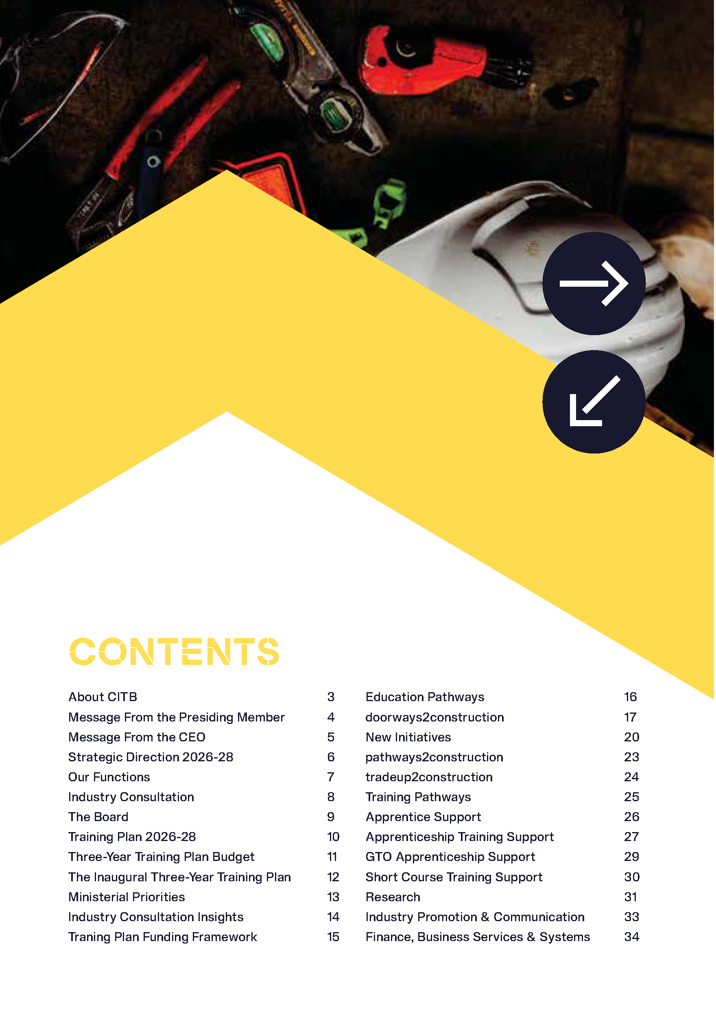
Construction Industry Training Board (CITB) Training Plan 2026-2028

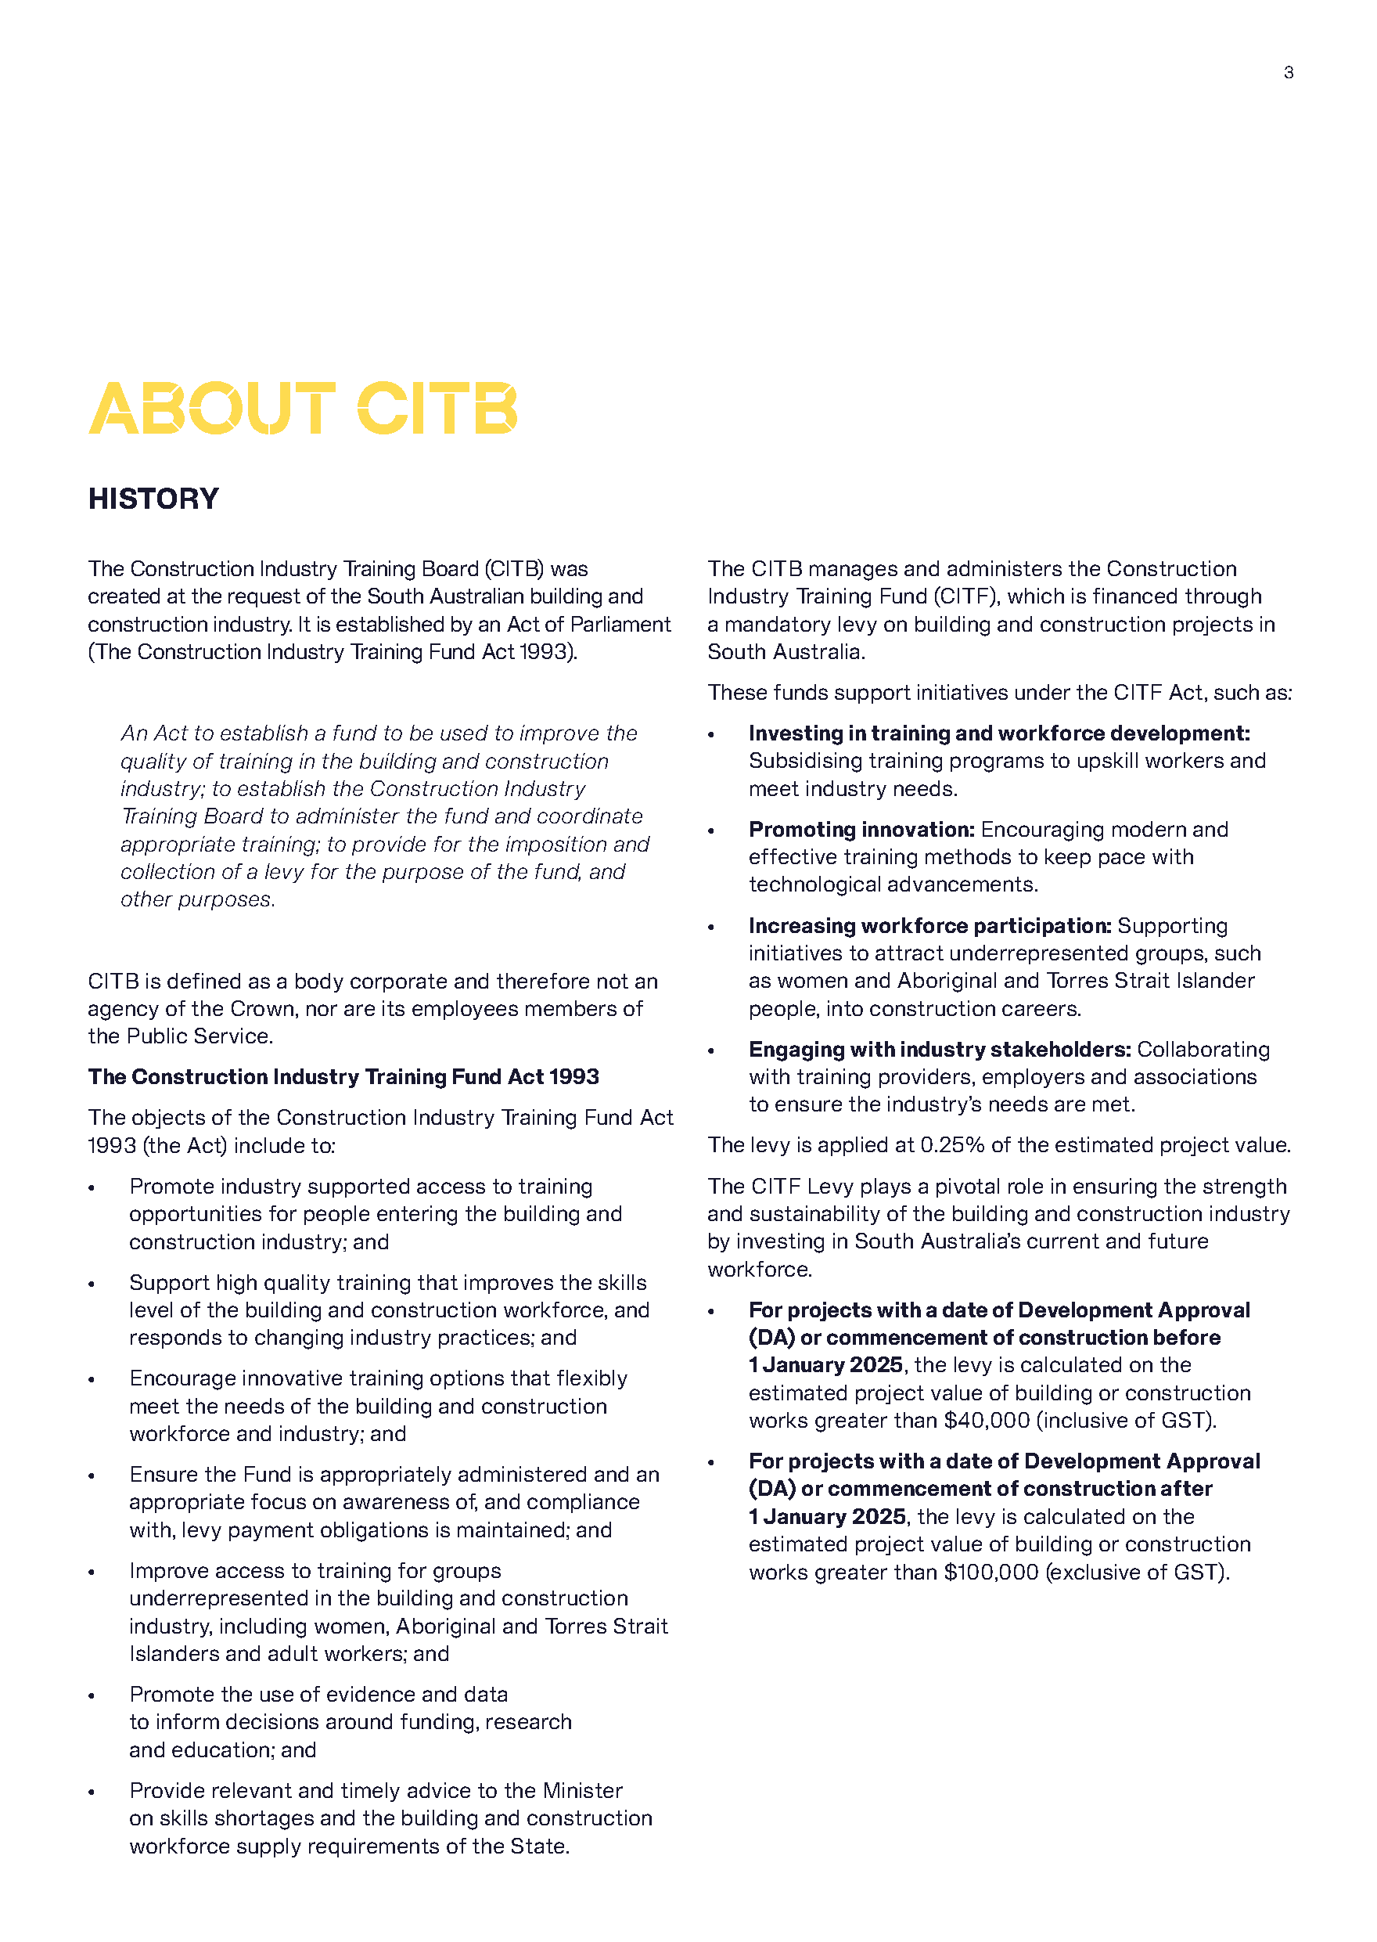
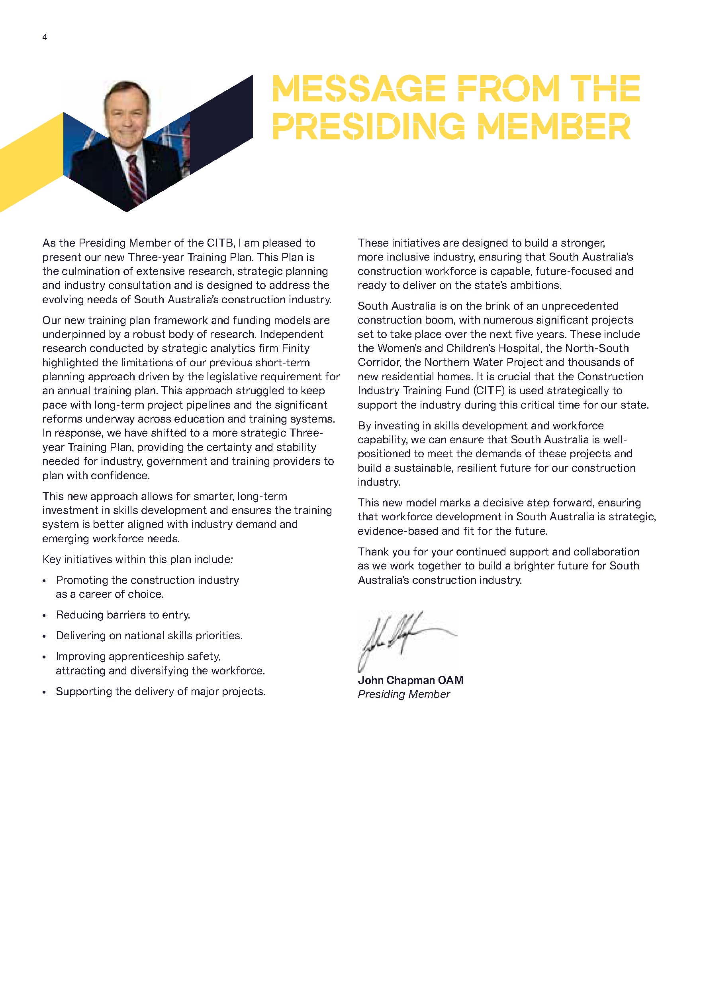
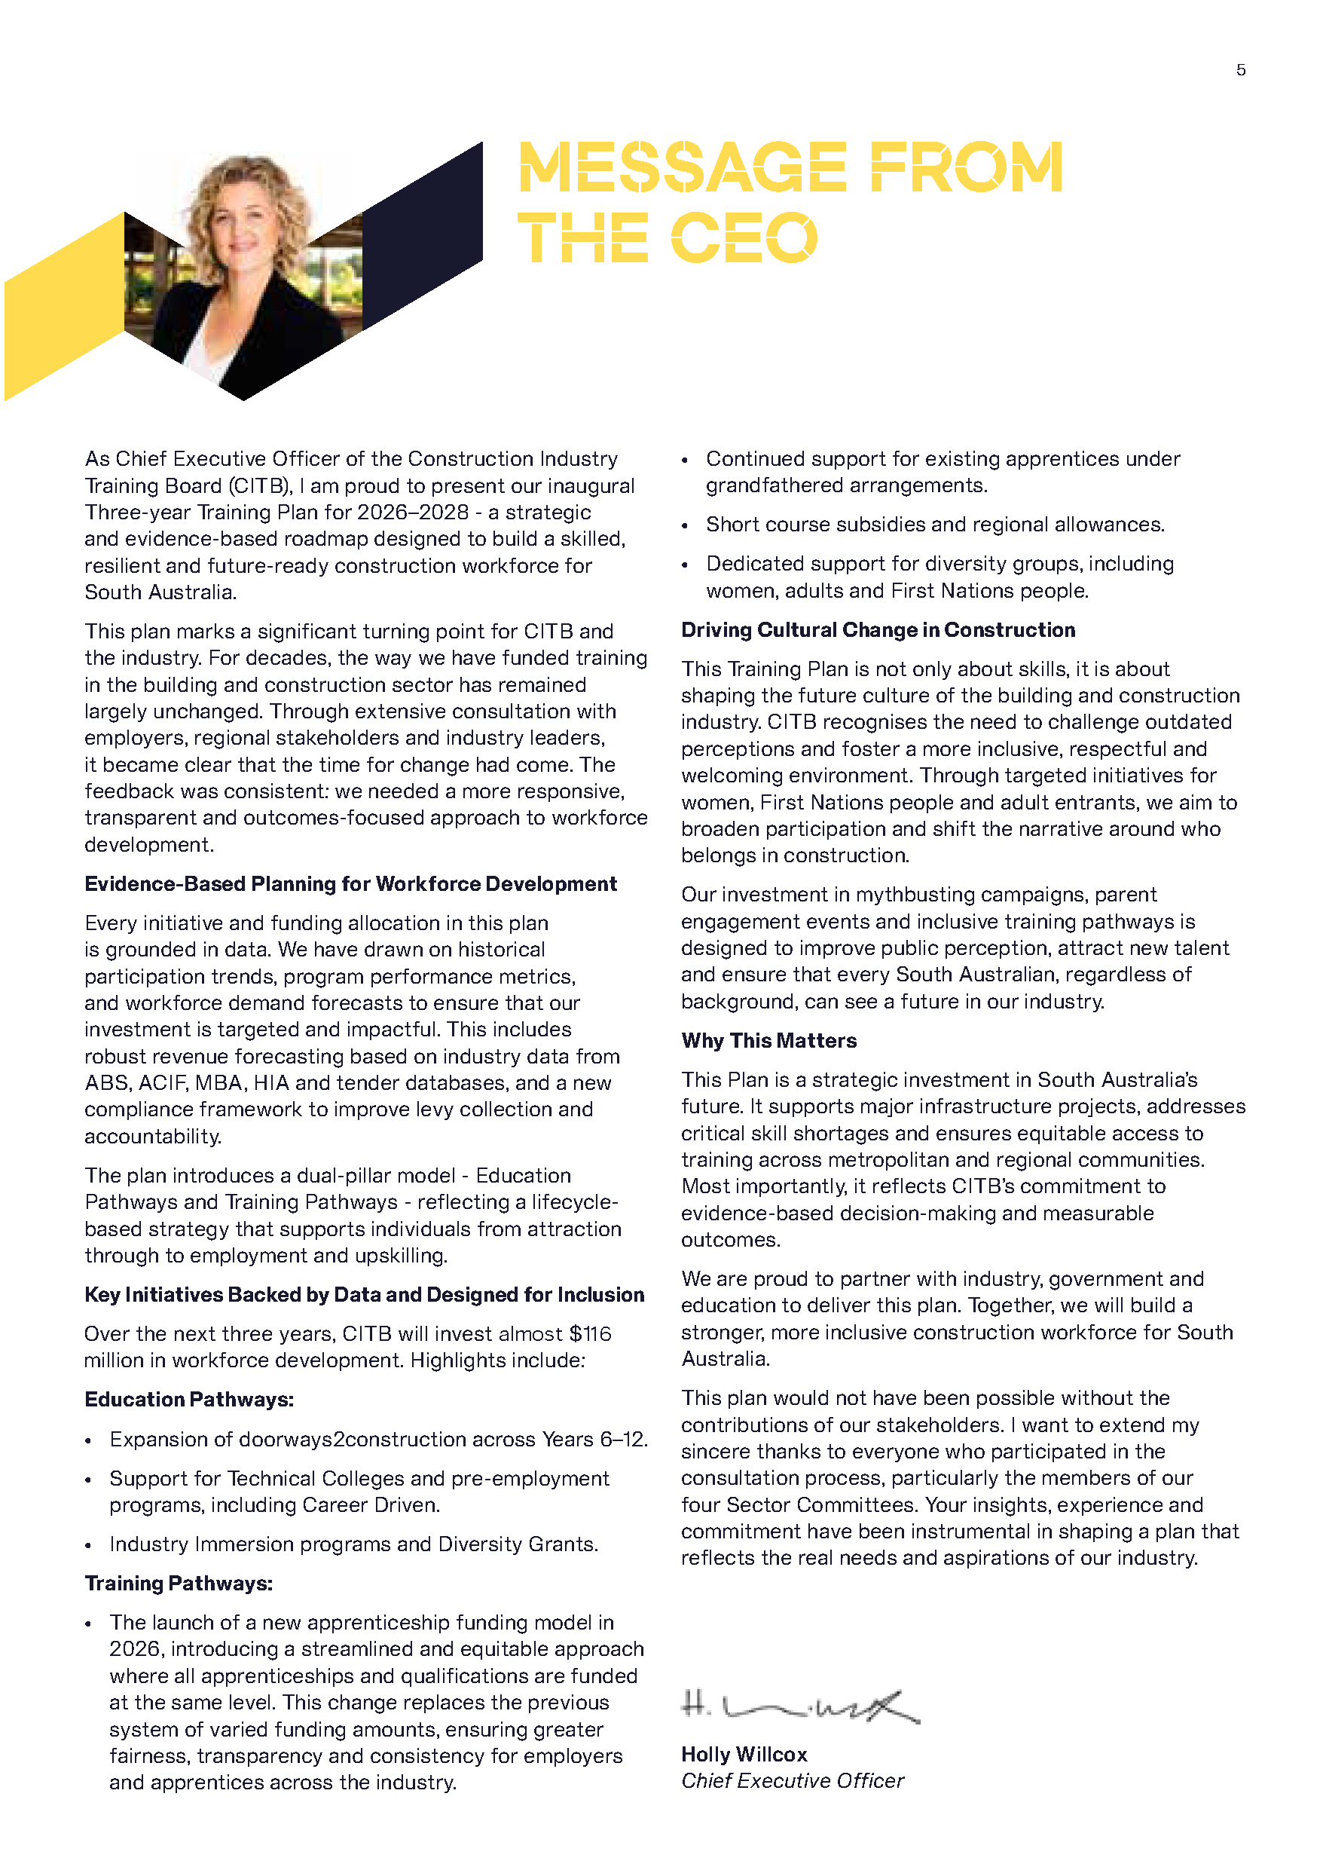
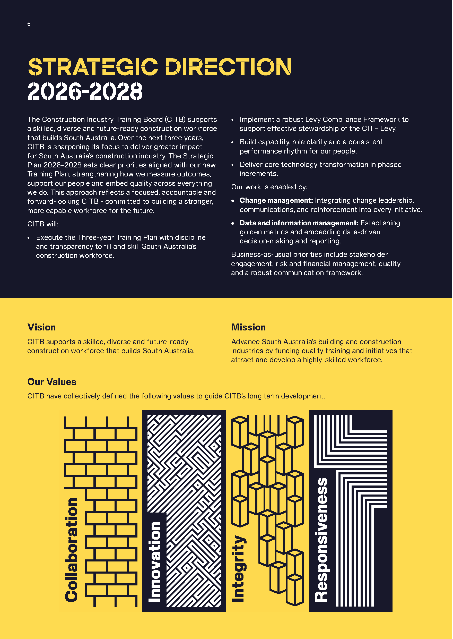
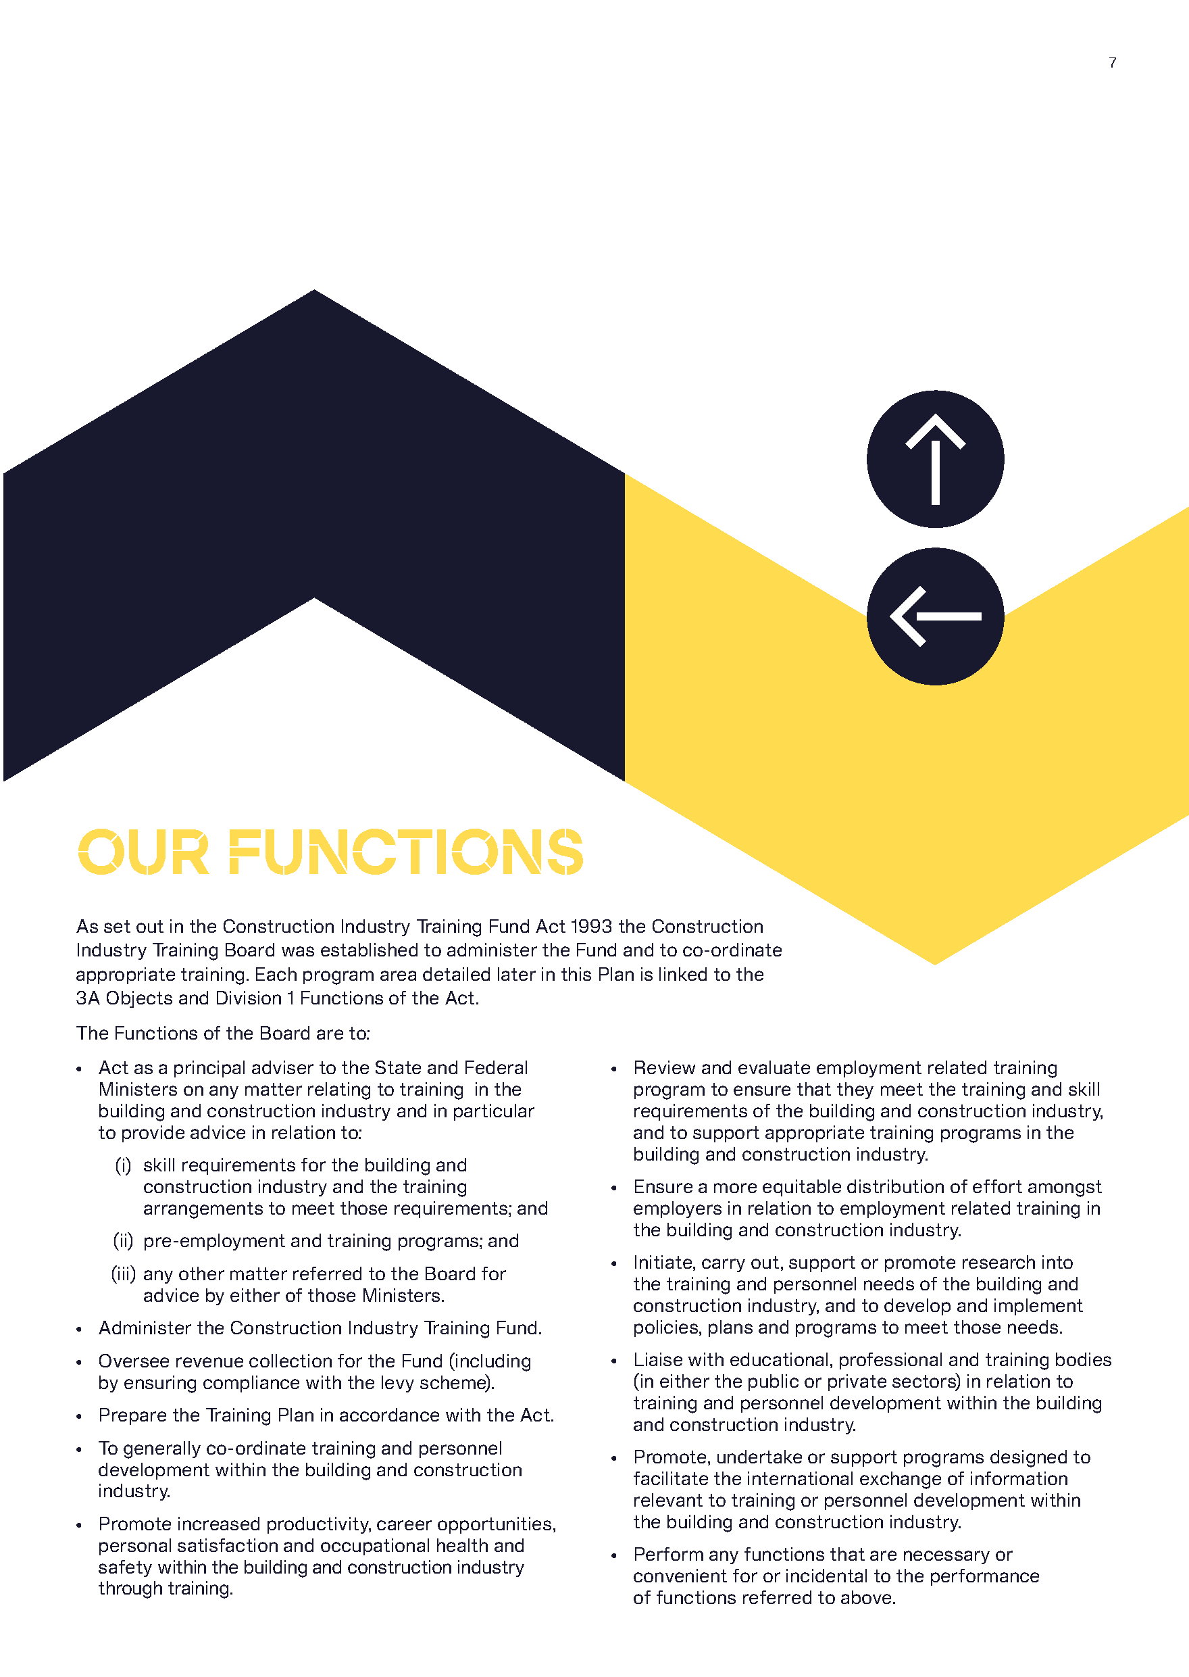


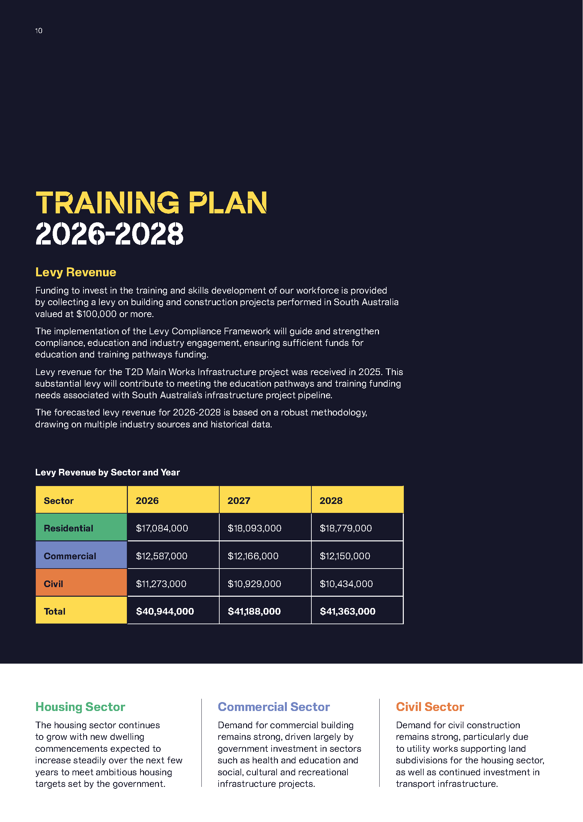

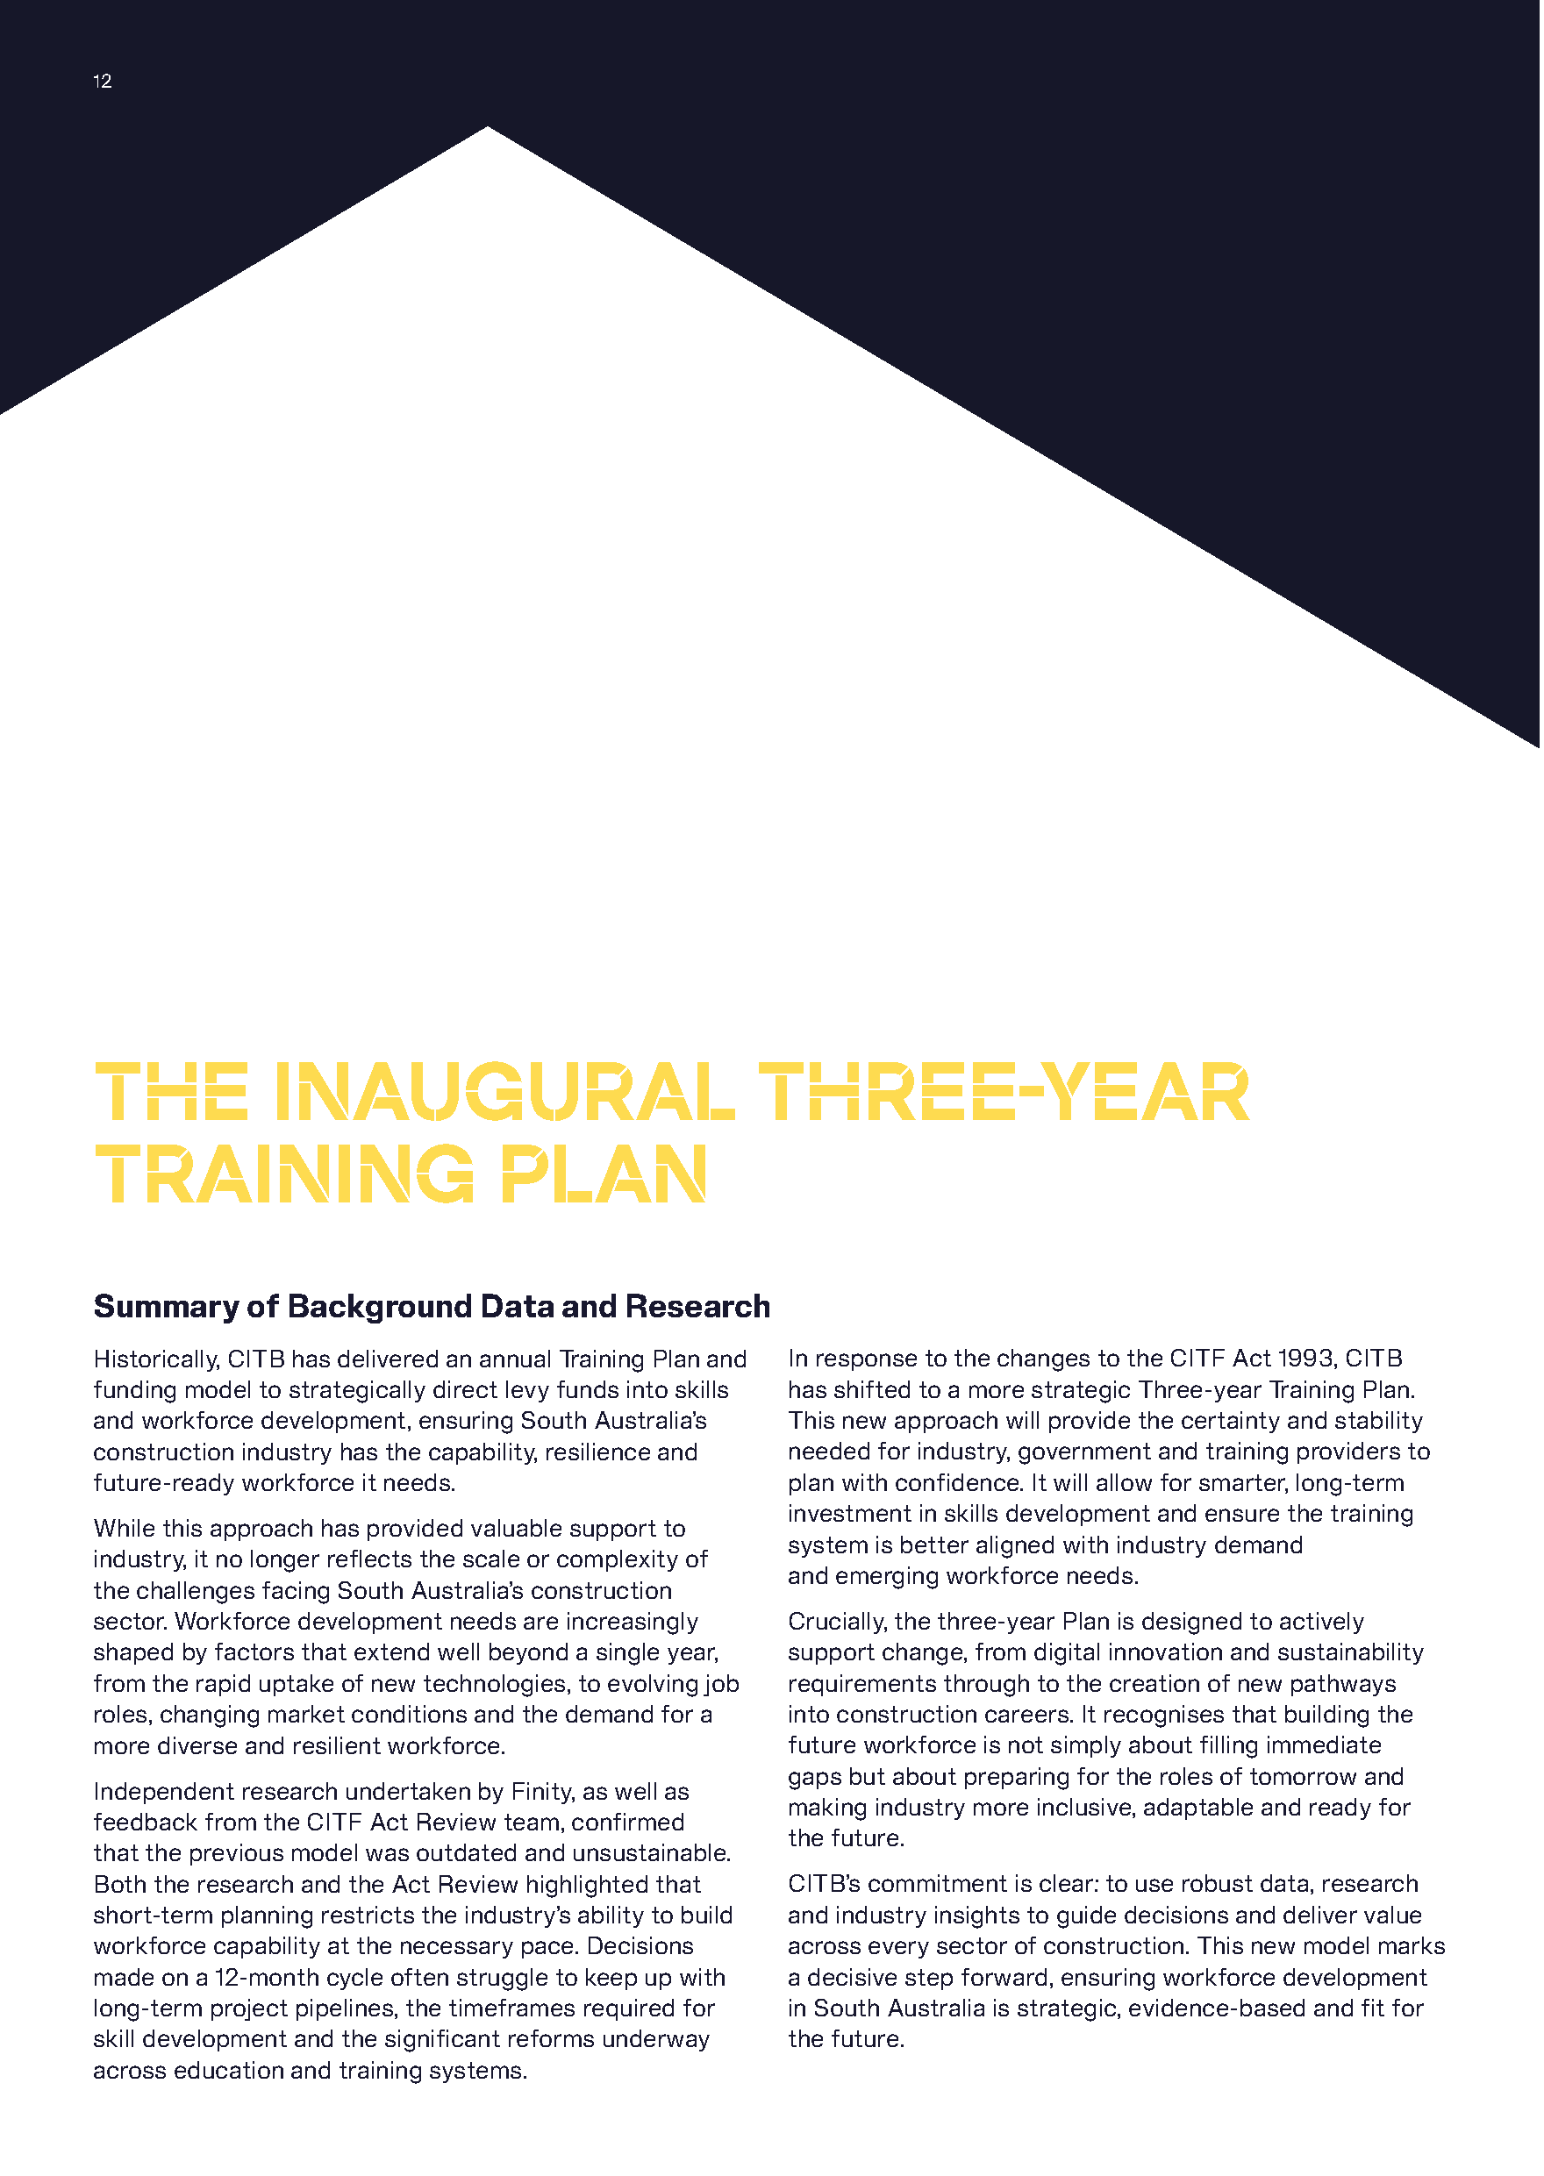
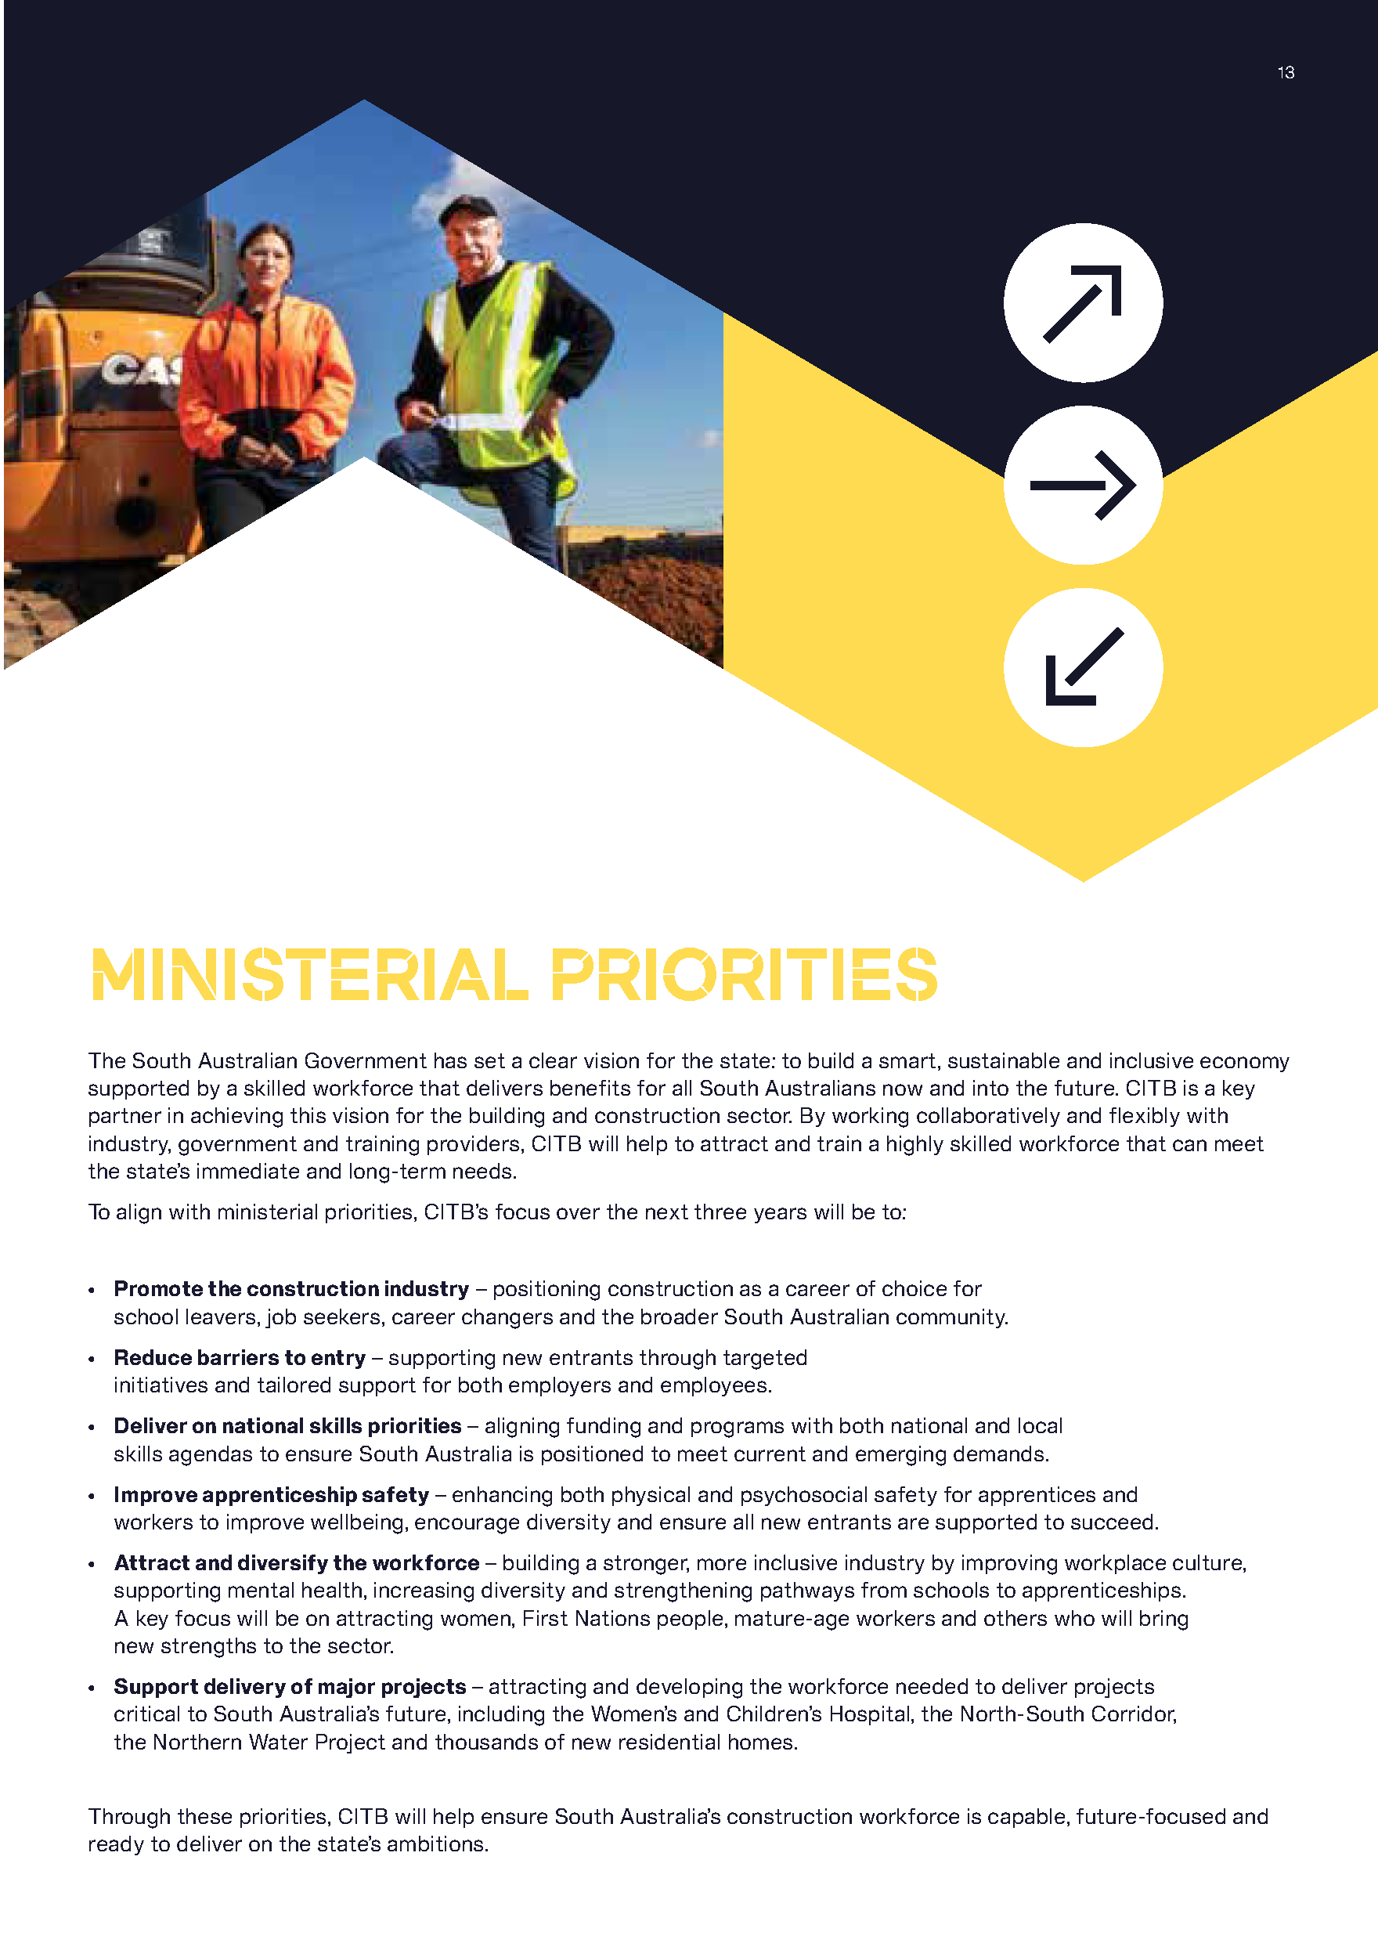
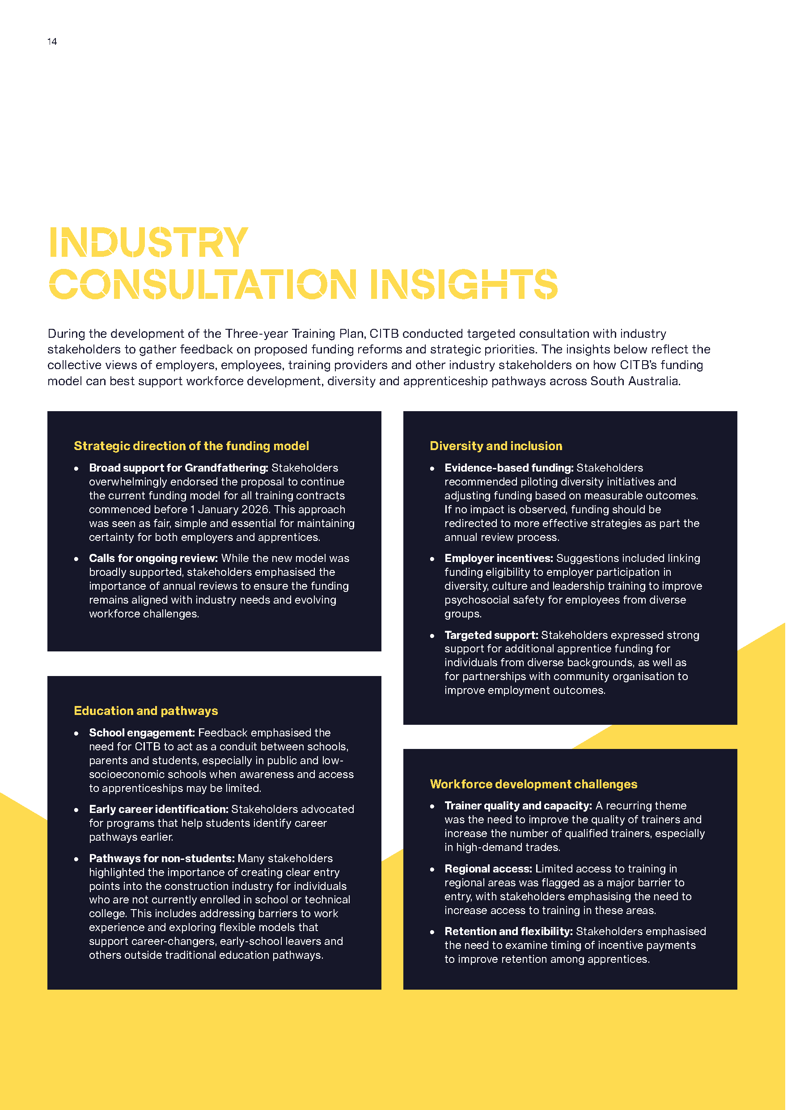
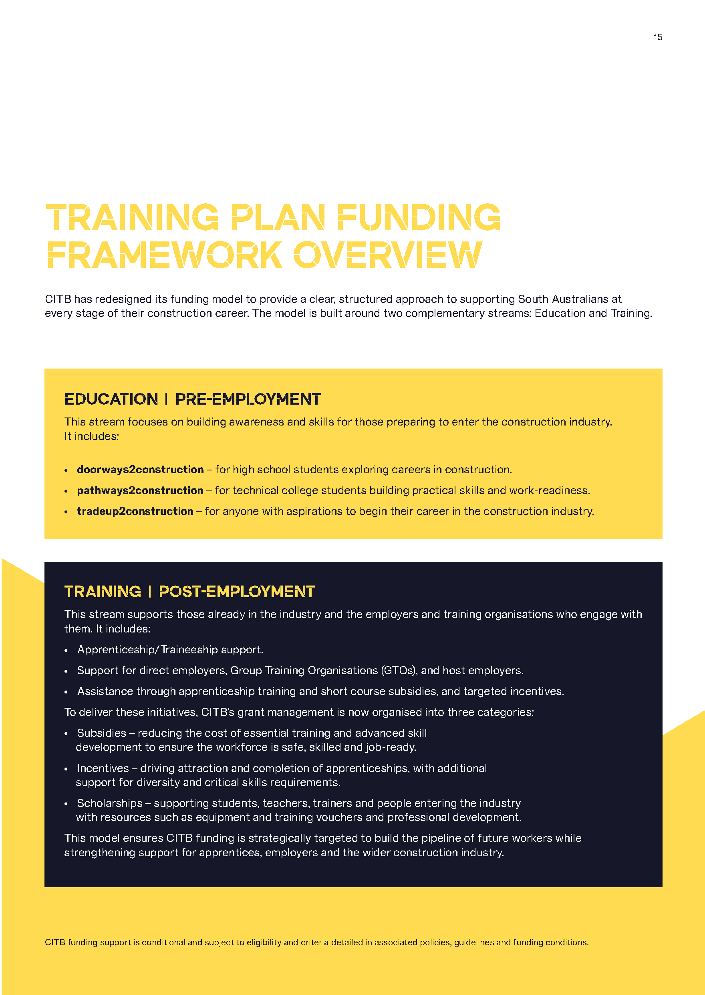

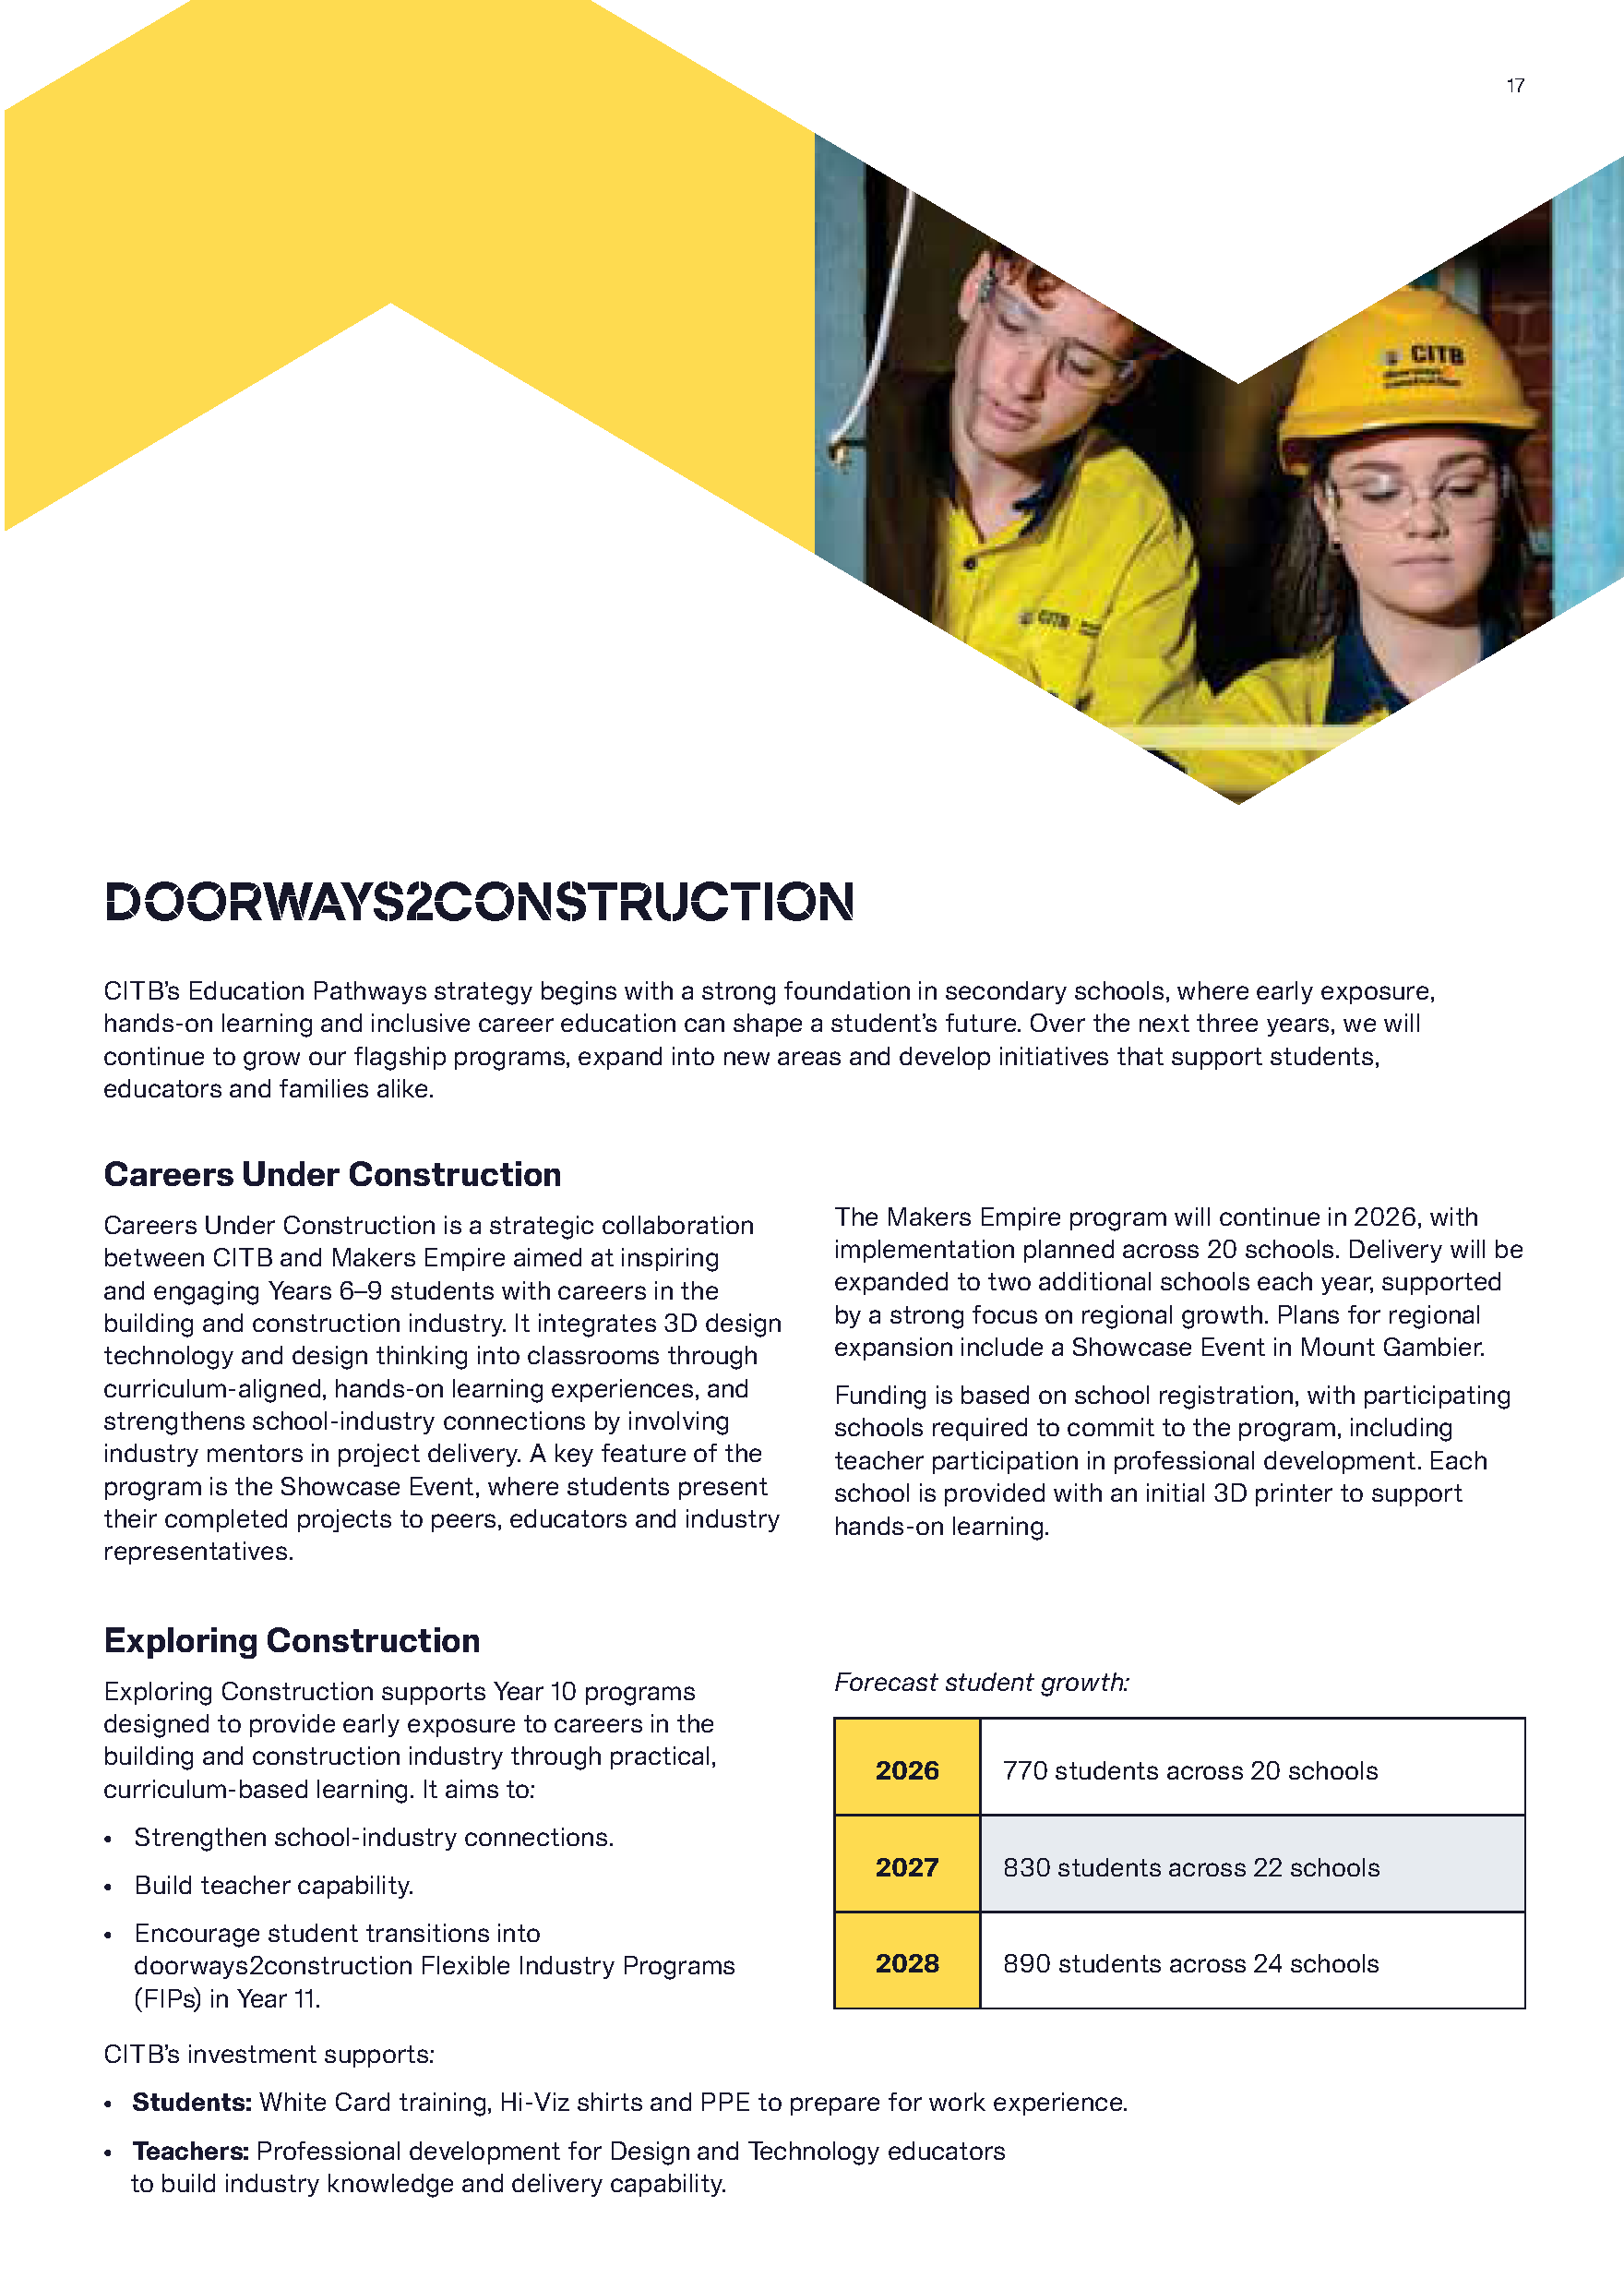
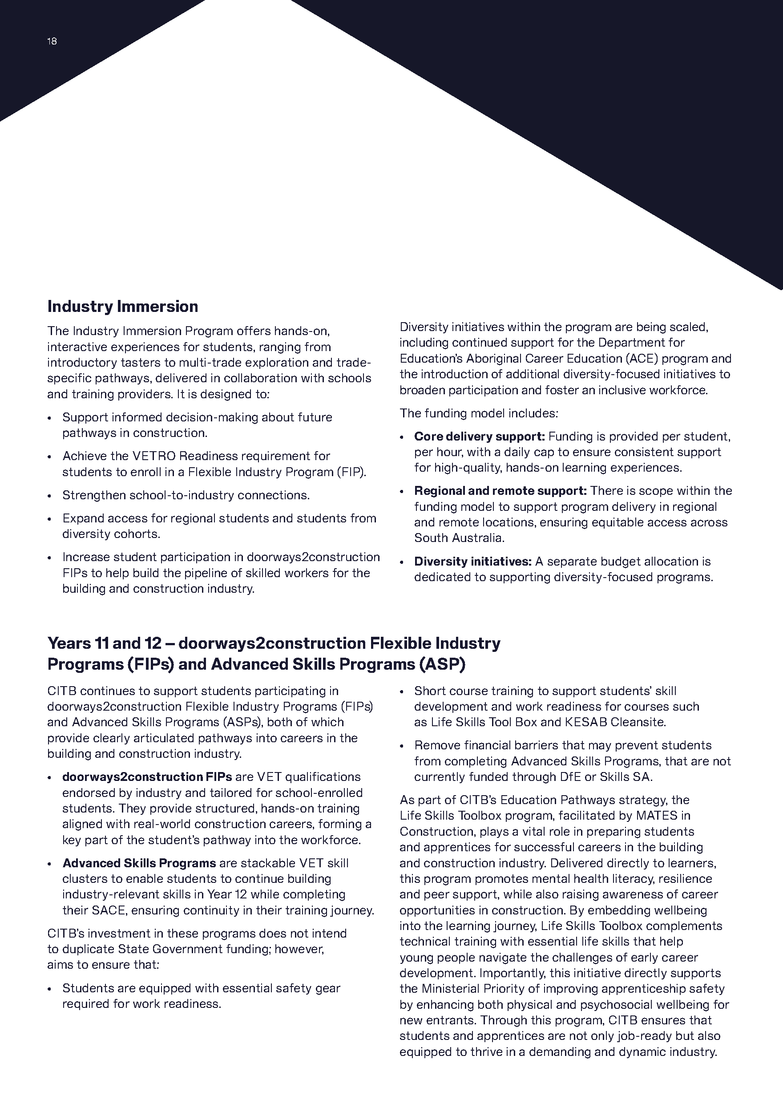
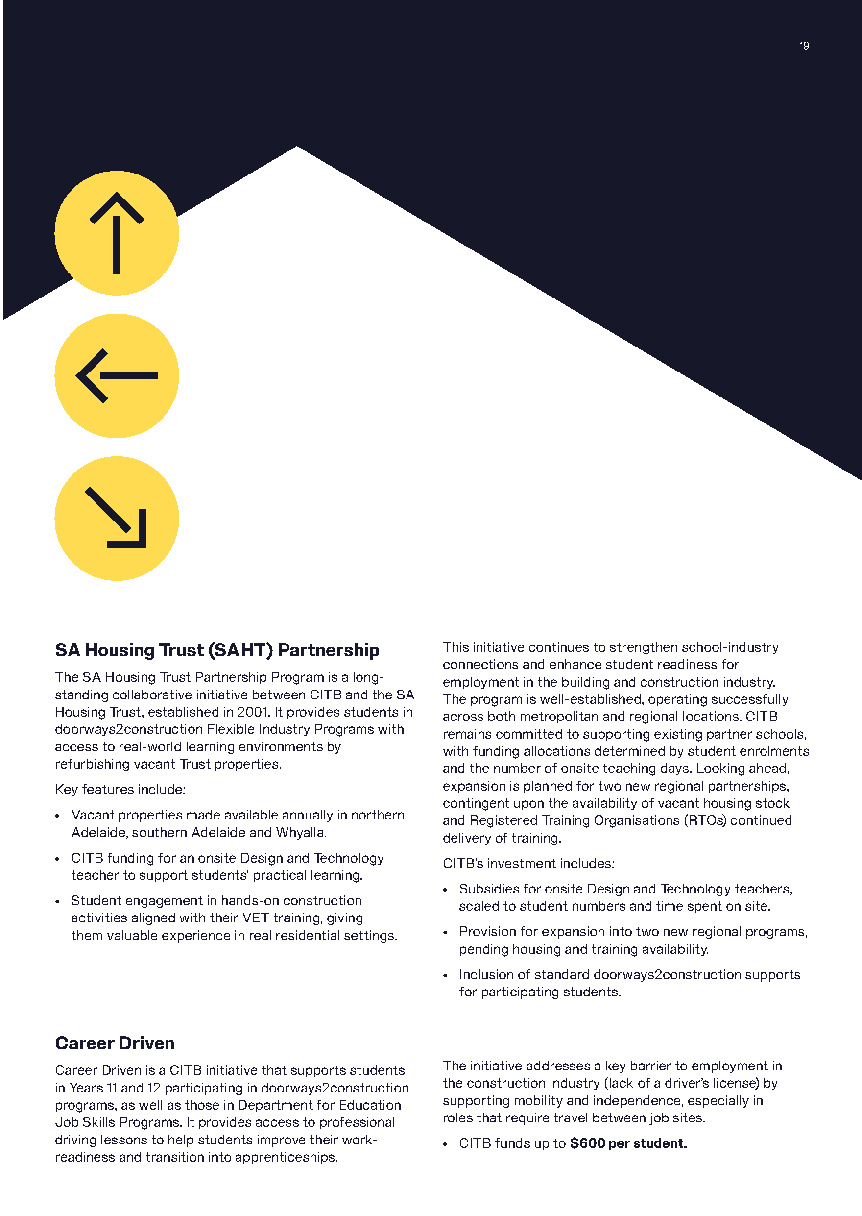


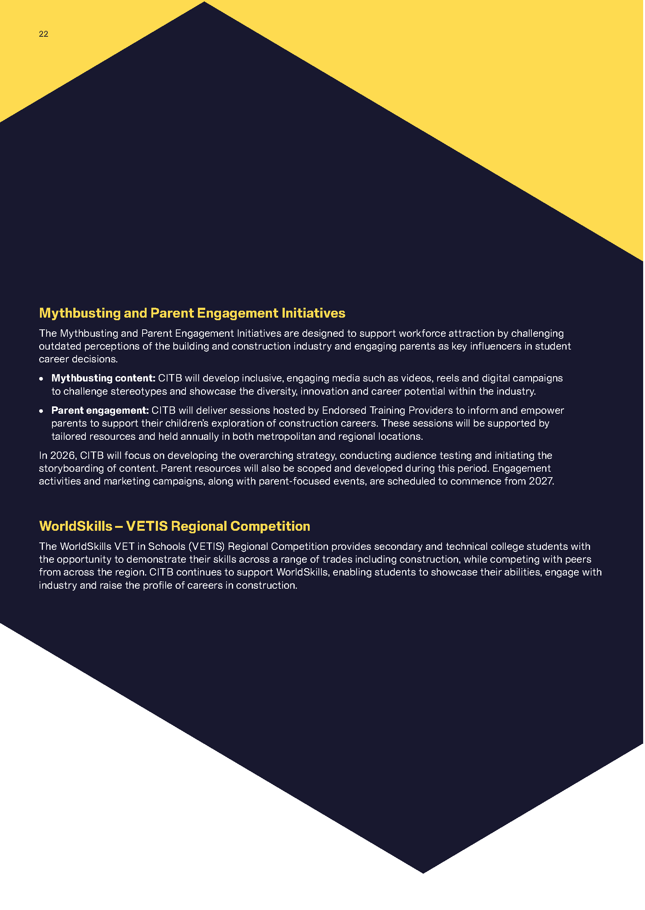
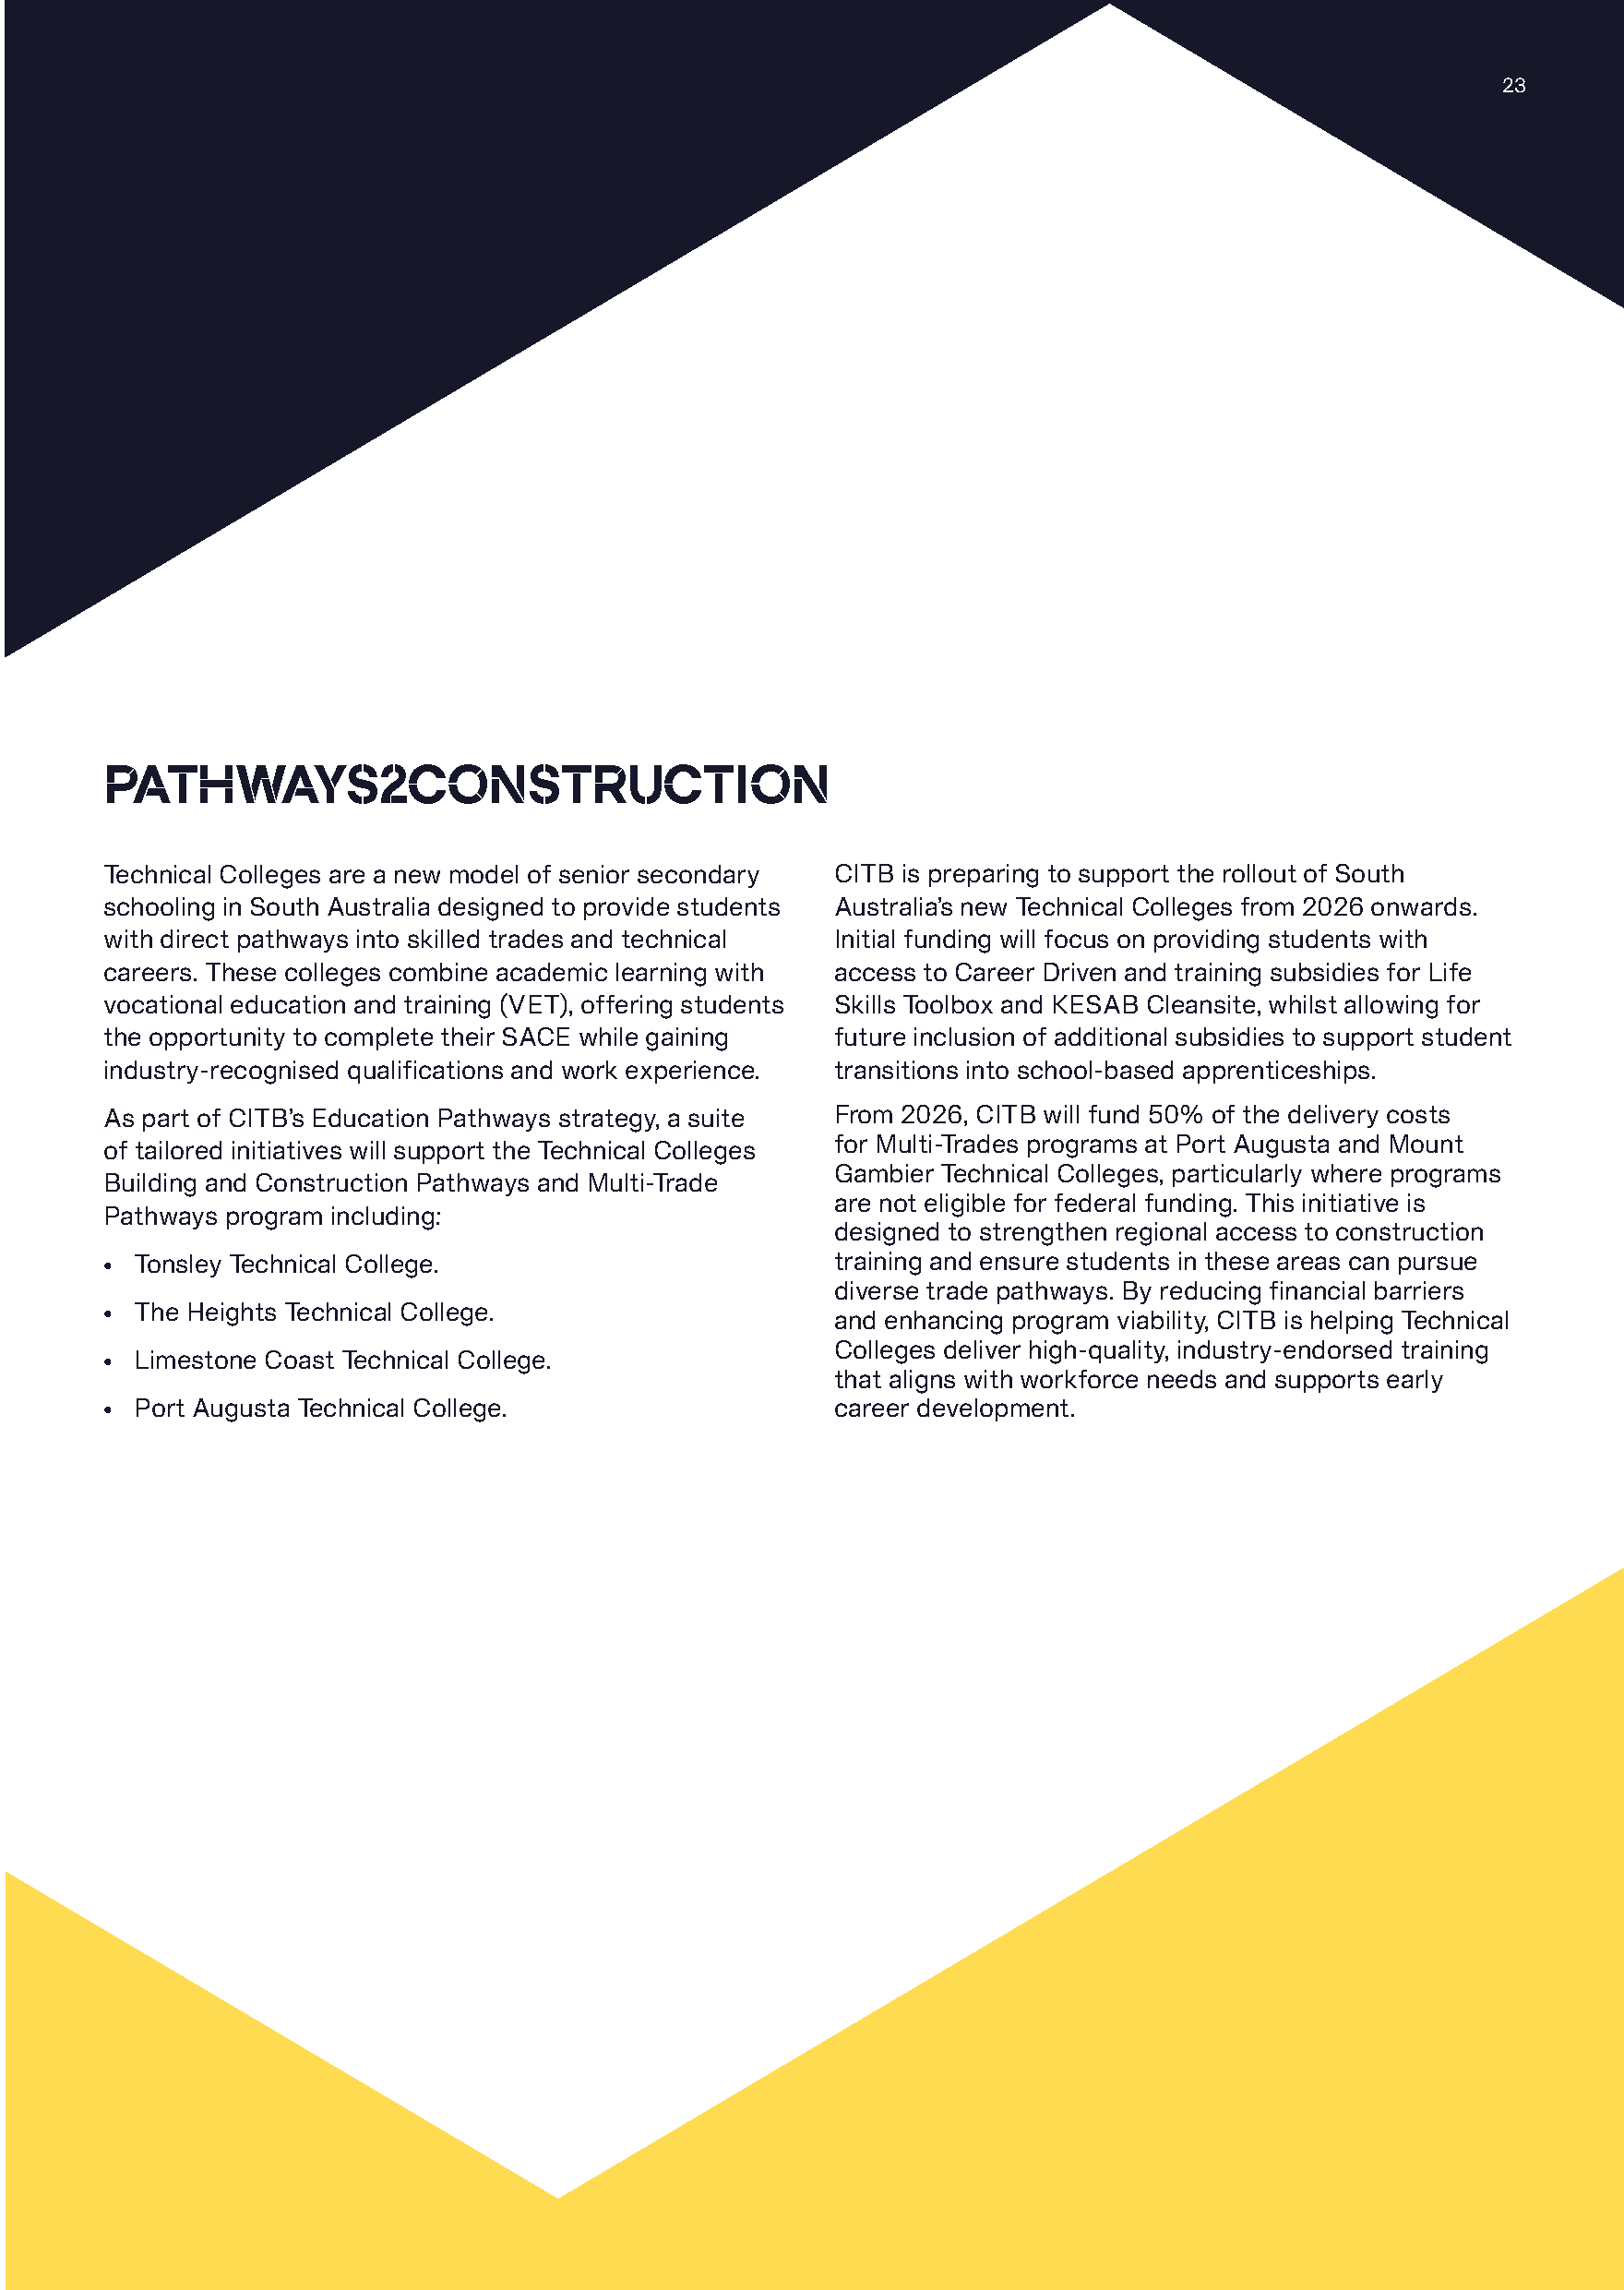
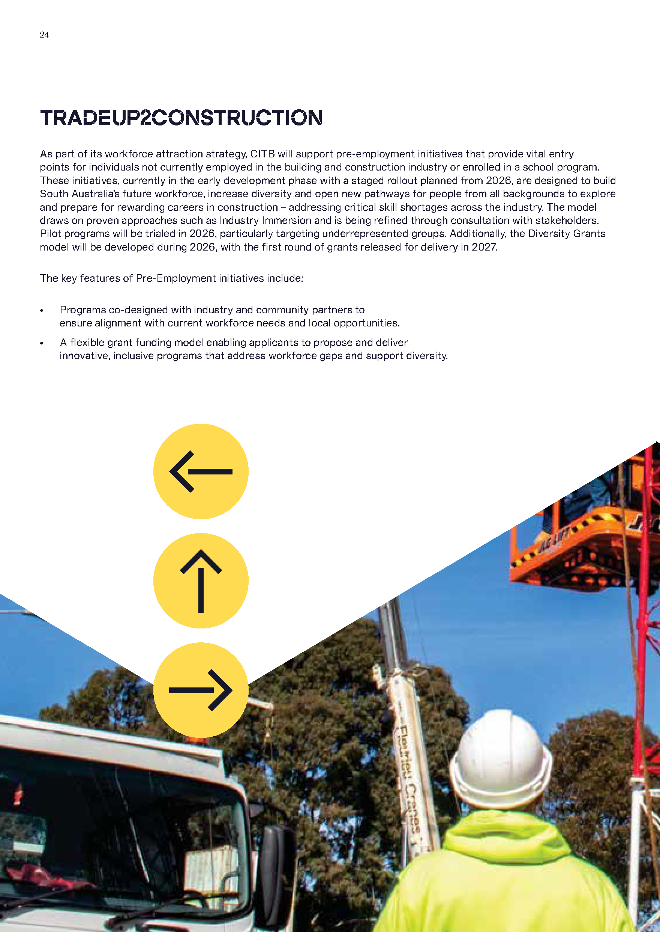


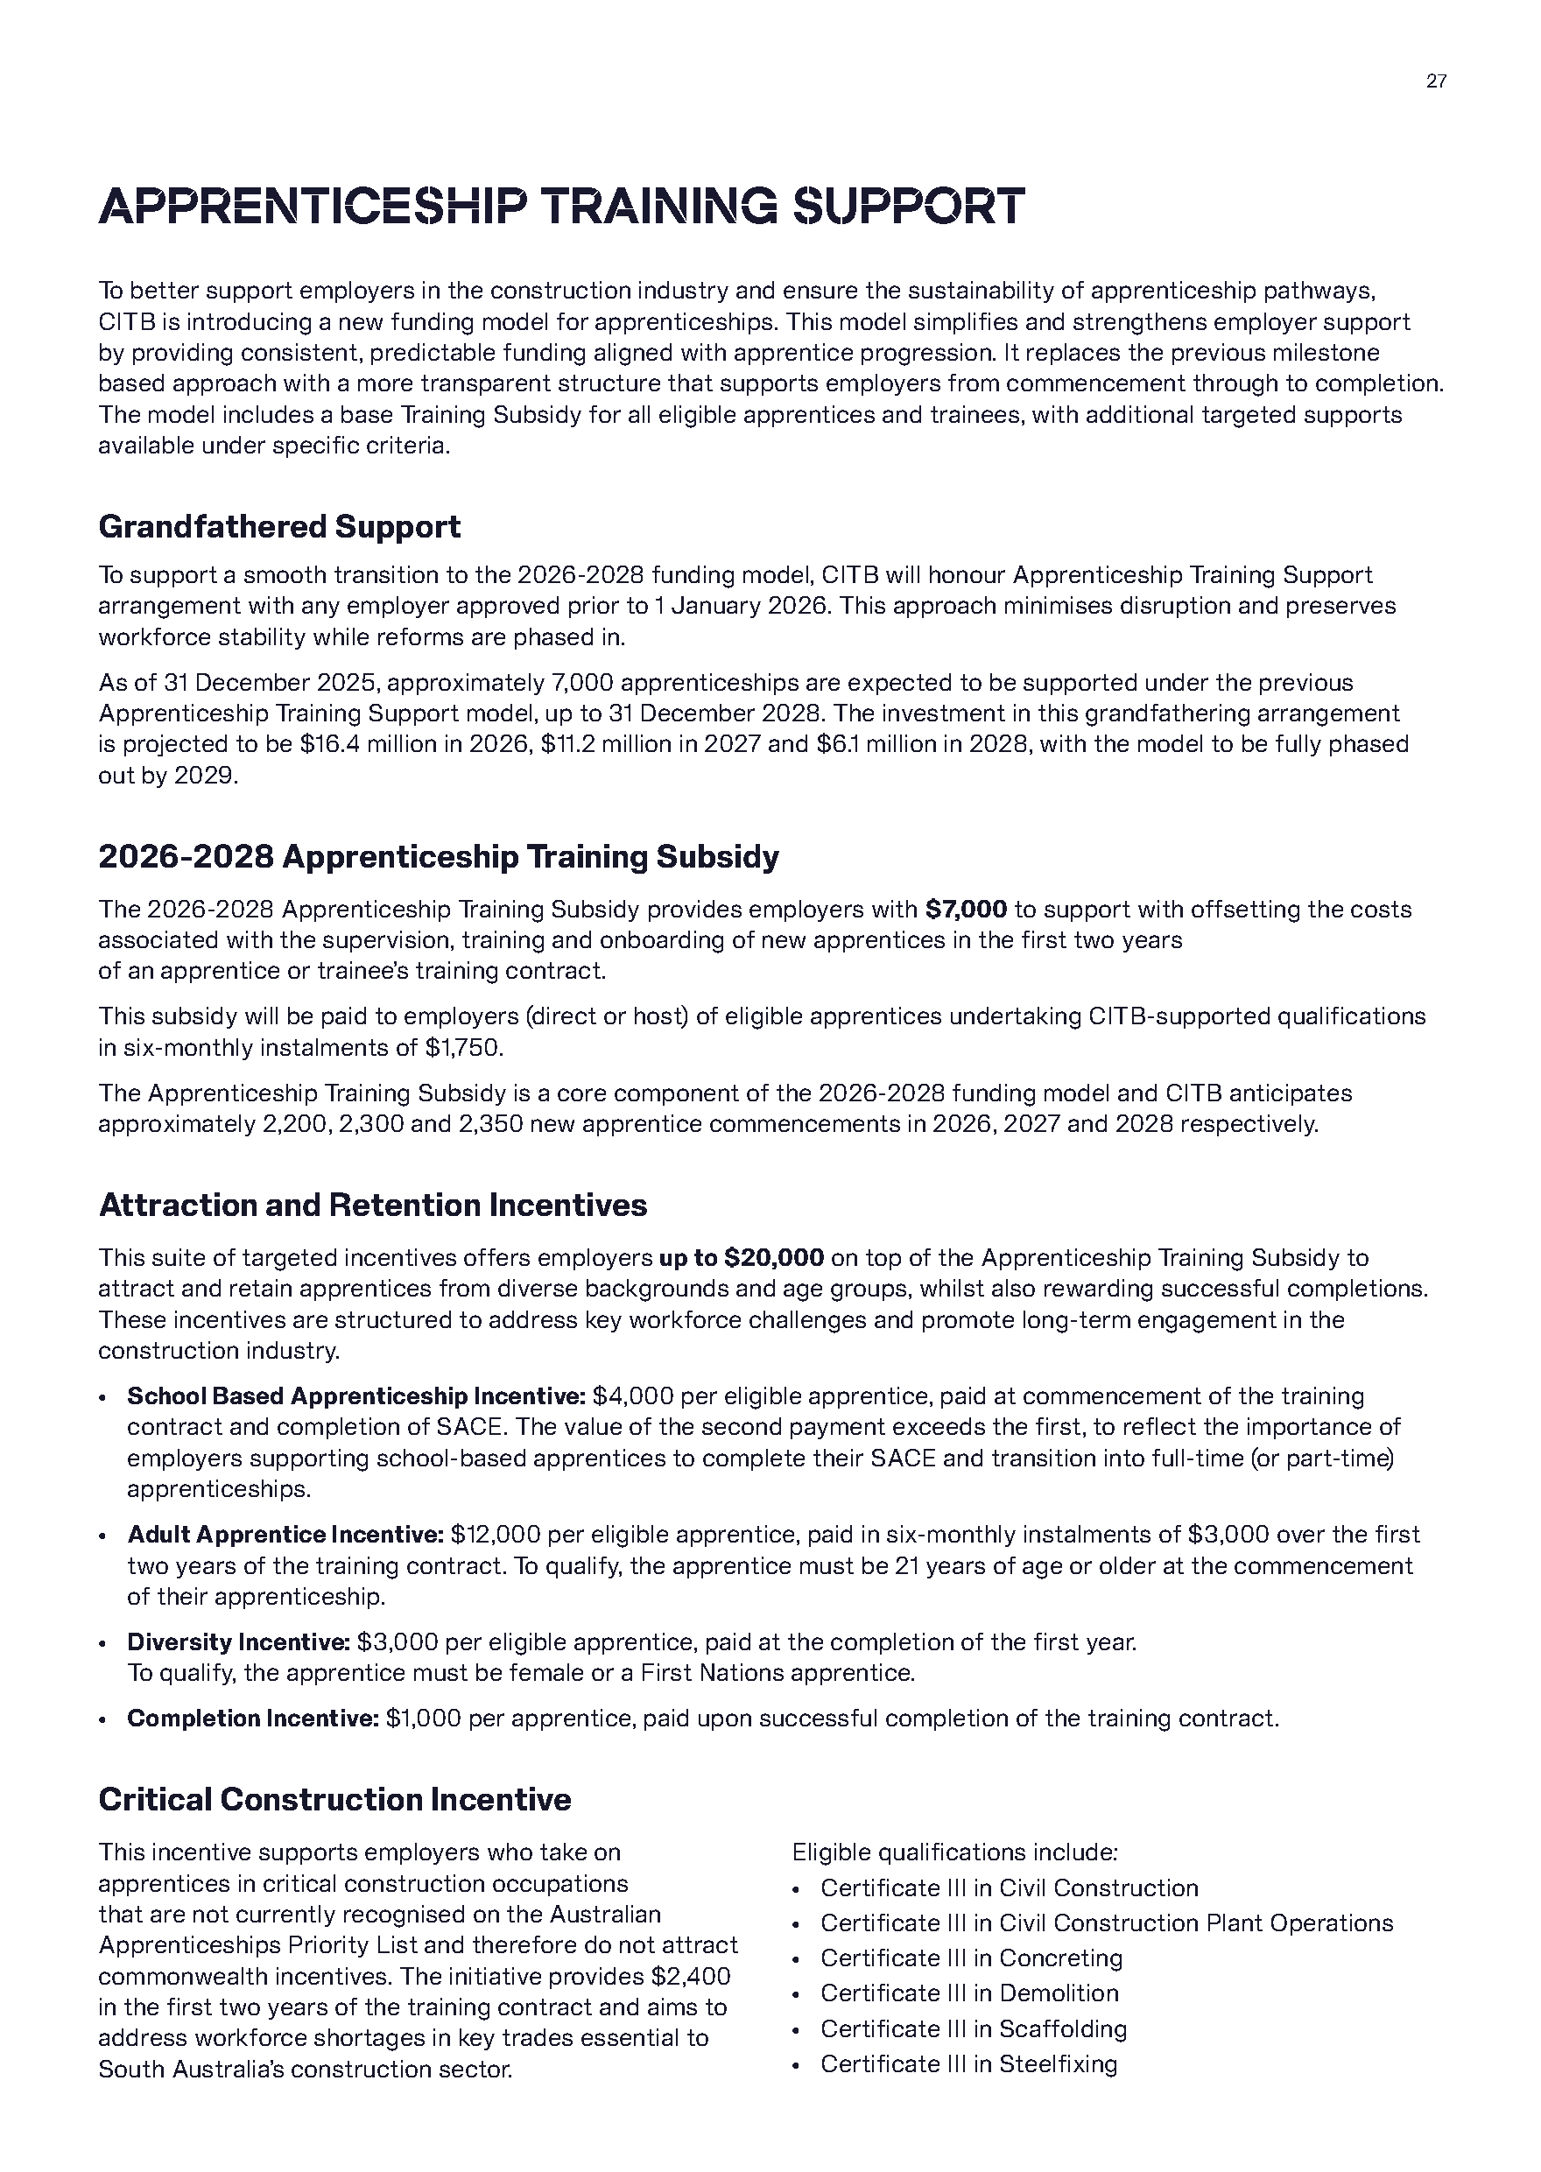
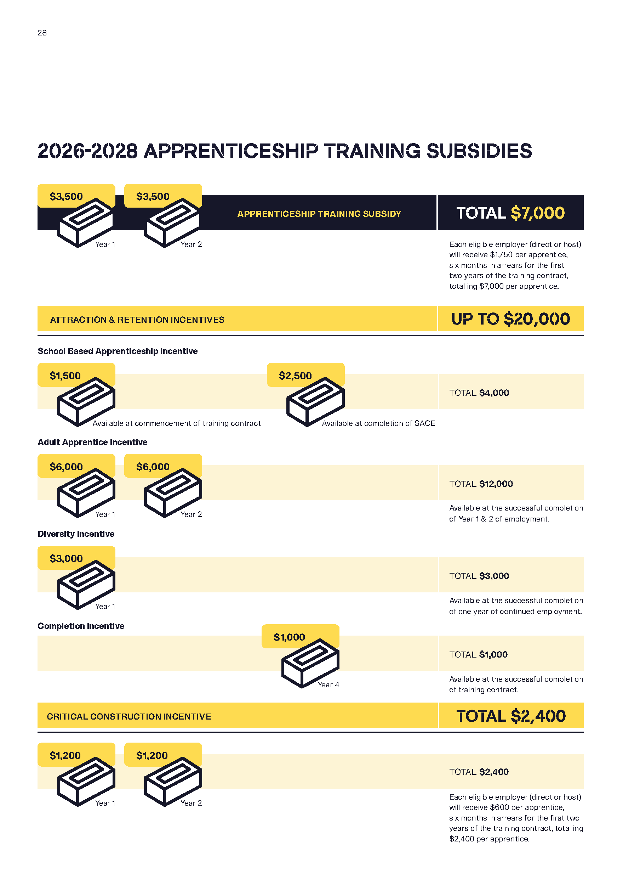







Dangerous Substances Act 1979
Authorised Officers
I, Glenn Stephen Farrell, Executive Director, SafeWork SA, in my capacity as the Competent Authority, hereby appoint the following person as an Authorised Officer for the purposes of the Dangerous Substances Act 1979 pursuant to Section 7(1) of the Dangerous Substances Act 1979:
Michael Leigh WATERS
Dated: 16 December 2025
Glenn Farrell
Executive Director
SafeWork SA
Competent Authority

Dangerous Substances Act 1979
Authorised Officers
I, Glenn Stephen Farrell, Executive Director, SafeWork SA, in my capacity as the Competent Authority, hereby revoke the following person as an Authorised Officer for the purposes of the Dangerous Substances Act 1979 pursuant to Section 7(1) of the Dangerous Substances Act 1979:
Michael Leigh WALTERS
Dated: 15 December 2025
Glenn Farrell
Executive Director
SafeWork SA
Competent Authority

Disability Inclusion Act 2018
Authorised Program Officer
I, Nichola Hunt, exercising the delegated authority of the Senior Authorising Officer, hereby revoke the authorisation for the following person to be an Authorised Program Officer with respect to Orana Australia Limited for the purposes of the Disability Inclusion Act 2018 in accordance with Section 23L(4) of that Act:
• Leanne Hallgath
Dated: 18 December 2025
Nichola Hunt
Senior Authorising Officer
Department of Human Services

Electoral Act 1985
Part 6—Registration of Political Parties
Notice is hereby given, pursuant to Section 42 of the Electoral Act 1985, that I have this day registered the following political party:
Name of Party Australian Citizens Party (SA) Division
Abbreviation of Party Name Citizens Party
Dated: 18 December 2025
Mick Sherry
Electoral Commissioner

Fisheries Management (Prawn Fisheries) Regulations 2017
Surveying in the Gulf St Vincent Prawn Fishery
Take notice that pursuant to Regulation 10 of the Fisheries Management (Prawn Fisheries) Regulations 2017, the notice dated 23 October 2025 published on page 4292 of the South Australian Government Gazette on 30 October 2025, prohibiting fishing activities in the Gulf St Vincent Prawn Fishery as outlined in Schedule 1, is Hereby varied such that it will not apply to the holders of a Gulf St Vincent Prawn Fishery licence issued pursuant to the Fisheries Management (Prawn Fisheries) Regulations 2017 listed in Schedule 2 or their registered master insofar as they may use prawn trawl nets in accordance with the conditions of their fishery licence for the purpose of undertaking a prawn survey during the period specified in Schedule 3, subject to the conditions contained in Schedule 4 unless this notice is varied or revoked.
Schedule 1
The waters of Gulf Saint Vincent contained within the enclosed rectangular area bordered by a line between the following coordinate points (GDA2020):
The line commencing at point 34° 29′ 35″S, 138° 5′ 29″E to point 34° 54′ 29″S, 138° 29′ 3″E then to point 35° 0′ 2″S, 138° 20′ 29″E to point 34° 35′ 18″S, 137° 56′ 54″E and then returning to the point of commencement (34° 29′ 35″S, 138° 5′ 29″E).
Schedule 2
Licence Number | Licence Holder/Master | Boat Name
V03 | Josephine K Fisheries Pty Ltd | Josephine K
V06 | Todreel Pty Ltd | Anna Pearl
V10 | Ledo Pty Ltd | Miss Jenny

Schedule 3
Commencing at sunset on 16 December 2025 to sunrise on 18 December 2025.
Schedule 4
- For the purposes of this notice the trawl survey areas cannot include any waters of a habitat protection zone or a sanctuary zone of a marine park established under the Marine Parks Act 2007 or depths less than 10 metres.
- The licence holders listed in Schedule 2 or their registered master must comply with all regulations and conditions that apply to fishing activities undertaken pursuant to their Gulf St Vincent Prawn Fishery licence, in addition to the conditions imposed by this notice.
- While engaged in fishing activities or unloading the survey catch, the licence holders listed in Schedule 2 or their registered master must have a copy of this notice on board the boat or near his person. This notice must be produced to a Fisheries Officer if requested.
- While engaged in fishing activities, the licence holders listed in Schedule 2 or their registered master must have an observer from the South Australian Research Development Institute (SARDI) aboard the vessel.
- No fishing activity may be undertaken between the prescribed times of sunrise and sunset for Adelaide (as published in the South Australian Government Gazette).
- The licence holders listed in Schedule 2 or their register master must not contravene or fail to comply with the Fisheries Management Act 2007, or any other regulations made under that Act except where specifically exempted by this notice.
- This notice does not purport to override the provisions or operation of any other Act including, but not limited to, the Marine Parks Act 2007. The notice holder and his agents must comply with any relevant regulations, permits, requirements and directions from the Department for Environment and Water when undertaking activities within a marine park.
- A report (including the raw survey data) is to be provided by SARDI to the Saint Vincent Gulf Prawn Boat Owner’s Association detailing the outcomes of the survey as soon as practicable on the survey completion.
Dated: 15 December 2025
Jade Fredericks
Prawn Fishery Manager
Delegate of the Minister for Primary Industries and Regional Development

Fisheries Management (Prawn Fisheries) Regulations 2017
Temporary Prohibition on Fishing Activities in the Gulf St Vincent Prawn Fishery
Take notice that pursuant to Regulation 10 of the Fisheries Management (Prawn Fisheries) Regulations 2017, the activities of the class specified in Schedule 1 are prohibited in the waters of the Gulf St Vincent Prawn Fishery, except for the licence holders listed in Schedule 2, for the purpose of undertaking a prawn survey, during the period specified in Schedule 3, subject to conditions contained in Schedule 4, unless this notice is varied or revoked.
Schedule 1
The act of taking or an act preparatory to or involved in the taking of King Prawns (Melicertus latisulcatus) pursuant to a Gulf St Vincent Prawn Fishery Licence.
Schedule 2
Licence Number | Licence Holder | Boat Name
V03 | Josephine K Fisheries Pty Ltd | Josephine K
V06 | Todreel Pty Ltd | Anna Pearl
V10 | Ledo Pty Ltd | Miss Jenny
Schedule 3
From sunset on 16 December 2025 to sunrise on 18 December 2025.
Schedule 4
1. For the purposes of this notice the trawl survey areas cannot include any waters of a habitat protection zone or a sanctuary zone of a marine park established under the Marine Parks Act 2007 or depths less than 10 metres.
2. The licence holders listed in Schedule 2 or their registered master must comply with all regulations and conditions that apply to fishing activities undertaken pursuant to their Gulf St Vincent Prawn Fishery licence, in addition to the conditions imposed by this notice.
3. While engaged in fishing activities or unloading the survey catch, the licence holders listed in Schedule 2 or their registered master must have a copy of this notice on board the boat or near his person. This notice must be produced to a Fisheries Officer if requested.
4. While engaged in fishing activities, the licence holders listed in Schedule 2 or their registered master must have an observer from the South Australian Research Development Institute (SARDI) aboard the vessel.
5. No fishing activity may be undertaken between the prescribed times of sunrise and sunset for Adelaide (as published in the
South Australian Government Gazette).
6. The licence holders listed in Schedule 2 or their register master must not contravene or fail to comply with the Fisheries Management Act 2007, or any other regulations made under that Act except where specifically exempted by this notice.
7. This notice does not purport to override the provisions or operation of any other Act including, but not limited to, the Marine Parks Act 2007. The notice holder and his agents must comply with any relevant regulations, permits, requirements and directions from the Department for Environment and Water when undertaking activities within a marine park.
8. A report (including the raw survey data) is to be provided by SARDI to the Saint Vincent Gulf Prawn Boat Owner’s Association detailing the outcomes of the survey as soon as practicable on the survey completion.
Dated: 15 December 2025
Jade Fredericks
Prawn Fishery Manager
Delegate of the Minister for Primary Industries and Regional Development

Fisheries Management Act 2007
Section 79
Temporary Prohibition of Fishing Activity
Catch and Release for Australian Bass in Specified Reservoirs
Pursuant to Section 79 of the Fisheries Management Act 2007, I Matt Read, A/Executive Director Fisheries and Aquaculture, delegate of the Minister for Primary Industries and Regional Development, hereby declare that it shall be unlawful for any person to engage in the class of fishing activity specified in Schedule 1, in the areas specified in Schedule 2 during the period specified in Schedule 3.
Schedule 1
The take of Australia Bass from the waters in Schedule 2, other than for the purposes of removing a fishing hook to immediately release the fish where:
• The weight of the fish is at all times supported;
• The gills or fins of the fish are not handled at any stage; and
• The fish is released immediately after removal of a fishing hook.
Schedule 2
Waters of Beetaloo Reservoir, Bundaleer Reservoir, Happy Valley Reservoir, Myponga Reservoir, South Para Reservoir and Warren Reservoir.
Schedule 3
From 10 December 2025, until 10 December 2026.
Dated: 10 December 2025
Matt Read
A/Executive Director
Fisheries and Aquaculture
Delegate of the Minister for Primary Industries and Regional Development

Fisheries Management Act 2007
Section 79
Variation—Temporary Restrictions on Recreational Bag and Boat Limits in Waters of Gulf St Vincent and Spencer Gulf
Take notice that pursuant to Section 79 of the Fisheries Management Act 2007, I, Hon Clare Scriven MLC, Minister for Primary Industries and Regional Development, vary the declaration titled Temporary Restrictions on Recreational Bag and Boat Limits in Waters of Gulf St Vincent and Spencer Gulf dated 31 October 2025 and published in the South Australian Government Gazette on 31 October 2025 on page 4338 (being the second notice on that page), effective 19 December 2025, to delete the following fish species rows from the table in Schedule 1:
Species | Bag Limit | Boat Limit
Waters of the Spencer Gulf Fishing Zone—remove the following rows
Blue Swimmer Crab | 10* | 30*
Southern Garfish | 15 | 45
Waters of the Gulf St Vincent and Kangaroo Island Fishing Zone or the Port Adelaide River estuary—remove the following rows
Albacore | 1 | 3
Australian herring | 20 | 60
Mulloway | 1 | 3
Southern Bluefin Tuna | 1 | 3
Salmon (large/small) | 10/5 | 30/15
Yellowtail Kingfish | 1 | 2
Dated: 16 December 2025
Hon Clare Scriven MLC
Minister for Primary Industries and Regional Development

Fisheries Management Act 2007
Section 79
Variation—Temporary Restrictions on Recreational Charter Boat Limits in Waters of Gulf St Vincent and Spencer Gulf
Take notice that pursuant to Section 79 of the Fisheries Management Act 2007, I, Hon Clare Scriven MLC, Minister for Primary Industries and Regional Development, vary the declaration titled Temporary Restrictions on Recreational Charter Boat Limits in Waters of Gulf St Vincent and Spencer Gulf dated 31 October 2025 and published in the South Australian Government Gazette on 31 October 2025 on page 4341 (being the first notice on that page), effective 19 December 2025, to delete the following fish species rows from the table in Schedule 1:
Species | Daily Limit (trip <3 days) | Trip Limit (trip >3 days)
Waters of the Spencer Gulf Fishing Zone—remove the following rows
Blue Swimmer Crab | 10* | 30*
Southern Garfish | 15 | 45
Waters of the Gulf St Vincent and Kangaroo Island Fishing Zone or the Port Adelaide River estuary—remove the following rows
Albacore | 1 | 2
Australian herring | 20 | 60
Barracouta | 3 | 8
Mulloway | Trip limit applies | 1
Southern Bluefin Tuna | Trip limit applies | 1
Salmon (large/small) | 5/3 | 15/8
Yellowtail Kingfish | Trip limit applies | 1
Dated: 16 December 2025
Hon Clare Scriven MLC
Minister for Primary Industries and Regional Development

Health Care Act 2008
Clause 5A of Schedule 3
Notice of Appointment of Members of a Governing Board of an Incorporated Hospital
Chris Picton, Minister for Health and Wellbeing, has been pleased to appoint the persons named in Column 1 of the Schedule to the respective position in Column 2 of the Schedule as a member of the governing board of the respective incorporated hospital in Column 3 of the Schedule for the respective term in Column 4 of the Schedule.
Schedule
Column 1 | Column 2 | Column 3 | Column 4
Person | Position | Incorporated Hospital | Term
Steven Seth Sumner | Member | Barossa Hills Fleurieu Local Health Network Incorporated | Commencing 12 January 2026  and expiring 30 June 2028
Dated: 13 December 2025
Chris Picton MP
Minister for Health and Wellbeing

Housing Improvement Act 2016
Rent Control Revocations
In the exercise of the powers conferred by the Housing Improvement Act 2016, the Delegate of the Minister for Housing and Urban Development hereby revokes the maximum rental amount per week that shall be payable subject to Section 55 of the Residential Tenancies Act 1995, in respect of each premises described in the following table.
Address of Premises |  | Allotment Section | Certificate of Title  Volume/Folio
54 Lewis Road, Carrickalinga SA 5204 |  | Allotment 543 Deposited Plan 6399 Hundred of Myponga | CT5628/8
307 Marion Road, North Plympton SA 5037 (Flat at rear) |  | Allotment 100 Filed Plan 10728 Hundred of Adelaide | CT6132/605
7 Newland Street, Mount Barker SA 5251 |  | Allotment 153 Filed Plan 9188 Hundred of Macclesfield | CT5779/10
10 Grace Street, Goodwood SA 5034 |  | Allotment 8 Filed Plan 1340 Hundred of Adelaide | CT5514/178
23 Kneebone Street, Goodwood SA 5034 |  | Allotment 556 Filed Plan 10805 Hundred of Adelaide | CT5219/264
Dated: 18 December 2025
Craig Thompson
Housing Regulator and Registrar
Housing Safety Authority
Delegate of the Minister for Housing and Urban Development

Justices Of The Peace Act 2005
Section 4
Notice of Appointment of Justices of the Peace for South Australia
by the Commissioner for Consumer Affairs
I, Brett Humphrey, Commissioner for Consumer Affairs, delegate of the Attorney-General, pursuant to Section 4 of the Justices of the Peace Act 2005, do hereby appoint the people listed as Justices of the Peace for South Australia as set out below. It being a condition of appointment that the Justices of the Peace must take the oaths required of a justice under the Oaths Act 1936 and return the oaths of office form to Justice of the Peace Services within three months after the date of appointment:
For a period of ten years for a term commencing on 22 December 2025 and expiring on 21 December 2035:
Cheng ZHANG
Derry Edwin John WARR
Ziyu WANG
Michael Allen VEALE
Lisa Louise SLADE
Natalie Joanne ROESLER
Sandeep Kaur RANDHAWA
Cheryle Gaye PEDLER
Edward James Scott DUNSTAN
Kim Ngan BURLEY
Robert Ronald BUCK
Janet Anne BRENNAN
Kathrine Jayne BIDDELL
Hayley Louise ALLEN
Dated: 11 December 2025
Brett Humphrey
Commissioner for Consumer Affairs
Delegate of the Attorney-General

Landscape South Australia Act 2019
Declaration of Penalty in Relation to the Unauthorised or Unlawful Taking of Water
Notice is hereby given pursuant to Section 88 of the Landscape South Australia Act 2019 (the Act), I, Dan Jordan, delegate of the Minister for Climate, Environment and Water to whom the Act is committed, hereby declare that the following penalties are payable in relation to the unauthorised or unlawful taking of water during the consumption period that corresponds to the accounting period 1 July 2025 to 30 June 2026 inclusive:
1. Where a person who is the holder of a water allocation (other than a water allocation pursuant to an authorisation under Section 105 of the Act) takes water from a prescribed water resource listed in Column 1 of the table in Schedule 1 to this notice, which is in excess of the amount available under the allocation, the penalty declared pursuant to Section 88(1)(a) is the corresponding rate in Column 2 of the table in Schedule 1 per kilolitre of water taken in excess of the amount available under the allocation, as determined or assessed to have been taken in accordance with Section 79 of the Act.
2. Where a person who is the holder of a water allocation pursuant to an authorisation under Section 105 of the Act takes water from a prescribed water resource listed in Column 1 of the table in Schedule 2 to this notice, which is in excess of the amount available under the allocation, the penalty declared pursuant to Section 88(1)(a) is the corresponding rate in Column 2 of the table in Schedule 2 per kilolitre of water taken in excess of the amount available under the allocation, as determined or assessed to have been taken in accordance with Section 79 of the Act.
3. Where a person takes water from a prescribed water resource in Column 1 of the table in Schedule 1 to this notice and is not authorised under Section 105 or as part of a water allocation to take that water, and so acts in contravention of the Act, the penalty declared under Section 88(1)(e) is the corresponding rate in Column 3 of the table in Schedule 1 per kilolitre of water taken, as determined or assessed to have been taken in accordance with Section 79 of the Act.
4. Where a person takes water from a prescribed water resource described in Column 1 of the table in Schedule 1 to this notice in contravention of a notice under Section 109 of the Act, the penalty declared under Section 88(1)(f) is the corresponding rate in Column 3 of the table in Schedule 1 per kilolitre of water taken in excess of the amount authorised for take, as determined or assessed to have been taken in accordance with Section 79 of the Act.
5. Where a person may be subject to more than one penalty under Section 88 in respect of the same conduct, the penalty that is the greater shall be imposed.
In this notice:
‘the Northern Adelaide Plains Prescribed Wells Area’ means the area declared to be the Northern Adelaide Plains Proclaimed Region by proclamation under Section 41 of the Water Resources Act 1976 (see Government Gazette 13 May 1976 page 2459), and as further declared by regulation under Section 125 of the Natural Resources Management Act 2004 (see Government Gazette 22 July 2004, p.2600);
‘the Central Adelaide Prescribed Wells Area’ means the area which includes the wells declared by regulation under Section 125 of the Natural Resources Management Act 2004 (Natural Resources Management (Central Adelaide—Prescribed Wells Area) Regulations 2007) (see Government Gazette 7 June 2007, pp.2573-2574);
‘the Dry Creek Prescribed Wells Area’ means the area declared to be the Dry Creek Proclaimed Wells Area by proclamation under Section 33(2) of the Water Resources Act 1990 (see Government Gazette 11 July 1996 p. 76, and as further varied by Government Gazette 28 November 1996, p.1747)’;
‘the Angas-Bremer Prescribed Wells Area’ means the area declared to be the Angas-Bremer Proclaimed Region by proclamation under Section 41 of the Water Resources Act 1976 (see Government Gazette 23 October 1980 p.1192);
‘the Peake, Roby and Sherlock Prescribed Wells Area’ means the area declared by regulation under Section 125 of the Natural Resources Management Act 2004 (Natural Resources Management (Peake, Roby and Sherlock Prescribed Wells Area) Regulations 2005) (see Government Gazette 27 October 2005 p.3836);
‘the Marne Saunders Prescribed Water Resources Area’ means the area declared by regulation under Section 125 of the Natural Resources Management Act 2004 (see Government Gazette 20 March 2003, p.1111);
‘the Clare Valley Prescribed Water Resources Area’ means the area declared by regulation to be the Clare Valley Prescribed Wells Area and Watercourses under Section 8 of the Water Resources Act 1997 (see Government Gazette 25 July 1996 p.171) and the area declared by regulation to be the Clare Valley Prescribed Surface Water Area under Section 8 of the Water Resources Act 1997 (see Government Gazette 28 October 1999 p.2127);
‘the Mallee Prescribed Wells Area’ means the area declared to be the Mallee Prescribed Wells Area by proclamation under Section 41 of the Water Resources Act 1976 (See Government Gazette 28 July 1983, page 205 and varied on 9 January 1986, page 19) and as further declared by regulation under Section 125 of the Natural Resources Management Act 2004 (see Government Gazette 27 October 2005, p.3833);
‘the Southern Basins Prescribed Wells Area’ means the area declared to be the Southern Basins Proclaimed Region by proclamation under Section 41 of the Water Resources Act 1976 (see Government Gazette 12 March 1987 p.596);
‘the Musgrave Prescribed Wells Area’ means the area declared to be the Musgrave Proclaimed Region by proclamation under Section 41 of the Water Resources Act 1976 (see Government Gazette 12 March 1987 p.596);
‘the Far North Prescribed Wells Area’ means the area declared to be the Far North Prescribed Wells Area by regulation under Section 8 of the Water Resources Act 1997 (see Government Gazette 27 March 2003 p.1250);
‘the Barossa Prescribed Water Resources Area’ means the area declared by regulation under Section 8 of the Water Resources Act 1997 (see Government Gazette 19 May 2005, p. 1295);
‘the McLaren Vale Prescribed Wells Area’ means the area gazetted on 7 January 1999 page 13, under the provisions of the Water Resources Act 1997;
‘the Western Mount Lofty Ranges Prescribed Water Resources Area’ means that area which includes:
the watercourses declared by regulation under Section 125 of the Natural Resources Management Act 2004 (Natural Resources Management (Western Mount Lofty Ranges—Prescribed Watercourses) Regulations 2005) (see Government Gazette 20 October 2005, pp.3791-3792); and
the wells declared by regulation under Section 125 of the Natural Resources Management Act 2004 (Natural Resources Management (Western Mont Lofty Ranges—Prescribed Wells Area) Regulations 2005) (see Government Gazette 20 October 2005, pp.3793-3794); and
the surface water area declared by regulation under Section 125 of the Natural Resources Management Act 2004 (Natural Resources Management (Western Mount Lofty Ranges—Surface Water Prescribed Area) Regulation 2005) (see Government Gazette 20 October 2005, pp.3795-3796);
‘the Eastern Mount Lofty Ranges Prescribed Resources Area’ means that area which includes:
the watercourses and surface water area declared by regulation under Section 125 of the Natural Resources Management Act 2004 (Natural Resources Management (Eastern Mount Lofty Ranges—Prescribed Watercourses and Surface Water Prescribed Area) Regulations 2005) (see Government Gazette 8 September 2005, pp.3292-3293); and
the wells declared by regulation under Section 125 of the Natural Resources Management Act 2004 (Natural Resources Management (Eastern Mount Lofty Ranges—Prescribed Wells Area) Regulations 2005) (see Government Gazette 8 September 2005, pp.3294-3295).
‘the Morambro Creek Prescribed Watercourse and Prescribed Surface Water Area’ means that area which includes:
the watercourse declared by regulation under Section 8 of the Water Resources Act 1997 (Water Resources (Morambro Creek) Regulations 2001) (see Government Gazette 12 April 2001, p.1605); and
the surface water prescribed area declared by regulation under Section 8 of the Water Resources Act 1997 (Water Resources (Surface Water Prescribed Area—Morambro Catchment) Regulations 2001).
‘the Lower Limestone Coast Prescribed Wells Area’ means the area declared by regulation under Section 8 of Water Resource Act 1997 (see Government Gazette 2 December 2004, p.4462-4464);
‘the Padthaway Prescribed Wells Area’ means the area declared by proclamation under Section 25 of the Water Resources Act 1976 (see Government Gazette 13 May 1976, p.2459);
‘the Tatiara Prescribed Wells Area’ means the area declared to be the Tatiara Prescribed Area by proclamation under Section 41 of the Water Resources Act 1976 (See Government Gazette 12 July 1984, p.134) and further revoked and varied (see Government Gazette 30 January 1986, p.206);
‘the Tintinara-Coonalpyn Prescribed Wells Area’ means the area prescribed under Section 8 of the Water Resource Act 1997 (Water Resources (Tintinara Coonalpyn Prescribed Wells Area) Regulations 2000) (see Government Gazette 2 November 2000, p.2933).
Schedule 1
Penalties for unauthorised or unlawful take from a prescribed water resource 2025-2026:
Column 1 | Column 2 | Column 3
Angas Bremer Prescribed Wells Area | $0.69/kL | $0.92/kL
Barossa Prescribed Water Resources Area | $2.25/kL | $3.00/kL
Clare Valley Prescribed Water Resources Area | $0.69/kL | $0.92/kL
Dry Creek Prescribed Wells Area | $0.69/kL | $0.92/kL
Eastern Mt Lofty Ranges Prescribed Water Resources Area | $1.20/kL | $1.60/kL
Far North Prescribed Wells Area | $0.69/kL | $0.92/kL
Lower Limestone Coast Prescribed Wells Area | $1.20/kL | $1.60/kL
Mallee Prescribed Wells Area | $0.75/kL | $1.00/kL
Marne Saunders Prescribed Water Resources Area | $0.69/kL | $0.92/kL
McLaren Vale Prescribed Wells Area | $3.75/kL | $5.00/kL
Morambro Creek Prescribed Watercourse and Prescribed Surface Water Area | $0.69/kL | $0.92/kL
Musgrave Prescribed Wells Area | $0.69/kL | $0.92/kL
Northern Adelaide Plains Prescribed Wells Area | $2.40/kL | $3.20/kL
Padthaway Prescribed Wells Area | $0.69/kL | $0.92/kL
Peake, Roby and Sherlock Prescribed Wells Area | $0.69/kL | $0.92/kL
Southern Basins Prescribed Wells Area | $0.69/kL | $0.92/kL
Tatiara Prescribed Wells Area | $0.69/kL | $0.92/kL
Tintinara Coonalpyn Prescribed Wells Area | $0.69/kL | $0.92/kL
Western Mt Lofty Ranges Prescribed Water Resources Area | $0.90/kL | $1.20/kL
Unit of measure kL is the abbreviation of kilolitre
Schedule 2
Penalties for unauthorised take from a prescribed water resource, taken in association with an authorisation pursuant to Section 105 of the Act:
Column 1 | Column 2
Central Adelaide Prescribed Wells Area | $0.69/kL
Western Mount Lofty Ranges Prescribed Water Resources Area | $0.90/kL
Unit of measure kL is the abbreviation of kilolitre
Dated: 9 December 2025
Dan Jordan
A/Executive Director, Water and River Murray
Department for Environment and Water
Delegate of the Minister for Climate, Environment and Water

Mental Health Act 2009
Authorised Mental Health Professional
Notice is hereby given in accordance with Section 94(1) of the Mental Health Act 2009, that the Chief Psychiatrist has determined the following persons as Authorised Mental Health Professionals:
Jodie Hathaway—The determination will expire three years after the commencement date.
Gordon Murray—The determination will expire one year after the commencement date.
The Chief Psychiatrist make vary or revoke these determinations at any time.
Dated: 18 December 2025
Dr John Brayley
Chief Psychiatrist

National Electricity (South Australia) Act 1996
Section 90EH
Notice of Making of National Electricity Amendment (Retailer of Last Resort) Rule 2025
I, Tom Koutsantonis, Minister for Energy and Mining for the Crown in right of the State of South Australia, as the Minister administering the National Electricity (South Australia) Act 1996 of South Australia, hereby make the National Electricity Amendment (Retailer of Last Resort) Rule 2025 under Section 90EH of the National Electricity Law on the unanimous recommendation of the Ministers of the participating jurisdictions sitting as the Ministerial Council on Energy for the purposes of that section.
This Rule has been signed by me for the purposes of identification as the National Electricity Amendment (Retailer of Last Resort) Rule 2025 and commences operation on the date on which Clause 4 of Schedule 1 to the National Energy Laws Amendment (Retailer of Last Resort) Act 2025 commences.
Dated: 17 December 2025
Hon. Tom Koutsantonis MP
Minister for Energy and Mining

Planning, Development And Infrastructure Act 2016
Section 42
Practice Directions
Preamble
The State Planning Commission may issue a practice direction for the purposes of this Act.
A practice direction may specify procedural requirements or steps in connection with any matter arising under this Act.
A practice direction must be notified in the Gazette and published on the SA Planning Portal.
A practice direction may be varied or revoked by the State Planning Commission from time to time by a further instrument notified in the Gazette and published on the SA Planning Portal.
Notice
Pursuant to Section 42(4)(b) of the Planning, Development and Infrastructure Act 2016, I, Andy Humphries, Director Development, as delegate of the State Planning Commission:
(a) give notice of a variation to State Planning Commission Practice Direction 12—Conditions; and
(b) fix the day on which the varied State Planning Commission Practice Direction 12—Conditions is published on the SA Planning Portal as the day on which it will come into operation.
Dated: 15 December 2025
Andy Humphries
Director Development, Planning and Building
Department for Housing and Urban Development
Delegate of the State Planning Commission

PLANNING, DEVELOPMENT AND INFRASTRUCTURE ACT 2016
Section 76
Amendment to the Planning and Design Code
Preamble
It is necessary to amend the Planning and Design Code (the Code) in operation at 4 December 2025 (Version 2025.21) in order to make changes of form relating to the Code’s spatial layers and their relationship with land parcels. Note: There are no changes to the application of zone, subzone or overlay boundaries and their relationship with affected parcels or the intent of policy application as a result of this amendment.
1. Pursuant to Section 76 of the Planning, Development and Infrastructure Act 2016 (the Act), I hereby amend the Code in order to make changes of form (without altering the effect of underlying policy), correct errors and make operational amendments as follows:
(a) Undertake minor alterations to the geometry of the spatial layers and data in the Code to maintain the current relationship between the parcel boundaries and Code data as a result of the following:
(i) New plans of division deposited in the Land Titles Office between 26 November 2025 and 9 December 2025 affecting the following spatial and data layers in the Code:
A. Zones and subzones

B. Technical and Numeric Variations
• Building Heights (Levels)
• Building Heights (Metres)
• Interface Height
• Minimum Frontage
• Minimum Site Area
• Minimum Primary Street Setback
• Minimum Side Boundary Setback
• Future Local Road Widening Setback
C. Overlays
• Affordable Housing
• Coastal Areas
• Defence Aviation Area
• Design
• Future Local Road Widening
• Future Road Widening
• Hazards (Bushfire—High Risk)
• Hazards (Bushfire—Medium Risk)
• Hazards (Bushfire—General Risk)
• Hazards (Bushfire—Urban Interface)
• Hazards (Bushfire—Regional)
• Hazards (Bushfire—Outback)
• Heritage Adjacency
• Historic Area
• Local Heritage Place
• Noise and Air Emissions
• Significant Retirement Facility Supported Accommodation Sites
• State Heritage Place
• Stormwater Management
• Urban Transport Routes
• Urban Tree Canopy
(b) In Part 13 of the Code—Table of Amendments, update the publication date, Code version number, amendment type and summary of amendments within the ‘Table of Planning and Design Code Amendments’ to reflect the amendments to the Code as described in this Notice.
2. Pursuant to Section 76(5)(a) of the Act, I further specify that the amendments to the Code as described in this Notice will take effect upon the date those amendments are published on the SA planning portal.
Dated: 15 December 2025
Greg Van Gaans
Director, Geospatial, Data Science and Analytics,
Department for Housing and Urban Development
Delegate of the Minister for Planning

PLANNING, DEVELOPMENT AND INFRASTRUCTURE ACT 2016
Section 80
Alterations to the Building Rules—Ministerial Building Standards
Preamble
1. The Planning, Development and Infrastructure Act 2016 (the Act) defines the Building Rules as meaning (amongst other things) the Building Code, being the Building Code of Australia published by the Australian Building Codes Board from time to time, and Ministerial building standards published by the Minister under the Act.
2. Under Section 80(1) of the Act, the Minister may, after consultation with the State Planning Commission (the Commission), publish Ministerial building standards that:
(a) relate to any aspect of building work (including the regulation, control, restriction or prohibition of building work);
(b) relate to any aspect of the design, construction, quality, safety, health, amenity, sustainability, adaptive re-use or maintenance of buildings; or
(c) modify the Building Code as it applies under the Act (including pursuant to Section 79(1)(b)).
3. Under Section 80(4) of the Act, the Minister may, after consultation with the Commission, vary or revoke a Ministerial building standard.
4. Pursuant to Section 80 of the Act, notice of publishing, varying, or revoking a Ministerial building standard must be placed in the Government Gazette before they can take effect.
Notice
Pursuant to Section 80(1) of the Act, I give notice, having consulted with the Commission, that the following Ministerial building standard that modifies the Building Code (including further modifications to modifications that are made under Section 79(1)(a) of the Act) has been varied and is to commence from the date of this notice:
Ministerial Building Standard MBS 007—Modifications to the Building Code of Australia (Amendment 5) dated December 2025 as published on the PlanSA portal.
Dated: 18 December 2025
Jodie Evans
Director, Building
Department for Housing and Urban Development
delegate of the Minister for Planning

Ministerial Building Standard MBS 007
Modifications to the Building Code of Australia—December 2025
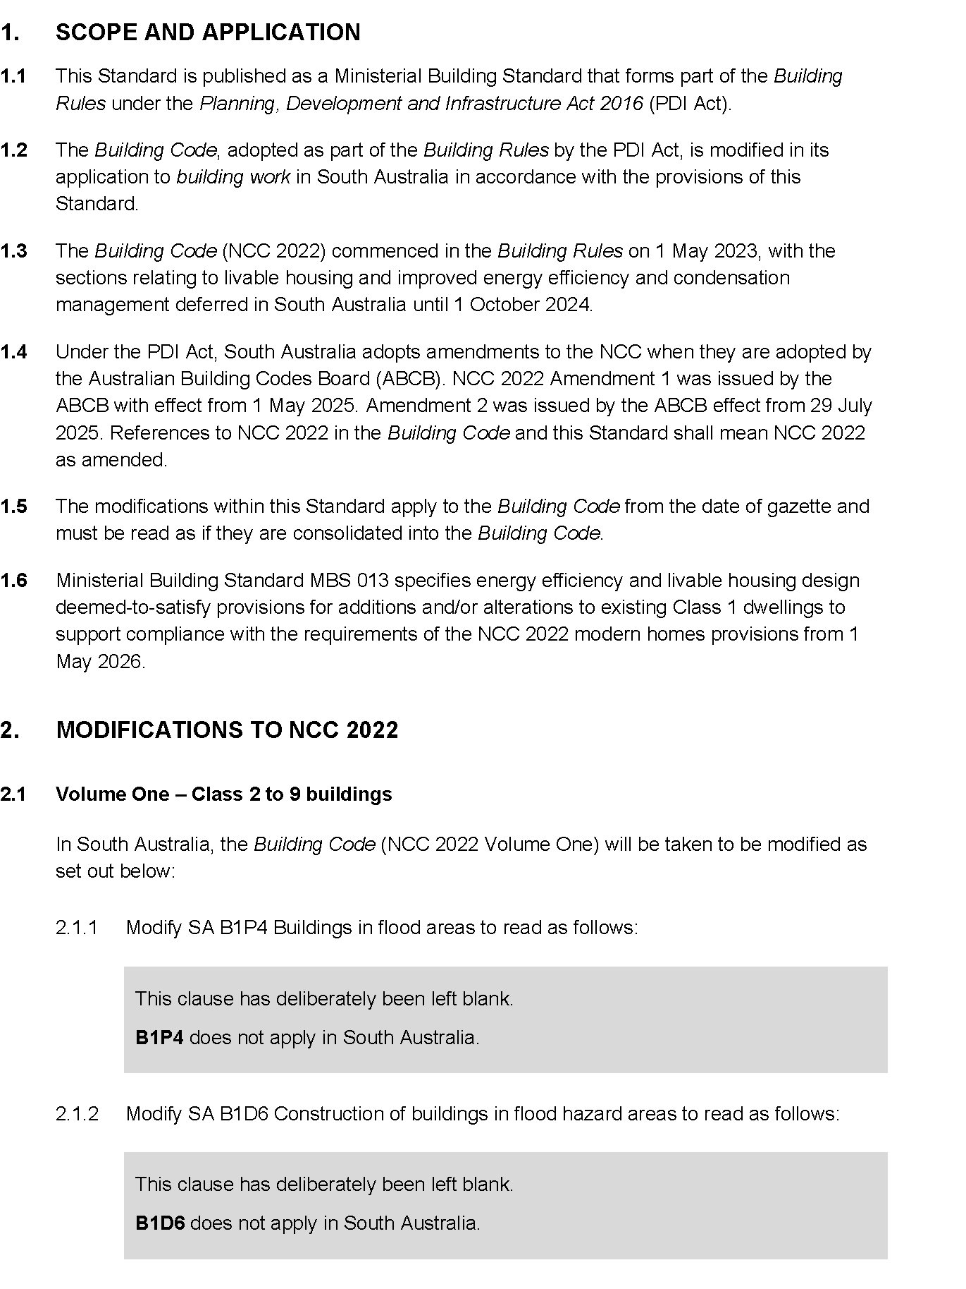
Published by the Minister for Planning
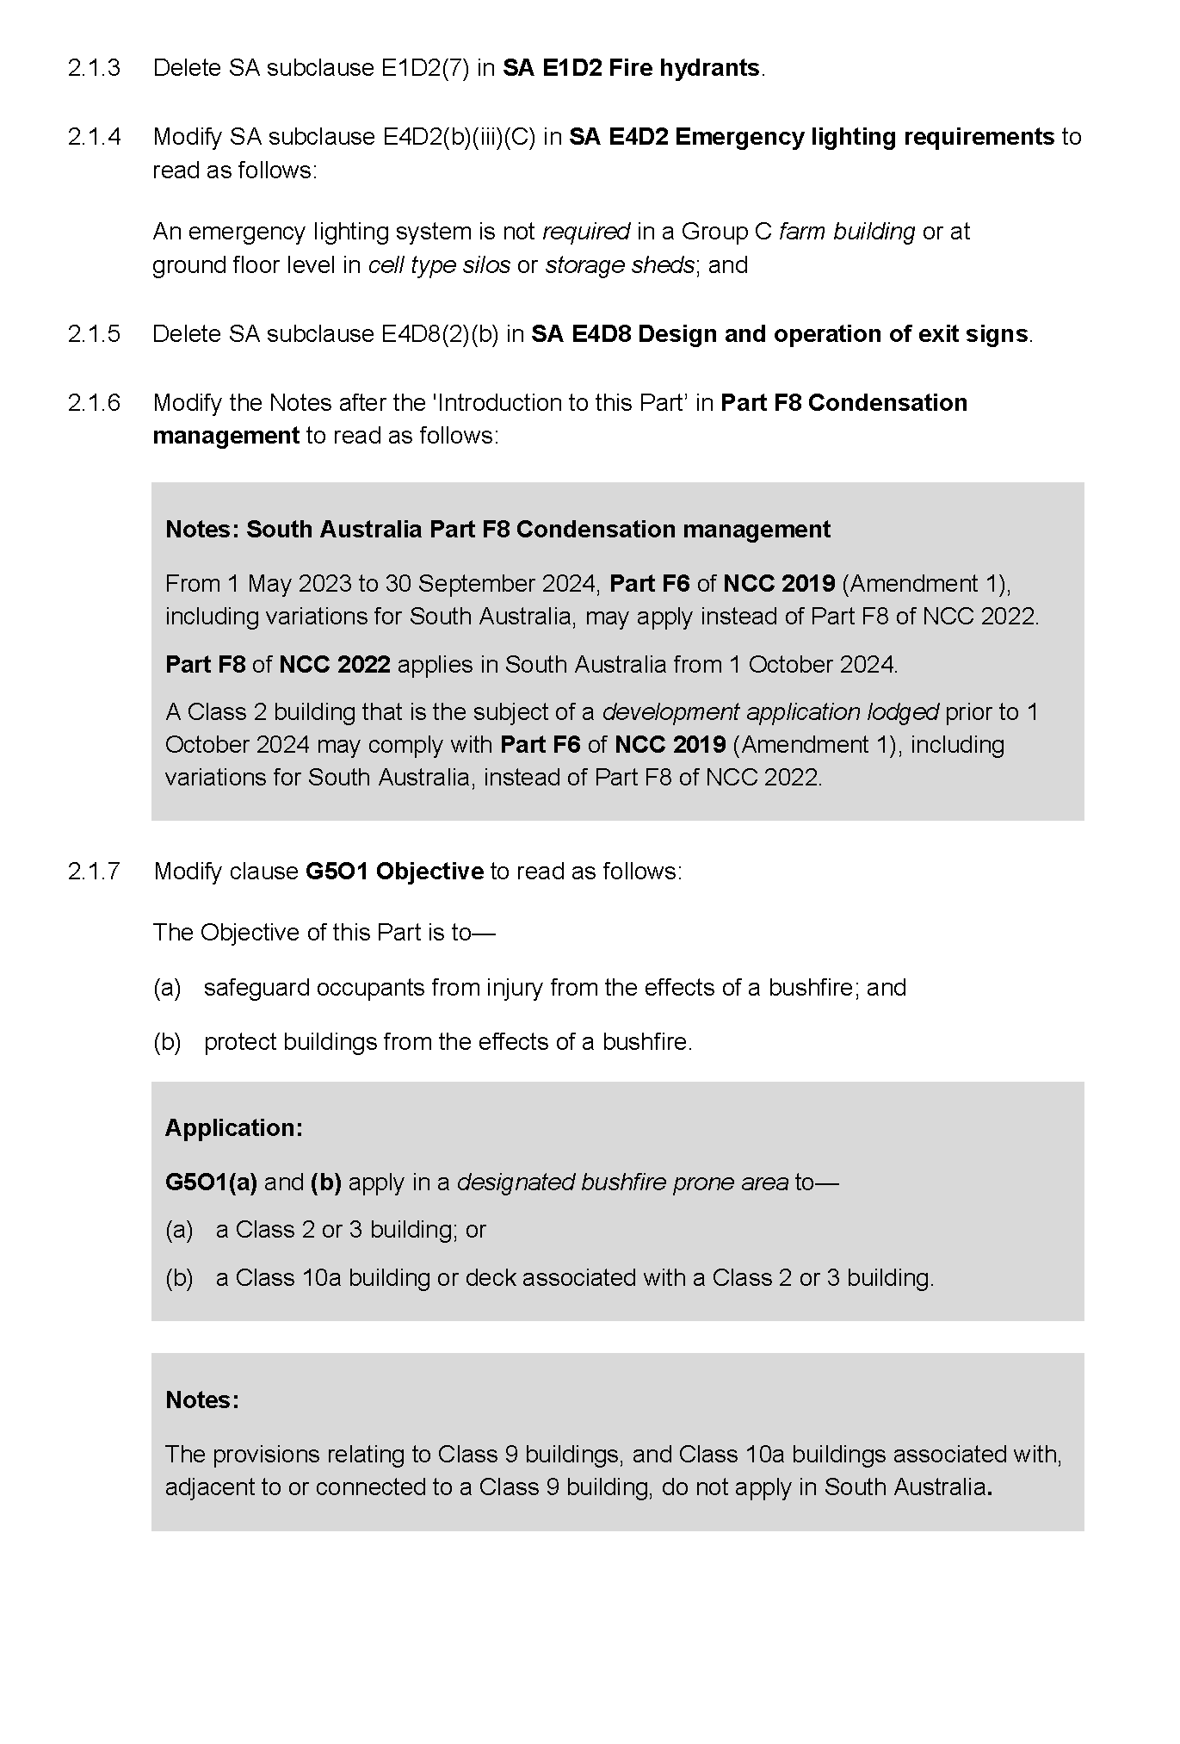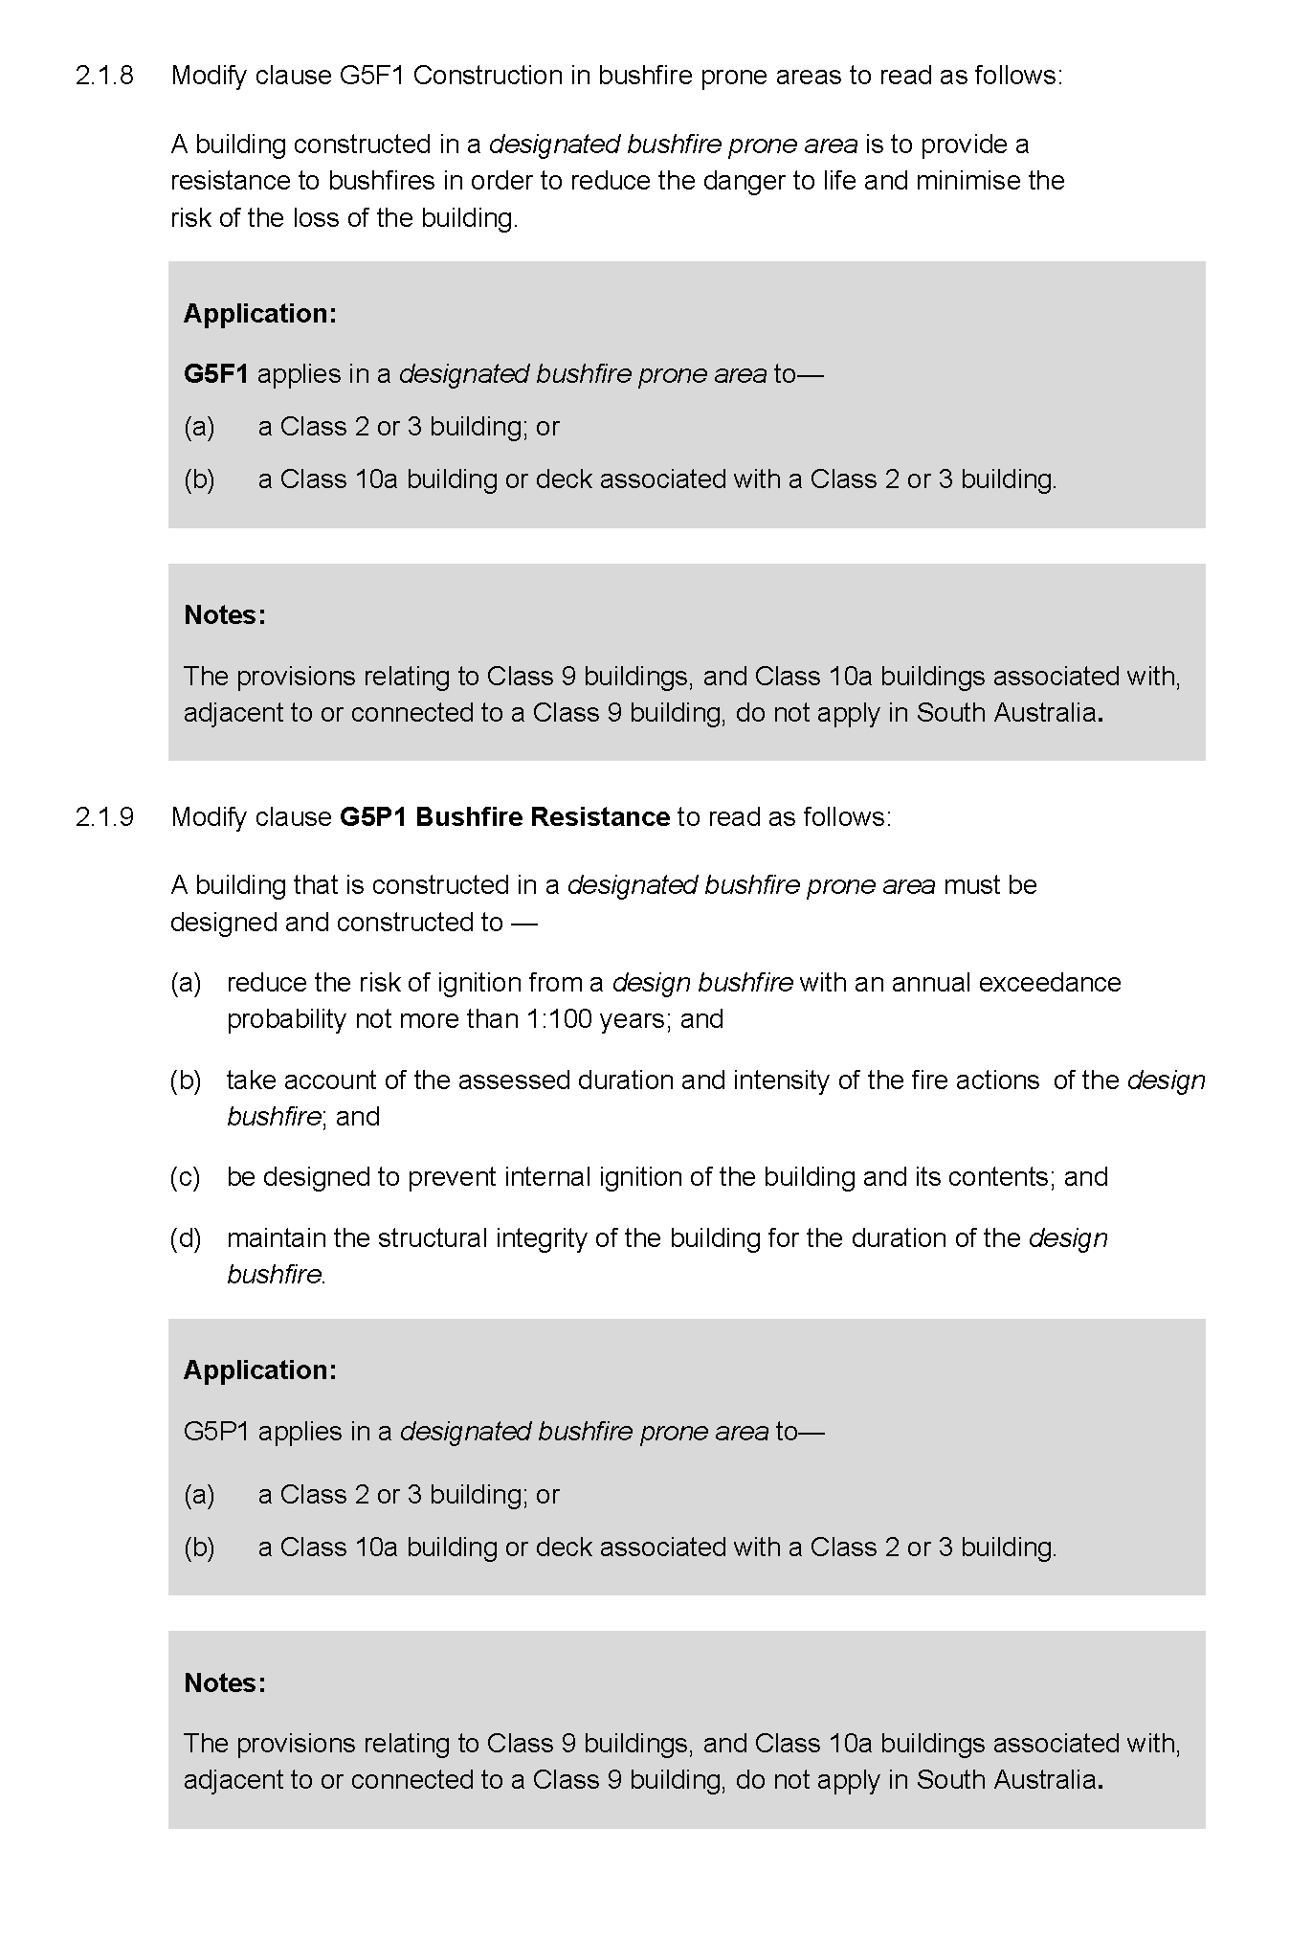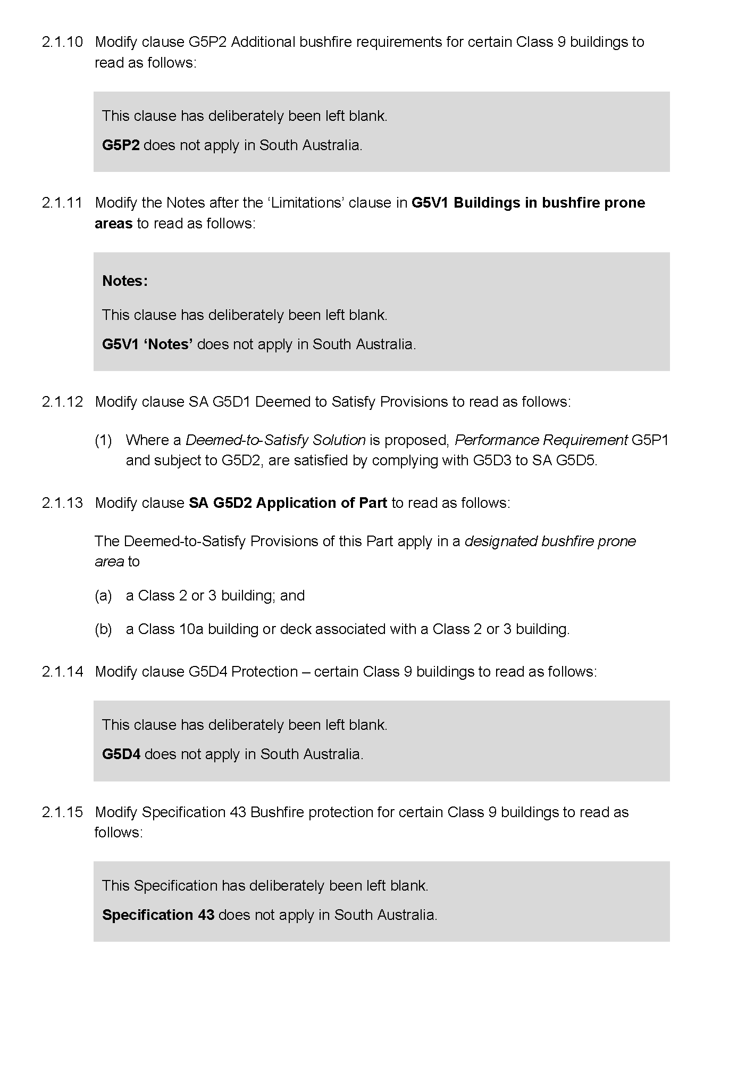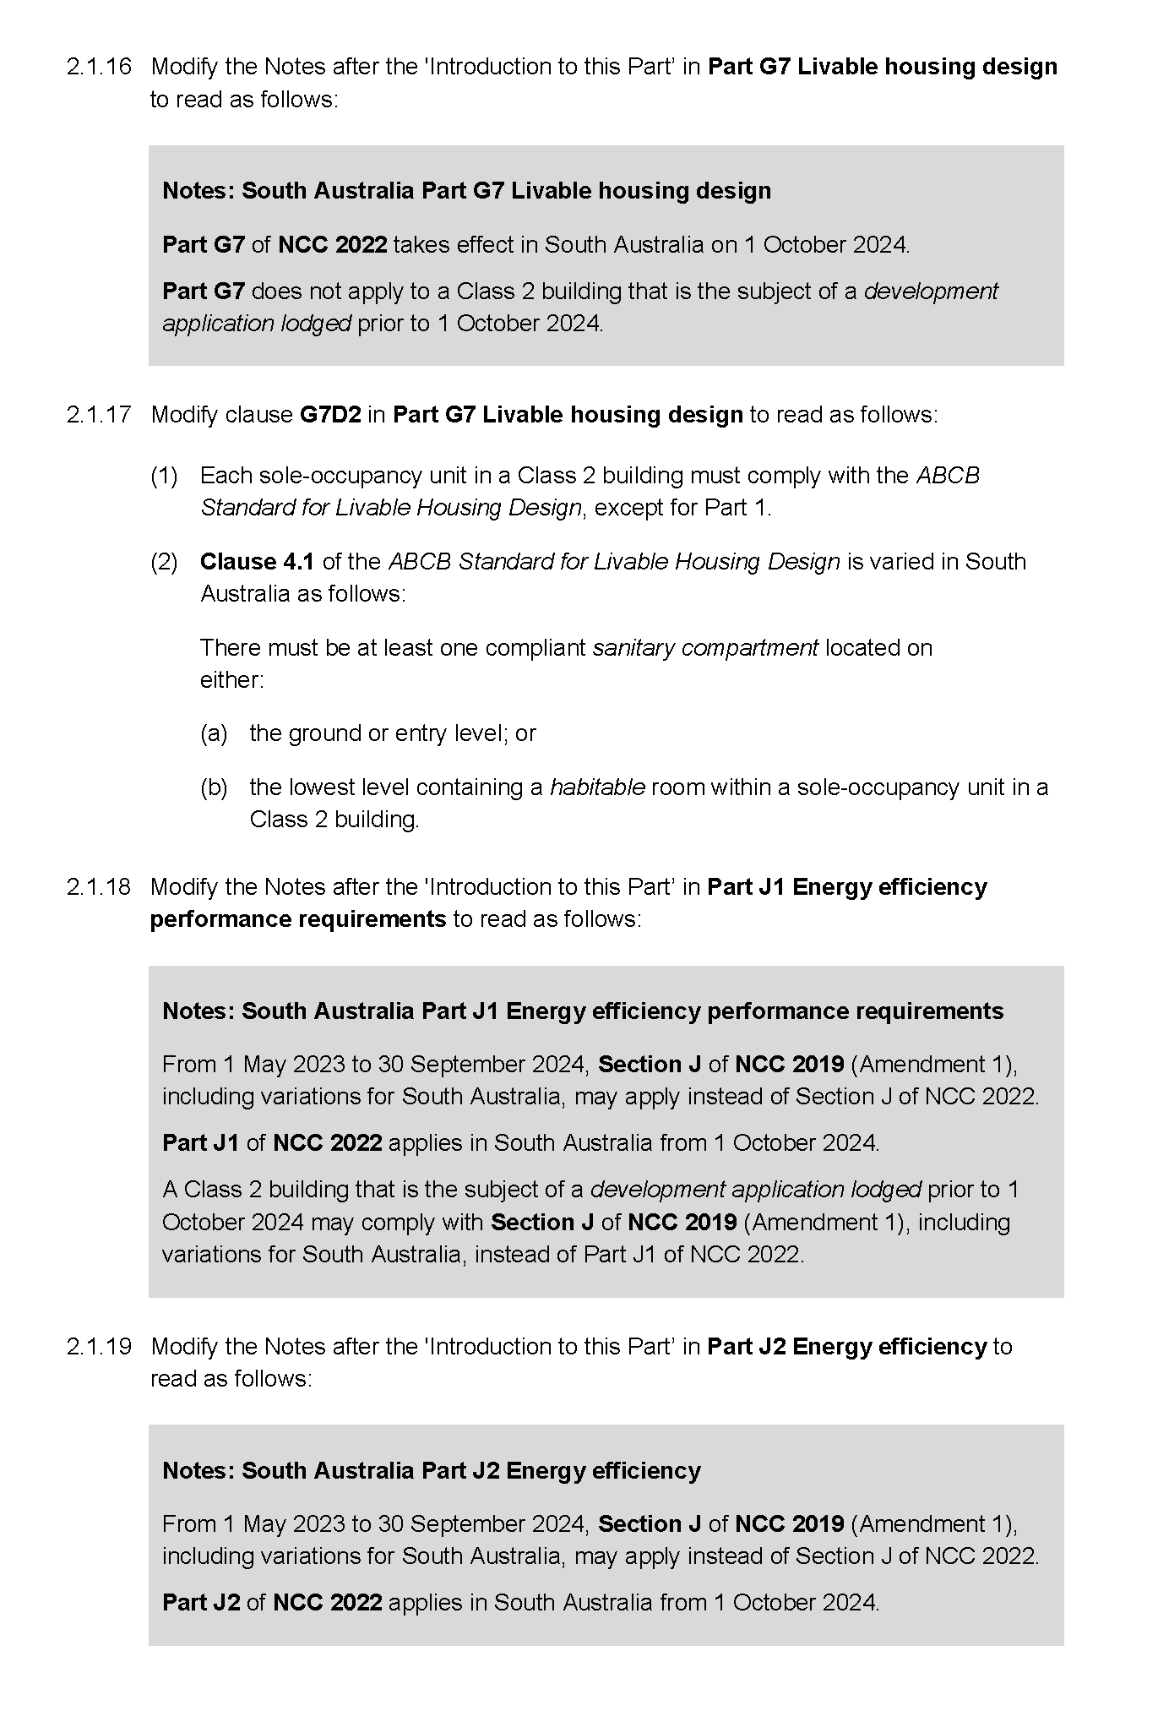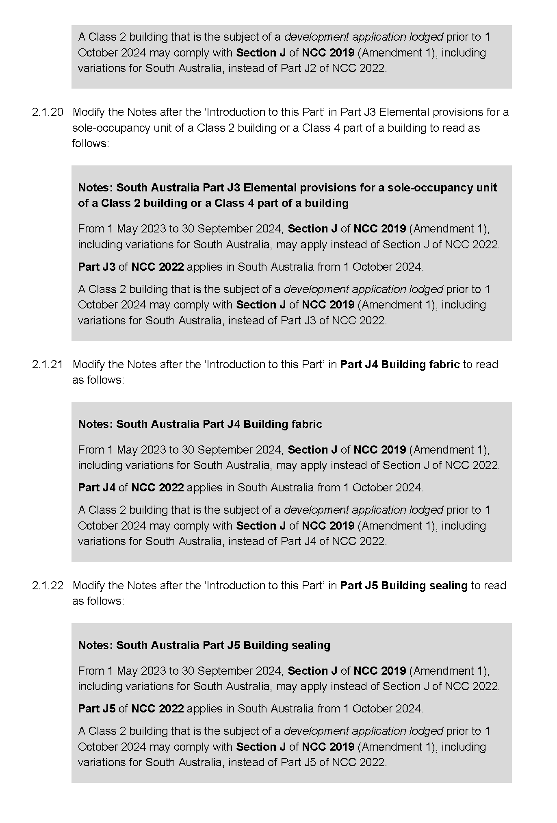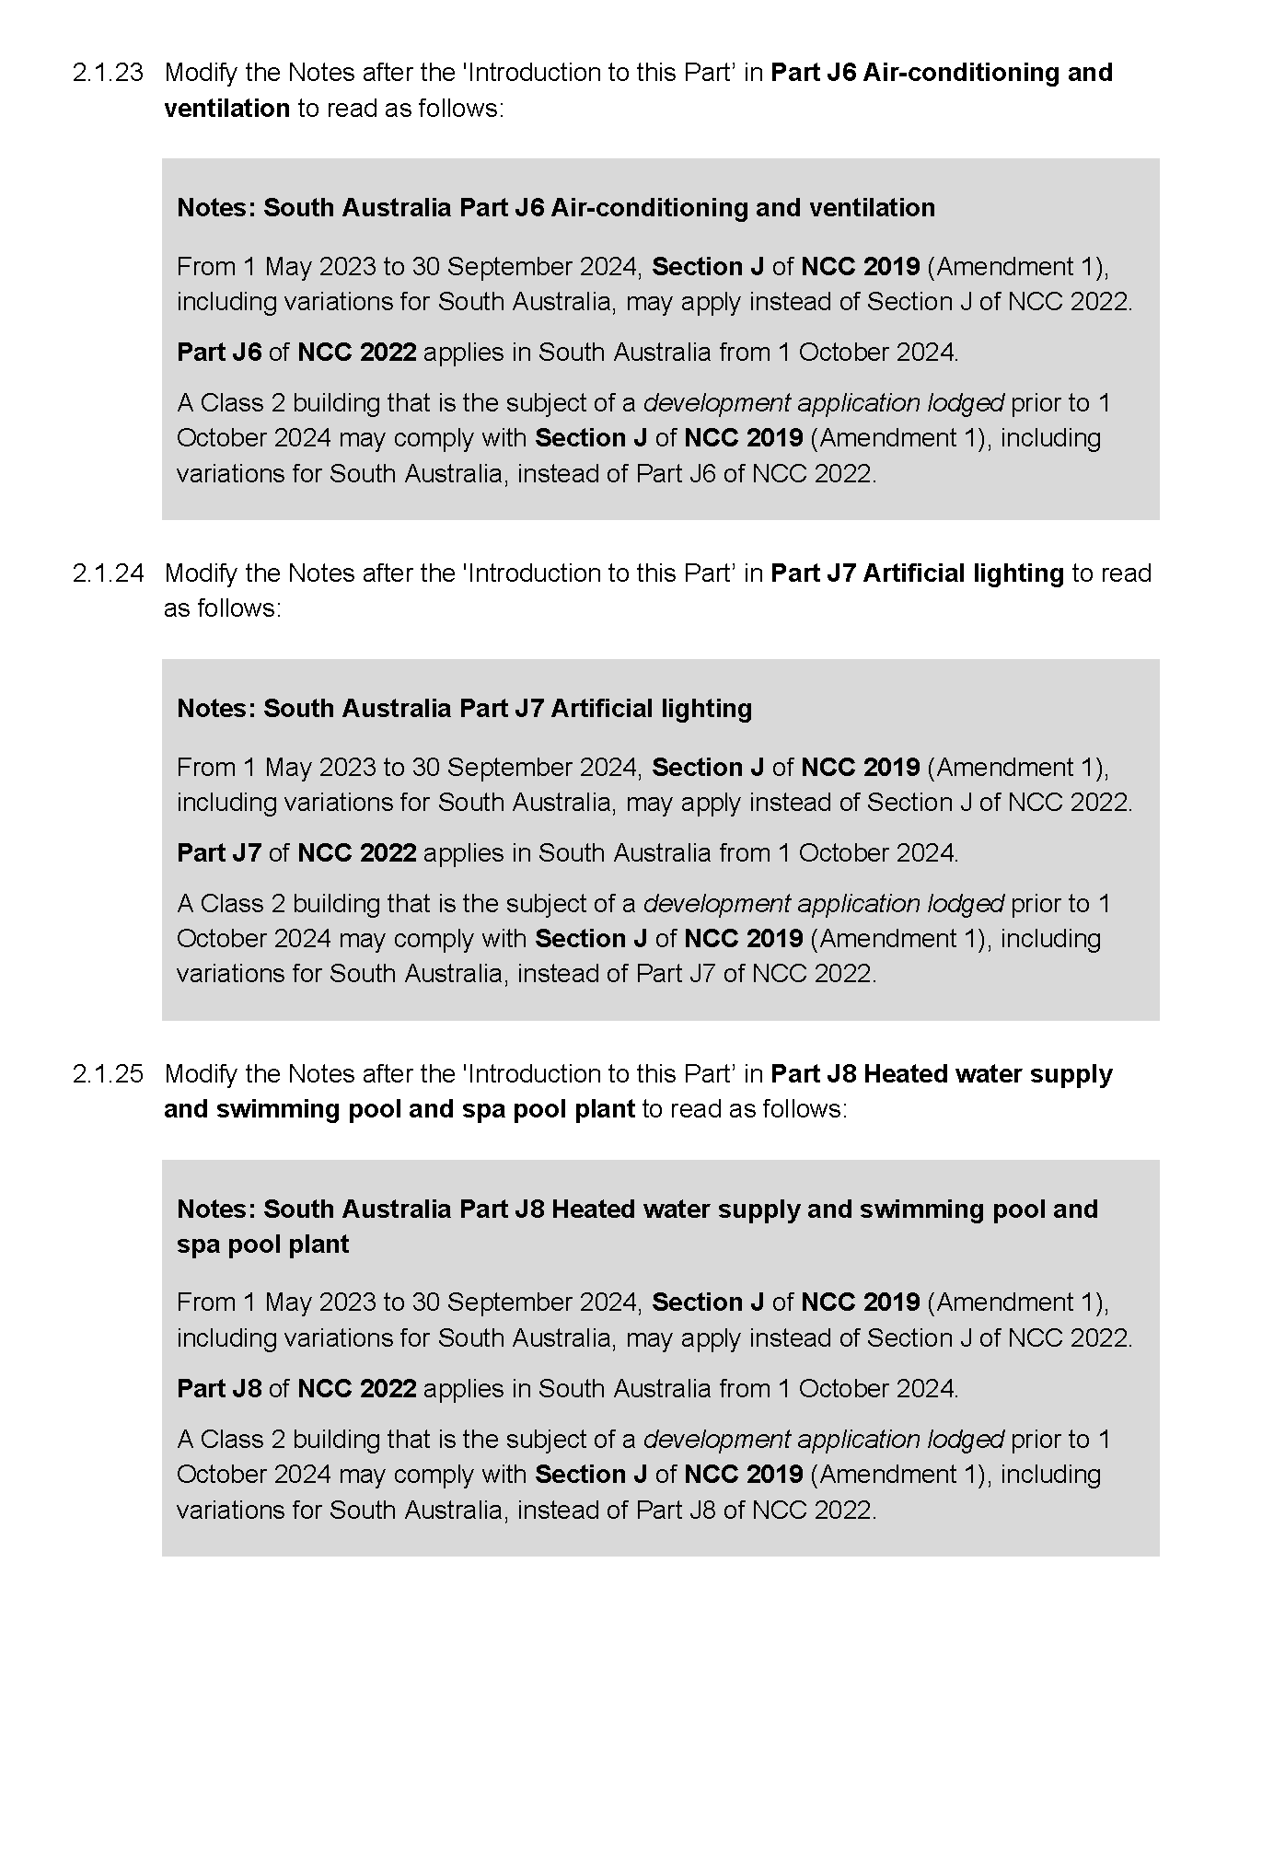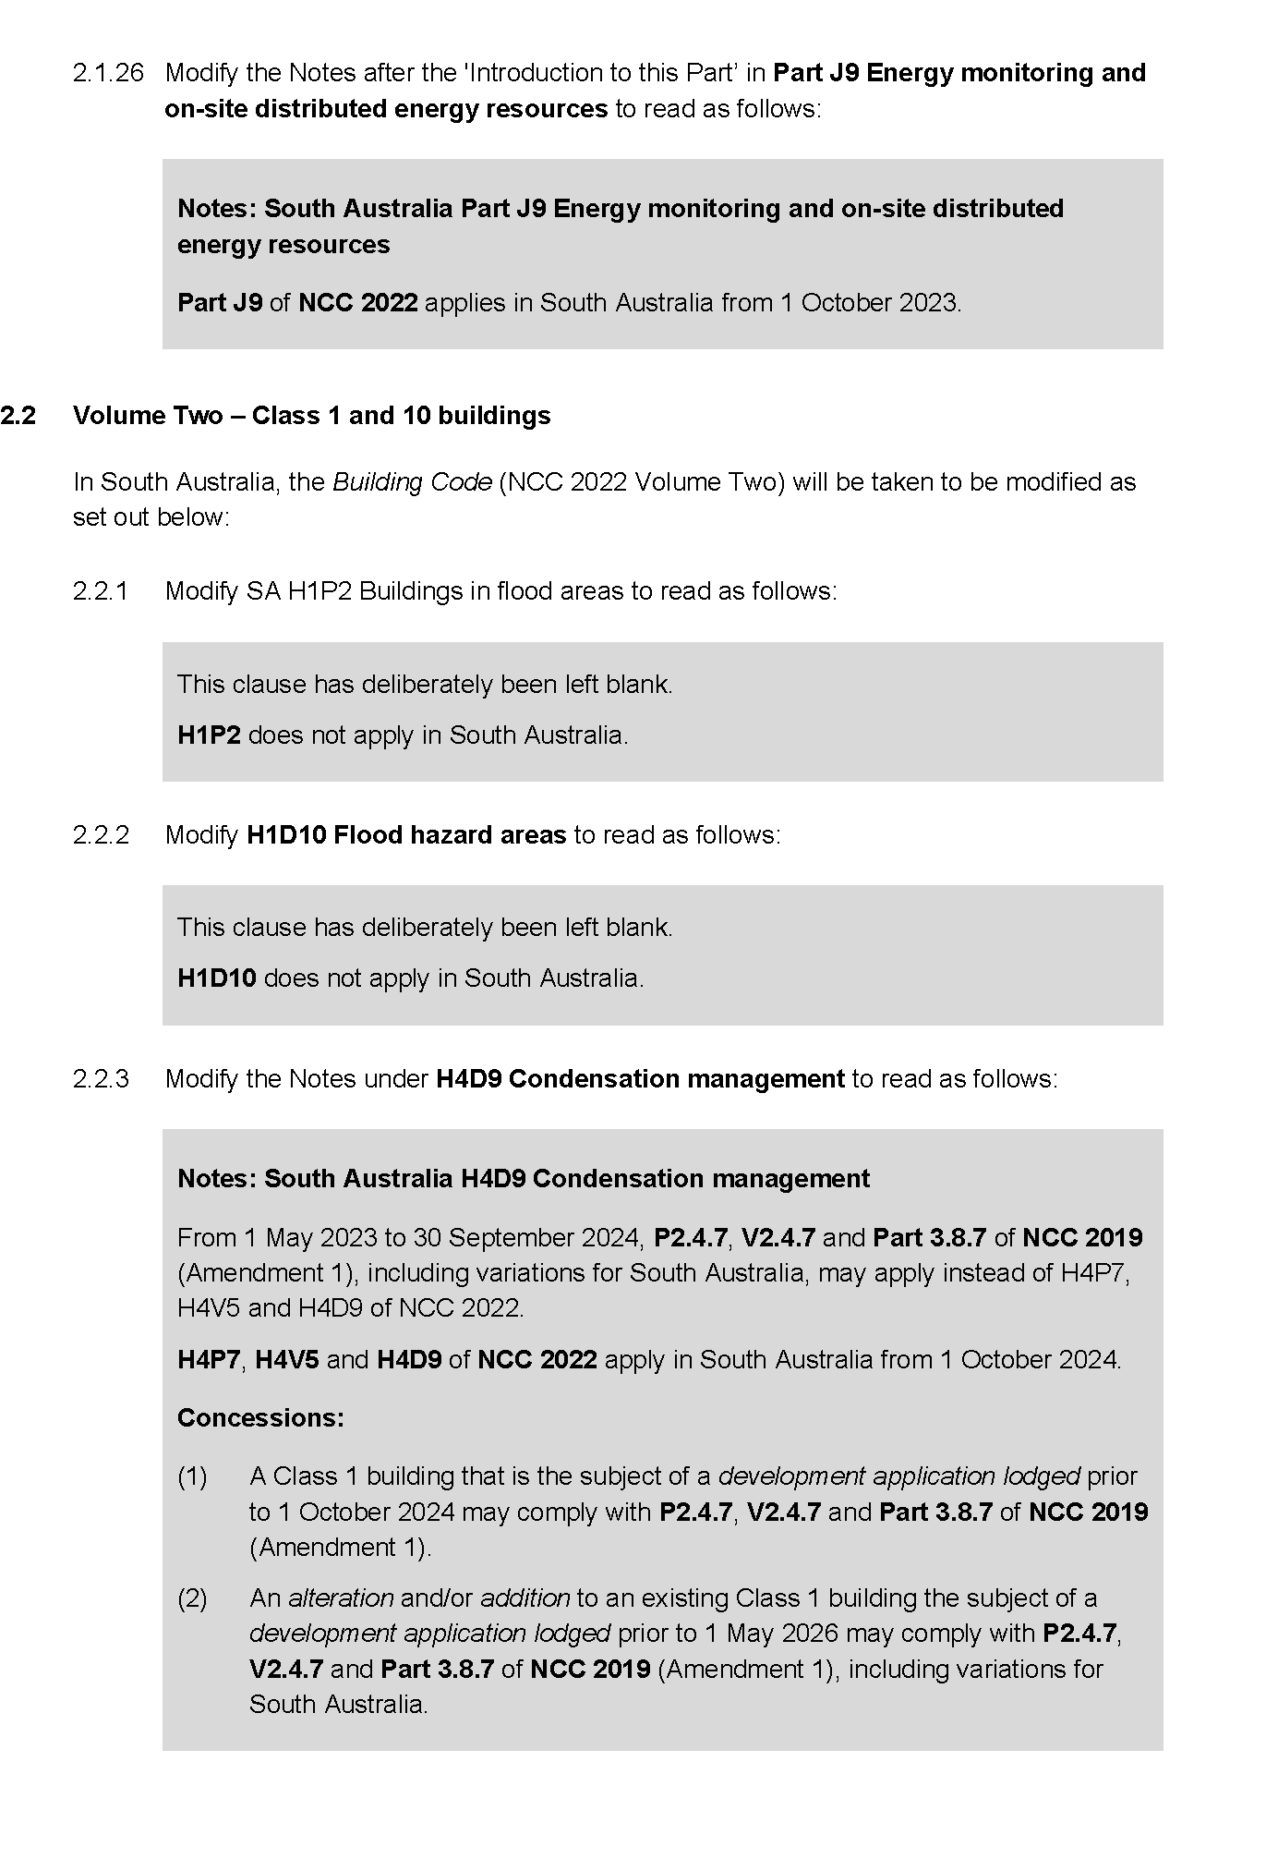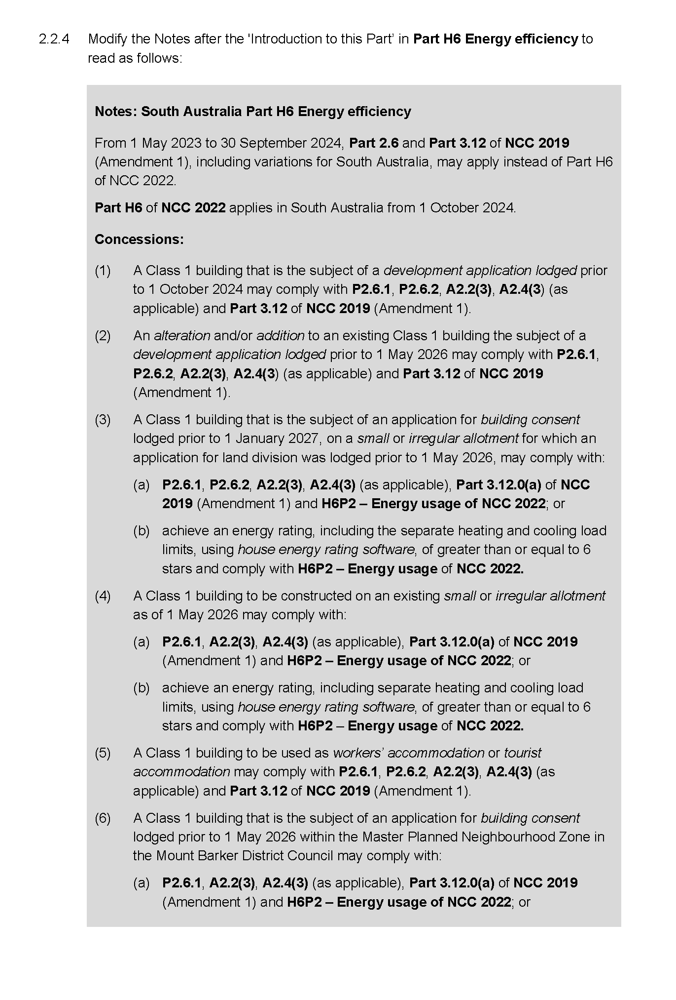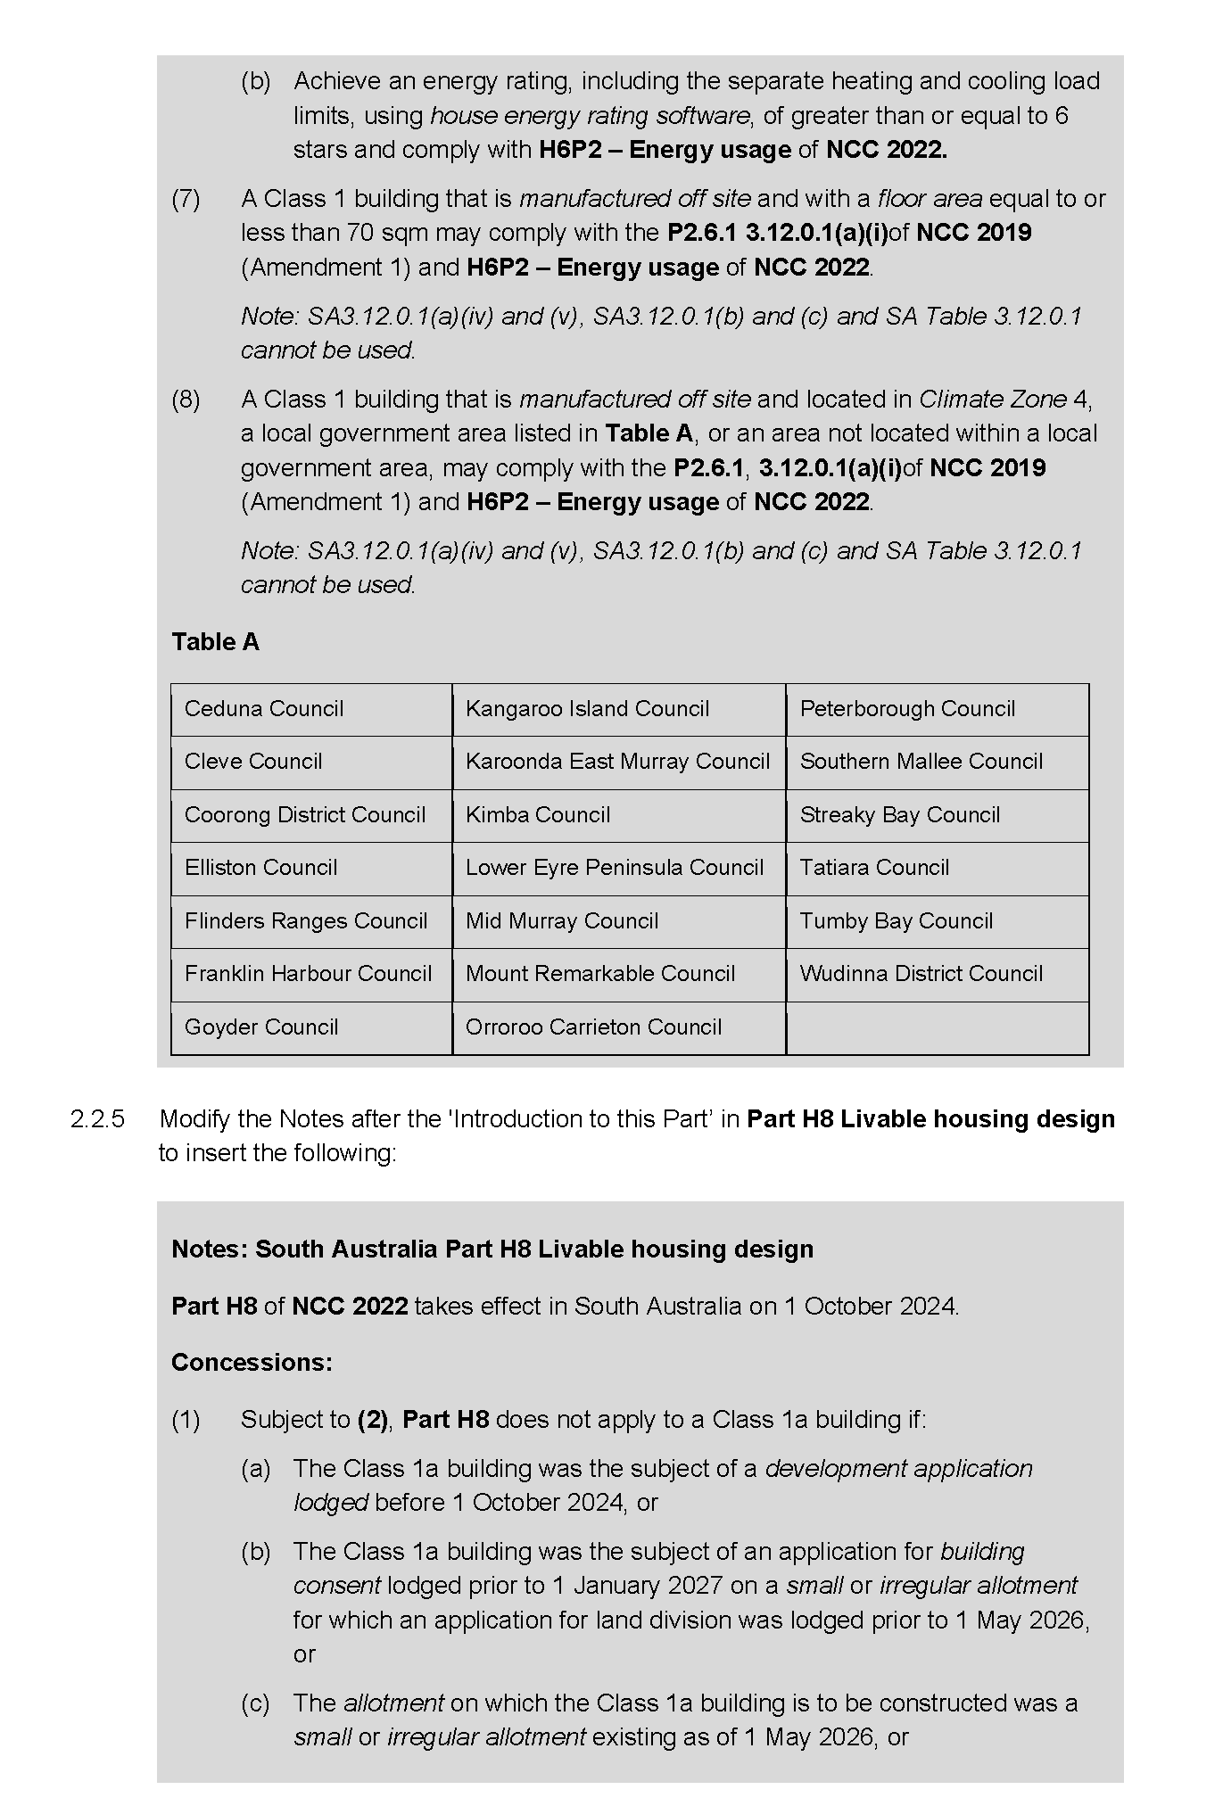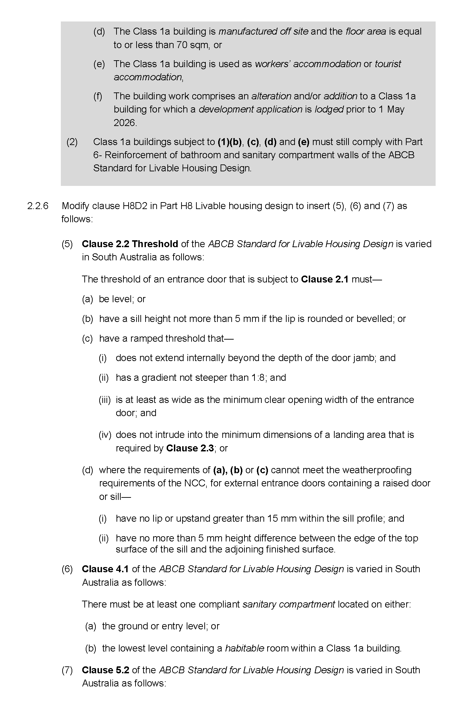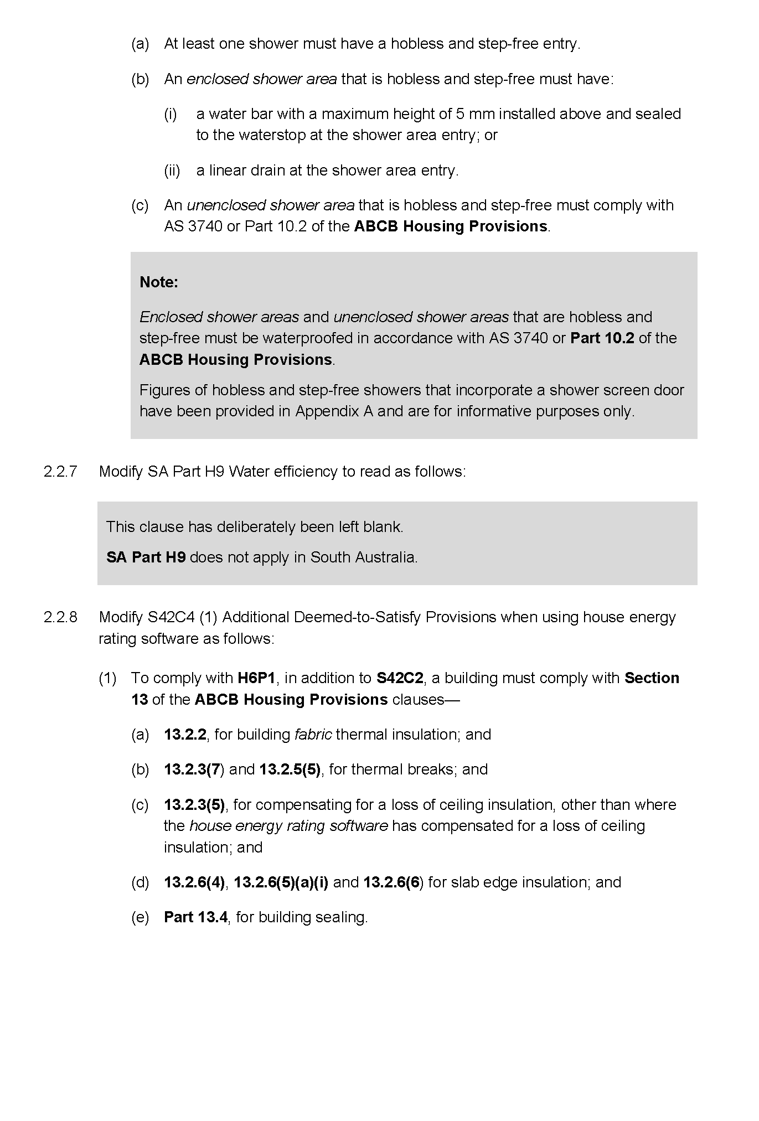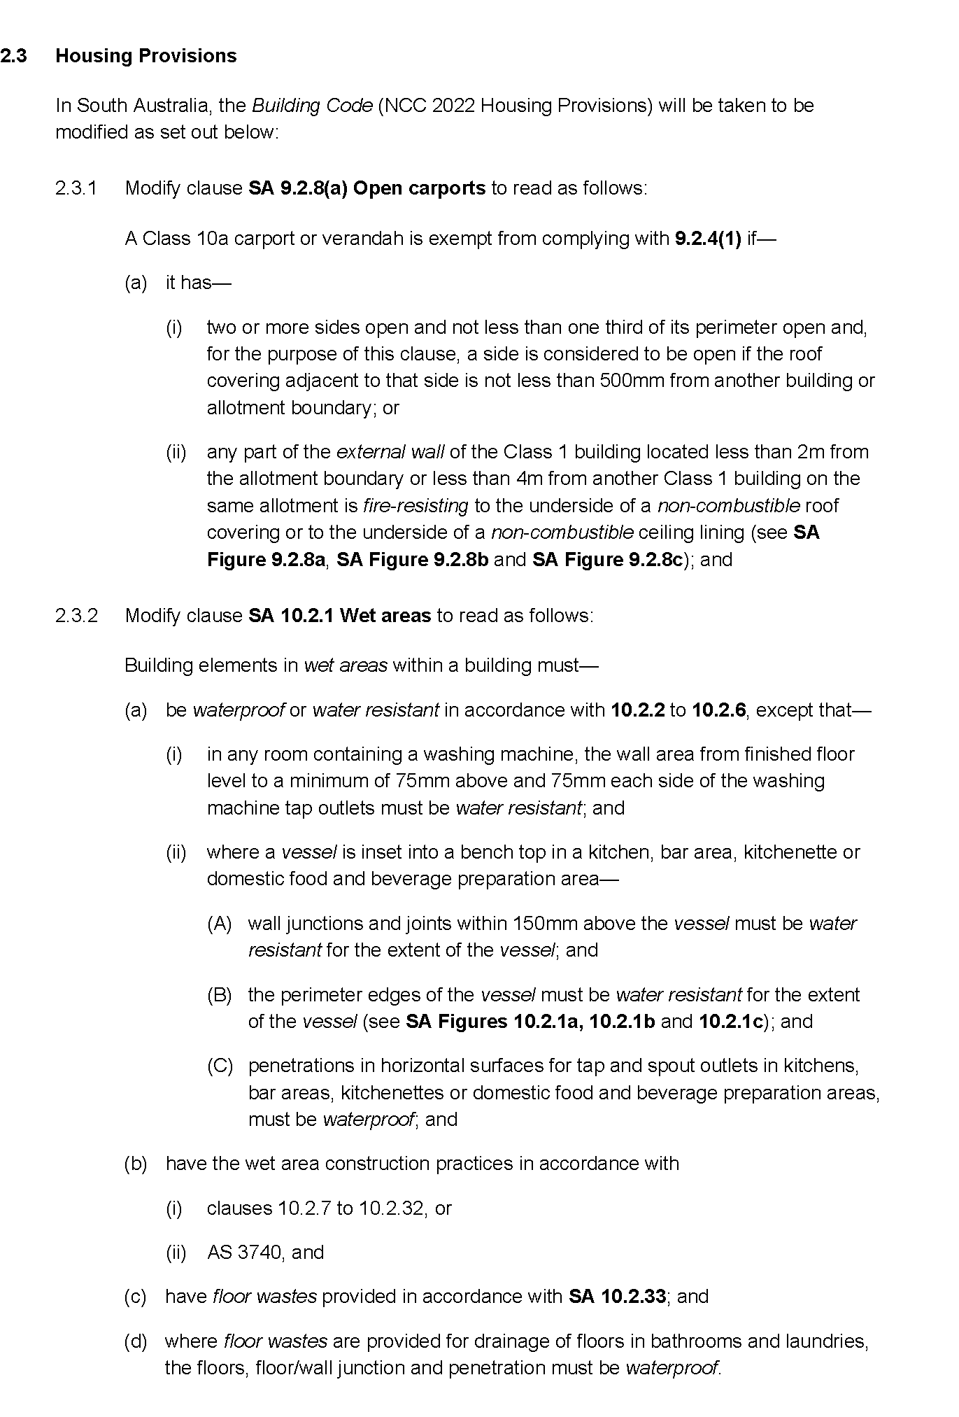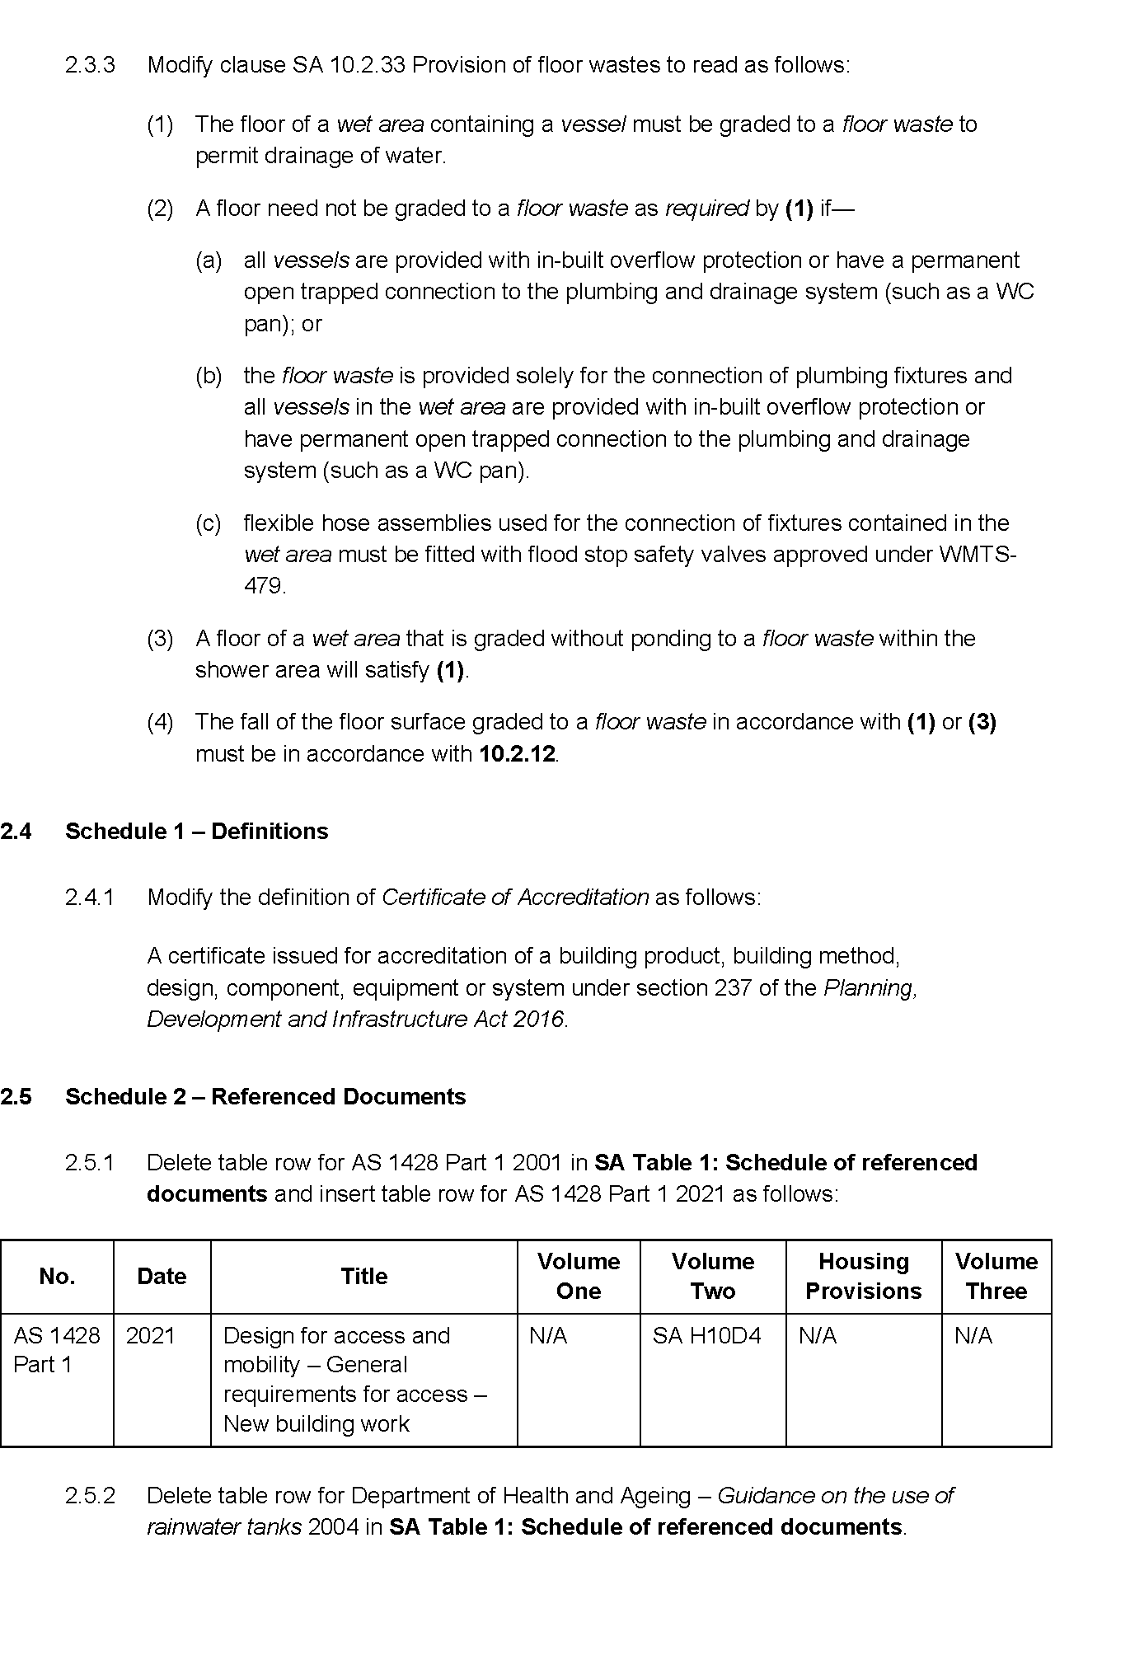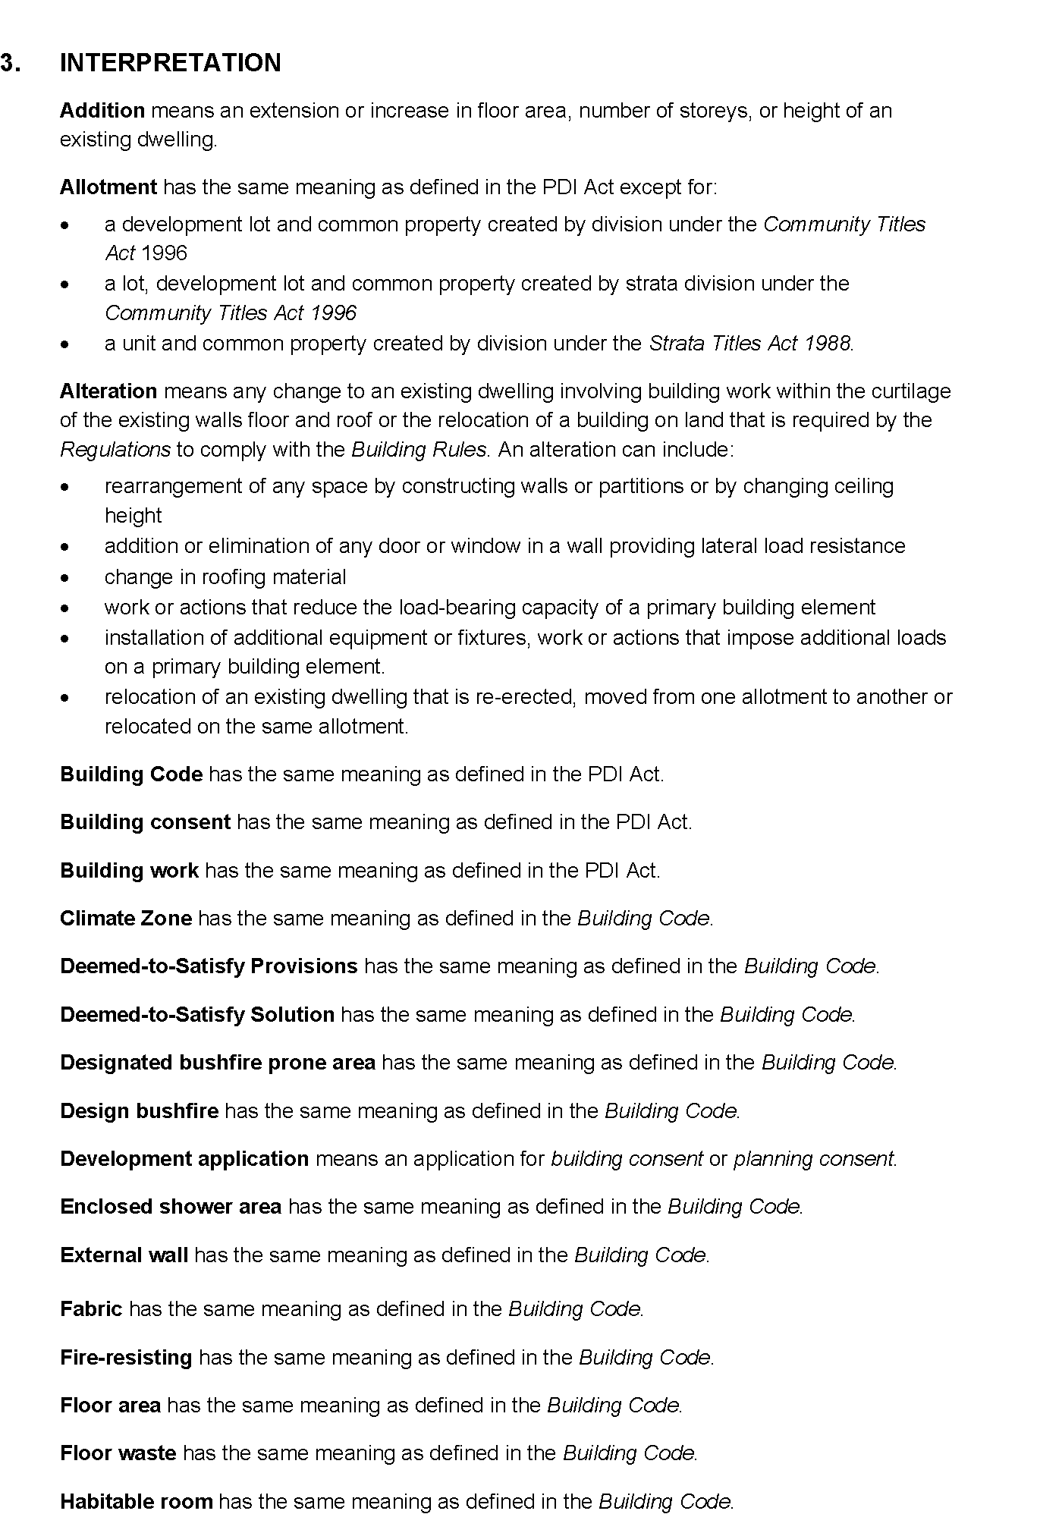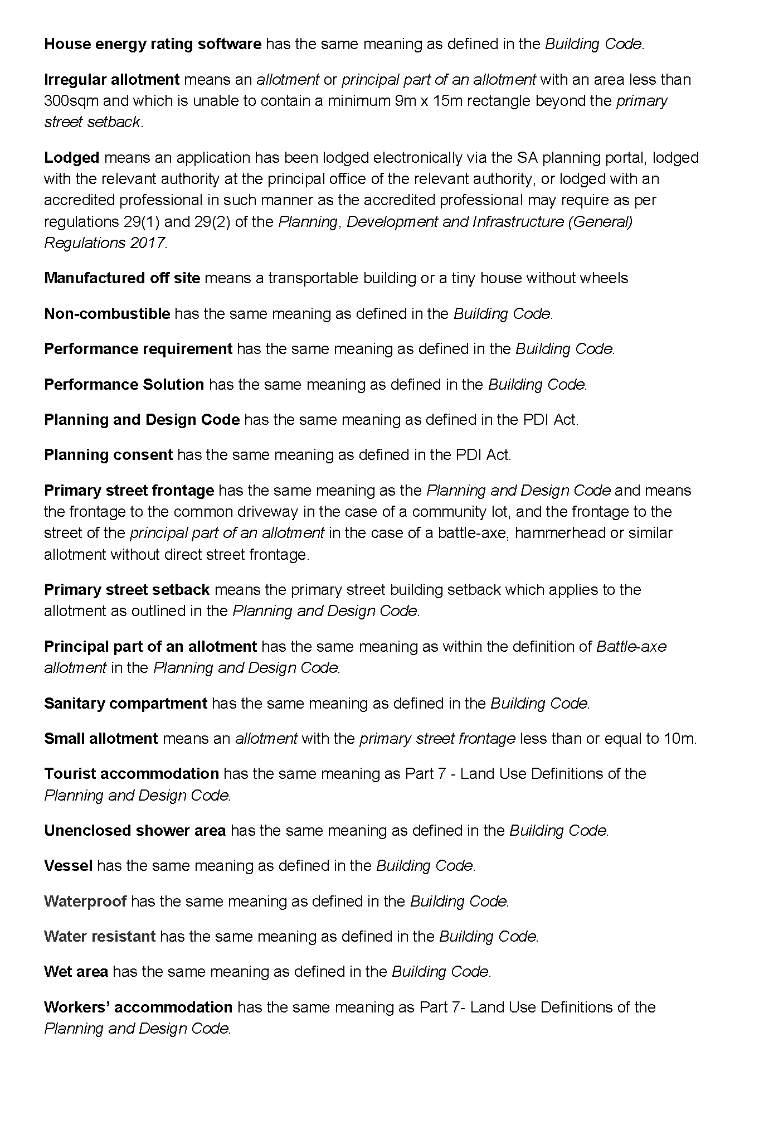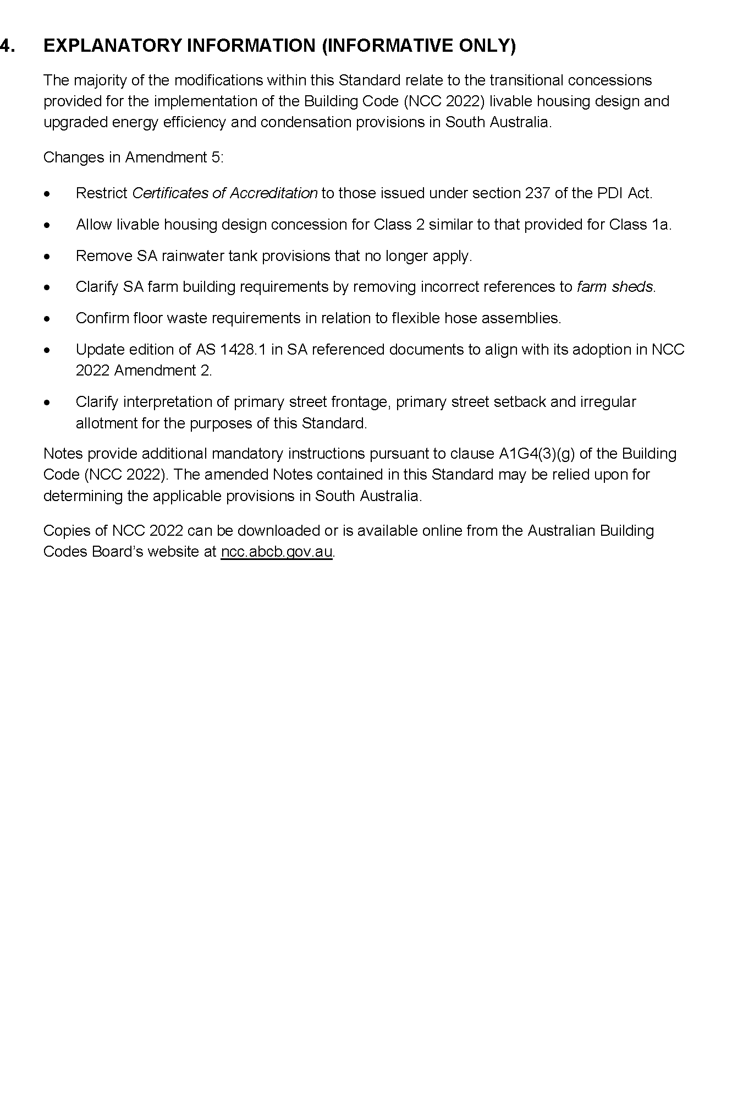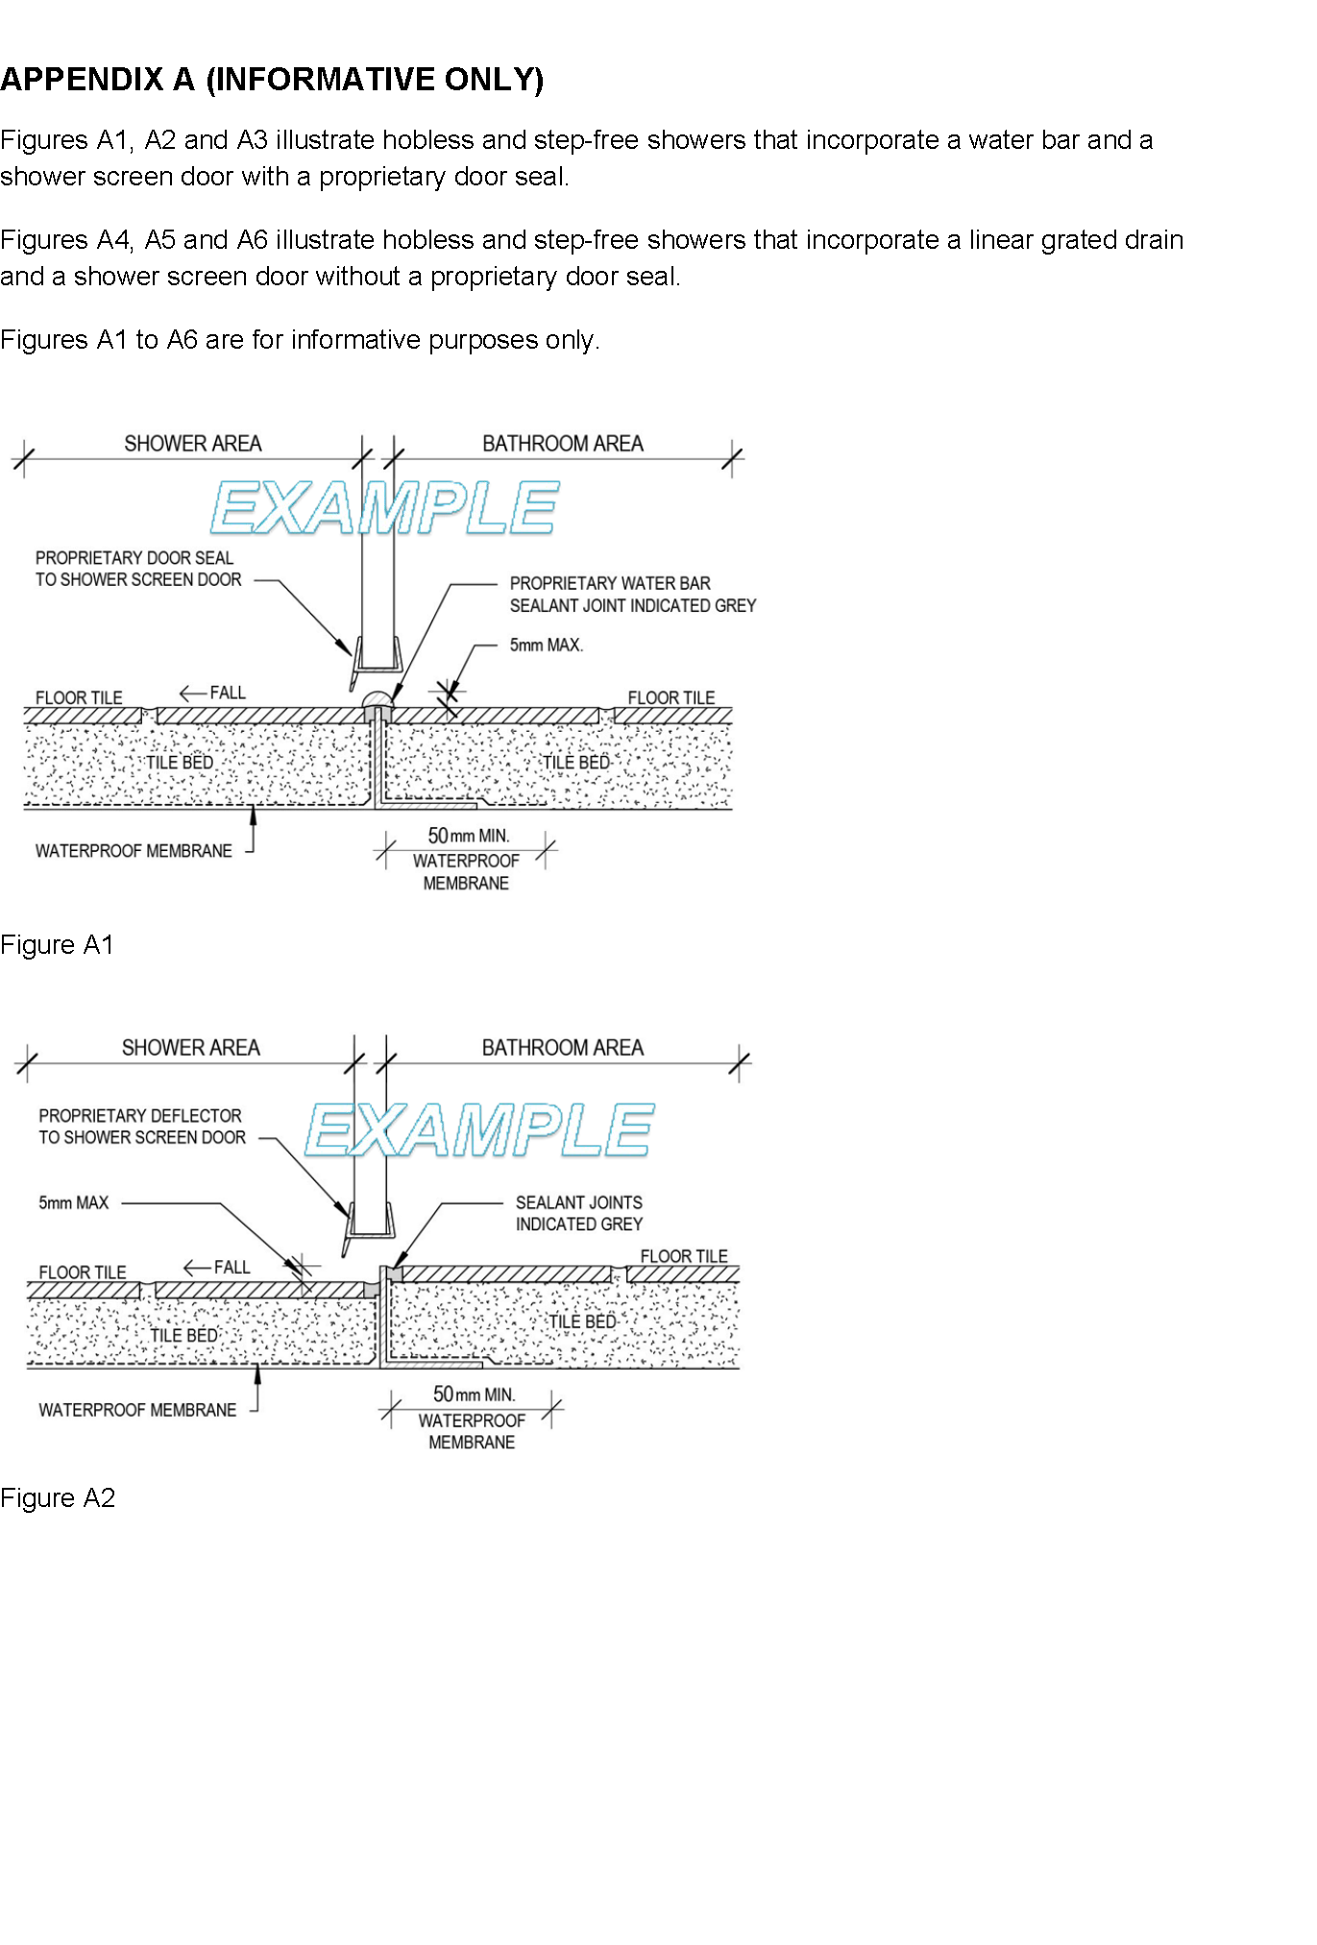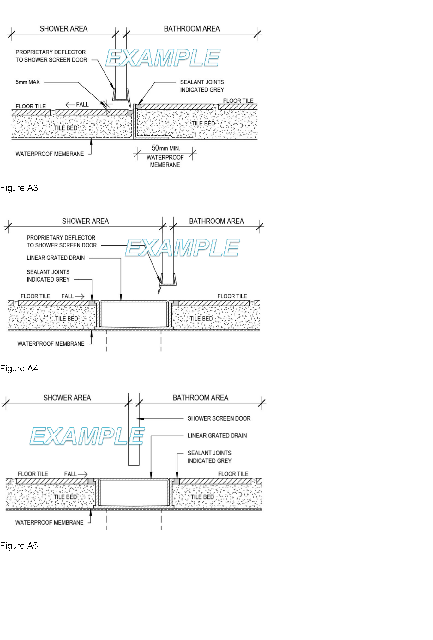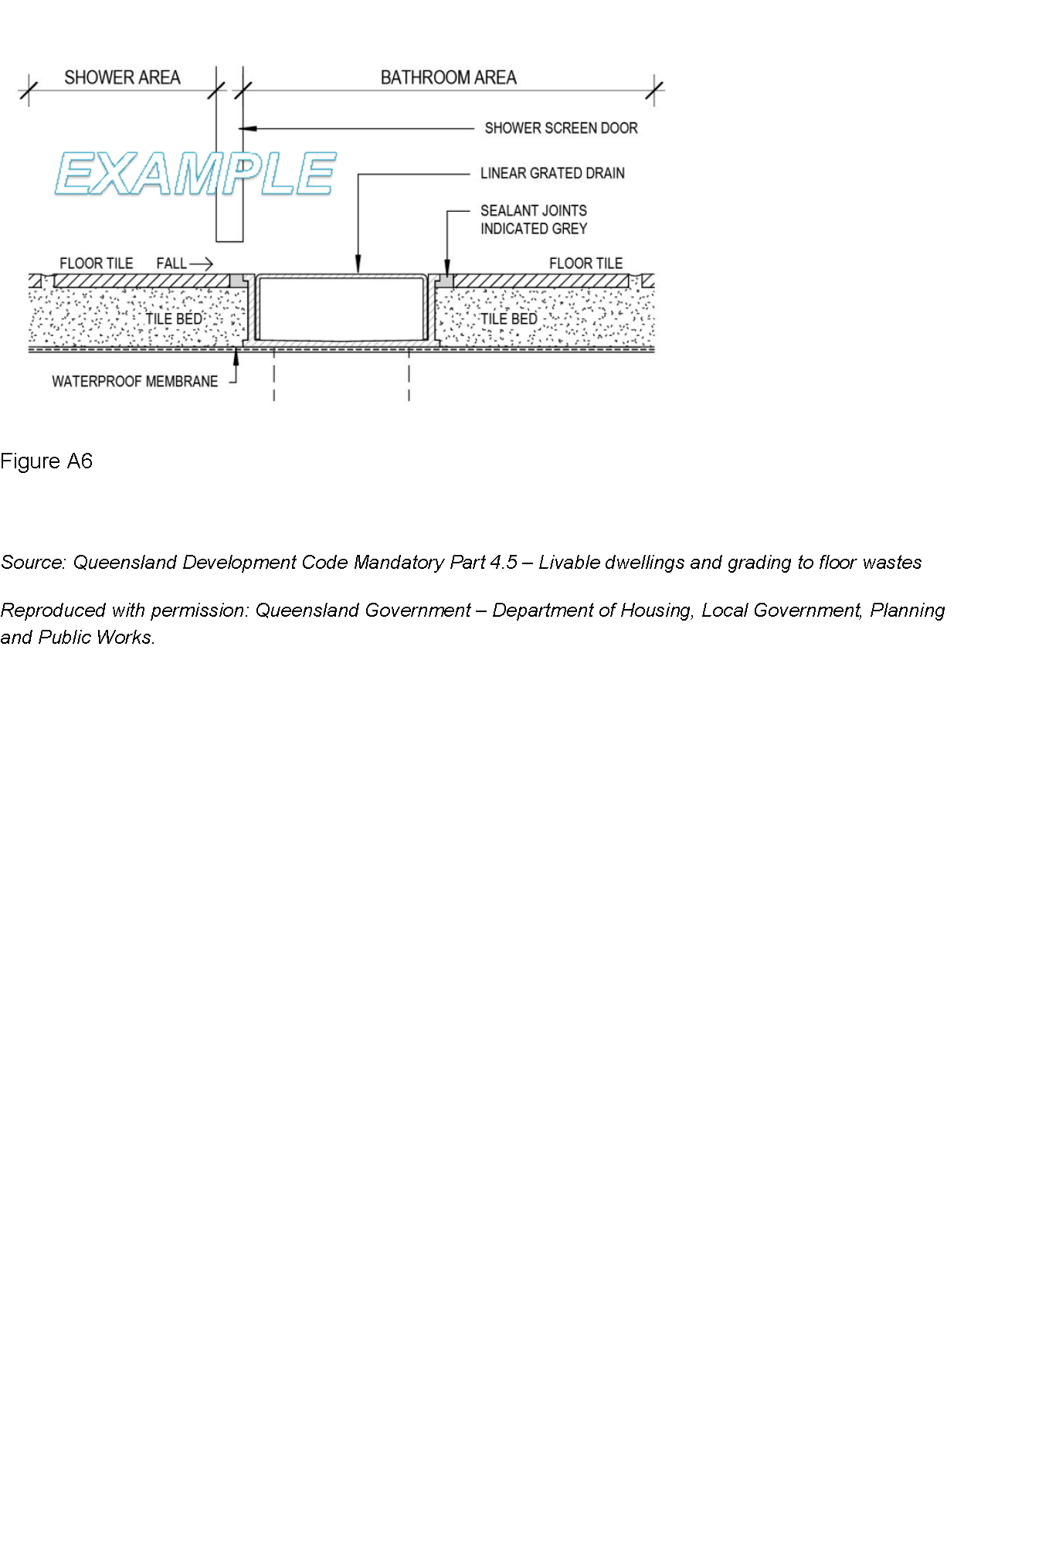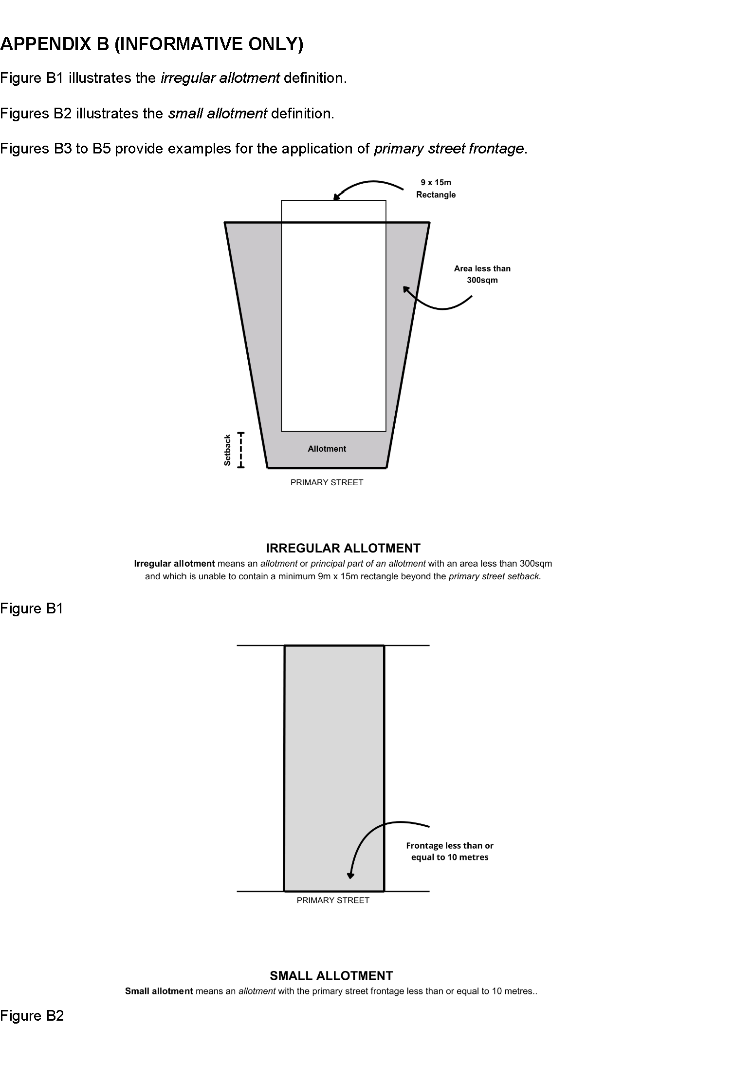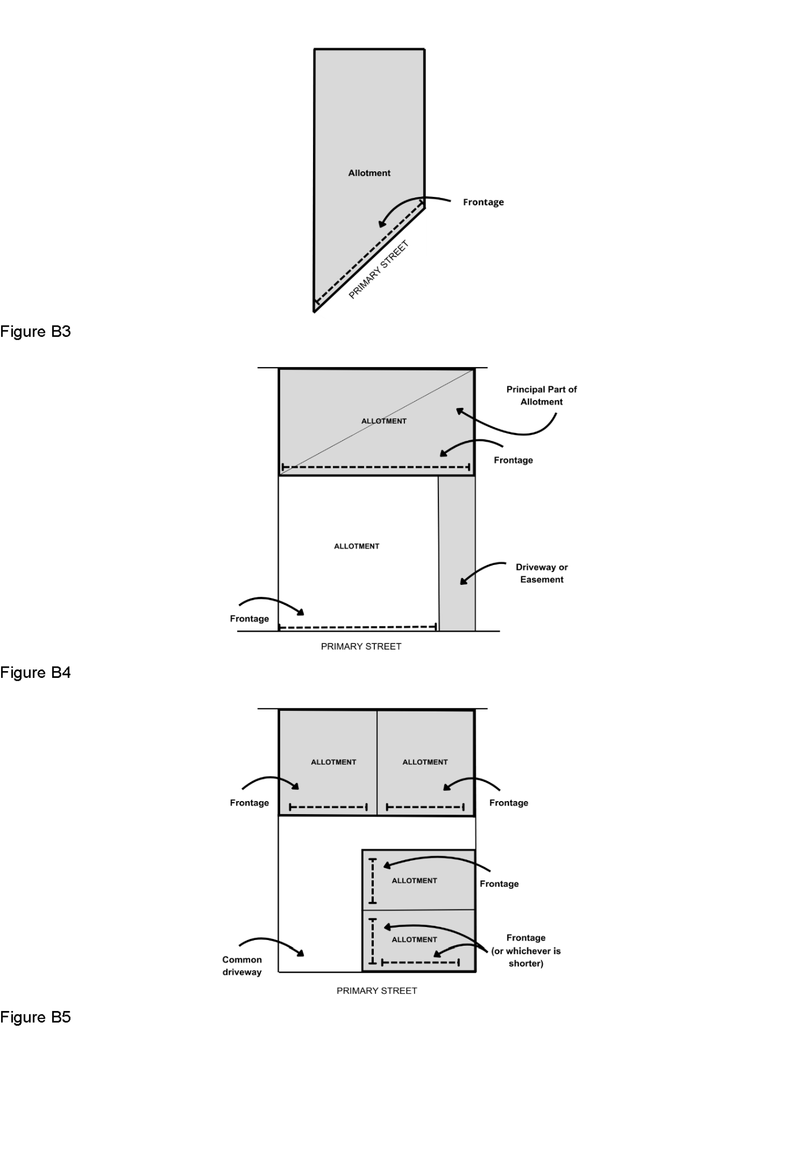

Planning, Development and Infrastructure Act 2016
South Australia
Planning, Development and Infrastructure (Fees)
Notice 2025 (No. 3)
under the Planning, Development and Infrastructure Act 2016
1—Short title
This notice may be cited as the Planning, Development and Infrastructure (Fees) Notice 2025 (No. 3).
Note—
This is a fee notice made in accordance with the Legislation (Fees) Act 2019.
2—Commencement
This notice has effect on the date of publication in the Gazette.
3—Interpretation
(1) In this notice, unless the contrary intention appears—
Act means the Planning, Development and Infrastructure Act 2016;
allotment does not include an allotment for road or open space requirements;
development cost does not include any fit-out costs;
regulations means the following:
(a) the Planning, Development and Infrastructure (Accredited Professionals) Regulations 2019;
(b) the Planning, Development and Infrastructure (Fees, Charges and Contributions) Regulations 2019;
(c) the Planning, Development and Infrastructure (General) Regulations 2017.
(2) Words and expressions used in the regulations and in this fee notice have the same respective meanings in this notice as they have in the regulations.
(3) Subclause (2) does not apply to the extent that the context or subject matter otherwise indicates or requires.
4—Fees payable
(1) The fees set out in Schedule 1 are prescribed for the purposes of the Act and the regulations and are payable as specified in that Schedule.
(2) A fee set out in Schedule 1 item 8 is payable to the body specified in relation to the fee.
(3) Subject to subclauses (4) and (5), if an application, matter or circumstance falls within more than 1 item under Schedule 1, then the fee under each such item applies and those fees in total will be payable.
(4) If planning consent is sought for development comprising more than 1 element—
(a) a fee is not payable under Schedule 1 item 6 for each element of the development; and
(b) the fee payable under Schedule 1 item 6 is the highest fee applying to a single element of the development; and
(c) if the relevant fee is based on the total development cost, the fee payable will be based on the total cost of all elements of the development.
(5) If an application for planning consent must be referred to the same body under more than 1 item of Schedule 9 of the Planning, Development and Infrastructure (General) Regulations 2017, then only 1 prescribed fee under Schedule 1 item 8 is payable with respect to the referral of the application to that body.
(6) A reference in subclause (5) to a prescribed fee extends to a prescribed fee that, although payable, was waived (in whole or in part) by a relevant authority.
(7) Subject to subclause (8) if a lodgement fee has been paid in respect of an application for planning consent or building consent for a development, no lodgement fee is payable for any other consents related to that application or for the issue of the final development approval in respect of that development.
(8) If a lodgement fee has been paid in respect of an application under the repealed Act, a lodgement fee under this notice is payable in respect of the first application for consent related to the application under the repealed Act that is lodged electronically via the SA planning portal.
5—Assessment requirements—water and sewerage
(1) A prescribed fee under Schedule 1 item 27 is payable to the South Australian Water Corporation or any other water industry entity identified for the purposes of Section 102(1)(c)(iii) and (1)(d)(vii) of the Act.
(2) The prescribed fee is payable by the person who makes the application to divide the land.
6—Applications relating to certain electricity infrastructure—issue of certificate by Technical Regulator
The prescribed fee under Schedule 1 item 32 is payable to the Technical Regulator for the issue of a certificate required by the Planning, Development and Infrastructure (General) Regulations 2017 to accompany an application in respect of a proposed development for the purposes of the provision of electricity generating plant with a generating capacity of more than 5 MW that is to be connected to the State’s power system.
Schedule 1—Fees
Part 1—Fees regarding applications to the Accreditation Authority
The following fees are payable for the purposes of the Planning, Development and Infrastructure (Accredited Professionals) Regulations 2019:
1 | Application to the accreditation authority for accreditation under the Planning, Development and Infrastructure (Accredited Professionals) Regulations 2019, other than where item 2 applies. | $647.00
2 | Application to the accreditation authority for accreditation under the Planning, Development and Infrastructure (Accredited Professionals) Regulations 2019 where—
 | (a) the person is a member of a professional association or body recognised by the Chief Executive for the purposes of Regulation 16(2)(a) of the Planning, Development and Infrastructure (Accredited Professionals) Regulations 2019 and the person is applying as a member of that association or body for a corresponding level of accreditation under Regulation 16(2)(a)(ii) of those regulations; or | $312.00
 | (b) the person is reapplying for an accreditation previously held under the Planning, Development and Infrastructure (Accredited Professionals) Regulations 2019 within the preceding 12 months; or
 | (c) the person is applying for building level 4 accreditation under the building supervisor pathway; or
 | (d) the person has lodged a notification under Section 40 of the Mutual Recognition Act 1992 for recognition of the person’s interstate registration, to carry out that occupation in South Australia
3 | Application to the accreditation authority under Regulation 19 of the Planning, Development and Infrastructure (Accredited Professionals) Regulations 2019 | $208.00
4 | Late application fee under Regulation 19(3) of the Planning, Development and Infrastructure (Accredited Professionals) Regulations 2019 | $69.00
4a | Application to the accreditation authority for enrolment into the accredited professionals scheme core competency assessment course | $566.50
Part 2—Fees relating to development assessment
The following fees are payable in relation to development assessment under the Act (including in connection with the Planning, Development and Infrastructure (General) Regulations 2017):
5 | Application for outline consent, planning consent or building consent (the base amount)—
 | (a) a lodgement fee
 | (i) if the total development cost is no more than $10,000 | $95.50
 | (ii) if the total development cost is greater than $10,000 and no more than $50,000 | $153.00
 | (iii) if the total development cost is greater than $50,000 and no more than $100,000 | $172.00
 | (iv) if the total development cost is greater than $100,000 and no more than $300,000 | $181.00
 | (v) if the total development cost is greater than $300,000 and no more than $500,000 | $191.00
 | (vi) if the total development cost is greater than $500,000 and no more than $700,000 | $439.00
 | (vii) if the total development cost is greater than $700,000 and no more than $1,000,000 | $765.00
 | (viii) if the total development cost is greater than $1,000,000 and no more than $5,000,000 | $1,721.00
 | (ix) if the total development cost is greater than $5,000,000 and no more than $10,000,000 | $2,294.00
 | (x) if the total development cost is greater than $10,000,000; and | $3,154.00
 | (b) if the application is lodged at the principal office of the relevant authority—a processing fee | $92.50
5a | Application for outline consent under Section 120 of the Act | $6,372.00
6 | Application for planning consent—
 | (a) if the proposed development is to be assessed as deemed to satisfy development under Section 106 of the Act—
 | (i) if the total development cost is no more than $10,000 | $146.00
 | (ii) in any other case | $242.00
 | (b) if the proposed development is to be assessed on its merits under Section 107 of the Act | $289.00 or 0.125% of the total development cost up to a maximum of $200,000, whichever is the greater
 | (c) if the proposed development is restricted development under Section 108(1)(a) of the Act
 | (i) if the proposed development is the division of land | $567.00
 | (ii) in any other case | 0.25% of the total development cost up to a maximum of $300,000
 | (d) if the applicant applies for a review of the decision under Section 110(15) of the Act | $591.00
 | (e) if an application for the proposed development is to be determined under Section 115 of the Act—
 |  | $2,024.00 plus 0.25% of the total development cost up to a maximum of $500,000
7 | Application for planning consent that must be notified—
 | (a) if Section 107(3)(a) applies | $289.00
 | (b) if Section 110(2)(a) applies | $289.00
7a | Application for outline consent that must be notified | $289.00
8 | Application for outline consent or planning consent that must be referred to 1 or more prescribed bodies under Schedule 9 of the Planning, Development and Infrastructure (General) Regulations 2017—
 | (a) for referral to the Commissioner of Highways—
 | (i) if the proposed development involves a change in the use of land | $461.00
 | (ii) if the proposed development involves the division of land | $461.00
 | (b) for referral to the Environment Protection Authority
 | (i) non-licensable | $857.00
 | (ii) licensable | $1,928.00
 | (iii) site contamination | $1,587.00
 | (c) for referral to the Minister responsible for the administration of the Heritage Places Act 1993 | $461.00
 | (d) for referral to the Minister responsible for the administration of the River Murray Act 2003 | $461.00
 | (e) for referral to the Relevant authority under the Landscape South Australia Act 2019 | $461.00
 | (f) for referral to the Chief Executive of the Department of the Minister responsible for the administration of the Landscape South Australia Act 2019 | $461.00
 | (g) for referral to the Coast Protection Board | $461.00
 | (h) for referral to the Minister responsible for the administration of the Historic Shipwrecks Act 1981 | $461.00
 | (i) for referral to the Commonwealth Minister responsible for the administration of the Underwater Cultural Heritage Act 2018 of the Commonwealth | $461.00
 | (j) for referral to the Native Vegetation Council | $739.00
 | (k) for referral to the Government Architect or Associate Government Architect | $563.00
 | (l) for referral to Minister responsible for the administration of the South Australian Housing Trust Act 1995 | $278.00 plus $173.00 per stage
 | (m) for referral to the Minister responsible for the administration of the Aquaculture Act 2001 | $478.00
 | (n) for referral to the South Australian Country Fire Service | $461.00
 | (o) for referral to Chief Executive of the Department of the Minister responsible for the administration of the Petroleum and Geothermal Energy Act 2000 | $378.00
 | (p) for referral to the Minister responsible for the administration of the Mining Acts | $378.00
 | (q) for referral to the Technical Regulator | $193.00
 | (r) for referral to the Airport-operator company for the relevant airport within the meaning of the Airports Act 1996 of the Commonwealth or, if there is no airport-operator company, Secretary of the Department of the Minister responsible for the administration of the Airports Act 1996 of the Commonwealth | $461.00
9 | Application for building consent (a building assessment fee)—
 | (a) for a Class 1 building under the Building Code | $521.00 or 0.25%  of the total development cost, whichever is  the greater
 | (b) for a Class 10 building under the Building Code | $149.00 or 0.25%  of the total development cost, whichever is  the greater
 | (c) for any other class of building under the Building Code—
 | (i) if the total development cost is no more than $20,000 | $775.00
 | (ii) if the total development cost is greater than $20,000 and no more than $200,000 | $775.00 plus 0.4% of the amount determined by subtracting $20,000 from the total development cost
 | (iii) if the total development cost is greater than $200,000 and no more than $1,000,000 | $1,606.00 plus 0.25% of the amount determined by subtracting $200,000 from the total development cost
 | (iv) if the total development cost is greater than $1,000,000 | $3,921.00 plus 0.15% of the amount determined by subtracting $1,000,000  from the total  development cost
10 | Application for building consent (a compliance fee)—
 | (a) for a Class 1 building under the Building Code | $278.00
 | (b) for a swimming pool or swimming pool safety features | $278.00
 | (c) for a Class 1 building under the Building Code if the building comprises multiple dwellings | $278.00 for  each dwelling
 | (d) for a Class 10 building under the Building Code—
 | (i) if the total development cost is no more than $10,000 | no fee
 | (ii) if the total development cost is greater than $10,000 | $92.50
 | (e) for any other class of building under the Building Code | Once per building—  $278.00 or 0.075% of the total development  cost up to a maximum of $2,893.00, whichever is the greater
11 | Application for building consent for the demolition of a building | $168.00
11a | Where Regulation 39 of the Planning, Development and Infrastructure (General) Regulations 2017 applies | 20% of the fees payable under  items 6 to 11
12 | Application for the concurrence of the Commission under Section 118(2)(a) of the Act | $399.00
13 | Referral of application to the Commission for an opinion under Section 118(4) of the Act | $399.00
14 | Application for a development authorisation under Section 102(1)(c) or (d) of the Act—
 | (a) if the number of allotments resulting from the division is equal to or less than the existing number of allotments, or creates no more than 4 additional allotments and does not involve the creation of a public road | $203.00
 | (b) if the division creates more than 4 additional allotments | $203.00 plus $18.50 for each additional allotment created
 | (c) if the division involves the creation of a public road (regardless  of the number of additional allotments created) | $203.00 plus $18.50 for each additional allotment created
15 | Application for final development approval in respect of HomeBuilder development (fee payable to the council for the area in which the proposed development is to be undertaken) | $136.00
16 | Advice of the Commission under Regulation 76 of the Planning, Development and Infrastructure (General) Regulations 2017 (payable by the applicant at the time of lodgement of the application) | $232.00
17 | A Certificate of Approval Fee for the purposes of Section 138 of the Act | $1,190.00
18 | Application under Section 130 or 131 of the Act (fee payable to the Commission) | $205.00 plus 0.25% of the total development cost  up to a maximum  of $300,000
19 | Amount for public advertisement or notice under Sections 130(12)(a)  or 131(13)(a) of the Act (amount payable to the Commission) | An amount determined by  the Commission as  being appropriate  to cover its reasonable costs  in giving public advertisement  or notice of the application under Sections 130(12)(a) or 131(13)(a) of  the Act
20 | Application for a variation of a development authorisation previously given that is minor in nature | $146.00
21 | Application to assessment panel for review of a prescribed matter under Section 202(1)(b)(i)(A) of the Act | $591.00
Part 3—Fees relating to building activity and use
The following fees are payable in relation to building activity and use (including in connection with the Planning, Development and Infrastructure (General) Regulations 2017):
22 | Issue of a certificate relating to essential safety provisions under Regulation 94 of the Planning, Development and Infrastructure (General) Regulations 2017 | $278.00
23 | Application for assignment of a classification to a building or a change in the classification of a building under Section 151 of the Act | $196.00
24 | Application for a certificate of occupancy under Section 152 of the Act | $57.50
Part 4—Funds and off-set schemes
The following fees are payable in relation to funds and off-set schemes:
25 | Rates of contribution under Section 198(1)(d), (2)(c) or (8) of the Act—
 | (a) where the land to be divided is within Greater Adelaide | $8,977.00 for each new allotment or strata lot delineated by the relevant plan that does not exceed 1 hectare in area
 | (b) where the land to be divided is within any other part of  South Australia | $3,604.00 for each new allotment or strata lot delineated by the relevant plan that does not exceed 1 hectare in area
26 | Rates of contribution for the purposes of Section 199(1) of the Act—
 | (a) where the prescribed building is within Greater Adelaide | $8,977 for each apartment or allotment delineated by the relevant plan
 | (b) where the prescribed building is within any other part of  South Australia | $3,604.00 for each apartment or allotment delineated by the relevant plan
Part 5—Other fees
The following fees are also payable:
27 | An assessment, or the update of an assessment, under Regulation 79 of the Planning, Development and Infrastructure (General) Regulations 2017—
 | (a) in relation to an original assessment | $465.00
 | (b) in relation to an updating of the original or a subsequent assessment (including where the update is required because of an amended plan of division) | $134.00
28 | Application for design review under Section 121 of the Act | $113.00 plus the reasonable costs of the design panel to provide advice on  the application
29 | Amount for the purposes of Section 127(6) of the Act | $516.00 for each replacement tree  that is not planted
29A | Amount for the purposes of the Urban Tree Canopy Offset Scheme established under Section 197 of the Act—
 | (a) in relation to a small tree | $516.00
 | (b) in relation to a medium tree | $1,031.00
 | (c) in relation to a large tree | $1,547.00
29B | Amount for the purposes of Schedule 4, Clause 18(1a)(a)(ii) of the Planning, Development and Infrastructure (General) Regulations 2017 | $516.00 for each replacement tree  that is not planted
30 | Application for the extension of a development authorisation under Section 126(3) of the Act—
 | (a) if the development authorisation relates to development assessed as restricted development under Section 108(1)(a) of the Act | $146.00
 | (b) if the development authorisation relates to development determined under Section 115 of the Act (including development determined under Section 48 of the Development Act 1993 by virtue of Regulation 11A of the Planning, Development and Infrastructure (Transitional Provisions) Regulations 2017) | $10,000 for the first request, with the  fee to be double  the previously applicable fee for each subsequent request thereafter
 | (c) in any other case | $123.00
30a | Application for the extension of a development authorisation under Regulation 104B of the Planning, Development and Infrastructure (General) Regulations 2017 where the development authorisation relates to development assessed under Section 130 of the Act | $146.00
30b | Application for the extension of a development authorisation under Regulation 108 of the Planning, Development and Infrastructure (General) Regulations 2017:
 | (a) if the development authorisation relates to development assessed under Section 131(2)(b) of the Act, and the development is undertaken in partnership or joint venture with a person or body that is not a State agency | $10,000 for the first request, with the  fee to be double  the previously applicable fee for  each subsequent  request thereafter
 | (b) if the development authorisation relates to development assessed under Section 131(2)(c) of the Act | $10,000 for the first request, with the  fee to be double  the previously applicable fee for each subsequent  request thereafter
 | (c) in any other case | $146.00
31 | Request for initiation of infrastructure scheme under Section 163(3)(b) of the Act | $4,247.00
32 | Certificate from Technical Regulator | $465.00
33 | Application to register an agreement under Section 192 or 193 of the Act | $92.50
34 | Fee for the purposes of Section 192(7) or 193(7) of the Act | $17.20
35 | Fee for approval under Section 197(5) of the Act | $431.00
36 | Application for the approval of the Minister under Section 235  of the Act | $184.00
37 | Application for approval of building envelope plan under Regulation 19A(1) of the Planning, Development and  Infrastructure (General) Regulations 2017 | $203.00 plus $18.50 for each allotment delineated under  the building  envelope plan
38 | Fee for consideration and publication of building envelope plan under Regulation 19A(3) and (4) of the Planning, Development and Infrastructure (General) Regulations 2017 (payable by applicant at the time of making application for approval of building envelope plan) | $232.00
39 | Fee for registration as a Local Design Review Administrator under the Minister’s Design Review scheme established under Section 121 of  the Act | $625.00
40 | Fee for registration an Independent Design Review Administrator under the Minister’s Design Review scheme established under Section 121 of the Act | $363.00
41 | Fee for consideration of an amendment to the Planning and Design Code in relation to—  (a) a proposal to initiate under Section 73(2)(b) of the Act; or  (b) lodgement of a complying change under Section 75 of the Act | $6,243.00
42 | Fee for the administration and management of a proposed amendment to the Planning and Design Code, where approval of the Minister to initiate the amendment has been granted under Section 73(2)(b) of  the Act:
 | (a) if the proposed amendment is determined to be simple in nature | $4,768.00
 | (b) if the proposed amendment is determined to be moderately complex in nature | $23,157.00
 | (c) if the proposed amendment is determined to be complex in nature | $32,352.00
43 | Fee for the publication of consultation of a proposed amendment of the Planning and Design Code under Section 73(2)(b) or Section 75 of  the Act | $9,876.00
44 | Fee for the consideration by the Minister of a proposed amendment to the Planning and Design Code  (a) under Section 73(2)(b) of the Act:
 | (i) where the proposed amendment is determined to be simple in nature | $4,767.00
 | (ii) where the proposed amendment is determined to be moderately complex in nature | $23,156.00
 | (iii) where the proposed amendment is determined to be complex in nature | $32,352.00
 | (b) under Section 75 of the Act | $4,767.00
45 | Fee for administration of implementing a code amendment adopted by the Minister under Section 73(2)(b) or Section 75 of the Act | $11,124.00
46 | Fee for accredited professionals acting in a private capacity to use the SA Planning Portal to assess development applications | $53.00 per consent decision made in the preceding quarter
Signed by the Minister for Planning
On 4 November 2025

Preventive Health Sa Act 2024
Designation of Administrative Unit
Pursuant to Section 6(1) of the Preventive Health SA Act 2024 (the Act), I, Chris Picton, Minister for Health and Wellbeing, hereby designate the administrative unit Preventive Health SA as the Office for Preventive Health SA, for the purposes of the Act.
This notice has effect on 18 December 2025.
Dated: 13 December 2025
Chris Picton MP
Minister for Health and Wellbeing

Summary Offences Act 1953
Declared Public Precincts
Notice of Ministerial Declaration
I, Kyam Joseph Maher, Attorney-General in the State of South Australia, being the Minister responsible for the administration of Part 14B— Declared Public Precincts of the Summary Offences Act 1953, do hereby declare pursuant to the provisions of Section 66N of the said Act that the area, comprised of more than one public place, within the following boundaries:
• Northern boundary of North Terrace to western boundary of Montefiore Road;
• Western boundary of Montefiore Road to the southern bank of the River Torrens;
• Southern bank of the River Torrens to eastern boundary of King William Road (adjacent to the King William Road Bridge);
• Eastern boundary of King William Road to the northern boundary of North Terrace;
• Northern boundary of North Terrace to the eastern boundary of Pulteney Street;
• Eastern boundary of Pulteney Street to the southern boundary of Grenfell Street;
• Southern boundary of Grenfell Street and Currie Street to the western boundary of West Terrace;
• Western boundary of West Terrace to northern boundary of North Terrace;
will be a declared public precinct for a period of 8 hours from 10:00pm on Wednesday, 31 December 2025 to 6:00am Thursday, 1 January 2026.
This Declaration period combined with the current Declaration made on 9 July 2025 combines a total of 20 hours in one 24 hour period. I am satisfied that special circumstances exist in this particular case to allow the extra hours.
References to boundaries identified by streets, roads or terraces for the purpose of this declaration will be taken to mean and include the area up to applicable building or fence lines, or the imagined projection thereof, on the relevant boundary.
I am satisfied that there is, during the period specified in this declaration, a reasonable likelihood of conduct in the area posing a risk to public order and safety.
I am satisfied that the inclusion of each public place in the area is reasonable having regard to that identified risk.
Dated: 17 December 2025
Kyam Joseph Maher
Attorney-General
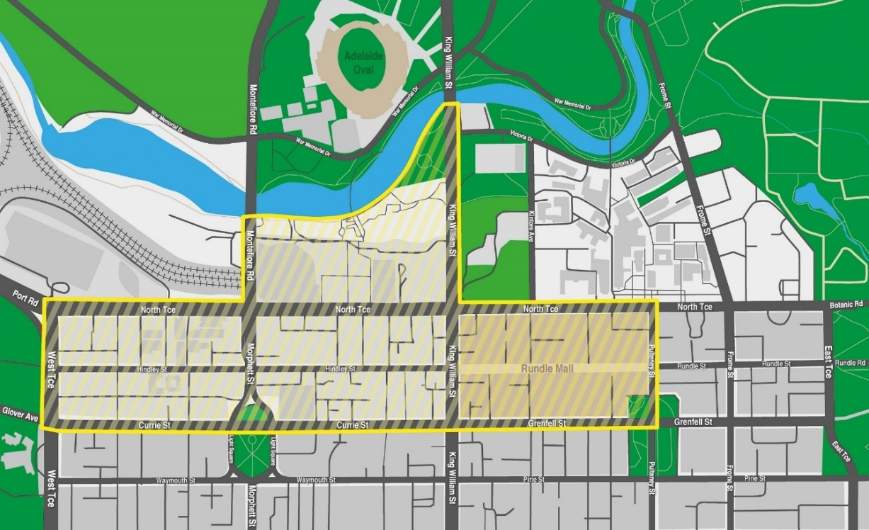

Summary Offences Act 1953
Declared Public Transport Hub
Declaration by Delegate of the Commissioner of Police
I, Scott Fitzgerald, being the Acting Assistant Commissioner, Operations Support Service, and acting as a delegate of the Commissioner of Police, hereby declare under Section 66ZG of the Summary Offences Act 1953 (“the Act”) as a declared public transport hub the Adelaide Railway Station, North Terrace, Adelaide.
This declaration commences effect at 12:00 noon on 18 December 2025.
I am satisfied that the declaration is necessary for the purposes of deterring or detecting the commission of offences involving the possession or use of a knife or other weapons in the public transport hub, and that the exercise of search powers under Section 66ZB of the Act is likely to be effective in deterring or detecting the commission of offences involving the possession or use of a knife or other weapons in the public transport hub and, further, will not unduly affect lawful activity in the transport hub.
This declaration will remain in effect until being revoked at such time that the Commissioner of Police (or delegate) is satisfied the grounds for this declaration are no longer met.
Dated: 18 December 2025
Scott Fitzgerald
Acting Assistant Commissioner of Police
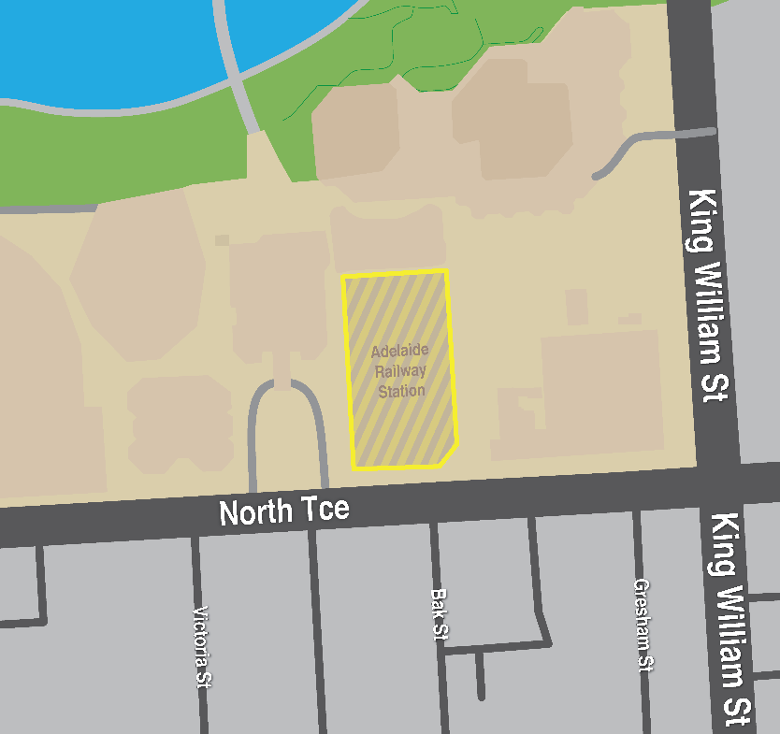

Unclaimed Money Act 2021
Section 9
Exemption
I, Tom Koutsantonis, Treasurer for the State of South Australia, hereby, pursuant to Section 9 of the Unclaimed Money Act 2021 (the Act), exempt the following persons from the requirement of Section 4 of the Act:
• An agent under the Land Agents Act 1994; and
• A conveyancer registered under the Conveyancers Act 1994.
This instrument of exemption has effect from the day on which it is published in the Government Gazette.
Dated: 4 December 2025
Tom Koutsantonis
Treasurer

Local Government Instruments

City Of Charles Sturt
Private Road Name
Notice is hereby given that the Council of the City of Charles Sturt at its meeting held on 8 December 2025 resolved that pursuant to Section 219(1) of the Local Government Act 1999, that two private roads on crown land, be named Sports Lane and West Beach Lane, West Beach.
A plan which delineates the section of private roads, which is subject to the private road names, together with a copy of the Council’s resolution is available for inspection at the Council’s Civic Centre, 72 Woodville Road, Woodville SA 5011, during the hours of 9.00am and 5.00pm on weekdays.
Dated: 11 December 2025
Paul Sutton
Chief Executive Officer

City Of Port Lincoln
Adoption of Revised ‘Naming of Roads’ Policy
In accordance with Section 219(7) of the Local Government Act 1999, notice is hereby given that at the Ordinary meeting of Council held on Monday, 8 December 2025, Council endorsed a Naming of Roads Policy 14.63.13.
The policy is available for viewing on Council’s website www.portlincoln.sa.gov.au or in person at the Council Office.
Dated: 18 December 2025
E. Brown
Chief Executive Officer

City Of West Torrens
Naming of Private Road
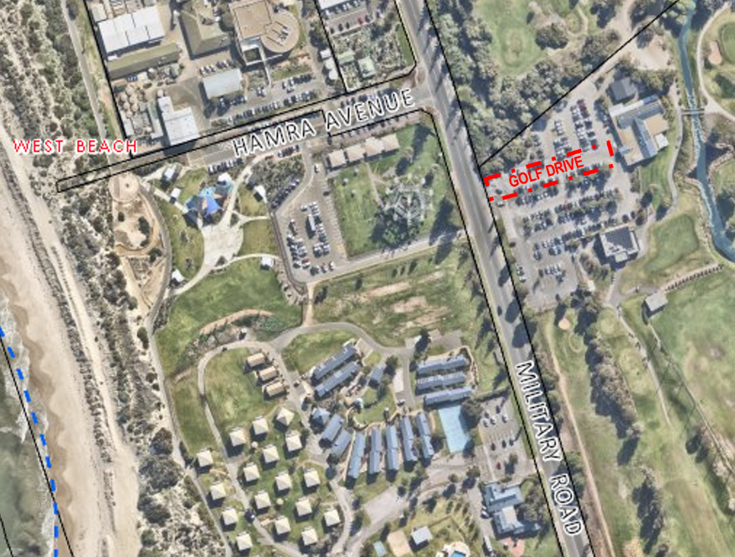
Notice is hereby given that at its meeting held on 9 December 2025, the City of West Torrens approved the assignment of the name “Golf Drive” to the unnamed private road in West Beach Parks located off Military Road, which provides access to Westward Ho Golf Club and
The Pat Golf Club, effective from 9 December 2025, pursuant to Section 219(1) of the Local Government Act 1999.
Dated: 18 December 2025
Angelo Catinari
Chief Executive Officer

District Council Of Kimba
Change of Meeting Date
Notice is hereby given that the District Council of Kimba resolved at its meeting held on 10 December 2025, to change the scheduled
February 2026 Council Meeting from Wednesday, 11 February 2026 commencing at 2 pm to Tuesday, 10 February 2026 commencing at 2.30 pm.
Dated: 16 December 2025
Deb Larwood
Chief Executive Officer

Lower Eyre Council
South Australia
Liquor Licensing (Dry Areas) Notice 2025
Under Section 131(1a) of the Liquor Licensing Act 1997
1—Short title
This notice may be cited as the Liquor Licensing (Dry Areas) Notice 2025.
2—Commencement
This notice comes into operation on 31 December 2025.
3—Interpretation
(1) In this notice—
principal notice means the Liquor Licensing (Dry Areas) Notice 2015 published in the Gazette on 5.1.15, as in force from time to time.
(2) Clause 3 of the principal notice applies to this notice as if it were the principal notice.
4—Consumption etc of liquor prohibited in dry areas
(1) Pursuant to Section 131 of the Act, the consumption and possession of liquor in the area described in the Schedule is prohibited in accordance with the provisions of the Schedule.
(2) The prohibition has effect during the periods specified in the Schedule.
(3) The prohibition does not extend to private land in the area described in the Schedule.
(4) Unless the contrary intention appears, the prohibition of the possession of liquor in the area does not extend to—
(a) a person who is genuinely passing through the area if—
(i) the liquor is in the original container in which it was purchased from licensed premises; and
(ii) the container has not been opened; or
(b) a person who has possession of the liquor in the course of carrying on a business or in the course of his or her employment by another person in the course of carrying on a business; or
(c) a person who is permanently or temporarily residing at premises within the area or on the boundary of the area and who enters the area solely for the purpose of passing through it to enter those premises or who enters the area from those premises for the purpose of leaving the area.
Schedule—Coffin Bay Area 1
1—Extent of prohibition
The consumption of liquor is prohibited and the possession of liquor is prohibited.
2—Period of prohibition
From 9pm on 31 December 2025 to 8am on 1 January 2026.
3—Description of area
The public area in and adjacent to the town of Coffin Bay bounded as follows:
Commencing at the point at which the prolongation in a straight line of the northern boundary of Section 665 Hd of Lake Wangary intersects the low water mark of Coffin Bay, then generally northerly, easterly, southerly, south-easterly and north-easterly along the low water mark to the point at which it is intersected by the prolongation in a straight line of the western boundary of Section 131 Hd of Lake Wangary, then southerly along that prolongation and boundary of Section 131 to the northern boundary of Lot 57 DP 54186, then generally south-westerly and south-easterly along the northern and south-western boundaries of Lot 57 to the point at which the south-western boundary is intersected by the prolongation in a straight line of the north-western boundary of Section 273 Hd of Lake Wangary, then south-westerly along that prolongation and boundary of Section 273 to the point at which it meets the eastern boundary of Section 295 Hd of Lake Wangary, then south-westerly, north-westerly, north-easterly and north-westerly along the north-eastern and northern boundaries of Section 295 to the western boundary of the Section, then southerly along the western boundaries of Section 295, Lots 212 and 211 of DP 71703, Lot 101 of DP 56785 and Lot 6 DP 25759 to the northern boundary of Section 665 Hd of Lake Wangary, then generally westerly, north-westerly, northerly and westerly along the northern boundary of that Section to the point at which it meets the eastern boundary of Section 667 Hd of Lake Wangary, then westerly along the northern boundary of Section 667, the northern boundary of Section 665 Hd of Lake Wangary and the prolongation in a straight line of the northern boundary of Section 665 to the point of commencement. The area includes the whole of any jetty, boat ramp or other structure that projects below the low water mark from within the area described above (as well as any area beneath such a structure).
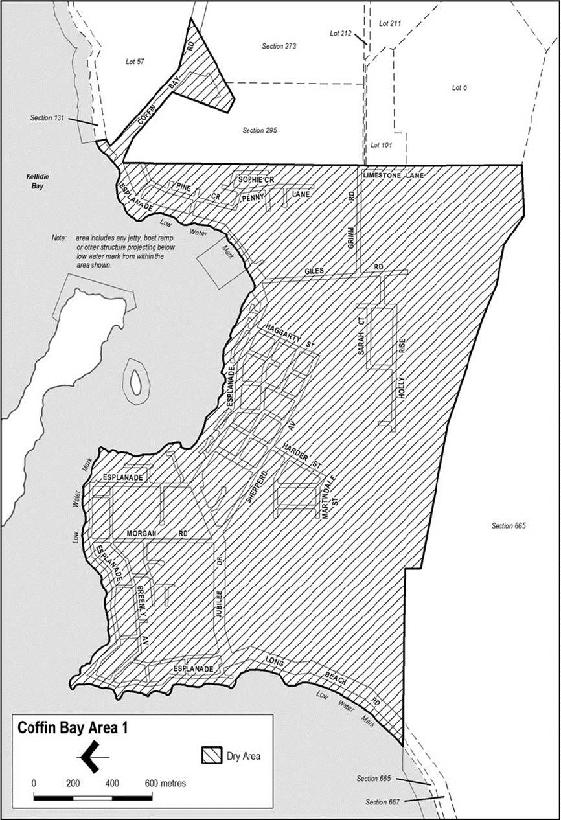

Made by the Lower Eyre Council
Dated: 26 November 2025
Delfina Lanzilli
Chief Executive Officer

LOWER EYRE COUNCIL
South Australia
Liquor Licensing (Dry Areas) Notice 2025
Under Section 131(1a) of the Liquor Licensing Act 1997.
1—Short title
This notice may be cited as the Liquor Licensing (Dry Areas) Notice 2025.
2—Commencement
This notice comes into operation on 31 December 2025.
3—Interpretation
(1) In this notice—
principal notice means the Liquor Licensing (Dry Areas) Notice 2015 published in the Gazette on 5.1.15, as in force from time to time.
(2) Clause 3 of the principal notice applies to this notice as if it were the principal notice.
4—Consumption etc of liquor prohibited in dry areas
(1) Pursuant to Section 131 of the Act, the consumption and possession of liquor in the area described in the Schedule is prohibited in accordance with the provisions of the Schedule.
(2) The prohibition has effect during the periods specified in the Schedule.
(3) The prohibition does not extend to private land in the area described in the Schedule.
(4) Unless the contrary intention appears, the prohibition of the possession of liquor in the area does not extend to—
(a) a person who is genuinely passing through the area if—
(i) the liquor is in the original container in which it was purchased from licensed premises; and
(ii) the container has not been opened; or
(b) a person who has possession of the liquor in the course of carrying on a business or in the course of his or her employment by another person in the course of carrying on a business; or
(c) a person who is permanently or temporarily residing at premises within the area or on the boundary of the area and who enters the area solely for the purpose of passing through it to enter those premises or who enters the area from those premises for the purpose of leaving the area.
Schedule—Cummins Area 1
1—Extent of prohibition
The consumption of liquor is prohibited and the possession of liquor is prohibited.
2—Period of prohibition
From 9pm on 31 December 2025 to 8am on 1 January 2026.
3—Description of area
The public area in Cummins bounded as follows:
All in the Hundred of Cummins and within an area as defined as commencing at northwest corner of Allotment 99 in FP 180131 and extending northwards in line with the western boundary of this allotment to a point on the northern boundary of Warrow Road, then heading eastwards and following the boundary of Allotment 550 in DP 66791 until the north corner of Allotment 22 in DP 79231, then heading eastwards across Bratten Way to follow the southern boundary, then the eastern boundary of Allotment 71 in DP 94689 to a point in line with the northern boundary of Section 80, then heading eastwards across the Tod Highway to follow northern and then eastern boundary of Section 80, then heading roughly southeast to the nearest corner of Section 30, then heading eastwards along the northern boundary of Section 30 until reaching a point in line with the northeast corner of Allotment 601 in DP 87427, then heading southwest and following the boundary of Allotment 600 in DP 87427 until the southern corner of Allotment 24 in DP 50626, then heading to a point on the southern boundary of Tumby Bay Road in line with the southeast boundary of Allotment 24 in DP 50626, then heading northwest nd following the southern boundary of Bratten Way up to the northwest corner of Allotment 149 in FP 180181 and then following, in a southerly direction the western boundary of Allotments 10, 11 and 12 in DP 95966 and Allotment 52 in DP 53199 until the southwest corner of Allotment 802 in FP 209177, then heading westwards along and in line with the southern boundary of Allotment 802 in FP 209177 until the western boundary of the Tod Highway, then heading north and following the boundary of Allotment 111 in DP 67442 until, and then following the eastern boundary of Allotment 11 in DP 85166 until the commencement point being the northwest corner of Allotment 99 in FP 180131.
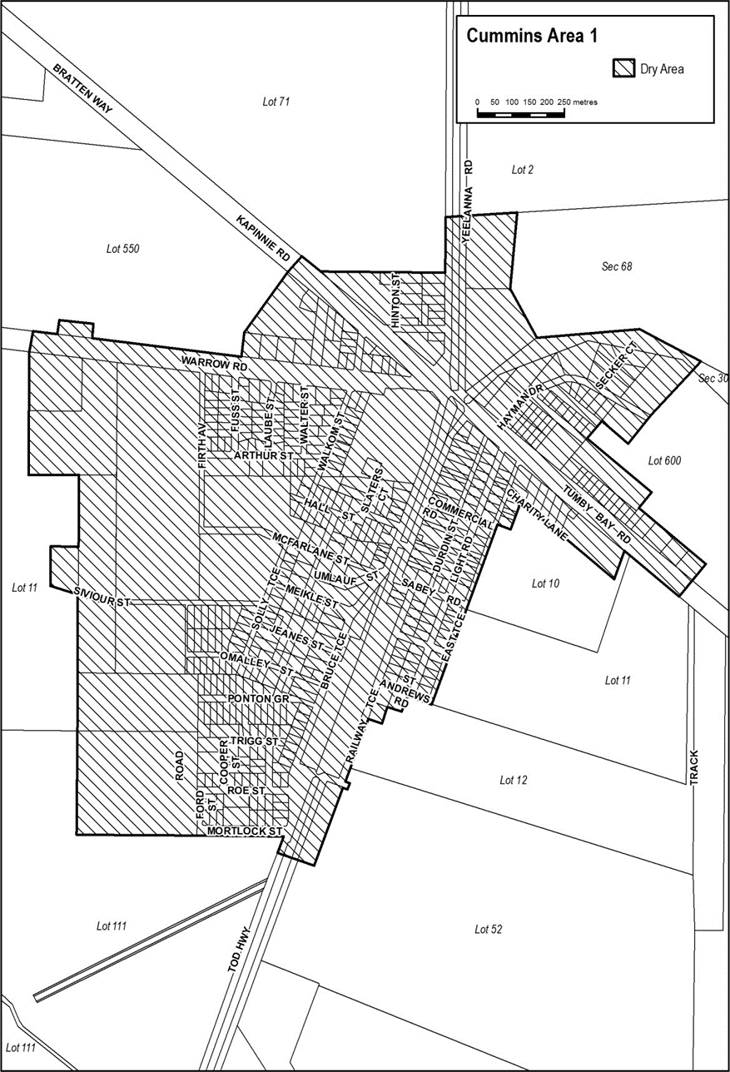
Made by the Lower Eyre Council
Dated: 26 November 2025
Delfina Lanzilli
Chief Executive Officer

District Council Of Streaky Bay
South Australia
Liquor Licensing (Dry Areas) Notice 2025
Under Section 131(1a) of the Liquor Licensing Act 1997.
1—Short title
This notice may be cited as the Liquor Licensing (Dry Areas) Notice 2025.
2—Commencement
This notice comes into operation on 31 December 2025.
3—Interpretation
(1) In this notice—
Principal notice means the Liquor Licensing (Dry Areas) Notice 2015 published in the Gazette on 5.1.15, as in force from time to time.
(2) Clause 3 of the principal notice applies to this notice as if it were the principal notice.
4—Consumption etc of liquor prohibited in dry areas
(1) Pursuant to Section 131 of the Act, the consumption and possession of liquor in the area described in the Schedule is prohibited in accordance with the provisions of the Schedule.
(2) The prohibition has effect during the periods specified in the Schedule.
(3) The prohibition does not extend to private land in the area described in the Schedule.
(4) Unless the contrary intention appears, the prohibition of the possession of liquor in the area does not extend to—
(a) a person who is genuinely passing through the area if—
(i) the liquor is in the original container in which it was purchased from licensed premises; and
(ii) the container has not been opened; or
(b) a person who has possession of the liquor in the course of carrying on a business or in the course of his or her employment by another person in the course of carrying on a business; or
(c) a person who is permanently or temporarily residing at premises within the area or on the boundary of the area and who enters the area solely for the purpose of passing through it to enter those premises or who enters the area from those premises for the purpose of leaving the area.
(5) Schedule 1 and Schedule 2 are in substitution for Schedule—Streaky Bay Area 1 and Area 2 in the principal notice.
Schedule 1—Streaky Bay Area 1
1—Extent of prohibition
The consumption of liquor is prohibited and the possession of liquor is prohibited.
2—Period of prohibition
From 6:00pm on Wednesday, 31 December 2025 to 8:00am on Thursday, 1 January 2026.
3—Description of area
The area in and adjacent to the town of Streaky Bay bounded as follows: commencing at the point at which the prolongation in a straight line of the eastern boundary of Linklater Street intersects the low water mark on the southern side of Blanche Port, then generally easterly along the low water mark to the point at which it is intersected by the prolongation in a straight line of the western boundary of Philip Street, then south-easterly along that prolongation and boundary of Philip Street to the northern boundary of Wells Street, then south-westerly and westerly along that boundary of Wells Street to the eastern boundary of Linklater Street, then northerly along that boundary of Linklater Street and the prolongation in a straight line of that boundary to the point of commencement. The area includes the whole of any jetty, boat ramp, slipway or other structure that projects below the low water mark from within the area described (as well as any area beneath such a structure).
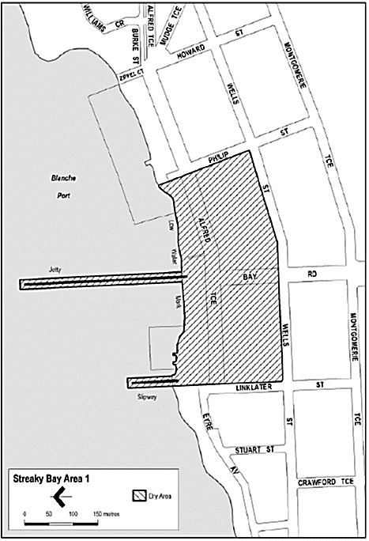
Schedule 2—Streaky Bay Area 2
1—Extent of prohibition
The consumption of liquor is prohibited and the possession of liquor is prohibited.
2—Period of prohibition
From 6:00pm on Wednesday, 31 December 2025 to 8:00am on Thursday, 1 January 2026.
3—Description of area
The area adjacent to Streaky Bay, generally known as the Little Islands car park and access road (together with adjoining land), comprising—
(a) the whole of that part of the Government road (the access road between Little Islands Road and the Little Islands car park) that lies between the north-eastern boundary of Lot 101 DP 70670 and the south-western boundary of Lot 102 DP 70670; and
(b) the area at the north-western end of that part of the Government road (including a car park and other land) bounded on the south-east by the south-eastern boundary of Lot 104 DP 70670 from a point 140 metres south-west of the north-eastern boundary of Lot 101 DP 70670 (‘‘point A’’) to a point 140 metres north-east of the south-western boundary of Lot 102 DP 70670 (‘‘point B’’), on the north-east by a straight line along the shortest route from point B to the low water mark of Blanche Port, on the north-west by the low water mark of Blanche Port and on the south-west by a straight line along the shortest route from the low water mark of Blanche Port to point A.
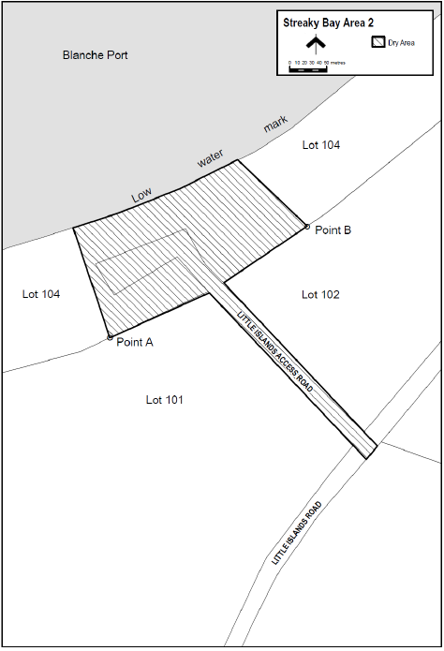
Dated: 18 December 2025
Damian Carter
Chief Executive Officer

Wattle Range Council
Local Government Act 1999
Adoption of Community Land Management Plans
Notice is hereby given pursuant to Section 197(3) of the Local Government Act 1999 that the Wattle Range Council, at its Ordinary Meeting held 9 December 2025, resolved to adopt the following updated Community Land Management Plans:
• Active Recreation Reserves—Council Owned Land (CLMP No. 1)
• Active Recreation Reserves—Crown Land (CLMP No. 2)
• Passive Recreation Reserves—Council Owned Land (CLMP No. 3)
• Passive Recreation Reserves—Crown Land (CLMP No. 4)
• Community Facilities—Council Owned Land (CLMP No. 5)
• Community Facilities—Crown Land (CLMP No. 6)
• Corporate Resources—Council Owned Land (CLMP No. 9)
Copies of the updated Community Land Management Plans can be viewed by visiting Council’s website, www.wattlerange.sa.gov.au.
Dated: 18 December 2025
Ben Gower
Chief Executive Officer

Yorke Peninsula Council
Declaration of Separate Rate
Notice is hereby given that at a meeting of the Yorke Peninsula Council held on 10 December 2025, the Council resolved to declare, pursuant to Section 154 of the Local Government Act 1999, a separate rate on the land identified in the table below for a period of 10 years, with the annual liability as indicated in the table and based on a proportional measure or other proportional basis related to the relevant land or to the estimated benefit to the occupiers of the land, and for the purpose of the development and construction of a seawall at Rogues Point.
The separate rate has been declared with effect from 1 January 2026 in the 2025/2026 financial year for a period of 10 years concluding in the financial year ending 30 June 2036.
Assessment Number | Property Description | Certificate of Title | Total Liability | Separate Rate liability  25/26 FY & 35/36 FY | Separate Rate liability  26/27 FY to 34/35 FY
33654 | Lot 21, Davey Road, Rogues Point | 5899/420 | $93,056.72 | $4,652.84 | $9,305.67
33662 | Lot 22, Davey Road, Rogues Point | 5899/421 | $80,911.00 | $4,045.55 | $8,091.10
33670 | Lot 23, Davey Road, Rogues Point | 5901/685 | $79,581.62 | $3,979.08 | $7,958.16
33688 | Lot 24, Davey Road, Rogues Point | 5899/422 | $84,476.16 | $4,223.81 | $8,447.62
33696 | Lot 25, Davey Road, Rogues Point | 5904/420 | $137,168.01 | $6,858.40 | $13,716.80
33704 | Lot 26, Davey Road, Rogues Point | 5901/754 | $129,070.88 | $6,453.54 | $12,907.09
Dated: 18 December 2025
Andrew Cameron
Chief Executive Officer

Public Notices

National Electricity Law
Notice of Final Rule and Final Determination
Notice of Draft Determination Extension
The Australian Energy Market Commission (AEMC) gives notice under the National Electricity Law as follows:
Under ss 102, 102A and 103, the making of the National Electricity Amendment (Real-time data for consumers) Rule 2025 No. 12
(Ref. ERC0399) and related final determination. Provisions commence as follows: Schedule 1 of this Rule commences operation on 26 November 2026, Schedule 2 of this Rule commences operation on 30 November 2028 and Schedule 3 of this Rule commences operation on 18 December 2025.
Under s 107, the time for making the draft determination on the Enhancing access for registered participant representatives (Ref. ERC0415) proposal has been extended to 5 February 2026.
Documents referred to above are available on the AEMC’s website and are available for inspection at the AEMC’s office.
Australian Energy Market Commission
Level 15, 60 Castlereagh St
Sydney NSW 2000
19 December 2024
Telephone: (02) 8296 7800
www.aemc.gov.au
Dated: 18 December 2025

National Energy Retail Law
Notice of Final Rule and Final Determination
Notice of Final Determination
The Australian Energy Market Commission (AEMC) gives notice under the National Energy Retail Law as follows:
Under ss 259, 260 and 261, the making of the National Energy Retail Amendment (Real-time data for consumers) Rule 2025 No. 6 (Ref. RRC0057) and related final determination. Provisions commence on 30 November 2028.
Under s 259, the making of the final determination on the Updating the regulatory framework for gas connections proposal (Ref. RRC0069) on 11 December 2025.
Documents referred to above are available on the AEMC’s website and are available for inspection at the AEMC’s office.
Australian Energy Market Commission
Level 15, 60 Castlereagh St
Sydney NSW 2000
Telephone: (02) 8296 7800
www.aemc.gov.au
Dated: 18 December 2025

National Gas Law
Notice of Consolidation
Notice of Draft Determination Extension
Notice of Final Determination Extension
The Australian Energy Market Commission (AEMC) gives notice under the National Gas Law as follows:
Under s 300(1)(a), the rule change requests for GRC0082, GRC0083, GRC0084 and GRC0088 have been consolidated. The consolidated request is named Gas Networks in Transition (Ref. GRC0082).
Under s 317, the time for making the draft determination on Gas Networks in Transition (Ref. GRC0082) proposal has been extended to 27 August 2026.
Under s 317, the time for the making of the final determination on Gas Networks in Transition (Ref. GRC0082) proposal has been extended to 17 December 2026.
Under s 317, the time for making the draft determination on the Enhancing access for registered participant representatives (Ref. GRC0087) proposal has been extended to 5 February 2026.
Documents referred to above are available on the AEMC’s website and are available for inspection at the AEMC’s office.
Australian Energy Market Commission
Level 15, 60 Castlereagh St
Sydney NSW 2000
Telephone: (02) 8296 7800
www.aemc.gov.au
Dated: 18 December 2025

Notice Submission

The South Australian Government Gazette is published each Thursday afternoon.
Notices must be emailed by 4 p.m. Tuesday, the week of publication.
Submissions are formatted per the gazette style and a proof will be supplied prior to publication, along with a quote if applicable. Please allow one day for processing notices.
Alterations to the proof must be returned by 4 p.m. Wednesday.

Gazette notices must be submitted as Word files, in the following format:
• Title—the governing legislation
• Subtitle—a summary of the notice content
• Body—structured text, which can include numbered lists, tables, and images
• Date—day, month, and year of authorisation
• Signature block—name, role, and department/organisation authorising the notice

Please provide the following information in your email:
• Date of intended publication
• Contact details of the person responsible for the notice content
• Name and organisation to be charged for the publication—Local Council and Public notices only
• Purchase order, if required—Local Council and Public notices only

Email: governmentgazettesa@sa.gov.au
Phone: (08) 7133 3552
Website: www.governmentgazette.sa.gov.au

All instruments appearing in this gazette are to be considered official, and obeyed as such

Printed and published weekly by authority of T. Foresto, Government Printer, South Australia
$9.50 per issue (plus postage), $479.00 per annual subscription—GST inclusive
Online publications: www.governmentgazette.sa.gov.au

