
No. 75 p. 5135
THE SOUTH AUSTRALIAN
GOVERNMENT GAZETTE
Published by Authority

Adelaide, Wednesday, 24 December 2025

Contents

Rules
Legal Practitioners Act 1981 5136
State Government Instruments
Animal Welfare Act 1985 5137
Animal Welfare Regulations 2012 5138
Dangerous Substances Act 1979 5138
Electricity Act 1996 5138
Gas Act 1997 5138
Energy Resources Act 2000 5141
Fisheries Management (Sardine Fishery) Regulations 2021 5141
Gambling Administration Act 2019 5150
Health Care Act 2008 5160
Housing Improvement Act 2016 5160
Hydrogen and Renewable Energy Act 2023 5160
Major Events Act 2013 5161
Mental Health Act 2009 5176
Mining Act 1971 5177
Outback Communities (Administration and Management)
Act 2009 5178
Retirement Villages Act 2016 5178
South Australian Civil and Administrative Tribunal 5178
South Australian Skills Act 2008 5179
Local Government Instruments
City of Marion 5180
Public Notices
Unclaimed Goods Act 1987 5181

Rules

Legal Practitioners Act 1981
South Australia
Legal Profession Education and Admission Council (No 4) Amending Rules 2025
By virtue and in pursuance of the Legal Practitioners Act 1981 and all other enabling powers, I, the Chief Justice of the Supreme Court and the Presiding Member of the Legal Profession Education and Admission Council, make the following Legal Profession Education and Admission Council (No 4) Amending Rules 2025.
1. These Rules may be cited as the Legal Profession Education and Admission Council (No 4) Amending Rules 2025.
2. The Legal Profession Education and Admission Council Rules 2018 (“the Rules”) are amended as set out below.
3. The amendments made by these rules come into effect on 1 January 2026.
4. Rule 7(2) is deleted and replaced with the following:
(2) A tertiary academic course will satisfy the requirements of this rule if it is accredited by LPEAC from time to time as satisfying the academic requirements for admission prescribed in subrule 7(1).
5. Rule 8(1)(b) is deleted and replaced with the following:
(b) the successful completion, during its period of accreditation, of a course of study accredited by LPEAC and leading to the grant of the Graduate Diploma in Legal Practice.
Dated this 5th day of December 2025.
Chief Justice Kourakis

State Government Instruments

Animal Welfare Act 1985
South Australia
Animal Welfare (Electrical Devices) (Fees) Notice 2025
under the Animal Welfare Act 1985
1—Short title
This notice may be cited as the Animal Welfare (Electrical Devices) (Fees) Notice 2025.
Note—
This is a fee notice made in accordance with the Legislation (Fees) Act 2019.
2—Commencement
This notice has effect on 24 December 2025.
3—Interpretation
In this notice, unless the contrary intention appears—
Act means the Animal Welfare Act 1985;
regulations means the Animal Welfare (Electrical Devices) Amendment Regulations 2025.
4—Fees
The fees set out in Schedule 1 are prescribed for the purposes of the Act and the regulations.
Schedule 1—Fees
1—Interpretation
In this Schedule—
2—Fees
Fees payable on application for manufacturers or suppliers to apply for approval or renewal of their virtual fencing system to enable cost recovery by government to administer the regulations:

Fees relating to Regulation 8A |  | Fee
1 | Application for assessment of virtual fencing system or renewal | $6000.00
 | The fee specified in this item is the fee payable for each period of 36 months for which the approval is granted.
Made by the Minister for Climate, Environment and Water
On 24 December 2025

Animal Welfare Regulations 2012
Animal Welfare (Electrical Devices) Notice 2025
1. Short Title
This notice may be cited as the Animal Welfare (Electrical Devices) Notice 2025.
2. Commencement
This notice will come into operation on the day it is published in the Government Gazette.
3. Specified Approval Criteria
Pursuant to Regulation 8A(1)(a)(iv)(B) of the Animal Welfare Regulations 2012, I, Lucy Hood, the Minister for Climate, Environment and Water specify that, for virtual fencing systems generally, any electrical stimulus delivered to an animal must not exceed 0.5 joules.
Dated: 21 December 2025
Hon Lucy Hood MP
Minister for Climate, Environment and Water

Dangerous Substances Act 1979
Authorised Officer
I, Glenn Stephen Farrell, Executive Director, SafeWork SA in my capacity as the Competent Authority, hereby revoke the following person as an Authorised Officer for the purposes of the Dangerous Substances Act 1979 pursuant to Section 7(1) of the Dangerous Substances Act 1979:
MA. Carmen Suarez ESTRADA
Dated: 16 December 2025
Glenn Farrell
Executive Director
Safework SA
Competent Authority

DANGEROUS SUBSTANCES ACT 1979
Authorised Officer
I, Glenn Stephen Farrell, Executive Director, SafeWork SA in my capacity as the Competent Authority, hereby appoint the following person as an Authorised Officer for the purposes of the Dangerous Substances Act 1979 pursuant to Section 7(1) of the Dangerous Substances Act 1979:
Ma. Carmine Suarez ESTRADA
Dated: 16 December 2025
Glenn Farrell
Executive Director
Safework SA
Competent Authority

Electricity Act 1996

Gas Act 1997
Retailer Energy Productivity Scheme
Annual Targets for 2026, 2027, 2028, 2029 and 2030
Pursuant to Regulations 24 and 25(2) of the Electricity (General) Regulations 2012 under the Electricity Act 1996, and Regulations 18 and 19(2) of the Gas Regulations 2012 under the Gas Act 1997, I set the following for the purposes of Part 4 of the Electricity (General) Regulations 2012 and Part 4 of the Gas Regulations 2012:
• annual energy productivity targets
• the amount of each annual productivity target that is to be achieved by the provision of energy productivity activities to priority group households
The targets (normalised gigajoules) are set for 2026, 2027, 2028, 2029 and 2030 as follows:
 | Annual energy  productivity targets | The amount of each annual productivity target that is to be achieved by the provision of energy productivity activities to priority group households
2026 | 1,650,000 | 750,000
2027 | 1,650,000 | 750,000
2028 | 1,650,000 | 750,000
2029 | 1,650,000 | 750,000
2030 | 1,650,000 | 750,000
Dated: 22 December 2025
Hon Tom Koutsantonis MP
Minister for Energy and Mining

ELECTRICITY ACT 1996
GAS ACT 1997
Retailer Energy Productivity Scheme
Application Thresholds for 2026, 2027, 2028, 2029 and 2030
Pursuant to Regulation 22(2) of the Electricity (General) Regulations 2012 under the Electricity Act 1996, I set the following thresholds:
- 5,000 residential customers for the purposes of paragraph (a) of Regulation 22(1)
- 20,000MWh of electricity for the purposes of paragraph (b) of Regulation 22(1)
Pursuant to Regulation 16(2) of the Gas Regulations 2012 under the Gas Act 1997, I set the following thresholds:
- 5,000 residential customers for the purposes of paragraph (a) of Regulation 16(1)
- 133,000GJ of gas for the purposes of paragraph (b) of Regulation 16(1)
Dated: 22 December 2025
Hon Tom Koutsantonis MP
Minister for Energy and Mining

Electricity Act 1996
Gas Act 1997
Retailer Energy Productivity Scheme
Apportioning of Targets
Pursuant to Regulation 24(3) and Regulation 25(4)(a) of the Electricity (General) Regulations 2012 under the Electricity Act 1996, and Regulation 18(3) and Regulation 19(4)(a) of the Gas Regulations 2012 under the Gas Act 1997, I revoke the Ministerial Notice—Apportioning of Targets in the South Australian Government Gazette No. 18 dated 25 March 2021 on pages 1054-1055.
Pursuant to Regulation 24(3) of the Electricity (General) Regulations 2012 under the Electricity Act 1996, I require that the annual energy productivity target (EPT) for a calendar year for a relevant electricity retailer is to be calculated using the following formula:
A × (B × N_{e}) ÷ ((C × N_{e}) + (D × N_{g}))
Where:
A is the annual energy productivity target for the calendar year set under Regulation 24(1) of the Electricity (General) Regulations 2012. This value is expressed in gigajoules of energy.
B is the relevant electricity retailer’s net electricity purchases for retailing to customers within South Australia, for the preceding financial year, excluding designated electricity purchases. This value is expressed in gigajoules of energy purchased.
C is the sum of the net electricity purchases made by each relevant electricity retailer for retailing to customers within South Australia, for the preceding financial year, excluding designated electricity purchases. This value is expressed in gigajoules of energy purchased.
D is the sum of the net gas purchases made by each relevant gas retailer for retailing to customers within South Australia, for the preceding financial year, excluding designated gas purchases. This value is expressed in gigajoules of energy purchased.
N_{e} is the REPS electricity normalisation factor and has a value of 1.00.
N_{g} is the REPS gas normalisation factor and has a value of 0.4.
Relevant electricity retailer has the same meaning as in Regulation 23 of the Electricity (General) Regulations 2012.
Designated electricity purchase has the same meaning as in Regulation 22(4) of the Electricity (General) Regulations 2012.
Relevant gas retailer has the same meaning as in Regulation 17 of the Gas Regulations 2012.
Designated gas purchase has the same meaning as in Regulation 16(4) of the Gas Regulations 2012.
Pursuant to Regulation 18(3) of the Gas Regulations 2012 under the Gas Act 1997, I require that the annual energy productivity target (EPT) for a calendar year for a relevant gas retailer is to be calculated using the following formula:
A × (B × N_{g}) ÷ ((C × N_{e}) + (D × N_{g}))
Where:
A is the annual energy productivity target for the calendar year set under Regulation 18(1) of the Gas Regulations 2012. This value is expressed in gigajoules of energy.
B is the relevant gas retailer’s net gas purchases for retailing to customers within South Australia, for the preceding financial year, excluding designated gas purchases. This value is expressed in gigajoules of energy purchased.
C is the sum of the net electricity purchases made by each relevant electricity retailer for retailing to customers within South Australia, for the preceding financial year, excluding designated electricity purchases. This value is expressed in gigajoules of energy purchased.
D is the sum of the net gas purchases made by each relevant gas retailer for retailing to customers within South Australia, for the preceding financial year, excluding designated gas purchases. This value is expressed in gigajoules of energy purchased.
N_{e} is the REPS electricity normalisation factor and has a value of 1.00.
N_{g} is the REPS gas normalisation factor and has a value of 0.4.
Relevant gas retailer has the same meaning as in Regulation 17 of the Gas Regulations 2012.
Designated gas purchase has the same meaning as in Regulation 16(4) of the Gas Regulations 2012.
Relevant electricity retailer has the same meaning as in Regulation 23 of the Electricity (General) Regulations 2012.
Designated electricity purchase has the same meaning as in Regulation 22(4) of the Electricity (General) Regulations 2012.

Pursuant to Regulation 25(4)(a) of the Electricity (General) Regulations 2012 under the Electricity Act 1996, I require that the priority group energy productivity target (PGEPT) for a calendar year for a relevant electricity retailer is to be calculated according to the following principles:
• Each relevant retailer’s PGEPT will comprise a portion of the retailer’s energy productivity target.
• Each relevant retailer’s PGEPT will reflect that retailer’s net electricity purchases for retailing to customers within South Australia.
• The total of all relevant retailers’ PGEPTs will sum to the overall PGEPT set for that calendar year.
Pursuant to Regulation 19(4)(a) of the Gas Regulations 2012 under the Gas Act 1997, I require that the priority group energy productivity target (PGEPT) for a calendar year for a relevant gas retailer is to be calculated according to the following principles:
• Each relevant retailer’s PGEPT will comprise a portion of the retailer’s energy productivity target.
• Each relevant retailer’s PGEPT will reflect that retailer’s net gas purchases for retailing to customers within South Australia.
• The total of all relevant retailer’s PGEPTs will sum to the overall PGEPT set for that calendar year.
Dated: 22 December 2025
Hon Tom Koutsantonis MP
Minister for Energy and Mining

ELECTRICITY ACT 1996
GAS ACT 1997
Retailer Energy Productivity Scheme
Designated Purchases
Pursuant to Regulation 22(4) of the Electricity (General) Regulations 2012 under the Electricity Act 1996, I designate the following electricity purchases:
- purchases of 1,000MWh or more of electricity for on-selling and subsequent use in South Australia through an individual contract for sale.
Pursuant to Regulation 16(4) of the Gas Regulations 2012 under the Gas Act 1997, I designate the following gas purchases:
- purchases of 3,600GJ or more of gas for on-selling and subsequent use in South Australia through an individual contract for sale.
Dated: 22 December 2025
Hon Tom Koutsantonis MP
Minister for Energy and Mining

ELECTRICITY ACT 1996
GAS ACT 1997
Retailer Energy Productivity Scheme
Maximum Energy Credit
Pursuant to Regulations 30(7) and 30(8) of the Electricity (General) Regulations 2012 under the Electricity Act 1996 and Regulations 24(7) and 24(8) of the Gas Regulations 2012 under the Gas Act 1997, I set the following maximum energy credit that a retailer may apply to have taken into account in determining whether the retailer has met a target that applies to the retailer in the subsequent year.
2027—20 per cent of the retailer’s 2026 Priority Group Energy Productivity Target.
2028—20 per cent of the retailer’s 2027 Priority Group Energy Productivity Target.
2029—20 per cent of the retailer’s 2028 Priority Group Energy Productivity Target.
2030—5 per cent of the retailer’s 2029 Priority Group Energy Productivity Target.
Dated: 22 December 2025
Hon Tom Koutsantonis MP
Minister for Energy and Mining

ELECTRICITY ACT 1996
GAS ACT 1997
Retailer Energy Productivity Scheme
Minimum Specifications for Energy Productivity Activities
Pursuant to Regulation 28(5) of the Electricity (General) Regulations 2012 under the Electricity Act 1996, and Regulation 22(5) of the Gas Regulations 2012 under the Gas Act 1997, I revoke the following Ministerial Notices:
• Building Sealing Activities (Various); (Residential and Small Energy Consuming Customers)—Activity No. BS2—in the South Australian Government Gazette No. 55, dated 1 August 2024, on pages 2370-2375.
• Commercial and Industrial Demand Savings (PIAM&V DM); Commercial or Industrial Only—Activity No. CD1—in the South Australian Government Gazette No. 98, dated 21 December 2020, on pages 6118-6122.
• Commercial Lighting Upgrade; Commercial Only—Activity No. CL1—in the South Australian Government Gazette No. 98, dated 21 December 2020, on pages 6067-6071.
• Install an LED General Purpose Lamp; Residential Only—Activity No. L1—in the South Australian Government Gazette No. 98, dated 21 December 2020, on pages 6058-6060.
• Install an LED Down-light Lamp or LED Down-light Luminaire; Residential Only L2A—ELV Down-Light Lamp Replacement; L2B—ELV Down-Light Luminaire Replacement—Activity No. L2—in the South Australian Government Gazette No. 98, dated 21 December 2020, on pages 6061-6063.

• Replace Halogen Floodlight Luminaire; Residential Only—Activity No. L3—in the South Australian Government Gazette No. 98, dated 21 December 2020, on pages 6064-6066.
• Improve Energy Productivity—Large Facilities—Activity No. LF1—in the South Australian Government Gazette No. 69, dated 21 October 2021, on pages 3799-3801.
• NABERS Building Demand Savings; Commercial and NABERS Rated Residential Buildings Only—Activity No. NB1—in the South Australian Government Gazette No. 98, dated 21 December 2020, on pages 6114-6117.
• Install a High Efficiency Refrigerated Display Cabinet: Commercial Only—Activity No. RDC1—in the South Australian Government Gazette No. 98, dated 21 December 2020, on pages 6094-6097.
• Install Standby Power Controllers—Audio Visual (AV); Residential Only—Activity No. SPC1—in the South Australian Government Gazette No. 98, dated 21 December 2020, on pages 6072-6074.
• Install Standby Power Controllers—Information Technology (IT); Residential Only—Activity No. SPC2—in the South Australian Government Gazette No. 98, dated 21 December 2020, on pages 6075-6077.
This notice will take effect on 1 January 2026.
Dated: 22 December 2025
Hon Tom Koutsantonis MP
Minister for Energy and Mining

Energy Resources Act 2000
Application for Variation of Pipeline Licence—PL 6
Pursuant to Section 65(6) of the Energy Resources Act 2000 (the Act), and delegated powers dated 21 August 2024, notice is hereby given that APA Group has applied to vary Pipeline Licence (PL) 6.
The application will be determined on or after 9 January 2026.
Description of Application
APA Group has applied for a variation to Riverland Pipeline Licence PL 6 to install a new section of pipe parallel to the existing river crossing near Moorook, South Australia.
Description of Area
Moorook crossing
All coordinates in GDA2020 Zone 54
446722.20mE 6194526.42mE
447092.10mE 6194717.47mE
LENGTH: 416 metres approximately
Dated: 19 December 2025
Michael Smith
Director, Regulatory Risk and Resource Tenure
Regulation and Compliance Division
Department for Energy and Mining
Delegate of the Minister for Energy and Mining

Fisheries Management (Sardine Fishery) Regulations 2021
Regulation 12
Variation of Determination
The Determination made for the purposes of Regulation 12, dated 25 September 2025 is hereby varied as of 19 December 2025.
For the purpose of Regulation 12 relating to catch and disposal requirements in the Sardine Fishery, commencing 19 December 2025, I make the following determinations:
Regulation 12—Catch and disposal requirements—12(1)(a) record information and 12(1)(c) (arrangements for fish)
The holder of the licence or registered master must—
(1) Complete and submit an electronic ‘Sardine-Start Report’ prior to departing port.
(2) Complete and submit an electronic ‘Sardine—Change Zone’ report via the Commercial Fishing SA app before the registered boat leaves the Zone originally reported, where:
(a) A ‘Sardine-Start Report’ has been submitted declaring that fishing will occur in a Zone; and
(b) No fish are taken from that Zone: and
(c) The licence holder or registered master intends to take fish from another Zone.
(3) Immediately after the sardines are unloaded from the registered boat, complete and submit Part A of electronic report ‘Sardine—CDR’ record in respect of the sardines.
(4) If the sardines are to be loaded onto a boat specified in the certificate of registration of a registered fish processor, he or she must ensure that the Part A electronic report ‘Sardine—CDR’ record is completed and submitted in respect of the sardines consigned to the registered fish processor or an agent of the registered fish processor when the sardines are loaded onto that boat.
(5) If the sardines are to be transported to the registered premises of a registered fish processor, he or she must ensure that the Part A electronic report ‘Sardine—CDR’ record is completed and submitted in respect of the sardines that are transported to the registered premises.

(6) If the sardines are to be transported to the registered premises of a registered fish processor by 2 or more vehicles or are to be unloaded to a boat or boats specified in the certificate of registration of a registered fish processor, he or she must ensure that Part A of electronic report ‘Sardine—Transit Form’ record is completed and submitted in respect of each other vehicle or boat that is to be used to transport the sardines.
(7) Ensure that sardines to be delivered or consigned to a registered fish processor are:
(a) Transported to the fish processor in bins or containers of a kind consistent with those listed in Schedule 1 of this Determination; and
(b) The quantity of fish being transported do not exceed the specified fill line of the bin or container when level in the bin or container.
Regulation 12(1)(b) (provide information)
(1) The holder of the licence or registered master must report to the Department, by the Commercial Fishing SA Application, at least 1 hour before the sardines are to be unloaded from the registered boat to be delivered to the registered premises of a fish processor other than a boat; or at least 2 hours before the sardines are to be unloaded from the registered boat to be loaded on to a boat registered as the premises of a fish processor:
(a) the name of the person making the telephone call or report; and
(b) the number of the licence under which the sardines were taken; and
(c) the name of the registered boat from which the sardines were taken; and
(d) the name of the registered master of the registered boat; and
(e) the location at which the sardines are to be unloaded from the registered boat; and
(f) the estimated time of arrival of the registered boat at that location; and
(g) the estimated total weight in tonnes of the sardines taken; and
(h) the name of the registered fish processor to whom the sardines are to be consigned; and
(i) whether the sardines are to be delivered to the registered premises of the registered fish processor or to be loaded onto a boat specified in the certificate of registration of the registered fish processor; and
(j) the estimated time at which the sardines are to be unloaded from the registered boat; and
(k) the trip ID;
(l) any threatened, endangered or protected species mortality events; and
(m) any threatened, endangered or protected species entanglement or injury events; and
(n) the number of net shots made.
(3) The holder of the licence in respect of the fishery or registered master under such a licence, must immediately notify the Department of any change to information already submitted to the Department by telephone on 1800 065 522 or by the Commercial Fishing SA Application before the sardines are unloaded from the registered boat.
Regulation 12(3) (keeping of records)
(1) Where an electronic report has been submitted to the Department no further record need be kept for the purposes of this determination.
For the purposes of this determination—
Electronic report—means an entry received in the eCatch electronic database created and administered by the Department. Submission of the electronic report may be directly entered into the eCatch electronic database via the myPIRSA portal (www.pir.sa.gov.au/ecatch); via the Commercial Fishing SA App; or other third party application. If entered by a third party application the Licence Holder, Registered Master or Nominated Agent must ensure the report has been received by the eCatch electronic database.
Department—means the Department of Primary Industries and Regions South Australia.
Dated: 18 December 2025
Professor Gavin Begg
Executive Director, Fisheries and Aquaculture
Delegate of the Minister for Primary Industries and Regional Development

Schedule 1
Register of bins for the purposes of paragraph 7 of the Determination made under
Regulation 12(1)(a) (record information) and Regulation 12(1)(c) (arrangements for fish)
Australian Fishing Enterprises Pty Ltd (AFE) | Bin Type 1—Australian Fishing Enterprises Yellow Bin  • The bin is of a style depicted in the attached photograph  • Material: Aluminium  • Outside Dimensions: 2,100mm x 1,200mm x 700mm  • Internal Structures: a rectangular aluminium box with drilled holes in it extends over the bung area inside  the bin  • Fill Line: filled to the top of the bin and levelled  • Tare: 120kg  • Identification: yellow painted strip around rim of the bin  • Agreed Sardine Capacity: 1,350kg | 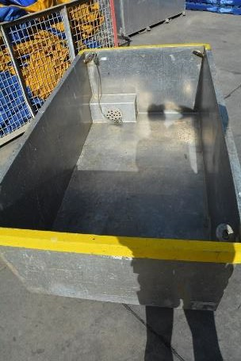

Australian Fishing Enterprises Pty Ltd (AFE) | Bin Type 2—Australian Fishing Enterprises Blue Bin  • The bin is of a style depicted in the attached photograph  • Material: Aluminium  • Outside Dimensions: 2,085mm x 1,200mm x 755mm  • Internal Structures: a rectangular aluminium box with drilled holes in it extends over the bung area inside the bin  • Fill Line: filled to the top of the bin and levelled  • Tare: 139kg  • Identification: blue painted strip around rim of the bin  • Agreed Sardine Capacity: 1,550kg | 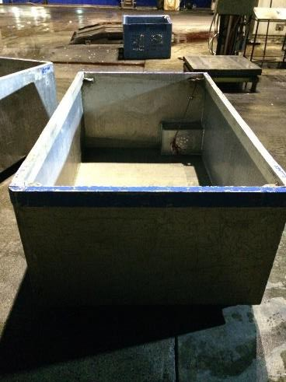
Australian Fishing Enterprises Pty Ltd (AFE) | Bin Type 3—AFE—Ex—SMF Tall Ally  • The bin is of a style depicted in the attached photograph  • Material: Aluminium  • Internal dimensions: 1,800mm x 1,100mm x 900mm  • Fill Line: filled to the top of the bin and levelled  • Identification: Blue around rim  • Tare weight: 154kg  • Agreed Sardine Capacity: 1,550kg | 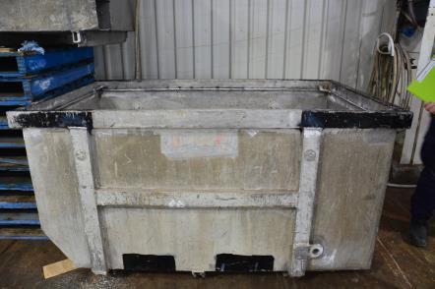
Australian Southern Exporters Pty Ltd | Bin Type 1—Grey Plastic Bin  • The bin is of a style depicted in the attached photograph  • Material: grey plastic  • Outside Dimensions: 1,200mm x 1,100mm 1,200mm  • Internal Structures: Nil  • Fill Line: 100mm from top of bin (catch levelled)  • Tare: 95kg  • Identification: grey plastic bin with lid  • Agreed Sardine Capacity: 800kg | 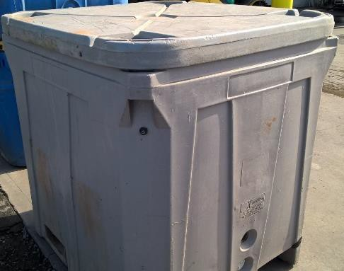
Australian Southern Exporters Pty Ltd | Bin Type 2—Blue Plastic RIFT35A bin—marked ASE  • The bin is of a style depicted in the attached photograph  • Material: blue plastic  • Outside Dimensions: 1220mm x 1085mm x 1275mm  • Internal Structures: Nil  • Fill Line: Fill to 5cm from top  • Tare: 103kg (lid on)  • Identification: blue plastic bin stencilled with ASE on side  • Agreed Sardine Capacity: 800kg | 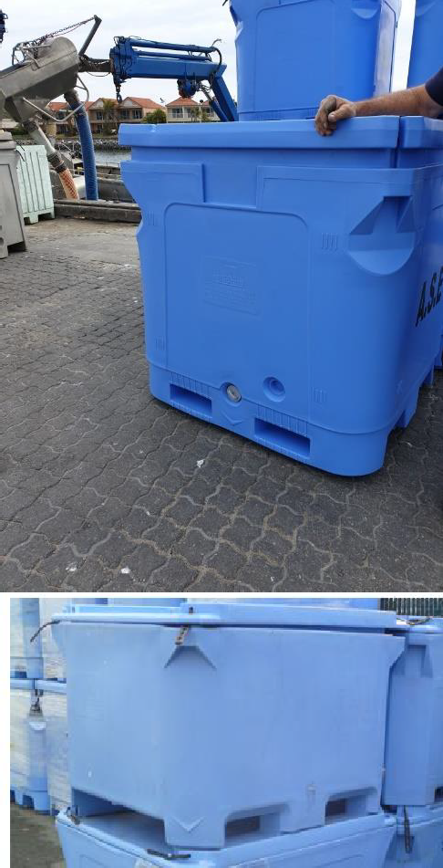
Australian Southern Exporters Pty Ltd | Bin Type 3—Blue Plastic RIFT1000 short bin—marked ASE  • The bin is of a style depicted in the attached photograph  • Material: blue plastic  • Outside Dimensions: 1,470mm x 1,180mm x 965mm  • Internal Structures: Nil  • Fill Line: Fill to top  • Tare: 81.5kg (lid off)  • Identification: blue plastic bin stencilled with ASE on side  • Agreed Sardine Capacity: 500kg when used for IQF with wet fish and an ice slurry  • Agreed Sardine Capacity: 850kg when used for  Tuna Feed
Australian Tuna Fisheries Pty Ltd | Bin Type 1—Australian Tuna Fisheries Small Bin  • The bin is of a style depicted in the attached photograph  • Material: Aluminium  • Outside Dimensions 1,190mm x 1,880mm x 700mm  • Internal Structures: square grating box in one corner  • Fill line: 100mm from top of bin—welded fill line at intervals (catch levelled)  • Tare: 129kg  • Identification: SG welded on side of bin  • Agreed Sardine Capacity: 1,000kg | 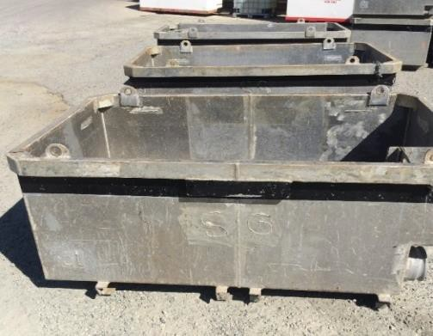
Australian Tuna Fisheries Pty Ltd | Bin Type 2—Australian Tuna Fisheries Medium Bin  • The bin is of a style depicted in the attached photograph  • Material: Aluminium  • Outside Dimensions: 1,190mm x 2,080mm x 710mm  • Internal Structures: grating across one corner of the inside of the bin  • Fill line: 160mm from top of bin—welded fill line at intervals (catch levelled)  • Tare: 137kg  • Identification: SG welded on side of bin and the letter M stencilled on side of bin  • Agreed Sardine Capacity: 1,000kg | 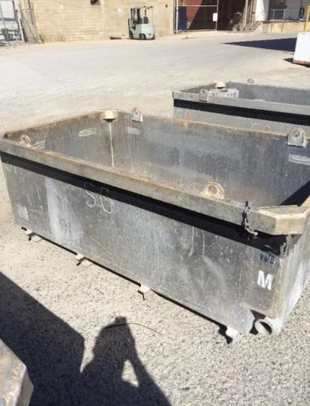
Australian Tuna Fisheries Pty Ltd | Bin Type 3—Australian Tuna Fisheries Large Bin  • The bin is of a style depicted in the attached photograph  • Material: Aluminium  • Outside Dimensions: 1,190mm x 2,280mm x 710mm  • Internal Structures: grating across one corner of the inside of the bin  • Fill Line: 210mm from top of bin—welded fill line at intervals (catch levelled)  • Tare: 117kg  • Identification: SG welded on the side and the letter L stencilled on the bin  • Agreed Sardine Capacity: 1,000kg | 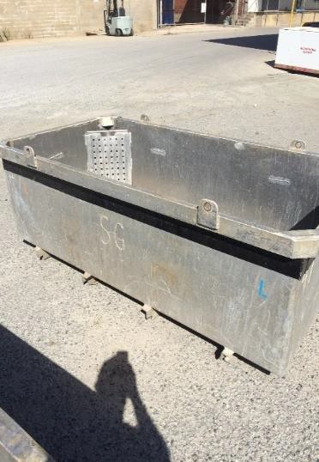
Australian Tuna Fisheries Pty Ltd | Bin Type 4—Australian Tuna Fisheries Hopper on Vessel Saxon S  • The bin is of a style depicted in the attached photograph  • Material: Aluminium  • Outside Dimensions: 3,870mm x 1,510mm x 760mm. One long side is cut down to 510mm in height  • Internal Structures: Nil  • Fill Line: to the base of the lip on the cut down  side of the bin—contents level with this position  • Tare: approximately 250kg including the  hydraulic rams  • Identification: permanently fixed to deck of vessel Saxon S  • Agreed Sardine Capacity: 2,000kg | 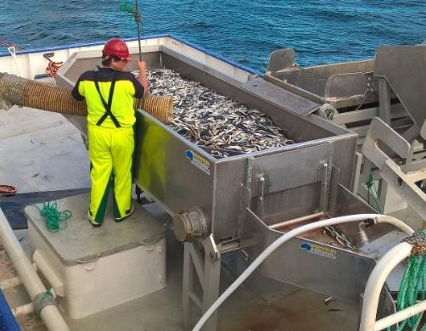
Australian Tuna Fisheries Pty Ltd | Bin Type 5—Australian Tuna Fisheries Hopper on Vessel Kingfish 1  • The bin is of a style depicted in the attached photograph  • Material: Aluminium  • Outside Dimensions: 1,190mm x 2,280mm x 710mm  • Internal Structures: angled corners inside one end of the bin  • Fill Line: 190mm from the top (contents levelled)  • Tare: 117kg  • Identification: Bin fitted with contents release hatch on one end, a “leg” affixed to each exterior corner on underside, SG welded on side of bin, black painted strip just below rim  • Agreed Sardine Capacity: 1,000kg | 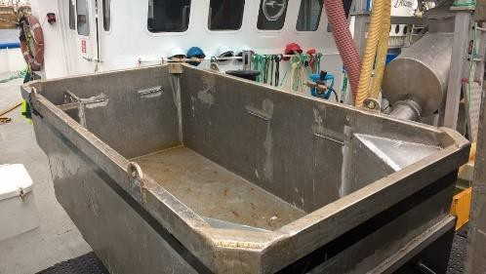
Blaslov Fishing  Pty Ltd | Bin Type 1—Blaslov Fishing Bin  • The bin is of a style depicted in the attached photograph  • Material: Aluminium  • Outside Dimensions: 2,100mm x 1,200mm x 710mm  • Internal Structures: a recessed bung area in one bottom corner of the bin and internal grating the diagonally opposite corner  • Fill Line: 130mm from the top of bin, catch levelled to base of bin lugs  • Tare: 110kg  • Identification: BTF stencilled on long side of bin  • Agreed Sardine Capacity: 1,150kg | 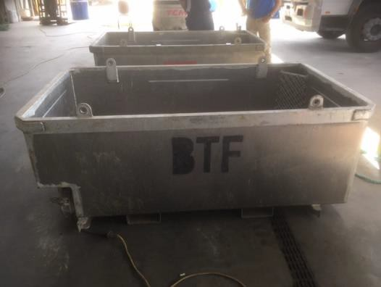
Blaslov Fishing  Pty Ltd | Bin Type 2—BFG 1,150kg (Ex TTI—1,250kg)  • The bin is of a style depicted in the attached photograph  • Material: Aluminium  • Outside Dimensions: 760mm x 2,000mm x 1,145mm  • Internal Structure: Nil  • Tare Weight: 138kg  • Fill line: 200mm from top  • Identification: Stamped ‘BFG’ No coloured rim.  • Agreed Sardine Capacity: 1,150kg | 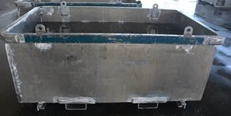
Dinko Tuna Farmers Pty Ltd | Bin Type 1—Dinko Tuna Farmers Blue Bin  • The bin is of a style depicted in the attached photograph  • Material: Aluminium  • Outside Dimensions: 1,200mm x 2,520mm x 770mm  • Internal Structures: mesh insert in one corner and a small square metal box in another corner  • Fill Line: 150mm from top of bin—welded fill line around interior (catch levelled)  • Tare: 155kg  • Identification: DTF stencilled on side of the bin, blue painted strip around rim of the bin  • Agreed Sardine Capacity: 1,450kg | 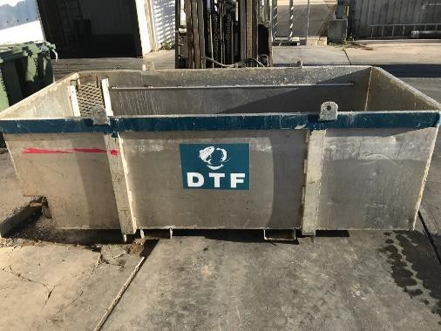
Dinko Tuna Farmers Pty Ltd | Bin Type 2—Dinko Tuna Farmers Hopper (on vessel SEATAS 3)  • The bin is of a style depicted in the attached photograph  • Material: Aluminium  • Outside Dimensions: 1,200mm x 2,520mm x 770mm  • Internal Structures: mesh grating in the floor of the bin and two angled corners, release hatch one end of bin  • Fill Line: 110mm from top of bin—welded fill line around interior (contents levelled)  • Tare: 164kg  • Identification: permanently fixed to deck of vessel SEATAS 3  • Agreed Sardine Capacity: 1,500kg | 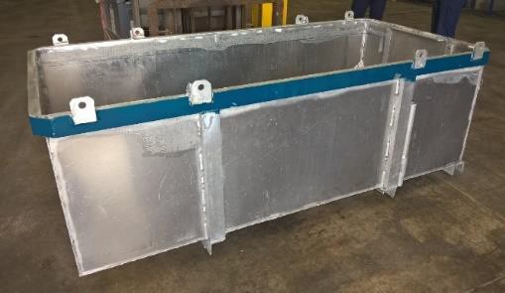
Dinko Tuna Farmers Pty Ltd | Bin Type 3—DTF 1,000kg—Blue Rim  • The bin is of a style depicted in the attached photograph  • Material: Aluminium  • Outside Dimensions: 2,200mm x 1,150mm x 715mm  • Internal Structure: Nil  • Tare Weight: 177kg  • Fill line: 300mm from the top (Welded internal line)  • Agreed Sardine Capacity: 1,000kg | 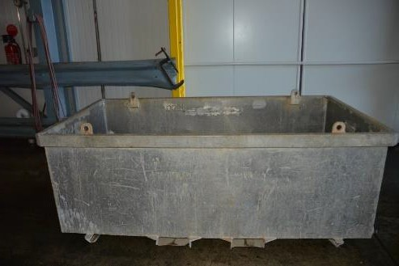
Dinko Tuna Farmers Pty Ltd | Bin Type 4—DTF 1200kg Bin—Blue Rim  • The bin is of a style depicted in the attached photograph  • Material: Aluminium  • Outside Dimensions: 2,200mm x 1,150mm x 715mm  • Internal Structure: Nil  • Tare Weight: 177kg  • Fill line: 230mm from the top (Welded internal line)  • Agreed Sardine Capacity: 1200kg | 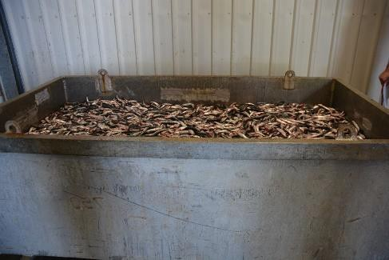
Dinko Tuna Farmers Pty Ltd | Bin Type 5—Foam Box  • The bin is of a style depicted in the attached photograph  • Material: polystyrene  • Outside Dimensions: 200mm x 490mm x 340mm  • Internal Structures: Plastic bin liner and ice around liner  • Fill Line: 3cm from top  • Tare: 2.6kg  • Identification: white foam box  • Agreed Sardine Capacity: 10kg | 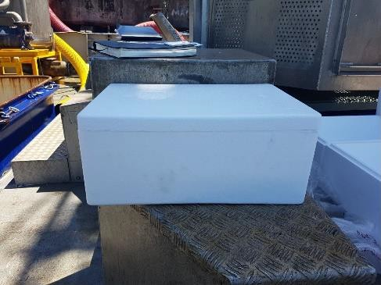
Marnikol Fisheries Pty Ltd | Bin Type 1—Blue and Yellow Plastic Bins  • The bin is of a style depicted in the attached photograph  • Material: Plastic  • Outside Dimensions: 1,455mm x 1,130mm x 900mm  • Internal Structures: Nil  • Fill line: Fill to the top  • Tare: 105kg  • Identification: Blue or yellow in colour and constructed from Plastic  • Agreed Sardine Capacity: 800kg when used to  receive tuna feed and 500kg when used to receive  IQF Sardines | 
Marnikol Fisheries Pty Ltd | Bin Type 2—Grey Plastic Bins  • The bin is of a style depicted in the attached photograph  • Material: Plastic  • Outside Dimensions: 1,200mm x 1,100mm x 1,200mm  • Internal Structures: Nil  • Fill line: Fill to the top  • Tare: 95kg  • Identification: Grey and made of Plastic  • Agreed Sardine Capacity: 900kg when used to  receive tuna feed and 500kg when used to receive  IQF Sardines | 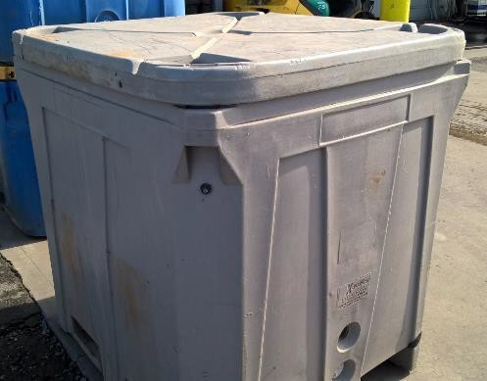
Marnikol Fisheries Pty Ltd | Bin Type 3—Marnikol Ally Bin  • The bin is of a style depicted in the attached photograph  • Material: Aluminium  • Outside Dimensions: 1,180mm x 1940mm x 760mm  • Internal Structures: Mesh grating across one corner  • Fill Line: 80mm from top  • Tare: 159kg  • Identification: MARNIKOL stencilled on the side of the bin  • Agreed Sardine Capacity: 1,200kg | 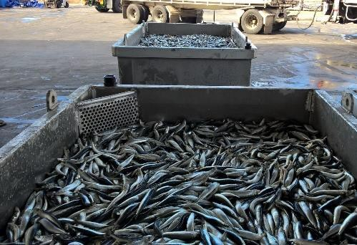
Marnikol Fisheries Pty Ltd | Bin Type 4—AJKA Bin  • The bin is of a style depicted in the attached photograph  • Material: Aluminium  • Outside Dimensions: 1,180mm x 1,920mm x 840mm  • Internal Structures: internal bin drain structures  • Fill line: 160mm from top  • Tare: 141kg  • Identification: AJKA and bin number welded on end of the bin  • Agreed Sardine Capacity: 1,200kg | 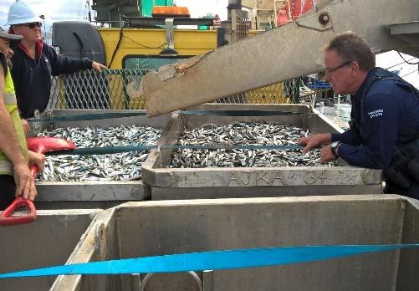
Marnikol Fisheries Pty Ltd | Bin Type 5—Blue plastic RIFT35A bin  • The bin is of a style depicted in the attached photograph  • Material: blue plastic  • Outside Dimensions: 1,220mm x 1,085mm x 1,275mm  • Internal Structures: Nil  • Fill Line: Fill to top  • Tare: 103kg  • Identification: blue plastic bin stencilled with ASE on side  • Agreed Sardine Capacity—Tuna Feed: 800kg  • Agreed Sardine Capacity—IQF/Ice Slurry: 500kg | 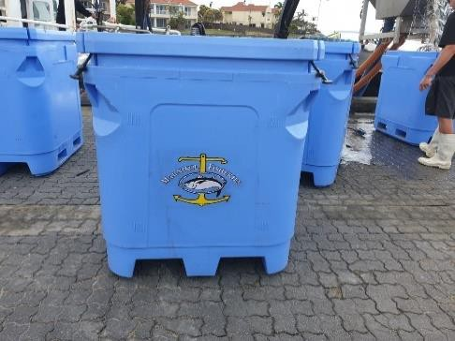
AFE | Bin Type 4—AFE  • The bin is of a style depicted in the attached photograph  • Material: Aluminium  • Outside Dimensions: 1,820mm x 1,180mm x 830mm  • Internal Structures: Nil  • Fill line to top of bin.  • Identification: Blue Painted Top Rim  • Agreed Sardine Capacity: 1,550kg | 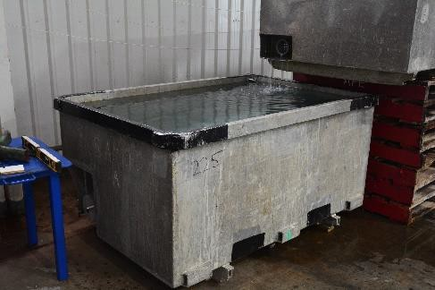
AFE | Bin Type 5—AFE  • The bin is of a style depicted in the attached photograph  • Material: Aluminium  • Outside Dimensions: 1,830mm x 1,160mm x 830mm  • Internal Structures: Nil  • Fill line: Filled to Top  • Identification: Blue Painted Top Rim  • Agreed Sardine Capacity: 1,550kg | 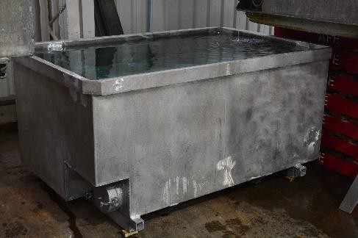
Sekol Farmed Tuna Pty Ltd | Bin Type 1—Sekol Steel Bin  • The bin is of a style depicted in the attached photograph  • Material: Steel  • Outside Dimensions: 2,100mm x 1,240mm x 700mm  • Internal Structures: a mesh grate extends over the bung area inside the bin  • Fill Line: 150mm from the top of bin (contents levelled)  • Tare: 250kg  • Identification: SEKOL stencilled on side of bin  • Agreed Sardine Capacity: 1,000kg | 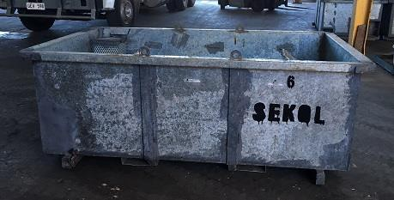
Sekol Farmed Tuna Pty Ltd | Bin Type 2—Sekol Ally Bin  • The bin is of a style depicted in the attached photograph  • Material: Aluminium  • Outside Dimensions: 1,930mm x 1,190mm x 830mm  • Internal Structures: a mesh grate extends over the bung area inside the bin  • Fill Line: 260mm from top of bin (contents levelled)  • Tare: 132kg  • Identification: SEKOL stencilled on side of bin  • Agreed Sardine Capacity: 1,000kg | 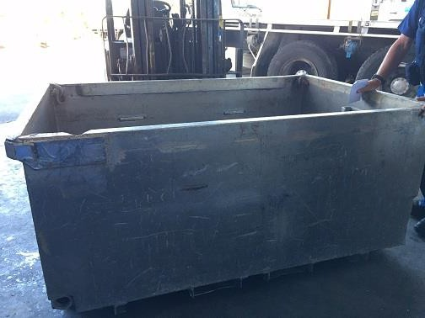
Blaslov Fishing Group | Bin Type 1—TTI  • The bin is of a style depicted in the attached photograph  • Material: Aluminium  • Outside Dimensions: 2,200mm x 1,150mm x 770mm  • Internal Structures: mesh across one corner  • Fill Line: 240mm from the top of bin, catch levelled, metal railing affixed along long sides of bin  • Tare: 136kg  • Identification: TTI and 1,250kg stencilled on side of bin, teal colour around rim of bin  • Agreed Sardine Capacity: 1,250kg | 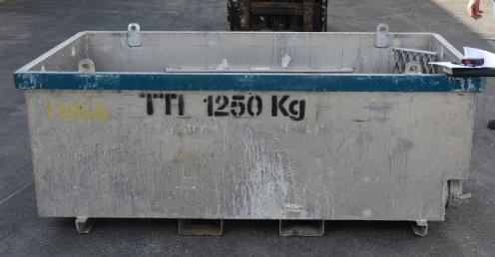
Blaslov Fishing Group | Bin Type 2—TTI s (Smaller Bin)  • The bin is of a style depicted in the attached photograph  • Material: Aluminium  • Outside Dimensions: 2,200mm x 1,150mm x 700mm  • Internal Structures: mesh across one corner  • Fill Line: 160mm from the top of bin, catch levelled, metal railing affixed along long sides of bin  • Tare: 138kg  • Identification: TTI and 1,250kg stencilled on side of bin, teal colour around rim of bin  • Agreed Sardine Capacity: 1,250kg | 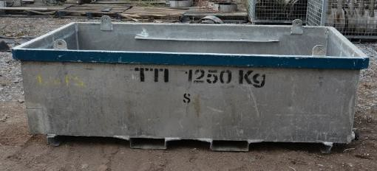
Peter White | Bin Type 1—Large White Plastic Bin—marked L  • The bin is of a style depicted in the attached photograph  • Material: white plastic  • Outside Dimension: 860mm x 1,160mm x 1,450mm  • Internal Structures: Nil  • Fill Line: Fill to 16cm from top  • Tare: u/k  • Identification: White bin marked with White Fisheries and letter L  • Agreed Sardine Capacity—IQF/Ice Slurry: 500kg | 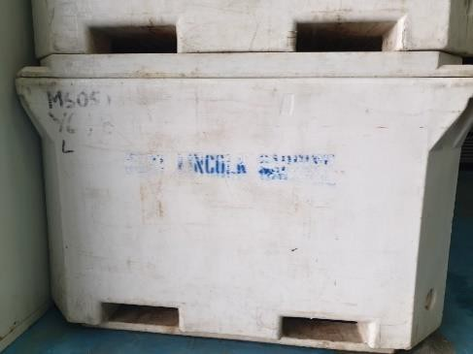
Peter White | Bin Type 2—Small White Plastic Bin—marked S  • The bin is of a style depicted in the attached photograph  • Material: white plastic (TUB 660)  • Outside Dimensions: 780mm x 1,300mm x 1,220mm  • Internal Structures: Nil  • Fill Line: Fill to 14cm from top  • Tare: 60kg (lid off)  • Identification: White bin marked with White Fisheries and letter S  • Agreed Sardine Capacity—IQF/Ice Slurry: 400kg | 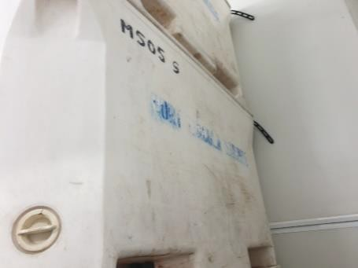
Peter White | Box Type 1—15kg sale box  • The bin is of a style depicted in the attached photograph  • Material: Cardboard/Plastic  • Outside Dimensions: 1,180mm x 1,900mm x 940mm  • Internal Structures: Nil  • Fill line: Internal top of box  • Tare: 0.3kg  • Identification: FP0811 sticker on box with company identification information  • Agreed Sardine Capacity: 15kg | 

Gambling Administration Act 2019
Section 15
Authorised Betting Operations Gambling Code of Practice Variation Notice 2025 (No.1)
Part 1—Preliminary
1. Short title
This notice may be cited as the Authorised Betting Operations Gambling Code of Practice Variation Notice 2025 (No.1) (Variation Notice).
2. Commencement
This Variation Notice comes into operation on 1 January 2026.
3. Variation of existing codes of practice
This notice varies the Authorised Betting Operations Gambling Code of Practice published in the Gazette on 28 September 2023 as varied by a notice published in the Gazette on 28 November 2024 and is made by the Liquor and Gambling Commissioner under Section 15 of the Gambling Administration Act 2019.
4. Variation provisions
In this notice, a provision under a heading referring to a variation of a specified clause of the Authorised Betting Operations Gambling Code of Practice made under the Gambling Administration Act 2019 varies the clause so specified.
Part 2—Variation of Authorised Betting Operations Gambling Code of Practice
5. Variation of Clause 4—Interpretation
(1) Clause 4—Interpretation:
Delete the definition of ‘condensed warning message’ and substitute:
condensed warning message means the relevant message for the period listed in Schedule 1.
Delete the definition of ‘expanded warning message’ and substitute:
expanded warning message means the relevant message for the period listed in Schedule 1 immediately followed by the following text ‘For free and confidential support call 1800 858 858 or visit gamblinghelponline.org.au’.
Delete the definition of ‘social media platform’ and substitute:
social media platforms means, but is not limited to, Instagram videos, reels stories, TikTok videos, YouTube videos, X posts.
6. Variation of Clause 12—Mandatory warning messages—Venue-based gambling operations
(1) Clause 12—delete and substitute:
11. Mandatory warning messages
(1) Expanded warning messages must be included in gambling advertising by a venue-based gambling provider unless the inclusion of the expanded warning message in that particular advertising would be unreasonable or impracticable.
(2) If gambling advertising does not include an expanded warning message as required by sub-clause (1), the gambling advertising must include the condensed warning message.
(3) Despite clause (12)(2), gambling advertising by a venue-based gambling provider may include the text ‘For free and confidential support call 1800 858 858 or visit gamblinghelponline.org.au’ only where inclusion of the condensed warning message is unreasonable or impracticable.
(4) When a mandatory warning message is included in gambling advertising by a venue-based gambling provider, the manner of its inclusion must be consistent with the message being a warning message.
(5) Social media advertising by a venue-based gambling provider which is posting of 160 characters or less must be concluded with the condensed warning message.
(6) Social media advertising by a venue-based gambling provider which is a posting of more than 160 characters must be concluded with the condensed warning message and the following text ‘Gambling Helpline 1800 858 858’.
(7) A venue-based gambling provider may use the applicable tagline and call-to-action as required by clauses 16, 17, 18, 19, 20, 21, 22 or 25 (depending on the medium that the gambling advertising is displayed) instead of the mandatory warning messages as required by sub-clause (1) or (2).
7. Variation of Clause 14—Advertising on radio and television—Venue-based gambling operations
(1) Clauses 14(2)—delete subclause and substitute:
14. Advertising on radio and television—Venue-based gambling operations
(2) Despite clause 12 gambling advertising by a venue-based gambling provider on television that is longer than 15 seconds, must be accompanied by the expanded warning message and in the case of a plug or commentary, must end with the condensed warning message and the national Gambling Helpline number 1800 858 858.
8. Variation of Clause 15—Additional requirements for print media, outdoor and other forms of advertising—Venue-based gambling operations
(1) Clause 15(1)—delete subclause and substitute:
15. Additional requirements for print media, outdoors and other forms of advertising—Venue-based gambling operations
(1) If the condensed warning message is used in advertising by a venue-based gambling provider to which this clause applies, it must be accompanied by the following text ‘Gambling Helpline 1800 858 858’.
9. Variation of Clause 28—Customer information and signage in gambling areas
(1) Clause 28—delete and substitute:
28. Customer information and signage in gambling areas
(1) The gambling provider (other than an interactive wagering service provider) must—
(a) ensure the prominent display of the following text ‘For free and confidential support call 1800 858 858 or visit gamblinghelponline.org.au’ on or near each point of sale of its gambling product and on any electronic display in a gambling area which is used for displaying venue generated messages in the nature of internal advertising;
(b) in each gambling area display prominently a message indicating that gambling operations are governed by a code of practice and ensure that a copy of this code is made available on request;
(c) ensure that a quantity of Gambling Helpline cards are available on or near each ATM and other places throughout gambling areas; and
(d) ensure that the time of day is prominently displayed and visible throughout gambling areas.
(2) The gambling provider must—
(a) prominently display and renew responsible gambling materials (including a poster and pamphlet) in gambling areas in a form which includes the expanded warning message, or if it is not reasonable or practicable to include the expanded warning message, the following text ‘For free and confidential support call 1800 858 858 or visit gamblinghelponline.org.au’; and
(b) make available its responsible gambling poster written in English, Arabic, Chinese, Greek, Italian, Vietnamese, and any other relevant language.
(3) If a gaming machine or casino licensee is also the agent of SA TAB and has placed additional responsible gambling signage and a multi-lingual sign in areas which are gambling areas for the purposes of SA TAB, SA TAB is deemed to have complied with the requirements of sub-clauses (1) and (2).
10. Variation of Clause 29—Self service terminals
(1) Clause 29(1)(c)(iv)—delete subclause and substitute:
29. Self service terminals
(1)
(c)
(iv) The device must display the relevant expanded warning message alternating with the condensed warning message and the national Gambling Helpline number 1800 858 858, at the bottom of the screen at all times, at no more than 10-minute intervals; and
11. Variation of Clause 31—Account holder information and signage for virtual gambling areas
(1) Clause 31(4)(a)—delete subclause and substitute:
31. Customer interaction and help information
(4) For the purposes of sub-clauses (2) and (3), the gambling provider must—
(a) publish its responsible gambling materials in a form which includes the contents of a Gambling Helpline card;

12. Variation of Schedule 1—Expanded warning messages
(1) Schedule 1—delete and substitute:
Schedule 1
Condensed warning messages
(1) For the purposes of clause 3, the following condensed warning messages are prescribed:
What are you prepared to lose today? Set a limit. 1 January 2026 to 30 June 2026
Imagine what you could be buying instead. 1 July 2026 to 31 December 2026
You win some, you lose more. 1 January 2027 to 30 June 2027
What are you really gambling with? 1 July 2027 to 31 December 2027
Chances are you’re about to lose. 1 January 2028 to 30 June 2028
Think. Is this a bet you really want to place? 1 July 2028 to 31 December 2028
What’s gambling really costing you? 1 January 2029 to 30 June 2029
Dated: 22 December 2025
Brett Humphrey
Liquor and Gambling Commissioner

Gambling Administration Act 2019
Section 17
Casino (Ticket-in Ticket-out System Guidelines) Variation Notice 2025
Part 1—Preliminary
1. Short title
This notice may be cited as the Casino (Ticket-in Ticket-out System Guidelines) Variation Notice 2025 (Variation Notice).
2. Commencement
This Variation Notice comes into operation on 1 January 2026.
3. Ticket-in Ticket-out (TITO) System Guidelines
This notice varies the Gambling Administration Guidelines Notice 2020—Casino Act 1997 (Ticket-in Ticket-out Systems) published in the Gazette on 4 December 2020 and is made by the Liquor and Gambling Commissioner under Section 17 of the Gambling Administration Act 2019 for the purpose of Regulation 9(2)(b) of the Casino Regulation 2013.
4. Amendment provisions
In this notice, a provision under a heading referring to the amendment of a specified gambling administration guideline made under the Gambling Administration Act 2019 amends the gambling administration guideline so specified.
Part 2—Variation of Gambling Administration Guidelines—Casino Act 1997 (Ticket-in Ticket-out Systems)
5. Variation of Clause 9—Ticket details
(1) Clause 9(1)(a)(vii)—delete subclause and substitute:
9. Ticket Details
(1)
(a)
(vii) the following gambling helpline information text:
”For free and confidential support call 1800 858 858 or visit gamblinghelponline.org.au”
(2) Clause 9(1)(b)—delete subclause and substitute:
9. Ticket Details
(1)
(b) tickets must include a condensed warning message either printed by the issuing TITO enabled device or pre-printed on the ticket (it is acceptable for condensed warning messages to be printed on the front or rear face of the ticket).
Dated: 22 December 2025
Brett Humphrey
Liquor and Gambling Commissioner

Gambling Administration Act 2019
Section 15
Casino Gambling Code of Practice Variation Notice 2025 (No.1)
Part 1—Preliminary
1. Short title
This notice may be cited as the Casino Gambling Code of Practice Variation Notice 2025 (No.1) (Variation Notice).
2. Commencement
This Variation Notice comes into operation on 1 January 2026.

3. Variation of existing codes of practice
This notice varies the Casino Gambling Code of Practice published in the Gazette on 28 September 2023 as varied by a notice published in the Gazette on 28 November 2024 and is made by the Liquor and Gambling Commissioner under Section 15 of the Gambling Administration Act 2019.
4. Variation provisions
In this notice, a provision under a heading referring to a variation of a specified clause of the Casino Gambling Code of Practice made under the Gambling Administration Act 2019 varies the clause so specified.
Part 2—Variation of Casino Gambling Code of Practice
5. Variation of Clause 4—Interpretation
(1) Clause 4—Interpretation:
Delete the definition of ‘condensed warning message’ and substitute:
condensed warning message means the relevant message for the period listed in Schedule 1.
Delete the definition of ‘expanded warning message’ and substitute:
expanded warning message means the relevant message for the period listed in Schedule 1 immediately followed by the following text ‘For free and confidential support call 1800 858 858 or visit gamblinghelponline.org.au’
After the definition of ‘private webpage’, insert:
social media advertising means all forms of promotional content relating to gambling advertising, marketing (including direct marketing sent by SMS, text message or push notification) and/or communications conducted via social media platforms which is in exchange for payment, or some other form of valuable consideration that the gambling provider has a reasonable degree of control over. For the avoidance of doubt, social media advertising—
(a) includes promotional content created and shared by another person or organisation
(b) excludes video advertising broadcast or shared on social media platforms or online.
social media platforms means, but is not limited to, Instagram videos, reels stories, TikTok videos, YouTube videos, X posts.
6. Variation of Clause 11—Mandatory warning messages
(1) Clause 11—delete and substitute:
11. Mandatory warning messages
(1) Expanded warning messages must be included in gambling advertising, unless the inclusion of the expanded warning message in that particular advertising would be unreasonable or impracticable.
(2) If gambling advertising does not include an expanded warning message, the gambling advertising must include the condensed warning message.
(3) Despite clause (11)(2), gambling advertising may include the text ‘For free and confidential support call 1800 858 858 or visit gamblinghelponline.org.au’ only where inclusion of the condensed warning message is unreasonable or impracticable.
(4) When a mandatory warning message is included in gambling advertising, the manner of its inclusion must be consistent with the message being a warning message.
(5) Social media advertising which is a posting of 160 characters or less must be concluded with the condensed warning message.
(6) Social media advertising which is a posting of more than 160 characters must be concluded with the condensed warning message and the following text ‘Gambling Helpline 1800 858 858’.
7. Variation of Clause 12—Gambling Advertising on Radio and Television
(1) Clauses 12(2), 12(3) and 12(4)—delete subclauses and substitute:
12. Gambling Advertising on Radio and Television
(2) Despite clause 11, gambling advertising on radio or television, including a plug or commentary, that is less than 15 seconds must be accompanied by the condensed warning message.
(3) Despite clause 11, gambling advertising on radio or television, that is longer than 15 seconds, including a plug or commentary, must be accompanied by the expanded warning message.
(4) A mandatory warning message announced on radio or television must be spoken slowly, calmly, and evenly paced at the end of the advertisement with a perceptible pause between those messages and any other content that forms part of the advertisement.
8. Variation of Clause 13—Additional requirements for print media, outdoor and other forms of advertising
(1) Clause 13(1)—delete subclause and substitute:
13. Additional requirements for print media, outdoors and other forms of advertising
(1) If the condensed warning message is used in advertising to which this clause applies, it must be accompanied by the following text ‘Gambling Helpline 1800 858 858’.
(2) Clause 13(7)—delete subclause and substitute:
13. Additional requirements for print media, outdoors and other forms of advertising
(7) Gambling advertising which is the placement of a logo on the apparel of a participant (including an official) in an event which is broadcast on television in South Australia, or at an event at which gambling takes place, must be accompanied by the following text ‘Gambling Helpline 1800 858 858’ adjacent to the logo, occupying no less than half the space occupied by the logo.
(3) After Clause 13(10), insert:
13. Additional requirements for print media, outdoors and other forms of advertising
(11) Gambling advertising must not occur at Cinemas when films rated G, PG, M or MA(15+) are showing.
9. Variation of Clause 16—In-venue messaging
(1) Clause 16(5)—delete subclause and substitute:
16. In-venue messaging
(5) If the licensee is also the agent of SA TAB or the SA Lotteries Commission and has placed additional responsible gambling signage and a multi-lingual sign in areas which are gambling areas for the purposes of SA TAB or the SA Lotteries Commission, SA TAB or the SA Lotteries Commission (as the case may be) is deemed to have complied with the relevant provisions of the Authorised Betting Operations Gambling Code of Practice and State Lotteries Gambling Code of Practice.
10. Variation of Clause 17—Help information in gaming areas
(1) Clause 17—delete and substitute:
17. Help information in gaming areas
(1) The licensee must ensure that—
(a) each automatic teller machine (ATM) which is available for operation by patrons operates so that when the ATM is idle, the screen displays a responsible gambling message approved by the welfare agency at least 20% of the time, or if there is no current approval the condensed warning message and the following text ‘Gambling Helpline 1800 858 858’ at least 20% of the time;
(b) when the ATM prints a transaction slip (however described) the transaction record includes the following text ‘For free and confidential support call 1800 858 858 or visit gamblinghelponline.org.au’.
(2) The licensee must ensure that—
(a) each cashable ticket redemption terminal (CRT) which is available for operation by patrons operates so when the CRT is idle, at least half of the available screen space displays a responsible gambling message approved by the welfare agency, or if there is no current approval the following text ‘For free and confidential support call 1800 858 858 or visit gamblinghelponline.org.au’.
(b) when the CRT prints a transaction slip (however described) the transaction record includes the following text ‘For free and confidential support call 1800 858 858 or visit gamblinghelponline.org.au’.
(3) The licensee must ensure—
(a) that the following text ‘For free and confidential support call 1800 858 858 or visit gamblinghelponline.org.au’ is prominently displayed on or near—
(i) each automated coin dispensing machine; and
(ii) each customer service point at which money is exchanged for coin, banknotes, tickets or credit on an approved account based cashless gaming system; and
(b) that a quantity of Gambling Helpline cards are available at or near—
(i) each ATM, EFTPOS facility and CRT;
(ii) each automated coin dispensing machine;
(iii) each customer service point at which money is exchanged for coin, banknotes, tickets or credit on an approved account based cashless gaming system; and
(iv) each gaming machine.
(4) Sub-clauses (1), (2) and (3) apply to any ATM, EFTPOS facility or CRT, in or near a gaming area, over which the licensee could reasonably be expected to exercise control.
(5) Condensed warning messages must be used to populate the dynamic message field on tickets issued from gaming machines being operated in connection with a ticket-in ticket-out (TITO) system.
(6) Despite sub-clause (5), if batches of pre-printed tickets are used for this purpose, the condensed warning message must be replaced with the relevant condensed message for that period on each subsequent batch of tickets re-ordered. It is acceptable for any stocks of tickets which were pre-printed to comply immediately before the commencement of the required period, to be exhausted.
(7) The licensee must ensure that the time of day is prominently displayed and visible throughout gaming areas.
(8) The licensee must ensure that a copy of this code is available within the gaming area.
11. Variation of Schedule 1—Expanded warning messages
(1) Schedule 1—delete and substitute:
Schedule 1
Condensed warning messages
What are you prepared to lose today? Set a limit. 1 January 2026 to 30 June 2026
Imagine what you could be buying instead. 1 July 2026 to 31 December 2026
You win some, you lose more. 1 January 2027 to 30 June2027
What are you really gambling with? 1 July 2027 to 31 December 2027
Chances are you’re about to lose. 1 January 2028 to 30 June 2028
Think, Is this a bet you really want to place? 1 July 2028 to 31 December 2028
What’s gambling really costing you? 1 January 2029 to 30 June 2029
Dated: 22 December 2025
Brett Humphrey
Liquor and Gambling Commissioner

Gambling Administration Act 2019
Section 17
Gaming Machines (Ticket-in Ticket-out System Guidelines) Variation Notice 2025
Part 1—Preliminary
1. Short title
This notice may be cited as the Gaming Machines (Ticket-in Ticket-out System Guidelines) Variation Notice 2025 (Variation Notice).
2. Commencement
This Variation Notice comes into operation on 1 January 2026.
3. Ticket-in Ticket-out (TITO) System Guidelines
This notice varies the Gambling Administration Guidelines Notice 2021—Gaming Machines Act 1992 (Ticket-in Ticket-out Systems) published in the Gazette on 18 February 2021 as varied by a notice published in the Gazette on 24 November 2022 and is made by the Liquor and Gambling Commissioner under Section 17 of the Gambling Administration Act 2019 for the purpose of Regulation 27(2) of the Gaming Machine Regulations 2020.
4. Amendment provisions
In this notice, a provision under a heading referring to the amendment of a specified gambling administration guideline made under the Gambling Administration Act 2019 amends the gambling administration guideline so specified.
Part 2—Variation of Gambling Administration Guidelines—Gaming Machines Act 1992 (Ticket-in Ticket-out Systems)
5. Variation of Clause 5—Dependencies
(1) Clause 5.8—after ‘available from’ delete ‘the Independent Gaming Corporation (IGC), the holder of the South Australian Gaming Machine Monitor Licence’ and substitute ‘IGC.’
6. Variation of Clause 8—Ticket details
(1) Clause 8.2 j—delete subclause and substitute:
j. support for a dynamic message field for a condensed warning message; capable of displaying up to 80-characters of text and populated by the QCOM CTEXT field in the Cash Ticket Out Request Acknowledgement Poll (as indicated by the three lines of numerical text on the ticket template below).
(2) Clause 8.3—delete and substitute:
8.3 The following “static” gambling helpline information text must be printed on the ticket:
“For free and confidential support call 1800 858 858 or visit gamblinghelponline.org.au”
(3) Clause 8.6—delete and substitute:
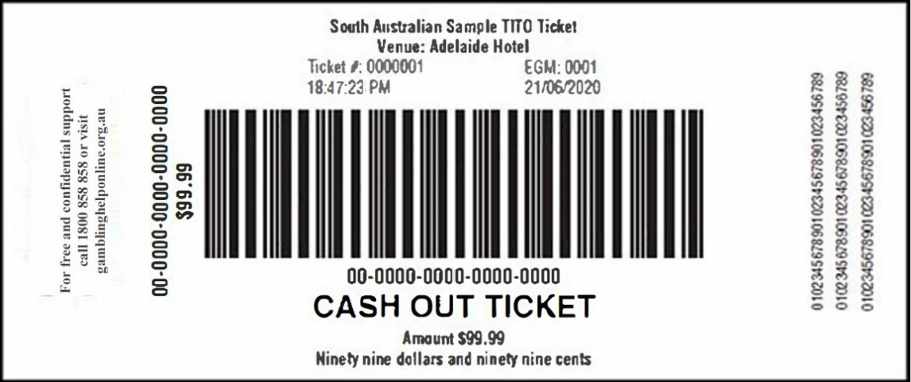
8.6 Template of a Cashable Ticket:
7. Variation of Clause 10—Ticket-out process
(1) Clause 10.1—delete and substitute:
10.1 The ticket-out functionality is equivalent to a player pressing collect and collecting credits from a gaming machine in coin. The ticket will include a unique identifier and additional information including the value of the ticket and a condensed warning message. Tickets printed by a gaming machine can be redeemed for cash by presenting the ticket to a venue staff member at a cashier terminal or at a CRT.
Dated: 22 December 2025
Brett Humphrey
Liquor and Gambling Commissioner

Gambling Administration Act 2019
Section 15
Gaming Machines Gambling Code of Practice Variation Notice 2025 (No.2)
Part 1—Preliminary
1. Short title
This notice may be cited as the Gaming Machines Gambling Code of Practice Variation Notice 2025 (No.2) (Variation Notice).
2. Commencement
This Variation Notice comes into operation on 1 January 2026.
3. Variation of existing codes of practice
This notice varies the Gaming Machines Gambling Code of Practice published in the Gazette on 28 September 2023 as varied by notices published in the Gazette on 28 November 2024 and 28 April 2025 and is made by the Liquor and Gambling Commissioner under Section 15 of the Gambling Administration Act 2019.
4. Variation provisions
In this notice, a provision under a heading referring to a variation of a specified clause of the Gaming Machines Gambling Code of Practice made under the Gambling Administration Act 2019 varies the clause so specified.
Part 2—Variation of Gaming Machines Gambling Code of Practice
5. Variation of Clause 4—Interpretation
(1) Clause 4—Interpretation:
Delete the definition of ‘condensed warning message’ and substitute:
condensed warning message means the relevant message for the period listed in Schedule 1.
Delete the definition of ‘expanded warning message’ and substitute:
expanded warning message means the relevant message for the period listed in Schedule 1 immediately followed by the following text ‘For free and confidential support call 1800 858 858 or visit gamblinghelponline.org.au’
After the definition of ‘private webpage’, insert:
social media advertising means all forms of promotional content relating to gambling advertising, marketing (including direct marketing sent by SMS, text message or push notification) and/or communications conducted via social media platforms which is in exchange for payment, or some other form of valuable consideration that the gambling provider has a reasonable degree of control over. For the avoidance of doubt, social media advertising—
(a) includes promotional content created and shared by another person or organisation
(b) excludes video advertising broadcast or shared on social media platforms or online.
social media platforms means, but is not limited to, Instagram videos, reels stories, TikTok videos, YouTube videos, X warning messages must be included in gambling advertising, unless the inclusion of the expanded warning message in that particular advertising would be unreasonable or impracticable posts.
6. Variation of Clause 11—Mandatory warning messages
(1) Clause 11—delete and substitute:
11. Mandatory warning messages
(1) Expanded warning messages must be included in gambling advertising, unless the inclusion of the expanded warning message in that particular advertising would be unreasonable or impracticable.
(2) If gambling advertising does not include an expanded warning message, the gambling advertising must include the condensed warning message.
(3) Despite clause (11)(2), gambling advertising may include the text ‘For free and confidential support call 1800 858 858 or visit gamblinghelponline.org.au’ only where inclusion of the condensed warning message is unreasonable or impracticable.
(4) When a mandatory warning message is included in gambling advertising, the manner of its inclusion must be consistent with the message being a warning message.
(5) Social media advertising which is a posting of 160 characters or less must be concluded with the condensed warning message.
(6) Social media advertising which is a posting of more than 160 characters must be concluded with the condensed warning message and the following text ‘Gambling Helpline 1800 858 858’.
7. Variation of Clause 12—Gambling Advertising on Radio and Television
(1) Clauses 12(2), 12(3) and 12(4)—delete subclauses and substitute:
12. Gambling Advertising on Radio and Television
(2) Despite clause 11, gambling advertising on radio or television, including a plug or commentary, that is less than 15 seconds must be accompanied by the condensed warning message.
(3) Despite clause 11, gambling advertising on radio or television, that is longer than 15 seconds, including a plug or commentary, must be accompanied by the expanded warning message.
(4) A mandatory warning message announced on radio or television must be spoken slowly, calmly, and evenly paced at the end of the advertisement with a perceptible pause between those messages and any other content that forms part of the advertisement.
8. Variation of Clause 13—Additional requirements for print media, outdoor and other forms of advertising
(1) Clause 13(1)—delete subclause and substitute:
13. Additional requirements for print media, outdoors and other forms of advertising
(1) If the condensed warning message is used in advertising to which this clause applies, it must be accompanied by the following text ‘Gambling Helpline 1800 858 858’.
(2) Clause 13(7)—delete subclause and substitute:
13. Additional requirements for print media, outdoors and other forms of advertising
(7) Gambling advertising which is the placement of a logo on the apparel of a participant (including an official) in an event which is broadcast on television in South Australia, or at an event at which gambling takes place, must be accompanied by the following text ‘Gambling Helpline 1800 858 858’ adjacent to the logo, occupying no less than half the space occupied by the logo.
9. Variation of Clause 16—In-venue messaging
(1) Clause 16(4)—delete subclause and substitute:
16. In-venue messaging
(4) If the licensee is also the agent of SA TAB or the SA Lotteries Commission and has placed additional responsible gambling signage and a multi-lingual sign in areas which are gambling areas for the purposes of SA TAB or the SA Lotteries Commission, SA TAB or the SA Lotteries Commission (as the case may be) is deemed to have complied with the relevant provisions of the Authorised Betting Operations Gambling Code of Practice and State Lotteries Gambling Code of Practice.
10. Variation of Clause 17—Help information in gaming areas
(1) Clause 17—delete and substitute:
17. Help information in gaming areas
(1) The licensee must ensure that—
(a) each automatic teller machine (ATM) which is available for operation by patrons operates so when the ATM is idle, the screen displays a responsible gambling message approved by the welfare agency at least 20% of the time, or if there is no current approval the condensed warning message and the following text ‘Gambling Helpline 1800 858 858’ at least 20% of the time;
(b) when the ATM prints a transaction slip (however described) the transaction record includes the following text ‘For free and confidential support call 1800 858 858 or visit gamblinghelponline.org.au’.
(2) The licensee must ensure that—
(a) each cashable ticket redemption terminal (CRT) which is available for operation by patrons operates so when the CRT is idle, at least half of the available screen space displays a responsible gambling message approved by the welfare agency, or if there is no current approval the following text ‘For free and confidential support call 1800 858 858 or visit gamblinghelponline.org.au’.
(b) when the CRT prints a transaction slip (however described) the transaction record includes the following text ‘For free and confidential support call 1800 858 858 or visit gamblinghelponline.org.au’.
(3) The licensee must ensure—
(a) that the following text ‘For free and confidential support call 1800 858 858 or visit gamblinghelponline.org.au’ is prominently displayed on or near—
(i) each automated coin dispensing machine; and
(ii) each customer service point at which money is exchanged for coin, banknotes, tickets or credit on an approved account based cashless gaming system; and
(b) that a quantity of Gambling Helpline cards are available at or near—
(i) each ATM, EFTPOS facility and CRT;
(ii) each automated coin dispensing machine;
(iii) each customer service point at which money is exchanged for coin, banknotes, tickets or credit on an approved account based cashless gaming system; and
(iv) each gaming machine.
(4) Sub-clauses (1), (2) and (3) apply to any ATM, EFTPOS facility or CRT, in or near a gaming area, over which the licensee could reasonably be expected to exercise control.
(5) Condensed warning messages must be used to populate the dynamic message field on tickets issued from gaming machines being operated in connection with a ticket-in ticket-out (TITO) system.
(6) The licensee must ensure that the time of day is prominently displayed and visible throughout gaming areas.
(7) The licensee must ensure that a copy of this code is available within the gaming area.
11. Variation of Schedule 1—Expanded warning messages
(1) Schedule 1—delete and substitute:
Schedule 1
Condensed warning messages
What are you prepared to lose today? Set a limit. 1 January 2026 to 30 June 2026
Imagine what you could be buying instead. 1 July 2026 to 31 December 2026
You win some, you lose more. 1 January 2027 to 30 June 2027
What are you really gambling with? 1 July 2027 to 31 December 2027
Chances are you’re about to lose. 1 January 2028 to 30 June 2028
Think, Is this a bet you really want to place? 1 July 2028 to 31 December 2028
What’s gambling really costing you? 1 January 2029 to 30 June 2029
Dated: 22 December 2025
Brett Humphrey
Liquor and Gambling Commissioner

Gambling Administration Act 2019
Section 15
State Lotteries Gambling Code of Practice Variation Notice 2025 (No.1)
Part 1—Preliminary
1. Short title
This notice may be cited as the State Lotteries Gambling Code of Practice Variation Notice 2025 (No.1) (Variation Notice).
2. Commencement
This Variation Notice comes into operation on 1 January 2026.
3. Variation of existing codes of practice
This notice varies the State Lotteries Gambling Code of Practice published in the Gazette on 28 September 2023 as varied by a notice published in the Gazette on 28 November 2024 and is made by the Liquor and Gambling Commissioner under Section 15 of the Gambling Administration Act 2019.
4. Variation provisions
In this notice, a provision under a heading referring to a variation of a specified clause of the State Lotteries Gambling Code of Practice made under the Gambling Administration Act 2019 varies the clause so specified.
Part 2—Variation of State Lotteries Gambling Code of Practice
5. Variation of Clause 4—Interpretation
(1) Clause 4—Interpretation:
Delete the definition of ‘condensed warning message’ and substitute:
condensed warning message means the relevant message for the period listed in Schedule 1.
Delete the definition of ‘expanded warning message’ and substitute:
expanded warning message means the relevant message for the period listed in Schedule 1 immediately followed by the following text ‘For free and confidential support call 1800 858 858 or visit gamblinghelponline.org.au’
After the definition of ‘permitted external sign’, insert:
social media advertising means all forms of promotional content relating to gambling advertising, marketing (including direct marketing sent by SMS, text message or push notification) and/or communications conducted via social media platforms which is in exchange for payment, or some other form of valuable consideration that the gambling provider has a reasonable degree of control over. For the avoidance of doubt, social media advertising—
(a) includes promotional content created and shared by another person or organisation
(b) excludes video advertising broadcast or shared on social media platforms or online.
social media platforms means, but is not limited to, Instagram videos, reels stories, TikTok videos, YouTube videos, X posts.
6. Variation of Clause 12—Mandatory warning messages
(1) Clause 12—delete and substitute:
12. Mandatory warning messages
(1) Expanded warning messages must be included in gambling advertising, unless the inclusion of the expanded warning message in that particular advertising would be unreasonable or impracticable.
(2) If gambling advertising does not include an expanded warning message, the gambling advertising must include the condensed warning message.
(3) Despite clause (12)(2), gambling advertising may include the text ‘For free and confidential support call 1800 858 858 or visit gamblinghelponline.org.au’ only where inclusion of the condensed warning message is unreasonable or impracticable.
(4) When a mandatory warning message is included in gambling advertising, the manner of its inclusion must be consistent with the message being a warning message.
(5) Social media advertising which is a posting of 160 characters or less must be concluded with the condensed warning message.
(6) Social media advertising which is a posting of more than 160 characters must be concluded with the condensed warning message and the following text ‘Gambling Helpline 1800 858 858’.
7. Variation of Clause 13—Gambling Advertising on Radio and Television
(1) Clauses 13(2), 13(3) and 13(4)—delete subclauses and substitute:
13. Gambling Advertising on Radio and Television
(3) Despite clause 12, gambling advertising on radio or television, including a plug or commentary, that is less than 15 seconds must be accompanied by the condensed warning message.
(4) Despite clause 12, gambling advertising on radio or television, that is longer than 15 seconds, including a plug or commentary, must be accompanied by the expanded warning message.
(5) A mandatory warning message announced on radio or television must be spoken slowly, calmly, and evenly paced at the end of the advertisement with a perceptible pause between those messages and any other content that forms part of the advertisement.
8. Variation of Clause 14—Additional requirements for print media, outdoor and other forms of advertising
(1) Clause 14(1)—delete subclause and substitute:
14. Additional requirements for print media, outdoors and other forms of advertising
(1) If the condensed warning message is used in advertising to which this clause applies, it must be accompanied by the following text ‘Gambling Helpline 1800 858 858’.
(2) Clause 14(7)—delete subclause and substitute:
14. Additional requirements for print media, outdoors and other forms of advertising
(7) Gambling advertising which is the placement of a logo on the apparel of a participant (including an official) in an event which is broadcast on television in South Australia, or at an event at which gambling takes place, must be accompanied by the following text ‘Gambling Helpline 1800 858 858’ adjacent to the logo, occupying no less than half the space occupied by the logo.
9. Variation of Clause 16—Customer information and signage in gambling areas
(1) Clause 26—delete and substitute:
16. Customer information and signage in gambling areas
(1) The gambling provider must—
(a) ensure the prominent display of the following text ‘For free and confidential support call 1800 858 858 or visit gamblinghelponline.org.au’ on or near each point of sale of its gambling product and on any electronic display in a gambling area which is used for displaying venue generated messages in the nature of internal advertising;
(b) in each gambling area display prominently a message indicating that gambling operations are governed by a code of practice and ensure that a copy of this code is made available on request;
(c) ensure that a quantity of Gambling Helpline cards are available on or near each ATM and other places throughout gambling areas; and
(d) ensure that the time of day is prominently displayed and visible throughout gambling areas.
(2) The gambling provider must—
(a) prominently display and renew responsible gambling materials (including a poster and pamphlet) in gambling areas in a form which includes the expanded warning message, or if it is not reasonable or practicable to include the expanded warning message, the following text ‘For free and confidential support call 1800 858 858 or visit gamblinghelponline.org.au’; and
(b) make available its responsible gambling poster written in English, Arabic, Chinese, Greek, Italian, Vietnamese, and any other relevant language.
(3) If a gaming machine or casino licensee is also the agent of the Lotteries Commission and has placed additional responsible gambling signage and a multi-lingual sign in areas which are gambling areas for the purposes of the Lotteries Commission, the Lotteries Commission is deemed to have complied with the requirements of sub-clauses (1) and (2).
10. Variation of Clause 17—Self-service terminals
(1) Clause 17(1)(c)(iv)—delete subclause and substitute:
29. Self-service terminals
(1)
(c)
(iv) the device must display the relevant expanded warning message alternating with the condensed warning message and the national Gambling Helpline number 1800 858 858, at the bottom of the screen at all times, at no more than 10-minute intervals; and
11. Variation of Clause 19—Account holder information and signage for virtual gambling areas
(1) Clause 19(3)—delete subclause and substitute:
. Customer interaction and help information
(4) The gambling provider must ensure the prominent display of the following text ‘For free and confidential support call 1800 858 858 or visit gamblinghelpoinline.org.au’
(2) Clause 19(5)(a)—delete subclause and substitute:
19. Customer interaction and help information
(5)
(a) publish its responsible gambling materials in a form which includes the contents of a Gambling Helpline card and the expanded warning message;
12. Variation of Schedule 1—Expanded warning messages
(1) Schedule 1—delete and substitute:
Schedule 1
Condensed warning messages
What are you prepared to lose today? Set a limit. 1 January 2026 to 30 June 2026
Imagine what you could be buying instead. 1 July 2026 to 31 December 2026
You win some, you lose more. 1 January 2027 to 30 June 2027
What are you really gambling with? 1 July 2027 to 31 December 2027
Chances are you’re about to lose. 1 January 2028 to 30 June 2028
Think. Is this a bet you really want to place? 1 July 2028 to 31 December 2028
What’s gambling really costing you? 1 January 2029 to 30 June 2029
Dated: 22 December 2025
Brett Humphrey
Liquor and Gambling Commissioner

Health Care Act 2008
Section 64
Declaration of Authorised Quality Improvement Activity and Authorised Person—Notice by the Minister
Take notice that I, Christopher James Picton, Minister for Health and Wellbeing, pursuant to Section 64(1)(a)(i) and (b)(i) of the Health Care Act 2008 (the Act) do hereby:
Declare the activity of reviewing mortality, morbidity, and critical or adverse events and the development and implementation of related recommendations for the purposes of enhancing patient safety and clinical outcomes to be an authorised quality improvement activity to which Part 7 of the Act applies; and
Declare the Significant Event Review Committee of the Women’s and Children’s Health Network to be an authorised entity for the purposes of carrying out the authorised activity within the ambit of this declaration and to which Part 7 of the Act applies;
being satisfied:
(a) that the performance of the activities within the ambit of this declaration and the functions or activities of the person or group of persons within the ambit of this declaration would be facilitated by the making of the declaration; and
(b) that the making of the declaration is in the public interest.
Dated: 15 December 2025
Christopher James Picton
Minister for Health and Wellbeing

Housing Improvement Act 2016
Rent Control
In the exercise of the powers conferred by the Housing Improvement Act 2016, the Delegate of the Minister for Housing and Urban Development hereby fixes the maximum rental amount per week that shall be payable subject to Section 55 of the Residential Tenancies Act 1995, in respect of each premises described in the following table. The amount shown in the said table shall come into force on the date of this publication in the Gazette.
Address of Premises | Allotment Section | Certificate of Title  Volume/Folio | Maximum Rental per week payable
19 Fisher Terrace, Glenelg North SA 5045 | Allotment 72 Deposited Plan 62479  Hundred of Noarlunga | CT5899/366 | $0.00
Dated: 24 December 2025
Craig Thompson
Housing Regulator and Registrar
Housing Safety Authority
Delegate of the Minister for Housing and Urban Development

HOUSING IMPROVEMENT ACT 2016
Rent Control Variations
In the exercise of the powers conferred by the Housing Improvement Act 2016, the Delegate of the Minister for Housing and Urban Development hereby varies the maximum rental amount per week that shall be payable subject to Section 55 of the Residential Tenancies Act 1995, in respect of each premises described in the following table. The amount shown in the said table shall come into force on the date of this publication in the Gazette.
Address of Premises | Allotment Section | Certificate of Title  Volume/Folio | Reason for Variation | Maximum Rental per week payable
16 Sherwood Avenue, Bellevue Heights SA 5050 | Allotment 168 Deposited Plan 4773 Hundred of Adelaide | CT5653/970 |  | $50.00
Dated: 24 December 2025
Craig Thompson
Housing Regulator and Registrar
Housing Safety Authority
Delegate of the Minister for Housing and Urban Development

Hydrogen and Renewable Energy Act 2023
Application for Grant of Associated Infrastructure Licence—AILA 6
Pursuant to Section 32(3) of the Hydrogen and Renewable Energy Act 2023, notice is hereby given that an application for an associated infrastructure licence over the area described below has been received from:
Kincraig Battery Pty Ltd

Description of Application Area
All that part of the State of South Australia, bounded as follows:
All coordinates GDA2020, Zone 54
472535.077mE 5909256.023mN
472755.812mE 5909076.484mN
472868.110mE 5908530.233mN
472285.972mE 5908211.533mN
472246.854mE 5908806.357mN
472175.182mE 5908788.198mN
472217.682mE 5908916.241mN
472338.637mE 5908948.373mN
472275.166mE 5909020.347mN
472535.077mE 5909256.023mN
AREA: 0.45 square kilometres approximately
The application may be inspected at the offices of the Department for Energy and Mining located at Level 4, 11 Waymouth Street, Adelaide SA 5000. To arrange an inspection, please contact the Department via email at DEM.ERDLicensing@sa.gov.au.
Dated: 11 November 2025
Michael Smith
Director, Regulatory Risk and Resource Tenure
Regulation and Compliance Division
Department for Energy and Mining
Delegate of the Minister for Energy and Mining

Major Events Act 2013
Section 6B
Declaration of a Major Event
Pursuant to Section 6B of the Major Events Act 2013, I, Hon. Zoe Bettison MP, Minister for Tourism declare the 2026 Santos Tour Down Under to be held from 16 to 25 January 2026 to be declared a major event.
By virtue of the provisions of the Major Events Act 2013, I do hereby:
1. Declare the 2026 Santos Tour Down Under to be a major event.
2. Specify the period of the event, for which the declaration of the major event is in force is 12:01am on Friday, 16 January to 11:59pm on Sunday, 25 January 2026.
3. Declare the 2026 Santos Tour Down Under and its associated events officially organised by the event organiser to be a major event:
• The Santos Tour Down Under comprises:
◦ Three days of women’s competition racing, namely:
- Ziptrak Women’s Stage 1
- Health Partners Women’s Stage 2
- Hyundai Women’s Stage 3
◦ Vanguard Women’s One-Day Race
◦ Six days of men’s competition racing, namely:
- South Australia Prologue
- Vanguard Men’s Stage 1
- Health Partners Men’s Stage 2
- Ziptrak Men’s Stage 3
- Think! Road Safety Men’s Stage 4
- EFEX Men’s Stage 5
◦ The associated events officially organised by the event organiser, namely:
- City of Adelaide Tour Village
- Team Presentation
- Health Partners Family Day
- Health Partners Family Ride
- Detours
- Hillside Social at Willunga Hill
- Race Day Presentation Podiums
4. Declare the major event venues to be the women’s race routes, men’s race routes, women’s one-day race route and City of Adelaide Tour Village.
5. Declare the controlled areas to be any public place or part of a public place that is within 250 metres from the boundary of the major event venues, excluding the City of Adelaide Tour Village which has a controlled area of 275 metres from the boundary of the major event venue.
6. Designate South Australian Tourism Commission (ABN 80 485 623 691) to be the event organiser for the event.
7. Declare that the following provisions of Part 3 of the Act apply to the event, the event site and the declared controlled area for the event:
(a) Section 8
(b) Section 10
(c) Section 11
(d) Section 12
(e) Section 13
(f) Section 14

8. Being satisfied that the title “Santos Tour Down Under” and the logo as it appears below are sufficiently connected with the identity and conduct of the major event, and that the event has commercial arrangements that are likely to be adversely affected by unauthorised use of the title and logo, I hereby declare, pursuant to Section 14(1) of the Act, that “Santos Tour Down Under” is an official title and the logo as it appears below is an official logo in respect of the event.
Dated: 19 December 2025
Hon Zoe Bettison MP
Minister for Tourism

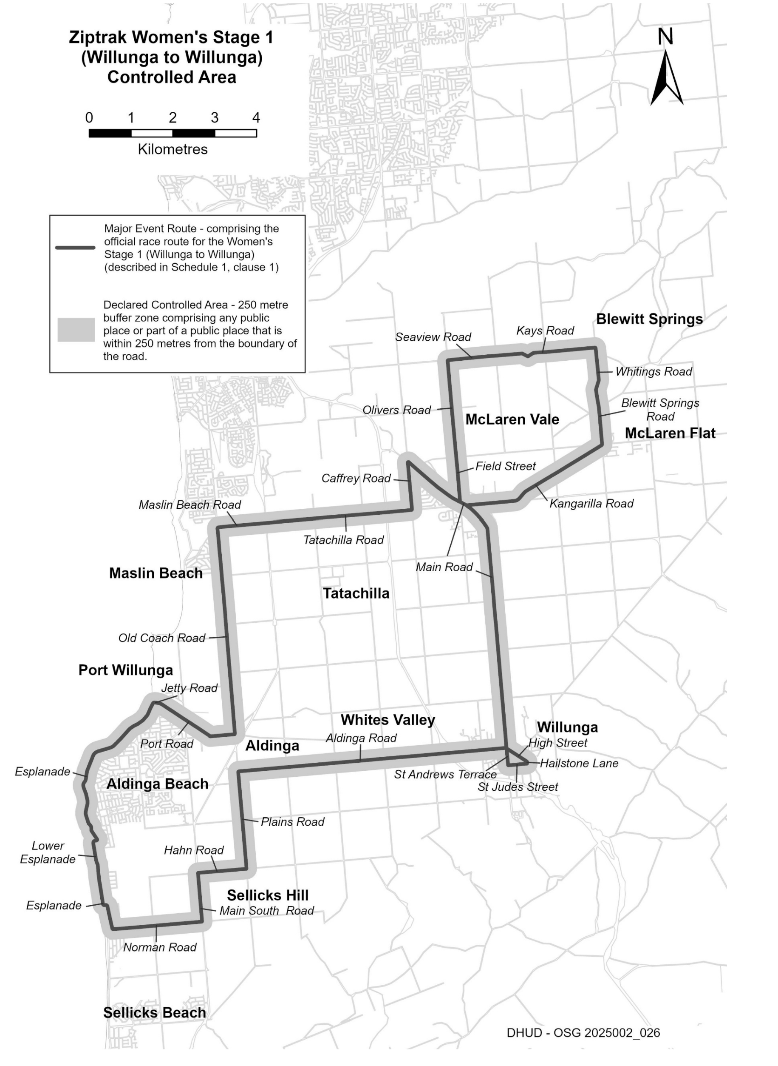
Maps of Controlled Areas
2026 Santos Tour Down Under

Description of Official Race Route for Ziptrak Women’s Stage 1 (Willunga to Willunga)
The official race route for Ziptrak Women’s Stage 1 (Willunga to Willunga) comprises—
(a) the portion of road commencing on High Street in Willunga near the Old Bush Inn, then south-easterly along High Street to its intersection with Hailstone Lane, then southerly along Hailstone Lane to its intersection with St Judes Street, then westerly along St Judes Street to its intersection with St Andrews Terrace, then northerly along St Andrews Terrace to its intersection with High Street, then north-westerly along High Street to its intersection with Aldinga Road, then westerly along Aldinga Road to its intersection with Plains Road in Aldinga, then southerly along Plains Road to its intersection with Hahn Road in Sellicks Hill, then westerly along Hahn Road to its intersection with Main South Road, then southerly along Main South Road to its intersection with Norman Road, then westerly along Norman Road to its intersection with Esplanade in Aldinga Beach, then northerly along Esplanade to its intersection with Lower Esplanade, then generally northerly along Lower Esplanade to its intersection with Esplanade, then northerly and north-easterly along Esplanade to its intersection with Jetty Road in Port Willunga, then easterly along Jetty Road to its intersection with Port Road, then south-easterly and easterly along Port Road to its intersection with Old Coach Road in Aldinga, then northerly along Old Coach Road to its intersection with Maslin Beach Road in Maslin Beach, then easterly along Maslin Beach Road until it becomes Tatachilla Road, the easterly along Tatachilla Road to its intersection with Caffrey Road in McLaren Vale, then northerly along Caffrey Road to its intersection with Main Road, then south-easterly along Main Road to its intersection with Field Street, then northerly along Field Street until it becomes Olivers Road, then northerly along Olivers Road to its intersection with Seaview Road, then easterly along Seaview Road until it becomes Kays Road, then generally easterly along Kays Road to its intersection with Whitings Road in McLaren Flat, then southerly along Whitings Road to its intersection with Blewitt Springs Road, then southerly along Blewitt Springs Road to its intersection with Kangarilla Road, then south-westerly and westerly along Kangarilla Road to its intersection with Main Road in McLaren Vale, then south-easterly and southerly along Main Road to its intersection with High Street in Willunga, then south-easterly along High Street, and
(b) the portion of road commencing at the intersection of Main Road with Field Street, then south-easterly along Main Road to its intersection with Kangarilla Road.

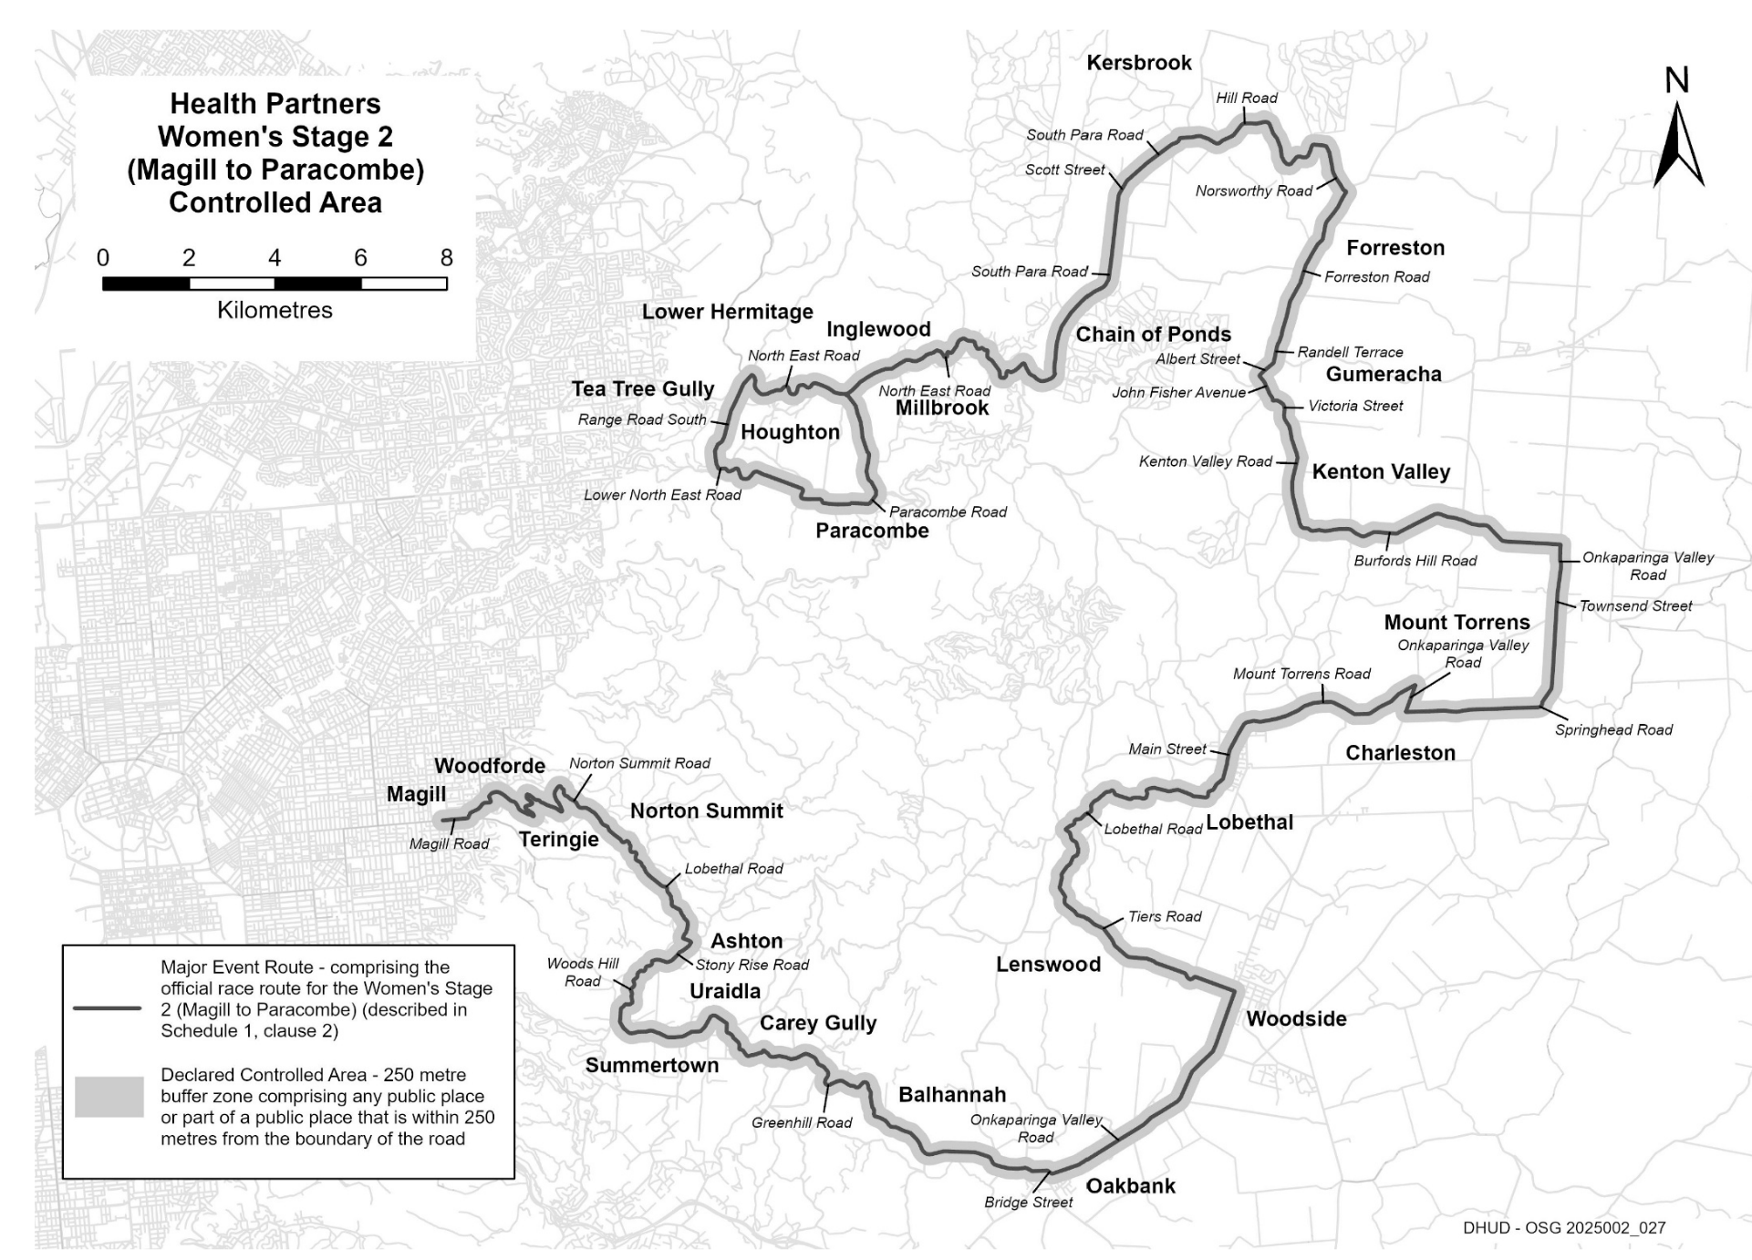
Description of Official Race Route for Health Partners Women’s Stage 2 (Magill to Paracombe)
The official race route for the Health Partners Women’s Stage 2 (Magill to Paracombe) commencing at the intersection of Magill Road and Pepper Street in Magill, then easterly along Magill Road to its intersection with Norton Summit Road, then generally north-easterly, generally south-easterly, generally northerly, south-easterly, northerly and generally south-easterly until it becomes Lobethal Road in Norton Summit, then south-easterly along Lobethal Road to its intersection with Stony Rise Road in Ashton, then south-westerly and westerly along Stony Rise Road to its intersection with Woods Hill Road, then generally south-westerly, generally southerly, south-westerly and southerly along Woods Hill Road to its intersection with Greenhill Road in Summertown, then south-easterly, generally easterly, north-easterly, generally south-easterly, generally easterly, generally south-easterly along Greenhill Road until it becomes Bridge Street in Balhannah, then easterly and south easterly to its intersection with Onkaparinga Valley Road, then generally north-easterly along Onkaparinga Valley Road to its intersection with Tiers Road in Woodside, then generally westerly, and generally northerly to its intersection with Lobethal Road in Lenswood, then generally north-easterly, generally easterly and generally north-easterly to its intersection with Main Street in Lobethal, then northerly along Main Street until it becomes Mount Torrens Road, then generally easterly along Mount Torrens Road to its intersection with Onkaparinga Valley Road in Mount Torrens, then south-westerly along Onkaparinga Valley Road to its intersection with Springhead Road in Charleston, then easterly and northerly along Springhead Road until it becomes Townsend Street in Mount Torrens, then northerly along Townsend Street until it becomes Onkaparinga Valley Road, then northerly along Onkaparinga Valley Road to its intersection with Burfords Hill Road, then generally westerly along Burfords Hill Road to its intersection with Kenton Valley Road in Kenton Valley, then northerly along Kenton Valley Road until it becomes Victoria Street in Gumeracha, then westerly along Victoria Street to its intersection with John Fisher Avenue, then generally north-westerly along John Fisher Avenue to its intersection with Albert Street, then north-easterly along Albert Street to its intersection with Randell Terrace, the northerly along Randell Terrace until it becomes Forreston Road, then northerly along Forreston Road to its intersection with Norsworthy Road in Forreston, then northerly, westerly, and generally south-westerly along Norsworthy Road until it becomes Hill Road, then northerly and generally westerly along Hill Road to its intersection with South Para Road in Kersbrook, then south-westerly along South Para Road until it becomes Scott Street, then south-westerly along Scott Street until it becomes South Para Road, then southerly, south-westerly and southerly to its intersection with North East Road in Chain of Ponds, then westerly, north-westerly, generally south-westerly, generally north-westerly and generally south-westerly along North East Road to its intersection with Paracombe Road in Paracombe, then southerly and generally westerly along Paracombe Road to its intersection with Lower North East Road in Houghton, then westerly along Lower North East Road to its intersection with Range Road South, then northerly along Range Road South to its intersection with North East Road, then generally easterly along North East Road to its intersection with Paracombe Road in Paracombe.

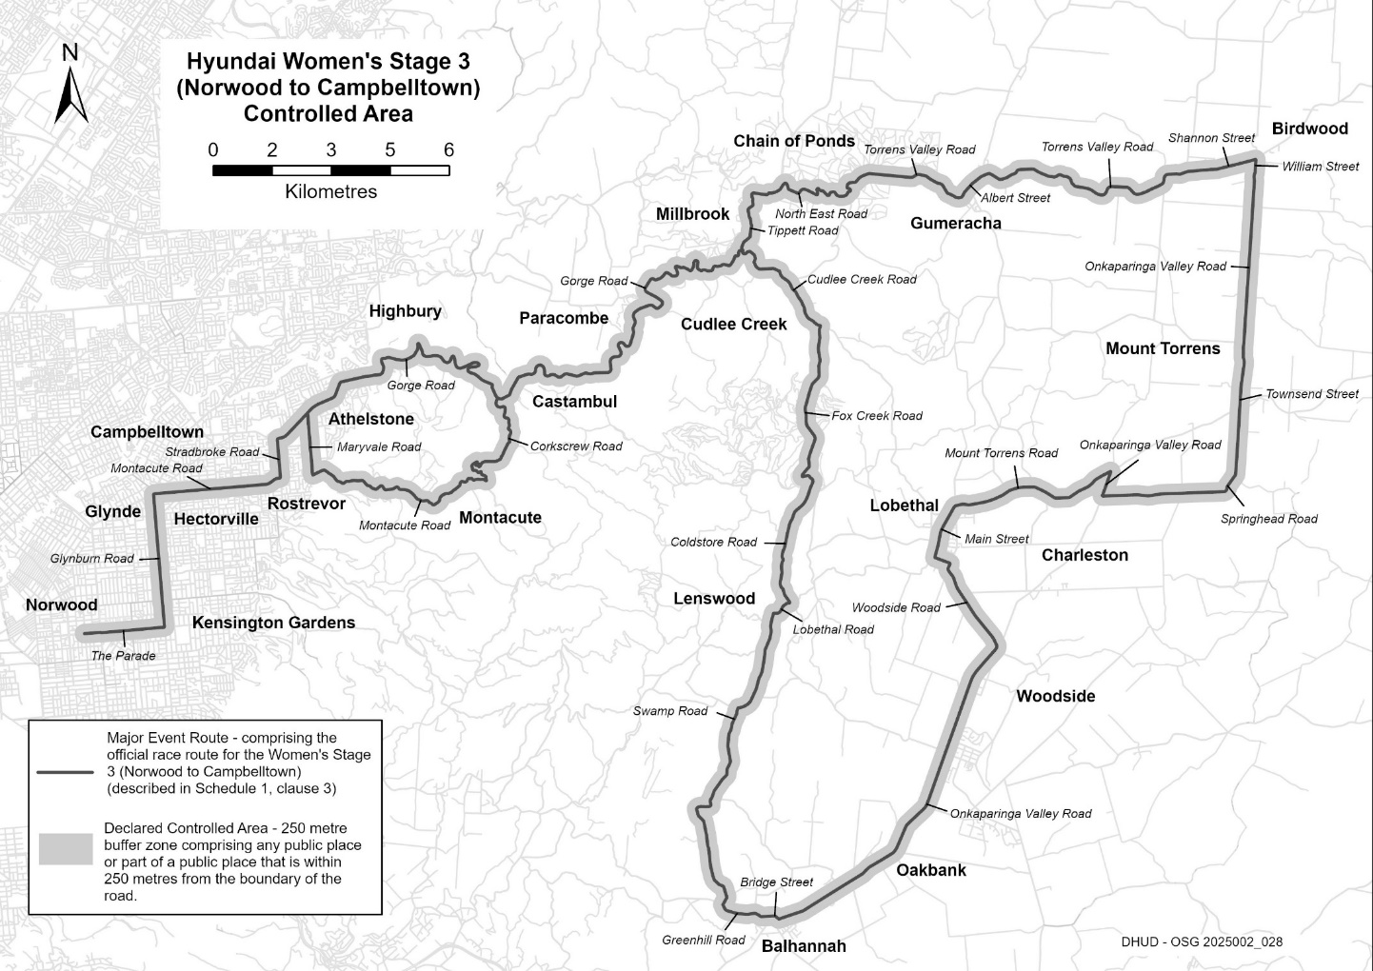
Description of Official Race Route for Hyundai Women’s Stage 3 (Norwood to Campbelltown)
The official race route for Hyundai Women’s Stage 3 (Norwood to Campbelltown) comprises—
(a) the portion of road commencing at the intersection of The Parade and George Street, in Norwood, then easterly along The Parade to its intersection with Glynburn Road, then northerly along Glynburn Road to its intersection with Montacute Road in Glynde, then easterly along Montacute Road to its intersection with Stradbroke Road in Rostrevor, then northerly along Stradbroke Road to its intersection with Gorge Road in Athelstone, then generally north-easterly, generally south-easterly, generally easterly and generally north-easterly to its intersection with Tippett Road in Millbrook, then generally northerly and easterly to its intersection with North East Road in Chain of Ponds, then generally easterly to its intersection with Torrens Valley Road in Gumeracha, then generally easterly until it becomes Albert Street, then north-easterly and easterly until it becomes Torrens Valley Road, then generally easterly along Torrens Valley Road until it becomes Shannon Street in Birdwood, then easterly along Shannon Street to its intersection with William Street, then southerly along William Street until it becomes Onkaparinga Valley Road, then southerly along Onkaparinga Valley Road until it becomes Townsend Street in Mount Torrens, then southerly along Townsend Street to its intersection with Springhead Road, then southerly and westerly along Springhead Road to its intersection with Onkaparinga Valley Road in Charleston, then northerly along Onkaparinga Valley Road to its intersection with Mount Torrens Road in Mount Torrens, then generally westerly along Mount Torrens Road until it becomes Main Street in Lobethal, then southerly along Main Road to its intersection with Woodside Road, then generally south-easterly along Woodside Road to its intersection with Onkaparinga Valley Road in Woodside, then generally south-westerly along Onkaparinga Vally Road to its intersection with Bridge Street in Balhannah, then westerly along Bridge Street to its intersection with Greenhill Road, then generally westerly along Greenhill Road to its intersection with Swamp Road, then generally northerly, north-easterly, generally northerly along Swamp Road to its intersection with Lobethal Road in Lenswood, then generally north-easterly along Lobethal Road to its intersection with Coldstore Road in Lobethal, then generally northerly along Coldstore Road until it becomes Fox Creek Road in Cudlee Creek, then northerly, generally westerly and northerly to its intersection with Cudlee Creek Road, then north-westerly to its intersection with Gorge Road and
(b) the portion of road commencing at the intersection of Gorge Road and Corkscrew Road in Castambul, then generally southerly, generally south-westerly and south-easterly to its intersection with Montacute Road in Montacute, then generally south-westerly and westerly to its intersection with Maryvale Road in Athelstone, then northerly to its intersection with Gorge Road.

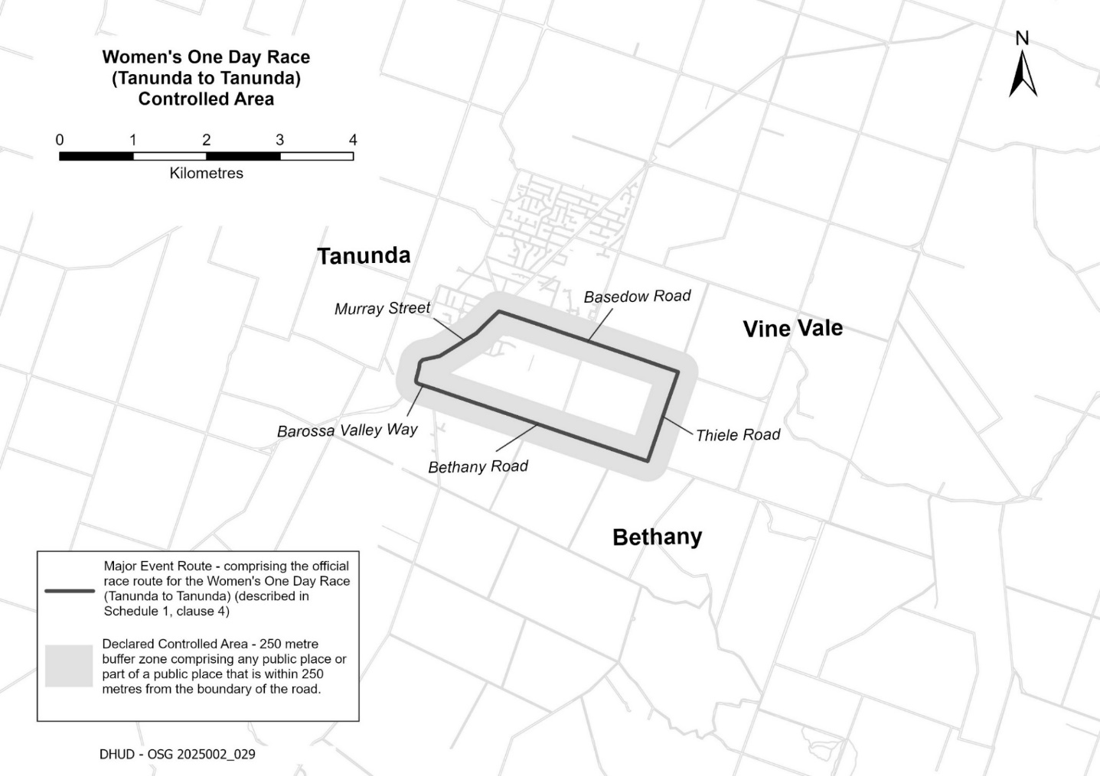
Description of Official Race Route for Vanguard Women’s One Day Race (Tanunda to Tanunda)
The official race route for the Women’s One Day Race (Tanunda to Tanunda) commencing at the intersection of Murray Street and John Street in Tanunda, then north-easterly along Murray Street to its intersection with Basedow Road, south-easterly along Basedow Road to its intersection with Thiele Road, then south-westerly along Thiele Road to its intersection with Bethany Road in Bethany, then north-westerly along Bethany Road to its intersection with Barossa Valley Way, then north-westerly along Barossa Valley Way until it becomes Murray Street, then northerly and north-easterly along Murray Street to the place of commencement.

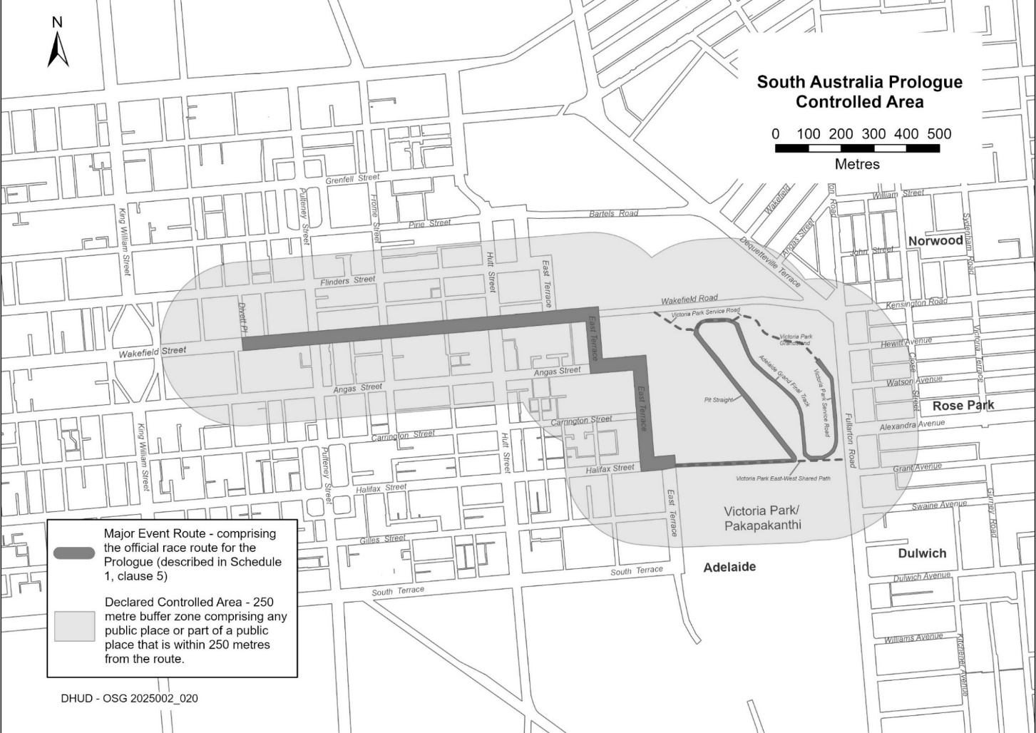
Description of Official Race Route for South Australia Prologue
The official race route for the Men’s Prologue (Adelaide) comprises the portion of road commencing in Adelaide at the intersection of Wakefield Street and Divett Place, then easterly along Wakefield Street to its intersection with East Terrace and Wakefield Road, then southerly, easterly, southerly and easterly along East Terrace to its intersection with Victoria Park East-West Shared Path, then easterly along Victoria Park East-West Shared Path to its intersection with Pit Straight, then north-westerly along Pit Straight to its intersection with Victoria Park Service Road, then easterly along Victoria Park Service Road to its intersection with Adelaide Grand Final Track, then south-easterly along Adelaide Grand Final Track to its intersection with Victoria Park East-West Shared Path, then easterly, northerly and north-westerly to Victoria Park Grandstand.

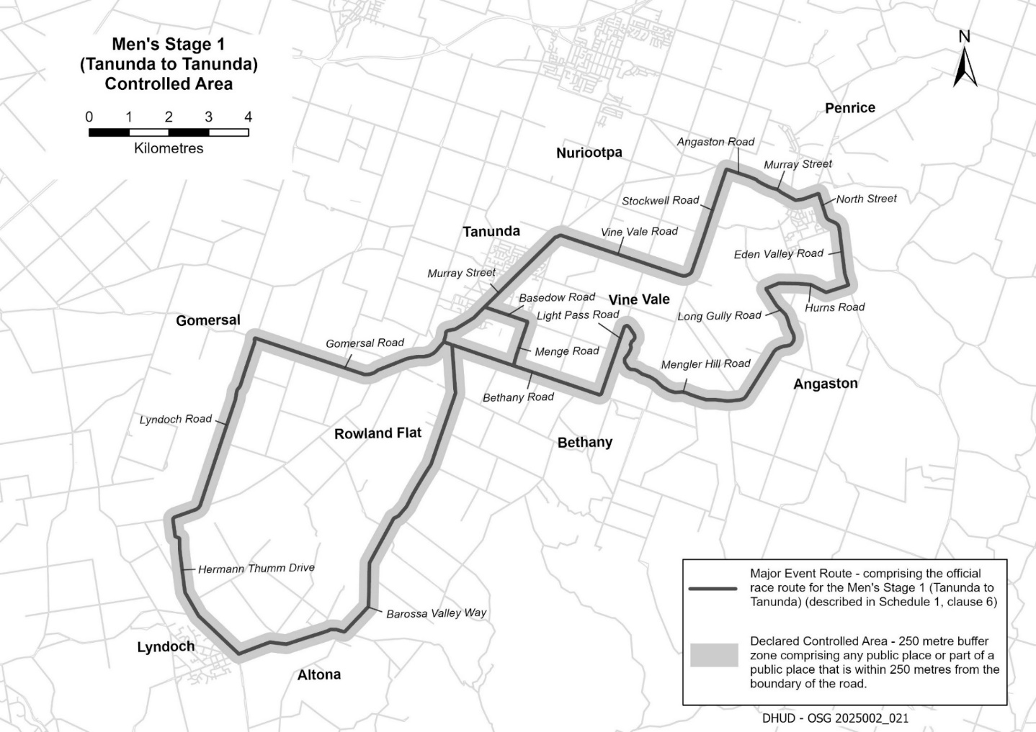
Description of official race route Vanguard Men’s Stage 1 (Tanunda to Tanunda)
The official race route for Men’s Stage 1 (Tanunda to Tanunda) comprises—
(a) the portion of road commencing at the intersection of Murray Street and John Street in Tanunda, then north-easterly along Murray Street to its intersection with Basedow Road, south-easterly along Basedow Road to its intersection with Menge Road, then south-westerly along Menge Road to its intersection with Bethany Road in Bethany, then north-westerly along Bethany Road to its intersection with Barossa Valley Way in Tanunda, then southerly, generally south-westerly, generally westerly and north-westerly along Barossa Valley Way to its intersection with Hermann Thumm Drive in Lyndoch, then north-westerly, northerly and north-westerly along Hermann Thumm Drive to its intersection with Lyndoch Road in Lyndoch, then northerly, easterly, generally north-easterly along Lyndoch Road to its intersection with Gomersal Road in Gomersal, then generally south-easterly and generally north-easterly along Gomersal Road to its intersection with Barossa Valley Way in Tanunda, then northerly and generally north-easterly along Barossa Valley Way until it becomes Murray Street to the point of commencement;
(b) from the point of commencement on Murray Street in Tanunda to its intersection with Vine Vale Road, then south-easterly along Vine Vale Road to its intersection with Stockwell Road in Vine Vale, then north-easterly along Stockwell Road to its intersection with Angaston Road in Angaston, then south-easterly along Angaston Road until it becomes Murray Street in Angaston, then generally south-easterly and north-easterly along Murray Street to its intersection with North Street, then generally south-easterly, generally easterly and southerly along North Street until it becomes Eden Valley Road, then southerly along Eden Valley Road to its intersection with Hurns Road, then generally westerly along Hurns Road to its intersection with Long Gully Road, then south-easterly along Long Gully Road until it becomes Mengler Hill Road, then generally south-easterly, generally south-westerly, generally westerly, generally north-westerly, north-easterly and north-westerly along Mengler Hill Road to its intersection with Light Pass Road in Vine Vale, then south-westerly along Light Pass Road to its intersection with Bethany Road in Bethany, then north-westerly along Bethany Road to its intersection with Menge Road;
(c) the portion of road commencing at the intersection of Bethany Road and Barossa Valley Way, then north-westerly along Barossa Valley Way until it becomes Murray Street.

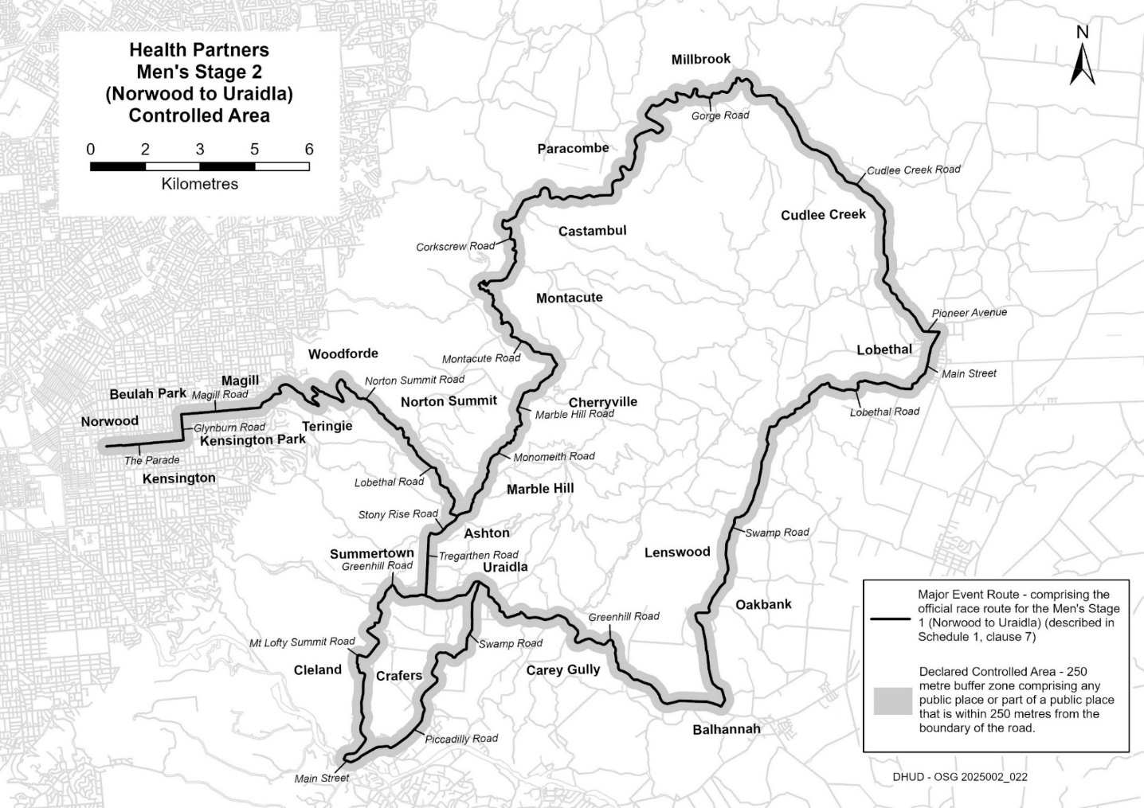
Description of Official Race Route Health Partners Men’s Stage 2 (Norwood to Uraidla)
The official race route for Health Partners Men’s Stage 2 (Norwood to Uraidla) comprises—
(a) the portion of road commencing at the intersection of The Parade and George Street in Norwood, then easterly along The Parade to its intersection with Glynburn Road in Kensington Park, then northerly along Glynburn Road to its intersection with Magill Road in Kensington Gardens, then easterly along Magill Road until its intersection with Norton Summit Road in Magill, then generally north-easterly, south-easterly, generally northerly, south-easterly, generally northerly and south-easterly along Norton Summit Road until it becomes Lobethal Road in Norton Summit, then generally south-easterly along Lobethal Road to its intersection with Stony Rise Road in Ashton, then generally south-westerly and westerly along Stony Rise Road until its intersection with Tregarthen Road in Ashton, then southerly along Tregarthen Road until its intersection with Greenhill Road in Summertown, then westerly, north-westerly and generally south-westerly along Greenhill Road to its intersection with Mount Lofty Summit Road, then generally southerly, generally south-westerly, south-easterly, south-westerly, generally southerly and south-westerly along Mount Lofty Summit Road to its intersection with Main Street in Crafers, then south-easterly along Main Street to its intersection with Piccadilly Road, then north-easterly and easterly along Piccadilly Road to its intersection with Swamp Road, then generally south-easterly, generally north-easterly and generally northerly along Swamp Road to its intersection with Greenhill Road in Uraidla, then south-easterly, southerly, south-easterly, generally easterly, generally south-easterly, generally south-westerly, generally easterly, generally southerly, generally south-easterly and generally easterly along Greenhill Road to its intersection with Swamp Road in Balhannah, then generally northerly, easterly and generally north-easterly along Swamp Road to its intersection with Lobethal Road in Lenswood, then generally north-easterly, easterly and north-easterly along Lobethal Road to its intersection with Main Road in Lobethal, then generally north-easterly along Main Road to its intersection with Pioneer Avenue, then westerly along Pioneer Avenue until it becomes Cudlee Creek Road, then north-westerly, northerly and north-westerly along Cudlee Creek Road to its intersection with Gorge Road in Cudlee Creek, then westerly, northerly, generally westerly, south-westerly, westerly, northerly, south-westerly, south-easterly, south-westerly, westerly and south-westerly along Gorge Road to its intersection with Corkscrew Road in Castambul, then southerly, easterly, southerly, generally south-westerly and south-easterly along Corkscrew Road to its intersection with Montacute Road in Montacute, then generally south-easterly and south-westerly along Montacute Road until it becomes Marble Hill Road, then generally south-westerly along Marble Hill Road to its intersection with Monomeith Road in Ashton, then southerly and south-westerly along Monomeith Road to its intersection with Stony Rise Road, and
(b) the portion of road commencing at the intersection of Tregarthen Road with Greenhill Road in Summertown, then generally easterly and north-easterly along Greenhill Road to its intersection with Swamp Road in Uraidla.

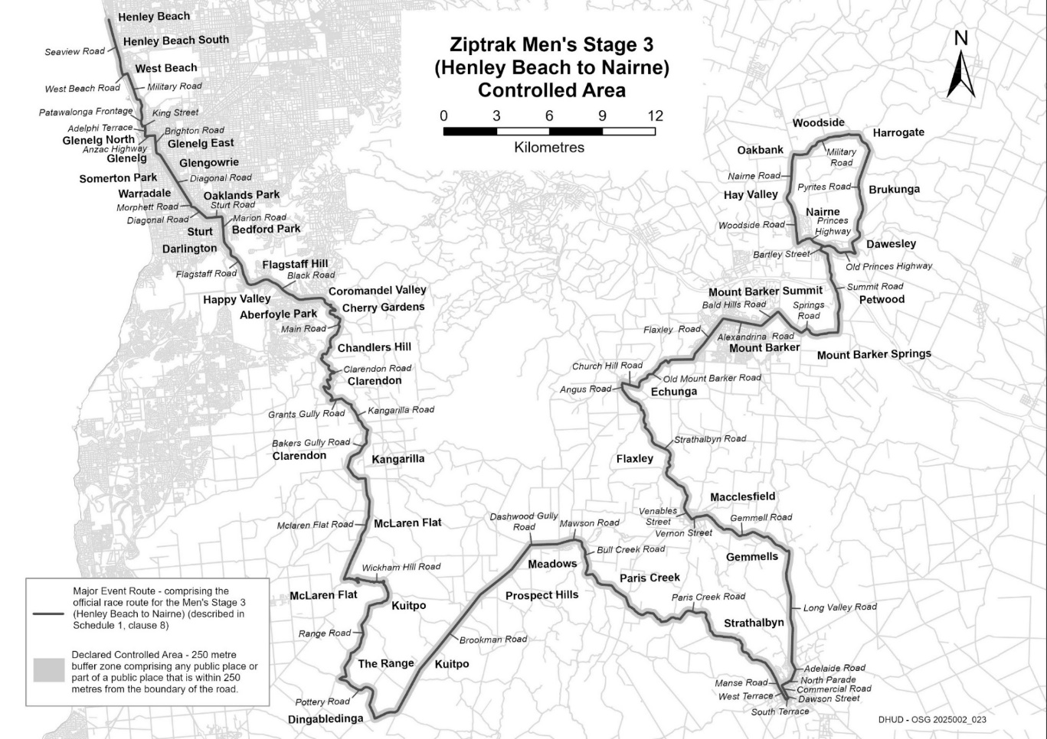
Description of Official Race Route for Ziptrak Men’s Stage 3 (Henley Beach to Nairne)
The official race route for Ziptrak Men’s Stage 3 (Henley Beach to Nairne) comprises the portion of road commencing at the intersection of Seaview Road and Main Street, Henley Beach, then generally southerly along Seaview Road to its intersection with West Beach Road in West Beach, then easterly along West Beach Road to its intersection with Military Road, then generally southerly along Military Road until it becomes Patawalonga Frontage in Glenelg North, then southerly along Patawalonga Frontage to its intersection with King Street, then easterly along King Street to its intersection with Adelphi Terrace, then southerly along Adelphi Terrace to its intersection with Anzac Highway in Glenelg, then easterly along Anzac Highway to its intersection with Brighton Road, then south along Brighton Road to its intersection with Diagonal Road in Glenelg East, then south-easterly along Diagonal Road to its intersection with Morphett Road in Oaklands Park, then southerly along Morphett Road to its intersection with Diagonal Road, then south-easterly along Diagonal Road to its intersection with Sturt Road in Marion, then easterly along Sturt Road to its intersection with Marion Road in Mitchell Park, then southerly along Marion Road to its intersection with Flagstaff Road in Bedford Park, then generally south-easterly along Flagstaff Road to its intersection with Black Road in Flagstaff Hill, then north-easterly, south-easterly and generally easterly along Black Road to its intersection with Main Road in Coromandel Valley, then generally south-easterly, westerly, southerly, generally south-easterly, generally south-westerly and south-easterly along Main Road to its intersection with Clarendon Road in Chandlers Hill, then generally south-easterly, generally south-westerly, westerly, southerly, generally north-westerly, generally south-easterly, south-westerly and southerly along Clarendon Road to its intersection with Grants Gully Road in Clarendon, then easterly and generally south-easterly until it becomes Kangarilla Road, then generally south-easterly to its intersection with Bakers Gully Road, then generally south-westerly and south-easterly to its intersection with McLaren Flat Road in Kangarilla, then generally southerly and south-westerly along McLaren Flat Road to its intersection with Wickham Hill Road in McLaren Flat, then generally easterly, north-westerly, easterly and southerly along Wickham Hill Road to its intersection with Range Road in Kuitpo, then generally south-westerly along Range Road to its intersection with Pottery Road in The Range, then generally south-easterly and southerly to its intersection with Brookman Road in Dingabledinga, then generally north-easterly along Brookman Road to its intersection with Dashwood Gully Road in Meadows, then easterly along Dashwood Gully Road until it becomes Mawson Road, then generally easterly along Mawson Road to its intersection with Bull Creek Road, then generally southerly along Bull Creek Road to its intersection with Paris Creek Road in Paris Creek, then generally south-easterly, generally easterly and generally south-easterly along Paris Creek Road until it becomes Manse Road in Strathalbyn, then south-easterly until it becomes West Terrace, then south-easterly along West Terrace to its intersection with South Terrace, then north-easterly along South Terrace to its intersection with Dawson Street, then north-westerly along Dawson Street until it becomes Commercial Road, then north-westerly along Commercial Road to its intersection with North Parade, then generally north-easterly along North Parade to its intersection with Adelaide Road, then north-easterly and north-westerly along Adelaide Road until it becomes Long Valley Road, then generally north along Long Valley Road to its intersection with Gemmell Road in Gemmells, then generally north-westerly and generally westerly until it becomes Vernon Street in Macclesfield, then generally westerly along Vernon Street to its intersection with Venables Street, then north-westerly along Venables Street until it becomes Strathalbyn Road, then north-easterly, generally north-westerly, generally northerly and generally north-westerly until it becomes Angus Road in Echunga, then northerly along Angus Road to its intersection with Church Hill Road, then south-easterly along Church Hill Road to its intersection with Old Mount Barker Road, then generally north-easterly and easterly along Old Mount Barker Road to its intersection with Flaxley Road in Mount Barker, then north-easterly along Flaxley Road to its intersection with Alexandrina Road, then easterly along Alexandrina Road to its intersection with Bald Hills Road, then north-easterly along Bald Hills Road to its intersection with Springs Road, then south-easterly, north-easterly, south-easterly and easterly to its intersection with Summit Road in Mount Barker Springs, then northerly and north-westerly along Summit Road to its intersection with Bartley Street in Nairne, then generally north along Bartley Street to its intersection with Princes Highway, then north-westerly and south-westerly along Princes Highway to its intersection with Woodside Road, then generally northerly along Woodside Road until it becomes Nairne Road in Hay Valley, then generally northerly along Nairne Road to its intersection with Military Road, then easterly, north-easterly, easterly and south-easterly along Military Road to its intersection with Pyrites Road in Brukunga, then generally southerly along Pyrites Road to its intersection with Old Princes Highway in Nairne, then generally westerly along Old Princes Highway to its intersection with Bartley Street.
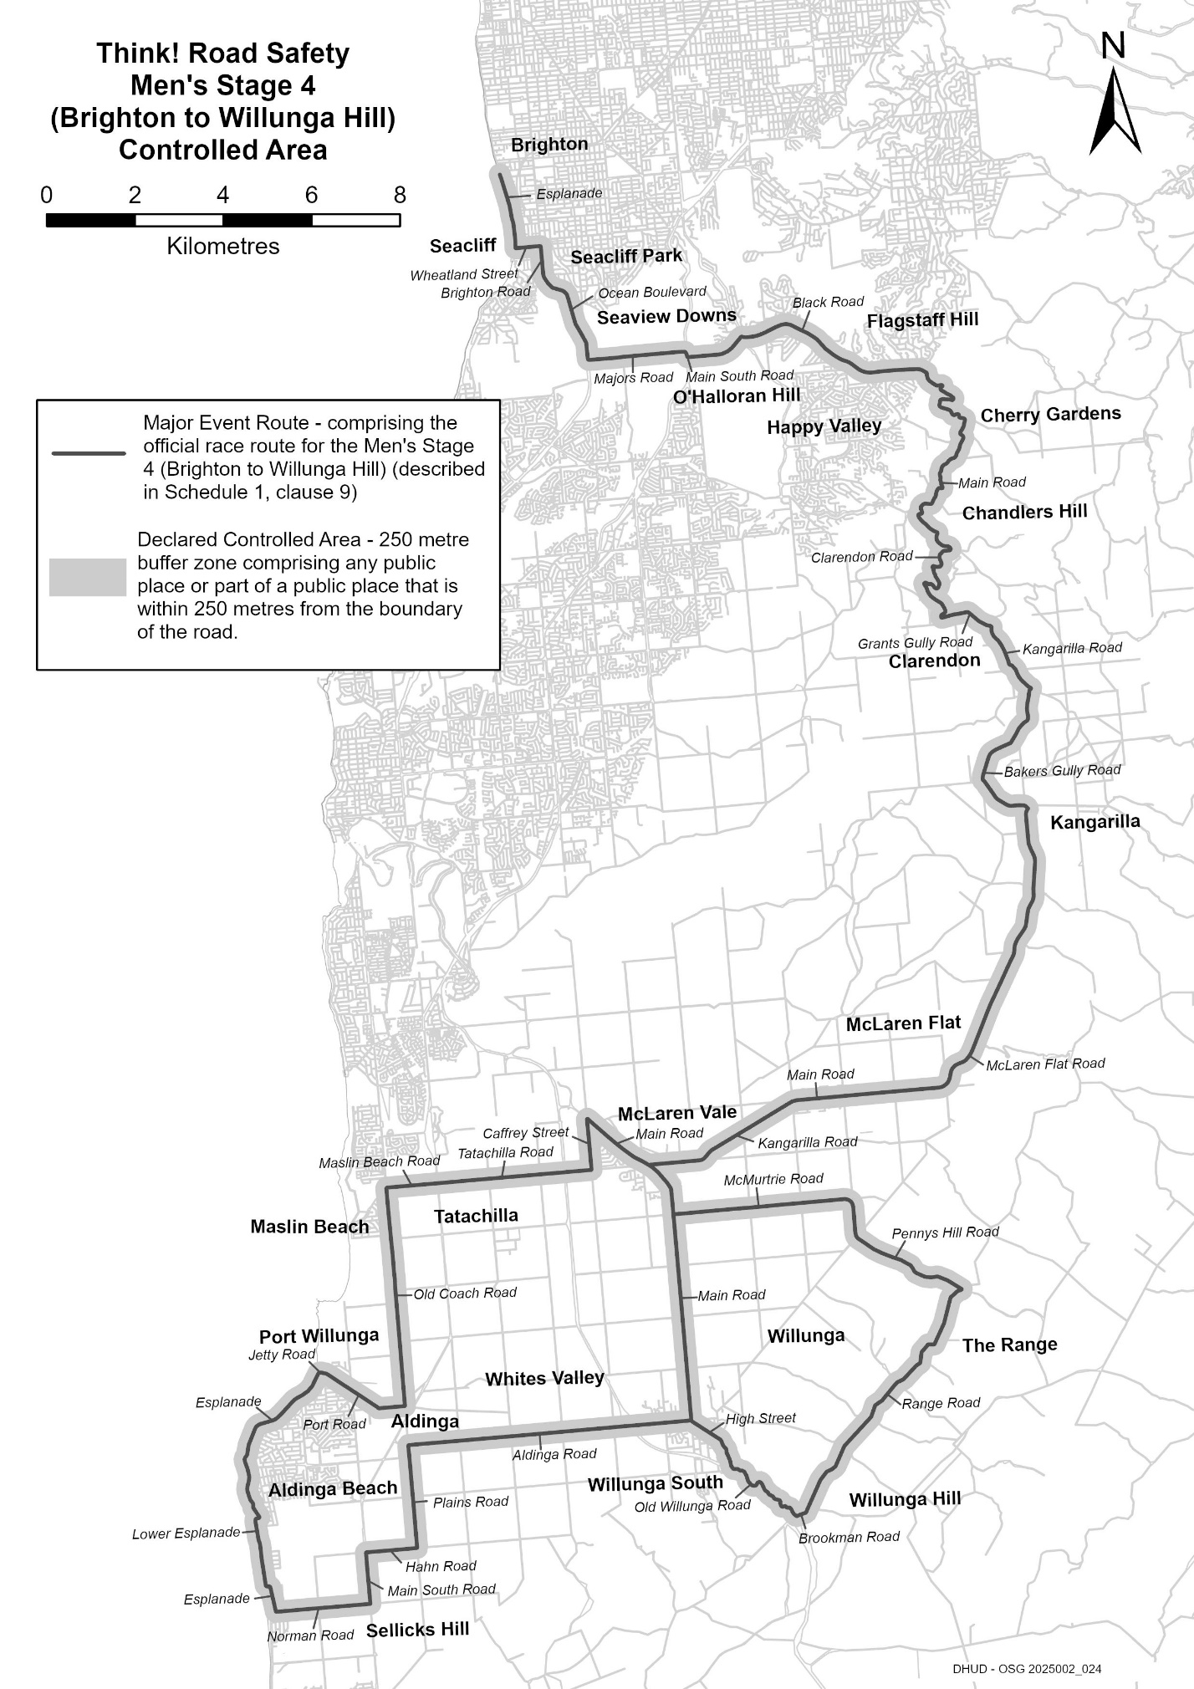
Description of Official Race Route for Think! Road Safety Men’s Stage 4 (Brighton to Willunga Hill)
The official race route for Think! Road Safety Men’s Stage 4 (Brighton to Willunga Hill) comprises—
(a) the portion of road commencing next to 133 Esplanade, Brighton, then southerly along the Esplanade to its intersection with Wheatland Street in Seacliff, then easterly along Wheatland Street to its intersection with Brighton Road, then southerly along Brighton Road until it becomes Ocean Boulevard in Seacliff Park, then generally southerly along Ocean Boulevard to its intersection with Majors Road in Seaview Downs, then easterly along Majors Road to its intersection with Main South Road in O’Halloran Hill, then southerly along Main South Road to its intersection with Black Road, then easterly, north-easterly, south-easterly and easterly along Black Road to its intersection with Main Road in Coromandel Valley, then generally south-easterly, westerly, southerly, generally south-easterly, generally south-westerly and south-easterly along Main Road to its intersection with Clarendon Road in Chandlers Hill, then generally south-easterly, generally south-westerly, westerly, southerly, generally north-westerly, generally south-easterly and south-westerly to its intersection with Grants Gully Road in Clarendon, then easterly and generally south-easterly until it becomes Kangarilla Road, then generally south-easterly to its intersection with Bakers Gully Road, then generally south-westerly and south-easterly to its intersection with McLaren Flat Road in Kangarilla, then generally south-westerly and westerly along McLaren Flat Road until it becomes Main Road in McLaren Flat, then westerly along Main Road until it becomes Kangarilla Road, then south-westerly and westerly along Kangarilla Road to its intersection with Main Road in McLaren Vale, then south-easterly and southerly along Main Road to its intersection with High Street in Willunga, then south-easterly along High Street until it becomes Old Willunga Hill Road, then generally south-easterly along Old Willunga Hill Road to its intersection with Brookman Road in Willunga Hill, then easterly along Brookman Road to its intersection with Range Road, then generally north-easterly along Range Road to its intersection with Pennys Hill Road in The Range, then north-westerly and northerly along Pennys Hill Road to its intersection with McMurtrie Road in McLaren Vale, then westerly along McMurtrie Road to its intersection with Main Road, and
(b) the portion of road commencing at the intersection of Main Road and Aldinga Road in Willunga, then westerly along Aldinga Road to its intersection with Plains Road in Aldinga, then southerly along Plains Road to its intersection with Hahn Road in Sellicks Hill, then westerly along Hahn Road to its intersection with Main South Road, then southerly along Main South Road until its intersection with Norman Road, then westerly along Norman Road to its intersection with Esplanade in Aldinga Beach, then generally northerly along the Esplanade to its intersection with Lower Esplanade, the generally northerly to its intersection with Esplanade, then generally northerly and north-easterly along Esplanade to its intersection with Jetty Road in Port Willunga, then easterly along Jetty Road to its intersection with Port Road, then south-easterly and easterly along Port Road to its intersection with Old Coach Road in Aldinga, then northerly along Old Coach Road to its intersection with Maslin Beach Road on Maslin Beach, then easterly along Maslin Beach Road until it becomes Tatachilla Road, then easterly along Tatachilla Road to its intersection with Caffrey Street in McLaren Vale, then northerly along Caffrey Street to its intersection with Main Road.

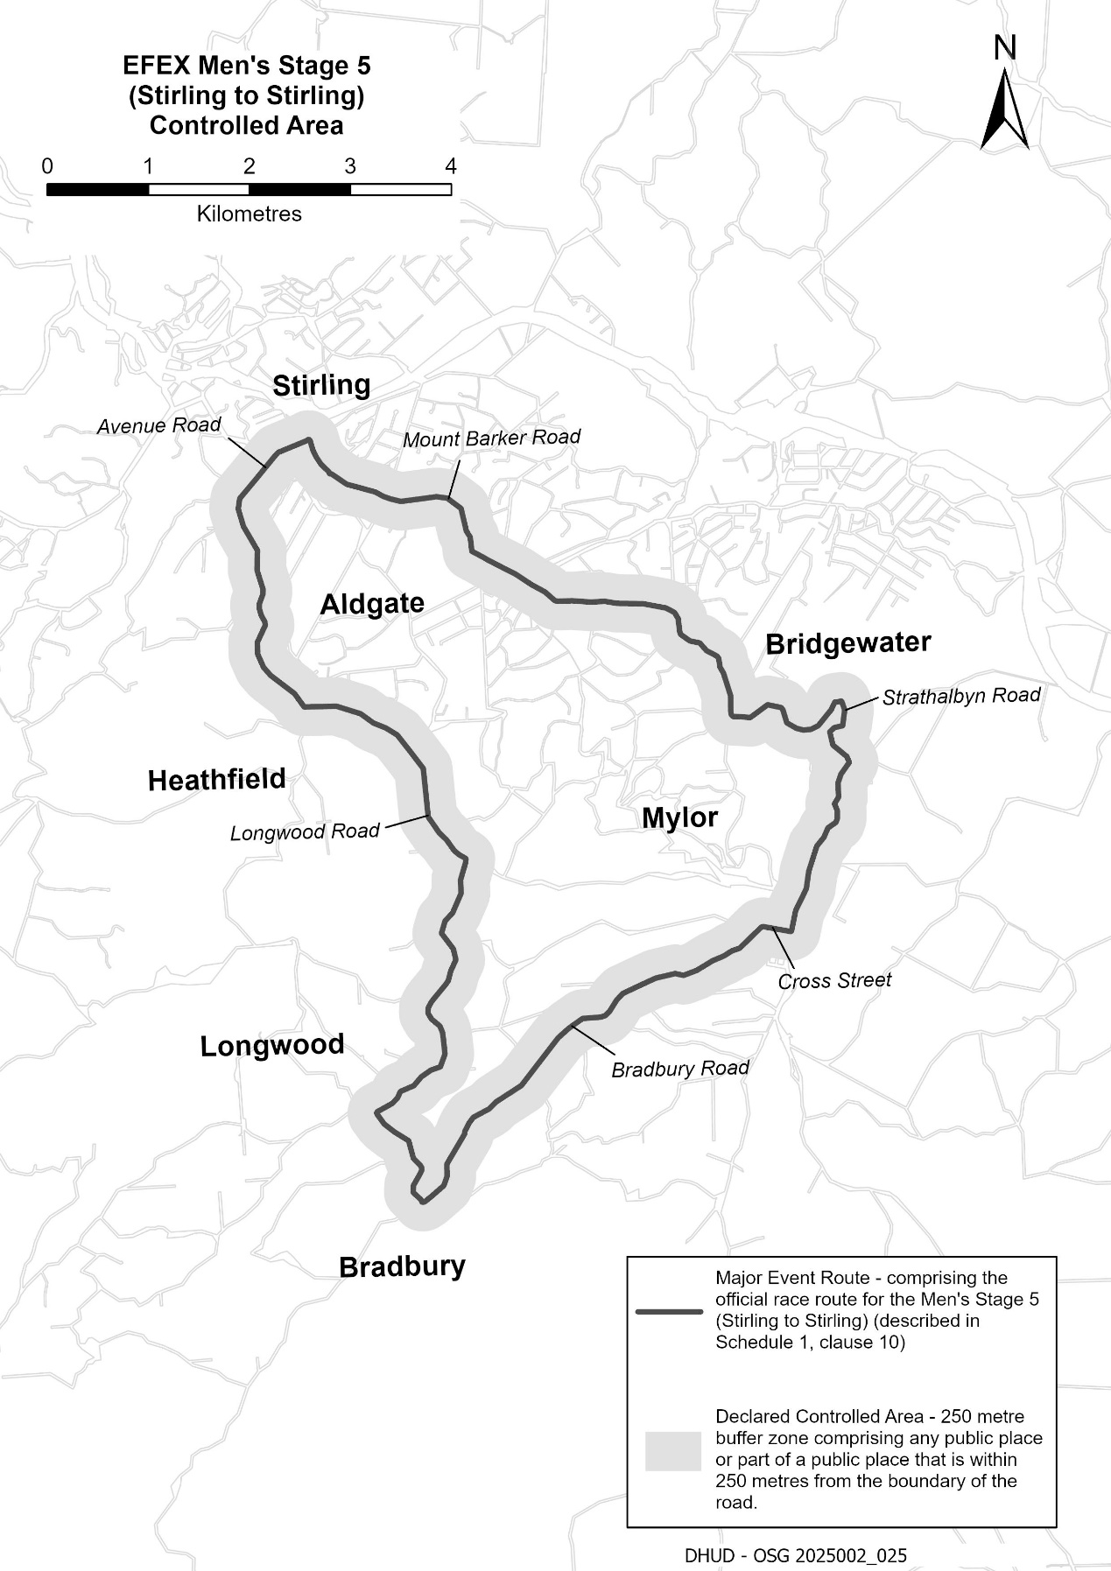
Description of Official Race Route for EFEX Men’s Stage 5 (Stirling to Stirling)
The official race route for EFEX Men’s Stage 5 (Stirling to Stirling) comprises the portion of road commencing at the intersection of Mount Barker Road and Garrod Crescent in Stirling, then north-westerly along Mount Barker Road to its intersection with Avenue Road, then south-easterly along Avenue Road until it becomes Longwood Road, then southerly, south-easterly, southerly, south-westerly and generally southerly along Longwood Road to its intersection with Bradbury Road in Bradbury, then generally north-easterly along Bradbury Road to its intersection with Cross Street in Mylor, then easterly along Cross Road its intersection with Strathalbyn Road, then northerly, generally westerly, northerly and north-westerly along Strathalbyn Road until it becomes Mount Barker Road in Aldgate, then north-westerly along Mount Barker Road to the point of commencement.
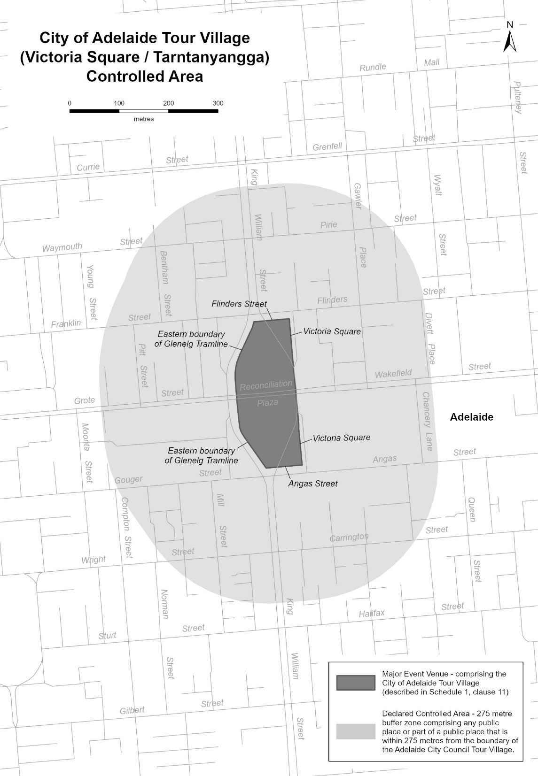
Description of the City of Adelaide Tour Village
The City of Adelaide Tour Village comprises the area in Victoria Square/Tarntanyangga in Adelaide bounded as follows: commencing at the point at which the eastern boundary of the Glenelg Tramline intersects the southern boundary of Franklin Street, then easterly along the southern boundary of Franklin Street to its intersection with the western boundary of the portion of road (running generally north to south) known as Victoria Square, then southerly along that boundary to its south-eastern-most point, then southerly in a straight line across Wakefield Street to the north-eastern-most point on the western boundary of the portion of road (running generally north to south) known as Victoria Square, then southerly along that boundary to its intersection with the northern boundary of Angas Street, then westerly along the northern boundary of Angas Street to its intersection with the eastern boundary of the Glenelg Tramline, then generally north-westerly and northerly along the eastern boundary of the Glenelg Tramline to its intersection with the southern boundary of Reconciliation Plaza, then northerly in a straight line across Reconciliation Plaza to the intersection of the northern boundary of Reconciliation Plaza with the eastern boundary of the Glenelg Tramline, then northerly and generally north-easterly along the eastern boundary of the Glenelg Tramline to the point of commencement.

Mental Health Act 2009
Authorised Mental Health Professional
Notice is hereby given in accordance with Section 94(1) of the Mental Health Act 2009, that the Chief Psychiatrist has determined the following persons as Authorised Mental Health Professionals:
David West
The determination will expire three years after the commencement date.
The Chief Psychiatrist make vary or revoke these determinations at any time.
Dated: 24 December 2025
Dr John Brayley
Chief Psychiatrist

MENTAL HEALTH ACT 2009
Determination that a Specified Place will be a Limited Treatment Centre
Notice is hereby given that the Chief Psychiatrist pursuant to Section 97 of the Mental Health Act 2009 (‘the Act’), has determined that the following facility is a Limited Treatment Centre:
Ward A, Port Pirie Regional Health Service, Corner of The Terrace and Alexander Street, Port Pirie SA 5540 (Ward A).
This determination is subject to the following conditions and limitations:
Overarching Conditions
• All aspects of the Rural and Remote Mental Health Procedure Mental State Examination, Risk Assessment, Observations and Management in General Health Settings (2023), as endorsed by the Yorke Northern Local Health Networks Clinical Effectiveness Committee on 4th September 2023 must be complied with in the operation and management of Ward A.
• A report must be provided each month to the Office of the Chief Psychiatrist which documents compliance in Ward A with this policy.
• Security staff used to observe or monitor patients in Ward A must receive training in operating within a healthcare setting,
de-escalating people in distress, and any necessary skills required to support a “Code Black” response.
• Any instance where untrained security staff are used to observe or monitor patients in Ward A must be reported to the Office of the Chief Psychiatrist within (2) days and this use must be by exception.
Conditions on the Admission of Voluntary Patients
A voluntary patient must not be admitted to Ward A unless:
• The Port Pirie Director of Nursing and Midwifery or their Delegate has approved the admission on the basis that there is the capability to provide necessary care for the patient’s clinical needs at that time in Ward A, and that for the expected duration of admission the Rural and Remote Mental Health Procedure Mental State Examination, Risk Assessment, Observations and Management in General Health Settings (2023) can be complied with.
• In making this decision, consideration should be given by the Port Pirie Director of Nursing and Midwifery or their Delegate to the limitations of Ward A’s physical environment in meeting the clinical needs of the patient.
Conditions on the Admission of Patients Under the Mental Health Act 2009, Section 56 (Care and Control)
A patient who in respect of whom a patient assistance request or a patient transport request has been issued, including patients to whom a Level 1 Inpatient Treatment Order applies, who is awaiting transport to an Approved Treatment Centre, must not be admitted to Ward A unless:
• The Port Pirie Director of Nursing and Midwifery or their Delegate has approved admission under the same conditions that apply to the care of voluntary patients (as outlined above), and
• An authorised officer has the person into their care and control, and
• The name of the authorised officer on site and able to attend to review the patient in Ward A is recorded in the clinical record, with a handover and update between authorised officers occurring at each change of shift.
Note: Ward A is a general ward with two rooms designated for mental health care. Patients to whom an Inpatient Treatment Order applies must not be admitted to Ward A, except in the circumstances above where the patient has an Inpatient Treatment Order made to another Approved Treatment Centre and is awaiting transport as soon as practicable.
Dated: 24 December 2025
Dr John Brayley
Chief Psychiatrist

MENTAL HEALTH ACT 2009
Extension of Temporary Conditions
Notice is hereby given that that the Chief Psychiatrist pursuant to Section 96 of the Mental Health Act 2009 (‘the Act’) has varied the determination published in the Government Gazette on 11 January 2024 that The Queen Elizabeth Hospital, 28 Woodville Road, Woodville, South Australia, 5011 is an Approved Treatment Centre subject to temporary conditions by extending the conditions attached to the determination dated 11 January 2024 until 24 June 2026.

These conditions are:
Cramond Ward, Queen Elizabeth Hospital may continue to admit voluntary mental health patients and patients subject to Inpatient Treatment Orders with the following conditions:
• Admission to dual occupancy rooms will be subject to an additional bed allocation procedure that considers the recognised limitations of dual occupancy rooms in acute inpatient mental health care. The procedure will describe clinical and other criteria for allocation of dual occupancy rooms, and how these criteria will be monitored.
• A report will be provided on a 6 monthly basis on the operation of dual occupancy rooms.
Admissions to single occupancy rooms can proceed without condition using standard clinical procedures.
In issuing this notice the Chief Psychiatrist notes the intent to phase out dual occupancy rooms at Cramond Ward.
Dated: 24 December 2025
Dr John Brayley
Chief Psychiatrist

MENTAL HEALTH ACT 2009
Extension of Temporary Conditions
Notice is hereby given that the Chief Psychiatrist pursuant to Section 96 of the Mental Health Act 2009 (‘the Act’) has varied the determination published in the Government Gazette on 11 January 2024 that the Noarlunga Health Services, Alexander Kelly Drive, Noarlunga, South Australia, 5168, is an Approved Treatment Centre subject to temporary conditions by extending the conditions attached to the determination dated 11 January 2024 until 24 June 2026.
These conditions are:
Morier Ward, Noarlunga Hospital, may continue to admit voluntary mental health patients and patients subject to Inpatient Treatment Orders with the following conditions:
• Admission to dual occupancy rooms will be subject to an additional bed allocation procedure that considers the recognised limitations of dual occupancy rooms in acute inpatient mental health care. The procedure will describe clinical and other criteria for allocation of dual occupancy rooms, and how these criteria will be monitored.
• A report will be provided on a 6 monthly basis on the operation of dual occupancy rooms.
Admissions to single occupancy rooms can proceed without condition using standard clinical procedures.
In issuing this notice the Chief Psychiatrist notes the intent to phase out dual occupancy rooms at Morier Ward.
Dated: 24 December 2025
Dr John Brayley
Chief Psychiatrist

MENTAL HEALTH ACT 2009
Variation of Determination—Approved Treatment Centre
Notice is hereby given that the Chief Psychiatrist pursuant to Section 96 of the Mental Health Act 2009 (‘the Act’) has varied the previous determination published in the Government Gazette on 30 May 2017 for Mt Gambier and Districts Health Service, 276-300 Wehl Street North, Mount Gambier, SA 5290, as an Approved Treatment Centre.
The new Wari-ngu Unit at Mt Gambier and Districts Health Service will now be included in the facility’s determination as an Approved Treatment Centre, subject to a condition limiting its use to the provision of sub-acute care and rehabilitation care for patients receiving care on a voluntary basis.
Dated: 24 December 2025
Dr John Brayley
Chief Psychiatrist

Mining Act 1971
Section 15
Whereas by Notice published in the South Australian Government Gazette on 18 October 2018 at page 3816 and on 20 December 2018 at pages 4325 to 4326 (‘the Notice’), pursuant to Section 15(5) of the Mining Act 1971 (‘the Act’) I advised that the Geological Survey of South Australia of the Department for Energy and Mining will be undertaking geological, geophysical and geochemical investigation and survey commencing from 18 October 2018 over land described in the Notice.
Pursuant to Section 15(6) of the Act, further notice is hereby given that the completion date in respect of the geological, geophysical and geochemical investigation and survey is extended from 31 December 2025 to 31 December 2030 unless another further notice extending the completion date is published in the South Australian Government Gazette.
Dated: 17 December 2025.
Paul De Ionno
Executive Director
Regulation and Compliance
Delegate of the Minister for Energy and Mining Delegate of the Director of Mines

Outback Communities (Administration and Management) Act 2009
Outback Communities Authority
Declaration of Community Contribution (Copley) for 2025-2026
Notice is hereby given that on 3 December 2025, the Outback Communities Authority, for the financial year ending 30 June 2026 and in exercise of the powers contained in Division 2, Part 3 of the Outback Communities (Administration and Management) Act 2009, resolved as follows:
Declaration of the Community Contribution
To declare a community contribution for the rateable land in:
• the township of Copley.
Purpose of Community Contribution
Declare a fixed charge of $308 per property unit on rateable land for the purpose of funding a household waste collection service in Copley. The charge will be raised on a pro-rata basis of $154 per property unit from 1 January 2026 to 30 June 2026.
Payment of Community Contribution
Pursuant to Section 181(2) of the Local Government Act 1999, that the community contribution is payable in two equal or approximately equal instalments as follows:
• first instalment, payable on 16 March 2026; and
• second instalment, payable on 15 June 2026.
Fixed charge amount approved by the Minister for Local Government on 18 December 2025.
Dated: 19 December 2025
M. Howard
Director
(A7265016)

Retirement Villages Act 2016
Section 59(1)
Voluntary Termination of Retirement Village Scheme
Take notice that I, Nat Cook, Minister for Seniors and Ageing Well, pursuant to Section 59(1) of the Retirement Villages Act 2016,
hereby terminate the Halsey Road retirement village scheme situated at 36B Halsey Road, Elizabeth East, SA, 5112 and comprising all of the land and improvements in Certificate of Title Register Book Volume 5133 Folio 553. I do so being satisfied for the purposes of Section 59(2) of the Act that there are no retirement village residents in occupation. The termination will take effect on the day upon which the retirement village endorsement is cancelled.
Dated: 18 December 2025
Nat Cook
Minister for Seniors and Ageing Well

South Australian Civil and Administrative Tribunal
SACAT Reference Number: 2025/SA003663
Notice of Renewal of Exemption before Tribunal Member Alex Lazarevich
I hereby certify that on the 17th of December 2025, the South Australian Civil and Administrative Tribunal, on application of the State of South Australia (Chief Executive, Department for Health and Wellbeing), made the following orders for renewal of an exemption:
1. That an exemption be granted to the State of South Australia (Chief Executive, Department for Health and Wellbeing, SA Ambulance Service, Commission on Excellence and Innovation in Health, Preventive Health, Barossa Hills Fleurieu Local Health Network, Flinders and Upper North Local Health Network, Limestone Coast Local Health Network, Northern Adelaide Local Health Network, Riverland Mallee Coorong Local Health Network, Southern Adelaide Local Health Network, Women’s and Children’s Local Health Network, and Yorke and Northern Local Health Network) and members of the AHCSA from the provisions of Sections 30(1), 52(1) and 103 of the EO Act for a period of three years, to enable the State of South Australia and the AHCSA and its members to advertise for Aboriginal and/or Torres Strait Islander persons, including Aboriginal and/or Torres Strait Islander persons of a specific gender (men and/or women), to apply for positions which undertake Aboriginal and/or Torres Strait Islander Health Worker roles and functions including, but not limited to, Aboriginal and/or Torres Strait Islander Health Practitioner; Health Worker (Clinical); Aboriginal Health Worker; Cultural Consultant; Mental Health Worker; Mental Health Consultant; Hospital Liaison Officer; Social and Emotional Wellbeing Worker; Maternal and Infant Care Worker; Director and Manager of Aboriginal Health; Patient Pathway Officer; Project/Program Officer; Disability Liaison Officer; Administration Officer/Trainee; Alcohol and Other Drugs Worker; Assistant in Nursing; Allied Health Practitioner; Allied Health Assistant Trainee; Board Member; Child and Mental Health Worker; Children’s Health and Development Practitioner/Trainee; Enrolled Nurse; Environmental Health Worker; Executive Assistant; Family Resource Worker; Health Services Coordinator; Health Team Leader; Human Resources Officer; Aboriginal Infant Care Worker and/or Trainee; Mental Health Cultural Worker; Chronic Disease Worker; Mental Health Cultural Advisor; Mental Health Nurse; Mental Health Nurse Practitioner; Midwife; Registered Nurse; and Transport Officer and to prefer Aboriginal and Torres Strait Islander applicants, including Aboriginal and Torres Strait Islander applicants of a specific gender (men and/or women), in offering employment in such positions, and to appoint Aboriginal and/or Torres Strait Islander applicants to such positions.
2. The above exemption is to remain in force for a period of 3 years commencing on 17 December 2025.
Dated: 17 December 2025
Principal Registrar
South Australian Civil and Adminstrative Tribunal

South Australian Skills Act 2008
Part 4—Apprenticeships, Traineeships and Training Contracts
Pursuant to the provision of the South Australian Skills Act 2008, the South Australian Skills Commission (SASC) gives notice that determines the following qualification and training contract conditions for Trades or Declared Vocations, in addition to those published in past Gazette notices.
*Trade/ #Declared Vocation/ Other Occupation | Qualification Code | Qualification Title | Nominal Term of Training Contract | Probationary Period | Supervision Level Rating
Concrete Batching Plant Operator# | MSM30325 | Certificate III in Manufactured Mineral Products | 36 months | 90 days | H
Condition/s | N/A
Dated: 24 December 2025
John Evangelista
Director, Traineeship and Apprenticeship Services
South Australian Skills Commission

South Australian Skills Act 2008
Part 4—Apprenticeships, Traineeships and Training Contracts
Pursuant to the provision of the South Australian Skills Act 2008, the South Australian Skills Commission (SASC) gives notice that determines the following qualification and training contract conditions for Trades or Declared Vocations, in addition to those published in past Gazette notices.
*Trade/ #Declared Vocation/ Other Occupation | Qualification Code | Qualification Title | Nominal Term of Training Contract | Probationary Period | Supervision Level Rating
IAAP Pathway—Cook* | SIT30821 | Certificate III in Commercial Cookery | 30 months | 90 days | M
Condition/s | Only available for delivery through the Industry Accelerated Apprenticeship Pilot.  The South Australian Skills Commission has mandated both the core and elective units of competency for this pathway. Apprentices training in this trade must undertake all mandated units of competency, or their equivalent.  Not suitable for a school-based apprenticeship.

*Trade/ #Declared Vocation/ Other Occupation | Qualification Code | Qualification Title | Nominal Term of Training Contract | Probationary Period | Supervision Level Rating
Employment Consultant# | CHC42021 | Certificate IV in Community Service | 24 months | 60 days | H
Condition/s | Not suitable as a school-based traineeship
Dated: 24 December 2025
Commissioner Cameron Baker
Chair of the South Australian Skills Commission

SOUTH AUSTRALIAN SKILLS ACT 2008
Part 4—Apprenticeships, Traineeships and Training Contracts
Pursuant to the provision of the South Australian Skills Act 2008, the South Australian Skills Commission (SASC) gives notice that determines the following qualification and training contract conditions for Trades or Declared Vocations, in addition to those published in past Gazette notices.
*Trade/ #Declared Vocation/ Other Occupation | Qualification Code | Qualification Title | Nominal Term of Training Contract | Probationary Period | Supervision Level Rating
Precast Worker# | MSM30325 | Certificate III in Manufactured Mineral Products (precast concrete) | 36 months | 90 days | H
Condition/s | In accordance with the Manufacturing Training Package rules for the award of MSM30325 Certificate III in Manufactured Mineral Products (precast concrete), at least 4 units must be selected from the Group B Precast Concrete specialisation.
Dated: 24 December 2025
Commissioner Cameron Baker
Chair of the South Australian Skills Commission

Local Government Instruments

City of Marion
Local Government Act 1999
Exclusion of Land from Community Land Classification
Notice is hereby given that pursuant to Section 193(4) of the Local Government Act 1999, the Council resolved at its meeting held on
26 November 2024, that the whole of the land comprised in Certificates of Title Volume 5349 Folio 187, Volume 5349 Folio 275, Volume 5454 Folio 329, and Volume 6277 Folio 362 and known as 8-10 The Esplanade and Allotment 29 Nungamoora Street, Hallett Cove SA 5158, be excluded from classification as Community Land.
Dated: 18 December 2025
Tony Harrison
Chief Executive Officer

CITY OF MARION
Local Government Act 1999
Exclusion of Land from Community Land Classification
Notice is hereby given that pursuant to Section 193(4) of the Local Government Act 1999, the Council resolved at its meeting held on 23 September 2025, that the whole of the land comprised in Certificates of Title Volume 5478 Folio 862, Volume 5396 Folio 194, Volume 5799 Folio 62 and Volume 5875 Folio 839 known as 2-8 Ash Avenue and Certificates of Title Volume 5385 Folio 838 and Volume 5385 Folio 837 known as 22-24 Chestnut Court all in Tonsley SA 5042, be excluded from classification as Community Land.
Dated: 18 December 2025
Tony Harrison
Chief Executive Officer

Public Notices

Unclaimed Goods Act 1987
Notice of Intention to Sell
Manheim Pty Ltd of 180 Phillip Highway, Elizabeth South SA 5112 intends to sell the following vehicles under the Unclaimed Goods Act 1987. Owners of the vehicles have been sent notices that state that they are ready for collection. If said owners do not make arrangements for payment within 28 days from now they will be disposed of to settle any outstanding debt.
Make | Model Description | Registration No. | VIN
Honda | Civic Gli | WUK045 | MRHES16502P042534
Dated: 16 December 2025
Rebecca Barry
Cox Automotive Australia & New Zealand
Ph: 1800 326 243

Notice Submission

The South Australian Government Gazette is published each Thursday afternoon.
Notices must be emailed by 4 p.m. Tuesday, the week of publication.
Submissions are formatted per the gazette style and a proof will be supplied prior to publication, along with a quote if applicable. Please allow one day for processing notices.
Alterations to the proof must be returned by 4 p.m. Wednesday.

Gazette notices must be submitted as Word files, in the following format:
• Title—the governing legislation
• Subtitle—a summary of the notice content
• Body—structured text, which can include numbered lists, tables, and images
• Date—day, month, and year of authorisation
• Signature block—name, role, and department/organisation authorising the notice

Please provide the following information in your email:
• Date of intended publication
• Contact details of the person responsible for the notice content
• Name and organisation to be charged for the publication—Local Council and Public notices only
• Purchase order, if required—Local Council and Public notices only

Email: governmentgazettesa@sa.gov.au
Phone: (08) 7133 3552
Website: www.governmentgazette.sa.gov.au

All instruments appearing in this gazette are to be considered official, and obeyed as such

Printed and published weekly by authority of T. Foresto, Government Printer, South Australia
$9.50 per issue (plus postage), $479.00 per annual subscription—GST inclusive
Online publications: www.governmentgazette.sa.gov.au

