
SUPPLEMENTARY GAZETTE
THE SOUTH AUSTRALIAN
GOVERNMENT GAZETTE
Published by Authority

Adelaide, Wednesday, 5 November 2025

Contents

Governor’s Instruments

Acts 4348

Appointments, Resignations and General Matters 4348

Proclamations—

Statutes Amendment (Transport Portfolio) Act
(Commencement) Proclamation 2025 4349

Regulations—

Planning, Development and Infrastructure (General) (Miscellaneous) Amendment Regulations 2025—
No. 113 of 2025 4350

Planning, Development and Infrastructure (Accredited Professionals) (Audits) Amendment Regulations 2025—
No.114 of 2025 4362

Road Traffic (Miscellaneous) (Approved Apparatus) Amendment Regulations 2025—No.115 of 2025 4364

Road Traffic (Miscellaneous) (Drink and Drug Driving) Amendment Regulations 2025—No.116 of 2025 4366

Road Traffic (Miscellaneous) (Device Testing)
Amendment Regulations 2025—No.117 of 2025 4368

Governor’s Instruments

Acts
Department of the Premier and Cabinet
Adelaide, 5 November 2025
His Excellency the Governor’s Deputy directs it to be notified for general information that he has in the name and on behalf of His Majesty The King, this day assented to the undermentioned Bills passed by the Legislative Council and House of Assembly in Parliament assembled, viz.:
No. 44 of 2025—Nurse and Midwife to Patient Ratios Bill 2025
An Act to establish nurse and midwife to patient ratios and other staffing requirements in incorporated hospitals, and for other purposes
No. 45 of 2025—Criminal Law Consolidation (Street Gangs) Amendment Bill 2025
An Act to amend the Criminal Law Consolidation Act 1935 and to make related amendments to the Serious and Organised Crime (Control) Act 2008
No. 46 of 2025—Radiation Protection and Control (Commencement of Proceedings) Amendment Bill 2025
An Act to amend the Radiation Protection and Control Act 2021
No. 47 of 2025—Highways (Works for Residential Developments) Amendment Bill 2025
An Act to amend the Highways Act 1926
No. 48 of 2025—Local Nuisance and Litter Control (Miscellaneous) Amendment Bill 2025
An Act to amend the Local Nuisance and Litter Control Act 2016, and to make related amendments to the Liquor Licensing Act 1997
No. 49 of 2025—Harbors and Navigation (Miscellaneous) Amendment Bill 2025
An Act to amend the Harbors and Navigation Act 1993
No. 50 of 2025—Preventive Health SA (Council Governance) Amendment Bill 2025
An Act to amend the Preventive Health SA Act 2024
By command,
Natalie Fleur Cook, MP
For Premier

Appointments, Resignations and General Matters
Department of the Premier and Cabinet
Adelaide, 5 November 2025
His Excellency the Governor’s Deputy in Executive Council has been pleased to appoint the undermentioned to the Adelaide Festival Corporation Board, pursuant to the provisions of the Adelaide Festival Corporation Act 1998:
Member: from 6 November 2025 until 5 November 2028
Donny Walford
Nicholas Stewart Linke
By command,
Natalie Fleur Cook, MP
For Premier
25ART0019CS

Proclamations
South Australia

Statutes Amendment (Transport Portfolio) Act (Commencement) Proclamation 2025
1—Short title
This proclamation may be cited as the Statutes Amendment (Transport Portfolio) Act (Commencement) Proclamation 2025.
2—Commencement
Section 20 of the Statutes Amendment (Transport Portfolio) Act 2024 (No 46 of 2024) comes into operation on 6 November 2025.
Made by the Governor’s Deputy
with the advice and consent of the Executive Council
on 5 November 2025

Regulations
South Australia

Planning, Development and Infrastructure (General) (Miscellaneous) Amendment Regulations 2025
under the Planning, Development and Infrastructure Act 2016

Contents
Part 1—Preliminary
1 Short title
2 Commencement
Part 2—Amendment of Planning, Development and Infrastructure (General) Regulations 2017
3 Amendment of regulation 3A—Application of Act (section 8)
4 Amendment of regulation 3F—Regulated and significant trees
5 Amendment of regulation 19—Incorporation of material (section 71(b))
6 Amendment of regulation 21—Minor or operational amendments (section 76)
7 Amendment of regulation 22—Prescribed scheme (section 93)
8 Amendment of regulation 25—Accredited professionals (section 97)
9 Amendment of regulation 29—Application to relevant authority
10 Amendment of regulation 53—Time within which decision must be made (section 125(1))
11 Amendment of regulation 61—Certificate of independent technical expert in certain cases
12 Amendment of regulation 65—Variation of authorisation (section 128)
13 Amendment of regulation 93—Notifications during building work
14 Amendment of regulation 109—Mining production tenements
15 Insertion of regulation 116A
116A Access to documents
16 Amendment of Schedule 3—Additions to definition of development
12 Division of proposed allotments
17 Amendment of Schedule 4—Exclusions from definition of development—general
18 Amendment of Schedule 8—Plans
19 Amendment of Schedule 9—Referrals
20 Amendment of Schedule 13—State agency development exempt from approval
21 Insertion of Schedule 18
Schedule 18—Maps of designated areas (regulation 3A)
1 Blakes Crossing
2 Blakes Grove
3 20 Acres at Andrews Farm
4 Playford and Lakeside at Andrews Farm
5 Eyre at Penfield
6 Playford Alive

Part 1—Preliminary
1—Short title
These regulations may be cited as the Planning, Development and Infrastructure (General) (Miscellaneous) Amendment Regulations 2025.
2—Commencement
(1) Subject to subregulation (2), these regulations come into operation on 7 November 2025.
(2) Regulation 17(4) comes into operation on 1 July 2026.
Part 2—Amendment of Planning, Development and Infrastructure (General) Regulations 2017
3—Amendment of regulation 3A—Application of Act (section 8)
(1) Regulation 3A—after subregulation (3) insert:
(3a) In accordance with section 8(2) of the Act, sections 213, 214 and 215 of the Act do not apply to circumstances in which there has been a contravention (whether before or after the commencement of this subregulation) consisting of a failure to comply with a condition relating to the provision of recycled water that is imposed under the Act in relation to a development authorisation issued for a development within a designated area.
(2) Regulation 3A(5)—after the definition of ancillary accommodation insert:
designated area means a shaded area bounded by a bold black line in a map set out in Schedule 18;
4—Amendment of regulation 3F—Regulated and significant trees
(1) Regulation 3F(4)(a)—after "pool," insert:
provided that the tree is on the same allotment as the dwelling or pool,
(2) Regulation 3F(6)(c)—delete subparagraph (c) and substitute:
(c) that is—
(i) in the case of a tree on land owned by, or under the care, control and management of, a council—undertaken by or on behalf of the council at any time; or
(ii) in any other case—undertaken at least 5 years after pruning of a kind referred to in this subregulation was last undertaken in relation to the tree,
5—Amendment of regulation 19—Incorporation of material (section 71(b))
(1) Regulation 19(ac)—delete ", in relation to regulation 19A"
(2) Regulation 19—after paragraph (c) insert:
(ca) Austroads;
6—Amendment of regulation 21—Minor or operational amendments (section 76)
Regulation 21—before its present contents (now to be designated as subregulation (2)) insert:
(1) The Environment Protection Act 1993 is prescribed for the purposes of section 76(1)(c)(i) of the Act.
7—Amendment of regulation 22—Prescribed scheme (section 93)
(1) Regulation 22(1)(d)—after "consent" insert:
and consent under section 102(1)(c) or (d) of the Act
(2) Regulation 22(1)(d)—after "106(2) of the Act" insert:
or where it is necessary in connection with the division for land to be vested in another entity or a public road to be created
8—Amendment of regulation 25—Accredited professionals (section 97)
Regulation 25(2)—delete subregulation (2) and substitute:
(2) For the purposes of section 97 of the Act, and subject to these regulations, an Accredited professional—building level 1 may act as a relevant authority for the purposes of giving building consent in relation to any class of development.
9—Amendment of regulation 29—Application to relevant authority
Regulation 29—after subregulation (4) insert:
(5) The appropriate fee for the purposes of section 119(1)(d) of the Act is the fee identified as the base amount in respect of an application for consent under Part 7 of the Act in a fee notice made for the purposes of the Act.
10—Amendment of regulation 53—Time within which decision must be made (section 125(1))
(1) Regulation 53(1)—after paragraph (b) insert:
(ba) if the application proposes to divide land under section 102(1)(c) or (d) of the Act and—
(i) the proposed development involves the division of land into 10 allotments or less; and
(ii) does not involve the creation of a public road,
30 business days;
(2) Regulation 53(1)—after paragraph (ja) insert:
(jb) if paragraph (ca) applies and the development that is the subject of the application for outline consent is being assessed against a proposed amendment to the Planning and Design Code, an additional period equal to the time taken for the proposed amendment to be adopted by the Minister must be added to the period that applies under paragraph (ca); and

(3) Regulation 53—after subregulation (4) insert:
(4a) In addition, if an application was verified under regulation 31—
(a) in less than the number of days prescribed for verification under regulation 31—an additional period equivalent to the remaining days prescribed for verification under that regulation must be added to the period prescribed in subregulation (1); or
(b) in more than the number of days prescribed for verification under regulation 31—a period equivalent to the days by which the period prescribed for verification under that regulation was exceeded is subtracted from the period prescribed in subregulation (1).
11—Amendment of regulation 61—Certificate of independent technical expert in certain cases
(1) Regulation 61(1)(a)—delete "of Volume 1, or Part 2.1 of Volume 2," and substitute:
or Part H1
(2) Regulation 61(1)(b)—delete "of Volume 1"
(3) Regulation 61(1)(c)—delete "of Volume 1, or Part 2.6 of Volume 2," and substitute:
or Part H6
12—Amendment of regulation 65—Variation of authorisation (section 128)
Regulation 65—after subregulation (1) insert:
(1a) For the purposes of subregulation (1), if the variation—
(a) relates to planning consent previously given by an accredited professional in respect of development within the area of a council; and
(b) is requested after final development approval has been granted,
the relevant authority will, insofar as the variation relates to planning consent, be the assessment manager appointed for the assessment panel of the council.
13—Amendment of regulation 93—Notifications during building work
Regulation 93—after subregulation (4) insert:
(4a) This regulation only applies to building work that constitutes development for the purposes of the Act.
14—Amendment of regulation 109—Mining production tenements
Regulation 109(5)(c)—after "Mining Acts" insert:
or the Hydrogen and Renewable Energy Act 2023

15—Insertion of regulation 116A
Before regulation 117 insert:
116A—Access to documents
(1) Subject to subregulation (2), an owner of land may inspect at the office of the council for the area in which the land is situated, or obtain from the council a copy of, any plans, drawings, specifications or other documents or information retained on the SA planning portal in relation to an application for a development authorisation under section 102 of the Act in respect of development on the land.
(2) The council is not required to make available any plans, drawings, specifications or other documents or information referred to in subregulation (1) for inspection or copying under that subregulation if to do so would—
(a) in the opinion of the council, unreasonably jeopardise the present or future security of a building; or
(b) involve an infringement of copyright in matter contained in a document; or
(c) constitute a breach of any other law.
(3) The council is not permitted to charge a fee for the inspection of documents or information under this regulation but may charge a reasonable fee for providing copies of documents or information, unless the Minister sets a fee for that purpose by fee notice made for the purposes of the Act.
16—Amendment of Schedule 3—Additions to definition of development
Schedule 3—after clause 11 insert:
12—Division of proposed allotments
The division of land that is subject to a development application that proposes to create an allotment comprising the land where—
(a) that application has not been finally determined; or
(b) —
(i) a development authorisation has been issued in respect of that application; and
(ii) the development authorisation is operative; and
(iii) a certificate of title has not been issued in respect of the land.

17—Amendment of Schedule 4—Exclusions from definition of development—general
(1) Schedule 4, clause 14(1)(c)(i)—delete "not more than 1 m deep"
(2) Schedule 4, clause 14(1)(c)(ii)—delete "not more than 1 m in diameter"
(3) Schedule 4, clause 18(1)—after paragraph (d) insert:
(da) the tree is on land on which a school that provides courses of instruction in primary or secondary education is located or is proposed to be built; or
(4) Schedule 4—after clause 21 insert:
22—Electric vehicle charging stations
(1) The construction, alteration, repair or maintenance of an electric vehicle charging station, other than—
(a) in respect of a local heritage place; or
(b) on adjacent land to a State heritage place or local heritage place; or
(c) in an area that is underground or covered and does not relate to a Class 1 building under the Building Code; or
(d) a charging station that features advertising that is not permitted advertising.
(2) For the purposes of subclause (1), permitted advertising is advertising that is no greater than 0.2 m² in size, is not illuminated and is for the purposes of identifying the charging station as such or providing other information directly related to the charging station.
18—Amendment of Schedule 8—Plans
Schedule 8, clause 7(3)(a)(iii)—delete subparagraph (iii)
19—Amendment of Schedule 9—Referrals
(1) Schedule 9, clause 3, table, Part A, item 8, column relating to "Period"—delete "30" and substitute:
20
(2) Schedule 9, clause 3, table, Part A, item 11, column relating to "Period"—delete "20" and substitute:
30
20—Amendment of Schedule 13—State agency development exempt from approval
(1) Schedule 13, clause 2(1)(w)(i)—delete subparagraph (i)
(2) Schedule 13, clause 5(b)(viii)(A)—delete subsubparagraph (A)

21—Insertion of Schedule 18
After Schedule 17 insert:
Schedule 18—Maps of designated areas (regulation 3A)
1—Blakes Crossing
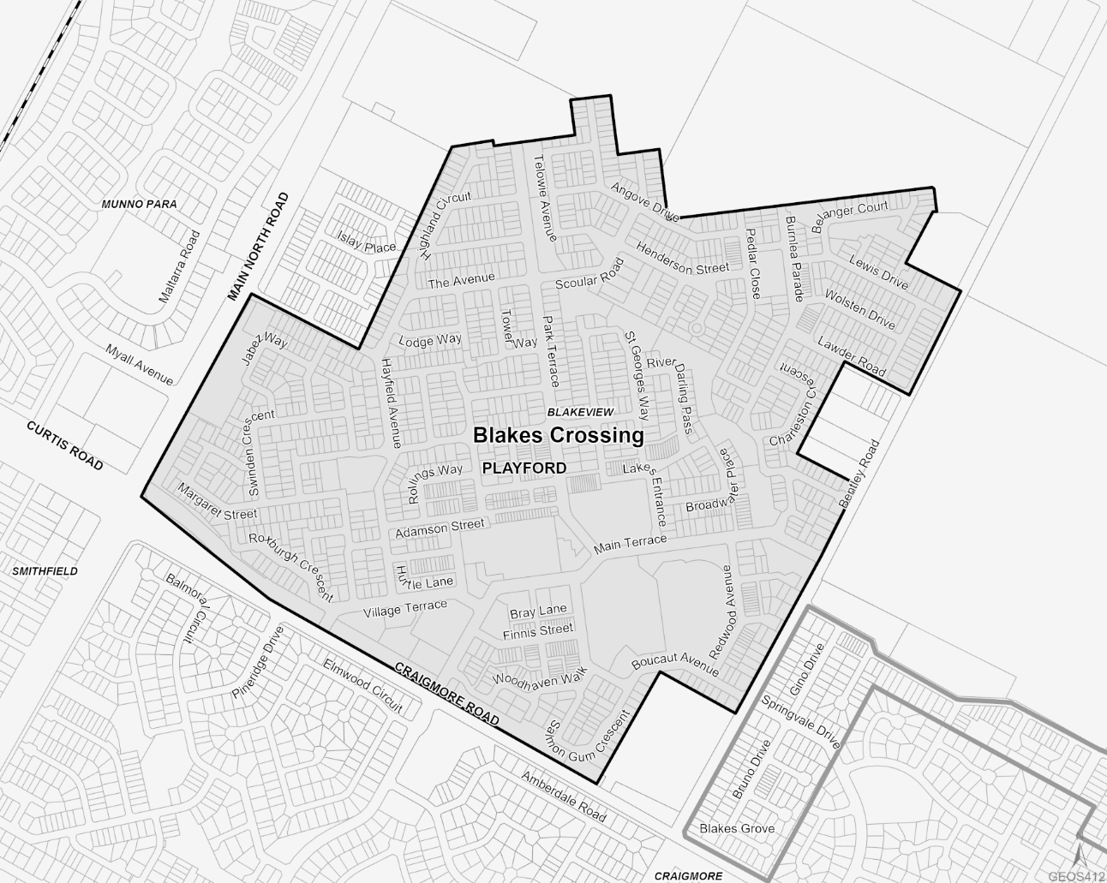
Note—
The shaded area bounded by the bold black line in this map shows the designated area referred to as "Blakes Crossing".
2—Blakes Grove
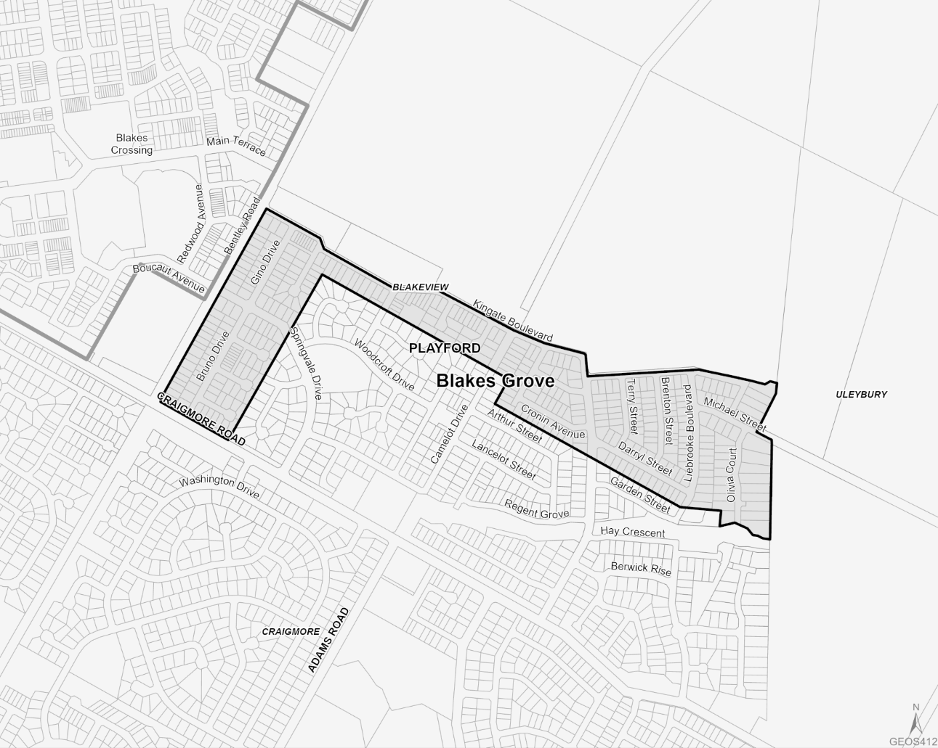
Note—
The shaded area bounded by the bold black line in this map shows the designated area referred to as "Blakes Grove".
3—20 Acres at Andrews Farm
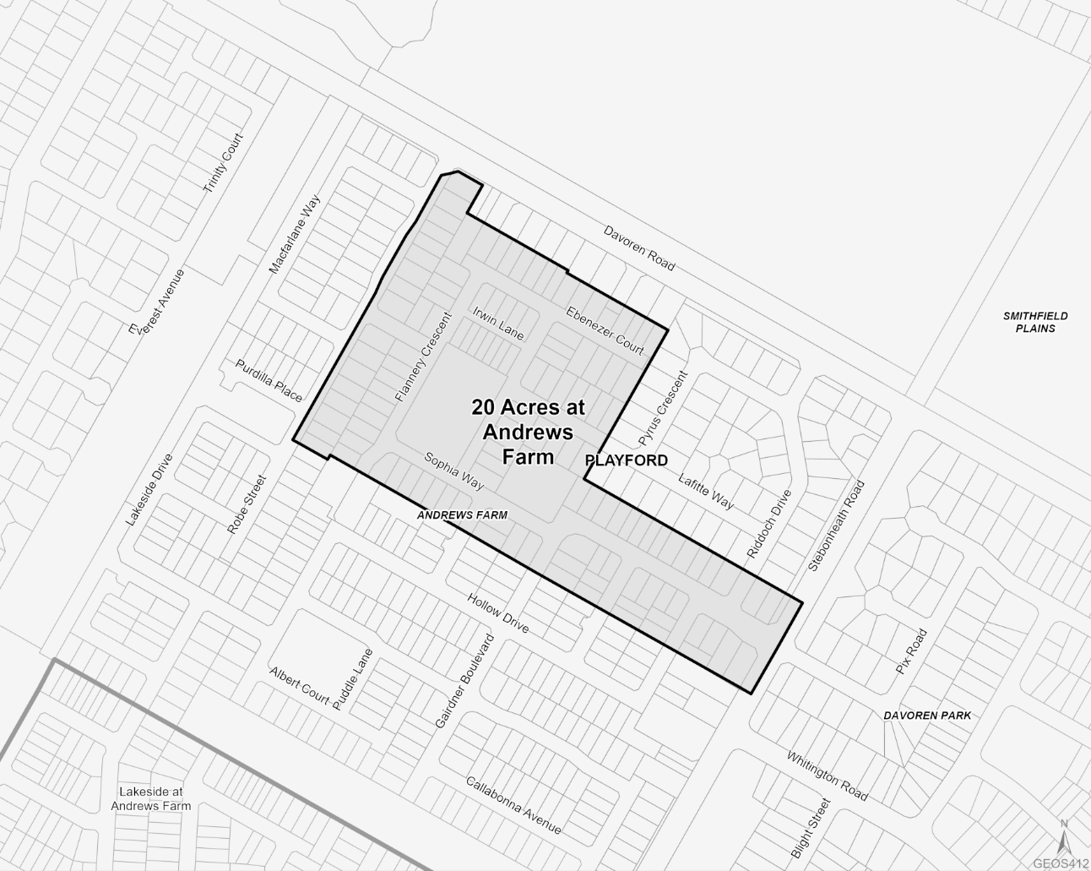
Note—
The shaded area bounded by the bold black line in this map shows the designated area referred to as "20 Acres at Andrews Farm".
4—Playford and Lakeside at Andrews Farm
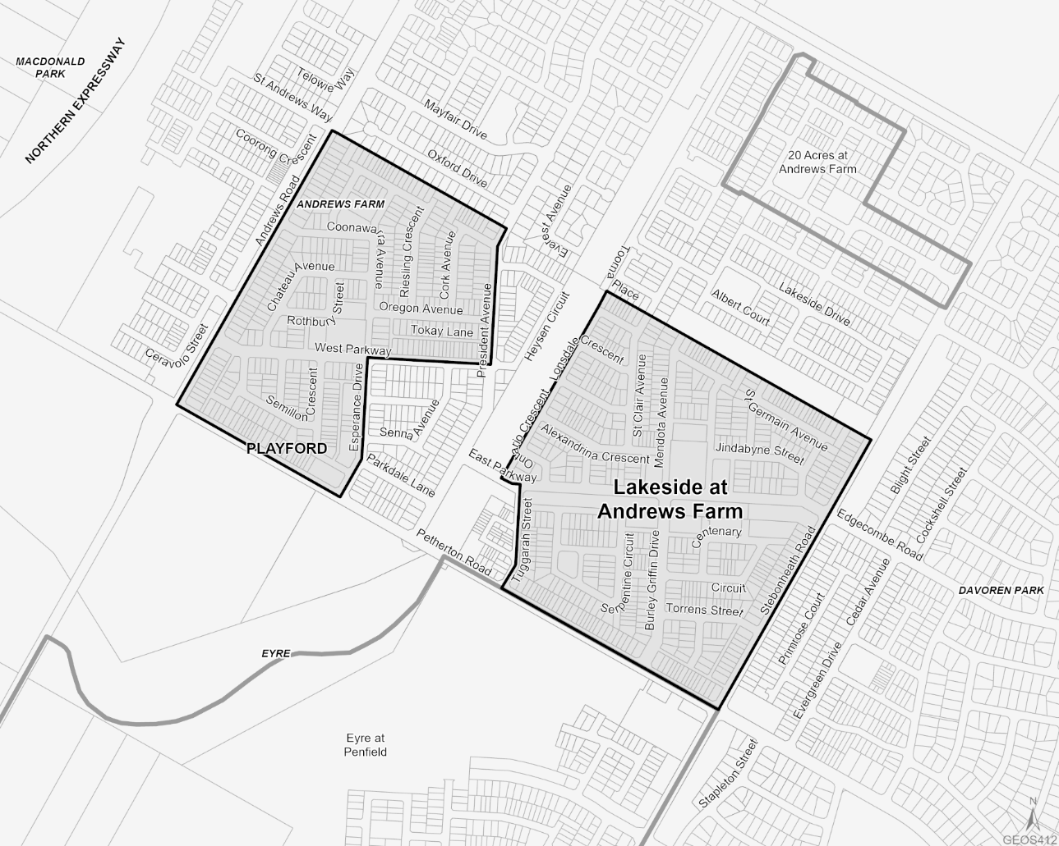
Note—
The shaded areas bounded by the bold black lines in this map show the designated areas referred to as "Playford" and "Lakeside at Andrews Farm".
5—Eyre at Penfield
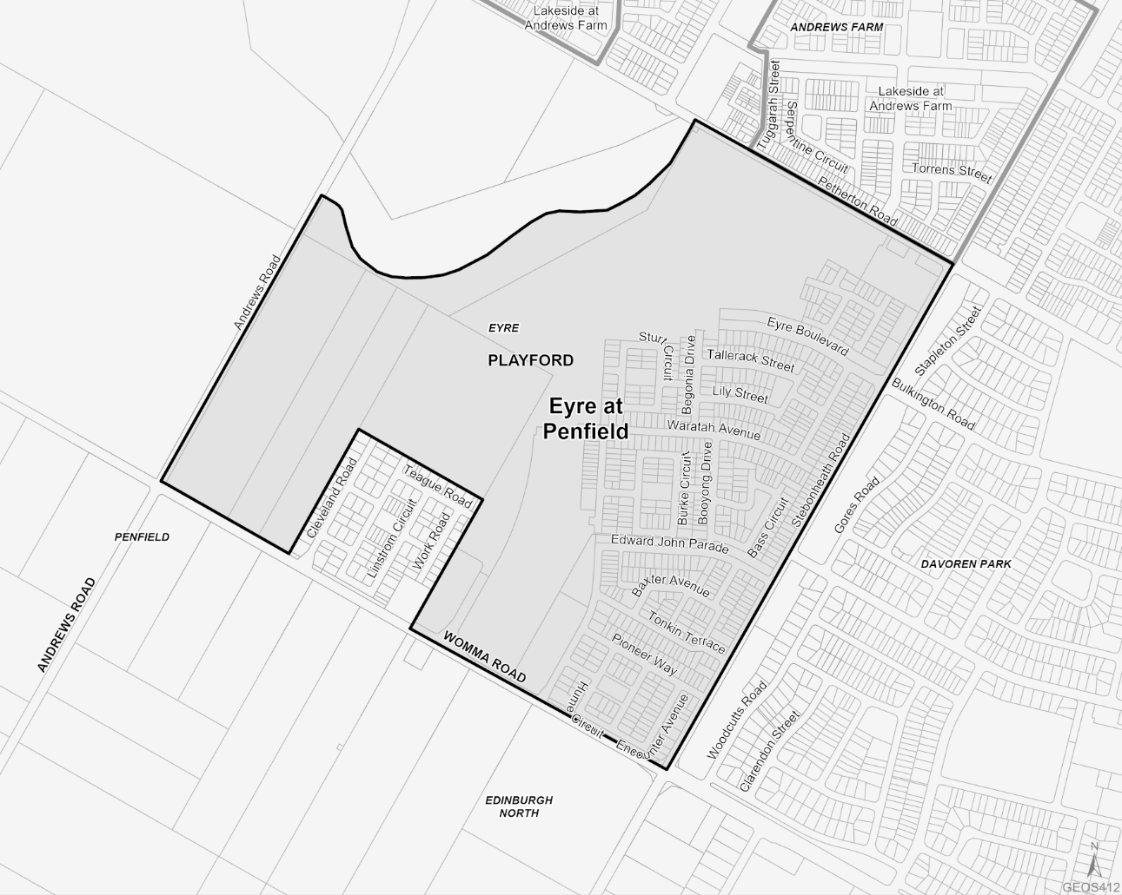
Note—
The shaded area bounded by the bold black line in this map shows the designated area referred to as "Eyre at Penfield".
6—Playford Alive
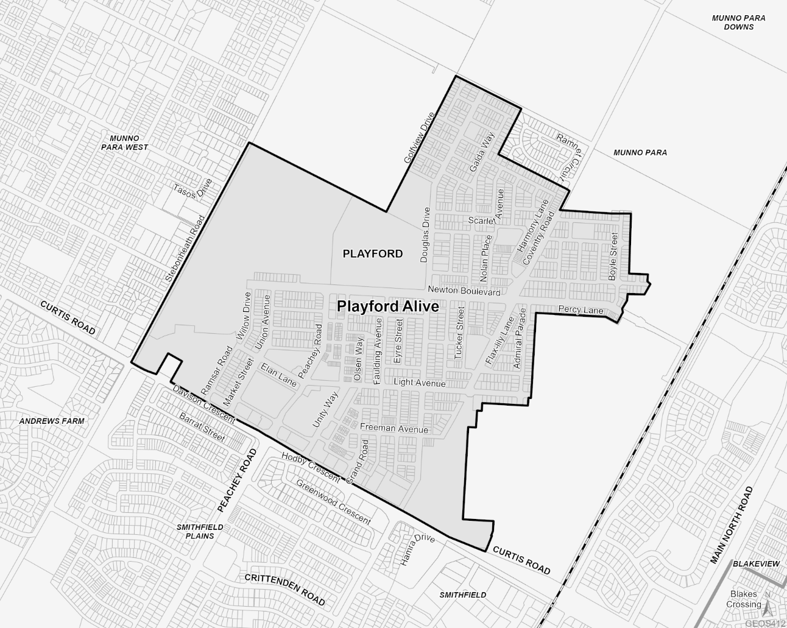
Note—
The shaded area bounded by the bold black line in this map shows the designated area referred to as "Playford Alive".
Editorial note—
As required by section 10AA(2) of the Legislative Instruments Act 1978, the Minister has certified that, in the Minister's opinion, it is necessary or appropriate that these regulations come into operation as set out in these regulations.
Made by the Governor’s Deputy
with the advice and consent of the Executive Council
on 5 November 2025
No 113 of 2025

South Australia

Planning, Development and Infrastructure (Accredited Professionals) (Audits) Amendment Regulations 2025
under the Planning, Development and Infrastructure Act 2016

Contents
Part 1—Preliminary
1 Short title
2 Commencement
Part 2—Amendment of Planning, Development and Infrastructure (Accredited Professionals) Regulations 2019
3 Amendment of regulation 27—Audits

Part 1—Preliminary
1—Short title
These regulations may be cited as the Planning, Development and Infrastructure (Accredited Professionals) (Audits) Amendment Regulations 2025.
2—Commencement
These regulations come into operation on 7 November 2025.
Part 2—Amendment of Planning, Development and Infrastructure (Accredited Professionals) Regulations 2019
3—Amendment of regulation 27—Audits
(1) Regulation 27(6)—delete subregulation (6) and substitute:
(6) The first periodic audit under subregulation (4)(a) that is commenced in relation to an accredited professional following the commencement of the relevant regulations must be completed—
(a) if the accredited professional is carrying on business as an accredited professional on the commencement of the relevant regulations and—
(i) a periodic audit has previously been completed in relation to the accredited professional—within 5 years after the last periodic audit completed in relation to the accredited professional; or
(ii) a periodic audit has not previously been completed in relation to the accredited professional—within 5 years after the date on which the accredited professional commenced business; or
(iii) a periodic audit is being completed in relation to the accredited professional on the commencement of the relevant regulations—within 3 years after that periodic audit; or
(b) if the accredited professional commences business as an accredited professional after the commencement of the relevant regulations—within 3 years after the date on which the accredited professional commences business.
(2) Regulation 27(7)—delete "5" and substitute:
3
(3) Regulation 27(10)—delete subregulation (10) and substitute:
(10) An audit under this regulation will relate to an antecedent period—
(a) in the case of the first periodic audit completed in relation to an accredited professional in circumstances referred to in subregulation (6)(a)(i) or (ii) or a non-periodic audit conducted in relation to the accredited professional before such a periodic audit—not exceeding 5 years; or
(b) in any other case—not exceeding 3 years,
determined to be appropriate by the qualified auditor.
(4) Regulation 27—after subregulation (17) insert:
(18) In this regulation—
relevant regulations means the Planning, Development and Infrastructure (Accredited Professionals) (Audits) Amendment Regulations 2025.
Editorial note—
As required by section 10AA(2) of the Legislative Instruments Act 1978, the Minister has certified that, in the Minister's opinion, it is necessary or appropriate that these regulations come into operation as set out in these regulations.
Made by the Governor’s Deputy
with the advice and consent of the Executive Council
on 5 November 2025
No 114 of 2025

South Australia

Road Traffic (Miscellaneous) (Approved Apparatus) Amendment Regulations 2025
under the Road Traffic Act 1961

Contents
Part 1—Preliminary
1 Short title
2 Commencement
Part 2—Amendment of Road Traffic (Miscellaneous) Regulations 2014
3 Amendment of regulation 27—Apparatus approved as traffic speed analysers (section 53A of Act)
4 Amendment of regulation 29—Apparatus approved as photographic detection devices

Part 1—Preliminary
1—Short title
These regulations may be cited as the Road Traffic (Miscellaneous) (Approved Apparatus) Amendment Regulations 2025.
2—Commencement
These regulations come into operation on the day on which they are made.
Part 2—Amendment of Road Traffic (Miscellaneous) Regulations 2014
3—Amendment of regulation 27—Apparatus approved as traffic speed analysers (section 53A of Act)
Regulation 27—after paragraph (g) insert:
(ga) a REDFLEXred-speed HDX system manufactured by Redflex Traffic Systems Pty Ltd, linked to and used in conjunction with an induction loop vehicle detector and a device programmed to automatically adjust the speed at which a vehicle will trigger the system during certain periods on certain days;

4—Amendment of regulation 29—Apparatus approved as photographic detection devices
Regulation 29(1)(a)—after subparagraph (iv) insert:
(v) a REDFLEXred-speed HDX system manufactured by Redflex Traffic Systems Pty Ltd, linked to and used in conjunction with an induction loop vehicle detector and a device programmed to automatically adjust the speed at which a vehicle will trigger the system during certain periods on certain days;
Editorial note—
As required by section 10AA(2) of the Legislative Instruments Act 1978, the Minister has certified that, in the Minister's opinion, it is necessary or appropriate that these regulations come into operation as set out in these regulations.
Made by the Governor’s Deputy
with the advice and consent of the Executive Council
on 5 November 2025
No 115 of 2025

South Australia

Road Traffic (Miscellaneous) (Drink and Drug Driving) Amendment Regulations 2025
under the Road Traffic Act 1961

Contents
Part 1—Preliminary
1 Short title
2 Commencement
Part 2—Amendment of Road Traffic (Miscellaneous) Regulations 2014
3 Amendment of regulation 14—Approval of apparatus and kits for breath analysis etc (section 47H of Act)
4 Amendment of regulation 15—Offences included in prescribed circumstances (section 47A of Act)
5 Amendment of regulation 16—Prescribed drugs (section 47A of Act)

Part 1—Preliminary
1—Short title
These regulations may be cited as the Road Traffic (Miscellaneous) (Drink and Drug Driving) Amendment Regulations 2025.
2—Commencement
These regulations come into operation on the day on which they are made.
Part 2—Amendment of Road Traffic (Miscellaneous) Regulations 2014
3—Amendment of regulation 14—Approval of apparatus and kits for breath analysis etc (section 47H of Act)
Regulation 14(3)—delete subregulation (3) and substitute:
(3) The following apparatus are approved for the purposes of conducting drug screening tests:
(a) Securetec Drugwipe II Twin;
(b) Securetec Drugwipe 3S.

4—Amendment of regulation 15—Offences included in prescribed circumstances (section 47A of Act)
Regulation 15—after paragraph (g) insert:
(h) an offence against section 19ABA(1) or 19ABA(2) of the Criminal Law Consolidation Act 1935;
(i) an offence against section 19ADA(1) of the Criminal Law Consolidation Act 1935.
5—Amendment of regulation 16—Prescribed drugs (section 47A of Act)
Regulation 16—after paragraph (c) insert:
(d) cocaine.
Editorial note—
As required by section 10AA(2) of the Legislative Instruments Act 1978, the Minister has certified that, in the Minister's opinion, it is necessary or appropriate that these regulations come into operation as set out in these regulations.
Made by the Governor’s Deputy
with the advice and consent of the Executive Council
on 5 November 2025
No 116 of 2025

South Australia

Road Traffic (Miscellaneous) (Device Testing) Amendment Regulations 2025
under the Road Traffic Act 1961

Contents
Part 1—Preliminary
1 Short title
2 Commencement
Part 2—Amendment of Road Traffic (Miscellaneous) Regulations 2014
3 Amendment of regulation 32—Operation and testing of photographic detection devices referred to in regulation 29(1)(a) for offences committed at intersections, marked foot crossings or level crossings
4 Amendment of regulation 33—Operation and testing of photographic detection devices referred to in regulation 29(1)(a) or (b)(iii) for offences committed other than at intersections, marked foot crossings or level crossings
5 Amendment of regulation 34—Operation and testing of photographic detection devices referred to in regulation 29(1)(b)(i) or (ii) for offences committed other than at intersections, marked foot crossings or level crossings
6 Amendment of regulation 35—Operation and testing of photographic detection devices referred to in regulation 29(1)(c)
7 Amendment of regulation 36—Operation and testing of average speed cameras
Schedule 1—Transitional provision
1 Transitional provision

Part 1—Preliminary
1—Short title
These regulations may be cited as the Road Traffic (Miscellaneous) (Device Testing) Amendment Regulations 2025.
2—Commencement
These regulations come into operation on the day on which section 20 of the Statutes Amendment (Transport Portfolio) Act 2024 comes into operation.

Part 2—Amendment of Road Traffic (Miscellaneous) Regulations 2014
3—Amendment of regulation 32—Operation and testing of photographic detection devices referred to in regulation 29(1)(a) for offences committed at intersections, marked foot crossings or level crossings
(1) Regulation 32(2)(f)—delete "28 days" and substitute:
year
(2) Regulation 32(2)(g)—delete "28 days" and substitute:
year
(3) Regulation 32(2)(h)—delete "not required to be carried out in relation to each such lane in the same 28 day period provided that, once in every 28 days, the test is carried out in relation to 1 of those lanes and the lane in relation to which the test is carried out is not the same as the lane in relation to which the previous test was carried out" and substitute:
required to be carried out in relation to each such lane once in every year
(4) Regulation 32(2)(j)—delete "27 days" and substitute:
1 year
4—Amendment of regulation 33—Operation and testing of photographic detection devices referred to in regulation 29(1)(a) or (b)(iii) for offences committed other than at intersections, marked foot crossings or level crossings
(1) Regulation 33(1)(d)—delete "28 days" and substitute:
year
(2) Regulation 33(1)(e)—delete "not required to be carried out in relation to each such lane in the same 28 day period provided that, once in every 28 days, the test is carried out in relation to 1 of those lanes and the lane in relation to which the test is carried out is not the same as the lane in relation to which the previous test was carried out" and substitute:
required to be carried out in relation to each such lane once in every year
(3) Regulation 33(1)(g)—delete "27 days" and substitute:
1 year
5—Amendment of regulation 34—Operation and testing of photographic detection devices referred to in regulation 29(1)(b)(i) or (ii) for offences committed other than at intersections, marked foot crossings or level crossings
(1) Regulation 34(1)(g)—delete "28 days" and substitute:
year

(2) Regulation 34(1)(h)—delete "not required to be carried out in relation to each such lane in the same 28 day period provided that, once in every 28 days, the test is carried out in relation to 1 of those lanes and the lane in relation to which the test is carried out is not the same as the lane in relation to which the previous test was carried out" and substitute:
required to be carried out in relation to each such lane once in every year
(3) Regulation 34(1)(j)—delete "27 days" and substitute:
1 year
6—Amendment of regulation 35—Operation and testing of photographic detection devices referred to in regulation 29(1)(c)
Regulation 35(1)(f)—delete paragraph (f) and substitute:
(f) the accuracy with which the device registers vehicle speeds must be tested on the day on which it is used (or on the day immediately preceding that day) in accordance with—
(i) the appropriate Australian Standard for testing the device, as in force on the day of testing; or
(ii) if there is no appropriate Australian Standard for testing the device in force on the day of testing—the manufacturer's specifications,
with a view to the issuing of a certificate under section 175(3)(baaa) of the Act.
7—Amendment of regulation 36—Operation and testing of average speed cameras
Regulation 36(1)(d)—delete "28 days" and substitute:
year
Schedule 1—Transitional provision
1—Transitional provision
(1) Where, for the purposes of a provision of Part 3 Division 4 of the principal regulations as amended by these regulations, specified tests or checks are required to be carried out in relation to the use of a photographic detection device once in every year, then for the purposes of determining that year the last such tests or checks will be taken to have occurred—
(a) if no such tests or checks have been carried out since the commencement of these regulations—when the most recent tests or checks before that commencement for the purposes of the corresponding provision of the principal regulations as in force at that time were carried out; or
(b) in any other case—when the most recent tests or checks for the purposes of the provision of the principal regulations as in force after that commencement were carried out.
(2) In this regulation—
principal regulations means the Road Traffic (Miscellaneous) Regulations 2014.

Editorial note—
As required by section 10AA(2) of the Legislative Instruments Act 1978, the Minister has certified that, in the Minister's opinion, it is necessary or appropriate that these regulations come into operation as set out in these regulations.
Made by the Governor’s Deputy
with the advice and consent of the Executive Council
on 5 November 2025
No 117 of 2025

All instruments appearing in this gazette are to be considered official, and obeyed as such

Printed and published weekly by authority of T. Foresto, Government Printer, South Australia
$9.50 per issue (plus postage), $479.00 per annual subscription—GST inclusive
Online publications: www.governmentgazette.sa.gov.au

