
No. 66 p. 4373
THE SOUTH AUSTRALIAN
GOVERNMENT GAZETTE
Published by Authority

Adelaide, Thursday, 6 November 2025

Contents

State Government Instruments
Associations Incorporation Act 1985 4374
Building Work Contractors Act 1995 4374
Energy Resources Act 2000 4374
Fire and Emergency Services Act 2005 4376
Highways Act 1926 4376
Housing Improvement Act 2016 4377
Land Acquisition Act 1969 4377
Liquor Licensing Act 1997 4385
Major Events Act 2013 4420
Motor Vehicles Act 1959 4423
Radiation Protection and Control Act 2021 4424
Road Traffic Act 1961 4425
Local Government Instruments
City of West Torrens 4427
Town of Walkerville, Corporation of the 4427
Adelaide Hills Council 4427
Barunga West Council 4428
Mid Murray Council 4429
Port Pirie Regional Council 4438
Renmark Paringa Council 4438
Wattle Range Council 4438

State Government Instruments

Associations Incorporation Act 1985
Section 42(2)
Dissolution of Association
Whereas the Corporate Affairs Commission (the Commission) pursuant to Section 42(1) of the Associations Incorporation Act 1985 (the Act) is of the opinion that the undertaking or operations of THE AUSTRALIAN PROFESSIONAL RODEO ASSOCIATION INCORPORATED (the Association) being an incorporated association under the Act are being carried on, or would more appropriately be carried on by a Company Limited by Guarantee incorporated under the Corporations Act 2001 (Cth) and whereas the Commission was on 29 October 2025 requested by the Association to transfer its undertaking to AU PROFESSIONAL RODEO ASSOCIATION LIMITED (Australian Company Number 691 542 944), the Commission pursuant to Section 42(2) of the Act does hereby order that on 1 December 2025, the Association will be dissolved, the property of the Association becomes the property of AU PROFESSIONAL RODEO ASSOCIATION LIMITED and the rights and liabilities of the Association become the rights and liabilities of AU PROFESSIONAL RODEO ASSOCIATION LIMITED.
Given under the seal of the Commission at Adelaide.
Dated: 6 November 2025
Kirsty Lawrence
Delegate of the Corporate Affairs Commission

Building Work Contractors Act 1995
Exemption
Take notice that, pursuant to Section 45 of the Building Work Contractors Act 1995, I, Brett Humphrey as a delegate for the Minister for Consumer and Business Affairs, do hereby exempt the licensee named in Schedule 1 from the application of Division 3 of Part 5 of the above Act in relation to domestic building work described in Schedule 2 and subject to the conditions specified in Schedule 3.
Schedule 1
JAKE RYAN SLAGHEKKE (BLD 321660)
Schedule 2
Construction of a single storey addition to an existing dwelling at Allotment 234, Deposited Plan 4695, being a portion of the land described in Certificate of Title Volume 5512, Folio 309, more commonly known as 4 Shannon Avenue, Glenelg North SA 5045.
Schedule 3
1. This exemption is limited to domestic building work personally performed by the licensee in relation to the building work described in Schedule 2.
2. This exemption does not apply to any domestic building work the licensee contracts to another building work contractor, for which that contractor is required by law to hold building indemnity insurance.
3. That the licensee does not transfer his interest in the land prior to five years from the date of completion of the building work the subject of this exemption, without the prior authorisation of Consumer and Business Services (CBS). Before giving such authorisation, CBS may require the licensee to take any reasonable steps to protect the future purchaser(s) of the property, including but not limited to:
• providing evidence that an adequate policy of building indemnity insurance is in force to cover the balance of the five-year period from the date of completion of the building work the subject of this exemption;
• providing evidence of an independent expert inspection of the building work the subject of this exemption;
• making an independent expert report available to prospective purchasers of the property;
• giving prospective purchasers of the property notice of the absence of a policy of building indemnity insurance.
Dated: 6 November 2025
Brett Humphrey
Commissioner for Consumer Affairs
Delegate for the Minister for Consumer and Business Affairs

Energy Resources Act 2000
Grant of Associated Activities Licence—AAL 332
(Adjunct to Petroleum Retention Licence—PRL 115)
Notice is hereby given that the undermentioned Associated Activities Licence has been granted with effect from 29 October 2025, under the provisions of the Energy Resources Act 2000, pursuant to delegated powers dated 19 August 2024.
Licence Number | Licensees | Locality | Area in km² | Reference
AAL 332 | Santos Limited | Cooper Basin | 1.44 | MER-2025/0062
Description of Area
All that part of the State of South Australia, bounded as follows:
Area A
433227.77mE 6850890.86mN
434033.51mE 6850529.88mN
434360.02mE 6849992.55mN
434025.97mE 6849627.08mN
433871.82mE 6849772.49mN
434043.02mE 6849957.34mN
433799.87mE 6850240.18mN
433230.00mE 6850499.77mN
433227.77mE 6850890.86mN
Area B
432490.81mE 6849844.13mN
432043.76mE 6849392.70mN
431816.82mE 6849408.11mN
431646.16mE 6849135.47mN
431653.23mE 6848642.38mN
431484.32mE 6848073.07mN
430916.32mE 6846663.32mN
430790.11mE 6846836.32mN
431017.95mE 6847376.68mN
430849.60mE 6847434.19mN
431006.92mE 6847823.73mN
431196.38mE 6847749.62mN
431493.07mE 6848733.38mN
431473.62mE 6849188.79mN
431347.13mE 6849267.46mN
431622.25mE 6849839.11mN
432490.81mE 6849844.13mN
AREA: 1.44 square kilometres approximately
Dated: 29 October 2025
Paul De Ionno
Executive Director
Regulation and Compliance Division
Department for Energy and Mining
Delegate of the Minister for Energy and Mining

Energy Resources Act 2000
Grant of Associated Activities Licence—AAL 333
(Adjunct to Petroleum Retention Licence—PRL 115)
Notice is hereby given that the undermentioned Associated Activities Licence has been granted with effect from 29 October 2025, under the provisions of the Energy Resources Act 2000, pursuant to delegated powers dated 19 August 2024.
Licence Number | Licensees | Locality | Area in km² | Reference
AAL 333 | Santos Limited | Cooper Basin | 0.45 | MER-2025/0048
Description of Area
All that part of the State of South Australia, bounded as follows:
All coordinates in GDA2020, Zone 54
430830.25mE 6846907.36mN
431305.02mE 6846162.24mN
431725.24mE 6846122.91mN
431853.64mE 6846069.34mN
432031.23mE 6846224.96mN
432159.04mE 6845912.35mN
432173.98mE 6845507.17mN
432802.37mE 6844493.52mN
432629.21mE 6844231.18mN
432920.42mE 6843865.69mN
432784.31mE 6843748.18mN
432626.84mE 6843906.13mN
432713.28mE 6843998.64mN
432509.23mE 6844215.60mN
432685.78mE 6844481.62mN
432444.20mE 6844890.42mN
432391.90mE 6844856.70mN
432222.65mE 6845077.14mN
432285.11mE 6845169.41mN
432085.83mE 6845498.31mN
432079.47mE 6845872.20mN
431994.28mE 6846078.52mN
431856.32mE 6845969.09mN
431719.41mE 6846042.45mN
431419.11mE 6846043.84mN
431229.80mE 6846099.13mN
430763.72mE 6846794.16mN
430830.25mE 6846907.36mN
AREA: 0.45 square kilometres approximately
Dated: 29 October 2025
Paul De Ionno
Executive Director
Regulation and Compliance Division
Department for Energy and Mining
Delegate of the Minister for Energy and Mining

Energy Resources Act 2000
Suspension of Petroleum Retention Licences—PRLs 207, 208 and 209
Pursuant to Section 90 of the Energy Resources Act 2000, notice is hereby given that the abovementioned Petroleum Retention Licences have been suspended for the period 6 August 2025 to 5 February 2026 inclusive, pursuant to delegated powers dated 19 August 2024.
The expiry date of these licences is now determined to be 8 June 2026.
Dated: 29 October 2025
Paul De Ionno
Executive Director
Regulation and Compliance Division
Department for Energy and Mining
Delegate of the Minister for Energy and Mining

Energy Resources Act 2000
Temporary Cessation of Suspension
Petroleum Exploration Licence—PEL 182
Petroleum Retention Licences—PRLs 207, 208, 209, 245 and 246
Associated Activities Licence—AAL 224
Pursuant to Section 90 of the Energy Resources Act 2000, notice is hereby given that the suspensions of the following licences have been temporarily ceased, for the period 31 October 2025 to 1 November 2025 inclusive pursuant to delegated powers dated 19 August 2024.
The expiry date of PEL 182 and AAL 224 suspended on 1 October 2025 remains as 18 November 2026.
The expiry date of PRLs 207, 208 and 209 suspended on 29 October 2025 remains as 8 June 2026.
The expiry date of PRLs 245 and 246 suspended on 1 October 2025 remains as 24 December 2027.
Dated: 29 October 2025
Paul De Ionno
Executive Director
Regulation and Compliance Division
Department for Energy and Mining
Delegate of the Minister for Energy and Mining

Fire and Emergency Services Act 2005
Section 78
Fire Danger Season
The South Australian Country Fire Service hereby:
1. Fixes the date of the Fire Danger Season within the part of the State defined as the Adelaide Metropolitan Fire Ban District so as to commence on 1 December 2025 and to end on the 30 April 2026.
2. Fixes the date of the Fire Danger Season within the part of the State defined as the Kangaroo Island Fire Ban District so as to commence on 15 November 2025 and to end on 30 April 2026.
3. Fixes the date of the Fire Danger Season within the part of the State defined as the Mount Lofty Ranges Fire Ban District so as to commence on 1 December 2025 and to end on 30 April 2026.
Dated: 6 November 2025
Brett Loughlin AFSM
Chief Officer, SA Country Fire Service

Highways Act 1926
Section 26(3)
Care, Control and Management of Local Roads
I, Andrew John Excell, dele gate of the Commissioner of Highways, with the approval of the Minister for Infrastructure and Transport, and pursuant to my delegated powers under Section 12A of the Highways Act 1926 do hereby give notice that I will undertake the care, control and management of the following local roads, within the boundaries of the City of Charles Sturt until further notice, in association with the North-South, River Torrens to Darlington Project.
• Bacon Street (partial)
• Susan Street (partial)
• Orsmond Street (partial)
• Torrens Avenue (partial)
• Jervois Avenue (partial)
• Hindmarsh Avenue (partial)
• Gawler Avenue (partial)
• Cator Street (partial)
• Bertie Street (partial)
The extent of the Commissioners care, control and management is identified in blue in the attached plans.
Dated: 4 November 2025
Andrew John Excell
Delegate of the Commissioner of Highways

Housing Improvement Act 2016
Rent Control Revocations
In the exercise of the powers conferred by the Housing Improvement Act 2016, the Delegate of the Minister for Housing and Urban Development hereby revokes the maximum rental amount per week that shall be payable subject to Section 55 of the Residential Tenancies Act 1995, in respect of each premises described in the following table.
Address of Premises | Allotment Section | Certificate of Title  Volume/Folio
6-8 Keith Street, Port Pirie West SA 5540  (AKA 6, PKA 8) | Allotment 53 and 54 Filed Plan 28920 Hundred of Pirie | CT5347/617  CT5348/1
8 Kingsbury Street, Davoren Park SA 5113 | Allotment 6 Deposited Plan 32850 Hundred of Munno Para | CT5059/894
12 Castle Street, Glanville SA 5015 | Allotment 39 Filed Plan 3333 Hundred of Port Adelaide | CT5420/89
122 Day Road, Redbanks SA 5502  (AKA Section 123) | Section 123 Hundred Plan 140500 Hundred of Grace | CT5886/165
12 Toronto Street, Ovingham SA 5082 | Allotment 56 Filed Plan 109122 Hundred of Yatala | CT6308/380
31 Melbury Street, Davoren Park SA 5113 | Allotment 676 Deposited Plan 7397 Munno Para | CT5672/980
Dated: 6 November 2025
Craig Thompson
Housing Regulator and Registrar
Housing Safety Authority
Delegate of the Minister for Housing and Urban Development

Housing Improvement Act 2016
Rent Control Variations
In the exercise of the powers conferred by the Housing Improvement Act 2016, the Delegate of the Minister for Housing and Urban Development hereby varies the maximum rental amount per week that shall be payable subject to Section 55 of the Residential Tenancies Act 1995, in respect of each premises described in the following table. The amount shown in the said table shall come into force on the date of this publication in the Gazette.
Address of Premises | Allotment Section | Certificate of Title  Volume/Folio | Reason for  Variation | Maximum Rental per week payable
483 Krieg Road, Wasleys SA 5400 | Allotment 473 Filed Plan 174374  Hundred of Mudla Wirra | CT5647/593 |  | $0.00
Unit 3, 7 Wellington Square,  North Adelaide SA 5006  (AKA Unit 3G) | Unit 3, Strata Plan 549  Hundred of Yatala | CT5047/240 |  | $150.00
11 Union Street, Dulwich SA 5065 | Unit 2, Strata Plan 6033  Hundred of Adelaide | CT5011/144 |  | $310.00
Dated: 6 November 2025
Craig Thompson
Housing Regulator and Registrar
Housing Safety Authority
Delegate of the Minister for Housing and Urban Development

Land Acquisition Act 1969
Section 26F
Form 6B—Notice of Acquisition of Underground Land
1. Notice of acquisition
The Commissioner of Highways (the Authority), of 83 Pirie Street, Adelaide SA 5000 acquires the following interests in the following land:
An unencumbered estate in fee simple in the whole of Allotment 304 in D138146 lodged in the Lands Titles Office, being portion of the land comprised in Certificate of Title Volume 6217 Folio 359.
This notice is given under Section 26F of the Land Acquisition Act 1969.
2. Compensation not payable unless certain water infrastructure or rights are affected
You are not entitled to compensation in relation to the acquisition of the underground land to which this notice relates, unless the following conditions are satisfied:
• you held at least one of the following interests in relation to the underground land immediately before the notice of acquisition was published in relation to the land—
◦ ownership of a lawful well that provides access to underground water in the underground land, and any underground infrastructure associated with the well; or
◦ a right to take underground water from the underground land by means of such a well;
• you notified the Authority of your interest in response to a notice given under Section 26G of the Land Acquisition Act 1969;
• the acquisition of the underground land either—
◦ involved the acquisition of your interest; or
◦ resulted in the discharge of your interest; or
◦ resulted in you being unable to take water by means of, or pursuant to, your interest;
• you make an application for compensation to the Authority under Section 26H of the Land Acquisition Act 1969.
3. Application for compensation under Section 26H
If you believe you are entitled to compensation, you must apply to the Authority for compensation within 6 months after the publication of the notice of acquisition in relation to the underground land to which this notice relates.
The application must be in the following manner and form:
“Application for Compensation for Acquisition of Underground Land” (enclosed) to be submitted by email to DIT.ULAapplications@sa.gov.au or by mail marked attention: Property Acquisition c/- GPO Box 1533, Adelaide SA 5001.
The application must be accompanied by the following information or documents:
Any relevant supporting documentation including, but not limited to water licences, bore licences etc.
After receiving your application, the Authority may (but is not required to) make you a written offer of compensation not exceeding $50,000.
See Section 26H(4) of the Land Acquisition Act 1969 for further details on the payment of compensation.
4. Inquiries
Inquiries should be directed to: T2D Project Team
GPO Box 1533
Adelaide SA 5001
Telephone: 1800 572 414
Dated: 3 November 2025
The Common Seal of the COMMISSIONER OF HIGHWAYS was hereto affixed by authority of the Commissioner in the presence of:
Rocco Caruso
Director, Property Acquisition
(Authorised Officer)
Department for Infrastructure and Transport
DIT: 2024/07187/01

Land Acquisition Act 1969
Section 26F
Form 6B—Notice of Acquisition of Underground Land
1. Notice of acquisition
The Commissioner of Highways (the Authority), of 83 Pirie Street, Adelaide SA 5000 acquires the following interests in the following land:
An unencumbered estate in fee simple in the whole of Allotment 911 in D138831 lodged in the Lands Titles Office, being portion of the land comprised in Certificate of Title Volume 6253 Folio 35.
This notice is given under Section 26F of the Land Acquisition Act 1969.
2. Compensation not payable unless certain water infrastructure or rights are affected
You are not entitled to compensation in relation to the acquisition of the underground land to which this notice relates, unless the following conditions are satisfied:
• you held at least one of the following interests in relation to the underground land immediately before the notice of acquisition was published in relation to the land—
◦ ownership of a lawful well that provides access to underground water in the underground land, and any underground infrastructure associated with the well; or
◦ a right to take underground water from the underground land by means of such a well;
• you notified the Authority of your interest in response to a notice given under Section 26G of the Land Acquisition Act 1969;
• the acquisition of the underground land either—
◦ involved the acquisition of your interest; or
◦ resulted in the discharge of your interest; or
◦ resulted in you being unable to take water by means of, or pursuant to, your interest;
• you make an application for compensation to the Authority under Section 26H of the Land Acquisition Act 1969.
3. Application for compensation under Section 26H
If you believe you are entitled to compensation, you must apply to the Authority for compensation within 6 months after the publication of the notice of acquisition in relation to the underground land to which this notice relates.
The application must be in the following manner and form:
“Application for Compensation for Acquisition of Underground Land” (enclosed) to be submitted by email to DIT.ULAapplications@sa.gov.au or by mail marked attention: Property Acquisition c/- GPO Box 1533, Adelaide SA 5001.
The application must be accompanied by the following information or documents:
Any relevant supporting documentation including, but not limited to water licences, bore licences etc.
After receiving your application, the Authority may (but is not required to) make you a written offer of compensation not exceeding $50,000.
See Section 26H(4) of the Land Acquisition Act 1969 for further details on the payment of compensation.

4. Inquiries
Inquiries should be directed to: T2D Project Team
GPO Box 1533
Adelaide SA 5001
Telephone: 1800 572 414
Dated: 3 November 2025
The Common Seal of the COMMISSIONER OF HIGHWAYS was hereto affixed by authority of the Commissioner in the presence of:
Rocco Caruso
Director, Property Acquisition
(Authorised Officer)
Department for Infrastructure and Transport
DIT 2024/08166/01

Land Acquisition Act 1969
Section 26F
Form 6B—Notice of Acquisition of Underground Land
1. Notice of acquisition
The Commissioner of Highways (the Authority), of 83 Pirie Street, Adelaide SA 5000 acquires the following interests in the following land:
An unencumbered estate in fee simple in the whole of Allotment 921 in D138832 lodged in the Lands Titles Office, being portion of the land comprised in Certificate of Title Volume 6253 Folio 36.
This notice is given under Section 26F of the Land Acquisition Act 1969.
2. Compensation not payable unless certain water infrastructure or rights are affected
You are not entitled to compensation in relation to the acquisition of the underground land to which this notice relates, unless the following conditions are satisfied:
• you held at least one of the following interests in relation to the underground land immediately before the notice of acquisition was published in relation to the land—
◦ ownership of a lawful well that provides access to underground water in the underground land, and any underground infrastructure associated with the well; or
◦ a right to take underground water from the underground land by means of such a well;
• you notified the Authority of your interest in response to a notice given under Section 26G of the Land Acquisition Act 1969;
• the acquisition of the underground land either—
◦ involved the acquisition of your interest; or
◦ resulted in the discharge of your interest; or
◦ resulted in you being unable to take water by means of, or pursuant to, your interest;
• you make an application for compensation to the Authority under Section 26H of the Land Acquisition Act 1969.
3. Application for compensation under Section 26H
If you believe you are entitled to compensation, you must apply to the Authority for compensation within 6 months after the publication of the notice of acquisition in relation to the underground land to which this notice relates.
The application must be in the following manner and form:
“Application for Compensation for Acquisition of Underground Land” (enclosed) to be submitted by email to DIT.ULAapplications@sa.gov.au or by mail marked attention: Property Acquisition c/- GPO Box 1533, Adelaide SA 5001.
The application must be accompanied by the following information or documents:
Any relevant supporting documentation including, but not limited to water licences, bore licences etc.
After receiving your application, the Authority may (but is not required to) make you a written offer of compensation not exceeding $50,000.
See Section 26H(4) of the Land Acquisition Act 1969 for further details on the payment of compensation.
4. Inquiries
Inquiries should be directed to: T2D Project Team
GPO Box 1533
Adelaide SA 5001
Telephone: 1800 572 414
Dated: 3 November 2025
The Common Seal of the COMMISSIONER OF HIGHWAYS was hereto affixed by authority of the Commissioner in the presence of:
Rocco Caruso
Director, Property Acquisition
(Authorised Officer)
Department for Infrastructure and Transport
DIT 2024/08167/01

Land Acquisition Act 1969
Section 26F
Form 6B—Notice of Acquisition of Underground Land
1. Notice of acquisition
The Commissioner of Highways (the Authority), of 83 Pirie Street, Adelaide SA 5000 acquires the following interests in the following land:
An unencumbered estate in fee simple in the whole of Allotment 2202 in D139121 lodged in the Lands Titles Office, being portion of the land comprised in Certificate of Title Volume 5087 Folio 933.
This notice is given under Section 26F of the Land Acquisition Act 1969.
2. Compensation not payable unless certain water infrastructure or rights are affected
You are not entitled to compensation in relation to the acquisition of the underground land to which this notice relates, unless the following conditions are satisfied:
• you held at least one of the following interests in relation to the underground land immediately before the notice of acquisition was published in relation to the land—
◦ ownership of a lawful well that provides access to underground water in the underground land, and any underground infrastructure associated with the well; or
◦ a right to take underground water from the underground land by means of such a well;
• you notified the Authority of your interest in response to a notice given under Section 26G of the Land Acquisition Act 1969;
• the acquisition of the underground land either—
◦ involved the acquisition of your interest; or
◦ resulted in the discharge of your interest; or
◦ resulted in you being unable to take water by means of, or pursuant to, your interest;
• you make an application for compensation to the Authority under Section 26H of the Land Acquisition Act 1969.
3. Application for compensation under Section 26H
If you believe you are entitled to compensation, you must apply to the Authority for compensation within 6 months after the publication of the notice of acquisition in relation to the underground land to which this notice relates.
The application must be in the following manner and form:
“Application for Compensation for Acquisition of Underground Land” (enclosed) to be submitted by email to DIT.ULAapplications@sa.gov.au or by mail marked attention: Property Acquisition c/- GPO Box 1533, Adelaide SA 5001.
The application must be accompanied by the following information or documents:
Any relevant supporting documentation including, but not limited to water licences, bore licences etc.
After receiving your application, the Authority may (but is not required to) make you a written offer of compensation not exceeding $50,000.
See Section 26H(4) of the Land Acquisition Act 1969 for further details on the payment of compensation.
4. Inquiries
Inquiries should be directed to: T2D Project Team
GPO Box 1533
Adelaide SA 5001
Telephone: 1800 572 414
Dated: 3 November 2025
The Common Seal of the COMMISSIONER OF HIGHWAYS was hereto affixed by authority of the Commissioner in the presence of:
Rocco Caruso
Director, Property Acquisition
(Authorised Officer)
Department for Infrastructure and Transport
DIT: 2024/08170/01

Land Acquisition Act 1969
Section 26F
Form 6B—Notice of Acquisition of Underground Land
1. Notice of acquisition
The Commissioner of Highways (the Authority), of 83 Pirie Street, Adelaide SA 5000 acquires the following interests in the following land:
An unencumbered estate in fee simple in the whole of Allotment 31 in D138819 lodged in the Lands Titles Office, being portion of the land comprised in Certificate of Title Volume 6153 Folio 833.
This notice is given under Section 26F of the Land Acquisition Act 1969.
2. Compensation not payable unless certain water infrastructure or rights are affected
You are not entitled to compensation in relation to the acquisition of the underground land to which this notice relates, unless the following conditions are satisfied:
• you held at least one of the following interests in relation to the underground land immediately before the notice of acquisition was published in relation to the land—
◦ ownership of a lawful well that provides access to underground water in the underground land, and any underground infrastructure associated with the well; or
◦ a right to take underground water from the underground land by means of such a well;

• you notified the Authority of your interest in response to a notice given under Section 26G of the Land Acquisition Act 1969;
• the acquisition of the underground land either—
◦ involved the acquisition of your interest; or
◦ resulted in the discharge of your interest; or
◦ resulted in you being unable to take water by means of, or pursuant to, your interest;
• you make an application for compensation to the Authority under Section 26H of the Land Acquisition Act 1969.
3. Application for compensation under Section 26H
If you believe you are entitled to compensation, you must apply to the Authority for compensation within 6 months after the publication of the notice of acquisition in relation to the underground land to which this notice relates.
The application must be in the following manner and form:
“Application for Compensation for Acquisition of Underground Land” (enclosed) to be submitted by email to DIT.ULAapplications@sa.gov.au or by mail marked attention: Property Acquisition c/- GPO Box 1533, Adelaide SA 5001.
The application must be accompanied by the following information or documents:
Any relevant supporting documentation including, but not limited to water licences, bore licences etc.
After receiving your application, the Authority may (but is not required to) make you a written offer of compensation not exceeding $50,000.
See Section 26H(4) of the Land Acquisition Act 1969 for further details on the payment of compensation.
4. Inquiries
Inquiries should be directed to: T2D Project Team
GPO Box 1533
Adelaide SA 5001
Telephone: 1800 572 414
Dated: 3 November 2025
The Common Seal of the COMMISSIONER OF HIGHWAYS was hereto affixed by authority of the Commissioner in the presence of:
Rocco Caruso
Director, Property Acquisition
(Authorised Officer)
Department for Infrastructure and Transport
DIT: 2024/08192/01

Land Acquisition Act 1969
Section 26F
Form 6B—Notice of Acquisition of Underground Land
1. Notice of acquisition
The Commissioner of Highways (the Authority), of 83 Pirie Street, Adelaide SA 5000 acquires the following interests in the following land:
An unencumbered estate in fee simple in the whole of Allotment 921 in D139103 lodged in the Lands Titles Office, being portion of the land comprised in Certificate of Title Volume 5401 Folio 785.
This notice is given under Section 26F of the Land Acquisition Act 1969.
2. Compensation not payable unless certain water infrastructure or rights are affected
You are not entitled to compensation in relation to the acquisition of the underground land to which this notice relates, unless the following conditions are satisfied:
• you held at least one of the following interests in relation to the underground land immediately before the notice of acquisition was published in relation to the land—
◦ ownership of a lawful well that provides access to underground water in the underground land, and any underground infrastructure associated with the well; or
◦ a right to take underground water from the underground land by means of such a well;
• you notified the Authority of your interest in response to a notice given under Section 26G of the Land Acquisition Act 1969;
• the acquisition of the underground land either—
◦ involved the acquisition of your interest; or
◦ resulted in the discharge of your interest; or
◦ resulted in you being unable to take water by means of, or pursuant to, your interest;
• you make an application for compensation to the Authority under Section 26H of the Land Acquisition Act 1969.
3. Application for compensation under Section 26H
If you believe you are entitled to compensation, you must apply to the Authority for compensation within 6 months after the publication of the notice of acquisition in relation to the underground land to which this notice relates.
The application must be in the following manner and form:
“Application for Compensation for Acquisition of Underground Land” (enclosed) to be submitted by email to DIT.ULAapplications@sa.gov.au or by mail marked attention: Property Acquisition c/- GPO Box 1533, Adelaide SA 5001.
The application must be accompanied by the following information or documents:
Any relevant supporting documentation including, but not limited to water licences, bore licences etc.
After receiving your application, the Authority may (but is not required to) make you a written offer of compensation not exceeding $50,000.
See Section 26H(4) of the Land Acquisition Act 1969 for further details on the payment of compensation.
4. Inquiries
Inquiries should be directed to: T2D Project Team
GPO Box 1533
Adelaide SA 5001
Telephone: 1800 572 414
Dated: 3 November 2025
The Common Seal of the COMMISSIONER OF HIGHWAYS was hereto affixed by authority of the Commissioner in the presence of:
Rocco Caruso
Director, Property Acquisition
(Authorised Officer)
Department for Infrastructure and Transport
DIT: 2024/08225/01

Land Acquisition Act 1969
Section 26F
Form 6B—Notice of Acquisition of Underground Land
1. Notice of acquisition
The Commissioner of Highways (the Authority), of 83 Pirie Street, Adelaide SA 5000 acquires the following interests in the following land:
An unencumbered estate in fee simple in the whole of Allotment 2361 in D139168 lodged in the Lands Titles Office, being portion of the land comprised in Certificate of Title Volume 5227 Folio 810.
This notice is given under Section 26F of the Land Acquisition Act 1969.
2. Compensation not payable unless certain water infrastructure or rights are affected
You are not entitled to compensation in relation to the acquisition of the underground land to which this notice relates, unless the following conditions are satisfied:
• you held at least one of the following interests in relation to the underground land immediately before the notice of acquisition was published in relation to the land—
◦ ownership of a lawful well that provides access to underground water in the underground land, and any underground infrastructure associated with the well; or
◦ a right to take underground water from the underground land by means of such a well;
• you notified the Authority of your interest in response to a notice given under Section 26G of the Land Acquisition Act 1969;
• the acquisition of the underground land either—
◦ involved the acquisition of your interest; or
◦ resulted in the discharge of your interest; or
◦ resulted in you being unable to take water by means of, or pursuant to, your interest;
• you make an application for compensation to the Authority under Section 26H of the Land Acquisition Act 1969.
3. Application for compensation under Section 26H
If you believe you are entitled to compensation, you must apply to the Authority for compensation within 6 months after the publication of the notice of acquisition in relation to the underground land to which this notice relates.
The application must be in the following manner and form:
“Application for Compensation for Acquisition of Underground Land” (enclosed) to be submitted by email to DIT.ULAapplications@sa.gov.au or by mail marked attention: Property Acquisition c/- GPO Box 1533, Adelaide SA 5001.
The application must be accompanied by the following information or documents:
Any relevant supporting documentation including, but not limited to water licences, bore licences etc.
After receiving your application, the Authority may (but is not required to) make you a written offer of compensation not exceeding $50,000.
See Section 26H(4) of the Land Acquisition Act 1969 for further details on the payment of compensation.
4. Inquiries
Inquiries should be directed to: T2D Project Team
GPO Box 1533
Adelaide SA 5001
Telephone: 1800 572 414
Dated: 3 November 2025
The Common Seal of the COMMISSIONER OF HIGHWAYS was hereto affixed by authority of the Commissioner in the presence of:
Rocco Caruso
Director, Property Acquisition
(Authorised Officer)
Department for Infrastructure and Transport
DIT: 2024/08246/01

Land Acquisition Act 1969
Section 26F
Form 6B—Notice of Acquisition of Underground Land
1. Notice of acquisition
The Commissioner of Highways (the Authority), of 83 Pirie Street, Adelaide SA 5000 acquires the following interests in the following land:
An unencumbered estate in fee simple in the whole of Allotment 931 in D139104 lodged in the Lands Titles Office, being portion of the land comprised in Certificate of Title Volume 5095 Folio 875.
This notice is given under Section 26F of the Land Acquisition Act 1969.
2. Compensation not payable unless certain water infrastructure or rights are affected
You are not entitled to compensation in relation to the acquisition of the underground land to which this notice relates, unless the following conditions are satisfied:
• you held at least one of the following interests in relation to the underground land immediately before the notice of acquisition was published in relation to the land—
◦ ownership of a lawful well that provides access to underground water in the underground land, and any underground infrastructure associated with the well; or
◦ a right to take underground water from the underground land by means of such a well;
• you notified the Authority of your interest in response to a notice given under Section 26G of the Land Acquisition Act 1969;
• the acquisition of the underground land either—
◦ involved the acquisition of your interest; or
◦ resulted in the discharge of your interest; or
◦ resulted in you being unable to take water by means of, or pursuant to, your interest;
• you make an application for compensation to the Authority under Section 26H of the Land Acquisition Act 1969.
3. Application for compensation under Section 26H
If you believe you are entitled to compensation, you must apply to the Authority for compensation within 6 months after the publication of the notice of acquisition in relation to the underground land to which this notice relates.
The application must be in the following manner and form:
“Application for Compensation for Acquisition of Underground Land” (enclosed) to be submitted by email to DIT.ULAapplications@sa.gov.au or by mail marked attention: Property Acquisition c/- GPO Box 1533, Adelaide SA 5001.
The application must be accompanied by the following information or documents:
Any relevant supporting documentation including, but not limited to water licences, bore licences etc.
After receiving your application, the Authority may (but is not required to) make you a written offer of compensation not exceeding $50,000.
See Section 26H(4) of the Land Acquisition Act 1969 for further details on the payment of compensation.
4. Inquiries
Inquiries should be directed to: T2D Project Team
GPO Box 1533
Adelaide SA 5001
Telephone: 1800 572 414
Dated: 4 November 2025
The Common Seal of the COMMISSIONER OF HIGHWAYS was hereto affixed by authority of the Commissioner in the presence of:
Rocco Caruso
Director, Property Acquisition
(Authorised Officer)
Department for Infrastructure and Transport
DIT: 2024/08274/01

Land Acquisition Act 1969
Section 26F
Form 6B—Notice of Acquisition of Underground Land
1. Notice of acquisition
The Commissioner of Highways (the Authority), of 83 Pirie Street, Adelaide SA 5000 acquires the following interests in the following land:
An unencumbered estate in fee simple in the whole of Allotment 941 in D139105 lodged in the Lands Titles Office, being portion of the land comprised in Certificate of Title Volume 5095 Folio 876.
This notice is given under Section 26F of the Land Acquisition Act 1969.
2. Compensation not payable unless certain water infrastructure or rights are affected
You are not entitled to compensation in relation to the acquisition of the underground land to which this notice relates, unless the following conditions are satisfied:
• you held at least one of the following interests in relation to the underground land immediately before the notice of acquisition was published in relation to the land—
◦ ownership of a lawful well that provides access to underground water in the underground land, and any underground infrastructure associated with the well; or
◦ a right to take underground water from the underground land by means of such a well;
• you notified the Authority of your interest in response to a notice given under Section 26G of the Land Acquisition Act 1969;
• the acquisition of the underground land either—
◦ involved the acquisition of your interest; or
◦ resulted in the discharge of your interest; or
◦ resulted in you being unable to take water by means of, or pursuant to, your interest;
• you make an application for compensation to the Authority under Section 26H of the Land Acquisition Act 1969.
3. Application for compensation under Section 26H
If you believe you are entitled to compensation, you must apply to the Authority for compensation within 6 months after the publication of the notice of acquisition in relation to the underground land to which this notice relates.
The application must be in the following manner and form:
“Application for Compensation for Acquisition of Underground Land” (enclosed) to be submitted by email to DIT.ULAapplications@sa.gov.au or by mail marked Attention: Property Acquisition c/- GPO Box 1533, Adelaide SA 5001.
The application must be accompanied by the following information or documents:
Any relevant supporting documentation including, but not limited to water licences, bore licences etc.
After receiving your application, the Authority may (but is not required to) make you a written offer of compensation not exceeding $50,000.
See Section 26H(4) of the Land Acquisition Act 1969 for further details on the payment of compensation.
4. Inquiries
Inquiries should be directed to: T2D Project Team
GPO Box 1533
Adelaide SA 5001
Telephone: 1800 572 414
Dated: 4 November 2025
The Common Seal of the COMMISSIONER OF HIGHWAYS was hereto affixed by authority of the Commissioner in the presence of:
Rocco Caruso
Director, Property Acquisition
(Authorised Officer)
Department for Infrastructure and Transport
DIT: 2024/08274/01

Land Acquisition Act 1969
Section 26F
Form 6B—Notice of Acquisition of Underground Land
1. Notice of acquisition
The Commissioner of Highways (the Authority), of 83 Pirie Street, Adelaide SA 5000 acquires the following interests in the following land:
An unencumbered estate in fee simple in the whole of Allotment 11 in D138816 lodged in the Lands Titles Office, being portion of the land comprised in Certificate of Title Volume 5305 Folio 913.
This notice is given under Section 26F of the Land Acquisition Act 1969.
2. Compensation not payable unless certain water infrastructure or rights are affected
You are not entitled to compensation in relation to the acquisition of the underground land to which this notice relates, unless the following conditions are satisfied:
• you held at least one of the following interests in relation to the underground land immediately before the notice of acquisition was published in relation to the land—
◦ ownership of a lawful well that provides access to underground water in the underground land, and any underground infrastructure associated with the well; or
◦ a right to take underground water from the underground land by means of such a well;
• you notified the Authority of your interest in response to a notice given under Section 26G of the Land Acquisition Act 1969;
• the acquisition of the underground land either—
◦ involved the acquisition of your interest; or
◦ resulted in the discharge of your interest; or
◦ resulted in you being unable to take water by means of, or pursuant to, your interest;
• you make an application for compensation to the Authority under Section 26H of the Land Acquisition Act 1969.
3. Application for compensation under Section 26H
If you believe you are entitled to compensation, you must apply to the Authority for compensation within 6 months after the publication of the notice of acquisition in relation to the underground land to which this notice relates.
The application must be in the following manner and form:
“Application for Compensation for Acquisition of Underground Land” (enclosed) to be submitted by email to DIT.ULAapplications@sa.gov.au or by mail marked attention: Property Acquisition c/- GPO Box 1533, Adelaide SA 5001.
The application must be accompanied by the following information or documents:
Any relevant supporting documentation including, but not limited to water licences, bore licences etc.
After receiving your application, the Authority may (but is not required to) make you a written offer of compensation not exceeding $50,000.
See Section 26H(4) of the Land Acquisition Act 1969 for further details on the payment of compensation.
4. Inquiries
Inquiries should be directed to: T2D Project Team
GPO Box 1533
Adelaide SA 5001
Telephone: 1800 572 414
Dated: 3 November 2025
The Common Seal of the COMMISSIONER OF HIGHWAYS was hereto affixed by authority of the Commissioner in the presence of:
Rocco Caruso
Director, Property Acquisition
(Authorised Officer)
Department for Infrastructure and Transport
DIT: 2024/08298/01

Liquor Licensing Act 1997
South Australia
Liquor Licensing (Dry Areas) Notice 2025
under Section 131(1a) of the Liquor Licensing Act 1997
1—Short title
This notice may be cited as the Liquor Licensing (Dry Areas) Notice 2025.
2—Commencement
This notice comes into operation on 26 December 2025.
3—Interpretation
(1) In this notice—
principal notice means the Liquor Licensing (Dry Areas) Notice 2015 published in the Gazette on 5 January 2015, as in force from time to time.
(2) Clause 3 of the principal notice applies to this notice as if it were the principal notice.
4—Consumption etc of liquor prohibited in dry areas
(1) Pursuant to Section 131 of the Act, the consumption and possession of liquor in the area described in the Schedule is prohibited in accordance with the provisions of the Schedule.
(2) The prohibition has effect during the periods specified in the Schedule.
(3) The prohibition does not extend to private land in the area described in the Schedule.
(4) Unless the contrary intention appears, the prohibition of the possession of liquor in the area does not extend to—
(a) a person who is genuinely passing through the place if—
(i) the liquor is in the original container in which it was purchased from licensed premises; and
(ii) the container has not been opened; or
(b) a person who has possession of the liquor in the course of carrying on a business or in the course of their employment by another person in the course of carrying on a business; or
(c) a person who is permanently or temporarily residing at premises near the public place and who enters the public place solely for the purpose of passing through it to enter those premises or who enters the public place from those premises for the purpose of leaving the place; or
(d) a person who possesses or consumes the liquor for sacramental or other similar religious purposes.
Schedule—Beachport Area 1
1—Extent of prohibition
The consumption of liquor is prohibited and the possession of liquor is prohibited.
2—Period of prohibition
From 12:01 midnight to 7:00am on each day from 26 December 2025 to 31 December 2025 (inclusive); and
From 7:01am on 31 December 2025 to 12 noon on 2 January 2026.
3—Description of area
The area in Beachport generally known as Centennial Park, comprising Lot 2, DP 41193.

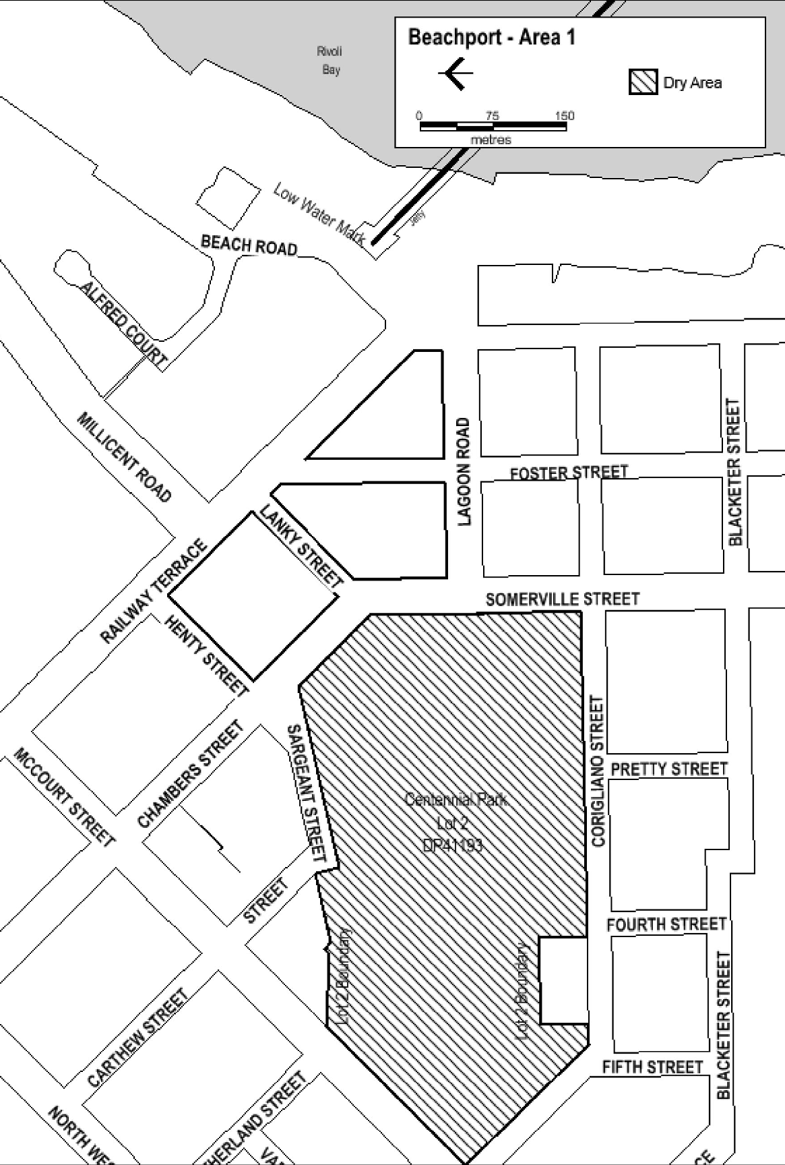
Dated: 27 October 2025
Made by the Liquor and Gambling Commissioner
Alison Selleck, Acting Assistant Director Licensing
Delegate of the Liquor and Gambling Commissioner

Liquor Licensing Act 1997
South Australia
Liquor Licensing (Dry Areas) Notice 2025
under Section 131(1a) of the Liquor Licensing Act 1997
1—Short title
This notice may be cited as the Liquor Licensing (Dry Areas) Notice 2025.
2—Commencement
This notice comes into operation on 26 December 2025.
3—Interpretation
(1) In this notice—
principal notice means the Liquor Licensing (Dry Areas) Notice 2015 published in the Gazette on 5 January 2015, as in force from time to time.
(2) Clause 3 of the principal notice applies to this notice as if it were the principal notice.
4—Consumption etc of liquor prohibited in dry areas
(1) Pursuant to Section 131 of the Act, the consumption and possession of liquor in the area described in the Schedule is prohibited in accordance with the provisions of the Schedule.
(2) The prohibition has effect during the periods specified in the Schedule.
(3) The prohibition does not extend to private land in the area described in the Schedule.
(4) Unless the contrary intention appears, the prohibition of the possession of liquor in the area does not extend to—
(a) a person who is genuinely passing through the place if—
(i) the liquor is in the original container in which it was purchased from licensed premises; and
(ii) the container has not been opened; or
(b) a person who has possession of the liquor in the course of carrying on a business or in the course of their employment by another person in the course of carrying on a business; or
(c) a person who is permanently or temporarily residing at premises near the public place and who enters the public place solely for the purpose of passing through it to enter those premises or who enters the public place from those premises for the purpose of leaving the place; or
(d) a person who possesses or consumes the liquor for sacramental or other similar religious purposes.

Schedule—Beachport Area 2
1—Extent of prohibition
The consumption of liquor is prohibited and the possession of liquor is prohibited.
2—Period of prohibition
From 12 noon on 26 December 2025 to 12 noon on 2 January 2026.
3—Description of area
The area in and adjacent to Beachport comprising the following roads and other areas:
(a) Railway Terrace between the south-eastern boundary of McCourt Street and the north-western boundary of Beach Road;
(b) Chambers Street and Somerville Street between the south-eastern boundary of McCourt Street and the southern boundary of Lagoon Road;
(c) Lagoon Road between the eastern boundary of Somerville Street and the western boundary of Beach Road;
(d) Henty Street;
(e) Lanky Street;
(f) Foster Street between Railway Terrace and the southern boundary of Lagoon Road;
(g) the area commencing at the point at which the prolongation in a straight line of the southern boundary of Lagoon Road intersects the low water mark on the western side of Rivoli Bay, then westerly along that prolongation to the western boundary of Beach Road, then generally northerly, north-easterly and northerly along that boundary of Beach Road to the southern boundary of Alfred Court, then along the prolongation in a straight line of that southern boundary of Alfred Court to the low water mark on the western side of Rivoli Bay, then generally south-westerly along the low water mark to the point of commencement.

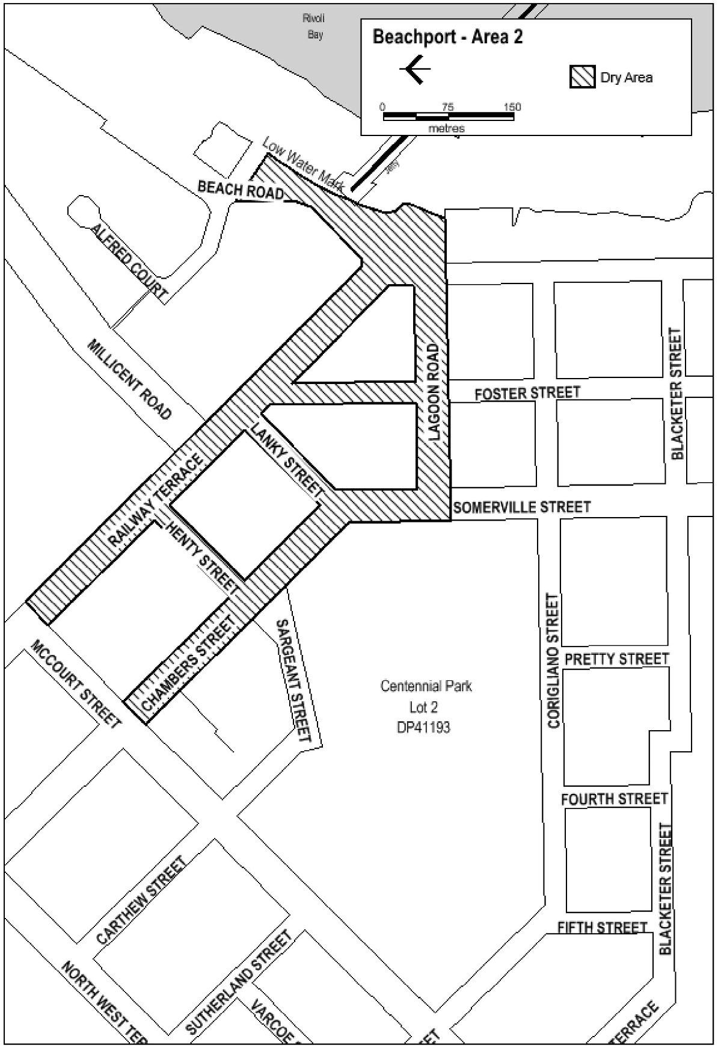
Dated: 27 October 2025
Made by the Liquor and Gambling Commissioner
Alison Selleck, Acting Assistant Director Licensing
Delegate of the Liquor and Gambling Commissioner

Liquor Licensing Act 1997
South Australia
Liquor Licensing (Dry Areas) Notice 2025
under Section 131(1a) of the Liquor Licensing Act 1997
1—Short title
This notice may be cited as the Liquor Licensing (Dry Areas) Notice 2025.
2—Commencement
This notice comes into operation on 30 December 2025.
3—Interpretation
(1) In this notice—
principal notice means the Liquor Licensing (Dry Areas) Notice 2015 published in the Gazette on 5 January 2015, as in force from time to time.
(2) Clause 3 of the principal notice applies to this notice as if it were the principal notice.
4—Consumption etc of liquor prohibited in dry areas
(1) Pursuant to Section 131 of the Act, the consumption and possession of liquor in the area described in the Schedule is prohibited in accordance with the provisions of the Schedule.
(2) The prohibition has effect during the periods specified in the Schedule.
(3) The prohibition does not extend to private land in the area described in the Schedule.
(4) Unless the contrary intention appears, the prohibition of the possession of liquor in the area does not extend to—
(a) a person who is genuinely passing through the place if—
(i) the liquor is in the original container in which it was purchased from licensed premises; and
(ii) the container has not been opened; or
(b) a person who has possession of the liquor in the course of carrying on a business or in the course of their employment by another person in the course of carrying on a business; or
(c) a person who is permanently or temporarily residing at premises near the public place and who enters the public place solely for the purpose of passing through it to enter those premises or who enters the public place from those premises for the purpose of leaving the place; or
(d) a person who possesses or consumes the liquor for sacramental or other similar religious purposes.

Schedule 1—Chiton Rocks Car Park Area 1
1—Extent of prohibition
The consumption of liquor is prohibited and the possession of liquor is prohibited.
2—Period of prohibition
From 6:00pm on 30 December 2025-6:00am on 2 January 2026.
3—Description of area
Chiton Rocks Surf Life Saving Club—car park area and adjacent beach area to the low water mark. The area adjacent to Victor Harbor generally known as the Chiton Rocks Surf Lifesaving Club car park and the adjacent beach, being the area bounded on the north by the northern boundaries of Lot 469 DP 3482 and Lot 440 DP 3207, on the west by the prolongation in a straight line of the western boundary of Lot 433 DP 3207, on the south by the low water mark on Encounter Bay and on the east by the prolongation in a straight line of the eastern boundary of Lot 463 DP 3482.
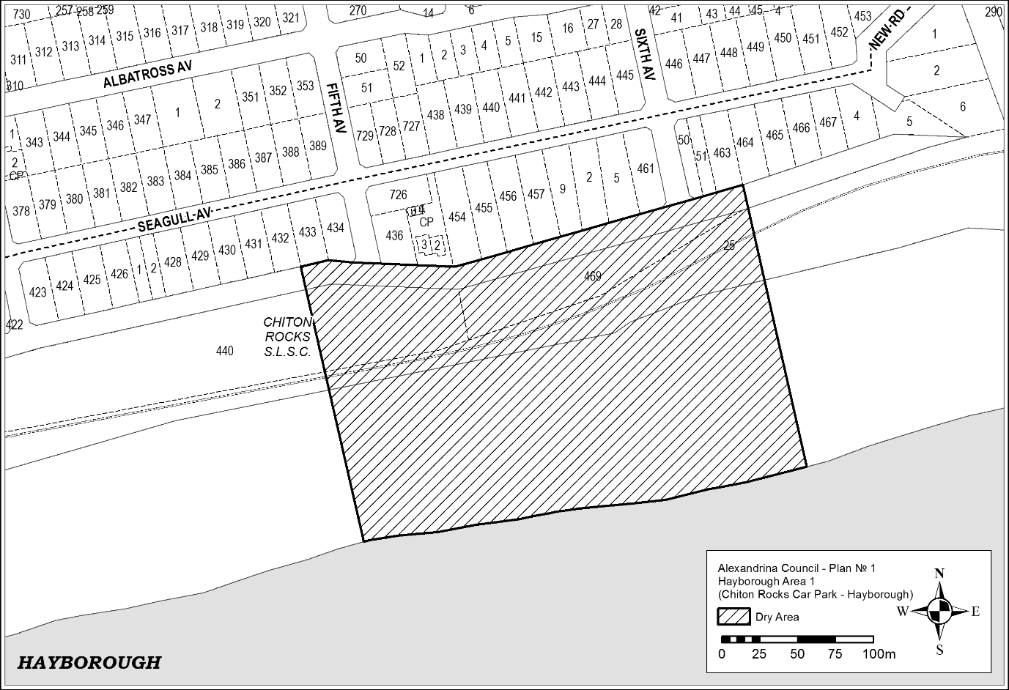

Schedule 2—Port Elliot Area 2
1—Extent of prohibition
The consumption of liquor is prohibited and the possession of liquor is prohibited.
2—Period of prohibition
From 6:00pm on 30 December 2025-6:00am on 2 January 2026.
3—Description of area
Port Elliot Area 2—Plan No. 2
The area in and adjacent to Port Elliot bounded as follows: commencing at the point at which the eastern boundary of Lot 26 of DP 74300 meets the northern boundary of Railway Terrace (approximately 50 metres west of the western boundary of Bennett Road), then easterly along the northern boundary of Railway Terrace to the western boundary of Carfax Street, then northerly along that boundary of Carfax Street to the point at which it is intersected by the prolongation in a straight line of the northern boundary of Battunga Avenue, then generally easterly, south-easterly and easterly along that prolongation and boundary of Battunga Avenue and the prolongation in a straight line of that boundary to the eastern boundary of Rosetta Terrace, then southerly along that boundary of Rosetta Terrace to the northern boundary of Barbara Street, then easterly along that boundary of Barbara Street to the point at which it intersects the eastern boundary of Hutton Street, then southerly along that boundary of Hutton Street to the northern boundary of Merrilli Place, then easterly along that boundary of Merrilli Place to the point at which it is intersected by the prolongation in a straight line of the eastern boundary of The Esplanade, then south-easterly along that prolongation and boundary of The Esplanade to the western boundary of Lot 101 of DP 46201, then south-easterly and easterly along the western and southern boundaries of Lot 101 and the southern boundaries of the adjoining Lots to the western boundary of The Strand, then northerly along that boundary of The Strand to the point at which it intersects the southern boundary of Torrens Street, then in a straight line by the shortest route (across The Strand) to the point at which the southern boundary of Murray Place meets the eastern boundary of The Strand, then easterly and north-easterly along that boundary of Murray Place to the point at which it meets the prolongation in a straight line of the southern boundary of Freeling Street, then north-easterly along that prolongation of the southern boundary of Freeling Street to the point at which it intersects the low water mark of Horseshoe Bay, then generally south-westerly, south-easterly, south-westerly and westerly along the low water mark to the point at which the low water mark is intersected by the prolongation in a straight line of the eastern boundary of Lot 26 of DP 74300, then northerly along that prolongation of the eastern boundary of Lot 26 to the point of commencement. The area includes the whole of any wharf, jetty, boat ramp, breakwater or other structure that projects below the low water mark from within the area described above (aswell as any area beneath such a structure).

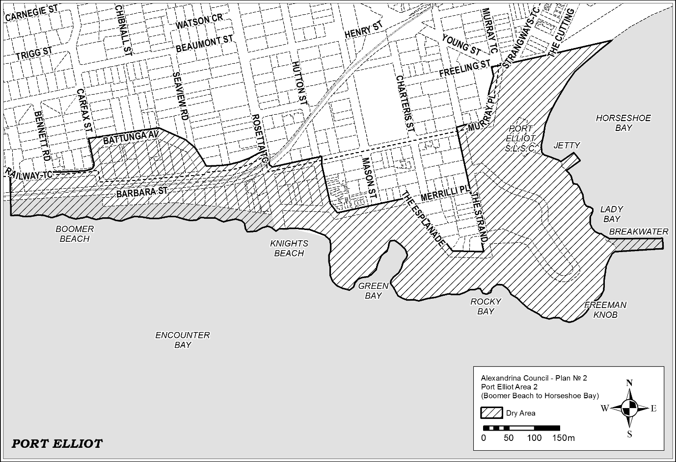
Schedule 3—Middleton Point Foreshore Area, Middleton Beach
1—Extent of prohibition
The consumption of liquor is prohibited and the possession of liquor is prohibited.
2—Period of prohibition
From 6:00pm on 30 December 2025-6:00am on 2 January 2026.
3—Description of area
Middleton Area 1—Plan No. 3
The area in and adjacent to Middleton bounded as follows: commencing at the point at which the prolongation in a straight line of the western boundary of Basham Beach Road intersects the high water mark of Encounter Bay, then north-westerly along that prolongation and boundary to the point at which it is intersected by the prolongation in a straight line of the southern boundary of Set Road, then north-easterly along that prolongation and boundary of Set Road to the western boundary of Seaview Avenue, then generally south-easterly and north-easterly along that boundary of Seaview Avenue to the point at which it meets the eastern boundary of Lot 101 DP 10654, then south-easterly along that boundary of Lot 101 to the south-western corner of Lot 19 DP 3145, then generally north-easterly along the south-eastern boundary of Lot 19, the south-eastern boundaries of the adjoining Lots and the northern boundary of Ocean Parade to the south-eastern corner of Lot 133 FP 166507, then generally north-easterly and northerly along the easternmost boundaries of Lot 133 and the adjoining Lots (including the eastern boundary of Dover Road) to the north-eastern corner of Lot 39 DP 3262, then in a straight line by the shortest route to the north-western corner of Lot 160 DP 9417, then easterly along the southern boundary of the Esplanade to the western boundary of Lot 3 DP 13398, then northerly, easterly and southerly along the western, northern and eastern boundaries of that Lot to its south-eastern corner, then along the northern boundary of Section 345, Hundred of Goolwa, (the southern boundary of Surfer’s Parade) to the point at which it is intersected by the prolongation in a straight line of the eastern boundary of Lot 39 DP 6156, then along that prolongation to the point at which it intersects the high water mark of Encounter Bay, then generally westerly and south-westerly along the high water mark to the point of commencement.
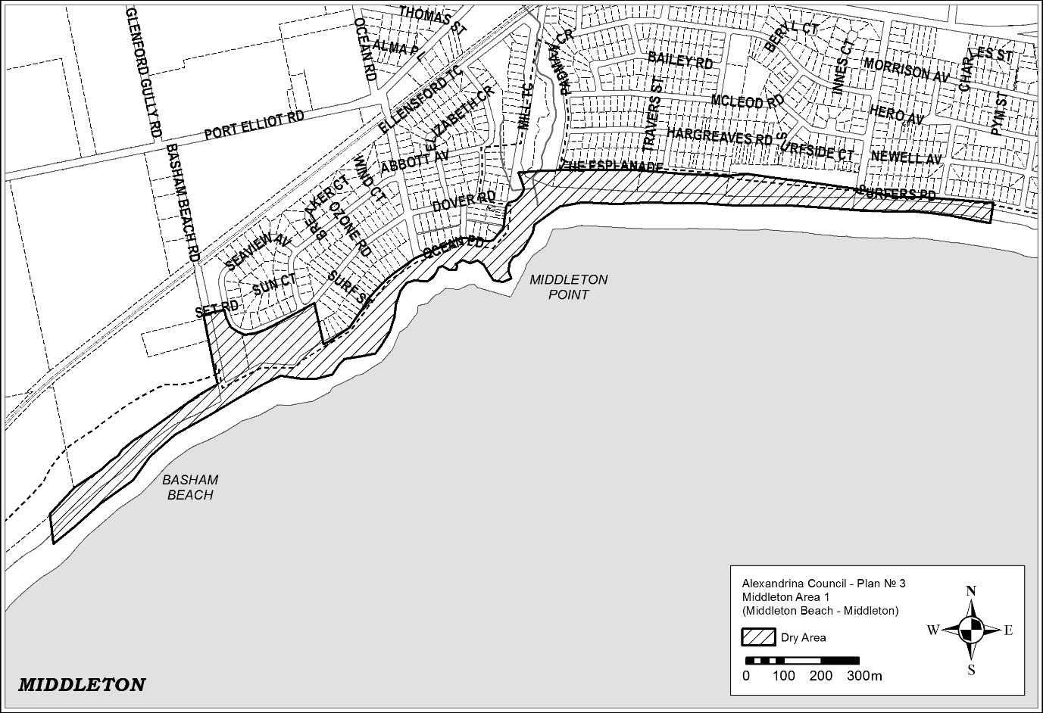

Schedule 4—Goolwa Wharf Precinct
1—Extent of prohibition
The consumption of liquor is prohibited and the possession of liquor is prohibited.
2—Period of prohibition
From 6:00pm on 30 December 2025-6:00am on 2 January 2026.
3—Description of area
Goolwa Wharf Precinct
The area in Goolwa Central and Port of Goolwa (generally known as the Wharf Precinct) and to be known as Goolwa Area 3 bounded as follows:
Commencing at the north eastern corner of Section 315, Hundred of Goolwa, and then due west to the eastern side of the railway reserve. Then follow the easterly side of the railway reserve until reaching the south western underside of the Goolwa and Hindmarsh Island Bridge. Head in a north westerly direction, along the south western side of Brooking Street, until the round-about intersection of Brooking Street, Liverpool Road and Goolwa Terrace. Follow the south eastern side of Goolwa Terrace until the intersection of Cadell Street and Goolwa Terrace. Traversing the north eastern side of Cadell Street, past the Cadell Street and Cutting Road intersection. Continue along Cadell Street and enter Hayes Street then to the Hayes Street and Porter Street intersection. Head south east to the Porter Street and Admiral Terrace intersection. Then head south west and continue along the eastern side of Admiral Terrace past the intersections of Goyder Street, Hutchinson Street, Sidmouth Street until the Admiral Terrace and Baronet Street intersection. Head east south east and traverse around the jetty and return to the eastern side of the boardwalk. Head north east along the eastern side of the boardwalk then a straight line, by the shortest route, to the southern side of the jetty. Then in a straight line by the shortest route to the south eastern side of the Goolwa Wharf. Traverse the south eastern side of the Goolwa Wharf under the Goolwa and Hindmarsh Island Bridge along the River Murray bank to the south eastern side of Section 315 returning to the point of commencement.

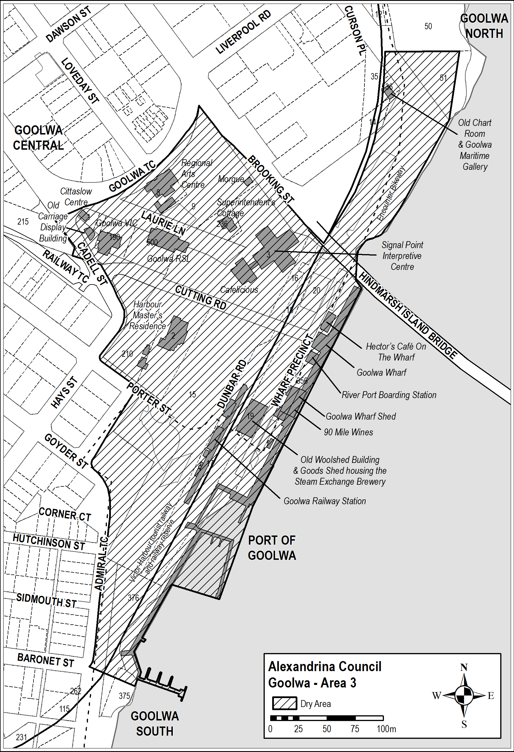
Schedule 5—Goolwa Beach Area 1
1—Extent of prohibition
The consumption of liquor is prohibited and the possession of liquor is prohibited.
2—Period of prohibition
From 6:00pm on 30 December 2025-6:00am on 2 January 2026.
3—Description of area
Goolwa Beach Area 1—Plan No. 4
The area in Goolwa Beach and Goolwa South (generally known as the Goolwa Beach car park) bounded as follows: commencing at the north-eastern corner of Section 279, Hundred of Goolwa, then westerly and southerly along the northern and western boundaries of Section 279 to the northern boundary of Section 367, Hundred of Goolwa, then southerly and easterly along the western and southern boundaries of Section 367 to the south-eastern corner of the Section, then in a straight line by the shortest route to the south-western corner of Section 368, Hundred of Goolwa, then easterly and northerly along the southern and eastern boundaries of Section 368 to the southern boundary of Section 278, Hundred of Goolwa, then northerly and westerly along the eastern and northern boundaries of Section 278 to the north-western corner of the Section, then in a straight line by the shortest route across Goolwa Beach Road to the point of commencement.

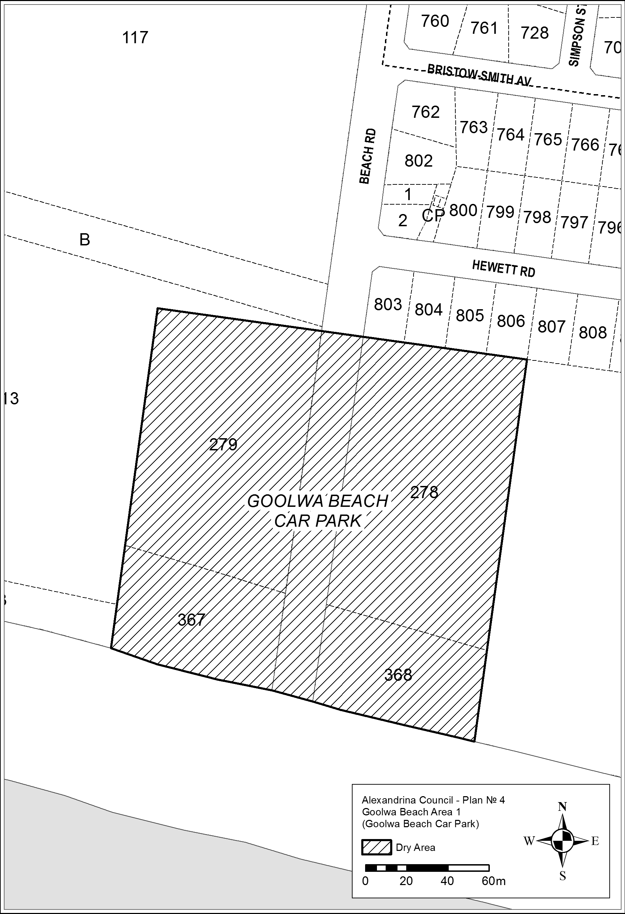
Schedule 6—Basham Beach Area 1
1—Extent of prohibition
The consumption of liquor is prohibited and the possession of liquor is prohibited.
2—Period of prohibition
From 6:00pm on 30 December 2025-6:00am on 2 January 2026.
3—Description of area
Basham Beach Area 1—Plan No 6
Commencing at the point at which the western boundary of Basham Beach Road, Middleton, intersects the southern boundary of the railway reserve for the Victor Harbor Tourist Railway, then south-easterly along that boundary of Basham Beach Road to the northern boundary of Lot 96 FP 166155, then south-westerly, south-easterly and north-easterly along the northern, western and southern boundaries of Lot 96 to the western boundary of Basham Beach Road, then south-easterly along that boundary of Basham Beach Road and the prolongation in a straight line of that boundary to the low water mark of Encounter Bay, then generally south-westerly, southerly, south-easterly, easterly, southerly, south-westerly and north-westerly along the low water mark to the prolongation in a straight line of the western boundary of Lot 2 DP 52281, then northerly along that prolongation and boundary of Lot 2 to the southern boundary of Lot 1 DP 52281 (the southern boundary of the Port Elliot Caravan Park), then generally easterly, south-easterly, north-easterly and northerly along that boundary of Lot 1 and the eastern boundary of Lot 858 FP 166107 to the northern boundary of Lot 858, then south-westerly along the northern boundary of Lot 858 and the northern boundaries of the adjoining allotments to the eastern boundary of the railway reserve for the Victor Harbor Tourist Railway, then generally north-easterly along that boundary of the railway reserve to the point of commencement.

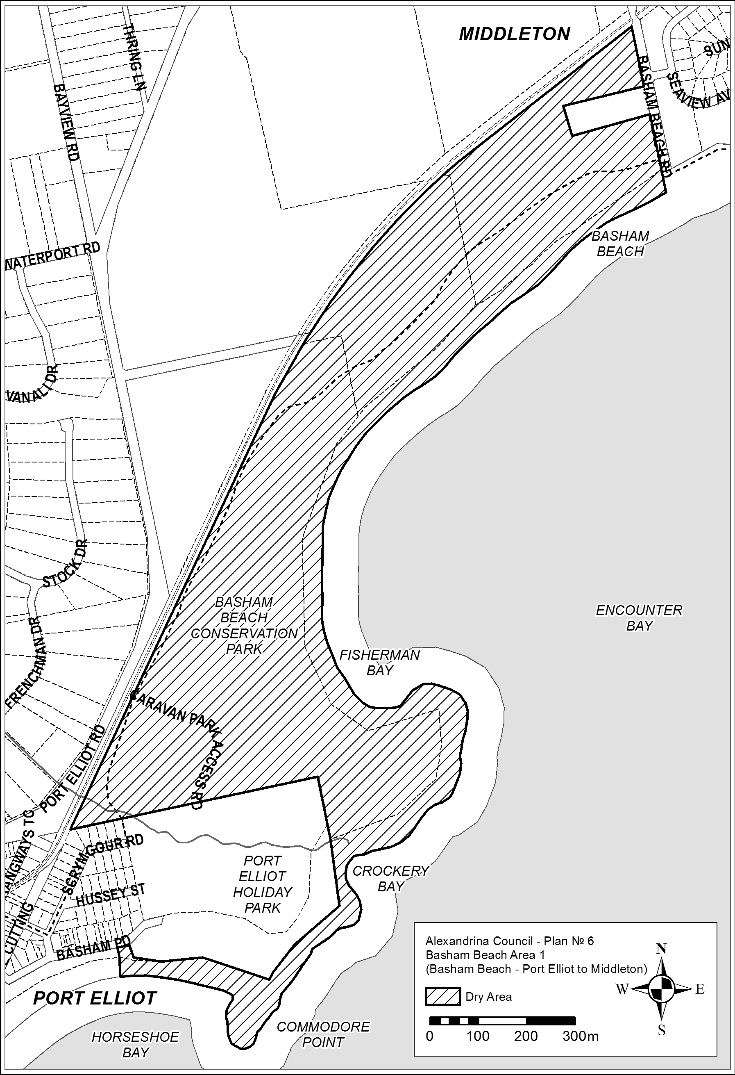
Dated: 6 November 2025
Made by the Liquor and Gambling Commissioner
Delegate of the Liquor and Gambling Commissioner

Liquor Licensing Act 1997
South Australia
Liquor Licensing (Dry Areas) Notice 2025
under Section 131(1a) of the Liquor Licensing Act 1997
1—Short title
This notice may be cited as the Liquor Licensing (Dry Areas) Notice 2025.
2—Commencement
This notice comes into operation on 20 November 2025.
3—Interpretation
(1) In this notice—
principal notice means the Liquor Licensing (Dry Areas) Notice 2015 published in the Gazette on 5 January 2015, as in force from time to time.
(2) Clause 3 of the principal notice applies to this notice as if it were the principal notice.
4—Consumption etc of liquor prohibited in dry areas
(1) Pursuant to Section 131 of the Act, the consumption and possession of liquor in the area described in the Schedule is prohibited in accordance with the provisions of the Schedule.
(2) The prohibition has effect during the periods specified in the Schedule.
(3) The prohibition does not extend to private land in the area described in the Schedule.
(4) Unless the contrary intention appears, the prohibition of the possession of liquor in the area does not extend to—
(a) a person who is genuinely passing through the place if—
(i) the liquor is in the original container in which it was purchased from licensed premises; and
(ii) the container has not been opened; or
(b) a person who has possession of the liquor in the course of carrying on a business or in the course of their employment by another person in the course of carrying on a business; or
(c) a person who is permanently or temporarily residing at premises near the public place and who enters the public place solely for the purpose of passing through it to enter those premises or who enters the public place from those premises for the purpose of leaving the place; or
(d) a person who possesses or consumes the liquor for sacramental or other similar religious purposes.
Schedule 1—Middleton Area 1
1—Extent of prohibition
The consumption of liquor is prohibited and the possession of liquor is prohibited.

2—Period of prohibition
From 8:00am on 20 November 2025 to 10:00am on 24 November 2025.
3—Description of area
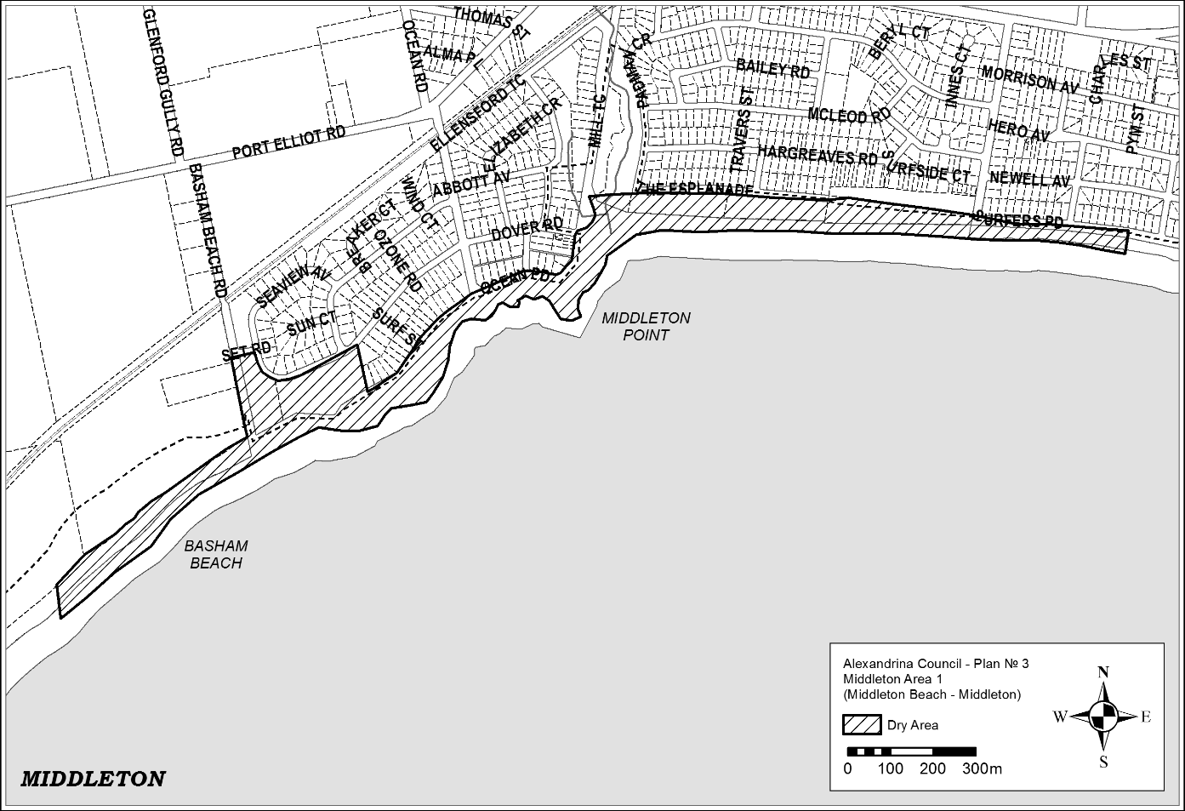
The area in and adjacent to Middleton bounded as follows: commencing at the point at which the prolongation in a straight line of the western boundary of Basham Beach Road intersects the high water mark of Encounter Bay, then north-westerly along that prolongation and boundary to the point at which it is intersected by the prolongation in a straight line of the southern boundary of Set Road, then north-easterly along that prolongation and boundary of Set Road to the western boundary of Seaview Avenue, then generally south-easterly and north-easterly along that boundary of Seaview Avenue to the point at which it meets the eastern boundary of Lot 101 DP 10654, then south-easterly along that boundary of Lot 101 to the south-western corner of Lot 19 DP 3145, then generally north-easterly along the south-eastern boundary of Lot 19, the south-eastern boundaries of the adjoining Lots and the northern boundary of Ocean Parade to the south-eastern corner of Lot 133 FP 166507, then generally north-easterly and northerly along the easternmost boundaries of Lot 133 and the adjoining Lots (including the eastern boundary of Dover Road) to the north-eastern corner of Lot 39 DP 3262, then in a straight line by the shortest route to the north-western corner of Lot 160 DP 9417, then easterly along the southern boundary of the Esplanade to the western boundary of Lot 3 DP 13398, then northerly, easterly and southerly along the western, northern and eastern boundaries of that Lot to its south-eastern corner, then along the northern boundary of Section 345, Hundred of Goolwa, (the southern boundary of Surfer's Parade) to the point at which it is intersected by the prolongation in a straight line of the eastern boundary of Lot 39 DP 6156, then along that prolongation to the point at which it intersects the high water mark of Encounter Bay, then generally westerly and south-westerly along the high water mark to the point of commencement.

Schedule 2—Port Elliot Area 3
1—Extent of prohibition
The consumption of liquor is prohibited and the possession of liquor is prohibited.
2—Period of prohibition
From 8:00am on 20 November 2025 to 10:00am on 24 November 2025.
3—Description of area
Commencing at the South Eastern corner of the intersection of The Strand and Murray Place and then traversing along the Eastern side of The Strand until the North Eastern side of the intersection of The Stand and Freeman Lookout. Then traverse along the Northern side of Freeman Lookout until the Eastern post of the gate into the Obelisk reserve then head West North West along the Western edge of the Soldiers’ Memorial Gardens until Murray Place returning to the point of commencement.

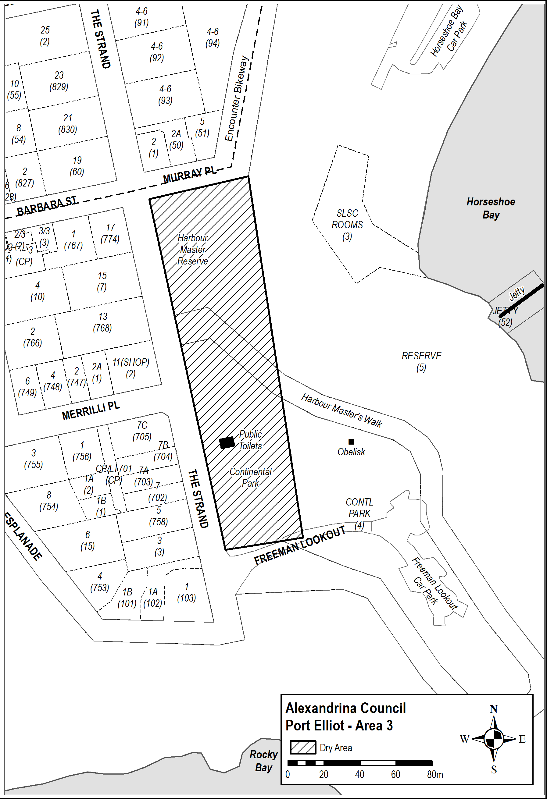
Dated: 6 November 2025
Made by the Liquor and Gambling Commissioner
Delegate of the Liquor and Gambling Commissioner

Liquor Licensing Act 1997
South Australia
Liquor Licensing (Dry Areas) Notice 2025
under Section 131(1a) of the Liquor Licensing Act 1997
1—Short title
This notice may be cited as the Liquor Licensing (Dry Areas) Notice 2025.
2—Commencement
This notice has effect on the day on which it is published in the Gazette.
3—Interpretation
(1) In this notice—
principal notice means the Liquor Licensing (Dry Areas) Notice 2015 published in the Gazette on 5 January 2015, as in force from time to time.
(2) Clause 3 of the principal notice applies to this notice as if it were the principal notice.
4—Consumption etc of liquor prohibited in dry areas
(1) Pursuant to Section 131 of the Act, the consumption and possession of liquor in the area described in the Schedule is prohibited in accordance with the provisions of the Schedule.
(2) The prohibition has effect during the periods specified in the Schedule.
(3) The prohibition does not extend to private land in the area described in the Schedule.
(4) Unless the contrary intention appears, the prohibition of the possession of liquor in the area does not extend to—
(a) a person who is genuinely passing through the place if—
(i) the liquor is in the original container in which it was purchased from licensed premises; and
(ii) the container has not been opened; or
(b) a person who has possession of the liquor in the course of carrying on a business or in the course of their employment by another person in the course of carrying on a business; or
(c) a person who is permanently or temporarily residing at premises near the public place and who enters the public place solely for the purpose of passing through it to enter those premises or who enters the public place from those premises for the purpose of leaving the place; or
(d) a person who possesses or consumes the liquor for sacramental or other similar religious purposes.
Schedule 1—Ovingham and Renown Park—Area 1
1—Extent of prohibition
The consumption of liquor is prohibited and the possession of liquor is prohibited.
2—Period of prohibition
Continuous from the day on which this notice is published in the Gazette for a period of 14 days.
3—Description of area
The area in Renown Park, known as Napier Reserve (and surrounds), bounded as follows:
The Dry Zone Boundary is intended to encompass the reserve, land and associated road reserves, kerbs and footpaths beneath and near the Torrens Road Underpass, Ovingham.
The Dry Zone Boundary begins at the north-west corner of Lot 101 Drayton Street Bowden (known as 163 Drayton Street, Pocket Park, currently under construction) and travels north-west in a straight line across Drayton Street to (and including) the kerb. The boundary follows the kerb north-west until level with the shop verandah (Lot 92 Torrens Road Bowden), and then follows the line of the verandah West, including the footpath. It continues along the southern edge of the footpath in a direct line along the fences of property boundaries across Picton and East Streets toward Manintjeru Way. At the northern corner of Lot 1 Torrens Road Brompton (known as Unit 1/65 Torrens Road Brompton), the Boundary crosses Manintjeru Way in a direct line west and follows the northern fence of Lots 54 and 55 Torrens Road (known as 71 Torrens Road Brompton, Chief Street Pocket Park, currently under construction). The boundary then crosses Chief Street in a direct line and travels along the southern edge of the footpath in front of Lot 5 Torrens Road Brompton (known as 73-77 Torrens Road Brompton, On the Run Service Station) and continues to the north-western corner of Lot 53 (known as 83 Torrens Road Brompton). It then crosses Torrens Road in a direct line to the south-western corner of Lot 3 (known as 23 Napier Street Renown Park) and travels south-east along the southern fence of Lot 3 (including the footpath and garden) toward Napier Street. At the western edge of the footpath on Napier Street, the boundary turns north-east in front of Lot 3 and follows the western edge of the footpath to the northern corner of Lot 1 Napier Street Renown Park (known as 19 Napier Street, Renown Park). At the corner, the boundary then travels south-east across Napier Street in a direct line to the south-western corner of Lot 105 Napier Street Renown Park (known as 20 Napier Street Renown Park). It then follows the fence at the rear of the properties along McEwin Street Renown Park south-east, until the south-eastern Corner of Lot 1 McEwin Street Renown Park (known as 1 McEwin Street Renown Park). The Boundary moves north-east along the fence (west of the playground) until it reaches the southern edge of the footpath on McEwin Street Renown Park. The boundary moves in a direct line north across McEwin Street to meet the western edge of the footpath travelling north along Exeter Terrace Renown Park. It follows the eastern property boundary of Lot 2 McEwin Street Renown Park (known as 2C McEwin Street Renown Park) until the northern edge of the traffic control (slow speed) infrastructure on Exeter Terrace Renown Park. The boundary then travels east in a direct line across Exeter Terrace and across the railway corridor toward the northern boundary of Lot 30 Devonport Terrace Ovingham (known as 21 Devonport Terrace Ovingham). It then travels south (including the footpath), crosses Avenue Road in a straight line and continues south along the western property boundaries of Devonport Terrace to the southern boundary of 5 Devonport Terrace, Ovingham.
It then travels east along the southern boundary of 5 Devonport Terrace, to the eastern boundary and then north along the eastern boundaries at the rear of properties on Devonport Terrace to the southern boundary of 28 Churchill Road. It then travels east along the southern boundary of 28 Churchill Road to the eastern boundary of the same property, then in a direct line north to the northern boundary of 28 Churchill Road. It then travels east across Churchill Road to the northern boundary of 29 Churchill Road and then south along the western property lines of Churchill Road (including the service road) to the intersection of Torrens Road. It then travels in a direct line across Torrens Road south-west to the south-eastern boundary of Lot 9 Torrens Road (known as the Ovingham Hotel), then continuing north-west along the north-eastern boundary of the Ovingham Hotel (excluding its licenced area), across Guthrie Street, to the north-eastern property boundary of Lot 17 Torrens Road Ovingham (known as 31 Torrens Road Ovingham). It then travels north-west in a direct line toward Drayton Street, Bowden, continuing along the northern property boundaries and across the Railway corridor, until reaching the beginning at the north-western Corner of Lot 101 Drayton Street Bowden.
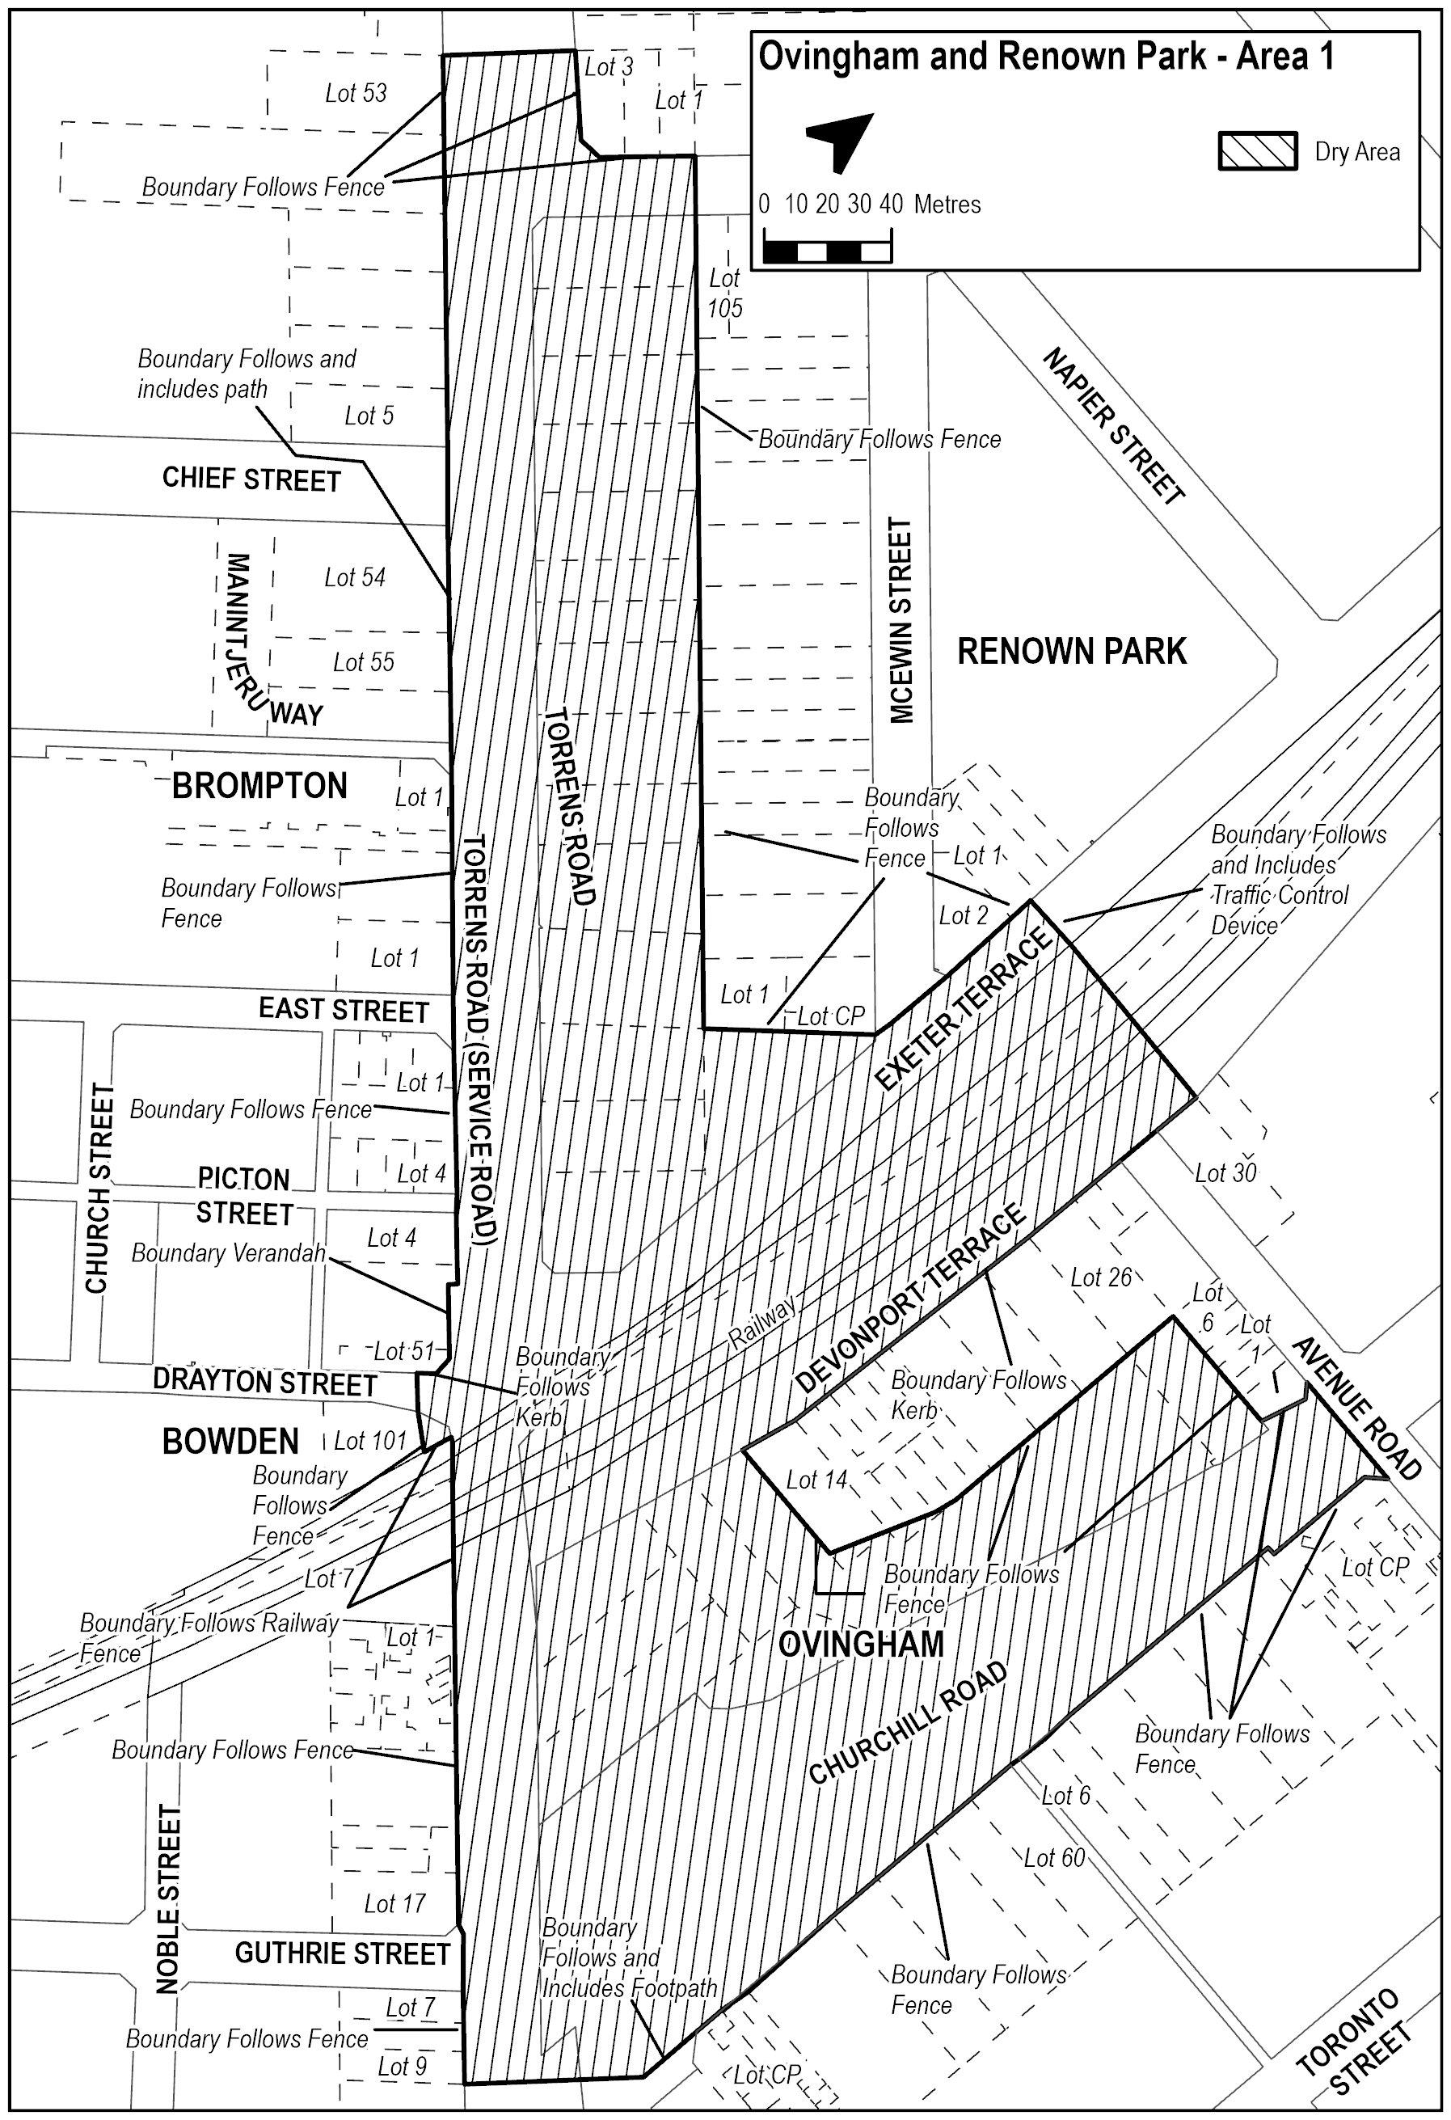
Made by the Liquor and Gambling Commissioner
On 4 November 2025

Liquor Licensing Act 1997
South Australia
Liquor Licensing (Dry Areas) Notice 2025
under Section 131(1a) of the Liquor Licensing Act 1997
1—Short title
This notice may be cited as the Liquor Licensing (Dry Areas) Notice 2025.
2—Commencement
This notice comes into operation on 26 December 2025.
3—Interpretation
(1) In this notice—
principal notice means the Liquor Licensing (Dry Areas) Notice 2015 published in the Gazette on 5 January 2015, as in force from time to time.
(2) Clause 3 of the principal notice applies to this notice as if it were the principal notice.
4—Consumption etc of liquor prohibited in dry areas
(1) Pursuant to Section 131 of the Act, the consumption and possession of liquor in the area described in the Schedule is prohibited in accordance with the provisions of the Schedule.
(2) The prohibition has effect during the periods specified in the Schedule.
(3) The prohibition does not extend to private land in the area described in the Schedule.
(4) Unless the contrary intention appears, the prohibition of the possession of liquor in the area does not extend to—
(a) a person who is genuinely passing through the place if—
(i) the liquor is in the original container in which it was purchased from licensed premises; and
(ii) the container has not been opened; or
(b) a person who has possession of the liquor in the course of carrying on a business or in the course of their employment by another person in the course of carrying on a business; or
(c) a person who is permanently or temporarily residing at premises near the public place and who enters the public place solely for the purpose of passing through it to enter those premises or who enters the public place from those premises for the purpose of leaving the place; or
(d) a person who possesses or consumes the liquor for sacramental or other similar religious purposes.

Schedule—Robe Area 1

1—Extent of prohibition
The consumption of liquor is prohibited and the possession of liquor is prohibited.
2—Period of prohibition
From 12 noon on 26 December 2025 to 12 midnight on 1 January 2026.
3—Description of area
The area in and adjacent to Robe bounded as follows: commencing at the western end of the northern boundary of Dawson Drive, then in a straight line by the shortest route to the low water mark of Guichen Bay on the eastern side of the entrance to Fox's Lake, then in a straight line by the shortest route (across the entrance) to the low water mark on the western side of the entrance, then generally westerly along the low water mark to the eastern side of the entrance to Lake Butler, then in a straight line by the shortest route (across the entrance) toD the eastern boundary of the breakwater on the western side of the entrance to the lake, then northerly, north-easterly, westerly and south-westerly around the outer boundary of the breakwater back to the low water mark on the shore on the western side of the breakwater, then generally north-westerly and southerly along the low water mark to the point at which it is intersected by the prolongation in a straight line of the southern boundary of Evans Cave Road (the northern boundary of Section 363 Hundred of Waterhouse), then generally easterly along that prolongation and boundary of Evans Cave Road, and the prolongation in a straight line of that boundary, to the eastern boundary of Robe Street, then northerly along that boundary of Robe Street to the southern boundary of Beacon Hill Road, then generally easterly along that boundary of Beacon Hill Road to the point at which it meets the north-eastern boundary of Lot 5 of DP 78111, then generally south-easterly and easterly along that boundary of Lot 5 and easterly and north-easterly along the northern boundary of Section 289 Hundred of Waterhouse to the eastern boundary of Section 289, then in a straight line by the shortest route to the south-western corner of Lot 11 of DP 64831, then easterly along the southern boundary of Lot 11 and the prolongation in a straight line of that boundary to the point at which the prolongation intersects the eastern boundary of Nora Creina Road, then northerly along that boundary of Nora Creina Road to the point at which it meets the southern boundary of Wildfield Road, then generally easterly along that boundary of Wildfield Road and the prolongation in a straight line of that boundary to the point at which the prolongation intersects the northern boundary of Southern Ports Highway, then generally north-westerly and south-westerly along that boundary of Southern Ports Highway and the northern boundary of Main Road to the eastern boundary of Dawson Drive, then generally north-westerly and westerly along that boundary of Dawson Drive to the point of commencement. The area includes any wharf, jetty, boat ramp, breakwater or other structure projecting below low water mark from within the area described above (as well as any area beneath such a structure).

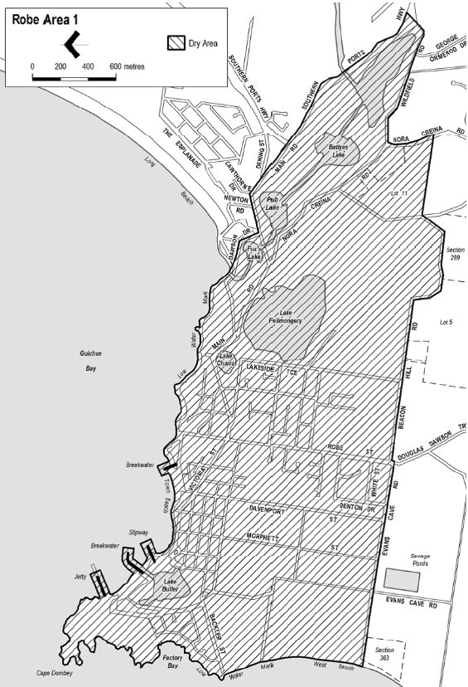
Dated: 6 November 2025
Made by the Liquor and Gambling Commissioner
Delegate of the Liquor and Gambling Commissioner

Liquor Licensing Act 1997
South Australia
Liquor Licensing (Dry Areas) Notice 2025
under Section 131(1a) of the Liquor Licensing Act 1997
1—Short title
This notice may be cited as the Liquor Licensing (Dry Areas) Notice 2025.
2—Commencement
This notice comes into operation on 26 December 2025.
3—Interpretation
(1) In this notice—
principal notice means the Liquor Licensing (Dry Areas) Notice 2015 published in the Gazette on 5 January 2015, as in force from time to time.
(2) Clause 3 of the principal notice applies to this notice as if it were the principal notice.
4—Consumption etc of liquor prohibited in dry areas
(1) Pursuant to Section 131 of the Act, the consumption and possession of liquor in the area described in the Schedule is prohibited in accordance with the provisions of the Schedule.
(2) The prohibition has effect during the periods specified in the Schedule.
(3) The prohibition does not extend to private land in the area described in the Schedule.
(4) Unless the contrary intention appears, the prohibition of the possession of liquor in the area does not extend to—
(a) a person who is genuinely passing through the place if—
(i) the liquor is in the original container in which it was purchased from licensed premises; and
(ii) the container has not been opened; or
(b) a person who has possession of the liquor in the course of carrying on a business or in the course of their employment by another person in the course of carrying on a business; or
(c) a person who is permanently or temporarily residing at premises near the public place and who enters the public place solely for the purpose of passing through it to enter those premises or who enters the public place from those premises for the purpose of leaving the place; or
(d) a person who possesses or consumes the liquor for sacramental or other similar religious purposes.

Schedule—Robe Area 2
1—Extent of prohibition
The consumption of liquor is prohibited and the possession of liquor is prohibited.
2—Period of prohibition
From 12 noon on 26 December 2025 to 12 midnight on 1 January 2026.
3—Description of area
The area in and adjacent to Robe bounded as follows: commencing at the western end of the northern boundary of Dawson Drive, then in a straight line by the shortest route to the low water mark of Guichen Bay on the eastern side of the entrance to Fox's Lake, then generally north-easterly along the low water mark to the point at which it is intersected by the prolongation in a straight line of the northern boundary of Section 573 Hundred of Waterhouse, then easterly along that prolongation and boundary of Section 573 to the eastern boundary of the Section, then generally southerly and south-westerly along that boundary of Section 573 to the north-eastern boundary of Section 390 Hundred of Waterhouse, then south-easterly along that boundary of Section 390 to the point at which it is intersected by the prolongation in a straight line of the northern boundary of Dennis Avenue, then easterly along that prolongation and boundary of Dennis Avenue, and the prolongation in a straight line of that boundary, to the point at which the prolongation intersects the western boundary of Lot 223 of FP 205569, then generally south-westerly and southerly along that boundary of Lot 223 and the prolongation in a straight line of that boundary to the point at which the prolongation intersects the south-eastern boundary of Southern Ports Highway, then south-westerly along that boundary to the western boundary of Lot 2 of FP 9707, then southerly along that boundary of Lot 2 to the southern boundary of the Lot, then generally north-westerly and south-westerly along the northern boundary of Southern Ports Highway and the northern boundary of Main Road to the eastern boundary of Dawson Drive, then generally north-westerly and westerly along that boundary of Dawson Drive to the point of commencement.

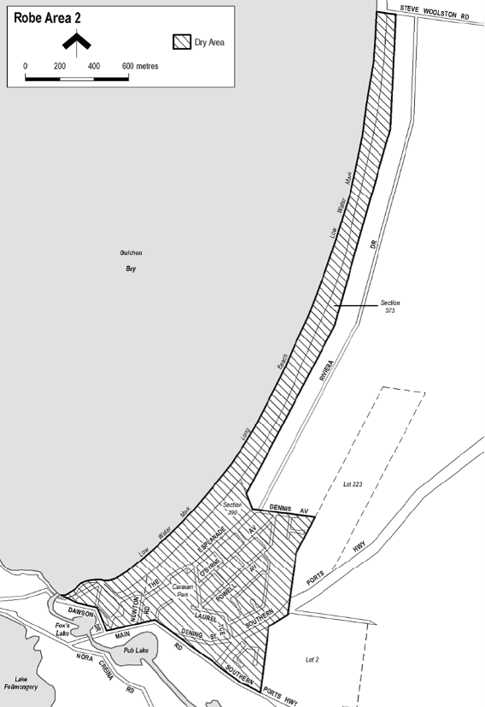
Dated: 6 November 2025
Made by the Liquor and Gambling Commissioner
Delegate of the Liquor and Gambling Commissioner

Liquor Licensing Act 1997
South Australia
Liquor Licensing (Dry Areas) Notice 2025
under Section 131(1a) of the Liquor Licensing Act 1997
1—Short title
This notice may be cited as the Liquor Licensing (Dry Areas) Notice 2025.
2—Commencement
This notice comes into operation on 17 November 2025.
3—Interpretation
(1) In this notice—
principal notice means the Liquor Licensing (Dry Areas) Notice 2015 published in the Gazette on 5.1.15, as in force from time to time.
(2) Clause 3 of the principal notice applies to this notice as if it were the principal notice.
4—Consumption etc of liquor prohibited in dry areas
(1) Pursuant to Section 131 of the Act, the consumption and possession of liquor in the area described in the Schedule is prohibited in accordance with the provisions of the Schedule.
(2) The prohibition has effect during the periods specified in the Schedule.
(3) The prohibition does not extend to private land in the area described in the Schedule.
(4) Unless the contrary intention appears, the prohibition of the possession of liquor in the area does not extend to—
(a) a person who is genuinely passing through the area if—
(i) the liquor is in the original container in which it was purchased from licensed premises; and
(ii) the container has not been opened; or
(b) a person who has possession of the liquor in the course of carrying on a business or in the course of his or her employment by another person in the course of carrying on a business; or
(c) a person who is permanently or temporarily residing at premises within the area or on the boundary of the area and who enters the area solely for the purpose of passing through it to enter those premises or who enters the area from those premises for the purpose of leaving the area.
Schedule—Victor Harbor Area 2
1—Extent of prohibition
The consumption of liquor is prohibited and the possession of liquor is prohibited.
2—Period of prohibition
From 8am Monday, 17 November 2025 to 10am Monday, 24 November 2025.
3—Description of area
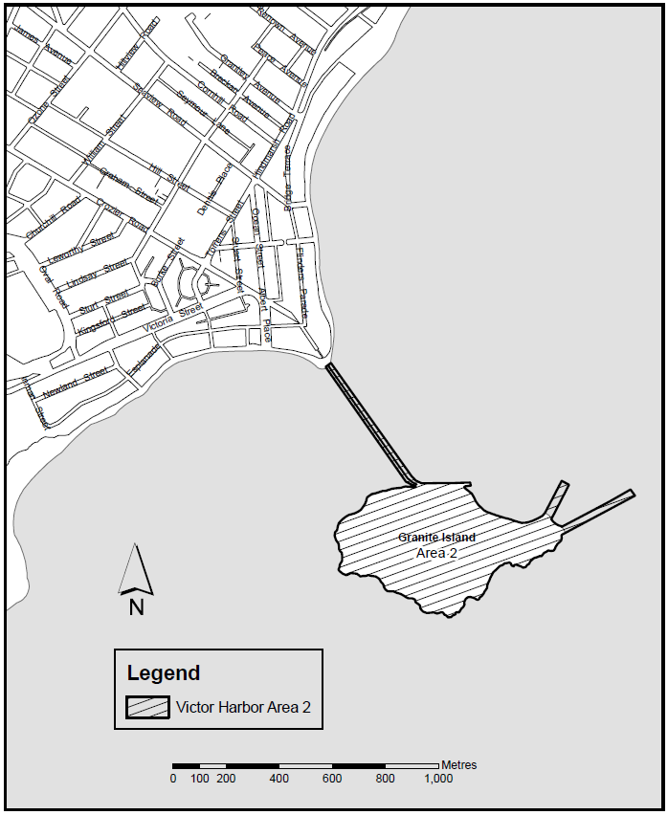
The whole of Granite Island to low water mark, together with the whole of the causeway linking the mainland and Granite Island (apart from the part of the causeway above the low water mark on the mainland as well as any area beneath the causeway. In addition to the causeway, the area also includes the whole of any wharf, jetty, boat ramp, breakwater or other structure extending below low water mark from Granite Island, as well as any area beneath such a structure.
Dated: 6 November 2025
Made by the Liquor and Gambling Commissioner
Delegate of the Liquor and Gambling Commissioner

Liquor Licensing Act 1997
South Australia
Liquor Licensing (Dry Areas) Notice 2025
under Section 131(1a) of the Liquor Licensing Act 1997
1—Short title
This notice may be cited as the Liquor Licensing (Dry Areas) Notice 2025.
2—Commencement
This notice comes into operation on 17 November 2025.
3—Interpretation
(1) In this notice—
principal notice means the Liquor Licensing (Dry Areas) Notice 2015 published in the Gazette on 5 January 2015, as in force from time to time.
(2) Clause 3 of the principal notice applies to this notice as if it were the principal notice.
4—Consumption etc of liquor prohibited in dry areas
(1) Pursuant to Section 131 of the Act, the consumption and possession of liquor in the area described in the Schedule is prohibited in accordance with the provisions of the Schedule.
(2) The prohibition has effect during the periods specified in the Schedule.
(3) The prohibition does not extend to private land in the area described in the Schedule.
(4) Unless the contrary intention appears, the prohibition of the possession of liquor in the area does not extend to—
(a) a person who is genuinely passing through the area if—
(i) the liquor is in the original container in which it was purchased from licensed premises; and
(ii) the container has not been opened; or
(b) a person who has possession of the liquor in the course of carrying on a business or in the course of his or her employment by another person in the course of carrying on a business; or
(c) a person who is permanently or temporarily residing at premises within the area or on the boundary of the area and who enters the area solely for the purpose of passing through it to enter those premises or who enters the area from those premises for the purpose of leaving the area.
Schedule—Victor Harbor Area 4
1—Extent of prohibition
The consumption of liquor is prohibited and the possession of liquor is prohibited.
2—Period of prohibition
From 8am on Monday, 17 November 2025 to 10am on Monday, 24 November 2025.
3—Description of area
The area in and adjacent to Victor Harbor bounded as follows: commencing at the point at which the north-western boundary of Hindmarsh Road intersects the southern bank of the Hindmarsh River, then generally westerly, north-easterly and north-westerly along that bank of the Hindmarsh River to the point at which it is intersected by the prolongation in a straight line of the northern boundary of Dinan Road, then easterly along that prolongation and boundary of Dinan Road and the prolongation in a straight line of that boundary to the western boundary of Laxton Street, then generally south-westerly and south-easterly along that boundary of Laxton Street, the south-western boundary of Adare Avenue and the prolongation in a straight line of the south-western boundary of Adare Avenue to the south-eastern boundary of Hindmarsh Road, then generally south-westerly along that boundary of Hindmarsh Road to the point at which it intersects the northern bank of the Hindmarsh River, then along that bank of the Hindmarsh River to the low water mark of Encounter Bay, then generally
south-westerly and southerly along the low water mark to the eastern side of the causeway linking Granite Island to the mainland, then in a straight line by the shortest route to the low water mark on the western side of the causeway, then generally westerly, south-westerly, southerly and south-westerly along the low water mark to the point at which it is intersected by the prolongation in a straight line of the south-western boundary of Harbour View Terrace, then north-westerly along that prolongation and boundary of Harbour View Terrace to the point at which it is intersected by the prolongation in a straight line of the north-western boundary of Kent Drive, then generally north-easterly, northerly and north-westerly along that prolongation and boundary of Kent Drive to the point at which it is intersected by the prolongation in a straight line of the south-eastern boundary of a foot bridge across the Inman River (being the foot bridge closest to the mouth of the river), then north-easterly along the line of that south-eastern boundary of the foot bridge across the river to the south-western boundary of the Victor Harbor Beachfront Holiday Park, then generally south-easterly and north-easterly along the boundary of the park to the south-western boundary of Inman Street, then north-westerly along that boundary of Inman Street and the prolongation in a straight line of that boundary to the north-western boundary of Victoria Street, then north-easterly along that boundary of Victoria Street to the
south-western boundary of George Main Road, then north-westerly along that boundary of George Main Road to the northern bank of the Inman River, then westerly along that bank of the river to the point at which it is intersected by the prolongation in a straight line of the western boundary of Lot 57 of FP 20694, then north-westerly along that prolongation to the kerb line on the south-eastern side of Bay Road, then generally north-easterly along that kerb line to the kerb line on the south-western side of George Main Road, then in a straight line by the shortest route across George Main Road to the north-eastern boundary of that road, then north-westerly along that boundary of George Main Road to the point at which the north-eastern boundary of George Main Road meets the eastern boundary of Lot 11 DP 14245 (Victor Harbor High School), then north-easterly, north-westerly, north-easterly, north-westerly and south-westerly along that boundary of Lot 11 to the point at which it meets the south-eastern boundary of Kullaroo Road, then north-easterly along the south-eastern boundary of Kullaroo Road and the prolongation in a straight line of that boundary to the north-eastern corner of Lot 333 FP 165581, then in a straight line by the shortest route to the point at which the north-western boundary of Leworthy Street meets the north-eastern boundary of Oval Road, then generally north-easterly along that north-western boundary of Leworthy Street and the prolongation in a straight line of that boundary to the north-eastern boundary of Crozier Road, then south-easterly along that boundary of Crozier Road to the north-western boundary of Acraman Street, then north-easterly along the north-western boundaries of Acraman Street and Carlyle Street to the point at which the north-western boundary of Carlyle Street intersects the north-eastern boundary of Cornhill Road, then south-easterly along that north-eastern boundary of Cornhill Road to the north-western boundary of Hindmarsh Road, then north-easterly along that boundary of Hindmarsh Road to the north-eastern boundary of Peace Avenue, then north-westerly along that boundary of Peace Avenue to the south-eastern boundary of Broadway Terrace, then north-easterly along that boundary of Broadway Terrace to the south-western boundary of Renown Avenue, then south-easterly along that boundary of Renown Avenue to the north-western boundary of Hindmarsh Road, then generally north-easterly along that boundary of Hindmarsh Road to the point of commencement.
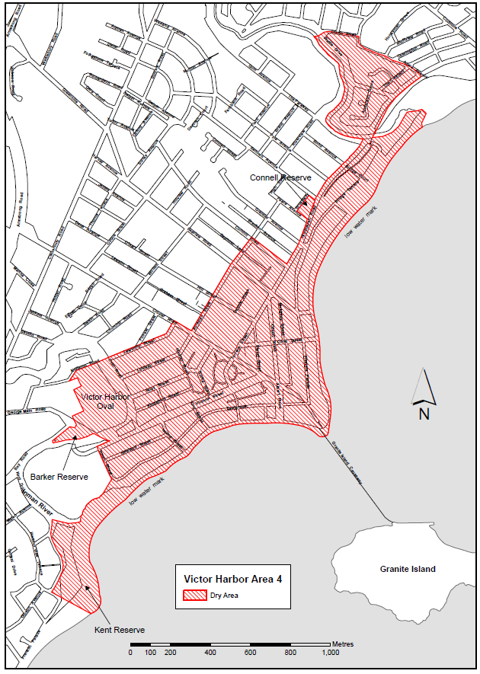
The area includes the whole of any wharf, jetty, boat ramp, breakwater or other structure that extends below low water mark from within the area (as well as any area beneath such a structure), but does not include that part of the causeway to Granite Island that lies within the area to which the prohibition in Victor Harbor Area 2 applies.
Dated: 6 November 2025
Made by the Liquor and Gambling Commissioner
Delegate of the Liquor and Gambling Commissioner

Major Events Act 2013
Section 6B
Declaration of a Major Event
Pursuant to Section 6B of the Major Events Act 2013, I, Hon. Zoe Bettison MP, Minister for Tourism declare the 2026 Repco Adelaide Motorsport Festival to be held from 27 February to 1 March 2026 to be declared a major event.
By virtue of the provisions of the Major Events Act 2013, I do hereby:
1. Declare the 2026 Repco Adelaide Motorsport Festival to be a major event.
2. Specify the period of the event, for which the declaration of the major event is in force is from 5:00am on Friday, 27 February to 11:59pm Friday, 27 February 2026 for the Gouger Street Party, and 5:00am on Friday, 27 February to 11:59pm on Sunday, 1 March 2026 for the Victoria Park Sprint.
3. Declare the major event venues to be the areas as shown as ‘Major Event Venue’ in descriptions and maps specifically covering the Gouger Street Party on Gouger Street between Mill Street and Morphett Street, and the Victoria Park Sprint on Wakefield Road between East Terrace and Dequetteville Terrace, and Park 16 (Victoria Park/Pakapakanthi).
4. Declare the controlled areas to be any public place or a part of a public place that is within 250 metres of the boundary of the major event venues.
5. Designate Massive Events Corp P/L (ABN 55 984 494 841) to be the event organisers for the event.
6. Declare that the following provisions of Part 3 of the Act apply to the event, the event site and the declared controlled area for the event:
- Section 8
- Section 10
- Section 11
- Section 12
- Section 13
- Section 14

7. Being satisfied that the title “Repco Adelaide Motorsport Festival” and the logo as it appears below are sufficiently connected with the identity and conduct of the major event, and that the event has commercial arrangements that are likely to be adversely affected by unauthorised use of the title and logo, I hereby declare, pursuant to Section 14(1) of the Act, that “Repco Adelaide Motorsport Festival” is an official title and the logo as it appears below is an official logo in respect of the event.

Dated: 23 October 2025
Hon Zoe Bettison MP
Minister for Tourism

Maps of Controlled Areas
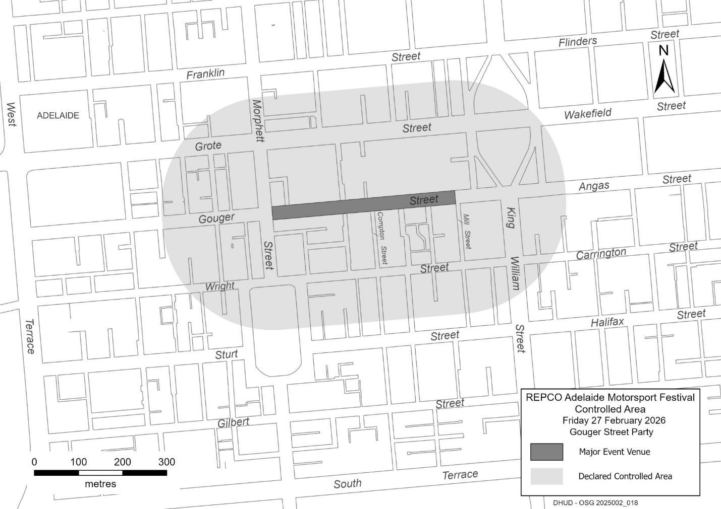
2026 Repco Adelaide Motorsport Festival

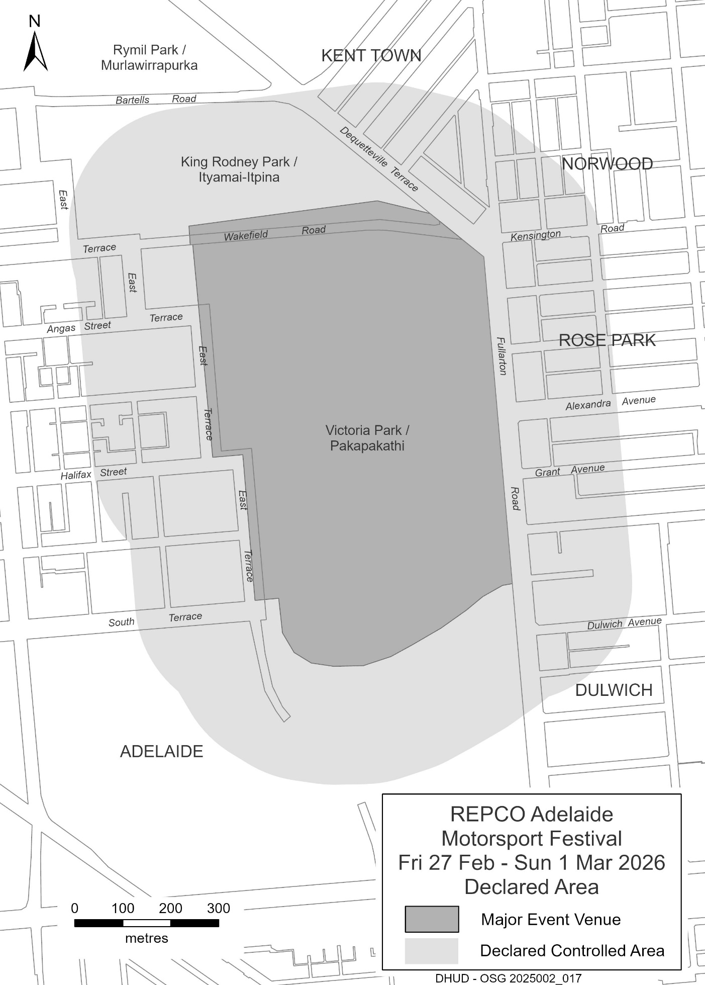

Motor Vehicles Act 1959
South Australia
Motor Vehicles (Legend of the Lakes Hillclimb 2025) Notice
under Section 6 of the Motor Vehicles Act 1959
1—Operation and expiry
This Notice comes into operation at 11:00am on 6 November 2025 and expires at 6:00pm
on 10 November 2025.
2—Interpretation
In this Notice—
Legend of the Lakes Hillclimb 2025 means the Trident Tyre Centre Legend of the
Lakes Hillclimb Event promoted by the South Eastern Automobile Club and held
under Motorsport Australia Permit Number 525/0911/01;
Minister means the Minister to whom the administration of the Motor Vehicles Act 1959
is committed.
3—Exemption
In accordance with the power under Section 6 of the Motor Vehicles Act 1959 I declare that
the whole of the Act does not apply to roads that are closed within the area designated in the Schedule to this Notice during the operation of this Notice.
4—Revocation
This Notice may be revoked or varied by the Minister or their delegate at any time.
5—Execution
Dated: 6 November 2025
Hon Emily Bourke MLC
Minister for Infrastructure and Transport

Schedule
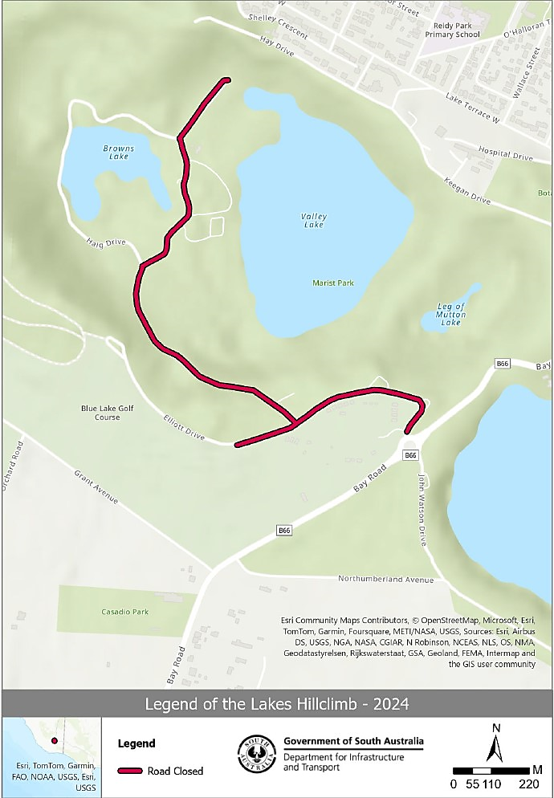
Legend of the Lakes Hillclimb 2025

Radiation Protection and Control Act 2021
Section 76
Notice RPC202510-01
Pursuant to Section 76 of the Radiation Protection and Control Act 2021 (the Act), I, David Kruss, Principal Radiation Specialist, Environment Protection Authority, Delegate of the Minister for Climate, Environment and Water, for the purposes Sections 22, 23 and 25 of the Radiation Protection and Control Act 2021 (the Act), Persons are exempt from the requirement to:
(a) hold a radiation management licence authorising the possession of a radiation source under Section 22; or
(b) register the premises in which unsealed radioactive materials are handled or kept under Section 25; or
(c) hold a radiation use licence to use or handling of radioactive material under Section 23;
with respect to the following classes of things incorporating radioactive materials:
(a) instruments, timepieces or safety items where radioactive material used as luminous markers; or
(b) vehicle structures or components containing thorium;
subject to the following conditions:
1. the thing(s) are only used for teaching, display as an exhibit or are a component of a vehicle, and
2. the owner of the thing has notified the Department of the possession of the thing(s), and
3. the owner has prepared a radiation management plan detailing arrangements for safe handling procedures and storage to the satisfaction of the Department, and
4. the owner has supplied the radiation management plan in clause 3 to the Department, and
5. the owner must comply with the radiation management plan in clause 3, and
6. the owner must comply with any notice in writing given by the Department directing that changes be made to the radiation management plan, having regard to the objects of the RPC Act, and
7. the owner must not transfer the thing to another person without notifying the Department.
Terms used carry the meaning given by the Act.
Note, nothing absolves the owner from the requirement to apply obtain prior approval to dispose the thing containing radioactive material in accordance with the regulations.
Dated: 28 October 2025
D. Kruss
Delegate of the Minister for Climate, Environment and Water

Radiation Protection And Control Act 2021
Section 76
Notice RPC202510-02
Pursuant to Section 76 of the Radiation Protection and Control Act 2021 (the Act), I, David Kruss, Principal Radiation Specialist, Environment Protection Authority, Delegate of the Minister for Climate, Environment and Water, revoke the following exemption notices:
1. RPC202501-01 published in Gazette No. 5, 23 January 2025, pp. 75 for reason that the Code of Compliance for Facility Design and Shielding 2022 published by the Department has been revised to address the content of the exemption.
2. RPC202402-06 published in Gazette No. 7, 8 February 2024, p. 149 for reason that the Code of Compliance for medical, veterinary and chiropractic X-ray apparatus 2022 published by the Department has been revised to address the content of the exemption.
Dated: 28 October 2025
D. Kruss
Delegate of the Minister for Climate, Environment and Water

Road Traffic Act 1961
South Australia
Road Traffic (Legend of the Lakes Hillclimb 2025) Notice
under Section 163AA of the Road Traffic Act 1961
1—Operation and expiry
This Notice comes into operation at 11:00am on 6 November 2025 and expires at 6:00pm on 10 November 2025.
2—Interpretation
In this Notice—
Legend of the Lakes Hillclimb 2025 means the Trident Tyre Centre Legend of the
Lakes Hillclimb Event promoted by the South Eastern Automobile Club and held
under Motorsport Australia Permit Number 525/0911/01;
Minister means the Minister to whom the administration of the Road Traffic Act 1961
is committed.
3—Exemption
In accordance with the power under Section 163AA of the Road Traffic Act 1961 I declare that the whole of Part 4 of the Act does not apply to a vehicle on roads that are closed within the area designated in the Schedule to this Notice during the operation of this Notice.
4—Revocation
This Notice may be revoked or varied by the Minister or their delegate at any time.
5—Execution
Dated: 6 November 2025
Hon Emily Bourke MLC
Minister for Infrastructure and Transport

Schedule
Legend of the Lakes Hillclimb 2025

Local Government Instruments

City of West Torrens
Roads (Opening and Closing) Act 1991
Road Closure—Land Adjacent 1 Witty Court, Underdale
Notice is hereby given, pursuant to Section 10 of the Roads (Opening and Closing) Act 1991, that the City of West Torrens (council) proposes to close and sell to the adjoining owner portion of the Road Reserve adjacent 1 Witty Court, Underdale being that portion of Arthur Lemon Avenue adjoining Allotment 50 Deposited Plan D68576 more particularly delineated and lettered ‘A’ on Preliminary Plan 22/0002. A copy of the Preliminary Plan and Statement of Persons Affected can be viewed on council’s website, westtorrens.sa.gov.au, or is available for public inspection at the offices of the City of West Torrens, 165 Sir Donald Bradman Drive, Hilton SA and the Adelaide Office of the Surveyor-General during normal office hours. The Preliminary Plan can also be viewed at www.sa.gov.au/roadsactproposals.
Any application for easement or objection must set out the full name, address and details of the submission and must be fully supported by reasons. The application for easement or objection must be made in writing to the City of West Torrens at 165 Sir Donald Bradman Drive, Hilton 5033, or via email info@wtcc.sa.gov.au WITHIN 28 DAYS OF THIS NOTICE and a copy must be forwarded to the Surveyor General at GPO Box 1815, Adelaide SA 5001. All written submissions will be duly presented to the council in the form of a report. The report, including submissions, may be made publicly available on the council’s website detailing the person’s name, suburb and feedback.
Dated: 6 November 2025
Angelo Catinari
Chief Executive Officer

Corporation of the Town of Walkerville
Adoption of a Community Land Management Plan
Notice is hereby given pursuant to Section 197(3) of the Local Government Act 1999, that the Corporation of the Town of Walkerville at its Ordinary Council Meeting on 20 October 2025 resolved to adopt a Community Land Management Plan for the W: Walkerville Recreation Centre.
The adopted Community Land Management Plan can be viewed at www.walkerville.sa.gov.au
Dated: 31 October 2025
Dr. Andrew Johnson
Chief Executive Officer

Corporation of the Town of Walkerville
Review of Representation
Notice is hereby given that the Corporation of the Town of Walkerville has reviewed its composition and elector representation arrangements in accordance with the requirements of Section 12 of the Local Government Act 1999 (the Act).
Pursuant to Section 12(13)(a) of the Act, the Electoral Commissioner has issued a certificate that the review undertaken by Council satisfies the requirements of Section 12 of the Act.
The following arrangements will therefore take effect from polling day of the next periodic Local Government election:
• The principal member of the Council will be a Mayor elected by the electors for the area.
• The future elected body of Council will comprise the Mayor and eight (8) Area Councillors.
• The Council area not be divided into wards (retain the existing “no wards” structure).
Dated: 31 October 2025
Dr. Andrew Johnson
Chief Executive Officer

Adelaide Hills Council
Liquor Licencing (Liquor Review) Amendment Act 2017
Short Term Dry Area Declaration (48 Hours or Less)
I, Greg Georgopoulos, Chief Executive Officer, for and on behalf of the Adelaide Hills Council, in accordance with Section 131 of the Liquor Licencing (Liquor Review) Amendment Act 2017 in effect from September 2018, hereby declare a short term dry area of 48 hours or less for the following community event.
Event: Woodside Christmas Pageant 2025
Event date/s: Thursday, 11 December 2025
Period of prohibition: 5:00pm-11:59pm
Extent of Temporary Dry Area
Various roads around the Woodside township as shown in the attached map (written description included).
The Council and event organisers have declared a dry area to ensure the township remains ‘family friendly’ and to enable SA Police to proactively manage potential alcohol-related anti-social behaviour. A temporary dry area has been in place during this December period in recent years. It has been well received and is considered to have been a successful initiative.
Description of Area
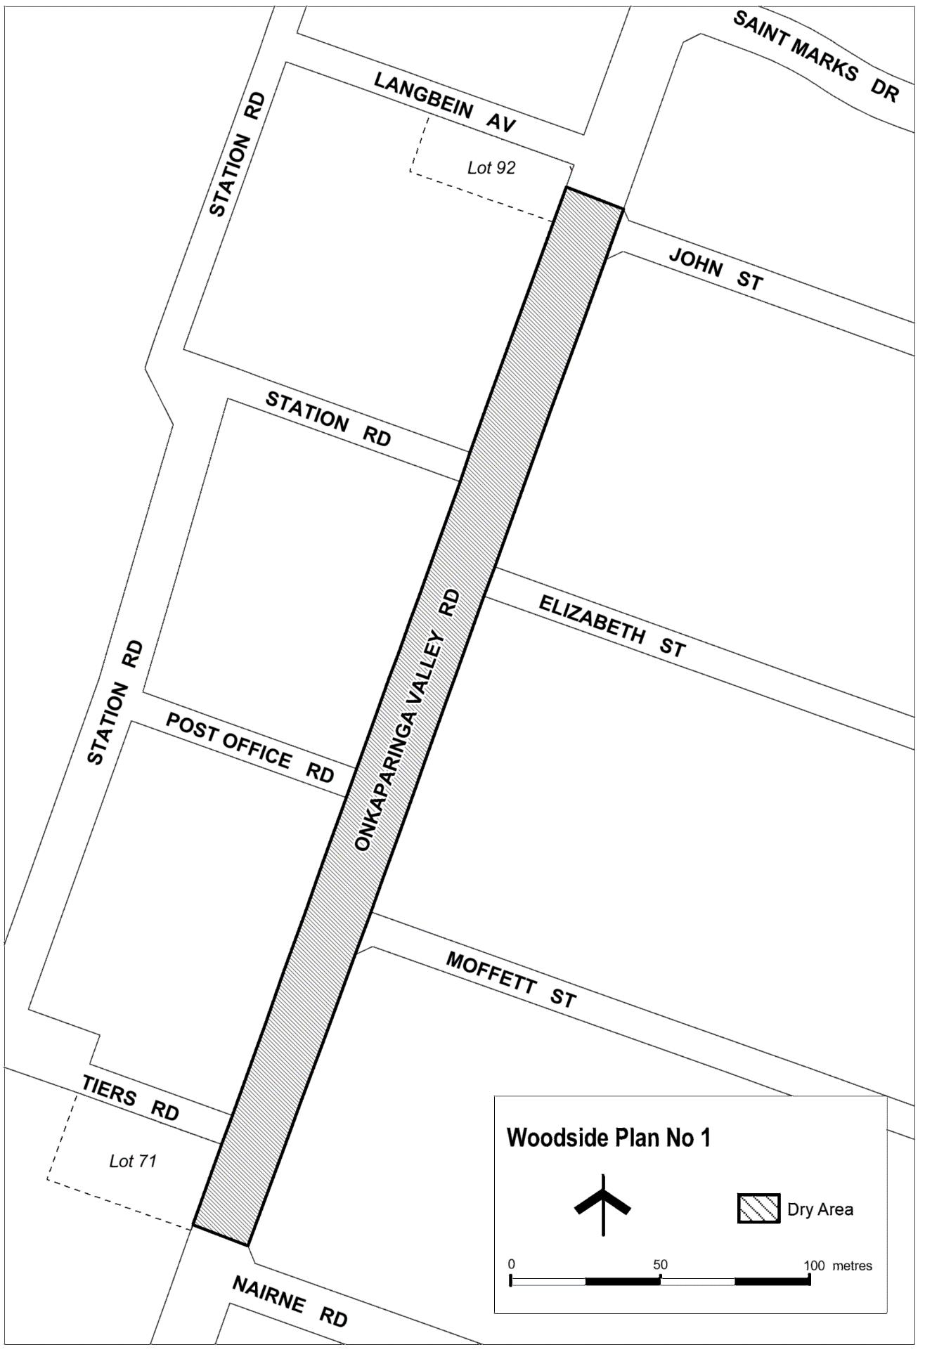
The area in Woodside comprising Onkaparinga Valley Road between the prolongation in a straight line of the northern boundary of Nairne Road and the prolongation in a straight line of the northern boundary of John Street.
Dated: 24 October 2025
Greg Georgopoulos
Chief Executive Officer

Barunga West Council
Review of Representation
Notice is hereby given that the Barunga West Council in accordance with the requirements of Section 12 of the Local Government Act 1999 and Regulation 11A of the Local Government (Transitional Provisions) Regulations 2021, has reviewed its composition to ensure the election of a Mayor will take effect from polling day of the next periodic elections.
Pursuant to Section 12(13)(a) of the Act, the Electoral Commissioner has issued a certificate that the review undertaken by council satisfies the requirements of Section 12.
The following arrangements will therefore take effect from polling day of the next periodic Local Government election:
• The Principal Member of Council shall be a Mayor, elected as a representative of the area as a whole, in accordance with the requirements of Section 51 of the Act.
• The area of the Council shall not be divided into wards.
• The elected body of the Council will be comprised of the nine (9) elected members, being the Mayor and eight (8) Councillors.
Dated: 3 November 2025
Tamara Harrison
Acting Chief Executive Officer

Mid Murray Council
Liquor Licensing (Dry Areas) Notice 2025
Under Section 131(1ab) of the Liquor Licensing Act 1997
1—Short title
This notice may be cited as the Liquor Licensing (Dry Areas) Notice 2025.
2—Commencement
This notice comes into operation on 31 December 2025.
3—Interpretation
(1) In this notice—
principal notice means the Liquor Licensing (Dry Areas) Notice 2017 published in the Gazette on 17 October 2017, as in force from time to time.
(2) Clause 3 of the principal notice applies to this notice as if it were the principal notice.
4—Consumption etc of liquor prohibited in dry areas
(1) Pursuant to Section 131 of the Act, the consumption and possession of liquor in the area described in the Schedule is prohibited in accordance with the provisions of the Schedule.
(2) The prohibition has effect during the periods specified in the Schedule.
(3) The prohibition does not extend to private land in the area described in the Schedule.
(4) Unless the contrary intention appears, the prohibition of the possession of liquor in the area does not extend to—
(a) a person who is genuinely passing through the area if—
(i) the liquor is in the original container in which it was purchased from licensed premises; and
(ii) the contained has not been opened; or
(b) a person who has possession of the liquor in the course of carrying on a business or in the course of his or her employment by another person in the course of carrying on a business; or
(c) a person who is permanently or temporarily residing at premises within the area or on the boundary of the area and who enters the area solely for the purpose of passing through it to enter those premises or who enters the area from those premises for the purpose of leaving the area
(5) The Schedule is in addition to Schedule—Mannum Area 2, Mannum Area 3, Mannum Area 4 and Mannum Area 5 in the principal notice.

Schedule—Cadell Area 1
1—Extent of prohibition
The consumption of liquor is prohibited and the possession of liquor is prohibited.
2—Period of prohibition
From 6:00pm on 31 December 2025 to 8:00am on 1 January 2026.
3—Description of area
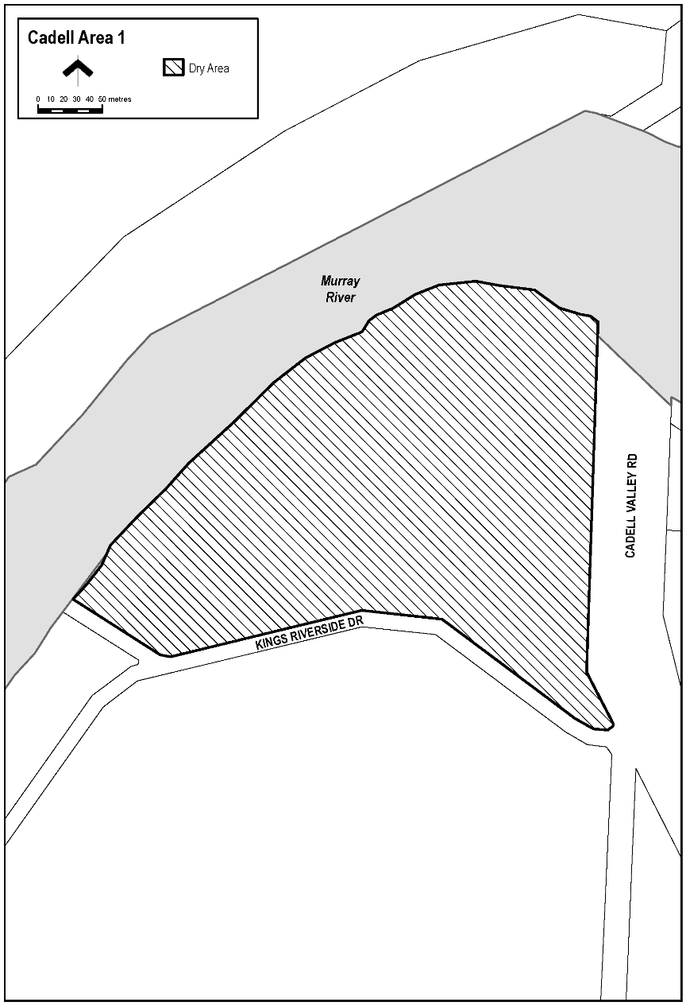
The area adjacent to and to the north of the town of Cadell, being the whole of the land comprised in Piece 14 DP75804 (approximately the area bounded on the north-west and north-east by the River Murray, on the east by the Cadell Valley Road and on the south by the portion of Kings Riverside Drive that runs generally east-west and the access road from that portion of Kings Riverside Drive to a boat ramp on the eastern bank of the River Murray).

Schedule—Morgan Area 1
1—Extent of prohibition
The consumption of liquor is prohibited and the possession of liquor is prohibited.
2—Period of prohibition
From 6:00pm on 31 December 2025 to 8:00am on 1 January 2026.
3—Description of area
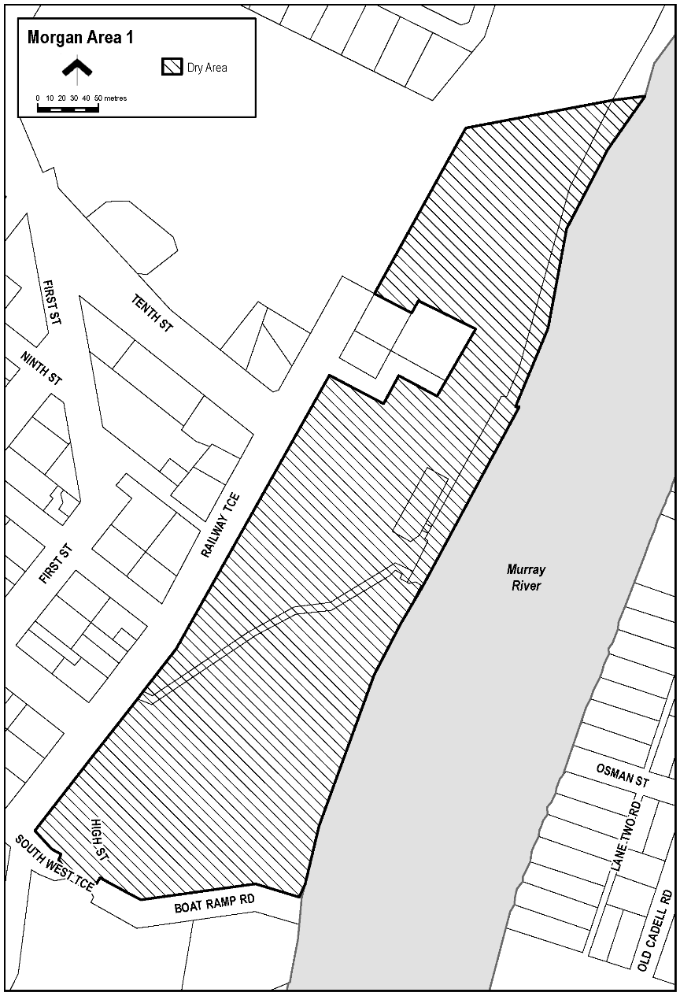
The area in Morgan bounded as follows: commencing at the point at which the prolongation in a straight line of the southern boundary of Section 432, Hundred of Eba intersects the waterline on the north-western side of the River Murray, then generally north-westerly, westerly and north-westerly along that prolongation and boundary of Section 432 so the south-eastern boundary of Railway Terrace, then generally north-easterly along that south-eastern boundary of Railway Terrace to the point at which it meets the northern corner of Section 484, Hundred of Eba, then generally north-easterly along the north-western boundary of Section 433, Hundred of Eba to the northernmost boundary of Section 429, Hundred of Eba, then north-easterly along that boundary of Section 429 and the prolongation in a straight line of that boundary to the waterline on the north-western side of the River Murray, then generally south-westerly along the waterline of the River to the point of commencement, but excluding Section 483, 484 and 485, Hundred of Eba.

Schedule—Mannum Area 2
1—Extent of prohibition
The consumption of liquor is prohibited and the possession of liquor is prohibited.
2—Period of prohibition
From 6:00pm to 11:00pm on 31 December 2025.
3—Description of area
Anna Street between Randell Street and William Street.
The stairway (generally known as “the Golden Stairs”) between Anna Street and Randell Street, adjacent to Shearer’s Carpark.
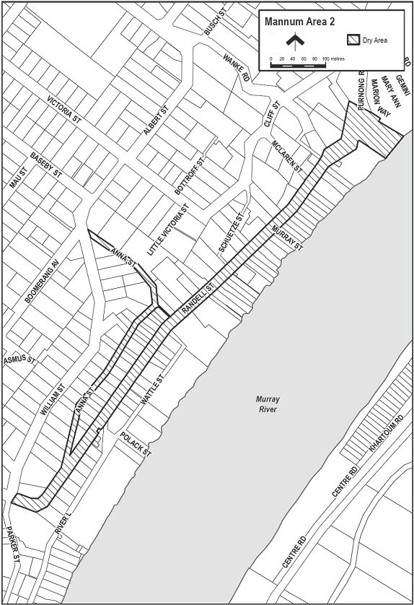
Randell Street (and Purnong Road) between William Street and River Road.

Schedule—Mannum Area 3
1—Extent of prohibition
The consumption of liquor is prohibited and the possession of liquor is prohibited.
2—Period of prohibition
From 6:00pm to 11:00pm on 31 December 2025.
3—Description of area
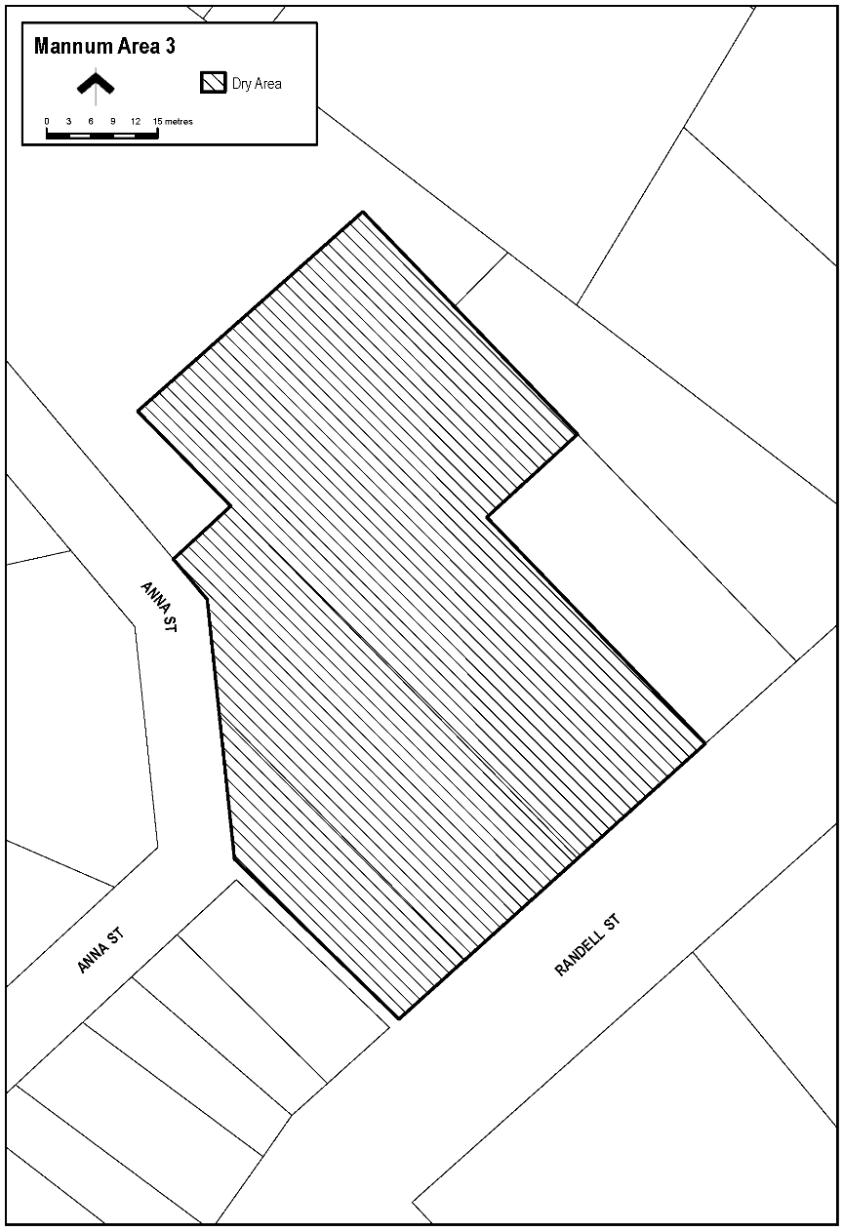
The car park in Mannum (generally known as Shearer’s Carpark) situated between Randell Street and Anna Street, being Lots 33 and 34 DP1091, Hundred of Finniss and Lot 435 FP208811, Hundred of Finniss.

Schedule—Mannum Area 4
1—Extent of prohibition
The consumption of liquor is prohibited and the possession of liquor is prohibited.
2—Period of prohibition
From 6:00pm to 11:00pm on 31 December 2025.
3—Description of area
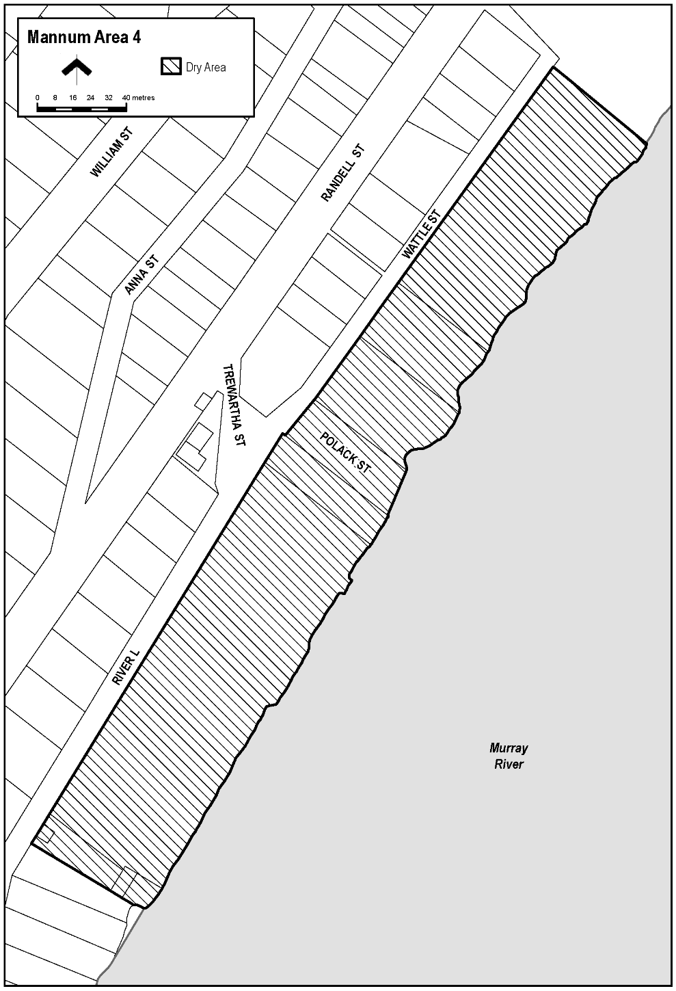
The area in Mannum known as Mary Ann Reserve (together with abutting land and structures), being the area bounded on the north-east by the south-west boundary of Lot 10 FP21817 (Bowling Green), on the north-west by River Lane, on the south-west by the north-eastern boundary of Certificate of Title Volume 5799 Folio 318 (24 River Lane) and on the south-east by the River Murray, together with the whole of any wharf, jetty, boat ramp or other structure projecting from that area into the River.

Schedule—Mannum Area 5
1—Extent of prohibition
The consumption of liquor is prohibited and the possession of liquor is prohibited.
2—Period of prohibition
From 6:00pm to 11:00pm on 31 December 2025.
3—Description of area
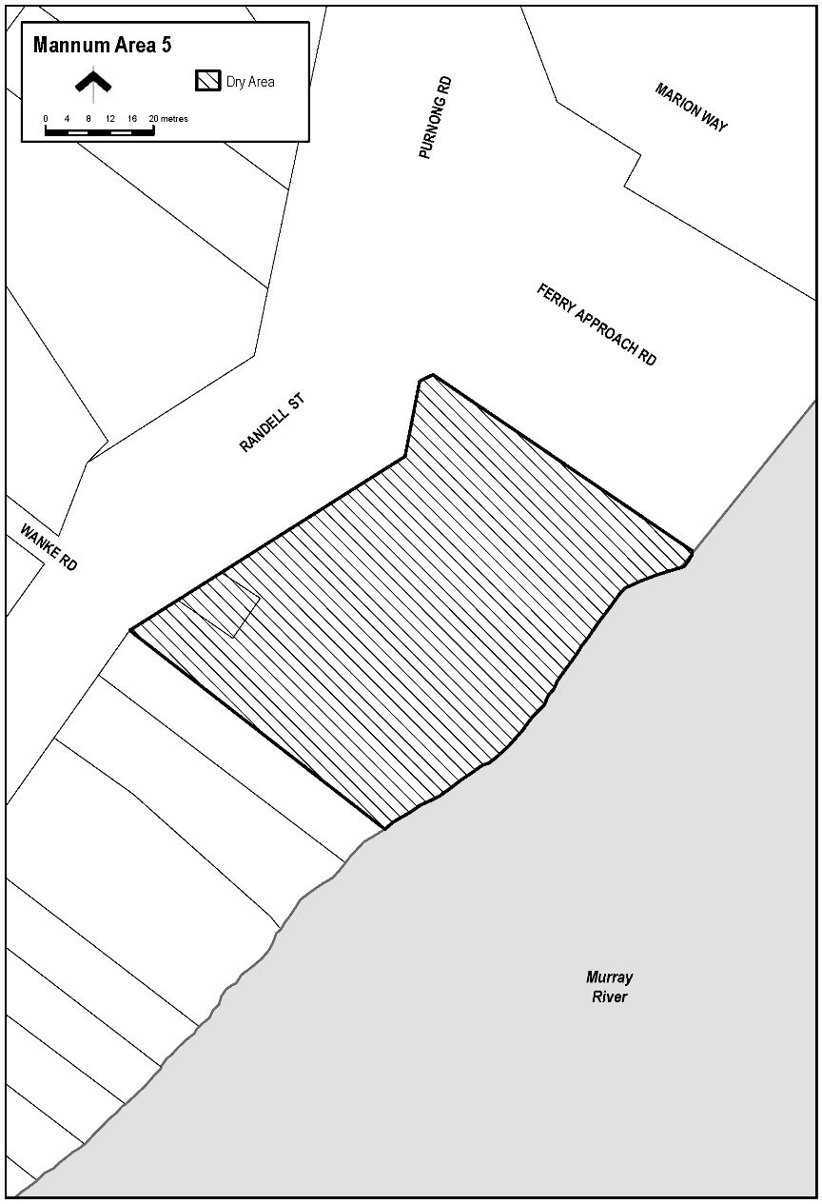
The area in Mannum known as Arnold Park, situated between Randell Street and the River Murray adjacent to the south-western boundary of River Road, being Lot 93 FP213066, Hundred of Finniss.

Schedule—Mannum Area 6
1—Extent of prohibition
The consumption of liquor is prohibited and the possession of liquor is prohibited.
2—Period of prohibition
From 6:00pm on 31 December 2025 to 8:00am on 1 January 2026.
3—Description of area
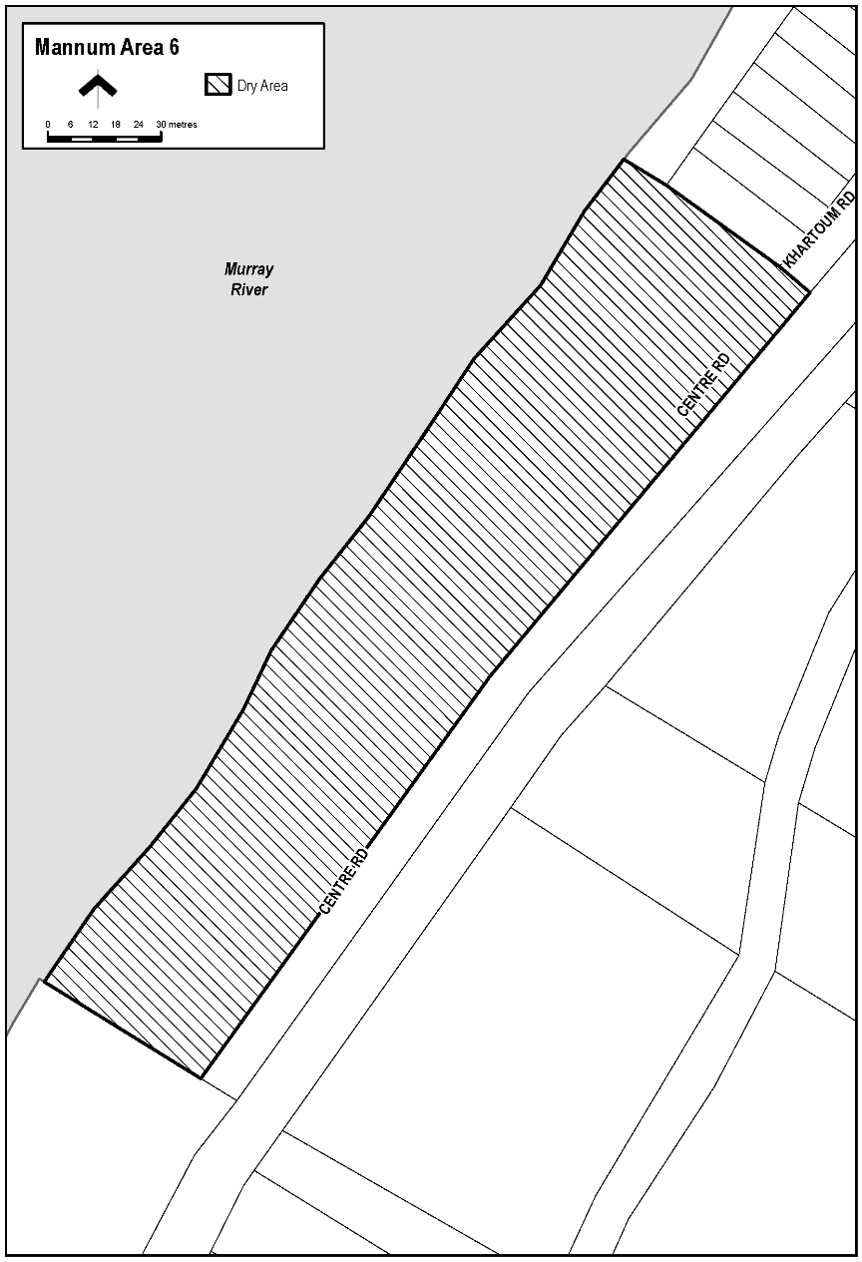
The area adjacent Mannum, generally known as Bolto Reserve, bounded on the south-east by the north-western boundary of Section 909, Hundred of Younghusband, on the south-west by the north-eastern boundary of Section 914, Hundred of Younghusband, on the north-west by the River Murray and on the north-east by the south-western boundary of Lot 94 DP49431 and the prolongation in a straight line north-westerly and south-easterly of that boundary.

Schedule—Mannum Area 7
1—Extent of prohibition
The consumption of liquor is prohibited and the possession of liquor is prohibited.
2—Period of prohibition
From 6:00pm on 31 December 2025 to 8:00am on 1 January 2026.
3—Description of area
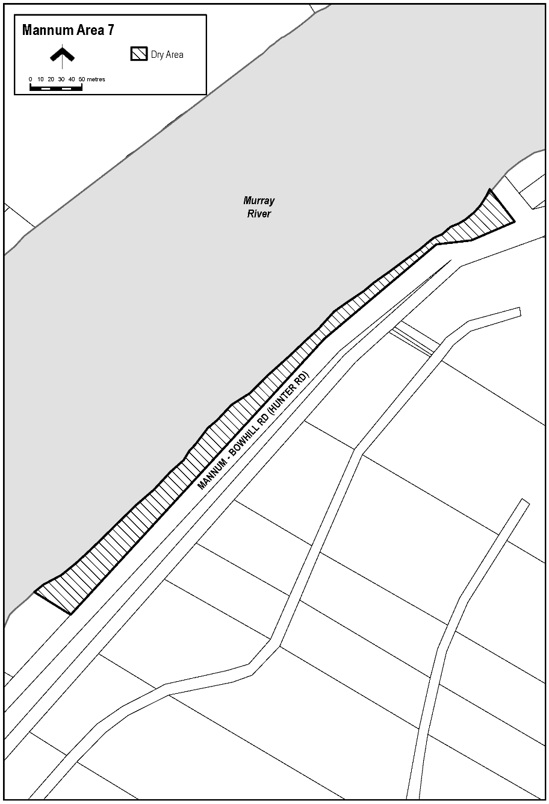
The area adjacent Mannum, generally known as Haythorpe Reserve, bounded on the south-east by the north-western boundary of the carriageway of Hunter Road, on the south-west by the south-western boundary of Section 727, Hundred of Younghusband and the prolongation in a straight line south-easterly and north-westerly of that boundary, on the north-west by the River Murray and on the north-east by the south-western boundary of Section 397, Hundred of Younghusband and the prolongation in a straight line north-westerly and south-easterly of that boundary.
Dated: 6 November 2025
Ben Scales
Chief Executive Officer

Port Pirie Regional Council
Roads (Opening and Closing) Act 1991
Road Closure—Public Roads, Redhill
Notice is hereby given, pursuant to Section 10 of the Roads (Opening and Closing) Act 1991, that the Port Pirie Regional Council proposes to make a Road Process Order to open as road the portion of land at the northern end of Barr Street adjacent to Section 841, Hundred of Redhill more particularly delineated and numbered ‘1’ and the portion of land passing through Section 840, Hundred of Redhill more particularly delineated and numbered ‘2’ on Preliminary Plan 25/0022; and
close and retain for addition to the adjoining Council owned land the portion of the public road adjoining Section 840, Hundred of Redhill more particularly delineated and lettered ‘A’ and the portion of the public road adjoining Section 841, Hundred of Redhill more particularly delineated and lettered ‘B’ on Preliminary Plan PP25/0022.
The Preliminary Plan and Statement of Persons Affected is available for public inspection at the offices of the Port Pirie Regional Council, 115 Ellen Street, Port Pirie and the Adelaide Office of the Surveyor-General during normal office hours. The Preliminary Plan may also be viewed at www.sa.gov.au/roadsactproposals.
Any application for easement or objection must set out the full name, address and details of the submission and must be fully supported by reasons.
The application for easement or objection must be made in writing to the Port Pirie Regional Council, PO Box 45, Port Pirie SA 5540 WITHIN 28 DAYS OF THIS NOTICE and a copy must be forwarded to the Surveyor-General at GPO Box 1815, Adelaide 5001. Where an objection is made, the Council will give notification of a meeting at which the matter will be considered.
Dated: 5 November 2025
Peter Ackland
Chief Executive Officer

Renmark Paringa Council
Aerodrome Fees Act 1998
Arrival and Departure Fees
Notice is hereby given that, pursuant to the Aerodrome Fees Act 1998, Renmark Paringa Council hereby advises that Arrival and Departure Fees at the Renmark Airport are fixed as follows and are effective from 1 July 2025:
Landing Fees
General Aviation Landing Fee: $18.00/tonne for all aircraft (including helicopters) except Local Pilots Bulk Landing Fee.
Local Pilots Bulk Landing Fee: $540.00
All amounts are inclusive of GST
Dated: 6 November 2025
Tony Siviour
Chief Executive Officer

Wattle Range Council
South Australia
Liquor Licensing (Dry Areas) Notice 2025
under Section 131(1ab) of the Liquor Licensing Act 1997
1—Short title
This notice may be cited as the Liquor Licensing (Dry Areas) Notice 2025.
2—Commencement
This notice comes into operation on 31 December 2025.
3—Interpretation
(1) In this notice—
principal notice means the Liquor Licensing (Dry Areas) Notice 2015 published in the Gazette on 5 January 2015, as in force from time to time.
(2) Clause 3 of the principal notice applies to this notice as if it were the principal notice.

4—Consumption etc. of liquor prohibited in dry areas
(1) Pursuant to Section 131 of the Act, the consumption and possession of liquor in the area described in the Schedule is prohibited in accordance with the provisions of the Schedule.
(2) The prohibition has effect during the periods specified in the Schedule.
(3) The prohibition does not extend to private land in the area described in the Schedule.
(4) Unless the contrary intention appears, the prohibition of the possession of liquor in the area does not extend to—
(a) a person who is genuinely passing through the area if—
(i) the liquor is in the original container in which it was purchased from licensed premises; and
(ii) the container has not been opened; or
(b) a person who has possession of the liquor in the course of carrying on a business or in the course of his or her employment by another person in the course of carrying on a business; or
(c) a person who is permanently or temporarily residing at premises within the area or on the boundary of the area and who enters the area solely for the purpose of passing through it to enter those premises or who enters the area from those premises
for the purpose of leaving the area.
Schedule—Beachport Area 3
1—Extent of prohibition
The consumption of liquor is prohibited and the possession of liquor is prohibited.
2—Period of prohibition
From 12 noon on 31 December 2025 to 12 noon on 1 January 2026.
3—Description of area
The area in and adjacent to Beachport comprising the following roads and other areas—
(a) Beach Road between the property boundaries and low water marker, from the
Lake George Outlet up to and including Glenn Point;
(b) The Beachport Jetty;
(c) All breakwaters/groins and Beachport Boat Ramp off Beach Road.

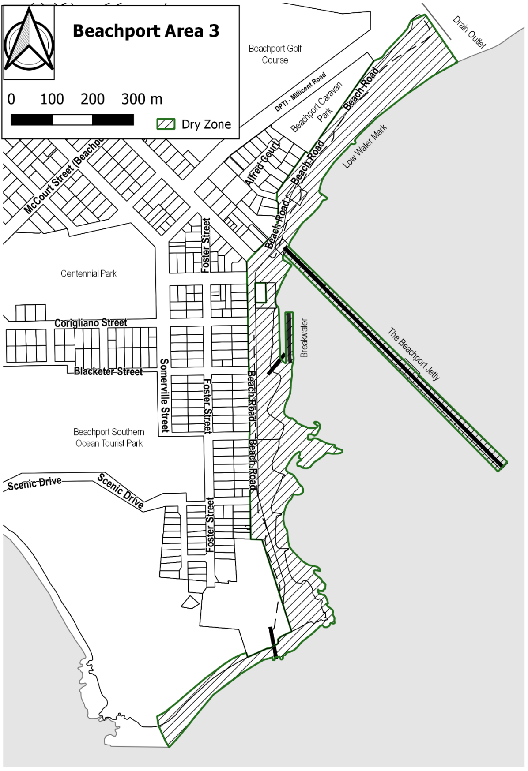
Dated: 6 November 2025
P.A. Duka
Acting Chief Executive Officer

Notice Submission

The South Australian Government Gazette is published each Thursday afternoon.
Notices must be emailed by 4 p.m. Tuesday, the week of publication.
Submissions are formatted per the gazette style and a proof will be supplied prior to publication, along with a quote if applicable. Please allow one day for processing notices.
Alterations to the proof must be returned by 4 p.m. Wednesday.

Gazette notices must be submitted as Word files, in the following format:
• Title—the governing legislation
• Subtitle—a summary of the notice content
• Body—structured text, which can include numbered lists, tables, and images
• Date—day, month, and year of authorisation
• Signature block—name, role, and department/organisation authorising the notice

Please provide the following information in your email:
• Date of intended publication
• Contact details of the person responsible for the notice content
• Name and organisation to be charged for the publication—Local Council and Public notices only
• Purchase order, if required—Local Council and Public notices only

Email: governmentgazettesa@sa.gov.au
Phone: (08) 7133 3552
Website: www.governmentgazette.sa.gov.au

All instruments appearing in this gazette are to be considered official, and obeyed as such

Printed and published weekly by authority of T. Foresto, Government Printer, South Australia
$9.50 per issue (plus postage), $479.00 per annual subscription—GST inclusive
Online publications: www.governmentgazette.sa.gov.au

