
No. 69 p. 4633
THE SOUTH AUSTRALIAN
GOVERNMENT GAZETTE
Published by Authority

Adelaide, Thursday, 27 November 2025

Contents

Governor’s Instruments
Acts 4634
Appointments, Resignations and General Matters 4634
Notices—
Mutual Recognition (Victorian Container Deposit
Scheme) Notice 2025 4636
Trans-Tasman Mutual Recognition (Victorian
Container Deposit Scheme) Notice 2025 4641
Proclamations—
Emergency Management (Miscellaneous)Amendment
Act (Commencement) Proclamation 2025 4646
Passenger Transport (Point to Point Transport Services) Amendment Act (Commencement) Proclamation 2025 4646
Adelaide University (Adelaide University Union)
(Transfer of Assets, Contracts and Liabilities) Proclamation 2025 4647
Regulations—
Planning, Development and Infrastructure (General)
(Family Day Care) Amendment Regulations 2025—
No. 129 of 2025 4648
Education and Early Childhood Services (Registration
and Standards) (Amendment of Schedule 2 of Act) Regulations 2025—No. 130 of 2025 4650
Education and Early Childhood Services (Registration
and Standards) Regulations 2025—No. 131 of 2025 4652
Passenger Transport (Point to Point Transport Services) Amendment Regulations 2025—No. 132 of 2025 4667
Controlled Substances (Poisons) (Prescriptions by
Pharmacists) Amendment Regulations 2025—
No. 133 of 2025 4672
State Government Instruments
Building Work Contractors Act 1995 4674
Environment Protection Act 1993 4675
Fisheries Management (Prawn Fisheries)
Regulations 2017 4677
Fisheries Management Act 2007 4679
Housing Improvement Act 2016 4680
Land Acquisition Act 1969 4681
Liquor Licensing Act 1997 4689
Motor Vehicles Regulations 2025 4696
South Australian Civil and Administrative Tribunal 4696
South Australian Skills Act 2008 4698
Work Health and Safety Regulations 2012 4698
Local Government Instruments
City of Charles Sturt 4699
City of Port Adelaide Enfield 4699
Adelaide Plains Council 4699
District Council of Franklin Harbour 4702
District Council of Kimba 4702
Kingston District Council 4702
Mid Murray Council 4702
Renmark Paringa Council 4703
District Council of Tumby Bay 4703
Public Notices
National Electricity Law 4708
—Corrigendum 4708
National Energy Retail Law 4708
National Gas Law 4708

Governor’s Instruments

Acts
Department of the Premier and Cabinet
Adelaide, 27 November 2025
Her Excellency the Governor directs it to be notified for general information that she has in the name and on behalf of His Majesty The King, this day assented to the undermentioned Acts passed by the Legislative Council and House of Assembly in Parliament assembled, viz.:
No. 58 of 2025—Fines Enforcement and Debt Recovery (Miscellaneous) Amendment Bill 2025
An Act to amend the Fines Enforcement and Debt Recovery Act 2017 and to make related amendments to the Criminal Law (Clamping, Impounding and Forfeiture of Vehicles) Act 2007 and the Enforcement of Judgments Act 1991
No. 59 of 2025—Education and Children’s Services (Inclusive Education) Amendment Bill 2025
An Act to amend the Education and Children’s Services Act 2019
No. 60 of 2025—Firearms (Digital Blueprints for 3D Printing) Amendment Bill 2025
An Act to amend the Firearms Act 2015 and to make related amendments to the Summary Offences Act 1953
No. 61 of 2025—National Energy Retail Law (Retailer of Last Resort) Amendment Bill 2025
An Act to amend the National Energy Retail Law (South Australia) Act 2011 and to make related amendments to the National Electricity (South Australia) Act 1996
No. 62 of 2025—TAFE SA Bill 2025
An Act to continue TAFE SA, to repeal the TAFE SA Act 2012, to make consequential amendments to certain other Acts, and for other purposes
No. 63 of 2025—Statutes Amendment (Local Government Elections Review) Bill 2025
An Act to amend the Local Government (Elections) Act 1999, the Local Government Act 1999 and the City of Adelaide Act 1998
No. 64 of 2025—Statutes Amendment (Planning, Infrastructure and Other Matters) Bill 2025
An Act to amend the Architectural Practice Act 2009, the Land and Business (Sale and Conveyancing) Act 1994, the Law of Property Act 1936, the Planning, Development and Infrastructure Act 2016, the Real Property Act 1886, the Residential Tenancies (Miscellaneous) Amendment Act 2023 and the State Development Coordination and Facilitation Act 2025
By command,
Joseph Karl Szakacs, MP
For Premier

Appointments, Resignations and General Matters
Department of the Premier and Cabinet
Adelaide, 27 November 2025
Her Excellency the Governor in Executive Council has been pleased to appoint the undermentioned to the Libraries Board of South Australia, pursuant to the provisions of the Libraries Act 1982:
Member: from 27 November 2025 until 26 November 2028
Joost den Hartog
Member: from 1 December 2025 until 30 November 2028
Joanne Cys
Amanda Elizabeth Nettelbeck
By command,
Joseph Karl Szakacs, MP
For Premier
25ART0024CS

Department of the Premier and Cabinet
Adelaide, 27 November 2025
Her Excellency the Governor in Executive Council has been pleased to appoint the undermentioned to the Construction Industry Training Board, pursuant to the provisions of the Construction Industry Training Fund Act 1993:
Member: from 27 November 2025 until 19 December 2027
Gaynor Maree
By command,
Joseph Karl Szakacs, MP
For Premier
ME25/104

Department of the Premier and Cabinet
Adelaide, 27 November 2025
Her Excellency the Governor in Executive Council has been pleased to appoint the undermentioned to the Education and Early Childhood Services Registration and Standards Board of South Australia, pursuant to the provisions of the Education and Early Childhood Services (Registration and Standards) Act 2011:
Member: from 27 November 2025 until 31 December 2026
Vivienne Margaret Brand
Member: from 2 March 2026 until 31 December 2026
Laura Juliet Butler
Noel Emmanuel Mifsud
Rebecca Carly Vandermoer
Peta Narelle Smith
By command,
Joseph Karl Szakacs, MP
For Premier
ME25/108

Department of the Premier and Cabinet
Adelaide, 27 November 2025
Her Excellency the Governor in Executive Council has been pleased to appoint the Honourable Michael David as the Parole Administrative Review Commissioner for a term of two months commencing on 1 December 2025 and expiring on 31 January 2026 - pursuant to section 77B of the Correctional Services Act 1982.
By command,
Joseph Karl Szakacs, MP
For Premier
25MCS0010CS

Department of the Premier and Cabinet
Adelaide, 27 November 2025
Her Excellency the Governor in Executive Council has been pleased to appoint Elpitha Olivia Spyrou as Deputy Registrar of the South Australian Civil and Administrative Tribunal for a term of five years, commencing on 27 November 2025 and expiring on 26 November 2030 - pursuant to section 74 of the South Australian Civil and Administrative Tribunal Act 2013.
By command,
Joseph Karl Szakacs, MP
For Premier
AGO0204-25CS

Department of the Premier and Cabinet
Adelaide, 27 November 2025
Her Excellency the Governor in Executive Council has been pleased to appoint Felicity Iolanda Parrella as Deputy Registrar of the South Australian Civil and Administrative Tribunal for a term of five years, commencing on 27 November 2025 and expiring on 26 November 2030 - pursuant to section 74 of the South Australian Civil and Administrative Tribunal Act 2013.
By command,
Joseph Karl Szakacs, MP
For Premier
AGO0204-25CS

Department of the Premier and Cabinet
Adelaide, 27 November 2025
Her Excellency the Governor in Executive Council has been pleased to appoint Sue-Ann Charlton as the Registrar of the Teachers Registration Board of South Australia for a term of three years commencing on 1 January 2026 and expiring on 31 December 2028 - pursuant to the Teachers Registration and Standards Act 2004.
By command,
Joseph Karl Szakacs, MP
For Premier
ME25/102

Notices
South Australia

Mutual Recognition (Victorian Container Deposit Scheme) Notice 2025
under section 47 of the Mutual Recognition Act 1992 of the Commonwealth as adopted by section 4 of the Mutual Recognition (South Australia) Act 1993
1—Short title
This notice may be cited as the Mutual Recognition (Victorian Container Deposit Scheme) Notice 2025.
2—Commencement
This notice comes into operation on the day on which it is made.
3—Request for regulations to be made
For the purposes of section 47 of the Mutual Recognition Act 1992 of the Commonwealth, it is requested that the proposed regulations set out in Schedule 1 be made.
Schedule 1—Proposed regulations
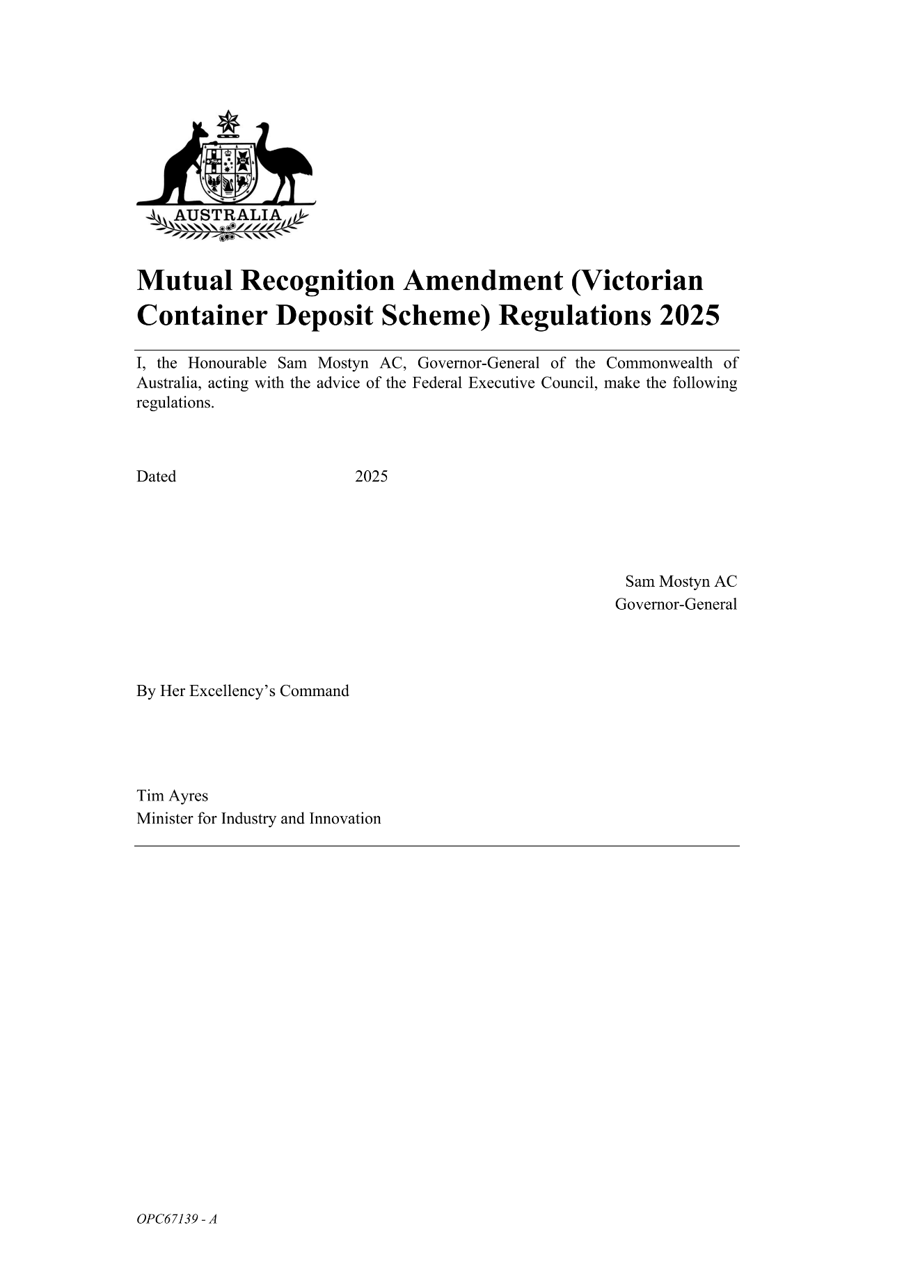
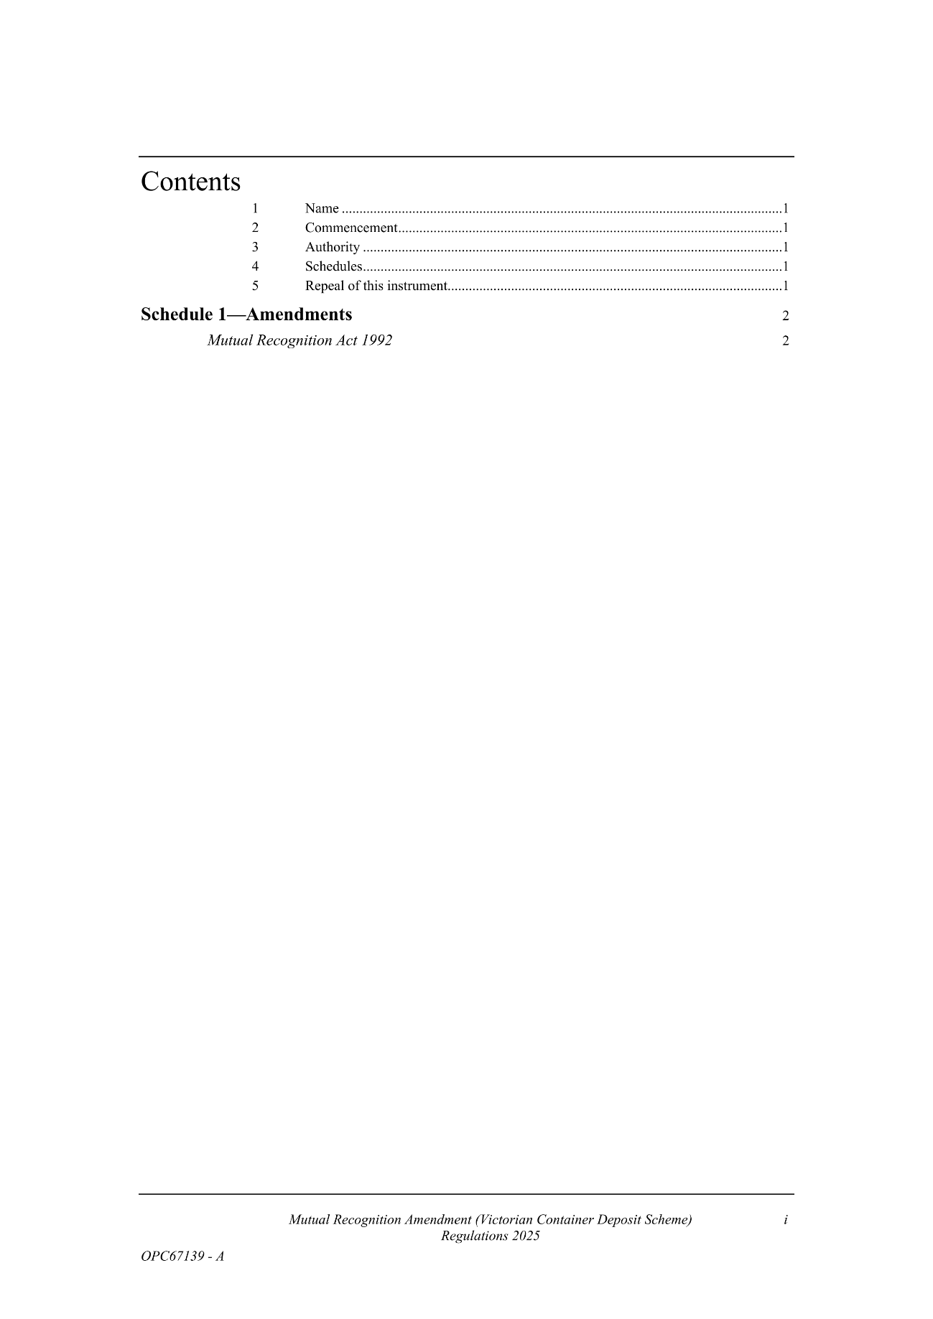
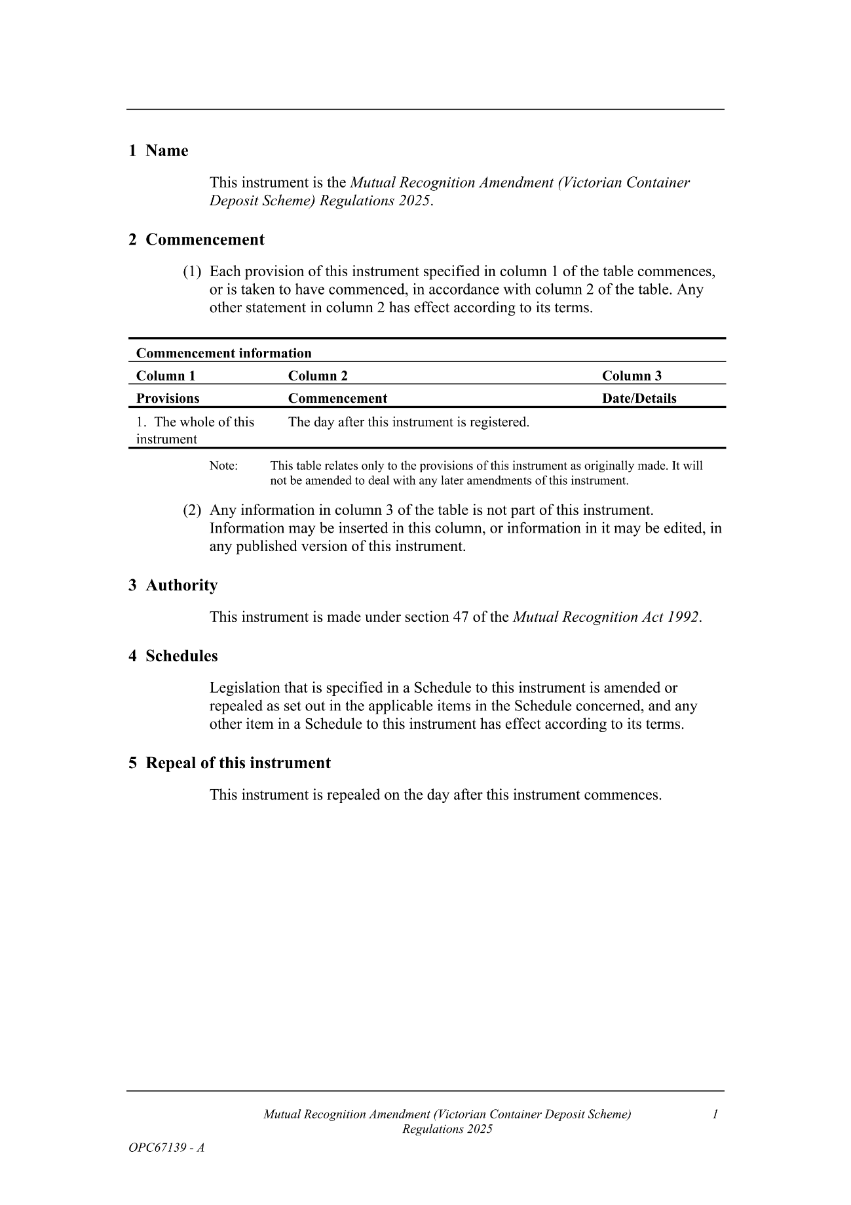
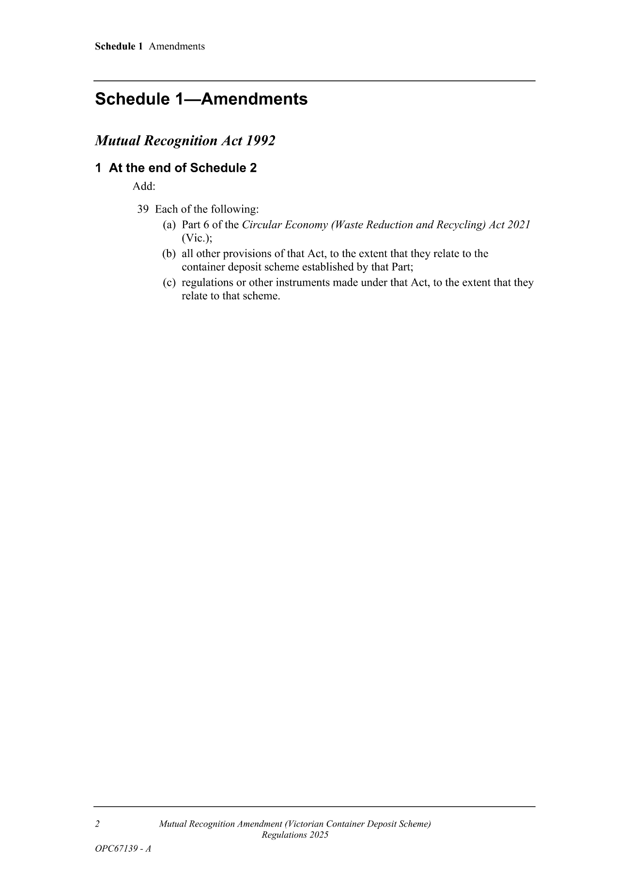
Made by the Governor
with the advice and consent of the Executive Council
on 27 November 2025

South Australia

Trans-Tasman Mutual Recognition (Victorian Container Deposit Scheme) Notice 2025
under section 43 of the Trans-Tasman Mutual Recognition Act 1997 of the Commonwealth as adopted by section 4 of the Trans-Tasman Mutual Recognition (South Australia) Act 1999
1—Short title
This notice may be cited as the Trans-Tasman Mutual Recognition (Victorian Container Deposit Scheme) Notice 2025.
2—Commencement
This notice comes into operation on the day on which it is made.
3—Endorsement of regulations
The proposed regulations set out in Schedule 1 are endorsed for the purposes of section 45 of the Trans-Tasman Mutual Recognition Act 1997 of the Commonwealth.
Schedule 1—Proposed regulations
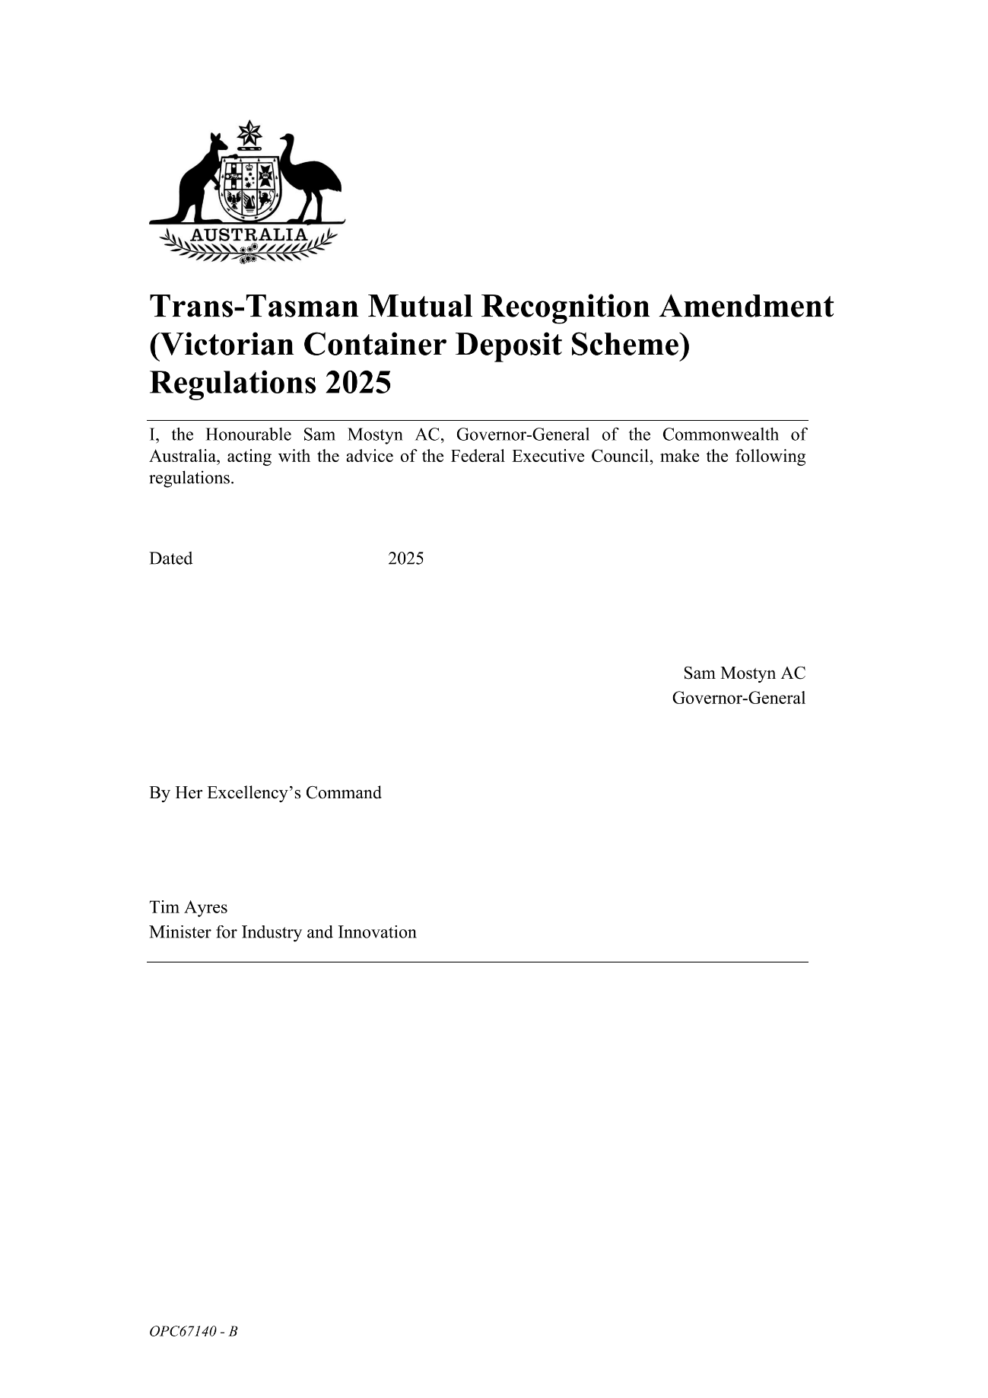
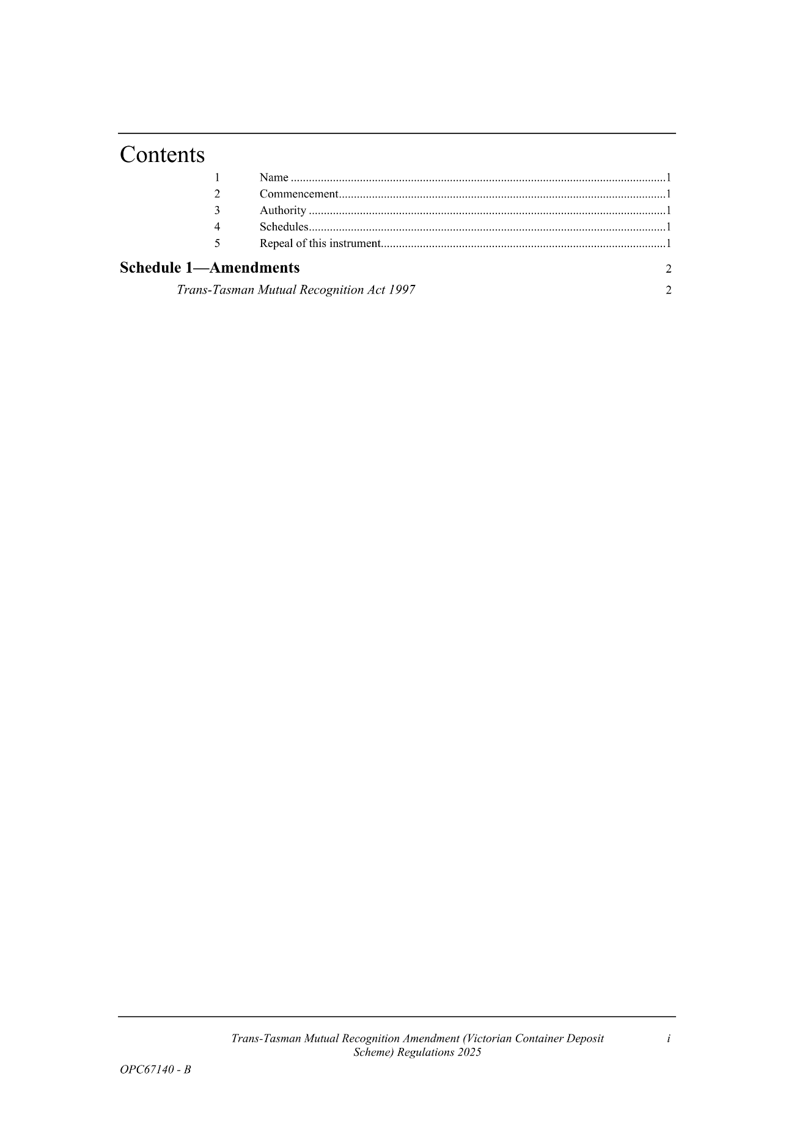
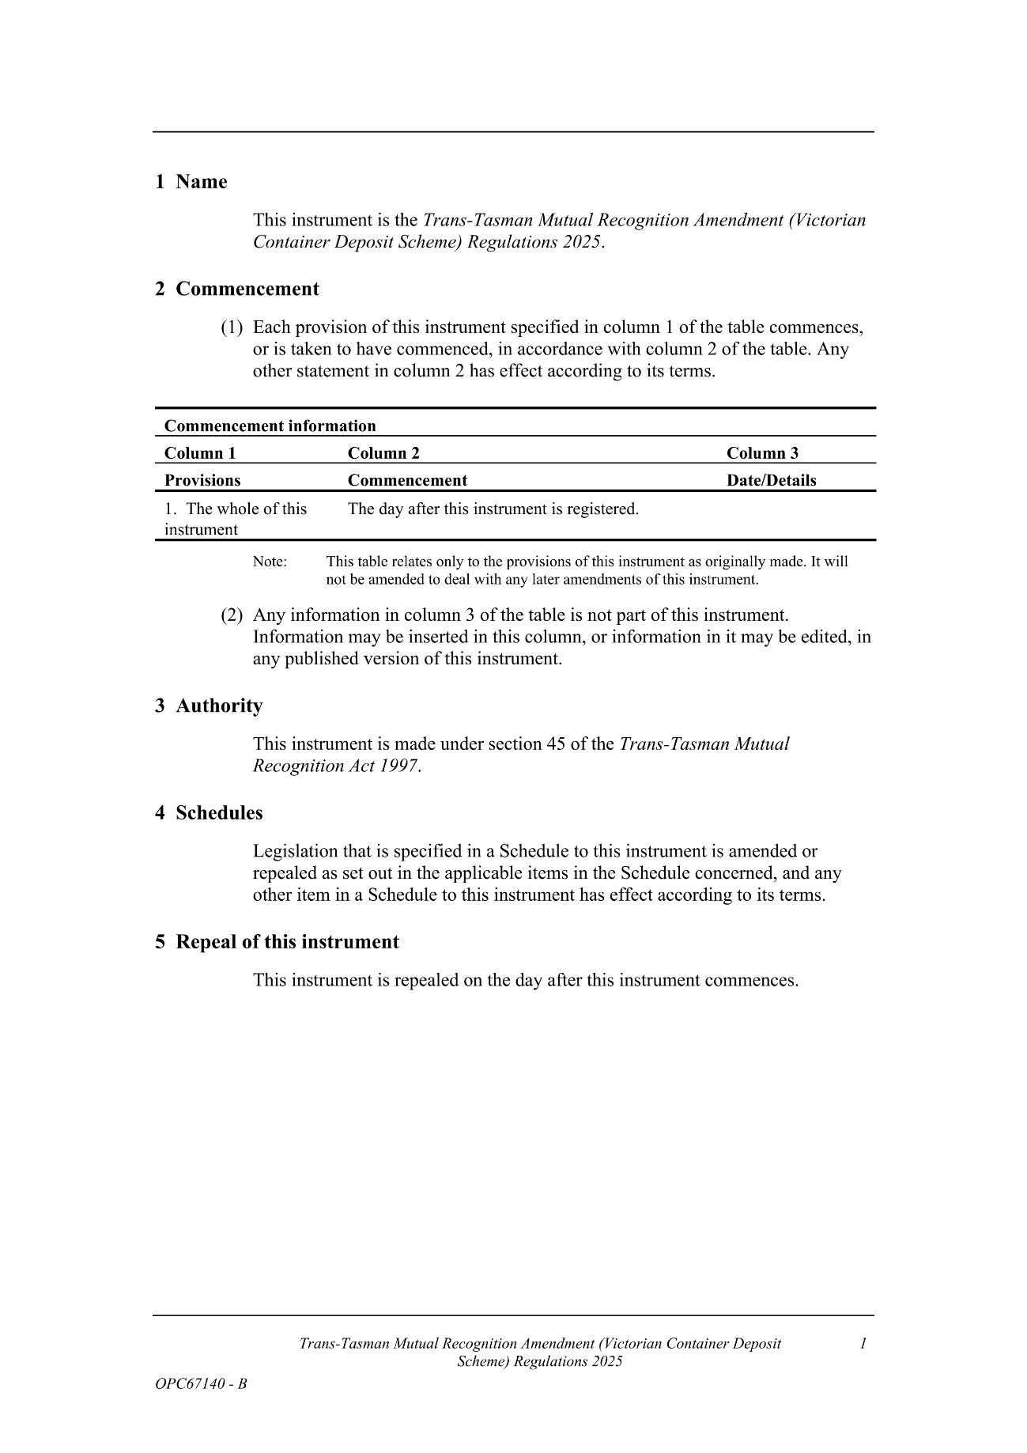
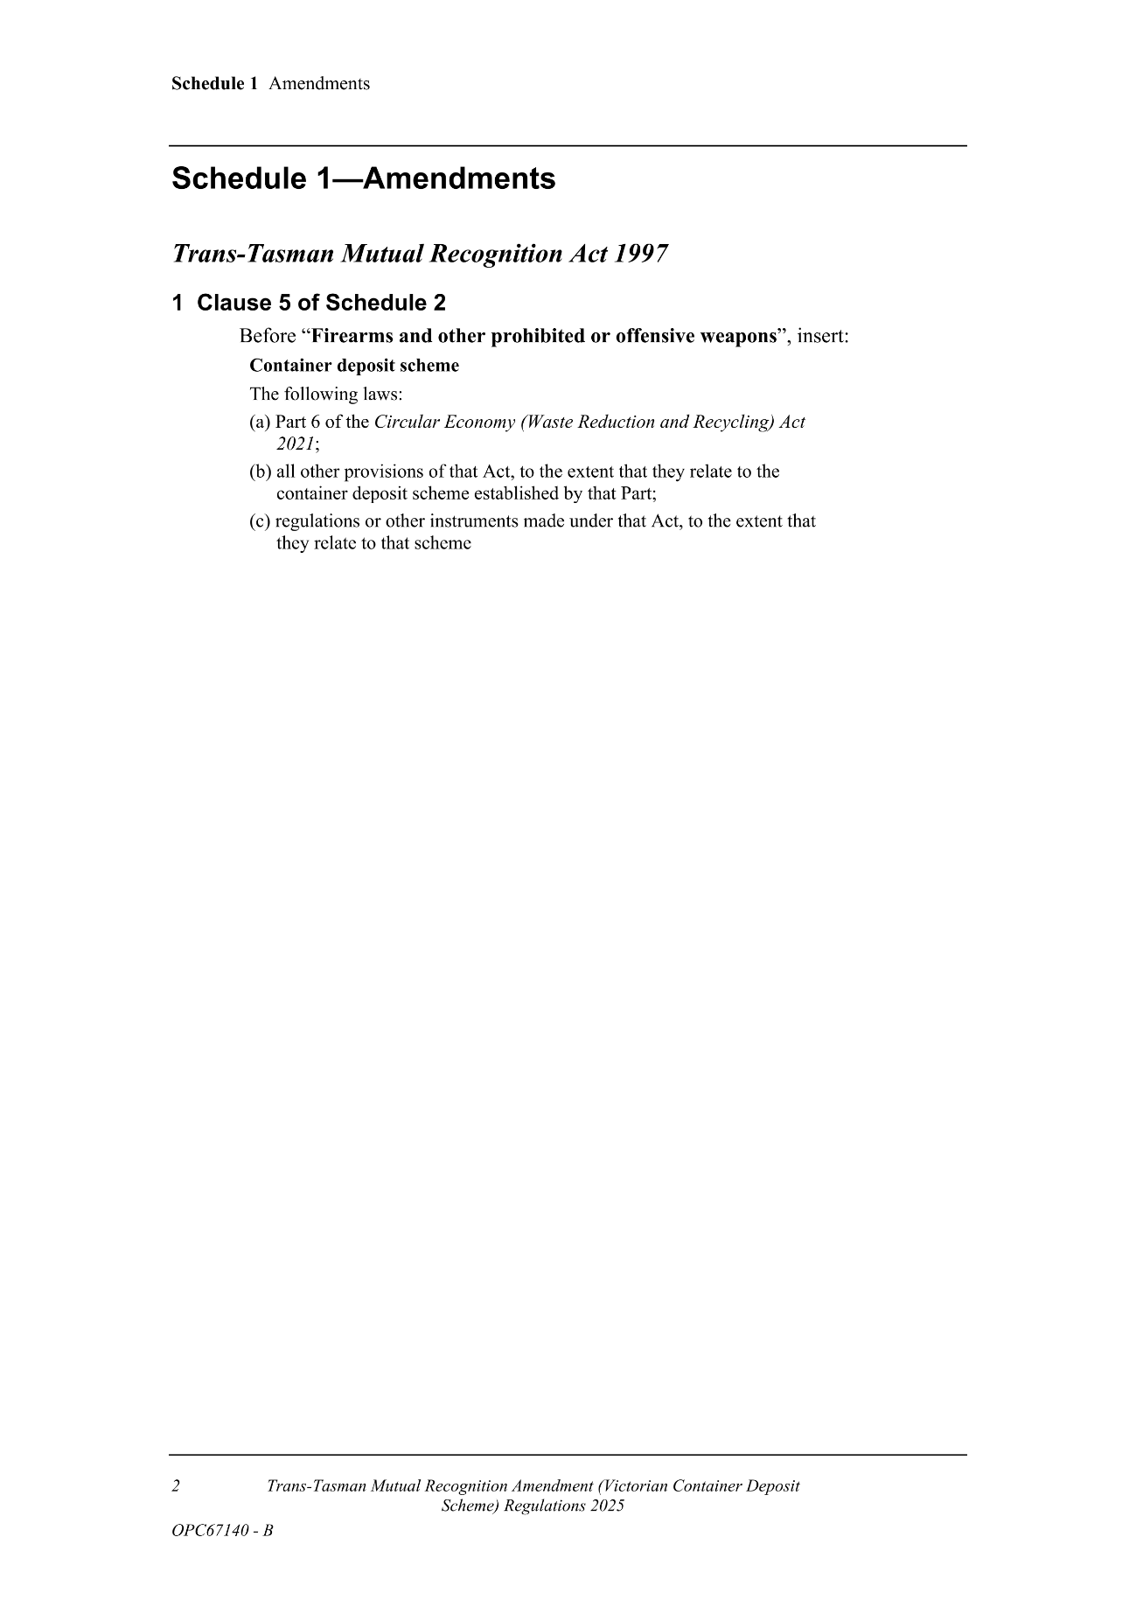
Made by the Governor
with the advice and consent of the Executive Council
on 27 November 2025

Proclamations
South Australia

Emergency Management (Miscellaneous) Amendment Act (Commencement) Proclamation 2025
1—Short title
This proclamation may be cited as the Emergency Management (Miscellaneous) Amendment Act (Commencement) Proclamation 2025.
2—Commencement of Act
The Emergency Management (Miscellaneous) Amendment Act 2025 (No 36 of 2025) comes into operation on 1 December 2025.
Made by the Governor
with the advice and consent of the Executive Council
on 27 November 2025

South Australia

Passenger Transport (Point to Point Transport Services) Amendment Act (Commencement) Proclamation 2025
1—Short title
This proclamation may be cited as the Passenger Transport (Point to Point Transport Services) Amendment Act (Commencement) Proclamation 2025.
2—Commencement of suspended provisions
The following provisions of the Passenger Transport (Point to Point Transport Services) Amendment Act 2025 (No 16 of 2025) come into operation on 27 November 2025:
(a) sections 30 and 31;
(b) section 37, but only insofar as it inserts section 52D into the Passenger Transport Act 1994.
Made by the Governor
with the advice and consent of the Executive Council
on 27 November 2025

South Australia

Adelaide University (Adelaide University Union) (Transfer of Assets, Contracts and Liabilities) Proclamation 2025
under Schedule 1 clause 31 of the Adelaide University Act 2023
1—Short title
This proclamation may be cited as the Adelaide University (Adelaide University Union) (Transfer of Assets, Contracts and Liabilities) Proclamation 2025.
2—Commencement
This proclamation comes into operation on the day on which it is made.
3—Transfer of assets, contracts and liabilities
All assets, contracts and liabilities of The Adelaide University Union are, on 5 January 2026, transferred to Adelaide University Student Association Incorporated.
Made by the Governor
on the request of The Adelaide University Union and with the advice and consent of the Executive Council
on 27 November 2025

Regulations
South Australia

Planning, Development and Infrastructure (General) (Family Day Care) Amendment Regulations 2025
under the Planning, Development and Infrastructure Act 2016

Contents
Part 1—Preliminary
1 Short title
2 Commencement
Part 2—Amendment of Planning, Development and Infrastructure (General) Regulations 2017
3 Amendment of Schedule 4—Exclusions from definition of development—general

Part 1—Preliminary
1—Short title
These regulations may be cited as the Planning, Development and Infrastructure (General) (Family Day Care) Amendment Regulations 2025.
2—Commencement
These regulations come into operation on the day on which they are made.
Part 2—Amendment of Planning, Development and Infrastructure (General) Regulations 2017
3—Amendment of Schedule 4—Exclusions from definition of development—general
(1) Schedule 4, clause 5(2)—after paragraph (g) insert:
(h) the operation of an approved family day care service, or a family day care service that is a residual early childhood service for which a service approval exists, at a residence.
(2) Schedule 4, clause 5(3)—before the definition of low impact entertainment insert:
approved family day care service, family day care service, residence and service approval have the same respective meanings as in the Education and Care Services National Law (South Australia);
(3) Schedule 4, clause 5(3)—after the definition of low impact entertainment insert:
residual early childhood service has the same meaning as in section 16 of the Education and Early Childhood Services (Registration and Standards) Act 2011.
Editorial note—
As required by section 10AA(2) of the Legislative Instruments Act 1978, the Minister has certified that, in the Minister's opinion, it is necessary or appropriate that these regulations come into operation as set out in these regulations.
Made by the Governor
with the advice and consent of the Executive Council
on 27 November 2025
No 129 of 2025

South Australia

Education and Early Childhood Services (Registration and Standards) (Amendment of Schedule 2 of Act) Regulations 2025
under the Education and Early Childhood Services (Registration and Standards) Act 2011

Contents
Part 1—Preliminary
1 Short title
2 Commencement
3 Amendment provisions
Part 2—Amendment of Education and Early Childhood Services (Registration and Standards) Act 2011
4 Amendment of Schedule 2—Modifications to Education and Care Services National Law (South Australia) for purposes of Part 3

Part 1—Preliminary
1—Short title
These regulations may be cited as the Education and Early Childhood Services (Registration and Standards) (Amendment of Schedule 2 of Act) Regulations 2025.
2—Commencement
These regulations come into operation on 1 December 2025.
3—Amendment provisions
In these regulations, a provision under a heading referring to the amendment of a specified Act amends the Act so specified.
Part 2—Amendment of Education and Early Childhood Services (Registration and Standards) Act 2011
4—Amendment of Schedule 2—Modifications to Education and Care Services National Law (South Australia) for purposes of Part 3
(1) Schedule 2, clause 2(1)(c)—delete paragraph (c)
(2) Schedule 2, clause 3(1)(d)—delete paragraph (d) and substitute:
(d) Section 51(5)—delete "in the national regulations" and substitute:
by the regulations

(3) Schedule 2, clause 3(1)(e) and (f)—delete paragraphs (e) and (f)
(4) Schedule 2, clause 3(1)(g)—delete "Section 172(e)" and substitute:
Section 172(1)(e)
(5) Schedule 2, clause 3(1)(k)—delete paragraph (k)
(6) Schedule 2, clause 3(1)(q), inserted text—delete "Schedule 2" and substitute:
Schedule 3
(7) Schedule 2, clause 3(1)(r), inserted text—delete "Schedule 2" and substitute:
Schedule 3
Editorial note—
As required by section 10AA(2) of the Legislative Instruments Act 1978, the Minister has certified that, in the Minister's opinion, it is necessary or appropriate that these regulations come into operation as set out in these regulations.
Made by the Governor
with the advice and consent of the Executive Council
on 27 November 2025
No 130 of 2025
South Australia

Education and Early Childhood Services (Registration and Standards) Regulations 2025
under the Education and Early Childhood Services (Registration and Standards) Act 2011

Contents
Part 1—Preliminary
1 Short title
2 Commencement
3 Interpretation
Part 2—Regulations relating to administration
4 Power of delegation—Minister
5 Prescribed childcare bodies
6 Prescribed designated entities
7 Prescribed offences
8 Prescribed peak bodies
9 Power of delegation—Board
10 Annual report
Part 3—Regulations relating to residual early childhood services
Division 1—Exemptions
11 Exemptions
Division 2—General provisions
12 Early childhood services
13 Prescribed documents
14 Prescribed class of persons etc taken to be approved providers
15 Service approvals
Division 3—Regulations applying to residual early childhood services in place of national regulations
Subdivision 1—Preliminary
16 Interpretation
17 Certain requirements under Education and Care Services National Law (South Australia) to be determined by Board
Subdivision 2—Provider approvals
18 Applications for provider approvals etc
19 Maximum period of suspension of provider approval

Subdivision 3—Service approvals
20 Applications for service approvals etc
21 Additional grounds for refusal to grant service approval
22 Condition on service approval—insurance
23 Condition on service approval—entitlement to occupy premises
24 Condition on service approval—educator to child ratios
25 Condition on service approval—educator qualifications
26 Condition on service approval—in-home care services and family day care services
27 Prescribed information—notifications
28 Maximum period of suspension of service approval
Subdivision 4—Operational requirements
29 Certain parts of national regulations to apply to residual early childhood services
Division 4—Standards
30 Standards applying to residual early childhood services
Part 4—Regulations relating to schools
31 Education services—exclusions
32 Full fee paying overseas students—exclusions
33 Requirements for registration on schools register
34 Prescribed bodies
35 Certificates of registration
36 Requirements for endorsement of registration with approval to enrol full fee paying overseas students
37 Requirements for reviews of registration
38 Records to be kept by registered schools
Part 5—Miscellaneous
39 Fees
Schedule 1—Specified entities—early childhood services
Schedule 2—Fees
Schedule 3—Repeal of Education and Early Childhood Services (Registration and Standards) Regulations 2011

Part 1—Preliminary
1—Short title
These regulations may be cited as the Education and Early Childhood Services (Registration and Standards) Regulations 2025.
2—Commencement
These regulations come into operation on 1 December 2025.
3—Interpretation
(1) In these regulations—
Act means the Education and Early Childhood Services (Registration and Standards) Act 2011;
Schedule 1 early childhood service—see regulation 12(1).
(2) In these regulations, a reference to the granting of an approval or certificate includes a reference to an approval or certificate taken to be granted by the operation of the Act or the Education and Care Services National Law (South Australia).
Part 2—Regulations relating to administration
4—Power of delegation—Minister
For the purposes of section 20(1) of the Act, the functions and powers under the following provisions of the Act are prescribed:
(a) section 19;
(b) section 22;
(c) section 24;
(d) section 62.
5—Prescribed childcare bodies
For the purposes of section 22(2)(e) of the Act, the following childcare bodies are prescribed:
(a) Australian Childcare Alliance South Australia Incorporated;
(b) Community Children's Centres SA Incorporated;
(c) Family Day Care Educators Association of South Australia Incorporated;
(d) Out of School Hours Care Association Incorporated.
6—Prescribed designated entities
For the purposes of section 22(4)(b) of the Act, the following designated entities are prescribed:
(a) Association of Independent Schools of South Australia;
(b) Association of Principals of Catholic Secondary Schools;
(c) Australian Childcare Alliance South Australia Incorporated;
(d) Australian Children's Education and Care Quality Authority;
(e) Australian Community Children's Services (SA) Incorporated;
(f) Australian Education Union (SA Branch);
(g) Catholic School Parents South Australia;

(h) Child Development Council;
(i) Community Children's Centres SA Incorporated;
(j) Early Childhood Australia South Australia Committee;
(k) Family Day Care Educators Association of South Australia Incorporated;
(l) Flinders University;
(m) Independent Education Union (South Australia) Incorporated;
(n) The Isolated Children's Parents' Association of South Australia Incorporated;
(o) the Minister to whom the administration of the Carers Recognition Act 2005 is committed;
(p) the Minister to whom the administration of the Health Care Act 2008 is committed;
(q) the Minister to whom the administration of the South Australian Skills Act 2008 is committed;
(r) Multicultural Education and Languages Committee;
(s) Office of the Guardian for Children and Young People;
(t) Out of School Hours Care Association Incorporated;
(u) Pitjantjatjara Yankunytjatjara Education Committee;
(v) Preschool Directors Association of South Australia Incorporated;
(w) Public Service Association of South Australia Incorporated;
(x) SACE Board of South Australia;
(y) Small Schools Association of South Australia (SSASA) Incorporated;
(z) South Australian Area Schools Leaders Association Incorporated;
(za) South Australian Association of School Parent Communities Incorporated;
(zb) South Australian Association of State School Organisations Incorporated;
(zc) South Australian Catholic Primary Principals Association;
(zd) South Australian Commission for Catholic Schools Incorporated;
(ze) South Australian Employers' Chamber of Commerce and Industry Incorporated (South Australian Business Chamber);
(zf) The South Australian Primary Principals Association Incorporated;
(zg) South Australian Secondary Principals Association Incorporated;
(zh) South Australian Special Education Principals and Leaders Association;
(zi) Teachers Registration Board of South Australia;
(zj) United Workers Union (SA Branch);
(zk) The University of Adelaide;
(zl) University of South Australia.

7—Prescribed offences
For the purposes of section 23(4)(d) of the Act, the following offences are prescribed:
(a) an offence of a sexual nature committed against, or in relation to, a minor;
(b) an offence of dishonesty under the Act.
8—Prescribed peak bodies
For the purposes of section 29(2)(b) of the Act, the following peak bodies are prescribed:
(a) Association of Independent Schools of South Australia;
(b) South Australian Commission for Catholic Schools Incorporated.
9—Power of delegation—Board
For the purposes of section 32(1) of the Act, the functions and powers under the following provisions of the Act are prescribed:
(a) section 29(1)(a), (b) and (d);
(b) section 30(2).
10—Annual report
For the purposes of section 40(2)(a), the annual report of the Board must contain the following information:
(a) a report on consultation undertaken for the purposes of the Act during the relevant year and an assessment of the extent to which this has assisted the Board in the performance of its functions;
(b) any information required to be included in the annual report under the Education and Care Services National Law (South Australia);
(c) any other information that the Minister may reasonably require to be included in the annual report.
Part 3—Regulations relating to residual early childhood services
Division 1—Exemptions
11—Exemptions
(1) The Board may, by notice in writing—
(a) exempt a person, or class of persons, subject to such conditions as the Board thinks fit and specifies in the notice, from specified provisions of the Education and Care Services National Law (South Australia) as they apply to, or in relation to, residual early childhood services; or
(b) vary or revoke an exemption, or a condition of an exemption, under this regulation or impose a further condition.
(2) A person who contravenes a condition of an exemption is guilty of an offence.
Maximum penalty: $10 000.
Division 2—General provisions
12—Early childhood services
(1) For the purposes of section 4(1)(e) of the Act, a service of a kind provided by an entity specified in Schedule 1 (a Schedule 1 early childhood service) is of a kind declared to be included in the ambit of the definition of early childhood services in section 4(1) of the Act.
(2) For the purposes of the definition of in-home care services in section 4 of the Act, services (not being services that are an education and care service within the meaning of the Education and Care Services National Law (South Australia)) of the following kinds are in-home care services:
(a) a service comprising the provision of care to children in their own homes in the temporary absence of the children's parents or guardians;
(b) a service comprising the introduction of parents or guardians of children to a person who will care for the children in their own homes in the temporary absence of the children's parents or guardians,
other than a service comprising—
(c) a personal arrangement (within the meaning of the Education and Care Services National Law (South Australia)); or
(d) a person engaged by a parent or guardian of a child to babysit the child in the child's home; or
(e) a babysitting, playgroup or child minding service that is organised informally by the parents of the children concerned; or
(f) care provided to a child by a person in accordance with a parenting order under the Family Law Act 1975 of the Commonwealth or the Family Court Act 1997 of Western Australia; or
(g) care provided to a child in accordance with a placement under section 77 or 84 of the Children and Young People (Safety) Act 2017.
(3) For the purposes of the definition of occasional care services in section 4 of the Act, a service (not being services that are an education and care service within the meaning of the Education and Care Services National Law (South Australia)) comprising the care for fee or reward in a place other than a child's home of 4 or more children of preschool age or younger is an occasional care service (however, such a service will be taken not to be an occasional care service if a parent or guardian of the children remains on site and is available to care for their child if required).
(4) For the purposes of the definition of rural and mobile care services in section 4 of the Act, services (not being a service that is an education and care service within the meaning of the Education and Care Services National Law (South Australia)) of the following kinds are rural and mobile care services:
(a) a service comprising the care, in a community venue in a rural community, of not more than 7 children at a particular time, of whom—
(i) not more than 4 are children under school age; and
(ii) not more than 3 are school age children;
(b) a service providing care to children of preschool age or under at multiple locations and that transports its equipment and materials to those locations.
(5) In this regulation—
metropolitan Adelaide means Metropolitan Adelaide as defined by General Registry Office Plan 639/93;
rural community means a community located outside of metropolitan Adelaide.
13—Prescribed documents
(1) For the purposes of Schedule 2 clause 3(1)(h) of the Act, the documents that an approved provider must keep are such documents as may be specified by the Board from time to time.
Note—
Schedule 2 clause 3(1)(h) of the Act modifies section 175(1) of the Education and Care Services National Law (South Australia) as it applies to residual early childhood services.
Regulation 29(3) provides that the record keeping requirements under Chapter 4 of the national regulations, as it applies to residual early childhood services, do not apply to residual early childhood services.
(2) An approved provider must keep a record referred to in subregulation (1)—
(a) for a period of not less than 3 years (or such longer period as may be specified by the Board); and
(b) in a place, and in a manner, that complies with any requirements determined by the Board for the purposes of this subregulation.
14—Prescribed class of persons etc taken to be approved providers
For the purposes of Schedule 3 clause 29(g) of the Act, a person or body who, immediately before the commencement of this regulation, operated a Schedule 1 early childhood service is declared to be included in the ambit of clause 29.
15—Service approvals
For the purposes of Schedule 3 clause 30(1)(e) of the Act, the following services are declared to be included in the ambit of clause 30:
(a) a family day care service provided under the Children's Services Act 1985 immediately before the commencement of that clause (other than a family day care service that is an education and care service within the meaning of the Education and Care Services National Law (South Australia));
(b) a Schedule 1 early childhood service.
Division 3—Regulations applying to residual early childhood services in place of national regulations
Subdivision 1—Preliminary
16—Interpretation
(1) In this Division, a term or phrase that is defined in the Education and Care Services National Law (South Australia) or the national regulations has the same meaning as in that Law or those regulations (as the case requires).
(2) In this Division, a reference to the Education and Care Services National Law (South Australia) will be taken to be a reference to that Law as it applies to residual early childhood services.
17—Certain requirements under Education and Care Services National Law (South Australia) to be determined by Board
If the Education and Care Services National Law (South Australia) requires a matter to be prescribed by, or determined in accordance with, the national regulations, and the matter is not the subject of a regulation under this Division, then the Board may prescribe or determine the matter according to its discretion (including, to avoid doubt, by not requiring compliance with the provision).
Subdivision 2—Provider approvals
18—Applications for provider approvals etc
(1) The prescribed information in respect of an application under the Education and Care Services National Law (South Australia) for—
(a) a provider approval; or
(b) an amendment of a provider approval; or
(c) voluntary suspension of a provider approval; or
(d) a provider approval made under section 39(5) of the Education and Care Services National Law (South Australia); or
(e) a provider approval made under section 40 of the Education and Care Services National Law (South Australia),
is such information as may be determined by the Board from time to time.
(2) An application must be accompanied by the appropriate fee as set out in Schedule 2.
(3) In determining the information required in relation to an application, the Board should have regard to the requirements (if any) for similar applications under the Education and Care Services National Law (South Australia) and the national regulations as applying to education and care services.
19—Maximum period of suspension of provider approval
The prescribed maximum period of suspension of a provider approval under section 27(b)(i) or 33(1)(a)(ii) of the Education and Care Services National Law (South Australia) is 12 months.
Subdivision 3—Service approvals
20—Applications for service approvals etc
(1) The prescribed information in respect of an application under the Education and Care Services National Law (South Australia) for—
(a) a service approval; or
(b) an amendment of a service approval; or
(c) voluntary suspension of a service approval,
is such information as may be determined by the Board from time to time.
(2) An application must be accompanied by the appropriate fee as set out in Schedule 2.
(3) In determining the information required in relation to an application, the Board should have regard to the requirements (if any) for similar applications under the Education and Care Services National Law (South Australia) and the national regulations as applying to education and care services.
21—Additional grounds for refusal to grant service approval
The Board may refuse to grant a service approval on the following grounds:
(a) the Board is not satisfied that the applicant is capable of operating the proposed service in a way that meets the requirements of the Education and Care Services National Law (South Australia) or these regulations;
(b) in the case of a centre-based service—the Board is not satisfied that the applicant is entitled to occupy the premises proposed as the place at which the service will operate.
22—Condition on service approval—insurance
A service approval is granted subject to a condition that the approved provider must hold the following insurance in respect of the residual early childhood service:
(a) a current policy of insurance providing adequate cover for the residual early childhood service against public liability with a minimum cover of $10 000 000;
(b) a policy of insurance or an indemnity against public liability provided by the Government in respect of the residual early childhood service.
23—Condition on service approval—entitlement to occupy premises
A service approval for a centre-based service is granted subject to the condition that the service continues to be entitled to occupy the premises at which the residual early childhood service operates.
24—Condition on service approval—educator to child ratios
(1) A service approval for a residual early childhood service is granted subject to the condition that the approved provider must comply with any requirements regarding the minimum number of educators required to educate and care for children at the residual early childhood service when children are being educated and cared for by the service as may be determined by the Board from time to time.
(2) To avoid doubt, and without limitation, a determination of the Board may differ according to a specified class of residual early childhood service and the ages of the children being educated and cared for by the service.
25—Condition on service approval—educator qualifications
(1) A service approval for a residual early childhood service is granted subject to the condition that the approved provider must ensure that each educator educating and caring for children at the residual early childhood service meets any qualification requirements for educators as may be determined by the Board from time to time.
(2) To avoid doubt, and without limitation, a determination of the Board may differ according to a specified class of residual early childhood service, the role of the educator and the ages of the children being educated and cared for by the educator.
26—Condition on service approval—in-home care services and family day care services
A service approval for a residual early childhood service that is an in-home care service or a family day care service is granted subject to a condition that the approved provider must comply with any standards or requirements determined by the Board from time to time in relation to the operation of such services.
27—Prescribed information—notifications
(1) The prescribed information for notices under the following sections of the Education and Care Services National Law (South Australia) is such information as may be determined by the Board from time to time:
(a) section 56;
Note—
Section 56 relates to a change of nominated supervisor.
(b) section 59.
Note—
Section 59 relates to the transfer of a service approval for a centre-based service.
(2) In determining the information required in relation to a notice, the Board should have regard to the requirements (if any) for similar notices under the Education and Care Services National Law (South Australia) and the national regulations as applying to education and care services.
28—Maximum period of suspension of service approval
The prescribed maximum period of suspension of a service approval under sections 72(b)(i) and 79(1)(a)(ii) of the Education and Care Services National Law (South Australia) is 12 months.
Subdivision 4—Operational requirements
29—Certain parts of national regulations to apply to residual early childhood services
(1) Subject to this regulation and to any modification of the national regulations made by or under the Act, Chapter 4 of the national regulations applies to residual early childhood services as if they were education and care services within the meaning of the Education and Care Services National Law (South Australia).
(2) Chapter 4 of the national regulations (as it applies pursuant to subregulation (1)) does not apply to, or in relation to, a residual early childhood service that is an in-home care service or a family day care service.
Note—
Regulation 26 permits the Board to set operational requirements for in-home care services or family day care services by way of conditions imposed on their service approval.
(3) A provision of Chapter 4 of the national regulations that imposes a requirement in relation to the keeping or making of records does not apply to, or in relation to, a residual early childhood service.
Note—
Regulation 13 sets out what records must be made by approved providers and how they must be kept.
Other provisions of Chapter 4 of the national regulations may not apply to, or in relation to, residual early childhood services. For example, regulations that are made for the purposes of provisions of the Education and Care Services National Law (South Australia) that do not apply to, or in relation to, residual early childhood services under the Act (see Schedule 2 of the Act).
Division 4—Standards
30—Standards applying to residual early childhood services
(1) For the purposes of Schedule 2 clause 3(2) of the Act, the standards approved or adopted by the Board from time to time for the purposes of that subclause are prescribed.
(2) To avoid doubt, a particular standard may apply to all residual early childhood services or a specified class of residual early childhood services.
Part 4—Regulations relating to schools
31—Education services—exclusions
For the purposes of the definition of education services in section 3(1) of the Act, the following services are declared not to be included in the ambit of that definition:
(a) lessons or coaching in, or providing for participation in, a linguistic, cultural, recreational, religious or sporting activity;
(b) private tutoring.
32—Full fee paying overseas students—exclusions
For the purposes of section 3(3) of the Act, the following students or classes of students are, in respect of the specified activities, declared not to be full fee paying overseas students:
(a) a student or class of students referred to in section 3(3)(a) of the Act receiving lessons or coaching in, or providing for participation in, a linguistic, cultural, recreational, religious or sporting activity;
(b) a student or class of students referred to in section 3(3)(a) of the Act receiving private tutoring;
(c) a student or class of students taking part in a student exchange program organised by a registered school.

33—Requirements for registration on schools register
(1) For the purposes of section 43(1)(c) of the Act, it is a requirement that the school must comply, or be able to comply, with the standards for registration and review of registration of schools in South Australia.
(2) In this regulation—
standards for registration and review of registration of schools in South Australia means the standards for registration and review of registration of schools in South Australia published by the Board after consultation with the members of the Board appointed under section 22(2)(b), (c) and (d) of the Act, as in force from time to time.
34—Prescribed bodies
For the purposes of section 43(3) of the Act, the following bodies are prescribed:
(a) Association of Independent Schools of South Australia;
(b) Association of Principals of Catholic Secondary Schools;
(c) Australian Education Union (SA Branch);
(d) Catholic School Parents South Australia;
(e) Independent Education Union (South Australia) Incorporated;
(f) The Isolated Children's Parents' Association of South Australia Incorporated;
(g) Multicultural Education and Languages Committee;
(h) Pitjantjatjara Yankunytjatjara Education Committee;
(i) SACE Board of South Australia;
(j) Small Schools Association of South Australia (SSASA) Incorporated;
(k) South Australian Area Schools Leaders Association Incorporated;
(l) South Australian Association of School Parent Communities Incorporated;
(m) South Australian Association of State School Organisations Incorporated;
(n) South Australian Catholic Primary Principals Association;
(o) South Australian Commission for Catholic Schools Incorporated;
(p) The South Australian Primary Principals Association Incorporated;
(q) South Australian Secondary Principals Association Incorporated;
(r) South Australian Special Education Principals and Leaders Association;
(s) Teachers Registration Board of South Australia;
(t) United Workers Union (SA Branch).

35—Certificates of registration
For the purposes of section 45 of the Act, a certificate of registration must be in a form approved by the Board.
36—Requirements for endorsement of registration with approval to enrol full fee paying overseas students
For the purposes of section 49(1) of the Act, the following requirements must be satisfied:
(a) if the endorsement relates to overseas students within the meaning of the Education Services for Overseas Students Act 2000 of the Commonwealth—the registered school—
(i) must comply, or be able to comply, with—
(A) any standard or code of practice prepared or adopted for the purposes of this paragraph by the Board, as in force from time to time; or
(B) if no such standard or code of practice has been prepared or adopted—the standards for registered providers contained in the National Code of Practice for Providers of Education and Training to Overseas Students under that Act, as in force from time to time; and
(ii) must be registered on the Commonwealth Register of Institutions and Courses for Overseas Students under that Act;
(b) if the endorsement relates to students other than overseas students within the meaning of the Education Services for Overseas Students Act 2000 of the Commonwealth—the registered school must comply, or be able to comply, with any standard or code of practice prepared or adopted for the purposes of this paragraph by the Board, as in force from time to time;
(c) in any case—the registered school must comply, or be able to comply, with any other requirement determined by the Board for the purposes of this paragraph.
37—Requirements for reviews of registration
(1) For the purposes of section 54(1) of the Act, a review of the registration of a registered school must satisfy the following requirements:
(a) the review must be undertaken in accordance with the standards for registration and review of registration of schools in South Australia;
(b) a review must be undertaken at least once in each 5 year period in accordance with the following provisions:
(i) if the registered school was first registered after the commencement of this regulation, the first review must be undertaken not later than 5 years after the date of registration;
(ii) if the registration of the registered school has not been reviewed in the 5 years immediately preceding the commencement of this regulation, the first review following the commencement of this regulation must be undertaken not later than 5 years after the date of registration;
(iii) subsequent reviews must be undertaken not later than 5 years after a preceding review (including a preceding review undertaken before the commencement of this regulation).
(2) In this regulation—
standards for registration and review of registration of schools in South Australia means the standards for registration and review of registration of schools in South Australia published by the Board after consultation with the members of the Board appointed under section 22(2)(b), (c) and (d) of the Act, as in force from time to time.
38—Records to be kept by registered schools
(1) For the purposes of section 56(1)(b) of the Act, a registered school is required to keep such records as the Board may determine for the purposes of this subregulation.
(2) A registered school must keep a record referred to in subregulation (1)—
(a) for a period of not less than 7 years (or such longer period as may be specified by the Board); and
(b) in a place, and in a manner, that complies with the requirements (if any) determined by the Board for the purposes of this subregulation.
Part 5—Miscellaneous
39—Fees
(1) The fees for the purposes of the Act (including fees payable by, or in relation to, residual early childhood services for a matter under the Education and Care Services National Law (South Australia) as it applies to those services) are as set out in Schedule 2.
Note—
Schedule 2 clause 2(4) of the Act provides that the fees set under the Education and Care Services National Law (South Australia) do not apply to residual early childhood services.
(2) The Board may waive or remit the whole or any part of a fee payable under the Act.
Schedule 1—Specified entities—early childhood services
(regulation 12(1))
Note—
The location of an entity specified in this Schedule is provided for convenience of reference only.
Kaurna Plains Childcare Centre (located at Kaurna Plains School, 83 Ridley Road, Elizabeth)
Koonibba Child Care Centre (located at 1 Highfold Street, Koonibba)
Kura Yerlo Children's Centre (located at 178-180 Tapleys Hill Road, Royal Park)
Marree Aboriginal School Creche (located at First Street, Marree)
Milang Old School House Community Centre (located at 24-25 Daranda Terrace, Milang)
Minya Bunhii Children's Centre (located at 1 Kelly Street, Ceduna)
Port Lincoln Children's Centre Inc (located at 80 Saint Andrews Terrace, Port Lincoln)
Tjitji Tjapu Tjuta Childcare Centre (located at Lot 315 Robins Boulevard, Coober Pedy)
Wynbring Jida M.A.C.S Child Care Centre (located at 2-4 Booth Street, Whyalla Stuart, Whyalla)

Schedule 2—Fees

Item | Fee
Items related to residual early childhood services
Application fee for provider approval | $200
Application fee for service approval | $400
Fee for notice of transfer of a service approval (section 59 of Education and Care Services National Law (South Australia)) | $100
Application for exemption (section 17 of Act or regulation 11) | no fee
Items related to schools
Copy of schools register (section 41(6) of Act)—
(a) for electronic copy of register | $65
(b) for a hard copy of register | $5 per page
Application for registration on schools register (section 43(4)(b) of Act) | $300
Reinstatement fee (section 48(5)(b) of Act) | $0
Application for endorsement of registration (section 49(2)(c) of Act)—
(a) if the school is a primary school | no fee
(b) if the school is a secondary school with—
(i) not more than 10 students | $500
(ii) more than 10 but not more than 20 students | $1 000
(iii) more than 20 students | $2 000
Copy of register of prohibition orders (section 65(6) of Act)—
(a) for electronic copy of register | $65
(b) for a hard copy of register | $5 per page
Schedule 3—Repeal of Education and Early Childhood Services (Registration and Standards) Regulations 2011
The Education and Early Childhood Services (Registration and Standards) Regulations 2011 are repealed.
Editorial note—
As required by section 10AA(2) of the Legislative Instruments Act 1978, the Minister has certified that, in the Minister's opinion, it is necessary or appropriate that these regulations come into operation as set out in these regulations.
Made by the Governor
in the case of regulations 33 and 37, on the recommendation of the Education and Early Childhood Services Registration and Standards Board of South Australia, and in any case, with the advice and consent of the Executive Council
on 27 November 2025
No 131 of 2025

South Australia

Passenger Transport (Point to Point Transport Services) Amendment Regulations 2025
under the Passenger Transport Act 1994

Contents
Part 1—Preliminary
1 Short title
2 Commencement
Part 2—Amendment of Passenger Transport Regulations 2024
3 Amendment of regulation 3—Interpretation
4 Amendment of regulation 35—Prescribed kinds or grades of licences
5 Substitution of regulation 36
36 Conditions of licences
6 Repeal of regulation 37
7 Substitution of regulation 39
39 Particulars in licence
8 Repeal of regulation 42
9 Amendment of regulation 43—Suspension or cancellation of licences
10 Repeal of regulations 46 to 48
11 Amendment of regulation 141—Maximum age of vehicles
12 Repeal of Schedule 1
13 Amendment of Schedule 2—Maximum fares (metropolitan taxis)
Schedule 1—Transitional provision
1 Transitional provision

Part 1—Preliminary
1—Short title
These regulations may be cited as the Passenger Transport (Point to Point Transport Services) Amendment Regulations 2025.
2—Commencement
These regulations come into operation on the day on which section 30 of the Passenger Transport (Point to Point Transport Services) Amendment Act 2025 comes into operation.
Part 2—Amendment of Passenger Transport Regulations 2024
3—Amendment of regulation 3—Interpretation
(1) Regulation 3(1), definition of relevant person, (b)—delete ", or leased by," wherever occurring
(2) Regulation 3(1), definition of small passenger vehicle, (b)—after "persons" insert:
(including the driver)
(3) Regulation 3(1), definitions of standby taxi licence, standby taxi and stretch limousine—delete the definitions
(4) Regulation 3(3)—delete subregulation (3) and substitute:
(3) Unless the contrary intention appears, a reference in these regulations to the owner of a vehicle includes a reference to a person who is leasing the vehicle, or who is using the vehicle with the consent of the owner.
4—Amendment of regulation 35—Prescribed kinds or grades of licences
(1) Regulation 35(1)(b)—delete paragraph (b)
(2) Regulation 35(1)(d)—delete paragraph (d)
(3) Regulation 35(2)—delete subregulation (2)
(4) Regulation 35(4)—delete subregulation (4)
5—Substitution of regulation 36
Regulation 36—delete the regulation and substitute:
36—Conditions of licences
Pursuant to section 45(5) of the Act, a taxi licence is subject to the following conditions:
(a) a condition that the holder of the licence must remain an accredited person of an appropriate kind;
(b) a condition that the holder of the licence must remain a fit and proper person to hold a taxi licence;
(c) a condition that the licence relates only to 1 vehicle.
6—Repeal of regulation 37
Regulation 37—delete the regulation
7—Substitution of regulation 39
Regulation 39—delete the regulation and substitute:
39—Particulars in licence
A taxi licence must specify the conditions (if any) imposed by the Minister in relation to the licence under section 45 of the Act.
8—Repeal of regulation 42
Regulation 42—delete the regulation
9—Amendment of regulation 43—Suspension or cancellation of licences
Regulation 43(2)(a) and (b)—delete paragraphs (a) and (b) and substitute:
(a) give the holder of the licence written notice of the proposed course of action (including a brief summary of the matters alleged against them); and
(b) allow the holder of the licence a reasonable opportunity to answer or make submissions in relation to the matters alleged against them.
10—Repeal of regulations 46 to 48
Regulations 46 to 48 (inclusive)—delete the regulations
11—Amendment of regulation 141—Maximum age of vehicles
(1) Regulation 141(1)—delete "subregulation (2)" and substitute:
subregulations (1a) and (2)
(2) Regulation 141(1)(a)—delete "8 years" and substitute:
10 years
(3) Regulation 141(1)(b)—delete "12 years" and substitute:
14 years
(4) Regulation 141—after subregulation (1) insert:
(1a) The following standards apply to stretch limousines:
(a) no age limit applies to a stretch limousine that is a small passenger vehicle;
(b) a person must not use a stretch limousine that is a large passenger vehicle for the purposes of a passenger transport service if the limousine is more than 25 years old unless—
(i) the limousine is less than 30 years old; and
(ii) the Minister is satisfied that—
(A) the vehicle meets appropriate standards for passenger safety and comfort determined by the Minister; or
(B) there are other exceptional circumstances that justify the approval of the use of an older vehicle.
(5) Regulation 141(2)(b)—delete paragraph (b) and substitute:
(b) in the case of a vehicle being wholly or predominantly used for a regular passenger service—the Minister is satisfied that the vehicle meets appropriate standards for passenger safety and comfort determined by the Minister; or
(6) Regulation 141(4)—delete subregulation (4) and substitute:
(4) The Minister cannot grant an approval in relation to a metropolitan taxi (other than an access taxi) unless the Minister is satisfied that there are exceptional circumstances justifying the approval.
(7) Regulation 141(5)—delete subregulation (5)
(8) Regulation 141(8)—delete subregulation (8) and substitute:
(8) In this regulation—
large passenger vehicle means a motor vehicle—
(a) designed for the principal purpose of carrying passengers; and
(b) designed to carry 13 or more persons (including the driver);
stretch limousine means—
(a) a motor vehicle designed to carry passengers that—
(i) has been certified by its manufacturer as a long wheelbase limousine; and
(ii) has been designed to carry not less than 6 persons and not more than 24 persons (including the driver); or
(b) a motor vehicle designed to carry passengers that—
(i) has been modified from its original construction in such a manner that increases the overall wheelbase of the vehicle—
(A) beyond the original wheelbase dimension of the vehicle; and
(B) to a length sufficient to accommodate additional passengers; and
(ii) after such modification has a seating capacity not exceeding 24 persons (including the driver).
12—Repeal of Schedule 1
Schedule 1—delete the Schedule
13—Amendment of Schedule 2—Maximum fares (metropolitan taxis)
(1) Schedule 2, clause 1, heading—delete "ending in Metropolitan Adelaide" and substitute:
undertaken by metropolitan taxis
(2) Schedule 2, clause 1(1) and (2)—delete subclauses (1) and (2) and substitute:
(1) This clause applies to any journey by a metropolitan taxi other than a journey to which clause 2 applies.
(2) For a journey by metropolitan taxi to which this clause applies, the fare must not exceed the sum of the following:

(a) flagfall—
(i) on tariff 1 | $4.00
(ii) on tariff 2 | $5.40
(iii) on tariff 3 | $5.20
(iv) on tariff 4 | $7.00
(b) for the distance travelled—
(i) on tariff 1—for every 44.21 m or part | $0.10
(ii) on tariff 2—for every 38.45 m or part | $0.10
(iii) on tariff 3—for every 34.21 m or part | $0.10
(iv) on tariff 4—for every 29.56 m or part | $0.10
(c) for waiting time after the commencement of the hiring—
(i) on tariff 1—for each period of 7.59 seconds | $0.10
(ii) on tariff 2—for each period of 7.59 seconds | $0.10
(iii) on tariff 3—for each period of 5.95 seconds | $0.10
(iv) on tariff 4—for each period of 5.95 seconds | $0.10
(3) Schedule 2, clause 1(4)—delete "$2.30" and substitute:
$2.40
(4) Schedule 2, clause 2, heading—delete "ending outside Metropolitan Adelaide (Area A)" and substitute:
where fare determined by agreement
(5) Schedule 2, clause 2(1)—after paragraph (c) insert:
(d) a journey that begins and ends outside Metropolitan Adelaide.
(6) Schedule 2, clause 2(2)—delete "7.83" wherever occurring and substitute:
7.59
(7) Schedule 2, clause 2(2)(a)—delete "$1.80" and substitute:
$1.86
(8) Schedule 2, clause 2(2)(b)—delete "1.30" and substitute:
$1.34
(9) Schedule 2, clause 2(4)—delete "7.83" and substitute:
7.59
(10) Schedule 2, clause 3—delete the clause and substitute:
3—Journeys from Adelaide Airport T1 Airport Terminal
For the purposes of section 52D(5) of the Act, an amount determined according to the discretion of Adelaide Airport Limited may be charged in addition to the fare payable in accordance with this Schedule for a journey by metropolitan taxi that begins at the taxi rank of the "T1 Airport Terminal" on Andy Thomas Circuit at Adelaide Airport, if a service fee of that amount has been charged to the taxi for entering that taxi rank.
Schedule 1—Transitional provision
1—Transitional provision
(1) An approval of the Minister granted under regulation 141 of the principal regulations and in force immediately before the commencement of these regulations continues in force as an approval granted under regulation 141 of the principal regulations (as amended by regulation 11).
(2) In this clause—
principal regulations means the Passenger Transport Regulations 2024.
Editorial note—
As required by section 10AA(2) of the Legislative Instruments Act 1978, the Minister has certified that, in the Minister's opinion, it is necessary or appropriate that these regulations come into operation as set out in these regulations.
Made by the Governor
with the advice and consent of the Executive Council
on 27 November 2025
No 132 of 2025
South Australia

Controlled Substances (Poisons) (Prescriptions by Pharmacists) Amendment Regulations 2025
under the Controlled Substances Act 1984

Contents
Part 1—Preliminary
1 Short title
2 Commencement
Part 2—Amendment of Controlled Substances (Poisons) Regulations 2011
3 Insertion of regulation 17A
17A Regulation of prescription drugs—prescription by pharmacists of certain prescription drugs (section 18(1)(a)(iii) of Act)

Part 1—Preliminary
1—Short title
These regulations may be cited as the Controlled Substances (Poisons) (Prescriptions by Pharmacists) Amendment Regulations 2025.
2—Commencement
These regulations come into operation on the day on which they are made.
Part 2—Amendment of Controlled Substances (Poisons) Regulations 2011
3—Insertion of regulation 17A
After regulation 17 insert:
17A—Regulation of prescription drugs—prescription by pharmacists of certain prescription drugs (section 18(1)(a)(iii) of Act)
(1) For the purposes of section 18(1)(a)(iii) of the Act, a pharmacist is authorised to prescribe a prescription drug (not being a drug of dependence) if—
(a) the pharmacist is included on the register of authorised pharmacists; and
(b) the drug is prescribed in accordance with the Community Pharmacist Prescribing Code.
(2) The Minister may authorise a pharmacist for the purpose of this regulation (an authorised pharmacist) if the Minister is satisfied that the pharmacist meets the criteria and requirements set out by the Community Pharmacist Prescribing Code.
(3) The Minister must cause a register of authorised pharmacists to be kept and made available to the public on a website operated by, or on behalf of, the Department.
(4) In this regulation—
Community Pharmacist Prescribing Code means the document of that name published by the Department, as in force from time to time.
Editorial note—
As required by section 10AA(2) of the Legislative Instruments Act 1978, the Minister has certified that, in the Minister's opinion, it is necessary or appropriate that these regulations come into operation as set out in these regulations.
Made by the Governor
on the recommendation of the Controlled Substances Advisory Council and with the advice and consent of the Executive Council
on 27 November 2025
No 133 of 2025

State Government Instruments

Building Work Contractors Act 1995
Exemption
Take notice that, pursuant to Section 45 of the Building Work Contractors Act 1995, I, Brett Humphrey as a delegate for the Minister for Consumer and Business Affairs, do hereby exempt the licensee named in Schedule 1 from the application of Division 3 of Part 5 of the above Act in relation to domestic building work described in Schedule 2 and subject to the conditions specified in Schedule 3.
Schedule 1
GOOLWA JETTY BUILDERS PTY LTD (BLD 262904)
Schedule 2
Construction of a jetty on Council-owned reserve land adjacent to Allotment 1 Deposited Plan 7789, being a portion of land as described in Certificate of Title Volume 5161 Folio 651, more commonly known as 190 Liverpool Road, Goolwa SA 5214.
Schedule 3
1. This exemption is limited to domestic building work personally performed by the licensee in relation to the building work described in Schedule 2.
2. This exemption does not apply to any domestic building work the licensee contracts to another building work contractor, for which that contractor is required by law to hold building indemnity insurance.
3. That the licensee ensures all required approvals are sought from relevant statutory authorities.
Dated: 18 November 2025
Brett Humphrey
Commissioner for Consumer Affairs
Delegate for the Minister for Consumer and Business Affairs

Building Work Contractors Act 1995
Exemption
Take notice that, pursuant to Section 45 of the Building Work Contractors Act 1995, I, Brett Humphrey as a delegate for the Minister for Consumer and Business Affairs, do hereby exempt the licensee named in Schedule 1 from the application of Division 3 of Part 5 of the above Act in relation to domestic building work described in Schedule 2 and subject to the conditions specified in Schedule 3.
Schedule 1
JAMES MICK BURNETT (BLD 344746)
Schedule 2
Carport and verandah works at Allotment 3 Filed Plan 171, being a portion of the land described in Certificate of Title Volume 5164 Folio 793, more commonly known as 83 Windebanks Road, Aberfoyle Park SA 5159.
Schedule 3
1. This exemption is limited to domestic building work personally performed by the licensee in relation to the building work described in Schedule 2.
2. This exemption does not apply to any domestic building work the licensee contracts to another building work contractor, for which that contractor is required by law to hold building indemnity insurance.
3. That the licensee does not transfer his interest in the land prior to five years from the date of completion of the building work the subject of this exemption, without the prior authorisation of Consumer and Business Services (CBS). Before giving such authorisation, CBS may require the licensee to take any reasonable steps to protect the future purchaser(s) of the property, including but not limited to:
• Providing evidence that an adequate policy of building indemnity insurance is in force to cover the balance of the five-year period from the date of completion of the building work the subject of this exemption;
• Providing evidence of an independent expert inspection of the building work the subject of this exemption;
• Making an independent expert report available to prospective purchasers of the property;
• Giving prospective purchasers of the property notice of the absence of a policy of building indemnity insurance.
Dated: 20 November 2025
Brett Humphrey
Commissioner for Consumer Affairs
Delegate for the Minister for Consumer and Business Affairs

Building Work Contractors Act 1995
Exemption
Take notice that, pursuant to Section 45 of the Building Work Contractors Act 1995, I, Brett Humphrey as a delegate for the Minister for Consumer and Business Affairs, do hereby exempt the licensee named in Schedule 1 from the application of Division 3 of Part 5 of the above Act in relation to domestic building work described in Schedule 2 and subject to the conditions specified in Schedule 3.
Schedule 1
MATT JORDAN PEARCE (BLD 283753)
Schedule 2
Construction of a single storey detached dwelling at Allotment 39 Deposited Plan 72223, being a portion of the land described in Certificate of Title Volume 5987 Folio 381, more commonly known as Lot 39 Naomi Street, Renmark SA 5341.
Schedule 3
1. This exemption is limited to domestic building work personally performed by the licensee in relation to the building work described in Schedule 2.
2. This exemption does not apply to any domestic building work the licensee contracts to another building work contractor, for which that contractor is required by law to hold building indemnity insurance.
3. That the licensee does not transfer his interest in the land prior to five years from the date of completion of the building work the subject of this exemption, without the prior authorisation of Consumer and Business Services (CBS). Before giving such authorisation, CBS may require the licensee to take any reasonable steps to protect the future purchaser(s) of the property, including but not limited to:
• Providing evidence that an adequate policy of building indemnity insurance is in force to cover the balance of the five-year period from the date of completion of the building work the subject of this exemption;
• Providing evidence of an independent expert inspection of the building work the subject of this exemption;
• Making an independent expert report available to prospective purchasers of the property;
• Giving prospective purchasers of the property notice of the absence of a policy of building indemnity insurance.
Dated: 20 November 2025
Brett Humphrey
Commissioner for Consumer Affairs
Delegate for the Minister for Consumer and Business Affairs

Building Work Contractors Act 1995
Exemption
Take notice that, pursuant to Section 45 of the Building Work Contractors Act 1995, I, Brett Humphrey as a delegate for the Minister for Consumer and Business Affairs, do hereby exempt the licensee named in Schedule 1 from the application of Division 3 of Part 5 of the above Act in relation to domestic building work described in Schedule 2 and subject to the conditions specified in Schedule 3.
Schedule 1
VAN TRI PHAN (NSW Licence 295495C)
Schedule 2
Construction of two double storey dwellings at Allotments 191 and 192, Deposited Plan 137003, being a portion of the land described in Certificate of Title Volume 6319, Folios 258 and 259, more commonly known as 25 and 25A Caroline Drive, Fulham Gardens SA 5024.
Schedule 3
1. This exemption is limited to domestic building work personally performed by the licensee in relation to the building work described in Schedule 2.
2. This exemption does not apply to any domestic building work the licensee contracts to another building work contractor, for which that contractor is required by law to hold building indemnity insurance.
3. That the licensee does not transfer his interest in the land prior to five years from the date of completion of the building work the subject of this exemption, without the prior authorisation of Consumer and Business Services (CBS). Before giving such authorisation, CBS may require the licensee to take any reasonable steps to protect the future purchaser(s) of the property, including but not limited to:
• Providing evidence that an adequate policy of building indemnity insurance is in force to cover the balance of the five-year period from the date of completion of the building work the subject of this exemption;
• Providing evidence of an independent expert inspection of the building work the subject of this exemption;
• Making an independent expert report available to prospective purchasers of the property;
• Giving prospective purchasers of the property notice of the absence of a policy of building indemnity insurance.
Dated: 18 November 2025
Brett Humphrey
Commissioner for Consumer Affairs
Delegate for the Minister for Consumer and Business Affairs

Environment Protection Act 1993
Prohibition on Taking Water Affected by Site Contamination
I, Wendy Boyce, Manager Site Contamination and Delegate of the Environment Protection Authority (‘the Authority’), being satisfied that site contamination exists that affects or threatens groundwater and that action is necessary pursuant to Section 103S of the Environment Protection Act 1993 to prevent actual or potential harm to human health or safety hereby prohibit the taking of groundwater (as defined below) within the area specified in the map to this notice, other than for environmental assessment or environmental monitoring purposes or as approved in writing by the Authority.
This Notice relates to groundwater in:
(i) The watertable aquifer and any deeper water bearing zones hydraulically connected to the watertable aquifer, being the body of groundwater 0 to approximately 15 metres below ground surface within the specified area (see map).
The site contamination affecting the groundwater is in the form of total recoverable hydrocarbons, benzene, toluene, ethyl benzene, xylenes and naphthalene, iron, lead, phenols, 1,2-dichloroethane, 1,2-dibromoethane, formaldehyde, tert-butyl alcohol, and methyl tertbutyl ether which represent actual or potential harm to human health or safety. This prohibition becomes official upon the gazettal of this notice.
Dated: 27 November 2025
W. Boyce
Manager Site Contamination
Environment Protection Authority

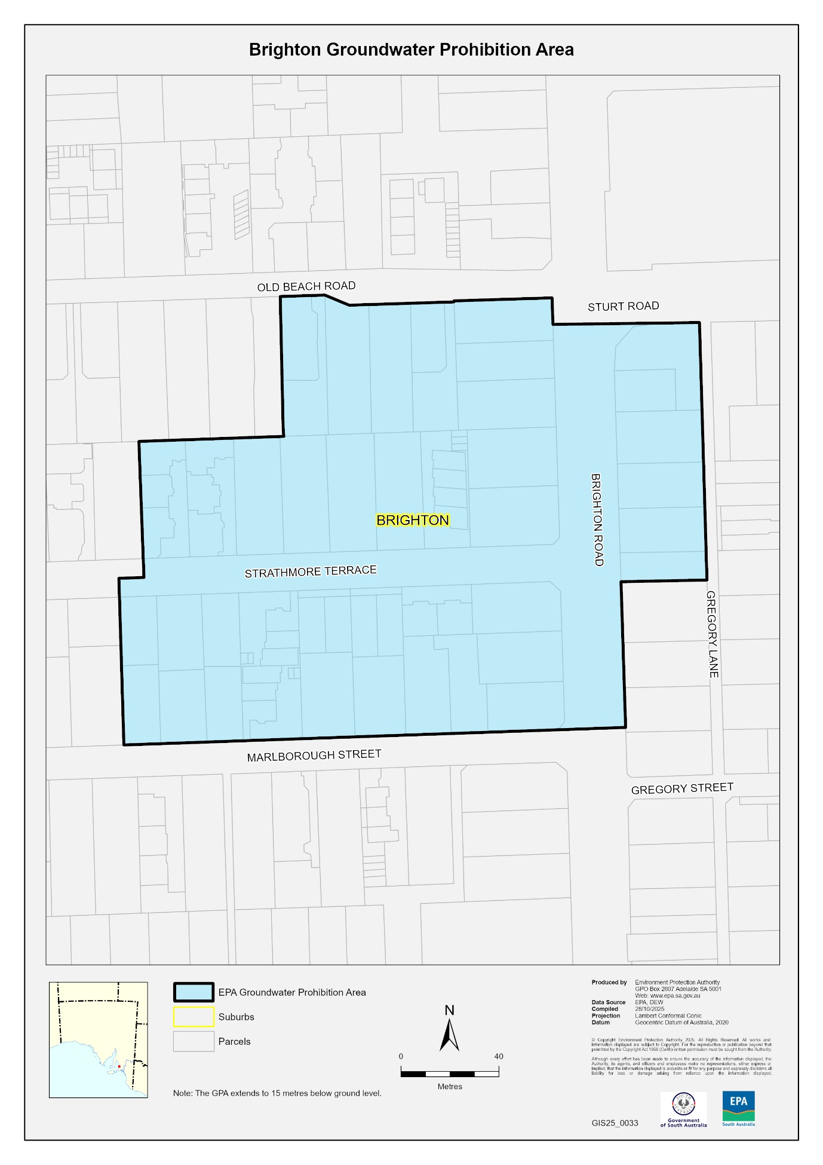

Fisheries Management (Prawn Fisheries) Regulations 2017
Revocation of Declarations—Variation on Prohibition of Fishing Activities in the Spencer Gulf Prawn Fishery
Take note that the notice pursuant to Regulation 10 of the Fisheries Management (Prawn Fisheries) Regulations 2017 dated 18 November 2025 in relation to variation to prohibited fishing activities in the Spencer Gulf Prawn Fishery, is hereby revoked.
Dated: 22 November 2025
Ashley Lukin
Coordinator at Sea, Spencer Gulf and West Coast Prawn Association Inc.
Delegate of the Minister for Primary Industries and Regional Development

FISHERIES MANAGEMENT (PRAWN FISHERIES) REGULATIONS 2017
Surveying in the Gulf St Vincent Prawn Fishery
Take notice that pursuant to Regulation 10(1)(b) of the Fisheries Management (Prawn Fisheries) Regulations 2017, the notice dated 23 October 2025 published on page 4292 of the South Australian Government Gazette on 30 October 2025, prohibiting fishing activities in the Gulf St Vincent Prawn Fishery as outlined in Schedule 1, is hereby varied such that it will not apply to the holders of a Gulf St Vincent Prawn Fishery licence issued pursuant to the Fisheries Management (Prawn Fisheries) Regulations 2017 listed in Schedule 2 or their registered master insofar as they may use prawn trawl nets in accordance with the conditions of their fishery licence for the purpose of undertaking a prawn survey during the period specified in Schedule 3, subject to the conditions contained in Schedule 4 unless this notice is varied or revoked.
Schedule 1
The waters of Gulf Saint Vincent contained within the enclosed rectangular area bordered by a line between the following coordinate points (GDA2020):
The line commencing at point 34°29′35″S, 138°5′29″E to point 34°54′29″S, 138°29′3″E then to point 35°0′2″S, 138°20′29″E to point 34°35′18″S, 137°56′54″E and then returning to the point of commencement (34°29′35″S, 138°5′29″E).
Schedule 2
Licence Number | Licence Holder | Boat Name
V06 | Todreel Pty Ltd | Anna Pearl
V14 | W J Fountain Pty Ltd | Zadar
Schedule 3
Commencing at sunset on 21 November 2025 to sunrise on 23 November 2025.
Schedule 4
1. For the purposes of this notice the trawl survey areas cannot include any waters of a habitat protection zone or a sanctuary zone of a marine park established under the Marine Parks Act 2007 or depths less than 10 metres.
2. The licence holders listed in Schedule 2 or their registered master must comply with all regulations and conditions that apply to fishing activities undertaken pursuant to their Gulf St Vincent Prawn Fishery licence, in addition to the conditions imposed by this notice.
3. While engaged in fishing activities or unloading the survey catch, the licence holders listed in Schedule 2 or their registered master must have a copy of this notice on board the boat or near his person. This notice must be produced to a Fisheries Officer if requested.
4. While engaged in fishing activities, the licence holders listed in Schedule 2 or their registered master must have an observer from the South Australian Research Development Institute (SARDI) aboard the vessel.
5. No fishing activity may be undertaken between the prescribed times of sunrise and sunset for Adelaide (as published in the South Australian Government Gazette).
6. The licence holders listed in Schedule 2 or their register master must not contravene or fail to comply with the Fisheries Management Act 2007, or any other regulations made under that Act except where specifically exempted by this notice.
7. This notice does not purport to override the provisions or operation of any other Act including, but not limited to, the Marine Parks Act 2007. The notice holder and his agents must comply with any relevant regulations, permits, requirements and directions from the Department for Environment and Water when undertaking activities within a marine park.
8. A report (including the raw survey data) is to be provided to SARDI by the Saint Vincent Gulf Prawn Boat Owner’s Association detailing the outcomes of the survey as soon as practicable on the survey completion.
Dated: 21 November 2025
Steve Shanks
Acting Prawn Fishery Manager
Delegate of the Minister for Primary Industries and Regional Development

FISHERIES MANAGEMENT (PRAWN FISHERIES) REGULATIONS 2017
Variation on Prohibition of Fishing Activities in the Spencer Gulf Prawn Fishery
Take note that pursuant to Regulation 10 of the Fisheries Management (Prawn Fisheries) Regulations 2017, the notice dated 8 September 2025 published on pages 3810 and 3811 of the South Australian Government Gazette on 11 September 2025 prohibiting fishing activities in the Spencer Gulf Prawn Fishery, is hereby varied such that it will not be unlawful for a person fishing pursuant to a Spencer Gulf Prawn Fishery licence to use prawn trawl nets in the areas specified in Schedule 1, during the period specified in Schedule 2, and under the conditions specified in Schedule 3.

Schedule 1
The waters of the Spencer Gulf Prawn Fishery:
(a) Except the Northern closure area, which is defined as the waters north of the following index points:
1. 33°29.50S 137°18.00E West shore
2. 33°29.50S 137°29.50E
3. 33°25.70S 137°29.50E
4. 33°25.70S 137°31.72E
5. 33°33.37S 137°33.64E
6. 33°46.00S 137°29.40E
7. 33°50.00S 137°38.60E East shore
Points 1-2, 3-4 and 6-7 are designated east-west lines.
Other than the Musgrave Fishing Area, within the Northern closure area, which is defined as the waters contained within the following index points:
1. 33°15.00S 137°49.20E North east shore
2. 33°15.00S 137°38.18E
3. 33°18.00S 137°36.00E
4. 33°24.00S 137°36.00E
5. 33°24.00S 137°53.00E South east shore
Points 1-2 and 4-5 are designated east-west lines.
(b) Except the Southern closure area, which is defined as the waters contained within the following index points:
1. 33°48.00S 136°48.00E North west Shore
2. 33°53.60S 136°52.00E
3. 33°50.24S 136°58.51E
4. 33°56.29S 137°04.06E
5. 33°52.60S 137°14.20E
6. 33°56.40S 137°17.20E
7. 33°59.00S 137°12.00E
8. 34°09.64S 137°00.00E
9. 34°20.00S 137°00.00E
10. 34°20.00S 136°53.00E
11. 34°26.70S 136°48.65E
12. 34°26.70S 136°56.00E
13. 34°35.00S 136°56.00E
14. 34°35.00S 136°30.00E
15. 34°09.00S 136°47.00E
16. 33°56.00S 136°34.00E South west Shore
Points 1-2, 3-4, 5-6, 9-10, 11-12, 13-14 and 15-16 are designated east-west lines.
(c) Except the Wardang closure area, which is defined as the waters contained within the following index points:
1. 34°10.00S 137°28.00E
2. 34°21.00S 137°12.00E
3. 34°45.00S 137°15.00E
4. 34°48.53S 137°09.45E
5. 34°48.53S 137°06.00E
6. 34°50.75S 137°06.00E
7. 34°54.00S 137°01.00E
(d) Except the Corny closure area, which is defined as the waters contained within following closure index points:
1. 34°27.00S 136°53.00E
2. 34°27.00S 137°02.00E
3. 34°35.00S 136°56.00E
4. 34°48.60S 136°52.00E
5. 34°54.00S 136°52.00E
6. 34°54.00S 136°48.50E
7. 34°49.50S 136°48.50E
8. 34°49.50S 136°40.50E
9. 34°39.50S 136°40.50E
Then back to point 1.
(e) Except the Illusions Park closure area, which is defined as the waters contained within the following closure index points:
1. 33°28.80S 137°32.20E
2. 33°28.30S 137°33.20E
3. 33°28.85S 137°33.50E
4. 33°29.40S 137°32.50E
Then back to point 1.
(f) Except the Jurassic Park closure area, which is defined as the waters contained within the following closure index points:
1. 33°54.90S 137°17.60E
2. 33°54.40S 137°19.40E
3. 33°54.70S 137°19.60E
4. 33°55.20S 137°17.80E
Then back to point 1.
(g) Except the Estelle Star closure area, which is defined as the waters contained within the following closure index points:
1. 33°58.80S 136°49.80E
2. 33°58.20S 136°51.00E
3. 33°59.10S 136°51.70E
4. 33°59.80S 136°50.40E
Then back to point 1.
Schedule 2
Commencing at sunset on 22 November 2025 and ending at sunrise on 1 December 2025.
Schedule 3
1. The coordinates in Schedule 1 are defined as degrees decimal minutes and are based on the World Geodetic System 1984 (WGS 84).
2. No fishing activity may be undertaken between the prescribed times of sunrise and sunset for Adelaide (as published in the South Australian Government Gazette pursuant to the requirements of the Proof of Sunrise and Sunset Act 1923) during the period specified in Schedule 2.
3. Based on the best information available from the fleet, fishing must cease in the Musgrave and South Gutter fishing areas after two nights. Fishing must cease in an area in the Mid/North Gulf if the average prawn bucket count exceeds 260 prawns per 7kg; or in an area in the Southern Gulf if the average prawn bucket count exceeds 260 prawns per 7kg or in the whole area when a total catch of 213 tonnes has been landed or if the fleet average catch falls below 300kg/vessel/night.
4. No fishing activity may occur without the authorisation of Coordinator at Sea, Ashley Lukin, or other nominated Coordinator at Sea appointed by the Spencer Gulf and West Coast Prawn Association.
5. The authorisation of the Coordinator at Sea must be in writing, signed and record the day, date, and permitted fishing area within the waters of Schedule 1 in the form of a notice sent to the fishing fleet or vary an earlier authorisation issued by the Coordinator at Sea.
6. The Coordinator at Sea must cause a copy of any authorisation for fishing activity or variation of same, made under this notice to be emailed to the Prawn Fisheries Manager immediately after it is made.
7. The Spencer Gulf and West Coast Prawn Association must keep records of all authorisations issued pursuant to this notice.
Dated: 22 November 2025
Ashley Lukin
Coordinator at Sea, Spencer Gulf and West Coast Prawn Association Inc.
Delegate of the Minister for Primary Industries and Regional Development

Fisheries Management Act 2007
Section 115
Ministerial Exemption: ME9903402
Take notice that pursuant to Section 115 of the Fisheries Management Act 2007, the Executive Director, National Parks and Wildlife Service and the Director, Regional Operations, of the Department for Environment and Water (DEW) (the ‘exemption holder’) and their nominated agents, are exempt from Section 70 and 71 of the Fisheries Management Act 2007, and Schedule 6 and Schedule 7 of the Fisheries Management (General) Regulations 2017 but only insofar as the exemption holders are permitted to use a fish net as described in Schedule 1 in State waters to undertake marine mammal or turtle rescue and/or intervention activities from time to time consistent with the Marine Mammal Intervention Policy (Ref: DEWNR 97/14/0023) or consistent with other animal welfare standards and guidelines of the Department for Environment and Water (DEW), subject to the conditions set out in Schedule 2, from 21 November 2025 until 20 November 2026, unless varied or revoked earlier.
Schedule 1
• A fish net with dimensions not greater than 150 metres by 3 metres by a person who does not otherwise hold a commercial fishing licence that authorises the use of nets; or
• A fish net that is otherwise lawful if used by the holder (or registered master) of a commercial licence that is endorsed with a haul net and is also authorised.

Schedule 2
1. The exemption holder will be deemed responsible for the conduct of all persons conducting the exempted activities under this notice. Any person conducting activities under this exemption must be provided with a copy of this notice, which they must have signed as an indication that they have read and understood the conditions under it.
2. The exemption holder or their nominated agents must take all reasonable steps to minimise the extent of injury, damage, or harm to all captured aquatic animals when undertaking the activity.
3. The exemption holder or their nominated agents must release any aquatic resources that may be incidentally caught while operating the nets in the interaction with other aquatic mammals or turtles as soon as possible.
4. The nominated agents of the exemption holder are:
• Wardens appointed under the National Parks and Wildlife Act 1972;
• A licence holder or a registered master of a Marine Scalefish Fishery licence endorsed with a haul net who is authorised to capture marine mammals and turtles under the National Parks and Wildlife Act 1972; or
• Persons who are registered volunteers of DEW.
5. Nominated agents of the exemption holder that are not Wardens appointed under the National Parks and Wildlife Act 1972, must be under the direct supervision of a Warden appointed under the National Parks and Wildlife Act 1972 who is working pursuant to a permit issued for the purpose of administration of that Act.
6. Before undertaking the exempted activity pursuant to this notice, the exemption holder or their nominated agent must contact the Department of Primary Industries and Regions (PIRSA) Fishwatch on 1800 065 522 and answer a series of questions about the exempted activity. The exemption holder or their nominated agent will need to have a copy of the exemption at the time of making the call and be able to provide information about the area and time of the exempted activity, the vehicles and/or boats involved and other related questions.
7. While engaging in the exempted activity, the exemption holder or their nominated agents must be in possession of a copy of this notice. Such notice must be produced to a Fisheries Officer upon request.
8. Except where specifically exempted by this notice, the exemption holder or their nominated agents must not contravene or fail to comply with the Fisheries Management Act 2007 or any regulations made under that Act, and pursuant to Section 23 of the River Murray Act 2003, the permit holder must take all reasonable measures to prevent or minimise any harm to the River Murray.
This notice does not purport to override the provisions or operation of any other Act including, but not limited to, the Marine Parks Act 2007, Adelaide Dolphin Sanctuary Act 2005 or the River Murray Act 2003.
Dated: 20 November 2025
Professor Gavin Begg
Executive Director
Fisheries and Aquaculture
Delegate of the Minister for Primary Industries and Regional Development

Housing Improvement Act 2016
Rent Control Revocations
In the exercise of the powers conferred by the Housing Improvement Act 2016, the Delegate of the Minister for Housing and Urban Development hereby revokes the maximum rental amount per week that shall be payable subject to Section 55 of the Residential Tenancies Act 1995, in respect of each premises described in the following table.
Address of Premises | Allotment Section | Certificate of Title  Volume/Folio
12-14 Brown Street, Brompton SA 5007 (PKA 2) | Allotment 32 and 33 Deposited Plan 747 Hundred Yatala | CT5246/880,  CT5397/294
1202 Ryelands (Rear Flat) Road,  Riverton SA 5412 | Allotment 1 Filed Plan 4982 Hundred of Gilbert | CT5119/399
17 Noble Street, Ovingham SA 5082 | Allotment 8 Filed Plan 122155 Hundred of Yatala | CT5509/54
10 Stanley Street, Tailem Bend SA 5260 | Allotment 77 Deposited Plan 2072 Hundred Seymour | CT6019/333
2/472 Seaview Road, Henley Beach SA 5022 (AKA 472-474) | FL 2 Community Plan 23478 Hundred of Yatala | CT5506/932,  CT5964/10
2/474 Seaview Road, Henley Beach SA 5022  (AKA 472-474) | FL 2 Community Plan 23478 Hundred of Yatala | CT5506/932,  CT5964/10
19 Gray Court, Adelaide SA 5000 | Allotment 406 Filed Plan 182868 Hundred of Adelaide | CT6211/679,  CT6211/680  CT6211/681,  CT6211/682
1202 Ryelands (Front Flat) Road,  Riverton SA 5412 | Allotment 1 Filed Plan 4982 Hundred of Gilbert | CT5186/57
6 Grants Gully Road, Chandlers Hill SA 5159 (PKA Lot 85 Chandlers Hill) | Allotment 85 Filed Plan 152161 Hundred of Noarlunga | CT5561/193
24 Marion Street, Adelaide SA 5000 | Allotment 822 Filed Plan 182474 Hundred of Adelaide | CT5750/318
88 East Street, Brompton SA 5007 | Allotment 78 Filed Plan 122125 Hundred of Yatala | CT1416/190,  CT5752/264
30 Clyde Street, Parkside SA 5063 | Allotment 81 Filed Plan 14109 Hundred of Adelaide | CT5078/656
434 Yatala Vale Road, Yatala Vale SA 5126 (AKA 434-442) | Allotment 4 Filed Plan 3449 Hundred of Yatala | CT6162/36
7 Coglin Street, Brompton SA 5007 | Allotment 202 and 203 Deposited Plan 459 Hundred of Yatala | CT6162/36
27A Everard Terrace, Everard Park SA 5035 | Allotment 9 Filed Plan 158786 Hundred of Adelaide | CT5554/266
57 Moloney Road, Virginia SA 5120 Aka Lot 4 Section 3009 Roberts Road | Allotment 4 Filed Plan 29490 Hundred of Munno Para | CT5712/294
15 Kooline Crescent, Gilles Plains SA 5086 | Allotment 289 Deposited Plan 7688 Hundred of Yatala | CT5446/418
Dated 27 November 2025
Craig Thompson
Housing Regulator and Registrar
Housing Safety Authority
Delegate of the Minister for Housing and Urban Development

Land Acquisition Act 1969
Section 26F
Form 6B—Notice of Acquisition of Underground Land
1. Notice of acquisition
The Commissioner of Highways (the Authority), of 83 Pirie Street, Adelaide SA 5000 acquires the following interests in the following land:
An unencumbered estate in fee simple in the whole of Allotment 702 in D139011 lodged in the Lands Titles Office, being portion of the Common Property Primary Community Strata Plan 22005 comprised in Certificate of Title Volume 5909 Folio 140.
This notice is given under Section 26F of the Land Acquisition Act 1969.
2. Compensation not payable unless certain water infrastructure or rights are affected
You are not entitled to compensation in relation to the acquisition of the underground land to which this notice relates, unless the following conditions are satisfied:
• you held at least one of the following interests in relation to the underground land immediately before the notice of acquisition was published in relation to the land—
◦ ownership of a lawful well that provides access to underground water in the underground land, and any underground infrastructure associated with the well; or
◦ a right to take underground water from the underground land by means of such a well;
• you notified the Authority of your interest in response to a notice given under Section 26G of the Land Acquisition Act 1969;
• the acquisition of the underground land either—
◦ involved the acquisition of your interest; or
◦ resulted in the discharge of your interest; or
◦ resulted in you being unable to take water by means of, or pursuant to, your interest;
• you make an application for compensation to the Authority under Section 26H of the Land Acquisition Act 1969.
3. Application for compensation under Section 26H
If you believe you are entitled to compensation, you must apply to the Authority for compensation within 6 months after the publication of the notice of acquisition in relation to the underground land to which this notice relates.
The application must be in the following manner and form:
“Application for Compensation for Acquisition of Underground Land” (enclosed) to be submitted by email to DIT.ULAapplications@sa.gov.au or by mail marked attention: Property Acquisition c/- GPO Box 1533, Adelaide SA 5001.
The application must be accompanied by the following information or documents:
Any relevant supporting documentation including, but not limited to water licences, bore licences etc.
After receiving your application, the Authority may (but is not required to) make you a written offer of compensation not exceeding $50,000.
See Section 26H(4) of the Land Acquisition Act 1969 for further details on the payment of compensation.
4. Inquiries
Inquiries should be directed to: T2D Project Team
GPO Box 1533
Adelaide SA 5001
Telephone: 1800 572 414
Dated: 24 November 2025
The Common Seal of the COMMISSIONER OF HIGHWAYS was hereto affixed by authority of the Commissioner in the presence of:
Rocco Caruso
Director, Property Acquisition
(Authorised Officer)
Department for Infrastructure and Transport
DIT 2024/07249/01

Land Acquisition Act 1969
Section 26F
Form 6B—Notice of Acquisition of Underground Land
1. Notice of acquisition
The Commissioner of Highways (the Authority), of 83 Pirie Street, Adelaide SA 5000 acquires the following interests in the following land:
An unencumbered estate in fee simple in the whole of Allotment 938 in D138122 lodged in the Lands Titles Office, being portion of the land comprised in Certificate of Title Volume 5547 Folio 977.
This notice is given under Section 26F of the Land Acquisition Act 1969.
2. Compensation not payable unless certain water infrastructure or rights are affected
You are not entitled to compensation in relation to the acquisition of the underground land to which this notice relates, unless the following conditions are satisfied:
• you held at least one of the following interests in relation to the underground land immediately before the notice of acquisition was published in relation to the land—
◦ ownership of a lawful well that provides access to underground water in the underground land, and any underground infrastructure associated with the well; or
◦ a right to take underground water from the underground land by means of such a well;
• you notified the Authority of your interest in response to a notice given under Section 26G of the Land Acquisition Act 1969;
• the acquisition of the underground land either—
◦ involved the acquisition of your interest; or
◦ resulted in the discharge of your interest; or
◦ resulted in you being unable to take water by means of, or pursuant to, your interest;
• you make an application for compensation to the Authority under Section 26H of the Land Acquisition Act 1969.
3. Application for compensation under Section 26H
If you believe you are entitled to compensation, you must apply to the Authority for compensation within 6 months after the publication of the notice of acquisition in relation to the underground land to which this notice relates.
The application must be in the following manner and form:
“Application for Compensation for Acquisition of Underground Land” (enclosed) to be submitted by email to DIT.ULAapplications@sa.gov.au or by mail marked attention: Property Acquisition c/- GPO Box 1533, Adelaide SA 5001.
The application must be accompanied by the following information or documents:
Any relevant supporting documentation including, but not limited to water licences, bore licences etc.
After receiving your application, the Authority may (but is not required to) make you a written offer of compensation not exceeding $50,000.
See Section 26H(4) of the Land Acquisition Act 1969 for further details on the payment of compensation.
4. Inquiries
Inquiries should be directed to: T2D Project Team
GPO Box 1533
Adelaide SA 5001
Telephone: 1800 572 414
Dated: 24 November 2025
The Common Seal of the COMMISSIONER OF HIGHWAYS was hereto affixed by authority of the Commissioner in the presence of:
Rocco Caruso
Director, Property Acquisition
(Authorised Officer)
Department for Infrastructure and Transport
DIT: 2024/07284/01

Land Acquisition Act 1969
Section 26F
Form 6B—Notice of Acquisition of Underground Land
1. Notice of acquisition
The Commissioner of Highways (the Authority), of 83 Pirie Street, Adelaide SA 5000 acquires the following interests in the following land:
An unencumbered estate in fee simple in the whole of Allotment 1102 in D138044 lodged in the Lands Titles Office, being portion of the land comprised in Certificate of Title Volume 5152 Folio 754.
This notice is given under Section 26F of the Land Acquisition Act 1969.
2. Compensation not payable unless certain water infrastructure or rights are affected
You are not entitled to compensation in relation to the acquisition of the underground land to which this notice relates, unless the following conditions are satisfied:
• you held at least one of the following interests in relation to the underground land immediately before the notice of acquisition was published in relation to the land—
◦ ownership of a lawful well that provides access to underground water in the underground land, and any underground infrastructure associated with the well; or
◦ a right to take underground water from the underground land by means of such a well;
• you notified the Authority of your interest in response to a notice given under Section 26G of the Land Acquisition Act 1969;
• the acquisition of the underground land either—
◦ involved the acquisition of your interest; or
◦ resulted in the discharge of your interest; or
◦ resulted in you being unable to take water by means of, or pursuant to, your interest;
• you make an application for compensation to the Authority under Section 26H of the Land Acquisition Act 1969.
3. Application for compensation under Section 26H
If you believe you are entitled to compensation, you must apply to the Authority for compensation within 6 months after the publication of the notice of acquisition in relation to the underground land to which this notice relates.
The application must be in the following manner and form:
“Application for Compensation for Acquisition of Underground Land” (enclosed) to be submitted by email to DIT.ULAapplications@sa.gov.au or by mail marked attention: Property Acquisition c/- GPO Box 1533, Adelaide SA 5001.
The application must be accompanied by the following information or documents:
Any relevant supporting documentation including, but not limited to water licences, bore licences etc.
After receiving your application, the Authority may (but is not required to) make you a written offer of compensation not exceeding $50,000.
See Section 26H(4) of the Land Acquisition Act 1969 for further details on the payment of compensation.
4. Inquiries
Inquiries should be directed to: T2D Project Team
GPO Box 1533
Adelaide SA 5001
Telephone: 1800 572 414
Dated: 24 November 2025
The Common Seal of the COMMISSIONER OF HIGHWAYS was hereto affixed by authority of the Commissioner in the presence of:
Rocco Caruso
Director, Property Acquisition
(Authorised Officer)
Department for Infrastructure and Transport
DIT: 2024/07304/01

Land Acquisition Act 1969
Section 26F
Form 6B—Notice of Acquisition of Underground Land
1. Notice of acquisition
The Commissioner of Highways (the Authority), of 83 Pirie Street, Adelaide SA 5000 acquires the following interests in the following land:
An unencumbered estate in fee simple in the whole of Allotment 1108 in D138047 lodged in the Lands Titles Office, being portion of the land comprised in Certificate of Title Volume 5122 Folio 174.
This notice is given under Section 26F of the Land Acquisition Act 1969.
2. Compensation not payable unless certain water infrastructure or rights are affected
You are not entitled to compensation in relation to the acquisition of the underground land to which this notice relates, unless the following conditions are satisfied:
• you held at least one of the following interests in relation to the underground land immediately before the notice of acquisition was published in relation to the land—
◦ ownership of a lawful well that provides access to underground water in the underground land, and any underground infrastructure associated with the well; or
◦ a right to take underground water from the underground land by means of such a well;
• you notified the Authority of your interest in response to a notice given under Section 26G of the Land Acquisition Act 1969;
• the acquisition of the underground land either—
◦ involved the acquisition of your interest; or
◦ resulted in the discharge of your interest; or
◦ resulted in you being unable to take water by means of, or pursuant to, your interest;
• you make an application for compensation to the Authority under Section 26H of the Land Acquisition Act 1969.
3. Application for compensation under Section 26H
If you believe you are entitled to compensation, you must apply to the Authority for compensation within 6 months after the publication of the notice of acquisition in relation to the underground land to which this notice relates.
The application must be in the following manner and form:
“Application for Compensation for Acquisition of Underground Land” (enclosed) to be submitted by email to DIT.ULAapplications@sa.gov.au or by mail marked attention: Property Acquisition c/- GPO Box 1533, Adelaide SA 5001.
The application must be accompanied by the following information or documents:
Any relevant supporting documentation including, but not limited to water licences, bore licences etc.
After receiving your application, the Authority may (but is not required to) make you a written offer of compensation not exceeding $50,000.
See Section 26H(4) of the Land Acquisition Act 1969 for further details on the payment of compensation.
4. Inquiries
Inquiries should be directed to: T2D Project Team
GPO Box 1533
Adelaide SA 5001
Telephone: 1800 572 414
Dated: 24 November 2025
The Common Seal of the COMMISSIONER OF HIGHWAYS was hereto affixed by authority of the Commissioner in the presence of:
Rocco Caruso
Director, Property Acquisition
(Authorised Officer)
Department for Infrastructure and Transport
DIT: 2024/07313/01

Land Acquisition Act 1969
Section 26F
Form 6B—Notice of Acquisition of Underground Land
1. Notice of acquisition
The Commissioner of Highways (the Authority), of 83 Pirie Street, Adelaide SA 5000 acquires the following interests in the following land:
An unencumbered estate in fee simple in the whole of Allotment 1110 in D138048 lodged in the Lands Titles Office, being portion of the land comprised in Certificate of Title Volume 5143 Folio 899.
This notice is given under Section 26F of the Land Acquisition Act 1969.
2. Compensation not payable unless certain water infrastructure or rights are affected
You are not entitled to compensation in relation to the acquisition of the underground land to which this notice relates, unless the following conditions are satisfied:
• you held at least one of the following interests in relation to the underground land immediately before the notice of acquisition was published in relation to the land—
◦ ownership of a lawful well that provides access to underground water in the underground land, and any underground infrastructure associated with the well; or
◦ a right to take underground water from the underground land by means of such a well;
• you notified the Authority of your interest in response to a notice given under Section 26G of the Land Acquisition Act 1969;
• the acquisition of the underground land either—
◦ involved the acquisition of your interest; or
◦ resulted in the discharge of your interest; or
◦ resulted in you being unable to take water by means of, or pursuant to, your interest;
• you make an application for compensation to the Authority under Section 26H of the Land Acquisition Act 1969.
3. Application for compensation under Section 26H
If you believe you are entitled to compensation, you must apply to the Authority for compensation within 6 months after the publication of the notice of acquisition in relation to the underground land to which this notice relates.
The application must be in the following manner and form:
“Application for Compensation for Acquisition of Underground Land” (enclosed) to be submitted by email to DIT.ULAapplications@sa.gov.au or by mail marked attention: Property Acquisition c/- GPO Box 1533, Adelaide SA 5001.
The application must be accompanied by the following information or documents:
Any relevant supporting documentation including, but not limited to water licences, bore licences etc.
After receiving your application, the Authority may (but is not required to) make you a written offer of compensation not exceeding $50,000.
See Section 26H(4) of the Land Acquisition Act 1969 for further details on the payment of compensation.
4. Inquiries
Inquiries should be directed to: T2D Project Team
GPO Box 1533
Adelaide SA 5001
Telephone: 1800 572 414
Dated: 24 November 2025
The Common Seal of the COMMISSIONER OF HIGHWAYS was hereto affixed by authority of the Commissioner in the presence of:
Rocco Caruso
Director, Property Acquisition
(Authorised Officer)
Department for Infrastructure and Transport
DIT: 2024/07314/01

Land Acquisition Act 1969
Section 26F
Form 6B—Notice of Acquisition of Underground Land
1. Notice of acquisition
The Commissioner of Highways (the Authority), of 83 Pirie Street, Adelaide SA 5000 acquires the following interests in the following land:
An unencumbered estate in fee simple in the whole of Allotment 1152 in D138069 lodged in the Lands Titles Office, being portion of the land comprised in Certificate of Title Volume 5596 Folio 991.
This notice is given under Section 26F of the Land Acquisition Act 1969.
2. Compensation not payable unless certain water infrastructure or rights are affected
You are not entitled to compensation in relation to the acquisition of the underground land to which this notice relates, unless the following conditions are satisfied:
• you held at least one of the following interests in relation to the underground land immediately before the notice of acquisition was published in relation to the land—
◦ ownership of a lawful well that provides access to underground water in the underground land, and any underground infrastructure associated with the well; or
◦ a right to take underground water from the underground land by means of such a well;
• you notified the Authority of your interest in response to a notice given under Section 26G of the Land Acquisition Act 1969;
• the acquisition of the underground land either—
◦ involved the acquisition of your interest; or
◦ resulted in the discharge of your interest; or
◦ resulted in you being unable to take water by means of, or pursuant to, your interest;
• you make an application for compensation to the Authority under Section 26H of the Land Acquisition Act 1969.
3. Application for compensation under Section 26H
If you believe you are entitled to compensation, you must apply to the Authority for compensation within 6 months after the publication of the notice of acquisition in relation to the underground land to which this notice relates.
The application must be in the following manner and form:
“Application for Compensation for Acquisition of Underground Land” (enclosed) to be submitted by email to DIT.ULAapplications@sa.gov.au or by mail marked attention: Property Acquisition c/- GPO Box 1533, Adelaide SA 5001.
The application must be accompanied by the following information or documents:
Any relevant supporting documentation including, but not limited to water licences, bore licences etc.
After receiving your application, the Authority may (but is not required to) make you a written offer of compensation not exceeding $50,000.
See Section 26H(4) of the Land Acquisition Act 1969 for further details on the payment of compensation.
4. Inquiries
Inquiries should be directed to: T2D Project Team
GPO Box 1533
Adelaide SA 5001
Telephone: 1800 572 414
Dated: 24 November 2025
The Common Seal of the COMMISSIONER OF HIGHWAYS was hereto affixed by authority of the Commissioner in the presence of:
Rocco Caruso
Director, Property Acquisition
(Authorised Officer)
Department for Infrastructure and Transport

DIT: 2024/07321/01

Land Acquisition Act 1969
Section 26F
Form 6B—Notice of Acquisition of Underground Land
1. Notice of acquisition
The Commissioner of Highways (the Authority), of 83 Pirie Street, Adelaide SA 5000 acquires the following interests in the following land:
An unencumbered estate in fee simple in the whole of Allotment 1931 in D139088 lodged in the Lands Titles Office, being portion of the land comprised in Certificate of Title Volume 5255 Folio 608.
This notice is given under Section 26F of the Land Acquisition Act 1969.
2. Compensation not payable unless certain water infrastructure or rights are affected
You are not entitled to compensation in relation to the acquisition of the underground land to which this notice relates, unless the following conditions are satisfied:
• you held at least one of the following interests in relation to the underground land immediately before the notice of acquisition was published in relation to the land—
◦ ownership of a lawful well that provides access to underground water in the underground land, and any underground infrastructure associated with the well; or
◦ a right to take underground water from the underground land by means of such a well;
• you notified the Authority of your interest in response to a notice given under Section 26G of the Land Acquisition Act 1969;
• the acquisition of the underground land either—
◦ involved the acquisition of your interest; or
◦ resulted in the discharge of your interest; or
◦ resulted in you being unable to take water by means of, or pursuant to, your interest;
• you make an application for compensation to the Authority under Section 26H of the Land Acquisition Act 1969.
3. Application for compensation under Section 26H
If you believe you are entitled to compensation, you must apply to the Authority for compensation within 6 months after the publication of the notice of acquisition in relation to the underground land to which this notice relates.
The application must be in the following manner and form:
“Application for Compensation for Acquisition of Underground Land” (enclosed) to be submitted by email to DIT.ULAapplications@sa.gov.au or by mail marked attention: Property Acquisition c/- GPO Box 1533, Adelaide SA 5001.
The application must be accompanied by the following information or documents:
Any relevant supporting documentation including, but not limited to water licences, bore licences etc.
After receiving your application, the Authority may (but is not required to) make you a written offer of compensation not exceeding $50,000.
See Section 26H(4) of the Land Acquisition Act 1969 for further details on the payment of compensation.
4. Inquiries
Inquiries should be directed to: T2D Project Team
GPO Box 1533
Adelaide SA 5001
Telephone: 1800 572 414
Dated: 24 November 2025
The Common Seal of the COMMISSIONER OF HIGHWAYS was hereto affixed by authority of the Commissioner in the presence of:
Rocco Caruso
Director, Property Acquisition
(Authorised Officer)
Department for Infrastructure and Transport
DIT 2024/08127/01

Land Acquisition Act 1969
Section 26F
Form 6B—Notice of Acquisition of Underground Land
1. Notice of acquisition
The Commissioner of Highways (the Authority), of 83 Pirie Street, Adelaide SA 5000 acquires the following interests in the following land:
An unencumbered estate in fee simple in the whole of Allotment 491 in D139339 lodged in the Lands Titles Office, being portion of the land comprised in Certificate of Title Volume 5659 Folio 380.
This notice is given under Section 26F of the Land Acquisition Act 1969.
2. Compensation not payable unless certain water infrastructure or rights are affected
You are not entitled to compensation in relation to the acquisition of the underground land to which this notice relates, unless the following conditions are satisfied:
• you held at least one of the following interests in relation to the underground land immediately before the notice of acquisition was published in relation to the land—
◦ ownership of a lawful well that provides access to underground water in the underground land, and any underground infrastructure associated with the well; or
◦ a right to take underground water from the underground land by means of such a well;
• you notified the Authority of your interest in response to a notice given under Section 26G of the Land Acquisition Act 1969;
• the acquisition of the underground land either—
◦ involved the acquisition of your interest; or
◦ resulted in the discharge of your interest; or
◦ resulted in you being unable to take water by means of, or pursuant to, your interest;
• you make an application for compensation to the Authority under Section 26H of the Land Acquisition Act 1969.
3. Application for compensation under Section 26H
If you believe you are entitled to compensation, you must apply to the Authority for compensation within 6 months after the publication of the notice of acquisition in relation to the underground land to which this notice relates.
The application must be in the following manner and form:
“Application for Compensation for Acquisition of Underground Land” (enclosed) to be submitted by email to DIT.ULAapplications@sa.gov.au or by mail marked attention: Property Acquisition c/- GPO Box 1533, Adelaide SA 5001.
The application must be accompanied by the following information or documents:
Any relevant supporting documentation including, but not limited to water licences, bore licences etc.
After receiving your application, the Authority may (but is not required to) make you a written offer of compensation not exceeding $50,000.
See Section 26H(4) of the Land Acquisition Act 1969 for further details on the payment of compensation.
4. Inquiries
Inquiries should be directed to: T2D Project Team
GPO Box 1533
Adelaide SA 5001
Telephone: 1800 572 414
Dated: 24 November 2025
The Common Seal of the COMMISSIONER OF HIGHWAYS was hereto affixed by authority of the Commissioner in the presence of:
Rocco Caruso
Director, Property Acquisition
(Authorised Officer)
Department for Infrastructure and Transport
DIT 2024/08148/01

Land Acquisition Act 1969
Section 26F
Form 6B—Notice of Acquisition of Underground Land
1. Notice of acquisition
The Commissioner of Highways (the Authority), of 83 Pirie Street, Adelaide SA 5000 acquires the following interests in the following land:
Firstly: An unencumbered estate in fee simple in the whole of Allotment 721 in D139087 lodged in the Lands Titles Office, being portion of the land comprised in Certificate of Title Volume 5840 Folio 856.
Secondly: An unencumbered estate in fee simple in the whole of Allotment 711 in D139086 lodged in the Lands Titles Office, being portion of the land comprised in Certificate of Title Volume 5840 Folio 855.
This notice is given under Section 26F of the Land Acquisition Act 1969.
2. Compensation not payable unless certain water infrastructure or rights are affected
You are not entitled to compensation in relation to the acquisition of the underground land to which this notice relates, unless the following conditions are satisfied:
• you held at least one of the following interests in relation to the underground land immediately before the notice of acquisition was published in relation to the land—
◦ ownership of a lawful well that provides access to underground water in the underground land, and any underground infrastructure associated with the well; or
◦ a right to take underground water from the underground land by means of such a well;
• you notified the Authority of your interest in response to a notice given under Section 26G of the Land Acquisition Act 1969;
• the acquisition of the underground land either—
◦ involved the acquisition of your interest; or
◦ resulted in the discharge of your interest; or
◦ resulted in you being unable to take water by means of, or pursuant to, your interest;
• you make an application for compensation to the Authority under Section 26H of the Land Acquisition Act 1969.
3. Application for compensation under Section 26H
If you believe you are entitled to compensation, you must apply to the Authority for compensation within 6 months after the publication of the notice of acquisition in relation to the underground land to which this notice relates.
The application must be in the following manner and form:
“Application for Compensation for Acquisition of Underground Land” (enclosed) to be submitted by email to DIT.ULAapplications@sa.gov.au or by mail marked attention: Property Acquisition c/- GPO Box 1533, Adelaide SA 5001.
The application must be accompanied by the following information or documents:
Any relevant supporting documentation including, but not limited to water licences, bore licences etc.
After receiving your application, the Authority may (but is not required to) make you a written offer of compensation not exceeding $50,000.
See Section 26H(4) of the Land Acquisition Act 1969 for further details on the payment of compensation.
4. Inquiries
Inquiries should be directed to: T2D Project Team
GPO Box 1533
Adelaide SA 5001
Telephone: 1800 572 414
Dated: 24 November 2025
The Common Seal of the COMMISSIONER OF HIGHWAYS was hereto affixed by authority of the Commissioner in the presence of:
Rocco Caruso
Director, Property Acquisition
(Authorised Officer)
Department for Infrastructure and Transport
DIT 2024/08151/01

Land Acquisition Act 1969
Section 26F
Form 6B—Notice of Acquisition of Underground Land
1. Notice of acquisition
The Commissioner of Highways (the Authority), of 83 Pirie Street, Adelaide SA 5000 acquires the following interests in the following land:
An unencumbered estate in fee simple in the whole of Allotment 2611 in D139161 lodged in the Lands Titles Office, being portion of the land comprised in Certificate of Title Volume 5378 Folio 661.
This notice is given under Section 26F of the Land Acquisition Act 1969.
2. Compensation not payable unless certain water infrastructure or rights are affected
You are not entitled to compensation in relation to the acquisition of the underground land to which this notice relates, unless the following conditions are satisfied:
• you held at least one of the following interests in relation to the underground land immediately before the notice of acquisition was published in relation to the land—
◦ ownership of a lawful well that provides access to underground water in the underground land, and any underground infrastructure associated with the well; or
◦ a right to take underground water from the underground land by means of such a well;
• you notified the Authority of your interest in response to a notice given under Section 26G of the Land Acquisition Act 1969;
• the acquisition of the underground land either—
◦ involved the acquisition of your interest; or
◦ resulted in the discharge of your interest; or
◦ resulted in you being unable to take water by means of, or pursuant to, your interest;
• you make an application for compensation to the Authority under Section 26H of the Land Acquisition Act 1969.
3. Application for compensation under Section 26H
If you believe you are entitled to compensation, you must apply to the Authority for compensation within 6 months after the publication of the notice of acquisition in relation to the underground land to which this notice relates.
The application must be in the following manner and form:
“Application for Compensation for Acquisition of Underground Land” (enclosed) to be submitted by email to DIT.ULAapplications@sa.gov.au or by mail marked attention: Property Acquisition c/- GPO Box 1533, Adelaide SA 5001.
The application must be accompanied by the following information or documents:
Any relevant supporting documentation including, but not limited to water licences, bore licences etc.
After receiving your application, the Authority may (but is not required to) make you a written offer of compensation not exceeding $50,000.
See Section 26H(4) of the Land Acquisition Act 1969 for further details on the payment of compensation.
4. Inquiries
Inquiries should be directed to: T2D Project Team
GPO Box 1533
Adelaide SA 5001
Telephone: 1800 572 414
Dated: 24 November 2025
The Common Seal of the COMMISSIONER OF HIGHWAYS was hereto affixed by authority of the Commissioner in the presence of:
Rocco Caruso
Director, Property Acquisition
(Authorised Officer)
Department for Infrastructure and Transport
DIT 2024/08307/01

Liquor Licensing Act 1997
South Australia
Liquor Licensing (Dry Areas) Notice 2025
under Section 131(1a) of the Liquor Licensing Act 1997
1—Short title
This notice may be cited as the Liquor Licensing (Dry Areas) Notice 2025.
2—Commencement
This notice has effect on the day on which it is published in the Gazette.
3—Interpretation
(1) In this notice—
principal notice means the Liquor Licensing (Dry Areas) Notice 2015 published in the Gazette on 5 January 2015, as in force from time to time.
(2) Clause 3 of the principal notice applies to this notice as if it were the principal notice.
4—Consumption etc of liquor prohibited in dry areas
(1) Pursuant to Section 131 of the Act, the consumption and possession of liquor in the area described in the Schedule is prohibited in accordance with the provisions of the Schedule.
(2) The prohibition has effect during the periods specified in the Schedule.
(3) The prohibition does not extend to private land in the area described in the Schedule.
(4) Unless the contrary intention appears, the prohibition of the possession of liquor in the area does not extend to—
(a) a person who is genuinely passing through the place if—
(i) the liquor is in the original container in which it was purchased from licensed premises; and
(ii) the container has not been opened; or
(b) a person who has possession of the liquor in the course of carrying on a business or in the course of their employment by another person in the course of carrying on a business; or
(c) a person who is permanently or temporarily residing at premises near the public place and who enters the public place solely for the purpose of passing through it to enter those premises or who enters the public place from those premises for the purpose of leaving the place; or
(d) a person who possesses or consumes the liquor for sacramental or other similar religious purposes.

Schedule 1—Ovingham and Renown Park—Area 1
1—Extent of prohibition
The consumption of liquor is prohibited and the possession of liquor is prohibited.
2—Period of prohibition
Continuous from the day on which this notice is published in the Gazette for a period of 14 days.
3—Description of area
The areas in Ovingham, Renown Park and Fitzroy including Napier Reserve (and surrounds), bounded as follows:
The Dry Zone Boundary is intended to encompass the reserve, land and associated road reserves, kerbs and footpaths beneath and near the Torrens Road Underpass, Ovingham and Renown Park, and excludes private property. The Dry Zone Boundary begins at the north-west corner of Lot 101 Drayton Street Bowden (known as 163 Drayton Street, Pocket Park, currently under construction) and travels north-west in a straight line across Drayton Street to (and including) the kerb. The boundary follows the kerb north until level with the shop verandah (Lot 92 Torrens Road Bowden), and then follows the line of the verandah west, including the footpath. It continues along the southern edge of the footpath in a direct line along the fences of properties across Picton and East Streets toward Manintjeru Way. At the northern corner of Lot 1 Torrens Road Brompton (known as Unit 1/65 Torrens Road Brompton), the Boundary crosses Manintjeru Way in a direct line west and follows the northern fence of Lots 54 and 55 Torrens Road (known as 71 Torrens Road Brompton, Chief Street Pocket Park, currently under construction). The Boundary then crosses Chief Street in a direct line and travels along the southern edge of the footpath in front of Lot 5 Torrens Road Brompton (known as 73-77 Torrens Road Brompton, On the Run Service Station) and continues to the north-western corner of Lot 100 (known as 85 Torrens Road Brompton). It then crosses Torrens Road north-east to the south-western corner of Lot 4 (known as 62 Torrens Road Renown Park) and travels south-east along the southern fence of Lots 4 and 3 (known as 23 Napier Street Renown Park), including the footpath and garden, toward Napier Street. At the western edge of the footpath on Napier Street, the boundary turns north-east in front of Lot 3 and follows the western edge of the footpath to the northern corner of Lot 1 Napier Street Renown Park (known as 19 Napier Street, Renown Park). At the corner, the Boundary then travels south-east across Napier Street in a direct line to the south-western corner of Lot 105 Napier Street Renown Park (known as 20 Napier Street Renown Park). It then follows the fences at the rear of the properties along McEwin Street Renown Park south-east, until the south-eastern corner of Lot 1 McEwin Street Renown Park (known as 1 McEwin Street Renown Park). The Boundary moves north-east along the fence (west of the playground) until it reaches the southern edge of the footpath on McEwin Street Renown Park. The Boundary moves in a direct line north across McEwin Street to meet the western edge of the footpath travelling north along Exeter Terrace Renown Park. It follows the eastern property boundary of Lot 2 McEwin Street Renown Park (known as 2C McEwin Street Renown Park) until the northern edge of the traffic control (slow speed) infrastructure on Exeter Terrace Renown Park. The boundary then travels east in a direct line across Exeter Terrace and across the railway corridor toward the northern boundary of Lot 30 Devonport Terrace Ovingham (known as 21 Devonport Terrace Ovingham).

It then travels south (including the footpath), crosses Avenue Road in a straight line and continues south along the western property boundaries of Devonport Terrace to the southern boundary of Lot 14 Devonport Terrace (known as 5 Devonport Terrace, Ovingham). It then travels east along the southern boundary of Lot 14, to the eastern boundary and then north along the eastern boundaries at the rear of properties on Devonport Terrace to the southern boundary of Lot 6 Avenue Road (known as 63 Avenue Road Ovingham). It then travels east along the southern boundary of Lot 6 and Lot 1 Avenue Road (known as 53 Avenue Road Ovingham) to the eastern boundary of Lot 1, then in a direct line north to the northern boundary of Lot 1. It then travels east across Churchill Road to the northern boundary of 27-29 Churchill Road and then south along the western property lines of Churchill Road (including the service road) to the south-western corner of 5 Churchill Road Ovingham. The Boundary then travels east along the southern fence of 5 Churchill Road Ovingham to the western boundary of Lot 18 Toronto Street (known as 8 Toronto Street Ovingham). It then travels south along the western fence of Lot 18 and follows the fences at the rear of the properties on Toronto Street Ovingham south and south-east, before moving east along the southern boundary of Lot 29 Toronto Street (known as 2 Toronto Street Ovingham) until meeting the south-eastern corner of that property. It then travels south-east to the north-western corner of Lot 31 Toronto Street (known as 9 Toronto Street Ovingham), before travelling south along the western property boundaries of Toronto Street until the south-western corner of Lot 30 Toronto Street (known as 3 Toronto Street Ovingham). It then travels east along the southern fence of the property, until the eastern edge of the kerb of the road reserve. It then follows the eastern edge of the kerb (including the footpath) south until level with the southern edge of the driveway crossover over Lot 600 Fitzroy Terrace (known as the Church of Jesus Christ of Latter-Day Saints). It then crosses Cotton Street in a direct line to the western fence of Lot 600 before following the western and then southern fence of Lot 600 until level with the eastern edge of the pedestrian crossing. It then travels south along the eastern edge of the pedestrian crossing, then east at the pedestrian crossing at the traffic lights, before travelling south-west along the southern edge of the pedestrian crossing across Torrens Road. The Boundary then moves south-west along the southern edge of the pedestrian crossing to the eastern edge of the kerb of Park Terrace. The Boundary follows the eastern edge of the kerb south-west down Park Terrace until level with the northern kerb of Noble Street Ovingham. It then travels in a direct line to the northern kerb of Noble Street Ovingham until level with the eastern fence of Lot 1 Park Terrace Ovingham (known as Unit 1, 60 Park Terrace Ovingham), before following the front boundaries of the properties on the Park Terrace Service Road north (including the footpath and road reserve). The Boundary then follows the fence of Lot 4 Park Terrace (known as 63A Park Terrace Ovingham) north-west, before travelling west along the northern boundaries of the front of properties on Torrens Road (service road). It continues in a straight line across Gilbert Street Ovingham, following the northern boundary of Lots 7-11 Torrens Road (known as 28 Torrens Road Ovingham, The Ovingham Hotel; excluding its licenced area), across Guthrie Street to the north-eastern property boundary of Lot 17 Torrens Road Ovingham (known as 31 Torrens Road Ovingham). It then continues north-west in a direct line toward Drayton Street, Bowden, continuing along the northern property boundaries and across the Railway corridor, until reaching the beginning at the north-western Corner of Lot 101 Drayton Street Bowden.
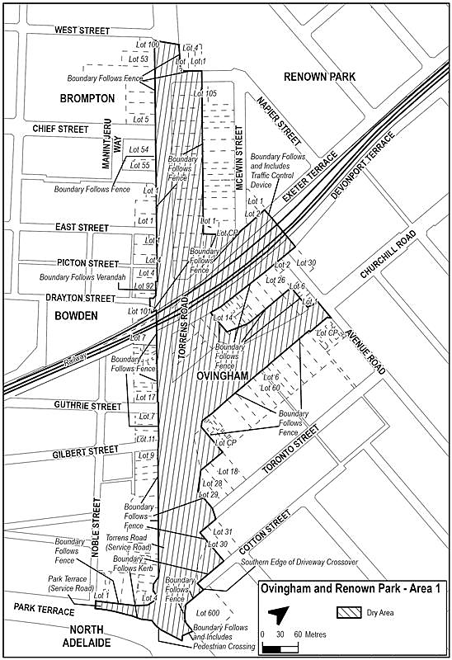
Made by the Liquor and Gambling Commissioner
On 25 November 2025

Liquor Licensing Act 1997
South Australia
Liquor Licensing (Dry Areas) Revocation Notice 2025
under Section 131(1c) of the Liquor Licensing Act 1997
1—Short title
This notice may be cited as the Liquor Licensing (Dry Areas) Revocation Notice 2025.
2—Commencement
This notice comes into operation on 1 December 2025.
3—Revocation of Liquor Licensing (Dry Areas) Notice 2022
This notice will have the effect of revoking the Liquor Licensing (Dry Areas) Notice 2022 published in the Gazette at pages 6151-6153 on 22 September 2022.
Made by the Minister for Consumer and Business Affairs
On 24 November 2025

Liquor Licensing Act 1997
South Australia
Liquor Licensing (Dry Areas) Notice 2025
under Section 131(1) of the Liquor Licensing Act 1997
1—Short title
This notice may be cited as the Liquor Licensing (Dry Areas) Notice 2025.
2—Commencement
This notice comes into operation on 1 December 2025.
3—Interpretation
(1) In this notice—
principal notice means the Liquor Licensing (Dry Areas) Notice 2015 published in the Gazette on 5.1.15, as in force from time to time.
(2) Clause 3 of the principal notice applies to this notice as if it were the principal notice.
4—Consumption etc of liquor prohibited in dry areas
(1) Pursuant to Section 131 of the Act, the consumption and possession of liquor in the area described in the Schedule is prohibited in accordance with the provisions of the Schedule.
(2) The prohibition has effect during the periods specified in the Schedule.
(3) The prohibition does not extend to private land in the area described in the Schedule.
(4) Unless the contrary intention appears, the prohibition of the possession of liquor in the area does not extend to—
(a) a person who is genuinely passing through the place if—
(i) the liquor is in the original container in which it was purchased from licensed premises; and
(ii) the container has not been opened; or
(b) a person who has possession of the liquor in the course of carrying on a business or in the course of their employment by another person in the course of carrying on a business; or
(c) a person who is permanently or temporarily residing at premises near the public place and who enters the public place solely for the purpose of passing through it to enter those premises or who enters the public place from those premises for the purpose of leaving the place; or
(d) a person who possesses or consumes the liquor for sacramental or other similar religious purposes.
Schedule 1—Whyalla—City Wide Dry Area
1—Extent of prohibition
The consumption of liquor is prohibited and the possession of liquor is prohibited.
2—Period of prohibition
Continuous.
3—Description of area
Using Parcel Identifiers described on Plan SA’s SA Property and Planning Atlas, the dry area of the Corporation of the City of Whyalla township is bounded as follows:
Commencing at the eastern most boundary point of H560500SE125 (Lot 125 McBryde Terrace Whyalla Norrie), traversing anticlockwise in a north-westerly direction, following the northern boundary of H560500SE125, including the prolongation of that boundary through McDouall Stuart Avenue road reserve to the western most point of H560500SE125 then following the western boundary to the northeast corner of D74902QP14 (Lot 13 McDouall Stuart Avenue Whyalla Stuart), following the northern and western boundaries of D74902QP14 to the south-eastern corner of D74902AL15 (Lot 15 McDouall Stuart Avenue Middleback Range) following its southern boundary in a westerly direction to the northern corner of D89185AL3002 (Lot 3002 Jenkins Avenue Middleback Range), following the eastern boundary of DP89185AL3002 in a southerly direction to the northern corner of T560501AL6763 (Lot 6763 Jenkins Avenue Whyalla Jenkins), following the northern boundary of T560501AL6763 to the western boundary of Jenkins Avenue road reserve, following the western boundary of Jenkins Avenue road reserve southerly to the intersection of Lincoln Highway (B100) road reserve, following the prolongation of the southwestern point of the western boundary of Jenkins Avenue road reserve to intersect with the southern boundary of Lincoln Highway (B100) road reserve, following Lincoln Highway/Broadbent Terrace (B100) road reserve southern boundary in an easterly direction to the northwestern corner of D26386AL6 (Lot 6 Newton Street Whyalla), following the northern and eastern boundaries of D26386AL6 to the shoreline, following the entire shoreline easterly, encompassing D61444AL100 (Lot 100 / 1A / 1B Cudmore Terrace Whyalla), D26088AL3 (31-58 Buttlingara Way Whyalla), breakwater, jetty and marina to the intersect of the northern most point of D26088AL3 and the Corporation of the City of Whyalla’s Local Government Boundary, following this boundary north-westerly to the southeastern point of D61915QP80 (26806 Lincoln Highway Whyalla Barson), then following the eastern and northern boundaries of D61915QP80 to Lincoln Highway (B100 / Playford Avenue extension) road reserve, following the prolongation of the northern boundary of D61915QP80 to the northwestern corner of D61915QP81 (26806 Lincoln Highway Whyalla Barson), following the northern and western boundaries of D61915QP81 to the intersect of McBryde Terrace road reserve, following the prolongation of the northern boundary of McBryde Terrace road reserve, through Arthur Glennie Drive road reserve and the continuation of the northern boundary of McBryde Terrace road reserve to the starting point of H560500SA125
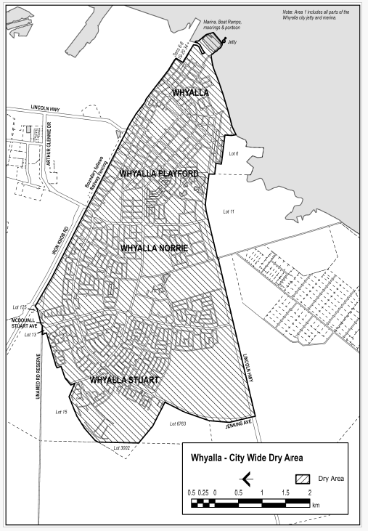
Made by the Minister for Consumer and Business Affairs
On 24 November 2025

Motor Vehicles Regulations 2025
Regulation 32(4)
Motor Vehicles (Specified Event) Notice 2025
1. Short Title
This notice may be cited as the Motor Vehicles (Specified Event) Notice 2025.
2. Commencement
This notice will come into operation on the day it is published in the Government Gazette.
3. Specified Event, Period and Conditions
In accordance with Regulation 32(4) of the Motor Vehicles Regulations 2025, and with the concurrence of the Minister for Infrastructure and Transport (as the Minister responsible for the operation of the Motor Vehicles Act 1959), I, the Minister for Tourism:
(a) specify the Santos Tour Down Under as an event; and
(b) specify the period commencing at 12:01am on 29 December 2025 and ending at 11:58pm on 31 January 2026 as the period during which motor vehicles approved by me may be driven, or caused to stand, on a road in relation to the Santos Tour Down Under; and
(c) specify that the following condition applies to driving such a motor vehicle, or causing such a motor vehicle to stand, on a road in relation to the Santos Tour Down Under:
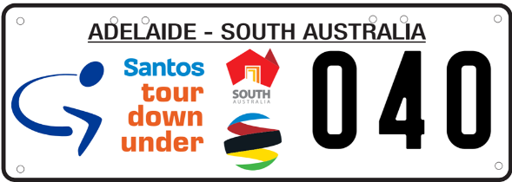
All such vehicles must display number plate covers of a design approved by the Registrar of Motor Vehicles over their vehicle number plates at all times during the period specified in paragraph (b).
Dated: 18 November 2025
Hon Zoe Bettison MP
Minister for Tourism

South Australian Civil And Administrative Tribunal
SACAT Reference Number: 2025/SA003537
Notice of Exemption Renewal before Tribunal Member Alex Reilly
I hereby certify that on the 19th of November 2025, the South Australian Civil and Administrative Tribunal, on application of Leidos Airborne Solutions Australia Pty Ltd, made the following orders for renewal of an exemption:
1. Pursuant to Section 92 of the Act and subject to the conditions contained in the Schedule, an exemption is granted to the Applicant from the operation of Sections 52, 53, 54 and 103 of the Act for the period of three years from the date of these Orders.
2. The exemption is granted in respect of the operation of Sections 52, 53, 54, and 103 of the Act insofar as those sections relate to the ‘nationality’, ‘country of birth’ or ‘current and past citizenship’ (as attributes included within the definition of ‘race’ in Section 5 of the Act) of the Applicant’s workforce.
3. The exemption permits the Applicant to engage in the following activities:
Applicants for employment
(a) Inform applicants for employment or contract work in roles which will require access to Controlled Material and are subject to permits, licences, approvals or agreements made under US and Australian import and export control laws that they may be adversely affected by ITAR and EAR controls if they:
(i) are not an Australian citizen; or
(ii) hold, or have held, dual nationality and/or citizenship from proscribed countries for the purposes of security requirements; or
(iii) have substantive contacts with proscribed countries for the purposes of security requirements;
Request for information about nationality
(b) Request information from prospective personnel who perform work on the Applicant’s premises or offsite and who are subject to the Applicant’s control and direction for positions related to projects which use Controlled Material, in relation to prospective citizenship, previous citizenships or nationality, or substantive contacts where such contacts are affiliated with countries proscribed by Section 126.1 of ITAR, provided the request for information is limited to information for determining whether an application for authorisation would be required to allow the prospective personnel to have access to Controlled Material and whether in the Applicant’s reasonable judgment that application would have significant prospects of success;
Use of nationality information
(c) Impose a condition on any offer of employment in roles which are likely to require access to Controlled Material that an applicant for those roles must, pursuant to ITAR, be authorised to access that Controlled Material, whether pursuant to an individual approval obtained from the US Department of State or otherwise;
(d) Take into account citizenship, previous citizenships or nationality, or substantive contacts of personnel where such contacts are affiliated with countries proscribed by Section 126.1 of ITAR in determining whether those personnel may be offered a role or allocated work that involves access to Controlled Material;
(e) Maintain records of the nationalities, citizenships and substantive contacts of personnel who have or may have access to Controlled Material;
(f) Require personnel involved in projects which access Controlled Material to notify the Applicant of any change to their citizenship status or substantive contacts;
(g) Restrict access to Controlled Material to particular personnel based on their citizenship, previous citizenships or nationality, or substantive contacts where such contacts are affiliated with countries proscribed by Section 126.1 of ITAR;
(h) Record information relating to security clearances granted to personnel who are under the control and direction of the Applicant in relation to work requiring access to Controlled Material;
(i) Impose limitations or prohibitions on access to Controlled Material on persons not authorised to access the Controlled Material;
(j) Maintain records of the nationalities of persons who have or will have access to Controlled Material, with distribution limited to only those persons with a need to know, for the purposes of determining their ability to participate in a particular engagement;
(k) Establish security systems and access protocols that will prevent the unauthorised export or transfer (including re-export or re-transfer) of Controlled Material;
(l) Disclose, if and when required, citizenship, previous citizenships or nationality, or substantive contacts where such contacts are affiliated with countries proscribed by Section 126.1 of ITAR, of the Applicant’s personnel in South Australia to:
(i) the US Department of State;
(ii) the US Department of Commerce;
(iii) the Australian Department of Defence; and
(iv) any other person or organisation for which, or on whose behalf, or at whose request the Applicant undertakes work in respect of which the Applicant has directly or indirectly an obligation not to transfer Controlled Material to persons of certain nationalities.
4. In this exemption:
(a) “Act” means the Equal Opportunity Act 1984 (SA);
(b) “Applicant” means Leidos Australia Pty Ltd (ACN 612 590 155);
(c) “Controlled Material” means material (including equipment, technology, articles and services) and information (including classified or sensitive information and technical data) to which the security requirements apply;
(d) “EAR” means the Export Administration Regulations of the US;
(e) “ITAR” means the International Trafficking in Arms Regulations of the US;
(f) “Personnel” means the current and prospective workforce of the Applicant, including employees, contract workers, employees of contractors and candidates or applicants for these roles;
(g) “Security requirements” means any of the following:
(i) requirements of Australian or US laws, including but not limited to ITAR and EAR, including requirements of any permit, licence or approval granted, or agreement made, under those laws;
(ii) contractual requirements applying to the Applicant and relating to any of the requirements mentioned in subparagraph (i) above;
(h) “US” means United States of America.
Schedule—Conditions
1. This exemption applies only to the Applicant’s conduct where:
(a) it is necessary to enable the Applicant to obtain and maintain US export licences and approvals or to perform contractual obligations which involve access to Controlled Material;
(b) the Applicant has taken all steps reasonably available to avoid engaging in conduct which would otherwise be in breach of Sections 52, 53, 54 and 103 of the Act, including:
(i) reliance on ITAR exemptions, exceptions or other provisions, including Section 126.18 of ITAR, where applicable;
(ii) where personnel are nationals or dual nationals of a country not approved for access to Controlled Material, then the Applicant will either request the US Department of State, or request the relevant export license holders to request the US Department of State to amend the relevant export licences to enable those personnel to have access to Controlled Material, unless the Applicant, on reasonable grounds, determines that either:
A. the personnel are not the best candidate for the relevant position; or
B. such an application does not have significant prospects of success;
(iii) in the event the US Department of State requires the Applicant to provide further information specific to an individual, then with the consent of that individual, the Applicant will work with the individual to supply all relevant information to the US Department of State so that an application for approval may be made in relation to that individual.
2. Where, pursuant to this exemption, an Applicant wishes to reserve the right to make a conditional offer of employment in relation to a position which will or may involve access to Controlled Material, any advertisement, invitation for expressions of interest, or other promotional information referring to the position must include the information that:
(a) the position will or is likely to require access to Controlled Material and that any individual occupying the position must be able to satisfy ITAR-based requirements which may require specific authorisation for that individual to access Controlled Material; and
(b) if a candidate for the position is concerned as to whether or not they will satisfy the requirement in (a) above, the candidate should contact a nominated member of the Applicant’s personnel who is able to provide relevant information, including information about the scope of the exemption and the candidate’s individual rights.
3. The Applicant must provide to the Commissioner for Equal Opportunity in South Australia a written report for every 12 month period from the date of this exemption order on its compliance with the exemption requirements, any changes in its procedures to reflect amendments to the ITAR, and as to how its employees and contractors are affected. Each report must be provided within 21 days from the end of the relevant reporting period. Each report must detail:
(a) the training and education provided to new and existing employees on these Orders and their implementation;
(b) the steps taken by the Applicant to implement these Orders;
(c) how the Applicant monitors compliance with these Orders;
(d) the number of persons affected by these Orders and the nature of those effects;
(e) the steps taken by the Applicant to address any adverse effects on existing employees as a result of these Orders; and
(f) the steps taken by the Applicant to minimise the impact of these Orders on current and future employees.
Dated: 19 November 2025
Anne Lindsay
Principal Registrar
South Australian Civil and Administrative Tribunal

South Australian Skills Act 2008
Part 4—Apprenticeships, Traineeships and Training Contracts
Pursuant to the provision of the South Australian Skills Act 2008, the South Australian Skills Commission (SASC) gives notice that determines the following qualification and training contract conditions for Trades or Declared Vocations, in addition to those published in past Gazette notices.
*Trade/ #Declared Vocation/ Other Occupation | Qualification Code | Qualification Title | Nominal Term of Training Contract | Probationary Period | Supervision Level Rating
Cook# | SIT30821 | Certificate III in Commercial Cookery | 48 months | 90 days | Medium
Condition/s | N/A
Dated: 27 November 2025
Commissioner Cameron Baker
Chair of the South Australian Skills Commission

Work Health And Safety Regulations 2012
Exemption
Granting of exemption from requirements of the Work Health and Safety Regulations 2012—Regulation 419(1)—Work involving asbestos or ACM—Prohibitions and exceptions
The purpose of Regulation 419 of the Work Health and Safety Regulations 2012 (WHS Regulations) is to enforce the prohibition on new uses of asbestos containing materials in workplaces, and in doing so to reduce the risk of persons being exposed to respirable asbestos fibres which present a risk of harm to health.
It has been identified that certain coloured decorative sands (the Sands) that have been imported to Australia from overseas and sold by stores in Australia may contain asbestos. The Sands have been in use in homes and workplaces for some time, and those in possession of the Sands now seek to dispose of them.
In that context I have considered that there is a risk that some persons may not have access to approved asbestos disposal facilities, and that certain stores that previously supplied the Sands have offered to accept that the Sands be returned to the store for appropriate disposal.
In accordance with Regulation 685 of the WHS Regulations, I consider that the risks associated with stores collecting the Sands can be mitigated and are lower than the risks associated with unlawful disposal that may otherwise occur if the Sands cannot be returned to stores.
Pursuant to Regulations 684(1) and 684(2) of the WHS Regulations, I have determined on my own initiative to grant an exemption to stores that are accepting the Sands for return from the requirement under Regulation 419(1) of the WHS Regulations that a person conducting a business or undertaking must not carry out, or direct or allow a worker to carry out, work if it involves asbestos (the Exemption).
The Exemption is granted subject to the following conditions:
1. The Exemption is exclusively limited to facilitate the return to stores of the Sands identified as containing, or be at risk of containing, trace levels of asbestos.
2. The Exemption only applies to stores that are accepting Sands for return that have been recalled, or that are otherwise suspected of containing trace asbestos.
3. The stores must ensure that a safe work procedure is implemented for the return of the Sands, and including at a minimum:
(a) A dedicated storage area separate from other wastes and goods for sale;
(b) A sign for the dedicated storage area of the Sands, including an asbestos caution;
(c) Checks of incoming material to ensure that they are fully contained or wrapped;
(d) Provision of wrapping/containment material to further contain any materials where the original containment is damaged and the wearing of disposable gloves and P2 masks if wrapping/containing the Sands further;
(e) Labels to be applied to the contained Sands including an asbestos caution;
(f) A procedure to follow for handling the Sands, and a procedure to follow in the event of a spill of the Sands; and
(g) A system to regularly dispose of the materials at an approved asbestos disposal site to prevent long-term storage, with transport carried out by a waste transporter holding an Environment Protection Authority (EPA) Regulated Waste Transport licence.
4. The Exemption does not create a duty for any store to accept returned Sands.
5. The Exemption takes effect on 25 November 2025 and is valid until 30 June 2026.
For the purposes of Regulation 484(1)(b), stores accepting returned Sands are considered to be sites authorised to accept asbestos waste, (limited to waste of the category of the Sands).
Dated: 25 November 2025
Glenn Farrell
Executive Director
SafeWork SA

Local Government Instruments

City Of Charles Sturt
Section 208
Declaration
Notice is hereby given in accordance with Section 208(4) of the Local Government Act 1999 (SA) that the City of Charles Sturt (Council) made a declaration under Section 208(4) of the said Act declaring all ‘private roads’ noted on Certificate of Title Volume 6075 Folio 374 as ‘public road’ at a duly convened meeting of the Council held on 27 October 2025.
Dated: 27 November 2025
Paul Sutton
Chief Executive Officer

City Of Port Adelaide Enfield
Local Government Act 1999
Renaming of Taperoo Reserve
Notice is hereby given that the Council of the City of Port Adelaide Enfield at its meeting held on 13 October 2020 resolved that pursuant to
Section 219(1) of the Local Government Act 1999, that “Taperoo Reserve”, be renamed to have dual names, “Ngarrpadla” and “Josie Agius Reserve”.
A copy of the Council’s resolution is available for inspection at the Council’s Civic Centre, 163 St Vincent Street, Port Adelaide SA 5015, during the hours of 9:00am and 5:00pm on weekdays.
Dated: 27 November 2025
Mark Withers
Chief Executive Officer

City of Port Adelaide Enfield
Roads (Opening and Closing) Act 1991
Notice of Proposed Road Closure—Welwyn Road, Manningham
Notice is hereby given pursuant to Section 10 of the Roads (Opening and Closing) Act 1991 that the City of Port Adelaide Enfield proposes to make a Road Process Order to close and sell to the adjoining landowner a portion of Welwyn Road adjoining Allotment 98 in F127132, more particularly delineated and lettered ‘A’ on Preliminary Plan 25/0031.
A copy of the Preliminary Plan is available for public inspection at the City of Port Adelaide Enfield’s Civic Centre, located at 163 St Vincent Street, Port Adelaide between the hours of 8:30am and 5:00pm, Monday to Friday or at the office of the Surveyor-General, Level 10, 83 Pirie Street, Adelaide, during normal office hours. The Preliminary Plan can also be viewed at www.sa.gov.au/roadsactproposals.
Any person may object to the proposed road process, or any person affected by the proposed closure may apply for an easement to be granted in that person’s favour over the land subject to the proposed road closure.
An objection must set out the full name and address of the person making the objection and must be fully supported by reasons, and state whether the objector wishes to make submissions to the relevant authority at any meeting held by the authority to consider objections and applications made in relation to the proposed road process.
An application for an easement must set out the full name and address of the person making the application, be fully supported by reasons and must give full particulars of the nature and location of the easement that is being applied for, and where made by a person as the owner of adjoining or nearby land, specify the land to which the easement is to be annexed.
Any objection or application for an easement must be made in writing setting out full details and must be submitted to the City of Port Adelaide Enfield by post to PO Box 110, Port Adelaide SA 5015 or via email to consultation@cityofpae.sa.gov.au within 28 days of the date of publication of this notice and a copy must be forwarded to the Surveyor-General at GPO Box 1815, Adelaide SA 5001 within the same time period.
Dated: 27 November 2025
Mark Withers
Chief Executive Officer

Adelaide Plains Council
South Australia
Liquor Licensing (Dry Areas) Notice 2025
under Section 131(1ab) of the Liquor Licensing Act 1997
1—Short title
This notice may be cited as the Liquor Licensing (Dry Areas) Notice 2025.
2—Commencement
This notice comes into operation on 12 December 2025.
3—Interpretation
(1) In this notice—
principal notice means the Liquor Licensing (Dry Areas) Notice 2015 published in the Gazette on 5 January 2015, as in force from time to time.
(2) Clause 3 of the principal notice applies to this notice as if it were the principal notice.
4—Consumption etc of liquor prohibited in dry areas
(1) Pursuant to Section 131 of the Act, the consumption and possession of liquor in the area described in the Schedule is prohibited in accordance with the provisions of the Schedule.
(2) The prohibition has effect during the periods specified in the Schedule.
(3) The prohibition does not extend to private land in the area described in the Schedule.
(4) Unless the contrary intention appears, the prohibition of the possession of liquor in the area does not extend to—
(a) a person who is genuinely passing through the place if—
(i) the liquor is in the original container in which it was purchased from licensed premises; and
(ii) the container has not been opened; or
(b) a person who has possession of the liquor in the course of carrying on a business or in the course of their employment by another person in the course of carrying on a business; or
(c) a person who is permanently or temporarily residing at premises near the public place and who enters the public place solely for the purpose of passing through it to enter those premises or who enters the public place from those premises for the purpose of leaving the place; or
(d) a person who possesses or consumes the liquor for sacramental or other similar religious purposes.
Schedule—Two Wells Area 1
1—Extent of prohibition
The consumption of liquor is prohibited and the possession of liquor is prohibited.
2—Period of prohibition
From 4pm on 12 December 2025 to 5am on 13 December 2025.
3—Description of area
Old Port Wakefield Road between Gawler Road and Chapman Street in Two Wells
Vacant land bounded by Windmill Road, Old Port Wakefield Road, Wells Road and Section 716 Deposited Plan H140800 Wells Road in Two Wells
Two Wells Village Green bounded by metal fencing, Adelaide Plains Library and Old Port Wakefield Road in Two Wells
Two Wells Memorial Gardens bounded by stone fencing and Old Port Wakefield Road in Two Wells
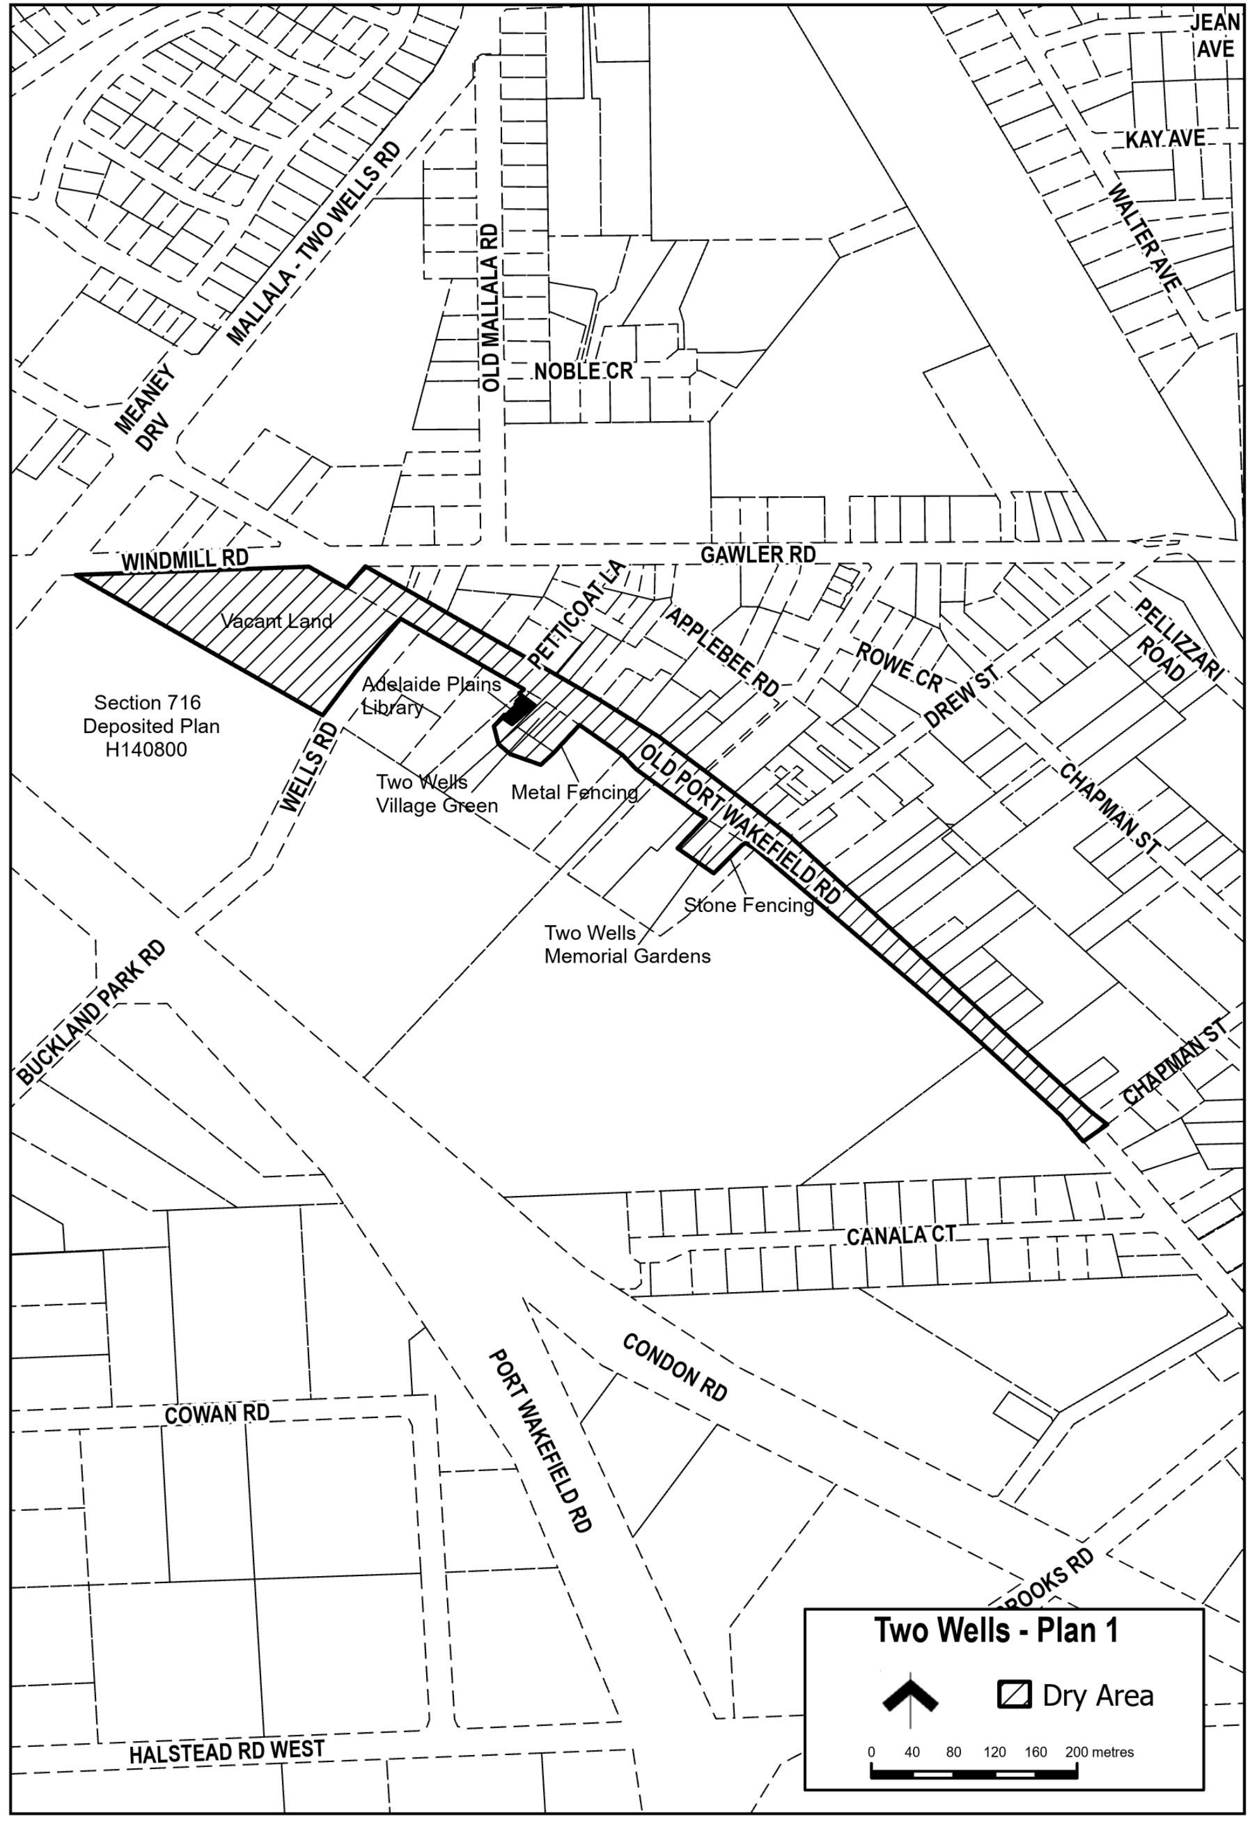
Dated: 25 November 2025
James Miller
Chief Executive Officer

District Council Of Franklin Harbour
Change of Meeting Date
Notice is hereby given that the Ordinary January Council Meeting will now be held on Wednesday, 21 January 2026, commencing at 1:00pm in the Council Chambers of Main Street, Cowell, in lieu of Wednesday, 14 January 2026.
Dated: 18 November 2025
S. A. Gill
Chief Executive Officer

District Council Of Kimba
Roads (Opening and Closing) Act 1991
Road Closure—Public Road, Lake Gilles
Notice is hereby given pursuant to Section 10 of the Roads (Opening and Closing) Act 1991 that the Council proposes to make a Road Process Order to close and retain by the Crown the unmade Public Road adjoining Allotment 101 in D123721, more particularly delineated and lettered ‘A’ on Preliminary Plan 25/0032.
The Preliminary Plan is available for public inspection at the office of the District Council of Kimba, located at Cross Street Kimba and the office of the Surveyor-General located at Level 10, 83 Pirie Street Adelaide, during normal office hours. The Preliminary Plan can also be viewed at www.sa.gov.au/roadsactproposals.
Any application for easement or objection must set out the full name, address and details of the submission and must be fully supported by reasons. The application for easement or objection must be made in writing to the District Council of Kimba, PO Box 189 Kimba SA 5641, within 28 days of this notice and a copy must be forwarded to the Surveyor-General at GPO Box 1815, Adelaide 5001. Where a submission is made, the applicant must be prepared to support their submission in person upon council giving notification of a meeting at which the matter will be considered.
Dated: 27 November 2025
Debra Larwood
Chief Executive Officer

Kingston District Council
Revocation of Community Land Classification
Notice is hereby given that Kingston District Council at its meeting held on 19 November 2025 and with the consent of the Minister for Local Government, resolved that the following property has its classification as community land revoked pursuant to Section 194 of the Local Government Act 1999:
• Allotment 585, Cape Jaffa, Hundred of Mt Benson in Deposited Plan 79232 comprised in Certificate of Title Volume 6022 Folio 410.
Dated: 27 November 2025
Ian Hart
Chief Executive Officer

Mid Murray Council
By-law Made Under the Local Government Act 1999
Mid Murray Council (Miscellaneous) Amendment By-law 2025
By-law No. 8 of 2025
To amend the Council’s Cats By-law 2025 and for related purposes.
Part 1—Preliminary
1. Short title
This by-law may be cited as the Mid Murray Council (Miscellaneous) Amendment By-law 2025.
2. Commencement
This by-law will come into operation on the day on which the Cats By-law 2025 of the Council commences operation in accordance with Section 249(6)(b) of the Local Government Act 1999.
3. Amendment Provisions
In this by-law, a provision under a heading referring to the amendment of a specified by-law amends the by-law so specified.
Part 2—Amendment of Cats By-law 2025
4. Amendment of Paragraph 6—Identification of Cats
Part 3—after paragraph 6.3 insert:
6.4 For the purposes of this paragraph:
6.4.1 the prescribed manner in which a cat is to be identified at all times while the cat is not effectively confined to premises of which the owner of the cat is the occupier is by means of a collar around its neck to which a tag is attached legible setting out:
6.4.1.1 the name of the owner of the cat, or a person entitled to possession of the cat; and
6.4.1.2 either:
(a) the address of the owner or other person; or
(b) the telephone number of the owner or other person.
6.5 prescribed premises means:
6.5.1 a cattery;
6.5.2 a veterinary practice;
6.5.3 a pet shop; or
6.5.4 any premises for which the Council has granted an exemption.
5. Amendment of Paragraph 5—Registration of Cats
5.1 Paragraph 5.4—replace ‘7.1’ with ‘5.1’;
5.2 Paragraph 5.5—replace ‘7.1’ with ‘5.1’.
Part 3—Expiry
6. Expiry
This by-law will expire 24 hours after it comes into operation in accordance with Section 251(1) of the Local Government Act 1999.
Note: In accordance with Section 32(2)(c) of the Legislation Interpretation Act 2021, the expiry of this by-law does not affect any direct amendments made by this by-law.
The foregoing by-law was duly made and passed at a meeting of the Council of the Mid Murray Council held on the 18th day of November 2025 by an absolute majority of the members for the time being constituting the Council, there being at least two thirds of the members present.
Dated: 27 November 2025
Ben Scales
Chief Executive Officer

Renmark Paringa Council
Local Government Act 1999
Review of Representation
Notice is hereby given that the Renmark Paringa Council (the Council) has reviewed its composition and elector representation arrangements in accordance with the requirements of Section 12 of the Local Government Act 1999 (the Act).
Pursuant to Section 12(13)(a) of the Act, the Electoral Commissioner has certified that the review undertaken by the Council satisfies the requirements of Section 12 of the Act.
The following arrangements will therefore take effect in accordance with Section 12(18) of the Act, which is presently expected to be as from polling day for the first periodic election held after the publication of this notice:
• The Council will continue to be a district council.
• The Council will continue to retain the name ‘Renmark Paringa Council’.
• The Council area continue not be divided into wards (retain the existing “no wards” structure).
• The Council continue to comprise eight (8) area councillors, plus the Mayor.
• The principal member of Council continue to be a Mayor elected by the community.
Dated: 27 November 2025
Tony Siviour
Chief Executive Officer

District Council Of Tumby Bay
South Australia
Liquor Licensing (Dry Areas) Notice 2025
under Section 131(1ab) of the Liquor Licensing Act 1997
1—Short title
This notice may be cited as the Liquor Licensing (Dry Areas) Notice 2025.
2—Commencement
This notice comes into operation on 31 December 2025.
3—Interpretation
(1) In this notice—
principal notice means the Liquor Licensing (Dry Areas) Notice 2015 published in the Gazette on 5 January 2015, as in force from time to time.
(2) Clause 3 of the principal notice applies to this notice as if it were the principal notice.
4—Consumption etc of liquor prohibited in dry areas
(1) Pursuant to Section 131 of the Act, the consumption and possession of liquor in the area described in the Schedule is prohibited in accordance with the provisions of the Schedule.
(2) The prohibition has effect during the periods specified in the Schedule.
(3) The prohibition does not extend to private land in the area described in the Schedule.
(4) Unless the contrary intention appears, the prohibition of the possession of liquor in the area does not extend to—
(a) a person who is genuinely passing through the place if—
(i) the liquor is in the original container in which it was purchased from licensed premises; and
(ii) the container has not been opened; or
(b) a person who has possession of the liquor in the course of carrying on a business or in the course of their employment by another person in the course of carrying on a business; or
(c) a person who is permanently or temporarily residing at premises near the public place and who enters the public place solely for the purpose of passing through it to enter those premises or who enters the public place from those premises for the purpose of leaving the place; or
(d) a person who possesses or consumes the liquor for sacramental or other similar religious purposes.
Schedule—Port Neill Area 1

1—Extent of prohibition
The consumption of liquor is prohibited and the possession of liquor is prohibited.
2—Period of prohibition
From 10.30pm on 31 December 2025 to 8am on 1 January 2026.
3—Description of area
Port Neill Area 1
The area in and adjacent to Port Neill bounded as follows: commencing at the point at which the prolongation in a straight line of the south-western boundary of Section 194 Hundred of Dixson intersects the low water mark on the western side of Spencer Gulf, then north-westerly along that prolongation and boundary of Section 194 to the western boundary of the Section, then in a straight line by the shortest route to the point at which the eastern boundary of Section 195 Hundred of Dixson meets the south-western boundary of that Section, then north-westerly along the south-western boundary of Section 195 to the north-western boundary of the Section (the south-eastern boundary of Kinnaird Street), then in a straight line by the shortest route to the eastern corner of Lot 55 of DP 80902, then south-westerly along the south-eastern boundary of Lot 55 to the eastern boundary of North Coast Road, then northerly, north-westerly and northerly along that boundary of North Coast Road to the point at which it meets the northern boundary of Coneybeer Terrace, then in a straight line by the shortest route across North Coast Road to the western boundary of North Coast Road, then due west in a straight line for 200 metres, then due north in a straight line to the northern boundary of Section 54 Hundred of Dixson (the southern boundary of the Port Neill Access Road), then easterly along that boundary of Section 54 and the prolongation in a straight line of that boundary to the eastern boundary of North Coast Road, then northerly along that boundary of North Coast Road to the point at which it meets the northern boundary of Section 120 Hundred of Dixson, then south-easterly, north-easterly and southerly along the northern and eastern boundaries of Section 120 to the point at which the eastern boundary of the Section is intersected by the prolongation in a straight line of the northern boundary of Section 136 Hundred of Dixson, then easterly along that prolongation and boundary of Section 136, and the prolongation in a straight line of that boundary, to the low water mark on the western side of Spencer Gulf, then generally south-easterly, easterly, south-westerly, easterly, southerly and south-westerly along the low water mark to the point of commencement. The area includes any jetty, wharf, boat ramp, breakwater or other structure projecting below low water mark from within the area described above, as well as any area beneath such a structure.
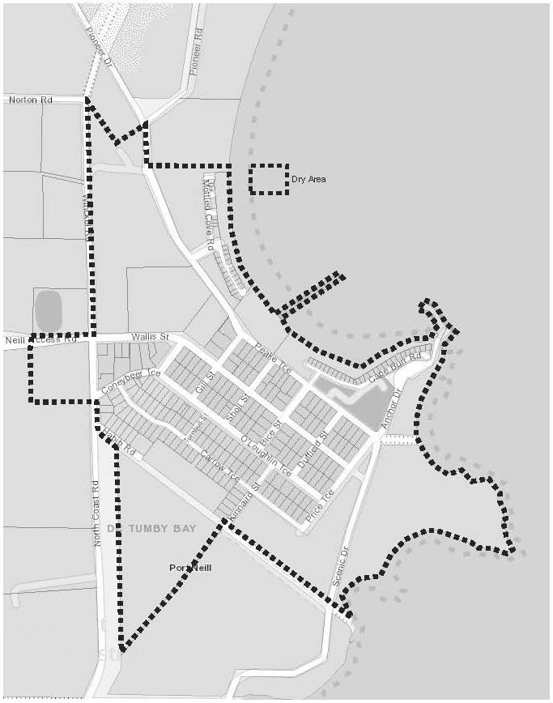
Port Neill Area 1

Schedule—Tumby Bay Area 1

1—Extent of prohibition
The consumption of liquor is prohibited and the possession of liquor is prohibited.
2—Period of prohibition
From 10.30pm on 31 December 2025 to 8am on 1 January 2026.
3—Description of area
Tumby Bay Area 1
The area in and adjacent to Tumby Bay bounded as follows: commencing at the point at which the prolongation in a straight line of the northern boundary of Section 353 Hundred of Hutchison intersects the low water mark of Tumby Bay, then generally southerly, easterly, south-easterly, southerly and westerly along the low water mark to the point at which it is intersected by the prolongation in a straight line of the northern boundary of Section 355 Hundred of Hutchison, then westerly along that prolongation and northern boundary of Section 355 and the southern boundary of Piece 501 DP 85629 to the point at which the southern boundary of Piece 501 meets the eastern boundary of Thuruna Road, then generally northerly, north-easterly and northerly along that eastern boundary of Thuruna Road to the point at which it intersects the northern boundary of Dutton Terrace, then westerly and northerly along that boundary of Dutton Terrace to the point at which it meets the southern boundary of Bratten Way, then in a straight line by the shortest route (across Bratten Way) to the southern boundary of Lot 65 DP 59150, then generally north-westerly, north-easterly and south-easterly along the south-western, north-western and north-eastern boundaries of Lot 65 to the point at which the north-eastern boundary of Lot 65 is intersected by the prolongation in a straight line of the western boundary of Lot 101 DP 78505, then northerly along that prolongation and boundary of Lot 101 to the northern boundary of the Lot, then easterly along the northern boundaries of Lot 101, Section 817 Hundred of Hutchison and Section 353 Hundred of Hutchison and the prolongation in a straight line of the northern boundary of Section 353 to the point of commencement. The area includes the whole of any wharf, jetty, boat ramp, breakwater or other structure extending below low water mark from within the area described above, as well as any area beneath such a structure.

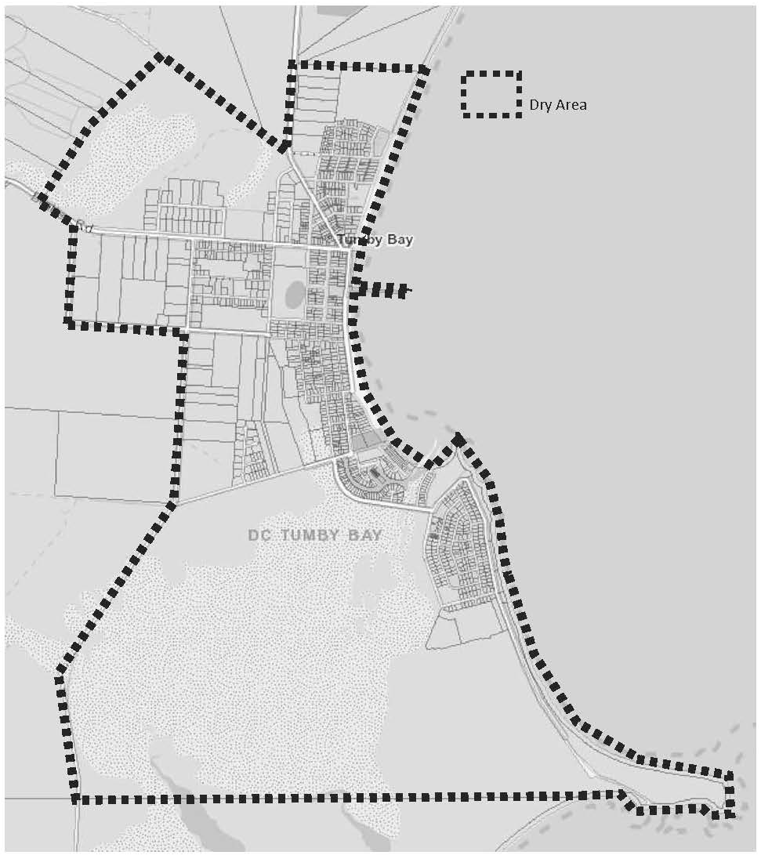
Tumby Bay Area 1
Dated: 18 November 2025
Darren Keenan
Chief Executive Officer

Public Notices

National Electricity Law
Corrigendum
Notice of Extension of Draft Determination
The notice published in the South Australian Government Gazette No. 68, dated 20 November 2025, on page 4631, under the heading National Electricity Law, was published with an incorrect date of 26 March 2025 located at the end of the 3rd paragraph and should be replaced with 26 March 2026.

NATIONAL ELECTRICITY LAW
Corrigendum
Notice of Extension of Draft Determination
The notice published in the South Australian Government Gazette No. 68, dated 20 November 2025, on page 4631, under the heading National Electricity Law, was published with an incorrect date of 26 March 2025 located at the end of the 4th paragraph and 5th paragraph and should be replaced with 26 March 2026.

National Electricity Law
Notice of Extension of Final Determination
Notice of Final Determination and Final Rule
The Australian Energy Market Commission (AEMC) gives notice under the National Electricity Law as follows:
Under s 107, the time for the making of the final determination on the Real-time data for consumers (Ref. ERC0399) proposal has been extended to 18 December 2025.
Under ss 102 and 103, the making of the National Electricity Amendment (Minor changes 2) Rule 2025 No.10 (Ref. ERC0420) and related final determination. All provisions commence on 27 November 2025.
Documents referred to above are available on the AEMC’s website and are available for inspection at the AEMC’s office.
Australian Energy Market Commission
Level 15, 60 Castlereagh St
Sydney NSW 2000
Telephone: (02) 8296 7800
www.aemc.gov.au
Dated: 27 November 2025

National Energy Retail Law
Notice of Extension of Final Determination
The Australian Energy Market Commission (AEMC) gives notice under the National Energy Retail Law as follows:
Under s 266, the time for the making of the final determination on the Real-time data for consumers (Ref. RRC0057) proposal has been extended to 18 December 2025.
Documents referred to above are available on the AEMC’s website and are available for inspection at the AEMC’s office.
Australian Energy Market Commission
Level 15, 60 Castlereagh St
Sydney NSW 2000
Telephone: (02) 8296 7800
www.aemc.gov.au
Dated: 27 November 2025

National Gas Law
Notice of Extension of Draft Determination
Notice of Extension of Final Determination
The Australian Energy Market Commission (AEMC) gives notice under the National Gas Law as follows:
Under s 317, the time for making the draft determination on the ECGS Reliability standard and associated settings (Ref. GRC0076) proposal has been extended to 26 February 2026.
Under s 317, the time for the making of the final determination on the ECGS Projected Assessment of System Adequacy (Ref. GRC0080) proposal has been extended to 25 June 2026.
Documents referred to above are available on the AEMC’s website and are available for inspection at the AEMC’s office.
Australian Energy Market Commission
Level 15, 60 Castlereagh St
Sydney NSW 2000
Telephone: (02) 8296 7800
www.aemc.gov.au
Dated: 27 November 2025

Notice Submission

The South Australian Government Gazette is published each Thursday afternoon.
Notices must be emailed by 4 p.m. Tuesday, the week of publication.
Submissions are formatted per the gazette style and a proof will be supplied prior to publication, along with a quote if applicable. Please allow one day for processing notices.
Alterations to the proof must be returned by 4 p.m. Wednesday.

Gazette notices must be submitted as Word files, in the following format:
• Title—the governing legislation
• Subtitle—a summary of the notice content
• Body—structured text, which can include numbered lists, tables, and images
• Date—day, month, and year of authorisation
• Signature block—name, role, and department/organisation authorising the notice

Please provide the following information in your email:
• Date of intended publication
• Contact details of the person responsible for the notice content
• Name and organisation to be charged for the publication—Local Council and Public notices only
• Purchase order, if required—Local Council and Public notices only

Email: governmentgazettesa@sa.gov.au
Phone: (08) 7133 3552
Website: www.governmentgazette.sa.gov.au

All instruments appearing in this gazette are to be considered official, and obeyed as such

Printed and published weekly by authority of T. Foresto, Government Printer, South Australia
$9.50 per issue (plus postage), $479.00 per annual subscription—GST inclusive
Online publications: www.governmentgazette.sa.gov.au

