
No. 57 p. 3981
THE SOUTH AUSTRALIAN
GOVERNMENT GAZETTE
Published by Authority

Adelaide, Thursday, 2 October 2025

Contents

Governor’s Instruments
Appointments, Resignations and General Matters 3982
Proclamations—
National Parks and Wildlife (Horsnell Gully
Conservation Park) Proclamation 2025 3983
National Parks and Wildlife (Ikara – Flinders Ranges
National Park) Proclamation 2025 3984
State Government Instruments
Aquaculture Act 2001 3985
District Court of South Australia, The 3985
Fisheries Management (Sardine Fishery) Regulations 2021 3986
Fisheries Management Act 2007 3994
Housing Improvement Act 2016 3997
Land Acquisition Act 1969 3998
Mental Health Act 2009 4008
Police Act 1998 4009
Real Property Act 1886 4009
Roads (Opening and Closing) Act 1991 4009
South Australian Civil and Administrative Tribunal 4010
South Australian Housing Trust Regulations 2025 4011
South Australian Skills Act 2008 4012
Summary Offences Act 1953 4013
Tobacco and E-Cigarette Products Act 1997 4016
Local Government Instruments
City of Adelaide 4017
The Rural City of Murray Bridge 4017
City of Norwood Payneham & St Peters 4017
City of Playford 4017
City of Port Adelaide Enfield 4018
Port Augusta City Council 4019
City of Whyalla 4020
Town of Gawler 4020
Adelaide Hills Council 4020
Adelaide Plains Council 4021
Mount Barker District Council 4021
District Council of Orroroo Carrieton 4022
District Council of Peterborough 4022
Yorke Peninsula Council 4022
Public Notices
National Electricity Law 4023
National Gas Law 4023
Trustee Act 1936 4023

Governor’s Instruments

Appointments, Resignations and General Matters
Department of the Premier and Cabinet
Adelaide, 2 October 2025
Her Excellency the Governor in Executive Council has been pleased to appoint the undermentioned to the Aboriginal Lands Trust, pursuant to the provisions of the Aboriginal Lands Trust Act 2013:
Member: from 2 October 2025 until 1 October 2028
Glen Wingfield
Sandra Anne Miller
Dean Robin Walker
By command,
Kyam Joseph Maher, MLC
For Premier
AGO0165-25CS

Department of the Premier and Cabinet
Adelaide, 2 October 2025
Her Excellency the Governor in Executive Council has been pleased to appoint the undermentioned to the State Opera of South Australia Board, pursuant to the provisions of the State Opera of South Australia Act 1976:
Member: from 2 October 2025 until 1 October 2028
Michael Edward Harvey
By command,
Kyam Joseph Maher, MLC
For Premier
25ART0014CS

Proclamations
South Australia

National Parks and Wildlife (Horsnell Gully Conservation Park) Proclamation 2025
under section 29(3) of the National Parks and Wildlife Act 1972
1—Short title
This proclamation may be cited as the National Parks and Wildlife (Horsnell Gully Conservation Park) Proclamation 2025.
2—Commencement
This proclamation comes into operation on the day on which it is made.
3—Alteration of boundaries of Horsnell Gully Conservation Park
The boundaries of the Horsnell Gully Conservation Park are altered by adding to the Park the following Crown land:
Allotment comprising Pieces 91, 92 and 93 in Deposited Plan 131059, Hundred of Adelaide, County of Adelaide
Made by the Governor
with the advice and consent of the Executive Council
on 2 October 2025

South Australia

National Parks and Wildlife (Ikara – Flinders Ranges National Park) Proclamation 2025
under section 27(3) of the National Parks and Wildlife Act 1972
1—Short title
This proclamation may be cited as the National Parks and Wildlife (Ikara – Flinders Ranges National Park) Proclamation 2025.
2—Commencement
This proclamation comes into operation on the day on which it is made.
3—Alteration of boundaries of Ikara – Flinders Ranges National Park
The boundaries of the Ikara – Flinders Ranges National Park are altered by adding to the Park the following Crown land:
Allotment 506 in Deposited Plan 133259, Out of Hundreds (Parachilna), County of Hanson
Made by the Governor
with the advice and consent of the Executive Council
on 2 October 2025

State Government Instruments

Aquaculture Act 2001
Grant of Emergency Lease
Pursuant to the provisions of Section 40 of the Aquaculture Act 2001, notice is hereby given of the grant of the following emergency lease in Port Lincoln, South Australia, for the preservation of endangered Yellowtail Kingfish (Seriola lalandi) aquaculture stock:
LA00550 (Lincoln aquaculture zone)
Further details for the above lease are available through the Aquaculture Public Register, which can be found at https://pir.sa.gov.au/
primary_industry/aquaculture/aquaculture_public_register or by contacting Fisheries and Aquaculture, Leasing and Licensing by phone on (08) 8207 5332.
Dated: 24 September 2025
Matt Read
Director Operations

The District Court of South Australia
Mount Gambier Circuit Court
Sheriff’s Office, Adelaide, 7 October 2025
In pursuance of a precept from the District Court to me directed, I do hereby give notice that the said Court will sit as a Court of Oyer and Terminer and General Gaol Delivery at the Courthouse at Mount Gambier on the day and time undermentioned and all parties bound to prosecute and give evidence and all jurors summoned and all others having business at the said Court are required to attend the sittings thereof and the order of such business will be unless a Judge otherwise orders as follows:
Tuesday, 7 October 2025 at 10am on the first day of the sittings the only business taken will be the arraignment of prisoners in gaol and the passing of sentences on prisoners in gaol committed for sentence; the surrender of prisoners on bail committed for sentence; the surrender of persons in response to ex officio informations or of persons on bail and committed for trial who have signified their intentions to plead guilty and the passing of sentences for all matters listed for disposition by the District Court.
Juries will be summoned for 3 October 2025 and persons will be tried on this and subsequent days of the sittings.
Prisoners in H.M. Gaol and on bail for sentence and for trial at the sittings
of the Mount Gambier Courthouse, commencing 7 October 2025.
Atkinson, Aaron James |  | Unlawful sexual intercourse with person under 17 years (3); Engage in sexual intercourse with a person without consent (2). |  | On bail
Beck, Joshua Douglas |  | Aggravated assault causing harm (2); Aggravated assault (4); Unlawfully choking, suffocating or strangling another. |  | In gaol
Brabham, Jason Graeme |  | Threatening to damage property |  | In gaol
Bryant, Joel Matthew |  | Induce witness not to attend or give or produce evidence. |  | On bail
Burley, Lindsay Maree |  | Possess firearm without a licence; Aggravated possess firearm without a licence; Attempted supplying a firearm. |  | On bail
Carter, Paul David |  | Aggravated assault (3); Rape. |  | On bail
Davis, Brodie Allan |  | Basic recklessly cause serious harm; Basic cause harm with intent; Basic commit assault. |  | On bail
Delaney, Damian Demetrious |  | Aggravated threatening life; Aggravated possessing a firearm without a licence. |  | On bail
Kessegian, Matthew |  | Sexual abuse of a child. |  | On bail
Larkin, Jon William |  | Aggravated assault (3); Unlawfully choking, suffocating or strangling another. |  | In gaol
Leistra, Shane Robert |  | Causing death by dangerous driving (2); Causing harm by dangerous driving. |  | On bail
Millhouse, Jaystin Rodi |  | Trafficking in a controlled drug (4); Traffic in a commercial quantity of a controlled drug; Money laundering. |  | On bail
Neumann, Benjamin Gregory |  | Aggravated causing serious harm by careless driving; Leaving an accident scene after causing serious harm by careless driving; Attempt to obstruct or pervert the course of justice. |  | In gaol
Rappard, Johann Harley |  | Unlawfully choking, suffocating or strangling another; Aggravated assault (4); Property damage. |  | On bail
Richards, Peter Scott |  | Knowingly be in possession of Child Exploitation Material (4); Produce child pornography (10); Unlawful sexual intercourse with person under 17 years (5). |  | In gaol
Richards, Peter Scott |  | Unlawfully choking, suffocating or strangling another; Aggravated assault. |  | In gaol
Richardson, Joshua Mark |  | Trafficking in a commercial quantity of a controlled drug; Trafficking in a controlled drug (3). |  | On bail
Slape, Joshua James |  | Rape; Attempted rape; Indecent assault. |  | On bail
Thomson, Adam Paul |  | Aggravated commit assault with weapon – other circumstance; Aggravated contravene intervention order with violence – not programs; Serious aggravated criminal trespass on occupied residential property. |  | In gaol
Thorp, James Leslie |  | Adult, sexual abuse of a child. |  | On bail
Versteegh, Aaron Peter Scott |  | Trafficking in a controlled drug in a prescribed area. |  | On bail
Wilson, David Thomas |  | Adult, maintain unlawful sexual relationship with a child (2). |  | On bail
Prisoners on bail must surrender at 10am of the day appointed for their respective trials. If they do not appear when called upon their recognizances and those of their bail will be estreated and a bench warrant will be issued forthwith.
By order of the Court,
S. Duncan
A/Sheriff

Fisheries Management (Sardine Fishery) Regulations 2021
Regulation 12
Revocation and Determination
The Determination made for the purposes of Regulation 12 dated 20 December 2024 will be revoked as of 25 September 2025.
For the purpose of Regulation 12 relating to catch and disposal requirements in the Sardine Fishery, commencing 25 September 2025, I make the following determinations:
Regulation 12—Catch and disposal requirements—12(1)(a) record information and 12(1)(c) (arrangements for fish)
The holder of the licence or registered master must—
(1) Complete and submit an electronic ‘Sardine-Start Report’ prior to departing port.
(2) Complete and submit an electronic ‘Sardine—Change Zone’ report via the Commercial Fishing SA app before the registered boat leaves the Zone originally reported, where:
(a) A ‘Sardine-Start Report’ has been submitted declaring that fishing will occur in a Zone; and
(b) No fish are taken from that Zone; and
(c) The licence holder or registered master intends to take fish from another Zone.
(3) Immediately after the sardines are unloaded from the registered boat, complete and submit Part A of electronic report ‘Sardine—CDR’ record in respect of the sardines.
(4) If the sardines are to be loaded onto a boat specified in the certificate of registration of a registered fish processor, he or she must ensure that the Part A electronic report ‘Sardine—CDR’ record is completed and submitted in respect of the sardines consigned to the registered fish processor or an agent of the registered fish processor when the sardines are loaded onto that boat.
(5) If the sardines are to be transported to the registered premises of a registered fish processor, he or she must ensure that the Part A electronic report ‘Sardine—CDR’ record is completed and submitted in respect of the sardines that are transported to the registered premises.
(6) If the sardines are to be transported to the registered premises of a registered fish processor by 2 or more vehicles or are to be unloaded to a boat or boats specified in the certificate of registration of a registered fish processor, he or she must ensure that Part A of electronic report ‘Sardine—Transit Form’ record is completed and submitted in respect of each other vehicle or boat that is to be used to transport the sardines.
(7) Ensure that sardines to be delivered or consigned to a registered fish processor are:
(a) Transported to the fish processor in bins or containers of a kind consistent with those listed in Schedule 1 of this Determination; and
(b) The quantity of fish being transported do not exceed the specified fill line of the bin or container when level in the bin or container.
Regulation 12(1)(b) (provide information)
(1) The holder of the licence or registered master must report to the Department, by the Commercial Fishing SA Application, at least 1 hour before the sardines are to be unloaded from the registered boat to be delivered to the registered premises of a fish processor other than a boat; or at least 2 hours before the sardines are to be unloaded from the registered boat to be loaded on to a boat registered as the premises of a fish processor:
(a) the name of the person making the telephone call or report;
(b) the number of the licence under which the sardines were taken;
(c) the name of the registered boat from which the sardines were taken;
(d) the name of the registered master of the registered boat;
(e) the location at which the sardines are to be unloaded from the registered boat;
(f) the estimated time of arrival of the registered boat at that location;
(g) the estimated total weight in tonnes of the sardines taken;
(h) the name of the registered fish processor to whom the sardines are to be consigned;
(i) whether the sardines are to be delivered to the registered premises of the registered fish processor or to be loaded onto a boat specified in the certificate of registration of the registered fish processor;
(j) the estimated time at which the sardines are to be unloaded from the registered boat;
(k) the trip ID;
(l) any threatened, endangered or protected species mortality events;
(m) any threatened, endangered or protected species entanglement or injury events; and
(n) the number of net shots made.
(3) The holder of the licence in respect of the fishery or registered master under such a licence, must immediately notify the Department of any change to information already submitted to the Department by telephone on 1800 065 522 or by the Commercial Fishing SA Application before the sardines are unloaded from the registered boat.
Regulation 12(3) (keeping of records)
(1) Where an electronic report has been submitted to the Department no further record need be kept for the purposes of this determination.
For the purposes of this determination—
Electronic report—means an entry received in the eCatch electronic database created and administered by the Department. Submission of the electronic report may be directly entered into the eCatch electronic database via the myPIRSA portal (www.pir.sa.gov.au/ecatch); via the Commercial Fishing SA App; or other third party application. If entered by a third party application the Licence Holder, Registered Master or Nominated Agent must ensure the report has been received by the eCatch electronic database.
Department—means the Department of Primary Industries and Regions South Australia.
Dated: 25 September 2025
Professor Gavin Begg
Executive Director, Fisheries and Aquaculture
Delegate of the Minister for Primary Industries and Regional Development

Schedule 1
Register of Bins for the purposes of paragraph 7 of the Determination made under
Regulation 12(1)(a) (record information) and Regulation 12(1)(c) (arrangements for fish)
Australian Fishing Enterprises Pty Ltd (AFE) | Bin Type 1—Australian Fishing Enterprises Yellow Bin  • The bin is of a style depicted in the attached photograph  • Material—Aluminium  • Outside Dimensions—2,100mm x 1,200mm x 700mm  • Internal Structures—a rectangular aluminium box with drilled holes in it extends over the bung area inside the bin  • Fill Line—filled to the top of the bin and levelled  • Tare—120 kilograms  • Identification—yellow painted strip around rim of the bin  • Agreed Sardine Capacity—1,350 kilograms | 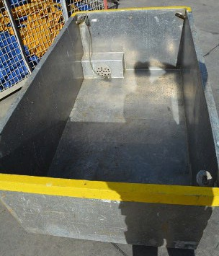
Australian Fishing Enterprises Pty Ltd (AFE) | Bin Type 2—Australian Fishing Enterprises Blue Bin  • The bin is of a style depicted in the attached photograph  • Material—Aluminium  • Outside Dimensions—2,085mm x 1,200mm x 755mm  • Internal Structures—a rectangular aluminium box with drilled holes in it extends over the bung area inside the bin  • Fill Line—filled to the top of the bin and levelled  • Tare—139 kilograms  • Identification—blue painted strip around rim of the bin  • Agreed Sardine Capacity—1,550 kilograms | 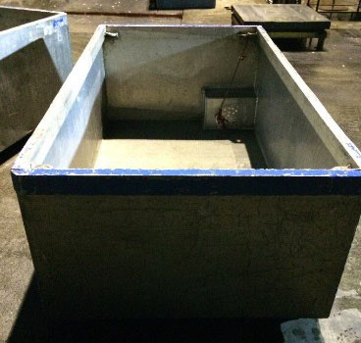
Australian Fishing Enterprises Pty Ltd (AFE) | Bin Type 3—AFE—Ex—SMF Tall Ally  • The bin is of a style depicted in the attached photograph  • Material—Aluminium  • Internal dimensions—1,800 x 1,100 x 900mm  • Fill Line—filled to the top of the bin and levelled  • Identification—Blue around rim  • Tare weight 154kg  • Agreed Sardine Capacity—1,550 kilograms | 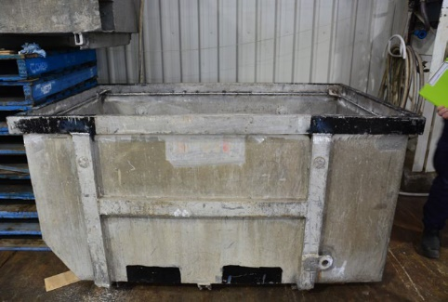
Australian Southern Exporters Pty Ltd | Bin Type 1—Grey Plastic Bin  • The bin is of a style depicted in the attached photograph  • Material—grey plastic  • Outside Dimensions—1,200mm x 1,100mm 1,200mm  • Internal Structures—Nil  • Fill Line—100mm from top of bin (catch levelled)  • Tare—95 kilograms  • Identification—grey plastic bin with lid  • Agreed Sardine Capacity—800 kilograms | 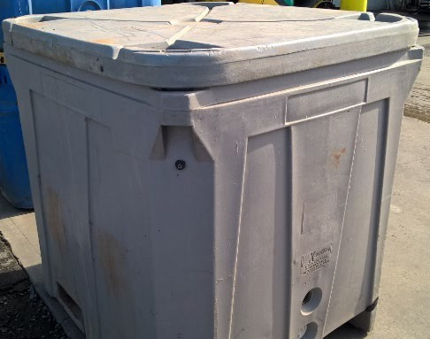
Australian Southern Exporters Pty Ltd | Bin Type 2—Blue Plastic RIFT35A bin—marked ASE  • The bin is of a style depicted in the attached photograph  • Material—blue plastic  • Outside Dimensions—1,220mm x 1,085mm x 1,275mm  • Internal Structures—Nil  • Fill Line—Fill to 5cm from top  • Tare—103 kilograms (lid on)  • Identification—blue plastic bin stencilled with ASE on side  • Agreed Sardine Capacity—800 kilograms | 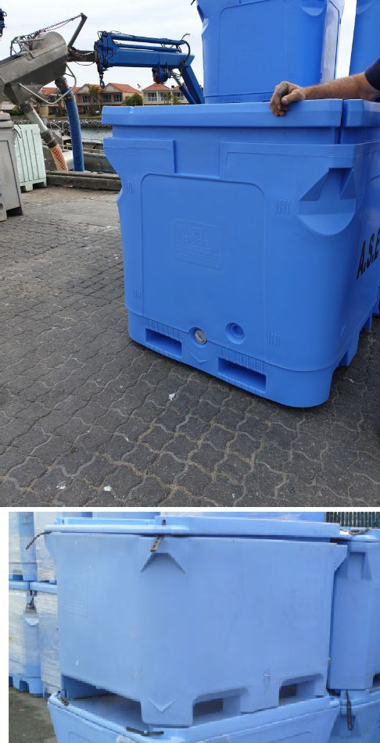
Australian Southern Exporters Pty Ltd | Bin Type 3—Blue Plastic RIFT1000 short bin—marked ASE  • The bin is of a style depicted in the attached photograph  • Material—blue plastic  • Outside Dimensions—1,470mm x 1,180mm x 965mm  • Internal Structures—Nil  • Fill Line—Fill to top  • Tare—81.5 kilograms (lid off)  • Identification—blue plastic bin stencilled with ASE on side  • Agreed Sardine Capacity—500 kilograms when used for IQF with wet fish and an ice slurry  • Agreed Sardine Capacity—850 kilograms when used for Tuna Feed
Australian Tuna Fisheries Pty Ltd | Bin Type 1—Australian Tuna Fisheries Small Bin  • The bin is of a style depicted in the attached photograph  • Material—Aluminium  • Outside Dimensions 1,190mm x 1,880mm x 700mm  • Internal Structures—square grating box in one corner  • Fill line—100mm from top of bin—welded fill line at intervals (catch levelled)  • Tare—129 kilograms  • Identification—SG welded on side of bin  • Agreed Sardine Capacity—1,000 kilograms | 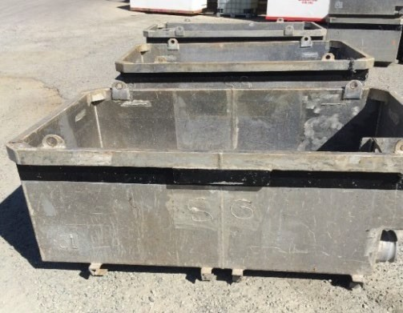
Australian Tuna Fisheries Pty Ltd | Bin Type 2—Australian Tuna Fisheries Medium Bin  • The bin is of a style depicted in the attached photograph  • Material—Aluminium  • Outside Dimensions—1,190mm x 2,080mm x 710mm  • Internal Structures—grating across one corner of the inside  of the bin  • Fill line—160mm from top of bin—welded fill line at intervals (catch levelled)  • Tare—137 kilograms  • Identification—SG welded on side of bin and the letter M stencilled on side of bin  • Agreed Sardine Capacity—1,000 kilograms | 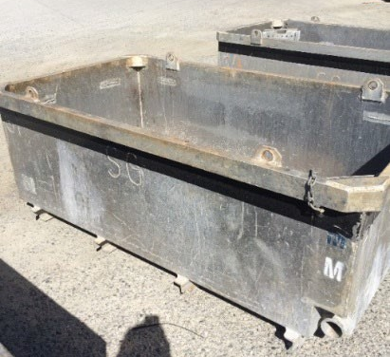
Australian Tuna Fisheries Pty Ltd | Bin Type 3—Australian Tuna Fisheries Large Bin  • The bin is of a style depicted in the attached photograph  • Material—Aluminium  • Outside Dimensions—1,190mm x 2,280mm x 710mm  • Internal Structures—grating across one corner of the inside  of the bin  • Fill Line—210mm from top of bin—welded fill line at intervals (catch levelled)  • Tare—117 kilograms  • Identification—SG welded on the side and the letter L stencilled on the bin  • Agreed Sardine Capacity—1,000 kilograms | 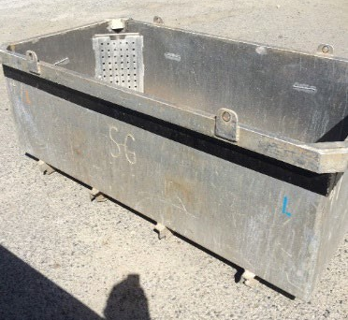
Australian Tuna Fisheries Pty Ltd | Bin Type 4—Australian Tuna Fisheries Hopper on Vessel Saxon S  • The bin is of a style depicted in the attached photograph  • Material—Aluminium  • Outside Dimensions—3,870mm x 1,510mm x 760mm.  One long side is cut down to 510mm in height  • Internal Structures—Nil  • Fill Line—to the base of the lip on the cut down side of  the bin—contents level with this position  • Tare—approximately 250 kilograms including the  hydraulic rams  • Identification—permanently fixed to deck of vessel SAXON S  • Agreed Sardine Capacity—2,000 kilograms | 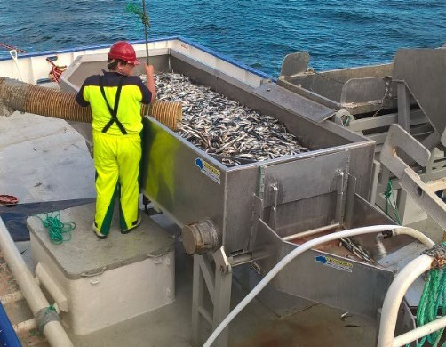
Australian Tuna Fisheries Pty Ltd | Bin Type 5—Australian Tuna Fisheries Hopper on Vessel Kingfish 1  • The bin is of a style depicted in the attached photograph  • Material—Aluminium  • Outside Dimensions—1,190mm x 2,280mm x 710mm  • Internal Structures—angled corners inside one end of the bin  • Fill Line—190mm from the top (contents levelled)  • Tare—117 kilograms  • Identification—Bin fitted with contents release hatch on one end, a “leg” affixed to each exterior corner on underside, SG welded on side of bin, black painted strip just below rim  • Agreed Sardine Capacity—1,000 kilograms | 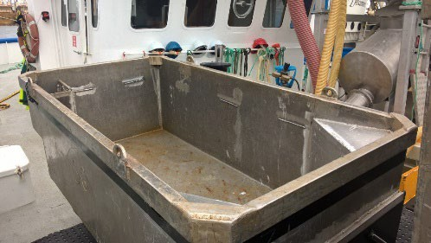
Blaslov Fishing  Pty Ltd | Bin Type 1—Blaslov Fishing Bin  • The bin is of a style depicted in the attached photograph  • Material—Aluminium  • Outside Dimensions—2,100mm x 1,200mm x 710mm  • Internal Structures—a recessed bung area in one bottom corner of the bin and internal grating the diagonally  opposite corner  • Fill Line—130mm from the top of bin, catch levelled to base of bin lugs  • Tare—110 kilograms  • Identification—BTF stencilled on long side of bin  • Agreed Sardine Capacity—1,150 kilograms | 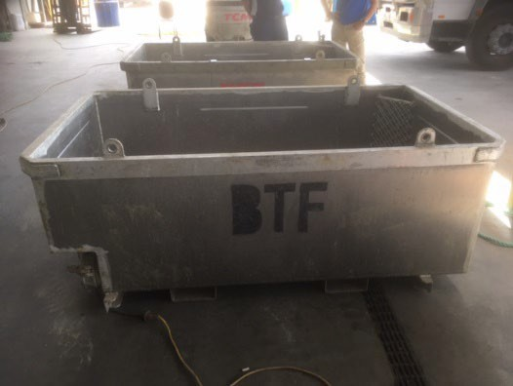
Blaslov Fishing  Pty Ltd | Bin Type 2—BFG 1150kg (Ex TTI—1250kg)  • The bin is of a style depicted in the attached photograph  • Material—Aluminium  • Outside Dimensions: 760mm x 2,000mm x 1,145mm  • Internal Structure—Nil  • Tare Weight: 138kg  • Fill line: 200mm from top  • Identification: Stamped ‘BFG’ No coloured rim.  • Agreed Sardine Capacity: 1,150kg | 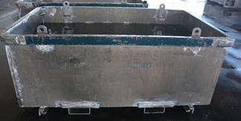
Dinko Tuna Farmers Pty Ltd | Bin Type 1—Dinko Tuna Farmers Blue Bin  • The bin is of a style depicted in the attached photograph  • Material—Aluminium  • Outside Dimensions—1,200mm x 2,520mm x 770mm  • Internal Structures—mesh insert in one corner and a small square metal box in another corner  • Fill Line—150mm from top of bin—welded fill line around interior (catch levelled)  • Tare—155 kilograms  • Identification—DTF stencilled on side of the bin, blue painted strip around rim of the bin  • Agreed Sardine Capacity—1,450 kilograms | 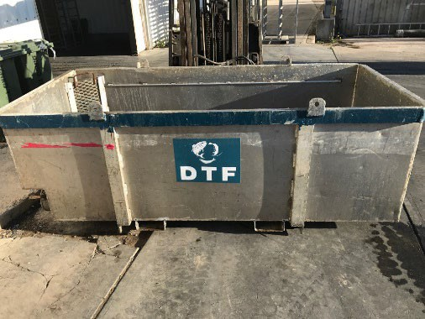
Dinko Tuna Farmers Pty Ltd | Bin Type 2—Dinko Tuna Farmers Hopper (on vessel SEATAS 3)  • The bin is of a style depicted in the attached photograph  • Material—Aluminium  • Outside Dimensions—1,200mm x 2,520mm x 770mm  • Internal Structures—mesh grating in the floor of the bin and two angled corners, release hatch one end of bin  • Fill Line—110mm from top of bin—welded fill line around interior (contents levelled)  • Tare—164 kilograms  • Identification—permanently fixed to deck of vessel SEATAS 3  • Agreed Sardine Capacity—1,500 kilograms | 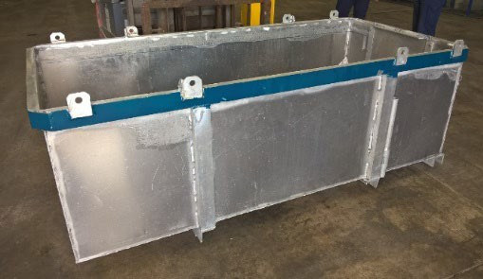
Dinko Tuna Farmers Pty Ltd | Bin Type 3—DTF 1,000kg—Blue Rim  • The bin is of a style depicted in the attached photograph  • Material—Aluminium  • Outside Dimensions: 2,200mm x 1,150mm x 715mm  • Internal Structure—Nil  • Tare Weight: 177kg  • Fill line: 300mm from the top (Welded internal line)  • Agreed Sardine Capacity: 1,000kg | 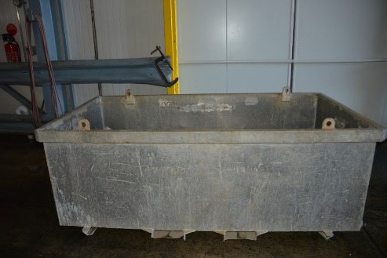
Dinko Tuna Farmers Pty Ltd | Bin Type 4—DTF 1,200kg Bin—Blue Rim  • The bin is of a style depicted in the attached photograph  • Material—Aluminium  • Outside Dimensions: 2,200mm x 1,150mm x 715mm  • Internal Structure—Nil  • Tare Weight: 177kg  • Fill line: 230mm from the top (Welded internal line)  • Agreed Sardine Capacity: 1,200kg | 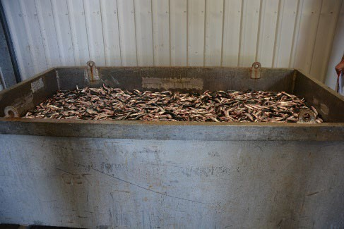
Dinko Tuna Farmers Pty Ltd | Bin Type 5—Foam Box  • The bin is of a style depicted in the attached photograph  • Material—polystyrene  • Outside Dimensions—200mm x 490mm x 340mm  • Internal Structures—Plastic bin liner and ice around liner  • Fill Line—3cm from top  • Tare—2.6kg  • Identification—white foam box  • Agreed Sardine Capacity—10 kilograms | 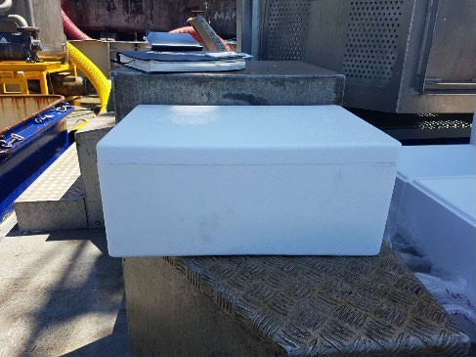
Marnikol Fisheries Pty Ltd | Bin Type 1—Blue and Yellow Plastic Bins  • The bin is of a style depicted in the attached photograph  • Material—Plastic  • Outside Dimensions—1,455mm x 1,130mm x 900mm  • Internal Structures—Nil  • Fill line—Fill to the top  • Tare—105 kilograms  • Identification—Blue or yellow in colour and constructed from Plastic  • Agreed Sardine Capacity—800 kilograms when used to receive tuna feed and 500 kilograms when used to receive IQF Sardines | 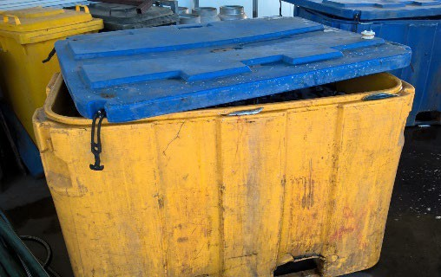
Marnikol Fisheries Pty Ltd | Bin Type 2—Grey Plastic Bins  • The bin is of a style depicted in the attached photograph  • Material—Plastic  • Outside Dimensions—1,200mm x 1,100mm x 1,200mm  • Internal Structures—Nil  • Fill line—Fill to the top  • Tare—95 kilograms  • Identification—Grey and made of Plastic  • Agreed Sardine Capacity—900 kilograms when used to receive tuna feed and 500 kilograms when used to receive IQF Sardines | 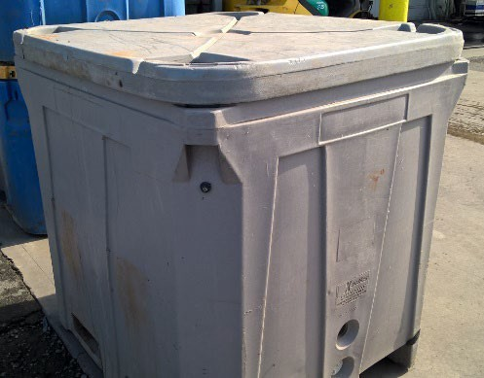
Marnikol Fisheries Pty Ltd | Bin Type 3—Marnikol Ally Bin  • The bin is of a style depicted in the attached photograph  • Material—Aluminium  • Outside Dimensions—1,180mm x 1,940mm x 760mm  • Internal Structures—Mesh grating across one corner  • Fill Line—80mm from top  • Tare—159 kilograms  • Identification—MARNIKOL stencilled on the side of the bin  • Agreed Sardine Capacity—1,200 kilograms | 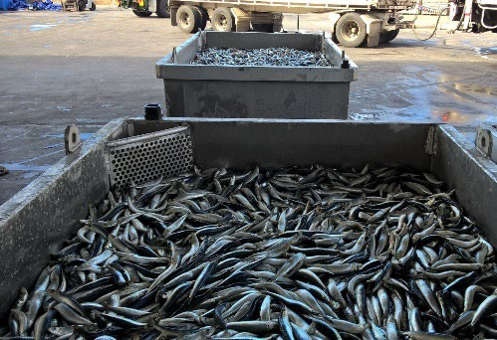
Marnikol Fisheries Pty Ltd | Bin Type 4—AJKA Bin  • The bin is of a style depicted in the attached photograph  • Material—Aluminium  • Outside Dimensions—1,180mm x 1,920mm x 840mm  • Internal Structures—internal bin drain structures  • Fill line—160mm from top  • Tare—141 kilograms  • Identification—AJKA and bin number welded on end of  the bin  • Agreed Sardine Capacity—1200 kilograms | 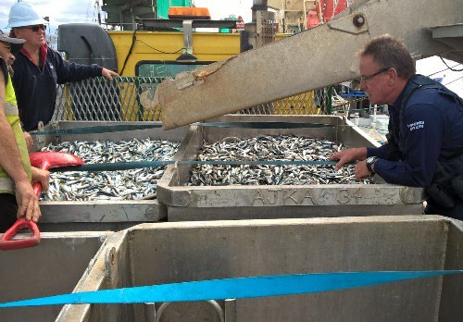
Marnikol Fisheries Pty Ltd | Bin Type 5—Blue plastic RIFT35A bin  • The bin is of a style depicted in the attached photograph  • Material—blue plastic  • Outside Dimensions—1,220mm x 1,085mm x 1,275mm  • Internal Structures—Nil  • Fill Line—Fill to top  • Tare—103 kilograms  • Identification—blue plastic bin stencilled with ASE on side  • Agreed Sardine Capacity—Tuna Feed—800 kilograms  • Agreed Sardine Capacity—IQF/Ice Slurry—500 kilograms | 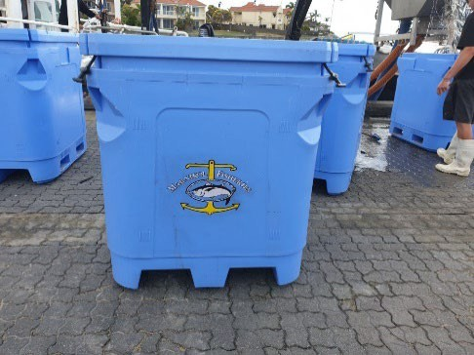
AFE | Bin Type 4—AFE  • The bin is of a style depicted in the attached photograph  • Material—Aluminium  • Outside Dimensions—1,820mm x 1,180mm x 830mm  • Internal Structures—Nil  • Fill line to top of bin.  • Identification—Blue Painted Top Rim  • Agreed Sardine Capacity—1,550 kilograms | 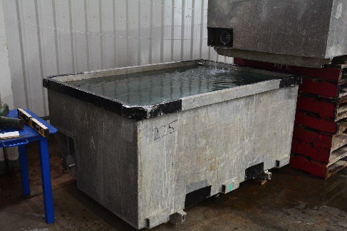
AFE | Bin Type 5—AFE  • The bin is of a style depicted in the attached photograph  • Material—Aluminium  • Outside Dimensions—1,830mm x 1,160mm x 830mm  • Internal Structures—Nil  • Fill line—Filled to Top  • Identification—Blue Painted Top Rim  • Agreed Sardine Capacity—1,550 kilograms | 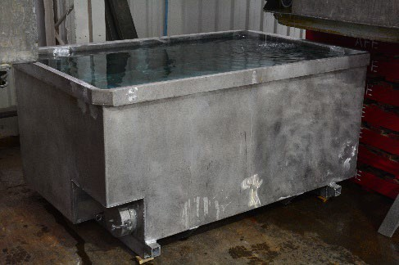
Sekol Farmed Tuna Pty Ltd | Bin Type 1—Sekol Steel Bin  • The bin is of a style depicted in the attached photograph  • Material—Steel  • Outside Dimensions—2,100mm x 1,240mm x 700mm  • Internal Structures—a mesh grate extends over the bung area inside the bin  • Fill Line—150mm from the top of bin (contents levelled)  • Tare—250 kilograms  • Identification—SEKOL stencilled on side of bin  • Agreed Sardine Capacity—1,000 kilograms | 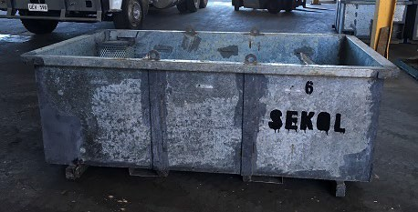
Sekol Farmed Tuna Pty Ltd | Bin Type 2—Sekol Ally Bin  • The bin is of a style depicted in the attached photograph  • Material—Aluminium  • Outside Dimensions—1,930mm x 1,190mm x 830mm  • Internal Structures—a mesh grate extends over the bung area inside the bin  • Fill Line—260mm from top of bin (contents levelled)  • Tare—132 kilograms  • Identification—SEKOL stencilled on side of bin  • Agreed Sardine Capacity—1,000 kilograms | 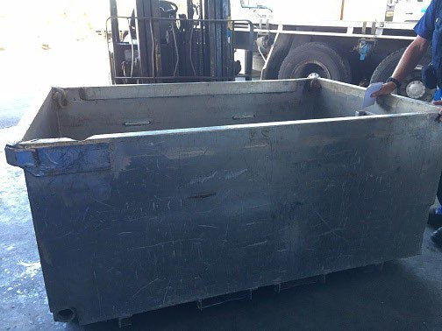
Blaslov Fishing Group | Bin Type 1—TTI  • The bin is of a style depicted in the attached photograph  • Material—Aluminium  • Outside Dimensions—2,200mm x 1,150mm x 770mm  • Internal Structures—mesh across one corner  • Fill Line—240mm from the top of bin, catch levelled,  metal railing affixed along long sides of bin  • Tare—136 kilograms  • Identification—TTI and 1,250kg stencilled on side of bin,  teal colour around rim of bin  • Agreed Sardine Capacity—1,250 kilograms | 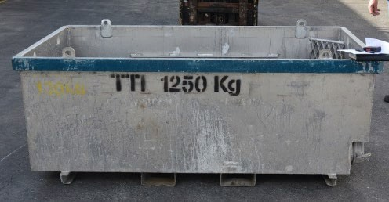
Blaslov Fishing Group | Bin Type 2—TTI s (Smaller Bin)  • The bin is of a style depicted in the attached photograph  • Material—Aluminium  • Outside Dimensions—2,200mm x 1,150mm x 700mm  • Internal Structures—mesh across one corner  • Fill Line—160mm from the top of bin, catch levelled,  metal railing affixed along long sides of bin  • Tare—138 kilograms  • Identification—TTI and 1,250kg stencilled on side of bin,  teal colour around rim of bin  • Agreed Sardine Capacity—1,250 kilograms | 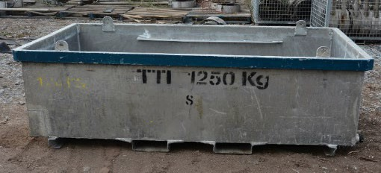
Peter White | Bin Type 1—Large White Plastic Bin—marked L  • The bin is of a style depicted in the attached photograph  • Material—white plastic  • Outside Dimension—860 h x 1,160 w x 1450 d (mm)  • Internal Structures—Nil  • Fill Line—Fill to 16cm from top  • Tare—u/k  • Identification—White bin marked with White Fisheries and letter L  • Agreed Sardine Capacity—IQF/Ice Slurry—500 kilograms | 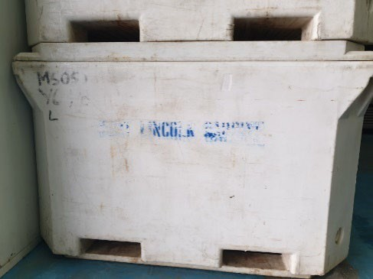
Peter White | Bin Type 2—Small White Plastic Bin—marked S  • The bin is of a style depicted in the attached photograph  • Material—white plastic (TUB 660)  • Outside Dimensions—780 h x 1300 w x 1,220 d (mm)  • Internal Structures—Nil  • Fill Line—Fill to 14 cm from top  • Tare—60kg (lid off)  • Identification—White bin marked with White Fisheries and letter S  • Agreed Sardine Capacity—IQF/Ice Slurry—400 kilograms | 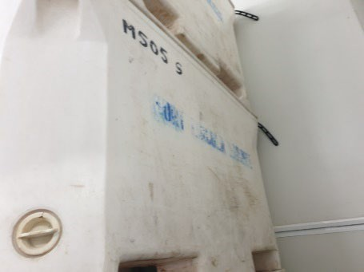

Fisheries Management Act 2007
Section 79
Temporary Prohibition of the Taking of Rock Lobster without Marking the Tail Fan
Pursuant to Section 79 of the Fisheries Management Act 2007, I Professor Gavin Begg, Executive Director Fisheries and Aquaculture, delegate of the Minister for Primary Industries and Regional Development, hereby declare that it shall be unlawful for any unlicensed person to engage in the class of fishing activities specified in Schedule 1 during the period specified in Schedule 2.
Schedule 1
1. The taking of Eastern Rock Lobster (Sagmariasus verreauxi) or Western Rock Lobster (Panulirus cygnus) from waters of the state unless:
(a) the middle tail fan has been clipped in half horizontally across the tail and removed, before the rock lobster is brought ashore or landed; or
(b) a round hole, no less than 10 mm in diameter, has been punched in the distal end of the middle tail fan, before the rock lobster is brought ashore or landed.
Schedule 2
From 0600 hours on 1 October 2025 until 31 May 2026.
Dated: 29 September 2025
Professor Gavin Begg
Executive Director
Fisheries and Aquaculture
Delegate of the Minister for Primary Industries and Regional Development

Fisheries Management Act 2007
Section 115
Ministerial Exemption: ME9903383
Take notice that pursuant to Section 115 of the Fisheries Management Act 2007, Mr Julian Arriagada of Charles Sturt University, 386 Elizabeth Mitchell Drive, Thurgoona NSW 2640 (the ′exemption holder′) and his nominated agents, are exempt from Section 70 of the Fisheries Management Act 2007, Regulation 5, and Clauses 40, 42, and 74 of Schedule 6 of the Fisheries Management (General) Regulations 2017 but only insofar as the exemption holder may fish in waters described in Schedule 1, for the purpose and using the equipment described in Schedule 2, and subject to the conditions set out in Schedule 3, from 26 September 2025 until 25 September 2026, unless varied or revoked earlier.
Schedule 1
Sites within the River Murray Proper, limited a 5 km radius upstream or downstream of:
• Site 1: 33°59′50.5″S, 140°53′22.0″E (GDA94)
• Site 2: 34°05′23.7″S, 140°47′52.2″E (GDA94)
• Site 3: 34°21′33.1″S, 140°32′24.2″E (GDA94)
• Site 4: 34°06′13.1″S, 139°56′56.0″E (GDA94)
• Site 5: 34°08′39.5″S, 139°39′10.1″E (GDA94)
• Site 6: 34°16′13.6″S, 139°38′01.4″E (GDA94)
Schedule 2
The following equipment is permitted for the use for the purpose of the PhD research project ′Drivers of population dynamics of Murray-Darling Basin bony herring (Nematalosa erebi)′:
• A maximum of 1x seine net (10m length, 2m drop, 6mm mesh)
• A maximum of 4x single-winged fyke net per site (5800mm wing, 600mm depth, 580mm ring entrance, 30mm mesh)
• A maximum of 2x double winged fyke net per site (2100mm wing, 1000mm depth, 380 ring entrance, 2mm mesh)
• A maximum of 1x dip net (30cm wide, 30cm deep).
Schedule 3
1. The exemption holder will be deemed responsible for the conduct of all persons undertaking the exempted activities under this notice. Any person conducting activities under this exemption must be provided a copy of this notice, which they must have signed as an indication that they have read and understood the conditions under it.
2. A maximum of 105 live Bony Herring (Nematalosa erebi) and a maximum of 15 naturally deceased Bony Herring may be collected under this exemption.
3. Other than the fish listed in condition 2 that may be retained, all native fish taken pursuant to the exempted activity must be returned to the water in the locations where they were captured.
4. All non-native species of fish caught during the exempted activity must be destroyed and disposed of appropriately.
5. Any gear types listed in Schedule 2 that are left overnight are required to be buoyed with a 2L white float if set away from the bank of the locations listed in Schedule 2 and tagged with the exemption holder′s name and Ministerial exemption number.
6. The following person is a nominated agent under this exemption ME9903383:
• Paul Humphries—Charles Sturt University, Thurgoona, NSW, 2460.
7. The exemption holder must notify the Department of Primary Industries and Regions (PIRSA) Fishwatch on 1800 065 522 at least 2 hours prior to conducting any exempted activities and answer a series of questions about the exempted activity. The exemption holder will need to have a copy of the exemption notice at the time of making the call and be able to provide information about the area and time of the exempted activity, the vehicles and bats involved, the number of agents undertaking the exempted activity and other related questions.
8. The exemption holder must provide a written report detailing the outcomes of the collection of organisms within pursuant to this notice to PIRSA, Fisheries and Aquaculture, (PIRSA.Ministerialexemptionsandpermits@sa.gov.au) within 14 days of expiry of this notice, giving the following details:
• The date, soak time and location of collection;
• The number and types of nets used;
• The description of all species collected;
• The number of each species collected; and
• Any other relevant information.
9. While engaging in the exempted activity, the exemption holder must be in possession of a copy of this notice. Such notice must be produced to a Fisheries Officer if requested.
10. The exemption holder must not contravene or fail to comply with the Fisheries Management Act 2007 or any regulations made under that Act, except where specifically exempted by this notice.
This notice does not purport to override the provisions or operation of any other Act including, but not limited to, the River Murray Act 2003. The exemption holder and his agents must comply with any relevant regulations, permits, requirements and directions from the Department for Environment and Water when undertaking activities within a River Murray.
Dated: 25 September 2025
Professor Gavin Begg
Executive Director
Fisheries and Aquaculture
Delegate of the Minister for Primary Industries and Regional Development

Fisheries Management Act 2007
Section 115
Ministerial Exemption: ME9903396
Take notice that pursuant to Section 115 of the Fisheries Management Act 2007, I Professor Gavin Begg, Executive Director Fisheries and Aquaculture, delegate of the Minister for Primary Industries and Regional Development, hereby exempt Mr Garry Ian Warrick of 1979 Kingston Road, New Residence SA 5333, holder of River Fishery licence number R27 (the ‘exemption holder’), and his nominated agent, from Sections 53(2) and 70 of the Fisheries Management Act 2007 and Regulation 5, Schedule 6 and Schedule 7 of the Fisheries Management (General) Regulations 2017 but only insofar as the exemption holder may use the devices described in Schedule 1 (the ‘exempted activity’) to take the species specified in Schedule 2 from the areas specified in Schedule 3, subject to the conditions set out in Schedule 4, from 26 September 2025 until 25 September 2026, unless varied or revoked earlier.
Schedule 1
• 30 x gill net with a ply greater than 5, having a maximum length of 50 metres and a minimum mesh size of 10 centimetres and a maximum mesh size not exceeding 18 centimetres (“carp nets”).
• 2 x Carp Separation Cages forming part of Lock 1 in Blanchetown on the River Murray.
• 1 x Backpack electro fisher (Smith-Root LR24).
• 1 x Boat electro fisher (Smith-Root 5.0kW GPP).
Schedule 2
• European Carp (Cyprinus carpio)
• Bony Bream (Nematalosa erebi)
Schedule 3
1. The exemption holder may conduct fishing activities using the Carp nets and electro fisher gear specified in Schedule 1 in the following areas of the waters connected to the River Murray:
• Lake Bonney and connected Chambers Creek
• Wachtels Lagoon
• Spectacle Lakes and unnamed connected creek
• Yatco Lagoon
• Gurra Gurra Lakes.
2. The exemption holder may conduct fishing activities using the Carp Separation Cages which form part of Lock 1 at Blanchetown on the River Murray consistent with any requisite approvals and requirements of SA Water.
Schedule 4
1. The exemption holder must not use more than the permitted number of devices specified in Schedule 1 at any one time.
2. The exemption holder may only engage in the exempted activity when also fishing pursuant to River Fishery licence number R27 and may only use a boat to engage in the exempted activity if that boat is registered by endorsement on River Fishery licence number R27.
3. The exempted activity may only be conducted by the exemption holder or his nominated agent:
• Mr Jayden Warrick, 1979 Kingston Road, New Residence SA 5333
4. Use of the electrofisher gear must comply with guidelines set out by the Australian Code of Electrofishing Practice. All persons using the devices must be trained in accordance with these guidelines.
5. All native fish (excluding Bony Bream (Nematalosa erebi)) taken in the course of the exempted activity must be immediately returned to the water, and consistent with the Australian Code of Electrofishing Practice, when native species are encountered while electrofishing, electrofishing must be discontinued until the native species recovers and escapes.
6. Immediately prior to commencing the exempted activity, the exemption holder must contact the Department of Primary Industries and Regions (PIRSA) Fishwatch on 1800 065 522 and provide the following details:
• The licence number and person(s) conducting the activity; and
• The exact location(s) of the fishing activities; and
• The gear type and quantity being used; and
• Ministerial exemption number: ME9903396.
7. The exemption holder must ensure that the carp nets are checked and all fish removed at least once during any 24 hour period during which they are in the water. All noxious species captured during these activities must not be returned to the water and disposed of appropriately.
8. Carp nets must be removed from the water when fishing pursuant to this exemption notice ceases.
9. Where the exemption holder moves the carp nets more than 3 kilometres from the location of the nets reported to the Department under condition 6, or removes any of the nets from the river completely, the exemption holder must provide an additional report to the PIRSA Fishwatch on 1800 065 522 and either provide details as required under condition 6 of this exemption notice, or report that fishing with carp nets and carp separation cages has ceased.
10. While engaging in the exempted activity, the exemption holder and his nominated agent must be in possession of a copy of this notice. Such notice must be produced to a Fisheries Officer as requested.
11. The exemption holder must not contravene or fail to comply with the Fisheries Management Act 2007 or any regulations made under that Act, except where specifically exempted by this notice.
Dated: 25 September 2025
Professor Gavin Begg
Executive Director
Fisheries and Aquaculture
Delegate of the Minister for Primary Industries and Regional Development

Fisheries Management Act 2007
Section 115
Ministerial Exemption: ME9903397
Take notice that pursuant to Section 115 of the Fisheries Management Act 2007, Dr Bradley Moore of the Commonwealth Scientific and Industrial Research Organisation (CSIRO) 3 Castray Esplanade, Hobart, TAS, 7004 (the ‘exemption holder’) and his nominated agents, are exempt from Section 71(1)(b) and 71(2) of the Fisheries Management Act 2007 within the waters specified in Schedule 1, but only insofar as they may undertake the research activities specified in Schedule 2 (the ‘exempted activity’), subject to the conditions set out in Schedule 3, from 25 September 2025 until 30 June 2026, unless varied or revoked earlier.
Schedule 1
Waters of South Australia, excluding the Adelaide Dolphin Sanctuary, Sanctuary and Restricted Access zones of any marine park unless authorised under the Marine Parks Act 2007 and aquatic reserves unless otherwise authorised under the Fisheries Management Act 2007.
Schedule 2
1. The tagging and tissue sampling of up to a maximum of 50 White Sharks (Carcharodon carcharias).
Schedule 3
1. The exemption holder will be deemed responsible for the conduct of all persons conducting the exempted activities under this notice. Any person conducting activities under this exemption must be provided a copy of this notice, which they must have signed as an indication that they have read and understand the conditions under it.
2. The exemption holder or nominated agents may take tissue samples and/or tag up to a maximum of 50 White Shakes during the term of this notice.
3. No shark of any species may be taken from the water.
4. No sharks are to be restrained during the exempted activity.
5. For the purposes of this notice, the following persons are the nominated agents of the exemption holder:
• Mr Russell Bradford, CSIRO, Castray Esplanade, Hobart, TAS, 7004
• Ms Leah Soo, CSIRO, Castray Esplanade Hobart, Tas 7004
• Mr Richard Pillans, CSIRO, 41 Boggo Road, Dutton Park, QLD, 4102
• Dr Paul Rogers, Southern Fishery and Ecosystem Solutions, The Causeway, O’Halloran Hill, SA 5158.
6. Before undertaking the exemption activity, the exemption holder or a person acting as his agent must contact PIRSA Fishwatch on 1800 065 522 and answer a series of questions about the exemption activity. The exemption holder will need to have a copy of the exemption at the time of making the call and be able to provide information about the area and time of the exempted activity, the vehicles and/or boats involved, the number of agents undertaking the exempted activity and other related questions.
7. The exemption holder must provide a report in writing detailing the outcomes when he or his agents were in possession of White Sharks to PIRSA Fisheries and Aquaculture (GPO Box 1625, Adelaide SA 5001, or PIRSA.MinisterialExemptionsandPermits@sa.gov.au) within 30 days of the final tagging/biopsy (the exempted activity) with the following details:
• The date, time and location of the exempted activity;
• The number of samples retained;
• Any other information deemed relevant or of interest that is able to be volunteered.
8. While engaging in the exempted activity, the exemption holders and nominated agents must be in possession of a signed copy of this notice. Such notice must be produced to a PIRSA Fisheries Officer immediately upon request.
9. The exemption holders or agents must not contravene or fail to comply with the Fisheries Management Act 2007 or any regulations made under that Act, except where specifically exempted by this notice.
This notice does not purport to override the provisions or operation of any other Act including, but not limited to, the Marine Parks Act 2007. The exemption holder and his agents must comply with any relevant regulations, permits, requirements and directions from the Department for Environment and Water when undertaking activities within a marine park.
Dated: 24 September 2025
Professor Gavin Begg
Executive Director
Fisheries and Aquaculture
Delegate of the Minister for Primary Industries and Regional Development

Fisheries Management Act 2007
Section 115
Ministerial Exemption ME9903401
Take notice that pursuant to Section 115 of the Fisheries Management Act 2007, persons who take rock lobster in state waters (other than under a licence in respect of a rock lobster fishery) (the exemption holders) are exempt from Regulation 23 of the Fisheries Management (General) Regulations 2017 but only insofar as the exemption holder may take rock lobster without clipping the middle tail fan in half horizontally subject to the conditions specified in Schedule 1, from 0600 hours on 1 October 2025 to 31 May 2026, unless varied or revoked earlier.
Schedule 1
1. The exemption holder must mark the rock lobster by punching a round hole, no less than 10mm in diameter on the distal end of the middle tail fan of the rock lobster.
2. The hole must form a complete/closed shape on the middle tail fan of the rock lobster.
3. The exemption holder must mark the rock lobster in accordance with conditions 1 and 2 (above) before the rock lobster is brought ashore or landed.
4. The exemption holder must otherwise comply with the Fisheries Management Act 2007.
Dated: 29 September 2025
Professor Gavin Begg
Executive Director
Fisheries and Aquaculture
Delegate of the Minister for Primary Industries and Regional Development

Housing Improvement Act 2016
Rent Control
In the exercise of the powers conferred by the Housing Improvement Act 2016, the Delegate of the Minister for Housing and Urban Development hereby fixes the maximum rental amount per week that shall be payable subject to Section 55 of the Residential Tenancies Act 1995, in respect of each premises described in the following table. The amount shown in the said table shall come into force on the date of this publication in the Gazette.
Address of Premises | Allotment Section | Certificate of Title  Volume/Folio | Maximum Rental per week payable
35 Third Avenue, Klemzig SA 5087 | Allotment 15 Deposited Plan 5679 Hundred of Yatala | CT5644/735 | $0.00
Dated: 2 October 2025
Craig Thompson
Housing Regulator and Registrar
Housing Safety Authority
Delegate of the Minister for Housing and Urban Development

Housing Improvement Act 2016
Rent Control Revocations
In the exercise of the powers conferred by the Housing Improvement Act 2016, the Delegate of the Minister for Housing and Urban Development hereby revokes the maximum rental amount per week that shall be payable subject to Section 55 of the Residential Tenancies Act 1995, in respect of each premises described in the following table.
Address of Premises | Allotment Section | Certificate of Title  Volume/Folio
17 Bone Street, Morphett Vale SA 5162 | Allotment 56 Deposited Plan 9217 Hundred of Noarlunga | CT5375/141
13 Stannington Avenue, Heathpool SA 5068 | Allotment 5 Filed Plan 138485 Hundred of Adelaide | CT5751/160
Unit 100, 22 Wakefield Street, Kent Town SA 5067 | Allotment 45 Filed Plan 100143 Hundred of Adelaide | CT5078/930
21 RL Gambling Road, Berri SA 5343  (AKA RL Gambling Street) | Allotment 15 Deposited Plan 25978 Hundred of Berri Irrigation Area | CT5386/475
41 Anderson Avenue, Port Noarlunga SA 5167 | Allotment 78 Filed Plan 151954 Hundred of Noarlunga | CT5760/154
47 Ellen Street, Nailsworth SA 5083 | Allotment 91 Filed Plan 206898 Hundred of Yatala | CT5435/999
26 Coglin Street, Brompton SA 5007 | Allotment 1 and 2 Deposited Plan 795 Hundred of Yatala | CT5569/885
Dated: 2 October 2025
Craig Thompson
Housing Regulator and Registrar
Housing Safety Authority
Delegate of the Minister for Housing and Urban Development

HOUSING IMPROVEMENT ACT 2016
Rent Control Variations
In the exercise of the powers conferred by the Housing Improvement Act 2016, the Delegate of the Minister for Housing and Urban Development hereby varies the maximum rental amount per week that shall be payable subject to Section 55 of the Residential Tenancies Act 1995, in respect of each premises described in the following table. The amount shown in the said table shall come into force on the date of this publication in the Gazette.
Address of Premises | Allotment Section | Certificate of Title  Volume/Folio | Reason for Variation | Maximum Rental per week payable
6 Cairns Street, Norwood SA 5067 | Allotment 84 Filed Plan 139164 Hundred of Adelaide | CT6056/880 |  | $100.00
Dated: 2 October 2025
Craig Thompson
Housing Regulator and Registrar
Housing Safety Authority
Delegate of the Minister for Housing and Urban Development

Land Acquisition Act 1969
Section 26F
Form 6B—Notice of Acquisition of Underground Land
1. Notice of acquisition
The Commissioner of Highways (the Authority), of 83 Pirie Street, Adelaide SA 5000 acquires the following interests in the following land:
An unencumbered estate in fee simple in the whole of Allotment 508 in D138162 lodged in the Lands Titles Office, being portion of the land comprised in Certificate of Title Volume 5109 Folio 472.
This notice is given under Section 26F of the Land Acquisition Act 1969.
2. Compensation not payable unless certain water infrastructure or rights are affected
You are not entitled to compensation in relation to the acquisition of the underground land to which this notice relates, unless the following conditions are satisfied:
• you held at least one of the following interests in relation to the underground land immediately before the notice of acquisition was published in relation to the land—
◦ ownership of a lawful well that provides access to underground water in the underground land, and any underground infrastructure associated with the well; or
◦ a right to take underground water from the underground land by means of such a well;
• you notified the Authority of your interest in response to a notice given under Section 26G of the Land Acquisition Act 1969;
• the acquisition of the underground land either—
◦ involved the acquisition of your interest; or
◦ resulted in the discharge of your interest; or
◦ resulted in you being unable to take water by means of, or pursuant to, your interest;
• you make an application for compensation to the Authority under Section 26H of the Land Acquisition Act 1969.
3. Application for compensation under Section 26H
If you believe you are entitled to compensation, you must apply to the Authority for compensation within 6 months after the publication of the notice of acquisition in relation to the underground land to which this notice relates.
The application must be in the following manner and form:
“Application for Compensation for Acquisition of Underground Land” (enclosed) to be submitted by email to DIT.ULAapplications@sa.gov.au or by mail marked attention: Property Acquisition c/- GPO Box 1533, Adelaide SA 5001.
The application must be accompanied by the following information or documents:
Any relevant supporting documentation including, but not limited to water licences, bore licences etc.
After receiving your application, the Authority may (but is not required to) make you a written offer of compensation not exceeding $50,000.
See Section 26H(4) of the Land Acquisition Act 1969 for further details on the payment of compensation.
4. Inquiries
Inquiries should be directed to: T2D Project Team
GPO Box 1533
Adelaide SA 5001
Telephone: 1800 572 414
Dated: 29 September 2025
The Common Seal of the COMMISSIONER OF HIGHWAYS was hereto affixed by authority of the Commissioner in the presence of:
Rocco Caruso
Director, Property Acquisition
(Authorised Officer)
Department for Infrastructure and Transport
DIT: 2024/07219/01

Land Acquisition Act 1969
Section 26F
Form 6B—Notice of Acquisition of Underground Land
1. Notice of acquisition
The Commissioner of Highways (the Authority), of 83 Pirie Street, Adelaide SA 5000 acquires the following interests in the following land:
An unencumbered estate in fee simple in the whole of Allotment 510 in D138163 lodged in the Lands Titles Office, being portion of the land comprised in Certificate of Title Volume 5108 Folio 646.
This notice is given under Section 26F of the Land Acquisition Act 1969.
2. Compensation not payable unless certain water infrastructure or rights are affected
You are not entitled to compensation in relation to the acquisition of the underground land to which this notice relates, unless the following conditions are satisfied:
• you held at least one of the following interests in relation to the underground land immediately before the notice of acquisition was published in relation to the land—
◦ ownership of a lawful well that provides access to underground water in the underground land, and any underground infrastructure associated with the well; or
◦ a right to take underground water from the underground land by means of such a well;
• you notified the Authority of your interest in response to a notice given under Section 26G of the Land Acquisition Act 1969;
• the acquisition of the underground land either—
◦ involved the acquisition of your interest; or
◦ resulted in the discharge of your interest; or
◦ resulted in you being unable to take water by means of, or pursuant to, your interest;
• you make an application for compensation to the Authority under Section 26H of the Land Acquisition Act 1969.
3. Application for compensation under Section 26H
If you believe you are entitled to compensation, you must apply to the Authority for compensation within 6 months after the publication of the notice of acquisition in relation to the underground land to which this notice relates.
The application must be in the following manner and form:
“Application for Compensation for Acquisition of Underground Land” (enclosed) to be submitted by email to DIT.ULAapplications@sa.gov.au or by mail marked attention: Property Acquisition c/- GPO Box 1533, Adelaide SA 5001.
The application must be accompanied by the following information or documents:
Any relevant supporting documentation including, but not limited to water licences, bore licences etc.
After receiving your application, the Authority may (but is not required to) make you a written offer of compensation not exceeding $50,000.
See Section 26H(4) of the Land Acquisition Act 1969 for further details on the payment of compensation.
4. Inquiries
Inquiries should be directed to: T2D Project Team
GPO Box 1533
Adelaide SA 5001
Telephone: 1800 572 414
Dated: 29 September 2025
The Common Seal of the COMMISSIONER OF HIGHWAYS was hereto affixed by authority of the Commissioner in the presence of:
Rocco Caruso
Director, Property Acquisition
(Authorised Officer)
Department for Infrastructure and Transport
DIT: 2024/07222/01

Land Acquisition Act 1969
Section 26F
Form 6B—Notice of Acquisition of Underground Land
1. Notice of acquisition
The Commissioner of Highways (the Authority), of 83 Pirie Street, Adelaide SA 5000 acquires the following interests in the following land:
An unencumbered estate in fee simple in the whole of Allotment 604 in D138167 lodged in the Lands Titles Office, being portion of the land comprised in Certificate of Title Volume 5108 Folio 647.
This notice is given under Section 26F of the Land Acquisition Act 1969.
2. Compensation not payable unless certain water infrastructure or rights are affected
You are not entitled to compensation in relation to the acquisition of the underground land to which this notice relates, unless the following conditions are satisfied:
• you held at least one of the following interests in relation to the underground land immediately before the notice of acquisition was published in relation to the land—
◦ ownership of a lawful well that provides access to underground water in the underground land, and any underground infrastructure associated with the well; or
◦ a right to take underground water from the underground land by means of such a well;
• you notified the Authority of your interest in response to a notice given under Section 26G of the Land Acquisition Act 1969;
• the acquisition of the underground land either—
◦ involved the acquisition of your interest; or
◦ resulted in the discharge of your interest; or
◦ resulted in you being unable to take water by means of, or pursuant to, your interest;
• you make an application for compensation to the Authority under Section 26H of the Land Acquisition Act 1969.
3. Application for compensation under Section 26H
If you believe you are entitled to compensation, you must apply to the Authority for compensation within 6 months after the publication of the notice of acquisition in relation to the underground land to which this notice relates.
The application must be in the following manner and form:
“Application for Compensation for Acquisition of Underground Land” (enclosed) to be submitted by email to DIT.ULAapplications@sa.gov.au or by mail marked attention: Property Acquisition c/- GPO Box 1533, Adelaide SA 5001.
The application must be accompanied by the following information or documents:
Any relevant supporting documentation including, but not limited to water licences, bore licences etc.
After receiving your application, the Authority may (but is not required to) make you a written offer of compensation not exceeding $50,000.
See Section 26H(4) of the Land Acquisition Act 1969 for further details on the payment of compensation.
4. Inquiries
Inquiries should be directed to: T2D Project Team
GPO Box 1533
Adelaide SA 5001
Telephone: 1800 572 414
Dated: 29 September 2025
The Common Seal of the COMMISSIONER OF HIGHWAYS was hereto affixed by authority of the Commissioner in the presence of:
Rocco Caruso
Director, Property Acquisition
(Authorised Officer)
Department for Infrastructure and Transport
DIT: 2024/07232/01

Land Acquisition Act 1969
Section 26F
Form 6B—Notice of Acquisition of Underground Land
1. Notice of acquisition
The Commissioner of Highways (the Authority), of 83 Pirie Street, Adelaide SA 5000 acquires the following interests in the following land:
An unencumbered estate in fee simple in the whole of Allotment 708 in D138171 lodged in the Lands Titles Office, being portion of the land comprised in Certificate of Title Volume 5506 Folio 745.
This notice is given under Section 26F of the Land Acquisition Act 1969.
2. Compensation not payable unless certain water infrastructure or rights are affected
You are not entitled to compensation in relation to the acquisition of the underground land to which this notice relates, unless the following conditions are satisfied:
• you held at least one of the following interests in relation to the underground land immediately before the notice of acquisition was published in relation to the land—
◦ ownership of a lawful well that provides access to underground water in the underground land, and any underground infrastructure associated with the well; or
◦ a right to take underground water from the underground land by means of such a well;
• you notified the Authority of your interest in response to a notice given under Section 26G of the Land Acquisition Act 1969;
• the acquisition of the underground land either—
◦ involved the acquisition of your interest; or
◦ resulted in the discharge of your interest; or
◦ resulted in you being unable to take water by means of, or pursuant to, your interest;
• you make an application for compensation to the Authority under Section 26H of the Land Acquisition Act 1969.
3. Application for compensation under Section 26H
If you believe you are entitled to compensation, you must apply to the Authority for compensation within 6 months after the publication of the notice of acquisition in relation to the underground land to which this notice relates.
The application must be in the following manner and form:
“Application for Compensation for Acquisition of Underground Land” (enclosed) to be submitted by email to DIT.ULAapplications@sa.gov.au or by mail marked attention: Property Acquisition c/- GPO Box 1533, Adelaide SA 5001.
The application must be accompanied by the following information or documents:
Any relevant supporting documentation including, but not limited to water licences, bore licences etc.
After receiving your application, the Authority may (but is not required to) make you a written offer of compensation not exceeding $50,000.
See Section 26H(4) of the Land Acquisition Act 1969 for further details on the payment of compensation.
4. Inquiries
Inquiries should be directed to: T2D Project Team
GPO Box 1533
Adelaide SA 5001
Telephone: 1800 572 414
Dated: 29 September 2025
The Common Seal of the COMMISSIONER OF HIGHWAYS was hereto affixed by authority of the Commissioner in the presence of:
Rocco Caruso
Director, Property Acquisition
(Authorised Officer)
Department for Infrastructure and Transport
DIT: 2024/07254/01

Land Acquisition Act 1969
Section 26F
Form 6B—Notice of Acquisition of Underground Land
1. Notice of acquisition
The Commissioner of Highways (the Authority), of 83 Pirie Street, Adelaide SA 5000 acquires the following interests in the following land:
An unencumbered estate in fee simple in the whole of Allotment 710 in D138172 lodged in the Lands Titles Office, being portion of the land comprised in Certificate of Title Volume 5797 Folio 969.
This notice is given under Section 26F of the Land Acquisition Act 1969.
2. Compensation not payable unless certain water infrastructure or rights are affected
You are not entitled to compensation in relation to the acquisition of the underground land to which this notice relates, unless the following conditions are satisfied:
• you held at least one of the following interests in relation to the underground land immediately before the notice of acquisition was published in relation to the land—
◦ ownership of a lawful well that provides access to underground water in the underground land, and any underground infrastructure associated with the well; or
◦ a right to take underground water from the underground land by means of such a well;
• you notified the Authority of your interest in response to a notice given under Section 26G of the Land Acquisition Act 1969;
• the acquisition of the underground land either—
◦ involved the acquisition of your interest; or
◦ resulted in the discharge of your interest; or
◦ resulted in you being unable to take water by means of, or pursuant to, your interest;
• you make an application for compensation to the Authority under Section 26H of the Land Acquisition Act 1969.
3. Application for compensation under Section 26H
If you believe you are entitled to compensation, you must apply to the Authority for compensation within 6 months after the publication of the notice of acquisition in relation to the underground land to which this notice relates.
The application must be in the following manner and form:
“Application for Compensation for Acquisition of Underground Land” (enclosed) to be submitted by email to DIT.ULAapplications@sa.gov.au or by mail marked attention: Property Acquisition c/- GPO Box 1533, Adelaide SA 5001.
The application must be accompanied by the following information or documents:
Any relevant supporting documentation including, but not limited to water licences, bore licences etc.
After receiving your application, the Authority may (but is not required to) make you a written offer of compensation not exceeding $50,000.
See Section 26H(4) of the Land Acquisition Act 1969 for further details on the payment of compensation.
4. Inquiries
Inquiries should be directed to: T2D Project Team
GPO Box 1533
Adelaide SA 5001
Telephone: 1800 572 414
Dated: 29 September 2025
The Common Seal of the COMMISSIONER OF HIGHWAYS was hereto affixed by authority of the Commissioner in the presence of:
Rocco Caruso
Director, Property Acquisition
(Authorised Officer)
Department for Infrastructure and Transport
DIT: 2024/07256/01

Land Acquisition Act 1969
Section 26F
Form 6B—Notice of Acquisition of Underground Land
1. Notice of acquisition
The Commissioner of Highways (the Authority), of 83 Pirie Street, Adelaide SA 5000 acquires the following interests in the following land:
An unencumbered estate in fee simple in the whole of Allotment 712 in D138173 lodged in the Lands Titles Office, being portion of the land comprised in Certificate of Title Volume 5456 Folio 204.
This notice is given under Section 26F of the Land Acquisition Act 1969.
2. Compensation not payable unless certain water infrastructure or rights are affected
You are not entitled to compensation in relation to the acquisition of the underground land to which this notice relates, unless the following conditions are satisfied:
• you held at least one of the following interests in relation to the underground land immediately before the notice of acquisition was published in relation to the land—
◦ ownership of a lawful well that provides access to underground water in the underground land, and any underground infrastructure associated with the well; or
◦ a right to take underground water from the underground land by means of such a well;
• you notified the Authority of your interest in response to a notice given under Section 26G of the Land Acquisition Act 1969;
• the acquisition of the underground land either—
◦ involved the acquisition of your interest; or
◦ resulted in the discharge of your interest; or
◦ resulted in you being unable to take water by means of, or pursuant to, your interest;
• you make an application for compensation to the Authority under Section 26H of the Land Acquisition Act 1969.
3. Application for compensation under Section 26H
If you believe you are entitled to compensation, you must apply to the Authority for compensation within 6 months after the publication of the notice of acquisition in relation to the underground land to which this notice relates.
The application must be in the following manner and form:
“Application for Compensation for Acquisition of Underground Land” (enclosed) to be submitted by email to DIT.ULAapplications@sa.gov.au or by mail marked attention: Property Acquisition c/- GPO Box 1533, Adelaide SA 5001.
The application must be accompanied by the following information or documents:
Any relevant supporting documentation including, but not limited to water licences, bore licences etc.
After receiving your application, the Authority may (but is not required to) make you a written offer of compensation not exceeding $50,000.
See Section 26H(4) of the Land Acquisition Act 1969 for further details on the payment of compensation.
4. Inquiries
Inquiries should be directed to: T2D Project Team
GPO Box 1533
Adelaide SA 5001
Telephone: 1800 572 414
Dated: 30 September 2025
The Common Seal of the COMMISSIONER OF HIGHWAYS was hereto affixed by authority of the Commissioner in the presence of:
Rocco Caruso
Director, Property Acquisition
(Authorised Officer)
Department for Infrastructure and Transport
DIT: 2024/07265/01

Land Acquisition Act 1969
Section 26F
Form 6B—Notice of Acquisition of Underground Land
1. Notice of acquisition
The Commissioner of Highways (the Authority), of 83 Pirie Street, Adelaide SA 5000 acquires the following interests in the following land:
An unencumbered estate in fee simple in the whole of Allotment 271 in D138702 lodged in the Lands Titles Office, being portion of the land comprised in Certificate of Title Volume 5146 Folio 595.
This notice is given under Section 26F of the Land Acquisition Act 1969.
2. Compensation not payable unless certain water infrastructure or rights are affected
You are not entitled to compensation in relation to the acquisition of the underground land to which this notice relates, unless the following conditions are satisfied:
• you held at least one of the following interests in relation to the underground land immediately before the notice of acquisition was published in relation to the land—
◦ ownership of a lawful well that provides access to underground water in the underground land, and any underground infrastructure associated with the well; or
◦ a right to take underground water from the underground land by means of such a well;
• you notified the Authority of your interest in response to a notice given under Section 26G of the Land Acquisition Act 1969;
• the acquisition of the underground land either—
◦ involved the acquisition of your interest; or
◦ resulted in the discharge of your interest; or
◦ resulted in you being unable to take water by means of, or pursuant to, your interest;
• you make an application for compensation to the Authority under Section 26H of the Land Acquisition Act 1969.
3. Application for compensation under Section 26H
If you believe you are entitled to compensation, you must apply to the Authority for compensation within 6 months after the publication of the notice of acquisition in relation to the underground land to which this notice relates.
The application must be in the following manner and form:
“Application for Compensation for Acquisition of Underground Land” (enclosed) to be submitted by email to DIT.ULAapplications@sa.gov.au or by mail marked Attention: Property Acquisition c/- GPO Box 1533, Adelaide SA 5001.
The application must be accompanied by the following information or documents:
Any relevant supporting documentation including, but not limited to water licences, bore licences etc.
After receiving your application, the Authority may (but is not required to) make you a written offer of compensation not exceeding $50,000.
See Section 26H(4) of the Land Acquisition Act 1969 for further details on the payment of compensation.
4. Inquiries
Inquiries should be directed to: T2D Project Team
GPO Box 1533
Adelaide SA 5001
Telephone: 1800 572 414
Dated: 29 September 2025
The Common Seal of the COMMISSIONER OF HIGHWAYS was hereto affixed by authority of the Commissioner in the presence of:
Rocco Caruso
Director, Property Acquisition
(Authorised Officer)
Department for Infrastructure and Transport
DIT 2024/08098/01

Land Acquisition Act 1969
Section 26F
Form 6B—Notice of Acquisition of Underground Land
1. Notice of acquisition
The Commissioner of Highways (the Authority), of 83 Pirie Street, Adelaide SA 5000 acquires the following interests in the following land:
An unencumbered estate in fee simple in the whole of Allotment 922 in D138631 lodged in the Lands Titles Office, being portion of the land comprised in Certificate of Title Volume 5208 Folio 44.
This notice is given under Section 26F of the Land Acquisition Act 1969.
2. Compensation not payable unless certain water infrastructure or rights are affected
You are not entitled to compensation in relation to the acquisition of the underground land to which this notice relates, unless the following conditions are satisfied:
• you held at least one of the following interests in relation to the underground land immediately before the notice of acquisition was published in relation to the land—
◦ ownership of a lawful well that provides access to underground water in the underground land, and any underground infrastructure associated with the well; or
◦ a right to take underground water from the underground land by means of such a well;
• you notified the Authority of your interest in response to a notice given under Section 26G of the Land Acquisition Act 1969;
• the acquisition of the underground land either—
◦ involved the acquisition of your interest; or
◦ resulted in the discharge of your interest; or
◦ resulted in you being unable to take water by means of, or pursuant to, your interest;
• you make an application for compensation to the Authority under Section 26H of the Land Acquisition Act 1969.
3. Application for compensation under Section 26H
If you believe you are entitled to compensation, you must apply to the Authority for compensation within 6 months after the publication of the notice of acquisition in relation to the underground land to which this notice relates.
The application must be in the following manner and form:
“Application for Compensation for Acquisition of Underground Land” (enclosed) to be submitted by email to DIT.ULAapplications@sa.gov.au or by mail marked attention: Property Acquisition c/- GPO Box 1533, Adelaide SA 5001.
The application must be accompanied by the following information or documents:
Any relevant supporting documentation including, but not limited to water licences, bore licences etc.
After receiving your application, the Authority may (but is not required to) make you a written offer of compensation not exceeding $50,000.
See Section 26H(4) of the Land Acquisition Act 1969 for further details on the payment of compensation.
4. Inquiries
Inquiries should be directed to: T2D Project Team
GPO Box 1533
Adelaide SA 5001
Telephone: 1800 572 414
Dated: 29 September 2025
The Common Seal of the COMMISSIONER OF HIGHWAYS was hereto affixed by authority of the Commissioner in the presence of:
Rocco Caruso
Director, Property Acquisition
(Authorised Officer)
Department for Infrastructure and Transport
DIT 2024/08113/01

Land Acquisition Act 1969
Section 26F
Form 6B—Notice of Acquisition of Underground Land
1. Notice of acquisition
The Commissioner of Highways (the Authority), of 83 Pirie Street, Adelaide SA 5000 acquires the following interests in the following land:
An unencumbered estate in fee simple in the whole of Allotment 261 in D138701 lodged in the Lands Titles Office, being portion of the land comprised in Certificate of Title Volume 5146 Folio 596.
This notice is given under Section 26F of the Land Acquisition Act 1969.
2. Compensation not payable unless certain water infrastructure or rights are affected
You are not entitled to compensation in relation to the acquisition of the underground land to which this notice relates, unless the following conditions are satisfied:
• you held at least one of the following interests in relation to the underground land immediately before the notice of acquisition was published in relation to the land—
◦ ownership of a lawful well that provides access to underground water in the underground land, and any underground infrastructure associated with the well; or
◦ a right to take underground water from the underground land by means of such a well;
• you notified the Authority of your interest in response to a notice given under Section 26G of the Land Acquisition Act 1969;
• the acquisition of the underground land either—
◦ involved the acquisition of your interest; or
◦ resulted in the discharge of your interest; or
◦ resulted in you being unable to take water by means of, or pursuant to, your interest;
• you make an application for compensation to the Authority under Section 26H of the Land Acquisition Act 1969.
3. Application for compensation under Section 26H
If you believe you are entitled to compensation, you must apply to the Authority for compensation within 6 months after the publication of the notice of acquisition in relation to the underground land to which this notice relates.
The application must be in the following manner and form:
“Application for Compensation for Acquisition of Underground Land” (enclosed) to be submitted by email to DIT.ULAapplications@sa.gov.au or by mail marked attention: Property Acquisition c/- GPO Box 1533, Adelaide SA 5001.
The application must be accompanied by the following information or documents:
Any relevant supporting documentation including, but not limited to water licences, bore licences etc.
After receiving your application, the Authority may (but is not required to) make you a written offer of compensation not exceeding $50,000.
See Section 26H(4) of the Land Acquisition Act 1969 for further details on the payment of compensation.
4. Inquiries
Inquiries should be directed to: T2D Project Team
GPO Box 1533
Adelaide SA 5001
Telephone: 1800 572 414
Dated: 29 September 2025
The Common Seal of the COMMISSIONER OF HIGHWAYS was hereto affixed by authority of the Commissioner in the presence of:
Rocco Caruso
Director, Property Acquisition
(Authorised Officer)
Department for Infrastructure and Transport
DIT 2024/08185/01

Land Acquisition Act 1969
Section 26F
Form 6B—Notice of Acquisition of Underground Land
1. Notice of acquisition
The Commissioner of Highways (the Authority), of 83 Pirie Street, Adelaide SA 5000 acquires the following interests in the following land:
An unencumbered estate in fee simple in the whole of Allotment 611 in D138519 lodged in the Lands Titles Office, being portion of the land comprised in Certificate of Title Volume 6134 Folio 737.
This notice is given under Section 26F of the Land Acquisition Act 1969.
2. Compensation not payable unless certain water infrastructure or rights are affected
You are not entitled to compensation in relation to the acquisition of the underground land to which this notice relates, unless the following conditions are satisfied:
• you held at least one of the following interests in relation to the underground land immediately before the notice of acquisition was published in relation to the land—
◦ ownership of a lawful well that provides access to underground water in the underground land, and any underground infrastructure associated with the well; or
◦ a right to take underground water from the underground land by means of such a well;
• you notified the Authority of your interest in response to a notice given under Section 26G of the Land Acquisition Act 1969;
• the acquisition of the underground land either—
◦ involved the acquisition of your interest; or
◦ resulted in the discharge of your interest; or
◦ resulted in you being unable to take water by means of, or pursuant to, your interest;
• you make an application for compensation to the Authority under Section 26H of the Land Acquisition Act 1969.
3. Application for compensation under Section 26H
If you believe you are entitled to compensation, you must apply to the Authority for compensation within 6 months after the publication of the notice of acquisition in relation to the underground land to which this notice relates.
The application must be in the following manner and form:
“Application for Compensation for Acquisition of Underground Land” (enclosed) to be submitted by email to DIT.ULAapplications@sa.gov.au or by mail marked attention: Property Acquisition c/- GPO Box 1533, Adelaide SA 5001.
The application must be accompanied by the following information or documents:
Any relevant supporting documentation including, but not limited to water licences, bore licences etc.
After receiving your application, the Authority may (but is not required to) make you a written offer of compensation not exceeding $50,000.
See Section 26H(4) of the Land Acquisition Act 1969 for further details on the payment of compensation.
4. Inquiries
Inquiries should be directed to: T2D Project Team
GPO Box 1533
Adelaide SA 5001
Telephone: 1800 572 414
Dated: 29 September 2025
The Common Seal of the COMMISSIONER OF HIGHWAYS was hereto affixed by authority of the Commissioner in the presence of:
Rocco Caruso
Director, Property Acquisition
(Authorised Officer)
Department for Infrastructure and Transport
DIT 2024/08217/01

Land Acquisition Act 1969
Section 26F
Form 6B—Notice of Acquisition of Underground Land
1. Notice of acquisition
The Commissioner of Highways (the Authority), of 83 Pirie Street, Adelaide SA 5000acquires the following interests in the following land:
An unencumbered estate in fee simple in the whole of Allotment 291 in D138704 lodged in the Lands Titles Office, being portion of the land comprised in Certificate of Title Volume 6081 Folio 136.
This notice is given under Section 26F of the Land Acquisition Act 1969.
2. Compensation not payable unless certain water infrastructure or rights are affected
You are not entitled to compensation in relation to the acquisition of the underground land to which this notice relates, unless the following conditions are satisfied:
• you held at least one of the following interests in relation to the underground land immediately before the notice of acquisition was published in relation to the land—
◦ ownership of a lawful well that provides access to underground water in the underground land, and any underground infrastructure associated with the well; or
◦ a right to take underground water from the underground land by means of such a well;
• you notified the Authority of your interest in response to a notice given under Section 26G of the Land Acquisition Act 1969;
• the acquisition of the underground land either—
◦ involved the acquisition of your interest; or
◦ resulted in the discharge of your interest; or
◦ resulted in you being unable to take water by means of, or pursuant to, your interest;
• you make an application for compensation to the Authority under Section 26H of the Land Acquisition Act 1969.
3. Application for compensation under Section 26H
If you believe you are entitled to compensation, you must apply to the Authority for compensation within 6 months after the publication of the notice of acquisition in relation to the underground land to which this notice relates.
The application must be in the following manner and form:
“Application for Compensation for Acquisition of Underground Land” (enclosed) to be submitted by email to DIT.ULAapplications@sa.gov.au or by mail marked attention: Property Acquisition c/- GPO Box 1533, Adelaide SA 5001.
The application must be accompanied by the following information or documents:
Any relevant supporting documentation including, but not limited to water licences, bore licences etc.
After receiving your application, the Authority may (but is not required to) make you a written offer of compensation not exceeding $50,000.
See Section 26H(4) of the Land Acquisition Act 1969 for further details on the payment of compensation.
4. Inquiries
Inquiries should be directed to: T2D Project Team
GPO Box 1533
Adelaide SA 5001
Telephone: 1800 572 414
Dated: 29 September 2025
The Common Seal of the COMMISSIONER OF HIGHWAYS was hereto affixed by authority of the Commissioner in the presence of:
Rocco Caruso
Director, Property Acquisition
(Authorised Officer)
Department for Infrastructure and Transport
DIT 2024/08264/01

Land Acquisition Act 1969
Section 26F
Form 6B—Notice of Acquisition of Underground Land
1. Notice of acquisition
The Commissioner of Highways (the Authority), of 83 Pirie Street, Adelaide SA 5000 acquires the following interests in the following land:
An unencumbered estate in fee simple in the whole of Allotment 531 in D138530 lodged in the Lands Titles Office, being portion of the land comprised in Certificate of Title Volume 5707 Folio 846.
This notice is given under Section 26F of the Land Acquisition Act 1969.
2. Compensation not payable unless certain water infrastructure or rights are affected
You are not entitled to compensation in relation to the acquisition of the underground land to which this notice relates, unless the following conditions are satisfied:
• you held at least one of the following interests in relation to the underground land immediately before the notice of acquisition was published in relation to the land—
◦ ownership of a lawful well that provides access to underground water in the underground land, and any underground infrastructure associated with the well; or
◦ a right to take underground water from the underground land by means of such a well;
• you notified the Authority of your interest in response to a notice given under Section 26G of the Land Acquisition Act 1969;
• the acquisition of the underground land either—
◦ involved the acquisition of your interest; or
◦ resulted in the discharge of your interest; or
◦ resulted in you being unable to take water by means of, or pursuant to, your interest;
• you make an application for compensation to the Authority under Section 26H of the Land Acquisition Act 1969.
3. Application for compensation under Section 26H
If you believe you are entitled to compensation, you must apply to the Authority for compensation within 6 months after the publication of the notice of acquisition in relation to the underground land to which this notice relates.
The application must be in the following manner and form:
“Application for Compensation for Acquisition of Underground Land” (enclosed) to be submitted by email to DIT.ULAapplications@sa.gov.au or by mail marked attention: Property Acquisition c/- GPO Box 1533, Adelaide SA 5001.
The application must be accompanied by the following information or documents:
Any relevant supporting documentation including, but not limited to water licences, bore licences etc.
After receiving your application, the Authority may (but is not required to) make you a written offer of compensation not exceeding $50,000.
See Section 26H(4) of the Land Acquisition Act 1969 for further details on the payment of compensation.
4. Inquiries
Inquiries should be directed to: T2D Project Team
GPO Box 1533
Adelaide SA 5001
Telephone: 1800 572 414
Dated: 29 September 2025
The Common Seal of the COMMISSIONER OF HIGHWAYS was hereto affixed by authority of the Commissioner in the presence of:
Rocco Caruso
Director, Property Acquisition
(Authorised Officer)
Department for Infrastructure and Transport
DIT 2024/08293/01

Land Acquisition Act 1969
Section 26F
Form 6B—Notice of Acquisition of Underground Land
1. Notice of acquisition
The Commissioner of Highways (the Authority), of 83 Pirie Street, Adelaide SA 5000 acquires the following interests in the following land:
An unencumbered estate in fee simple in the whole of Allotment 541 in D138531 lodged in the Lands Titles Office, being portion of the land comprised in Certificate of Title Volume 5723 Folio 848.
This notice is given under Section 26F of the Land Acquisition Act 1969.
2. Compensation not payable unless certain water infrastructure or rights are affected
You are not entitled to compensation in relation to the acquisition of the underground land to which this notice relates, unless the following conditions are satisfied:
• you held at least one of the following interests in relation to the underground land immediately before the notice of acquisition was published in relation to the land—
◦ ownership of a lawful well that provides access to underground water in the underground land, and any underground infrastructure associated with the well; or
◦ a right to take underground water from the underground land by means of such a well;
• you notified the Authority of your interest in response to a notice given under Section 26G of the Land Acquisition Act 1969;
• the acquisition of the underground land either—
◦ involved the acquisition of your interest; or
◦ resulted in the discharge of your interest; or
◦ resulted in you being unable to take water by means of, or pursuant to, your interest;
• you make an application for compensation to the Authority under Section 26H of the Land Acquisition Act 1969.
3. Application for compensation under Section 26H
If you believe you are entitled to compensation, you must apply to the Authority for compensation within 6 months after the publication of the notice of acquisition in relation to the underground land to which this notice relates.
The application must be in the following manner and form:
“Application for Compensation for Acquisition of Underground Land” (enclosed) to be submitted by email to DIT.ULAapplications@sa.gov.au or by mail marked attention: Property Acquisition c/- GPO Box 1533, Adelaide SA 5001.
The application must be accompanied by the following information or documents:
Any relevant supporting documentation including, but not limited to water licences, bore licences etc.
After receiving your application, the Authority may (but is not required to) make you a written offer of compensation not exceeding $50,000.
See Section 26H(4) of the Land Acquisition Act 1969 for further details on the payment of compensation.
4. Inquiries
Inquiries should be directed to: T2D Project Team
GPO Box 1533
Adelaide SA 5001
Telephone: 1800 572 414
Dated: 29 September 2025
The Common Seal of the COMMISSIONER OF HIGHWAYS was hereto affixed by authority of the Commissioner in the presence of:
Rocco Caruso
Director, Property Acquisition
(Authorised Officer)
Department for Infrastructure and Transport
DIT 2024/08293/01

Land Acquisition Act 1969
Section 26F
Form 6B—Notice of Acquisition of Underground Land
1. Notice of acquisition
The Commissioner of Highways (the Authority), of 83 Pirie Street, Adelaide SA 5000 acquires the following interests in the following land:
An unencumbered estate in fee simple in the whole of Allotment 281 in D138703 lodged in the Lands Titles Office, being portion of the land comprised in Certificate of Title Volume 6081 Folio 135.
This notice is given under Section 26F of the Land Acquisition Act 1969.
2. Compensation not payable unless certain water infrastructure or rights are affected
You are not entitled to compensation in relation to the acquisition of the underground land to which this notice relates, unless the following conditions are satisfied:
• you held at least one of the following interests in relation to the underground land immediately before the notice of acquisition was published in relation to the land—
◦ ownership of a lawful well that provides access to underground water in the underground land, and any underground infrastructure associated with the well; or
◦ a right to take underground water from the underground land by means of such a well;
• you notified the Authority of your interest in response to a notice given under Section 26G of the Land Acquisition Act 1969;
• the acquisition of the underground land either—
◦ involved the acquisition of your interest; or
◦ resulted in the discharge of your interest; or
◦ resulted in you being unable to take water by means of, or pursuant to, your interest;
• you make an application for compensation to the Authority under Section 26H of the Land Acquisition Act 1969.
3. Application for compensation under Section 26H
If you believe you are entitled to compensation, you must apply to the Authority for compensation within 6 months after the publication of the notice of acquisition in relation to the underground land to which this notice relates.
The application must be in the following manner and form:
“Application for Compensation for Acquisition of Underground Land” (enclosed) to be submitted by email to DIT.ULAapplications@sa.gov.au or by mail marked attention: Property Acquisition c/- GPO Box 1533, Adelaide SA 5001.
The application must be accompanied by the following information or documents:
Any relevant supporting documentation including, but not limited to water licences, bore licences etc.
After receiving your application, the Authority may (but is not required to) make you a written offer of compensation not exceeding $50,000.
See Section 26H(4) of the Land Acquisition Act 1969 for further details on the payment of compensation.
4. Inquiries
Inquiries should be directed to: T2D Project Team
GPO Box 1533
Adelaide SA 5001
Telephone: 1800 572 414
Dated: 29 September 2025
The Common Seal of the COMMISSIONER OF HIGHWAYS was hereto affixed by authority of the Commissioner in the presence of:
Rocco Caruso
Director, Property Acquisition
(Authorised Officer)
Department for Infrastructure and Transport
DIT 2024/08297/01

Mental Health Act 2009
Authorised Medical Practitioner
Notice is hereby given in accordance with Section 93(1) of the Mental Health Act 2009 that the Chief Psychiatrist has determined the following person as an Authorised Medical Practitioner:
Vikram Sembhi
A determination will be automatically revoked upon the person being registered as a specialist psychiatrist with the Australian Health Practitioner Regulation Agency and as a fellow of the Royal Australian and New Zealand College of Psychiatrists.
The Chief Psychiatrist may vary or revoke this determination at any time.
Dated: 2 October 2025
Dr John Brayley
Chief Psychiatrist

Police Act 1998
Authorisation to Conduct Oral Fluid Screening
I, Grant Stevens, Commissioner of Police, do hereby notify that on and from 22 September 2025, the following persons were authorised by the Commissioner of Police to conduct oral fluid screening as defined in and for the purposes of the:
• The Police Act 1998;
• Police Regulations 2014;
PD Number | Officer Name
74611 | Kirsty Clarke
72156 | Daniel Soper
41643 | Leanne Trimboli
Dated: 27 September 2025
Grant Stevens
Commissioner of Police
Reference: 2024/1962

Police Act 1998
Authorisation to Conduct Urine Screening
I, Grant Stevens, Commissioner of Police, do hereby notify that on and from 22 September 2025, the following persons were authorised by the Commissioner of Police to conduct urine screening as defined in and for the purposes of the:
• The Police Act 1998
• Police Regulations 2014
PD Number | Officer Name
74611  72156  41643 | Kirsty Clarke  Daniel Soper  Leanne Trimboli
Dated: 27 September 2025
Grant Stevens
Commissioner of Police
Reference: 2024/1962

Real Property Act 1886
Caveat to be Lodged
Whereas the Applicant named at the foot hereof has for itself made application to have the land set forth and described before its name at the foot hereof brought under the operation of the Real Property Act 1886:
Notice is hereby given that unless caveat be lodged with the Registrar General by some person having estate or interest in the said land on or before the expiration of the period herein below for each case specified, the said land will be brought under the operation of the said Act as by law directed. Diagrams delineating this land may be inspected at the Land Titles Registration Office, Adelaide and in the offices of the several corporations or district councils in which the lands are situated.
The Schedule
No. of Application | Description of Property | Name | Residence | Date up to  and inclusive of  which caveat  may be lodged
32097 | Part Town Acre 315 (named Right of Way)  Part Town Acre 316 (named Private Road)  Hundred of Adelaide in the area named Adelaide | PFA Grote Street Pty Ltd | L6, 211 Victoria Square, Adelaide SA 5000 | 2 December 2025
Dated: 2 October 2025
B. Pike
Chief Executive Officer, Land Services SA
Acting under delegation of the Registrar-General
Pursuant to Sec. 17 of the Real Property Act 1886

Roads (Opening and Closing) Act 1991
Section 24
NOTICE OF CONFIRMATION OF
ROAD PROCESS ORDER
Road Closure—Portion of Princes Road, Greenacres
By Road Process Order made on 13 May 2025, the City of Port Adelaide Enfield ordered that:
1. Portion of Princes Road, Greenacres, situated adjoining Allotments 74, 75, 80, 85and 88 in Deposited Plan 7922, Allotment 771 in Deposited Plan 91756, Hundred of Yatala, more particularly lettered ‘A’ and ‘B’ in Preliminary Plan 24/0012 be closed.
2. Transfer the whole of the land subject to closure to Catholic Church Endowment Society Inc. in accordance with the Agreement for Transfer dated 7 May 2025entered into between the City of Port Adelaide Enfield and Catholic Church Endowment Society Inc.
On 29 September 2025 that order was confirmed by the Minister for Planning conditionally upon the deposit by the Registrar-General of Deposited Plan 137767 being the authority for the new boundaries.
Pursuant to Section 24(5) of the Roads (Opening and Closing) Act 1991, notice of the Order referred to above and its confirmation is hereby given.
Dated: 2 October 2025
B. J. Slape
Surveyor-General
2024/01827/01

Roads (Opening and Closing) Act 1991
Section 24
NOTICE OF CONFIRMATION OF
ROAD PROCESS ORDER
Road Closure—Portion of Public Road, Farrell Flat
By Road Process Order made on 19 June 2025, the Regional Council of Goyder ordered that:
1. Portion of Public Road, Farrell Flat, situated adjoining Allotment 100 in Deposited Plan 60115, more particularly lettered ‘A’ in Preliminary Plan 24/0014 be closed.
2. Transfer the whole of the land subject to closure to Ilira Pty. Ltd. (ACN: 008 202 864) and Sihero Pty. Ltd. (ACN: 060 572 269) in accordance with the Agreement for Transfer dated 17 June 2025 entered into between the Regional Council of Goyder and Ilira Pty. Ltd. (ACN: 008 202 864) and Sihero Pty. Ltd. (ACN: 060 572 269).
On 29 September 2025 that order was confirmed by the Minister for Planning conditionally upon the deposit by the Registrar-General of Deposited Plan 135930 being the authority for the new boundaries.
Pursuant to Section 24(5) of the Roads (Opening and Closing) Act 1991, notice of the order referred to above and its confirmation is hereby given.
Dated: 2 October 2025
B. J. Slape
Surveyor-General
2024/01952/01

Roads (Opening and Closing) Act 1991
Section 24
NOTICE OF CONFIRMATION OF
ROAD PROCESS ORDER
Road Opening and Closing—Crooked Lane, Moyhall
By Road Process Orders made on 6 June 2025, the Naracoorte Lucindale Council ordered that:
1. Portions of Section 214, Hundred of Robertson, more particularly delineated and numbered ‘1’ and ‘2’ in Preliminary Plan 24/0009 be opened as road.
2. Portions of Crooked Lane, Moyhall, situated adjoining Section 214, Hundred of Robertson, more particularly delineated and lettered ‘A’ and ‘B’ in Preliminary Plan 24/0009 be closed.
3. Transfer the whole of the land subject to closure to Mark Samuel Livingston Buckett in accordance with the Agreement for Exchange dated 6 June 2025entered into between the Naracoorte Lucindale Council and Mark Samuel Livingston Buckett.
On 29 September 2025 that order was confirmed by the Minister for Planning conditionally upon the deposit by the Registrar-General of Deposited Plan 137317 being the authority for the new boundaries.
Pursuant to Section 24 of the Roads (Opening and Closing) Act 1991, notice of the Order referred to above and its confirmation is hereby given.
Dated: 2 October 2025
B. J. Slape
Surveyor-General
2024/01459/01

South Australian Civil and Administrative Tribunal
SACAT Reference Number: 2025/SA002957
Notice of Exemption Before Senior Tribunal Member Candida D’Arcy
I hereby certify that on 23 September 2025, the South Australian Civil and Administrative Tribunal, on application by the Office of The Director of Public Prosecutions (SA), made the following orders for an exemption:
1. Pursuant to Section 92 of the Equal Opportunity Act 1984 the Tribunal grants the applicant exemption from the provisions of Sections 52 and 103 of that Act so as to permit it to employ a person of Aboriginal or Torres Strait Islander descent in the role of Aboriginal and Torres Strait Islander Witness Assistance Officer.
2. This exemption will expire on Saturday 23 September 2028.
Dated: 23 September 2025
Anne Lindsay
Principal Registrar
South Australian Civil and Administrative Tribunal

South Australian Housing Trust Regulations 2025
Regulation 4
Determination of Criteria for the Purposes of Affordable Housing
1. Application
This Notice applies to:
(1) assessment of applications for development approval under the PDI Act; and
(2) policies under the Planning and Design Code pursuant to the PDI Act.
2. Determination of Criteria
(1) Land or a dwelling that is the subject of an application or policy to which this Notice applies will fall within the concept of affordable housing for the purposes of Regulation 4 of the Regulations if the developer/owner of the land or dwelling has a Legally Enforceable Obligation in place to ensure:
(a) that the land or dwelling is offered for sale to an Eligible Home Buyer at or below the Price (subject to any increase to the Price approved under paragraph 2(2)) and that the offer is listed on the HomeSeeker SA website; or
(b) that the land or dwelling will be sold to an Eligible Rental Provider for the purpose of that Eligible Rental Provider making the land or dwelling available for affordable lease or rent0; or
(c) where the relevant developer/owner is an Eligible Rental Provider, that the land or dwelling will be provided for affordable lease or rent by that Eligible Rental Provider,
or the Minister otherwise determines, in the Minister’s absolute discretion, that the land or dwelling constitutes affordable housing for the purposes of Regulation 4 of the Regulations.
(2) Where the land or dwelling:
(a) has features which make it more energy efficient and environmentally sustainable; or
(b) is on a small allotment within close proximity to public transport; or
(c) is offered for sale in conjunction with a financing product that increases an Eligible Home Buyer’s purchasing capacity as outlined in the industry guidelines published from time to time by the Department for Housing and Urban Development,
(each, a “designated feature”), the developer/owner may seek approval from the Chief Executive of the Department for Housing and Urban Development, or their delegate, to increase the Price by up to 10% with respect to that land or dwelling, and up to 15% where two or more designated features have been satisfied in relation to the land or dwelling.
3. Definitions
For the purposes of this Notice:
(1) “Eligible Home Buyer” means a person:
(a) who satisfies the eligibility criteria to buy a home through HomeSeeker SA (which eligibility criteria are set out on the HomeSeeker SA website accessible at https://homeseeker.sa.gov.au/ and as updated from time to time); or
(b) who is otherwise assessed as being eligible by the Chief Executive of the Department for Housing and Urban Development, or their delegate.
(2) “Eligible Rental Provider” means:
(a) the South Australian Housing Trust; or
(b) a community housing provider (however described) that is registered under a law of, or under a scheme administered by, a State or Territory of the Commonwealth of Australia, including the Community Housing Providers National Law set out in Schedule 1 of the Community Housing Providers (National Law) (South Australia) Act 2013 (SA); or
(c) a person (natural or corporate) approved to provide affordable rental under the ‘National Rental Affordability Scheme’; or
(d) a person (natural or corporate) subject to an affordable housing facilitation agreement with a Minister, or an instrumentality of the Crown in right of the State of South Australia; or
(e) any class of persons, declared from time to time by the Minister.
(3) “HomeSeeker SA” means the state government initiative by that name which is administered by the Department for Housing and Urban Development for the purpose of helping more South Australians buy or rent an affordable property, and which is described on the HomeSeeker SA website accessible at https://homeseeker.sa.gov.au/.
(4) “Legally Enforceable Obligation” includes:
(a) a legally binding agreement entered into between the developer/owner and a Minister, instrumentality of the Crown in right of the State of South Australia or Council (constituted under the Local Government Act 1999 (SA)), and in the case of a Land Management Agreement (as defined in the PDI Act) registered against the relevant instrument of title;
(b) a condition imposed, on the direction of the Minister in accordance with Schedule 9 of the PDI Regulations, on a development authorisation granted under the PDI Act by a relevant authority (as defined in the PDI Act); and
(c) any other form of legally enforceable obligation approved by the Minister.
(5) “Minister” means the Minister responsible for administering the South Australian Housing Trust Act 1995 (SA).
(6) “PDI Act” means the Planning, Development and Infrastructure Act 2016 (SA).
(7) “PDI Regulations” means the Planning, Development and Infrastructure (General) Regulations 2017 (SA).
(8) “Price” means the affordable sale price published on the HomeSeeker SA website accessible at https://homeseeker.sa.gov.au/ and as updated from time to time.
(9) “Regulations” means the South Australian Housing Trust Regulations 2025 under the South Australian Housing Trust Act 1995 (SA).
Dated: 17 September 2025
Hon Nick Champion MP
Minister for Housing and Urban Development
Minister for Housing Infrastructure
Minister for Planning

South Australian Skills Act 2008
Part 4—Apprenticeships, Traineeships and Training Contracts
Pursuant to the provision of the South Australian Skills Act 2008, the South Australian Skills Commission (SASC) gives notice that determines the following qualification and training contract conditions for Trades or Declared Vocations, in addition to those published in past Gazette notices.
*Trade/ #Declared Vocation/ Other Occupation | Qualification Code | Qualification Title | Nominal Term of Training Contract | Probationary Period | Supervision Level Rating
Entertainment Industry Worker# | CUA30425 | Certificate III in Live Production and Technical Services | 12 months | 60 days | Medium
Entertainment Industry Worker# | CUA40425 | Certificate IV in Live Production and Technical Services | 24 months | 60 days | Medium
Entertainment Industry Worker# | CUA41225 | Certificate IV in Screen and Media | 24 months | 60 days | Medium
Entertainment Industry Worker# | CUA50825 | Diploma of Music | 36 months | 90 days | Medium
Tourism Marketing Coordinator# | SIT40125 | Certificate IV in Travel and Tourism | 36 months | 90 days | Medium
Tourism Sales Consultant# | SIT30125 | Certificate III in Tourism | 24 months | 60 days | Medium
Tourism Sales Coordinator# | SIT40125 | Certificate IV in Travel and Tourism | 36 months | 90 days | Medium
Visitor Information Officer# | SIT30125 | Certificate III in Tourism | 24 months | 60 days | Medium
Condition/s | N/A
Dated: 2 October 2025
John Evangelista
Director, Traineeship and Apprenticeship Services
South Australian Skills Commission

Summary Offences Act 1953
Declared Shopping Precinct
Declaration by Delegate of the Commissioner of Police
I, Narelle Jayne Kameniar, being the Assistant Commissioner, Operations Support Service, and acting as a delegate of the Commissioner of Police, hereby declare under Section 66ZF of the Summary Offences Act 1953 (“the Act”) as a declared shopping precinct, the following area at Adelaide that includes Rundle Street, Rundle Mall and Hindley Street and other retail shops located in the general vicinity of Rundle Street, Rundle Mall and Hindley Street and is bounded:
• To the north by North Terrace, but excluding any part of the carriageway of North Terrace;
• To the east by East Terrace, but excluding any part of the carriageway of East Terrace;
• To the south by Grenfell Street and Currie Street, but excluding any part of the carriageways of Grenfell Street and Currie Street; and
• To the west by West Terrace, but excluding any part of the carriageway of West Terrace.
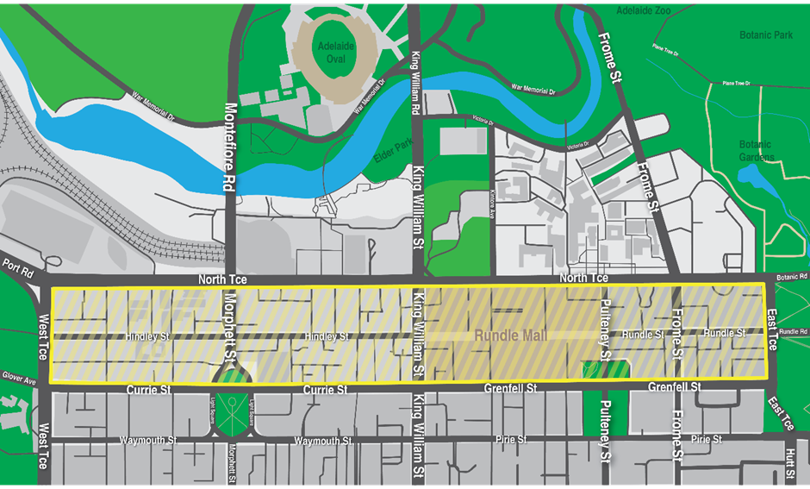
This declaration commences effect at 12:00 noon on Thursday, 2 October 2025.
I am satisfied that the declaration is necessary for the purposes of deterring or detecting the commission of offences involving the possession or use of a knife or other weapons in the shopping precinct, and that the exercise of search powers under Section 66ZB of the Act is likely to be effective in deterring or detecting the commission of offences involving the possession or use of a knife or other weapons in the shopping precinct and, further, will not unduly affect lawful activity in the shopping precinct.
This declaration will remain in effect until being revoked at such time that the Commissioner of Police (or delegate) is satisfied the grounds for this declaration are no longer met.
Dated: 2 October 2025
Narelle Jayne Kameniar
Assistant Commissioner of Police

Summary Offences Act 1953
Declared Shopping Precinct
Declaration by Delegate of the Commissioner of Police
I, Narelle Jayne Kameniar, being the Assistant Commissioner, Operations Support Service, and acting as a delegate of the Commissioner of Police, hereby declare under Section 66ZF of the Summary Offences Act 1953 (“the Act”) as a declared shopping precinct the following area at Modbury that includes Westfield Tea Tree Plaza Shopping Centre and Modbury Triangle Shopping Centre and certain other retail shops and is bounded:
• To the north by North East Road, but excluding any part of the carriageway of North East Road;
• To the east by Modbury Avenue and the eastern boundary of the car park immediately adjacent to Smart Road and the North East Busway, but excluding any part of the carriageway of Modbury Avenue; and
• To the south by Smart Road, but excluding any part of the carriageway of Smart Road.
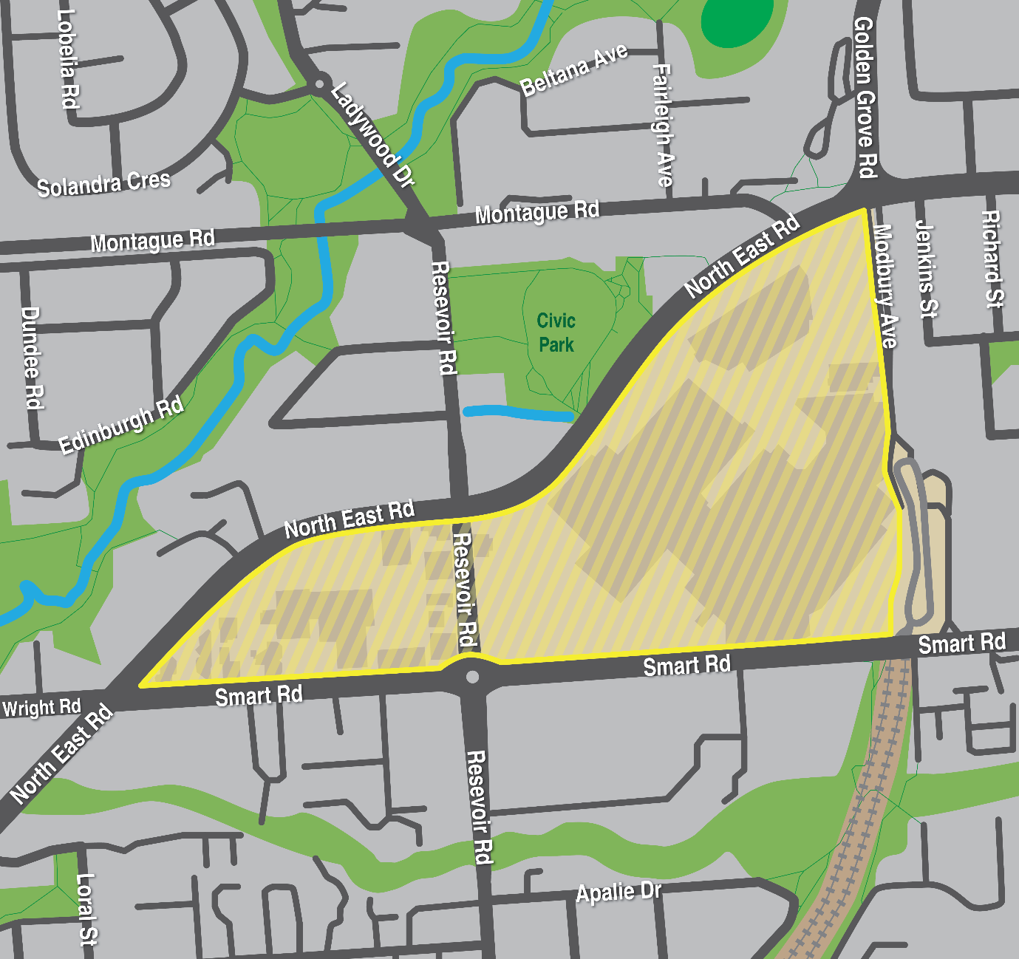
This declaration commences effect at 12:00 noon on Thursday, 2 October 2025.
I am satisfied that the declaration is necessary for the purposes of deterring or detecting the commission of offences involving the possession or use of a knife or other weapons in the shopping precinct, and that the exercise of search powers under Section 66ZB of the Act is likely to be effective in deterring or detecting the commission of offences involving the possession or use of a knife or other weapons in the shopping precinct and, further, will not unduly affect lawful activity in the shopping precinct.
This declaration will remain in effect until being revoked at such time that the Commissioner of Police (or delegate) is satisfied the grounds for this declaration are no longer met.
Dated: 2 October 2025
Narelle Jayne Kameniar
Assistant Commissioner of Police

SUMMARY OFFENCES ACT 1953
Declared Shopping Precinct
Declaration by Delegate of the Commissioner of Police
I, Narelle Jayne Kameniar, being the Assistant Commissioner, Operations Support Service, and acting as a delegate of the Commissioner of Police, hereby declare under Section 66ZF of the Summary Offences Act 1953 (“the Act”) as a declared shopping precinct the following area at Noarlunga that includes Colonnades Shopping Centre and certain other retail shops and is bounded:
• To the north by Beach Road, Alexander Kelly Drive and Jackson Place, but excluding any part of the carriageways of Beach Road, Alexander Kelly Drive and Jackson Place;
• To the east by Hannah Road, Community Drive and Goldsmith Drive, but excluding any part of the carriageways of Hannah Road, Community Drive and Goldsmith Drive;
• To the south by Goldsmith Drive, but excluding any part of the carriageway of Goldsmith Drive; and
• To the west by Burgess Drive, but excluding any part of the carriageway of Burgess Drive.
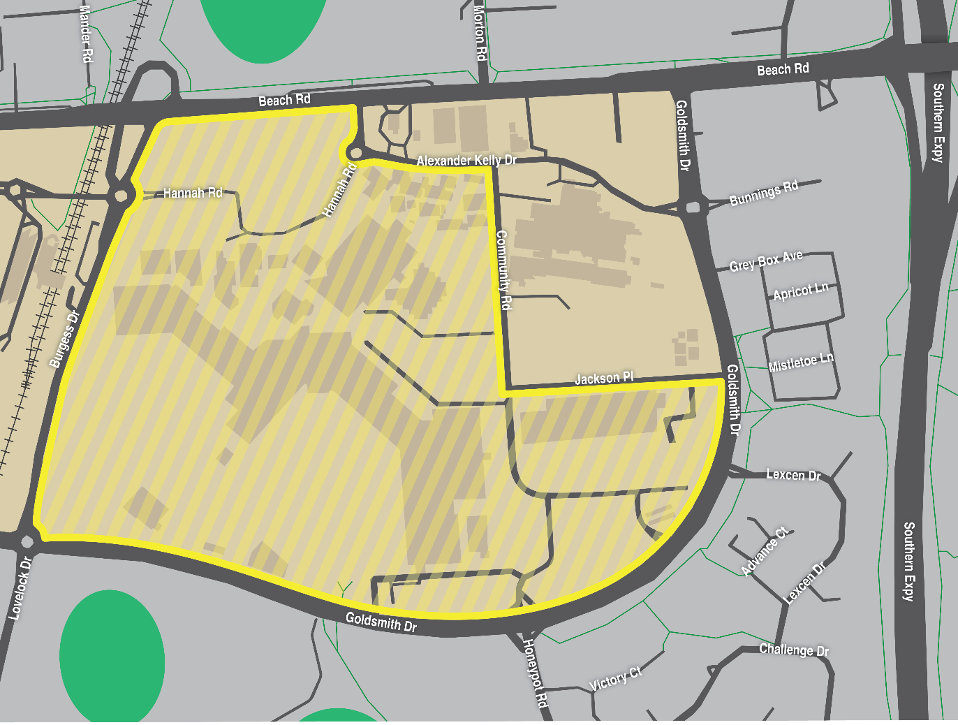
This declaration commences effect at 12:00 noon on Thursday, 2 October 2025.
I am satisfied that the declaration is necessary for the purposes of deterring or detecting the commission of offences involving the possession or use of a knife or other weapons in the shopping precinct, and that the exercise of search powers under Section 66ZB of the Act is likely to be effective in deterring or detecting the commission of offences involving the possession or use of a knife or other weapons in the shopping precinct and, further, will not unduly affect lawful activity in the shopping precinct.
This declaration will remain in effect until being revoked at such time that the Commissioner of Police (or delegate) is satisfied the grounds for this declaration are no longer met.
Dated: 2 October 2025
Narelle Jayne Kameniar
Assistant Commissioner of Police

Tobacco and E-Cigarette Products Act 1997
Section 51
Declaration that Smoking is Banned in Certain Public Areas
Take notice that I, Hon Christopher Picton, Minister for Health and Wellbeing, pursuant to Section 51 of the Tobacco and E-Cigarette Products Act 1997, do hereby declare that smoking is banned during the 2025 Ceduna Oysterfest from 08:00am on Saturday, 4 October and 11:00pm on Sunday, 5 October 2025 in the public areas within the O’Loughlin Terrace foreshore park lawns bounded by O’Loughlin Terrace to the east, the southern boundary of the Day Terrace Carpark to the north, the foreshore to the west and the prolongation of the entrance driveway of the Davison Street carpark to the south. To avoid doubt, smoking is banned during this period in all public areas within these boundaries, except where there is a designated “smoking permitted” area that will be clearly signed.
The following map of the area known as the Ceduna Oysterfest 2025 No-Smoking Zone is provided for ease of reference only.
Dated: 25 September 2025
Hon Chris Picton MP
Minister for Health and Wellbeing

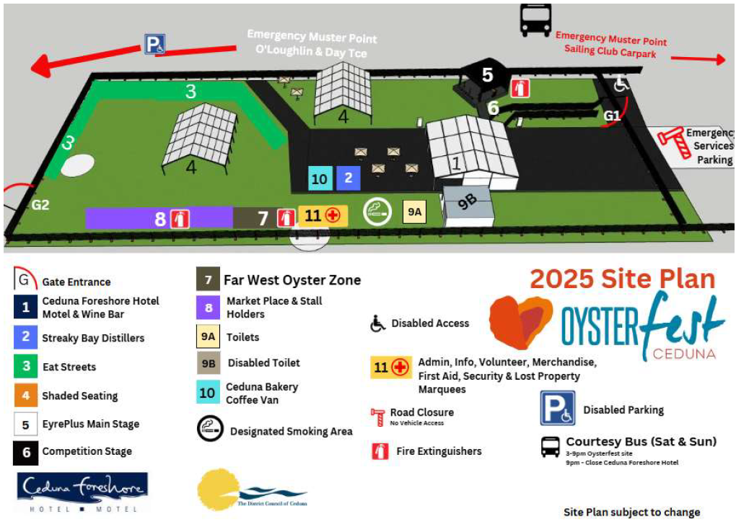
Map

Local Government Instruments

City of Adelaide
Local Government Act 1999—Section 232
Proposal to Plant Vegetation Within the Roadway
The City of Adelaide gives notice of its proposal to plant two (2) new street trees on the verge outside The Playford Hotel on North Terrace. Under the Local Government Act 1999, Council is required to undertake public consultation in accordance with its public consultation policy before it plants vegetation on a road or footpath that may have a significant impact on residents, nearby businesses, or advertisers in the area.
Copies of the proposed plans are available for inspection at the Council’s Customer Centre, 25 Pirie Street, Adelaide SA 5000 during office hours.
For further information or to provide feedback on the proposal, please visit ouradelaide.sa.gov.au anytime, or the City of Adelaide Customer Centre, libraries or community centres during business hours.
All submissions can be sent to treesonstreets@cityofadelaide.com.au.
Dated: 26 September 2025
Michael Sedgman
Chief Executive Officer

THE Rural City of Murray Bridge
Change of Road Name
Notice is hereby given that the Rural City of Murray Bridge, at its meeting held on 8 September 2025, resolved pursuant to Section 219(1) of the Local Government Act 1999 to change the name of the road ‘Meadow Way’ to now be known as ‘Hay Street’. A plan delineating the extent of Hay Street, Murray Bridge is available for inspection at the Local Government Centre, 2 Seventh Street, Murray Bridge, during normal business hours.
Dated: 24 September 2025
Heather Barclay
Chief Executive Officer

City of Norwood Payneham & St Peters
Local Government (Elections) Act 1999
Supplementary Election of Councillor for St Peters Ward—Election Results
Conducted on Tuesday, 23 September 2025
Formal Ballot Papers—1,038
Informal Ballot Papers—5
Quota—520
Candidates | First Preference Votes | Elected or Excluded | Votes at Election or Exclusion
RAKSHIT, Rima | 18 | Excluded | 18
CAVENEY, Ben | 20 | Excluded | 30
YOUNG, Zane | 97 | Excluded | 111
EXCELL, Rita | 327 | Elected | 495
GOODE, Matthew | 203 |  | 305
CHENOWETH, Spencer | 191 | Excluded | 227
GRAHAM, Patrick Litchfield | 158 | Excluded | 180
KUSHNIR, Julienne | 24 | Excluded | 25
Dated: 2 October 2025
Mick Sherry
Returning Officer

City of Playford
Change of Road Name
Notice is hereby given that the City of Playford, pursuant to Section 219(1) of the Local Government Act 1999, has resolved to change the names of the following portions of roads within its area:
• Small portion of road formerly known as Lakeside Drive, Andrews Farm (Road Segment 506, Deposited Plan 73852) affecting Lot 208 and Lot 602 only, will be renamed to Saint Lawrence Avenue.
• Frome Street, Andrews Farm SA 5114 (Road Segment 505, Deposited Plan 73852) affecting Lot 206 and Lot 207, will be renamed to Saint Lawrence Avenue, to form a continuous road with the southern road segment known as Saint Lawrence Avenue (Road Segment 934 Deposited Plan 82545).
• Portion of road formerly known as Gairdner Boulevard, Andrews Farm SA 5114 (Road Segment 510 Deposited Plan 73852) will be renamed to Saint Germain Avenue, to form a continuous road with the southern segment known as Saint Germain Avenue (Road Segment 802 Deposited Plan 83754). This will affect Lots 157 to 163; Lots 185 to 186 and Reserve Lot 604 from Deposited Plan 73852.
A plan delineating the extent of the affected portions is available for inspection online via the City of Playford Council website.
Dated: 2 October 2025
Matt Dineen
Senior Manager, Development Services

City of Port Adelaide Enfield
South Australia
Liquor Licensing (Dry Areas) Notice 2025
under section 131(1ab) of the Liquor Licensing Act 1997
1—Short title
This notice may be cited as the Liquor Licensing (Dry Areas) Notice 2025.
2—Commencement
This notice comes into operation on 31st December 2025
3—Interpretation
(1) In this notice—
principal notice means the Liquor Licensing (Dry Areas) Notice 2015 published in the Gazette on 5 January 2015, as in force from time to time.
(2) Clause 3 of the principal notice applies to this notice as if it were the principal notice.
4—Consumption etc of liquor prohibited in dry areas
(1) Pursuant to section 131 of the Act, the consumption and possession of liquor in the area described in the Schedule is prohibited in accordance with the provisions of the Schedule.
(2) The prohibition has effect during the periods specified in the Schedule.
(3) The prohibition does not extend to private land in the area described in the Schedule.
(4) Unless the contrary intention appears, the prohibition of the possession of liquor in the area does not extend to—
(a) a person who is genuinely passing through the place if—
(i) the liquor is in the original container in which it was purchased from licensed premises; and
(ii) the container has not been opened; or
(b) a person who has possession of the liquor in the course of carrying on a business or in the course of their employment by another person in the course of carrying on a business; or
(c) a person who is permanently or temporarily residing at premises near the public place and who enters the public place solely for the purpose of passing through it to enter those premises or who enters the public place from those premises for the purpose of leaving the place; or
(d) a person who possesses or consumes the liquor for sacramental or other similar religious purposes.

Schedule—Semaphore Area 4
1—Extent of prohibition
The consumption of liquor is prohibited, and the possession of liquor is prohibited.
2—Period of prohibition
From 12 noon on 31 December 2025 to 12 noon on 1 January 2026.
3—Description of area
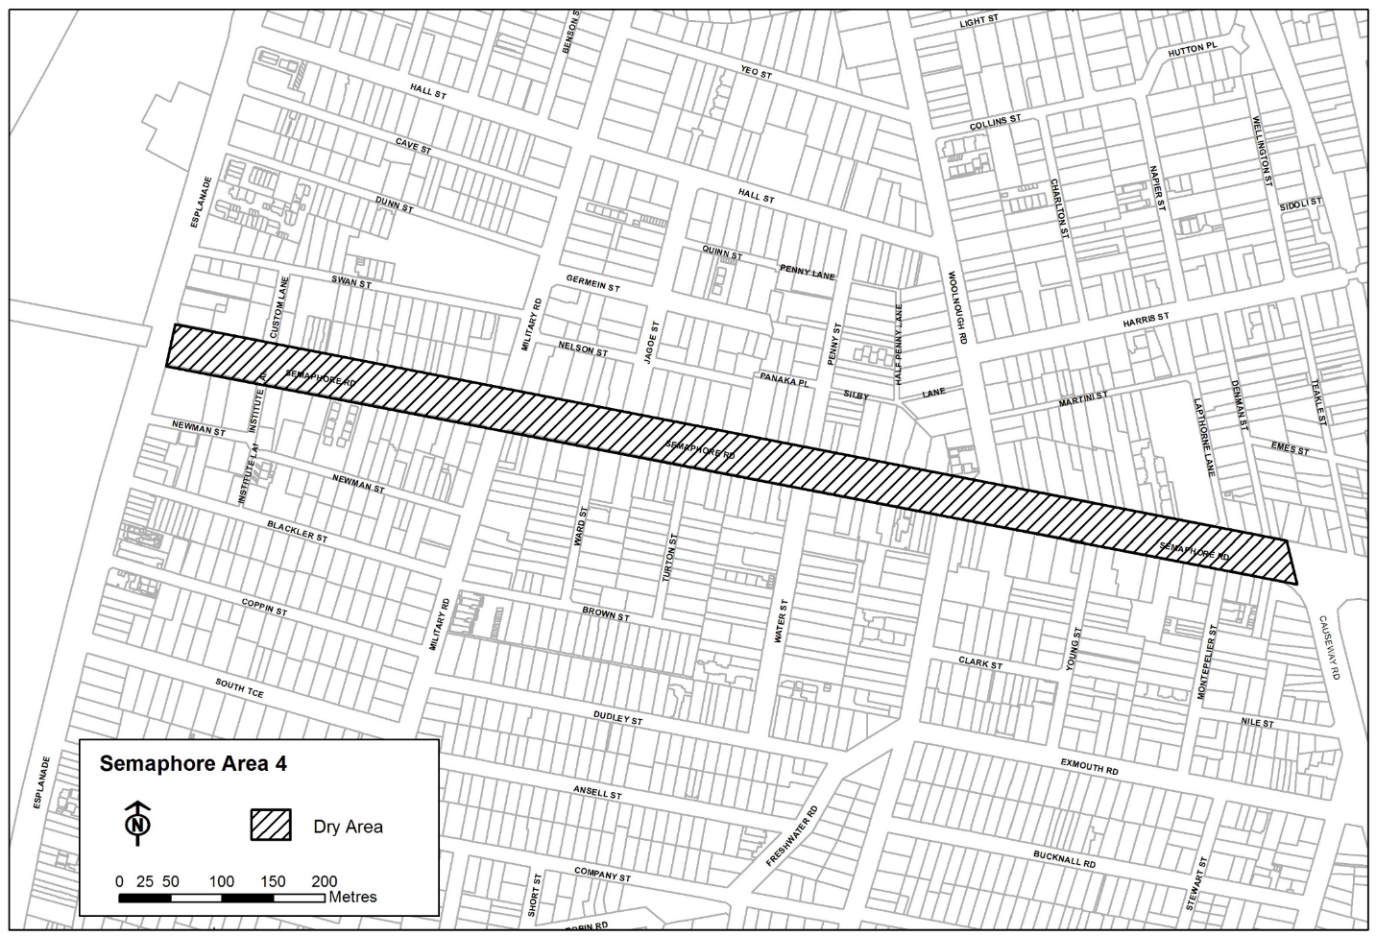
The area in Semaphore and Exeter comprising Semaphore Road between the eastern boundary of the Esplanade and the prolongation in a straight line of the marked centre line of Causeway Road.
Dated: 16 September 2025
Mark Withers
Chief Executive Officer

Port Augusta City Council
Review of Representation
Notice is hereby given that the Port Augusta City Council has reviewed its composition and elector representation arrangements in accordance with the requirements of Section 12 of the Local Government Act 1999 (the Act).
Pursuant to Section 12(13)(a) of the Act, the Electoral Commissioner has issued a certificate that the review undertaken by Council satisfies the requirements of Section 12 of the Act. The following arrangements will therefore take effect from polling day of the next periodic Local Government election:
• The Council area will not be divided into wards (i.e. the existing “no wards” structure will be retained)
• The future elected body of Council will comprise the Mayor and nine (9) area councillors, all of whom will represent the whole of the Council area and shall be elected by the community at a council-wide election.
Dated: 2 October 2025
John Banks
Chief Executive Officer

City of Whyalla
Review of Representation
Notice is hereby given that the Corporation of the City of Whyalla has reviewed its composition in accordance with the requirements of Section 12 of the Local Government Act 1999.
Pursuant to Section 12(13)(a) of the Act, the Electoral Commissioner has issued a certificate that the review undertaken by the Council satisfies the requirements of Section 12 and may now be put into effect as from the day of the first periodic election held after the publication of this notice.
The Council proposes to make no change to its representation arrangements, with the following arrangements to take effect from polling day of the next periodic elections.
The following arrangements will therefore take effect from polling day of the next periodic elections:
• The name of the council is to be changed to City of Whyalla;
• The Principal Member of the Council continues to be a Mayor, elected as a representative of the area as a whole;
• The area of the Council shall not be divided into wards;
• The elected body of the Council will be comprised of ten (10) elected members, these being the Mayor and nine (9) Councillors.
Dated: 30 September 2025
Justin Commons
Chief Executive Officer

Town of Gawler
Local Government (Elections) Act 1999
Supplementary Election of Mayor—Election Results
Conducted on Tuesday 23 September 2025
Formal Ballot Papers—6,373
Informal Ballot Papers—25
Quota—3,187
Candidates | First Preference Votes | Elected or Excluded | Votes at Election or Exclusion
SHANKS, Nathan | 2,955 | Elected | 3,259
DAVIES, Cody | 2,805 |  | 2,932
LITTLE, Paul Robert | 613 | Excluded | 613
Dated: 2 October 2025
Mick Sherry
Returning Officer

Adelaide Hills Council
Local Government (Elections) Act 1999
Supplementary Election of Councillor for Ranges Ward—Election Results
Conducted on Tuesday, 23 September 2025
Formal Ballot Papers—4,080
Informal Ballot Papers—17
Quota—2,041
Candidates | First Preference Votes | Elected or Excluded | Votes at Election or Exclusion
WOOLCOCK, Lisa Clare | 987 | Elected | 1,846
McDONNELL, Georgia | 790 | Excluded | 1,160
TRANTER, Jenn | 422 | Excluded | 451
CUTHBERTSON, Mark | 1,082 |  | 1,482
SADLER, James Grant | 431 | Excluded | 497
De’ATH, James | 368 | Excluded | 368
Dated: 2 October 2025
Mick Sherry
Returning Officer

Adelaide Hills Council
Local Government (Elections) Act 1999
Supplementary Election of 2 Councillors for Valleys Ward
Conducted on Tuesday, 23 September 2025
Formal Ballot Papers—2,960
Informal Ballot Papers—37
Quota—987
Candidates | First Preference Votes | Elected or Excluded | Votes at Election or Exclusion
ROBERTS, Scott | 305 | Excluded | 354
GLADIGAU, Richard | 1,155 | Elected 1 | 1,155
PENNO, Mell | 416 | Excluded | 563
TRESCOWTHICK, Alex | 416 | Elected 2 | 1,113
STEINBECK, Matthew | 149 | Excluded | 166
BRAY, Martin | 519 | Excluded | 782
Dated: 2 October 2025
Mick Sherry
Returning Officer

Adelaide Hills Council
Resignation of Mayor
Notice is hereby given in accordance with Section 54(6) of the Local Government Act 1999, that a vacancy has occurred in the office of Mayor, due to the resignation of Mayor Jan-Claire Wisdom, effective 6:00pm Tuesday, 23 September 2025.
Dated: 26 September 2025
Greg Georgopoulos
Chief Executive Officer

Adelaide Plains Council
Roads (Opening and Closing) Act 1991
Road Closure—Old Port Wakefield Road, Two Wells
Notice is hereby given, pursuant to Section 10 of the Roads (Opening and Closing) Act 1991 that the Adelaide Plains Council proposes to make a Road Process Order to close and merge with the adjoining landowner portion of the public road (Old Port Wakefield Road) adjoining allotment 44 in D6229 more particularly delineated and lettered ‘A’ on Preliminary Plan 25/0023.
The Preliminary Plan is available for public inspection at the offices of the Adelaide Plains Council, 2A Wasleys Road, Mallala, and the Adelaide Office of the Surveyor-General located at Level 10, 83 Pirie Street, Adelaide, during normal office hours. The Preliminary Plan can also be viewed at www.sa.gov.au/roadsactproposals.
Any application for easement or objection must set out the full name, address and details of the submission and must be fully supported by reasons. The application for easement or objection must be made in writing to the Adelaide Plains Council, PO Box 18, Mallala SA 5502, within 28 days of this notice and a copy must be forwarded to the Surveyor-General at GPO Box 1815, Adelaide 5001. Where a submission is made, the applicant must be prepared to support their submission in person upon council giving notification of a meeting at which the matter will be considered.
Dated: 2 October 2025
James Miller
Chief Executive Officer

Mount Barker District Council
Local Government (Elections) Act 1999
Supplementary Election of Councillor for South Ward—Election Results
Conducted on Tuesday 23 September 2025
Formal Ballot Papers—2,141
Informal Ballot Papers—7
Quota—1,071
Candidates | First Preference Votes | Elected or Excluded | Votes at Election or Exclusion
ATKINSON, Diane | 464 | Excluded | 464
FORDHAM, Anne Elizabeth | 800 | Elected | 1,042
KELLY, Darren | 877 |  | 948
Dated: 2 October 2025
Mick Sherry
Returning Officer

District Council of Orroroo Carrieton
Local Government (Elections) Act 1999
Supplementary Election of 2 Area Councillors—Election Results
Conducted on Tuesday 23 September 2025
Formal Ballot Papers—371
Informal Ballot Papers—3
Quota—124
Candidates | First Preference Votes | Elected or Excluded | Votes at Election or Exclusion
JESSER, Roger Grant | 170 | Elected 1 | 170
HOOPER, Shane | 50 |  | 50
CLARKE, Julia | 151 | Elected 2 | 151
Dated: 2 October 2025
Mick Sherry
Returning Officer

District Council of Peterborough
Review of Representation
Notice is hereby given that the District Council of Peterborough has reviewed its composition and elector representation arrangements in accordance with the requirements of Section 12 of the Local Government Act 1999 (the Act).
Pursuant to Section 12(13)(a) of the Act, the Electoral Commissioner has issued a certificate that the review undertaken by the Council satisfies the requirements of Section 12 of the Act.
The following arrangements will therefore take effect from polling day of the next periodic Local Government election:
• The principal member of the Council shall be a Mayor elected by the electors for the area.
• The Council area will not be divided into wards.
• The future elected body of the Council will comprise the Mayor and seven (7) councillors, all of whom will represent the whole of the Council area and shall be elected by the community at a council-wide election.
Dated: 25 September 2025
Kristen Clark
Chief Executive Officer
District Council of Peterborough

Yorke Peninsula Council
Local Government (Elections) Act 1999
Supplementary Election of Mayor—Election Results
Conducted on Tuesday, 23 September 2025
Formal Ballot Papers—3,611
Informal Ballot Papers—15
Quota—1,806
Candidates | First Preference Votes | Elected or Excluded | Votes at Election or Exclusion
O’CONNELL, Michael | 996 |  | 996
GRAY, Kylie Leanne | 2,615 | Elected | 2,615
Dated: 2 October 2025
Mick Sherry
Returning Officer

Public Notices

National Electricity Law
Notice of Expedited Initiation
The Australian Energy Market Commission (AEMC) gives notice under the National Electricity Law as follows:
Under s 95, the AEMC has requested the Minor changes 2 2025 (Ref. ERC0420) proposal. The proposal seeks to correct minor errors and make non-material changes to the Rules. The AEMC intends to expedite the proposal under s 96 as it considers the proposed Rule is a non-controversial Rule, subject to requests not to do so. Written requests not to expedite the proposal must be received by 16 October 2025. Submissions must be received by 30 October 2025.
Submissions can be made via the AEMC’s website. Before making a submission, please review the AEMC’s privacy statement on its website, and consider the AEMC’s Tips for making a submission. The AEMC publishes all submissions on its website, subject to confidentiality.
Written requests should be sent to submissions@aemc.gov.au and cite the reference in the title. Before sending a request, please review the AEMC’s privacy statement on its website.
Documents referred to above are available on the AEMC’s website and are available for inspection at the AEMC’s office.
Australian Energy Market Commission
Level 15, 60 Castlereagh St
Sydney NSW 2000
Telephone: (02) 8296 7800
www.aemc.gov.au
Dated: 2 October 2025

National Gas Law
Notice of Extension of Final Determination
The Australian Energy Market Commission (AEMC) gives notice under the National Gas Law as follows:
Under s 317, the time for the making of the final determination on the ECGS projected assessment of system adequacy (Ref. GRC0080) proposal has been extended to 18 December 2025.
Documents referred to above are available on the AEMC’s website and are available for inspection at the AEMC’s office.
Australian Energy Market Commission
Level 15, 60 Castlereagh St
Sydney NSW 2000
Telephone: (02) 8296 7800
www.aemc.gov.au
Dated: 2 October 2025

Trustee Act 1936
Public Trustee
Estates of Deceased Persons
In the matter of the estates of the undermentioned deceased persons:
BENNETTS Ellen late of 17 Rockville Avenue Daw Park Retired Secretary who died 13 January 2025
BURDON Rosalie Valma late of 336 Kensington Road Leabrook Retired Teacher who died 4 May 2025
DEED Dorothy Dawn late of 106-112 Florence Street Port Pirie of no occupation who died 11 April 2025
JENKINS Alice Marlene late of 24 Arden Vale Road Quorn Cook who died 3 July 2024
JONES Carroll late of 1 Myzantha Street Lockleys Retired Nurse who died 14 April 2024
LAUBE Max Lex late of 40 Skyline Drive Flagstaff Hill Retired Clerical Officer who died 12 June 2025
PARASKEVA Christalla late of 22 Marlborough Street Fulham Gardens Business Proprietor who died 18 May 2022
UPHILL Jeffrey Gordon late of 28 Liddell Drive Huntfield Heights Retired Fitter and Turner who died 17 February 2025
WARD Neil Andrew late of Unit 32 20 The Parkway Hampstead Gardens of no occupation who died 10 September 2024
WELSH Joan Marilyn late of 12 St Kilda Street Hayborough Retired Cleaner who died 13 May 2025
WHITTLE Leah Regina late of 1 Warooka Drive Smithfield Retired Process Worker who died 20 June 2021
Notice is hereby given pursuant to the Trustee Act 1936 (SA), the Succession Act 2023 (SA) and the Family Relationships Act 1975 (SA) that all creditors, beneficiaries, and other persons having claims against the said estates are required to send, in writing, to the office of Public Trustee at GPO Box 1338, Adelaide 5001, full particulars and proof of such claims, on or before the 31 October 2025 otherwise they will be excluded from the distribution of the said estate; and notice is also hereby given that all persons indebted to the said estates are required to pay the amount of their debts to the Public Trustee or proceedings will be taken for the recovery thereof; and all persons having any property belonging to the said estates are forthwith to deliver same to the Public Trustee.
Dated: 2 October 2025
T. Brumfield
Public Trustee

Notice Submission

The South Australian Government Gazette is published each Thursday afternoon.
Notices must be emailed by 4 p.m. Tuesday, the week of publication.
Submissions are formatted per the gazette style and a proof will be supplied prior to publication, along with a quote if applicable. Please allow one day for processing notices.
Alterations to the proof must be returned by 4 p.m. Wednesday.

Gazette notices must be submitted as Word files, in the following format:
• Title—the governing legislation
• Subtitle—a summary of the notice content
• Body—structured text, which can include numbered lists, tables, and images
• Date—day, month, and year of authorisation
• Signature block—name, role, and department/organisation authorising the notice

Please provide the following information in your email:
• Date of intended publication
• Contact details of the person responsible for the notice content
• Name and organisation to be charged for the publication—Local Council and Public notices only
• Purchase order, if required—Local Council and Public notices only

Email: governmentgazettesa@sa.gov.au
Phone: (08) 7133 3552
Website: www.governmentgazette.sa.gov.au

All instruments appearing in this gazette are to be considered official, and obeyed as such

Printed and published weekly by authority of T. Foresto, Government Printer, South Australia
$9.50 per issue (plus postage), $479.00 per annual subscription—GST inclusive
Online publications: www.governmentgazette.sa.gov.au

