
No. 62 p. 4127
THE SOUTH AUSTRALIAN
GOVERNMENT GAZETTE
Published by Authority

Adelaide, Thursday, 30 October 2025

Contents

Governor’s Instruments
Acts 4128
Appointments, Resignations and General Matters 4128
Lifetime Support Scheme (LSS) Rules, The 4129
Proclamations—
Adelaide University Act (Commencement)
Proclamation 2025 4240
Dog and Cat Management (Breeder Reforms)
Amendment Act (Commencement)
Proclamation 2025 4240
Mental Health (Community Visitor Scheme)
Amendment Act (Commencement)
Proclamation 2025 4241
Summary Offences (Humiliating, Degrading or Invasive Depictions) Amendment Act (Commencement) Proclamation 2025 4242
Adelaide University (Transfer of Assets, Contracts
and Liabilities) Proclamation 2025 4242
Adelaide University (Transfer of Students)
Proclamation 2025 4247
Liquor Licensing (Conferral of Authority)
Proclamation 2025 4273
Liquor Licensing (Designation of District Court Judge
as Licensing Court Judge) Proclamation 2025 4274
South Australian Employment Tribunal (Appointment
of Deputy President) Proclamation 2025 4275
Regulations—
Adelaide University (Transitional) (Further Transitional Provisions) Amendment Regulations 2025—
No. 110 of 2025 4276
Mental Health (Community Visitor Scheme)
Amendment Regulations 2025—No. 111 of 2025 4286
Work Health and Safety (High Risk Construction Work) Amendment Regulations 2025—No. 112 of 2025 4288
State Government Instruments
Associations Incorporation Act 1985 4289
Building Work Contractors Act 1995 4289
Controlled Substances Act 1984 4290
District Court of South Australia, The 4291
Energy Resources Act 2000 4292
Fisheries Management (Prawn Fisheries) Regulations 2017 4292
Fisheries Management Act 2007 4294
Geographical Names Act 1991 4295
Housing Improvement Act 2016 4297
Justices of the Peace Act 2005 4298
Land Acquisition Act 1969 4298
Major Events Act 2013 4306
Mental Health Act 2009 4308
Motor Vehicles Act 1959 4308
Planning, Development and Infrastructure Act 2016 4326
Real Property Act 1886 4326
Retail and Commercial Leases Act 1995 4327
Road Traffic Act 1961 4327
Shop Trading Hours Act 1977 4327
Local Government Instruments
City of Mitcham 4328
City of Norwood Payneham & St Peters 4328
Mount Barker District Council 4332
Yorke Peninsula Council 4332
Public Notices
Corporations Act 2001 4334
National Energy Retail Law 4334
National Gas Law 4335
Trustee Act 1936 4335

Governor’s Instruments

Acts
Department of the Premier and Cabinet
Adelaide, 30 October 2025
Her Excellency the Governor directs it to be notified for general information that she has in the name and on behalf of His Majesty The King, this day assented to the undermentioned Bills passed by the Legislative Council and House of Assembly in Parliament assembled, viz.:
No. 42 of 2025—Statutes Amendment (Claim Farming) Bill 2025
An Act to amend the Legal Practitioners Act 1981 and the Summary Offences Act 1953
No. 43 of 2025—Fair Work (Worker Entitlements) Amendment Bill 2025
An Act to amend the Fair Work Act 1994, and to make related amendments to the South Australian Employment Tribunal Act 2014
By command,
Katrine Anne Hildyard, MP
For Premier

Appointments, Resignations and General Matters
Department of the Premier and Cabinet
Adelaide, 30 October 2025
Her Excellency the Governor in Executive Council has been pleased to appoint the Honourable Chief Justice Christopher John Kourakis as Governor’s Deputy of South Australia from 7.00am until 1.00pm on Wednesday, 5 November 2025.
By command,
Katrine Anne Hildyard, MP
For Premier

Department of the Premier and Cabinet
Adelaide, 30 October 2025
Her Excellency the Governor in Executive Council has been pleased to appoint Jodie Mareika Carrel as a Judge of the District Court of South Australia, effective from 1 November 2025 - pursuant to section 12 of the District Court Act 1991.
By command,
Katrine Anne Hildyard, MP
For Premier
AGO0191-25CS

Department of the Premier and Cabinet
Adelaide, 30 October 2025
Her Excellency the Governor in Executive Council has been pleased to designate the primary judicial office of President Justice Steven Peter Dolphin as being President of the South Australian Employment Tribunal from 20 March 2026 until 19 September 2026 - pursuant to section 6 of the Judicial Administration (Auxiliary Appointments and Powers) Act 1988.
By command,
Katrine Anne Hildyard, MP
For Premier
AGO0191-25CS

Department of the Premier and Cabinet
Adelaide, 30 October 2025
Her Excellency the Governor in Executive Council has substituted the Lifetime Support Scheme Rules, noting that they will come into operation on the day on which they are made - pursuant to section 56 of the Motor Vehicles Accidents (Lifetime Support Scheme) Act 2013.
By command,
Katrine Anne Hildyard, MP
For Premier
T&F25-0100CS

The Lifetime Support Scheme (LSS) Rules
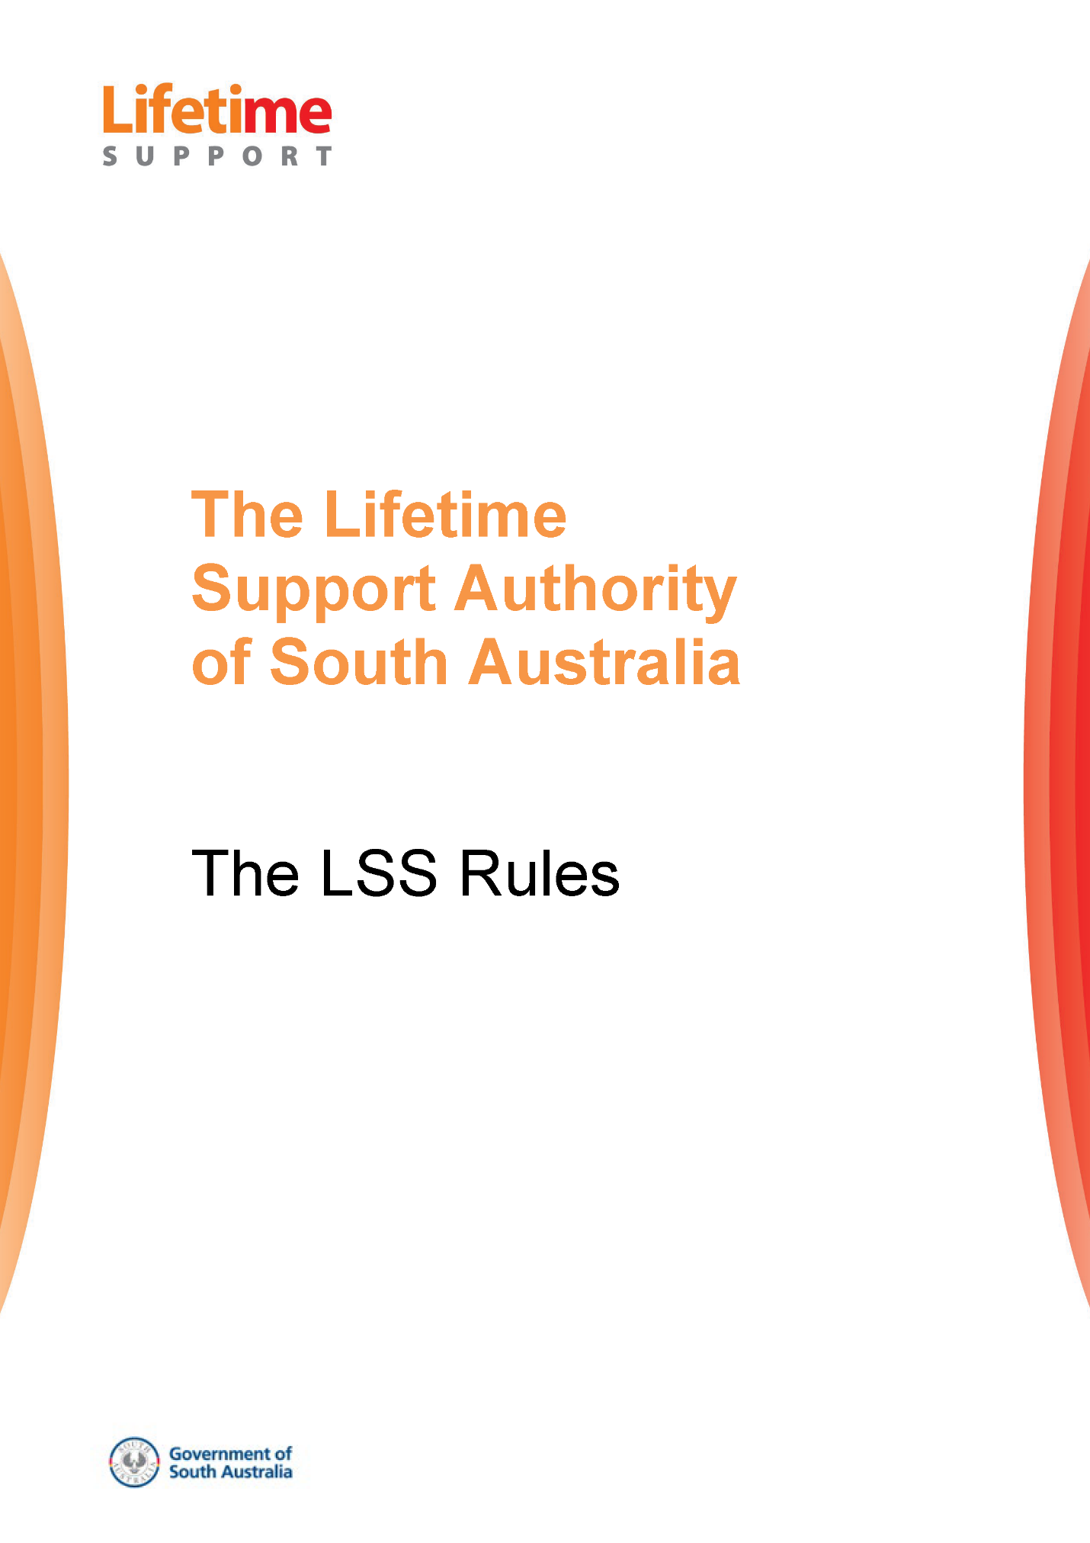
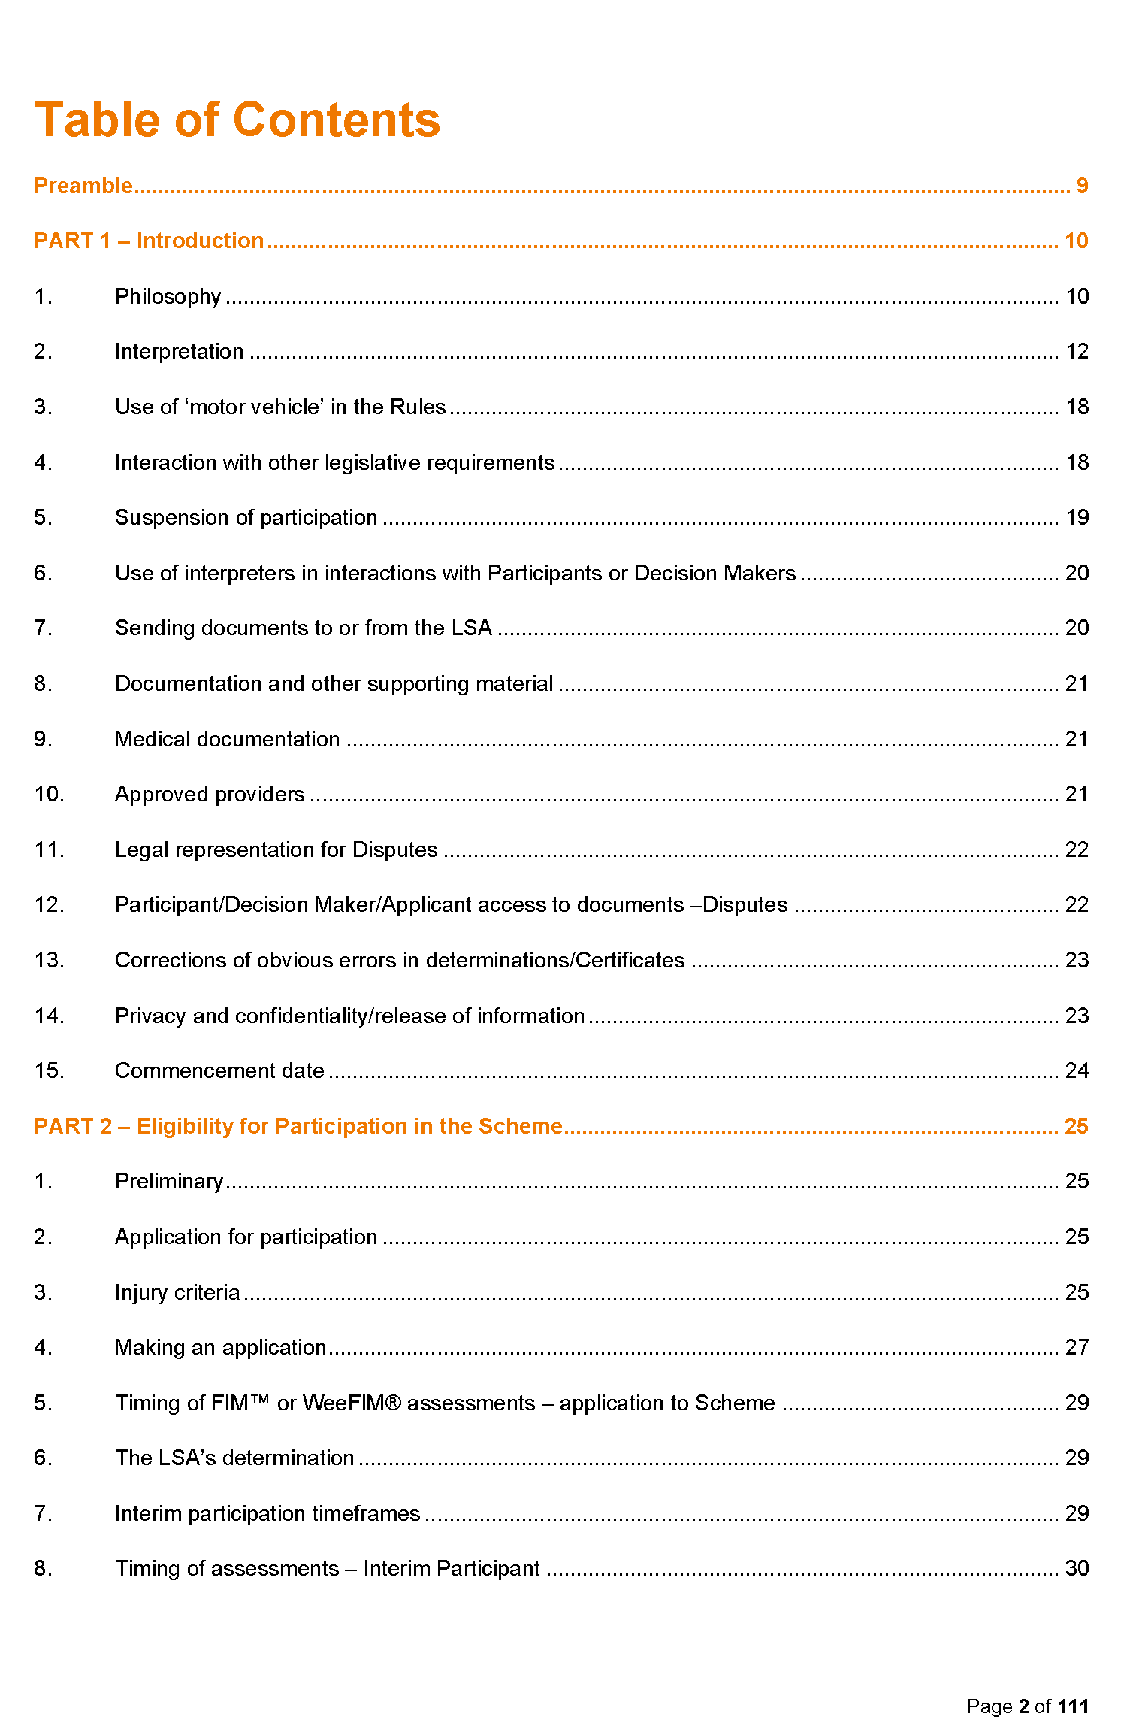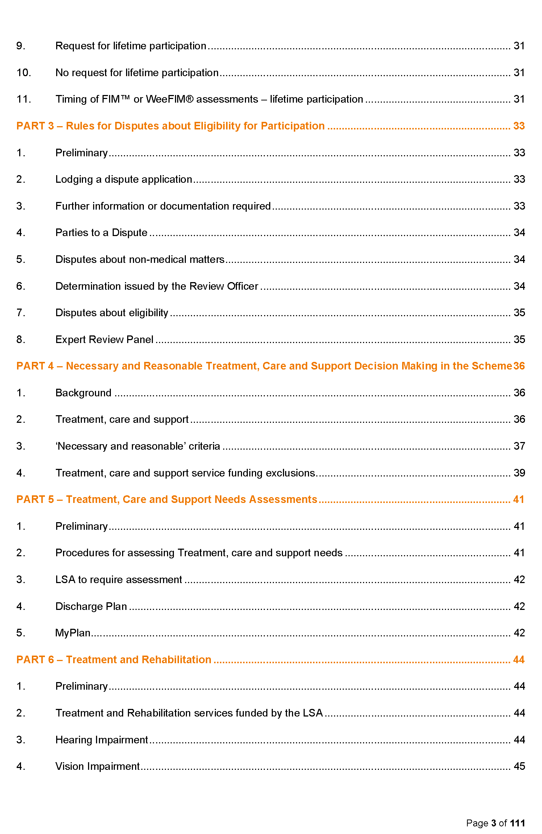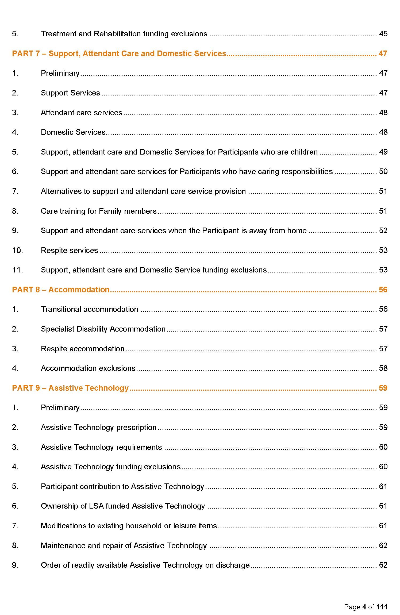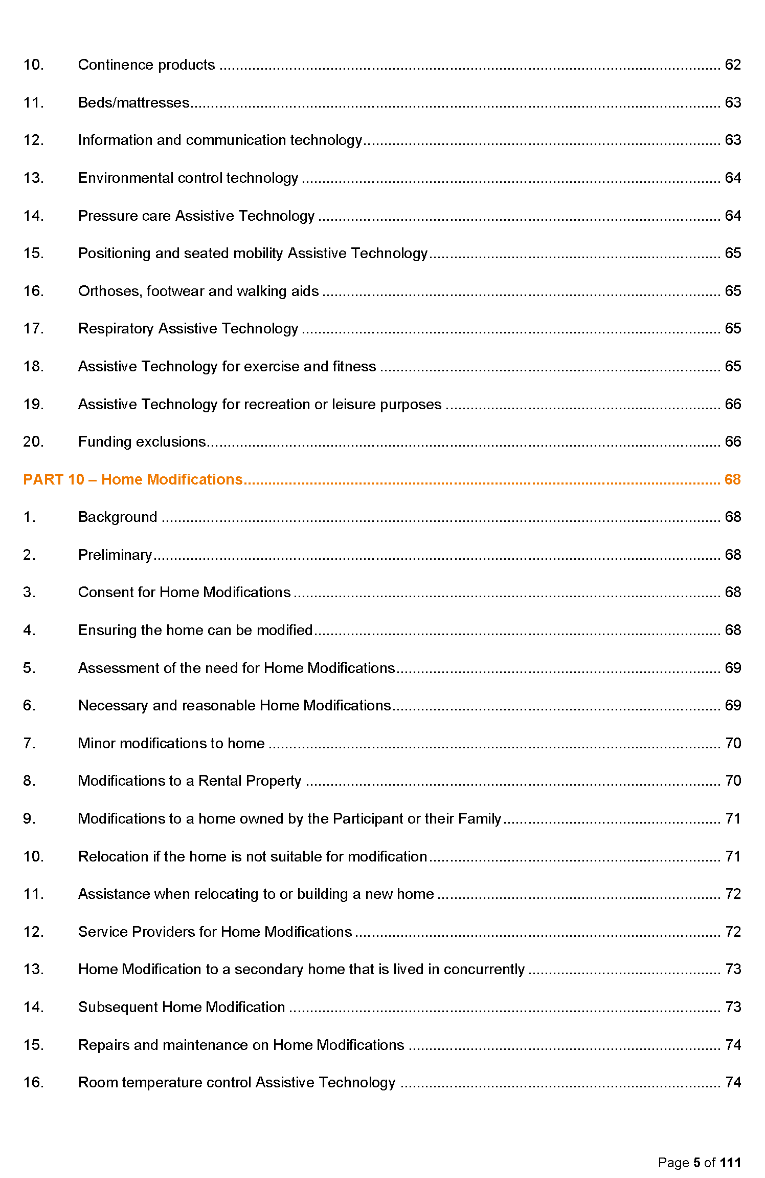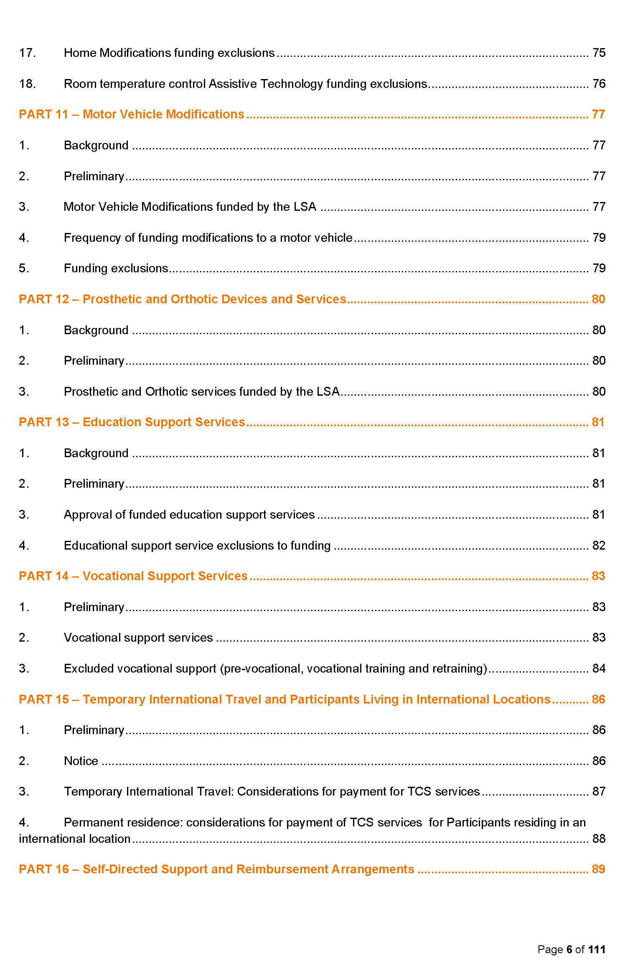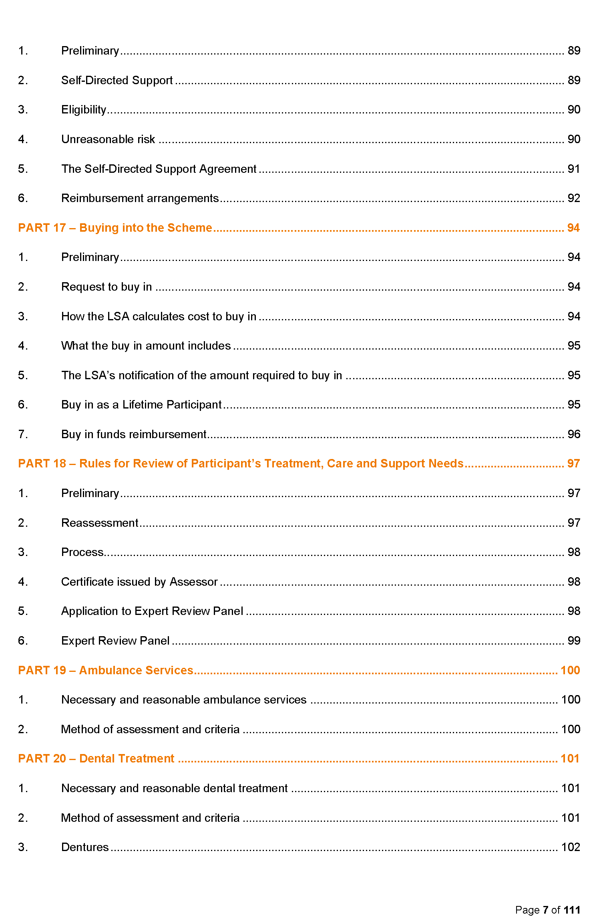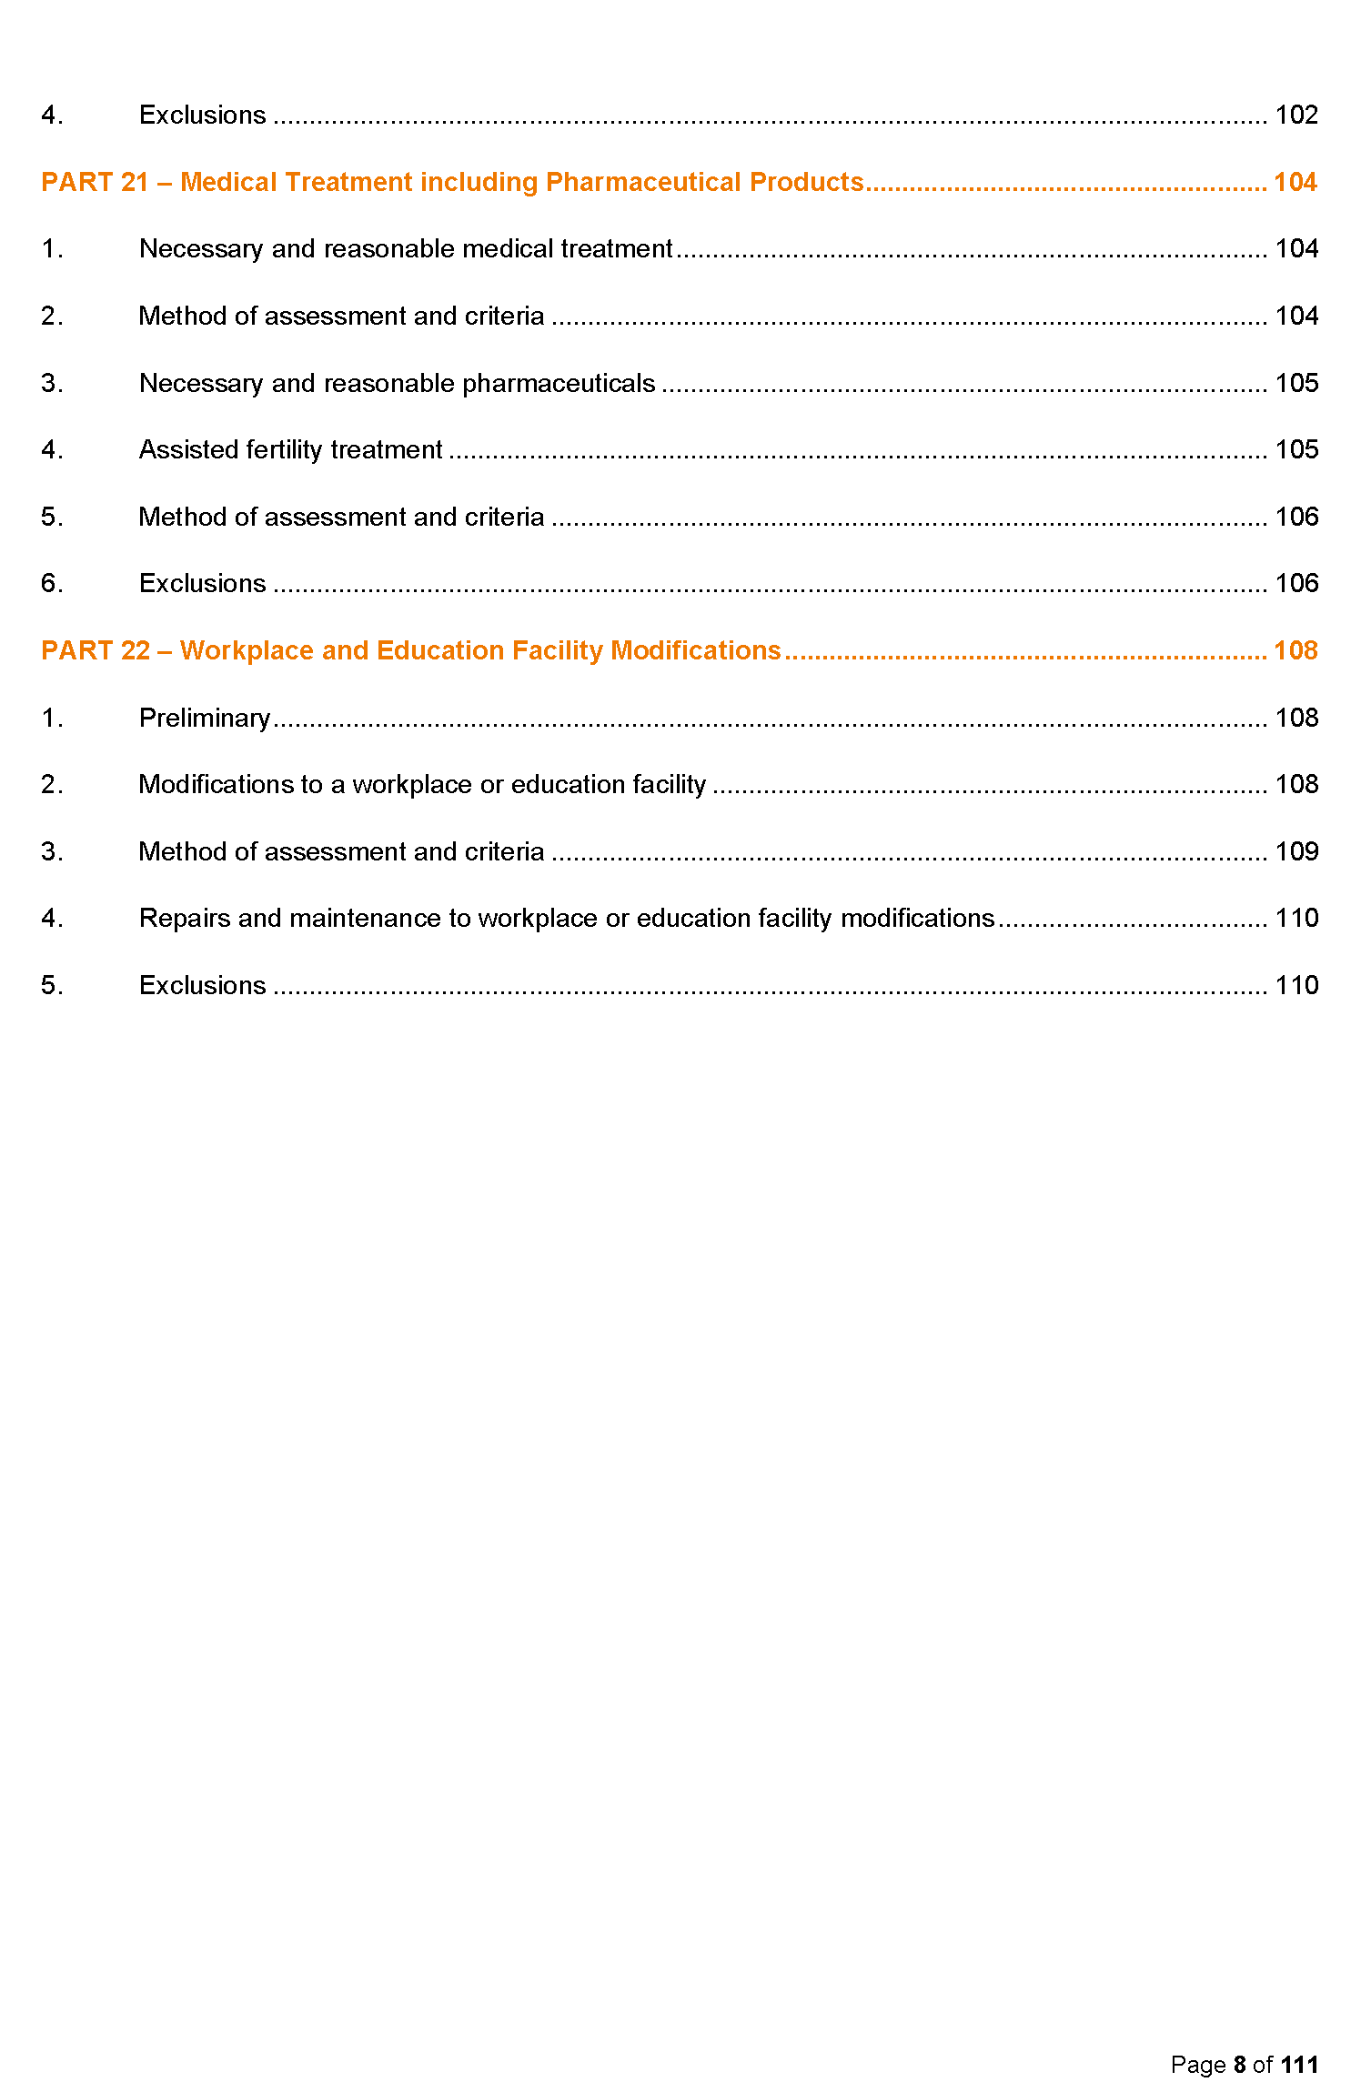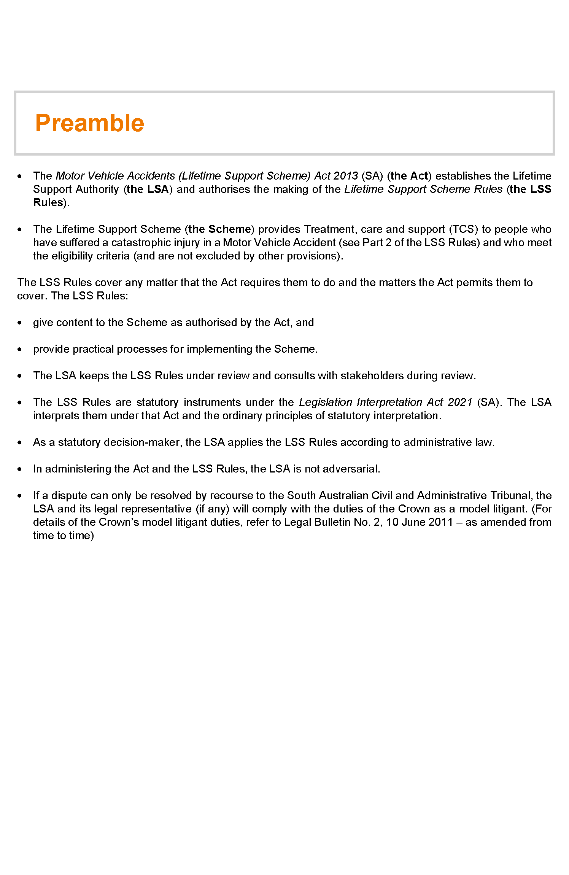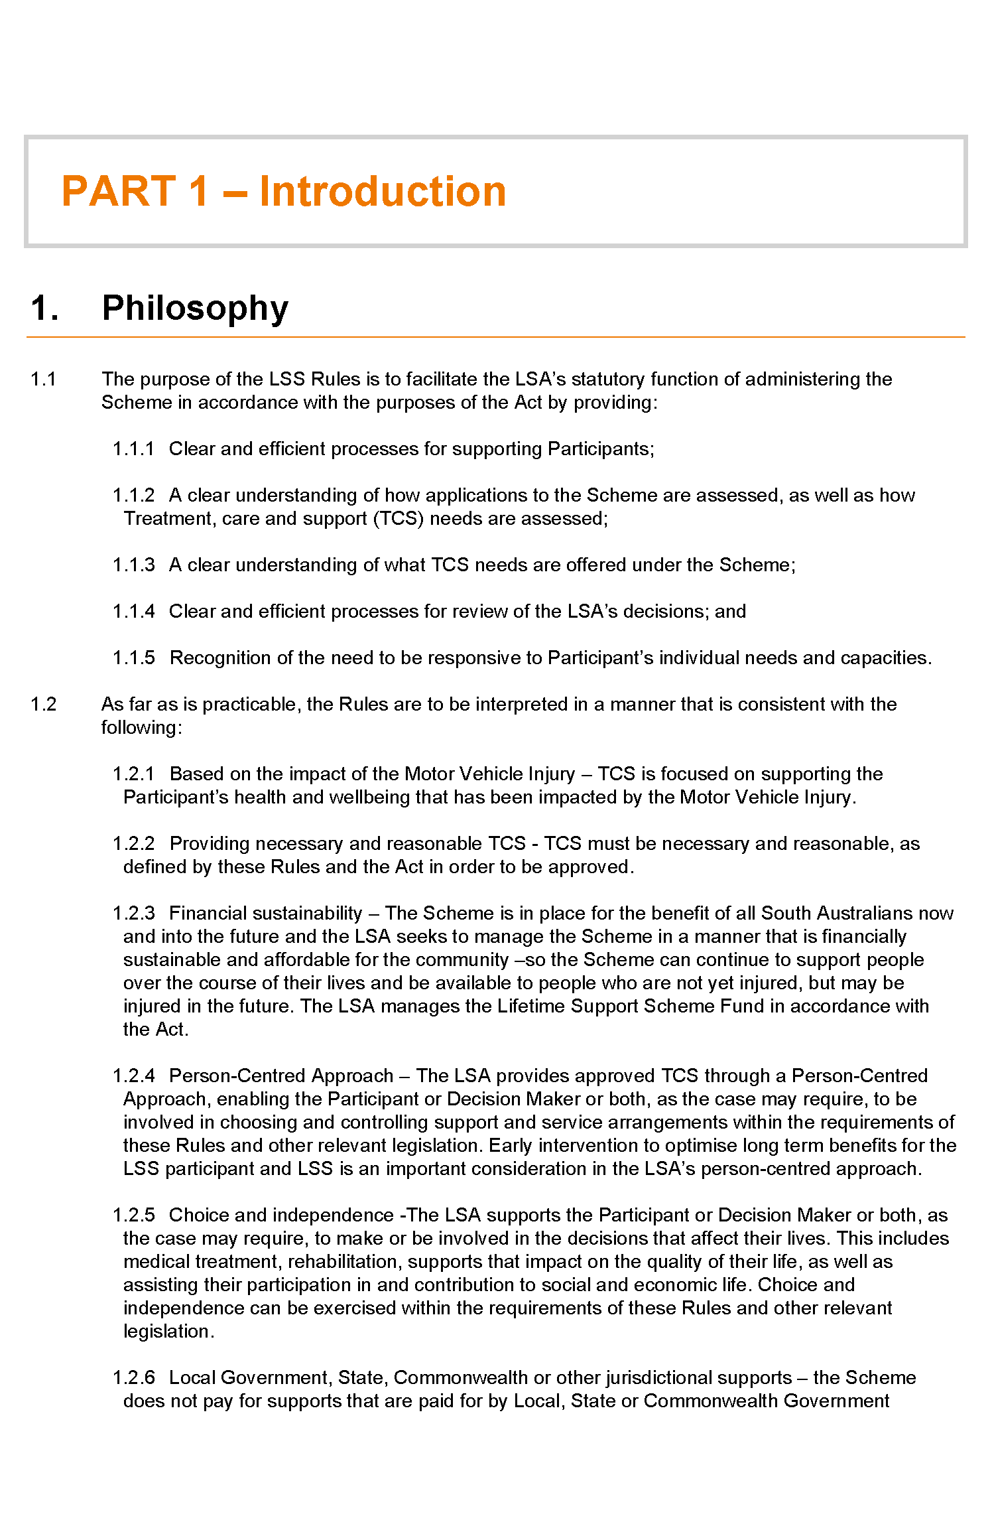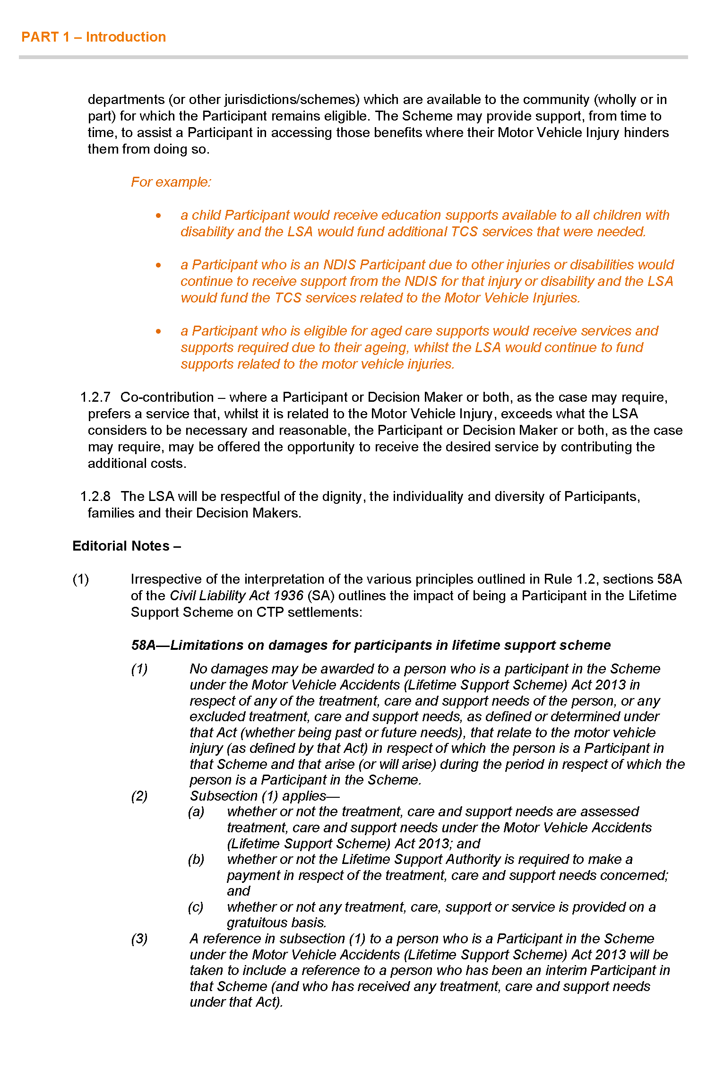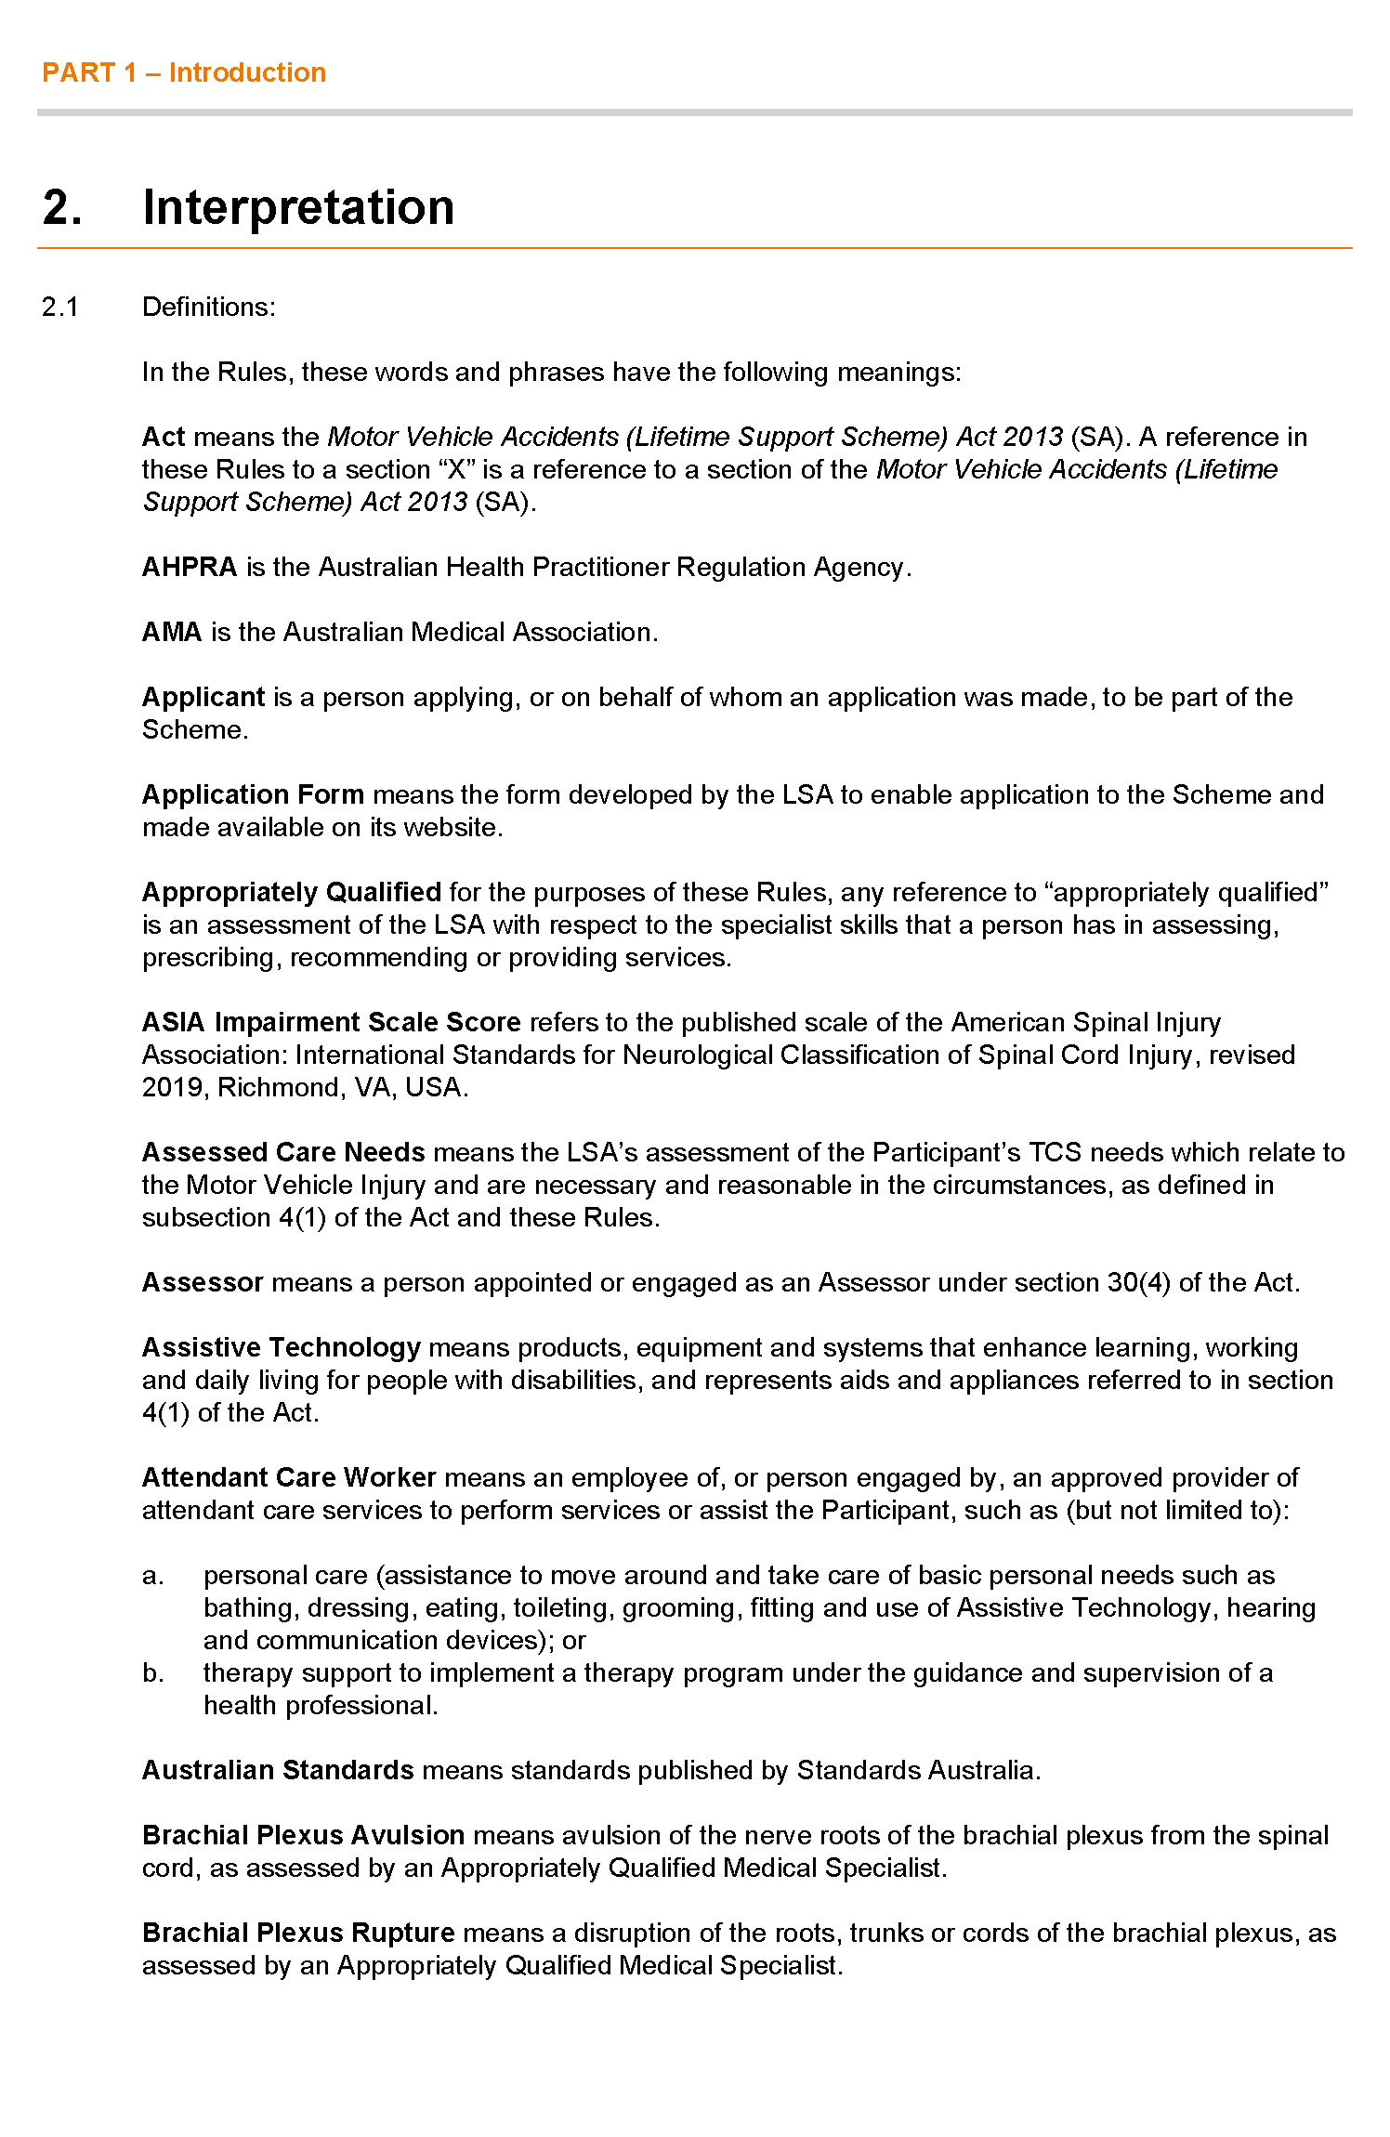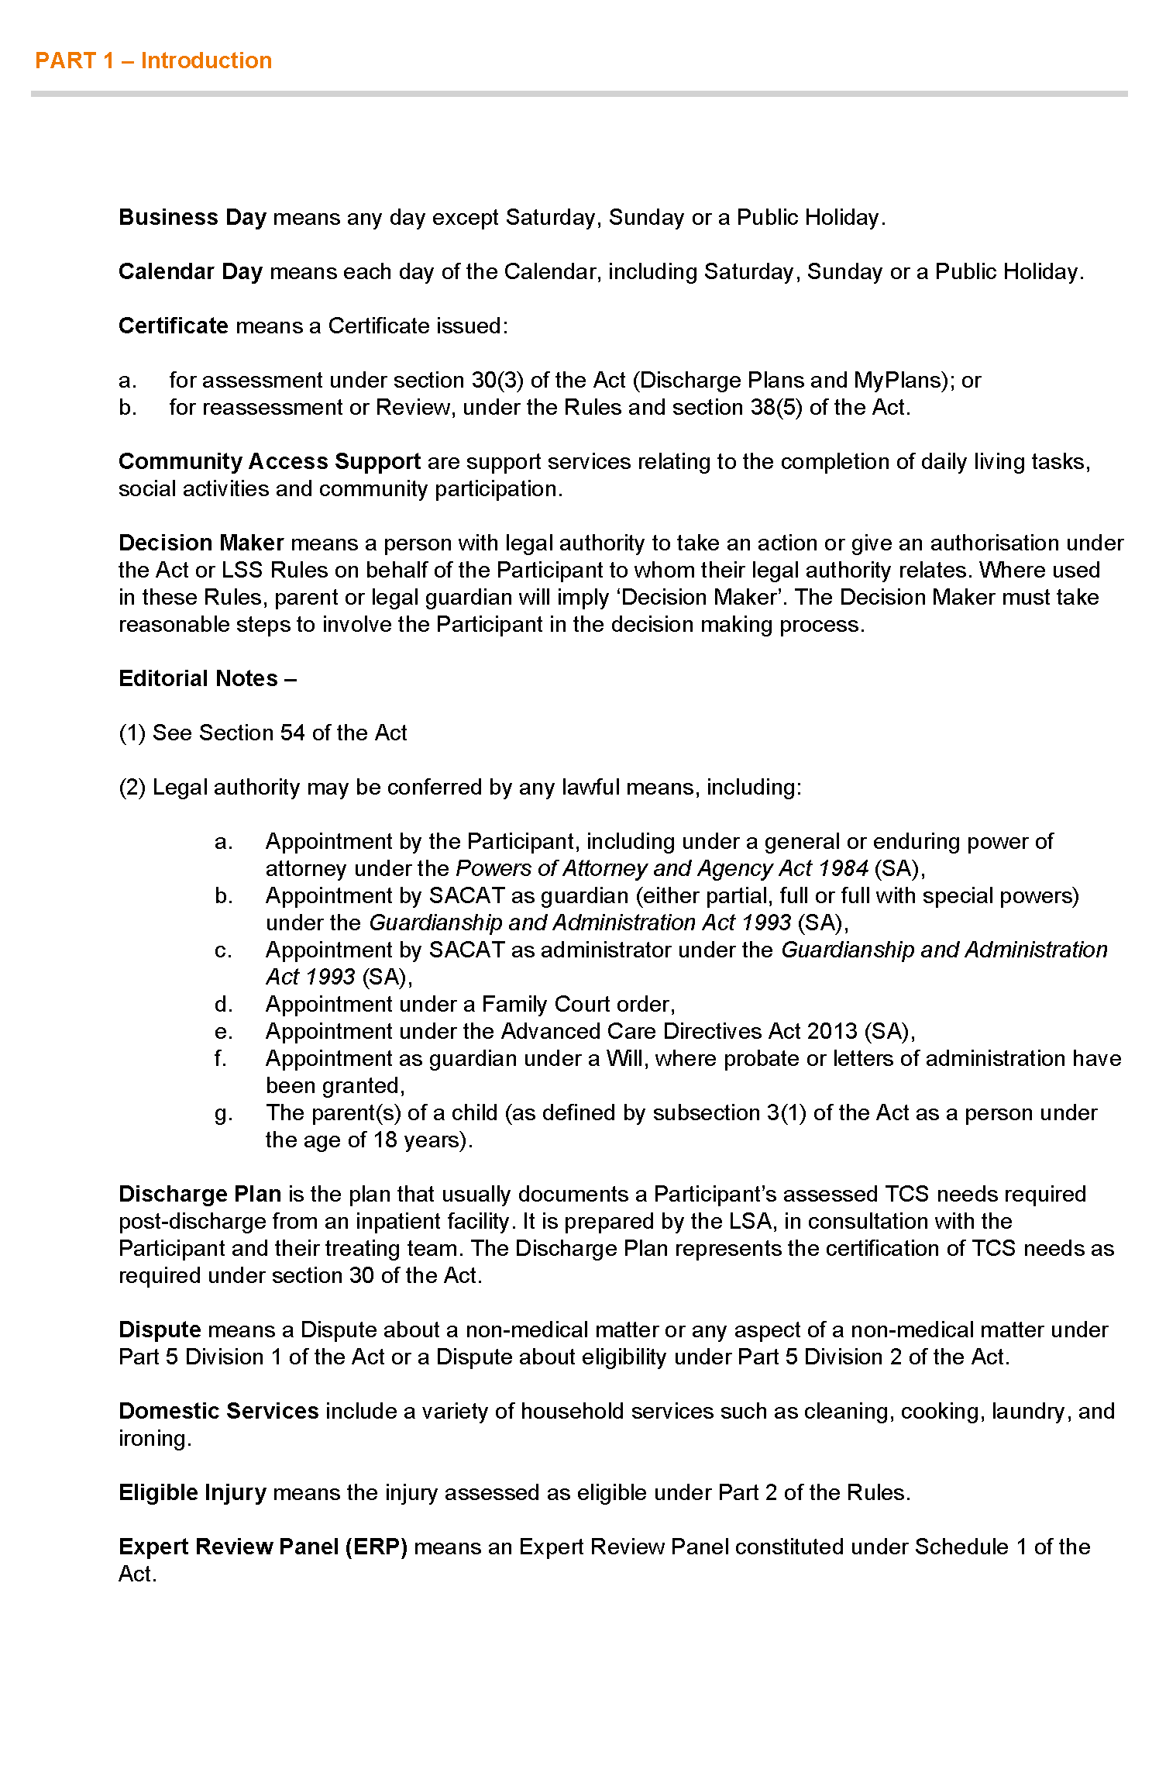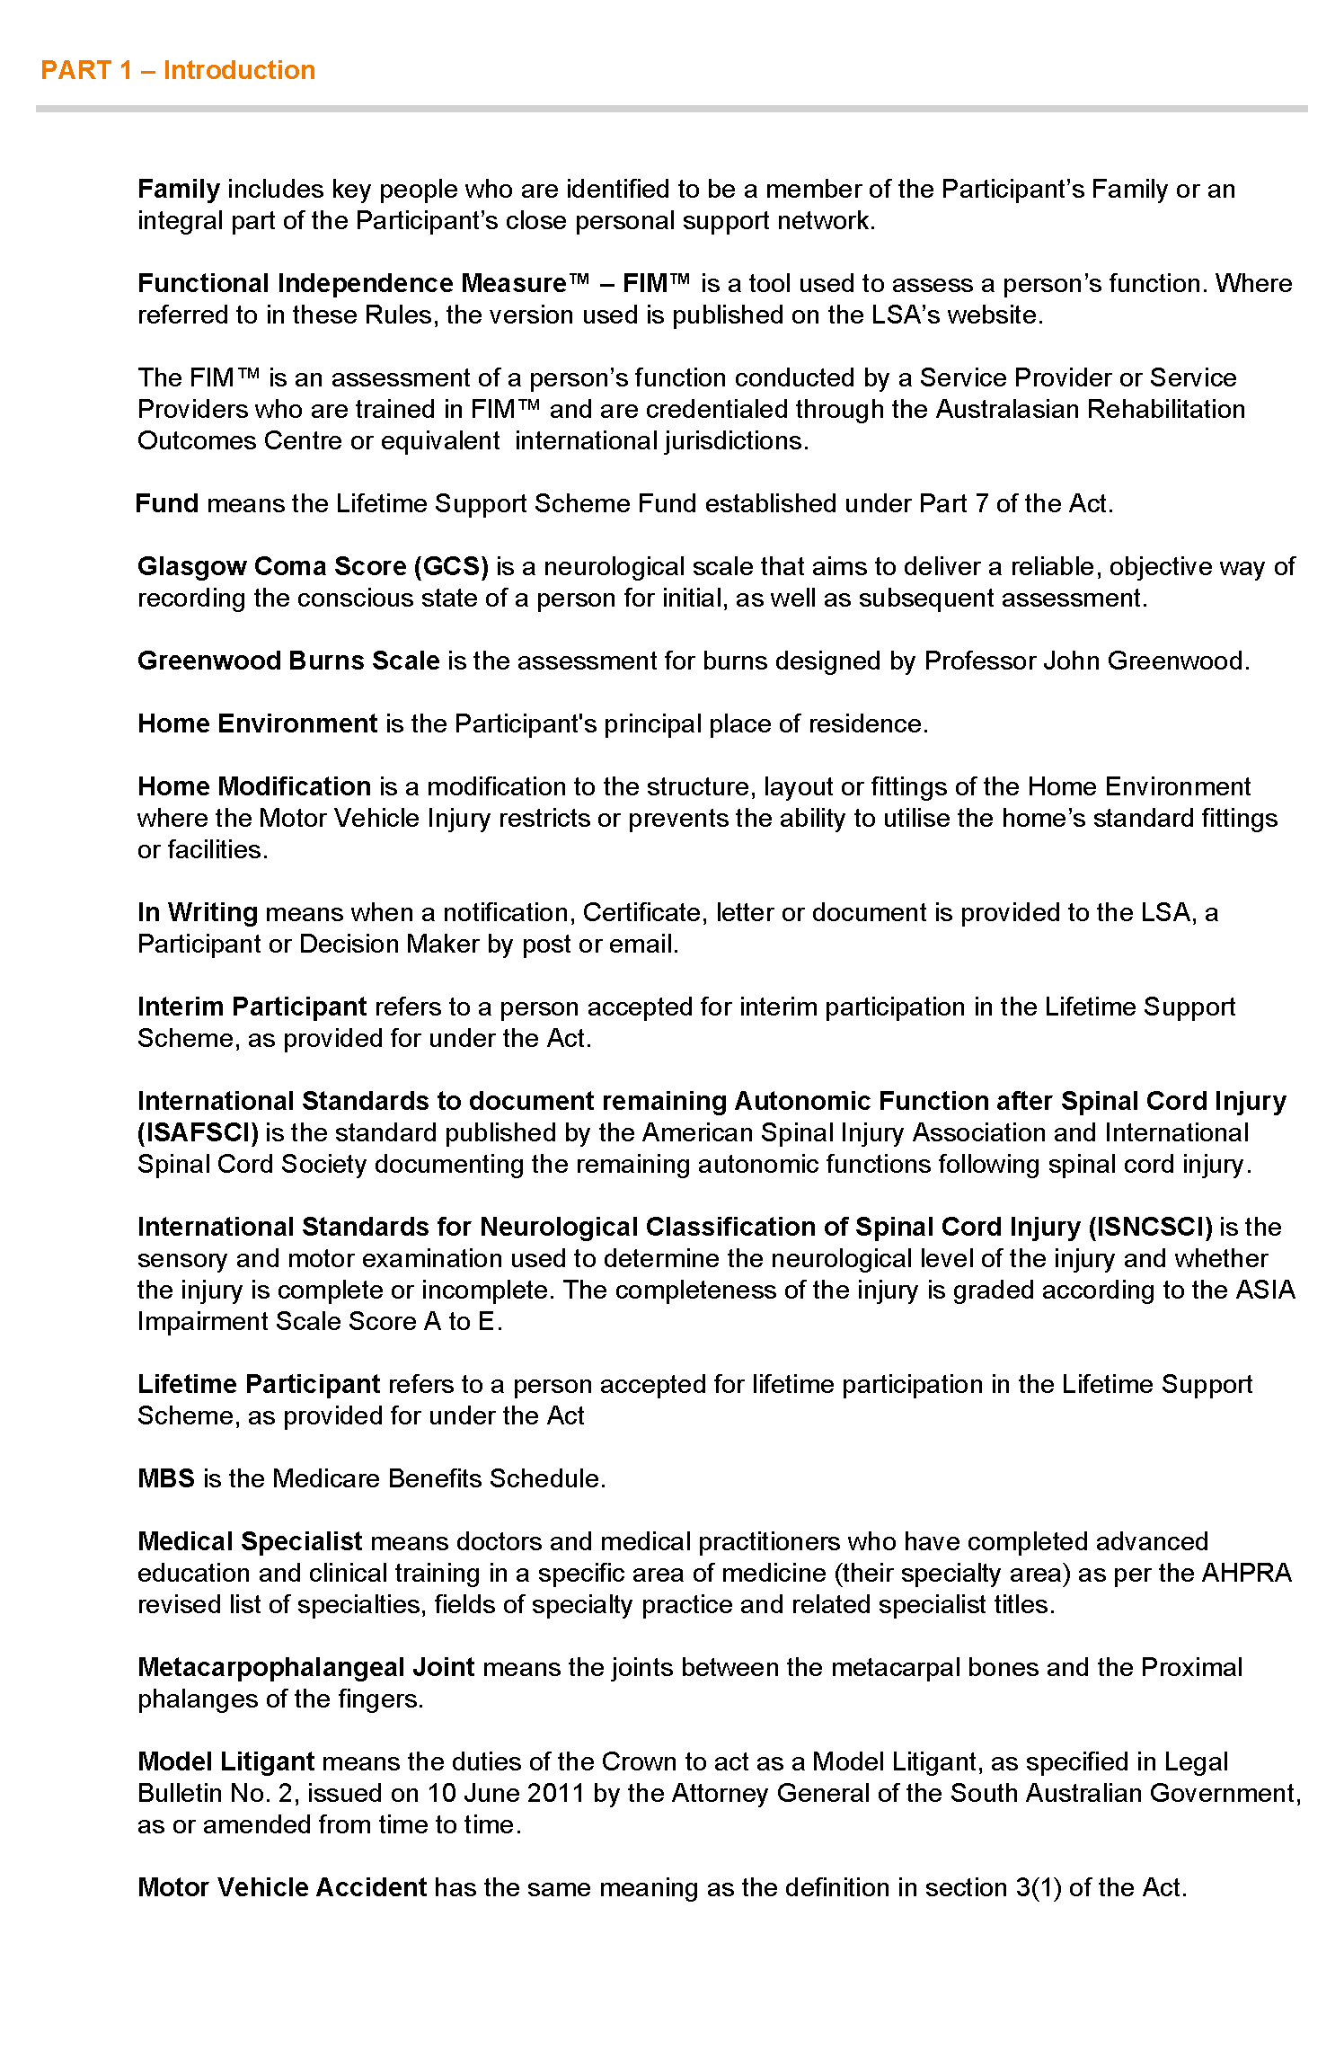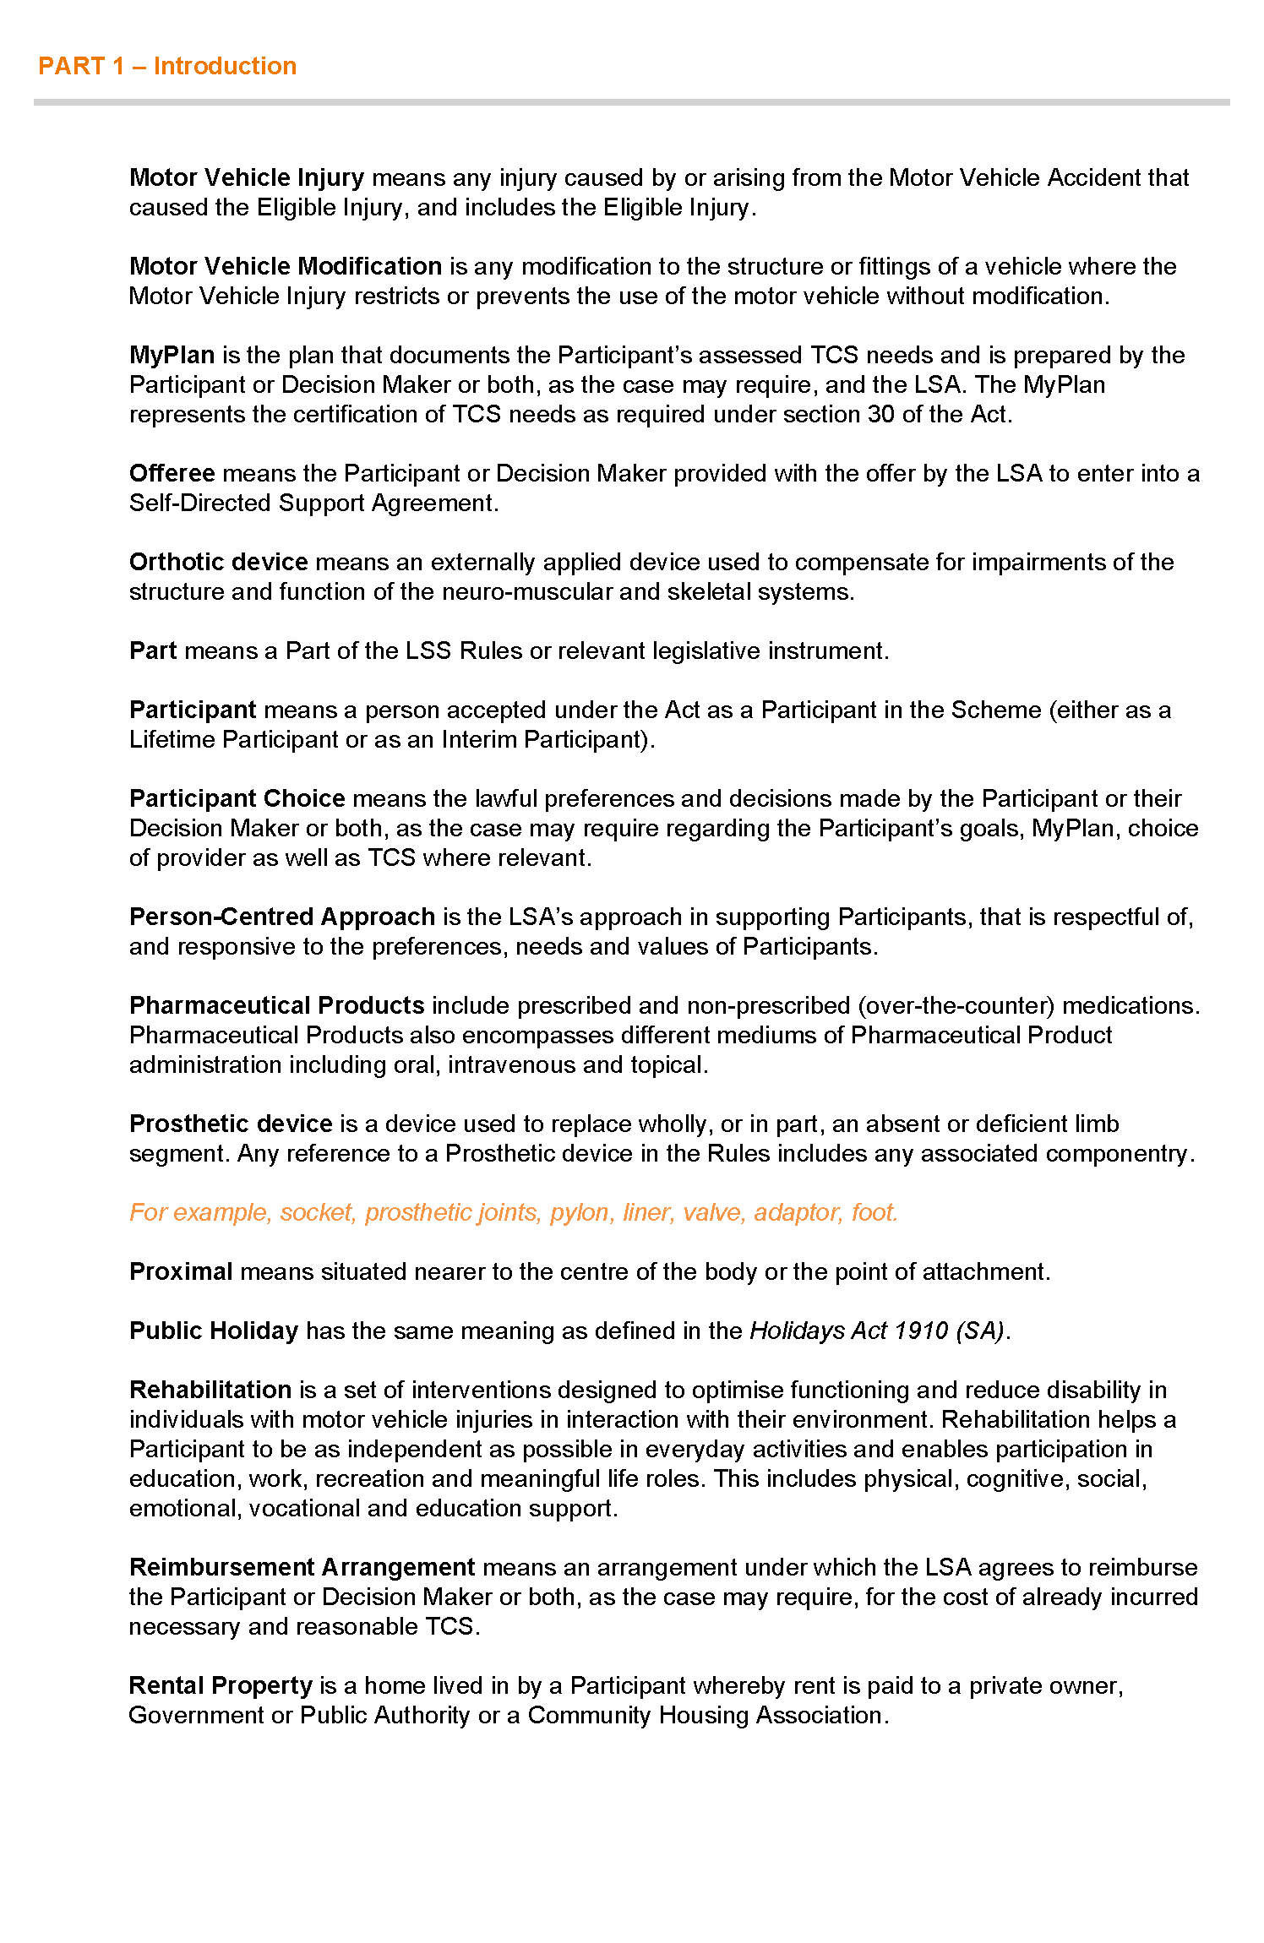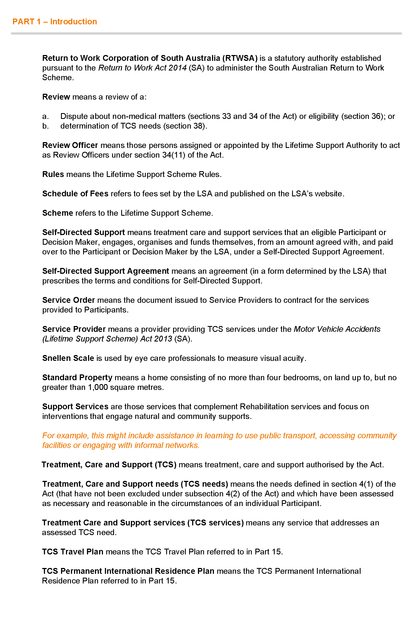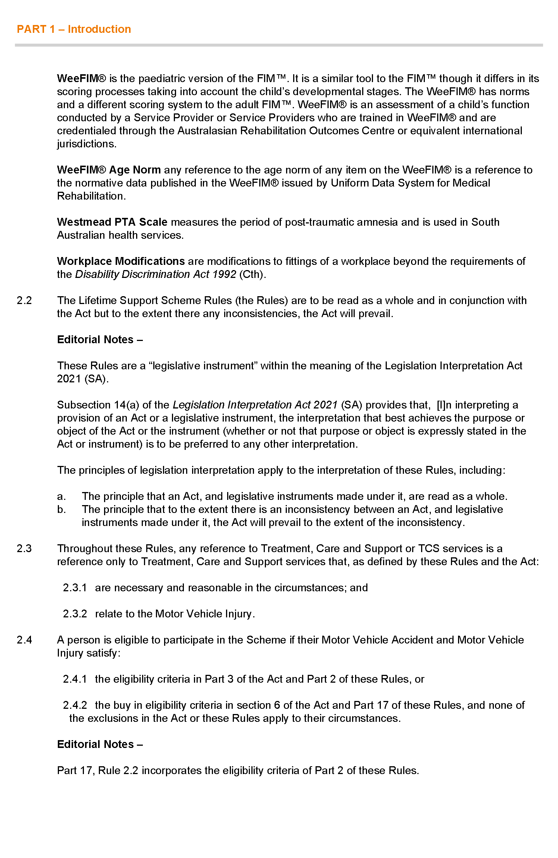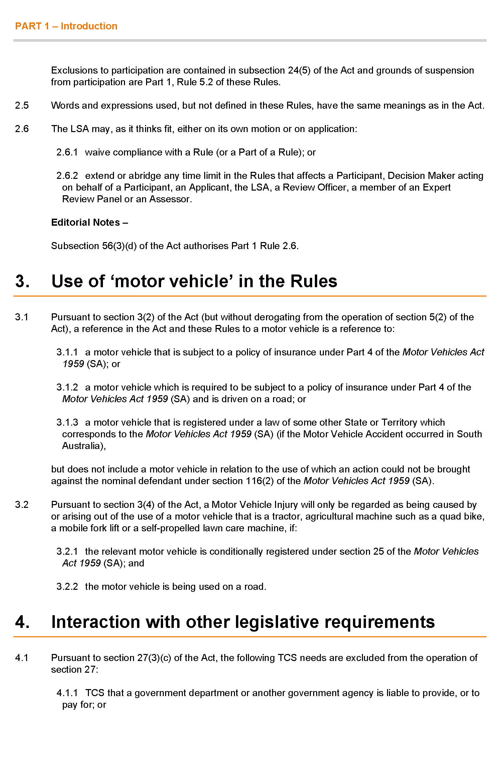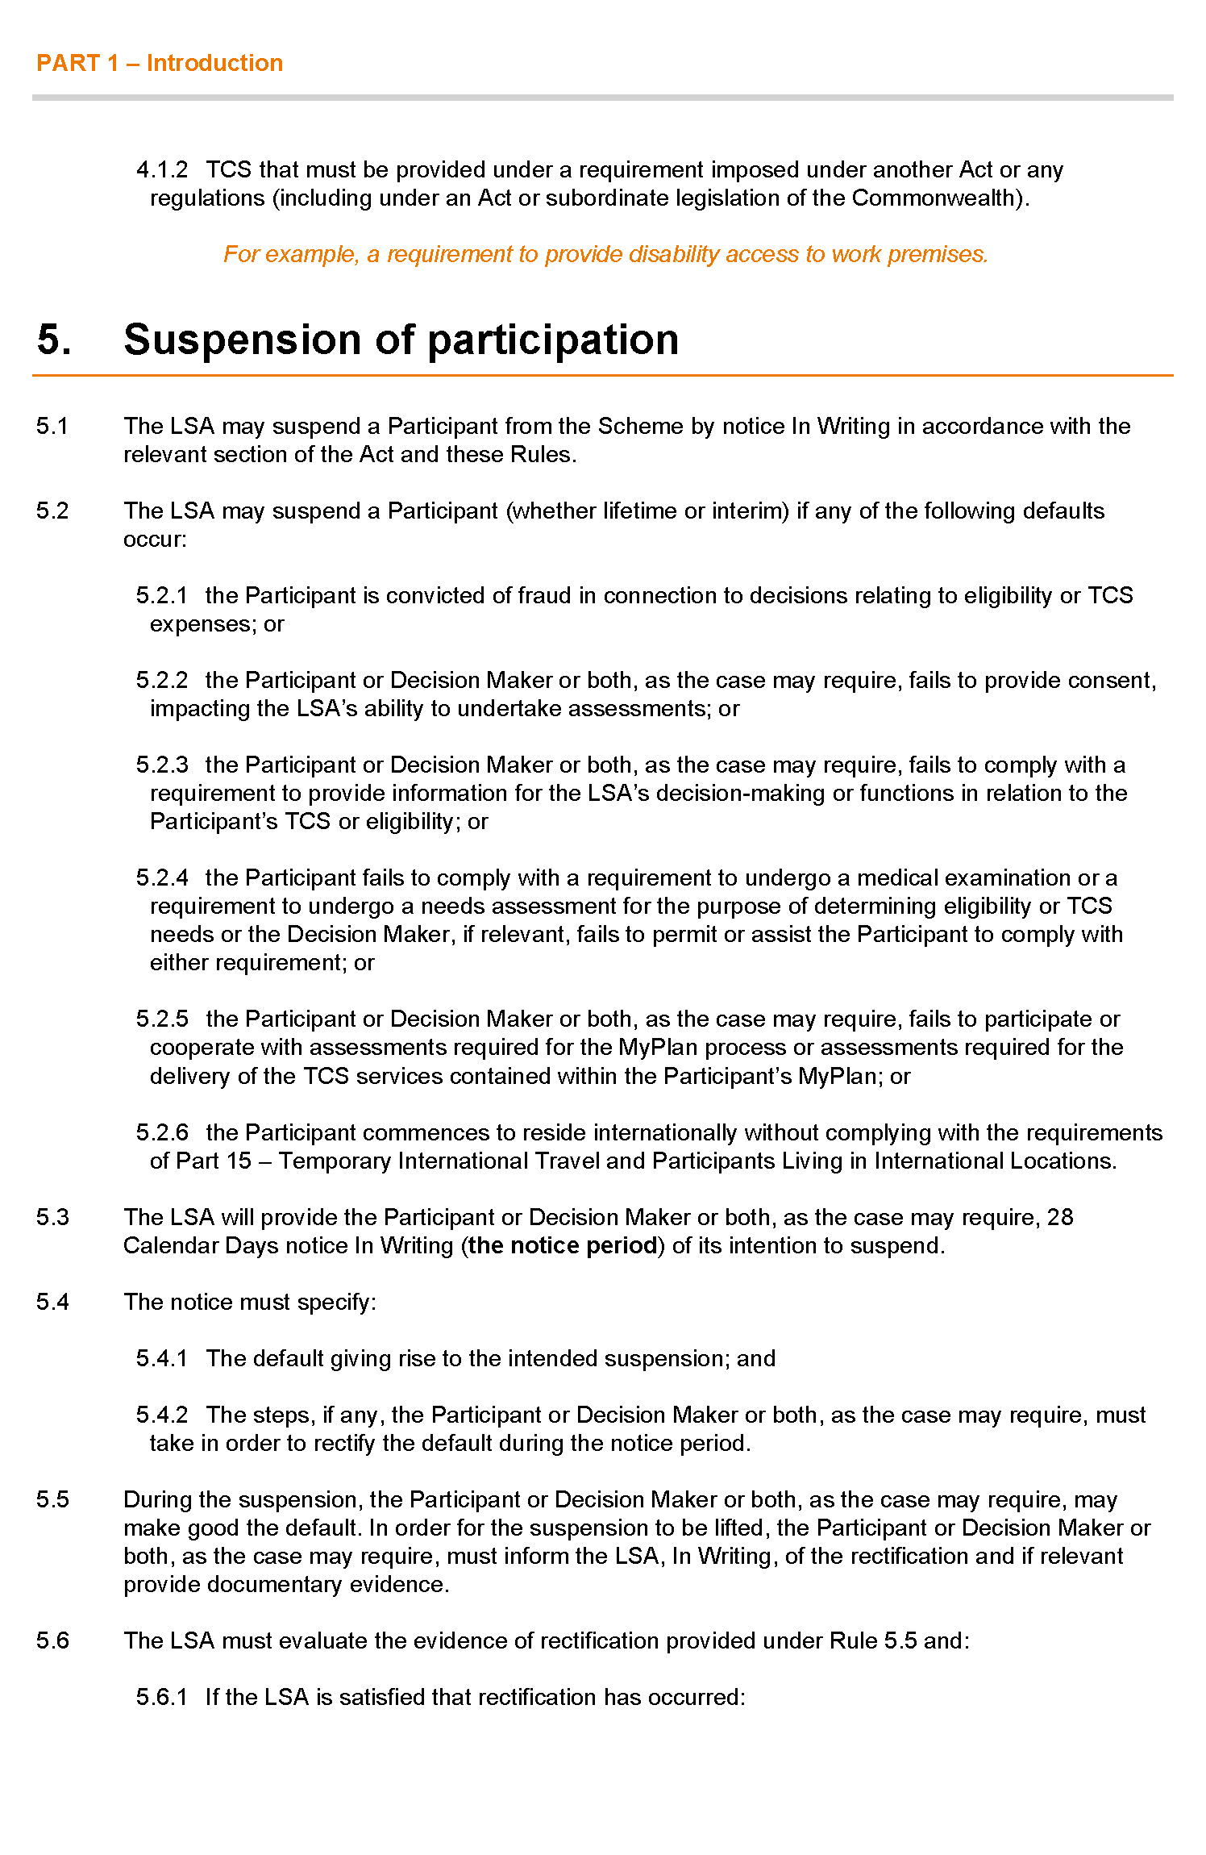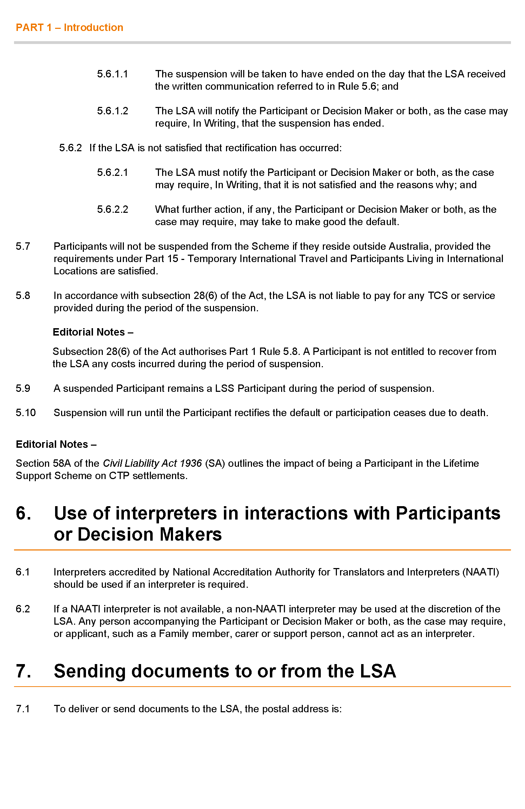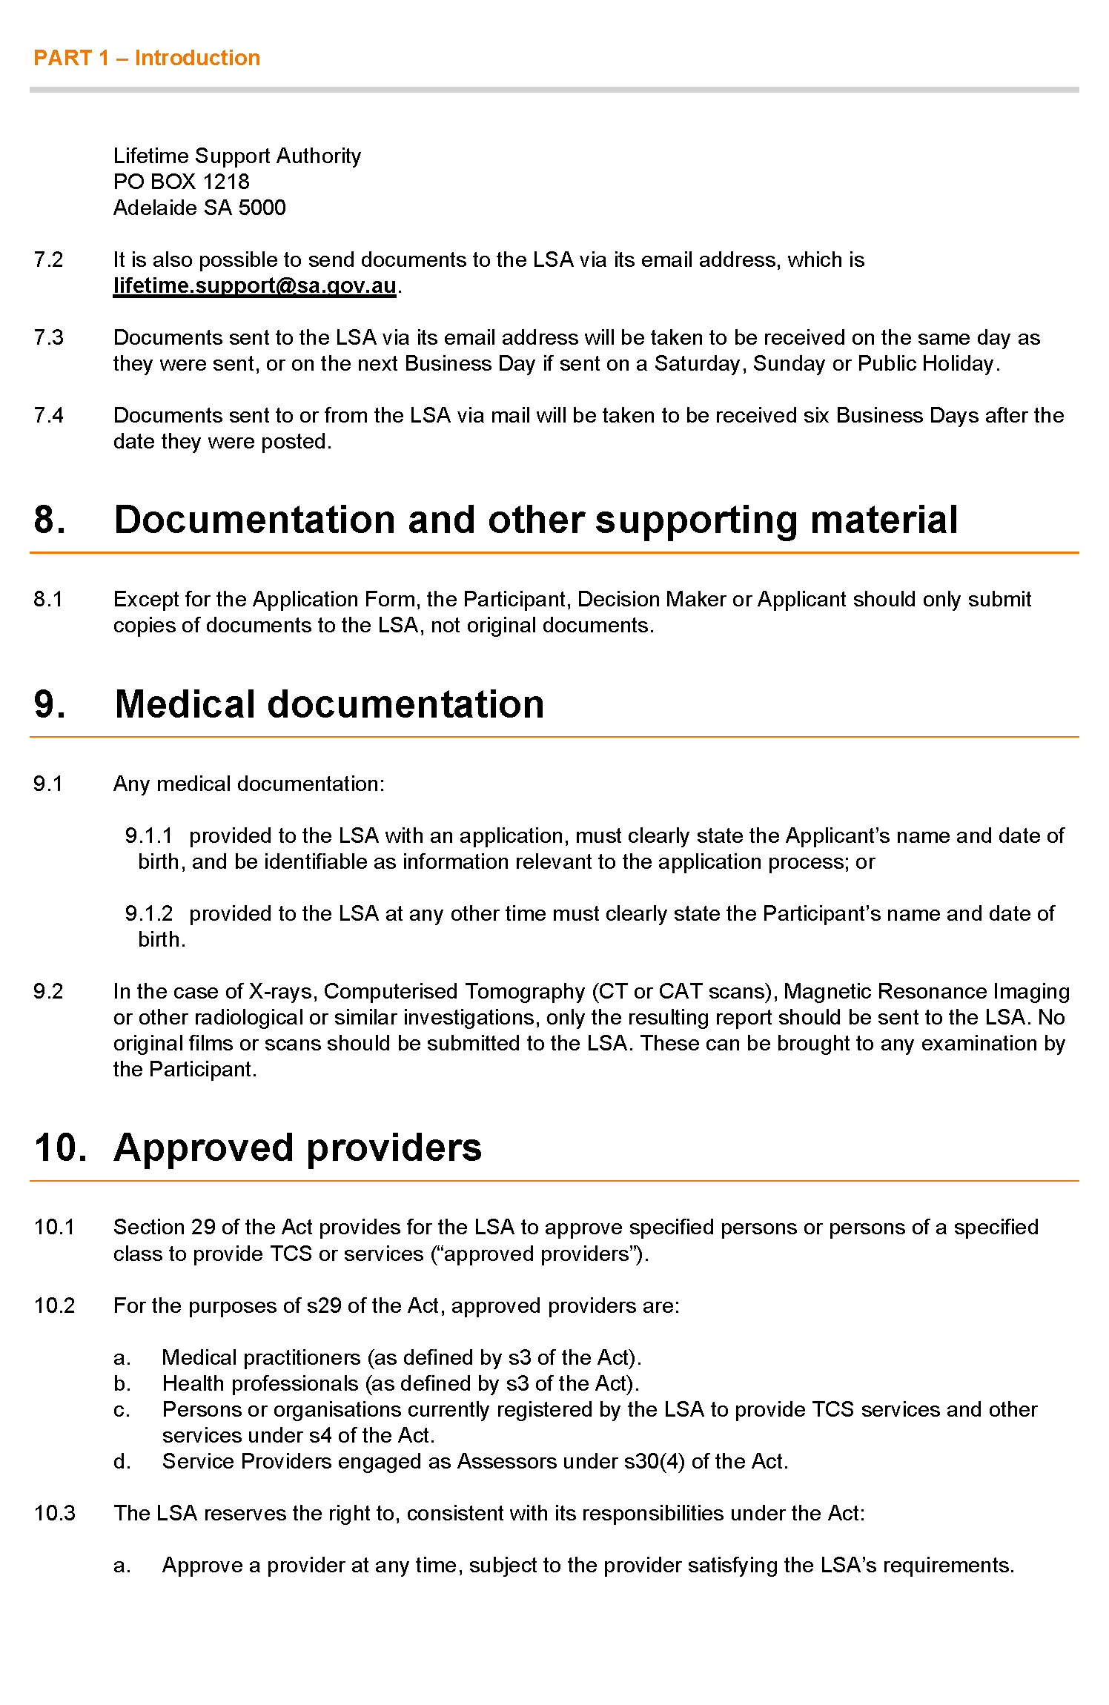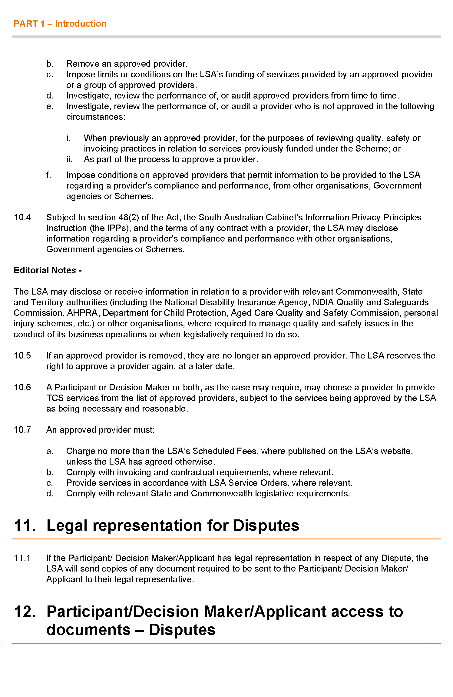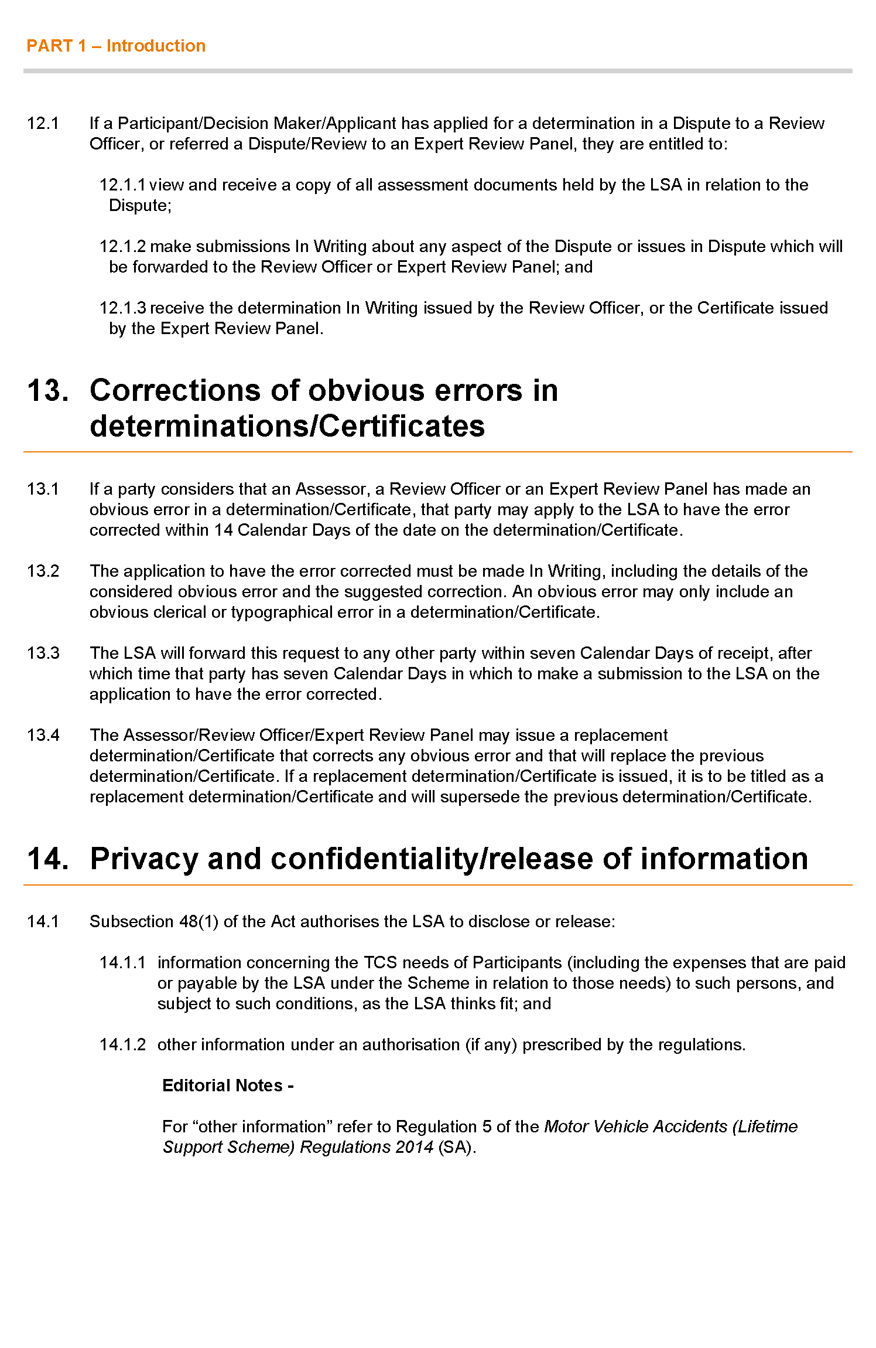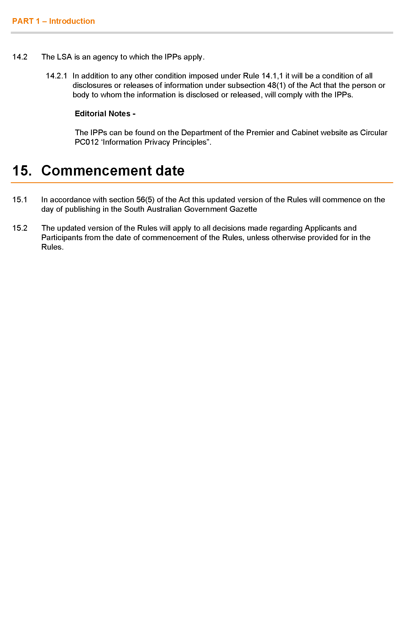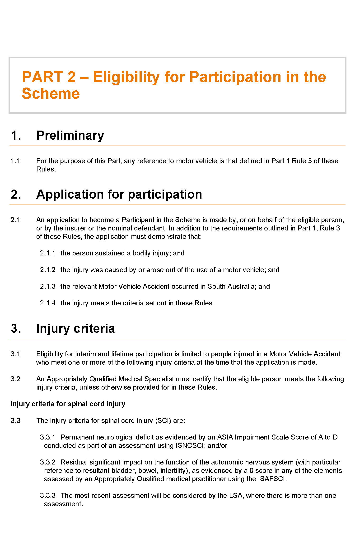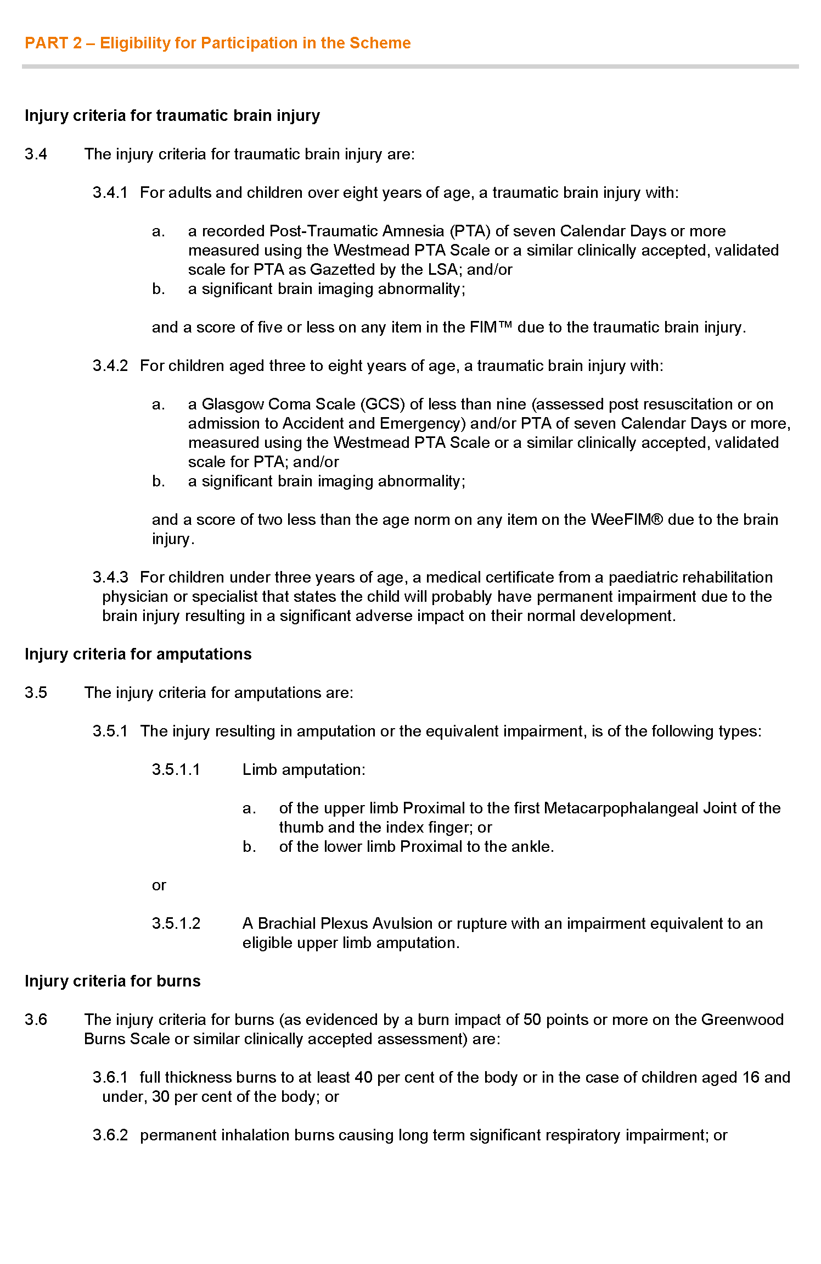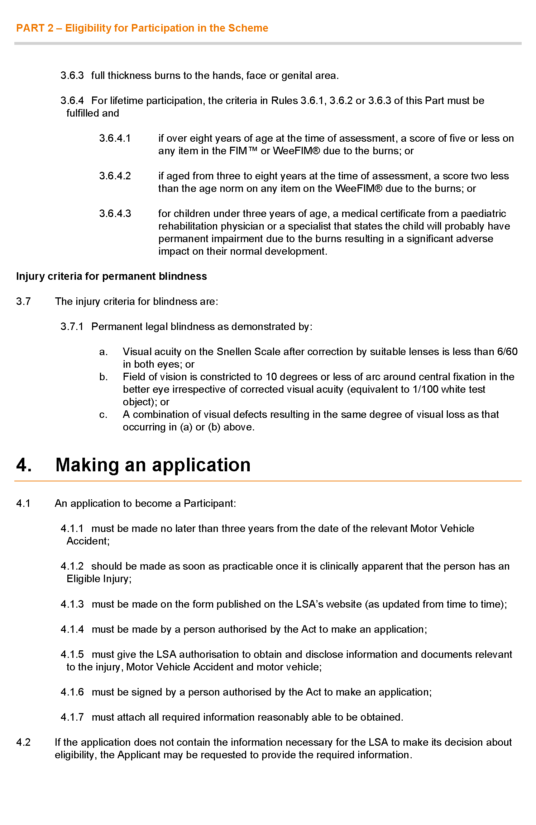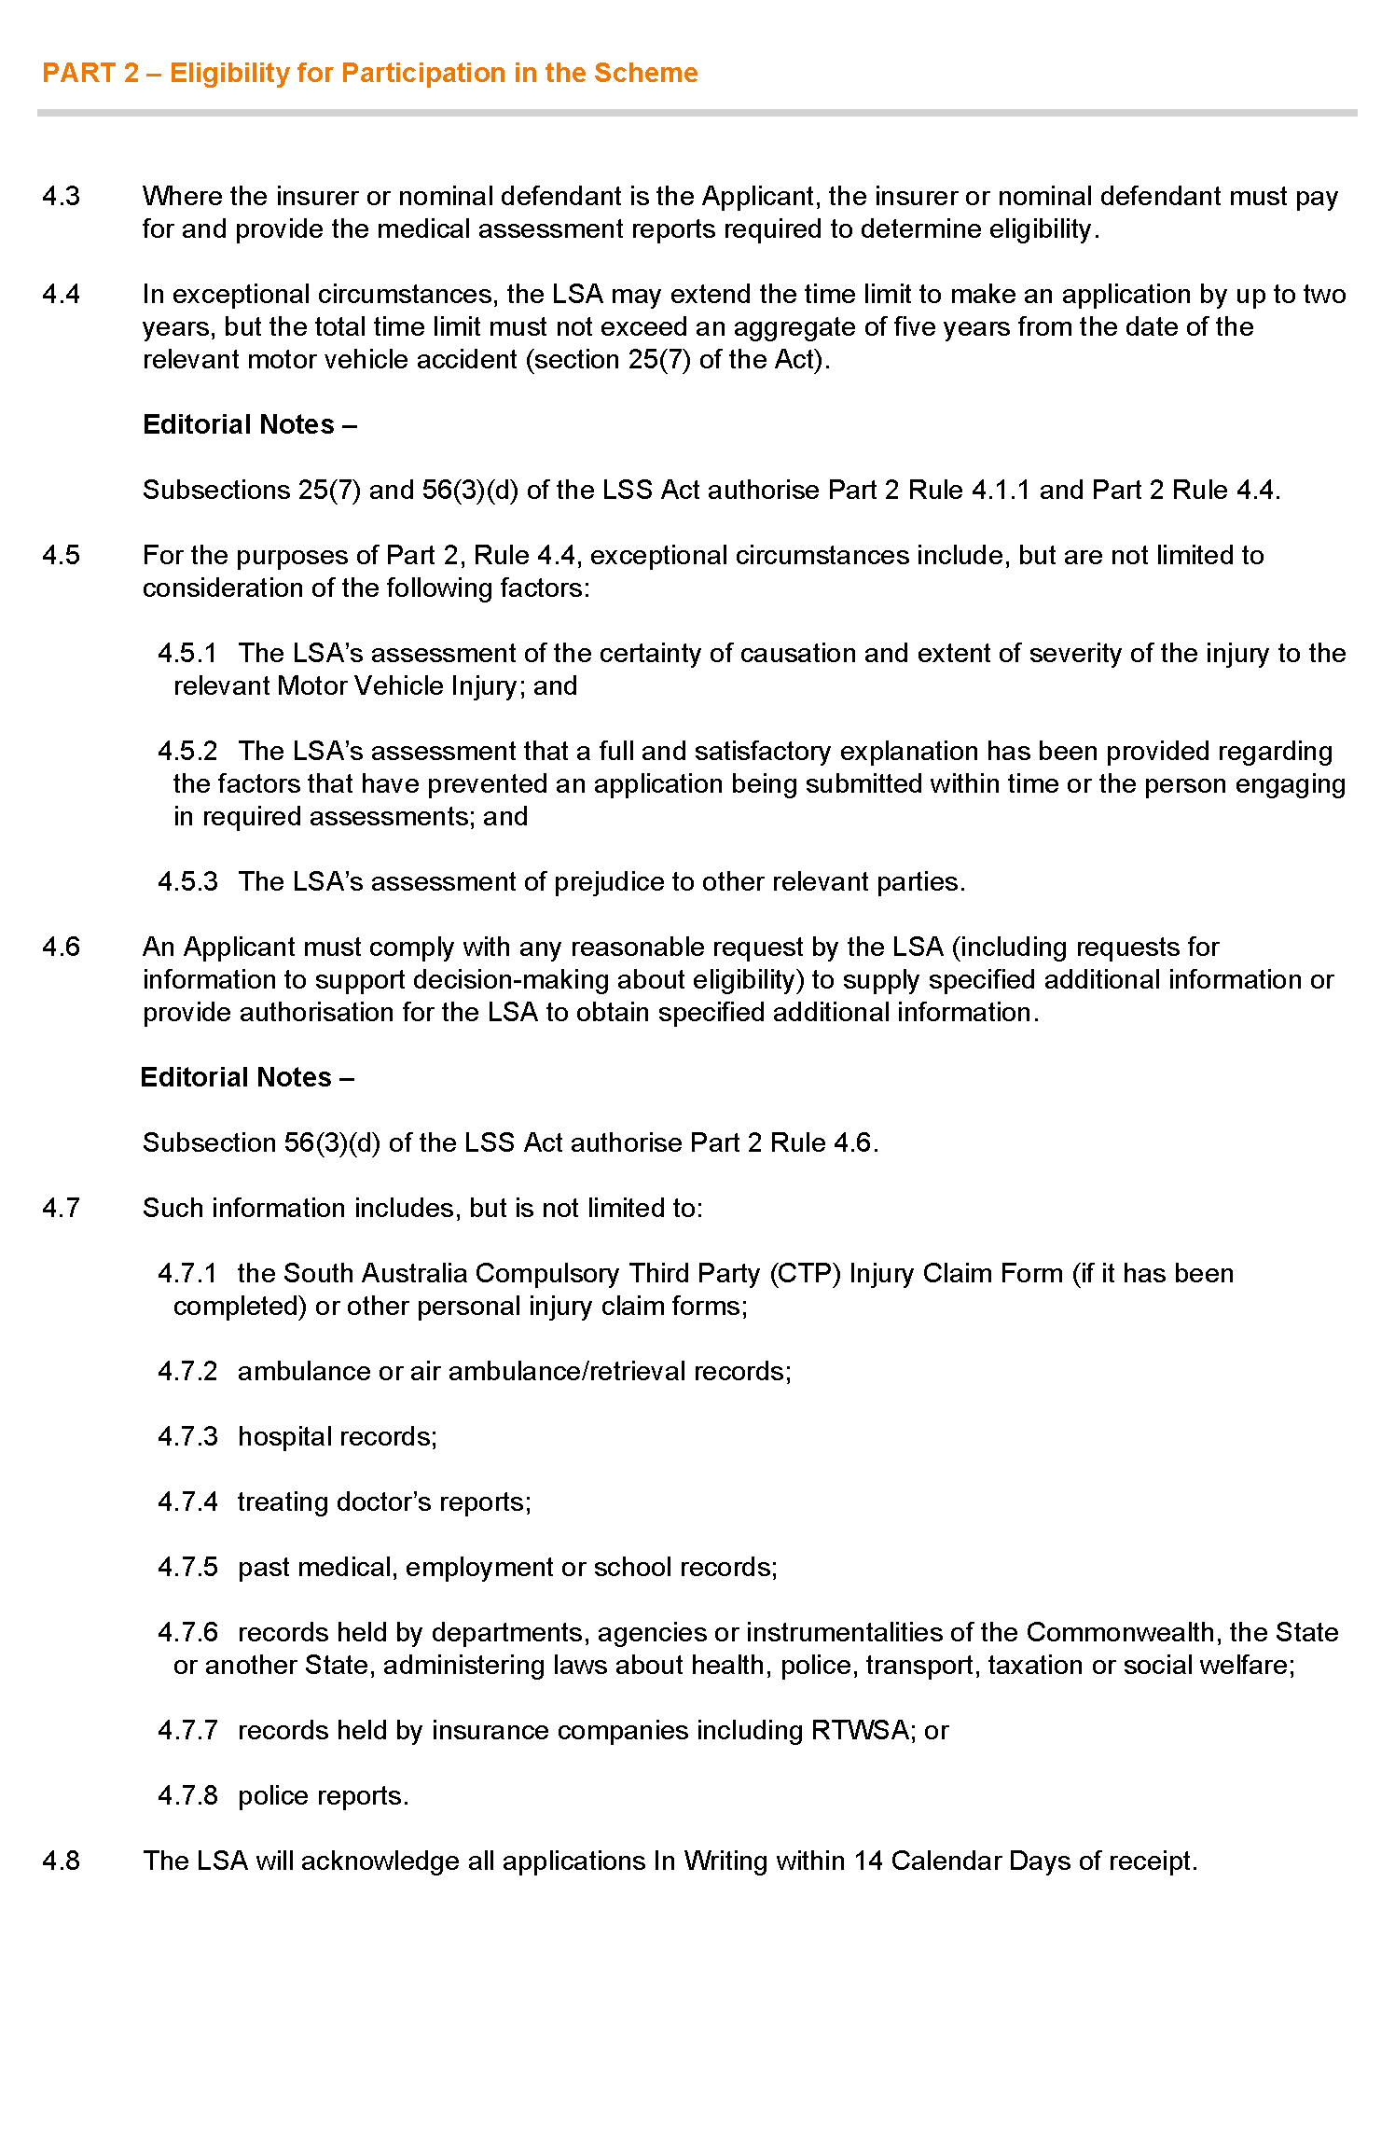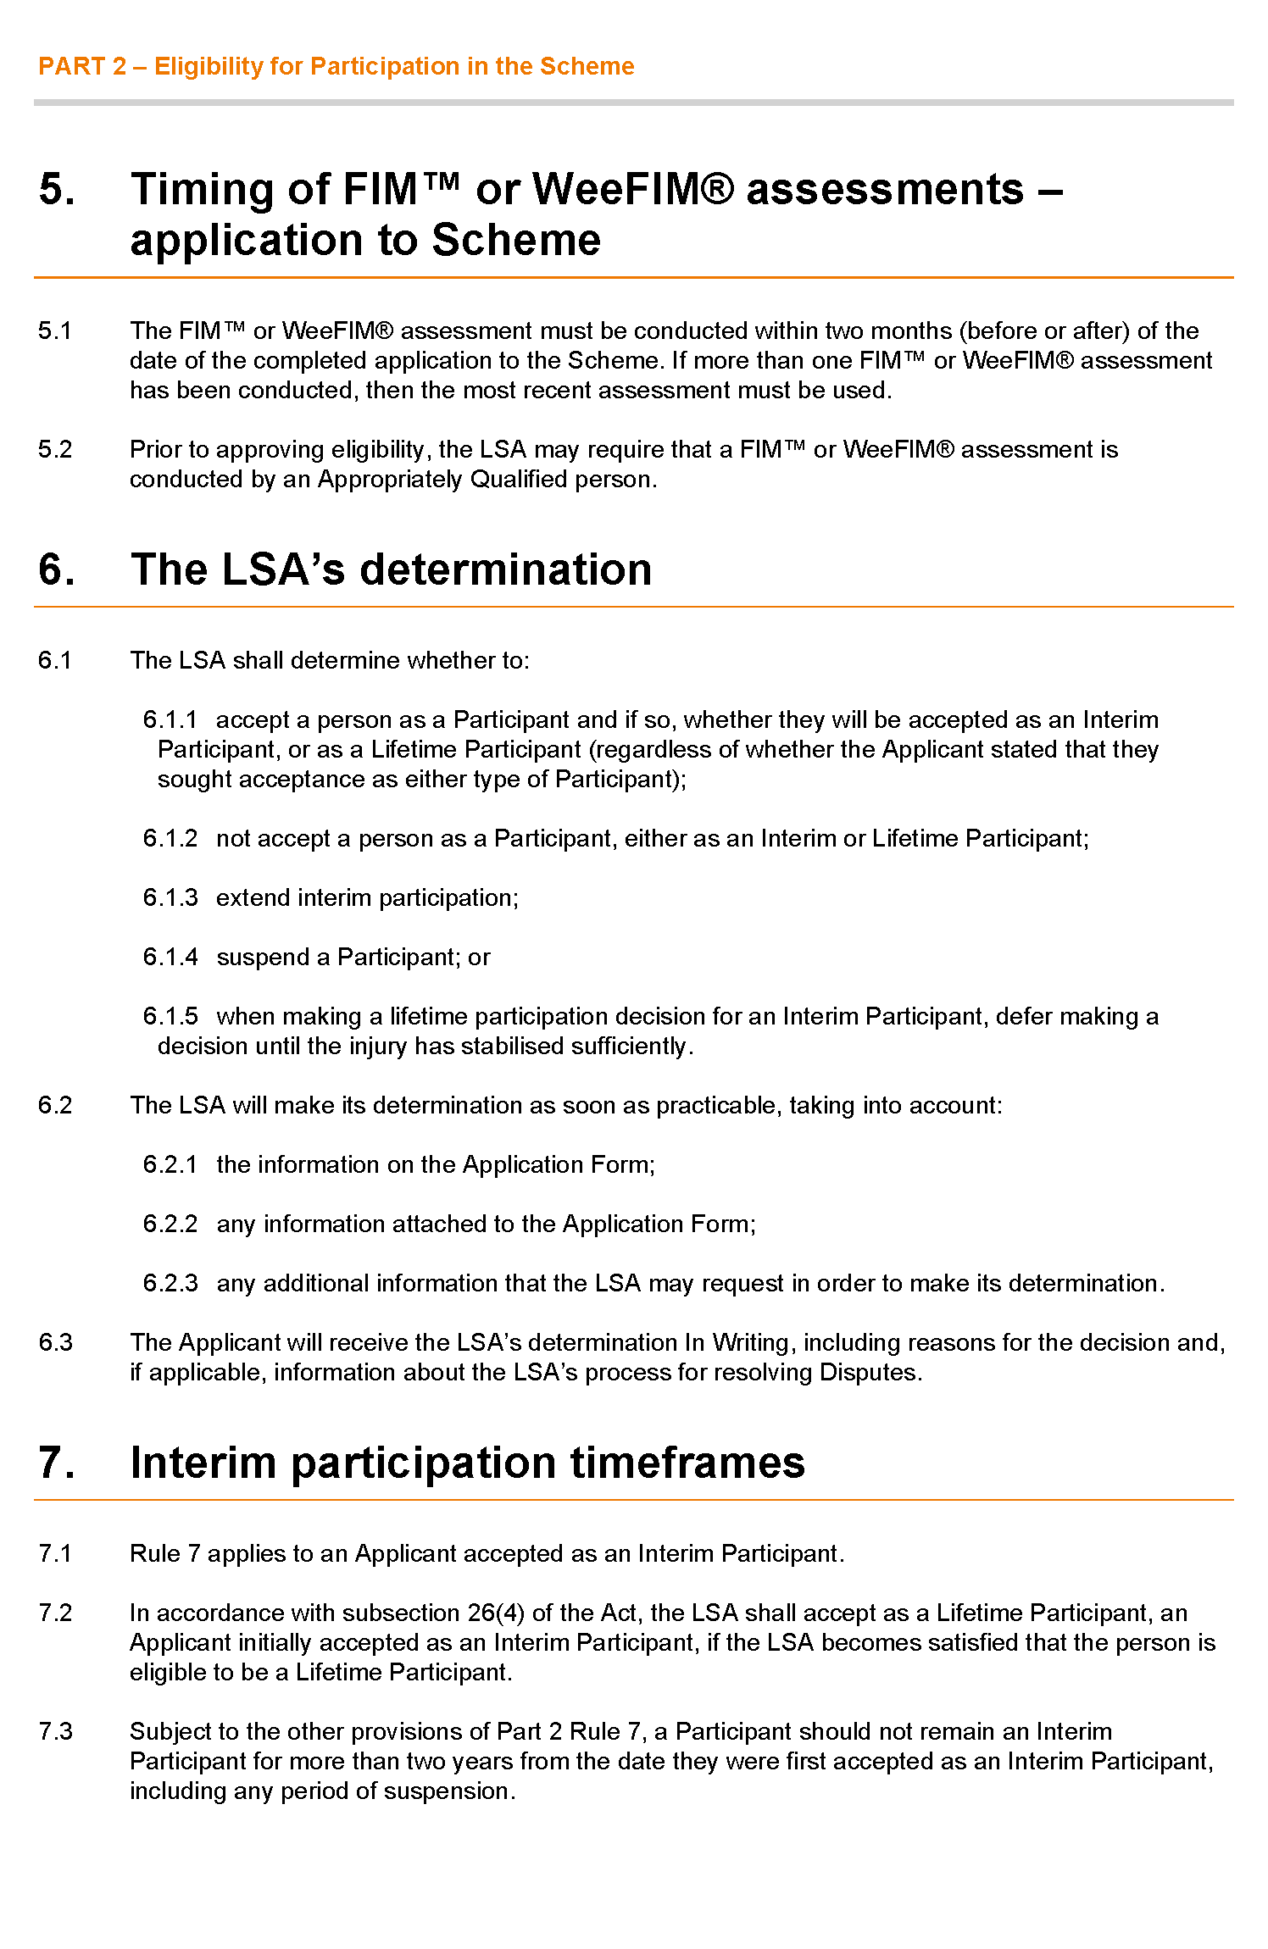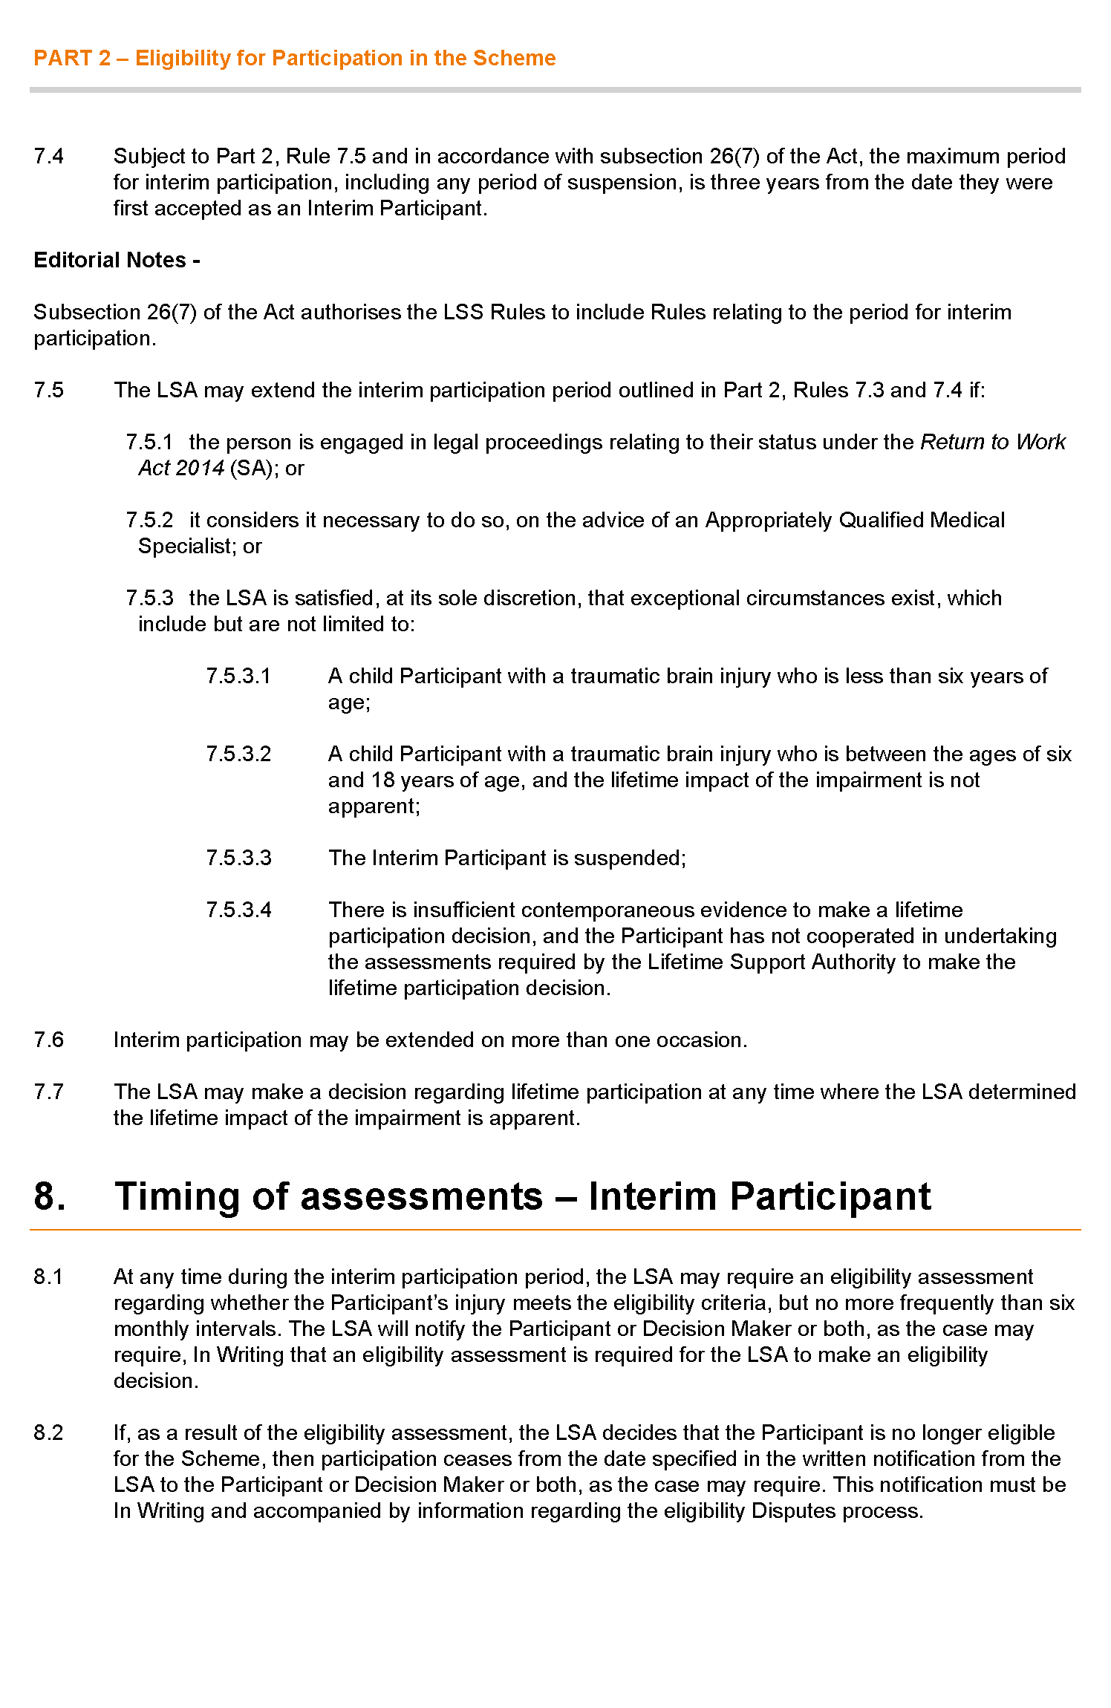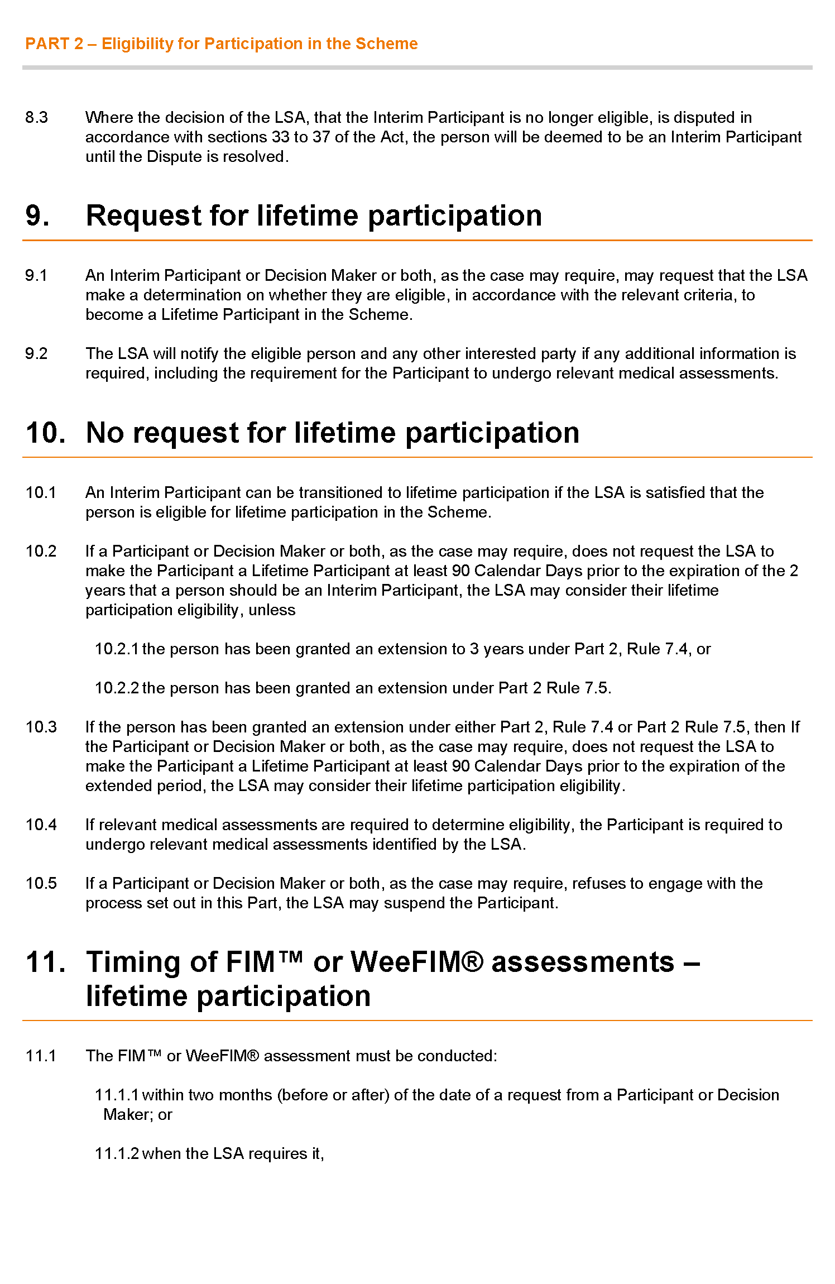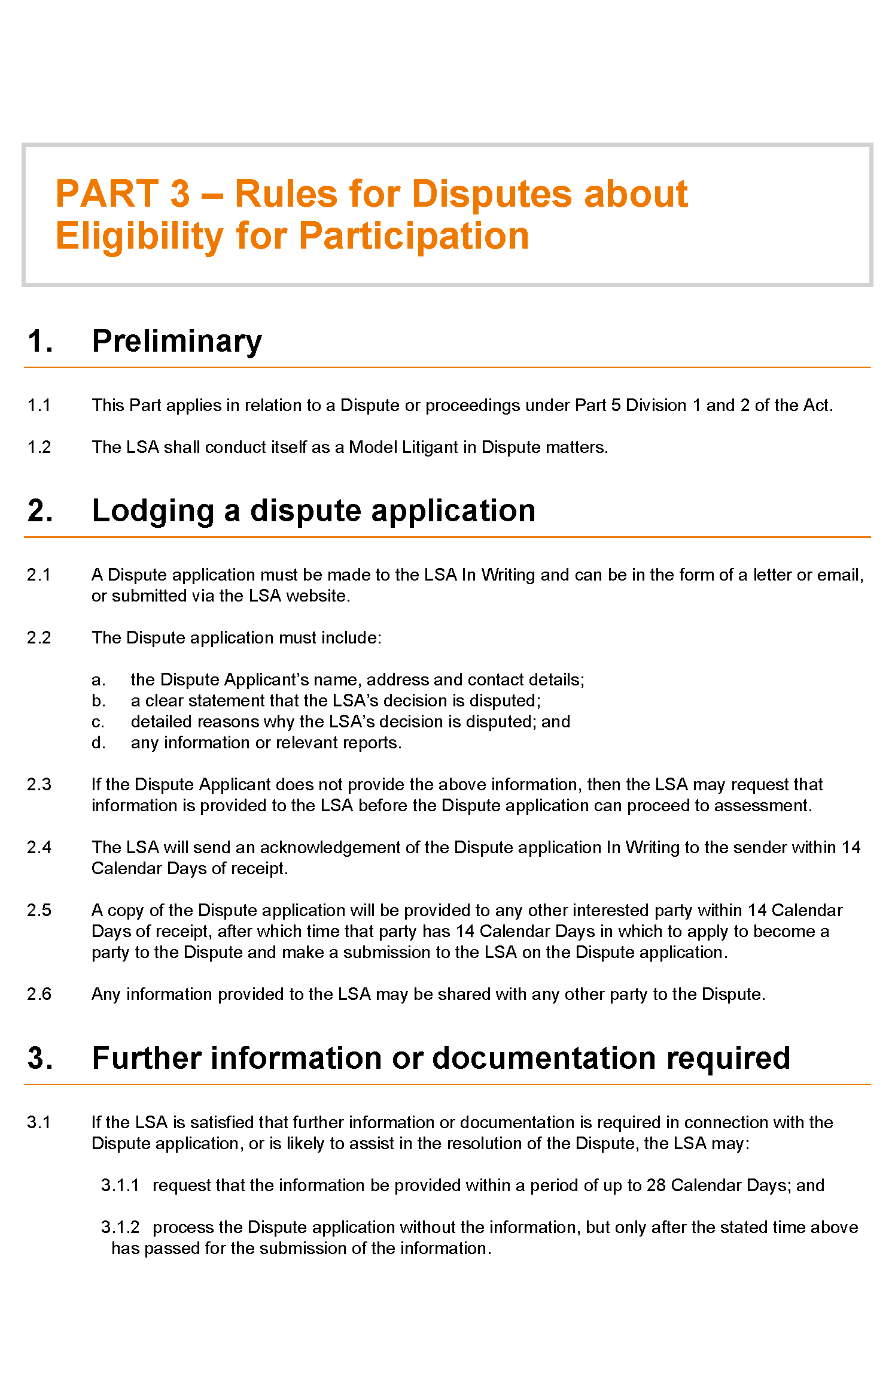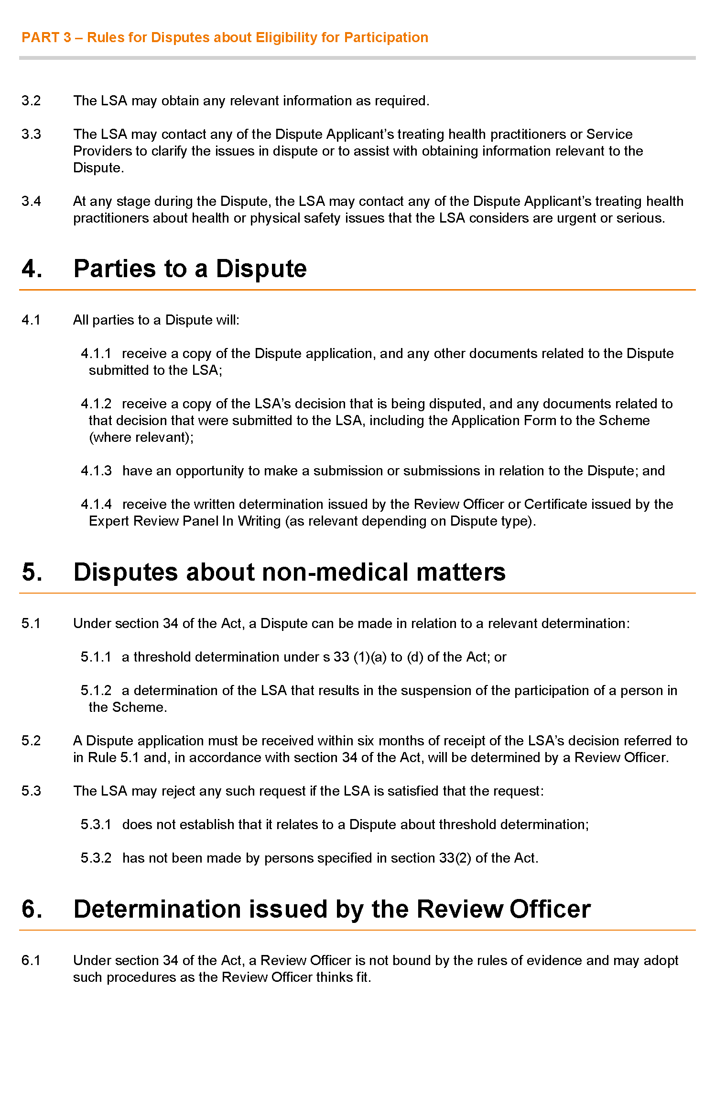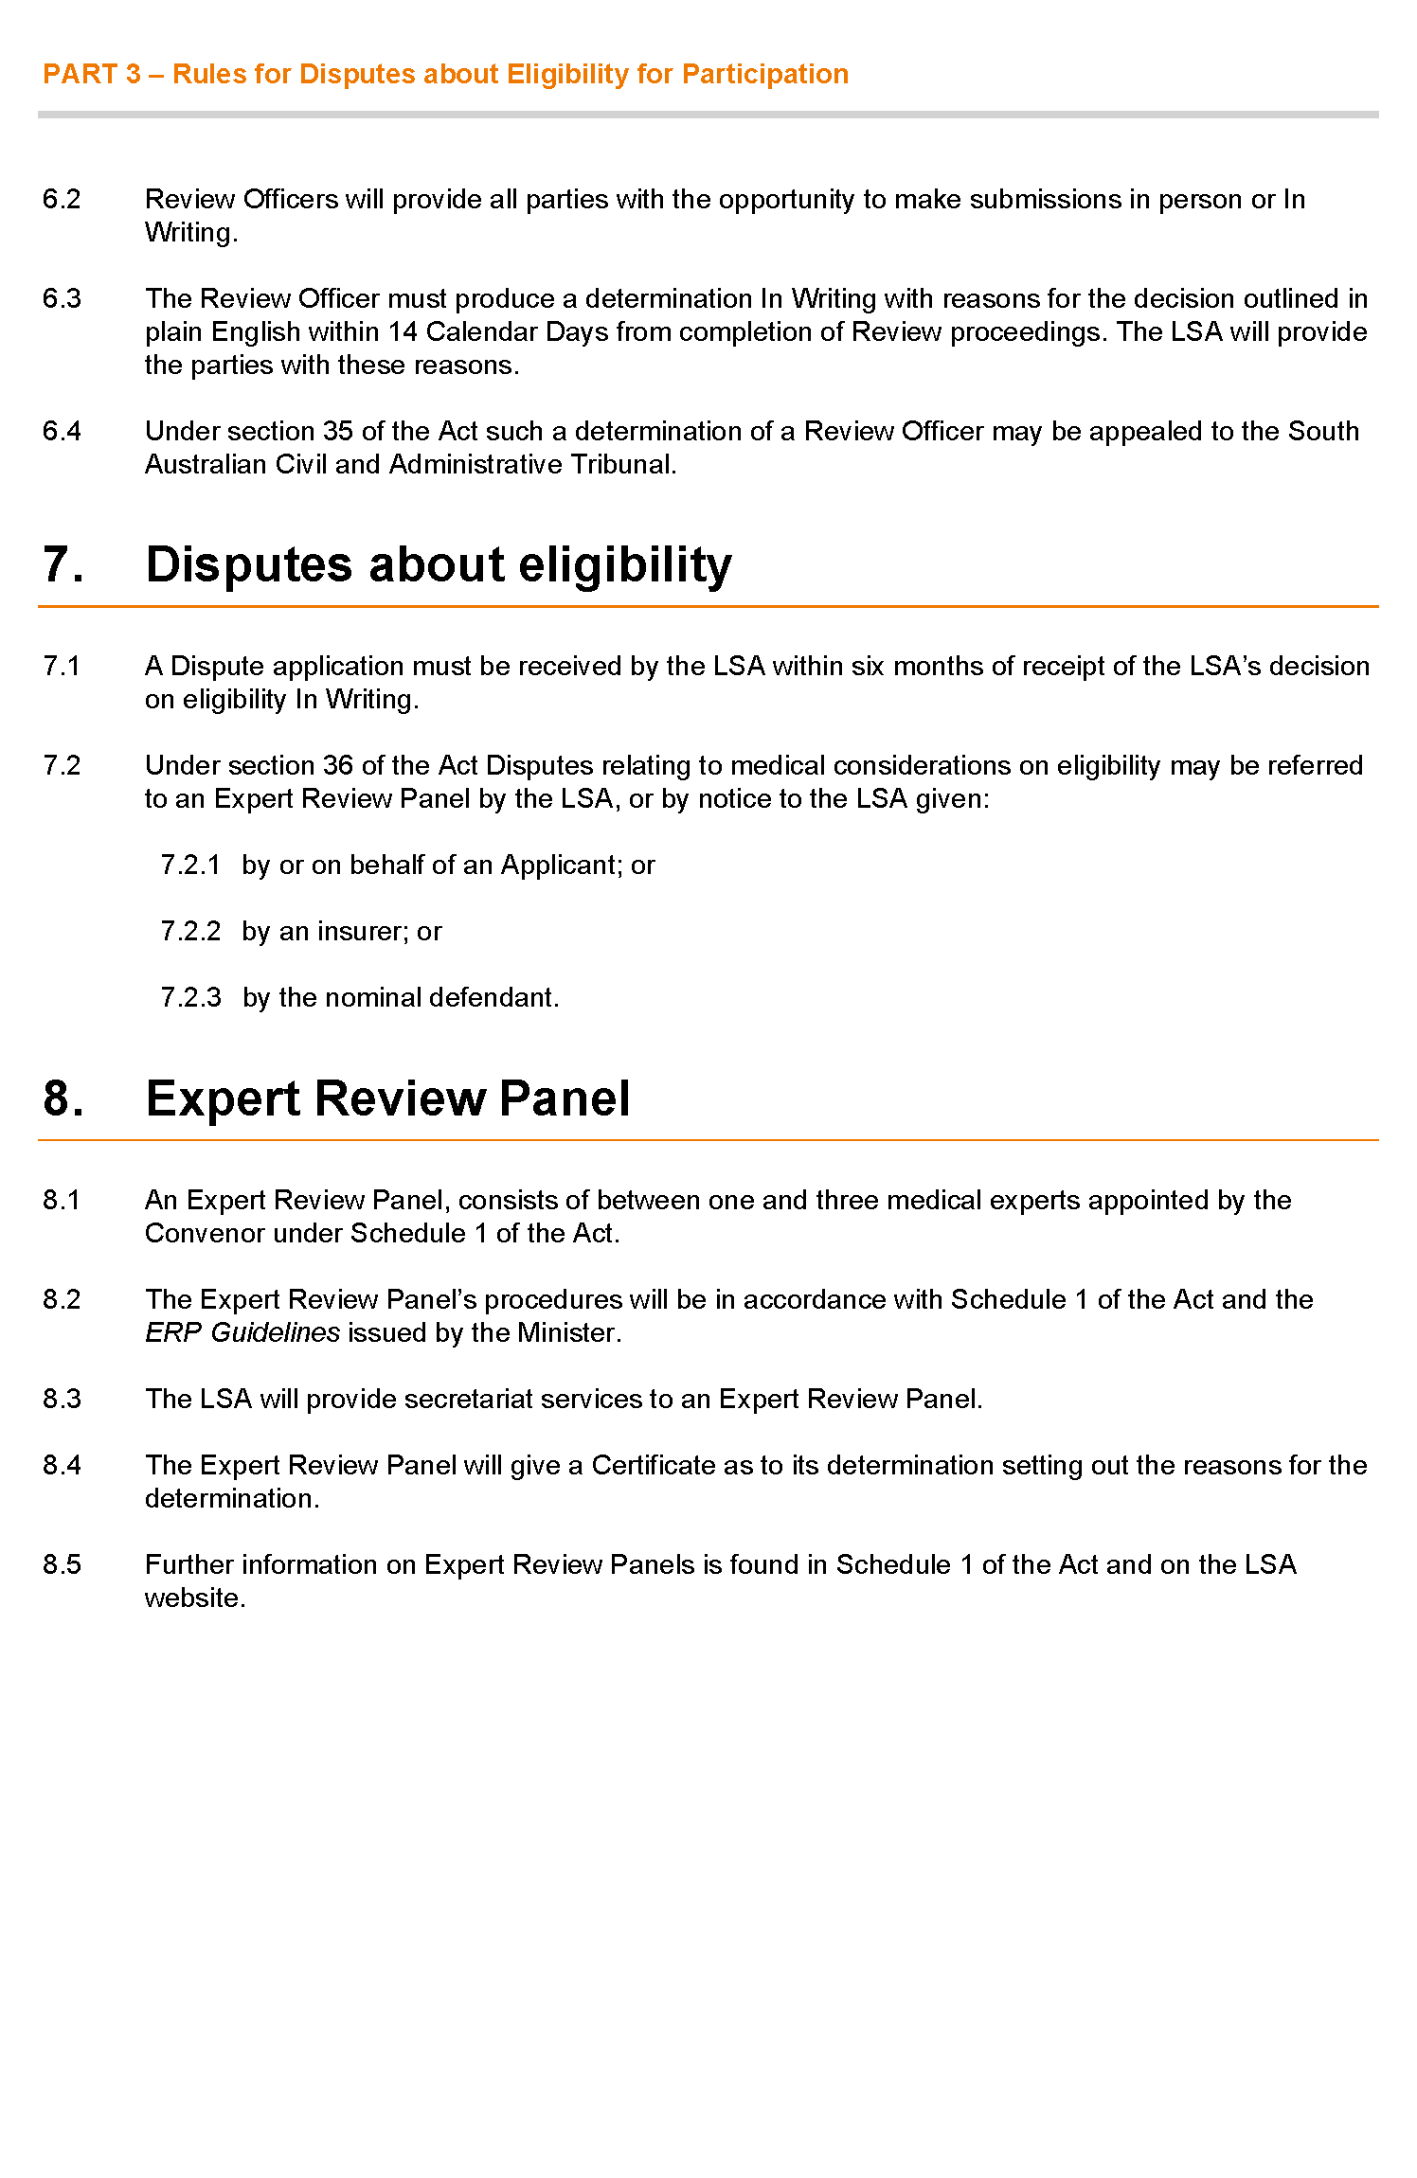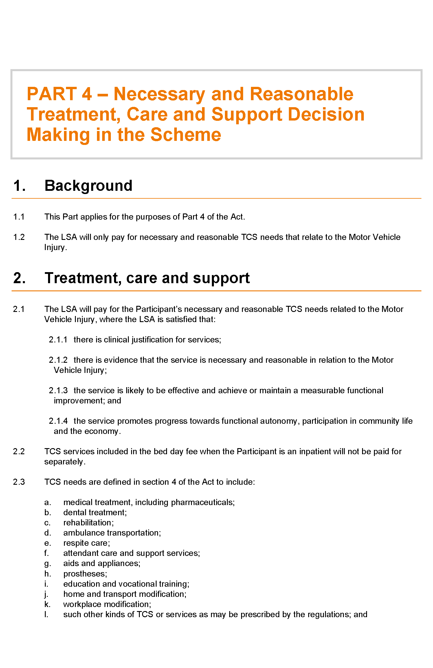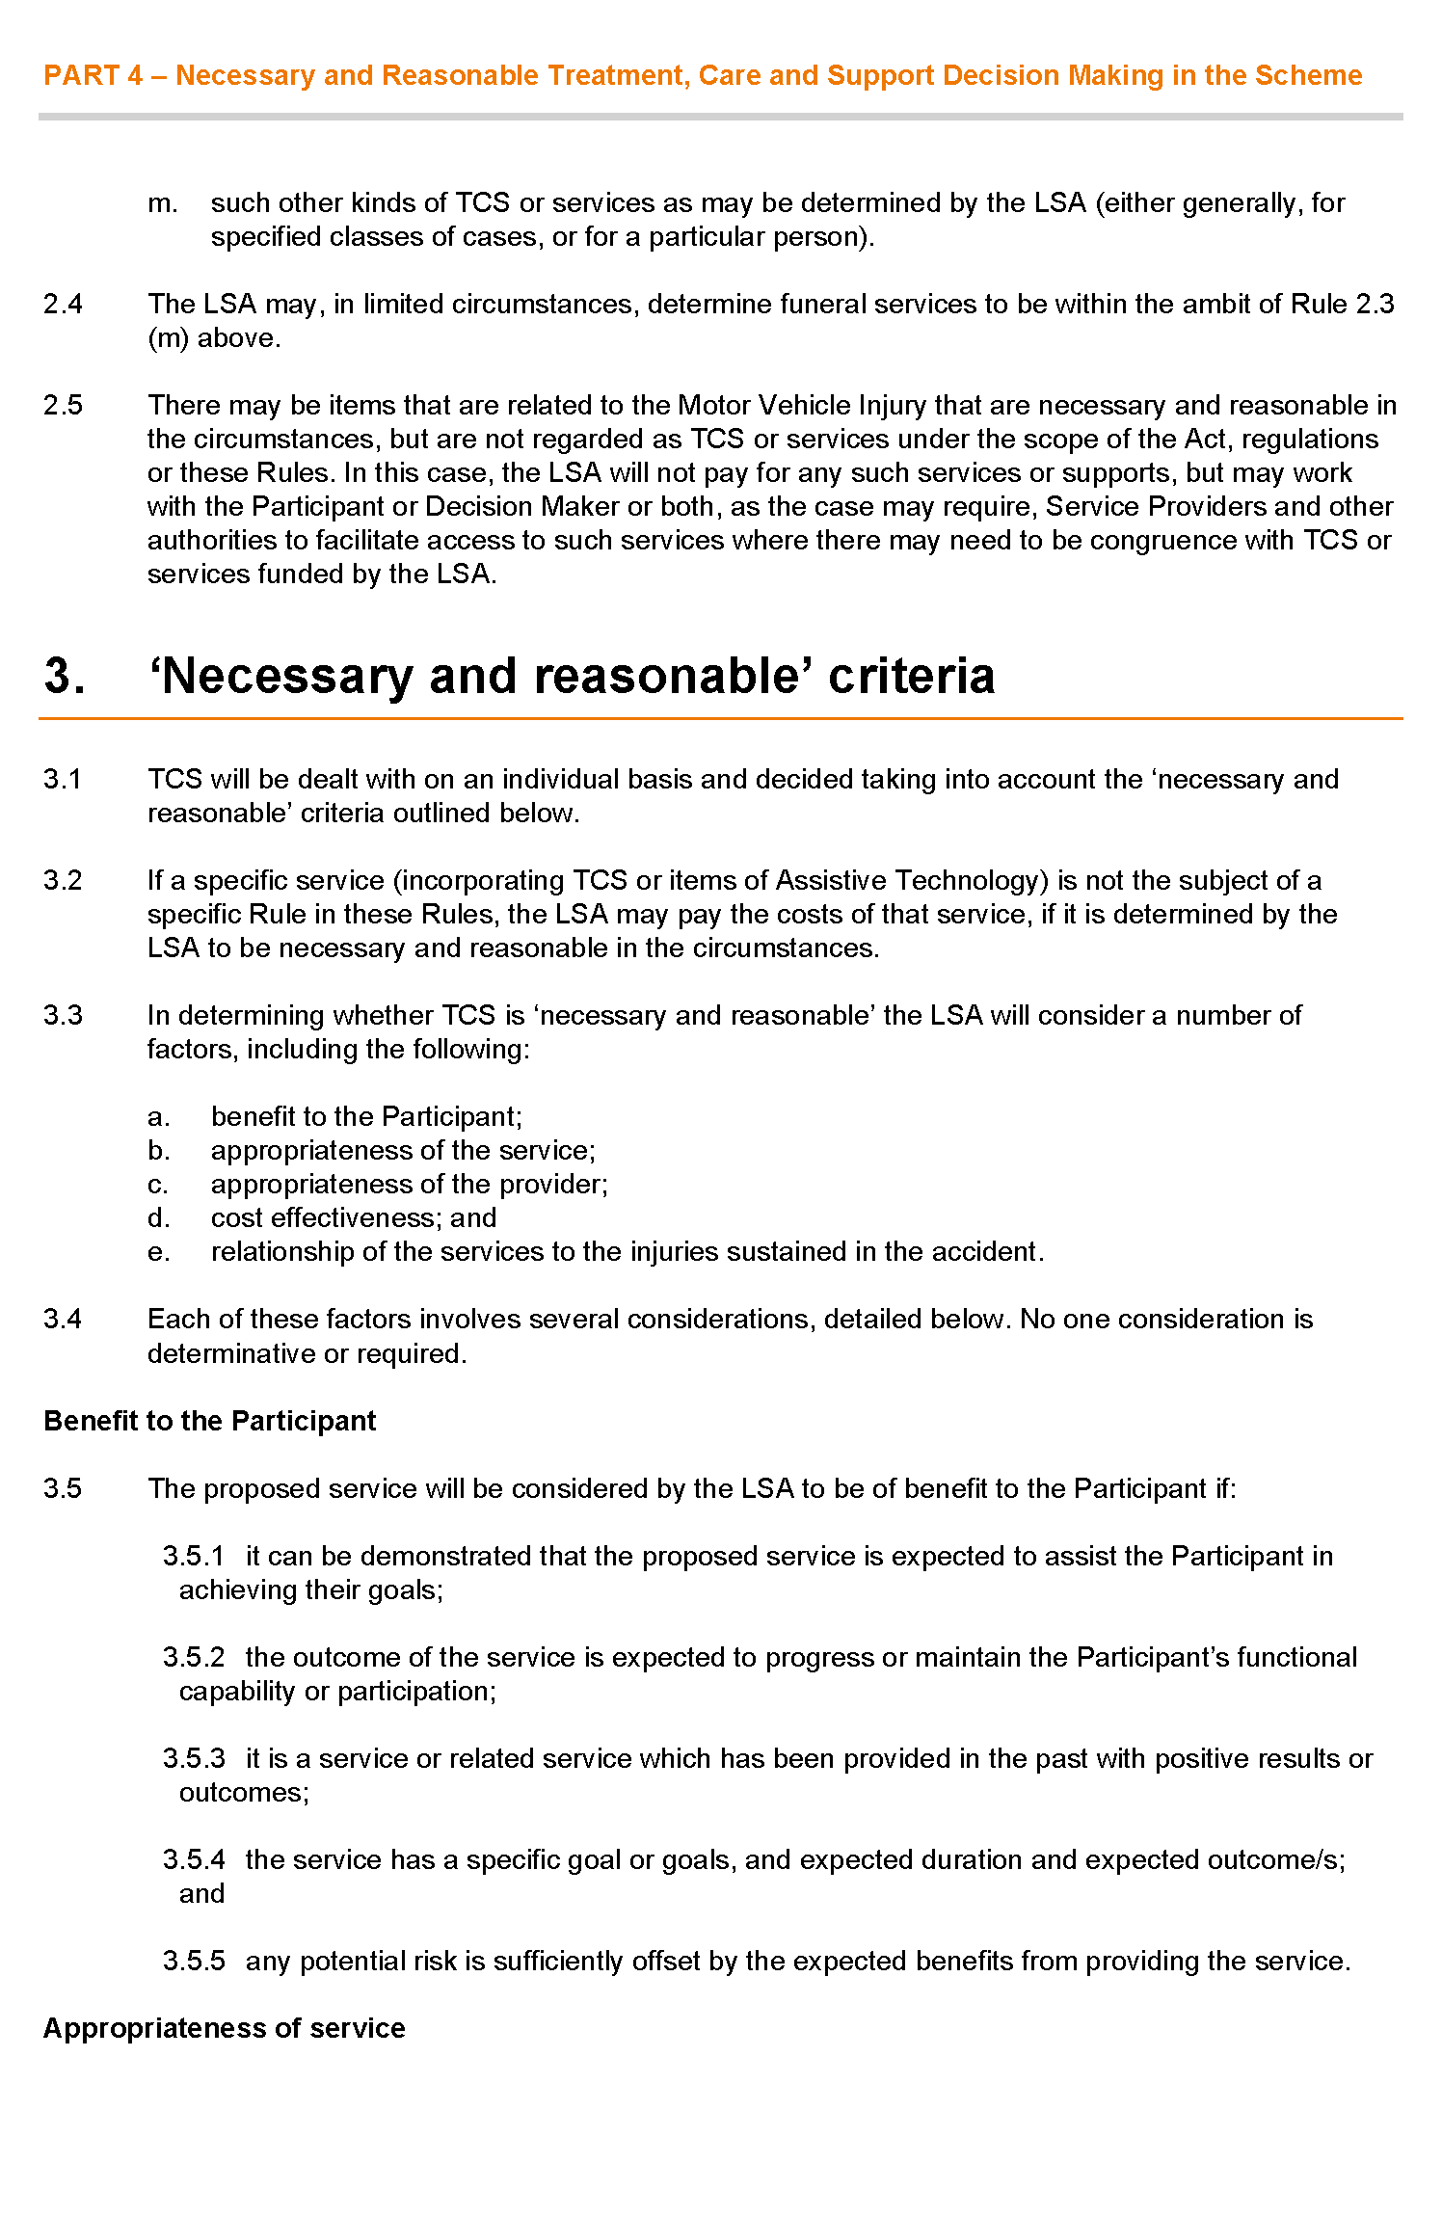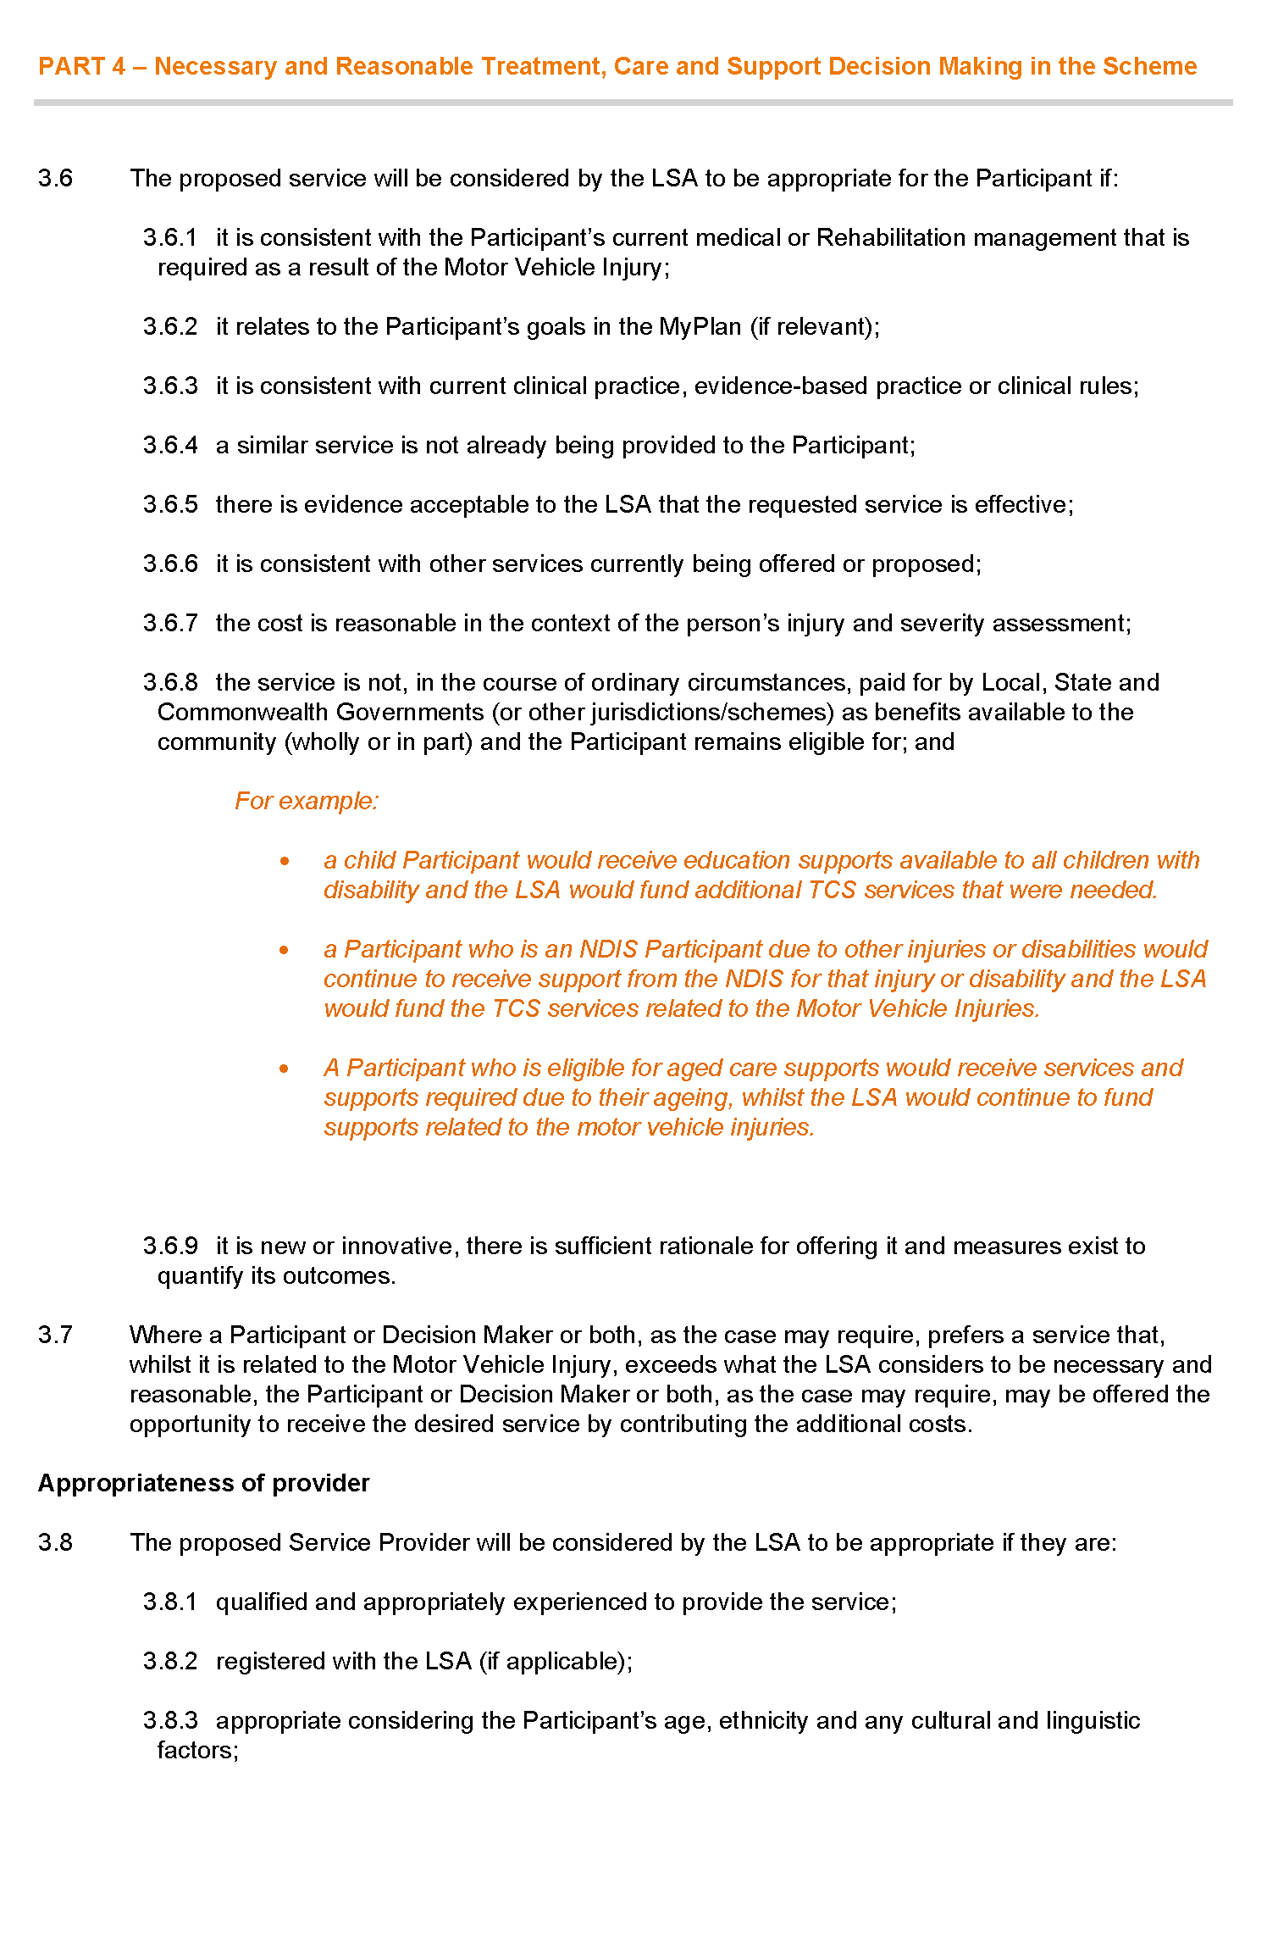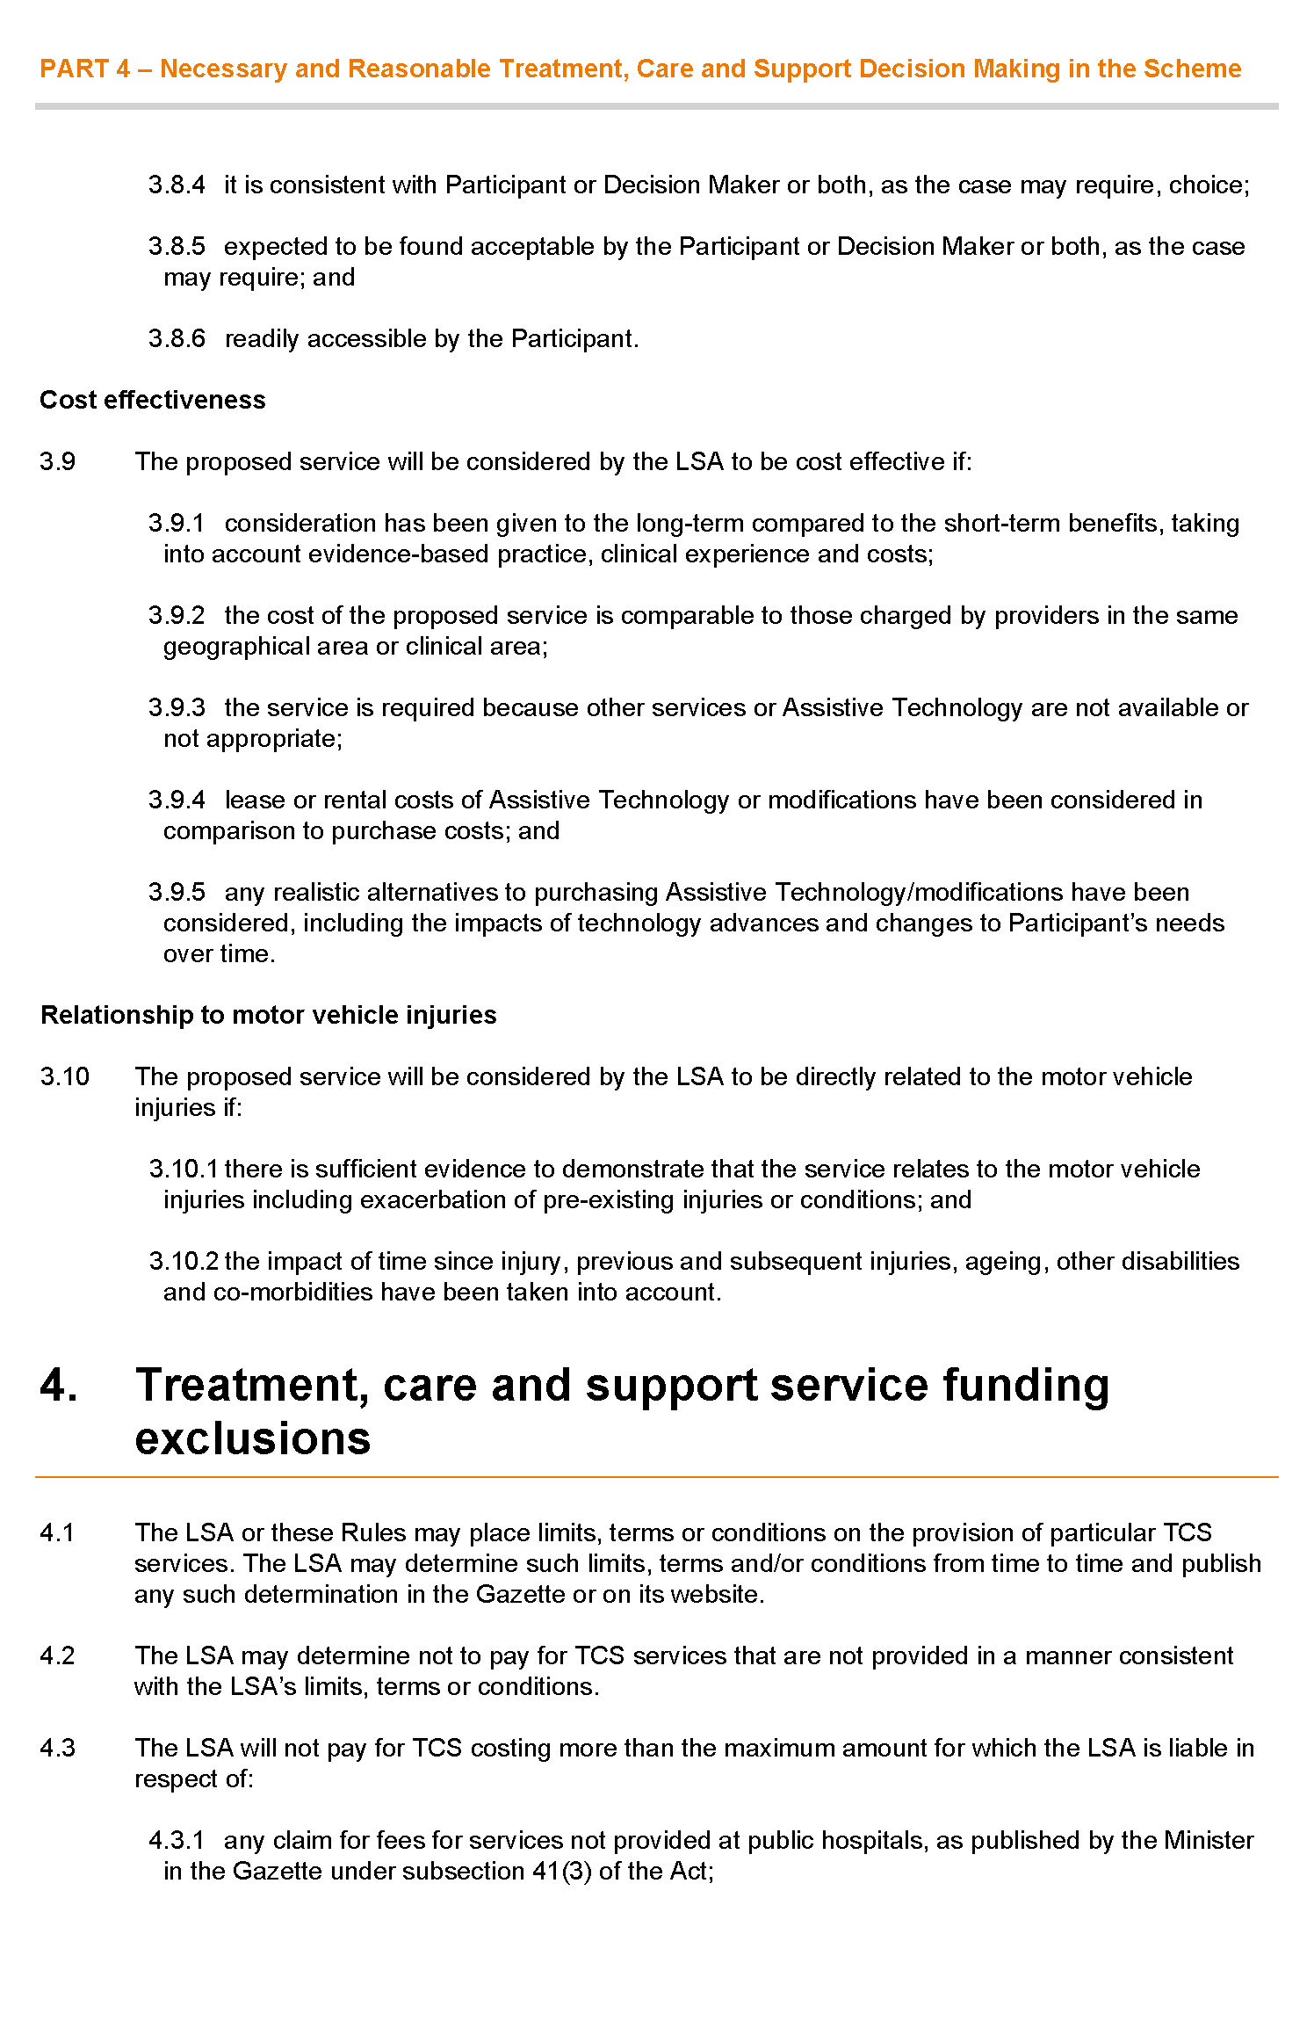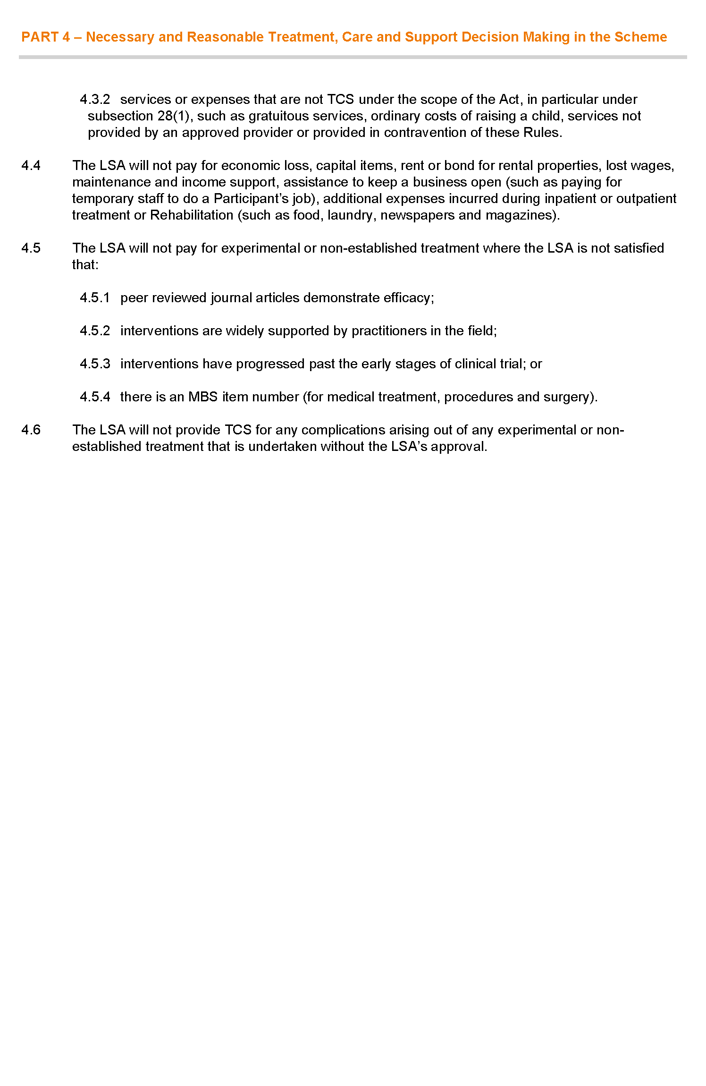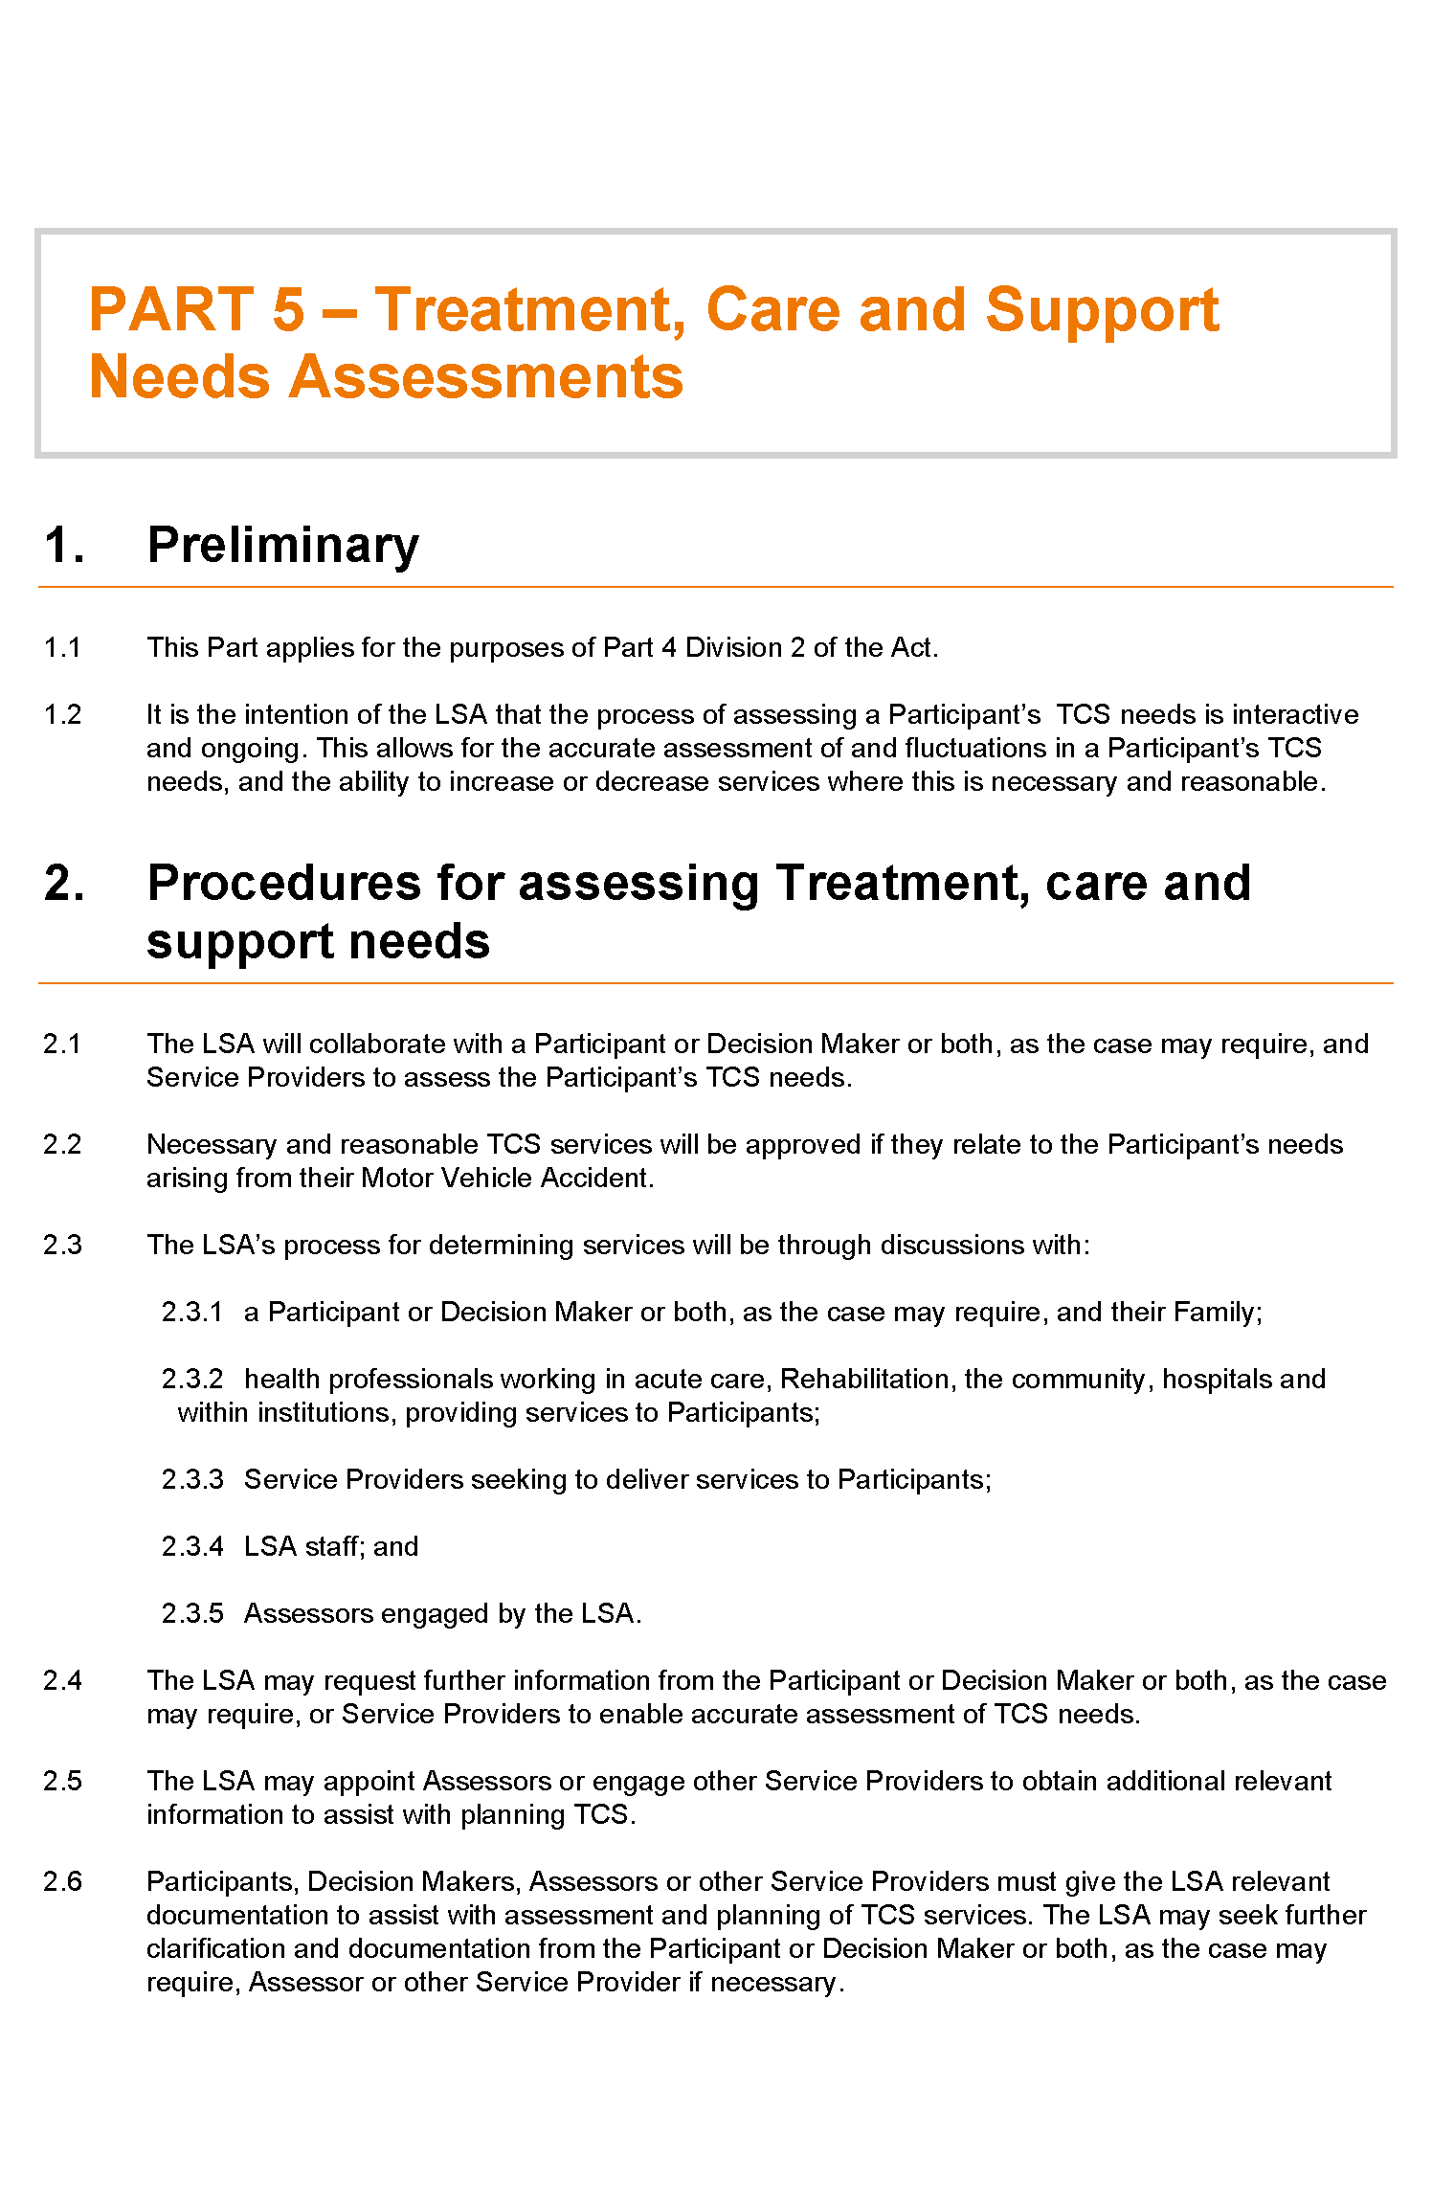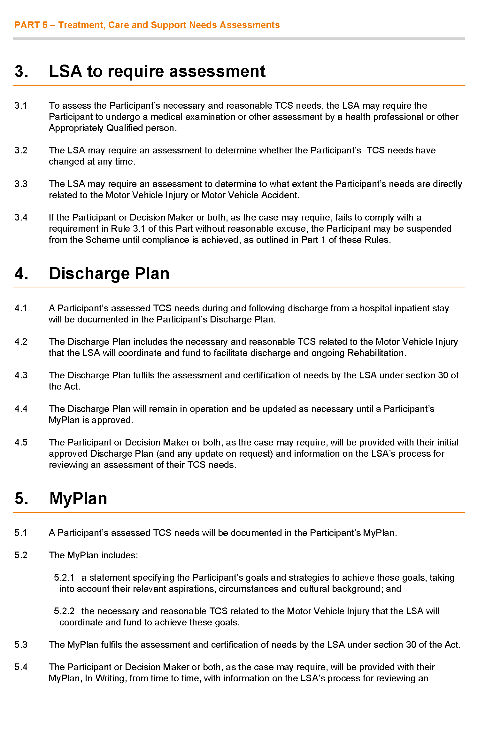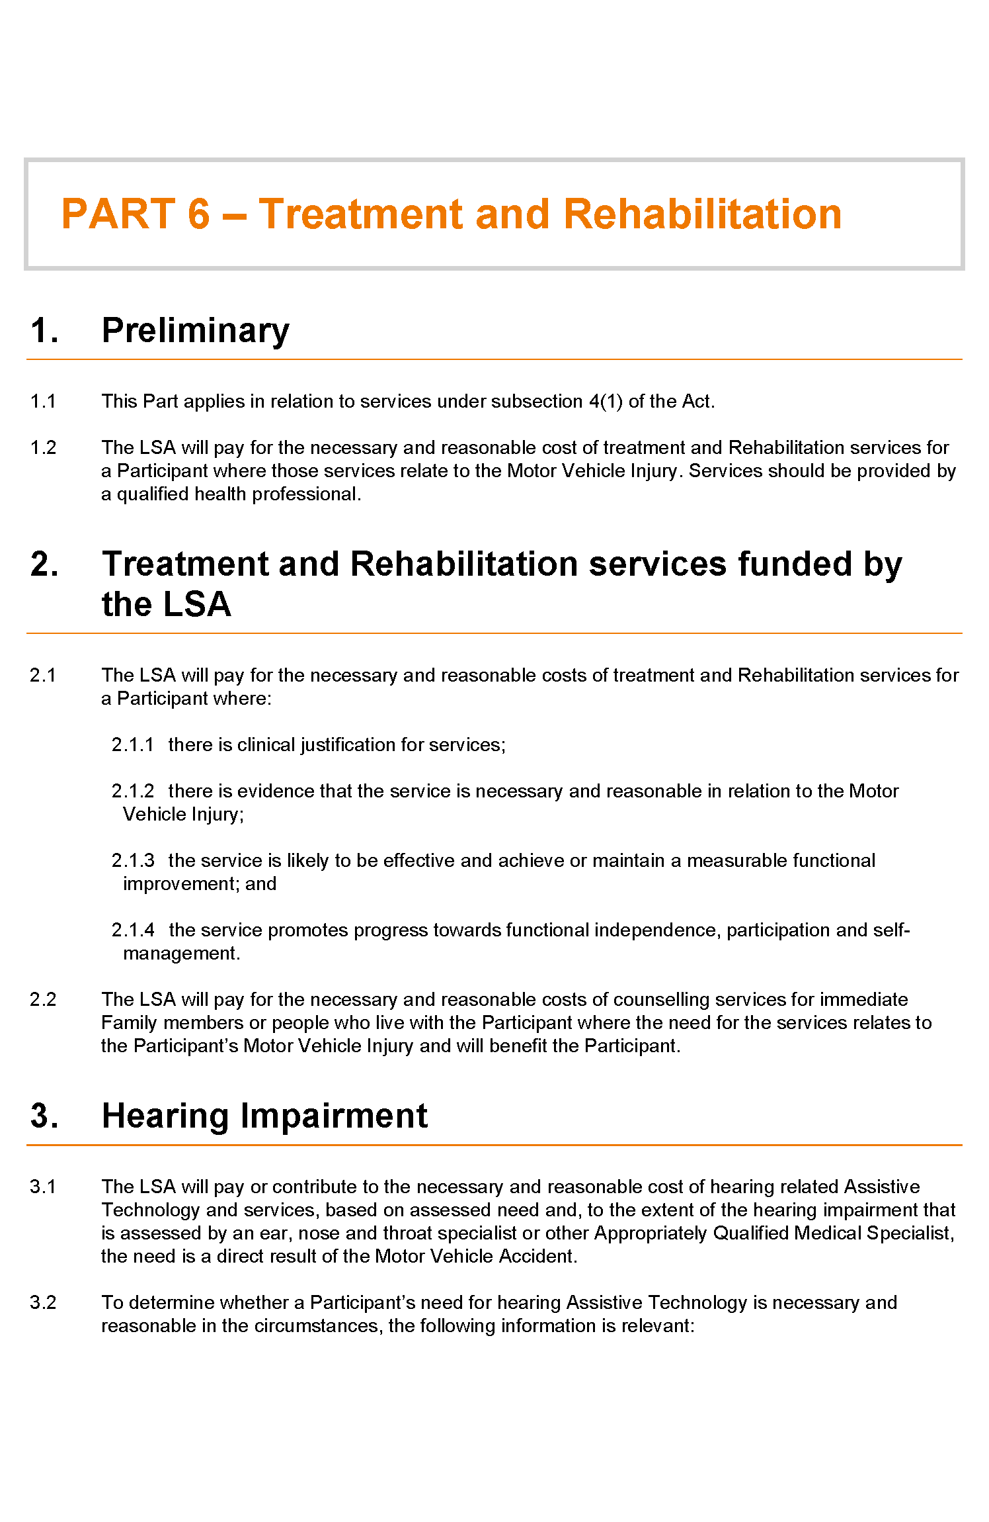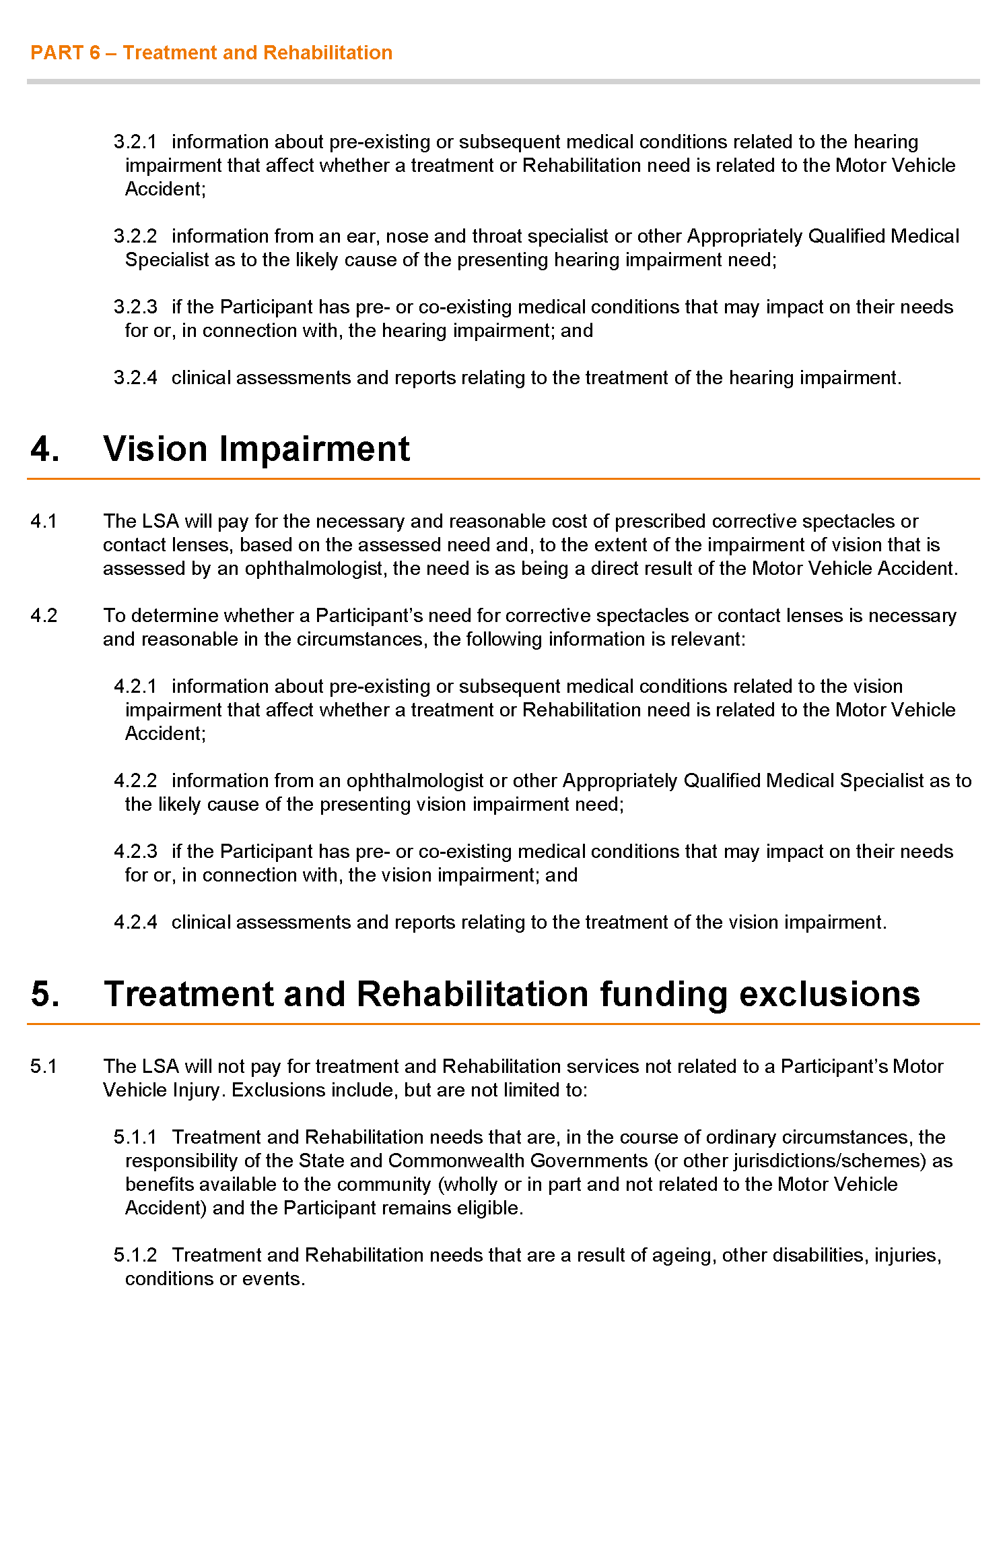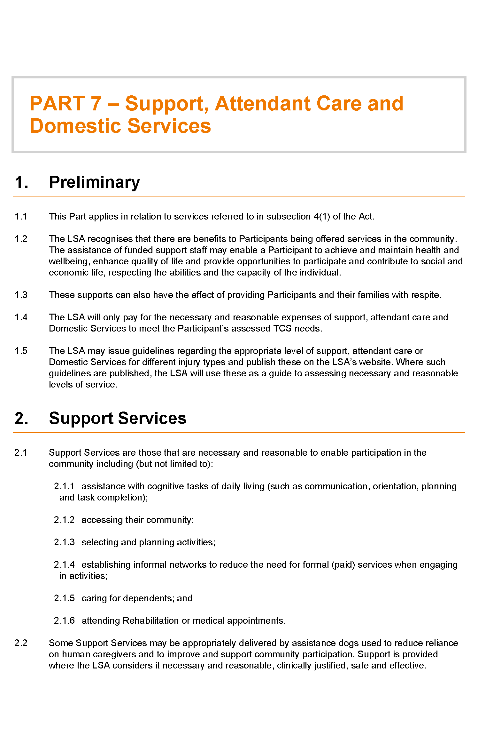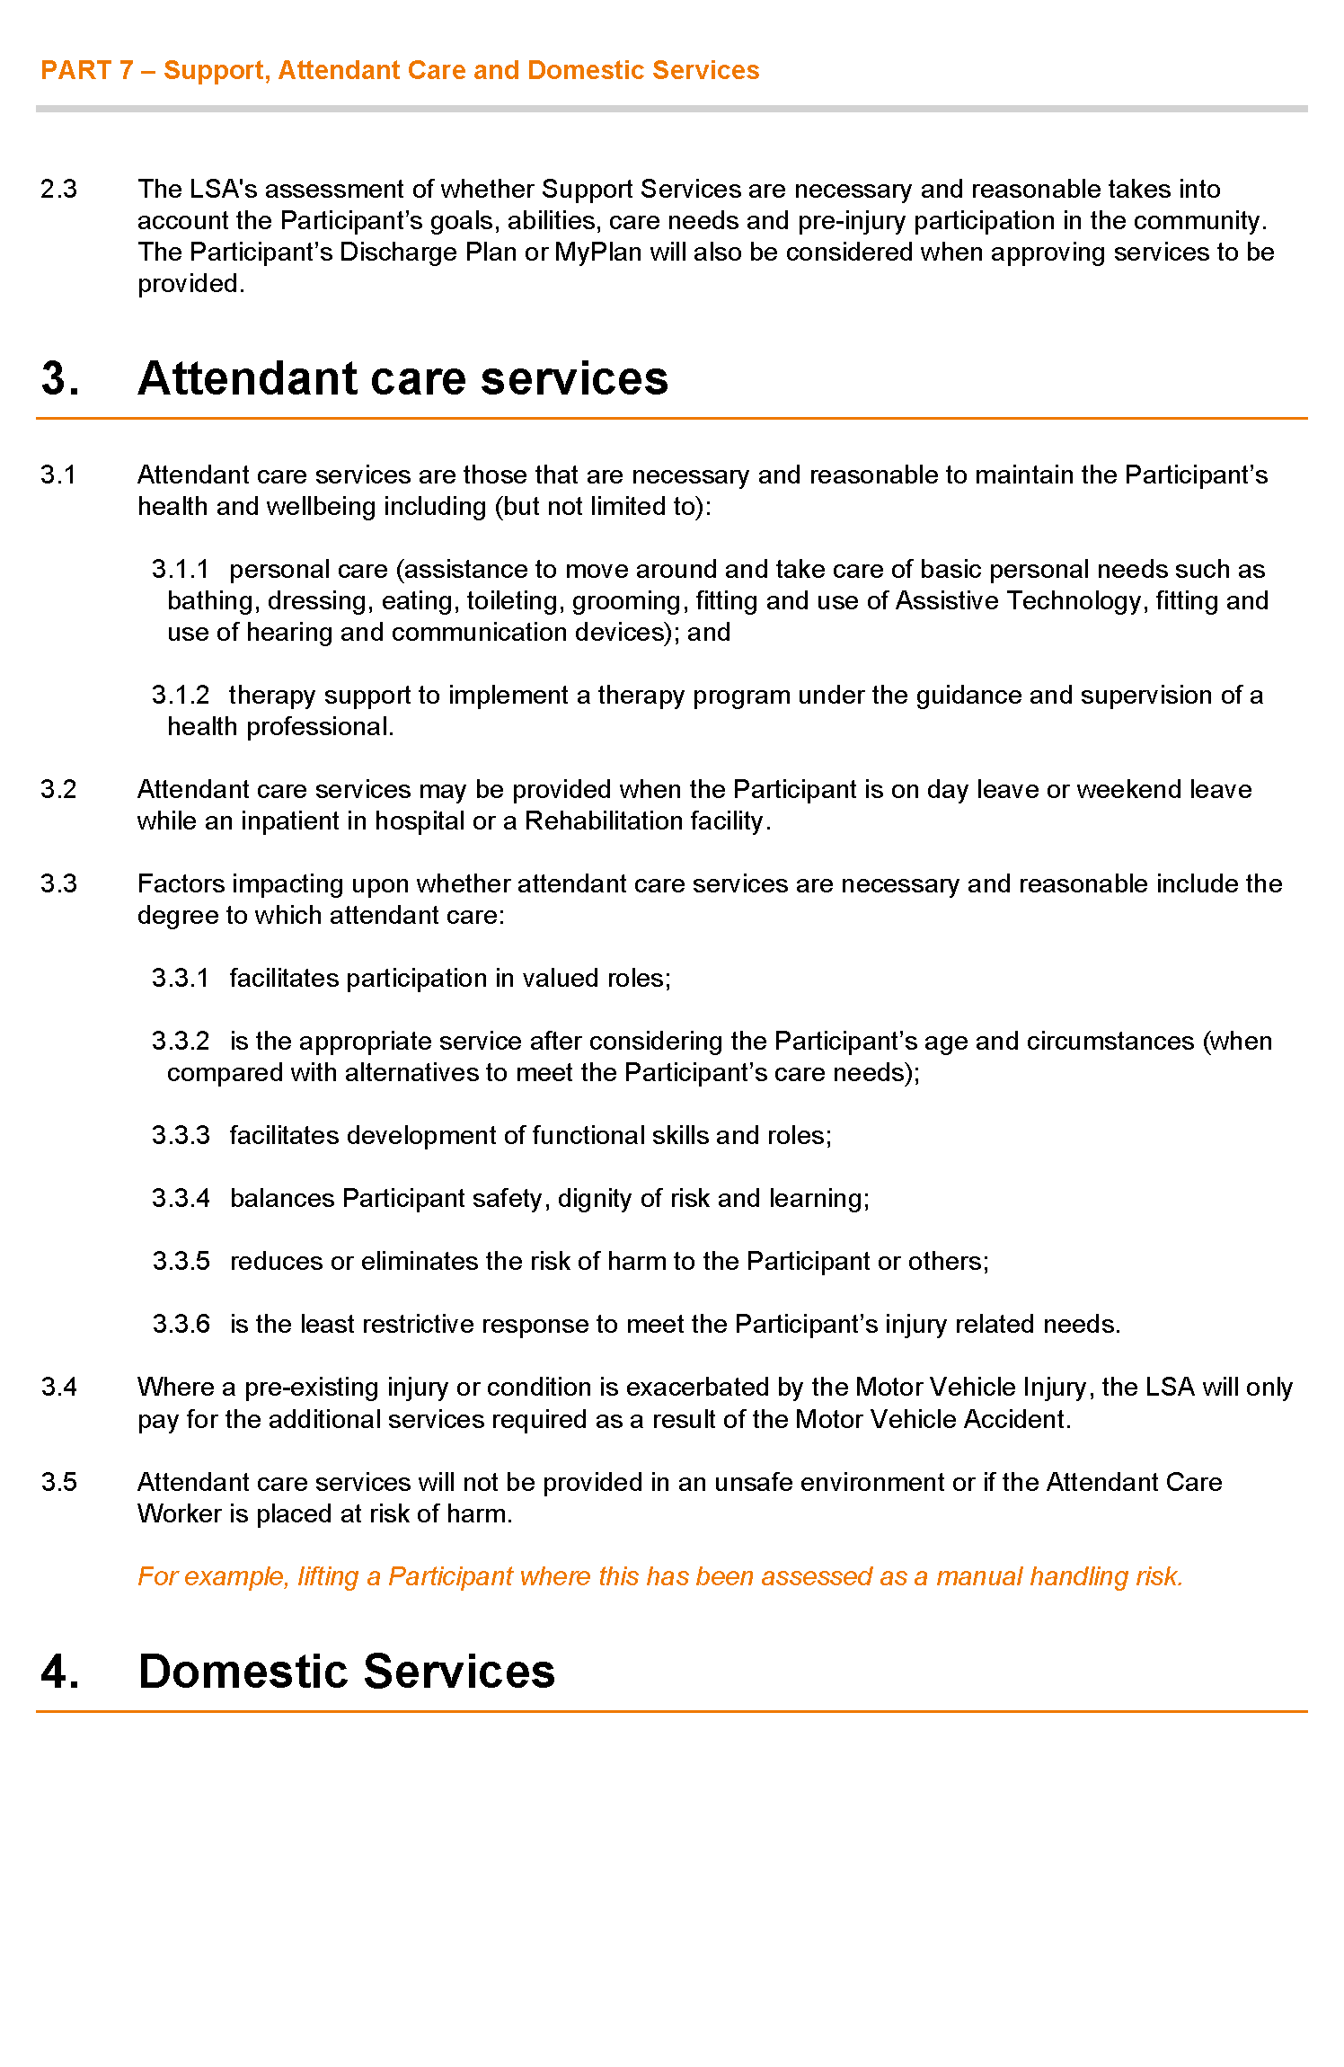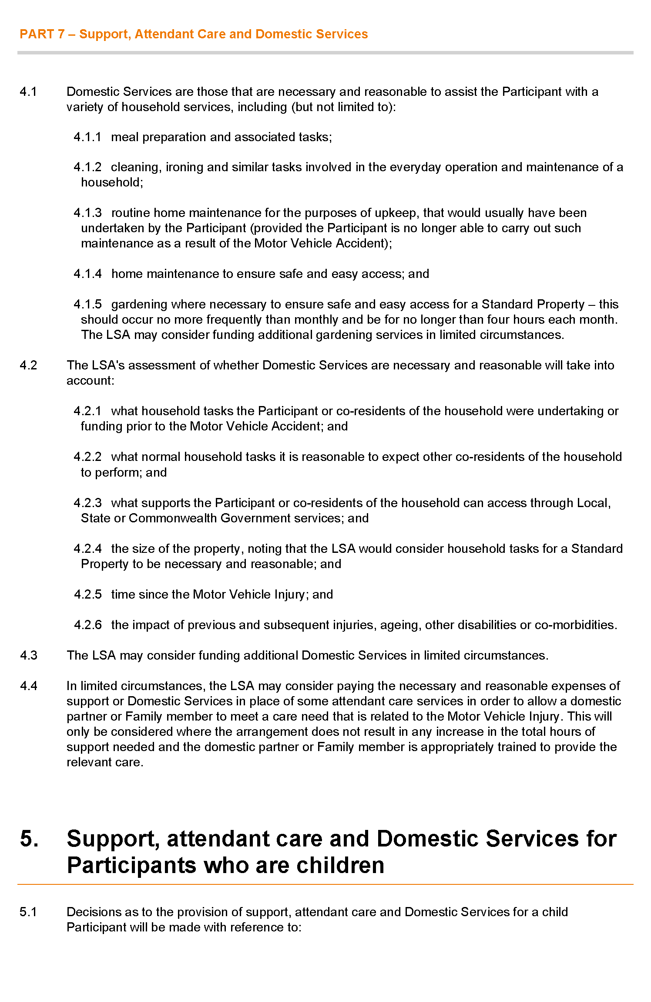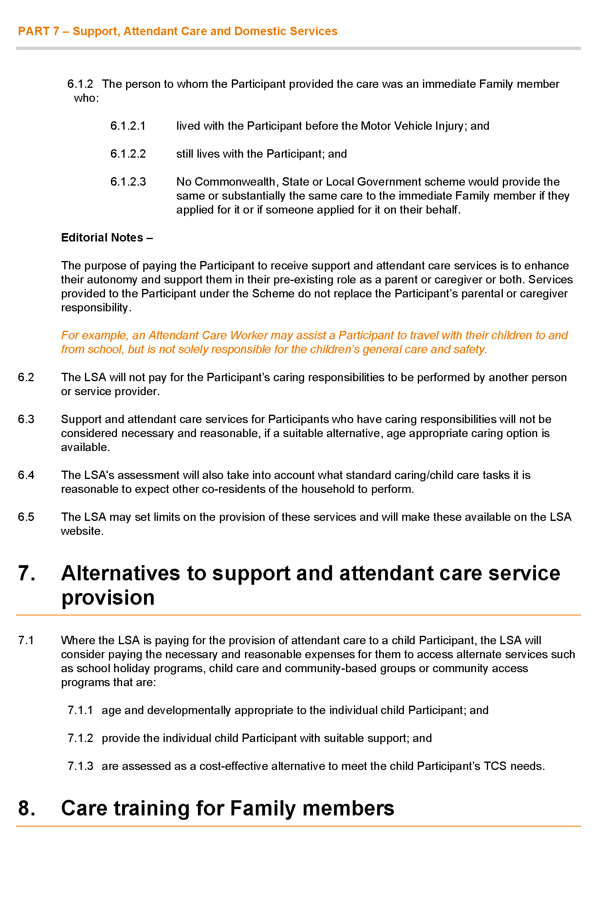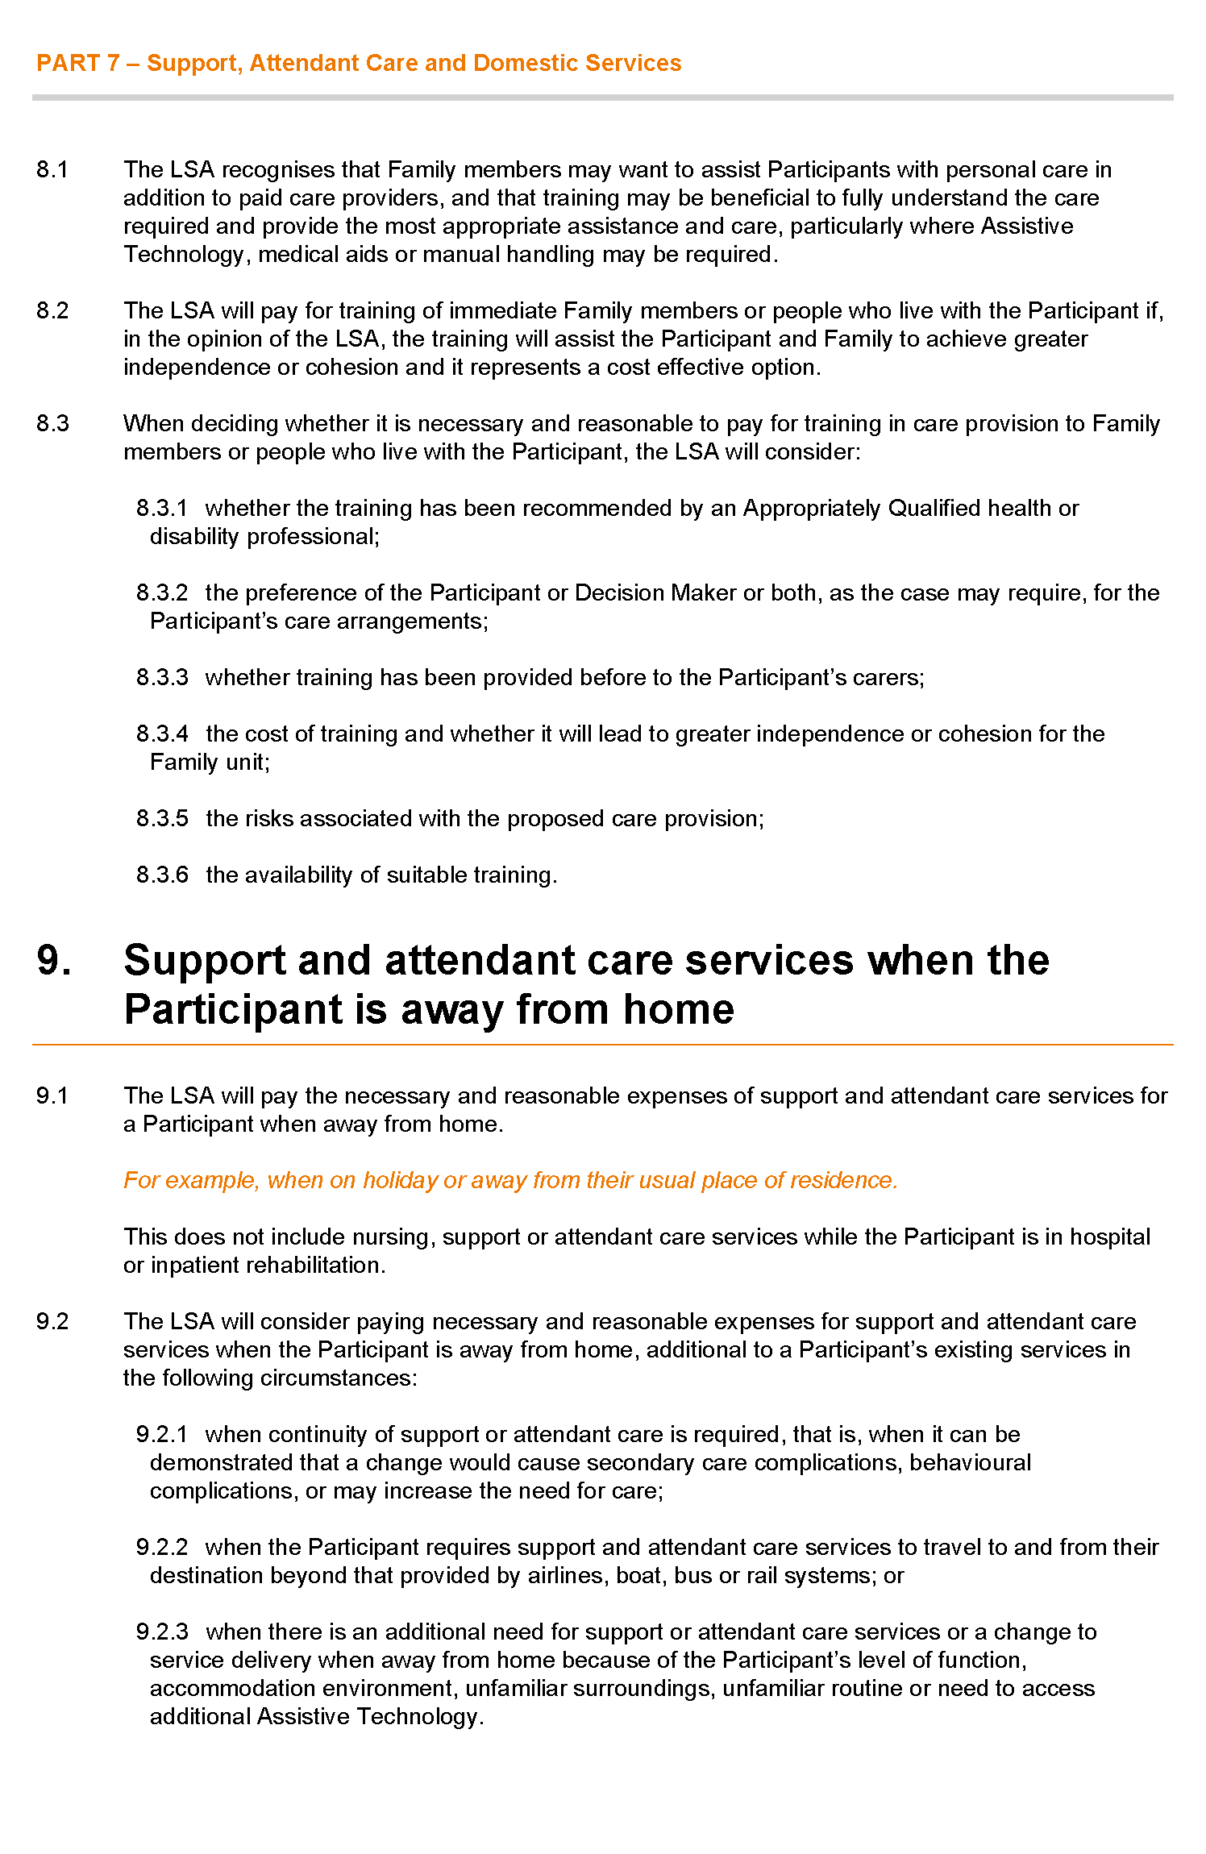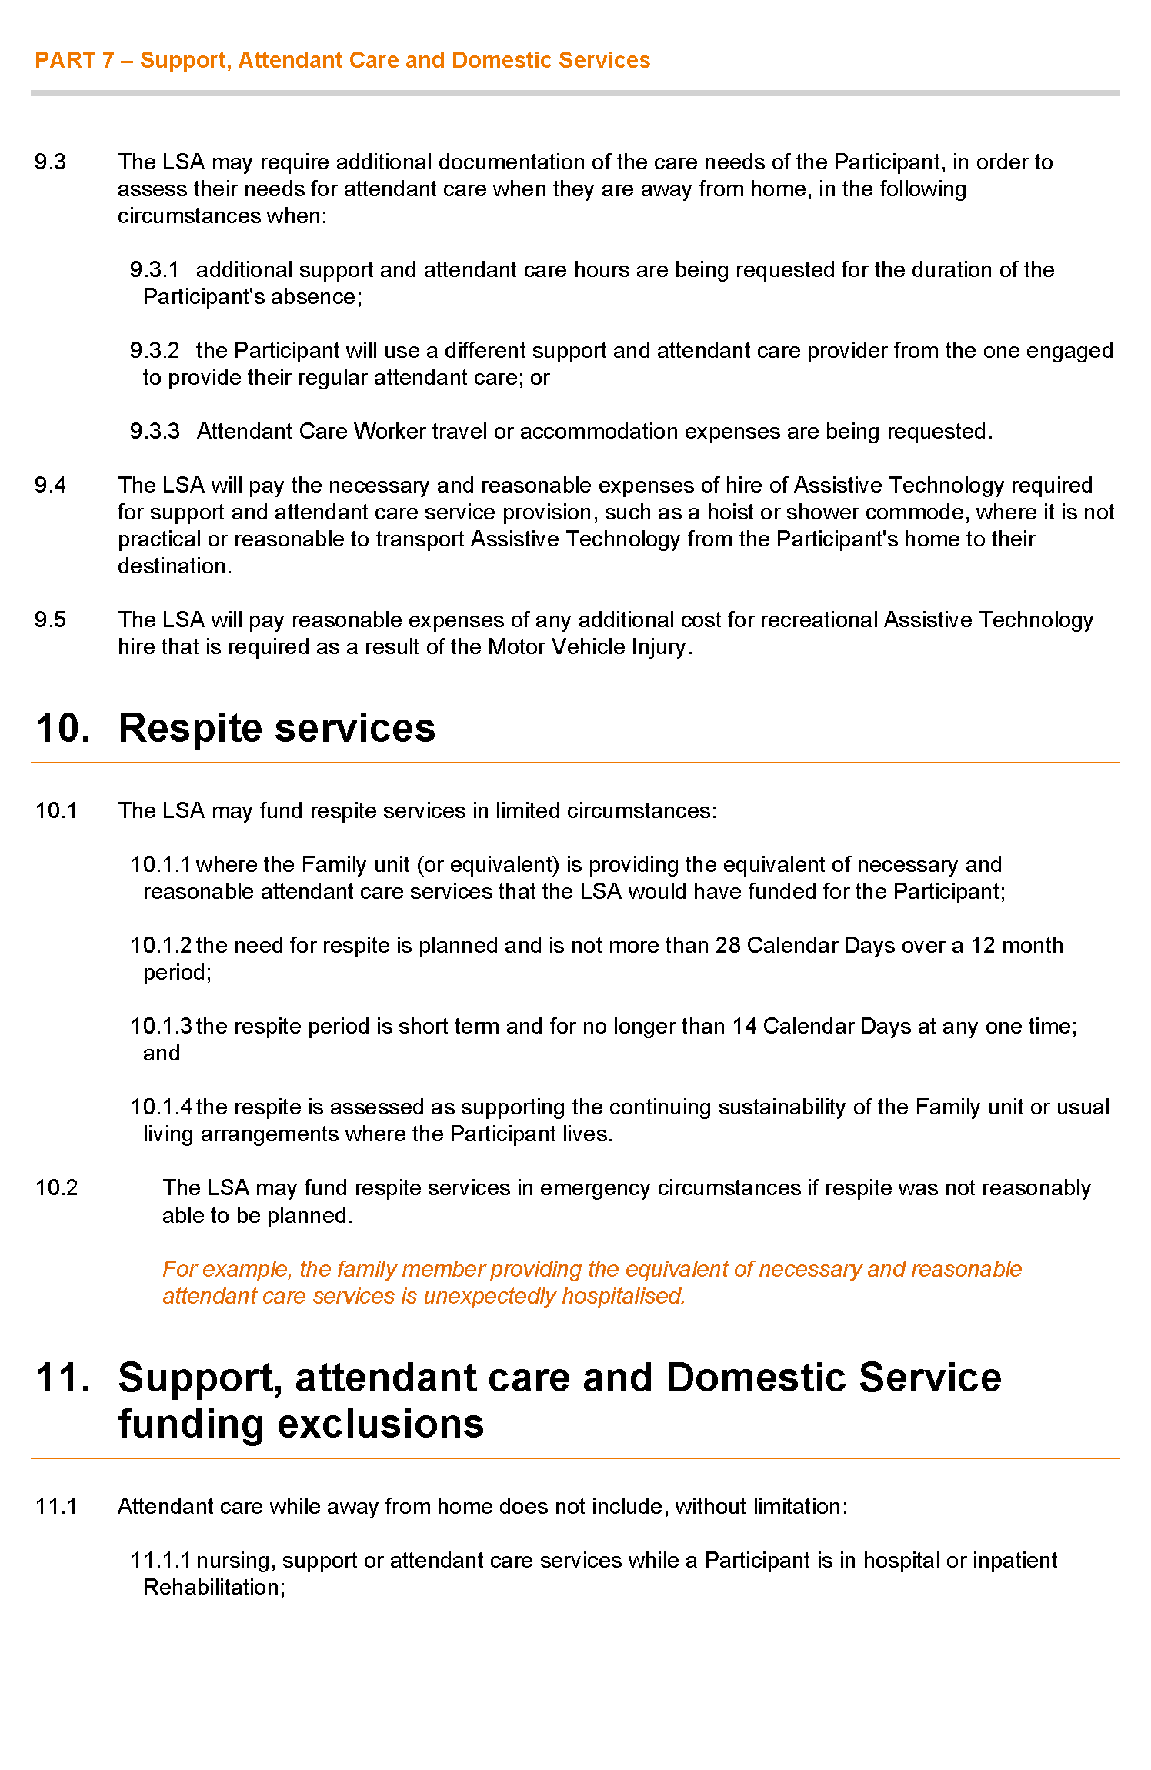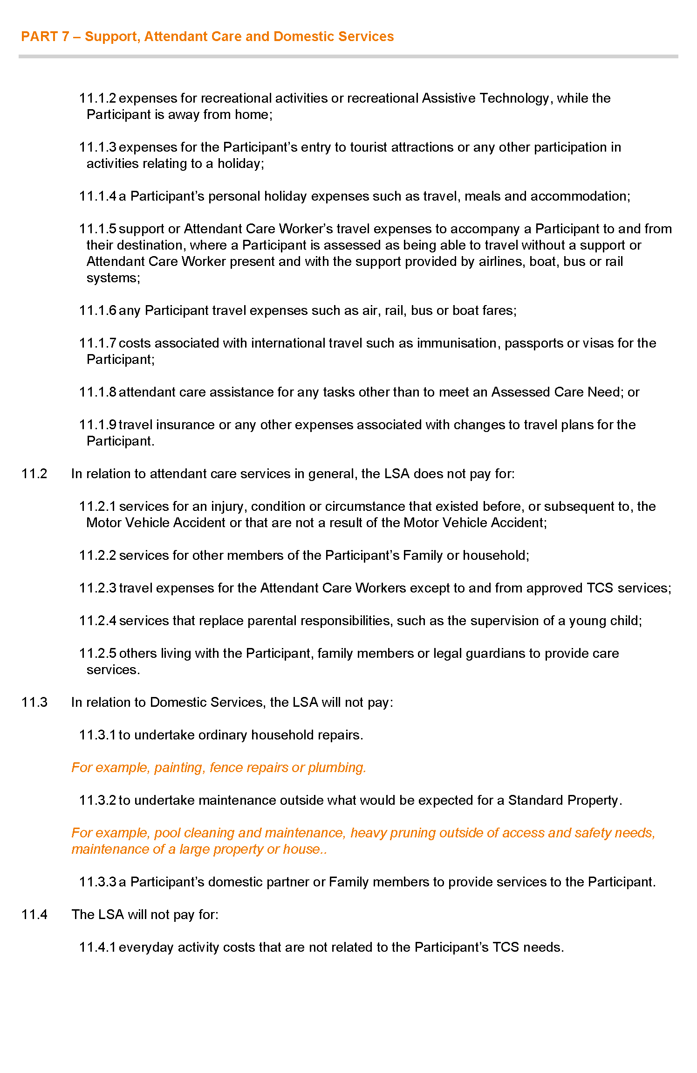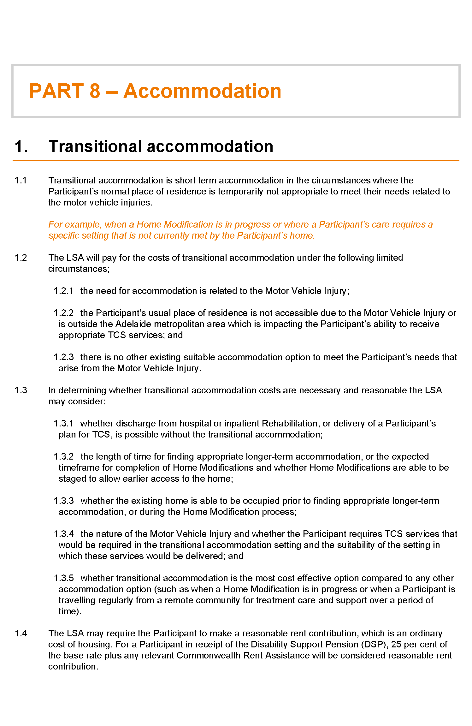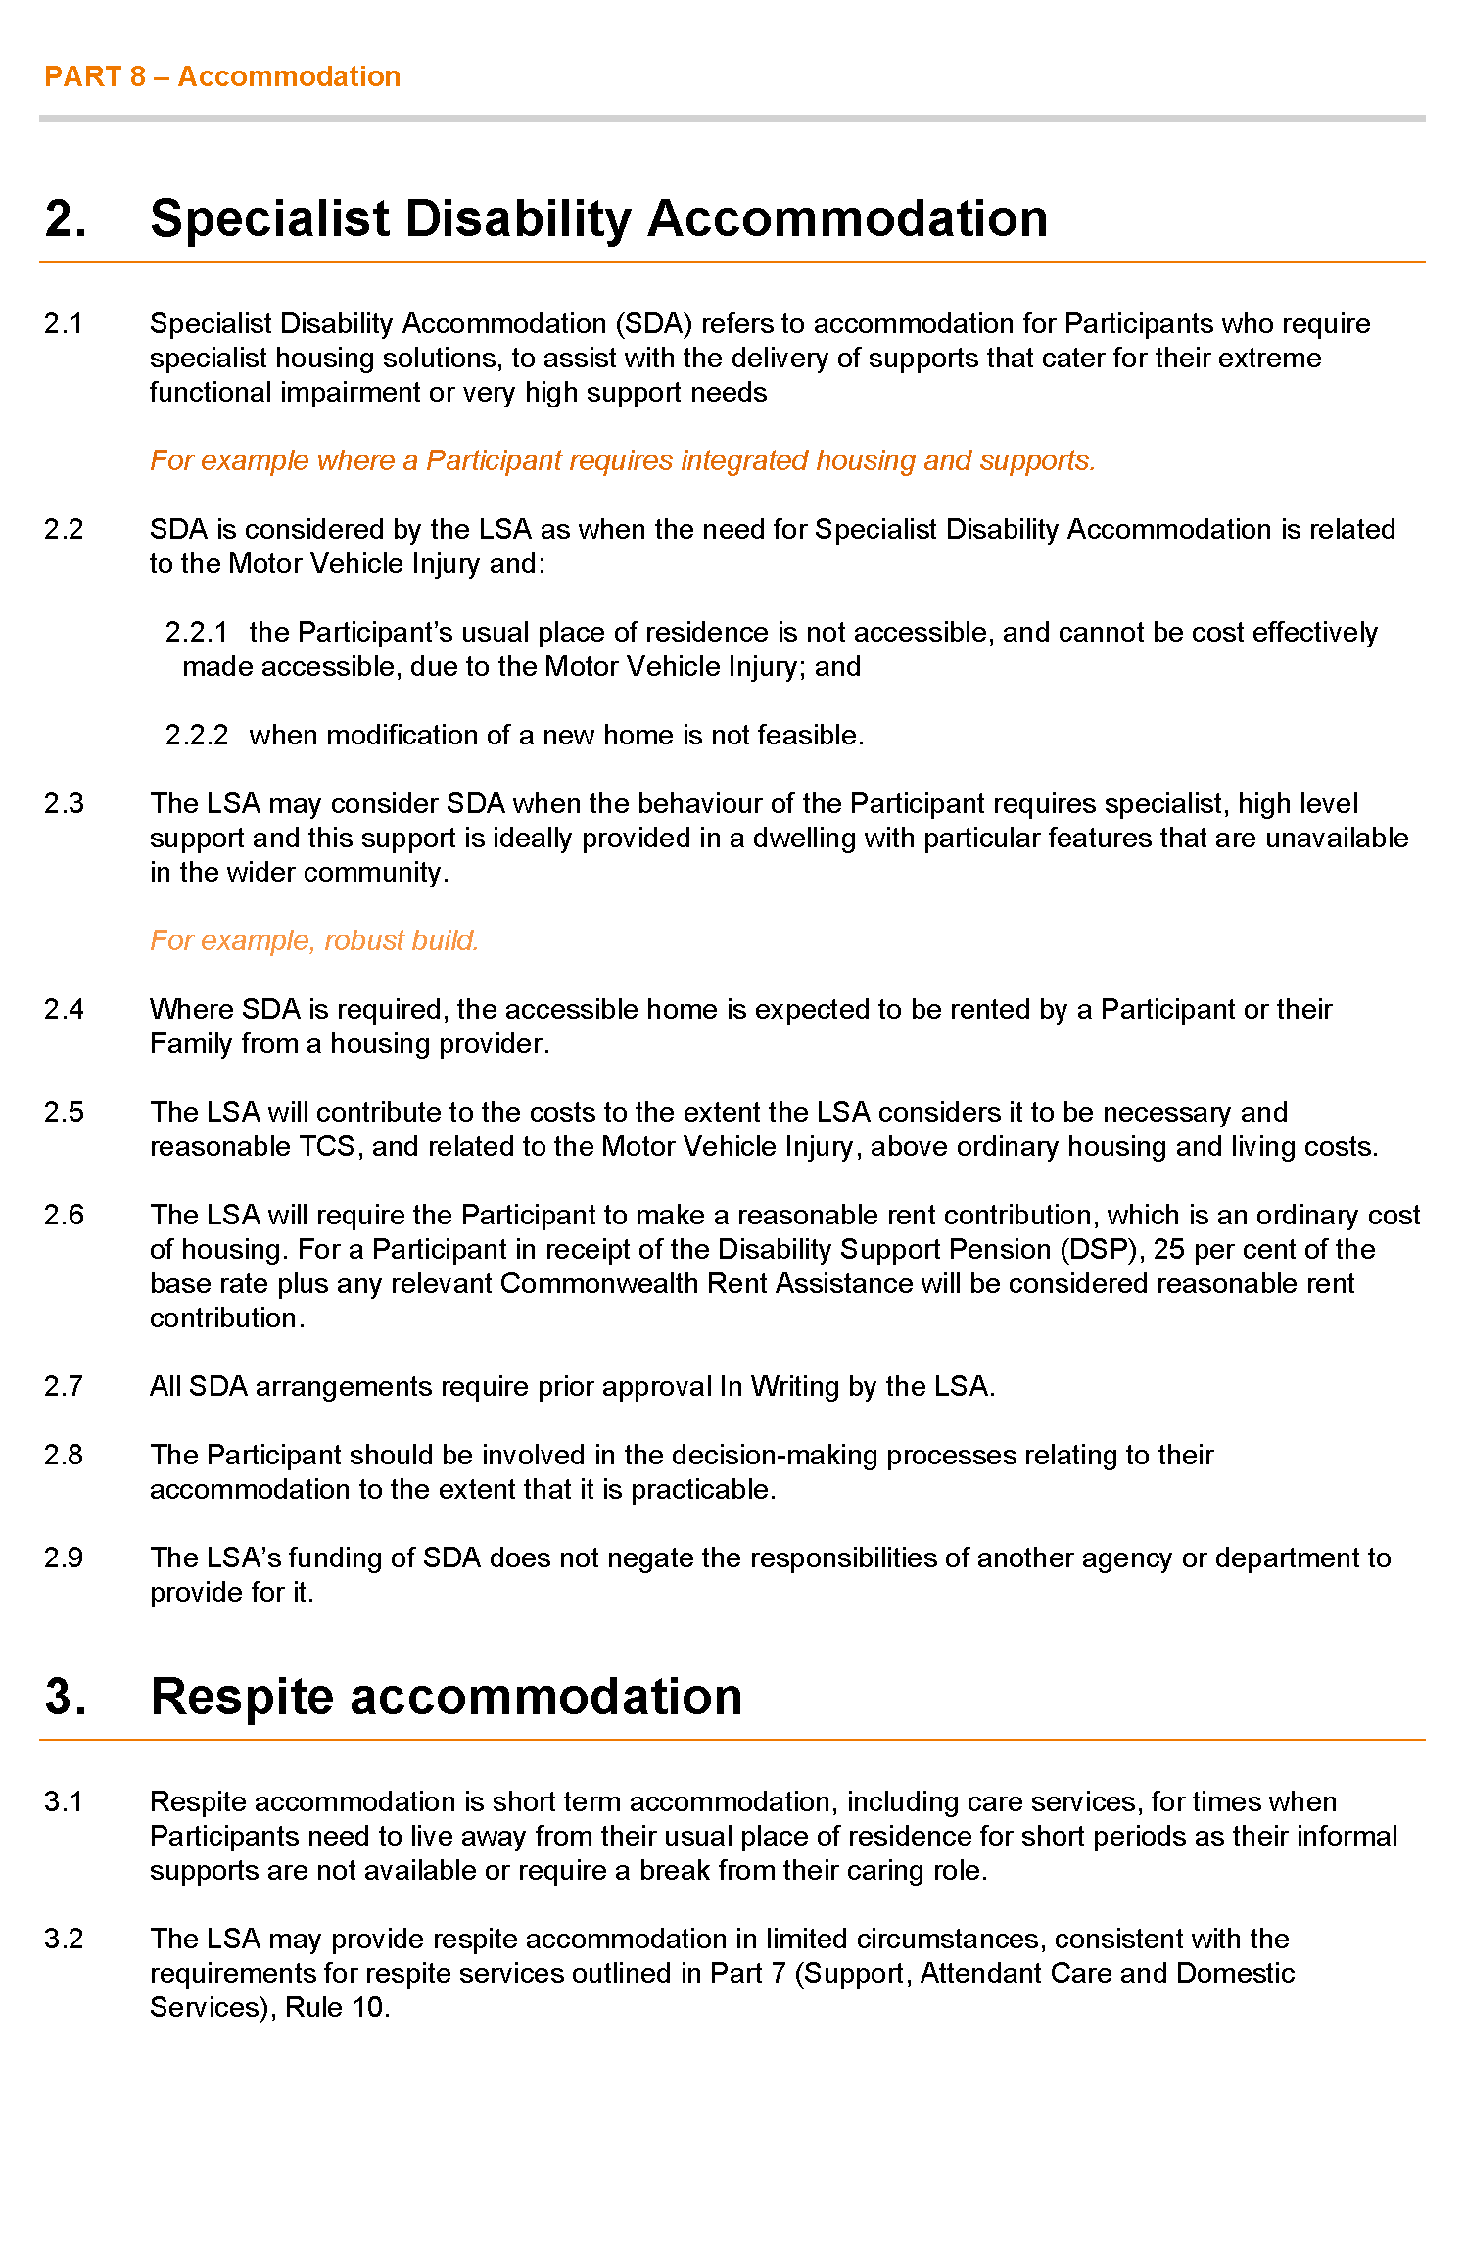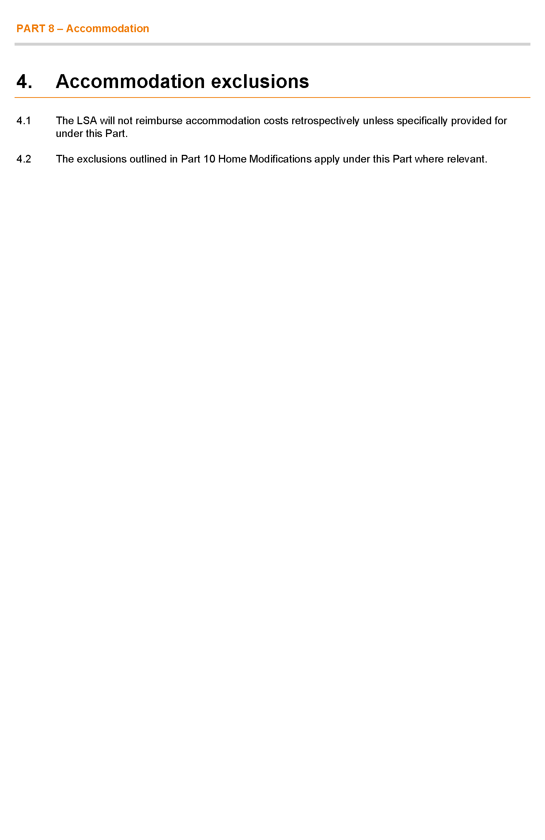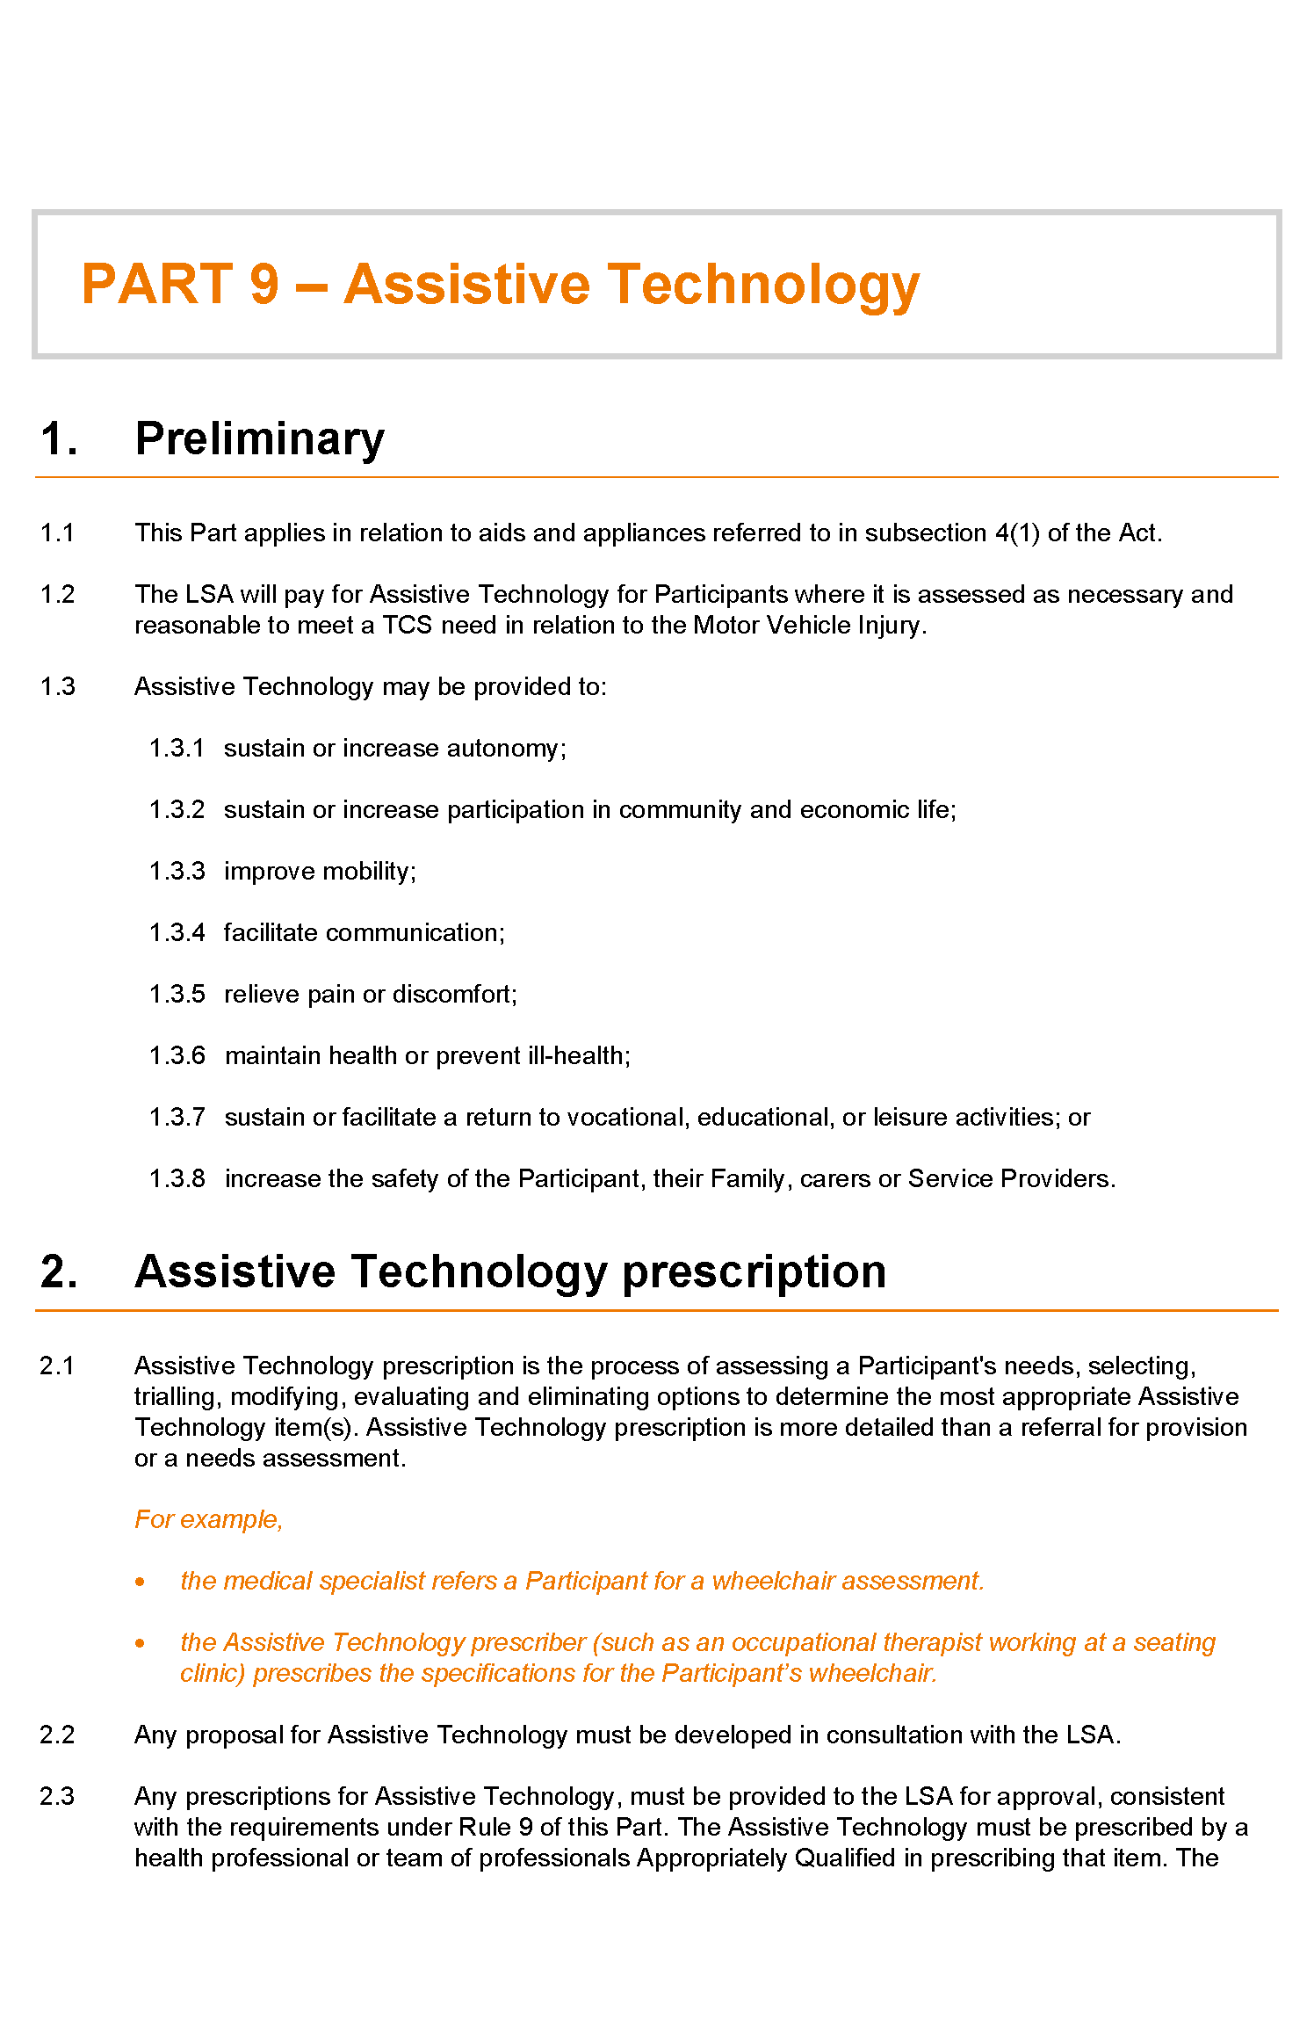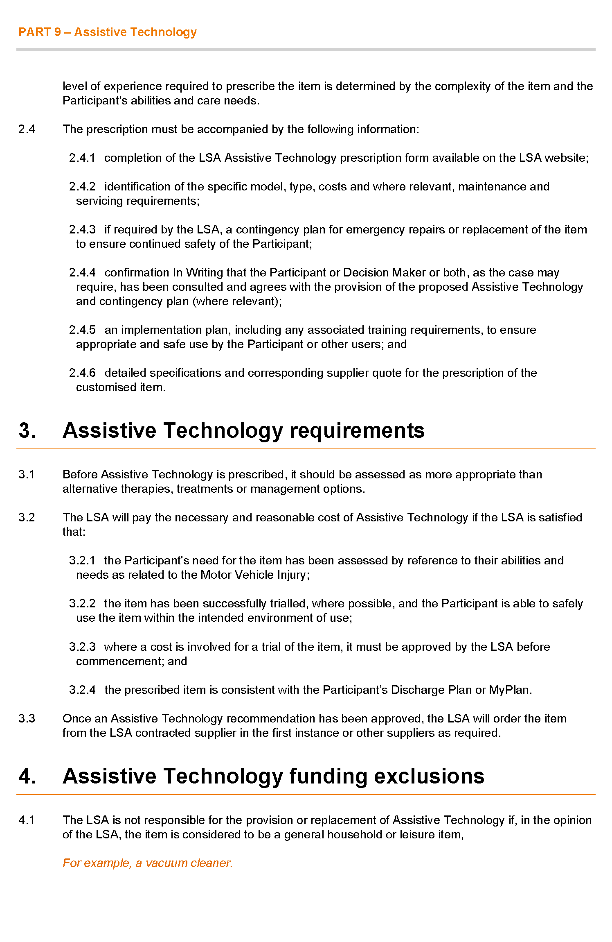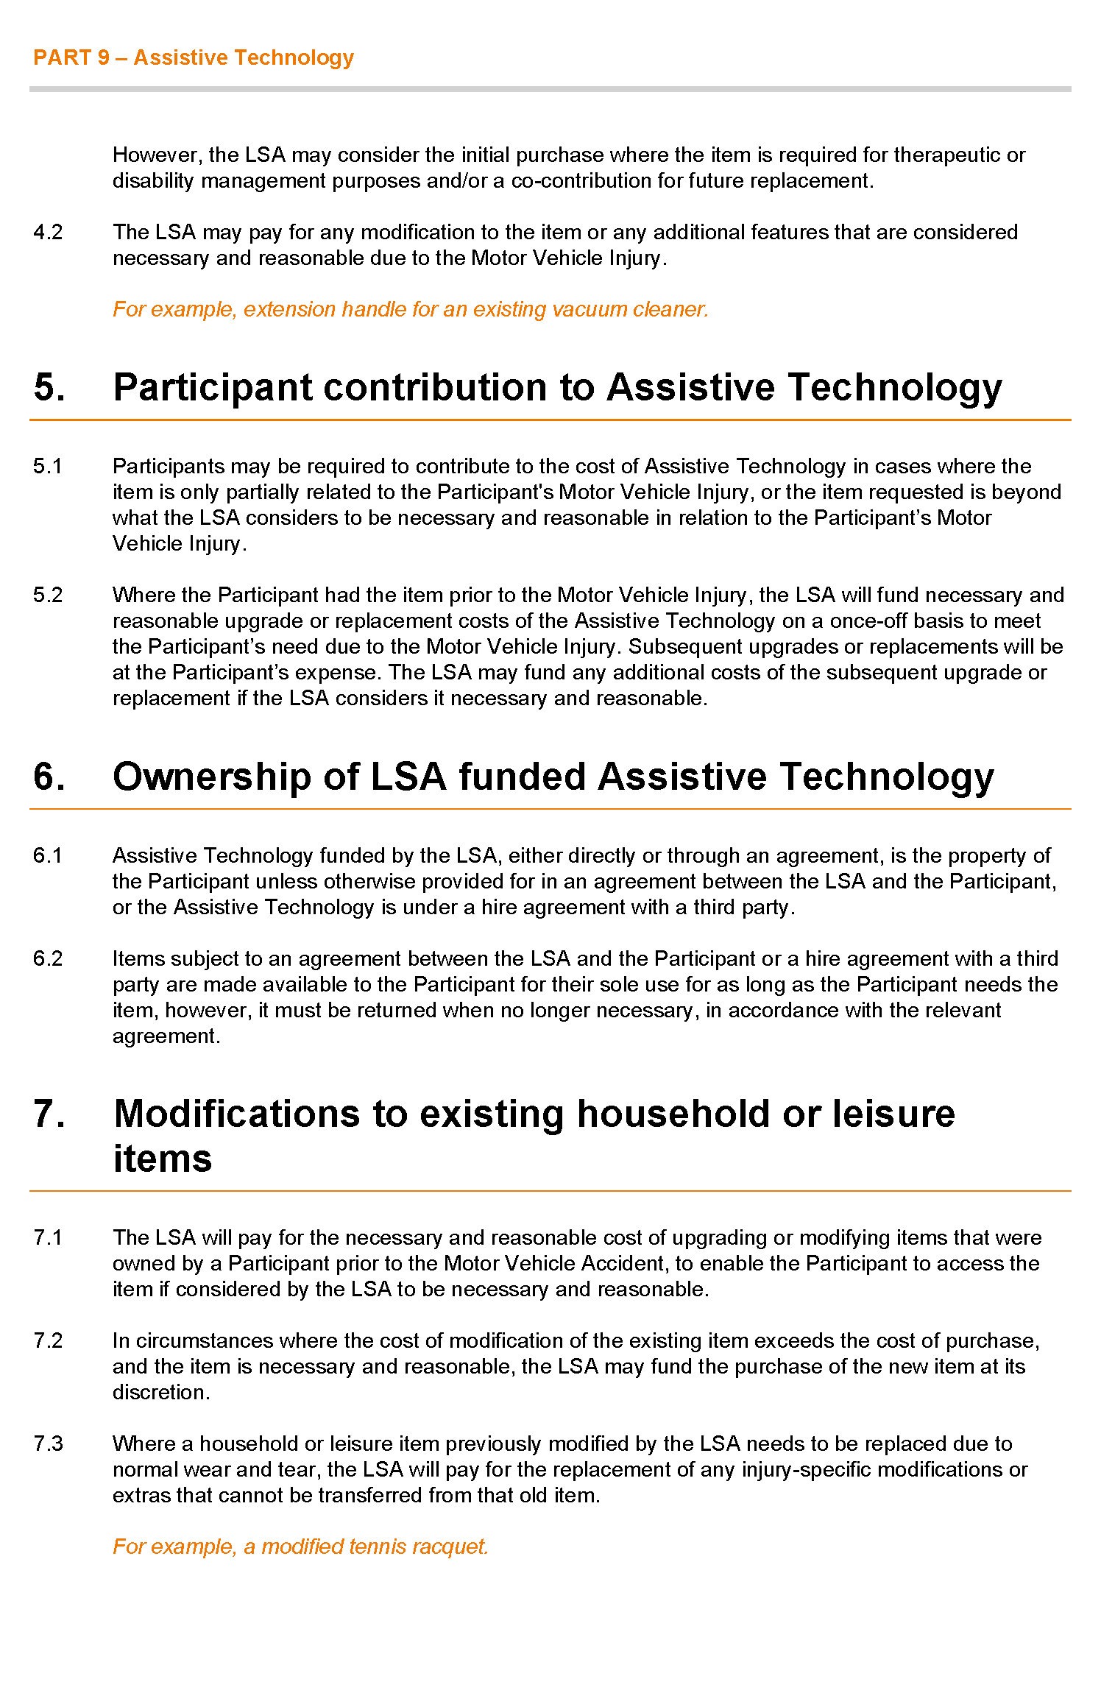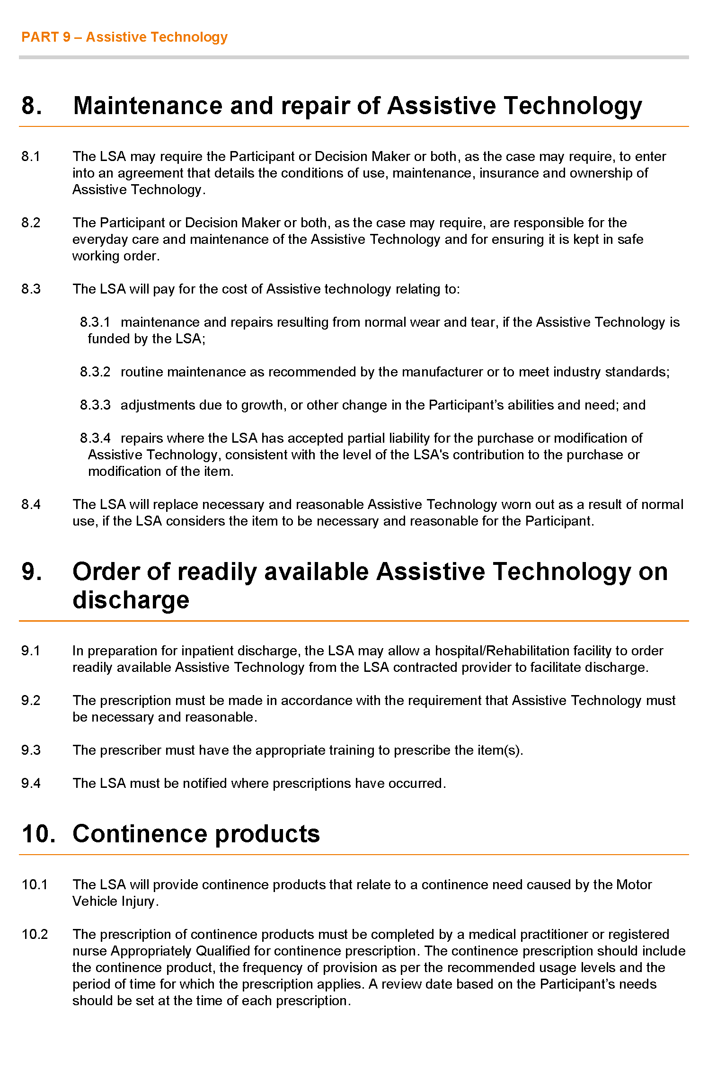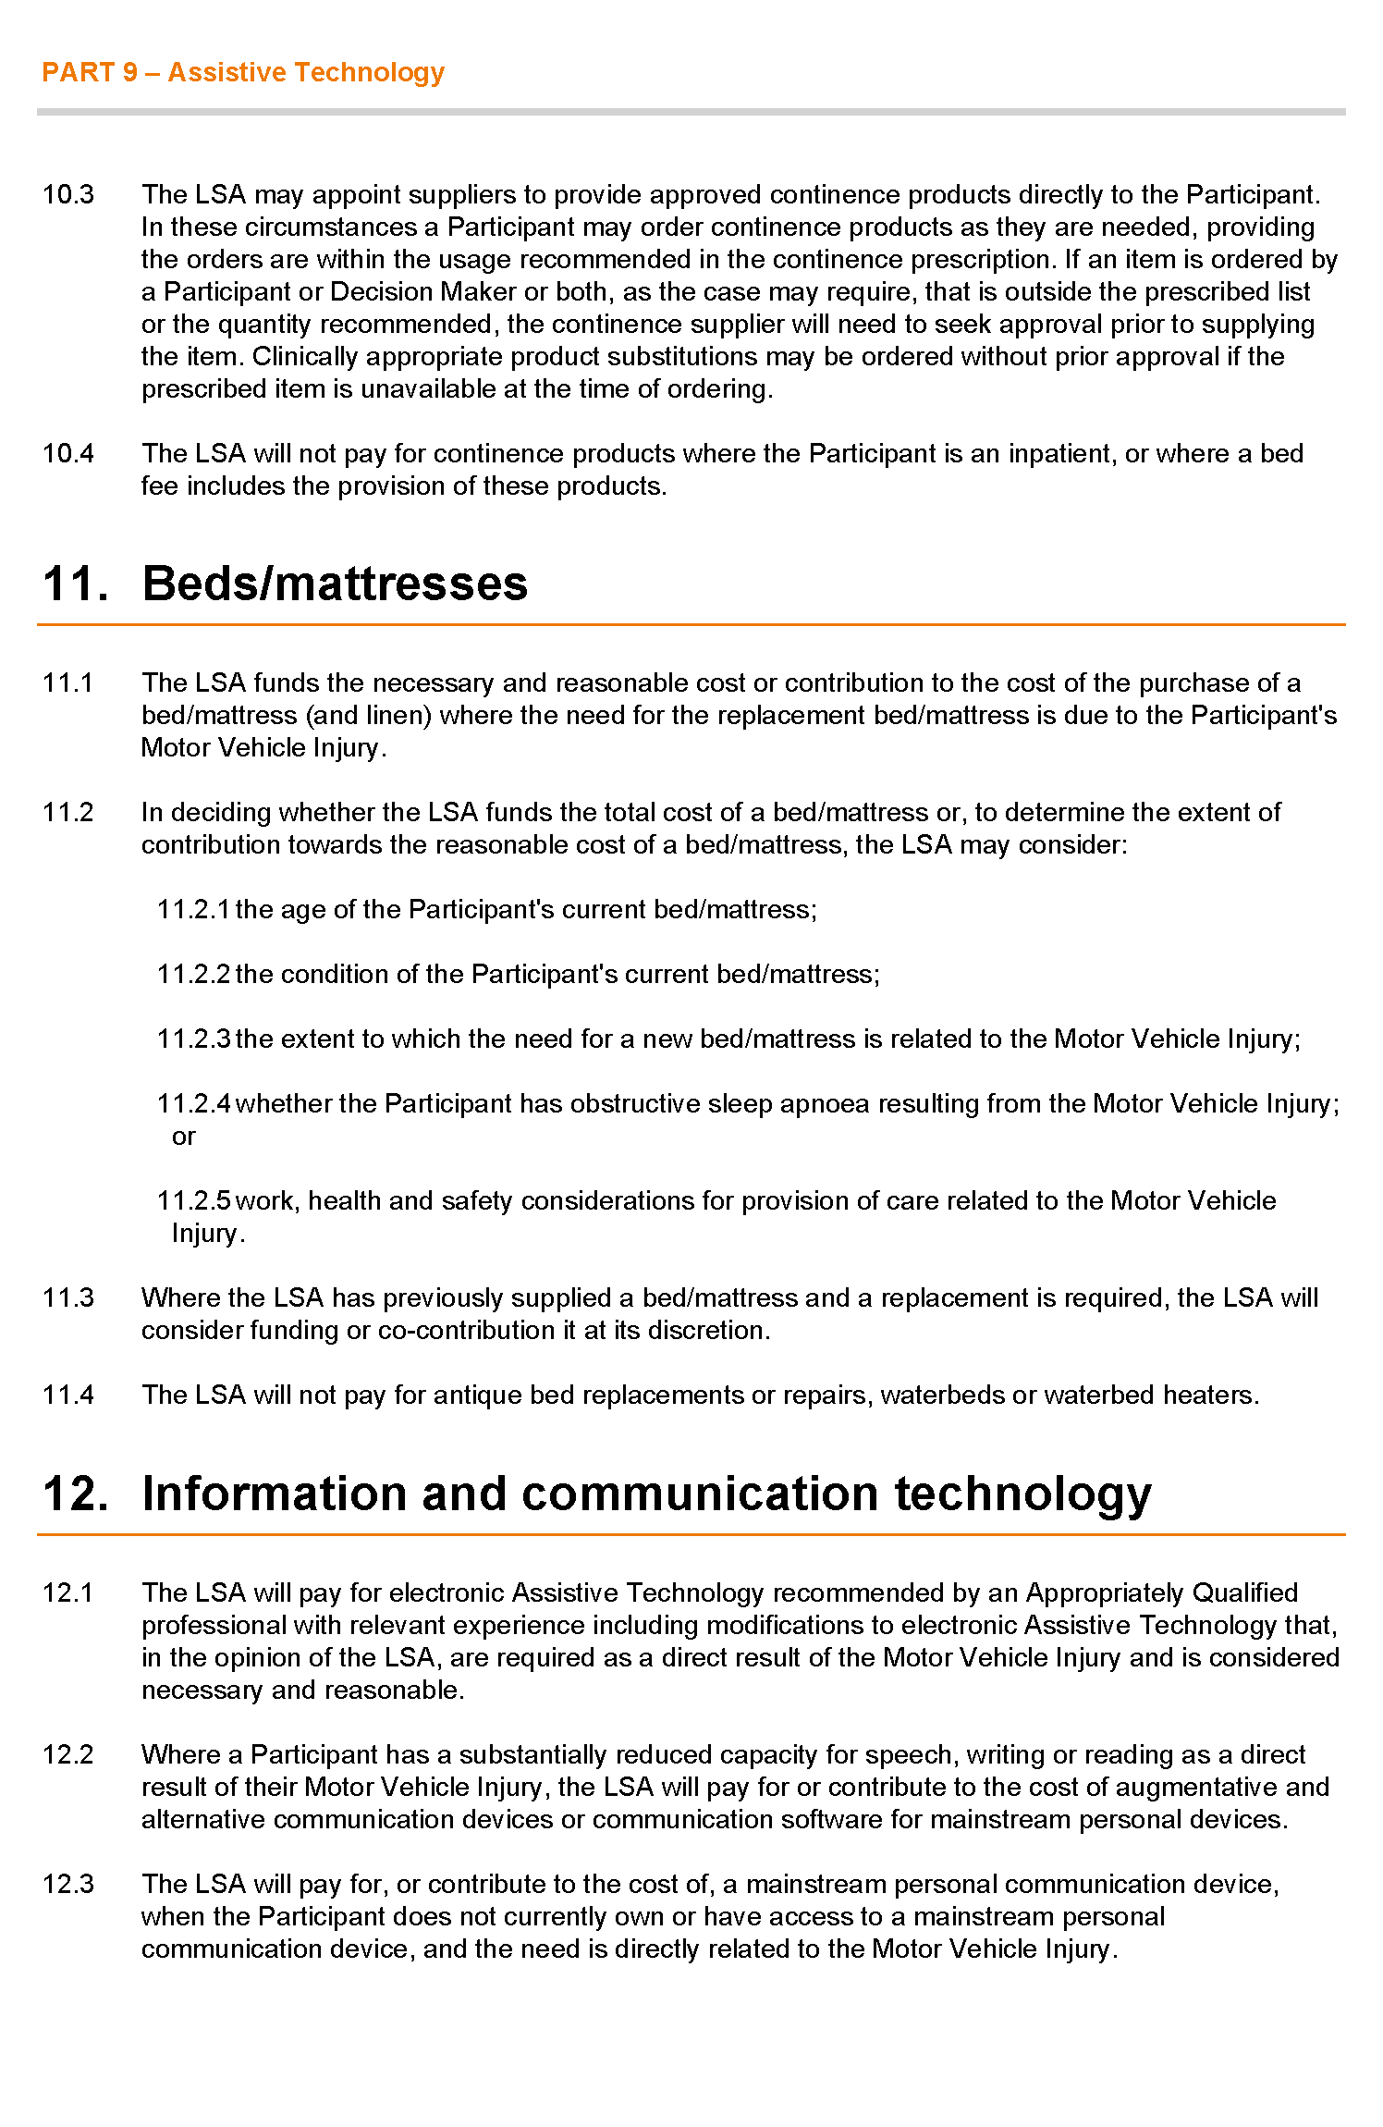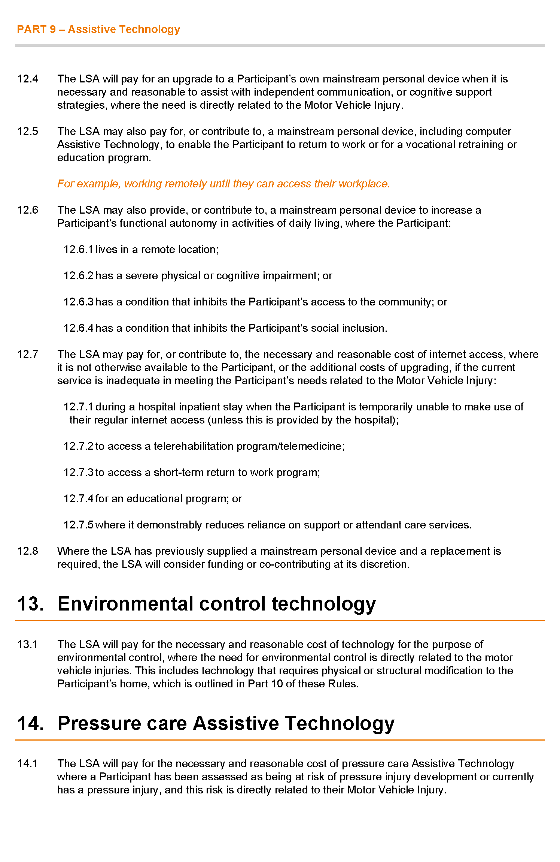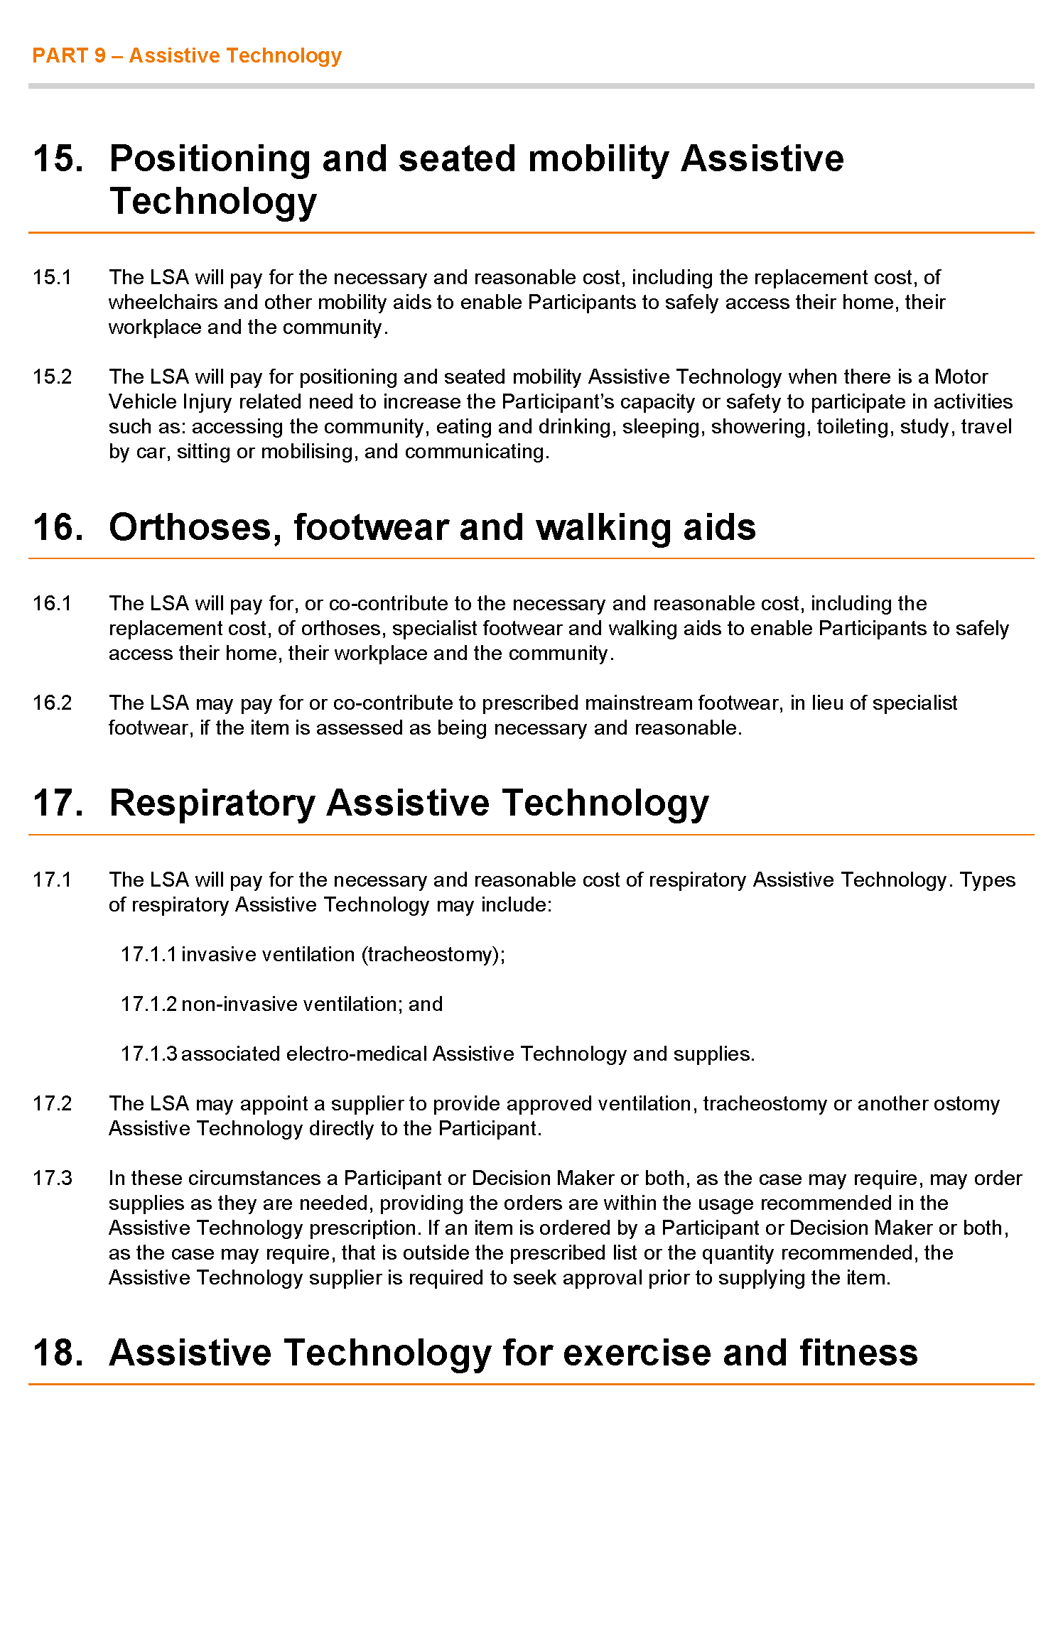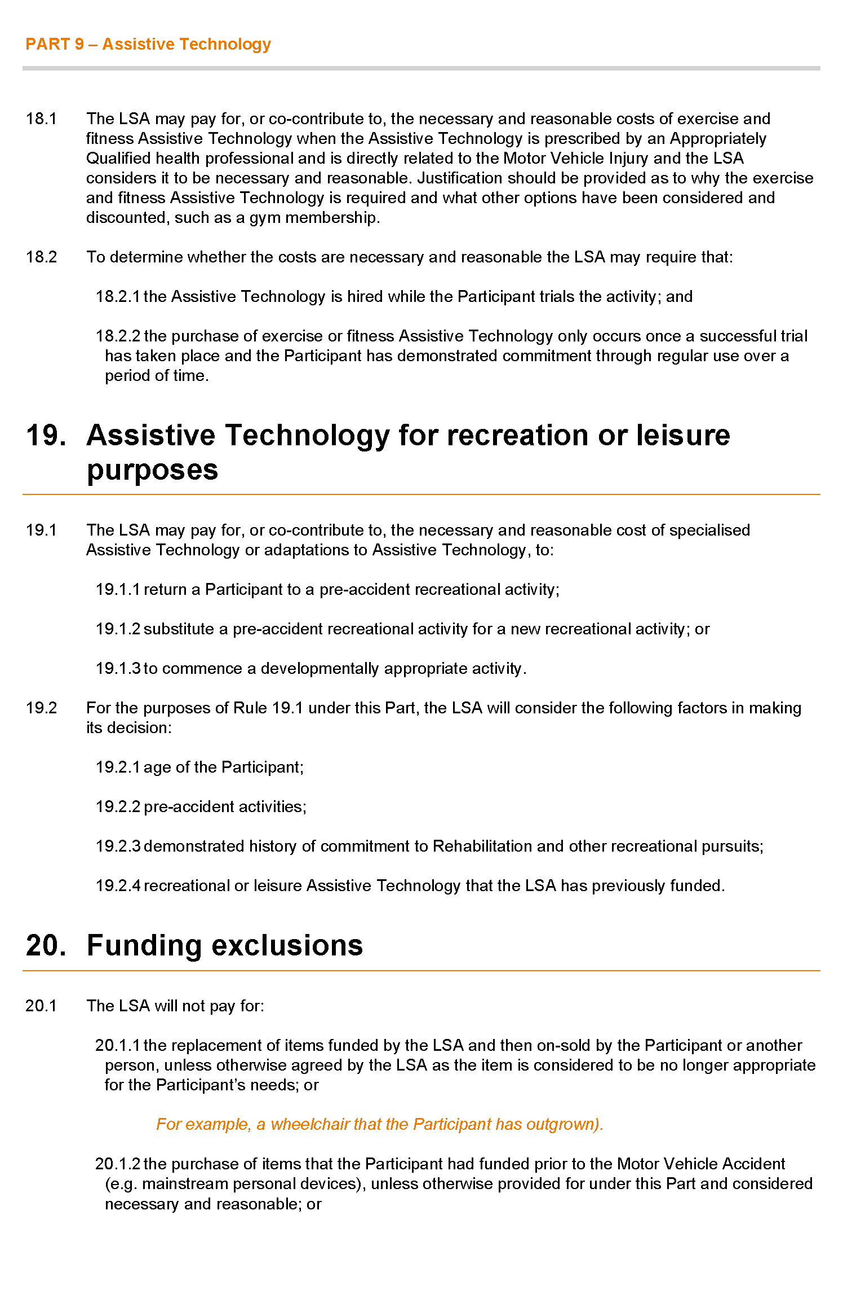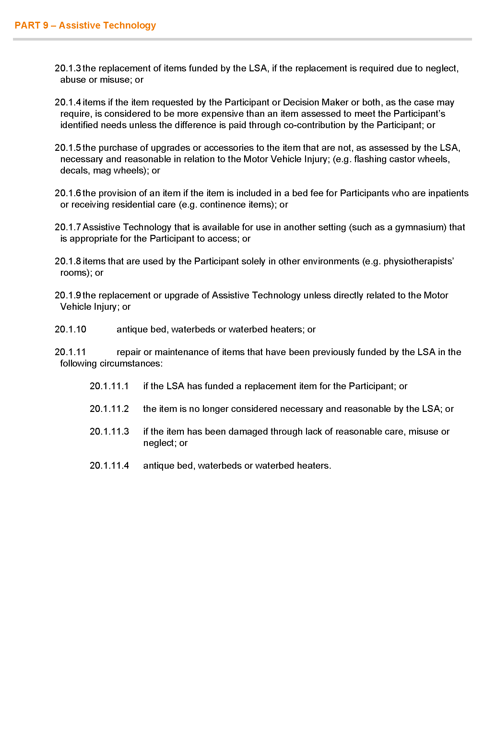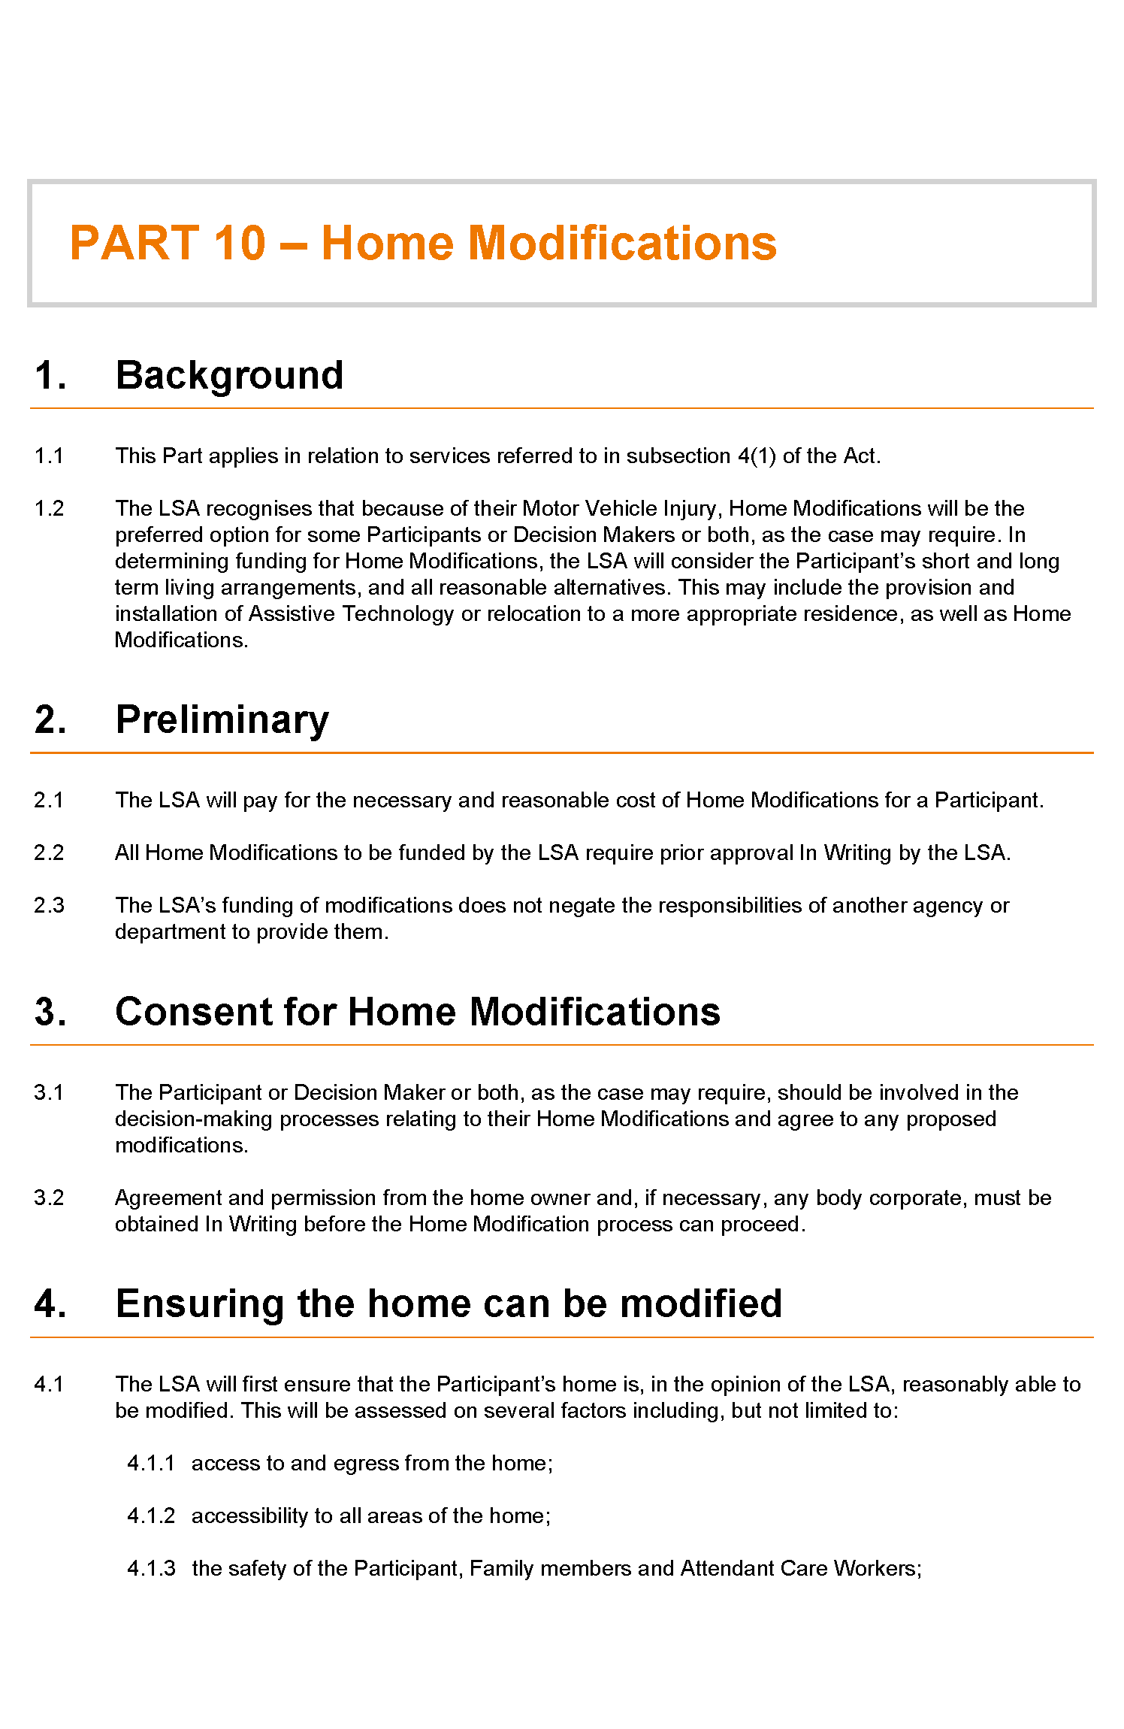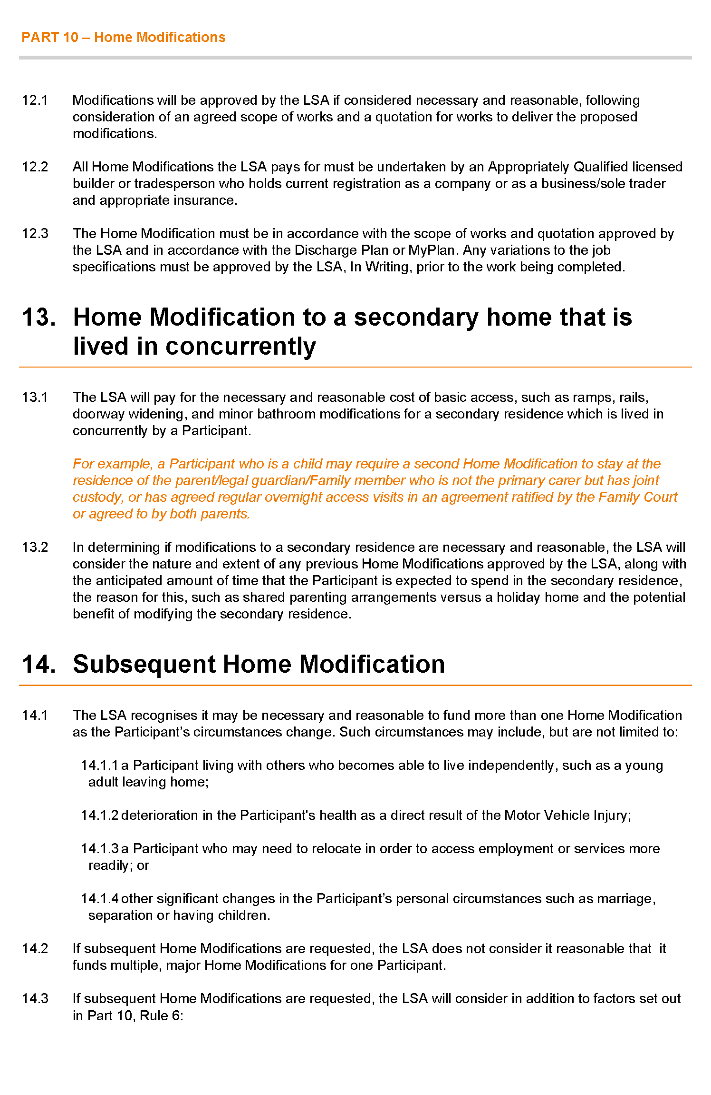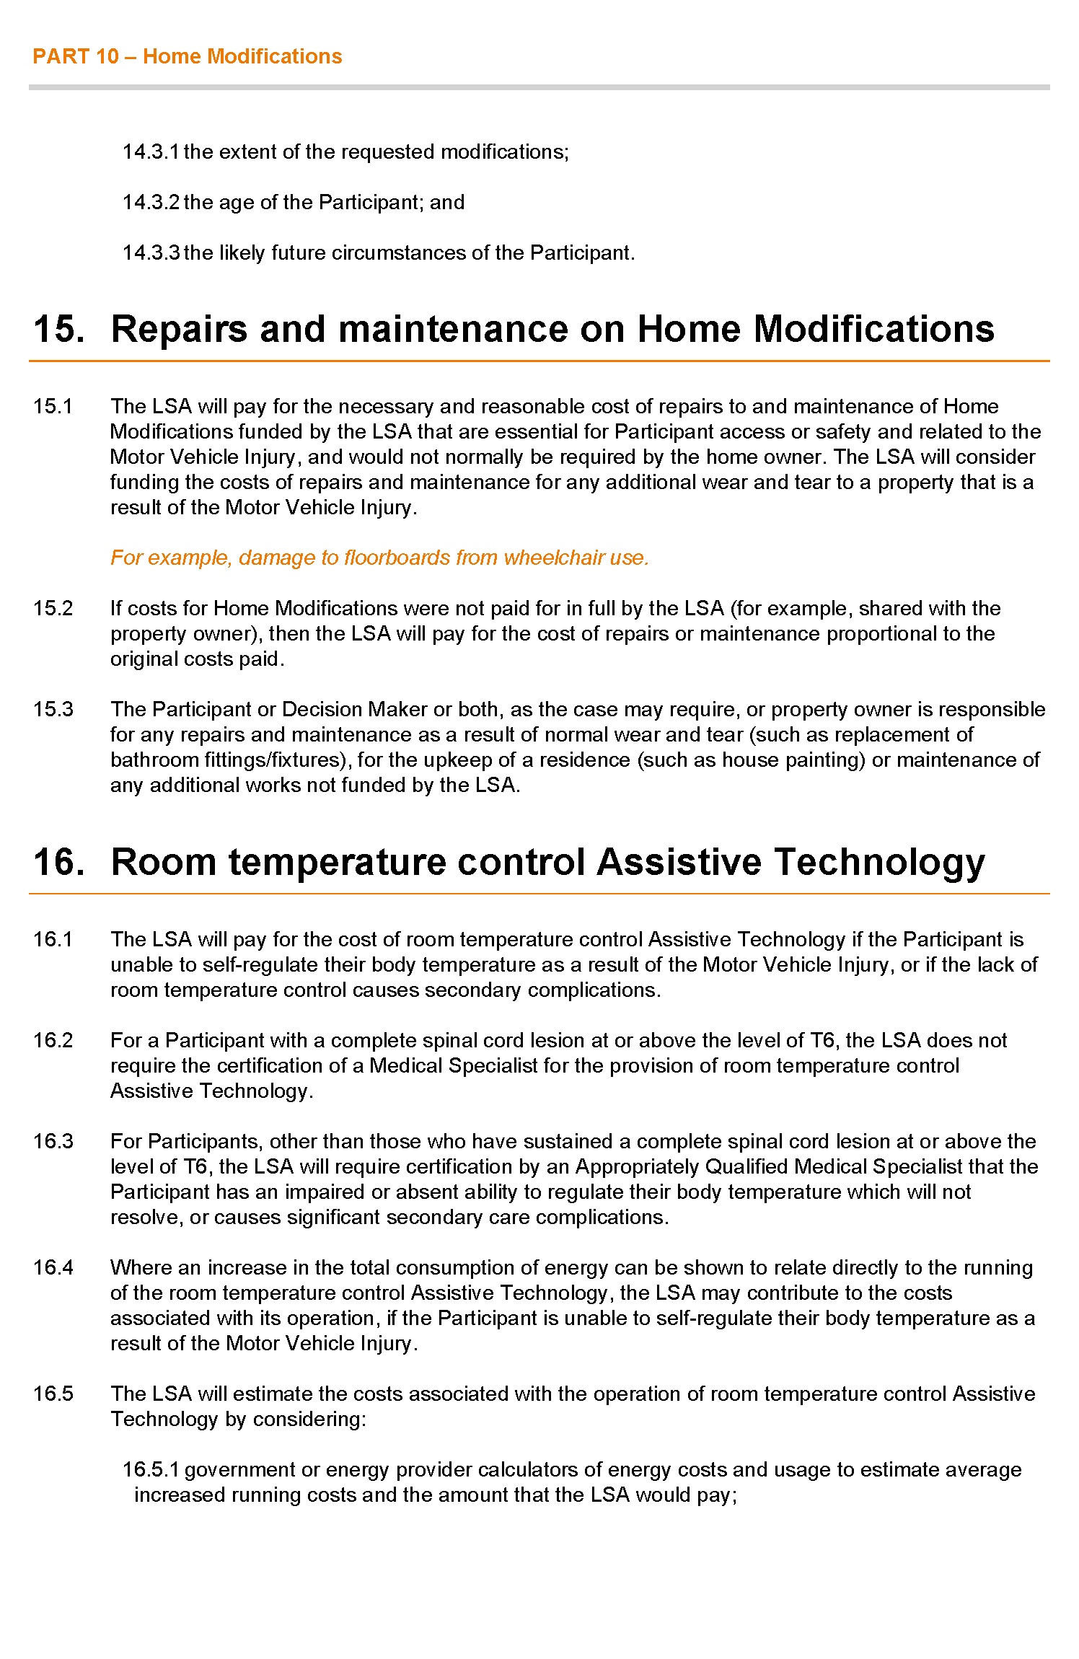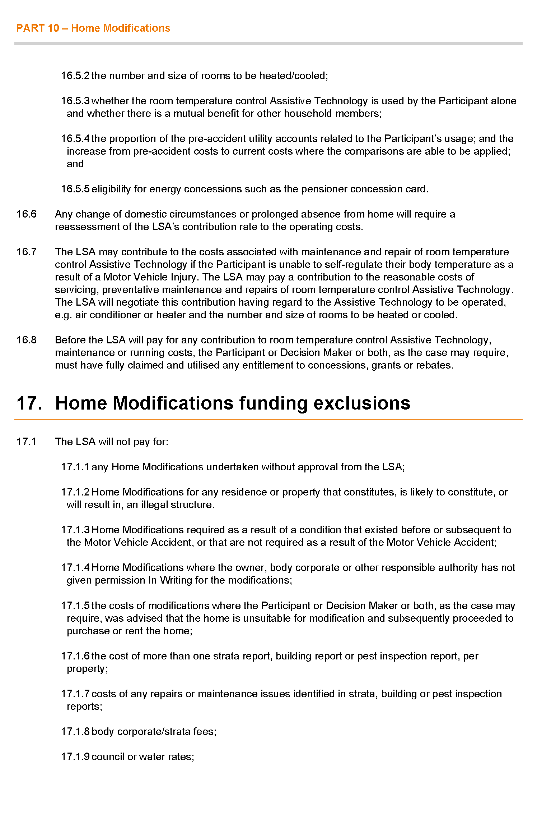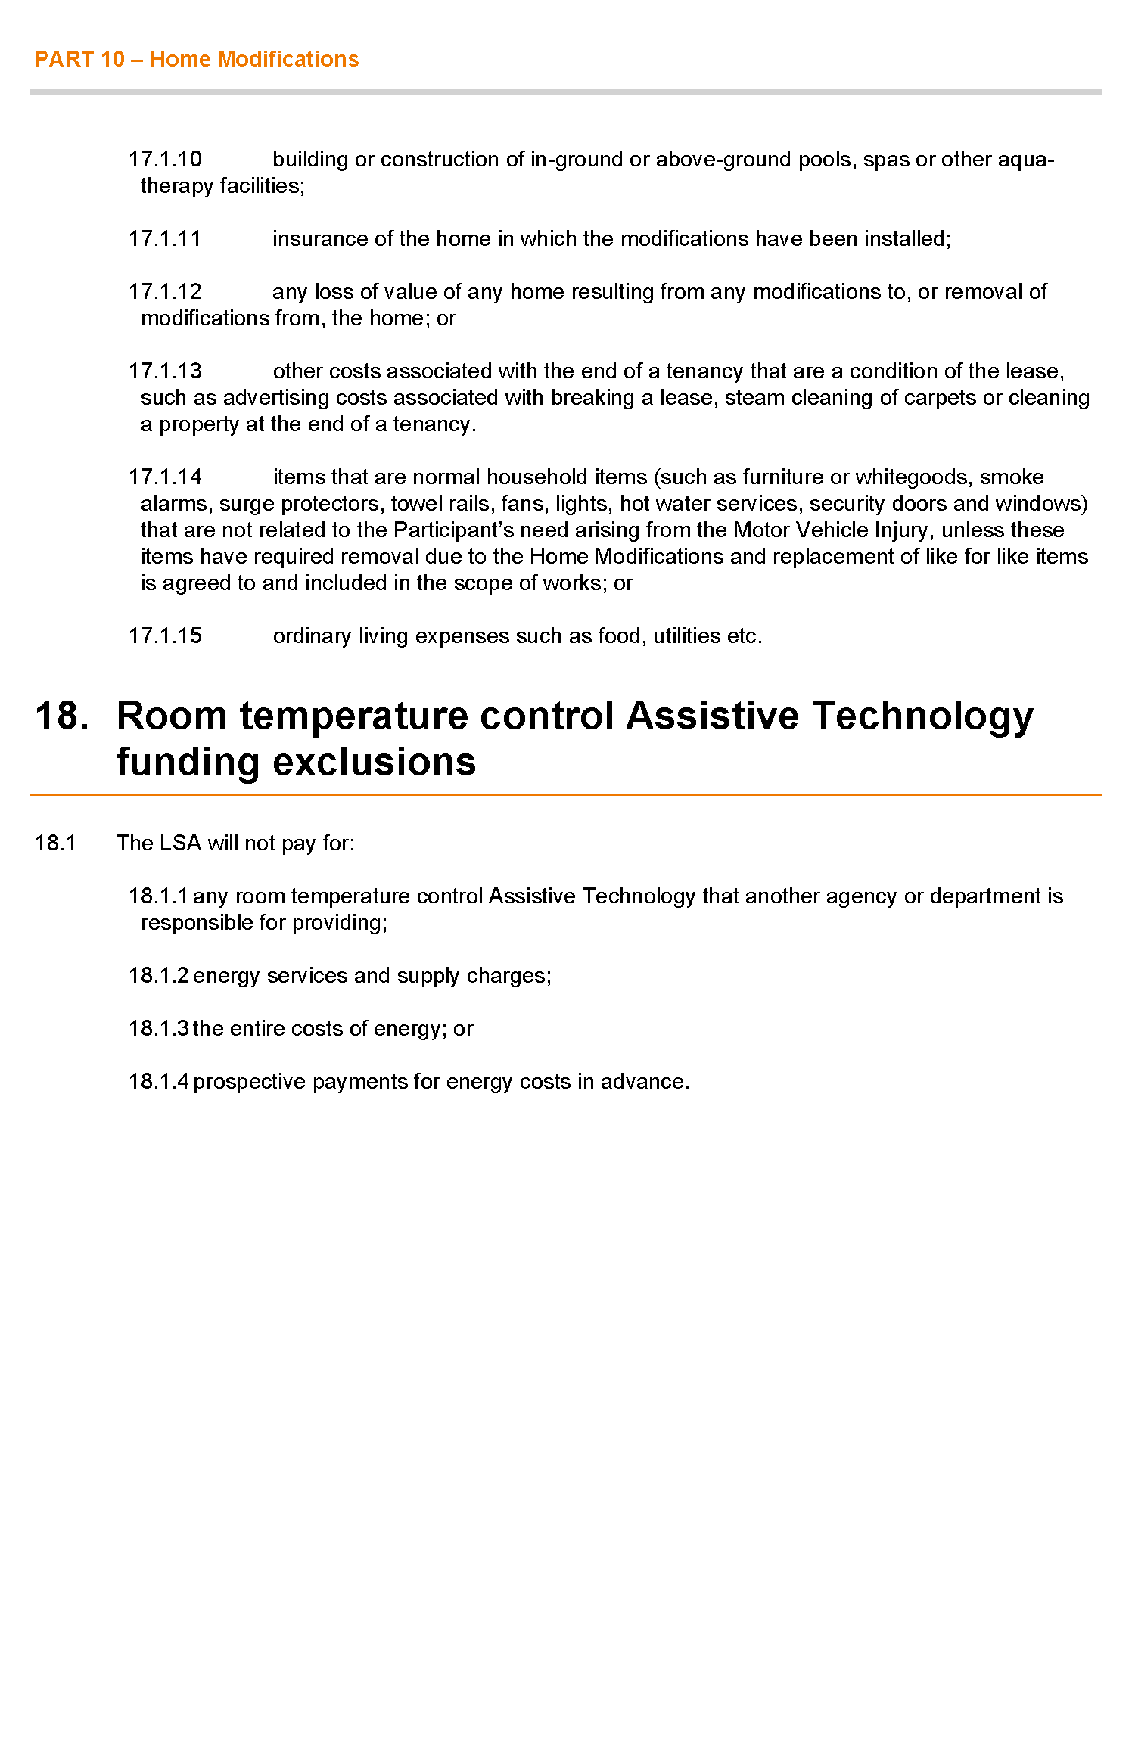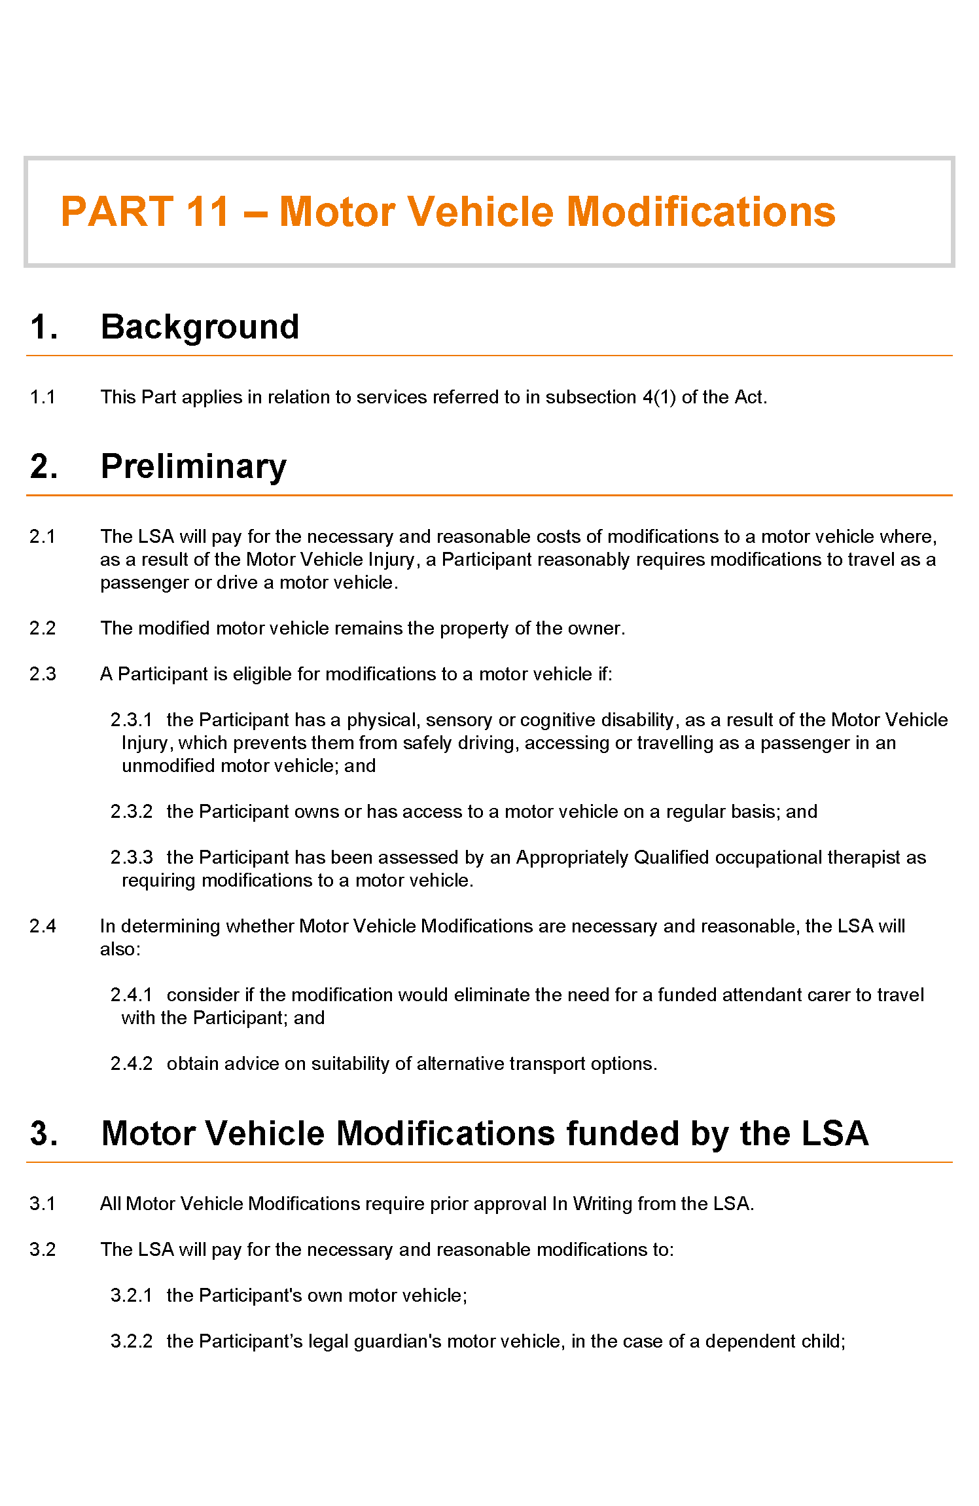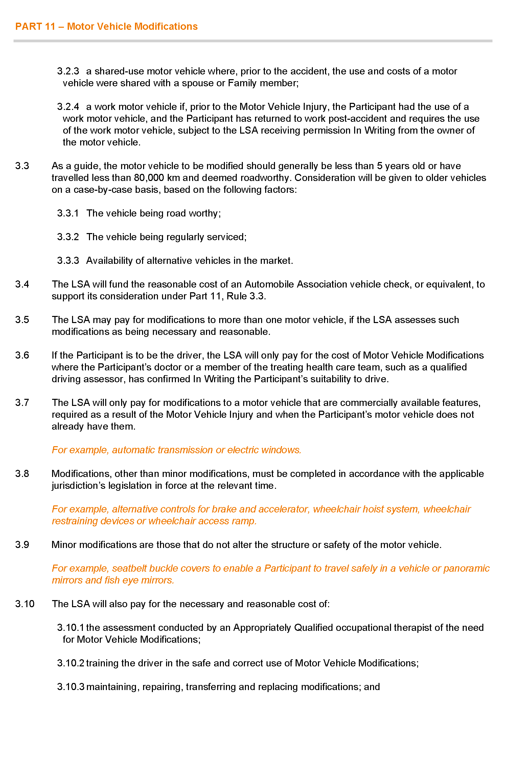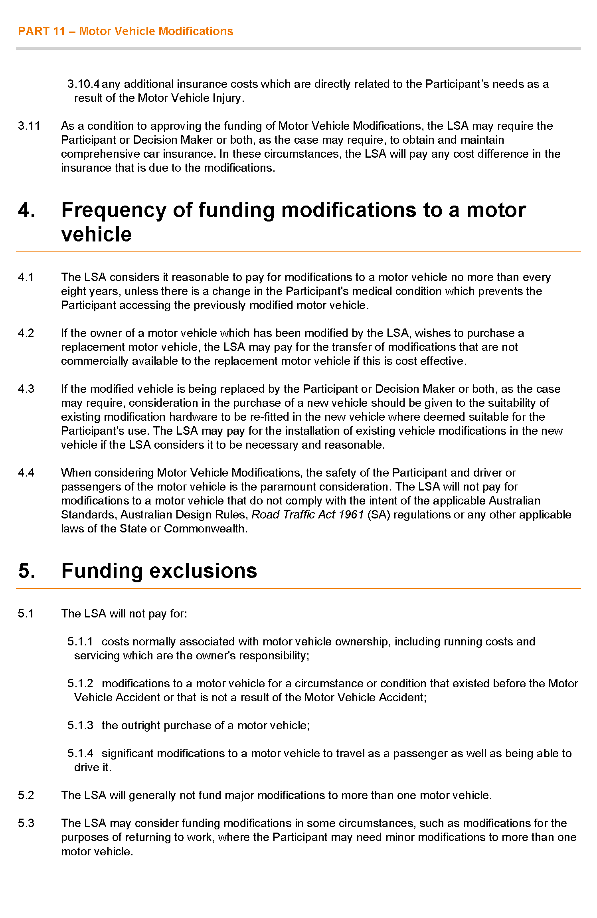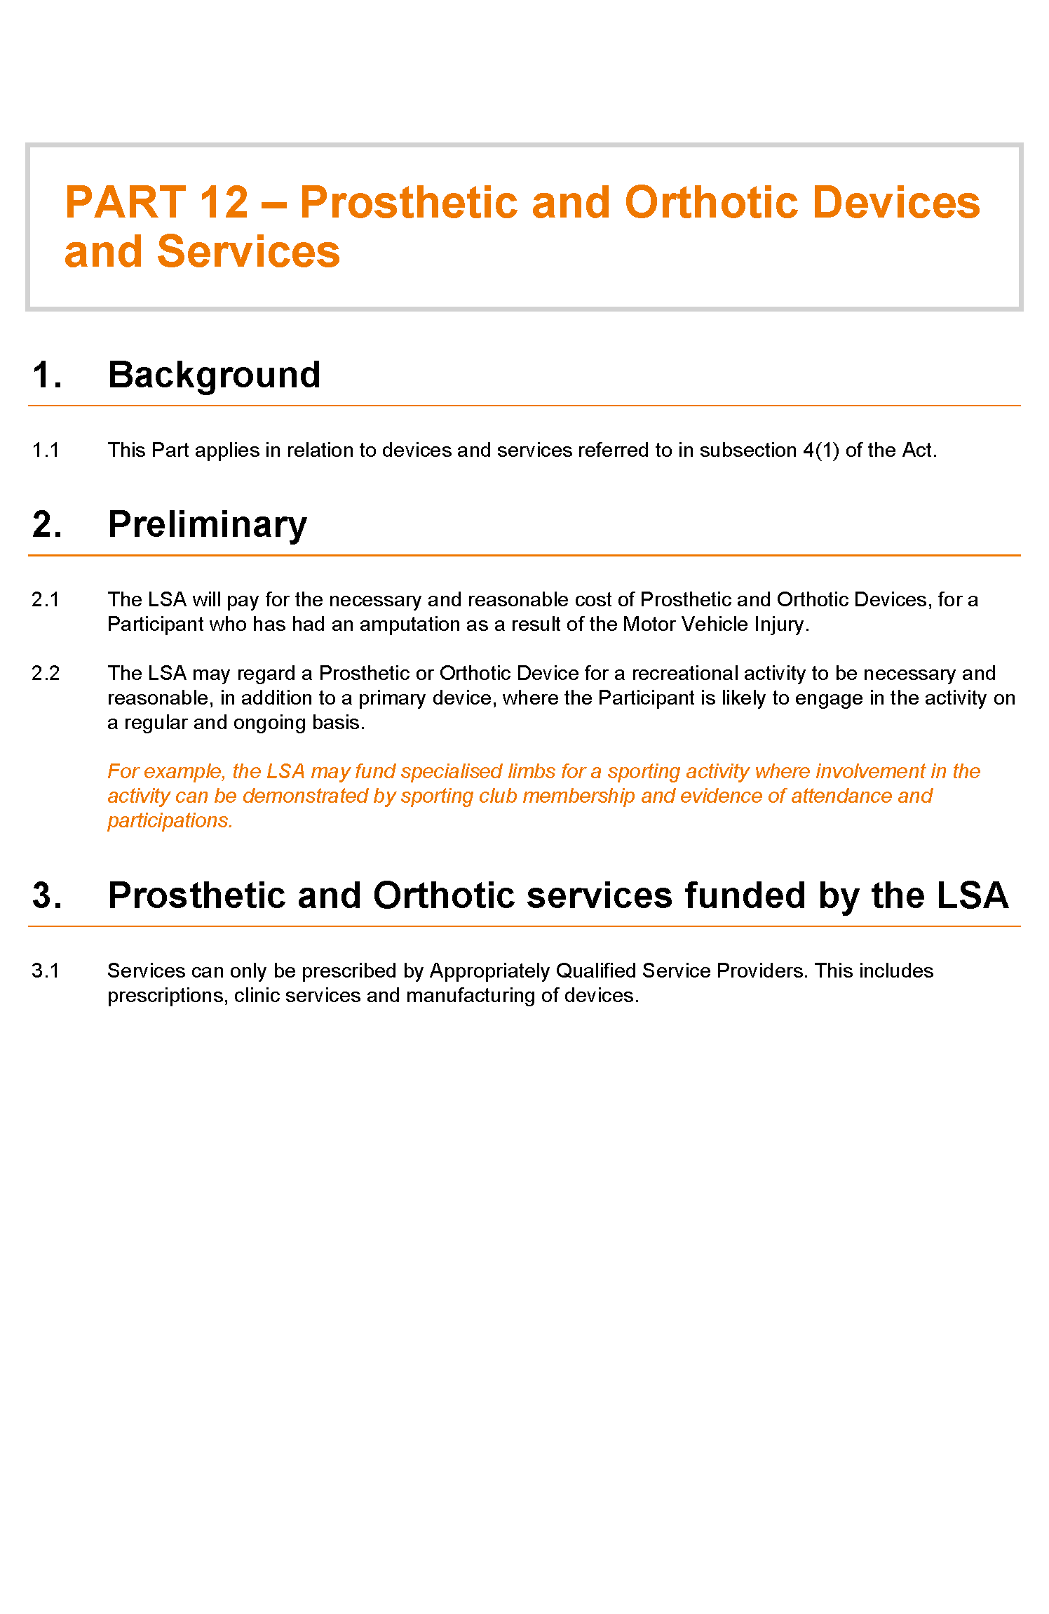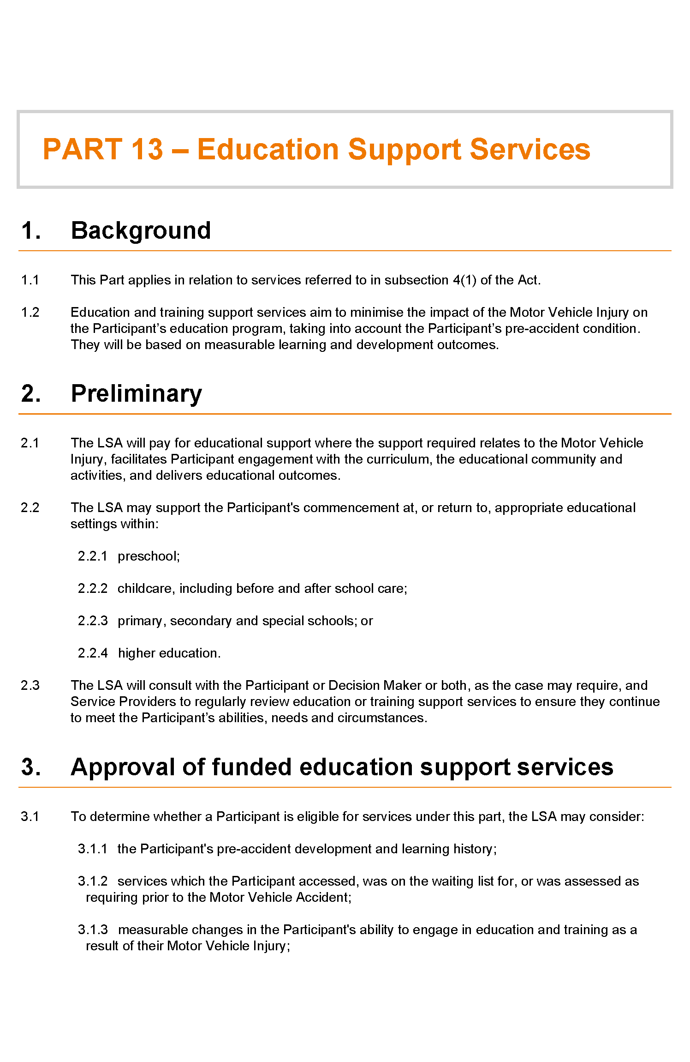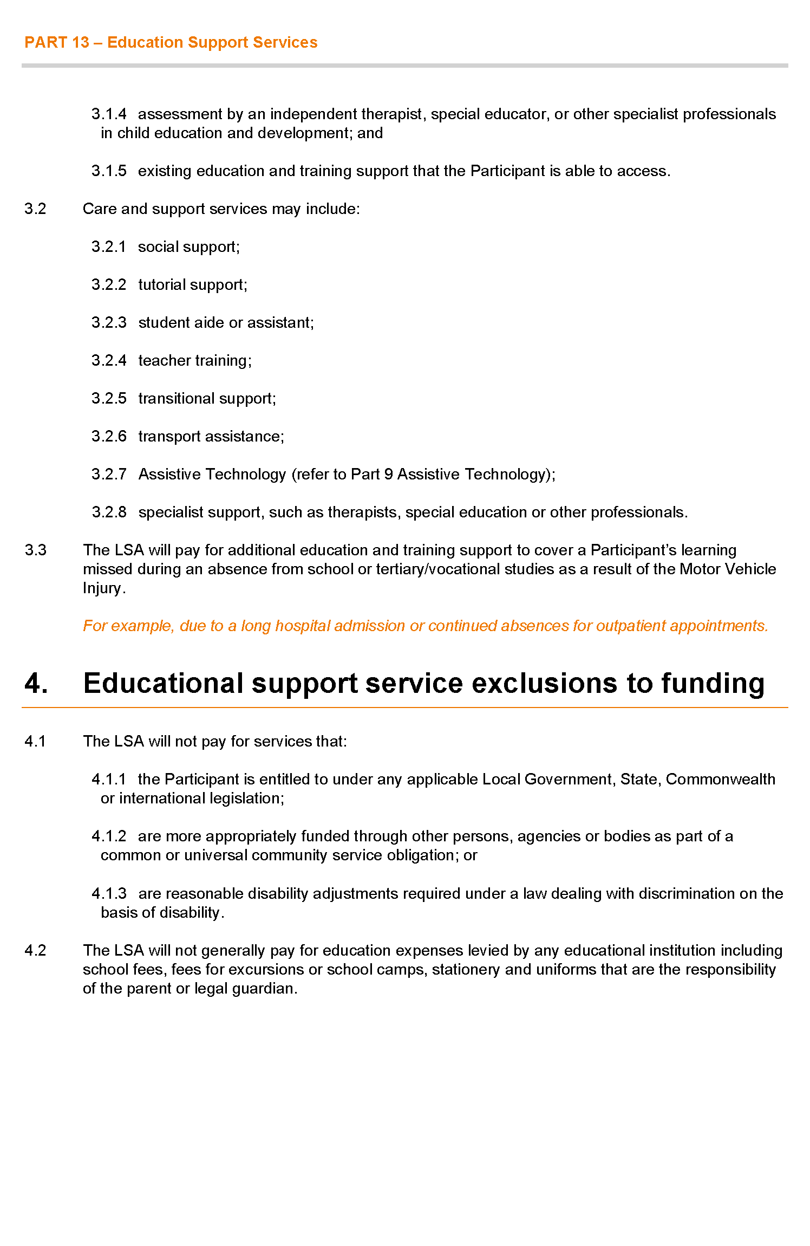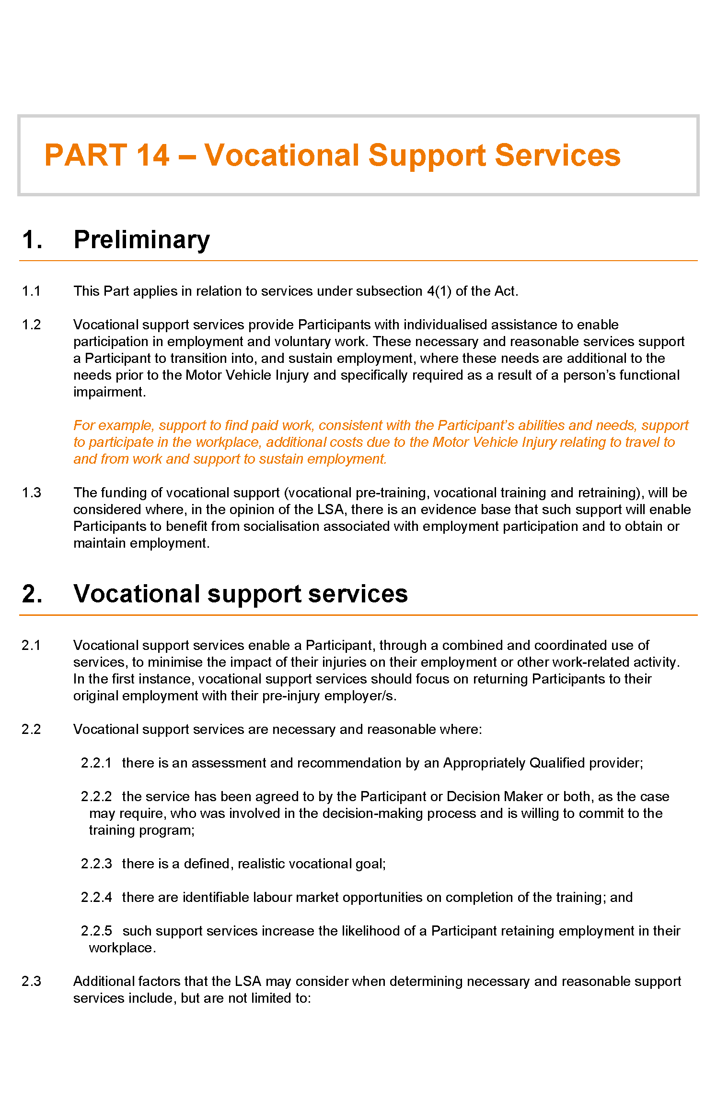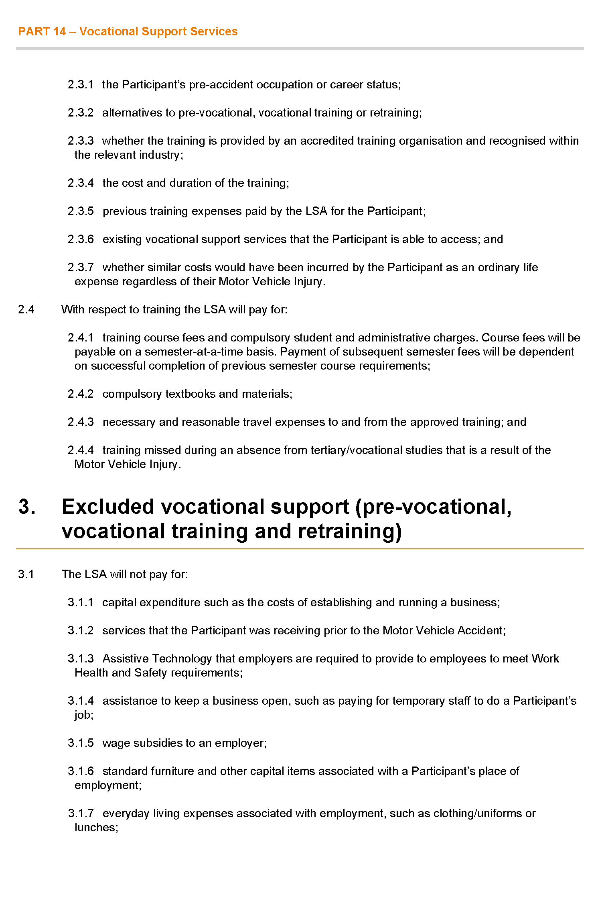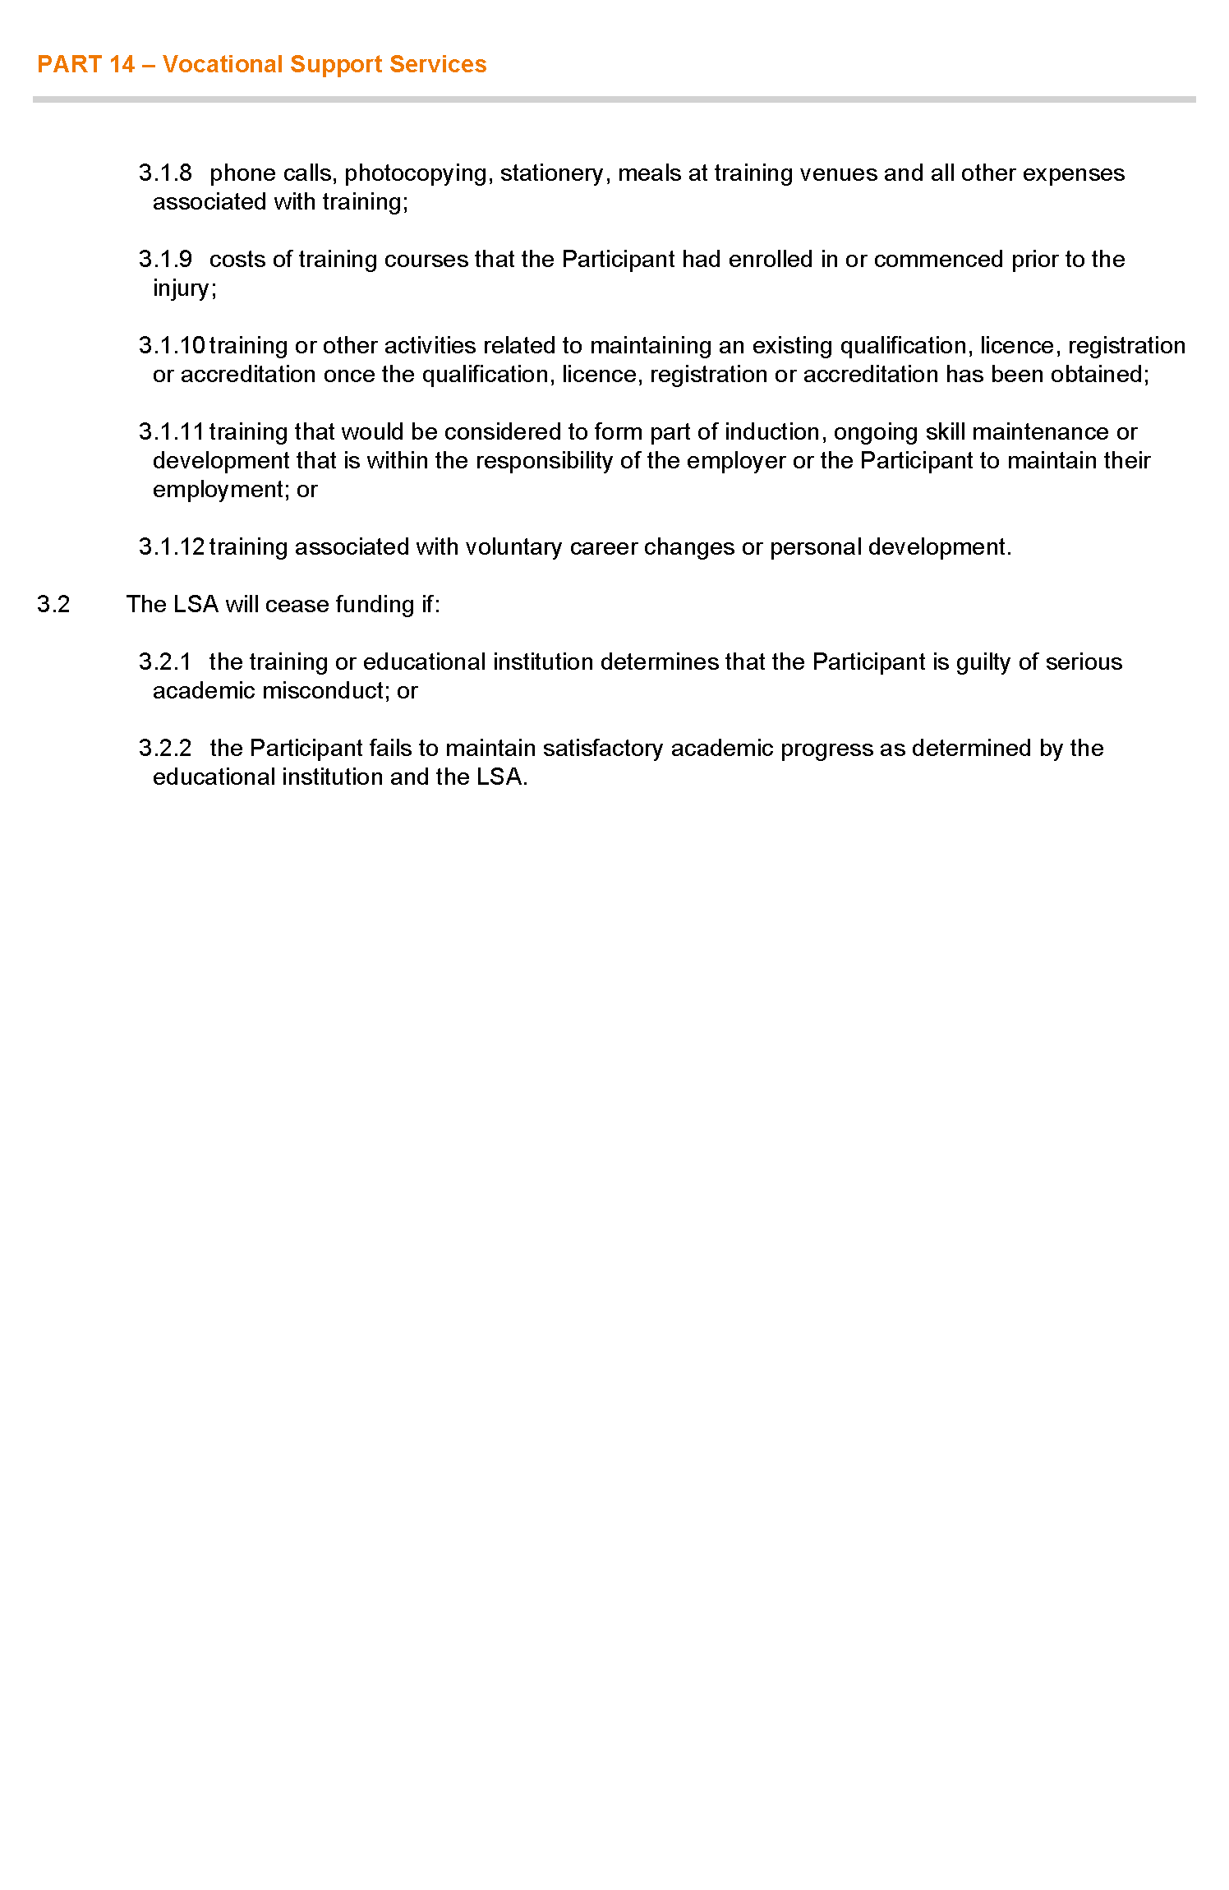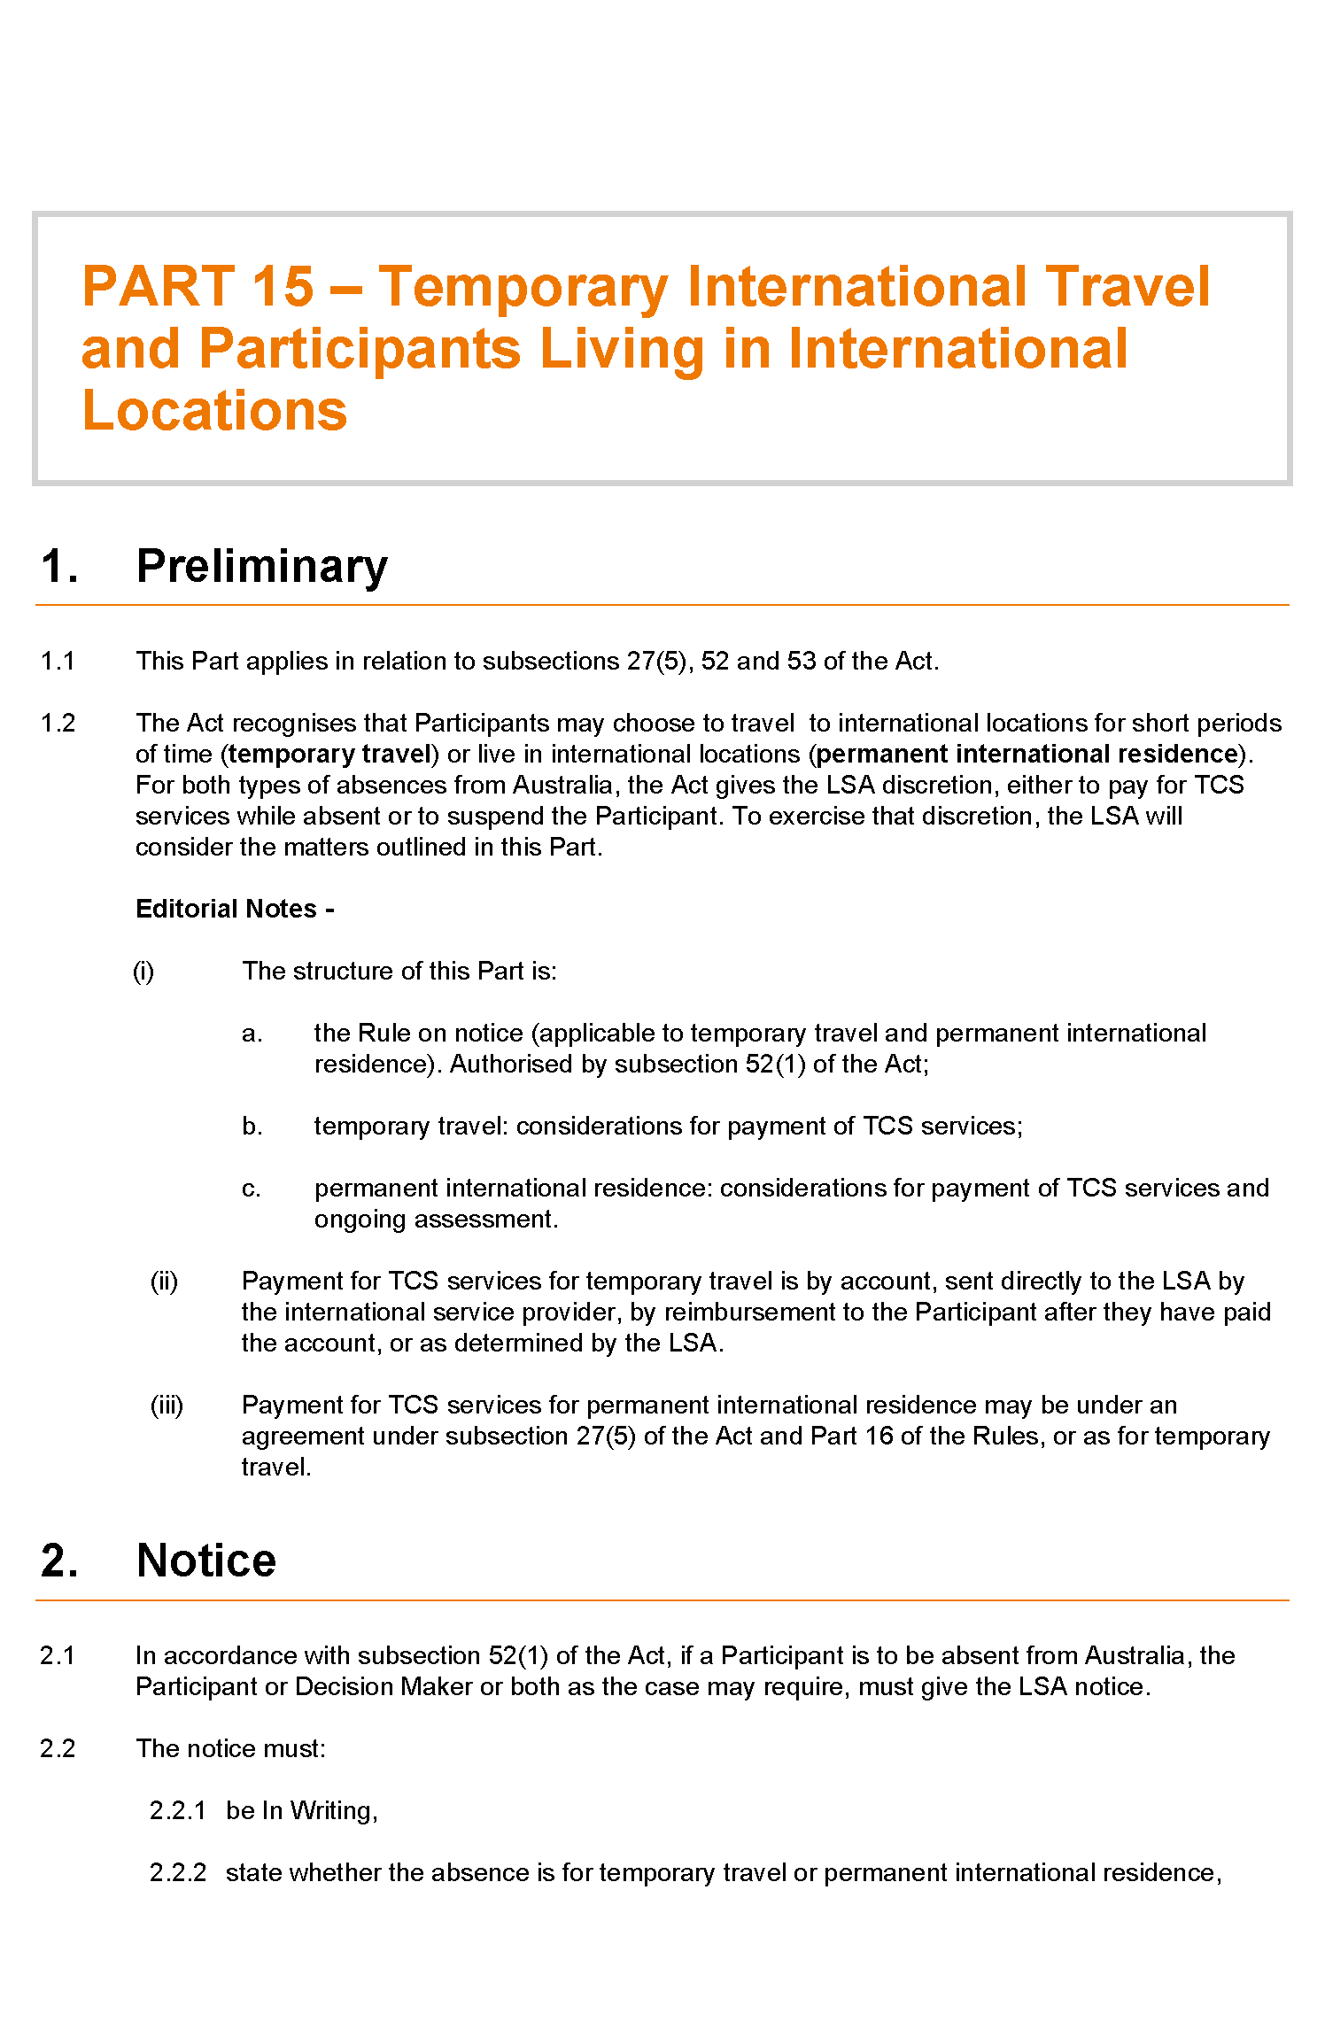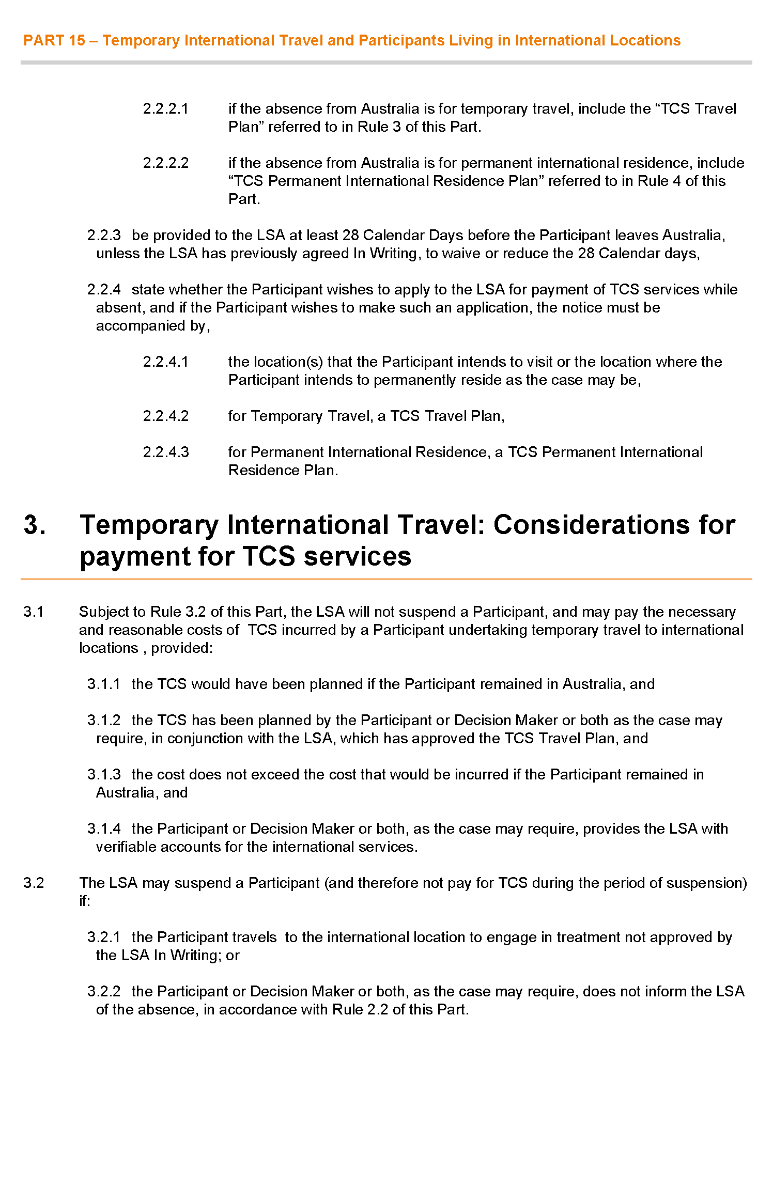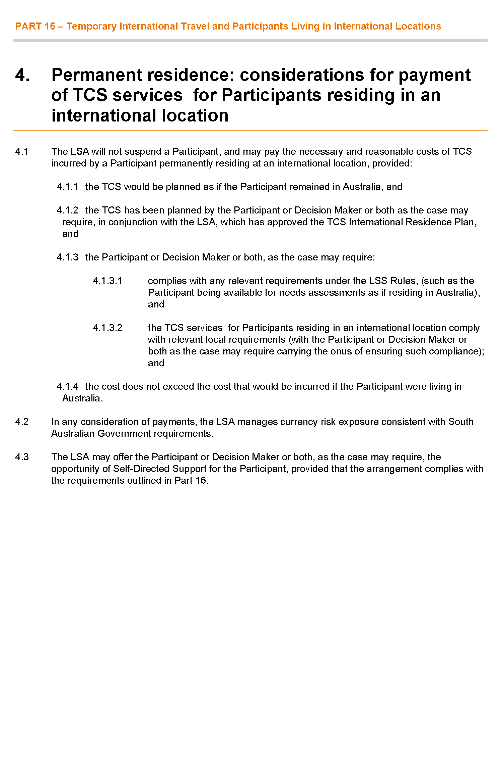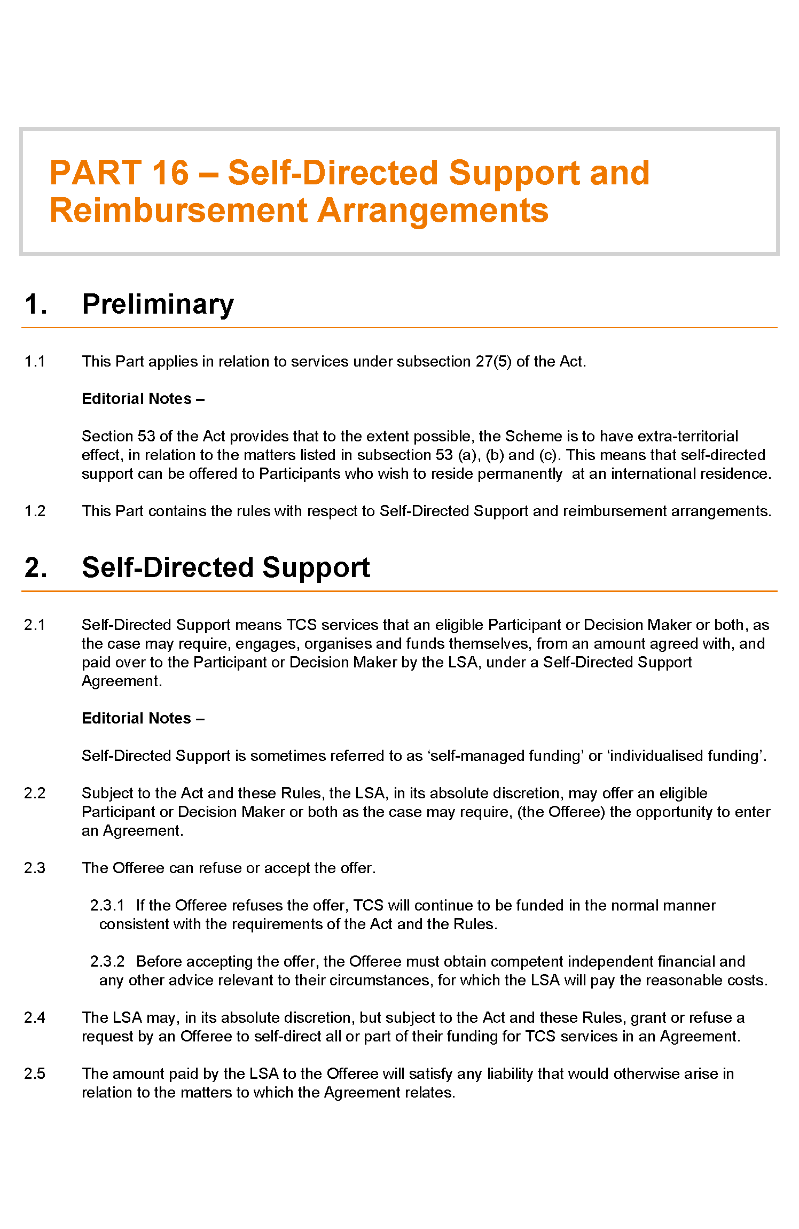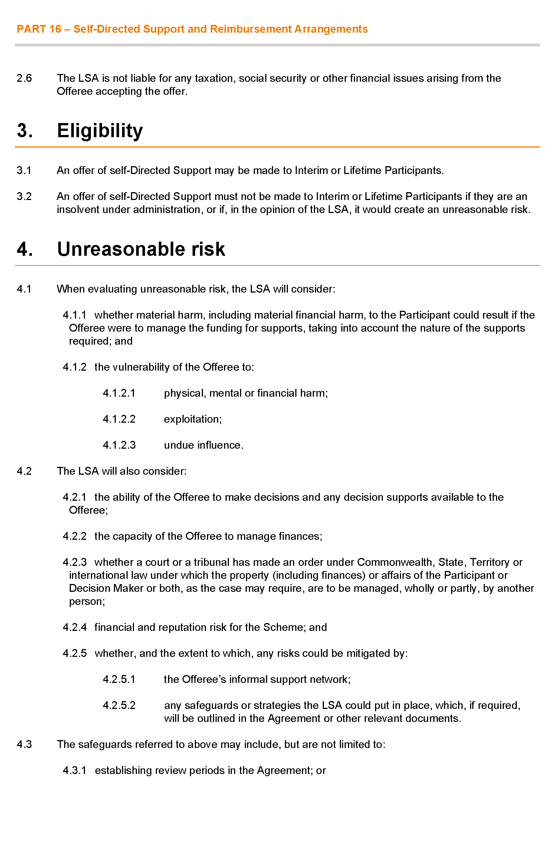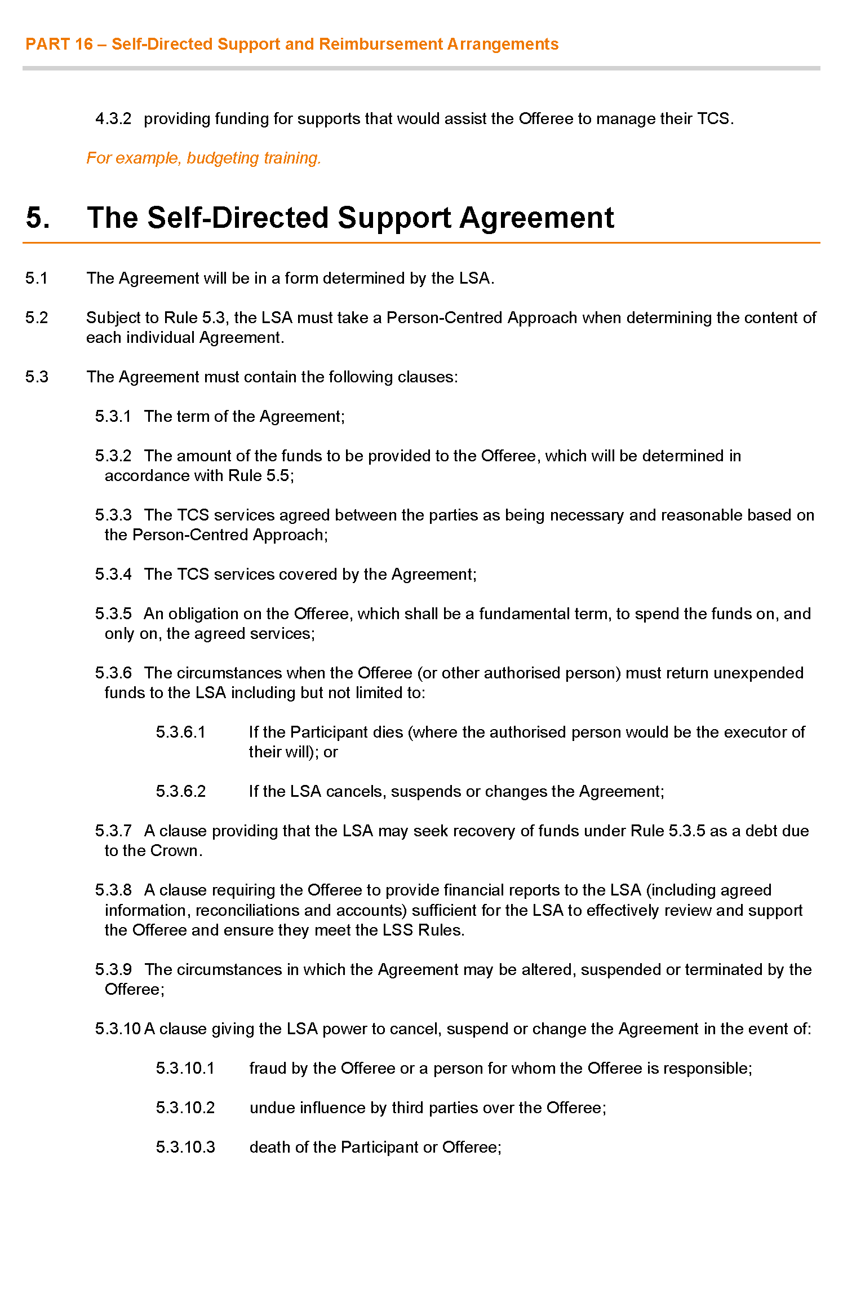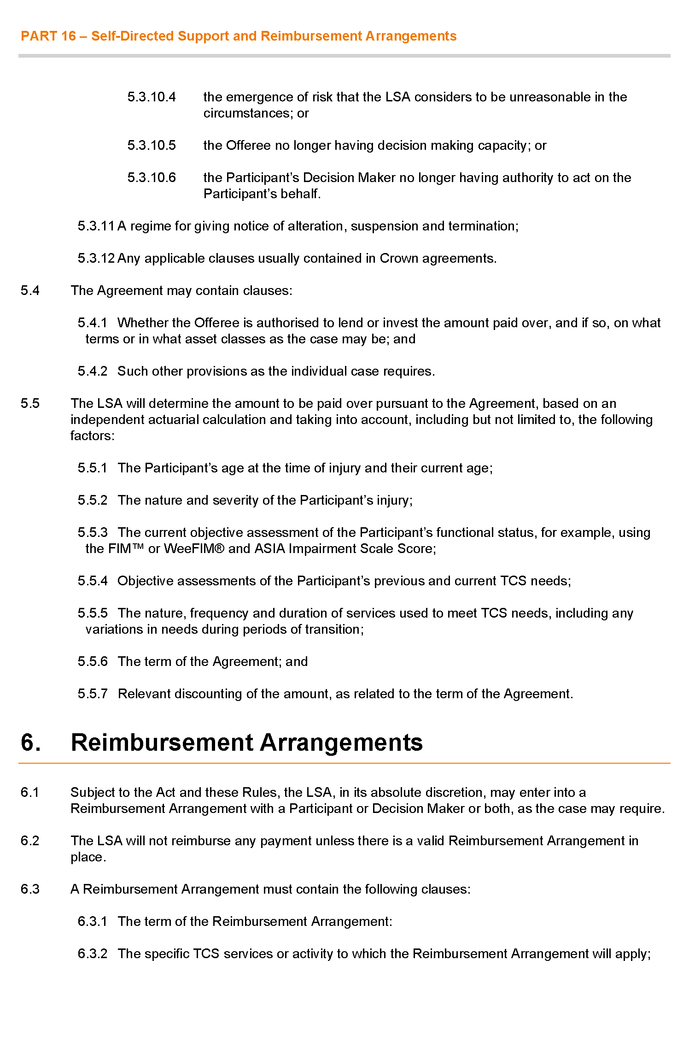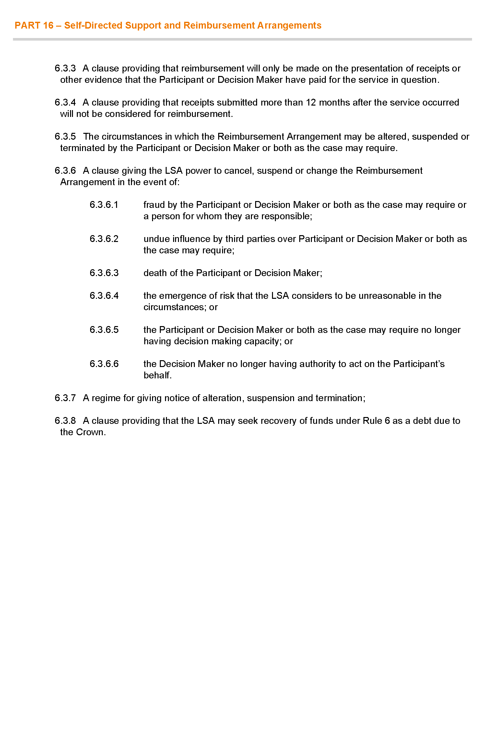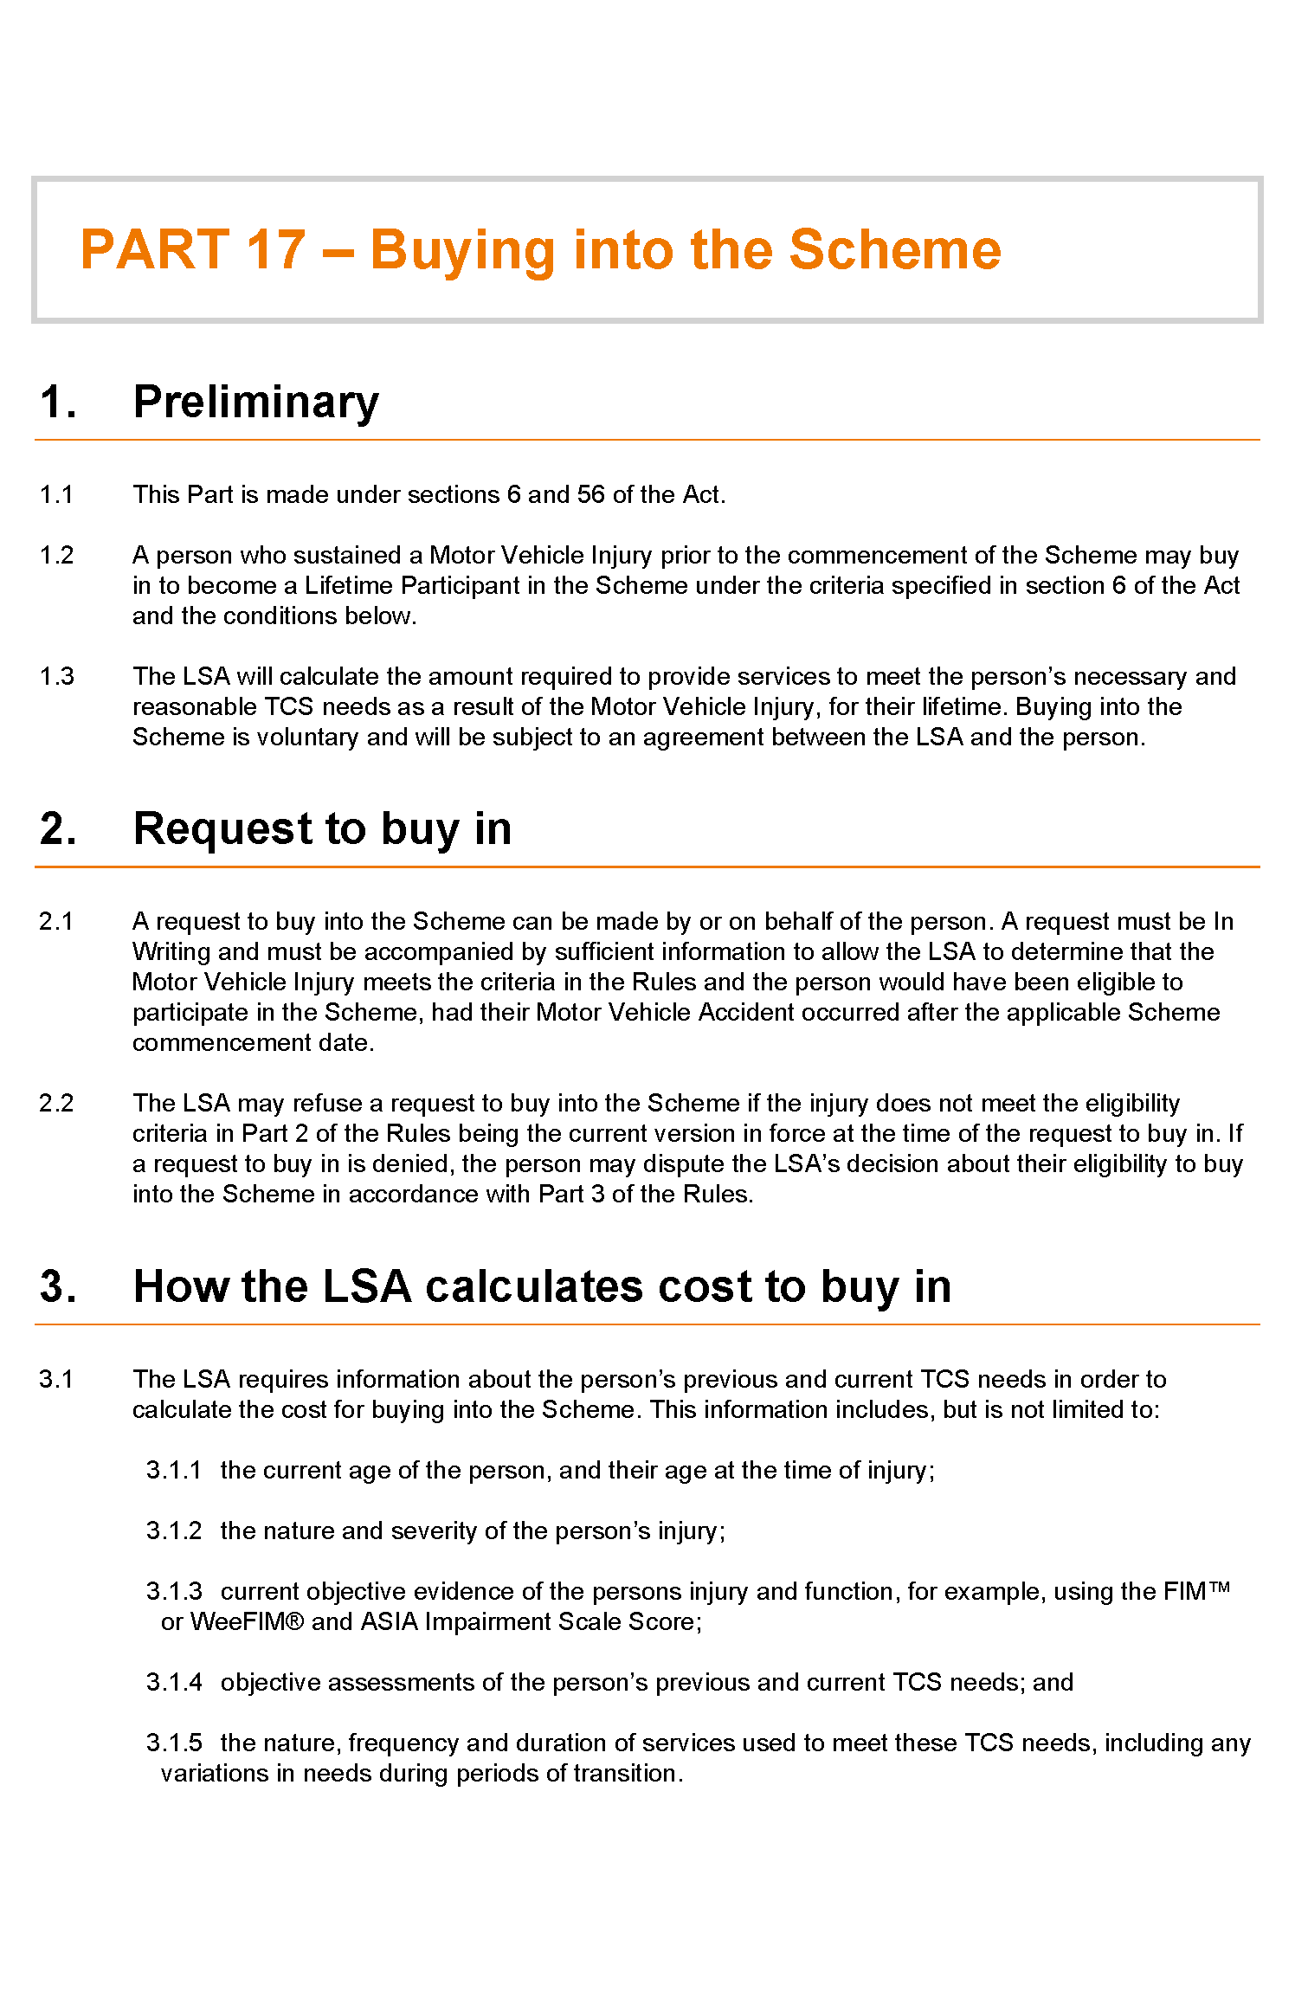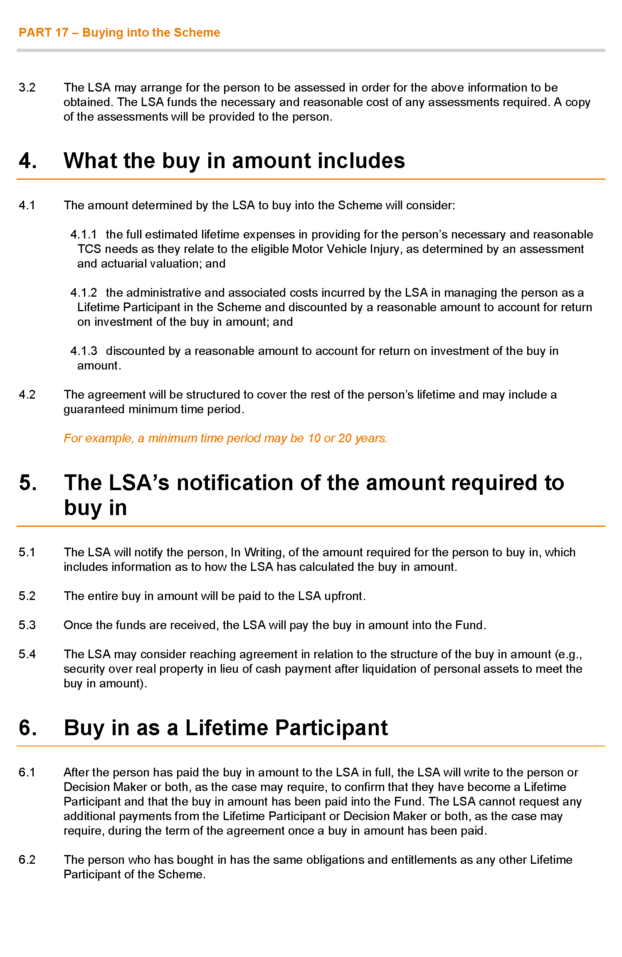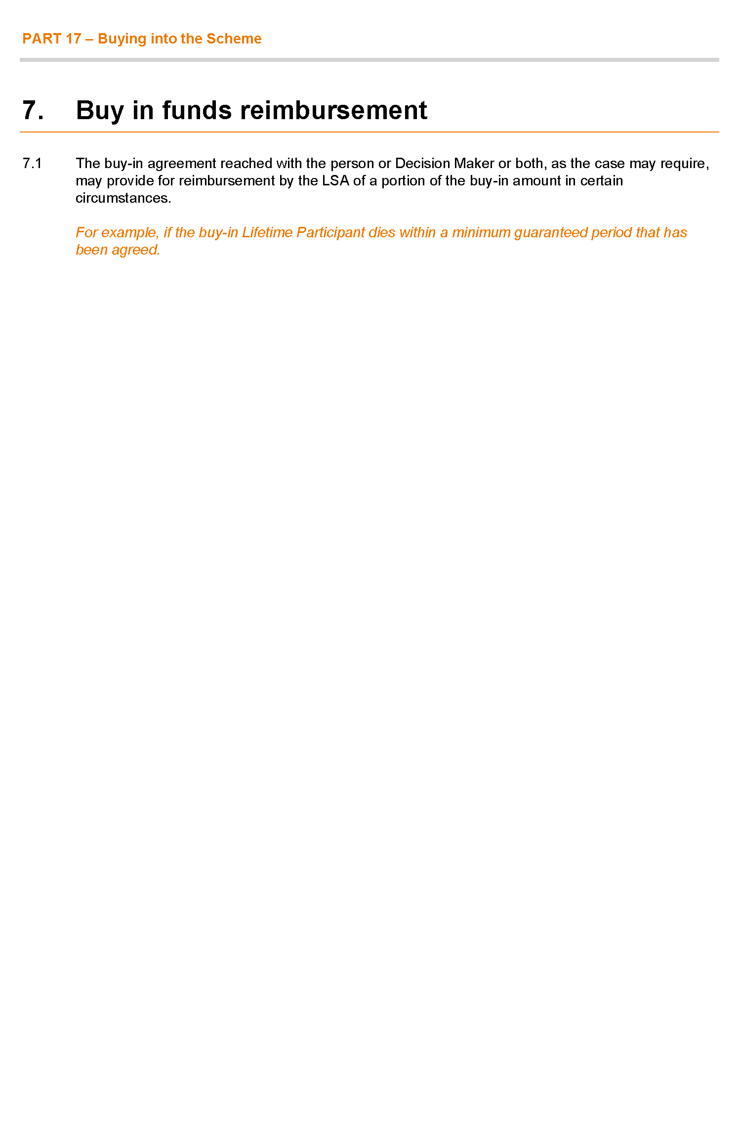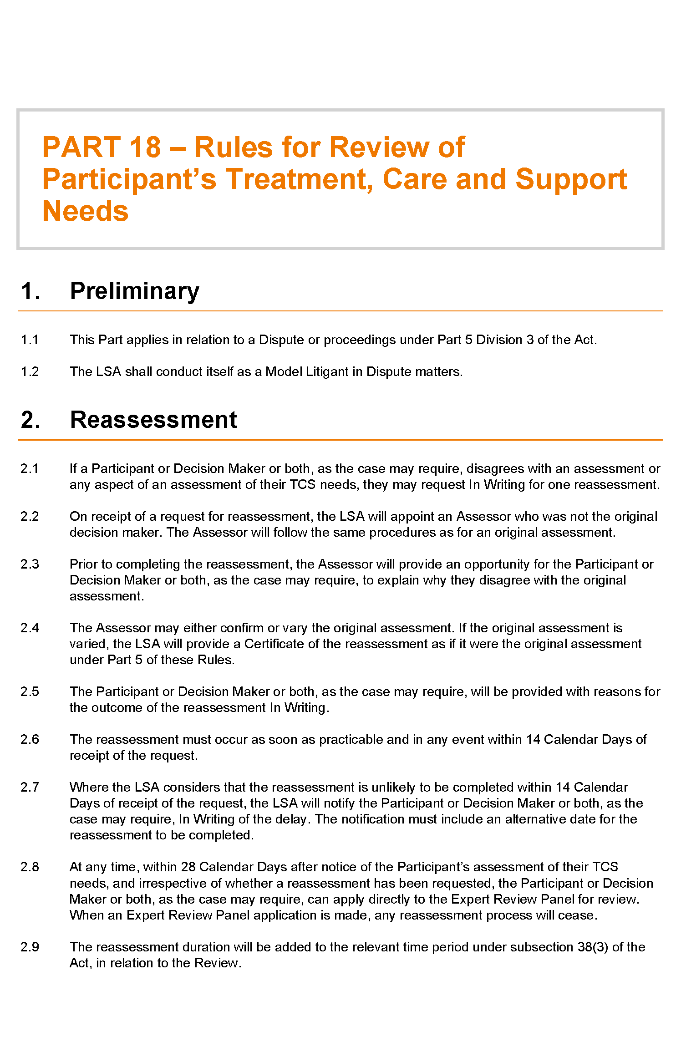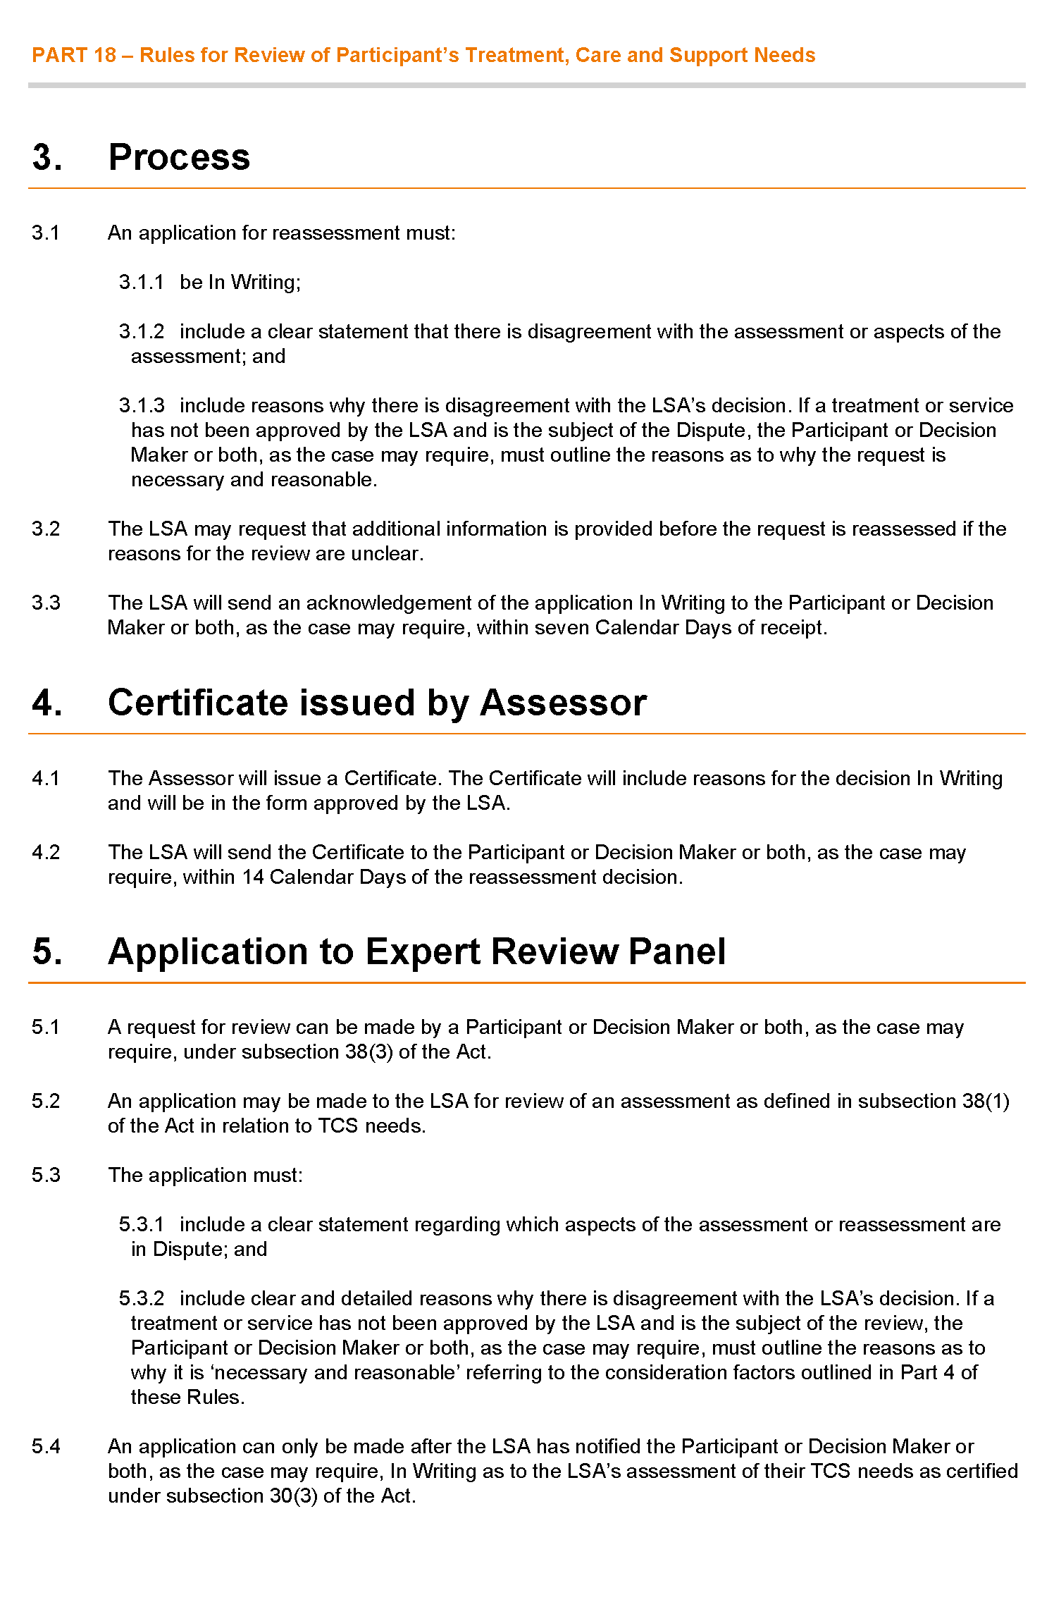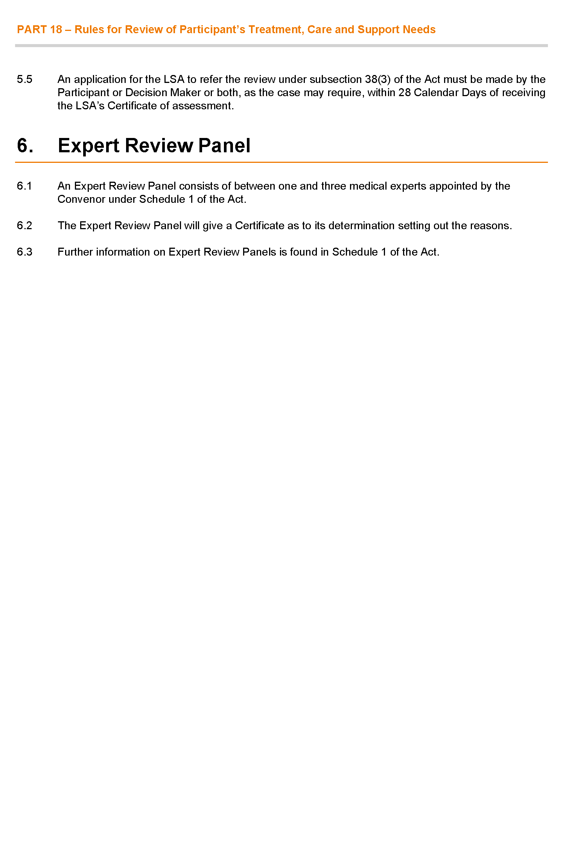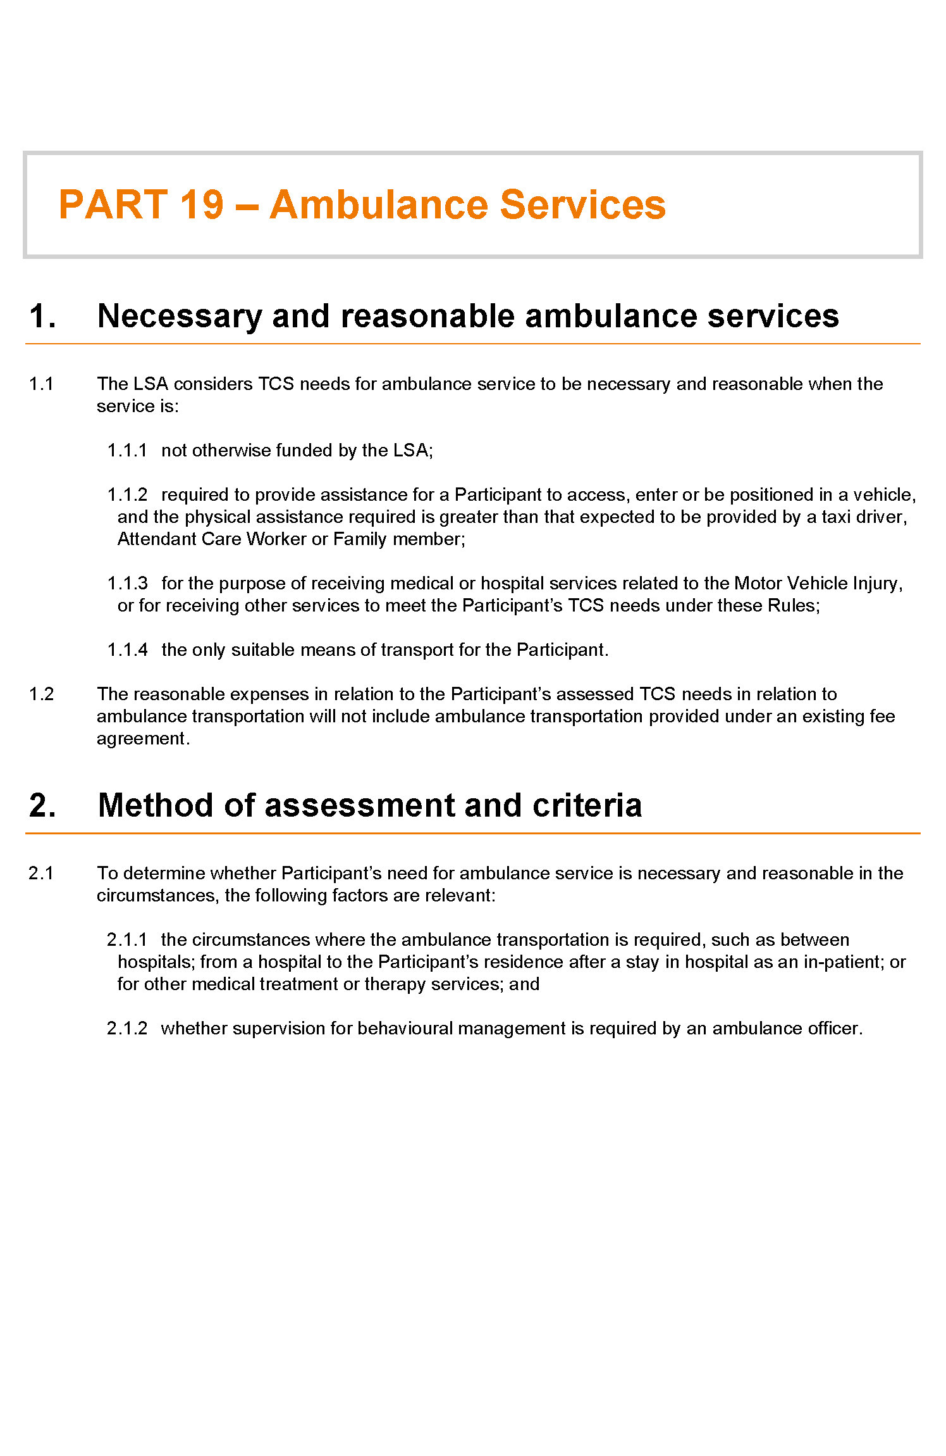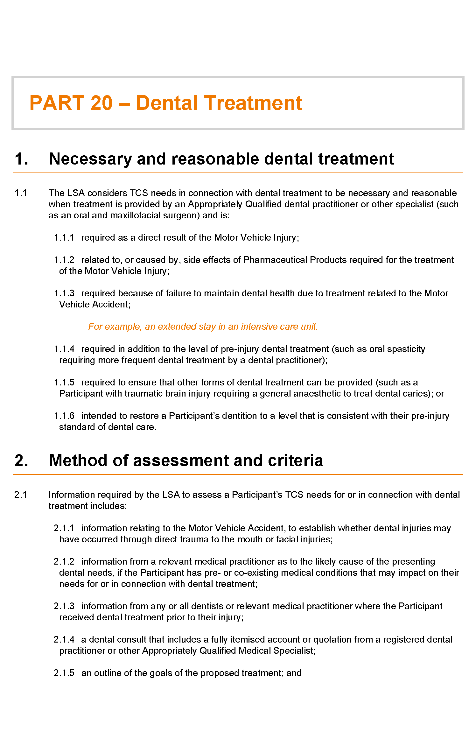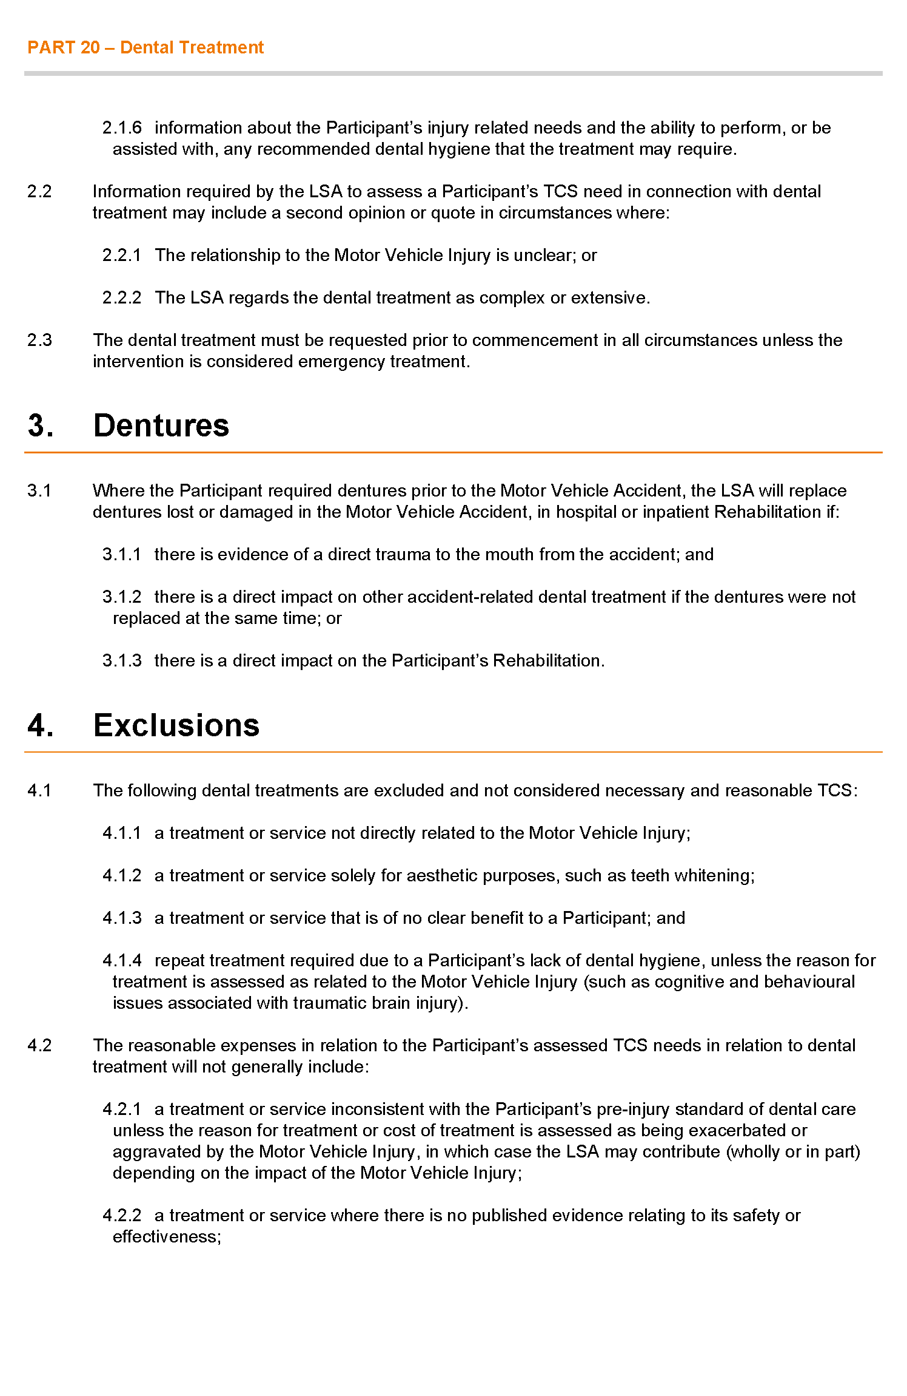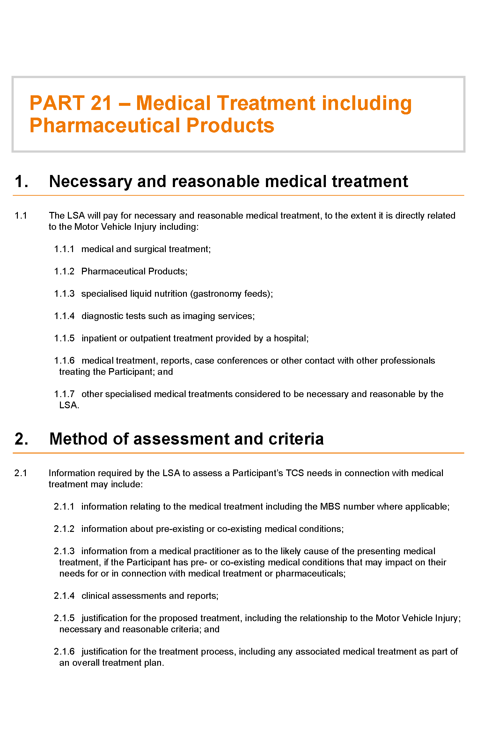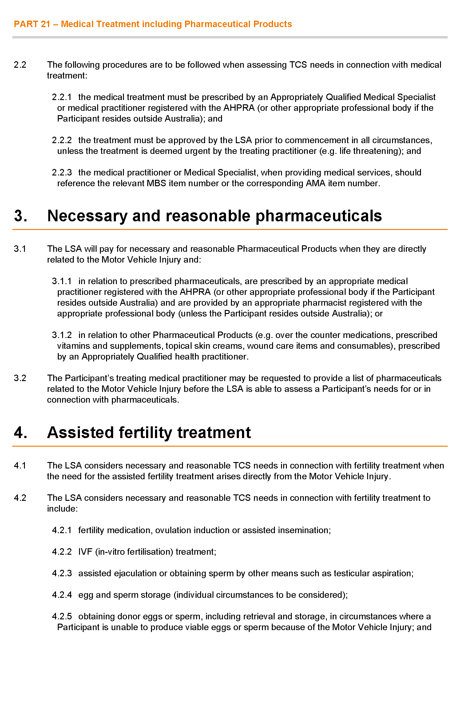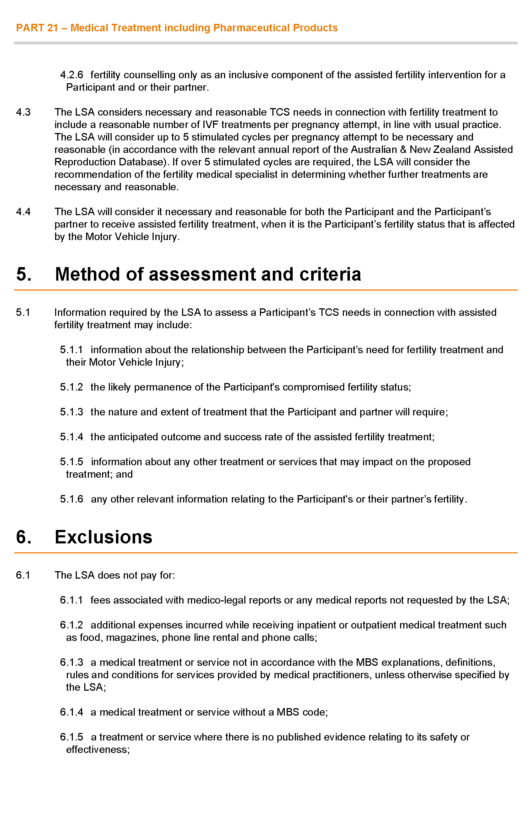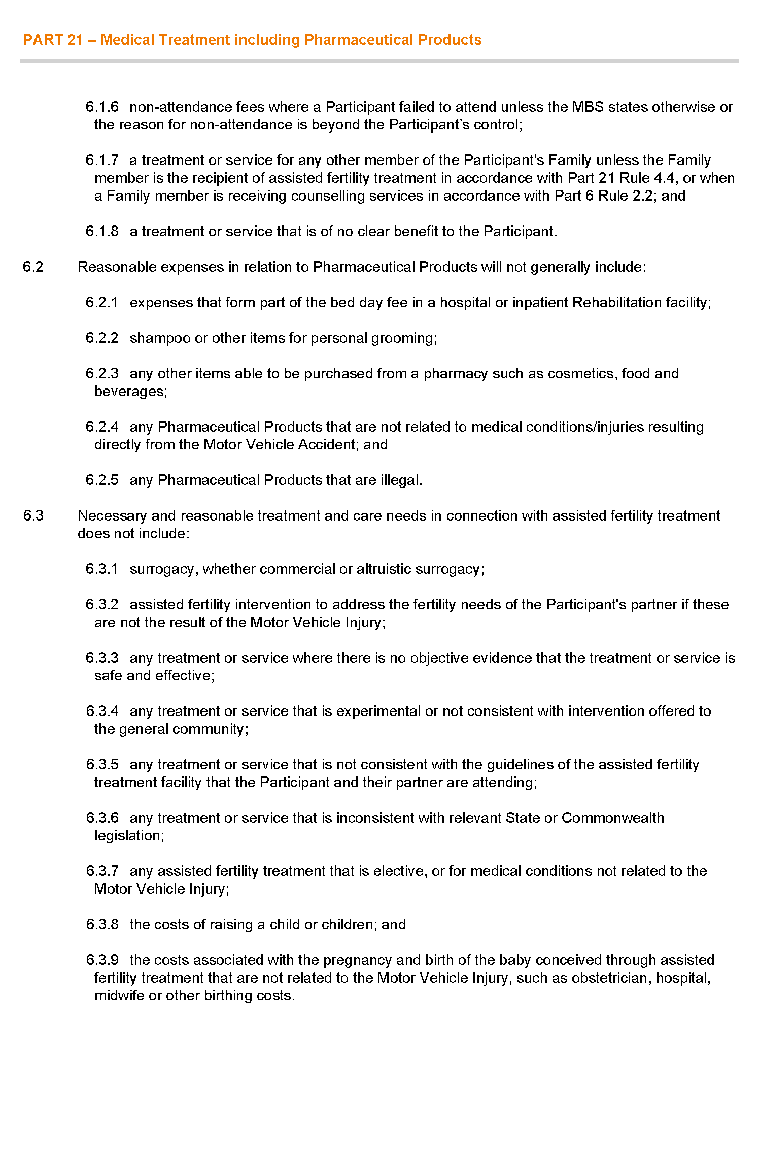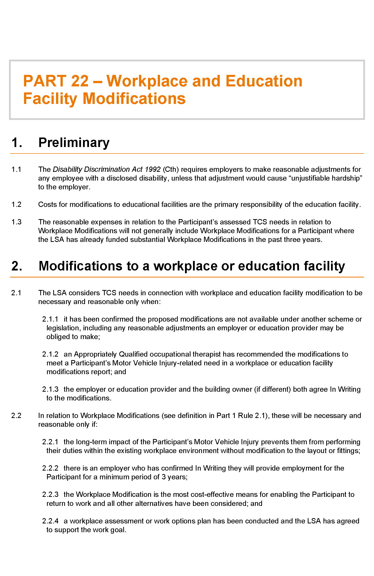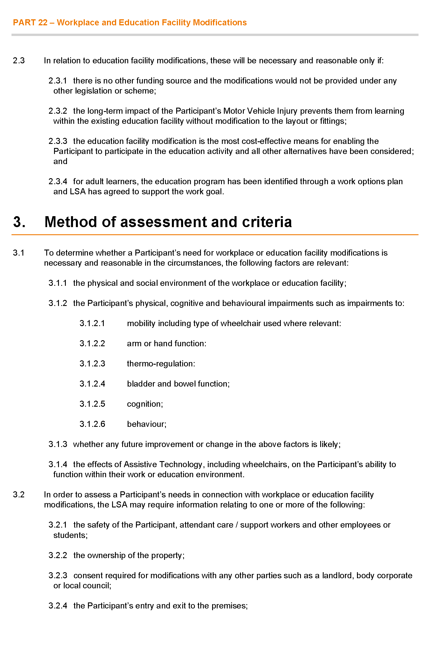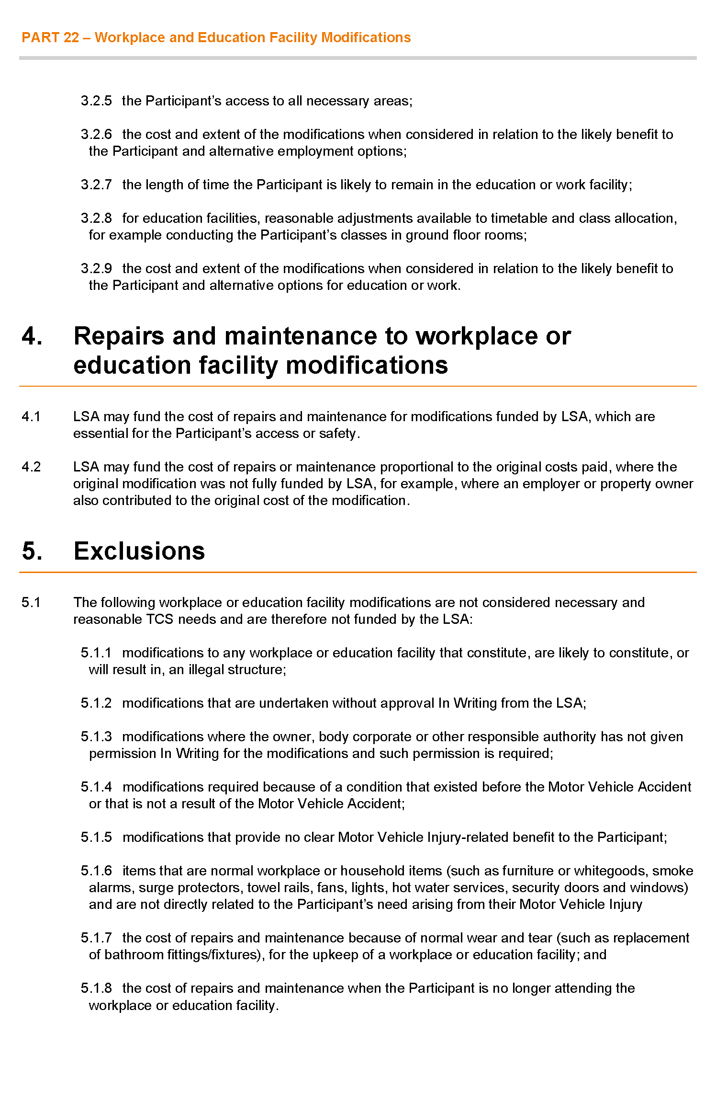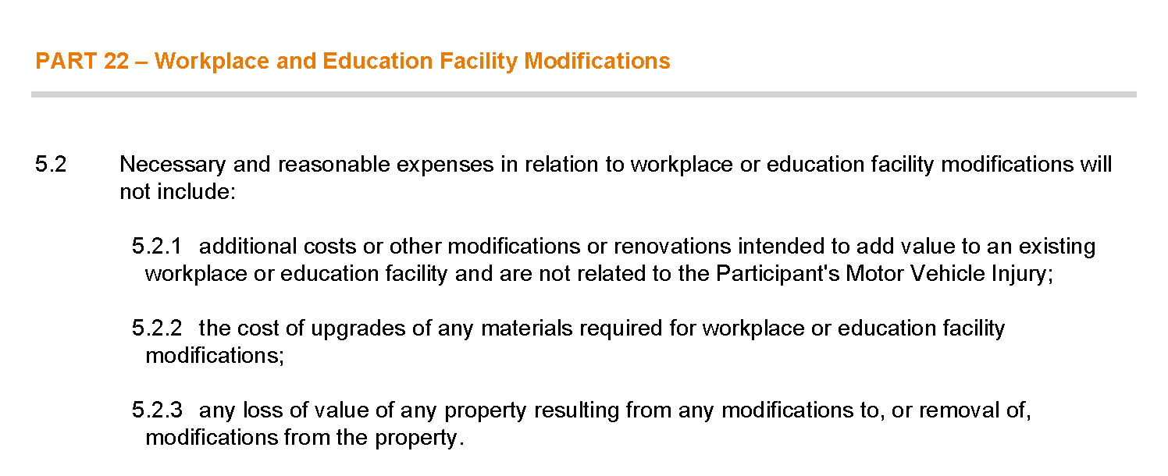

Proclamations
South Australia

Adelaide University Act (Commencement) Proclamation 2025
1—Short title
This proclamation may be cited as the Adelaide University Act (Commencement) Proclamation 2025.
2—Commencement of remaining provisions
(1) The following provisions of the Adelaide University Act 2023 (No 32 of 2023) come into operation on 1 January 2026:
(a) Schedule 1 clauses 2 and 3;
(b) Schedule 1 clauses 5 and 6;
(c) Schedule 1 clause 29.
(2) Schedule 1 clause 4(1) of the Act comes into operation on 31 March 2026.
(3) Section 55 of the Act comes into operation on 30 June 2027.
Made by the Governor
with the advice and consent of the Executive Council
on 30 October 2025

South Australia

Dog and Cat Management (Breeder Reforms) Amendment Act (Commencement) Proclamation 2025
1—Short title
This proclamation may be cited as the Dog and Cat Management (Breeder Reforms) Amendment Act (Commencement) Proclamation 2025.
2—Commencement of Act
(1) Subject to subclause (2), the Dog and Cat Management (Breeder Reforms) Amendment Act 2025 (No 28 of 2025) comes into operation on 17 November 2025.
(2) The operation of the following provisions of the Act is suspended until a day or time or days or times to be fixed by subsequent proclamation or proclamations:
(a) section 4(1), (2), (3), (5) and (6);
(b) section 7;
(c) section 10;
(d) section 11;
(e) section 14;
(f) section 15;
(g) section 16;
(h) section 18;
(i) section 22;
(j) section 27;
(k) section 28(6);
(l) section 31;
(m) section 34;
(n) section 36;
(o) section 37 to the extent that it enacts section 60(1)(h) of the Dog and Cat Management Act 1995;
(p) section 43;
(q) section 44;
(r) section 48;
(s) section 49;
(t) Schedule 1 clause 3.
Made by the Governor
with the advice and consent of the Executive Council
on 30 October 2025

South Australia

Mental Health (Community Visitor Scheme) Amendment Act (Commencement) Proclamation 2025
1—Short title
This proclamation may be cited as the Mental Health (Community Visitor Scheme) Amendment Act (Commencement) Proclamation 2025.
2—Commencement of Act
The Mental Health (Community Visitor Scheme) Amendment Act 2025 (No 37 of 2025) comes into operation on the day on which this proclamation is made.
Made by the Governor
with the advice and consent of the Executive Council
on 30 October 2025

South Australia

Summary Offences (Humiliating, Degrading or Invasive Depictions) Amendment Act (Commencement) Proclamation 2025
1—Short title
This proclamation may be cited as the Summary Offences (Humiliating, Degrading or Invasive Depictions) Amendment Act (Commencement) Proclamation 2025.
2—Commencement of Act
The Summary Offences (Humiliating, Degrading or Invasive Depictions) Amendment Act 2025 (No 19 of 2025) comes into operation on 3 November 2025.
Made by the Governor
with the advice and consent of the Executive Council
on 30 October 2025

South Australia

Adelaide University (Transfer of Assets, Contracts and Liabilities) Proclamation 2025
under Schedule 1 clause 20 of the Adelaide University Act 2023
1—Short title
This proclamation may be cited as the Adelaide University (Transfer of Assets, Contracts and Liabilities) Proclamation 2025.
2—Commencement
(1) Subject to this clause, this proclamation comes into operation on the day on which it is made.
(2) Clause 4, Schedule 1 and Schedule 2 come into operation on 1 January 2026.
3—Interpretation
(1) In this proclamation—
Act means the Adelaide University Act 2023;
authorisation includes a licence, consent, approval, permit, registration, accreditation or certification;
business record includes—
(a) correspondence; and
(b) a book, report, contract, file or manual; and
(c) student and staff records; and
(d) a title document or authorisation; and
(e) a contacts list,
whether in printed, electronic or any other form, and includes a copy of such a record;
cash and deposits includes cash in hand and money held by an ADI or other financial institution;
binding decision means a decision made by a prescribed university pursuant to the direct or indirect authority of a statute, rule, by-law or policy of the prescribed university that is binding on a person;
intellectual property includes—
(a) registered and unregistered business names, brand names, logos and images; and
(b) patents, designs, plant breeder's rights, trademarks and service marks, including all applications for, or rights to apply for, registration of any patent, design, plant breeder's right, trademark or service mark; and
(c) domain names and all pages and content of, and platforms on, the websites at those domain names, and all content of any social media pages (including on Facebook, X and Instagram); and
(d) intellectual property arising from research and development activities; and
(e) colours, fonts, graphics, styles and distinctive identifiers comprising or used in or in connection with any intellectual property; and
(f) copyright (including copyright in software, social media pages, websites, databases and advertising and other promotional materials); and
(g) rights to have information (including trade secrets, know how, operating procedures and technical information) kept confidential; and
(h) any modification, enhancement, development or re-engineering of intellectual property;
titleholder arrangement means an arrangement establishing and governing adjunct, affiliate and other titleholder appointments (including emeritus professors, emeritus fellows and honorary fellows) at a prescribed university;
trust fund includes any trust or fund (including investment common funds) established, created or administered by a prescribed university;
university grounds means land, buildings, structures and facilities owned or occupied by a prescribed university or of which a prescribed university has the care, control and management.
(2) In addition to section 12 of the Legislation Interpretation Act 2021, terms used in this proclamation and in Part 7 of Schedule 1 of the Act have the same meaning in this proclamation as they have in that Part.
4—Transfer of assets, contracts and liabilities
(1) The assets, contracts and liabilities of The University of Adelaide referred to in Schedule 1 are, on 1 January 2026, transferred to Adelaide University.
(2) The assets, contracts and liabilities of the University of South Australia referred to in Schedule 2 are, on 1 January 2026, transferred to Adelaide University.
Schedule 1—Assets, contracts and liabilities of The University of Adelaide
(1) Subject to subclause (2), all assets, contracts and liabilities of The University of Adelaide in existence on 1 January 2026, including in or in relation to—
(a) authorisations; and
(b) binding decisions; and
(c) business records; and
(d) cash and deposits; and
(e) intellectual property; and
(f) titleholder arrangements; and
(g) trust funds; and
(h) university grounds.
(2) Subclause (1) does not apply to the following assets, contracts and liabilities:
(a) the Agreement for the Provision of Services and Resources to Support the Operations of the Prescribed Universities between The University of Adelaide, the University of South Australia and Adelaide University dated 4 December 2024 and any secondment agreement entered into pursuant to clause 8 of that contract to which The University of Adelaide is party;
(b) the Tripartite Agreement between The University of Adelaide, the University of South Australia and Adelaide University dated 8 March 2024;
(c) the Heads of Agreement between The University of Adelaide and the University of South Australia dated 2 July 2023;
(d) the binding scheme established under Schedule 1 clause 27(2) of the Act;
(e) all assets, contracts and liabilities arising out of or in connection with—
(i) the office of Chancellor; or
(ii) the office of Vice-Chancellor; or
(iii) the Council of The University of Adelaide; or
(iv) a member of the Council of The University of Adelaide; or
(v) a sub-committee of the Council of The University of Adelaide,
including all Council and sub-committee papers, minutes and other records;
(f) the service agreement between The University of Adelaide and Diligent Board Services Australia Pty Ltd dated 12 October 2018, as amended;

(g) any interest as an insured or otherwise under any insurance policy;
(h) all rights and liabilities in connection with the registration of The University of Adelaide as a self-insured employer under section 129 of the Return to Work Act 2014;
(i) any contracts entered into with advisors for the purposes of assisting The University of Adelaide with disestablishment;
(j) any shares held in UniSuper Limited (ABN 54 006 027 121);
(k) the Deed of Covenant between The University of Adelaide and SSAU Nominees Pty Limited (now UniSuper Limited (ABN 54 006 027 121)) dated 14 December 1984, as amended;
(l) the Deed of Retirement as Employer between The University of Adelaide, UniSuper Limited (ABN 54 006 027 121) and Adelaide University as entered into before 1 January 2026;
(m) any contract the subject matter of which relates solely to The University of Adelaide and its operations during the period up to and including 31 December 2025;
(n) any contract which, either on its own terms or by further written agreement between The University of Adelaide or Adelaide University (or both) and the other contract party or parties, is not intended (whether expressly or by necessary implication) to extend to Adelaide University or its operations on and after 1 January 2026;
(o) all official insignia, as defined in the University of Adelaide Act 1971;
(p) the common seal of The University of Adelaide;
(q) all liabilities arising out of or in connection with students enrolled in a program at The University of Adelaide immediately before 1 January 2026 whose enrolments are not transferred to a corresponding program at Adelaide University, including any obligations of The University of Adelaide to confer awards on students who complete the requirements for such conferral at The University of Adelaide.
Schedule 2—Assets, contracts and liabilities of the University of South Australia
(1) Subject to subclause (2), all assets, contracts and liabilities of the University of South Australia in existence on 1 January 2026, including in or in relation to—
(a) authorisations; and
(b) binding decisions; and
(c) business records; and
(d) cash and deposits; and
(e) intellectual property; and
(f) titleholder arrangements; and
(g) trust funds; and
(h) university grounds.

(2) Subclause (1) does not apply to the following assets, contracts and liabilities:
(a) the Agreement for the Provision of Services and Resources to Support the Operations of the Prescribed Universities between The University of Adelaide, the University of South Australia and Adelaide University dated 4 December 2024 and any secondment agreement entered into pursuant to clause 8 of that contract to which the University of South Australia is party;
(b) the Tripartite Agreement between The University of Adelaide, the University of South Australia and Adelaide University dated 8 March 2024;
(c) the Heads of Agreement between The University of Adelaide and the University of South Australia dated 2 July 2023;
(d) the binding scheme established under Schedule 1 clause 27(2) of the Act;
(e) all assets, contracts and liabilities arising out of or in connection with—
(i) the office of Chancellor; or
(ii) the office of Vice Chancellor; or
(iii) the Council of the University of South Australia; or
(iv) a member of the Council of the University of South Australia; or
(v) a sub-committee of the Council of the University of South Australia,
including all Council and sub-committee papers, minutes and other records;
(f) the service agreement between the University of South Australia and Diligent Board Services Australia Pty Ltd dated 22 February 2018, as amended;
(g) any interest as an insured or otherwise under any insurance policy;
(h) all rights and liabilities in connection with the registration of the University of South Australia as a self-insured employer under section 129 of the Return to Work Act 2014;
(i) any contracts entered into with advisors for the purposes of assisting the University of South Australia with disestablishment;
(j) any shares held in UniSuper Limited (ABN 54 006 027 121);
(k) the Deed of Covenant between the University of South Australia and UniSuper Limited (ABN 54 006 027 121) dated 1 June 2016;
(l) the Deed of Retirement as Employer between the University of South Australia, UniSuper Limited (ABN 54 006 027 121) and Adelaide University as entered into before 1 January 2026;
(m) any contract the subject matter of which relates solely to the University of South Australia and its operations during the period up to and including 31 December 2025;
(n) any contract which, either on its own terms or by further written agreement between the University of South Australia or Adelaide University (or both) and the other contract party or parties, is not intended (whether expressly or by necessary implication) to extend to Adelaide University or its operations on and after 1 January 2026;

(o) all official insignia, as defined in the University of South Australia Act 1990;
(p) the common seal of the University of South Australia;
(q) all liabilities arising out of or in connection with students enrolled in a program at the University of South Australia immediately before 1 January 2026 whose enrolments are not transferred to a corresponding program at Adelaide University, including any obligations of the University of South Australia to confer awards on students who complete the requirements for such conferral at the University of South Australia.
Made by the Governor
after consultation with The University of Adelaide, the University of South Australia and Adelaide University and with the advice and consent of the Executive Council
on 30 October 2025

South Australia

Adelaide University (Transfer of Students) Proclamation 2025
under Schedule 1 clause 24 of the Adelaide University Act 2023
1—Short title
This proclamation may be cited as the Adelaide University (Transfer of Students) Proclamation 2025.
2—Commencement
(1) Subject to this clause, this proclamation comes into operation on the day on which it is made.
(2) Clause 4 comes into operation on 1 January 2026.
(3) Clause 5 comes into operation on 24 March 2026.
3—Interpretation
(1) In this proclamation—
Act means the Adelaide University Act 2023;
course means a subject or unit that a student may undertake at a prescribed university as part of a program.
(2) In addition to section 12 of the Legislation Interpretation Act 2021, terms used in this proclamation and in Part 7 of Schedule 1 of the Act have the same meaning in this proclamation as they have in that Part.
4—Transfer of students on 1 January 2026
(1) Subject to this clause—
(a) a person who is, immediately before the commencement of this clause, enrolled as a student in a program at The University of Adelaide specified in column 1 of table 1 in Schedule 1, is, on 1 January 2026, transferred to be a student enrolled at Adelaide University in the corresponding program listed in column 2 of that table; and
(b) a person who is, immediately before the commencement of this clause, enrolled as a student in a program at the University of South Australia listed in column 1 of table 2 in Schedule 1, is, on 1 January 2026, transferred to be a student enrolled at Adelaide University in the corresponding program listed in column 2 of that table.
(2) Subclause (1) does not apply to the following persons:
(a) a person enrolled as a student at The University of Adelaide or the University of South Australia who, before the commencement of this clause, has completed all of the requirements—
(i) for the conferral of the award in the program in which they are enrolled; or
(ii) to be otherwise recognised as having successfully completed the program in which they are enrolled;
(b) a person who, immediately before the commencement of this clause—
(i) is enrolled as a student in 1 or more courses at The University of Adelaide or the University of South Australia; and
(ii) has not completed all of the requirements necessary for the completion of the course or courses;
(c) a person who—
(i) immediately before the commencement of this clause, is enrolled as a student in—
(A) a higher degree by research program at The University of Adelaide; or
(B) a research degree program at the University of South Australia; and
(ii) has submitted a thesis for examination that remains, immediately before the commencement of this clause, under examination.
5—Transfer of students on 24 March 2026
(1) Subject to this clause—
(a) a person who is, immediately before the commencement of this clause, enrolled as a student in a program at The University of Adelaide listed in column 1 of table 1 in Schedule 1, is, on 24 March 2026, transferred to be a student enrolled at Adelaide University in the corresponding program listed in column 2 of that table; and
(b) a person who is, immediately before the commencement of this clause, enrolled as a student in a program at the University of South Australia listed in column 1 of table 2 in Schedule 1, is, on 24 March 2026, transferred to be a student enrolled at Adelaide University in the corresponding program listed in column 2 of that table.
(2) Subclause (1) does not apply to a person enrolled as a student at The University of Adelaide or the University of South Australia who, before the commencement of this clause, has completed all of the requirements—
(a) for the conferral of the award in the program in which they are enrolled; or
(b) to be otherwise recognised as having successfully completed the program in which they are enrolled.
Schedule 1—Corresponding programs

Table 1
Program at The University of Adelaide | Corresponding program
Adelaide Graduate Certificate in Business Administration | Graduate Certificate in Business Administration
Adelaide Graduate Diploma in Business Administration | Graduate Diploma in Business Administration
Adelaide Master of Business Administration | Master of Business Administration
Associate Degree in Construction Management | Associate Degree in Building Studies
Associate Degree in Technology (Defence Industries) | Associate Degree in Technology
Bachelor of Accounting | Bachelor of Commerce
Bachelor of Accounting & Corporate Finance | Bachelor of Accounting and Corporate Finance
Bachelor of Agricultural Sciences | Bachelor of Agricultural Sciences
Bachelor of Applied Biology | Bachelor of Applied Biology
Bachelor of Applied Data Analytics | Bachelor of Applied Data Analytics
Bachelor of Architectural Design | Bachelor of Architectural Design
Bachelor of Architectural Design (Honours) | Bachelor of Architectural Design (Honours)
Bachelor of Arts | Bachelor of Arts
Bachelor of Arts (Advanced) | Bachelor of Arts (Advanced)
Bachelor of Arts (Advanced) with Bachelor of Laws | Bachelor of Arts (Advanced), Bachelor of Laws
Bachelor of Arts (Advanced) with Bachelor of Laws (Honours) | Bachelor of Arts (Advanced), Bachelor of Laws (Honours)
Bachelor of Arts (Honours) | Bachelor of Arts (Honours)
Bachelor of Arts with Bachelor of Economics | Bachelor of Arts, Bachelor of Economics
Bachelor of Arts with Bachelor of Science | Bachelor of Arts, Bachelor of Science
Bachelor of Biotechnology | Bachelor of Science
Bachelor of Biotechnology (Honours) | Bachelor of Biotechnology (Honours)
Bachelor of Business | Bachelor of Business
Bachelor of Business (Global) | Bachelor of Business
Bachelor of Commerce | Bachelor of Business or Bachelor of Commerce
Bachelor of Commerce (Honours) | Bachelor of Commerce (Honours)
Bachelor of Computer Science | Bachelor of Computer Science
Bachelor of Computer Science (Advanced) | Bachelor of Computer Science (Advanced)
Bachelor of Computer Science (Honours) | Bachelor of Computer Science (Honours)
Bachelor of Construction Management | Bachelor of Construction Management
Bachelor of Construction Management (Honours) | Bachelor of Construction Management (Honours)
Bachelor of Corporate Finance | Bachelor of Commerce
Bachelor of Creative Arts | Bachelor of Creative Arts
Bachelor of Criminology | Bachelor of Criminology and Criminal Justice
Bachelor of Criminology (Honours) | Bachelor of Criminology (Honours)
Bachelor of Criminology with Bachelor of Laws | Bachelor of Criminology and Criminal Justice, Bachelor of Laws
Bachelor of Dental Surgery | Bachelor of Dental Surgery
Bachelor of Economics | Bachelor of Economics
Bachelor of Economics (Advanced) | Bachelor of Economics (Advanced)
Bachelor of Economics (Honours) | Bachelor of Economics (Honours)
Bachelor of Economics with Bachelor of Finance and Banking | Bachelor of Economics, Bachelor of Commerce majoring in Banking and Finance
Bachelor of Economics/Bachelor of Finance | Bachelor of Economics, Bachelor of Commerce majoring in Banking and Finance
Bachelor of Engineering (Honours) - Engineering Pathway | Bachelor of Engineering (Honours) (Flexible Entry)
Bachelor of Engineering (Honours) - Flexible Entry | Bachelor of Engineering (Honours) (Flexible Entry)
Bachelor of Engineering (Honours) (Architectural and Structural) | Bachelor of Engineering (Honours) (Architectural and Structural)
Bachelor of Engineering (Honours) (Chemical) | Bachelor of Engineering (Honours) (Chemical) or Bachelor of Engineering (Honours) (Chemical and Pharmaceutical)
Bachelor of Engineering (Honours) (Chemical) with Bachelor of Biotechnology | Bachelor of Engineering (Honours) (Chemical), Bachelor of Biotechnology
Bachelor of Engineering (Honours) (Chemical) with Bachelor of Finance | Bachelor of Engineering (Honours) (Chemical), Bachelor of Commerce majoring in Banking and Finance
Bachelor of Engineering (Honours) (Chemical) with Bachelor of Finance and Banking | Bachelor of Engineering (Honours) (Chemical), Bachelor of Commerce majoring in Banking and Finance
Bachelor of Engineering (Honours) (Chemical) with Bachelor of Mathematical and Computer Sciences | Bachelor of Engineering (Honours) (Chemical), Bachelor of Mathematical and Computer Sciences
Bachelor of Engineering (Honours) (Chemical) with Bachelor of Science | Bachelor of Engineering (Honours) (Chemical), Bachelor of Science
Bachelor of Engineering (Honours) (Chemical) with Bachelor of Science (Biotechnology) | Bachelor of Engineering (Honours) (Chemical), Bachelor of Science majoring in Biotechnology
Bachelor of Engineering (Honours) (Civil and Architecture) | Bachelor of Engineering (Honours) (Civil and Architecture)
Bachelor of Engineering (Honours) (Civil and Environmental) with Bachelor of Finance | Bachelor of Engineering (Honours) (Civil), Bachelor of Commerce majoring in Banking and Finance
Bachelor of Engineering (Honours) (Civil and Structural) | Bachelor of Engineering (Honours) (Civil and Structural)
Bachelor of Engineering (Honours) (Civil and Structural) with Bachelor of Finance | Bachelor of Engineering (Honours) (Civil Structures), Bachelor of Commerce majoring in Banking and Finance
Bachelor of Engineering (Honours) (Civil and Structural) with Bachelor of Mathematical and Computer Sciences | Bachelor of Engineering (Honours) (Civil Structures), Bachelor of Mathematical and Computer Sciences
Bachelor of Engineering (Honours) (Civil) | Bachelor of Engineering (Honours) (Civil)
Bachelor of Engineering (Honours) (Civil) with Bachelor of Finance | Bachelor of Engineering (Honours) (Civil), Bachelor of Commerce majoring in Banking and Finance
Bachelor of Engineering (Honours) (Civil) with Bachelor of Finance and Banking | Bachelor of Engineering (Honours) (Civil), Bachelor of Commerce majoring in Banking and Finance
Bachelor of Engineering (Honours) (Civil) with Bachelor of Mathematical and Computer Sciences | Bachelor of Engineering (Honours) (Civil), Bachelor of Mathematical and Computer Sciences
Bachelor of Engineering (Honours) (Civil, Structural & Environmental) | Bachelor of Engineering (Honours) (Civil, Structural and Environmental)
Bachelor of Engineering (Honours) (Electrical and Electronic) | Bachelor of Engineering (Honours) (Electrical and Electronic)
Bachelor of Engineering (Honours) (Electrical and Electronic) with Bachelor of Finance | Bachelor of Engineering (Honours) (Electrical and Electronic), Bachelor of Commerce majoring in Banking and Finance
Bachelor of Engineering (Honours) (Electrical and Electronic) with Bachelor of Finance and Banking | Bachelor of Engineering (Honours) (Electrical and Electronic), Bachelor of Commerce majoring in Banking and Finance
Bachelor of Engineering (Honours) (Electrical and Electronic) with Bachelor of Mathematical and Computer Sciences | Bachelor of Engineering (Honours) (Electrical and Electronic), Bachelor of Mathematical and Computer Sciences
Bachelor of Engineering (Honours) (Electrical and Electronic) with Bachelor of Science | Bachelor of Engineering (Honours) (Electrical and Electronic), Bachelor of Science
Bachelor of Engineering (Honours) (Electrical and Electronic) & Bachelor of Arts | Bachelor of Engineering (Honours) (Electrical and Electronic), Bachelor of Arts
Bachelor of Engineering (Honours) (Environmental & Climate Solutions) & Bachelor of Arts | Bachelor of Engineering (Honours) (Environmental and Climate Solutions), Bachelor of Arts
Bachelor of Engineering (Honours) (Environmental & Climate Solutions) with Bachelor of Finance and Banking | Bachelor of Engineering (Honours) (Environmental and Climate Solutions), Bachelor of Commerce majoring in Banking and Finance
Bachelor of Engineering (Honours) (Environmental & Climate Solutions) with Bachelor of Mathematical and Computer Sciences | Bachelor of Engineering (Honours) (Environmental and Climate Solutions), Bachelor of Mathematical and Computer Sciences
Bachelor of Engineering (Honours) (Environmental & Climate Solutions) with Bachelor of Science | Bachelor of Engineering (Honours) (Environmental and Climate Solutions), Bachelor of Science
Bachelor of Engineering (Honours) (Environmental and Climate Solutions) | Bachelor of Engineering (Honours) (Environmental and Climate Solutions)
Bachelor of Engineering (Honours) (Environmental) | Bachelor of Engineering (Honours) (Environmental)
Bachelor of Engineering (Honours) (Environmental) with Bachelor of Finance | Bachelor of Engineering (Honours) (Environmental), Bachelor of Commerce majoring in Banking and Finance
Bachelor of Engineering (Honours) (Environmental) with Bachelor of Mathematical and Computer Sciences | Bachelor of Engineering (Honours) (Environmental), Bachelor of Mathematical and Computer Sciences
Bachelor of Engineering (Honours) (Environmental) with Bachelor of Science | Bachelor of Engineering (Honours) (Environmental), Bachelor of Science
Bachelor of Engineering (Honours) (Mechanical and Aerospace) | Bachelor of Engineering (Honours) (Mechanical and Aerospace)
Bachelor of Engineering (Honours) (Mechanical and Aerospace) with Bachelor of Science | Bachelor of Engineering (Honours) (Mechanical and Aerospace), Bachelor of Science
Bachelor of Engineering (Honours) (Mechanical and Aerospace) with Bachelor of Mathematical and Computer Sciences | Bachelor of Engineering (Honours) (Mechanical and Aerospace), Bachelor of Mathematical and Computer Sciences
Bachelor of Engineering (Honours) (Mechanical and Sports) | Bachelor of Engineering (Honours) (Mechanical and Sports)
Bachelor of Engineering (Honours) (Mechanical) | Bachelor of Engineering (Honours) (Mechanical)
Bachelor of Engineering (Honours) (Mechanical) with Bachelor of Mathematical and Computer Sciences | Bachelor of Engineering (Honours) (Mechanical), Bachelor of Mathematical and Computer Sciences
Bachelor of Engineering (Honours) (Mechanical) with Bachelor of Finance | Bachelor of Engineering (Honours) (Mechanical), Bachelor of Commerce majoring in Banking and Finance
Bachelor of Engineering (Honours) (Mechanical) with Bachelor of Finance and Banking | Bachelor of Engineering (Honours) (Mechanical), Bachelor of Commerce majoring in Banking and Finance
Bachelor of Engineering (Honours) (Mechanical) with Bachelor of Mathematical and Computer Sciences | Bachelor of Engineering (Honours) (Mechanical), Bachelor of Mathematical and Computer Sciences
Bachelor of Engineering (Honours) (Mechanical) with Bachelor of Science | Bachelor of Engineering (Honours) (Mechanical), Bachelor of Science
Bachelor of Engineering (Honours) (Mechanical) & Bachelor of Arts | Bachelor of Engineering (Honours) (Mechanical), Bachelor of Arts
Bachelor of Engineering (Honours) (Mechatronic) with Bachelor of Mathematical and Computer Sciences | Bachelor of Engineering (Honours) (Mechatronic), Bachelor of Mathematical and Computer Sciences
Bachelor of Engineering (Honours) (Mining) | Bachelor of Engineering (Honours) (Mining)
Bachelor of Engineering (Honours) (Mining) with Bachelor of Mathematical and Computer Sciences | Bachelor of Engineering (Honours) (Mining), Bachelor of Mathematical and Computer Sciences
Bachelor of Engineering (Honours) (Petroleum) | Bachelor of Engineering (Honours) (Petroleum)
Bachelor of Engineering (Honours) (Petroleum) with majors in Civil, Chemical, Mechanical or Mining engineering | Bachelor of Engineering (Honours) (Petroleum) with majors in Civil, Chemical, Mechanical or Mining engineering
Bachelor of Engineering (Honours) (Petroleum, Civil and Structural) | Bachelor of Engineering (Honours) (Petroleum, Civil and Structures)
Bachelor of Engineering (Honours) (Software) | Bachelor of Software Engineering (Honours)
Bachelor of Environmental Policy and Management | Bachelor of Environmental Policy and Management
Bachelor of Environmental Policy and Management (Honours) | Bachelor of Environmental Policy and Management (Honours)
Bachelor of Finance | Bachelor of Commerce majoring in Banking and Finance
Bachelor of Finance (Honours) | Bachelor of Finance (Honours)
Bachelor of Finance and Banking | Bachelor of Commerce
Bachelor of Finance and Banking with Bachelor of Mathematical and Computer Sciences | Bachelor of Commerce majoring in Banking and Finance, Bachelor of Mathematical and Computer Sciences
Bachelor of Finance/Bachelor of Mathematical and Computer Sciences | Bachelor of Commerce majoring in Banking and Finance, Bachelor of Mathematical and Computer Sciences
Bachelor of Food and Nutrition Science | Bachelor of Food and Nutrition Science
Bachelor of Food and Nutrition Science (Honours) | Bachelor of Food and Nutrition Science (Honours)
Bachelor of Food and Nutrition Science (Honours) [4 years] | Bachelor of Food and Nutrition Science (Honours)
Bachelor of Health and Medical Sciences | Bachelor of Biomedical and Health Sciences
Bachelor of Health and Medical Sciences (Advanced) | Bachelor of Health and Medical Sciences (Advanced)
Bachelor of Health and Medical Sciences (Honours) | Bachelor of Health and Medical Sciences (Honours)
Bachelor of Health Sciences | Bachelor of Biomedical and Health Sciences
Bachelor of Health Service Management [online] | Bachelor of Health Service Management
Bachelor of Information Technology | Bachelor of Information Technology
Bachelor of Innovation and Entrepreneurship | Bachelor of Business, majoring in Innovation, Entrepreneurship and Strategy
Bachelor of International Relations with Bachelor of Arts | Bachelor of International Relations, Bachelor of Arts
Bachelor of International Business | Bachelor of Business
Bachelor of International Business [online] | Bachelor of International Business
Bachelor of International Development | Bachelor of Arts
Bachelor of International Relations | Bachelor of International Relations
Bachelor of International Relations (Honours) | Bachelor of International Relations (Honours)
Bachelor of International Relations with Bachelor of Economics | Bachelor of International Relations, Bachelor of Economics
Bachelor of International Relations with Bachelor of Media | Bachelor of International Relations, Bachelor of Media and Communication
Bachelor of International Studies | Bachelor of International Relations
Bachelor of International Studies with Bachelor of Economics | Bachelor of International Relations, Bachelor of Economics
Bachelor of Languages | Bachelor of Languages
Bachelor of Laws | Bachelor of Laws
Bachelor of Laws (Honours) | Bachelor of Laws (Honours)
Bachelor of Marine and Wildlife Conservation | Bachelor of Science
Bachelor of Marketing | Bachelor of Business
Bachelor of Mathematical and Computer Sciences | Bachelor of Mathematical and Computer Sciences
Bachelor of Mathematical and Computer Sciences (Honours) | Bachelor of Mathematical and Computer Sciences (Honours)
Bachelor of Mathematical Sciences | Bachelor of Mathematics
Bachelor of Mathematical Sciences (Advanced) | Bachelor of Mathematical Sciences (Advanced)
Bachelor of Mathematical Sciences (Honours) | Bachelor of Mathematics (Honours)
Bachelor of Mathematical Sciences (Honours) [4 years] | Bachelor of Mathematics (Honours)
Bachelor of Media | Bachelor of Media and Communication
Bachelor of Media (Honours) | Bachelor of Media (Honours)
Bachelor of Media with Bachelor of Arts | Bachelor of Media and Communication, Bachelor of Arts
Bachelor of Media with Bachelor of Computer Sciences | Bachelor of Media and Communication, Bachelor of Computer Sciences
Bachelor of Media with Bachelor of Creative Arts | Bachelor of Media and Communication, Bachelor of Creative Arts
Bachelor of Media with Bachelor of Criminology | Bachelor of Media and Communication, Bachelor of Criminology
Bachelor of Media with Bachelor of Sociology | Bachelor of Media and Communication, Bachelor of Sociology
Bachelor of Medical Studies | Bachelor of Medical Studies
Bachelor of Medicine & Bachelor of Surgery | Bachelor of Medicine, Bachelor of Surgery
Bachelor of Music | Bachelor of Music
Bachelor of Music (Advanced) | Bachelor of Music (Advanced)
Bachelor of Music (Honours) | Bachelor of Music (Honours)
Bachelor of Music Theatre | Bachelor of Music Theatre
Bachelor of Nursing | Bachelor of Nursing
Bachelor of Occupational Therapy (Honours) | Bachelor of Occupational Therapy (Honours)
Bachelor of Oral Health | Bachelor of Oral Health
Bachelor of Peace & Conflict Studies | Bachelor of Peace and Conflict Studies
Bachelor of Philosophy, Politics and Economics | Bachelor of Philosophy, Politics and Economics
Bachelor of Physiotherapy (Honours) | Bachelor of Physiotherapy (Honours)
Bachelor of Project Management | Bachelor of Business
Bachelor of Psychological Science | Bachelor of Psychology
Bachelor of Psychological Science (Honours) | Bachelor of Psychology (Honours)
Bachelor of Psychology (Advanced) (Honours) | Bachelor of Psychology (Honours)
Bachelor of Science | Bachelor of Science
Bachelor of Science (Advanced) | Bachelor of Science (Advanced)
Bachelor of Science (Advanced) (Honours) [4 years] | Bachelor of Science (Advanced) (Honours)
Bachelor of Science (Animal Behaviour) | Bachelor of Science
Bachelor of Science (Animal Science) | Bachelor of Science
Bachelor of Science (Biomedical Science) | Bachelor of Biomedical and Health Sciences
Bachelor of Science (Dentistry) - honours | Bachelor of Science (Dentistry) (Honours)
Bachelor of Science (High Performance Computational Physics) (Honours) | Bachelor of Science (Honours)
Bachelor of Science (Honours) | Bachelor of Science (Honours)
Bachelor of Science (Honours) [4 years] | Bachelor of Science (Honours)
Bachelor of Science (Mineral Geoscience) | Bachelor of Science
Bachelor of Science (Space Science and Astrophysics) | Bachelor of Science
Bachelor of Science (Veterinary Bioscience) | Bachelor of Science (Veterinary Bioscience)
Bachelor of Social Sciences | Bachelor of Social Science
Bachelor of Social Sciences/Bachelor of Health Sciences | Bachelor of Social Science, Bachelor of Health Science
Bachelor of Sociology | Bachelor of Arts
Bachelor of Sociology (Honours) | Bachelor of Sociology (Honours)
Bachelor of Speech Pathology (Honours) | Bachelor of Speech Pathology (Honours)
Bachelor of Teaching (Middle)/Bachelor of Arts | Bachelor of Teaching (Middle), Bachelor of Arts
Bachelor of Teaching (Middle)/Bachelor of Business Management | Bachelor of Teaching (Middle), Bachelor of Business majoring in Management
Bachelor of Teaching (Middle)/Bachelor of Mathematical and Computer Sciences | Bachelor of Teaching (Middle), Bachelor of Mathematical and Computer Sciences
Bachelor of Teaching (Middle)/Bachelor of Music | Bachelor of Teaching (Middle), Bachelor of Music
Bachelor of Teaching (Middle)/Bachelor of Science | Bachelor of Teaching (Middle), Bachelor of Science
Bachelor of Teaching (Secondary)/Bachelor of Economics | Bachelor of Teaching (Secondary), Bachelor of Economics
Bachelor of Teaching (Secondary) with Bachelor of Arts | Bachelor of Teaching (Secondary), Bachelor of Arts
Bachelor of Teaching (Secondary) with Bachelor of Mathematical and Computer Sciences | Bachelor of Teaching (Secondary), Bachelor of Mathematical and Computer Sciences
Bachelor of Teaching (Secondary) with Bachelor of Music | Bachelor of Teaching (Secondary), Bachelor of Music
Bachelor of Teaching (Secondary) with Bachelor of Science | Bachelor of Teaching (Secondary), Bachelor of Science
Bachelor of Teaching/Bachelor of Arts | Bachelor of Teaching (Secondary), Bachelor of Arts
Bachelor of Teaching/Bachelor of Economics | Bachelor of Teaching (Secondary), Bachelor of Economics
Bachelor of Teaching/Bachelor of Mathematical and Computer Sciences | Bachelor of Teaching (Secondary), Bachelor of Mathematical and Computer Sciences
Bachelor of Teaching/Bachelor of Science | Bachelor of Teaching (Secondary), Bachelor of Science
Bachelor of Technology (Defence Industries) | Bachelor of Information Technology
Bachelor of Veterinary Technology | Bachelor of Veterinary Technology
Bachelor of Viticulture and Oenology | Bachelor of Viticulture and Oenology
Bachelor of Viticulture and Oenology (Honours) | Bachelor of Viticulture and Oenology (Honours)
Centre for Aboriginal Studies in Music (CASM) Foundation Year | CASM Foundation Studies
Diploma in Arts | Diploma in Arts Studies
Diploma in Arts (Specialisation) | Diploma in Arts Studies
Diploma in Business | Diploma in Business Studies
Diploma in Engineering | Diploma in Engineering
Diploma in Languages | Diploma in Languages
Doctor of Clinical Dentistry | Doctor of Clinical Dentistry
Doctor of Medicine | Doctor of Medicine
Doctor of Philosophy | Doctor of Philosophy
Doctor of Philosophy, Master of Psychology (Clinical) | Doctor of Philosophy, Master of Psychology (Clinical)
Doctor of Veterinary Medicine | Doctor of Veterinary Medicine
Executive Graduate Certificate in Business Administration | Graduate Certificate in Business Administration
Executive Graduate Diploma in Business Administration | Graduate Diploma in Business Administration
Executive Master of Business Administration | Master of Business Administration
Graduate Certificate in Marine Engineering | Graduate Certificate in Engineering
Graduate Certificate in Alcohol and Drug Studies | Graduate Certificate in Alcohol and Drug Studies
Graduate Certificate in Applied Economics | Graduate Certificate in Economics and Resource Policy
Graduate Certificate in Applied Project Management | Graduate Certificate in Project Management
Graduate Certificate in Artificial Intelligence and Machine Learning | Graduate Certificate in Artificial Intelligence and Machine Learning
Graduate Certificate in Biostatistics | Graduate Certificate in Biostatistics
Graduate Certificate in Biotechnology (Biomedical) | Graduate Certificate in Science
Graduate Certificate in Business Administration [Online] | Graduate Certificate in Business Administration
Graduate Certificate in Business Analytics | Graduate Certificate in Business Analytics
Graduate Certificate in Business Law | Graduate Certificate in Law
Graduate Certificate in Computer Science | Graduate Certificate in Computer Science
Graduate Certificate in Counselling and Psychotherapy | Graduate Certificate in Counselling and Psychotherapy
Graduate Certificate in Curatorial and Museum Studies | Graduate Certificate in Curatorial and Museum Studies
Graduate Certificate in Cyber Security | Graduate Certificate in Cyber Security
Graduate Certificate in Cyber Security (Secure Software) | Graduate Certificate in Cyber Security
Graduate Certificate in Cyber Security [Online] | Graduate Certificate in Cyber Security
Graduate Certificate in Data Science | Graduate Certificate in Data Science
Graduate Certificate in Data Science (Applied) [Online] | Graduate Certificate in Data Science (Applied)
Graduate Certificate in Economics and Resource Policy | Graduate Certificate in Economics and Resource Policy
Graduate Certificate in Education | Graduate Certificate in Education
Graduate Certificate in Environmental Policy and Management | Graduate Certificate in Environmental Policy and Management
Graduate Certificate in Global Food and Agricultural Business | Graduate Certificate in Economics and Resource Policy
Graduate Certificate in Immersive Media Technologies | Graduate Certificate in Immersive Media Technologies
Graduate Certificate in International Addiction Studies | Graduate Certificate in International Addiction Studies
Graduate Certificate in Law | Graduate Certificate in Law
Graduate Certificate in Machine Learning | Graduate Certificate in Artificial Intelligence and Machine Learning
Graduate Certificate in Maritime Engineering | Graduate Certificate in Engineering
Graduate Certificate in Materials Engineering | Graduate Certificate in Engineering
Graduate Certificate in Media (Strategic Communication) | Graduate Certificate in Strategic Communication
Graduate Certificate in Medical Physics | Graduate Certificate in Science
Graduate Certificate in Military Law | Graduate Certificate in Military Law
Graduate Certificate in Nursing Science | Graduate Certificate in Nursing
Graduate Certificate in Oral Health Science | Graduate Certificate in Oral Health Science
Graduate Certificate in Petroleum Engineering | Graduate Certificate in Engineering
Graduate Certificate in Project Management | Graduate Certificate in Project Management
Graduate Certificate in Public Health | Graduate Certificate in Public Health
Graduate Certificate in Public Policy | Graduate Certificate in Public Policy
Graduate Certificate in Radiation Management | Graduate Certificate in Radiation Management
Graduate Certificate in Wine Business | Graduate Certificate in Wine and Food Business
Graduate Diploma in Addiction and Mental Health | Graduate Diploma in Addiction and Mental Health
Graduate Diploma in Applied Economics | Graduate Diploma in Economics and Resource Policy
Graduate Diploma in Applied Finance | Graduate Diploma in Finance
Graduate Diploma in Applied Project Management | Graduate Diploma in Project Management
Graduate Diploma in Artificial Intelligence and Machine Learning | Graduate Diploma in Artificial Intelligence and Machine Learning
Graduate Diploma in Biostatistics | Graduate Diploma in Biostatistics
Graduate Diploma in Biotechnology (Biomedical) | Graduate Diploma in Science
Graduate Diploma in Business Administration [Online] | Graduate Diploma in Business Administration
Graduate Diploma in Business Analytics | Graduate Diploma in Business Analytics
Graduate Diploma in Computer Science | Graduate Diploma in Information Technology
Graduate Diploma in Counselling and Psychotherapy | Graduate Diploma in Counselling and Psychotherapy
Graduate Diploma in Curatorial and Museum Studies | Graduate Diploma in Curatorial and Museum Studies
Graduate Diploma in Cyber Security | Graduate Diploma in Cyber Security
Graduate Diploma in Cyber Security [Online] | Graduate Diploma in Cyber Security
Graduate Diploma in Data Science | Graduate Diploma in Data Science
Graduate Diploma in Data Science (Applied) [Online] | Graduate Diploma in Data Science (Applied)
Graduate Diploma in Economics and Resource Policy | Graduate Diploma in Economics and Resource Policy
Graduate Diploma in Education Studies | Graduate Diploma in Education Studies
Graduate Diploma in Engineering | Graduate Diploma in Engineering
Graduate Diploma in Environmental Policy and Management | Graduate Diploma in Environmental Policy and Management
Graduate Diploma in Forensic Odontology | Graduate Diploma in Forensic Odontology
Graduate Diploma in Global Food Agri Business | Graduate Diploma in Economics and Resource Policy
Graduate Diploma in Immersive Media Technologies | Graduate Diploma in Immersive Media Technologies
Graduate Diploma in International Addiction Studies | Graduate Diploma in International Addiction Studies
Graduate Diploma in International Economics | Graduate Diploma in Economics and Resource Policy
Graduate Diploma in Law | Graduate Diploma in Law
Graduate Diploma in Legal Practice | Graduate Diploma in Legal Practice
Graduate Diploma in Marine Engineering | Graduate Diploma in Engineering
Graduate Diploma in Maritime Engineering | Graduate Diploma in Engineering
Graduate Diploma in Media (Strategic Communication) | Graduate Diploma in Strategic Communication
Graduate Diploma in Military Law | Graduate Diploma in Military Law
Graduate Diploma in Music (Performance and Pedagogy) | Graduate Diploma in Music (Performance and Pedagogy)
Graduate Diploma in Music Performance | Graduate Diploma in Music Performance
Graduate Diploma in Nursing Science | Graduate Diploma in Nursing
Graduate Diploma in Petroleum Engineering | Graduate Diploma in Engineering
Graduate Diploma in Professional Accounting | Graduate Diploma in Accounting
Graduate Diploma in Project Management | Graduate Diploma in Project Management
Graduate Diploma in Psychology (Advanced) [Online] | Graduate Diploma in Psychology (Advanced)
Graduate Diploma in Psychology [Online] | Graduate Diploma in Psychology
Graduate Diploma in Public Health | Graduate Diploma in Public Health
Graduate Diploma in Public Policy | Graduate Diploma in Public Policy
Graduate Diploma in Viticulture and Oenology | Graduate Diploma in Viticulture and Oenology
Graduate Diploma in Wine Business | Graduate Diploma in Wine and Food Business
Master of Accounting | Master of Accounting
Master of Accounting and Finance | Master of Accounting and Finance
Master of Agribusiness | Master of Agribusiness
Master of Applied Economics | Master of Applied Economics
Master of Applied Finance | Master of Applied Finance
Master of Applied Innovation & Entrepreneurship | Master of Technology, Innovation and Entrepreneurship
Master of Applied Project Management | Master of Project Management
Master of Applied Project Management (Project Systems) | Master of Project Management
Master of Architecture | Master of Architecture
Master of Architecture with Master of Landscape Architecture | Master of Architecture, Master of Landscape Architecture
Master of Artificial Intelligence and Machine Learning | Master of Artificial Intelligence and Machine Learning
Master of Arts | Master of Arts
Master of Arts (Interpreting, Translation & Transcultural Communication) | Master of Arts (Interpreting, Translation and Transcultural Communication)
Master of Bioinformatics | Master of Bioinformatics
Master of Biopharmaceutical Engineering | Master of Engineering (Biopharmaceutical)
Master of Biostatistics | Master of Biostatistics
Master of Biotechnology (Biomedical) | Master of Science
Master of Biotechnology (Biomedical) (Advanced) | Master of Biotechnology (Biomedical) (Advanced)
Master of Business Administration (Emerging Leaders) | Master of Business Administration
Master of Business Administration | Master of Business Administration
Master of Business Administration [12] | Master of Business Administration
Master of Business Administration (Entrepreneurship) | Master of Business Administration
Master of Business Administration (Health Management) [Online] | Master of Business Administration (Health Management)
Master of Business Administration (International Trade & Development) | Master of Business Administration
Master of Business Administration (International) | International Master of Business Administration
Master of Business Administration (Project Management) | Master of Business Administration
Master of Business Administration (Wine Business) | Master of Business Administration
Master of Business Administration [Online] | Master of Business Administration
Master of Business Analytics | Master of Business Analytics
Master of Business Law | Master of Business Law
Master of Clinical Nursing | Master of Clinical Nursing
Master of Clinical Science | Master of Clinical Science
Master of Commerce | Master of Marketing
Master of Computer Science | Master of Computer Science
Master of Computing and Innovation | Master of Information Technology (Computing and Innovation)
Master of Construction Management | Master of Construction Management
Master of Counselling and Psychotherapy | Master of Counselling and Psychotherapy
Master of Curatorial and Museum Studies | Master of Curatorial and Museum Studies
Master of Cyber Security | Master of Information Technology (Cyber Security)
Master of Cyber Security [Online] | Master of Cyber Security
Master of Data Science | Master of Data Science
Master of Data Science (Applied) [Online] | Master of Data Science (Applied)
Master of Economics and Resource Policy | Master of Economics and Resource Policy
Master of Education | Master of Education
Master of Engineering (Aerospace) | Master of Engineering (Aerospace)
Master of Engineering (Chemical) | Master of Engineering (Chemical)
Master of Engineering (Civil and Structural) | Master of Engineering (Civil & Structural)
Master of Engineering (Electrical) | Master of Engineering (Electrical)
Master of Engineering (Electronic) | Master of Engineering (Electronic)
Master of Engineering (Environmental) | Master of Engineering (Environmental)
Master of Engineering (Mechanical) | Master of Engineering (Mechanical)
Master of Engineering (Mechatronic) | Master of Engineering (Mechatronic)
Master of Engineering (Mining) | Master of Engineering (Mining)
Master of Environmental Policy and Management | Master of Environmental Policy and Management
Master of Finance | Master of Finance
Master of Finance and Business Economics | Master of Finance and Business Economics
Master of Food and Nutrition Science | Master of Science
Master of Geostatistics | Master of Geostatistics
Master of Global Food & Agricultural Business | Master of Economics and Resource Policy
Master of Global Food and Nutrition Science | Master of Science
Master of Immersive Media Technologies | Master of Immersive Media Technologies
Master of Innovation and Entrepreneurship | Master of Technology, Innovation and Entrepreneurship
Master of International and Security Law | Master of International and Security Law
Master of International Management | Master of International Business
Master of International Security | Master of International Security
Master of International Trade & Development | Master of International Trade and Development
Master of Landscape Architecture | Master of Landscape Architecture
Master of Laws (Coursework) | Master of Laws
Master of Machine Learning | Master of Artificial Intelligence and Machine Learning
Master of Marine Engineering | Master of Marine Engineering
Master of Maritime Engineering | Master of Maritime Engineering
Master of Marketing | Master of Marketing
Master of Materials Engineering | Master of Engineering (Materials)
Master of Mathematical Sciences | Master of Mathematical Sciences
Master of Media (Strategic Communication) | Master of Strategic Communication
Master of Medical Radiation Physics | Master of Science
Master of Minimally Invasive Surgery | Master of Minimally Invasive Surgery
Master of Music (Performance and Pedagogy) | Master of Music (Performance and Pedagogy)
Master of Music (Performance Studies) | Master of Music (Performance Studies)
Master of Nursing Science | Master of Nursing
Master of Petroleum Engineering | Master of Petroleum Engineering
Master of Petroleum Engineering Science | Master of Petroleum Engineering
Master of Philosophy (Clinical Science) | Master of Philosophy (Clinical Science)
Master of Philosophy (Dentistry) | Master of Philosophy (Dentistry)
Master of Philosophy (Medical Science) | Master of Philosophy (Medical Science)
Master of Philosophy (Ophthalmology) | Master of Philosophy (Ophthalmology)
Master of Philosophy (Public Health) | Master of Philosophy (Public Health)
Master of Philosophy (Surgery) | Master of Philosophy (Surgery)
Master of Philosophy [100% research stream] | Master of Philosophy
Master of Philosophy [coursework stream] | Master of Philosophy
Master of Planning (Urban Design) | Master of Urban and Regional Planning
Master of Planning (Urban Design) with Master of Landscape Architecture | Master of Planning specialising in Urban Design, Master of Landscape Architecture
Master of Professional Accounting | Master of Professional Accounting
Master of Project Management | Master of Project Management
Master of Project Management (Complex Systems) | Master of Project Management
Master of Property | Master of Property
Master of Psychology (Clinical) | Master of Psychology (Clinical)
Master of Psychology (Health) | Master of Psychology (Health)
Master of Psychology (Organisational and Human Factors) | Master of Psychology (Organisational and Human Factors)
Master of Public Health | Master of Public Health
Master of Public Policy | Master of Public Policy
Master of Science (Petroleum Geoscience) | Master of Science
Master of Science | Master of Science
Master of Science in Addiction Studies | Master of Science in Addiction Studies
Master of Teaching | Master of Teaching
Master of Teaching (Middle & Secondary) | Master of Teaching (Middle and Secondary)
Master of Teaching (Secondary) | Master of Teaching (Secondary)
Master of Technology Innovation and Leadership | Master of Technology, Innovation and Entrepreneurship
Master of Viticulture and Oenology | Master of Viticulture and Oenology
Master of Wine Business | Master of Wine and Food Business
UoA Preparatory Program | Foundation Studies
Wirltu Yarlu - Uni Preparatory Program | Aboriginal and Torres Strait Islander Pathway Program

Table 2
Program at University of South Australia | Corresponding program
Aboriginal Pathway | Aboriginal and Torres Strait Islander Pathway
Associate Degree in Arts Studies | Associate Degree in Arts Studies
Associate Degree in Business Studies | Associate Degree in Business Studies
Associate Degree in Data Analytics | Associate Degree in Data Analytics
Associate Degree in Engineering | Associate Degree in Engineering
Associate Degree in Health Studies | Associate Degree in Health Studies
Associate Degree in Information Technology | Associate Degree in Information Technology
Bachelor of Accounting | Bachelor of Commerce
Bachelor of Accounting [online] | Bachelor of Accounting
Bachelor of Accounting, Bachelor of Finance | Bachelor of Commerce majoring in Accounting, Bachelor of Commerce majoring in Banking and Finance
Bachelor of Applied Finance | Bachelor of Commerce majoring in Banking and Finance
Bachelor of Applied Science (Honours) | Bachelor of Science (Honours) or Bachelor of Mathematics (Honours)
Bachelor of Architectural Studies | Bachelor of Architectural Design
Bachelor of Arts | Bachelor of Arts or Bachelor of Creative Arts
Bachelor of Arts (Aboriginal Cultures and Australian Society) | Bachelor of Arts
Bachelor of Arts (Aboriginal Cultures and Australian Society), Bachelor of Social Work | Bachelor of Arts majoring in Aboriginal Studies, Bachelor of Social Work
Bachelor of Arts (Aboriginal Studies), Bachelor of Education (Middle and Secondary) | Bachelor of Arts majoring in Aboriginal Studies, Bachelor of Education (Middle and Secondary)
Bachelor of Arts (Honours) | Bachelor of Arts (Honours)
Bachelor of Arts (Indigenous Studies) | Bachelor of Arts
Bachelor of Arts [Criminology and Criminal Justice] | Bachelor of Criminology and Criminal Justice
Bachelor of Arts [International Relations] | Bachelor of International Relations
Bachelor of Aviation | Bachelor of Aviation
Bachelor of Biomedical Research (Honours) | Bachelor of Biomedical Research (Honours)
Bachelor of Biomedical Science | Bachelor of Biomedical and Health Sciences
Bachelor of Business | Bachelor of Business or Bachelor of Commerce
Bachelor of Business (Economics, Finance and Trade) | Bachelor of Business majoring in Economics, Finance and Trade
Bachelor of Business (Economics, Finance and Trade) [online] | Bachelor of Business (Economics, Finance and Trade)
Bachelor of Business (Economics, Finance and Trade), Bachelor of International Relations | Bachelor of Business majoring in Economics, Finance and Trade, Bachelor of International Relations
Bachelor of Business (Finance) | Bachelor of Commerce majoring in Banking and Finance
Bachelor of Business (Financial Planning) | Bachelor of Business (Financial Planning)
Bachelor of Business (Human Resource Management) | Bachelor of Business majoring in Human Resource Management
Bachelor of Business (Human Resource Management) [online] | Bachelor of Business (Human Resource Management)
Bachelor of Business (Legal Studies) | Bachelor of Business
Bachelor of Business (Logistics and Supply Chain Management) | Bachelor of Business
Bachelor of Business (Management) | Bachelor of Business majoring in Management
Bachelor of Business (Management) [online] | Bachelor of Business (Management)
Bachelor of Business (Marketing) | Bachelor of Business majoring in Marketing
Bachelor of Business (Marketing) [online] | Bachelor of Business (Marketing)
Bachelor of Business (Property) | Bachelor of Commerce majoring in Property
Bachelor of Business (Sport and Recreation Management) | Bachelor of Business
Bachelor of Business (Tourism and Event Management) | Bachelor of Business
Bachelor of Business (Tourism, Event and Hospitality Management) | Bachelor of Business majoring in Tourism, Event and Hospitality Management
Bachelor of Business (Tourism, Event and Hospitality Management) [online] | Bachelor of Business (Tourism, Events and Hospitality Management)
Bachelor of Business Administration | Bachelor of Business
Bachelor of Clinical Exercise Physiology (Honours) | Bachelor of Clinical Exercise Physiology (Honours)
Bachelor of Commerce | Bachelor of Commerce
Bachelor of Commerce (Accounting) | Bachelor of Accounting or Bachelor of Commerce majoring in Accounting
Bachelor of Commerce (Accounting), Bachelor of Business (Finance) | Bachelor of Commerce majoring in Accounting, Bachelor of Commerce majoring in Banking and Finance
Bachelor of Commerce, Bachelor of Applied Finance | Bachelor of Commerce majoring in Accounting, Bachelor of Commerce majoring in Banking and Finance
Bachelor of Communication | Bachelor of Communication
Bachelor of Communication and Media | Bachelor of Media and Communication
Bachelor of Community Health | Bachelor of Community Health
Bachelor of Construction Management | Bachelor of Construction Management
Bachelor of Construction Management (Honours) | Bachelor of Construction Management (Honours)
Bachelor of Contemporary Art | Bachelor of Fine Arts
Bachelor of Creative Arts (Honours) | Bachelor of Creative Arts (Honours)
Bachelor of Creative Industries | Bachelor of Creative Arts
Bachelor of Criminology and Criminal Justice | Bachelor of Criminology and Criminal Justice
Bachelor of Data Analytics | Bachelor of Data Analytics
Bachelor of Design (Communication Design) | Bachelor of Graphic Communication Design
Bachelor of Design (Graphic and Communication Design) | Bachelor of Graphic Communication Design
Bachelor of Design (Illustration and Animation) | Bachelor of Illustration and Animation
Bachelor of Design (Product Design) | Bachelor of Industrial Design
Bachelor of Digital Business | Bachelor of Business majoring in Digital Business
Bachelor of Digital Business [online] | Bachelor of Digital Business
Bachelor of Digital Media | Bachelor of Digital Media
Bachelor of Early Childhood (B-5 years) | Bachelor of Early Childhood (B-5 years)
Bachelor of Early Childhood Education (Honours) | Bachelor of Early Childhood Education (Honours)
Bachelor of Education Studies | Bachelor of Education Studies
Bachelor of Engineering (Honours) (Surveying) | Bachelor of Engineering (Honours) (Surveying)
Bachelor of Engineering (Honours) [Civil and Construction Management] | Bachelor of Engineering (Honours) (Civil and Construction Management)
Bachelor of Engineering (Honours) [Civil and Structural] | Bachelor of Engineering (Honours) (Civil and Structural)
Bachelor of Engineering (Honours) [Civil] | Bachelor of Engineering (Civil) (Honours) or Bachelor of Engineering (Honours) (Civil)
Bachelor of Engineering (Honours) [Electrical and Electronic] | Bachelor of Engineering (Honours) (Electrical and Electronic)
Bachelor of Engineering (Honours) [Electrical and Mechatronic] | Bachelor of Engineering (Honours) (Electrical and Mechatronic)
Bachelor of Engineering (Honours) [Flexible Entry] | Bachelor of Engineering (Honours) (Flexible Entry)
Bachelor of Engineering (Honours) [Mechanical and Advanced Manufacturing] | Bachelor of Engineering (Honours) (Mechanical and Advanced Manufacturing)
Bachelor of Engineering (Honours) [Mechanical and Mechatronic) | Bachelor of Engineering (Honours) (Mechanical and Mechatronic)
Bachelor of Engineering (Honours) [Mechanical] | Bachelor of Engineering (Honours) (Mechanical)
Bachelor of Engineering (Honours) [Mechatronic] | Bachelor of Engineering (Honours) (Mechatronic)
Bachelor of Environmental Science | Bachelor of Science
Bachelor of Exercise and Sport Science | Bachelor of Exercise and Sport Science
Bachelor of Exercise and Sport Science, Bachelor of Nutrition and Food Sciences | Bachelor of Exercise and Sport Science, Bachelor of Human Nutrition
Bachelor of Exercise and Sport Science, Bachelor of Psychology (Counselling and Interpersonal Skills) | Bachelor of Exercise Sport Science, Bachelor of Psychology majoring in Counselling and Interpersonal Skills
Bachelor of Film and Television | Bachelor of Film and Television
Bachelor of Finance | Bachelor of Commerce majoring in Banking and Finance
Bachelor of Health Science | Bachelor of Health Science
Bachelor of Health Science (Nutrition and Exercise) | Bachelor of Health Science (Nutrition and Exercise)
Bachelor of Health Science (Public Health) | Bachelor of Public Health
Bachelor of Health Studies | Bachelor of Health Studies
Bachelor of Human Movement | Bachelor of Human Movement
Bachelor of Human Movement, Bachelor of Business (Sport and Recreation Management) | Bachelor of Human Movement, Bachelor of Business majoring in Sport Management
Bachelor of Human Movement, Bachelor of Nutrition and Food Sciences | Bachelor of Human Movement, Bachelor of Human Nutrition
Bachelor of Information Technology | Bachelor of Information Technology
Bachelor of Information Technology (Honours) | Bachelor of Information Technology (Honours)
Bachelor of Information Technology (Honours) (Enterprise Business Solutions) | Bachelor of Information Technology (Honours)
Bachelor of Information Technology and Data Analytics | Bachelor of Information Technology and Data Analytics
Bachelor of Interior Architecture | Bachelor of Interior Architecture (Honours)
Bachelor of Journalism | Bachelor of Journalism
Bachelor of Journalism and Professional Writing | Bachelor of Journalism
Bachelor of Journalism and Professional Writing, Bachelor of Arts (Creative Writing and Literature) | Bachelor of Journalism, Bachelor of Arts majoring in Creative Writing
Bachelor of Journalism and Professional Writing, Bachelor of Arts (Creative Writing and Literature) | Bachelor of Journalism, Bachelor of Arts majoring in Creative Writing
Bachelor of Laboratory Medicine (Honours) | Bachelor of Laboratory Medicine (Honours)
Bachelor of Laws | Bachelor of Laws
Bachelor of Laws [5 years] | Bachelor of Laws, [equivalent Bachelor degree]
Bachelor of Laws (Honours) | Bachelor of Laws (Honours)
Bachelor of Management | Bachelor of Business
Bachelor of Management (Marketing) | Bachelor of Business
Bachelor of Marketing and Communication | Bachelor of Business majoring in Marketing and Communication
Bachelor of Marketing and Communication [online] | Bachelor of Marketing and Communication
Bachelor of Mathematics | Bachelor of Mathematics
Bachelor of Medical Radiation Science | Bachelor of Medical Radiation Science
Bachelor of Medical Radiation Science (Honours) | Bachelor of Medical Radiation Science (Honours)
Bachelor of Medical Science | Bachelor of Medical Science
Bachelor of Midwifery | Bachelor of Midwifery
Bachelor of Nursing | Bachelor of Nursing
Bachelor of Nutrition and Food Sciences | Bachelor of Human Nutrition
Bachelor of Occupational Therapy | Bachelor of Occupational Therapy
Bachelor of Occupational Therapy (Honours) | Bachelor of Occupational Therapy (Honours)
Bachelor of Outdoor and Environmental Leadership | Bachelor of Outdoor and Environmental Leadership
Bachelor of Pharmaceutical Science | Bachelor of Pharmaceutical Science
Bachelor of Pharmaceutical Science, Bachelor of Pharmacy (Honours) | Bachelor of Pharmaceutical Science, Bachelor of Pharmacy (Honours)
Bachelor of Pharmacy (Honours) | Bachelor of Pharmacy (Honours)
Bachelor of Physiotherapy (Honours) | Bachelor of Physiotherapy (Honours)
Bachelor of Podiatry | Bachelor of Podiatry
Bachelor of Podiatry (Honours) | Bachelor of Podiatry (Honours)
Bachelor of Primary Education (Honours) | Bachelor of Teaching (Primary) (Honours) or Bachelor of Primary Education (Honours)
Bachelor of Psychological Science and Sociology | Bachelor of Psychological Sciences and Sociology
Bachelor of Psychology | Bachelor of Psychology
Bachelor of Psychology (Counselling and Interpersonal Skills), Bachelor of Business (Human Resource Management) | Bachelor of Psychology majoring in Counselling and Interpersonal Skills, Bachelor of Business majoring in Human Resource Management
Bachelor of Psychology (Honours) | Bachelor of Psychology (Honours)
Bachelor of Public Health | Bachelor of Public Health
Bachelor of Science (Honours) | Bachelor of Science (Honours)
Bachelor of Secondary Education (Honours) | Bachelor of Teaching (Secondary) (Honours) or Bachelor of Secondary Education (Honours)
Bachelor of Social Science | Bachelor of Social Science
Bachelor of Social Science (Human Services), Bachelor of Arts | Bachelor of Social Science majoring in Human Services, Bachelor of Arts
Bachelor of Social Science (Human Services), Bachelor of Psychology | Bachelor of Social Science majoring in Human Services, Bachelor of Psychology
Bachelor of Social Work | Bachelor of Social Work
Bachelor of Social Work (Honours) | Bachelor of Social Work (Honours)
Bachelor of Social Work, Bachelor of Arts (International Relations) | Bachelor of Social Work, Bachelor of Arts majoring in International Relations
Bachelor of Software Engineering (Honours) | Bachelor of Software Engineering (Honours)
Bachelor of Speech Pathology (Honours) | Bachelor of Speech Pathology (Honours)
Bachelor of Tourism and Event Management | Bachelor of Business
Bachelor of Urban and Regional Planning (Honours) | Bachelor of Urban and Regional Planning (Honours)
Bachelor of Visual Effects | Bachelor of Visual Effects
Diploma in Aged Care | Diploma in Aged Care
Diploma in Arts | Diploma in Arts Studies
Diploma in Arts Studies | Diploma in Arts Studies
Diploma in Business | Diploma in Business or Diploma in Business Studies
Diploma in Business Studies | Diploma in Business Studies
Diploma in Construction | Diploma in Building Studies
Diploma in Creative Studies | Diploma in Creative Studies
Diploma in Digital Business | Diploma in Digital Business
Diploma in Education Studies | Diploma in Education Studies
Diploma in Engineering | Diploma in Engineering
Diploma in Health | Diploma in Health or Diploma in Health Studies
Diploma in Health Studies | Diploma in Health Studies
Diploma in Information Technology | Diploma in Information Technology
Diploma in Languages | Diploma in Languages
Diploma in Science and the Environment | Diploma in Science Studies
Diploma in Social Sciences | Diploma in Social Sciences
Diploma in Sport Management | Diploma in Sport Management
Diploma in STEM | Diploma in STEM
Doctor of Education | Doctor of Education
Doctor of Philosophy | Doctor of Philosophy
Global Executive MBA: Defence and Space | Global Executive Master of Business Administration (Defence and Space)
Graduate Certificate in 3D Animation | Graduate Certificate in 3D Animation
Graduate Certificate in Aboriginal Studies | Graduate Certificate in Aboriginal Studies
Graduate Certificate in Advanced Clinical Musculoskeletal and Sports Physiotherapy | Graduate Certificate in Advanced Clinical Musculoskeletal and Sports Physiotherapy
Graduate Certificate in Ageing and Disability | Graduate Certificate in Ageing and Disability
Graduate Certificate in Breast Imaging | Graduate Certificate in Breast Imaging
Graduate Certificate in Building Surveying | Graduate Certificate in Building Surveying
Graduate Certificate in Business | Graduate Certificate in Business
Graduate Certificate in Business (Digital Transformation) | Graduate Certificate in Business (Digital Transformation)
Graduate Certificate in Business Administration | Graduate Certificate in Business Administration
Graduate Certificate in Business Administration: Defence and Space | Graduate Certificate in Global Executive Business Administration in Defence and Space
Graduate Certificate in Childhood Trauma | Graduate Certificate in Childhood Trauma
Graduate Certificate in Compositing and Tracking | Graduate Certificate in Compositing and Tracking
Graduate Certificate in Creature Effects | Graduate Certificate in Creature Effects
Graduate Certificate in Cyber Security | Graduate Certificate in Cyber Security
Graduate Certificate in Data Science | Graduate Certificate in Data Science
Graduate Certificate in Dynamic Effects and Lighting | Graduate Certificate in Dynamic Effects and Lighting
Graduate Certificate in Education | Graduate Certificate in Education
Graduate Certificate in Education (Catholic Education) | Graduate Certificate in Education (Catholic Education)
Graduate Certificate in Education (Islamic Education) | Graduate Certificate in Education (Islamic Education)
Graduate Certificate in Education Studies (Digital Learning) | Graduate Certificate in Education (Digital Learning)
Graduate Certificate in Education Studies (Educational Leadership) | Graduate Certificate in Education Studies (Educational Leadership)
Graduate Certificate in Education Studies (Inclusive Education) | Graduate Certificate in Education Studies (Inclusive Education)
Graduate Certificate in Education Studies (TESOL) | Graduate Certificate in Education Studies (TESOL)
Graduate Certificate in Engineering | Graduate Certificate in Engineering or Graduate Certificate in Engineering (Management)
Graduate Certificate in Film and Television | Graduate Certificate in Film and Television
Graduate Certificate in Financial Planning | Graduate Certificate in Financial Planning
Graduate Certificate in Health Services Management | Graduate Certificate in Health Services Management
Graduate Certificate in Human Services Management | Graduate Certificate in Human Services Management
Graduate Certificate in Information Management | Graduate Certificate in Information Management
Graduate Certificate in Information Technology | Graduate Certificate in Information Technology
Graduate Certificate in Leadership | Graduate Certificate in Leadership
Graduate Certificate in Management | Graduate Certificate in Business
Graduate Certificate in Marketing | Graduate Certificate in Marketing
Graduate Certificate in Medical Sonography Principles and Theory | Graduate Certificate in Medical Sonography Principles and Theory
Graduate Certificate in Mental Health | Graduate Certificate in Mental Health
Graduate Certificate in Mental Health Nursing | Graduate Certificate in Nursing
Graduate Certificate in Midwifery | Graduate Certificate in Midwifery
Graduate Certificate in Midwifery (SA Health Clinical Specialisation Program) | Graduate Certificate in Midwifery
Graduate Certificate in Nursing | Graduate Certificate in Nursing
Graduate Certificate in Nursing (SA Health Clinical Specialisation Program) | Graduate Certificate in Nursing
Graduate Certificate in Perinatal Mental Health | Graduate Certificate in Perinatal Mental Health
Graduate Certificate in Pharmacy Practice | Graduate Certificate in Pharmacy Practice
Graduate Certificate in Project Management | Graduate Certificate in Project Management
Graduate Certificate in Strategic Communication | Graduate Certificate in Strategic Communication
Graduate Diploma in Aboriginal Studies | Graduate Diploma in Aboriginal Studies
Graduate Diploma in Aviation | Graduate Diploma in Aviation
Graduate Diploma in Building Surveying | Graduate Diploma in Building Surveying
Graduate Diploma in Business Administration | Graduate Diploma in Business Administration
Graduate Diploma in Business Administration: Defence and Space | Graduate Diploma in Global Executive Business Administration in Defence and Space
Graduate Diploma in Communication | Graduate Diploma in Strategic Communication
Graduate Diploma in Data Science | Graduate Diploma in Data Science
Graduate Diploma in Design | Graduate Diploma in Design
Graduate Diploma in Education (Islamic Education) | Graduate Diploma in Education (Islamic Education)
Graduate Diploma in Engineering | Graduate Diploma in Engineering
Graduate Diploma in Engineering (Engineering Management) | Graduate Diploma in Engineering (Management)
Graduate Diploma in Financial Planning | Graduate Diploma in Financial Planning
Graduate Diploma in Health Services Management | Graduate Diploma in Health Services Management
Graduate Diploma in Human Resource Management | Graduate Diploma in Human Resource Management
Graduate Diploma in Information Management | Graduate Diploma in Information Management
Graduate Diploma in Information Technology | Graduate Diploma in Information Technology
Graduate Diploma in International Business | Graduate Diploma in International Business
Graduate Diploma in Management | Graduate Diploma in Management
Graduate Diploma in Management (Arts and Cultural Management) | Graduate Diploma in Management
Graduate Diploma in Medical Sonography (Cardiac) | Graduate Diploma in Medical Sonography (Cardiac)
Graduate Diploma in Medical Sonography (General) | Graduate Diploma in Medical Sonography (General)
Graduate Diploma in Medical Sonography (Vascular) | Graduate Diploma in Medical Sonography (Vascular)
Graduate Diploma in Mental Health | Graduate Diploma in Mental Health
Graduate Diploma in Mental Health Nursing | Graduate Diploma in Mental Health Nursing
Graduate Diploma in Nursing | Graduate Diploma in Nursing
Graduate Diploma in Project Management | Graduate Diploma in Project Management
Graduate Diploma in Systems Engineering | Graduate Diploma in Engineering
Graduate Diploma in Urban and Regional Planning | Graduate Diploma in Urban and Regional Planning
International Master of Business Administration | International Master of Business Administration
Laws Double Degree (Honours) [5.5 Years] | Bachelor of Laws (Honours), Bachelor of Commerce majoring in Accounting
Laws Double Degree (Honours) [with Bachelor of Arts (History and Global Politics)] | Bachelor of Laws (Honours), Bachelor of Arts majoring in History and Global Politics
Laws Double Degree (Honours) [with Bachelor of Arts (International Relations)] | Bachelor of Laws (Honours), Bachelor of Arts majoring in International Relations
Laws Double Degree (Honours) [with Bachelor of Arts] | Bachelor of Laws (Honours), Bachelor of Arts
Laws Double Degree (Honours) [with Bachelor of Business (Economics, Finance and Trade)] | Bachelor of Laws (Honours), Bachelor of Business majoring in Economics, Finance and Trade
Laws Double Degree (Honours) [with Bachelor of Business (Human Resource Management)] | Bachelor of Laws (Honours), Bachelor of Business majoring in Human Resource Management
Laws Double Degree (Honours) [with Bachelor of Business (Management)] | Bachelor of Laws (Honours), Bachelor of Business majoring in Management
Laws Double Degree (Honours) [with Bachelor of Business (Marketing)] | Bachelor of Laws (Honours), Bachelor of Business majoring in Marketing
Laws Double Degree (Honours) [with Bachelor of Business (Sport and Recreation Management)] | Bachelor of Laws (Honours), Bachelor of Business majoring in Sport Management
Laws Double Degree (Honours) [with Bachelor of Business (Tourism and Event Management)] | Bachelor of Laws (Honours), Bachelor of Business majoring in Tourism and Event Management
Laws Double Degree (Honours) [with Bachelor of Business (Tourism, Event and Hospitality Management)] | Bachelor of Laws (Honours), Bachelor of Business majoring in Tourism, Event and Hospitality Management
Laws Double Degree (Honours) [with Bachelor of Journalism and Professional Writing] | Bachelor of Laws (Honours), Bachelor of Journalism
Laws Double Degree (Honours) [with Bachelor of Psychology] | Bachelor of Laws (Honours), Bachelor of Psychology
Master of Aboriginal Studies | Master of Aboriginal Studies
Master of Advanced Clinical Physiotherapy | Master of Advanced Clinical Physiotherapy
Master of Applied Project Management | Master of Project Management or Master of Applied Project Management
Master of Architecture | Master of Architecture
Master of Business Administration | Master of Business Administration
Master of Clinical Pharmacy | Master of Clinical Pharmacy
Master of Communication | Master of Strategic Communication
Master of Cybersecurity | Master of Information Technology (Cyber Security)
Master of Data Science | Master of Data Science
Master of Design | Master of Design
Master of Education | Master of Education
Master of Education (TESOL) | Master of Education (TESOL)
Master of Education Studies | Master of Education Studies
Master of Engineering (Civil and Infrastructure) | Master of Engineering (Civil and Infrastructure)
Master of Engineering (Cyber Engineering and Telecommunications) | Master of Engineering (Cyber Engineering and Telecommunications)
Master of Engineering (Electrical Power) | Master of Engineering (Electrical Power)
Master of Engineering (Engineering Management) | Master of Engineering (Engineering Management)
Master of Engineering (Telecommunications) | Master of Engineering (Telecommunications)
Master of Engineering (Water Resources Management) | Master of Professional Engineering (Environmental and Water Resources Management)
Master of Environmental Science | Master of Science or Master of Environmental Science
Master of Finance | Master of Finance
Master of Finance (Financial Planning) | Master of Financial Planning
Master of Health Services Management | Master of Health Services Management
Master of Information Management | Master of Information Management
Master of Information Technology | Master of Information Technology (Enterprise Management) or Master of Information Technology (Cyber Security)
Master of International Business | Master of International Business
Master of Logistics and Supply Chain Management | Master of Procurement and Supply Chain Management
Master of Management | Master of Management or Master of Business Analytics
Master of Management (Arts and Cultural Management) | Master of Management
Master of Management (Human Resource Management) | Master of Human Resource Management
Master of Management (Marketing) | Master of Marketing
Master of Management (Tourism and Event Management) | Master of Tourism, Events and Hospitality Management
Master of Medical Sonography (Cardiac) | Master of Medical Sonography (Cardiac)
Master of Medical Sonography (General) | Master of Medical Sonography (General)
Master of Medical Sonography (Vascular) | Master of Medical Sonography (Vascular)
Master of Midwifery | Master of Midwifery
Master of Nursing | Master of Nursing
Master of Nursing (Nurse Practitioner) | Master of Nursing (Nurse Practitioner)
Master of Occupational Therapy (Graduate Entry) | Master of Occupational Therapy (Graduate Entry)
Master of Pharmacy | Master of Pharmacy
Master of Physiotherapy (Graduate Entry) | Master of Physiotherapy (Graduate Entry)
Master of Professional Accounting | Master of Professional Accounting
Master of Project and Program Management | Master of Project Management or Master of Project and Program Management
Master of Project Management | Master of Project Management
Master of Psychology (Clinical) | Master of Psychology (Clinical)
Master of Research (Health Sciences) [coursework] | Master of Research (Health Sciences
Master of Research [100% research, all specialisations] | Master of Philosophy or Master of Research [100% research, all specialisations]
Master of Social Work | Master of Social Work
Master of Systems Engineering | Master of Engineering (Systems)
Master of Teaching | Master of Teaching
Master of Teaching (Early Childhood) | Master of Teaching (Early Childhood)
Master of Teaching (Primary) | Master of Teaching (Primary)
Master of Teaching (Secondary) | Master of Teaching (Secondary)
Master of Urban and Regional Planning | Master of Urban and Regional Planning
MBA Double Masters | Master of Business Administration, Master of Human Resource Management
Undergraduate Certificate in Business | Undergraduate Certificate in Business
Undergraduate Certificate in Business (Digital Innovation) | Undergraduate Certificate in Business (Digital Innovation)
Undergraduate Certificate in Construction Management | Undergraduate Certificate in Construction Management
Undergraduate Certificate in Digital Technology for Business | Undergraduate Certificate in Digital Technology for Business
Undergraduate Certificate in Mental Health | Undergraduate Certificate in Mental Health
Undergraduate Certificate in Psychology | Undergraduate Certificate in Psychology
Undergraduate Certificate in University Studies | Undergraduate Certificate in University Studies
UniSA Foundation Studies | Foundation Studies
UniStart | UniStart
Made by the Governor
after consultation with The University of Adelaide, the University of South Australia and Adelaide University and with the advice and consent of the Executive Council
on 30 October 2025

South Australia

Liquor Licensing (Conferral of Authority) Proclamation 2025
under section 15 of the Liquor Licensing Act 1997
1—Short title
This proclamation may be cited as the Liquor Licensing (Conferral of Authority) Proclamation 2025.
2—Commencement
This proclamation comes into operation on 1 November 2025.
3—Conferral of authority on District Court Judges
Authority is conferred on the District Court Judges named in Schedule 1 to exercise the jurisdiction of the Licensing Court of South Australia.
Schedule 1—District Court Judges on whom authority is conferred
His Honour Judge Steven Peter Dolphin
His Honour Judge Mark Calligeros
Made by the Governor
with the advice and consent of the Executive Council
on 30 October 2025

South Australia

Liquor Licensing (Designation of District Court Judge
as Licensing Court Judge) Proclamation 2025
under section 15 of the Liquor Licensing Act 1997
1—Short title
This proclamation may be cited as the Liquor Licensing (Designation of District Court Judge as Licensing Court Judge) Proclamation 2025.
2—Commencement
This proclamation comes into operation on 20 March 2026.
3—Designation of District Court Judge as Licensing Court Judge
The District Court Judge named in Schedule 1 is designated as the Licensing Court Judge.
4—Lapse of proclamation
(1) This proclamation lapses at the end of the prescribed period.
(2) In this clause—
prescribed period means the period commencing on 20 March 2026 and ending on 19 September 2026.
Schedule 1—District Court Judge designated as Licensing
Court Judge
His Honour Steven Peter Dolphin
Made by the Governor
with the advice and consent of the Executive Council
on 30 October 2025

South Australia

South Australian Employment Tribunal (Appointment of Deputy President) Proclamation 2025
under section 13 of the South Australian Employment Tribunal Act 2014
1—Short title
This proclamation may be cited as the South Australian Employment Tribunal (Appointment of Deputy President) Proclamation 2025.
2—Commencement
This proclamation comes into operation on 1 November 2025.
3—Appointment of Deputy President
Jodie Mareika Carrel, a Judge of the District Court, is appointed to be a Deputy President of the South Australian Employment Tribunal from 1 November 2025.
Made by the Governor
after consultation by the Attorney-General with the Chief Justice of the Supreme Court, the Chief Judge of the District Court and the President of the Tribunal, and with the advice and consent of the Executive Council
on 30 October 2025

Regulations
South Australia

Adelaide University (Transitional) (Further Transitional Provisions) Amendment Regulations 2025
under the Adelaide University Act 2023

Contents
Part 1—Preliminary
1 Short title
2 Commencement
Part 2—Amendment of Adelaide University (Transitional) Regulations 2024
3 Amendment of regulation 3—Interpretation
4 Amendment of regulation 9—Licences and fees
5 Insertion of regulations 11A to 11J
11A Requirements if transfer of assets, contracts and liabilities is ineffective
11B Registrations and power of attorney
11C By-laws
11D Ethics approvals
11E Access to business records
11F Student misconduct
11G Research integrity
11H Testamentary trusts, gifts or deeds—additional provisions
11I Reference to prescribed university in certain instruments
11J Functions and powers of certain officers to continue
6 Amendment of regulation 12—Saving provisions

Part 1—Preliminary
1—Short title
These regulations may be cited as the Adelaide University (Transitional) (Further Transitional Provisions) Amendment Regulations 2025.
2—Commencement
These regulations come into operation on the day on which they are made.
Part 2—Amendment of Adelaide University (Transitional) Regulations 2024
3—Amendment of regulation 3—Interpretation
(1) Regulation 3(1)—after the definition of Act insert:
authorisation includes a licence, consent, approval, permit, registration, accreditation or certification;
business record includes—
(a) correspondence; and
(b) a book, report, contract, file or manual; and
(c) student and staff records; and
(d) a title document or authorisation; or
(e) a contacts list,
whether in printed, electronic or any other form, and includes a copy of such a record;
(2) Regulation 3(1)—after the definition of information insert:
intellectual property includes—
(a) registered and unregistered business names, brand names, logos, images; and
(b) patents, designs, plant breeder’s rights, trademarks and service marks, including all applications for, or right to apply for, registration of any patent, design, plant breeder’s right, trademark or service mark; and
(c) domain names and the pages and content of, and platforms on, the websites at those domain names; and
(d) the content of any social media page (including Facebook, X and Instagram); and
(e) intellectual property arising from research and development activities; and
(f) colours, fonts, graphics, styles and distinctive identifiers comprising or used in or in connection with intellectual property; and
(g) copyright (including copyright in software, social media pages, websites, databases and advertising and other promotional materials); and
(h) a right to have information (including trade secrets, know how, operating procedures and technical information) kept confidential; and
(i) a modification, enhancement, development or re-engineering of intellectual property;
(3) Regulation 3(1)—after the definition of personal information insert:
university grounds means land, buildings, structures and facilities owned or occupied by a prescribed university or of which a prescribed university has the care, control and management.
4—Amendment of regulation 9—Licences and fees
Regulation 9(1)—after paragraph (a) insert:
(ab) assets, contracts and liabilities are transferred from a prescribed university to Adelaide University; or
5—Insertion of regulations 11A to 11J
After regulation 11 insert:
11A—Requirements if transfer of assets, contracts and liabilities is ineffective
(1) To the extent that a proclamation made under clause 20 of Schedule 1 of the Act is ineffective to transfer an asset or contract which it purports to so transfer, The University of Adelaide or the University of South Australia (as the case may be) must—
(a) hold the asset or contract for the benefit of Adelaide University and allow Adelaide University to—
(i) in the case of an asset—use the asset; or
(ii) in the case of a contract that is a lease or licence of property, plant or equipment—use the property, plant or equipment (as the case may be); and
(b) in the case of a contract—
(i) perform the contract by sub-contracting or delegating such performance to Adelaide University; and
(ii) enforce the contract against the other parties to the contract as directed by Adelaide University from time to time; and
(iii) not amend or terminate the contract unless directed to do so by Adelaide University; and
(c) pay or otherwise provide to Adelaide University all economic benefits it receives with respect to the asset or contract.
(2) To the extent that a proclamation made under clause 20 of Schedule 1 of the Act is ineffective to transfer a liability which it purports to so transfer, Adelaide University must discharge the liability on behalf of The University of Adelaide or the University of South Australia (as the case may be)—
(a) in the case of a pecuniary obligation—by making payment; or
(b) in the case of a duty or non-pecuniary obligation—by performing the duty or obligation.
(3) A designated university must execute all documents and do, or procure to be done, any other act or thing that may be necessary to give effect to the transfer of a contract, asset or liability referred to in this regulation.
11B—Registrations and power of attorney
(1) A prescribed university must, as soon as possible after receiving a request by Adelaide University, take any action that may reasonably be necessary to enable Adelaide University to apply for and obtain registration as the registered owner of all registered property (including shares, real property and intellectual property) transferred to Adelaide University by a proclamation made under clause 20 of Schedule 1 of the Act, including by executing any documents necessary to effect such registration.
(2) Adelaide University and its agents and assigns are appointed as the attorney of The University of Adelaide and the University of South Australia and authorised, in the name of each respective university—
(a) to register or otherwise perfect the transfer or purported transfer of any asset, contract or liability transferred or purportedly transferred by a proclamation made under clause 20 of Schedule 1 of the Act; or
(b) to exercise any rights, to receive any entitlements or to perform any obligations in connection with any asset, contract or liability transferred or purportedly transferred by a proclamation made under clause 20 of Schedule 1 of the Act.
11C—By-laws
(1) The following provisions apply in relation to by-laws made by the Council of The University of Adelaide applying to, or otherwise in connection with, the university grounds of The University of Adelaide or any portion, part or parts of them, that are in operation immediately before the transfer of the university grounds by a proclamation made under clause 20 of Schedule 1 of the Act:
(a) the by-laws will continue to apply to regulate conduct on, and otherwise in connection with, the university grounds following any such transfer as if they were by-laws made by the Council of Adelaide University unless and until and, if relevant, subject to the extent to which, the Council of Adelaide University makes by-laws to replace them;
(b) the authorisation of a person by the Council of The University of Adelaide in connection with the enforcement of the by-laws (including an authorisation to issue an expiation notice for offences against the by-laws) will continue as if the authorisation was given by the Council of Adelaide University unless and until the Council of Adelaide University varies or revokes the authorisation.
(2) The following provisions apply in relation to by-laws made by the Council of the University of South Australia applying to, or otherwise in connection with, the university grounds of the University of South Australia or any portion, part or parts of them, that are in operation immediately before the transfer of those university grounds by a proclamation made under clause 20 of Schedule 1 of the Act:
(a) the by-laws will continue to apply to regulate conduct on, and otherwise in connection with, such university grounds following such transfer, as if they were by-laws made by the Council of Adelaide University unless and until and, if relevant, subject to the extent to which, the Council of Adelaide University makes by-laws to replace them;
(b) the authorisation of a person by the Council of the University of South Australia in connection of the enforcement of the by-laws (including an authorisation to issue an expiation notice for offences against the by-laws) will continue as if the authorisation was given by the Council of Adelaide University unless and until the Council of Adelaide University varies or revokes the authorisation.
11D—Ethics approvals
(1) An ethics approval continues in force and has effect according to its terms despite the dissolution of the ethics committee that granted the approval.
(2) Adelaide University may transfer or assign the powers and functions of an ethics committee in relation to each ethics approval to an Adelaide University ethics committee in a manner determined by the University.
(3) In this regulation—
Adelaide University ethics committee means a human research ethics committee or animal research ethics committee established by Adelaide University;
ethics approval means an approval granted by an ethics committee;
ethics committee means—
(a) a human research ethics committee of a prescribed university; or
(b) an animal research ethics committee of a prescribed university.
11E—Access to business records
Adelaide University must, until the prescribed day for a prescribed university, provide the prescribed university with access to business records transferred from the prescribed university to Adelaide University by proclamation made under clause 20 of Schedule 1 of the Act, that the prescribed university may require for the purpose of—
(a) preparing a tax return, business activity statement or other financial or accounting statement; or
(b) discharging an obligation or complying with a requirement under any Act or law; or
(c) undertaking any other activity for which business records may reasonably be required.
11F—Student misconduct
(1) All present, contingent or future rights, powers, privileges and immunities of a prescribed university, including all present or future causes of action in favour of and investigations being undertaken by a prescribed university, and any decision made by a prescribed university in connection with a transferred student, including any penalties imposed for, conditions attaching to enrolment as a result of, or any other decisions made in connection with, the academic performance, behaviour, conduct or misconduct of the transferred student during their enrolment at the prescribed university, continue to be binding on the transferred student as if Adelaide University were the prescribed university.
(2) The statutes, rules, policies and procedures of The University of Adelaide relating to student misconduct will continue to apply to govern the ongoing management and resolution by Adelaide University of any unresolved complaints or allegations of student misconduct at The University of Adelaide as if they were the statutes, rules or policies (as the case may be) of Adelaide University.
(3) The statutes, rules, policies and procedures of the University of South Australia relating to student misconduct will continue to apply to govern the ongoing management and resolution by Adelaide University of any unresolved complaints or allegations of student misconduct at the University of South Australia as if they were the statutes, rules or policies (as the case may be) of Adelaide University.
(4) In this regulation—
transferred student means a person whose enrolment as a student is transferred from a prescribed university to Adelaide University under Part 7 Division 8 of Schedule 1 of the Act.
11G—Research integrity
(1) All present, contingent or future rights, powers, privileges and immunities of a prescribed university, including all present or future causes of action in favour of, and investigations being undertaken by, a prescribed university, and any decision made by a prescribed university, in connection with research that is being, or has been, undertaken at or in connection with a prescribed university, including any decisions made in connection with, the performance, behaviour, conduct or misconduct of any person involved in such research at the prescribed university will continue to be binding on Adelaide University as if Adelaide University were the prescribed university.
(2) The statutes, rules, policies and procedures of The University of Adelaide relating to research misconduct will continue to apply to govern the ongoing management and resolution by Adelaide University of any unresolved complaints or allegations of research misconduct at The University of Adelaide as if they were the statutes, rules, policies or procedures (as the case may be) of Adelaide University.
(3) The statutes, rules, policies and procedures of the University of South Australia relating to research misconduct will continue to apply to govern the ongoing management and resolution by Adelaide University of any unresolved complaints or allegations of research misconduct at the University of South Australia as if they were the statutes, rules, policies or procedures (as the case may be) of Adelaide University.
11H—Testamentary trusts, gifts or deeds—additional provisions
(1) In addition to clause 29 of Schedule 1 of the Act, the following provisions apply in relation to a reference of the following kinds in any testamentary disposition, gift or trust (whenever made or declared) in existence before the prescribed day for a prescribed university:
(a) a reference to graduates of The University of Adelaide will be taken to be a reference to graduates of The University of Adelaide and graduates of Adelaide University but not graduates of the University of South Australia;
(b) a reference to graduates of the University of South Australia will be taken to be a reference to graduates of the University of South Australia and graduates of Adelaide University but not graduates of The University of Adelaide;
(c) a reference to former students of The University of Adelaide will be taken to be a reference to former students of The University of Adelaide and former students of Adelaide University but not former students of the University of South Australia;
(d) a reference to former students of the University of South Australia will be taken to be a reference to former students of the University of South Australia and former students of Adelaide University but not former students of The University of Adelaide;
(e) a reference to former staff members or title holders of The University of Adelaide will be taken to be a reference to former staff members or title holders of The University of Adelaide and former staff members or title holders of Adelaide University but not former staff members or title holders of the University of South Australia;
(f) a reference to former staff members or title holders of the University of South Australia will be taken to be a reference to former staff members or title holders of the University of South Australia and former staff members or title holders of Adelaide University but not former staff members or title holders of The University of Adelaide.
(2) Nothing in this regulation operates to defeat the intention reflected by the provisions or terms of a testamentary disposition, gift or trust that provide that, should the beneficiary or donee cease to exist, the testamentary disposition, gift or trust was to lapse or was to be in favour of some other person or body.
(3) Nothing in this regulation invalidates the execution, declaration or creation of a testamentary disposition, gift or trust made or effected before the prescribed day.
(4) Nothing in this regulation—
(a) affects the operation of any order or determination of a court made before the prescribed day; or
(b) affects the operation or validity of an act or decision of an executor or executrix, a donor or person acting on behalf of a donor, or a trustee, lawfully taken or made before the prescribed day.
11I—Reference to prescribed university in certain instruments
(1) A reference to a prescribed university—
(a) in a contract entered into by a relevant person; or
(b) in the constitution of a company any shares or other membership rights in which have been transferred from a prescribed university to Adelaide University by proclamation made under Part 7 of Schedule 1 of the Act; or
(c) in an instrument which creates or confirms an asset or liability of a prescribed university, where such asset or liability has been transferred from a prescribed university to Adelaide University by proclamation made under Part 7 of Schedule 1 of the Act,
will, on and after 1 January 2026, be taken to be a reference to Adelaide University.
(2) In this regulation—
relevant person means—
(a) an employee of Adelaide University; or
(b) an employee of a prescribed university whose employment is transferred to Adelaide University under Part 7 Division 6 of Schedule 1 of the Act; or
(c) a person whose enrolment as a student at a prescribed university is transferred to Adelaide University under Part 7 Division 8 of Schedule 1 of the Act; or
(d) a title holder (including emeritus professors, emeritus fellows and honorary fellows) at a prescribed university.
11J—Functions and powers of certain officers to continue
(1) Subject to subregulation (2) if—
(a) a function, power or authorisation is, pursuant to a designated authority, conferred on an office or position at a prescribed university; and
(b) that office or position ceases to exist; and
(c) the function, power or authorisation is required by a designated university to be performed, exercised or in operation for a particular purpose,
the function, power or authorisation will continue to be conferred on the last person to have held that office or position.
(2) Subregulation (1) does not apply if a designated Vice Chancellor determines that a function, power or authorisation made pursuant to a designated authority is instead to be conferred on—
(a) the designated Vice Chancellor; or
(b) some other person, office or position specified in the determination,
and the determination will have effect in accordance with its terms.
(3) In this regulation—
designated authority means—
(a) a statute, rule, by-law, policy or procedure of—
(i) The University of Adelaide; or
(ii) the University of South Australia; or
(iii) Adelaide University; or
(b) a contract to which The University of Adelaide or the University of South Australia is a party; or
(c) an authorisation issued to The University of Adelaide or the University of South Australia; or
(d) an authorisation issued by—
(i) the Council of The University of Adelaide; or
(ii) the Council of the University of South Australia; or
(iii) the Council of Adelaide University;
designated Vice Chancellor means the Vice Chancellor of the designated university that requires the function, power or authorisation to be performed, exercised or in operation.
6—Amendment of regulation 12—Saving provisions
Regulation 12—after subregulation (1) insert:
(1a) The transfer of assets, contracts or liabilities effected under Part 7 of Schedule 1 of the Act may occur despite any limitation, duty or prohibition under—
(a) a contract, agreement, arrangement, undertaking or understanding; or
(b) an accreditation, licence, permit or other authority.
Editorial note—
As required by section 10AA(2) of the Legislative Instruments Act 1978, the Minister has certified that, in the Minister's opinion, it is necessary or appropriate that these regulations come into operation as set out in these regulations.
Made by the Governor
with the advice and consent of the Executive Council
on 30 October 2025
No 110 of 2025

South Australia

Mental Health (Community Visitor Scheme) Amendment Regulations 2025
under the Mental Health Act 2009

Contents
Part 1—Preliminary
1 Short title
2 Commencement
Part 2—Amendment of Mental Health Regulations 2025
3 Insertion of regulation 4A
4A Visits to and inspection of residential authorised community mental health facilities (section 52A(1) of Act)

Part 1—Preliminary
1—Short title
These regulations may be cited as the Mental Health (Community Visitor Scheme) Amendment Regulations 2025.
2—Commencement
These regulations come into operation on the day on which the Mental Health (Community Visitor Scheme) Amendment Act 2025 comes into operation.
Part 2—Amendment of Mental Health Regulations 2025
3—Insertion of regulation 4A
After regulation 4 insert:
4A—Visits to and inspection of residential authorised community mental health facilities (section 52A(1) of Act)
Pursuant to section 52A(1)(a)(i) of the Act, the following residential authorised community mental health facilities must be visited and inspected at least once in every 2 month period:
(a) Northgate House (Beachside and Woodland wards);
(b) the Repat Neuro-Behavioural Unit.
Editorial note—
As required by section 10AA(2) of the Legislative Instruments Act 1978, the Minister has certified that, in the Minister's opinion, it is necessary or appropriate that these regulations come into operation as set out in these regulations.
Made by the Governor
with the advice and consent of the Executive Council
on 30 October 2025
No 111 of 2025

South Australia

Work Health and Safety (High Risk Construction Work) Amendment Regulations 2025
under the Work Health and Safety Act 2012

Contents
Part 1—Preliminary
1 Short title
2 Commencement
Part 2—Amendment of Work Health and Safety Regulations 2012
3 Amendment of regulation 291—Meaning of high risk construction work

Part 1—Preliminary
1—Short title
These regulations may be cited as the Work Health and Safety (High Risk Construction Work) Amendment Regulations 2025.
2—Commencement
These regulations come into operation on 1 July 2026.
Part 2—Amendment of Work Health and Safety Regulations 2012
3—Amendment of regulation 291—Meaning of high risk construction work
Regulation 291, definition of high risk construction work,(a)—delete "3 metres" and substitute:
2 metres
Made by the Governor
with the advice and consent of the Executive Council
on 30 October 2025
No 112 of 2025

State Government Instruments

Associations Incorporation Act 1985
Section 43A
Deregistration of Associations
Notice is hereby given that the Corporate Affairs Commission approves the applications for deregistration received from the associations named below pursuant to Section 43A of the Associations Incorporation Act 1985 (SA). Deregistration takes effect on the date of publication of this notice:
TANUNDA LUTHERAN SCHOOL PARENTS & FRIENDS INCORPORATED (A45483)
DAIRY GOAT SOCIETY OF SOUTH AUSTRALIAN INCORPORATED (A18820)
SOUTH AUSTRALIAN NISSAN DEALER’S ASSOCIATION INCORPORATED (A37527)
ESTERMAN MINISTRIES INTERNATIONAL INCORPORATED (A39771)
ADELAIDE SOCIETY FOR PSCHIATRIC EDUCATION AND CONTINUING TRAINING INCORPORATED (A40540)
ASSOCIAZIONE ABRUZZESI DEL SOUTH AUSTRALIA INCORPORATED (A20341)
FRIENDS OF COOBOWIE FORESHORE INCORPORATED (A45116)
MORPHETT VALE BAPTIST CHURCH COMMUNITY SERVICES INCORPORATED (A22761)
ROTARY CLUB OF TEA TREE GULLY INCORPORATED (A4994)
TAN KYU SHIN MARTIAL ARTS INCORPORATED (A43547)
GAWLER BAPTIST CHURCH INCORPORATED (A20007)
THE ITALIAN PENSIONERS OF THEBARTON AND SUBURBS INCORPORATED (A20451)
EYRE PENINSULA CAMERA CLUBS ASSOCIATION INCORPORATED (A19502)
HEALING TO THE NATIONS INTERNATIONAL CHURCH INCORPORATED (A36733)
GREEK PENSIONERS SOCIETY OF SALISBURY & SUBURBS INCORPORATED (A10407)
Given under the seal of the Commission at Adelaide.
Dated: 30 October 2025
Kirsty Lawrence
Team Leader, Gambling and Associations
Delegate of the Corporate Affairs Commission

Building Work Contractors Act 1995
Exemption
Take notice that, pursuant to Section 45 of the Building Work Contractors Act 1995, I, Brett Humphrey as a delegate for the Minister for Consumer and Business Affairs, do hereby exempt the licensee named in Schedule 1 from the application of Division 3 of Part 5 of the above Act in relation to domestic building work described in Schedule 2 and subject to the conditions specified in Schedule 3.
Schedule 1
CHAD WILLIAM PAREDES (BLD 309968)
Schedule 2
Concrete paving, installation of pool fencing and erection of a kit shed at Allotment 10 Deposited Plan 9576, being a portion of the land described in Certificate of Title Volume 5580 Folio 673, more commonly known as 9 Germaine Street, Morphett Vale SA 5162.
Schedule 3
1. This exemption is limited to domestic building work personally performed by the licensee in relation to the building work described in Schedule 2.
2. This exemption does not apply to any domestic building work the licensee contracts to another building work contractor, for which that contractor is required by law to hold building indemnity insurance.
3. That the licensee does not transfer his interest in the land prior to five years from the date of completion of the building work the subject of this exemption, without the prior authorisation of Consumer and Business Services (CBS). Before giving such authorisation, CBS may require the licensee to take any reasonable steps to protect the future purchaser(s) of the property, including but not limited to:
• providing evidence that an adequate policy of building indemnity insurance is in force to cover the balance of the five-year period from the date of completion of the building work the subject of this exemption;
• providing evidence of an independent expert inspection of the building work the subject of this exemption;
• making an independent expert report available to prospective purchasers of the property;
• giving prospective purchasers of the property notice of the absence of a policy of building indemnity insurance.
Dated: 24 October 2025
Brett Humphrey
Commissioner for Consumer Affairs
Delegate for the Minister for Consumer and Business Affairs

Building Work Contractors Act 1995
Exemption
Take notice that, pursuant to Section 45 of the Building Work Contractors Act 1995, I, Brett Humphrey as a delegate for the Minister for Consumer and Business Affairs, do hereby exempt the licensee named in Schedule 1 from the application of Division 3 of Part 5 of the above Act in relation to domestic building work described in Schedule 2 and subject to the conditions specified in Schedule 3.
Schedule 1
DANIEL JAMES STORTI (BLD 271031)
Schedule 2
Construction of a single storey addition to an existing dwelling at Allotment 1, Filed Plan 17761, being a portion of the land described in Certificate of Title Volume 5470 Folio 587, more commonly known as 498 Piccadilly Road, Uraidla SA 5142.
Schedule 3
1. This exemption is limited to domestic building work personally performed by the licensee in relation to the building work described in Schedule 2.
2. This exemption does not apply to any domestic building work the licensee contracts to another building work contractor, for which that contractor is required by law to hold building indemnity insurance.
3. That the licensee does not transfer his interest in the land prior to five years from the date of completion of the building work the subject of this exemption, without the prior authorisation of Consumer and Business Services (CBS). Before giving such authorisation, CBS may require the licensee to take any reasonable steps to protect the future purchaser(s) of the property, including but not limited to:
• Providing evidence that an adequate policy of building indemnity insurance is in force to cover the balance of the five-year period from the date of completion of the building work the subject of this exemption;
• Providing evidence of an independent expert inspection of the building work the subject of this exemption;
• Making an independent expert report available to prospective purchasers of the property;
• Giving prospective purchasers of the property notice of the absence of a policy of building indemnity insurance.
Dated: 28 October 2025
Brett Humphrey
Delegate for the Minister for Consumer and Business Affairs

Building Work Contractors Act 1995
Exemption
Take notice that, pursuant to Section 45 of the Building Work Contractors Act 1995, I, Brett Humphrey as a delegate for the Minister for Consumer and Business Affairs, do hereby exempt the licensee named in Schedule 1 from the application of Division 3 of Part 5 of the above Act in relation to domestic building work described in Schedule 2 and subject to the conditions specified in Schedule 3.
Schedule 1
GOOLWA JETTY BUILDERS PTY LTD (BLD 262904)
Schedule 2
Construction of a jetty on Council-owned reserve land adjacent to Allotment 12 Deposited Plan 66802, being a portion of land as described in Certificate of Title Volume 5963 Folio 692, more commonly known as Lot 12, 53 Fidock Road, Goolwa North SA 5214.
Schedule 3
1. This exemption is limited to domestic building work personally performed by the licensee in relation to the building work described in Schedule 2.
2. This exemption does not apply to any domestic building work the licensee contracts to another building work contractor, for which that contractor is required by law to hold building indemnity insurance.
3. That the licensee ensures all required approvals are sought from relevant statutory authorities.
Dated: 24 October 2025
Brett Humphrey
Commissioner for Consumer Affairs
Delegate for the Minister for Consumer and Business Affairs

Controlled Substances Act 1984
Section 51(1)
Appointment of an Analyst
I, Kyam Maher MLC, Attorney-General, pursuant to powers delegated to me under Section 62A of the Controlled Substances Act 1984 (the Act) and pursuant to Section 51(1) of the Act, appoint Deanna Langone, Forensic Scientist at Forensic Science South Australia, as an Analyst for the purposes of the Act, effective from the date of the gazettal of this appointment by Her Excellency the Governor in Executive Council until revoked and on the condition that she is employed in a forensic analyst role, and that she does not have a direct or indirect interest in the manufacture, production, sale or supply of any substance or device to which the Act applies.
Dated: 25 October 2025
Hon Kyam Maher MLC
Deputy Premier
Attorney-General

CONTROLLED SUBSTANCES ACT 1984
Section 51(1)
Appointment of an Analyst
I, Kyam Maher MLC, Attorney-General, pursuant to powers delegated to me under Section 62A of the Controlled Substances Act 1984 (the Act) and pursuant to Section 51(1) of the Act, appoint Manuela Cokara, Forensic Scientist at Forensic Science South Australia, as an Analyst for the purposes of the Act, effective from the date of the gazettal of this appointment by Her Excellency the Governor in Executive Council until revoked and on the condition that she is employed in a forensic analyst role, and that she does not have a direct or indirect interest in the manufacture, production, sale or supply of any substance or device to which the Act applies.
Dated: 25 October 2025
Hon Kyam Maher MLC
Deputy Premier
Attorney-General

The District Court of South Australia
Port Augusta Circuit Court
Sheriff’s Office, Adelaide, 4 November 2025
In pursuance of a precept from the District Court to me directed, I do hereby give notice that the said Court will sit as a Court of Oyer and Terminer and General Gaol Delivery at the Courthouse at Port Augusta on the day and time undermentioned and all parties bound to prosecute and give evidence and all jurors summoned and all others having business at the said Court are required to attend the sittings thereof and the order of such business will be unless a Judge otherwise orders as follows:
Tuesday, 4 November 2025 at 10am on the first day of the sittings the only business taken will be the arraignment of prisoners in gaol and the passing of sentences on prisoners in gaol committed for sentence; the surrender of prisoners on bail committed for sentence; the surrender of persons in response to ex officio informations or of persons on bail and committed for trial who have signified their intentions to plead guilty and the passing of sentences for all matters listed for disposition by the District Court.
Juries will be summoned for 3 November 2025, and persons will be tried on this and subsequent days of the sittings.
Prisoners in H.M. Gaol and on bail for sentence and for trial at the sittings
of the Port Augusta Courthouse, commencing 4 November 2025
Anderson, Phillip Neil | Disseminate Child Exploitation Material (2); Knowingly be in Possession of Child Exploitation Material | In gaol
Brady, Hadley Lee | Sexual Abuse of a Child | On bail
Brown, Ali Jay | Aggravated Threatening Life; Aggravated Assault (2); Aggravated Criminal Trespass in a Place of Residence | On bail
Brown, Caiden Roderick | Trafficking in a Controlled Drug (2); Prisoner Possessing a Controlled Drug (2) | In gaol
Burlison, Christopher Brian | Sexual Abuse of a Child; Aggravated Indecent Assault | On bail
Campbell, Sabrina Serena | Aggravated Serious Criminal Trespass in a Place of Residence; Aggravated Assault Causing Harm; Aggravated Assault (2) | On bail
Carll, Adrian John | Possess Supplies; Take Step in Manufacture of Explosive | On bail
Carll, Adrian John | Basic-not Programs-Contravene Intervention Order Term; Aggravated Possess Prescribed Firearm without Licence; Non-aggravated Possess any other Firearm Without Licence; Acquire, Own or Possess Ammunition without Licence or Permit; Use or have Possession of a Prohibited Weapon | On bail
Carruthers, Robert James Paul | Trafficking in a Controlled Drug | On bail
Clarke, Craig Dustin | Rape | On bail
Cong, Lin | Causing Death by Dangerous Driving; Causing Harm by Dangerous Driving (2) | On bail
Crocker, Laurence Stephen | Knowingly be in Possession of Child Exploitation Material (2) | In gaol
De Costa, Anthony Sydney | Adult Sexual Abuse of a Child; Unlawful Sexual Intercourse | On bail
Dingaman, Andrew John  Coulthard, Andrew Rex | Aggravated Serious Criminal Tresspass in a Place of Residence; Aggravated Assault Causing Harm | On bail  On bail
Dingaman, Irene Anne | Aggravated Affray; Serious Criminal Trespass in a Place of Residence; Arson; Aggravated Creating Likelihood of Harm | On bail
Doak, Jared Leigh | Traffic in a Controlled Drug (2) | In gaol
Evans-Eldridge, Rikky Sam  Lawrie, Amanda Nicole | Trafficking in a Controlled Drug (2); Money Laundering; Traffic in a Large Commercial Quantity of a Controlled Drug; Posses Prescribed Equipment  Trafficking in a Controlled Drug (2); Money Laundering; Possessing Prescribed Equipment | On bail  On bail
Falciani, Brodie Pacifico | Rape (2); Assault (3); Aggravated Assault; Damaging Property | On bail
Gaiter, Nicole Ann | Traffic in a Controlled Drug (type Unknown) | On bail
Ginger, Edward Miller | Causing Harm with Intent to Cause Harm; Aggravated Causing Harm with Intent to Cause Harm (2) | In gaol
Higgins, Joshua David | Aggravated Assault (3); Unlawfully Choking, Suffocating or Strangling Another; Aggravated Assault Causing Harm | On bail
Joyce, Cody James  Puckridge, Ricki David | Trafficking in a Controlled Drug | On bail  On bail
King, Mike | Serious Aggravated Criminal Trespass of an Occupied Residence; Arson of Building or Motor Vehicle | In gaol
Lynch, David William | Sexual Abuse of a Child | In gaol
Mastrosavas, Levi Robert | Aggravated Causing Harm with Intent to Cause Harm; Damaging Property | On bail
Merritt, Stuart John Rex | Aggravated Indecent Assault | In gaol
Mitchell, Joshuah Wayne | Aggravated Serious Criminal Trespass in a Place of Residence; Aggravated Assault Causing Harm; Aggravated Assault; Aggravated Theft | On bail
Nottage, Dylan Luke | Aggravated Assault (5); Unlawfully Choking, Suffocating or Strangling Another; Aggravated Threatening to Cause Harm | In gaol
Nottage, Paul Mark | Sexual Abuse of a Child (4) | In gaol
Odonohoe, Paul Stephen | Application for Enforcement of Breached Bond; Trafficking in a Controlled Drug | In gaol
Pearson, Kevin Maxwell | Cause Death by Dangerous Driving (2) | On bail
Peters, Fabian Murray James | Cause a Bushfire, being Recklessly Indifferent as (3) | In gaol
Powell, Evan Bruce | Aggravated Assault Causing Harm (5); Aggravated Assault (9); Aggravated Causing Harm with Intent to Cause Harm (4); Unlawfully Choking, Suffocating or Strangling Another | In gaol
Queama, Braddon Herbert  Charles | Aggravated Threaten to Kill or Endanger Life; Aggravated Commit Assault against Own Child; Aggravated Commit Assault against Spouse without Weapon | In gaol
Roberts, Seth Clifton | Aggravated Serious Criminal Trespass in a Place of Residence; Assault; Aggravated Assault | On bail
Roesch, Michael Arthur | Aggravated Serious Criminal Trespass in a Non-Residential Building | On bail
Ross, Grant Anthony | Aggravated Robbery; Attempting to Dissuade a Witness; Contravening an Intervention Order; Failing to Comply with Bail | On bail
Sandimar, Owen Donald Curtis | Aggravated Causing Harm with Intent to Cause Harm | In gaol
Smith, Eugene Anthony  Barnes, Hayden Carl Alex | Aggravated Serious Criminal Trespass in a Place of Residence; Theft (2) | In gaol  In gaol
Smith, Lisa-Anne  Aghan, Mark William | Theft (2); Serious Criminal Trespass in a non-Residential Building; Arson | On bail  On bail
Sorensen, Daniel James  Sorensen, Tharren Jon | Aggravated Assault; Aggravated Serious Criminal Trespass in a Place of Residence; Damaging Property | On bail  On bail
Tyler, Aaron Scott | Prevent Person from Attending as Witness | In gaol
Wedding, Robert Thomas | Aggravated Possess Prescribed Firearm without Licence; Aggravated Possess Cat C, D, H Firearm without Licence; Aggravated Possess any other Firearm  without Licence (5); Acquire, Own or Possess Ammunition without Licence  or Permit | On bail
Willis, Brandon Stanley Thomas | Sexual Abuse of a Child; Gross Indecency; Aggravated Indecent Assault | On bail
Yates, Aaron Wayne | Traffic in a Controlled Drug (type unknown) | On bail
Prisoners on bail must surrender at 10am of the day appointed for their respective trials. If they do not appear when called upon their recognizances and those of their bail will be estreated and a bench warrant will be issued forthwith.
By order of the Court,
S. Duncan
Acting Sheriff

Energy Resources Act 2000
Suspension of Petroleum Exploration Licences—PELs 138, 143 and 499
Pursuant to Section 90 of the Energy Resources Act 2000, notice is hereby given that the abovementioned Petroleum Exploration Licences have been suspended for the period from 20 October 2025 to 19 April 2026 inclusive, pursuant to delegated powers dated 19 August 2024.
The expiry date of PEL 138 is now determined to be 21 March 2028.
The expiry date of PEL 143 is now determined to be 20 April 2029.
The expiry date of PEL 499 is now determined to be 1 May 2026.
Dated: 23 October 2025
Paul De Ionno
Executive Director
Regulation and Compliance Division
Department for Energy and Mining
Delegate of the Minister for Energy and Mining

Fisheries Management (Prawn Fisheries) Regulations 2017
Regulation 10(1)(a)
Closure of Northern Gulf St Vincent to Prawn Fishing Operations in 2025 and 2026
Pursuant to Regulation 10(1)(a) of the Fisheries Management (Prawn Fisheries) Regulations 2017, I Professor Gavin Begg, Executive Director Fisheries and Aquaculture, delegate of the Minister for Primary Industries and Regional Development, hereby give notice that the act of taking or an act preparatory to or involved in the taking of King Prawn (Melicertus latisulcatus) by licensed persons is prohibited within the waters of the Gulf Saint Vincent Prawn Fishery specified in Schedule 1, during the period specified in Schedule 2 unless revoked or varied earlier.
Schedule 1
The waters of Gulf Saint Vincent contained within the enclosed rectangular area bordered by a line between the following coordinate points (GDA2020):
The line commencing at point 34° 29′ 35″S, 138° 5′ 29″E to point 34° 54′ 29″S, 138° 29′ 3″E then to point 35° 0′ 2″S, 138° 20′ 29″E to point 34° 35′ 18″S, 137° 56′ 54″E and then returning to the point of commencement (34° 29′ 35″S, 138° 5′ 29″E).
Schedule 2
From 1 November 2025 until 31 December 2025 and 1 November 2026 until 31 December 2026.
Dated: 23 October 2025
Professor Gavin Begg
Executive Director
Fisheries and Aquaculture
Delegate of the Minister for Primary Industries and Regional Development

Fisheries Management (Prawn Fisheries) Regulations 2017
Variation on Prohibition of Fishing Activities in the Spencer Gulf Prawn Fishery
Take note that pursuant to Regulation 10 of the Fisheries Management (Prawn Fisheries) Regulations 2017, the notice dated 8 September 2025 published on pages 3810 and 3811 of the South Australian Government Gazette on 11 September 2025 prohibiting fishing activities in the Spencer Gulf Prawn Fishery, is hereby varied such that it will not be unlawful for a person fishing pursuant to a Spencer Gulf Prawn Fishery licence to use prawn trawl nets in the areas specified in Schedule 1, during the period specified in Schedule 2, and under the conditions specified in Schedule 3.
Schedule 1
The waters of the Spencer Gulf Prawn Fishery:
(a) Except the Northern closure area, which is defined as the waters north of the following index points:
1. 33°29.50S 137°18.00E East shore
2. 33°29.50S 137°29.50E
3. 33°25.50S 137°29.50E
4. 33°25.50S 137°32.65E
5. 33°31.70S 137°34.20E
6. 33°46.00S 137°29.40E
7. 33°50.00S 137°38.60E West shore
Points 1-2, 3-4 and 6-7 are designated east-west lines.
Other than the Musgrave Fishing Area, within the Northern closure area, which is defined as the waters contained within the following index points:
1. 33°12.50S 137°51.00E North east shore
2. 33°12.50S 137°40.00E
3. 33°18.00S 137°36.00E
4. 33°24.00S 137°36.00E
5. 33°24.00S 137°53.00E South east shore
Points 1-2 and 4-5 are designated east-west lines.
(b) Except the Southern closure area, which is defined as the waters contained within the following index points:
1. 33°48.00S 136°48.00E North west Shore
2. 33°53.60S 136°52.00E
3. 33°50.50S 136°58.00E
4. 33°56.50S 137°03.50E
5. 33°52.60S 137°14.20E
6. 33°56.40S 137°17.20E
7. 33°59.00S 137°12.00E
8. 34°14.00S 136°55.00E
9. 34°17.00S 136°55.00E
10. 34°24.00S 136°50.50E
11. 34°24.00S 136°56.00E
12. 34°35.00S 136°56.00E
13. 34°35.00S 136°30.00E
14. 34°09.00S 136°47.00E
15. 33°56.00S 136°34.00E South west Shore
Points 1-2, 3-4, 5-6, 10-11, 12-13 & 14-15 are designated east-west lines.
(c) Except the Wardang closure area, which is defined as the waters contained within the following index points:
1. 34°10.00S 137°28.00E
2. 34°21.00S 137°12.00E
3. 34°45.00S 137°15.00E
4. 34°48.53S 137°09.45E
5. 34°48.53S 137°06.00E
6. 34°50.75S 137°06.00E
7. 34°54.00S 137°01.00E
(d) Except the Corny closure area, which is defined as the waters contained within following closure index points:
1. 34°27.00S 136°53.00E
2. 34°27.00S 137°02.00E
3. 34°35.00S 136°56.00E
4. 34°48.60S 136°52.00E
5. 34°54.00S 136°52.00E
6. 34°54.00S 136°48.50E
7. 34°49.50S 136°48.50E
8. 34°49.50S 136°40.50E
9. 34°39.50S 136°40.50E
Then back to point 1.
(e) Except the Illusions Park closure area, which is defined as the waters contained within the following closure index points:
1. 33°28.80S 137°32.20E
2. 33°28.30S 137°33.20E
3. 33°28.85S 137°33.50E
4. 33°29.40S 137°32.50E
Then back to point 1.
(f) Except the Jurassic Park closure area, which is defined as the waters contained within the following closure index points:
1. 33°54.90S 137°17.60E
2. 33°54.40S 137°19.40E
3. 33°54.70S 137°19.60E
4. 33°55.20S 137°17.80E
Then back to point 1.
(g) Except the Estelle Star closure area, which is defined as the waters contained within the following closure index points:
1. 33°58.80S 136°49.80E
2. 33°58.20S 136°51.00E
3. 33°59.10S 136°51.70E
4. 33°59.80S 136°50.40E
Then back to point 1.
Schedule 2
Commencing at sunset on 23 October 2025 and ending at sunrise on 1 November 2025.
Schedule 3
1. The coordinates in Schedule 1 are defined as degrees decimal minutes and are based on the World Geodetic System 1984 (WGS 84).
2. No fishing activity may be undertaken between the prescribed times of sunrise and sunset for Adelaide (as published in the South Australian Government Gazette pursuant to the requirements of the Proof of Sunrise and Sunset Act 1923) during the period specified in Schedule 2.
3. Based on the best information available from the fleet, fishing must cease in the Musgrave area after two nights. Fishing must cease in an area in the Mid/North Gulf if the average prawn bucket count exceeds 260 prawns per 7kg; or in an area in the Southern Gulf if the average prawn bucket count exceeds 260 prawns/7kg or in the whole area when a total catch of 475 tonnes has been landed.
4. No fishing activity may occur without the authorisation of Coordinator at Sea, Ashley Lukin, or other nominated Coordinator at Sea appointed by the Spencer Gulf and West Coast Prawn Association.
5. The authorisation of the Coordinator at Sea must be in writing, signed and record the day, date, and permitted fishing area within the waters of Schedule 1 in the form of a notice sent to the fishing fleet or vary an earlier authorisation issued by the Coordinator at Sea.
6. The Coordinator at Sea must cause a copy of any authorisation for fishing activity or variation of same, made under this notice to be emailed to the Prawn Fisheries Manager immediately after it is made.
7. The Spencer Gulf and West Coast Prawn Association must keep records of all authorisations issued pursuant to this notice.
Dated: 23 October 2025
Ashley Lukin
Coordinator at Sea, Spencer Gulf & West Coast Prawn Association Inc.
Delegate of the Minister for Primary Industries and Regional Development

Fisheries Management Act 2007
Section 115
Ministerial Exemption ME9903400
Take notice that, pursuant to Section 115 of the Fisheries Management Act 2007, I Professor Gavin Begg, Executive Director Fisheries and Aquaculture, delegate of the Minister for Primary Industries and Regional Development, hereby exempt the classes of persons specified in Schedule 1 from Section 71 of the Fisheries Management Act 2007, insofar as they may interfere with, harass, take, destroy, injure, damage or otherwise harm White Sharks also known as Great White or White Pointer Sharks (Carcharodon carcharias) in an emergency (the exempted activity), in State waters, subject to the conditions specified in Schedule 2, from 18 October 2025 until 17 October 2026, unless otherwise varied or revoked.
Schedule 1
• A Fisheries Officer appointed under the Fisheries Management Act 2007; or
• A member of SA Police (within the meaning of the Police Act 1998).
Schedule 2
1. Subject to the conditions of this notice, the exempted activity must not be carried out without the written authorisation and direction of one of the following officers of the Department of Primary Industries and Regions:
• Executive Director, Fisheries and Aquaculture
• Director Operations, Fisheries and Aquaculture
• General Manager Operations Support, Fisheries and Aquaculture.
2. Authorisation to carry out the exempt activity may only be granted in such circumstances where there is prolonged danger or continued threat to human life consistent with the PIRSA Fisheries and Aquaculture Shark Sightings and Incident Response Plan.
3. The exemption holder may be assisted by persons (including commercial licence holders) under the direct supervision of the exemption holder.
4. Authorisation may be verbal if the urgency of the situation requires an immediate response. In these circumstances written confirmation of the authorisation and direction must be given within 48 hours.
5. No Authorisation is required if:
• The threat to human life from shark attack is considered to be so imminent that seeking authorisation is not reasonably practicable; or
• All reasonable attempts to contact the persons listed in condition 1 have been unsuccessful and immediate action is required in circumstances consistent with condition 2.
This notice does not purport to override the provisions or operation of any other Act including, but not limited to, the Marine Parks Act 2007. The exemption holder and his agents must comply with any relevant regulations, permits, requirements and directions from the Department for Environment and Water when undertaking activities within a marine park.
Dated: 17 October 2025
Professor Gavin Begg
Executive Director
Fisheries and Aquaculture
Delegate of the Minister for Primary Industries and Regional Development

Geographical Names Act 1991
Notice of Intention to Alter the Boundaries of a Place
Notice is hereby given that, pursuant to Section 11B(2)(d) of the Geographical Names Act 1991, I, the Honourable Nick Champion MP, Minister for Planning, Minister of the Crown to whom the administration of the Geographical Names Act 1991 is committed, seeks public comment on a proposal to:
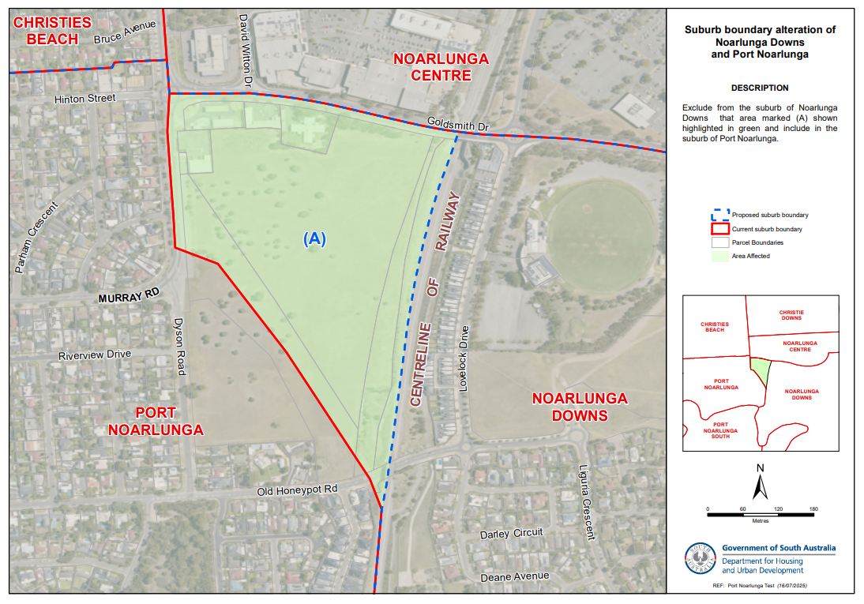
• Alter the suburb boundary to exclude from the suburb of NOARLUNGA DOWNS that area marked (A) shown highlighted in green and include in the suburb of PORT NOARLUNGA as shown on the location map.
This proposal can also be viewed at www.sa.gov.au/placenameproposals
Submissions in writing regarding this proposal may be lodged with the Surveyor-General, GPO Box 1815, Adelaide SA 5001, or DHUD.PlaceNames@sa.gov.au within one month of the publication of this notice.
Dated: 30 October 2025
Hon Nick Champion MP
Minister for Planning
DHUD: 2025/04188/01

GEOGRAPHICAL NAMES ACT 1991
Notice to Alter the Boundary of a Place
Notice is hereby given that, pursuant to Section 11B(1)(b) of the Geographical Names Act 1991, I, the Honourable Nick Champion MP, Minister for Planning, Minister of the Crown to whom the administration of the Geographical Names Act 1991 is committed, do hereby:
• Alter the suburb boundary to exclude from the suburb of BOLIVAR that area marked (A) shown highlighted in green and include in the suburb of PARALOWIE, as shown on the location map.
This notice is to take effect immediately upon its publication in the Government Gazette.
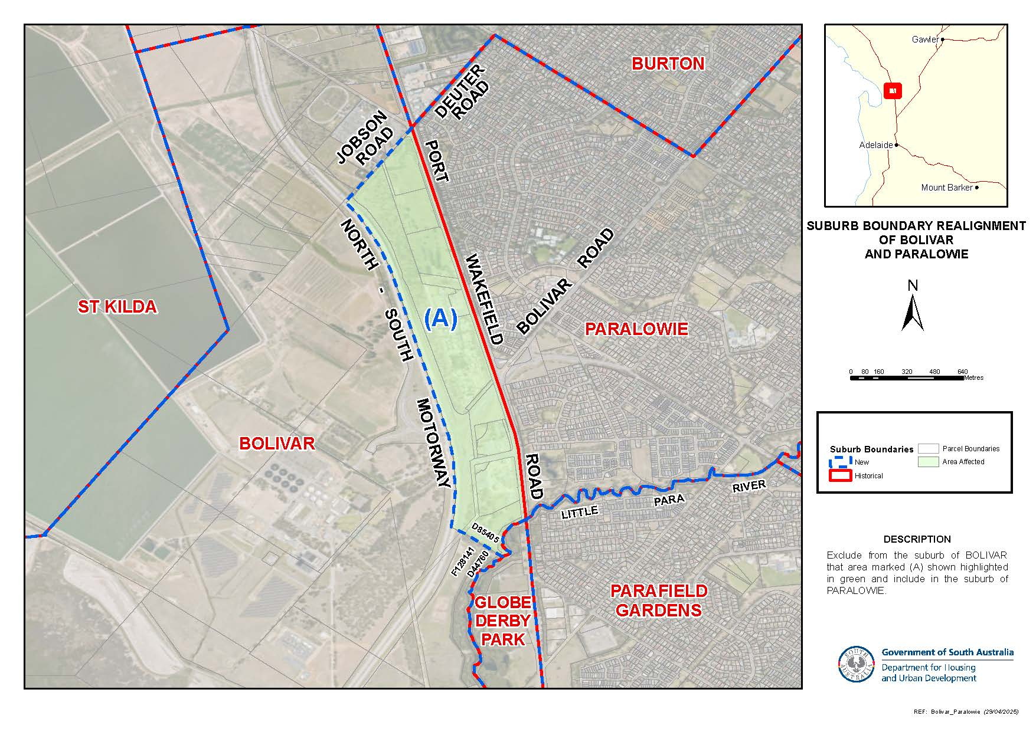
This proposal can also be viewed at www.sa.gov.au/placenameproposals.
Dated: 30 October 2025
Hon Nick Champion MP
Minister for Planning
2025/01187/01

GEOGRAPHICAL NAMES ACT 1991
Notice to Alter the Boundary of a Place and Assign a Name to a Place
Notice is hereby given that, pursuant to Section 11B(1)(a) and (b) of the Geographical Names Act 1991, I, the Honourable Nick Champion MP, Minister for Planning, Minister of the Crown to whom the administration of the Geographical Names Act 1991 is committed, do hereby:
1. Alter the suburb boundary to exclude from the suburb of THEBARTON that area marked (A) shown highlighted in green, as shown on the location map.
2. Assign the name SOUTHWARK to that area marked (A).
This notice is to take effect immediately upon its publication in the Government Gazette.
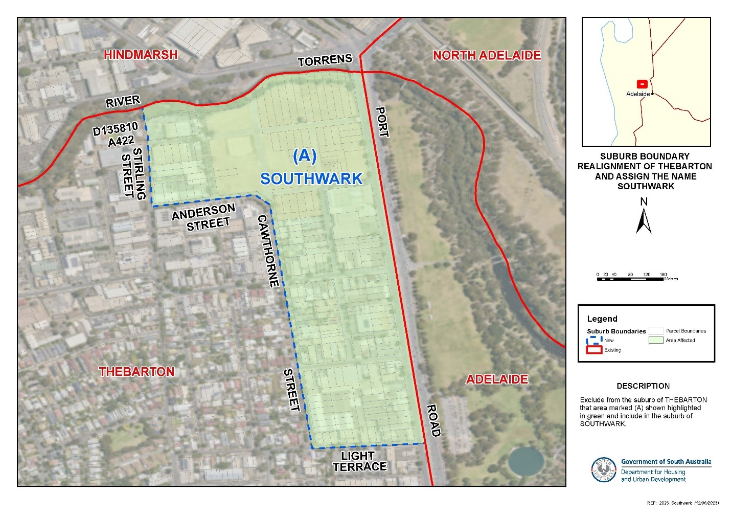
This proposal can also be viewed at www.sa.gov.au/placenameproposals.
Dated: 30 October 2025
Hon Nick Champion MP
Minister for Planning
2024/03736/01

Housing Improvement Act 2016
Rent Control
In the exercise of the powers conferred by the Housing Improvement Act 2016, the Delegate of the Minister for Housing and Urban Development hereby fixes the maximum rental amount per week that shall be payable subject to Section 55 of the Residential Tenancies Act 1995, in respect of each premises described in the following table. The amount shown in the said table shall come into force on the date of this publication in the Gazette.
Address of Premises | Allotment Section | Certificate of Title  Volume/Folio | Maximum Rental per week payable
28A Campbell Road, Paradise SA 5075 | Allotment 101 Deposited Plan 14953 Hundred of Adelaide | CT5699/65 | $352.00
13 Tenth Street, Renmark SA 5341 | Allotment 92 Filed Plan 208121  Out of Hundreds (Renmark) | CT5491/821 CT5492/74 | $220.00
16 Nari Drive, Sheidow Park SA 5158 | Allotment 400 Deposited Plan 10122 Hundred of Noarlunga | CT5531/827 | $311.50
Unit 1, 13 Harradine Street, Gawler East SA 5118 | Unit 1 Strata Plan 7856  Hundred of Nuriootpa | CT5004/16 | $337.50
Dated: 30 October 2025
Craig Thompson
Housing Regulator and Registrar
Housing Safety Authority
Delegate of the Minister for Housing and Urban Development

Housing Improvement Act 2016
Rent Control Revocations
In the exercise of the powers conferred by the Housing Improvement Act 2016, the Delegate of the Minister for Housing and Urban Development hereby revokes the maximum rental amount per week that shall be payable subject to Section 55 of the Residential Tenancies Act 1995, in respect of each premises described in the following table.
Address of Premises | Allotment Section | Certificate of Title  Volume/Folio
829 Onkaparinga Valley Road, Oakbank SA 5243 (AKA Section 241) | Section 241 Hundred Plan 105600 Hundred of Onkaparinga | CT5678/154
11 Railz Road, Coonalpyn SA 5265 (AKA Lot 100) (PKA Lot 100 Dukes Highway) | Allotment 100 Deposited Plan 26429 Hundred of Livingston | CT5237/321
6 Dunbar Street, Davoren Park SA 5113 | Allotment 58 Deposited Plan 7521 Hundred of Munno Para | CT5596/172
13 Ponsonby Street, West Hindmarsh SA 5007 | Allotment 22 Deposited Plan 1342 Hundred of Yatala | CT5715/895
62 Maria Street, Thebarton SA 5031 | Allotment 146 Filed Plan 6531 Hundred of Adelaide | CT5233/444
538 Seaview Road, Grange SA 5022 | Allotment 103 Deposited Plan 81480 Hundred of Yatala | CT6079/814
4160 Hunter Road, Nildottie SA 5238 | Allotment 92 Filed Plan 216337 Hundred of Nildottie | CT5861/952
Dated: 30 October 2025
Craig Thompson
Housing Regulator and Registrar
Housing Safety Authority
Delegate of the Minister for Housing and Urban Development

Justices of the Peace Act 2005
Section 4
Notice of Appointment of Justices of the Peace for South Australia
by the Commissioner for Consumer Affairs
I, Brett Humphrey, Commissioner for Consumer Affairs, delegate of the Attorney-General, pursuant to Section 4 of the Justices of the Peace Act 2005, do hereby appoint the people listed as Justices of the Peace for South Australia as set out below. It being a condition of appointment that the Justices of the Peace must take the oaths required of a justice under the Oaths Act 1936 and return the oaths of office form to Justice of the Peace Services within three months after the date of appointment.
For a period of ten years for a term commencing on 3 November 2025 and expiring on 2 November 2035:
Tangeet Kaur SACHDEVA
Cassandra Marie ROSE
Raphy POULOSE
Tanya Jane MITCHELL
Carmel Bridget LOWE
Maksud IMRAN
Terri GRILLETT
Thomas Riley GASKELL
Emily Jane DELLER
Rakesh CHEWPARSAD
Dated: 23 October 2025
Brett Humphrey
Commissioner for Consumer Affairs
Delegate of the Attorney-General

Land Acquisition Act 1969
Section 16
Form 5—Notice of Acquisition
1. Notice of acquisition
The Minister for Infrastructure and Transport (The Authority), of 83 Pirie Street, Adelaide SA 5000 acquires the following interests in the following land:
First, comprising an unencumbered estate in fee simple in that piece of land being portion of Allotment 49 in Deposited Plan 2436 comprised in Certificate of Title Volume 6281 Folio 52, being the whole of the land identified as Allotment 101 in the plan D134335 lodged at the Lands Titles Office, and
Secondly, comprising an unencumbered estate in fee simple in that piece of land being portion of Allotment 49 in Deposited Plan 2436 comprised in Certificate of Title Volume 6281 Folio 52, being the whole of the land identified as Allotment 102 in the plan D134335 lodged at the Lands Titles Office, and

Thirdly, comprising an unencumbered estate in fee simple in that piece of land being portion of Allotment 49 in Deposited Plan 2436 comprised in Certificate of Title Volume 6281 Folio 52, being the whole of the land identified as Allotment 104 in the plan D134335 lodged at the Lands Titles Office, and
Fourthly, comprising an unencumbered estate in fee simple in that piece of land being portion of Allotment 49 in Deposited Plan 2436 comprised in Certificate of Title Volume 6281 Folio 52, being the whole of the land identified as Allotment 103 in the plan D134335 lodged at the Lands Titles Office and,
Fifthly, comprising an unencumbered estate in fee simple in that piece of land being portion of Allotment 100 in Filed Plan 261205 comprised in Certificate of Title Volume 6315 Folio 894, being the whole of the land identified as 105 in the plan D134549 lodged at the Lands Titles Office.
This notice is given under Section 16 of the Land Acquisition Act 1969.
2. Compensation
A person who has or had an interest consisting of native title or an alienable interest in the land that is divested or diminished by the acquisition or the enjoyment of which is adversely affected by the acquisition who does not receive an offer of compensation from the Authority may apply to the Authority for compensation.
2A. Payment of professional costs relating to acquisition (Section 26B)
If you are the owner in fee simple of the land to which this notice relates, you may be entitled to a payment of up to $10,000 from the Authority for use towards the payment of professional costs in relation to the acquisition of the land.
Professional costs include legal costs, valuation costs and any other costs prescribed by the Land Acquisition Regulations 2019.
3. Inquiries
Inquiries should be directed to: Philip Cheffirs
GPO Box 1533
Adelaide SA 5001
Telephone: (08) 7133 2395
Dated: 28 October 2025
Signed for and on behalf of the MINISTER FOR INFRASTRUCTURE AND TRANSPORT by his duly constituted Attorney Pursuant to Power of Attorney No. 13405184, who has not received a notice of the revocation of that Power of Attorney in the presence of:
Rocco Caruso
Director, Property Acquisition
(Authorised Officer)
Department for Infrastructure and Transport
File Reference: 2020/18000/01

Land Acquisition Act 1969
Section 26F
Form 6B—Notice of Acquisition of Underground Land
1. Notice of acquisition
The Commissioner of Highways (the Authority), of 83 Pirie Street, Adelaide SA 5000 acquires the following interests in the following land:
An unencumbered estate in fee simple in the whole of Allotment 716 in D138175 lodged in the Lands Titles Office, being portion of the land comprised in Certificate of Title Volume 6200 Folio 306.
This notice is given under Section 26F of the Land Acquisition Act 1969.
2. Compensation not payable unless certain water infrastructure or rights are affected
You are not entitled to compensation in relation to the acquisition of the underground land to which this notice relates, unless the following conditions are satisfied:
• you held at least one of the following interests in relation to the underground land immediately before the notice of acquisition was published in relation to the land—
◦ ownership of a lawful well that provides access to underground water in the underground land, and any underground infrastructure associated with the well; or
◦ a right to take underground water from the underground land by means of such a well;
• you notified the Authority of your interest in response to a notice given under Section 26G of the Land Acquisition Act 1969;
• the acquisition of the underground land either—
◦ involved the acquisition of your interest; or
◦ resulted in the discharge of your interest; or
◦ resulted in you being unable to take water by means of, or pursuant to, your interest;
• you make an application for compensation to the Authority under Section 26H of the Land Acquisition Act 1969.
3. Application for compensation under Section 26H
If you believe you are entitled to compensation, you must apply to the Authority for compensation within 6 months after the publication of the notice of acquisition in relation to the underground land to which this notice relates.
The application must be in the following manner and form:
“Application for Compensation for Acquisition of Underground Land” (enclosed) to be submitted by email to DIT.ULAapplications@sa.gov.au or by mail marked attention: Property Acquisition c/- GPO Box 1533, Adelaide SA 5001.

The application must be accompanied by the following information or documents:
Any relevant supporting documentation including, but not limited to water licences, bore licences etc.
After receiving your application, the Authority may (but is not required to) make you a written offer of compensation not exceeding $50,000.
See Section 26H(4) of the Land Acquisition Act 1969 for further details on the payment of compensation.
4. Inquiries
Inquiries should be directed to: T2D Project Team
GPO Box 1533
Adelaide SA 5001
Telephone: 1800 572 414
Dated: 27 October 2025
The Common Seal of the COMMISSIONER OF HIGHWAYS was hereto affixed by authority of the Commissioner in the presence of:
Rocco Caruso
Director, Property Acquisition
(Authorised Officer)
Department for Infrastructure and Transport
DIT: 2024/07267/01

Land Acquisition Act 1969
Section 26F
Form 6B—Notice of Acquisition of Underground Land
1. Notice of acquisition
The Commissioner of Highways (the Authority), of 83 Pirie Street, Adelaide SA 5000 acquires the following interests in the following land:
An unencumbered estate in fee simple in the whole of Allotment 916 in D138111 lodged in the Lands Titles Office, being portion of the land comprised in Certificate of Title Volume 5575 Folio 282.
This notice is given under Section 26F of the Land Acquisition Act 1969.
2. Compensation not payable unless certain water infrastructure or rights are affected
You are not entitled to compensation in relation to the acquisition of the underground land to which this notice relates, unless the following conditions are satisfied:
• you held at least one of the following interests in relation to the underground land immediately before the notice of acquisition was published in relation to the land—
◦ ownership of a lawful well that provides access to underground water in the underground land, and any underground infrastructure associated with the well; or
◦ a right to take underground water from the underground land by means of such a well;
• you notified the Authority of your interest in response to a notice given under Section 26G of the Land Acquisition Act 1969;
• the acquisition of the underground land either—
◦ involved the acquisition of your interest; or
◦ resulted in the discharge of your interest; or
◦ resulted in you being unable to take water by means of, or pursuant to, your interest;
• you make an application for compensation to the Authority under Section 26H of the Land Acquisition Act 1969.
3. Application for compensation under Section 26H
If you believe you are entitled to compensation, you must apply to the Authority for compensation within 6 months after the publication of the notice of acquisition in relation to the underground land to which this notice relates.
The application must be in the following manner and form:
“Application for Compensation for Acquisition of Underground Land” (enclosed) to be submitted by email to DIT.ULAapplications@sa.gov.au or by mail marked attention: Property Acquisition c/- GPO Box 1533, Adelaide SA 5001.
The application must be accompanied by the following information or documents:
Any relevant supporting documentation including, but not limited to water licences, bore licences etc.
After receiving your application, the Authority may (but is not required to) make you a written offer of compensation not exceeding $50,000.
See Section 26H(4) of the Land Acquisition Act 1969 for further details on the payment of compensation.
4. Inquiries
Inquiries should be directed to: T2D Project Team
GPO Box 1533
Adelaide SA 5001
Telephone: 1800 572 414
Dated: 27 October 2025
The Common Seal of the COMMISSIONER OF HIGHWAYS was hereto affixed by authority of the Commissioner in the presence of:
Rocco Caruso
Director, Property Acquisition
(Authorised Officer)
Department for Infrastructure and Transport
DIT: 2024/07274/01

Land Acquisition Act 1969
Section 26F
Form 6B—Notice of Acquisition of Underground Land
1. Notice of acquisition
The Commissioner of Highways (the Authority), of 83 Pirie Street, Adelaide SA 5000 acquires the following interests in the following land:
An unencumbered estate in fee simple in the whole of Allotment 961 in D139077 lodged in the Lands Titles Office, being portion of the land comprised in Certificate of Title Volume 5101 Folio 811.
This notice is given under Section 26F of the Land Acquisition Act 1969.
2. Compensation not payable unless certain water infrastructure or rights are affected
You are not entitled to compensation in relation to the acquisition of the underground land to which this notice relates, unless the following conditions are satisfied:
• you held at least one of the following interests in relation to the underground land immediately before the notice of acquisition was published in relation to the land—
◦ ownership of a lawful well that provides access to underground water in the underground land, and any underground infrastructure associated with the well; or
◦ a right to take underground water from the underground land by means of such a well;
• you notified the Authority of your interest in response to a notice given under Section 26G of the Land Acquisition Act 1969;
• the acquisition of the underground land either—
◦ involved the acquisition of your interest; or
◦ resulted in the discharge of your interest; or
◦ resulted in you being unable to take water by means of, or pursuant to, your interest;
• you make an application for compensation to the Authority under Section 26H of the Land Acquisition Act 1969.
3. Application for compensation under Section 26H
If you believe you are entitled to compensation, you must apply to the Authority for compensation within 6 months after the publication of the notice of acquisition in relation to the underground land to which this notice relates.
The application must be in the following manner and form:
“Application for Compensation for Acquisition of Underground Land” (enclosed) to be submitted by email to DIT.ULAapplications@sa.gov.au or by mail marked attention: Property Acquisition c/- GPO Box 1533, Adelaide SA 5001.
The application must be accompanied by the following information or documents:
Any relevant supporting documentation including, but not limited to water licences, bore licences etc.
After receiving your application, the Authority may (but is not required to) make you a written offer of compensation not exceeding $50,000.
See Section 26H(4) of the Land Acquisition Act 1969 for further details on the payment of compensation.
4. Inquiries
Inquiries should be directed to: T2D Project Team
GPO Box 1533
Adelaide SA 5001
Telephone: 1800 572 414
Dated: 27 October 2025
The Common Seal of the COMMISSIONER OF HIGHWAYS was hereto affixed by authority of the Commissioner in the presence of:
Rocco Caruso
Director, Property Acquisition
(Authorised Officer)
Department for Infrastructure and Transport
DIT: 2024/08122/01

Land Acquisition Act 1969
Section 26F
Form 6B—Notice of Acquisition of Underground Land
1. Notice of acquisition
The Commissioner of Highways (the Authority), of 83 Pirie Street, Adelaide SA 5000 acquires the following interests in the following land:
An unencumbered estate in fee simple in the whole of Allotment 2322 in D139128 lodged in the Lands Titles Office, being portion of the land comprised in Certificate of Title Volume 5892 Folio 552.
This notice is given under Section 26F of the Land Acquisition Act 1969.
2. Compensation not payable unless certain water infrastructure or rights are affected
You are not entitled to compensation in relation to the acquisition of the underground land to which this notice relates, unless the following conditions are satisfied:
• you held at least one of the following interests in relation to the underground land immediately before the notice of acquisition was published in relation to the land—
◦ ownership of a lawful well that provides access to underground water in the underground land, and any underground infrastructure associated with the well; or
◦ a right to take underground water from the underground land by means of such a well;
• you notified the Authority of your interest in response to a notice given under Section 26G of the Land Acquisition Act 1969;
• the acquisition of the underground land either—
◦ involved the acquisition of your interest; or
◦ resulted in the discharge of your interest; or
◦ resulted in you being unable to take water by means of, or pursuant to, your interest;
• you make an application for compensation to the Authority under Section 26H of the Land Acquisition Act 1969.
3. Application for compensation under Section 26H
If you believe you are entitled to compensation, you must apply to the Authority for compensation within 6 months after the publication of the notice of acquisition in relation to the underground land to which this notice relates.
The application must be in the following manner and form:
“Application for Compensation for Acquisition of Underground Land” (enclosed) to be submitted by email to DIT.ULAapplications@sa.gov.au or by mail marked ATTENTION: Property Acquisition c/- GPO Box 1533, Adelaide SA 5001.
The application must be accompanied by the following information or documents:
Any relevant supporting documentation including, but not limited to water licences, bore licences etc.
After receiving your application, the Authority may (but is not required to) make you a written offer of compensation not exceeding $50,000.
See Section 26H(4) of the Land Acquisition Act 1969 for further details on the payment of compensation.
4. Inquiries
Inquiries should be directed to: T2D Project Team
GPO Box 1533
Adelaide SA 5001
Telephone: 1800 572 414
Dated: 27 October 2025
The Common Seal of the COMMISSIONER OF HIGHWAYS was hereto affixed by authority of the Commissioner in the presence of:
Rocco Caruso
Director, Property Acquisition
(Authorised Officer)
Department for Infrastructure and Transport
DIT 2024/08129/01

Land Acquisition Act 1969
Section 26F
Form 6B—Notice of Acquisition of Underground Land
1. Notice of acquisition
The Commissioner of Highways (the Authority), of 83 Pirie Street, Adelaide SA 5000 acquires the following interests in the following land:
An unencumbered estate in fee simple in the whole of Allotment 2291 in D139163 lodged in the Lands Titles Office, being portion of the land comprised in Certificate of Title Volume 5312 Folio 420.
This notice is given under Section 26F of the Land Acquisition Act 1969.
2. Compensation not payable unless certain water infrastructure or rights are affected
You are not entitled to compensation in relation to the acquisition of the underground land to which this notice relates, unless the following conditions are satisfied:
• you held at least one of the following interests in relation to the underground land immediately before the notice of acquisition was published in relation to the land—
◦ ownership of a lawful well that provides access to underground water in the underground land, and any underground infrastructure associated with the well; or
◦ a right to take underground water from the underground land by means of such a well;
• you notified the Authority of your interest in response to a notice given under Section 26G of the Land Acquisition Act 1969;
• the acquisition of the underground land either—
◦ involved the acquisition of your interest; or
◦ resulted in the discharge of your interest; or
◦ resulted in you being unable to take water by means of, or pursuant to, your interest;
• you make an application for compensation to the Authority under Section 26H of the Land Acquisition Act 1969.
3. Application for compensation under Section 26H
If you believe you are entitled to compensation, you must apply to the Authority for compensation within 6 months after the publication of the notice of acquisition in relation to the underground land to which this notice relates.
The application must be in the following manner and form:
“Application for Compensation for Acquisition of Underground Land” (enclosed) to be submitted by email to DIT.ULAapplications@sa.gov.au or by mail marked attention: Property Acquisition c/- GPO Box 1533, Adelaide SA 5001.

The application must be accompanied by the following information or documents:
Any relevant supporting documentation including, but not limited to water licences, bore licences etc.
After receiving your application, the Authority may (but is not required to) make you a written offer of compensation not exceeding $50,000.
See Section 26H(4) of the Land Acquisition Act 1969 for further details on the payment of compensation.
4. Inquiries
Inquiries should be directed to: T2D Project Team
GPO Box 1533
Adelaide SA 5001
Telephone: 1800 572 414
Dated: 27 October 2025
The Common Seal of the COMMISSIONER OF HIGHWAYS was hereto affixed by authority of the Commissioner in the presence of:
Rocco Caruso
Director, Property Acquisition
(Authorised Officer)
Department for Infrastructure and Transport
DIT: 2024/08156/01

Land Acquisition Act 1969
Section 26F
Form 6B—Notice of Acquisition of Underground Land
1. Notice of acquisition
The Commissioner of Highways (the Authority), of 83 Pirie Street, Adelaide SA 5000 acquires the following interests in the following land:
An unencumbered estate in fee simple in the whole of Allotment 2302 in D139126 lodged in the Lands Titles Office, being portion of the land comprised in Certificate of Title Volume 5848 Folio 333.
This notice is given under Section 26F of the Land Acquisition Act 1969.
2. Compensation not payable unless certain water infrastructure or rights are affected
You are not entitled to compensation in relation to the acquisition of the underground land to which this notice relates, unless the following conditions are satisfied:
• you held at least one of the following interests in relation to the underground land immediately before the notice of acquisition was published in relation to the land—
◦ ownership of a lawful well that provides access to underground water in the underground land, and any underground infrastructure associated with the well; or
◦ a right to take underground water from the underground land by means of such a well;
• you notified the Authority of your interest in response to a notice given under Section 26G of the Land Acquisition Act 1969;
• the acquisition of the underground land either—
◦ involved the acquisition of your interest; or
◦ resulted in the discharge of your interest; or
◦ resulted in you being unable to take water by means of, or pursuant to, your interest;
• you make an application for compensation to the Authority under Section 26H of the Land Acquisition Act 1969.
3. Application for compensation under Section 26H
If you believe you are entitled to compensation, you must apply to the Authority for compensation within 6 months after the publication of the notice of acquisition in relation to the underground land to which this notice relates.
The application must be in the following manner and form:
“Application for Compensation for Acquisition of Underground Land” (enclosed) to be submitted by email to DIT.ULAapplications@sa.gov.au or by mail marked attention: Property Acquisition c/- GPO Box 1533, Adelaide SA 5001.
The application must be accompanied by the following information or documents:
Any relevant supporting documentation including, but not limited to water licences, bore licences etc.
After receiving your application, the Authority may (but is not required to) make you a written offer of compensation not exceeding $50,000.
See Section 26H(4) of the Land Acquisition Act 1969 for further details on the payment of compensation.
4. Inquiries
Inquiries should be directed to: T2D Project Team
GPO Box 1533
Adelaide SA 5001
Telephone: 1800 572 414
Dated: 27 October 2025
The Common Seal of the COMMISSIONER OF HIGHWAYS was hereto affixed by authority of the Commissioner in the presence of:
Rocco Caruso
Director, Property Acquisition
(Authorised Officer)
Department for Infrastructure and Transport
DIT 2024/08241/01

Land Acquisition Act 1969
Section 26F
Form 6B—Notice of Acquisition of Underground Land
1. Notice of acquisition
The Commissioner of Highways (the Authority), of 83 Pirie Street, Adelaide SA 5000 acquires the following interests in the following land:
An unencumbered estate in fee simple in the whole of Allotment 81 in D138755 lodged in the Lands Titles Office, being portion of the land comprised in Certificate of Title Volume 5441 Folio 612.
This notice is given under Section 26F of the Land Acquisition Act 1969.
2. Compensation not payable unless certain water infrastructure or rights are affected
You are not entitled to compensation in relation to the acquisition of the underground land to which this notice relates, unless the following conditions are satisfied:
• you held at least one of the following interests in relation to the underground land immediately before the notice of acquisition was published in relation to the land—
◦ ownership of a lawful well that provides access to underground water in the underground land, and any underground infrastructure associated with the well; or
◦ a right to take underground water from the underground land by means of such a well;
• you notified the Authority of your interest in response to a notice given under Section 26G of the Land Acquisition Act 1969;
• the acquisition of the underground land either—
◦ involved the acquisition of your interest; or
◦ resulted in the discharge of your interest; or
◦ resulted in you being unable to take water by means of, or pursuant to, your interest;
• you make an application for compensation to the Authority under Section 26H of the Land Acquisition Act 1969.
3. Application for compensation under Section 26H
If you believe you are entitled to compensation, you must apply to the Authority for compensation within 6 months after the publication of the notice of acquisition in relation to the underground land to which this notice relates.
The application must be in the following manner and form:
“Application for Compensation for Acquisition of Underground Land” (enclosed) to be submitted by email to DIT.ULAapplications@sa.gov.au or by mail marked attention: Property Acquisition c/- GPO Box 1533, Adelaide SA 5001.
The application must be accompanied by the following information or documents:
Any relevant supporting documentation including, but not limited to water licences, bore licences etc.
After receiving your application, the Authority may (but is not required to) make you a written offer of compensation not exceeding $50,000.
See Section 26H(4) of the Land Acquisition Act 1969 for further details on the payment of compensation.
4. Inquiries
Inquiries should be directed to: T2D Project Team
GPO Box 1533
Adelaide SA 5001
Telephone: 1800 572 414
Dated: 27 October 2025
The Common Seal of the COMMISSIONER OF HIGHWAYS was hereto affixed by authority of the Commissioner in the presence of:
Rocco Caruso
Director, Property Acquisition
(Authorised Officer)
Department for Infrastructure and Transport
DIT 2024/08269/01

Land Acquisition Act 1969
Section 26F
Form 6B—Notice of Acquisition of Underground Land
1. Notice of acquisition
The Commissioner of Highways (the Authority), of 83 Pirie Street, Adelaide SA 5000 acquires the following interests in the following land:
An unencumbered estate in fee simple in the whole of Allotment 971 in D139078 lodged in the Lands Titles Office, being portion of the land comprised in Certificate of Title Volume 5208 Folio 314.
This notice is given under Section 26F of the Land Acquisition Act 1969.
2. Compensation not payable unless certain water infrastructure or rights are affected
You are not entitled to compensation in relation to the acquisition of the underground land to which this notice relates, unless the following conditions are satisfied:
• you held at least one of the following interests in relation to the underground land immediately before the notice of acquisition was published in relation to the land—

◦ ownership of a lawful well that provides access to underground water in the underground land, and any underground infrastructure associated with the well; or
◦ a right to take underground water from the underground land by means of such a well;
• you notified the Authority of your interest in response to a notice given under Section 26G of the Land Acquisition Act 1969;
• the acquisition of the underground land either—
◦ involved the acquisition of your interest; or
◦ resulted in the discharge of your interest; or
◦ resulted in you being unable to take water by means of, or pursuant to, your interest;
• you make an application for compensation to the Authority under Section 26H of the Land Acquisition Act 1969.
3. Application for compensation under Section 26H
If you believe you are entitled to compensation, you must apply to the Authority for compensation within 6 months after the publication of the notice of acquisition in relation to the underground land to which this notice relates.
The application must be in the following manner and form:
“Application for Compensation for Acquisition of Underground Land” (enclosed) to be submitted by email to DIT.ULAapplications@sa.gov.au or by mail marked attention: Property Acquisition c/- GPO Box 1533, Adelaide SA 5001.
The application must be accompanied by the following information or documents:
Any relevant supporting documentation including, but not limited to water licences, bore licences etc.
After receiving your application, the Authority may (but is not required to) make you a written offer of compensation not exceeding $50,000.
See Section 26H(4) of the Land Acquisition Act 1969 for further details on the payment of compensation.
4. Inquiries
Inquiries should be directed to: T2D Project Team
GPO Box 1533
Adelaide SA 5001
Telephone: 1800 572 414
Dated: 27 October 2025
The Common Seal of the COMMISSIONER OF HIGHWAYS was hereto affixed by authority of the Commissioner in the presence of:
Rocco Caruso
Director, Property Acquisition
(Authorised Officer)
Department for Infrastructure and Transport
DIT: 2024/08273/01

Land Acquisition Act 1969
Section 26F
Form 6B—Notice of Acquisition of Underground Land
1. Notice of acquisition
The Commissioner of Highways (the Authority), of 83 Pirie Street, Adelaide SA 5000 acquires the following interests in the following land:
An unencumbered estate in fee simple in the whole of Allotment 2301 in D139164 lodged in the Lands Titles Office, being portion of the land comprised in Certificate of Title Volume 5403 Folio 337.
This notice is given under Section 26F of the Land Acquisition Act 1969.
2. Compensation not payable unless certain water infrastructure or rights are affected
You are not entitled to compensation in relation to the acquisition of the underground land to which this notice relates, unless the following conditions are satisfied:
• you held at least one of the following interests in relation to the underground land immediately before the notice of acquisition was published in relation to the land—
◦ ownership of a lawful well that provides access to underground water in the underground land, and any underground infrastructure associated with the well; or
◦ a right to take underground water from the underground land by means of such a well;
• you notified the Authority of your interest in response to a notice given under Section 26G of the Land Acquisition Act 1969;
• the acquisition of the underground land either—
◦ involved the acquisition of your interest; or
◦ resulted in the discharge of your interest; or
◦ resulted in you being unable to take water by means of, or pursuant to, your interest;
• you make an application for compensation to the Authority under Section 26H of the Land Acquisition Act 1969.
3. Application for compensation under Section 26H
If you believe you are entitled to compensation, you must apply to the Authority for compensation within 6 months after the publication of the notice of acquisition in relation to the underground land to which this notice relates.

The application must be in the following manner and form:
“Application for Compensation for Acquisition of Underground Land” (enclosed) to be submitted by email to DIT.ULAapplications@sa.gov.au or by mail marked attention: Property Acquisition c/- GPO Box 1533, Adelaide SA 5001.
The application must be accompanied by the following information or documents:
Any relevant supporting documentation including, but not limited to water licences, bore licences etc.
After receiving your application, the Authority may (but is not required to) make you a written offer of compensation not exceeding $50,000.
See Section 26H(4) of the Land Acquisition Act 1969 for further details on the payment of compensation.
4. Inquiries
Inquiries should be directed to: T2D Project Team
GPO Box 1533
Adelaide SA 5001
Telephone: 1800 572 414
Dated: 27 October 2025
The Common Seal of the COMMISSIONER OF HIGHWAYS was hereto affixed by authority of the Commissioner in the presence of:
Rocco Caruso
Director, Property Acquisition
(Authorised Officer)
Department for Infrastructure and Transport
DIT 2024/08288/01

Major Events Act 2013
Section 6B
Declaration of a Major Event
Pursuant to Section 6B of the Major Events Act 2013, I, Hon. Zoe Bettison MP, Minister for Tourism declare the Beach Volleyball World Championships—Adelaide 2025 to be held from Friday, 14 November to Sunday, 23 November 2025 to be declared a major event.
By virtue of the provisions of the Major Events Act 2013, I do hereby:
1. Declare the Beach Volleyball World Championships—Adelaide 2025 to be a major event.
2. Specify the period of the event, for which the declaration of the major event is in force is from 00:01am Friday, 14 November to 11:59pm Sunday, 23 November 2025.
3. Declare the major event venue to be the area as shown as “Major Event Venue” in description and map including The Drive and Pinky Flat.
4. Declare the controlled areas to be any public place or a part of a public place that is within 300 metres of the boundary of the major event venues, excluding Adelaide Oval, as shown as the ‘Declared Controlled Area’ on the map.
5. Designate Volleyball Australia (ABN 46 487 409 518) to be the event organisers for the event.
6. Declare that the following provisions of Part 3 of the Act apply to the event, the event site and the declared controlled area for the event:
(a) Section 8
(b) Section 10
(c) Section 11
(d) Section 12
(e) Section 13
(f) Section 14

7. Being satisfied that the title “Beach Volleyball World Championships—Adelaide 2025” and the logo as it appears below are sufficiently connected with the identity and conduct of the major event, and that the event has commercial arrangements that are likely to be adversely affected by unauthorised use of the title and logo, I hereby declare, pursuant to Section 14(1) of the Act, that “Beach Volleyball World Championships—Adelaide 2025” is an official title and the logo as it appears below is an official logo in respect of the event.
Dated: 28 October 2025
Hon Zoe Bettison MP
Minister for Tourism

Map of Controlled Areas
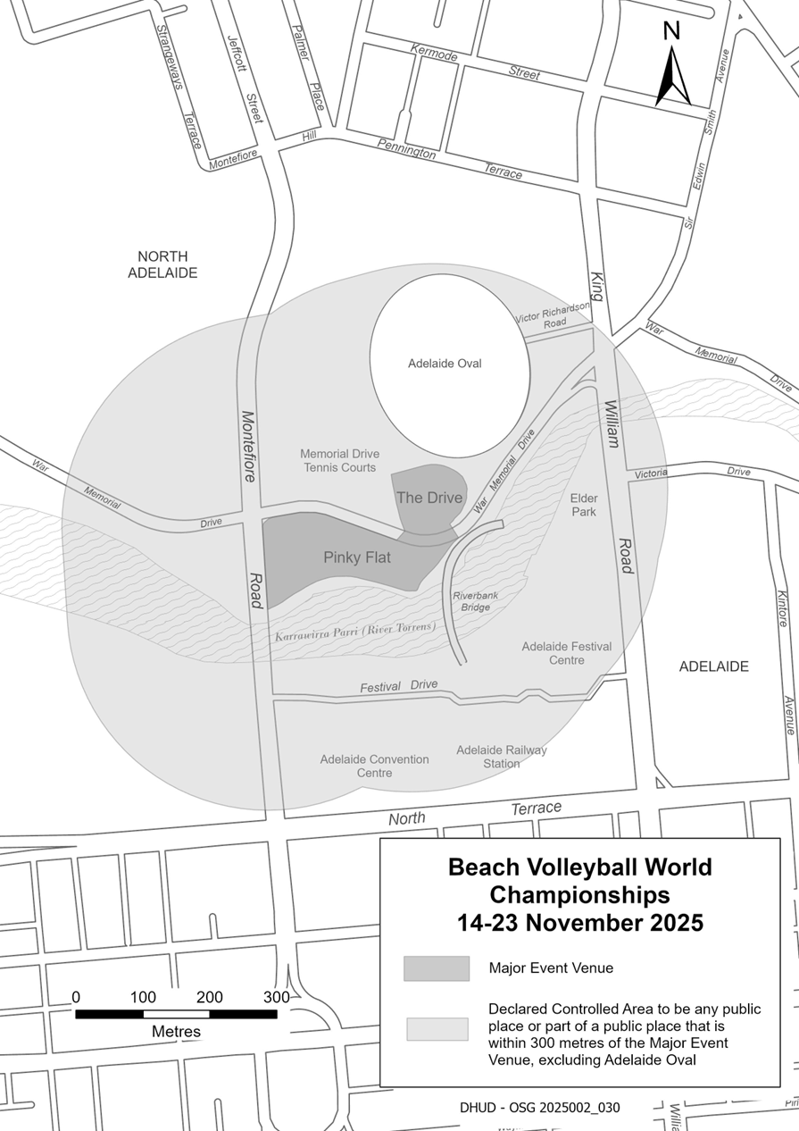
Beach Volleyball World Championships—Adelaide 2025

Mental Health Act 2009
Authorised Mental Health Professional
Notice is hereby given in accordance with Section 94(1) of the Mental Health Act 2009, that the Chief Psychiatrist has determined the following persons as Authorised Mental Health Professionals:
Suzanne Millard
Steven Ridley
The determination will expire three years after the commencement date.
The Chief Psychiatrist make vary or revoke these determinations at any time.
Dated: 30 October 2025
Dr John Brayley
Chief Psychiatrist

Motor Vehicles Act 1959
South Australia
Motor Vehicles (Approval of Motor Bikes and Motor Trikes) Notice 2025 No 3
under the Motor Vehicles Act 1959
1—Short title
This notice may be cited as the Motor Vehicles (Approval of Motor Bikes and Motor Trikes) Notice 2025.
2—Commencement
This notice will come into operation on the date of publication in this Gazette.
3—Approved motor bikes and motor trikes
For the purposes of Schedules 2 and 3 of the Motor Vehicles Regulations 2025 the motor bikes and motor trikes specified in Schedule 1 are approved.
Schedule 1—Approved motor bikes and motor trikes
The following are approved:
• All motor bikes and motor trikes built before December 1960 with an engine capacity not exceeding 660ml
• All motor bikes and motor trikes with an engine capacity not exceeding 260 milliliters and a power to weight ratio not exceeding 150 kilowatts per tonne, except the following:
Suzuki RGV250
Kawasaki KR250 (KR-1 and KR1s models)
Honda NSR250
Yamaha TZR250
Aprilia RS250
• All motor bikes and motor trikes with electric powered engines, with a power output not in excess of 25 kw

Motor bikes and Motor trikes with electric powered engines listed in the table below are approved:
MAKE | MODEL | VARIANT NAME | YEAR(S) | CAPACITY
BRAAAP | MotoE | 5000w | 2022-current | Electric
 | MotoE | 8000w | 2022-current | Electric
 | MotoE | 10000w | 2022-current | Electric
EVOKE | URBAN S |  | 2020-current | Electric
 | URBAN CLASSIC |  | 2020-current | Electric
FONZARELLI | 125 | 125 | 2014-2015 | Electric
KAWASAKI | NX011A | NR011A (Ninja e-1)  NX011A (Ninja e-1) | 2023 | Electric
KYBURZ | DXP | KYBURZ | 2017 | Electric
ZERO | DS | Zero DS | Unit 2015 | Electric
 | S | Zero S | Until 2015 | Electric
Motor trikes with an engine capacity not less than 261ml and not exceeding 660ml listed in the table below are approved:
MAKE | MODEL | VARIANT NAME | YEAR(S) | CAPACITY
BRP | Can am Ryker | Rotax 600 ACE | 2018 | 599
GILERA | FUOCO 500 | FUOCO 500 | 2007-13 | 493
LAMBRETTA | All model | Lambretta | pre 2008 | under 660
OZ TRIKE | FUN 500 | FUN 500 | pre 2008 | 500
METROPOLIS | AA | 2018 | 399 | METROPOLIS
PGO | All models | All models under 220 | All | 220
PIAGGIO | All Models | All models | 2010-17 | under 350
Motor bikes with an engine capacity not less than 261ml and not exceeding 660ml listed in the table below are approved:
MAKE | MODEL | VARIANT NAME | YEAR(S) | CAPACITY
AJP | PR7 | PR7 | 2017-19 | 600
AJS | MODEL 18 | MODEL 18 | pre 1963 | 497
 | MODEL 20 | MODEL 20 | 1955-61 | 498
APRILIA | KV | RS 660 LAMS & Tuono 660 LAMS | 2020-on | 659
 | Moto 6.5 | Moto 6.5 | 1998-99 | 649
 | M35 | SR MAX 300 | 2012 | 278
 | PEGASO 650 | DUAL SPORTS | 1994-01 | 652
 | PEGASO 650 | OUTBACK | 2000-01 | 652
 | PEGASO 650 | Factory 650 | 2007-08 | 660
 | PEGASO 650 I.E. | OUTBACK | 2001-02 | 652
 | PEGASO 650 I.E. | DUAL SPORTS | 2001-06 | 652
 | SCARABEO 300 | VRG | 2009 | 278
 | SCARABEO 400 | SCARABEO 400 | 2007 | 399
 | SCARABEO 500 | SCARABEO 500 | 2007-08 | 460
 | SPORTCITY300 | SPORTCITY300 | 2010-12 | 300
 | STRADA 650 | ROAD | 2006-08 | 659
 | STRADA 650 | TRAIL | 2006-08 | 659
 | VP (RXV 450) | VPV-VPT-VPH 18.3kW | 2006-10 | 449
 | VP (RXV 550) | VPZ- VPX- VPL 20kW | 2006-10 | 553
 | VS (SXV 450) | SXV 450 (VSR-VSH) 14kW | 2006-08 | 449
 | VS (SXV 550) | SXV 550 (VSS-VSL) 14.5kW | 2006-08 | 553
 | XC | Tuareg 660 (LAMS) | 2022-on | 659
ASIAWING | LD450 | ODES MCF450 | 2011-13 | 449
ATK | 605 | 605 | 1995 | 598
BENELLI | LEON | Leoncino, Leoncino Trail | 2018-on | 500
 | VELVET DUSK | Velvet 400 Dusk, Velvet Touring 400 | 2002-06 | 383
 | P10 | BN 302 | 2015 on | 300
 | P16 | TRK 502X | 2018 on | 500
 | P18 | LEONCINO 500 | 2017 on | 500
 | P18 | LEONCINO 500 TRAIL | 2018 on | 500
 | P18  P16 | BENELLI  TRK502 | 2017  2017 | 500  500
 | P25 | GT600 RESTRICTED | 2014-15 | 600
 | P25 | BN 600 RESTRICTED | 2013-on | 600
 | P36 | 502C | 2019 | 500
 | VELVET DUSK | VELVET DUSK | 2003-05 | 383
BETA | BETA | FUPA RR E3 | 2018 | 293
 | BMA RR | RR350 15 | 2018 | 349
 | BMA RR | RR390 16 | 2018 | 386
 | BMA RR | RR430 17 | 2018 | 431
 | BMA RR | RR480 18 | 2018 | 478
 | FUPA E5 | E5 00 | 2015 | 293
 | FUPA E5 | E8/03 | 2016-on | 293
 | FUPA RR E3 | RR 2T 300 | 2012-on | 293
 | FUPA RR E3 | RR350 20 & RR350 15 | 2016-on | 349
 | FUPA RR E3 | RR390 31 & RR390 16 | 2016-on | 386
 | FUPA RR E3 | RR430 32 & RR430 17 | 2016-on | 431
 | FUPA RR E3 | RR480 33 & RR480 18 | 2016-on | 478
 | RR E3 | RR350 | 2011-on | 349
 | RR E3 | RR400 | 2010-14 | 398
 | RR E3 | RR450 | 2010-14 | 449
 | RR E3 | RR520 | 2010-11 | 498
 | RR300 2T | RR300 2T | 2018-on | 293
 | RR350 4T | RR350 4T | 2019-on | 349
 | RR390 4T | RR390 4T | 2019-on | 386
 | RR430 4T | RR430 4T | 2019-on | 431
 | RR450 | RR450 | 2000-08 | 448
 | RR480 4T | RR480 4T | 2019-on | 478
 | RR525 | RR525 | 2000-08 | 510
 | XTRAINER 300 2T | XTRAINER 300 2T | 2019-on | 293
BMW | C400X | 0C09/C400X | 2018-on | 350
 | C400GT | 0C06, C400GT | 2018-on | 350
 | C650 | C600 SPORT | ALL | 647
 | C650 | C650 GT/Sport | All | 647
 | F650 | FUNDURO | 1995-00 | 652
 | F650 | G650 GS | 2009-2016 | 652
 | F650 | G650 GS Sertao | 2012-2016 | 652
 | F650CS | SCARVER | 2002-06 | 652
 | F650CS | SE ROAD | 2004-06 | 652
 | F650GS | DAKAR | 2000-08 | 652
 | F650GS | F650GS | 2000-10 | 652
 | F650ST | F650ST | 1998 | 652
 | G 450 X | G 450 X | 2008-10 | 450
 | G310 | G310R-0G01 | 2016-on | 313
 | G310GS | G310GS-0G02 | 2016-on | 313
 | G650GS | Sertao | All | 650
 | R45 | R45 | All | 453
 | R50 | R50 | All | 499
 | R60 | R60 | 1960-78 | 590
 | R65 | R65 | 1978-88 | 650
 | R65LS | R65LS | 1981-86 | 650
 | R69 | R69S | 1961-67 | 600
BOLWELL | LM25W | FIRENZE | 2009 | 263
BOLLINI | All models | All models under 250 | All | 250
BRAAAP | Moto4 | Moto Range, Cruiser 400 | 2021-on | 400
 | ST | 450 | 2016-on | 450
 | ST400 | Shadow | 2022-on | 367
BSA | A50 | A50 | 1964-70 | 500
 | A65 | A65 | 1966-69 | 650
 | A7 | A7 | 1961 | 500
 | B40 | B40 | 1969 | 350
 | B44 | B44 | 1967-71 | 440
 | B50 | B50 | 1971 | 495
 | B50SS GOLDSTAR | B50SS GOLDSTAR | 1971 | 498
 | GOLD STAR | GOLD STAR | 1938-63 | 500
 | LIGHTNING | LIGHTNING | 1964 | 654
 | SPITFIRE MKIII | SPITFIRE MKIII | 1967 | 650
 | THUNDERBOLT | THUNDERBOLT | 1968 | 499
BUELL | Blast | STREET FIGHTER | 2002-07 | 491
BUG | SEE KYMCO
BULTACO | ALPINA | ALPINA | 1974 | 350
 | FRONTERA | FRONTERA | 1974 | 360
 | SHERPA | SHERPA | 1974 | 350
CAGIVA | 360WR | 360WR | 1998-02 | 348
 | 410TE | 410TE | 1996 | 399
 | 610TEE | 610TEE | 1998 | 576
 | 650 ALAZZURA | 650 ALAZZURA | 1984-88 | 650
 | 650 ELFANT | 650 ELFANT | 1985-88 | 650
 | CANYON 500 | DUAL SPORTS | 1999-06 | 498
 | CANYON 600 | DUAL SPORTS | 1996-98 | 601
 | RIVER 600 | RIVER 600 | 1995-98 | 601
 | W16 600 | W16 600 | 1995-97 | 601
CAN-AM | CAN-AM RYKER | ROTAX 600 ACE | 2019-on | 599
CCM | GP Series | GP450-1(A1 30kW) | 2015-16 | 450
 | GP Series | GP450-2(A1 30kW) | 2015-16 | 450
CFMOTO | CF300-7F | 300CL-X | 2023-on | 292
 | CF 400-6F | 450SR | 2022-on | 449
 | CF 650 | CF650NK-LAM | 2012-on | 649
 | CF 650 | CF650TK-LAM | 2013-17 | 649
 | CF 650 | 650NK-LAM | 2016-18 | 649
 | CF 650 | 650MT | 2016-on | 649
 | CF 650 | 650GT | 2019-on | 649
 | CF 650 (400NK) | 400NK | 2016-17 | 400
CHANGJIANG | CJ650B with sidecar | Nomad, Tourer | 2023-on | 649
COSSCK | 650 | Ural | 1974 | 649
DERBI | MULHACEN | MULHACEN | 2008 | 659
 | RAMBLA | RA 300 | 2010 | 278
DNEPR | K650 | K650 | 1972 | 650
 | K650 | K650 DNEPR | 1967-74 | 650
 | MT9 | MT9 | 1974 | 650
DUCATI | 400 MONSTER | 400 MONSTER | 2002 | 398
 | 400 SIE | 400 S I E monster |  | 398
 | 400 SS JUNIOR | 400 SS | 1989-96 | 398
 | 400SS | 400SS | 1992-95 | 398
 | 500 DESMO | 500 Sport Desmo | 1977-83 | 497
 | 500GTL | 500GTL | 1975-77 | 497
 | 500SL | PANTAH | 1984 | 499
 | 600 MONSTER | 600 MONSTER | 1994-01 | 583
 | 600 MONSTER | DARK | 1998-01 | 583
 | 600 S | 600 SUPERSPORT | 1994-97 | 583
 | 600M | 600M | 1994-01 | 583
 | 600SL | PANTAH | 1980-84 | 583
 | 600SS | 600SS | 1994-98 | 583
 | 620 MONSTER LITE | M620 LITE | 2003-07 | 618
 | 620 MULTISTRADA LITE | MTS620 24.5Kw | 2005-07 | 618
 | 659 Monster | Monster 659 | All | 659
 | DM 350 | 350 | pre 85 | 350
 | DM 450 | 450 | pre 85 | 448
 | DM450 | DM450 | 1972 | 450
 | DM500 | DM500 | 1981-84 | 498
 | F3 | 350 F3 | 1986-1989 | 349
 | F4 | 400 F4 | 1986 | 400
 | KA (Scrambler) | 00AA Sixty2 | 2015-on | 399
 | M4 | M620ie LITE | 2003-04 | 620
 | M5 | Monster 659 | 2011 | 659
 | MD | 02AU | 2017 | 659
ELSTAR SHINERAY | XY400 | CAFÉ RACER | 2018 | 397
 | XY400 | CAFÉ RACER F | 2018 | 397
 | XY400 | CLASSIC C | 2018 | 397
 | XY400 | SCRAMBLER C | 2018 | 397
 | XY400 | WB400 & WB400c | 2015-17 | 397
ENFIELD | BULLET | CLASSIC | 1993-08 | 499
 | BULLET | DELUXE | 1993-08 | 499
 | BULLET | ELECTRA ROAD | 2006-08 | 499
 | BULLET 350 | DELUXE | 1988-01 | 346
 | BULLET 350 | SUPERSTAR | 1988-95 | 346
 | BULLET 350 | CLASSIC | 1993-01 | 346
 | BULLET 500 | 500 | 1995-08 | 499
 | BULLET 65 | ROAD | 2003-04 | 499
 | LIGHTNING | ROAD | 2000-08 | 499
 | MILITARY | ROAD | 2002-08 | 499
 | TAURUS | DIESEL | 2001 | 325
FANTIC | CA50 | Flat Track | 2020-on | 449
 | CA50 | Scrambler | 2020-on | 449
 | CA50 | Rally | 2020-on | 449
 | TZ | EC300 | 2011-12 | 300
 | TZ | Gas Gas EC30 | 2012 | 300
GAS-GAS | 4E | EC 30 | 2017 | 299
 | 4E | EC25 | 2017 | 299
 | 4E (IPA 48807) | EC 30 | 2018 | 299
 | CONTACT ES | 280 ES | 2018 | 272
 | EC ENDURO | EC30 | 2016-17 | 299
 | EC Series | EC300 | 2001-on | 293
 | EC Series | EC350F | 2021-on | 350
 | EC400 | FSE ENDURO | 2002-03 | 399
 | EC450 | FSE ENDURO | 2003-05 | 449
 | EC450 | FSE SUPERMOTARD | 2003-08 | 449
 | EC450 | FSR ENDURO | 2006-12 | 449
 | FS 400 | FS40A | 2006 | 398
 | FS 450 | FS45 | 2006 | 443
 | FS 500 | FS50 (503) | 2006-2009 | 503
 | FSE 400 | 400 | 2002 | 398
 | FSE 450 | 450 | 2003-08 | 398
 | PAMPERA | 320 TRAIL | 1998-02 | 333
 | PAMPERA | 400 TRAIL | 2006-08 | 399
 | PAMPERA | 450 | 2007-09 | 443
 | SM400 | SUPERMOTARD | 2003-08 | 399
 | SM450 | SUPERMOTARD | 2003-08 | 443
 | TT300 | EC300 | 1998-08 | 295
GILERA | NEXUS 500 | NEXUS 500 | 2003-08 | 460
HARLEY DAVIDSON | LWZ Series | X350 | 2023-on | 353
 | LWZ Series | X500 | 2023-on | 500
 | SS350 | Sprint | 69-1974 | 350
 | XGS SERIES | Street 500 -XG500 16MY | 2014-15 | 494
 | XGS SERIES | Street 500 | 2015-on | 494
HONDA | 600V TRANSALP | 600V | 1988 | 583
 | BROS400 | BROS400 | 1988 | 399
 | C70 | DREAM | pre 1970 | 305
 | CB300 (FA) | CB300FA | 2014-18 | 286
 | CB300R | CBF300NA | 2018-on | 286
 | CB350 | CB350 | 1969-72 | 348
 | CB350F | CB350F | 1972-74 | 325
 | CB360 | CB360 | 1973-76 | 360
 | CB400 | CB400 | 1981 -2014 | 395
 | CB400 ABS | CB400 ABS | 2008 - 2016 | 399
 | CB400F | CB400F | 1975-77 | 408
 | CB400N | CB400N | 1981 | 395
 | CB400T | CB400T | 1977 | 408
 | CB450 | CB450 | 1967-75 | 450
 | CB500 FOUR | CB500-FOUR K,K1,K2 | 1971-73 | 498
 | CB500 TWIN | CB500T | 1974-78 | 498
 | CB500F | CB500FA/F | 2012-on | 471
 | CB500X | CB500XA | 2013-on | 471
 | CB550 | CB550 | 1974-78 | 544
 | CB650 | CB650 | All | 650
 | CB650F | CB650FA-LTD-16ym | 2015-2017 | 649
 | CBR300R | CBR300R | 2014-16 | 286
 | CBR300R | CBR300RA | 2014-18 | 286
 | CBR500R | CBR500RA | 2012-on | 471
 | CBR650F | CBR650F LAMS (CBR650FL) | 2015-2019 | 649
 | CBR650R | CBR650R | 2019-on | 649
 | CBX550 | CBX550F | 1982-85 | 572
 | CJ360 | CJ360 | 1976 | 356
 | CL450 | CL450 | 1965-77 | 444
 | CL500A | CL500 | 2023-on | 471
 | CMX500 | CMX500 | 2016-on | 471
 | CMX500A | CMX500A | 2016-20 | 471
 | CRF300 | CRF300 Rally | 2020-on | 286
 | CRF300 | CRF300L | 2020-on | 286
 | CRF400R | CRF400R | 2013 | 399
 | CRF450L | CRF450L | 2018-on | 449
 | CRF450L | CRF450L2019YM | 2018-on | 449
 | CRF450X | CRF450X | 2005-09 | 449
 | CX500 | CX500 | 1977-82 | 495
 | DEAUVILLE | NT650V | 2000-07 | 647
 | FJS400A | SW-T400 | 2009 | 399
 | Fortza 300 | NSS300 Forza | All | 279
 | FT500 | FT500 | 1982-84 | 498
 | FTS600D | SILVERWING | 2006-08 | 582
 | GB350 | GB350 | 2023-on | 348
 | GB350C | GB350C | 2024-on | 348
 | GB400 | GB400 | All | 399
 | GB500 | GB500 TT | 1975-91 | 498
 | GL400 | GL400 | 1985 | 396
 | NF02 | SH300 | 2009 | 279
 | NSS300 | NSS300 Forza | 2013-on | 279
 | NSS350 | NSS350 Forza | 2020-on | 330
 | NT400 | NT400 | 1989-92 | 400
 | NT650V | DEAUVILLE | 2003-07 | 647
 | NTV650 | REVERE | 1989-92 | 647
 | NX650 | DOMINATOR | 1988-00 | 644
 | OBI RVF400 VFR400 | OBI RVF400 Otobai import model only | All | 400
 | REVERE | REVERE | 1990 | 647
 | SL350 | SL350 | 1972 | 348
 | Steed | steed | 2002 | 398
 | VT400 | VT 400 | All | 398
 | VT400C | SHADOW | All | 399
 | VT500 | VT500 | 1983-87 | 491
 | VT600C | VT600C | 1993-00 | 583
 | VT600C | SHADOW VLX | 1988-2008 | 583
 | XBR500 | XBR500 | 1986-89 | 499
 | XBR500SH | XBR500 | 1986-89 | 499
 | XL350 | XL350 | 1984-87 | 339
 | XL500 | XL500 | 1979-84 | 498
 | XL600R | XL600R | 1984-87 | 589
 | XL600RMG | XL600RMG | 1986-88 | 591
 | XL600VH | TRANSALP | 1987-89 | 583
 | XL650 | TRANSALP | 2005 | 647
 | XL650V | TRANSALP | 2002-08 | 647
 | XR350 | XR350 | 1983 | 339
 | XR350R | XR350R | 1983-84 | 339
 | XR350R | XR350R | 1985-86 | 353
 | XR400 | XR400 | 1996-08 | 397
 | XR400 MOTARD | XR400M | 1996-08 | 397
 | XR400R | XR400R | 1996-08 | 397
 | XR500R | XR500R | 1983-84 | 498
 | XR600R | XR600R | 1985-00 | 591
 | XR650L | XR650L/ XR650R | 2001-06 | 644
 | XR650R | XR650R Kss and Mss (only) | 2004-05 | 649
 | XR650R | XR650R (Australian version only) | 1999-2001 | 649
HUNTER | DD350E-2 | BOBBER | 2011-13 | 320
 | DD350E-6C | DAYTONA | 2010-13 | 320
 | DD350E-6C | SPYDER | 2010-13 | 320
HUSABERG | FE01 | FE450 MY05 (Ab) | 2004 | 449
 | FE01 | FS650 MY05 (Db) | 2004 | 628
 | FE350 | ENDURO | All | 350
 | FE400 | ENDURO | All | 399
 | FE450 | ENDURO | 2008-14 | 449
 | FE501 | ENDURO | 2012-14 | 510
 | FE501E | ENDURO | 1997-12 | 501
 | FE570 | ENDURO | 2008-10 | 565
 | FE600E | ENDURO | 1997-00 | 595
 | FE650E | ENDURO | 2004-08 | 628
 | FE650E | ENDURO | 2000-04 | 644
 | FS450 | SUPERMOTARD | 2008-10 | 449
 | FS450E | ENDURO | 2004 | 449
 | FS570 | SUPERMOTARD | 2009-10 | 565
 | FS650C/E | SUPERMOTARD | 2004-08 | 628
 | FS650E | SUPERMOTARD | 2002-04 | 644
 | TE300 | TE Series | 2010-14 | 293
HUSQVARNA | 300WR | WR300 | 2008-12 | 298
 | 310TE | TE310 A3 | 2009-13 | 303
 | 310TE | TE310 A2 | 2008-10 | 298
 | 350TE | TE350 | 1995 | 349
 | 400SM | SUPERMOTARD | 2002-04 | 400
 | 400TE | ENDURO | 2000-01 | 400
 | 410TE | ENDURO | 1998-00 | 400
 | 410TE | ENDURO | 1994-97 | 415
 | 450SM/R/RR | SUPERMOTARD | 2003-08 | 449
 | 450TC | MOTOCROSS | 2001-08 | 449
 | 450TE | ENDURO | 2001-10 | 449
 | 450TE-IE | ENDURO | 2007-08 | 449
 | 450TXC | TRAIL | 2007-08 | 449
 | 510SM | SUPERMOTARD | 2006-10 | 501
 | 510TC | MOTOCROSS | 2004-07 | 501
 | 510TE | ENDURO | 1986-2008 | 510
 | 510TE-IE | TE510IE | 2008 | 510
 | 570TE | 570TE(RP) | 2000 | 577
 | 610SM | SUPERMOTARD | 2000-08 | 577
 | A6 SMR 449 | A600AB | 2010-12 | 450
 | A6 SMR 511 | A601AB | 2010-12 | 478
 | A6 SMR 511 | A602AB | 2012 | 478
 | A6 TE 449 | A600AATE449 | 2010-13 | 450
 | A6 TE 511 | A601AATE511 | 2010-13 | 478
 | A8 | 0H11B 35kW | 2013 | 652
 | AE430 | ENDURO | 1986-88 | 430
 | FE | FE350 | 2014-on | 350
 | FE | FE450 | 2014 on | 449
 | FE | FE450 | 2016-on | 450
 | FE | FE501 | 2014 on | 501
 | FE | FE501 | 2016-on | 510
 | Pilen Series | VP 401 | 2018-on | 373
 | Pilen Series | SP 401 | 2018-on | 373
 | SMR449 | SMR449 | 2011 | 449.6
 | SMR511 | SMR511 | 2012 | 447.5
 | SMS630 | A401AB SMS630 | 2010-on | 600
 | TE | TE300 | 2014 on | 298
 | TE | TE300 | 2016-17 | 293
 | TE449 | Enduro 2014 | 2013 | 449.6
 | TE510 (A2) | Enduro 2013 | 2006-2013 | 477.5
 | TE610 | TE610(RP), dual sports | 2000 on | 577
 | TE630 | A401AA TE630 | 2010-on | 600
 | TR650 | TR650 Terra | 2013 | 652
 | TR650 Strada | 0H11F 35kW | 2013-on | 652
 | TR650 Terra | 0H11B 35kW and 0H11D 35kW | 2013-on | 652
 | WR260 | ENDURO | 1990-91 | 260
 | WR300 | ENDURO | 2010-13 | 293
 | WR360 | ENDURO | 1991-03 | 349
 | WR400 | ENDURO | 1984-88 | 396
 | WR430 | ENDURO | 1988 | 430
HYOSUNG | GT650 EFI | GT650EFI Lams | All | 647
 | GT650R EFI | GT650R EFI Learner | All | 647
 | GV650C/S | Lams model | All | 647
INDIAN | VELO | VELO | 1969 | 500
JAWA | 350 | 350 | 1974 | 350
 | 634 ROAD | 634 ROAD | 1984-85 | 343
 | 638 ROAD | 638 ROAD | 1985-86 | 343
JONWAY | MALIBU | MALIBU 320 | 2012 | 320
KAWASAKI | EL450A | EL450A L, EL450B L, Eliminator, Eliminator SE | 2023-on | 451
 | EN400 | Vulcan | 1986 | 400
 | EN450 | 450LTD | 1985-87 | 454
 | EN500 | Vulcan | 1990-02 | 500
 | EN650B | Vulcan S ABS/ABS L | 2014-current | 649
 | EN650B | EN650E ABS L 1&2 | 2016-17 | 649
 | EN650C | VULCAN S, VULCAN S L | 2016-on | 649
 | ER300B | ER300B (Z300 ABS) | 2015-on | 296
 | ER-5 | ER500 | 1999-06 | 498
 | ER-650C | ER-6nL | 2009 | 649
 | ER-650C | ER-6nL ABS | 2009-11 | 649
 | ER650F | ER-6nl ABS learner model | 2012-2016 | 649
 | ER650H | ER650H LAMS (Z650L) | 2016-17 | 649
 | ER650H | ER659K LAM (Z650L) | 2019-on | 649
 | ER650H | ER650M LAMS (Z650RS) | 2021-on | 649
 | ER650H | ER650R L | 2023-on | 649
 | ER650H | ER650S L | 2021-on | 649
 | EX300A (Ninja 300) | EX300B Ninja/ special (A&B) | 2012-18 | 296
 | EX300B | EX300B | 2015-on | 296
 | EX400 | GPX 400R | 1987-94 | 399
 | EX400G | Ninja 400 & EX400G | 2018-on | 399
 | EX400G | KAWASAKI | 2018 | 399
 | EX400G | Z400 and ER400G | 2019 | 399
 | EX400G | Ninja 500 & Z500 | 2024-on | 451
 | EX650F | Ninja 650L (2012) | 2012 | 649
 | EX650K | EX650S L | 2021-on | 649
 | EX650K (LAMS) | Ninja 650 L | 2016-on | 649
 | GPZ550 | GPZ550 | 1981-90 | 553
 | GT550 | Z550 | 1984-88 | 553
 | KL600 | KLR600 | 1984-87 | 564
 | KL650 | KLR650 | 1987-99 | 651
 | KL650E | KLR650 | 2013-2016 | 651
 | KLE300C | KLE300C VERSYS-X 300 | 2017-on | 295
 | KLE500 | DUAL SPORTS | 1992-08 | 498
 | KLE500 | KLE500 | 1992-2008 | 498
 | KLE650F | Versys 650L ABS | 2014-on | 649
 | KLE650F | KLE650F ABS L & ABS L MY17 | 2016-on | 649
 | KLE650F | KLE650H L | 2021-on | 649
 | KLR600 | KL600 | 1984-87 | 564
 | KLR650E | KL650E | 1987-2012 | 651
 | KLX300R | KLX300R | 1996-04 | 292
 | KLX400 | KLX400 | 2003 | 400
 | KLX450R | KLX450R | 2007-on | 449
 | KLX650 | KLX650 | 1989-95 | 651
 | KLX650R | ENDURO | 1993-04 | 651
 | KZ400 | KZ400 | 1974-84 | 398
 | KZ440 | KZ440 | 1985 | 443
 | KZ500 | KZ500 | 1979 | 497
 | KZ550 | KZ550 | 1986 | 547
 | LE650D | Versys 650L ABS | 2010 | 649
 | LE650D | Versys 650L ABS | 2011-on | 649
 | LTD440 | LTD440 | 1982 | 443
 | LX400 | LX400 Eliminator | 1989 | 398
 | Ninja 650 | Ninja 650RL ABS | 2009-11 | 649
 | Ninja 650 | Ninja 650L ABS | 2011-16 | 649
 | Ninja 650 L model | Ninja 650RL | 2009 | 649
 | S2 | S2 | 1972 | 346
 | S3 | S3 | 1974 | 400
 | W400 | EJ400AE | 2006-09 | 399
 | Z400B2 | KZ400B2 | 1979 | 398
 | Z400D | KZ400D | 1975 | 398
 | Z500 | Z500 | 1980 | 498
 | ZR550 | ZEPHYR | 1991-99 | 553
 | ZZR400 | ZZR400 | 1991 | 399
 | ZZR400 | ZZR400 | 1992 | 399
KTM | 2T-EXC | 300 EXC | 2012-2017 | 293
 | 300 exc | 300exc | All | 300
 | 300EXC | ENDURO | 1984-2011 | 293
 | 300EXC-E | ENDURO | 2007-08 | 293
 | 300GS | ENDURO | 1990-95 | 280
 | 350EXC Special-R | ENDURO | 2005-06 | 350
 | 350EXC-F | ENDURO | 2011-on | 347
 | 360EXC | ENDURO | 1996-98 | 360
 | 380EXC | ENDURO | 2000 | 368
 | 390 Duke | 390 Duke | All | 390
 | 400EXC | ENDURO | 2008-11 | 393
 | 400GS | ENDURO | 1993-99 | 400
 | 400SC | 400SC | 1996-98 | 400
 | 400TE | 400TE | 2001 | 400
 | 450EXC | ENDURO | 2002-07 | 448
 | 450EXC | ENDURO | 2005-11 | 449
 | 450EXC | ENDURO | 2011-on | 449
 | 4T-EXC RACING | 350 EXC-F | 2012-on | 350
 | 4T-EXC RACING | 450 EXC | 2012-on | 449
 | 4T-EXC RACING | 500 EXC | 2012-on | 510
 | 500EXC | ENDURO | 2011-on | 510
 | 500GS | ENDURO | 1984-91 | 553
 | 510EXC | ENDURO | 1999-02 | 510
 | 520EXC | ENDURO | 2000-02 | 510
 | 525EXC | ENDURO | 2002-05 | 510
 | 525EXC-R | ENDURO | 2005-07 | 510
 | 530EXC | ENDURO | 2008-11 | 510
 | 600 ENDURO | ENDURO | 1987-93 | 553
 | 600 ENDURO INCAS | ENDURO | 1989-90 | 553
 | 625SMC | 625SMC | 2004 | 609
 | 640 4T -EGS | 640 LC4-EMY04 | 2004-05 | 625
 | 640 4T -EGS | 640 LC4-MY05 | 2004-05 | 625
 | 660 SMC | 4T-EGS | 2004 | 654
 | Adventure | 390 Adventure | 2020-on | 373
 | Freeride | Freeride (MY12 on) | 2012 | 350
 | IS DUKE | 390 DUKE (C3) | 2013 | 373
 | IS RC | RC 390 | 2016-on | 373
 | Rally | 450 RALLY | 2017-on | 449
 | Rally | 690 RALLY | 2017 | 654
 | RC390 | RC390 | all | 390
KYMCO | AGILITY 300 | T4 (300) | 2020 | 276
 | AK Series | AK 550 | 2017-on | 550
 | DT Series | DT X360/E70000 | 2021-on | 321
 | V2 | Downtown 350i (V200010, V20020, V20030, V23010-V23000, C71100)) | 2015-on | 321
 | XCITING S 400 | D62001 & D62000 | 2019-on | 400
 | X-Town | KS60A (300i) | 2016-on | 276
LAMBRETTA | All model | Lambretta | pre 2008 | under 660
LARO | DD350E-6C | Pro Street 350 | 2011 | 320
 | SPT series | SPT350 | 2011 | 320
LAVERDA | 500 | 500 | 1979 | 497
LIFAN | All model | All models | 2009-10 | under 300
LIFENG | Regal Raptor | CRUISER 350 | 2011 | 320
MAICO | Enduro | 500E | 1984-88 | 488
MATCHLESS | G12 | G12 | pre 1966 | 646
 | G80 | HARRIS | 1988-90 | 494
 | G80 | G80 | pre 1963 | 497
MBK | FALCONE | YAMAHA XT660R/X | 2005-08 | 660
MONTESA | COTA 330 | TRIAL | 1985-86 | 328
 | COTA 335 | TRIAL | 1986-88 | 327
 | COTA 348T | TRIAL | 1984-87 | 305
 | COTA 350 | TRIAL | 1984-85 | 349
MOTO GUZZI | 350 GT | 350 GT | 1992 | 350
 | Falcone | Falcone | 1972 | 498
 | V35 | V35 | 1977-90 | 346
 | V50 | V50 | 1977-79 | 490
 | V50 | Monza | 1980-85 | 490
 | V65 | V65 | 1982-94 | 643
 | V65 | Lario | 1984-89 | 643
MOTO MORINI | 3.5 ROAD | 3.5 ROAD | 1984-85 | 344
 | 350 SPORT | 350 SPORT | 1974-85 | 344
 | 500 CAMEL | TRAIL | 1984-86 | 479
 | 500 SEI | 500 SEI | 1984-85 | 479
 | 500 STRADA | 500 STRADA | 1977-85 | 479
MUZ | BAGHIRA | ENDURO | 1999-02 | 660
 | MASTIFF | SUPERMOTARD | 1999-02 | 660
 | SKORPION | REPLICA | 1998-02 | 660
 | SKORPION | SPORT | 1998-02 | 660
 | SKORPION | TRAVELLER | 1998-02 | 660
 | SKORPION | TOUR | 1998-02 | 660
MV AGUSTA | 350 | 350 | 1972-76 | 349
NORTON | 650SS | 650SS | 1961-68 | 650
 | ES2 | ES2 | pre 1963 | 490
 | MANX | MANX | All | Under 660
 | MODEL 50 | MODEL 50 | 1933-63 | 348
 | MODEL 88 | DOMINATOR | pre 1966 | 497
 | NAVIGATOR | NAVIGATOR | 1964 | 350
PANTHER | MODEL 100 | 600 | pre 1963 | 598
 | MODEL 120 | 650 | pre 1966 | 645
PEUGEOT | GEOPOLIS | AEAA | 2007-08 | 399
 | METROPOLIS | AA | 2018-on | 399
 | SATELIS | AEAA | 2007-08 | 399
 | SATELIS | AFAA | 2007-08 | 493
PIAGGIO | All Models | All models | 2010-17 | under 350
 | PSI M59 (MP3 400) | M59101 (400ie RL) | 2006-08 | 399
 | PSI M52 | M52101 XEVO 400ie | 2006-08 | 399
QJ MOTORCYCLES | BJ60 | BJ60 | All | 600
 | P25 | BJ600 | All | 600
RICKMAN | 650 | Triumph | 1964 | 649
RIEJU | MR5E | MR300 ENDURO | 2020-on | 293
 | MR5E | MR300 ENDURO PRO | 2020-on | 293
RIYA | RY300T (RY) | RY300T | 2012-15 | 288
ROYAL ALLOY | GP300 | GP300 | 2020-on | 278
ROYAL ENFIELD | All models | All models under 660 | till 2014 | under 660
 | CLASSIC | Classic 350 | 2016-on | 349
 | CNEX | Bear 650 | 2024 – on | 648
 | CNEX | CNEG | 2018-on | 648
 | CNEX | CNEH | 2018-on | 648
 | CNEX | CNEG (CONTINENTAL GT 650) | 2018-on | 648
 | CNEX | CNEH (INTERCEPTOR GT 650) | 2018-on | 648
 | CNEX | Shotgun 650 | 2024 – on | 648
 | CNEX | Super Meteor 650 | 2023-on | 648
 | CNEX | Super Meteor 650 Touring | 2023-on | 648
 | D4A5C | Himalayan | 2016-on | 411
 | D4A5C EFI | Himalayan | 2016-on | 411
 | GOAN | GOAN 350 | 2025-on | 350
 | GUERRILLA | 450 G1 | 2024-on | 450
 | HIMALAYAN 450 | G1 | 2024-on | 452
 | HUNTER | Hunter 350 | 2022-on | 349
 | J1 | Bullet 350 | 2023-on | 349
 | Meteor | Meteor 350 | 2020-on | 349
 | UMI BULLET | U3S | 2015-19 | 346
 | UMI BULLET | BULLET 500 CKE | 2015-19 | 499
 | UMI CONTINENTAL | CONTINENTAL GT | 2015 | 535
RS HONDA | XR400M | MOTARD | 2005-08 | 397
RUDGE WHITWORTH | 650 | Rudge | pre 1961 | 650
SHERCO | S4 | ENDURO 450 | 2007-2010 | 448
 | S4 | ENDURO 510 | 2007-2010 | 510
 | S4 | ENDURO 300 | 2010 | 290
 | S6 | 300 2ST | 2014-on | 293
 | S6 | 300 4ST | 2015-on | 303
 | S6 | 450 4ST | 2015-on | 449
 | S6 | 480ST | 2021-on | 479
 | S6 | 500 4ST | 2018-on | 510
SUZUKI | AN400 | AN 400 | 2004-on | 400
 | AN400 | BURGMAN | 2008-18 | 400
 | AN400 | AN400 | 2008-18 | 400
 | AN650 | BURGMAN | 2008-18 | 638
 | Burgman | Burgman 400ABS (AN400A) | 2014-on | 400
 | DL650 | DL650 AUE & DL650X AUE | 2016-20 | 645
 | DL650AUE | V Strom | 2014-on | 645
 | DL650XAUE | V-Strom 650 XT learner approved | 2015-on | 645
 | DR350 | All | 1991-98 | 349
 | DR400 | DR400 | 1999 | 400
 | DR500 | All | 1981-84 | 498
 | DR600R | DR600R | 1985-90 | 598
 | DR650 | All | 1990-08 | 644
 | DR650SE | DR650SE | 1995-on | 644
 | DR-Z400E | DR-Z400E | All | 398
 | DR-Z400E | DR-Z400 (2006 MY~) | All | 398
 | DR-Z400E | DR-Z400 | All
 | DR-Z400S | DR-Z400S | 2005-14 | 398
 | DR-Z400SM | DR-Z400SM | 2005-on | 398
 | GN400 | GN400 | 1980-81 | 400
 | GR650 | All | 1983-88 | 651
 | GS400 | GS400 | 1976-82 | 400
 | GS450 | All | 1981-89 | 450
 | GS500 | GS500 | 2000-13 | 487
 | GS500E | GS500E | 1976-99 | 492
 | GS500F | GS500F | 2003-13 | 487
 | GS550 | All | 1977-82 | 549
 | GSR400 | GSR400 | 2006-08 | 398
 | GSX400 | F | 1981-04 | 398
 | GSX400 | E | 1981-84 | 398
 | GSX650F | GSX650 /FU | 2008-12 | 656
 | GT380 | GT380 | 1973-78 | 380
 | GT500 | GT500 | 1976-78 | 500
 | GT550 | GT550 | 1973-78 | 550
 | KATANA 550 | KATANA 550 | 1981-83 | 550
 | LS650 | Boulevard S40 | 2015-on | 652
 | LS650 | SAVAGE | 1986-89 | 652
 | LS650 | LS650 | 2018 | 652
 | PE400 | PE400 | 1980-81 | 400
 | RE5 | ROTARY | 1974 | 500
 | RMX450  (market name RMX450Z) | RMX450 | 2014-15 | 449
 | SFV650U | SFV650U | 2009-17 | 645
 | SP370 | ENDURO | 1978 | 370
 | SV650-3 | SV650 UA | 2015-2017 | 645
 | SV650S LAMS | SV650SU LAMs Gladdius | 2008/2013 | 645
 | SVF650  (Market name-Gladius) | SVF650 U/UA | 2009-2014 | 645
 | T500 | T500 | 1970-74 | 500
 | TS400 | TS400 | 1976 | 400
 | XF650 | FREEWIND | 1997-01 | 644
SWM | A1 | 01/AA and 01/AB | 2015-2017 | 600
 | A2 | 01/AA | 2016 | 300
 | A2 | 03/AA and 03/AB | 2016 | 500
 | A3 | 00-01-02 | 2016 | 445
 | B3 | Silver Vase, Gran Milano | 2019-20 | 445
SYM | All Models | All models under 400 | 2008-12 | 400
 | LN | GTS 300i Sport | 2015-16 | 278
 | LX | MaxSYM 400i | 2012-on | 399
TGB | All Models | All models under 300 | 2012 | 300
TM | 3002T | ENDURO | 2010 | 297
 | 300E | ENDURO | 2000-08 | 294
 | 400E | ENDURO | 2002-03 | 400
 | 4504T | ENDURO | 2010 | 450
 | 450E | ENDURO | 2003-08 | 449
 | 450MX | 450MX | 2008 | 449
 | 5304T | ENDURO | 2010 | 528
 | 530E | ENDURO | 2003-08 | 528
 | 530MX | 530MX | 2008 | 528
TRIUMPH | 21 | 21 | 1963 | 350
 | DAYTONA 500 | DAYTONA 500 | 1970 | 490
 | HD Series | HD418MY | 2017 | 660
 | L Series | TRIDENT 660 | 2020-on | 660
 | L Series | TIGER SPORT 660 | 2022-on | 660
 | Street triple | LAMs Street Triple 659 L67Ls7 | 2014-on | 659
 | T010 | Speed 400 | 2023-on | 398
 | T010 | Scrambler 400 X | 2023-on | 398
 | T100 | TIGER | pre-1970 | 498
 | T120 | BONNEVILLE | 1959-1974 | 649
 | TR5 | TROPHY | 1969 | 449
 | TR6 | TROPHY | 1961 - 73 | 649
 | TR7 | TIGER | 1971 | 649
 | TRIBSA | TRIBSA | 1960-70 | 650
UBCO | 2018 2X2 | UBCO | 2018
URAL | DNEPR | DNIEPNER | 1974 | 650
 | K650 | K650 | 1967-74 | 650
 | MT9 | MT9 | 1974 | 650
 | THRUXTON | THRUXTON | 1965-67 | 499
VESPA | All Models | All models | until 1/09/2013 | 50-300
 | GTS 300 | GTS 300 (Super/Sport/Super Sport/Tech) | 2008-on | 278
 | GTV 300 | MD3109 | All | 278
 | PSI M45 | M45200 300 S/SS | 2016-on | 278
 | PSI M45 | M45202 300 ABS | 2018-on | 278
 | PSI M45 | M45710 300 S/SS | 2018-on | 278
 | PSI M45 | M45715 300 S/TECH | 2019-on | 278
 | PSI M45 | M45710 300 | 2018 | 278
 | PSI M45 | M45719 GTS 300 SS HPE | 2020-on | 278
 | PSI M45 | M45724 GTS 300 SG | 2020-on | 278
 | PSI M45 | M45200 300 S/SS | 2016-on | 278
 | PSI M45 | M45202 300 ABS | 2018-on | 278
 | PSI M45 | M45710 300 S/SS | 2018-on | 278
 | PSI MA3 | MA330 300 E4 (GTS/SUPER/SS) | 2016-17 | 278
VOR | 400 ENDURO | 400 ENDURO | 2000 | 399
 | 450 ENDURO | 450 ENDURO | 2002 | 450
 | 500 ENDURO | 500 ENDURO | 2001 | 503
 | 530 ENDURO | 530 ENDURO | 2001 | 530
 | VOR ENDURO | 400SM | 2000-01 | 399
 | VOR ENDURO | 500SM | 2000-01 | 503
XINGYUE | XY400Y | XY400Y | 2008-09 | 400
YAMAHA | CZD300 (X-Max300) | CZD300-A | 2016-on | 292
 | DT400 | DT400 | 1976-77 | 400
 | FZ600 | FZ600 | All | 600
 | FZ6R | FZ6R | All | 600
 | IT426 | IT426 | 1987 | 426
 | IT465 | IT465 | 1987 | 465
 | IT490 | IT490 | 1983 | 490
 | MT 07 | MT07 LAMS, MTN660-A | 2015-on | 655
 | MT 07 | MT07, MTN660 | 2015-on | 655
 | MT-03 | MT03 | 2011 on | 660
 | MT-07 | MT-07 LAMs | 2015-on | 655
 | MTM660 | XSR700 | 2016-on | 655
 | MTN320 | MTN320-A | All | 321
 | MTT660-A | RM 161 | 2016-17 | 655
 | MX400 | MX400 | 1976 | 400
 | RD350 | RD350 | to 1975 | 350
 | RD400 | RD400 | 1976 | 398
 | RT2 | RT2 | 1970 | 360
 | RT350 | RT350 | 1972 | 347
 | SR400 | SR400 | All | 400
 | SR500 | SR500 | 1978-1981 | 499
 | SRX400 | SRX400 | 1985-90 | 400
 | SRX600 | SRX600 | 1986-96 | 608
 | SZR660 | SZR660 | 1997 | 659
 | T MAX | Tmax 530 | All | 530
 | Tenere | Tener | All | 660
 | Tricity 300 (MWD300) | Tricity 300 (MWD300) | 2020-on | 292
 | TT350 | TT350 | 1986-01 | 346
 | TT500 | TT500 | 1975 | 500
 | TT600 | TT600 | All | 595
 | TT600E | TT600E | All | 595
 | TT600R | TT600R | All | 595
 | TX650 | TX650 | 1976 | 653
 | WR400F | WR400F | 1998 - 2000 | 399
 | WR426F | Belgarda import ONLY | 2001 | 426
 | WR450F | WR450F | All | 450
 | WR450F | WR450F (2GC) | All | 449
 | XJ550 | XJ550 | 1981-82 | 528
 | XJ6 | XJ6FL/NL (25kW & 35kW) | All | 600
 | XJ6 | XJ6SL (25kW) | All | 600
 | XJR400 | ZJR400 | 1999 | 400
 | XJR400 | 4HM | 2003 | 399
 | XP500 | XP500 | All | 499
 | XP500 | XP500 | All | 530
 | XS360 | XS360 | All | 359
 | XS400 | XS400 | All | 391
 | XS650 | XS650 | 1972-1984 | 653
 | XSR700 | RM131 | 2015-17 | 655
 | XT350 | XT350 | All | 346
 | XT500 | XT500 | All | 499
 | XT550 | XT550 | All | 552
 | XT600 | XT600 | All | 590
 | XT660R | XT660R | All | 659
 | XT660X | XT660X | All | 659
 | XT660Z T N R | XT660Z | All | 660
 | XTZ660 | XT660Z Tenere | All | 659
 | XV400 | XV400 Virago | 1983 | 399
 | XV535 | XV535 Virago | All | 535
 | XVS400 | XVS400 Dragstar | 2001-08 | 399
 | XVS650A/custom | XVS650 custom and classic | All | 649
 | XZ400 | XZ400 | 1982 | 399
 | XZ550 | XZ550 | 1982-83 | 550
 | YP400 | MAJESTY | All | 395
 | YZF R3 | YZF R3A | All | 321
 | YZF320-A | YZF320-A | 2022-on | 321
 | YZF660 |  | 2021-on | 649
ZHEJIANG | HT300T | Base | 2015 | 275
An approved motor bike and motor trike must:
• Be the standard model and variant as specified on the above list; and
• Not be modified in any way that increases its power-to-weight ratio.

Schedule 2—Revocation
The Motor Vehicles (Approval of Motor Bikes and Motor Trikes) Notice 2025 No 2 made on
11 September 2025.
(Gazette No.52, p.3803-3849) is revoked.
Stuart Gilbert
Deputy Registrar of Motor Vehicles
On 23 October 2025

Motor Vehicles Act 1959
South Australia
Motor Vehicles (Conditional Registration—Recognition of Motor Vehicle Clubs) Notice 2025—Rootes Group Auto Club of South Australia Incorporated
under the Motor Vehicles Act 1959
1—Short title
This notice may be cited as the Motor Vehicles (Conditional Registration—Recognition of Motor Vehicle Clubs) Notice 2025—Rootes Group Auto Club of South Australia Incorporated.
2—Commencement
This notice takes effect from the date it is published in the Gazette.
3—Interpretation
In this notice—
Act means the Motor Vehicles Act 1959;
Code of Practice means the ‘Code of Practice – Conditional Registration Scheme for Historic, Individually Constructed, Left-Hand Drive and Street Rod Vehicles’ published by the Department for Infrastructure and Transport;
Conditional Registration Scheme or Scheme means the scheme for conditional registration of historic, individually constructed, left hand drive, street rod and vehicles under Section 25 of the Act and Regulation 23 of the Motor Vehicles Regulations 2025;
Department means the Department for Infrastructure and Transport;
Federation means the Federation of Historic Motoring Clubs SA Incorporated;
MR334 form means an ‘Approval for Registration of Vehicle on the Club Registration Scheme (MR334)’;
Prescribed log book means a log book in a form approved by the Registrar;
Registrar means the Registrar of Motor Vehicles;
Regulations means the Motor Vehicles Regulations 2025.

4—Recognition of motor vehicles clubs
The motor vehicle clubs specified in Schedule 1 are, subject to the conditions set out in Clause 5, recognised for the purposes of Regulation 23(3) of the Regulations.
5—Conditions of recognition
A motor vehicle club specified in Schedule 1 must comply with the following conditions:
  - the club must maintain a constitution approved by the Registrar;
  - the club must nominate and have members authorised by the Registrar (authorised persons). The club’s authorised person(s) are responsible for approving applicants and motor vehicles for registration under the Scheme. This includes confirming that Scheme applicants are financial members of a club; any other details as required by the Registrar on the MR334 form; and to inspect members’ vehicles when requested to do so by the Registrar;
  - the club must issue a prescribed log book to club members for each of their vehicles to record vehicle use;
  - the club must cancel a member’s prescribed log book when a member resigns, must ensure that a statutory declaration is provided when a member’s log book is lost or destroyed, must keep details of members’ prescribed log book return sheets and forward copies of the same to the Registrar or Federation annually as required;
  - the club must create and maintain records detailing all its financial members, its authorised persons, all vehicles for which an MR334 form has been issued, all statutory declarations received and prescribed log books issued and returned to the club;
  - the club must keep records for a period of 5 years from the date of the document and these records must include all duplicate MR334 forms, all records of motor vehicle inspections undertaken in accordance with paragraph (b), all statutory declarations provided by members for the purposes of paragraphs (d), all prescribed log books issued by reference to their serial number, the member’s name and the vehicle for which it was issued, and to make all such records available for inspection or provide copies of the records at the request of the Registrar for audit purposes;
  - the club must ensure, as far as practicable, that all members comply with the Code of Practice;
  - the club, as far as practicable, must report to the Registrar or the Federation details of members and motor vehicles not complying with the conditions and criteria set out in the Code of Practice for the Scheme;
  - the club must provide to the Registrar, within 2 months after the end of the club’s financial year, an annual report detailing members from that financial year with vehicles registered under the Scheme who are no longer financial members of the club;
  - the club must notify the Registrar, in writing, within 14 days of resolution to cease operation as a club and must provide the club records specified in paragraph (f) to the Registrar within 14 days of its dissolution.
Note—
Under Regulation 23(3)(c) of the Motor Vehicle Regulations 2025, the Registrar may, by notice in the Gazette, withdraw the recognition of a motor vehicle club if satisfied that the club has contravened or failed to comply with a condition applying to its recognition by the Registrar, or if there is other good cause to withdraw the recognition.

Schedule 1—Recognised motor vehicle clubs
Historic, individually constructed, left-hand drive and street rod vehicles motor vehicle clubs
Rootes Group Auto Club of South Australia Incorporated
And REVOKE the below clubs as a recognised Motor Vehicles club for the purpose of the Conditional Registration Scheme:
Sunbeam Car Owners Club of South Australia Inc; and
Hillman Car Club of South Australia Inc
Made by the Deputy Registrar of Motor Vehicles
On 28 October 2025

Planning, Development and Infrastructure Act 2016
Section 42
Practice Directions
Preamble
The State Planning Commission may issue a practice direction for the purposes of this Act.
A practice direction may specify procedural requirements or steps in connection with any matter arising under this Act.
A practice direction must be notified in the Gazette and published on the SA Planning Portal.
Notice
Pursuant to Section 42(4)(b) of the Planning, Development and Infrastructure Act 2016, I, Lisa Teburea, Acting Chair State Planning Commission, as delegate of the State Planning Commission:
(a) give notice of a variation to State Planning Commission Practice Direction 14 (Site Contamination Assessment); and
(b) fix the day on which the varied State Planning Commission Practice Direction 14 (Site Contamination Assessment) is published on the SA Planning Portal as the day on which it will come into operation.
Dated: 23 October 2025
Lisa Teburea
Acting Chair, State Planning Commission
Delegate of the State Planning Commission

Real Property Act 1886
Caveat to be Lodged
Whereas the Applicant named at the foot hereof has for itself made application to have the land set forth and described before its name at the foot hereof brought under the operation of the Real Property Act 1886:
Notice is hereby given that unless caveat be lodged with the Registrar General by some person having estate or interest in the said land on or before the expiration of the period herein below for each case specified, the said land will be brought under the operation of the said Act as by law directed. Diagrams delineating this land may be inspected at the Land Titles Registration Office, Adelaide and in the offices of the several corporations or district councils in which the lands are situated.
The Schedule
No. of Application | Description of Property | Name | Residence | Date up to and inclusive of which caveat may be lodged
32094 | Allotment 201 in F38094  Hundred of Adelaide  in the area named Parkside | Geraldine Margaret Evenden | 5 Liston Street  Parkside SA 5063 | 30th December 2025
Dated: 30 October 2025
B. Pike
Chief Executive Officer, Land Services SA
Acting under delegation of the Registrar-General
Pursuant to Section 17 of the Real Property Act 1886

Retail and Commercial Leases Act 1995
Exemption
Pursuant to Section 77(2) of the Retail and Commercial Leases Act 1995 (SA) I, Daniel van Holst Pellekaan, Small Business Commissioner for the State of South Australia, exempt the lease agreement between the District Council of Robe and Front Beach Caravan Park Pty Ltd as trustee for the Sea Vu Caravan Park Trust in relation to the whole of the land in Certificate of Title Volume 5571 Folio 838 and Volume 5557 Folio 969, located at 1 Squires Drive, Robe, South Australia from Sections 13, 22(4), 38, 43 and 45A of the Retail and Commercial Leases Act 1995.
Dated: 17 October 2025
Daniel Van Holst Pellekaan
Small Business Commissioner

Road Traffic Act 1961
Authorisation to Operate Breath Analysing Instruments
I, Grant Stevens, Commissioner of Police, do hereby notify that on and from 23 October 2025 the following persons were authorised by the Commissioner of Police to operate breath analysing instruments as defined in and for the purposes of the:
• Road Traffic Act 1961;
• Harbors and Navigation Act 1993;
• Security and Investigation Industry Act 1995; and
• Rail Safety National Law (South Australia) Act 2012.
PD Number | Officer Name
15625 | LYONS, Chloe Rebecca
15373 | MADIGAN, Mhairi Louise
14785 | MICKAN, Chelsea Victoria
14923 | MILANESE, Vanessa Marie
12796 | OBORN, Max Walter
14680 | ZDANOWICZ, Sarah Lucy
Dated: 30 October 2025
Grant Stevens
Commissioner of Police
Reference: 2025-0166

Shop Trading Hours Act 1977
Section 13
Specified Weekdays of Trading until Midnight
Pursuant to Section 13(2)(d) of the Shop Trading Hours Act 1977, I, Kyam Maher, Minister for Industrial Relations and Public Sector, specify the following weekdays that the shopkeeper of a shop situated in the Greater Adelaide Shopping District may open the shop until midnight.
• Friday, 19 December 2025
• Monday, 22 December 2025
• Tuesday, 23 December 2025
Dated: 28 October 2025
Hon Kyam Maher MLC
Minister for Industrial Relations and Public Sector

Local Government Instruments

City of Mitcham
Local Government Act 1999
Adoption of a Community Land Management Plan
Notice is hereby given pursuant to Section 197(3) of the Local Government Act 1999, that the City of Mitcham at its Full Council Meeting on 14 October 2025 resolved to adopt a Community Land Management Plan for O’Deas Reserve—Grandview Crescent Entrance.
The adopted Community Land Management Plan can be viewed at www.mitchamcouncil.sa.gov.au.
Dated: 22 October 2025
Matthew Pears
Chief Executive Officer

City of Mitcham
Local Government Act 1999
Adoption of Amended Community Land Management Plan
Notice is hereby given pursuant to Section 198(4) of the Local Government Act 1999, that the City of Mitcham at its Full Council Meeting on 14 October 2025 resolved to adopt the proposal for an amended Community Land Management Plan for Conservation/Biodiversity Reserves.
The adopted Community Land Management Plan can be viewed at www.mitchamcouncil.sa.gov.au.
Dated: 22 October 2025
Matthew Pears
Chief Executive Officer

City of Norwood Payneham & St Peters
Review of Representation
Notice is hereby given that the City of Norwood Payneham & St Peters has reviewed its composition and elector representation arrangements in accordance with the requirements of Section 12 of the Local Government Act 1999 (the Act).
Pursuant to Section 12(13)(a) of the Act, the Electoral Commissioner has issued a certificate that the review undertaken by Council satisfies the requirements of Section 12 of the Act.
The following arrangements will therefore take effect from polling day of the next periodic Local Government election:
• The principal member of the Council will be a Mayor elected by the electors for the area.
• The future elected body of Council will comprise the Mayor and eleven (11) Ward Councillors.
• The Council area shall be divided into four (4) wards, as defined in Schedules One to Four inclusive.
• The wards be identified as Payneham/Felixstow Ward, St Peters/Kent Town Ward, Trinity/Maylands Ward and Kensington/Norwood Ward.
• The Payneham/Felixstow Ward, Trinity/Maylands Ward and Kensington/Norwood Ward will each be represented by three (3) Ward Councillors, whilst the St Peters/Kent Town Ward is to be represented by two (2) Ward Councillors.
Dated: 30 October 2025
Mario Barone PSM
Chief Executive Officer

Schedule 1
Payneham/Felixstow Ward
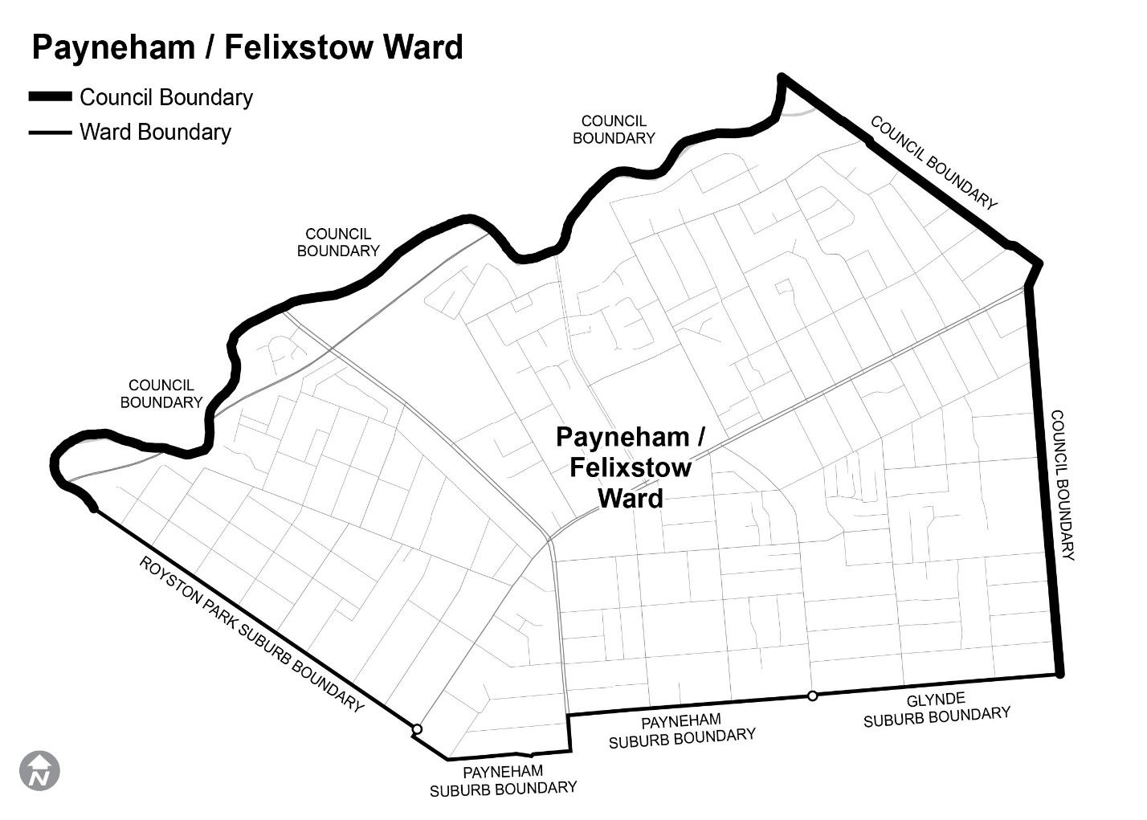
Comprising the suburbs of Marden, Felixstow, Royston Park, Payneham and Glynde.

Schedule 2
St Peters/Kent Town Ward
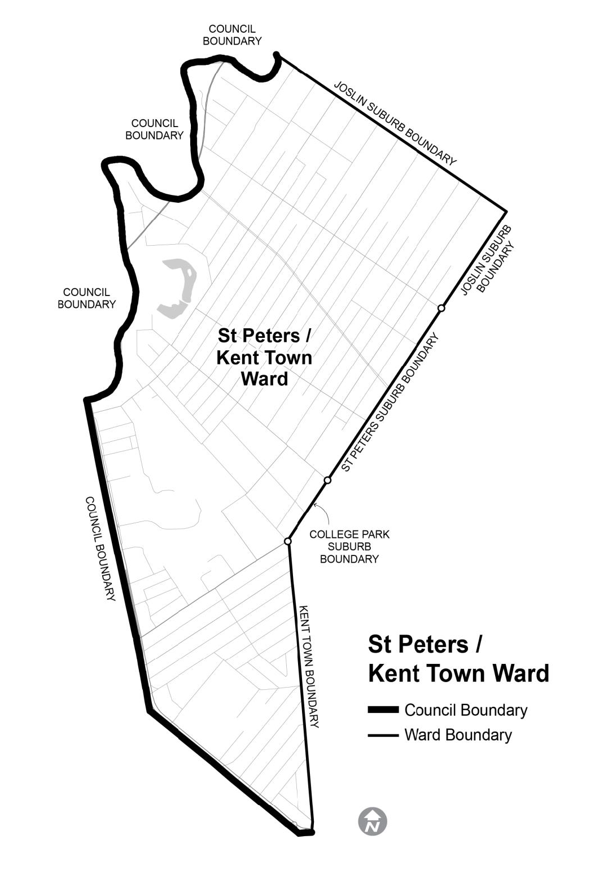
Comprising the suburbs of Joslin, St Peters, College Park, Hackney and Kent Town.

Schedule 3
Trinity/Maylands Ward
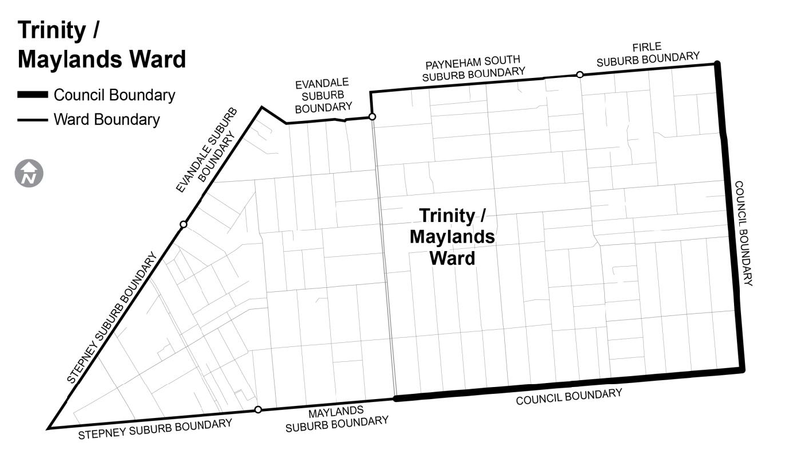
Comprising the suburbs of Firle, Payneham South, Evandale, Stepney, Maylands, Trinity Gardens and St Morris.

Schedule 4
Kensington/Norwood Ward
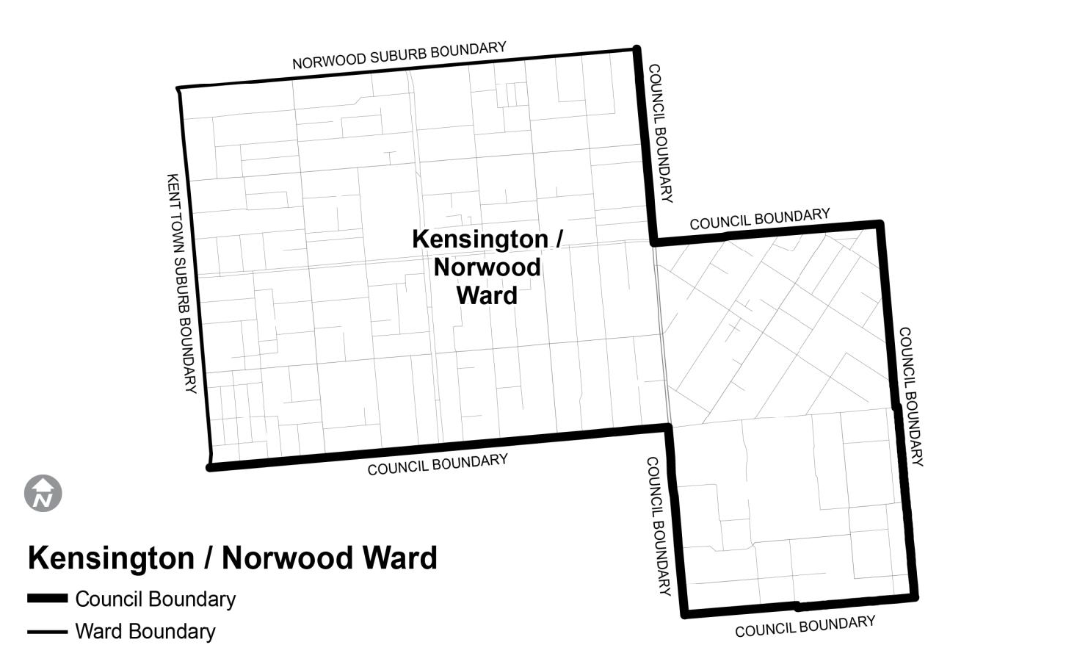
Comprising the suburbs of Norwood, Kensington, Marryatville and Heathpool.

Mount Barker District Council
Public Place Naming
Notice is hereby given, that in accordance with Section 219(1) of the Local Government Act 1999, Council, at its meeting held 7 October 2025, resolved to name the land within Certificate of Title Volume 6035 Folio 171, 84 Princes Highway Nairne to “Market Reserve”.
Dated: 30 October 2025
Andrew Stuart
Chief Executive Officer

Yorke Peninsula Council
Liquor Licensing Act 1977—Section 131(1ab)
Liquor Licensing (Dry Area) Notice 2025
1. Short title
This notice may be cited as the Liquor Licensing (Dry Area) Notice 2025.
2. Commencement
This notice comes into operation on 31 December 2025.
3. Interpretation
(1) Pursuant to Section 131 (1ab) of the Act, the Yorke Peninsula Council has declared that consumption and possession of liquor in the area described in the Schedule is prohibited in accordance with the provisions of the Schedule.
(2) The prohibition has effect during the periods specified in the Schedule.
(3) The prohibition does not extend to private land in the area described in the Schedule.
(4) Unless the contrary intention appears, the prohibition of the possession of liquor in the area does not extend to—
(a) A person who is genuinely passing through the area if:
(i) the liquor is in the original container in which it was purchased from licensed premises; and
(ii) the container has not been opened; or
(b) a person who has possession of the liquor in the course of carrying on a business or in the course of his or her employment by another person in the course of carrying on a business: or
(c) a person who is permanently or temporarily residing in premises within the area or on the boundary of the area and who enters the area solely for the purpose of passing through it to enter those premises or who enters the area from those premises for the purpose of leaving the area.
Schedule—Stansbury Area 1 and Area 2
1. Extent of prohibition
The consumption of liquor and the possession of liquor is prohibited.
2. Period of prohibition
From 10pm on 31 December 2025 to 8am on 1 January 2026.
3. Description of area.
The Area 1 in Stansbury is bounded as follows: commencing at the point at which the prolongation in a straight line of the south-eastern boundary of Stormbird Street intersects the low water mark on the western side of Gulf St. Vincent, then south-westerly along that prolongation to the southwestern boundary of Anzac Parade, then north-westerly along that boundary of Anzac Parade to the northern boundary of Towler Street, then westerly along that that boundary of Towler Street to the western boundary of Weaver Street, the northerly along that boundary of Weaver Street and the prolongation in a straight line of that boundary to the south-western boundary of Anzac Parade, then generally north-westerly and westerly along that boundary of Anzac Parade and the southern boundary of North Terrace to the western boundary of Parrington Street, then along the prolongation in a straight line of then western boundary of Parrington Street to the southern boundary of Dalrymple Terrace, the easterly along that boundary of Dalrymple Terrace to the western boundary of Adelaide Road, then in a straight line by the shortest route to the point at which the southern boundary of Bayview Road meets the eastern boundary of Adelaide Road, then generally easterly and north easterly along that boundary of Bayview Road to the point at which it meets the southern corner of Lot 17 DP 5864, then north-easterly and northerly along the western boundary of Lot 1 DP 37028 to the northern boundary of the Lot, then easterly along the northern boundary of Lot 1 and the prolongation in a straight line of the boundary to the low water mark on the western side of Gulf St. Vincent, then generally south-easterly along the low water mark to the northern side of Stansbury Jetty, then north-easterly south-easterly and southwesterly around the outer boundary of the jetty back to the low water mark on the southern side of the jetty (so as to include in the area the whole of the jetty and any area beneath the jetty), then southeasterly along the low water mark to the northern side of the breakwater that forms the northern wall of the enclosed boat launching facility immediately to the south-east of the jetty, then generally north-easterly, south-easterly and south-westerly around the outer boundary of the boat launching facility back to the low water mark on the shore on the southern side of the facility (so as to include in the area the whole of the facility, including the breakwaters and the area between them), then generally south-westerly and south-easterly along the low water mark on the point of commencement.
Area 2 will include the area bounded on the north by South Terrace, on the east by Weaver Street, on the south by Park Terrace and on the west by the prolongation in a straight line of the western boundary of Lot 692 FP 196114.

Dry Area Location—Area 1 and Area 2
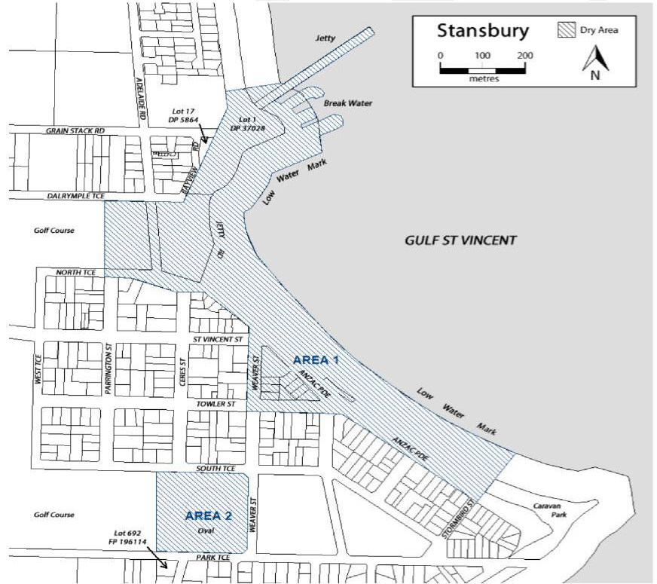
Dated: 30 October 2025
Andrew Cameron
Chief Executive Officer

Public Notices

Corporations Act 2001
Section 491(2)(b), Regulation 5.5.01
Associations Incorporations Act 1985
Pharmaceutical Society of Australia (South Australian Branch) Incorporated (ABN: 81 144 107 332)—In Voluntary Liquidation
Notice of Appointment as Liquidator—Special Resolution
Notice is hereby given that at an annual general meeting of the members of the Association held on 22 October 2025, it was resolved that the Association be wound up voluntarily and that Maris Andris Rudaks be appointed liquidator.
Dated: 23 October 2025
Maris Andris Rudaks
Liquidator, BRI Ferrier
Level 8, 50 Pirie Street, Adelaide SA 5000
Ph: (08) 8233 9900 | Email: info@brifsa.com.au

Corporations Act 2001
Section 491(2)(b), Regulation 5.6.48
Associations Incorporations Act 1985
Pharmaceutical Society of Australia (South Australian Branch) Incorporated (ABN: 81 144 107 332)—In Voluntary Liquidation
Notice Inviting Formal Proof of Debt or Claim
Take notice that the creditors of the Association, whose debts or claims have not already been admitted, are required on or before 5 December 2025 to prove their debts and claims and to establish any title they may have to a priority by delivering or posting to me at my address a formal proof of debt or claim in accordance with Form 535 or 536 containing their respective debts or claims. If they do not, they will be excluded from:
(a) The benefit of any distribution made before their debts or claims are proved or their priority is established; and
(b) Objecting to the distribution.
Form of proof may be obtained from:
Maris Andris Rudaks
Liquidator, BRI Ferrier
Level 8, 50 Pirie Street
Adelaide SA 5000
Ph: (08) 8233 9900
Email: info@brifsa.com.au
Dated: 23 October 2025
Maris Andris Rudaks
Liquidator, BRI Ferrier

National Energy Retail Law
Notice of Draft Determination and Draft Rule
The Australian Energy Market Commission (AEMC) gives notice under the National Energy Retail Law as follows:
Under s 256, the making of a draft determination and related draft rule on the Establishing a regulatory framework for retail customer initiated gas abolishment (Ref. RRC0068) proposal. Written requests for a pre-determination hearing must be received by 6 November 2025. Submissions must be received by 11 December 2025.
Submissions can be made via the AEMC’s website. Before making a submission, please review the AEMC’s privacy statement on its website, and consider the AEMC’s Tips for making a submission. The AEMC publishes submissions on its website, subject to confidentiality and other considerations.
Written requests should be sent to submissions@aemc.gov.au and cite the reference in the title. Before sending a request, please review the AEMC’s privacy statement on its website.
Documents referred to above are available on the AEMC’s website and are available for inspection at the AEMC’s office.
Australian Energy Market Commission
Level 15, 60 Castlereagh St
Sydney NSW 2000
Telephone: (02) 8296 7800
www.aemc.gov.au
Dated: 30 October 2025

National Gas Law
Notice of Final Determination and Final Rule
Notice of Draft Determination and Draft Rule
The Australian Energy Market Commission (AEMC) gives notice under the National Gas Law as follows:
Under ss 311, 312 and 313, the making of the National Gas Amendment (Extension of the DWGM Dandenong LNG interim arrangements) Rule 2025 No. 3 (Ref. GRC0078) and related final determination. Provisions commence as follows: Schedules 1, 3 and 4 commence on 30 October 2025 and Schedule 2 commences on 1 April 2026.
Under s 308, the making of a draft determination and related draft rule on the Establishing a regulatory framework for retail customer initiated gas abolishment (Ref. GRC0086) proposal. Written requests for a pre-determination hearing must be received by 6 November 2025. Submissions must be received by 11 December 2025.
Submissions can be made via the AEMC’s website. Before making a submission, please review the AEMC’s privacy statement on its website, and consider the AEMC’s Tips for making a submission. The AEMC publishes submissions on its website, subject to confidentiality and other considerations.
Written requests should be sent to submissions@aemc.gov.au.au and cite the reference in the title. Before sending a request, please review the AEMC’s privacy statement on its website.
Documents referred to above are available on the AEMC’s website and are available for inspection at the AEMC’s office.
Australian Energy Market Commission
Level 15, 60 Castlereagh St
Sydney NSW 2000
Telephone: (02) 8296 7800
www.aemc.gov.au
Dated: 30 October 2025

Trustee Act 1936
Public Trustee
Estates of Deceased Persons
In the matter of the estates of the undermentioned deceased persons:
BARTSCH Simon Nathanael late of 507B Anzac Highway Glenelg North Warehouse Operative who died 1 May 2025
BOSCO Domenic otherwise Dominic late of 22 Kylie Crescent Ingle Farm of no occupation who died 20 January 2025
CERNY Josef late of 14 Ryde Street Gawler West Retired Factory Worker who died 24 September 2024
COOPER Fern Kathleen late of 80 Nunyah Avenue Park Holme of no occupation who died 7 November 2024
DONALDSON Anthony James late of 30 Midlow Road Elizabeth Downs of no occupation who died 2 June 2024
EDDY Catherine Jane late of 39 Dudley Avenue Daw Park Retired Administrator who died 23 May 2025
HOLBROOK Dorothy Marian late of 53 Austral Terrace Morphettville Shorthand Typist who died 19 July 2024
MILDE Deidre late of 289 Esplanade Coffin Bay Retired Teacher who died 19 June 2025
ROBSON Janet Anne late of 82 Coventry Road Davoren Park Administration Clerk who died 20 July 2025
ROGERS David late of 6 Booth Avenue Linden Park Retired Accountant who died 9 April 2024
SCHULZ Pauline Helen late of 14-24 King William Road Wayville Retired Receptionist/Secretary who died 7 April 2024
THOMAS Susanne late of 26 Amberleigh Close Christie Downs Retired Cleaner who died 7 May 2025
USHER James Gordon late of 43 East Avenue Allenby Gardens Jack of all trades who died 8 July 2024
WATKINS Christopher Robin late of 13 Sutherland Street Glanville Retired Postal Worker who died on or about 2 September 2024
ZACHAT Steven late of 9 Kelvin Road Ingle Farm Labourer who died 23 December 2024
Notice is hereby given pursuant to the Trustee Act 1936 (SA), the Succession Act 2023 (SA) and the Family Relationships Act 1975 (SA) that all creditors, beneficiaries, and other persons having claims against the said estates are required to send, in writing, to the office of Public Trustee at GPO Box 1338, Adelaide 5001, full particulars and proof of such claims, on or before the 28 November 2025 otherwise they will be excluded from the distribution of the said estate; and notice is also hereby given that all persons indebted to the said estates are required to pay the amount of their debts to the Public Trustee or proceedings will be taken for the recovery thereof; and all persons having any property belonging to the said estates are forthwith to deliver same to the Public Trustee.
Dated: 30 October 2025
T. Brumfield
Public Trustee

Notice Submission

The South Australian Government Gazette is published each Thursday afternoon.
Notices must be emailed by 4 p.m. Tuesday, the week of publication.
Submissions are formatted per the gazette style and a proof will be supplied prior to publication, along with a quote if applicable. Please allow one day for processing notices.
Alterations to the proof must be returned by 4 p.m. Wednesday.

Gazette notices must be submitted as Word files, in the following format:
• Title—the governing legislation
• Subtitle—a summary of the notice content
• Body—structured text, which can include numbered lists, tables, and images
• Date—day, month, and year of authorisation
• Signature block—name, role, and department/organisation authorising the notice

Please provide the following information in your email:
• Date of intended publication
• Contact details of the person responsible for the notice content
• Name and organisation to be charged for the publication—Local Council and Public notices only
• Purchase order, if required—Local Council and Public notices only

Email: governmentgazettesa@sa.gov.au
Phone: (08) 7133 3552
Website: www.governmentgazette.sa.gov.au

All instruments appearing in this gazette are to be considered official, and obeyed as such

Printed and published weekly by authority of T. Foresto, Government Printer, South Australia
$9.50 per issue (plus postage), $479.00 per annual subscription—GST inclusive
Online publications: www.governmentgazette.sa.gov.au

