
No. 55 p. 3927
THE SOUTH AUSTRALIAN
GOVERNMENT GAZETTE
Published by Authority

Adelaide, Thursday, 25 September 2025

Contents

Governor’s Instruments
Acts 3928
Appointments, Resignations and General Matters 3928
Notices—
Trans-Tasman Mutual Recognition (Tobacco and Other Products) Notice 2025 3930
Regulations—
Planning, Development and Infrastructure (General)
(Co-located Housing and Schedule 6) Amendment Regulations 2025—No. 105 of 2025 3935
Rules
Uniform Civil (No 15) Amending Rules 2025 3938
State Government Instruments
Dog Fence Act 1946 3942
Electoral Act 1985 3943
Essential Services Commission Act 2002 3943
Fisheries Management Act 2007 3943
Housing Improvement Act 2016 3945
Hydrogen and Renewable Energy Act 2023 3945
Justices of the Peace Act 2005 3945
Land Acquisition Act 1969 3946
Major Events Act 2013—Republished 3956
Major Events Act 2013 3958
Planning, Development and Infrastructure Act 2016 3964
South Australian Skills Act 2008 3965
Local Government Instruments
City of Onkaparinga 3967
City of Port Lincoln 3967
District Council of Franklin Harbour 3968
District Council of Orroroo Carrieton 3968
Public Notices
National Electricity Law 3969
National Energy Retail Law 3969
National Gas Law 3969

Governor’s Instruments

Acts
Department of the Premier and Cabinet
Adelaide, 25 September 2025
Her Excellency the Governor directs it to be notified for general information that she has in the name and on behalf of His Majesty The King, this day assented to the undermentioned Bill passed by the Legislative Council and House of Assembly in Parliament assembled, viz.:
No. 40 of 2025—Summary Offences (Prohibition of Publication of Certain Material) Amendment Bill 2025
An Act to amend the Summary Offences Act 1953
By command,
Kyam Joseph Maher, MLC
For Premier

Appointments, Resignations and General Matters
Department of the Premier and Cabinet
Adelaide, 25 September 2025
Her Excellency the Governor in Executive Council has been pleased to appoint the undermentioned to the Art Gallery Board, pursuant to the provisions of the Art Gallery Act 1939:
Member: from 2 October 2025 until 1 October 2028
Adrian Gary Tisato
By command,
Kyam Joseph Maher, MLC
For Premier
25ART0013CS

Department of the Premier and Cabinet
Adelaide, 25 September 2025
Her Excellency the Governor in Executive Council has been pleased to appoint the undermentioned to the Architectural Practice Board of South Australia, pursuant to the provisions of the Architectural Practice Act 2009:
Member: from 5 April 2026 until 4 October 2026
Dario Salvatore
By command,
Kyam Joseph Maher, MLC
For Premier
25MPCS07187

Department of the Premier and Cabinet
Adelaide, 25 September 2025
Her Excellency the Governor in Executive Council has been pleased to appoint the undermentioned to the South Australian Forestry Corporation Board, pursuant to the provisions of the South Australian Forestry Corporation Act 2000:
Director: from 1 October 2025 until 30 September 2028
Alaric Ross Sinclair
Hayley Barelds Neumann
Director: from 1 October 2025 until 30 September 2026
June Ruby Roache
Chair: from 1 October 2025 until 30 September 2028
Alaric Ross Sinclair
By command,
Kyam Joseph Maher, MLC
For Premier
MPRIDF2025/000133

Department of the Premier and Cabinet
Adelaide, 25 September 2025
Her Excellency the Governor in Executive Council has been pleased to appoint the undermentioned to the Adelaide Festival Corporation Board, pursuant to the provisions of the Adelaide Festival Corporation Act 1998:
Member: from 25 September 2025 until 24 September 2028
Daniela Ritorto
Anthony Richard Berg
By command,
Kyam Joseph Maher, MLC
For Premier
25ART0012CS

Department of the Premier and Cabinet
Adelaide, 25 September 2025
Her Excellency the Governor in Executive Council has been pleased to appoint the undermentioned to the State Theatre Company of South Australia Board, pursuant to the provisions of the State Theatre Company of South Australia Act 1972:
Member: from 25 September 2025 until 11 September 2028
Joseph Eliott Thorp
Presiding Member: from 25 September 2025 until 11 September 2028
Joseph Eliott Thorp
Member: from 27 October 2025 until 26 October 2028
Judith Thora Carmel Henshall
By command,
Kyam Joseph Maher, MLC
For Premier
25ART0015CS

Department of the Premier and Cabinet
Adelaide, 25 September 2025
Her Excellency the Governor in Executive Council has been pleased to appoint the Honourable Kyam Joseph Maher MLC as Acting Minister for Education, Training and Skills and Acting Minister for Police from 27 September 2025 until 11 October 2025 inclusive, during the absence of the Honourable Blair Ingram Boyer MP.
By command,
Kyam Joseph Maher, MLC
For Premier
ME25/081

Department of the Premier and Cabinet
Adelaide, 25 September 2025
Her Excellency the Governor in Executive Council has been pleased to appoint Sarah Rachel Fletcher and Rita Fitton as Commissioners of the South Australian Employment Tribunal, on a sessional basis, for a term of five years commencing on 25 September 2025 and expiring on 24 September 2030, pursuant to the South Australian Employment Tribunal Act 2014.
By command,
Kyam Joseph Maher, MLC
For Premier
AGO0172-25CS

Department of the Premier and Cabinet
Adelaide, 25 September 2025
Her Excellency the Governor in Executive Council has been pleased to appoint the Honourable Michael David as the Parole Administrative Review Commissioner for a term of two months commencing on 1 October 2025 and expiring on 30 November 2025, pursuant to section 77B of the Correctional Services Act 1982.
By command,
Kyam Joseph Maher, MLC
For Premier
25MCS0006CS

Department of the Premier and Cabinet
Adelaide, 25 September 2025
Her Excellency the Governor in Executive Council has been pleased to appoint Sonya Marie Beyers as a member and the presiding member of the Veterinary Surgeons Board of South Australia for a term of three years commencing on 1 January 2026 and expiring on 31 December 2028, pursuant to the provisions of the Veterinary Practice Act 2003.
By command,
Kyam Joseph Maher, MLC
For Premier
MPIRDF2025/000124

Department of the Premier and Cabinet
Adelaide, 25 September 2025
Her Excellency the Governor in Executive Council has been pleased to appoint Krysteen Helen McElroy as a member of the Veterinary Surgeons Board of South Australia commencing on 1 October 2025 and expiring on 30 June 2028, pursuant to the provisions of the Veterinary Practice Act 2003.
By command,
Kyam Joseph Maher, MLC
For Premier
MPIRDF2025/000124

Notices
South Australia

Trans-Tasman Mutual Recognition (Tobacco and Other Products) Notice 2025
under section 43 of the Trans-Tasman Mutual Recognition Act 1997 of the Commonwealth as adopted by section 4 of the Trans-Tasman Mutual Recognition (South Australia) Act 1999
1—Short title
This notice may be cited as the Trans-Tasman Mutual Recognition (Tobacco and Other Products) Notice 2025.
2—Commencement
This notice comes into operation on the day on which it is made.
3—Endorsement of regulations
The proposed regulations set out in Schedule 1 are endorsed for the purposes of section 47 of the Trans-Tasman Mutual Recognition Act 1997 of the Commonwealth.

Schedule 1—Proposed regulations
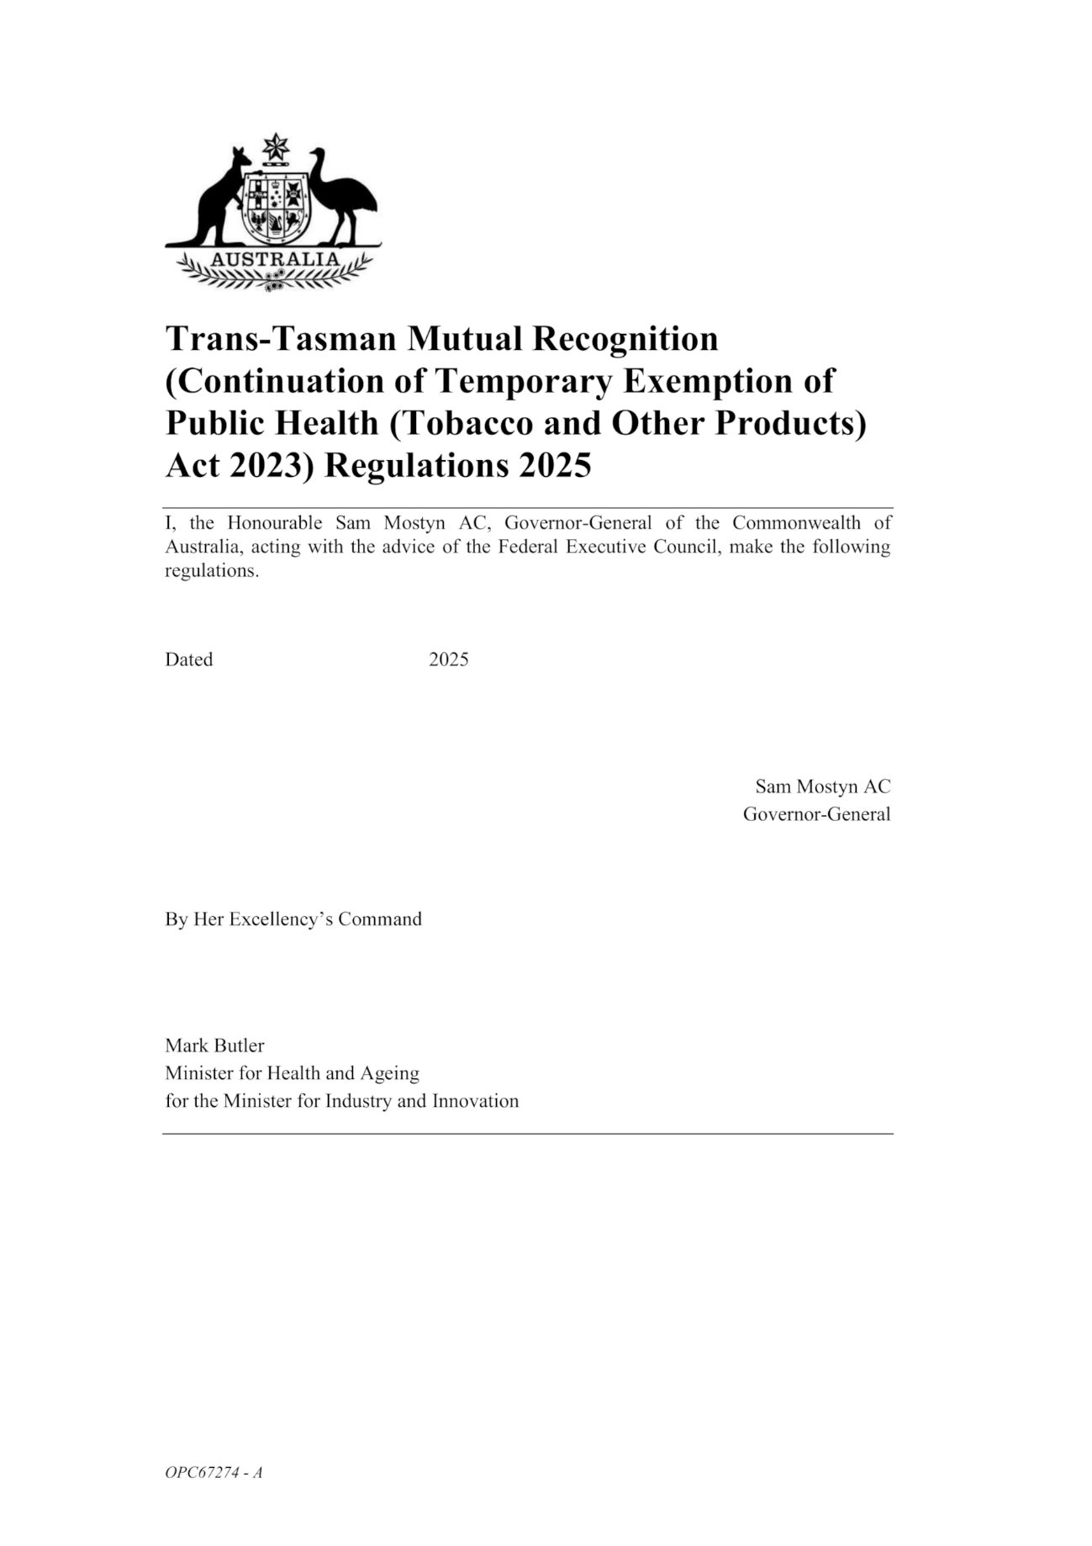

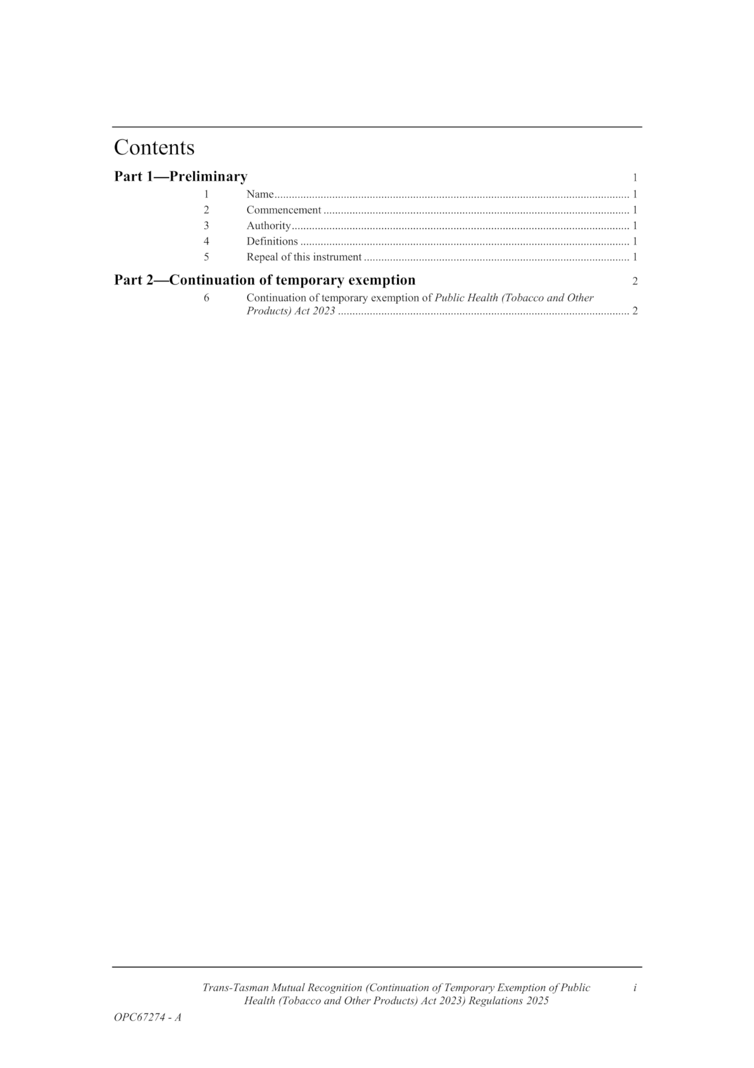

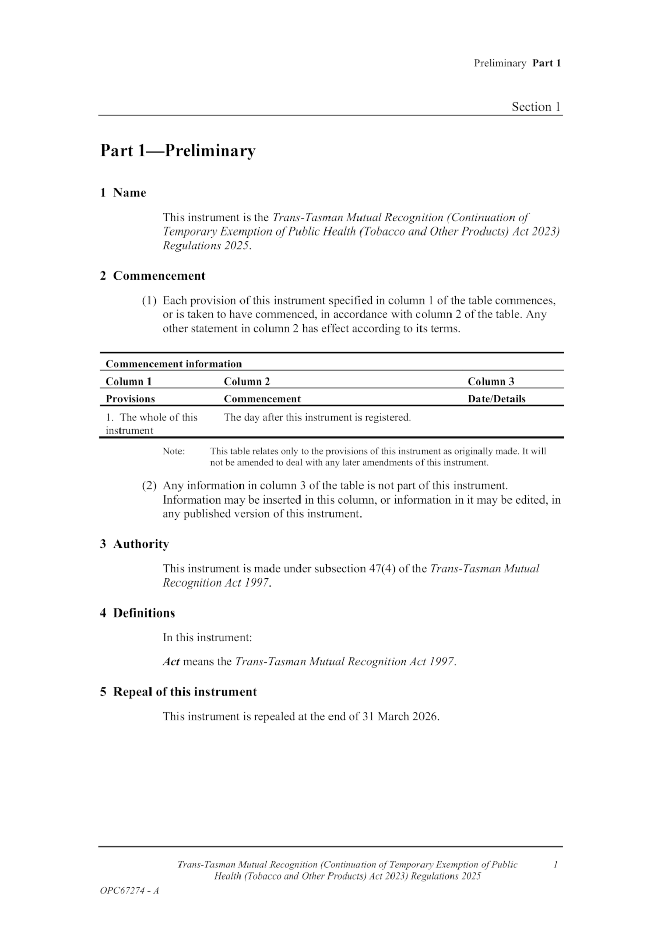

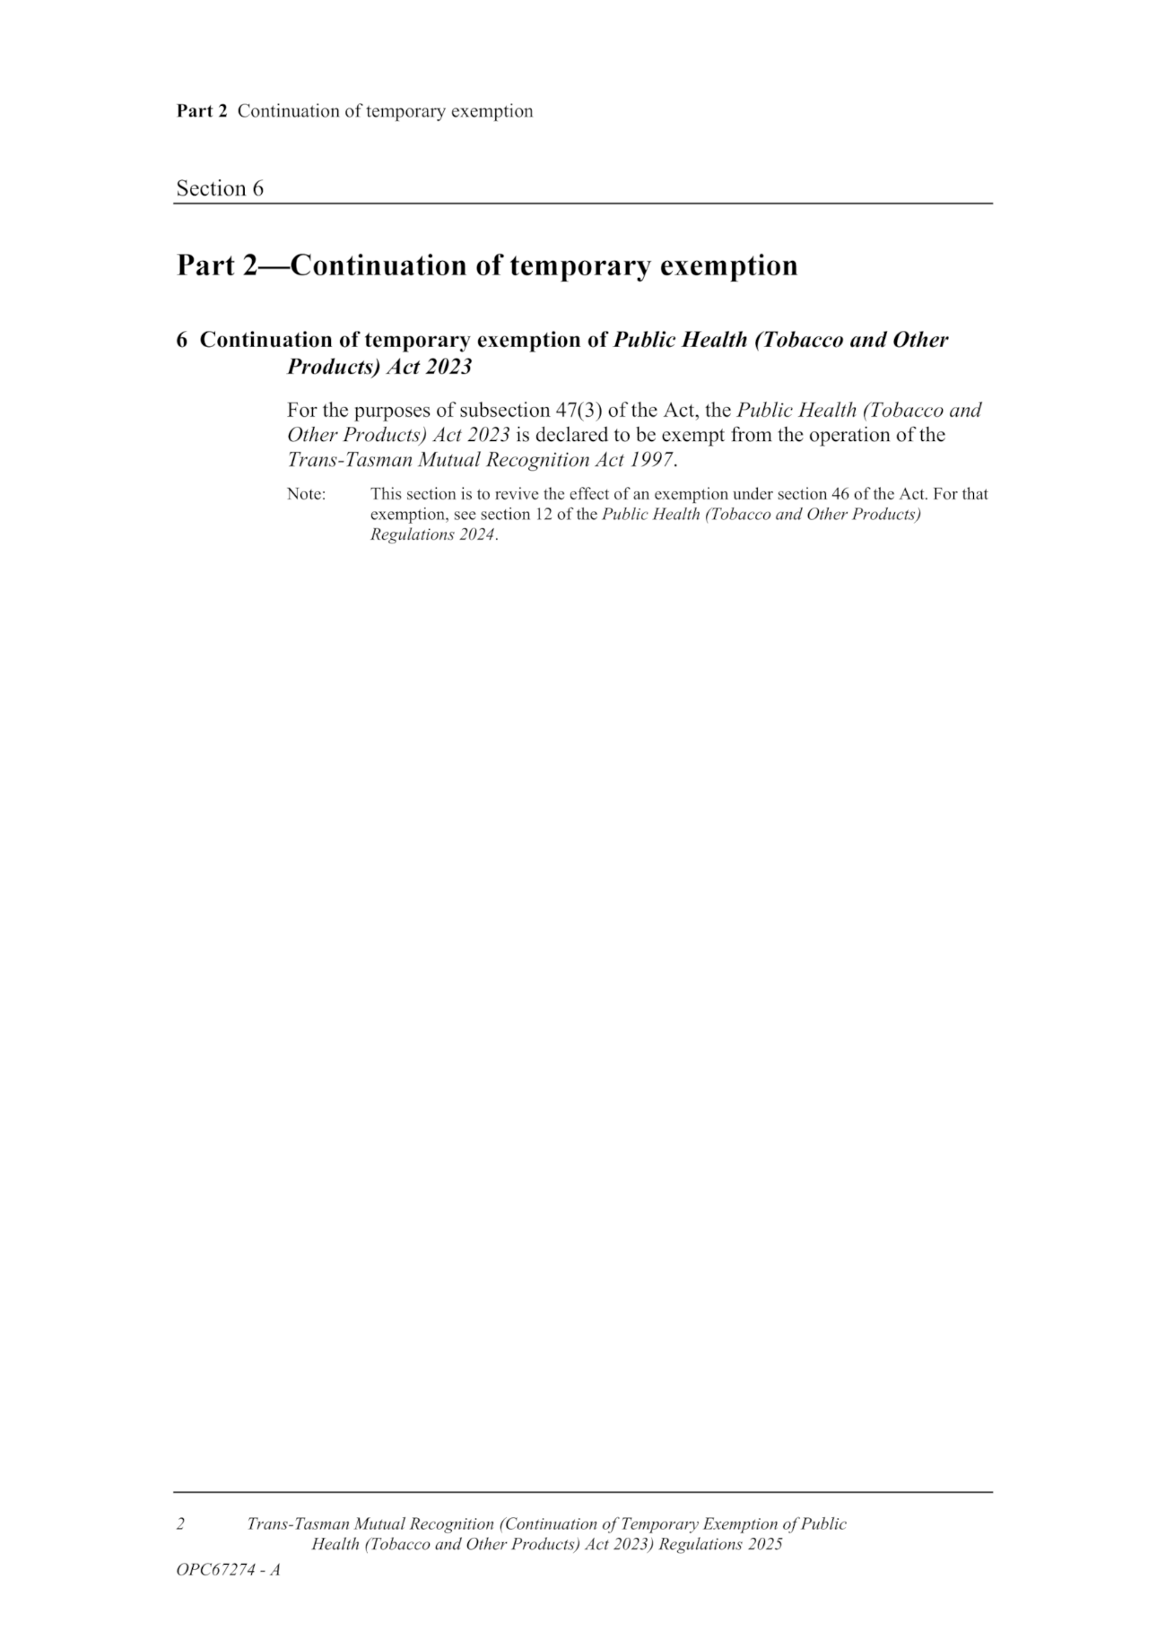
Made by the Governor
with the advice and consent of the Executive Council
on 25 September 2025

Regulations
South Australia

Planning, Development and Infrastructure (General) (Co-located Housing and Schedule 6) Amendment Regulations 2025
under the Planning, Development and Infrastructure Act 2016

Contents
Part 1—Preliminary
1 Short title
2 Commencement
Part 2—Amendment of Planning, Development and Infrastructure (General) Regulations 2017
3 Amendment of regulation 3—Interpretation
4 Amendment of Schedule 4—Exclusions from definition of development—general
5 Amendment of Schedule 6—Relevant authority—Commission
6 Amendment of Schedule 8—Plans
2AA Plans for applications seeking planning consent for co-located housing

Part 1—Preliminary
1—Short title
These regulations may be cited as the Planning, Development and Infrastructure (General) (Co-located Housing and Schedule 6) Amendment Regulations 2025.
2—Commencement
These regulations come into operation on the day on which they are made.
Part 2—Amendment of Planning, Development and Infrastructure (General) Regulations 2017
3—Amendment of regulation 3—Interpretation
Regulation 3(1)—after the definition of coastal land insert:
co-located housing has the same meaning as in the Planning and Design Code;
4—Amendment of Schedule 4—Exclusions from definition of development—general
Schedule 4, clause 4(1)(d)—after subparagraph (iia) insert:
(iib) a fence on land used, or to be used, for co-located housing (the relevant land), other than a fence situated on the boundary of the relevant land and some other land; or

5—Amendment of Schedule 6—Relevant authority—Commission
(1) Schedule 6, clause 4, heading—delete "Metropolitan area—buildings" and substitute:
Buildings
(2) Schedule 6, clause 4(1)—delete "in Metropolitan Adelaide"
6—Amendment of Schedule 8—Plans
Schedule 8—after clause 2 insert:
2AA—Plans for applications seeking planning consent for co-located housing
(1) An application seeking planning consent for a co-located housing development must be accompanied by—
(a) a site plan, drawn to scale, including appropriate bar and ratio scales, showing—
(i) the footprints of the dwellings on the site and those of any dwellings on immediately adjoining land that is not part of the co-located housing; and
(ii) the location of any common outdoor areas, private outdoor areas, shared car parking spaces, rubbish bin storage, washing lines or other shared facilities; and
(iii) if any existing buildings or structures are to be removed or demolished to accommodate the proposed development—the current location of those buildings or structures; and
(b) a community scheme description in relation to the proposed co-located housing contemplated by the co-located housing development, which must include the following information:
(i) the name of the co-located housing;
(ii) an identification of the proposed community parcel and the lots and common property into which the parcel is to be divided under the Community Titles Act 1996;
(iii) a description of the purpose or purposes for which the lots and common property may be used;
(iv) the standard of buildings and other improvements (if any) to be, or which may be, erected on or made to the lots or common property, and the time expected for their completion;
(v) a description of the nature and scope of any improvements to be made to the community lots and common property;
(vi) any other important features of the scheme; and

(c) a floor plan drawn to scale of all dwellings that form part of the co-located housing contemplated by the co-located housing development, showing the location or proposed location of fixed and loose furniture.
(2) In this clause—
co-located housing development means a change in use of land, division of land, or any building work to alter or construct dwellings on that land, for the purposes of creating co-located housing;
community scheme description means a description of the co-located housing and the proposed division of land in a form approved by the Minister and published on the SA planning portal.
Editorial note—
As required by section 10AA(2) of the Legislative Instruments Act 1978, the Minister has certified that, in the Minister's opinion, it is necessary or appropriate that these regulations come into operation as set out in these regulations.
Made by the Governor
with the advice and consent of the Executive Council
on 25 September 2025
No 105 of 2025

Rules
Supreme Court Act 1935
District Court Act 1991
Magistrates Court Act 1991
Youth Court Act 1993
Environment, Resources and Development Court Act 1993
Local Government (Elections) Act 1999
First Nations Voice Act 2023
South Australia

Uniform Civil (No 15) Amending Rules 2025
By virtue and in pursuance of the Supreme Court Act 1935, the District Court Act 1991, the Magistrates Court Act 1991, the Youth Court Act 1993, the Environment, Resources and Development Court Act 1993, the Local Government (Elections) Act 1999, the First Nations Voice Act 2023 and all other enabling powers, we, the Chief Justice of the Supreme Court, the Chief Judge of the District Court (in respect of the District Court and the Court of Disputed Returns), the Chief Magistrate of the Magistrates Court, the Judge of the Youth Court, and the Senior Judge of the Environment, Resources and Development Court, make the following Uniform Civil (No 15) Amending Rules 2025.
1. These Rules may be cited as the Uniform Civil (No 15) Amending Rules 2025.
2. The Uniform Civil Rules 2020 (“the Rules”) are amended as set out below.
3. The amendments made by these rules come into effect on the later of—
(a) 1 October 2025; or
(b) the date of their publication in the Gazette.
4. Rule 25.2(1) is amended by inserting a new note immediately below the words, “Form 23 Notice of Acting” in the following terms:
Note—
A lawyer who appears or provides legal assistance for a limited purpose on behalf of a pro bono or not for profit law firm or a publicly funded Legal Assistance Service is not regarded, for the purpose of this rule, as being retained to act for a party in the proceeding and is not required to file a notice of acting.
5. Rule 25.2(3) is amended by inserting a new note immediately below the words, “Form 23 Notice of Cessation of Acting” in the following terms:
Note—
A lawyer who appears or provides legal assistance for a limited purpose on behalf of a pro bono or not for profit law firm or a publicly funded Legal Assistance Service is not regarded, for the purpose of this rule, as being retained to act for a party in the proceeding and is not required to file a notice of cessation of acting.
6. Subrule 31.7(2) is amended by replacing the words “court access” with the word “restricted” and by replacing the words “as defined in” with “in accordance with”.
7. Subrule 32.2(2) is amended by replacing the words “Subject to section 131 of the Supreme Court Act 1935, a” with “A”.
8. Subrule 32.2(2)(a) is amended by substituting a comma for the word “and” immediately after the words “judicial officers” and inserting the words “and registry staff” after the words “chambers staff”.
9. The note to subrule 32.2(2)(b) is deleted.
10. Subrule 32.2(3) is deleted and replaced with:
(3) Subject to:
(a) section 131 of the Supreme Court Act 1935;
(b) section 54 of the District Court Act 1991;
(c) section 51 of the Magistrates Court Act 1991; or
(d) section 47 of the Environment, Resources and Development Court Act 1993,
as the case may be, the Court may order that a document to be filed, be filed, or if already filed, be treated as filed, on a restricted access basis.
Note—
Section 131(1) of the Supreme Court Act 1935 provides for access to certain court records by members of the public. Section 131(2) of the Supreme Court Act 1935 provides for inspection of certain material including sensitive material in the custody of the Court only with the permission of the Court.
Section 54(1) of the District Court Act 1991 provides for access to certain court records by members of the public. Section 54(2) of the District Court Act 1991 provides for inspection of certain material including sensitive material in the custody of the Court only with the permission of the Court.
Section 51(1) of the Magistrates Court Act 1991 provides for access to certain court records by members of the public. Section 51(2) of the Magistrates Court Act 1991 provides for inspection of certain material including sensitive material in the custody of the Court only with the permission of the Court.
Section 47(1) of the Environment, Resources and Development Court Act 1993 provides for access to certain court records by members of the public. Section 47(2) provides for inspection of certain material only with the permission of the Court.
11. Subrule 61.8(1) is amended by inserting a new subrule 61.8(1)(da) immediately after subrule 61.8(1)(d) as follows:
(da) the action is to enforce a monetary order made by the South Australian Employment Tribunal sitting as the Industrial Relations Commission under section 86(1a) of the South Australian Employment Tribunal Act 2014;
12. Subrule 61.13(4) is amended by replacing the words “an excluded access basis” with the words “a restricted basis in accordance with rule 32.2”.

13. Rule 64.2 is deleted.
14. Rule 64.3 is deleted and replaced with:
64.3—Dismissal of action by the Registrar
(1) If, within 5 months of filing a claim:
(i) no respondent or interested party has filed a defence;
(ii) the applicant has not applied for default judgment;
(iii) neither party has applied to place the claim under a moratorium; and
(iv) the court has not ordered an extension of time for service of the claim or the filing of a defence,
the Registrar is to notify the applicant at their address for service that the claim will be dismissed at the expiration of four months from the date of the notice if no action is taken.
(2) At the expiration of 4 months from the date of any notice served on an applicant in accordance with rule 64.3(2), the Registrar is to dismiss the claim if no action has been taken by any party.
15. Rule 64.5 is amended by inserting, immediately after subrule 64.5(4) a new subrule 64.5(5) as follows:
(5) Once a claim is placed under a moratorium, the moratorium operates with respect to the entire claim and all parties.
16. Subrule 116.1(1) is amended by replacing “subrule (2)” with “subrule (3)”.
17. Subrule 134.4(2) is amended by replacing the words “court access” with the word “restricted” and by replacing the words “as defined in” with “in accordance with”.
18. Subrule 172.2(2) is amended by removing the word “a” between the words “witness” and “is”.
19. Chapter 14 Part 5 is deleted.
20. Subrule 203.2(4) is amended by replacing the word “issued” with the word “executed”.
21. Subrule 203.12(2) is amended by deleting the words “and the conditions in rule 201.6(1) are satisfied”.
22. Subrule 203.12 (3) is deleted.
23. Subrule 203.12(4) is renumbered subrule 203.12(3).
24. Subrule 240.1(3) is amended by deleting the word “Commissioner” in the title to Form 6A and replacing it with “Commission”.
25. Subrule 243.1(1) is amended by inserting, immediately below the subrule, the words:
Prescribed form—
Form 7 Originating Application Ex Parte
26. Part 15 of Chapter 9 is amended by inserting, immediately after rule 245.10, the following:
“Division 6A—Industrial Relations Commission order—District Court and Magistrates Court
245.10A—Claim
A claim under Section 86(1a) of the South Australian Employment Tribunal Act 2014 to enforce a monetary order by the South Australian Employment Tribunal sitting as the Industrial Relations Commission must be instituted as a claim in accordance with rule 63.1.
Division 6B—South Australian Employment Court monetary order—District Court and Magistrates Court
245.10B—Application for registration
(1) An application for the registration of an order of the South Australian Employment Court made pursuant to section 86(1) of the South Australian Employment Tribunal Act 2014 is to be instituted by filing an originating application in accordance with rule 82.1 in the prescribed form which may, but need not, be supported by an affidavit in accordance with rule 82.1(2).
Prescribed form—
Form 2R Originating Application – Register Judgment generic
(2) The applicant’s solicitor, or if self-represented, the applicant, must certify that the order of the South Australian Employment Court is enforceable and not subject to a stay of execution.
(3) The application must be accompanied by a sealed copy of the order of the South Australian Employment Court.
(4) The application may be made without notice.”
27. Subrule 253.1(4) is amended by replacing the words “court access” with the word “restricted” and by replacing the words “as defined in” with “in accordance with”.
28. Rule 263.6 is amended by:
(a) Replacing the words, “Family Court of Australia” with the words, “Federal Circuit and Family Court of Australia (Division 1)” wherever appearing;
(b) Replacing the words, “Federal Circuit Court” with the words, “Federal Circuit and Family Court of Australia (Division 2)” wherever appearing; and
(c) Replacing the words, “Administrative Appeals Tribunal” with the words, “Administrative Review Tribunal” wherever appearing.
29. Rule 297.1 is amended by replacing “61.3” with “63.1”.
30. Subrule 332.2(3)(a)(iv) is amended by deleting the word “Commissioner” and replacing it with “Commission”.
31. Subrule 332.2(3) is amended by inserting a new subrule 332.2(3)(da) immediately after subrule 332.2(3)(d) as follows:
“(da) the proceeding is to enforce a monetary order made by the South Australian Employment Tribunal sitting as the Industrial Relations Commission under section 86(1a) of the South Australian Employment Tribunal Act 2014;”
32. Subrule 7(4) of Schedule 6 Part 4 is amended by deleting the table following the words, “in the following table”, and replacing it with:

Minor Civil costs scale
Item | Description | Amount
1 | Filing a claim, originating application, defence or response (solicitor and counsel), including:  (a) supporting affidavit or opposing affidavit; and  (b) attending the first directions hearing or hearing (as applicable). | $20 plus 5% of quantum (up to a maximum of $500).
2 | Having a lawyer prepare and file personal injury particulars. | 2% of quantum.
3 | Where a matter is defended and a Magistrate orders that the complexity of the action justifies legal advice in the pre-trial processes. | 5% of quantum.
4 | When permitted by the Court in accordance with section 38(5) of the Magistrates Court Act 1991, any and all activity after the first directions hearing or hearing by solicitor and counsel until:  (a) if the action is to proceed to trial—the last hearing before trial, whether a directions hearing, hearing or pre-trial conference; or  (b) the final determination of an originating application:  (i) when determined at a hearing; and  (ii) when the action is not listed for trial. | 14% of quantum.
5 | Any attendance at Court by party or lawyer (when lawyer is entitled to attend). | 0.5% of quantum.
6 | Filing and serving a subpoena. | $55.
7 | When permitted by the Court in accordance with section 38(5) of the Magistrates Court Act 1991, preparation of a trial plan. | 3% of quantum.
8 | Notice of Demand and registration of Lien under the  Worker’s Liens Act 1893. | Either:  (a) for claims of $1 up to and including $10,000—$280; or  (b) for claims above $10,000—$500.
9 | Notice of withdrawal or satisfaction of Lien and registration. | Either:  (a) for claims of $1 up to and including $10,000—$110; or  (b) for claims above $10,000—$160.
Enforcement
10 | Request for Investigation or Examination summons including attendance at the hearing. | (a) $55.
11 | Any other request for enforcement of judgment. | (a) $55.
12 | Preparing and registering a warrant of sale against real property. | Either:  (a) for claims of $1 up to and including $10,000—$160; or  (b) for claims above $10,000–$190.
13 | Discharging a warrant of sale. | Either:  (a) for claims of $1 up to and including $10,000—$110; or  (b) for claims above $10,000—$160.

Minor Civil costs scale
Item |  | Description |  | Amount
14 |  | Applying for and obtaining a charging order over real property and registering it. |  | Either:  (a) for claims of $1 up to and including $10,000—$240; or  (b) for claims above $10,000—$500.
15 |  | Discharging a charging order at the Lands Titles Office. |  | Either:  (a) for claims of $1 up to and including $10,000—$110; or  (b) for claims above $10,000—$160.
Disbursements
16 |  | Service of originating process. |  | Either:  (a) personal service on an individual—$110; or  (b) other—$55.
17 |  | Witness fees generally. |  | $90—per day.
18 |  | Professional witness. |  | $560—per day.
19 |  | All other Court fees. |  | As allowed by the Court.
20 |  | Other disbursements. |  | As allowed by the Court.
Other items where counsel are permitted
21 | To advise on compromise or settlement when court approval required. |  | Either:  (a) when only the amount is in dispute—$1,110; or  (b) when liability and amount are in dispute—$1,670.
22 | When permitted by the Court in accordance with section 38(5) of the Magistrates Court Act 1991, attendance of counsel at trial, including a fee on brief. |  | The following applies:  (a) the first day—the greater of the following:  (i) $1,480; or  (ii) 4% of quantum; or  (b) Subsequent days—the greater of the following:  (i) $1,110; or  (ii) 3% of quantum.
33. The index to Schedule 7 is amended by replacing the word “Commissioner” with the word “Commission” in Form 6A.
34. Form 145 is amended by inserting a new row “4. Phone number”, between “3. Current occupation” and “4. Previous Occupations”, and adjusting the row numbering accordingly.
35. In accordance with the Supreme Court Act 1935, the District Court Act 1991, the Magistrates Court Act 1991, the Environment, Resources and Development Court Act 1993 and the Youth Court Act 1993 and all other enabling powers, the Uniform Civil (No 15) Amending Rules 2025 have been made—
• as rules of the Supreme Court by 3 or more Judges of the Supreme Court; and
• as rules of the District Court by the Chief Judge and 2 or more other Judges of that Court; and
• as rules of the Magistrates Court by the Chief Magistrate and 2 or more other Magistrates; and
• as rules of the Environment, Resources and Development Court by the Senior Judge and one other Judge; and
• as rules of the Youth Court by the Judge and the Magistrates who are members of the principal judiciary of that Court,
and such rules will apply to and in relation to the Court in accordance with their terms.
Dated this 22nd day of September 2025.
Acting Chief Justice Livesey
Acting Chief Judge Davison
Acting Chief Magistrate Duncan
Judge Durrant
Judge Sutcliffe

State Government Instruments

Dog Fence Act 1946
Declaration of Ratable Land
Pursuant to Section 25(1) of the Dog Fence Act 1946, the Dog Fence Board hereby declares that, for the financial year ending 30 June 2026, any land holding of more than 10 square kilometres situated within the declared rateable area inside the Dog Fence is ratable land.
This declaration does not apply to Lake Torrens National Park or Lake Gairdner National Park.
Dated: 25 September 2025
Geoff Power
Chair, Dog Fence Board

Dog Fence Act 1946
Declaration of Rate
Pursuant to Section 25(2) of the Dog Fence Act 1946, the Dog Fence Board, with the approval of the Minister for Primary Industries and Regional Development, hereby declares, for the financial year ending 30 June 2026, the following rates on rateable land and minimum amounts payable by way of rates, namely:
Rates
1. No rate shall apply to any portion of a land holding situated inside the Counties or Hundreds identified in Column A of Table 1.
2. A rate of $1.70 per square kilometre shall apply to any portion of a land holding situated inside the Hundreds identified in Column B of Table 1.
Minimum Amount Payable
3. No minimum amount is payable by way of rates for any land holding that falls entirely within the Counties or Hundreds identified in Column A of Table 1.
4. A minimum amount of $245 is payable by way of rates for any land holding that falls entirely within the Hundreds identified in Column B of Table 1.
Table 1
Column A | Column B
The whole of the Counties of:  Adelaide, Albert, Alfred, Buccleuch, Buckingham, Cardwell, Carnarvon, Chandos, Daly, Fergusson, Flinders, Gawler, Grey, Hindmarsh, MacDonnell, Musgrave, Robe, Russell and Sturt.  The whole of the Hundreds of:  Andrews, Anna, Appila, Bagot, Baroota, Belvidere, Blyth, Booleroo, Boonerdo, Boothby, Booyoolie, Boucaut, Brooker, Bundaleer, Butler, Campoona, Caralue, Clare, Cocata, Cootra, Crystal Brook, Darke, Darling, Dixson, Downer, Dutton, Everard, Fisher, Gilbert, Goyder, Hall, Hambidge, Hanson, Hart, Hawker, Hincks, Howe, Jellicoe, Kappakoola, Kapunda, Koolunga, Light, Mann, Milne, Moody, Moorooroo, Murlong, Napperby, Narridy, Nicholls, Nuriootpa, OH (Kimba), Palkagee, Pascoe, Pirie, Playford, Roberts, Rudall, Saddleworth, Skurray, Smeaton, Stanley, Stow, Telowie, Tooligie, Upper Wakefield, Verran, Wandearah, Warramboo, Wilton, Wongyarra, Yackamoorundie, Yadnarie and Yangya. | The whole of the Hundreds of:  Adams, Addison, Anne, Apoinga, Arkaba, Ash, Ayers, Bagster, Baldina, Barna, Barndioota, Bartlett, Batchelor, Beatty, Belalie, Bendleby, Bice, Black Rock Plain, Blacker, Bockelberg, Bonython, Boolcunda, Bower, Bright, Brownlow, Buckleboo, Bundey, Bunyeroo, Burgoyne, Caldwell, Caltowie, Campbell, Carawa, Carina, Carr, Castine, Catt, Cavenagh, Chandada, Charleston, Chillundie, Coglin, Cohen, Condada, Coomooroo, Coonatto, Copley, Corrobinnie, Cortlinye, Cotabena, Crozier, Cudlamudla, Cultana, Cungena, Cunyarie, Davenport, Eba, Edeowie, English, Erskine, Eurelia, Eurilpa, Finlayson, Forrest, French, Giles, Gillen, Glynn, Goode, Gregory, Gumbowie, Guthrie, Hague, Hallett, Handyside, Hardy, Haslam, Hay, Heggaton, Hill, Horn, Inkster, James, Jamieson, Jenkins, Julia Creek, Kaldoonera, Kanyaka, Karcultaby, Katarapko, Keith, Kelly, Ketchowla, Kevin, King, Kingston, Koolgera, Koongawa, Kooringa, Lindley, Loveday, Lucy, Magarey, Mamblin, Mangalo, Mannanarie, Markaranka, Maude, May, Mcgregor, Miller, Miltalie, Minbrie, Minburra, Minnipa, Mongolata, Moockra, Moonabie, Moorkitabie, Moralana, Morgan, Moseley, Moule, Murray, Nackara, Nash, Neales, Nilginee, Nilpena, Nunnyah, OConnor, OH (Andamooka),  OH (Barton), OH (Billakalina), OH (Burra), OH (Callabonna),  OH (Childara), OH (Chowilla), OH (Burra), OH (Herbert),  OH (Kimberley), OH (Lytton), OH (Coober Pedy), OH (Copley),  OH (Curdimurka), OH (Curnamona), OH (Elliston), OH (Fowler),  OH (Frome), OH (Gairdner), OH (Kingoonya), OH (Lake Eyre),  OH (Marree), OH (Murloocoppie), OH (Olary), OH (Orroroo),  OH (Parachilna), OH (Port Augusta), OH (Pt Augusta), OH (Renmark), OH (Tallaringa), OH (Tarcoola), OH (Torrens), OH (Yardea), Oladdie, OLoughlin, Oratunga, Palabie, Palmer, Panitya, Parachilna, Paratoo, Parcoola, Parnaroo, Peella, Pekina, Perlubie, Pethick, Petina, Pichi Richi, Pildappa, Pinbong, Pinda, Pinkawillinie, Pooginook, Pordia, Poynton, Pureba, Pygery, Randell, Rees, Reynolds, Ripon, Rounsevell, Russell, Scott, Solomon, Stuart, Sturdee, Tarcowie, Tarlton, Terowie, Tomkinson, Travers, Trunch, Uroonda, Wallala, Wallanippie, Wallis, Walloway, Walpuppie, Wandana, Wannamana, Warcowie, Waroonee, Warrakimbo, Warren, Waterloo, Whyte, Wilcherry, Willochra, Willowie, Winninowie, Wirreanda, Witera, Wonna, Wonoka, Wookata, Woolundunga, Woolyana, Wrenfordsley, Wright, Wudinna, Wyacca, Yalanda, Yalpara, Yaninee, Yantanabie, Yanyarrie, Yarrah, Yednalue and Yongala
Dated: 25 September 2025
Geoff Power
Chair, Dog Fence Board

Electoral Act 1985
Part 6—Registration of Political Parties
Notice is hereby given that the following application for registration as a registered political party under the provisions of Part 6 of the Electoral Act 1985, has been received:
Name of Party: Australian Citizens Party (SA) Division
Abbreviation of Party Name: Citizens Party
Name of Applicant: Matthew John Harris
Any elector who believes the application is not in accordance with the Electoral Act 1985 can formally object in writing via post to the Electoral Commissioner, Level 6, 60 Light Square, Adelaide SA 5000 by 5pm (ACST) on Thursday, 23 October. Objections must contain the postal address and signature of the objector and detail the grounds upon which the objection is made.
Dated: 25 September 2025
Mick Sherry
Electoral Commissioner

Essential Services Commission Act 2002
Retailer Energy Productivity Scheme Code
Notice is hereby given that:
1. Pursuant to Section 28(2) of the Essential Services Commission Act 2002, the Essential Services Commission has varied the Retailer Energy Productivity Scheme Code (designated as REPSC/03.1) to apply to retailers required to comply with the Retailer Energy Productivity Scheme in accordance with the provisions of Part 4 of the Electricity (General) Regulations 2012 and Part 4 of the Gas Regulations 2012. The Retailer Energy Productivity Scheme Code, as varied, will take effect on and from 1 January 2026.
2. Copies of the Retailer Energy Productivity Scheme Code may be inspected or obtained from the Essential Services Commission, Level 1, 151 Pirie Street, Adelaide and are also available at www.escosa.sa.gov.au.
3. Queries may be directed to the Essential Services Commission, Level 1, 151 Pirie Street, Adelaide.
Telephone (08) 8463 4444, Freecall 1800 633 592 or email escosa@escosa.sa.gov.au.
Execution:
The Retailer Energy Productivity Scheme Code was executed by the Chief Executive Officer of the Essential Services Commission with due authority on 11 September 2025.
Dated: 25 September 2025
A. Wilson
Chief Executive Officer
Authorised Signatory
Essential Services Commission

Fisheries Management Act 2007
Section 115
Ministerial Exemption: ME9903386
Take notice that pursuant to Section 115 of the Fisheries Management Act 2007 (the Act), Dr Scotte Wedderburn of the School of Biological Sciences, University of Adelaide SA 5005 (the ‘exemption holder’) or his nominated agent, are exempt from Sections 70 and 71(2) of the Fisheries Management Act 2007, and Regulation 5, Clauses 42 and 74 of Schedule 6 of the Fisheries Management (General) Regulations 2017 but only insofar as he may use the fishing gear specified in Schedule 1 (the exempted activity), in the waters specified in Schedule 2, subject to the conditions specified in Schedule 3, from 7 October 2025 to 6 October 2026, unless varied or revoked earlier.
Schedule 1
Up to 12 fyke nets that each have a single 6m wing, 5mm half mesh, 600mm front hoop.
Schedule 2
The wetland habitats associated with Lake Albert and Lake Alexandrina, South Australia.
Schedule 3
1. The exemption holder will be deemed responsible for the conduct of all persons conducting the exempted activities under this notice. Any person conducting activities under this exemption must be provided with a copy of this notice, which they must have signed as an indication that they have read and understand the conditions under it.
2. The nominated agent of the exemption holder is the following:
• Colin Bailey, University of Adelaide.
3. Subject to requirements for noxious fish under this exemption notice, the exemption holder and nominated agent may only catch fish for the purpose of identification and recording and thereafter they must be immediately returned to the water in the location where they were caught.
4. Noxious fish captured during the exempted activity may not be returned to the water and must be humanely destroyed.
5. A maximum of three (3) fyke nets may be set at any one site at a time and the nets set must be retrieved from the water no later than the following morning.
6. Fyke nets must be deployed with at least two floats in the cod end (final chamber) to permit surface access for air-breathing by-catch.
7. A two-litre white buoy tagged with the Ministerial Exemption number and the name of the exemption holder must be attached to the outer wing of the fyke net.
8. Any equipment used to collect fish during the exempted activity must be decontaminated prior to and after undertaking the research activities.
9. At least 1 hour before conducting activities under this exemption, the exemption holder or nominated agent must contact the Department of Primary Industries and Regions (PIRSA) Fishwatch on 1800 065 522 and answer a series of questions about the exempted activity. The caller will need to have a copy of this notice in their possession at the time of making the call and be able to provide information about the area and time of the exempted activity, the vehicles and/or boats involved, the number of persons assisting with undertaking the exempted activity and other related questions.
10. The exemption holder must provide a report in writing detailing the activities carried out pursuant to this notice to the Executive Director, Fisheries and Aquaculture (GPO Box 1625, Adelaide SA 5001) within 30 days of the expiry of this exemption that includes the following details:
• the date and location of sampling;
• the gear used;
• the number and description of all species collected;
• any interactions with protected species and marine mammals; and
• other information regarding, size, breeding or anything deemed relevant or of interest that is able to be volunteered.
11. While engaging in the exempted activity, the exemption holder and nominated agent must be in possession of a copy of this exemption which must be produced to a PIRSA Fisheries Officer if requested.
12. The exemption holder and nominated agent must not contravene or fail to comply with the Fisheries Management Act 2007 or any Regulations made under that Act, except where specifically exempted by this notice.
This notice does not purport to override the provisions or operation of any other Act including, but not limited to, the River Murray Act 2003. The exemption holder and his nominated agent must comply with any relevant regulations, permits, requirements and directions from the
Department for Environment and Water when undertaking activities within a marine park, national park or specially protected area.
Date: 18 September 2025
Professor Gavin Begg
Executive Director
Fisheries and Aquaculture
Delegate of the Minister for Primary Industries and Regional Development

Fisheries Management Act 2007
Section 115
Ministerial Exemption ME9903394
Take notice that pursuant to Section 115 of the Fisheries Management Act 2007 (the Act), Dr Scotte Wedderburn of the University of Adelaide, (the ‘exemption holder’) and his nominated agents, are exempt from Section 70 of the Fisheries Management Act 2007, Regulation 5, and Clauses 42 and 74 of Schedule 6 of the Fisheries Management (General) Regulations 2017 but only insofar as the exemption holder may use fishing gear described in Schedule 1, in the waters specified in Schedule 2 to survey Thukabi (short-necked and long-necked turtles), subject to the conditions set out in Schedule 3, from 1 December 2025 until 24 April 2026, unless varied or revoked earlier.
Schedule 1
• Up to 12 fyke nets that comply with the following dimensions:
◦ 6m length, 1m height hoops, 28mm 20 ply nylon mesh. Single-winged with a front “D” hoop and 4 other hoops, 2 funnels, fitted with three floats and two bait bags.
Schedule 2
In wetland habitats associated with the lower Murray River, Lake Alexandrina, Lake Albert and Lake Edward.
Schedule 3
1. The exemption holder will be deemed responsible for the conduct of all persons conducting the exempted activities under this notice. Any person conducting activities under this exemption must be provided with a copy of this notice, which they must have signed as an indication that they have read and understand the conditions under it.
2. The nominated agents of the exemption holder are the following members of the Ngarrindjeri Aboriginal Corporation, Murray Bridge:
• William Wilson
• Alban Kartinyeri.
3. All Thukabi (Turtle) caught pursuant to this permit must be immediately returned to the water in the location where they were caught after the required survey data have been recorded.
4. Any native fish that may be caught incidentally during the exempted activity must be immediately returned to the water in the location where they were caught.
5. Any noxious fish captured during the exempted activity must not be returned to the water and must be humanely destroyed and disposed of.
6. A maximum of three (3) fyke nets may be set at any one site on any day after 3pm and must all be retrieved and cleared before 10am the following morning.
7. Fyke nets must be deployed with a minimum of three floats >10cm diameter in the cod end (final chamber) to permit surface access of >3cm for air-breathing by-catch.
8. A two-litre white buoy tagged with the Ministerial Exemption number and the name of the exemption holder must be attached to the outer wing of the fyke net.
9. Any equipment used to collect fish or turtles during the exempted activity must be decontaminated after undertaking the research activities.
10. The exempted activity may only occur where it is consistent with authorised activities under a Department for Environment and Water (DEW) Scientific Research Permit issued under the National Parks and Wildlife Act 1972.
11. At least 1 hour before conducting activities under this exemption, the exemption holder or nominated agent must contact the Department of Primary Industries and Regions (PIRSA) Fishwatch on 1800 065 522 and answer a series of questions about the exempted activity. The caller will need to have a copy of this notice in their possession at the time of making the call and be able to provide information about the area and time of the exempted activity, the vehicles and/or boats involved, the number of persons assisting with undertaking the exempted activity and other related questions.
12. The exemption holder must provide a report in writing detailing the activities carried out pursuant to this notice to the Executive Director, Fisheries and Aquaculture (GPO Box 1625, Adelaide SA 5001) within 30 days of the expiry of this exemption that includes the following details:
• the date and location of sampling;
• the gear used;
• the number and description of all species collected;
• any interactions with protected species and marine mammals; and
• other information regarding size, breeding or anything deemed relevant or of interest that is able to be volunteered.
13. While engaging in the exempted activity, the exemption holder and nominated agent must be in possession of a copy of this exemption which must be produced to a PIRSA Fisheries Officer if requested.
14. The exemption holder and nominated agent must not contravene or fail to comply with the Fisheries Management Act 2007 or any Regulations made under that Act, except where specifically exempted by this notice.
This notice does not purport to override the provisions or operation of any other Act including, but not limited to, the River Murray Act 2003 or the exercise of any existing native title right. The exemption holder and his agents must comply with any relevant Regulations, permits, requirements and directions from the Department for Environment and Water when undertaking activities within a specially protected area.
Dated: 18 September 2025
Professor Gavin Begg
Executive Director
Fisheries and Aquaculture
Delegate of the Minister for Primary Industries and Regional Development

Housing Improvement Act 2016
Rent Control Revocations
In the exercise of the powers conferred by the Housing Improvement Act 2016, the Delegate of the Minister for Housing and Urban Development hereby revokes the maximum rental amount per week that shall be payable subject to Section 55 of the Residential Tenancies Act 1995, in respect of each premises described in the following table.
Address of Premises | Allotment Section | Certificate of Title  Volume/Folio
120 Gawler Road, Virginia SA 5120 | Allotment 8 Deposited Plan 7102 Hundred of Munno Para | CT5437/669
Dated: 25 September 2025
Craig Thompson
Housing Regulator and Registrar
Housing Safety Authority
Delegate of the Minister for Housing and Urban Development

Hydrogen and Renewable Energy Act 2023
Statement of Environmental Objectives—Approval
Pursuant to Section 65(1) of the Hydrogen and Renewable Energy Act 2023 (the Act) I, Benjamin Zammit, Executive Director Regulation and Compliance Division, Department for Energy and Mining do hereby publish the following document as having been approved as a statement of environmental objectives under the Act.
Documents:
• Revera Energy, Cape Hardy Green Hydrogen Project: Meteorological Masts, Statement of Environmental Objectives, 11 September 2025
This document is available for public inspection on the Hydrogen and Renewable Energy Register section of the following webpage: (https:/www.energymining.sa.gov.au/industry/hydrogen-and-renewable-energy/hydrogen-and-renewable-energy-act/hydrogen-and-renewable-energy-register)
Dated: 25 September 2025
Benjamin Zammit
Executive Director
Regulation and Compliance Division
Department for Energy and Mining
Delegate of the Minister for Energy and Mining

Justices of the Peace Act 2005
Section 4
Notice of Appointment of Justices of the Peace for South Australia
by the Commissioner for Consumer Affairs
I, Brett Humphrey, Commissioner for Consumer Affairs, delegate of the Attorney-General, pursuant to Section 4 of the Justices of the Peace Act 2005, do hereby appoint the people listed as Justices of the Peace for South Australia as set out below.
For a period of ten years for a term commencing on 22 October 2025 and expiring on 21 October 2035:
David James SIMMONS
Tony SCHKABARYN
Sharon Patricia PATTERSON
Konstantinos PAPPAS
Jolanta Eliza O’SULLIVAN
Matthew David MUNDY
Lindy Louise MADIGAN
Richard LUFF
Charles Ronald JACKSON
Lindsay Lawrence HEMBROW
Frank Jaroslaw FURSENKO
Martyn John EVANS
Warren John ELLIOTT
Jennifer Anne DREWETT
Jacky CHANG
Damien John CASE
Philip Wayne CARTER
Ewan Christopher BRUNTON
Lynda Ann BIGNELL
Lucija BARTOSZEWICZ
Madeline Rosemary ASHFORD
Dated: 17 September 2025
Brett Humphrey
Commissioner for Consumer Affairs
Delegate of the Attorney-General

Land Acquisition Act 1969
Section 26F
Form 6B—Notice of Acquisition of Underground Land
1. Notice of acquisition
The Commissioner of Highways (the Authority), of 83 Pirie Street, Adelaide SA 5000 acquires the following interests in the following land:
An unencumbered estate in fee simple in the whole of Allotment 410 in D138156 lodged in the Lands Titles Office, being portion of the land comprised in Certificate of Title Volume 5095 Folio 185.
This notice is given under Section 26F of the Land Acquisition Act 1969.
2. Compensation not payable unless certain water infrastructure or rights are affected
You are not entitled to compensation in relation to the acquisition of the underground land to which this notice relates, unless the following conditions are satisfied:
• you held at least one of the following interests in relation to the underground land immediately before the notice of acquisition was published in relation to the land—
◦ ownership of a lawful well that provides access to underground water in the underground land, and any underground infrastructure associated with the well; or
◦ a right to take underground water from the underground land by means of such a well;
• you notified the Authority of your interest in response to a notice given under Section 26G of the Land Acquisition Act 1969;
• the acquisition of the underground land either—
◦ involved the acquisition of your interest; or
◦ resulted in the discharge of your interest; or
◦ resulted in you being unable to take water by means of, or pursuant to, your interest;
• you make an application for compensation to the Authority under Section 26H of the Land Acquisition Act 1969.
3. Application for compensation under Section 26H
If you believe you are entitled to compensation, you must apply to the Authority for compensation within 6 months after the publication of the notice of acquisition in relation to the underground land to which this notice relates.
The application must be in the following manner and form:
“Application for Compensation for Acquisition of Underground Land” (enclosed) to be submitted by email to DIT.ULAapplications@sa.gov.au or by mail marked attention: Property Acquisition c/- GPO Box 1533, Adelaide SA 5001.
The application must be accompanied by the following information or documents:
Any relevant supporting documentation including, but not limited to water licences, bore licences etc.
After receiving your application, the Authority may (but is not required to) make you a written offer of compensation not exceeding $50,000.
See Section 26H(4) of the Land Acquisition Act 1969 for further details on the payment of compensation.
4. Inquiries
Inquiries should be directed to: T2D Project Team
GPO Box 1533
Adelaide SA 5001
Telephone: 1800 572 414
Dated: 23 September 2025
The Common Seal of the COMMISSIONER OF HIGHWAYS was hereto affixed by authority of the Commissioner in the presence of:
Rocco Caruso
Director, Property Acquisition
(Authorised Officer)
Department for Infrastructure and Transport
DIT: 2024/07205/01

Land Acquisition Act 1969
Section 26F
Form 6B—Notice of Acquisition of Underground Land
1. Notice of acquisition
The Commissioner of Highways (the Authority), of 83 Pirie Street, Adelaide SA 5000 acquires the following interests in the following land:
An unencumbered estate in fee simple in the whole of Allotment 504 in D138160 lodged in the Lands Titles Office, being portion of the land comprised in Certificate of Title Volume 5213 Folio 861.
This notice is given under Section 26F of the Land Acquisition Act 1969.
2. Compensation not payable unless certain water infrastructure or rights are affected
You are not entitled to compensation in relation to the acquisition of the underground land to which this notice relates, unless the following conditions are satisfied:
• you held at least one of the following interests in relation to the underground land immediately before the notice of acquisition was published in relation to the land—
◦ ownership of a lawful well that provides access to underground water in the underground land, and any underground infrastructure associated with the well; or
◦ a right to take underground water from the underground land by means of such a well;
• you notified the Authority of your interest in response to a notice given under Section 26G of the Land Acquisition Act 1969;
• the acquisition of the underground land either—
◦ involved the acquisition of your interest; or
◦ resulted in the discharge of your interest; or
◦ resulted in you being unable to take water by means of, or pursuant to, your interest;
• you make an application for compensation to the Authority under Section 26H of the Land Acquisition Act 1969.
3. Application for compensation under Section 26H
If you believe you are entitled to compensation, you must apply to the Authority for compensation within 6 months after the publication of the notice of acquisition in relation to the underground land to which this notice relates.
The application must be in the following manner and form:
“Application for Compensation for Acquisition of Underground Land” (enclosed) to be submitted by email to DIT.ULAapplications@sa.gov.au or by mail marked attention: Property Acquisition c/- GPO Box 1533, Adelaide SA 5001.
The application must be accompanied by the following information or documents:
Any relevant supporting documentation including, but not limited to water licences, bore licences etc.
After receiving your application, the Authority may (but is not required to) make you a written offer of compensation not exceeding $50,000.
See Section 26H(4) of the Land Acquisition Act 1969 for further details on the payment of compensation.
4. Inquiries
Inquiries should be directed to: T2D Project Team
GPO Box 1533
Adelaide SA 5001
Telephone: 1800 572 414
Dated: 22 September 2025
The Common Seal of the COMMISSIONER OF HIGHWAYS was hereto affixed by authority of the Commissioner in the presence of:
Rocco Caruso
Director, Property Acquisition
(Authorised Officer)
Department for Infrastructure and Transport
DIT: 2024/07213/01

Land Acquisition Act 1969
Section 26F
Form 6B—Notice of Acquisition of Underground Land
1. Notice of acquisition
The Commissioner of Highways (the Authority), of 83 Pirie Street, Adelaide SA 5000 acquires the following interests in the following land:
An unencumbered estate in fee simple in the whole of Allotment 106 in D138129 lodged in the Lands Titles Office, being portion of the land comprised in Certificate of Title Volume 5858 Folio 139.
This notice is given under Section 26F of the Land Acquisition Act 1969.
2. Compensation not payable unless certain water infrastructure or rights are affected
You are not entitled to compensation in relation to the acquisition of the underground land to which this notice relates, unless the following conditions are satisfied:
• you held at least one of the following interests in relation to the underground land immediately before the notice of acquisition was published in relation to the land—
◦ ownership of a lawful well that provides access to underground water in the underground land, and any underground infrastructure associated with the well; or
◦ a right to take underground water from the underground land by means of such a well;
• you notified the Authority of your interest in response to a notice given under Section 26G of the Land Acquisition Act 1969;
• the acquisition of the underground land either—
◦ involved the acquisition of your interest; or
◦ resulted in the discharge of your interest; or
◦ resulted in you being unable to take water by means of, or pursuant to, your interest;
• you make an application for compensation to the Authority under Section 26H of the Land Acquisition Act 1969.
3. Application for compensation under Section 26H
If you believe you are entitled to compensation, you must apply to the Authority for compensation within 6 months after the publication of the notice of acquisition in relation to the underground land to which this notice relates.
The application must be in the following manner and form:
“Application for Compensation for Acquisition of Underground Land” (enclosed) to be submitted by email to DIT.ULAapplications@sa.gov.au or by mail marked attention: Property Acquisition c/- GPO Box 1533, Adelaide SA 5001.
The application must be accompanied by the following information or documents:
Any relevant supporting documentation including, but not limited to water licences, bore licences etc.
After receiving your application, the Authority may (but is not required to) make you a written offer of compensation not exceeding $50,000.
See Section 26H(4) of the Land Acquisition Act 1969 for further details on the payment of compensation.
4. Inquiries
Inquiries should be directed to: T2D Project Team
GPO Box 1533
Adelaide SA 5001
Telephone: 1800 572 414
Dated: 22 September 2025
The Common Seal of the COMMISSIONER OF HIGHWAYS was hereto affixed by authority of the Commissioner in the presence of:
Rocco Caruso
Director, Property Acquisition
(Authorised Officer)
Department for Infrastructure and Transport
DIT: 2024/07214/01

Land Acquisition Act 1969
Section 26F
Form 6B—Notice of Acquisition of Underground Land
1. Notice of acquisition
The Commissioner of Highways (the Authority), of 83 Pirie Street, Adelaide SA 5000 acquires the following interests in the following land:
An unencumbered estate in fee simple in the whole of Allotment 606 in D138168 lodged in the Lands Titles Office, being portion of the land comprised in Certificate of Title Volume 5879 Folio 204.
This notice is given under Section 26F of the Land Acquisition Act 1969.
2. Compensation not payable unless certain water infrastructure or rights are affected
You are not entitled to compensation in relation to the acquisition of the underground land to which this notice relates, unless the following conditions are satisfied:
• you held at least one of the following interests in relation to the underground land immediately before the notice of acquisition was published in relation to the land—
◦ ownership of a lawful well that provides access to underground water in the underground land, and any underground infrastructure associated with the well; or
◦ a right to take underground water from the underground land by means of such a well;
• you notified the Authority of your interest in response to a notice given under Section 26G of the Land Acquisition Act 1969;
• the acquisition of the underground land either—
◦ involved the acquisition of your interest; or
◦ resulted in the discharge of your interest; or
◦ resulted in you being unable to take water by means of, or pursuant to, your interest;
• you make an application for compensation to the Authority under Section 26H of the Land Acquisition Act 1969.
3. Application for compensation under Section 26H
If you believe you are entitled to compensation, you must apply to the Authority for compensation within 6 months after the publication of the notice of acquisition in relation to the underground land to which this notice relates.
The application must be in the following manner and form:
“Application for Compensation for Acquisition of Underground Land” (enclosed) to be submitted by email to DIT.ULAapplications@sa.gov.au or by mail marked attention: Property Acquisition c/- GPO Box 1533, Adelaide SA 5001.
The application must be accompanied by the following information or documents:
Any relevant supporting documentation including, but not limited to water licences, bore licences etc.
After receiving your application, the Authority may (but is not required to) make you a written offer of compensation not exceeding $50,000.
See Section 26H(4) of the Land Acquisition Act 1969 for further details on the payment of compensation.
4. Inquiries
Inquiries should be directed to: T2D Project Team
GPO Box 1533
Adelaide SA 5001
Telephone: 1800 572 414
Dated: 22 September 2025
The Common Seal of the COMMISSIONER OF HIGHWAYS was hereto affixed by authority of the Commissioner in the presence of:
Rocco Caruso
Director, Property Acquisition
(Authorised Officer)
Department for Infrastructure and Transport
DIT: 2024/07244/01

Land Acquisition Act 1969
Section 26F
Form 6B—Notice of Acquisition of Underground Land
1. Notice of acquisition
The Commissioner of Highways (the Authority), of 83 Pirie Street, Adelaide SA 5000 acquires the following interests in the following land:
An unencumbered estate in fee simple in the whole of Allotment 381 in D138561 lodged in the Lands Titles Office, being portion of the land comprised in Certificate of Title Volume 5823 Folio 464.
This notice is given under section 26F of the Land Acquisition Act 1969.
2. Compensation not payable unless certain water infrastructure or rights are affected
You are not entitled to compensation in relation to the acquisition of the underground land to which this notice relates, unless the following conditions are satisfied:
• you held at least one of the following interests in relation to the underground land immediately before the notice of acquisition was published in relation to the land—
◦ ownership of a lawful well that provides access to underground water in the underground land, and any underground infrastructure associated with the well; or
◦ a right to take underground water from the underground land by means of such a well;
• you notified the Authority of your interest in response to a notice given under Section 26G of the Land Acquisition Act 1969;
• the acquisition of the underground land either—
◦ involved the acquisition of your interest; or
◦ resulted in the discharge of your interest; or
◦ resulted in you being unable to take water by means of, or pursuant to, your interest;
• you make an application for compensation to the Authority under Section 26H of the Land Acquisition Act 1969.
3. Application for compensation under Section 26H
If you believe you are entitled to compensation, you must apply to the Authority for compensation within 6 months after the publication of the notice of acquisition in relation to the underground land to which this notice relates.
The application must be in the following manner and form:
“Application for Compensation for Acquisition of Underground Land” (enclosed) to be submitted by email to DIT.ULAapplications@sa.gov.au or by mail marked attention: Property Acquisition c/- GPO Box 1533, Adelaide SA 5001.
The application must be accompanied by the following information or documents:
Any relevant supporting documentation including, but not limited to water licences, bore licences etc.
After receiving your application, the Authority may (but is not required to) make you a written offer of compensation not exceeding $50,000.
See Section 26H(4) of the Land Acquisition Act 1969 for further details on the payment of compensation.
4. Inquiries
Inquiries should be directed to: T2D Project Team
GPO Box 1533
Adelaide SA 5001
Telephone: 1800 572 414
Dated: 22 September 2025
The Common Seal of the COMMISSIONER OF HIGHWAYS was hereto affixed by authority of the Commissioner in the presence of:
Rocco Caruso
Director, Property Acquisition
(Authorised Officer)
Department for Infrastructure and Transport
DIT: 2024/08094/01

Land Acquisition Act 1969
Section 26F
Form 6B—Notice of Acquisition of Underground Land
1. Notice of acquisition
The Commissioner of Highways (the Authority), of 83 Pirie Street, Adelaide SA 5000 acquires the following interests in the following land:
An unencumbered estate in fee simple in the whole of Allotment 1001 in D138522 lodged in the Lands Titles Office, being portion of the land comprised in Certificate of Title Volume 5398 Folio 142.
This notice is given under Section 26F of the Land Acquisition Act 1969.
2. Compensation not payable unless certain water infrastructure or rights are affected
You are not entitled to compensation in relation to the acquisition of the underground land to which this notice relates, unless the following conditions are satisfied:
• you held at least one of the following interests in relation to the underground land immediately before the notice of acquisition was published in relation to the land—
◦ ownership of a lawful well that provides access to underground water in the underground land, and any underground infrastructure associated with the well; or
◦ a right to take underground water from the underground land by means of such a well;
• you notified the Authority of your interest in response to a notice given under Section 26G of the Land Acquisition Act 1969;
• the acquisition of the underground land either—
◦ involved the acquisition of your interest; or
◦ resulted in the discharge of your interest; or
◦ resulted in you being unable to take water by means of, or pursuant to, your interest;
• you make an application for compensation to the Authority under Section 26H of the Land Acquisition Act 1969.
3. Application for compensation under Section 26H
If you believe you are entitled to compensation, you must apply to the Authority for compensation within 6 months after the publication of the notice of acquisition in relation to the underground land to which this notice relates.
The application must be in the following manner and form:
“Application for Compensation for Acquisition of Underground Land” (enclosed) to be submitted by email to DIT.ULAapplications@sa.gov.au or by mail marked attention: Property Acquisition c/- GPO Box 1533, Adelaide SA 5001.
The application must be accompanied by the following information or documents:
Any relevant supporting documentation including, but not limited to water licences, bore licences etc.
After receiving your application, the Authority may (but is not required to) make you a written offer of compensation not exceeding $50,000.
See Section 26H(4) of the Land Acquisition Act 1969 for further details on the payment of compensation.
4. Inquiries
Inquiries should be directed to: T2D Project Team
GPO Box 1533
Adelaide SA 5001
Telephone: 1800 572 414
Dated: 22 September 2025
The Common Seal of the COMMISSIONER OF HIGHWAYS was hereto affixed by authority of the Commissioner in the presence of:
Rocco Caruso
Director, Property Acquisition
(Authorised Officer)
Department for Infrastructure and Transport
DIT: 2024/08108/01

Land Acquisition Act 1969
Section 26F
Form 6B—Notice of Acquisition of Underground Land
1. Notice of acquisition
The Commissioner of Highways (the Authority), of 83 Pirie Street, Adelaide SA 5000 acquires the following interests in the following land:
An estate in fee simple in the whole of Allotment 912 in D138626 lodged in the Lands Titles Office, being portion of the land comprised in Certificate of Title Volume 5208 Folio 246, subject to easement(s) over the land marked A to the Electricity Trust of South Australia (TG 7017169).
This notice is given under Section 26F of the Land Acquisition Act 1969.
2. Compensation not payable unless certain water infrastructure or rights are affected
You are not entitled to compensation in relation to the acquisition of the underground land to which this notice relates, unless the following conditions are satisfied:
• you held at least one of the following interests in relation to the underground land immediately before the notice of acquisition was published in relation to the land—
◦ ownership of a lawful well that provides access to underground water in the underground land, and any underground infrastructure associated with the well; or
◦ a right to take underground water from the underground land by means of such a well;
• you notified the Authority of your interest in response to a notice given under Section 26G of the Land Acquisition Act 1969;
• the acquisition of the underground land either—
◦ involved the acquisition of your interest; or
◦ resulted in the discharge of your interest; or
◦ resulted in you being unable to take water by means of, or pursuant to, your interest;
• you make an application for compensation to the Authority under Section 26H of the Land Acquisition Act 1969.
3. Application for compensation under Section 26H
If you believe you are entitled to compensation, you must apply to the Authority for compensation within 6 months after the publication of the notice of acquisition in relation to the underground land to which this notice relates.
The application must be in the following manner and form:
“Application for Compensation for Acquisition of Underground Land” (enclosed) to be submitted by email to DIT.ULAapplications@sa.gov.au or by mail marked attention: Property Acquisition c/- GPO Box 1533, Adelaide SA 5001.
The application must be accompanied by the following information or documents:
Any relevant supporting documentation including, but not limited to water licences, bore licences etc.
After receiving your application, the Authority may (but is not required to) make you a written offer of compensation not exceeding $50,000.
See Section 26H(4) of the Land Acquisition Act 1969 for further details on the payment of compensation.
4. Inquiries
Inquiries should be directed to: T2D Project Team
GPO Box 1533
Adelaide SA 5001
Telephone: 1800 572 414
Dated: 23 September 2025
The Common Seal of the COMMISSIONER OF HIGHWAYS was hereto affixed by authority of the Commissioner in the presence of:
Rocco Caruso
Director, Property Acquisition
(Authorised Officer)
Department for Infrastructure and Transport
DIT: 2024/08112/01

Land Acquisition Act 1969
Section 26F
Form 6B—Notice of Acquisition of Underground Land
1. Notice of acquisition
The Commissioner of Highways (the Authority), of 83 Pirie Street, Adelaide SA 5000 acquires the following interests in the following land:
An unencumbered estate in fee simple in the whole of Allotment 231 in D138579 lodged in the Lands Titles Office, being portion of the land comprised in Certificate of Title Volume 5288 Folio 893.
This notice is given under Section 26F of the Land Acquisition Act 1969.
2. Compensation not payable unless certain water infrastructure or rights are affected
You are not entitled to compensation in relation to the acquisition of the underground land to which this notice relates, unless the following conditions are satisfied:
• you held at least one of the following interests in relation to the underground land immediately before the notice of acquisition was published in relation to the land—
◦ ownership of a lawful well that provides access to underground water in the underground land, and any underground infrastructure associated with the well; or
◦ a right to take underground water from the underground land by means of such a well;
• you notified the Authority of your interest in response to a notice given under Section 26G of the Land Acquisition Act 1969;
• the acquisition of the underground land either—
◦ involved the acquisition of your interest; or
◦ resulted in the discharge of your interest; or
◦ resulted in you being unable to take water by means of, or pursuant to, your interest;
• you make an application for compensation to the Authority under Section 26H of the Land Acquisition Act 1969.
3. Application for compensation under Section 26H
If you believe you are entitled to compensation, you must apply to the Authority for compensation within 6 months after the publication of the notice of acquisition in relation to the underground land to which this notice relates.
The application must be in the following manner and form:
“Application for Compensation for Acquisition of Underground Land” (enclosed) to be submitted by email to DIT.ULAapplications@sa.gov.au or by mail marked attention: Property Acquisition c/- GPO Box 1533, Adelaide SA 5001.
The application must be accompanied by the following information or documents:
Any relevant supporting documentation including, but not limited to water licences, bore licences etc.
After receiving your application, the Authority may (but is not required to) make you a written offer of compensation not exceeding $50,000.
See Section 26H(4) of the Land Acquisition Act 1969 for further details on the payment of compensation.
4. Inquiries
Inquiries should be directed to: T2D Project Team
GPO Box 1533
Adelaide SA 5001
Telephone: 1800 572 414
Dated: 23 September 2025
The Common Seal of the COMMISSIONER OF HIGHWAYS was hereto affixed by authority of the Commissioner in the presence of:
Rocco Caruso
Director, Property Acquisition
(Authorised Officer)
Department for Infrastructure and Transport
DIT: 2024/08142/01

Land Acquisition Act 1969
Section 26F
Form 6B—Notice of Acquisition of Underground Land
1. Notice of acquisition
The Commissioner of Highways (the Authority), of 83 Pirie Street, Adelaide SA 5000 acquires the following interests in the following land:
An unencumbered estate in fee simple in the whole of Allotment 1221 in D138573 lodged in the Lands Titles Office, being portion of the land comprised in Certificate of Title Volume 5577 Folio 470.
This notice is given under Section 26F of the Land Acquisition Act 1969.
2. Compensation not payable unless certain water infrastructure or rights are affected
You are not entitled to compensation in relation to the acquisition of the underground land to which this notice relates, unless the following conditions are satisfied:
• you held at least one of the following interests in relation to the underground land immediately before the notice of acquisition was published in relation to the land—
◦ ownership of a lawful well that provides access to underground water in the underground land, and any underground infrastructure associated with the well; or
◦ a right to take underground water from the underground land by means of such a well;
• you notified the Authority of your interest in response to a notice given under Section 26G of the Land Acquisition Act 1969;
• the acquisition of the underground land either—
◦ involved the acquisition of your interest; or
◦ resulted in the discharge of your interest; or
◦ resulted in you being unable to take water by means of, or pursuant to, your interest;
• you make an application for compensation to the Authority under Section 26H of the Land Acquisition Act 1969.
3. Application for compensation under Section 26H
If you believe you are entitled to compensation, you must apply to the Authority for compensation within 6 months after the publication of the notice of acquisition in relation to the underground land to which this notice relates.
The application must be in the following manner and form:
“Application for Compensation for Acquisition of Underground Land” (enclosed) to be submitted by email to DIT.ULAapplications@sa.gov.au or by mail marked attention: Property Acquisition c/- GPO Box 1533, Adelaide SA 5001.
The application must be accompanied by the following information or documents:
Any relevant supporting documentation including, but not limited to water licences, bore licences etc.
After receiving your application, the Authority may (but is not required to) make you a written offer of compensation not exceeding $50,000.
See Section 26H(4) of the Land Acquisition Act 1969 for further details on the payment of compensation.
4. Inquiries
Inquiries should be directed to: T2D Project Team
GPO Box 1533
Adelaide SA 5001
Telephone: 1800 572 414
Dated: 22 September 2025
The Common Seal of the COMMISSIONER OF HIGHWAYS was hereto affixed by authority of the Commissioner in the presence of:
Rocco Caruso
Director, Property Acquisition
(Authorised Officer)
Department for Infrastructure and Transport
DIT: 2024/08179/01

Land Acquisition Act 1969
Section 26F
Form 6B—Notice of Acquisition of Underground Land
1. Notice of acquisition
The Commissioner of Highways (the Authority), of 83 Pirie Street, Adelaide SA 5000 acquires the following interests in the following land:
An unencumbered estate in fee simple in the whole of Allotment 1211 in D138572 lodged in the Lands Titles Office, being portion of the land comprised in Certificate of Title Volume 5589 Folio 638.
This notice is given under Section 26F of the Land Acquisition Act 1969.
2. Compensation not payable unless certain water infrastructure or rights are affected
You are not entitled to compensation in relation to the acquisition of the underground land to which this notice relates, unless the following conditions are satisfied:
• you held at least one of the following interests in relation to the underground land immediately before the notice of acquisition was published in relation to the land—
◦ ownership of a lawful well that provides access to underground water in the underground land, and any underground infrastructure associated with the well; or
◦ a right to take underground water from the underground land by means of such a well;
• you notified the Authority of your interest in response to a notice given under Section 26G of the Land Acquisition Act 1969;
• the acquisition of the underground land either—
◦ involved the acquisition of your interest; or
◦ resulted in the discharge of your interest; or
◦ resulted in you being unable to take water by means of, or pursuant to, your interest;
• you make an application for compensation to the Authority under Section 26H of the Land Acquisition Act 1969.
3. Application for compensation under Section 26H
If you believe you are entitled to compensation, you must apply to the Authority for compensation within 6 months after the publication of the notice of acquisition in relation to the underground land to which this notice relates.
The application must be in the following manner and form:
“Application for Compensation for Acquisition of Underground Land” (enclosed) to be submitted by email to DIT.ULAapplications@sa.gov.au or by mail marked attention: Property Acquisition c/- GPO Box 1533, Adelaide SA 5001.
The application must be accompanied by the following information or documents:
Any relevant supporting documentation including, but not limited to water licences, bore licences etc.
After receiving your application, the Authority may (but is not required to) make you a written offer of compensation not exceeding $50,000.
See Section 26H(4) of the Land Acquisition Act 1969 for further details on the payment of compensation.
4. Inquiries
Inquiries should be directed to: T2D Project Team
GPO Box 1533
Adelaide SA 5001
Telephone: 1800 572 414
Dated: 22 September 2025
The Common Seal of the COMMISSIONER OF HIGHWAYS was hereto affixed by authority of the Commissioner in the presence of:
Rocco Caruso
Director, Property Acquisition
(Authorised Officer)
Department for Infrastructure and Transport
DIT: 2024/08179/01

Land Acquisition Act 1969
Section 26F
Form 6B—Notice of Acquisition of Underground Land
1. Notice of acquisition
The Commissioner of Highways (the Authority), of 83 Pirie Street, Adelaide SA 5000 acquires the following interests in the following land:
An unencumbered estate in fee simple in the whole of Allotment 1231 in D138575 lodged in the Lands Titles Office, being portion of the land comprised in Certificate of Title Volume 5079 Folio 288.
This notice is given under Section 26F of the Land Acquisition Act 1969.
2. Compensation not payable unless certain water infrastructure or rights are affected
You are not entitled to compensation in relation to the acquisition of the underground land to which this notice relates, unless the following conditions are satisfied:
• you held at least one of the following interests in relation to the underground land immediately before the notice of acquisition was published in relation to the land—
◦ ownership of a lawful well that provides access to underground water in the underground land, and any underground infrastructure associated with the well; or
◦ a right to take underground water from the underground land by means of such a well;
• you notified the Authority of your interest in response to a notice given under Section 26G of the Land Acquisition Act 1969;
• the acquisition of the underground land either—
◦ involved the acquisition of your interest; or
◦ resulted in the discharge of your interest; or
◦ resulted in you being unable to take water by means of, or pursuant to, your interest;
• you make an application for compensation to the Authority under Section 26H of the Land Acquisition Act 1969.
3. Application for compensation under Section 26H
If you believe you are entitled to compensation, you must apply to the Authority for compensation within 6 months after the publication of the notice of acquisition in relation to the underground land to which this notice relates.
The application must be in the following manner and form:
“Application for Compensation for Acquisition of Underground Land” (enclosed) to be submitted by email to DIT.ULAapplications@sa.gov.au or by mail marked attention: Property Acquisition c/- GPO Box 1533, Adelaide SA 5001.
The application must be accompanied by the following information or documents:
Any relevant supporting documentation including, but not limited to water licences, bore licences etc.
After receiving your application, the Authority may (but is not required to) make you a written offer of compensation not exceeding $50,000.
See Section 26H(4) of the Land Acquisition Act 1969 for further details on the payment of compensation.
4. Inquiries
Inquiries should be directed to: T2D Project Team
GPO Box 1533
Adelaide SA 5001
Telephone: 1800 572 414
Dated: 22 September 2025
The Common Seal of the COMMISSIONER OF HIGHWAYS was hereto affixed by authority of the Commissioner in the presence of:
Rocco Caruso
Director, Property Acquisition
(Authorised Officer)
Department for Infrastructure and Transport
DIT: 2024/08218/01

Land Acquisition Act 1969
Section 26F
Form 6B—Notice of Acquisition of Underground Land
1. Notice of acquisition
The Commissioner of Highways (the Authority), of 83 Pirie Street, Adelaide SA 5000 acquires the following interests in the following land:
An unencumbered estate in fee simple in the whole of Allotment 601 in D138621 lodged in the Lands Titles Office, being portion of the land comprised in Certificate of Title Volume 5138 Folio 300.
This notice is given under Section 26F of the Land Acquisition Act 1969.
2. Compensation not payable unless certain water infrastructure or rights are affected
You are not entitled to compensation in relation to the acquisition of the underground land to which this notice relates, unless the following conditions are satisfied:
• you held at least one of the following interests in relation to the underground land immediately before the notice of acquisition was published in relation to the land—
◦ ownership of a lawful well that provides access to underground water in the underground land, and any underground infrastructure associated with the well; or
◦ a right to take underground water from the underground land by means of such a well;
• you notified the Authority of your interest in response to a notice given under Section 26G of the Land Acquisition Act 1969;
• the acquisition of the underground land either—
◦ involved the acquisition of your interest; or
◦ resulted in the discharge of your interest; or
◦ resulted in you being unable to take water by means of, or pursuant to, your interest;
• you make an application for compensation to the Authority under Section 26H of the Land Acquisition Act 1969.
3. Application for compensation under Section 26H
If you believe you are entitled to compensation, you must apply to the Authority for compensation within 6 months after the publication of the notice of acquisition in relation to the underground land to which this notice relates.
The application must be in the following manner and form:
“Application for Compensation for Acquisition of Underground Land” (enclosed) to be submitted by email to DIT.ULAapplications@sa.gov.au or by mail marked attention: Property Acquisition c/- GPO Box 1533, Adelaide SA 5001.
The application must be accompanied by the following information or documents:
Any relevant supporting documentation including, but not limited to water licences, bore licences etc.
After receiving your application, the Authority may (but is not required to) make you a written offer of compensation not exceeding $50,000.
See Section 26H(4) of the Land Acquisition Act 1969 for further details on the payment of compensation.
4. Inquiries
Inquiries should be directed to: T2D Project Team
GPO Box 1533
Adelaide SA 5001
Telephone: 1800 572 414
Dated: 22 September 2025
The Common Seal of the COMMISSIONER OF HIGHWAYS was hereto affixed by authority of the Commissioner in the presence of:
Rocco Caruso
Director, Property Acquisition
(Authorised Officer)
Department for Infrastructure and Transport
DIT: 2024/08262/01

Land Acquisition Act 1969
Section 26F
Form 6B—Notice of Acquisition of Underground Land
1. Notice of acquisition
The Commissioner of Highways (the Authority), of 83 Pirie Street, Adelaide SA 5000 acquires the following interests in the following land:
An unencumbered estate in fee simple in the whole of Allotment 3711 in D138564 lodged in the Lands Titles Office, being portion of the land comprised in Certificate of Title Volume 6172 Folio 62.
This notice is given under Section 26F of the Land Acquisition Act 1969.
2. Compensation not payable unless certain water infrastructure or rights are affected
You are not entitled to compensation in relation to the acquisition of the underground land to which this notice relates, unless the following conditions are satisfied:
• you held at least one of the following interests in relation to the underground land immediately before the notice of acquisition was published in relation to the land—
◦ ownership of a lawful well that provides access to underground water in the underground land, and any underground infrastructure associated with the well; or
◦ a right to take underground water from the underground land by means of such a well;
• you notified the Authority of your interest in response to a notice given under Section 26G of the Land Acquisition Act 1969;
• the acquisition of the underground land either—
◦ involved the acquisition of your interest; or
◦ resulted in the discharge of your interest; or
◦ resulted in you being unable to take water by means of, or pursuant to, your interest;
• you make an application for compensation to the Authority under Section 26H of the Land Acquisition Act 1969.
3. Application for compensation under Section 26H
If you believe you are entitled to compensation, you must apply to the Authority for compensation within 6 months after the publication of the notice of acquisition in relation to the underground land to which this notice relates.
The application must be in the following manner and form:
“Application for Compensation for Acquisition of Underground Land” (enclosed) to be submitted by email to DIT.ULAapplications@sa.gov.au or by mail marked attention: Property Acquisition c/- GPO Box 1533, Adelaide SA 5001.
The application must be accompanied by the following information or documents:
Any relevant supporting documentation including, but not limited to water licences, bore licences etc.
After receiving your application, the Authority may (but is not required to) make you a written offer of compensation not exceeding $50,000.
See Section 26H(4) of the Land Acquisition Act 1969 for further details on the payment of compensation.
4. Inquiries
Inquiries should be directed to: T2D Project Team
GPO Box 1533
Adelaide SA 5001
Telephone: 1800 572 414
Dated: 22 September 2025
The Common Seal of the COMMISSIONER OF HIGHWAYS was hereto affixed by authority of the Commissioner in the presence of:
Rocco Caruso
Director, Property Acquisition
(Authorised Officer)
Department for Infrastructure and Transport
DIT: 2024/08292/01

[Republished]
The notice published in the South Australian Government Gazette No. 52, dated 11 September 2025, on page 3823, under the heading
Major Events Act 2013—Declaration of a Major Event, has since been updated to include the naming partner in the title and logo; and should be replaced with the following:

Major Events Act 2013
Section 6B
Declaration of a Major Event
Pursuant to Section 6B of the Major Events Act 2013, I, Hon. Zoe Bettison MP, Minister for Tourism declare the 2025 BKT Tyres Men’s ODI Series, Australia V India to be held on 23 October 2025 to be declared a major event.
By virtue of the provisions of the Major Events Act 2013, I do hereby:
1. Declare the 2025 BKT Tyres Men’s ODI Series, Australia V India to be a major event.
2. Specify the period of the event, for which the declaration of the major event is in force is from 7:00am to 11:59pm on Thursday, 23 October 2025.
3. Declare the major event venue to be Adelaide Oval/Tarntanya Wama (Park 26).
4. Declare the area bounded by the northern boundary of Festival Drive including the northern entry to Adelaide Railway Station, King William Road, Kermode Street, Palmer Place (south of Kermode Street), Montefiore Hill and Montefiore Road as a controlled area in relation to the event, as shown as the ‘Declared Controlled Area’ on the map.
5. Designate Cricket Australia (ABN 53 006 089 130) to be the event organiser for the event.
6. Declare that the following provisions of Part 3 of the Act apply to the event, the event site and the declared controlled area for the event:
(a) Section 8
(b) Section 10
(c) Section 11
(d) Section 12
(e) Section 13
(f) Section 14

7. Being satisfied that the title “BKT Tyres Men’s ODI Series, Australia V India” and the logo as it appears below are sufficiently connected with the identity and conduct of the major event, and that the event has commercial arrangements that are likely to be adversely affected by unauthorised use of the title and logo, I hereby declare, pursuant to Section 14(1) of the Act, that
“BKT Tyres Men’s ODI Series, Australia V India” is an official title and the logo as it appears below is an official logo in respect of the event.
Dated: 17 September 2025
Hon Zoe Bettison MP
Minister for Tourism

Map of Controlled Areas
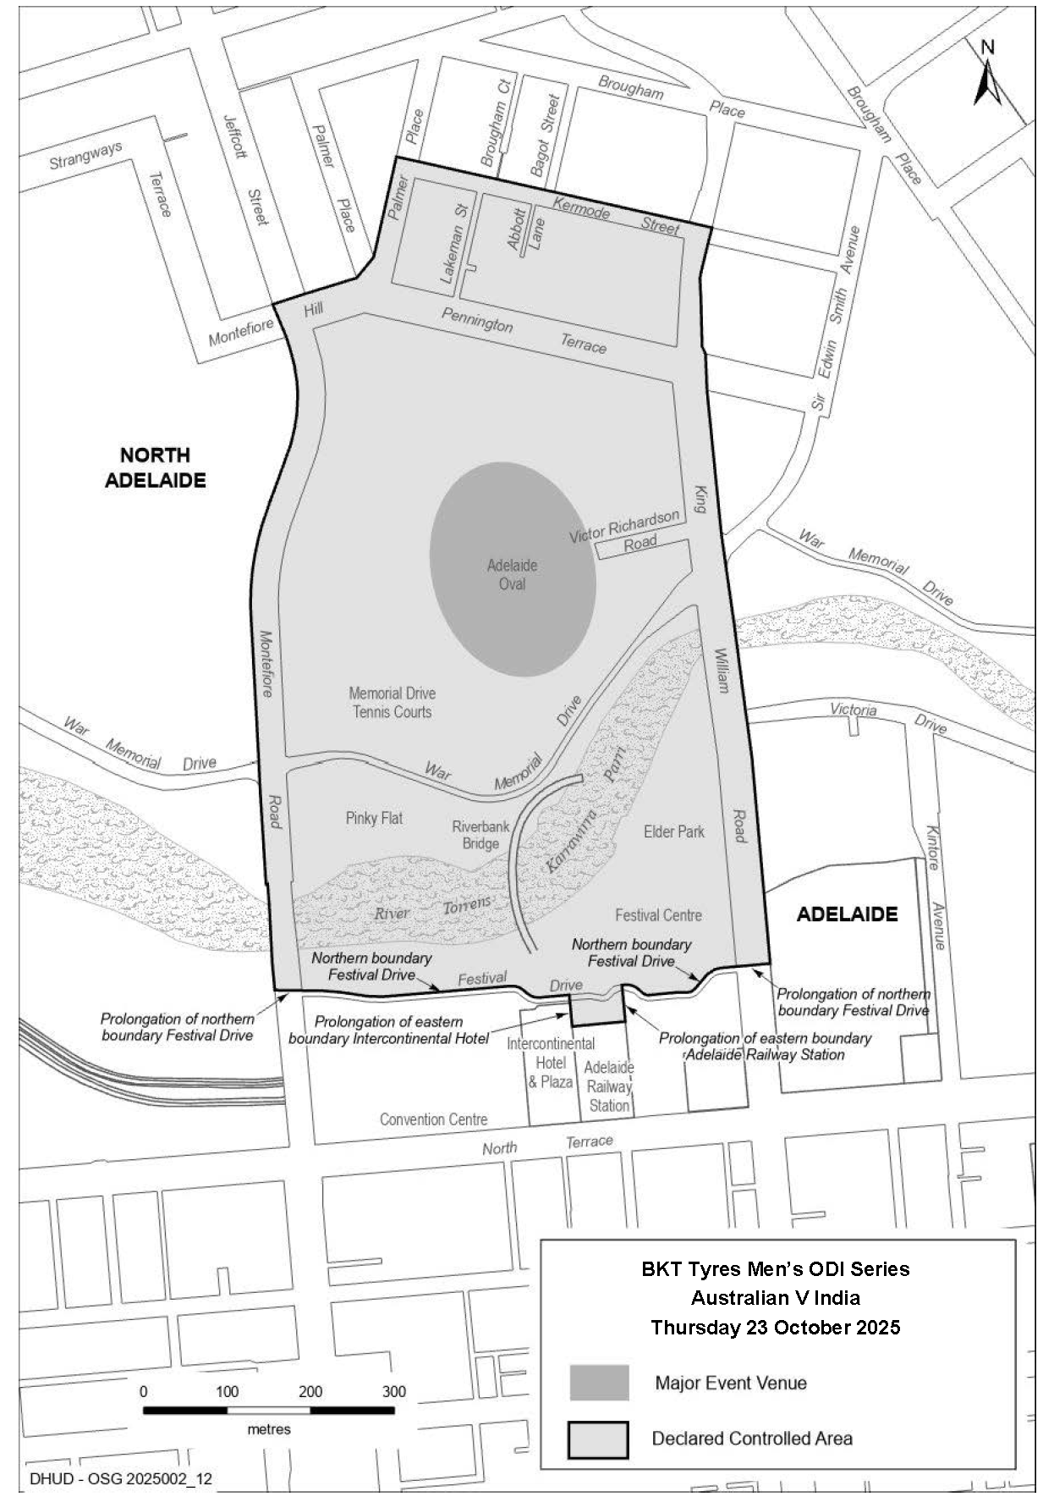
2025 BKT Tyres Men’s ODI Series, Australia V India

Major Events Act 2013
Section 6B
Declaration of a Major Event
Pursuant to Section 6B of the Major Events Act 2013, I, Hon. Zoe Bettison MP, Minister for Tourism declare the 2025 Shannons Adelaide Rally to be held from 21-23 November 2025 to be declared a major event.
By virtue of the provisions of the Major Events Act 2013, I do hereby:
1. Declare the 2025 Shannons Adelaide Rally to be a major event.
2. Specify the period of the event, for which the declaration of the major event is in force is from 5:00am on Friday, 21 November to 11:59pm on Sunday, 23 November 2025.
3. Declare the major event venues to be the areas as shown as ‘Major Event Venue’ in descriptions and maps specifically covering Gouger Street, O’Connell Street, Tynte Street and the rally stage routes, and controlled areas to be any public place or a part of a public place that is within 250 metres of the boundary of Gouger Street, O’Connell Street, Tynte Street or the rally stage route.
4. Declare the controlled areas to be any public place or a part of a public place that is within 250 metres of the boundary of the major event venues, as shown as the ‘Declared Controlled Area’ on the map.
5. Designate Massive Events Corp P/L (ABN 55 984 494 841) to be the event organisers for the event.
6. Declare that the following provisions of Part 3 of the Act apply to the event, the event site and the declared controlled area for the event:
(a) Section 8
(b) Section 10
(c) Section 11
(d) Section 12
(e) Section 13
(f) Section 14

7. Being satisfied that the title “Shannons Adelaide Rally” and the logo as it appears below are sufficiently connected with the identity and conduct of the major event, and that the event has commercial arrangements that are likely to be adversely affected by unauthorised use of the title and logo, I hereby declare, pursuant to Section 14(1) of the Act, that “Shannons Adelaide Rally” is an official title and the logo as it appears below is an official logo in respect of the event.

Dated: 22 September 2025
Hon Zoe Bettison MP
Minister for Tourism

Maps of Controlled Areas
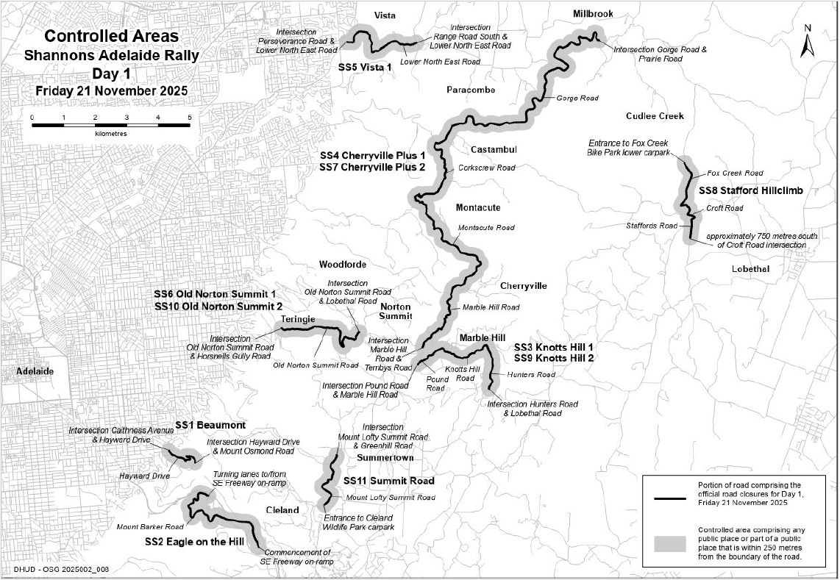
2025 Shannons Adelaide Rally

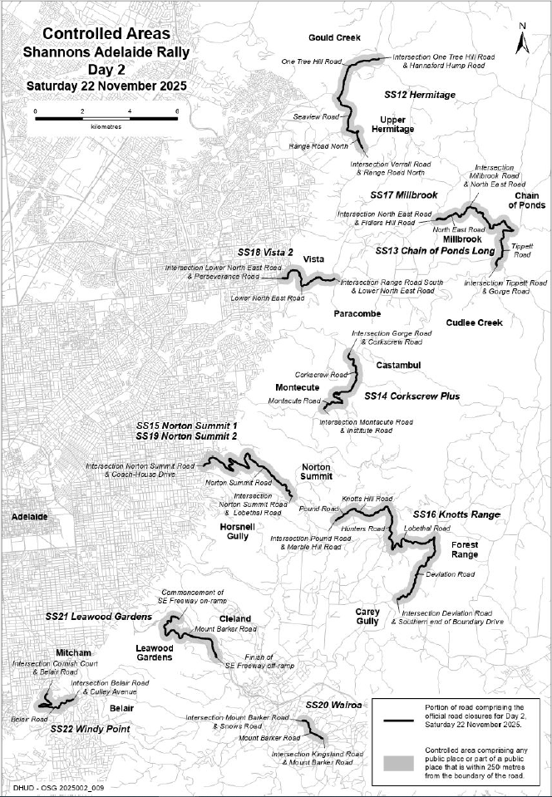
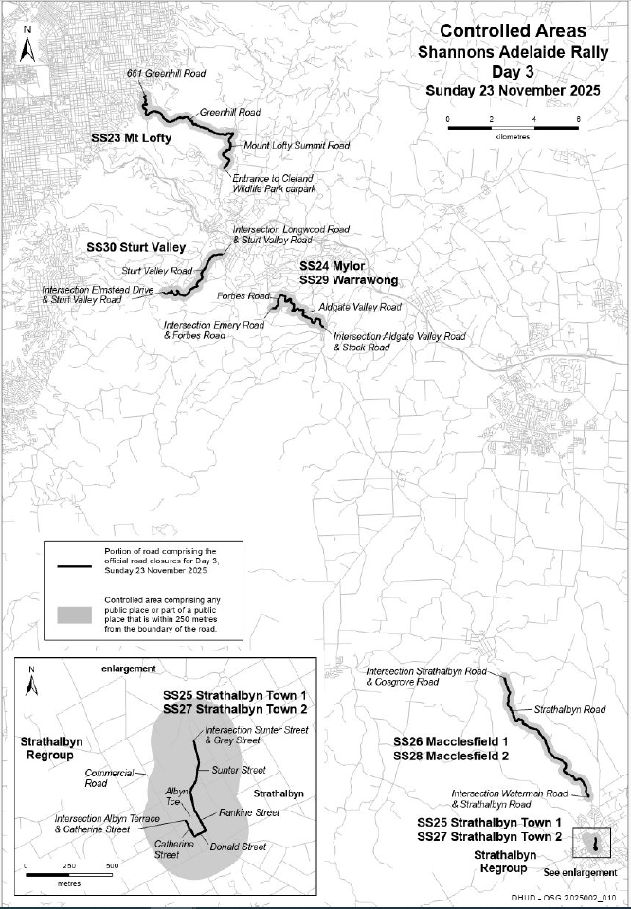
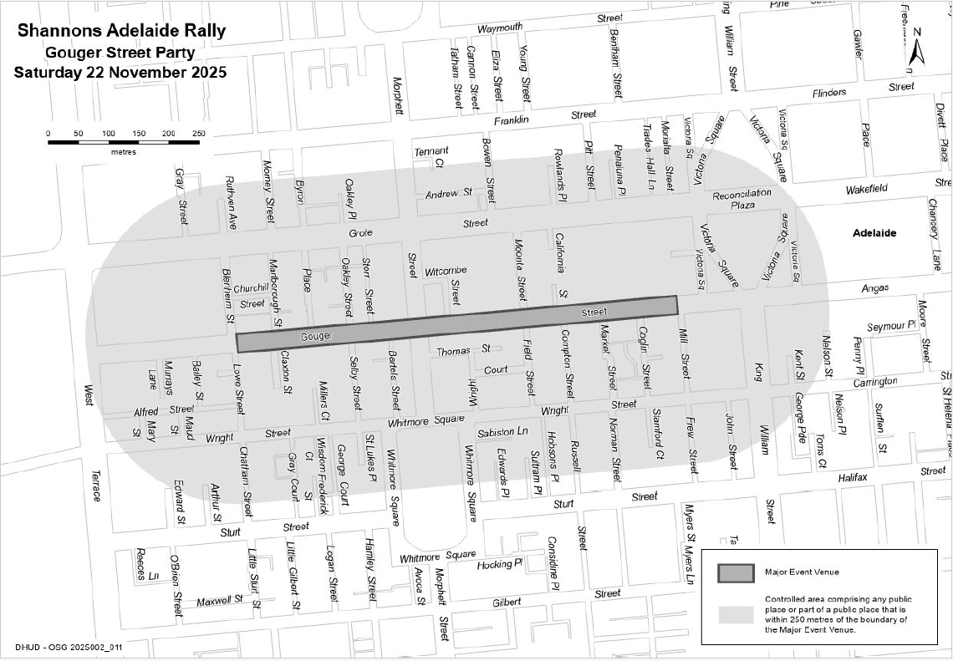
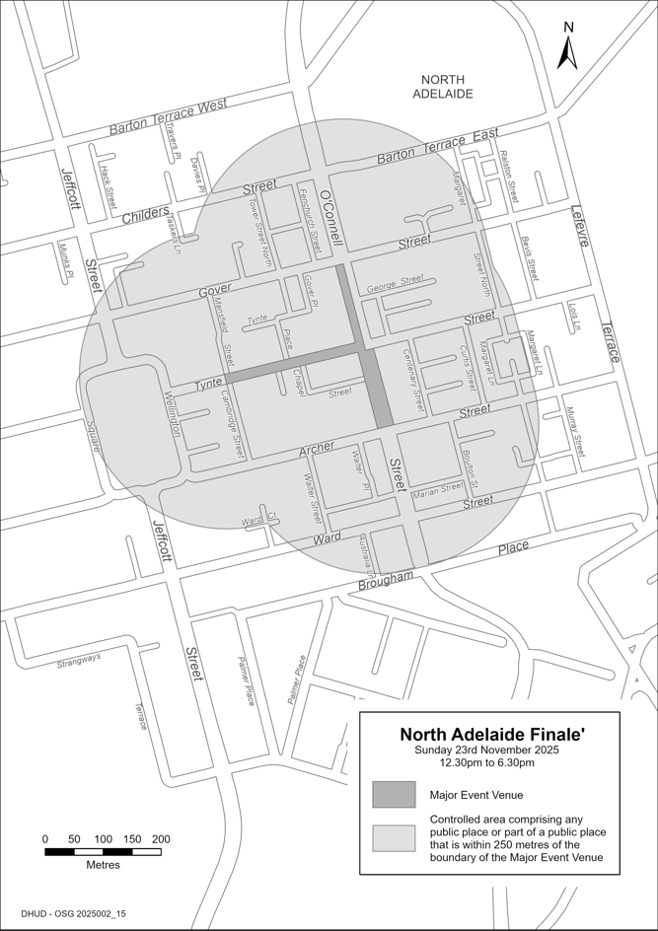

Planning, Development and Infrastructure Act 2016
Section 76
Amendment to the Planning and Design Code
Preamble
It is necessary to amend the Planning and Design Code (the Code) in operation at 11 September 2025 (Version 2025.17) in order to make changes of form relating to the Code’s spatial layers and their relationship with land parcels. Note: There are no changes to the application of zone, subzone or overlay boundaries and their relationship with affected parcels or the intent of policy application as a result of this amendment.
1. Pursuant to Section 76 of the Planning, Development and Infrastructure Act 2016 (the Act), I hereby amend the Code in order to make changes of form (without altering the effect of underlying policy), correct errors and make operational amendments as follows:
(a) Undertake minor alterations to the geometry of the spatial layers and data in the Code to maintain the current relationship between the parcel boundaries and Code data as a result of the following:
(i) New plans of division deposited in the Land Titles Office between 3 September 2025 and 16 September 2025 affecting the following spatial and data layers in the Code:
A. Zones and subzones
B. Technical and Numeric Variations
• Building Heights (Levels)
• Building Heights (Metres)
• Gradient Minimum Frontage
• Gradient Minimum Site Area
• Minimum Frontage
• Minimum Site Area
• Minimum Primary Street Setback
• Minimum Side Boundary Setback
• Future Local Road Widening Setback
• Site Coverage
C. Overlays
• Affordable Housing
• Future Road Widening
• Hazards (Bushfire—High Risk)
• Hazards (Bushfire—Medium Risk)
• Hazards (Bushfire—General Risk)
• Hazards (Bushfire—Urban Interface)
• Hazards (Bushfire—Regional)
• Hazards (Bushfire—Outback)
• Heritage Adjacency
• Local Heritage Place
• State Heritage Place
• Stormwater Management
• Urban Tree Canopy
(ii) Improved spatial data for existing land parcels in the following locations (as described in Column A) that affect data layers in the Code (as shown in Column B):

Location (Column A) | Layers (Column B)
D26961 A54—Glen Osmand  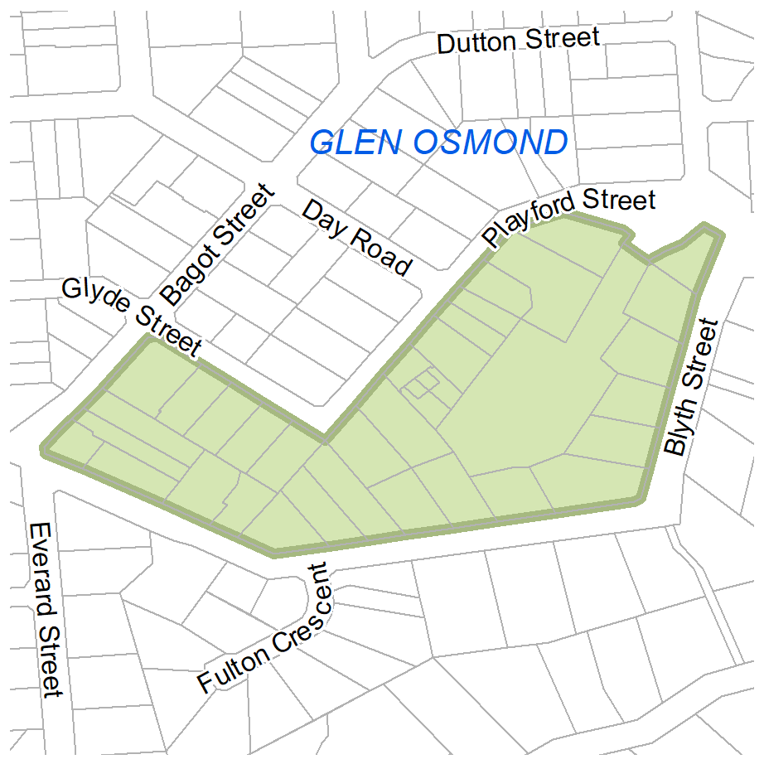 | Zones  Technical and Numeric Variations  - Gradient Minimum Frontage  - Gradient Minimum Site Area  - Minimum Frontage  - Minimum Site Area  Overlays  - Heritage Adjacency  - State Heritage Place
(b) In Part 13 of the Code—Table of Amendments, update the publication date, Code version number, amendment type and summary of amendments within the ‘Table of Planning and Design Code Amendments’ to reflect the amendments to the Code as described in this Notice.
2. Pursuant to Section 76(5)(a) of the Act, I further specify that the amendments to the Code as described in this Notice will take effect upon the date those amendments are published on the SA planning portal.
Dated: 22 September 2025
Greg Van Gaans
Director, Geospatial, Data Science and Analytics,
Department for Housing and Urban Development
Delegate of the Minister for Planning

South Australian Skills Act 2008
Part 4—Apprenticeships, Traineeships and Training Contracts
Pursuant to the provision of the South Australian Skills Act 2008, the South Australian Skills Commission (SASC) gives notice that determines the following qualification and training contract conditions for Trades or Declared Vocations, in addition to those published in past Gazette notices.
*Trade/ #Declared Vocation/ Other Occupation | Qualification Code | Qualification Title | Nominal Term of Training Contract | Probationary Period | Supervision Level Rating
Aged Care Worker # | CHC52025 | Diploma of Community Services | 24 months | 60 days | Medium
Alcohol and Other Drugs Worker # | CHC52025 | Diploma of Community Services | 24 months | 60 days | High
Community Worker # | CHC52025 | Diploma of Community Services | 24 months | 60 days | High
Disability Worker # | CHC52025 | Diploma of Community Services | 24 months | 60 days | High
Mental Health  (Non Clinical Worker) # | CHC52025 | Diploma of Community Services | 24 months | 60 days | High
Youth Worker # | CHC52025 | Diploma of Community Services | 24 months | 60 days | High
Children’s Services Worker # | CHC50125 | Diploma of Early Childhood Education and Care | 36 months | 90 days | Medium
Youth Worker # | CHC50425 | Diploma of Youth Work | 36 months | 90 days | High
Engineering Tradesperson (Fabrication) * | MEM31925 | Certificate III in Engineering— Fabrication Trade | 48 months | 90 days | High
Silversmith * | MEM31925 | Certificate III in Engineering— Fabrication Trade | 48 months | 90 days | High
Condition/s | N/A

*Trade/ #Declared Vocation/ Other Occupation | Qualification Code | Qualification Title | Nominal Term of Training Contract | Probationary Period | Supervision Level Rating
Pipe Fitter * | MEM31925 | Certificate III in Engineering— Fabrication Trade | 48 months | 90 days | High
Condition/s | The South Australian Skills Commission has mandated both the core and elective units of competency for this pathway. The mandated training plan is published on the Commission’s website. Apprentices training in this trade must undertake all mandated units of competency, or their equivalent.
Dated: 25 September 2025
john Evangelista
Director, Traineeship and Apprenticeship Services
South Australian Skills Commission

Local Government Instruments

City of Onkaparinga
Local Government Act 1999
Change of Road Name—Noarlunga Downs SA
Notice is hereby given in accordance with Section 219 (1) of the Local Government Act 1999, Garland Court Noarlunga Downs will be changed to Delta Court Noarlunga Downs, effective 25 September 2025.
Dated: 25 September 2025
Renee Mitchell
Acting Chief Executive Officer

City of Port Lincoln
Local Government Act 1999—Section 246
Notification of Application of By-laws
Notice is hereby given pursuant to Section 246(4a) of the Local Government Act 1999, that at its meeting of 15 September 2025 the City of Port Lincoln determined, in accordance with Section 246(3)(e) of the Local Government Act 1999 and Clause 11 of Council’s By-law 4—Local Government Land 2025 that:
(a) Clause 4.24 shall apply to all local government land, excepting land defined as a cemetery, natural burial ground or crematorium under the Burial and Cremation Act 2013;
(b) Clause 4.26.2 shall apply to all local government land;
(c) Clause 4.43 shall apply to all local government land.
And at its meeting of 15 September 2025 the City of Port Lincoln determined, in accordance with Section 246(3)(e) of the Local Government Act 1999, and Clause 8 of Council’s By-law 5—Dogs that:
(a) Clause 4.1—Dog Prohibited Areas, shall apply to all children’s playgrounds, in addition to the following areas:
(i) Centenary Oval between 8.30am and 5.00pm Monday to Friday and when there is organised sport or training or other community event;
(ii) Ravendale Sports Complex (all areas within complex boundaries), when there is organised sport or training or other community event;
(iii) Poole Oval, when there is organised sport or training or other community event;
(iv) Kirton Oval Soccer Grounds, when there is organised sport or training or other community event.
(b) Clause 5.1 Dog on Leash Areas, shall apply to the following areas:
(i) Central Business District Area Roads and Footpaths between Bishop and Eyre Streets and Tasman Terrace and Liverpool Street/Hallett Place;
(ii) Port Lincoln Foreshore between mean low water mark and Tasman Terrace (beach and lawns), from the carpark adjacent to the beach (aligned with the bend in Bishop Street) to the silos, between 8.30am and sunset
(iii) Altair Crescent Playground Reserve;
(iv) Train Playground, New West Road;
(v) Rustlers Gully Reserve;
(vi) Wellington Square Reserve;
(vii) Flinders Park (all of park);
(viii) Puckridge Park (areas around BBQ’s and Rotundas)
(ix) Formed Walking Trails, including total length of Parnkalla Trail.
(c) Clause 6.1 Dog Exercise Areas, shall apply to the following areas:
(i) The City of Port Lincoln Dog Park located at Windsor Avenue, Verran Terrace, Puckridge Place;
(ii) Nelson Square (excluding within 5 metres of children’s playground equipment)
Council’s By-laws 2025 and determinations are available for inspection on the Council’s website www.portlincoln.sa.gov.au and at the Council’s office at Level 1, 60 Tasman Terrace, Port Lincoln during business hours.
This determination will take effect from 29 September 2025.
Dated: 25 September 2025
David Levey
Acting Chief Executive Officer

District Council of Franklin Harbour
Assigning of Road Names
Notice is hereby given that the District Council of Franklin Harbour has resolved, pursuant to Section 219(4) of the Local Government Act 1999, to assign the following road names to new roads within the Council’s area:
1. Harbourside Drive;
2. Simms Street; and
3. Ramsey Court
As referenced in Deposited Plan D138900, a sub-division located South of Farr Street.
Dated: 18 September 2025
Shane Gill
Chief Executive Officer

District Council of Orroroo Carrieton
Review of Representation
Notice is hereby given that the District Council of Orroroo Carrieton has reviewed its composition in accordance with the requirements of Section 12 of the Local Government Act 1999.
Pursuant to Section 12(13)(a) of the Act, the Electoral Commissioner has issued a certificate that the review undertaken by the Council satisfies the requirements of Section 12 and may now be put into effect from polling day of the first periodic election held after the publication of this notice.
The Council proposes to make no change to its representation arrangements, with the following arrangements to take effect from polling day of the next periodic elections:
• the name of the Council is to remain unchanged;
• the Principal Member of Council is to be a Mayor, elected as a representative of the area as a whole;
• the area of the Council shall not be divided into wards;
• the elected body of the Council will be comprised of six (6) elected members, these being the Mayor and five (5) Councillors.
Dated: 22 September 2025
Stephen Rufus
Chief Executive Officer

Public Notices

National Electricity Law
Notice of Final Rule
The Australian Energy Market Commission (AEMC) gives notice under the National Electricity Law as follows:
Under ss 102, 102A and 103, the making of the National Electricity Amendment (Inter-regional settlements residue arrangements for transmission loops) Rule 2025 No. 9 (Ref. ERC0386) and related final determination. All provisions commence on 2 October 2025.
Documents referred to above are available on the AEMC’s website and are available for inspection at the AEMC’s office.
Australian Energy Market Commission
Level 15, 60 Castlereagh St
Sydney NSW 2000
Telephone: (02) 8296 7800
www.aemc.gov.au
Dated: 25 September 2025

National Energy Retail Law
Notice of Final Rule and Final Determination
The Australian Energy Market Commission (AEMC) gives notice under the National Energy Retail Law as follows:
Under ss 259, 260 and 261, the making of the National Energy Retail Amendment (Improving the application of concessions to bills) Rule 2025 No. 5 (Ref. RRC0063) and related final determination. Schedule 2 commences on 2 October 2025, and second provision Schedule 1 commences on 1 July 2026.
Documents referred to above are available on the AEMC’s website and are available for inspection at the AEMC’s office.
Australian Energy Market Commission
Level 15, 60 Castlereagh St
Sydney NSW 2000
Telephone: (02) 8296 7800
www.aemc.gov.au
Dated: 25 September 2025

National Gas Law
Notice of Initiation
Notice of Extension of Draft Determination and Final Determination
The Australian Energy Market Commission (AEMC) gives notice under the National Gas Law as follows:
Under s 303, the Energy Senior Officials and the Victorian Minister for Energy and Resources requested the ECGS Supplier of last resort mechanism (Ref. GRC0077) proposal. The proposal seeks to establish a supplier of last resort mechanism to support efficient responses to reliability and supply adequacy threats in the ECGS. Submissions must be received by 30 October 2025.
Under s 317, the time for making the draft determination on the ECGS Supplier of last resort mechanism (Ref. GRC0077) proposal has been extended to 26 February 2026.
Under s 317, the time for the making of the final determination on the ECGS Supplier of last resort mechanism (Ref. GRC0077) proposal has been extended to 25 June 2026.
Submissions can be made via the AEMC’s website. Before making a submission, please review the AEMC’s privacy statement on its website, and consider the AEMC’s Tips for making a submission. The AEMC publishes submissions on its website, subject to confidentiality and other considerations.
Documents referred to above are available on the AEMC’s website and are available for inspection at the AEMC’s office.
Australian Energy Market Commission
Level 15, 60 Castlereagh St
Sydney NSW 2000
Telephone: (02) 8296 7800
www.aemc.gov.au
Dated: 25 September 2025

Notice Submission

The South Australian Government Gazette is published each Thursday afternoon.
Notices must be emailed by 4 p.m. Tuesday, the week of publication.
Submissions are formatted per the gazette style and a proof will be supplied prior to publication, along with a quote if applicable. Please allow one day for processing notices.
Alterations to the proof must be returned by 4 p.m. Wednesday.

Gazette notices must be submitted as Word files, in the following format:
• Title—the governing legislation
• Subtitle—a summary of the notice content
• Body—structured text, which can include numbered lists, tables, and images
• Date—day, month, and year of authorisation
• Signature block—name, role, and department/organisation authorising the notice

Please provide the following information in your email:
• Date of intended publication
• Contact details of the person responsible for the notice content
• Name and organisation to be charged for the publication—Local Council and Public notices only
• Purchase order, if required—Local Council and Public notices only

Email: governmentgazettesa@sa.gov.au
Phone: (08) 7133 3552
Website: www.governmentgazette.sa.gov.au

All instruments appearing in this gazette are to be considered official, and obeyed as such

Printed and published weekly by authority of T. Foresto, Government Printer, South Australia
$9.50 per issue (plus postage), $479.00 per annual subscription—GST inclusive
Online publications: www.governmentgazette.sa.gov.au

